

Role and Function of Macrophages in Symptomatic Carotid Stenosis
Klaudia Kocsy
Registration No: 170120292

A thesis submitted in partial fulfilment of the requirements for the degree of
Doctor of Philosophy

The University of Sheffield
Faculty of Medicine, Dentistry & Health
Department of Infection, Immunity and Cardiovascular Disease

July 2021

“Felfedezni valamit annyit tesz,
mint látni, amit mindenki lát,
és közben arra gondolni,
amire még senki.”

Szent-Györgyi Albert

“Discovery consists in seeing
what everyone else has seen
and thinking what
no one else has thought.”

Albert Szent-Györgyi

Abstract

Introduction:
Large artery atherosclerosis is the most frequent cause of ischaemic stroke and patients with a high atherosclerotic burden are at increased risk of early recurrent ischaemic events. Atherosclerotic plaque formation and progression are highly influenced by macrophages, which are in turn affected by their microenvironment and medications.
I hypothesised 1) that the two major subtypes of macrophage (M1, M2a) coalesce and are altered within stable vs. unstable atherosclerotic plaques and 2) that statins or an anti-inflammatory compound could modulate these subtypes in humans.
Methods:
A novel immunofluorescence staining (IF) with common macrophage markers (pan macrophage: CD68, M1: CD86, M2: MRC1), and analysis technique were developed to characterise macrophage phenotypes in human carotid plaques (n= 13) taken from patients with recent stroke.
Plaque macrophages were classified with Laser Capture Microdissection & single-cell RNA sequencing (LCM scRNA-seq).
An in vitro model of human monocyte derived macrophages (hMDMs) was used to test the effect of statins and dexamethasone (dex) on macrophage specific genes and proteins with RT-qPCR (n= 4-10) and Western Blot (n= 7). The physiological effect of dex was also tested (n=5) in a biological assay with oxLDL uptake.
Results:
Across all 11 analysed plaques, the macrophage population was dominated by double positive (CD68+CD86+MRC1+) (68%), followed by M1 single positive (CD68+CD86+MRC1-) (16%), M2 single positive (CD68+CD86-MRC1+) (9%) and double negative (CD68+CD86-MRC1-) macrophages (7%). ScRNA-seq data confirmed that individually dissected, CD68+ cells from the plaque were macrophages and they are clustered between M1 and M2a polarised macrophages.
In vitro, statins did not have a significant effect on macrophage specific genes, but dex reprogrammed macrophage subtypes to a less inflammatory state and promoted polarization towards an M2 state as marked by increasing (2-fold) Mannose Receptor C-type 1 (MRC1) gene expression (p= 0.0183). The expression of Macrophage Scavenger Receptor 1 (MSR1) gene was reduced 2-fold (p= 0.0845) in M2a cells, resulting a reduced low- density lipoprotein (LDL) internalization. Oxidized Low Density Lipoprotein Receptor 1 (OLR1) gene (p= 0.0003) and protein (p= 0.0003) expression were significantly reduced 5-fold, following exposure to dex. In functional tests, oxidized low-density lipoprotein (oxLDL) accumulation by dex treated hMDMs was significantly impaired (p= 0.0030).
Conclusions:
In this study, double positive macrophages had the highest prevalence in the shoulder regions of symptomatic carotid plaques compare to single positive or double negative macrophages. The double negative macrophage subtype may represent a novel and yet uncharacterised population. LCM scRNA-seq followed by a hierarchical clustering algorithm suggested that the microdissected macrophages clustered between M1 and M2a macrophages. Dexamethasone reduced ‘active’ and pathogenic cell behaviours e.g., oxLDL accumulation and promoted the polarisation to the M2 state. These data show that macrophages can be reprogrammed to a less pathogenic state in vitro by dex, which opens the exciting possibility that this drug could be used to stabilise unstable plaque to reduce the risk of ischaemic stroke.

Declaration of Contributions

I, Klaudia Kocsy, confirm that this Thesis is my own work. The work presented in this study has been generated and analysed by me, unless otherwise stated. I am aware of the University’s Guidance on the Use of Unfair Means (www.sheffield.ac.uk/ssid/unfair-means). This work has not previously been presented for an award at this, or any other, university.
Chapter 4 arises from a close collaboration with the Mutagenesis & Carcinogenesis Research Group (Biological Research Centre, Szeged, Hungary) who carried out single cell RNA sequencing and Sumeet Deshmukh (supervisor: Dr Ian Sudbery) who performed the whole transcriptomics analysis.
Chapter 3 and Chapter 4 are intended to be published, along with data not shown in this thesis. Results presented in Chapter 5 will be continued as a pre-clinical project following a clinical study.
Figures were made by me with the use of images from Servier Medical Art by Servier which is licensed under a Creative Commons License; unless stated otherwise.
During my PhD all the help and support received from IICD technicians was critical and I would like to thank them all, in particular Dr Benjamin Durham, Dr Colin Gray, Jonathan Kilby, Veronika Kiss-Tóth and Fiona Wright.

Associated Publications

Conference posters:
Joint BAS/BSCR Late Spring Meeting 2018:
- Semi-Quantitative Imaging of Macrophages in Human Carotid Atherosclerotic Plaques
Klaudia Kocsy, Shavinthi Wadanamby, Kevin Tang, Jessica Johnston, Sheila Francis, Endre Kiss-Toth, Arshad Majid, Jessica Redgrave
BAS Annual Meeting 2018:
- Human Macrophage Subsets in the Pathogenesis of Carotid Atherosclerosis
Klaudia Kocsy, Rehab Alqurashi, Jessica M Johnston, Kajus Baidzajevas, Arshad Majid, Heather L Wilson, Endre Kiss-Toth, Jessica Redgrave, Sheila Francis
Joint BAS/BSCR Late Spring Meeting 2019:
- Double positive (CD86+ MRC1+) inflammatory macrophages in the pathogenesis of carotid atherosclerosis
Klaudia Kocsy, Sheila Francis, Endre Kiss-Toth, Robert Lonsdale, Arshad Majid, Jessica Redgrave
BAS Annual Meeting 2019:
- Inflammatory macrophages in the pathogenesis of carotid atherosclerosis
Klaudia Kocsy, Endre Kiss-Toth, Arshad Majid, Jessica Redgrave, Sheila Francis
Joint BAS/BSCR Late Spring Meeting 2021:
- Reprogramming human macrophages with Drug X: potential mechanisms for stabilisation of atherosclerotic plaques
Klaudia Kocsy, Endre Kiss-Toth, Jessica Redgrave, Arshad Majid, Sheila Francis

Manuscripts in preparation:
- Reprogramming human macrophages with dexamethasone: potential mechanisms for stabilisation of atherosclerotic plaques
- Identification of novel macrophage populations in human carotid lesions

Other publications/ manuscripts (contribution is not presented in this thesis):
- Genome-wide association and functional analyses identify CASC20 and KIF26b as target loci in heterotopic ossification
Konstantinos Hatzikotoulas, George Ae Pickering, Matthew J Clark, Favour Felix-Ilemhenbhio, Klaudia Kocsy, Jonathan Simpson, Scott J Macinnes, Mine. Koprulu, Lorraine Southam, Ilaria Bellantuono, Kajus Baidžajevas, David A Young, Alison Gartland, Eleftheria Zeggini, Endre Kiss-Toth, J Mark Wilkinson

- Tribbles 3 deficiency promotes atherosclerotic fibrous cap thickening and macrophage- mediated extracellular matrix remodelling (submitted)
Laura Martinez Campesino, Klaudia Kocsy, Jaime Canedo, Jessica M Johnston, Charlotte Moss, Simon A Johnston, Stephen Hamby, Alison H. Goodall, Jessica Redgrave, Sheila E Francis, Endre Kiss-Toth, Heather L Wilson

- Human pro-inflammatory macrophage FAM26F regulates chemokine expression and macrophage–lymphocyte interaction (manuscript)
Kajus Baidžajevasa, Rehab Alqurashi, Klaudia Kocsy, Éva Hadada, Radoslaw M Sobota, Dilip Kumar, Laura Martínez Campesino, Bernett Lee, Michael Poidinger, Caroline Evans, Jessica N Redgrave, S Kim Suvarna, Mark J Dickman, Arshad Majid, Sheila E Francis, Siew Cheng Wong, Endre Kiss–Tóth, Heather L Wilsona

Acknowledgements

Firstly, I would like to express my deepest appreciation to Professor Sheila E Francis and Professor Endre Kiss-Tóth for the opportunity to complete my PhD in their laboratory. I am exceptionally grateful for their invaluable encouragement, unparalleled support, guide and insightful suggestions.
Moreover, I would also like to extend my deepest gratitude to Dr Jessica Redgrave and Professor Arshad Majid for their valuable time and effort in helping me and to gain a bit of clinical experience.
I would also like to say thanks to all my laboratory colleagues and friends, especially Laura, Favour, Taghreed, Chiara and Taewoo for their help and for the countless stimulating conversations. The completion of my dissertation would have been a whole different experience without their support and encouragement.
I gratefully acknowledge the assistance of the histological technician, Fiona Wright at IICD; the microscopy lead, Dr Colin Gray and the vascular surgery team.

A very special thanks also goes to my forever best friend, Árpi, who always understands both my scientific and emotional ramblings. The relentless love and support he provided me during our university and PhD years meant the world to me.
I would not have been able to do this without the encouragement of my friends and without all the fun times we have had together. I am particularly thankful to Matt, Dave, Balázs, Ádám, Fanni and Tomi. Without them I would have been lost.

Végül, de nem utolsó sorban végtelenül hálás vagyok a családomnak a kitartó támogatásukért és a rengeteg telefonon töltött óráért. Köszönöm anyának és apának, hogy mindig mindenben mellettem állnak és számíthatok rájuk, bárhova is sodor az élet. Köszönöm húgomnak, Briginek a rengeteg beszélgetést, jó tanácsot és vidám pillanatokat, nélküle unalmas lenne az életem.
(Last but not least, I am endlessly grateful to my family for their persistent support and for the countless hours spent on the phone. I wish to thank my Mom and Dad who I can always count on and who are always there for me wherever life takes me. Many thanks to my sister, Brigi for all the talks, good advice and fun, without her my life would be boring.)

Table of Contents

I. Abstract I
II. Declaration of Contributions III
III. Associated Publications IV
IV. Acknowledgements VI
V. Table of Contents VII
VI. List of Figures XIII
VII. List of Tables XV
VIII. List of Abbreviations XVI
1. Chapter 1. Introduction 1
1.1. Stroke 1
1.1.1. Epidemiology 1
1.1.2. Definition of stroke and TIA 1
1.1.3. Risk factors for stroke 2
1.1.4. Types of stroke 3
1.1.5. Diagnosis and treatment of stroke 4
1.1.6. Stroke recurrence and risk of stroke after TIA 5
1.1.7. COVID-19 and stroke 6
1.2. Atherosclerosis 8
1.2.1. Historical background of atherosclerosis and histology 8
1.2.2. Pathogenesis of atherosclerosis 11
1.2.3. Endothelial dysfunction and injury 11
1.2.4. Foam cell formation 13
1.2.5. Necrotic core formation 13
1.2.6. Smooth muscle cell proliferation and migration 14
1.2.7. Fibrous cap formation 14
1.2.8. Atherosclerotic plaque characteristics and instability 15
1.2.9. Vulnerable plaque and vulnerable patient 16
1.2.10. Atherosclerotic plaque erosion and rupture 17
1.2.11. Histological classification of atherosclerosis by the American Heart Association 17
1.3. Inflammatory cells in atherosclerotic lesions 19
1.3.1. Inflammatory cells 19
1.3.2. Monocytes 20
1.3.3. Monocyte accumulation in atherosclerotic plaque 20
1.3.4. Monocyte differentiation into macrophages 21
1.3.5. Polarization and role of macrophages 21
1.3.6. M1 macrophages 23
1.3.7. M2 macrophages 24
1.3.8. M4 macrophages 24
1.3.9. Oxidized phospholipid derived macrophages- Mox 25
1.3.10. Haemorrhage-specialist macrophage- Mhem 25
1.3.11. Pan macrophage markers 26
1.3.12. CD68, a pan macrophage marker 27
1.3.13. Macrophage distribution in lesions and role in plaque stability 27
1.3.14. Other inflammatory cells in atherosclerotic lesions 28
1.3.15. Inflammatory signalling 29
1.4. Transcriptome analysis of human plaque tissue 31
1.4.1. Transcriptome analysis 31
1.4.2. Transcriptome analysis of macrophages 32
1.4.3. Single-cell analysis of murine atherosclerotic plaques 35
1.4.4. Single-cell analysis of human atherosclerotic plaques 38
1.5. Drugs that may influence inflammation and macrophages in stroke and atherosclerosis 40
1.5.1. Dexamethasone and glucocorticoid signalling 40
1.5.2. Glucocorticoid Receptors 42
1.5.3. The effect of glucocorticoids 42
1.5.4. The effect of dexamethasone treatment in ischemic stroke patients 43
1.5.5. The effect of dexamethasone on atherosclerosis & macrophages 44
1.5.6. Concentrations of dexamethasone used in different human studies 45
1.6. Lipid metabolism and its role in atherosclerosis 47
1.6.1. Lipoproteins and lipids as risk factors for atherosclerosis 47
1.6.2. Triglycerides and triglyceride-rich lipoproteins 47
1.6.3. High-density lipoprotein (HDL) 48
1.6.4. Low-density lipoprotein (LDL) 48
1.6.5. Oxidized low-density lipoprotein (oxLDL) 48
1.6.6. Scavenger receptors and their role in atherosclerosis 49
1.6.7. Macrophages and their role in lipid metabolism 50
1.6.8. Statins and other hypolipidemic agents in atherosclerosis 53
1.7. Knowledge Gap 55
1.8. Hypothesis and Aims 56
2. Chapter 2. Materials and Methods 57
2.1. Governance 57
2.2. Patient Recruitment 57
2.3. Histological processing and assessment 58
2.3.1. Histological processing of human carotid plaques 58
2.3.2. Haematoxylin and Eosin staining 59
2.3.3. Connective tissue staining 59
2.3.4. CD3 and CD68 immunohistochemical staining 59
2.3.5. Histological assessment 60
2.4. Fluorescence Immunohistochemistry 60
2.4.1. Immunofluorescence staining of human carotid plaques with CD68, CD86 and MRC1 macrophage markers 60
2.4.2. Imaging 61
2.4.3. Image Analysis & Statistical Analysis 62
2.5. Single-cell analysis of human carotid plaques 66
2.5.1. Modified histological protocol to maintain RNA integrity 66
2.5.2. RNA quality control with Real Time quantitative PCR 67
2.5.3. RNA quality control with bioanalyzer analysis and pilot sequencing 67
2.5.4. PET membrane pre-treatment before tissue sectioning 67
2.5.5. Laser Capture Microdissection 67
2.5.6. RNA quality control with sequencing after LCM 69
2.5.7. Quality control of DNA with PCR and agarose gel electrophoresis 70
2.5.8. cDNA library preparation and sequencing 70
2.5.9. Bioinformatic analysis of single macrophages microdissected from human carotid plaques 70
2.6. In vitro Macrophage Subsets 71
2.6.1. PBMC isolation 71
2.6.2. CD14+ monocyte isolation 72
2.6.3. Macrophage differentiation 73
2.6.4. Macrophage polarization 74
2.6.5. Macrophage treatment with statins and dexamethasone 75
2.6.6. RNA isolation 75
2.6.7. cDNA synthesis and Real Time quantitative PCR 75
2.6.8. Cell lysis and BCA Assay 77
2.6.9. Western blot 77
2.6.10. oxLDL accumulation in MDMs, Oil Red O Staining, microscopy and analysis 79
2.6.11. OLR1 IF stain, microscopy and analysis 79
3. Chapter 3. Different Macrophage Subsets in Human Carotid Atherosclerotic Plaques 81
3.1. Introduction 81
3.2. Hypothesis 82
3.3. Results 82
3.3.1. Patient demographics 83
3.3.2. Histological Analysis 85
3.3.3. Macrophage phenotype characterisation in carotid plaques 87
3.3.4. Double positive macrophage (CD68+CD86+MRC1+) phenotype is the most abundant in the shoulder regions of human carotid plaques 90
3.3.5. Macrophage phenotype distribution in stable and unstable carotid plaques 91
3.3.6. Macrophage phenotype distribution in AHA lesion types 91
3.4. Summary of Results 96
3.5. Discussion 97
3.5.1. Stroke and patient characteristics 97
3.5.2. Atherosclerosis and the histological analysis of human carotid plaques 98
3.5.3. Inflammatory cells in human carotid plaques 98
3.6. Limitations 101
4. Chapter 4. Single Cell Transcriptome Analysis of Human Atherosclerotic Plaque Macrophages 102
4.1. Introduction 102
4.2. Hypothesis 102
4.3. Results 103
4.3.1. Preserved RNA integrity from an IF stained FFPE tissue section 103
4.3.2. Transcriptome of single plaque macrophages 107
4.4. Summary of Results 110
4.5. Discussion 110
4.6. Limitations 113
5. Chapter 5. Programming Human Macrophages in vitro with Atorvastatin, Simvastatin and Dexamethasone 114
5.1. Introduction 114
5.2. Hypothesis & Aims 115
5.3. Results 115
5.3.1. Statins do not have significant effect on gene expression in hMDMs in an in vitro model 116
5.3.2. Dexamethasone promotes polarization towards an M2a state 118
5.3.3. Dexamethasone modifies SCARB1 expression in M2a macrophages 119
5.3.4. Dexamethasone affects MSR1 expression in polarised macrophages 120
5.3.5. The effect of dexamethasone on CD36 and OLR1 gene expression in polarised macrophages 121
5.3.6. The effect of dexamethasone on scavenger receptor gene expression 122
5.3.7. The effect of dexamethasone on OLR1 protein in polarised macrophages 123
5.3.8. Beneficial physiological effect of dexamethasone in polarised macrophages 126
5.4. Summary of Results 127
5.5. Discussion 127
5.5.1. The effect of statins on macrophages specific genes in human M1 and M2a polarized cells 128
5.5.2. The effect of dexamethasone on macrophage specific genes in human M1 and M2a polarized cells 129
5.6. Limitations 132
6. Chapter 6. General Discussion and Conclusions 133
6.1. Major outcomes 133
6.2. Future Work 136
VIII. References 138
IX. Appendix 164
IX.1. Patient consent form 164
IX.2. Volunteer consent form 165
IX.3. Volunteer consent form (version 1 (21/10/2019) 166
IX.4. Summary of collected plaque samples 167
IX.5. EDTA 167
IX.6. H&E staining protocol 168
IX.7. CD3 and CD68 staining protocol 169
IX.8. CD68, CD86, MRC1 staining protocol 171
IX.9. Semiquantitative grading scales of histological features 173
IX.10. RT-qPCR results of simvastatin and atorvastatin experiments 174
IX.11. Representative image of RT-qPCR results of dexamethasone treatment 178
IX.12. Western Blots of dexamethasone treatment experiments 179
IX.13. Summary of reagents and consumables 181
IX.14. Summary of machines and software 184

List of Figures
Figure 1: A schematic illustration of haemorrhagic and ischemic stroke 3
Figure 2: The technique of carotid endarterectomy 5
Figure 3: Historical records of atherosclerosis in humans 10
Figure 4: The pathogenesis of atherosclerosis 12
Figure 5: Differences between the histologically classified stable and unstable atherosclerotic plaques 16
Figure 6: The differentiation and polarization of macrophages 22
Figure 7: Correlation networks of 299 human macrophage mRNA transcriptomes created with correlation coefficient matrices 33
Figure 8: Genomic action of glucocorticoids 41
Figure 9: Lipid metabolism in macrophages 52
Figure 10: The mechanism of action of statins 53
Figure 11: Illustration of the orientation of the carotid bifurcation and plaque division into wax blocks 58
Figure 12: An example of immunofluorescence-stained image analysis 63
Figure 13: A representative example of the qualitative aspects of the image analysis workflow 65
Figure 14: Zeiss PET membrane frame slide used for LCM scRNA-seq 66
Figure 15: Representative image of LCM marker points on IF stained human carotid plaque sample 68
Figure 16: Methodological overview of Laser Capture Microdissection 69
Figure 17: Workflow of in vitro cell work 72
Figure 18: Summary of the in vitro experiments 74
Figure 19: Summary of the histological features of the analysed human carotid plaques 86
Figure 20: Representative images of positive and negative IF staining controls 87
Figure 21: Representative images of single and dual IF staining of human plaque macrophages 89
Figure 22: Percentage of different macrophage phenotypes in the plaque shoulder regions of human carotid plaques 90
Figure 23: Macrophage phenotype distribution in stable and unstable carotid plaques 91
Figure 24: Percentage of different macrophage phenotype populations in type IV: lipid core atheroma lesion 92
Figure 25: Percentage of different macrophage phenotype populations in type V lesions 94
Figure 26: Percentage of different macrophage phenotype populations in type VI lesions 95
Figure 27: Amplification curves of CD68 and GAPDH gene expression as a result of RT-qPCR 103
Figure 28: Bioanalyzer quality control of human carotid plaque cDNA (10 pg) 104
Figure 29: Genomic distribution of human carotid plaque RNA after Illumina NextSeq pilot sequencing 105
Figure 30: Agarose gel electrophoresis of direct PCR amplicons for TP53 after LCM to test laser settings 106
Figure 31: Quality plot generated by FastQC. 107
Figure 32: Genomic distribution of reads from 4 CD68+ cells 108
Figure 33: Cluster analysis of macrophages 109
Figure 34: Relative gene expression analysis of OLR1 in human MDMs after simvastatin and atorvastatin treatment 117
Figure 35: Relative gene expression analysis of MRC1 in human MDMs after dexamethasone treatment 118
Figure 36: Relative gene expression analysis of SCARB1 in human MDMs after dexamethasone treatment 119
Figure 37: Relative gene expression analysis of MSR1 in human MDMs after dexamethasone treatment 120
Figure 38: Relative gene expression analysis of CD36 in human MDMs after dexamethasone treatment 121
Figure 39: Relative gene expression analysis of OLR1 in human MDMs after dexamethasone treatment 122
Figure 40: Summary of the effect of dexamethasone on scavenger receptor gene expression in polarised cells 123
Figure 41: OLR1 protein in human MDMs after dexamethasone treatment 124
Figure 42: Detection of OLR1 positive cells in human MDMs after dexamethasone treatment 125
Figure 43: Detection of ORO positive cells in human MDMs after dexamethasone treatment 126
Figure 44: Beneficial effect of dexamethasone on human macrophages 132
Figure 45: Relative gene expression analysis of MRC1, MSR1, CD36, SCARB1 in human MDMs after simvastatin and atorvastatin treatment 177
Figure 46: Relative gene expression analysis of CD68, CD86, MRC1, MSR1, CD36, OLR1 and SCARB1 in human MDMs after dexamethasone treatment 178
Figure 47: Western Blots of OLR1 protein in human MDMs after dexamethasone treatment. 180

List of Tables
Table 1: Types of atherosclerotic lesions and classification 19
Table 2.: Dose dependent pharmacokinetics of dexamethasone measured by radioimmunoassay 46
Table 3: Scavenger receptors studied during my PhD 50
Table 4: Summary of primary and secondary antibodies 61
Table 5: Summary of the microscope settings for single and dual IF staining of carotid plaques 62
Table 6: Summary of the differentiation conditions used in further techniques 73
Table 7: List of macrophage polarization markers with working concentration and polarization time 75
Table 8: cDNA synthesis reaction components (A) and reaction protocol (B) 76
Table 9: Real Time qPCR cycle conditions (A) and primers (B) for testing of human genes 76
Table 10: Primary and secondary antibodies for western blotting 79
Table 11: Summary of patient demographic and clinical data 84
Table 12: Stability and AHA classification of the collected plaques 85
Table 13: The number of reads uniquely mapped to the samples 107

List of Abbreviations
27OHChol | ﻿27-Hydroxycholesterol
ABCA1 | ATP-binding cassette transporter
ABCG1 | ATP Binding Cassette Subfamily G Member 1
ACE2 | angiotensin-converting enzyme 2
AHA | American Heart Association
AMPK | 5′-AMP activated protein kinase
apoC-III | apolipoprotein C-III
APOE | apolipoprotein E
ASA | American Stroke Association
ATF-1 | activating transcription factor 1
ATLAS  ATP | Acute Stroke Registry and Analyses of Lausanne  adenosine triphosphate
BCE | before common era
BSA | bovine serum albumin
cAMP  CAD | cyclic adenosine monophosphate  coronary artery diseases
CCA | common carotid artery
CCL2 | C-C motif chemokine ligand 2
CCL5  CCM  CCR5  CD | chemokine ligand 5  correlation coefficient matrix  chemokine receptor type 5  cluster of differentiation
CE  CEA  CETP | common era  carotid endarterectomy  cholesteryl ester transport protein
CITE-seq | Cellular Indexing of Transcriptomes and Epitopes by Sequencing
CL2M | Correlative Light Light Microscopy
CMP | common myeloid progenitor
CNS  CoQ10 | central nervous system  coenzyme Q₁₀
COVID-19 | Coronavirus Disease 2019
Cq  CRA | quantification cycle  co-regulation analysis
CSF1 | colony stimulating factor 1
CSF1-R | colony stimulating factor 1 receptor
CSF2 | colony stimulating factor 2
CT  CTLA-4 | computed tomography  cytotoxic T-Lymphocyte Antigen 4
CVD | cardiovascular diseases
CX3CL1 | C-X3-C motif chemokine ligand 1
CX3CR1 | C-X3-C motif chemokine receptor 1
CXCL | C-X-C motif chemokine Ligand
CyTOF | cytometry by time of flight
DAPI  DC | 4′,6-diamidino-2-phenylindole  dendritic cell
DEPC | diethyl pyrocarbonate
dex | dexamethasone
ECA | external carotid artery
ECM | extracellular matrix
EDTA  eNOS | ethylenedinitrilotetraacetic acid  endothelial nitric oxide synthase
EtOH | ethanol
F13A1 | coagulation factor XIII A chain
FBS | fetal bovine serum
FFPE | formalin fixed paraffin embedded
GAPDH | glyceraldehyde 3-phosphate dehydrogenase
GC | glucocorticoid
GM-CSF | colony stimulating factor 2
GR | glucocorticoid receptor
GRE | glucocorticoid response elements
H&E | haematoxylin and eosin stain
H₂O₂ | hydrogen peroxide
HA-mac | haemorrhage-associated macrophage phenotype
Hb | hemoglobin
HDL | high-density lipoprotein
HLA-DR | human leukocyte antigen- DR isotype
hMDM | human monocyte- derived macrophage
HMG-CoA  HMGCR | 3-hydroxy-3-methylglutaryl coenzyme A  3-hydroxy-3-methylglutaryl coenzyme A reductase
HO-1 | heme oxygenase- 1
Hp | haptoglobin
HRP | horseradish peroxidase
HSC | hematopoietic stem cells
ICA | internal carotid artery
ICAM-1 | intracellular adhesion molecule- 1
ICH | intracerebral haemorrhage
ICS | inhaled corticosteroid
IF | immunofluorescence
Ig  iNOS | immunoglobulin  inducible nitric oxide synthase
IL | interleukin
IMT | intima and media thickness
INF-γ  IRAK | interferon gamma  IL-1 receptor-associated kinase
IUIS  JAK  JNK | International Union of Immunological Societies  Janus kinase  c-Jun N-terminal kinase
KLF4  LAMP  LBP | kruppel like factor 4  lysosomal-associated membrane protein  LPS-binding protein
LCL-DXP | dexamethasone phosphate-containing long-circulating liposomes
LCM | Laser Capture Microdissection
LDL | low- density lipoprotein
LDL-C | low- density lipoprotein– cholesterol
LDLR | low- density lipoprotein receptor
LMOD1  LOX1 | leiomodin 1  lectin-like VLDL receptor 1
LPS  LYVE | Lipopolysaccharide  lymphatic vessel endothelial hyaluronan receptor
LXR-β  Mac^{AIR} | liver X receptor- beta  aortic intima resident macrophages
M-CSF | macrophage colony-stimulating factor
M(Hb) | hemoglobin- stimulated macrophages
MCP-1 | monocyte chemoattractant protein 1
MDM | monocyte- derived macrophage
MHCII | major histocompatibility complex-II
Mhem | haemorrhage-specialist macrophage
MMP | matrix metalloproteinase
Mox | oxidised phospholipid derived macrophages
MRC1 | mannose receptor C-type 1
MRI | magnetic resonance imaging
MSR1  MyD | macrophage scavenger receptor 1  myeloid differentiation factor
NADPH  NF-κB | nicotinamide adenine dinucleotide phosphate oxidase  Nuclear factor- κB
NGS | next- generation sequencing
NIHSS  NK  nNOS | National Institutes of Health Stroke Scale  natural killer cells  neuronal nitric oxide synthase
NK  NO  NOS | natural killer cells  nitric oxide  nitric oxide synthase
Nrf2 | nuclear factor erythroid 2-like 2
OLR1 | oxidized low density lipoprotein receptor 1
ORO | Oil Red O
oxLDL | oxidized low-density lipoprotein
PAF  PAF-AH | platelet-activating factor  PAF-specific acetylhydrolase
PBMC | peripheral blood mononuclear cell
PBS | phosphate-buffered saline
PBSE | phosphate- buffered saline EDTA
PCR  PCSK9 | polymerase chain reaction  proprotein convertase subtilisin/kexin 9
PDGF | platelet-derived growth factor
PET | polyester
PLIN2 | ﻿perilipin 2
PPAR | peroxisome proliferator-activated receptor
PPBP | pro- platelet basic protein
PRR | pattern recognition receptor
PTAFR  PTM  p.o. | platelet-activating factor receptor  post-translational modification  oral administration
RBC | red blood cell
RECOVERY  RES-like | Randomised Evaluation of COVID-19 Therapy  Resident like (macrophage)
RFU | relative fluorescence unit
rh M-CSF | recombinant human macrophage colony stimulating factor
RIPA | radioimmunoprecipitation assay
ROI | region of interest
ROS  rRNA | reactive oxygen species  ribosomal RNA
RT-qPCR | real time quantitative polymerase chain reaction
rtPA | recombinant tissue plasminogen activator
SAH | subarachnoid haemorrhage
SARS-CoV-1 | severe acute respiratory syndrome coronavirus
SARS-CoV-2 | severe acute respiratory syndrome coronavirus 2
SCARB1 | scavenger receptor class B member 1
scRNA-seq  SM | single cell RNA sequencing  squalene monooxygenase
SMART  SMC  SNPs | Switching Mechanism At 5' end of RNA Template  smooth muscle cell  single nucleotide polymorphisms
SR | scavenger receptor
SRCR  STAT | scavenger receptor cysteine-rich  signal transducer and activator of transcription
SYNPO2 | ﻿synaptopodin 2
TBST | tris-buffered saline with 0.1% Tween
TGF-b | transforming growth factor beta
Th1 | T helper 1 cell
TIA  TLR | transient ischemic attack  Toll-like receptor
TNFα | tumour necrosis factor alpha
TOAST  Treg | Trial of Org 10172 in Acute Stroke Treatment  regulatory T cells
TREM2 | triggered receptor expressed on myeloid cells 2
TRL  TSC | triglyceride rich lipoprotein  trisodium citrate
TUNEL | terminal deoxynucleotidyl transferase (TdT)-mediated dUTP-biotin nick end labelling
UCP | ultra-clean production
VCAM-1 | vascular cell adhesion molecule-1
VLDL | very-low-density lipoprotein
VSMC | vascular smooth muscle cells
VVG | Verhoeff- van Gieson stain
WHO | World Health Organization

Chapter 1.
Introduction

Stroke

Epidemiology
In 2017, the American Heart Association (AHA) found that 104 million people had a stroke, worldwide. Stroke was the second leading cause of death and was fatal in 6.5 million cases in 2013 (Benjamin et al., 2017). Additionally, stroke is one of the leading causes of disability and dementia (Deb et al., 2010). The prevalence of stroke in women is higher than in men, except between the age of 60 and 79. Globally, the incidence of stroke increases gradually with age, after 80 years in both genders it is approximately 14% (Benjamin et al., 2017).
It was reported that in the United Kingdom there are more than 100,000 strokes each year and this serious life-threatening medical condition is the fourth leading cause of death (Lee et al., 2011). Childhood stroke is one of the top ten causes of childhood death and incidence rates vary from 1.3 to 13.0 per 100.000 (Mallick and O'Callaghan, 2010).
Therefore, both basic and clinical research of stroke are fundamental due to its high prevalence and mortality rate.

Definition of stroke and TIA
Stroke is a neurological condition caused by an acute injury of the central nervous system (CNS). The CNS consists of the brain and spinal cord, divided into white and grey matter and controls thoughts, movements and registers sensations. The stroke injury is caused by vascular occlusion, intracerebral haemorrhage (ICH), or subarachnoid haemorrhage (SAH) (Sacco et al., 2013).
The term “stroke” was first used in 1689 by William Cole in A Physico-Medical Essay Concerning the Late Frequencies of Apoplexies (Cole, 1995). The diagnosis of stroke and the related term “Transient Ischaemic Attack (TIA)” were based on the duration of symptoms (Sacco et al., 2013). For instance, in the early 1970s the World Health Organization (WHO) introduced the following stroke definition: “rapidly developed clinical signs of focal (or global) disturbance of cerebral function, lasting more than 24 hours or leading to death, with no apparent cause other than of vascular origin” (Aho et al., 1980). According to Fisher (Fisher, 1958), a TIA “may last from a few seconds up to several hours, the most common duration being between a few seconds up to 5 or 10 minutes.” In 1975, an Ad Hoc Committee on Cerebrovascular Disease published the following definition: “Transient ischemic attacks are episodes of temporary and focal dysfunction of vascular origin, which are variable in duration, commonly lasting from 2 to 15 minutes, but occasionally lasting as long as a day (24 hours). They leave no persistent neurological deficit” (American Heart Association, 1975). With the advent of high-resolution brain imaging such as diffusion-weighted magnetic resonance imaging (MRI), areas of ischaemia on the brain appear within seconds and can be easily visualised radiologically (Easton et al., 2009). Consequently, a new definition of TIA has emerged- The American Heart Association /American Stroke Association (ASA) in 2009 defined TIA as “a transient episode of neurological dysfunction caused by focal brain, spinal cord, or retinal ischemia without acute infarction on brain imaging” (Easton et al., 2009). However, the clinical (symptoms <24 hours) definition of TIA remains the most used in clinical practice and in research studies (Easton et al., 2009). In effect, a TIA is a warning that the person is at risk of future stroke. Certain clinical features predict TIAs which are at high versus low risk of a further ischaemic event e.g., advanced age, diabetes and the presence of carotid stenosis or atrial fibrillation (see section: 1.1.6) (Rothwell et al., 2005).

Risk factors for stroke
Many modifiable and non-modifiable risk factors can lead to stroke. Modifiable risk factors include medical conditions and behavioural factors. Medical condition risk factors include high blood pressure/hypertension, type 2 diabetes mellitus, atrial fibrillation, carotid stenosis, low high-density lipoprotein cholesterol and hyperlipidaemia. Risks due to lifestyle factors include smoking, alcohol abuse, unhealthy diet, low physical activity levels, and obesity. Non-modifiable risk factors are race, age, gender, prior TIA or stroke and heritability. (Galkina and Ley, 2009, Sacco et al., 1997).
According to recent studies, diabetes mellitus and smoking can double the risk of stroke (Sarwar et al., 2010) (Thun, 2013). Smoking can lower high- density lipoprotein (HDL) level and higher low- density lipoprotein (LDL) levels in the blood stream (Thun, 2013). Regular alcohol consumption can trigger high blood pressure, obesity, type 2 diabetes mellitus or atrial fibrillation which can cause stroke (Guiraud, 2010).
Men have an increased risk of having a stroke at a younger age than women, and it is mostly because of the combination of medical conditions and lifestyle. On the other hand, women had more severe stroke than men (Dehlendorff et al., 2015).
Black people are more likely to have a stroke than white people but white people frequently smoke or drink alcohol more than other ethnicities, which can increase the risk of stroke (Wang, 2013).

Types of stroke
There are two main categories of stroke, ischemic and haemorrhagic (Figure 1). Ischemic stroke is caused by a combination of fatty blockages in arteries and blood clots. Such an obstruction in a carotid artery is one of the most common causes of ischaemic stroke. This type of stroke accounts for about 90% of all cases. The Trial of Org 10172 in Acute Stroke Treatment (TOAST) classification system of acute ischemic strokes described 5 subcategories: large-artery atherosclerosis (most common), cardio embolism, small-vessel occlusion, stroke of other determined aetiology and stroke of undetermined aetiology, based on computed tomography (CT), MRI, cardiac imaging and arteriography (Adams et al., 1993).
Haemorrhagic stroke is due to rupture of a weakened artery and comprises approximately 10% of strokes. The effluent blood compresses the surrounding brain tissue and damages cells (Ojaghihaghighi et al., 2017). A CT head scan in the first few hours after a stroke can reliably identify a haemorrhage but ischaemic changes can take several hours or days to become evident on a CT. In contrast, an MRI scan in the first few hours can detect acute ischaemia, but the scan takes a long time and not all hospitals have rapid access to MRI facilities (Adams et al., 1993).
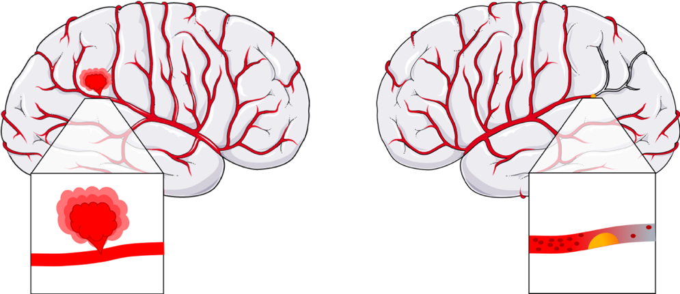
Haemorrhagic stroke Ischemic stroke

Figure 1: A schematic illustration of haemorrhagic and ischemic stroke
Haemorrhagic stroke is due to rupture of a weakened artery while ischemic stroke happens when a blood clot blocks the blood flow.

Diagnosis and treatment of stroke
The diagnosis of the correct type of stroke and specific treatment is important and can prevent disability and save lives. Patients with stroke due to carotid stenosis often require surgical treatment and the options in the acute phase after ischaemic stroke versus haemorrhagic strokes are very different from one another.
Ischaemic stroke is treated with thrombolysis, thrombectomy, endarterectomy or stenting (tube inserted into a vessel lumen). Thrombolysis is an emergency treatment to dissolve a blood-clot with an injection of clot-busting drugs into a vein, through a catheter (direct) or intravenous line depending on the circumstances. These thrombolytic agents can be alteplase, recombinant tissue plasminogen activator or anistreplase (Adams et al., 2003, Hacke et al., 2008). Thrombectomy is a method to physically break up and remove the clot by a catheter-based intervention from the large arteries. The catheter is supplied with an ultrasound device, rotating device, or a suction cup (Berkhemer et al., 2015). Carotid stenosis is treated with endarterectomy (CEA) under general or local anaesthetic. In the course of the surgery, an 8-10 cm long incision is made on the skin then, the artery is clamped to reduce blood flow. A small cut is made across the length of the narrowed part of the carotid artery and the atherosclerotic plaque is carefully removed as seen in Figure 2. (Wijeyaratne et al., 2002). Antiplatelets such as aspirin or clopidogrel are also prescribed to reduce the chance of another blood clot forming. In patients who have a presumed cardioembolic source for their stroke e.g., those with atrial fibrillation, anticoagulants such as warfarin or one of the novel anticoagulation drugs (e.g., rivaroxaban, apixaban) are more effective than antiplatelets at reducing recurrent stroke and are prescribed instead, although they are usually commenced 1-2 weeks after an ischaemic stroke to reduce the chance of bleeding into the ischaemic brain. Longer term secondary stroke prevention involves treatment of vascular risk factors such as hypertension and hypercholesterolaemia. Antihypertensives (calcium-channel blockers, beta-blockers) are used to lower high blood pressure while statins reduce low-density lipoprotein–cholesterol (LDL-C), improve endothelial function and lower the immune response (Kwak et al., 2003).
Haemorrhagic stroke is usually associated with an increase in blood pressure which can in turn accelerate growth of the haematoma. Therefore, the mainstay of emergency treatment is to bring the blood pressure down to <160 mmHg systolic within the first 6 hours. In patients who have a brain haemorrhage on warfarin, the warfarin action needs to be reversed with agents such as beriplex and vitamin K. Sometimes, surgeons can intervene, e.g., if the haematoma is peripheral and large and causes brain swelling. Surgery can be performed to remove blood from the brain and/or to repair the injured blood vessel. These patients also receive antihypertensives in the longer term as hypertension is a common underlying cause of haemorrhagic stroke (Adams et al., 2003).
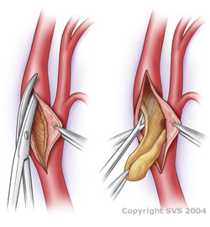

Figure 2: The technique of carotid endarterectomy
The surgeon makes a small incision along the artery and removes the plaque.
Image from: https://www.circulationfoundation.org.uk under a Creative Commons License

Stroke recurrence and risk of stroke after TIA
Having a stroke confers an increased risk to the individual of having a further stroke in the future. The risk of stroke from 30 days to 10 years after first stroke was analysed in a detailed systematic review. It was reported that the pooled risk was 3.1% at 30 days, 11.1% at 1 year, 26.4 % at 5 years and 39.2 % at 10 years after stroke (Mohan et al., 2011). However, recurrent stroke risk varies between subtyped strokes by aetiology. It was found that, stroke due to large artery atherosclerosis had the highest early risk of early recurrent ischaemic events (Lovett et al., 2004a). Most of these repeated events are due to recurrent emboli. However, in some cases, there is restenosis of a carotid artery after an apparently successful endarterectomy (Lovett et al., 2004a). In a large study (n= 829 patients undergoing carotid endarterectomy), 4% of patients were diagnosed with restenosis, after 1 year of CEA (Li et al., 2020b). Based on the analysis of carotid plaques from 21 studies, it was found that, an inflammatory, lipid rich plaque has a reduced risk of restenosis, while patients with calcified plaques have a higher risk for restenosis, after CEA (Zhou et al., 2020).
TIA is frequently followed by ischaemic stroke and about the 10-20% of patients had a stroke within 90 days. Prognostic scores are used to predict who is at higher risk for recurrent stroke. Both the California score (Johnston et al., 2000) and the ABCD score (Rothwell et al., 2005) can reliably predict short-term risk of stroke after TIA. These scores rely on points associated with clinical symptoms and risk factors such as age, sex, ethnicity, diabetes, coronary artery disease, arterial fibrillation, prior TIA or stroke and TIA symptoms (duration, weakness, numbness, vision, speech). The California score examined the prevalence of stroke within 90 days after TIA, while the ABCD score studied a 7-day risk of stroke. These 2 similar scores work reliably, without a significant difference, but a new system was needed for the immediate evaluation for stroke prevention in high-risk patients. The unified ABCD² score is an improved, more accurate system which can predict 2-day risk of stroke and serve as standard in clinic. Individual components are used in this simple system to score points for 5 factors: 60 years or older (1 point), blood pressure (systolic ﻿≥ 140 mmHg or diastolic ﻿≥ 90; 1 point), diabetes (1 point), duration of TIA ﻿(≥ 60 minutes, 2 points; or 10–59 minutes, 1 point), ﻿clinical features of TIA (unilateral weakness, 2 points; or speech impairment without weakness, 1 point). Patients with score of 6 had a chance of stroke within 2 days if not commenced on best medical treatment (Johnston et al., 2007).

COVID-19 and stroke
Several studies suggested that, confirmed Coronavirus Disease (COVID-19) can lead to acute stroke. In a study by Avula et al. (2020), four patients were reported with acute ischemic stroke (radiographic confirmation) and with COVID-19 (polymerase chain reaction (PCR) confirmed). It was also reported that 36.4% of COVID-19 positive patients (n= 214) had neurological symptoms and 5.7% of patients developed a cerebrovascular disease (Mao et al., 2020).
Patients with COVID-19 may be susceptible to cardiovascular disease (CVD) mediated by inflammation, platelet activation or endothelial dysfunction (Ntaios et al., 2020). Laboratory confirmed COVID-19 and ischaemic stroke patients (n=174) were pooled together to determine whether there was a difference in stroke severity and outcomes between patients with or without COVID-19. COVID-19 was confirmed with PCR in 96% of the cases, and by serology in the rest. As a control group, patients were matched from the Acute Stroke Registry and Analyses of Lausanne (ATLAS) based on stroke risk factors and comorbidities. Overall, it was found that COVID-19 associated ischemic strokes were more severe with a higher mortality rate and with worse functional outcomes than non-COVID-19 ischemic strokes. The potential reasons for this could be a strengthened prothrombotic environment via infection induced cardiac arrhythmias or immune mediated platelet activation (Ntaios et al., 2020).
Ischemic stroke can also occur with a higher chance at younger age within COVID-19 positive patients (Oxley et al., 2020). In another study, five patients, all younger than 50 years old, tested positive for COVID-19 and presented with ischemic stroke symptoms. As a comparison, before COVID-19 only 0.73 patients, younger then 50 years old were hospitalized with stroke. The average National Institutes of Health Stroke Scale (NIHSS) score of these 5 patients was 17 which means they had a severe large-vessel stroke. Interestingly, large-vessel stroke was also reported during the 2004 severe acute respiratory syndrome coronavirus (SARS-CoV-1) outbreak. There could be an association between ischemic stroke and COVID-19, but this requires further investigation (Oxley et al., 2020).
With regards to mechanisms, stroke in COVID-19 positive patients may occur due to the usual causes (atherosclerosis, atrial fibrillation, hypertension) but there could include additional mechanisms directly related to COVID-19, such as a hypercoagulable state, vasculitis and cardiomyopathy. One of the newly identified main mechanisms responsible for ischemic stroke in COVID-19 is a hypercoagulable state (increased tendency towards blood clotting) (Spence et al., 2020). About 20-55% of hospitalized patients with COVID-19 have a coagulopathy which correlates with the severity of the disease. This is due to an increased level of D-dimer (D-dimer is a fibrin degradation product in blood and risk factor for CVD (Folsom et al., 2016)), thrombocytopenia, prolonged prothrombin time and decreased fibrinogen level (Lee et al., 2020). Several studies have confirmed an increase in the level of D-dimers in hospitalized COVID-19 patients (Jecko Thachil, 2020, Tang et al., 2020, Huang et al., 2020, Guan et al., 2020). Yaghi et al. (2020) described outcomes in a study examining 3556 hospitalized patients with diagnosis of COVID-19, observing that in COVID-19 patients with ischemic stroke (n= 32; imaging proven), D-dimer levels were high and there was significantly higher mortality in these than control group (patients without COVID-19). The second mechanism which may play an additional role in the pathogenesis of ischemic stroke in COVID-19 patients is vasculitis (inflammation of the blood vessels) (Spence et al., 2020). Severe acute respiratory syndrome coronavirus 2 (SARS-CoV-2) has a high affinity to angiotensin-converting enzyme 2 (ACE2) receptors which are found in the lungs, heart, kidney and in the vascular endothelium. In the vessel wall, infection (viral inclusions via ACE2 receptor) can cause immune cell recruitment and inflammatory response which can lead to thrombotic complications (Spence et al., 2020). In a recent pathological study, these viral inclusions were documented in endothelial cells, hearts and lungs with associated endothelial dysfunction (Varga et al., 2020). Viral inclusions are specific intracellular compartments which provide a platform for viral replication and assembly to increase efficiency of virus production (Netherton et al., 2007). The other identified possible cause for ischemic stroke in hospitalized patients with diagnosis of COVID-19 is cardiomyopathy. Cardiomyopathy can be caused by different mechanisms in COVID-19 diagnosed patients, such as myocarditis which can lead to the death of cardiomyocytes. Hypoxemia and respiratory failure can cause increased cardiac stress, promoting cardiomyopathy. Cardiac arrythmias and cardiomyopathy can also happen due to the stimulation of the sympathetic nervous system (Spence et al., 2020).

Atherosclerosis

Historical background of atherosclerosis and histology
Atherosclerosis is the main biological process leading to ischaemic stroke. This pathological disorder occurs in arteries and it is not only typical of modern people (Figure 3).
One of the first known atherosclerotic patients was King Menephtah, who showed the same signs as the present-day men (Insull, 2009). He lived more than 3200 years ago and was found in the tomb of Amuenhotep at Biban-el-Muluk, Thebes, in Egypt by M. Loret in 1898 (Shattok, 1909). Sir Marc Ruffer in the early 1900s described that this mummy had severe atheromatous disease and degenerative arterial changes which indicated atherosclerosis (Brown et al., 2017).
More recently, the “hardening of the arteries” was first reported in the 16th century (Long, 1933) moreover, William Heberden, Edward Jenner and Caleb Hillier Parry in the late 1700s found that this process included calcification of the coronary arteries (Warren, 1812). As well, Jean Lobstein in 1829 was the first who introduced the term “arteriosclerosis”, which is the hardening and thickening of the arterial wall (Galkina and Ley, 2009). In the 19th century, it was described that inflammatory cells have a role in atherosclerosis, Rudolf Virchow considered that inflammatory changes have a primary role, while Carl von Rokitansky suggested that these changes are secondary after the initial injury of the vessel wall (Mayerl, 2006) (Galkina and Ley, 2009). Recently, CD3+ cell accumulation was proved in early lesions on human samples from Rokitansky’s collection which supports Virchow’s view on the importance of inflammation (Mayerl, 2006). Moreover, Virchow named 3 components that together lead to pulmonary embolism. Today, these concepts are known as Virchow’s Triad which together can cause thrombogenesis (thrombus formation): vessel wall injury (endothelial dysfunction), hypercoagulability and altered blood flow (Lip and Blann, 2000). Ludvig Hektoen in 1879 discovered that myocardial infarction is caused by coronary thrombosis. Based on the important discoveries made by Virchow and Hektoen, today we know that coronary plaque disruption and thrombus formation are leading to myocardial ischemia and can cause myocardial infarction (Hajar, 2016).
Thompson et al. (2013) examined 137 mummies (1600 BCE-1900CE) from Egypt, Peru, southwest America (Ancestral Puebloans), and the Aleutian Islands (Unangan) with CT scans. Definite atherosclerosis was reported in 47 mummies (34%) from all cultures so atherosclerosis was a common disease in ancient populations (Thompson et al., 2013). These individuals did not have a marine-based diet which was thought to be protective (described in detail below).
Fornaciari et al. (2013) questioned these details because these rates are too high and opposite to the behaviours in these cultures (hunter-gatherer diet, no cigarette smoking). On the other hand, chronic infection or inflammation is not investigated and ancient people were subject to environmental smoke, by using indoor fires, which is a risk factor for atherosclerosis (Wann et al., 2019). Both genetic and environmental risk factors could take part in the development of atherosclerosis which need to be investigated (Thompson et al., 2014). It was further suggested that vascular calcification can be related to disorders of calcium and phosphorus metabolism, diabetes or chronic microinflammation not just atherosclerosis.
Atherosclerosis was also characterized in remains from a Chinese burial (700 BCE) and in Canadian circumpolar people (1500-400 BCE) (indigenous circumpolar people are formerly known as Eskimos) (Heagerty, 2013). In 1970, hunters and/or fishermen Greenlandic Inuit (n=130) were examined, whose food (mostly meat of whales, fish, seals and seabirds) is extremely rich in protein and fat moreover poor in carbohydrates. This diet is rich in omega-3 fatty acids which can reduce platelet aggregation, coagulation and thrombosis (DiNicolantonio and OKeefe, 2019). It was found that they had lower levels of total lipid, cholesterol, triglycerides and pre-B-lipoprotein than healthy Danish controls. It may explain the low number of ischaemic heart diseases and the absence of diabetes mellitus (Bang et al., 1971). Clinical studies showed that marine omega 3 fatty acids can reduce platelet aggregation, coagulation and thrombosis (DiNicolantonio and OKeefe, 2019).
It was also described that Alaskan Inuits (before 1950s) develop much milder atherosclerosis, compared to the westernised population, and it did not account for major causes of death (DiNicolantonio and O'Keefe, 2017, Feldman et al., 1972). Interestingly, the disease rate of the Alaskan natives changed to a similar rate to US whites in the second half of the 20th century due to the increased intake of sugars and refined carbohydrates (DiNicolantonio and O'Keefe, 2017, Feldman et al., 1972), which proves the fact that unhealthy diet is a risk factor for the development of atherosclerosis.
Therefore, atherosclerosis has been around for a considerable period of time and scientists have studied the pathology and mechanisms in order to develop new treatments. Some of the most successful treatments are the use of statins (see section: 1.6.8) to lower the cholesterol level in arteries and decrease vascular inflammation (Kwak et al., 2003, Amarenco et al., 2004).
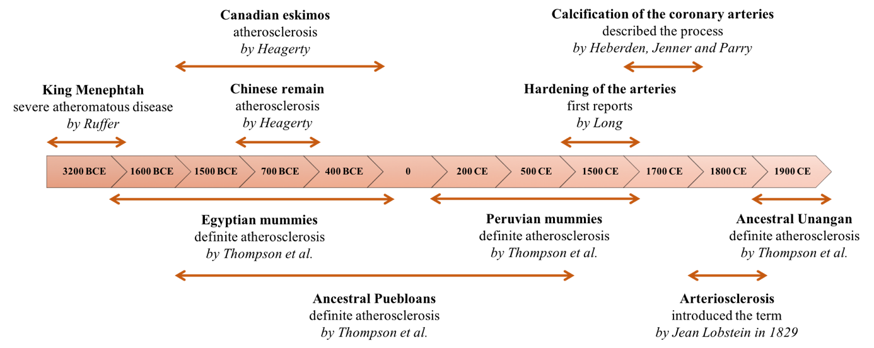

Figure 3: Historical records of atherosclerosis in humans
Atherosclerosis is not only typical of modern people. The oldest remain with atherosclerosis lived around 3200 BCE.

Furthermore, histological stains are important to study cell types and structures therefore atherosclerosis at the microscopic level. Aniline is an aromatic amine consist of a benzene ring along with an amino group and aniline dye was first used in the 19th century to stain tissue sections (Titford, 1993). Aniline blue is an acidic synthetic dye that stain acidophilic cell structures e.g., cytoplasm to a blue colour. Other synthetic dyes were discovered later, like azo dyes which have red or yellow colour (Titford, 1993).
The development of microscopes is another essential part of all biological studies and it cannot be attributed to any one person (Amos, 2000). In the 11th century, convex lenses were used to magnify manuscripts and Hans Janssen built the first compound microscope in the 16th century which could be adjusted between 3 and 9x magnification (Araki, 2017). Interestingly, Galileo Galilei converted one of his telescopes to make a microscope in 1609. The first published work on microscopy was written by Robert Hooke in 1667, whose drawings contained observations at 50x magnifications, while Leeuwenhoek was the first who observed living bacteria cells in the early 18th century (Araki, 2017). Principals of fluorescent microscopy and technology were established in the first half of the 20th century. The first phase contract microscope was constructed by Fritz Zernike in 1941 and the first confocal microscope by Marvin Minsky in 1957 (Araki, 2017).

Pathogenesis of atherosclerosis
Atherosclerosis is a systemic inflammatory disease, where a lipid plaque is formed within an artery (Ross, 1999). In the course of atherosclerosis, major arteries narrow, and an atherosclerotic plaque develops. Atherosclerotic plaques occur in large and medium arteries at the site of arterial bifurcation, where oscillatory or low shear stress pattern form (Mahmoud et al., 2017). Plaques are made up of cholesterol- rich lipids, macrophages, foam cells, T-cells, dendritic cells, smooth muscle cells, collagen, elastin and cholesterol crystals (Figure 4) (Brown et al., 2017). Generally, the plaque starts to develop in teenage years in the carotid, coronary, cerebral, iliac or femoral arteries (Brown et al., 2017).

Endothelial dysfunction and injury
Several studies have suggested that the formation of atherosclerotic plaque starts with damage to the inner layer of an artery and a qualitative change of the endothelium, because of the previously mentioned risk factors (see section: 1.1.3). Plaque development is caused by endothelial cell dysfunction, an increased number of surface adhesion molecules (e.g.: VCAM, ICAM; see section: 1.3.3) and altered vascular permeability (Pello et al., 2011, Jashari et al., 2013). Steinberg and Witzum (2010) described that oxidized low-density lipoprotein (oxLDL) in the arterial wall stimulates atherogenesis. In addition, there is a chemokine gradient which attracts circulatory monocytes into the vessel wall (Moore et al., 2013). Once inside the media, monocytes differentiate into macrophages stimulated by colony-stimulating factor 1 (see section: 1.3.4). An inflammatory environment is formed by the released proinflammatory cytokines (monocyte chemoattractant protein-1 (MCP-1), IL-6, IL-1β) from macrophages (Singh et al., 2002).

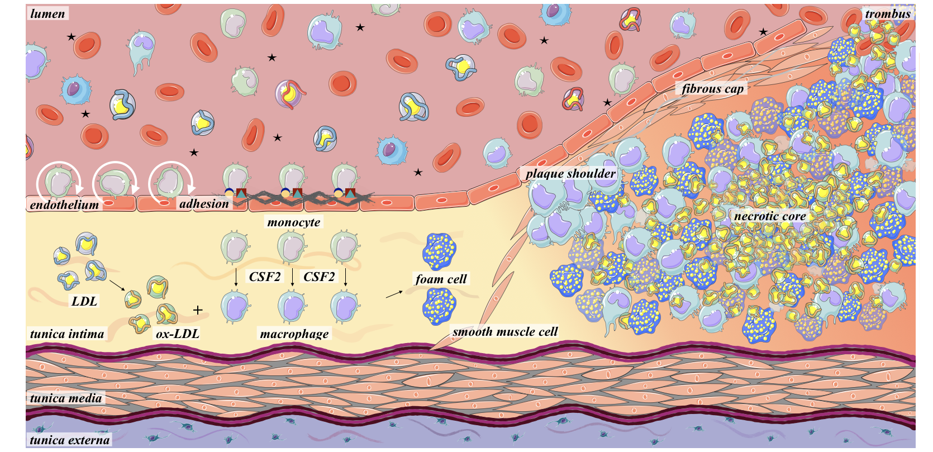
Figure 4: The pathogenesis of atherosclerosis
The main steps of atherosclerosis are the adhesion of monocytes to the injured endothelial monolayer, their migration into the intima, differentiation into macrophages, ox-LDL uptake and foam cell formation. During lesion progression SMCs migrate from the media to the intima, synthesize extracellular matrix and form a fibrous cap. In advanced lesions macrophages and SMCs die through apoptosis and together with LDL it is called necrotic core. These plaques also contain micro vessels, calcium and cholesterol crystals. If the fibrous cap erodes, it causes a rupture. If the lipid core gets into the circulation, it induces platelet accumulation and activation which leads to fibrin enrichment, thrombus formation and may cause thrombosis.

Foam cell formation
In early atherosclerosis, foam cell formation is deemed to be protective, because of the uptake of cytotoxic LDL, but later, as a result of continuous monocyte migration, macrophage differentiation and foam cell production become unwanted as atherosclerotic lesion increases (Brown et al., 2017, Bobryshev, 2006). Foam cell formation in the tunica intima is mediated by scavenger receptors (see section: 1.6.6) which mediate cholesterol uptake from oxidized LDL. These lipids are digested in lysosomes, resulting free fatty acids and free cholesterol. The free cholesterol then re-esterified and becoming cholesterol fatty acid esters and stored in lipid droplets in the cytosol. These lipid droplets are the “foamy” part of the foam cells (Figure 9) (Remmerie, 2018).
Liver X receptor (LXR) is an important factor during lipid metabolism (activate genes involved in cholesterol efflux), therefore in foam cell formation. LXR genes were activated after the accumulation of desmosterol which is an intermediate in the cholesterol biosynthetic pathway (Spann et al., 2012). It was also proved that LXR support cholesterol outflow and decreases the expression of proinflammatory factors in macrophages (Bobryshev et al., 2016).
Several studies have found that, the major pathway for oxidized LDL uptake and atherogenesis promotion is induced by class A scavenger receptor I/II (SR-A) expression and SR-B CD36 in mouse models (Babaev et al., 2000, Febbraio et al., 2000). In contrast, Moore et al. (2005) showed that there is a possible alternative lipid uptake mechanism, because lipid uptake occurs in the macrophages of Apoe–/– mice lacking SR-A or CD36. In the last 15 years, the peroxisome proliferator-activated receptor (PPAR) family of nuclear receptors have been prominent and PPARγ deficiency increases atherosclerosis (Babaev et al., 2005). Additionally, PPARγ inhibits the dendritic cell migration (Angeli et al., 2003) and suppresses immune responses (Nencioni et al., 2003).

Necrotic core formation
Foam cell aggregation leads to the formation of an atheromatous core and in the centre of it, apoptotic foam cells accumulate. It is widely reported that oxidized- LDL can cause DNA damage and cell death by apoptosis, induced by the expression of p53 or Fas/Fas ligand (Hegyi et al., 2001, Takahashi, 2002, Akishima et al., 2005). The apoptosis of macrophages was examined with the detection of apoptotic cells after immunostaining with antibodies against terminal deoxynucleotidyl transferase (TdT)-mediated dUTP-biotin nick end labelling (TUNEL), single-stranded DNA (clone F7-26), and active caspase-3 (Akishima et al., 2005).
This is controversial since according to Bobryshev et al. (1997) foam cells die through necrosis, not apoptosis (13 atherosclerotic lesions were examined for typical expression of apoptotic death with an electron microscope). However, a recent study has found that necroptosis, a non-apoptotic programmed cell-death can cause necrosis-like morphologic changes and triggers inflammation (Ruan et al., 2019). A new type of cell death, ferroptosis was discovered recently which is an iron-dependent form of necrosis (Li et al., 2020a). It is characterised by oxidative damage to phospholipids and promotes advanced atherosclerosis formation by accelerating endothelial cell dysfunction (Ouyang et al., 2021).
These various types of cell death led to dead cell accumulation, plaque growth and necrotic core formation. During this process, a so-called plaque shoulder starts to shape. The plaque shoulder is defined as the region where the fibrous cap meets the normal adventitia wall (Bobryshev, 2006).

Smooth muscle cell proliferation and migration
As a result of foam cell formation, cytokines and growth factors are produced by macrophages, which cause vascular smooth muscle cell (VSMC) and macrophage recruitment. The intimal smooth muscle cells (SMCs) start to proliferate, moreover SMCs from the media proliferate and migrate to the intima as a response to platelet-derived growth factor (PDGF) secreted by endothelial cells and release of factors such as IL-1 and tumour necrosis factor alpha (TNFα). SMC proliferation is also promoted by lipoprotein lipase and matrix metalloproteinases (MMP), both produced by activated endothelial cells, macrophages and smooth muscle cells (Singh et al., 2002).

Fibrous cap formation
Due to lesion progression, synthesis of extracellular matrix molecules (proteoglycan, collagen, elastin) is increased (Brown et al., 2017) which helps to create a stable atherosclerotic plaque (Singh et al., 2002). These processes form a firm fibrous cap (Figure 4) (Bobryshev, 2006). Collagen production and the inhibition of SMC proliferation is due to transforming growth factor beta (TGF-β) (Weissberg, 2000). The developing plaque also contains apoptotic macrophages, T cells, cholesterol crystals and new blood vessels (Weissberg, 2000).

Atherosclerotic plaque characteristics and instability
The most widely used predictor for ischaemic stroke is the severity of stenosis in carotid arteries. However, several studies have found that plaque components such as the extent of disease, plaque instability, large lipid core and thin, ruptured cap are useful predictors for future stroke determination in asymptomatic populations (Rothwell, 2000). Nowadays MRI, ﻿ computed tomography and ultrasound are the best techniques to delineate plaque components and therefore stratify the risk of subsequent stroke in patients with carotid stenosis (Hennerici and Meairs, 2000). Using these, it would be clinically useful to identify unstable atherosclerotic plaques and this research is underway. such non-invasive techniques, if validated in longitudinal studies could be used in clinical practice to select patients for carotid endarterectomy and/or aggressive medical interventions e.g., high dose statins.
In a large histological study (Lovett et al., 2004c) of recently symptomatic carotid plaques, the majority of vulnerable plaque features (e.g., rupture and haemorrhage), if present anywhere within the plaque, were found within 3 mm of the bifurcation. According to these findings, the best way for detection of most of the histological features (lipid core, calcification, haemorrhage, rupture, surface thrombus) is to divide the plaque for four (or more) 3mm thick sections centred from the bifurcation (Figure 11) (Lovett et al., 2004c).
Histological features and overall stability of carotid plaques can be defined by a semiquantitative grading scale (e.g., lipid core, haemorrhage, calcification, inflammatory cells (IX.9) (Lovett et al., 2004b). Plaque stability depends on the extent of inflammation, composition and fibrous cap thickness (Figure 5) (Wang and Bennett, 2012). A stable plaque has a thick fibrous cap which provides structural stability and prevents contact between thrombogenic necrotic core and blood (Singh et al., 2002). VSMCs can create the fibrous cap, through secreting ECM proteins, therefore they have historically been considered responsible for one of the key roles to preserve the plaque stability and prevent rupture (Clarke and Bennett, 2006) (Harman and Jørgensen, 2019, Bentzon et al., 2014). Interestingly, in the past few years, it was discovered that VSMCs could both promote plaque stability and rupture because of their wide-ranging plasticity. VSMCs can alter their phenotype to a more active (synthetic) state which is characterised by the upregulation of pro-inflammatory cytokines and MMPs, resulting to cell migration and cell proliferation (Alexander and Owens, 2012). Increased MMP activity (MMP3, MMP9, MMP12) were detected in plaque shoulder and foam cell rich regions, which is responsible for degrading ECM components and weakening fibrous cap (Müller et al., 2014, Johnson, 2017). Furthermore, plaque VSMCs can amend their gene expression to mimic other cell types, like macrophages (CD68, MAC2, MAC3 expression) (Dobnikar et al., 2018). Like macrophages, these cells also take up oxLDL, form foam cells and tribute to necrotic core formation (Feil et al., 2014).
In contrast, unstable plaques have a thin fibrous cap, more inflammatory cells and big lipid pool, therefore these plaques are more susceptible to erosion than stable ones (Weissberg, 2000). It was also found that VSMC apoptosis is increased in unstable plaques compared to stable plaques (Bauriedel et al., 1999).
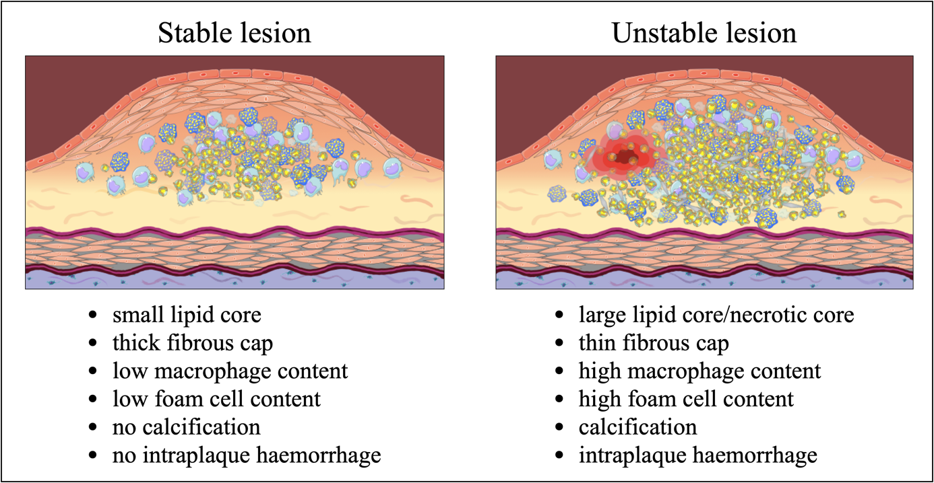
Figure 5: Differences between the histologically classified stable and unstable atherosclerotic plaques
Stable lesions have smaller lipid core and thick fibrous cap, while the unstable lesion has a necrotic core, thin fibrous cap, high cellular content, calcification and intraplaque haemorrhage.

Vulnerable plaque and vulnerable patient
The term “vulnerable plaque” became widespread in the 2000s, and has now largely replaced the term "unstable plaque" but Naghavi et al. (2003) initiated a new definition. Briefly, this says that thrombosis-prone plaques are susceptible to rapid progression and complications. There are several criteria to define a vulnerable plaque such as active inflammation, platelet aggregation, intraplaque haemorrhage, thin fibrous cap, large lipid core, fissure, endothelial dysfunction and yellow colour on angioscopy. The more factors from these are observable, the greater the risk of complication. In addition, the concept of a “vulnerable patient” is introduced where the person may have vulnerable plaques together with vulnerable blood and myocardium. Such patients are more susceptible to cardiac death or acute coronary syndrome (Naghavi et al., 2003).
Most of the vulnerable plaques are similar to type IV atherosclerotic lesions in the AHA pathological classification. (see section: 1.2.11) (Stary et al., 1995).

Atherosclerotic plaque erosion and rupture
Atherosclerotic plaques can lead to thrombus formation by the mechanisms of rupture or erosion. Circumferential stress, inflammatory cells and the previously mentioned MMP activation can destroy the fibrous cap and cause plaque rupture (Singh et al., 2002). Ruptured plaques usually have a thin fibrous cap containing a low number of VSMCs and their apoptosis can be induced by macrophages, through cell-cell contact (Boyle et al., 2001). An eroded plaque can lead to a fissure, and if blood enters the fissure, it may form a clot. If the lipid core contacts the circulating blood, platelets will accumulate and will get activated which leads to fibrin enrichment and thrombus formation (Weissberg, 2000). The resulting complex clot can cause significant damage to organs, such as heart attack or stroke in the brain (Libby et al., 2011).

Histological classification of atherosclerosis by the American Heart Association
Characterization and classification of human intimal thickening, atherosclerotic lesion development and histological components is made by ﻿the Committee on Vascular Lesions of the Council on Arteriosclerosis, American Heart Association (AHA). In this classification, lesions are labelled by Roman numbers which indicate plaque progression (summarised in Table 1) (Stary, 1994, Stary et al., 1995).
Type I, II and III are early lesion types, which are relatively small, clinically silent, contain cholesterol esters and grow by lipid accumulation. These lesion types can be the silent precursor of possible future diseases, such as stroke. Type I and type II lesions are the only lesions which are present in children. Within type I plaques, the number of the intimal macrophages are increased, and foam cells started to form, which are microscopically detectable. Type II lesions are the first visible ones to the unaided eye, which include a fatty streak. These are defined by layers of macrophages, foam cells and lipid-laden SMCs. Lipids are cholesterol esters, cholesterol and phospholipids and the droplets are mostly in cells and not extracellular. Mast cells and T lymphocytes are also found in these lesions, but fewer than macrophages. Type III lesions contain pools of extracellular lipid droplets which are free, or membrane bound. These lipid pools are under the macrophage and foam cell layers. Extracellular lipid droplets disrupt the coherence of intimal SMC layers.
Advanced lesions are type IV, V, VI and are associated with accumulation of cells, lipids, minerals, thickening of the intima and deformity of the arterial wall. These lesions can be clinically significant and symptom-producing. Type IV lesions are known as atheroma and characterized by accumulation of extracellular lipids which is called a lipid core. Lipid core formation can induce fibrous tissue development and the disorganization and thickening of the proteoglycan-rich layer of the intima. Vascular SMCs are also present but may be calcified and calcium crystals are also identified inside the lipid core. Mast cells and lymphocytes are often found in this region. In type V lesions a new fibrous connective tissue formed. This new tissue is increased in collagen, rough-surfaced endoplasmic reticulum and SMCs. Capillaries and microhaemorrhages may be present and lymphocytes, macrophages and other plasma cells are associated with them. Type Va lesions are often referred to as multi-layered fibroatheroma, in which more lipid cores are separated by fibrous connective tissue and layered irregularly on each other. Mechanical forces initiate the formation of these lesions and can cause asymmetric vascular narrowing and changes in the lumen. Type Vb lesions are calcified and have an increased amount of fibrous connective tissue. Calcium can replace extracellular lipid even the entire lipid core and dead cells. Type Vc lesions are characterized by thickened fibrous tissue and minimal or absent lipid. Extension of the fibrous tissue, formation of a thrombus or lipid core regression can form these types of lesions. Type VI plaques are often referred to as complicated lesions because more of the type IV and V lesion features are present. Type VIa described as rupture, type VIb characterized by haemorrhage and type VIc identified as thrombosis. These complicated lesions may occur because of differences in blood composition and individual risk factors (Stary, 1994, Stary et al., 1995).

Table 1: Types of atherosclerotic lesions and classification
Shaded areas represent collected and analysed carotid plaques studied in this thesis. Adapted from: (Stary et al., 1995, Virmani et al., 2002a);

 | Lesion Type |  | Characteristics | Growth mechanism
Early Plaque | Type I | lipid droplets | atherogenic lipoprotein; increase in macrophage number; foam cell formation | growth by lipid accumulation
 | Type II | fatty streak | visible, primer layer of foam cells and lipid laden SMCs
 | Type III | extracellular lipid | extracellular lipid droplets; small lipid pools
Intermediate plaque | Type IV | lipid core atheroma | accumulation of extracellular lipid
Late lesion | Type Va | multilayer fibrous atheroma with core | new fibrous tissue | SMC and collagen increase
 | Type Vb | calcification | calcification
 | Type Vc | fibrotic without lipid core | fibrotic lesion with minimal lipid
Complicated features | Type VIa | rupture | surface disruption | thrombosis, hematoma
 | Type VIb | haemorrhage | intraplaque haemorrhage
 | Type VIc | thrombosis | thrombosis

Inflammatory cells in atherosclerotic lesions

Although it is not completely understood, inflammation is increasingly being shown to be a critical driver of plaque status. In this section, I focus on inflammatory cells and describe in detail the latest information on monocytes and macrophage subtypes which contribute to inflammation inside plaques.

Inflammatory cells
Inflammatory cells (granulocytes, monocytes, lymphocytes, macrophages) are the main components of the atherosclerotic plaque, reported first in pigs in 1979 (Gerrity et al., 1979). Where the aortic intima has an increased permeability, monocytes adhere to the endothelium and foam cell lesions develop. Monocytes, macrophages and dendritic cells are categorized as part of the mononuclear phagocyte system, and these derive from the same monocyte macrophage dendritic cell progenitor called the common myeloid progenitor (CMP) (van Furth and Cohn, 1968, Geissmann et al., 2010). Lymphocytes, granulocytes and monocytes take part in all stages of plaque formation, presenting a link between atherosclerosis and inflammation (Geovanini and Libby, 2018).

Monocytes
Human monocytes comprise approximately 10% of total leukocytes (total human leukocytes number: 4.00-11.0 x 10⁹/L), and are produced in the bone marrow from hematopoietic stem cells (HSC), stimulated by colony-stimulating factor-2 (CSF2, also known as GM-CSF), (Burgess and Metcalf, 1980) and are released into the bloodstream. The surface of these cells is irregular, they have a kidney-shaped nucleus and cytoplasmic vesicles, they are phagocytes and respond to pathogens (Italiani and Boraschi, 2014).
The International Union of Immunological Societies (IUIS) together with the WHO presented a new nomenclature of monocytes in human blood and there are three major types in human: the classical (CD14++ CD16-), the intermediate (CD14++ CD16+), and the non-classical (CD14+ CD16++). Non-classical monocytes are pro-inflammatory, while the classical and intermediate cells are the inflammatory monocytes (Ziegler-Heitbrock, 2007).

Monocyte accumulation in atherosclerotic plaque
In the early stages of atherosclerosis, monocytes are attached to the endothelium due to an arterial injury or shear stress. They migrate into the vessel wall, regulated by cellular adhesion molecules, such as selectins and integrins. L-selectin (expressed in leukocytes), P-selectin (expressed in megakaryocytes, endothelial cells) and E-selectin (expressed in activated endothelium) mediate the linking, but integrins are also necessary for the firm adhesion. Specifically, β1 and β2 integrins are expressed by monocytes, activated by chemokines and bind to intracellular adhesion molecule-1 (ICAM-1) and vascular cell adhesion molecule-1 (VCAM-1) (Quehenberger, 2005, Galkina and Ley, 2009).
There is also an integrin-independent pathway for monocyte binding described by Bazan et al. (1997) involving a chemokine fractalkine (C-X3-C Motif Chemokine Ligand 1- CX3CL1). CX3CL1 is expressed on the endothelium and is able to make a strong interaction with the CX3CR1 (receptor), which is expressed on leukocytes.
Another key recruitment molecule is monocyte chemoattractant protein-1 (MCP-1) expressed by macrophages, SMCs, endothelial cells and stimulated by LDL trapped in extracellular matrix (Bazan et al., 1997). Several studies have suggested that this protein is a proinflammatory mediator that plays an important role in monocyte recruitment (Nelken et al., 1991, Ylä-Herttuala et al., 1991).

Monocyte differentiation into macrophages
Monocytes can migrate into a tissue, infected area, or a damaged site, where they differentiate into macrophages (Figure 6) (Monie, 2017). Under homeostatic conditions, macrophage colony-stimulating factor 1 (CSF1, also known as M-CSF) produced by stromal cells (Italiani and Boraschi, 2014), mostly influences the monocyte/macrophage development, whilst during inflammation, colony stimulating factor 2 (CSF2) is responsible for proliferation (Gasson, 1991). During the differentiation process, CD68 expression increases, which is a transmembrane glycoprotein located in lysosomes (Bobryshev, 2006). Monocyte proliferation is regulated by a feedback loop, in which macrophage development is decreased, since macrophages express CSF1 receptors (CSF1-R) and remove circulating CSF1. Monocytes can also differentiate into dendritic cells which found both in normal and atherosclerotic arterial walls (Italiani and Boraschi, 2014).

Polarization and role of macrophages
Macrophages are present in all tissues taking part in the immune response, maintaining tissue homeostasis and monitoring any changes. Several studies have suggested that in atheromatous plaques there are macrophages which participate in all stages of plaque formation and progression (Daugherty et al., 2005, Chinetti-Gbaguidi et al., 2014).
The transcriptional programme and phenotype of monocytes are influenced by stimuli such as cytokines, lipids and senescent erythrocytes (Daugherty et al., 2005, Chinetti-Gbaguidi et al., 2014). Macrophages express pattern- recognition receptors (PRR), for instance Toll-like receptors, that connect the immune response during atherosclerosis. These white blood cells can phagocytose microbes and modified LDL by using PRRs (Galkina and Ley, 2009).
The macrophage cell population is very heterogeneous and there is increasing evidence that macrophages can switch phenotype between pro-inflammatory M1 and anti-inflammatory M2 subsets in the developing atherosclerotic plaque (Chinetti-Gbaguidi et al., 2014).

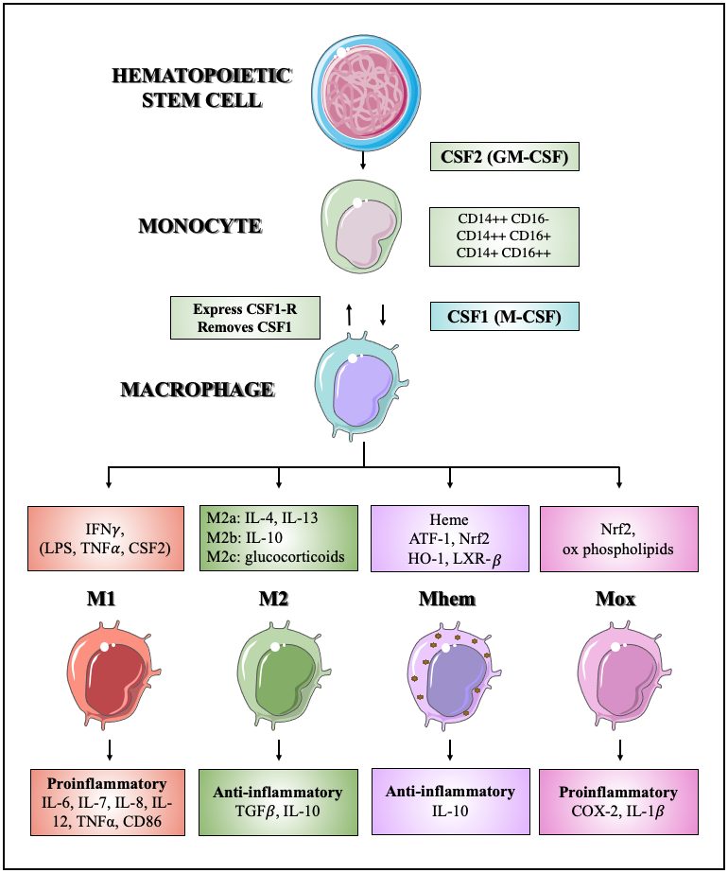
Figure 6: The differentiation and polarization of macrophages
Hematopoietic stem cells are stimulated by CSF2 and become monocytes. Monocyte differentiation into macrophages is induced by CSF. M1 macrophages are polarized by IFN-γ and partly with LPS, TNFα, or CSF2; they produce proinflammatory cytokines. M2 anti-inflammatory macrophages are alternatively activated without Th1 cytokines. M2a is activated by IL-4 and IL-13; M2b is stimulated by IL-10 and M2c is triggered by glucocorticoids or secosteroid hormones. Mhem is activated by heme induced HO-1 expression via Nrf2 and ATF-1. Both M2 and Mhem produce IL-10. Mox proinflammatory macrophages are activated by fatty acids and oxidized phospholipids.

M1 macrophages
Macrophages have to perform different functions and so they are altered into a specific state (called polarisation) by signals from their environment (Moore et al., 2013). The polarization towards M1 and M2 macrophages states depends on two groups of T-lymphocyte-derived cytokines (Figure 6). The M1 macrophage phenotype is classically activated by interferon gamma (IFN-γ) and partly with lipopolysaccharide (LPS), TNFα, or CSF2 (Moore et al., 2013). Macrophage activation was first described by Mackaness in the 1960s (Mackaness, 1962).
M1 macrophages are proinflammatory and take part in atherogenesis and enhance plaque instability as they secrete proinflammatory cytokines such as IL-1β, IL-7, IL-8, IL-12 and IL-6 which, increases the chance of myocardial infarction (Kirbiš et al., 2010, Chinetti-Gbaguidi, 2014). These macrophages also produce chemokines, TNFα, reactive oxygen species (ROS), nitric oxide (NO) and bioactive lipids (Wilson, 2010). Moreover, they can activate smooth muscle cell proliferation (Khallou-Laschet et al., 2010) and express vasoactive molecules (nitric oxide) (Aliev et al., 2001).
M1 macrophages express CD80 and CD86 proteins, which are also upregulated on dendritic cells and B cells (Moore et al., 2013, Ewing et al., 2013). CD28 (expressed on resting T-cells) and Cytotoxic T-Lymphocyte Antigen 4 (CTLA-4) (expressed on activated T-cells), with higher affinity bind CD80 and CD86 (Maszyna et al., 2003). The upregulated CTLA-4 compared to CD28, inhibit T cell proliferation leading to decreased IL-2 production (Krummel and Allison, 1995). IL-2 reduction has an atherogenic effect, and it was found that local delivery of IL-2 can significantly reduce the size of an atherosclerotic plaque in Western diet-fed apoE−/− mice (Dietrich et al., 2012).
M1 macrophages express CD68 (a pan macrophage marker) (see section: 1.3.12) and major histocompatibility complex-II (MHC-II) molecules (Moore, 2013). MHC-II molecules are crucial for cell-mediated immunity because they present protein fragments (ingested by macrophages, dendritic cells, B cells) to CD4+ T cells (Rock et al., 2016). MHC-II molecules on dendritic cells present antigen to naive CD4+ T cells to activate them and later MHC-II molecules take part in the interaction of these effector T cells with macrophages and B cells (Unanue et al., 2016).

M2 macrophages
M2 macrophages are alternatively activated without T helper 1 (Th1) cytokines. The M2a class is activated by IL-4 and IL-13 and M2b is stimulated by IL-10 and M2c is triggered by glucocorticoids or secosteroid (vitamin D3) hormones (Gordon and Martinez, 2010, Pello et al., 2011).
M2 macrophages are regulatory and wound-healing macrophages, which carry out tissue reparation and collagen synthesis (Shaikh et al., 2012). They have high endocytic activity, oxidize fatty acids and express the mannose receptor C-type 1 (MRC1, also known as CD206) (Moore et al., 2013). According to Oscar M. Pello (2011), their role in atherosclerosis is uncertain, and they have pro- and anti-atherogenesis roles. They produce anti-inflammatory cytokines and have a potential role in the maintenance of plaque stability, due to their immunoregulatory functions (Wilson, 2010). The released transforming growth factor beta (TGF-β) from these cells enhances inflammatory cell accumulation, (Mallat et al., 2001) while the IL-10 is an immunosuppressive cytokine, which inhibits IFN-γ expression (Mosser and Edwards, 2008). It was found that the IL-4 activated M2 phenotype has pro-atherogenic roles. Atherosclerotic lesions have increased IL-4, which is associated with atherosclerotic progression (Baetta and Corsini, 2010). Furthermore, IL-4 induces the 15-lipooxygenase secretion, which has a role in foam cell formation (Huo et al., 2004).
In humans, M2 macrophage markers are MRC1, Dectin-1 and CD163. MRC1 is a type-1 membrane receptor protein, which mediates glycoprotein endocytosis and is found on the cell surface (de Gaetano et al., 2016). CD163 is a haemoglobin- haptoglobin scavenger receptor but its expression is not restricted to M2 phenotype. Dectin-1 is lectin-like immune receptor which binds β-glucan and is expressed on leukocytes. The M2b macrophage subset has a low level of dectin-1 expression, while M2a has a high expression level (Rőszer, 2015).

M4 macrophages
M4 macrophage differentiation is induced by the chemokine like platelet factor 4 (CXCL4). In M4, the expression of MMP7 and MMP12 is significantly higher while the expression of MMP8 is lower in M-CSF-induced macrophages. MMPs may degrade the extracellular matrix, these molecules can promote plaque destabilization, so they may have an atheroprotective function (Gleissner et al., 2012).
The transcriptome of M4 macrophages is closer to M2 than M1, but it is not clearly pro- or anti-atherogenic. CD163 protein coding gene is downregulated by CXCL4, therefore the haemoglobin-haptoglobin scavenger receptor is lower expressed and leads to fewer oxLDL uptake than M0 macrophages. Because of these changes the heme-oxygenase-1 is upregulated, which has an atheroprotective role (Chinetti-Gbaguidi et al., 2014).

Oxidized phospholipid derived macrophages- Mox
In atherosclerotic lesions, oxidative tissue damage and oxidized phospholipids produce a novel macrophage subtype, the oxidised phospholipid derived macrophages (Mox). The key regulator is nuclear factor erythroid 2-like 2 (Nrf2), which is a redox regulated transcription factor (Kadl et al., 2010). The monocyte chemotactic activity in Mox is increased compared to M0 but is still lower than in M1 or M2 macrophages. Mox is proinflammatory, since COX-2 and IL-1β are upregulated, but lesser than in M1 phenotype (Kadl et al., 2010).

Haemorrhage-specialist macrophage- Mhem
Atherosclerotic lesion destabilization is influenced by intraplaque haemorrhage (1.2.8). During haemorrhage, extracellular hemoglobin (Hb) is tightly bound to haptoglobin (Hp) and cleared by CD163, a macrophage hemoglobin scavenger receptor (Schaer et al., 2006). (CD163 is a member of the scavenger receptor cysteine-rich (SRCR) superfamily and its function is the endocytosis of haemoglobin/haptoglobin complexes (Virmani et al., 2002b)). This macrophages response to HbHp complex is also linked to heme oxygenase-1 (HO-1) expression (Schaer et al., 2006).
Boyle et al. (2009) investigated the expression and role of CD163 in atherosclerosis. It was found that macrophages in plaques with haemorrhage ﻿are either predominantly CD163^{high} HLA-DR^{low} or CD163^{low} HLA-DR^{high}. (Human Leukocyte Antigen- DR isotype (HLA-DR) is an MHC class II molecule which presents peptide antigens for the purpose of eliciting T-helper-cell responses (Jendro et al., 1991)). CD163^{high} macrophages are colocalized with haemorrhage (and CD34+ neovessels) and were defined as a new macrophage subset, the haemorrhage-associated macrophage phenotype (HA-mac). ﻿8-oxo-guanosine (8-oxo-G) and HO-1 stain in plaques confirmed the fact that HO-1 expression is increased, while oxidative stress is reduced in HA-mac compared to foam cells. HO-1 is a necessary enzyme in iron homeostasis, catalyses pro-oxidant heme and has a role in the production of free iron and biliverdin (Boyle et al., 2009).
To study the role and the pathways leading to the development of HA-mac, human monocytes were differentiated with HbHp complexes to reproduce HA-mac. These in vitro studies proved that HA-mac has an increased hemoglobin uptake and suppressed hydrogen peroxide (H₂O₂) production compared to control macrophages. This novel macrophage subtype also releases IL-10, an anti-inflammatory cytokine, induced by HbHp complexes. Because of all these properties HA-mac were deemed to be an atheroprotective macrophage subset (Boyle et al., 2009). It was proved that macrophages internalize HbHp complexes and in consequence, release heme. Heme induces HO-1 expression via Nrf2 (transcription factor, activated by cellular oxidative stress) (Boyle et al., 2011) in cooperation with ﻿activating transcription factor 1 (ATF-1) (Boyle, 2012). ATF-1 (﻿closest homologue of CREB1 which mediates cyclic- adenosine monophosphate (cAMP) signalling) pathway is mediated via 5′-AMP–activated protein kinase (AMPK)-dependent phosphorylation (Wan et al., 2013). (Cyclic AMP is a derivative of adenosine triphosphate (ATP) and a versatile signalling molecule. It has a role in glucose and lipid metabolism and regulates cellular death and metabolism (Laudette et al., 2021).) ATF-1 ﻿also stimulate the expression of Liver X receptor beta (LXR-β) which is the key transcriptional factor of lipid metabolism. Because of the increased cholesterol export HA-mac is resistant to becoming a foam cell (Boyle et al., 2012). The provoked HO-1 has a role in the increase of CD163 and in decreasing oxidative stress, therefore it is essential to trigger the features of HA-mac. This novel atheroprotective macrophage phenotype can reduce the harmful effect of intraplaque haemorrhage (Boyle et al., 2011).
In the meantime, HA-mac was renamed to haemorrhage-specialist macrophage (Mhem) (Boyle et al., 2012) and was also confirmed by Finn and Virmani and named as hemoglobin-stimulated macrophage (M(Hb)) (Finn et al., 2012).

Pan macrophage markers
In humans, there are commonly used markers to detect tissue-specific monocytes and macrophages such as CD68, CD14, CD16 or HLA-DR. CD68 is the most used pan macrophage marker and it is detailed in: 1.3.12.
CD14 is a lipopolysaccharide-binding protein and is strongly positive in monocytes, most tissue macrophages and some granulocytes (Heusinkveld and van der Burg, 2011). CD16 is found on the surface of monocytes, macrophages, neutrophils and NK cells (Pander et al., 2011). Macrophages are also express class I and class II HLA-molecules (Heusinkveld and van der Burg, 2011).

CD68, a pan macrophage marker
The 2.6 kb human CD68 gene encodes the CD68 protein. The first intron acts as a macrophage-specific transcriptional enhancer in human (Chistiakov et al., 2017). CD68 is a glycosylated type I membrane protein and is a member of the class D Scavenger receptors (Song et al., 2011). It is predominately localized to late endosomal and lysosomal compartments but can rapidly shuttle to the cell surface (Chistiakov et al., 2017). CD68 is structurally similar to lysosomal-associated membrane proteins (LAMPs) and belongs to the LAMP family of glycoproteins (Chistiakov et al., 2017). It has a short cytoplasmic tail and is able to bind oxLDL and phosphatidylserine (Song et al., 2011).
CD68 is highly expressed in cells of the mononuclear phagocyte lineage including monocytes and tissue-specific macrophages. As estimated, 5000 CD68 molecules can be expressed on the surface of macrophages (Chistiakov et al., 2017). CD68 is a good pan macrophage marker for macrophages because its expression is increased compared to non-myeloid cells (Holness and Simmons, 1993).

Macrophage distribution in lesions and role in plaque stability
In atherosclerotic plaques, macrophages have a specific spatial distribution which has a great importance on plaque stability. M1 macrophages have a higher ratio in the shoulder region of the plaque, where cap disruption most often occurs, while M2 macrophages are mostly found in the adventitia layer. Both M1 and M2 macrophage subsets are found in the fibrous cap (Stöger et al., 2012). Because of these findings it was suggested that, M1 and M2 cells may arise from distinct monocyte precursors or that macrophages switch phenotype because of different microenvironmental effects (Chinetti-Gbaguidi et al., 2014, Khallou-Laschet, 2010). Phenotype switching was reported in ApoE KO mouse model with the use of arginase expression to define M1 (Arg II) and M2 (Arg I) macrophages in atherosclerotic plaques (Khallou-Laschet, 2010). Another macrophage study used iNOS as an M1 marker and Arg I as an M2 marker (Kadl, 2010). Interestingly, there is a difference in macrophage distribution in the plaques from symptomatic or asymptomatic patients. In symptomatic plaques, M1 expression markers are dominant, while in asymptomatic plaques M2 cells arise more frequently (Cho et al., 2013b).
Overall, macrophages are influenced by microenvironment, which has an effect on their functional phenotype and modulate plaque progression.

Other inflammatory cells in atherosclerotic lesions
Other inflammatory cells e.g., neutrophils, dendritic cells (DCs), T cells (T lymphocytes) and natural killer (NK) cells also take part in the progression of atherosclerotic lesions by responding to infections or tissue injuries (Chávez-Sánchez, 2014).
Neutrophils are produced and released from the bone marrow and they are part of the innate immune system (Soehnlein, 2012). They respond to tissue damage or microbial pathogens and migrate to the site of inflammation (Chávez-Sánchez, 2014). During lesion progression, the upregulation of adhesion molecules, caused by endothelial dysfunction, attracts all leukocytes including neutrophils. The rolling neutrophils on the endothelial wall sense chemokines (e.g., CCL5, which binds to CCR5) and promote arterial adhesion (Döring et al., 2015). Neutrophils release matrix metallopeptidase (MMP-2, MMP-9), neutrophil elastase, stimulate the production of reactive oxygen species and promote a shift toward M1 macrophage phenotype (Leclercq et al., 2007) (Soehnlein et al., 2008, Soehnlein, 2012). Because of these features, neutrophils may contribute to plaque destabilization, rupture and erosion (Soehnlein et al., 2008, Soehnlein, 2012).
Dendritic cells are antigen-presenting cells and part both of the innate and adaptive immune systems (Shortman and Naik, 2007). Dendritic cells have increased cytokine (TNF, IL-12) expression which stimulates T helper (Th1) and NK cells, moreover, the ox-LDL activated DCs, together with NK cells induce IFN-γ and IL-12 production (Shortman and Naik, 2007, Dong et al., 2011, Merad et al., 2013). Due to their contribution to stimulating T cells and NK cells, DCs have a role in plaque progression (Chávez-Sánchez, 2014).
CD4⁺ T cells are part of the adaptive immune system, they can differentiate into two subtypes T helper or regulatory T cells and both of them can trigger or reduce the response of other immune cells, therefore their role is versatile during the pathogenesis of atherosclerosis (Saigusa et al., 2020). T helper 1 cells promote atherosclerosis by secreting IFN-γ (reduce plaque stability by influencing macrophage polarisation, modulating foam cell formation and inhibiting VSMC proliferation) (Buono et al., 2005, Saigusa et al., 2020). Th1 is the most frequent Th subtype in the plaque and is mostly found in plaques of symptomatic patients (Buono et al., 2005, Fernandez et al., 2019). Regulatory T (Treg) cells secrete IL-10 and TGF-β. IL-10 is an anti-inflammatory cytokine while TGF-β has plaque-stabilizing effects in Apoe−/− mice (Robertson et al., 2003), therefore Treg cells have anti-atherogenic functions. Interestingly, during lesion progression, Treg cells can switch to pro-inflammatory T cell phenotypes, like Th1 (Saigusa et al., 2020). The role of other T helper cell subtypes, like Th2, Th17 and follicular T helper cells during lesion progression is controversial (Saigusa et al., 2020).
Natural killer cells are innate immune cells and are found near the luminal endothelium in atherosclerotic lesions in both human and mice (Jeziorska et al., 1997). In response to LPS, NK cells are one of the main sources of IFN-γ secretion (Dong et al., 2011). In Apoe−/− mice, it was found that IFN-γ deficiency reduced plaque formation (Fogg et al., 2006).

Inflammatory signalling
Macrophages along with other inflammatory cells respond to their microenvironment, develop polarized functions and initiate inflammatory signalling pathways, e.g., cytokine signalling, glucocorticoid receptor (GR) signalling or LPS signalling.
The term cytokine (previously known as lymphokine) was first introduced by Stanley Cohen in 1974 (Cohen, 2004). Cytokines are responsible for intercellular communication, by regulating inflammatory and immune responses, moreover, controlling innate and adaptive immunity. Currently, there are more than 50 known cytokines and these are characterized according to the structural homology of their receptors including ﻿interleukin (IL), tumor necrosis factors (TNF), interferons (IFN), colony stimulating factors (CSF), transforming growth factors (TGF), and chemokines (Tedgui and Mallat, 2006).
The nuclear factor- κB (NF-κB) pathway is one of the most important cytokine signalling pathways and its activation has a crucial role in inflammation, through controlling genes encoding chemokines, growth factors, adhesion molecules and pro-inflammatory cytokines (Tedgui and Mallat, 2006). The inactive NF-κB is bound to an inhibitor (I-κBα/β) and located in the cytoplasm. Proinflammatory cytokines (TNFα and IL-1) activate the IκB kinase (IKK) complex and initiate I-κBα/β phosphorylation. The phosphorylated IκB complex is then ubiquitinated and degraded which releases NF-κB. The formed complex (NF-κB-IκB) translocates to the nucleus, where NF-κB binds to κB enhancer elements and promotes transcription (Tedgui and Mallat, 2006). The in vivo role of the NF-κB pathway was studied in an experimental atherosclerosis model (LDLr-deficient mice with cell specific deletion of IKK2, preventing NF-κB activation in macrophages) (Kanters et al., 2003). In these mice, increased atherosclerotic lesion and inflammation were found, together with the reduction of anti-atherogenic IL-10 level. It suggests that the NF-κB pathway has a role in the induction of anti-inflammatory genes (Lawrence et al., 2001). The effect of hematopoietic NF-κB1deficiency was also studied in a mice model (﻿transplanting bone marrow from mice deficient in NF-κB1 into irradiated LDLr−/− mice) during atherosclerotic lesion formation (Kanters et al., 2004). Interestingly, NF-κB1 deficiency led to decreased lesion size and increased accumulation of T and B lymphocytes (Kanters et al., 2004). The expression of MCP-1 was downregulated, while IL-10 was upregulated in NF-κB1 deficient macrophages which could contribute to the smaller lesion size. Reduced plaque size also could be resulted from a defect in oxLDL uptake by macrophages, because foam cells were lacking in NF-κB1 deficient lesions (Tedgui and Mallat, 2006).
The c-Jun N-terminal kinase (JNK) pathway regulates many pro-inflammatory genes, e.g., TNFα, IL-2, E-selectin, ICAM-1, VCAM-1, MCP-1, MMPs through interaction with the activator protein-1 (AP-1). In vivo, atherosclerotic plaques were reduced in JNK2-deficient apoE−/− mice, compared to apoE−/− mice (Ricci et al., 2004).
The Janus kinase (JAK)- signal transducer and activator of transcription (STAT) pathway plays an important role in transferring signals from cell-membrane receptor to the nucleus (Seif et al., 2017). JAK tyrosine kinases are bound to the cytoplasmic region of cytokine receptors. The activation of these receptors is associated with the transphosphorylation of JAKs and then the recruitment and phosphorylation of STATs. The dimerized STATs are translocated to the nuclei and regulate the transcription of target genes (Seif et al., 2017). The JAK-STAT pathway is a major part of the immune system by modulating the polarization of T helper cells (O'Shea and Murray, 2008). It was found that IL-12 activates STAT4 and promotes cell polarisation towards Th1 which cells secrete IFN-γ and therefore promote atherosclerosis (O'Shea and Murray, 2008).
Many signalling pathways are regulated by the glucocorticoid receptor (GR) transcription factor. GR is found almost everywhere in the body and it can regulate various biological processes depending on the cell, tissue or physiological status. The detailed mechanism of action is described in 1.5.1 Dexamethasone and glucocorticoid signalling.
During atherosclerosis, pathogenic bacteria can trigger vascular inflammation. The source of these inflammatory responses is lipopolysaccharides (LPS) which are found in the outer membrane of Gram-negative bacteria. Bacterial LPS is recognized by Toll-like receptor 4 (TLR4) which is expressed on different inflammatory cells, such as macrophages or monocytes (Gorabi et al., 2021). The recognition of LPS by TLR4 and other cell surface molecules (CD14 and LPS-binding protein (LBP)), stimulates a cascade of downstream protein kinases ﻿such as IL-1 receptor-associated kinase (IRAK-1) and myeloid differentiation factor 88 (MyD88), resulting the activation of the NF-κB pathway and therefore the production of anti-inflammatory chemokines and cytokines (Guha and Mackman, 2001, Karnati et al., 2015). In vivo, the expression of TLR4 was confirmed on the surface of inflammatory macrophages in atherosclerotic plaques, both in human and animal models (high-fat diet apoE deficient mice) (Xu et al., 2001).

Transcriptome analysis of human plaque tissue

Studies have described the cellular and molecular interactions in atherogenesis, but the understanding of the process taking place inside diseased artery walls is continuously developing (Brown et al., 2017).

Transcriptome analysis
Fast transcriptome analysis (microarray, RNA-seq) is a good method to reveal gene expression, investigate cellular states and map molecular pathways in health and disease (Mutz et al., 2013). Formerly, microarray and real-time PCR were used to measure mRNA expression, but these techniques are not sensitive enough or cannot be used for genome-wide studies (Mardis, 2008). Various sequencing methods and platforms are available today. The classical dideoxy Sanger method uses enzymatic reactions (Sanger et al., 1977) while pyrosequencing is based on sequencing by synthesis technology where nucleotide incorporation is monitored by luminescence (Ronaghi, 2001). These technologies are referred to as high-throughput or deep sequencing, however when it is used for mRNA sequencing the method is termed RNA-seq (Uchida, 2012). One of the most used adaptions of the technique is the Genome Analyzer developed by Solexa (now part of Illumina) which has 2 main steps: DNA fragmentation with bridge amplification and sequencing (Mutz et al., 2013). Billions of nucleotides can be sequenced with this method in a single run, providing reads of 20-50 nucleotides (Mutz et al., 2013).
The discovery of single-cell analysis techniques like Cellular Indexing of Transcriptomes and Epitopes by Sequencing (CITE-seq) or scRNA-seq, enabled a better understanding of intrinsic cellular processes and extrinsic stimuli such as the local environment (Willemsen and Winther, 2020). ScRNA-seq can help to investigate drug resistance and cancer relapse, determine the origin of infection or discover previously unknown cell types and regulatory processes (Saliba et al., 2014). There are various widely used scRNA-seq technologies and one of the most evident differences is that some of them can generate full-length transcripts (e.g., Smart-seq, Smart-seq2, MATQ-seq) while others can only capture the 5’-end (e.g., STRT-seq) or 3’-end (e.g., CEL-seq, CEL-seq2, Drop-Seq, Chromium) of the transcripts (Chen et al., 2019).
RNA-seq coupled with Laser Capture Microdissection (LCM) is a powerful tool to analyse differentially expressed genes in cell populations dissected from heterogenous tissue (Espina et al., 2006, Civita et al., 2019). Microdissection paired with scRNA-seq technology allows a better understanding of the role of single cells in complex cell populations (Civita et al., 2019). To understand the relative gene expression changes in specific tissue subtypes LCM could be coupled with reverse-transcription quantitative PCR (RT-qPCR) but this method is limited to the analysis of a few genes (Amini et al., 2017). LCM works with direct visualization of the cells (phenotypically similar) therefore the positional information is kept, unlike the fluorescence cell sorting (FACS), enzymatic or physical dissociation where the whole tissue is disrupted (Nichterwitz et al., 2016). The effect of these dissociation methods on the transcriptome of single cells is traceable and should be assessed. It was found that dissociated dead cells transcriptomes are similar to live cells and express significantly high levels of MHC I genes (HLA-A, HLA-B) which have a role in stress response. (O'Flanagan et al., 2019).
There are alternative single-cell approaches to analyse the genome and transcriptome of a single cell. For example, cytometry by time of flight (CyTOF) is a real-time application of mass spectrometry and flow cytometry in which the abundance of metal ion tags on antibodies is measured instead of fluorochromes. It can be used to evaluate the target effects of drug treatments and hopefully identify new therapeutic targets (Tracey et al., 2021). Another interesting method is the Hyperion Imaging System (Fluidigm). This approach can examine high numbers of protein markers, using a laser to collect metal-tagged biological samples with detecting the mass of each metal tags (Xie et al., 2020). Single nuclei RNA-seq (snRNA-seq) is a great alternative to single-cell methods because it requires a quick nuclear dissociation and does not require protease digestion or heating therefore it can result better quality transcription (Lacar et al., 2016).
Single-cell transcriptomic studies have their drawbacks mostly because of the low amount of starting material. ScRNA-seq generates variable data with more noise which raise the challenges of bioinformatic analysis. Because of the bias and low transcript coverage, a series of Quality Control (QC) analyses is essential to eliminate poor quality cells (Chen et al., 2019).

Transcriptome analysis of macrophages
A large dataset of human monocyte- derived macrophages (hMDMs) was generated to understand macrophage activation, polarization, function and how macrophages respond to signal from their microenvironment in inflammatory conditions (Xue et al., 2014). For the dataset, human MDMs were activated with 28 different stimuli including glucocorticoid (dex: 1 μM) , lauric acid (150 μM), stearic acid (150 μM), TNF (800 IU/ml) or HDL (2 mg/ml) and gene expression profiling were performed by Illumina Beadchip arrays. A spectrum model of macrophage activation (Figure 7) was created by sorting macrophage clusters achieved by correlation coefficient matrices (CCM). 3D coordinates were generated by co-regulation analysis (CRA). Graphs were plotted using Matlab and BioLayout.
(Detailed protocol is available online:
https://www.cell.com/cms/10.1016/j.immuni.2014.01.006/attachment/177898e3-52b0-4597-9e59-74db61b4ec98/mmc1.pdf). When macrophages were polarized only with interferon-γ (towards M1) or with IL-4 (towards M2), a bipolar structure was visible on the correlation network of 299 macrophage transcriptomes (Figure 7: A). When cells were treated with M1 or M2 related stimuli the bipolar structure was still kept (Figure 7: B). Although, when macrophages were stimulated with agents not linked to M1 or M2 polarization, other activation signatures appeared (Figure 7: C, D). Based on these transcriptome analyses, findings extend the classical polarization model to a spectrum model of macrophage activation (Xue et al., 2014).

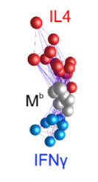
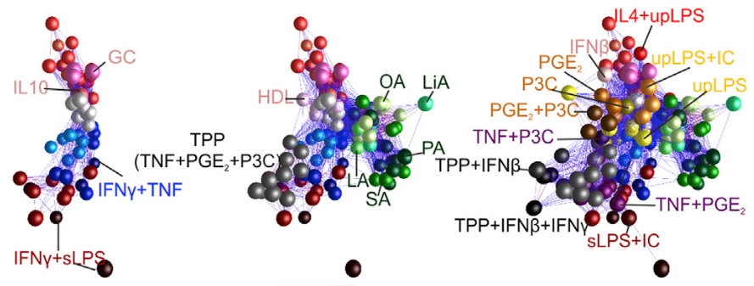
A
B
C
D

Figure 7: Correlation networks of 299 human macrophage mRNA transcriptomes created with correlation coefficient matrices
A: Bipolar structure with M1 and M2 polarization factors. B: Further M1 and M2 associated stimuli and maintained bipolar structure C, D: Stimuli not linked to M1 or M2 polarization factors and more activation signatures appeared
Figure is from (Xue et al., 2014) under the terms of the Creative Commons CC-BY license.

In another study, genomic DNA and RNA were isolated from the total carotid intima of Apoe−/− mice and analysed with next-generation sequencing (NGS) and microarray to show that disturbed blood flow can control endothelial gene expression epigenetically by regulating genome-wide DNA methylation patterns (Dunn et al., 2014).
In a comprehensive study (Perisic et al., 2016), 127 human carotid plaques (40 asymptomatic, 87 symptomatic) and an overlapping subset of peripheral blood mononuclear cells isolations (30 asymptomatic, 66 symptomatic) were analysed by microarray profiling to identify pathways linked to plaque instability. The analysis of plaques and peripheral blood mononuclear cells (PBMCs) revealed that the haemoglobin metabolism is upregulated in symptomatic patients along with inflammatory response, LDL clearance and foam cell differentiation. The effect of statins was also investigated, and it was suggested that osteoblast differentiation and calcification was enriched in symptomatic patients treated with statins. Patient with TIA or minor stroke have an increased stroke risk (see section: 1.1.6) and it was reported that, genes associated with platelet activation (e.g.: ﻿platelet-activating factor receptor: PTAFR) were upregulated in TIA or minor stroke patients compare to stroke patients (Perisic et al., 2016). (Platelet-activating factor (PAF) is a pro-inflammatory phospholipid mediator with versatile physiological effects. It promotes chemotaxis and aggregation, has a role in granule secretion, increases the permeability of endothelial cells and stimulates smooth muscle cell contraction. These different activities are dependent on the activation of catabolic pathways and one of the most important enzymes is the PAF-specific acetylhydrolase (PAF-AH) which forms a biologically inactive lyso-PAF. There are a lot of molecules that are able to inhibit PAF mediated actions and therefore act as anti-inflammatory agents (Montrucchio et al., 2000).) Samples from symptomatic TIA or minor stroke patients showed an upregulation in the process of inflammation, angiogenesis and oxidoreductase activity. Human carotid plaque tissue was also compared to normal arterial wall. Pathways of immune cell activation, extracellular matrix (ECM) disassembly, cell proliferation, lipoprotein clearance were enriched in plaques. To determine the classification of symptomatic and asymptomatic plaque on a molecular level, a prediction model was performed. 30 genes were found which can predict plaque stability with 78% accuracy. More genes were also specified with qPCR that had previously not been identified in atherosclerosis. For example, ﻿leiomodin 1 (LMOD1: role in actin binding) and ﻿synaptopodin 2 (SYNPO2: role in actin binding) were downregulated in plaque tissue (﻿mean difference ± SD -2.405 ± 0.2162, P < 0.0001 and -4.256 ± 0.2827, P < 0.0001, respectively) while Pro-Platelet Basic Protein (PPBP: growth factor activity and glucose transmembrane transporter activity) and ﻿perilipin 2 (PLIN2: role in development and maintenance of adipose tissue) were upregulated in plaque tissue ﻿(mean difference 3.560 ± 0.3138, P < 0.0001 and 2.640 ± 0.2852, P < 0.0001, respectively) compared to normal arterial wall (Perisic et al., 2016).
Transcriptomic studies were also looking for regulator genes involved in cholesterol metabolism and inflammatory response in macrophages, after interaction with modified LDL. Interestingly, it was found that these genes are responsible for inflammation but do not have direct role in cholesterol metabolism (IL-7, IL-15, CXCL8). The data proves that the primary response of macrophages to modified LDL is the activation of inflammatory pathways (Orekhov et al., 2018). Foam cell formation described in detail: 1.2.4 Foam cell formation.
These are just a few examples, but the methods use multiple cells from which to extract RNA and adopt a biased approach that targets on the microarray are predefined. Moreover, the discovery of gene transcripts, alternative splicing, tissue-specific gene expression or alternative polyadenylation would be useful in disease with the use of expressed sequence tags (ESTs, single strand reads of cDNA sequences) (Liu and Graber, 2006)

Single-cell analysis of murine atherosclerotic plaques
Single cell techniques are useful to better understand the mechanism of atherosclerosis as well as analyse different immune cell subsets, understand their roles in atherosclerotic lesion progression, expose cell-type specific pathways and identify markers for unstable carotid plaque. During the last couple of years, Cellular Indexing of Transcriptomes and Epitopes by Sequencing (CITE-seq) and scRNA-seq methods started to be used in both mouse and human atherosclerosis research (Fernandez and Giannarelli, 2022).
A murine study (Winkels et al., 2018b) described leukocytes from healthy and atherosclerotic aortas by scRNA-seq and mass cytometry. 11 aortic leukocyte clusters (1 macrophage, 2 monocytes, 5 T cells, 2 B cells, 1 NK cell cluster) were identified by single cell RNA-seq (10X Genomics, chow diet: 909 CD45⁺ cells, Western diet: 2077 CD45⁺ cells) and different pathways such as cytokine secretion or lipid metabolism were limited to certain clusters. Leukocytes are differently regulated and less diverse in healthy aortas (chow fed) compared to atherosclerotic mice (﻿Apoe−/−, western diet). Their results confirmed that macrophages, monocytes and T-cells are present in mouse aortic lesions with the highest proportion (Winkels et al., 2018b).
In another study (Cochain et al., 2018), aortic CD45+ cells were classified using scRNA-seq (Drop-seq, chow diet: 372 CD45⁺ cells, Western diet: 854 CD45⁺ cells) from atherosclerotic (Ldlr−/−, high fat diet) and nondiseased (chow fed) mice. Thirteen aortic clusters (3 macrophages, 1 monocyte, 4 T cells, 1 B cell, 1 NK cell, 1 dendritic cell, 1 granulocyte, 1 mixed cell cluster) were identified which revealed 3 separate macrophage populations during lesion formation at different time points (28.9% of all cells). The first group are described as Resident like (Res-like) macrophages and are found both in healthy and diseased aortas accounting for 34.4% of all macrophages. These cells express genes linked to aortic resident macrophages (e.g., Coagulation Factor XIII A Chain: F13a1) or M2 like macrophages (Mrc1). One of the 2 atherosclerosis specific clusters contain the inflammatory macrophage transcripts which represent 47% of all macrophages. This group shows an enrichment in the expression of proatherogenic genes e.g., Il1b and Il1a. The last, previously undescribed macrophage population are the TREM2^{hi} (triggered receptor expressed on myeloid cells 2) cells which highly express Trem2 (18.6% of all macrophages). Gene ontology analysis showed that Inflammatory and Res-like macrophages had a role in inflammatory responses and all 3 macrophage clusters were responsible for myeloid leukocyte activation. TREM2^{hi} macrophages had unique roles in lipid metabolism and regulation of oxidative stress and cholesterol efflux (Cochain et al., 2018).
The aim of another murine study (Kim et al., 2018) was the comparison of foamy and non-foamy macrophages from the atherosclerotic aortae (Ldlr−/− mice, western diet) and their role in plaque progression. 11 aortic clusters (8 macrophages, 2 DCs, 1 T cell clusters) were identified by single cell RNA-seq (10X Genomics, 3781 CD45⁺ cells). It was shown that lipid-laden foamy macrophages accumulated in more severe lesions and expressed genes related to lipid metabolism, not inflammation. On the other hand, non-foamy macrophages showed enrichment in the expression of inflammatory genes, like IL1β, both in mouse and human plaques. Interestingly, their data suggest that foamy macrophages do not lead to plaque inflammation (Kim et al., 2018). It was also reported earlier that foam cell formation relates to inflammatory gene suppression and not activation (Spann et al., 2012).
Vascular smooth muscle cells (143 cells) heterogeneity from normal and atherosclerotic aorta from Apoe−/− mice were investigated with scRNA-seq (Smart-Seq2, 10x Genomics) (Dobnikar et al., 2018). The transcription analysis of VSMCs confirmed the region-specific development of these cells. Moreover, it was found that genes associated with inflammation, wound healing and migration are upregulated in VSMCs as a response to Stem Cell Antigen 1 (Sca1), a multipotent progenitor marker (Dobnikar et al., 2018).
Another murine (Cx3cr1^{CreERT2-IRES-YFP/+}Rosa26^{fl-tdTomato/+)} study (Lin et al., 2019) focused on plaque cells derived from CX3CR1+ precursors during plaque progression (3157 cells) and regression (2198 cells). After single cell RNA-seq (10X Genomics) 11 clusters were identified from the combined cell groups (5355 CD11b⁺ cells). A cluster of stem cell-like proliferating monocytes was identified which suggest that monocytes are in a self-renewal state in the plaque and not differentiating immediately into macrophages. It was found that during plaque progression macrophages differentiate into more distinct states than during regression and macrophage activation is more complex than the M1 and M2 phenotypes (Lin et al., 2019).
Flores et al., (2020) developed a macrophage specific nanotherapy to reactivate lesional phagocytosis and reduce plaque burden in Apoe−/− mice. Prophagocytic carbon nanotubes decreased the expression of inflammatory genes in connection with cytokine and chemokine pathways in lesional macrophages, confirmed with scRNA-seq (10X Genomics, ~1500 CD45⁺ cells) (Flores et al., 2020).
A recent study investigated CD4⁺ T cells from aortas of Apoe−/− mice (chow or Western diet) (Wolf et al., 2020). ApoB⁺ T cells were found in both mice and human plaques and converted into Th1-like cells as apoB directs the generation of pathogenic Th1 cells. In healthy mice, apoB⁺ T cells accumulated and presented a Treg- like transcriptome. ScRNA-seq (10X Genomics) analysis revealed several apoB⁺ T cell clusters with different Th signatures with overlapping phenotypes of Th1, Th2, Th17 and follicular helper cells, moreover, T cells were expanded during plaque progression showing a mixed Th1-Th17 phenotype (Wolf et al., 2020). These findings demonstrate a novel mixed phenotype of apoB-reactive T cells in atherosclerosis and suggest a protective autoimmune response against apoB (Wolf et al., 2020).
Myeloid cells (CD45+), isolated from Ldlr−/− mice (n=10) were analysed with scRNA-seq (10X Genomics) (Williams et al., 2020). It was revealed that a specialised and unique macrophage population, the aortic intima resident macrophages (Mac^{AIR}) are from monocyte progenitors during inflammation and depend on colony stimulating factor 1. Mac^{AIR} is maintained by local proliferation in the intimal tissue and differentiates into the first foam cells (Williams et al., 2020).
CD45+ leukocytes were isolated from the atherosclerotic aorta of Apoe−/− mice (normal or high cholesterol diet) and sequenced ﻿(C1 Single-Cell mRNA Seq HT IFC chip) (Burger et al., 2022). Resident-like macrophages expressed the lymphatic vessel endothelial hyaluronan receptor 1 (LYVE-1) promoted the transformation of VSMCs to osteogenic-like cells via the secretion of chemokine ligand 24 (CCL24). These cells were found to have a role in vascular calcification and therefore plaque destabilization (Burger et al., 2022).

Single-cell analysis of human atherosclerotic plaques
Human atherosclerotic macrophage types have also studied by single-cell approaches like cytometry, CITE-seq and scRNA-seq in the past years.
The majority of macrophages, T cells, B cells and NK cells in human atherosclerotic plaques was already discovered with immunohistochemistry, but the existence of new subtypes has been revealed by single cell techniques in the past years (Winkels et al., 2018a). Leukocytes isolated from human carotid atherosclerotic plaques (n=126) and analysed with cytometry by time of flight (CyTOF) showed that 51% of leukocytes were macrophages (Winkels et al., 2018b). CyTOF allows high-dimensional protein analysis but is biased and limited to around 60 markers. Another drawback is the variation in signal intensity across machines and normalisation and anchor samples are necessary for reproducibility (Fernández-Zapata et al., 2020). Different types of plaque cells were enriched compared to ﻿peripheral blood mononuclear cells from the same patients and two subpopulations of resident macrophages were detected: ﻿CD11b⁺HLA-DR^{med} and a CD11b⁺CD36⁺ (Winkels et al., 2018b).
Single-cell transcriptomic (10X Genomics) and proteomic (CITE-seq) analyses were also used to create the first single-cell immune landscape of human atherosclerotic plaques (Fernandez et al., 2019). In this comprehensive study (n= 46 stroke patients undergoing carotid endarterectomy), the different characteristics of macrophages and T cells were described in carotid plaques from both symptomatic and asymptomatic patients (plaques were digested for further analysis). A distinct subset of CD4+ T cells were found in carotid plaques from symptomatic patients and T cell exhaustion markers (e.g., programmed cell death protein 1 (PD-1)) were present. Mass cytometry analysis of 8 asymptomatic and 7 symptomatic plaques revealed 15 plaque specific clusters, including 2 macrophage clusters. These 2 clusters are described as ﻿CD206^{hi}CD163^{hi} and CD206^{lo}CD163^{lo} macrophages. CITE-seq (detection of proteins) immune profiling also identified 2 macrophage clusters (CD64⁺HLADR⁺CD206^{hi} and CD64⁺HLADR⁺CD206^{lo}) based on different CD206 expression levels. The transcriptional analysis revealed five different subsets of macrophages in the carotid plaques. All these different clusters had different transcriptional signatures and characteristics e.g., macrophage activation, inflammatory response, plaque stabilization, foam cell formation and cholesterol metabolism. Single cell RNA-seq (10X Genomics) analysis was used to compare macrophages (n=747 cells) from the asymptomatic (n=4) and symptomatic (n=2) carotid plaques. Asymptomatic macrophages were defined by more pro-inflammatory chemokines (e.g., activated IL-1 signalling), however, they were more engaged in lipid uptake and foam cell formation. Using a computational approach, cell to cell (targeting ligand-receptor interactions, based on: (Kumar et al., 2018)) interactions were predicted. It was found that macrophages stimulate self-activation via IL-1 signalling in asymptomatic plaques. Symptomatic plaque macrophages expressed cytokines involved in inflammatory response and it was suggested that they may be associated with the self-maintenance of M2-like phenotype through the expression of M2 markers (Fernandez et al., 2019).
Human immune cells from atherosclerotic coronary arteries (n= 4 patients) were studied with scRNA-seq (10X Genomics) (Wirka et al., 2019). It was found that SMCs transform into unique fibroblast like cells (called fibromyocytes) rather than classical macrophages. TCF21 (transcription factor, gene at coronary artery disease-associated locus) expression was upregulated during SMC phenotypic modulation both in human and Apoe−/− mice. A higher level of TCF21 expression was associated with decreased coronary artery disease which indicates the protective role of TCF21 in disease (Wirka et al., 2019).
Another single cell study (Depuydt et al., 2020), identified 14 distinct cell populations in human carotid plaques (n=18 plaques from 18 patients) by scRNA-seq (CEL-seq2). From these 14 clusters, 11 were confirmed as leukocytes and the myeloid population was 18.5% of all cells. Myeloid cells were reclustered (sub clustering was performed using canonical correlation analysis) and it was found that 3 out of the 5 new clusters represented a different macrophage activation state. Proinflammatory macrophages were clustered into two populations, one of them showed inflammasome activation (called My.0), while the other group of macrophages expressed tumor necrosis factor and toll-like receptors (called My.1). These proinflammatory cells had a role in immune cell interactions and cellular activation. Interestingly, an inhibitory feedback loop was discovered in these proinflammatory macrophages subpopulations mediated by kruppel like factor 4 (KLF4) expression. The next cluster (called My.2) represented foam cells and expressed profibrotic markers, like TREM2 (Depuydt et al., 2020). TREM2 has a role in lipid metabolism and cholesterol efflux like the LXR genes, reported by Spann et al., (2012). The 4th cluster (called My.3) of myeloid cells are defined by dendritic cell markers, while the last group (My.4) potentially included regulatory T cells (Depuydt et al., 2020).
In summary, it is evident that the cell population of atherosclerotic lesions are highly diverse and there are numerous macrophage subtypes, demonstrated by RNA-seq and CITE-seq (Fernandez and Giannarelli, 2022).

Drugs that may influence inflammation and macrophages in stroke and atherosclerosis

Glucocorticoids such as dexamethasone are used in medicine to treat the diseases of the immune system. The effect of glucocorticoids is highly diverse; they can increase apoptosis of inflammatory cells, decrease cytokine production and activate histone deacetylase increasing gene transcription (Ramamoorthy and Cidlowski, 2016). In this section, I describe the mechanism of action of dex and the latest information of its effect on stroke and atherosclerosis including macrophage phenotypes.

Dexamethasone and glucocorticoid signalling
Dexamethasone is an anti-inflammatory synthetic glucocorticoid (GC) which was first synthesized in 1957 to create a steroid with a longer action than hydrocortisone. It is a widely used medication for inflammatory conditions, including allergies, lupus, arthritis, psoriasis, ulcerative colitis and asthma (Bo-Young Kim, 2017). Glucocorticoids are essential stress hormones, which bind to the GC receptors and play a role in inflammation, homeostasis, cell proliferation and development (Vandewalle, 2018).
Glucocorticoids are produced in the adrenal cortex, enter cells and bind to intracellular glucocorticoid receptors (GR) (Figure 8). GR is a member of the nuclear receptor superfamily of transcription factors and has 3 main parts: the N-terminal transactivation domain, DNA-binding domain and C-terminal ligand-binding domain. GR is located in the cytoplasm in a multiprotein complex (Whirledge and DeFranco, 2018). As a result of ligand induced conformational changes, the activated steroid-receptor complex is transported into the nucleus (Ramamoorthy and Cidlowski, 2016). GR- DNA binding depends on several factors e.g., genomic sequence and chromatin environment. The classical transcriptional regulation starts with the dimerization of GR then the complex binds to the glucocorticoid response elements (GRE) and modifies transcription from proximate promoters (Whirledge and DeFranco, 2018). Alternatively, GR can localize to genomic sites through protein-protein interactions without directly binding DNA or monomeric GR can bind DNA with the help of other transcriptional factors, located proximal to the direct GR binding site (Whirledge and DeFranco, 2018). The mRNA of the altered targeted genes leaves the nucleus, directs the synthesis of proteins which are released from the cell and trigger biological responses.
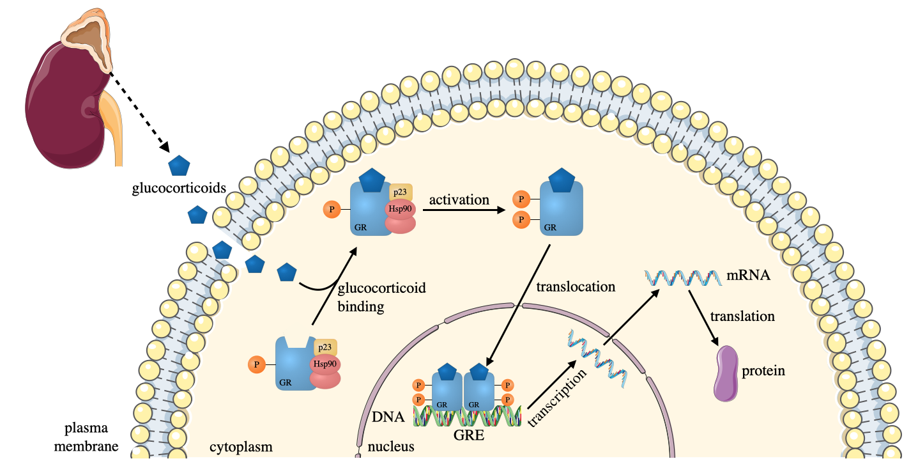
Glucocorticoids bind to GR which is a ligand-dependent transcription factor (Sacta et al., 2016). Regulation of transcription plays an important role in health and disease therefore the identification of these major DNA binding sites for proteins or histone modification by chromatin immunoprecipitation combined with sequencing (ChIP-seq) is necessary. In the past years, several studies have mapped the location of binding sites in many cell types in human (e.g., (ENCODE Project Consortium, 2012). A recent study (Vockley et al., 2016) determined the functional effect of GR binding sites (GBSs) by measuring the GC responsive activity of GBSs using ChIP-seq. It was found that direct GBSs encode GC-induced enhancers and non-GC-induced GBSs interact with direct GBSs which can amplify the activity of direct GC-induced enhancers (Vockley et al., 2016).

Figure 8: Genomic action of glucocorticoids
The adrenal cortex synthesizes and release glucocorticoids. Glucocorticoids bind to the intracellular glucocorticoid receptor (GR), undergoes a conformational change and translocated to the nucleus. Inside the nucleus GR binds to the glucocorticoid response elements (GRE) and stimulates target gene expression.

Glucocorticoid Receptors
Glucocorticoid receptors can be modified by several post-translational modifications (PTMs), which can create or inactivate protein interaction surfaces and affect DNA binding or ligand response (Weikum et al., 2017). Phosphorylation is one of the PTMs which affect GR on the basal level and additional sites on ligand treatment.
The phosphorylation of GR, mostly increases the protein half-life, resulting rapid protein degradation (Weikum et al., 2017). SUMOylation, another post-translational modification (small ubiquitin-related modifier 1 (SUMO-1) links to Lys residue and alters their stability) affects the GR target genes and chromatin binding (Paakinaho et al., 2014). It was revealed that genes down- or up-regulated by dex are affected by GR SUMOylation and these genes are in connection with cellular proliferation. SUMOylation also modulated the chromatin occupancy of GR on several loci associated with cellular growth in a way that parallels their differential dex-regulated expression between different cell lines (HEK293 and U2 osteosarcoma cells) (Paakinaho et al., 2014).
Investigating the regulation of the human genome and functional annotations could help biomedical research find potential direct genes to treat disease.

The effect of glucocorticoids
Steroids, including GCs, have anti-inflammatory and immunosuppressive effects in a direct or indirect way. The direct way is when GR binds to GRE, while the indirect effect is relying on the interaction of GR with other transcription factors (Rhen and Cidlowski, 2005). For example, GCs can inhibit vascular permeability and endothelial activation through direct inhibition of endothelial adhesion and indirect inhibition of cytokine transcription (Salvador et al., 2014). Dexamethasone can also affect the blood-brain barrier, via the direct induction of F-actin concentration and increased occludin expression (Salvador et al., 2014). Dexamethasone can indirectly regulate serotonin activity by increasing the expression of the serotonin transporter and inhibiting its biosynthesis (Bordag et al., 2015).
The anti-inflammatory properties of GCs are through the repression of ﻿NFκB and the downregulation of proinflammatory cytokines (IL-1, IL-6, TNFα). Moreover, GR dimerization is also essential for the anti-inflammatory effects (Desgeorges et al., 2019). Interestingly, one of the GR isoforms (GRα) has also been shown to induce apoptosis through both extrinsic and intrinsic apoptotic pathways (Gruver-Yates and Cidlowski, 2013). Another study suggested that a high dose (1000ng/ml) of GC can induce apoptosis in macrophages, T cells, B cells, natural killer cells and dendritic cells in vitro (Zhou et al., 2010). It was also shown that a high dose of dex can decrease the production of pro-inflammatory compounds e.g., cytokine, adhesion molecules or chemokines (Ramamoorthy and Cidlowski, 2016). Glucocorticoids have inhibitory effects on adhesion molecules (e.g., E-selectin) in endothelial cells which have a role in the progression of early atherosclerosis (Otsuki et al., 2010). GCs also have a role in the mobilisation of glucose, breakdown of proteins, neutrophilia or immunosuppression (Ramamoorthy and Cidlowski, 2016).
Glucocorticoid binding to GR can also release accessory proteins that have a role in secondary signalling cascades, e.g., phosphorylate annexin 1 (Ramamoorthy and Cidlowski, 2016). Annexins can bind Ca²⁺ and phospholipids and have a role in cell growth, differentiation, neuroendocrine function and inflammation (Solito et al., 2003). Furthermore, annexin 1 expression can be increased by GC treatment in the plasma membrane (Solito et al., 2003).

The effect of dexamethasone treatment in ischemic stroke patients
The effect of dex treatment in ischemic stroke patients is widely researched and the results are varied.
A double-blind study (Bernard et al., 1972, Patten et al., 1972) (n= 31 patients; 14 received dex, 17 received placebo) showed that dex can be useful after severe stroke compared to a control (non-stroke) group. Patients who received steroids improved their functional status and it was found that dex decreased brain oedema and brain infarction. Interestingly, another study (n= 118 patients; 61 received dex, 57 received placebo), showed that the routine use of dex has no beneficial effect on acute ischaemic stroke patients (Mulley et al., 1978). In another study, on 300 stroke patients (rigorously randomized), there was evidence of effectiveness of dex, but this did not reach statistical significance. Patients in this study were divided in four groups, Group A: placebo, Group B: ﻿mixture of dihydroergocornine, dihydroergocristine and dihydroergocriptine, 0.3 mg each in a daily dosage of 6, Group C: ﻿dex 24 mg daily, given in divided doses, Group D: ﻿20% hypertonic mannitol given intravenous 0.8-0.9 g/kg daily (Santambrogio et al., 1978).
Systematic reviews were published in 2002 and 2011 on the effect of corticosteroids in ischaemic stroke. The first (Qizilbash et al., 2002), summarizes the findings from 7 trials, including 453 people, while the second (Sandercock and Soane, 2011), added on one more trial to the previous one (all together 8 trials) to reach 466 participants. These 2 studies showed that there was no evidence of benefit from corticosteroids on improving functional outcomes or decreasing the number of deaths from stroke. The limitation of all of the trials is that only one of the studies used CT scans to exclude haemorrhage. To conclude, it was suggested that corticosteroids, could be useful in stroke patients with large infarcts and cerebral oedema (Qizilbash et al., 2002, Sandercock and Soane, 2011).
In contrast to the equivocal data presented in the systematic reviews, the data from stroke models is more encouraging. In a rat thromboembolic stroke model, combined treatment with ﻿dex phosphate-containing long-circulating liposomes (LCL-DXP) and ﻿recombinant tissue plasminogen activator (rtPA) restricted lesion progression and significantly improved neurological outcome after embolic stroke compared to ﻿only phosphate-buffered saline-loaded LCLs (Tiebosch et al., 2012). Another study examined rats with intracerebral haemorrhage (ICH) and treated them with high dose dex (15mg/kg) after ICH induction and on day 3. The ﻿intraperitoneal injection of dex (control group: saline; n=56) resulted a significant decrease in apoptotic cell death, earlier appearance of lymphocytes and an increased neuron survival (Lee et al., 2014). ﻿A recent study showed that a single dose of intranasal dex (0.25 mg/kg) could significantly decrease infarct volume size, mortality and neurological deficits in a mouse ischemic stroke model (Espinosa et al., 2020). Overall, these findings have shown that dex has an advantageous effect on ischaemic or haemorrhagic stroke in mouse or rat experimental models.

The effect of dexamethasone on atherosclerosis & macrophages
Given the interesting preclinical data on experimental stroke, there are several studies which examine the effect of dex on atherosclerosis in animal models and human or mouse monocytic cells. For instance, dex significantly decreased the development of aortic atherosclerotic plaque in rabbits (daily injection of 0.125 mg dex) compared to control animals after a 1% cholesterol diet for 8 weeks by an average of 83% (Asai et al., 1993). Immunofluorescence staining showed that in dex treated rabbits, clusters of macrophages and T lymphocytes were significantly reduced compared to control rabbits. In vitro, dex treated (versus control) mouse peritoneal macrophages had reduced uptake and degradation of very-low-density lipoprotein (VLDL). Taken together, these data suggest that dex (10⁻⁷ M for 36 h) can inhibit the proliferation of MDMs in the aortic wall and suppress the formation of foam cells in atherosclerotic lesions (Asai et al., 1993).
Both asthma and atherosclerosis are inflammatory diseases, therefore the anti-inflammatory corticosteroids used in asthma treatment may be able to reduce atherosclerotic vascular diseases. To prove this hypothesis, 150 asthmatic patients were selected with reversible airway obstruction (Otsuki et al., 2010). These patients were matched with non-asthmatic control subjects based on age, sex and other atherosclerotic risk factors (e.g., hypertension, diabetes mellitus, smoking). The most effective long-term therapy against asthma are the inhaled corticosteroids (ICS) which are also effective in tissues not just in the airways. During the study period, the daily dose of ICS was calculated from the cumulative dose of used ICS in the previous 2 years. The intima and media thickness (IMT) of the carotid atherosclerosis was evaluated with high- resolution ultrasound B-mode imaging. It was found that carotid atherosclerosis was reduced in asthmatic patients treated with ICS than in control group (Otsuki et al., 2010). However, asthmatic patients may have altered immune macrophages which may shift the effect of this drug.
In terms of recent work with human cells, dex treatment (10⁻⁹ to 10⁻⁶ M for 48 h) suppressed the differentiation of U937 cells (Asai et al., 1993). Another study showed that dex inhibited monocytic cell activation induced by ﻿27-Hydroxycholesterol (27OHChol) (Bo-Young Kim, 2017). 27OHChol is the most frequent oxysterol in atherosclerotic arteries and promotes inflammatory process in vivo via the activation of monocytic cells. A chemotaxis assay proved that a high concentration (1 μM) of dex inhibited the migration of THP-1 monocytic cells (cell migration was measured in transwell chambers). In these cells, the enhanced secretion of C-C Motif Chemokine Ligand 2 (CCL2) chemokine (which recruits monocytes to the sites of inflammation) induced by LPS and 27OHChol was significantly suppressed by dex treatment. Expression of CD14 protein was also suppressed by dex treatment at 3 different concentrations (0.01, 0.1, 1 μM). Dexamethasone (0.01, 0.1, 1 μM) also inhibited MMP-9 expression (plays a role in the formation and destabilization of the atherosclerotic plaque) of monocytic cells induced by 27OHChol. Dexamethasone also reduced the expression of the p65 subunit of NF-κB both at RNA and protein level (Bo-Young Kim, 2017).

Concentrations of dexamethasone used in different human studies
There appears to be significant variance in the amount of dex used in in vitro studies and this is also the case for experimental studies in man.
Given the variability of dex effects in stroke it is important to review the information available (Table 2). During standard pharmacokinetic studies, 10 healthy female volunteers received 0.5 mg oral administration (p.o.) or 1.5 mg p.o. dex. After taking the appropriate dose of dex, blood samples were taken at 10 different time points. The elimination of dex was rapid and after 24h the plasma concentration was less than 1/10th of the maximal concentration in all dose groups (Loew, 1986). At 0.5 mg p.o. dex dose, the average plasma level was 8 ng/ml while after 1.5 mg p.o. dex the plasma level reached 14 ng/ml (Loew, 1986). Similar results were reported (Weijtens et al., 1998), where 98.1 ng/ml serum level was measured after 7.5 mg p.o. dex (n=54).

Table 2.: Dose dependent pharmacokinetics of dexamethasone measured by radioimmunoassay
Plasma level (C_{max}) is shown as an average of n=10 healthy donors after a single dose (p.o.) of dex. Based on: (Loew, 1986) Dex III concentration is not measured, it was estimated based on the values of dex I and dex II.

Name | Dosage | Plasma level (C_{max})  (Average of n=10)
dex I | 0.5 mg | 8 ng/ml
dex II | 1.5 mg | 14 ng/ml
dex III | 10 mg | 125 ng/ml

The Randomised Evaluation of COVID-19 Therapy (RECOVERY) Trial has recently tested dex on COVID-19 patients (The RECOVERY Collaborative Group, 2020). During the dex trial, 2104 patients randomly allocated to receive dex were compared with 4321 patients concurrently allocated to usual care. Patients were received 6 mg dex p.o., once daily for up to 10 days.
Dexamethasone reduced deaths by one-third in patients receiving invasive mechanical ventilation; by one-fifth in patients receiving oxygen without invasive mechanical ventilation; but did not reduce mortality in patients not receiving respiratory support at randomization (Horby, 2020).

Lipid metabolism and its role in atherosclerosis

Alongside macrophages, lipids also have a major role in the pathogenesis of atherosclerosis. In this section, I briefly summarise the major lipoprotein classes, their link to macrophages, lipids and the effect of the lipid lowering drugs, the statins.

Lipoproteins and lipids as risk factors for atherosclerosis
Signalling lipids and lipid-modifying enzymes (controlled by growth factors, cytokines and nutrients) maintain a complex lipid signalling network. Imbalances in these signalling pathways can lead to various diseases, such as chronic inflammation, atherosclerosis, autoimmunity, allergy or hypertension (Wymann, 2008).
Lipoproteins (HDL, LDL, VLDL, oxLDL), cholesterol and triglycerides have a main role in the pathogenesis of atherosclerosis (Singh et al., 2002). Lipoproteins are molecular complexes which transport proteins and lipids in the bloodstream, also vary in function, size and composition. These transported lipids are triglycerides, phospholipids and cholesterol (Miller, 2011).

Triglycerides and triglyceride-rich lipoproteins
Triglycerides are a main source of energy, which contain three fatty acids combined with glycerol. Hypertriglyceridemia is a marker for several types of atherogenic lipoproteins and a risk factor for CVD, obesity, type 2 diabetes mellitus, insulin resistance and atherosclerosis (Singh, 2002). Triglycerides are not directly atherogenic, but if connected with apolipoprotein C-III (apoC-III) become an important biomarker (Talayero, 2011). ApoC-III is a proinflammatory protein found on chylomicrons, VLDL, LDL and HDL. It is a significant risk factor for CVD because it is able to trigger VLDL secretion, enhance plasma triglycerides through the inhibition of lipoprotein lipase and stimulate inflammation in the cardiovascular system (Kohan, 2015).
Increased triglyceride levels promote VLDL production and delay VLDL clearance from the blood therefore triglycerides appear to promote atherogenesis through lipoproteins. Triglyceride rich lipoproteins (TRLs) enhance proatherogenic effects, like monocyte recruitment and attachment, through macrophage derived inflammatory proteins, such as TNF-α or IL-1β. TRLs can also enhance endothelial disfunction through decreased flow-mediated vasodilation and increased expression of adhesion molecules (Talayero, 2011).

High-density lipoprotein (HDL)
High-density lipoprotein is known as the “good cholesterol” because it can remove cholesterol from the bloodstream and transport it into the liver where it is internalized and degraded.
HDL and macrophages have a role in the reverse cholesterol transport; therefore, both are important in the pathogenesis of atherosclerosis. Macrophages can transport free cholesterols to lipid poor apolipoproteins (e.g.: ApoA-I) to form mature HDLs (Figure 9: B). This efflux is regulated by transporters whose expression is modulated by several transcription factors activated by the accumulation of cellular cholesterol (Remmerie, 2018). The HDL cholesterol uptake is mediated by cell surface receptors, like SR-B1. Moreover, HDL may be able to transport and inactivate oxLDL (Singh, 2002). HDL also can suppress monocyte migration into the tunica intima, inhibit VSMC proliferation, stimulate cell repair and prevent thrombosis (Acton, 1999).

Low-density lipoprotein (LDL)
LDL, the so-called “bad” cholesterol, refers to low-density lipoprotein. LDL promotes the cellular accumulation of cholesterol because it can deliver fat molecules to a cell. Cholesterol is absorbed by receptor-mediated endocytosis through LDLR (Zhang, 2008).
LDL is a risk factor for cardiovascular diseases because high LDL levels can lead to the formation of fatty blockages in arteries. LDL has a well-established role in inflammation, endothelial dysfunction, foam cell formation and in the rupture of an unstable plaque (Rosenson, 2004). LDL particles are very heterogeneous in composition, size and density. The small and dense LDL molecules are more atherogenic then the bigger ones because they can enter the vessel wall more easily (Rosenson, 2004). These small dense LDL particles are more likely to be retained by the extracellular matrix, through binding to intimal proteoglycans. Moreover, small LDL molecules are more easily oxidized, because oxidative modification can occur at a maximum of 25.5nm diameter (Rosenson, 2004).

Oxidized low-density lipoprotein (oxLDL)
Oxidized low-density lipoprotein (oxLDL) is pathologically modified because of oxidative stress. Vascular oxidative stress, nitric oxide (NO) and modified oxLDL play an important role in the pathogenesis of atherosclerosis (Förstermann et al., 2017). There are many reactive oxygen species (ROS) producing systems in vessel walls, such as nicotinamide adenine dinucleotide phosphate (NADPH) oxidase, mitochondrial electron transport chain enzymes and endothelial NO synthase (eNOS) (Förstermann et al., 2017). NADPH oxidase can trigger eNOS and mitochondrial ROS production (Kröller-Schön et al., 2014). Interestingly, different NOS isoforms have different roles, eNOS and neuronal NOS (nNOS) are atheroprotective, while inducible NOS (iNOS) is proatherogenic (Förstermann et al., 2017). Increased ROS causes oxidative stress. Risk factors trigger excessive ROS production and reduce the production of NO. Endothelial NO inhibits atherosclerosis while oxidative stress promotes unwanted oxLDL formation, endothelial cell and macrophage activation (Förstermann et al., 2017). The sensitivity of LDL to oxidation is affected by several factors including composition, size, density and endogenous antioxidant compounds such as ﻿α-tocopherol or β-carotene. Small and dense LDL molecules are more easily oxidized then the bigger particles (Rosenson, 2004).
The formed oxLDL takes part in the progression of the atherosclerotic plaque. It has a role in endothelial cell dysfunction, smooth muscle cell migration and foam cell formation (Pirillo, 2013). Macrophages can engulf oxLDL (and become foam cells (see section: 1.2.4)) with the help of several cell surface scavenger receptors like oxidized low density lipoprotein receptor 1 (OLR1), CD36 and Macrophage Scavenger Receptor 1 (MSR1) (Chistiakov, 2016).

Scavenger receptors and their role in atherosclerosis
Scavenger receptors (SRs) were first described by Brown and Goldstein (Goldstein et al., 1979) when they defined receptors which can degrade modified low-density lipoproteins. Later, scavenger receptors were systematically characterized into classes based on their sequences and further subdivided into types (Krieger, 1997). This large and structurally diverse family of cell surface receptors are responsible for a broad range of biological functions, such as homeostasis, apoptosis and inflammatory diseases. They bind multiple ligands and remove harmful substances by different mechanisms (adhesion, endocytosis, phagocytosis).
Macrophages, in atherosclerotic lesions, express structurally different SRs for lipoprotein uptake which promote the cellular accumulation of cholesterol (Figure 9: C) (Moore, 2006). Cholesterol accumulation leads to the formation of foam cells (see section: 1.2.4). Therefore the development of the atherosclerotic plaque is partially enhanced by receptor mediated lipid uptake and foam cell formation (Moore, 2006).
Based on consensus classification, currently, mammalian scavenger receptors are divided into 12 different classes (PrabhuDas et al., 2017). During my research I focused on the scavenger receptors detailed in Table 3.

Table 3: Scavenger receptors studied during my PhD
Nomenclature based on: (PrabhuDas et al., 2017).
* indicates the chosen name throughout this thesis

﻿Consensus Member Nomenclature | Protein Name | Common Gene Name | Official Gene Symbol Approved by the HGNC | Official Gene Name Approved by the HGNC | CD number
﻿SR-A1 | MSR1 | ﻿SCARA1 | MSR1* | macrophage scavenger receptor 1 | CD204
﻿SR-B1 | ﻿SR-BI | SRB1 | SCARB1 * | scavenger receptor class B member 1 | CD36L1
﻿SR-B2 | CD36 | SCARB3 | CD36 * | CD36 molecule | CD36
﻿SR-D1 | CD68 | CD68 | CD68 * | CD68 molecule | CD68
﻿SR-E1 | ﻿LOX-1 | LOX-1 | OLR1 * | oxidized low density lipoprotein receptor 1 | –
﻿SR-E3 | MRC1 | CD206 | MRC1 * | mannose receptor C-type 1 | CD206

Macrophages and their role in lipid metabolism
Lipid metabolism is an essential and complex process which involves the delivery of lipids to peripheral tissue and returning of lipids to the liver. There are 3 main lipid metabolism pathways: exogenous, endogenous and reverse. The exogenous pathway is responsible for the processing of dietary lipids (triglycerides and cholesterol), while the endogenous is in charge of processing lipids synthesised in the liver (mostly VLDL). The reverse cholesterol transport can remove lipids from tissue and return it to the liver (Remmerie, 2018).
Macrophages have an important role in lipid metabolism (Figure 9), because they take up LDL, VLDL and oxLDL via, scavenger receptor mediated pathways (see section: 1.6.6.), phagocytosis or micropinocytosis (Tabas and Bornfeldt, 2016). Macrophages are also able to eliminate cholesterol but if the excess cholesterol is not removed foam cells will form (see section: 1.2.4.) (Moore, 2013). Cellular cholesterol accumulation can also lead to the expression of transporter proteins (e.g.: ATP-binding cassette transporter (ABCA1), ATP Binding Cassette Subfamily G Member 1 (ABCG1)) which regulate cholesterol efflux (Hutchins, 2015). ABCA1 is a phospholipid translocase that accumulates phospholipid substrate, creating an activated lipid domain. ApoA-I binds to this lipid domain which leads to the release of free cholesterol and phospholipid to lipid-free apolipoprotein, resulting small, immature HDL particles (Hutchins, 2015). There is a passive movement of neutral lipids between HDL and LDL/VLDL particles through the cholesteryl ester transport protein (CETP). During this process, a cholesteryl ester is changed for a triacylglyceride promoting a flux of cholesteryl ester from HDL to LDL (Hutchins, 2015).

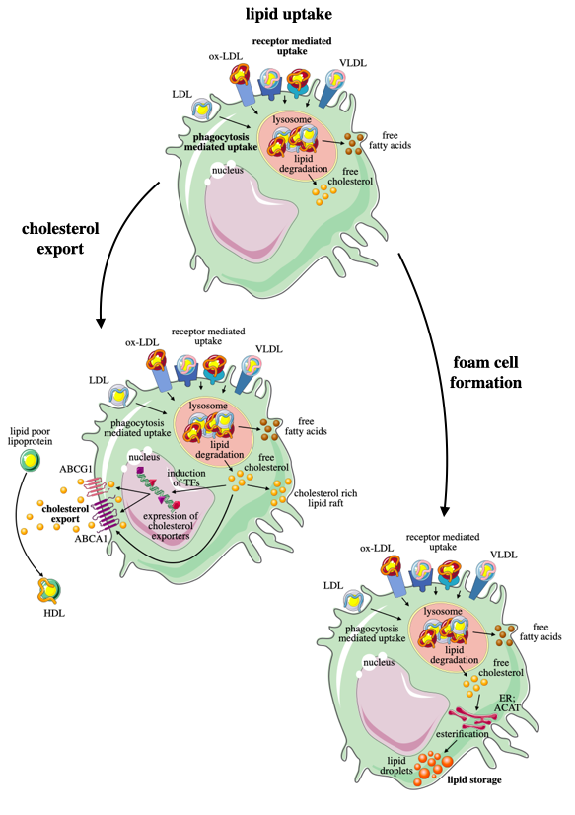
Figure 9: Lipid metabolism in macrophages
C
A
B
A: Macrophages take up LDL, VLDL, ox-LDL through receptor mediated or phagocytosis mediated uptake. These lipoproteins are digested in the lysosome, producing free cholesterol and fatty acids. B: Free cholesterol can be exported out from the cell through transporters and form HDL from poorly lipidated apolipoproteins. C: Free cholesterol can be re-esterified in the endoplasmic reticulum (ER), stored in the cytosol as lipid droplets and generating the formation of foam cells.

Statins and other hypolipidemic agents in atherosclerosis
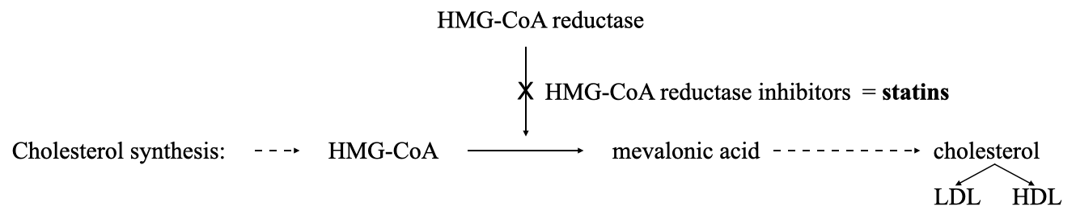
Statins (3-hydroxy-3-methyglutaryl coenzyme A reductase inhibitors) can reduce the risk of cardiovascular events e.g.: stroke, with their several beneficial effects (National Cholesterol Education Program, 2001, Toth and Banach, 2019). In the liver, during cholesterol synthesis, the reduction of mevalonate is catalysed by 3-hydroxy-3-methylglutaryl coenzyme A (HMG-CoA) reductase. This is a rate-limiting step and the site of action for statins. Statins can reduce cholesterol biosynthesis through the inhibition of the HMG-CoA reductase (HMGCR) (Figure 10) (Toth and Banach, 2019). Another rate-limiting step in cholesterol biosynthesis is the squalene monooxygenase (SM). The ubiquitin-proteasome system degrades SM, which is accelerated by excess cholesterol, resulting limited cholesterol synthesis and regulated cellular cholesterol levels (Chua et al., 2017). The mevalonate pathway produces a compound, ubiquinone or coenzyme Q₁₀ (CoQ₁₀) which is essential for normal cellular functions (Raizner and Quiñones, 2021). Inhibiting the mevalonate pathway by HMG-CoA reductase inhibitors can lead to decreased Q₁₀ therefore mitochondrial dysfunction (Raizner and Quiñones, 2021). The mevalonate pathway is also responsible for the production of isoprenoid lipids (Novelli and D’Apice, 2012). These lipids are substrates for protein isoprenylation, which involves the transfer of a farnesyl group onto a cysteine residue, resulting farnesylated proteins. Farnesylation promotes protein-protein and protein-membrane interactions (Novelli and D’Apice, 2012).
Figure 10: The mechanism of action of statins
Statins inhibit HMG-CoA reductase, which has a beneficial effect on cholesterol biosynthesis.

Statins can efficiently reduce LDL level and may modify LDL particle size, distribution and composition (Otvos et al., 2001). Statins have been shown to lower cholesterol content and enhance lipoprotein fluidity which can decrease the tendency of LDL oxidation (Rosenson, 2004). They can also decrease the concentration of the small LDLs and increase LDL size (McKenney et al., 2001). Moreover, statins can modify the levels of other lipoproteins for example, they can increase levels of HDL, improve HDL subpopulation profile and as a result promote reverse cholesterol transport (Asztalos et al., 2002). Additionally, statins can reduce the levels of triglycerides and non-HDL cholesterol (Ballantyne et al., 2001). Statins have different antioxidant properties for instance they can reduce oxidative stress through the inhibition of ﻿angiotensin II-induced superoxide formation by NADPH oxidase (Wassmann, 2002). Statins can reduce NADPH-dependent superoxide formation (Delbosc et al., 2002) and can increase the release of NO (Dobrucki et al., 2021).
Statins have multiple pleiotropic effects, like improvement of endothelial functions, anti-inflammatory, antioxidative and antiproliferative properties (Janicko et al., 2016). Treatment of hypercholesteraemic patients with statins has been shown to lower cytokine expression (Ferro et al., 2000) and decrease monocyte adhesion to endothelial cells (Crisby et al., 2001). Statins can reduce the risk of Alzheimer’s disease, other types of dementia, vitiligo, sclerosis multiplex, osteoporosis and rheumatoid arthritis (Janicko et al., 2016).
Other lipid-lowering drugs are fibrates, bile-acid sequestrants, nicotinic acid and proprotein convertase subtilisin/kexin 9 (PCSK9) inhibitors. Fibrates (clofibrate) can increase LDL cholesterol breakdown, raise HDL cholesterol and lower plasma triglycerides by activating peroxisome proliferator-activated receptors (PPARs) (Jun et al., 2010). Bile acid sequestrants, like cholestyramine, colestipol and colesevelam are non-digestible resins that bind to bile acids, therefore decreasing the absorption of fats and lowering plasma cholesterol levels (Scaldaferri et al., 2013). Nicotinic acids e.g., acipimox are member of the vitamin B complex and have the ability to reduce LDL cholesterol level and improve HDL level by inhibiting the breakdown of fat molecules (Offermanns, 2006). The newest agents are the PCSK9 inhibitors which can lower plasma LDL cholesterol level by 60% and significantly reduce the risk of vascular events (Sabatine, 2018). However, PCSK9 inhibitors have pleiotropic effects, like reducing the expression of pro-inflammatory molecules (OLR1) and membrane adhesive molecules (VCAM-1, ICAM-1), reducing oxidative stress (NADPH, ROS), decreasing macrophage accumulation, reducing VSMC proliferation and migration (Karagiannis et al., 2018).

Knowledge Gap

Stroke survivors with advanced carotid atherosclerotic plaques have an increased risk of early recurrent ischaemic events (Mohan et al., 2011). For this reason, investigation of the pathophenotypic features of culprit cells in carotid plaques and the in vitro analysis of different macrophage subtypes are necessary.

- Previous studies did not consider that one macrophage can express both M1 and M2 markers and therefore stained separately for these markers (Medbury et al., 2013). However, it is possible that a considerable number of these single M1 or M2 cells may actually be ‘intermediates’ or double M1/M2 marker expressing macrophages. Thereby, an immunofluorescence (IF) protocol to simultaneously stain for M1 and M2 macrophages alongside an image acquisition and analysis strategy are necessary.

- To date, human atherosclerotic immune single cell studies only used mechanical or enzymatic dissociation, which can cause an under-representation of macrophages (Gerner et al., 2012). Therefore, ﻿techniques without tissue dissociation are required, like Laser Capture Microdissection (LCM).

- Inflammatory cells are influenced by their microenvironment and exposure to certain medications such as lipid-lowering statins or anti-inflammatory drugs, like dex, reduce stroke incidence and recurrence in patients, but in vitro studies of the possible mechanisms in humans are lacking. Consequently, the effect of these drugs needs to be investigated, not just in unpolarized macrophages, but also separately in M1 and M2a phenotypes.

Hypothesis and Aims

I hypothesised 1) that M1 pro-inflammatory and M2 anti-inflammatory macrophage subtypes coalesce and are altered within stable vs. unstable atherosclerotic plaques and 2) that pharmacological agents (e.g., anti-inflammatory drugs, statins) could modulate these subtypes in human macrophages.

This project has 3 main aims:
- Classification of different macrophage phenotypes with immunofluorescence stain in the most prone to rupture regions of stable and unstable human carotid plaques.
- Laser Capture Microdissection single cell RNA sequencing of human atherosclerotic plaque macrophages.
- Investigation of the effect of dexamethasone and statins on human M1 and M2 macrophages in vitro.

Chapter 2.
Materials and Methods

This materials and methods chapter includes techniques that have been used throughout my PhD work.

Governance
All experiments were performed in accordance with United Kingdom legislation under the Human Tissue Act 2004.
The human carotid plaque work (2.2, 2.3, 2.4, 2.5) was approved under “Red cell membrane cholesterol: a novel biomarker of unstable carotid plaque?” (STH18222). The Research Ethics Committee approved the amendments: study protocol (V5, 21/01/2018), patient information sheet (V6, 21/06/2018) and consent form (V7, 21/01/2018).
Two licences were in place for the in vitro cell work (2.6). A: “Studies of the function of platelets, leukocytes and stem cells in blood and plasma from healthy volunteers”. The Research Ethics Committee approved the amendments: participant information sheet (V5, 24/04/2014) and consent form (V4, 02/005/2014) (IX.2). This was revised to: “Studies of the function of platelets and leukocytes in blood and plasma from healthy volunteers”, reference number 031330. Participant information sheet 1071555 version 1 (21/10/2019) and participant consent form 1071553 version 1 (21/10/2019) (IX.3) were approved by the University of Sheffield ethics reviewers.

Patient Recruitment
Patients were approached by me or Dr. Jessica Redgrave at The Royal Hallamshire Hospital and The Northern General Teaching Hospitals in Sheffield. Patients with a recent stroke or TIA and with a greater than 50% stenosis of the ipsilateral internal carotid artery were eligible to be enrolled. All patients were given the patient information sheet, given time to read through and to ask any questions prior to informed consent being obtained according to Good Clinical Practice Guidelines (IX.1).

Histological processing and assessment

Histological processing of human carotid plaques
Carotid plaques were removed during carotid endarterectomy and placed in 10% (v/v) neutral buffered formalin (for maximum 2 days) by the surgical team and transported to the histopathology lab at The Royal Hallamshire Hospital. The plaques were collected from there and taken to the departmental histology lab, maximum 2 days after surgery. The carotid plaque was decalcified in excess amount of 0.5 M EDTA at pH8 for 7 days (IX.5 EDTA). Plaques were processed (Leica TP 1020 automatic Tissue Processor), divided and embedded (Leica EG1150 H Paraffin Embedding Station) into 3 mm thick wax blocks (A, B, C, D) as shown in (Figure 11) (Lovett et al., 2004c). The wax blocks were sectioned serially at 5 µm thickness, transversely from the origin of the internal carotid artery at the bifurcation point, using a Leica RM2245 semi-automated rotary microtome and placed on silane coated microscope slides (Cell Path) (dividing, embedding and sectioning were done by Fiona Wright, histology core technician). Method is adapted from (Lovett et al., 2004c).
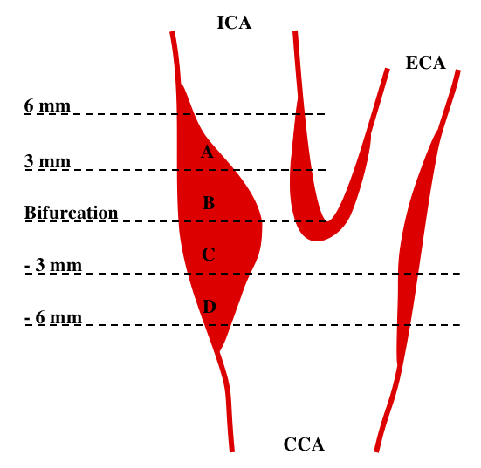
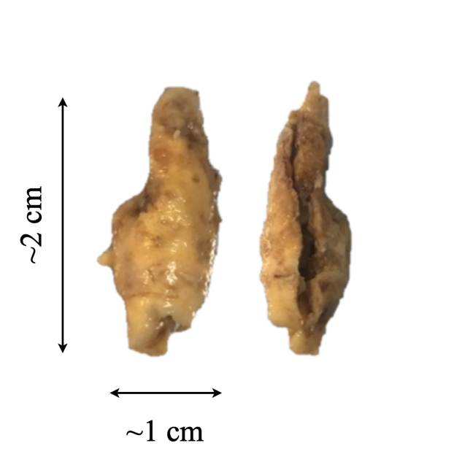

Figure 11: Illustration of the orientation of the carotid bifurcation and plaque division into wax blocks
3mm thick sections are centred from the bifurcation. ICA = Internal carotid artery; ECA = external carotid artery; CCA = common carotid artery; Adapted from: (Lovett et al., 2004c)

Haematoxylin and Eosin staining
The sections were stained for Haematoxylin and Eosin (H&E) to determine histological features and identify the Region of Interest (ROI), which is the plaque shoulder region.
H&E stain is the most common technique for the evaluation of morphology with the combination of two dyes, haematoxylin and eosin. Haematoxylin with aluminium salts is positively charged and reacts with negatively charged nucleic acids. The bluing step with Scott’s tap water (Merck) is necessary to convert the reddish-purple colour to a deep blue/purple shade, which marks the nucleus. Eosin is negatively charged and can react with positively charged components non-specifically, such as the amino groups in proteins. This eosin staining results a pale pink colour of collagen and mitochondria. Muscles, cytoplasm and leukocytes will have reddish colour (Fischer et al., 2008) (detailed staining protocol: IX.6).

Connective tissue staining
The Elastic (Connective Tissue Stain) kit (Abcam) is a modified Verhoeff- Van Gieson stain (VVG), which was used according to the manufacturer’s instructions. The Verhoeff staining is an iron-haematoxylin stain which is specific for elastic fibres and results a dark blue- black colour, as well in the nuclei. The Van Gieson counterstain is specific for collagen and stains it red along with muscle while cell cytoplasm and other tissue elements stain yellow (Carson, 2015).

CD3 and CD68 immunohistochemical staining
In addition to the H&E and VVG staining, immunohistochemical staining with CD3 and CD68 antibodies are necessary for histological assessment. CD3 is a T cell marker, while CD68 is an overall macrophage marker.
Formalin-fixed, paraffin-embedded (FFPE) carotid atherosclerotic plaque sections were de-waxed in xylene (Fisher Scientific) and rehydrated through graded ethanols (Fisher Scientific) to water. Sections were incubated in 3% (v/v) H₂O₂ (Merck) for a minimum of 10 minutes to abolish endogenous peroxide activity. Cross-links between antigens were broke down with heat mediated antigen retrieval, which was done with 0.01M trisodium citrate (TSC) pH6 (Fisher Scientific). To reduce non-specific background staining for CD3 staining, samples were incubated in 5% (v/v) normal goat serum (Abcam) in phosphate-buffered saline (PBS) while samples for CD68 staining were incubated in 5% (v/v) donkey serum (Abcam) in PBS. Slides were incubated with rabbit anti-human CD3 (Agilent) and mouse anti-human CD68 (Agilent) primary antibodies for 1 hour at room temperature. To finish the staining, anti-rabbit IgG (ImmPRESS™ HRP Reagent Kit, Vector Laboratories) for CD3 stained samples or anti-mouse immunoglobulin (Ig) G (ImmPRESS™ HRP Reagent Kit, Vector Laboratories) was used for CD68 stained slides, followed by a DAB substrate kit (Cell Signaling), according to manufacturer’s instructions. Samples were then lightly counterstained in Gill's haematoxylin (Fisher Scientific), dehydrated and mounted (detailed staining protocol: IX.7).

Histological assessment
Overall stability and the American Heart Association lesion types (see section: 1.2.11) based on different histological features such as haemorrhage, lipid core, calcification, rupture, plaque macrophages, cap inflammation were determined by Professor S Kim Suvarna (Consultant Cardiac Pathologist) or Dr Jessica Redgrave, after H&E, VVG, CD3 and CD68 staining. The classification is summarised in IX.9.

Fluorescence Immunohistochemistry

Immunofluorescence staining of human carotid plaques with CD68, CD86 and MRC1 macrophage markers
Macrophage phenotypes within the shoulder regions were characterized with immunofluorescence (IF) microscopy. An IF protocol to simultaneously stain for M1 and M2 macrophages alongside an image acquisition and analysis strategy was developed (based on (Johnston, 2019) (detailed staining protocol: IX.8).
FFPE atherosclerotic plaque sections were de-waxed in xylene (Fisher Scientific) and rehydrated through graded ethanols (Fisher Scientific) to water. Endogenous peroxide activity was blocked with 3% (v/v) H₂O₂ (Merck)in methanol (Fisher Scientific) for 10 minutes. Heat mediated antigen retrieval was performed by 0.01M TSC pH6 (Fisher Scientific) to break down cross-links between antigens. Non-specific binding was blocked by incubating the sections in 5% (v/v) donkey serum (Abcam) for 30 minutes at room temperature. Single IF stain with a pan macrophage polarization marker (Anti-CD68 antibody, Abcam), and dual IF with M1 (Anti-CD86 antibody, Abcam) and M2 markers (Anti-Mannose Receptor antibody, Abcam) (Table 4). Positive staining was detected by Anti-mouse IgG-NL493 (R&D Systems) in the single staining protocol, while in the dual IF staining Anti-mouse IgG-NL493 was used along with Anti-rabbit IgG-NL557 (R&D Systems) secondary antibody. ProLong Gold Antifade Mountant with 4′,6-diamidino-2-phenylindole (DAPI) (Thermo Fisher Scientific) was used to mount the sections and counterstain the nuclei. Images were captured using a Leica AF6000LX inverted microscope.
Negative and positive controls were added to ensure specific stains. For negative control purified mouse (Abcam) or purified rabbit (Vector Laboratories) IgG were used in the same concentration as primary antibodies. Human tonsil tissue was used as a positive control for CD68 antibody while human spleen and lung were used for CD86 and MRC1 antibodies respectively, as suggested by manufacturers.

Table 4: Summary of primary and secondary antibodies
 | Marker | Primary antibody | Secondary antibody
Single IF staining | Macrophage | Mouse anti- human CD68 (ab125157) | Donkey anti- mouse NL493 (NL009)
Dual IF staining | M1 | Mouse anti- human CD86 (ab213044)
 | M2 | Rabbit anti- human  MRC1 (ab64693) | Donkey anti- mouse NL557 (NL004)

Imaging
A LeicaDMI4000B inverted microscope with Leica Application Suite Advanced Fluorescence (LASAF) v2.63 software (Microscopy Core Facility) was used for the imaging of H&E-stained sections. For the tile scan images, a 2.5x/0.07 dry objective was used, but this system is equipped with a non-automatic camera, therefore, the single images were fitted to each other with the grid/collection plugin of the FIJI image processing package.
All IF images were captured with the Leica AF6000LX inverted microscope and the Leica Application Suite Advanced Fluorescence (LASAF) 2.7.0.9329 software (Microscopy Core Facility). Tile scan images were taken with a 5x/0.12 dry objective, captured with the automatic camera and fitted to each other by the LASAF software. The plaque shoulder region (region of interest: ROI) was captured with 10x/0.3 or 20x/0.35 dry lens. The used filters and colours are summarized in (Table 5).

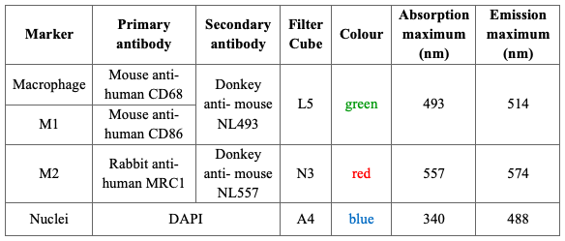
Table 5: Summary of the microscope settings for single and dual IF staining of carotid plaques

Image Analysis & Statistical Analysis
Regions of interest were analysed across two sections with Fiji. The percentage of macrophages (CD68+) which were single positive CD68+CD86+MRC1- or CD68+CD86-MRC1+, double positive CD68+CD86+MRC1+ or double negative CD68+CD86-MRC1- was calculated.
Raw images of the plaque shoulder region from separate fluorescence channels (L5, N3, A4) were exported from LASAF software as a .tiff file to Fiji (Figure 12). The dual stained green channel was changed to blue colour (Image › Lookup Table › Blue) to improve separation of the single and dual images’ green colour. The blue and red channels of dual stained images were merged to create the dual stained composite image with the ‘Merge Channels’ (Image › Colour › Merge Channels) function. The workflow of the imaging is shown below: 1A through D.
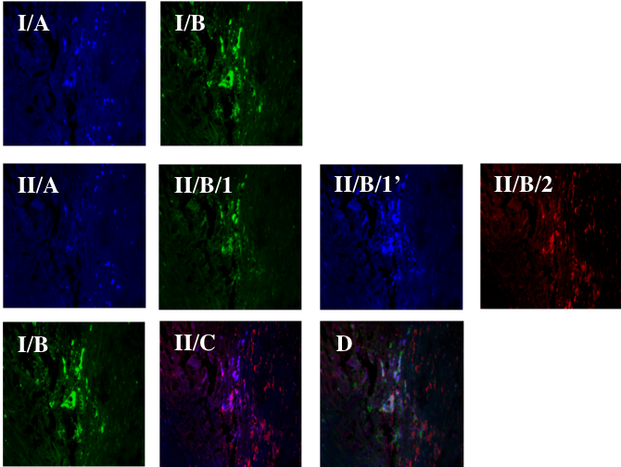

Figure 12: An example of immunofluorescence-stained image analysis
I/A: single IF stained image with blue nuclei on A4 channel; I/B: single IF stained image with pan macrophage green marker on L5 channel; II/A: dual IF stained image with blue nuclei on A4 channel; II/B/1: dual IF stained image with positive CD86 marker on L5 channel; II/B/1’: positive CD86 marker changed to blue colour on dual IF stained image; II/B/2: dual IF stained image with positive MRC1 marker on N3 channel; II/C: composite image of II/B/1’ and II/B/2 layers; D: overlaid and aligned image of I/B and II/C (green- macrophage, blue- M1, red-M2)

A ‘TrakEM2 blank’ new file (File › New › TrackEM2 blank) was opened, the green CD68 and dual composite image were dropped to the canvas window and accurately aligned with the transform affine function (Transform › Transform Affine › Apply Transform).
The aligned image could be separated into the single stained green channel, while the dual stained was split into blue and red channels (Image › Colour › Split Channels) (Figure 13). CD68 positive macrophages were selected based on hue, saturation and brightness (Image › Adjust › Colour threshold). Positive cells are highlighted in the selected threshold colour. The ‘Analyse particles’ tool was used to mark and analyse ROI based on size and circularity. All particles between 300-100000 pixels were highlighted. With this range, cell debris and junk could be excluded, moreover, only those cells which had nuclei were analysed. All the outlined cells are CD68+ macrophages and listed in ROI manager, where with the measure function, the mean intensity values of the cells were calculated. The separated green/blue channel of the dual stained images was opened, ‘colour threshold’ used to select the positive staining, the outlines of positive CD68+ cells from ROI manager were overlaid and the mean intensities were measured. These steps were repeated on the separate red channel. All fluorescence intensity data were visually evaluated to ensure true positive values then used to determine if a CD68+ positive macrophage was positive for either or both M1 (CD86) or M2 (MRC1) markers.

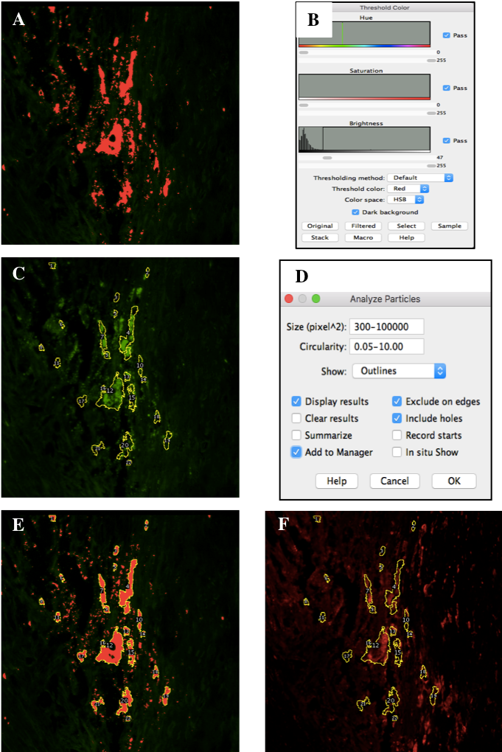

Figure 13: A representative example of the qualitative aspects of the image analysis workflow
A: Positive CD68 cells marked with red based on B: Colour Threshold; C: Outlined ROI with yellow done with D: Analyse Particles tool. E: Overlaid ROI on CD86 stained image; F: Overlaid ROI on MRC1-stained image.

Single-cell analysis of human carotid plaques

Modified histological protocol to maintain RNA integrity
The previous histological steps (decalcification, embedding, IF stain) degrade RNA (Wang, 2006) and these steps were modified to preserve RNA integrity.
The modifications were as follows. The carotid plaque decalcification was performed with Diethyl Pyrocarbonate (DEPC) (Merck) treated 0.5 M EDTA (Fisher Scientific) pH8 and RNase Inhibitor (Merck) was added to this solution (1:200) to prevent further RNA degradation. Embedding was performed with DEPC treated alcohols. Sections were first placed on a Zeiss polyester (PET) membrane frame slide because this was the chosen microscope slide for LCM work (Figure 14). During CD68 IF staining, all solutions were made with DEPC treated water plus RNase Inhibitor. The mounting step was omitted in the two following cases. For RNA quality control experiments, RNA was isolated with a RNeasy UCP (Ultra-Clean Production) Micro Kit (Qiagen) directly after the IF staining, according to the manufacturer’s instructions. For LCM experiments, the stained tissue was covered with PBS and the frame was covered with glass coverslips.


Figure 14: Zeiss PET membrane frame slide used for LCM scRNA-seq
(picture from: Carl Zeiss MicroImaging PALM Protocols- RNA handling)

RNA quality control with Real Time quantitative PCR
RNA isolation was performed within 15 minutes after IF staining from Zeiss membrane-covered, metal frame slides. The purpose of this step was to measure RNA integrity before LCM scRNA-seq. A silica technology-based RNeasy UCP Micro Kit was used according to the manufacturer’s instructions because it is designed for total RNA extraction (up to 45 µg) from small or law biomass samples (5 x 10⁵ cells) in a small elution volume (10-20 µl).
cDNA synthesis and real time quantitative polymerase chain reaction (RT-qPCR) were performed as summarised in 2.6.7 with glyceraldehyde 3-phosphate dehydrogenase (GAPDH) and CD68 specific primers.

RNA quality control with bioanalyzer analysis and pilot sequencing
The same RNA samples (2.5.2) were sent to our collaboration partner (Mutagenesis & Carcinogenesis Research Group, Biological Research Centre, Szeged, Hungary) where cDNA synthesis (and library preparation) was performed, using the SMART-Seq v4 Ultra Low Input RNA Kit for Sequencing (Takara Bio). The cDNA arising from this was diluted into 3 different concentrations, 10 ng, 100 pg and 10 pg (similar to the DNA quantity of 1 cell, in terms of scale) (Gillooly, 2015). The quality and quantity of the diluted cDNAs were tested on Agilent 2100 Bioanalyzer with a high sensitivity DNA assay kit.
Pilot sequencing was performed in Hungary by our collaboration partner with 0.1M single reads with Illumina NextSeq high-throughput sequencing system.

PET membrane pre-treatment before tissue sectioning
PET membrane frame slide pre-treatment was essential before tissue sectioning to enhance tissue adhesion to the slide. For this, slides were washed in 70% (v/v) ethanol (EtOH) for 30 minutes and then rinsed with DEPC treated H₂O. Slides were then UV treated for 1 hour in a hood from a maximum of 5 cm distance. Sterile poly-L-lysine was added to the membrane and the slides were dried in a 37°C incubator for 30 minutes.

Laser Capture Microdissection
After CD68 IF staining in Sheffield, UK (2.5.1), samples were transported to Hungary and Laser Capture Microdissection was completed by me in our collaboration partner’s laboratory (Péter Horváth Laboratory, Biological Research Centre, Szeged, Hungary). Scanning was performed with a Leica SP8 LIGHTNING confocal microscope and LAS X software. The macrophage rich plaque shoulder region was located using a 5x objective and 4 marker points were made with a Leica LMD6 Laser Microdissection Microscope (Figure 15). A marked ROI was screened using the 20x objective on the confocal microscope (Figure 15).

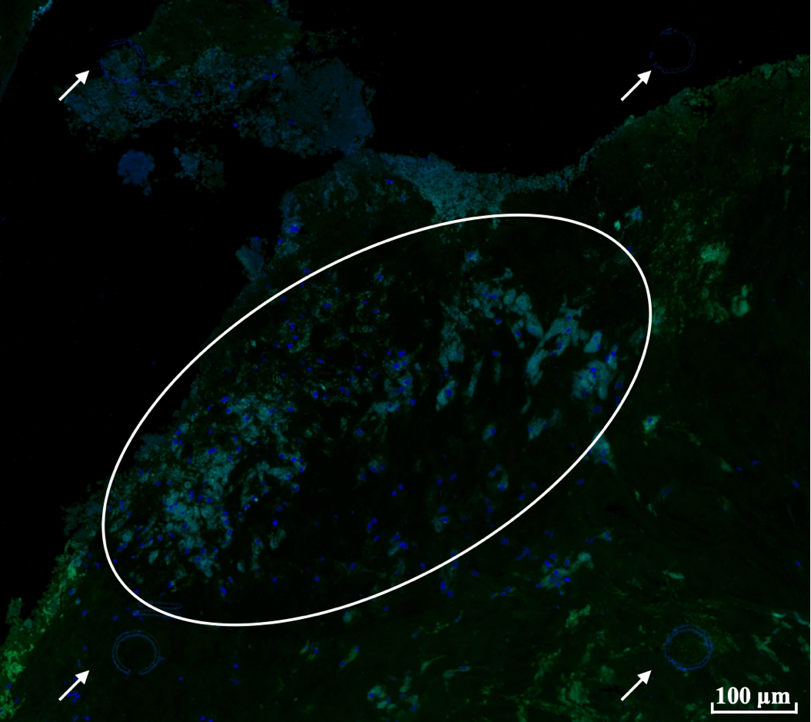

Figure 15: Representative image of LCM marker points on IF stained human carotid plaque sample
White arrows indicate the laser cut marker point; white circle shows ROI.

Correlative Light Light Microscopy (CL2M) software was used to detect and indicate cell contours of positive macrophages (green fluorescent signal) (Figure 16). Data (cell contours) were exported and uploaded to the LMD6 microscope’s software and with the help of the marker points, cell contours were matched. Marked cells were laser cut and collected in the caps of UV treated Leica PCR tubes (Figure 16).

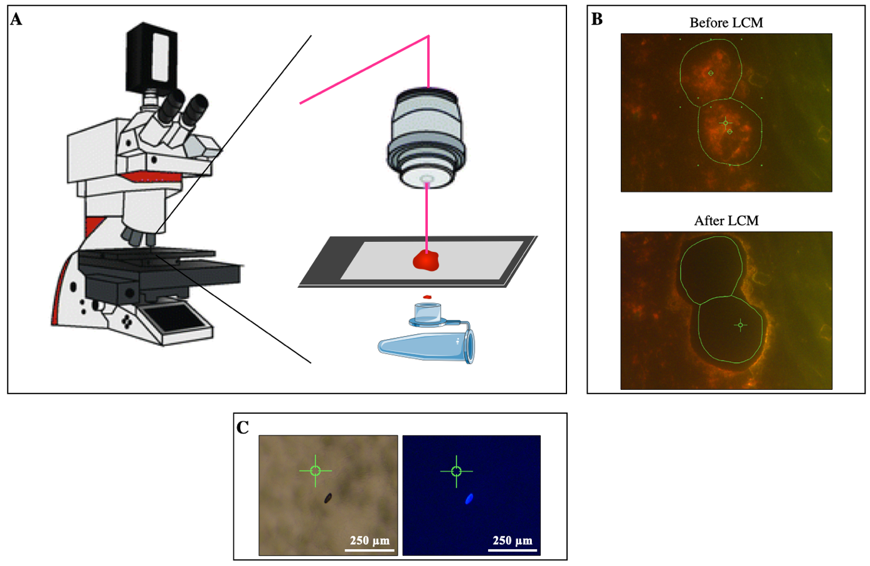

Figure 16: Methodological overview of Laser Capture Microdissection
Leica LMD6 Laser Microdissection Microscope used to cut out the CD68+ macrophages from the IF stained FFPE tissue. A: Overview of LCM. B: Outlines exported from CL2M, top picture: before LCM, bottom picture: after LCM. C: PCR cap check with BF and IF channels after LCM

RNA quality control with sequencing after LCM
After LCM, cDNA was synthesised in the Mutagenesis & Carcinogenesis Research Group (Biological Research Centre, Szeged, Hungary), using the SMART-Seq v4 Ultra Low Input RNA Kit for Sequencing (Takara Bio) by our collaboration partner. With this kit cDNA synthesis can be performed directly from intact cells with high reproducibility. Provided control total RNA (RIN›8) was used as a positive control according to cell number.
Tagmentation (transposon cleaving and tagging of the double-stranded DNA with a universal overhang) was performed according to the manufacturer’s protocol and during PCR amplification, indexed primers and complementary adapters were used. Ampure XP beads were used for library clean-up. Quality control was performed on Agilent 2100 Bioanalyzer with a high sensitivity DNA assay kit.

Quality control of DNA with PCR and agarose gel electrophoresis
To further test the LCM settings, nucleic acid integrity was tested by me. Individual cells or tissue areas were collected in 7 µl catapult buffer (900 µl Milli-Q water; 100µl 1xTE buffer /pH:8/; 0.01% Igepal) and centrifuged at 500 g. Before the PCR, Qiagen protease was used according to the manufacturer’s instructions. For the direct PCR, TP53 primers (designed and optimised by the Mutagenesis & Carcinogenesis Research Group) and Q5 high-fidelity DNA polymerase was used. To verify PCR products, gel electrophoresis was performed with 2% (w/v) agarose gel containing ethidium bromide and visualised using transillumination.

cDNA library preparation and sequencing
In this section, I briefly summarise the steps of the chosen method for library preparation and sequencing which was performed by Mutagenesis & Carcinogenesis Research Group (Biological Research Centre, Szeged, Hungary).

To capture degraded RNA inputs from FFPE samples, a SMARTer Stranded Total RNA-Seq Kit v2 - Pico Input Mammalian kit (Takara Bio) was used according to supplementary protocol for processing intact-cell inputs. For the NGS-based analysis, cDNA was generated from total RNA with the random priming technique after ribosomal RNA (rRNA) was removed with RiboGone technology (Takara Bio).
Following library preparation, the MiniSeq System was used to sequence samples which works with Illumina NGS technique. Libraries were loaded into the MiniSeq System and sequencing was automated.

Bioinformatic analysis of single macrophages microdissected from human carotid plaques
Here, I summarise the steps of the bioinformatic analysis which was performed by Sumeet R Deshmukh (supervisor: Dr Ian Sudbery).
First, the quality of the sequences was checked with FastQC and adapter sequences were removed with Trimmomatic, a flexible trimmer for Illumina sequence data (Bolger et al., 2014). Then reads were mapped with HG38 human genome using the STAR alignment method as it is one of the most reliable algorithms for RNA-mapping. Annotations of the aligned files were checked using the bam2stats customized CGAT pipeline. FeatureCounts, an R package, was used to extract the read counts from bam files.
Unstimulated and M1 macrophage datasets from GEO (GSE81046) (Nédélec et al., 2016) was downloaded to compare it to the read counts of my single-cell macrophage dataset. Unstimulated macrophages were further mapped using a Salmon-pseudo mapping aligner against HG38 which provides the output with quantified reads counts. Then, the top 100 highly expressed atherosclerosis plaque single-cell genes read counts were compared with the data from macrophage datasets.
Moreover, to check the classification of the single-cell dataset the following methods and datasets were used:
- For classification between macrophages and smooth muscle cells 2 datasets were used.
  - macrophages: hMDM dataset generated by Kajus Baidzajevas, a former PhD student (unpublished)
  - smooth muscle cells: GEO dataset (GSE144274) (Gorr et al., 2020)
- Statistical analysis was performed by using EdgeR.
- Data was plotted on a dendrogram, based on genes that are statically significant in all 3 datasets: single cells from human atherosclerotic plaque, hMDMs, smooth muscle cells
- The distance for the dendrogram was calculated using the Euclidean method.

In vitro Macrophage Subsets

Peripheral blood mononuclear cells (PBMCs) were prepared, differentiated and cultured following previously established methods (Geng and Hansson, 1992) which were further optimised by our research group (Baidžajevas et al., 2020). In the following chapters (2.6.1- 2.6.4), I summarise the optimised protocol used for this thesis.

PBMC isolation
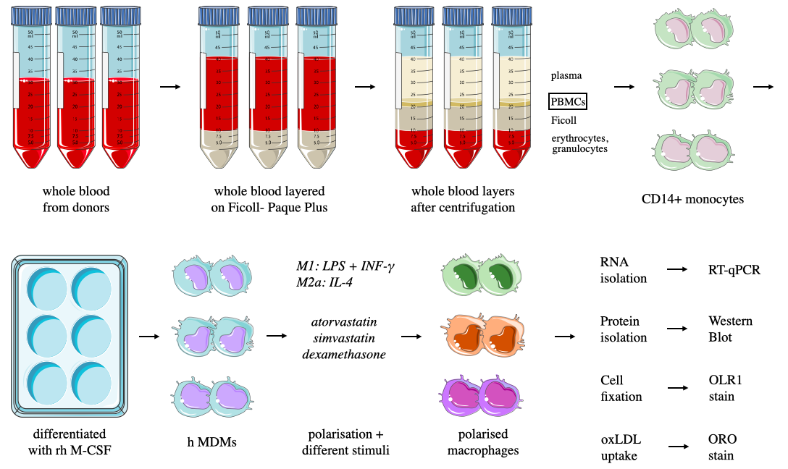
PBMCs were isolated from whole blood donated by healthy adult donors (typically 80 ml per donor for the experiments in this thesis). Blood was taken by venepuncture and dispensed into tubes which already contained 3.8 % (w/v) trisodium citrate dihydrate (Fisher Scientific). The blood to citrate ratio was approximately 9:1. After mixing by inversion, whole citrated blood was layered carefully onto Ficoll-Paque Plus (GE Healthcare, Life Sciences) in 2:1 ratio in three 50 ml Falcon tubes (Figure 17). After overlaying the blood, the tube was centrifuged at 900 g, at room temperature for 20 minutes with acceleration and brake set at 1. The upper plasma layer was discarded and then the layer of PBMCs were collected and transferred into a sterile 50 ml tube containing 5 ml 1x phosphate-buffered saline- EDTA (2mM) (PBSE). Cells were then centrifuged at 400 g, at room temperature for 5 minutes. The resulting soft cell pellet was resuspended by pipetting in 10 ml red blood cell (RBC) lysis buffer (155 mM NH₄Cl, 10mM KHCO₃, 0.1mM EDTA) and incubated for 5 min at room temperature. The suspension was topped up to 50 ml with PBSE and centrifuged at 400 g, at room temperature for 5 minutes. The cell pellet was resuspended in 40 ml PBSE and the cell number was counted using a haemocytometer.

Figure 17: Workflow of in vitro cell work
PBMCs were isolated from 80 ml whole blood. CD14+ monocytes were selected and differentiated with rh M-CSF. Human MDMs were treated with atorvastatin, simvastatin or dexamethasone in different clinically relevant concentrations.

CD14+ monocyte isolation
The PBMC suspension was centrifuged at 400 g, at room temperature for 5 minutes. The PBMC pellet was resuspended in 90 μl cold MACS buffer (0.5% (w/v) bovine serum albumin (BSA) in PBSE) followed by addition of 10 μl CD14 microbeads (Miltenyi Biotec) per 10 million PBMCs and incubation for 15 minutes at 4 °C. A further 2 ml MACS buffer was then added, and the solution centrifuged at 300 g, at room temperature for 5 minutes. The cell pellet was resuspended in 500 μl MACS buffer avoiding making bubbles whilst doing so. Magnetic separation was carried out by LS columns (Miltenyi Biotec). Columns were washed with 3 ml of cold MACS buffer before the 500 μl cell suspension was added. The column was then rinsed 3 times with 3 ml of cold MACS buffer. After removal of the column from the magnet, the cells were flushed out with 4 ml MACS buffer into 6 ml MACS buffer in a sterile 15 ml tube (total volume: 10 ml). The cell number was counted using a haemocytometer.

Macrophage differentiation
The CD14+ cell suspension was centrifuged at 400 g, at room temperature for 5 minutes. The cell pellet was resuspended at the desired cell density in complete media and cultured at 37°C with 5% CO₂ (Table 6). The culturing media (RPMI-1640, Gibco) was supplemented with 10% (v/v) ultra-low endotoxin heat-inactivated fetal bovine serum (FBS) (Pan Biotech), 1% (v/v) L-glutamine (Gibco), 1% (v/v) Penicillin-Streptomycin (Gibco). MDMs were differentiated in this complete media on plastic wells with the addition of 100 ng/ml recombinant human Macrophage Colony Stimulating Factor (rh M-CSF, Gibco) for 7 days (Figure 18). PBMC, CD14+ monocyte isolation and macrophage differentiation protocols were developed, based on a previously established method by Geng and Hansson (1992).

Table 6: Summary of the differentiation conditions used in further techniques
Method | Cell Density | Cell Culture Plate
RT-qPCR | 500.000/ well | 6-well plate (Jet Bio-Filtration)
Western Blot | 500.000/ well | 6-well plate (Jet Bio-Filtration)
oxLDL accumulation | 200.000/ well | 12-well plate (Jet Bio-Filtration)
OLR1 IF stain | 100.000/ well | chamber slide (Thermo Fisher)
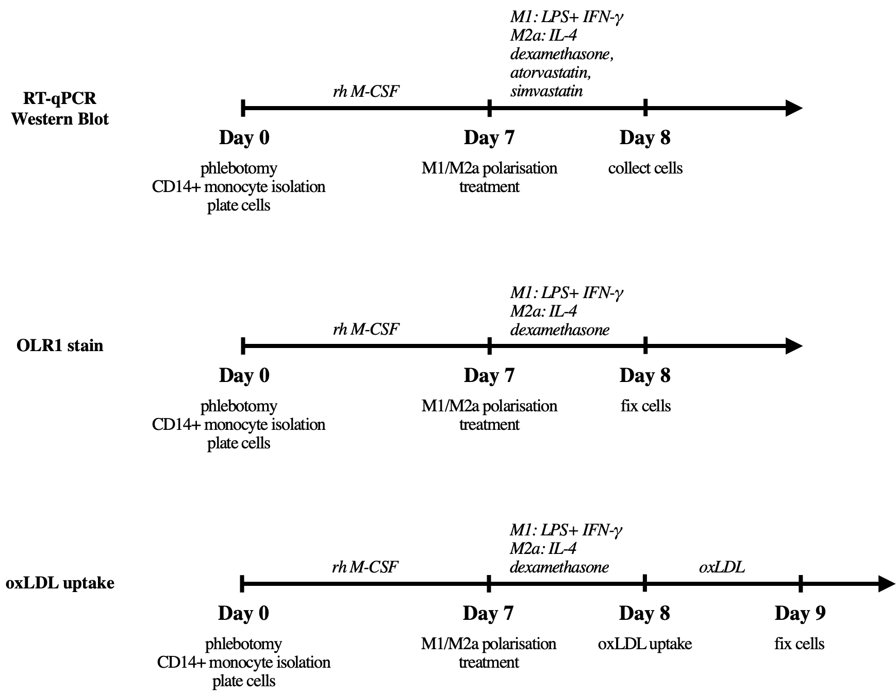

Figure 18: Summary of the in vitro experiments
The three timelines show the performed experiments on different days for RT-qPCR, Western Blot, OLR1 stain and oxLDL accumulation.

Macrophage polarization
After differentiation (Day 7), the polarization of M1 and M2a macrophages was performed on Day 7 of differentiation by culturing cells for 24 hours in fresh complete media supplemented with specific polarising factors (summarised in Table 7).
Cells steered towards M1 macrophages were polarised by LPS (100 ng/ml, Enzo Life Sciences) and interferon gamma (INF-γ) (20 ng/ml, Pepro Tech). Cells steered towards M2a phenotype were polarised using IL-4 (20ng/ml, Pepro Tech). In each of the following assays, unpolarised macrophages (M0) were used as controls.

Macrophage treatment with statins and dexamethasone
Macrophage treatment with clinically relevant statin concentrations was performed on day 7 by culturing cells for 4 hours in fresh complete media supplemented with atorvastatin (30 ng/ml, 70 ng/ml, Merck) (Lins, 2003) and simvastatin (6 ng/ml, Merck) (Neuvonen et al., 2008). After this, cells were polarized with M1 or M2a markers in addition to the statins for 24 h.
Macrophage polarisation with dex (Merck) was performed in fresh complete media supplemented with 3 different clinically relevant concentrations of dex 8 ng/ml, 14 ng/ml, 125 ng/ml (Loew, 1986). After all polarisations, cells were washed twice with PBS 1X and prepared for further experiments.

Table 7: List of macrophage polarization markers with working concentration and polarization time
Name | Differentiation with 100 ng/ml rh M-CSF (days) | Polarization markers/stimuli with final concentrations | Polarization time (hours)
M1 | 7 | LPS: 100 ng/ml + INF-γ: 20 ng/ml | 24
M2a | 7 | IL-4: 20ng/ml | 24
dexamethasone | 7 | 8; 14; 125 ng/ml | 24
atorvastatin | 7 | 30; 70 ng/ml | 4 + 24
simvastatin | 7 | 6 ng/ml | 4 + 24

RNA isolation
RNA was isolated using RNeasy UCP Micro Kit (Qiagen) according to the manufacturer’s instructions.
RNA concentration was measured using spectrophotometric analysis (Nanodrop), measuring the absorbance of each sample at 260nm.

cDNA synthesis and Real Time quantitative PCR
cDNA synthesis was performed by using the iScript cDNA synthesis kit (Biorad) according to manufacturer’s instructions. This kit operates an up to 15 µl of RNA sample in a 20 µl cDNA synthesis reaction. Reaction components and protocol are listed below in Table 8.

Table 8: cDNA synthesis reaction components (A) and reaction protocol (B)
A
Component | Volume / Reaction
5x iScript Reaction Mix | 4 µl
iScript Reverse Transcriptase | 1 µl
Nuclease-free water | Up to 20 µl
RNA template ›1 µg | variable
Total volume | 20 µl
B
Reaction Protocol
Priming | 5 min at 25°C
Reverse transcription | 20 min at 46°C
RT inactivation | 1 min at 95°C
Hold | 4°C
Storage | 4°C or -20°C

RT-qPCR was performed using a Precision PLUS qPCR Master Mix with SYBR Green (Primer Design) and results were analysed with CFX384 C1000 Touch Thermal Cycler (Biorad). Primer sequences and qPCR cycle conditions are summarised in Table 9. Primers were designed and checked for specify using the BLAST Primer Design Tool (https://www.ncbi.nlm.nih.gov/tools/primer-blast/) and purchased from Merck.
Data was plotted from individual donors, normalized to GAPDH housekeeping gene and analysed with two-tailed paired t test after normality test. In all the graphs, the direction of change in expression is shown with the treatment as an arrow for each individual donor.

Table 9: Real Time qPCR cycle conditions (A) and primers (B) for testing of human genes
A

Steps | Settings
Polymerase activation  Denaturation | 95°C; 2 min
Amplification | 40 amplification cycles:  95°C; 15 secs  60°C; 1 min
Melting Curve Analysis | 60°C- 95°C/ 0,5°C  Increment

Name | Sequence | Length (nt) | Tm  (°C) | GC  %
GAPDH Fwd | ATTGCCCTCAACGACCACTTT | 21 | 52 | 48
GAPDH Rev | CCCTGTTGCTGTAGCCAAATTC | 22 | 55 | 50
CD68 Fwd | AAGGGGGCTCTTGGGAACTA | 20 | 54 | 55
CD68 Rev | CCAAGCCCTCTTTAAGCCCC | 20 | 56 | 60
CD86 Fwd | CCCAGACCACATTCCTTGGAT | 21 | 54 | 52
CD86 Rev | TCCCTCTCCATTGTGTTGGT | 20 | 52 | 50
MRC1 Fwd | CCATCGAGGAAGAGGTTCGG | 20 | 56 | 60
MRC1 Rev | GGGTGGGTTACTCCTTCTGC | 20 | 56 | 60
OLR1 Fwd | TGCGACTCTAGGGGTCCTTTG | 21 | 56 | 57
OLR1 Rev | TGTTAGGAGGTCAGACACCTGG | 22 | 57 | 55
MSR1 Fwd | CGAGGTCCCACTGGAGAAAGT | 21 | 56 | 57
MSR1 Rev | CAATTGCTCCCCGATCACCTTT | 22 | 55 | 50
CD36 Fwd | TCTGTCCTATTGGGAAAGTCACTG | 24 | 56 | 46
CD36 Rev | GAACTGCAATACCTGGCTTTTCTC | 24 | 56 | 46
SCARB1 Fwd | GAATCCCCATGAACTGCTCTGT | 22 | 55 | 50
SCARB1 Rev | TCCCAGTTTGTCCAATGCCTG | 21 | 54 | 52
B

Cell lysis and BCA Assay
A BCA Assay was used for quantification of total protein before western blotting. Polarized cells were lysed overnight in radioimmunoprecipitation assay (RIPA) buffer (Merck) in the presence of phosphatase inhibitors (PhosSTOP, Roche) and protease inhibitors (Protease Inhibitor Cocktail, Merck) as per manufacturer’s instruction. Cells were sonicated in an ultrasonic bath (Fisherbrand) for 20 minutes to complete cell lysis. Cell lysates were centrifuged at 20.000 g, 4°C for 20 minutes and the supernatant which contains the total protein was transferred to a new tube and cell pellet was discarded.
Protein concentration was determined with Pierce BCA Protein Assay Kit (Thermo Fisher Scientific) which was used according to the manufacturer’s instructions. Varioskan Flash plate reader (Thermo Fisher Scientific) was used to measure OD at 562 nm.

Western blot
15 μg of sample protein was added to NuPage LDS Sample Buffer (4x) (Invitrogen) up to a final volume of 20 μl and incubated at 70°C for 10 minutes. Equal amounts of protein sample (10 μl) were loaded into the wells of a NuPAGE 4-12% Bis-Tris SDS-PAGE Gel (Invitrogen) together with a standard protein size marker (SeeBlue, Plus2 Prestained Standard, Invitrogen). Electrophoresis was performed at 120V for 70 minutes in NuPAGE MES SDS Running Buffer (Novex, Invitrogen). Proteins were then transferred onto a nitrocellulose membrane at 35 V for 60 minutes in NuPAGE Transfer Buffer (5% (v/v) 20x transfer buffer, 0.1% (v/v) antioxidant, 20% (v/v) methanol. NuPAGE Antioxidant (Novex, Invitrogen) was added to the Transfer Buffer (0.1% (v/v)) to enhance the transfer of proteins to membranes. Transfer efficiency was further determined by staining the membrane with Red-Ponceau S Solution (Merck) for 5-10 minutes at room temperature (this step is optional). The membrane was washed in TBST (Tris Buffered Saline pH 8.0 powder dissolved in 1 litre of distilled water and 0.1% (v/v) Tween 20, Merck) and blocked at room temperature for 1 hour in 5% (w/v) milk TBST.
The membrane was incubated at 4°C overnight with primary antibody (OLR1, Abcam) diluted in 5% (w/v) milk TBST (summarized in: Table 10). After incubation the membrane was washed 3 times for 5 minutes in TBST and incubated with the horseradish peroxidase (HRP) conjugated secondary antibody (Agilent) diluted in 5% (w/v) milk TBST at room temperature for 1 hour. The membrane was washed again 3 times for 5 minutes in TBST.
Specific protein bands were detected by the addition of a chemiluminescent substrate (SuperSignal™ West Pico PLUS Chemiluminescent Substrate, Thermo Fisher) and using the ChemiDoc XRS+ Imaging System (Biorad).
In order to use different primary antibodies (i.e., housekeeping: GAPDH, Santa Cruz Biotechnology) the membrane was stripped in ReBlot Plus Strong Antibody Stripping Solution 1X (Millipore) for 20 minutes at room temperature. Membrane was re-blocked at room temperature for 1 hour in 5% (w/v) milk TBST before the usage of new primary and secondary antibodies.
Results were analysed in Excel through Image Studio Lite version 5.2.5. First, the intensity for each protein band was calculated with background subtraction. Intensity was normalised for each test samples (adjusted intensity _{protein of interest} / adjusted intensity _{housekeeping}).

Table 10: Primary and secondary antibodies for western blotting
Primary antibody | Working concentration | Secondary antibody | Working concentration
Rabbit Polyclonal OLR1 (Abcam) | 1:500 | Polyclonal Goat Anti-Rabbit Immunoglobulins/  HRP (Agilent) | 1:2500
Mouse Monoclonal GAPDH (SCBT) | 1:5000 | Polyclonal Goat Anti-Rabbit Immunoglobulins/  HRP (Agilent) | 1:5000

oxLDL accumulation in MDMs, Oil Red O Staining, microscopy and analysis
To detect the oxLDL accumulation in cells, human MDMs were plated and polarized in 12 well plates. After 1 day of polarization in the presence of dex, cells were washed 3 times with PBS 1X and human oxLDL was added for 24h (working concentration: 25 μg/ml; Thermo Fisher).
Oil Red O (ORO) staining was used to detect lipid accumulation in cells (Xu, 2010). After oxLDL accumulation, cells were fixed with 4% (w/v) PFA (Merck) at room temperature for 30 minutes, washed 3 times with PBS 1X and stored at 4°C until further work.
To prepare the stock of ORO solution 0.3 g ORO powder (Merck) was dissolved in 100ml isopropanol (Fisher Scientific). For the preparation of the working solution, a 6:4 dilution was made with distilled water then filtered using Whatmann grade 1 filter paper and used immediately for best results.
Prior to staining, cells were rinsed with water, then with 60% (v/v) isopropanol. 1 ml of ORO working solution was added to the cells for 15 mins, then removed and rinsed with 60% (v/v) isopropanol and washed at least 3 times with distilled water. Haematoxylin ((Fisher Scientific) counterstain was used. Cells were covered with distilled water and observed with a LeicaDMI4000B inverted microscope with Leica Application Suite Advanced Fluorescence (LASAF) v2.63 software (Microscopy Core Facility) was used.

OLR1 IF stain, microscopy and analysis
Human MDMs were plated and polarized in 8-well chamber slides (Thermo Fisher) and stained to detect the OLR1 which binds oxLDL. Immediately after polarization, cells were fixed with 4% (w/v) PFA at room temperature for 30 minutes, washed 3 times with PBS 1X and stored at 4°C until further work.
Cells were permeabilized with 0.1% (v/v) Triton PBS for 15 minutes, washed 3 times with PBS 1X, then blocked with 2% (w/v) BSA-PBS for 45 minutes at room temperature and washed 3 times with PBS 1X. Cells were incubated with rabbit polyclonal OLR1 primary antibody (Abcam) (1:200) for 1 hour at RT. After washing 3 times with PBS 1X, positive stain was detected by donkey anti-rabbit IgG-NL557 conjugated antibody (R&D Systems). ProLong Gold Antifade Mountant with DAPI (Thermo Fisher Scientific) was used to mount the sections and counterstain the nuclei.
Images were captured using Leica AF6000LX inverted microscope and with Leica Application Suite Advanced Fluorescence (LASAF) v2.63 software (Microscopy Core Facility).

Chapter 3.
Different Macrophage Subsets in Human Carotid Atherosclerotic Plaques

Introduction
Stroke is the second leading cause of death and one of the leading causes of disability and dementia worldwide (Deb et al., 2010). It is a neurological condition caused by vascular occlusion due to atherosclerosis in the central nervous system and has two main types: ischaemic and haemorrhagic stroke. Ischaemic stroke has several aetiologies, the most common of which is large artery atherosclerosis (e.g., arising from the carotid arteries). In this process, arteries become occluded by thrombus in situ or embolization from a distant ruptured plaque. Other mechanisms for ischaemic stroke include small vessel disease (hyalinosis) and cardio embolism e.g., due to atrial fibrillation or heart valve disorders. Other causes of ischaemic stroke include arterial dissection or vasculitis (TOAST classification) (Spence et al., 2020). Carotid stenosis can be treated with endarterectomy which is where atherosclerotic plaque is surgically removed (Wijeyaratne et al., 2002).
Atherosclerosis is a pathological chronic inflammatory process and commonly leads to myocardial infarction and ischaemic stroke (Ross, 1999). During this pathological disorder, lipoproteins, cholesterol, calcium and apoptotic cells build up to form a lipid-rich plaque within an artery. Atherosclerotic plaques can be classified as histologically stable or unstable based on the American Heart Association grading scale (see section: 1.2.11), depending on different histological features, such as the extent of inflammation, composition and the thickness of fibrous cap. I have collected carotid plaques with ethical permission from advanced lesions: type IV- lipid core atheroma, type Va- multilayer fibrous atheroma, type Vb- calcification, type Vc- fibrotic without lipid core, type VIa- rupture and type VIb- haemorrhage (Stary, 1994, Stary et al., 1995).
Inflammatory cells are main cellular components of the atherosclerotic plaques and macrophages participate in all stages of the plaque formation and progression (Daugherty et al., 2005, Chinetti-Gbaguidi et al., 2014). Macrophage subtypes within carotid plaques have been shown to be altered in unstable vs. stable plaques. Broadly, M1 macrophages are proinflammatory and promote atherogenesis as well as enhancing plaque instability. In contrast, M2 macrophages have regulatory and wound-healing properties including collagen synthesis and promote tissue repair (Chinetti-Gbaguidi et al., 2014). One macrophage can express both M1 and M2 markers, but this has not been studied in detail. Studies have described the cellular and molecular interactions in atherogenesis, however, the understanding of this process is continuously developing (Brown et al., 2017).

Hypothesis

Human M1 pro-inflammatory and M2 anti-inflammatory macrophage subtype ratios may differ between histologically classified stable or unstable carotid atherosclerotic plaques. The characterisation of these changes may lead to the identification of clinically useful diagnostic markers to direct the best treatment for patients.

Aims of this chapter:
- Histological classification of human carotid plaques based on stability and the AHA grading scale.
- Identify the most prone to rupture regions of human carotid plaques.
- Classify the different macrophage phenotypes with IF staining in the previously identified regions.

Results

In this chapter, different macrophage phenotypes within carotid plaque shoulder regions are described in detail. These plaque shoulder regions can be unstable and more prone to rupture (Richardson et al., 1989). Macrophage phenotypes within the shoulder regions were characterised with immunofluorescence microscopy. A novel IF protocol to simultaneously stain for M1 and M2 macrophages alongside an image acquisition and analysis strategy was then developed. I have used single IF with a pan macrophage polarisation marker (CD68), and dual IF with M1 (CD86) and M2 marker (MRC1). The regions of positive staining for CD68 were overlaid with the dual stained section and the prevalence of CD86+ and MRC1+ macrophages were quantified by Image J.

Patient demographics
I studied carotid plaques from patients with confirmed stroke; patient demographic and clinical data are summarised in Table 11. It is clear that stroke mostly happens in older age, usually over 60 years. The median age of the patients is 74 while their average age is 72.6 years. In this cohort, 69% of stroke patients are male and 82% of the patients were smokers or ex-smokers, which is a risk factor for stroke. High blood pressure is a leading risk factor for stroke and the 91% of the examined patients had this condition. The 36% of the patients had type 2 diabetes mellitus and none of these patients had atrial fibrillation. Previous stroke or TIA can predict a new ischaemic stroke (see section: 1.1.6), which happened with 2 patients. Patient 1 had two previous strokes and patient 3 also had two previous strokes, both within 2 years.
Desirable total cholesterol level is under 5.2 mmol/L and all patients are under this reference range (average: 3.8 mmol/L). Triglyceride level is healthy under 1.7 mmol/L and only one patient had higher level (2.0 mmol/L). HDL is the “good” cholesterol, which carries cholesterol from the body to the liver (see section: 1.6.3). The healthy range is above 1.53 mmol/L, and there is an increased risk factor under 1.03 mmol/L. 50% of the patients are in the average risk range, while 25% is in increased risk range for diseases. LDL is the cholesterol which can build the plaque in the arteries and its level is normal under 2.6 mmol/L, so patient 6 is in the increased risk range with higher then 12 mmol/L LDL level. Reference ranges from: (©2018 HEALTHTAB, 2018).

Table 11: Summary of patient demographic and clinical data
NA- Not available; All data are verified by hospital stuff and collected from patient’s clinical files.
Study ID | Age | Sex | Smoker | Type 2 DM | High Blood Pressure | Atrial Fibrillation | Previous stroke or TIA | Cholesterol (mmol/l) | Tri-glyceride  (mmol/l) | HDL (mmol/l) | LDL (mmol/l)
1 | 74 | male | ex | yes | yes | no | yes (2) | 3.1 | 1.5 | 0.96 | 1.50
2 | 76 | male | ex | no | no | no | no | 4.6 | 2.0 | 1.32 | NA
3 | 79 | male | yes | no | yes | no | yes (2) | 3.3 | 1.5 | 1.36 | NA
4 | 64 | male | ex | no | yes | no | no | NA | NA | NA | NA
5 | 70 | male | ex | yes | yes | no | no | NA | NA | NA | NA
6 | 86 | male | no | no | yes | no | no | 4.8 | 1.0 | 1.99 | 12.40
7 | 79 | male | ex | no | yes | no | no | NA | NA | NA | NA
8 | 61 | male | no | no | yes | no | no | 3.4 | NA | NA | NA
9 | 52 | female | ex | yes | yes | no | NA | NA | NA | NA | NA
10 | 86 | male | yes | no | yes | no | NA | NA | NA | NA | NA
11 | 72 | female | yes | yes | yes | no | NA | NA | NA | NA | NA

Histological Analysis
During this study, 13 plaques were collected, and 11 good quality human carotid plaques were analysed (2 were excluded because of poor quality (in 2 or more pieces)). As detailed in 2.3 Histological processing and assessment, plaques were divided into 3 mm thick regions to detect all histological features. All together, these 11 plaques were divided into 46 regions (A, B, C, D, E) based on their sizes and used to determine histological regions (Table 12). Regions were analysed and not whole plaques because this way most of the histological features are detectable (see section: 1.2.8) (Lovett et al., 2004c).
From the analysed regions, 26.1% were designated as definitely unstable, 26.1% as probably unstable, 26.1% as probably stable and 21.7% as definitely stable (Figure 19: A). Histological assessment was made by Professor S Kim Suvarna (Consultant Cardiac Pathologist) or Dr Jessica Redgrave as described in 2.3.5.
According to the AHA classification, 6.5% (n= 3 regions) of the samples grouped to the ‘IV: Lipid core atheroma’, 34.8% (n= 16 regions) were the ‘Va: Multilayer fibrous atheroma with core’, 8.7% (n= 4 regions) were in ‘Vb: calcification’, 17.4% (n=8 regions) were ‘Vc: Fibrotic without lipid core’, 15.2% (n= 7 regions) considered as ‘VIa: Rupture’ and 17.4% (n= 8 regions) within ‘VIb: Haemorrhage’ lesion type (Figure 19: B) (Stary et al., 1995).

Table 12: Stability and AHA classification of the collected plaques
Study ID | Section | Stability | AHA classification
1 | A | Probably unstable | VIa: Rupture
 | B | Definitely unstable | VIb: Haemorrhage
 | C | Definitely unstable | VIb: Haemorrhage
 | D | Probably unstable | VIb: Haemorrhage
 | E | Probably unstable | VIb: Haemorrhage
2 | A | Definitely unstable | VIb: Haemorrhage
 | B | Definitely unstable | VIb: Haemorrhage
 | C | Definitely unstable | VIb: Haemorrhage
 | D | Probably stable | Va: Multilayer fibrous atheroma with core
3 | A | Probably unstable | VIa: Rupture
 | B | Probably stable | Va: Multilayer fibrous atheroma with core
 | C | Probably stable | Va: Multilayer fibrous atheroma with core
 | D | Probably unstable | VIa: Rupture
4 | A | Probably unstable | VIa: Rupture
 | B | Definitely unstable | Va: Multilayer fibrous atheroma with core
 | C | Probably unstable | VIa: Rupture
 | D | Probably unstable | IV: Lipid core atheroma
5 | A | Probably unstable | VIb: Haemorrhage
 | B | Definitely unstable | VIa: Rupture
 | C | Definitely unstable | VIa: Rupture
6 | A | Probably stable | Vc: fibrotic without lipid core
 | B | Definitely stable | Va: Multilayer fibrous atheroma with core
 | C | Probably stable | Va: Multilayer fibrous atheroma with core
 | D | Probably stable | Va: Multilayer fibrous atheroma with core
7 | A | Probably stable | Va: Multilayer fibrous atheroma with core
 | B | Probably stable | Va: Multilayer fibrous atheroma with core
 | C | Probably stable | Va: Multilayer fibrous atheroma with core
 | D | Probably stable | Va: Multilayer fibrous atheroma with core
8 | A | Probably unstable | Va: Multilayer fibrous atheroma with core
 | B | Probably unstable | Va: Multilayer fibrous atheroma with core
 | C | Definitely unstable | Va: Multilayer fibrous atheroma with core
 | D | Definitely unstable | Va: Multilayer fibrous atheroma with core
 | E | Definitely stable | IV: Lipid core atheroma
9 | A | Definitely stable | Vc: fibrotic without lipid core
 | B | Definitely stable | Vc: fibrotic without lipid core
 | C | Definitely stable | IV: Lipid core atheroma
 | D | Definitely stable | Vc: fibrotic without lipid core
10 | A | Definitely unstable | Vb: calcification
 | B | Definitely unstable | Vb: calcification
 | C | Probably unstable | Vb: calcification
 | D | Probably stable | Vb: calcification
 | E | Probably stable | Va: Multilayer fibrous atheroma with core
11 | A | Definitely stable | Vc: fibrotic without lipid core
 | B | Definitely stable | Vc: fibrotic without lipid core
 | C | Definitely stable | Vc: fibrotic without lipid core
 | D | Definitely stable | Vc: fibrotic without lipid core

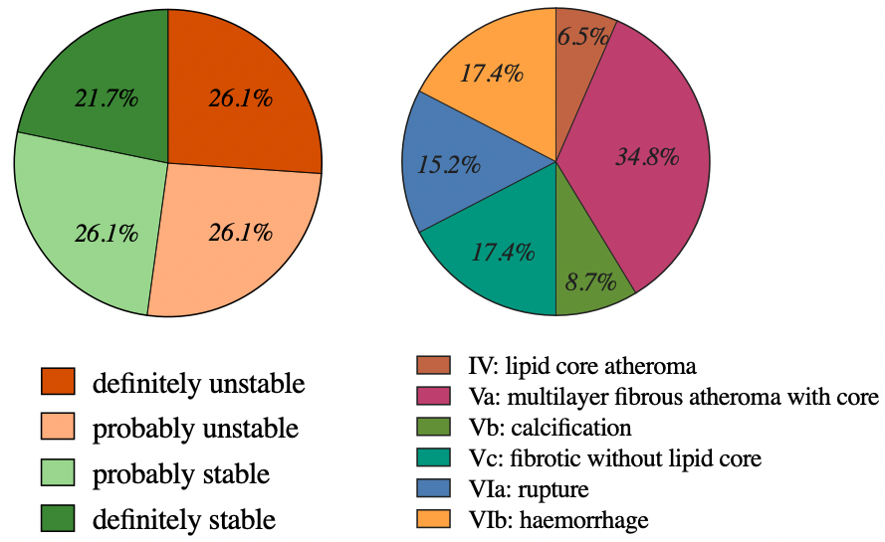
A
B

Figure 19: Summary of the histological features of the analysed human carotid plaques
The 2 pie charts show human carotid plaque classification based on overall stability (A) and according to the American Heart Association grading scale (B). Histological features were determined by Professor S Kim Suvarna (Consultant Cardiac Pathologist) and Dr Jessica Redgrave, after H&E, VVG, CD3 and CD68 staining. (n= 11 patients, 45 regions)

Macrophage phenotype characterisation in carotid plaques
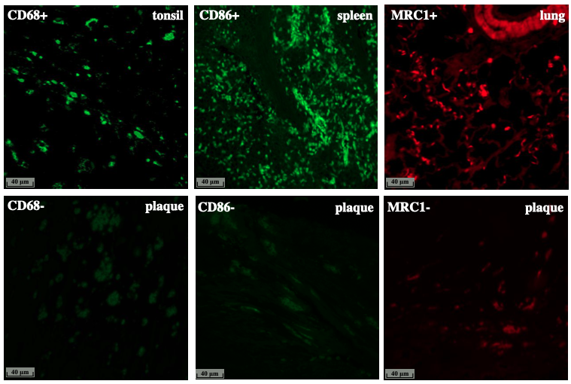
The plaque shoulder regions identified on 23 H&E stained sections (11 patients) were deemed the regions of interest (an unstable region prone to rupture (Richardson et al., 1989). Positive and negative control IF staining worked well and representative images are shown in Figure 20.
Figure 20: Representative images of positive and negative IF staining controls
Top row: Positive controls of CD68, CD86 and MRC1 markers on FFPE human tonsil, spleen and lung tissues. Bottom row: Negative controls of CD68 (mouse IgG), CD86 (mouse IgG), and MRC1 (rabbit IgG) on human carotid atherosclerotic lesions from stroke patients.

Macrophage phenotypes within the shoulder regions were characterised with immunofluorescence microscopy including simultaneous staining for M1 and M2 macrophages (2.4 Fluorescence Immunohistochemistry). The staining and image analysis was successful on all 23 plaque sections. Figure 21 shows a successful dual IF staining and 4 different macrophage phenotypes: M1 single positive (CD68+CD86+MRC1-), M2 single positive (CD68+CD86-MRC1+), double positive (CD68+CD86+MRC1+) and double negative (CD68+CD86-MRC1-) macrophages. Panels A and C show the IF-stained sections with cells indicated with dotted circles. These tile scan images are necessary to get whole view of the plaque and to identify the shoulder region. B and D panels show the previously identified shoulder regions of the single and dual IF stained sections with a higher resolution. CD68 antibody (green signal on single stained sections; panel: A and B) shows a little background staining and cell debris, but the brightest green signal indicates macrophages. The blue colour is DAPI staining which shows the cell nuclei.
On the dual stained samples (C and D panels) where the red immunofluorescence marker overlaps with the green signal of the single stained section (A and B panels), this indicates M2 single positive (CD68+CD86-MRC1+) macrophage, while the overlapping of the two green signals from single and dual stained images shows M1 single positive (CD68+CD86+MRC1-) macrophage. If both red and green colour are visible within a single cell, both CD86 and MRC1 are expressed, so identifies a double positive (CD68+CD86+MRC1+) macrophage. The last group are the double negative (CD68+CD86-MRC1-) macrophages, where one can observe the CD68 marker on the single stained slide, but not on the double stained one.

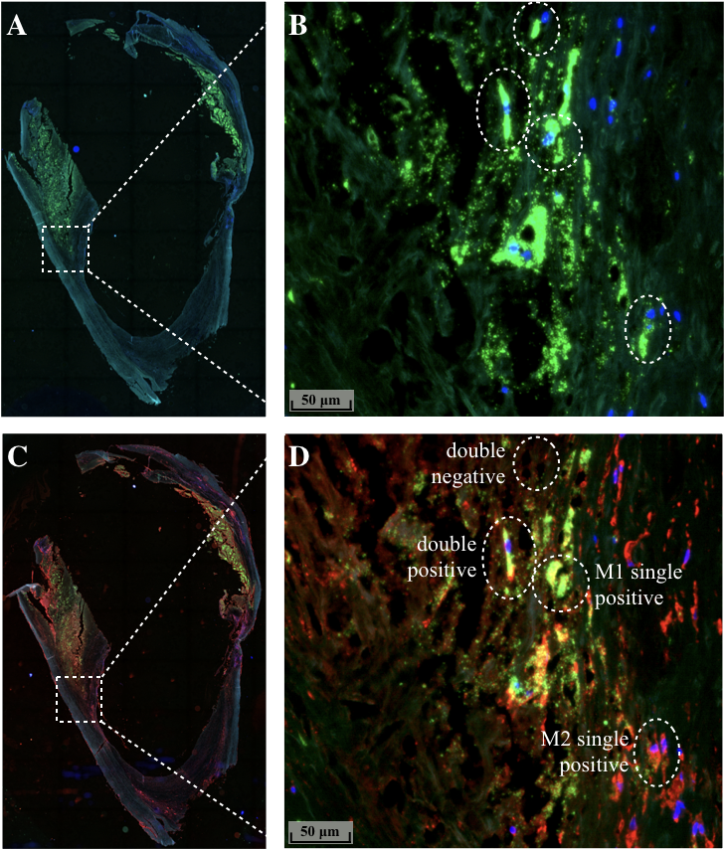
Figure 21: Representative images of single and dual IF staining of human plaque macrophages
IF stained FFPE human carotid atherosclerotic lesions from stroke patients. A, B: stained for pan macrophage marker: CD68 (green); C, D: simultaneously stained for M1: CD86 (green) and for M2: MRC1 (red). Positive staining was detected by incubating with Anti-mouse NL493 and Anti-rabbit NL557 (Northern Lights™, R&D Systems) and nuclei were counterstained with DAPI (blue). Images were captured using Leica inverted wide field fluorescence microscope AF6000LX. A, C: IF stained serially next, entire carotid sections. B, D: enlarged regions of the previously identified shoulder regions of the single and dual IF stained sections. Dotted circles indicate the 4 main macrophage types: double positive (CD68+CD86+MRC1+), double negative (CD68+CD86-MRC1-), M1 single positive (CD68+CD86+MRC1-) and M2 single positive (CD68+CD86-MRC1+) macrophages.

Double positive macrophage (CD68+CD86+MRC1+) phenotype is the most abundant in the shoulder regions of human carotid plaques
In the cohort of studied samples, the proportion of macrophages in carotid plaque shoulder regions is very different from previous studies, because those are separately stained for M1 or M2 markers (Stöger et al., 2012). Of the 11 analysed human patient plaques, an intact shoulder was identified in 11 lesions and in these regions, macrophages were abundant. Double positive (CD68+CD86+MRC1+) macrophages were present with the highest rate and account for 67.8% of all CD68+ macrophages. M1 single positive (CD68+CD86+MRC1-) macrophages account for 16.5%, while M2 single positive (CD68+CD86-MRC1+) macrophage make up 8.7% of all CD68+ macrophages. Double negative (CD68+CD86-MRC1-) macrophages represent 7.0% of all macrophages.
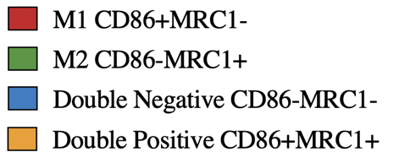
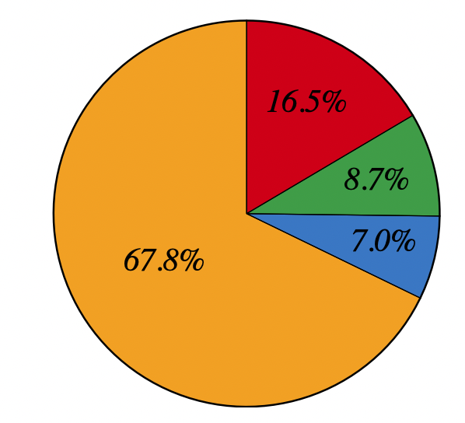
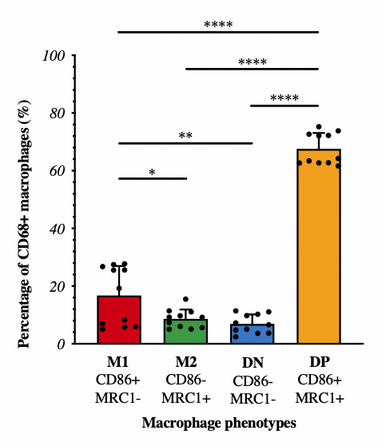
A
B

Figure 22: Percentage of different macrophage phenotypes in the plaque shoulder regions of human carotid plaques
The regions of positive staining for CD68 were overlaid with the dual stained section and the prevalence of CD86+ and MRC1+ macrophages were quantified by Image J and presented on A: pie chart and B: bar graph. The double positive (CD68+CD86+MRC1+) macrophage ratio is significantly higher than the other CD68+ cell groups. The proportion of M2 single positive (CD68+CD86-MRC1+) and double negative (CD68+CD86-MRC1-) macrophages is similar, while M1 single positive (CD68+CD86+MRC1-) macrophages account for 16.5% of all CD68+ cells. Data follow normal (Gaussian) distribution and Graphs present mean + SD, ordinary one-way ANOVA with Tukey’s multiple comparison test; each data point represents one patient; n=11 individual patient samples (1 single and 1 dual stained image per patient); p value: * ‹0.0332, ** ‹0.0021, **** ‹0.000; (DN= double negative, DP= double positive)

Macrophage phenotype distribution in stable and unstable carotid plaques
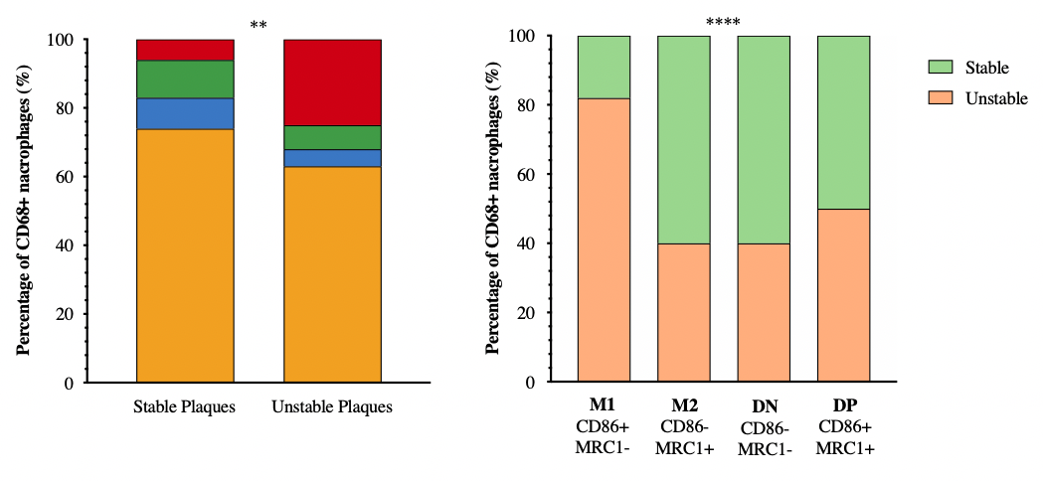
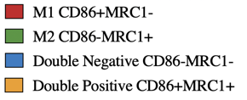
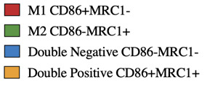
The following bar graphs (Figure 23) illustrate the proportion of different macrophage subsets in stable and unstable carotid plaques. Average cell counts and percentages were calculated from the different regions to get one data point per patient/lesion. Overall, data points were plotted from 6 unstable and 5 stable carotid plaques. It can be seen that M2 single positive (CD68+CD86-MRC1+), double negative (CD68+CD86-MRC1-) and double positive (CD68+CD86+MRC1+) macrophages are of a higher proportion in the stable plaques, while M1 single positive (CD68+CD86+MRC1-) macrophage ratio is significantly higher in unstable plaques.

Figure 23: Macrophage phenotype distribution in stable and unstable carotid plaques
Different macrophage phenotypes were determined with single (CD68) and dual (CD86, MRC1) IF stains. Data on grouped bar graphs is plotted from 6 unstable and 5 stable carotid plaques and analysed with Chi-square test to determine difference between groups; n=11 individual patient samples; p value: ** ‹0.0021, **** ‹0.000; (DN= double negative, DP= double positive)

Macrophage phenotype distribution in AHA lesion types
Classification and characterization of all histological features within carotid plaques using the American Heart Association grading scale are summarized in Table 12. The following graphs (Figure 24, Figure 25, Figure 26) outline the proportion of macrophage phenotypes in carotid plaque regions identified using specific AHA criteria. (If 2 regions are classified to different AHA types within 1 plaque sample, they are counted separately. If individual regions are described as the same AHA type within a plaque, average cell counts, and percentages were calculated.)
Within all AHA classified lesions (1.2.11) the percentage of double positive (CD68+CD86+MRC1+) macrophages is high, between 60-80% of all CD68+ macrophages. The percentage of M1 single positive (CD68+CD86+MRC1-) macrophage population is similar in type IV, Vb, VIa and VIb lesions (20-30% of all CD68+ macrophages) while in type Va and Vc lesions this is significantly lower (approximately 5 % of all CD68+ macrophages). M2 single positive (CD68+CD86-MRC1+) and double negative (CD68+CD86-MRC1-) macrophage populations are more represented in type Va, Vc lesions than in any other plaque types.
Only one carotid plaque region was characterized as type IV lesion, a lipid core atheroma. In this unstable region, 26% of the CD68+ cells are M1 single positive macrophages (CD68+CD86+MRC1-), which typically enhance instability (1.3.6). M2 single positive (CD68+CD86-MRC1+) and double negative (CD68+CD86-MRC1-) macrophages are rare in this lesion type, whilst the double positive (CD68+CD86+MRC1+) cells are the highest proportion at 64%.
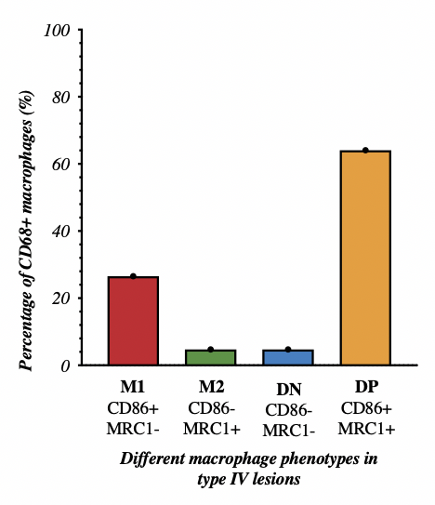

Figure 24: Percentage of different macrophage phenotype populations in type IV: lipid core atheroma lesion
Different macrophage phenotypes were determined with single (CD68) and dual (CD86, MRC1) IF stains and data is presented from type IV: lipid core atheroma lesion. M1 single positive (CD68+CD86+MRC1-) macrophage ratio (26%) is higher than M2 single positive (CD68+CD86-MRC1+) (5%) or double negative (CD68+CD86-MRC1-) (5%) macrophages. Each data point represents one patient, n=1; (DN= double negative, DP= double positive)

Four carotid plaque regions were described as type Va lesions: a multilayer fibrous atheroma with core (Figure 25). Three out of the 4 regions were considered stable and the proportion of the M1 single positive (CD68+CD86+MRC1-) macrophages was 6%, while in the unstable lesion region it is higher (19%). The M2 (CD68+CD86-MRC1+) and double negative (CD68+CD86-MRC1-) macrophage percentage was around 10% in all 4 samples. Double positive (CD68+CD86+MRC1+) macrophages were present of a significantly higher ratio than all other cell types, within these plaques.
Only one carotid plaque region was described as type Vb- calcification and two as type Vc-fibrotic without a lipid core. The main difference between these 2 types, was the ratio of the M1 single positive (CD68+CD86+MRC1-) macrophages, which arise since a calcified lesion is definitely unstable, while a plaque without lipid core is a bit more stable (Wang and Bennett, 2012). In type Vb lesion, M1 single positives (CD68+CD86+MRC1-) were presented at approximately 27% and M2 single positive (CD68+CD86-MRC1+) cells were only the 6% of all CD68+ macrophages. In the stable type Vc lesion, the ratio of M1 single positive (CD68+CD86+MRC1-) cells were only around 6%, while M2 single positive (CD68+CD86-MRC1+) macrophages presented of a higher proportion (13%). Double positive (CD68+CD86+MRC1+) and double negative (CD68+CD86-MRC1-) macrophages were at a higher percentage in the stable type Vc.

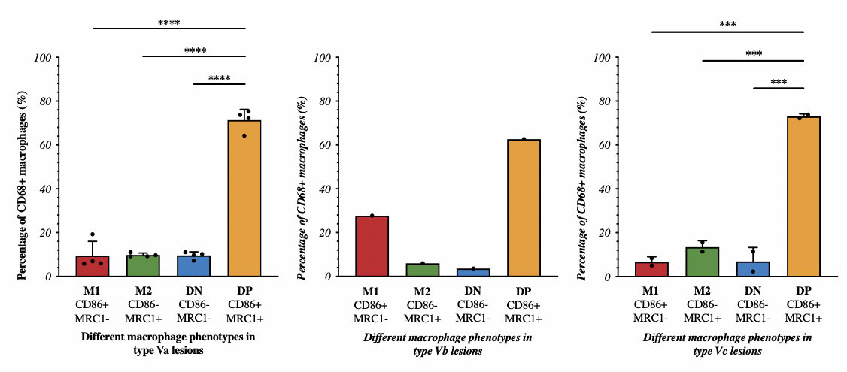

Figure 25: Percentage of different macrophage phenotype populations in type V lesions
Different macrophage phenotypes were determined with single (CD68) and dual (CD86, MRC1) IF stains and data is presented from type V lesions.
In Va lesions (multilayer fibrous atheroma with core) the ratio of M1 single positive (CD68+CD86+MRC1-), M2 single positive (CD68+CD86-MRC1+) and double negative (CD68+CD86-MRC1-) macrophages is similar, around 10%, while the percentage of double positive (CD68+CD86+MRC1+) macrophages is significantly higher (75%). In Vb lesions (calcification) M1 single positive (CD68+CD86+MRC1-) macrophage ratio (27%) is higher than M2 single positive (CD68+CD86-MRC1+) (6%) or double negative (CD68+CD86-MRC1-) (4%) macrophages. In Vc lesion group (fibrotic without lipid core) the percentage of M1 single positive (CD68+CD86+MRC1-) cells is around 6%, while M2 single positive (CD68+CD86-MRC1+) macrophages presented at about 13%. Data follow normal (Gaussian) distribution and graphs present mean + SD, ordinary one-way ANOVA with Tukey’s multiple comparison test; each data point represents one patient; n=4 individual patient samples in type Va lesion, n=1 individual patient sample in type Vb and n=2 individual patient sample Vc lesions; p value: **** ‹0.000; (DN= double negative, DP= double positive)

Five carotid plaque regions were described as complicated lesions, 3 as type VIa- rupture, and 2 as type VIb- haemorrhage (Figure 26). These lesion types are unstable, which is supported by the higher M1 single positive (CD68+CD86+MRC1-) macrophage ratio (25-30%) and the lower M2 single positive (CD68+CD86-MRC1+) proportion (5%). In both of these lesion types, double positive (CD68+CD86+MRC1+) macrophages are present at approximately 62% and double negative (CD68+CD86-MRC1-) macrophages at around 5%.
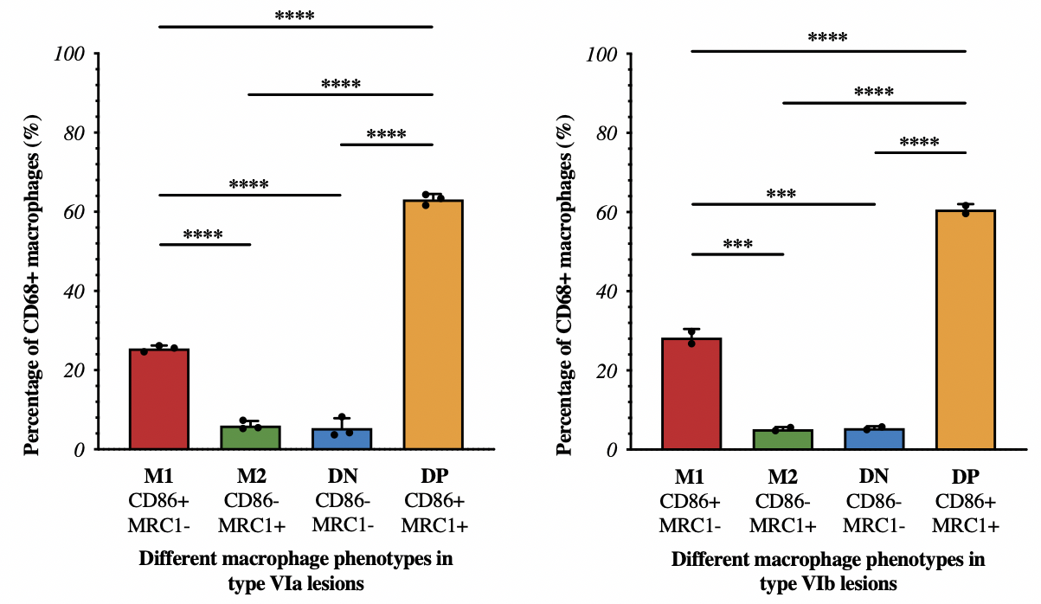

Figure 26: Percentage of different macrophage phenotype populations in type VI lesions
Different macrophage phenotypes were determined with single (CD68) and dual (CD86, MRC1) IF stains and data is presented from type VI lesions. In both VIa (rupture) and VIb (haemorrhage) lesions M1 single positive (CD68+CD86+MRC1-) macrophage ratio (approximately 27%) is higher than M2 single positive (CD68+CD86-MRC1+) (5%) or double negative (CD68+CD86-MRC1-) (5%) macrophages. In both of these lesion types double positive (CD68+CD86+MRC1+) macrophage proportion is around 62%, higher than the other macrophage groups. Data follow normal (Gaussian) distribution and graphs present mean + SD, ordinary one-way ANOVA with Tukey’s multiple comparison test; each data point represents one patient; n=3 individual patient samples in type VIa lesion, n=2 individual patient samples in type VIb lesions; p value: **** ‹0.000; (DN= double negative, DP= double positive)

Summary of Results
The work presented in this chapter characterises the histological features and different macrophage distribution of human carotid atherosclerotic plaques.

- 52.2% of the collected plaques were deemed to be unstable and 47.8% were recognized as stable. Based on the American Heart Association grading scale, the collected plaques belong to the following types: IV- lipid core atheroma, Va- multilayer fibrous atheroma with core, Vb- calcification, Vc- fibrotic without lipid core, Via- rupture, VIb- haemorrhage
- An IF protocol to simultaneously stain for M1 (CD86) and M2 (MRC1) macrophages alongside an overall macrophage marker (CD68), as well as an image acquisition and analysis strategy was developed to characterise macrophage phenotypes within the shoulder region of the carotid plaque
- Double positive (CD68+CD86+MRC1+) macrophages were 67.8% of all CD68+ macrophages. M1 single positive (CD68+CD86+MRC1-) macrophages make up 16.5%, while M2 single positive (CD68+CD86-MRC1+) macrophage account for 8.7% of all CD68+ macrophages. Double negative (CD68+CD86-MRC1-) macrophages represent 7.0% of all macrophages.
- M1 single positive (CD68+CD86+MRC1-) macrophages were present with a significantly higher ratio in unstable plaques (82%) than in stable (18%) ones.
- In type IV- lipid core atheroma lesions M1 single positive (CD68+CD86+MRC1-) macrophage ratio (26%) is significantly higher than M2 single positive (CD68+CD86-MRC1+) (5%) or double negative (CD68+CD86-MRC1-) (5%) macrophages.
- In type Va lesions (multilayer fibrous atheroma with core) the ratio of M1 single positive (CD68+CD86+MRC1-), M2 single positive (CD68+CD86-MRC1+) and double negative (CD68+CD86-MRC1-) macrophages is around 10%.
- In Vb calcified lesions M1 single positive (CD68+CD86+MRC1-) macrophage ratio (27%) is higher than M2 single positive (CD68+CD86-MRC1+) (6%) or double negative (CD68+CD86-MRC1-) (4%) macrophages.
- In type Vc- fibrotic without lipid core lesions the percentage of M1 single positive (CD68+CD86+MRC1-) cells is about 6%, while M2 single positive (CD68+CD86-MRC1+) macrophages presented at about 13%.
- In both VIa (rupture) and VIb (haemorrhage) lesions M1 single positive (CD68+CD86+MRC1-) macrophage ratio is about 27% which is significantly higher than the proportion of M2 single positive (CD68+CD86-MRC1+) (5%) or double negative (CD68+CD86-MRC1-) (5%) macrophages.

Discussion

Stroke is the second leading cause of death and one of the major causes of disability and dementia worldwide (Benjamin et al., 2017). It is a neurological condition caused by an acute injury of the central nervous system. Around 80% of all stroke cases are ischaemic stroke and of those 50% are due to large artery atherosclerosis (fatty blockage within the carotid artery) (Sacco et al., 2013). Stroke has many risk factors like hypertension or carotid stenosis and unfortunately, there is increasing evidence that COVID-19 is associated with ischemic stroke. It was found that the anterior circulation is more frequently affected than the posterior circulation and occurs predominantly in males (Finsterer et al., 2022). Stroke associated with COVID-19 it is most frequently embolic and due to cardiovascular risk factors than coagulopathy (Finsterer et al., 2022).

Stroke and patient characteristics
In my study, carotid plaques were obtained from patients undergoing carotid endarterectomy for recently symptomatic stroke or TIA with greater than 50% stenosis of the ipsilateral internal carotid artery. In my cohort, 69% of stroke patients are male and similar data have been published previously (Appelros et al., 2009). Several studies have reported that smoking is a modifiable risk factor for stroke (Shah and Cole, 2014) and my data support this, because 82% of the patients in this cohort were smokers or ex-smokers.
It can be predicted that patients with hypertension, type 2 diabetes mellitus and previous stroke or TIA have a higher possibility to suffer from stroke (see section: 1.1.3) (Khan et al., 2006, Almdal et al., 2004, Mohan et al., 2011). High blood pressure is a leading risk factor for stroke and the 91% of the examined patients had hypertension and this high ratio is also reported (Khan et al., 2006). The 36% of the patients had type 2 diabetes mellitus and similarly a low percentage (19%) was stated previously (Wang, 2013).
Stroke survivors are at increased risk of early recurrent ischaemic events (Mohan et al., 2011) and in my study two patients had suffered from previous stroke/TIA. HDL and LDL ratio can be highly important in stroke or CVD prediction (Wannamethee et al., 2000, Zeljkovic et al., 2010). In my cohort, 75% of the patients had lower HDL levels than the desirable standard and higher LDL levels were measured in 50% of the patients.

Atherosclerosis and the histological analysis of human carotid plaques
Ischaemic stroke is caused by atherosclerosis (Benjamin et al., 2017), where a plaque is formed within an artery, modulated by genetic and environmental factors (Ross, 1999). The plaque as classified histologically, can be stable and unstable, depending on the extent of inflammation and macrophage content (Wang and Bennett, 2012). In this study, I sought to classify macrophage phenotypes in human carotid plaques to test the hypothesis that the ratio of various macrophage subtypes may differ between the unstable or stable atherosclerotic plaques.

Carotid plaques were divided into regions (Figure 11) (Lovett et al., 2004c). Overall stability (Lovett et al., 2004c) and AHA classified lesion types were determined by the characteristic components and pathogenic mechanism of the plaque (Table 1) (Stary et al., 1995). In this study, 11 plaques were suitable for analysis and these were divided into 46 regions (A, B, C, D, E). 45% of carotid samples were probably or definitely stable plaques, while 55% were judged as unstable. Similarly, in a larger study (n=126 carotid plaques: (TIA: 75; symptomatic: 29; asymptomatic, 22), 31% of samples were stable and 69% were considered as unstable lesions (Salem et al., 2014). According to the AHA classification, 6.5% of my samples grouped to the ‘IV: Lipid core atheroma’, 34.8% were the ‘Va: Multilayer fibrous atheroma with core’, 8.7% were in ‘Vb: calcification’, 17.4% were ‘Vc: Fibrotic without lipid core’, 15.2% considered as ‘VIa: Rupture’ and 17.4% within ‘VIb: Haemorrhage’ lesion type. These findings are partly similar with a study by Cai et.al. (2002), where they reported that 28% of carotid plaques belonged to type IV and Va lesions, 23% were type Vb, 4% considered as type Vc and 45% were grouped to lesion type VI.

Inflammatory cells in human carotid plaques
Studies have described the cellular and molecular interactions in atherogenesis, however, the understanding of the process is continuously developing (Brown et al., 2017). One of the main cellular components of the atherosclerotic plaques are macrophages which are part of the inflammatory response and also linked to foam cell formation. Macrophages take up lipoprotein from dying cells and later when this excess cholesterol from macrophages is not eliminated, foam cells form (Remmerie, 2018). At the early stages of atherosclerosis lipid uptake is considered to be protective because of the removal of proinflammatory oxLDL, but later on, the continuous migration of inflammatory cells and the uptake of lipoprotein will result a large-scale foam cell formation, resulting the necrotic core (Brown et al., 2017, Bobryshev, 2006). Scavenger receptors, mainly SR-A, are key indicators of foam cell formation, but recently new scavenger receptors were found to promote lipid absorption. These are the protein 1 associated with LDL receptor (LRP1) and lectin-like VLDL receptor 1 (LOX1) (Sukhorukov et al., 2020). On the other hand, cholesterol outflow is supported by oxLDL activated LXR, resulting reduced proinflammatory markers and advantageous effect on atherosclerosis (Spann et al., 2012) (Bobryshev et al., 2016). Interestingly, a murine study (Kim et al., 2018) has reported that genes expressed in foam cells are associated with lipid metabolism and not inflammation, while another study (Poznyak et al., 2020) reported that 7 out of the 10 foam cell formation regulatory genes are involved in inflammation and not cholesterol metabolism. It would be important to investigate whether changes in proinflammatory gene expression are a consequence or the cause of intracellular lipid accumulation.

In this study, macrophages were abundant in the collected plaques which agrees with the fact that macrophages participate in all stages of the plaque formation and progression (Daugherty et al., 2005). The macrophage population is remarkably heterogenous and influenced by the microenvironment (Chinetti-Gbaguidi, 2014).
The plaque shoulder regions were deemed the regions of interest, for it is an unstable region prone to rupture (Richardson et al., 1989). Intact plaque shoulder regions were identified in 23 regions (n=11 patients) and macrophage phenotypes within ROI were characterised with immunofluorescence microscopy.
The proinflammatory M1 macrophages are atherogenic, have a role in endothelial activation and oxidative stress. These macrophages enhance plaque stability by weakening the fibrous cap and enlarging the necrotic core (Shirai et al., 2015). In this study, the M1 single positive (CD68+CD86+MRC1-) pro-inflammatory macrophage ratio (17%) was significantly higher in unstable plaques, while all the other phenotypes have higher proportion in stable plaques. These findings agree with the fact that M1 macrophages enhance plaque instability as they secrete proinflammatory cytokines, like as IL-1β, IL-7, IL-8 (Kirbiš et al., 2010). The percentage of M1 single positive macrophage is significantly lower in the ‘Va: Multilayer fibrous atheroma with core’ (9%) and ‘Vc: Fibrotic without lipid core’ (7%) than in other lesion types, where M1 single macrophage ratio is around 28%. Multi-layered fibroatheromas and fibrotic lesions without lipid core plaques are a bit more stable since the fibrous cap provides structural stability, creating a stable plaque (Singh et al., 2002, Bobryshev, 2006), moreover stable plaques have smaller lipid pools (Weissberg, 2000). M1 single positive macrophages have the highest ratio in lesion types characterised by a bigger lipid core, calcification, rupture and haemorrhage which agrees with previous studies (Kirbiš et al., 2010, Cho et al., 2013a, Chinetti-Gbaguidi, 2014). M1 macrophages are found in all types of tissue and protect it against pathogens and dangerous stimuli. Pathological consequences could be chronic inflammation, tissue damage and autoimmune diseases (Italiani and Boraschi, 2014). Atherosclerosis is a chronic inflammatory disease, therefore M1 macrophages have a similar role in pathological conditions in different tissue.
The anti-inflammatory M2 macrophages are atheroprotective have a regulatory function and can carry out collagen synthesis (Shaikh et al., 2012). M2 macrophages promote ﻿neoangiogenesis, produce TGF-β and an immunosuppressive cytokine, IL-10 (Shirai et al., 2015). In this study, M2 single positive (CD68+CD86-MRC1+) anti-inflammatory macrophages have a lower ratio in plaques, accounting for 9% of all CD68+ macrophages. This proportion is noticeable through all AHA classified lesion types. In this study, M1 macrophage phenotype has significantly higher than M2 cells in the plaque shoulder region of the collected symptomatic plaques. These data are supported by several other studies (Shirai et al., 2015). It was previously reported that the ratio of M2 macrophage phenotype is low in symptomatic plaques (Chinetti-Gbaguidi, 2014, Shaikh, 2012). The M1 macrophage ratio may be higher in my samples because they are mostly present in the shoulder region (ROI), while M2 macrophages are mainly found in the adventitia layer (not analysed in this thesis) (Stöger et al., 2012). It was also reported that M2 macrophages are mostly presented in early atherosclerotic lesions, and progressed plaques contain mainly M1 subtypes (Shirai et al., 2015) which is supported by my findings. The fact that the M1 and M2 macrophage ratio is different in early and progressed plaques could indicate that macrophages are polarised according to their microenvironment and can change phenotype based on the surrounding signals. The homeostatic functions of M2 macrophages are mostly healing and angiogenesis but under pathological conditions, it has a role in cancer, fibrosis or epithelial hyperplasia (Italiani and Boraschi, 2014). As indicated, M2 macrophages have a regulatory function throughout the body, which is mostly beneficial during atherosclerosis, but it can be disadvantageous in other diseases.
Double positive cells (CD68+CD86+MRC1+) are present with the highest rate (68% of all CD68+ cells), through all AHA classified lesion types. This may be a previously undescribed subtype because one macrophage can express both M1 and M2 markers at the same time but all previous studies (Medbury et al., 2013) separately stained for these markers. These double macrophages could be ‘intermediates’ between phenotype switching, supporting the fact that macrophage functions can temporarily change in disease (Lichtnekert et al., 2013).
Double negative (CD68+CD86-MRC1-) macrophage population has the lowest ratio (7%) in carotid plaques without any significant differences in all AHA classified lesion types. Interestingly, the ratio of this previously uncharacterised macrophage phenotype is higher in stable plaques. To date there has been no reported study that has investigated the role of this macrophage subtype, therefore further analysis is required.

Limitations

The work presented in this chapter has some limitations. First of all, we could only collect 13 human carotid plaques. This happened because in some cases patients did not give consent or the dissected plaque did not arrive to the histopathology lab from the operating theatre. It was also difficult to consent patients and get samples during the COVID-19 pandemic, from March 2020.
Although histology and IF staining is relatively cheap and quick method to study the morphology of a tissue, it has disadvantages (optimisation, specificity, fixation artifacts, human error). Developing the novel IF stain to simultaneously stain for both M1 and M2 marker along with CD68 pan macrophage marker was challenging. Furthermore, to identify specific cell types is difficult which can affect the value of evaluation, since there are no single or agreed markers for each cell type. The histological feature of carotid plaques also varies along the length of the tissue therefore it is possible that some features were missed. However, it was shown that 3mm thick sections are reasonably representative (Lovett et al., 2004c).

Chapter 4.
Single Cell Transcriptome Analysis of Human Atherosclerotic Plaque Macrophages

Introduction

Atherosclerosis is a systemic inflammatory disease, where a lipid plaque is formed within an artery (Ross, 1999) and different types of macrophages participate in all stages of the plaque formation and progression (Stöger et al., 2012). Previously, histological studies revealed the presence of different macrophage subtypes in the carotid plaques and they are affected by their microenvironment (Chinetti-Gbaguidi, 2014) or localisation (Stöger et al., 2012). The discovery of single cell analysis techniques like CITE-seq or scRNA-seq, enabled a better understanding of diseases, e.g., atherosclerosis (Willemsen and Winther, 2020). Single cell analysis of plaque macrophages is useful to better understand the mechanism of atherosclerosis, their roles in atherosclerotic lesion progression, and identify markers for unstable atherosclerotic plaque.

Hypothesis

The characterisation of the identified double positive and double negative macrophages and their localisation within human atherosclerotic plaques may lead to stroke diagnostic markers.

Aims of this chapter:
- Modify CD68 IF staining to preserve RNA integrity for LCM scRNA-seq
- Optimise LCM (laser power, aperture, speed) to preserve RNA integrity
- Test different single cell cDNA library preparation kits for suitability for small amounts of RNA isolated from FFPE tissue
- Perform LCM scRNA-seq
- Optimise bioinformatic analysis of scRNAseq data

Results
In this chapter, the challenging optimisation of Laser Capture Microdissection single cell RNA sequencing (LCM scRNA-seq) is described. Briefly, the previously identified macrophage subtypes were classified with LCM scRNA-seq. A Leica LMD6 Laser Microdissection Microscope was used to cut out the CD68+ macrophages from the IF stained FFPE tissue. Library preparation was performed with a SMARTer Stranded Total RNA-Seq Kit and samples were sequenced with MiniSeq System.

Preserved RNA integrity from an IF stained FFPE tissue section
The integrity (quality and quantity) of the isolated RNA (5 µm thick section) following the modified CD68 IF stain (2.5.1) was tested with RT-qPCR, Bioanalyzer and pilot sequencing.
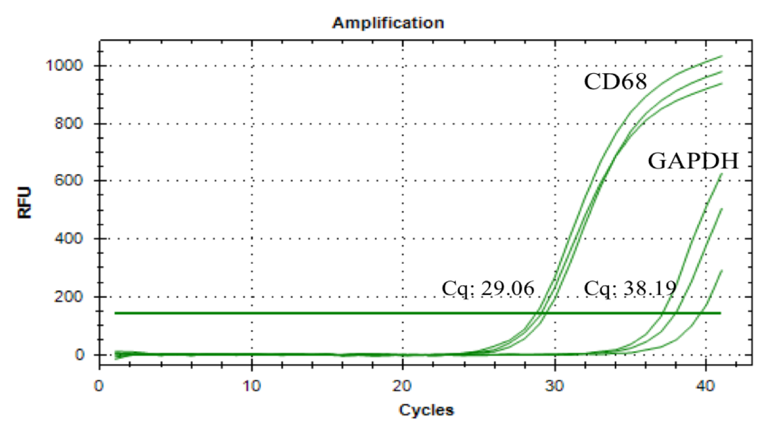
First, RT-qPCR was performed with CD68 macrophage and GAPDH housekeeping primers (average RNA yield: 40 ng/ul). The following graph (Figure 27) shows the amplification curves of these 2 genes in the degraded RNA sample. The average quantification cycle (Cq) of CD68 gene amplification is 29, demonstrating that CD68 gene is well detectable from the human carotid plaque RNA sample.

Figure 27: Amplification curves of CD68 and GAPDH gene expression as a result of RT-qPCR
RNA was isolated from a 5 µm thick IF stained section. Cq of CD68 is 29.06, Cq of GAPDH is 38.19. RFU=Relative Fluorescence Unit

Next, the size and quality of lower yield of cDNA were tested with a Bioanalyzer. The cDNA transcribed from the isolated RNA was diluted into 3 different concentrations, 10 ng, 100 pg (equivalent to more cells) and to 10 pg (equivalent to RNA quantity from 1 cell).
Using the bioanalyzer, different sizes of RNA fragments were present in the sample since peaks were visible on the bioanalyzer electropherogram from all the different concentrations of cDNA.

Figure 28 is a representative image of the electropherogram with the 10 pg cDNA. Both positive and negative controls worked well, and 36 peaks of cDNA (from the diluted RNA isolated from IF stained FFPE tissue section) were detected with adequate molarity.
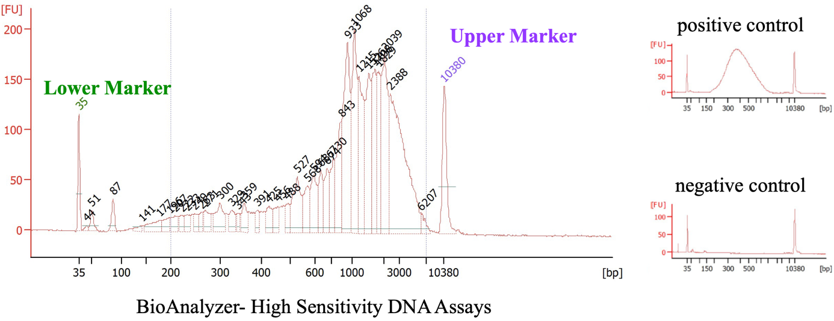

Figure 28: Bioanalyzer quality control of human carotid plaque cDNA (10 pg)
The electropherogram shows the size and quality of sample cDNA, by displaying a data plot of size/migration time versus fluorescence intensity. X-axis indicates the size of the DNA fragment in base pairs (bp) while y-axis represents the fluorescence unit (FU). The highlighted lower and upper markers are internal standards to bracket the DNA sizing range.
Left side: 36 peaks were detected between the lower and upper markers which means that cDNA is detected in the sample. Right side: Positive control show cDNA sample between the lower and upper markers while negative control graph only indicates the two markers.

After the cDNA quality control, a pilot sequencing was performed with 0.1 M reads using the Illumina NextSeq high-throughput sequencing system (total RNA from a 5 µm thick IF stained section). The bioinformatic analysis highlighted that 17% of the reads are mapped to protein coding genes (32656 reads) (Figure 29) moreover CD68, CD86 and MRC1 macrophage markers were detected in the dataset.

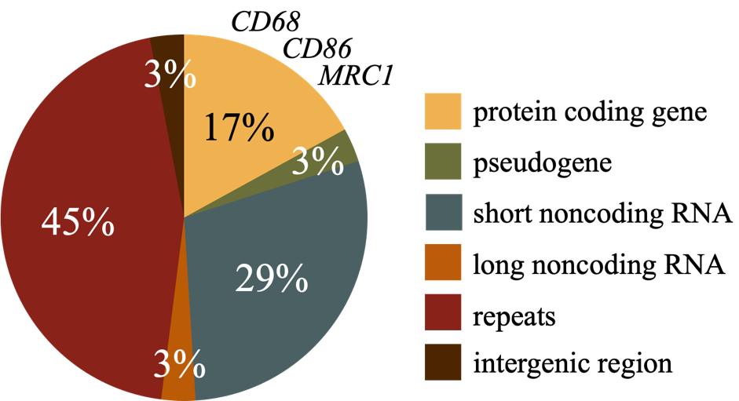

Figure 29: Genomic distribution of human carotid plaque RNA after Illumina NextSeq pilot sequencing
This pie chart shows the percentage of different genomic regions of carotid plaque RNA. 17% of reads were mapped to protein coding genes and macrophage markers (CD68, CD86, MRC1) were detected in the sample. Repeats are accounted for 45% of the sequenced nucleic acid and compromises transposable elements along with single repeats. Short- and long- noncoding RNA (29%, 3%) were also found in the sample which regulates gene expression at the transcriptional and post-transcriptional levels. Pseudogenes (3%) are inactivated sequences while intergenic regions (3%) are located between genes.

These results indicated that the quality and quantity of the RNA was sufficient for scRNA-seq and that the reads were containing some of the expected markers. Therefore, the next step was the optimisation of the LCM (laser power, aperture and speed). We decided to test different LCM settings with PCR amplification of TP53 (designed and optimised by the Mutagenesis & Carcinogenesis Research Group) and gel electrophoresis as outputs since this was time and cost efficient.

Figure 30 is a representative image of the agarose gel electrophoresis after amplification of TP53. All the negative and positive controls were as expected and the TP53 gene was amplified in 9 out of 15 individual single cell samples. This means that the optimisation of LCM was successful therefore, the next step was the LCM scRNA-seq on new carotid plaque tissue and the optimisation of the bioinformatic analysis.
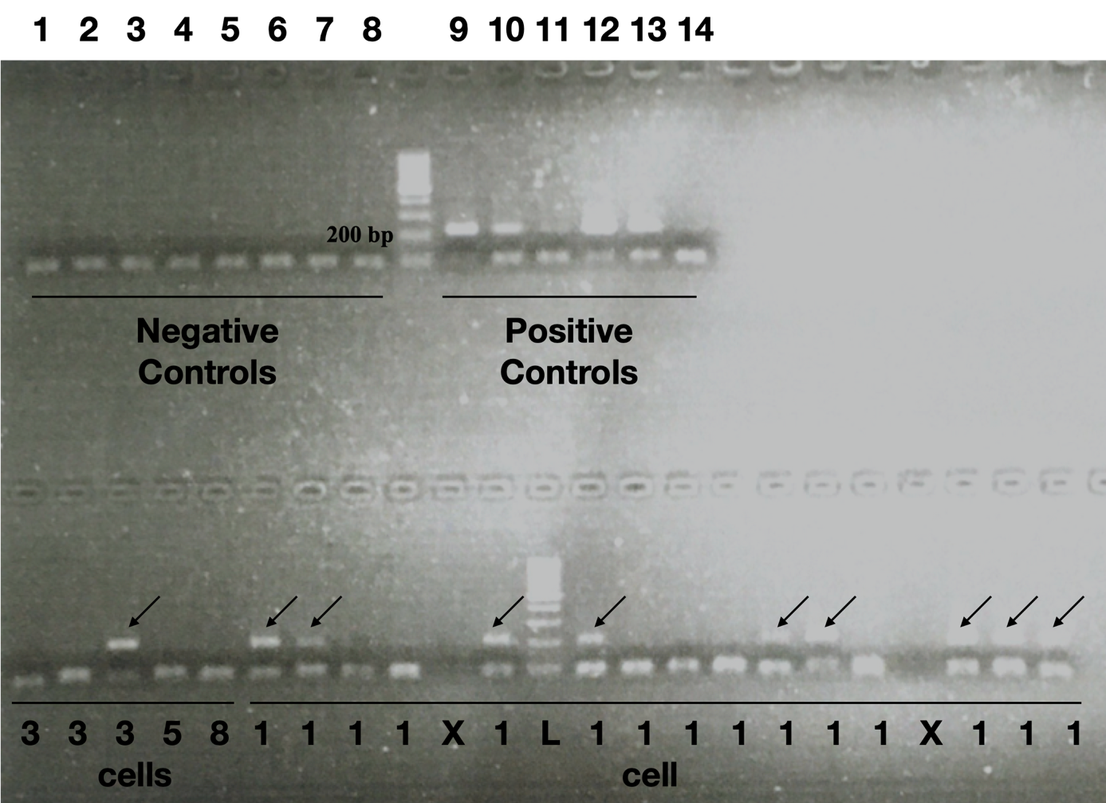

Figure 30: Agarose gel electrophoresis of direct PCR amplicons for TP53 after LCM to test laser settings
9 out of 15 individual cells had enough DNA to amplify TP53 gene. Negative and positive controls worked well. Samples in top line: 1.: Empty PCR tube; 2.-4.: Catapult buffer; 5.: PET membrane without DAPI; 6.: Tissue without DAPI; 7.: ProK control; 8.: PCR control; 9.-14.: Positive Controls (1 ng, 10 pg, 100 pg); Samples in bottom line: 1.-3.: 3-cells area; 4.: 5 individual cells; 5.: 8 individual cells; 6.-23.: 1 individual cell. L= ladder; Arrows= positive amplicons

Transcriptome of single plaque macrophages
To optimise the steps of the library preparation and the bioinformatic analysis, reads from 4 individual samples were used.
First, adapter sequences were removed with Trimmomatic (Bolger et al., 2014), as indicated on the following quality plot (representative image for sequencing data from 1 cell (Figure 31).
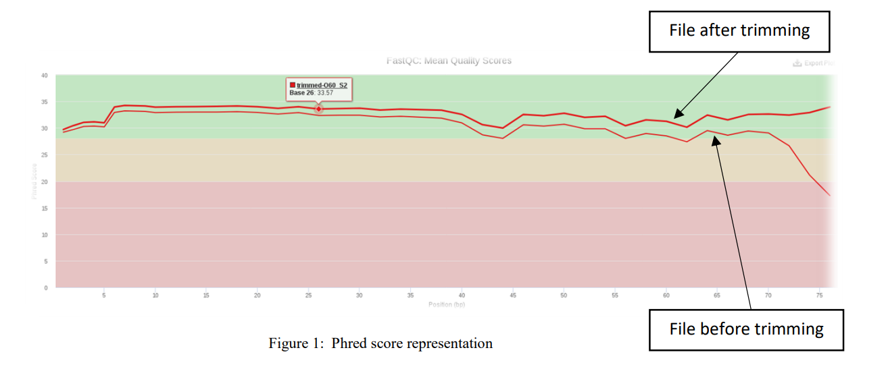

Figure 31: Quality plot generated by FastQC.
X-axis indicates Phred score (the quality of the identification of the nucleobases) while y-axis represents the position (bp). The top line illustrates the file after trimming and the bottom one demonstrates the file before trimming

The good quality reads were mapped against the HG38 human genome and the quality of reads is shown in Table 13. The percentage of reads is low because of the low number of cells. Poor mapping quality needs to be further investigated.

Table 13: The number of reads uniquely mapped to the samples
 | Cell 1 | Cell 2 | Cell 3 | Cell 4
Uniquely mapped reads number | 460755 | 2296989 | 1285668 | 2148845
Uniquely mapped reads % | 23.70% | 29.04% | 55.97% | 30.44%
The following 4 pie charts (Figure 32) show the genomic distribution of 4 CD68+ cells after mapping. Only a small % of the reads could be mapped to exons because of the degraded RNA. This low RNA quality was expected because of the processing of the FFPE tissue.

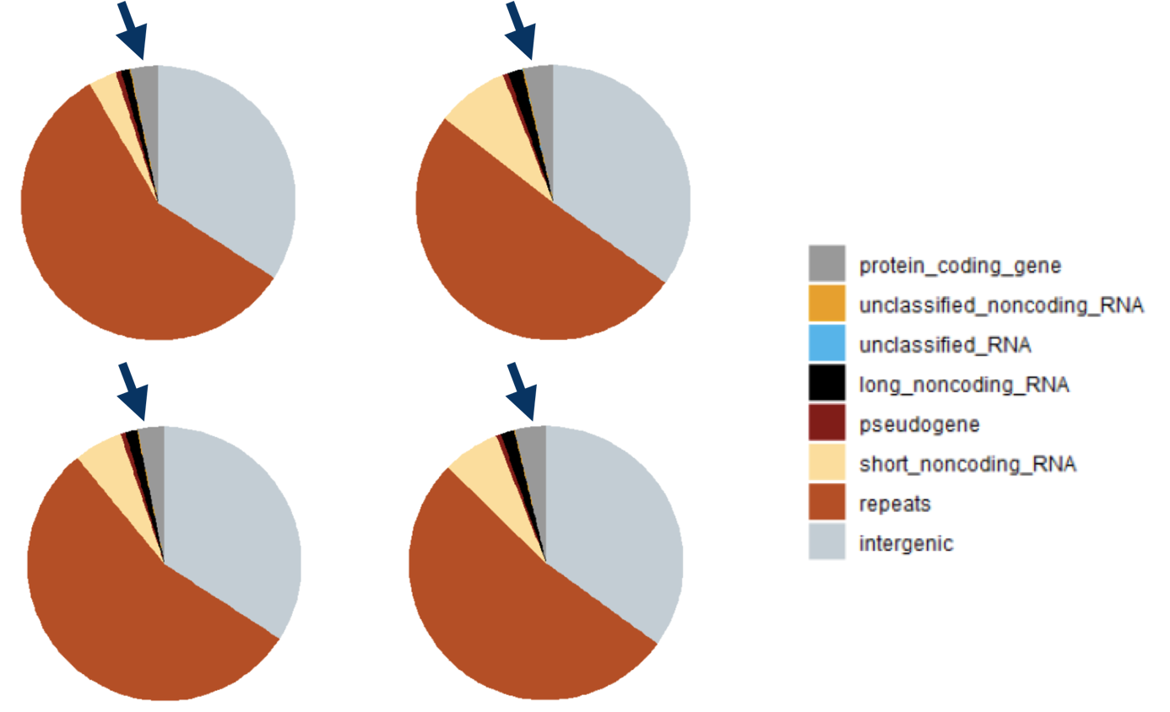

Figure 32: Genomic distribution of reads from 4 CD68+ cells
These 4 pie charts show the percentage of different genomic regions of 4 individually dissected cells from human carotid plaque. The dark grey segments, highlighted with blue arrows, indicate the percentage of the mapped reads to protein coding genes. Repeats accounted for the highest portion with more than 50% of the reads.

The next step was the cluster analysis of the collected cells (Figure 32) with bulk RNA-seq data from in vitro polarised macrophages and smooth muscle cells. The results are shown on a dendrogram (Figure 33). The collected human plaque cells are separate from the SMCs and are clustered within the polarised macrophage dataset. Moreover, the transcriptomes of these 4 macrophages are grouped between the M1 and M2a polarised macrophages.
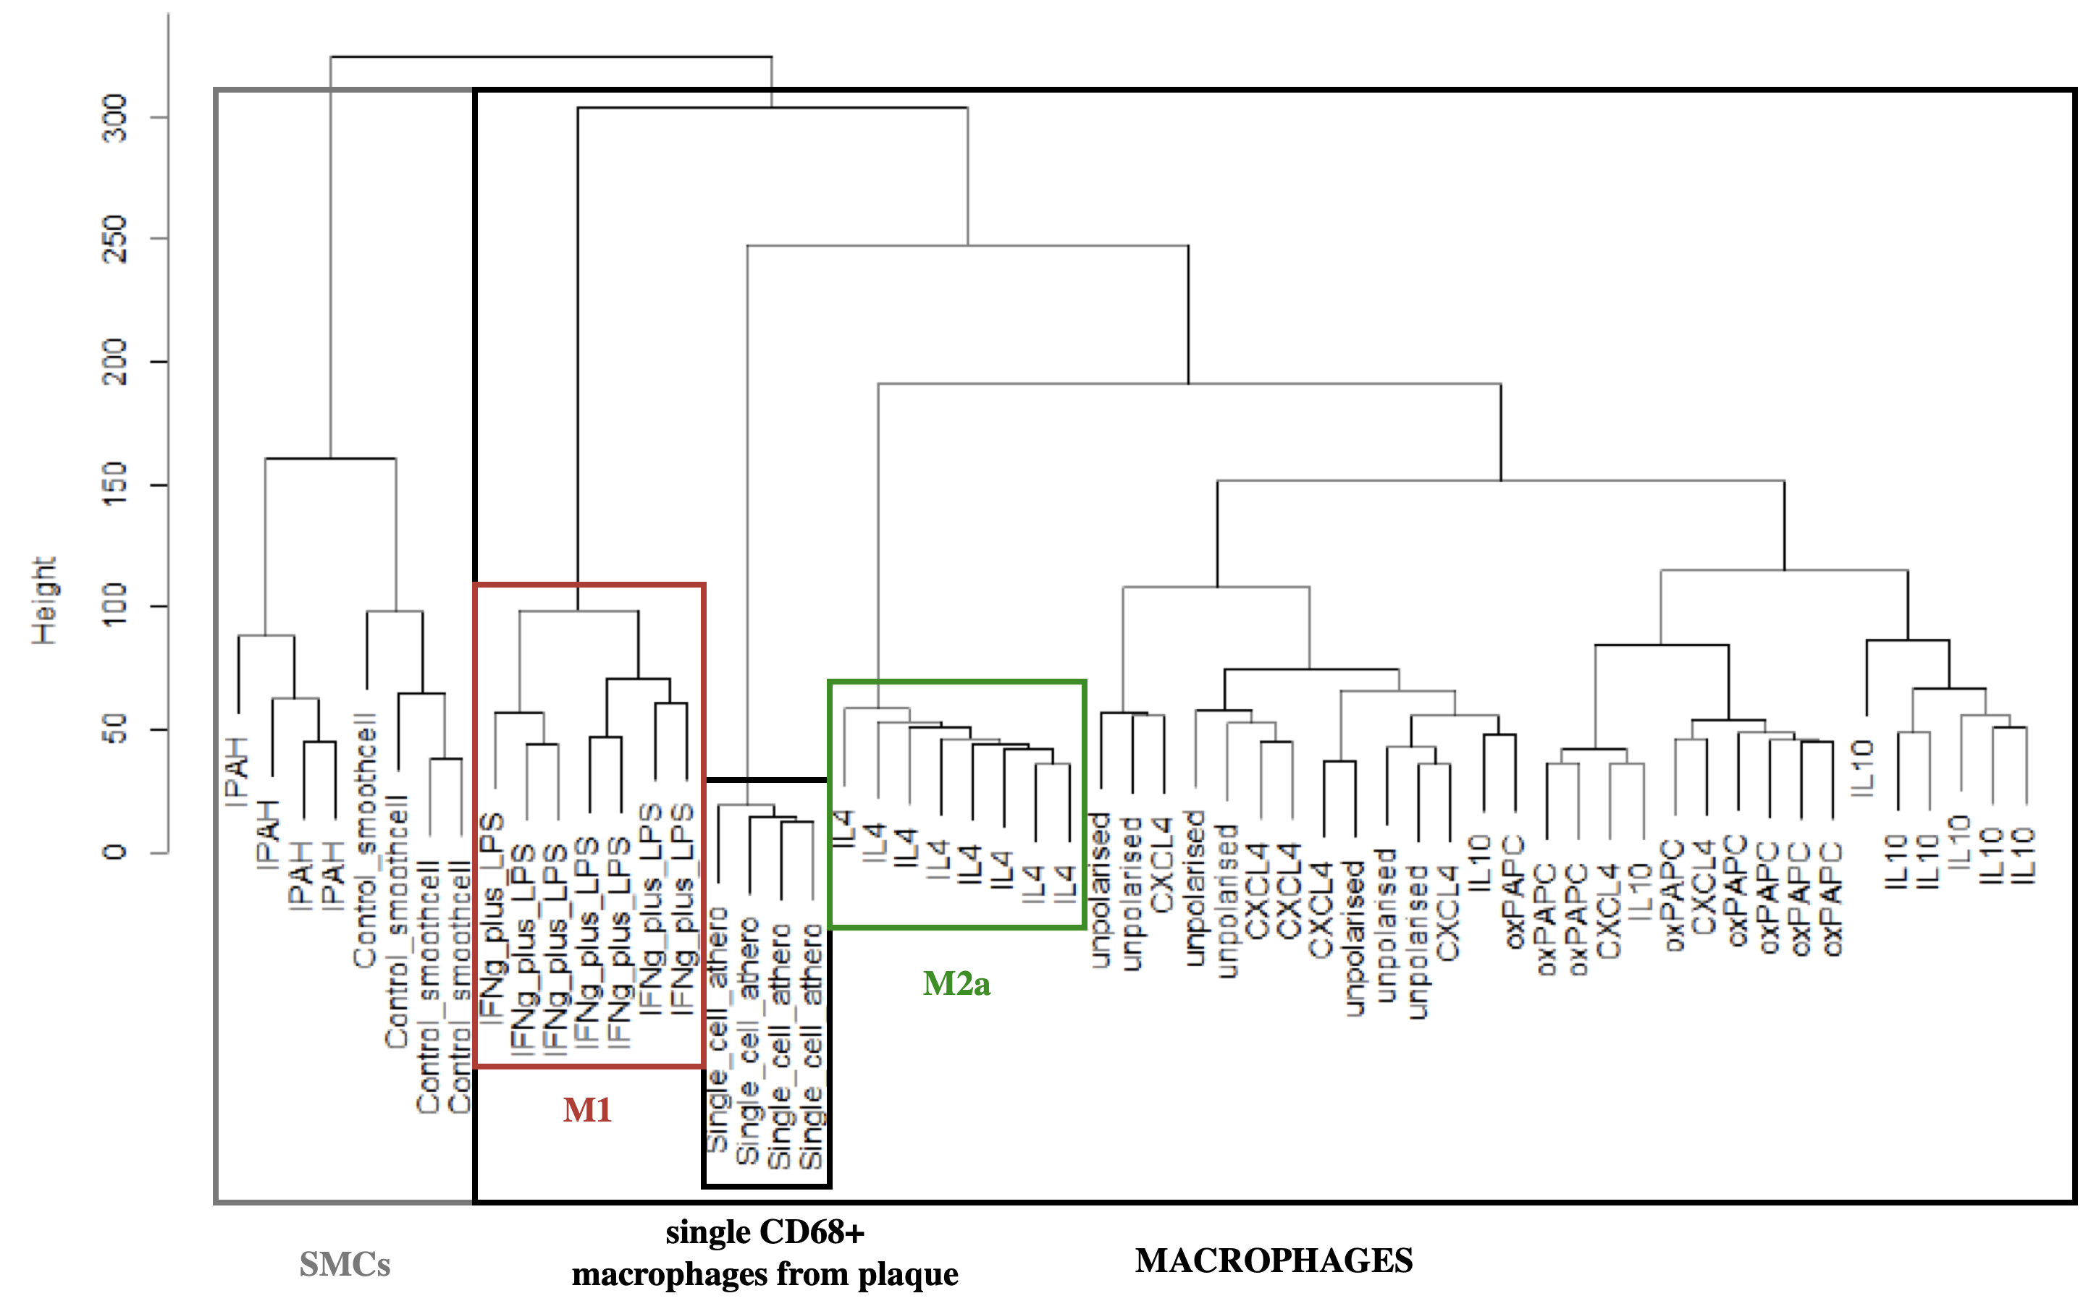

Figure 33: Cluster analysis of macrophages
This dendrogram shows the cluster analysis of collected cells and bulk RNA-seq data from in vitro polarised macrophages and smooth muscle cells. The collected cells from human carotid plaques are separate from the SMCs and clustered within the polarised macrophage dataset.
On the left side of the dendrogram, SMCs (IPAH: idiopathic pulmonary arterial hypertension; GEO dataset (GSE144274) (Gorr et al., 2020)) are labelled with grey while on the right side, macrophages are presented in the black square (unpublished dataset generated by Kajus Baidzajevas, a former PhD student). M1 and M2a macrophages from the bulk RNA-seq data are highlighted with red and green squares, respectively. Carotid plaque macrophages (n=4) are labelled in the middle.

Summary of Results
The work presented in this chapter describes the results and the optimisation of LCM scRNA-seq along with the bioinformatic analysis.

- The CD68 IF protocol was successfully modified to preserve RNA integrity for LCM
- LCM was optimised to collect single cells from IF stained human carotid plaque for single cell RNA sequencing
- Individual cells were collected for the optimisation of library preparation
- 4 individual cells from human carotid plaques were sequenced and analysed with MiniSeq system
- These cells are definitely macrophages and clustered between M1 and M2a subtypes generated in vitro

Discussion

Laser Capture Microdissection single cell RNA sequencing is a powerful approach for studying the mechanism of diseases, like atherosclerosis, analysing different immune cell subsets as well as identify markers for unstable atherosclerotic plaque. However, LCM scRNA-seq investigations of human atherosclerotic plaque macrophages have not been reported to date, due to the numerous methodological challenges. Recently, a methodological study discussed a protocol of the LCM-based mRNA expression microarrays of atherosclerotic plaques to obtain information on local gene expression changes during disease progression (Zhang et al., 2022). Single cell RNA seq data is already available from mouse (CD45+ aortic cells dissected from atherosclerotic (Ldlr−/−; Apoe−/−) mice) (Cochain et al., 2018) and human (46 carotid plaques) (Fernandez et al., 2019) samples but these studies do not focus on the localisation of different cells within the lesions. Moreover, macrophages are more susceptible to becoming damaged than other cell types during mechanical or enzymatic dissociation, often resulting data loss (Willemsen and Winther, 2020, Denisenko et al., 2020). Single cell approaches revealed that asymptomatic plaque macrophages are pro-inflammatory (Fernandez et al., 2019), foam cells are related to lipid metabolism (Kim et al., 2018), and it was shown that macrophage activation is more like a spectrum model and more complex than the distinct M1 and M2 phenotypes (Lin et al., 2019). All these previous studies have proven that macrophages are highly diverse and can adapt their phenotype based on different environmental stimuli, therefore it is important to study atherosclerotic plaque macrophages and consider their localisation within the lesion.
Here, we developed approaches to preserve RNA integrity in IF stained FFPE tissue during LCM and tested the available library preparation kits to achieve the best quality sequencing outcomes.

In this study, carotid plaques were collected and IF stained with CD68 pan macrophage marker before LCM scRNA-seq. All of methodological steps, (IF stain, LCM, library preparation, bioinformatic analysis) needed to be optimised which was challenging and time consuming.
Methods used during histology (decalcification, embedding, IF stain) degrade RNA (Wang, 2006), due to chemical RNA–protein crosslinking and RNA fragmentation (Amini et al., 2017), therefore steps needed to be modified to preserve RNA integrity. As detailed in a review by Datta et.al. (2015), RNA extraction is possible from FFPE tissue if it is free of contaminants and nucleases. To achieve this, DEPC treated solutions were used in addition with RNase Inhibitor during the histological process. Frame slides were sterilized along with all the used consumables and equipment. The quality of isolated RNA from 5 µm thick section after modified CD68 IF stain was tested in this thesis with various methods. RT-qPCR analysis showed that, CD68 is detectable, while the bioanalyzer indicated that different sizes of cDNA fragments (transcribed from RNA) are in the sample. After the cDNA quality control, a pilot sequencing was performed with Illumina NextSeq high-throughput sequencing system which highlighted that CD68, CD86 and MRC1 macrophage specific genes are present in the RNA sample.
Following these promising results, the next step was the optimisation of the LCM (laser power, aperture and speed). LCM settings were tested with time and cost-effective direct PCR amplification and gel electrophoresis. DNA could be amplified with 60% success rate from a single dissected macrophage from FFPE tissue which meant that the optimisation of LCM was successful. The 60% success rate might seem low but as described by Chung and Shen (2015), the quality of microdissected cells may not be adequate for further analysis due to its exposure to fixatives and staining reagents. The lack of mounting media, coverslip, and therefore tissue dehydration can further degrade RNA and cause morphological changes Chung and Shen (Chung and Shen, 2015). Nichterwitz et. al. (2016) showed that RNA sequencing from single motor neurons from both mouse and human tissue is possible with 62% success rate, using LCM. Their tissue samples were stained for Nissl histological stain which only took 6 minutes (Nichterwitz et al., 2016), not like the several hours long IF stain on the carotid samples examined in this study. Another noticeable difference in the protocol is that my samples were transported at room temperature and kept at 4°C while in the study of Nichterwitz et. al. (2016) tissue slides were kept in a slide box on dry ice (Nichterwitz et al., 2016). To minimize RNA degradation of carotid plaque samples the tissue sections should have been transported on dry ice.
Consequently, the next step was the LCM scRNA-seq of new carotid plaque tissue along with the optimisation of library preparation and bioinformatic analysis. SMARTer (Switching Mechanism At 5' end of RNA Template) technology developed by Takara Bio was used for library preparation and it provided and adequate cDNA yield from an area of 800-2000 μm² of the IF stained FFPE tissue. After sequencing, genomic distribution of individual cells showed that around 5 % of all reads could be mapped to protein coding regions because of the degraded RNA. Similarly, Civita et.al. (2019) reported that RNA integrity extracted from FFPE tissue is poor but sufficient. In their study, RNA was isolated from endothelial cells and from a significantly bigger area (30.000 μm²) of H&E-stained human glioblastoma multiforme FFPE tumor tissue and prepared with SMARTer technology (Civita et al., 2019).
Preliminary scRNA-seq data have confirmed that microdissected, CD68+ cells from the human plaque are macrophages and that in hierarchical clustering analysis with reference to existing transcriptomic datasets, collected cells are clustered between M1 and M2a polarised macrophages.
My data are promising and suggest that I have developed a sensitive technology pipeline for characterisation of unique inflammatory cell subtypes in IF stained human FFPE carotid plaques.

Limitations

The transcriptome of single macrophages isolated from IF stained FFPE tissue with Laser Capture Microdissection has not been investigated before and the work presented in this chapter has some technical limitations.
First of all, as detailed previously (3.6) the collection of the human carotid plaques was not easy. For single cell analysis I needed an inflamed plaque with higher cellular content. Secondly, all steps of the single cell analysis (tissue processing, sectioning, IF stain, LCM, library preparation, bioinformatic analysis) had to be optimised to preserve RNA integrity, which was demanding. Although, LCM has numerous advantages it still has disadvantages. Those are that nuclease free membrane slides are very expensive and there is a risk that the quality of tissue, the microdissected cells or the RNA integrity may be not well preserved for further analysis due to its exposure to EDTA, fixatives and IF staining reagents. The morphology of the section also can be affected by the different steps e.g., dehydration. Despite these disadvantages, I have shown that LCM is a powerful and very useful tool for the isolation of single cells. Furthermore, given the budget at the time, 4 was the maximum number of cells we could capture, sequence and analyse, but it was adequate for final optimisation.

Chapter 5.
Programming Human Macrophages in vitro with Atorvastatin, Simvastatin and Dexamethasone

Introduction

Carotid atherosclerosis is a common cause of acute ischaemic stroke. Patients with a high atherosclerotic burden (stenosis) and inflamed or ulcerated plaques are at increased risk of early recurrent ischaemic events (Mohan et al., 2011). Macrophages, lipoproteins and foam cell formation are the key components of atherosclerotic plaque formation and progression, thereby targeting these could be a potential treatment for stroke patients. Therefore, treatment with statins or steroids such as dex may reduce stroke incidence and recurrence, but in vitro human studies of the possible mechanisms are lacking.
Statins are widely used in medicine as lipid-lowering drugs. Statins are HMG-CoA reductase inhibitors therefore they can reduce cholesterol biosynthesis (Toth and Banach, 2019). Statins reduce the risk of cardiovascular events by decreasing LDL and increasing HDL levels in the bloodstream (Asztalos et al., 2002). Statins can increase macrophage apoptosis through the JNK pathway, downregulate chemokine and chemokine receptor expression in macrophages and reduce macrophage colony stimulating factor-mediated proinflammatory activities (Montecucco and Mach, 2009). Recent studies have found that plaque calcification can increase lesion stability, and interestingly statins are capable of enhancing calcification through increasing IL-1β in a Rac-1-dependent way in macrophages (Healy et al., 2020).
Dexamethasone, an anti-inflammatory glucocorticoid, is a frequently used medication for anti-inflammatory conditions. The effect of GCs is very diverse, a low concentration of dex can increase the production of anti-inflammatory compounds (e.g., annexin 1) while a high dose of dex can reduce the production of pro-inflammatory compounds, like cytokines (Ramamoorthy and Cidlowski, 2016). Dexamethasone can inhibit macrophages proliferation and suppresses foam cell formation in vitro (Asai et al., 1993). Dexamethasone also suppresses CD14 protein and MMP-9 expression (Bo-Young Kim, 2017). Glucocorticoid treated macrophages participate in matrix remodelling by reducing the production of collagenase, elastase and secreting more fibronectin (Desgeorges et al., 2019).

Hypothesis & Aims

The molecular characterization of human M1 and M2 macrophages in vitro and the use of pharmacological agents to modify their phenotypes may lead to the identification of clinically useful diagnostic markers or treatment.

Aims of this chapter:
- Isolate monocytes from whole blood and differentiate them to hMDMs.
- Polarise hMDMs toward M1 and M2a states and study the effects of atorvastatin, simvastatin and dexamethasone on specific markers.
- Gene expression analysis with RT-qPCR.
- Protein expression analysis with Western Blot and IF staining.
- Assess the physiological effects of dexamethasone with oxLDL accumulation and ORO staining.

Results

In this chapter, I summarize the molecular characterization of human M1 (100 ng/ml LPS, 20 ng/ml INF-γ) and M2a (20 ng/ml IL-4) macrophages with in vitro experiments. The effect of atorvastatin, simvastatin and dex was compared on macrophage activation.
PBMCs were isolated from whole blood donated by healthy adult donors. CD14+ monocytes were collected and differentiated to MDMs. Human MDMs were stimulated with atorvastatin, simvastatin and dex in clinically relevant concentrations, based on previous pharmacokinetic studies (see sections: 1.5.6, 2.6.5). Gene expression analysis with RT-qPCR was carried out to test for macrophage specific genes and scavenger receptors. Western Blot analysis and immunofluorescence stain was performed on dex treated hMDMs to validate changes in the expression of OLR1. The encoded OLR1 protein by OLR1 gene encodes a low-density lipoprotein. The physiological effect of the dex was tested with the addition of oxLDL to the dex treated cells and lipid accumulation was quantified in macrophages by Oil Red O staining.
In all in vitro experiments, macrophage identity was verified by the increased expression of CD68, and cell adhesion to plastic (Genin et al., 2015). M1 and M2a polarization were verified by the gene expression changes of specific markers (see representative graph: IX.11).

Statins do not have significant effect on gene expression in hMDMs in an in vitro model
Macrophages were polarised towards M1 (100 ng/ml LPS, 20 ng/ml INF-γ) or M2a (20 ng/ml IL-4) state in the presence of simvastatin (6 ng/ml) or atorvastatin (30 ng/ml, 70 ng/ml). Macrophage specific, including scavenger receptor genes were analysed by RT-qPCR.
Figure 34 is a representative image of the gene expression analysis of OLR1 after simvastatin and atorvastatin treatment. These graphs show the direction of change in expression with the treatment as an arrow. The gene expression of OLR1 and other tested genes were variable and not significantly affected following a 24-hour exposure to simvastatin or atorvastatin. This implies that statins do not have beneficial or disadvantageous effect on human MDMs in this particular in vitro model. Results of the MRC1, MSR1, SCARB1 and CD36 gene expression analysis are listed in IX.10.
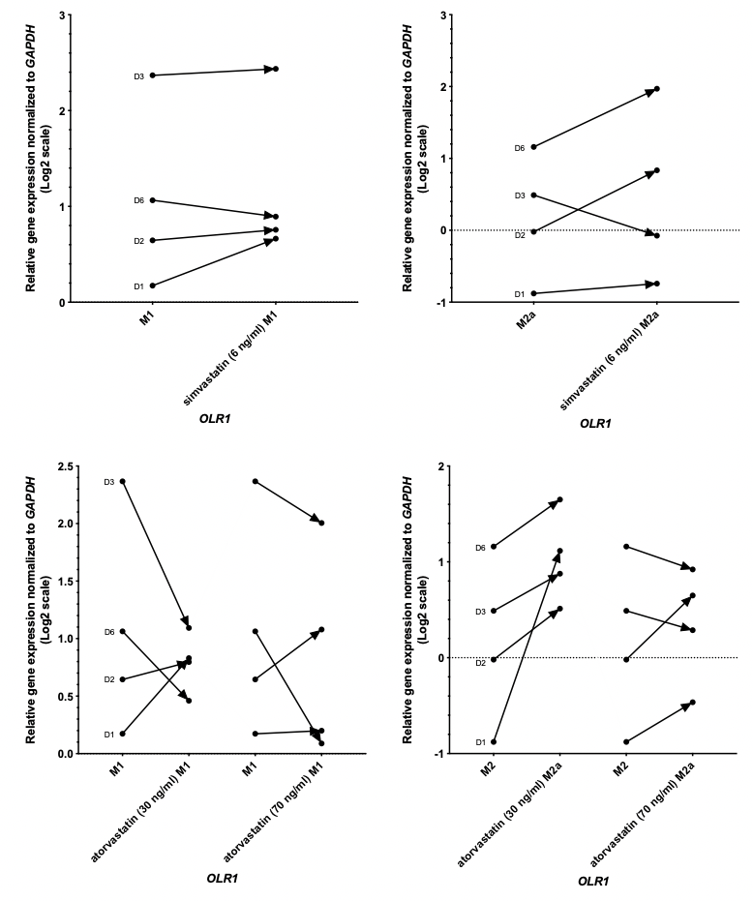
Figure 34: Relative gene expression analysis of OLR1 in human MDMs after simvastatin and atorvastatin treatment
Human M1 (left panels) and M2a (right panels) polarized macrophages were treated with simvastatin (6 ng/ml) (top panels) or atorvastatin (30, 70 ng/ml) (bottom panels) and OLR1 gene expression was determined with RT-qPCR. Data is plotted from 4 donors, individually listed (n=4; D1, D2, D3, D6), normalised to the GAPDH housekeeping gene. Data is analysed with Wilcoxon matched pairs signed rank test. The direction of change in expression is shown with the treatment as an arrow for each individual donor. Dotted line indicates 0 expression level.

Dexamethasone promotes polarization towards an M2a state
Macrophages were polarised towards an M1 or M2a state in the presence of dex and the expression of Mannose Receptor C-type 1 gene (MRC1, or CD206) was analysed by RT-qPCR.
MRC1 gene encodes a type I membrane protein which has a role in the endocytosis of glycoprotein by macrophages and it is important in the clearance of mannose-bearing serum glycoproteins during inflammation (de Gaetano et al., 2016). MRC1 has been identified as a human M2a (anti-inflammatory) macrophage marker (Bobryshev et al., 2016, Chistiakov, 2015).
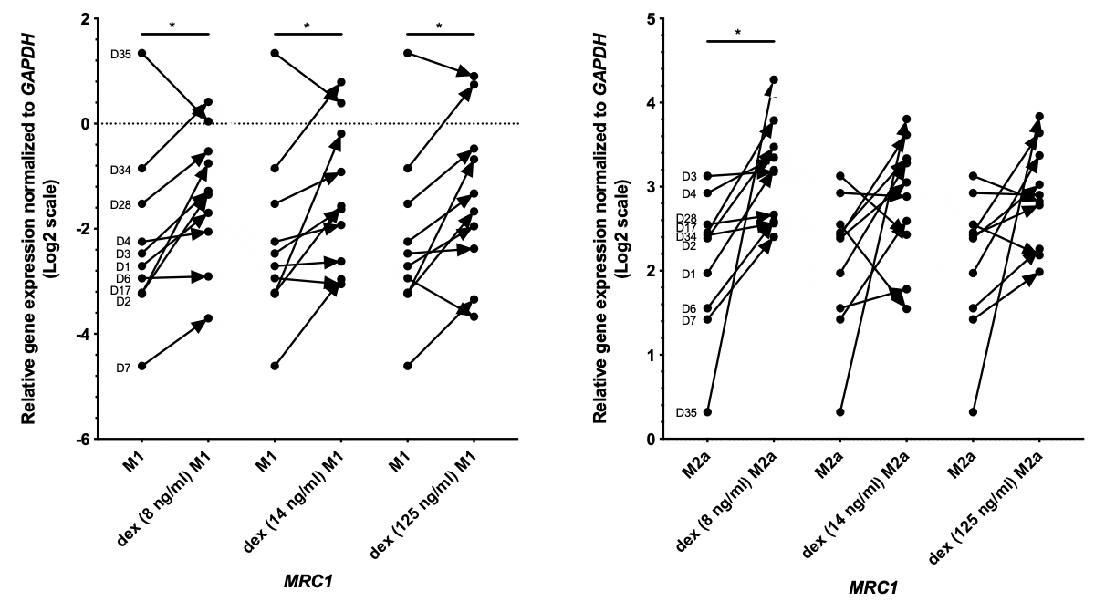
MRC1 gene expression was altered following 24-hour exposure to dex and there is a general upward trend with each dose (Figure 35). There is a significant change with the 8ng/ml dex polarisation in both M1 and M2a macrophage subtypes. Based on these results, dex may reprogram macrophages to a less inflammatory state and promotes polarization toward an M2 state.
Figure 35: Relative gene expression analysis of MRC1 in human MDMs after dexamethasone treatment
Human M1 (left panel) and M2a (right panel) polarized macrophages were treated with dex (8, 14, 125 ng/ml) and MRC1 gene expression was determined with RT-qPCR. Data is plotted from 10 donors, individually listed (n=10; D1, D2, D3, D4, D6, D7, D17, D28, D34, D35), normalised to GAPDH housekeeping gene. Data follow normal (Gaussian) distribution and analysed with two-tailed paired t test. The direction of change in expression is shown with the treatment as an arrow for each individual donor. Dotted line indicates 0 expression level. p value: * ‹0.0332

Dexamethasone modifies SCARB1 expression in M2a macrophages
Next, I studied Scavenger Receptor Class B Member 1 (SCARB1) which encodes a plasma membrane receptor. It has a major role in cholesterol transfer to and from HDL therefore it plays a main role in cholesterol homeostasis and atherosclerosis. It mediates reverse cholesterol transport and reduce foam cell formation (Linton, 2017).
Data in M1 proinflammatory macrophages were variable (Figure 36, right panel), but in the M2a state SCARB1 gene expression was significantly reduced (Figure 36, left panel). Decreased HDL uptake through the protein encoded by SCARB1 can affect cholesterol mobilization and inflammation.
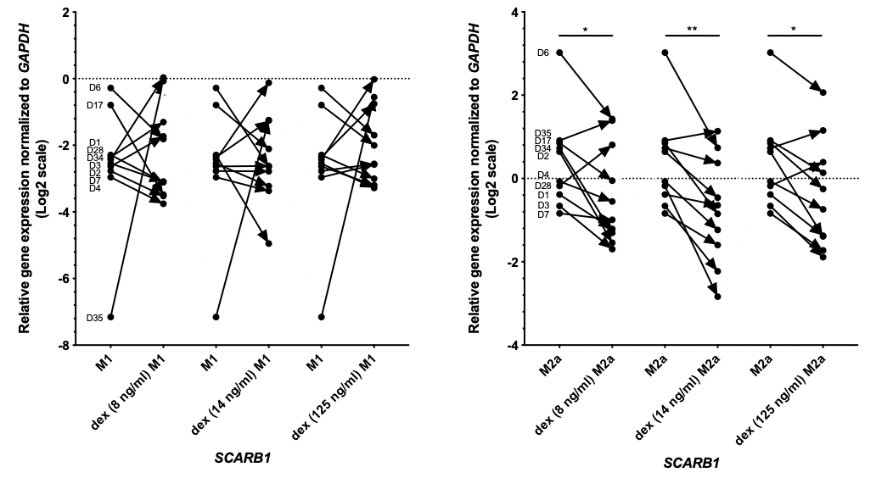

Figure 36: Relative gene expression analysis of SCARB1 in human MDMs after dexamethasone treatment
Human M1 (left panel) and M2a (right panel) polarized macrophages were treated with dex (8, 14, 125 ng/ml) and SCARB1 gene expression was determined with RT-qPCR. Data is plotted from 9 donors, individually listed (n=10; D1, D2, D3, D4, D6, D7, D17, D28, D34, D35), normalised to GAPDH housekeeping gene. Data follow normal (Gaussian) distribution and analysed with two-tailed paired t test. The direction of change in expression is shown with the treatment as an arrow for each individual donor. Dotted line indicates 0 expression level. p value: * ‹0.0332, ** ‹0.0021

Dexamethasone affects MSR1 expression in polarised macrophages
Next, the expression of an important scavenger receptor gene (Macrophage Scavenger Receptor 1- MSR1), which mediates the uptake of modified LDLs, was assessed.
The expression data for MSR1 are variable (Figure 37), but it is visible that dex upregulated the expression of MSR1 in the M1 state and downregulated in the M2a state. M1 macrophages mostly found in unstable plaques and the because of the possible increased modified LDL uptake, these plaques might become more unstable. While stable plaques contain more M2a cells, the possibility of decreased modified LDL internalization through MSR1 could be beneficial. It is likely that dex decreases plaque stability through M1 cells, while increase stability through M2a macrophages. Data of MSR1 expression changes are not significant, therefore further investigation is required to determine the effect of dex on this gene.
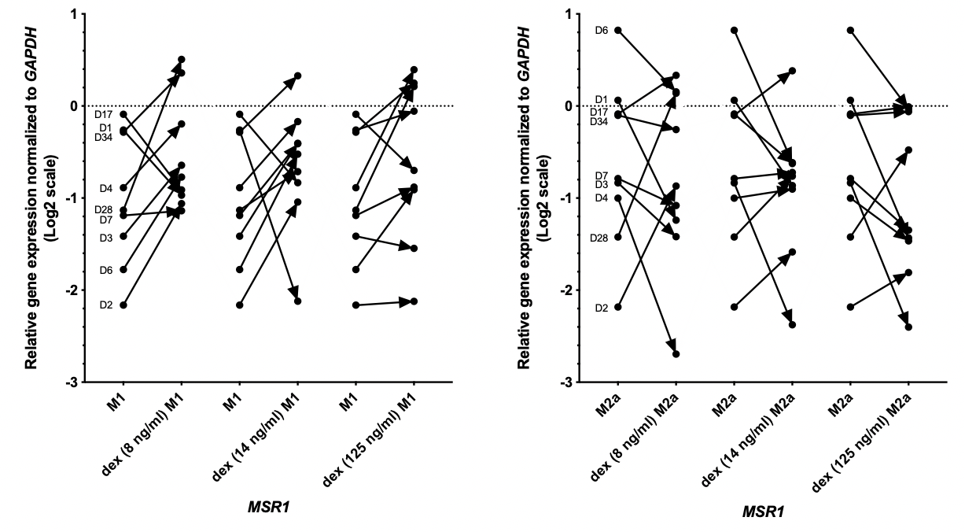
Figure 37: Relative gene expression analysis of MSR1 in human MDMs after dexamethasone treatment
Human M1 (left panel) and M2a (right panel) polarized macrophages were treated with dex (8, 14, 125 ng/ml) and MSR1 gene expression was determined with RT-qPCR. Data is plotted from 9 donors, individually listed (n=9; D1, D2, D3, D4, D6, D7, D17, D28, D34), normalised to GAPDH housekeeping gene. Data follow normal (Gaussian) distribution and analysed with two-tailed paired t test. The direction of change in expression is shown with the treatment as an arrow for each individual donor. Dotted line indicates 0 expression level.

The effect of dexamethasone on CD36 and OLR1 gene expression in polarised macrophages
Following on, the expression of CD36 and OLR1 was investigated. The encoded protein by CD36 binds to collagen, thrombospondin and lipoproteins, especially, oxLDL. It has a role in foam cell formation and in the pathogenesis of atherosclerosis (Calvo, 1998). OLR1 gene is regulated through the cyclic AMP signalling pathway and encodes a low-density lipoprotein receptor which binds, internalizes and degrades oxLDL. This protein may play a role as a scavenger receptor and has been associated with the progression of atherosclerosis (Tatsuguchi, 2003).
Data on CD36 gene expression is shown in Figure 38 and it is clearly visible that, dex, in 3 different concentrations, do not have a significant effect on CD36 gene expression.
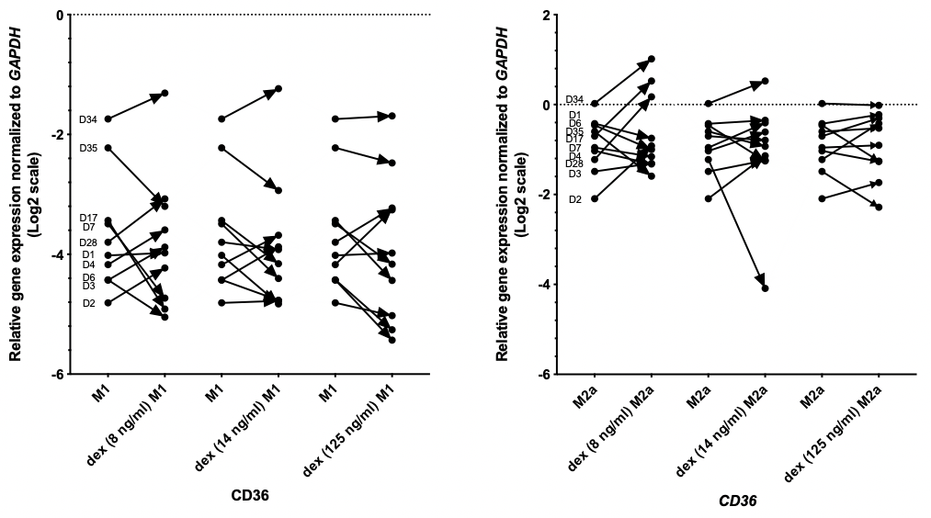
Figure 38: Relative gene expression analysis of CD36 in human MDMs after dexamethasone treatment
Human M1 (left panel) and M2a (right panel) polarized macrophages were treated with dex (8, 14, 125 ng/ml) and CD36 gene expression was determined with RT-qPCR. Data is plotted from 10 donors, individually listed (n=10; D1, D2, D3, D4, D6, D7, D17, D28, D34, D35), normalised to GAPDH housekeeping gene. Data follow normal (Gaussian) distribution and analysed with two-tailed paired t test. The direction of change in expression is shown with the treatment as an arrow for each individual donor. Dotted line indicates 0 expression level.

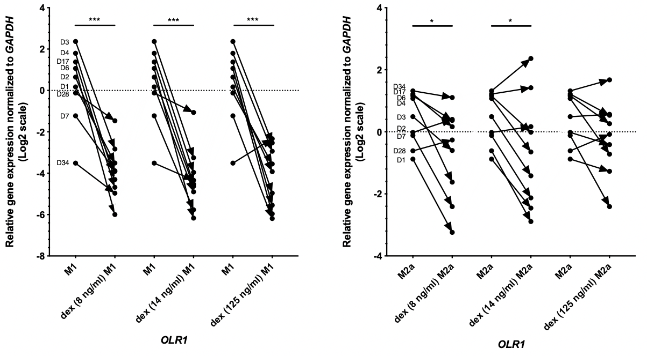
In contrast, in both M1 and M2a macrophages, the average OLR1 expression was decreased by dex treatment (Figure 39). The reduction of gene expression was highly significant in M1 macrophage state. Biologically, this implies that M1 macrophages can bind less oxLDL which could reduce the formation of atherosclerosis in the vessel wall.

Figure 39: Relative gene expression analysis of OLR1 in human MDMs after dexamethasone treatment
Human M1 (left panel) and M2a (right panel) polarized macrophages were treated with dex (8, 14, 125 ng/ml) and OLR1 gene expression was determined with RT-qPCR. Data is plotted from 9 donors, individually listed (n=9; D1, D2, D3, D4, D6, D7, D17, D28, D34), normalised to GAPDH housekeeping gene. Data follow normal (Gaussian) distribution and analysed with two-tailed paired t test. The direction of change in expression is shown with the treatment as an arrow for each individual donor. Dotted line indicates 0 expression level. p value: * ‹0.0332, *** ‹0.0002

The effect of dexamethasone on scavenger receptor gene expression
To conclude, dex treatment had a significant effect on macrophage specific, including scavenger receptor genes in M1 and M2a polarised cells in vitro (Figure 40). MRC1 gene expression was increased following dex treatment which indicates polarisation toward an M2 state. Dexamethasone can also reduce HDL uptake through decreased SCARB1 gene expression. Dexamethasone had the opposite effect on the expression of MSR1 in pro-inflammatory versus anti-inflammatory macrophages. MSR1 was slightly upregulated in the M1 state and downregulated in the M2a state which implies that dex might reduce plaque stability through M1 cells. Downregulation of OLR1 gene expression was highly significant following dex treatment which suggests decreased oxLDL binding capability which can lead to reduced plaque formation.
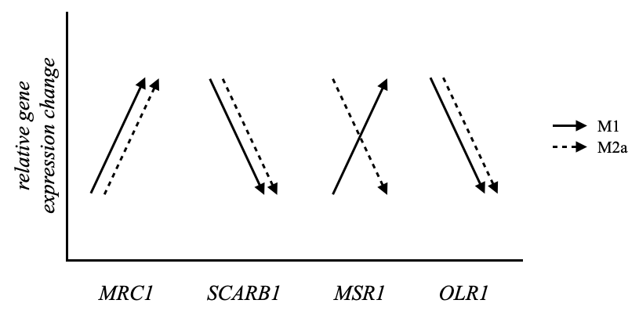
From these studied genes, the change in OLR1 expression was the most significant, therefore I focused my future research on this.
Figure 40: Summary of the effect of dexamethasone on scavenger receptor gene expression in polarised cells
Human M1 (solid arrow) and M2a (dashed arrow) polarized macrophages were treated with dex and MRC1, SCARB1, MSR1 and OLR1 gene expression was determined with RT-qPCR. Data is shown as an average of 9 donors and the direction of change in expression is shown with the treatment as an arrow.

The effect of dexamethasone on OLR1 protein in polarised macrophages
Next, western blots were performed to verify the change of OLR1 expression at a protein level. M1 and M2a polarised macrophages were treated with dex and OLR1 protein expression was determined. Figure 41 (top) shows the analysed results of western blot experiments, where the direction of change in expression is indicated. Relative OLR1 protein expression, normalized to GAPDH, was reduced following 24-hour exposure to 8ng/ml or 14 ng/ml dex treatment in both M1 and M2a macrophage subtypes (Figure 41). This suggests that the polarized and dex treated macrophages can bind less oxLDL. Figure 41 (bottom) is a representative image of the western blot analysis of OLR1 after dex treatment. Western blots from all donors are listed in 0.

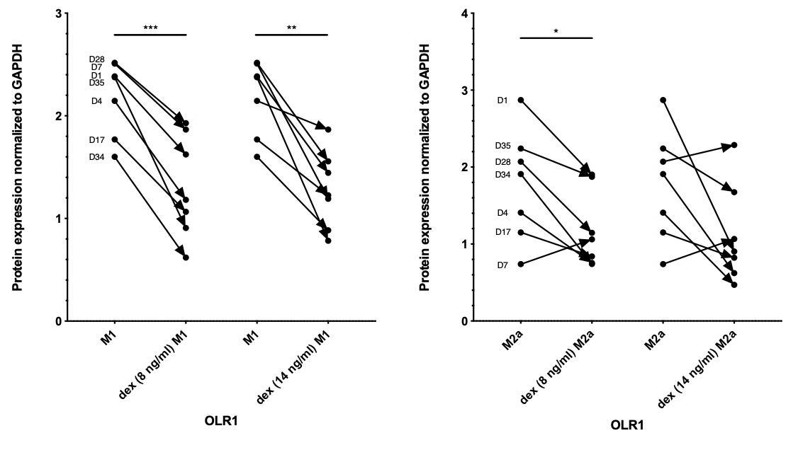
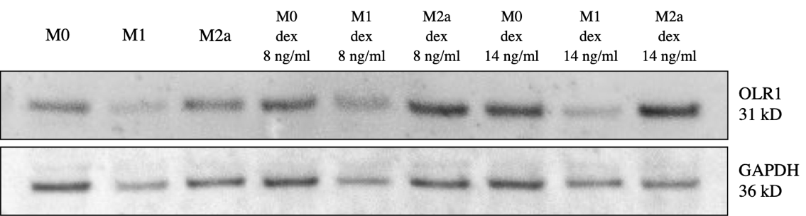

Figure 41: OLR1 protein in human MDMs after dexamethasone treatment
Human M1 (left panel) and M2a (right panel) polarized macrophages were treated with dex (8, 14 ng/ml) and OLR1 protein expression was determined with Western Blot. A representative Western Blot is shown below. Data is plotted from 7 donors, individually listed (n=7; D1, D4, D7, D17, D28, D34, D35), normalised to GAPDH housekeeping protein. Data follow normal (Gaussian) distribution and analysed with two-tailed paired t test. The direction of change in expression is shown with the treatment as an arrow for each individual donor. p value: * ‹0.0332, ** ‹0.0021, *** ‹0.0002

The change in OLR1 protein expression after 24h dex treatment was further tested using immunofluorescence staining for surface receptors.
The percentage of OLR1 positive cells were reduced by approximately 30%, after 24h exposure to dex using 8 ng/ml and 14 ng/ml concentration (Figure 42).
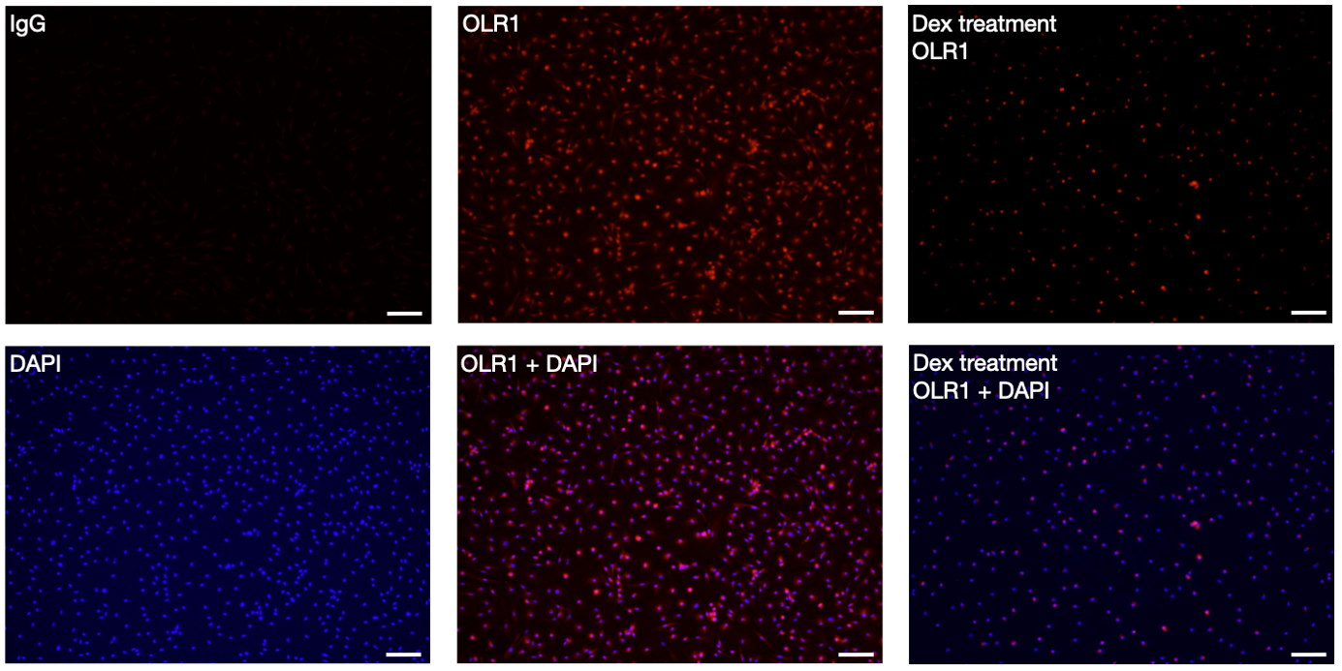
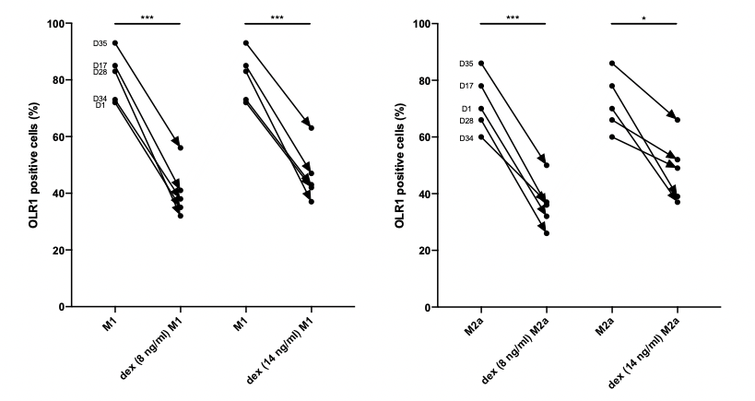
Figure 42: Detection of OLR1 positive cells in human MDMs after dexamethasone treatment
Human M1 (left panel) and M2a (right panel) polarized macrophages were treated with dex (8, 14 ng/ml). OLR1 positive cells were counted and compared to maximum cell number, based on DAPI IF signal. Immunofluorescence of nonpolarized hMDMs with OLR1 (red) and nuclei (DAPI, blue) markers are shown on the lower panels. Dexamethasone treated hMDMs are shown on the lower right side. Scale bar= 100 µm. Quantifications performed on an average of 5 field of view. Data is plotted from 5 donors, individually listed (n=5; D1, D17, D28, D34, D35). Data follow normal (Gaussian) distribution and analysed with two-tailed paired t test. The direction of change in expression is shown with the treatment as an arrow for each individual donor. p value: * ‹0.0332, *** ‹0.0002

Beneficial physiological effect of dexamethasone in polarised macrophages
These data, showing a reduction in OLR1 expression, led on to a functional test for lipid accumulation in polarised macrophages exposed to dex. oxLDL accumulation in dex treated hMDMs was assessed using Oil Red O staining to visualize lipids in macrophages.
In both M1 and M2a cells after 8 and 14 ng/ml dex treatment the percentage of ORO cells was reduced (approximately 50%) which means that dex effectively decreases the oxLDL binding capability of macrophages (Figure 43).
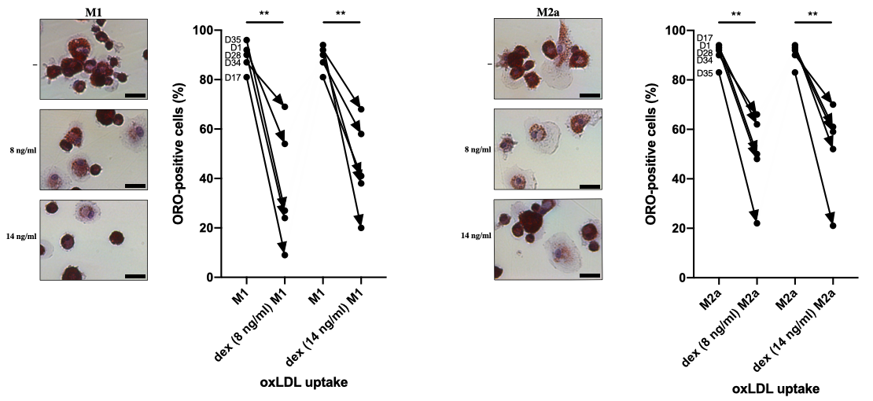
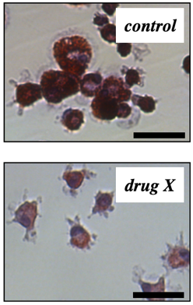

Figure 43: Detection of ORO positive cells in human MDMs after dexamethasone treatment
Human M1 (left panel) and M2a (right panel) polarized macrophages were treated with dex (8, 14 ng/ml) and lipid accumulation was tested with the addition of 25µg/ml oxLDL. Oil Red O stain was done to count the percentage of positive cells. Scale bar = 25 µm. Quantifications performed on an average of 5 field of view. Data is plotted from 5 donors, individually listed (n=5; D1, D17, D28, D34, D35). Data follow normal (Gaussian) distribution and analysed with two-tailed paired t test. The direction of change in expression is shown with the treatment as an arrow for each individual donor. p value: ** ‹0.0021

Summary of Results
The data presented in this chapter focuses on the effect of statins and dex treatment of human M1 and M2a macrophage activation in vitro.

- Atorvastatin and simvastatin do not have significant effects on upon the expression of macrophage specific or scavenger receptor genes.
- Dexamethasone reprograms macrophages to a less inflammatory state and promotes polarization toward an M2 state.
- Dexamethasone pacifies the expression of MSR1 in the M1 state with a resulting beneficial effect on the accumulation of LDLs.
- Dexamethasone treatment of the in vitro macrophages significantly reduces the OLR1 gene expression, therefore M1 macrophages can bind less oxLDL.
- Dexamethasone significantly reduced OLR1 protein expression in both M1 and M2a macrophage subtypes.
- Dexamethasone treatment reduced the ratio of OLR1 positive cells in IF stained M1 and M2a macrophages.
- Dexamethasone significantly reduced the percentage of ORO cells which means that dex effectively can decrease the oxLDL binding capability of hMDMs.
- Generally, dexamethasone reduced ‘active’ cell behaviours e.g., lipid accumulation and promoted the polarisation to the M2 state.

Discussion

Stroke survivors with a high atherosclerotic burden (stenosis) and inflamed or ulcerated plaque are at increased risk of early recurrent ischaemic events (Mohan et al., 2011). Atherosclerotic plaque macrophages are influenced by their microenvironment and exposure to certain medications such as lipid-lowering or anti-inflammatory drugs, may affect their functional phenotype (Chinetti-Gbaguidi et al., 2014). Treatment with glucocorticoids, like dexamethasone, or different statins may therefore reduce stroke incidence and recurrence in patients, but in vitro studies of the possible mechanisms in humans are lacking.

To characterise human macrophages, and their response to exposure to statins and dex, an in vitro model was developed, based on a previously established method by Geng and Hansson (1992). Human MDMs were differentiated from isolated PBMCS, polarised towards M1 and M2a phenotype, then treated with atorvastatin, simvastatin or dex in different clinically relevant concentrations (Loew, 1986).

The effect of statins on macrophages specific genes in human M1 and M2a polarized cells
Statins can reduce the risk of cardiovascular events through the reduction of cholesterol biosynthesis (Otvos et al., 2001). Experiments suggest that statins can improve the neurological outcome after ischemic stroke, but clinical results are conflicting, therefore a large meta-analysis study, including ﻿>113 000 patients, investigated the outcome of pre-stroke and post-stroke statin therapy. It was found that statin treatment ﻿was associated with good functional outcome and ﻿reduced likelihood of death at 90 days (Chróinín et al., 2013). Modified LDL uptake is mediated by scavenger receptors and can lead to foam cell formation, which is a key point in atherosclerosis. The regulation of scavenger receptors is very heterogenous, therefore, changes in gene expression of macrophage specific scavenger receptors, after the anti-atherosclerotic statin therapy, are expected and needed to be tested (Hofnagel et al., 2007).
The direct target of statin inhibition is the 3-hydroxy-3-methylglutaryl coenzyme A reductase (HMGCR), which undergoes alternative splicing of exon 13. It encodes a part of the statin-binding domain of HMGCR (Medina et al., 2008). A comprehensive mRNA expression analysis of 170 simvastatin incubated immortalised lymphocyte cell lines from participants (n=170 participants, 40mg/d for 6 weeks) found that the individual differences in the response to statin treatment are because of a variation in the production of an HMGCR isoform with reduced statin sensitivity (Medina et al., 2008). Statin responsive splice variant expression changes were further investigated to identify genes of statin response and cholesterol homeostasis (Stormo et al., 2014). RNA-seq confirmed that 98 transcript splice variants were altered by atorvastatin treatment (10 μM for 24h) and atorvastatin mostly changed the mRNA expression level of major splice variants. Interestingly, 4 minor splice variants changed more with statin treatment than did the major one (ZNF195 and SP1 are transcription factors and have a role in cell growth, DTNA which is involved in synapse formation, FAM189 which has a role in apoptosis) (Stormo et al., 2014) and these genes previously were not connected with statin response.
In this study, atorvastatin and simvastatin were tested, because these are commonly used statins to treat high cholesterol. These statins in clinically relevant concentration did not alter the gene expression of macrophage specific genes including scavenger receptors in M1 and M2a macrophages in vitro. Similarly, in the monocytic THP-1 cell line there was no influence of atorvastatin treatment in the expression of SR-AI (MSR1) or CD36 (Llaverias et al., 2004). In contrast, the expression of SR-AI (MSR1) was reduced after lovastatin treatment in THP-1 cells (Umetani et al., 1996), and also in PBMCs (Hrboticky et al., 1999). CD36 expression was reduced in cultured M0 macrophages supplemented with pitavastatin (Han et al., 2004). LOX-1 (OLR1) scavenger receptor gene expression was supressed in blood monocytes treated with lovastatin (Draude et al., 1999).
The outcome of statins could be cell type specific, as indicated by Morikawa et. al. (2004) who reported that atorvastatin an pitavastatin have various effect in different cultured vascular cells (human umbilical vein endothelial cells- HUVEC, human coronary artery smooth muscle cells- HCASMC, human hepatocarcinoma HepG2 cells) and mediate pleiotropic effect by transcriptional control. (Morikawa et al., 2004). It was confirmed that the effect of statins is cell type specific confirmed by the different RNA-seq results in different cell types (Stormo et al., 2014). In epithelial cells, 10 μM atorvastatin treatment induced anti-thrombotic effects through the increased expression of genes encoding endothelial nitric oxide synthase and thrombomodulin (Boerma et al., 2008) but these genes were not affected in HepG2 cells (Stormo et al., 2014). An anti-inflammatory effect of atorvastatin was detected in human peripheral blood through reduced mRNA level of cytokines (IL-6, IL-1, TGF-β) and chemokines (CCL2, CXCL1) (Wang et al., 2011). None of these changes was detected in HepG2 cells (Stormo et al., 2014).
To conclude, the effect of statins on scavenger receptors remains controversial because of the previously shown conflicting results in different cell types.

The effect of dexamethasone on macrophage specific genes in human M1 and M2a polarized cells
Glucocorticoid hormones regulate fundamental physiological functions, like stress response and energy homeostasis and in medicine, they are widely used as anti-inflammatory and immunosuppressive medications (Sacta et al., 2016). The glucocorticoid receptor is a ligand regulated transcription factor, which regulates gene expression by binding directly or indirectly to the genome (Desgeorges et al., 2019). Glucocorticoid receptor regulated gene networks are highly plastic and vary between cell types and physiological context (Weikum et al., 2017).
Anti-inflammatory synthetic glucocorticoids like dex have a beneficial role in atherosclerosis through the regulation of glucocorticoid response elements (Ramamoorthy and Cidlowski, 2016). Dexamethasone treatment of stroke patients suggested that there is no benefit from corticosteroids on improving functional outcomes or decreasing the number of deaths from stroke (Sandercock and Soane, 2011). On the contrary, data from stroke models or monocytic cells are more encouraging, e.g., it was found that dex (0.25 mg/kg) could reduce infarct volume size, mortality and neurological deficits in a mouse ischemic stroke model (Espinosa et al., 2020). Dexamethasone also inhibited human monocytic cell activation induced by ﻿27-Hydroxycholesterol (27OHChol) (Bo-Young Kim, 2017).
Glucocorticoids also play a role in the regulation of macrophage functions to resolve inflammation mainly through the reduction of the expression of pro-inflammatory cytokines (Desgeorges et al., 2019). Glucocorticoids also promote macrophage survival to decrease inflammation through their anti-apoptotic effect (Luedke and Cerami, 1990, Barczyk et al., 2010). Moreover, it was found that lower doses of GCs increased NO production while higher doses of GCs reduced the production of NO (Lim et al., 2007).
Therefore, the dose-dependent effect of dex needed to be tested on human polarized M1 and M2a macrophages, in vitro.

In this study, the effect of dex on polarized macrophages was investigated. It was found that the gene expression of macrophage specific genes including scavenger receptors in M1 and M2a macrophages was significantly altered following 24h exposure to different, clinically relevant concentration of dex.
First, it was important to determine what is the clinically relevant concentration on the cellular/plasma level for human research because the amount of dex used both in vitro and in vivo studies is highly variable. In in vitro studies, the concentration of dex varies between 0.4 ng/ml and 392 ng/ml (Asai et al., 1993) (Bo-Young Kim, 2017). In vivo, in animal models, the range of the used dex is from 0.125 mg/kg up to 15 mg/kg (Asai et al., 1993) (Lee et al., 2014) (Espinosa et al., 2020) while in human, the daily dose is between 0.3 mg and 24 mg (Loew, 1986) (Weijtens et al., 1998). In the 20th century, standard pharmacokinetic studies measured the concentration of dex in the plasma level by radioimmunoassay (Loew, 1986) (Weijtens et al., 1998). These studies have reported that after 0.5 mg oral administration of dex, the plasma level (C_{max}) was 8 ng/ml and after 10 mg of dex the plasma level reached 14 ng/ml (Loew, 1986). Adults usually take between 0.5 mg and 10 mg dex daily, therefore 8 ng/ml, 14 ng/ml (1.5 daily dose) and 125 ng/ml concentrations were chosen for this study. Cell death (apoptosis) was not detected in my samples and this agrees with a previous study (Zhou et al., 2010) which proved that glucocorticoids only induce apoptosis in high dose (1000 ng/ml).
My data suggest that dex may re-program macrophages to a less inflammatory state (an M2 state) by significantly increasing MRC1 gene expression (p= 0.0183). Similarly, dex (0.3 µM= 117.65 ng/ml) upregulated MRC1 gene expression (up to 100 fold) in human polarized M1 and M2 macrophages (THP-1) (Sarsenbayeva et al., 2021). It indicates that dex has potent anti-inflammatory effect on human macrophages, through the induction of inflammatory mediators (Abraham et al., 2006). On the contrary, in a mouse model (C57BL/6 mice) and murine cell line (Lewis lung carcinoma- LLC), Mrc1 gene expression was significantly decreased after exposure to high dose of dex (50 mg/kg) (Lei et al., 2020).
I also found that dexamethasone reduces SCARB1 gene expression in polarized macrophages. Similarly, it was reported that dex decreased the expression of this gene in rat stem Leydig cells (dex: 0–100 nM) (Zhang et al., 2019) and adrenal gland (dex: 100 μg) (Azhar et al., 2002). In contrast, SCARB1 expression in monocyte‐ derived human DCs was upregulated following dex (10 nM-100 nM) treatment (Hodrea et al., 2012)
The expression of MSR1 gene was not significantly altered in my work following dex treatment, which has various effects on modified LDL uptake. On the other hand, rat macrophages (polarized M1 and M2 BMDMs) expressed lower level of MSR1 following dex (100 nM) treatment (van Putten et al., 2013).
In my data, dex did not have a significant effect on CD36 gene expression. In dex (0.1 mg/kg) injected adult rat offspring, the CD36 expression in the jejunum was reduced which is resulted lower fatty acid absorption (de Souza et al., 2021).
Using OLR1 gene expression as a readout, in both M1 and M2a macrophages, the average OLR1 gene and protein expression was significantly reduced (average 4-5 fold) following an exposure to dexamethasone. In support, OLR1 expression was also reduced in monocyte‐ derived human DCs after dex (10 nM-100 nM) treatment (Hodrea et al., 2012). Cortisol, another glucocorticoid (0.1 to 1000 nM) decreased oxLDL uptake in macrophages differentiated from THP1 cells (Ledda et al., 2016). In functional tests, in the research, oxLDL accumulation by dex treated hMDMs was reduced by around 50%. This implies that M1 and M2 macrophages bind less oxLDL after exposure to this drug, which could reduce the formation of atherosclerotic plaque in the vessel wall. In support, previous studies have shown that dex significantly decreased the development of aortic atherosclerotic plaque in rabbits (Asai et al., 1993). One of the processes which leads to the migration of inflammatory cells is the monocytic cell activation. This could be inhibited with dex through the inhibition of the secretion of chemoattractants (e.g., CCL2) (Bo-Young Kim, 2017).
The controversiality of the data is supported by the fact that most of the GR target genes are unique and showing cell type specificity (Weikum et al., 2017). For example, it was found that different sets of target genes were regulated by dex in two different cancer cell lines (U2OS: human bone osteosarcoma epithelial cells, A549: human lung adenocarcinoma cells) (Weikum et al., 2017). Generally, dex reduced ‘active’ and pathogenic cell behaviours e.g., lipid accumulation and promoted the polarisation to the M2 (anti-inflammatory) state (Figure 44).
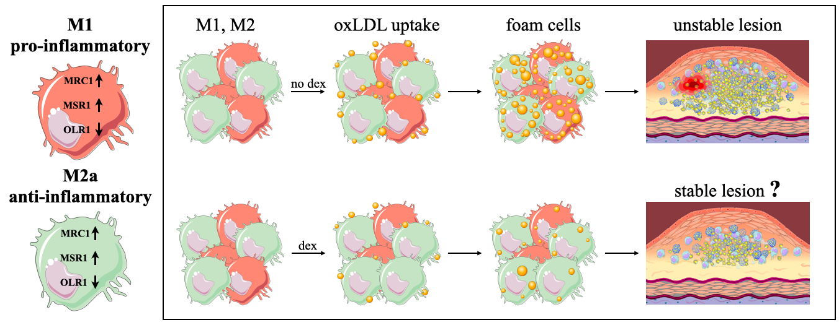

Figure 44: Beneficial effect of dexamethasone on human macrophages
Dexamethasone treatment of hMDMs beneficially alters the expression of scavenger receptor genes and promotes polarisation to a less inflammatory state. Dexamethasone may help in the stabilisation of carotid atherosclerotic plaques.

Limitations
The work presented in this chapter is mostly in vitro cell culture experiments, which are highly controlled and easily reproducible, but it has some limitations.
First of all, blood used for PBMC isolation was donated by healthy young adult donors, and not from elderly people, who are more susceptible to stroke (Soriano-Tárraga et al., 2016). Secondly, only the effect of dex was tested as an anti-inflammatory drug, but other glucocorticoids, like prednisolone or hydrocortisone, might be effective, therefore, the investigation of these drugs are necessary.

Chapter 6.
General Discussion and Conclusions

Major outcomes

Stroke is a neurological condition caused by an acute injury of the central nervous system (Deb et al., 2010). Ischemic stroke is resulted by atherosclerosis, which is a systemic inflammatory disease, where mostly inflammatory cells and lipid form a plaque within an artery (Ross, 1999, Daugherty et al., 2005, Chinetti-Gbaguidi et al., 2014). Inflammatory cells, like macrophages, are highly sensitive to their surrounding microenvironment and can adapt their phenotype and function on demand (Shapouri-Moghaddam et al., 2018) Treatment with lipid-lowering (e.g., statins) or anti-inflammatory drugs (e.g., dexamethasone), reduce stroke recurrence, therefore the molecular mechanism of the effect of these drugs needs to be investigated.
In this thesis, I described the function and role of human carotid plaque macrophages and I simulated the effect of statins and dex on polarised M1 and M2a macrophages, in vitro.

In this study, carotid plaques were taken from patients with recently symptomatic carotid stenosis and histological features were analysed according to the American Heart Association criteria (Stary, 1994, Stary et al., 1995). Patients were mostly elderly males who had increased risk for stroke because of high blood pressure or smoking (Appelros et al., 2009, Shah and Cole, 2014). The collected plaques were histologically classified and 55% were considered unstable, a similar ratio (69%) as reported previously (Salem et al., 2014). Interestingly, a recent study (n= 92 patients) reported a significantly increased percentage of patients identified with unstable plaques (94%), using advanced ultrasound technology, and electron paramagnetic resonance (Ignatyev et al., 2021).
A novel IF staining and analysis technique was developed to identify single M1 (CD68+CD86+MRC1-), single M2 (CD68+CD86-MRC1+), double positive (CD68+CD86+MRC1+) and double negative (CD68+CD86-MRC1-) macrophages in the shoulder regions (either side of a thinned fibrous cap) of the lesions. Different macrophages subtypes were abundant in the collected plaques and as previously described by Stöger et al. (2012). In this thesis, the population comprised double positive (68%), M1 single positive (16%), M2 single positive (9%) and double negative macrophages (7%). Amongst the unstable plaques (n=6) the majority (88%) of shoulder macrophages were expressing the CD86 surface marker. In contrast, amongst stable plaques (n=5), the majority of plaque macrophages (83%) exhibited MRC1 expression. The data presented here is different from previous studies (Medbury et al., 2013), because those studies separately stained for M1 and M2 markers and did not consider that a single macrophage can express both markers. My data indicate that a considerable number (68% of total) of macrophages are actually ‘intermediates’ expressing both M1 and M2 marker genes, while double negative macrophages may represent a previously uncharacterised population. Macrophages, in an inflammatory region, like atherosclerotic lesion, are activated and polarized to functional phenotypes as a response for microenvironmental changes(Shirai et al., 2015).

Single cell RNA sequencing is a powerful approach to identify differences between cell types, for example characterise these novel macrophage subsets, while bulk RNA-seq (data points are observed from more cells) is useful to measure and average gene expression and compare conditions (Chaudhry et al., 2019). To dissect single cells, Laser Capture Microdissection was used, because I hypothesised that cell localisation and clustering within the plaque could be important. Moreover macrophages are more susceptible to becoming damaged than other cell types during dissociation with enzymatic or mechanical solutions (Willemsen and Winther, 2020).
To date, no one has dissected single human macrophages and sequenced whole transcriptome RNA from IF stained FFPE atherosclerotic plaques, using LCM; therefore, all steps needed to be optimised. First, the histological steps (decalcification, embedding, IF stain) were modified to maintain RNA integrity and tested with RT-qPCR, Bioanalyzer scans and pilot sequencing. It was shown that common macrophage specific markers (CD68, CD86 and MRC1) were present in the RNA sample with adequate quality and quantity. Second, laser settings were specified for carotid plaque samples because the quality of microdissected cells were not be adequate due to its exposure to fixatives and staining reagents (Chung and Shen, 2015). Finally, library preparation and bioinformatic analysis were optimised, by our collaboration partners. Results indicated that, RNA sequencing is possible from a single macrophage dissected from carotid plaque tissue, with a 5% mapping rate to protein coding genes. This rate might seem low, but it is sufficient, considering the exposure to chemicals (e.g., EDTA, xylene, ethanol) (Civita et al., 2019).
Preliminary scRNA-seq data validated the macrophage origin of the microdissected cells. Moreover, these 4 dissected cells were clustered between M1 and M2a polarised macrophages, generated in vitro, confirmed by hierarchical analysis. Previously in this thesis, I described that a considerable number (68%) of plaque macrophages are double positive (CD68+CD86+MRC1+) cells, which could be ‘intermediates’ between phenotype switching or a previously uncharacterised phenotype. LCM scRNA-seq data confirmed this new hypothesis, that this phenotype (CD68+CD86+MRC1+) is highly represented in the shoulder regions of carotid lesions. At the time, we could only dissect and sequence 4 individual cells, but it was sufficient for optimisation. LCM scRNA-seq analysis of more cells from human carotid plaques is necessary to study inflammatory cells in atherosclerosis.

In this study, an in vitro model was also optimised, based on the previously established method by Geng and Hansson (1992), to study human monocyte derived macrophages and the gene expression changes that occur as an effect of exposure to different drugs.
Polarized macrophages were treated with simvastatin and atorvastatin in clinically relevant concentrations, and it was found that these lipid lowering drugs do not amend the gene expression of macrophage specific, including scavenger receptor genes (OLR1, MRC1, MSR1, CD36, SCARB1). Previously, equivocal data were published (Llaverias et al., 2004) about the effect of different statins, therefore the impact of these drugs on scavenger receptor genes remains uncertain and further investigation is necessary. Interestingly, it was found that statins (lovastatin, atorvastatin, fluvastatin and pravastatin) can disrupt OLR1 receptor, leading to a decreased receptor function (Biocca et al., 2015).
To explore the effect of anti-inflammatory drugs on plaque macrophages, polarized hMDMs were treated with dex in clinically relevant concentrations and the changes in gene expression were studied. MRC1 gene expression was significantly increased, following dex treatment, which proves the anti-inflammatory effect of this drug (Sarsenbayeva et al., 2021). SCARB1 gene expression was decreased in M2a macrophages which could result increased HDL level in the bloodstream (de Villiers and Smart, 1999). MSR1 gene expression was upregulated in M1 macrophages with a possible disadvantageous effect on LDL uptake, but it was downregulated in M2 cells with a protentional beneficial result. Dexamethasone had the most significant effect in the expression level of OLR1 gene and protein. OLR1 gene encodes low-density lipoprotein receptor transcript variants (e.g., LOX-1,) which bind, internalize and degrade oxLDL, therefore it has a role in the process of atherosclerosis. Over expression of LOX-1 is associated with coronary artery diseases (CAD). A recent study (Salehipour et al., 2021) investigated the impact of different OLR1 polymorphisms because of the possible clinical significance of single nucleotide polymorphisms (SNPs) in OLR1 gene. It was found that there are 6 SNPs which form a haplotype block, and between these two (rs1050283 & rs3736235) are highly associated with CAD (Salehipour et al., 2021). I have found that dex reduced OLR1 with a favourable impact on oxLDL accumulation. Biological tests (oxLDL accumulation) supported this which suggest that dex can reduce the formation of a lipid rich atherosclerotic plaque.
Overall, polarized human macrophages are characterised by increased MRC1 expression and decreased OLR1 expression following dex treatment and these results are in accordance with the anti-inflammatory effect of dex (Desgeorges et al., 2019). These data demonstrate that human macrophages can be reprogrammed to a less pathogenic state in vitro and provide a potential mechanism for the effectiveness of dex in the stabilisation of carotid atherosclerotic plaques in humans. Longitudinal studies incorporating biomarkers of plaque instability are now needed to further explore the plaque stabilising effects of dex in humans.

Future Work

The findings presented in this thesis raise new questions about the function and role of macrophages in human atherosclerotic plaques. In order to obtain further insight, further investigation is required, which is discussed below.

Firstly, collection and analysis of more carotid plaques are necessary to investigate the function of atherosclerotic macrophages. The optimised LCM scRNA-seq is a powerful tool to study the mechanism of atherosclerosis, characterise the previously described double positive (CD68+CD86+MRC1+) and double negative (CD68+CD86-MRC1-) macrophages or identify markers for unstable atherosclerotic lesions. A previous study (Nichterwitz et al., 2016) suggested that the length of the staining is important to minimize RNA degradation, therefore the use of a quick histological stain, like H&E would be useful.

Secondly, my findings suggest that dex treatment of hMDMs significantly decreased the binding capacity of macrophages for lipids and that this may have an impact on the development of atherosclerosis and the formation of unstable plaques. However, the data presented are from macrophages derived from healthy young donors (in their 20s) but patients requiring endarterectomy tend to be older adults. Therefore, to test the effect of dex on MDMs isolated from elderly donors, samples from stroke patients are necessary.
The timing of the dex is also need to be studied. Does it work on already polarised macrophages or can it prevent polarisation? To investigate the beneficial effect of dex on already polarised cells, MDMs need to be cultured for 7 days, polarize toward M1 or M2 state for 24h then add dex for an other 24h. To study wether dex can prevent polarisation, cultutred macrophages need to be treated with dex, then add polarisation factors.
Steroids are effective in a low dose, thereby to test a lower concentration of dex is required.
In this thesis only dex was tested as an anti-inflammatoty glucocorticoid, therefore a comparison of clinically relevant concentration of prednisolone, hydrocortisone in an in vitro system would be useful.
Finally, the effect of dex on human carotid plaques should be assesed to see if it can alter the gene and protein expression of macrophage specific and scavenger receptors ex vivo. Carotid plaques (right after surgery) needed to be divided in different sections, to culture it in the presence and absence of dex. The affect of dex treatment cold be tested with OLR1 histological staining and RT-qPCR after cell lysis and RNA extraction.

References

ABRAHAM, S., LAWRENCE, T., KLEIMAN, A., WARDEN, P., MEDGHALCHI, M., TUCKERMANN, J., SAKLATVALA, J. & CLARK, A. 2006. Antiinflammatory effects of dexamethasone are partly dependent on induction of dual specificity phosphatase 1. The Journal of experimental medicine, 203.
ACTON, S. L. A. K. K. F. A. R. A. 1999. The HDL receptor SR-BI: a new therapeutic target for atherosclerosis? Molecular Medicine Today, 5, 518--524.
ADAMS, H. P., ADAMS, R. J., BROTT, T., DEL ZOPPO, G. J., FURLAN, A., GOLDSTEIN, L. B., GRUBB, R. L., HIGASHIDA, R., KIDWELL, C., KWIATKOWSKI, T. G., MARLER, J. R., HADEMENOS, G. J. & STROKE COUNCIL OF THE AMERICAN STROKE, A. 2003. Guidelines for the early management of patients with ischemic stroke: A scientific statement from the Stroke Council of the American Stroke Association. Stroke, 34, 1056-83.
ADAMS, H. P., BENDIXEN, B. H., KAPPELLE, L. J., BILLER, J., LOVE, B. B., GORDON, D. L. & MARSH, E. E. 1993. Classification of subtype of acute ischemic stroke. Definitions for use in a multicenter clinical trial. TOAST. Trial of Org 10172 in Acute Stroke Treatment. Stroke, 24, 35-41.
AHO, K., HARMSEN, P., HATANO, S., MARQUARDSEN, J., SMIRNOV, V. E. & STRASSER, T. 1980. Cerebrovascular disease in the community: results of a WHO collaborative study. Bulletin of the World Health Organization, 58.
AKISHIMA, Y., AKASAKA, Y., ISHIKAWA, Y., LIJUN, Z., KIGUCHI, H., ITO, K., ITABE, H. & ISHII, T. 2005. Role of macrophage and smooth muscle cell apoptosis in association with oxidized low-density lipoprotein in the atherosclerotic development. Modern pathology : an official journal of the United States and Canadian Academy of Pathology, Inc, 18.
ALEXANDER, M. & OWENS, G. 2012. Epigenetic control of smooth muscle cell differentiation and phenotypic switching in vascular development and disease. Annual review of physiology, 74.
ALIEV, G., SMITH, M. A., TURMAINE, M., NEAL, M. L., ZIMINA, T. V., FRIEDLAND, R. P., PERRY, G., LAMANNA, J. C. & BURNSTOCK, G. 2001. Atherosclerotic Lesions Are Associated with Increased Immunoreactivity for Inducible Nitric Oxide Synthase and Endothelin-1 in Thoracic Aortic Intimal Cells of Hyperlipidemic Watanabe Rabbits. Experimental and Molecular Pathology, 71, 40-54.
ALMDAL, T., SCHARLING, H., JENSEN, J. S. & VESTERGAARD, H. 2004. The Independent Effect of Type 2 Diabetes Mellitus on Ischemic Heart Disease, Stroke, and Death A Population-Based Study of 13 000 Men and Women With 20 Years of Follow-up. Archives of Internal Medicine, 164, 1422-1426.
AMARENCO, P., LABREUCHE, J., LAVALLÉE, P. & TOUBOUL, P.-J. 2004. Statins in stroke prevention and carotid atherosclerosis: systematic review and up-to-date meta-analysis. Stroke, 35, 2902-9.
AMERICAN HEART ASSOCIATION, I. 1975. A classification and outline of cerebrovascular diseases. II. American Heart Association, Inc.
AMINI, P., ETTLIN, J., OPITZ, L., CLEMENTI, E., MALBON, A. & MARKKANEN, E. 2017. An optimised protocol for isolation of RNA from small sections of laser-capture microdissected FFPE tissue amenable for next-generation sequencing. BMC molecular biology, 18.
AMOS, B. 2000. Lessons from the history of light microscopy. Nature Cell Biology, 2.
ANGELI, V., HAMMAD, H., STAELS, B., CAPRON, M., LAMBRECHT, B. N. & TROTTEIN, F. 2003. Peroxisome proliferator-activated receptor gamma inhibits the migration of dendritic cells: consequences for the immune response. Journal of immunology (Baltimore, Md. : 1950), 170, 5295-301.
APPELROS, P., STEGMAYR, B. & TERÉNT, A. 2009. Sex Differences in Stroke Epidemiology.
ARAKI, T. 2017. The history of optical microscope. Mechanical Engineering Reviews.
ASAI, K., FUNAKI, C., HAYASHI, T., YAMADA, K., NAITO, M., KUZUYA, M., YOSHIDA, F., YOSHIMINE, N. & KUZUYA, F. 1993. Dexamethasone-induced suppression of aortic atherosclerosis in cholesterol-fed rabbits. Possible mechanisms.
ASZTALOS, B., HORVATH, K., MCNAMARA, J., ROHEIM, P., RUBINSTEIN, J. & SCHAEFER, E. 2002. Comparing the effects of five different statins on the HDL subpopulation profiles of coronary heart disease patients. Atherosclerosis, 164.
AVULA, A., NALLEBALLE, K., NARULA, N., SAPOZHNIKOV, S., DANDU, V., TOOM, S., GLASER, A. & ELSAYEGH, D. 2020. COVID-19 presenting as stroke. Brain, Behavior, and Immunity, 87, 115-119.
AZHAR, S., NOMOTO, A. & REAVEN, E. 2002. Hormonal regulation of adrenal microvillar channel formation. Journal of lipid research, 43.
BABAEV, V. R., GLEAVES, L. A., CARTER, K. J., SUZUKI, H., KODAMA, T., FAZIO, S. & LINTON, M. F. 2000. Reduced atherosclerotic lesions in mice deficient for total or macrophage-specific expression of scavenger receptor-A. Arteriosclerosis, thrombosis, and vascular biology, 20, 2593-9.
BABAEV, V. R., YANCEY, P. G., RYZHOV, S. V., KON, V., BREYER, M. D., MAGNUSON, M. A., FAZIO, S. & LINTON, M. F. 2005. Conditional knockout of macrophage PPARgamma increases atherosclerosis in C57BL/6 and low-density lipoprotein receptor-deficient mice. Arteriosclerosis, thrombosis, and vascular biology, 25, 1647-53.
BAETTA, R. & CORSINI, A. 2010. Role of polymorphonuclear neutrophils in atherosclerosis: Current state and future perspectives. Atherosclerosis, 210, 1-13.
BAIDŽAJEVAS, K., HADADI, É., LEE, B., LUM, J., SHIHUI, F., SUDBERY, I., KISS-TÓTH, E., WONG, S. & WILSON, H. 2020. Macrophage polarisation associated with atherosclerosis differentially affects their capacity to handle lipids. Atherosclerosis, 305.
BALLANTYNE, C. M., OLSSON, A. G., COOK, T. J., MERCURI, M. F., PEDERSEN, T. R. & KJEKSHUS, J. 2001. Influence of Low High-Density Lipoprotein Cholesterol and Elevated Triglyceride on Coronary Heart Disease Events and Response to Simvastatin Therapy in 4S.
BANG, H., DYERBERG, J. & NIELSEN, A. 1971. Plasma lipid and lipoprotein pattern in Greenlandic West-coast Eskimos. Lancet (London, England), 1.
BARCZYK, K., EHRCHEN, J., TENBROCK, K., AHLMANN, M., KNEIDL, J., VIEMANN, D. & ROTH, J. 2010. Glucocorticoids promote survival of anti-inflammatory macrophages via stimulation of adenosine receptor A3. Blood, 116.
BAURIEDEL, G., HUTTER, R., WELSCH, U., BACH, R., SIEVERT, H. & LÜDERITZ, B. 1999. Role of smooth muscle cell death in advanced coronary primary lesions: implications for plaque instability. Cardiovascular research, 41.
BAZAN, J. F., BACON, K. B., HARDIMAN, G., WANG, W., SOO, K., ROSSI, D., GREAVES, D. R., ZLOTNIK, A. & SCHALL, T. J. 1997. A new class of membrane-bound chemokine with a CX3C motif. Nature, 385, 640-644.
BENJAMIN, E. J., BLAHA, M. J., CHIUVE, S. E., CUSHMAN, M., DAS, S. R., DEO, R., DE FERRANTI, S. D., FLOYD, J., FORNAGE, M., GILLESPIE, C., ISASI, C. R., JIMÉNEZ, M. C., JORDAN, L. C., JUDD, S. E., LACKLAND, D., LICHTMAN, J. H., LISABETH, L., LIU, S., LONGENECKER, C. T., MACKEY, R. H., MATSUSHITA, K., MOZAFFARIAN, D., MUSSOLINO, M. E., NASIR, K., NEUMAR, R. W., PALANIAPPAN, L., PANDEY, D. K., THIAGARAJAN, R. R., REEVES, M. J., RITCHEY, M., RODRIGUEZ, C. J., ROTH, G. A., ROSAMOND, W. D., SASSON, C., TOWFIGHI, A., TSAO, C. W., TURNER, M. B., VIRANI, S. S., VOEKS, J. H., WILLEY, J. Z., WILKINS, J. T., WU, J. H., ALGER, H. M., WONG, S. S., MUNTNER, P. & AMERICAN HEART ASSOCIATION STATISTICS COMMITTEE AND STROKE STATISTICS, S. 2017. Heart Disease and Stroke Statistics-2017 Update: A Report From the American Heart Association. Circulation, 135, e146-e603.
BENTZON, J., OTSUKA, F., VIRMANI, R. & FALK, E. 2014. Mechanisms of plaque formation and rupture. Circulation research, 114.
BERKHEMER, O., FRANSEN, P., BEUME, R. D., VAN DEN BERG, L., LINGSMA, H., YOO, A., SCHONEWILLE, W., VOS, J., NEDERKOORN, P., WERMER, M., VAN WALDERVEEN, M., STAALS, J., HOFMEIJER, J., VAN OOSTAYEN, J., LYCKLAMA À, N., GJ, BOITEN, J., BROUWER, P., EMMER, B., DE BRUIJN, S., VAN DIJK, L., KAPPELLE, L., LO, R., VAN DIJK, E., DE VRIES, J., DE KORT, P., VAN ROOIJ, W., VAN DEN BERG, J., VAN HASSELT, B., AERDEN, L., DALLINGA, R., VISSER, M., BOT, J., VROOMEN, P., ESHGHI, O., SCHREUDER, T., HEIJBOER, R., KEIZER, K., TIELBEEK, A., DEN HERTOG, H., GERRITS, D., VAN DEN BERG-VOS, R., KARAS, G., STEYERBERG, E., FLACH, H., MARQUERING, H., SPRENGERS, M., JENNISKENS, S., BEENEN, L., VAN DEN BERG, R., KOUDSTAAL, P., VAN ZWAM, W., ROOS, Y., VAN DER LUGT, A., VAN OOSTENBRUGGE, R., MAJOIE, C. & DIPPEL, D. 2015. A randomized trial of intraarterial treatment for acute ischemic stroke. The New England journal of medicine, 372.
BERNARD, P., JERRY, M., BERTEL, B., WILLIAM, C. & SIDNEY, C. 1972. Double Blind Study of the Effects of Dexamethasone on Acute Stroke | SpringerLink.
BIOCCA, S., IACOVELLI, F., MATARAZZO, S., VINDIGNI, G., OTERI, F., DESIDERI, A. & FALCONI, M. 2015. Molecular mechanism of statin-mediated LOX-1 inhibition. Cell cycle (Georgetown, Tex.), 14.
BO-YOUNG KIM, Y. S., JEONGA LEE, JEONGYOON CHOI, CHI DAE KIM, SUN SIK BAE, SEONG-KUG EO, 2017. Dexamethasone inhibits activation of monocytes/macrophages in a milieu rich in 27-oxygenated cholesterol.
BOBRYSHEV, Y. V. 2006. Monocyte recruitment and foam cell formation in atherosclerosis. Micron, 37, 208-222.
BOBRYSHEV, Y. V., BABAEV, V. R., LORD, R. S. & WATANABE, T. 1997. Cell death in atheromatous plaque of the carotid artery occurs through necrosis rather than apoptosis. In vivo (Athens, Greece), 11, 441-52.
BOBRYSHEV, Y. V., IVANOVA, E. A., CHISTIAKOV, D. A., NIKIFOROV, N. G. & OREKHOV, A. N. 2016. Macrophages and Their Role in Atherosclerosis: Pathophysiology and Transcriptome Analysis. BioMed Research International, 2016, 1-13.
BOERMA, M., FU, Q., WANG, J., LOOSE, D., BARTOLOZZI, A., ELLIS, J., MCGONIGLE, S., PARADISE, E., SWEETNAM, P., FINK, L., VOZENIN-BROTONS, M. & HAUER-JENSEN, M. 2008. Comparative gene expression profiling in three primary human cell lines after treatment with a novel inhibitor of Rho kinase or atorvastatin. Blood coagulation & fibrinolysis : an international journal in haemostasis and thrombosis, 19.
BOLGER, A., LOHSE, M. & USADEL, B. 2014. Trimmomatic: a flexible trimmer for Illumina sequence data. Bioinformatics (Oxford, England), 30.
BORDAG, N., KLIE, S., JÜRCHOTT, K., VIERHELLER, J., SCHIEWE, H., ALBRECHT, V., TONN, J., SCHWARTZ, C., SCHICHOR, C. & SELBIG, J. 2015. Glucocorticoid (dexamethasone)-induced metabolome changes in healthy males suggest prediction of response and side effects. Scientific reports, 5.
BOYLE, J., BOWYER, D., WEISSBERG, P. & BENNETT, M. 2001. Human blood-derived macrophages induce apoptosis in human plaque-derived vascular smooth muscle cells by Fas-ligand/Fas interactions. Arteriosclerosis, thrombosis, and vascular biology, 21.
BOYLE, J., M, J. O., LO, J., CHIODINI, A., AMBROSE, N., EVANS, P., MASON, J. & HASKARD, D. 2011. Heme induces heme oxygenase 1 via Nrf2: role in the homeostatic macrophage response to intraplaque hemorrhage. Arteriosclerosis, thrombosis, and vascular biology, 31.
BOYLE, J. J., HARRINGTON, H. A., PIPER, E., ELDERFIELD, K., STARK, J., LANDIS, R. C. & HASKARD, D. O. 2009. Coronary Intraplaque Hemorrhage Evokes a Novel Atheroprotective Macrophage Phenotype. The American Journal of Pathology, 174, 1097-1108.
BOYLE, J. J., JOHNS, M., KAMPFER, T., NGUYEN, A. T., GAME, L., SCHAER, D. J., MASON, J. C. & HASKARD, D. O. 2012. Activating transcription factor 1 directs Mhem atheroprotective macrophages through coordinated iron handling and foam cell protection. Circulation research, 110, 20-33.
BOYLE, J. J. A. J. M. A. K. T. A. N. A. T. A. G. L. A. S. D. J. A. M. J. C. A. H. D. O. 2012. Activating transcription factor 1 directs Mhem atheroprotective macrophages through coordinated iron handling and foam cell protection. Circulation research, 110, 20--33.
BROWN, R., SHANTSILA, E., VARMA, C. & LIP, G. 2017. Current Understanding of Atherogenesis. The American Journal of Medicine, 130, 268-282.
BUONO, C., BINDER, C., STAVRAKIS, G., WITZTUM, J., GLIMCHER, L. & LICHTMAN, A. 2005. T-bet deficiency reduces atherosclerosis and alters plaque antigen-specific immune responses. Proceedings of the National Academy of Sciences of the United States of America, 102.
BURGER, F., BAPTISTA, D., ROTH, A., BRANDT, K., DA SILVA, R., MONTECUCCO, F., MACH, F. & MITEVA, K. 2022. Single-Cell RNA-Seq Reveals a Crosstalk between Hyaluronan Receptor LYVE-1-Expressing Macrophages and Vascular Smooth Muscle Cells. Cells, 11.
BURGESS, A. W. & METCALF, D. 1980. The nature and action of granulocyte-macrophage colony stimulating factors. Blood, 56.
CAI, J., HATSUKAMI, T., FERGUSON, M., SMALL, R., POLISSAR, N. & YUAN, C. 2002. Classification of human carotid atherosclerotic lesions with in vivo multicontrast magnetic resonance imaging. Circulation, 106.
CARSON, F. L. 2015. Histotechnology; A Self Instructional Text
ASCP.
CHAUDHRY, F., ISHERWOOD, J., BAWA, T., PATEL, D., GURDZIEL, K., LANFEAR, D., RUDEN, D. & LEVY, P. 2019. Single-Cell RNA Sequencing of the Cardiovascular System: New Looks for Old Diseases. Frontiers in cardiovascular medicine, 6.
CHEN, G., NING, B. & SHI, T. 2019. Single-Cell RNA-Seq Technologies and Related Computational Data Analysis. Frontiers in genetics, 10.
CHINETTI-GBAGUIDI, G., COLIN, S. & STAELS, B. 2014. Macrophage subsets in atherosclerosis. Nature Reviews Cardiology, 12, 10-17.
CHINETTI-GBAGUIDI, G. A. C. S. A. S. B. 2014. Macrophage subsets in atherosclerosis. Nature Reviews Cardiology, 12, 10--17.
CHISTIAKOV, D., KILLINGSWORTH, M., MYASOEDOVA, V., OREKHOV, A. & BOBRYSHEV, Y. 2017. CD68/macrosialin: not just a histochemical marker. Laboratory investigation; a journal of technical methods and pathology, 97.
CHISTIAKOV, D. A. A. B. Y. V. A. N. N. G. A. E. N. V. A. S. I. A. A. O. A. N. 2015. Macrophage phenotypic plasticity in atherosclerosis: The associated features and the peculiarities of the expression of inflammatory genes. International Journal of Cardiology, 184, 436--445.
CHISTIAKOV, D. A. A. B. Y. V. A. O. A. N. 2016. Macrophage-mediated cholesterol handling in atherosclerosis. Journal of cellular and molecular medicine, 20, 17--28.
CHO, K., MIYOSHI, H., KURODA, S., YASUDA, H., KAMIYAMA, K., NAKAGAWARA, J., TAKIGAMI, M., KONDO, T. & ATSUMI, T. 2013a. The phenotype of infiltrating macrophages influences arteriosclerotic plaque vulnerability in the carotid artery. Journal of stroke and cerebrovascular diseases : the official journal of National Stroke Association, 22.
CHO, K. Y., MIYOSHI, H., KURODA, S., YASUDA, H., KAMIYAMA, K., NAKAGAWARA, J., TAKIGAMI, M., KONDO, T. & ATSUMI, T. 2013b. The Phenotype of Infiltrating Macrophages Influences Arteriosclerotic Plaque Vulnerability in the Carotid Artery. Journal of Stroke and Cerebrovascular Diseases, 22, 910-918.
CHRÓINÍN, N. D., ASPLUND, K., ÅSBERG, S., CALLALY, E., CUADRADO-GODIA, E., DÍEZ-TEJEDOR, E., DI, N. M., ENGELTER, S., KL, F., GIANNOPOULOS, S., GOTTO, A., HANNON, N., F, J., MK, K., J, M.-F., P, M.-S., HJ, M., J, M., A, M., S, P., J, P., NS, R., AG, T., K, V. & PJ, K. 2013. Statin therapy and outcome after ischemic stroke: systematic review and meta-analysis of observational studies and randomized trials. Stroke, 44.
CHUA, N., HOWE, V., JATANA, N., THUKRAL, L. & BROWN, A. 2017. A conserved degron containing an amphipathic helix regulates the cholesterol-mediated turnover of human squalene monooxygenase, a rate-limiting enzyme in cholesterol synthesis. The Journal of biological chemistry, 292.
CHUNG, S. & SHEN, W. 2015. Laser capture microdissection: from its principle to applications in research on neurodegeneration. Neural regeneration research, 10.
CHÁVEZ-SÁNCHEZ, L. E.-L., JOSE E. CHÁVEZ-RUEDA, KARINA LEGORRETA-HAQUET, MARÍA V. MONTOYA-DÍAZ, EDUARDO BLANCO-FAVELA, FRANCISCO 2014. Innate Immune System Cells in Atherosclerosis Luis.
CIVITA, P., FRANCESCHI, S., ARETINI, P., ORTENZI, V., MENICAGLI, M., LESSI, F., PASQUALETTI, F., NACCARATO, A. & MAZZANTI, C. 2019. Laser Capture Microdissection and RNA-Seq Analysis: High Sensitivity Approaches to Explain Histopathological Heterogeneity in Human Glioblastoma FFPE Archived Tissues. Frontiers in oncology, 9.
CLARKE, M. & BENNETT, M. 2006. The emerging role of vascular smooth muscle cell apoptosis in atherosclerosis and plaque stability. American journal of nephrology, 26.
COCHAIN, C., VAFADARNEJAD, E., ARAMPATZI, P., PELISEK, J., WINKELS, H., LEY, K., WOLF, D., SALIBA, A.-E. & ZERNECKE, A. 2018. Single-Cell RNA-Seq Reveals the Transcriptional Landscape and Heterogeneity of Aortic Macrophages in Murine Atherosclerosis. Circulation Research, 122, 1661-1674.
COHEN, S. 2004. Cytokine: more than a new word, a new concept proposed by Stanley Cohen thirty years ago. Cytokine, 28.
COLE, W. 1995. A Physico-Medical Essay Concerning the Late Frequency of Apoplexies Together With a General Method of Their Prevention and Cure: In a Letter to a Physician. Oxford, United Kingdom; The Theater; 1869. Reprinted by: New York, NY: Classics of Neurology & Neurosurgery Library.
CRISBY, M., NORDIN-FREDRIKSSON, G., SHAH, P. K., YANO, J., ZHU, J. & NILSSON, J. 2001. Pravastatin Treatment Increases Collagen Content and Decreases Lipid Content, Inflammation, Metalloproteinases, and Cell Death in Human Carotid Plaques.
D, C., D, G.-C., Y, S., MA, L. & MA, V. 1998. Human CD36 is a high affinity receptor for the native lipoproteins HDL, LDL, and VLDL. Journal of lipid research, 39.
DATTA, S., MALHOTRA, L., DICKERSON, R., CHAFFEE, S., SEN, C. & ROY, S. 2015. Laser capture microdissection: Big data from small samples. Histology and histopathology, 30.
DAUGHERTY, A., WEBB, N. R., RATERI, D. L. & KING, V. L. 2005. Thematic review series: The immune system and atherogenesis. Cytokine regulation of macrophage functions in atherogenesis. Journal of lipid research, 46, 1812-22.
DE GAETANO, M., CREAN, D., BARRY, M. & BELTON, O. 2016. M1- and M2-Type Macrophage Responses Are Predictive of Adverse Outcomes in Human Atherosclerosis | Immunology.
DE SOUZA, D., TEIXEIRA, C., VERONESI, V., MURATA, G., SANTOS-SILVA, J., HECHT, F., VICENTE, J., BORDIN, S. & ANHÊ, G. 2021. Dexamethasone programs lower fatty acid absorption and reduced PPAR-γ and fat/CD36 expression in the jejunum of the adult rat offspring. Life sciences, 265.
DE VILLIERS, W. & SMART, E. 1999. Macrophage scavenger receptors and foam cell formation. Journal of leukocyte biology, 66.
DEB, P., SHARMA, S. & HASSAN, K. M. 2010. Pathophysiologic mechanisms of acute ischemic stroke: An overview with emphasis on therapeutic significance beyond thrombolysis. Pathophysiology, 17, 197-218.
DEHLENDORFF, C., ANDERSEN, K. & OLSEN, T. 2015. Sex Disparities in Stroke: Women Have More Severe Strokes but Better Survival Than Men. Journal of the American Heart Association, 4.
DELBOSC, S., MORENA, M., F, D., C, L., B, D. & JP, C. 2002. Statins, 3-hydroxy-3-methylglutaryl coenzyme A reductase inhibitors, are able to reduce superoxide anion production by NADPH oxidase in THP-1-derived monocytes. Journal of cardiovascular pharmacology, 40.
DENISENKO, E., GUO, B., JONES, M., HOU, R., DE KOCK, L., LASSMANN, T., POPPE, D., CLÉMENT, O., SIMMONS, R., LISTER, R. & FORREST, A. 2020. Systematic assessment of tissue dissociation and storage biases in single-cell and single-nucleus RNA-seq workflows. Genome biology, 21.
DEPUYDT, M. A. C., PRANGE, K. H. M., SLENDERS, L., ÖRD, T., ELBERSEN, D., BOLTJES, A., JAGER, S. C. A. D., ASSELBERGS, F. W., BORST, G. J. D., AAVIK, E., LÖNNBERG, T., LUTGENS, E., GLASS, C. K., RUIJTER, H. M. D., KAIKKONEN, M. U., BOT, I., SLÜTTER, B., LAAN, S. W. V. D., YLA-HERTTUALA, S., MOKRY, M., KUIPER, J., WINTHER, M. P. J. D. & PASTERKAMP, G. 2020. Microanatomy of the Human Atherosclerotic Plaque by Single-Cell Transcriptomics.
DESGEORGES, T., CARATTI, G., MOUNIER, R., TUCKERMANN, J. & CHAZAUD, B. 2019. Glucocorticoids Shape Macrophage Phenotype for Tissue Repair. Frontiers in immunology, 10.
DIETRICH, T., HUCKO, T., SCHNEEMANN, C., NEUMANN, M., MENRAD, A., WILLUDA, J., ATROTT, K., STIBENZ, D., FLECK, E., GRAF, K. & MENSSEN, H. 2012. Local delivery of IL-2 reduces atherosclerosis via expansion of regulatory T cells. Atherosclerosis, 220.
DINICOLANTONIO, J. & O'KEEFE, J. 2017. Markedly increased intake of refined carbohydrates and sugar is associated with the rise of coronary heart disease and diabetes among the Alaskan Inuit. Open heart, 4.
DINICOLANTONIO, J. & OKEEFE, J. 2019. Importance of maintaining a low omega-6/omega-3 ratio for reducing platelet aggregation, coagulation and thrombosis. Open heart, 6.
DOBNIKAR, L., TAYLOR, A., CHAPPELL, J., OLDACH, P., HARMAN, J., OERTON, E., DZIERZAK, E., BENNETT, M., SPIVAKOV, M. & JØRGENSEN, H. 2018. Disease-relevant transcriptional signatures identified in individual smooth muscle cells from healthy mouse vessels. Nature communications, 9.
DOBRUCKI, L. W., DEPARTMENT OF CHEMISTRY AND BIOCHEMISTRY, O. U., ATHENS, OH, USA, KALINOWSKI, L., DEPARTMENT OF LABORATORY MEDICINE, M. U. O. G. A. L. O. C. A. M. N., MEDICAL RESEARCH, DOBRUCKI, I. T., DEPARTMENT OF CHEMISTRY AND BIOCHEMISTRY, O. U., ATHENS, OH, USA, MALINSKI, T. & DEPARTMENT OF CHEMISTRY AND BIOCHEMISTRY, O. U., ATHENS, OH, USA 2021. Statin-stimulated nitric oxide release from endothelium. Medical Science Monitor, 7.
DONG, K., GE, J., GU, S., LI, S., ZHU, W., FAN, F. & ZHU, J. 2011. Ox-LDL can enhance the interaction of mice natural killer cells and dendritic cells via the CD48-2B4 pathway. Heart and vessels, 26.
DRAUDE, G., HRBOTICKY, N. & LORENZ, R. 1999. The expression of the lectin-like oxidized low-density lipoprotein receptor (LOX-1) on human vascular smooth muscle cells and monocytes and its down-regulation by lovastatin. Biochemical pharmacology, 57.
DUNN, J., QIU, H., KIM, S., JJINGO, D., HOFFMAN, R., KIM, C. W., JANG, I., SON, D. J., KIM, D., PAN, C., FAN, Y., JORDAN, I. K. & JO, H. 2014. Flow-dependent epigenetic DNA methylation regulates endothelial gene expression and atherosclerosis. The Journal of clinical investigation, 124, 3187-99.
DÖRING, Y., DRECHSLER, M., SOEHNLEIN, O. & WEBER, C. 2015. Neutrophils in atherosclerosis: from mice to man. Arteriosclerosis, thrombosis, and vascular biology, 35.
EASTON, J. D., SAVER, J. L., ALBERS, G. W., ALBERTS, M. J., CHATURVEDI, S., FELDMANN, E., HATSUKAMI, T. S., HIGASHIDA, R. T., JOHNSTON, S. C., KIDWELL, C. S., LUTSEP, H. L., MILLER, E. & SACCO, R. L. 2009. Definition and evaluation of transient ischemic attack: A scientific statement for healthcare professionals from the American heart association/American stroke association stroke council; council on cardiovascular surgery and anesthesia; council on cardio.
ENCODE PROJECT CONSORTIUM 2012. An integrated encyclopedia of DNA elements in the human genome. Nature, 489.
ESPINA, V., MILIA, J., WU, G., COWHERD, S. & LIOTTA, L. 2006. Laser capture microdissection. Methods in molecular biology (Clifton, N.J.), 319.
ESPINOSA, A., MENESES, G., CHAVARRÍA, A., MANCILLA, R., PEDRAZA-CHAVERRI, J., FLEURY, A., BÁRCENA, B., PÉREZ-OSORIO, I. N., BESEDOVSKY, H., ARAUZ, A., FRAGOSO, G. & SCIUTTO, E. 2020. Intranasal Dexamethasone Reduces Mortality and Brain Damage in a Mouse Experimental Ischemic Stroke Model. Neurotherapeutics, 17, 1907-1918.
EWING, M., KARPER, J., ABDUL, S., DE JONG, R., PETERS, H., DE VRIES, M., REDEKER, A., KUIPER, J., TOES, R., ARENS, R., JUKEMA, J. & QUAX, P. 2013. T-cell co-stimulation by CD28-CD80/86 and its negative regulator CTLA-4 strongly influence accelerated atherosclerosis development. International journal of cardiology, 168.
FEBBRAIO, M., PODREZ, E. A., SMITH, J. D., HAJJAR, D. P., HAZEN, S. L., HOFF, H. F., SHARMA, K. & SILVERSTEIN, R. L. 2000. Targeted disruption of the class B scavenger receptor CD36 protects against atherosclerotic lesion development in mice. The Journal of clinical investigation, 105, 1049-56.
FEIL, S., FEHRENBACHER, B., LUKOWSKI, R., ESSMANN, F., SCHULZE-OSTHOFF, K., SCHALLER, M. & FEIL, R. 2014. Transdifferentiation of vascular smooth muscle cells to macrophage-like cells during atherogenesis. Circulation research, 115.
FELDMAN, S., HO, K., LEWIS, L., MIKKELSON, B. & TAYLOR, C. 1972. Lipid and cholesterol metabolism in Alaskan Arctic Eskimos. Archives of pathology, 94.
FERNANDEZ, D. & GIANNARELLI, C. 2022. Immune cell profiling in atherosclerosis: role in research and precision medicine. Nature reviews. Cardiology, 19.
FERNANDEZ, D. M., RAHMAN, A. H., FERNANDEZ, N. F., A, C., ED, A., L, A., NS, K., CK, W., R, S., CA, H., Z, W., R, R., JR, L., C, P., C, F., AJ, A., N, M., JLM, B., S, K.-S., S, G., A, M. A., J, M., P, F., M, M. & C, G. 2019. Single-cell immune landscape of human atherosclerotic plaques. Nature medicine, 25.
FERNÁNDEZ-ZAPATA, C., LEMAN, J., PRILLER, J. & BÖTTCHER, C. 2020. The use and limitations of single-cell mass cytometry for studying human microglia function. Brain pathology (Zurich, Switzerland), 30.
FERRO, D., PARROTTO, S., BASILI, S., ALESSANDRI, C. & VIOLI, F. 2000. Simvastatin inhibits the monocyte expression of proinflammatory cytokines in patients with hypercholesterolemia.
FINN, A. V., NAKANO, M., POLAVARAPU, R., KARMALI, V., SAEED, O., ZHAO, X., YAZDANI, S., OTSUKA, F., DAVIS, T., HABIB, A., NARULA, J., KOLODGIE, F. D. & VIRMANI, R. 2012. Hemoglobin Directs Macrophage Differentiation and Prevents Foam Cell Formation in Human Atherosclerotic Plaques.
FINSTERER, J., SCORZA, F., SCORZA, C. & FIORINI, A. 2022. Ischemic stroke in 455 COVID-19 patients. Clinics (Sao Paulo, Brazil), 77.
FISCHER, A. H., JACOBSON, K. A., ROSE, J. & ZELLER, R. 2008. Hematoxylin and eosin staining of tissue and cell sections. CSH protocols, 2008, pdb.prot4986-pdb.prot4986.
FISHER, C. M. 1958. Intermittent cerebral ischemia. Wright IS, Millikan CH, eds. Cerebral Vascular Diseases. New York, NY: Grune & Stratton;, 81-97.
FLORES, A., HOSSEINI-NASSAB, N., JARR, K., YE, J., ZHU, X., WIRKA, R., KOH, A., TSANTILAS, P., WANG, Y., NANDA, V., KOJIMA, Y., ZENG, Y., LOTFI, M., SINCLAIR, R., WEISSMAN, I., INGELSSON, E., SMITH, B. & LEEPER, N. 2020. Pro-efferocytic nanoparticles are specifically taken up by lesional macrophages and prevent atherosclerosis. Nature nanotechnology, 15.
FOGG, D., SIBON, C., MILED, C., JUNG, S., AUCOUTURIER, P., LITTMAN, D., CUMANO, A. & GEISSMANN, F. 2006. A clonogenic bone marrow progenitor specific for macrophages and dendritic cells. Science (New York, N.Y.), 311.
FOLSOM, A. R., GOTTESMAN, R. F., APPIAH, D., SHAHAR, E. & MOSLEY, T. H. 2016. Plasma d-Dimer and Incident Ischemic Stroke and Coronary Heart Disease.
FORNACIARI, G. & GAETA, R. 2013. Atherosclerosis in ancient populations. The Lancet, 382, 123-123.
FÖRSTERMANN, U., XIA, N. & LI, H. 2017. Roles of Vascular Oxidative Stress and Nitric Oxide in the Pathogenesis of Atherosclerosis. Circulation research, 120, 713-735.
GALKINA, E. & LEY, K. 2009. Immune and Inflammatory Mechanisms of Atherosclerosis. Annual Review of Immunology, 27, 165-197.
GASSON, J. C. 1991. Molecular Physiology of Granulocyte-Macrophage Colony-Stimulating Factor.
GEISSMANN, F., MANZ, M. G., JUNG, S., SIEWEKE, M. H., MERAD, M. & LEY, K. 2010. Development of monocytes, macrophages, and dendritic cells. Science (New York, N.Y.), 327, 656-61.
GENG, Y. J. & HANSSON, G. K. 1992. Interferon-gamma inhibits scavenger receptor expression and foam cell formation in human monocyte-derived macrophages.
GENIN, M., CLEMENT, F., FATTACCIOLI, A., RAES, M. & MICHIELS, C. 2015. M1 and M2 macrophages derived from THP-1 cells differentially modulate the response of cancer cells to etoposide. BMC Cancer, 15.
GEOVANINI, G. & LIBBY, P. 2018. Atherosclerosis and inflammation: overview and updates. Clinical science (London, England : 1979), 132.
GERNER, M., KASTENMULLER, W., IFRIM, I., KABAT, J. & GERMAIN, R. 2012. Histo-cytometry: a method for highly multiplex quantitative tissue imaging analysis applied to dendritic cell subset microanatomy in lymph nodes. Immunity, 37.
GERRITY, R. G., NAITO, H. K., RICHARDSON, M. & SCHWARTZ, C. J. 1979. Dietary Induced Atherogenesis in Swine: Morphology of the Intima in Prelesion Stages. The American Journal of Pathology, 95, 775-775.
GILLOOLY, J. F. A. H. A. A. D. R. 2015. Nuclear DNA Content Varies with Cell Size across Human Cell Types. Cold Spring Harbor Perspectives in Biology, 7.
GLEISSNER, C. A., UNIVERSITY OF HEIDELBERG, C., INNERE MEDIZIN III (KARDIOLOGIE), IM NEUENHEIMER FELD 410, HEIDELBERG, 69120, GERMANY & CHRISTIAN.GLEISSNER@MED.UNI-HEIDELBERG.DE 2012. Macrophage Phenotype Modulation by CXCL4 in Atherosclerosis. Frontiers in Physiology, 3.
GOLDSTEIN, J. L., HO, Y. K., BASU, S. K. & BROWN, M. S. 1979. Binding site on macrophages that mediates uptake and degradation of acetylated low density lipoprotein, producing massive cholesterol deposition. Proceedings of the National Academy of Sciences of the United States of America, 76, 333-7.
GORABI, A., KIAIE, N., KHOSROJERDI, A., JAMIALAHMADI, T., AL-RASADI, K., JOHNSTON, T. & SAHEBKAR, A. 2021. Implications for the role of lipopolysaccharide in the development of atherosclerosis. Trends in cardiovascular medicine.
GORDON, S. & MARTINEZ, F. O. 2010. Alternative Activation of Macrophages: Mechanism and Functions. Immunity, 32, 593-604.
GORR, M., SRIRAM, K., MUTHUSAMY, A. & INSEL, P. 2020. Transcriptomic analysis of pulmonary artery smooth muscle cells identifies new potential therapeutic targets for idiopathic pulmonary arterial hypertension. British journal of pharmacology, 177.
GRUVER-YATES, A. & CIDLOWSKI, J. 2013. Tissue-specific actions of glucocorticoids on apoptosis: a double-edged sword. Cells, 2.
GUAN, W., NI, Z., HU, Y., LIANG, W., OU, C., HE, J., LIU, L., SHAN, H., LEI, C., HUI, D., DU, B., LI, L., ZENG, G., YUEN, K., CHEN, R., TANG, C., WANG, T., CHEN, P., XIANG, J., LI, S., WANG, J., LIANG, Z., PENG, Y., WEI, L., LIU, Y., HU, Y., PENG, P., WANG, J., LIU, J., CHEN, Z., LI, G., ZHENG, Z., QIU, S., LUO, J., YE, C., ZHU, S. & ZHONG, N. 2020. Clinical Characteristics of Coronavirus Disease 2019 in China. The New England journal of medicine, 382.
GUHA, M. & MACKMAN, N. 2001. LPS induction of gene expression in human monocytes. Cellular signalling, 13.
GUIRAUD, V. A. A. M. B. A. M. J.-L. A. T. 2010. Triggers of Ischemic Stroke. Stroke, 41, 2669--2677.
HACKE, W., KASTE, M., BLUHMKI, E., BROZMAN, M., DÁVALOS, A., GUIDETTI, D., LARRUE, V., LEES, K. R., MEDEGHRI, Z., MACHNIG, T., SCHNEIDER, D., VON KUMMER, R., WAHLGREN, N. & TONI, D. 2008. Thrombolysis with Alteplase 3 to 4.5 Hours after Acute Ischemic Stroke. New England Journal of Medicine, 359, 1317-1329.
HAJAR, R. 2016. Evolution of Myocardial Infarction and its Biomarkers: A Historical Perspective. Heart views : the official journal of the Gulf Heart Association, 17.
HAN, J., X, Z., YOKOYAMA, T., HAJJAR, D., GOTTO, A. & NICHOLSON, A. 2004. Pitavastatin downregulates expression of the macrophage type B scavenger receptor, CD36. Circulation, 109.
HARMAN, J. & JØRGENSEN, H. 2019. The role of smooth muscle cells in plaque stability: Therapeutic targeting potential. British journal of pharmacology, 176.
HEAGERTY, A. M. 2013. Scanning ancient history for evidence of modern diseases. The Lancet, 381, 1165-1166.
HEALY, A., BERUS, J., CHRISTENSEN, J., LEE, C., MANTSOUNGA, C., DONG, W., WATTS, J., ASSALI, M., CENERI, N., NILSON, R., NEVERSON, J., WU, W., CHOUDHARY, G. & MORRISON, A. 2020. Statins Disrupt Macrophage Rac1 Regulation Leading to Increased Atherosclerotic Plaque Calcification. Arteriosclerosis, thrombosis, and vascular biology, 40.
HEGYI, L., HARDWICK, S., SIOW, R. & SKEPPER, J. 2001. Macrophage death and the role of apoptosis in human atherosclerosis. Journal of hematotherapy & stem cell research, 10.
HENNERICI, M. & MEAIRS, S. 2000. Imaging Arterial Wall Disease. Cerebrovascular Diseases, 10, 9-20.
HEUSINKVELD, M. & VAN DER BURG, S. 2011. Identification and manipulation of tumor associated macrophages in human cancers. Journal of translational medicine, 9.
HODREA, J., MAJAI, G., DORÓ, Z., ZAHUCZKY, G., PAP, A., RAJNAVÖLGYI, É. & FÉSÜS, L. 2012. The glucocorticoid dexamethasone programs human dendritic cells for enhanced phagocytosis of apoptotic neutrophils and inflammatory response. Journal of leukocyte biology, 91.
HOFNAGEL, O., LUECHTENBORG, B., WEISSEN-PLENZ, G. & ROBENEK, H. 2007. Statins and foam cell formation: impact on LDL oxidation and uptake of oxidized lipoproteins via scavenger receptors. Biochimica et biophysica acta, 1771.
HOLNESS, C. & SIMMONS, D. 1993. Molecular cloning of CD68, a human macrophage marker related to lysosomal glycoproteins. Blood, 81.
HORBY, P. 2020. Effect of Dexamethasone in Hospitalized Patients with COVID-19: Preliminary Report.
HRBOTICKY, N., DRAUDE, G., HAPFELMEIER, G., LORENZ, R. & WEBER, P. 1999. Lovastatin decreases the receptor-mediated degradation of acetylated and oxidized LDLs in human blood monocytes during the early stage of differentiation into macrophages. Arteriosclerosis, thrombosis, and vascular biology, 19.
HUANG, C., WANG, Y., LI, X., REN, L., ZHAO, J., HU, Y., ZHANG, L., FAN, G., XU, J., X, G., CHENG, Z., YU, T., XIA, J., WEI, Y., WU, W., XIE, X., YIN, W., LI, H., LIU, M., XIAO, Y., GAO, H., GUO, L., XIE, J., WANG, G., JIANG, R., GAO, Z., JIN, Q., WANG, J. & CAO, B. 2020. Clinical features of patients infected with 2019 novel coronavirus in Wuhan, China. Lancet (London, England), 395.
HUO, Y., ZHAO, L., HYMAN, M. C., SHASHKIN, P., HARRY, B. L., BURCIN, T., FORLOW, S. B., STARK, M. A., SMITH, D. F., CLARKE, S., SRINIVASAN, S., HEDRICK, C. C., PRATICÒ, D., WITZTUM, J. L., NADLER, J. L., FUNK, C. D. & LEY, K. 2004. Critical Role of Macrophage 12/15-Lipoxygenase for Atherosclerosis in Apolipoprotein E–Deficient Mice. Circulation, 110, 2024-2031.
HUTCHINS, P. M. A. H. J. W. 2015. Cholesterol efflux capacity, macrophage reverse cholesterol transport and cardioprotective HDL. Current Opinion in Lipidology, 26, 388--393.
IGNATYEV, I., GAFUROV, M. & KRIVOSHEEVA, N. 2021. Criteria for Carotid Atherosclerotic Plaque Instability. Annals of vascular surgery, 72.
INSULL, W. 2009. The Pathology of Atherosclerosis: Plaque Development and Plaque Responses to Medical Treatment. The American Journal of Medicine, 122, S3-S14.
ITALIANI, P. & BORASCHI, D. 2014. From Monocytes to M1/M2 Macrophages: Phenotypical vs. Functional Differentiation. Frontiers in immunology, 5, 514-514.
JANICKO, M., DRAZILOVA, S., PELLA, D., FEDACKO, J. & JARCUSKA, P. 2016. Pleiotropic effects of statins in the diseases of the liver. World journal of gastroenterology, 22.
JASHARI, F., IBRAHIMI, P., NICOLL, R., BAJRAKTARI, G. & WESTER, P. 2013. Coronary and carotid atherosclerosis: Similarities and differences. Atherosclerosis, 227, 193-200.
JECKO THACHIL, N. T., SATOSHI GANDO, ANNA FALANGA, MARCO CATTANEO, MARCEL LEVI, CARY CLARK, TOSHIAKI IBA 2020. ISTH interim guidance on recognition and management of coagulopathy in COVID‐19 - Thachil - 2020 - Journal of Thrombosis and Haemostasis - Wiley Online Library. The Journal of Thrombosis and Haemostasis.
JENDRO, M., GORONZY, J. J. & WEYAND, C. M. 1991. Structural and functional characterization of HLA-DR molecules circulating in the serum. Autoimmunity, 8, 289-96.
JEZIORSKA, M., MCCOLLUM, C. & WOOLLEY, D. 1997. Mast cell distribution, activation, and phenotype in atherosclerotic lesions of human carotid arteries. The Journal of pathology, 182.
JM, M., MCCORMICK, L., SCHAEFER, E., BLACK, D. & WATKINS, M. 2001. Effect of niacin and atorvastatin on lipoprotein subclasses in patients with atherogenic dyslipidemia. The American journal of cardiology, 88.
JOHNSON, J. 2017. Metalloproteinases in atherosclerosis. European journal of pharmacology, 816.
JOHNSTON, J. M. A. A. A. A. B. R. C. A. H. S. A. S. S. K. A. B. K. A. H. Z. A. D. T. N. A. T. 2019. Myeloid Tribbles 1 induces early atherosclerosis via enhanced foam cell expansion. Science Advances, 5, eaax9183.
JOHNSTON, S. C., GRESS, D. R., BROWNER, W. S. & SIDNEY, S. 2000. Short-term Prognosis After Emergency Department Diagnosis of TIA. JAMA, 284, 2901-2901.
JOHNSTON, S. C., ROTHWELL, P. M., NGUYEN-HUYNH, M. N., GILES, M. F., ELKINS, J. S., BERNSTEIN, A. L. & SIDNEY, S. 2007. Validation and refinement of scores to predict very early stroke risk after transient ischaemic attack. The Lancet, 369, 283-292.
JUN, M., FOOTE, C., LV, J., NEAL, B., PATEL, A., NICHOLLS, S., GROBBEE, D., CASS, A., CHALMERS, J. & PERKOVIC, V. 2010. Effects of fibrates on cardiovascular outcomes: a systematic review and meta-analysis. Lancet (London, England), 375.
KADL, A., MEHER, A. K., SHARMA, P. R., LEE, M. Y., DORAN, A. C., JOHNSTONE, S. R., ELLIOTT, M. R., GRUBER, F., HAN, J., CHEN, W., KENSLER, T., RAVICHANDRAN, K. S., ISAKSON, B. E., WAMHOFF, B. R. & LEITINGER, N. 2010. Identification of a novel macrophage phenotype that develops in response to atherogenic phospholipids via Nrf2. Circulation research, 107, 737-46.
KADL, A. A. M. A. K. A. S. P. R. A. L. M. Y. A. D. A. C. A. J. S. R. A. E. M. R. A. G. 2010. Identification of a novel macrophage phenotype that develops in response to atherogenic phospholipids via Nrf2. Circulation research, 107, 737--46.
KANTERS, E., GIJBELS, M., VAN DER MADE, I., VERGOUWE, M., HEERINGA, P., KRAAL, G., HOFKER, M. & DE WINTHER, M. 2004. Hematopoietic NF-kappaB1 deficiency results in small atherosclerotic lesions with an inflammatory phenotype. Blood, 103.
KANTERS, E., PASPARAKIS, M., GIJBELS, M., VERGOUWE, M., PARTOUNS-HENDRIKS, I., FIJNEMAN, R., CLAUSEN, B., FÖRSTER, I., KOCKX, M., RAJEWSKY, K., KRAAL, G., HOFKER, M. & DE WINTHER, M. 2003. Inhibition of NF-kappaB activation in macrophages increases atherosclerosis in LDL receptor-deficient mice. The Journal of clinical investigation, 112.
KARAGIANNIS, A., LIU, M., TOTH, P., ZHAO, S., AGRAWAL, D., LIBBY, P. & CHATZIZISIS, Y. 2018. Pleiotropic Anti-atherosclerotic Effects of PCSK9 InhibitorsFrom Molecular Biology to Clinical Translation. Current atherosclerosis reports, 20.
KARNATI, H., PASUPULETI, S., KANDI, R., UNDI, R., SAHU, I., KANNAKI, T., SUBBIAH, M. & GUTTI, R. 2015. TLR-4 signalling pathway: MyD88 independent pathway up-regulation in chicken breeds upon LPS treatment. Veterinary research communications, 39.
KHALLOU-LASCHET, J., VARTHAMAN, A., FORNASA, G., COMPAIN, C., GASTON, A.-T., CLEMENT, M., DUSSIOT, M., LEVILLAIN, O., GRAFF-DUBOIS, S., NICOLETTI, A. & CALIGIURI, G. 2010. Macrophage Plasticity in Experimental Atherosclerosis. PLoS ONE, 5, e8852-e8852.
KHALLOU-LASCHET, J. A. V. A. A. F. G. A. C. C. A. G. A.-T. A. C. M. A. D. M. A. L. O. A. G.-D. S. A. N. 2010. Macrophage Plasticity in Experimental Atherosclerosis. PLoS ONE, 5, e8852.
KHAN, J., REHMAN, A.-U., SHAH, A. A. & JIELANI, A. 2006. Frequency of hypertension in stroke patients presenting at Ayub Teaching Hospital.
KIM, K., SHIM, D., LEE, J. S., ZAITSEV, K., WILLIAMS, J. W., KIM, K.-W., JANG, M.-Y., SEOK JANG, H., YUN, T. J., LEE, S. H., YOON, W. K., PRAT, A., SEIDAH, N. G., CHOI, J., LEE, S.-P., YOON, S.-H., NAM, J. W., SEONG, J. K., OH, G. T., RANDOLPH, G. J., ARTYOMOV, M. N., CHEONG, C. & CHOI, J.-H. 2018. Transcriptome Analysis Reveals Nonfoamy Rather Than Foamy Plaque Macrophages Are Proinflammatory in Atherosclerotic Murine Models. Circulation Research, 123, 1127-1142.
KIRBIŠ, S., BRESKVAR, U. D., ŠABOVIČ, M., ZUPAN, I. & SINKOVIČ, A. 2010. Inflammation markers in patients with coronary artery disease – comparison of intracoronary and systemic levels. Wiener klinische Wochenschrift, 122, 31-34.
KOHAN, A. B. 2015. ApoC-III: a potent modulator of hypertriglyceridemia and cardiovascular disease. Curr Opin Endocrinol Diabetes Obes, 22, 119-25.
KRIEGER, M. 1997. The other side of scavenger receptors: pattern recognition for host defense. Current opinion in lipidology, 8.
KRUMMEL, M. & ALLISON, J. 1995. CD28 and CTLA-4 have opposing effects on the response of T cells to stimulation. The Journal of experimental medicine, 182.
KRÖLLER-SCHÖN, S., STEVEN, S., KOSSMANN, S., SCHOLZ, A., DAUB, S., OELZE, M., XIA, N., HAUSDING, M., MIKHED, Y., ZINSSIUS, E., MADER, M., STAMM, P., TREIBER, N., SCHARFFETTER-KOCHANEK, K., LI, H., SCHULZ, E., WENZEL, P., MÜNZEL, T. & DAIBER, A. 2014. Molecular mechanisms of the crosstalk between mitochondria and NADPH oxidase through reactive oxygen species-studies in white blood cells and in animal models. Antioxidants & redox signaling, 20.
KUMAR, M., DU, J., LAGOUDAS, G., JIAO, Y., SAWYER, A., DRUMMOND, D., LAUFFENBURGER, D. & RAUE, A. 2018. Analysis of Single-Cell RNA-Seq Identifies Cell-Cell Communication Associated with Tumor Characteristics. Cell reports, 25.
KWAK, B. R., MULHAUPT, F. & MACH, F. 2003. Atherosclerosis: anti-inflammatory and immunomodulatory activities of statins. Autoimmunity reviews, 2, 332-8.
LACAR, B., LINKER, S., JAEGER, B., KRISHNASWAMI, S., BARRON, J., KELDER, M., PARYLAK, S., PAQUOLA, A., VENEPALLY, P., NOVOTNY, M., O'CONNOR, C., FITZPATRICK, C., ERWIN, J., HSU, J., HUSBAND, D., MCCONNELL, M., LASKEN, R. & GAGE, F. 2016. Nuclear RNA-seq of single neurons reveals molecular signatures of activation. Nature communications, 7.
LAUDETTE, M., SAINTE-MARIE, Y., COUSIN, G., BERGONNIER, D., BELHABIB, I., BRUN, S., FORMOSO, K., LAIB, L., TORTOSA, F., BERGOGLIO, C., MARCHEIX, B., BORÉN, J., LAIREZ, O., FAUCONNIER, J., LUCAS, A., MIALET-PEREZ, J., MORO, C. & LEZOUALC'H, F. 2021. Cyclic AMP-binding protein Epac1 acts as a metabolic sensor to promote cardiomyocyte lipotoxicity. Cell death & disease, 12.
LAWRENCE, T., GILROY, D., COLVILLE-NASH, P. & WILLOUGHBY, D. 2001. Possible new role for NF-kappaB in the resolution of inflammation. Nature medicine, 7.
LECLERCQ, A., HOUARD, X., PHILIPPE, M., OLLIVIER, V., SEBBAG, U., MEILHAC, O. & MICHEL, J. 2007. Involvement of intraplaque hemorrhage in atherothrombosis evolution via neutrophil protease enrichment. Journal of leukocyte biology, 82.
LEDDA, A., GONZÁLEZ, M., GULFO, J., DÍAZ LUDOVICO, I., RAMELLA, N., TOLEDO, J., GARDA, H., GRASA, M. & ESTEVE, M. 2016. Decreased OxLDL uptake and cholesterol efflux in THP1 cells elicited by cortisol and by cortisone through 11β-hydroxysteroid dehydrogenase type 1. Atherosclerosis, 250.
LEE, I., WC, C., CY, C., MH, L., MH, L., CH, K., HH, W. & JT, Y. 2014. Dexamethasone reduces brain cell apoptosis and inhibits inflammatory response in rats with intracerebral hemorrhage. Journal of Neuroscience Research, 93, 178-188.
LEE, S., SHAFE, A. & COWIE, M. 2011. UK stroke incidence, mortality and cardiovascular risk management 1999-2008: time-trend analysis from the General Practice Research Database. BMJ open, 1.
LEE, S. G., FRALICK, M. & SHOLZBERG, M. 2020. Coagulopathy associated with COVID-19.
LEI, X., HUA, X., DONGSHENG, N., YANXIA, H., JIANING, L., YAO, Q., QIN, Z., QIYING, Y. & YAJUN, X. 2020. High-Dose Dexamethasone Manipulates the Tumor Microenvironment and Internal Metabolic Pathways in Anti-Tumor Progression. International Journal of Molecular Sciences, 21, 1846.
LI, J., CAO, F., YIN, H.-L., HUANG, Z.-J., LIN, Z.-T., MAO, N., SUN, B. & WANG, G. 2020a. Ferroptosis: past, present and future. Cell Death & Disease, 11, 1-13.
LI, Q., LIU, B., ZHAO, Y., LIU, Y., GAO, M., JIA, L., JIAO, L. & HUA, Y. 2020b. Echolucent carotid plaque is associated with restenosis after carotid endarterectomy. Journal of neurosurgery.
LIBBY, P., RIDKER, P. M. & HANSSON, G. K. 2011. Progress and challenges in translating the biology of atherosclerosis. Nature, 473, 317-325.
LICHTNEKERT, J., KAWAKAMI, T., PARKS, W. & DUFFIELD, J. 2013. Changes in macrophage phenotype as the immune response evolves. Current opinion in pharmacology, 13.
LIM, H., MÜLLER, N., HEROLD, M., VAN DEN BRANDT, J. & REICHARDT, H. 2007. Glucocorticoids exert opposing effects on macrophage function dependent on their concentration. Immunology, 122.
LIN, J.-D., NISHI, H., POLES, J., NIU, X., MCCAULEY, C., RAHMAN, K., BROWN, E. J., YEUNG, S. T., VOZHILLA, N., WEINSTOCK, A., RAMSEY, S. A., FISHER, E. A. & LOKE, P. N. 2019. Single-cell analysis of fate-mapped macrophages reveals heterogeneity, including stem-like properties, during atherosclerosis progression and regression. JCI Insight, 4.
LINS, R. L. A. M. K. E. A. V. G. A. A. P. P. C. A. D. M. A. S. J. C. A. L. N. 2003. Pharmacokinetics of atorvastatin and its metabolites after single and multiple dosing in hypercholesterolaemic haemodialysis patients. Nephrology Dialysis Transplantation, 18, 967--976.
LIP, G. & BLANN, A. 2000. Does hypertension confer a prothrombotic state? Virchow's triad revisited. Circulation, 101.
LIU, D. & GRABER, J. 2006. Quantitative comparison of EST libraries requires compensation for systematic biases in cDNA generation. BMC bioinformatics, 7.
LLAVERIAS, G., LACASA, D., VIÑALS, M., VÁZQUEZ-CARRERA, M., SÁNCHEZ, R., LAGUNA, J. & ALEGRET, M. 2004. Reduction of intracellular cholesterol accumulation in THP-1 macrophages by a combination of rosiglitazone and atorvastatin. Biochemical pharmacology, 68.
LOEW, D. A. S. O. A. G. E. H. 1986. Dose-dependent pharmacokinetics of dexamethasone. European Journal of Clinical Pharmacology, 30, 225--230.
LONG, E. R. 1933. The development of our knowledge of arteriosclerosis.
LOVETT, J., COULL, A. & ROTHWELL, P. 2004a. Early risk of recurrence by subtype of ischemic stroke in population-based incidence studies. Neurology, 62.
LOVETT, J., GALLAGHER, P., HANDS, L., WALTON, J. & ROTHWELL, P. 2004b. Histological correlates of carotid plaque surface morphology on lumen contrast imaging. Circulation, 110.
LOVETT, J. K., GALLAGHER, P. J. & ROTHWELL, P. M. 2004c. Reproducibility of histological assessment of carotid plaque: implications for studies of carotid imaging. Cerebrovasc Dis, 18, 117-23.
LUEDKE, C. & CERAMI, A. 1990. Interferon-gamma overcomes glucocorticoid suppression of cachectin/tumor necrosis factor biosynthesis by murine macrophages. The Journal of clinical investigation, 86.
MACKANESS, G. B. 1962. CELLULAR RESISTANCE TO INFECTION. Journal of Experimental Medicine.
MAHMOUD, M., SERBANOVIC-CANIC, J., FENG, S., SOUILHOL, C., XING, R., HSIAO, S., MAMMOTO, A., CHEN, J., ARIAANS, M., FRANCIS, S., VAN DER HEIDEN, K., RIDGER, V. & EVANS, P. 2017. Shear stress induces endothelial-to-mesenchymal transition via the transcription factor Snail. Scientific reports, 7.
MALLAT, Z., GOJOVA, A., MARCHIOL-FOURNIGAULT, C., ESPOSITO, B., KAMATÉ, C., MERVAL, R., FRADELIZI, D. & TEDGUI, A. 2001. Inhibition of transforming growth factor-beta signaling accelerates atherosclerosis and induces an unstable plaque phenotype in mice. Circulation research, 89, 930-4.
MALLICK, A. & O'CALLAGHAN, F. 2010. The epidemiology of childhood stroke. European journal of paediatric neurology : EJPN : official journal of the European Paediatric Neurology Society, 14.
MAO, L., DEPARTMENT OF NEUROLOGY, U. H., TONGJI MEDICAL COLLEGE, HUAZHONG UNIVERSITY OF SCIENCE AND TECHNOLOGY, WUHAN, CHINA, JIN, H., DEPARTMENT OF NEUROLOGY, U. H., TONGJI MEDICAL COLLEGE, HUAZHONG UNIVERSITY OF SCIENCE AND TECHNOLOGY, WUHAN, CHINA, WANG, M., DEPARTMENT OF NEUROLOGY, U. H., TONGJI MEDICAL COLLEGE, HUAZHONG UNIVERSITY OF SCIENCE AND TECHNOLOGY, WUHAN, CHINA, HU, Y., DEPARTMENT OF HEMATOLOGY, U. H., TONGJI MEDICAL COLLEGE, HUAZHONG UNIVERSITY OF SCIENCE AND TECHNOLOGY, WUHAN, CHINA, CHEN, S., DEPARTMENT OF NEUROLOGY, U. H., TONGJI MEDICAL COLLEGE, HUAZHONG UNIVERSITY OF SCIENCE AND TECHNOLOGY, WUHAN, CHINA, HE, Q., DEPARTMENT OF NEUROLOGY, U. H., TONGJI MEDICAL COLLEGE, HUAZHONG UNIVERSITY OF SCIENCE AND TECHNOLOGY, WUHAN, CHINA, CHANG, J., DEPARTMENT OF EPIDEMIOLOGY AND BIOSTATISTICS, K. L. F. E. A. H., SCHOOL OF PUBLIC HEALTH, TONGJI MEDICAL COLLEGE, HUAZHONG UNIVERSITY OF SCIENCE AND TECHNOLOGY, WUHAN, CHINA, HONG, C., DEPARTMENT OF NEUROLOGY, U. H., TONGJI MEDICAL COLLEGE, HUAZHONG UNIVERSITY OF SCIENCE AND TECHNOLOGY, WUHAN, CHINA, ZHOU, Y., DEPARTMENT OF NEUROLOGY, U. H., TONGJI MEDICAL COLLEGE, HUAZHONG UNIVERSITY OF SCIENCE AND TECHNOLOGY, WUHAN, CHINA, WANG, D., NEUROVASCULAR DIVISION, D. O. N., BARROW NEUROLOGICAL INSTITUTE, SAINT JOSEPH’S HOSPITAL AND MEDICAL CENTER, PHOENIX, ARIZONA, MIAO, X., DEPARTMENT OF EPIDEMIOLOGY AND BIOSTATISTICS, K. L. F. E. A. H., SCHOOL OF PUBLIC HEALTH, TONGJI MEDICAL COLLEGE, HUAZHONG UNIVERSITY OF SCIENCE AND TECHNOLOGY, WUHAN, CHINA, LI, Y., DEPARTMENT OF NEUROLOGY, U. H., TONGJI MEDICAL COLLEGE, HUAZHONG UNIVERSITY OF SCIENCE AND TECHNOLOGY, WUHAN, CHINA, HU, B. & DEPARTMENT OF NEUROLOGY, U. H., TONGJI MEDICAL COLLEGE, HUAZHONG UNIVERSITY OF SCIENCE AND TECHNOLOGY, WUHAN, CHINA 2020. Neurologic Manifestations of Hospitalized Patients With Coronavirus Disease 2019 in Wuhan, China. JAMA Neurology, 77, 683-690.
MARDIS, E. 2008. Next-generation DNA sequencing methods. Annual review of genomics and human genetics, 9.
MASZYNA, F., HOFF, H., KUNKEL, D., RADBRUCH, A. & BRUNNER-WEINZIERL, M. 2003. Diversity of clonal T cell proliferation is mediated by differential expression of CD152 (CTLA-4) on the cell surface of activated individual T lymphocytes. Journal of immunology (Baltimore, Md. : 1950), 171.
MAYERL, C. A. L. M. A. S. R. A. N. H. A. S. R. A. W. G. 2006. Atherosclerosis research from past to present—on the track of two pathologists with opposing views, Carl von Rokitansky and Rudolf Virchow. Virchows Archiv, 449, 96--103.
MEDBURY, H. J., JAMES, V., NGO, J., HITOS, K., WANG, Y., HARRIS, D. & FLETCHER, J. 2013. Differing association of macrophage subsets with atherosclerotic plaque stability. International Angiology : a Journal of the International Union of Angiology, 32, 74-84.
MEDINA, M., GAO, F., RUAN, W., ROTTER, J. & KRAUSS, R. 2008. Alternative splicing of 3-hydroxy-3-methylglutaryl coenzyme A reductase is associated with plasma low-density lipoprotein cholesterol response to simvastatin. Circulation, 118.
MERAD, M., SATHE, P., HELFT, J., MILLER, J. & MORTHA, A. 2013. The dendritic cell lineage: ontogeny and function of dendritic cells and their subsets in the steady state and the inflamed setting. Annual review of immunology, 31.
MF, L., H, T., EF, L. & PG, Y. 2017. SR-BI: A Multifunctional Receptor in Cholesterol Homeostasis and Atherosclerosis. Trends in endocrinology and metabolism: TEM, 28.
MILLER, M. A. S. N. J. A. B. C. A. B. V. A. C. M. H. A. G. H. N. A. G. A. C. A. H. W. J. A. J. 2011. Triglycerides and Cardiovascular Disease. Circulation, 123, 2292--2333.
MOHAN, K. M., WOLFE, C. D. A., RUDD, A. G., HEUSCHMANN, P. U., KOLOMINSKY-RABAS, P. L. & GRIEVE, A. P. 2011. Risk and Cumulative Risk of Stroke Recurrence.
MONIE, T. 2017. The innate immune system : a compositional and functional perspective, Academic Press.
MONTECUCCO, F. & MACH, F. 2009. Update on statin-mediated anti-inflammatory activities in atherosclerosis. Seminars in immunopathology, 31.
MONTRUCCHIO, G., ALLOATTI, G. & CAMUSSI, G. 2000. Role of platelet-activating factor in cardiovascular pathophysiology. Physiological reviews, 80.
MOORE, K. J., KUNJATHOOR, V. V., KOEHN, S. L., MANNING, J. J., TSENG, A. A., SILVER, J. M., MCKEE, M. & FREEMAN, M. W. 2005. Loss of receptor-mediated lipid uptake via scavenger receptor A or CD36 pathways does not ameliorate atherosclerosis in hyperlipidemic mice. The Journal of clinical investigation, 115, 2192-201.
MOORE, K. J., SHEEDY, F. J. & FISHER, E. A. 2013. Macrophages in atherosclerosis: a dynamic balance. Nature Reviews Immunology, 13, 709-721.
MOORE, K. J. A. F. M. W. 2006. Scavenger Receptors in Atherosclerosis. Arteriosclerosis, Thrombosis, and Vascular Biology, 26, 1702--1711.
MOORE, K. J. A. S. F. J. A. F. E. A. 2013. Macrophages in atherosclerosis: a dynamic balance. Nature Reviews Immunology, 13, 709--721.
MORIKAWA, S., TAKABE, W., MATAKI, C., WADA, Y., IZUMI, A., SAITO, Y., HAMAKUBO, T. & KODAMA, T. 2004. Global analysis of RNA expression profile in human vascular cells treated with statins. Journal of atherosclerosis and thrombosis, 11.
MOSSER, D. M. & EDWARDS, J. P. 2008. Exploring the full spectrum of macrophage activation. Nature Reviews Immunology, 8, 958-969.
MULLEY, G., WILCOX, R. G. & MITCHELL, J. R. 1978. Dexamethasone in acute stroke.
MUTZ, K., HEILKENBRINKER, A., LÖNNE, M., WALTER, J. & STAHL, F. 2013. Transcriptome analysis using next-generation sequencing. Current opinion in biotechnology, 24.
MÜLLER, A., KRÄMER, S., MELETTA, R., BECK, K., SELIVANOVA, S., RANCIC, Z., KAUFMANN, P., VOS, B., MEDING, J., STELLFELD, T., HEINRICH, T., BAUSER, M., HÜTTER, J., DINKELBORG, L., SCHIBLI, R. & AMETAMEY, S. 2014. Gene expression levels of matrix metalloproteinases in human atherosclerotic plaques and evaluation of radiolabeled inhibitors as imaging agents for plaque vulnerability. Nuclear medicine and biology, 41.
NAGHAVI, M., LIBBY, P. & VIRMANI, R. 2003. From Vulnerable Plaque to Vulnerable Patient A Call for New Definitions and Risk Assessment Strategies: Part I. Circulation.
NELKEN, N. A., COUGHLIN, S. R., GORDON, D. & WILCOX, J. N. 1991. Monocyte chemoattractant protein-1 in human atheromatous plaques. The Journal of clinical investigation, 88, 1121-7.
NENCIONI, A., WESSELBORG, S. & BROSSART, P. 2003. Role of Peroxisome Proliferator-Activated Receptor g and Its Ligands in the Control of Immune Responses. Critical Reviews in Immunology, 23, 1-13.
NETHERTON, C., MOFFAT, K., BROOKS, E. & WILEMAN, T. 2007. A guide to viral inclusions, membrane rearrangements, factories, and viroplasm produced during virus replication. Advances in virus research, 70.
NEUVONEN, P., BACKMAN, J. & NIEMI, M. 2008. Pharmacokinetic comparison of the potential over-the-counter statins simvastatin, lovastatin, fluvastatin and pravastatin. Clinical pharmacokinetics, 47.
NICHTERWITZ, S., CHEN, G., AGUILA, B., J, YILMAZ, M., STORVALL, H., CAO, M., SANDBERG, R., DENG, Q. & HEDLUND, E. 2016. Laser capture microscopy coupled with Smart-seq2 for precise spatial transcriptomic profiling. Nature communications, 7.
NOVELLI, G. & D’APICE, M. R. 2012. Protein farnesylation and disease. Journal of Inherited Metabolic Disease, 35, 917-926.
NTAIOS, G., MICHEL, P., GEORGIOPOULOS, G., GUO, Y., LI, W., XIONG, J., CALLEJA, P., OSTOS, F., GONZÁLEZ-ORTEGA, G., FUENTES, B., LECIÑANA, M. A. D., DÍEZ-TEJEDOR, E., GARCÍA-MADRONA, S., MASJUAN, J., DEFELIPE, A., TURC, G., GONÇALVES, B., DOMIGO, V., DAN, G.-A., VEZETEU, R., CHRISTENSEN, H., CHRISTENSEN, L. M., MEDEN, P., HAJDAREVIC, L., RODRIGUEZ-LOPEZ, A., DÍAZ-OTERO, F., GARCÍA-PASTOR, A., GIL-NUÑEZ, A., MASLIAS, E., STRAMBO, D., WERRING, D. J., CHANDRATHEVA, A., BENJAMIN, L., SIMISTER, R., PERRY, R., BEYROUTI, R., JABBOUR, P., SWEID, A., TJOUMAKARIS, S., CUADRADO-GODIA, E., CAMPELLO, A. R., ROQUER, J., MOREIRA, T., MAZYA, M. V., BANDINI, F., MATZ, K., IVERSEN, H. K., GONZÁLEZ-DUARTE, A., TIU, C., FERRARI, J., VOSKO, M. R., SALZER, H. J. F., LAMPRECHT, B., DÜNSER, M. W., CEREDA, C. W., QUINTERO, Á. B. C., KOROMPOKI, E., SORIANO-NAVARRO, E., SOTO-RAMÍREZ, L. E., CASTAÑEDA-MÉNDEZ, P. F., BAY-SANSORES, D., ARAUZ, A., CANO-NIGENDA, V., KRISTOFFERSEN, E. S., TIAINEN, M., STRBIAN, D., PUTAALA, J. & LIP, G. Y. H. 2020. Characteristics and Outcomes in Patients With COVID-19 and Acute Ischemic Stroke.
NÉDÉLEC, Y., SANZ, J., BAHARIAN, G., SZPIECH, Z., PACIS, A., DUMAINE, A., GRENIER, J., FREIMAN, A., SAMS, A., HEBERT, S., A, P. S., F, L., R, B., HERNANDEZ, R., PIQUE-REGI, R., TUNG, J., YOTOVA, V. & BARREIRO, L. 2016. Genetic Ancestry and Natural Selection Drive Population Differences in Immune Responses to Pathogens. Cell, 167.
O'FLANAGAN, C., CAMPBELL, K., ZHANG, A., KABEER, F., LIM, J., BIELE, J., EIREW, P., LAI, D., MCPHERSON, A., KONG, E., BATES, C., BORKOWSKI, K., WIENS, M., HEWITSON, B., HOPKINS, J., PHAM, J., CEGLIA, N., MOORE, R., MUNGALL, A., MCALPINE, J., SHAH, S. & APARICIO, S. 2019. Dissociation of solid tumor tissues with cold active protease for single-cell RNA-seq minimizes conserved collagenase-associated stress responses. Genome biology, 20.
O'SHEA, J. & MURRAY, P. 2008. Cytokine signaling modules in inflammatory responses. Immunity, 28.
OFFERMANNS, S. 2006. The nicotinic acid receptor GPR109A (HM74A or PUMA-G) as a new therapeutic target. Trends in pharmacological sciences, 27.
OJAGHIHAGHIGHI, S., VAHDATI, S., MIKAEILPOUR, A. & RAMOUZ, A. 2017. Comparison of neurological clinical manifestation in patients with hemorrhagic and ischemic stroke. World journal of emergency medicine, 8.
OREKHOV, A. N., OISHI, Y., NIKIFOROV, N. G., ZHELANKIN, A. V., DUBROVSKY, L., SOBENIN, I. A., KEL, A., STELMASHENKO, D., MAKEEV, V. J., FOXX, K., JIN, X., KRUTH, H. S. & BUKRINSKY, M. 2018. Modified LDL Particles Activate Inflammatory Pathways in Monocyte-derived Macrophages: Transcriptome Analysis.
OTSUKI, M., MIYATAKE, A., FUJITA, K., HAMASAKI, T. & KASAYAMA, S. 2010. Reduced carotid atherosclerosis in asthmatic patients treated with inhaled corticosteroids.
OTVOS, J., SHALAUROVA, I., FREEDMAN, D. & ROSENSON, R. 2001. Effects of pravastatin treatment on lipoprotein subclass profiles and particle size in the PLAC-I trial. Atherosclerosis.
OUYANG, S., YOU, J., ZHI, C., LI, P., LIN, X., TAN, X., MA, W., LI, L. & XIE, W. 2021. Ferroptosis: the potential value target in atherosclerosis. Cell Death & Disease, 12, 1-9.
OXLEY, T. J., MOCCO, J., MAJIDI, S., KELLNER, C. P., SHOIRAH, H., SINGH, I. P., LEACY, R. A. D., SHIGEMATSU, T., LADNER, T. R., YAEGER, K. A., SKLIUT, M., WEINBERGER, J., DANGAYACH, N. S., BEDERSON, J. B., TUHRIM, S. & FIFI, J. T. 2020. Large-Vessel Stroke as a Presenting Feature of Covid-19 in the Young. https://doi.org/10.1056/NEJMc2009787.
PAAKINAHO, V., KAIKKONEN, S., MAKKONEN, H., BENES, V. & PALVIMO, J. 2014. SUMOylation regulates the chromatin occupancy and anti-proliferative gene programs of glucocorticoid receptor. Nucleic acids research, 42.
PANDER, J., HEUSINKVELD, M., VAN DER STRAATEN, T., JORDANOVA, E., BAAK-PABLO, R., GELDERBLOM, H., MORREAU, H., VAN DER BURG, S., GUCHELAAR, H. & VAN HALL, T. 2011. Activation of tumor-promoting type 2 macrophages by EGFR-targeting antibody cetuximab. Clinical cancer research : an official journal of the American Association for Cancer Research, 17.
PATTEN, B., JERRY, M., BERTEL, B., WILLIAM, C. & SIDNEY, C. 1972. Double Blind Study of the Effects of Dexamethasone on Acute Stroke | SpringerLink.
PELLO, O. M., SILVESTRE, C., DE PIZZOL, M. & ANDRÉS, V. 2011. A glimpse on the phenomenon of macrophage polarization during atherosclerosis. Immunobiology, 216, 1172-1176.
PERISIC, L., ALDI, S., SUN, Y., FOLKERSEN, L., RAZUVAEV, A., ROY, J., LENGQUIST, M., ÅKESSON, S., WHEELOCK, C. E., MAEGDEFESSEL, L., GABRIELSEN, A., ODEBERG, J., HANSSON, G. K., PAULSSON-BERNE, G. & HEDIN, U. 2016. Gene expression signatures, pathways and networks in carotid atherosclerosis. Journal of Internal Medicine, 279, 293-308.
PIRILLO, A. A. N. G. D. A. C. A. L. 2013. LOX-1, OxLDL, and atherosclerosis. Mediators of inflammation, 2013, 152786.
POZNYAK, A., WU, W., MELNICHENKO, A., WETZKER, R., SUKHORUKOV, V., MARKIN, A., KHOTINA, V. & OREKHOV, A. 2020. Signaling Pathways and Key Genes Involved in Regulation of foam Cell Formation in Atherosclerosis. Cells, 9.
PRABHUDAS, M. R., BALDWIN, C. L., BOLLYKY, P. L., BOWDISH, D. M. E., DRICKAMER, K., FEBBRAIO, M., HERZ, J., KOBZIK, L., KRIEGER, M., LOIKE, J., MCVICKER, B., MEANS, T. K., MOESTRUP, S. K., POST, S. R., SAWAMURA, T., SILVERSTEIN, S., SPETH, R. C., TELFER, J. C., THIELE, G. M., WANG, X.-Y., WRIGHT, S. D. & KHOURY, J. E. 2017. A Consensus Definitive Classification of Scavenger Receptors and Their Roles in Health and Disease.
PROGRAM, N. C. E. 2001. Third Report of the National Cholesterol Education Program (NCEP) Expert Panel on Detection, Evaluation, and Treatment of High Blood Cholesterol in Adults (adult Treatment Panel III).
QIZILBASH, N., LWEINGTON, S. & LÓPEZ-ARRIETA, J. 2002. Corticosteroids for acute ischaemic stroke.
QUEHENBERGER, O. 2005. Thematic review series: the immune system and atherogenesis. Molecular mechanisms regulating monocyte recruitment in atherosclerosis. Journal of lipid research, 46, 1582-90.
RAIZNER, A. & QUIÑONES, M. 2021. Coenzyme Q 10 for Patients With Cardiovascular Disease: JACC Focus Seminar. Journal of the American College of Cardiology, 77.
RAMAMOORTHY, S. & CIDLOWSKI, J. 2016. Corticosteroids: Mechanisms of Action in Health and Disease. Rheumatic diseases clinics of North America, 42.
REMMERIE, A. A. S. C. L. 2018. Macrophages and lipid metabolism. Cellular Immunology.
RHEN, T. & CIDLOWSKI, J. 2005. Antiinflammatory action of glucocorticoids--new mechanisms for old drugs. The New England journal of medicine, 353.
RICCI, R., SUMARA, G., SUMARA, I., ROZENBERG, I., KURRER, M., AKHMEDOV, A., HERSBERGER, M., ERIKSSON, U., EBERLI, F., BECHER, B., BORÉN, J., CHEN, M., CYBULSKY, M., MOORE, K., FREEMAN, M., WAGNER, E., MATTER, C. & LÜSCHER, T. 2004. Requirement of JNK2 for scavenger receptor A-mediated foam cell formation in atherogenesis. Science (New York, N.Y.), 306.
RICHARDSON, P. D., DAVIES, M. J. & BORN, G. V. R. 1989. INFLUENCE OF PLAQUE CONFIGURATION AND STRESS DISTRIBUTION ON FISSURING OF CORONARY ATHEROSCLEROTIC PLAQUES. The Lancet, 334, 941-944.
ROBERTSON, A., RUDLING, M., ZHOU, X., GORELIK, L., FLAVELL, R. & HANSSON, G. 2003. Disruption of TGF-beta signaling in T cells accelerates atherosclerosis. The Journal of clinical investigation, 112.
ROCK, K., REITS, E. & NEEFJES, J. 2016. Present Yourself! By MHC Class I and MHC Class II Molecules. Trends in immunology, 37.
RONAGHI, M. 2001. Pyrosequencing sheds light on DNA sequencing. Genome research, 11.
ROSENSON, R. S. 2004. Statins in atherosclerosis: lipid-lowering agents with antioxidant capabilities. Atherosclerosis, 173, 1--12.
ROSS, R. 1999. Atherosclerosis — An Inflammatory Disease. New England Journal of Medicine, 340, 115-126.
ROTHWELL, P. M. 2000. Carotid Artery Disease and the Risk of Ischaemic Stroke and Coronary Vascular Events. Cerebrovascular Diseases, 10, 21-33.
ROTHWELL, P. M., GILES, M. F., FLOSSMANN, E., LOVELOCK, C. E., REDGRAVE, J. N. E., WARLOW, C. P. & MEHTA, Z. 2005. A simple score (ABCD) to identify individuals at high early risk of stroke after transient ischaemic attack. Lancet (London, England), 366, 29-36.
RUAN, Z.-H., XU, Z.-X., ZHOU, X.-Y., ZHANG, X. & SHANG, L. 2019. Implications of Necroptosis for Cardiovascular Diseases. Current Medical Science, 39, 513-522.
RŐSZER, T. 2015. Understanding the Mysterious M2 Macrophage through Activation Markers and Effector Mechanisms - ProQuest. Hindawi Publishing Corporation- Mediators of Inflammation, 2015.
SABATINE, M. S. 2018. PCSK9 inhibitors: clinical evidence and implementation. Nature Reviews Cardiology, 16, 155-165.
SACCO, R. L., BENJAMIN, E. J., BRODERICK, J. P., DYKEN, M., EASTON, J. D., FEINBERG, W. M., GOLDSTEIN, L. B., GORELICK, P. B., HOWARD, G., KITTNER, S. J., MANOLIO, T. A., WHISNANT, J. P. & WOLF, P. A. 1997. Risk Factors.
SACCO, R. L., KASNER, S. E., BRODERICK, J. P., CAPLAN, L. R., CONNORS, J. J., CULEBRAS, A., ELKIND, M. S. V., GEORGE, M. G., HAMDAN, A. D., HIGASHIDA, R. T., HOH, B. L., JANIS, L. S., KASE, C. S., KLEINDORFER, D. O., LEE, J. M., MOSELEY, M. E., PETERSON, E. D., TURAN, T. N., VALDERRAMA, A. L., VINTERS, H. V., AMERICAN HEART ASSOCIATION STROKE COUNCIL, C. O. C. S. A. A., COUNCIL ON CARDIOVASCULAR RADIOLOGY AND, I., COUNCIL ON CARDIOVASCULAR AND STROKE, N., COUNCIL ON EPIDEMIOLOGY AND, P., COUNCIL ON PERIPHERAL VASCULAR, D. & COUNCIL ON NUTRITION, P. A. A. M. 2013. An Updated Definition of Stroke for the 21st Century: A Statement for Healthcare Professionals From the American Heart Association/American Stroke Association. Stroke, 44, 2064-2089.
SACTA, M., CHINENOV, Y. & ROGATSKY, I. 2016. Glucocorticoid Signaling: An Update from a Genomic Perspective. Annual review of physiology, 78.
SAIGUSA, R., WINKELS, H. & LEY, K. 2020. T cell subsets and functions in atherosclerosis. Nature Reviews Cardiology, 17, 387-401.
SALEHIPOUR, P., REZAGHOLIZADEH, F., MAHDIANNASSER, M., KAZERANI, R. & MODARRESSI, M. 2021. Association of OLR1 gene polymorphisms with the risk of coronary artery disease: A systematic review and meta-analysis. Heart & lung : the journal of critical care, 50.
SALEM, M., BOWN, M., SAYERS, R., WEST, K., MOORE, D., NICOLAIDES, A., ROBINSON, T. & NAYLOR, A. 2014. Identification of patients with a histologically unstable carotid plaque using ultrasonic plaque image analysis. European journal of vascular and endovascular surgery : the official journal of the European Society for Vascular Surgery, 48.
SALIBA, A.-E., WESTERMANN, A. J., GORSKI, S. A. & VOGEL, J. 2014. Single-cell RNA-seq: advances and future challenges. Nucleic Acids Research, 42, 8845-8860.
SALVADOR, E., SHITYAKOV, S. & FÖRSTER, C. 2014. Glucocorticoids and endothelial cell barrier function. Cell and tissue research, 355.
SANDERCOCK, P. & SOANE, T. 2011. Corticosteroids for acute ischaemic stroke.
SANGER, F., NICKLEN, S. & COULSON, A. 1977. DNA sequencing with chain-terminating inhibitors. Proceedings of the National Academy of Sciences of the United States of America, 74.
SANTAMBROGIO, S., MARTINOTTI, R., SARDELLA, F., PORRO, F. & RANDAZZO, A. 1978. Is there a real treatment for stroke? Clinical and statistical comparison of different treatments in 300 patients.
SARSENBAYEVA, A., DIPTA, P., LUNDQVIST, M., ALMBY, K., TIROSH, B., DI NUNZIO, G., ERIKSSON, J. & PEREIRA, M. 2021. Human macrophages stimulate expression of inflammatory mediators in adipocytes; effects of second-generation antipsychotics and glucocorticoids on cellular cross-talk. Psychoneuroendocrinology, 125.
SARWAR, N., GAO, P., SESHASAI, S., GOBIN, R., KAPTOGE, S., DI ANGELANTONIO, E., INGELSSON, E., LAWLOR, D., SELVIN, E., STAMPFER, M., STEHOUWER, C., LEWINGTON, S., PENNELLS, L., THOMPSON, A., SATTAR, N., WHITE, I., RAY, K. & DANESH, J. 2010. Diabetes mellitus, fasting blood glucose concentration, and risk of vascular disease: a collaborative meta-analysis of 102 prospective studies. Lancet (London, England), 375.
SCALDAFERRI, F., PIZZOFERRATO, M., PONZIANI, F., GASBARRINI, G. & GASBARRINI, A. 2013. Use and indications of cholestyramine and bile acid sequestrants. Internal and emergency medicine, 8.
SCHAER, C., SCHOEDON, G., IMHOF, A., KURRER, M. & SCHAER, D. 2006. Constitutive endocytosis of CD163 mediates hemoglobin-heme uptake and determines the noninflammatory and protective transcriptional response of macrophages to hemoglobin. Circulation research, 99.
SEIF, F., KHOSHMIRSAFA, M., AAZAMI, H., MOHSENZADEGAN, M., SEDIGHI, G. & BAHAR, M. 2017. The role of JAK-STAT signaling pathway and its regulators in the fate of T helper cells. Cell communication and signaling : CCS, 15.
SHAH, R. & COLE, J. 2014. Smoking and stroke: the more you smoke the more you stroke.
SHAIKH, S., BRITTENDEN, J., LAHIRI, R., BROWN, P. A. J., THIES, F. & WILSON, H. M. 2012. Macrophage Subtypes in Symptomatic Carotid Artery and Femoral Artery Plaques. European Journal of Vascular and Endovascular Surgery, 44, 491-497.
SHAIKH, S. A. B. J. A. L. R. A. B. P. A. J. A. T. F. A. W. H. M. 2012. Macrophage Subtypes in Symptomatic Carotid Artery and Femoral Artery Plaques. European Journal of Vascular and Endovascular Surgery, 44, 491--497.
SHAPOURI-MOGHADDAM, A., MOHAMMADIAN, S., VAZINI, H., TAGHADOSI, M., ESMAEILI, S., MARDANI, F., SEIFI, B., MOHAMMADI, A., AFSHARI, J. & SAHEBKAR, A. 2018. Macrophage plasticity, polarization, and function in health and disease. Journal of cellular physiology, 233.
SHATTOK, S. G. 1909. A Report upon the Pathological Condition of the Aorta of King Menephtah, traditionally regarded as the Pharaoh of the Exodus.
SHIRAI, T., HILHORST, M., HARRISON, D., GORONZY, J. & WEYAND, C. 2015. Macrophages in vascular inflammation--From atherosclerosis to vasculitis. Autoimmunity, 48.
SHORTMAN, K. & NAIK, S. 2007. Steady-state and inflammatory dendritic-cell development. Nature reviews. Immunology, 7.
SINGH, R. B., MENGI, S. A., XU, Y.-J., ARNEJA, A. S. & DHALLA, N. S. 2002. Pathogenesis of atherosclerosis: A multifactorial process. Experimental and clinical cardiology, 7, 40-53.
SINGH, R. B. A. M. S. A. A. X. Y.-J. A. A. A. S. A. D. N. S. 2002. Pathogenesis of atherosclerosis: A multifactorial process. Experimental and clinical cardiology, 7, 40--53.
SOEHNLEIN, O. 2012. Multiple roles for neutrophils in atherosclerosis. Circulation research, 110.
SOEHNLEIN, O., KENNE, E., ROTZIUS, P., ERIKSSON, E. & LINDBOM, L. 2008. Neutrophil secretion products regulate anti-bacterial activity in monocytes and macrophages. Clinical and experimental immunology, 151.
SOLITO, E., MULLA, A., MORRIS, J., CHRISTIAN, H., FLOWER, R. & BUCKINGHAM, J. 2003. Dexamethasone induces rapid serine-phosphorylation and membrane translocation of annexin 1 in a human folliculostellate cell line via a novel nongenomic mechanism involving the glucocorticoid receptor, protein kinase C, phosphatidylinositol 3-kinase, and mitogen-activated protein kinase. Endocrinology, 144.
SONG, L., LEE, C. & SCHINDLER, C. 2011. Deletion of the murine scavenger receptor CD68. Journal of lipid research, 52.
SORIANO-TÁRRAGA, C., GIRALT-STEINHAUER, E., MOLA-CAMINAL, M., VIVANCO-HIDALGO, R., OIS, A., RODRÍGUEZ-CAMPELLO, A., CUADRADO-GODIA, E., S, S.-B., ELOSUA, R., ROQUER, J. & JIMÉNEZ-CONDE, J. 2016. Ischemic stroke patients are biologically older than their chronological age. Aging, 8.
SPANN, N., GARMIRE, L., MCDONALD, J., MYERS, D., MILNE, S., SHIBATA, N., REICHART, D., FOX, J., SHAKED, I., HEUDOBLER, D., RAETZ, C., WANG, E., KELLY, S., SULLARDS, M., MURPHY, R., MERRILL, A., BROWN, H., DENNIS, E., LI, A., LEY, K., TSIMIKAS, S., FAHY, E., SUBRAMANIAM, S., QUEHENBERGER, O., RUSSELL, D. & GLASS, C. 2012. Regulated accumulation of desmosterol integrates macrophage lipid metabolism and inflammatory responses. Cell, 151.
SPENCE, J. D., ^{A}, FREITAS, G. R. D., ^{B}, PETTIGREW, L. C., ^{C}, HTTPS://ORCID.ORG/0000-0001-7878-5803, AY, H., ^{D}, LIEBESKIND, D. S., ^{E}, HTTPS://ORCID.ORG/0000-0002-5109-8736, KASE, C. S., ^{F}, BRUTTO, O. H. D., ^{G}, HANKEY, G. J., ^{H}, VENKETASUBRAMANIAN, N. & ^{I} 2020. Mechanisms of Stroke in COVID-19. Cerebrovascular Diseases, 49, 451-458.
STARY, H. A. C. A. A. G. S. A. J. G. A. I. W. A. R. M. J. A. S. S. A. S. C. A. W. W. A. W. R. 1994. AHA Medical Scientific Statement Special Report A Definition of Initial , Fatty Streak , and Intermediate Lesions of Atherosclerosis. Circulation, 89, 2462--2478.
STARY, H. C., CHANDLER, A. B., DINSMORE, R. E., FUSTER, V., GLAGOV, S., INSULL, W., ROSENFELD, M. E., SCHWARTZ, C. J., WAGNER, W. D. & WISSLER, R. W. 1995. A definition of advanced types of atherosclerotic lesions and a histological classification of atherosclerosis. A report from the Committee on Vascular Lesions of the Council on Arteriosclerosis, American Heart Association. Circulation, 92, 1355-1374.
STEINBERG, D. & WITZTUM, J. L. 2010. Oxidized low-density lipoprotein and atherosclerosis. Arteriosclerosis, thrombosis, and vascular biology, 30, 2311-6.
STORMO, C., KRINGEN, M., LYLE, R., OLSTAD, O., SACHSE, D., BERG, J. & PIEHLER, A. 2014. RNA-sequencing analysis of HepG2 cells treated with atorvastatin. PloS one, 9.
STÖGER, J. L., GIJBELS, M. J. J., VAN DER VELDEN, S., MANCA, M., VAN DER LOOS, C. M., BIESSEN, E. A. L., DAEMEN, M. J. A. P., LUTGENS, E. & DE WINTHER, M. P. J. 2012. Distribution of macrophage polarization markers in human atherosclerosis. Atherosclerosis, 225, 461-468.
SUKHORUKOV, V., KHOTINA, V., CHEGODAEV, Y., IVANOVA, E., SOBENIN, I. & OREKHOV, A. 2020. Lipid Metabolism in Macrophages: Focus on Atherosclerosis. Biomedicines, 8.
TABAS, I. & BORNFELDT, K. E. 2016. Macrophage Phenotype and Function in Different Stages of Atherosclerosis.
TAKAHASHI, K. A. T. M. A. S. N. 2002. Multifunctional roles of macrophages in the development and progression of atherosclerosis in humans and experimental animals. Medical Electron Microscopy, 35, 179--203.
TALAYERO, B. G. A. S. F. M. 2011. The Role of Triglycerides in Atherosclerosis. Current Cardiology Reports, 13, 544--552.
TANG, N., LI, D., WANG, X. & SUN, Z. 2020. Abnormal coagulation parameters are associated with poor prognosis in patients with novel coronavirus pneumonia. Journal of thrombosis and haemostasis : JTH, 18.
TATSUGUCHI, M. A. F. M. A. H. J.-I. A. T. T. A. F. Y. A. I. S.-I. A. K. M. A. M. T. A. K. H. A. S. T. 2003. Oxidized LDL receptor gene (OLR1) is associated with the risk of myocardial infarction. Biochemical and Biophysical Research Communications, 303, 247--250.
TEDGUI, A. & MALLAT, Z. 2006. Cytokines in atherosclerosis: pathogenic and regulatory pathways. Physiological reviews, 86.
THE RECOVERY COLLABORATIVE GROUP 2020. Dexamethasone in Hospitalized Patients with Covid-19 — Preliminary Report. https://doi.org/10.1056/NEJMoa2021436.
THOMPSON, R., ALLAM, A., ZINK, A, LS, W., LOMBARDI, G., COX, S., FROHLICH, B., SUTHERLAND, M., SUTHERLAND, J., FROHLICH, T., KING, S., MIYAMOTO, M., MONGE, J., VALLADOLID, C., EL-HALIM NUR EL-DIN, A., NARULA, J., THOMPSON, A., FINCH, C. & THOMAS, G. 2014. Computed tomographic evidence of atherosclerosis in the mummified remains of humans from around the world. Global heart, 9.
THOMPSON, R. C., ALLA, A. H., LOMBARDI, G. H. & WANN, S. L. 2013. Atherosclerosis across 4000 years of human history: the Horus study of four ancient populations. The Lancet, 381, 1211-1222.
THUN, M. J. A. C. B. D. A. F. D. A. F. N. D. A. P. R. A. L. A. D. A. H. P. A. G. S. M. 2013. 50-Year Trends in Smoking-Related Mortality in the United States. New England Journal of Medicine, 368, 351--364.
TIEBOSCH, I., CRIELAARD, B., BOUTS, M., ZWARTBOL, R., SALAS-PERDOMO, A., LAMMERS, T., PLANAS, A., STORM, G. & DIJKHUIZEN, R. 2012. Combined treatment with recombinant tissue plasminogen activator and dexamethasone phosphate-containing liposomes improves neurological outcome and restricts lesion progression after embolic stroke in rats. Journal of Neurochemistry, 123, 65-74.
TITFORD, M. 1993. George Grubler and Karl Hollborn: two founders of the biological stain industry. Journal of histotechnology, 16.
TOTH, P. P. & BANACH, M. 2019. Statins: Then and Now.
TRACEY, L., AN, Y. & JUSTICE, M. 2021. CyTOF: An Emerging Technology for Single-Cell Proteomics in the Mouse. Current protocols, 1.
UCHIDA, S. 2012. Annotating New Genes. Woodhead Publishing Series in Biomedicine: Woodhead Publishing Series in Biomedicine.
UMETANI, N., KANAYAMA, Y., OKAMURA, M., NEGORO, N. & TAKEDA, T. 1996. Lovastatin inhibits gene expression of type-I scavenger receptor in THP-1 human macrophages. Biochimica et biophysica acta, 1303.
UNANUE, E., TURK, V. & NEEFJES, J. 2016. Variations in MHC Class II Antigen Processing and Presentation in Health and Disease. Annual review of immunology, 34.
VAN FURTH, R. & COHN, Z. A. 1968. The origin and kinetics of mononuclear phagocytes. The Journal of experimental medicine, 128, 415-35.
VAN PUTTEN, S., PLOEGER, D., POPA, E. & BANK, R. 2013. Macrophage phenotypes in the collagen-induced foreign body reaction in rats. Acta biomaterialia, 9.
VANDEWALLE, J. A. L. A. A. 2018. Therapeutic Mechanisms of Glucocorticoids. Trends in Endocrinology \& Metabolism, 29, 42--54.
VARGA, Z., FLAMMER, A., STEIGER, P., HABERECKER, M., ANDERMATT, R., ZINKERNAGEL, A., MEHRA, M., SCHUEPBACH, R., RUSCHITZKA, F. & MOCH, H. 2020. Endothelial cell infection and endotheliitis in COVID-19. Lancet (London, England), 395.
VIRMANI, R., BURKE, A., KOLODGIE, F. D. & FARB, A. 2002a. Vulnerable Plaque: The Pathology of Unstable Coronary Lesions.
VIRMANI, R., BURKE, A. P., FARB, A. & KOLODGIE, F. D. 2002b. Pathology of the unstable plaque. Progress in Cardiovascular Diseases, 44, 349-356.
VOCKLEY, C., D'IPPOLITO, A., MCDOWELL, I., MAJOROS, W., SAFI, A., SONG, L., CRAWFORD, G. & REDDY, T. 2016. Direct GR Binding Sites Potentiate Clusters of TF Binding across the Human Genome. Cell, 166.
WAN, X., HUO, Y., JOHNS, M., PIPER, E., MASON, J. C., CARLING, D., HASKARD, D. O. & BOYLE, J. J. 2013. 5'-AMP-activated protein kinase-activating transcription factor 1 cascade modulates human monocyte-derived macrophages to atheroprotective functions in response to heme or metformin. Arteriosclerosis, thrombosis, and vascular biology, 33, 2470-80.
WANG, H. A. O. J. D. A. S. J. H. A. L. M.-C. A. B. R. F. A. M. J. F. 2006. Histological staining methods preparatory to laser capture microdissection significantly affect the integrity of the cellular RNA. BMC Genomics, 7, 97.
WANG, J. C. & BENNETT, M. 2012. Aging and atherosclerosis: mechanisms, functional consequences, and potential therapeutics for cellular senescence. Circulation research, 111, 245-59.
WANG, Y., CHANG, H., ZOU, J., JIN, X. & QI, Z. 2011. The effect of atorvastatin on mRNA levels of inflammatory genes expression in human peripheral blood lymphocytes by DNA microarray. Biomedicine & pharmacotherapy = Biomedecine & pharmacotherapie, 65.
WANG, Y. A. R. A. G. A. W. C. D. A. 2013. Age and Ethnic Disparities in Incidence of Stroke Over Time. Stroke, 44, 3298--3304.
WANN, L., NARULA, J., BLANKSTEIN, R., THOMPSON, R., FROHLICH, B., FINCH, C. & THOMAS, G. 2019. Atherosclerosis in 16th-Century Greenlandic Inuit Mummies. JAMA network open, 2.
WANNAMETHEE, G., SHAPER, G. & EBRAHIM, S. 2000. HDL-Cholesterol, Total Cholesterol, and the Risk of Stroke in Middle-Aged British Men.
WARREN, J. 1812. Remarks on Angina Pectoris. The New England Journal of Medicine, Surgery and Collateral Branches of Science, 1, 1-11.
WASSMANN, S. A. L. U. A. M. K. A. K. C. A. A. K. A. B. A. T. A. L. W. A. B. M. A. N. G. 2002. Cellular Antioxidant Effects of Atorvastatin In Vitro and In Vivo. Arteriosclerosis, Thrombosis, and Vascular Biology, 22, 300--305.
WEIJTENS, O., SCHOEMAKER, R., COHEN, A., ROMIJN, F., LENTJES, E., VAN ROOIJ, J. & VAN MEURS, J. 1998. Dexamethasone concentration in vitreous and serum after oral administration. American journal of ophthalmology, 125.
WEIKUM, E. R., KNUESEL, M. T., ORTLUND, E. A. & YAMAMOTO, K. R. 2017. Glucocorticoid receptor control of transcription: precision and plasticity via allostery. Nature Reviews Molecular Cell Biology, 18, 159-174.
WEISSBERG, P. L. 2000. Atherogenesis: current understanding of the causes of atheroma. Heart (British Cardiac Society), 83, 247-52.
WHIRLEDGE, S. & DEFRANCO, D. 2018. Glucocorticoid Signaling in Health and Disease: Insights From Tissue-Specific GR Knockout Mice. Endocrinology, 159.
WIJEYARATNE, S. M., ABBOTT, C. R. & GOUGH, M. J. 2002. A Modification to the Standard Technique for Carotid Endarterectomy Allowing Removal of Intact Endarterectomy Specimens: Implications for Research and Quality Control of Preoperative Imaging. European Journal of Vascular and Endovascular Surgery, 23, 370-371.
WILLEMSEN, L. & WINTHER, M. P. 2020. Macrophage subsets in atherosclerosis as defined by single-cell technologies. The Journal of Pathology, 250, 705-714.
WILLIAMS, J., ZAITSEV, K., KIM, K., IVANOV, S., SAUNDERS, B., SCHRANK, P., KIM, K, ELVINGTO, N. A., SH, K., TUCKER, C., WOHLTMANN, M., FIFE, B., EPELMAN, S., ARTYOMOV, M., LAVINE, K., ZINSELMEYER, B., CHOI, J. & RANDOLPH, G. 2020. Limited proliferation capacity of aortic intima resident macrophages requires monocyte recruitment for atherosclerotic plaque progression. Nature immunology, 21.
WILSON, H. M. 2010. Macrophages heterogeneity in atherosclerosis - implications for therapy. Journal of Cellular and Molecular Medicine, 14, 2055-2065.
WINKELS, H., EHINGER, E., GHOSHEH, Y., WOLF, D. & LEY, K. 2018a. Atherosclerosis in the single-cell era. Current opinion in lipidology, 29.
WINKELS, H., EHINGER, E., VASSALLO, M., BUSCHER, K., DINH, H., KOBIYAMA, K., HAMERS, A., COCHAIN, C., VAFADARNEJAD, E., SALIBA, A.-E., ZERNECKE, A., PRAMOD, A., GHOSH, A., ANTO MICHEL, N., HOPPE, N., HILGENDORF, I., ZIRLIK, A., HEDRICK, C., LEY, K. & WOLF, D. 2018b. Atlas of the Immune Cell Repertoire in Mouse Atherosclerosis Defined by Single-Cell RNA-Sequencing and Mass Cytometry. Circulation research, CIRCRESAHA.117.312513-CIRCRESAHA.117.312513.
WIRKA, R., WAGH, D., PAIK, D., PJANIC, M., NGUYEN, T., MILLER, C., KUNDU, R., NAGAO, M., COLLER, J., KOYANO, T., FONG, R., WOO, Y., LIU, B., MONTGOMERY, S., WU, J., ZHU, K., CHANG, R., ALAMPRESE, M., TALLQUIST, M., KIM, J. & QUERTERMOUS, T. 2019. Atheroprotective roles of smooth muscle cell phenotypic modulation and the TCF21 disease gene as revealed by single-cell analysis. Nature medicine, 25.
WOLF, D., GERHARDT, T., WINKELS, H., MICHEL, N., PRAMOD, A., GHOSHEH, Y., BRUNEL, S., BUSCHER, K., MILLER, J., MCARDLE, S., BAAS, L., KOBIYAMA, K., VASSALLO, M., EHINGER, E., DILEEPAN, T., ALI, A., SCHELL, M., MIKULSKI, Z., SIDLER, D., KIMURA, T., SHENG, X., HORSTMANN, H., HANSEN, S., MITRE, L., STACHON, P., HILGENDORF, I., GADDIS, D., HEDRICK, C., BENEDICT, C., PETERS, B., ZIRLIK, A., SETTE, A. & LEY, K. 2020. Pathogenic Autoimmunity in Atherosclerosis Evolves From Initially Protective Apolipoprotein B 100-Reactive CD4 + T-Regulatory Cells. Circulation, 142.
WYMANN, M. P. A. S. R. 2008. Lipid signalling in disease. Nature Reviews Molecular Cell Biology, 9, 162--176.
XIE, S., SHAN, X., YAU, V., ZHANG, J., ZHANG, X., YAN, Y. & CAI, Z. 2020. Hyperion imaging system reveals heterogeneous tumor microenvironment of oral squamous cell carcinoma patients at T1N0M0 stage. Annals of translational medicine, 8.
XU, S. A. H. Y. A. X. Y. A. L. T. A. L. K. A. C. J. A. C. S. A. G. S. A. X. X. A. S. X. A. H. 2010. Evaluation of foam cell formation in cultured macrophages: an improved method with Oil Red O staining and DiI-oxLDL uptake. Cytotechnology 2010 62:5, 62, 473--481.
XU, X., SHAH, P., FAURE, E., EQUILS, O., THOMAS, L., FISHBEIN, M., LUTHRINGER, D., XU, X., RAJAVASHISTH, T., YANO, J., KAUL, S. & ARDITI, M. 2001. Toll-like receptor-4 is expressed by macrophages in murine and human lipid-rich atherosclerotic plaques and upregulated by oxidized LDL. Circulation, 104.
XUE, J., SCHMIDT, S. V., SANDER, J., DRAFFEHN, A., KREBS, W., QUESTER, I., DE NARDO, D., GOHEL, T. D., EMDE, M., SCHMIDLEITHNER, L., GANESAN, H., NINO-CASTRO, A., MALLMANN, M. R., LABZIN, L., THEIS, H., KRAUT, M., BEYER, M., LATZ, E., FREEMAN, T. C., ULAS, T. & SCHULTZE, J. L. 2014. Transcriptome-based network analysis reveals a spectrum model of human macrophage activation. Immunity, 40, 274-88.
YAGHI, S., ISHIDA, K., TORRES, J., GRORY, B. M., RAZ, E., HUMBERT, K., HENNINGER, N., TRIVEDI, T., LILLEMOE, K., ALAM, S., SANGER, M., KIM, S., SCHER, E., DEHKHARGHANI, S., WACHS, M., TANWEER, O., VOLPICELLI, F., BOSWORTH, B., LORD, A. & FRONTERA, J. 2020. SARS-CoV-2 and Stroke in a New York Healthcare System.
YLÄ-HERTTUALA, S., LIPTON, B. A., ROSENFELD, M. E., SÄRKIOJA, T., YOSHIMURA, T., LEONARD, E. J., WITZTUM, J. L. & STEINBERG, D. 1991. Expression of monocyte chemoattractant protein 1 in macrophage-rich areas of human and rabbit atherosclerotic lesions. Proceedings of the National Academy of Sciences of the United States of America, 88, 5252-6.
ZELJKOVIC, A., VEKIC, J., SPASOJEVIC-KALIMANOVSKA, V., JELIC-IVANOVIC, Z., BOGAVAC-STANOJEVIC, N., GULAN, B. & SPASIC, S. 2010. LDL and HDL subclasses in acute ischemic stroke: Prediction of risk and short-term mortality. Atherosclerosis, 210, 548-554.
ZHANG, D.-W. A. G. R. A. T. W.-J. A. C. J. C. A. H. H. H. 2008. Structural requirements for PCSK9-mediated degradation of the low-density lipoprotein receptor. Proceedings of the National Academy of Sciences of the United States of America, 105, 13045.
ZHANG, J., HU, G., HUANG, B., ZHUO, D., XU, Y., LI, H., ZHAN, X., GE, R. & XU, Y. 2019. Dexamethasone suppresses the differentiation of stem Leydig cells in rats in vitro. BMC pharmacology & toxicology, 20.
ZHANG, X., WANG, Z., ZHANG, C., LI, Y., LU, S., STEFFENS, S., MOHANTA, S., WEBER, C., HABENICHT, A. & YIN, C. 2022. Laser Capture Microdissection-Based mRNA Expression Microarrays and Single-Cell RNA Sequencing in Atherosclerosis Research. Methods in molecular biology (Clifton, N.J.), 2419.
ZHOU, F., HUA, Y., JI, X. & JIA, L. 2020. A systemic review into carotid plaque features as predictors of restenosis after carotid endarterectomy. Journal of vascular surgery.
ZHOU, J., ZHONG, H., YANG, C., YAN, J., WANG, H. & JIANG, J. 2010. Corticosterone exerts immunostimulatory effects on macrophages via endoplasmic reticulum stress. The British journal of surgery, 97.
ZIEGLER-HEITBROCK, L. 2007. The CD14+ CD16+ blood monocytes: their role in infection and inflammation. Journal of leukocyte biology, 81, 584-92.
©2018 HEALTHTAB, I. 2018. HealthTab - Reference Ranges [Online]. Available: https://www.healthtab.com/en/public_site/reference_ranges [Accessed].

Appendix

Patient consent form


Volunteer consent form


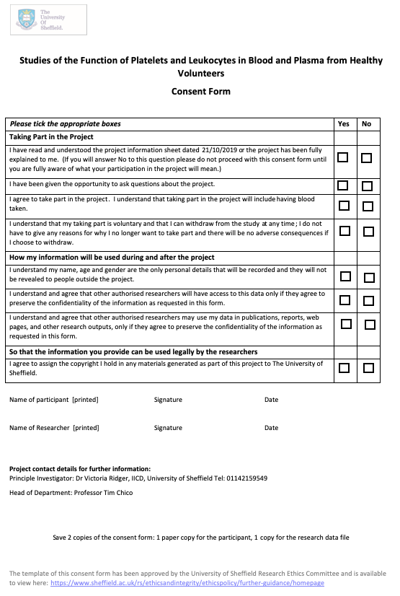
Volunteer consent form (version 1 (21/10/2019)

Summary of collected plaque samples
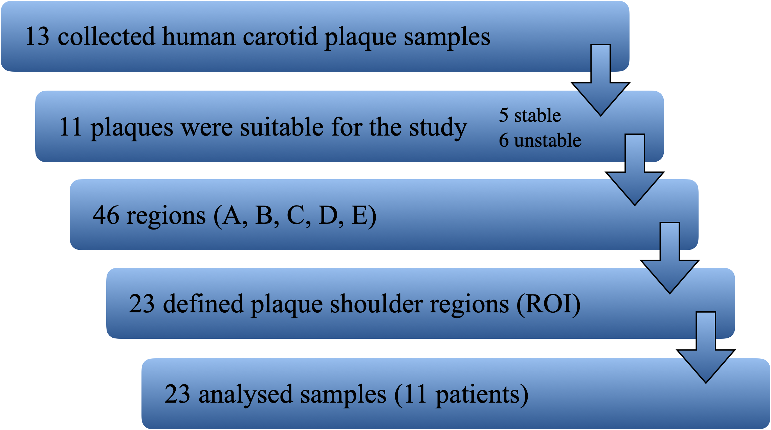

EDTA

- Stir 186.1g disodium ethylenediamine tetraacetate dihydrate into 800 ml of distilled water.
- Stir the solution vigorously using a magnetic stirrer.
- Add NaOH solution to adjust the pH to 8.0.
- Dilute the solution to 1 L with distilled water.

H&E staining protocol

- Dewax slides in a plastic rack and incubate them for 5 minutes in
    - Xylene I
    - Xylene II
- Rehydrate the slides for 2 minutes in each of the following solutions,
    - Ethanol 99 %
    - Ethanol 99 %
    - Ethanol 95 %
    - Ethanol70 %
- Wash the sections in running tap water for 5 minutes, to remove xylene and ethanol.
- Put the slides into Haematoxylin for 2 minutes.
- Rinse well in running tap water.
- Put the slides into Scott’s tap water for 20 seconds.
- Rinse well in running tap water.
- Put the slides into Eosin for 5 minutes.
- Rinse quickly in running tap water (3 dips).
- Dehydrate the slides for 3 dips in each of the following solutions,
    - Ethanol70 %
    - Ethanol 95 %
    - Ethanol 99 %
    - Ethanol 99 %
- Put the slides into fresh xylene for 5 minutes.
- Add mountant, place the cover slip and push the air bubbles away from the section.
- Leave slides overnight at RT.

CD3 and CD68 staining protocol

Dewaxing
- Put the slides in a plastic rack and incubate them for 5 minutes in
xylene I
xylene II
Rehydration
- Incubate the slides for 2 minutes in each of the following solutions,
ethanol 99 %
ethanol 99 %
ethanol 95 %
ethanol70 %
- Wash the sections in running tap water for 1 minute, to remove xylene and ethanol.
H₂o₂ blocking
- Incubate sections in 3% H₂O₂ in methanol for 10 mins.
- Wash the sections in running tap water for 1 minute.
Antigen retrieval
- Microwave sections in a plastic rack for 10 mins from cold at high power in 400ml of 10mM/L TSC pH6
- Wash the sections in running tap water for at least cool down (1-2 minutes).
Serum blocking
- Nonspecific binding is blocked with 50 µl 5% Donkey/Goat serum for 30 min at room temperature (consider not using BSA).
- CD3 samples: normal goat serum in PBS
- CD68 samples: normal donkey serum in PBS
Primery Antibody
SINGLE_1: Rabbit anti-human CD3 (1:300)
SINGLE_2: Mouse anti-human CD68 (1:100)

- Drain slides and wipe around the section with a tissue. Do not wash off the serum.
- Incubate with 50ul of primary antibody diluted in PBS for 1 hour at room temperature.
- Wash the sections twice, in PBS for 5 minutes on a magnetic stirrer.

Secondary Antibody; DAB Substrate
SINGLE_1: ImmPRESS™ HRP Reagent Kit; Anti-rabbit IgG, made in horse
SINGLE_2: ImmPRESS™ HRP Reagent Kit; Anti-mouse IgG, made in horse

- 1 drop from ImmPRESS™ HRP Reagent
- Incubate with it for 30 minutes at room temperature.
- Wash the sections twice, in PBS for 5 minutes on a magnetic stirrer.

- DAB working solution: add 1 drop (30 μl) SignalStain® DAB Chromogen Concentrate to 1 ml SignalStain® DAB Diluent and mix well before use.
- Incubate sections with DAB working solution for 5-10 minutes.
- Wash slides in water for 5 minutes.
Counterstaining, Dehydrating, Mounting
- Lightly counterstain sections in Gill's haematoxylin (1 min)
- Rinse well in running tap water.
- Dehydrate the slides for 3 dips in each of the following solutions,
    - Ethanol70 %
    - Ethanol 95 %
    - Ethanol 99 %
    - Ethanol 99 %
- Put the slides into fresh xylene for 5 minutes.
- Add mountant, place the cover slip and push the air bubbles away from the section.
- Leave slides overnight at RT.

CD68, CD86, MRC1 staining protocol

Dewaxing
- Put the slides in a plastic rack and incubate them for 5 minutes in
    - xylene I
    - xylene II
Rehydration
- Incubate the slides for 2 minutes in each of the following solutions,
    - ethanol 99 %
    - ethanol 99 %
    - ethanol 95 %
    - ethanol 70 %
- Wash the sections in running tap water for 1 minute, to remove xylene and ethanol.
H₂O₂ blocking
- Incubate sections in 3% H₂O₂ in methanol for 10 mins.
- Wash the sections in running tap water for 1 minute.
Antigen retrieval
- Microwave sections in a plastic rack for 10 mins from cold at high power in 400ml of 0.01M trisodium citrate (TSC) pH6
- Wash the sections in running tap water for at least cool down (1-2 minutes).
5% donkey serum blocking
- Non-specific binding is blocked with 50 µl 5% Normal Donkey Serum for 30 min at room temperature.
Primer antibody
Single staining: Anti-CD68 antibody (1:50)
Dual staining: Anti-CD86 antibody (1:50) + Anti- Mannose Receptor antibody (1:50)
- Negative Control: Purified Mouse IgG1, κ Isotype Control 1:150
- Drain slides and wipe around the section with a tissue. Do not wash off the serum.
- Incubate with 50ul of primary antibody (1:50) diluted in PBS for 1 hour at room temperature.
- Wash the sections twice, in PBS for 5 minutes on a magnetic stirrer.

Secondary antibody
Single staining: Donkey Anti-Mouse IgG- NL493 (1:400)
Dual staining: Donkey Anti-Mouse IgG- NL493 (1:400) + Donkey Anti-rabbit IgG-NL557 (1:200)
- Incubate with 50ul of secondary antibody diluted in PBS for 1 hour at room temperature, with the tub shielded from light.
- Wash the sections twice, in PBS for 5 minutes on a magnetic stirrer.
Mounting
- Add 40 ul of ProLong Gold Antifade Mountant with DAPI per slides.
- Place the cover slip and push the air bubbles away from the section.
- Leave slides overnight at RT.

Semiquantitative grading scales of histological features

Histological feature | Grade 1 | Grade 2 | Grade 3 | Grade 4
Haemorrhage | No haemorrhage | Width ‹0,5 mm or circumferential length ‹2 mm | Width ›0,5 mm or circumferential length ‹2 mm | N/A
Thrombus | No thrombus | Small thrombus (involving ‹ 50% of the luminal circumference of the vessel | Large thrombus (involving › 50% of the luminal circumference of the vessel | N/A
Lipid core | No lipid core | Small lipid core | Large lipid core  (› 25% cross sectional plaque area) | N/A
Fibrous tissue: lipid core ratio | Predominantly lipid | Approximately equal lipid and fibrous content | Predominantly fibrous | N/A
Foam cells | None | ‹ 50 cells per section | › 50 cells per section | N/A
New vessels | None | ‹ 10 cells per section | › 10 cells per section | N/A
Calcification | None | Stippling only | Calcified modules | N/A
Plaque Lymphocytes | None | Occasional cells or one group of  › 20 cells | 2-5 groups of › 20 cells | › 5 groups of  › 20 cells or one group of › 100 cells
Plaque Macrophages | None | Occasional cells or one group of  › 50 cells | 2-5 groups of › 50 cells | › 5 groups of  › 50 cells or one group of › 500 cells
Cap inflammation | None | ‹ 10 cells in cap | 10-50 cells in cap | › 50 cells in cap
Rupture | Intact cap, included cases obviously due to surgical incision | Probably intact e.g. processing artefact making analysis of cap integrity less reliable | Probably ruptured e.g site of rupture not clear but thrombus seen adherent to lipid in lumen | Definitely ruptured
Overall instability | Stable  e.g. predominantly fibrous, few inflammatory cells, intact cap | Predominantly stable  e.g. one feature of instability such as small haemorrhage or inflamed but intact cap | Unstable-intact cap  e.g. inflammation, thin cap and large lipid core but cap intact | Unstable ruptured cap  e.g. thrombus, large haemorrhage, thin inflamed ruptured cap

RT-qPCR results of simvastatin and atorvastatin experiments
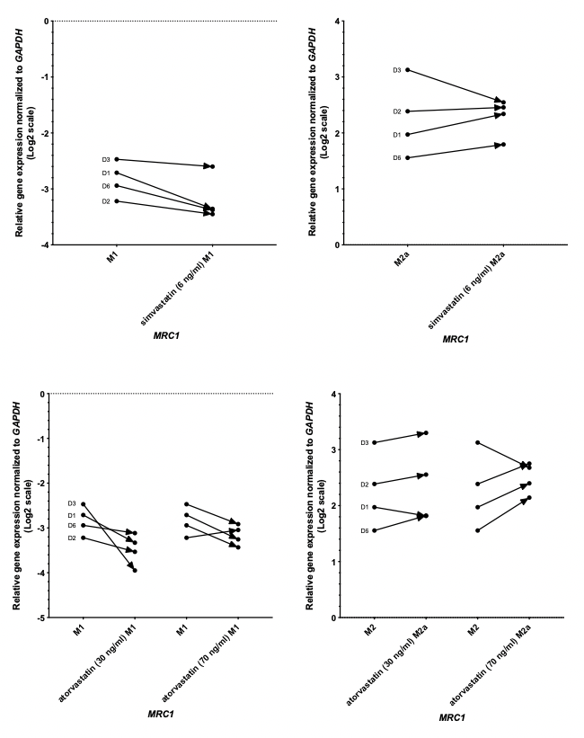

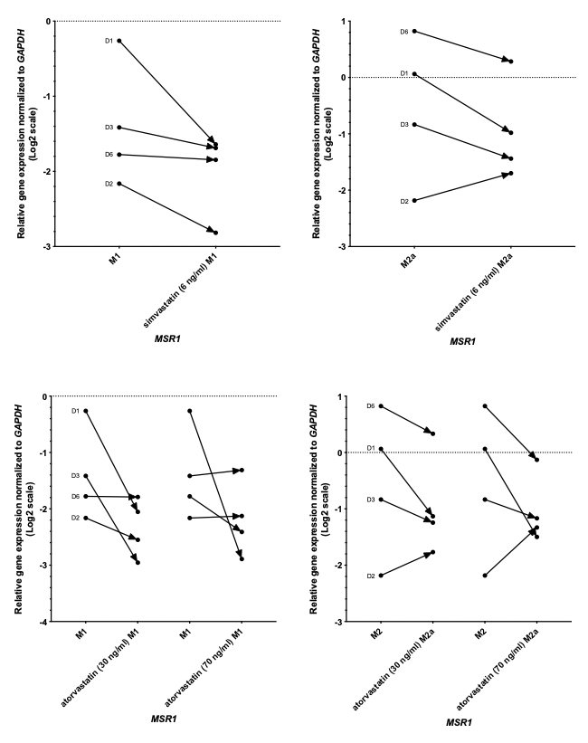

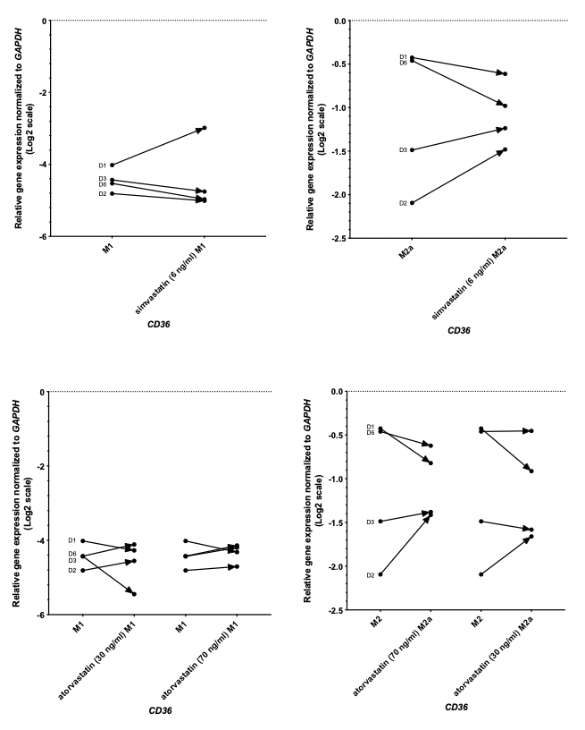

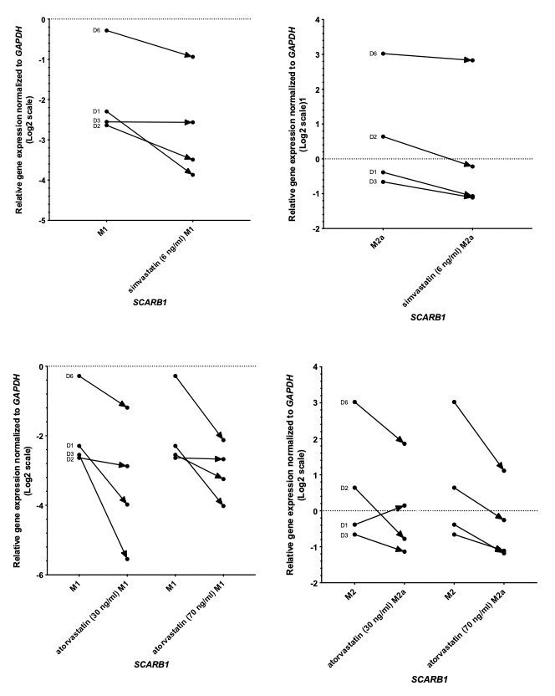
Figure 45: Relative gene expression analysis of MRC1, MSR1, CD36, SCARB1 in human MDMs after simvastatin and atorvastatin treatment
Human M1 (left panels) and M2a (right panels) polarized macrophages were treated with simvastatin (6 ng/ml) or atorvastatin (30, 70 ng/ml)) and gene expression was determined with RT-qPCR. Data is plotted from 4 donors, individually listed (n=4), normalised to GAPDH housekeeping gene. Data is analysed with Wilcoxon matched pairs signed rank test. The direction of change in expression is shown with the treatment as an arrow for each individual donor. Dotted line indicates 0 expression level.

Representative image of RT-qPCR results of dexamethasone treatment

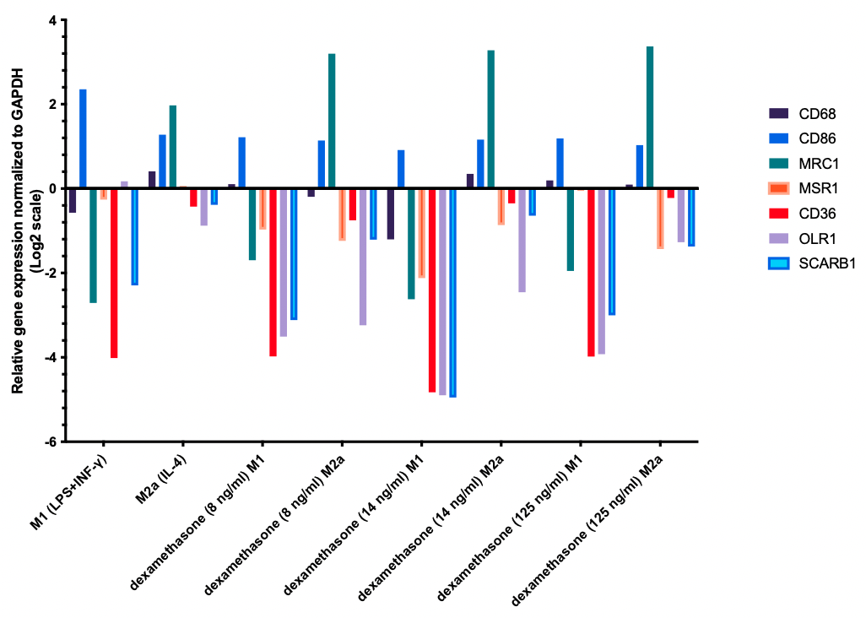
Figure 46: Relative gene expression analysis of CD68, CD86, MRC1, MSR1, CD36, OLR1 and SCARB1 in human MDMs after dexamethasone treatment

Western Blots of dexamethasone treatment experiments
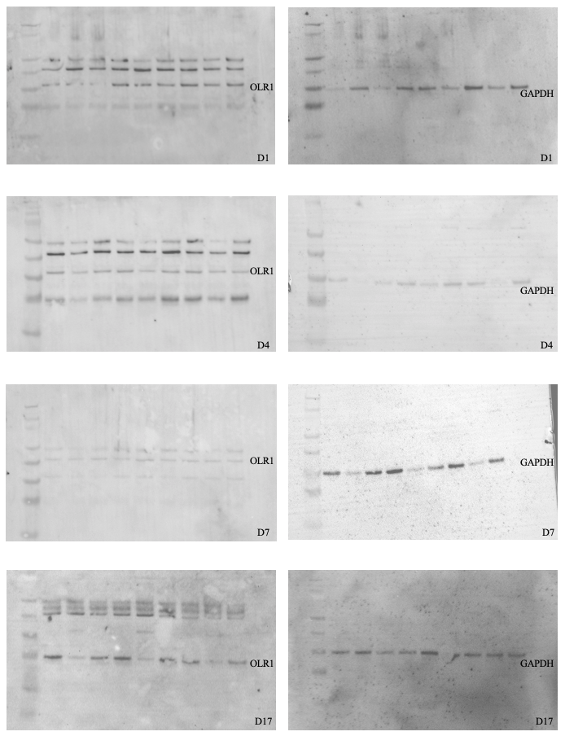

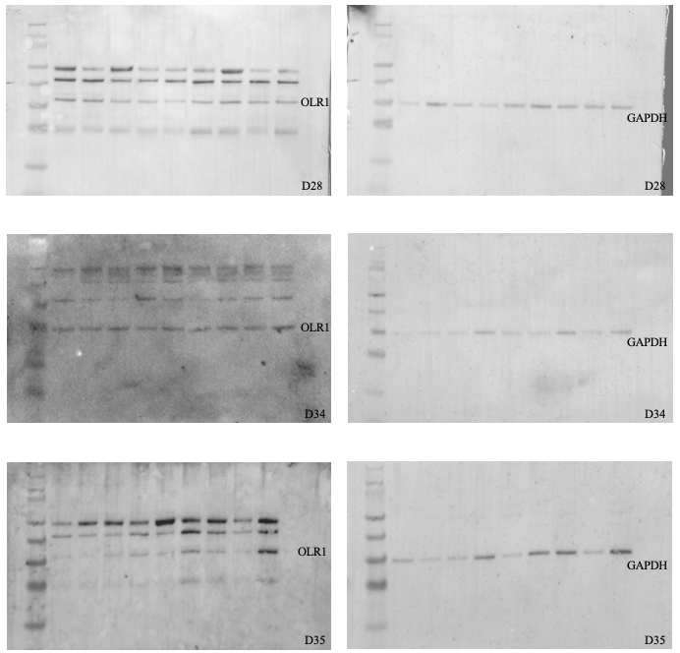

Figure 47: Western Blots of OLR1 protein in human MDMs after dexamethasone treatment.
Human M1 and M2a polarized macrophages were treated with dexamethasone (8, 14 ng/ml) and OLR1 protein (left panels) expression was determined. Western Blots were performed with cells from 7 donors (n=7; D1, D4, D7, D17, D28, D34, D35) and normalised to GAPDH housekeeping protein (right panels). Order of samples in each blot: marker size, M0, M1, M2a, M0-8 ng/ml dex, M1-8 ng/ml dex, M2a-8 ng/ml dex, M0-14 ng/ml dex, M1-14 ng/ml dex, M2a-14 ng/ml dex

Summary of reagents and consumables

REAGENTS/KITS | SUPPLIER | PRODUCT NUMBER
12-well plate | Jet Bio-Filtration | TCP011012
6-well plate | Jet Bio-Filtration | TCP011006
Anti-CD68 antibody (mouse) | Abcam | ab201340
Anti-CD86 antibody (mouse) | Abcam | ab213044
Anti-GAPDH Antibody | Santa Cruz Biotechnology | SC-47725
Anti-Mannose Receptor antibody (rabbit) | Abcam | ab64693
Atorvastatin | Merck | PZ0001-5MG
Bovine Serum Albumin (BSA) | Merck | A7906-100G
CD14+ microbeads | Miltenyi Biotec | 130-050-201
Chamber Slide | Thermo Fisher Scientific | 154534PK
DAB Substrate Kit SignalStain® | Cell Signaling | 8059
Dexamethasone | Merck | D4902-100MG
Diethyl pyrocarbonate (DEPC) | Merck | D5758-25ML
Donkey Anti-Mouse IgG- NL493 | R&D Systems | NL009
Donkey Anti-rabbit IgG-NL557 | R&D Systems | NL004
E. Coli Lipopolysaccharide | Enzo Life Sciences | ALX-581-007-L001
EDTA | Fisher Scientific | BP2482-500
Elastic (Connective Tissue Stain) kit | Abcam | ab150667
Eosin Y | Fisher Scientific | 6766010
Ethanol | Fisher Scientific | E/0600DF/17
FBS Good Forte | PAN Biotech | P40-37500
Ficoll-Plaque Plus | Merck | GE17-1440-03
Frame Slide PET | Zeiss | 415190-9101-000
Goat Anti-Mouse Immunoglobulins/HRP | Agilent | P044701-2
Goat Anti-Rabbit Immunoglobulins/HRP | Agilent | P044801-2
Haematoxylin (Gill 2) | Fisher Scientific | 72511
Human Recombinant IFN-g | Pepro Tech | 300-02
Human Recombinant IL-4 | Pepro Tech | 200-04
Human Recombinant M-CSF | Pepro Tech | 300-25
Human Recombinant M-CSF | Immuno Tools | 11343117
Hydrogen Peroxide 30 % | Merck | 107209
ImmPRESS™ HRP Anti-Mouse IgG (Peroxidase) Polymer Detection Kit, made in Horse | Vector Laboratories | MP-7402
ImmPRESS™ HRP Anti-Rabbit IgG (Peroxidase) Polymer Detection Kit, made in Horse | Vector Laboratories | MP-7401
iScript cDNA synthesis kit | Biorad | 1708890
L-glutamine | Gibco | 17-605E
LS Columns | Miltenyi Biotec | 130-042-401
Methanol | Fisher Scientific | M/4000/17
Monoclonal Mouse Anti-Human CD68 Clone KP1 | Agilent (DAKO) | M081401-2
Normal Donkey Serum | Abcam | ab7475
Normal Goat Serum | Abcam | ab7481
NuPAGE 4-12% Bis-Tris Gel | Invitrogen | NP0322BOX
NuPAGE Antioxidant | Invitrogen | NP0005
NuPage LDS Sample Buffer | Invitrogen | NP0007
NuPAGE MES SDS Running Buffer | Invitrogen | NP0002
NuPAGE Transfer Buffer | Invitrogen | NP0006
Oil Red O powder | Merck | O0625
oxLDL | Thermo Fisher Scientific | L34357
Penicillin/Streptomycin | Gibco | 15070-0063
PhosSTOP EASY pack | Roche | 04906837001
Pierce BCA Protein Assay Kit | Thermo Fisher Scientific | 23227
Polyclonal Rabbit Anti-Human CD3 | Agilent (DAKO) | A045201-2
Precision PLUS qPCR Master Mix with SYBR Green | Primer Design | PPLUS-XXML
ProLong Gold Antifade Mountant with DAPI | Thermo Fisher Scientific | P36931
Protease Inhibitor Cocktail | Merck | P8340-1ML
Protector RNase Inhibitor | Merck | 3335399001
Purified Mouse IgG1, κ Isotype Control | Abcam | ab170190
Rabbit IgG Control Antibody | Vector Laboratories | I-1000-5
Rabbit polyclonal OLR1 primary antibody | Abcam | ab203246
ReBlot Plus Strong Antibody Stripping Solution | Millipore | 2504
Red-Ponceau S Solution | Merck | P7170
RIPA buffer | Merck | R0278-500ML
RNase-Free DNase Set | Qiagen | 79256
RNeasy UCP Micro Kit | Qiagen | 73943
RPMI 1640 media | Gibco | 21875034
Scott’s Tap water | Merck | S5134-6X100ML
SeeBlue, Plus2 Prestained Standard | Invitrogen | LC5925
Silane Coated Microscope Slides | Cell Path | MDC-0102-54A
Simvastatin | Merck | S6196-5MG
SMART-Seq v4 Ultra Low Input RNA Kit | Takara Bio | 635026
SMARTer Stranded Total RNA-Seq Kit v2 - Pico Input Mammalian kit | Takara Bio | 634412
SuperSignal™ West Pico PLUS Chemiluminescent Substrate | Thermo Fisher Scientific | 34578
Tris Buffered Saline | Merck | T6664
Trisodium citrate | Fisher Scientific | S/3320/53
Tween 20 | Merck | P9416-50ML
Xylene | Fisher Scientific | X/0250/17
Isopropanol | Fisher Scientific | BP2618-4
Formaldehyde solution 4% | Merck | 1004960700

Summary of machines and software

MACHINE/SOFTWARE | MANUFACTURER
2100 Bioanalyzer | Agilent
AF6000LX inverted microscope | Leica
Application Suite Advanced Fluorescence (LASAF) software | Leica
CFX384 C1000 Touch Thermal Cycler | Biorad
ChemiDoc XRS+ Imaging System | Biorad
Correlative Light Light Microscopy software | Péter Horváth Laboratory
DMI4000B inverted microscope | Leica
EG1150 H Paraffin Embedding Station | Leica
FIJI
Image Studio Lite version 5.2.5 software | Li-Cor
LAS X software | Leica
LMD6 Laser Microdissection Microscope | Leica
Microplate Reader, Varioskan Flash | Thermo Fisher Scientific
MiniSeq System | Illumina
Nanodrop Spectrophotometer | Thermo Fisher Scientific
Prism 9 | GraphPad
RM2245 semi-automated rotary microtome | Leica
RM2245 semi-automated rotary microtome | Leica
SP8 LIGHTNING confocal microscope | Leica
TP 1020 automatic Tissue Processor | Leica
Ultrasonic bath | Thermo Fisher Scientific

