

The use of plant-based biochars for the remediation of heavy metal-contaminated soil

by

Rosa Isabel Soria Peñafiel
October 2021

Supervisors: Dr Steven F. Thornton and Dr Stephen A. Rolfe

Thesis submitted to the University of Sheffield in fulfilment of the requirements for the degree of

Doctor of Philosophy

Abstract
Heavy metals (HMs) are common contaminants in soil. At elevated concentrations they can have a negative impact on ecosystem functioning and pose a risk to human health. Cost-effective management solutions are required to reduce the environmental risk from HM-contaminated soil. Among other organic amendments, biochar has been proposed as a suitable low-cost material with the potential to immobilise HMs in soil and improve soil conditions for restoration of degraded land and re-use of contaminated soil.
Biochar is a black carbon produced by thermal decomposition of feedstock -biomass destined for conversion to energy. It typically has a high specific surface area and is rich in oxygenated functional groups (e.g. carboxyl, hydroxyl). These properties make it useful for the treatment of HM-contaminated soils, where it can immobilize pollutants by different physical and chemical mechanisms, reducing metal toxicity towards plants and soil microorganisms, and thereby enabling the re-use of restored land. However, there are uncertainties that can limit the generalised use of biochar in the remediation of HM-contaminated soil. For example, biochars have different potentials to immobilize HMs, wherein the metal sorption characteristics are influenced by the feedstock properties and production conditions. Other factors, such as biochar dosage, soil properties and the presence of different HMs in soil, may also result in varied metal attenuation characteristics. The varied and contrasting results of biochar studies make it difficult to identify biochars with suitable characteristics for the immobilisation of HMs at contaminated sites that can also improve soil health.
This thesis investigates the mechanistic properties of plant-based biochars that influence the immobilisation of HMs in contaminated soil and the broader impact of biochar addition on soil health in the short- and long-term. Biochar sorption mechanisms were studied in batch sorption tests using synthetic soil pore water as the sorption media. Five plant-based biochars were used. Single and competitive sorption tests were conducted to determine the sorption capacities of these biochars for cadmium (Cd), lead (Pb) and zinc (Zn). A strong correlation was identified between selected biochar properties (pH, cation exchange capacity -CEC- and electric conductivity -EC-) and HM sorption.
Thereafter, four biochars were selected to assess their potential in alleviating HM toxicity towards plant growth in short-term incubations under controlled conditions. The effect of biochar on plant performance was evaluated using Arabidopsis thaliana, Lolium perenne and Sinapsis alba plants. The results demonstrated that biochars applied at 1% (w/w) reduced bioavailable Pb to 18-69 %, Zn to 60-80% and Cd to 33-43 % of the control. Nonetheless, plants still accumulated HMs in above-ground tissue. Higher biochar application rates of 3% (w/w) and 5 % (w/w) caused inhibition of plant growth, depending on the plant species. This negative effect was mainly associated with increased salinity due to soluble Na and K released from biochars with high mineral content, which may have induced osmotic stress - water deficit in plants caused by a high salt content in the soil.
Finally, the ability of biochar or compost as single amendments or the combination of both, to reduce HM toxicity was studied in a long-term outdoor pot experiment using soil highly contaminated with Pb and Zn from former mining activity. Plant performance was assessed using Lolium perenne and microbial community composition assessed using high-throughput DNA sequencing. The results demonstrated that biochar and compost consistently reduced bioavailable concentrations of HMs and limited plant uptake of HMs over an 18 month period. Biochar was shown to have higher stability during aging and to be a more efficient adsorbent (based on mg of HM immobilised per kg of amendment) than compost. However, compost had the greatest impact on microbial community composition and abundance.
Overall, this research supports the use of organic amendments, particularly biochar, in the restoration of HM-contaminated soil. Biochar application can provide favourable results, especially when applied to highly contaminated soil or soil contaminated with multiple HMs. In this situation the benefits of biochar, outweigh possible unfavourable outcomes to plant growth, such as osmotic stress. However, although these organic amendments can reduce the bioavailability of HMs in restored soil, plants can still accumulate HMs which may limit land use. Besides, land-use change constantly. Therefore, a “solution” to contamination that is prescribed in one current context may not provide the expected conditions for all future demands. Hence, the results of biochar application as an additive to restore soils contaminated with HMs are encouraging, but must be taken with caution because some aspects concerning the interaction with plants and long-term fate of HMs immobilised by biochar remain unclear.

Author’s Declaration
I, the author, confirm that the Thesis is my own work. I am aware of the University’s Guidance on the Use of Unfair Means (www.sheffield.ac.uk/ssid/unfair-means). This work has not been previously been presented for an award at this, or any other, university.

Rosa Isabel Soria Peñafiel

October 2021

Acknowledgements
The completion of this work could not have been possible without the support of many great people. I would like to express my sincere gratitude to:

- My supervisors Prof. Steven F. Thornton and Dr. Stephen A. Rolfe for their constant guidance, support and encouragement during my PhD., and for giving me the opportunity to be part of this amazing experience that have changed my life;
- The INSPIRATION-ITN network, the supervisory and management team especially to Dr. Gabriella Kakonyi for making all the activities of this project possible and fellows Bastian Saputra, Gisela Quaglia, Golnaz Ezzati, Valeria Hernández and Collins Amoah-Antwi for experiences shared and friendship;
- The Groundwater Protection and Restoration Group (GPRG) and C45 Group from Animal and Plant Science Department for their advice for conducting experimental work;
- The technical staff: Andrew Fairburn, Linden Drezet, Mark Foster and Maggi Killion for providing assistance in the lab;
- ISO group at BOKU, especially to Prof. Andrea Watzinger for the supervision during my secondment;
- My caring parents Ketty and Francisco and my brother Rafael for the encouragement and endless love that gave me the strength to start this journey thousands of miles away from home;
- My husband Edgardo for being with me during the ups and downs, for the unconditional support, love, patience and above all for living this journey with me.

This work was supported by the Marie Skłodowska-Curie Innovative Training Network INSPIRATION funded by the European Union's Horizon 2020 research and innovation programme (Grant agreement no. 675120).

 | 

Table of Contents

Abstract i
Author’s Declaration iii
Acknowledgements iv
Table of Contents vi
List of Figures x
List of Tables xiv
Nomenclature xv
Chapter 1: General Introduction 1
1.1. Background 1
1.2. Thesis aim, objectives and structure 4
1.2.1. Aim 4
1.2.2. Research objectives 4
1.2.3. Thesis structure 4
Chapter 2: Literature review 7
2.1. Heavy metal pollution in soils 7
2.2. Heavy metals toxicity in soils 8
2.2.1. Toxicity to soil microorganisms 9
2.2.2. Toxicity to plants 10
2.2.3. Guideline values 11
2.3. Fractionation of HM in soil 13
2.3.1. Bioavailability of HM in soil 15
2.3.2. Factors affecting bioavailability of HM 16
2.4. Soil remediation techniques 17
2.5. Biochar 18
2.5.1. Factors determining biochar properties 19
2.5.2. Immobilization of soil heavy metals by biochar 24
2.5.3. Mechanisms responsible for the immobilization of heavy metals by biochar 25
2.5.4. Interaction of biochar with soil biota 27
2.5.5. Microorganisms 28
2.5.6. Plants 30
2.5.7. Monitoring toxicity of biochar-amended soils 32
2.5.8. Current uncertainties on biochar application 36
Chapter 3: The relationship between properties of plant-based biochars and sorption of Cd(II), Pb(II) and Zn(II) in soil model systems 38
3.1. Introduction 38
3.2. Materials and Methods 39
3.2.1. Biochar description 39
3.2.2. Biochar characterization 39
3.2.3. Adsorption experiments 40
3.2.4. Sorption models 43
3.2.5. Statistical analysis 45
3.3. Results and discussion 46
3.3.1. Biochar characterization 46
3.3.2. HMs sorption experiments 47
3.3.3. Nature of sorption interactions 56
3.3.4. Scanning electron microscopy with energy dispersive X-ray spectroscopy 61
3.3.5. Competitive sorption 63
3.3.6. Linking biochar properties to HMs immobilization 65
3.3.7. Models describing HM sorption potential 68
3.4. Conclusions 69
Chapter 4: Potential of biochar to reduce toxicity of Cd(II), Pb(II) and Zn(II) to plants in a controlled environment incubation 71
4.1. Introduction 71
4.2. Materials and methods 73
4.2.1. Biochar selection and preparation 73
4.2.2. Soil characterization 73
4.2.3. Heavy metal contamination 73
4.2.4. Experiment A: Controlled environment incubations with Arabidopsis thaliana-Col 0 74
4.2.5. Experiment B: Controlled environment incubations with White Mustard and Lolium perenne 78
4.3. Results 80
4.3.1. Total and bioavailable concentration of HMs in spiked soil 80
4.3.2. Experiment A: controlled environment incubation with Arabidopsis thaliana-Col 0 81
4.3.3. Experiment B: controlled environment incubations with White Mustard and Lolium perenne 103
4.4. Discussion 112
4.4.1. Immobilization of HMs and relationship with soil properties 112
4.4.2. HMs in plant uptake 119
4.4.3. Plant response to biochar amendments 122
4.4.4. Implications for soil remediation 125
4.5. Conclusion 125
Chapter 5: The effect of biochar on bioavailable Pb(II) and Zn(II) and its influence on soil health: an outdoor pot experiment 127
5.1. Introduction 127
5.2. Materials and Methods 129
5.2.1. Soil collection 130
5.2.2. Soil, biochar and compost characteristics 130
5.2.3. Outdoor pot experiment 131
5.2.4. Soil pore water analysis 132
5.2.5. Plant analysis 133
5.2.6. Soil analysis 133
5.2.7. DNA extraction 135
5.2.8. Relative quantitation q-PRC 135
5.2.9. rRNA gene fragment library preparation 136
5.2.10. Bioinformatic analysis 137
5.2.11. Microbial activity: soil respiration and PLFA analysis 138
5.2.12. Statistical analysis 141
5.3. Results 142
5.3.1. Soil treatment characteristics 142
5.3.2. Effect of organic amendments on soil properties 142
5.3.3. Effect of organic amendments on soil pore water parameters 144
5.3.4. Bioavailability of heavy metals 145
5.3.5. Fractionation of trace elements 147
5.3.6. Plant performance 149
5.3.7. Correlation of soil properties and HM bioavailability 150
5.3.8. Microbial total abundance 152
5.3.9. Microbial community structure and diversity 153
5.3.10. Differences in microbial community composition 156
5.3.11. Soil microbial activity - secondment at BOKU 163
5.4. Discussion 169
5.4.1. Soil toxicity 169
5.4.2. Effect of organic amendments on soil properties 170
5.4.3. Mobility and bioavailability of HM 171
5.4.4. Distribution of HMs in soil 173
5.4.5. Plant performance and its effect on soil properties and HM bioavailability 175
5.4.6. Aging effect on organic amendments 177
5.4.7. Microbial diversity and abundance 179
5.4.8. Microbial activity and PLFA 183
5.5. Conclusions 184
Chapter 6: Synthesis, future research, and conclusion 186
6.1. Synthesis 186
6.2. Immobilisation of heavy metals by biochar 186
6.3. Effect of biochar on plants 189
6.4. Effect of biochar on soil microbial community 191
6.5. Limitations and future research 192
6.6. Conclusion 193
7 References 196
8 Appendices 221
8.1. Appendix 1 221
8.2. Appendix 2 222
8.3. Appendix 3 223
8.4. Appendix 4 224
8.5. Appendix 5 225
8.6. Appendix 6 226
8.7. Appendix 7 227
8.8. Appendix 8 228
8.9. Appendix 9 229
8.10. Appendix 10 230
8.11. Appendix 11 231
8.12. Appendix 12 232
8.13. Appendix 13 233

List of Figures
Fig. 2-1 Two hypothetical models of the effects of stress such heavy metal toxicity on soil microbial diversity 10
Fig. 2-2 Relationship between heavy metal soil phases or operationally defined fractions and its mobility and bioavailability 14
Fig. 2-3 SEM images of biochar. 19
Fig. 2-4 Variation of cation exchange capacity (CEC) and pH of pig manure biochar and wheat straw biochar produced at temperatures from 200 to 650⁰C.. 22
Fig. 2-5. Variation of surface area (left) and ash content (right) for pig manure and wheat straw biochar produced at temperatures from 200 to 650⁰C. 23
Fig. 2-6 Proposed mechanisms of biochar interaction with heavy metals 26
Fig. 2-7 Schematic illustration of interaction between biochar and soil microorganisms in heavy metal-contaminated soil 29
Fig. 2-8 Interaction of biochar with plants on heavy metals (HM) contaminated soils 31
Fig. 3-1. Effect of contact time and solution pH on sorption capacity of Cd, Pb and Zn 48
Fig. 3-2. Inorganic speciation of studied elements in synthetic soil pore water. A) Cd, B) Pb, C) Zn. 52
Fig. 3-3 Adsorption isotherms of Cd, Pb and Zn fitted with the Dubinin-Radushkevich, Freundlich, Langmuir, Temkin and Hill sorption models. 54
Fig. 3-4. Adsorption isotherms for Cd, Pb and Zn fitted with the Hill sorption model.. 55
Fig. 3-5 ATR-FTIR normalized spectra of biochars before and after sorption of Cd, Pb and Zn. 57
Fig. 3-6 Biochar sorption mechanisms for Cd²⁺, Pb²⁺ or Zn²⁺. 58
Fig. 3-7 pH values at equilibrium at different trace element initial concentrations 59
Fig. 3-8 Principal component analysis (PCA) of normalized ATR-FTIR spectra of plant based biochars. . 60
Fig. 3-9. SEM-EDX images of biochar MSP550 after sorption of Cd, Pb and Zn and the main elements identified on its surface 62
Fig. 3-10. Competitive sorption of HMs onto biochar using binary and tertiary systems. 64
Fig. 3-11. Relationship between biochar sorption performance and physico-chemical properties.. 67
Fig. 4-1. Box plot of NH₄-NO₃ extractable HMs in soils treated with biochar at different application rates (w/w). 82
Fig. 4-2. Arabidopsis thaliana growing in soil artificially contaminated with heavy metals. 84
Fig. 4-3. Arabidopsis thaliana growing in soil artificially contaminated with heavy metals. 85
Fig. 4-4. Box plot of dry above-ground biomass of Arabidopsis thaliana Col-0 harvested from soil artificially contaminated with HMs and amended with plant-derived biochars at different application rates.. 86
Fig. 4-5. Arabidopsis thaliana Col-0 mean leaf area over time in plants growing in soil artificially contaminated with single elements Cd, Pb, Zn and a multielement contaminated soil (Mix-soil). 87
Fig. 4-6. Mean absolute growth rates (AGRs) predicted from the four-parameter logistic model for biochars OSR550, SWP550, MSP550 and MSP550 at application rates 0 (control), 1, 3 and 5 % (w/w).. 88
Fig. 4-7. Pairwise comparisons of absolute growth rates (AGRs) between control groups (no biochar) and 1% (w/w) biochars.. 90
Fig. 4-8. Box plot of the concentration of HMs in above-ground tissue of Arabidopsis thaliana Col-0 growing in artificially contaminated soils.. 92
Fig. 4-9. Effect of biochar and application rate on Fv/Fm over time measured in Arabidopsis thaliana col-0 growing in artificially contaminated soils. 94
Fig. 4-10. Plot showing significant differences in the effect of biochar and rate on Fv/Fm between control groups (no biochar) and biochars at different application rates. 95
Fig. 4-11 Box plot of soil pH and EC after treatment with biochars OSR550, SWP550, WSP550 and MSP550 at 0, 1, 3 and 5 % (w/w). 97
Fig. 4-12. Plot showing correlation between different plant performance indicators and soil physico-chemical properties of soils amended with biochar. 100
Fig. 4-13. Plot showing correlation between different plant performance indicators and soil physico-chemical properties in the Mix-soil treatment.. 102
Fig. 4-14 Boxplot of bioavailable HMs (NH₄-NO₃ extracted) in soils artificially contaminated with Pb, Cd, Zn and a ternary mixture of these elements amended with biochars WSP550 and MSP550 at 0, 1 and 3% (w/w). 104
Fig. 4-15 Boxplot of dry above-ground biomass of Lolium perenne and White Mustard amended with biochars WSP550 and MSP550 at 0, 1 and 3 % (w/w) in soils artificially contaminated with Pb, Cd, Zn and a ternary mixture of these elements. 106
Fig. 4-16 Boxplot of concentration of HMs in above-ground tissue of plants grown in soils artificially contaminated with Pb, Cd, Zn and a ternary mixture of these elements amended with biochars WSP550 and MSP550 at 0, 1 and 3% (w/w). 108
Fig. 4-17 Effect of biochar addition to soil properties. A) soil pH, B) soil EC [μS.cm⁻¹]. Biochars WSP550 and MSP550 addition at 0, 1 and 3 % (w/w). 110
Fig. 4-18 Plot showing correlation between soil properties, bioavailable HMs and tissue HM concentrations in the Lolium perenne treatment. 111
Fig. 4-19 Plot showing correlation between soil properties, bioavailable HMs and tissue HM concentrations in White mustard treatment.. 112
Fig. 5-1 Overview of Wemyss mine 130
Fig. 5-2 Outdoor pot experiment: A) individual pot with insulation cover and Rhizon sampler inserted; B) all 32 pots on the raised bed at the outdoor compound 132
Fig. 5-3 Box plot of properties of Wemyss soil treated with different organic amendments after 18 months of incubation at field conditions. 143
Fig. 5-4 Box plot of selected properties of soil pore water. Collections were at 2, 6 and 18 months after the establishment of the pot experiment.. 145
Fig. 5-5. Box plot of total and bioavailable (acid-soluble) heavy metal concentrations in Wemyss soil treated with different organic amendments. 146
Fig. 5-6. Metal fraction distribution in Wemyss soil treated with different organic amendments after18 months of incubation. 148
Fig. 5-7. Box plot of plant biomass and metal concentration in above-ground tissue of Lolium perenne grown in Wemyss soil treated with organic amendments during two harvesting seasons. 149
Fig. 5-8 Cross correlation of soil characteristics for planted and unplanted treatments. Mn, Al, Pb, Zn, Ca, Mg, K and Na corresponded to the concentration in the bioavailable (acid-soluble) fraction.. 151
Fig. 5-9 Box plot of total abundance of soil microorganisms based on gene copy numbers 152
Fig. 5-10 Box plot of diversity indicators of soil microorganisms.. 153
Fig. 5-11 Analysis of community composition.. 156
Fig. 5-12 Venn diagram displaying the number of microbial ASVs shared between treatments containing organic amendments that increased or decreased relative to the untreated soil after the addition of the amendments. 158
Fig. 5-13 Relative abundance of bacterial ASVs grouped by Phylum that changed with the addition of biochar. 159
Fig. 5-14 Relative abundance of bacterial ASVs grouped by Phylum that changed with the addition of Compost.. 161
Fig. 5-15 Relative abundance of fungal ASVs grouped by Phylum that changed with the addition of compost. 162
Fig. 5-16 Canonical correspondence analysis of bacterial and fungal ASVs abundance and relevant soil physico-chemical properties. 163
Fig. 5-17 Heavy metals in Wemyss soil used in the secondment at BOKU. Soil samples were analysed at 1 and 12 months after the beginning of the incubation experiment. 164
Fig. 5-18 Carbon dioxide production over time. 165
Fig. 5-19 Mean landscape fatty acids and delta ¹³C (Δ¹³C ‰) in fatty acids after 1 and 12 months from the start of the soil incubation. 167
Fig. 5-20 Soil microbial dynamics based on total PLFA.. 168
Fig. 8-1 Arabidopsis thaliana Col-0 leaf area measurements over time in plants growing in soil artificially contaminated with single elements Cd, Pb, Zn and a multielement polluted soil (Mix-soil). 221
Fig. 8-2. Fv/Fm along time measured in Arabidopsis thaliana col-0 growing in artificially contaminated soils 222
Fig 8-3. Effect of soil pH on nutrient bioavailability in soils planted with Lolium perenne amended with biochar. 223
Fig. 8-4. DNeasy PowerSoil Pro Kit Procedure from Qiagen (2020) 224
Fig. 8-5. Box plot of selected metals in soil pore water. 225
Fig. 8-6. Correlation matrix for the Pb fractions obtained after sequential extraction for each of the treatments used. 226
Fig. 8-7 Correlation matrix for the Zn fractions obtained after sequential extraction for each of the treatments used.. 227
Fig. 8-8 Phylum Proteobacteria grouped by Class that increased with the addition of compost.. 228
Fig. 8-9 Phylum Proteobacteria grouped by Class that decreased with the addition of compost. 229
Fig. 8-10 Firmicutes grouped by Class that increased with the addition of compost.. 230
Fig. 8-11 Phylum Actinobacteriota grouped by Class that increased with the addition of compost.. 231
Fig. 8-12 Phylum Actinobacteriota grouped by Class that decreased with the addition of compost.. 232
Fig. 8-13 Phylum Acidobacteriota grouped by Class that decreased with the addition of compost.. 233

List of Tables
Table 2-1 Examples of heavy metal concentrations reported for different land uses around the world.. 8
Table 2-2 Concentration ranges of heavy metals in plants 9
Table 2-3 Range of normal concentration of heavy metal concentration in soils and UK guideline values 12
Table 2-4 Toxic trace element concentrations in soils and soil solution. 16
Table 2-5 Physicochemical properties and structural characteristics of biochar derived from different source materials produced in a similar range of temperatures. 21
Table 2-6 Overview of studies using biochar for the remediation of heavy metal-polluted soils 25
Table 2-7 Current approaches used for monitoring soil toxicity after biochar application based on living organisms response 35
Table 3-1 Biochar properties 42
Table 3-2 AIC values for kinetic and adsorption isotherm models 49
Table 3-3 Second order kinetic model and Hill sorption model parameters for the adsorption of Cd, Pb and Zn onto biochars. 50
Table 3-4 Linear models which describe biochar sorption capacity (qm) for Pb, Zn and Cd. 70
Table 4-1 Characteristics of soil treatments contaminated artificially with Pb, Cd and Zn and a mixture of these elements. 80
Table 4-2 Soil properties for the Mix-soil treatment... 98
Table 4-3. Species distribution predicted for Cd, Pb and Zn present in the Mix-soil treatment according to Visual MINTEQ 3.1. 99
Table 5-1 Characteristics of experimental soil and biochar WSP550. 131
Table 5-2 Three step BCR sequential extraction procedure conditions 134
Table 5-3 Characteristics of soil treatments before outdoor incubation (time zero). 142
Table 5-4 Summary of pairwise comparisons using permutational multivariate analysis of variance (PERMANOVA) between soil treatments (n=4, α=0.05) 155
Table 5-5 Properties of soil used during the secondment at BOKU. 164
Table 5-6 Coefficients from the fit of CO₂ along time with the logistic model 166

Nomenclature

AGR | Absolute growth rate
AIC | Akaike Information Criterion
ANCOVA | Analysis of covariance
ANOVA | Analysis of variance
AS | Acid soluble fraction
ASV | Amplicon sequence variant
ATR-FTIR | Attenuated Total Reflection Fourier Transform Infrared
BCR | Community Bureau of Reference
BET | Brunauer-Emmett-Teller surface area method
BOKU | University of Natural Resources and Applied Life Sciences, Vienna-Austria
CCA | Canonical correspondence analysis
CEC | Cation exchange capacity
CLEA | Contaminated Land Exposure Assessment
DHA | Dehydrogenase activity
DNA | Deoxyribonucleic acid
DOC | Dissolved organic carbon
DTPA | Diethylene triamine penta-acetic acid
EA-IRMS | Elemental Analysis-Isotopic Ratio Mass Spectrometry
EC | Electrical Conductivity
EDTA | Ethylenediaminetetraacetic acid
EEA | European environment Agency
FAME | Fatty acid methyl esters
Fv/Fm | Maximum photochemical quantum yield of photosystem II
GC-c-IRMS | Gas chromatography-combustion-isotopic ratio mass spectrometry
HM | Heavy metal
HMs | Heavy metals
HSBA | Hard and soft (Lewis) acids and bases
HSD | Honestly significant difference post hoc test
ICP-MS | Inductively coupled plasma mass spectrometry
ICP-OES | Inductively coupled plasma optical emission spectrometry
ITS | Internal transcribed spacer
OM | Organic matter
OX | Oxidisable fraction
PAHs | Polycyclic aromatic hydrocarbons
PAM | Pulse amplitude modulated
PCA | Principal component analysis
PCR | Polymerase chain reaction
PERMANOVA | Permutational multivariate analysis of variance
PII | Photosystem II
PLFA | Phospholipid fatty acids
PTEs | Potentially toxic elements
qRT- PCR | Quantitative reverse transcription polymerase chain reaction
RD | Reducible fraction
RES | Residual fraction
RGB | Red, green, and blue
rRNA | Ribosomal ribonucleic acid
SA | Surface area
SDG | Sustainable development goal
SEM | Scanning electron microscopy
SEM-EDX | Scanning electron microscopy coupled with Energy Dispersive X-Ray Spectroscopy
SGVs | Soil guideline values
SIR | Substrate-induced respiration
SOC | Soil organic carbon
SPAD | Non-destructive measurement of chlorophyll content from the last expanded leaf
TC | Total carbon content
VM | Volatile organic matter
WHC | Water holding capacity

General Introduction

Background
Land and soil are essential to sustain life on our planet. “It is on land that we produce most of our food and we build our homes, we cannot live without healthy land and soil” (Bruyninckx, 2019). However, worldwide changes in land-use, driven by the need to provide goods and services to an increasing population have caused extensive environmental damage (Foley et al., 2005). Many sectors, including industry, agriculture, households and even waste water treatment release pollutants to land and soil, which can significantly impact ecosystems (EEA, 2019).
In Europe, soil contamination was reported to be around 2.5 million potentially contaminated sites in 2011, with an estimated annual cost due to soil degradation between €2.4 billion and €17.3 billion. Heavy metals (HM), also known as potentially toxic elements (PTEs), are reported as the most frequent soil contaminants according to the EEA (2014). At trace quantities (<0.1%) some HM such as Fe, Cu and Zn are essential micronutrients for plants and microorganisms (<50 mg.g⁻¹ in the plant) (Nagajyoti et al., 2010; Sparks, 2003). However, in elevated concentrations (i.e.; Cu > 40, Cd > 1, Zn >150, Pb > 50 mg.kg⁻¹ in soil), they pose a serious threat to the health of natural ecosystems and humans (Kim et al., 2015; Luo et al., 2016).
Soil is a very complex component of land and plays a crucial role in natural cycles, particularly the water cycle and nutrient cycles (EEA, 2019). Because of its importance, the protection of soil functions has been included in the global agenda. Some of the Sustainable Development Goals (SDGs) are linked to soil, from clean water and climate change mitigation, to zero hunger. For example, the sustainable development goal (SDG) 15 (Life on Land) aims to achieve a land degradation-neutral world by 2030 (United Nations, 2015).
To succeed in climate change mitigation and adaptation, safeguarding healthy and resilient soil ecosystems is of critical importance. Urgent action is required to achieve sustainable land use and management, including the remediation of contaminated soil to enable reuse and re‑purposing of land already taken and to conserve existing soil resources (Bruyninckx, 2019). For instance, in line with SDGs the EU aims to achieve ‘no net land take by 2050’ by making better use of the existing urban space (land recycling) to limit urban expansion (Bruyninckx, 2019). However, the economic cost of soil remediation is high and is estimated to be 5.5 million euros (€) per year in Europe alone for the most commonly used techniques such as excavation and off-site disposal (EEA, 2014). Nonetheless, increasing regulations for landfills and elevated costs associated with these techniques demand a shift in current remediation practices (Derakhshan et al., 2017). The search for low cost and sustainable approaches has led to interest in the use of various organic wastes as soil amendments (Collins Amoah-Antwi et al., 2020). Within these, biochar is highlighted as an environmentally friendly option for the remediation of HM-contaminated soil.
Biochar is an organic material produced from the thermal decomposition of residual biomass; it is a black carbon with high specific surface area and rich in oxygenated functional groups (Novak et al., 2009; Tang et al., 2013). These properties have prompted interest in the use of biochar as a promising soil amendment for different reasons: 1) as an enhancer of soil fertility by releasing nutrients and regulating soil pH; 2) as an adsorbent of organic or inorganic soil pollutants; and 3) to enhance carbon sequestration in soils by acting as a stable carbon sink (Ahmad et al., 2012; Hao Li et al., 2017). These qualities highlight the exceptional potential of biochar for improving soil quality. However, there are important knowledge gaps that must be addressed before biochar can be utilised more generally in large scale soil remediation processes.
Biochar can be produced from various feedstocks, such as forestry and agricultural residues, domestic garbage, sewage sludge among others (Teng et al., 2020). Recently, biochars produced from plant residues are gaining attention within the circular economy model that fosters the recycling of agricultural waste and non-edible biomasses for new applications (Domingues et al., 2017; Fiore et al., 2018). Previous studies have proposed plant-based biochars to be an effective and environmentally friendly sorbent for different HMs (Tang et al., 2013; Y. Wang et al., 2019). Biochars can immobilize HMs by different physico-chemical mechanisms limiting their bioavailability and mobility, hence reducing the toxicity to living organisms (Hongbo Li et al., 2017). However, results of biochar use in the restoration of HMs contaminated soils vary in sorption capacities, affinities and sorption mechanisms for different trace elements. These varied outcomes have been attributed to feedstock properties and production conditions of biochar as well as soil properties (Janus et al., 2015). Similarly, the reported impacts of biochar on plants range from inhibition to stimulation depending on biochar properties, application rate and specific sensitivity of different plant species (Joseph et al., 2021). The wide variety of biochars available and the heterogeneous nature of these materials complicate the identification of biochars with suitable characteristics for immobilisation of HMs.
Although knowledge in the use of biochar has advanced considerably in recent years, the complex interactions between biochar, soil geochemistry, HM, plants and microorganisms remains unclear (Natasha et al., 2021; Sedlak, 2018). In this context, this thesis explores the potential of different plant-based biochars to restore soil contaminated with HMs by a series of experiments including batch sorption tests, soil incubations under controlled environment and field conditions. This research addresses important knowledge gaps concerning the key properties and mechanisms of plant-based biochars that drive the sorption of different HMs in soils.
With a holistic approach this research assesses the effect of biochar on soil health in the short and long term by studying biological indicators such as plant performance and microbial dynamics in combination with chemical analysis of soil properties. Imaging techniques based on chlorophyll fluorescence were used to study the physiological response of plants to different biochar amendments. Soil microbial communities were studied by a combined approach of metataxonomics and stable isotope microbial phospholipid biomarkers (¹³C PLFA). This research provides criteria for biochar selection, estimation of application rates and new insight into the role of biochar in supporting the health of soil polluted with HMs. The findings of this work provide further clarity of the use of biochar for restoration of contaminated soil and contributes to achieving sustainable use of soil and land.

Thesis aim, objectives and structure

Aim
The aim of this thesis is to explore the potential of different plant-based biochars to restore soil contaminated with HMs by assessing the impact of these organic materials on soil health.

Research objectives
The objectives which must be completed to achieve the aim of the research, are :
- To characterize the properties of plant-based biochars produced from different feedstock that influence the immobilization of Pb, Cd and Zn and determine the nature of the immobilization mechanisms to provide criteria for biochar selection;
- To determine the effect of biochar amendments on HM-contaminated soils, with respect to HM bioavailability and chemical speciation in the short- and long-term, to assess the potential of biochar for reducing the ecological risk of HMs in soil;
- To determine the effect of biochar addition to HM-contaminated soil on plant and microbial performance, to understand the influence of biochar on soil health.

Thesis structure
The document is organized under the “Publication Format Thesis”, according to guidance provided by the Research Services of the University of Sheffield. Chapters 1-2 are traditional thesis chapters. Chapters 3-5 are original contributions presented in a format suitable for publication in a peer-reviewed journal. Finally, Chapter 6 presents a general discussion, the limitations of the research and conclusions. The primary contributor to the writing of each of the papers (chapters), including the design and execution of the reported research, is the author of this thesis.

Chapter 1: Introduction
The chapter introduces the problems related to soil contamination by heavy metals and the challenges facing current remediation approaches. Biochar is then presented as a novel low-cost material with potential for the restoration of HM-contaminated soil.

Chapter 2: Literature review
This chapter presents a comprehensive review on the state-of-the-art related to current understanding of the toxic effects of heavy metals in soils, their geochemical fractionation and current remediation technologies for HM-contaminated soil. It introduces the importance of finding low cost amendments for application in soil remediation. Biochar is presented as an appropriate organic amendment with suitable properties to immobilize bioavailable HMs. The importance of biochar feedstock and production conditions on the resulting biochar properties are presented as key factors that influence biochar performance. The effect of biochar on soil physico-chemical properties, soil microorganisms and plants is discussed, together with the current challenges and limitations reported to date in the application of biochar for soil remediation purposes.

Chapter 3: The relationship between properties of plant-based biochars and sorption of Cd(II), Pb(II) and Zn(II) in soil model systems

This chapter describes the relationship between the physico-chemical properties of plant-based biochars and the sorption of cadmium, lead and zinc in soil pore water to address objective 1. It comprises the characterization of five biochars and a series of batch test experiments which evaluate the kinetics of metal sorption, effect of pH, effect of adsorbent dose, single sorption isotherms and competitive sorption tests. The results of this chapter describe the nature of the mechanisms involved in the immobilization of the studied elements by the different biochars and the sorption capacities for each element. This chapter has been published in the form of the following peer-reviewed journal paper:
Soria, R.I., Rolfe, S.A., Betancourth, M.P. and Thornton, S.F. (2020). The relationship between properties of plant-based biochars and sorption of Cd(II), Pb(II) and Zn(II) in soil model systems. Heliyon 6. https://doi.org/10.1016/j.heliyon.2020.e05388

Chapter 4: Potential of biochar to reduce toxicity of Cd(II), Pb(II) and Zn(II) to plants in a controlled environment incubation
To address objective 2 this chapter explores the effect of biochar in alleviating metal toxicity in soil artificially contaminated with HMs in a series of short-term incubations under controlled conditions. Considering the outcome of Chapter 3, four biochars were selected and used at different application rates in soil contaminated with cadmium, lead and zinc as single metals and as a mixture. To address objective 3 the effect of biochar on plant growth was evaluated using Arabidopsis thaliana, Sinapsis alba and Lolium perenne plants. It is intended to submit this chapter for publication in the Plant and Soil journal (Springer).

Chapter 5: The effect of biochar on bioavailable Pb(II) and Zn(II) and its influence on soil health: an outdoor pot experiment
This chapter comprises a long-term pot-based field experiment where the effect of biochar addition on a highly contaminated mining soil is evaluated (objective 2). Considering the results from Chapter 4, one biochar is used to evaluate its effect on soil bioavailable heavy metal concentrations, plant performance (Lolium perenne) and soil microbial community, by using high-throughput sequencing sequencing and ¹³C PLFA techniques (objective 3). In parallel, green waste compost is studied as an alternative amendment and in combination with biochar. The changes in soil microbial abundance and composition are correlated with soil properties using canonical correlation analysis. The role of biochar to enhance soil microbial activity and soil physicochemical properties is discussed. The contents of this chapter are intended for publication as a paper in the Environmental Pollution journal.

Chapter 6: Synthesis, limitations, future research, and conclusion
This chapter integrates and synthesizes the findings from Chapters 3-5 and outlines their significance in the context of the research. This chapter also presents the limitations, future work and general conclusions of the research.

Literature review

Heavy metal pollution in soils
Heavy metals are important environmental pollutants because of their widespread occurrence and toxic effects on living organisms (Amari et al., 2017; Su et al., 2014). They persist long term in the environment as they are transported across different compartments of the environment (Ahmad et al., 2014; Beesley et al., 2011). Although the term heavy metal (HM) refers to a large group of elements with an atomic density greater than 6 g.cm⁻¹ (Duffus, 2002), in the literature it has been used extensively to describe metals associated with contamination and potential toxicity or ecotoxicity. Nowadays, some authors prefer the term potentially toxic trace elements “PTEs” rather than “heavy metals” (Shaheen et al., 2013).
HMs originate from two major sources: natural and anthropogenic. As part of the natural sources, heavy metals are released from the parent rock materials by weathering and pedogenesis (Abdu et al., 2017; Nagajyoti et al., 2010). Additionally, they are released into the environment during forest fires, volcanic events, soil erosion or released from vegetation (Dixit et al., 2015). However, the development of a global economy has caused heavy metals originating from anthropogenic activities to gradually increase (Su et al., 2014). Activities such as mining, smelting, inappropriate application of mineral fertilizers and pesticides containing metals, sewage discharge and metal-containing waste disposal are examples of anthropogenic sources of HM (Abdu et al., 2017; Amari et al., 2017; Su et al., 2014).
Currently anthropogenic activities constitute the major source of HM pollution (Abdu et al., 2017). Air and water are the main pathways of HM entry and diffusion into the environment (Pachana et al., 2010). Nevertheless, the fate of HM in the soil is controlled by processes of sinks (e.g. adsorption, precipitation and co-precipitation) and processes of remobilization (e.g. desorption and changes of redox or pH conditions) (Pachana et al., 2010).

Heavy metals toxicity in soils
In terrestrial systems, soil is the major repository of chemical contaminants (Wang et al., 2018). For this reason, it is common to find high concentrations of heavy metals in soils.
Table 2-1 Examples of heavy metal concentrations reported for different land uses around the world. The concentrations refer to total heavy metals in soil (mg.kg⁻¹). Data obtained from various authors.
City/Country | As | Cr | Co | Cu | Pb | Zn | Ni | Cd | Land use | Reference
Typical uncontaminated soils |  | 5-3000 |  | 2-100 | 2-200 | 10-300 | 10 | 0.01-0.7 | Natural/  Uncontaminated | Nagajyoti et al. (2010)
Guizhou, China |  |  |  |  | 5116 | 6028 |  | 41 | Mining | Yang et al. (2011)
Baghdad, Iraq | 36 | 84 |  | 22 | 7 | 87 | 104 |  | Urban | Hamad et al. (2014)
Lisbon, Portugal |  | 61 |  |  | 6 |  | 65 | 0.5 | Urban | Silva et al. (2021)
Shanghai, China |  | 233 |  | 151 | 192 | 1025 | 66 | 4 | Urban | Shi et al. (2008)
Montreal, Canada |  |  |  | 37 | 117 | 265 |  | 0.15 | Urban | Marr et al. (1997)
Montreal, Canada |  |  |  | 246 | 560 | 709 |  | 5 | Industrial | Marr et al. (1997)
Yerevan, Armenia | 0.69 | 66 |  | 58 | 2 | 195 | 31 | 0.56 | Urban | Tepanosyan et al. (2017)
Harz mountains, Germany |  |  |  | 985 | 5200 | 5284 |  | 107 | Mining | Ernst et al. (2004)
Bohai Sea, Korea | 78 | 58 |  | 21 | 25 | 71 | 23 | 0.17 | Industrial | Liu et al. (2020)
Panki, India |  | 859 |  | 8 | 55 | 346 | 10 | 1 | Industrial | Rawat et al. (2009)
Jajmau, India |  | 393 |  | 13 | 8 | 77 | 12 | 1.6 | Industrial | Rawat et al. (2009)
Guangdong, China |  | 71 | 9.11 | 33 | 40 | 84 | 21 | 0.58 | Agricultural | Wong et al. (2002)
Carmagnola, Italy |  | 162 |  | 30 | 215 | 94 | 102 | 5.4 | Agricultural | Abollino et al. (2002)

Some heavy metals can alter ecosystem function due to their toxic characteristics. To date 17 elements are considered to be both very toxic and relatively accessible to living organisms (Okoro et al., 2012). Some, such as zinc (Zn), iron (Fe), copper (Cu), molybdenum (Mo), Cobalt (Co), Nickel (Ni) and manganese (Mn) are important in plant and animal nutrition at low concentrations (Arif et al., 2016). However, beyond a certain threshold level, they are regarded as poisonous and deleterious to plant and animal health (Abdu et al., 2017). For example, Jayakumar et al. (2008) reported improved seed germination and increased length of roots and shoots of millet and rice at low doses of Co (5 µg.L⁻¹) while the opposite was observed at high dosage (25–100 µg Co L⁻¹). Similarly, Khan and Khan (2010) reported that low doses of Ni and Co (0-50 ppm) added to chickpea did not cause any harm to plants whereas higher doses (100- 400 ppm) affected negatively seed germination, plant growth and biomass production. It was noted that root nodulation was suppressed and leaf chlorophyll contents were reduced. Table 2-2 presents the normal and toxic concentrations of HM in plants.
Table 2-2 Concentration ranges of heavy metals in plants. Values were adapted from Kim et al. (2015) and Nagajyoti et al. (2010).
Heavy metal | Concentration range (mg.kg⁻¹)
 | Deficient | Sufficient or normal | Excessive or toxic
Cd |  | 0.05–2.4 | >5–10
Zn | <10–25 | 25–150 | >150–400
Ni |  | 0.1–5 | >20–30
Cu | <2–5 | 5–20 | >20–100
Cr |  | 0.0.5–0.5 | >1–2
Pb |  | 1–13 | >10–20
Co |  | 0.02-1 | 15-50
values are dry weight basis

The toxicity of heavy metals depends upon the type of metal, its biological role, the sensitivity of the organisms that are exposed to them and the time of exposure (Giller et al., 1998; Okoro et al., 2012). They are dangerous because they tend to bio-accumulate and increase in an organism over time, compared to the concentration of the pollutant in the environment (Okoro et al., 2012). This process can occur through direct uptake, as in the case of microorganisms or plants, or along the food chain, eventually posing a serious health risk to inhabitants of an ecosystem, and ultimately to humans (Mamboya, 2007; Zhu et al., 2015).

Toxicity to soil microorganisms
Heavy metals can cause changes in soil microbial community composition and abundance (Dixit et al., 2015; Okoro et al., 2012). Microorganisms have different thresholds of tolerance to metal toxicity. Exposure to sufficiently high amounts of heavy metals will cause cellular death due to disruption of essential functions such as growth, metabolism, protein denaturation or the destruction of the integrity of cell membranes (Kandeler et al., 1996). This will cause a decrease in total microbial biomass and gradual changes in population sizes due to changes in viability or competitive ability (Giller et al., 1998). For example, Kandeler et al., (1996) reported that increasing addition of Zn, Cu, Ni, V and Cd to a calcareous soil in concentrations from 3 to 300 ppm, negatively affected microbial community causing functional diversity loss. They reported a decrease in microbial biomass and enzyme activities related to the cycling of N, P and S which affected vital soil functions such as decomposition and nutrient cycling.
Two hypothetical models of the effect of a stress such as heavy metal toxicity in soil microbial diversity and consequently on microbial function are described by Giller et al. (1998). In model 1, the effects of increasingly severe stress result in a decrease in diversity within the microbial community, leading to community extinction (Fig. 2-1.A). Model 2 hypothesizes that under mild stress conditions competitive species would be predominant, resulting in a lack of diversity; however, as the levels of stress increases these individuals lose their competitive advantage and more types can proliferate. However, at high levels of stress progressive extinction of microorganisms due to heavy metal toxicity would lead to a loss of diversity as in model 1 (Fig. 2-1.B). Given that soil microbes are estimated to contribute to 90% of all soil processes, such shifts in microbial populations would have lasting and severe effects on ecosystem functioning (Abdu et al., 2017; Kandeler et al., 1996).
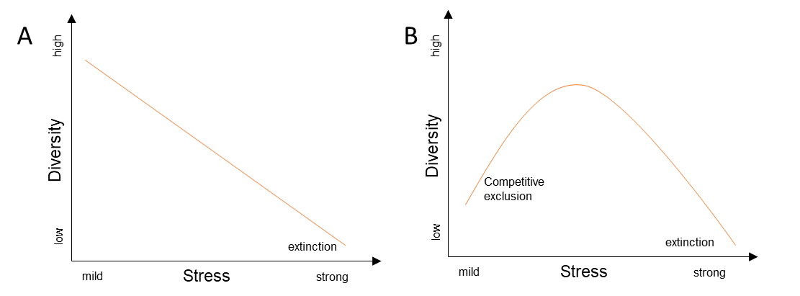
Fig. 2-1 Two hypothetical models of the effects of stress such heavy metal toxicity on soil microbial diversity. Figure was adapted from Giller et al. (1998).

Toxicity to plants
In plants, metal toxicity alters various physiological processes, such as water and nutrient uptake and transport, photosynthetic activity (Li et al., 2015; Razinger et al., 2012) and nitrogen metabolism (Amari et al., 2017). Some of these alterations occur at a biochemical level because metals can alter membrane function (Hajiboland and Hasani, 2007) and inhibit enzyme activities (Amari et al., 2017; Pahlsson, 1989). These alterations cause a broad range of dysfunctions, culminating ultimately in the sharp decline of crop production and quality (Amari et al., 2017). For example, it has been shown that Cd and Zn can induce disturbances of photosynthesis at different structural-functional levels: pigments and light capture, thylakoid ultrastructure and photosynthetic electron transport, stomatal conductance and access of CO₂, and activities of Calvin cycle enzymes among others (Paunov et al., 2018).
In vitro studies established that some heavy metals can significantly decrease the activities of the photosynthetic apparatus (photosystem II and, to lesser extent, photosystem I). A relationship between heavy metal induced stress and alterations in chlorophyll fluorescence has been established by studying the maximum photochemical quantum yield of photosystem II (Fv/Fm), which is recognized as a good indicator for photo-inhibitory or photo-oxidative effects on photosystem II (Ciscato et al., 1999; Żurek et al., 2014). For example, Borek et al. (2013) reported that addition of 10 mg.kg⁻¹ Cd into soil reduced the chlorophyll content and Fv/Fm of white cabage. Hajiboland and Hasani B (2007) found that Mn and Co at concentrations of 100 µM applied to rice and sunflower decreased shoot and root dry weight, inhibited assimilation of CO₂ and decreased chlorophyll concentration which depressed the leaf photosynthetic capacity. Conversely, the visible symptoms of toxicity in heavy metal exposed plants are often similar and include inhibited germination, stunted growth, leaf chlorosis, necrotic spots among others (Hajiboland and Hasani, 2007; Li et al., 2015; Paunov et al., 2018).

Guideline values
The metals Cd, Cu, Ni, Pb, As, Hg and Zn (without a particular order) are reported as the most common HMs in urban, industrial and agricultural soils worldwide (Di Bonito, 2005; Su et al., 2014; Yadav, 2010). Table 2-3 presents heavy metal concentrations considered to reflect the most commonly observed ranges in soils as well as the UK soil guideline values (SGVs). SGVs are scientifically based generic assessment criteria that can be used to simplify the assessment of human health risks arising from long-term and on-site exposure to chemical contamination in soil. They represent “trigger values” which indicate that soil concentrations above these level may pose a significant harm to human health (Environment Agency, 2009).

Table 2-3 Range of normal concentration of heavy metal concentration in soils and UK guideline values. Adapted from: Lancrop Laboratories (2014) and Phipps (1981).
Element | Normal Range in Soils¹ | CLEA Soil Guideline Value (SGV) ² |  |  | EC Directive 86/278/EEC ²
 | mg.kg⁻¹ | Soil land use mg.kg⁻¹ mg.kg⁻¹
Zn | 5-200 | Agricultural and after sludge application | Not available at present |  | At pH 5- 5.4 = 200  At pH 5.5-5.9 = 250  At pH 6-7= 300  At pH 7.1+ = 450
Ni | 2-100 | Residential  Allotment  Commercial  Agricultural and after sludge application | 130  230  1800  - |  | At pH 5.0-5.4 = 50  At pH 5.5 – 5.9 = 60  At pH 6.0-7.0 = 75  At pH 7.1+ = 110
Cu | 2-60 | Agricultural and after sludge application | Not available at present |  | At pH 5 – 5.4 = 80  At pH 5.5-5.9 = 100  At pH 6-7 = 135  At pH 7.1 + = 200
As | <5-40 | Residential  Allotment  Commercial  Agricultural and after sludge application | 32  43  640  - |  | -  -  -  50
Pb | 10-150 | Residential  Allotment  Commercial  Agricultural and after sludge application | 450  450  750  - |  | -  -  -  300
Cd | <1-2 | Residential  Allotment  Commercial  Agricultural and after sludge application | 10  1.8  230  - |  | -  -  -  3
¹Phipps (1981)
²Lancrop Laboratories (2014)

The heavy metals, Pb, Cd and Zn have been selected for study in this thesis because, from the group of pollutants commonly present in soils, they often occur together (P. Liu et al., 2020; Paranavithana et al., 2016; X. Yang et al., 2016) and have been reported as potentially toxic at the lowest bioavailable concentrations (Di Bonito, 2005; Sparks, 2003) as discussed below. Pb, Cd (Amari et al., 2017; World Health Organisation, 1972a, 1972b), and Zn (World Health Organisation, 1996) are recognized as major environmental pollutants with a well-documented biological toxicity (Paz-Ferreiro et al., 2014; Su et al., 2014).

Fractionation of HM in soil
Heavy metals are present in soil in different chemical forms (species) which are controlled by complex interacting processes such as adsorption/desorption, complexation/dissociation, precipitation/dissolution, or very slow diffusion into the interior of clay minerals and oxides (Kim et al., 2015). Heavy metal mobility and bioavailability in sediments and soil depend strongly on the mineralogical and chemical forms in which they occur (Okoro et al., 2012). In order to determine the speciation of metals in soils, sequential extraction methodologies have been developed.
Sequential extraction procedures provide information on the fractionation of metals in the different lattices of the solid sample (Okoro et al., 2012). Heavy metal fractions have been operationally defined by chemical extraction methods (Tessier et al., 1979). They are known generally as “water soluble fraction”, “exchangeable fraction”, “carbonate or acid soluble fraction”, “easily reducible or associated with iron or manganese oxides”, “oxidizable or associated with organic matter and sulfur’’, and ‘‘residuals or associated with silicates’’ (Filgueiras et al., 2002; Tessier et al., 1979).
The water soluble fraction is made up of free ions and ions complexed with soluble organic matter and other constituents. It constitutes the most mobile and potentially the most available metal and metalloid species (Filgueiras et al., 2002). The exchangeable fraction involves metals weakly retained on the solid surface by relatively weak electrostatic interaction (non-specific binding) which can be released by ion-exchange processes. This fraction generally accounts for less than 2% of total metals in soil, except for K, Ca, and Mn (Okoro et al., 2012). The carbonate fraction contains the metals which are precipitated or coprecipitated with carbonate, it is a loosely bound phase in which metals are specifically sorbed to organic and inorganic substrates. It is susceptible to changes in pH (Filgueiras et al., 2002; Okoro et al., 2012).
The iron and manganese oxides fraction involves the metals present as coating on mineral surfaces or as fine discrete particles. This fraction could be split into three sub-fractions: easily reducible fraction (Mn oxides); moderately reducible fraction (amorphous Fe oxides); and poorly-reducible fraction (crystalline Fe oxides) (Filgueiras et al., 2002; Okoro et al., 2012). In the organic fraction trace metals are associated with organic matter (living organisms, detritus, etc) due to bioaccumulation or complexation. Metallic pollutants bound to this phase are assumed not to be bioavailable due to the fact that are associated with stable high molecular weight humic substances, although they may be mobilised by decomposition processes (Filgueiras et al., 2002; Okoro et al., 2012). Finally, the strong acid-extractable or residual fraction consists of metals present in the crystalline lattice of primary and secondary minerals. The residual phase gives an estimate of the maximum amount of elements that are potentially mobilizable with changes in the environmental conditions (Filgueiras et al., 2002; Okoro et al., 2012). Typically metals of anthropogenic inputs are contained in the first four fractions while metals found in the residual fraction are generally of natural occurrence in the parent rock (Zimmerman and Weindorf, 2010).
Each of these fractions have an assumed different behaviour regarding mobility and solubility, as depicted in Fig. 2-2; the higher the solubility, the higher the mobility and consequently a higher risk for an element to become bioavailable or toxic. From these phases, some are more biologically available than others (Zimmerman and Weindorf, 2010). Metals that occur in a chemical form which can be accessible to the food chain, plants and other components of the soil microbial biomass are considered the bioavailable fraction (Abdu et al., 2017). Considering the properties of the different fractions, it has been generally considered that the water soluble and exchangeable fractions represent the bioavailable metals in soil (Filgueiras et al., 2002; Kim et al., 2015).
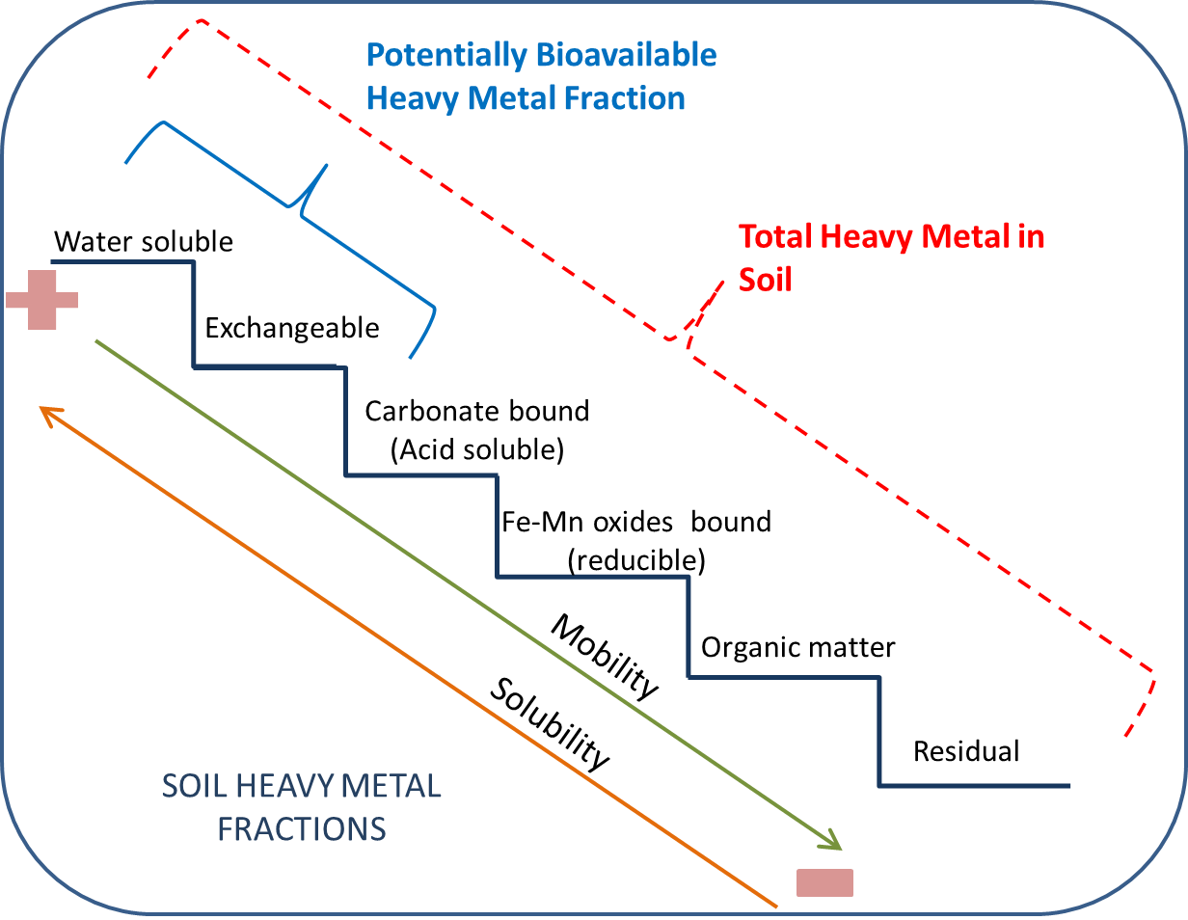
Fig. 2-2 Relationship between heavy metal soil phases or operationally defined fractions and its mobility and bioavailability.

Bioavailability of HM in soil
There is much debate on the precise definition of bioavailability and on the standardization of methods for the measurement of bioavailability. According to Kim et al. (2015), bioavailability is a dynamic process that comprises three stages, (1) Environmental availability, which is determined by measuring the available amount of metal in the soil pore water and the amount potentially available in the soil matrix. This is influenced by the physico-chemical properties of the soil (e.g. dissolved organic matter, pH, texture) and the properties of the trace element (e.g. binding strength). This fraction contains dissolved free ions and molecules but also species complexed with organic matter. (2) Environmental bioavailability is the fraction of dissolved metal species in the pore water which can be taken up by plant roots or other soil organisms; it is a physiologically controlled process which may be specific to individual microorganisms. (3) Toxicological bioavailability, is the biological effect of accumulation within the organism. This type of bioavailability can be determined by bioassays such as measuring bioaccumulation of metals in plant roots, shoots and grains or assessing growth inhibition.
As mentioned previously in section 2.3, not all the forms of metals in soil are available to soil organisms (Chojnacka et al., 2005). It is common that soils with very large concentrations of metals have a small bioavailable fraction due to the presence of insoluble mineral forms (Giller et al., 1998). Therefore, remediation approaches, as well as monitoring techniques, should be directed to target only the metal fraction that accounts for toxicity, because risk assessment based on total metal concentrations may overestimate the risk induced by the exposure to these elements (Hamad et al., 2014).
Table 2-4 presents the concentrations of HMs in soils above which plant toxicity is considered possible as well as the potentially toxic concentrations in soil pore water. However, it is important to mention that the term “potentially toxic” has been used, because not all metals present in the soil solution will be readily bioavailable because of chelation with organic molecules and the occurrence of chemical forms that cannot be taken up directly by living organisms (Giller et al., 1998).

Table 2-4 Toxic trace element concentrations in soil and soil solution. Adapted from: Di Bonito (2005); Kabata-Pendias and Pendias (2001) and Kim et al. (2015).
Element | Critical Soil Concentration (Total metal in soil) ¹ | Trigger values for arable soils (Total metal in soil)² | Potentially toxic concentration in soil pore water (bioavailable)³
 | mg.kg⁻¹ | mg.kg⁻¹ | mg.L⁻¹
Zn | 70-400 | 150-600 | 0.0052
Ni | 100 | 50-230 | 0.0099
Cu | 60-125 | 40-200 | 0.0635
Pb | 100-400 | 50-200 | 0.0010
Cd | 3-8 | 1-4 | 0.0045
¹Kabata-Pendias and Pendias (2001), the critical soil concentration is the range of values above which plant toxicity is considered possible
²Kim et al. (2015)
³Di Bonito (2015)

Factors affecting bioavailability of HM
Currently, it is recognized that the bioavailability of heavy metals in soils largely depends on the metal chemical speciation, mobility and concentration (Filgueiras et al., 2002). Bioavailability is metal specific because of the different adsorption affinities of metals on clay mineral and oxide binding sites, the different propensities to form stable complexes with organic and inorganic ligands, and the different complex and mineral solubilities (Kim et al., 2015).
In addition, other factors such as natural and anthropogenic environmental changes can also influence the behaviour of metallic pollutants influencing bioavailability. These external influences include pH, temperature, redox potential, organic matter decomposition, leaching and ion exchange processes and microbial activity (Epelde et al., 2008; Zimmerman and Weindorf, 2010). Of these, soil pH often has the greatest influence on bioavailability due to its strong effects on the solubility and speciation of heavy metals, both in the soil as a whole and particularly the soil solution (Giller et al., 1998). Acidic conditions tend to increase the mobility of heavy metals as a result of proton competition and decreased negative binding sites (Abdu et al., 2017).
Furthermore, processes such as oxidation, hydrolysis, and microbial degradation can modify the availability of heavy metals (Venegas et al., 2016). In addition, plant root exudates may affect metal availability directly or through the effect that exudates have on the rhizosphere chemistry. Similarly, microorganisms may alter metal availability in their vicinity due to acidification of the soil or production of compounds which complex metals (Giller et al., 1998).

Soil remediation techniques
Heavy metal contamination can reduce soil health and degrade its function to sustain life. On the contrary, healthy soils provide us with food and fibre, clean water and clean air among other ecosystem services (Bruyninckx, 2019). Because land and soil are limited resources, the only sustainable option is to prevent their degradation and use, hence the importance of soil remediation techniques to restore soil functions and allow contaminated lands to be repurposed.
The remediation of heavy metals in contaminated soils is considered to be one of the most complicated tasks (Derakhshan et al., 2017). However, understanding the mechanisms that govern metal mobility in soils has allowed the development of remediation approaches that reduce metal availability (Venegas et al., 2016). Conventional remediation methods for heavy metals in soil using physicochemical or biological processes include in situ and/or ex situ techniques (Su et al., 2014; M. Wang et al., 2018).
Of the physico or physico-chemical methods, the most commonly used are soil replacement, electro-kinetic remediation, soil leaching, thermal desorption, soil washing and adsorption. Between the bioremediation methods commonly used are phytoremediation techniques such as phytostabilization, phytovolatilization and phytoextraction and microbial remediation methods such as microbial leaching (Su et al., 2014; Yao et al., 2012). The key factors determining the application and selection of such technologies are cost, long-term effectiveness, commercial availability, general acceptance, the abundance of target metal concentrations, type of heavy metal, and physicochemical properties of the pollutant (Derakhshan et al., 2017).
In spite of the broad range of available remediation options, conventional treatment methods have limitations. For example, high costs and process complexity have limited the use of some physico-chemical methods in the immobilization or removal of HM from soil (Dixit et al., 2015). For these reasons, in situ chemical stabilisation by the addition of amendments has been considered the most suitable alternative for treating heavy metal-polluted soils (Pérez-De-Mora et al., 2006; Puga et al., 2015a; Venegas et al., 2016). The most commonly used amendments can be either inorganic compounds (e.g. lime, phosphate minerals, Al and Fe oxides) or organic compounds, including biosolids, animal manure, peat, compost and, more recently, biochar (Bandara et al., 2017; García-Carmona et al., 2017; Park et al., 2011b).
Amendments derived from organic wastes are promising candidates for heavy metal immobilization. They can regulate soil pH and provide specific sorption sites for heavy metal binding (Venegas et al., 2016), but also contribute nutrients to improve the soil condition (Karami et al., 2011). The advantages of these amendments are that they encourage recycling of biomass wastes, are inexpensive and readily available in large quantities (Derakhshan et al., 2017). These materials can reduce the mobility of heavy metals due to various immobilizing mechanisms, which can decrease metal bioavailability in polluted soils (Park et al., 2011b).

Biochar
Biochar is a black carbon compound obtained by a thermal degradation process (pyrolysis), in which residual biomass is treated under oxygen-limited conditions at temperatures ranging from 300ᵒC to 700ᵒC (Arán et al., 2016; Lehmann et al., 2011; Liu et al., 2015; Mandal et al., 2016). It is obtained from a wide variety of feedstock materials, such as grasses, nutshells, wheat straw, wicker, sewage sludge and biosolids, forestry products, animal manures and municipal waste (Beesley et al., 2011; Janus et al., 2015; Liu et al., 2015; Novak et al., 2009).
Previous studies describe this form of carbon as a stable solid, recalcitrant, low density, with high porosity and surface area, rich in functional groups (e.g. carboxylic, alcohol, hydroxyl group, phenolic among others), chemically heterogeneous and dominated by aromatic structured material (Puga et al., 2015a; Tang et al., 2013). The pore distribution of biochar in general comprise micropores < 2 nm, mesopores 2–50 nm, and macropores > 50 nm in diameter (Inyang and Dickenson, 2015; Titirici et al., 2012). However, pores 2–20 nm in size are considered to be the main contributors to the high surface area of biochar (Inyang and Dickenson, 2015; Mandal et al., 2016). The physical characteristics of biochar, porosity and internal structure can be observed in Fig. 2-3 .
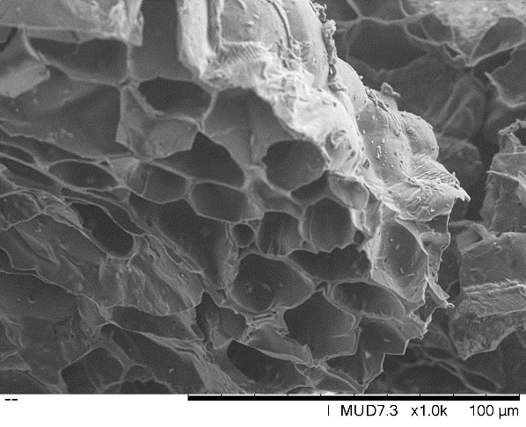  (a) | 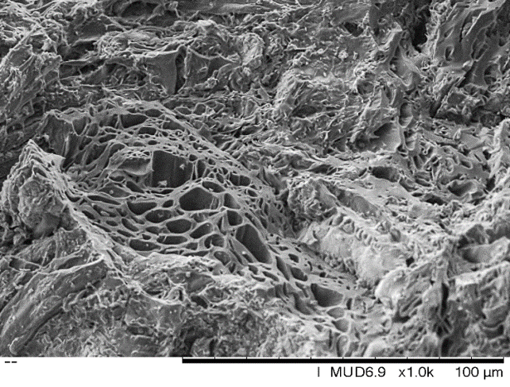  (b)
Fig. 2-3 SEM images of (a) oil seed rape straw biochar pellets (550⁰C) and (b) soft wood biochar pellets (550⁰C).

Factors determining biochar properties
The study of biochar properties is vital for understanding its ability to immobilize heavy metals in polluted soils, as evidenced by previous studies (Břendová et al., 2012; Sun et al., 2014; Zhao et al., 2013). It is known that pyrolysis conditions and the composition of the feedstock materials are the key factors which determine biochar properties and consequently its suitability for applications in pollutant removal (Janus et al., 2015; Novak et al., 2009; Zhao et al., 2013).

Influence of feedstock on biochar properties
Biomass is generally composed of three major groups of polymeric materials: cellulose, hemicellulose and lignin (Brownsort, 2009), with minor amounts of smaller organic molecules and minerals such as K, Ca, Si and Al among others. These compounds are present in various proportions depending on the biomass origin. Previous reports demonstrated that feedstock nature has a significant influence on its mineral composition (Bandara et al., 2017; Břendová et al., 2012; Novak et al., 2009).
According to Zhao et al. (2013), the biochar parameters most affected by feedstock properties are total organic carbon and mineral composition. According to Janus et al. (2015), biochars produced from woodchip have a higher C:N ratio and specific surface area than dairy manure biochar produced at the same temperature. Similarly, Zhao et al. (2013) reported that biochars derived from wood biomasses often have a higher surface area than grass biochar. An increase in surface area in biochars produced above 350⁰C appears to reflect the temperature at which cellulose is known to decompose and transform from layered C to amorphous char, leading to pore formation. These findings are supported by the data obtained by Ahmad et al. (2014) who showed that biochars produced from animal litter and solid waste feedstocks exhibited lower surface areas compared to biochars produced from high lignocellulosic content, such as crop residues and wood biomass. These findings suggest that biochars derived from feedstock high in lingo-cellulosic content may have higher surface areas and high C content. The variation in biochar properties for different feedstocks treated at similar temperatures is shown in Table 2-5.
Some variation is observed in the elemental composition of biochar, depending on the nature of the source material. For example, the coconut shell biochar obtained by Anyika et al. (2015) had greater C but lower N and P content compared with livestock biochars. The elemental composition also may be responsible for influencing biochar pH. Novak et al. (2009) studied different biochars (peanut hull, pecan shell, poultry litter and switchgrass) and demonstrated that poultry litter biochar had higher pH values than the other biochars due to the Ca and Mg content of the poultry biochar. These observations on mineral composition of biochars are supported by Zhao et al. (2013), who concluded that mineral elements of biochars were more influenced by feedstock composition than pyrolysis temperature.

Table 2-5 Physicochemical properties and structural characteristics of biochar derived from different source materials produced in a similar range of temperatures. Data obtained from various authors.
Biochar feedstock | Temperatureª | TC^{b} (%) | Yield (%) | VM^{c} (%) | Ash (%) | pH | CEC^{d} (cmol kg⁻¹) | SA (m²g⁻¹) | Source
Soy bean | 450 ᵒC | 57.5 |  |  | 17.7 | 9.2 |  | 17.50 | Liu et al. (2015)
Corn stalk | 450 ᵒC | 62.2 |  |  | 15.2 | 8.9 |  | 19.60 | Liu et al. (2015)
Rice stalk | 450 ᵒC | 52.4 |  |  | 27.1 | 9.5 |  | 25.80 | Liu et al. (2015)
Poultry manure | 450 ᵒC | 43.8 |  |  | 37.9 | 8.1 |  | 19.40 | Liu et al. (2015)
Cattle manure | 450 ᵒC | 55.5 |  |  | 22.4 | 8.9 |  | 13.50 | Liu et al. (2015)
Pig manure | 450 ᵒC | 41.2 |  |  | 42.4 | 8.9 |  | 13.40 | Liu et al. (2015)
Cow manure | 500ᵒC | 43.7 | 57.2 | 17.2 | 67.5 | 10.2 | 149.0 | 21.90 | Zhao et al. (2013)
Pig manure | 500ᵒC | 42.7 | 38.5 | 11.0 | 48.4 | 10.5 | 82.8 | 47.40 | Zhao et al. (2013)
Shrimp hull | 500ᵒC | 52.1 | 33.4 | 26.6 | 53.8 | 10.3 | 389.0 | 13.30 | Zhao et al. (2013)
Bone dregs | 500ᵒC | 24.2 | 48.7 | 11.0 | 77.6 | 9.6 | 87.9 | 113.0 | Zhao et al. (2013)
Waste water sludge | 500ᵒC | 26.6 | 45.9 | 15.8 | 61.9 | 8.8 | 168.0 | 71.60 | Zhao et al. (2013)
Waste paper | 500ᵒC | 56.0 | 36.6 | 30.0 | 53.5 | 9.9 | 516.0 | 133.0 | Zhao et al. (2013)
Sawdust | 500ᵒC | 75.8 | 28.3 | 17.5 | 9.9 | 10.5 | 41.7 | 203.0 | Zhao et al. (2013)
Grass | 500ᵒC | 62.1 | 27.8 | 18.9 | 20.8 | 10.2 | 84.0 | 3.33 | Zhao et al. (2013)
Wheat straw | 500ᵒC | 62.9 | 29.8 | 17.6 | 18.0 | 10.2 | 95.5 | 33.20 | Zhao et al. (2013)
Peanut Shell | 500ᵒC | 73.7 | 32.0 | 16.0 | 10.6 | 10.5 | 44.5 | 43.50 | Zhao et al. (2013)
Chlorella | 500ᵒC | 39.3 | 40.2 | 29.3 | 52.6 | 10.8 | 562.0 | 2.78 | Zhao et al. (2013)
Bamboo chip biochar | 600 ᵒC | 80.5 | 28.1 |  |  | 9.59 | 54.5 | 446.70 | Mandal et al. (2017)
Corn cob biochar | 600 ᵒC | 80.1 | 29.7 |  |  | 10.1 | 55.9 | 242.20 | Mandal et al. (2017)
Eucalyptus bark biochar | 600 ᵒC | 72.2 | 28.9 |  |  | 9.37 | 36.46 | 188.20 | Mandal et al. (2017)
ª Biochar production temperature
^{b} TC is total carbon content
^{c} VM Volatile organic matter (%, dry basis)
^{d} CEC is cation exchange capacity (cmol kg⁻¹)
SA is BET-N₂ surface area (m²g⁻¹)

Effect of pyrolysis conditions on biochar properties
In addition to the influence of feedstock, biochar properties can be controlled to some extent by optimizing pyrolysis parameters such as temperature and residence time (Ahmad et al., 2014). Pyrolysis temperature appears to strongly influence the cation exchange capacity (CEC) of biochar (Song and Guo, 2012). CEC indicates the abundance of negatively charged sites on the biochar surface that can attract and exchange cationic elements (Dohrmann, 2006; Jiang et al., 2017). This property is important for pollutant adsorption as it is determines key adsorption mechanisms including electrostatic and non-electrostatic interactions, (Janus et al., 2015; Zhao et al., 2013), described in the following sections. Fig. 2-4 illustrates the effect of pyrolysis temperature on CEC and pH of two biochars.

Fig. 2-4 Variation of cation exchange capacity (CEC) and pH of pig manure biochar and wheat straw biochar produced at temperatures from 200 to 650⁰C. Graphic elaborated with data reported by Zhao et al. (2013).
Biochar is generally alkaline due to the presence of ash containing carbonates of exchangeable base cations (Ca²⁺, Mg²⁺, Na⁺, K⁺) (He et al., 2021). In addition, higher temperatures tend to increase biochar pH (Lamb et al., 2009; R. Z. Wang et al., 2018). This is due to the separation of alkali salts from the organic matrix at higher temperatures, which increases the concentration of these salts in the ash (Janus et al., 2015; Kah et al., 2016; Novak et al., 2009). Concerning the surface area (SA), it has been observed that an increase in SA occurs at higher pyrolysis temperature, following the release of volatile material and the formation of channel structures (Janus et al., 2015).
Increasing temperature is related to an increase in pore formation and cracking in the basal-structural sheets of biochar (Novak et al., 2009), which contributes to a greater surface area. Fig. 2-5 illustrates the effect of pyrolysis on surface area and ash content of two biochars.

Fig. 2-5. Variation of surface area (left) and ash content (right) for pig manure and wheat straw biochar produced at temperatures from 200 to 650⁰C. From the data show in Zhao et al. (2013).
Moreover, increased temperatures and resident time are accompanied by a decrease of H and O content (mostly aliphatic-volatile material), resulting in lower O:C and H:C ratios. This trend suggests that high pyrolysis temperatures produce biochars which are more aromatic (less hydrophilic) and with a higher % C. This is due to dehydration and decarboxylation reactions that occur during high temperature pyrolysis (Janus et al., 2015; Kah et al., 2016; Novak et al., 2009; Purakayastha et al., 2016). In contrast, biochars produced at lower pyrolysis temperatures are more polar, with higher O:C and O+N:C ratios according to Novak et al. (2009). The analysis of these molar ratios and elemental composition is very important because it indicates the ability of biochar to adsorb specific pollutants.
Biochar itself may contain toxic compounds, the amount being determined by the pyrolysis temperature and the source material. The results of Khasifah (2016) demonstrate that potentially toxic aromatic compounds are formed during incomplete combustion. In this regard, Keiluweit et al. (2012) states that pyrolysis temperatures between 400 and 500 ᵒC, which are the commonly used to produce biochar in industry, could result in significant concentrations of PAHs in biochar. Stefaniuk et al. (2016) reported an increase in the content of PAHs and certain heavy metals (Cr, Cu, Cd, Pb and Mn) in biochar produced at higher temperatures, that was related to mass losses during pyrolysis which resulted in the concentration of these compounds in biochar. Inyang and Dickenson (2015) mention that toxic compounds, such as dioxins and furans, may be formed during slow pyrolysis process (350–550 °C, with residence times < 1 h). The fact that biochar may contain toxic compounds derived from the parent material or produced during pyrolysis, indicates the need for careful characterization of biochar prior to use, to avoid the release of such compounds into the environment.

Immobilization of soil heavy metals by biochar
Biochar has been evaluated as an adsorbent for heavy metals and metalloids with potential application for soil remediation. Table 2-6 summarises studies in which biochar was used as a soil amendment for the immobilization of heavy metals. Biochar can immobilize bioavailable heavy metals in soils by different physico-chemical mechanisms, preventing them from interacting with living organisms (Park et al., 2011a). After biochar application a redistribution of heavy metals stored among different fractions in soils has been observed; in general a decrease in the bioavailable fraction and an increase in the more stable fractions has been reported.
For example, sugar cane biochar applied to metal-contaminated (Cd, Pb and Zn) mining soils produced a slight decrease of Zn in mobile and exchangeable fractions, while there was no reduction in Cd and Pb mobility (Puga et al., 2016). Park et al. (2011) evaluated chicken manure and green waste-derived biochars for the immobilization of Cd, Cu and Pb in naturally contaminated and artificially spiked soils. They reported a reduction in the easily exchangeable and carbonate bound fractions and an increase in organic bound and residual fraction. Similar results were obtained by Bandara et al. (2017), who studied the effect of woody biomass on metal-rich serpentine soils. In this study a sequential chemical extraction of heavy metals revealed that the exchangeable and carbonate bound fraction of Ni, Mn and Cr were significantly decreased after the addition of biochar, while an increase in the organic-bound fraction occurred. These results confirm the potential of biochar to reduce the potentially toxic fractions of heavy metals in soils, although each biochar may have a different performance depending on its unique properties.

Table 2-6 Overview of studies using biochar for the remediation of heavy metal-polluted soils.
Soil heavy metal concentrations  [mg.kg⁻¹] |  |  |  |  | Biochar used | Reference
As | Cd | Cu | Pb | Zn
96 | 119 | 58 | 157 | 249 | Hardwood-derived biochar | Beesley et al. (2010)
 | 5  0.74  7.2 | 160  18050  81 | 1000  161  346 |  | Chicken manure and green  waste biochar | Park et al. (2011)
 |  | 600 | 21000 |  | British Oak, Ash, Sycamore and Birch biochars | Karami et al. (2011)
26.1 | 10.7 | 83.8 | 244 | 182 | Hardwood-derived biochar | Gomez-Eyles et al. (2011)
 | 10  50 |  |  |  | Oil mallee or wheat chaff biochars | Zhang et al. (2013)
 | 9.6  6.8  9  9.9 | 387  220  293  357 | 449  153  198  220 | 780  368  553  697 | Giant miscanthus biochar | Schweiker et al. (2014)
 | 8.4 |  | 2300 | 698 | Sugarcane straw biochar | Puga et al. (2015)
 | 1.6 | 10.15 | 376 | 150 | Garden waste, bamboo and Paulownia biochars | Awad et al. (2020)
 | 13.99 |  |  |  | Poultry-litter and sugar-gum-wood biochars | Bandara et al. (2021)
52 |  |  | 1259 |  | Vegetable waste and pine cone biochars | Igalavithana et al. (2017)
 | 1.6 |  | 252 |  | Suaeda glauca and pig manure biochars | Liu et al. (2020)

Mechanisms responsible for the immobilization of heavy metals by biochar
The available information suggests that the immobilisation of heavy metals onto biochar occurs mainly at surface level. This immobilizing capacity is achieved by different physical and chemical mechanisms (Hilber et al., 2017; R. Z. Wang et al., 2018; X. Yang et al., 2016). The functional groups on the surface of biochar combined with its high surface area are believed to control the process (Paz-Ferreiro et al., 2014; Puga et al., 2015a). The main mechanisms associated with sorption of heavy metals on biochar are physical entrapment, precipitation and adsorption processes such as electrostatic interactions, ion exchange and complexation (Ahmad et al., 2014; Bogusz et al., 2015; Jiang et al., 2015). These immobilization mechanisms are illustrated in Fig. 2-6 and are described in detail below.
Sorption studies in the aqueous phase have reported electrostatic attraction as one of the main mechanisms for heavy metal immobilisation by biochar. Similar processes occur in soil (pore water), although the presence of interfering ions may cause a competition for sorption sites, which has not been fully studied to date. The application of biochar to soil increases the negative charge (CEC increases) (Tang et al., 2013). Therefore, it is expected that electrostatic attraction between positively charged metals and negatively charged functional groups of biochar occur in these circumstances (Ahmad et al., 2014).
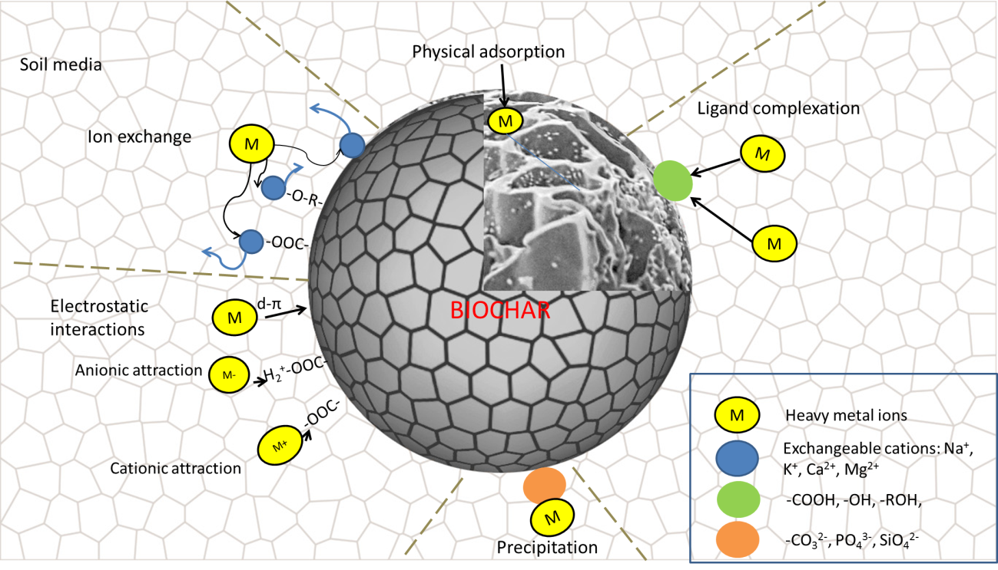
Fig. 2-6 Proposed mechanisms of biochar interaction with heavy metals.
However, depending on the soil pH the functional groups of biochar can also be protonated, having a positive charge in which case the attraction of negatively charged ions can occur, as reported by Wang et al. (2015) for the adsorption of $HAsO_{4}^{-2}$. Similarly, Zhu et al. (2016) studied the adsorption of chromium on bismute impregnated biochar, noting that the maximum adsorption capacity of Cr (VI) occurred at pH 3. This indicated that HCrO⁴⁻ was adsorbed over the protonated surface of biochar. Similarly, electrostatic attraction was suggested by Jiang et al. (2015) to drive Cu(II) adsorption onto low temperature (200 to 400 ⁰C) biochars, which contain more acid functional groups (negatively charged). Cu(II) adsorption was reported to decrease in biochars produced at higher temperatures (> 600 ⁰C) where other mechanisms, such as non-electrostatic interaction (mainly complexation and precipitation) were suggested to be more important.
These results from aqueous experiments concur with the study of Uchimiya et al. (2011), where cottonseed hull biochars (CH) produced at different temperatures were tested on a heavy metal-contaminated (Pb, Cd, Cu and Ni) soil. It was demonstrated that electrostatic interactions between cationic metal species and negatively charged surfaces were significantly greater for the soil amended with biochar CH350 (produced at 350⁰C), followed by CH500, CH650, and CH800 (produced at temperatures of 500, 600 and 800⁰C, respectively). It was concluded that the surface functional groups of biochars (mainly determined by pH together with volatile matter and oxygen contents) controlled the retention of heavy metals by biochar in the studied soil. Other studies (Jiang et al., 2015; Uchimiya et al., 2011) also suggest that such electrostatic interaction between anionic and cationic metals is particularly important for biochars produced at low-mid pyrolysis temperatures, due to the high amount of functional groups present on the biochar.
Heavy metals may also be immobilized by precipitation after biochar application, which is strongly influenced by pH changes caused by biochar addition and its alkaline nature. An increased soil pH may lead to decreased mobilization of heavy metals and precipitation as metal oxides. The presence of soluble phosphates ($PO_{4}^{3-})$ and carbonates$(CO_{3}^{2-})$on the biochar surface can support the formation of metal precipitates (Jiang et al., 2015; Xu et al., 2013). Furthermore, the formation of complexes between functional groups on the biochar surface and inorganic compounds has been reported as an alternative adsorption mechanism Tang et al. (2013). For example, Xu et al. (2013) reported a surface adsorption process via complexation of Cu and Zn with ionized phenolic groups. Similarly, other authors report the immobilization of different metals, such as Cu (Jiang et al., 2015), Pb (Karami et al., 2011), Cd, Zn and Cu (Xu et al., 2013) on biochar, suggesting complexation with functional groups as the driving mechanism.
Biochar may also enhance metal immobilization due to the liming effect that it induces in soil (Park et al., 2011a; X. Yang et al., 2016). Adding biochars, which in general have an alkaline pH (pH 7-9 or even higher depending on feedstock and pyrolysis conditions), to acidic soils may increase the soil pH, and decrease the mobility of cationic metals (Beesley et al., 2011; Paz-Ferreiro et al., 2014). The influence of soil pH as an immobilizing mechanism has been reported previously (Derakhshan et al., 2017; García-Carmona et al., 2017) and given the alkaline character of biochar it is difficult to isolate the action of such pH changes from the other immobilizing mechanisms facilitated by biochar, as described previously.

Interaction of biochar with soil biota
Biochar may affect soil biota in different ways depending on the unique nature of biochar and soil properties. The effects on microbes and plants are explained in detail below.

Microorganisms
Because microbes have important roles in soil function, related to soil structure and stability, nutrient cycling, aeration, water use efficiency, disease resistance, and C storage capacity (Lehmann et al., 2011), it is vital to understand how biochar may affect soil microbial communities. Biochar application in polluted soils may affect microbial community composition, structure and abundance (Zhu et al., 2017). These effects can be considered direct, in 1) providing shelter on its porous structure; 2) providing macro and micro nutrients contained in biochar ash (Puga et al., 2015a); 3) modifying soil abiotic conditions such as soil pH, moisture and aeration (Jaafar et al., 2015; Janus et al., 2015; Zhu et al., 2017). Potential or indirect effects include 1) changing enzyme activities that affect soil elemental cycles related to microbes (Zhu et al., 2017); 2) interference with microbial communication due to sorption of signalling molecules (Anyika et al., 2015; Beesley et al., 2011), and 3) enhancing microbial activity by promoting the sorption of soil contaminants, reducing in this way the bioavailability of the contaminant and toxicity to microbes (Jaafar et al., 2015; Jindo et al., 2012; Wawra et al., 2018). Fig. 2-7 illustrates the main interactions between biochar and soil microorganisms.
The changes in community composition and structure are related to the modification of soil abiotic factors as result of biochar properties (Jaafar et al., 2015; Janus et al., 2015; Zhu et al., 2017). For example, soil pH strongly determines the viability of microbial groups and it is known that soil bacteria tend to increase in abundance with increasing pH, up to values around pH 7, whereas fungi may show no change in abundance (Lehmann et al., 2011). In addition, increases in soil pH and CEC may increase bioavailable P and base cations in biochar amended soils, favouring the presence of mycorrhizal groups (Warnock et al., 2007).
It has been suggested that the moisture-retention property of biochar may allow a continued hydration of microorganisms, decreasing mortality during dry conditions. Some minerals in biochar ash can include macro and micro nutrients which are essential for biological cycles. Therefore, biochar can represent a valuable input into the soil food web, influencing microbially-mediated nutrient transformation in soils.
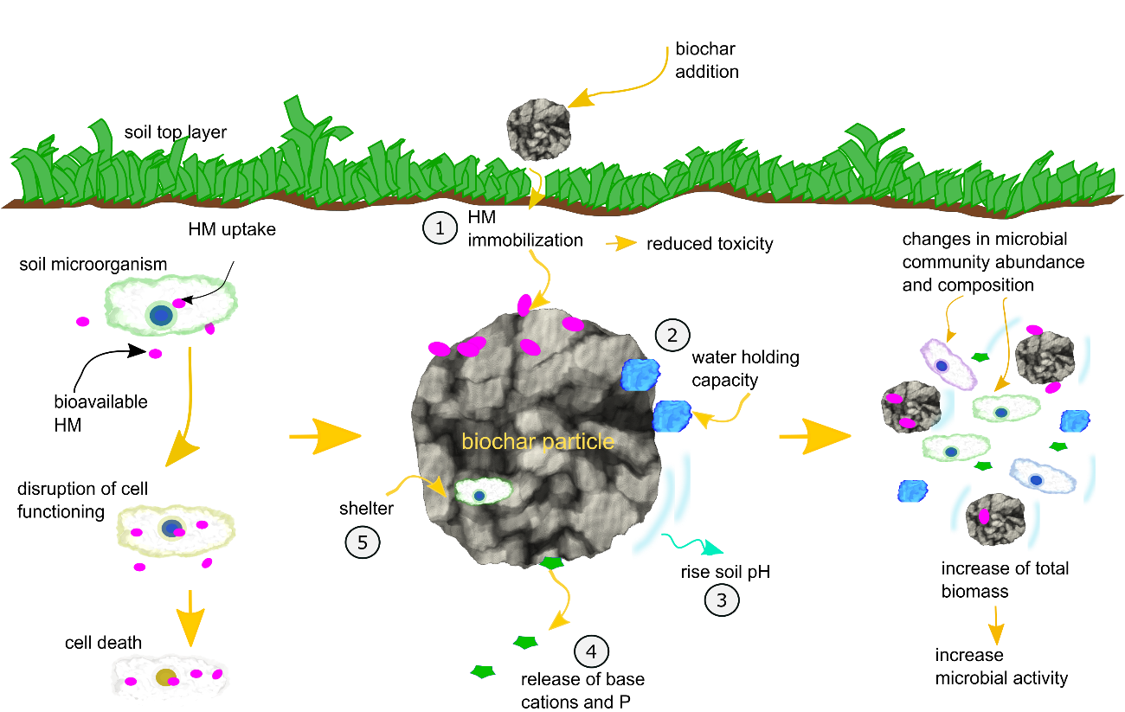
Fig. 2-7 Schematic illustration of interaction between biochar and soil microorganisms in heavy metal-contaminated soil.
In relation to changes in microbial abundance influenced by biochar, the effect may differ for groups of microorganisms. The most studied microbial group are mycorrhizal fungi, which are often positively affected by biochar addition. For example, the internal pore system of biochar particles may protect the extra radical mycelium from grazers, favouring its proliferation. Occasionally, observed decreases in abundance of mycorrhizal fungi are not completely understood, but are suggested to result from increased nutrient and water availability promoted by biochar application, thereby reducing the need for symbionts (Lehmann et al., 2011). It may also be related to the high salt or heavy metal content associated with some biochars, which can limit mycorrhizal colonization (Warnock et al., 2007).
The effect of biochar on microbial activity and diversity has been investigated. Biochar can enhance microbial activity due to sorption and thereby inactivation of growth-inhibiting or toxic substances (Jaafar et al., 2015; Jindo et al., 2012; Wawra et al., 2018). Generally, the biodiversity of contaminated soil is poor because the contaminants are toxic to soil communities at high concentrations (Beesley et al., 2011). Therefore, binding toxic compounds can increase microbial activity and promote changes at the community level (Ahmad et al., 2014; Anyika et al., 2015; Park et al., 2011a). Such changes in community structure can occur even without a noticeable change in microbial activity or biomass (Zhu et al., 2017).

Plants
Biochar application to heavy metal-contaminated soil can protect plants from HM toxicity and improve plant performance in some cases. As illustrated in Fig. 2-8, this influence is associated with a decreased toxicity of metals (reduced bioavailability), changes in pH (liming effect), increased water holding capacity and aeration, and input of organic material and nutrients (Janus et al., 2015).
For example, Puga et al. (2015) reported that addition of sugar cane biochar at 1.5, 3 and 5 % (w/w) to a mining soil contaminated with Zn, Pb and Cd showed a protective effect to Mucuna aterrina plants which show roots more developed and colonized by mycorrhiza and leaves without toxicity symptoms. However, no effect was observed in dry biomass; the protective effect was associated to the reduction of bioavailable Cd (54%), Pb (50%) and Zn (57%) due to biochar addition. Shan et al. (2020) reported that addition of peanut shell biochar to a Cd contaminated soil cultivated with spinach protected plants from toxicity and improved plant performance; an increase in shoot height was associated with a reduced uptake (7-52 %) and decreased Cd bioavailability (5-21 %) in relation to the controls (no biochar). Similarly, Younis et al. (2016) reported that under Cd stress, biochar application increased the growth, photosynthesis, and protein content of spinach seedlings.
However, some studies have raised concerns regarding biochar application in soils and potential impacts on plants. Biochar can contain polycyclic aromatic hydrocarbons, chlorinated hydrocarbons and heavy metals (Cr, Cu, Cd, Pb and Mn) as trace constituents; some authors have warned about their potential release into the soil (Qian et al., 2015; Shim et al., 2015). Besides, negative effects have been associated with relatively high application rates due to the high levels of soluble salts released from biochar that can inhibit germination and growth (Joseph et al., 2021).
For instance, Das et al. (2020) reported that addition of biochars produced from maize stock and Lantana camara (500 °C) at 7.5 and 10 t.ha⁻¹ reduced seed germination and biomass of maize and black gram in relation to the 5 t.ha⁻¹ application. The negative impact of biochars at 10 t.ha⁻¹ was explained by the presence of trace quantities of PAHs and hazardous metals which are phytotoxic at certain levels. Buss et al. (2016) observed growth inhibition on cress seedling treated with biochars at 5 % (w/w) - 5 biochars out of 19 studied shown this inhibitory effect. Since the level of trace elements present in the studied biochars was similar to levels commonly found in soil, it was concluded that the inhibition was due to an increase in K⁺ and pH due to biochar addition which caused osmotic stress to plants.
At high biochar application rates free radicals from biochar can inhibit germination and seedling growth. Nevertheless, at low biochar rates, low levels of free radicals could be beneficial, as reactive oxygen species can interact with plant hormones that trigger germination (Joseph et al., 2021). For instance, Liao et al. (2014) reported germination inhibition, root and shoot growth retardation and plasma membrane damage in wheat, rice and corn seedlings treated with biochars with abundant free radicals at high application rates (2-6 g/petri dish) whereas an stimulatory effect on plants was observed at low applications (0.5-1 g/petri dish).
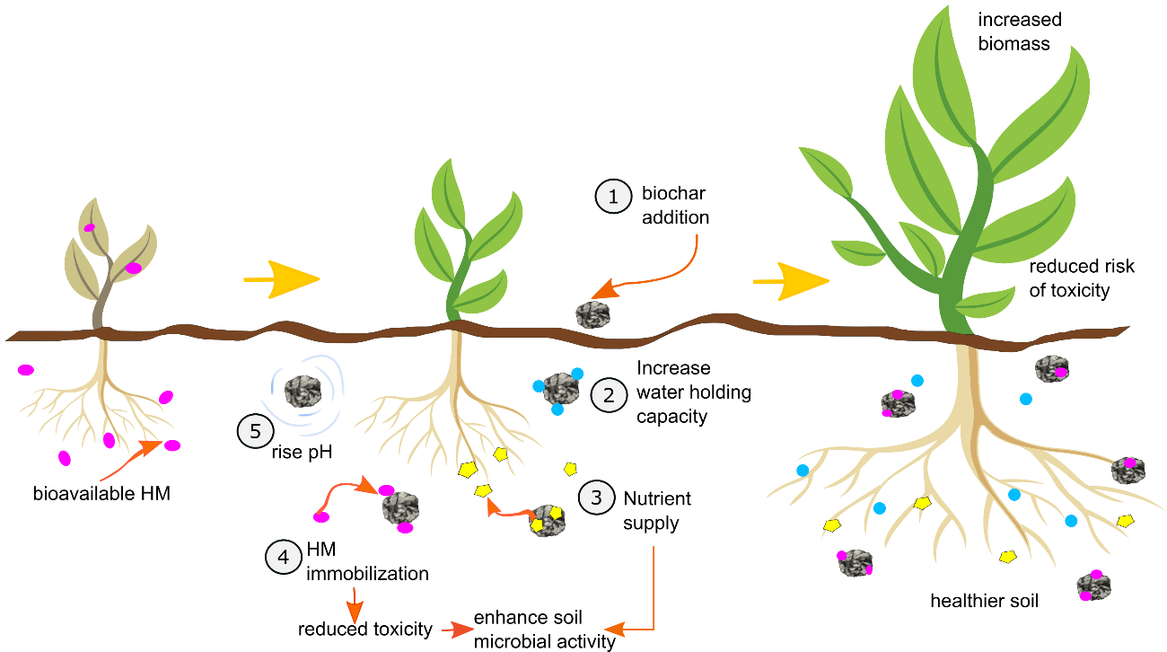
Fig. 2-8 Interaction of biochar with plants on heavy metals (HM) contaminated soils.
Moreover, the same immobilization mechanisms of biochar for heavy metals may affect other compounds such as nutrients, flavonoids and hormones (Beesley et al., 2011). It is still unclear if the sorption of signalling compounds and nutrients is beneficial or harmful to plants, and more research is necessary to determine if sorption is reversible or permanent (Beesley et al., 2011).

Monitoring toxicity of biochar-amended soils
In order to assess the environmental risk of heavy metal-polluted soils during and following biochar amendment, the concentration, mobility and toxicity levels of heavy metals require routine monitoring. Pollution monitoring is a key aspect for the sustainable management of contaminated land, but questions remain regarding what should be monitored to assess the ecological risk (Moreno et al., 2011). Much of the confusion in deriving critical toxic concentrations of heavy metals in soils arises from comparing the results of short-term laboratory experiments with monitoring of long-term exposures of microbial populations to heavy metals in field experiments. Laboratory studies measure responses to immediate, acute toxicity (disturbance) but fail to asses responses to long-term chronic toxicity (stress) which develops gradually (Giller et al., 1998).
Different methodologies have been employed to monitor heavy metal toxicity in biochar-amended soils. Some studies focus exclusively on monitoring the environmental bioavailability. In this context, soil pore water has been commonly used to assess the toxicity of heavy metals in biochar-amended soils (Beesley et al., 2010; Jiang et al., 2017; Karami et al., 2011; Lamb et al., 2009). Using the soil pore water concentration of metals, it is possible to explain leaching, plant uptake and toxicological effects of heavy metals and other pollutants. In these cases, the ‘bioavailable fraction’ and ‘pore water concentration’ have been considered to be equivalent (Harmsen et al., 2005). Usually, ‘Rhizon’ soil moisture samplers are used to collect soil pore water for monitoring and assessing eco-toxicity in soils (Moreno et al., 2011). Soil pore water is considered the most direct and simple method for the determination of bioavailable metals. In addition, the use of passive samplers as previously mentioned may allow the in situ collection of soil pore water, offering a routine way to monitor this solution under field conditions (Moreno et al., 2011; Schweiker et al., 2014).
Other approaches use chemical reagents as extractants to quantify the more labile fraction of heavy metals in soils. The more common extractants used are 1M solution of NH₄NO₃ (Park et al., 2011a; Wawra et al., 2018), ammonium citrate 2% w/v, 0.1 M sodium nitrate, 0.05 M Na₂EDTA (Chojnacka et al., 2005), diethylene triamine penta acetic acid (DTPA) (Awad et al., 2020; P. Liu et al., 2020), sodium acetate and MgCl₂ (Okoro et al., 2012; Tessier et al., 1979).
Other studies have focused on the sequential extraction of heavy metals to assess the effect of biochar on the distribution and mobility of heavy metals in different soil fractions (Bandara et al., 2017; Park et al., 2011a; Puga et al., 2016; C. Xu et al., 2020; Zhu et al., 2015). A number of sequential extraction techniques have been developed over the last 30 years, and there is no standardized procedure (Filgueiras et al., 2002). The most commonly used protocols are modifications derived from the 5-step sequential extraction method originally presented by Tessier et al. (1979) and the extraction method developed by the Community Bureau of Reference (BCR) (Ure et al., 2006). Although sequential extraction procedures are time consuming, they provide valuable information on the origin, mode of occurrence, biological and physicochemical availability, mobilization and transport of trace metals in soils (Filgueiras et al., 2002). However, sample processing during sequential extraction procedures can disturb soil structure, enhance the surface area exposed to extractants and, due to the destruction of the soil matrix, this type of analysis may provide an inaccurate results (Beesley et al., 2010; Moreno et al., 2011).
In all the methods mentioned above, the determination of heavy metals is generally undertaken via inductively coupled plasma mass spectrometry (ICP-MS), inductively coupled plasma - optical emission spectrometry (ICP-OES), atomic absorption spectroscopy (AAS) or flame atomic absorption spectroscopy (FAAS) (Filgueiras et al., 2002).
An alternative approach to monitor the toxicity of heavy metals in biochar-amended soils is using biological performance indicators. As previously mentioned biochar application affects both the soil physico-chemical properties and the soil biological properties from the perspectives of plant growth (vegetation measurement), microbial community and activity, ecotoxicity, and the whole food-web structure (He et al., 2021). Hence, the study of soil biota after biochar amendments can provide a deeper understanding of the effects on soil health and the environmental impact of biochar application.
Table 2-7 summarises studies that have used different biological performance indicators to monitor soils amended with biochars. Among various biological performance indicators the most commonly used are the physical vegetation indicators, such as biomass weight (yield, dry weight of shoot and root), length, area and volume (i.e., plant height, root length, root diameter, root surface area, leaf area, and root volume), as well as chemical vegetation indicators (photosynthesis and respiration-related indicators, nutrient-related indicators, metal toxicity-related indicators) and soil microbial community (qRT- PCR, 16 rRNA, PLFA, soil mineralization, enzymatic activities).
Overall, different methods are used to assess the impact of biochar on amended soils; however, some are time consuming and do not provide accurate information on the biological toxicity of heavy metals, whereas other techniques are designed for use under laboratory conditions only. Therefore, a careful selection of methods is required in order to provide a holistic understanding of the ecological risk derived from heavy metal-contaminated soils and the impact of biochar amendments to improve soil health.
Table 2-7 Current approaches used for monitoring soil toxicity after biochar application based on living organisms response. Data obtained from various authors detailed below.
Approach | Method | Description | Metals monitored | Biochar type | Source
Vegetation indicators | Plant tissue concentration | Tissue acid digestion of Lolium perenne for metal determination | Pb, Cu | British oak ash derived biochar | Karami et al. (2011)
 | Total leaf chlorophyll & parameters related to growth and development | Total leaf chlorophyll-related  SPAD units  Plant shoots weight and root size  Plant tissue concentration of Sylibum marianum L. and Helianthus annuus L. | Cu, Zn | Oak biochar | Sáez et al. (2016)
 | Dry biomass and tissue concentration (shoots and roots) | Acid digestion of Indian mustard for metal determination | Cd, Cu, Pb | Chicken manure-derived biochar and green waste derived biochar | Park et al. (2011)
 | Parameters related to growth and development | Plant growth parameters shoot/root length and tissue digestion for Cd determination in Juncus subsecundus | Cd | oil mallee biochar and wheat chaff biochar | Zhang et al. (2013)
 | Tissue concentration in paddy plant | Acid digestion of roots, shoots and leaves of rice plants | Cr, Ni, Cu, Pb, Zn and Cd | lees-derived biochar | Zhu et al. (2015)
Soil microbial community | Physiological response and enzyme activity | Soil basal respiration and dehydrogenase activity (DHA) | Cd, Cu, Pb | Chicken manure-derived biochar | Park et al. (2011)
 | Physiological response and functional diversity | Soil basal respiration and mineralization analysis, PFLA | Pb, Zn, Cd, Sb, Cu |  | Wawra et al. (2018)
 | Enzymatic activity | Urease, catalase, phosphatase activities | Cu, Pb, Cd, Zn | Bamboo and rice straw biochar | X. Yang et al. (2016)
 | Microbial community (bacterial) | 16S rRNA sequencing | Pb, As | Soybean stover and pine needle derived biochars | Ahmad et al. (2016)
Other living organisms | Tissue concentration of the earth worm Eisenia fetida | Acid digestion of worm tissue | Multi-contaminated site organics and metals | hardwood-derived biochar | Gomez-Eyles et al. (2011)

Current uncertainties on biochar application
The results of biochar use for the immobilization of heavy metals in soil are promising. However, a better understanding is required regarding present uncertainties related to its application. Some of the aspects that are not yet clear include biochar affinity and performance for immobilization of different metals, the estimation of application rates and an accurate procedure for monitoring the remediation process that includes the impact of biochar on soil biota.
Biochars may have a higher capacity for the immobilization of specific heavy metals, but the biochar properties and soil conditions which determine this affinity are not clearly defined. For example, both bamboo and rice straw biochar are reported to be more effective at decreasing extractable Cu and Pb than removing extractable Cd and Zn from soil (X. Yang et al., 2016). Similarly, there is still uncertainty concerning the best biochar application rate. Previous studies have used varied application rates from 0.5 to 10% w/w (C. Amoah-Antwi et al., 2020; C. Xu et al., 2020), but it has not been clearly established how to best estimate an appropriate biochar application rate in soils to obtain optimal metal immobilization using the least adsorbent material and without negatively impacting on soil health (e.g. soil salinity, pH, nutrient ratios).
For example, Yang et al. (2016) found a biochar application rate of 5% w/w to be the best for reducing the bioavailability of Cd, Cu, Pb and Zn. Similarly, other studies have also reported the highest reduction in bioavailable Zn, Cd and Pb at 5% w/w biochar dosage (Puga et al., 2015). Biochar derived from pyrolysis of oak wood at 400 °C at 5 % (w/w) was the most effective in decreasing the bioavailability of Pb among the amendments tested by Ahmad et al. (2012). Nevertheless, higher application rates of biochar have also been reported, such as 20%v/v (Karami et al., 2011) and 15% w/w (Park et al., 2011a). Apart from the concerns raised about high application rates of biochar discussed previously in section 2.5.6 also the cost of the amendment must be considered as cost would rise with high rates which would discourage the use of biochar for large scale applications.
Finally, some undesirable effects triggered by biochar application are poorly understood. For instance, some reports have related biochar application to As and Cu co-mobilization. For example, increased concentrations of As in the pore water of a contaminated urban soil were recorded after hardwood biochar application (Puga et al., 2015). Biochar can enhance the solubility of heavy metals by co-mobilization with dissolved organic carbon (DOC). Adding organic soil amendments can increase DOC concentrations in pore water; the increased metal solubility, mobility and bioavailability in soils treated with organic amendments can be attributed to the formation of soluble organo-metallic complexes with DOC (Karami et al., 2011). Beesley et al. (2010) found that Cu mobility increased after the application of hardwood biochar, which was related to increased DOC in the soil pore water. This feature was also observed by Uchimiya et al. (2011), who explained Cu mobilization after biochar addition by the formation of a soluble complex with metal ion-coordinating organic fractions, or due to competition between organic matter and metal ions for the sorption sites on biochar and soil components.

The relationship between properties of plant-based biochars and sorption of Cd(II), Pb(II) and Zn(II) in soil model systems

Introduction
Heavy metals (HMs) are important environmental pollutants due to their widespread occurrence. Cost-effective management solutions are required to reduce the environmental risk from HM-contaminated soil. Of the HMs commonly present in polluted soils, Pb(II), Cd(II) and Zn(II) are most problematic, according to reported potential toxicity at the lowest bioavailable concentration (Di Bonito, 2005; Sparks, 2003). Recent studies highlight biochars as effective amendments for improving soil health at contaminated sites. This is achieved by reducing bioavailable concentrations of HMs (Yang et al., 2017; Y. Wang et al., 2019). Among different feedstock types, biochars derived from plant waste are gaining attention as a means to recycle agricultural wastes (Domingues et al., 2017).
The metal sorption process by biochars has been previously described as a result of three different mechanisms: (i) ion exchange (Ca²⁺,K⁺,Mg²⁺,Na⁺); (ii) metal complexation onto free and complexed carbonyl, carboxyl, alcoholic, hydroxyl or phenolic hydroxyl functional groups; and (iii) physical adsorption or surface precipitation caused by sorptive interaction involving delocalization of π electrons of organic carbon (Trakal et al., 2014). It is known that pyrolysis conditions and feedstock origin are key factors determining biochar properties and consequently its sorption capacity (Janus et al., 2015). However, adsorption of HMs is also influenced by element properties and their competitive behaviour for biochar sorption sites (Park et al., 2016). Because biochar is not a well-defined material, the identification of biochars with beneficial properties for soils is complicated, resulting in large variation in sorption potential and performance (Keiluweit et al., 2010). In the case of HM immobilization in soil, it is not yet clear what determines the binding affinity and interactions between biochar and HMs in the complex soil environment (Y. Wang et al., 2019).
Sorption of HMs by biochar is usually determined with batch studies. However, most sorption studies have focused on water treatment, using high HM concentrations up to 1000 mg.L⁻¹ (Ma et al., 2016; Z. Wang et al., 2015; Xiang et al., 2020) which are much greater than bioavailable concentrations of HMs in soil. Soils with very large HM concentrations commonly have a small bioavailable fraction due to the presence of insoluble mineral phases (Giller et al., 1998). The bioavailable HM concentrations reported in soil pore water from contaminated soils vary between 0.1 to 4 mg.L⁻¹ for Cd and Zn, but 0.1 to 90 mg.L⁻¹ for Pb (Moreno et al., 2011; Schweiker et al., 2014).
We hypothesised that biochar sorption capacity for Cd(II), Pb(II) and Zn(II) is determined by a limited number of biochar properties. Understanding which are the key properties of plant-derived biochars controlling the sorption for these elements can serve as a basis to assess and select suitable biochars for the remediation of HM-contaminated soil. The aim of this study is to establish relationships between the physico-chemical properties of five plant-based biochars and the immobilization capacity for Cd(II), Pb(II) and Zn(II) in synthetic soil pore water. The specific objectives were to:
- analyse biochar characteristics associated with HM sorption mechanisms,
- determine sorption capacity and affinity for Cd, Pb and Zn,
- determine the nature of the mechanisms driving the sorption of each HM, and
- use these relationships to build predictive models of biochar sorption potential.

Materials and Methods

Biochar description
Five biochars produced from different plant-derived feedstocks were obtained from the UK Biochar Research Centre. These were converted under well-controlled and reproducible process conditions, comprising a rotary kiln pyrolyser heated indirectly and electrically (Mašek et al., 2018). The feedstock included oil seed rape straw (OSR550, OSR700), wheat straw (WSP550), Miscanthus straw (MSP550) and soft wood (SWP550) pellets. Selected biochar properties provided by the supplier are shown in Table 3-1, with other properties determined in this study experimentally. The material used in the study was the fraction passing through a 2 mm stainless steel sieve screen after grinding manually with a mortar and pestle.

Biochar characterization
The cation exchange capacity (CEC) of biochar was determined using the silver thiourea (AgTU) method, as described by Jiang et al. (2017) and the porosity was studied using the N₂ adsorption method at 77 K with an ASAP 2010 porosity analyser (Micrometrics, USA). Pore size distribution was determined by the Barrett–Joyner–Halenda (BJH) analysis, and biochar surface area was determined using the Brunauer-Emmett-Teller (BET) method; measurements were based on 15 analysis points using the 3 Flex 4.04 software. Samples were degassed overnight (16 hours) at 100 °C in a Vacprep 061 prior to analysis (Micrometrics Sample Degas System, USA).

Adsorption experiments
A synthetic soil pore water solution resembling the average ion composition of UK soil solution (Kinniburgh and Miles, 1983) was used for the sorption tests. Only major anions and cations were considered in the make-up of the synthetic soil pore water by dissolving the following salts in deionized water: KNO₃ (49.52 mg.L⁻¹), NaNO₃ (26.33 mg.L⁻¹), Mg(NO₃)₂.6H₂O (31.089 mg.L⁻¹), CaCl₂.2H₂O (55.19 mg.L⁻¹), CaSO₄ (43.55 mg.L⁻¹), Ca(NO₃)₂.4H₂O (181.71 mg.L⁻¹). The ionic strength of this solution was 5 mM, with a pH of 6.8.
The metal adsorption experiments were performed using a batch equilibration technique in triplicate. Stock solutions (1000 mg.L⁻¹) of Zn, Cd, and Pb were prepared in deionized water from Zn(NO₃)₂.6H₂O, Cd(NO₃)₂.4H₂O and Pb(NO₃)₂ (GR grade, Fisher Scientific, USA).

Kinetics
The effect of contact time on the adsorption capacity of biochars for Cd, Pb and Zn as single element solutions was studied. The kinetic experiments were conducted in 50 mL polyethylene centrifuge tubes containing 100.0 ± 0.3 mg of biochar and 20 mL of 5000 µg.L⁻¹ soil solution of each element, preadjusted to pH 7 (average pH of pore water in UK soils) using 0.1 M NaOH solution. The mixture was agitated at 120 rpm on a reciprocating shaker at 22 ± 2 ⁰C. Replicate tubes for each biochar were destructively sampled at 10 time points (0, 1, 2, 4, 8, 12, 24, 48, 72 and 96 hours), and filtered using 0.45 µm syringe filters. The filtrates were acidified with 1% (v/v) HNO3 (TraceMetalTM grade, Fisher, USA) and the concentration of Cd, Pb and Zn determined by ICP-MS (Sciex Elan DRCII, PerkinElmer, USA).

Effect of pH on adsorption tests
The impact of soil pore water pH on HM sorption capacity was determined as described above except that the initial pH of the solutions was adjusted to values between 4.0 and 9.0 ± 0.3 using 0.1 M NaOH or 0.1 M HCl. This is the pH range commonly present in UK soil solutions (Kinniburgh and Miles, 1983). The chemical speciation of Cd, Pb and Zn at different initial pH values was studied using visual MINTEQ 3.1 (https://vminteq.lwr.kth.se/).

HMs sorption capacity
Sorption capacity for the HMs was measured using a constant quantity (1.25 mg.L⁻¹) of biochar. Trace element solutions were prepared in the range commonly present in the soil pore water of contaminated soils: from 0.05 to 10 mg.L⁻¹ for Cd and Zn and from 0.5 to 50 mg.L⁻¹ for Pb. As the biochar did not reach its maximum sorption capacity within that range additional concentrations up to 50 mg.L⁻¹ were used for Cd and Zn and up to 85 mg.L⁻¹ for Pb. Sorption experiments were carried out at an initial pH 5 for Pb sorption, pH 6.5 for Cd and pH 7.5 for Zn.
After filtration, biochar samples loaded with Cd, Pb and Zn were recovered and rinsed with deionized water, then dried at 22 ⁰C ± 2 ⁰C. Attenuated Total Reflection Fourier Transform Infrared (ATR-FTIR) spectra of loaded biochars were obtained using a dry-air purged spectrometer (Vertex 70, Bruker, Germany) equipped with a KBr splitter, a DLaTGS detector and a diamond crystal accessory (Platinum ATR Unit A225, Bruker, Germany). The spectra were acquired between 400 and 2000 cm⁻¹ with a resolution of 1 cm⁻¹ and are an average from 16 scans. Spectra were acquired in random order, in duplicate.
The ATR-FTIR spectra was normalized with Orange 3.25 (Demsar et al., 2013). The normalized spectra was used to conduct a principal component analysis (PCA) in R (R Core Team, 2020). Since it is possible that ATR-FTIR spectra might contain small differences between biochars that could not be distinguished visually, multivariate data tools as PCA are necessary for spectra analysis. PCA is an effective variable reduction technique for spectroscopic data (Lazzari et al., 2018). Scanning electron microscopy coupled with Energy Dispersive X-Ray Spectroscopy (SEM-EDX) was conducted on HM-loaded biochars using an Inspect F50 (FEI, USA) and AZtec (Oxford Instruments, UK) respectively; 20 kV with spot size 4 were used and point ID area analysis and electronic x-ray mapping were assessed in raw and HM-loaded samples.

Table 3-1 Biochar properties
Source | Oil seed rape pellets |  | Wheat pellets | Miscanthus pellets | Soft wood pellets
Biochar notation | OSR550 OSR700 |  | WSP550 | MSP550 | SWP550
Temperature (⁰C)¹ | 550 | 700 | 550 | 550 | 550
pH ª | 9.8 ± 0.5 | 10.4 ± 0.5 | 9.9 ± 0.2 | 9.8 ± 0.2 | 7.9 ± 0.3
H:C_{tot} (molar ratio)¹ | 0.32 ± 0.03 | 0.19 ± 0.02 | 0.4 ± 0.1 | 0.38 ± 0.04 | 0.39 ± 0.01
O:C_{tot} (molar ratio) ¹ | 0.12 ± 0.02 | 0.09 ± 0.02 | 0.1 ± 0.0 | 0.09 ± 0.03 | 0.09 ± 0.01
Ash content [wt%]* ¹ | 19 ± 2 | 21.9 ± 0.5 | 21 ± 1 | 12 ± 1 | 1.3 ± 0.4
Electric  conductivity [dS.m⁻¹] ¹ | 2.3 ± 0.4 | 3.1 ± 0.4 | 1.7 ± 0.4 | 0.8 ± 0.2 | 0.09 ± 0.03
Total N [wt%]* ¹ | 1.6 ± 0.2 | 1.3 ± 0.2 | 1.4 ± 0.1 | 0.8 ± 0.1 | <0.10
Total P [wt%]* ¹ | 0.29 ± 0.08 | 0.3 ± 0.1 | 0.14 ± 0.02 | 0.19 ± 0.04 | 0.06 ± 0.04
Total K [wt%]* ¹ | 2.9 ± 0.3 | 2.9 ± 0.4 | 1.6 ± 0.4 | 0.9 ± 0.1 | 0.3 ± 0.1
Total pore volume  [cm³.g⁻¹]² | 0.38 ± 0.02 c | 0.42 ± 0.01 b | 0.27 ± 0.01 e | 0.6108 ± 0.0003 a | 0.33 ± 0.01 d
BET [m².g⁻¹] ² | 416 ± 5 c | 461 ± 5 b | 299 ± 3 e | 490 ± 12 a | 358 ± 3 d
CEC [cmol.kg⁻¹] ² | 22 ± 3 a | 23 ± 1 a | 21 ± 2 a | 22 ± 1 a | 11 ± 3 b

¹ Data reproduced from UK Biochar Research Centre, values are means ± run to run variation (SD), (http://www.biochar.ac.uk/standard_materials.php; Accessed 17/08/2020)
² Data determined experimentally in the present study, values are means ± standard deviation; n = 3; different letters indicate significant differences between biochars (p < 0.05; one-way ANOVA, Tukey's honestly significant difference (HSD) post hoc test)
* dry basis
BET: specific surface area determined by the Brunauer-Emmett-Teller (BET) method
CEC: cation exchange capacity

Competitive sorption
Competitive sorption effects were evaluated in binary and ternary systems of the studied HMs. Initial concentrations that induced an intermediate sorption capacity by biochars in the single sorption test were used in this competitive experiment; the initial concentrations were: Zn 13 mg.L⁻¹, Pb 41 mg.L⁻¹ and Cd 22 mg.L⁻¹, which are equivalent to 0.2 mM in each case. Equimolar concentrations were used in this test to allow comparison between elements; the combinations were: Zn:Cd, Pb:Cd, Zn:Pb and Cd:Zn:Pb. The pH was 6.5 for the first combination and 5 for the rest, as required for the evaluation of Pb binding. Pb is present as insoluble Pb(OH)₂ at pH 5.5-12.5 (Hongbo Li et al., 2017), which would limit the amount of soluble Pb²⁺ that can bind with biochar.

Sorption models

Kinetic models
First-order (Lagergren, 1907) and second-order (Ho and McKay, 1998) kinetic models presented in Eq. 1 and Eq. 2 respectively were fitted to the experimental data to elucidate the sorption rate and kinetic parameters, instead of the linearized versions.
$$Q_{t}= Q_{e}\left(1-e^{-k_{1}t}\right)$$ | Eq. 1
$$Q_{t}=\frac{k_{2}Q_{e}^{2}t}{1+k_{2}Q_{e}t}$$ | Eq. 2
where Q_{t} and Q_{e} (mg.g⁻¹) are adsorbed Cd, Pb and Zn at any time and at equilibrium, t is the time (min) and k₁ (min⁻¹) and k₂ (g.mg⁻¹.min⁻¹) are the rate constants. The amount of immobilized trace elements onto biochars, Qt (mg.g⁻¹), was calculated as described in Eq. 3
$$Q_{t}=\frac{{(C}_{0}-C_{t}) V}{m}$$ | Eq. 3
where C₀ and Ct (mg.L⁻¹) are Cd, Pb or Zn concentrations at time zero and time t respectively, V (L) is the volume of synthetic soil pore water solution and m (g) is the weight of biochar used in each tube. At equilibrium Q_{t} and C_{t} are referred as Q_{e} and C_{e} respectively (Cui et al., 2016b). To select the best statistical model we used a penalized likelihood criterion known as Akaike Information Criterion (AIC) developed by Akaike (1974). AIC penalizes the number of parameters of a model and allows the goodness of fit of a model to be balanced against its degrees of freedom. The model for which AIC is minimal is selected as the one that best describes the experimental data (Akpa and Unuabonah, 2011). The general form for calculating the AIC is given in:
$$AIC= -2log\left(L\right)+2n_{par}$$ | Eq. 4
where, L is the likelihood of the fitted model and npar is the total number of parameters in the model. AIC has been reported as a better criterion for ranking sorption models instead of the error functions (sum of absolute error, average relative error, sum of square error, coefficient of determination, chi-squares, etc) due to its high sensitivity to model deviations (Akpa and Unuabonah, 2011). The AIC values for the fitted models were estimated using the AIC function from R (R Core Team, 2020).

Adsorption isotherm models
To evaluate the sorption of Cd, Pb and Zn by the studied biochars, the commonly used Langmuir (Langmuir, 1918), Freundlich (Freundlich, 1906), and Temkin (Temkin and Pyzhev, 1940) sorption models presented in Eq. 5-7 were examined.
$$Q_{e}=\frac{K_{l}q_{m}Ce}{1+K_{l}Ce}$$ | Eq. 5
Where, q_{m} (mg.g⁻¹) is the maximum adsorption capacity of biochar for Cd, Pb or Zn and K_{l} (L.mg⁻¹) is the Langmuir constant related to the affinity of the binding sites (Cui et al., 2016b).
$$Q_{e}=K_{F}{Ce}^{\frac{1}{nF}}$$ | Eq.6
Where, K_{F} (L.g⁻¹) is the Freundlich constant and nF is the Freundlich exponent related to adsorption intensity (Cui et al., 2016b).
$$Q_{e}=\left(\frac{RT}{b}\right)lnA+\left(\frac{RT}{b}\right)Ce$$ | Eq. 7
Where, A (g⁻¹) is the Temkin constant, b (J.mol⁻¹) is the constant related with the heat of sorption, R is the gas constant (8.31 J.mol⁻¹.K⁻¹) and T (K) is the absolute temperature. Additionally, models that adapt to describe S-shape isotherms, such as Dubinin-Radushkevich (Dubinin, 1975) and Hill model (Hill, 1910) presented in Eq. 8 and Eq. 9, were studied.
$$Q_{e}=q_{m}exp\left\{-β{\left[RT ln \left(\frac{Cs}{Ce}\right)\right]}^{2}\right\}$$ | Eq. 8
Where, β (mol² kJ⁻²) is the Dubinin- Radushkevich constant related to the adsorption energy and C_{s} (mg.L⁻¹) is the solubility of the solute (Hu and Zhang, 2019).
$$Q_{e}=q_{m}\frac{C_{e}^{n}}{K_{H}+C_{e}^{n}}$$ | Eq. 9
Where, K_{H} (mg.L⁻¹) is the Hill constant that represents the concentration for which Q_{e} is equal to 0.5 q_{m} (hence an expression of affinity and/or sensitivity of the system (Goutelle et al., 2008) and n (dimensionless) is the Hill coefficient of sigmoidicity which is related to the degree of cooperation between binding sites (Martucci et al., 2015).
Biochar SWP550 was excluded from the model fitting as it showed little HM sorption (data not shown), possibly due to a low CEC. Instead the maximum sorption capacity determined experimentally was used for comparison.

Statistical analysis
The data was analysed using R (R Core Team, 2020). Differences in BET, CEC and pore volume were analysed using linear regression followed by one-way ANOVA. Differences in sorption capacities due to the contact time (kinetic study) and pH, were analysed by using linear regression followed by two-way ANOVA. Tukey's honestly significant difference (HSD) post hoc test was used to determine significant differences among groups in the before mentioned analysis.
In order to determine statistical differences in the parameters obtained from nonlinear model fitting (kinetics and Hill isotherm), data were subset by element. Two non-linear regressions for each of the respective equations (second order kinetic model and Hill equation) were performed using biochar type as the grouping variable; the first non-linear regression allowed the fitted model parameters to be different for each biochar (model 1) while in the second non-linear regression the parameters were set to be the same for all biochars (model 2), as recommended by Ritz and Streibig (2009).
Thereafter a one-way ANOVA comparing model 1 against model 2 was conducted as a pairwise comparison between biochars for each of the fitted parameters to establish significant differences between biochars. The raw data and the coding (R script) for fitting the Hill and Langmuir adsorption isotherm models as well as the code to analyse statistical differences in the parameters derived from the Hill model between biochars can be accessed at (Soria P. et al., 2020).

Correlation analysis
A Pearson correlation analysis was conducted to understand the relationship between biochar maximum sorption capacities (q_{m}) for Cd, Pb and Zn and biochar physical and chemical properties. The q_{m} (mg.g⁻¹) values were derived from the Hill isotherm; however in the case of SWP550 the highest experimentally-determined sorption capacity was used. The biochar properties used in the analysis were CEC [cmol.kg⁻¹], BET [m².g⁻¹], total pore volume [cm³.g⁻¹], total K [wt%], total P [wt%], total N [wt%], EC [dS.m⁻¹], O:Ctot (molar ratio), H:Ctot (molar ratio) and pH (Fig. 3-1). Also, the functional groups Si ̶ O, C ̶ H, C ̶ O, COH and COOH from the ATR-FTIR analysis were included using the absorbance values from normalized spectra of raw biochars. The correlation was conducted at 95% confidence using R (R Core Team, 2020) and the results were presented as a heat map.

Linear models to describe biochar sorption capacity
Linear regression analysis was conducted to determine if biochar sorption capacity for Cd, Pb and Zn can be described as a function of its physico-chemical properties. The regression considered the same biochar physico-chemical properties used in the correlation analysis (section 3.2.5.1) as single predictor variables and when there was poor linearity (r² < 0.8), a second variable was introduced. The maximum sorption capacities (q_{m}) of the biochars for Cd, Pb and Zn estimated with the Hill model were used as the response variable. The AIC criterion determined the parameters that produce the most suitable model describing the sorption capacity for each element.

Results and discussion

Biochar characterization
The physico-chemical properties of the biochars are presented in Table 3-1. The BET surface area varied depending on the feedstock used, the highest was MSP550 (490 m².g⁻¹) and the lowest was WSP550 (299 m².g⁻¹). These BET areas were correlated with the total pore volume, in the order: MSP550>OSR700>OSR550>SWP550>WSP550.
Biochars produced from herbaceous biomass (WSP550, MWSP550 and OSRs) had a significantly higher CEC (p < 0.001), from 20.65 to 23.29 cmol.kg⁻¹, than biochar SWP550 produced from the wood feedstock, with a CEC of 11.23 cmol.kg⁻¹. The CEC of SWP550 was similar to that of a biochar obtained from pinewood produced at 650 °C (from 7.0 to 11.9 cmol.kg⁻¹ at different pH) reported by Mukherjee et al. (2011). Similarly, Domingues et al. (2017)(Domingues et al., 2017) reported lower CEC values (2.4 to 10.8 cmol.kg⁻¹) for three wood-derived biochars relative to coffee husk biochar (69-72 cmol.kg⁻¹) and chicken manure biochar (23 cmol.kg⁻¹).

HMs sorption experiments

Kinetics
The effect of contact time on Zn, Cd and Pb sorption by the biochars is presented in Fig. 3-1A. HM adsorption was fast during the first 4 hours (90-95 % of trace elements sorption) and complete by 24 hours. Therefore, 24 hours was selected as the equilibrium time.
Calculation of AIC coefficients (Table 3-2) indicated that the second order kinetic model best described the data. At equilibrium the value of k₂ indicated that sorption occurred in the following rate order: Pb >Zn >Cd for biochars MSP550 and WSP550, Zn >Pb >Cd for biochars OSR550 and OSR700, and Cd >Pb >Zn for biochar SWP550. The sorption capacity (Q_{e}) for Pb was lower than that for Cd and Zn for all the biochars except SWP550, whose performance was significantly lower (p < 0.05) than the rest of biochars for all metals tested (Table 3-3).
The lower sorption capacity for Pb is attributed to the initial pH of the solution (pH 7). In natural systems Pb is present mainly as soluble species Pb²⁺ and Pb(OH)⁺ at pH < 5.5, but as insoluble forms, Pb(OH)₂, at pH 5.5-12.5 and Pb(OH₄)₂- at pH > 12.5 (Hongbo Li et al., 2017). This is consistent with other biochar sorption studies which describe the formation of Pb metal hydroxide precipitates at pH >5 (Naidu et al., 2013; Z. Yang et al., 2016). The formation of Pb precipitates reduces the amount of soluble Pb forms that can interact with biochar surface binding sites. Therefore, in soil pore water with pH >5, Pb immobilization by biochar will be restricted by the amount of Pb soluble species.
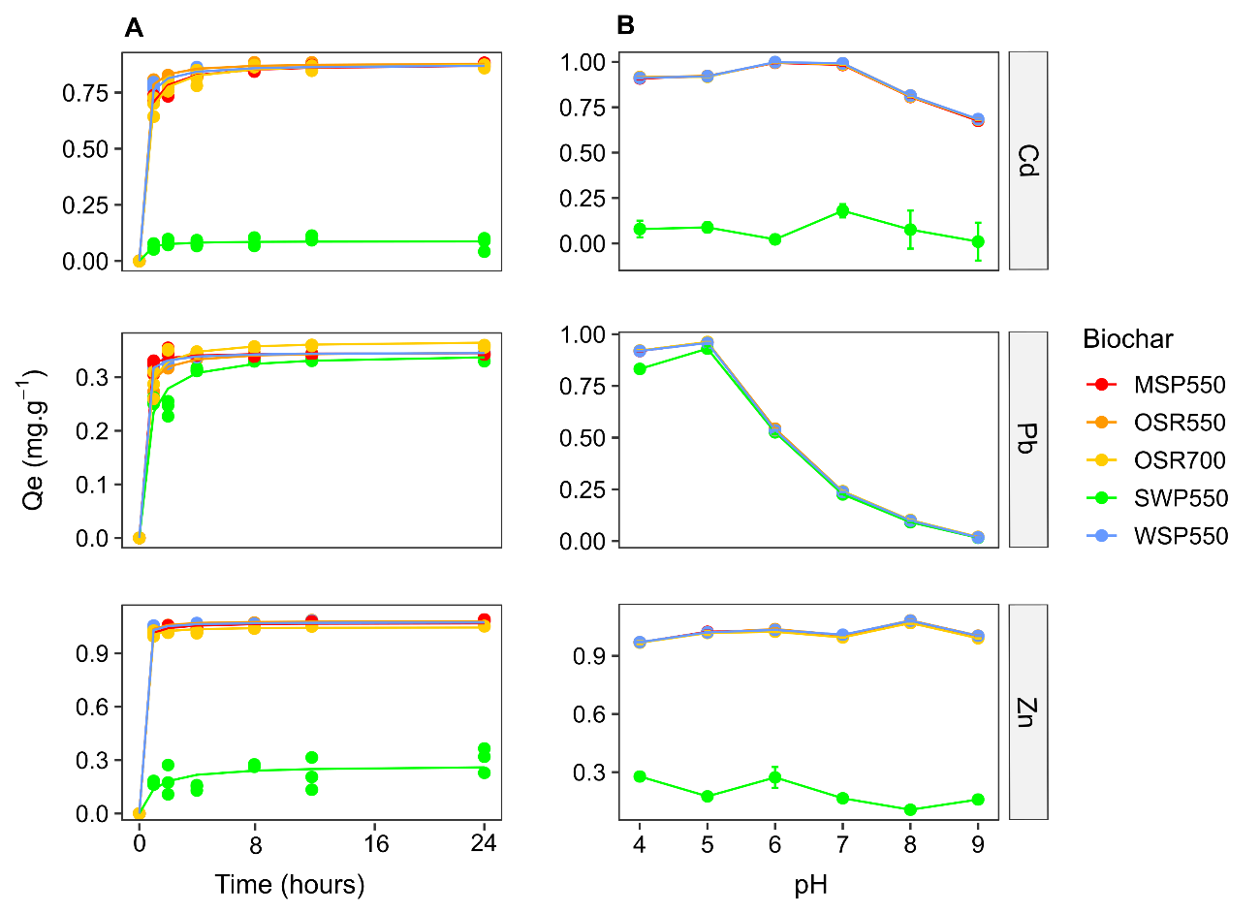
Fig. 3-1. Effect of contact time and solution pH on sorption capacity of Cd, Pb and Zn. A) Sorption kinetics during the first 24 hours using a background solution with initial pH 7, t= 22 ± 2 °C, the line is a second order kinetic model fit. B) Effect of background solution pH on sorption capacity (means ± standard deviation), contact time = 24 hours, t= 22 ± 2 °C.

Table 3-2 AIC values for kinetic and adsorption isotherm models
 |  | Kinetic models |  |  | Adsorption isotherm models
Element | Biochar | Second order | First order |  | Hill model | Langmuir model
Pb | MSP550 | -118.678 | -128.926 |  | 157.149 | 157.760
 | OSR550 | -123.799 | -111.672 |  | 167.402 | 175.854
 | OSR700 | -97.746 | -108.825 |  | 150.232 | 195.784
 | SWP550 | -86.932 | -74.059 |  | - | -
 | WSP550 | -137.935 | -134.369 |  | 174.766 | 183.262
Cd | MSP550 | -82.747 | -61.051 |  | 76.527 | 76.990
 | OSR550 | -106.998 | -82.130 |  | 119.097 | 131.950
 | OSR700 | -80.193 | -67.331 |  | 79.58973 | 145.806
 | SWP550 | -89.405 | -89.728 |  | - | -
 | WSP550 | -83.848 | -66.698 |  | 111.449 | 125.145
Zn | MSP550 | -93.397 | -87.825 |  | 56.463 | 54.486
 | OSR550 | -114.667 | -98.404 |  | 58.295 | 67.439
 | OSR700 | -105.267 | -95.211 |  | 74.830 | 100.986
 | SWP550 | -42.776 | -39.922 |  | - | -
 | WSP550 | -89.543 | -81.0505 |  | 94.719 | 101.688
Note: the model for which AIC is minimal is the one that best describes the experimental data

Table 3-3 Second order kinetic model and Hill sorption model parameters for the adsorption of Cd, Pb and Zn onto biochars. Kinetics conducted at initial concentration 5 mg.L⁻¹ and pH 7. Sorption isotherm with concentrations starting at 0.05 mg.L⁻¹ to 50 mg.L⁻¹ (Zn with pH 7.5 and Cd with pH of 6.5) and up to 85 mg.L⁻¹ for Pb (pH 5), contact time = 24 hours, t= 22 ± 2 °C. Values are parameters means ± standard deviation; different letters indicate significant differences in parameters between biochars grouped by meta (p < 0.05; pairwise one-way ANOVA).
 |  | Second order kinetic model |  |  | Hill sorption model
Element | Biochar | k₂  (g.mg⁻¹.min⁻¹) | Q_{e}  (mg.g⁻¹) |  | n | q_{m}  (mg.g⁻¹) | K_{H}  (mg.L⁻¹)
Pb | MSP550 | 0.8 ± 0.2 a | 0.345 ± 0.003 a |  | 0.7 ± 0.2 a | 41 ± 8 a | 1 ± 1 a
 | OSR550 | 0.27 ± 0.03 b | 0.348 ± 0.002 a |  | 2.7 ± 0.7 b | 46 ± 4 a | 0.22 ± 0.03 b
 | OSR700 | 0.19 ± 0.03 c | 0.368 ± 0.005 c |  | 3.2 ± 0.3 b | 56 ± 1 b | 0.137 ± 0.005 c
 | SWP550 | 0.10 ± 0.02 bc | 0.344 ± 0.007 b |  | - | 0.44* | -
 | WSP550 | 0.53 ± 0.06 d | 0.346 ± 0.001 a |  | 2.1 ± 0.5 b | 42 ± 3 a | 0.19 ± 0.02 b
Cd | MSP550 | 0.079 ± 0.008 a | 0.877 ± 0.007 a |  | 1.4 ± 0.3 a | 8.0 ± 0.7 a | 2.6 ± 0.6 a
 | OSR550 | 0.16 ± 0.01 b | 0.882 ± 0.004 a |  | 3.0 ± 0.8 b | 19 ± 1 b | 0.71 ± 0.06 b
 | OSR700 | 0.068 ± 0.007 a | 0.883 ± 0.008 a |  | 6.4 ± 0.6 c | 20.5 ± 0.5 b | 0.335 ± 0.005 c
 | SWP550 | 0.5 ± 0.4 d | 0.089 ± 0.006 a |  | - | 10.31 * | -
 | WSP550 | 0.13 ± 0.02 c | 0.875 ± 0.007 a |  | 6 ± 1 bc | 18 ± 1 b | 1.53 ± 0.06 a
Zn | MSP550 | 0.28 ± 0.05 a | 1.070 ± 0.005 a |  | 1.0 ± 0.5 a | 3.3 ± 0.3 a | 0.10 ± 0.06 a
 | OSR550 | 0.36 ± 0.05 a | 1.081 ± 0.003 a |  | 1.6 ± 0.2 a | 8.6 ± 0.3 b | 0.068 ± 0.009 a
 | OSR700 | 0.38± 0.07 a | 1.046 ± 0.004 b |  | 4.0 ± 0.6 b | 10.7 ± 0.4 c | 0.045 ± 0.002 b
 | SWP550 | 0.06 ± 0.04 b | 0.27 ± 0.03 ab |  | - | 0.67* | -
 | WSP550 | 0.4 ± 0.1 a | 1.075 ± 0.006 a |  | 4 ± 1 a | 6.2 ± 0.6 a | 0.034 ± 0.004 c
* Highest sorption capacity determined experimentally

Effect of media pH
The pH of the synthetic pore water had a significant effect on the adsorption of Zn, Cd and Pb by the biochars (Fig. 3-1B). The adsorption capacity of Pb was significantly decreased above pH 5 (p < 0.001); the greatest adsorption capacity was observed between pH 6 to pH 7 for Cd (p < 0.001) and between pH 5 to pH 8 for Zn (p <0.001). Biochar SWP550 had the lowest sorption capacity for Cd and Zn at all pH values tested (p <0.001) and for Pb at pH 4, 5, 7, 8 and 9 (p < 0.001).
These results are supported by the chemical speciation predicted with Visual MINTEQ 3.1 (Fig. 3-2), which indicates that soluble forms of Cd, Pb and Zn available to bind with biochar sorption sites enhanced sorption at specific pH ranges. As illustrated in Fig. 3-2, soluble Cd forms, Cd²⁺ (93%) and CdCl⁺ (2.5%), dominate at pH 4-7, after which insoluble Cd₄(OH)₆SO_{4(s)} would form and finally be the dominant species at pH 9. Pb would be mainly present as soluble Pb²⁺ (90-62 %) and PbOH⁺ (0.02-10.2 %) at initial pH 4-6.5; insoluble Pb(OH)₂ would start to form at pH 6.75 and become dominant at pH > 8 (98%). Zn would be present as Zn²⁺ (96%) at pH 4-7, after which insoluble Zn(OH)₂ would form and became the dominant species at pH 9.
The decreased sorption capacity for Pb above the initial pH 5 reflects the progressively reduced solubility of Pb at increasing pH. Other authors have reported similar effects of pH on the HM sorption capacity of biochars. For example, biochars prepared from pinewood and rice husk have maximum Pb removal capacities at pH 5 (Liu and Zhang, 2009). The optimal pH for Zn adsorption was determined to be pH 8 for hard wood biochar (Chen et al., 2011), pH 7 for Zn adsorption by wheat straw biochar and pH 6 for Cd on biochar made from S. hermaphrodita (Bogusz et al., 2015).
The effect of pH on the sorption capacity of biochars differs for trace elements as solution pH significantly influences both metal speciation and biochar surface charge. Biochar addition increases the pH of the metal-enriched soil pore water solution. Due to release of alkaline mineral components and the presence of alkaline functional groups such as ketones on the biochar surface (Hongbo Li et al., 2017; Timothy McMillan, 2018), an increase in solution pH enhances the formation of insoluble precipitates. This is especially important for Pb as non-soluble forms start to develop at pH 6.75 according to the predicted speciation (Fig. 3-2). Under acidic conditions the functional groups are protonated, but become deprotonated as pH increases, allowing binding of positively charged metal ions (Hongbo Li et al., 2017). The enhanced sorption capacity for Cd and Zn at pH > 6 can be attributed to metal binding with deprotonated functional groups such as carboxylic (pKa 4.7-10.10) or acid-lactone (pKa 6.4-10.3), which are often present in biochars (Mandal et al., 2017).
Based on these findings the remaining sorption experiments were completed at an initial pH 5 for Pb sorption, pH 6.5 for Cd and pH 7.5 for Zn to ensure maximum sorption capacity.
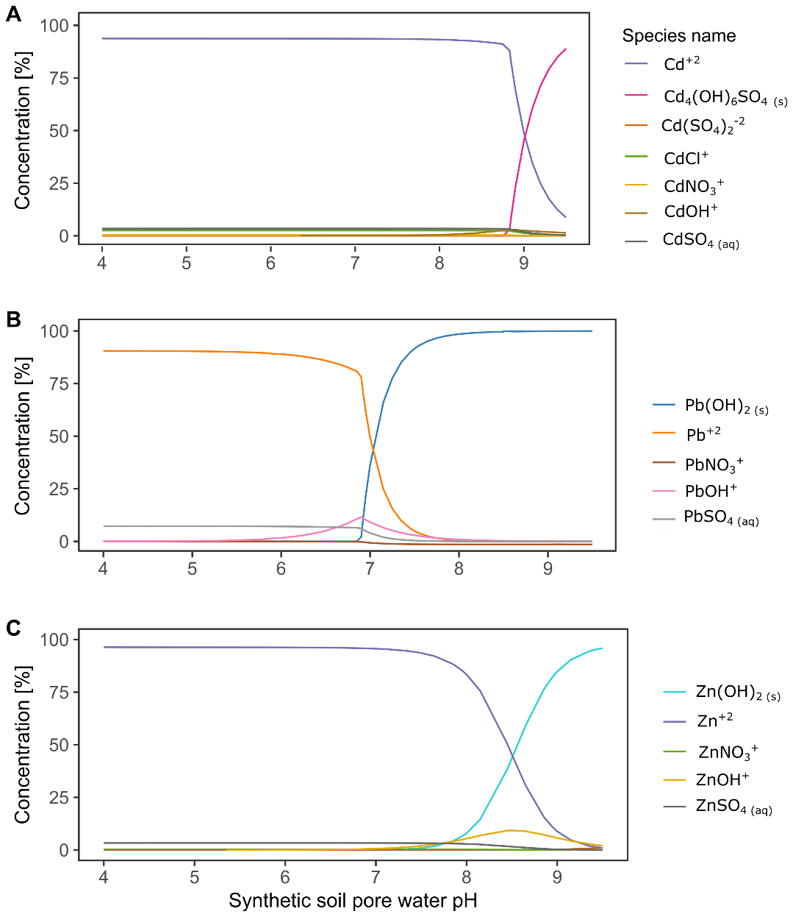
Fig. 3-2. Inorganic speciation of studied elements in synthetic soil pore water. A) Cd, B) Pb, C) Zn. t = 22 °C and a total concentration of 5 mg.L⁻¹ of each element.

Sorption isotherms
Isotherm fitting in Fig. 3-3 indicated that Langmuir and Hill are the sorption isotherm models that best described the experimental data. The Hill isotherm model was selected over the Langmuir model as fitting the experimental data better, based on AIC values (Table 3-2). The Hill isotherm describes the binding of different species by cooperative sorption mechanisms onto different substrates (Ayawei et al., 2017), including carbonaceous materials (Shahbeig et al., 2013).
The cooperative binding is characterized by a side-by-side association between adsorbed molecules at low solute concentrations, while at higher solute concentrations there is progressively less chance that a solute molecule will find an available site (Giles et al., 1960). When the Hill coefficient of sigmoidicity n > 1 there is cooperative binding; while n = 1 indicates reactions of no cooperativity (Weiss, 1997). The n values derived from the Hill isotherms (Table 3-3) indicated cooperative binding in the adsorption of HMs for all biochars except MSP550 with Pb. The cooperative sorption was confirmed by the sigmoidal “S”-shape isotherms observed at low equilibrium concentrations for Cd and Pb sorption with OSR550, OSR700 and WSP550 (Fig. 3-4). This is important as bioavailable concentrations of HMs in polluted soils are generally below 5 mg.L⁻¹ (Berkowitz et al., 2014). “L”-shape isotherms, according to the isotherm classification of Giles et al. (1960), were observed for all HMs with MSP550 and for all biochars with Zn (Fig. 3-4).
The parameters derived from the Hill sorption model in Table 3-3 indicated that the maximum sorption capacities (q_{m}) were higher for Pb, followed by Cd and Zn (Pb>Cd>Zn). This trend is the same as that presented by Park et al. (2016), who obtained sorption capacities in the order Pb>Cd>Cr>Cu>Zn for sesame straw biochar applied at a rate of 2 g.L⁻¹ in mono-metal systems when testing concentrations from 0 to 320 mg.L⁻¹ at pH 7.
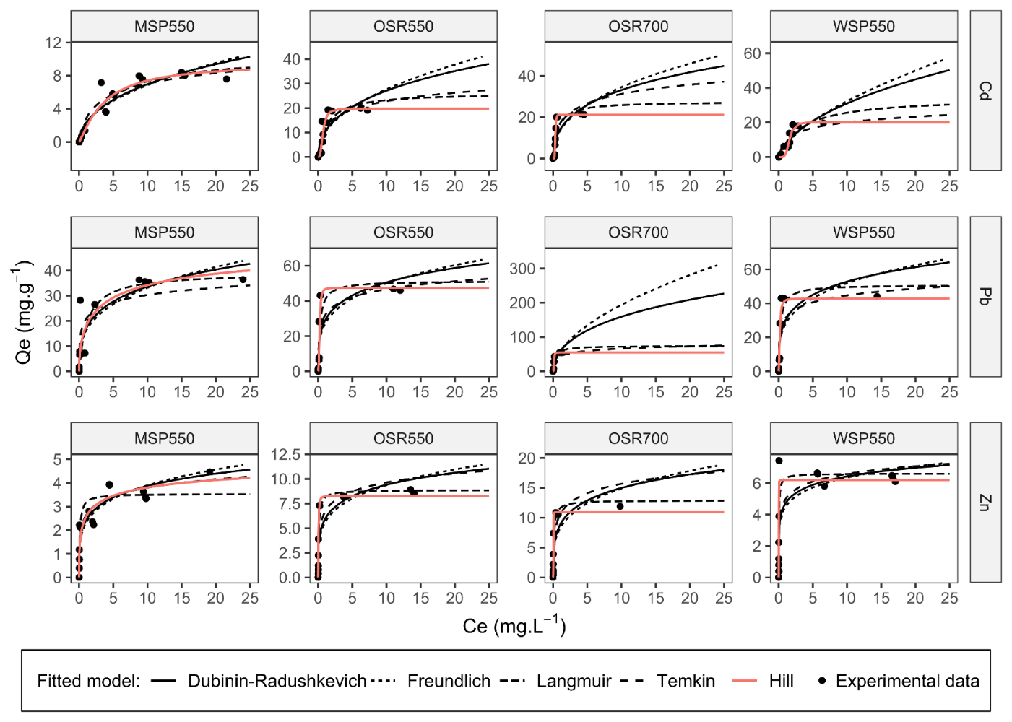
Fig. 3-3 Adsorption isotherms of Cd, Pb and Zn fitted with the Dubinin-Radushkevich, Freundlich, Langmuir, Temkin and Hill sorption models. Biochar dose 1.25 g.L⁻¹, the initial pH of the background solution was pH 5 for Pb, pH 6.5 for Cd and pH 7.5 for Zn with a contact time of 24 hours and t= 22 ± 2 °C.
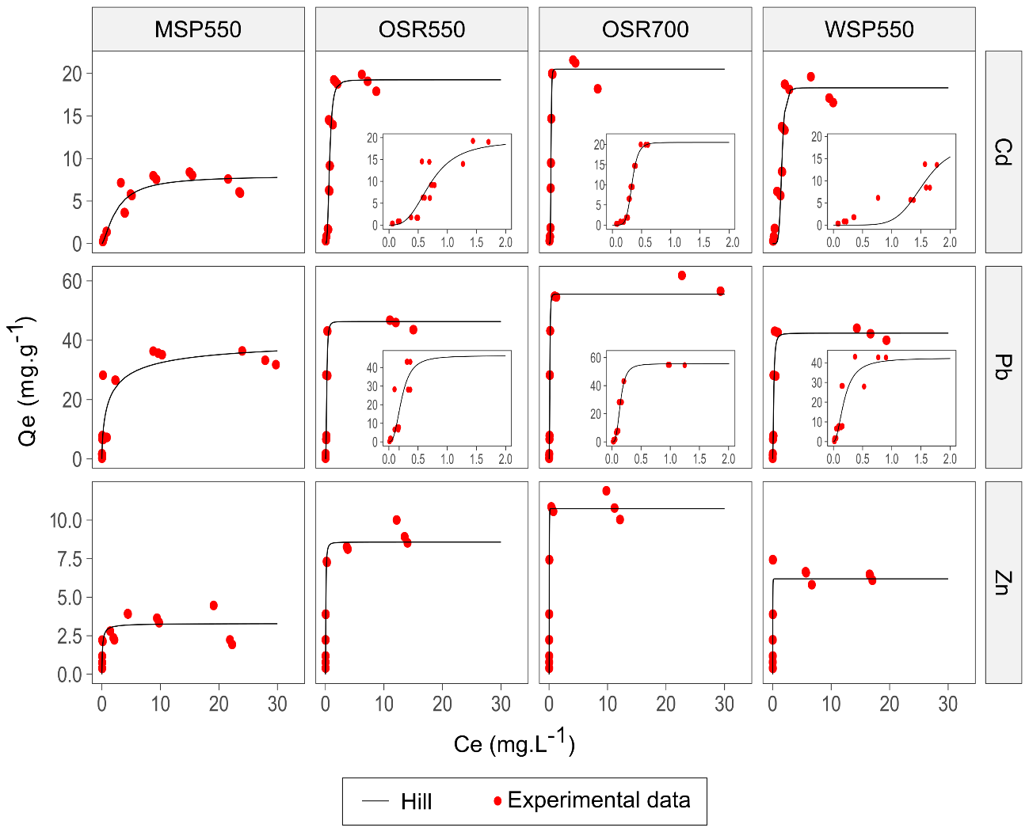
Fig. 3-4. Adsorption isotherms for Cd, Pb and Zn fitted with the Hill sorption model. Inset plots, are close-ups that illustrate the sorption behaviour at equilibrium concentrations up to 2 mg.L⁻¹.The initial pH of the background solution was 5 for Pb, 6.5 for Cd and 7.5 for Zn; 24 hours contact time, t= 22 ± 2 °C.
Biochar maximum sorption capacities (q_{m}) were, ordered from high to low, OSR700>OSR550>WSP550>MSP550>SWP550 for all HMs tested. For Cd, biochar MSP550 (8 mg.L⁻¹) had a significantly lower (p < 0.05) sorption capacity than biochars OSR550 (19 mg.L⁻¹), OSR700 (21 mg.L⁻¹) and WSP550 (18 mg.L⁻¹). For Pb, biochar OSR700 (56 mg.L⁻¹) had a significantly higher (p < 0.05) sorption capacity than OSR550 (46 mg.L⁻¹), WSP (42 mg.L⁻¹) and MSP550 (41 mg.L⁻¹). For Zn biochar OSR700 (11 mg.L⁻¹) demonstrated a significantly higher sorption (p < 0.05) capacity than OSR550 (9 mg.L⁻¹), WSP550 (6 mg.L⁻¹) and MSP550 (3 mg.L⁻¹).
Overall herbaceous-derived biochars had a higher sorption capacity than the soft wood-derived biochar SWP550. Sun et al. (2014) also reported that four herbaceous biochars produced at 600 °C (corn, cotton, wheat and rice straw) had greater sorption capacity for Cd than wood-derived biochar (poplar) produced at the same temperature. This was attributed to the limited pore development of the wood char due to the higher lignin content of wood. Trakal et al. (2014) concluded that “high lignin biomass’’ biochars are less effective than herbaceous biochars for Cd and Pb sorption, despite their high BET surface area.
Since K_{H} is the concentration of adsorbate (C_{e}) at half maximum sorption capacity (q_{m}), a biochar with a high K_{H} would require a greater concentration of adsorbate to achieve q_{m}, which implies a low affinity for the adsorbent, while low K_{H} values indicate that less concentration of adsorbate is required to achieve q_{m}, which represents a higher affinity between the adsorbate and biochar. Values of the Hill constants (K_{H}) shown in Table 3-3 indicate binding affinity in the order Zn >Pb >Cd for all biochars. Although the binding affinity (K_{H}) of Zn to all biochars was greatest, the sorption capacity (q_{m}) for this metal was the lowest. This indicates that Zn sorption is associated with less abundant, but high-affinity binding sites, whereas Cd and Pb sorption onto biochar is related to lower affinity, but more abundant binding sites. Other studies have reported that most Cd sorption onto plant-derived biochars involves low binding energy sites. Pourret and Houben (2018) characterized biochar binding sites using rare earth elements, indicating that strong aromatic functional groups, such as carboxy-phenolic and phenolic groups, have high affinity for metals while carboxylic groups have lower affinity.

Nature of sorption interactions

Functional groups analysis
Fig. 3-5 illustrates the ATR-FTIR spectra of biochars with and without HMs. Band positions and their assignments were identified according to major spectra structure correlations by spectral regions. Bands at 458 cm⁻¹ were assigned to inorganic silicates Si ̶ O asymmetric deformation vibration (Babu et al., 2011; Colthup et al., 1990). Si species present in biomass undergo changes during pyrolysis, where some of the Si species would transform into quartz, dehydroxylated silicates or alkali silicates (Qian et al., 2016). The band at 570 cm⁻¹ was assigned to dicalcium phosphate or phosphate ion ${(PO}_{4}^{3-})$ bending (Bekiaris et al., 2016; Colthup et al., 1990). The change in the intensity of these bands in relation to the raw biochar was observed for all HMs, however the changes in the band at 570 cm⁻¹ associated with ${(PO}_{4}^{3-})$ bending were more pronounced after Zn sorption. These shifts in the spectrum suggest the formation of Si complexes or Si mineral precipitates and phosphate precipitates with the trace element species calculated to be the dominant ones (Cd²⁺, Pb²⁺ and Zn²⁺).
Changes of intensity and displacement of bands between 600 and 900 cm⁻¹ were attributed to bending vibrations (CH) of aromatic groups. For instance, a band at 680 cm⁻¹ (CH deformation) appeared in the spectra of biochars OSR550, WSP550 and MSP550 after Pb exposure, suggesting an important role in the sorption of this HM. Bands at 750, 780 and 870 cm⁻¹ (CH bending) showed changes in intensity after exposure to all trace elements tested.
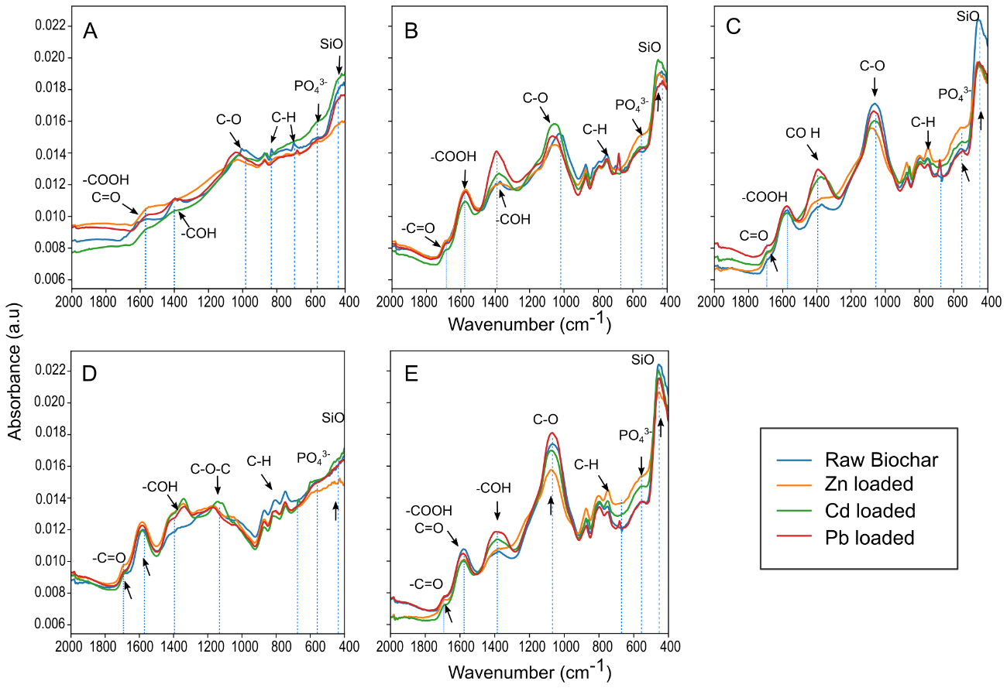
Fig. 3-5 ATR-FTIR normalized spectra of biochars before and after sorption of Cd, Pb and Zn. A) biochar OSR700, B) OSR550, C) WSP550, D) SWP550, E) MSP550.
The aromatic structure of biochar surfaces may have promoted HM sorption via cation ̶ π bonding mechanisms, since aromatic structures have a pool of π electrons which can be donated to metal ions, thereby creating such interactions (Bandara et al., 2017). An abundance of lone-pair electrons is known to be associated with the “graphene-like” domains of plant-derived biochars (Harvey et al., 2011). Plant-derived biochars have been reported to immobilize Cd (Cui et al., 2016a; Harvey et al., 2011), Pb (Z. Wang et al., 2015) and Zn (Xu et al., 2013) by cation-π bonding mechanisms. This cation- π interactions can be considered an electrostatic effect that involves non-covalent bonding between the quadrupole moment of the aromatic structure and the monopole of the cation, which allow aromatic systems to interact strongly with cations (Dougherty, 1996). The proposed mechanism for cation-π bonding between biochar aromatic structures and the studied metals is represented in Fig. 3-6.
The vibrations involving the asymmetric stretching of the C ̶ O bond of aromatic secondary alcohols (phenyl ̶ CHOH ̶) produced a strong band between 1000 to 1075 cm⁻¹. In OSR700 this band was absent, which is consistent with a higher pyrolysis temperature for this biochar. The loss of the 1030 cm⁻¹peak has been associated with higher production temperatures due to dehydration, decarbonylation, and decarboxylation reactions (Uchimiya et al., 2011; Yang et al., 2007). The band was also absent in the spectra of the wood derived biochar SWP550. This was associated with the feedstock type; as presented by Domingues et al. (2017) the spectrum of lignocellulosic biochars were characterized by a weak peak or the complete absence of a band in this position. For the other biochars shifts in the intensity of this band and displacements to the left were observed after exposure to all HMs. For biochar SWP550 a band between 1160-1200 cm⁻¹ associated with C ̶ O ̶ C stretching of pyranose ring structures (Lazzari et al., 2018; Yang et al., 2007) increased in intensity after Cd sorption.
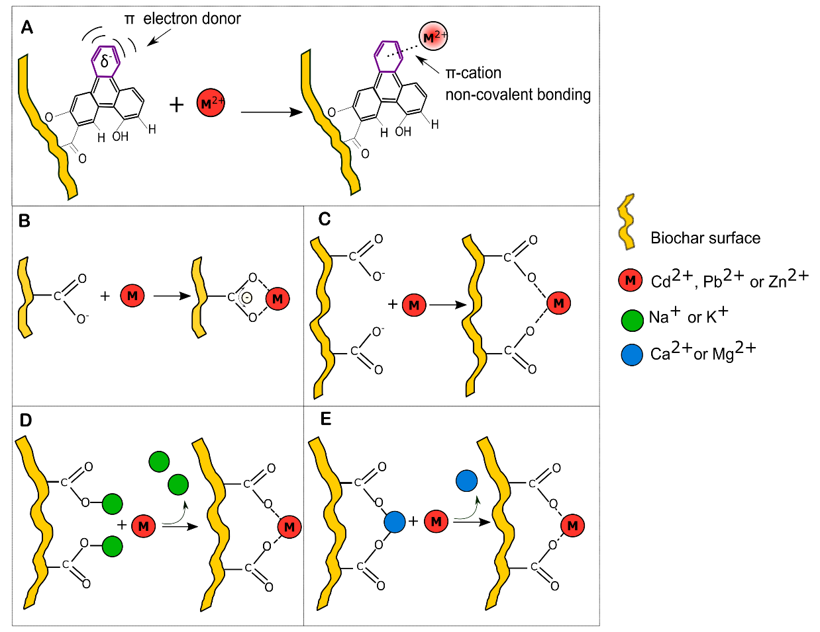
Fig. 3-6 Biochar sorption mechanisms for Cd²⁺, Pb²⁺ or Zn²⁺. A) Cation ̶ π interaction, B) Carboxylic group acting as a chelating ligand, C) Carboxylic groups forming a complex with a divalent cation. Surface complexation mediated by cation exchange of D) monovalent cations K⁺ or Na⁺ and E) divalent cations Ca²⁺ or Mg²⁺.
The band at 1380-1420 cm⁻¹ was associated with phenols in solid state, which typically absorb between 1330-1390 cm⁻¹ due to interaction between OH deformation and C ̶ O stretch (Colthup et al., 1990) or to a or δ (C ̶ H) vibration in alkanes and alkyl groups (Komnitsas and Zaharaki, 2016). This last band indicated important shifts in intensity especially after contact with Cd and Pb for all the biochars. Bands attributed to metallic salts made from carboxylic acids (COO ̶ ) were identified, the C=O and C ̶ O bonds replaced by two equivalent carbon-oxygen bonds created a strong asymmetric COO stretching vibration at 1590 cm⁻¹. The carboxyl dimer infrared band of C=O stretch was identified at 1690 cm⁻¹ (Ma et al., 2016). These bands associated with carboxylic groups are demonstrated to have an important role in the immobilization of the studied metals, especially for Pb and Cd. The intensification of the bands may be attributed to chelation reactions between carboxylic acids and HMs on biochar surfaces during the adsorption process, suggested by Wu et al. (2017) to be the dominant adsorption mechanism for Pb on biochar.
The coordination between oxygenated functional groups (e.g., ̶ COOH and ̶ OH) and different heavy metals is usually accompanied with the release of H⁺, resulting in the reduction of solution pH (Qian et al., 2016; Z. Wang et al., 2015). In this study the solution pH during sorption was not controlled; samples containing low initial concentrations of HMs had pH values at equilibrium of >8, >7 and >8 for Cd, Pb and Zn respectively (Fig. 3-7), caused by the release of the mineral ash of biochars (Z. Wang et al., 2015).
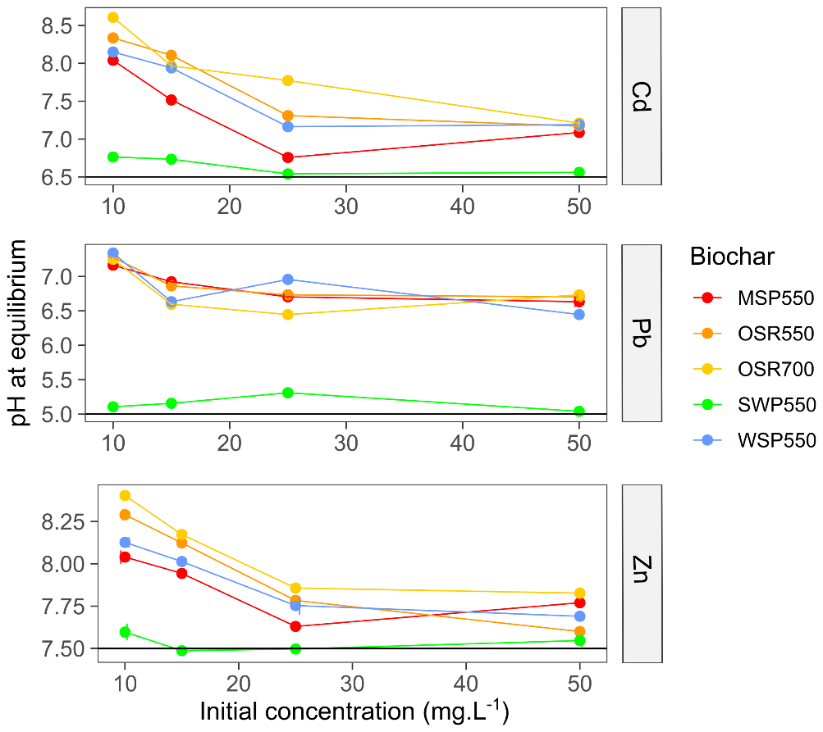
Fig. 3-7 pH values at equilibrium at different trace element initial concentrations. A) Cd, B) Pb and C) Zn. The black line ̶ ̶ ̶ represents the initial pH of the soil pore water solution before being in contact with biochar. The biochar rate was 1.25 g.L⁻¹ in all samples, temperature was 22 ± 2 °C, contact time = 24 hours. Values are the mean ± standard deviation, n=3.
However, as the concentration of HMs in the solution increased, the pH of the solution decreased to < 7.5, < 7, <7.75 for Cd, Pb and Zn, respectively, indicating that higher amounts of trace elements in the solution enhance the formation of complexes with oxygen-containing functional groups. These results were in accordance with Trakal et al. (2014) who reported a decrease of solution pH, particularly at higher HM concentration and greater adsorption capacity. Samples treated with biochar SWP550, which is characterized by low ash content (Table 3-1), did not alter the solution pH (Fig. 3-7).
The complexation with functional groups has been schematized in Fig. 3-6BE, where complexation with deprotonated functional groups (chelation mechanism with carboxylic groups) or cation exchange-mediated complexation are represented.
The principal component analysis (PCA) of biochar spectra in Fig. 3-8 shows that 68 % of the variation in the biochar spectra were explained by PC1 and 18 % by PC2. Feedstock origin and temperature significantly influenced biochar spectra (p < 0.001). In the PCA similar samples appear as clusters in the score plot, while different samples are segregated from each other. Biochar clustered as three groups: group one with biochar SWP550 samples (wood-derived biochar produced at 550 °C), group 2 with biochar samples WSP550, OSR550 and MSP550 (herbaceous biochars produced at 550 °C) and group 3 with OSR700 samples (herbaceous biochar produced at 700 °C).
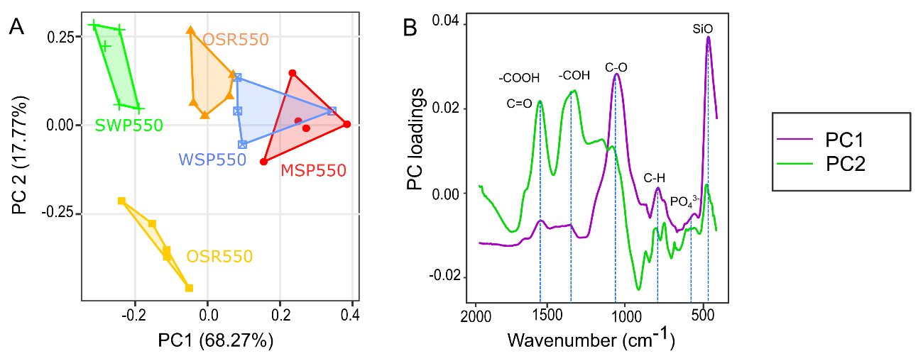
Fig. 3-8 Principal component analysis (PCA) of normalized ATR-FTIR spectra of plant based biochars. A) Score plots of PC1 and PC2, B) PC loadings against the wavenumber indicating the bands that mostly contributed to the separation of biochar groups in the PCA.
Biochars with fewer oxygen-functional groups (OSR700 and SWP550) were more distant from the other biochars. The bands responsible for the differentiation of these biochar groups are illustrated in Fig. 3-8B. and identified as carboxylic (COOH, C=O), phenolic (COH, C ̶ O), aromatic (C ̶ H), PO₄³⁻ and SiO.

Scanning electron microscopy with energy dispersive X-ray spectroscopy
Visual comparison of SEM-EDX images using biochar MSP550 (Fig. 3-9) demonstrates the typical effect of HM exposure on pores and mineral phases at the biochar surface. The SEM-EDX images of the other four biochars can be accessed at Soria P. et al. (2020). SEM backscattered images revealed a heterogeneous topography and material contrasts (composition). HM immobilization was confirmed on biochar surfaces; elements with higher atomic number such as Pb, Cd and Zn yield more backscattered electrons, which appear brighter on the image (left column on Fig. 3-9).
Electronic x-ray mapping was used to visualize the colocalization of elements on SEM images of biochar MSP550 loaded with HMs . The images show colocalization of Si and O, indicating the presence of compounds containing Si minerals on the biochar surface. The images also show that Cd occurred together with K⁺, suggesting compounds containing Cd²⁺ and K⁺. The formation of K₄CdCl₆ precipitates has been previously reported on Cd-loaded biochars (Bashir et al., 2018; Xu et al., 2017; Zhang et al., 2015). Likewise, the images revealed that Pb occurred together with S. In other studies precipitates of Pb with sulphate compounds such as Pb₂(SO₄)O and Pb₄(CO₃)₂(SO₄)(OH)₂ have been reported to contribute to Pb metal sorption (Z. Wang et al., 2015). Regarding Zn-loaded samples, there was no clear indication of elements occurring at the same positions as Zn, apart from O, for any biochar analysed.
These SEM-EDX results suggest that in the case of Cd and Pb, in addition to the interactions with functional groups indicated in section 3.3.3.1, sorption could have also be mediated by the formation of mineral precipitates containing K⁺ and S.

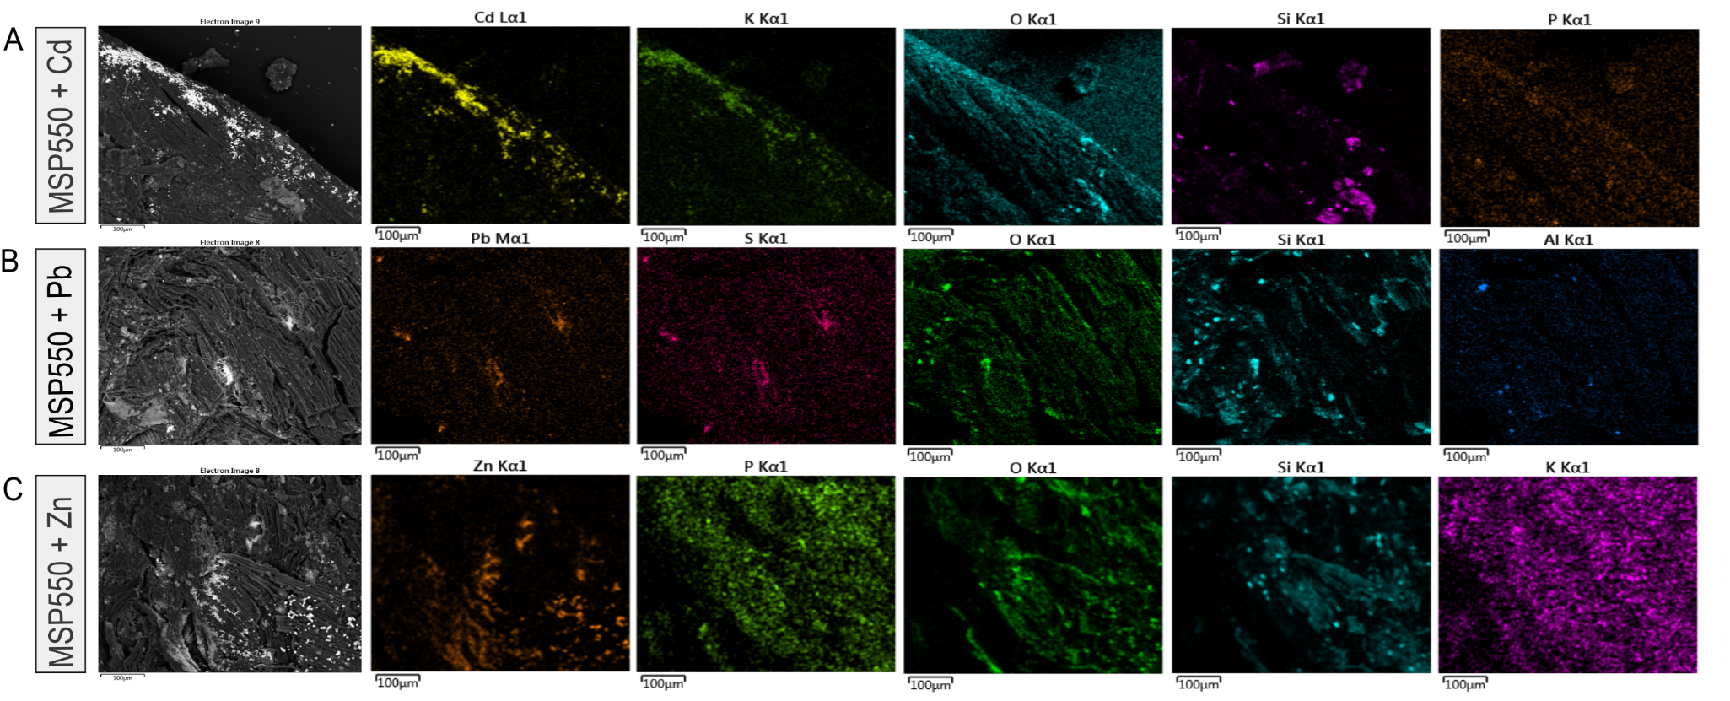
Fig. 3-9. SEM-EDX images of biochar MSP550 after sorption of Cd, Pb and Zn and the main elements identified on its surface.

Competitive sorption
The effect of metal competition on the sorption capacity of biochars in binary and ternary equimolar systems is illustrated in Fig. 3-10. The presence of additional elements in synthetic soil pore water had a significant effect (p < 0.001) on the sorption capacity of the biochars for HMs. In the systems containing equimolar concentrations of Zn and Cd the sorption capacity for Zn was higher than for Cd (p < 0.05) for all the biochars. When Pb was present, either in Zn-Pb or Pb-Cd binary systems, or the ternary system containing Pb, Cd and Zn; the sorption capacity for Pb was significantly higher (p < 0.001), limiting the binding of the other elements for all the biochars.
The higher sorption capacity for Pb in the multi-element sorption studies regardless of the biochar type is consistent with the higher sorption capacity for Pb observed in the mono-element sorption studies (section 3.3.2.3). This finding is supported by the results of Park et al. (2016), who reported a sorption capacity in the order of Pb >Cu >Cr > Zn> Cd for a multi-element sorption experiment using sesame straw biochar. These results are consistent with our findings and indicate that in spite of a lower Zn sorption capacity (Zn<Cd) in mono-metal systems, Zn sorption was higher than Cd (Zn>Cd) when in competition.
The negligible sorption of Zn or Cd in the presence of Pb suggests that these trace elements compete for the same sorption sites. The sorption of HMs onto biochar depends on the nature of the elements involved. The adsorption preference exhibited by biochars for Pb over Zn and Cd when in competition could be due to (i) the hydrolysis constant, (ii) the ionic radius, and subsequently hydrated radius, and (iii) its Misono softness value due to a stronger surface electrostatic attraction.
The first hydrolysis constant (pK) of Pb²⁺ (7.71) is lower than that of Cd²⁺ (10.1) and Zn²⁺ (9.0) (Park et al., 2016). The first hydrolysis product of divalent ions is capable of forming complexes with the adsorbent, which result in stronger element retention (inner-sphere complexes) than the electrostatic attraction of hydrated ion elements. Thus, the lower the hydrolysis constant of the element, the stronger the element specific sorption (Shaheen et al., 2013).
Pb²⁺ has a smaller hydrated radius of 4.01 Å compared with Cd²⁺ (4.26 Å) or Zn²⁺ (4.30 Å). The larger the hydrated radius the higher the activation energy required to initiate cation exchange (Harvey et al., 2011), besides a smaller hydrated radius favours Coulombic interactions (outer-sphere complexes) between the cation and exchange sites of the adsorbent (Shaheen et al., 2013). The scale of Misono represents the acidity of metal ions as Lewis acids based on two parameters, one associated with the softness and the second to the electronegativity of the ion. Considering these two parameters respectively, Pb²⁺ (3.58, 4.15) is a harder acid than Zn²⁺ (2.34, 4.64), while Cd²⁺ (3.04, 4.60) is considered a soft acid (Misono et al., 1967). According to the HSBA theory (Alfarra et al., 2004), as a harder acid Pb would have greater affinity than Zn or Cd for the carboxylic functional groups (band at 1590 cm⁻¹) and phenolic groups (band 1380-1420 cm⁻¹) identified on biochars, which are hard Lewis bases. Thus, the preferential retention of Pb to Zn or Cd is in agreement with differences in ionic radius, first hydrolysis constants, and the Misono softness parameter, making Pb a better candidate than the other elements for both electrostatic and inner-sphere surface complexation reactions.
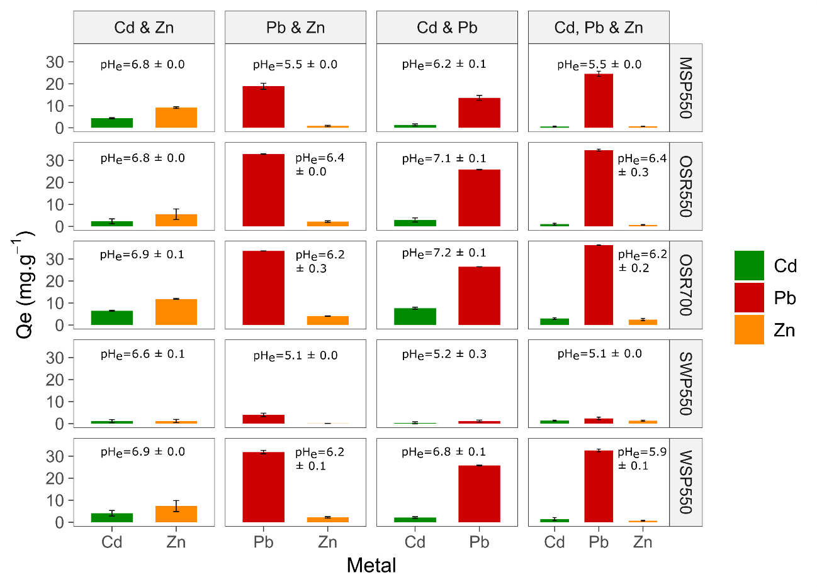
Fig. 3-10. Competitive sorption of PTEs onto biochar using binary and tertiary systems. Initial concentrations were for Zn 13 mg.L⁻¹, Pb 41 mg.L⁻¹ and Cd 22 mg.L⁻¹ which equals 0.2 mM of each metal. Contact time = 24 hours, t= 22 ± 2 °C. Results are the average of 3 measurements ± standard error. Initial pH 6.5 for binary system Zn-Cd and pH 5 for the rest of combinations; pH_{e} is the pH value at equilibrium ± standard error.

The same reasoning can be applied to explain Zn preferential sorption over Cd, in that the first hydrolysis constants as well as the Misono scale and the HSBA theory accurately predict the observed sequence Zn > Cd, however the hydrated ionic radius reasoning predicts Cd > Zn which is the opposite of the results obtained. This suggests that Zn vs Cd competitive sorption was not entirely electrostatic, since elements with larger ionic radius would have been sorbed less strongly (Shaheen et al., 2013), which was not the case.
Other authors have suggested that the hydrolysis constant may be a good predictor of selective element retention rather than the Misono (HSBA theory) or the ionic radius (Park et al., 2016; Shaheen et al., 2013). HMs in polluted soils are usually present as mixtures and their interactions are known to influence their transport and fate between phases (Chen et al., 2011; Park et al., 2013). Therefore, it is important to conduct competitive sorption tests. The results indicate that in a scenario where Pb, Cd and Zn coexist in a polluted soil, regardless of the type of biochar applied as a remediation measure, the adsorbent will preferentially immobilize Pb over the other elements, requiring a higher biochar application rate to maximize binding of additional HMs.

Linking biochar properties to HMs immobilization
The Pearson correlation analysis illustrated in Fig. 3-11A. indicated that CEC, pH, electric conductivity (EC) and total K⁺ were highly correlated (>0.8) with Cd sorption capacity (q_{m}Cd). Pb sorption capacity (q_{m}Pb) was highly correlated (>0.8) with pH, CEC, EC and total P. Zn sorption capacity (q_{m}Zn) had a correlation coefficient of 1.0 with EC and > 0.8 with pH, total P and total K. The high correlations between biochar sorption capacities (q_{m}) and CEC, EC and biochar pH suggest that the HM sorption is dominated by electrostatic interactions and precipitation mechanisms.
This implies that the surface complexes formed with Cd, Pb and Zn on biochars are mainly outer-sphere complexes. This is in agreement with the speciation diagram (Fig. 3-2) which indicated that for the range of pH found at equilibrium (Fig. 3-7), the dominant trace element species would be the free cation species Cd²⁺ (96 %), Pb²⁺ (95-81 %) and Zn²⁺ (96-83 %), while the hydrolysed forms CdOH⁺ (0.5 %), PbOH⁺ (3-10%) and ZnOH⁺ (2-5%) that enhance inner-sphere complexes formation are expected in smaller amounts. It is important to highlight that outer- and inner-sphere complexation can occur simultaneously (Sparks, 2003).
Our findings are similar to that of Trakal et al. (2014), who reported a high correlation between Cd and Pb removal and the CEC and pH of various biochars, although they did not consider EC, biochar mineral constituents or functional groups.
The high correlation of q_{m}Pb and q_{m}Zn with total P and EC is supported by the ATR-FTIR analysis, where shifts in the intensity of PO₄³⁻ were observed after contact with Zn, but also Pb. This implies that formation of precipitates with soluble phosphates released from biochar contributes to Pb and Zn immobilization. Previously the formation of phosphate precipitates with Pb such as Pb₅(PO₄)₃OH (Cao et al., 2009), Pb₃(PO₄)₂ (W. Wu et al., 2017) or Zn precipitates such as Zn₃(PO₄)₂ (Qian et al., 2016) or Zn₃(PO₄)₂.4H₂O (Xu et al., 2013) have been reported on biochar surfaces.
Furthermore, the high correlation of q_{m}Zn with EC and total K⁺ suggests the interaction of Zn with soluble minerals containing K⁺ as an important contributor in Zn immobilization. The formation of large amounts of hemimorphite (Zn₄(Si₂O₇)(OH)₂·H₂O) mediated by soluble K₂SiO₃ released from wheat straw biochar produced at 550 °C was reported by Qian et al. (2016) as one of the main Zn sorption mechanisms. The interaction of Zn with Si-O and PO₄³⁻ groups observed in the ATR-FTIR analysis of Zn-loaded biochars is in agreement with the direct correlation between EC and q_{m}Zn., implying that besides the observed interaction of Zn with oxygenated functional groups (phenolic and carboxylic), another important mechanism for Zn immobilization was precipitation with phosphate and silicate soluble minerals.
The high correlation of q_{m}Cd with total K⁺ and CEC suggests the occurrence of cation exchange mechanisms between Cd and K⁺ by electrostatic ion exchange with surface functional groups of biochar or with K⁺ present in biochar minerals. The EC values (dS.m⁻¹) indicate the amount of biochar water-soluble salts (Jiang et al., 2017). Soluble cations and anions released from biochar can show a strong positive correlation with CEC and anion exchange capacity (AEC) (Xu et al., 2017), both mechanisms associated with Pb, Zn and Cd immobilization by biochar (Komkiene and Baltrenaite, 2016; Lu et al., 2012; Ma et al., 2016).
The adsorption affinity of water-soluble mineral fractions in biochar for HMs is much higher than that of water-insoluble minerals (Xu et al., 2017). For instance, soluble cations including potassium (K⁺), calcium (Ca²⁺), magnesium (Mg²⁺), and anions (PO₄³⁻ or CO₃²⁻) in biochar participate in ion exchange reactions or form precipitates with HMs, reducing their availability (Hongbo Li et al., 2017; Xu et al., 2017). Trakal et al. (2014) suggested the release of cations as the most important characteristic in biochar selection for metal sorption.

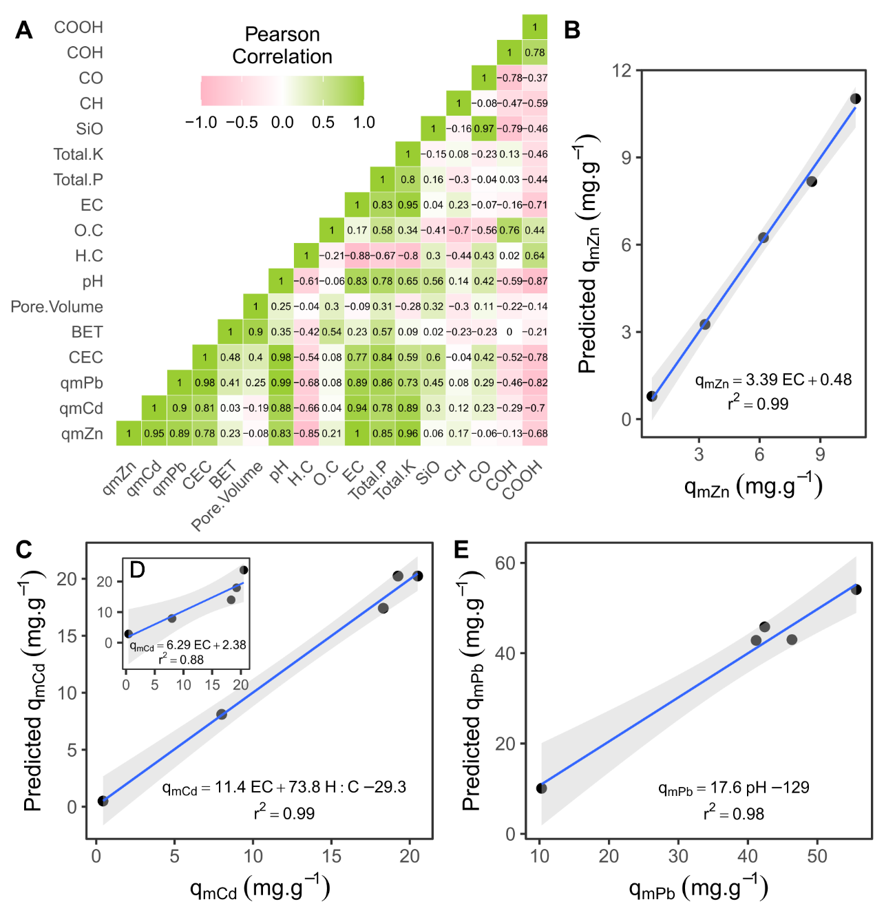

Fig. 3-11. Relationship between biochar sorption performance and physico-chemical properties. A) Pearson correlation matrix of physico-chemical properties of biochar and sorption capacity q_{m} (mg.g⁻¹) for Cd, Zn and Pb. Plots showing predicted sorption capacity versus the maximum sorption capacity (mg.g⁻¹) observed for B) Zn with single variable linear regression, C) Cd multi variable linear regression, D) Cd single variable linear regression and E) Pb single variable linear regression. − represent the regression line and grey areas indicate 95% confidence intervals for predicted biochar sorption capacity.
The high correlation between q_{m} and pH also reflects the importance of biochar mineral constituents; alkali metals (Na⁺, K⁺) or alkaline earth metals (Ca²⁺, Mg²⁺) in the form of carbonates are the main alkaline substances responsible for the high pH of biochar (Xu et al., 2017). Furthermore, higher pH values favour deprotonation of carboxylic and other functional groups, thus negatively charged sorption sites are created on the surface of all biochars (Trakal et al., 2014). Therefore, the high correlation of q_{m} with biochar pH suggests that a higher biochar pH is associated with a higher immobilization potential due to different mechanisms (complexation or precipitation). As per EC, these correlations suggest that biochars with a high soluble mineral content would have a higher pH, EC and CEC, supporting HMs immobilization.
The low potential for Cd, Pb and Zn sorption on SWP550 can be related to the feedstock type. Wood-derived biochars, such as SWP550, are reported to have low EC values (Domingues et al., 2017), whereas crop-derived biochars often exhibit greater EC values. This is consistent with SWP550, which has the lowest EC, CEC, lowest ash content and pH.
No direct correlation between HM sorption capacity and surface area (BET) was found. Previous studies have also reported a poor correlation between the surface areas of plant-derived biochars and Cd (Sun et al., 2014), and Cd and Pb sorption capacities (Trakal et al., 2014). Similarly, no direct correlation was identified between sorption capacity (q_{m}) and the absorbance of the functional groups used in the correlation analysis despite their known role in sorption of HMs. This indicates that there is no quantitative relationship between surface area and q_{m} and between functional groups and q_{m}, suggesting that the importance of these biochar properties is of a qualitative nature instead.
Overall, the correlation analysis highlighted the importance of the biochar water soluble mineral fraction as a potential indicator of HM immobilization. The inherent mineral constituents in biochar may explain up to 90% of metal removal by biochars (Xu et al., 2017). In this respect EC, CEC and pH are properties of biochar that directly reflect HM sorption potential and should be considered as the most important criteria when selecting a biochar for the remediation of soils polluted with Pb, Cd and Zn. Consequently, herbaceous biochars may exhibit a greater potential for HM immobilization as they are characterized by higher EC, CEC and pH than wood derived biochars.

Models describing HM sorption potential
The models obtained to describe biochar sorption capacity for Cd, Pb and Zn as a function of biochar physico-chemical properties is presented in Table 3-4 and illustrated in Fig. 3-11A. Pb sorption (q_{m}Pb) was described mainly as a function of biochar pH, as shown in Fig. 3-11E. The sorption capacity for Zn (q_{m}Zn) was fully explained by the biochar EC (dS.m⁻¹) (Fig. 3-11B.). For Cd sorption (q_{m}Cd) the best predictor was EC (dS.m⁻¹), however as illustrated in Fig. 3-11D, the relationship was not linear. A second parameter (H:C ratio) was introduced into this regression which improved its linearity (Fig. 3-11C.). The addition of H:C ratio as a predictor of Cd sorption implies that biochar aromaticity is related to Cd immobilization mechanisms, which is consistent with results from the ATR-FTIR analysis.

Conclusions
Regardless of biochar type, the immobilization of Pb was favoured over Cd and Zn in both single and competitive systems. The sorption between the studied HMs and plant-based biochars was dominated by electrostatic interactions. Cd and Pb sorption was mediated by complexation with carboxylic groups mainly enhanced by cation exchange mechanisms, cation ̶ π interactions and precipitation with biochar phosphates and silicates; while Zn sorption was mediated by complexation with phenolic groups and precipitation with biochar phosphates.
Statistical analysis showed that biochar sorption capacity was highly correlated with biochar properties EC, CEC and pH, which are associated with biochar water-soluble minerals. These results confirmed the hypothesis that the potential for HM sorption by plant-based biochars can be predicted from a relatively limited suite of physico-chemical properties, which may facilitate the selection of biochars for the immobilization of HMs in soils. Accordingly, biochars derived from herbaceous feedstock were demonstrated to be better candidates for the remediation of soil polluted with HMs than wood-derived materials.
However, a limitation of this study is the small number of plant-based biochars analysed in relation to the wide variety of feedstock existing as well as the absence of dissolved organic matter as part of the synthetic soil pore water solution. Further research should focus on developing robust mathematical models to optimize estimates of biochar sorption capacity and application for different soil remediation scenarios. Predictive models are required to optimize soil restoration strategies which reduce biochar application costs by selecting the most suitable materials.

Table 3-4 Linear models which describe biochar sorption capacity (q_{m}) for Pb, Zn and Cd.
HM | Type of linear model | Graph | Coefficients | Estimate | Signif. codes | Multiple  R² | Adjusted  R² | F-statistic | p-value
Zn | Single variableª | Fig. 3-11B | Intercept | 0.5 ± 0.2 |  | 0.99 | 0.99 | 747 | 0.00^{c}
 |  |  | EC (dS.m⁻¹) | 3.4 ± 0.1 | ***
Pb | Single variableª | Fig. 3-11E | Intercept | -129 ± 15 | ** | 0.98 | 0.97 | 123 | 0.00^{c}
 |  |  | pH | 18 ± 2 | **
Cd | Single variableª | Fig. 3-11D | Intercept | 2 ± 3 |  | 0.88 | 0.84 | 21.9 | 0.02
 |  |  | EC (dS.m⁻¹) | 7 ± 2 | *
 | Two variables^{b} | Fig. 3-11C | Intercept | -29 ± 5 | * | 0.99 | 0.99 | 163 | 0.01
 |  |  | EC (dS.m⁻¹) | 11.4 ± 0.8 | **
 |  |  | H.C (molar ratio) | 74 ± 12 | *
ª formula, y = mx + b
^{b} formula, y = m₁x₁ + m₂x₂ + b
^{c} = low coefficients considered very significant

Potential of biochar to reduce toxicity of Cd(II), Pb(II) and Zn(II) to plants in a controlled environment incubation

Introduction
The most frequent soil contaminants are heavy metals (HMs) (European Environmental Agency, 2014). These elements can have a natural origin but are mainly released to the biosphere by anthropogenic activities (Abdu et al., 2017; Nagajyoti et al., 2010). At trace level some are important in plant and animal nutrition (Arif et al., 2016). However, beyond a certain threshold level, they are toxic as they interfere with the normal metabolism of living systems (Abdu et al., 2017; Chojnacka et al., 2005; Paz-Ferreiro et al., 2014). The major risk of soil contamination by HMs is bioaccumulation (increases in metal concentration as the element passes from lower to higher trophic levels), generating different toxic effects to different components of the ecosystem (Abdu et al., 2017; Paz-Ferreiro et al., 2014; Tóth et al., 2016).
Contaminated land often contains poorly developed soils with little or no vegetation cover (Beesley et al., 2011), which may restrict soil functions (Puga et al. 2015). This is because HMs affect plant physiological processes such as water and nutrient uptake and transport, photosynthetic activity (Li et al., 2015; Razinger et al., 2012), and nitrogen metabolism (Amari et al., 2017).
In-situ immobilization of metals via chemical stabilization is a particularly cost-effective way to reduce the risk of HM transfer to groundwater and soil ecosystems (Puga et al. 2015, Chen et al. 2018). In recent years, numerous studies have investigated the use of biochar to immobilize HMs in soils and reduce metal bioavailability and mobility (Tang et al., 2013; Y. Wang et al., 2019). This application is a promising alternative for the restoration of soils contaminated with HMs as it can potentially immobilize pollutants while fostering the establishment of a green cover. This is especially important, since the revegetation of soils contaminated with HMs is a key step for stabilisation, as vegetation protects soil from erosion and reduces contaminant migration to water courses, limiting the transfer of the contaminants to ecosystems or humans (Beesley et al., 2011).
An understanding of the interactions of biochar with plants, soil microorganisms, HMs and soil is important, given the extended contact time (years-decades) that biochar remains in soil. The reported impacts of biochar on plants range from inhibition to stimulation, depending on biochar properties and specific sensitivity of different plant species (Joseph et al., 2021). Thus, the high variability of outcomes from biochar applications makes it difficult to identify specific biochars with suitable properties for immobilization of HMs that are also beneficial for plant growth.
Soil organisms and plants are sensitive to HMs in soil and provide useful insight about soil health. Biological performance indicators have been used to evaluate the health of biochar-amended soil, instead of direct measurement of HMs. For instance, plant uptake (i.e. concentration of HMs in roots/shoots) is commonly used to interpret the efficiency of remediation using biochar and assess the quality of agricultural products (Abbas et al., 2017; He et al., 2021; Y. Liu et al., 2020). Also, physical vegetation indicators such as biomass weight (i.e. dry weight of shoot or roots and yield) (Lomaglio et al., 2018; Zhang et al., 2013), root length (Shan et al., 2020; C. Xu et al., 2020), leaf area (Olmo et al., 2016) and chemical vegetation indicators such as chlorophyll content (Brennan et al., 2014) are commonly used to monitor soils amended with biochar.
Nevertheless, few studies have examined in planta responses to biochar addition when faced with environmental pressures such as HMs (Joseph et al., 2021). Therefore, there is limited information concerning the physiological response of plants to biochar addition in HMs-contaminated soil, and biochar effects on plant growth still appear unpredictable (Natasha et al., 2021). For these reasons the short term physiological response of plants growing in HM-polluted soils amended with standard biochars of known composition was studied.
The sorption capacities and affinities of five biochars for Pb(II), Cd(II) and Zn(II) were characterised in synthetic soil pore water in Chapter 3. In this chapter, four of these biochars were used in an incubation experiment to explore their ability to alleviate the toxic effects of Pb(II), Cd(II) and Zn(II) on plants, both as single elements and as a mixture in artificially-contaminated soils. The objectives were to:
- evaluate the potential of biochars derived from different feedstocks to reduce the bioavailability of single and multiple HMs in soil, at different biochar application rates, and
- study the impact of biochars on plant growth using Arabidopsis thaliana, Lolium perenne and Sinapsis alba as indicator species.

Materials and methods

Biochar selection and preparation
Based on the results obtained in Chapter 3, four biochars were selected for this study, including oil seed rape straw (OSR550), wheat straw (WSP550), soft wood (SWP550) and Miscanthus straw pellets (MSP550). These biochars were produced at 550 °C. A summary of the properties of these biochars has been published in Soria et al. (2020) and is shown in Table 3-1. The biochar pellets were ground manually with a mortar and pestle and sieved through a 2 mm stainless steel screen for the study.

Soil characterization
One tonne of multipurpose top-soil (BS3882 certified) was sourced from Quality Garden Supplies (Stafford, UK) on November 2017. The soil was classified as 70% sand, 20 % silt and 10% clay according to a particle size distribution analysis performed on the samples (British Standards, 2018). The soil organic matter content was 4.98 ± 0.58 % (determined using the K₂Cr₂O₇ titration method with FeSO₄), bulk density was 1.18 ± 0.01 g.cm⁻³, pH was 7.16 ± 0.03 and electric conductivity (EC) was 977 ± 39 μS.cm⁻¹ (British Standards, 2018). The content of bioavailable phosphates in the soil was 105 ± 6 mg.kg⁻¹ and nitrates was 332 ± 14 mg.kg⁻¹, determined by the Olsen (Iatrou et al., 2014) and vanadium chloride (Miranda et al., 2001) methods, respectively.

Heavy metal contamination
The experimental soil (above) was contaminated artificially with selected HMs, to produce four treatments: three containing single additions of Zn, Cd or Pb; the other containing a mixture of these elements, with a control lacking metal additions. These soils are respectively referred to as Zn-soil, Cd-soil, Pb-soil and Mix-soil. Four perforated plastic pots (41.5 cm diameter and 35 cm depth) were each filled with 15 kg of soil and artificially contaminated using 2.084 g.L⁻¹ ZnCl₂, 1.6 g.L⁻¹ Pb(NO₃)₂ or 24.7 mg.L⁻¹ Cd(NO₃)₂ solutions accordingly. The spike/leach procedure to prepare samples for trace metal eco-toxicity soil testing recommended by Schwertfeger and Hendershot (2013) was adapted to create more environmentally-relevant concentrations. The soil was spiked progressively over four days. On day 1 the soils were pre-treated with deionized water added in 500 mL increments over 3 hours until water holding capacity was reached. The solutions of HMs were added from day 2 by progressively adding 3 L of metal solution per day over a period of 3 hours. The soil was then left to stabilize for 2 months (January-February 2018) under field conditions.

Experiment A: Controlled environment incubations with Arabidopsis thaliana-Col 0

Experiment set up
An incubation experiment under controlled conditions was set up with the contaminated soil. The soil was air-dried, ground and passed through a 2 mm stainless steel sieve. Plastic pots (8.5 cm depth, 6 cm diameter) were used with a layer of fibreglass placed at the bottom to prevent soil loss during irrigation through drainage holes. Each pot contained 0.1 L of either soil or a soil and biochar mixture from each treatment. Biochar was added at 1%, 3% or 5 % on a dry weight basis (w/w) - the optimum rates for application to agricultural soil (Yin et al., 2016). These biochar application rates corresponded to 24, 73 and 124 t biochar ha⁻¹.
Pots containing the HM-spiked soils without biochar (0%) were used as controls. Pots were prepared in triplicate, giving a total of 156 pots (4 soil treatments $×$ 4 biochars $×$ 3 biochar application rates $×$ 3 replicates $+$ 4 soil treatments (controls without biochar) $×$ 3 replicates). Each pot was placed in a petri dish and deionized water added to reach 70 % water holding capacity. Pots were positioned randomly on benches inside a controlled environment room in darkness at 22 ⁰C and left to equilibrate for 1 week.
Seeds of Arabidopsis thaliana ecotype Col-0 were stratified by mixing 300 mg of seeds with 3.5 mL of deionized water and incubated at 4 °C in the dark for 48 h. Due to the small size of the seeds, these were added on a volume basis. After stratification the mixture was vortexed for 5 seconds and 20 μL of the seed suspension distributed evenly on the surface of each pot. Arabidopsis thaliana was selected as it is known to be sensitive to HMs and its growth cycle and genome have been widely studied (Álvarez-Aragón et al., 2016; Weraduwage et al., 2015; Zhang et al., 2020). Planted pots were incubated in a controlled environment chamber at 22⁰C with a photoperiod of 12 hours. All pots received the same amount of irrigation (10 mL of water every 48 hours) during the growth experiment.

Plant performance analysis
Ten days after sowing plants were positioned randomly over 8 trays and scanned using a chlorophyll fluorescence phenomics platform (PSI TrackScan, Czech Republic). The system has an RGB camera for measuring green leaf area and a pulse amplitude modulated (PAM) chlorophyll fluorometer for measuring photosynthetic parameters. The PAM fluorimeter was used to measure the maximum photochemical efficiency of photosystem PSII (Fv/Fm); Fv/Fm was measured after 5 min dark adaptation as defined in Martínez-Peñalver et al. (2011). Plants were monitored daily by the phenomics platform over 14 days.

Plant growth
Plant growth was estimated by plant green leaf area using the 2D images captured by the RGB camera. A four-parameter logistic model (Eq. 10) was fitted to the leaf area values over time using the non-linear least squares method, as suggested by Paine et al. (2012).
$$A=L+ \frac{A_{o}\left(K-L\right)}{A_{o} +\left(K-L-A_{o}\right)e^{-rt}}$$ | Eq. 10
where A (pixels) is the leaf area at time t (min) and Ao (pixels) is the initial leaf area. The parameters L and K indicate lower and upper horizontal asymptotes, respectively, and r is the slope around the inflection point. The absolute growth rate (AGR) was calculated as the derivative of the green leaf area A with respect to time (Eq. 11). The parametrization of the model was taken from Paine et al. (2012). The four-parameter logistic equation was fitted in R studio (R Core Team, 2020) using the drm function (L.4).
$$\frac{∂A}{∂t}=AGR=\frac{{rA}_{o}\left(K-L\right)\left(K-L-A_{o}\right)e^{-rt}}{{\left(A_{o} +{\left(K-L-A_{o}\right)e}^{-rt}\right)}^{2}}$$ | Eq. 11

Plant stress (Fv/Fm)
The response of Arabidopsis thaliana Col-0 to biochar amendments was analyzed using the Fv/Fm values measured from the fluorescence images. The images were processed using the FluorCam 7 software (Photon Systems Instruments, Czech Republic). The effect of biochar type and application rate on plant physiological response (Fv/Fm) over time was analysed using linear regression models in R (R Core Team, 2020).

Trace elements analysis
After 30 days of incubation the plants were harvested for the analysis of trace metals in above-ground tissue and dry above-ground biomass. Soils were air dried and sieved (< 2 mm) for chemical analysis. Bioavailable trace elements in soils were determined using NH₄NO₃ (1 M), as recommended by Wawra et al. (2018). For metal analysis in plant tissue, 100.00 ± 0.03 mg of dried biomass (40 °C) was finely ground and placed in 15 mL glass tubes and digested with 5 mL of HNO₃ (> 68%, Fisher) for 4 hours at 120 °C in a heating block (Wawra et al., 2018). Afterwards, extracts were diluted to 25 mL with deionized water and filtered using 0.45 µm syringe filters (Non-sterile PTFE Syringe Filter, Fisherbrand™, UK). All samples were analysed by ICP-MS (Sciex Elan DRCII , PerkinElmer, USA). The percentage reduction (% Red) of bioavailable HMs in the treated soils or tissue concentrations relative to the unamended control was calculated as follows:
$$\% Reduction=\frac{Unamended control -Treatment}{Unamended control} ×100$$

Soil physico-chemical analysis
After the incubation experiment, soil samples were analysed for pH (Thermo Orion 5 star, FB68800, USA, pH meter) and EC (470 portable conductivity/TDS meter, JENWAY, China) in a 1:2.5 (w/v) suspension of soil in de-ionised water (Beesley et al., 2010). To determine the effect of biochar feedstock and application rate on soil properties, one of the treatments (Mix-soil) was selected for further physico-chemical analysis. Soil ionic composition was determined by aqueous extraction (Zeng et al., 2015). Briefly, 2.50 ± 0.03 g of dry weight soil was mixed with 25 mL deionized water (18.2 MΩ.cm⁻¹) and placed in an end-over-end shaker at 120 rpm for 3 hours. Samples were filtered using 0.45 µm syringe filters (Non-sterile PTFE Syringe Filter, Fisherbrand™, UK) and analysed for anions and cations by ion chromatography (Dionex ICS-3000, Conquer Scientific, USA).
For available phosphorus, the Olsen method (Iatrou et al., 2014) was used, in which 2.00 ± 0.03 g of soil was mixed with 40 mL of 0.5 N NaHCO₃ solution (pH 8.5) for 30 min at 120 rpm. Samples were filtered using 0.45 μm syringe filters and P determined with the ascorbic acid method (Murphy and Riley, 1962) at 880 nm by UV-visible spectroscopy (UV-2401PC, Shimadzu, Japan). Available nitrate was determined following the method of Miranda et al. (2001), wherein 2.00 ± 0.03 g of soil was mixed with 2M KCl solution and shaken for 30 min at 120 rpm. Samples were filtered with 0.45 μm syringe filters, and filtrates mixed with vanadium cocktail solution (1:1 ratio). This solution consisted of concentrated VCl₃ (400 mg VCl₃ in 50 mL 1M HCl), 2% sulphanilamide (2 g sulphanilamide in 100 mL of 5% HCl), 0.1% NEED (0.1 g N-ethylenediamine dihydrochloride in 100 mL water) and water in a volume ratio of 9.2: 139: 70: 1.15, respectively. Samples were left to react in the dark for 2 hours and measured at 540 nm (UV-2401PC, Shimadzu, Japan).
The chemical speciation of Cd²⁺, Pb²⁺ and Zn²⁺ was predicted using Visual MINTEQ 3.1 speciation software. The ionic composition and the mean pH of the Mix-soil amended with biochar OSR550 were used as input data.

Statistical analysis
The data for dry biomass, bioavailable HM concentrations and plant tissue concentrations was organised in subsets by soil treatment. Statistical differences between biochars and application rates were assessed by linear regression followed by a two-way ANCOVA. The homogeneity of variances was verified with the Levene’s test and the normality with the Shapiro-Wilk’s test. Tukey's honestly significant difference (HSD) post hoc test was used to determine significant differences among groups.
In order to determine if the differences in absolute growth rates (AGRs) between groups were significant, the difference between means was calculated by pairwise comparisons. The mean AGRs from the biochar treatments were subtracted from those of the controls (no biochar) and the difference compared to zero, corresponding to the null expectation of no difference between groups. The confidence interval for the difference between group means was calculated with Eq. 12:
$$\left(\underline{x_{1}} - \underline{x_{2}}\right) ±t^{*} \sqrt{\frac{S_{1}^{2}}{n_{1}}+\frac{S_{2}^{2}}{n_{2}}}; t^{*}=t\left(\frac{α}{2}, df\right); df= {(n}_{1}+ n_{2 })-2$$ | Eq. 12
where $\underline{x_{1}} - \underline{x_{2}}$ is the difference between the means of two independent samples, $t^{*}$ is the critical T-value, S₁² and S₂² denote the sample standard deviations, n₁ and n₂ denote the sample sizes, α is the significance level and $df$ represents the degrees of freedom. The differences were considered significant, as the 95% confidence intervals around the differences in AGR between groups did not overlap zero.
Pairwise comparisons between soils amended with biochar and the control (no biochar) were performed to assess statistical differences in Fv/Fm at each time. These comparisons were corrected for false discovery using the Tukey method (α = 0.05) at different times during the growth experiment. All analyses were performed in R (R Core Team, 2020).

Experiment B: Controlled environment incubations with Sinapsis alba and Lolium perenne
Experiment B used the same artificially contaminated soil used for experiment A, but the number of biochars was reduced to two to allow for more replicates, and the 5% (w/w) application was excluded due to the observed negative impact of biochars on plants at this dosage. An additional control treatment using uncontaminated soil was added. Soil was planted with white mustard (Sinapsis alba) or ryegrass (Lolium perenne) to examine the sensitivity of commonly used groundcover plants to biochar amendments in heavy metal-contaminated soils.

Experiment set up
Uncontaminated multipurpose top-soil (BS3882 certified) used to prepare the artificially contaminated soils (section 4.2.3) was air-dried, ground and passed through a 2 mm stainless steel sieve. Plastic pots (8.5 cm depth, 6 cm diameter) were prepared as described in Experiment A (section 4.2.4.1). Each pot contained 0.1 L of either soil (Soil treatments: Uncontaminated, Pb-spiked, Cd-spiked, Zn-spiked and Mix-spiked) or a soil and biochar mixture from each treatment. The selected biochars were wheat straw pellets (WSP550) and Miscanthus pellets (MSP550) biochars. Biochar was added at 1% or 3% on a dry weight basis (w/w). These biochar application rates corresponded to 24 and 73 t biochar ha⁻¹, respectively. Pots containing soil without biochar (0%) were used as controls. The pots were prepared in four replicates, giving a total of 100 pots (5 soil treatments $×$ 2 biochars $×$ 2 biochar application rates $×$ 4 replicates $+$ 5 soil treatments (controls without biochar) $×$ 4 replicates). The pots were equilibrated for one week at 70% water holding capacity, as described in Experiment A (section 4.2.4.1).
Six seeds of either white mustard (Sinapsis Alba) or ryegrass (Lolium perenne) were planted in each pot, giving a total of 100 pots planted with Sinapsis alba and 100 pots planted with Lolium perenne. Planted pots were incubated in a controlled environment chamber at 22⁰C with a photoperiod of 12 hours during 4 weeks. All pots received the same amount of irrigation (10 mL of water every 48 hours) during the growth experiment.

Plant analysis
After four weeks of incubation under controlled conditions, above-ground biomass was harvested. Plant tissue was placed in paper bags and dried at 40 °C for 10 days. Dried tissue was weighed and then finely ground with a mortar and pestle; 200.0 ± 0.3 mg of ground plant tissue was used for the determination of heavy metals by acid digestion following the same procedure described in section 4.2.4.5

Soil analysis
After harvest, soil samples were air dried and sieved (< 2 mm) for chemical analysis. Bioavailable trace elements in soils were extracted using NH₄NO₃ (1 M), as described in section 4.2.4.5 and analysed by ICP-OES (Optima 7300, Perkin Elmer, USA). Major elements (K, Na, Al, Ca, Mg, Fe and Mn) and trace metals (B, Mo, Cd, Cr, Cu, Ni, Pb and Zn) were determined. Soil pH (Orion 5 star FB68800, Thermo, USA, pH meter) and EC (470 portable conductivity/TDS meter, JENWAY, China) were measured in a 1:2.5 (w/v) suspension of soil in de-ionised water.

Statistical analysis
The data for dry above-ground biomass, bioavailable HM concentrations, HM tissue concentrations, and soil pH and EC was organised in subsets by soil treatment. Statistical differences between biochars and application rates were assessed by linear regression followed by a two-way ANCOVA (considering application rate as a numeric variable). The homogeneity of variances was verified with the Levene’s test and the normality with the Shapiro-Wilk’s test. Tukey's honestly significant difference (HSD) post hoc test was used to determine significant differences among groups. A correlation matrix using all available information from the experiment was done, with the significance level set at 95 %. All the analyses were conducted in R (R Core Team, 2020).

Results

Total and bioavailable concentration of HMs in spiked soil
The concentrations of heavy metals in the soils contaminated artificially before the treatment with biochars and UK soil guideline values (Environment Agency, 2009) are shown in Table 4-1. The total concentration of Cd and Pb in the Cd-soil and Pb-soil, respectively, and in the Mix-soil treatments exceeded the soil guideline values (SGVs) established for different land uses by several fold. The total concentrations of Zn in the Zn-soil and Mix-soil treatments were near the SGV for agricultural soils (200 mg.kg⁻¹), but the bioavailable Zn concentrations were higher than in the soils not exposed to Zn.
Table 4-1 Characteristics of soil treatments contaminated artificially with Pb, Cd and Zn and a mixture of these elements. Values are mean ± standard deviation (n=3).
Treatment | Cd [mg.kg⁻¹] |  | Pb [mg.kg⁻¹] |  | Zn [mg.kg⁻¹] |  | pH | EC  [μS.cm⁻¹]
 | Total | Bioav. | Total | Bioav. | Total | Bioav.
Soil-Cd | 263 ± 19 | 1.78 ± 0.19 | < 0.01 | < 0.01 | 55 ± 12 | 0.14 ± 0.01 | 7.40 | 240
Soil-Pb | < 0.01 | < 0.01 | 1841 ± 259 | 2.52 ± 0.1 | 66 ± 4 | 0.17 ± 0.01 | 7.45 | 380
Soil-Zn | < 0.01 | < 0.01 | < 0.01 | < 0.01 | 191 ± 12 | 0.79 ± 0.00 | 7.50 | 412
Soil-Mix | 260 ± 13 | 1.39 ± 0.08 | 934 ± 203 | 1.06 ± 0.05 | 104 ± 5 | 0.64 ± 0.08 | 7.40 | 299
Non-spiked soil | < 0.01 | < 0.01 | <0.01 | <0.01 | 49 ± 7 | 0.15 ± 0.01 | 7.16 | -
SGVs*
allotment | 1.8
agricultural | 3 |  | 300 |  | 200
residential | 10 |  | 450
commercial | 230 |  | 750
Total= aqua regia extracted
Bioav.= Bioavailable HMs: 1 M NH₄NO₃ extract
* SGVs=Soil guideline values for different land use according to the Environment Agency (2009)

Experiment A: controlled environment incubation with Arabidopsis thaliana-Col 0

Bioavailability of HMs
The effect of biochar feedstock and application rate on the bioavailability of HMs in soils is shown in Fig. 4-1. The bioavailable concentrations of Pb and Cd before the incubation experiment (day 0) were significantly higher than the 0 % biochar groups at the end of the experiment (day 30) in the Pb-soil, Cd-soil and Mix-soil treatments, while the Zn concentration did not change significantly. The bioavailable concentrations of Pb and Cd in the multielement polluted soil (Mix-soil) at 0% biochar were lower than that of these elements in the single element spiked soils.
After 30 days of incubation all biochars added to the Pb-soil significantly reduced the bioavailable metal concentration to a similar extent at 1% application rates, to values 58-69 % of the control (Fig. 4-1A). With greater biochar application rates (3% and 5%), the bioavailable Pb concentration tended to increase. This was most noticeable with OSR550 where the Pb concentration exceeded the control at the highest (5%) application rate. Increases were also evident with SWP550 and WSP550, but not MSP550. None of the biochars caused significant changes in the bioavailable Cd at any application rate in the Cd-soil (Fig. 4-1B). With Zn-amended soils, biochars at all rates (with the exception of 1% OSR550) significantly reduced the bioavailable Zn to 60-80% of the control (Fig. 4-1C).
In the soils amended with a ternary mixture of elements (Mix-soil), all biochars applied at 1 % significantly reduced bioavailable Pb to 36% of the control (Fig. 4-1D). OSR550 was the only biochar to cause a significant decrease in bioavailable Cd, to 40 % of the control at all application rates (Fig. 4-1E). The concentration of bioavailable Zn in the Mix-soil decreased significantly to 70-84 % depending on the biochar and the application rate (Fig. 4-1F).
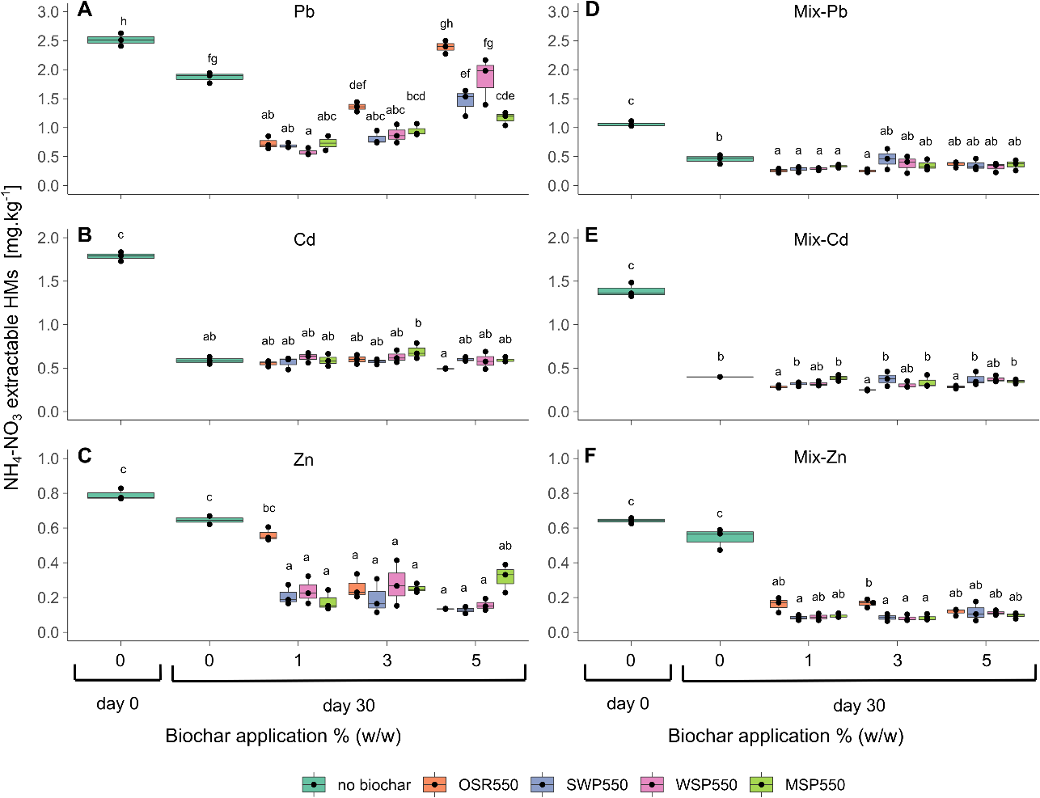
Fig. 4-1. Box plot of NH₄-NO₃ extractable HMs in soils treated with biochar at different application rates (w/w). A) Pb-soil, B) Cd-soil, C) Zn-soil, D-F) Mix-soil. Values at day 0 correspond to the initial concentrations before the incubation experiment; values at day 30 indicate the NH₄-NO₃ extractable HMs at the end of the incubation. Treatments with the same letter do not differ significantly according to Tukey post hoc test (α=0.05).

Plant biomass
Plant development showed high variability between replicates, probably caused by the heterogeneous nature of both biochar and the artificially contaminated soil. At the end of the incubation experiment (day 30) plants in the single element spiked soils with 0% biochar grew to a comparable extent without any visible signs of damage (Fig. 4-2 and Fig. 4-3). Conversely, in the Mix-soil with 0% biochar there were fewer plants. Those present were stunted and smaller than in the other soil treatments.
Overall, plants grown in soils amended with biochars applied at 1% appeared similar to the control groups (0% biochar) in the single Pb/Cd/Zn spiked soils, while in the Mix-soil a 1% biochar application increased the plant size. Biochars OSR550 and WSP550 at 3 and 5% reduced growth in the single Pb- Cd- and Mix- soils and, to lesser extent, in Zn-soil. However, a few plants were considerably larger in some pots at these biochar application rates. Only in the Cd-soil amended with biochars OSR550, WSP550 and MSP550 at 3 and 5 % was chlorosis in leaf tissue of plants observed (Fig. 4-2A and Fig. 4-3A-B), suggesting an interaction between Cd and biochar that negatively affected the plants.
Dry above-ground biomass of Arabidopsis thaliana Col-0 is shown in Fig. 4-4. Overall, an increase in biochar from 1 to 5 % tended to reduce biomass. This trend was observed for OSR550, WSP550 and MSP550, but not SWP550. Biochars applied at 1% to soils promoted greater above-ground biomass than the control (0% biochar). Biochar WSP550 added at 1% increased the dry biomass in the Zn-soil and Mix-soil by 48 % and 58 % relative to the control, respectively, whereas OSR550 added at 1% significantly increased biomass in the Mix-soil by 51% relative to the control (p < 0.001). Other increases in biomass were observed at 1% with OSR550, SWP550 and WSP550 in other treatments. However, these increases were not statistically significant, possibly due to the limited statistical power based on 3 replicates. None of the biochars at any application rate enhanced dry biomass in the Cd spiked soil (Fig. 4-4B). The results indicate that the biochars added at low application rates had a protective effect on these plants against HM toxicity and a deleterious effect at high application rates.
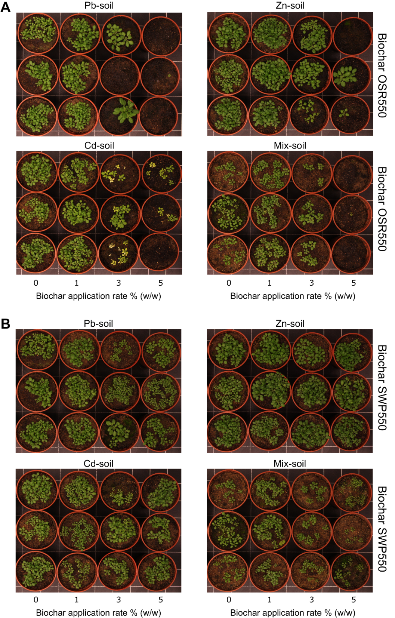
Fig. 4-2. Arabidopsis thaliana growing in soil artificially contaminated with heavy metals. Soil amended with biochars, A) OSR550 and B) SWP550, at different application rates. Picture taken 24 days after sowing, background grid = 5 cm.
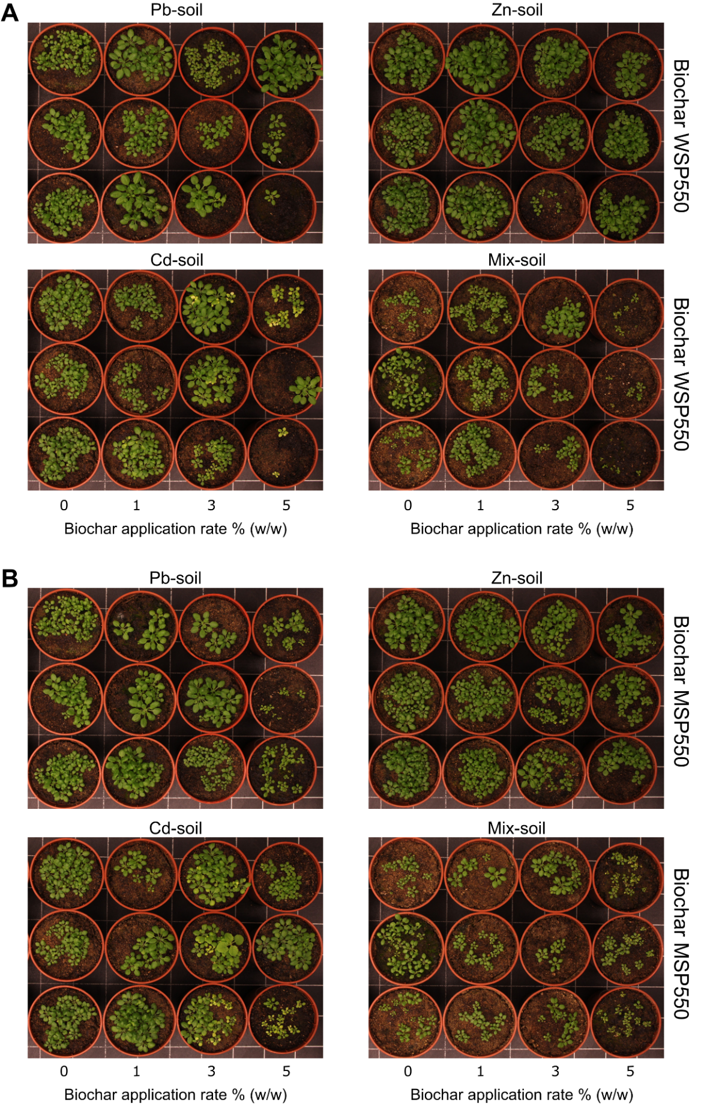
Fig. 4-3. Arabidopsis thaliana growing in soil artificially contaminated with heavy metals. Soil amended with biochars, A) WSP550 and B) MSP550, at different application rates. Picture taken 24 days after sowing, background grid = 5 cm.

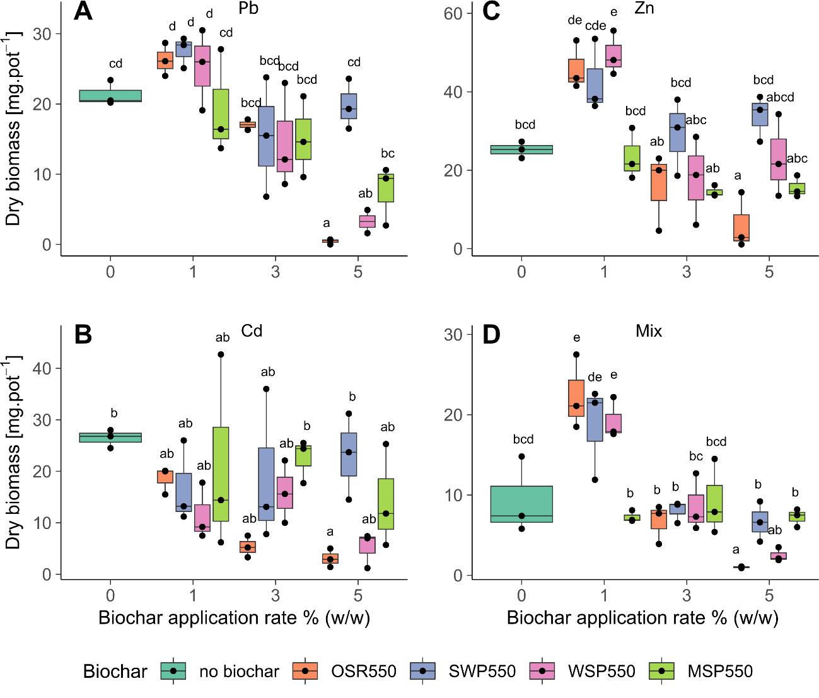
Fig. 4-4. Box plot of dry above-ground biomass of Arabidopsis thaliana Col-0 harvested from soil artificially contaminated with HMs and amended with plant-derived biochars at different application rates. A) Pb-soil, B) Cd-soil, C) Zn-soil, D) Mix-soil. Harvesting time was 25 days after planting. Treatments with the same letter do not differ significantly according to Tukey post hoc test (α=0.05).

Plant growth rates
Plant growth rate (as assessed by leaf area vs time) is shown in Fig. 4-5. There was high variability between replicates but consistent patterns emerged with the variability observed in the dry above-ground biomass data (section 4.3.2.2).
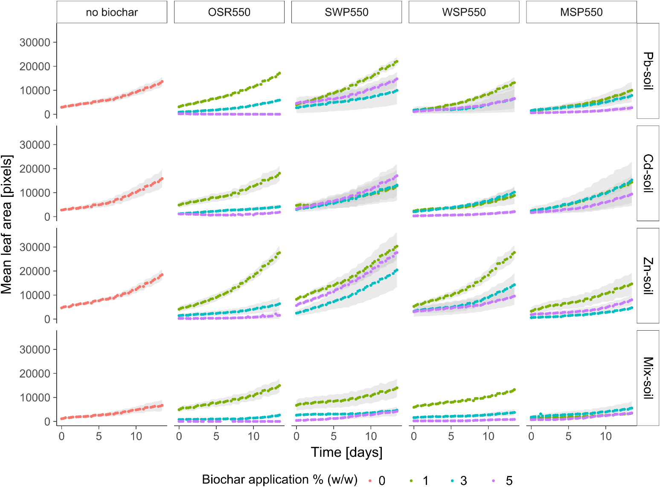
Fig. 4-5. Arabidopsis thaliana Col-0 mean leaf area over time in plants growing in soil artificially contaminated with single elements Cd, Pb, Zn and a multielement contaminated soil (Mix-soil). Soil was amended with plant-based biochars at application rates of 0, 1, 3 and 5 % (w/w). Measurements started 10 days after sowing. Dots represent the mean of green leaf area at different times; the grey area represents the standard error (n=3).

The four parameter logistic model fitted to each replicate described the data well (Appendix 1) and was used to smooth the data before the estimation of AGRs (Fig. 4-6). AGRs for plants grown in the 0% biochar were similar for the single Pb/Cd/Zn spiked soils but lower for the Mix-soil, which is consistent with the lower biomass observed in this treatment.
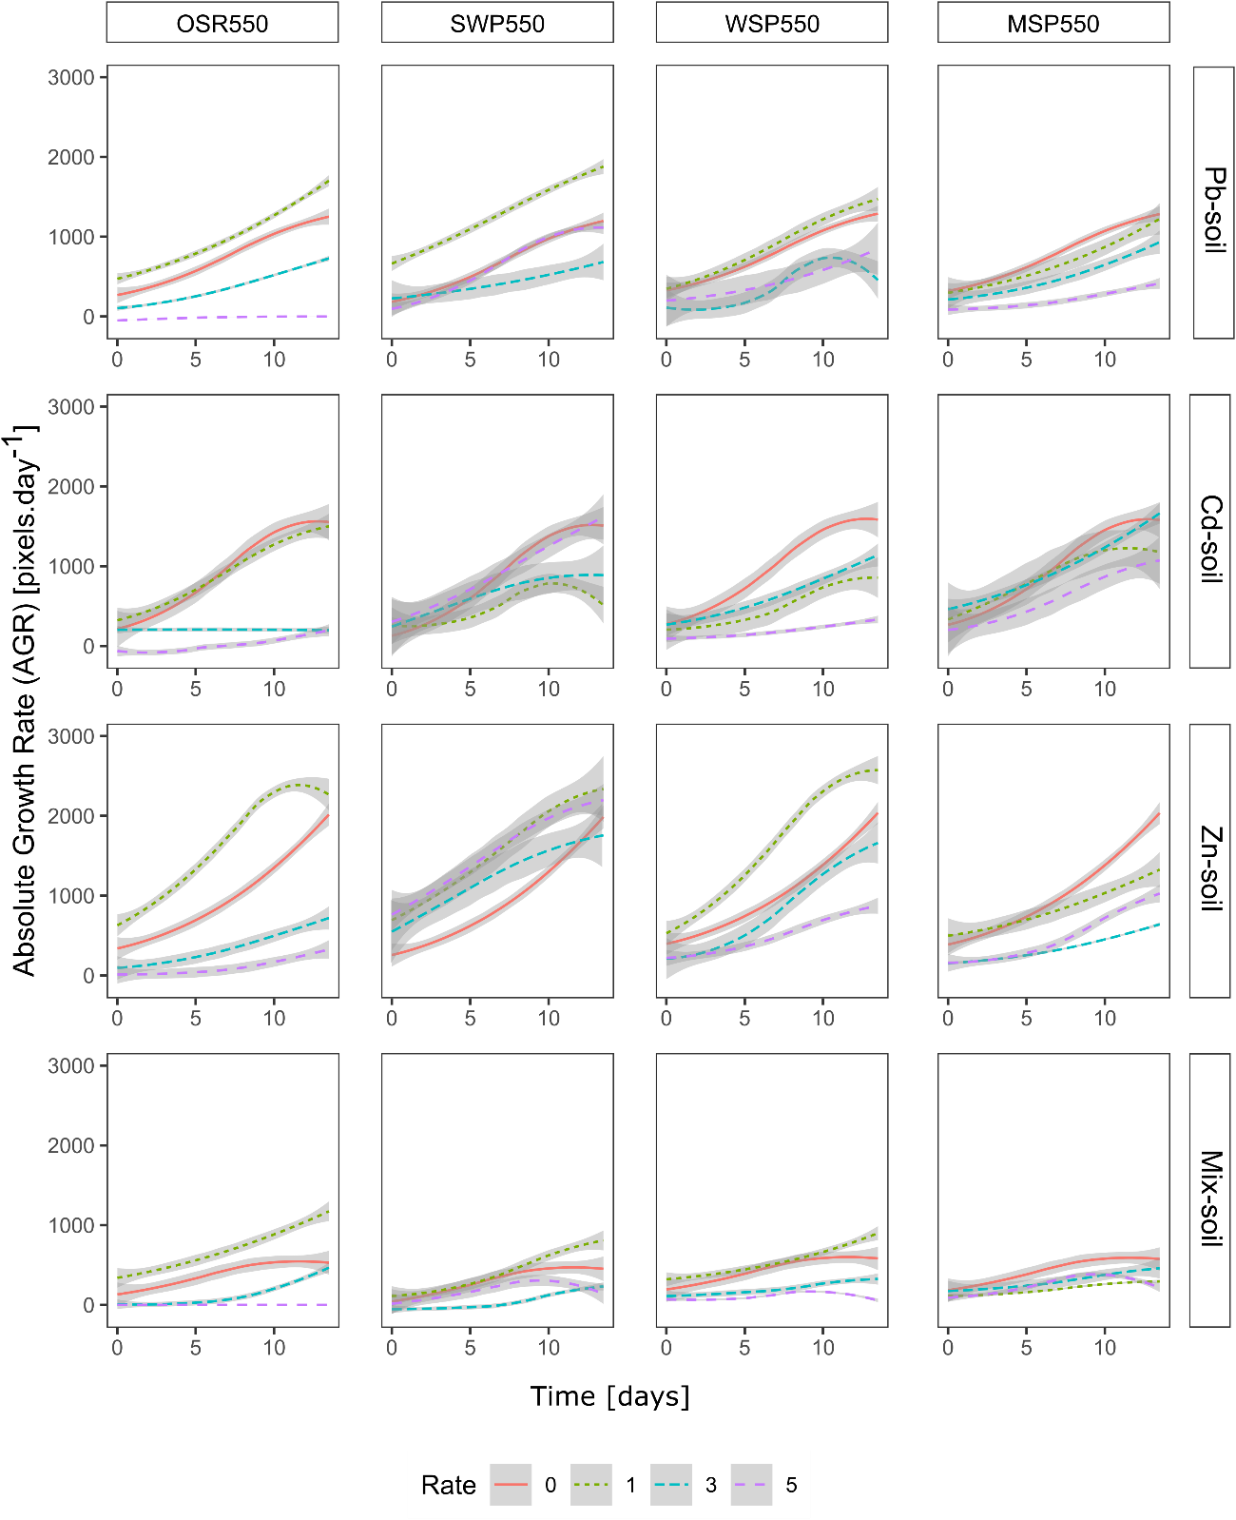
Fig. 4-6. Mean absolute growth rates (AGRs) predicted from the four-parameter logistic model for biochars OSR550, SWP550, MSP550 and MSP550 at application rates 0 (control), 1, 3 and 5 % (w/w). Lines represent the mean AGR values predicted from the four-parameter logistic model, grey curves indicate 95% confidence intervals (n=3).

In general, the addition of 1 % biochar resulted in AGRs that were either similar to, or greater than, the control (0 % biochar). AGRs were greater than the control in three of the four treatments for OSR550 and SWP550, one of four treatments for WSP550 but no treatments for MSP550. At higher application rates (3 and 5 %) the impact of biochar addition tended to be negative, with AGRs lower than the control (Fig. 4-6).
Overall, a biochar application rate of 1% demonstrated a positive response in AGRs. Therefore, only AGRs from the 1% biochar additions were assessed for significant differences between groups, following the protocol described in section 4.2.4.7. The comparison of AGRs with the controls for each treatment (metal, biochar, 1% rate) is shown in Fig. 4-7.
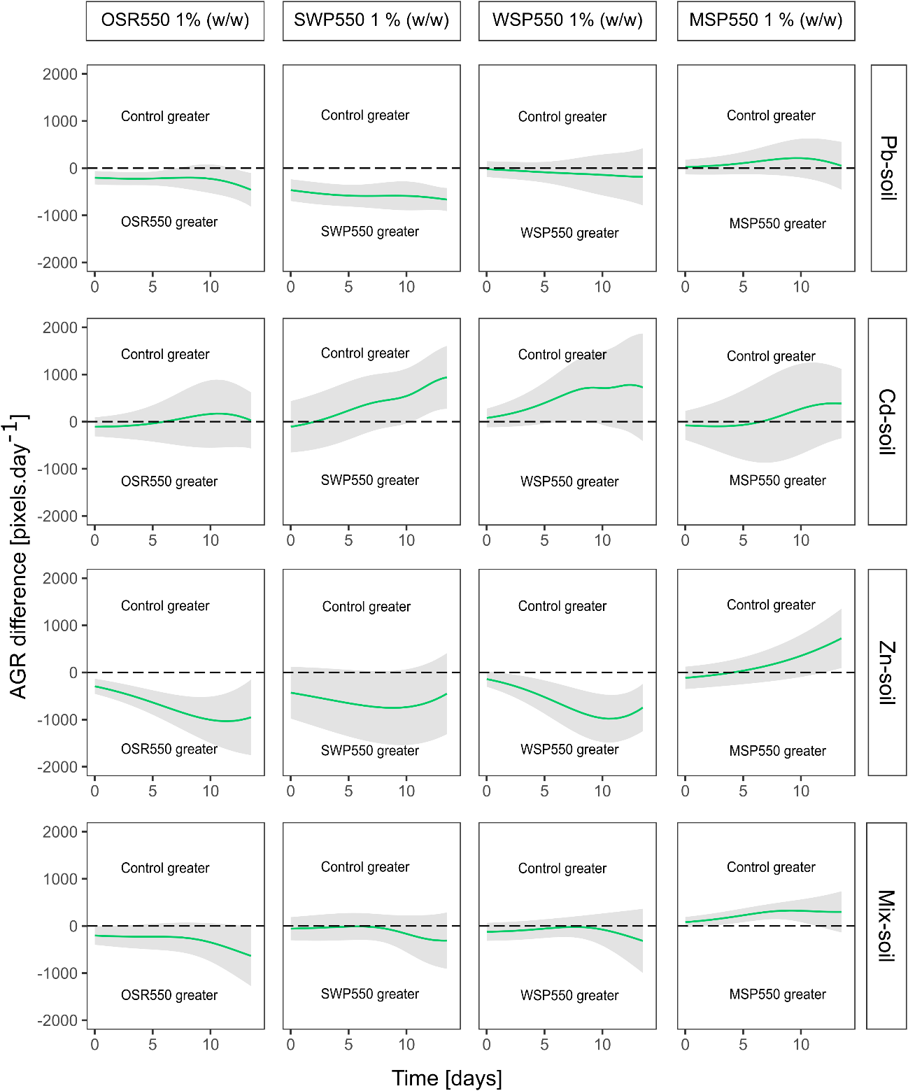
Fig. 4-7. Pairwise comparisons of absolute growth rates (AGRs) between control groups (no biochar) and 1% (w/w) biochars. The difference was calculated by subtracting the mean AGR at 1% (w/w) of each biochar from the mean AGR of the control group (no biochar). Grey curves indicate 95% confidence intervals for the difference of the means (AGRs), n= 3. Differences were considered significant when the confidence interval around the difference did not overlap zero. Values above zero (dotted line) indicate the days at which the control groups had greater AGRs, while values below the dotted line indicate the days at which 1% (w/w) biochars demonstrated greater AGR than the control.

Toxicological bioavailability of HMs
The concentration of HMs in Arabidopsis thaliana Col-0 above-ground tissue is presented in Fig. 4-8. The concentration of Pb/Cd or Zn in the 0% biochar treatments that were not exposed to these metals (i.e. Pb concentration in the tissue of plants grown in Zn-soil) was below the detection limit (data not shown). Except for OSR550 added at 5 % (which significantly reduced the concentration of Pb in the tissue of plants grown in Pb-soil), there was no significant reduction (p > 0.05) in tissue concentration of HMs in Pb-soil, Cd-soil and Zn-soil treatments in the other biochar treatments (Fig. 4-8 A-C).
The concentration of Pb, Cd and Zn in the tissue of plants grown in the Mix-soil decreased significantly (p < 0.01) with OSR550, WSP550 and SWP550 at all application rates and with MSR550 at 1 and 5 % (Fig. 4-8 D-F). The lowest Pb and Cd tissue concentrations were observed with biochar OSR550 and WSP550 added at 3 and 5 %, with reductions > 96%. The concentrations of HMs in the tissue of plants grown in the control group (0% biochar) of the Mix-soil were higher than the tissue concentrations of plants grown in the control groups of the single element contaminated soils. As shown before (section 4.3.2.2) this is associated with a lower biomass observed for the Mix-soil treatment, which may have caused a concentration effect.
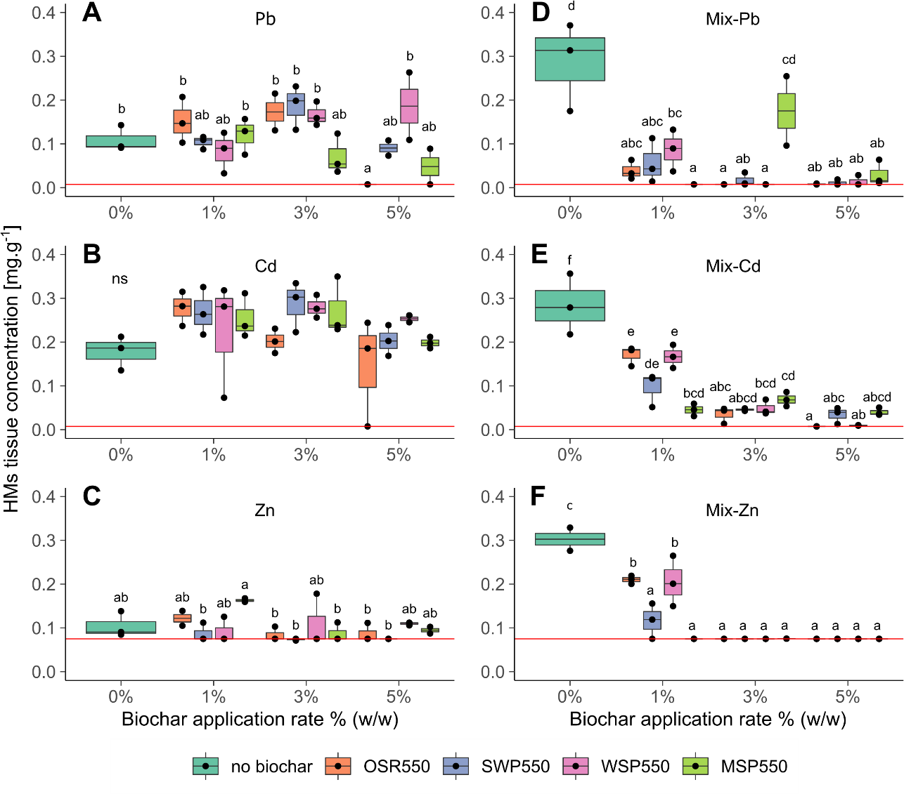
Fig. 4-8. Box plot of the concentration of HMs in above-ground tissue of Arabidopsis thaliana Col-0 growing in artificially contaminated soils. A) Pb-soil, B) Cd-soil, C) Zn-soil, D-F) Mix-soil. The red line represents the lower threshold detection limit of the instrument. Different letters indicate significant differences between treatments according to the Tukey post hoc test, ns= no significant difference (α=0.05).

Plant stress (Fv/Fm)
The functioning of photosystem II (PSII) of Arabidopsis thaliana expressed by Fv/Fm, showed a varied effect on plant response over time depending on biochar type, application rate and the HM in soil. Mean Fv/Fm values at 0% biochar addition were ~ 0.8 in the single Pb/Cd/Zn spiked soils (Fig. 4-9). These are Fv/Fm values typical of healthy plants and show that the addition of HMs did not affect PSII function. The addition of biochar from 1 to 5 % tended to decrease Fv/Fm values, indicating that plant stress increased with biochar additions. At 5% biochar additions, Fv/Fm values could sometimes not be measured, especially for biochar OSR550. This was because some plants died with the addition of this biochar at this application rate, or plants were too small to be detected by the fluorescence camera.
In the Mix-soil the Fv/Fm values at 0 % biochar were lower than in the single Pb/Cd/Zn spiked soils, indicating plant damage due to the combined effect of HMs. However, Fv/Fm values (0 % biochar) tended to recover as the experiment progressed. Biochar additions of 1 and 3 % led to an increase in Fv/Fm values at all times, relative to the control (0 % biochar). In the case of OSR550 and WSP550, Fv/Fm values were around 0.8 or higher and for SWP550 and MSP550 values were approaching 0.8, indicating no impact on PSII function. A direct comparison of Fv/Fm values with the controls for each treatment (metal, biochar, rate) is shown in Fig. 4-10. The raw data for Fv/Fm plotted against time can be found in Appendix 2.

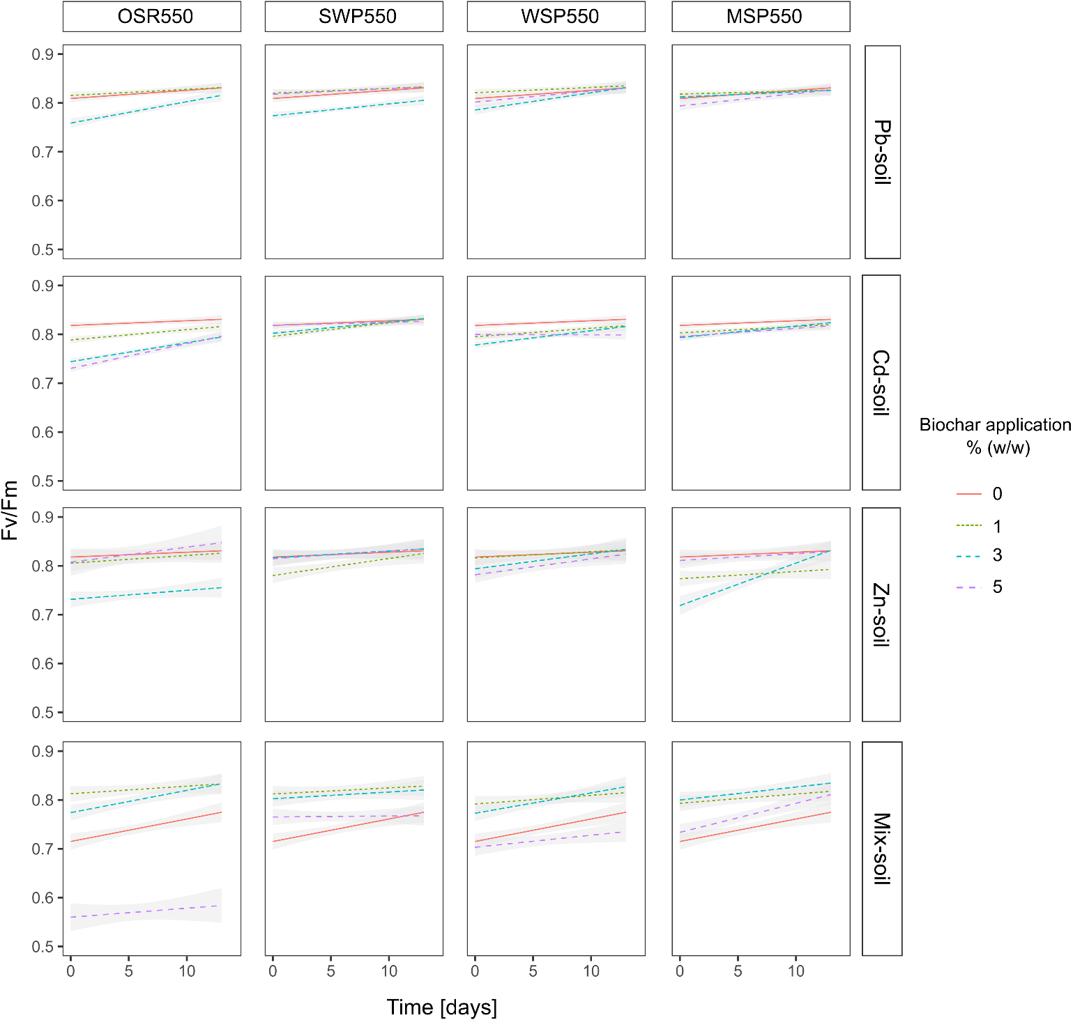
Fig. 4-9. Effect of biochar and application rate on Fv/Fm over time measured in Arabidopsis thaliana ol-0 growing in artificially contaminated soils amended with biochars OSR550, SWP550, WSP550 and MSP550 applied at 0, 1, 3 and 5 % (w/w). Lines are the linear regression of Fv/Fm values for the interaction biochar:rate:time. Grey areas correspond to the 95% confidence interval (n=3).

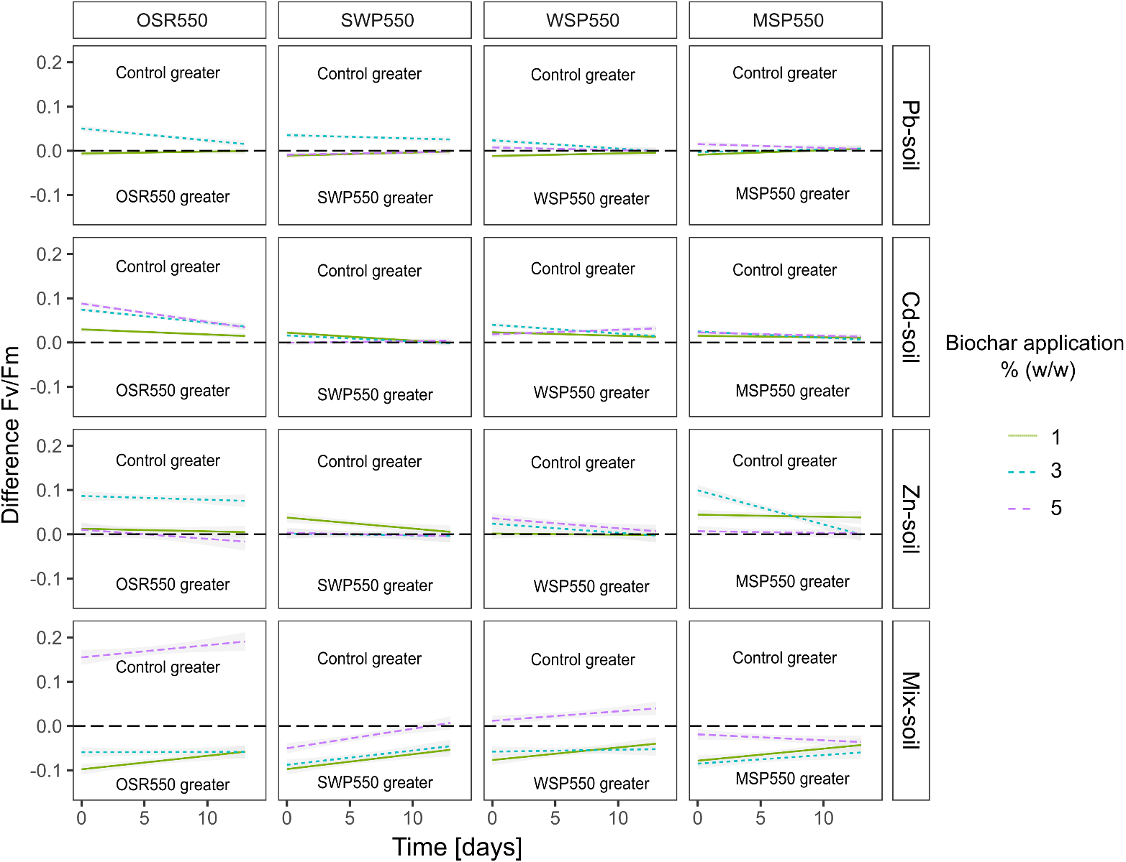
Fig. 4-10. Plot showing significant differences in the effect of biochar and rate on Fv/Fm between control groups (no biochar) and biochars at different application rates. The difference corresponds to the pairwise comparison (Tukey method) control vs biochar treatments of the Fv/Fm intercepts obtained from the linear regression of the interaction biochar:rate at different times. Grey curves indicate 95% confidence intervals. Differences are considered significant when the confidence interval around the difference does not overlap zero. Values above zero (dotted line) indicate the days at which the control (0% biochar) had significantly greater Fv/Fm values, while values below the dotted line indicate the days when biochar addition produced Fv/Fm values significantly greater than the control.

The effect of biochar on soil chemistry
The pH and EC of the soils after application of the biochars are shown in Fig. 4-11. Overall three of four biochars studied increased the soil pH and EC at 3 and 5 % addition. The increase in soil pH after the addition of biochar was consistent with the pH, EC and ash content of each material. For example, biochars OSR550 and WSP550, derived from herbaceous materials, which possess high EC (2270 and 1700 μS.cm⁻¹, respectively), pH (9.78 and 9.94, respectively) and ash contents (19.50 and 21.25 %, respectively) produced a significant rise of 0.3-0.7 pH units and 1.5-2 fold increase in soil EC (p < 0.05). In contrast, at the same application rates, SWP550, with EC of 0.09 dS.m⁻¹, pH = 7.91 and ash content of 1.25 %, had a neglectable effect on soil pH and EC relative to the control (p < 0.05) (Fig. 4-11).
Considering the water extractable soil ions from the Mix-soil (Table 4-2), there was no effect of biochar addition on anions (Cl⁻, NO⁻², S₂O₃⁻², NO₃⁻, PO₄⁻³) (P > 0.05), but a significant effect on water extractable cations. For example, the biochars increased the concentration of water soluble Na⁺ (p < 0.01), except for MSP550 at 1%. Similarly, the concentrations of water soluble K⁺ increased with OSR550 and WSP550 at 3 and 5 %, and with MSP550 at 5% (p < 0.05). The water soluble Mg²⁺ concentration was significantly higher in the soils amended with SWP550 (p < 0.01). Conversely, the concentration of water soluble Ca²⁺ decreased with the addition of biochars OSR550 and WSP550 at 3 and 5 %.
Plant available phosphate (Olsen extract) increased significantly (p < 0.01) after the addition of biochars, with the exception of OSR550 and WSP550 at 1%, which were not different from the control. Conversely, the concentration of plant available nitrate and nitrite was significantly higher with the addition of biochars OSR550 and WSP550 at 3 % (p < 0.01).

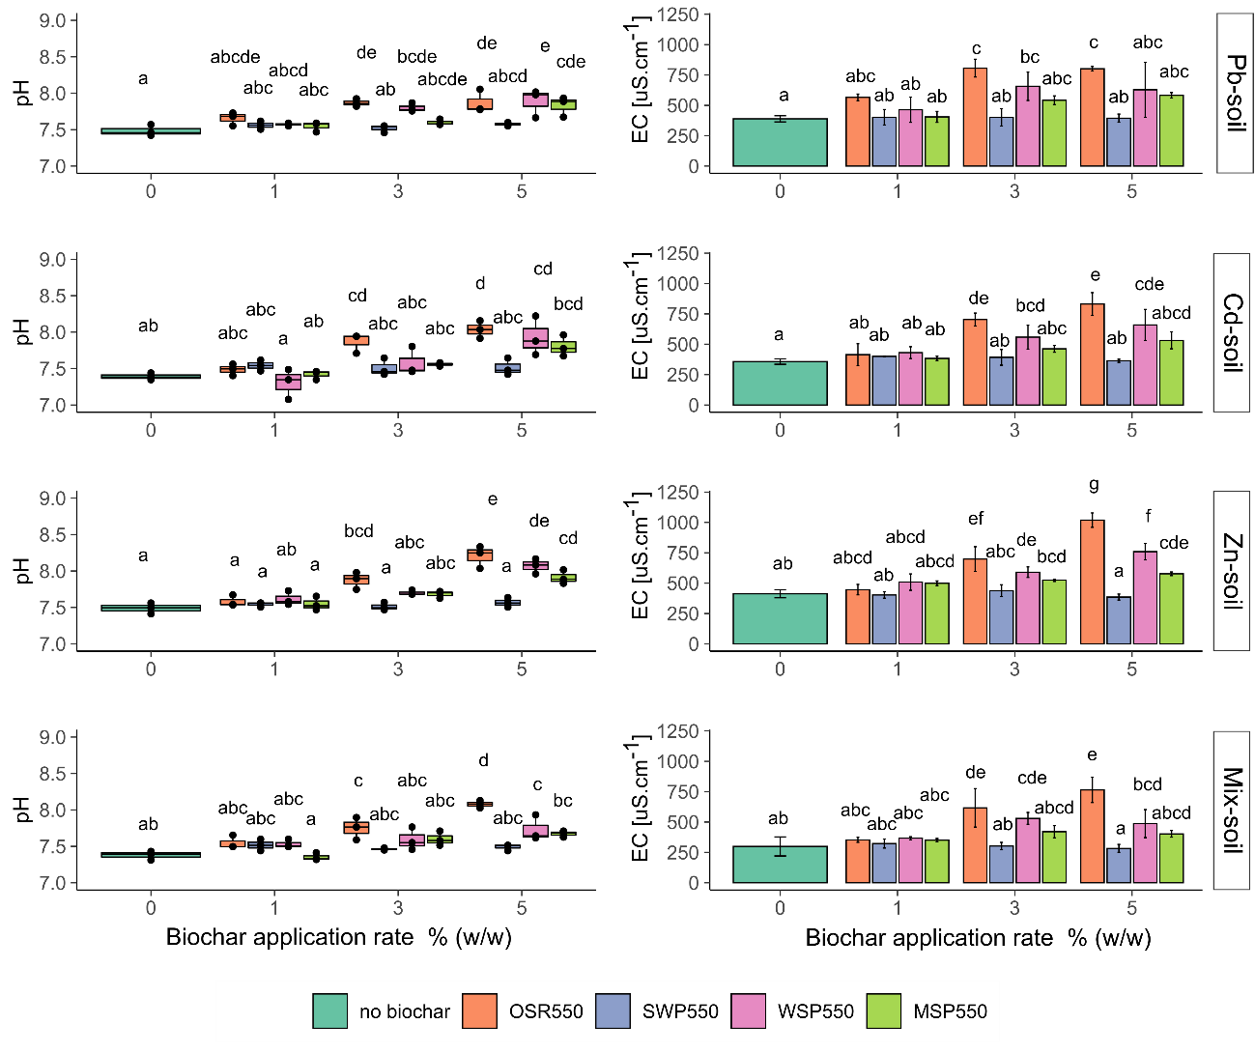
Fig. 4-11 Box plot of soil pH and EC after treatment with biochars OSR550, SWP550, WSP550 and MSP550 at 0, 1, 3 and 5 % (w/w). Values are the mean ± standard deviation, n=3. Treatments which do not share a letter are significantly different according to Tukey post hoc test HSD (α=0.05, n=4).

Table 4-2 Soil properties for the Mix-soil treatment. Values are the mean ± standard deviation, n=3. Treatments which do not share a letter are significantly different according to Tukey post hoc test HSD (α = 0.05).
 |  | *Anions [mg.kg⁻¹] |  |  |  |  |  | *Cations [mg.kg⁻¹] |  |  |  |  | Plant available nutrients  [mg.kg⁻¹]
Biochar | Rate % (w/w) | Cl⁻ | NO⁻² | S₂O₃⁻² | NO⁻³ | PO₄⁻³ |  | Na⁺ | K⁺ | Mg²⁺ | Ca²⁺ |  | **PO₄³⁻ | *** NO₃⁻
no biochar | 0 | 63 ± 14 ab | 8.1 ± 1.4 a | 100 ± 21 a | 55 ± 6 a | 99 ± 11 a |  | 5.1 ± 0.4 f | 199 ± 18 e | 19 ± 1 ab | 158 ± 26 a |  | 72 ± 5 e | 151 ± 35 cd
OSR550 | 1 | 69 ± 34 b | 8.4 ± 0.5 a | 115 ± 52 a | 95 ± 42 a | 89 ± 22 a |  | 8.4 ± 0.7 de | 284 ± 31 de | 18 ± 2 b | 131 ± 53 ab |  | 70 ± 5 e | 95 ± 51 cd
 | 3 | 153 ± 22 ab | 7.6 ± 1.6 a | 112 ± 13 a | 104 ± 30 a | 91 ± 25 a |  | 9.6 ± 0.6 abcde | 562 ± 47 bc | 16 ± 1 b | 78 ± 17 b |  | 93 ± 7 cd | 300 ± 57 a
 | 5 | 114 ± 110 ab | 10 ± 1 a | 120 ± 15 a | 112 ± 53 a | 96 ± 39 a |  | 8.4 ± 0.3 de | 897 ± 26 a | 19 ± 3 b | 66 ± 11 b |  | 98 ± 12 cd | 137 ± 20 cd
SWP550 | 1 | 49 ± 17b | 13 ± 6 a | 101 ± 26 a | 101 ± 38 a | 56 ± 26 a |  | 8.6 ± 1.0 cde | 228 ± 15 e | 21 ± 3 a | 105 ± 17 ab |  | 100 ± 1 cd | 130 ± 58 cd
 | 3 | 46 ± 5 ab | 23 ± 15 a | 80 ± 3 a | 31 ± 9 a | 63 ± 36 a |  | 9.1 ± 0.8 bcde | 218 ± 25 e | 19 ± 3 a | 121 ± 9 ab |  | 103 ± 8 c | 172 ± 20 cd
 | 5 | 189 ± 118 a | 8.8 ± 1.2 a | 161 ± 50 a | 139 ± 30 a | 123 ± 31 a |  | 8.3 ± 0.5 de | 227 ± 25 e | 22 ± 3 a | 138 ± 48 ab |  | 107 ± 4 c | 73 ± 28 d
WSP550 | 1 | 40 ± 10 b | 7.9 ± 1.1 a | 98 ± 33 a | 67 ± 34 a | 43 ± 7 a |  | 8.3 ± 1.3 de | 302 ± 67 de | 21 ± 3 ab | 84 ± 5 ab |  | 83 ± 4 de | 181 ± 28 c
 | 3 | 50 ± 13 ab | 8.9 ± 0.7 a | 90 ± 33 a | 54 ± 40 a | 62 ± 27 a |  | 11.3 ± 0.8 abcd | 469 ± 35 cd | 19 ± 1 ab | 80 ± 5 b |  | 102 ± 5 c | 287 ± 38 ab
 | 5 | 95 ± 48 a | 15 ± 9 a | 162 ± 32 a | 92 ± 60 a | 145 ± 52 a |  | 12 ± 1 ab | 753 ± 82 ab | 22 ± 1 ab | 77 ± 6 b |  | 107 ± 5 c | 123 ± 11 cd
MSP550 | 1 | 43 ± 8 b | 7.6 ± 1.6 a | 95 ± 34 a | 70 ± 20 a | 39 ± 2 a |  | 7.9 ± 0.4 ef | 292 ± 30 de | 20 ± 2 ab | 116 ± 14 ab |  | 128 ± 9 b | 195 ± 28 bc
 | 3 | 46 ± 14 ab | 9.5 ± 1.2 a | 105 ± 41 a | 71 ± 20 a | 36 ± 8 a |  | 11 ± 1 abc | 381 ± 13 cde | 21 ± 1 ab | 121 ± 27 ab |  | 140 ± 3 b | 179 ± 11 c
 | 5 | 64 ± 18 a | 12 ± 1 a | 89 ± 25 a | 55 ± 8 a | 71 ± 36 a |  | 11.8 ± 0.7 ab | 502 ± 48 cd | 19 ± 1 ab | 108 ± 15 ab |  | 160 ± 6 a | 144 ± 14 cd
*=aqueous extract, **= Olsen extract, ***= 2M KCl extract

Chemical speciation of HMs
The chemical speciation of the Mix-soil treated with biochar OSR550 at 1% is presented as an example to assess the effect of biochar on the chemical speciation of HMs (Table 4-3). The speciation model predicted that Cd and Zn were mainly present in ionic forms, Cd²⁺ (54.6 %) and Zn²⁺ (71.83 %), while Pb was mostly in the hydrolyzed form of PbOH⁺ (69.87 %). In the case of Pb, Zn, and Ca the model predicted the formation of products which exceed the saturation indexes of specific mineral phases, such as chloropyromorphite ([Pb₅(PO₄)₃Cl]), Pb₅(PO₄)₃(OH), Pb(OH)_{2 (s)}, PbHPO_{4(s)}, Zn₃(PO₄)2. 4H₂O_{(s)}, Ca₃(PO₄)₂ and Ca₄H(PO₄)₃.3H₂O _{(s)}. No Cd-precipitates were predicted under the conditions evaluated.
Table 4-3. Species distribution predicted for Cd, Pb and Zn present in the Mix-soil treatment according to Visual MINTEQ 3.1.
Element | % of total concentration | Species Name | Precipitates predicted
Cd | 54.6 | Cd²⁺ | NA
 | 29.7 | CdS₂O_{3(aq)}
 | 13.5 | CdHPO_{4(aq)}
Zn | 71.83 | Zn²⁺ | Zn₃(PO₄)₂.4H₂O_{(s)}
 | 7.83 | ZnOH⁺
 | 11.87 | Zn(OH)_{2(aq)}
 | 7.2 | ZnHPO₄
 | 1 | ZnS₂O₃
Pb | 69.87 | PbOH⁺ | [Pb₅(PO₄)₃Cl]
 | 25.52 | Pb²⁺ | Pb₅(PO₄)₃(OH)
 | 2.66 | Pb(OH)_{2 (aq)} | Pb(OH)_{2 (s)}
 | 1.57 | PbHPO_{4(aq)} | PbHPO_{4(s)}
Ca | 95 | Ca²⁺ | Ca₃(PO₄)₂
 | 2.16 | CaHPO₄ | Ca₄H(PO₄)₃.3H₂O _{(s)}
 | 1.92 | CaPO₄⁻
NA= Not applicable as none of the predicted products exceeded the saturation index

Cross-correlations
The cross-correlation matrix performed with the information available from all the spiked soils is presented in Fig. 4-12.
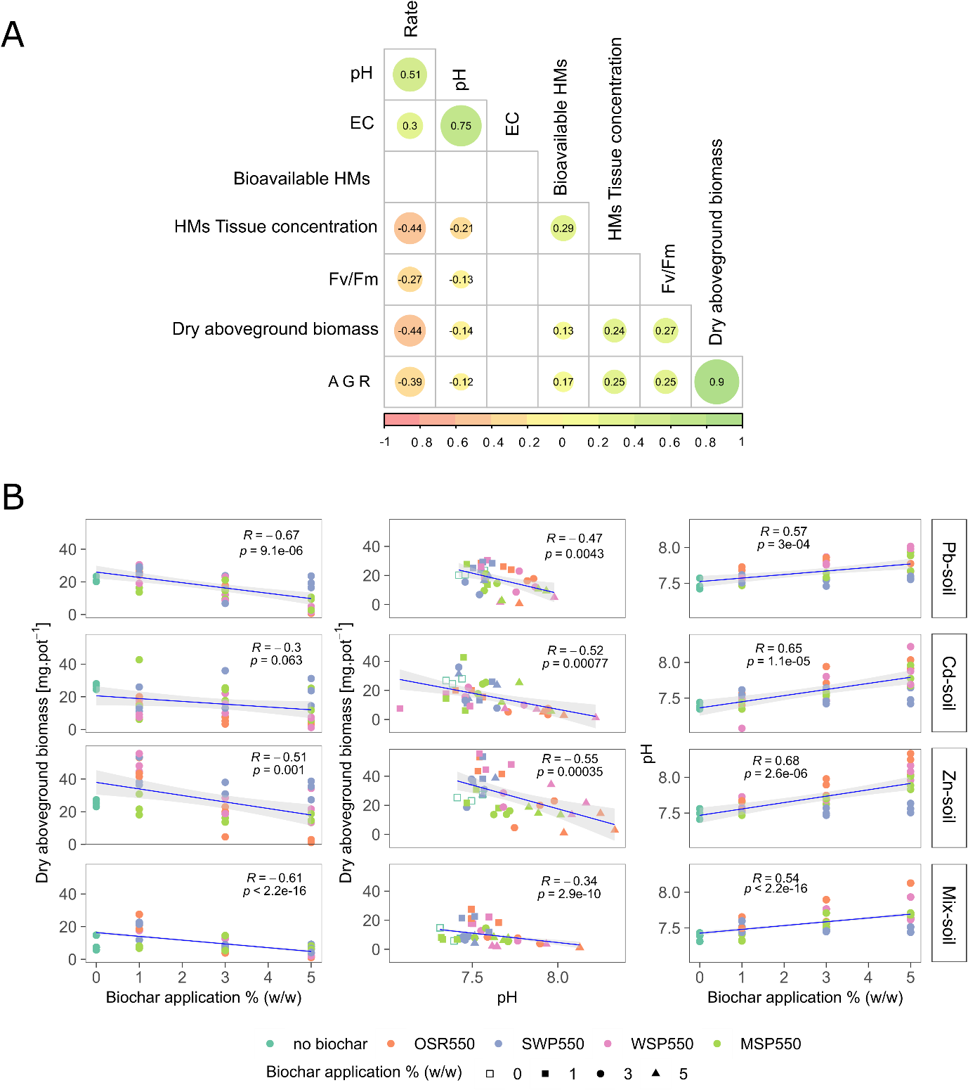
Fig. 4-12. Plot showing correlation between different plant performance indicators and soil physico-chemical properties of soils amended with biochar. A) Cross correlation matrix using the data available for all soil treatments, showing the R values for parameters which correlation had p < 0.05, non-significant correlations are shown blank. B) Correlations affecting plant performance parameters for each soil treatment. Data used for the correlation: Rate = biochar application rate (% w/w), pH, EC, bioavailable HMs (NH₄-NO₃ extracts), Fv/ Fm (at day 13), dry above-ground biomass (mg.pot⁻¹), AGR (absolute growth rate at day 13).
Biochar application rate negatively affected plant performance, as evidenced by negative correlations with dry above-ground biomass, absolute growth rates (AGRs) and Fv/Fm. Besides, biochar application rate directly influenced soil pH and EC. All indicators associated with plant performance (AGR, Fv/Fm and dry biomass) were positively correlated to each other, confirming the rigor of the methods used.
The chemical analysis performed for the Mix-soil enabled additional parameters to be integrated into the cross-correlation analysis (Fig. 4-13). This showed that biochar application rate negatively affected plant performance (based on dry biomass and AGR). Other negative relationships between some elements released by biochar, such as phosphate, Na⁺ and K⁺, and plant performance indicators were also apparent. In contrast, the cross-correlation of the Mix-soil showed no significant relationship between plant performance parameters and soil pH. However, a negative relationship was found between soil pH and water extractable Ca²⁺. Contrary to expectation, there was no direct correlation between bioavailable HMs and tissue concentrations for Pb and Cd, only for Zn (Fig. 4-13).

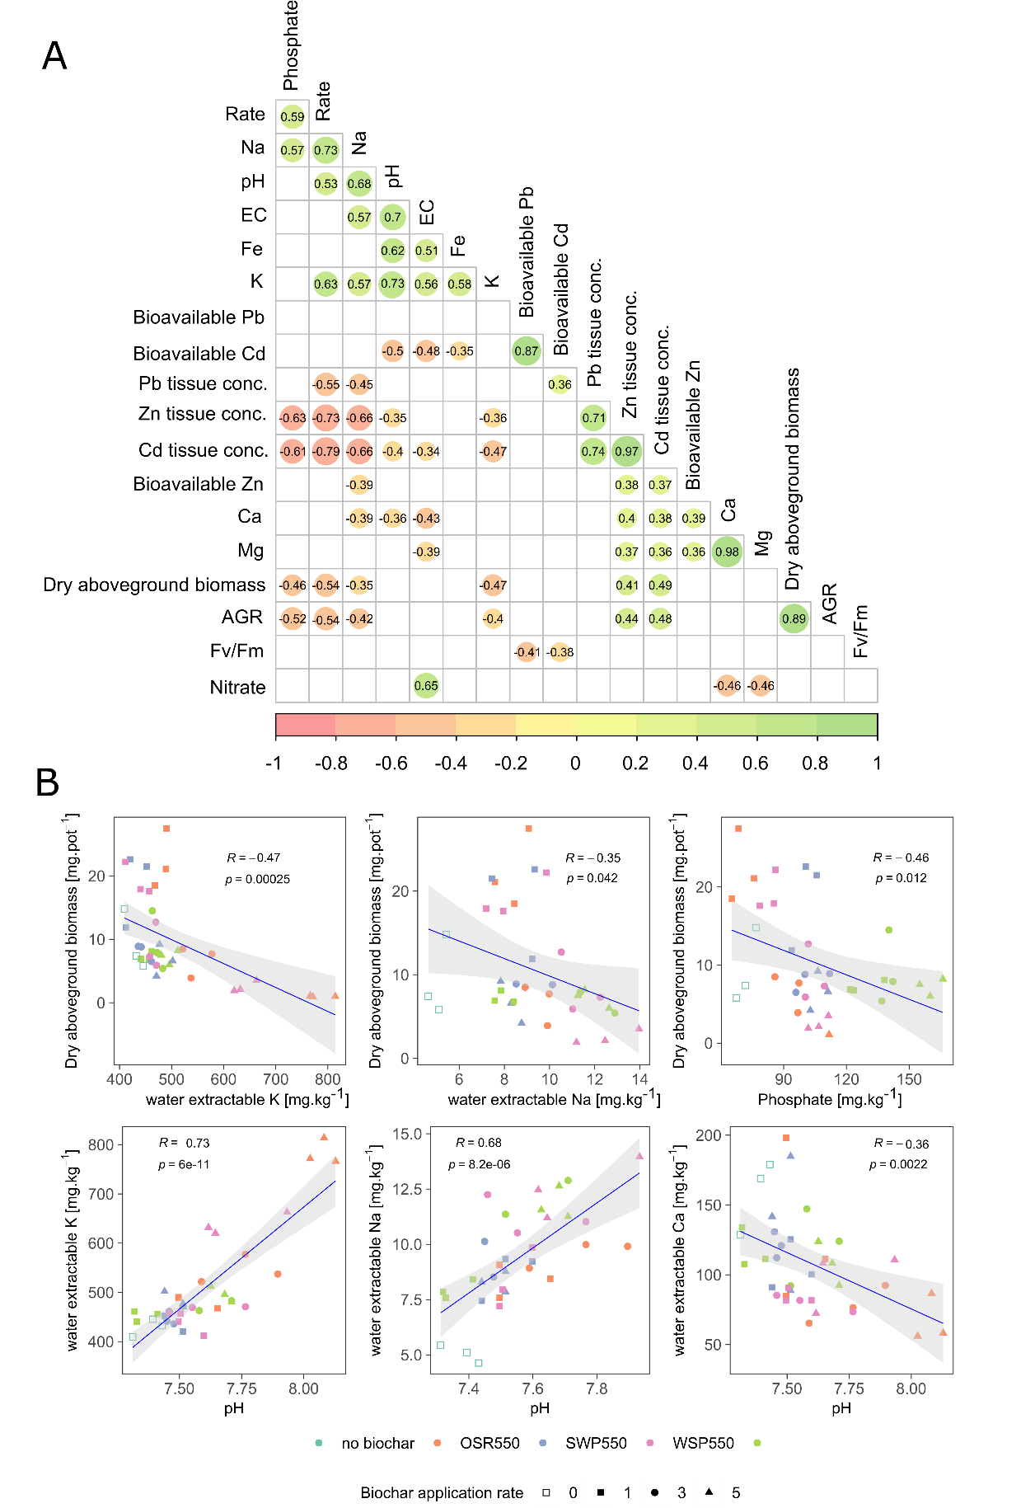
Fig. 4-13. Plot showing correlation between different plant performance indicators and soil physico-chemical properties in the Mix-soil treatment. A) Cross-correlation matrix indicating the R coefficient of parameters with p < 0.05. B) Correlations between dry above-ground biomass and selected physico-chemical properties, and between soil pH and water extractable cations. Data used: phosphate (Olsen), nitrate (vanadium chloride method, mg.kg⁻¹), Rate (biochar application rate % w/w), Na, K, Ca, Mg, Fe (water extractable, mg.kg⁻¹), pH (soil pH), EC (soil electrical conductivity, μS.cm⁻¹), bioavailable HMs (NH₄-NO₃ extracts, mg.kg⁻¹), Fv/ Fm (at day 13), dry above-ground biomass (mg.pot⁻¹), HMs tissue concentration (acid digest, mg.g⁻¹), AGR (absolute growth rate at day 13).

Experiment B: controlled environment incubations with Sinapsis alba and Lolium perenne

Bioavailability of HMs
The bioavailable concentrations of HMs in soil treatments amended with biochars WSP550 and MSP550 are presented in Fig. 4-14. As expected the Non-spiked soil had lower concentrations of bioavailable HMs than the spiked soils. Overall, the addition of biochar did not affect the concentrations of bioavailable HMs in the Non-spiked soil cultivated with Lolium perenne, except for bioavailable Zn, which was reduced relative to the control (0% biochar).
In the Non-spiked soil cultivated with Lolium perenne, the concentration of bioavailable HMs in the control treatment (0% biochar) at day 0 was not different from that at the end of the incubation (day 40). Conversely, in the Non-spiked soil cultivated with Sinapsis alba, the concentration of bioavailable Pb and Cd in the control treatment (0% biochar) decreased significantly from day 0 to the end of the incubation (day 40) (p < 0.05). Besides, the addition of biochar WSP550 tended to increase bioavailable Pb and Cd relative to the 0 % biochar soil at the end of the incubation. However, the increase was only significant for bioavailable Pb with the addition of 1 % WSP550 and bioavailable Cd with the addition of 1% and 3% WSP550 (p < 0.05). The addition of MSP550 did not cause any significant effect on bioavailable HMs relative to the 0 % biochar soil (p > 0.05).
Overall the concentration of HMs in the Pb/Cd/Zn/Mix-spiked soils without biochar (0%) at the beginning of the experiment (day 0) were significantly higher than the concentration of HMs in treatments without biochar (0% biochar) at the end of the incubation (p < 0.01). An exception was the Lolium perenne treatment (Zn-spiked soil, day 40), in which bioavailable Zn was not different than the concentration at the beginning of the experiment (day 0).
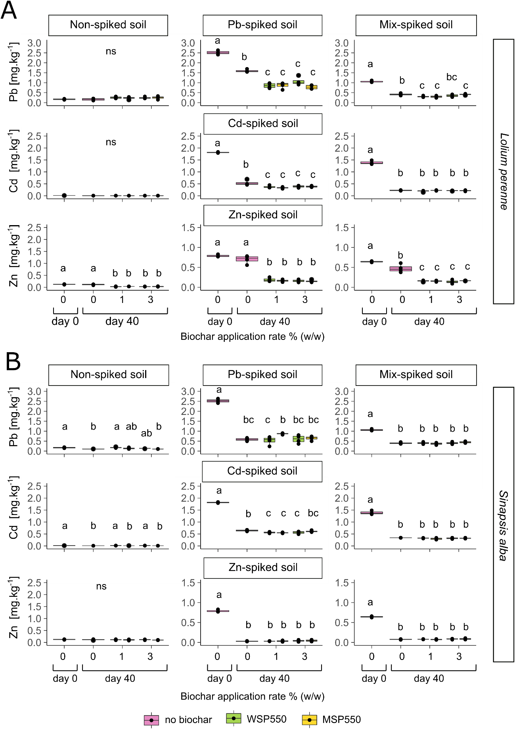
Fig. 4-14 Boxplot of bioavailable HMs (NH₄-NO₃ extracted) in soils artificially contaminated with Pb, Cd, Zn and a ternary mixture of these elements amended with biochars WSP550 and MSP550 at 0, 1 and 3% (w/w). Values at day 0 correspond to the initial concentrations before the incubation experiment; values at day 40 indicate the NH₄-NO₃ extractable HMs at the end of the incubation. Different letters indicate significant differences between treatments according to Tukey post hoc test (α = 0.05), n=4, ns= no significant differences between treatments. (A) Lolium perenne (B) Sinapsis alba.
In the Lolium perenne treatments the addition of biochars to the Pb/Cd/Zn/Mix-spiked soils significantly reduced the concentration of bioavailable HMs regardless of application rate relative to the control (0 % biochar) (p < 0.01), except for bioavailable Cd in the Mix-spiked soil. Overall, both biochars reduced bioavailable HMs to a similar extent; in the Pb-spiked soil to 18-45 %, Cd-spiked soil to 33-43% and Zn-spiked soil to 63-69% of the control. In the Mix-spiked soil, bioavailable Pb was significantly reduced to 13-27% of the control (0% biochar) with biochar WSP550 at 1 % and MSP550 at 1% and 3%. Bioavailable Zn in the Mix-spiked soil was reduced to a similar extent with both biochars, regardless of application rate, to 63-67% respectively (p < 0.01). Conversely, bioavailable Cd in the Mix-spiked soil was not significantly reduced with any biochar tested (p > 0.05).
In the Sinapsis alba treatment, a decrease in the concentration of bioavailable HMs was observed only in the Cd-spiked soil with biochars WSP550 at 1% and 3%, and MSP550 at 1%. In the other treatments, the concentration of bioavailable HMs from biochar treatments was not significantly different from the control (0% biochar). None of the biochars enhanced the reduction of bioavailable HMs with increasing application rate.

Plant above-ground biomass
The dry above-ground biomass data of Lolium perenne and Sinapsis alba plants grown in the amended soils is presented in Fig. 4-15. In the Non-spiked soil Lolium perenne biomass cultivated in the biochar-amended soils was not significantly different from the 0 % biochar treatment, regardless of biochar type or application rate. Conversely, Sinapsis alba biomass was significantly decreased to a comparable extent with the addition of WSP550 at 1 % and 3% (p < 0.01), relative to the control (0% biochar), whereas biomass from plants cultivated in MSP550-amended soil was not different from the control.
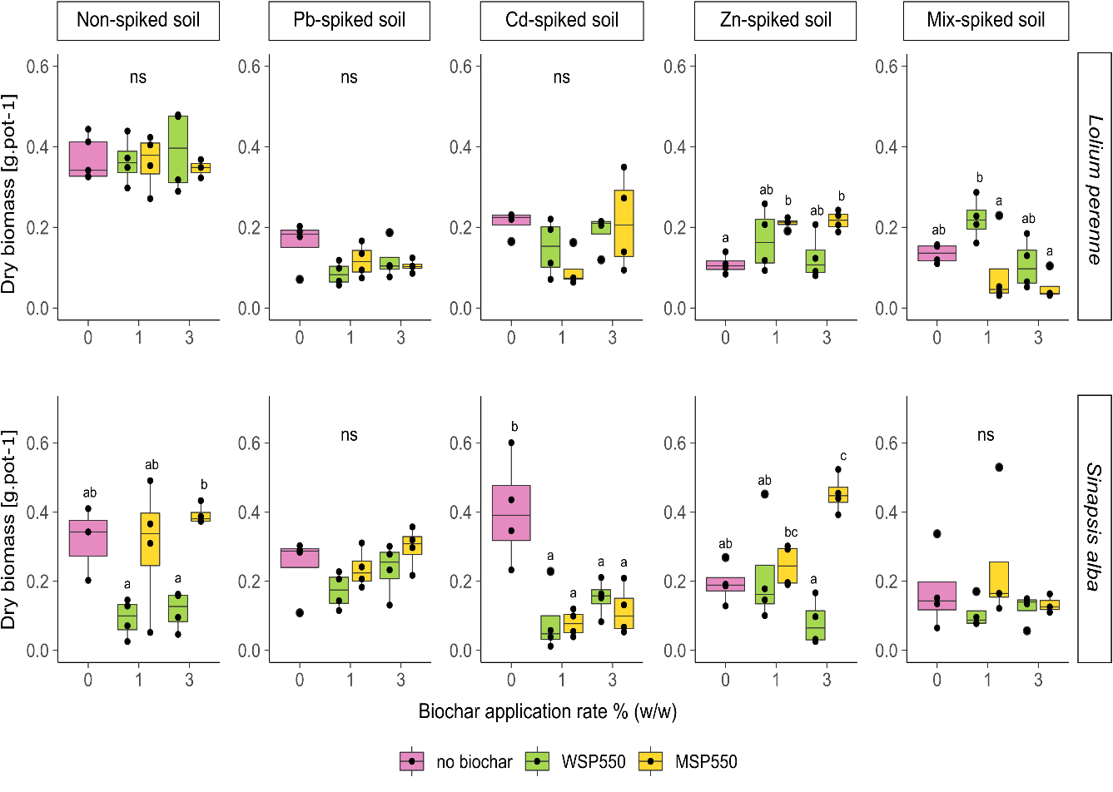
Fig. 4-15 Boxplot of dry above-ground biomass of Lolium perenne and Sinapsis alba amended with biochars WSP550 and MSP550 at 0, 1 and 3 % (w/w) in soils artificially contaminated with Pb, Cd, Zn and a ternary mixture of these elements. Growth period 30 days. Different letters indicate significant differences between treatments according to Tukey post hoc test (α = 0.05), n= 4, ns= no significant differences between treatments.
In the Pb-spiked soil, the dry above-ground biomass of both plants cultivated in the biochar-amended soils was not significantly different from plants grown in 0% biochar treatment. In the Cd-spiked soil there were no significant differences in the biomass of Lolium perenne (p > 0.05); however Sinapsis alba biomass was significantly reduced by both biochars to the same extent, regardless of application rate (p < 0.01). In the Zn-spiked soil, Lolium perenne biomass was significantly increased with the addition of MSP550 at 1% and 3%, whereas Sinapsis alba biomass was significantly increased with the same biochar at 3%. Conversely, regardless of biochar or application rate, the dry biomass of plants grown in the Mix-spiked soil treated with biochars was not significantly different from the control (0% biochar) (p > 0.05).

Toxicological bioavailability of HMs
The concentration of HMs in plant above-ground tissue of Lolium perenne and Sinapsis alba is presented in Fig. 4-16. Overall, biochar addition to the Non-spiked soil did not cause significant differences in HM tissue concentrations relative to the 0% biochar plants, except for Sinapsis alba plants grown in WSP550-amended soil which demonstrated an increase in Cd concentration in plant tissue at 1% and 3% additions. This increase is consistent with the slight increase in bioavailable Cd observed in this treatment (section 4.3.3.1).
In the Pb-spiked soil, none of the biochars/rates significantly reduced tissue Pb concentrations relative to the control soil (0%), regardless of the plant species (p > 0.05). In the Cd- and Zn-spiked soils cultivated with Lolium perenne, tissue HM concentrations tended to decrease with increasing application rates from 1% to 3 %. However, only MSP550 at 3% caused a significant reduction in Cd concentration to 37% of the control (0% biochar), whereas significant reductions in Zn concentrations of 20% and 19% of the control were observed, respectively, with WSP550 and MSP550 at 3% additions. No significant differences in Cd concentrations in Sinapsis alba were observed, whereas WSP550 added at 3% significantly decreased Zn concentrations in this plant by 72% of the control (0% biochar).
In the Mix-spiked soil, none of the biochars were able to reduce tissue HM concentrations in Lolium perenne or Sinapsis alba (p > 0.05). However, the WSP550 added at 1% significantly reduced the Cd concentration in Sinapsis alba plants by 52% of the control.
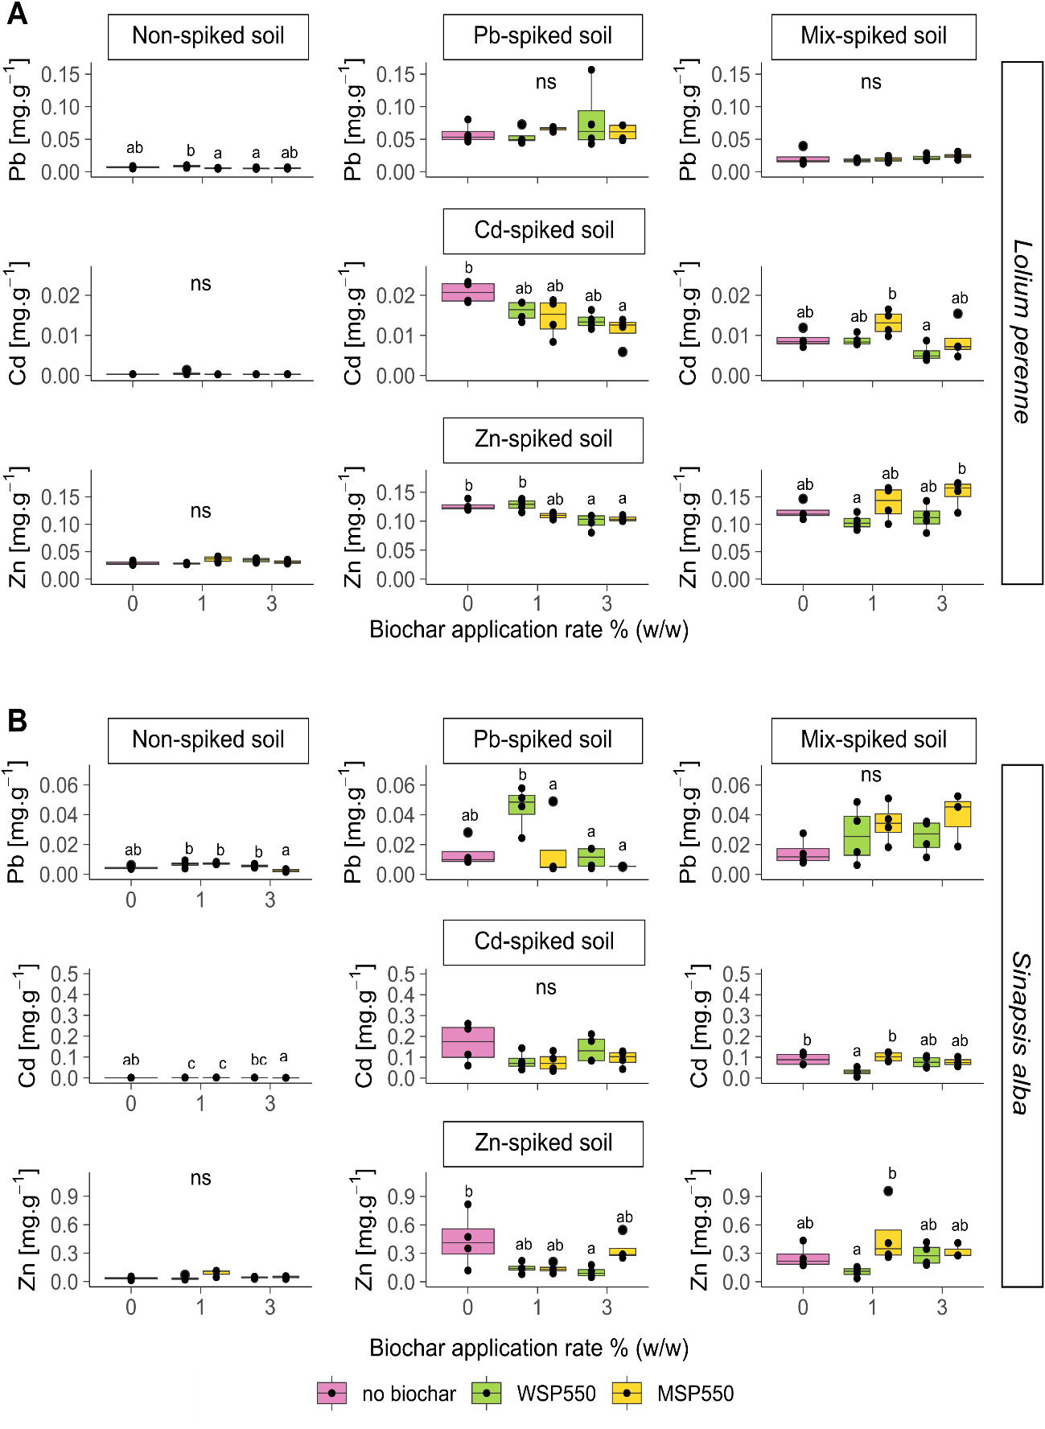
Fig. 4-16 Boxplot of concentration of HMs in above-ground tissue of plants grown in soils artificially contaminated with Pb, Cd, Zn and a ternary mixture of these elements amended with biochars WSP550 and MSP550 at 0, 1 and 3% (w/w). A) Lolium perenne and B) Sinapsis alba. Growth period 30 days. Different letters indicate significant differences between treatments according to Tukey post hoc test (α= 0.05), n= 4, ns= no significant differences between treatments.

Effect of biochar on soil pH and EC
The results of soil pH and EC are presented in Fig. 4-17. Overall, soil pH tended to increase with addition of biochars; in four of five soil treatments the addition of biochars at 3% significantly increased the pH relative to the control soil (0% biochar) by 0.3-0.7 pH units. Similarly, electric conductivity (EC) tended to increase with biochar additions, however this was not observed in the Non-spiked soil, Pb-spiked soil (Sinapsis alba), and Zn-spiked soil (Lolium perenne), which were not different from the control. These results are consistent with the findings of Experiment A (Fig. 4-11).

Correlation between soil properties, HM bioavailability and plant growth
The cross-correlation matrix performed with the information available for Lolium perenne treatments is presented in Fig. 4-18 and for the Sinapsis alba treatments in Fig. 4-19. Overall, plant growth (on dry above-ground biomass basis) was negatively affected by bioavailable and tissue concentrations of Pb, Cd and Zn. Besides, Sinapsis alba biomass was negatively affected by biochar application rate, which was not the case for Lolium perenne. Overall, biochar application rates were positively correlated to soil pH. At the same time soil pH affected the bioavailability of some elements that determine plant growth, for example, bioavailable Ca, Mn and Mg were negatively correlated with soil pH, whereas bioavailable K was positively correlated. In both Lolium perenne and Sinapsis alba treatments the application rate of biochar was positively correlated with pH and bioavailable K.
Bioavailable Zn was negatively correlated with pH, EC, biochar application rate and bioavailable Na and K. Bioavailable Pb was negatively correlated with pH and EC, whereas bioavailable Cd was negatively correlated with EC and Na. In addition, bioavailable Pb and Cd were significantly positively correlated to Pb and Cd tissue concentrations, however, no significant correlation was found between bioavailable Zn and Zn tissue concentration. A plot of correlations between bioavailable soil elements and pH, and between dry above-ground biomass and pH is presented in Appendix 3.
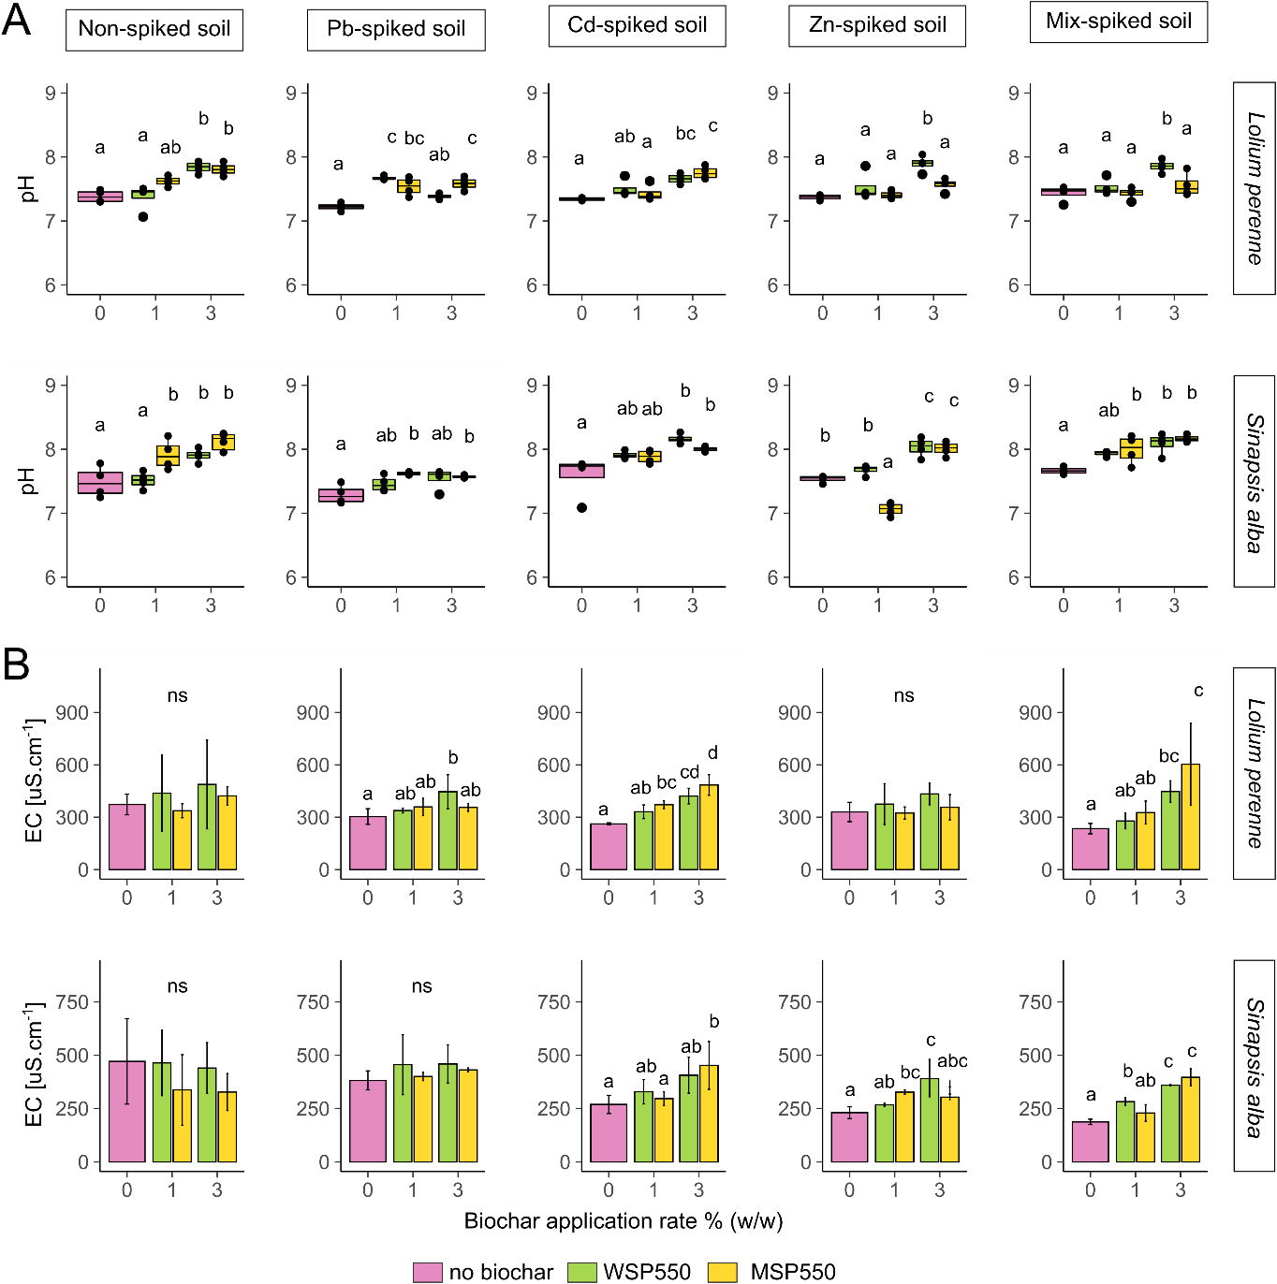
Fig. 4-17 Effect of biochar addition to soil properties. A) soil pH, B) soil EC [μS.cm⁻¹]. Biochars WSP550 and MSP550 addition at 0, 1 and 3 % (w/w). Incubation period 40 days. Different letters indicate significant differences between treatments according to Tukey post hoc test (α= 0.05), n= 4, ns= no significant differences between treatments.
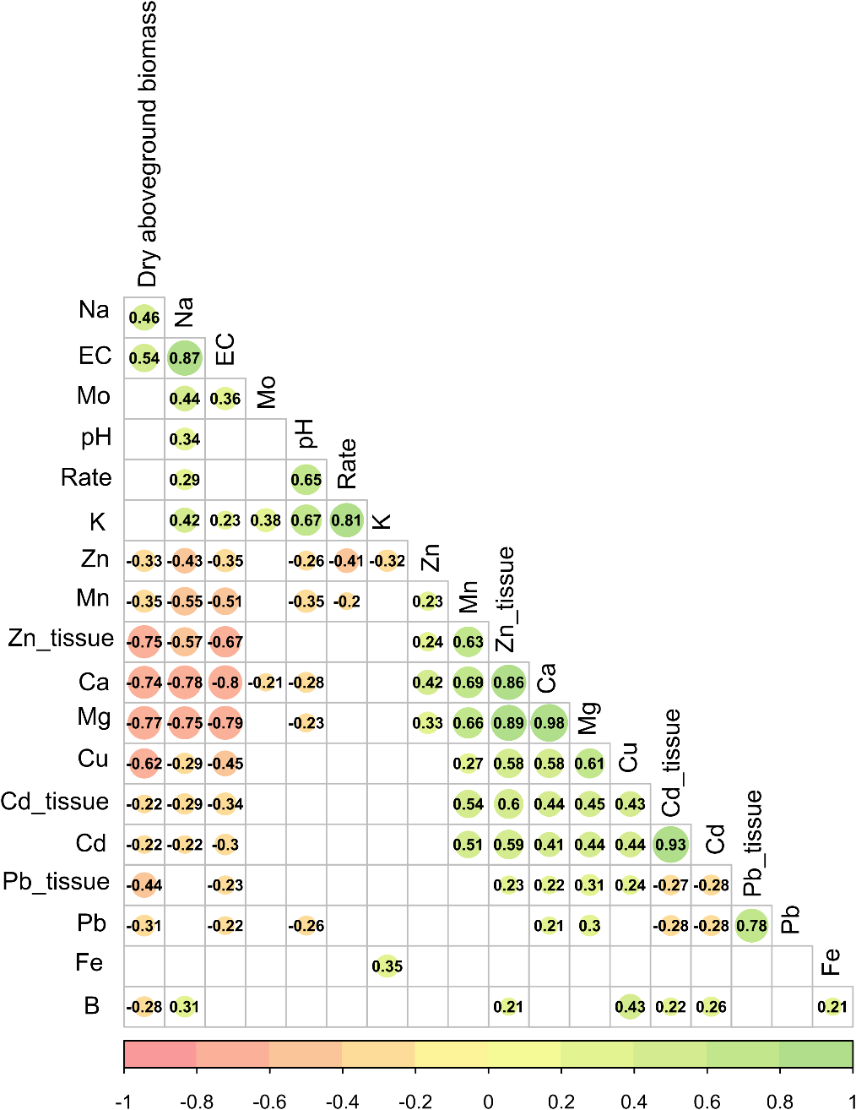
Fig. 4-18 Plot showing correlation between soil properties, bioavailable HMs and tissue HM concentrations in the Lolium perenne treatment. Data used: Cd, Pb, Zn, B, Cu, Na, K, Ca, Mg, Mn, Fe, Mo (NH₄-NO₃ extracts mg.kg⁻¹), pH (soil pH), EC (soil electrical conductivity, μS.cm⁻¹), HM_tissue (HM tissue concentration of mg.g⁻¹), dry above-ground biomass (mg.pot⁻¹), Rate (biochar application % w/w). Values in the matrix are the correlation coefficient (R) for parameters which had a correlation p < 0.05, non-significant correlations are shown in blank, α=0.05.
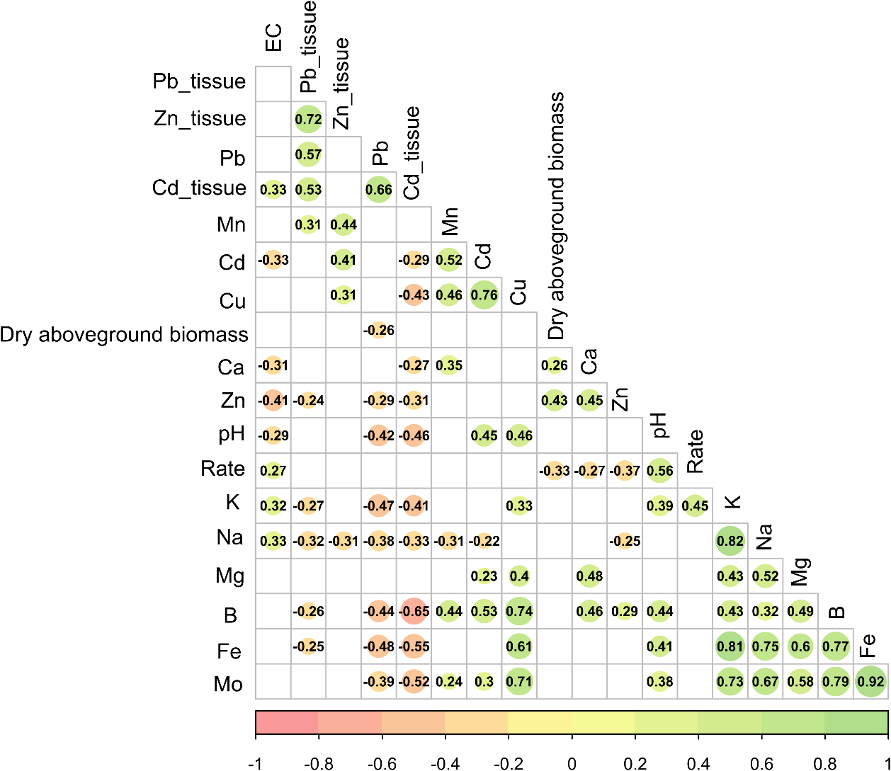
Fig. 4-19 Plot showing correlation between soil properties, bioavailable HMs and tissue HM concentrations in Sinapsis alba treatment. Data used: Cd, Pb, Zn, B, Cu, Na, K, Ca, Mg, Mn, Fe, Mo (NH₄-NO₃ extracts mg.kg⁻¹), pH (soil pH), EC (soil electrical conductivity, μS.cm⁻¹), HM_tissue (HM tissue concentrations mg.g⁻¹), dry above-ground biomass (mg.pot⁻¹), Rate (biochar application % w/w). Values in the matrix are the correlation coefficient (R) for parameters which had a correlation p < 0.05, non-significant correlations are shown in blank, α=0.05.

Discussion

Immobilization of HMs and relationship with soil properties
The lower bioavailable concentrations of Pb and Cd in the control groups (0% biochar) in the single Pb/Cd spiked soils and Mix-spiked soil at the end of the incubations relative to the initial bioavailable HMs (Table 4-1) are attributed in part to metal uptake by plants and metal loss during watering events (leaching). The soils were artificially contaminated and allowed to equilibrate for 2 months. It is possible that excess Pb and Cd remained in the soil even after the stabilization period, contributing to the higher initial bioavailability at day 0. Similarly, Zhou et al. (2019) found high initial bioavailable concentrations of Pb, Cd, Zn and As in a soil contaminated artificially. They reported that between 5-91 % of bioavailable metals (CaCl₂ extracts) were removed by leaching and 8-94 % (depending on the metal) were removed by plants during a 12 week incubation experiment. The authors concluded that stabilizing the soil for a limited period (1 month) produced HM concentrations in their study that did not fully reflect the behaviour of a soil contaminated for a long time.
The lower concentration of Pb and Cd in the Mix-spiked soil (0 % biochar) relative to the single element spiked soils observed in Experiment A and Experiment B could reflect the simultaneous presence of three HMs in the Mix-spiked soil. This could have promoted competition for sorption sites, affecting the individual retention of these metals by soil particles, despite the use of similar metal concentrations. Besides, it is possible that the alkaline pH of the soil enhanced the simultaneous co-precipitation of the metals in the presence of metal hydroxides or other soil elements such as Fe, thus decreasing Pb and Cd availability in the Mix-soil (0% biochar) relative to the Pb-spiked soil and Cd-spiked soil (0% biochar).
Coprecipitates of Pb and Cd with Fe oxides may form in contaminated soil at pH >5, limiting heavy metal mobility, solubility, toxicity, and bioavailability (Martínez and Mcbride, 2001). The formation of Fe-precipitates with Pb and Cd was not verified by XRD, but is consistent with the results of the cross-correlation analysis performed for the Mix-spiked soil in Experiment A (Fig. 4-13) and the cross-correlation analysis of Experiment B (Fig. 4-19), where negative correlations between bioavailable Cd and Fe and between bioavailable Pb and Fe were identified. In addition, it is possible that metal hydroxides of one of the HMs could have promoted the formation of Pb or Cd coprecipitates. Because most metals form sparingly soluble hydroxides, coprecipitation by hydrated metal oxides usually exhibits low selectivity, such that different metals can be coprecipitated simultaneously (Terada, 2000).
The reduction of bioavailable HMs (NH₄-NO₃ extracts) in the Pb/Zn/Mix-spiked soil treatments at 1 and 3 % biochar application rates is attributed to different sorption mechanisms supported by the biochar. The effect of different biochars and soil physico-chemical properties on the sorption of HMs is discussed in detail in the following sections.

Effect of soil pH and EC
The reduction in bioavailable concentrations of HMs was influenced by increases in the soil pH and EC (Fig. 4-11 and Fig. 4-17), corroborated in other studies (C. Amoah-Antwi et al., 2020; Shan et al., 2020; C. Xu et al., 2020). The increase in soil pH and EC after biochar addition is most likely due to the considerable amount of ash and base cations in biochar (Hailegnaw et al., 2019; Igalavithana et al., 2017). This is consistent with the significant correlation between biochar application rate and soil pH and EC in the cross-correlation analysis (Fig. 4-12, Fig. 4-13, Fig. 4-18, Fig. 4-19) and the positive correlation between soil pH, EC and water extractable Na⁺ and K⁺.
Besides, the low clay content (10%) of the soil used in this study (section 4.2.2) suggests a weaker ion retention ability, thereby promoting larger increases in EC due to the increase of water-soluble ions released from biochar, as proposed by Igalavithana et al. (2017). As a result of the increased soil pH, the mobility of Cd²⁺, Pb²⁺ and Zn²⁺ decrease due to a reduced competition between H⁺ ions and metal ions for cation exchange sites, either directly on the biochar surface or as a general liming effect on the soil matrix (Beesley et al., 2011). In addition, the high pH in the amended soils promote the formation of sorption sites on the negatively charged functional groups, or the formation of mineral precipitates, thus decreasing the bioavailability of HMs in the soil (Tang et al., 2013).

Soil CEC
With increasing soil pH the CEC of a soil generally increases due to the greater negative charge that develops on organic functional groups (e.g. from soil organic matter and biochar) and clay minerals due to deprotonation (Natasha et al., 2021; Sparks, 2003). C. Xu et al. (2020) reported a decrease in exchangeable Pb and Cd in soil but increase in exchangeable K⁺, Na⁺, Ca²⁺ and Mg²⁺ due to heavy metal immobilization by biochar, indicating that biochar can immobilize heavy metals through cation exchange mechanisms. In this study, the water extractable concentration (Experiment A) and bioavailable concentration (Experiment B) of K⁺ and Na⁺ increased with the addition of biochar (Table 4-2, Fig. 4-18, Fig. 4-19), while water extractable/bioavailable Ca²⁺, Mn²⁺ and Mg²⁺ decreased.
The decrease in water extractable Ca is likely to be associated with the release of phosphate from biochars, which may have promoted the formation of precipitates, as predicted with the speciation analysis for the Mix-soil in Experiment A (Table 4-3). The formation of CaHPO₄ and CaPO₄⁻ precipitates are reported to occur at pH > 7 and pH 7.5, respectively (Rice et al., 2010), which is consistent with the pH of the biochar-amended soils (pH >7.5).
The decrease of bioavailable Mg and Mn is possibly due to the increase in soil pH caused by biochar addition. Sims (1986) stated that exchangeable Mn decreased as pH increased due to transformation into the less available oxide fractions. Similarly Grove et al. (1981), indicated that Mg availability decreased with increasing soil pH due to lime application, the Mg-fixation was associated with the formation of a surface-solid phase involving Al. Conversely, the higher concentration of water extractable/bioavailable monovalent cations (e.g. K⁺ and Na⁺) is explained by their lower sorption potential (Rippy and Nelson, 2007). Overall, the results suggest that cation exchange, initiated mainly by monovalent cations released from the biochars, contributed to the sorption of HMs in the soils studied.

Effect of biochar application rate
Contrary to expectations the high biochar application rates (3% and 5% w/w) did not necessarily lead to greater reductions in bioavailable HMs in the soil studied. In both experiments A and B, biochars applied at 1% led to the highest reduction in bioavailable HMs. No significant differences with higher application rates 3 and 5 % were observed, except for Pb-soil (Experiment A) where biochars applied at 5% caused an increase in bioavailable Pb relative to the 1% application (section 4.3.2.1). These findings are consistent with that of C. Amoah-Antwi et al. (2020), who reported that a 5% (w/w) application of conifer wood chip biochar applied to a soil spiked with Pb, Cd and Zn was more effective reducing bioavailable Cd, Pb and Zn than a 10% (w/w) application rate. Similarly, Yin et al. (2016) reported that biochars derived from water hyacinth (BCW) and rice straw (BCR) applied at 2% (w/w) to a multi element contaminated soil were equally effective in reducing bioavailable concentrations of As, Cd and Pb, at a 5% (w/w) application.
However, other studies have shown more pronounced reduction in bioavailable HMs with higher biochar application rates. For example, Awad et al. (2020) reported that the most significant reduction in bioavailable Pb, Cd, Cu and Zn in heavy metal-contaminated soil occurred at a 6% (w/w) application rate of garden waste biochar, Paulownia biochar and bamboo biochar tested at 2%, 4% and 6% (w/w). Another study reported that the concentration of bioavailable Cd, Pb, Zn and Cu in a naturally contaminated soil decreased significantly (P<0.05) with increasing addition of bamboo biochar and rice straw biochar from 1 to 5 % (Lu et al., 2017). The different outcomes can be explained by the unique biochar properties, sorption capacities for specific heavy metals and their concentration in the soil solution, as well as the soil properties.
Previously, in batch sorption experiments using synthetic soil pore water (Chapter 3), the maximum sorption capacities (mg.g⁻¹) of the biochars used in this experiment were reported to be 46-19-9 (OSR550), 0.5-10-0.6 (SWP550), 42-18-6 (WSP550) and 41-42-3 (MSP550) for Pb, Cd and Zn, respectively (Soria et al., 2020). Considering these sorption capacities and the initial concentration of bioavailable HMs in the spiked soils (Table 4-1), the application of biochars at 1 % greatly exceed the dose theoretically required to immobilize the bioavailable fraction of HMs initially present in the Pb-soil, Zn-soil and Cd-soil treatments. This explains why higher application rates (3 and 5 %) did not enhance the further reduction of bioavailable HMs.
The presence of remaining bioavailable HMs in the soil, despite an excess of binding sites at high rates of biochar application, suggest that i) biochar cannot immobilize the total bioavailable HMs in soils, implying a limitation for sorption of low amounts of metals, or ii) immobilisation of HMs promoted by biochar may have displaced the soil equilibrium, enhancing the dissolution of more HMs into the soil solution. It is known that if the soil solution becomes undersaturated with respect to minerals in the soil, further dissolution of that mineral can occur until equilibrium is reached (Sparks, 2003).
The increase in bioavailable Pb observed with increasing biochar dosage in the Pb-soil in Experiment A (Fig. 4-1A) is consistent with previous findings. Igalavithana et al. (2017) showed that biochars derived from pine cone produced at 200°C and 500°C and applied at 5% (w/w) increased exchangeable Pb in a rice paddy soil. Similarly, Liu et al. (2020) reported that the addition of biochars produced from pig manure and Suaeda glauca at 2% and 4% (w/w) increased extractable Pb and Cd concentrations in red soil by up to 13.7 times and 6.83 times, respectively, compared with the control treatment. They explained the increased bioavailability of Pb and Cd by the dissolution of base cations from biochar that would compete with the ion exchange sites in the soil. This behaviour was described by Pourret and Houben (2018) as an ionic strength (IS) effect due to biochar addition. Classical IS effects arise from competition with surplus electrolytes (Ca²⁺,Na⁺) on biochar planar sites to form outer-sphere surface complexes (Strawn and Sparks, 1999; Uchimiya, 2014). Pourret and Houben (2018). stated that the immobilization of rare earth elements by biochar was more efficient at high than low ionic strength at acidic pH, whereas at more alkaline pH the opposite behaviour was observed.
The electric conductivity data (indicative for IS) and (alkaline) soil pH (Fig. 4-11) suggest that increasing the biochar application from 1% to 5 % (w/w) increased the soil IS, resulting in decreased Pb sorption. Despite a decrease in the amount of metal sorbed onto biochar, increasing IS favours metal sorption on high affinity sites according to Pourret and Houben (2018). This suggests that although less Pb was immobilized with the biochars at 3% and 5%, the amount that was sorbed could potentially be bound to high affinity sites, implying the formation of a stable reservoir for Pb.

Speciation of HMs
The sorption of HMs by biochar can be affected by environmental factors such as pH, surface loading, ionic strength, type of sorbent and time, all of which determine the type of sorption complex or product formed (Sparks, 2003). It has been reported that ash within biochar may help with the formation of insoluble mineral precipitates (Natasha et al., 2021). This was implied by the speciation analysis performed for the Mix-soil in Experiment A (Table 4-3), where phosphate precipitates with Pb and Zn were predicted.
The results from the speciation analysis agree with the increased bioavailable phosphate concentrations measured after the addition of biochars (Table 4-2). This is also consistent with previous reports that increasing available P induced by biochar can lead to a reduced extractability of HMs, potentially by precipitation and complexation with phosphate (X. Yang et al., 2016). The suggested mechanism proposed by Cao et al. (2011) is that phosphorus originally contained in the biochar induced conversion of less stable PbCO₃ to more stable Pb₅(PO₄)3OH, responsible for soil Pb immobilization. Some of the predicted Pb precipitates are pyromorphites, which are the most stable Pb phosphate minerals under normal environmental conditions. Chloropyromorphite [Pb₅(PO₄)₃Cl] is several orders of magnitude less soluble than other pyromorphites (Ryan et al., 2001). This suggests that Pb was immobilized as a stable form by the addition of biochar.
According to the speciation analysis and pH of the amended soils conducted in Experiment A, the dominant Pb species in the Mix-soil would be the hydrolyzed form PbOH⁺ (Table 4-3), which suggests that Pb sorption by biochar is mainly driven by the formation of inner-sphere complexes. The first hydrolysis product of divalent ions is capable of forming inner-sphere complexes with clay lattice edges or, in this case with biochar, result in stronger element retention than the electrostatic attraction of hydrated ion elements in soil (Shaheen et al., 2013). This result is in agreement with section 4.3.2.1 where the increase of bioavailable Pb with increasing biochar dosage, due to increased competition with base cations to form outer-sphere complexes, suggested that Pb binding was mainly by specific sorption (inner-sphere complexation). Hence in the context of Pb sorption these results imply that biochar will enhance the formation of stable Pb phosphate precipitates or inner-sphere complexes in the soil, which are often not reversible (Sparks, 2003).
The speciation analysis (Table 4-3) indicates that at pH < 8, Zn would be mainly present as Zn²⁺. This suggests that Zn sorption occurred mainly by electrostatic attraction. The speciation model also predicted the formation of Zn₃(PO₄)₂.4H₂O_{(s)}, which is consistent with the results of Melo et al. (2016), who reported the formation of Zn-phosphates precipitates enhanced by sugar cane biochar in a tropical Entisol. Overall, the data suggest that Zn sorption was mainly driven by electrostatic attractions (outer-sphere complexes) and to a lesser extent the formation of phosphate precipitates and inner-sphere complexes.
In aqueous solutions at pH < 8 Cd is present in a dissociated form as free ions Cd²⁺ or aqua ions [Cd(H₂O)₆ ]²⁺_{(aq)} (Anielak and Schmidt, 2011; Melo et al., 2016; Soria et al., 2020). Therefore, considering the pH of the amended soils (Fig. 4-11) and abundance of the predicted species in Table 4-3, it is inferred that Cd sorption occurred when the positively charged species (Cd²⁺ or aqua ions) dominated. Hence, it is concluded that Cd sorption at pH < 8, was associated with electrostatic attractions rather than precipitation. Metal sorption can be either non-specific (formation of outer-sphere complexes) or specific (formation of inner-sphere complexes). Outer sphere complexes are mainly electrostatic and not as strong as inner-sphere complexes. Thus, they are the main mechanisms responsible for the easily reversible ion exchange reactions in soil (Antoniadis and Tsadilas, 2007). This behaviour can be explained by the first hydrolysis constant (pK) of Cd²⁺ (10.1), which is higher than that of Pb²⁺ (7.71) and Zn²⁺ (9.0) (Park et al., 2016). The higher the hydrolysis constant of the element, the weaker the element specific sorption (Shaheen et al., 2013).

HMs in plant uptake
The results demonstrate that a decrease in the bioavailable concentration of HMs (NH₄-NO₃ extracts) enhanced by biochar addition does not necessarily lead to a reduced plant uptake. For example a decrease in the concentration of HMs in Arabidopsis thaliana and Lolium perenne above-ground tissue was expected in some plants grown in soils amended with 1% and 3% biochar since reductions in bioavailable HMs (Fig. 4-1, Fig. 4-14) were identified at this dosage. However, this only occurred in the Mix-soil for Arabidopsis thaliana and in the Zn-spiked soil (WSP550 3%) for Lolium perenne.
The findings are consistent with that of Karami et al. (2011), who reported that in spite of a reduction of > 67% Pb in pore water from a mining soil dosed with British oak biochar, the concentration of Pb in ryegrass shoots grown in the amended soils were not significantly different from the control (no biochar). Puga et al. (2015) also reported that sugar cane biochar (700°C) applied to a metal-contaminated soil significantly reduced available (diethylenetriaminepentaacetic acid, DTPA) concentrations of Pb, Cd and Zn. However, the translocation index (root-shoot) of these HMs for Jack bean plants grown in the amended soils increased compared with plants grown in the control group (no biochar).
Biochar addition did not prevent HM uptake in Sinapsis alba plants which, on the contrary, seemed to accumulate Cd and Zn. The concentrations of these HMs in Sinapsis alba tissue were at least 5 times higher than those of Lolium perenne plants in the same treatments (even in the control treatments without biochar). Besides, bioavailable HMs in Sinapsis alba soil tended to be lower than in Lolium perenne soil, suggesting plant uptake. Popoviciu et al. (2017) reported that Sinapsis alba grown in a media with excess Cr showed a significant potential for chromium phytoextraction. Similarly, Zalewska and Nogalska (2014) proposed Sinapsis alba as a possible alternative for phytoextraction and phytostabilization of Zn-contaminated soil.
Results from Arabidopsis thaliana and Lolium perenne indicate that the use of chemical extractants, such as NH₄-NO₃, do not accurately represent the phytoavailable HMs in contaminated soils. In this context, Zhang et al. (2016) concluded that common extraction techniques (i.e. water, CaCl₂, NH₄NO₃, HOAc, and EDTA) used to assess the bioavailability of metals in soil are unreliable in predicting the phytoavailability of most heavy metals in biochar-treated soils. This is because, besides bioavailability, two other processes determine metal exposure levels and metal accumulation in plants: uptake activity and efficiency of translocation, which depend on plant species (Clemens, 2006; Puga et al., 2015b).
Conversely, the concentrations of HMs in Arabidopsis thaliana tissue were consistent with the results of the plant physiological response expressed by Fv/Fm presented in Experiment A (Fig. 4-9). Fv/Fm values represent the maximum efficiency of photosystem II (PSII) after dark adaptation and have been widely used as an indicator of stress in plants (Martínez-Peñalver et al., 2011). Under normal conditions, healthy plants may have Fv/Fm values of 0.8 to 0.83 (Li et al., 2015; X. Xu et al., 2020), while lower values indicate plant stress or damage. The Fv/Fm results showed that the addition of biochars at 1% and 3% to the Mix-soil, characterized by Fv/Fm values < 0.8, had promoted a protective effect against the toxicity of HMs. No direct correlation was found between Fv/Fm and HMs-tissue concentration (Fig. 4-12), although a significant relationship was found between available Pb/Cd and Fv/Fm (Fig. 4-13). In part this could be because the concentration of HMs in the roots was not analysed.
This lack of correlation also reflects the complexity of HMs plant uptake. Several factors can affect the uptake mechanism of HMs by plants: root zone, the plant species, bioavailability of the metal, environmental conditions, chemical properties of the contaminant, chelating agent added and properties of the medium (Kutrowska et al., 2017). Overall, the results suggest that fluorescence imaging Fv/Fm is sensitive to changes of HMs concentration in plants and correlates well with other plant performance indicators (absolute growth rates (AGRs) and above-ground biomass) (Fig. 4-12, Fig. 4-13). This demonstrates that Fv/Fm can be used as an alternative method for the indirect determination of HM toxicity in plants, rather than the traditional acid digestion which is often dangerous and time consuming. Fv/Fm measurements can provide useful information for monitoring plant response to biochar amendments on HMs-contaminated soils. This method is non-invasive, highly sensitive, rapid, reliable and, in parallel with the detection of HMs in soils, represents a good screening tool (Żurek et al., 2014).
The increased concentration of base cations released from biochar could explain why Cd concentration in Arabidopsis thaliana grown in soils amended with biochars tended to increase. Previous reports suggest that the presence of some base cations in soils can enhance Cd uptake by plants. Zhao et al. (2004) reported that when K⁺ increased from 0 to 55 mg kg⁻¹, the concentration of Cd in shoots increased by 60–90% respectively, which suggested that K⁺ itself may increase Cd plant uptake. Similarly, Wu et al. (2002) demonstrated that Cd concentrations in wheat grains were positively correlated to soil salinity, especially to Na⁺ and Cl⁻ ions. Thus, increased concentrations of K⁺ and Na⁺ released from biochar at high application rates could have enhanced the uptake of Cd by A. thaliana in the Cd-soil.
This is consistent with the chlorosis observed in plants grown in Cd-soil (Fig. 4-2, Fig. 4-3) after addition of biochars OSR550, WSP550 at 3% and 5%, which have higher K content (Chapter 3, Table 3-1). It is reported that plants grown in soil containing high levels of Cd show visible symptoms of injury, reflected in terms of chlorosis, growth inhibition, browning of root tips and finally death (Nagajyoti et al., 2010). This is consistent with the symptoms observed in Arabidopsis thaliana after addition of these biochars to the Cd-soil.
Also the dry above-ground biomass of Sinapsis alba was the lowest in the Cd-spiked soil amended with biochar, which was not observed in the control (no biochar) nor in the Non-spiked soil. Although the Cd concentration in Sinapsis alba above-ground tissue was not different from the control (0% biochar), it is possible that metal was being concentrated in roots which were not analysed. Zalewska and Nogalska (2014) reported that root fragments of Sinapsis alba accumulated higher concentrations of heavy metals than above-ground plant tissue.
The results from the Arabidopsis thaliana and Sinapsis alba incubations suggest that some plants from the Brassicaceae family are negatively affected by biochar in Cd-contaminated soil. Although the specific mechanism is not clear, it is possible that excess of K⁺ interferes with transmembrane carriers involved in the uptake of nutritional ions. Many reports suggest that Cd, Pb and Ni enter plant cells via activated Ca²⁺ and/or K⁺ channels (Amari et al., 2017; Luo et al., 2016). This could result in the uptake of potentially toxic elements instead of essential nutrients, causing plant mortality (Melo et al., 2016). It is important to highlight that Arabidopsis thaliana (Col) does not originate from a metal-rich soil (Arrivault et al., 2006) and has been reported to be a non-accumulator (Luo et al., 2016).

Plant response to biochar amendments
Plant response to biochar amendments varied depending on plant species. The contrast between enhanced plant biomass observed at 1% biochar dosage and the growth inhibition observed at 3% and 5% dosage observed with Arabidopsis thaliana (Fig. 4-4) is associated with an increased soil pH at the higher rate of biochar application (Fig. 4-12), but is most likely due to the increased K⁺ and Na⁺ content released from biochar. Similarly, Sinapsis alba was negatively affected by the addition of WSP550 even in the un-contaminated soil (Fig. 4-15), demonstrating that the sensitivity of this species is not associated with HM toxicity but to biochar addition exclusively.
The correlation analysis suggests that it is not biochar pH directly that inhibits plant growth at 3% and 5% addition, but the chemical species (Na⁺ and K⁺) within the biochar (Fig. 4-12, Fig. 4-19). These monovalent cations increase with biochar application rate, and simultaneously biochar addition increases the soil pH which negatively affects the bioavailability of Ca²⁺, Mn²⁺ and Mg²⁺. These conditions may have contributed to the detrimental effects observed on the Arabidopsis thaliana and Sinapsis alba plants, after addition of some biochars at 3% and 5% (Fig. 4-4, Fig. 4-15), hence suggesting that some plants from the Brassicaceae family are more sensitive to biochar addition.
The results are in accordance with that of Awad et al. (2020), who reported that dry biomass of Brassica juncea plants were significantly boosted by garden waste biochar at applications of 2% and 4% (w/w), while a decline was observed at 6% (w/w), despite reductions in extractable Pb, Cd and Zn. Buss et al. (2016) reported that elevated biochar pH caused growth suppression of Lepidium sativum seeds in germination tests in a 5% (w/w) biochar-sand mixture. They attributed the high pH of the biochars to K salts (Buss et al., 2016). Rajkovich et al. (2012) reported increased soil pH and EC with increasing biochar application rates from 0% to 7%. It was shown that Na negatively affected crop growth (corn) at 7% biochar, causing an 80% decline.
In the present study there was a correlation between soil pH and water extractable K⁺ and Na⁺, and a negative correlation between above-ground biomass and these water extractable cations (Fig. 4-13B, Fig. 4-19). This confirms that the growth inhibition at high biochar application rates is associated with an increased salinity of the soil, caused mainly by the dissolution of K⁺ and Na⁺ salts from biochar. Álvarez-Aragón et al. (2016) concluded that the growth inhibition of Arabidopsis thaliana under salinity was either due to osmotic stress or over-accumulation of K⁺ and Na⁺ that might induce the inhibition.
High salinity conditions cause osmotic stress to plants because of a water deficit created by the decreased osmotic potential in the soil solution (Zhu, 2007). It has been reported that soil salinity interferes with the growth and development of several crops of the Brassicaceae family in two ways: (i) by disturbing the osmotic relationship of tissues and, (ii) by specific ion effects (Singh et al., 2019). Conversely, Lolium perenne was not affected by biochar addition, suggesting it is less sensitive to soil salinity. Hu et al. (2012) studied the salinity tolerance in perennial ryegrass, and concluded that some genotypes of perennial ryegrass possess antioxidant genes, which contribute to plant defense against salinity stress.
The decrease in Fv/Fm observed in Experiment A with some biochars at 3% and 5% (w/w) relative to the control (0% biochar) (Fig. 4-10) is consistent with the osmotic stress generated in Arabidopsis thaliana by the increased soil salinity previously discussed. It implies that in spite of a lower bioavailability of HMs, plant stress was not decreased due to the osmotic stress induced by biochars at high dosages. However, the slopes of the linear models used to study Fv/Fm over time indicate that the osmotic stress induced by biochars can be temporary, as the mean Fv/Fm values of plants grown in the biochar-amended soils show a steady increase over time.
This indicates that if plants survive the initial stage where salinity and osmotic stress delayed plant germination and inhibited plant growth, they can potentially recover from osmotic stress damage to the point of showing no signs of stress. This conceptual model implies that after this first stage, plants would grow well as the soil toxicity originating from metals would be decreased, with less competition for nutrients and light due to less plants reaching this point. They should increase in size, as observed in Fig. 4-2 and Fig. 4-3. Conversely, the mean Fv/Fm values of the Mix-soils amended with biochars suggest that the stress induced by the presence of multiple contaminants in the Mix-soil outweighed the osmotic stress induced by biochar, showing overall higher Fv/Fm ratios for the biochar-treated soils than the control treatments. Overall, the results demonstrate that Fv/Fm is sensitive to changes in HMs in plant tissue and other stress conditions such as osmotic stress.
The higher growth rates (AGRs) of Arabidopsis thaliana Col-0 observed at 1% (w/w) in Zn-soil, Pb-soil and Mix-soil (Fig. 4-6) are consistent with the dry biomass results (Fig. 4-4). The cross-correlation analysis demonstrated a strong positive correlation (R= 0.9) between these two plant performance indicators, illustrating the feasibility of using rapid imaging techniques for the assessment of biochar-amended soils instead of traditional destructive measurements. Weraduwage et al. (2015) reported a linear relationship between leaf mass and plant mass during the vegetative phase of A. thaliana; at this stage leaf mass could provide a reasonably accurate estimation of plant mass.
The lower AGRs of plants grown on soils amended with biochars at 3% and 5% (w/w) are associated with diminished photosynthetic efficiency (Fv/Fm) due to the osmotic stress caused by high biochar applications. Despite the absence of statistically significant differences in some treatments (Fig. 4-4, Fig. 4-6), biochars applied at 1% (w/w) generally enhanced growth rates (AGR) and plant biomass, highlighting the biological significance of the role of biochar in protecting plants from HM toxicity. The steady increase of AGRs for Arabidopsis thaliana in soil with 1% biochar during the vegetative phase indicates that the favourable response of plants to biochar amendments would continue over the mid-term.
Although the analysis of plant biomass (fresh or dry weight) is common practice, the use of continuous monitoring techniques, such as imaging green leaf area, will allow links to be established between scales of biology, from physiology and metabolism, to community dynamics (Paine et al., 2012). This will provide further understanding of the effect of biochar in reducing the ecological toxicity of HMs in contaminated soils and more accurate predictions of plant establishment, since leaf area can be used as a parameter to predict overall growth (Weraduwage et al., 2015).

Implications for soil remediation
Some biochars may have a high sorption capacity for HMs in soil, which could prevent metals from entering water courses and reduce the accumulation of trace elements by living organisms. However, biochars can have a high pH and salt content according to the source of the feedstock, which may negatively impact soil health and plant development due to osmotic stress (Joseph et al., 2021; Stefaniuk et al., 2016; C. Xu et al., 2020).
It is important to determine whether the goal of biochar application in soil is the immobilization of HMs only, or if revegetation is also desired. If the establishment of plants is intended, the selection of biochar and the estimation of application rates should carefully consider the composition and physicochemical properties of both the soil and biochar. Hormesis is commonly observed in biochar applications, that is, high rates of biochar can have a detrimental effect, while low rates can be stimulatory (Joseph et al., 2021). Consequently, low biochar application rates should be preferred over high application rates, which might negatively affect soil properties required for successful plant development as well as creating unnecessary additional costs in biochar use.
The specific sensitivity of different plant species to biochar related factors, such as salinity and water availability, may result in very variable results (Joseph et al., 2021). The remediation and revegetation of HM-contaminated soils with biochar can yield successful results if used in combination with salt tolerant plants (halophytes) to overcome the potential osmotic stress created by the use of some biochars. Besides, it has been suggested that halophytes show high potential to tolerate and concentrate heavy metals in their tissues by triggering detoxification mechanisms (Amari et al., 2017; Cheng et al., 2018). Therefore, the use of halophytes may offer an alternative approach that combines phytoremediation and chemical stabilization with biochar addition for a more efficient soil remediation. This would allow amended soils with a vegetative cover to be repurposed into different land uses which may be determined depending on the level of ecological risk.

Conclusion
The potential protective effect of biochar to plants cultivated in HM-contaminated soil depends on plant species and biochar properties. The addition of biochar had a protective effect to Arabidopsis thaliana grown in a multi-element metal-contaminated soil. The protective effect was indicated by an increased plant biomass and absolute growth rates, decreased plant stress and lower HM concentrations in plant tissue. However, this protective effect was overall not observed in Arabidopsis thaliana grown in the single element metal-contaminated soils, nor in Lolium perenne or Sinapsis alba plants, despite the reduced HM bioavailability due to biochar addition.
The lowest biochar application rate of 1% (w/w) resulted in the highest immobilization of the bioavailable HMs in soil. Higher biochar application rates of 3% and 5% (w/w) did not provide any further decrease in bioavailable HMs, but instead caused growth inhibition of Arabidopsis thaliana and Sinapsis alba due to the increased salinity that led to osmotic stress in the plants. Lolium perenne plants showed tolerance to the salinity induced by biochar addition. The salinity in the soil was associated with a relatively high K⁺ and Na⁺ content released from the biochars. The immobilization of Pb was associated with precipitation and sorption by inner sphere complexation, whereas Cd was retained by electrostatic attraction (outer sphere complexes) and Zn was retained by a combination of electrostatic attraction, inner-sphere complexes and precipitation.
The results indicate that plant-based biochars can reduce trace metal bioavailability in soils at low biochar application rates. However, soils may need to be managed with caution, because biochar can reduce metal bioavailability but plants can still accumulate metals in their tissues. This may limit the type of land use for the amended soils.

The effect of biochar on bioavailable Pb(II) and Zn(II) and its influence on soil health: an outdoor pot experiment

Introduction
The contamination of soil by heavy metals (HMs) can have marked and persistent effects on soil characteristics and function by disturbing both soil biological and physiochemical properties (e.g. poor soil structure, soil fertility and soil microbial activity) (Abdu et al., 2017; Lwin et al., 2018). Ecotoxicological studies have shown decreased microbial populations and alterations in microbial diversity and structure as a result of HM toxicity (Abdu et al., 2017). Because microbes play a vital role in soil productivity and sustainability, some soil functions, such as nutrient cycling, may be impeded by HM toxicity. Soil is a complex, dynamic and living resource (Bruyninckx, 2019), but once contamination exceeds a certain threshold, the soil may be considered ‘functionally dead’ due to damage to the soil microbial community (Lwin et al., 2018). Therefore, holistic remediation technologies are required, to reduce metal concentrations and simultaneously improve soil functioning.
In situ chemical stabilisation of metals in soil by the addition of suitable amendments can be relatively low cost and facilitates the treatment of large areas of contaminated land (Venegas et al., 2016). Of the numerous amendment materials used for in situ stabilization of HMs, biochar has proven to be successful at immobilizing and reducing the bioavailability of HMs, hence restoring chemical, physical, biological and ecological functionality of soil (Zeng et al., 2015; Amoah-Antwi et al., 2020). Biochar can reduce the environmental bioavailability of metal ions in soil through a variety of adsorption, complexation, precipitation, and redox reactions and decrease the toxicity of soil contaminants to soil microbes (Lwin et al., 2018; Zhu et al., 2017).
Recently, it has been proposed that mixing biochar and compost could improve the effectiveness of biochar for HM immobilization (S. Wu et al., 2017; Zeng et al., 2015). The addition of organic material, such as compost, plays an important role in determining HM availability, through changes in soil chemical properties and metal-chelating ability. This favours the complexation of HMs and reduces metal bioavailability in soil (Al Chami et al., 2013). Compost can also ameliorate ecological functionality and improve the physical and chemical properties of degraded soils (Amoah-Antwi et al., 2020; Noller et al., 2021), which often increases soil microbial activity (Li et al., 2018). The combined application of compost and biochar as soil amendments is inexpensive and sustainable, providing synergistic effects on soil remediation, plant growth and microbial processes (S. Wu et al., 2017; Ye et al., 2016). However, as mentioned by Zeng et al. (2015), the interaction between biochar and compost requires further studies to maximize the potential benefits of both.
One uncertainty concerning the use of biochar, or combined use with compost, is the potential remobilization of HMs. For instance, Beesley et al. (2010) reported that the application of biochar and green waste compost effectively reduced Zn and Cd concentrations in soil pore water, but increased As and Cu concentrations at least 30-fold due to an increase in pH and dissolved organic carbon (DOC), especially in the treatment that combined both amendments.
Another uncertainty concerns the fate of HM in the long term. Immobilization approaches are generally effective and low cost, but the long-term stability of a system has to be monitored constantly to prevent future environmental risks (Lwin et al., 2018). Joseph et al. (2021) classified the duration of biochar experiments based on the interactions between biochar, soil and plants in the context of the annual crop cycle, establishing that short-term studies last 1-3 weeks, medium-term 1-6 months and long-term more than 6 months. In this context, most studies to date on the use of biochar to treat HM-contaminated soils are short to mid-term (Karami et al., 2011; Puga et al., 2015b; Yin et al., 2016) and often use artificially contaminated soil (Park et al., 2011; Younis et al., 2016; Amoah-Antwi et al., 2020) which do not accurately represent the behaviour of long-term contaminated soils.
Only a few studies have explored the stability of HMs immobilized by biochar in the long-term. For example, Bian et al. (2014) reported that after a 3 year field experiment wheat straw biochar still reduced soil extractable Cd and Pb. Recently, Bandara et al. (2021) reported a long term study (270 days) using poultry-litter biochar and sugar-gum-wood biochar to immobilize Cd in an artificially contaminated soil. They reported that although the use of both biochars initially reduced Cd bioaccumulation in Brassica rapa, after 270 days sugar-gum biochar increased Cd bioaccumulation while poultry-litter biochar decreased Cd bioaccumulation. Hence, the long-term fate of HM in soils amended with biochar specially under field conditions remains unclear.
Similarly, studies have investigated the effect of biochar on microbial dynamics in HM-contaminated soil by different methods, including next generation sequencing (Jien et al., 2020), enzymatic activities (X. Yang et al., 2016), phospholipid fatty acids PLFAs (Igalavithana et al., 2017; Wawra et al., 2018) and basal respiration (Bandara et al., 2021), but most have focused on the impact of biochar on bacterial populations rather than fungal populations. Despite acknowledging the link between above-ground and below-ground microbial communities, there is still a lack of mechanistic understanding on how communities facilitate the restoration of highly degraded environments such as post-mining landscapes (Kumaresan et al., 2017). Thus, the complex interactions between biochar, microbial communities, plants, HMs and soil physical properties in this important setting are not fully understood.
In order to address these knowledge gaps, the aim of the research described in this chapter was to study the ability of biochar to reduce bioavailable HMs from a mining soil in a long-term outdoor pot experiment. The objectives of this study were to:
- examine the effect of biochar, and biochar combined with compost, on the immobilization of bioavailable HMs and soil quality in the long-term, under variable environmental conditions;
- determine the impact of biochar, and biochar combined with compost, on soil microbial (bacterial and fungal) abundance and composition;
- determine the effect of biochar, and biochar combined with compost, on plant growth over two growing seasons.

Materials and Methods
Wemyss Mine is located in South Wales near the village of Pont-rhyd-y-groes, Ceredigion (UK), and covers approximately 11 hectares (Edwards et al., 2016). The mine produced lead and zinc ore from the late 1700s until the early 1900s, when it fell into disuse. From 1924 to 1930 the waste dumps were reworked to reclaim zinc and lead. As a result, copious amounts of contaminated waste material is present (Fig. 5-1), which in combination with drainage from underground workings pose a serious threat to the ecological and environmental health of nearby watercourses (Lort, 2017).
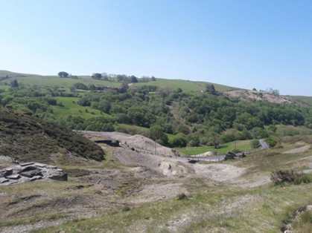
Fig. 5-1 Overview of Wemyss mine.

Soil collection
Soil from Wemyss mine was sampled from the top surface layer (20-40 cm) at three points (A, B and C) selected randomly within an 8 meter distance. Approximately 25 kg of soil was collected from each point. Soil was placed in plastic bags and transported to the University of Sheffield where the samples from the 3 sampling points were combined to create a composite sample and stored at 4 °C.

Soil, biochar and compost characteristics
Two kg of soil was used for particle size distribution analysis following the British Standard BS1377 (British Standards, 2018). An aliquot (1 kg) of the composite soil was dried at 40 °C and sieved < 2 mm for physico-chemical analysis. The methods used for the characterization of the soil are described in Chapter 4, section 4.2.2. Wheat straw pellet biochar produced at 550 °C (WSP550) was provided in February 2019 by the UK Biochar research Centre (Edinburgh, UK). The garden waste compost was produced at the Green Estate Waste Recycling facilities (Sheffield, UK). The compost complied with the PAS 100:2018 specifications for composted materials. The characteristics of the soil, selected biochar and compost properties are shown in Table 5-1.

Table 5-1 Characteristics of experimental soil and biochar WSP550, values are means ± standard deviation; n =3.
Soil |  |  |  | WSP550 biochar |  |  | Compost
 | Total  mg.kg⁻¹ | Bioavailable  mg.kg⁻¹
Cd | 5 ± 5 | 0.05 ± 0.00 |  | Temperature (⁰C)^{d} | 550 |  | pH | 8.4 ± 0.1
Co | 67 ± 8 | 0.26 ± 0.07 |  | pH ^{d} | 9.9 ± 0.2 |  | EC [μS.cm⁻¹] | 772 ± 39
Cr | 135 ± 14 | 0.01 ± 0.00 |  | H:C_{tot} (molar ratio) ^{d} | 0.4 ± 0.1 |  | OM % | 8.8 ± 0.3
Cu | 174 ± 9 | 0.22 ± 0.05 |  | O:C_{tot} (molar ratio) ^{d} | 0.1 ± 0.0 |  | Olsen Phosphate [mg.kg⁻¹] | 51 ± 2
Ni | 129 ± 16 | 0.17 0.02 |  | EC [dS.m⁻¹] ^{d} | 21 ± 1 |  | Nitrate  [mg.kg⁻¹] | 49 ± 5
Pb | 6314 ± 1880 | 302 ± 91 |  | BET [m².g⁻¹] ^{b} | 299 ± 3
Zn | 1655± 64 | 10 ± 2 |  | CEC [cmol.kg⁻¹] ^{b} | 21 ± 2
pH | 4.7 ± 0.1
WHC % | 21 ± 1
DOC  mg.L⁻¹ | 138 ± 17
OM % | 2.4
Clay % | 12
Sand % | 70
Gravel % | 18
Total: Aqua regia digestion
Bioavailable: NH₄-NO₃ extract
^{d} Data reproduced from UK Biochar Research Centre, *= dry basis
^{b} Data from (Soria et al., 2020)
WHC: water holding capacity, DOC, dissolved organic carbon, OM: organic matter, EC: electric conductivity, BET: Brunauer, Emmett and Teller surface area, CEC: cation exchange capacity.

Outdoor pot experiment
Soil samples were transported to the Arthur Willis Research Centre (The University of Sheffield, UK) for the outdoor experiment. Soil was dried at 20 ± 5 °C for 1 week and sieved through a 2 cm stainless sieve. Square plastic pots (width 10 cm, depth 20 cm) were lined at the bottom with fiberglass to avoid soil loss through the drainage holes. The pots were filled with soil or soil supplemented with organic amendments (biochar, compost, or both), as follows:
- Soil (S):1.2 kg of contaminated soil
- Soil and biochar (S+B): 1.164 kg soil and 36 g biochar (3 % w/w or 73 t.ha⁻¹)
- Soil and compost (S+C), 976 g of soil and 224 g of compost (18 % w/w or 380 t.ha⁻¹)
- Soil, compost and biochar (S+C+B): 940 g of soil, 36 g of biochar (3% w/w) and 224 g of compost (18 % w/w)
An aliquot (1.0 ± 0.1 kg) of soil from each treatment was used to characterize the physico-chemical properties, using the methods described in section 5.2.2. Deionized water was added to each pot until water holding capacity was reached, then the pots were allowed to equilibrate for one week at 22 °C in the dark. After this time, the pots were perforated at 10 cm height and Rhizon soil moisture samplers (Rhizon MOM, 10 cm, Eijkelkamp Agrisearch Equipment, Netherlands) were inserted through the wall. The pots were protected with insulation material (100mm GA4100, Celotex, UK) to prevent overheating in summer or freezing in winter. Half of the pots were planted (P) and the rest unplanted (U).
For planting, 100 seeds of perennial ryegrass (Lolium perenne) were added per pot. Each treatment was replicated four times giving a total of 32 pots, 16 pots with plants (S, S+C, S+C+B, S+B) and 16 unplanted (S, S+C, S+C+B, S+B). The pots were placed on a raised bed in the outdoor compound at Arthur Willis Research Centre and left for 18 months (April 2019-October 2020) under ambient environmental conditions. Fig. 5-2 shows the experimental set up. Deionized water (300 mL) was added to each pot from June to August if more than 2 consecutive weeks without rainfall occurred.
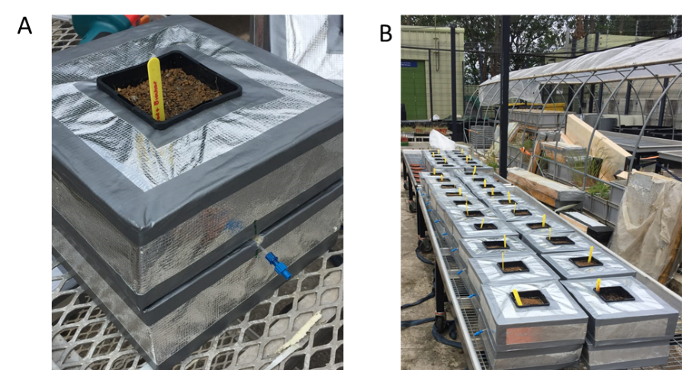
Fig. 5-2 Outdoor pot experiment: A) individual pot with insulation cover and Rhizon sampler inserted; B) all 32 pots on the raised bed at the outdoor compound.

Soil pore water analysis
Soil pore water was collected from Rhizon samplers after 2, 6 and 18 months for chemical analysis. Electrodes were used to determine pH (Orion 5 star FB68800, Thermo, USA, pH meter and electric conductivity (470 portable conductivity/TDS meter, JENWAY, China). In order to monitor HM mobility, separate aliquots of soil pore water were filtered using 0.45 µm syringe filters (Non-sterile PTFE Syringe Filter, Fisherbrand™, USA) and acidified with 1 % trace analysis grade HNO₃ (Primar Plus™ > 68%, Thermo Fisher, Sweden) for the analysis of trace elements by ICP-OES (Optima 7300, Perkin Elmer, USA).

Plant analysis
Plants were harvested in September 2019 (6 months) and at the end of the experiment in September 2020 (18 months). Plant above-ground tissue was cut 1 cm from the soil, placed in paper bags and dried at 40 °C for 10 days, then weighed. Thereafter, plant tissue was finely ground with a mortar and pestle; 200.0 ± 0.3 mg was placed into 15 ml glass tubes and digested with 5 mL HNO₃ (Primar Plus™ > 68%, Thermo Fisher, Sweden) in a heating block at 120 °C for 4 hours (Wawra et al., 2018). Trace elements were determined by ICP-OES (Optima 7300, Perkin Elmer, USA).

Soil analysis
At the end of the experiment after harvesting plants, soil samples were taken from each pot at ~10 cm depth. Approximately 100 g of soil was taken from three different points and mixed to create a composite sample representative of each pot. The composite sample was split in two, one aliquot for physico-chemical analysis and the other for DNA extraction (section 5.2.7). The soil aliquots intended for DNA extraction were stored at -80 °C until processed. Soil samples intended for physico-chemical analysis were dried at 40 °C for 10 days and sieved through a 2 mm stainless steel sieve after grinding manually with a mortar and pestle.
Organic matter was determined using the K₂Cr₂O₇ titration method with FeSO₄ following the British Standard BS1377 (British Standards, 2018). Plant-available phosphate and nitrate were determined by the Olsen (Iatrou et al., 2014) and vanadium chloride (Miranda et al., 2001) methods, respectively. These methods are described in detail in Chapter 4, section 4.2.4.6. Ammonium was determined according to ISO, (1997) by mixing 2.0 ± 0.3 g of soil with 20 mL of 2 M KCl solution for 1 hour at 120 rpm; samples were filtered through 0.45 μm syringe filters (Non-sterile PTFE Syringe Filter, Fisherbrand™, USA) and NH₄⁺ determined with a continuous flow analyser (San+, Skalar Analytica, Netherlands). Soil pH (Orion 5 star FB68800, Thermo, USA, pH meter) and EC (470 portable conductivity/TDS meter, JENWAY, China) were measured in a 1:2.5 (w/v) suspension of soil in de-ionised water.

Sequential extraction
Soil samples were analysed with the Community Bureau of Reference (BCR) three-step sequential extraction procedure modified by Pueyo et al. (2008). Initially 1.0 ± 0.3 g of soil was placed in 50 mL plastic tubes and treated following the procedure described in Table 5-2. The final product of each step was separated by centrifugation at 1000 g for 20 min, the supernatant filtered through 0.45 μm syringe filters (Non-sterile PTFE Syringe Filter, Fisherbrand™, USA), collected in 15 mL polyethylene tubes and stored at 4 °C until analysis.
After the extraction of each fraction, the sediment was washed to remove the residue of reagent used in previous steps by shaking for 15 min at 30 rpm with 20 mL of deionised water and then centrifuged 1000 g for 10 min, discarding the supernatant. All extracts were filtered through 0.45 µm filters (Non-sterile PTFE Syringe Filter, Fisherbrand™, USA) and stabilized by the addition of 1% of trace analysis grade HNO₃ (Primar Plus™ > 68%, Thermo Fisher, Sweden). Samples were stored at 4°C until analysis by ICP-OES (Optima 7300, Perkin Elmer, USA). Major elements (K, Na, Al, Ca, Fe and Mn) and trace metals (Cd, Cr, Cu, Ni, Pb and Zn) were determined in the different extracts described in Table 5-2.
Table 5-2 Three step BCR sequential extraction procedure conditions, as modified by Pueyo et al. (2008)
 | Fraction | Reagent | Shaking time
AS | Exchangeable and weak acid soluble | 40 mL of 0.11 mol.L⁻¹ acetic acid | 30 ± 10 rpm at 22 ± 5 °C for 16 h
RD | Reducible fraction | 40 mL of 0.5 mol.L⁻¹ hydroxylammonium chloride (Merck pro-analysis) acidified 2.5 % v/v with 2 M HNO₃ | 30 ± 10 rpm at 22 ± 5 °C for 16 h
OX | Oxidisable fraction | -10 mL of 8.8 mol.L⁻¹ hydrogen peroxide  30% solution (Perhydrol™)  -10 mL of H2O2  -50 mL of 1 M ammonium acetate (pH2) | -1 h at 22 ±5 °C + 1 h at 85 ±2 °C (water bath)  - 1 hour 85 ±2 °C  - 30 ± 10 rpm at 22 ± 5 °C for 16 hours
RES | Residual | Aqua regia (7 mL of HNO₃ 37% + 2.3 mL HNO₃ >68 %) | 4 hours at 120 ⁰C

DNA extraction
Frozen soil samples (-80 °C) were thawed at 22 °C for 3 minutes and DNA was extracted using a DNeasy PowerSoil Pro Kit extraction kit (Qiagen, Germany). Approximately 250 ± 10 mg of soil from each pot was used; the extraction followed the manufacturer’s instructions (Qiagen, 2021). The protocol is illustrated in Appendix 4. The final DNA extract was diluted to 70 μL and stored at -20 °C. Two μL of DNA were used to determine the concentration of DNA in the extracts using a Qubit™ dsDNA HS Assay Kit and benchtop fluorometer Qubit® 3.0 (Thermo Fisher Scientific, Malasya).

Relative quantitation q-PRC
Soil bacterial and fungal DNA was quantified using Real-Time Quantitative Reverse Transcription PCR (qRT-PCR) to estimate bacterial and fungal total abundance per gram of soil, based on gene copy numbers. Aliquots of DNA were normalized to 1 ng μL⁻¹. Soil DNA was amplified in the same run with the DNA of either E. coli or C. tropicalis as standards for bacterial and fungal DNA, respectively.
Bacterial DNA was amplified using the primer pair 799F (5′-AACMGGATTAGATACCCKG-3′) and 1193R (5′-ACGTCATCCCCACCTTCC-3′) that targets the 16S rRNA gene (regions V5V6V7), while fungal DNA was amplified using primer ITS3 F (5′-GCATCGATGAAGAACGCAGC-3′) and ITS4 R (5′-TCCTCCGCTTATTGATATGC-3′) that target the ITS2 sequence located between the 5.8S and 28S rRNA genes. The following assumptions were made: the genome of E.coli is 4.7 Mbp (Blattner et al., 1997), therefore 1 ng of DNA of E.coli contained 1.941 $×$ 10⁵ copies of the genome. Each genome contains seven 16S gene copies (Johnson et al., 2019), hence 1 ng of E.coli DNA would contain 1.36 $×$ 10⁶ 16S gene copies.
Similarly, C. tropicalis genome is 14.5 Mbp (Zuza-Alves et al., 2017), therefore 1 ng of C. tropicalis DNA contains 6.39 $×$ 10⁴ copies of the genome. The C. tropicalis genome has 55 copies of the unit that encodes the 18S gene and each unit encodes a single copy of the 18S gene (Jones et al., 2004). Therefore, 1 ng of C. tropicalis DNA would contain 3.5 $×$10⁶ 18S gene copies. The DNA of E.coli was serially diluted from 1 ng.μL⁻¹ to 0.00001 ng.μL⁻¹ (1.36 $×$ 10⁶ to 1.36 16S gene copies) and DNA from C. tropicalis was diluted from 1 ng.μL⁻¹ to 0.00001 ng.μL⁻¹ (3.5 $×$10⁶ to 3.5 18S gene copies) to serve as standards. The 10 μL reactions contained 1 μL of input DNA, 5 μL of mastermix, 0.4 μL of each primer (10 μM) and 3.2 μL of nuclease-free water. The master mix used was SensiFast™ SYBR® No-ROX Kit (Bioline, Germany). All standards were amplified in triplicate and the samples in duplicates. Amplification was performed using a real-time PCR Thermocycler (RG-6000, Corbett Research, UK). The conditions used for the amplification were: hold at 95 °C for 3 min followed by 40 cycles of 95 °C for 3 min + 62 °C for 10 s + 72 °C for 10 s, the temperature ramp was from 61 °C to 95 °C.

rRNA gene fragment library preparation
Based on the DNA concentrations measured with Qubit (section 5.2.7), DNA aliquots from each sample were normalized to 5 ng.μL⁻¹ and used for DNA amplification. Three replicates from each sample were amplified in separate PCR reactions using different primers for bacterial and fungal DNA. For bacterial DNA amplification the primer pair bact-0341 F (5′ CCTACGGGNGGCWGCAG -3′) and bact-805 R (5′- GACTACHVGGGTATCTAATCC -3′) (Klindworth et al., 2013) were used.
For fungal DNA amplification, the primer pair 5.8S_Fun F (5′- TCGTCGGCAGCGTCAGATGTGTATAAGAGACAG -3′) and ITS4_Fun R (5′- GTCTCGTGGGCTCGGAGATGTGTATAAGAGACAG -3′) were used (Lee Taylor et al., 2016). Primers had the Illumina overhang adapter sequences F (5′- TCGTCGGCAGCGTCAGATGTGTATAAGAGACAG-[locus-specific sequence] -3′) and F (5′-GTCTCGTGGGCTCGGAGATGTGTATAAGAGACAG-[locus-specific sequence] -3′) (Illumina, 2013).
The 20 μL reactions contained 11.8 μL of nuclease-free water, 4 μL of MyTaq buffer (Meridian Bioscience, USA), 0.4 μL of forward primer (10 μM), 0.4 μL (10 μM) of reverse primer, 0.5 μL of MyTaq™ DNA Polymerase (Meridian Bioscience, USA) and 2 μL of DNA. The thermal cycler (5 Prime G, Techne, UK) was programmed as follows: for amplification of bacterial DNA the conditions were 95 C for 5 min, 22 cycles of 95 C for 40 s + 55 C for 60 s + 72 C for 60 s and a final step of 72 C for 7 min. The PCR conditions for fungal DNA amplification were 95 C for 2 min, 27 cycles of 95 C for 30 s + 55 C for 30 s + 72 C for 30 s and then a final step of 72 C for 10 min.
Afterwards, amplicons were visualized in 1% (w/v) agarose gels. Amplification conditions were chosen to produce bands of low-to-mid intensity, as suggested by Illumina (2013). If high intensity bands were obtained, input DNA samples were reduced to 1 ng.μL⁻¹. The PCR products (triplicates) from each sample were pooled and purified using AMPure XP PCR (Beckman Coulter, USA) purification beads in a ratio of 0.75:1 (beads:PCR product) according to the manufacturer’s instructions (Beckman Coulter, 2016).
DNA libraries were prepared by Index-PCR, the 50 μL reactions contained 5 µL of DNA, 21.5 μL of nuclease-free water, 5 µL of each index primer (Nextera XT Index kit v2 set A, Illumina, USA), 10 μL of KAPA HiFidelity buffer, 1 μL of MgCl₂ (25 mM), 1.5 μL of KAPA dNTP Mix (10 mM), 1 μL KAPA HiFi HotStart DNA Polymerase (1U/ µL) from the KAPA HiFi PCR Kit (Kapa Biosystems, Germany). The Index-PCR conditions were 95 C for 3 min, 12 cycles of 95 C for 30 s + 55 C for 30 s + 72 C for 30 s, and then a final step of 72 C for 5 min. The purification step with AMPure beads was repeated.
Quantification of the final indexed samples was made using the fluorometer Qubit 3.0 and Qubit™ dsDNA HS Assay Kit. Bacterial DNA samples were diluted to a final concentration of 8 nM while fungal DNA samples were diluted to 11 nM. A final pool of 30 μL containing 90% bacterial DNA (8 nM) and 10 % fungal DNA (11 nM) was sent for sequencing. Samples were sequenced by synthesis using an Illumina^{R}MiSeq instrument, on a V3 chemistry flow cell with 300 bp paired end reads at the Sheffield Diagnostic Genetics Service of the Sheffield’s Children NHS Foundation Trust.

Bioinformatic analysis
Sequencing data was received as forward (F) and reverse (R) reads in FASTQ format. For quality checks FastQC version 0.119 was used. Samples (paired-end fastq files) were demultiplexed based on the sample-specific multiplex identifier and further processed with DADA2 v1.18 in R (R Core Team, 2020). All reads were quality-filtered with maxEE = (2, 5) (maximum 2 expected errors in a read in the Forward sequence and maximum 5 errors in the Reverse sequence). Primer sequences were trimmed from bacterial samples (17 bp from 5′ and 21 bp from 3′ ends respectively) and for fungal samples (33 bp from 5′ and 34 bp from 3′ ends).
The forward and reverse reads were merged and an amplicon sequence variant table (ASV) created; de novo chimera sequence detection and removal was performed using removeBimeraDenovo function (method= “consensus”). The distribution of sequences was inspected and sequences were trimmed to > 400 bp. Taxonomy was assigned using the assignTaxonomy function from DADA2, the unknown sequences were compared with Silva 138.1 prokaryotic SSU taxonomic training data formatted for DADA2 (McLaren and Callahan, 2021).
Sequences were aligned using library DECIPHER (Wright, 2020). A phylogenetic tree was created for bacterial samples using the Neighbor joining (NJ) function from library phangorn (Schliep, 2011); the tree was rooted. Further processing was performed using the phyloseq package (McMurdie and Holmes, 2013). Rarefaction curves were performed with the vegan package (Oksanen et al., 2020) and samples with a minimum of 1000 reads were selected. Alpha diversity indexes, such as Richness, Shannon and Inverse Simpson, were calculated. All samples were made a proportion out of 100% to estimate relative abundances. The change in composition of species among the different treatments was estimated by principal components analysis (PCoA) using weighted Unifrac and Bray distance for bacterial and fungal samples, respectively.
Statistical analysis of samples was performed by Permanova using the ‘pairwiseAdonis’ function. Differential ASV abundance was determined with DESeq2 (Love et al., 2014) using unrarefied data and parametric estimation of the count-variance relationship (Mujica-Alarcon et al., 2021). Contrasts between planted/unplanted and amended/unamended treatments were conducted; changes in ASVs were considered significant when they appeared at least 10 times in a read and the p value from the contrast was < 0.05. Venn diagrams were performed to visualize the ASVs shared between treatments with the ggvenn package (Yan, 2021). Finally a canonical correspondence analysis (CCA) was performed with the package vegan (Oksanen et al., 2020) to ellucidate the relationships between biological assemblages of species and the environment. The soil properties used in the CCA were the ones used for the cross correlation matrix Fig. 5-8.

Microbial activity: soil respiration and PLFA analysis
The effect of biochar on the long-term microbial activity of Wemyss soil was examined within a secondment undertaken at The University of Natural Resources and Applied Life Sciences (BOKU), Austria. The secondment was conducted in two separate stays. During the first visit in 2019 the experiments were undertaken with another research student (Bastian Saputra), while during the second visit (2020) I conducted the experimentation alone. Microbial activity was studied by monitoring soil respiration (C mineralization) as a parameter directly related to soil functioning. Changes in soil microbial community composition were studied from phospholipid fatty acid (PLFA) profiles.

Experiment set-up
Wemyss soil was dried at 40 °C, ground manually with a mortar and pestle and sieved through a 2 mm stainless steel sieve. Thereafter, 4 kg of soil was sent to the Soil Institute-BOKU (Austria). A 1.0 ± 0.1 kg sample of soil was mixed with biochar WSP550 at 3 % (w/w) in a plastic pot (15 cm square, 10 cm depth), with a second pot containing 1.0 ± 0.1 kg without biochar addition used as a control. Deionized water was added to reach 60 % water holding capacity (WHC) and the pots were incubated at 20 °C for 4 weeks, keeping the soil moisture constant at 60%.
The soil was then used to measure substrate-induced respiration and for PLFA analysis, after which it was transported to Sheffield and left to age in the out-door compound at the Arthur Willis Research Centre. To assess long term changes in microbial community composition, 12 months later 1 ± 0.1 kg of the soil from each treatment (Soil+biochar and control soil) were taken to BOKU and analysed again for mineralization and PLFA.

Substrate-induced respiration
Substrate-induced respiration (SIR) was used to measure active microbial biomass in the soil treated with biochar and the untreated soil (control). This was evaluated according to the ability of the soil to mineralize ¹³C-labelled glucose as a substrate (Sigma Aldrich 99% ¹³C atom). A 2.0 ± 0.3 g sample of soil from each treatment was placed into 20.5 mL glass vials and then substrate was added in solution (100 μL solution of 500 µg ¹³C.g⁻¹). Five replicate vials were prepared for each treatment, giving a total of 10 vials. The vials were closed with aluminium crimp caps fitted with rubber septum and flushed with synthetic air (free of CO₂).
Measurements of CO₂ evolution inside the vials were carried out for 3 consecutive days by EA-IRMS (Elemental Analysis-Isotopic Ratio Mass Spectrometry coupled with Delta V Advantage, Thermo Scientific, Germany). The production of CO₂ over time was studied with the logistic model presented in Eq. 13:

$$C_{t}=\frac{C_{max}}{1+ \left(\frac{C_{max}}{C_{o}} -1\right)*e^{-kt}}$$ | Eq. 13
where C_{t} is the cumulative CO₂ evolved at time t (mg.g⁻¹), C_{max} is the constant indicating the upper limit of the concentration of CO₂ production, C_{o} is the concentration of CO₂ at zero time, and k is the rate constant (min⁻¹). The parametrization of the logistic model was taken from Yonebayashi and Hattori (2012)

PLFA analysis
Once CO₂ measurements were finished soil samples were frozen (-20°C) prior to PLFA extraction. Thawed soil samples were recovered from the glass vials, weighed and transferred to a 12 ml glass tube. Phospholipid fatty acids (PLFA) were extracted and analysed according to Watzinger (2015). Approximately 2 grams of soil (recovered from the mineralization experiment) were mixed with 1.7 mL citric buffer (0.085 M citric acid, 0.065 M tri-potassium citrate adjusted at pH 4), 2.1 mL chloroform, 3.2 mL methanol and 1.0 mL of the PLFA standard 19:00 (15 nmol); the mixture was incubated overnight at 20 °C.
The next day the mixture was centrifuged at 2000 g for 1 minute and the supernatant recovered. The supernatant was passed through solid phase extraction columns (Biotage, Isolute SI, Fisher Scientific, USA) filled with 500 mg unbonded silica, 50 μm in diameter and 60 Å pore size. Lipids retained in the solid phase were eluted with methanol. Methanolic KOH was used to start a mild alkaline transmethylation to transform phospholipids into fatty acid methyl esters (FAMEs), and methylated samples were concentrated by incubation at 40°C for 20 min.
Finally, samples were collected in GC vials and stored in darkness at -20 °C. Isotopic ratios and areas were measured as described by Watzinger (2015) using GC-c-IRMS (gas chromatography-combustion-isotopic ratio mass spectrometry) with a HP5890 Series II (Agilent, Santa Clara, USA) connected to a Delta S via a Combustion II Interface (Finnigan, Bremen, Germany). Uptake of added ¹³C-label into PLFAs was determined in an isotopic mass balance calculation presented in Eq.14 according to Watzinger (2015):

$$m_{labelFA}=m_{label+soilFA}\left(F_{label+soil FA}-F_{soil FA}\right)/\left(F_{label FA} - F_{soil FA}\right)$$ | Eq.14

where m_{label+soil FA} and F_{label+soil FA} represent the mass (mol carbon) and fractional abundance of fatty acids (FA) in the soil after adding labelled material, m_{label FA} and F_{label FA} represent the mass (mol carbon) and fractional abundance of the FA exclusively using the labelled material, and m_{soil FA} and F_{soil FA} represent the mass (mol carbon) and fractional abundance of the FA exclusively using native soil organic matter (Watzinger, 2015). As individual microorganisms show distinctively different isotope fractionation between the carbon substrates and their PLFAs, changes in the microbial community as a consequence of the soil treatments was studied with a principal component analysis (PCoA) using the Δ¹³C values of individual fatty acids. Microbial groups were linked to PLFAs according to Willers et al. (2015).

Statistical analysis
Soil pore water parameters, dry above-ground biomass, plant tissue concentrations, bioavailable and total HM concentrations were analysed by linear regression followed by a two-way ANOVA. The analysis of the coefficients obtained from fitting the logistic model to the CO₂ production over time was conducted by linear regression followed by one-way ANOVA. The homogeneity of variances was verified with Levene’s test and the normality with the Shapiro-Wilk’s test. Tukey's honestly significant difference (HSD) post hoc test was used to determine significant differences between groups. The correlation between soil properties was performed using the Pearson correlation method with corrplot package (α=0.05).
The analysis of total mass of PLFA and ¹³C PLFA was conducted by linear regression. When data were not normally distributed, differences between treatments were calculated using a non-parametric Kruskal-Wallis test followed by pairwise comparison with the Dunn test. The significance level in all analyses was set at 95 %. All analyses were performed in R studio (R Core Team, 2020).

Results

Soil treatment characteristics
The characteristics of the four soil treatments at the beginning of the experiment are presented in Table 5-3.
Table 5-3 Characteristics of soil treatments before outdoor incubation (time zero). Values are means ± standard deviation; n =3
Treatments  Characteristics | S | S+B | S+C | S+C+B
OM % | 3.1 ± 0.1 | 3.0 ± 0.1 | 11.9 ± 0.6 | 11.9 ± 0.4
Olsen phosphate (mg.kg⁻¹) | 9.4 ± 2.0 | 16.5 ± 0.4 | 60 ± 2 | 70 ± 2
Nitrate (mg.kg⁻¹) | 98 ± 4 | 271 ± 7 | 50 ± 3 | 178 ± 14
Ammonium (mg.kg⁻¹) | 53 ± 1 | 65 ± 1 | 33.0 ± 0.3 | 33.1 ± 0.1
pH | 5.3 ± 0.1 | 5.8 ± 0.1 | 7.3 ± 0.1 | 7.2 ± 0.0
EC (μS.cm⁻¹) | 59 ± 10 | 162 ± 3 | 831 ± 39 | 824 ± 64
Total Ca (g.kg⁻¹) | 1.3 ± 0.1 | 2.9 ± 0.2 | 46 ± 3 | 44 ± 1
Total Mg (g.kg⁻¹) | 20.9 ± 0.0 | 21.2 ± 0.3 | 23. ± 1.4 | 21.4 ± 0.5
Total Mn (g.kg⁻¹) | 6.1 ± 0.2 | 6.4 ± 0.1 | 6.7 ± 0.5 | 5.8 ± 0.2
Total Na (g.kg⁻¹) | 1.8 ± 0.1 | 1.8 ± 0.0 | 2.0 ± 0.1 | 2.3 ± 0.4
Total Fe (g.kg⁻¹) | 20.4 ± 2.4 | 205 ± 1 | 185 ± 12 | 166 ± 6
Total Pb (g.kg⁻¹) | 3.4 ± 0.2 | 3.4 ± 0.2 | 2.4 ± 0.2 | 2.3 ± 0.0
Bioavailable Pb (mg.kg⁻¹) | 135 ± 25 | 24.5 ± 0.0 | 1.2 ± 0.0 | 1.1 ± 0.0
Total Zn (g.kg⁻¹) | 1.6 ± 0.0 | 1.7 ± 0.0 | 1.5 ± 0.0 | 1.4 ± 0.0
Bioavailable Zn (mg.kg⁻¹) | 21.3 ± 0.2 | 13.4 ± 0.3 | 1.2 + 0.1 | 1.1 ± 0.2
Total Cd (mg.kg⁻¹) | 16.6 ± 0.2 | 16.5 ± 0.1 | 15.0 ± 0.3 | 14.5 ± 0.3
Bioavailable Cd (mg.kg⁻¹) | < 0.01 | < 0.01 | < 0.01 | < 0.01
Total: extracted with aqua regia
Bioavailable: extracted with 1 M NH₄-NO₃

Effect of organic amendments on soil properties
Selected properties of the soil analysed at the end (18 months) of the outdoor pot experiment are presented in Fig. 5-3. Soil pH increased with the addition of the organic amendments tested. In the soil amended with biochar (S+B) the pH was significantly greater by 0.3-0.5 units compared to the untreated soil and the pH was 2 units greater in S+C and S+C+B treatments (p < 0.05).
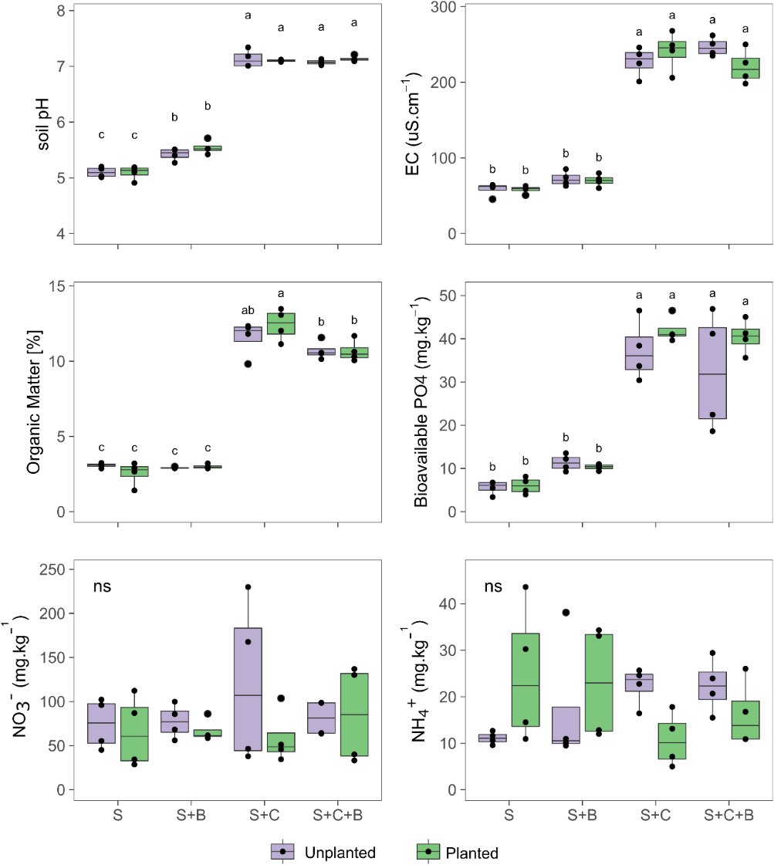
Fig. 5-3 Box plot of properties of Wemyss soil treated with different organic amendments after 18 months of incubation at field conditions. Soil treatments: control soil (S), soil with biochar (S+B), soil with compost (S+C), soil with compost and biochar (S+C+B). Treatments with the same letter do not differ significantly according to Tukey post hoc test (α = 0.05), n = 4, ns = no significant differences.
Soil organic matter (OM), EC and bioavailable phosphate (Olsen) increased significantly in the treatments containing compost (S+C and S+C+B) compared with the untreated soil (p < 0.05) (Fig. 5-3); increments of 8.5-10 % in OM, 82-85 % in bioavailable phosphate and 73-76 % in EC were observed. The soil amended with biochar (S+B) was not different from the untreated soil (S) (p < 0.05) for OM, EC and phosphate. No significant differences between treatments were observed for ammonium or nitrate (p < 0.05).

Effect of organic amendments on soil pore water parameters
Selected characteristics of soil pore water are presented in Fig. 5-4. Overall, the concentration of Pb and Zn in the soil pore water decreased with the addition of the organic amendments. With exception of S+B (6 months, planted) and S+C (6 months, unplanted), the concentration of Pb in the pore water decreased to the detection limit. Similarly, the concentration of Zn in the soil pore water of the amended soils was significantly reduced relative to the unamended soils (except for unplanted samples after 6 months), in some cases to the detection limit. In the S treatment (control), the pots with plants tended to have lower concentrations of heavy metals than the unplanted pots, but the difference was significant only after 6 months for Pb and at all times for Zn (p < 0.05).
The soil pore water of the planted pots from the S and S+B treatments sampled after 2 and 6 months showed a rise in pH of at least 1.5 and 0.5 units, respectively, relative to the unplanted pots, but only the S treatment was significantly different (p < 0.05). The pH of the soil pore water from planted pots with S+C and S+C+B treatments was ~8.2 and comparable to the pH of S treatment sampled at 2 months (planted). The pH of unplanted pots with S+C and S+C+B treatments (pH 8.2) was higher than the unplanted pots in the S (pH 5.1 - 5.9) and S+B (pH 5.4 -7.1) treatments at the same sampling times. All treatments tended to show a decrease in the pH of the soil pore water with time, which became significant in samples taken at 18 months (p < 0.05). This decrease was more pronounced in the S+B treatment, in which the pH of the soil pore water dropped 2 units in the last sampling relative to the samples taken at 6 months.
Overall, the EC of the S+C and S+C+B treatments was significantly higher than that for S and S+B treatments, except for S+C+B sampled at 18 months, which was not significantly different. The EC of treatments containing compost tended to decrease with time, but remained constant for S and S+B. No differences were observed between planted or unplanted pots.
The concentration of K, Ca, Mg and B and Na in the soil pore water increased in the treatments containing compost compared with the untreated soil (S) and soil amended with biochar (S+B) (data is shown in Appendix 5). These elements had a high concentration in the first sampling and decreased with time. The concentration of other elements, such as Cd, As, Al, Cu, Co, Ni, Mo and Fe, were below the detection limit.
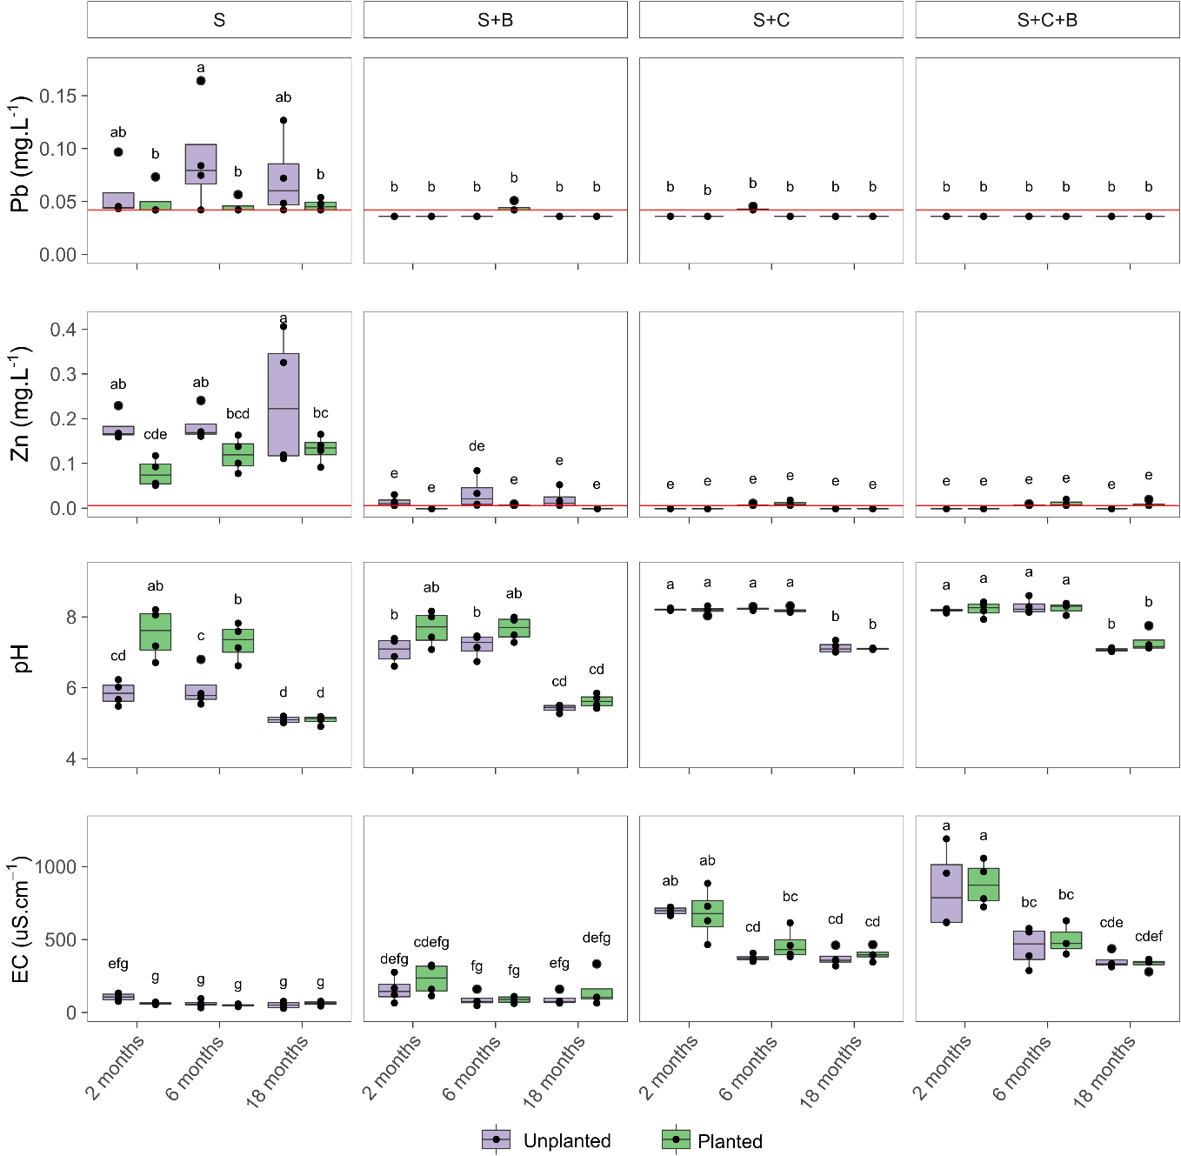
Fig. 5-4 Box plot of selected properties of soil pore water. Collections were at 2, 6 and 18 months after the establishment of the pot experiment. Soil treatments: control soil (S), soil with biochar (S+B), soil with compost (S+C), soil with compost and biochar (S+C+B). Treatments with the same letter do not differ significantly according to Tukey post hoc test (α = 0.05), n = 4, ns = no significant differences. The red line represents the detection limit of the instrument for each element.

Bioavailability of heavy metals
The total and bioavailable (acid-soluble fraction) concentrations of Pb and Zn at the end of the 18 months outdoor experiment are presented in Fig. 5-5. Total Pb concentration in the biochar treatment (S+B) was not significantly different from the untreated soil (S). Overall, the concentration of total Pb in treatments containing compost (S+C and S+C+B) was lower than that of the untreated soil (S), but not in S+C (unplanted). The total Pb concentration tended to be lower in the planted S+C and S+C+B treatments relative to the unplanted ones, but in S+C the difference was significant (p < 0.05). The total concentration of Zn did not show any significant difference between samples.
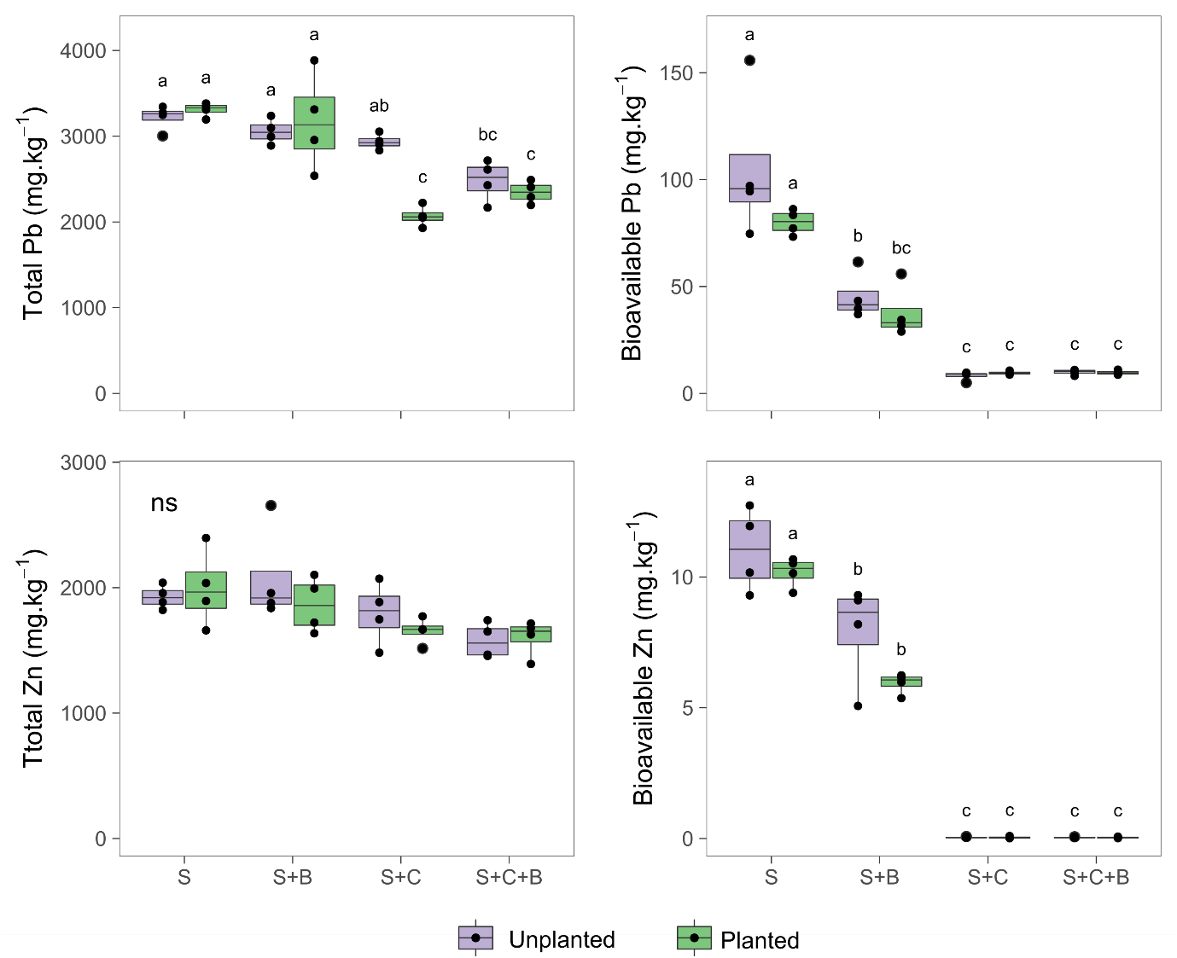
Fig. 5-5. Box plot of total and bioavailable (acid-soluble) heavy metal concentrations in Wemyss soil treated with different organic amendments. Soil treatments: control soil (S), soil with biochar (S+B), soil with compost (S+C), soil with compost and biochar (S+C+B). Treatments with the same letter do not differ significantly according to Tukey post hoc test (α = 0.05), n = 4, ns = no significant differences.
Bioavailable Pb and Zn were significantly reduced in all treatments containing organic amendments. Overall, planted treatments tended to have lower bioavailable concentrations of Pb and Zn relative to the unplanted ones. The reductions were more evident in treatments containing compost. For example, bioavailable Pb was reduced to 89-90% of the control in the S+C treatment and 87-90% in the S+C+B, while in the S+B treatment, the reductions were 52 and 56% of the control for planted and unplanted treatments, respectively. Similarly, bioavailable Zn was reduced by 99% of the control in S+C and S+C+B treatments, whether planted or planted, while in S+B reductions were 28 and 41 % of the untreated soil (S) for planted and unplanted treatments, respectively.

Fractionation of trace elements
The results from the sequential extraction shown in Fig. 5-6 are consistent with the results of soil pore water analysis (section 5.3.3) and total/bioavailable heavy metals in soil (section 5.3.4). The acid soluble fraction (AS) that contains metals considered readily and potentially bioavailable was reduced for Pb and Zn with the addition of the organic amendments, while an increase in the other fractions was observed.
A correlation analysis (Appendix 6 and Appendix 7) performed between the concentration of Pb and Zn in the different fractions for the treatments containing organic amendments and the untreated soil was used to identify fractions that were related, with the reduction of metals in the acid soluble fraction and redistribution into other fractions. For example, the reduction of Pb in the acid soluble (AS) fraction in the S+B treatment was correlated significantly with an increase in the residual fraction (RES) (R = -0.66). In the S+C treatment the reduction in Pb-acid soluble was strongly correlated with an increase in the oxidisable fraction (OX) (R = -0.53) and residual fraction (R = -0.6). There was no difference between planted and unplanted soils for these treatments (p < 0.05). Conversely, Pb from the S+C+B treatment demonstrated a different fractionation for planted and unplanted soils (p < 0.05). In the unplanted soil the reduction of Pb in the acid-soluble fraction was strongly correlated with an increase in the oxidisable fraction (R= -0.74), while in the planted soil there was no clear correlation between the acid soluble and other fractions.
Similarly, the reduction of acid soluble Zn in the S+C treatment was strongly correlated with an increase in the reducible fraction (RD) (R= - 0.85). The distribution of Zn in the S+C+B treatment was significantly different for planted and unplanted soil (p < 0.05). In the unplanted soil the reduction in acid soluble Zn was associated with an increase in the reducible (R = -0.82) and oxidisable (R = -72) fractions, but with reducible fraction only (R = -0.77) in the planted soil. No significant correlations were identified between the Zn fractions in the S+B treatment.
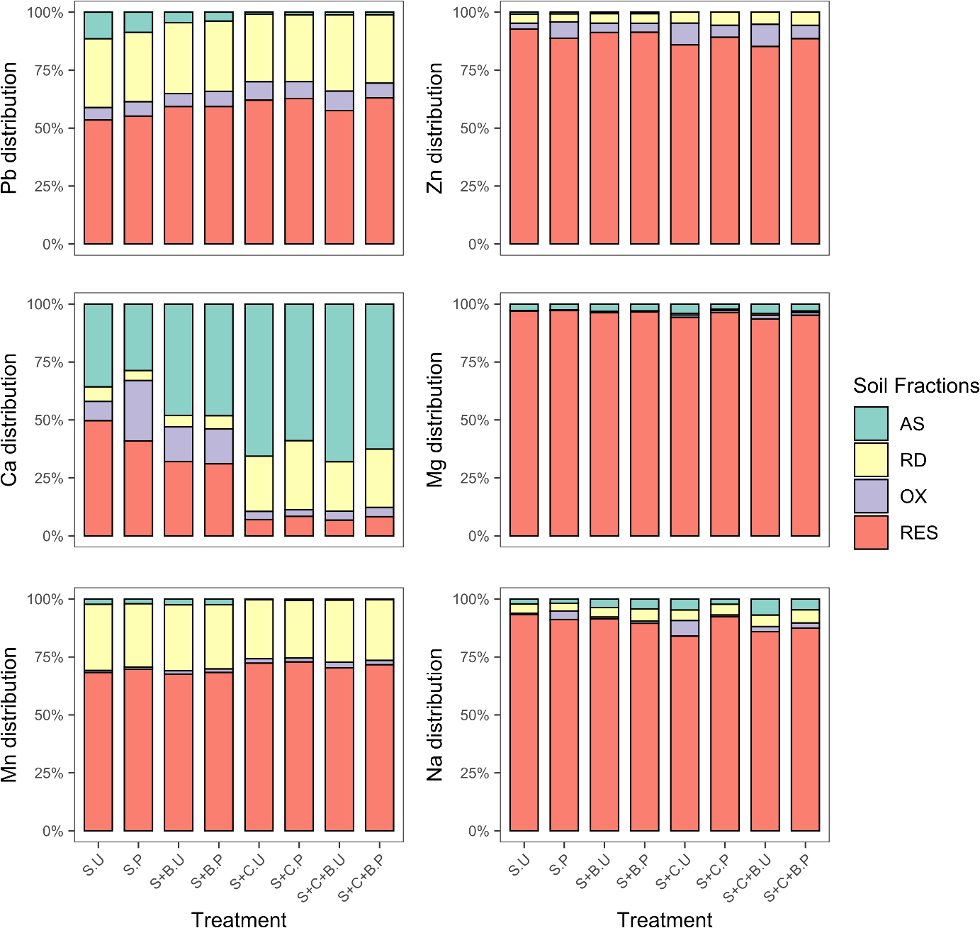
Fig. 5-6. Metal fraction distribution in Wemyss soil treated with different organic amendments after18 months of incubation. Soil fractions according to the BCR procedure: exchangeable and weak acid soluble (AS), reducible (RD), oxidisable (OX) and residual (RES). Soil treatments: control soil unplanted (S.U), control soil planted (S.P), soil with biochar unplanted (S+B.U), soil with biochar planted (S+B.P), soil with compost unplanted (S+C.U), soil with compost planted (S+C.P), soil with compost and biochar unplanted (S+C+B.U) and soil with compost and biochar planted (S+C+B.P).

The acid soluble fraction of Ca, Mg and Na increased in the soils treated with organic amendments relative to the untreated soil (Fig. 5-6), which is consistent with the increased concentration of these cations in the soil pore water. Conversely, a decrease in the acid soluble fraction of Mn was observed in the S+C and S+C+B treatments. The concentration of Cd, As, Cu, Co, Ni in the acid soluble fraction was below the detection limit, hence the fractionation of these elements is not presented.

Plant performance
The dry above-ground biomass of Lolium perenne and the concentration of Pb and Cd in leaf tissue are shown in Fig. 5-7. The dry biomass of plants from the first harvest did not differ between treatments (p > 0.05). The biomass from the second harvest was less than that from the first harvest in S and S+B treatments, although the difference was not significant. In the second harvest the biomass of plants growing in soil treated with organic amendments was greater than that of the untreated soil, but this was only significant for the S+C treatment (p < 0.05).
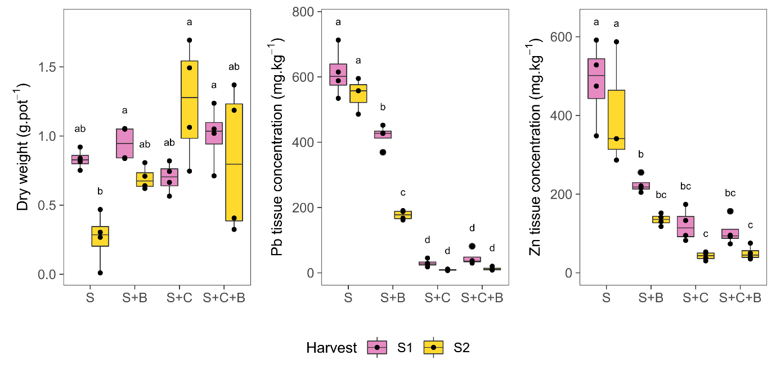
Fig. 5-7. Box plot of plant biomass and metal concentration in above-ground tissue of Lolium perenne grown in Wemyss soil treated with organic amendments during two harvesting seasons. S1 (6 months), S2 (18 months). Soil treatments: control soil (S), soil with biochar (S+B), soil with compost (S+C), soil with compost and biochar (S+C+B). Treatments with the same letter do not differ significantly according to Tukey post hoc test (α=0.05), n=4.
The concentration of Pb and Zn in plants cultivated in the amended soils was significantly less than that of plants cultivated in the untreated soil (p < 0.005). The addition of biochar (S+B) reduced Pb concentrations in plant tissue to 32% and 68 % of the control during the first and second harvests, respectively. The treatments containing compost were the most effective in reducing Pb in plant tissue; S+C+B and S+C treatments reduced Pb to a similar extent (between 93-97% of the control) during the first and second harvest, respectively. The concentration of Zn in plant tissue was reduced significantly by all amendments to a similar extent, between 54-78% of the control during the first harvest and to 66-87 % during the second harvest. Although the reductions of Zn were more pronounced in plants cultivated in S+C+B and S+C, there was no significant difference with plants cultivated in S+B (p > 0.05).

Correlation of soil properties and HM bioavailability
The cross-correlation analysis performed between the soil properties, bioavailable HM concentration (acid-soluble fraction) and the above-ground tissue concentration of heavy metals is presented in Fig. 5-8. In the unplanted treatments Pb, Zn, Al and Mn had a strong negative correlation with pH, EC, OM, phosphate, Ca, Mg, Na and K. Conversely, the base cations Ca, Mg, Na and K were positively related to each other. Soil pH and EC were directly correlated with Na, K, Ca and phosphate (p < 0.05). Nitrate was not significantly correlated with any physico-chemical properties (p < 0.05). A strong correlation (R > 0.8) was observed between soil bioavailable Pb and Zn (acid-soluble fractions) and the plant above-ground tissue concentration of these heavy metals in the planted treatments.
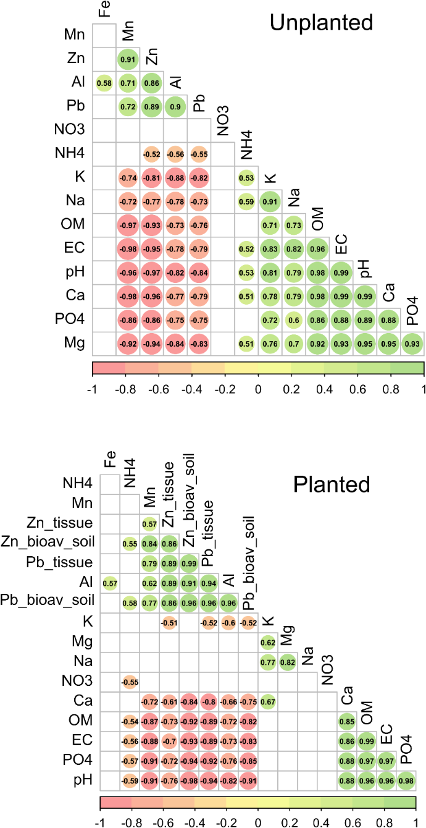
Fig. 5-8 Cross correlation of soil characteristics for planted and unplanted treatments. Mn, Al, Pb, Zn, Ca, Mg, K and Na corresponded to the concentration in the bioavailable (acid-soluble) fraction. In the Planted correlation matrix “_tissue” represents the above-ground tissue concentration and “bioav_soil” the bioavailable-acid soluble fraction. Values inside the circle correspond to the R coefficient of relations where p < 0.05. Non-significant correlations (p > 0.05) are shown as blank.

Microbial total abundance
The results of the q-RT-PCR analysis shown in Fig. 5-9 showed that bacterial total abundance in Wemyss soil treatments was at least one order of magnitude higher than fungal total abundance. The total abundance, based on gene copy numbers, did not differ significantly between planted and unplanted treatments. The gene copy numbers in the biochar treatment (S+B) were not significantly different from the untreated soil (S) in either the bacterial or fungal populations (p > 0.05). Except for S+C (planted), treatments containing compost had significantly higher bacterial gene (16S) copy numbers than the untreated soil (planted) (p < 0.01). Similarly, the fungal gene (18S) copy numbers were significantly higher in the planted S+C and S+C+B treatments than that of planted unamended soil (S) (p < 0.01).

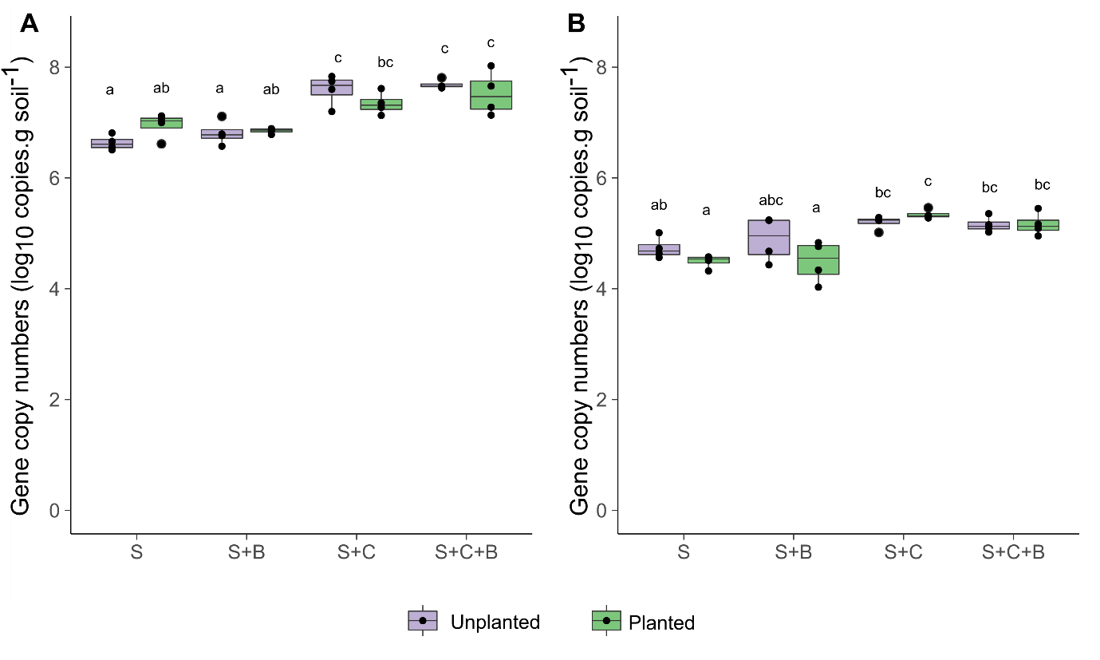
Fig. 5-9 Box plot of total abundance of soil microorganisms based on gene copy numbers of A) 16S gene of Bacteria using E.coli as reference organism; B) 18S gene of Fungi using C. tropicalis as reference organism. Treatments with the same letter do not differ significantly according to Tukey post hoc test (α = 0.05), n = 4, ns = no significant differences.

Microbial community structure and diversity
From the high-throughput sequencing of 16S rRNA and ITS genes, a minimum of 60925 bacterial and 1491 fungal sequences per sample were obtained from 32 independent samples. A total of 14,570 Amplified Sequence Variants (ASVs) were identified for bacteria and 1052 ASVs for fungi. After removing taxa that were poorly represented (less than 30 reads across all samples) and those that did not appear at least 3 times in 20% of the samples, 2767 (bacterial) and 122 (fungal) unique ASVs were identified.
The diversity indexes are shown in Fig. 5-10. In the bacterial samples the addition of organic amendments to the soil caused a significant increase in the Inverse Simpson index (average proportional abundance) relative to samples from untreated soil (p < 0.05). No significant differences between treatments were identified for bacterial samples with the Shannon dissimilarity measure or the Richness index (p > 0.05). Similarly, no significant differences were identified for the fungal samples in any of the diversity indexes (Richness and Inverse Simpson) or dissimilarity measure (Shannon).
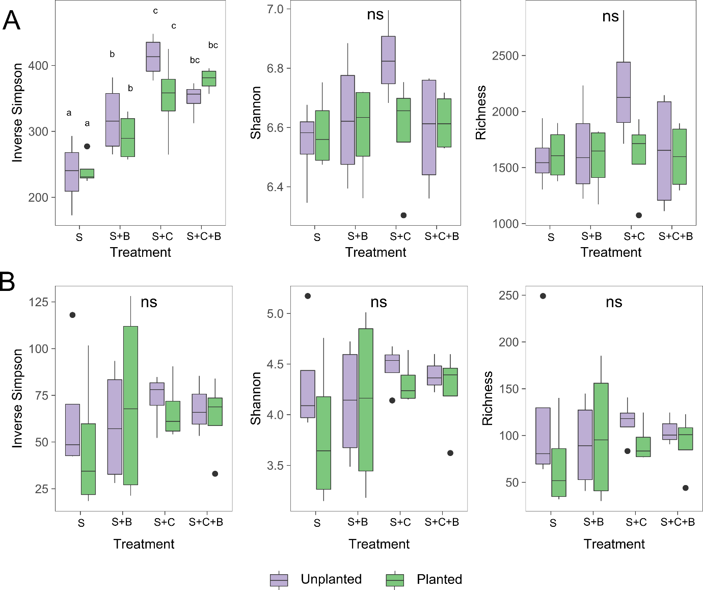
Fig. 5-10 Box plot of diversity indicators of soil microorganisms. A) Bacterial and B) Fungal. Treatments with the same letter do not differ significantly according to Tukey post hoc test (α = 0.05), n = 4, ns = no significant differences.
The number of species indicated by the Richness index was at least ten times higher in the bacterial samples than in fungal samples, consistent with the amount of bacterial amplicons relative to fungal amplicons in the sample and results from the qRT-PCR analysis (Fig. 5-9).
The composition of the bacterial communities in S and S+B treatments was broadly similar at the Phylum taxonomic level (Fig. 5-11C), with major contributions from Acidobacteriota, Actinobacteriota, Chloroflexi and Proteobacteria and lesser contributions from Firmicutes, Planctomycetota and Verrucomicrobiota. Samples from S+C and S+C+B soils indicated major contributions from Phylum Firmicutes, Proteobacteria, Actinobacteriota and Myxococcota, whereas less abundant communities belonged to Acidobacteriota, Chloroflexi, Planctomycetota and Verrucomicrobiota.
Similarly, the composition of fungal communities in the S and S+B treatments was similar at the Phylum taxonomic level (Fig. 5-11D); the major contribution was from Phylum Ascomycota and to a lesser extent to Phyla Basidiomycota and Montierellomycota. Treatments S+C and S+C+B had a similar composition of fungal communities, with major contributions from Ascomycota and Basidiomycota, and lesser contributions from Montierellomycota and Aphelidiomycota, which was absent in S and S+B.
Principal components analysis (PCoA) using the phylogenetically-aware weighted Unifrac distance based on bacterial ASV abundance (Fig. 5-11A) showed clear separation of samples S+C and S+C+B from S and S+B, with the first component explaining 89.4 % of the variance. Soil (S) samples were also separated from S+B samples with component 2 explaining 3.4% of the variance. The permutational multivariate analysis of variance (PERMANOVA) analysis showed that the samples differed (p < 0.01) except for S+C+B and S+C that were not significantly different from each other. A significant difference between planted and unplanted samples was only evident in S+B samples (p < 0.05), for the other treatments planted and unplanted samples did not differ. A summary of the pairwise comparison is given in Table 5-4

Table 5-4 Summary of pairwise comparisons using permutational multivariate analysis of variance (PERMANOVA) between soil treatments (n=4, α=0.05)
 | Bacteria |  |  |  |  | Fungi
Treatments | S | S+B | S+C | S+C+B |  | S | S+B | S+C | S+C+B
S | - | ** | ** | ** |  | - | ns | ** | **
S+B | ** | - | ** | ** |  | ns | - | ** | **
S+C | ** | ** | - | ns |  | ** | ** | - | *
Planted vs Unplanted | ns | * | ns | ns |  | ns | ns | ns | ns
Significance codes ‘**’ p value < 0.01, ‘*’ p value < 0.05 , ns= p value > 0.05
The PCA using the weighted Bray dissimilarity based on fungal relative abundance (Fig. 5-11) showed clear separation of S+B and S from treatments S+C+B and S+C which was explained by component 1 (54 %). PERMANOVA analysis indicated that planting did not result in any significant difference in community composition in fungal groups within a treatment (p > 0.05). Treatments S+C and S+C+B were significantly different from S and S+B (p < 0.05), but not from each other. S+B was not significantly different from the untreated soil S (p > 0.05) (Table 5-4).
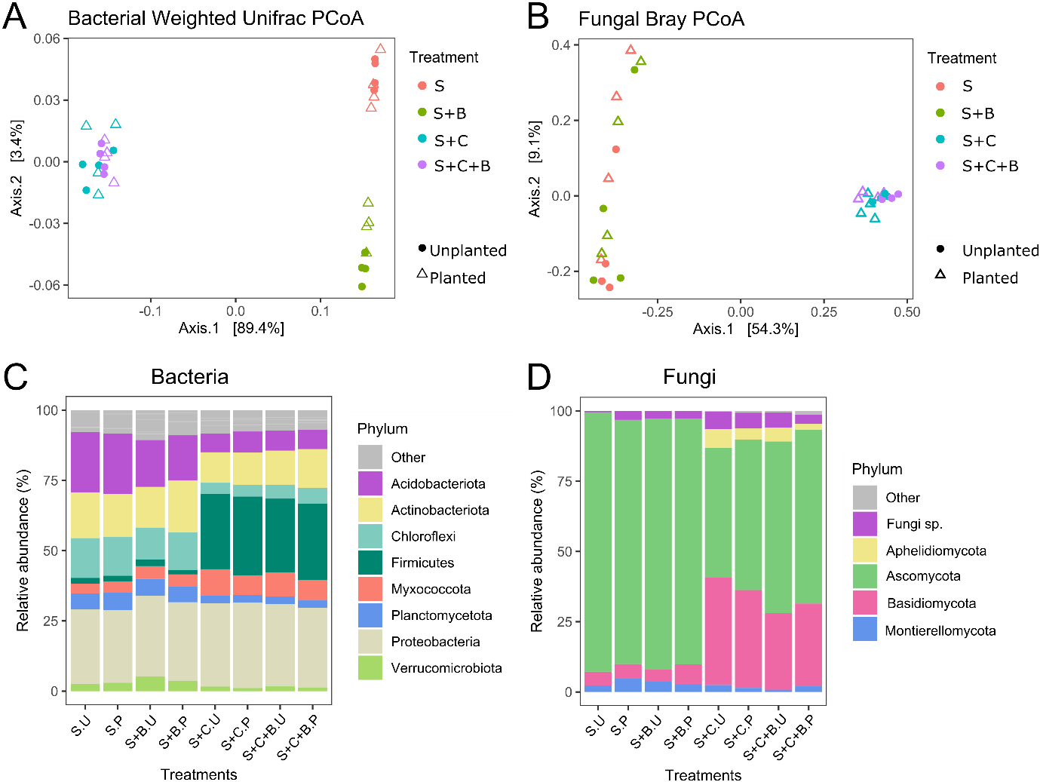
Fig. 5-11 Analysis of community composition. Principal components analysis of bacterial communities using (A) the phylogenetically-aware Unifrac measure and B) Fungal samples using the Bray measure, both weighted for ASVs abundance. Composition of microbial communities at Phylum level for C) Bacteria and D) Fungi. Phyla that contribute < 3 % of the total ASVs are shown as ‘Other’ for clarity. Soil treatments: control soil unplanted (S.U), control soil planted (S.P), soil with biochar unplanted (S+B.U), soil with biochar planted (S+B.P), soil with compost unplanted (S+C.U), soil with compost planted (S+C.P), soil with compost and biochar unplanted (S+C+B.U) and soil with compost and biochar planted (S+C+B.P).

Differences in microbial community composition
A generalized linear model implemented in DESeq2 was used to identify significant changes in microbial community composition (fungi and bacteria) after the addition of organic amendments. The analysis showed that planting the soil had a minimal effect on bacterial communities. In bacterial samples only 1, 4, 14 and 24 ASVs changed out of 2767 taxa in the S, S+B, S+C and S+C+B treatments, respectively, when comparing unplanted and planted samples. The ASVs that changed accounted for less than 0.2, 0.3, 0.4 and 4 % of the total sequences in those treatments. Similarly, in the fungal samples, comparing planted and unplanted treatments showed minimal changes in fungal communities; only 1, 4, 18, and 11 fungal ASVs changed out of 122 taxa in the S, S+B, S+C and S+C+B treatments, respectively. These ASVs accounted for less than 1.5, 3, 9 and 4% of the total ASVs in those treatments.
The DesSeq analysis showed that some ASVs increased significantly while others decreased with the addition of the organic amendments. These changes are illustrated with Venn diagrams. Since having planted/ unplanted treatments did not cause a significant difference in the relative abundance of ASVs within treatments, the unplanted samples were used to visualise overlaps between treatments in the Venn diagrams (Fig. 5-12). The diagrams showed that compost caused the biggest change in the composition of microbial groups and relative abundance, while biochar had little impact.
Of 1206 bacterial ASVs that increased with the addition of organic amendments relative to the untreated soil, 1164 increased due to the addition of compost (S+C). From these, 1109 were shared with S+C+B treatment and only 4 were shared with biochar treatment (S+B). Biochar alone (S+B) caused an increase in 27 bacterial ASVs relative to the untreated soil (S) (Fig. 5-12A). Of 459 bacterial ASVs that decreased with the addition of the organic amendments, 440 were due to the addition of compost (S+C). From these, 35 were shared with biochar (S+B) and 416 with S+C+B. None of the ASVs that decreased were unique to biochar.
As illustrated in Fig. 5-12B, compost was also the main driver of changes in the relative abundance of fungal ASVs. Of 52 fungal ASVs that increased with the addition of the organic amendments relative to the untreated soil, 49 fungal ASVs increased due to the addition of compost (S+C). From these, 47 fungal ASVs were shared with S+C+B and only one with S+B. The addition of biochar alone (S+B) did not significantly increase any ASV relative to the untreated soil. The combination of biochar and compost (S+C+B) increased 2 fungal ASVs relative to the untreated soil. The addition of organic amendments caused a decrease of 34 fungal ASVs relative to the untreated soil. From these, 28 ASVs decreased after the addition of compost (S+C), from which 2 were shared with S+B and 25 with S+C+B.

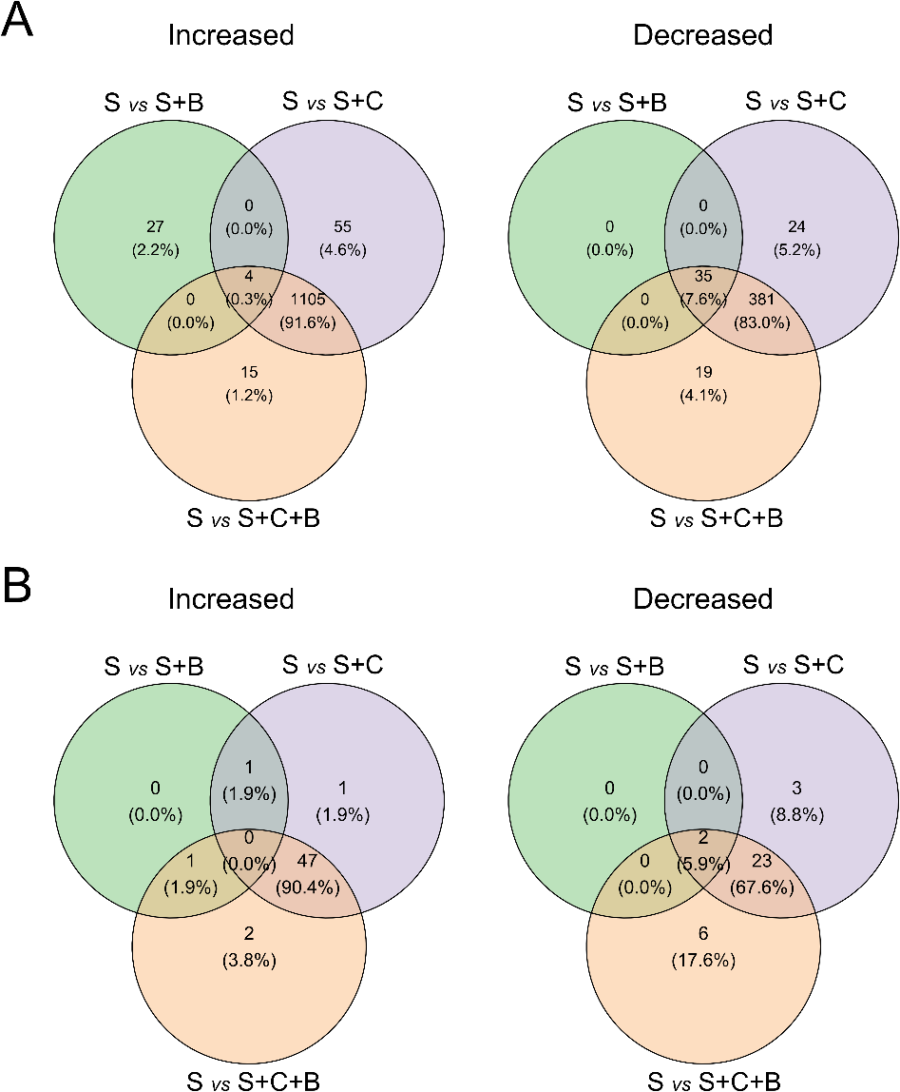
Fig. 5-12 Venn diagram displaying the number of microbial ASVs shared between treatments containing organic amendments that increased or decreased relative to the untreated soil after the addition of the amendments. A) Bacterial samples and B) Fungal samples. Treatments: control soil (S), soil with biochar (S+B), soil with compost (S+C) and soil with compost and biochar (S+C+B). For the analysis the unplanted samples of all treatments were used, n = 4.
Analyses at higher taxonomic levels were conducted to identify the groups of microorganisms that increased and decreased with the addition of the organic amendments. As illustrated in Fig. 5-13, the addition of biochar significantly increased bacterial ASVs assigned to the Class Alphaproteobacteria, Gammaproteobacteria, Thermoleophilia and Actinobacteria, but decreased ASVs including the Classes Acidobacteriae and Alphaproteobacteria. The addition of compost (S+C) caused substantial changes in ASVs of Class Proteobacteria (~50% of S+C relative abundance), Actinobacteria, Acidobacteria, Firmicutes and Myxococcota (Fig. 5-14). A further analysis at Family level was conducted (Appendix 8-Appendix 13).
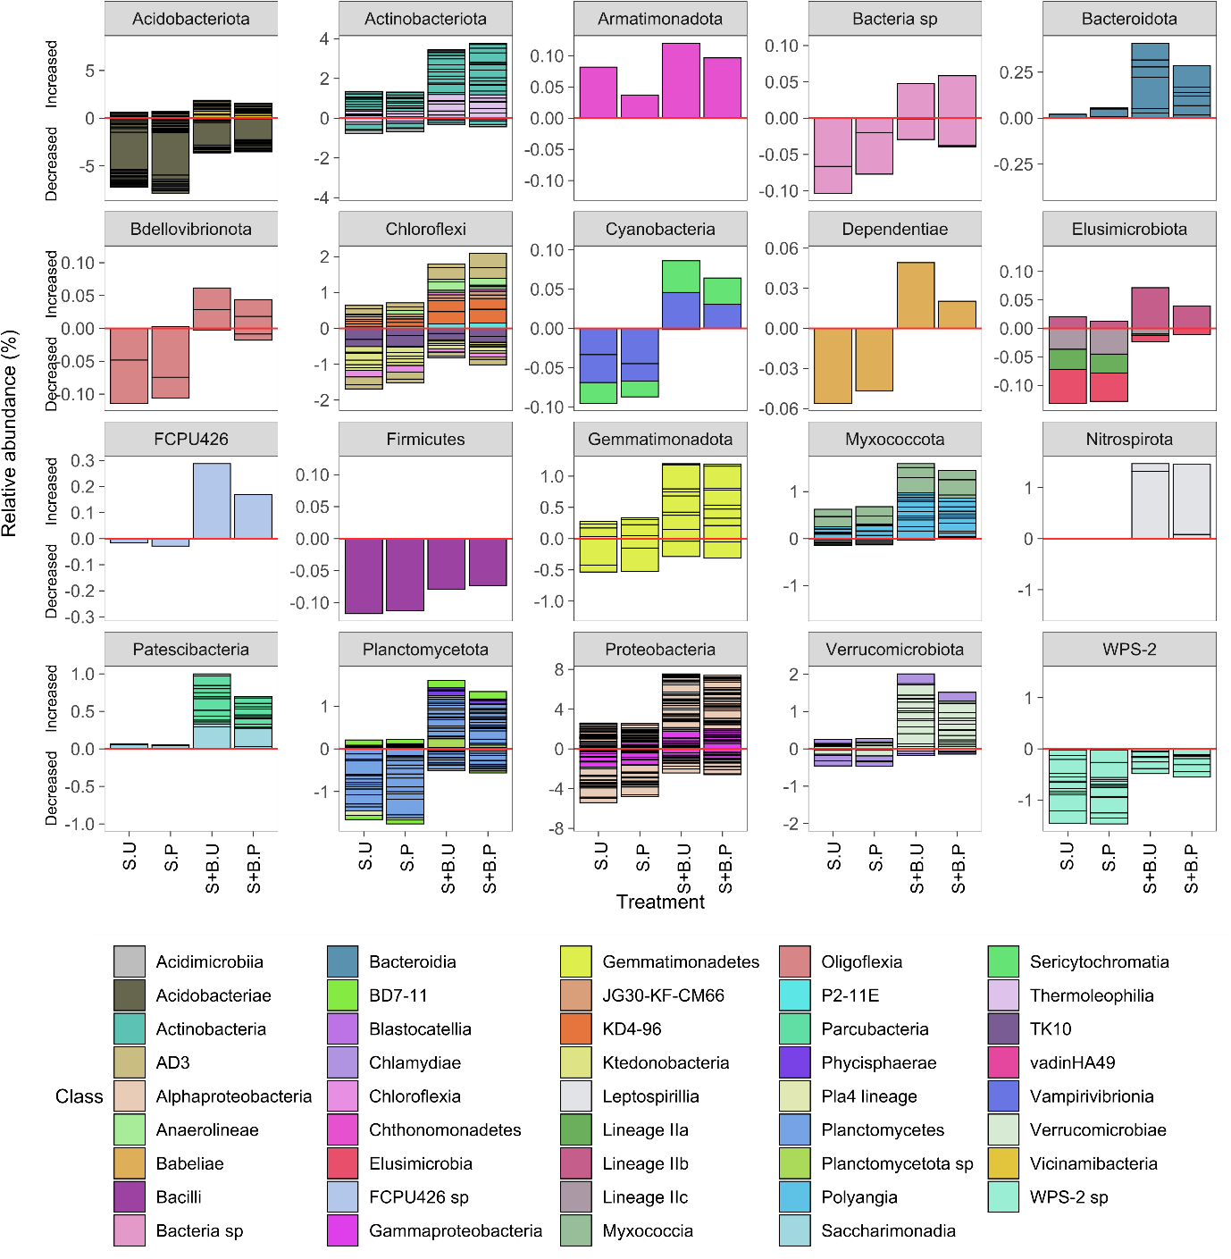
Fig. 5-13 Relative abundance of bacterial ASVs grouped by Phylum that changed with the addition of biochar. Bars above zero (red line) indicate an increase while bars below zero indicate a decrease in relative abundance (%) relative to the control. Treatments: Soil unplanted (S.U), Soil planted (S.P), Soil and Biochar unplanted (S+B.U) and Soil and Biochar planted (S+B.P). Different colors within the bars represent the relative abundance of individual ASVS by Class. Each ASV is separated by black lines. Results shown are the mean of 4 individual replicates.
The results indicated that bacterial ASVs that increased with the addition of compost belonged to the Order Alphaproteobacteria (Family Rhizobiales Incertae, Hyphomicrobiaceae, Rhizobiaceae), Gammaproteopacteria (Family Nitrosomonadaceae, Steroidobacteraceae), Bacilli, Actinobacteria, Acidimicrobiia (Family Microtrichales sp) whereas decreased ASVs assigned to Order Acidobacteriae, Actinobacteria (Family Acidothermaceae, Mycobacteriaceae), Acidimicrobiia (Family IMCC26256 sp), Thermoleophilia, Alphaproteobacteria (Genus Xanthobacteraceae sp, Sphingomonas, Elsterales sp) among other less abundant groups. When comparing S+B and S+C+B, only 3 ASV of the total 2767 changed, accounting for less than 0.5 % of the relative abundance, hence no further analysis was conducted.
As illustrated in Fig. 5-15, fungal ASVs from the Class Agaricomycetes, Pezizomycetes, Lobulomycetes that were not detected in the control soil, appeared with the addition of compost. Conversely, ASVs from the Class Leotiomycetes that were present in the control soil could not be detected after the addition of compost. Comparing S+C and S+C+B treatments, only one ASV changed out of 122 taxa identified. An ASV in the Class Orbiliomycetes was absent in the S+C treatment and appeared in S+C+B treatment.
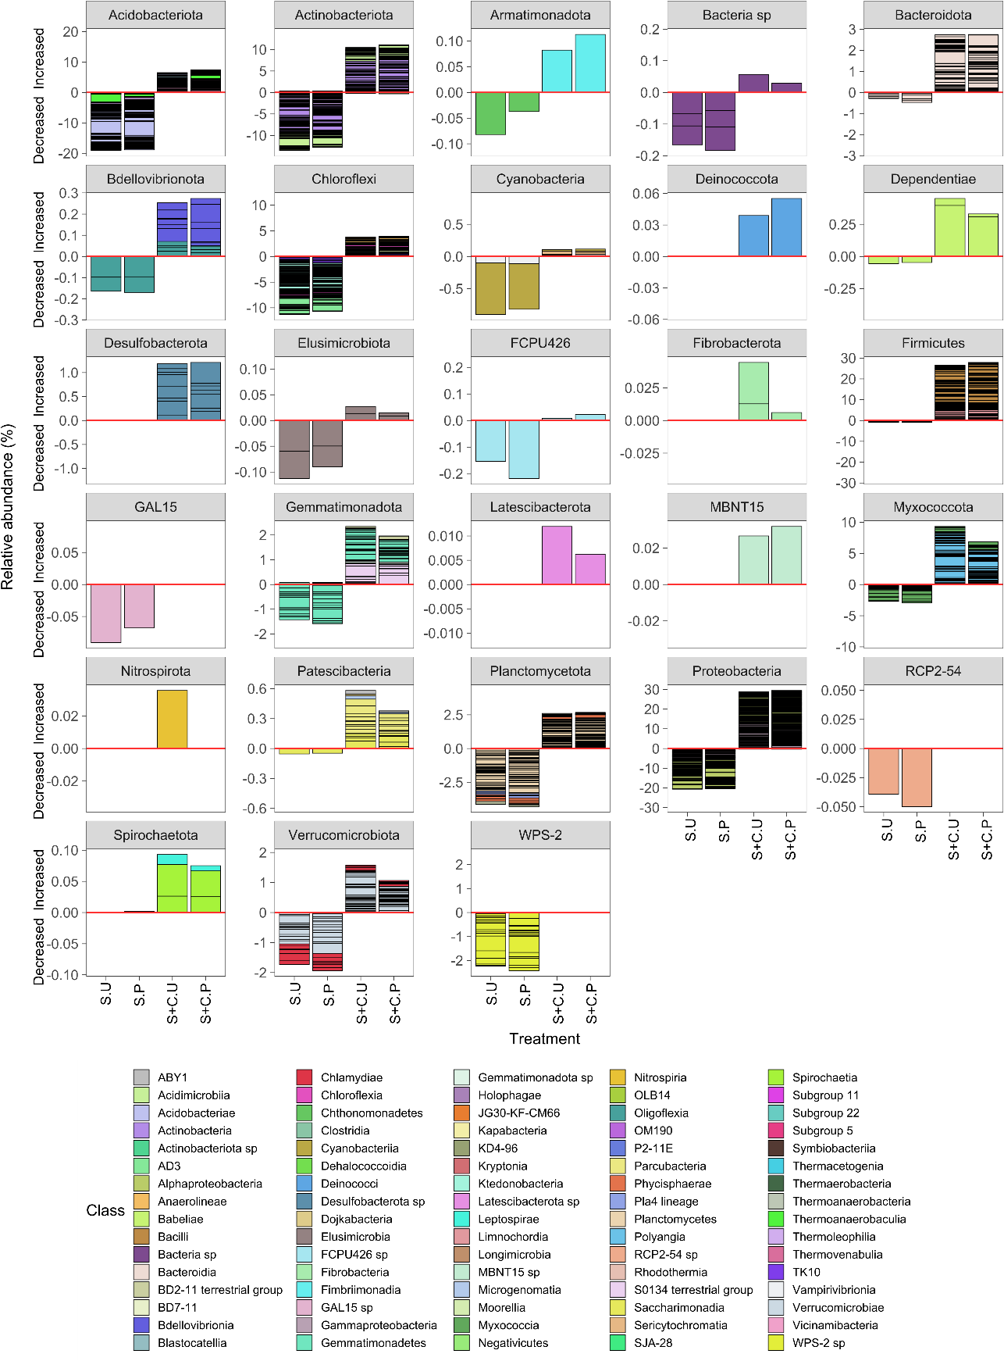
Fig. 5-14 Relative abundance of bacterial ASVs grouped by Phylum that changed with the addition of Compost. Bars above zero (red line) indicate an increase while bars below zero indicate a decrease in relative abundance (%) in relation to the control treatment. Treatments Soil unplanted (S.U), Soil planted (S.P), Soil and compost unplanted (S+C.U) and Soil and Compost planted (S+C.P). Different colours within the bars represent the relative abundance of individual ASVS by Class. Each ASV is separated by black lines. Results are shown as the mean of 4 individual replicates.
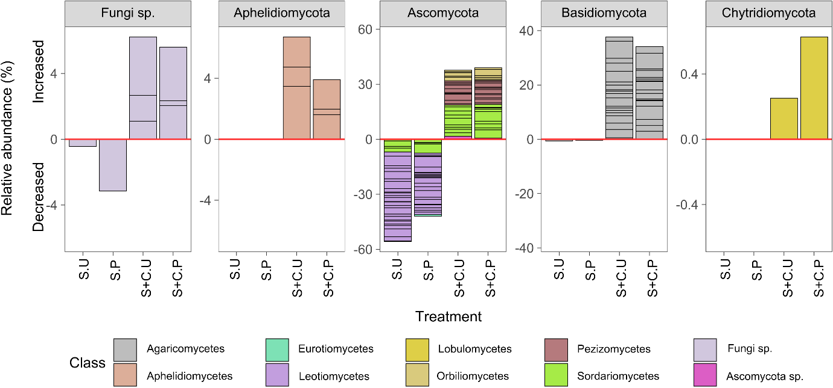
Fig. 5-15 Relative abundance of fungal ASVs grouped by Phylum that changed with the addition of compost. Bars above zero (red line) indicate an increase while bars below zero indicate a decrease in relative abundance (%) in relation to the control treatment. Treatments: Soil unplanted (S.U), Soil planted (S.P), Soil and compost unplanted (S+C.U) and Soil and Compost planted (S+C.P). Different colours within the bars represent the relative abundance of individual ASVS by Class. Each ASV is separated by black lines. Results are shown as the mean of 4 individual replicates.
The canonical correlation analysis (CCA) presented in Fig. 5-16 aligned the PCA of microbial groups presented in Fig. 5-11 with a PCA on physicochemical parameters. In both the bacterial and fungal analysis the separation of treatments containing compost S+C and S+C+B from S and S+B was associated with pH, OM, phosphate and bioavailable base cations Na, K, Ca and Mg. Conversely, S and S+B were related to the bioavailable concentration (acid-soluble fraction) of Pb, Zn, Cd and Mn.

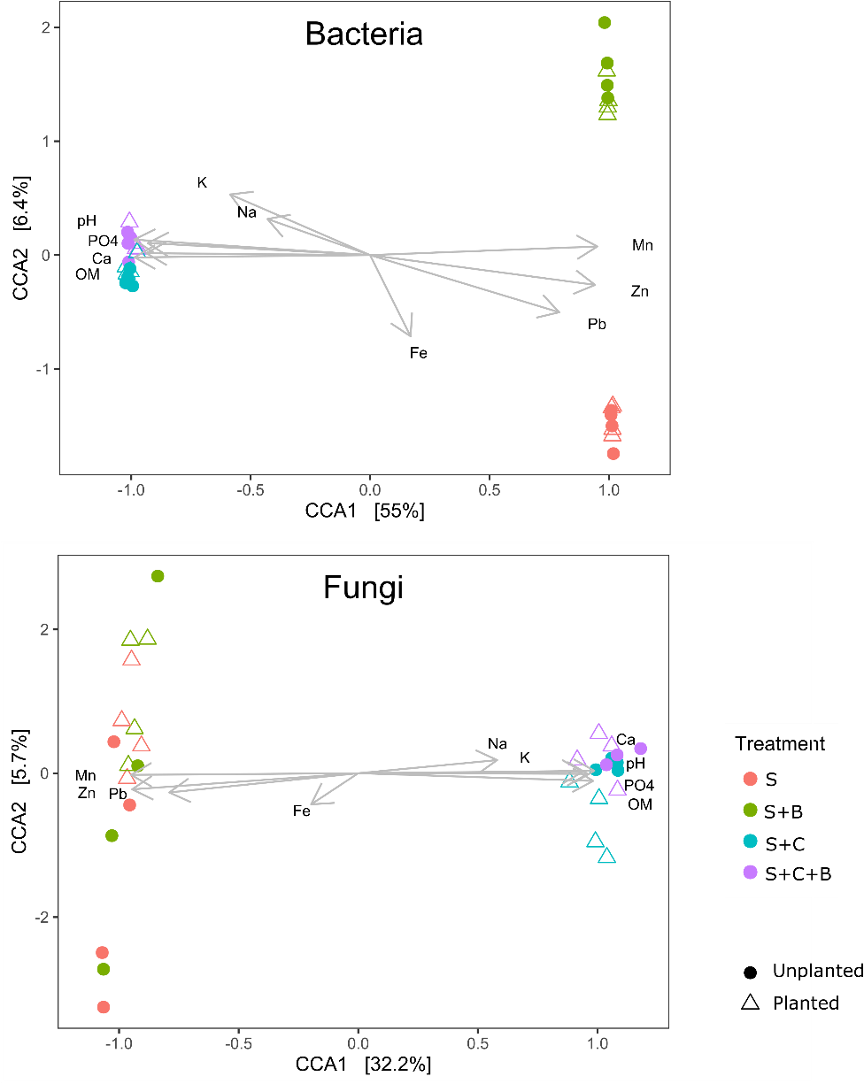
Fig. 5-16 Canonical correspondence analysis of bacterial and fungal ASVs abundance and relevant soil physico-chemical properties. Treatments: control soil (S), soil with biochar (S+B), soil with compost (S+C) and soil with compost and biochar (S+C+B).

Soil microbial activity - secondment at BOKU
The properties of the soil used in the soil respiration and PLFA experiments are presented in Table 5-5. The total and bioavailable (acid-soluble) concentrations of Pb and Zn as well as the HM distribution in the different soil fractions are compared in Fig. 5-17. The results are consistent with those presented in sections 5.3.4 and 5.3.5; the addition of biochar significantly reduced bioavailable HMs over the 12 month period (p < 0.01). The total concentration of Pb in the biochar treatment tended to be lower than the control soil, with the difference significant after 12 months. The total concentration of Zn did not vary between treatments. The fractionation of HMs indicated that the bioavailable (acid-soluble) fraction of Pb decreased while the residual Pb fraction increased. A decrease in the bioavailable Zn fraction was observed, while oxidizable Zn fraction increased. These results confirmed that biochar addition enhanced a redistribution of bioavailable HMs into less mobile soil fractions, such as oxidizable and residual.
Table 5-5 Properties of soil used during the secondment at BOKU. Values are the mean ± standard deviation, n=3.
Properties | Soil |  |  | Soil+Biochar
 | 1 month | 12 months |  | 1 month | 12 months
Total Pb (mg.kg⁻¹) | 3520 ± 132 | 3785 ± 133 |  | 3324 ± 123 | 3271 ± 81
Bioavailable Pb (mg.kg⁻¹) | 150 ± 10 | 137 ± 22 |  | 14± 1 | 24 ± 1
Total Zn (mg.kg⁻¹) | 1663 ± 61 | 1735 ± 52 |  | 1675 ± 21 | 1720 ± 71
Bioavailable Zn (mg.kg⁻¹) | 17 ± 1 | 16 ± 2 |  | 4.55 ± 0.88 | 5.13 ± 0.47
OM (%) | 2.39 ± 0.65 | 2.62 ± 0.60 |  | 3.41 ± 0.23 | 3.14 ± 0.09
pH | 4.75 | 5.3 ± 0.1 |  | 5.7 ± 0.1 | 5.9 ± 0.2
EC | - | 344 ± 14 |  | - | 301 ± 31
Δ¹³C | -26.97 ± 0.11 | -26.60 ± 0.19 |  | -26.99 ± 0.29 | -26.98 ± 0.34

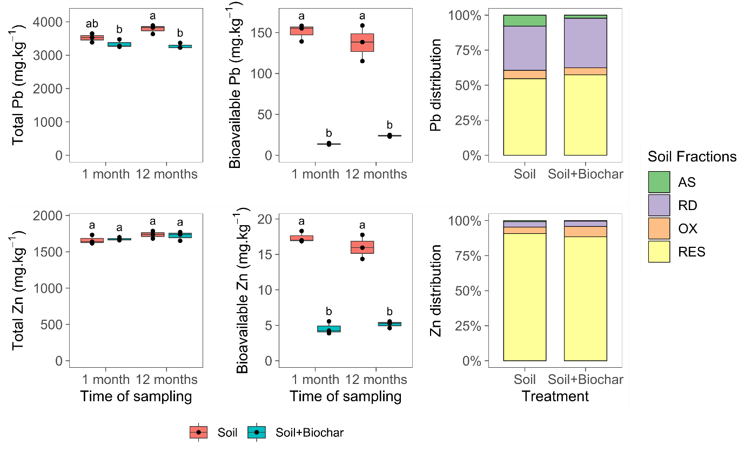
Fig. 5-17 Heavy metals in Wemyss soil used in the secondment at BOKU. Soil samples were analysed at 1 and 12 months after the beginning of the incubation experiment. Treatments with the same letter do not differ significantly according to Tukey post hoc test (α = 0.05), n = 3. Total Pb and Zn (aqua regia extracts), bioavailable Pb and Zn (acid-soluble fraction). Soil fractions: acid-soluble (AS), reducible (RD), oxidisable (OX) and residual (RES).
The production of carbon dioxide vs time after the addition of ¹³C glucose is presented in Fig. 5-18. C mineralization from the soil had two stages, fast production of CO₂ until 700 min and slower release of CO₂ from 700 to 1500 min. In the first monitoring period, conducted after one month of incubation, the treatment containing biochar released CO₂ faster than the control soil, as evident from the steeper slope. However, after one year of incubation outdoors, the release of CO₂ from both the soil amended with biochar and the control soil was slower and similar. The rate of CO₂ production was well described by a logistic model during both the fast and slow release phases. The coefficients obtained from fitting the logistic model to the experimental data are presented in Table 5-1.
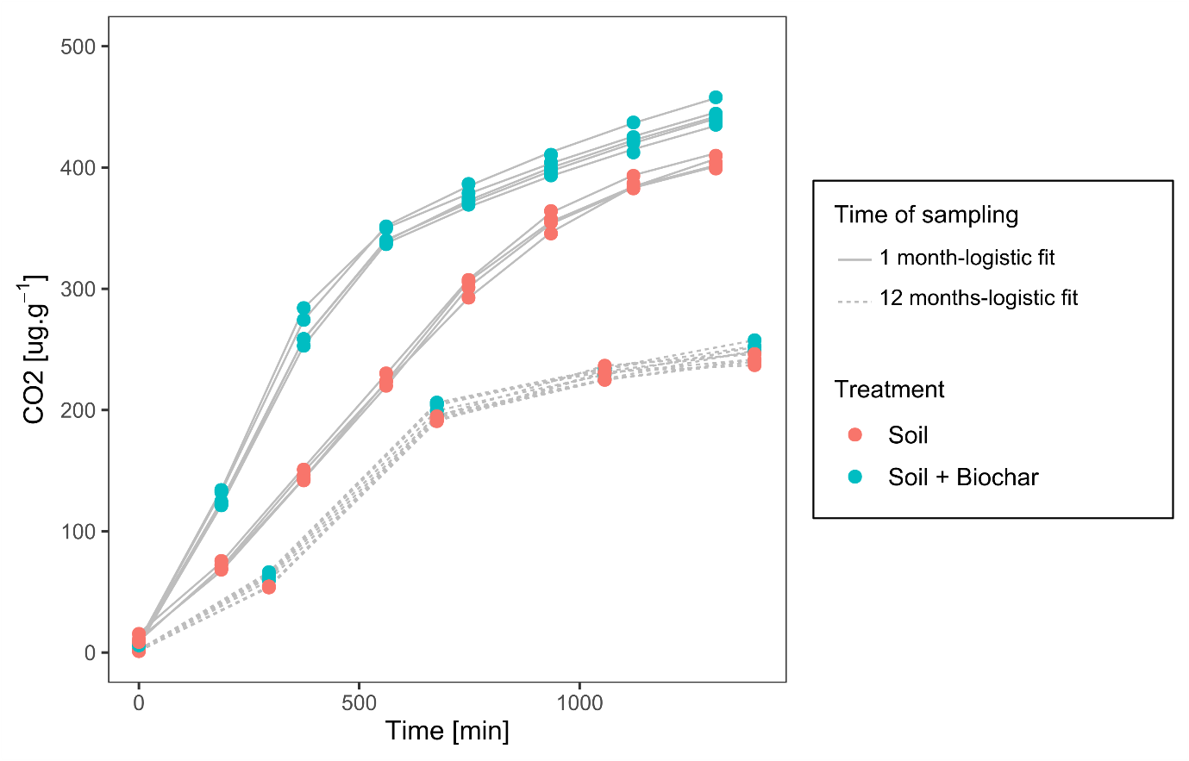
Fig. 5-18 Carbon dioxide production over time after addition of ¹³C glucose. Dots are the experimental values measured at 1 and 12 months after the start of the incubation with biochar. The lines are the fit of the four parameter logistic model, n = 5.
The cumulative production of CO₂ was different for the soil treated with biochar relative to the control soil. In the first sampling, the rate constant (k) and C_{min} were significantly lower for the soil amended with biochar than that of the control soil. However, in both cases the predicted maximum CO₂ production C_{max} was the same. After one year of incubation outdoors, the soil with biochar had significantly lower k and C_{min} and higher C_{max} than the control soil (p < 0.05) indicating a higher C mineralization than the control soil. However, the difference was not so obvious as during the first measurement.
Table 5-6 Coefficients from the fit of CO₂ along time with the logistic model
 |  | Coefficients
Sampling | Treatment | k (min⁻¹) | C_{min} (μg.g⁻¹) | C_{max} (μg.g⁻¹)
1 month | Soil | 2.08 | 26.30 | 495
 | Soil+Biochar | 1.63 | 6.06 | 495
Sig. level
Treatment |  | ** | ** | ns
12 months | Soil | 3.04 | 1.2 | 248
 | Soil+Biochar | 2.90 | 1.8 | 256
Sig. level
Treatment |  | ** | ** | *
Significance codes: ‘*’ p < 0.05, ‘**’ p < 0.01, ns = p > 0.05

The analysis of the phospholipid fatty acids (PLFAs) and uptake of ¹³C into PLFAs (Δ ¹³C) is shown in Fig. 5-19. The mean concentration of fatty acids did not show obvious differences between biochar-amended soil and the control soil, consistent with results presented in sections 5.3.8 and 5.3.9. The fatty acids that were more abundant were 16:00 (bacteria), 18:1 ω7&8c (Gram negative bacteria type II methanotrophs) and 18:1 ω9c (Fungi). There was a significant increase in some fatty acids in the treatment containing biochar. This occurred from the first measurement conducted after 1 month to the second measurement, particularly for the 16:00 (bacteria), 16:1ω7&6c (Gram-negative bacteria), 17:00 (General bacterial marker),18:00 (General bacterial marker), 18:1ω7&8c (Type II methanotrophs and Gram-negative bacteria), i15:00 (Gram-positive bacteria) and i17:1ω7c&10Me16:60 (Actinobacteria and Gram-positive bacteria) and 18:2ω6,9c (Saprotrophic fungi) (p < 0.05).
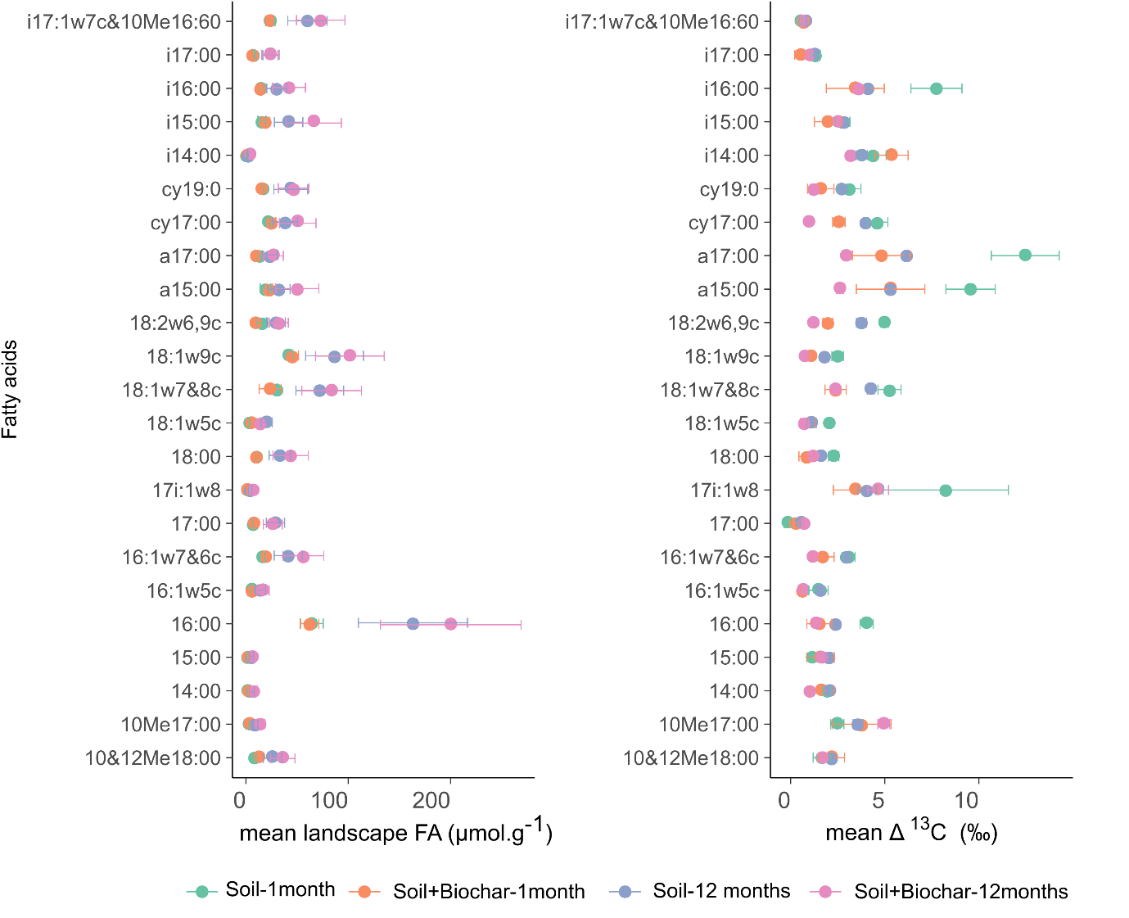
Fig. 5-19 Mean landscape fatty acids and delta ¹³C (Δ¹³C ‰) in fatty acids after 1 and 12 months from the start of the soil incubation. Points are the mean values, bars are the error bars, n = 5.
The analysis of the Δ¹³C in fatty acids indicated that overall there was more ¹³C carbon in the fatty acids from the control than in the soil with biochar treatment. The fatty acids that incorporated more ¹³C were 17i:1 ω8 (sulphate reducing bacteria), 18:1ω7&8c (Gram negative bacteria type II methanotrophs), 18:2ω6,9c (Saprotrophic fungi) and a15:00, i16:00 and a a17:00 associated with Gram positive bacteria.
The PCA analysis identified shifts in community composition based on the Δ¹³C PLFA pattern and distinct ¹³C discrimination between soil treatments (Fig. 5-20A). In the PCA the separation of samples from soil treated with biochar from the control soils was evident. The difference between biochar-treated soil and the control soil was explained by PC1 (63.48 %), while the difference between the first and second monitoring was explained by the PC2 (19.17%). The results indicated that there was a systematic change in ¹³C substrate utilization due to the presence or absence of biochar.
The mass of total PLFAs (approximation for total microbial biomass) and PLFA which incorporated ¹³C labelled substrate are presented in Fig. 5-20B.
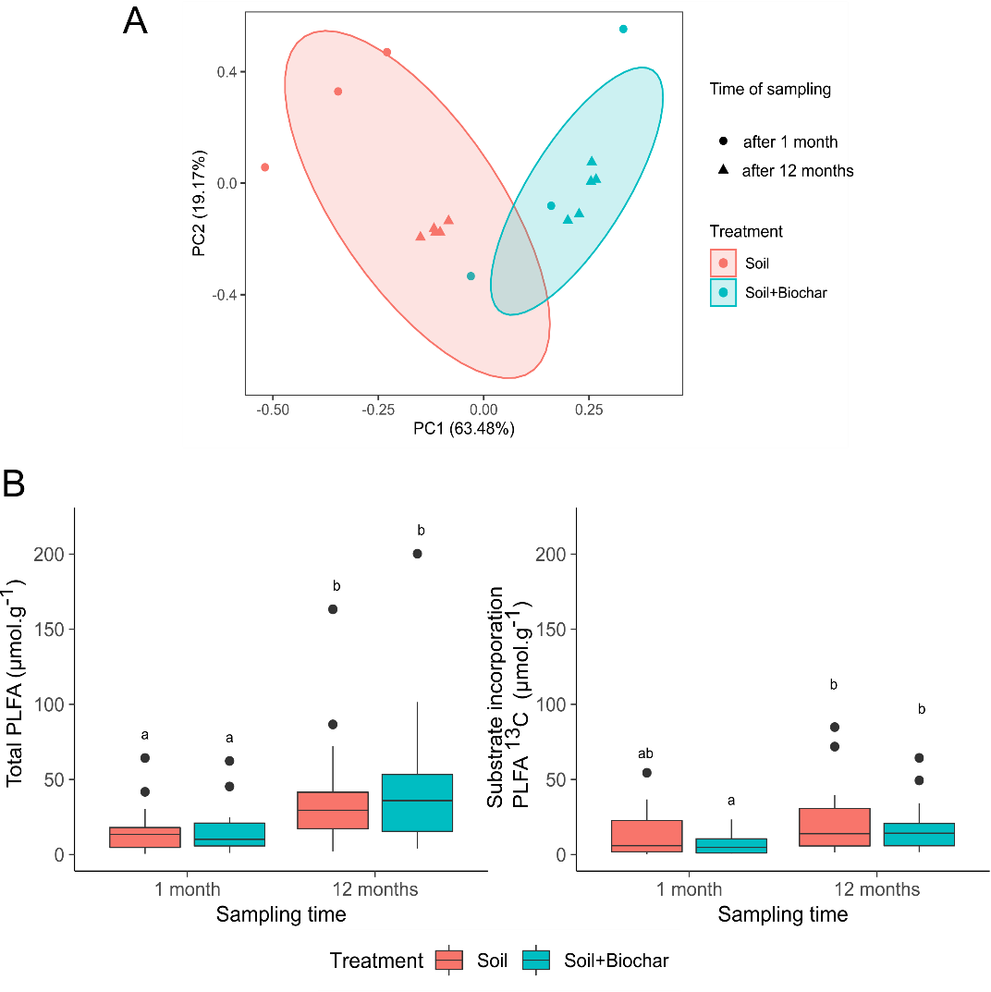
Fig. 5-20 Soil microbial dynamics based on total PLFA. A) Principal component analysis (PCA) of Δ ¹³C (‰) in individual fatty acids of the studied soil treatments. The PCA analysis contained samples measured after 1 month (n = 3) and after 12 months (n = 5) from the start of the incubation experiment). Boxplot of mass of total fatty acids in soil and mass of fatty acids from ¹³C glucose (n = 5). Treatments with the same letter do not differ significantly according Dunn post hoc test (α = 0.05).
There was a significant increase in total fatty acids after 12 months in both the control soil and soil amended with biochar relative to the first measurement (p < 0.05). However, there was no significant difference between the control soil and biochar-treated soil in total mass of PLFAs (p > 0.05). Similarly, there was an increase in the mass of ¹³C fatty acids after 12 months compared to the first measurement, although the difference was only significant in the biochar treatment. These findings are consistent with those from the qRT-PCR analysis (section 5.3.8) and the metataxonomic analysis (section 5.3.9), demonstrating that biochar addition did not significantly increase the total microbial biomass compared with the untreated soil. However, biochar addition resulted in a change in the composition of microbial communities, as evident from a distinct pattern in the assimilation of ¹³C and increased microbial activity associated with a faster C mineralization (CO₂ release).

Discussion

Soil toxicity
Wemyss soil exceeded, by several fold, the total concentration of Pb and Zn established in the soil guideline values of the Environment Agency for different land uses (Lancrop Laboratories, 2014). The total concentrations of Zn (1600 mg.kg⁻¹) and Pb (3400 mg.kg⁻¹) exceed the range of HM concentrations in soil above which plant toxicity is considered possible; these have been set between 100-400 mg.kg⁻¹ for Pb and 70-400 mg.kg⁻¹ for Zn (Kabata-Pendias and Pendias, 2001). The initial bioavailable concentration of Pb (135 mg.kg⁻¹) and Zn (21 mg.kg⁻¹) in Wemyss soil are comparable to bioavailable concentrations of mining soils in other locations which have been amended with biochar. For example, soil from a mining area in Vazante (Minas Gerais, Brazil) was reported to have initial bioavailable concentrations of 141 mg.kg⁻¹ Pb and 60 mg.kg⁻¹ Zn (Puga et al., 2015a). Similarly, Karami et al. (2011) reported bioavailable Pb to be 21 mg.kg⁻¹ in a former copper mine site in the UK.
The initial total HMs in the treatments containing compost (S+C and S+C+B) were lower than that of soil (S) or soil with biochar (S+B). This was most likely due to a dilution effect caused by the addition of compost at a higher rate than biochar. Despite the dilution effect, the initial total concentrations of these elements were still above the recommended guideline values and the threshold above which plant toxicity may occur.

Effect of organic amendments on soil properties
The addition of biochar, compost or a combination of the two, modified soil properties. Both materials increased soil pH and EC, with the increase being greatest in the treatments containing compost. The increase in soil pH is attributed to the alkaline nature of the biochar and garden waste compost used in this study. Similar results were reported by other investigators using biochar (Ali et al., 2017; Amoah-Antwi et al., 2020) and compost (Karami et al., 2011; Mkhabela and Warman, 2005; Sigua et al., 2019). The dissolution of the ash/minerals from biochar dominated by carbonates alkali and alkali-earth metals increases soil pH (Bandara et al., 2021; Mensah and Frimpong, 2018).
Compost addition alone, or in combination with biochar, often decreases soil pH due the acids generated during the nitrification process (Arthur et al., 2012; Zeng et al., 2015). However, the increase in soil pH with compost addition observed in this study can largely be due to the high level of basic cations in the compost, as reflected in its alkaline pH.
Besides, increases in soil pH promoted by compost have been attributed to production of NH₃ during decomposition, although adsorption of H⁺ ions, development of reducing conditions due to increased microbial activity and displacement of hydroxyls from sesquioxide surfaces by organic anions could contribute also (Walker et al., 2004). The increase in soil EC is associated with the soluble salts released from the ash of biochar (Bandara et al., 2017) or, in the case of compost, due to release of mineral salts such as phosphate, nitrate and ammonia ions through the decomposition or volatilization of organic substances (Aslam et al., 2008; Irvan et al., 2018). In this experiment, the EC did not exceed 3000 μScm⁻¹ in any treatment, indicating that salinity derived from the organic amendments was not a limitation for plant growth (Li et al., 2021). It is important to highlight that the analysis of the soil pore water indicated that soil pH and EC (only treatments containing compost) decreased with aging, as further explained in the next section.
The increase in soil organic matter (OM) and PO₄³⁻ with compost are associated with the elemental composition of the garden waste compost used in this study. Changes in the OM composition following the addition of compost are due to ongoing decay of the easily degradable organic matter, which is mainly polysaccharide and, to a considerable degree, microbial biomass (Leifeld et al., 2002). The increase in available PO₄³⁻ could be due to higher microbial activity after application of compost and consequently release of P during organic matter decomposition (Mkhabela and Warman, 2005). In addition, compost amendments and its derivatives can form complexes with active Al and Fe, reducing P fixation in soil (Giusquiani et al., 1988). The high content of available phosphate and OM associated with compost application have been reported as positive for soil, by providing nutrients and increasing the abundance and the activity of soil microorganisms (Li et al., 2021; Meharg and Killham, 1990).
In the present study, the application of compost significantly increased the content of soil nutrients required by plants, such as K, Ca, Mg and B and also Na. Similar findings have been reported to be associated with compost addition. For example, Mensah and Frimpong (2018) reported that the addition of corncob biochar alone, or in combination with compost, increased the exchangeable Ca, Mg, K, and Na contents in two types of soil. It was highlighted that compared to the biochar, the compost produced a greater increase in exchangeable Ca and Mg, which is consistent with the findings of the present study. After evaluating different types of compost Carmo et al. (2016) determined that the increase in soil P, K, Ca and Mg levels largely relies on the inputs of these nutrients provided by the source material.

Mobility and bioavailability of HM
The addition of the organic amendments reduced the mobility of Pb and Zn in the soil over the 18 month period, as evidenced by the soil pore water concentrations (Fig. 5-4). Previously, soil pore water concentrations of HMs have been used as an indicator of HM mobility in soils amended with biochar in the long-term. For example, Schweiker et al. (2014) added Miscanthus biochar to a soil contaminated by wastewater irrigation, noting that Zn and Cd in the soil solution were reduced over the 2 year experiment while Pb and Cu were increased.
Similarly, the reduced HM concentrations observed in the bioavailable (acid soluble) fraction of the soil demonstrated that the addition of the organic treatments effectively reduced the bioavailability of Pb and Zn. From the data it appeared as if compost treatments were more effective than biochar in the immobilization of bioavailable HMs (Fig. 5-5). However, compost addition on weight basis was 6 times higher than biochar addition; when considering the amount of HMs removed by kg of organic amendment added, biochar was the better adsorbent, as it immobilised 1900-2100 mg of Pb and 100-137 mg of Zn per kg of biochar added while garden waste compost immobilised 417-424 mg of Pb and 44-47 mg of Zn per kg of compost added.
HM availability depends on sorption reactions with mineral and organic soil phases, which are controlled by pH, ionic strength, surface area and the concentration of complexing ligands, among other factors (Venegas et al., 2016). However, Park et al. (2010) stated that soil pH is the most significant factor influencing metal(loid)–soil chemistry. In this study it is suggested that HM immobilisation by biochar was mainly controlled by pH, whereas HM immobilisation by compost is attributed to the formation of organo-metallic complexes.
This is consistent with the correlation between soil properties and bioavailable HM concentrations and HM tissue concentrations (Fig. 5-8), which indicated that the bioavailability of these elements was strongly negatively correlated with soil pH, base cations (cross-correlated with pH) and OM. These results are in agreement with those of Lu et al. (2017), who reported that bamboo and rice straw biochar treatments at 5 % increased soil pH significantly, resulting in a significant correlation between biochar-induced changes in pH and pore water concentrations of Cd, Cu, Pb and Zn.
HMs are more mobile at low pH than at moderately acidic pH up to slightly alkaline soil pH (Kim et al., 2015). Soil organic matter has a high affinity for metal cations due to the presence of ligands or functional groups. When soil pH increases H⁺ dissociates from functional groups such as carboxyl, phenolic, hydroxyl, and carbonyl functional groups, increasing the affinity for metal cations, hence reducing HM bioavailability and mobility (Park et al., 2011b). After the addition of mature OM, such as compost, the formation of stable, insoluble chelates with humic substances, as well as metal adsorption on the surface of OM, may decrease HM availability and plant uptake (Al Chami et al., 2013). In addition, it is known that the stability constants of metal–organic complexes increase with increasing pH (Kim et al., 2015).
Zinc is generally relatively insoluble at pH > 7 (Park et al., 2011b; Soria et al., 2020). Likewise, the amount of Pb sorption is a function of pH and increases sharply with pH, up to pH 5 and reaches a maximum at pH 8.0 (Park et al., 2011b). Therefore, increases in soil pH with the application of biochar, compost or the combination of both would have reduced the solubility of these metals as suggested by Beesley et al. (2010). Considering the pH of the amended soils and the speciation of these elements at different pH conducted in Chapter 3 section 3.3.2.2 and published as Soria et al. (2020), Zn would be mainly present as Zn²⁺ and in small amounts as Zn(OH)₂ and ZnOH⁺ while Pb would be mainly present as Pb²⁺ and its hydrolysed form PbOH⁺ in biochar treated soil and as Pb²⁺ and Pb(OH)₂ in the compost treatment.
Thus, it is inferred that Zn immobilization by biochar was mainly due to electrostatic attractions (outer-sphere complexes) between biochar functional groups and the positively charged species Zn²⁺ or cationic exchange with base cations from biochar and in a lesser extent to precipitation. Sigua et al. (2019) reported that the specific mechanism for Zn immobilization in the biochar treatments with increased soil pH, was likely a result of the formation of precipitates Zn(OH)₂.
Pb immobilisation by biochar was probably due to electrostatic attractions with the positively charged Pb²⁺ species, complexation with functional groups or due to precipitation. Pb precipitation with cations such as K⁺, Na⁺,Ca^{2+,} and Mg²⁺ and anions such as OH⁻,Cl⁻,CO₃⁻²,PO₄³⁻,SO₄²⁻ on the surface of biochar and electrostatic interactions have been previously identified as the primary mechanisms for Pb immobilization by vegetable waste biochars produced at 500 °C (Igalavithana et al., 2017). On the other hand, the immobilisation of Pb and Zn triggered by compost is suggested to be mainly due to the formation of organo-metallic complexes. Walker et al. (2004) reported reduced availability and plant uptake of Pb due to immobilisation of Pb by humified OM from compost addition.

Distribution of HMs in soil
The addition of biochar and compost mediated the transformation of bioavailable Pb and Zn species into forms less available for the studied plants and microbiota. In the context of sequential extraction procedures, the acid-soluble fraction can be easily absorbed by plants and microorganisms as it is more mobile and most of the available metal and metalloid species are in this fraction (Filgueiras et al., 2002). Conversely, the reducible and oxidizable fractions can be transformed into acid soluble (bioavailable) species depending on changes in soil conditions. For example, the degradation of organic matter under oxidising conditions can release soluble trace metals bound to the oxidisable fraction (Filgueiras et al., 2002; Okoro et al., 2012), hence reducible and oxidisable fractions are considered to be slow release fractions. Finally, the residual fraction contains metals bound to the crystalline lattice of minerals and is considered to be a biologically unavailable fraction (Zhu et al., 2015).
Hence, it is suggested that in the presence of biochar bioavailable Pb species were transformed into the most stable fraction, whereas the addition of compost reduced Pb bioavailability but transformed this element into a reservoir that can be released back into the soil solution. The bioavailability of Zn was reduced with both amendments, although the immobilization mechanisms in compost treatments could be reversible upon changes in soil conditions, as Zn was redistributed into the slow release fractions.
The redistribution of HMs induced by biochar and compost is consistent with the proposed immobilization mechanisms (section 5.4.3). It was suggested that immobilization of Pb by biochar was mainly due to the formation of surface complexes and precipitation, which are in agreement with the increase of Pb in the residual fraction. The formation of Pb organo-metallic complexes following compost addition is consistent with the observed increase in the oxidisable fraction.
Similarly, the electrostatic attractions proposed for Zn immobilization are consistent with the relocation of Zn into the reducible and oxidisable fractions after compost addition. Similar findings have been reported previously. Wang et al. (2019) reported that the addition of palm sawdust biochar reduced Cu and Pb from the bioavailable fraction but increased their concentration in the residual fraction of a polluted sediment. C. Xu et al. (2020) reported that kitchen waste, corn straw, and peanut hulls biochars could convert Pb and Cd from an acid soluble and reducible state to a residual and oxidizable state, thus reducing their bioavailability and uptake by swamp cabbage. Zeng et al. (2015) demonstrated that biochar and compost can reduce bioavailable fractions of Cd, Zn and Pb and increase the concentrations of these elements in carbonate-, Fe/Mn-, organic matter-bound fractions and residual fraction of heavy metals from a mining-contaminated soil.

Plant performance and its effect on soil properties and HM bioavailability
Ryegrass (Lolium perenne) has been reported widely as a suitable pasture to grow in HM-contaminated sites (Beesley et al., 2014; Cui et al., 2018; Gemmell, 1981; Karami et al., 2011), which can help reduce soil erosion and prevent contaminant run off. The addition of biochar and compost reduced Pb and Zn toxicity to Lolium perenne plants. The reduced concentration of HMs in plant tissue (Fig. 5-7) is attributed to the reduced bioavailability of these elements induced by the organic amendments, which is in agreement with the correlation analysis (Fig. 5-8).
The concentrations in above-ground tissue of plants cultivated in the amended soils decreased considerably during the first harvest. However, they were overall higher than levels considered normal in plant tissue, estimated to be 25-150 mg.kg⁻¹ Zn and 1-13 mg.kg⁻¹ Pb according to Nagajyoti et al. (2010). Nevertheless, during the second harvest treatments containing compost (S+C and S+C+B) reduced Pb tissue concentrations to levels considered normal (9-12 mg.kg⁻¹), which was not achieved by biochar. In comparison, Zn concentrations during the second harvest reached levels considered normal in all the treatments containing organic amendments S+B, S+C and S+C+B (135, 42 -50 mg kg⁻¹).
Despite the reduced bioavailability of HMs due biochar and compost addition, the plant above-ground biomass did not increase at first. Greater biomass was only observed during the second harvest in the S+C and S+C+B treatments, which is consistent with the levels of Pb and Zn in plant tissue considered to fall within the normal range in plants, as mentioned previously. The order of toxicity in terms of root growth inhibition for Lolium perenne is reported to be Pb > Zn (Meharg and Killham, 1990). This explains why the biochar treatment did not enhance plant growth despite achieving Zn levels in plant tissue that are considered normal during the second harvest, as the Pb was still within the toxic range for plants.
Similar results were presented by Zhang et al. (2013), who reported a reduction in bioavailable concentrations of Cd due to addition of oil mallee or wheat chaff biochar in an artificially-contaminated soil, but without significant growth of Juncus subsecundus plants regardless of biochar type or application rate. In addition, the results of HM plant tissue concentrations suggest indirectly that HMs were further immobilised with aging of the organic amendments, although this could not be verified as concentrations in the soil pore water taken at different times were below the detection limit, and soil chemical analysis were conducted at the end of the experiment. Hence this did not provide information about the evolution of HMs concentrations over time.
The presence of plants in the amended soils influenced the bioavailability of HMs and soil pore water pH. Treatments planted with Lolium perenne, particularly the control soil and biochar-amended soil, had lower bioavailable HMs than the unplanted treatments, confirming that some bioavailable HM was taken up by the plants (Fig. 5-5). Interestingly, this was not observed in the treatments containing compost, possibly due to the reduced bioavailability of these elements after compost addition. Similar findings were presented by Puga et al. (2015), who suggested that despite reduced bioavailability of Cd, Pb and Zn in a mining soil amended with sugar cane straw biochar, Mucuna aterrima and Jack bean plants still accumulated HMs in plant tissue.
The pH of the soil pore water tended to be higher in soil cultivated with Lolium perenne over the 18 month period (Fig. 5-4), although this was not observed in the bulk soil pH (section 5.3.2). The higher pH in the soil pore water of planted treatments could be due to root-induced changes in the rhizosphere. Rhizosphere pH is affected by the source of mineral N to the plant, decreasing when ammonium is the dominant N source, and increasing when nitrate is the dominant N source (Meharg and Killham, 1990). Plant root uptake of ammonium is balanced by the release of hydrogen ions into the soil (net H⁺ efflux from roots), while plant uptake of nitrate is balanced by the release of bicarbonate (HCO₃⁻) and hydroxyl ions (Hawkins and Robbins, 2010; Marschner et al., 1987).
Therefore, it is possible that in the treatments planted with Lolium perenne nitrate was the main source of N and hence increased the pH of the rhizosphere, which was reflected in the soil pore water pH. This proposed mechanism is consistent with the higher concentration of NO₃⁻ found in the soil treatments relative to NH₄⁺ concentrations (Fig. 5-3). Similarly, Bandara et al. (2021) mentioned that a rise in pH due to biochar addition can stimulate soil nitrifiers in acid soils and hence nitrification, as evidenced by a higher NO₃⁻ than NH₄⁺ concentration in the biochar treated soils after 270 days. This preference is because NO₃⁻ is the most available source of N for plants and microbes, whereas ammonium is bound to minerals or organic colloids in the soil and therefore less soluble (Florio et al., 2015; Marschner et al., 1987).

Aging effect on organic amendments
This study demonstrated that after an initial increase of soil pore water pH, observed until month 6 in the amended soils, the pH decreased in later months as the organic amendments aged. At the beginning of the experiment the solubilization of alkaline base cations in the biochar ash and compost may have increased the soil pH. However, as the soil and amendments aged outdoors, leaching of alkaline ions and the carbonation of the system (biochar can sorb CO₂ from the environment to form a new carbonate, decreasing soil alkalinity) may have contributed to a drop in pH, as suggested previously (Xu et al., 2018; Yao et al., 2010).
Changes in soil pH during aging of amended soils have been reported previously. Mukherjee et al. (2014) reported that after aging a mixture of soil and biochars (wood and grass biochars) over 15 months, the soil pH decreased significantly whereas the soil cation exchange capacity increased, which was attributed to extensive oxidation of biochar. Xu et al. (2018) associated the decreased alkalinity of biochars during aging to three possible reasons: i) oxidation processes that led to the formation of O-containing functional groups, ii) carbonation of the soil, and iii) decomposition of organic C on biochar into low molecular-weight organic acids during aging.
In the case of biochar treatment there was no evidence of base cations leaching, as the concentrations of Ca, Mg, K and Na in the soil pore water remained constant over the 18 months period (Appendix 5). Hence, it is suggested that the decrease in pH is related to the formation of Oxygen functional groups associated with the oxidation of biochar. This proposed mechanism is consistent with the decreased tissue concentrations observed in the second harvest, which suggested that immobilization of HMs by biochar increased with aging. Conversely, the treatments containing compost did exhibit a decrease of base cations over time, suggesting that the decrease in pH of these soils was due to leaching, although microbial decomposition of OM into low-molecular weight organic acids might have contributed.
The reduction of EC with aging was only observed in treatments containing compost and has been related to the decrease in mineralizable carbon, suggesting that compounds contributing to EC are present in the compost and progressively decompose during soil amendment (Aslam et al., 2008). Similarly, after the initial increase of macro and micro elements (Ca, K, Na, Mg and B) in soil pore water with the addition of compost, based cations decreased towards the end of experiment. This is related to the leaching of base cations, although the changes in pH and EC due to aging could have affected the solubility of these elements. Carmo et al. (2016) indicated that changes in pH and soil OM mineralization rates are key factors regulating the solubility and availability of nutrients in soil amended with compost.
Despite observed changes in soil properties with the natural aging of the organic amendments in soil, the immobilization of HMs was not affected and the reduction of labile Pb and Zn remained consistent with the concentrations in soil pore water, near or below the detection limit over the 18 months period. Similarly, Bian et al. (2014) reported a consistent and significant reduction of extractable Cd and Pb over a three years period following addition of wheat straw biochar to a contaminated rice paddy.
Contrary to these findings, changes in soil conditions during biochar or compost aging could have negative effects on HM immobilization. Xu et al. (2018) stated that carbonaceous material, such as biochar in soils, is susceptible to natural aging, which could alter its structural properties and ability to retain heavy metals. For example, Bandara et al. (2021) reported that the pH of a chromosol amended with poultry litter biochar and sugar gum-wood biochar decreased by 0.20 and 0.28 units after 270 days of incubation compared to the initial soil pH. Following a significant decrease in Cd bioavailability with both biochars after day one, at day 90 there was a bioaccumulation of Cd in the sugar-wood biochar-amended soil, which was associated with the decrease in soil pH. Xu et al. (2018) reported that a decrease in the alkalinity of biochars during aging was associated with a reduced biochar capacity for Cd immobilization during a simulated natural aging study.
The findings of this study suggest that biochar could be a more stable adsorbent for HMs in the long term as it demonstrated a more stable behaviour during aging as well as promoted the redistribution of bioavailable Pb into the most stable soil fraction. Conversely, compost was substantially affected by aging, which changed some properties associated with HM immobilisation, such as pH, EC and base cations. This suggests that the stability of HMs immobilised by this material could be affected in the future. Studies with a longer duration are needed to assess if HM remain immobilised after a single application of organic amendments and for how long, or if re-application of compost and biochar is required to ensure conditions for HM immobilisation.

Microbial diversity and abundance
Soil quality can impact the diversity, composition and abundance of soil microbial communities (Ahmad et al., 2016; Kandeler et al., 1996). The addition of biochar to Wemyss soil changed microbial relative abundance and composition but total abundance was not affected, whereas compost addition changed soil microbial composition, relative abundance and increased total abundance.
Zeng et al. (2015) reported that the addition of biochar and compost to a wetland soil contaminated by Cd, Cu, Zn and Pb significantly changed soil microbial biomass and also affected soil microbial community structure. Ahmad et al. (2016) reported that bacterial diversity in Pb- and As-contaminated soils treated with pine needle biochar was dramatically changed compared to the soil treated with soybean stover biochar. In this study, the addition of the organic amendments did not affect microbial diversity indexes (except Inverse Simpson). Similar findings were reported by Li et al. (2021), who found that the addition of compost changed the structure of bacterial populations but with no significant effect on bacterial diversity indexes.
In this study, both bacteria and fungi were significantly affected by the addition of compost to the soil, whereas biochar had little effect on soil microbial relative abundance and composition. Conversely, the combination of biochar and compost did not produce any major difference relative to the addition of compost only. Similarly, Trupiano et al. (2017) also reported no positive synergic and summative effects on microbial dynamics after combining biochar and compost in soil. Also, Mackie et al. (2015) stated that biochar addition had no significant effect on soil microbial abundance or activity, whereas the addition of compost and biochar–compost amendments significantly increased microbial abundance and enzyme activities. They concluded that the addition of biochar to compost has no added benefit for soil microbes.
The significant impact of compost in shaping the microbial community probably reflects three main reasons: i) a decreased HM toxicity due to the formation of organo-metallic complexes that reduced HM bioavailability, ii) an increase in soil pH, and iii) the nutrients (Ca, Mg, K, B, PO₄³⁻) and OM supplied by compost. In the case of biochar addition, it is suggested that changes in community composition and relative abundance were due to i) change in the soil pH, and ii) reduced HM toxicity. Previous studies have indicated that changes in soil pH, soil organic matter and nutrients could influence the diversity, composition or function of the soil bacterial community (Li et al., 2021; Zhao et al., 2021).
Yin et al. (2021) attributed the changes in microbial community composition of an albic soil to changes in soil properties, such as soil pH, after addition of rice and corn stalk biochars. The CCA analysis further supports the proposed reasons by which compost and biochar shaped the soil microbial communities. The main drivers of the separation of bacterial and fungal groups in the CCA were bioavailable Pb and Zn, and on the other side, bioavailable Ca, K, Mg, OM, phosphate and soil pH. After analysing the composition of bacterial communities in soil samples from 110 sites Hermans et al. (2017) concluded that most of the bacterial phyla showed a positive relationship with pH, increasing in abundance as soils became more neutral. Similarly, other authors have mentioned that the diversity of soil bacterial communities is often strongly correlated with soil pH (Rousk et al., 2010). This would explain why in the compost treatments, which had the highest pH, total bacterial abundance increased, while in the biochar treatment this was not observed as the pH increase was moderate. Besides, it is generally accepted that most biochar-C is largely unavailable to microbes, unlike compost (Anderson et al., 2011), hence further explaining why biochar addition did not impact the soil microbial community to the same extent as compost.
The presence or absence of plants did not cause any significant difference in microbial communities (less than 10% of ASV changed when comparing planted treatments with unplanted). This is probably because the soil samples were not collected from the rhizosphere but from bulk soil. Regardless of the presence or absence of plants, in the treatments containing compost the dominant phyla were Proteobacteria, Actinobacteria, Firmicutes and Myxococcota while Acidobacteria decreased. Similarly, in the biochar treatment Proteobacteria and Actinobacteria dominated, whereas Acidobacteria decreased relative to the control treatment. Similar results were reported by Ahmad et al. (2016), who indicated that the relative abundance of the Actinobacteria phylum was substantially increased in soils treated with pine biochars, whereas the relative abundance of the phyla Acidobacteria and Chloroflexi was reduced. Mackie et al. (2015) reported that the addition of compost and compost mixed with biochar increased the relative abundance of Firmicutes, while biochar increased Acidobacteria, Gemmatimonadetes and Actinobacteria in vineyard topsoil contaminated with Cu.
Phylum Acidobacteria is driven by environmental factors such as pH and nutrients; the abundance of most Acidobacteria subdivisions show a positive correlation with soil pH with predominance in low pH conditions (Kielak et al., 2016). Besides, Zhao et al. (2021) reported that Acidobacteria phyla appeared to be adapted to nutrient-poor soil (i.e. appeared to be oligotrophic) and have also been reported to show strong tolerance to heavy metals in agricultural soil (Li et al., 2021). These characteristics of Acidobacteria explain why it was dominant in the control soil (acidic pH and elevated concentrations of HMs) and decreased with the addition of biochar and compost.
The Firmicutes and Proteobacteria are dominated by heterotrophic species (Li et al., 2020). The addition of the organic amendments, particularly compost, provide carbon and nutrients, supporting the proliferation of both phyla. Proteobacteria accounted for the largest proportion (relative abundance) in the soils treated with compost and biochar which is consistent with the findings of Yin et al. (2021), who attributed the increase of this group to the improved nutrient properties in soils after biochar application.
Actinobacteria are copiotrophic bacteria, which are favoured by nutrient-rich environments and can thrive in soils with low-nutrient content upon nutrient addition (Zhao et al., 2021). Previously, Actinobacteria, Chloroflexi and Proteobacteria have been identified in a mining soil, suggesting these can tolerate HM toxicity (Kumaresan et al., 2017). This ability combined with the favourable soil conditions created with the addition organic amendments may have also supported the proliferation of these groups in the amended soil.
By examining bacterial groups at the Family level, potential functional capabilities of the microbial community were inferred (i.e., who is there and potential function). For example, in the compost treatments, there was an increase of Family Rhizobiales, which commonly fix nitrogen in soil and are correlated positively with soil nitrogen content (Jones, 2015). Hyphomicrobiaceae have a significant involvement in nitrogen cycling, with 454 genera/species identified as contributing to the denitrification of NO₃⁻ through to N₂ (Anderson et al., 2011). As well as being N₂ fixers, Rhizobiaceae are also efficient P solubilising bacteria (Anderson et al., 2011). Nitrosomonadaceae exert control over nitrification by oxidizing ammonia to nitrite, which is subsequently oxidized by bacterial nitrite oxidizers to nitrate (Prosser et al., 2014). Microtrichales are suggested to be important heterotrophs hydrolyzing complex substrates, and hence have a key role for carbon mineralization (Miksch et al., 2021). It is therefore inferred that nutrient cycling was enhanced with compost addition.
Major shifts were observed in the relative abundance and composition of bacteria rather than fungi, which is due to the natural proportion of bacteria over fungi in Wemyss soil, as reflected by the qPCR total abundance results. Similar results were presented by Li et al. (2021), who reported that the addition of sewage sludge compost and garden waste compost to a woodland significantly changed the bacterial community structure, with limited influence on the fungal community structure.
The absence of major changes in the fungal community may be related to the soil pH. In a comparison of bacterial and fungal diversity across a long-term liming experiment the authors demonstrated that pH strongly affected both the relative abundance and diversity of bacteria, while the influence of pH on fungal community composition was weaker (Jones et al., 2012). Fungi typically have a wide pH optimum, often covering 5–9 pH units without significant inhibition of their growth (Jones et al., 2012). It is therefore possible that changes in the soil pH did not substantially affect fungi due to this resilience.
In this study saprotrophs were the major fungal trophic type in treatments containing compost. The saprotrophic fungi belonged to Ascomycota and Basidiomycota, and are able to decompose cellulose (Li et al., 2021) and lignin (Anyika et al., 2015). Garden waste compost will contain large amounts of cellulose and lignin, which explains the presence of Ascomycota and Basidiomycota. The Family of Leotiomycetes on the other hand were not detectable in the soil treated with compost. Previously Leotiomycetes have been reported to be correlated with soil C/N ratio (Ni et al., 2018), hence it is suggested that due to an enriched environment promoted by compost addition the relative abundance of this group declined in compost-amended soil.
The soil microbial community is sensitive to the change of soil environment and is a crucial index of soil fertility and health, hence it can be used as an indicator of ecological risk assessment of soil contamination rather than soil physicochemical properties (Li et al., 2021; Zeng et al., 2015). Overall this study confirms that the addition of organic amendments reduce HM toxicity and enhance soil functioning, with compost having a more pronounced effect than biochar.

Microbial activity and PLFA
The analysis of PLFAs demonstrated that biochar addition did not increase total microbial abundance but promoted changes in microbial structure. PLFA patterns are sensitive to microbial community shifts even though the taxonomic resolution of PLFAs is low (Watzinger, 2015). Despite the low taxonomic resolution, the analysis showed that after 12 months the fatty acids that dominated in both treatments were i:15 (Gram positive bacteria), 16:00 (bacteria), 181:19ωc (Type II methanotrophs including Alphaproteobacteria) (Willers et al., 2015), i17:1ω7c&10Me and 181:ω7&8c, which have been assigned to Actinobacteria (Veum et al., 2019). The 18:2ω6c9c associated with saprotrophic fungi were low, which is consistent with the main groups described with the metataxonomic analysis.
Different soil microorganisms utilize different fractions of the complex carbon pool at different times (Watzinger, 2015), which explains the separation of biochar treated soil from the control soil in the PCA of the ¹³CΔ of PLFAs, confirming a change in community composition due to biochar addition.
The higher C mineralization observed in the biochar treatment relative to the control soil after one month of incubation indicates higher microbial activity in the amended soil. After 12 months outdoors the biochar-amended soil still had a higher C mineralization than the control, but the difference was minimal. The initial increase in soil microbial activity may be associated with the reduced bioavailability of HMs and higher pH due to biochar addition. Mackie et al. (2015) explained an initial increase in microbial activity after biochar addition to the easily consumable carbon resources derived from the biochar production process, which are released initially, after which the remaining carbon was recalcitrant and microbial activity decreased in in the long-term. This was also observed by Rutigliano et al. (2014) in a field study, where 3 months after initial hardwood biochar addition significant differences in microbial biomass, substrate induced respiration and enzyme activity were seen.
In contrast, no effect of biochar was detected 14 months after treatment for the parameters considered and the authors concluded that biochar had a priming effect on soil microorganisms. Mukherjee et al. (2014) suggested that during biochar aging a process called “negative priming” can occur, which is the inhibition of OM mineralization due to the addition of a substrate (biochar). A possible mechanism for negative priming is the enhanced sequestration of soil OM (both microbial and plant-derived) through biochar sorptive protection (Mukherjee et al., 2014). Similarly, Sarma et al. (2017) found that biochar application to a sandy loam soil reduced the lability of soil organic carbon fraction (SOC), soil enzyme activities and C mineralization. In the present study it is possible that biochar caused a priming effect which became evident with aging.
However, since the C mineralization of both the control soil and biochar-amended soil were lower after 12 months than in the first measurement, it is possible that with aging some nutrients were depleted from the soil. Hence, the nutrient imbalance may have changed C mineralization patterns. For example, Henriksen and Breland (1999) indicated that after depletion of available N the rate of carbon mineralization in soil was reduced while total bacterial biomass was not significantly affected.

Conclusions
The addition of biochar, compost or the combination of both consistently reduced the bioavailability of Pb and Zn over an 18 months period. The reduced bioavailability of these elements reduced their uptake by Lolium perenne, resulting in Pb (only compost treatments) and Zn concentrations in plant tissue at the end of the experiment that are considered to be normal. Despite the reduced HM concentrations in plant tissue, plant biomass was not enhanced during two harvesting seasons, except for the compost treatment. Biochar immobilised higher amounts of bioavailable HMs per kg of amendment added in relation to compost and no additional benefit of mixing biochar and compost was observed. Nonetheless, biochar was shown to be a more stable adsorbent than compost in the long-term.
In biochar and compost treatments the pH of the soil pore water was reduced with aging, but in the treatments containing compost EC, Ca, K, Mg, B and Na also decreased with aging due to leaching and organic matter mineralization. Biochar and compost enhanced the redistribution of bioavailable fractions of Pb and Zn into more stable fractions. The suggested mechanisms for Pb immobilization by biochar were complexation and precipitation, whereas electrostatic attraction was most likely to be the main mechanism for Zn. Compost addition may have promoted the formation of organo-metallic complexes.
Compost had the greatest impact on soil microbial communities relative to biochar. Biochar modified the microbial community composition and relative abundance of soil microorganisms, but did not increase total microbial abundance. In the short-term biochar enhanced soil microbial activity but the effect was not sustained in the long-term. Compost addition alone or in combination with biochar increased total microbial abundance and significantly changed the community composition. Bacterial communities exhibited important variations at the community level, whereas Fungi were little affected by the addition of the organic amendments. Changes in microbial communities due to the addition of the organic amendments were attributed to the reduced HM toxicity, increase in soil pH and organic matter (only compost treatments). The bacterial groups that increased with the addition of the organic amendments were associated with an improved nutrient cycling in soil, suggesting an enhanced soil functioning.
Overall, this study confirms the potential of biochar and compost to reduce the long-term ecological risk of sites highly contaminated with heavy metals. The addition of organic amendments, such as wheat straw pellets biochar and garden waste compost, support plant establishment and foster microbial processes required for restoring heavy metal-contaminated soils and re-purposing them for a different land use.

Synthesis, future research, and conclusion

Synthesis
In this thesis the potential of plant-based biochars for the remediation of heavy metal (HM)-contaminated soil was evaluated. A comprehensive literature review of the topic described biochar as carbon-rich in functional groups and with a high specific surface area. Biochar has gained favour due to the potential for the immobilisation of HMs by different physico-chemical mechanisms. It can reduce the ecological risk of HMs and allow soil to be repurposed, thereby minimising further land consumption.
However, despite decades of research in the area, there are still uncertainties that prevent the generalised use of biochar in the remediation of HM-contaminated soil. For example, the outcomes of biochar application to HM-contaminated soil vary widely depending on biochar properties and production conditions (particularly temperature), application rate, soil properties and the presence of different HMs in soil. Some studies have explored the use of biochar to reduce the ecological risk of HMs in soil, but very often studies are short-term laboratory incubations and limited information is provided about the long-term stability of HMs immobilized by biochar in soil. These uncertainties make it difficult to correlate results from previous studies and restrict the identification of biochars with suitable properties for the remediation of HMs and soil conditioner to enhance soil health.
Therefore, in this thesis experiments were conducted to develop a mechanistic understanding of plant-based biochars for the immobilisation of HMs in soil and the broader impact of this material in supporting soil health in the short and long term.

Immobilisation of heavy metals by biochar
It is known that pyrolysis conditions and feedstock origin are key factors determining biochar properties and consequently its sorption capacity for HMs (Janus et al., 2015). In Chapter 3, the study of biochars from different feedstock permitted a mechanistic understanding of how biochar properties drive the sorption of Cd, Pb and Zn in synthetic soil pore water. The biochars used were produced from different feedstock, including oil seed rape straw produced at 550 °C and 700 °C (OSR550, OSR700), wheat straw (WSP550), Miscanthus straw (MSP550) and soft wood (SWP550) pellets. Overall, herbaceous-derived biochars were shown to be better candidates for the immobilisation of HMs than soft wood-derived biochar, which was attributed to the higher pH and CEC associated with a higher mineral content.
Biochar can immobilize HMs by different physico-chemical mechanisms as proposed in the conceptual model presented in Fig. 2-6. The main mechanisms associated with HM immobilization by biochar reported in the literature are precipitation and adsorption processes such as electrostatic attractions, ion exchange and complexation (Bogusz et al., 2015; Jiang et al., 2015). A correlation analysis in Chapter 3 identified that selected biochar properties (EC, CEC and pH) largely determined HM sorption. These properties were associated with electrostatic interactions and precipitation, suggesting these are the most important sorption mechanisms for Pb, Cd and Zn by the studied biochars.
The importance of these properties on HM sorption by biochar was confirmed later in soil incubations in Chapter 4 and a pot-field experiment in Chapter 5, where these properties showed a significant negative correlation with bioavailable HMs and HMs in plant tissue. FTIR-ATR analysis demonstrated that complexation with functional groups also contributed to the immobilisation of HMs. The proposed mechanisms for the immobilisation of HMs by biochar were confirmed in soil incubations presented in Chapter 4 and the pot-field experiment in Chapter 5.
In Chapter 4 the effect of biochars OSR550, WSP550, SWP550 and MSP550 on HM availability in soil artificially contaminated with single additions of Pb, Cd, Zn and a ternary combination of these elements was conducted. The addition of biochar changed some soil properties, for example increased soil pH, EC and bioavailable phosphate. Similar findings were observed in Chapter 5, where biochar WSP550 and garden waste compost were used as single amendments, or in combination, to assess their potential for the immobilisation of HMs from a mining soil highly contaminated with Pb and Zn. The addition of both organic amendments increased soil pH, whereas compost increased EC, organic matter content and base cation content. These changes in soil properties due to the addition of biochar and compost (Chapter 4 and Chapter 5) were associated with HM immobilisation mechanisms that varied according to soil characteristics.
In the incubations conducted in Chapter 4 with a neutral soil (pH 7.2) it was evident that the increased soil pH due to biochar addition (pH > 7.5) largely determined the immobilisation of Pb and to a lesser extent Zn, whereas Cd sorption was not affected by soil pH. This was explained by the chemical speciation of these elements as a function of pH (Fig. 3-2), which demonstrated that HM solubility decreased with increasing pH. Park et al. (2010) stated that soil pH is the most significant factor influencing metal(loid)–soil availability. As a result of the increased soil pH, the mobility of HMs decrease due to a reduced competition between H⁺ ions and metal ions for cation exchange sites, either directly on the biochar surface or as a general liming effect on the soil matrix (Beesley et al., 2011). Besides, the formation of Pb and Zn phosphate precipitates contributed to HM immobilization by biochar. The suggested mechanism proposed by Cao et al. (2011) is that phosphorus originally contained in the biochar induced conversion of less stable PbCO₃ to more stable Pb₅(PO₄)3OH, responsible for soil Pb immobilization.
Conversely, in the pot-field experiment with a mining acidic soil (Chapter 5) the immobilization of bioavailable Pb and Zn by the organic amendments occurred due to complexation between these elements and biochar functional groups, precipitation or electrostatic attraction. The complexation of Pb, Zn and Cd with biochar functional groups was first presented in Chapter 3, where FTIR-ATR analysis demonstrated the complexation of HMs with carboxylic groups, phenolic groups and the occurrence of cation ̶ π interactions. The increased pH in biochar-amended soils promoted the formation of sorption sites on the negatively charged functional groups, thus decreasing the bioavailability of HMs in the soil (Tang et al., 2013).
In the case of compost treatments, the immobilization of HMs was attributed to the formation of organo-metallic complexes and the increase in soil pH due to compost addition. Following the addition of mature OM, such as compost, the formation of stable, insoluble chelates with humic substances, as well as metal adsorption on the surface of OM, may decrease HM availability and plant uptake (Al Chami et al., 2013).
Besides biochar properties, sorption of HMs is also influenced by element properties and their competitive behaviour for biochar sorption sites (Park et al., 2016). The competitive batch sorption test using synthetic soil pore water (Chapter 3) demonstrated that preferential sorption of Pb limited the immobilization of Cd and Zn in multi-element systems. Similarly, the study conducted in soil artificially contaminated with a ternary mixture of Cd, Pb and Zn demonstrated that the simultaneous presence of HMs was characterized by a preferential sorption of elements by biochar in the order Pb > Zn > Cd (Chapter 4). This was also evident in the pot-field experiment (Chapter 5), where bioavailable Pb was reduced to a greater extent than bioavailable Zn. The preferential sorption of Pb, compared to Zn or Cd, is in agreement with differences in ionic radius, first hydrolysis constants and the Misono softness parameter of these elements, all of which make Pb a better candidate than the other elements for both electrostatic and inner-sphere surface complexation reactions (Soria et al., 2020).

Effect of biochar on plants
Biochar has been proposed as a suitable material for immobilizing HMs in soil and as a soil conditioner as illustrated in Fig. 2-8. In this research it was hypothesized that biochar addition to HM contaminated soil would enhance plant performance due to a reduced HM toxicity to plants and supply of nutrients. However, the results presented in Chapter 4 and Chapter 5 demonstrated that biochar addition to HM contaminated soil is a very complex process that can result in varied outcomes depending on the plant species.
Chapter 4 demonstrated that biochar applied at 1 % (w/w) had a protective effect on Arabidopsis thaliana plants grown in a multi-element contaminated soil. This protective effect was illustrated by higher dry above-ground biomass, absolute growth rates and enhanced photosynthetic activity (Fv/Fm). The positive response of plants was attributed to a decreased bioavailability of HMs and decreased HM tissue concentration due to biochar addition. However, biochars were less effective in soils contaminated with single metals Pb/Cd/Zn; where the bioavailability of HMs was reduced at biochar applications of 1%, but plant growth was not enhanced.
The addition of biochars at 3% and 5% resulted in growth inhibition, which was associated with an increased salinity of the soil, caused mainly by the dissolution of K⁺ and Na⁺ salts from the biochar. Similar results were observed with Sinapsis alba plants treated with biochar WSP550 but not with Lolium perenne plants, in which growth was not affected by the biochar additions. The reported impact of biochar on plants ranged from inhibition to stimulation, depending on biochar properties and the specific sensitivity of different plant species (Joseph et al., 2021). Contrary to the conceptual model presented in Fig. 2-8, in which biochar addition to HM contaminated soil would supply nutrients and enhance plant growth. In this study plants seemed to be affected by increasing biochar additions due to an increased salinity caused by soluble minerals released from biochar. Nonetheless, other mechanisms may also have a role, such as nutrient deficiency, given that Ca²⁺ and Mn bioavailability seemed to decrease due to the increased soil pH.
In Chapter 5, Lolium perenne plants were used to assess the ecological risk of a mining soil treated with organic amendments (WSP550 and garden waste compost) during 18 months at ambient conditions. Overall plant performance was not affected by biochar addition in either of the two harvests, despite the reduced HM bioavailability and HMs in plant tissue observed. However, plants treated with compost had a higher above-ground biomass during the second harvest. The results from the biochar treatments are consistent with the results in Chapter 4, where Arabidopsis thaliana plants grown in the single element-spiked soils did not show an enhanced performance despite the reduced bioavailability of HMs observed with biochars applied at 1%.
These results can be due to two reasons: i) chemical extractants used to determine the bioavailability of HMs in soil do not accurately represent phytoavailable HMs in contaminated soils, and ii) despite the reduced bioavailability of HMs due to biochar/compost addition plants can still accumulate HMs in plant tissue, and hence toxicity persist. This is because plant uptake of HMs is a complex process that is influenced by several other factors: root zone, the plant species, bioavailability of the metal, environmental conditions, chemical properties of the contaminant, chelating agent added and properties of the medium (Kutrowska et al., 2017).
The results in Chapter 5 showed that: i) biochar and compost could effectively and consistently reduce HMs in plant tissue, and ii) reductions in HMs increased with aging. This suggests that eventually, when tissue concentrations of HMs are reduced to the range considered normal for plants, plant growth can be enhanced. This was demonstrated with compost amendments during the second harvest, where tissue concentrations of HMs were reduced to reach the normal range for plants.

Effect of biochar on soil microbial community
The response of soil microbial communities from a mining soil to the addition of biochar and compost in the long-term was evaluated in Chapter 5. It is known that soil quality can impact the diversity, composition and abundance of microorganisms in the soil microbial community (Ahmad et al., 2016; Kandeler et al., 1996). The conceptual model in Fig. 2-7 presents the possible mechanisms by which biochar addition to soil influence soil microorganisms. This influence can be related with: i) the reduced HM toxicity enhanced by biochar, ii) increased water holding capacity, iii) rise in soil pH, iv) the release of minerals from biochar and v) shelter to microorganism inside porous structure. Hence, it was hypothesized that biochar addition to HM contaminated soil would increase soil microbial diversity and change community composition and total abundance.
The results showed that the addition of compost and biochar in separate treatments changed the microbial community structure and relative abundance of microbial groups, but only the compost addition was able to significantly increase the total microbial abundance and diversity. Both bacteria and fungi communities were more influenced by compost than biochar addition.
Nonetheless, changes in fungal communities were minimal compared with bacterial communities. This was attributed to the higher total abundance of bacteria than fungi in the soil and differences in their sensitivity to changes in pH. The impact of compost in shaping microbial groups can be due to three reasons: i) decreased HM toxicity due to the formation of organo-metallic complexes that reduced HM bioavailability, ii) an increase in soil pH, and iii) the nutrients (Ca, Mg, K, B, PO₄³⁻) and OM supplied by compost. In the case of biochar addition, it is suggested that changes in community composition and relative abundance were due to i) change in the soil pH, and ii) reduced HM toxicity.
The study of substrate-induced soil respiration indicated that biochar addition can increase soil microbial activity initially, but this effect is not maintained in the long-term. The initial increase in microbial activity was attributed to the reduced HM toxicity and increase in soil pH. Conversely, Mackie et al. (2015) explained an initial increase in microbial activity after biochar addition due to the release of easily consumable carbon resources derived from biochar production, after which the remaining carbon is recalcitrant, resulting in a decreased microbial activity in the long-term. The ¹³C PLFA analysis confirmed that biochar addition did not increase total microbial abundance (on a total PLFA basis), but changed the microbial community structure.
Overall, the addition of the organic amendments increased bacterial groups associated with an enhanced soil functioning and decreased microbial groups associated with acidic pH and poor soil conditions. These findings showed the potential of biochar and compost for improving soil health and restoring soil functions.

Limitations and future research
Chapter 3 demonstrated that the potential for HM sorption by plant-based biochars can be predicted from a relatively limited suite of physico-chemical properties, which may facilitate the selection of biochars for the immobilization of HMs in soils. However, the scope of the study was limited due to the few plant-based biochars analysed relative to the wide variety of feedstock existing, as well as the absence of dissolved organic matter as part of the synthetic soil pore water solution. Further research should focus on developing robust mathematical models to optimize estimates of biochar sorption capacity and application for different soil remediation scenarios. Machine learning methods could be applied to accurately predict biochar sorption for different HMs in soil, which would maximize the benefits of biochar application. Zhu et al. (2019) used machine learning models, especially artificial neural networks (ANN) and random forest (RF) to predict adsorption efficiency for target metals (lead, cadmium, nickel, arsenic, copper, and zinc) in water and waste-water, based on measurable biochar characteristics such as CHON, pH and CEC. A similar approach could be designed to consider soil parameters.
It was shown in Chapter 4 and Chapter 5 that the effect of biochar on plant performance varied depending on plant species. The scope of this thesis is limited to the effect of biochar on three plant species (Arabidospsis thaliana, Lolium perenne and Sinapsis alba). Analysing the effect of biochar across different plant species in experiments of longer duration would be advantageous to understand the mechanisms by which biochar can positively or negatively impact plant growth and how plants interact with HMs and biochar. Innovative techniques to monitor plant response to biochar amendments must be developed, as traditional vegetation indicators (plant biomass, root length, etc) do not necessarily provide insight of the in-plant response. Information concerning the effect of biochar on plants, especially at the molecular level, is still scarce for HM-polluted soils, hence proteomics may offer an opportunity to clarify biochar-plant interaction. Proteomics can be used to understand common and specific mechanisms regulating plant growth and metal(loid) tolerance in HM-contaminated soils amended with biochar (Simiele et al., 2021). Using plant morphological parameters in combination with proteome profiles can help to understand the effect of biochar on soil nutrient content, plant growth, the impact on photosynthetic system, and mechanisms which recognize pathogen-derived molecules, as proposed by Polzella et al. (2019).
Further research must be conducted to evaluate the fate of HMs immobilised by organic amendments in the long-term. The duration of this study was limited to 18 months and a pot-field experiment, which did not fully recreate ground conditions (temperature, drainage, run-off). Hence, studies with a longer duration, or the establishment of sites for permanent monitoring, would provide a more accurate understanding of the stability of organic amendments and HMs immobilised under field conditions in the long-term. Predictive models of organic amendment decay would allow the behaviour of biochar and compost amendments in the long-term to be elucidated, and hence an appropriate estimation of the ecological risk. Modelled half-lives of biochar have been reported to be between 56–407 years, when the incubation lasted from one year to 3 years, contrary to half-lives (2–10 years) obtained from incubations with a duration of several days (Leng et al., 2019). Hence, long-term permanent biochar experiments are important to have reliable information that permit HM fate in biochar-treated soil to be properly assessed. Conversely, improved short-term incubations that can accurately predict long-term behaviour of HMs and microbial dynamics would allow to establish validation methodologies for biochar application.

Conclusion
The use of plant-based biochars on HM-contaminated sites can potentially reduce bioavailable HMs, limit plant uptake of HMs and support plant establishment. However, not all biochars have the same performance; herbaceous-derived biochars have higher potential for the immobilisation of HMs due to a higher mineral content than wood-derived biochars. Biochars demonstrated preferential sorption for Pb over Cd and Zn in batch sorption tests and in soil applications regardless of biochar feedstock. The sorption of HMs by biochars was driven mainly by i) electrostatic attractions (e.g. cation exchange, and cation-π interactions), ii) surface complexation, and iii) precipitation with phosphates and silicates.
Overall. low application rates of biochars (< 23 t.ha⁻¹ ) appear to be more beneficial in reducing the bioavailability of HMs and have a protective effect on plants depending on plant species. This protective effect on plants at low biochar application rates include improved photosynthetic activity, higher growth rates and aboveground biomass.
Conversely, high biochar application rates (> 80 t.ha⁻¹ ) in some cases caused inhibition of plant growth depending on the sensitivity of the plant species. This detrimental effect was associated with the sudden increase of soil salinity due to the release of soluble Na and K from the biochar, which can cause osmotic stress in plants. Nonetheless, the increased salinity could decrease over time as soluble minerals present in biochar tend to leach during natural aging.
Garden waste compost was found to be an efficient material for the immobilization of HMs with a lower cost of application than biochar. However, due to organic matter decomposition processes, compost amendments would require reapplications over time to ensure HM immobilization. On the other hand, if considering the sorption performance, biochar is a better option as it is more stable in the long-term and has a higher sorption capacity (on the basis of mg of HM immobilised per kg of adsorbent) for HMs than compost. Both amendments changed the composition of the soil microbial community (bacterial and fungal) and relative abundance, but only compost addition increased the total microbial abundance. The addition of organic amendments shaped the soil microbial communities due to i) reduced HM toxicity, ii) changes in soil pH, and ii) increased OM and nutrients (compost treatments). Overall, changes in the soil microbial community indicated that the addition of organic amendments enhanced soil functioning.
Overall, this research supports the use of organic amendments (plant-based biochars and green waste compost) in the restoration of HM-contaminated soil. Nonetheless, amended soils may need to be managed with caution, because biochar can reduce metal bioavailability but plants can still accumulate metals in their tissues. This may limit the type of land use according to the ecological risk. For example, amended soils could be repurposed for growing non-edible crops (intended for biofuel production), or could be repurposed for industrial use (wind or solar farms).
Land-use change constantly and soil guideline values are frequently updated. Therefore, a “solution” to contamination that is prescribed in one current context may not provide the expected conditions for all future demands. In this context, continuous monitoring of amended sites would be essential as the fate of HMs in soils amended with biochar or compost in the longer term is still unknown.

References
Abbas, T., Rizwan, M., Ali, S., Zia-ur-Rehman, M., Farooq Qayyum, M., Abbas, F., Hannan, F., Rinklebe, J., Sik Ok, Y., 2017. Effect of biochar on cadmium bioavailability and uptake in wheat (Triticum aestivum L.) grown in a soil with aged contamination. Ecotoxicology and Environmental Safety 140, 37–47.
Abdu, N., Abdullahi, A.A., Abdulkadir, A., 2017. Heavy metals and soil microbes. Environmental Chemistry Letters 15, 65–84.
Abollino, O., Aceto, M., Malandrino, M., Mentasti, E., Sarzanini, C., Petrella, F., 2002. Heavy metals in agricultural soils from Piedmont, Italy. Distribution, speciation and chemometric data treatment. Chemosphere 49, 545–557.
Ahmad, M., Lee, S.S., Dou, X., Mohan, D., Sung, J.K., Yang, J.E., Ok, Y.S., 2012. Effects of pyrolysis temperature on soybean stover- and peanut shell-derived biochar properties and TCE adsorption in water. Bioresource Technology 118, 536–544.
Ahmad, M., Ok, Y.S., Kim, B.Y., Ahn, J.H., Lee, Y.H., Zhang, M., Moon, D.H., Al-Wabel, M.I., Lee, S.S., 2016. Impact of soybean stover- and pine needle-derived biochars on Pb and As mobility, microbial community, and carbon stability in a contaminated agricultural soil. Journal of Environmental Management 166, 131–139.
Ahmad, M., Rajapaksha, A.U., Lim, J.E., Zhang, M., Bolan, N., Mohan, D., Vithanage, M., Lee, S.S., Ok, Y.S., 2014. Biochar as a sorbent for contaminant management in soil and water: A review. Chemosphere 99, 19–23.
Akaike, H., 1974. A new look at the statistical model identification. IEEE Transactions on Automatic Control 19, 716–723.
Akpa, O.M., Unuabonah, E.I., 2011. Small-Sample Corrected Akaike Information Criterion: An appropriate statistical tool for ranking of adsorption isotherm models. Desalination 272, 20–26.
Al Chami, Z., Cavoski, I., Mondelli, D., Miano, T., 2013. Effect of compost and manure amendments on zinc soil speciation, plant content, and translocation in an artificially contaminated soil. Environmental Science and Pollution Research 20, 4766–4776.
Alfarra, A., Frackowiak, E., Béguin, F., 2004. The HSAB concept as a means to interpret the adsorption of metal ions onto activated carbons. Applied Surface Science 228, 84–92.
Ali, S., Zia-ur-Rehman, M., Abbas, F., Rinklebe, J., Farooq Qayyum, M., Hannan, F., Rizwan, M., Abbas, T., Sik Ok, Y., 2017. Effect of biochar on cadmium bioavailability and uptake in wheat ( Triticum aestivum L.) grown in a soil with aged contamination. Ecotoxicology and Environmental Safety 140, 37–47.
Álvarez-Aragón, R., Haro, R., Benito, B., Rodríguez-Navarro, A., 2016. Salt intolerance in Arabidopsis: shoot and root sodium toxicity, and inhibition by sodium-plus-potassium overaccumulation. Planta 243, 97–114.
Amari, T., Ghnaya, T., Abdelly, C., 2017. Nickel, cadmium and lead phytotoxicity and potential of halophytic plants in heavy metal extraction. South African Journal of Botany 111, 99–110.
Amoah-Antwi, C., Kwiatkowska-Malina, J., Szara, E., Thornton, S., Fenton, O., Malina, G., 2020. Efficacy of woodchip biochar and brown coal waste as stable sorbents for abatement of bioavailable cadmium, lead and zinc in soil. Water, Air, and Soil Pollution 231, 515.
Amoah-Antwi, Collins, Kwiatkowska-Malina, J., Thornton, S.F., Fenton, O., Malina, G., Szara, E., 2020. Restoration of soil quality using biochar and brown coal waste: A review. Science of the Total Environment 722, 137852.
Anderson, C.R., Condron, L.M., Clough, T.J., Fiers, M., Stewart, A., Hill, R.A., Sherlock, R.R., 2011. Biochar induced soil microbial community change: Implications for biogeochemical cycling of carbon, nitrogen and phosphorus. Pedobiologia 54, 309–320.
Anielak, A.M., Schmidt, R., 2011. Sorption of lead and cadmium cations on natural and manganese-modified zeolite. Polish Journal of Environmental Studies 20, 15–19.
Antoniadis, V., Tsadilas, C.D., 2007. Sorption of cadmium, nickel, and zinc in mono- and multimetal systems. Applied Geochemistry 22, 2375–2380.
Anyika, C., Abdul Majid, Z., Ibrahim, Z., Zakaria, M.P., Yahya, A., 2015. The impact of biochars on sorption and biodegradation of polycyclic aromatic hydrocarbons in soils—a review. Environmental Science and Pollution Research 22, 3314–3341.
Arán, D., Antelo, J., Fiol, S., Macías, F., 2016. Influence of feedstock on the copper removal capacity of waste-derived biochars. Bioresource Technology 212, 199–206.
Arif, N., Yadav, V., Singh, Shweta, Singh, Swati, Ahmad, P., Mishra, R.K., Sharma, S., Tripathi, D.K., Dubey, N.K., Chauhan, D.K., 2016. Influence of high and low levels of plant-beneficial heavy metal ions on plant growth and development. Frontiers in Environmental Science 4, 69.
Arrivault, S., Senger, T., Krämer, U., 2006. The Arabidopsis metal tolerance protein AtMTP3 maintains metal homeostasis by mediating Zn exclusion from the shoot under Fe deficiency and Zn oversupply. The Plant Journal 46, 861–879.
Arthur, E., Cornelis, W., Razzaghi, F., 2012. Compost amendment to sandy soil affects soil properties and greenhouse tomato productivity. Compost Science and Utilization 20, 215–221.
Aslam, D.N., Horwath, W., VanderGheynst, J.S., 2008. Comparison of several maturity indicators for estimating phytotoxicity in compost-amended soil. Waste Management 28, 2070–2076.
Awad, M., Moustafa-Farag, M., Wei, L., Huang, Q., Liu, Z., 2020. Effect of garden waste biochar on the bioavailability of heavy metals and growth of Brassica juncea (L.) in a multi-contaminated soil. Arabian Journal of Geosciences 13, 1–12.
Ayawei, N., Ebelegi, A.N., Wankasi, D., 2017. Modelling and Interpretation of Adsorption Isotherms. Journal of Chemistry 2017, 3039817.
Babu, B.C., Naresh, V., Prakash, B.J., Buddhudu, S., 2011. Structural, thermal and dielectric properties of lithium zinc silicate ceramic powders by sol-gel method. Ferroelectrics Letters Section 38, 114–127.
Bandara, T., Franks, A., Xu, J., Chathurika, J.B.A.J., Tang, C., 2021. Biochar aging alters the bioavailability of cadmium and microbial activity in acid contaminated soils. Journal of Hazardous Materials 420, 126666.
Bandara, T., Herath, I., Kumarathilaka, P., Hseu, Z.-Y., Sik Ok, Y., Vithanage, M., 2017. Efficacy of woody biomass and biochar for alleviating heavy metal bioavailability in serpentine soil. Environmental Geochemistry and Health 39, 391–401.
Bashir, S., Zhu, J., Fu, Q., Hu, H., 2018. Comparing the adsorption mechanism of Cd by rice straw pristine and KOH-modified biochar. Environmental Science and Pollution Research 25, 11875–11883.
Beckman Coulter, 2016. Instructions For Use Agencourt AMPure XP.
Beesley, L., Inneh, O., Norton, G., Moreno, E., Pardo, T., Clemente, R., Dawson, J., 2014. Assessing the influence of compost and biochar amendments on the mobility and toxicity of metals and arsenic in a naturally contaminated mine soil. Environmental Pollution 186, 195–202.
Beesley, L., Moreno, E., Gomez, J., 2010. Effects of biochar and greenwaste compost amendments on mobility, bioavailability and toxicity of inorganic and organic contaminants in a multi-element polluted soil. Environmental Pollution 158, 2282–2287.
Beesley, L., Moreno, E., Gomez, J., Harris, E., Robinson, B., Sizmur, T., 2011. A review of biochars’ potential role in the remediation, revegetation and restoration of contaminated soils. Environmental Pollution 159, 3269–3282.
Bekiaris, G., Peltre, C., Jensen, L.S., Bruun, S., 2016. Using FTIR-photoacoustic spectroscopy for phosphorus speciation analysis of biochars. Spectrochimica Acta - Part A: Molecular and Biomolecular Spectroscopy 168, 29–36.
Berkowitz, B., Dror, I., Yaron, B., 2014. Abiotic contaminant transformations in subsurface water. In: Contaminant Geochemistry: Interactions and Transport in the Subsurface Environment. Springer, Heidelberg, pp. 1–577.
Bian, R., Joseph, S., Cui, L., Pan, G., Li, L., Liu, X., Zhang, A., Rutlidge, H., Wong, S., Chia, C., Marjo, C., Munroe, P., Donne, S., 2014. A three-year experiment confirms continuous immobilization of cadmium and lead in contaminated paddy field with biochar amendment. Journal of Hazardous Materials 272, 121–128.
Blattner, F.R., Plunkett, G., Bloch, C.A., Perna, N.T., Burland, V., Riley, M., Collado-Vides, J., Glasner, J.D., Rode, C.K., Mayhew, G.F., Gregor, J., Davis, N.W., Kirkpatrick, H.A., Goeden, M.A., Rose, D.J., Mau, B., Shao, Y., 1997. The complete genome sequence of Escherichia coli K-12. Science 277, 1453–1462.
Bogusz, A., Oleszczuk, P., Dobrowolski, R., 2015. Application of laboratory prepared and commercially available biochars to adsorption of cadmium, copper and zinc ions from water. Bioresource Technology 196, 540–549.
Borek, M., Bączek-Kwinta, R., Rapacz, M., 2013. Chlorophyll fluorescence imaging of cadmium-treated white cabbage plants. E3S Web of Conferences 1, 39004.
Břendová, K., Tlustoš, P., Száková, J., Habart, J., 2012. Biochar properties from different materials of plant origin. European Chemical Bulletin 1, 535–539.
Brennan, A., Moreno, E., Alburquerque, J., Knapp, C., Switzer, C., 2014. Effects of biochar and activated carbon amendment on maize growth and the uptake and measured availability of polycyclic aromatic hydrocarbons (PAHs) and potentially toxic elements (PTEs). Environmental Pollution 193, 79–87.
British Standards, 2018. BS 1377-3:2018 Methods of test for soils for civil engineering purposes. Chemical and electro-chemical testing [WWW Document]. European Standards. URL https://shop.bsigroup.com/ProductDetail/?pid=000000000030351284 (accessed 5.10.21).
Brownsort, P.A., 2009. Biomass pyrolysis processes: Review of scope, control and variability, UKBRC.
Bruyninckx, H., 2019. Land and soil in Europe. Why we need to use these vital and finite resources sustainably, EEA Signals 2019. Copenhagen.
Buss, W., Graham, M.C., Shepherd, J.G., Mašek, O., 2016. Risks and benefits of marginal biomass-derived biochars for plant growth. Science of The Total Environment 569–570, 496–506.
Cao, X., Ma, L., Gao, B., Harris, W., 2009. Dairy-manure derived biochar effectively sorbs lead and atrazine. Environmental Science & Technology 43, 3285–3291.
Carmo, D.L. do, Lima, L.B. de, Silva, C.A., 2016. Soil fertility and electrical conductivity affected by organic waste rates and nutrient inputs. Revista Brasileira de Ciência do Solo 40, e0150152.
CEN, 2005. Water quality – determination of ammonium nitrogen by flow analysis (CFA and FIA) and spectrometric detection, International Standard ISO 11732.
Chen, D., Liu, X., Bian, R., Cheng, K., Zhang, X., Zheng, J., Joseph, S., Crowley, D., Pan, G., Li, L., 2018. Effects of biochar on availability and plant uptake of heavy metals-A meta-analysis. Journal of Environmental Management 222, 76–85.
Chen, X., Chen, G., Chen, L., Chen, Y., Lehmann, J., McBride, M.B., Hay, A.G., 2011. Adsorption of copper and zinc by biochars produced from pyrolysis of hardwood and corn straw in aqueous solution. Bioresource Technology 102, 8877–8884.
Cheng, M., Wang, A., Liu, Z., Gendall, A.R., Rochfort, S., Tang, C., 2018. Sodium chloride decreases cadmium accumulation and changes the response of metabolites to cadmium stress in the halophyte Carpobrotus rossii. Annals of Botany 122, 373–385.
Chojnacka, K., Chojnacki, A., Górecka, H., Górecki, H., 2005. Bioavailability of heavy metals from polluted soils to plants. Science of the Total Environment 337, 175–182.
Ciscato, M., Vangronsveldb, J., Valcke, R., 1999. Effects of heavy metals on the fast chlorophyll fluorescence induction kinetics of photosystem II: a comparative study. Zeitschrift für Naturforschung C 54, 735–739.
Clemens, S., 2006. Toxic metal accumulation, responses to exposure and mechanisms of tolerance in plants. Biochimie 88, 1707–1719.
Colthup, N.B., Daly, L.H., Wiberley, S.E., 1990. Introduction to Infrared and Raman Spectroscopy, Third. ed. Academic Press, Inc, San Diego, California.
Cui, T., Fang, L., Wang, M., Jiang, M., Shen, G., 2018. Intercropping of gramineous pasture ryegrass (Lolium perenne L.) and leguminous forage alfalfa (Medicago sativa L.) increases the resistance of plants to heavy metals. Journal of Chemistry 2018, 7803408.
Cui, X., Fang, S., Yao, Y., Li, T., Ni, Q., Yang, X., He, Z., 2016a. Potential mechanisms of cadmium removal from aqueous solution by Canna indica derived biochar. Science of the Total Environment 562, 517–525.
Cui, X., Hao, H., Zhang, C., He, Z., Yang, X., 2016b. Capacity and mechanisms of ammonium and cadmium sorption on different wetland-plant derived biochars. Science of the Total Environment 539, 566–575.
Das, S.K., Ghosh, G.K., Avasthe, R., 2020. Evaluating biomas-derived biochar on seed germination and early seedling growth of maize and black gram. Biomass Conversion and Biorefinery 2020 1–14.
Datanovia, 2020. Heatmap in R: Static and interactive visualization [WWW Document]. URL https://www.datanovia.com/en/lessons/heatmap-in-r-static-and-interactive-visualization/ (accessed 3.22.22).
Demsar, J., Curk, T., Erjavec, A., Gorup, C., Hocevar, T., Milutinovic, M., Mozina, M., Polajnar, M., Toplak, M., Staric, A., Stajdohar, M., Umek, L., Zagar, L., Zbontar, J., Zitnik, M., Zupan, B., 2013. Orange: Data mining toolbox in phyton. Journal of Machine Learning Research 14, 2349−2353.
Derakhshan, Z., Chae, M., Ki-Hyun, K., 2017. Remediation of soils contaminated with heavy metals with an emphasis on immobilization technology. Environmental Geochemistry and Health.
Di Bonito, M., 2005. Trace elements in soil pore water: a comparison of sampling methods. University of Nottingham.
Dixit, R., Malaviya, D., Pandiyan, K., Singh, U.B., Sahu, A., Shukla, R., Singh, B.P., Rai, J.P., Kumar Sharma, P., Lade, H., Paul, D., 2015. Bioremediation of heavy metals from soil and aquatic environment: An overview of principles and criteria of fundamental processes. Sustainability 7, 2189–2212.
Dohrmann, R., 2006. Cation exchange capacity methodology II: A modified silver-thiourea method. Applied Clay Science 34, 38–46.
Domingues, R.R., Trugilho, P.F., Silva, C.A., de Melo, I.C., Melo, L.C.A., Magriotis, Z.M., Sánchez-Monedero, M.A., 2017. Properties of biochar derived from wood and high-nutrient biomasses with the aim of agronomic and environmental benefits. PLOS ONE 12, e0176884.
Dougherty, D.A., 1996. Cation-π interactions in chemistry and biology: A new view of benzene, Phe, Tyr, and Trp. Science 271, 163–168.
Dubinin, M., 1975. Physical Adsorption of Gases and Vapors in Micropores. Elsevier.
Duffus, J.H., 2002. “Heavy metals”- A meaningless term? (IUPAC technical report). Pure and Applied Chemistry 74, 793–807.
Edwards, P., Williams, T., Stanley, P., 2016. Surface water management and encapsulation of mine waste to reduce water pollution from Frongoch Mine , Mid Wales. Cardiff.
EEA, 2014. Progress in management of contaminated sites - Indicator Assessment | Data and maps 1–51.
Environment Agency, 2009. Using soil guideline values. Environment Agency, Cardiff.
Epelde, L., Becerril, J.M., Herná Ndez-Allica, J., Barrutia, O., Garbisu, C., 2008. Functional diversity as indicator of the recovery of soil health derived from Thlaspi caerulescens growth and metal phytoextraction. Applied Soil Ecology 39, 299–310.
Ernst, W., Knolle, F., Kratz, S., Schnug, E., 2004. Aspects of ecotoxicology of heavy metals in the Harz region-a guided excursion. Landbauforschung Volkenrode 54, 53–71.
Filgueiras, A. V, Lavilla, I., Bendicho, C., 2002. Chemical sequential extraction for metal partitioning in environmental solid samples. Journal of Environmental Monitoring 4, 823–857.
Fiore, S., Berruti, F., Briens, C., 2018. Investigation of innovative and conventional pyrolysis of ligneous and herbaceous biomasses for biochar production. Biomass and Bioenergy 119, 381–391.
Florio, A., Felici, B., Migliore, M., Teresa, M., Abate, D., Benedetti, A., 2015. Nitrogen losses, uptake and abundance of ammonia oxidizers in soil under mineral and organo-mineral fertilization regimes. Society of Chemical Industry 96, 2440–2450.
Foley, J.A., Defries, R., Asner, G.P., Barford, C., Bonan, G., Carpenter, S.R., Chapin, F.S., Coe, M.T., Daily, G.C., Gibbs, H.K., Helkowski, J.H., Holloway, T., Howard, E.A., Kucharik, C.J., Monfreda, C., Patz, J.A., Prentice, I.C., Ramankutty, N., Snyder, P.K., 2005. Global consequences of land use. Science 309, 570–574.
Freundlich, H., 1906. Über die Adsorption in Lösungen. Zeitschrift für Physikalische Chemie 57U, 385–470.
García-Carmona, M., Romero-Freire, A., Sierra Aragón, M., Martínez Garzón, F.J., Martín Peinado, F.J., 2017. Evaluation of remediation techniques in soils affected by residual contamination with heavy metals and arsenic. Journal of Environmental Management 191, 228–236.
Gemmell, R.P., 1981. The reclamation of acidic colliery spoil II. The use of lime wastes. Journal of Applied Ecology 18, 879–887.
Giles, C., MacEwan, T., Nakhwa, S., Smith, D., 1960. A system of classification of solution adsorption isotherms, and its use in diagnosis of adsorption mechanisms and in measurement of specific surface areas of solids. Journal of the Chemical Society 30, 3973–3993.
Giller, K.E., Witter, E., Mcgrath, S.P., 1998. Toxicity of heavy metals to microorganisms and microbial processes in agricultural soils: A review. Soil Biology and Biochemistry 30, 1389–1414.
Giusquiani, P.L., Marucchini, C., Businelli, M., 1988. Chemical properties of soils amended with compost of urban waste. Plant and Soil 109, 73–78.
Gomez-Eyles, J.L., Sizmur, T., Collins, C.D., Hodson, M.E., 2011. Effects of biochar and the earthworm Eisenia fetida on the bioavailability of polycyclic aromatic hydrocarbons and potentially toxic elements. Environmental Pollution 159, 616–622.
Goutelle, S., Maurin, M., Rougier, F., Barbaut, X., Bourguignon, L., Ducher, M., Maire, P., 2008. The Hill equation: A review of its capabilities in pharmacological modelling. Fundamental and Clinical Pharmacology 22, 633–648.
Grove, J.H., Sumner, M.E., Syers, J.K., 1981. Effect of lime on exchangeable magnesium in variable surface charge soils. Soil Science Society of America Journal 45, 497–500.
Hailegnaw, N.S., Mercl, F., Pračke, K., Száková, J., Tlustoš, P., 2019. Mutual relationships of biochar and soil pH, CEC, and exchangeable base cations in a model laboratory experiment. Journal of Soils and Sediments 19, 2405–2416.
Hajiboland, Hasani, B., 2007. Effect of Cu and Mn toxicity on chlorophyll fluorescence and gas exchanfe in rice and sunflower under different light intensities. Journal of Stress Physiology & Biochemistry 3, 4–17.
Hamad, S.H., Schauer, J.J., Shafer, M.M., Al-Rheem, E.A., Skaar, P.S., Heo, J., Tejedor-Tejedor, I., 2014. Risk assessment of total and bioavailable potentially toxic elements (PTEs) in urban soils of Baghdad-Iraq. Science of the Total Environment 494–495, 39–48.
Harmsen, J., Rulkens, W., Eijsackers, H., 2005. Bioavailability: Concept for understanding or tool for predicting? Land Contamination and Reclamation 13, 161–171.
Harvey, O.R., Herbert, B.E., Rhue, R.D., Kuo, L.-J., 2011. Metal interactions at the biochar-water interface: Energetics and structure-sorption relationships elucidated by flow adsorption microcalorimetry. Environmental Science & Technology 45, 5550–5556.
Hawkins, B.J., Robbins, S., 2010. pH affects ammonium, nitrate and proton fluxes in the apical region of conifer and soybean roots. Physiologia Plantarum 138, 238–247.
He, M., Xiong, X., Wang, L., Hou, D., Bolan, N.S., Sik, Y., 2021. A critical review on performance indicators for evaluating soil biota and soil health of biochar-amended soils. Journal of Hazardous Materials 414, 125378.
Henriksen, T.M., Breland, T.A., 1999. Nitrogen availability effects on carbon mineralization, fungal and bacterial growth, and enzyme activities during decomposition of wheat straw in soil. Soil Biology and Biochemistry 31, 1121–1134.
Hermans, S.M., Buckley, H.L., Case, B.S., Curran-cournane, F., Taylor, M., 2017. Bacteria as emerging indicators of soil condition. Applied and Environmental Microbiology 83, e02826-16.
Hilber, I., Bastos, A.C., Loureiro, S., Soja, G., Marsz, A., Cornelissen, G., Bucheli, T.D., 2017. The different faces of biochar: contamination risk versus remediation tool. Journal of Environmental Engineering and Landscape Management 25, 86–104.
Hill, A.V., 1910. The possible effects of the aggregation of the molecules of haemoglobin on its dissociation curves. The Journal of Physiology 40, iv–vii.
Ho, Y.S., McKay, G., 1998. Sorption of dye from aqueous solution by peat. Chemical Engineering Journal 70, 115–124.
Hu, L., Li, H., Pang, H., Fu, J., 2012. Responses of antioxidant gene, protein and enzymes to salinity stress in two genotypes of perennial ryegrass (Lolium perenne) differing in salt tolerance. Journal of Plant Physiology 169, 146–156.
Hu, Q., Zhang, Z., 2019. Application of Dubinin–Radushkevich isotherm model at the solid/solution interface: A theoretical analysis. Journal of Molecular Liquids 277, 646–648.
Iatrou, M., Papadopoulos, A., Papadopoulos, F., Dichala, O., Psoma, P., Bountla, A., 2014. Determination of soil available phosphorus using the Olsen and Mehlich 3 methods for Greek soils having variable amounts of calcium carbonate. Communications in Soil Science and Plant Analysis 45, 2207–2214.
Igalavithana, A.D., Lee, S.E., Lee, Y.H., Tsang, D.C.W., Rinklebe, J., Kwon, E.E., Ok, Y.S., 2017. Heavy metal immobilization and microbial community abundance by vegetable waste and pine cone biochar of agricultural soils. Chemosphere 174, 593–603.
Illumina, 2013. 16S Metagenomic Sequencing Library Preparation.
Inyang, M., Dickenson, E., 2015. The potential role of biochar in the removal of organic and microbial contaminants from potable and reuse water: A review. Chemosphere 134, 232–240.
Irvan, Husaini, T., Trisakti, B., Batubara, F., Daimon, H., 2018. Composting of empty fruit bunches in the tower composter-effect of air intake holes. In: IOP Conference Series: Materials Science and Engineering. p. 012066.
Jaafar, N., Clode, P., Abbott, L., 2015. Soil microbial responses to biochars varying in particle size, surface and pore roperties. Pedosphere 25, 770–780.
Janus, A., Pelfrêne, A., Heymans, S., Deboffe, C., Douay, F., Waterlot, C., 2015. Elaboration, characteristics and advantages of biochars for the management of contaminated soils with a specific overview on Miscanthus biochars. Journal of Environmental Management 162, 275–289.
Jayakumar, K., Jaleel, A., Azooz, M.M., 2008. Impact of cobalt on germination and seedling growth of Eleusine coracana l. and Oryza sativa l. under hydroponic culture. Global Journal of Molecular Sciences 3, 18–20.
Jiang, J., Peng, Y., Yuan, M., Hong, Z., Wang, D., Xu, R., 2015. Rice straw-derived biochar properties and functions as Cu(II) and cyromazine sorbents as influenced by pyrolysis temperature. Pedosphere 25, 781–789.
Jiang, S., Nguyen, T.A.H., Rudolph, V., Yang, H., Zhang, D., Ok, Y.S., Huang, L., 2017. Characterization of hard- and softwood biochars pyrolyzed at high temperature. Environmental Geochemistry and Health 39, 403–415.
Jien, S.H., Kuo, Y.L., Liao, C. Sen, Wu, Y.T., Igalavithana, A.D., Tsang, D.C.W., Ok, Y.S., 2020. Effects of field scale in situ biochar incorporation on soil environment in a tropical highly weathered soil. Environmental Pollution 116009.
Jindo, K., Sánchez-Monedero, M.A., Hernández, T., García, C., Furukawa, T., Matsumoto, K., Sonoki, T., Bastida, F., 2012. Biochar influences the microbial community structure during manure composting with agricultural wastes. Science of the Total Environment 416, 476–481.
Johnson, J.S., Spakowicz, D.J., Hong, B.-Y., Petersen, L.M., Demkowicz, P., Chen, L., Leopold, S.R., Hanson, B.M., Agresta, H.O., Gerstein, M., Sodergren, E., Weinstock, G.M., 2019. Evaluation of 16S rRNA gene sequencing for species and strain-level microbiome analysis. Nature communications 10, 1–11.
Jones, D.L., Rousk, J., Edwards-Jones, G., DeLuca, T.H., Murphy, D. V., 2012. Biochar-mediated changes in soil quality and plant growth in a three year field trial. Soil Biology and Biochemistry 45, 113–124.
Jones, R.T., 2015. A comprehensive survey of soil rhizobiales diversity using high-throughput DNA sequencing. In: de Bruijn, F.J. (Ed.), Biological Nitrogen Fixation. John Wiley & Sons, Inc, Montana, pp. 769–775.
Jones, T., Federspiel, N.A., Chibana, H., Dungan, J., Kalman, S., Magee, B.B., Newport, G., Thorstenson, Y.R., Agabian, N., Magee, P.T., Davis, R.W., Scherer, S., 2004. The diploid genome sequence of Candida albicans. Proceedings of the National Academy of Sciences 101, 7329–7334.
Joseph, S., Cowie, A.L., Van Zwieten, L., Bolan, N., Budai, A., Buss, W., Cayuela, M.L., Graber, E.R., Ippolito, J., Kuzyakov, Y., Luo, Y., Ok, Y.S., Palansooriya, K.N., Shepherd, J., Stephens, S., Weng, Z. (Han), Lehmann, J., 2021. How biochar works, and when it doesn’t: A review of mechanisms controlling soil and plant responses to biochar. GCB Bioenergy: Bioproducts for a Sustainable Bioeconomy 13, 1731–1764.
Kabata-Pendias, A., Pendias, H., 2001. Trace elements in soils and plants, Third Edit. ed. CRC Press LLC, Boca Raton.
Kah, M., Sun, H., Sigmund, G., Hüffer, T., Hofmann, T., 2016. Pyrolysis of waste materials: Characterization and prediction of sorption potential across a wide range of mineral contents and pyrolysis temperatures. Bioresource Technology 214, 225–233.
Kandeler, E., Kampichler, C., Horak, O., 1996. Influence of heavy metals on the functional diversity of soil microbial communities. Biology and Fertility of Soils 23, 299–306.
Karami, N., Clemente, R., Moreno, E., Lepp, N., Beesley, L., 2011. Efficiency of green waste compost and biochar soil amendments for reducing lead and copper mobility and uptake to ryegrass. Journal of Hazardous Materials 191, 41–48.
Keiluweit, M., Kleber, M., Sparrow, M.A., Simoneit, B.R.T., Prahl, F.G., 2012. Solvent-extractable polycyclic aromatic hydrocarbons in biochar: Influence of pyrolysis temperature and feedstock. Environmental Science & Technology 46, 9333–9341.
Keiluweit, M., Nico, P.S., Johnson, M., Kleber, M., 2010. Dynamic molecular structure of plant biomass-derived black carbon (biochar). Environmental Science and Technology 44, 1247–1253.
Khan, R., Khan, M.M., 2010. Effect of varying concentration of nickel and cobalt on the plant growth and yield of chickpea. Australian Journal of Basic and Applied Sciences 4, 1036–1046.
Khasifah, M., 2016. The impact of biochar on soil functioning in two contrasting climates. Lancaster University.
Kielak, A.M., Barreto, C.C., Kowalchuk, G.A., van Veen, J.A., Kuramae, E.E., 2016. The ecology of acidobacteria: Moving beyond genes and genomes. Frontiers in Microbiology 7, 744.
Kim, R.Y., Yoon, J.K., Kim, T.S., Yang, J.E., Owens, G., Kim, K.R., 2015. Bioavailability of heavy metals in soils: definitions and practical implementation—a critical review. Environmental Geochemistry and Health 37, 1041–1061.
Kinniburgh, D.G., Miles, D.L., 1983. Extraction and chemical analysis of interstitial water from soils and rocks. Environmental Science & Technology 17, 362–368.
Klindworth, A., Pruesse, E., Schweer, T., Peplies, J., Quast, C., Horn, M., Glöckner, F.O., 2013. Evaluation of general 16S ribosomal RNA gene PCR primers for classical and next-generation sequencing-based diversity studies. Nucleic Acids Research 41, 1–11.
Komkiene, J., Baltrenaite, E., 2016. Biochar as adsorbent for removal of heavy metal ions [cadmium(II), copper(II), lead(II), zinc(II)] from aqueous phase. International Journal of Environmental Science and Technology 13, 471–482.
Komnitsas, K.A., Zaharaki, D., 2016. Morphology of modified biochar and its potential for phenol removal from aqueous solutions. Frontiers in Environmental Science 4, 1–11.
Kumaresan, D., Cross, A.T., Moreira-Grez, B., Kariman, K., Nevill, P., Stevens, J., Allcock, R.J.N., O’Donnell, A.G., Dixon, K.W., Whiteley, A.S., 2017. Microbial functional capacity is preserved within engineered soil formulations used in mine site restoration. Scientific Reports 7, 1–10.
Kutrowska, A., Małecka, A., Piechalak, A., Masiakowski, W., Hanć, A., Barałkiewicz, D., Andrzejewska, B., Zbierska, J., Tomaszewska, B., 2017. Effects of binary metal combinations on zinc, copper, cadmium and lead uptake and distribution in Brassica juncea. Journal of Trace Elements in Medicine and Biology 44, 32–39.
Lagergren, S., 1907. Zur theorie der sogenannten adsorption geloster stoffe. Zeitschr f Chem und Ind der Kolloide 2.
Lamb, D.T., Ming, H., Megharaj, M., Naidu, R., 2009. Heavy metal (Cu, Zn, Cd and Pb) partitioning and bioaccessibility in uncontaminated and long-term contaminated soils. Journal of Hazardous Materials 171, 1150–1158.
Lancrop Laboratories, 2014. Heavy metal guidelines in soil, Technical Bulletin Yara. Yara, Lincolnshire.
Langmuir, I., 1918. The adsorption of gases on plane surfaces of glass, mica and platinum. Journal of the American Chemical Society 40, 1361–1403.
Lazzari, E., Schena, T., Marcelo, M.C.A., Primaz, C.T., Silva, A.N., Ferrão, M.F., Bjerk, T., Caramão, E.B., 2018. Classification of biomass through their pyrolytic bio-oil composition using FTIR and PCA analysis. Industrial Crops and Products 111, 856–864.
Lee Taylor, D., Walters, W.A., Lennon, N.J., Bochicchio, J., Krohn, A., Caporaso, J.G., Pennanen, T., 2016. Accurate estimation of fungal diversity and abundance through improved lineage-specific primers optimized for Illumina amplicon sequencing. Applied and Environmental Microbiology 82, 7217–7226.
Lehmann, J., Rillig, M.C., Thies, J., Masiello, C.A., Hockaday, W.C., Crowley, D., 2011. Biochar effects on soil biota - A review. Soil Biology and Biochemistry 43, 1812–1836.
Leifeld, J., Siebert, S., Kögel-Knabner, I., 2002. Changes in the chemical composition of soil organic matter after application of compost. European Journal of Soil Science 53, 299–309.
Leng, L., Xu, X., Wei, L., Fan, L., Huang, H., Li, Jianan, Lu, Q., Li, Jun, Zhou, W., 2019. Biochar stability assessment by incubation and modelling: Methods, drawbacks and recommendations. Science of The Total Environment 664, 11–23.
Li, Hongbo, Dong, X., da Silva, E., de Oliveira, L., Chen, Y., Ma, L.Q., 2017. Mechanisms of metal sorption by biochars: Biochar characteristics and modifications. Chemosphere 178, 466–478.
Li, Hao, Mahyoub, S.A.A., Liao, W., Xia, S., Zhao, H., Guo, M., Ma, P., 2017. Effect of pyrolysis temperature on characteristics and aromatic contaminants adsorption behavior of magnetic biochar derived from pyrolysis oil distillation residue. Bioresource Technology 223, 20–26.
Li, S., Yang, W., Yang, T., Chen, Y., Ni, W., 2015. Effects of cadmium stress on leaf chlorophyll fluorescence and photosynthesis of Elsholtzia argyi—a cadmium accumulating plant. International Journal of Phytoremediation 17, 85–92.
Li, W., Zhang, Y., Mao, W., Wang, C., Yin, S., 2020. Functional potential differences between Firmicutes and Proteobacteria in response to manure amendment in a reclaimed soil. Canadian Journal of Microbiology 66, 689–697.
Li, Y., Sun, B., Deng, T., Lian, P., Chen, J., Peng, X., 2021. Safety and efficiency of sewage sludge and garden waste compost as a soil amendment based on the field application in woodland. Ecotoxicology and Environmental Safety 222, 112497.
Li, Z., Schneider, R.L., Morreale, S.J., Xie, Y., Li, C., Li, J., 2018. Woody organic amendments for retaining soil water, improving soil properties and enhancing plant growth in desertified soils of Ningxia, China. Geoderma 310, 143–152.
Liao, S., Pan, B., Li, H., Zhang, D., Xing, B., 2014. Detecting free radicals in biochars and determining their ability to inhibit the germination and growth of corn, wheat and rice seedlings. Environmental Science and Technology 48, 8581–8587.
Liu, N., Charrua, A.B., Weng, C.H., Yuan, X., Ding, F., 2015. Characterization of biochars derived from agriculture wastes and their adsorptive removal of atrazine from aqueous solution: A comparative study. Bioresource Technology 198, 55–62.
Liu, P., Hu, W., Tian, K., Huang, B., Zhao, Y., Wang, X., Zhou, Y., Shi, B., Kwon, B.O., Choi, K., Ryu, J., Chen, Y., Wang, T., Khim, J.S., 2020. Accumulation and ecological risk of heavy metals in soils along the coastal areas of the Bohai Sea and the Yellow Sea: A comparative study of China and South Korea. Environment International 137, 105519.
Liu, Y., Wang, F., Yin, Z., Jia, W., Xiao, H., Lin, Q., Feng, Y., 2020. Immobilization of lead and cadmium in soil using biochars derived from pig manure and Suaeda glauca. Bulletin of Environmental Contamination and Toxicology 105, 146–154.
Liu, Z., Zhang, F.-S., 2009. Removal of lead from water using biochars prepared from hydrothermal liquefaction of biomass. Journal of Hazardous Materials 167, 933–939.
Lomaglio, T., Hattab-Hambli, N., Miard, F., Lebrun, M., Nandillon, R., Trupiano, D., Scippa, G.S., Gauthier, A., Motelica-Heino, M., Bourgerie, S., Morabito, D., 2018. d, Pb, and Zn mobility and (bio)availability in contaminated soils from a former smelting site amended with biochar. Environmental Science and Pollution Research 25, 25744–25756.
Lort, J., 2017. Assessment of stream sediment quality and the Fe / Mn oxide coatings of stream pebbles in the watercourses of Frongoch Mine. Aberystwyth University.
Love, M.I., Huber, W., Anders, S., 2014. Moderated estimation of fold change and dispersion for RNA-seq data with DESeq2. Genome Biology 2014 15:12 15, 1–21.
Lu, H., Zhang, W., Yang, Y., Huang, X., Wang, S., Qiu, R., 2012. Relative distribution of Pb 2+ sorption mechanisms by sludge-derived biochar. Water Research 46, 854–862.
Lu, K., Yang, X., Gielen, G., Bolan, N., Ok, Y.S., Niazi, N.K., Xu, S., Yuan, G., Chen, X., Zhang, X., Liu, D., Song, Z., Liu, X., Wang, H., 2017. Effect of bamboo and rice straw biochars on the mobility and redistribution of heavy metals (Cd, Cu, Pb and Zn) in contaminated soil. Journal of Environmental Management 186, 285–292.
Luo, Z. Bin, He, J., Polle, A., Rennenberg, H., 2016. Heavy metal accumulation and signal transduction in herbaceous and woody plants: Paving the way for enhancing phytoremediation efficiency. Biotechnology Advances 34, 1131–1148.
Lwin, C.S., Seo, B.-H., Kim, H.-U., Owens, G., Kim, K.-R., 2018. Application of soil amendments to contaminated soils for heavy metal immobilization and improved soil quality—a critical review. Soil Science and Plant Nutrition 64, 156–167.
Ma, F., Zhao, B., Diao, J., 2016. Adsorption of cadmium by biochar produced from pyrolysis of corn stalk in aqueous solution. Water Science and Technology 74, 1335–1345.
Mackie, K.A., Marhan, S., Ditterich, F., Schmidt, H.P., Kandeler, E., 2015. The effects of biochar and compost amendments on copper immobilization and soil microorganisms in a temperate vineyard. Agriculture, Ecosystems and Environment 201, 58–69.
Mamboya, F.A., 2007. Heavy metal contamination and toxicity studies of macroalgae from the Tanzanian coast. Stockholm University.
Mandal, A., Singh, N., Purakayastha, T.J., 2017. Characterization of pesticide sorption behaviour of slow pyrolysis biochars as low cost adsorbent for atrazine and imidacloprid removal. Science of the Total Environment 577, 376–385.
Mandal, S., Kunhikrishnan, A., Bolan, N.S., Wijesekara, H., Naidu, R., 2016. Application of biochar produced from biowaste materials for environmental protection and sustainable agriculture production. In: Environmental Materials and Waste: Resource Recovery and Pollution Prevention. pp. 73–89.
Marr, K., Fyles, H., Hendershot, W., 1997. Trace metals in Montreal urban soils and the leaves of Taraxacum officinale. Canadian Journal of Soil Science 79, 385–387.
Marschner, H., Römheld, V., Cakmak, I., 1987. Root-induced changes of nutrient availability in the rhizosphere. Journal of Plant Nutrition 10, 1175–1184.
Martínez-Peñalver, A., Reigosa, M.J., Sánchez-Moreiras, A.M., 2011. Imaging chlorophyll a fluorescence reveals specific spatial distributions under different stress conditions. Flora: Morphology, Distribution, Functional Ecology of Plants 206, 836–844.
Martínez, C.E., Mcbride, M.B., 2001. Environmental Chemistry Cd, Cu, Pb, and Zn Coprecipitates in Fe oxide formed at different pH: aging effects on metal solubility and extractability by citrate. Environmental Toxicology and Chemistry 20, 122–126.
Martucci, A., Braschi, I., Bisio, C., Sarti, E., Rodeghero, E., Bagatin, R., Pasti, L., 2015. Influence of water on the retention of methyl tertiary-butyl ether by high silica ZSM-5 and y zeolites: A multidisciplinary study on the adsorption from liquid and gas phase. RSC Advances 5, 86997–87006.
McLaren, M.R., Callahan, B.J., 2021. Silva 138.1 prokaryotic SSU taxonomic training data formatted for DADA2 [WWW Document]. Zenodo. URL https://zenodo.org/record/4587955 (accessed 9.21.21).
McMurdie, P.J., Holmes, S., 2013. Phyloseq: An R package for reproducible interactive analysis and graphics of microbiome census data. PLOS ONE 8, e61217.
Meharg, A.A., Killham, K., 1990. The effect of soil pH on rhizosphere carbon flow of Lolium perenne. Plant and Soil 123, 1–7.
Melo, L.C.A., Puga, A.P., Coscione, A.R., Beesley, L., Abreu, C.A., Camargo, O.A., 2016. Sorption and desorption of cadmium and zinc in two tropical soils amended with sugarcane-straw-derived biochar. Journal of Soils and Sediments 16, 226–234.
Mensah, A.K., Frimpong, K.A., 2018. Biochar and/or compost applications improve soil properties, growth, and yield of maize grown in acidic rainforest and coastal savannah soils in Ghana. International Journal of Agronomy 2018, 1–8.
Miksch, S., Meiners, M., Meyerdierks, A., Probandt, D., Wegener, G., Titschack, J., Jensen, M.A., Ellrott, A., Amann, R., Knittel, K., 2021. Bacterial communities in temperate and polar coastal sands are seasonally stable. ISME Communications 1, 1–11.
Miranda, K.M., Espey, M.G., Wink, D.A., 2001. A rapid, simple spectrophotometric method for simultaneous detection of nitrate and nitrite. Nitric Oxide - Biology and Chemistry 5, 62–71.
Misono, M., Ochiai, E., Saito, Y., Yoneda, Y., 1967. A new dual parameter scale for the strength of lewis acids and bases with the evaluation of their softness. Journal of Inorganic and Nuclear Chemistry 29, 2685–2691.
Mkhabela, M.S., Warman, P.R., 2005. The influence of municipal solid waste compost on yield, soil phosphorus availability and uptake by two vegetable crops grown in a Pugwash sandy loam soil in Nova Scotia. Agriculture, Ecosystems & Environment 106, 57–67.
Moreno, E., Beesley, L., Lepp, N., Dickinson, N., Hartley, W., Clemente, R., 2011. Field sampling of soil pore water to evaluate trace element mobility and associated environmental risk. Environmental Pollution 159, 3078–3085.
Mujica-Alarcon, J.F., Thornton, S.F., Rolfe, S.A., 2021. Long-term dynamic changes in attached and planktonic microbial communities in a contaminated aquifer. Environmental Pollution 277, 116765.
Mukherjee, A., Zimmerman, A.R., Hamdan, R., Cooper, W.T., 2014. Physicochemical changes in pyrogenic organic matter (biochar) after 15 months of field aging. Solid Earth 5, 693–704.
Mukherjee, A., Zimmerman, A.R., Harris, W., 2011. Surface chemistry variations among a series of laboratory-produced biochars. Geoderma 163, 247–255.
Murphy, J., Riley, J.P., 1962. A modified single solution method for the determination of phosphate in natural waters. Analytica Chimica Acta 27, 31–36.
Nagajyoti, P.C., Lee, K.D., Sreekanth, T.V.M., 2010. Heavy metals, occurrence and toxicity for plants: A review. Environmental Chemistry Letters 8, 199–216.
Naidu, D.A., King, P., Saibaba K.V, N., Prasad, V.S.R.K., 2013. Equilibrium, kinetic and thermodynamic studies on lead removal from aqueous solution by Tectona grandis L. f. International Journal of Research in Engineering & Technology 1, 35–48.
Natasha, N., Shahid, M., Sana, K., Irshad, B., Asif Naeem, M., Khan Niazi, N., G Tack, F.M., Ippolito, J., Rinklebe, J., 2021. Influence of biochar on trace element uptake, toxicity and detoxification in plants and associated health risks: A critical review. Critical Reviews in Environmental Science and Technology.
Ni, Y., Yang, T., Zhang, K., Shen, C., Chu, H., 2018. Fungal communities along a small-scale elevational gradient in an alpine tundra are determined by soil carbon nitrogen ratios. Frontiers in Microbiology 9.
Noller, C., Friesl-Hanl, W., Hood-Nowotny, R., Puschenreiter, M., Watzinger, A., 2021. Effect of chelant-based soil washing and post-treatment on Pb, Cd, and Zn bioavailability and plant uptake. Water, Air, and Soil Pollution 232, 1–14.
Novak, J.M., Lima, I., Xing, B., Gaskin, J.W., Steiner, C., Das, K.C., Ahmedna, M., Rehrah, D., Watts, D.W., Busscher, W.J., Schomberg, H., 2009. Characterization of designer biochar produced at different temperatures and their effects on a loamy sand. Annals of Environmental Science 3, 195–206.
Okoro, H.K., Fatoki, O.S., Adekola, F.A., Ximba, B.J., Snyman, R.G., 2012. A review of sequential extraction procedures for heavy metals speciation in soil and sediments. Open Access Scientific Reports 1, 181.
Oksanen, J., Blanchet, F.G., Friendly, M., Kindt, R., Legendre, P., Mcglinn, D., Minchin, P.R., O’hara, R.B., Simpson, G.L., Solymos, P., Henry, M., Stevens, H., Szoecs, E., Maintainer, H.W., 2020. Package “vegan.”
Olmo, M., Lozano, A.M., Barn, V., Villar, R., 2016. Spatial heterogeneity of soil biochar content affects soil quality and wheat growth and yield. Science of the Total Environment 562, 690–700.
Pachana, K., Wattanakornsiri, A., Nanuam, J., 2010. Heavy Metal Transport and Fate in the Environmental Compartments. NU International Journal of Science 7, 1–11.
Pahlsson, A.-M.B., 1989. Toxicity of heavy metals (Zn, Cu, Cd, Pb) to vascular plants. Water, Air, and Soil Pollution 47, 287–319.
Paranavithana, G.N., Kawamoto, K., Inoue, Y., Saito, T., Vithanage, M., Kalpage, C.S., Herath, G.B.B., 2016. Adsorption of Cd 2+ and Pb 2+ onto coconut shell biochar and biochar-mixed soil. Environmental Earth Sciences 75, 1–12.
Park, J.-H., Ok, Y.S., Kim, S.-H., Cho, J.-S., Heo, J.-S., Delaune, R.D., Seo, D.-C., 2016. Competitive adsorption of heavy metals onto sesame straw biochar in aqueous solutions. Chemosphere 142, 77–83.
Park, J.H., Choppala, G., Lee, S.J., Bolan, N., Chung, J.W., Edraki, M., 2013. Comparative sorption of Pb and Cd by biochars and its implication for metal immobilization in soils. Water, Air, and Soil Pollution 224, 1–12.
Park, J.H., Choppala, G.K., Bolan, N.S., Chung, J.W., Chuasavathi, T., 2011a. Biochar reduces the bioavailability and phytotoxicity of heavy metals. Plant and Soil 348, 439–451.
Park, J.H., Lamb, D., Paneerselvam, P., Choppala, G., Bolan, N., Chung, J.-W., 2011b. Role of organic amendments on enhanced bioremediation of heavy metal(loid) contaminated soils. Journal of Hazardous Materials 185, 549–574.
Paunov, M., Koleva, L., Vassilev, A., Vangronsveld, J., Goltsev, V., 2018. Effects of different metals on photosynthesis: Cadmium and zinc affect chlorophyll fluorescence in durum wheat. International Journal of Molecular Sciences 19, 1–13.
Paz-Ferreiro, J., Lu, H., Fu, S., Méndez, A., Gascó, G., 2014. Use of phytoremediation and biochar to remediate heavy metal polluted soils: A review. Solid Earth 5, 65–75.
Pérez-De-Mora, A., Burgos, P., Madejón, E., Cabrera, F., Jaeckel, P., Schloter, M., 2006. Microbial community structure and function in a soil contaminated by heavy metals: effects of plant growth and different amendments. Soil Biology and Biochemistry 38, 327–341.
Phipps, D., 1981. Chemistry and biochemistry of trace metals in biological systems. In: Effect of Heavy Metal Pollution on Plants. Applied Science Publlishers, Liverpoool, pp. 1–54.
Polzella, A., De Zio, E., Arena, S., Scippa, G.S., Scaloni, A., Montagnoli, A., Chiatante, D., Trupiano, D., 2019. Toward an understanding of mechanisms regulating plant response to biochar application. Plant Biosystems 153, 163–172.
Popoviciu, D.R., Negreanu Pirjol, T., Miclaus, L.S., 2017. Phytotoxic effect and bioaccumulation of chromium in white mustard (Sinapis alba L.) seedlings. Revista de Chimie 68, 40–42.
Pourret, O., Houben, D., 2018. Characterization of metal binding sites onto biochar using rare earth elements as a fingerprint. Heliyon 4, e00543.
Prosser, J.I., Head, I.M., Stein, L.Y., 2014. The Family Nitrosomonadaceae. In: The Prokaryotes: Alphaproteobacteria and Betaproteobacteria. Springer, Heidelberg, pp. 901–918.
Pueyo, M., Mateu, J., Rigol, A., Vidal, M., López-Sánchez, J.F., Rauret, G., 2008. Use of the modified BCR three-step sequential extraction procedure for the study of trace element dynamics in contaminated soils. Environmental Pollution 152, 330–341.
Puga, A.P., Abreu, C.A., Melo, L.C.A., Beesley, L., 2015a. Biochar application to a contaminated soil reduces the availability and plant uptake of zinc, lead and cadmium. Journal of Environmental Management 159, 86–93.
Puga, A.P., Abreu, C.A., Melo, L.C.A., Paz, J., Beesley, L., 2015b. Cadmium, lead, and zinc mobility and plant uptake in a mine soil amended with sugarcane straw biochar. Environmental Science and Pollution Research 22, 17606–17614.
Puga, A.P., Azevedo, L.C., De Abreu, C., Coscione, A.R., Paz-Ferreiro, J., 2016. Leaching and fractionation of heavy metals in mining soils amended with biochar. Soil and Tillage Research 164, 25–33.
Purakayastha, T.J., Das, K.C., Gaskin, J., Harris, K., Smith, J.L., Kumari, S., 2016. Effect of pyrolysis temperatures on stability and priming effects of C3 and C4 biochars applied to two different soils. Soil and Tillage Research 155, 107–115.
Qiagen, 2021. DNeasy® PowerSoil® Pro Kit Handbook.
Qian, K., Kumar, A., Zhang, H., Bellmer, D., Huhnke, R., 2015. Recent advances in utilization of biochar. Renewable and Sustainable Energy Reviews 42, 1055–1064.
Qian, T., Wang, Y., Fan, T., Fang, G., Zhou, D., 2016. A new insight into the immobilization mechanism of Zn on biochar: The role of anions dissolved from ash. Scientific Reports 6, 33630.
R Core Team, 2020. R: A language and environment for statistical computing.
Rajkovich, S., Enders, A., Hanley, K., Hyland, C., Zimmerman, A.R., Lehmann, J., 2012. Corn growth and nitrogen nutrition after additions of biochars with varying properties to a temperate soil. Biology and Fertility of Soils 48, 271–284.
Rawat, M., Ramanathan, A., Subramanian, V., 2009. Quantification and distribution of heavy metals from small-scale industrial areas of Kanpur city, India. Journal of Hazardous Materials 172, 1145–1149.
Razinger, J., Drinovec, L., Berden-Zrimec, M., 2012. Delayed fluorescence imaging of photosynthesis inhibitor and heavy metal induced stress in potato. Central European Journal of Biology 7, 531–541.
Rice, G., Barber, A., O’Connor, A., Stevens, G., Kentish, S., 2010. A theoretical and experimental analysis of calcium speciation and precipitation in dairy ultrafiltration permeate. International Dairy Journal 20, 694–706.
Rippy, J.F.M., Nelson, P. V., 2007. Cation exchange capacity and base saturation variation among Alberta, Canada, moss peats. HortScience 42, 349–352.
Ritz, C., Streibig, J.C., 2009. Nonlinear Regression with R, Journal of Statistical Software.
Roston, R.L., Mullineaux, C., Eaton-Rye, J., Kobayashi, K., Endo, K., Wada, H., 2017. Specific distribution of phosphatidylglycerol to photosystem complexes in the thylakoid membrane. Frontiers in Plant Science 8, 1991.
Rousk, J., Bååth, E., Brookes, P.C., Lauber, C.L., Lozupone, C., Caporaso, J.G., Knight, R., Fierer, N., 2010. Soil bacterial and fungal communities across a pH gradient in an arable soil. The ISME Journal 4, 1340–1351.
Rutigliano, F.A., Romano, M., Marzaioli, R., Baglivo, I., Baronti, S., Miglietta, F., Castaldi, S., 2014. Effect of biochar addition on soil microbial community in a wheat crop. European Journal of Soil Biology 60, 9–15.
Ryan, J.A., Zhang, P., Hesterberg, D., Chou, J., Sayers, D.E., 2001. Formation of chloropyromorphite in a lead-contaminated soil amended with hydroxyapatite. Environmental Science & Technology 35, 3798–3803.
Sáez, J.A., Belda, R.M., Bernal, M.P., Fornes, F., 2016. Biochar improves agro-environmental aspects of pig slurry compost as a substrate for crops with energy and remediation uses. Industrial Crops and Products 94, 97–106.
Sarma, B., Borkotoki, B., Narzari, R., Kataki, R., Gogoi, N., 2017. Organic amendments: Effect on carbon mineralization and crop productivity in acidic soil. Journal of Cleaner Production 152, 157–166.
Schliep, K.P., 2011. phangorn: phylogenetic analysis in R. Bioinformatics Application Note 27, 592–593.
Schweiker, C., Wagner, A., Peters, A., Bischoff, W.-A., Kaupenjohann, M., 2014. Biochar reduces zinc and cadmium but not copper and lead leaching on a former sewage field. Journal of Environment Quality 43, 1886–1893.
Schwertfeger, D.M., Hendershot, W.H., 2013. Spike/leach procedure to prepare soil samples for trace metal ecotoxicity testing: Method development using copper. Communications in Soil Science and Plant Analysis 44, 1570–1587.
Sedlak, D., 2018. Sifting through the embers. Environmental Science and Technology 52, 3327–3328.
Shahbeig, H., Bagheri, N., Ghorbanian, S.A., Hallajisani, A., Poorkarimi, S., 2013. A new adsorption isotherm model of aqueous solutions on granular activated carbon. World Journal of Modelling and Simulation 9, 243–254.
Shaheen, S.M., Tsadilas, C.D., Rinklebe, J., 2013. A review of the distribution coefficients of trace elements in soils: Influence of sorption system, element characteristics, and soil colloidal properties. Advances in Colloid and Interface Science 201–202, 43–56.
Shan, R., Li, W., Chen, Y., Sun, X., 2020. Effects of Mg-modified biochar on the bioavailability of cadmium in soil. BioResources 15, 8008–8025.
Shi, G., Chen, Z., Xu, S., Zhang, J., Wang, L., Bi, C., Teng, J., 2008. Potentially toxic metal contamination of urban soils and roadside dust in Shanghai, China. Environmental Pollution 156, 251–260.
Shim, T., Yoo, J., Ryu, C., Park, Y.K., Jung, J., 2015. Effect of steam activation of biochar produced from a giant Miscanthus on copper sorption and toxicity. Bioresource Technology 197, 85–90.
Sigua, G.C., Novak, J.M., Watts, D.W., Ippolito, J.A., Ducey, T.F., Johnson, M.G., Spokas, K.A., 2019. Phytostabilization of Zn and Cd in mine soil using corn in combination with biochars and manure-based compost. Environments 6, 1–19.
Silva, H.F., Silva, N.F., Oliveira, C.M., Matos, M.J., 2021. Heavy metals contamination of urban soils—a decade study in the city of lisbon, portugal. Soil Systems 5, 27.
Simiele, M., Sferra, G., Lebrun, M., Renzone, G., Bourgerie, S., Scippa, G.S., Morabito, D., Scaloni, A., Trupiano, D., 2021. In-depth study to decipher mechanisms underlying Arabidopsis thaliana tolerance to metal(loid) soil contamination in association with biochar and/or bacteria. Environmental and Experimental Botany 182, 104335.
Sims, J.T., 1986. Soil pH effects on the distribution and plant availability of manganese, copper, and zinc. Soil Science Society of America Journal 50, 367–373.
Singh, J., Singh, V., Vineeth, T. V., Kumar, P., Kumar, N., Sharma, P.C., 2019. Differential response of Indian mustard (Brassica juncea L., Czern and Coss) under salinity: photosynthetic traits and gene expression. Physiology and Molecular Biology of Plants 25, 71.
Song, W., Guo, M., 2012. Quality variations of poultry litter biochar generated at different pyrolysis temperatures. Journal of Analytical and Applied Pyrolysis 94, 138–145.
Soria P., R.I., Rolfe, S., Pazmiño Betancourth, M., Thornton, S.F., 2020. Dataset: The relationship between properties of plant-based biochars and sorption of Cd(II), Pb(II) and Zn(II) in soil model systems.
Soria, R.I., Rolfe, S.A., Betancourth, M.P., Thornton, S.F., 2020. The relationship between properties of plant-based biochars and sorption of Cd(II), Pb(II) and Zn(II) in soil model systems. Heliyon 6, e05388.
Sparks, D.L., 2003. Environmental Soil Chemistry, Second. ed. Academic Press, San Diego, California.
Stefaniuk, M., Oleszczuk, P., Bartminski, P., 2016. Chemical and ecotoxicological evaluation of biochar produced from residues of biogas production. Journal of Hazardous Materials 318, 417–424.
Strawn, D.G., Sparks, D.L., 1999. The use of XAFS to distinguish between inner-and outer-sphere lead adsorption complexes on montmorillonite. Journal of Colloid and Interface Science 216, 257–259.
Su, C., Jiang, L., Zhang, W., 2014. A review on heavy metal contamination in the soil worldwide: Situation, impact and remediation techniques. Environmental Skeptics and Critics 3, 24–38.
Sun, J., Lian, F., Liu, Z., Zhu, L., Song, Z., 2014. Biochars derived from various crop straws: Characterization and Cd(II) removal potential. Ecotoxicology and Environmental Safety 226–231.
Tang, J., Zhu, W., Kookana, R., Katayama, A., 2013. Characteristics of biochar and its application in remediation of contaminated soil. Journal of Bioscience and Bioengineering 116, 653–659.
Temkin, M., Pyzhev, V., 1940. Kinetics of ammonia synthesis on promoted iron catalysts. Acta Physicochim 12, 327–356.
Teng, D., Zhang, B., Xu, G., Wang, B., Mao, K., Wang, J., Sun, J., Feng, X., Yang, Z., Zhang, H., 2020. Efficient removal of Cd(II) from aqueous solution by pinecone biochar: Sorption performance and governing mechanisms. Environmental Pollution 265, 115001.
Tepanosyan, G., Maghakyan, N., Sahakyan, L., Saghatelyan, A., 2017. Heavy metals pollution levels and children health risk assessment of Yerevan kindergartens soils. Ecotoxicology and Environmental Safety 142, 257–265.
Terada, K., 2000. Trace elements by cooprecipitation: Extraction, Encyclopedia of Separation Science. Academic Press.
Tessier, A., Campbell, P.G.C., Bisson, M., 1979. Sequential extraction procedure for the speciation of particulate trace metals. Analytical Chemistry 51, 844–851.
Timothy McMillan, O.W., 2018. Characteristics and mechanisms of atrazine sorption to biochar for land remediation. University of Cambridge.
Timothy Paine, C.E., Marthews, T.R., Vogt, D.R., Purves, D., Rees, M., Hector, A., Turnbull, L.A., 2012. How to fit nonlinear plant growth models and calculate growth rates: an update for ecologists. Methods in Ecology and Evolution 3, 245–256.
Titirici, M.-M., White, R.J., Falco, C., Sevilla, M., 2012. Black perspectives for a green future: hydrothermal carbons for environment protection and energy storage. Energy & Environmental Science 5, 6796.
Tóth, G., Hermann, T., Da Silva, M.R., Montanarella, L., 2016. Heavy metals in agricultural soils of the European Union with implications for food safety. Environment International 88, 299–309.
Trakal, L., Bingöl, D., Pohořelý, M., Hruška, M., Komárek, M., 2014. Geochemical and spectroscopic investigations of Cd and Pb sorption mechanisms on contrasting biochars: Engineering implications. Bioresource Technology 171, 442–451.
Trupiano, D., Cocozza, C., Baronti, S., Amendola, C., Vaccari, F.P., Lustrato, G., Di Lonardo, S., Fantasma, F., Tognetti, R., Scippa, G.S., 2017. The effects of biochar and its combination with compost on lettuce (Lactuca sativa L.) growth, soil properties, and soil microbial activity and abundance. International Journal of Agronomy 2017, 3158207.
Uchimiya, M., 2014. Influence of pH, ionic strength, and multidentate ligand on the interaction of Cd II with biochars. Sustainable Chemistry & Engineering 2, 2019–2027.
Uchimiya, M., Wartelle, L.H., Klasson, K.T., Fortier, C.A., Lima, I.M., 2011. Influence of pyrolysis temperature on biochar property and function as a heavy metal sorbent in soil. Journal of Agricultural and Food Chemistry 59, 2501–2510.
United Nations, 2015. The Millennium Development Goals Report, United Nations. New York.
Ure, A.M., Quevauviller, P., Muntau, H., Griepink, B., 2006. Speciation of heavy metals in soils and sediments. An account of the improvement and harmonization of extraction techniques undertaken under the auspices of the BCR of the Commission of the European Communities. International Journal of Environmental Analytical Chemistry 51, 135–151.
Venegas, A., Rigol, A., Vidal, M., 2016. Effect of ageing on the availability of heavy metals in soils amended with compost and biochar: evaluation of changes in soil and amendment properties. Environmental Science and Pollution Research 23, 20619–20627.
Veum, K.S., Lorenz, T., Kremer, R.J., 2019. Phospholipid fatty acid profiles of soils under variable handling and storage conditions. Agronomy Journal 111, 1090–1096.
Wade, A.M., Richter, D.D., Craft, C.B., Bao, N.Y., Heine, P.R., Osteen, M.C., Tan, K.G., 2021. Urban-soil pedogenesis drives contrasting legacies of lead from paint and gasoline in city soil. Environmental Science and Technology 55, 7981–7989.
Walker, D.J., Clemente, R., Bernal, M.P., 2004. Contrasting effects of manure and compost on soil pH, heavy metal availability and growth of Chenopodium album L. in a soil contaminated by pyritic mine waste. Chemosphere 57, 215–224.
Wang, M., Ren, L., Wang, D., Cai, Z., Xia, X., Ding, A., 2019. Assessing the capacity of biochar to stabilize copper and lead in contaminated sediments using chemical and extraction methods. Journal of Environmental Sciences (China) 79, 91–99.
Wang, M., Zhu, Y., Cheng, L., Andserson, B., Zhao, X., Wang, D., Ding, A., 2018. Review on utilization of biochar for metal-contaminated soil and sediment remediation. Journal of Environmental Sciences (China) 63, 156–173.
Wang, R.Z., Huang, D.L., Liu, Y.G., Zhang, C., Lai, C., Zeng, G.M., Cheng, M., Gong, X.M., Wan, J., Luo, H., 2018. Investigating the adsorption behavior and the relative distribution of Cd2+ sorption mechanisms on biochars by different feedstock. Bioresource Technology 261, 265–271.
Wang, S., Gao, B., Zimmerman, A.R., Li, Y., Ma, L., Harris, W.G., Migliaccio, K.W., 2015. Removal of arsenic by magnetic biochar prepared from pinewood and natural hematite. Bioresource Technology 175, 391–395.
Wang, Y., Wang, H.-S., Tang, C.-S., Gu, K., Shi, B., 2019. Remediation of heavy metal contaminated soils by biochar: a Review. Environmental Geotechnics 1800091.
Wang, Z., Liu, G., Zheng, H., Li, F., Ngo, H.H., Guo, W., Liu, C., Chen, L., Xing, B., 2015. Investigating the mechanisms of biochar’s removal of lead from solution. Bioresource Technology 177, 308–317.
Warnock, D.D., Lehmann, J., Kuyper, T.W., Rillig, M.C., 2007. Mycorrhizal responses to biochar in soil - Concepts and mechanisms. Plant and Soil 300, 9–20.
Watzinger, A., 2015. Microbial phospholipid biomarkers and stable isotope methods help reveal soil functions. Soil Biology and Biochemistry 86, 98–107.
Wawra, A., Friesl-Hanl, W., Puschenreiter, M., Soja, G., Reichenauer, T., Roithner, C., Watzinger, A., 2018. Degradation of polycyclic aromatic hydrocarbons in a mixed contaminated soil supported by phytostabilisation, organic and inorganic soil additives. Science of the Total Environment 628–629, 1287–1295.
Weiss, J.N., 1997. The Hill equation revisited: uses and misuses. The FASEB Journal 11, 835–841.
Weraduwage, S.M., Chen, J., Anozie, F.C., Morales, A., Weise, S.E., Sharkey, T.D., 2015. The relationship between leaf area growth and biomass accumulation in Arabidopsis thaliana. Frontiers in Plant Science 6, 167.
Willers, C., Jansen, P., Claassens, S., 2015. Phospholipid fatty acid profiling of microbial communities-a review of interpretations and recent applications. Journal of Applied Microbiology 119, 1207–1218.
Wong, S.C., Li, X.D., Zhang, G., Qi, S.H., Min, Y.S., 2002. Heavy metals in agricultural soils of the Pearl River Delta, South China. Environmental Pollution 119, 33–44.
World Health Organisation, 1972a. Cadmium (WHO Food Additives Series 24) [WWW Document]. URL http://www.inchem.org/documents/jecfa/jecmono/v024je09.htm (accessed 5.5.18).
World Health Organisation, 1972b. Evaluation of mercury, lead, cadmiun and the food additives amaranth, diethylpyrocarbonate and octyl gallate [WWW Document]. WHO Food Additives Series. URL http://www.inchem.org/documents/jecfa/jecmono/v004je03.htm (accessed 5.5.18).
World Health Organisation, 1996. Zinc (WHO Food Additives Series 17) [WWW Document]. URL http://www.inchem.org/documents/jecfa/jecmono/v17je33.htm (accessed 5.5.18).
Wright, E.S., 2020. RNAconTest: comparing tools for noncoding RNA multiple sequence alignment based on structural consistency. RNA 26, 531–540.
Wu, J., Norvell, W.A., Hopkins, D.G., Welch, R.M., 2002. Spatial variability of grain cadmium and soil characteristics in a durum wheat field. Soil Science Society of America Journal 66, 268–275.
Wu, S., He, H., Inthapanya, X., Yang, C., Lu, L., Zeng, G., Han, Z., 2017. Role of biochar on composting of organic wastes and remediation of contaminated soils—a review. Environmental Science and Pollution Research 24, 16560–16577.
Wu, W., Li, Jianhong, Lan, T., Müller, K., Niazi, N.K., Chen, X., Xu, S., Zheng, L., Chu, Y., Li, Jianwu, Yuan, G., Wang, H., 2017. Unraveling sorption of lead in aqueous solutions by chemically modified biochar derived from coconut fiber: A microscopic and spectroscopic investigation. Science of the Total Environment 576, 766–774.
Xiang, W., Zhang, X., Chen, J., Zou, W., He, F., Hu, X., Tsang, D.C.W., Ok, Y.S., Gao, B., 2020. Biochar technology in wastewater treatment: A critical review. Chemosphere 252, 126539.
Xu, C., Zhao, J., Yang, W., He, L., Wei, W., Tan, X., Wang, J., Lin, A., 2020. Evaluation of biochar pyrolyzed from kitchen waste, corn straw, and peanut hulls on immobilization of Pb and Cd in contaminated soil. Environmental Pollution 261, 114133.
Xu, X., Cao, X., Zhao, L., Wang, H., Yu, H., Gao, B., 2013. Removal of Cu, Zn, and Cd from aqueous solutions by the dairy manure-derived biochar. Environmental Science and Pollution Research 20, 358–368.
Xu, X., Du, X., Wang, F., Sha, J., Chen, Q., Tian, G., Zhu, Z., Ge, S., Jiang, Y., 2020. Effects of potassium levels on plant growth, accumulation and distribution of carbon, and nitrate metabolism in apple dwarf rootstock seedlings. Frontiers in Plant Science 11, 904.
Xu, X., Zhao, Y., Sima, J., Zhao, L., Mašek, O., Cao, X., 2017. Indispensable role of biochar-inherent mineral constituents in its environmental applications: A review. Bioresource Technology 241, 887–899.
Xu, Z., Xu, X., Tsang, D.C.W., Cao, X., 2018. Contrasting impacts of pre- and post-application aging of biochar on the immobilization of Cd in contaminated soils. Environmental Pollution 242, 1362–1370.
Yadav, S.K., 2010. Heavy metals toxicity in plants: An overview on the role of glutathione and phytochelatins in heavy metal stress tolerance of plants. South African Journal of Botany 76, 167–179.
Yan, L., 2021. Draw Venn Diagram by “ggplot2” [R package ggvenn version 0.1.9] [WWW Document]. URL https://cran.r-project.org/package=ggvenn (accessed 10.5.21).
Yang, H., Yan, R., Chen, H., Lee, D.H., Zheng, C., 2007. Characteristics of hemicellulose, cellulose and lignin pyrolysis. Fuel 86, 1781–1788.
Yang, X., Liu, J., Mcgrouther, K., Huang, H., Lu, K., Guo, X., He, L., Lin, X., Che, L., Ye, Z., Wang, H., 2016. Effect of biochar on the extractability of heavy metals (Cd, Cu, Pb, and Zn) and enzyme activity in soil. Environmental Science and Pollution Research 23, 974–984.
Yang, X., Lu, K., McGrouther, K., Che, L., Hu, G., Wang, Q., Liu, X., Shen, L., Huang, H., Ye, Z., Wang, H., 2017. Bioavailability of Cd and Zn in soils treated with biochars derived from tobacco stalk and dead pigs. Journal of Soils and Sediments 17, 751–762.
Yang, Y., Li, F., Bi, X., Sun, L., Liu, T., Jin, Z., Liu, C., 2011. Lead, zinc, and cadmium in vegetable/crops in a zinc smelting region and its potential human toxicity. Bulletin of Environmental Contamination and Toxicology 87, 586–590.
Yang, Z., Fang, Z., Zheng, L., Cheng, W., Tsang, P.E., Fang, J., Zhao, D., 2016. Remediation of lead contaminated soil by biochar-supported nano-hydroxyapatite. Ecotoxicology and Environmental Safety 132, 224–230.
Yao, F.X., Arbestain, M.C., Virgel, S., Blanco, F., Arostegui, J., Maciá-Agulló, J.A., Macías, F., 2010. Simulated geochemical weathering of a mineral ash-rich biochar in a modified Soxhlet reactor. Chemosphere 80, 724–732.
Yao, Z., Li, J., Xie, H., Yu, C., 2012. Review on remediation technologies of soil contaminated by heavy metals. Procedia Environmental Sciences 16, 722–729.
Ye, J., Zhang, R., Nielsen, S., Joseph, S.D., Huang, D., Thomas, T., 2016. A combination of biochar–mineral complexes and compost improves soil bacterial processes, soil quality, and plant properties. Frontiers in Microbiology 7, 372.
Yin, D., Li, H., Wang, H., Guo, X., Wang, Z., Lv, Y., Ding, G., Jin, L., Lan, Y., 2021. Impact of different biochars on microbial community structure in the rhizospheric soil of rice grown in albic soil. Molecules 26, 4783.
Yin, D., Wang, X., Chen, C., Peng, B., Tan, C., Li, H., 2016. Varying effect of biochar on Cd, Pb and As mobility in a multi-metal contaminated paddy soil. Chemosphere 152, 196–206.
Yonebayashi, K., Hattori, T., 1986. Patterns and factors controlling nitrogen mineralization in paddy soils in tropical and temperate regions. Soil Science and Plant Nutrition 32, 407–420.
Younis, U., Malik, S.A., Rizwan, M., Qayyum, M.F., Ok, Y.S., Shah, M.H.R., Rehman, R.A., Ahmad, N., 2016. Biochar enhances the cadmium tolerance in spinach (Spinacia oleracea) through modification of Cd uptake and physiological and biochemical attributes. Environmental Science and Pollution Research 23, 21385–21394.
Zalewska, M., Nogalska, A., 2014. Phytoextraction potential of sunflower and white mustard plants in zinc-contaminated soil. Chilean journal of agricultural research 74, 485–489.
Zeng, G., Wu, H., Liang, J., Guo, S., Huang, L., Xu, P., Liu, Y., Yuan, Y., He, X., He, Y., 2015. Efficiency of biochar and compost (or composting) combined amendments for reducing Cd, Cu, Zn and Pb bioavailability, mobility and ecological risk in wetland soil. RSC Advances 5, 34541–34548.
Zhang, F., Wang, X., Yin, D., Peng, B., Tan, C., Liu, Y., Tan, X., Wu, S., 2015. Efficiency and mechanisms of Cd removal from aqueous solution by biochar derived from water hyacinth (Eichornia crassipes). Journal of Environmental Management 153, 68–73.
Zhang, G., Guo, X., Zhao, Z., He, Q., Wang, S., Zhu, Y., Yan, Y., Liu, X., Sun, K., Zhao, Y., Qian, T., 2016. Effects of biochars on the availability of heavy metals to ryegrass in an alkaline contaminated soil. Environmental Pollution 218, 513–522.
Zhang, L., Ding, H., Jiang, H., Wang, H., Chen, K., Duan, J., Feng, S., Wu, G., 2020. Regulation of cadmium tolerance and accumulation by miR156 in Arabidopsis. Chemosphere 242, 125168.
Zhang, Z., Solaiman, Z.M., Meney, K., Murphy, D. V., Rengel, Z., 2013. Biochars immobilize soil cadmium, but do not improve growth of emergent wetland species Juncus subsecundus in cadmium-contaminated soil. Journal of Soils and Sediments 13, 140–151.
Zhao, L., Cao, X., Mašek, O., Zimmerman, A., 2013. Heterogeneity of biochar properties as a function of feedstock sources and production temperatures. Journal of Hazardous Materials 256–257, 1–9.
Zhao, Q., Chu, S., He, D., Wu, D., Mo, Q., Zeng, S., 2021. Sewage sludge application alters the composition and co-occurrence pattern of the soil bacterial community in southern China forestlands. Applied Soil Ecology 157, 103744.
Zhao, Z.Q., Zhu, Y.G., Li, H.Y., Smith, S.E., Smith, F.A., 2004. Effects of forms and rates of potassium fertilizers on cadmium uptake by two cultivars of spring wheat (Triticum aestivum, L.). Environment International 29, 973–978.
Zhou, M., Engelmann, T., Lutts, S., 2019. Salinity modifies heavy metals and arsenic absorption by the halophyte plant species Kosteletzkya pentacarpos and pollutant leaching from a polycontaminated substrate. Ecotoxicology and Environmental Safety 182, 109460.
Zhu, J.-K., 2007. Plant salt stress. In: Encyclopedia of Life Sciences. John Wiley & Sons, Ltd, Chichester, UK.
Zhu, N., Yan, T., Qiao, J., Cao, H., 2016. Adsorption of arsenic, phosphorus and chromium by bismuth impregnated biochar: Adsorption mechanism and depleted adsorbent utilization. Chemosphere 164, 32–40.
Zhu, Q., Wu, J., Wang, L., Yang, G., Zhang, X., 2015. Effect of biochar on heavy metal speciation of paddy soil. Water, Air, and Soil Pollution 226, 429.
Zhu, X., Chen, B., Zhu, L., Xing, B., 2017. Effects and mechanisms of biochar-microbe interactions in soil improvement and pollution remediation : A review. Environmental Pollution 227, 98–115.
Zhu, X., Wang, X., Ok, Y.S., 2019. The application of machine learning methods for prediction of metal sorption onto biochars. Journal of Hazardous Materials 378, 120727.
Zimmerman, A.J., Weindorf, D.C., 2010. Heavy metal and trace metal analysis in soil by sequential extraction : A review of procedures. International Journal of Analytical Chemistry 2010, 387803.
Żurek, G., Rybka, K., Pogrzeba, M., Krzyżak, J., Prokopiuk, K., 2014. Chlorophyll a fluorescence in evaluation of the effect of heavy metal soil contamination on perennial grasses. PloS one 9, e91475.
Zuza-Alves, D.L., Silva-Rocha, W.P., Chaves, G.M., 2017. An update on Candida tropicalis based on basic and clinical approaches. Frontiers in Microbiology 8, 1927.

Appendices

Appendix 1
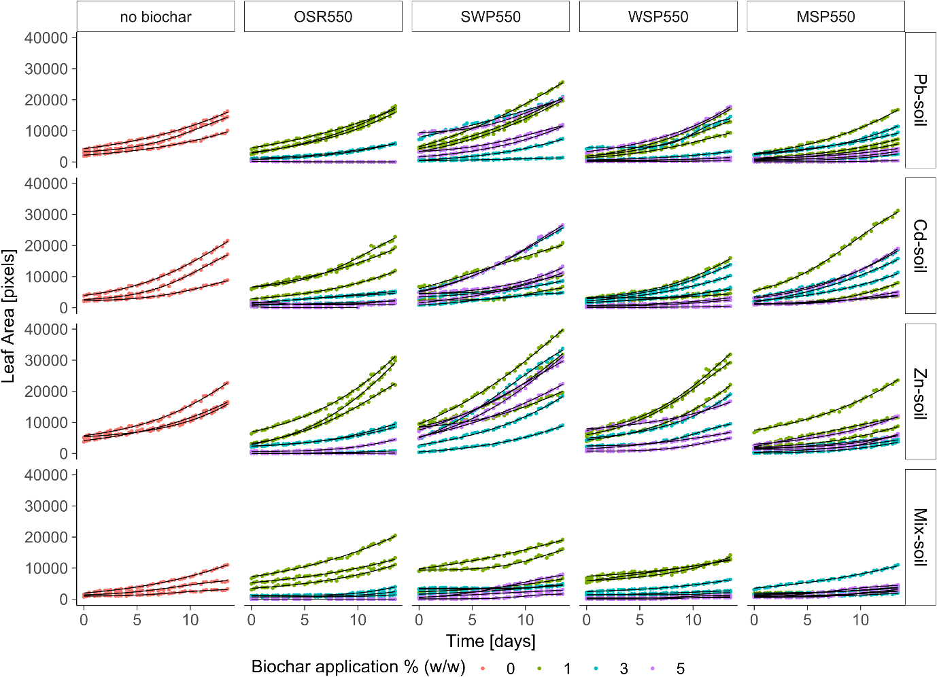

Fig. 8-1 Arabidopsis thaliana Col-0 leaf area measurements over time in plants growing in soil artificially contaminated with single elements Cd, Pb, Zn and a multielement polluted soil (Mix-soil). Soil was amended with plant-based biochars at application rates of 0, 1, 3 and 5 % (w/w). Measurements started 10 days after sowing. Dots represent experimental data measured and lines are the fits for the 4-parameters logistic model.

Appendix 2
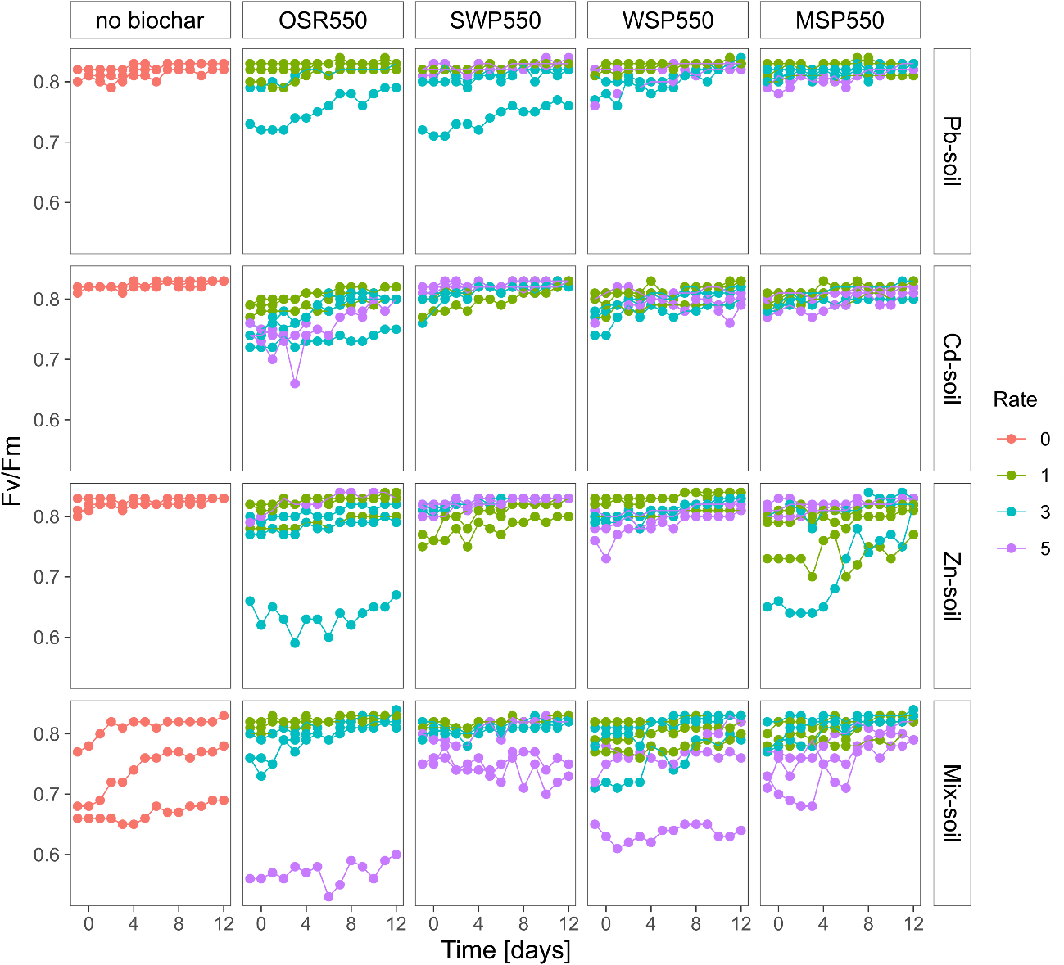

Fig. 8-2. Fv/Fm along time measured in Arabidopsis thaliana col-0 growing in artificially contaminated soils amended with biochars OSR550, SWP550, WSP550 and MSP550 applied at 0, 1, 3 and 5 % (w/w). Dots are the experimental Fv/Fm values recorded at noon.

Appendix 3
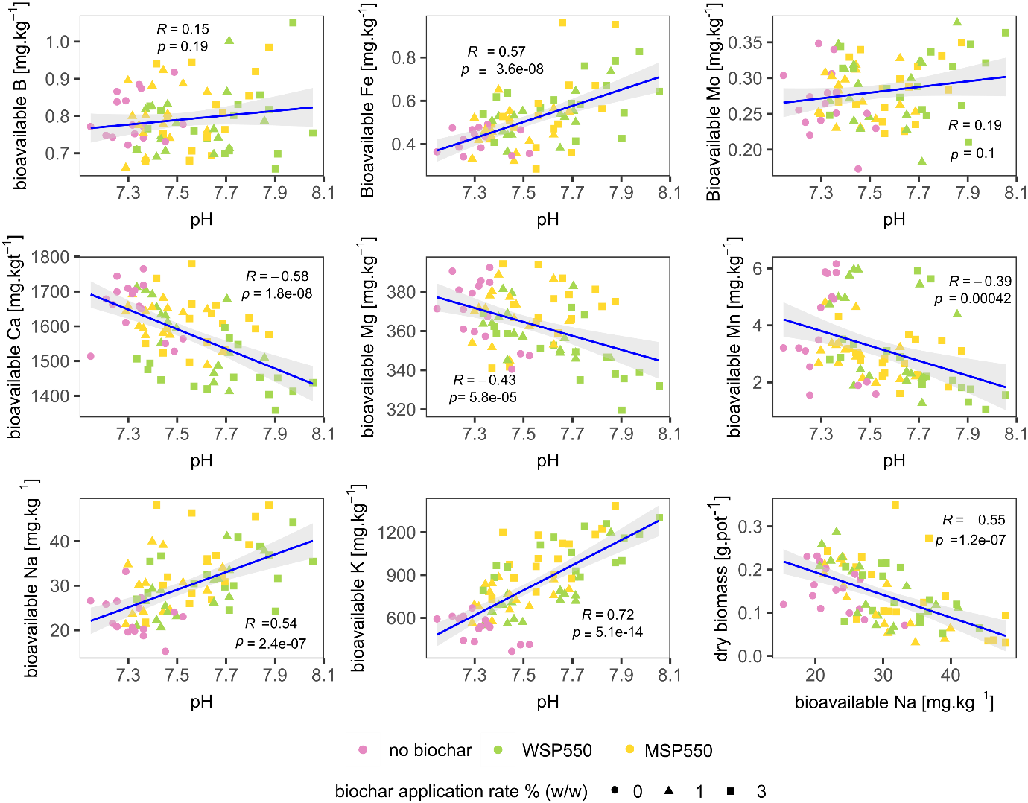
Fig 8-3. Effect of soil pH on nutrient bioavailability in soils planted with Lolium perenne amended with biochars WSP550 and MSP550 at 0, 1 and 3 % (w/w). R= Pearson correlation coefficient, p-value (α= 0.05).

Appendix 4
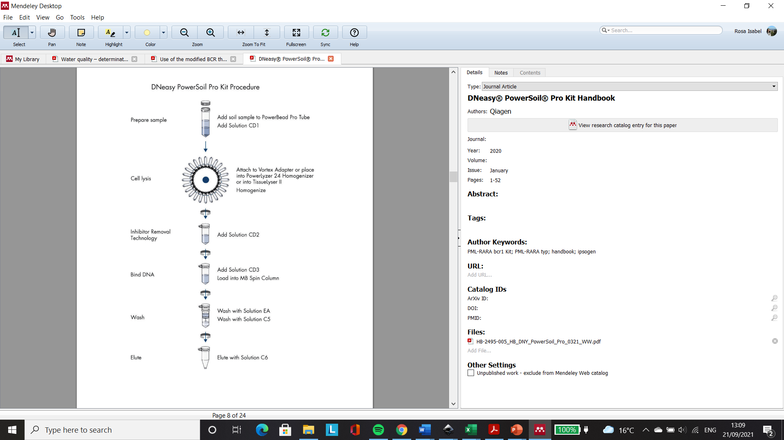
Fig. 8-4. DNeasy PowerSoil Pro Kit Procedure from Qiagen (2020).

Appendix 5

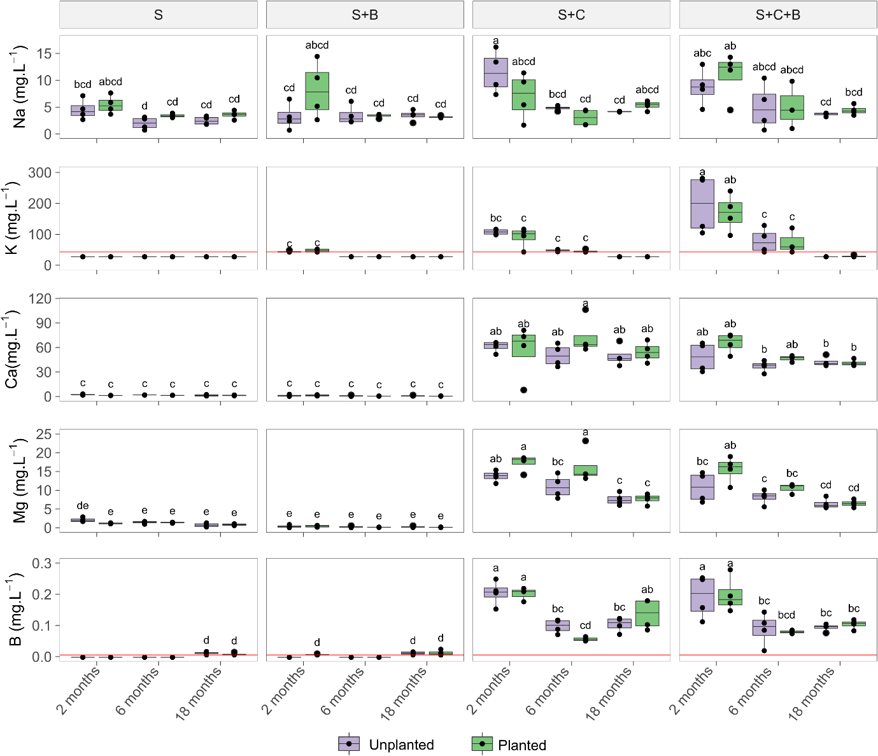
Fig. 8-5. Box plot of selected metals in soil pore water. Collections were at 2, 6 and 18 months after the establishment of the pot experiment. Soil treatments: control soil (S), soil with biochar (S+B), soil with compost (S+C), soil with compost and biochar (S+C+B). Different letters indicate significant differences between treatments according to Tukey post hoc test (α=0.05, n=4). The red line represent the lowest detection limit of the instrument for each element.

Appendix 6
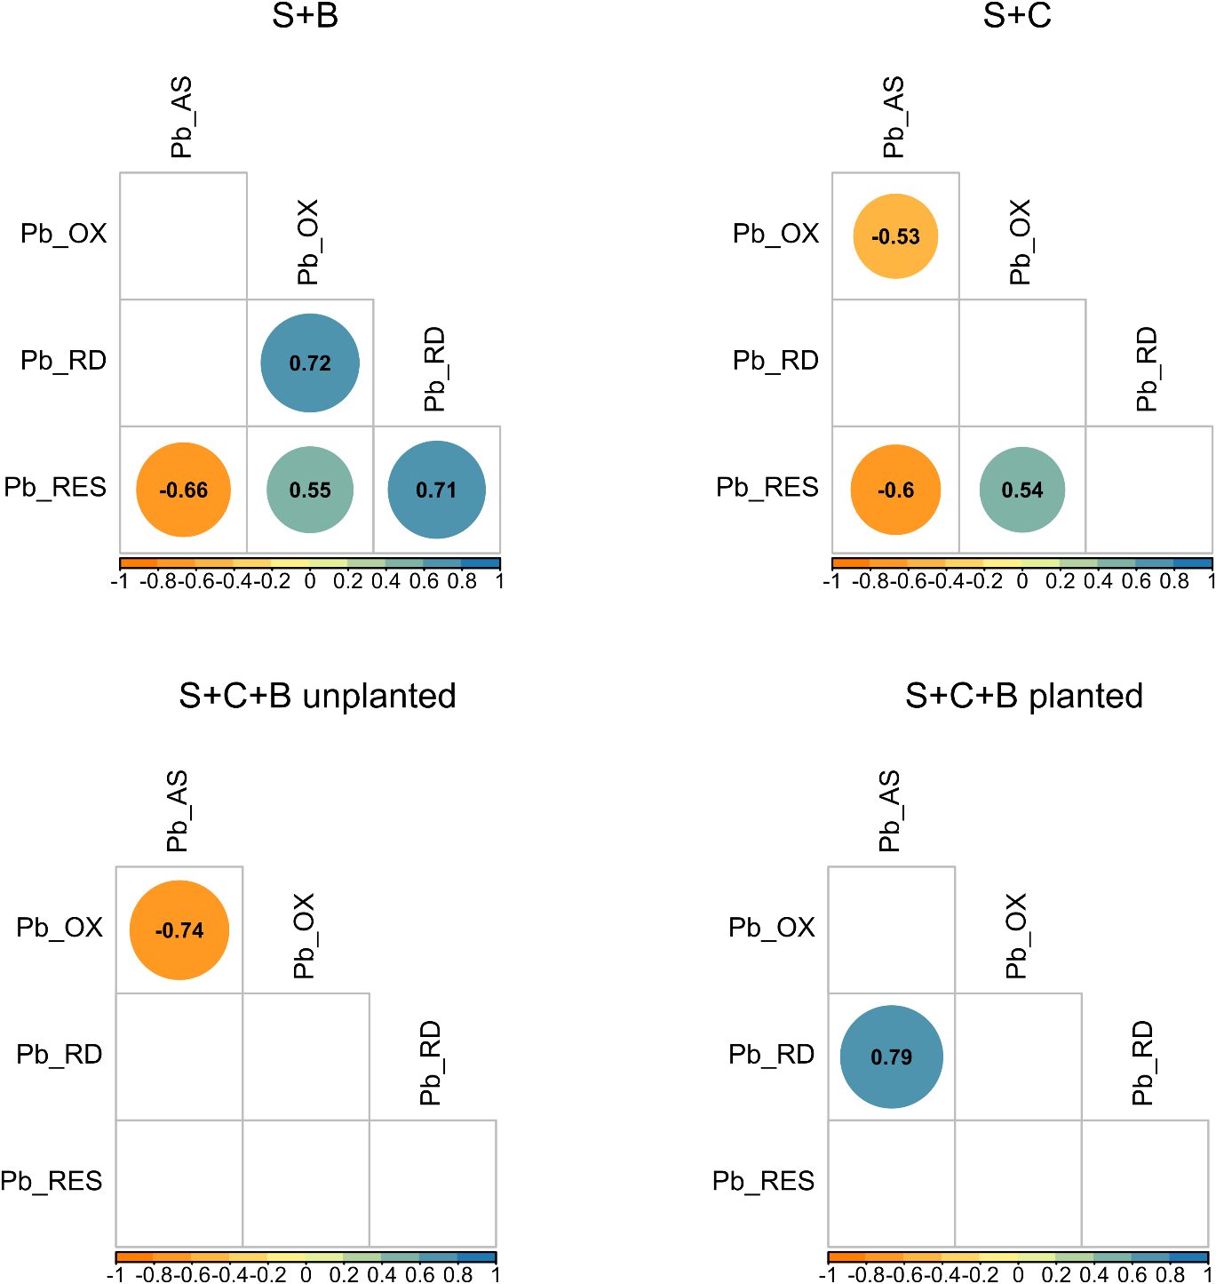

Fig. 8-6. Correlation matrix for the Pb fractions obtained after sequential extraction for each of the treatments used. In the treatments S+B and S+C having the pots planted or unplanted did not result in a significant difference in the different Pb fractions, whereas in the treatment S+C+B there was a significant difference. Fractions, acid soluble (AS), reducible (RD), oxidisable (OX) and residual (RES). R² value for significant correlations (p < 0.05) are shown, correlations that are non-significant are in blank.

Appendix 7
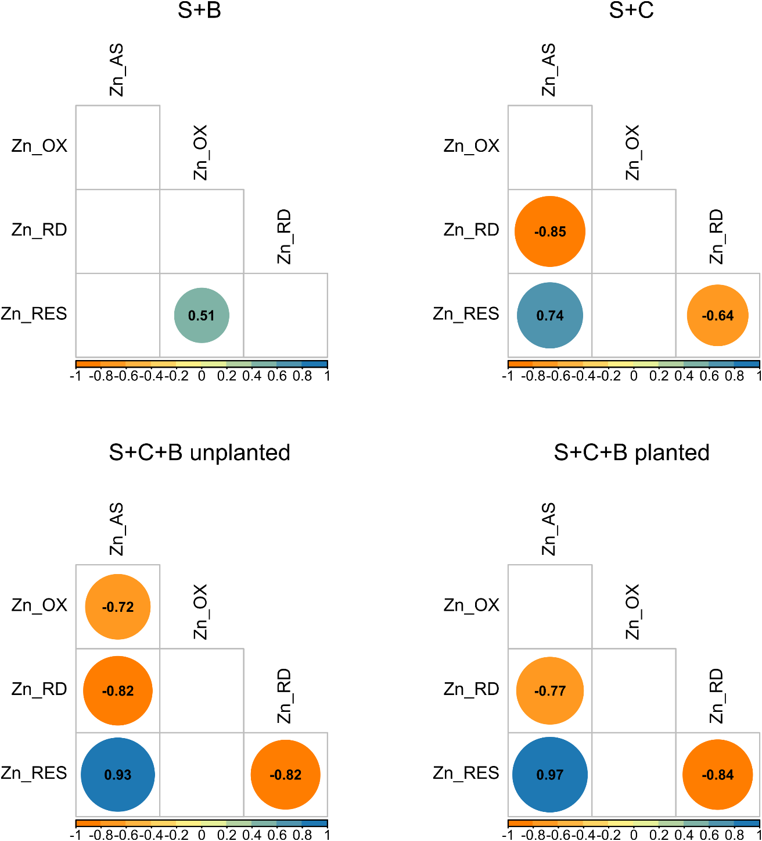
Fig. 8-7 Correlation matrix for the Zn fractions obtained after sequential extraction for each of the treatments used. In the treatments S+B and S+C having the pots planted or unplanted did not result in a significant difference in the different Pb fractions, whereas in the treatment S+C+B there was a significant difference. Fractions, acid soluble (AS), reducible (RD), oxidisable (OX) and residual (RES). R² value for significant correlations (p < 0.05) are shown, correlations that are non-significant are in blank.

Appendix 8
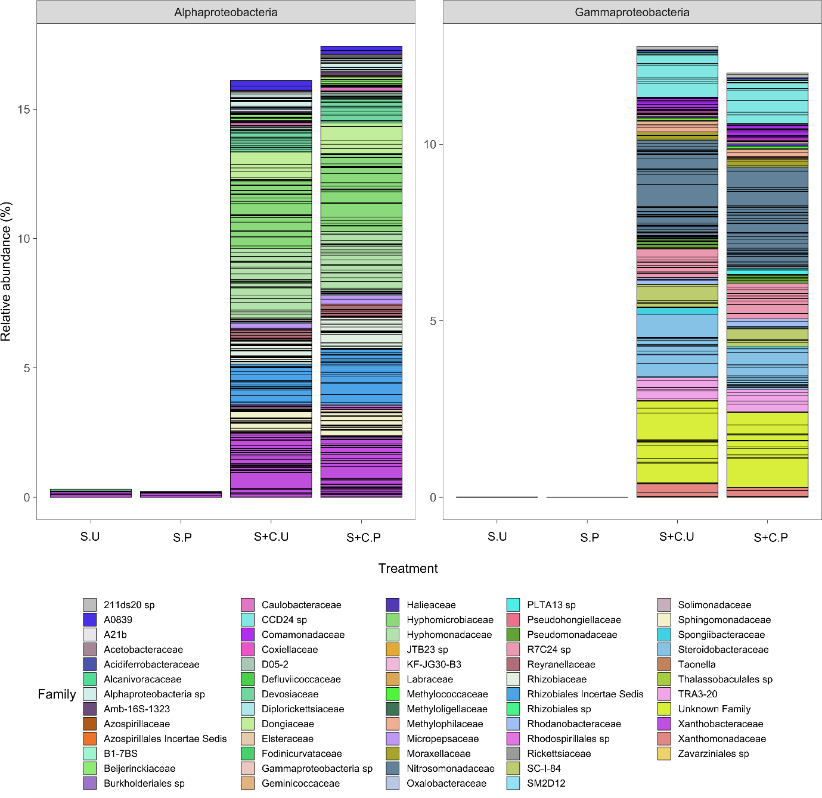
Fig. 8-8 Phylum Proteobacteria grouped by Class that increased with the addition of compost. Treatments Soil unplanted (S.U), Soil planted (S.P), Soil and Compost unplanted (S+C.U) and Soil and Compost planted (S+C.P). Different colors within the bars represent the relative abundance of individual ASVs by Family. Each ASV is separated by black lines. Results are shown as the mean of 4 individual replicates.

Appendix 9
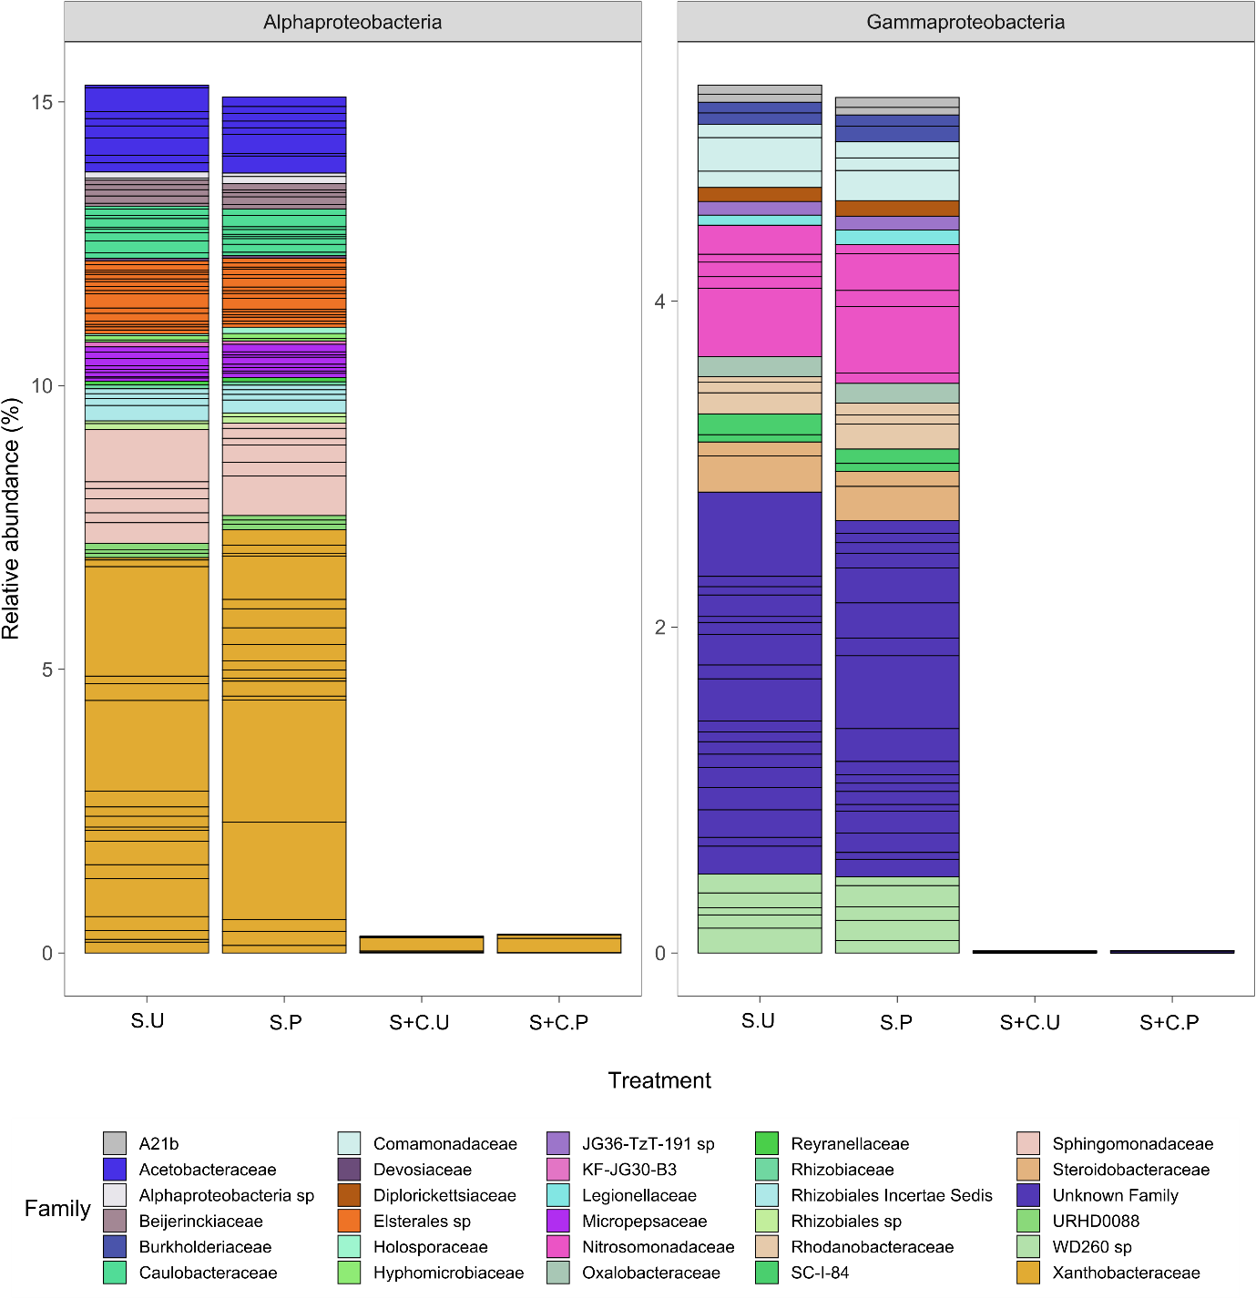
Fig. 8-9 Phylum Proteobacteria grouped by Class that decreased with the addition of compost. Treatments Soil unplanted (S.U), Soil planted (S.P), Soil and Compost unplanted (S+C.U) and Soil and Compost planted (S+C.P). Different colors within the bars represent the relative abundance of individual ASVs by Family. Each ASV is separated by black lines. Results are shown as the mean of 4 individual replicates.

Appendix 10
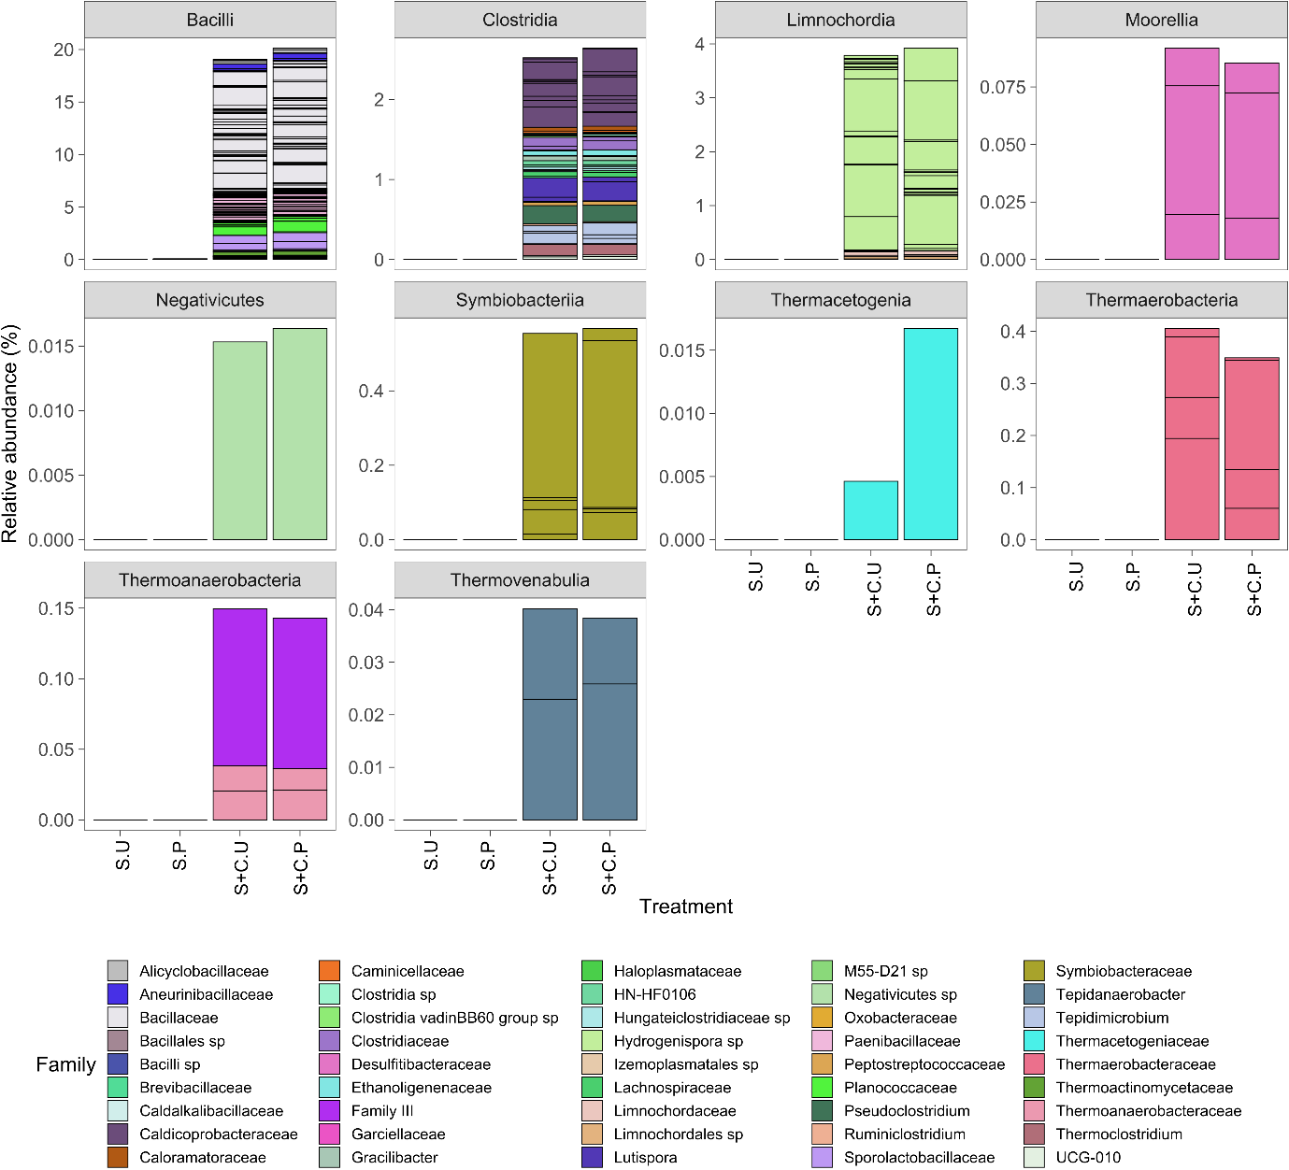
Fig. 8-10 Firmicutes grouped by Class that increased with the addition of compost. Treatments Soil unplanted (S.U), Soil planted (S.P), Soil and Compost unplanted (S+C.U) and Soil and Compost planted (S+C.P). Different colors within the bars represent the relative abundance of individual ASVs by Family. Each ASV is separated by black lines. Results are shown as the mean of 4 individual replicates.

Appendix 11
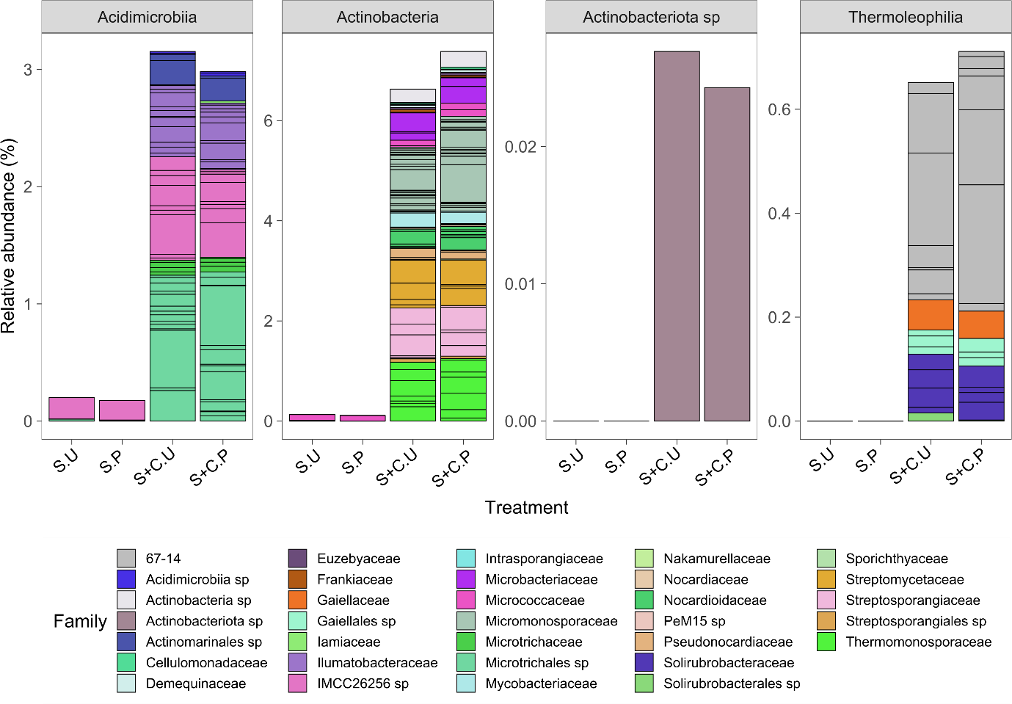
Fig. 8-11 Phylum Actinobacteriota grouped by Class that increased with the addition of compost. Treatments: Soil unplanted (S.U), Soil planted (S.P), Soil and Compost unplanted (S+C.U) and Soil and Compost planted (S+C.P). Different colors within the bars represent the relative abundance of individual ASVs at Family level. Each ASV is separated by black lines. Results are shown as the mean of 4 individual replicates.

Appendix 12
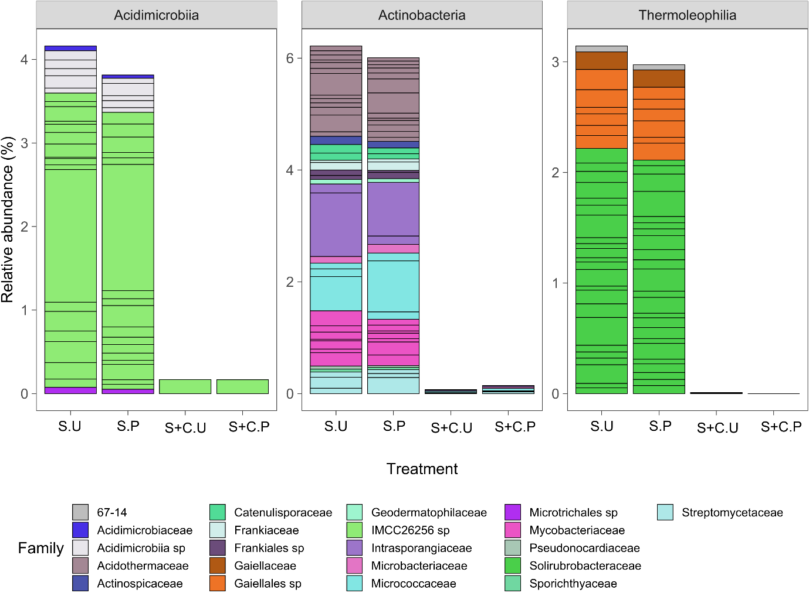

Fig. 8-12 Phylum Actinobacteriota grouped by Class that decreased with the addition of compost. Treatments Soil unplanted (S.U), Soil planted (S.P), Soil and Compost unplanted (S+C.U) and Soil and Compost planted (S+C.P). Different colors within the bars represent the relative abundance of individual ASVs by Family. Each ASV is separated by black lines. Results are shown as the mean of 4 individual replicates.

Appendix 13

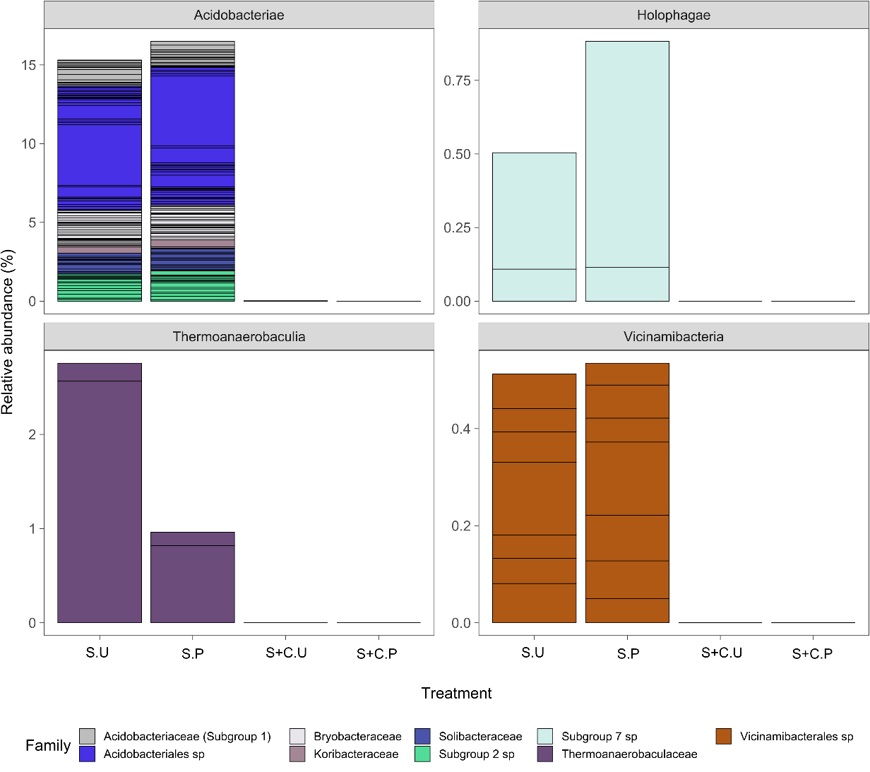
Fig. 8-13 Phylum Acidobacteriota grouped by Class that decreased with the addition of compost. Treatments Soil unplanted (S.U), Soil planted (S.P), Soil and Compost unplanted (S+C.U) and Soil and Compost planted (S+C.P). Different colors within the bars represent the relative abundance of individual ASVs by Family. Each ASV is separated by black lines. Results are shown as the mean of 4 individual replicates.

Pedogenesis: the transformation of weathered rock into differentiated soil horizons with unique visual, chemical, and physical characteristics (Wade et al., 2021).
Thylakoid: membrane-bound compartment inside chloroplasts where the photochemical and electron transport reactions of photosynthesis occur (Roston et al., 2017).
Heat map: is a way to visualize hierarchical clustering where data values are transformed to colour-scale (Datanovia, 2020).

