

Investigation of Solvent Interactions Affecting Reactions Rates Through Electrostatic Interactions

Matthew John Watson

PhD Thesis

The Department of Chemistry

The University of Sheffield

December 2020

Abstract

This thesis describes the application of an electrostatic competition model used to predict and rationalise binding equilibria to predicting the solvent dependence of organic reactions. Initial studies explored the applicability of the model to charged species, which are central to many organic reactions, and were followed by specific representative examples of transesterification and addition reactions.

**Chapter one** describes how solvent effects have been approached previously, leading up to descriptions of contemporary free energy relationships and the supramolecular electrostatic competition model utilised in this thesis.

**Chapter two** presents the analysis of phenolates as exemplars of charged species relevant to organic reactions as nucleophiles and leaving groups. The independently measured values of α (a hydrogen bond donor parameter) and β (A hydrogen bond acceptor parameter) showed a weak correlation, and previous reports of compensating effects in homodimer formation do not seem well founded. The β values of phenolates are found to be in the range 11.5 to 14.3, but without a simple relation to p*K*a or substituent and strongly affected by the formation of an initial hydrogen bond.

**Chapter three** examines the solvent dependence of a range of transesterification reactions between phenolates and aryl acetates using the α and β values obtained in chapter two. The solvent dependencies of the reactions are dominated by interactions with the ground state phenolates, and the equilibirum constant for the reaction also shows a related dependence on the hydrogen bond donor properties of the solvent. Model systems which introduced intramolecular hydrogen bond donors were partly successful in demonstrating the impact of different interactions between the solvent and the nucleophile or electrophile.

**Chapter four** expands the approach to explore an addition reaction, and it is shown that both nucleophile and electrophile are affected by specific solvent properties which can be quantified. This leads to the observation that solvent mixtures show the lowest reactivity for the addition reaction, and contrasts with previous assumptions in quantifying electrophilicity in particular. The different impacts of the solvent components are used to control the reactivity of a common nucleophile with two electrophiles in a rationale manner, holding out the prospect that binary solvent mixtures can be used to direct sites of reaction.

**Chapter five** presents the general conclusions of the work, noting the success of predicting changes in reactivity based on independently measured solvent parameters that only quantify hydrogen bond donating and accepting properties, and **chapter 6** provides the experimental details of the work carried out.

**Acknowledgements**

This thesis is dedicated to my dad, Philip Guy Watson, whose walks inspired my curiosity and gave me the confidence to ask “why?”

I would like to thank Professor Nick Williams for his support throughout my PhD and encouragement to investigate the “not that obvious” even from my undergraduate days.

I would like to thank my Postdocs. Dr Craig Robertson who was integral in making me feel welcome in the research group, Dr Jim Scotson for helping develop my research skills and Dr Rebecca Hawker for helping by proofreading my work and encouraging me to never settle. Professor Charles Stirling has always encouraged me to never let science get me down, hard as it may try.

My thanks to the entire N. H. Williams group, PJ Taylor, William Seddon, Valerio Viali, Søren Svenningsen, Fatma Ashour, Fatma Aburass, Layla Alajmee, and all the Masters Students for providing me with hours of entertainment in one way or another.

I would like to thank the GTA crew but especially Zoe Smallwood, Beth Crowston, Jenna Spencer-Briggs, Sally Morton, and Dr Julie Hyde for supporting my time as a GTA and having fun while teaching. I would also like to thank the students, I loved my time teaching, but not marking.

I would like to thank my friends Abs, Vlad, Eve, Dan, Cam, Joe, Mike, Chloe, James, and Bob for supporting me through this time and especially this incredibly hard year of 2020 by keeping me entertained and happy.

Finally, I would like to give many thanks to my sister, mum, dad, and Bracken, you have given me everything to be who I am.

**Abbreviations**

|  |  |
| --- | --- |
| 2-PhOH-2-PhO | 2-phenol-2-phenolate |
| 3-NO2-PhO | 3-nitrophenolate |
| 3-NO2-4-Cl-PhO | 3-nitro-4-chlorophenolate |
| 3-NO2-CF3-PhO | 3-nitro-4-trifluoromethylphenolate |
| 3-CN-PhO | 3-cyanophenolate |
| 4-NO2-PhO | 4-nitrophenolate |
| 4-CN-PhO | 4-cyanophenolate |
| Ac | Acetate |
| ACN | Acetonitrile |
| d | Doublet |
| DCM | Dichloromethane |
| DMSO | Dimethyl sulfoxide |
| E | Electrophile |
| Et al | Et alia |
| HBD | Hydrogen bond donor |
| HBA | Hydrogen bond acceptor |
| HFIP | Hexafluoroisopropanol |
| HMPA | Hexamethylphosphoramide |
| HPLC | High pressure liquid chromatography |
| LFER | Linear Free Energy Relationship |
| LG | Leaving group |
| ln | Natural logarithm (base e) |
| Log | Logarithm (base 10) |
| Nu | Nucleophile |
| obs | Observed |
| ppm | Parts per million |
| Pro | Product |
| q | Quartet |
| rel | Relative |
| s | Singlet |
| t | Triplet |
| TBA | Tetrabutylammonium |
| TFE | Trifluoroethanol |
| THF | Tetrahydrofuran |
| TS | Transition state |
| UV | Ultraviolet |
| Vis | Visible |

Table of Contents

1. Introduction 10

1.1 Empirical Models for predicting intramolecular interaction in solution 10

1.1.1 Solvent Effects on Energies of Interaction: Hughes and Ingold 10

1.1.2 Solvent Effects on Rates of Reaction: Kamlet-Taft 12

1.1.3 Solvent Effects on Energies of Interaction: Hunter Model 16

1.2 Predicting Reaction Rates 19

1.2.1 Predicting Reaction Rates: Reactivity Parameter 19

1.3 Modelling Reaction Pathways 21

1.3.1 Modelling Reaction Pathways: Transesterification 21

1.3 Project Aims 23

2. Hydrogen bond acceptor and donor values of phenols and phenolates 25

2.1 Introduction 25

2.1.1 Aims 25

2.1.2 Intermolecular interactions 25

2.1.3 Models 26

2.1.4 Intermolecular interactions of phenolates in solution 28

2.2 Experimental design 29

2.3 Results and Discussion 33

2.3.1 Binding constants 33

2.3.2 Predicting the bond energies of phenol-phenolate homodimers 37

2.4 Conclusion 40

3. Solvent effects on the kinetics of transesterification reactions 42

3.1 Introduction 42

3.1.1 Computational approach 42

3.1.2 Empirical Approach 43

3.1.3 A Targeted Approach 44

3.1.4 Model System 45

3.1.5 The transesterification reaction 47

3.2 Results and discussion 47

3.2.1 Experimental Data 47

3.2.2 Solvent effects in single solvent systems 49

3.2.3 Predicting the rate of transesterification in binary solvent mixtures 53

3.2.4 Equilibria 69

3.2.5 Protic Solvents 72

3.2.6 Local transition state stabilisation 76

3.2.7 Altering the nucleophilicity of 2-phenol-2-phenolate tetrabutylammonium salt 79

3.3 Conclusion and Future work 83

4. Solvent effects on the addition of a trityl cation and a phenolate anion 86

4.1 Introduction 86

4.1.1 Overall goal 86

4.1.2 Mayr Model 86

4.1.3 A Targeted Approach 87

4.1.4 Model Reaction 87

4.2 Results and discussion 90

4.2.1 Obtaining the α values of trityl cations 90

4.2.2 Reaction between a phenolate and a trityl cation 91

4.2.3 Solvent independent nucleophilicity parameters 100

4.2.4 Altering the preference of reactivity through solvent effects 101

4.3 Conclusion 105

5. Conclusion and Future work 107

5.1 Conclusion 107

5.2 Future Work 112

6. Experimental and appendix 115

6.1 General procedures 115

6.2 Synthesis 115

6.2.1 Synthesis of tetrabutylammonium phenolates 115

General synthesis of substituted phenolate tetrabutylammonium salts 115

4-nitrophenolate tetrabutylammonium salt monohydrate 115

4-cyanophenolate tetrabutylammonium salt 116

3-nitrophenolate tetrabutylammonium salt 116

3-nitro-4-chlorophenolate tetrabutylammonium salt 117

3-trifluoromethyl-4-nitrophenolate tetrabutylammonium 117

3-cyanophenolate tetrabutylammonium 118

2-phenol-2-phenolate tetrabutylammonium salt 118

6.2.2 Synthesis of substituted aryl acetates 119

3-nitrophenylacetate 119

3-nitro-4-chlorophenylacetate 119

2,4-dinitrophenylacaetate 119

6.3 Hydrogen bond titration 121

6.3.1 Experimental 121

3-nitrophenolate tetrabutylammonium salt 121

Average and 2× standard deviation 124

3-nitro-4-chorophenolate tetrabutylammonium salt 127

4-cyanophenolate tetrabutylammonium 133

2-phenol-2-phenolate tetrabutylammonium 138

4-Nitrophenolate tetrabutylammonium 141

3-cyanophenolate tetrabutylammonium 146

3-trifluoromethyl-4-nitrophenolate tetrabutylammonium 150

3-nitrophenol 155

3-nitro-4-chlorophenol 160

4-cyanophenol 165

3-cyanophenol 169

Crystal violet 173

Malachite green 176

6.4 Kinetic methods 181

6.4.1 Second order rate constants for transesterification reactions in single solvents 181

6.4.2 Second order rate constants for transesterification reactions in acetonitrile chloroform mixtures 191

6.4.3 Second order rate constants for transesterification reactions in acetonitrile pyrrole mixtures 208

6.4.3 Second order rate constants for transesterification reactions in acetonitrile trifluoroethanol mixtures and acetonitrile and hexaflouroisopropanol mixtures 218

6.4.2 Second order rate constants for the addition between trityl cations and phenolate anions in solvent mixtures of acetonitrile and chloroform 219

6.5 HPLC 237

6.5.1 Experimental set up 237

6.5.2 4-cyanophenolate reaction with 4-nitrophenylacetate in acetonitrile and chloroform mixtures, method a 240

6.5.3 4-cyanophenolate reaction with 4-nitrophenylacetate in acetonitrile and pyrrole mixtures, method a 241

6.5.4 3-nitro-4-chlorophenolate reaction with 4-nitrophenylacetate in acetonitrile and chloroform, method b 242

6.5.5 3-nitro-4-chlorophenolate reaction with 4-nitrophenylacetate in acetonitrile and Pyrrole method b 243

References 245

# Introduction

## Empirical Models for predicting intramolecular interaction in solution

### 1.1.1 Solvent Effects on Energies of Interaction: Hughes and Ingold

Understanding the effect solvents have in chemistry is of the utmost importance as huge numbers of chemical reactions, recognition and separation events in nature and the laboratory involve a solvent system. The desired role a solvent system can perform varies. A solvent system can be used to separate substances based on solubility,1 allow compounds to react by providing a medium for them to interact in, trap gases and more.

As the role a solvent can play is varied the number of parameters used to describe a solvent is very large.2 3 Understanding which parameter is relevant to a particular task is imperative to accurately predict how a solvent will perform at a given task. Amongst the first parameters used to predict solvent effects on reaction rates was the dielectric constant. The dielectric constant of the solvent was used in the Hughes-Ingold rules.4 The rules dealt with nucleophilic and elimination reactions and classified them into neutral, positively charged and negatively charged. Hughes and Ingold make the following assumptions:

1. Increasing the magnitude of the charge on the solute will increase the solubility of the solute.
2. The more delocalised the charge on the solute is the more the solubility of the solute will decrease.
3. Complete loss of charge on the solute will decrease the solubility more than delocalisation of charge.

These assumptions resulted in the general rules for all solvents:

1. Increasing the polarity of the solvent will accelerate the rate of reaction in the case where a charge is developed in the transition state from a neutral or slightly charged starting material.
2. Increasing the polarity of the solvent will decrease the rate of reaction in the case where charge is lost in the transition state from a charged starting material.
3. Changing the solvent polarity will have little or no effect if there is little change in the charge between the transition state and the starting materials.

These general rules are not ideal since they treat the solvent as a continuum and not as individual molecules. It must also be noted that while these rules are meant to be for all solvent systems, the data used to produce these rules primarily consists of aqueous, alcohol and acetone components. The bias towards strong hydrogen bonding solvents explains the implication that strongly charged species have better solubility in hexane than a neutral species, which is broadly not true. Treating the solvent in this way does not take into account any other interaction the solvent might have with the solute such as hydrogen bonding or Van der Waals forces. The result of generalising means there are reactions that do not fit with the Hughes-Ingold rules. For example, the Kemp decarboxylation, seen in Figure 1, does not see a linear relationship between dielectric constant of the solvent and the rate of reaction as can be seen in Figure 2.5



Figure : Reaction scheme of base-catalysed Kemp decarboxylation.

|  |  |  |  |  |  |
| --- | --- | --- | --- | --- | --- |
| Solvent | Water | Methanol | DCM | THF | HMPA |
| k(rel) | 1 | 34 | 6350 | 5,000,000 | 94,600,000 |
| Dielectric constant6 | 80 | 30 | 9.1 | 7.58 | 5.54 |

Table : The rate of reaction for the Kemp elimination relative to water in various solvents with varying dielectric constants.

Figure : The relative rate of reaction for the Kemp elimination in various solvents plotted against the dielectric constant showing a lack of linearity between the rate of reaction and the dielectric constant.

An explanation as to why the rate of reaction would be affected by a bulk property of a solvent was proposed later by Laidler and Eyring, Equation 1.7 They stated that the activation parameter for a reaction between two ions is heavily dependent on the solvent dielectric constant and ionic strength. They stated for a bimolecular reaction between two ions, the log of the rate constant is affected by the solvent dielectric constant. As the dissolution of an ion increases, the free energy inversely proportional to the new solvent dielectric constant. This is mostly based on applying the physics of stabilising charges in dielectric fields to chemistry problems.

Equation

Where *k* is the rate constant, D is the dielectric of the solvent. The symbol εo is the permittivity of free space, ZA and ZB are the charges of the reactants A and B and Z‡ is the transition state complex. The r is the radius of each species.

## 1.1.2 Solvent Effects on Rates of Reaction: Kamlet-Taft

Kamlet, Taft and later Abraham developed a series of equations rather than the general rules put forward by Hughes and Ingold. They used parameters that quantified the interactions between molecules. The new parameters were α, which represented the hydrogen bond donor abilities of the solvent, and β, which represented the hydrogen bond acceptor abilities of the solvent. The third parameter they used was π*,8 9 represents a blend of dipolarity and polarizability. There was a later addition to the Kamlet-Taft parameters to account for solvents with low polarizability behaving as though they had a higher polarizability, for example aromatic solvents and perfluoroalcohols. They did this by adding to the π* with δ, which represented the chargeability of the solvent. The new term δ had to be worked out empirically for each reaction, which meant it was not as effective to use when compared with solvents that only needed π*. These parameters were determined by solvatochromism. A linear relationship could then be established between the rate of reaction and some or all of these three parameters.8 They created this linear relationship by using the general equation as can be seen in Equation 2. The XYZ is a stand in for most solvent dependent terms. It can represent reaction rates, equilibria, partition coefficient and more.

Equation

Creating this linear relationship allows the rate of reaction in additional solvents to be predicted readily.

Work by Kamlet, Taft and Abraham looked at how the unimolecular rate of decomposition of tertiary butyl halides varied with solvents of various α, β, and π*.8 They found that the rate of reaction was dependent on the hydrogen bond donor strength of the solvent. The reaction rate was not affected by the hydrogen bond acceptor strength of the solvent. They attributed the relationship between the rate of reaction and the hydrogen bond donor strength to hydrogen bonding between the protic solvent and the leaving halide. The Kamlet and Taft equation has also been used to predict partitioning between solvents.10

The Kamlet-Taft parameters are still being used as a way to predict reaction rates and as a very common tool for predicting solvent effects on reactions.11 The parameters have shown remarkable versatility in solvents ranging from supercritical water12 to ionic liquids13. Most of these LFER use some way of measuring the bulk solvent system polarity, which is usually obtained from a solvatochromatic measurement (although the dye varies), and the dielectric constant with each system (using their own method of scaling these values). Koppel and Palm’s system, seen in Equation 3, uses a measure of the Lewis Acidity and basicity of the solvent system rather than Kamlet-Taft-Abraham use of hydrogen bond basicity and acidity. In Koppel and Palm’s general equation for predicting solvent effects A and A0 represent the values of interest which can represent nearly any solvent dependent parameter. Y represents the polarity, and y is its scalar, P represents the polarizability and, p is its scalar. E represents the solvent Lewis acidity and, e is its scalar, B represents the Lewis basicity and, b is its scalar.

Equation

Shorter’s model, seen in Equation 4, does not use parameters for any direct interactions and is based on polar constants, dielectric constant and the number of hydrogen atoms. Shorter’s equation for solvent affects in the reaction between diazodiphenylmethane and benzoic acid in alcohols. C represents a constant. The f(ε) represents the solvents dielectric constant and, A is its scalar, σ* represents the Taft polar constant and, B is its scalar, nγH represent the number of γ-hydrogen atoms in the solvent. The number of γ-hydrogen atoms can be used as an indicator of the size of Van der Waals forces the molecule will experience.

Equation

Systems such as these have problems as they require large quantities of data on the rates of reaction in various solvents to be available or require the time to perform such experiments. This method is not time efficient nor effective for improving the rates of a new reaction. The Kamlet-Taft and other LFERs are also valuable for providing information about what is occurring during the reaction. Seeing the dependence of the reaction rate on the α, β and π* terms can indicate what is occurring at the transition state. For example, a strong correlation with α indicates a negative charge is being stabilised by a solvent and is having a large effect on the energies along the reaction coordinate. What these empirical methods do not use is actual energetic information along the reaction pathway. For example, there is no indication that the transition state is being affected by X kJ whereas the starting materials are affected by Y kJ. In the 1960s pre-computational methods were developed to look at this route by calculating the free the energy of transfer between two solvents for the SM and TS. Then these new energies were used to determine the new difference in energy between the SM and TS and hence determine the new rate of reaction. When it has been possible, the energy of a solute that is somewhat analogous in structure to the transition state is used to estimate what the energy of the transition state should be. This method was used extensively by Abraham14 15 16 and proved to be effective at showing whether the change in Δ*G*‡ resulted mainly from a change in energy of the starting material, transition state or both. These LFER method and energy difference approaches were then compared side by side by Abraham who showed consistency between the two methods in spite of their different approaches.17

The two main non-computational approaches to predicting solvent effects on reactivity are very different. Either empirical parameters are used to see if there is a linear relationship between any of the empirical parameters and the rate of reaction or breaking down the change in Δ*G*‡ into changes from the starting materials and transition state. These two approaches have both been useful at providing information on what is occurring during the reaction. What the above methods have not been particularly effective at is predicting rates of reaction in untested solvent systems.

Raevsky created Equation 5 to predict changes in enthalpy for hydrogen-bond complexation of solutes in solvents.18

Equation

Δ*H*oAB represented the standard enthalpy of the interaction between, A, a hydrogen bond donor solute, and B, a hydrogen bond accepting solute, in tetrachloromethane. EA is the hydrogen bond acidity of the solute A, EB is the hydrogen bond basicity of solute B. It must be noted that both A and B are solutes, as they are both in tetrachloromethane. One or both may be a solvent in their own right. Tetrachloromethane has been the solvent of choice for measuring the hydrogen bonding interaction between molecules in a solvent system because of a lack of any hydrogen bonding donor or acceptor sites. The solvent was believed to be non-competitive with the molecules in the solvent that were having their binding affinity analysed. This equation had some problems: firstly, many studies require Gibbs energy and not enthalpy to provide useful information as the entropic cost of bringing two species together may reduce the overall favourability. The entropic cost was considered with the altered Equation 6.

Equation

Δ*G*oAB represented the standard Gibbs energy of the interaction between A, a hydrogen bond donor solute, and B, a hydrogen bond accepting solute, in tetrachloromethane. CA is the hydrogen bond acidity of the solute A, CB is the hydrogen bond basicity of solute B. The scale used to assign hydrogen bond acidity and basicity values was standardized empirically by using CA = -1.0 for phenol and CB = +1.0 for diethyl ether. The factor of 5.46 is the negative of the standard Gibbs energy for phenol-diethyl ether hydrogen bond formation. This method combined with the above equation led to some infinite values for hydrogen bonding due to a standard of 0 basicity giving *K* of 0, resulting in a Δ*G* of ∞ which is clearly not possible. The equation above was modified by changing the basicity and acidity scales to remove the possibility of having an infinite Δ*G*.

Abraham also created a scale of hydrogen bonding interaction.19 His scale, while related to the energy of hydrogen bonding interaction, is used in Equation 7.

Equation

The log SP is a property of a series of solutes in the same phase. Generally, it is a partition coefficient and has found much use in biology and pharmacy.20 R2 is an excess molar refraction. The term πH2 is the solute polarizability. The log L term is the solute gas-hexadecane partition coefficient. The solute gas-hexadecane partition coefficient encodes the Van der Waals interactions of the molecules. The αH2 and βH2 terms represent the hydrogen bond acidity and basicity of the solute. The symbols may also be described with the following symbols without altering the information they encode A=α2H, B=β2H, S=π2H , L = logL16, E=R2.To obtain the αH2 term, Abraham found the binding of the compound to a standard hydrogen bond acceptor, and βH2 term was obtained similarly but to a standard hydrogen bond donor. Abraham was then able to predict the association between two compounds with known αH2 and βH2 terms using Equation 8.

Equation

The αH2 and βH2 terms are the same as previously explained, c and c’ are constants.

### 1.1.3 Solvent Effects on Energies of Interaction: Hunter Model

Hunter created a new scale of α and β values.21 The new scale was different in several ways. One of the primary ways in which it was different was that it only considered electrostatic effects as the main influence on interactions between species in solution. This idea allows for the placement of hydrogen bonds,22 halogen bonds and dipolar interactions on the same scale, but does not take into consideration orbital interactions and does not include dispersion interactions as they are assumed to cancel out.23 For example, tetrachloromethane is used by Abraham as the solvent of choice to test hydrogen bonding interactions. Tetrachloromethane (CCl4) was used as it does not have any hydrogens to donate. However, treating CCl4 as an electrostatic potential surface showed that it did in fact have the capability of forming weak interactions with other compounds as shown in Figure 3. The Hunter scale can be converted to the Abraham scale for electrostatic surface with Equation 9 and Equation 10.

Equation

Equation

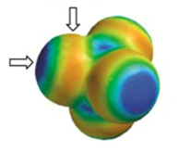

β = 0.6

α = 1.6

Figure : The electrostatic potential surface of tetrachloromethane. The blue areas indicate negative electrostatic potential surface; the red areas indicate positive electrostatic surface potential. The electrostatic surface potential can then be converted into α and β.

Once the electrostatic potential surface is modelled the α and β values are taken from only the most extreme points rather than the averages. A relationship between α and β of the solutes and solvents, and the Δ*G* of the system was found, and is represented in Equation 11. The + 6 term was attributed to account for the entropic cost of bringing together the solutes.

Equation

The α term is the α of the hydrogen bond donor in solution, the β term is the β of the hydrogen bond acceptor in solution. The αs term is the α term of the solvent, the βs term is the β term of the solvent. Ultimately treating α and β values in this way meant that molecules without traditional hydrogen bonding sites could still be shown to interact.24 23 This method was designed to be able to relate halogen bonding to hydrogen bonding. The method also related experimental data with computational values.25 An α or β value can be predicted via mapping the electrostatic potential surface, giving data in good agreement with experimental evidence.

However, the Hunter system is not ideal. Simplifying a molecule down to a single negative and positive electrostatic site under ideal conditions belies the complications of real-world solvent systems. An example of this is the complications of solvents that have strong self-association such as alcohols.26 The self-association of alcohols is a function of an alcohol group being both a strong hydrogen bond donor and acceptor, which allows alcohols to form supramolecular structures such as rings and chains. The formation of supramolecular rings and chains by alcohols is also a result of the consequences of forming hydrogen bonds to alcohols. When an alcohol acts as a hydrogen bond acceptor the alcohol then becomes a better hydrogen bond donor making the formation of another hydrogen bond to another alcohol thermodynamically more favourable. This ultimately results in a solution of a single solvent having the properties of a solvent mixture. The added complications of a solvent self-associating needs to be accounted for.

The method of obtaining the α or β value of a compound is also designed to treat the solute and solvents in the same way.27 As a result of treating solvents and solutes the same way only two terms are needed, α and β to describe any interaction in the liquid phase in theory. The Hunter group utilised already existing data such as αH2 and βH2 values to quickly create an extensive range of their own α and β values.

Recent work by the Hunter group has expanded the range of species with α and β values to charged species. The computational method used to obtain the α and β value from the electrostatic surface potential was not successful at producing α or β values for charged species. Understanding the intermolecular interactions between charged and neutral and charged and charged species is important as charged species are often seen in the binding pockets of enzymes and supramolecular structures. In dynamic systems such as reactions, charged species are often formed as either intermediates or products. Obtaining the α and β values of charged species would allow for a better understanding of the thermodynamic trends in the bindings of charged species.28 29 The α and β values of charged species were obtained through experimental rather than computational means.

The α values of cations were obtained through titrations to hydrogen-bond acceptors frequently used in titrations with neutral species; tributylphosphine oxide and Reichardt's dye. Tributylphosphine oxide is a neutral species and Reichardt's dye is a betaine with the hydrogen bond acceptor site being an oxyanion.



Figure : A) shows the structure of the Reichardt's dye and B) shows the structure of tributylphosphine oxide.

Both organic and inorganic cations behaved in a traditional manner, with binding to the hydrogen bond acceptors fitting well to 1:1 binding curve. The highest a value of the cations tested was the lithium ion. The lithium ion was found to have an α value of 5.0 which is surprisingly comparable to a neutral species, 3-trifluoro-4-nitrophenol which has an α value of 5.1. The cation with the lowest α value was tetrabutylammonium which has an a of 2.6. These experiments place the hydrogen-bond donor abilities of cations firmly within the range of neutral hydrogen-bond donors.28

The β values of anions were obtained through titrations to hydrogen-bond donors frequently used in hydrogen bond titrations with neutral species. The hydrogen-bond donors were 3‑trifluromethyl-4-nitrophenol, 4-nitrophenol and 4-phenylazophenol. Both organic and inorganic cations behaved in a traditional manor, with the interactions to the hydrogen-bond acceptors fitting well to 1:1 binding curve. Unlike the cations, the anions β values had a higher ceiling then the β values of any neutral species tested previously. The benzoate anion has a β value of 15.1, which is far higher than any neutral species. The lowest β value found was that of PF6– , which was 7.0.29

## 1.2 Predicting Reaction Rates

### 1.2.1 Predicting Reaction Rates: Reactivity Parameter

A chemical reaction is often broken down into two core drivers, kinetic and thermodynamic effects. The kinetic driver of a reaction is the rate at which a chemical reaction occurs as dictated by the height of the energy barrier in the rate limiting step. The thermodynamic driver is the difference in energy between the reactants and products and ultimately dictates the ratio of reactants to products. These simplifications can be of course be more complicated with recent work concerning out-of-equilibrium chemistry and tunnelling-controlled reactions.30

For most laboratory settings it is still kinetics and thermodynamics that dominate reaction behaviour. Creating a model capable of informing how the kinetic and thermodynamic drivers of a reaction can be altered by the environment would prove to be useful.

Swain and Scott produced the first attempt at empirically predicting the rate constant of a reaction in aqueous conditions using linear free energy relationships (Equation 12).31 The *k*0 term is the rate constant for a reaction with water or the background reaction, *k* is the rate constant for the reaction with the given nucleophile, s is the substrate constant and is defined by setting the value of methyl bromide to 1 in water, n is the nucleophilic constant and is defined relative to the value of water, which is given a value of 0.

Equation

Somewhat confusingly the electrophilicity parameter is defined as the role of the solvent or electrophilic solute. The electrophilicity parameter of water is 0 so in aqueous solution the s’e term is reduced to zero however for other systems Equation 13 is used.

Equation

Swain and Scott found that their equation produced good fitting for the substrates and nucleophiles chosen. They found that the relative rates of reaction with different nucleophiles is not solvent independent in mixtures of water and acetone of different ratios.32 Subsequent work by Edwards, Peterson and Schleyer attempted to improve on the work of Swain and Scott. However, they also found that changes to the solvent resulted in erroneous predictions.

Work by Ritchie on the matter of predicting the kinetic rate of reaction on fundamental nucleophilic properties resulted in looking at the reactions between cations and anions. The reactions between cations and anions were chosen to remove complications such as the effect that displacing a leaving group could have on the reactions. The anions selected were trityl cation, aryldiazonium ions and tropylium cations. For given solvent systems and electrophiles a correlation was found between the nucleophiles and the nucleophilicity parameter N+, seen in Equation 14. The N+ parameter was based on the reaction between the nucleophile and (*p*‑nitro) malachite green. The purpose of this work was to refute the idea that the selectivity (log *k*01/*k*2) decreases as reactivity (log *k*) increases for a given electrophile, which was an assumed dogma.

Equation

Ritchie determined that N+ must be based on an inherent property of nucleophilicity and that higher N+ values would be associated with lower solvation energies of the nucleophiles. Ritchie’s work did not create the same scale for the reactivities of the electrophile in the reactions, although they did note that the nucleophilicity correlation fitted better when separating electrophiles of different types.

Work by Herbert Mayr on reactivity and selectivity relationships through linear free energy relationships on the reactivity of diaryl carbenium ions led to the conclusion that Ritchie style correlations exist for a wide variety of nucleophiles for constant carbenium ion electrophiles. This work was further developed by Mayr to create a set of parameters for nucleophiles and electrophiles. Mayr’s first attempt to do so is presented in Equation 15. Mayr believed that electrophilic term was contained in the *k*H2O term in Equation 14. They maintained Ritchie’s notation for nucleophilicity and added an explicit term for electrophilicity, E+. The work assumed that solvents play a minimal role in the rate of reaction and as such the N+ and E+ were determined to be solvent independent terms.

Equation

Initial work by Herbert Mayr gave nucleophile parameters based on multi-step reactions. Subsequent work refined the model to single-step reactions forming carbon bonds.33 34

## 1.3 Modelling Reaction Pathways

### 1.3.1 Modelling Reaction Pathways: Transesterification

The transesterification reaction is a reaction frequently seen in nature and in laboratories for making esters. The reaction can also be used to form polymers via the ring opening of lactones.35 A transesterification reaction is the formation of an ester through the exchange of the alkoxy group with another ester, Figure 5.



Figure : A generic transesterification reaction between an ester and an alcohol.

The reaction is in equilibrium so the reaction products will be a mixture of the reactants and products. The reaction can also be accelerated by acid36 37 or base38 catalysis amongst a host of other catalysts. The textbook mechanism for an acid catalysed reaction, seen in Figure 6 shows the protonation of the carbonyl which results in a more electrophilic site at the carbon.



Figure : The text-book mechanism for an acid-catalysed transesterification reaction between an ester and an alcohol.

The acid catalysed mechanism for transesterification has multiple steps in equilibrium along the path to form the new ester. The textbook mechanism for the base catalysed transesterification (Figure 6) is comparatively simpler.



Figure : The mechanism for a base-catalysed transesterification reaction between an ester and an alcohol.

As shown in Figure 7 the base-catalysed transesterification reaction is typically shown as having an intermediate. Work by Andrew Williams has indicated that the intermediate may have a lifespan short enough to be treated as a transition state in some transesterification reactions.39 40 When reacting 4-nitrophenyl acetate with a series of phenolates whose p*K*a values are above and below that of the 4-nitrophenolate leaving group the Brønsted plot is linear as shown in Figure 8. A linear plot of this type of reaction indicates a process with either no intermediate or a very short lived intermediate.

Figure : The Bronsted like plot produced by Andrew Williams data does not show a change in the gradient around a pK­a of 7.1 which is the pKa of the 4-nitrophenol leaving group indicating a single step

Stepwise processes such as those involving the formation of a tetrahedral intermediate will not produce a linear plot and instead change in gradient as the pH is varied. A change in the slope of the plot is a result of a change in the rate limiting step. The different rate limiting steps in this reaction would be when the formation of the tetrahedral intermediate is the rate limiting step or the expulsion of the leaving group is the rate limiting step.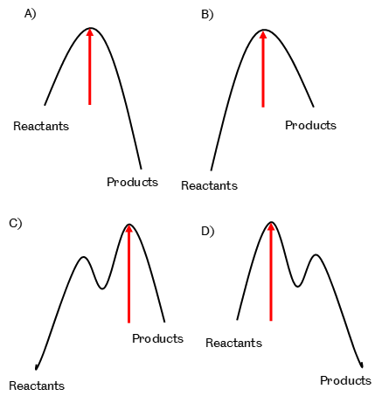

Figure : A) shows a reaction with a single step with the reactants at a lower energy then the products B) shows a reaction with a single step with the reactants at a higher energy then the products. They both have one transition state and therefore one rate liming step (red arrow), changing from one to the other will give a straight line on a Bronsted plot. C) shows a reaction with an intermediate and two transition states where the products are higher in energy then the reactants. D) shows a reaction with an intermediate and two transition states where the products are lower in energy then the reactants. As the rate limiting step in C is determined by the energy of the products but for D it is determined by the reactant a Bronsted graph for this reaction will have two different gradients for when the first or second transition state is the rate limiting step.

Concerted reactions will not see this change to the slope as the bond formation and breaking occur in the same step. If the formation and breaking occurs in one step there is only one rate limiting step. If there is one step, there cannot be a change in the rate limiting step. That does not mean that all transesterification processes occur by the same mechanism. By altering the acetate group into a better electron-donating group it is possible to have a dissociative mechanism. A dissociative mechanism would mean the leaving group leaves before the attack of the nucleophile. Swapping the acetate group for a better electron-withdrawing group encourages the formation of a tetrahedral intermediate. We aim to use this understanding to choose esters that form tetrahedral intermediates.

## 1.3 Project Aims

We aim to expand the understanding of the Hunter electrostatic interaction model of α and β values by experimentally determining the β values of several nucleophilic anionic species and the α values of cationic electrophiles. We aim to create a model to explain and predict how electrophiles and nucleophiles alter their reactivity in solvent systems, particularly solvent mixtures using the determined α and β values of electrophiles and nucleophiles. The model will treat the interactions in solution as electrostatic in nature. We will then take the principles of the model and investigate how it can be used to help laboratory chemists by altering activities.

# 2. Hydrogen bond acceptor and donor values of phenols and phenolates

## 2.1 Introduction

### 2.1.1 Aims

Our initial goal was to expand the measurement of β values beyond neutral functional groups to include anions. Achieving this could allow the effects of solvents on reactions that involve charged species to be predicted through the electrostatic competition model.

Phenolates were selected as the anionic group because it was anticipated that their electrostatic properties could be modified be changing their substituent groups. Altering substituents has predictable effects on the p*K*a of phenols, and might be expected to have similar effects on the corresponding α and β values. Conveniently, phenolates have strong chromophores allowing them to be monitored easily by UV-vis spectrometry. An improved understanding of the intermolecular binding behaviour of phenolates towards hydrogen bond donors will also prove useful. The prevalence of phenolates in laboratory chemistry means understanding their interactions with solutes and solvents will help chemists to understand their behaviour in solution. We aim to utilise the data from this chapter in subsequent chapters to further explain how solvent systems affect the reactivity of phenolates. In this chapter, we shall attempt to find trends in the binding capabilities of phenolates with regards to physicochemical properties such as p*K*a.

### 2.1.2 Intermolecular interactions

There are many ways that species can interact with one-another in solution. Phenolates are negatively charged at an oxonium anion which has three lone pairs, although delocalisation can stabilise the charge. As a result, phenolates experience strong intermolecular interactions with positively charged species and hydrogen bond donors.41 The computed hydrogen bond strength of phenol-phenolate species is around 104 kJ mol-1.42 The strength of a van der Waals force is dependent on the number of electrons and the surface area of interaction43 and can play a role in molecular interactions.44 Work by Scott Cockroft has indicated that while individual van der Waals interactions may be strong in solution the interactions cancel each other out.45 We believe that any focus on the intermolecular interactions between phenolates and phenols will be completely dominated by hydrogen bonds. We believe it is therefore reasonable to ignore these lesser interactions and focus on the significantly stronger hydrogen bonding.

### 2.1.3 Models

Work by Abraham in finding linear free energy relationships (LFER) for the physical properties of solutes and solvents has been extensively used by chemists. The LFER have been used to predict reactivity but can also be used to predict physical parameters such as the Gibbs free energy of solute-solute interactions such as the binding of drugs to binding sites in blood. There are many potential physical and chemical parameters of the solvents that can form LFER. Knowing which parameters are needed for the desired LFER can be a case of trial and error unless it has been done before. Some of the parameters required to form LFERs will not be known, which can take valuable time and money. However, the LFERs developed by Kamlet-Taft-Abraham have been in use for several decades, which means that there is a large database of many of the parameters for many solutes and solvents, from common lab solvents such as acetone and DMSO, to natural solvents such as blood and beer.

Abraham has utilised LFER methods to describe phenolate anions.46 The B values (also known as β value) describing hydrogen bond basicity of the species of the phenolates were found to be particularly high and amongst the highest values of β ever found, with a value of 3.01 for 2-naphtholate. They subsequently correlated the β values of the phenolates with the rate of reaction between the phenolates and iodomethane. The extremely high β values found for the phenolates further supports our simplification that the intermolecular interactions in solution of phenolate will be dominated by hydrogen bonds and so the weaker interactions can be ignored.

The Hunter electrostatic competition model views electrostatic interactions as the dominant method of interaction between species in solution. This model simplifies interactions into two parameters: the hydrogen bond donor value (α) and the hydrogen bond acceptor value (β). The α and β value correlate to the most positive and negative point on the molecules’ electrostatic surface potential. Knowing the α and β values of the species in solution allow the Gibbs free energy of interaction between two species to be predicted. The model is simplistic in its exclusion of σ hole interactions such as halogen22 and chalcogen bonds.47 The has been shown to be a powerful tool in predicting solute interactions even using this minimal information.26 The C term represents the entropic cost of bringing together the two solutes and is generally shown to be 6, however computation work by the Hunter group found 10 to produce the best correlation to experimental data.48

Equation

The α and β values of the solutes and solvents must be known to use Equation 16. As the purpose of Equation 16 is to be able to predict the energy of binding between two solutes competing to interact with one another, the solvent α and β values must be known.

The α and β values can be obtained experimentally through titrations with known hydrogen bond donors or acceptors by obtaining a binding constant between two solutes and rearranging Equation 16 into Equation 17 or Equation 18 depend on the desired unknown.

Equation

Equation

In performing a hydrogen bond titration, the α and β values of the solvent system must be selected carefully. If the α or β value of the solvent system is higher or very similar to that of the solutes there will not be a significant interaction between the solutes to obtain a binding constant. Another potential issue is that errors in α and β values become more important. For example, if the α values of the solute and solvent are 2.5 and 2.0 respectively, and both have an error of ± 0.1, while the β value of the solvent is 1.0 with a *K* of 5, then the possible range in β value for the unknown solute is between 14.8 and 33.8. The larger the difference between the values of the solute and solvent, the less significant the difference is. As phenolates have high B values, as shown by Abraham, the hydrogen bond titrations are not limited by the β value of the solvent. However, the α value of the solvent must be significantly higher than that of the hydrogen bond donor added. Such errors can also be limited by using multiple solvents with different α and β values.

The supramolecular electrostatic model was developed around neutral species. Since we started this work, recent papers have experimentally determined the α values of positively charged hydrogen bond donors28 and the β values of negatively charged hydrogen bond acceptors.29 The charged ions that have had their α or β parameters measured are common counterions and bases for the anions, and counterions and acidic species for the cations. Our aim is to expand the experimentally determined β parameters of anions to include strongly nucleophilic species such as phenolates so that this hydrogen bonding scale can be applied to predictions concerning reactivity. The strongly nucleophilic nature of phenolates adds an additional challenge to performing a hydrogen bond titration as they can potentially degrade by reacting with the usually inert solvent.

Finding the β values of charged nucleophilic species will open the door to potential correlations between reactivity and electrostatic binding capability and how solvent-nucleophile interactions affect reactivity. Furthermore, it will allow the comparison between the effect of systematic electronic variation on the donor/acceptor properties and the well explored Brønsted relationships of substituted phenolates with p*K*a, nucleophilicity and leaving group ability.

### 2.1.4 Intermolecular interactions of phenolates in solution

Work by Bordwell on the acidities of phenols in polar aprotic solvents found that homodimer formation complicated the determination of phenol p*K*a.



Figure : The equilibrium formed according to Bordwell when obtaining the pKa of a phenol in DMSO.

As can be seen in Figure 10, the equilibrium between the base and the phenol is determined by *K*a1. The *K*a1 equilibrium generates a phenolate anion that can create a homodimer through the formation of a hydrogen bond to the phenol, thereby reducing the amount of “free” phenol. The hydrogen bonded phenol has a different equilibrium with the base deprotonation. As a result of these competing equilibria, Bordwell fitted the data to two equilibrium constants of *K*hd and *K*a1. This resulted in a prediction of the homodimer equilibrium constant and the p*K*a. They did not consider the *K*a2 equilibrium.

Their prediction of the equilibrium constant for the formation of phenol-phenolate homodimers in DMSO remains fairly constant across a p*K*a range of 4.5 units. The explanation given for the lack of variation in the homodimer binding constant was that the effects of the functional groups on the phenols counteracted the effect of the same functional groups on phenolates. For example, 4-nitrophenol has a strong electron withdrawing group at a position, which allows for resonance structures that can help to stabilise a charge. 4-nitrophenol is a stronger hydrogen bond donor when compared to phenol. On 4-nitrophenolate, the strong electron withdrawing group can stabilise the negative charge by field effects, and forming stable resonance structures that delocalise the charge. As a result, 4-nitrophenolate has a more stabilised negative charge so it would be expected to be a worse hydrogen bond acceptor when compared to phenolate. The experimental work by Bordwell was carried out in DMSO, which is known to be a very strong hydrogen bond acceptor itself. As a result of the strong hydrogen bond accepting properties of DMSO there would be competition between the phenolate anion and DMSO. The competition between the phenolate and DMSO could reduce the contribution of the phenolate anion to the equilibrium constant and increase errors through the reduction of the size of the equilibrium constant. These issues mean that a new look at the hydrogen bond donor strength of phenols and donor strength of phenolates should occur. By measuring the hydrogen bond donor and acceptor strength of phenols and corresponding phenolates, the homodimer formation can be calculated independently, and the relationship between the changing parameters and the equilibrium constant established.

## 2.2 Experimental design



Figure : The phenolate compounds synthesised and investigated. Tetrabutylammonium was the counter ion for all phenolates.

This chapter sets out the experiments that we used to determine the β value of 7 phenolates, Figure 11, and the α of 3 phenols. Personal communication with former Hunter group member Craig Robertson has informed me that the computational determination of the β values for charged species has not been extensively tested and appears to be problematic. Due to the unknown reliability of a computationally determined β value for a charged species, such values need to be determined experimentally through titrations. Where possible, the hydrogen bond titrations have been performed in more than one solvent to ensure errors in the values of the solvent could be averaged out.

Trifluoroethanol was used as the hydrogen bond donor as it has a high α value and convenient properties that facilitate the experimental procedures. Trifluoroethanol has essentially no chromophore in the UV-Vis spectrum which allows it to be titrated into solutions containing UV‑active phenolates without altering the phenolate spectrum. Trifluoroethanol is also 19F NMR active so that titrations can be monitored by NMR spectroscopy by providing a change in the spectra of the hydrogen bond donor. Monitoring the 19F NMR spectrum has advantages compared to that of a 1H NMR spectrum. The 19F NMR spectral range is typically far wider and the change in shift is also typically greater than that of a 1H Spectrum, and the reduced number of nuclei mean that the spectra are typically simpler to analyse. These advantages mean that trifluoroethanol has often been used as a standard in hydrogen bond titrations.

To identify if multiple hydrogen bonds are formed between to a single phenolate and trifluoroethanol, the hydrogen bond titrations were performed in two methods. A hydrogen bond titration monitored by UV-vis spectroscopy and a constant concentration of the UV-vis active phenolates with increasing concentrations of trifluoroethanol was performed to identify multiple hydrogen bond interactions between phenolate and trifluoroethanol. The formation of a second hydrogen bond between the phenolate and trifluoroethanol would result in a more complicated binding curve, but one that could possibly be fitted to reveal information on the strength of secondary binding if it occurred. In contrast, the titrations monitored by 19F NMR maintained the concentration of trifluoroethanol with increasing concentrations of phenolate, meaning that the phenolate forming more than one hydrogen bond would not occur due to the scarcity of the hydrogen bond donor and thus ensure that only the binding constant for the primary hydrogen bond was measured.

Figure : 4-nitrophenolate binding curve with trifluoroethanol in acetonitrile from a UV-Vis titration.

Figure : 3-cyanophenolate fitted with a 1:1 binding curve fitted using Equation 18 with trifluoroethanol in acetonitrile from an NMR titration.

As a phenolate anion has three lone pairs of electrons on the oxyanion, it can act as a hydrogen bond acceptor to three hydrogen bond donors, steric demands allowing. When there is an excess of hydrogen bond donor to phenolate there is a possibility that a phenolate could form multiple hydrogen bonds, which would result in more complex binding curves. When there is an excess of phenolate to hydrogen bond donor this is avoided. The hydrogen bond donor has only one site with a strong α value, and in principle should only form a 1:1 complex with phenolate. However, the potential for forming an additional interaction must be considered. The hydrogen bonding data presented fit well to a 1:1 association model. The hydrogen bond titration between 3-cyanophenolate and trifluoroethanol monitored by UV-vis spectroscopy did not fit to a 1:1 binding model, nor a 1:2 model and was excluded from further studies. We believe the 3-cyanophenolate is likely too reactive to be stable in the conditions used due to the 3-cyano group not stabilising the charge of the phenolate enough to not react with either the vessel of solvents.

Acetonitrile and dichloromethane were used as solvents in the titrations. They have significantly different dielectric constants of 37.5 and 8.93 respectively. The dielectric constant of a solvent is important for ensuring separation of ions in solution. A significant decrease in the β value obtained from a hydrogen bond titration of a charged species in a solvent with a low dielectric constant compared to a solvent with a high dielectric constant would indicate ion pairing. As the dielectric constant is different between acetonitrile and dichloromethane and there was no significant decrease in the β value it shows that ion pairing between cation and anion was not significant in either solvent. Acetonitrile is a relatively poor hydrogen bond donor, but a good hydrogen bond acceptor, with α= 1.5 and β= 5.1. Dichloromethane is a similarly poor hydrogen bond donor with α= 1.7, and a poor hydrogen bond acceptor with β= 1.7. Performing the titrations in two solvents with different properties is important to show errors between the values of the solvent and solutes are not having a significant impact on value of the unknown α value as I have shown can happen above.

The counter ion to the phenolates was chosen as tetrabutylammonium to expand the range of solvents that the salts were soluble in and to reduce the effect of the counterion interacting with the anion. Work by the Hunter group showed that the experimentally determined β value of an anion could be affected by the counter ion, but this was minimised when using tetraalkylammonium cations with a chain length of 4 or longer.

A plot of the change in chemical shift or the change in absorbance against the concentration of the guest was constructed and a binding curve was fitted to an equation for a 1:1 binding isotherm, Equation 19 using a custom-made Microsoft Excel macro.

Equation

The binding constant *K* is used to calculate the ΔΔ*G* using Equation 20.

Equation

From the ΔΔ*G* the unknown value of the host can be calculated by rearranging Equation 20 into Equation 21.

Equation

## 2.3 Results and Discussion

### 2.3.1 Binding constants

The experimentally obtained binding constants between the phenolates and trifluorethanol in the two solvents typically vary by ten-fold. The binding constants for all the phenolates are larger in dichloromethane than in acetonitrile. This is predicted as dichloromethane is a significantly worse hydrogen bond acceptor then acetonitrile (α= 1.5, compared to 5.1 for acetonitrile). This means acetonitrile competes more effectively with the phenolates to form a complex with trifluoroethanol than dichloromethane. The very similar α values (acetonitrile 1.5 and dichloromethane 1.7) means that the competition with trifluoroethanol to form a complex with phenolates is very similar in both solvents.

|  |  |  |  |
| --- | --- | --- | --- |
| Compound | acetonitrile | | Dichloromethane |
|  | UV-Visa | 19F NMRa | 19F NMRa |
| 4-nitrophenolate TBA | 39 ± 8 M-1 |  | 500 ± 1 M-1 |
| 3-nitro-4-chlorophenolate TBA | 190 ± 30 M-1 |  | 1300 ± 200 M-1 |
| 4-cyanophenolate TBA | 100 ± 10 M-1 |  | 1000 ± 200 M-1 |
| 3-nitrophenolate TBA | 190 ± 20 M-1 |  | 1410 ± 40 M-1 |
| 2-phenol-2-phenolate TBA | 26 ± 5 M-1 |  | NDb |
| 3-cyanophenolate TBA |  | 540 ± 6 M-1 | 1800 ± 100 M-1 |
| 3-trifluoromethyl-4-nitrophenolate TBA | 27 ± 1 M-1 |  | NDb |

Table :a The errors are quoted to the 95% confidence interval.  bHydrogen bond titrations of 2-phenol-2-phenolate and 3-trifluoro-4-nitrophenolate were not successfully performed via NMR as the higher concentrations of the phenolates required were beyond how much could be dissolved in solution.

The experimentally determined β values span nearly 3 units shown in Table 3. The highest β value is that of 3‑cyanophenolate at 14.3, and the lowest β values are that of 2-phenol-2-phenolate and 3-trifluoro-4-nitrophenolate at 11.5, although the origin behind their low values is very different.

The β values obtained from measurements in dichloromethane and acetonitrile are within error of each other apart from 3-cyanophenolate. The high reactivity of 3-cyanophenolate could have contributed to disparity between the two values.

The experimentally determined β value for 2-phenol-2-phenolate is of particular interest as its β value most likely represents the binding constant for a phenolate acting as a hydrogen bond acceptor for the second time. The structure of 2-phenol-2-phenolate allows the formation of an intermolecular hydrogen bond between the phenol and phenolate. The formation of an intermolecular hydrogen bond is seen in the crystal structure of tetrabutylammonium 2-(2-hydroxyphenyl) phenolate and due to the strength of the interaction and the close proximity of alcohol to the oxyanion the intermolecular hydrogen bond would be expected to form in solution. The low β value for 2-(2-hydroxyphenyl) phenolate compared to other phenolates is explained as the negative charge of oxyanion has already been stabilised by the intramolecular proximity of a positive hydrogen.

It must be noted that while the β value of 2-(2-hydroxyphenyl) phenolate is lower than the β values of the other phenolates, the gap between the β value for the formation of the first hydrogen bond and that β value obtained for the second hydrogen bond is unknown. The β value for phenolate, which would provide a better value for the β value for the non-intramolecularly hydrogen bonded state, could not be found. The β value could not be found as the synthesis of phenolate tetrabutylammonium was not successfully performed. As its p*K*a is higher than that of the tested phenols it would be reasonable to assume its β value would be higher than the highest value recorded in this work.

The similar β values of 3-trifluoro-4-nitrophenolate and 2-phenol-2-phenolate is of interest as they reach similar β values via two completely different routes. 2-phenol-2-phenolate has a low β compared to other phenolates through the direct stabilisation of the phenolate through a hydrogen bond. 3-trifluoro-4-nitrophenolate has a reduced β value due to the stabilising the negative charge through the aromatic ring via two strongly electronegative , nitro, and trifluoromethyl.

|  |  |  |  |  |
| --- | --- | --- | --- | --- |
| Compound | β value from hydrogen bond titration in ACN | | β value from hydrogen bond titration in DCM | Averaged β value of phenolates from UV-Vis and 13F NMR titrations |
|  | UV-Visa | 19F NMRa | 19F NMRa | Average |
| 4-nitrophenolate TBA | 11.9 ± 0.4 | c | 12.2 ± 0.04 | 12.0 ± 0.2b |
| 3-nitro-4-chlorophenolate TBA | 13.7 ± 0.3 | c | 13.4 ± 0.4 | 13.5 ± 0.2b |
| 4-cyanophenolate TBA | 13.0 ± 0.2 | c | 13.1 ± 0.3 | 13.0 ± 0.1b |
| 3-nitrophenolate TBA | 13.7 ± 0.2 | c | 13.5 ± 0.1 | 13.6 ± 0.1b |
| 2-phenol-2-phenolate TBA | 11.5 ± 0.3 | c | c | 11.5 ± 0.2b |
| 3-cyanophenolate TBA | c | 14.9 ± 0.02 | 13.8 ± 0.1 | 14.3 ± 0.6b |
| 3-trifluoromethyl-4-nitrophenolate TBA | 11.5 ± 0.1 | c | c | 11.5 ± 0.04b |

Table : A table showing the β values of compounds 1 – 7 taken from UV-vis in either ACN or DCM and 13F NMR in DCM and the averaged values from both titration methods. aErrors taken from the 95% confidence interval.b errors taken from 2 standard deviations. c Data was not collected.

|  |  |  |  |
| --- | --- | --- | --- |
| Compound | α | p*K*a water | β of phenolate |
| 4-nitrophenol | 4.728 | 7.249 | 12.0 ± 0.2 |
| 3-nitro-4-chlorophenol | 4.8 ± 0.08 | 7.850 | 13.5 ± 0.2 |
| 4-cyanophenol | 4.7 ± 0.02 | 8.051 | 13.0 ± 0.1 |
| 3-nitrophenol | 4.6 ± 0.03 | 8.452 | 13.6 ± 0.1 |
| 2,2'-biphenol |  | 7.653 | 11.5 ± 0.2 |
| 3-cyanophenol | 4.6 ± 0.03 | 8.651 | 14.3 ± 0.6 |
| 4-nitro-3-trifluoromethylphenol | 5.128 | 6.154 | 11.5 ±0 .04 |

Table : A table showning the α value and pKa of coumpound 1 – 7 corresponding phenols and the β value of compound 1 - 7

Figure 14: The A graph showing the relationship of phenol pKa against the corresponding phenolate β.

Figure 15: A chart showing the relationship of phenol α against the corresponding phenolate β. The graph shows weak correlation between the α value of a phenol and the β value of it corresponding phenolate.

Figure : A graph showing the relationship of phenol pKa against the corresponding phenolate β. The table shows good correlation between the pKa and α value of a phenol.

Figure *14* shows there is poor correlation between p*K*a and the β value of a phenolate. The correlation between p*K*a and β value is not good enough to predict the β value from the conjugate p*K*a. This slight trend between p*K*a and β was also shown by the Hunter group. They found that there was a slight trend across all the anions analysed where the higher the conjugate p*K*a, the higher the β. The correlation of an increasing β value with an increasing p*K*a was stronger in anions of the same class. While the Hunter group classified the trends in anions by the element bearing the formal charge, we have made systematic variations in a specific type of oxyanion, the phenolate. It is surprising then that our variations to the phenolate did not result in a better correlation. The lack of improved correlation indicates that there is a fundamental difference between the cause for variation in p*K*a and variation in β value across a species.

Figure *15* shows there is also a slight trend between the α value of the conjugate phenol and the β value of the phenolate. While Figure 16 shows there is better correlation between the α value of the phenol and the p*K*a of the phenol. For both the correlation between p*K*a and β and α and β the 3-nitro-4-chlorophenolate salt was a strong contributor to the poor correlation with a higher-than-expected β value based on the trends in the corresponding α and p*K*a. We are unsure why it behaves atypically. 3-nitrophenolate behaves as expected, so the addition of the chlorine atom affects the system, a possible explanation would be complications due to halogen bonding, but 3-trifluoromethyl-4-nitrophenolate does not seem to experience an unexpected change to its β value.

### 2.3.2 Predicting the bond energies of phenol-phenolate homodimers

|  |  |  |  |  |  |  |
| --- | --- | --- | --- | --- | --- | --- |
|  | Calculated homodimer Gibbs energy in solvents /kJ mol-1 | | | |  |  |
| Compound | CCl4 | MeCN | Acetone | DMSO | β of phenolate | α of phenol |
| 4-nitrophenol | -32 | -16 | -16 | -6 | 12.0 ± 0.2 | 4.728 |
| 3-nitro-4-chlorophenol | -38 | -22 | -23 | -13 | 13.5 ± 0.2 | 4.8 ± 0.08 |
| 4-cyanophenol | -34 | -19 | -19 | -10 | 13.0 ± 0.1 | 4.7 ± 0.02 |
| 3-nitrophenol | -36 | -20 | -21 | -12 | 13.6 ± 0.1 | 4.6 ± 0.03 |
| 3-cyanophenol | -37 | -22 | -23 | -14 | 14.3 ± 0.6 | 4.6 ± 0.03 |
| 4-nitro-3-trifluoromethylphenol | -34 | -17 | -17 | -5 | 11.5 ± 0.04 | 5.128 |

Table : A table showing the calculated homodimer Gibbs energy of phenol-phenolate homodimers calculated from the α values of the phenols and β values of the phenolate inputted into Equation 11 with the αs and βs values of a range of solvents

|  |  |  |
| --- | --- | --- |
| Solvent | α | β |
| Carbon tetrachloride | 1.4 | 0.6 |
| Acetonitrile | 1.5 | 5.1 |
| Acetone | 1.2 | 5.7 |
| DMSOa | 2.2 | 7.9 |

Table : Data from28 aDMSO values have been provided through personal communication with the Hunter group.

Figure 17A graph showing the trend in homodimer Gibbs energy in various solvents calculated from Equation 20 against the β of the phenolate.

Figure A graph showing the trend in homodimer Gibbs energy in various solvents calculated from Equation 20 against the α of the phenol. The graph shows the ΔG is not dependent on the phenols α value

There appears to be a disagreement between our calculated data and Bordwell’s observation that the binding constant for phenol-phenolate homodimer formation does not vary much based on its substituent groups. We predict a variation of 5 kJ mol-1 between the weakest homodimer from 4-nitrophenol, -4.3 kJ mol-1, and the strongest 3-cyanophenol -9.1 kJ mol-1. Bordwell’s rationalisation of this observation was that an electron withdrawing group would decrease the ability of the phenolate to accept a hydrogen bond, but that this would be compensated by the increased ability of the phenol to act as a hydrogen bond donor. The result of this idea is that there would be little change between the binding of phenol-phenolate homodimers as the benefit a group would provide to strengthening of the complex for one of the parties would have an equally strong weakening effect on the other party. The disagreement between our predicted data and Bordwell’s data could be from the binding constants calculated by Bordwell. The binding constant for the formation of the 3-cyanophenol and 3-nitrophenol homodimers from Bordwell’s data is 1513 M-1 and 2187 M-1 respectively. Using the known α values of the phenols and the α and β values of DMSO the β values of 3-cyanophenolate and 3-nitrophenolate would be 18.4 and 18.3 respectively. These values are both significantly higher than our experimentally determined values of 14.3 and 13.7. Bordwell’s values for these two phenolates varies by 0.1 while ours varies by 0.6.

The difference between the binding constants of forming homodimers is dependent on the solvent. In carbon tetrachloride the difference in the binding constants between the homodimer formation of 4-nitrophenol and 3-cyanophenol is 3,000,000 M-1 while in DMSO we would predict it to be around 35 M-1. A smaller difference in the binding constants means a more significant error. Bordwell may have seen a more significant trend in a different solvent system. This is due to the large β value of DMSO, and as explained earlier, the closer the solvent α and β values are to the solutes the more that slight variations impact the error in the result.

Predicting the energies of forming homodimers in multiple solvents does show trends. A plot of Δ*G* against the β value of the phenolate (Figure *17*) shows clear trends of more favourable formation of homodimers the higher the β value of the phenolate. The correlation between the β value of the phenolate and the Δ*G* for the homodimer formation is due to the significantly larger variation in the β values of the phenolates compared to the α values of the phenols. The β values of the phenolates span nearly three units while the phenols span half a unit.

The difference in range that the phenolates span compared to the phenols could in part be explained by the overall range of β being 15 natural log units while the range of α is around 5 natural log units. An explanation behind this could be that the negative electrostatic surface potentials are more likely to be varied than positive regions upon addition of a negative charge in the locations that the α and β values are taken from. As a result, the addition of an extra electron makes a larger difference to β than α.

As a result, the β value of the phenolate makes a far larger impact on the homodimer formation then the α of the phenol. There is slight agreement with Bordwell’s idea that a stronger hydrogen bond donor phenol will produce a worse hydrogen bond accepting phenolate (Figure *15*), but the trend has significant scatter. Hence, knowing a the α value of a phenol would not provide information to how strong the homodimer bond would be. The correlation does not appear to be strongly linear and it certainly does not have the appropriate gradient for the accepting and donating properties to cancel each other out for Bordwell’s observation and explanation to be valid.

The solvent that the homodimers are dissolved in will also make a difference to the Δ*G* for the formation of the homodimers. Not only does the solvent alter the energy for the formation of the same homodimer but it also alters the trends across the series of phenol-phenolates. While Bordwell did not see much variation in the binding constants for homodimers, it may have become more apparent in solvents that are worse hydrogen bond donors.

## 2.4 Conclusion

We have determined the β values of seven phenolates that have not been previously determined. The β values were determined in acetonitrile and dichloromethane and agree within error apart from 3-cyanophenolate. The range of the β values measured is 2.8 units. The β value of phenolates less electron withdrawing than 3-cyanophenolate was not possible due to stability issues with the tetrabutylammonium phenolates. We have seen a variation in the β values as the substituents on the ring change and the position of these substituents change as we had planned although we were not able to expand the range of phenolates to those with electron donating groups as those species were too unstable to work with under the conditions.

The variation in the β value of the phenolates does not correlate well to other parameters of the phenols such as the p*K*a or α of the acid. This indicates there is a fundamental difference between the origin of the α and p*K*a compared to the β. The Hunter group had already shown there was not perfect correlation between the β value of an anion and the p*K*a of the acid. However, our systematic variation of phenolates shows the lack of correlation between p*K*a and β value to extend to molecules of the same classification . The β value of a second binding from the same atom has been determined directly through a hydrogen bond titration of 2-phenol-2-phenolate (11.5) and it is comparable to that of the β value of a strongly stabilised phenolates first binding (11.5 for 3-trifluoro-4-nitrophenolate). The addition of a strong hydrogen bond to an oxyanion does suppress the β value by several units, but the species is still capable of forming a strong hydrogen bond and is certainly not made inert. The formation of a hydrogen bond to a phenolate is neither independent of its context, nor exclusive. Further tests on the comparison between the behaviour of a phenolate stabilised through hydrogen bonds and substituent electron withdrawing effects is needed.

By independently measuring the hydrogen bond donor and accepting abilities of phenols and their corresponding phenolates we have determined that the hydrogen bond accepting ability of phenolates is not compensated by the corresponding phenols α value as predicted by Bordwell. The disagreement between our data and Bordwell’s experiments is due to poor correlation between the α and β value which fundamentally disagrees with Bordwell’s implication that the hydrogen bond donating ability of a phenol is proportional to the accepting ability of the phenolate. The disagreement is further expressed as the change due to the substituent effects changes the β of the phenolate more than the α of the phenol. We believe the disagreement arises due to Bordwell’s experiments being performed in DMSO, which is a strong hydrogen bond donor and acceptor that would compete with the phenolate and so have result in a compressed scale for binding constant for forming homodimers.

# 3. Solvent effects on the kinetics of transesterification reactions

## 3.1 Introduction

Understanding the extent that direct intermolecular interactions play in affecting a reaction’s rate constant is important for creating a new model capable of predicting solvent effects on reactivity. Predicting the effects solvents have on reactivity is important as most chemical reactions use solvents, both in small scale research facilities and on an industrial scale. Predicting the effect solvents have on reactivity has been attempted in many ways, either computationally with explicit or implicit solvent, or using linear free energy relationships that relate experimentally obtained solvent properties to a change in free energy. Currently, each method used to predict solvent affects involves compromises and different situations favour different models.

### 3.1.1 Computational approach

One method of modelling solvent systems via computational means is implicit continuum solvation, where the solvents effects are reduced to how the dielectric constant surrounding the reactants is changed by the bulk solvent. This method saves significant time in not requiring any additional calculations on molecules outside of those directly involved in the reaction. A derivative of this form is the COSMO solvation model, which has the significant advantage of being able to apply the dielectric continuum of solvent mixtures at variable temperatures.55 These conditions are particularly useful for industrial chemists, where a range of temperatures are frequently used. This method however lacks the information of direct interactions between solvents and solutes that can otherwise be provided by quantum mechanical and molecular modelling.

Using implicit solvent does not account for any direct interaction between reactants and the solvent and instead treats the solvent as a bulk medium. Implicit solvation is computationally light but lack the specific interactions that occur between the reactants and solvent.

Quantum mechanical (QM) calculations on multiple explicit solvent molecules interacting with the reactants is exceptionally resource-heavy with growth in computational scaling with N3 time for every additional basis function. As a result, QM calculation alone may be impractical for situations involving solvent interactions.

Quantum mechanical and molecular modelling (QM/MM) hybrid calculations are a practical compromise. The exponential growth in the computing power required for every basis function added is lower than that of QM calculations by having classical molecular dynamics model part of the system with the areas of specific interest being modelled QM. QM/MM can require prior knowledge of the system to optimise the use of the more accurate QM modelling. If the system does not have prior examples to inform the user, it may take time to optimise.

One option to reduce the computational load is to model the system with "micro solvation" were only a few key solvent molecules are added to the computational model. Limiting the number of molecules in the system saves time and it can be combined with a continuum model.56 However, there is no guarantee that the number of molecules modelled is enough to produce accurate predictions.

Fully modelling a complex solvent with many explicit solvent molecules will provide an accurate assessment of solvent affects, but as mentioned above would require an enormous amount of computational power. An ideal model would be a balance between these common methods of determining solvent effects. The model should require low levels of computational capability but provide specific information about molecular interactions.

Some computational models are designed to optimise the energies of the species to the lowest energy. As a result, many models make the assumption that all species are at the lowest energy level, which may not always be true. The lifetime of a transition state may be shorter than the time it takes for a bond rotation or other movement to optimise the transition states interactions with the solvent to the lowest possible energy.

### 3.1.2 Empirical Approach

Linear free energy relationships (LFERs) are easy to use and only need basic computational facilities. LFERs often require multiple solvent and solute properties to be known, which will often be a mix of physical properties and empirical parameters, and many experimental data points are required to define the LFER satisfactorily. LFERs become harder to use for solvent mixtures as many physical properties such as the dielectric constant or the hydrogen bond acidity and basicity are not a linear function between the pure solvent values. As it can be hard to predict the physical properties of solvent systems, they may need to be experimentally determined in addition to the multiple experiments needed to obtain a LFER. The most used LFER to predict solvent effects was formulated by Kamlet, Taft and Abraham, and is shown in Equation 22.

Equation

Currently, multiple data points are required across a range of solvents to predict where a data point for a new solvent would fall. This is because the scalar terms in the Kamlet-Taft equation are unique to a reaction. The strength of a hydrogen bond is dependent on the acceptors β value and the donors α value. The stronger the interaction the more stable the reactant is, and therefore the lower the reactivity is. A site with a higher β value will form a stronger hydrogen bond with any given α value then a lower β value. We therefore believe that the scalar term, b, in Equation 22 could related to the β value.

If a link between a solvent’s α value a nucleophile’s β value and the scalar of the β term could be made, it would allow for the prediction of the β scalar without the need for multiple experiments if the solvents α values where already known. A link between the solvent α, nucleophile β and the scalar term might require the interaction between a single solvent and a varying β nucleophile to be linear. Such a relationship might mean that when comparing two nucleophiles, one with a higher β value than the other, in two solvents, one with a higher α value then the other, the nucleophile with the higher β value will be affected more by the solvent’s α values than the nucleophile with the lower β value.

### 3.1.3 A Targeted Approach

Comparing the relationship between the rate constant and the strength of the reactant-solute interaction will identify how important the intermolecular interaction is when compared to other solvent properties such as dielectric constant and polarity. The aim is to create a new model that can accurately predict solvent effects on reactivity in neutral solvents and solvent mixtures using independently acquired data. This would negate the need to obtain new information on every composition of a solvent mixture. A model that is based on molecular properties rather than bulk solvent properties will be more versatile. It should function with minimal physical data on the solvents. The model should function in pure solvents and solvent mixtures without additional information being needed. In this chapter we will show how a model was created to help laboratory chemists and how it fares with regards to predicting solvent effects on the rate constant of transesterification in pure solvents and binary solvent mixtures and predicting changes to the equilibrium of the reactions.

### 3.1.4 Model System

This chapter will focus on understanding the impact of solvent interactions on transesterification reactions. Transesterification reactions are also well studied37 36 57 and solvent effects on the rate of transesterification were noted by Berthelot and de Saint-Giles in 1862.58 As such reactions are well understood we can more easily interpret the effects solvents have on reactivity by applying it to different steps of the reaction. To probe how reactivity is affected by a solvent, the transesterification of 4-nitrophenylacetate with other phenolates (Figure 20) was used as a model reaction. This specific reaction was chosen as it is a well-studied reaction.59 Phenolates and phenylacetates were chosen as they are UV active, meaning that the reaction can be monitored using UV-Vis spectroscopy. The nucleophilicity of the phenolates, and the equilibrium of the reaction can also be easily altered by changing the substituents. To compare the effect a solvent has on reactivity, the transesterification reaction was performed in a variety of polar, non-polar, halogenated, and aromatic solvents.

There are two points on the reaction profile of a transesterification reaction that could influence the rate - the energy of the reactants and the energy of the transition state. If the energy of the reactants is selectively stabilised the energy barrier will increase and the rate constant will decrease, if the reactants are destabilised the energy barrier will decrease, and the rate constant will increase. Stabilising the transition state will decrease the energy barrier relative to the starting energy of the starting material, thus increasing the rate constant. Destabilising the transition state will increase the energy barrier relative to the energy of the starting material and decrease the rate constant. The nucleophiles are negatively charged so stabilising the negative charge on the nucleophile will decrease the rate constant, while destabilising the negative charge will increase the rate constant. The transition state will also be negatively charged although less delocalised so stabilising its negative charge will increase the rate constant while destabilising the negative charge of the transition state will decrease the rate constant. As both charges are negative it is possible that a solvent that will affect one aspect will affect another. If both reactants and transition state move by the same energy in the same direction, they will cancel each other out. A change in energy of the transition state alone will not affect the equilibrium of the reaction while a differential change in the reactants and product energy will. Changes in the kinetic parameters of a reaction cannot identify alone where the change in energy has occurred, although combining kinetic data with equilibrium data will help identify the origin of the energy change.

a

b

c

d



Figure : The stabilisation of ground states, and transition states represented. A) No stabilisation to ground state, or transition state. B) The stabilisation of the transition state lowers the energy barrier. C) The stabilisation of the ground state increases the energy barrier D) The stabilisation of both transition state and ground state results in a negligible change in the energy barrier.

The aim is to decouple the effects of a solvent on the rate constant into those separate influences on the reactants and transition state. The ways a solvent could affect the rate constant of these species fall in to two categories. The solvent could affect the rate constant by physical interaction. A physical interaction such as a hydrogen bond could stabilise a negative charge by interacting with the partial positive charge of the hydrogen. The solvent could also affect the rate constant through changes in the bulk properties of the solvent. Bulk properties could affect the rate through changes in the dielectric constant, which is a measure of the permittivity of a charge through the medium. An increase in the dielectric constant may help stabilise charged species through the dissipation of the charge.60 Another bulk property that could have an effect is the viscosity. If the solvent became so viscous that the number of collisions and conformational changes were restricted, it would affect the rate. As a result, viscosity would impact bimolecular reactions that are limited by solvent diffusion,61 but we do not anticipate viscosity playing a role in non-diffusion controlled reactions.

**

Figure : The transesterification reaction between an phenylacetate and a phenolate anion.

The transesterification reactions are being used as the reaction is found in both laboratories and nature.

### 3.1.5 The transesterification reaction

The mechanism of a transesterification reactions is frequently depicted as having an intermediate. Studies by Andrew Williams62 on the reaction of 4-nitrophenyl acetate with phenolates of a p*K*a above and below that of 4-nitrophenol produce a linear Brønsted plot for unhindered phenolates. A linear relationship indicates a single transition state or an intermediate with an exceptionally low barrier to the two transition states. The latter event results in similar behaviour as the former has the characteristics of the transition states, and intermediates are very similar. Having an energy profile consisting of reactants, a transition state, and products, or even one with a very low energy barrier, will help in the creation of the solvent model used to predict solvent effects. A transition state for a single bond vibration and an intermediate with a very low barrier would also have a very short lifespan. In both those situations it is improbable that the surrounding solvent would be capable of reorienting itself to optimise the interactions. If the solvent cannot reorganise itself to optimise the stability of the transition state, but they can optimise the interaction with the reactants, the two should be treated differently. The transition state should be treated as not optimally stabilised by direct interaction with the solvent, although bulk solvent properties such as the dielectric constant could have a role. The reactants should be treated as being optimally stabilised by direct interaction with the solvent. If the reaction has an intermediate with a long enough life it would be possible for the intermediate to be stabilised, which could have consequences for its decomposition.

## 3.2 Results and discussion

### 3.2.1 Experimental Data

Reactions were monitored under pseudo first order conditions at 25 °C unless otherwise stated. The phenolate was in an excess concentration compared to the phenylacetate and the progress of the reaction, which was monitored by the production of 4-nitrophenolate, fitted well to the single exponential of Equation 23 over at least 4 half-lives. Where AI is the initial absorption, δA is the change in the absorption, *k*obs is the pseudo-first order rate constant and t is time.

Equation : The progress of the pseudo first order reaction conditions of the transesterification reactions were fitted to this equation.



Figure : The progress of the reaction between 4-cyanophenolate TBA (12.5 mM) and 4-nitrophenylacetate (0.05 mM) in DCM and the first order curve fitted to it.

The plots of observed rate constant against concentration of nucleophile are linear for the phenolates in Table 7 in all solvent systems tested. This shows that the reactions are second order overall and obey the rate law of Equation 24.

Equation

Figure : Second order plot 4-cyanophenolate TBA reaction with 4-nitrophenylacetate in DCM the error bars are the standard error bars.

|  |  |  |  |  |  |
| --- | --- | --- | --- | --- | --- |
|  |  | 4-CN-PhO- | 3-NO2-PhO- | 3-NO2-4-Cl-PhO- | 2-PhOH-2-PhO- |
| Solvent | α | *k*­2 /M-1 s-1 | *k*­2 /M-1 s-1 | *k*­2 /M-1 s-1 | *k*­2 /M-1 s-1 |
| ACN | 1.5 | 6.2 ± 0.8 | 59 ± 11 | 12.8 ± 0.8 | 0.0241 ± 0.0004 |
| DCM | 1.7 | 2.50 ± 0.14 | 16.0 ± 1.1 | 7 ± 2 | 0.0123 ± 0.0004 |
| CHCl3 | 2.2 | 0.49 ± 0.08 | 2.25 ± 0.15 | 2.3 ± 0.8 | 0.0054 ± 0.00007 |
| Acetone | 1.2 | 22.9 ± 2.4 | 192 ± 10 | 51 ± 4 | 0.0538 ± 0.0015 |
| THF | 0.9 | 43.7 ± 5.5 | 231 ± 5 | 77 ± 4 | 0.0492 ± 0.000006 |

The rate constants of the reactions in Table 7 show a strong correlation between the natural logarithm of the rate constant (ln*k*2) of the reaction in Figure 23 and the hydrogen bonding donor value (α) of the solvent for the reaction. We have used the natural log of the rate constant as the α and β scale is also on a natural log scale.

Table : The second order rate constants of all tested phenolates reactions with 4-nitrophenylacetate in various solvents. All errors are taken from the standard error of the nucleophile dependence plots.

### 3.2.2 Solvent effects in single solvent systems

Figure : A graph to show the linear relationship between the α value of a reactions solvent system and the Lnk2

#### 3.2.2.1 Discussion

The correlation between ln*k*2 and α can be seen as a subset of the Kamlet-Taft-Abraham equations. The αH2 term represents the same property as the α value used in this work. Although they are on different scales, the conversion between the two scales can be seen in Equation 25 and Equation 26.

Equation : The Abraham α values can approximately be interconverted to the Hunter α values.

Equation The Abraham β values can approximately be interconverted to the Hunter β values.

The rate is solely dependent on the hydrogen bonding ability of the solvent reducing Equation 22 to Equation 27.

Equation : The relationship between the ΔG‡ and the α­H2 is proportional for the transesterification reactions.

This indicates that the other terms, πH2, βH2, and δH2 which represent the polarisability, hydrogen bond acceptor ability, and the polarizability correction factor are insignificant compared to the importance of the strength of the hydrogen bond donating ability of the solvent. A comparison between the ln*k*2 against the natural log of two other frequently used solvent properties (dielectric constant and relative polarity) can been seen in Figure 24 and Figure 25 . The lack of linear correlation between these solvent properties, which are frequently used to predict the effect a solvent has on reactivity, shows their limitations as solvent property measurements.

Figure : There is no linear relationship between the dielectric constant of the solvent system and the rate constant of the transesterification reactions.

Figure : There was no relationship between the relative polarity of the solvents and the rate constant of the transesterification reactions.

The lack of importance of the dielectric constant and relative polarisability correction terms indicates that these bulk solvent properties do not play a large role in this reaction. However, there is a trend between the α value of the solvent and the rate constant, which indicates significant stabilisation of a hydrogen bond acceptor. Such stabilisation would most likely be the starting materials and/or transition state as they are negatively charged with lone pairs.



Figure : The ground states of the phenolates are lower when hydrogen bonded compared to when they do not have a hydrogen bond.

The correlation between the rate constant and α value of the solvent can be explained by the nucleophilic site of **1-7** being an oxyanion, which has three lone pairs of electrons. The lone pairs are hydrogen bond acceptors but are also nucleophilic. Accordingly, a hydrogen bond donor interacting with the lone pair of the nucleophile will be thermodynamically favourable but consequently lowers the nucleophile’s reactivity. Marcus theory computational studies have shown how a hydrogen bond interaction to an atom in a nucleophile lowers nucleophilicity. 63 64 The lowering of the nucleophilicity is due to both the ground state being more thermodynamically stable, which reduces the thermodynamic drive to react, but also the intrinsic barrier increases. An increase in the intrinsic barrier will increase the energy of the transition state if no other energy changes occur.

Figure : The relationship between the β value of phenolates and the gradient of the graph lnk2 against α of the solvent system.

A practical way to improve the predictive powers of this solvent model would be to link the amount that the hydrogen bond donor (α) value of the solvent affects the nucleophilicity to the hydrogen bond acceptor (β).

|  |  |  |
| --- | --- | --- |
| Nucleophile | Gradient | β value of phenolate |
| 3-nitro-4-chlorophenolate | -2.9 | 13.5±0.2 |
| 4-cyanophenolate | -3.6 | 13.0±0.1 |
| 2-phenol-3-phenolate | -1.9 | 11.5±0.2 |
| 3-nitrophenolate | -3.8 | 13.6±0.1 |

Table : The relationship between the β value of phenolates and the gradient of the graph lnk2 against α of the solvent system.

As mentioned previously, linking nucleophilicity to a solvents α value and nucleophiles β value would allow for single data point predictions. Currently, multiple data points are required across a range of solvents to predict where a new solvent’s data point would fall. To investigate this possibility, the gradients from Figure 23 were plotted against the β value of the respective phenolate. Figure 27 shows the potential for the desired predictive property. The graph has only four data points and more would be needed to determine if the β value of a nucleophile correlates with how strongly it is affected by the α value of the solvent. Of the four data points, 3-nitro-4-chlorophenolate does not fit the trend, 3-nitro-4-chlorophenolate also does not have a β value that fits with a trend of p*K*a or α value so it may be an outlier for most trends. As a result of this outlier, which was also an outlier for many other correlations, I would not rule out this trend being found with more data points.

Identifying trends in pure solvents has a precedent, even if current methods require lots of information on the solvents for the Kamlet and Taft equations.65 66 8 However, there are a limited number of possible solvents and significantly fewer when solubility is considered. Solvent mixtures can significantly increase the number of varieties of the solvent system and bridge gaps in properties being examined such as the hydrogen bond donating capacity of the solvent system between two existing solvents.

### 3.2.3 Predicting the rate of transesterification in binary solvent mixtures

Solvent mixtures present numerous challenges to predicting the effect that solvents have on rates of chemical reactions. Performing an experiment in a mixture of solvents may be required to ensure all components are dissolved, or when the reactants are in such high concentrations that they effectively act as a co-solvent. Trying to predict the effect a binary solvent mixture will have can be a complicated matter. Many of the solvent parameters often used to predict solvent effects on reactivity are difficult to predict in solvent mixtures. For example predicting the dielectric constant of a binary solvent mixture is not simply a linear transition between the two pure solvents values and requires calculation,67 which can take time. Also, as shown in Figure 2, there is no guarantee that a relationship between the dielectric constant and the rate constant will be found.

Experimentally obtaining the dielectric constant is not an easy alternative for many chemists who lack the equipment required to perform the experiment. The dielectric constant, and polarity are also bulk solvent properties and do not explain how solvents interact with reactants at a molecular scale. An investigation into the complicated effects of solvent mixtures poses difficulties in the analysis of the data. More complicated data however, provides an opportunity to create a more accurate model on the role solvents can play on chemical reactivity.

Second order rate constants (*k*2) were obtained for reactions with the solvent composition starting with solvent A, followed by additions of solvent B until the solvent composition is only solvent B.

The solvent mixture first used was acetonitrile and chloroform, which were chosen as they have significantly different α and β values: ACN α=1.5 and β=5.1, CHCl3 α=2.2 and β=1.3. The reactions were performed under pseudo first order conditions with the concentration of the phenolate in excess of the 4-nitrophenylacetate. Reaction progress was monitored through the production of 4-nitrophenolate monitored at 420 nm. The reactions fitted well to a first order curve in single solvents and solvent mixtures. A linear relationship was found between the observed rate constant and the concentration of nucleophile, the gradient of which provided the second order rate constant.



Figure : The progress of the reaction between 4-cyanophenolate TBA (5 mM) and 4-nitrophenylacetate (0.05 mM) in a mixture of acetonitrile and 2.8 M chloroform fitted well to a first order curve with an R value of 0.99963.

Figure : The nucleophile dependency plot of the reaction between 4-cyanophenolate TBA (5 mM) and 4-nitrophenylacetate (0.05 mM) in a mixture of acetonitrile and 2.8 M chloroform was linear.

On visual inspection, the profile of the first order rate constant against concentration of chloroform mimicked the shape of the change in absorbance against concentration of hydrogen bond donor. The change in absorbance against concentration of hydrogen bond donor is used to obtain the β value of the phenolates, and the shape of the graph is due to the changing proportion of phenolate bound to the hydrogen bond donor and bulk solvent. The change in the transesterification rate constant due to the addition of a better hydrogen bonding solvent could also be due solely to the change in proportion of the phenolate that is hydrogen bonded rather than large scale change to multiple molecules in a solvation shell or changes to the bulk solvent.

The log of the second order rate constants against log[CHCl3] for the phenolates **2-4** are plotted in Figure 30. As the scales are log plots, there is no point for when the concentration of chloroform is zero, but the raw data for all concentrations can be seen in appendix 6.4.2.

Figure : A graph of the second order log of the rate constant for the transesterification reaction between 3-nitrophenolate TBA, 4-cyanophenolate TBA, and 3-nitro-4-chlorophenolate and 4-nitrophenylacetate against the log of chloroform the concentration of chloroform with the rest of the solvent being acetonitrile.

A model was created to fit the graph based on the proportion of phenolate bound to each solvent component. The proportion is calculated by treating the system as 1:1 host-guest binding system. The assumption is made that second and third binding to the phenolate do not occur, or do occur but make no a significant impact on reactivity compared to the first guest binding.

The binding constant of a phenolate and a hydrogen bond donor can be predicted from the α and β value of the phenolate and solvents using Equation 28 created by Chris Hunter.

Equation

The concentration of a guest bound to host can be calculated from Equation 29.68

Equation

Where [HG] is the concentration of the host guest complex, [G0] is the total concentration guest, [H0] is the total concentration of host, *K*a is the binding constant between the host and guest in the solvent. Equation 28 means that if the α and β values of the relevant species and the concentrations of the host and guest are known, then the concentration of host bound to guest can be determined. In the transesterification reaction, the host is the phenolate acting as a nucleophile, and the guest is the solvent being added to the bulk solvent.

The [HG] can also be calculated from Equation 30, where [G] is the concentration of guest not bound to the host and [H] is the concentration of host not bound to the guest and [H]0 is the initial concentration of host and *K* is the binding constant between the host and guest. However, Equation 30 is rarely used to calculate the [HG] as it requires knowledge of the amount of free guest, which must be obtained experimentally, and if often difficult to determine.

Equation

As we are dealing with systems where the guest is a solvent, it is to be expected it will be in significantly higher in concentration than the host. Hence, Equation 30 can be simplified to Equation 31. This simplification can be made assuming [Guest]>>[Host] and the binding between host and guest is relatively weak. Both conditions will often be met in reactions where the concentration of the nucleophile will be significantly less than the concentration of the solvent.

Equation

The fraction of bound host can easily be derived from Equation 31 to give Equation 32

Equation

We can take these equations and use them to calculate the proportion of phenolate bound to each solvent component if we apply the assumption that the phenolate must be bound by one of the two solvents at any point. While the phenolate could interact with the tetrabutylammonium counter ion another phenolate, the phenylacetate, or be in an “unbound” state, the concentration of these other potential interactors is very low. In the case of being unbound, the Hunter equation in this form is not useful for determining how much of this species there is. For example, if the phenolate is not bound to the guest solvent it must be bound to the bulk solvent.

#### 3.2.3.1 Deriving a Rate equation

The rate equation of the second order transesterification reaction is normally described by Equation 33.

Equation

We propose that in a binary solvent mixture it is best described by Equation 34, which shows the observed rate in a binary solvent system is the product of the rates of each reactant bound to each solvent component reacting with one another. So, in this reaction when the reactant 1 bound to solvent 1, colliding with reactant 2 bound to solvent 1, has a different rate from reactant 1 bound to solvent 2, colliding with reactant 2 bound to solvent 2. The key is the molecules that are directly interacting with the nucleophilic site, the rest of the solvent shell matter significantly less. The idea is similar to that seen in general acid catalysis where every proton source has its own rate contribution to the reaction.69 70

Equation

However, as work by the Mayr group has indicated, electrophiles are frequently solvent insensitive. Hence, we simplified the equation further so 4-nitrophenylacetate is solvent insensitive. This means *k*1 = *k*2 and *k*3 = *k*4 so Equation 35 can be simplified into Equation 35.

Equation

The proposed change to the rate equation in a binary solvent mixture is based on the idea that the solvent-reactive site binding to is the primary driver in changing a reactant’s reactivity. Therefore, a rate constant is not just for a reaction between reactants, but between reactants and their coupled solvent.

Having multiple rate constants is still in agreement with the progression of a reaction under pseudo first order conditions. A pseudo-first order rate constant is described by Equation 36.

Equation

In a binary solvent, we propose the observed rate constant of a transesterification reaction is described by Equation 37. It may seem counterintuitive as pseudo first order conditions require one reactant to be in excess over the other and it is possible if there is a small amount of a second solvent that the concentration of a reactant-solvent species in “excess” is lower than that of the minority reactant. However, as the solvent reactant system is in a fast equilibrium the ratio of each reactant-solvent will remain constant and under pseudo first order conditions the total amount of the reactant is treated as constant. As both the total amount of reactant is constant and the ratio reactant-solvent1 to reactant-solvent2 is constant a small quantity of a reactant-solvent will remain constant.

Equation

The reaction progression of a system described by Equation 38 under pseudo first order conditions will result in a single exponential.

Equation

Where and

Therefore, the progress of a transesterification reaction in a binary solvent can be shown to follow Equation 39

Equation

#### 3.2.3.2 Fitting experimental data

The energy of a phenolate is affected by what it is bound to. The energy of the phenolate will affect a reaction’s rate through ground-state effects. Ultimately, a nucleophile bound to either solvent A or B practically gives two different nucleophiles. As has been mentioned previously in the chapter, a change in energy of the transition state will also affect the rate of a reaction. If the solvent exclusively alters the rate through changing the energy of the ground state by interacting with the electrophile, then the changes to the equilibrium of the reaction will relate to the binding energies of the reactants and the change in rate. However, if the solvent needs to be removed during or before the reaction to allow the two reactive sites to interact, a more complicated relationship between the energies will occur. Also, if the stabilisation of the nucleophile not only increases the barrier through altering the energy of the ground state, but also changes the intrinsic barrier, the change in energy of the equilibrium will not be equal to the change observed from the rate of the reaction.

The data shown in Figure 32 was fitted based on the assumption that the primary driver of a change in the rate of reaction was the change in the stability of the ground state phenolate. An illustration of our model can be seen in Figure 31.

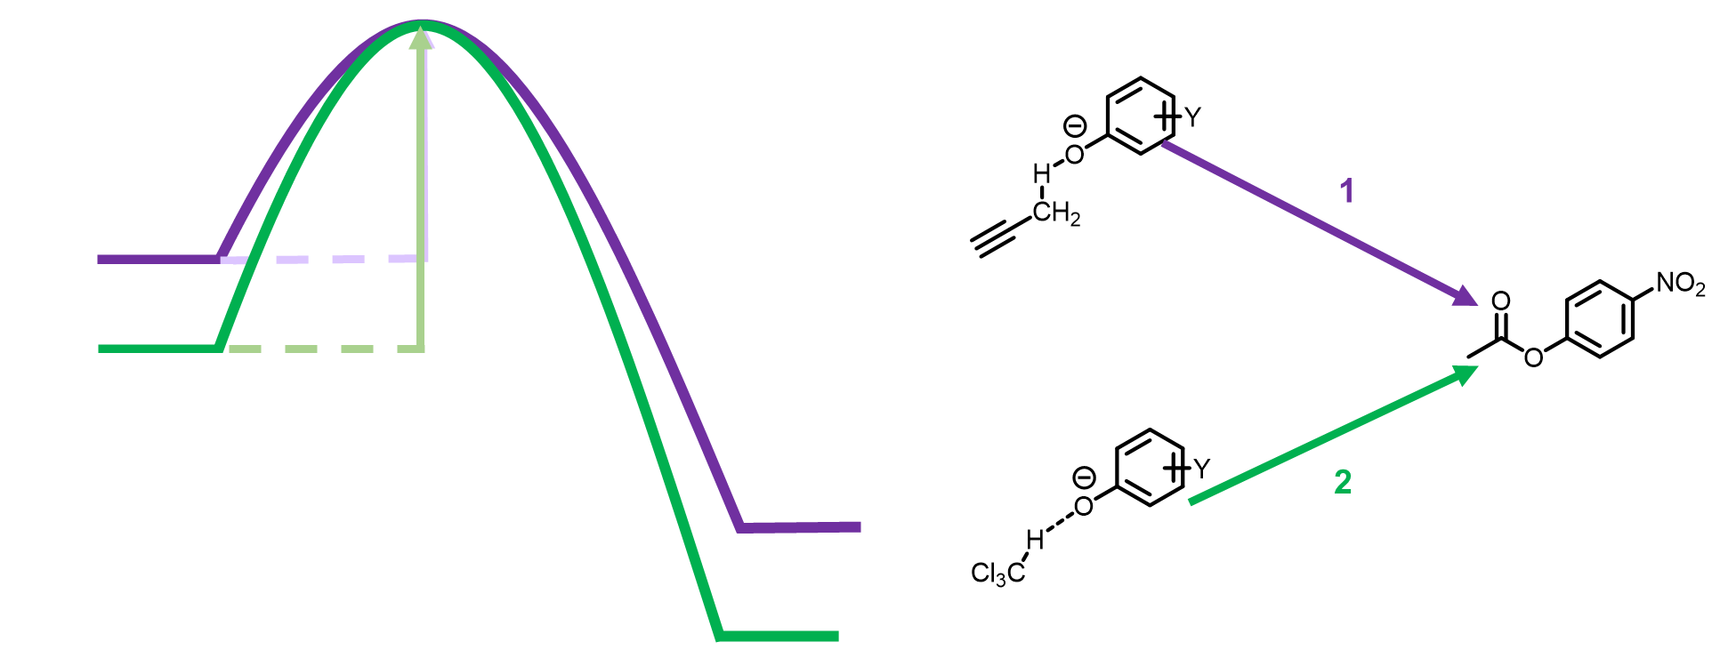

Figure : In a binary solvent mixture of acetonitrile and chloroform the phenolate nucleophile has two distinct energies depending on which solvent the phenolate is bound to. Hence, the average energy of the phenolate is a result of the proportion of the phenolate bound to each solvent.

A stronger interaction between the phenolate and the solvent stabilises the phenolate. So it is a matter of finding two rate constants, one representing phenolate bound to acetonitrile, and one representing phenolate bound to chloroform, which when multiplied by the proportion of phenolate-acetonitrile and phenolate-chloroform respectively, fits to the real data. A worked example can be seen below for the reaction between 4-cyanophenolate tetrabutylammonium and 4-nitrophenylacetate in acetonitrile, chloroform, and mixtures of the two solvents. A similar concept has been used by Guy Lloyd-Jones’s group for predicting the reactivity of triazole anions when bound to hydrogen bond donors and was found to accurately describe the outcome of the reactions.71

|  |  |  |  |  |
| --- | --- | --- | --- | --- |
| [CHCl3]/M |  | Bound to CHCl3 |  | Bound to ACN |
| 0 | (0.82×0)/1+0.82×0= | 0 | 1-0= | 1 |
| 0.0028125 | (0.82×0.0028125)/1+0.82×0.0028125= | 0.002300943 | 1-0.002301 | 0.997699057 |
| 0.005625 | (0.82×0.005625)/1+0.82×0.005625= | 0.004591323 | 1-0.004591= | 0.995408677 |
| 0.01125 | (0.82×0.01125)/1+0.82×0.01125= | 0.009140677 | 1-0.009141= | 0.990859323 |
| 0.0225 | (0.82×0.0225)/1+0.82×0.0225= | 0.018115764 | 1-0.018116= | 0.981884236 |
| 0.028125 | (0.82×0.028125)/1+0.82×0.028125= | 0.022542611 | 1-0.022543= | 0.977457389 |
| 0.05625 | (0.82×0.05625)/1+0.82×0.05625= | 0.044091289 | 1-0.044091= | 0.955908711 |
| 0.140625 | (0.82×0.140625)/1+0.82×0.140625= | 0.103390305 | 1-0.10339= | 0.896609695 |
| 0.5625 | (0.82×0.5625)/1+0.82×0.5625= | 0.315654405 | 1-0.315654= | 0.684345595 |
| 1.40625 | (0.82×1.40625)/1+0.82×1.40625= | 0.535558781 | 1-0.535559= | 0.464441219 |
| 2.8125 | (0.82×2.8125)/1+0.82×2.8125= | 0.697542533 | 1-0.697543= | 0.302457467 |
| 5.625 | (0.82×5.625)/1+0.82×5.625= | 0.821826281 | 1-0.821826= | 0.178173719 |
| 12.5 | (0.82×12.5)/1+0.82×12.5= | 0.911111111 | 1-0.911111= | 0.088888889 |
| *K* |  |  |  |  |
| 0.82 |  |  |  |  |
|  |  | *k*CHCl3 (pred) |  | *k*ACN (pred) |
|  |  | 0.134924348 |  | 5.912081822 |

Table

|  |  |  |
| --- | --- | --- |
|  | Predicted *k* | Experimental *k* |
| (0×0.1349)+(1*5.9120)= | 5.912081822 | 6.1997 |
| (0.0023×0.1349)+(0.9977*5.9120)= | 5.898788909 | 6.317 |
| (0.0046×0.1349)+(0.9954*5.9120)= | 5.885557029 | 6.3083 |
| (0.0091×0.1349)+(0.9909*5.9120)= | 5.85927469 | 6.2511 |
| (0.0181×0.1349)+(0.9819*5.9120)= | 5.8074242 | 6.2741 |
| (0.0225×0.1349)+(0.9775*5.9120)= | 5.781849608 | 6.352 |
| (0.0441×0.1349)+(0.9559*5.9120)= | 5.657359501 | 5.72 |
| (0.1034×0.1349)+(0.8966*5.9120)= | 5.314779746 | 4.9652 |
| (0.3157×0.1349)+(0.6843*5.9120)= | 4.088496614 | 3.5686 |
| (0.5356×0.1349)+(0.4644*5.9120)= | 2.818074409 | 2.4258 |
| (0.6975×0.1349)+(0.3025*5.9120)= | 1.882268764 | 1.7815 |
| (0.8218×0.1349)+(0.1782*5.9120)= | 1.164261983 | 1.3144 |
| (0.9111×0.1349)+(0.0889*5.9120)= | 0.648449457 | 0.494 |

Table

The *k*CHCl3 and *k*ACN are optimised using Microsoft Excel Solver to minimise the difference between the predicted and experimental *k* values.

The same procedure was also performed on the reaction between phenolates **2**, **3** and **4** with 4-nitrophenylacetate. The fitting can be seen in Figure 32.

Figure : A graph of the second order log of the rate constant for the transesterification reaction between 3-nitrophenolate TBA, 4-cyanophenolate TBA, and 3-nitro-4-chlorophenolate and 4-nitrophenylacetate against the log of chloroform the concentration of chloroform with the rest of the solvent being acetonitrile. With the fitting of our model applied.

The fitting of the experimental rate constants to our model across different solvent compositions ranges from good to excellent. The assumption is made that the number of energy states that the nucleophile can occupy equals the number of solvent species that can bind to the nucleophile.

#### 3.2.3.3 Problems

The model and method of predicting the binding ratios we have used are not perfect. Equation 28 makes assumptions about there being one solvent and two solutes. In our experiments, one of the solutes is a solvent and the changing composition of these two solvents poses the question: when is solvent X dissolved in solvent Y and when is Y dissolved in X? Figuring out this invisible transition has resulted in different α and β values of molecules if they are the “solvent” or “solute”24 and so having two components transition from one to another could complicate predicting the solvents effects. Our method of simplifying everything to the assumption that the binding constant does not change across this invisible distinction is clearly not ideal and is used to simplify the maths. An example is that in chloroform, which has a concentration of 12.5 M, the binding constant for 4-cyanophenolate bound to chloroform in acetonitrile does not predict that all of the nucleophile is bound to chloroform. In fact, it is predicted that only slightly over 90% of the 4-cyanophenolate is bound to chloroform. The obvious question to pose is what is the remaining phenolate actually doing? If there was unbound phenolate it could be expected to react at a far higher rate than if it was bound to any solvent. However, we are implying that it reacts at the same rate as in acetonitrile. An explanation is that the disparity between the amount of phenolate bound to each solvent, and what it must be, is compensated by a lower rate for the chloroform bound-phenolate. This is once again not ideal. The fitting of the binding curve to the rate data is good and is often unique, as it depends on the α and β of each solvent and phenolate, and the start and end points of each reaction profile. A close association between the many binding curves and the rate data being a coincidence would be highly unlikely. We therefore believe that the issue is with the accurate prediction of the binding proportion.

A logical thought experiment would be to consider a binary solvent mixture of carbon tetrachloride and chloroform, and dichloromethane and chloroform with 4-cyanophenolate TBA dissolved in the solution. As the concentration of chloroform increases, the amount of phenolate bound to chloroform increases, but differently for the two sets of mixtures. The calculated binding constant between 4-cyanophenolate and chloroform in carbon tetrachloride is 4.83, while the binding constant between 4-cyanophenolate and chloroform in dichloromethane is 0.90, which gives Equation 40 and Equation 41 respectively.

Equation

Equation

At the concentration of pure chloroform at 25 °C, the percentage of 4-cyanophenolate bound to chloroform is different using the two binding constants for carbon tetrachloride to chloroform and dichloromethane to chloroform. The binding constant from the carbon tetrachloride mixtures predicts that 98.4% of phenolate will be bound in 12.5 M chloroform. In contrast, using the binding constant associated with dichloromethane mixtures predicts 91.8% of phenolate will be bound in 12.5 M that chloroform. Such a 6.6% disparity makes no sense as the end point is exactly the same; that of only chloroform as the solvent with phenolate dissolved in it. This exposes a flaw in the equation we use.

It must be noted that another potential explanation is that unbound or “free” phenolate is the nucleophilic species that is exclusively reacting. Free phenolate can be described as a phenolate where the oxyanion is not stabilised by hydrogen bonding to the solvent. It seems unlikely to expect that the oxygen would have no electrostatic interaction with any of the surrounding molecules, but a small quantity of non-optimally bound complexes is a possibility. In this scenario the free phenolate is reacting at a significantly faster rate than bound phenolate, to such an extent that the proportion of the reaction accredited to solvent-bound states is negligible. Thus, hydrogen bond donors in solution aren’t only stabilising the phenolate making it less likely to react, but it may also be reducing the pool of free phenolate capable of reacting. I feel this scenario is not entirely likely as the reactivity of the (intramolecularly hydrogen bonded) 2-phenol-2-phenolate TBA is not zero. While 2-phenol-2-phenolate is clearly less reactive than any of the other phenolates tested in any solvent, it also has a much stronger hydrogen bond donor stabilising it compared to those possible from the examined solvents.

A significant advantage of the model is how little information is required to fit the data. We have obtained an effective model simply by fitting the predicted binding proportion to the rate of each pure solvent that the mixtures will be composed of. This form requires no experimental data at all on the rate of reaction in solvent mixtures instead it uses data from single solvent systems.

To explore the model’s predictive abilities, a non-acidic solvent with a high α value, pyrrole, was chosen as to act as the hydrogen-bond donor. Pyrrole is not conventionally used as a solvent, since it reacts with when exposed to oxygen. However, pyrrole is easily purified by distillation and degrades slowly enough to obtain kinetic measurements for reactions that take less than 36 hours. The α value of pyrrole is 3.0, which is comparable to common protic solvents such as methanol and ethanol at 2.9 and 2.7, respectively. Pyrrole’s β value is 4.1 which is less then methanol and ethanol at 5.2, and 4.8, respectively. Moreover, pyrrole was not expected to form the weakly bound rings and chains that the alcohols form due to its different structure, steric bulk and its lower β value. Using pyrrole as a solvent also expands the types of solvents tested as pyrrole is a heterocyclic aromatic unlike the other solvents examined.

The reactions were performed under pseudo first order conditions and fit well to a first order curve. A linear relationship between the pseudo first order rate constant and the concentration of the nucleophile was found with the gradient providing the second order rate constant.



Figure : The progress of the reaction between 3-nitro-4-chlorophenolate TBA (0.2 mM) and 4-nitrophenylacetate (0.01 mM) in a mixture of acetonitrile and 35 mM pyrrole fitted well to a first order curve.

Figure : The nucleophile dependence plot of the reaction between 3-nitro-4-chlorophenolate TBA (0.2 mM) and 4-nitrophenylacetate (0.01 mM) in a mixture of acetonitrile and 35 mM pyrrole gave a linear plot.

Figure : A graph of the second order log of the rate constant for the transesterification reaction between 3-nitrophenolate TBA, 4-cyanophenolate TBA, and 3-nitro-4-chlorophenolate and 4-nitrophenylacetate against the log of the concentration of pyrrole with the rest of the solvent being acetonitrile. With the fitting of our model applied.

The predicted rate constants fit relatively well to the experimental rate data for solvent mixtures of acetonitrile and pyrrole. The difference between predicted and the experimental second order rate constant is very small for 4-chloro-3-nitrophenolate TBA, and within error for the alpha and beta values of the solvents. The profile of rate constant in mixtures of acetonitrile and pyrrole is different, both the predicted and experimental, than for chloroform to acetonitrile. The profile for acetonitrile and chloroform mixtures shows that low concentrations of chloroform makes little difference to the rate constant. At higher concentrations, the rate is affected by the addition of chloroform and the flat response curves into a downward slope. As pyrrole has a higher α value than chloroform, 3.0 compared to 2.2 respectively, the binding constant is higher for the phenolate-pyrrole hydrogen bond than for the phenolate-chloroform hydrogen bond. The tighter binding can be seen in the profile of Figure 35. Significantly less pyrrole is needed to noticeably reduce the rate constant compared to the amount of chloroform needed in Figure 32. As a result, far less pyrrole is needed to achieve the same rate constant.

The concentration range does not go to pure pyrrole, as at very high concentrations of pyrrole there is proton transfer between the solvent and the phenolates. The proton transfer can be seen in the UV-vis spectrum of phenolates in pyrrole compared to acetonitrile/pyrrole mixtures, which unlike the latter show the existence of both phenolate and phenol.

#### 3.2.3.4 The Model

To investigate the accuracy of the model, the log of the experimentally obtained second order rate constants and the log of the predicted second order rate constant were compared for all the transesterification reactions in the solvent mixtures Figure 36. The R2 correlation coefficient for the experimentally obtained data against the predicted data is 0.978 with a gradient of 1.010. The correlation coefficient and gradient show a strong relationship between model outcome and the experimentally obtained data for transesterification reactions with the ideal gradient of 1 is close to the measured gradient.

Figure :Log of the predicted second order rate constant against the log of the experimentally obtained log of the second order rate constant for transesterification reactions in binary solvent systems,

The model presented here predicts the reactivity in binary solvent mixtures by calculating how much of the nucleophile is bound to each solvent. From the model we deduce that the effect of a solvent mixture on a nucleophile is the result of distinct nucleophile species being bound to each solvent component, which each react with distinct rates. The change in solvent composition alters the proportion of nucleophile bound to each solvent component and the rate constant is calculated from the amount of nucleophile-solvent species and its distinct rate constant, which is the sum of the other nucleophile-solvent species and the distinct rate constants. This model challenges the bulk solvent parameters often used to describe solvent mixtures and replaces the idea that changes in solvent composition changes the energy of the reactants through a continuum of energies. Instead the appearance of an infinite array of energies is a projection of an infinite array of proportions of distinct energy levels.

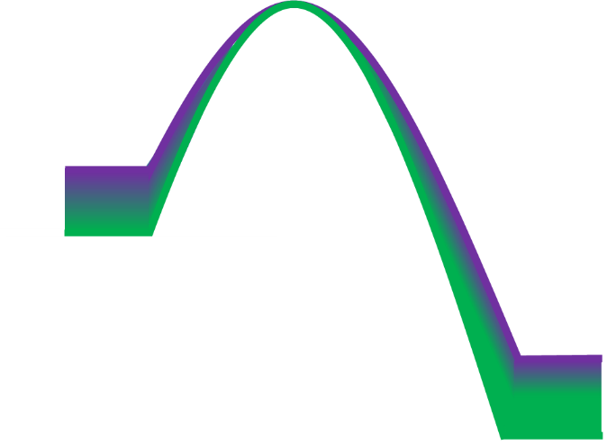

CHCl3

ACN

Mixtures off the two solvents gradually changing the energy of the ground state

Figure : The perceived change in the energy of the ground state upon as the mole fraction of chloroform increases.



Figure : Our interpretation of the energy of the ground states indicates the energy levels do not change significantly as the mole fraction of chloroform increases.

### 3.2.4 Equilibria

#### 3.2.4.1 Theory

The transesterification between a phenylacetate and a phenolate will form a phenylacetate and phenolate as a product. For example, the reaction between 4-nitrophenylacetate and 4-cyanophenolate will form 4-cyanophenylacetate and 4-nitrophenolate. The phenolate produced is itself capable of nucleophilic attack on the 4-cyanophenylacetate to reform the original products, therefore the reaction is in equilibrium.

The equilibrium constant of a reaction is determined by the ground state energies of the reactants and products. In the transesterification reactions studied in this chapter, both reactants and products will be phenolates and phenylacetates. As stated previously, phenolates are strong hydrogen-bond acceptors and the formation of a hydrogen bond between the phenolates and a hydrogen-bond donor is energetically favourable. In the model we have presented, the change in the second order rate constant in a reaction between a phenolate and a phenylacetate when a stronger hydrogen-bond donor is added to the solvent system is proposed to result from ground-state stabilisation of the nucleophile. We have assumed previously in 3.2.3 that the change in energy of the transition state is negligible compared to the change in energy of the ground state and is therefore not included.

As we are proposing that the change in ground state energies is exclusively driving the change in rate constant, then we would expect the equilibrium position of the reactions to alter in the same manner as the rate constant

#### 3.2.4.2 Experimental design

Solutions of 4-nitrophenylacetate and the desired phenolate were mixed together in solvent mixtures of acetonitrile and chloroform or acetonitrile and pyrrole. The mixtures were left to equilibrate and then analysed by high pressure liquid chromatography with the eluent gradients optimised to separate the peaks corresponding to the reactants and products. Standards of known concentration of each phenolate and phenylacetate were used to identify peaks and compound concentrations.

Peak separation of 3-nitrophenylacetate and 4-nitrophenylacetate could not be achieved with C8, C16, or Phenyl-Hexyl columns and gradients of water and acetonitrile, water and methanol, water and methanol with acetonitrile. Hence, the reaction equilibrium of 3-nitrophenolate, 4-nitrophenyl acetate, 4-nitrophenolate and 3-nitrophenylacetate could not be obtained.

Equilibrium constants were deduced using Equation 42 using the concentrations obtained from the peak areas, where A and B are the reactants and C and D are the product.

Equation

The difference in Gibbs free energy between the reactants and products can be calculated from the equilibrium constant using Equation 43.

Equation

The equilibrium constants from the reactions can be seen in Figure 39.

Figure : The change in the log of the equilibrium constant of the transesterification reactions against the log of the concentration of added solvent.

The graphs show that increasing the concentration of a hydrogen-bond donor reduces the equilibrium constant. A reduction in the equilibrium constant means that the products are thermodynamically less favoured. Thermodynamically less favoured products means that the energies of the reactants and products become closer together with increasing concentration of a hydrogen-bond donor in the solvent mixture.

The change in the equilibrium constant of the reactions shows that the ground state energies are affected by the addition of a hydrogen-bond donor as predicted by our model. If there was no shift in the equilibrium over an increasing concentration of hydrogen-bond donor the decrease in the rate constant of the reaction with increasing concentrations of hydrogen-bond donors would not be explained by our model.

The nucleophilic attack of 4-nitrophenolate on 4-cyanophenylacetate in solvent mixtures of acetonitrile and chloroform was found to follow our proposed model. As the reaction between 4-nitrophenolate and 4-cyanophenylacetate follows the model it shows that both sides of the equilibrium follow the model. Why does the simple model we have used work? The model looks at the changing energy of the initial reactants work as the energy of the products will also change depending on how they are bound to the solvent, which will depend on their β values. When obtaining the rate constants for the reactions we have used pseudo-first order conditions with the nucleophilic phenolate in excess. The excess of nucleophilic phenolate means there is far more of it in the system even after the reaction has reached equilibrium. The β value of the nucleophilic phenolate is often higher than that of the product phenolate. A larger β value results in greater energy difference between a phenolate bound to weak hydrogen bond donor and when it is bound to a stronger hydrogen-bond donor. As a result of the large excess of the phenolate reactant compared to the phenolate product and the larger β of the phenolate reactant, the dominant energy change involves the initial reactants. The energy of the reactants will also change depending on the proportion bound to each solvent component, which will influence the equilibrium position of the reaction.

Understanding the effect that solvent composition has on the equilibrium of the reaction is key to understanding the difference in energy of all the key species. The model uses the binding energy of a solute to a solvent to identify the speciation of solvent-solute interactions in a mixed solvent system. It is not clear if the difference in energy of a reactive species bound to solvent 1 compared to when it is bound to solvent 2 is directly proportional to its change in reactivity. By understanding the impact a binary solvent system has on the equilibria we will be able to create an energy profile of the reaction. This will illustrate the ability for a solvent to alter which side of an equilibrium is most favoured, which will further emphasise the importance a solvent system can play on a reaction.

Figure :The equilibrium of the transesterification reaction is altered by the reactants being stabilised more then the product when exposed to a strong hydrogen-bond donor as the reactant phenolates have higher β values and so bind more tightly.



### 3.2.5 Protic Solvents

To expand on the range of solvents, mixtures of trifluoroethanol and acetonitrile were examined. Trifluoroethanol (= 3.7) is a better hydrogen-bond donor than acetonitrile (= 1.5) and was used as the hydrogen-bond donor in our titration experiments. The graphs of *k*obs against [TFE] are presented in Figure 41 and Figure 42.

Figure : A plot of the observed rate constant of the transesterification reaction between 3-nitrophenolate, 3-nitro-4-chlorophenolate, and 4-cyanophenolate with 4-nitrophenyl acetate against the concentration of trifluoroethanol.

Figure : A plot of the log of the observed rate constant of the transesterification reaction between 3-nitrophenolate, 3-nitro-4-chlorophenolate, and 4-cyanophenolate with 4-nitrophenyl acetate against the log of the concentration of trifluoroethanol.

These data did not follow the trend the previous data had shown. The apparent *k*obs of the reaction between 4-cyanophenolate TBA salt and 4-nitrophenylacetate doubled compared to in acetonitrile alone, until the addition of >0.7 M trifluoroethanol, at which point the *k*obs reduced. When 4-chloro-3-nitrophenolate TBA salt was the nucleophile, addition of trifluoroethanol resulted in a reduction of *k*obs, which was in agreement with our prediction until around 1 M, where the *k*obs increased before declining again. The data was inconsistent across all the phenolates examined, so further examination was necessary.

One avenue to explain these data was that the transition state was being stabilised, which resulted in a lowered energy barrier, and thus an increase in the rate of reaction. If there was transition state stabilisation, two questions arise: why would solvation of the TS dominate over ground state interactions, and why would it only significantly affect 4-cyanophenolate? An attempt was made to fit a second binding curve to the models to represent the binding of a transition-state oxyanion to the trifluoroethanol, but this results in significantly different binding constants from those calculated in the hydrogen bond titrations. To expand on this investigation, hexafluoroisopropanol was also used as a hydrogen bond donating solvent. Hexafluoroisopropanol is a better hydrogen-bond donor and is less prone to forming cyclic, or chain species with itself than trifluoroethanol.72 The formation of these ring and chain species affect the ability of these species to hydrogen bond, so hexafluoroisopropanol not forming these species could potentially remove some complications, such as knowing the exact concentration of hydrogen-bond donors in the system and their α and β values.

Figure : A plot of the observed rate constant of the transesterification reaction between 3-nitrophenolate, 3-nitro-4-chlorophenolate, and 4-cyanophenolate with 4-nitrophenyl acetate against the concentration of hexafluoroisopropanol.

Figure : A plot of the log of the observed rate constant of the transesterification reaction between 3-nitrophenolate, 3-nitro-4-chlorophenolate, and 4-cyanophenolate with 4-nitrophenyl acetate against the log of the concentration of hexafluoroisopropanol.

When 4-cyanophenolate was present, 4.75 mM of hexafluoroisopropanol increased the *k*obs by a factor of five with a reduction in rate from that point with higher concentrations of HFIP. With 4-chloro-3-nitrophenolate, there was an increase in *k*obs by a factor 1.2 before declining. 3-nitrophenolate declined with small additions HFIP until 0.237 M, where it began to increase. Upon addition of HFIP there was a noticeable extinguishing of the absorbance bands of the phenolates in the solution. Small shifts in the absorbance are expected when a phenolate is bound to a strong hydrogen-bond donor, but the absorbance bands were extinguished and new bands formed beyond what would be expected from a typical hydrogen bond shift. The UV-Vis spectra of completed reaction solutions showed the extinction of the peak at 280 nm corresponding the 4-cyanophenolate with increased concentration of HFIP. A new band also appeared at around 245 nm which corresponded to 4-cyanophenol. There is an isosbestic point between the peaks, which indicated the 4-cyanophenolate is being protonated to form the 4-cyanophenol by the HFIP. The same result can be seen with 4-chloro-3-nitrophenolate and the 4-nitrophenolate present in both reactions.

Figure :UV-vis scan of the product mixture of the reaction between 4-cyanophenolate TBA and 4-nitrophenylacetate with varying additions of hexafluoroisopropanol.

Figure : UV-vis scan of the product mixture of the reaction between 3-nitro-4-chlorophenolate TBA and 4-nitrophenylacetate with varying additions of hexafluoroisopropanol.

The appearance of the phenol created multiple complications. A small complication is that there is a lower concentration of the phenolate nucleophile and an additional hydrogen-bond donor in the reaction mixture. A bigger complication is that the source of protons is the HFIP, and once deprotonated it becomes hexafluoroisopropoxide, which is a nucleophilic competitor to the phenolate. A scan of a post-reaction mixture in just acetonitrile compared to just TFE for 4-chloro-3-nitrophenolate, shows a similar complication.

The results of these tests lead to the hypothesis that the apparent increases in *k*obs when a protic solvent was added were the result of small quantities of trifluoroethoxide or hexafluoroisopropoxide competing with the phenolate to react with the 4-nitrophenylacetate, but as 4-nitrophenolate was monitored to show reaction progress, it would go undetected.

To test this hypothesis, the equilibrated reaction mixtures were analysed by high pressure liquid chromatography and it was found that the peak corresponding to 4-nitrophenylacetate and 4-cyanophenylacetate disappeared upon addition of the protic solvent. The disappearance of the phenylacetate peaks could be explained, since the trifluoroethoxide and hexaflouroisopropoxide product would not have UV absorbance at 260 nm, which was the wavelength at which the reaction was being monitored. From these proton transfer issues, protic solvents would not be suitable to use as a model solvent as they are not innocent in the reaction.

### 3.2.6 Local transition state stabilisation

As has been mentioned previously in the chapter, the key points along the reaction coordinate where changes in the energies would affect the kinetics of the reaction are the ground state energies of the reactants and the transition state energy. We have already assessed the influence solvent interactions have on the ground state and have successfully applied a model based entirely on solvent interactions with the reactants. We aimed to examine how molecular interactions affect the reaction rate by using a system where a hydrogen bond could be constrained to be near the site of charge generation in the transition state and preorganised at that site before a reaction occurred.

To investigate how a hydrogen bond could potentially stabilise the transition state, the transesterification reaction was performed with 4-nitrophenylsalicylate, Figure 47, as the electrophile.



Figure : 4-Nitrophenyl salicylate

The hydroxy group in 4-nitrophenylsalicylate is placed near the carbonyl group of the ester. When the phenolate reacts with the 4-nitrophenylsalicylate, the carbonyl of the 4-nitrophenylsalicylate becomes more negatively charged, Figure 48.



Figure : A mechanistic possibility for the reaction between 4-cyanophenolate and 4-nitrophenyl salicylate.

The placement of the hydroxy group could form a hydrogen bond to the carbonyl and stabilise the transition state. To obtain the rate constant, the reaction between 4-nitrophenylsalicylate and 4-cyanophenolate tetrabutylammonium salt was performed. The reaction did not proceed as expected. The reaction was exceptionally slow. The reactions did not follow first order behaviour. As can be seen in Figure 49, the reaction seemed to be zero order which was not expected.

Figure : The production of 4-nitrophenolate in the reaction between 4-cyanophenolate (0.5 mM) and 4-nitrophenyl salicylate (0.05 mM) was linear in acetonitrile, chloroform and mixtures of the two solvents.

To identify why the 4-nitrophenylsalicylate was behaving unexpectedly, 4-nitrophenyl benzoate was used as a substrate for the transesterification reaction (Figure 50). By removing the OH group, it could be possible to identify why the 4-nitrophenyl salicylate had unexpected behaviour.



Figure : 4-nitrophenylbenzoate.

The reactions between 4-nitrophenylbenzoate and excess phenolate fitted well to first order curves. As the concentration of chloroform increased, *k*obs decreased, matching the binding profile of phenolate binding to chloroform.

­

Figure : The rate constant for transesterification between 4-cyanophenolate tetrabutylammonium 4-nitrophenylbenzoate in acetonitrile against the log of the concentration of chloroform compared to the predicted rate.

As the 4-nitrophenylbenzoate reaction with 4-cyanophenolate was first order with respect to both reactants, and the change in rate with respect to concentration of a hydrogen-bond donor followed the same trends as 4-nitrophenylacetate, the aromatic group on 4-nitrophenylsalicylate was discounted as the source of its unusual behaviour. Further experimental work needs to be performed in order to identify a mechanism. A likely route is by the nucleophilic phenolate deprotonating 4-nitrophenyl salicylate.

It is important to note the distinction between the model proposed here and a preferential solvation shell model. A preferential solvation model describes how the solvent composition surrounding the nucleophile is different from the bulk solvent. A solvation shell can be several molecules deep surrounding the entire nucleophile. The existence of preferential solvation and its relevance is still debated.73 74 75 76 77The model put forward demonstrates the primary solvent-solute interaction of importance occurs at, or near, the nucleophilic site. Working out the composition of a solvation shell compared to that of the bulk solvent can be difficult, whereas working out the proportionof nucleophile bound to each solvent at the nucleophilic site is trivial when the α and β values are known. The model proposed here suggests that a transition state is not greatly affected by the solvent composition for the transesterifications shown in this chapter; the dominant effect is in the ground state. We have yet to see evidence of hydrogen bond stabilised transition states after the attempts to create one with the 4-nitrosalicylate however, a differently designed system could see such effects at work. The transesterification reactions seen here do not have an intermediate and so we proposed there is not enough time for the solvent to rearrange and create an energy optimised species with the transition state. If the solvent does not have time to rearrange the transition state is unlikely to be optimised in any solvent composition.

### 3.2.7 Altering the nucleophilicity of 2-phenol-2-phenolate tetrabutylammonium salt

The measured β value for 2-phenol-2-phenolate TBA salt is most likely the hydrogen bond accepting ability for a second hydrogen bond to the oxyanion. The oxyanion has three lone pairs and, sterics allowing, it is capable of forming multiple. The crystal structure of 2-phenol-2-phenolate shows the phenol OH acting as a hydrogen bond donor to the phenolate oxyanion. The α value of phenols are often above 4 which is higher than most commonly used solvents. The phenol is also positioned favourably to form a hydrogen bond with the phenolate so the effective molarity of the OH group will be high. Due to the strength of a hydrogen bond formed between the phenol and phenolate and the high effective molarity it is expected that the intramolecular hydrogen bond would exist in solution as well as in its crystalline form. The internal hydrogen bond is also evidenced by the β value measured for 2-phenol-2-phenolate being 11.51, which is the lowest β value of any phenolate measured. If it was possible to break the intramolecular hydrogen bond in 2-phenol-2-phenolate, the naked oxyanion would be expected to have a higher β value and potentially exhibit greater nucleophilicity. If greater nucleophilicity was observed in the presence of a strong hydrogen-bond acceptor 2-phenol-2-phenolate TBA could be activated easily from its dormant state. To test this hypothesis tributylphosphine oxide was titrated into a solution of 2-phenol-2-phenolate TBA in acetonitrile and the UV-Vis absorbance spectra measured.



Figure : The desired outcome of the addition of a hydrogen bond acceptor to 2-phenol-2-phenolate.

If the tributylphosphine oxide competed with the phenolate as a hydrogen-bond acceptor for the phenol OH, a separation of the phenolate and phenol UV-Vis absorbances would be expected. Phenolates hydrogen bonded to a weak hydrogen-bond donor absorb light with longer wavelengths compared to when they are hydrogen bonded to a strong hydrogen bond donor. Upon addition of the tributylphosphine oxide, the phenolate peak reduced with each addition of tributylphosphine oxide until the absorbance spectra matched that of 2,2’-biphenol. To test if the protonation was unique, the UV-vis absorbance spectrum of 4-cyanophenolate TBA in acetonitrile was monitored as tributylphosphine oxide was titrated in. The UV-Vis spectra showed protonation of the 4-cyanophenolate to form 4-cyanophenol indicating that in the p*K*a of the phenolates were too similar to that of tributylphosphine oxide in acetonitrile.

Figure : The change in the UV-vis absorbance of 4-cyanophenolate upon addition of tributylphosphine oxide.

Figure : The change in the UV-vis absorbance of 2-phenol-2-phenolate upon addition of tributylphosphine oxide.

To further the work, tetrabutylammonium acetate was chosen as the next candidate. It has a very high β value of 15. Acetate is highly unlikely to be deprotonated by the phenolate and also unlikely to be protonated by the phenolate. The counter ion for the acetate anion is tetrabutylammonium, which is the same counterion as is used for the phenolate. Upon addition of tetrabutylammonium acetate to a solution of 2-phenol-2-phenolate TBA in acetonitrile, the UV-vis absorbance spectrum indicated that once again the phenolate was being protonated, which was a surprising result.

Figure : The in the UV-vis absorbance of 2-phenol-2-phenolate upon the addition of A) acetate TBA salt and B) BF4 TBA salt.

A possible source of protons could be water in the TBA acetate solid. To test this, the acetate was recrystalised and then dissolved in dry acetonitrile with 4 Å molecular sieves and left for 24 hours. Upon titration of a dried solution of tetrabutylammonium acetate the UV-Vis absorbance spectrum still indicated protonation of the phenolate. To test if the tetrabutylammonium cation was the source of protons a dried solution of tetrabutylammonium tetrafluoroborate was titrated into a solution of 2-phenol-2-phenolate TBA in acetonitrile and there was no spectral shift observed. The results from the titration indicated tetrabutylammonium cation by itself was not causing the protonation of the 2-phenol-2-phenolate anion. The mechanism, is resulting in the protonation of 2-phenol-2-phenolate is likely to involve the acetate anion or potentially the vials themselves, although the anion is unlikely to be deprotonated itself. A possible mechanism is the acetate is behaving as desired and competing with the phenolate to act as a hydrogen-bond acceptor to the phenol. This would cause the naked phenolate to become far more reactive, both in terms of its nucleophilicity and basicity. The now-activated phenolate could strip protons from a source that it previously couldn’t, such as the solvent or tetrabutylammonium cation. Further work would be needed to confirm what is happening. The concept of using a hydrogen-bond acceptor to activate the 2-phenol-2-phenolate TBA compound has not been successfully achieved. Such activation may be possible with other hydrogen-bond acceptors of substituted forms of 2-phenol-2-phenolate.



Figure : The effects of adding a strong hydrogen-bond acceptor to an internally bonded phenol-phenolate species could drastically increase its nucleophilicity.

## 3.3 Conclusion and Future work

The analysis of the transesterification reaction between phenolates and phenylacetates in varying solvent systems has shown the reaction rates are affected by the nucleophile and the solvent system that the reactants are dissolved in. A negative linear relationship with a strong correlation was drawn between the hydrogen bond donor ability (α value) of the solvent and the natural log of the rate constant (ln*k*). A strong negative correlation between the α value of the solvent and the ln*k* of the reaction mean that the better the hydrogen bond donor ability, the slower the reaction.

There is no discernible relationship between the dielectric constant or the relative polarity of the solvent system and the rate constant of the transesterification reaction. Dielectric constant and relative polarity are bulk solvent properties that are frequently used as the independent variable when trying to ascertain a relationship between the solvent system and the relevant chemical or physical process. The lack of relationship with the rate constant of a transesterification reaction shows that these bulk solvent properties may not always be suitable to predict the effects of a solvent system can have on a reaction.

The strong linear relationship between the rate constant and the α value of the solvent indicates that the nucleophilicity of a phenolate is reduced by a solvent with a better hydrogen bond donor. This relationship is known in the literature17 78 and is ascribed to the interaction between the lone pair of the nucleophile and the hydrogen-bond donor, which reduces the energy of the nucleophile and increases the intrinsic barrier.

Further evidence pointing towards the importance of a hydrogen-bond donor reducing phenolate nucleophilicity is that the rate constant of 2-phenol-2-phenolate TBA is significantly lower than the phenolates that lack an intramolecular hydrogen bond. The crystal structure of 2-phenol-2-phenolate TBA shows that an internal hydrogen bond is sterically allowed. The reduced rate constant and evidence of an internal hydrogen bond between the phenolate and phenol are strong evidence for the role a hydrogen-bond donor has in reducing the nucleophilicity of the phenolates. The linear relationship between the α value of the solvent and the ln*k* of the reaction also has a reduced gradient compared to the other phenolates. We have identified this as being evidence that there is a reduced influence from a secondary hydrogen bond on the nucleophilicity compared to the first hydrogen bond.

Predicting the trends of a chemical process in solvent mixtures is harder than in single species solvent systems. It can be hard to find trends because bulk solvent properties such as the dielectric constant and relative polarity, which are often used to predict chemical changes, are not easily calculated in solvent mixtures. If the desired physical properties of a solvent mixture cannot be calculated from the properties of the component solvents , then time and money must be spent performing experiments to obtain the required data. For these reasons, chemical reactions are rarely optimised to be performed in solvent mixtures.

To improve the understanding of binary solvent mixtures on chemical reactions, the rate constant of the transesterification reactions was experimentally determined for solvent mixtures of acetonitrile and chloroform, and acetonitrile and pyrrole. A good relationship was found between the rate constant in the binary solvent mixture and the proportion of the nucleophile bound to each solvent component. The proportion of nucleophile bound to each solvent component was calculated from the equilibrium constant predicted by Equation 28, which requires the α and β values of the solvent species and the β value of the nucleophile. A rate for each solvent component was then chosen to optimally fit the rate constants of the solvent mixture. This method produced good fitting between the predicted rate constant and real rate constant in mixtures of acetonitrile and chloroform, and acetonitrile and pyrrole. The model describes an apparent rate constant obtained in a solvent mixture as being composed of separate discrete rate constants for each nucleophile-solvent bound species. This model challenges the idea that the gradual change in rate constants across a solvent mixture is due to a steadily changing bulk solvent property such as the dielectric constant or a gradual change in the composition of the solvent molecules in a large solvent shell around the reactants. These gradual changes in energy of the reactants is distinct from a change in proportion of two fixed energies.

There was no effect on the rate constant attributed to electrophile solvation. The strong correlation between the experimental data and the single parameter fit being solely on the predicted proportion of phenolate bound to solvent. The insignificant alteration of the rate constant due to changes in energy of the electrophile could be due to its energy being stabilised less by the solvent molecules as it is neutral compared to the charged nucleophile.

The equilibrium constant (*K*) of the transesterification reactions was also monitored in mixtures of acetonitrile and chloroform, and acetonitrile and pyrrole. The equilibrium constant reduced with increasing concentration of a hydrogen bonding solvent. The stronger hydrogen bonding solvent reduced the equilibrium more greatly, and even had an effect at lower concentrations. This experiment is in line with our projection that a hydrogen bonding solvent reduces the energy of the 3-nitro, 4-cyano, 3-nitro-4-chloro reactant phenolates, all of which have higher β values then the 4-nitro phenolate product phenolate. This is because the binding energy between the species with a higher β value is greater than with a lower β value.

Further work would look to expand the range of β values of the phenolates tested, with a specific aim of trying to introduce electron donating groups to the phenolates. Work would also examine increasing the range of solvents to include (weakly) protic solvents. Importantly, it would also try to introduce stabilising hydrogen bonds to key areas of charge build up in the transition state species. This experimental data would help us better understand the role a solvent system plays in stabilising a transition state.

# 4. Solvent effects on the addition of a trityl cation and a phenolate anion

## 4.1 Introduction

### 4.1.1 Overall goal

The importance of accurately predicting the effects of the solvent on the rate and pathway of a reaction has been made clear in the previous chapter. In this chapter we wish to expand on the model showcased in the last chapter by applying the solvent model to a new type of reaction, an addition reaction. By testing the model on both a new reactant, and on a different category of reaction, we aim to test the robustness of the model developed for transesterification reactions. Work by Herbert Mayr on the formation of bonds to carbon has created parameters on nucleophilicity and electrophilicity and has suggested that nucleophiles tend to be solvent sensitive, while electrophiles tend to be solvent insensitive. If the electrophilicity is solvent insensitive we would expect the same solvent-dependent relationship as with the transesterification reactions. The transesterification reactions had a rate constant *vs.* solvent profile that was dominated by the bound state of the nucleophile, which is in keeping with Mayr’s observations.

### 4.1.2 Mayr Model

The Mayr parameters quantify nucleophilicity or electrophilicity. The parameters are independent of the electrophile that the nucleophile is reacting with and vice versa. As they are independent of each other they can be used to predict the second order rate constant to within a factor of about 100 over a range of 40 orders of magnitude. The parameters SN and N are for the nucleophile-specific sensitivity and nucleophilicity respectively, and they are solvent dependent. The parameter E is for the electrophilicity and is considered solvent insensitive. They are used in Equation 44 to predict the rate constant at 20 °C of bond formation of a carbon bond.

Equation

As Equation 44 is specific to bond formation, the transesterification reaction modelled in the previous chapter is not applicable as the reaction involves the formation and breaking of bonds, not just the formation. Currently the SN and N parameters must be measured in a new solvent system as they are solvent dependent. The E parameter of most electrophiles is treated as solvent independent, but this is not always the case. Some electrophiles were found to have solvent-dependent E parameters. If the solvent model shown in the previous chapter can predict solvent effects on the rate constant of a reaction forming a carbon bond it could be used to predict solvent effects on the Mayr parameters.

### 4.1.3 A Targeted Approach

The aim is to discover whether the nucleophilicity of a phenolate is affected by the α value of the solvent for an addition reaction, in the same way as it is for a transesterification reaction. A hydrogen-bond donor will help to stabilise the negative charge of the phenolate. If only the formation of a stronger hydrogen bond between the phenolate and the solvent affects the energy of the reactants, a plot of rate against the concentration of a solvent with a higher α value should have the same profile as a transesterification reaction, which itself mimics a binding curve. The aim is also to see if the electrophile in an addition reaction will be as solvent insensitive as an ester appears to be. If the electrophile’s reactivity is affected by the solvent, we aim to see if it is stabilised by the β value of the solvent, or if not, what parameters will best fit the change in the electrophilicity.

### 4.1.4 Model Reaction



Figure : The structures of Crystal Violet (A) and Malachite Green (B) chloride salts.

This chapter will focus on understanding the impact of solvent interactions on addition reactions. Addition reactions are a fundamental type of reaction and important in the formation of carbon bonds. Addition reactions have also been well studied, especially by Herbert Mayr. To test how reactivity is affected by a solvent, an addition reaction between trityl cations, crystal violet and malachite green (Figure 57) with a phenolate will be used as a model reaction. These compounds were chosen as crystal violet and malachite green are UV active so the reaction can be monitored using UV-Vis spectroscopy. Phenolates were chosen as we have previously studied how their nucleophilicity is affected by solvents and all reactants have known α or β values. Malachite green, crystal violet and 4-cyanophenolate also have known Mayr parameters so a potential link between the reactivity and solvent system might be formed. Malachite green and crystal violet are both bulky molecules and the Mayr group has previously noted that that the apparent electrophilicity of trityl cations also varied depending on both the steric bulk and nucleophilicity of the nucleophile.79 We assume that the same steric clashes could be possible with a solvent forming a bond to the electrophilic centre.

The nucleophilicity and β value of the phenolates can be altered by changing the functional groups on the aromatic ring. The electrophilicity and α value is also different for malachite green compared to crystal violet. The rate constant of a reaction between a phenolate and trityl cation will be monitored in acetonitrile, chloroform, and mixtures of the two solvents. These solvents were selected as one is a good hydrogen-bond acceptor and the other a good hydrogen-bond donor: acetonitrile has an α of 1.5 and a β of 5.1, whereas chloroform has an α of 2.2 and a β of 1.3. They are also both small molecules, which will reduce the steric hindrance for any direct interaction between the solvent and the bulky trityl cations. An acetonitrile and chloroform solvent mixture was also used for the transesterification reaction. As the solvent systems are comparable across reactions, we will be able to compare the solvent effects directly. Both acetonitrile and chloroform were used in determining the α values of the trityl cations. As such, variation of the reaction conditions will not be completely independent from variation of the binding conditions. However, we hope that the electrostatic model of solvent-solute interactions might be robust enough that the data will reveal transferable principles.



Figure : The reaction between a phenolate anion and trityl carbocation.

The addition reaction, like the transesterification reaction, has two points on the reaction profile, which if changed would affect the rate of reaction. These points are the energy of the reactants and the transition state. The addition reaction differs from the transesterification in that charge is neutralised along the reaction pathway (), whereas the transesterification has no net change in charge from the starting materials to the products (Figure 7). The neutralisation of charge in the transition state of the addition reaction will reduce the impact of solvent interactions in the transition state compared to the anionic transition state in the transesterification reaction. Our model worked on the assumption that there is no noticeable solvent stabilisation of the transition state of the transesterification reaction.

Meanwhile in the ground state starting materials, both electrophile and nucleophile in the addition reaction are charged and have high α and β values (greater than 4 and 12 respectively) both could be significantly stabilised by a solvent interaction. The electrophiles will be most stabilised by acetonitrile and the phenolates most by chloroform. If the two pathways to reactant stabilisation act equally, there will be no difference across the solvent composition as an increase in one concentration must result in the decrease of the other. A dominant affect from the stabilisation of either the electrophile or nucleophile will give a profile of just one reactant being stabilised by the solvent. If the two effects are similar in magnitude there will be an intersection where both reactants are stabilised by the solvent mixture compared to the single solvent mixtures where only one could be stabilised. This will result in a reaction that proceeds most slowly in a mixture of two solvents rather than in a single solvent.

The reaction between a phenolate and trityl cation is one half of an SN1 reaction. The formation of a bond between an oxygen and trityl carbon is frequently used to protect alcohols.80 81 82 Such reactions often use trityls with unsubstituted aromatic rings and with a leaving group on the central carbon. For a reaction with an alcohol to occur, the slow dissociation of the leaving group occurs creating an sp2 carbocation that reacts quickly with the alcohol, Figure 59.



Figure : The protection of an alcohol group with a trityl functional group.

The same solvent property can affect the rate of different steps of Figure 59in opposing ways. If a solvent stabilises a carbocation, it could increase the rate of the dissociation by stabilising the product while reducing the rate of nucleophilic attack as the reactant is now stabilised. As it would be difficult to decouple changes in rate to solvent effects on the reaction pathway, the reaction in Figure 58was chosen as a simplified model of a frequently used reaction. The reaction between a phenolate and trityl cation is in equilibrium. The reverse reaction is bond dissociation, so the reaction conditions used were performed with an excess of phenolate to drive the reaction to completion.

## 4.2 Results and discussion

### 4.2.1 Obtaining the α values of trityl cations

The α value of the crystal violet and malachite green trityl cations must be found if we are to match the reactivity of the trityl electrophiles with the binding to two solvents. We have already shown how the reactivity of charged nucleophiles correlates with the α value of the solvent. In the previous experiments, the electrophile was an aryl acetate and it did not show any significant change in reactivity with respect to the solvent. The experiment was performed using acetonitrile as the hydrogen-bond donor and chloroform as the solvent. Acetonitrile was used as the hydrogen-bond donor as it is a small molecule and linear. Phosphine oxides are frequently used as hydrogen-bond acceptors. Phosphine oxide did not affect the UV spectrum of the trityl cations even at molar concentrations. A possible explanation was that the chloride counter ion was binding too tightly to be removed. When DMSO was used as the hydrogen-bond donor there was still no change in the UV spectrum even though concentrations can far exceed that of the chloroform “solvent” itself and was far larger then the concentrations of phosphine oxide used when phosphine oxide was the hydrogen bond acceptor. DMSO has a very high dielectric constant, a high β value and a significant α value so it was determined to be unlikely the binding between chloride and the trityl was the issue. There is a spectral shift when acetonitrile was added to chloroform, Figure 60. Acetonitrile is a significantly less bulky molecule and linear when compared to either phosphine oxide or DMSO. As the β value of acetonitrile is lower than both phosphine oxide or DMSO we believe that the lack of steric hindrance allows acetonitrile to bind with the bulky trityl cation. In contrast, the phosphine oxide and DMSO are too bulky to have a direct electrostatic interaction with the trityls.

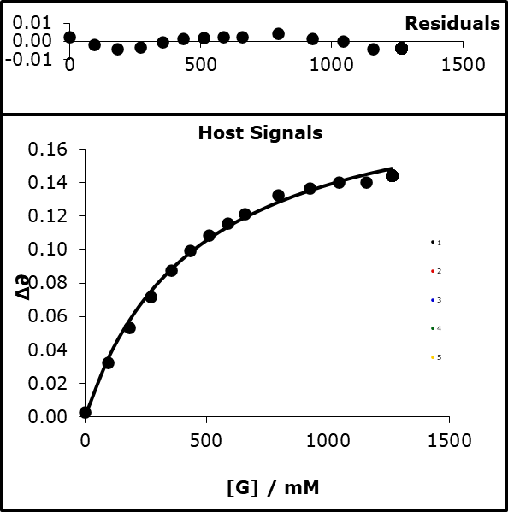

Figure : A figure showing the spectral shift of crystal violet at 580 nm as a result of binding with acetonitrile in chloroform. The 1:1 binding isotherm is also fitted to the data.

The solvent mixture of acetonitrile and chloroform will also be used in the kinetic experiments, so obtaining the α value of the trityls from a hydrogen bond titration in chloroform and acetonitrile would provide a useful direct comparison to the kinetic data. The binding constants between acetonitrile and the trityl cations in chloroform shown in Table 11 are very small compared to those seen with the binding of phenolates to trifluoroethanol. This is expected because the hydrogen-bond donor is interacting with a hydrogen-bond acceptor nearly ten units weaker than the best hydrogen-bond acceptor, phenolate. Despite the comparatively low binding constants, the α values of the trityl cations (Table 12) are high compared to other hydrogen-bond donors, being similar to phosphoric acid (α = 4.1) and 4-azophenol (α = 4.3).

|  |  |
| --- | --- |
| Compound | *K /M-1* |
| Crystal violet | 2.15 ± 0.15 |
| Malachite green | 1.52 ± 0.16 |

Table : Errors taken to 95% confidence interval. The hydrogen bond titrations and fitting to a 1:1 binding isotherm can be seen in 6.3.

|  |  |
| --- | --- |
| Compound | α |
| Crystal violet | 4.3 ± 0.1 |
| Malachite green | 4.1 ± 0.1 |

Table : Errors taken to 95% confidence interval. The hydrogen bond titrations and fitting to a 1:1 binding isotherm can be seen in 6.3.

The α value of malachite green is slightly lower than crystal violet, although they are within error of each other. The similarity of the α values is surprising as malachite green has one less amine group to stabilise the charge, so it would be expected for malachite green to have a more localised charge and therefore a larger α value.

The α value of both crystal violet and malachite green is similar to the α value of sodium (α = 4.1) obtained by the Hunter group in their report on the α value of cations.28

### 4.2.2 Reaction between a phenolate and a trityl cation

#### 4.2.2.1 Experimental execution

Reactions were monitored under pseudo first order conditions at 25 °C. A minimum of a tenfold excess of phenolate compared to the trityl was used to drive the reactions to completion. Reaction progress was monitored by the reduction of UV-vis absorbance at 600 nm and 620 nm for crystal violet and malachite green, respectively. The data fitted well to a single exponential curve in acetonitrile, chloroform, and mixtures of the solvents Figure 61.

Nucleophile dependence plots were linear for all phenolates (Figure 62) and solvent systems tested (section 6.4.2), which gives Equation 45 as the rate law.

Equation



Figure : The progress of the reaction between 4-cyanophenolate TBA (0.625 mM) and crystal violet (0.01 mM) monitored by the extinction of crystal violets absorbance in a mixture of acetonitrile first order curve.

Figure : The nucleophile dependence plot of the reaction between 4-cyanophenolate TBA (0.625 mM) and crystal violet (0.01 mM) in acetonitrile produced a linear fit. The gradient of which gave the second order rate constant.

#### 4.2.2.2 Reaction between phenolates and crystal violet

Figure 63 shows the relationship between the rate constant for the reaction between 4-cyanophenolate and crystal violet and the mole fraction of chloroform. There is a reduction in the rate constant as the mole fraction of chloroform increases until a 50:50 mixture of chloroform and acetonitrile. After this point, the rate begins to increase although the rate in chloroform is still less than the rate in acetonitrile. Interestingly a similar profile can be seen in work by Herbert Mayr on the reaction between a carbo cation and OH- in a binary solvent mixture of MeCN and H2O.79

­

Figure : The second order rate constant for the reaction between 4-cyanophenolate and crystal violet against the mole fraction of chloroform in the acetonitrile solvent system.

To better understand the role of the solvent, the data was split into two halves. One half goes from acetonitrile to higher concentrations of chloroform, and the second half goes from chloroform to increasing concentrations of acetonitrile. The division was made to help find if the total solvent profile was in fact made up of two distinct sections. It was proposed that one section corresponds to phenolate binding to the chloroform, and the other section corresponds to the crystal violet binding to acetonitrile. It was assumed that while an increase in the concentration of one solvent must reduce the concentration of the other, there is enough of the initial solvent that it can be treated as a constant and its change in concentration does not affect how much reactant it is bound to. For example, the concentration of pure acetonitrile is 19.1 M, and for a solution of 1.5 M chloroform in acetonitrile, the concentration of acetonitrile is 17 M. Since acetonitrile has a higher β value than chloroform, we may therefore assume that the high concentration of acetonitrile still saturates binding to the trityl cation. While at that concentration, as chloroform has a higher α value than acetonitrile, it is binding to the phenolate. The same assumption is made for saturation of phenolate by chloroform at low concentrations of acetonitrile. The assumption that at low concentrations only one of the reactant species solvent speciation changes allows for the application of the same binding model as the previous chapter. This assumption is not ideal as there will be a loss of saturation. However, the assumption does significantly simplify the analysis by allowing the data to be treated as two decoupled binding processes. Figure 64 shows the dependence of log *k* on log [ACN] up to an equimolar mixture of acetonitrile and chloroform.

Figure : The log of the rate constant for the reaction between 4-cyanophenolate and crystal violet against the log of the concentration of acetonitrile.

The relationship between log *k*2 and log [ACN] fits to Equation 46.

Equation

The equation shows how the rate constant in a binary solvent mixture can be modelled as the nucleophile reacting at distinct rates depending on which solvent is bound to it. The ratio of nucleophile bound to each solvent is calculated from the β value of the nucleophile and the α and β values of the solvent. The difference between the equation presented in previous chapters and this equation is that the binding state of the nucleophile is affecting the rate constant. It indicates that the electrophilicity of the electrophile is affected by the solvent system in the addition reaction, unlike the transesterification reactions in the previous chapter. A significant stabilisation of the electrophile in this addition reaction when compared to the transesterification reactions could be due to its positive charge, whereas the ester electrophile is not charged. As crystal violet is positively charged there is more to gain from an electrostatic interaction with a solvent with a high β value. A β value shows how much of a negative charge the compound has on its electrostatic potential; the higher the value, the greater the charge.

Equation 46 predicts the rate constant from an average of two fixed rate constants that vary in prominence based on the amount of electrophile bound to each solvent. Equation 46 fits well to the plot of log *k2* vs log [ACN]. The good fitting indicates that the electrophilicity of crystal violet is affected by the bound solvent in a similar way to how the nucleophilicity of a phenolate is affected by the solvent it is bound to. This model is devoid of other solvent properties such as the dielectric constant and the fit is entirely dependent on only the α and β values of the reactants and solvents. The assumption of there being no significant change in the binding state of the nucleophile has not affected how the model fits the real data, which supports this being a reasonable assumption.

For the reaction between crystal violet and 4-cyanophenolate, there is a two-fold change in the rate constant as result of acetonitrile binding to crystal violet. This two-fold change is significantly less than the effect of chloroform binding to 4-cyanophenolate instead of acetonitrile in the same reaction, which gives a ten-fold change in the rate constant. It must be noted we cannot see to the full extent of the influence that the hydrogen bond acceptor binding to trityl as the effect the hydrogen bond donor has on the phenolate becomes dominant from a 1:1 mixture of and higher amount of the hydrogen bond donor. Crystal violet was not previously found to be an electrophile with a solvent dependent E value by Herbert Mayr.79 While we can see that its electrophilicity is solvent dependent, on this occasion it is not so solvent dependent that the broad goal of Equation 44 set by Herbert Mayr, to predict reactivity to within a factor of 10, would be broken.

Figure : The log of the rate constant for the reaction between 4-cyanophenolate and crystal violet against the log of the concentration of chloroform.

Figure 65 shows the dependence of log *k*2 on log [CHCl3] up to an equimolar mixture of acetonitrile and chloroform. The relationship between log *k* and log [CHCl3] fits to Equation 47.

Equation

Equation 47 predicts the change in rate constant due to the interaction of the nucleophile binding with the solvent system. Equation 47 is functionally the same as the equation that predicts the solvent effects of a transesterification reaction.

Figure 66 shows the predicted rate constants of both the trityl binding to acetonitrile in chloroform and the phenolate binding to chloroform in acetonitrile. The model fits relatively well to the experimentally determined data for such a simple model.

Figure : The second order rate constant for the reaction between 4-cyanophenolate and crystal violet against the mole fraction of chloroform in the acetonitrile solvent system and the modelled rate constant.

The same equation can be used to explain the change in observed rate constant for the transesterification reaction between 4-cyanophenolate and 4-nitrophenylacetate, and the addition between crystal violet and 4-cyanophenolate up until an equimolar solvent system is important. Matching behaviour between the addition with a trityl and transesterification with a carbonyl indicates that the nucleophilicity of the nucleophile is being affected by the solvent in the same way for a different reaction and that this behaviour can be predicted.

The deduction made in the previous chapter was that the primary effect of the solvent on reactivity was through hydrogen bonding to the phenolate. A hydrogen bond would stabilise the phenolate reducing its nucleophilicity. As plots of rate constant against concentration of a hydrogen-bond donor fitted well to the speciation of the phenolate binding to the hydrogen-bond donor, it was assumed that the change in rate constant was due to the hydrogen-bond state of the phenolate. It was therefore assumed that there is no noticeable transition-state stabilisation specifically from a hydrogen bond to the carbonyl. For the addition reaction, there is no opportunity for transition-state stabilisation and the same model fits the addition reaction and the transesterification reaction. As the addition and transesterification reactions were modelled in the same way, but have very different structures over their reaction coordinate, it suggests that the transesterification reactions examined do not have transition state stabilisation. As the common component of the two reactions is the nucleophile. Since rate constants from both reactions can be fitted by predicting the binding of the nucleophile to the solvent, this and indicates ground state effects to be the dominant factor governing the rate constants.

The same model was fitted to data for the reaction between 3-nitrophenolate and crystal violet. The fitting was OK, but larger errors in the second order rate constants of the reaction resulted in problems with identifying how best to fit the data (Figure 67 - ).

Figure : The log of the rate constant of the reaction between 3-nitrophenolate and crystal violet against the log of the concentration of acetonitrile.

Figure : The log of the rate constant of the reaction between 3-nitrophenolate and crystal violet against the log of the concentration of chloroform.

Figure : The second order rate constant for the reaction between 3-cyanophenolate and crystal violet against the mole fraction of chloroform in the acetonitrile solvent system and the predicted rate constant from our model.

The solvent-dependent rate profile of the phenolate-crystal violet addition reactions were fitted using the same binding constant between crystal violet and acetonitrile in chloroform. The ratio of the rate constants of the transesterification reaction between 4-cyanophenolate and 4-nitrophenyl acetate and the addition of 4-cyanophenolate to crystal violet is remarkably consistent until around 3 M chloroform (Figure 70). The change in rate for both transesterification and addition change by around five-fold for both reactions until this deviation. As the same binding constant is used to predict the solvent state of crystal violet, it strongly indicates that the solvent-dependent electrophilicity of crystal violet is consistent across the different nucleophiles. The consistent behaviour of crystal violet indicates that its solvent dependent electrophilicity is independent of the nucleophile, at least for this set of nucleophiles. The observation of nucleophile-independent electrophilicity matches with the work performed by Herbert Mayr et al83 84. In contrast, we have also shown that the electrophilicity parameter of crystal violet’s is solvent dependent.

Figure : The ratio of the rate constants of the transesterification between 4-cyanophenolate and 4-nitrophenylacetate and the addition between 4-cyanophenolate and crystal violet against the log of chloroform. Only the data points of the same chloroform concentration have been included.

The reaction between malachite green and a phenolate was also tested. Malachite green has a Mayr electrophilicity parameter of -10.29 compared to -11.26 for crystal violet, so it would be expected that malachite green would react faster. The difference in reactivity in chloroform was so great that it was too high to be measured. The reactivity in acetonitrile is significantly lower. The higher reaction rate meant that it was not possible to ascertain if the solvent dependence of malachite green also matches to the predicted solvent-bound state.

## 4.2.3 Solvent independent nucleophilicity parameters

We believe our analysis of trityl addition reactions and transesterification reactions indicates nucleophilicity is affected in the same way by the solvents for substitution and addition. Work by Herbert Mayr has indicated that nucleophilicity for reactions forming a carbon bond is a universal property indifferent to the electrophile it is reacting with. Nucleophilicity can be described by the terms SN and N, which are for the nucleophile-specific sensitivity, and nucleophilicity, respectively. SN and N are considered to be solvent specific. Our work indicates that the rate constant of a reaction can be predicted in solvent mixtures if the rate constants of the component solvents on their own of the mixture are known. The rate constant of the mixture is formed from the proportion of each nucleophile-solvent rate constant. Work in the previous chapter showed a linear relationship between the rate constant of a transesterification reaction and the α of the solvent system. If a linear relationship between nucleophilicity and the α of a solvent can be shown for more nucleophiles, it would be possible to create a solvent independent nucleophilicity parameter that can effectively predict nucleophilicity in solvent mixtures. Further work on more nucleophiles and electrophiles would be needed to confirm this, but our work on phenolates indicates that it remains a possibility.

### 4.2.4 Altering the preference of reactivity through solvent effects

A reaction between a phenolate and an aryl ester has consistently shown that the ester’s electrophilicity is solvent insensitive, or is affected by the solvent so slightly it may be reasonably approximated as being solvent insensitive. A reaction between a phenolate and a trityl cation has shown that the electrophilicity of the trityl is solvent sensitive and the behaviour of crystal violet across a binary solvent system matches the trityl-solvent binding state. The behaviour of the phenolate nucleophiles appears to behave the same across a binary solvent system, which we have linked to the phenolate-solvent binding state.

We believe that we have created a model that can predict and explain some of the complex behaviour of reactions in solvent systems. A model that is only useful to physical organic chemists is not much use; the model needs to have practical uses for synthetic chemists. One way to show the practical application is in a real situation where there are two sites for the nucleophile to attack, but where only one site reacts to form the desired product. A transesterification reaction and the addition of a nucleophile to a trityl cation can both use a phenolate as the nucleophile, but the electrophiles are affected to differing degrees by the solvent. We aim to show that we can manipulate the rate constant of the transesterification reaction and the addition reaction in the same pot but in opposing directions, Figure 71. We will perform this manipulation by altering the solvent system. Modifying the difference in rate for the two reactions could result in completely changing which reaction is preferred. Adding such a tool to a synthetic chemist’s toolbox would be incredibly useful, as it could allow nucleophilic or electrophilic attacks to be programmed by simply by changing the solvent or adding a new solvent and creating a solvent mixture.



Figure : The reaction pot of 4-cyanophenolate TBA, 2,4-dinitrophenylacetate, and malachite green.

The system chosen was a mixture of 4-cyanophenolate (0.1 mM) as the nucleophile and Malachite green (0.01 mM) and 2,4-dinitrophenylacetate (0.01 mM) as the electrophiles. Malachite green was chosen as the trityl cation electrophile as it was shown to have a great alteration in rate depending on the solvent system, with it reacting quickly in chloroform, while being significantly slower in acetonitrile. 2,4-dinitrophenylacetate was chosen as the ester electrophile as the phenolate product of the reaction with the acetate is 2,4-dinitrophenolate. 2,4-dinitrophenolate has a peak that does not overlap with the UV-vis spectra of malachite green. 2,4-dinitrophenolate is also less nucleophilic than 4-nitrophenolate, which would be the product of a transesterification reaction with 4-nitrophenolate. As the reaction conditions will result in both transesterification and addition reactions occurring simultaneously, choosing an aryl ester whose reaction product would have a very low chance of acting as a nucleophile is important. A product that is a poor nucleophile is key to avoid the product of the transesterification reaction competing with the reaction between 4-cyanophenolate and malachite green in the addition reaction. An excess of the nucleophile was chosen as to avoid the thermodynamic product and reduce the possibility of the product of the transesterification attacking the trityl cation and producing complicated data. An excess of the 4-cyanophenolate would ensure there at all points along both reactions progress there would be enough of the intended nucleophile for the kinetic data produced to be of the reaction between the intended nucleophile and the electrophiles.

The reaction conditions were tested to ensure that 2,4-dinitrophenylacetate and malachite green were stable and did not react with one another by placing both reactants in solution and checking that the UV-vis spectrum didn’t change, Figure 72.

Figure : No reaction was found between malachite green and 2,4-dinitrophenylacetate with the absorbance of malachite green at 620 nm remaining constant.

The nucleophile was chosen to be 4-cyanophenolate as it does not have any overlapping signals in the UV-vis spectrum with either 2,4-dinitrophenolate or malachite green.

The outcome of the reaction in acetonitrile can be seen in Figure 73 - Figure 75.

**2,4-NO2-PhO-**

Figure : A scanning kinetic profile of the reaction mixture of 4-cyanophenolate TBA, 2,4-dinitrophenylacetate and malachite green in acetonitrile.

Figure : The progress of the reaction between 4-cyanophenolate TBA and 2,4-dinitrophenylacetate through the production of 2,4-dinitrophenolate in acetonitrile at 376 nm.

Figure : The progress of the reaction between 4-cyanophenolate TBA and 2,4-dinitrophenylacetate through the extinction of malachite green in acetonitrile at 620 nm.

The *k*obs obtained for the transesterification reaction in acetonitrile is 100 ×10-3 s-1 while the *k*obs obtained for the addition reaction in acetonitrile is 0.55 ×10-3 s-1 resulting in nearly a two‑hundred-fold preference for the transesterification reaction over the addition. Figure 77 shows the progress of the reaction system in in chloroform.

Figure : A scanning kinetic profile of the reaction mixture of 4-cyanophenolate TBA, 2,4-dinitrophenylacetate and malachite green in chloroform.

Figure : The progress of the reaction between 4-cyanophenolate TBA and 2,4-dinitrophenylacetate through the production of 2,4-dinitrophenolate in chloroform at 362.

Figure : The progress of the reaction between 4-cyanophenolate TBA and 2,4-dinitrophenylacetate through the extinction of malachite green in chloroform at 620 nm.

The *k*obs obtained for the transesterification reaction in chloroform was 8.78 ×10-3 s-1 while the *k*obs obtained for the addition reaction in chloroform was too fast to be measured with a *k*obs of >150 ×10-3 s-1. The lowest estimate of the addition reaction between 4-cyanophenolate and malachite green would mean the addition reaction in chloroform is reacting nearly twenty times faster than the transesterification reaction.

## 4.3 Conclusion

The effects of a binary solvent on the addition of a phenolate anion to a trityl cation has been modelled. The model for a reaction between a phenolate and trityl cation is an extension of the model created to predict the effects of binary solvent mixtures on the transesterification reaction between phenolates and phenyl acetates. In both models, a nucleophile bound to a solvent has a unique nucleophilicity when compared to the same nucleophile bound to a different solvent. The proportion of each nucleophile bound to each solvent component can be calculated form the α and β values of the nucleophile and solvent. Unlike the transesterification reaction, we found that trityl cation electrophilicity was solvent sensitive in a similar manner to a nucleophile. Specifically, the electrophilicity of crystal violet and malachite green when bound to acetonitrile was lower than when they were bound to chloroform. By combining the two binding curves (one for phenolate to chloroform in acetonitrile, and one for trityl to acetonitrile in chloroform), an accurate model of the U-shaped profile of the rate constant in the binary solvent mixtures was established. The previous chapter showed phenyl acetates to be relatively solvent insensitive to their electrophilicity, while the work here showed that trityl cations are solvent sensitive. It is interesting to note that the nucleophilicity of the nucleophile was affected in similar fashion when both the electrophile and the type of reaction was changed.

We have shown by exploiting the different behaviour of the aryl acetates and trityl cations, and the similar behaviour of the nucleophiles when attacking either of the electrophiles, that greater synthetic control can be given to chemists. A one-pot mixture of malachite green, 2,4-dinitrophenyl acetate and 4-cyanophenolate can result in the preferential attack of the trityl or the transesterification depending on the solvent system.

In acetonitrile, the observed rate of transesterification was 100 ×10-3 s-1 while the observed rate constant for the addition reaction was 0.55 ×10-3 s-1. In chloroform, the observed rate constant for the transesterification reaction was 8.78 ×10-3 s-1 and the observed rate constant for the addition reaction was too fast to be measured giving it a *k*obs of at least 150 ×10-3 s-1.

The ability to use basic principles to favour one reaction over the other purely by changing the solvent is helpful. While the set up here is basic, we believe it can be used to help laboratory chemists by controlling reactions through a small amount of a non-reactive binding species or identify an impurity in a reaction which is affecting one reaction over another.

# 5. Conclusion and Future work

## 5.1 Conclusion

* We have found the β values of 7 phenolate species, whose values range from 11.5 to 14.3.
* We found a correlation between the reactivity of phenolates with phenylacetates in binary solvent systems.
* The correlation indicated that reactants in mixed solvents systems do not move through a continuum of energy levels but are at fixed energy levels with a changing variance of the speciation of reactant at each energy level.
* We expanded our model to the reaction between phenolates and trityl cations and found the model held true however the energy levels of both nucleophiles and electrophiles had to be accounted for.
* We used our knowledge to demonstrate how reactivities can be controlled so a single nucleophile can select out of two electrophiles which reaction is favoured by changing the solvent.

The hydrogen-bond accepting abilities (β values) of seven tetrabutylammonium phenolate salts has been measured in two solvents with distinctly different dielectric constants. The β values determined in each solvent are consistent with each other apart from 3-cyanophenolate, which has a large error. The large error in the β value of 3-cyanophenolate is likely due to the phenolate being highly reactive and decomposing quickly in solution. The measurements were taken both with the phenolate in excess and trifluoroethanol in excess. Both these methods produced consistent results apart from for 3-cyanophenolate. This indicates that the possibility of multiple hydrogen bonds being formed to a single phenolate before saturation of a single hydrogen bond to every phenolate is not an issue for phenolates of greater stability than 3-nitrophenolate.

The range of the β values measured was just under three units. The lowest measured β value was 11.5 for 3-trifluoromethyl-4-nitrophenolate and 2-phenol-2-phenolate. The highest value was of 3-cyanophenolate at 14.3. The β value for 3-trifluoro-4-nitrophenolate and 2-phenol-2-phenolate are low through unrelated processes. 3-trifluoromethyl-4-nitrophenolate is a comparatively poor hydrogen-bond donor due to the electron-withdrawing properties of the substituents. Nitro groups are strongly electron withdrawing and can stabilise negative charge through resonance and strong field effects. Trifluoromethyl function groups are strongly electron withdrawing due to negative conjugation and strong field effects arising from having electronegativity between that of fluorine and chlorine. 2-phenol-2-phenolate has a low β value, which we have ascribed to the measured β value being for the formation of the second hydrogen bond formed by the oxyanion. The first hydrogen bond is intramolecular to the phenol, which can be seen in the crystal structure of 2-phenol-2-phenolate tetrabutylammonium. The intramolecular hydrogen bond stabilises the charge on the oxyanion directly. The similar values of phenolates stabilised through different means is interesting as is obtaining the β value for forming a secondary hydrogen bond, as it indicates that secondary hydrogen bonds can be as strong as primary hydrogen bonds. Hence, a phenolate with a hydrogen bond is by no means inert to further interactions and reactions. The similar β value of 2-phenol-2-phenolate TBA and 3-trifluoromethyl-4-nitrophenolate indicate that resonance/field stabilisation has an effect that is nearly identical to direct stabilisation of the negative charge by an interaction with a partial positive charge.

The phenolate with the highest β value has an electron-withdrawing group on the aromatic ring. Tetrabutylammonium phenolates that were less stable than 3-cyanophenolate were not synthesised successfully. Attempts to syntheses these phenolates resulted in either degradation back to the phenol, or phenol/phenolate mixtures. We believe that obtaining β values for these phenolates would be exceptionally difficult due to the high chance of the higher p*K*a phenolates deprotonating the solvent or the tetrabutylammonium counterion.

A weak correlation was found between the p*K*a of a phenol and the β value of each corresponding phenolate. A weak correlation was also found by the Hunter group when comparing p*K*a to the corresponding anion β values. However our more systematic variations across a species indicate there is an inherent difference between the origins of these properties. Both p*K*a and β values indicate how the charge of the base can be stabilised. The p*K*­a of a molecule is the result of the equilibrium between the acid and base as a result the stability of both sides of the equation play a role. The β value is only affected by the stability of the phenolate and so has a fundamentally different origin then that of the p*K*a. This differences results in the weak correlation we have seen between p*K*a and β value.

The phenol α values spanned half a unit compared to the β values of the phenolates, which spanned three units. Due to this disparity in the ranges, we predict that the binding constants for the formation of homodimers formed between phenols and phenolates will noticeably differ. Our measurements disagree with Bordwell’s data, which indicated that the binding constants for the formation of phenol-phenolate homodimers would be roughly equal. Bordwell believed that a phenol that is a good hydrogen-bond donor will form a phenolate that is an equally worse hydrogen-bond acceptor. While there is a loose correlation between the phenol α and phenolate β, the relationship is strong not enough for the two to cancel out. Therefore, a phenolate is more likely to dictate the strength of the binding constant over that of the phenol. Our disagreement is furthered by the solvent Bordwell used being DMSO, which is a very strong hydrogen-bond acceptor that provides strong competition with the phenolates. This would suppress the influence the phenolates would have on the strength of the binding constant for forming a homodimer.

The rate constant for the transesterification reaction between an aryl acetate and a phenolate was found to have a linear dependence on the α value of the solvent system. The linear relationship between the rate constant is an extreme example of the Abraham equation with rate constant being proportional to αH2. The αH2 value is a measure of hydrogen-bond donor ability and can be converted to the Hunter system α value.

There was no correlation between the dielectric constant or polarity of the solvent and the rate constant.

We found that accurate predictions of the rate constant in binary solvent mixtures can be made through the creation of a model based on the ratio of the nucleophile bound to each solvent component calculated from the solvent α and β values and the nucleophile’s β value. Stronger hydrogen-bond donors added to the solvent bind more tightly to the nucleophile resulting in significant changes to the rate constant, even at lower concentrations.

For these transesterification reactions, we found that the interaction between the electrophile and the solvent was insignificant compared to that of the nucleophile, and could thus be ignored, while still producing accurate predictions. The electrophile being weakly affected by the solvent is not surprising. However, Mayr has shown that the electrophilicity of many electrophiles is not affected by the solvent. We believe this is due to the site of attack being different from the location of the α value on the molecule. This contrasts with the nucleophile where the oxyanion is both the site of attack and the location of the β value. The lack of a significant solvent effect on the energies of the transition state indicates that changing the solvent is not stabilising or destabilising the transition states of the transesterification reactions. We believe this shows the solvent does not have enough time to rearrange and directly interact with the charged transition state generated and so the transition states energy is not optimised for the solvent system.

The model treats nucleophiles as having discrete energies depending on which solvent they are bound to. The projection of gradual changes in rate constants across the concentration of a binary solvent system is because of a continually changing proportion of the nucleophile in the fixed energy states.

We do not believe that the change in rate constant is a result of a continuum of energies of the nucleophile between the energies in the pure solvents. As stated above, our model was based on the change in the energy of the nucleophile, and not a change in energy of the transition state and produced good fitting. This implies that the transition state is not independently affected by the solvent systems tested. Attempts to force a stabilising interaction between a hydrogen bond donor and the transition state proved unsuccessful so we cannot say if the transition state can be stabilised by hydrogen bonds. The short life of a transition state can explain why a change to the solvent system may not directly affect the transition state. If the life span of the transition state is not long enough for the solvent to rearrange and form a hydrogen bond to the new charged oxygen, the transition state will not be affected as much as the reactants.

We found that the equilibrium of the transesterification reactions could also be fitted to the ratio of the nucleophile bound to each solvent component. A change in the equilibrium supports the idea that the reactants are changing in energy when a hydrogen-bonding solvent is added. However, the change in equilibrium seen was surprising as it indicates that the energy of the products, which also includes a phenolate, was moving very little in energy compared to that of the reactants. This could be explained by the product phenolate having a significantly lower β value. The equilibrium constant for 4-cyanophenolate suggests that in a strongly hydrogen-bond donating solvent the equilibrium may favour the reactants over the products.

The α value of the trityl cations was experimentally determined in chloroform with acetonitrile as the hydrogen-bond acceptor. The α values are 4.5 and 4.6 respectively. A model to predict the rate constant for an addition reaction between crystal violet and phenolates in binary solvent systems was created. The model is built on many of the same assumptions as for transesterification reactions.

The rate constant in binary solvent systems is dependent on the proportion of the nucleophile bound to each solvent component. The rate constant is also dependent on the proportion of the electrophile bound to each solvent component. The dependence of the rate constant on the bound state of the electrophile differs from the transesterification reaction where the solvent effect on the electrophile could be ignored. The rate constant for the addition reaction could be lowered by either the addition of a better hydrogen-bond donor to stabilise the nucleophile, or the addition of a better hydrogen-bond acceptor to stabilise the electrophile. This behaviour results in a u-shaped profile for a binary solvent mixture of chloroform and acetonitrile.

The rate constant for the addition reaction is dependent on the α and the β of the solvent system, whereas the transesterification reaction is dependent on α value alone. This difference in solvent dependence was exploited to show how a solvent system can dictate the selectivity of reactions. A one-pot reaction mixture of malachite green 2,4-dinitrophenylacetate and 4-cyanophenolate showed remarkably different preferences for the transesterification reaction and addition reaction depending on the solvent system. In acetonitrile, the transesterification reaction is preferred with a rate constant around 20 times faster than that of the addition reaction. Upon changing to chloroform, the preference flips, with the rate constant for the addition reaction becoming too fast to measure. This compares to the ratio of the reaction constant of transesterification/addition, which remains relatively constant for small additions of hydrogen-bond donor. This is because the addition of a hydrogen-bond donor stabilises the nucleophile, which affects the rate of both reaction in the same way.

We believe this is a strong sign of the understanding our model brings. In many laboratory reactions there will be more than one potential reaction that can occur, and by changing the solvent system alone, one reaction may be targeted over another, or both reactions can be targeted in the same way.

In this work, we have presented a holistic view that allows solvent effects on chemical reactivity to be predicted, even in binary solvent systems. Our model found good fitting based on the statistical mixture of binding states of the reactants, as predicted through using easily measured α and β values.

## 5.2 Future Work

While we feel we have shown the accuracy of the model in predicting rate constants in binary solvent systems for two types of reactions, the limits of the assumptions that have been made in this model need to be tested further. The assumption that the energy states of the reactants is major determinant of solvent effects on reactivity has only been tested when the reactants are charged. Neutral reactants that react to create charge may not abide by this simplification as the change in energy of the reactants due to hydrogen bonding with the solvent would be lessened. Conversely, the generation of charge at the transition state would potentially make the stabilisation of the transition state far more important. Seeing if a Menschutkin reaction between benzyl bromides and pyridines fits our model would be a reasonable suggestion as it has been used as a model reaction to test the effects of solvents on rate constants.85 86 87 88



Figure : An example of a Menschutkin reaction between benzyl bromide and pyridine to produce a quaternary ammonium cation and bromide anion.

Unpublished work within the Williams group has also extended such examination to include the Kemp elimination and Kemp decarboxylation reactions.

Work to force a stabilising interaction at the transition state would provide helpful insight into the effects that hydrogen bonds can have on transition states. The work should be possible by finding phenyl esters with appropriately placed functional groups.

As the model presented here works on the ratio of reactants bound to each solvent component, there is no reason to suggest it would stop working in two mixed solvents. Solvent systems with more than two solvents in the mixture should also be predictable. The attempted work in this thesis on disrupting the intramolecular hydrogen bond in 2-phenol-2-phenolate ion should be continued. In theory, if a strong enough acceptor could be found to compete with the intramolecular phenolate it would result in a naked phenolate with vastly increased reactivity. A potential solution would be to make the phenolate group a worse hydrogen bond acceptor using electron-withdrawing substituents. A system that can be efficiently be turned on through the addition of a hydrogen-bond acceptor to the solvent system would be of interest (Figure 80).



Figure : A diagram showing how a hydrogen bond acceptor could increase the reactivity of an intramolecularly bonded phenolate by competing with the phenolate as a hydrogen bond acceptor

Expanding the range of phenolates used in the transesterification reaction would also be of interest. It would allow a definitive answer to the question whether the β value can predict the scalar term for the effect of the solvent α value on the rate constant.

An ultimate goal would be attempts to combine this model with that of inherent reactivity of electrophile and nucleophiles by the Mayr group. While the Mayr groups work has been successful in producing good correlation between predicted and actual rate constants, the nucleophile terms are solvent specific with some electrophile terms being solvent specific as well. If it was possible to create nucleophilicity and electrophilicity terms that are decoupled from the solvent system, it would result in an exceptionally powerful prediction tool, especially when combined with our model for predicting rate constants in mixed solvent systems.

# 6. Experimental and appendix

# 6.1 General procedures

Organic and aqueous solutions were concentrated under reduced pressure on a Büchi rotary evaporator. 1H, 13C and 19F NMR spectra were recorded on Bruker AVIII and AVIIIHD spectrometers (400 MHz). All phenols were recrystalised in either methanol or ethanol before use. All commercially bought aryl acetates were recrystallised in ethanol before use. Tetrabutylammonium hydroxide in methanol solution (1 M) was obtained from Sigma Aldrich and used without further purification. The solvents Acetonitrile, Chloroform, DCM, and THF used in kinetic experiments were dried using a Grubbs solvent purification system prior to use. Acetone and Trifluoroethanol used in kinetic experiments and hydrogen bond titrations was distilled over 4 Å molecular sieves prior to use. UV spectra were recorded on Varian Cary 300, Cary 300 Bio, and Cary 50 spectrometers. HPLC samples were eluted through Phenomenex Kinetex 5 μ XB-C18 250 mm x 4.60 mm. UV hydrogen bond titrations were performed with a BMG POLARstar Omega plate reader.

# 6.2 Synthesis

## 6.2.1 Synthesis of tetrabutylammonium phenolates

### General synthesis of substituted phenolate tetrabutylammonium salts

The target phenol ( g, mmol) was dissolved in acetonitrile. Tetrabutylammonium hydroxide solution (1.0 M, ml) was added to the solution while stirring. The reaction mixture was heated to 50 °C for 2 hours. The reaction mixture was left to cool and solvent was removed under vacuum. The product was then recrystallised with ethyl acetate or diethyl ether.

### 4-nitrophenolate tetrabutylammonium salt monohydrate



4-nitrophenol (0.5 g, 3.6 mmol) was dissolved in methanol (10 mL). A solution of Tetrabutylammonium hydroxide in methanol (3.6 mL, 1.0 M) was added and the reaction mixture was heated at 80 °C for 2 h. The reaction mixture was left to cool and the solvent removed under reduced pressure giving a yellow solid. The crude product was recrystalised in ethyl acetate as yellow crystals (1.2 g, 88%); mp 142 °C, (lit., 147 – 148.5 °C); δH (400 MHz, CDCl3) 1.00 (12 H, t, *J* 7.3 Hz, C*H*3), 1.34 – 1.46 (8 H, m, C*H*2), 1.50 – 1.61 (8 H, m, C*H*2), 2.32 (2 H, s, *H*2O), 3.07 – 3.15 (8H, m, C*H*2), 6.34 (2 H, d, *J* 9.4 Hz, Ar-*H*) 7.97 (2 H, d, *J* 9.4 Hz, Ar-*H*); δC (400 MHz, CD3CN) 13.38 19.9 58.9 199.6 128.2 129.7 121.4 ; X-Ray crystal structure was obtained and uploaded to the CCDC deposition number 2076429.

### 4-cyanophenolate tetrabutylammonium salt



4-cyanophenol (0.5 g, 4.2 mmol) was dissolved in methanol (10 mL). A solution of Tetrabutylammonium hydroxide in methanol (4.2 mL, 1.0 M) was added and the reaction mixture was heated at 80 °C for 2 h. The reaction mixture was left to cool and the solvent removed under reduced pressure giving a white solid. The crude product was recrystalised in ethyl acetate as white crystals (0.79 g, 52%); mp 126 °C; δH (400 MHz, CDCl3) 0.97 (12 H, t, *J* 7.3 Hz, C*H*3), 1.30 – 1.44 (8 H, m, C*H*2), 1.49 – 1.62 (8 H, m, C*H*2), 3.13 – 3.22 (8H, m, C*H*2), 6.40 (2 H, d, *J* 8.7 Hz, Ar-*H*) 7.18 (2 H, d, *J* 8.7, Ar-*H*); δC (400 MHz, CDCl3); 13.4 19.9 23.9 58.8 87.3 120.5 123.9 134.8 176.8 ; X-Ray crystal structure was obtained and uploaded to the CCDC deposition number 2076428.

### 3-nitrophenolate tetrabutylammonium salt



3-nitrophenol (0.5 g, 3.6 mmol) was dissolved in methanol (10 mL). A solution of Tetrabutylammonium hydroxide in methanol (3.6 mL, 1.0 M) was added and the reaction mixture was heated at 80 °C for 2 h. The reaction mixture was left to cool and the solvent removed under reduced pressure giving a red solid. The crude product was recrystalised in ethyl acetate giving red crystals (1.2 g, 88%) mp 100 °C, (lit., 101 °C); δH (400 MHz, CDCl3); 0.94 (12 H, t, *J* 7.3 Hz, C*H*3), 1.29 – 1.43 (8 H, m, C*H*2), 1.47 – 1.61 (8 H, m, C*H*2), 3.07 – 3.18 (8H, m, C*H*2), 6.86 (1 H, d, *J* 7.5 Hz, Ar-*H*) 6.98 – 7.07 (2 H, m, Ar-*H*), 7.24 (1 H, s, Ar-*H*); δC (400 MHz, CD3CN); 13.4 19.9 23.9 28.9 103.6 112.1 126.7 129.2 150.6 172.2 ; X-Ray crystal structure was obtained and uploaded to the CCDC deposition number 2076433.

### 3-nitro-4-chlorophenolate tetrabutylammonium salt



3-nitro-4-chlorophenol (0.5 g, 2.9 mmol) was dissolved in acetonitrile (10 mL). A solution of Tetrabutylammonium hydroxide in methanol (2.9 mL, 1.0 M) was added and the reaction mixture was heated at 80 °C for 2 h. The reaction mixture was left to cool and the solvent removed under reduced pressure giving a red solid. The crude product was recrystalised in diethyl ether giving red crystals (0.78 g, 0.65%); mp 69 °C; δH (400 MHz, CDCl3); 0.99 (12 H, t, *J* 7.4 Hz, C*H*3), 1.32 – 1.45 (8 H, m, C*H*2), 1.50 – 1.64 (8 H, m, C*H*2), 3.10 – 3.21 (8H, m, C*H*2), 6.68 (1 H, dd, *J* 9.0, 2.9 Hz, Ar-*H*) 6.88 (2 H, d, J 2.9 Hz, Ar-*H*), 6.99 (1 H, d, *J* 9.0 Hz, Ar-*H*); δC (400 MHz, CD3CN); 13.4 29.9 23.9 58.9 101.1 113.9 125.0 131.1 149.9 171.5; X-Ray crystal structure was obtained and uploaded to the CCDC deposition number 2076431­.

### 3-trifluoromethyl-4-nitrophenolate tetrabutylammonium



3-trifluro-4-nitrophenol (1.6 g, 7.7 mmol) was dissolved in acetonitrile (10 mL). A solution of Tetrabutylammonium hydroxide in methanol (7.7 mL, 1.0 M) was added and the reaction mixture was heated at 80 °C for 2 h. The reaction mixture was left to cool and the solvent removed under reduced pressure giving a yellow solid. The crude product was recrystalised in ethyl acetate giving yellow crystals (2.4 g, 70%); mp 139 °C; δH (400 MHz, CD3CN); 0.98 (12 H, t, *J* 7.3 Hz, C*H*3), 1.29 – 1.43 (8 H, m, C*H*2), 1.55 – 1.67 (8 H, m, C*H*2), 2.38 (4 H, s, *H*2O), 3.04 – 3.14 (8H, m, C*H*2), 6.16 (1 H, dd, *J* 9.6, 2.6 Hz, Ar-*H*), 6.46 (1 H, d, *J* 2.6 Hz, Ar-*H*), 7.99 (1 H, d, *J* 9.6 Hz, Ar-*H*); δC (400 MHz, CD3CN); 13.4 19.9 23.9 58.9 120.0 (HC-CCF3 q *J* 6.3 Hz) 120.6 124.4 (CF3 q *J* 271.7 Hz) 126.1 (m C-NO2) 127.7 (C-CF3 q *J* 30.8 Hz) 131.8 179.4; X-Ray crystal structure was obtained and uploaded to the CCDC deposition number 2076434.

### 3-cyanophenolate tetrabutylammonium



3-cyanophenol (1.2 g, 10 mmol) was dissolved in acetonitrile (10 mL). A solution of Tetrabutylammonium hydroxide in methanol (10 mL, 1.0 M) was added and the reaction mixture was heated at 80 °C for 2 h. The reaction mixture was left to cool and the solvent removed under reduced pressure giving a white paste. The crude product was recrystalised in diethyl ether giving white fluorescent crystals (0.24 g, 7%);δH (400 MHz, CD3CN); 0.98 (12 H, t, *J* 7.3 Hz, C*H*3), 1.29 – 1.43 (8 H, m, C*H*2) 1.54 – 1.67 (8 H, m, C*H*2) 3.02 – 3.16 (8H, m, C*H*2), 3.39 (1 H, s, *H*2O), 6.31 (1 H, d, *J* 7.2 Hz, Ar-*H*), 6.46 (1 H, dd, *J* 1.9, 1.9 Hz, Ar-*H*), 6.51 (1 H, dd, 8.5, 1.9 Hz, Ar-*H*) 6.93 (1 H, dd, *J* 8.5, 7.2, Ar-*H*); δC (400 MHz, CD3CN); 13.48 19.9 23.9 58.7 112.5 120.4 130.7 161.0 165.4 ; X-Ray crystal structure was obtained and uploaded to the CCDC deposition number 2077526.

### 2-phenol-2-phenolate tetrabutylammonium salt



2,2’-biphenol (0.9 g, 5.0 mmol) was dissolved in acetonitrile (10 mL). A solution of Tetrabutylammonium hydroxide in methanol (5 mL, 1.0 M) was added and the reaction mixture was heated at 80 °C for 2 h. The reaction mixture was left to cool and the solvent removed under reduced pressure giving a white solid. The crude product was recrystalised in ethyl acetate giving white crystals (1.7 g, 81%); mp 132 °C; δH (400 MHz, CD3CN); 0.98 (12 H, t, *J* 7.3 Hz, C*H*3), 1.29 – 1.40 (8 H, m, C*H*2) 1.53 – 1.65 (8 H, m, C*H*2) 3.02 – 3.11 (8H, m, C*H*2), 6.52 – 6.61 (4 H, m, Ar-*H*), 7.01 (2 H, td, *J* 7.6, 1.6, Ar-*H*), 7.29 (2H, dd, *J* 7.7, 1.5 Ar-*H*), 15.85 (1 H, s, br, O*H*); δC (400 MHz, CD3CN); 13.4 19.9 23.9 58.8 115.3 119.6 127.7 130.2 130.8 164.0 ; X-Ray crystal structure was obtained and uploaded to the CCDC deposition number 2076427.

## 6.2.2 Synthesis of substituted aryl acetates

The target phenol ( g, mmol) was added to an excess of acetic anhydride ( mL, mmol). A catalytic amount of pyridine was added to the solution which was stirred for 1 hour. The reaction mixtures was quenched with water and the product extracted with dichloromethane (3 x 30 mL). Solvent was removed under vacuum to give a solid which was recrystallized with absolute ethanol.

### 3-nitrophenylacetate



3-nitrophenol (0.9 g, 6.9 mmol) was added to an excess of acetic anhydride (5 mL, mmol). A catalytic amount of pyridine was added to the solution which was stirred for 1 hour. The reaction mixtures was quenched with water and the product extracted with dichloromethane (3 x 30 mL). Solvent was removed under vacuum to give a solid which was recrystallized with absolute ethanol giving pale yellow crystals (0.17 g, 13%); δH (400 MHz, CDCl3); 2.37 (3 H, s, C*H*3), 7.48 (1 H, ddd, *J* 8.1, 2.3, 1.0, Ar-*H*) 7.59 (1 H, t, *J* 8.2, Ar-*H*) 8.02 (1H, t, *J* 2.2, Ar-*H*), 8.14 (1 H, ddd, *J* 8.2, 2.2, 1.0, Ar-*H*)

### 3-nitro-4-chloro-phenylacetate



3-nitro-4-chlorophenol (0.8 g, 4.6 mmol) was added to an excess of acetic anhydride (5 mL, mmol). A catalytic amount of pyridine was added to the solution which was stirred for 1 hour. The reaction mixtures was quenched with water and the product extracted with dichloromethane (3 x 30 mL). Solvent was removed under vacuum to give a solid which was recrystallized with absolute ethanol giving pale yellow crystals (0.2 g, 20%); δH (400 MHz, CDCl3); 2.36 (3 H, s, C*H*3), 7.33 (1 H, dd, *J* 8.8, 2.7 Ar-*H*) 7.58 (1 H, d, *J* 8.8, Ar-*H*) 7.73 (1H, d, *J* 2.7 Ar-*H*)

### 2,4-dinitro-phenylacaetate



2,4-dinitrophenol (1.2 g, 6.5 mmol) was added to an excess of acetic anhydride (5 mL). A catalytic amount of pyridine was added to the solution which was stirred for 1 hour. The reaction mixtures was quenched with water and the product extracted with dichloromethane (3 x 30 mL). Solvent was removed under vacuum to give a solid which was recrystallized with absolute ethanol giving pale yellow crystals (0.3 g, 20%); δH (400 MHz, CDCl3); 2.45 (3 H, s, C*H*3), 7.51 (1 H, d, *J* 8.9, Ar-*H*) 8.55 (1 H, dd, *J* 8.9, 2.4, Ar-*H*) 9.00 (1H, d, *J* 2.4 Ar-*H*)

## 6.3 Hydrogen bond titration

### 6.3.1 Experimental

#### 6.3.1.1 UV hydrogen bond titrations general method

UV titrations were performed using a BMG polstar plate reader with 0.5 mL pumps and a 96 well plate with 360 μL wells. A solution of the targeted phenolate was made up to an appropriate concentration to have UV maximum absorbance of at least 0.1 when 150 μL was added to a well. A programme injected 0 μL, 8 × 3 μL, 8 × 6 μl, 8 × 10 μL of the trifluoroethanol and solvent solution with a scan of the UV-Vis spectra from 800 -220 nm performed after each injection. The wavelength with the greatest spectral shift upon addition of the trifluoroethanol was then selected and a plot of the change in spectral shift against concentration of trifluoroethanol was plotted from which the binding constant was measured. All experiments were performed at 25 °C.

#### 6.3.1.2 NMR hydrogen bond titrations general method

NMR hydrogen bond titrations were performed using a 400 MHz spectrometer. Ten to twelve NMR tubes had a host guest solution of 0.7 mM trifluoroethanol with differing concentrations of the targeted phenolate dissolved in non-deuterated solvent added to them and mixed thoroughly. NMR tube inserts containing deuterium oxide were then added to the NMR tubes. The samples were locked and shimmed to the deuterium oxide and the 19F NMR was taken of the samples. The concentration of the targeted phenolate was plotted against the change in shift of the 19F signal of the trifluoroethanol. From this plot the binding constant was obtained.

### 3-nitrophenolate tetrabutylammonium salt

#### UV titration

H) [3-NO2-PhO- TBA] = 2 mM

G) [TFE] 35 mM α=3.721

S) acetonitrile α=1.5, β=5.1 28

|  |  |  |  |  |  |
| --- | --- | --- | --- | --- | --- |
| **expt** | **vol H / µl** | **vol G / µl** | **∂H 1** | **∂H** | **∂H** |
| 1 | 150 | 0 | 0.427 | 0.422 | 0.431 |
| 2 | 150 | 3 | 0.396 | 0.406 | 0.413 |
| 3 | 150 | 6 | 0.385 | 0.396 | 0.393 |
| 4 | 150 | 9 | 0.381 | 0.379 | 0.382 |
| 5 | 150 | 12 | 0.370 | 0.370 | 0.376 |
| 6 | 150 | 15 | 0.360 | 0.357 | 0.364 |
| 7 | 150 | 18 | 0.351 | 0.356 | 0.355 |
| 8 | 150 | 21 | 0.346 | 0.349 | 0.351 |
| 9 | 150 | 24 | 0.340 | 0.343 | 0.341 |
| 10 | 150 | 30 | 0.334 | 0.336 | 0.335 |
| 11 | 150 | 36 | 0.325 | 0.326 | 0.330 |
| 12 | 150 | 42 | 0.321 | 0.321 | 0.321 |
| 13 | 150 | 48 | 0.315 | 0.317 | 0.316 |
| 14 | 150 | 54 | 0.310 | 0.310 | 0.310 |
| 15 | 150 | 60 | 0.306 | 0.306 | 0.307 |
| 16 | 150 | 66 | 0.303 | 0.304 | 0.302 |
| 17 | 150 | 72 | 0.297 | 0.301 | 0.300 |
| 18 | 150 | 82 | 0.294 | 0.297 | 0.291 |
| 19 | 150 | 92 | 0.291 | 0.293 | 0.288 |
| 20 | 150 | 102 | 0.290 | 0.293 | 0.287 |
| 21 | 150 | 112 | 0.288 | 0.288 | 0.284 |
| 22 | 150 | 122 | 0.288 | 0.286 | 0.279 |
| 23 | 150 | 132 | 0.285 | 0.285 | 0.278 |
| 24 | 150 | 142 | 0.284 | 0.287 | 0.275 |
| 25 | 150 | 152 | 0.284 | 0.293 | 0.276 |

Run 1)

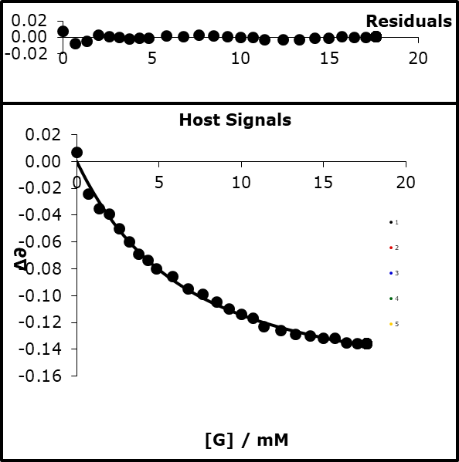

77% bound

K=193.84

LogK=2.287

(R= 8.314 x10-3 kJ mol-1)

Run 2)

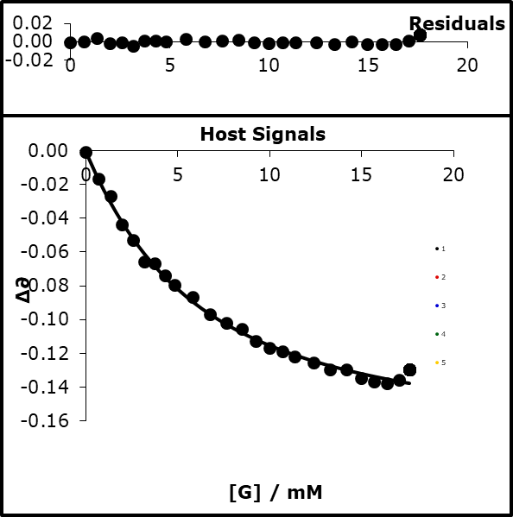

77% bound

K= 201.11

Log K=2.303

β=13.80

Run 3)  
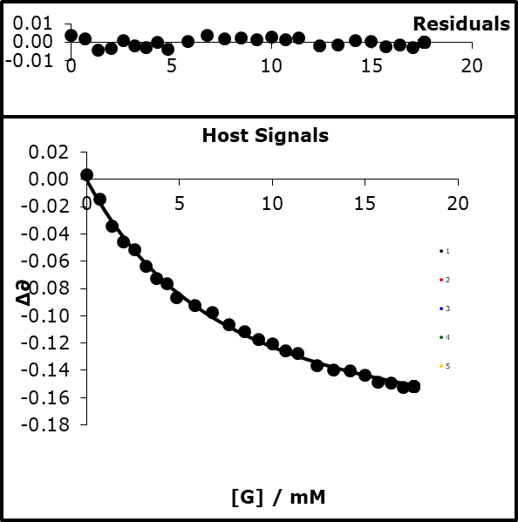

73% bound

K=158.83

Log K= 2.201

β=13.53

### Average and 2× standard deviation

13.69 ± 0.23

#### NMR titration

H/[TFE] = 1 mM

G/[3-NO2-PhO-]= 10 mM

[H] in G = 1 mM

S/Dichloromethane α =1.7, β=1.524

|  |  |  |  |  |  |  |
| --- | --- | --- | --- | --- | --- | --- |
| **expt** | **vol H / µl** | **vol G / µl** | **[H] / mM** | **[G] / mM** | **∂H 1** | **∂H** |
| 1 | 600 | 0 |  |  | -77.800 | -77.760 |
| 2 | 550 | 50 |  |  | -77.450 | -77.460 |
| 3 | 500 | 100 |  |  | -77.290 | -77.260 |
| 4 | 450 | 150 |  |  | -77.170 | -77.170 |
| 5 | 400 | 200 |  |  | -77.120 | -77.120 |
| 6 | 350 | 250 |  |  | -77.100 | -77.070 |
| 7 | 300 | 300 |  |  | -77.050 | -77.090 |
| 8 | 250 | 350 |  |  | -77.080 | -77.040 |
| 9 | 200 | 400 |  |  | -77.040 | -77.030 |
| 10 | 150 | 450 |  |  | -77.020 | -77.020 |
| 11 | 100 | 500 |  |  | -77.000 | -77.010 |
| 12 | 0 | 600 |  |  | -76.990 | -76.990 |

Run 1)

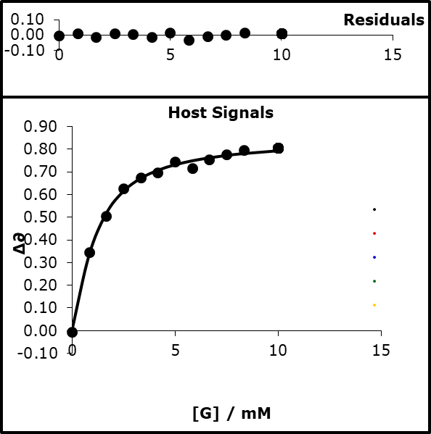

93% bound

K = 1440

logK=3.16

β=13.51

Run 2)

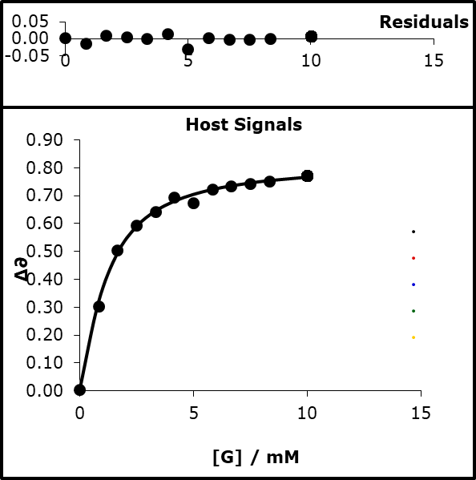

93% bound

K=1380

LogK=3.160

β=13.46

#### Average and 2× standard deviation

13.49 ± 0.05

#### Value and 95% confidence interval of all data

13.61 ± 0.12

### 3-nitro-4-choro-phenolate tetrabutylammonium salt

#### UV titration

H) [3-NO2-4-Cl-PhO- TBA] = 1 mM

G) [TFE] 56 mM α=3.721

S) acetonitrile α=1.5, β=5.128

|  |  |  |  |  |  |  |  |
| --- | --- | --- | --- | --- | --- | --- | --- |
| **expt** | **vol H / µl** | **vol G / µl** | **[H] / mM** | **[G] / mM** | **∂H 1** | **∂H** | **∂H** |
| 1 | 150 | 0 |  |  | 0.963 | 0.961 | 0.952 |
| 2 | 150 | 3 |  |  | 0.890 | 0.896 | 0.888 |
| 3 | 150 | 6 |  |  | 0.839 | 0.855 | 0.855 |
| 4 | 150 | 9 |  |  | 0.816 | 0.826 | 0.837 |
| 5 | 150 | 12 |  |  | 0.792 | 0.809 | 0.811 |
| 6 | 150 | 15 |  |  | 0.772 | 0.785 | 0.791 |
| 7 | 150 | 18 |  |  | 0.756 | 0.770 | 0.765 |
| 8 | 150 | 21 |  |  | 0.749 | 0.754 | 0.753 |
| 9 | 150 | 24 |  |  | 0.739 | 0.744 | 0.742 |
| 10 | 150 | 30 |  |  | 0.721 | 0.727 | 0.721 |
| 11 | 150 | 36 |  |  | 0.713 | 0.714 | 0.713 |
| 12 | 150 | 42 |  |  | 0.701 | 0.702 | 0.703 |
| 13 | 150 | 48 |  |  | 0.688 | 0.694 | 0.690 |
| 14 | 150 | 54 |  |  | 0.678 | 0.688 | 0.686 |
| 15 | 150 | 60 |  |  | 0.676 | 0.683 | 0.677 |
| 16 | 150 | 66 |  |  | 0.672 | 0.676 | 0.673 |
| 17 | 150 | 72 |  |  | 0.666 | 0.673 | 0.670 |
| 18 | 150 | 82 |  |  | 0.656 | 0.667 | 0.664 |
| 19 | 150 | 92 |  |  | 0.650 | 0.665 | 0.658 |
| 20 | 150 | 102 |  |  | 0.648 | 0.660 | 0.654 |
| 21 | 150 | 112 |  |  | 0.647 | 0.656 | 0.650 |
| 22 | 150 | 122 |  |  | 0.648 | 0.655 | 0.648 |
| 23 | 150 | 132 |  |  | 0.648 | 0.654 | 0.646 |
| 24 | 150 | 142 |  |  | 0.646 | 0.646 | 0.640 |
| 25 | 150 | 152 |  |  | 0.646 | 0.641 | 0.634 |

Run1)

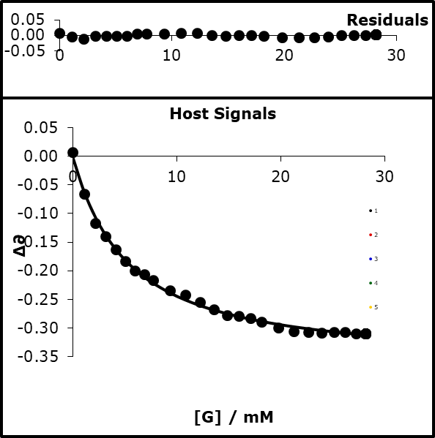

86% bound

K=214.31

logK=2.331

β=13.87

Run2)

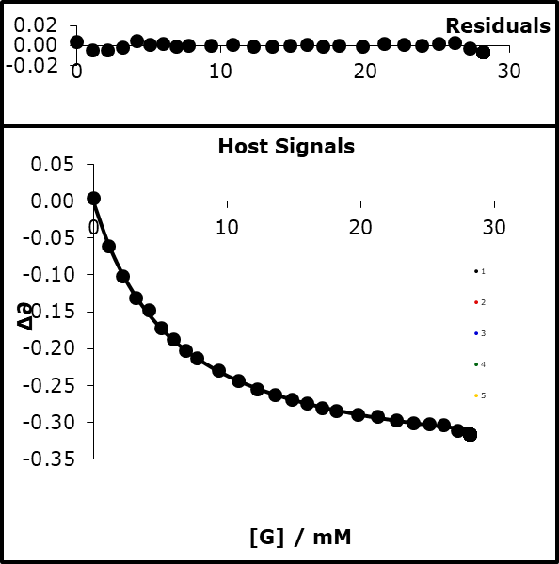

84% bound

K=188.29

logK=2.275

β=13.73

Run3)

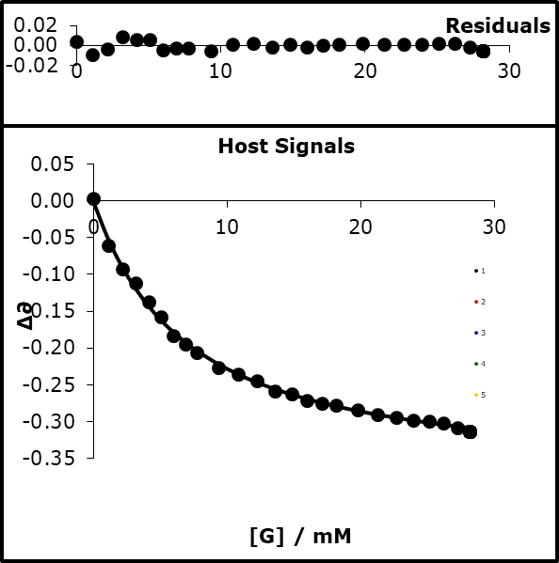

82% bound

K=160.33

logK=2.205

β=13.54

#### Average and 2 × standard deviation

13.71 ± 0.27

#### NMR titrations

H/[TFE] = 1 mM

G/[3-NO2-4-Cl-PhO-]= 10 mM

[H] in G = 1 mM

S/Dichloromethane α=1.7 β=1.524

|  |  |  |  |  |  |  |
| --- | --- | --- | --- | --- | --- | --- |
| **expt** | **vol H / µl** | **vol G / µl** | **[H] / mM** | **[G] / mM** | **∂H 1** | **∂H** |
| 1 | 600 | 0 |  |  | -77.810 | -77.760 |
| 2 | 550 | 50 |  |  | -77.450 | -77.500 |
| 3 | 500 | 100 |  |  | -77.290 | -77.290 |
| 4 | 450 | 150 |  |  | -77.280 | -77.210 |
| 5 | 400 | 200 |  |  | -77.160 | -77.160 |
| 6 | 350 | 250 |  |  | -77.130 | -77.220 |
| 7 | 300 | 300 |  |  | -77.110 | -77.110 |
| 8 | 250 | 350 |  |  | -77.090 | -77.130 |
| 9 | 200 | 400 |  |  | -77.080 | -77.090 |
| 10 | 150 | 450 |  |  | -77.070 | -77.070 |
| 11 | 100 | 500 |  |  | -77.120 | -77.060 |
| 12 | 0 | 600 |  |  | -77.040 | -77.050 |

Run1)

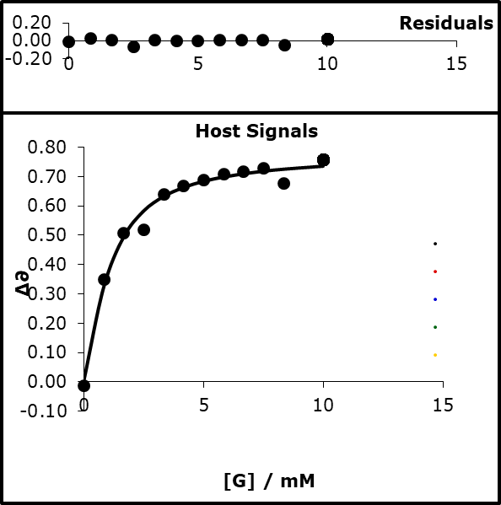

92% bound

K=1310

logK=3.119

β=13.39

Run2)

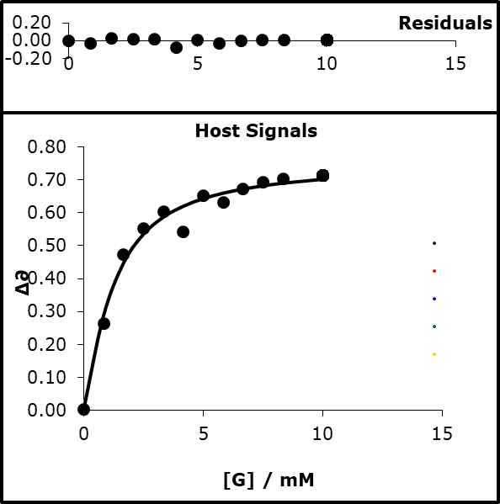

94% bound

K=1630

logK=3.212

β=13.66

Run3)

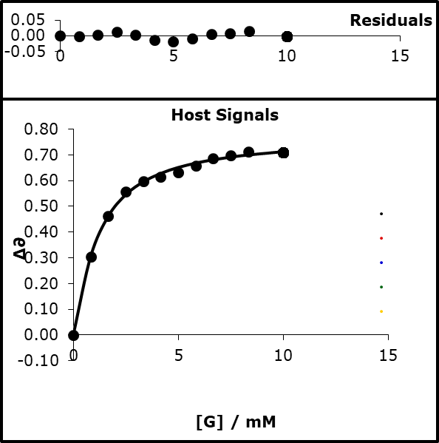

92% bound

K=1166.63

logK=3.067

β=13.25

Run4)

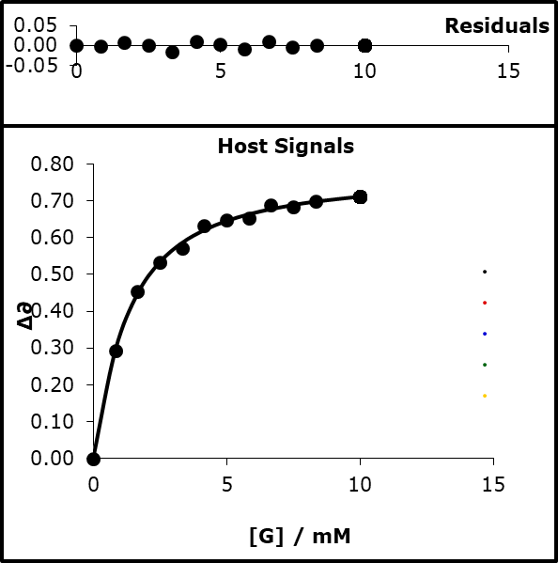

92% bound

K=1054.97

logK=3.023

β=13.12

#### Average and 2× standard deviation

13.36 ± 0.4

#### Value and 95% confidence interval of all data

13.51 ± 0.18

### 4-cyanophenolate tetrabutylammonium

#### UV titrations

H) [4-CN-PhO- TBA] = 0.1 mM

G) [TFE] 70 mM α=3.721

S) acetonitrile α=1.5, β=5.128

|  |  |  |  |  |  |  |  |
| --- | --- | --- | --- | --- | --- | --- | --- |
| **expt** | **vol H / µl** | **vol G / µl** | **[H] / mM** | **[G] / mM** | **∂H 1** | **∂H** | **∂H** |
| 1 | 150 | 0 |  |  | 0.719 | 0.736 | 0.714 |
| 2 | 150 | 3 |  |  | 0.688 | 0.700 | 0.682 |
| 3 | 150 | 6 |  |  | 0.648 | 0.668 | 0.652 |
| 4 | 150 | 9 |  |  | 0.628 | 0.646 | 0.628 |
| 5 | 150 | 12 |  |  | 0.615 | 0.630 | 0.618 |
| 6 | 150 | 15 |  |  | 0.603 | 0.617 | 0.606 |
| 7 | 150 | 18 |  |  | 0.597 | 0.608 | 0.598 |
| 8 | 150 | 21 |  |  | 0.585 | 0.597 | 0.586 |
| 9 | 150 | 24 |  |  | 0.579 | 0.588 | 0.579 |
| 10 | 150 | 30 |  |  | 0.567 | 0.579 | 0.568 |
| 11 | 150 | 36 |  |  | 0.558 | 0.569 | 0.557 |
| 12 | 150 | 42 |  |  | 0.550 | 0.563 | 0.550 |
| 13 | 150 | 48 |  |  | 0.542 | 0.555 | 0.543 |
| 14 | 150 | 54 |  |  | 0.537 | 0.547 | 0.537 |
| 15 | 150 | 60 |  |  | 0.534 | 0.540 | 0.532 |
| 16 | 150 | 66 |  |  | 0.528 | 0.536 | 0.528 |
| 17 | 150 | 72 |  |  | 0.523 | 0.531 | 0.524 |
| 18 | 150 | 82 |  |  | 0.518 | 0.520 | 0.517 |
| 19 | 150 | 92 |  |  | 0.514 | 0.517 | 0.512 |
| 20 | 150 | 102 |  |  | 0.510 | 0.513 | 0.507 |
| 21 | 150 | 112 |  |  | 0.506 | 0.510 | 0.503 |
| 22 | 150 | 122 |  |  | 0.504 | 0.506 | 0.499 |
| 23 | 150 | 132 |  |  | 0.502 | 0.504 | 0.497 |
| 24 | 150 | 142 |  |  | 0.501 | 0.501 | 0.495 |
| 25 | 150 | 152 |  |  | 0.498 | 0.499 | 0.493 |

Run1)

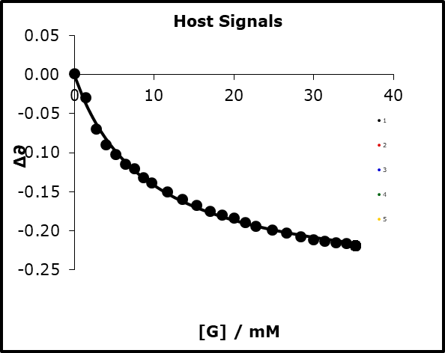

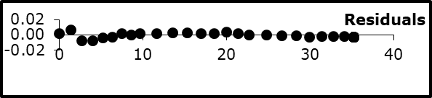

79% bound

K=110

logK=2.039

β=13.12

Run2)

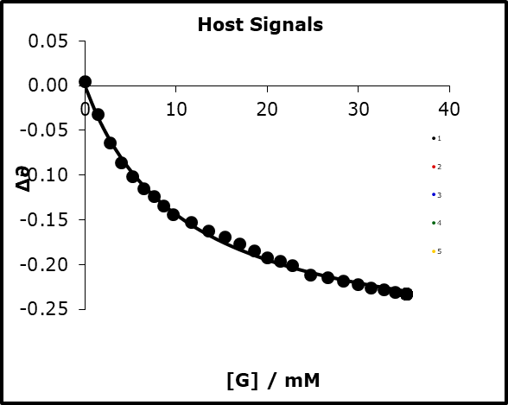

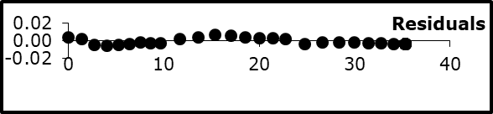

77% bound

K=92.9

logK=1.968

β=12.93

Run3)

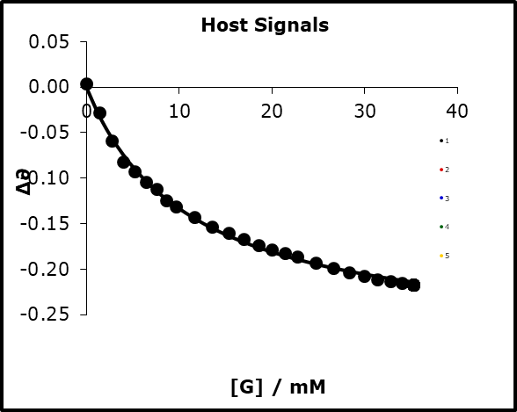

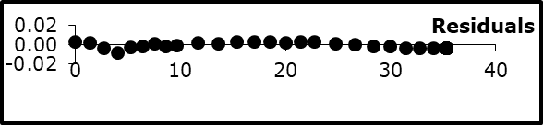

76% bound

K=90.7

LogK=1.958

β=12.90

#### Average and 2× standard deviation

12.98 ± 0.19

#### NMR titration

H) [TFE] = 0.7 mM

G) [4-CN-PhO- TBA+]= 15 mM

[H] in G = 0.7 mM

S) Dichloromethane α=1.7 β=1.524

|  |  |  |  |  |  |  |
| --- | --- | --- | --- | --- | --- | --- |
| **expt** | **vol H / µl** | **vol G / µl** | **[H] / mM** | **[G] / mM** | **∂H 1** | **∂H** |
| 1 | 600 | 0 |  |  | -77.706 | -77.711 |
| 2 | 550 | 50 |  |  | -77.321 | -77.304 |
| 3 | 500 | 100 |  |  | -77.219 | -77.167 |
| 4 | 450 | 150 |  |  | -77.110 | -77.092 |
| 5 | 400 | 200 |  |  | -77.050 | -77.051 |
| 6 | 350 | 250 |  |  | -77.036 | -77.029 |
| 7 | 300 | 300 |  |  | -77.017 | -77.013 |
| 8 | 200 | 400 |  |  | -76.982 | -76.984 |
| 9 | 100 | 500 |  |  | -76.971 | -76.972 |
| 10 | 0 | 600 |  |  | -76.963 | -76.961 |

Run1)

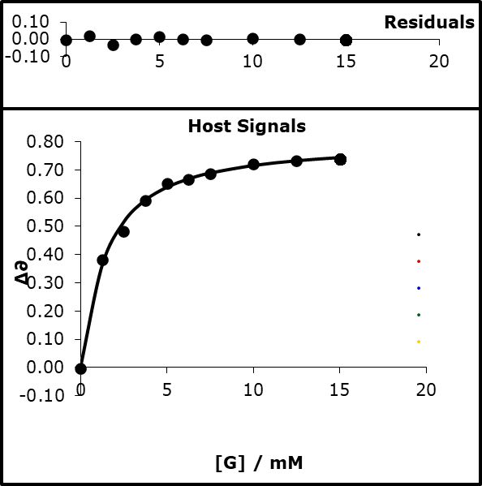

93% bound

K=872

logK=2.941

β=12.89

Run2)

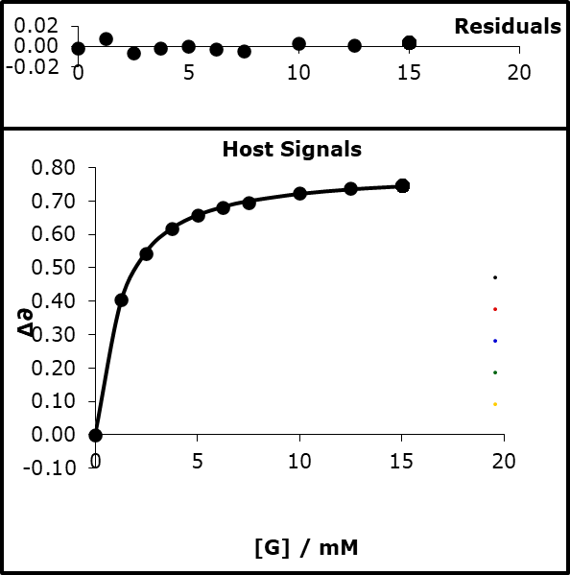

94% bound

K=1123.15

logK=3.050

β=13.20

#### Average and 2 × standard deviation

13.045 ± 0.31

#### Average of all and 95% confidence interval

13.01 ± 0.11

### 2-phenol-2-phenolate tetrabutylammonium

#### UV titration

H) [2-PhOH-2-PhO- TBA+] = 0.2 mM

G) [TFE] 333 mM α=3.721

S) acetonitrile α=1.5, β=5.128

|  |  |  |  |  |  |  |  |  |
| --- | --- | --- | --- | --- | --- | --- | --- | --- |
| **expt** | **vol H / µl** | **vol G / µl** | **∂H 1** | **∂H** | **∂H** | **∂H** | **∂H** | **∂H** |
| 1 | 150 | 0 | 0.691 | 0.586 | 0.589 | 0.712 | 0.611 | 0.615 |
| 2 | 150 | 3 | 0.715 | 0.604 | 0.606 | 0.658 | 0.581 | 0.590 |
| 3 | 150 | 6 | 0.730 | 0.619 | 0.621 | 0.637 | 0.549 | 0.556 |
| 4 | 150 | 9 | 0.739 | 0.629 | 0.630 | 0.615 | 0.527 | 0.532 |
| 5 | 150 | 12 | 0.746 | 0.638 | 0.638 | 0.599 | 0.511 | 0.515 |
| 6 | 150 | 15 | 0.754 | 0.644 | 0.645 | 0.588 | 0.497 | 0.502 |
| 7 | 150 | 18 | 0.761 | 0.650 | 0.652 | 0.580 | 0.486 | 0.492 |
| 8 | 150 | 21 | 0.767 | 0.657 | 0.657 | 0.572 | 0.479 | 0.482 |
| 9 | 150 | 24 | 0.771 | 0.661 | 0.661 | 0.565 | 0.470 | 0.473 |
| 10 | 150 | 30 | 0.776 | 0.665 | 0.668 | 0.551 | 0.457 | 0.461 |
| 11 | 150 | 36 | 0.781 | 0.670 | 0.673 | 0.543 | 0.446 | 0.451 |
| 12 | 150 | 42 | 0.788 | 0.676 | 0.677 | 0.536 | 0.440 | 0.443 |
| 13 | 150 | 48 | 0.791 | 0.682 | 0.681 | 0.531 | 0.436 | 0.437 |
| 14 | 150 | 54 | 0.800 | 0.683 | 0.685 | 0.529 | 0.428 | 0.431 |
| 15 | 150 | 60 | 0.802 | 0.687 | 0.690 | 0.525 | 0.425 | 0.429 |
| 16 | 150 | 66 | 0.808 | 0.689 | 0.690 | 0.523 | 0.420 | 0.422 |
| 17 | 150 | 72 | 0.809 | 0.690 | 0.693 | 0.518 | 0.415 | 0.419 |
| 18 | 150 | 82 | 0.812 | 0.694 | 0.696 | 0.513 | 0.411 | 0.413 |
| 19 | 150 | 92 | 0.821 | 0.697 | 0.704 | 0.512 | 0.406 | 0.412 |
| 20 | 150 | 102 | 0.830 | 0.701 | 0.707 | 0.514 | 0.404 | 0.409 |
| 21 | 150 | 112 | 0.826 | 0.704 | 0.708 | 0.505 | 0.400 | 0.405 |
| 22 | 150 | 122 | 0.831 | 0.706 | 0.713 | 0.504 | 0.398 | 0.404 |
| 23 | 150 | 132 | 0.843 | 0.708 | 0.715 | 0.511 | 0.396 | 0.402 |
| 24 | 150 | 142 | 0.837 | 0.708 | 0.716 | 0.501 | 0.393 | 0.400 |
| 25 | 150 | 152 | 0.841 | 0.711 | 0.720 | 0.501 | 0.392 | 0.399 |

Run1)

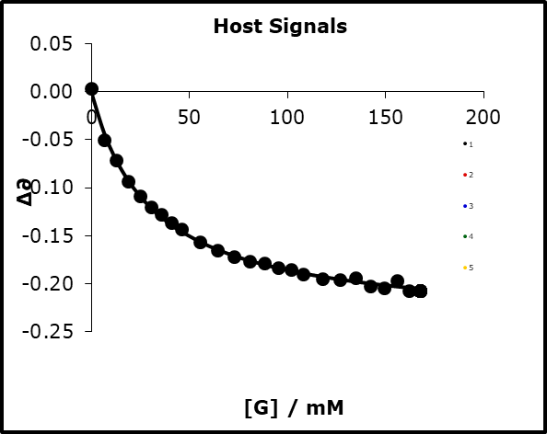

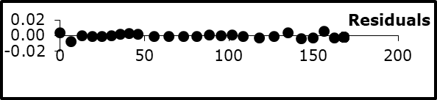

85% bound

K=32.61

β=11.75

Run2)

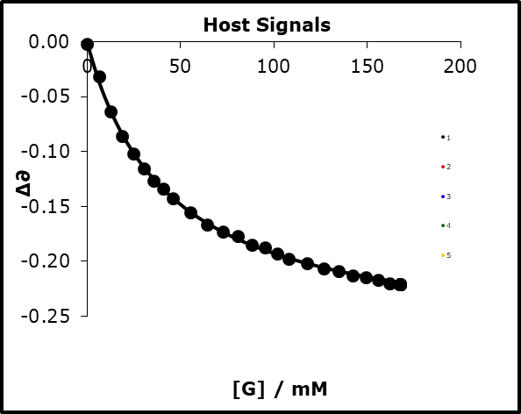

80% bound

K=23.28

β=11.37

Run3)

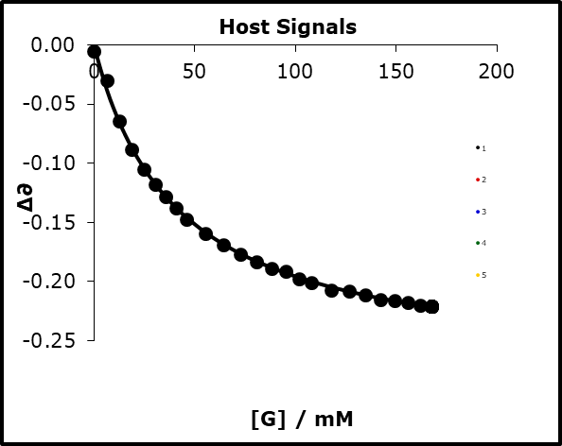

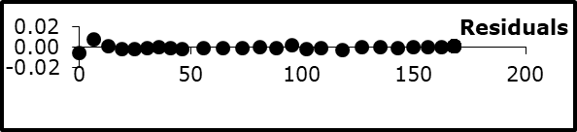

80%bound

K=24.31

β=11.42

#### Average and 2 × standard deviation

11.51 ± 0.33

#### Average of all and 95% confidence interval

11.51 ± 0.19

### 4-Nitrophenolate tetrabutylammonium

#### UV titration

H) [4-NO2-PhO- TBA] = 0.05 mM

G) [TFE] 140 mM α=3.721

S) acetonitrile α=1.5, β=5.128

|  |  |  |  |  |  |  |  |
| --- | --- | --- | --- | --- | --- | --- | --- |
| **expt** | **vol H / µl** | **vol G / µl** | **[H] / mM** | **[G] / mM** | **∂H 1** | **∂H** | **∂H** |
| 1 | 150 | 0 |  |  | 0.596 | 0.658 | 0.633 |
| 2 | 150 | 3 |  |  | 0.564 | 0.616 | 0.604 |
| 3 | 150 | 6 |  |  | 0.531 | 0.599 | 0.567 |
| 4 | 150 | 9 |  |  | 0.512 | 0.575 | 0.552 |
| 5 | 150 | 12 |  |  | 0.494 | 0.557 | 0.539 |
| 6 | 150 | 15 |  |  | 0.483 | 0.542 | 0.518 |
| 7 | 150 | 18 |  |  | 0.473 | 0.527 | 0.506 |
| 8 | 150 | 21 |  |  | 0.462 | 0.512 | 0.490 |
| 9 | 150 | 24 |  |  | 0.453 | 0.509 | 0.484 |
| 10 | 150 | 30 |  |  | 0.443 | 0.489 | 0.472 |
| 11 | 150 | 36 |  |  | 0.435 | 0.477 | 0.457 |
| 12 | 150 | 42 |  |  | 0.425 | 0.468 | 0.443 |
| 13 | 150 | 48 |  |  | 0.415 | 0.457 | 0.436 |
| 14 | 150 | 54 |  |  | 0.408 | 0.450 | 0.427 |
| 15 | 150 | 60 |  |  | 0.404 | 0.445 | 0.415 |
| 16 | 150 | 66 |  |  | 0.397 | 0.436 | 0.414 |
| 17 | 150 | 72 |  |  | 0.393 | 0.429 | 0.408 |
| 18 | 150 | 82 |  |  | 0.388 | 0.421 | 0.402 |
| 19 | 150 | 92 |  |  | 0.384 | 0.413 | 0.395 |
| 20 | 150 | 102 |  |  | 0.381 | 0.407 | 0.394 |
| 21 | 150 | 112 |  |  | 0.377 | 0.401 | 0.388 |
| 22 | 150 | 122 |  |  | 0.376 | 0.396 | 0.386 |
| 23 | 150 | 132 |  |  | 0.374 | 0.391 | 0.383 |
| 24 | 150 | 142 |  |  | 0.370 | 0.388 | 0.380 |
| 25 | 150 | 152 |  |  | 0.367 | 0.388 | 0.378 |

Run1)

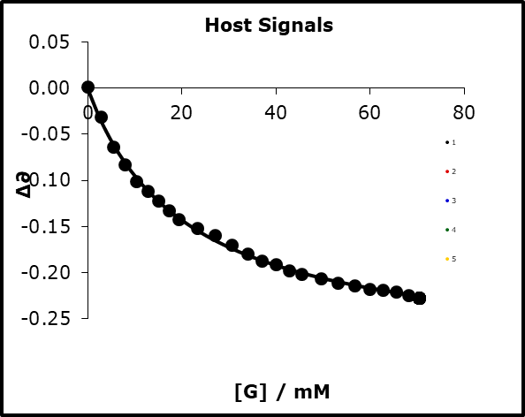

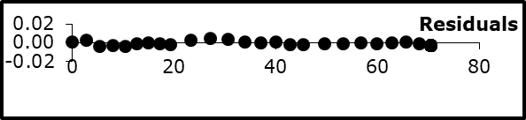

77% bound

K=48.01

logK=1.681

β=12.19

Run2)

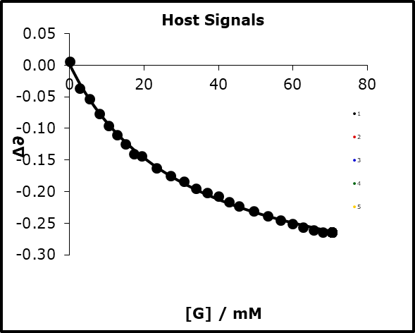

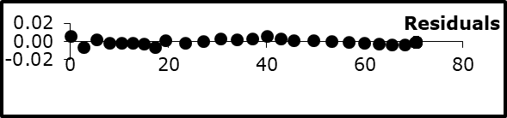

69% bound

K=31.34

logK=1.496

β=11.71

Run3)

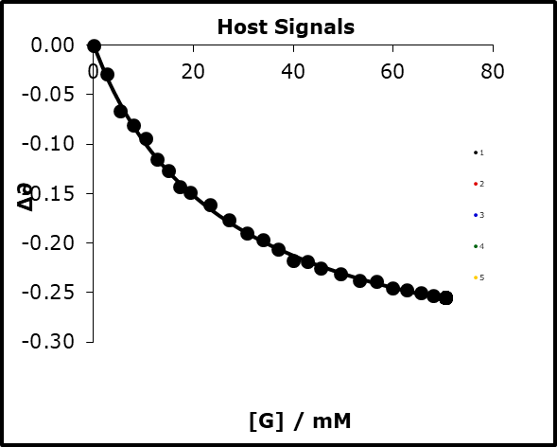

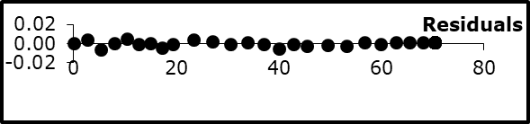

K=37.84

logK=1.578

β=11.92

#### Average and 2 × standard deviation

11.94 ± 0.39

#### NMR titration

H/[TFE] = 0.7 mM

G/[4-CN-PhO-]= 30 mM

[H] in G = 0.7 mM

S/Dichloromethane α=1.7 β=1.524

|  |  |  |  |  |  |  |
| --- | --- | --- | --- | --- | --- | --- |
| **expt** | **vol H / µl** | **vol G / µl** | **[H] / mM** | **[G] / mM** | **∂H 1** | **∂H** |
| 1 | 600 | 0 |  |  | -77.708 | -77.709 |
| 2 | 550 | 50 |  |  | -77.320 | -77.327 |
| 3 | 500 | 100 |  |  | -77.207 | -77.211 |
| 4 | 450 | 150 |  |  | -77.148 | -77.153 |
| 5 | 400 | 200 |  |  | -77.114 | -77.115 |
| 6 | 350 | 250 |  |  | -77.090 | -77.094 |
| 7 | 300 | 300 |  |  | -77.073 | -77.073 |
| 8 | 250 | 350 |  |  | -77.061 | -77.062 |
| 9 | 200 | 400 |  |  | -77.052 | -77.051 |
| 10 | 150 | 450 |  |  | -77.043 | -77.044 |
| 11 | 100 | 500 |  |  | -77.035 | -77.036 |
| 12 | 0 | 600 |  |  | -77.023 | -77.029 |

Run1)

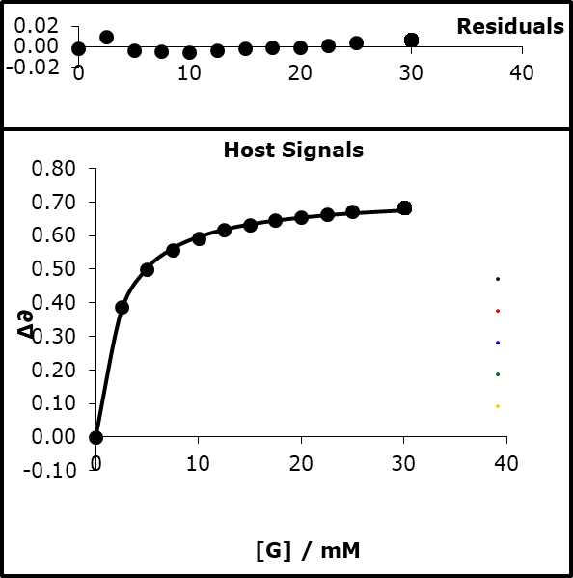

94% bound

K=512.04

logK=2.709

β=12.23

Run2)

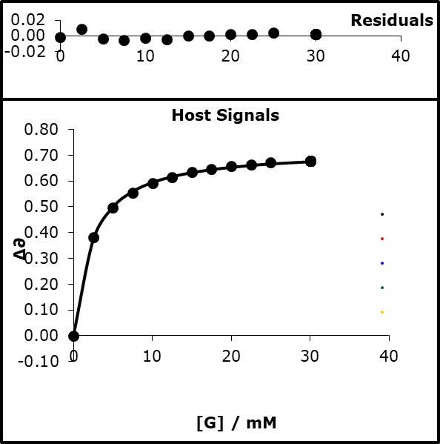

94% bound

K=495.57

logK=2.695

β=12.19

#### Average and 2 × standard deviation

12.21 ± 0.04

#### Average of all and 95% confidence interval

12.04 ± 0.18

### 3-cyanophenolate tetrabutylammonium

#### NMR titrations

H) [3-CN-PhO- TBA] = 15 mM

G) [TFE] 0.7 mM α=3.721

S) acetonitrile α=1.5, β=5.128

[H] in G = 0.7 mM

|  |  |  |  |  |  |  |
| --- | --- | --- | --- | --- | --- | --- |
| **expt** | **vol H / µl** | **vol G / µl** | **[H] / mM** | **[G] / mM** | **∂H 1** | **∂H** |
| 1 | 600 | 0 |  |  | -76.916 | -76.917 |
| 2 | 550 | 50 |  |  | -76.726 | -76.734 |
| 3 | 500 | 100 |  |  | -76.621 | -76.625 |
| 4 | 450 | 150 |  |  | -76.563 | -76.563 |
| 5 | 400 | 200 |  |  | -76.523 | -76.527 |
| 6 | 350 | 250 |  |  | -76.498 | -76.503 |
| 7 | 300 | 300 |  |  | -76.483 | -76.483 |
| 8 | 250 | 350 |  |  | -76.465 | -76.469 |
| 9 | 200 | 400 |  |  | -76.458 | -76.459 |
| 10 | 150 | 450 |  |  | -76.447 | -76.451 |
| 11 | 100 | 500 |  |  | -76.440 | -76.445 |
| 12 | 0 | 600 |  |  | -76.429 | -76.434 |

##### Run1)

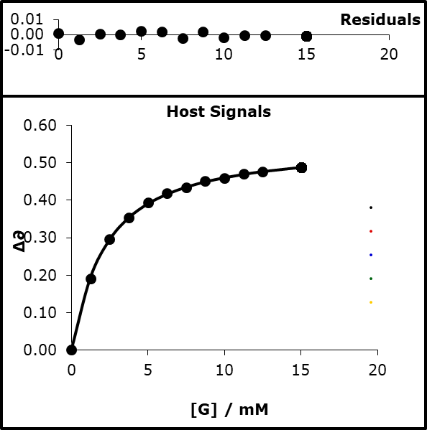

K=544.15

logK=2.736

β=14.92

Run2)

K=536.20

logK=2729

β=14.90

#### Average and 2 × standard deviation

14.91 ± 0.02

##### Run3)

H) [3-CN-PhO- TBA] = 10 mM

G) [TFE] 0.7 mM α=3.721

S) Dichloromethane α=1.7, β=1.5

[H] in G = 0.7 mM

|  |  |  |  |  |  |
| --- | --- | --- | --- | --- | --- |
| **expt** | **vol H / µl** | **vol G / µl** | **[H] / mM** | **[G] / mM** | **∂H 1** |
| 1 | 600 | 0 |  |  | -77.711 |
| 2 | 550 | 50 |  |  | -77.310 |
| 3 | 500 | 100 |  |  | -77.132 |
| 4 | 400 | 200 |  |  | -77.018 |
| 5 | 350 | 250 |  |  | -76.985 |
| 6 | 300 | 300 |  |  | -76.990 |
| 7 | 250 | 350 |  |  | -76.951 |
| 8 | 200 | 400 |  |  | -76.942 |
| 9 | 150 | 450 |  |  | -76.935 |
| 10 | 100 | 500 |  |  | -76.932 |
| 11 | 0 | 600 |  |  | -76.920 |

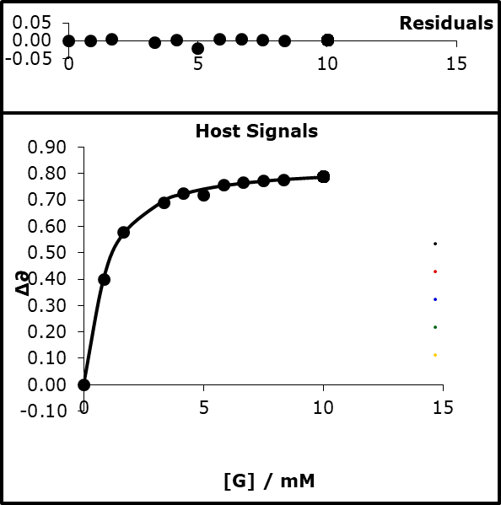

K=1869.66

logK=3.272

β=13.83

Run4)

|  |  |  |  |  |  |
| --- | --- | --- | --- | --- | --- |
| **expt** | **vol H / µl** | **vol G / µl** | **[H] / mM** | **[G] / mM** | **∂H 1** |
| 1 | 600 | 0 |  |  | -77.710 |
| 2 | 550 | 50 |  |  | -77.314 |
| 3 | 500 | 100 |  |  | -77.156 |
| 4 | 450 | 150 |  |  | -77.075 |
| 5 | 400 | 200 |  |  | -77.034 |
| 6 | 350 | 250 |  |  | -76.998 |
| 7 | 300 | 300 |  |  | -76.981 |
| 8 | 250 | 350 |  |  | -76.964 |
| 9 | 200 | 400 |  |  | -76.953 |
| 10 | 150 | 450 |  |  | -76.943 |
| 11 | 0 | 600 |  |  | -76.926 |

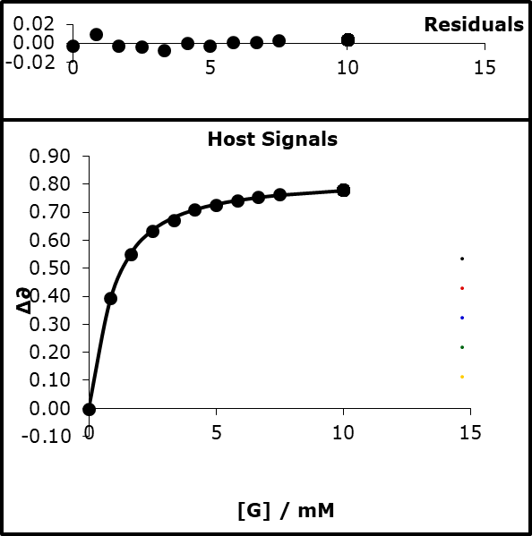

K=1700.61

logK=3.231

β=13.72

#### Average and 2 × standard deviation

13.78 ± 0.11

#### Average of all and 95% confidence interval

14.34 ± 0.56

### 3-trifluoromethyl-4-nitrophenolate tetrabutylammonium

#### UV titrations

H) [3-CF3-NO2-PhO- TBA] = 0.1 mM

G) [TFE] 280 mM α=3.721

S) acetonitrile α=1.5, β=5.128

|  |  |  |  |  |  |  |  |  |  |  |
| --- | --- | --- | --- | --- | --- | --- | --- | --- | --- | --- |
| **expt** | **vol H / µl** | **vol G / µl** | **[H] / mM** | **[G] / mM** | **∂H 1** | **∂H** | **∂H** | **∂H** | **∂H** | **∂H** |
| 1 | 150 | 0 |  |  | 0.782 | 0.777 | 0.780 | 0.768 | 0.772 | 0.761 |
| 2 | 150 | 3 |  |  | 0.705 | 0.703 | 0.713 | 0.691 | 0.711 | 0.704 |
| 3 | 150 | 6 |  |  | 0.635 | 0.652 | 0.652 | 0.639 | 0.657 | 0.644 |
| 4 | 150 | 9 |  |  | 0.598 | 0.607 | 0.604 | 0.595 | 0.608 | 0.604 |
| 5 | 150 | 12 |  |  | 0.563 | 0.563 | 0.573 | 0.564 | 0.567 | 0.575 |
| 6 | 150 | 15 |  |  | 0.537 | 0.539 | 0.540 | 0.534 | 0.542 | 0.537 |
| 7 | 150 | 18 |  |  | 0.511 | 0.521 | 0.520 | 0.513 | 0.520 | 0.513 |
| 8 | 150 | 21 |  |  | 0.491 | 0.491 | 0.497 | 0.495 | 0.497 | 0.493 |
| 9 | 150 | 24 |  |  | 0.474 | 0.479 | 0.481 | 0.475 | 0.479 | 0.473 |
| 10 | 150 | 30 |  |  | 0.446 | 0.450 | 0.453 | 0.454 | 0.451 | 0.447 |
| 11 | 150 | 36 |  |  | 0.427 | 0.430 | 0.433 | 0.428 | 0.428 | 0.422 |
| 12 | 150 | 42 |  |  | 0.410 | 0.415 | 0.415 | 0.412 | 0.411 | 0.408 |
| 13 | 150 | 48 |  |  | 0.398 | 0.401 | 0.403 | 0.398 | 0.397 | 0.392 |
| 14 | 150 | 54 |  |  | 0.386 | 0.389 | 0.392 | 0.385 | 0.386 | 0.382 |
| 15 | 150 | 60 |  |  | 0.377 | 0.380 | 0.381 | 0.375 | 0.377 | 0.373 |
| 16 | 150 | 66 |  |  | 0.368 | 0.371 | 0.372 | 0.368 | 0.369 | 0.368 |
| 17 | 150 | 72 |  |  | 0.364 | 0.364 | 0.366 | 0.361 | 0.363 | 0.359 |
| 18 | 150 | 82 |  |  | 0.351 | 0.353 | 0.355 | 0.349 | 0.352 | 0.348 |
| 19 | 150 | 92 |  |  | 0.342 | 0.345 | 0.347 | 0.342 | 0.344 | 0.339 |
| 20 | 150 | 102 |  |  | 0.336 | 0.338 | 0.339 | 0.335 | 0.337 | 0.335 |
| 21 | 150 | 112 |  |  | 0.329 | 0.331 | 0.332 | 0.327 | 0.331 | 0.327 |
| 22 | 150 | 122 |  |  | 0.325 | 0.326 | 0.327 | 0.322 | 0.326 | 0.322 |
| 23 | 150 | 132 |  |  | 0.320 | 0.321 | 0.322 | 0.318 | 0.321 | 0.317 |
| 24 | 150 | 142 |  |  | 0.314 | 0.317 | 0.316 | 0.313 | 0.318 | 0.313 |
| 25 | 150 | 152 |  |  | 0.311 | 0.313 | 0.313 | 0.310 | 0.314 | 0.311 |

Run1)

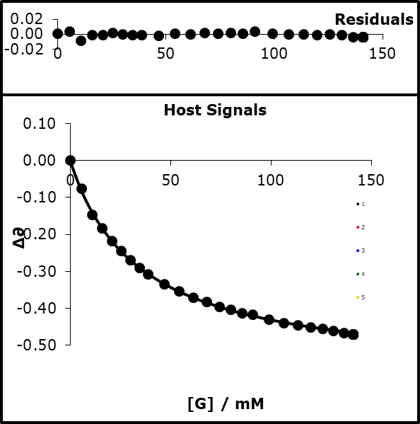

80% bound

K=28.83

logK=1.490

β=11.61

Run2)

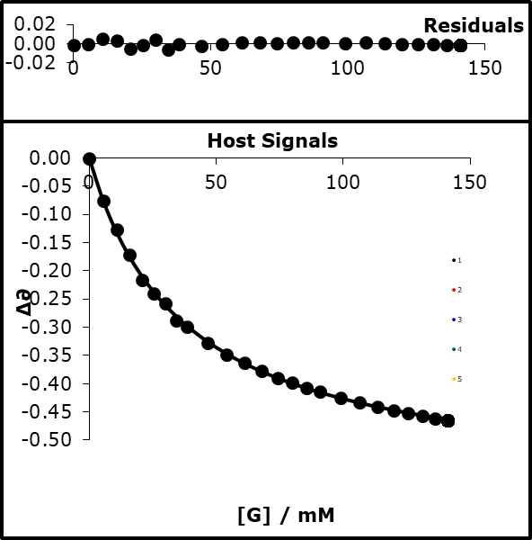

79% bound

K=26.96

logK=1.431

β=11.54

Run3)  
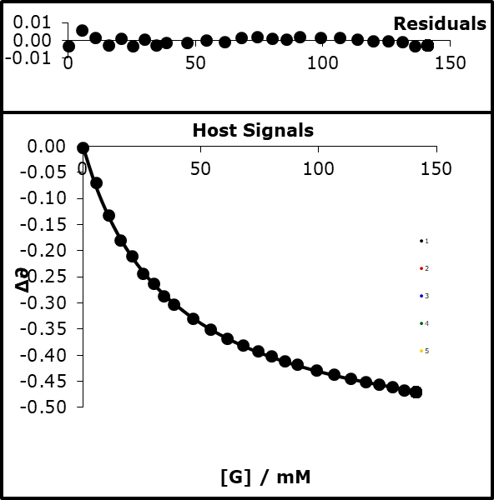

79% bound

K=26.85

logK=1.429

β=11.53

Run4)  
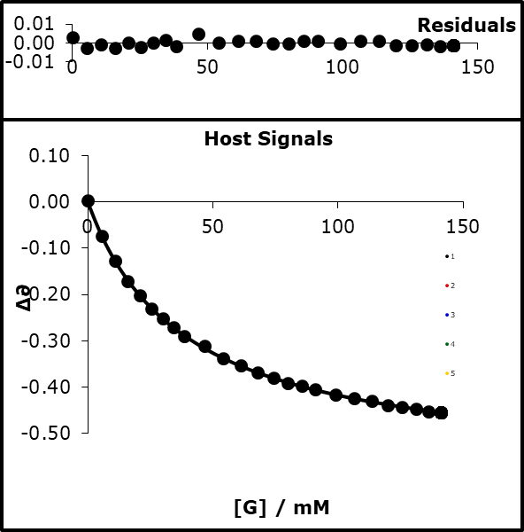

78% bound

K=25.75

logK=1.411

β=11.49

Run5)

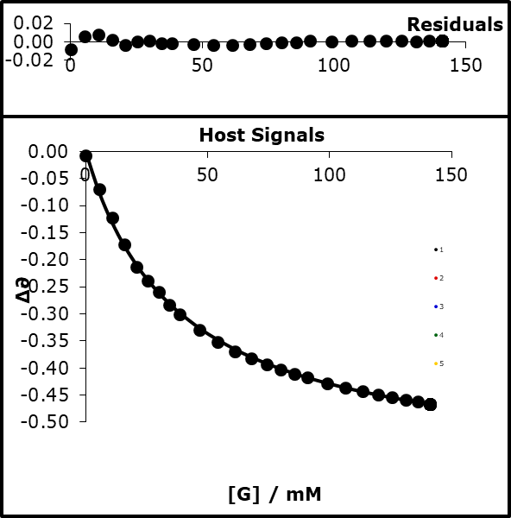

79% bound

K=26.40

logK=1.422

β=11.51

Run6)

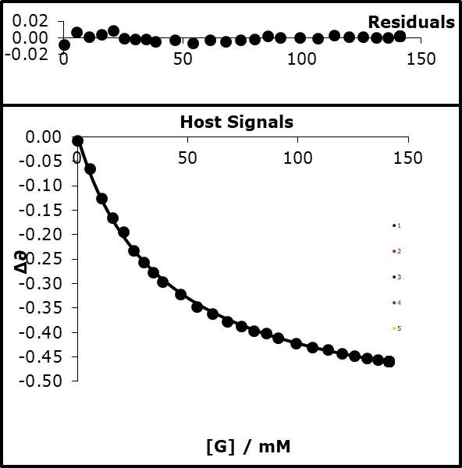

78% bound

K=25.49

logK=1.406

β=11.47

#### Average and 2 × standard deviation

11.53 ± 0.09

#### Average and 95% confidence interval

11.53 ± 0.04

### 3-nitrophenol

#### UV titration

H) [3-NO2-PhOH] = 1 mM

G) [tButP=O] 15 mM β = 10.728

S) CHCl3 α = 2.2, β = 1.328

|  |  |  |  |  |  |  |  |  |  |  |
| --- | --- | --- | --- | --- | --- | --- | --- | --- | --- | --- |
| **expt** | **vol H / µl** | **vol G / µl** | **[H] / mM** | **[G] / mM** | **∂H 1** | **∂H** | **∂H** | **∂H** | **∂H** | **∂H** |
| 1 | 150 | 0 |  |  | 0.224 | 0.221 | 0.219 | 0.218 | 0.224 | 0.223 |
| 2 | 150 | 3 |  |  | 0.304 | 0.277 | 0.272 | 0.272 | 0.286 | 0.277 |
| 3 | 150 | 6 |  |  | 0.378 | 0.329 | 0.310 | 0.315 | 0.334 | 0.327 |
| 4 | 150 | 9 |  |  | 0.401 | 0.367 | 0.356 | 0.353 | 0.371 | 0.365 |
| 5 | 150 | 12 |  |  | 0.423 | 0.390 | 0.381 | 0.390 | 0.401 | 0.400 |
| 6 | 150 | 15 |  |  | 0.453 | 0.430 | 0.416 | 0.416 | 0.428 | 0.424 |
| 7 | 150 | 18 |  |  | 0.469 | 0.451 | 0.442 | 0.439 | 0.451 | 0.447 |
| 8 | 150 | 21 |  |  | 0.490 | 0.478 | 0.460 | 0.460 | 0.472 | 0.468 |
| 9 | 150 | 24 |  |  | 0.501 | 0.499 | 0.476 | 0.478 | 0.486 | 0.483 |
| 10 | 150 | 30 |  |  | 0.522 | 0.528 | 0.506 | 0.503 | 0.515 | 0.507 |
| 11 | 150 | 36 |  |  | 0.531 | 0.543 | 0.529 | 0.522 | 0.533 | 0.531 |
| 12 | 150 | 42 |  |  | 0.548 | 0.546 | 0.547 | 0.540 | 0.548 | 0.548 |
| 13 | 150 | 48 |  |  | 0.557 | 0.559 | 0.561 | 0.554 | 0.560 | 0.561 |
| 14 | 150 | 54 |  |  | 0.565 | 0.563 | 0.564 | 0.567 | 0.576 | 0.569 |
| 15 | 150 | 60 |  |  | 0.576 | 0.571 | 0.565 | 0.572 | 0.586 | 0.571 |
| 16 | 150 | 66 |  |  | 0.576 | 0.578 | 0.573 | 0.580 | 0.590 | 0.581 |
| 17 | 150 | 72 |  |  | 0.587 | 0.582 | 0.583 | 0.580 | 0.603 | 0.587 |
| 18 | 150 | 82 |  |  | 0.600 | 0.587 | 0.591 | 0.589 | 0.613 | 0.597 |
| 19 | 150 | 92 |  |  | 0.606 | 0.599 | 0.597 | 0.592 | 0.623 | 0.607 |
| 20 | 150 | 102 |  |  | 0.612 | 0.604 | 0.602 | 0.601 | 0.617 | 0.612 |
| 21 | 150 | 112 |  |  | 0.614 | 0.608 | 0.604 | 0.604 | 0.633 | 0.617 |
| 22 | 150 | 122 |  |  | 0.617 | 0.613 | 0.614 | 0.609 | 0.635 | 0.625 |
| 23 | 150 | 132 |  |  | 0.625 | 0.616 | 0.616 | 0.617 | 0.637 | 0.632 |
| 24 | 150 | 142 |  |  | 0.630 | 0.622 | 0.619 | 0.619 | 0.638 | 0.630 |
| 25 | 150 | 152 |  |  | 0.627 | 0.627 | 0.623 | 0.625 | 0.636 | 0.641 |

Run1)

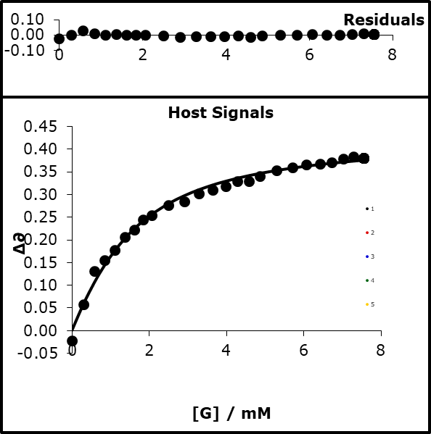

87% bound

K=940.62

LogK=2.973

(R= 8.314 x10-3 Kj mol-1)

Run2)

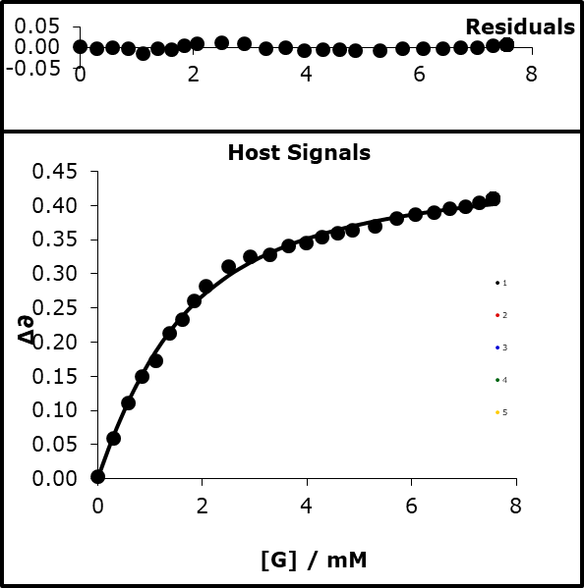

87% bound

K=906.53

logK=2.957

α=4.63

Run3)

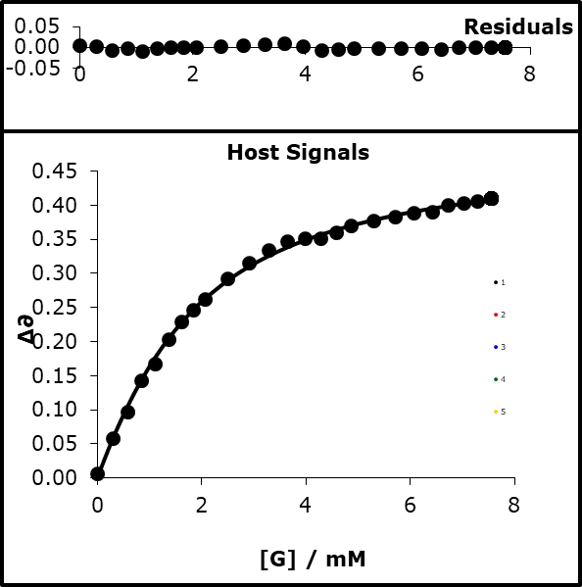

84% bound

K=741.63

logK=2.870

α=4.58

Run4)

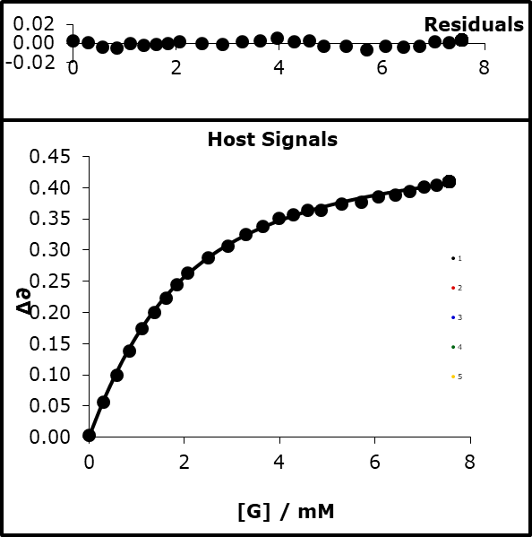

84% bound

K=733.96

logK=2.866

α=4.58

Run5)

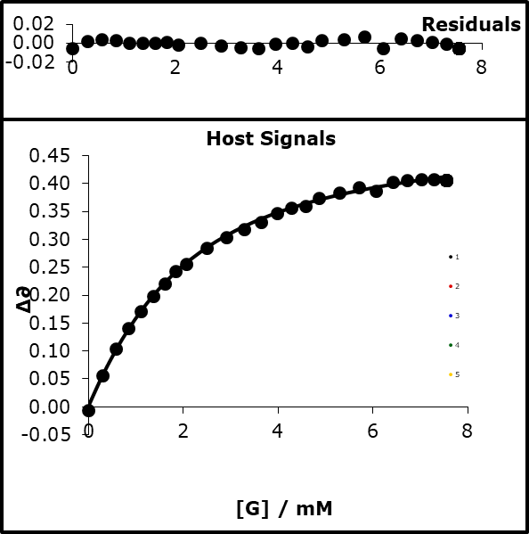

92% bound

K=654.72

logK=2.816

α=4.55

Run6)

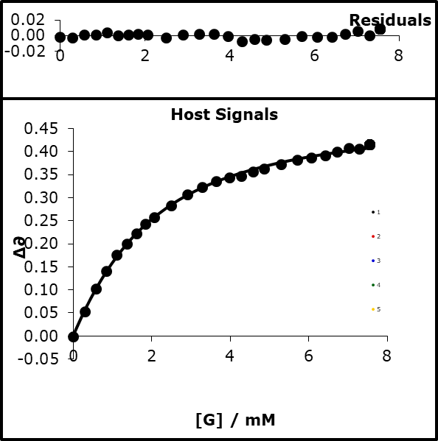

83% bound

K=682.97

logK=2.834

α=4.56

#### Average and 2 × standard deviation

4.59 ± 0.03

### 3-nitro-4-chlorophenol

#### UV titration

H) [3-NO2-4-Cl-PhOH] = 1 mM

G) [tButP=O] 15 mM β = 10.728

S) CHCl3 α = 2.2, β = 1.328

|  |  |  |  |  |  |  |  |  |  |  |
| --- | --- | --- | --- | --- | --- | --- | --- | --- | --- | --- |
| **expt** | **vol H / µl** | **vol G / µl** | **[H] / mM** | **[G] / mM** | **∂H 1** | **∂H** | **∂H** | **∂H** | **∂H** | **∂H** |
| 1 | 150 | 0 |  |  | 0.390 | 0.392 | 0.395 | 0.399 | 0.400 | 0.399 |
| 2 | 150 | 3 |  |  | 0.443 | 0.452 | 0.443 | 0.425 | 0.461 | 0.438 |
| 3 | 150 | 6 |  |  | 0.504 | 0.490 | 0.491 | 0.476 | 0.496 | 0.478 |
| 4 | 150 | 9 |  |  | 0.534 | 0.520 | 0.521 | 0.509 | 0.531 | 0.519 |
| 5 | 150 | 12 |  |  | 0.554 | 0.545 | 0.545 | 0.545 | 0.561 | 0.550 |
| 6 | 150 | 15 |  |  | 0.571 | 0.562 | 0.558 | 0.553 | 0.568 | 0.564 |
| 7 | 150 | 18 |  |  | 0.583 | 0.578 | 0.572 | 0.582 | 0.578 | 0.578 |
| 8 | 150 | 21 |  |  | 0.594 | 0.594 | 0.586 | 0.585 | 0.598 | 0.586 |
| 9 | 150 | 24 |  |  | 0.616 | 0.597 | 0.601 | 0.594 | 0.627 | 0.596 |
| 10 | 150 | 30 |  |  | 0.611 | 0.605 | 0.606 | 0.599 | 0.617 | 0.609 |
| 11 | 150 | 36 |  |  | 0.622 | 0.618 | 0.608 | 0.606 | 0.626 | 0.623 |
| 12 | 150 | 42 |  |  | 0.628 | 0.623 | 0.621 | 0.619 | 0.655 | 0.627 |
| 13 | 150 | 48 |  |  | 0.634 | 0.628 | 0.622 | 0.624 | 0.647 | 0.641 |
| 14 | 150 | 54 |  |  | 0.635 | 0.632 | 0.631 | 0.631 | 0.664 | 0.643 |
| 15 | 150 | 60 |  |  | 0.642 | 0.636 | 0.632 | 0.632 | 0.643 | 0.645 |
| 16 | 150 | 66 |  |  | 0.644 | 0.647 | 0.634 | 0.632 | 0.661 | 0.651 |
| 17 | 150 | 72 |  |  | 0.645 | 0.648 | 0.636 | 0.631 | 0.644 | 0.653 |
| 18 | 150 | 82 |  |  | 0.655 | 0.648 | 0.643 | 0.654 | 0.670 | 0.657 |
| 19 | 150 | 92 |  |  | 0.658 | 0.651 | 0.662 | 0.654 | 0.674 | 0.659 |
| 20 | 150 | 102 |  |  | 0.662 | 0.654 | 0.654 | 0.650 | 0.666 | 0.661 |
| 21 | 150 | 112 |  |  | 0.666 | 0.657 | 0.653 | 0.652 | 0.663 | 0.661 |
| 22 | 150 | 122 |  |  | 0.668 | 0.660 | 0.655 | 0.679 | 0.684 | 0.671 |
| 23 | 150 | 132 |  |  | 0.667 | 0.664 | 0.657 | 0.663 | 0.688 | 0.672 |
| 24 | 150 | 142 |  |  | 0.673 | 0.668 | 0.662 | 0.663 | 0.666 | 0.679 |
| 25 | 150 | 152 |  |  | 0.676 | 0.670 | 0.663 | 0.663 | 0.670 | 0.678 |

Run1)

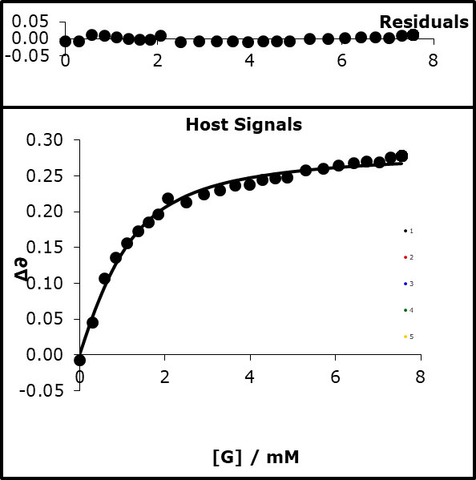

93% bound

K=1808.28

logK=3.257

α=4.56

Run2)  
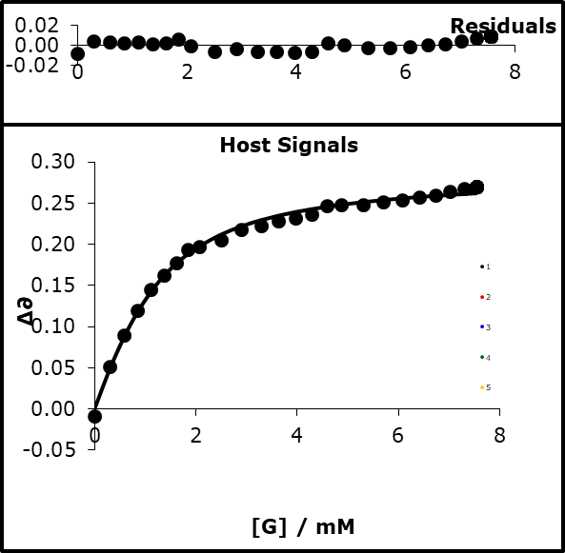

91% bound

K=1512.40

logK=3.180

α=4.77

Run3)

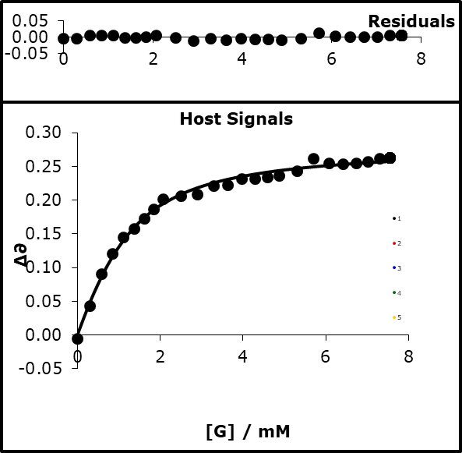

91% bound

K=1528.26

logK=3.184

α=4.77

Run4)

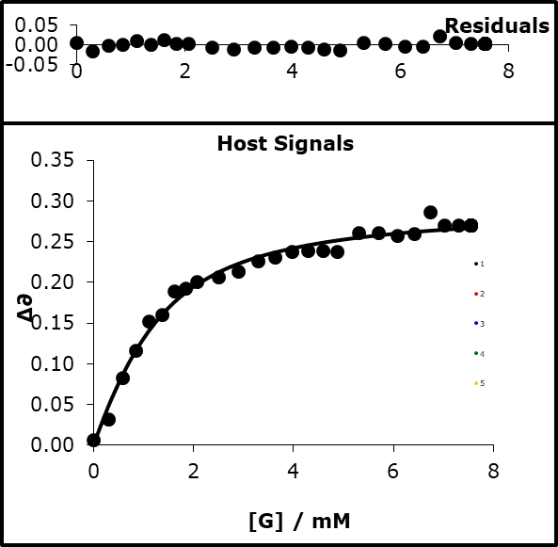

91% bound

K=1359.59

logK=3.133

α=4.74

Run5)

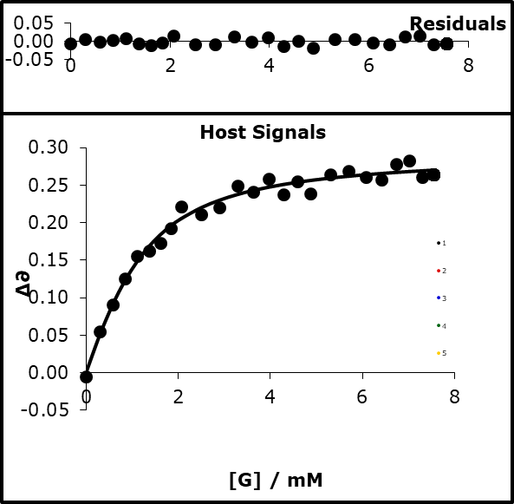

92% bound

K=1582.54

logK=3.199

α=4.78

Run6)

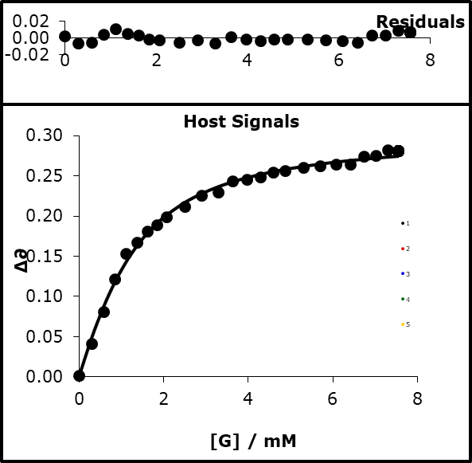

90% bound

K=1304.60

logK=3.115

α=4.73

#### Average and 2 × standard deviation

4.73 ± 0.07

### 4-cyanophenol

#### UV titration

H) [4-CN-PhOH] = 0.1 mM

G) [tButP=O] 15 mM β = 10.728

S) CHCl3 α = 2.2, β = 1.328

|  |  |  |  |  |  |  |  |  |  |
| --- | --- | --- | --- | --- | --- | --- | --- | --- | --- |
| **expt** | **vol H / µl** | **vol G / µl** | **[H] / mM** | **[G] / mM** | **∂H 1** | **∂H** | **∂H** | **∂H** | **∂H** |
| 1 | 150 | 0 |  |  | 0.166 | 0.169 | 0.162 | 0.167 | 0.178 |
| 2 | 150 | 3 |  |  | 0.280 | 0.294 | 0.257 | 0.266 | 0.260 |
| 3 | 150 | 6 |  |  | 0.320 | 0.343 | 0.322 | 0.314 | 0.341 |
| 4 | 150 | 9 |  |  | 0.378 | 0.398 | 0.350 | 0.372 | 0.382 |
| 5 | 150 | 12 |  |  | 0.408 | 0.425 | 0.391 | 0.400 | 0.411 |
| 6 | 150 | 15 |  |  | 0.429 | 0.443 | 0.416 | 0.420 | 0.438 |
| 7 | 150 | 18 |  |  | 0.446 | 0.459 | 0.431 | 0.440 | 0.452 |
| 8 | 150 | 21 |  |  | 0.461 | 0.471 | 0.444 | 0.453 | 0.473 |
| 9 | 150 | 24 |  |  | 0.475 | 0.487 | 0.461 | 0.469 | 0.480 |
| 10 | 150 | 27 |  |  | 0.483 | 0.497 | 0.471 | 0.479 | 0.491 |
| 11 | 150 | 30 |  |  | 0.491 | 0.503 | 0.479 | 0.486 | 0.499 |
| 12 | 150 | 33 |  |  | 0.499 | 0.512 | 0.486 | 0.494 | 0.509 |
| 13 | 150 | 36 |  |  | 0.505 | 0.517 | 0.493 | 0.500 | 0.515 |
| 14 | 150 | 39 |  |  | 0.509 | 0.521 | 0.500 | 0.506 | 0.520 |
| 15 | 150 | 42 |  |  | 0.517 | 0.529 | 0.504 | 0.512 | 0.528 |
| 16 | 150 | 45 |  |  | 0.521 | 0.534 | 0.509 | 0.516 | 0.532 |
| 17 | 150 | 48 |  |  | 0.525 | 0.541 | 0.514 | 0.520 | 0.536 |
| 18 | 150 | 51 |  |  | 0.531 | 0.544 | 0.519 | 0.528 | 0.539 |
| 19 | 150 | 54 |  |  | 0.535 | 0.546 | 0.523 | 0.530 | 0.542 |
| 20 | 150 | 57 |  |  | 0.535 | 0.553 | 0.526 | 0.533 | 0.547 |
| 21 | 150 | 60 |  |  | 0.539 | 0.554 | 0.530 | 0.533 | 0.550 |
| 22 | 150 | 63 |  |  | 0.544 | 0.556 | 0.533 | 0.539 | 0.554 |
| 23 | 150 | 66 |  |  | 0.546 | 0.560 | 0.537 | 0.536 | 0.558 |
| 24 | 150 | 69 |  |  | 0.550 | 0.562 | 0.538 | 0.547 | 0.559 |
| 25 | 150 | 72 |  |  | 0.551 | 0.565 | 0.542 | 0.549 | 0.560 |

Run1)

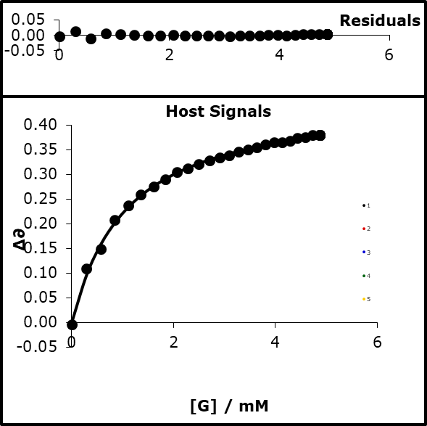

83% bound

K=989.23

logK=2.995

α=4.66

Run2)

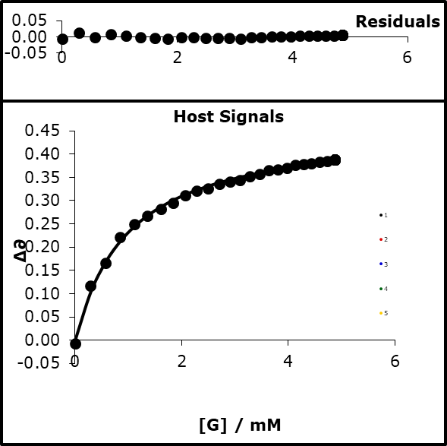

84% bound

K=1090.28

logK=3.038

α=4.68

Run3)

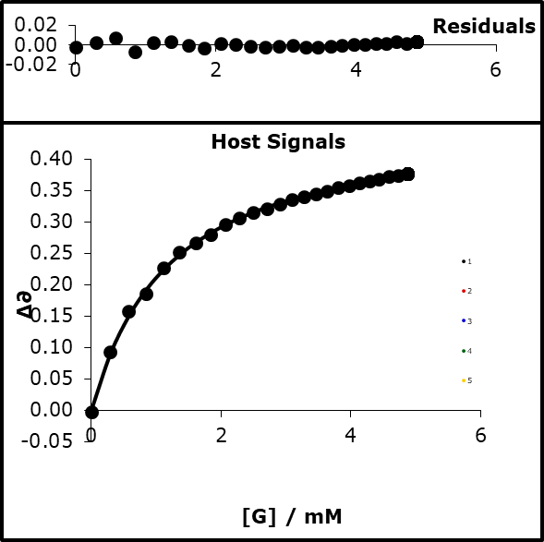

81% bound

K=880.97

logK=2.945

α=4.63

Run4)  
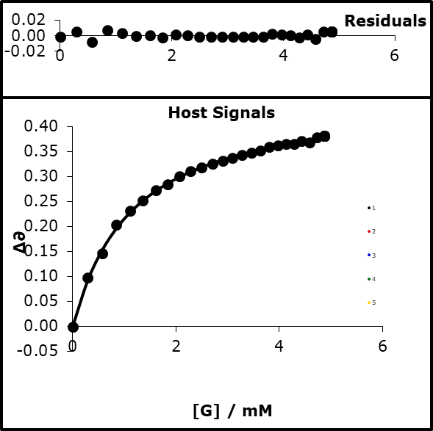

82% bound

K=880.97

logK=2.965

α=4.64

Run5)  
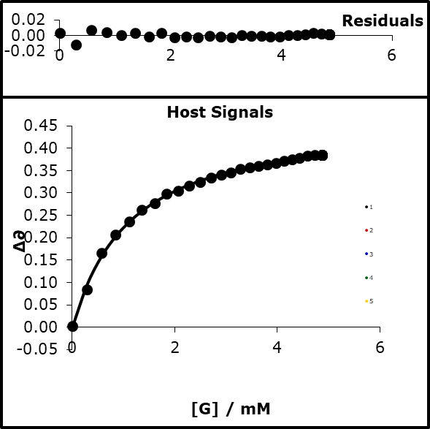

82% bound

K=949.52

logK=2.978

α=4.65

#### Average and 2 × standard deviation

4.65 ± 0.02

### 3-cyanophenol

#### UV titration

H) [3-CN-PhOH] = 1 mM

G) [tButP=O] 15 mM β = 10.728

S) CHCl3 α = 2.2, β = 1.328

|  |  |  |  |  |  |  |  |  |  |  |
| --- | --- | --- | --- | --- | --- | --- | --- | --- | --- | --- |
| **expt** | **vol H / µl** | **vol G / µl** | **[H] / mM** | **[G] / mM** | **∂H 1** | **∂H** | **∂H** | **∂H** | **∂H** | **∂H** |
| 1 | 150 | 0 |  |  | 0.078 | 0.077 | 0.079 | 0.078 | 0.092 | 0.088 |
| 2 | 150 | 3 |  |  | 0.175 | 0.151 | 0.137 | 0.131 | 0.156 | 0.158 |
| 3 | 150 | 6 |  |  | 0.247 | 0.198 | 0.200 | 0.187 | 0.219 | 0.226 |
| 4 | 150 | 9 |  |  | 0.276 | 0.237 | 0.245 | 0.237 | 0.260 | 0.266 |
| 5 | 150 | 12 |  |  | 0.318 | 0.265 | 0.276 | 0.279 | 0.297 | 0.296 |
| 6 | 150 | 15 |  |  | 0.346 | 0.313 | 0.303 | 0.315 | 0.328 | 0.323 |
| 7 | 150 | 18 |  |  | 0.368 | 0.331 | 0.329 | 0.334 | 0.357 | 0.353 |
| 8 | 150 | 21 |  |  | 0.383 | 0.358 | 0.363 | 0.354 | 0.383 | 0.373 |
| 9 | 150 | 24 |  |  | 0.402 | 0.377 | 0.385 | 0.371 | 0.402 | 0.389 |
| 10 | 150 | 30 |  |  | 0.426 | 0.403 | 0.410 | 0.404 | 0.430 | 0.427 |
| 11 | 150 | 36 |  |  | 0.449 | 0.428 | 0.433 | 0.423 | 0.457 | 0.451 |
| 12 | 150 | 42 |  |  | 0.464 | 0.449 | 0.453 | 0.444 | 0.485 | 0.461 |
| 13 | 150 | 48 |  |  | 0.479 | 0.464 | 0.467 | 0.460 | 0.493 | 0.479 |
| 14 | 150 | 54 |  |  | 0.490 | 0.476 | 0.479 | 0.473 | 0.505 | 0.493 |
| 15 | 150 | 60 |  |  | 0.500 | 0.488 | 0.490 | 0.483 | 0.526 | 0.503 |
| 16 | 150 | 66 |  |  | 0.509 | 0.497 | 0.498 | 0.493 | 0.521 | 0.509 |
| 17 | 150 | 72 |  |  | 0.514 | 0.504 | 0.507 | 0.500 | 0.531 | 0.518 |
| 18 | 150 | 82 |  |  | 0.526 | 0.519 | 0.518 | 0.513 | 0.543 | 0.525 |
| 19 | 150 | 92 |  |  | 0.537 | 0.526 | 0.530 | 0.522 | 0.562 | 0.532 |
| 20 | 150 | 102 |  |  | 0.544 | 0.536 | 0.538 | 0.528 | 0.567 | 0.540 |
| 21 | 150 | 112 |  |  | 0.551 | 0.544 | 0.546 | 0.537 | 0.565 | 0.545 |
| 22 | 150 | 122 |  |  | 0.557 | 0.549 | 0.551 | 0.542 | 0.573 | 0.551 |
| 23 | 150 | 132 |  |  | 0.562 | 0.555 | 0.558 | 0.550 | 0.584 | 0.556 |
| 24 | 150 | 142 |  |  | 0.567 | 0.559 | 0.578 | 0.552 | 0.588 | 0.560 |
| 25 | 150 | 152 |  |  | 0.571 | 0.562 | 0.565 | 0.555 | 0.586 | 0.563 |

Run1)

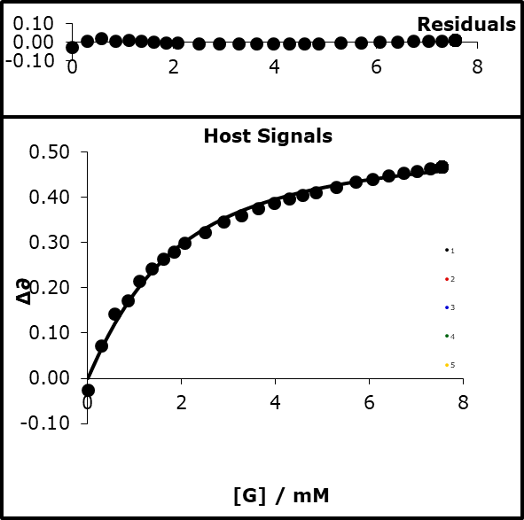

95% bound

K=806.68

logK=2.907

α=4.60

Run2)

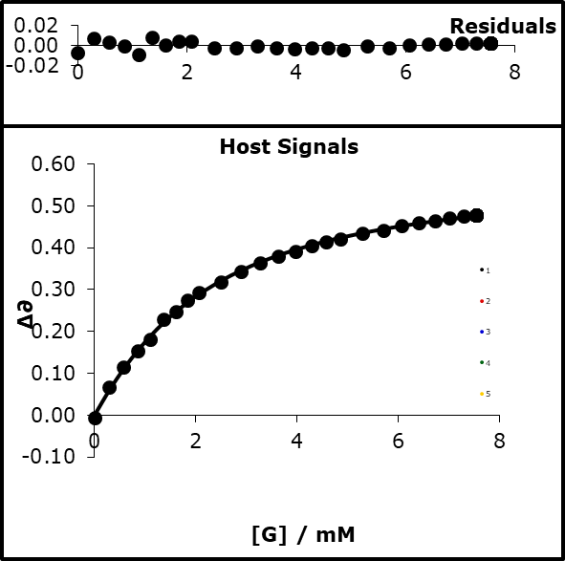

81% bound

K=583.93

logK=2.766

α=4.52

Run3)

81% bound

K=596.58

logK=2.776

α=4.52

Run4)

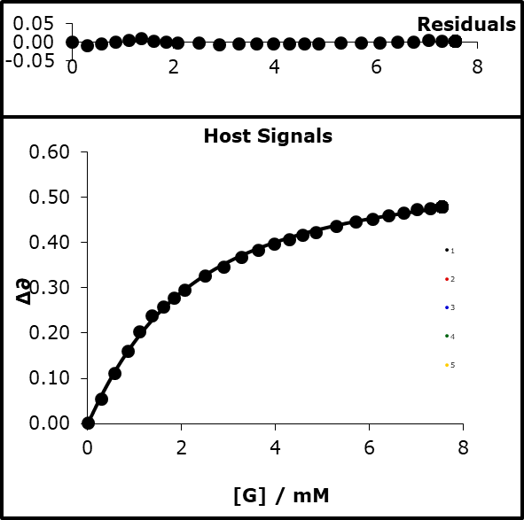

82% bound

K=643.26

logK=2.808

α=4.54

Run5)

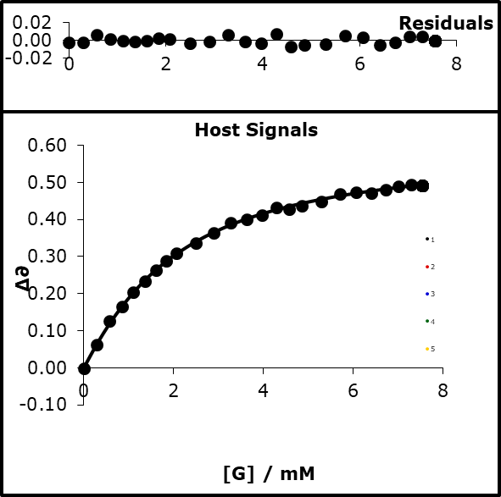

82% bound

K=642.41

logK=2.808

α=4.54

Run6)

84% bound

K=731.29

logK=2.864

α=4.58

#### Average and 2 × standard deviation

4.55 ± 0.03

### Crystal violet

#### UV titration

H) [CV] = 0.02 mM

G) [MeCN] 4775 mM β = 5.128

S) CHCl3 α = 2.2, β = 1.328

|  |  |  |  |  |  |
| --- | --- | --- | --- | --- | --- |
| **expt** | **vol H / µl** | **vol G / µl** | **∂H 1** | **∂H** | **∂H** |
| 1 | 150 | 0 | 0.698 | 0.710 | 0.722 |
| 2 | 150 | 3 | 0.729 | 0.735 | 0.752 |
| 3 | 150 | 6 | 0.751 | 0.753 | 0.773 |
| 4 | 150 | 9 | 0.768 | 0.772 | 0.791 |
| 5 | 150 | 12 | 0.782 | 0.787 | 0.807 |
| 6 | 150 | 15 | 0.795 | 0.800 | 0.819 |
| 7 | 150 | 18 | 0.805 | 0.811 | 0.828 |
| 8 | 150 | 21 | 0.812 | 0.815 | 0.835 |
| 9 | 150 | 24 | 0.816 | 0.821 | 0.841 |
| 10 | 150 | 30 | 0.827 | 0.831 | 0.852 |
| 11 | 150 | 36 | 0.832 | 0.837 | 0.856 |
| 12 | 150 | 42 | 0.833 | 0.840 | 0.860 |
| 13 | 150 | 48 | 0.833 | 0.838 | 0.860 |
| 14 | 150 | 54 | 0.839 | 0.845 | 0.864 |

Run1)

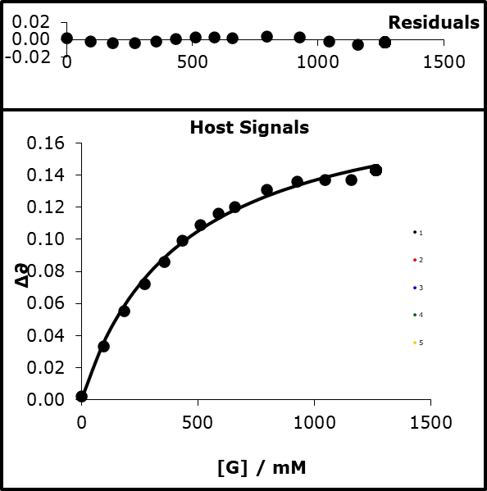

75% bound

K=2.32

logK=0.366

α=4.33

Run2)

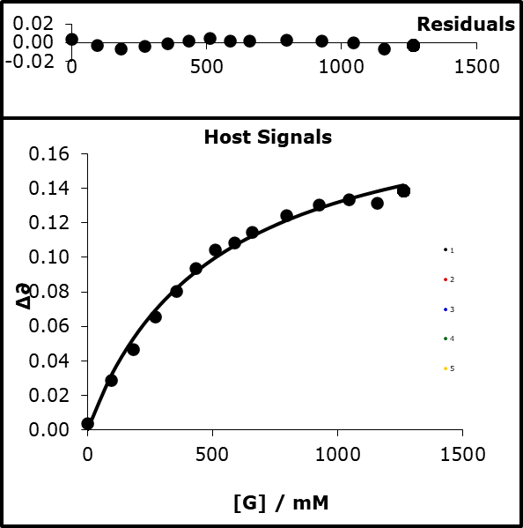

71% bound

K=1.98

logK=0.296

α=4.22

Run3)



73% bound

K=2.17

logK=0.336

α=4.28

#### Average and 2 × standard deviation

4.3 ± 0.1

### Malachite green

#### UV titration

H) [MG] = 0.02 mM

G) [MeCN] 4772 mM β = 5.128

S) CHCl3 α = 2.2, β = 1.328

|  |  |  |  |  |  |  |  |  |
| --- | --- | --- | --- | --- | --- | --- | --- | --- |
| **expt** | **vol H / µl** | **vol G / µl** | **∂H 1** | **∂H** | **∂H** | **∂H** | **∂H** | **∂H** |
| 1 | 150 | 0 | 0.539 | 0.538 | 0.544 | 0.539 | 0.540 | 0.539 |
| 2 | 150 | 3 | 0.548 | 0.546 | 0.552 | 0.548 | 0.546 | 0.548 |
| 3 | 150 | 6 | 0.555 | 0.553 | 0.557 | 0.555 | 0.553 | 0.555 |
| 4 | 150 | 9 | 0.562 | 0.560 | 0.563 | 0.560 | 0.556 | 0.562 |
| 5 | 150 | 12 | 0.568 | 0.569 | 0.570 | 0.567 | 0.564 | 0.568 |
| 6 | 150 | 15 | 0.573 | 0.572 | 0.575 | 0.572 | 0.571 | 0.573 |
| 7 | 150 | 18 | 0.579 | 0.575 | 0.578 | 0.577 | 0.575 | 0.579 |
| 8 | 150 | 21 | 0.582 | 0.580 | 0.583 | 0.581 | 0.577 | 0.582 |
| 9 | 150 | 24 | 0.584 | 0.585 | 0.585 | 0.584 | 0.581 | 0.584 |
| 10 | 150 | 30 | 0.591 | 0.588 | 0.592 | 0.589 | 0.585 | 0.591 |
| 11 | 150 | 36 | 0.592 | 0.593 | 0.594 | 0.592 | 0.589 | 0.592 |
| 12 | 150 | 42 | 0.594 | 0.609 | 0.597 | 0.594 | 0.591 | 0.594 |
| 13 | 150 | 48 | 0.596 | 0.596 | 0.599 | 0.597 | 0.593 | 0.596 |
| 14 | 150 | 54 | 0.602 | 0.604 | 0.601 | 0.603 | 0.597 | 0.602 |
| 15 | 150 | 60 | 0.602 | 0.601 | 0.603 | 0.600 | 0.598 | 0.602 |
| 16 | 150 | 66 | 0.603 | 0.603 | 0.605 | 0.603 | 0.599 | 0.603 |
| 17 | 150 | 72 | 0.605 | 0.602 | 0.604 | 0.602 | 0.601 | 0.605 |
| 18 | 150 | 82 | 0.605 | 0.603 | 0.607 | 0.605 | 0.601 | 0.605 |
| 19 | 150 | 92 | 0.604 | 0.603 | 0.607 | 0.604 | 0.600 | 0.604 |
| 20 | 150 | 102 | 0.603 | 0.603 | 0.607 | 0.604 | 0.600 | 0.603 |
| 21 | 150 | 112 | 0.607 | 0.603 | 0.610 | 0.606 | 0.602 | 0.607 |
| 22 | 150 | 122 | 0.605 | 0.606 | 0.610 | 0.606 | 0.602 | 0.605 |
| 23 | 150 | 132 | 0.606 | 0.606 | 0.614 | 0.606 | 0.603 | 0.606 |
| 24 | 150 | 142 | 0.607 | 0.605 | 0.612 | 0.606 | 0.602 | 0.607 |
| 25 | 150 | 152 | 0.606 | 0.605 | 0.616 | 0.607 | 0.603 | 0.606 |

Run1)

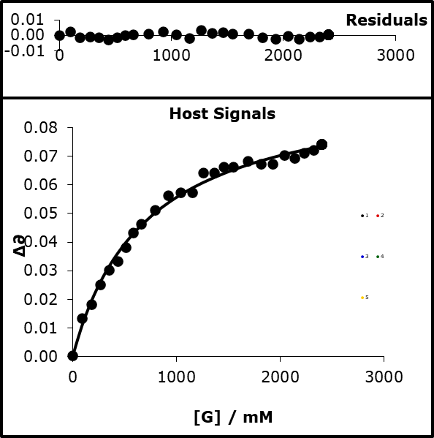

77% bound

K=1.40

logK=0.146

α=4.00

Run2)

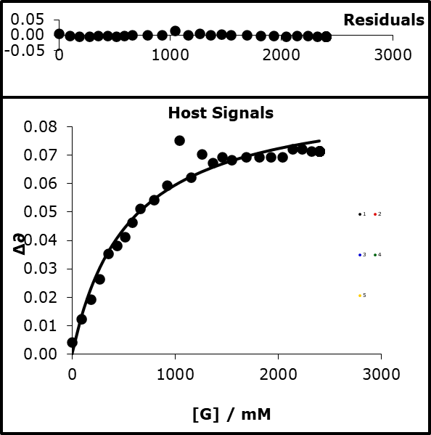

81% bound

K=1.82

logK=0.261

α=4.17

Run3)

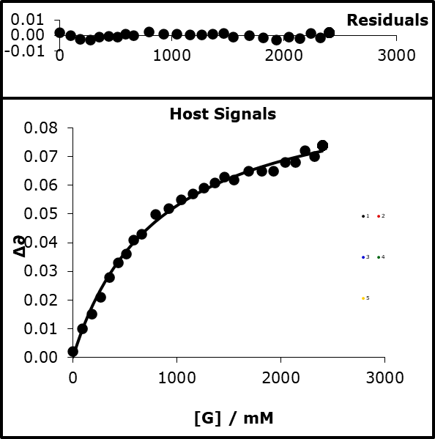

74% bound

K=1.2

logK=0.080

α=3.9

Run4)

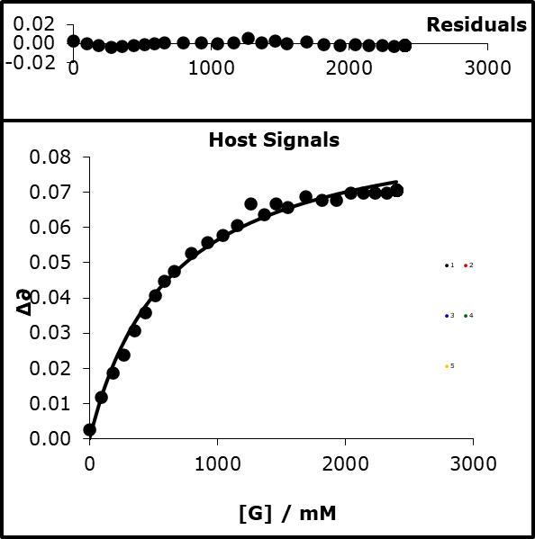

79% bound

K=1.57

logK=0.197

α=4.08

Run5)

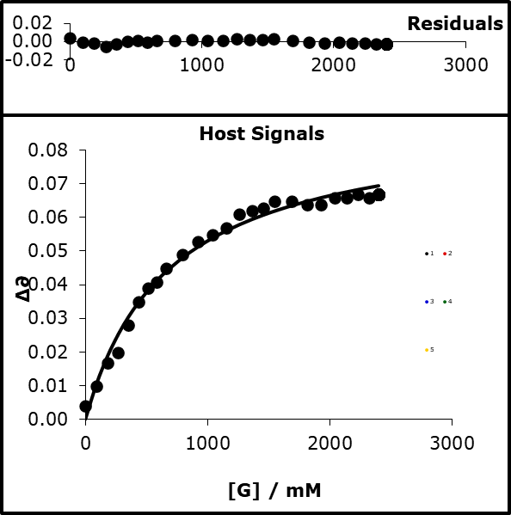

79% bound

K=1.47

logK=0.168

α=4.03

Run6)

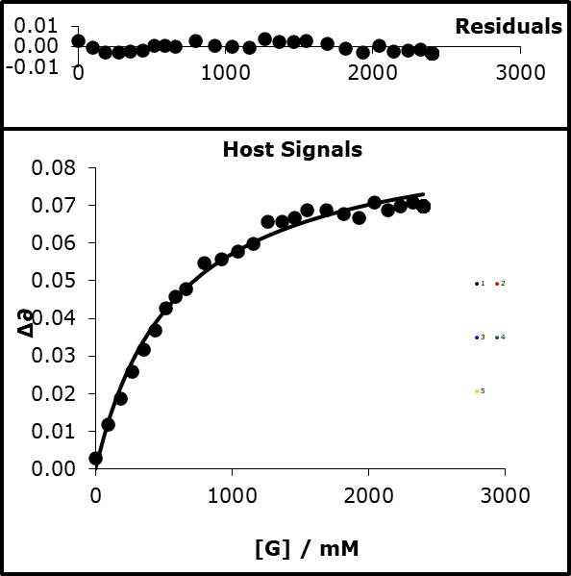

80% bound

K=1.69

logK=0.229

α=4.12

#### Average and 2 × standard deviation

4.1 ± 0.1

## 6.4 Kinetic methods

General experimental procedure

Kinetic experiments were performed using Cary 300, Cary 300 bio, and Cary 50 UV-Vis spectrometers and 3 mL quartz cuvettes with a 10 mm path length purchased from Thor Laboratories. All experiments monitored the production of 4-nitrophenolate as an indicator of reaction progression. The production of 4-nitrophenolate was monitored at 400 nm or 420 nm depending on the solvent system. All kinetic reactions were pseudo first order with the concentration of the nucleophile being at least tenfold high than the concentration of the phenylacetate. The concentration of the phenylacetate was either 0.01 mM or 0.05 mM to ensure a final absorbance of the 4-nitrophenolate product was below 2. A known mass of the phenolate was dissolved in known volume of the solvent system to create a stock solution of known concentration. A known mass of the phenylacetate was dissolved in the solvent system to create a stock solution of known concentration. A volume of the stock solution of phenolate was added to the cuvette and topped up with the same solvent system to produce the desired concentration of nucleophile. A volume of the stock solution of phenylacetate was added and thorough mixing ensued before being placed in the spectrometer. All experiments were performed at 25 °C.

### 6.4.1 Second order rate constants for transesterification reactions in single solvents

#### 6.4.1.1 3-nitrophenolate

##### 3-nitrophenolate TBA reaction with 4-nitrophenylacetate in tetrahydrofuran

|  |  |  |  |  |
| --- | --- | --- | --- | --- |
| [3-NO2-PhO TBA] | 0.0005 | 0.00065 | 0.00075 | 0.001 |
| *k*obs | 0.11928 | 0.15372 | 0.17625 | 0.23466 |

|  |  |  |  |
| --- | --- | --- | --- |
| Gradient | 230.7226 | 0.003704 | Intercept |
| Std Error | 1.147075 | 0.000857 | Error Intcp |

##### 3-nitrophenolate TBA reaction with 4-nitrophenylacetate in dichloromethane

|  |  |  |  |  |
| --- | --- | --- | --- | --- |
| [3-NO2-PhO TBA] | 0.0005 | 0.00065 | 0.00075 | 0.001 |
| *k*obs | 0.008138 | 0.011201 | 0.012716 | 0.016269 |

|  |  |  |  |
| --- | --- | --- | --- |
| Gradient | 16.00566 | 0.000477 | Intercept |
| Std Error | 1.099251 | 0.000822 | Error Intcp |

##### 3-nitrophenolate TBA reaction with 4-nitrophenylacetate in acetone

|  |  |  |  |  |  |  |  |  |  |
| --- | --- | --- | --- | --- | --- | --- | --- | --- | --- |
| [3-NO2-PhO TBA] | 0.0004 | 0.0004 | 0.0004 | 0.0008 | 0.0008 | 0.0008 | 0.002 | 0.002 | 0.002 |
| *k*obs | 0.069 | 0.083 | 0.083 | 0.186 | 0.187 | 0.185 | 0.384 | 0.423 | 0.37895 |

|  |  |  |  |
| --- | --- | --- | --- |
| Gradient | 192.5389 | 0.015081 | Intercept |
| Std Error | 9.902069 | 0.012525 | Error Intcp |

##### 3-nitrophenolate TBA reaction with 4-nitrophenylacetate in acetonitrile

|  |  |  |  |  |  |  |
| --- | --- | --- | --- | --- | --- | --- |
| [3-NO2-PhO TBA] | 0.0001 | 0.0002 | 0.0005 | 0.00065 | 0.00075 | 0.001 |
| *k*obs | 0.005387 | 0.011473 | 0.029162 | 0.021261 | 0.047803 | 0.060286 |

|  |  |  |  |
| --- | --- | --- | --- |
| Gradient | 58.51378 | -0.00198 | Intercept |
| Std Error | 10.93485 | 0.006748 | Error Intcp |

##### 3-nitrophenolate TBA reaction with 4-nitrophenylacetate in chloroform

|  |  |  |  |  |  |  |
| --- | --- | --- | --- | --- | --- | --- |
| [3-NO2-PhO TBA] | 0.0001 | 0.0002 | 0.0005 | 0.00065 | 0.00075 | 0.001 |
| *k*obs | 0.005387 | 0.011473 | 0.029162 | 0.021261 | 0.047803 | 0.060286 |

|  |  |  |  |
| --- | --- | --- | --- |
| Gradient | 2.192736 | 0.001354 | Intercept |
| Std Error | 0.153387 | 0.000115 | Error Intcp |

#### 6.4.1.2 3-nitro-4-chlorophenolate TBA

##### 3-nitro-4-chlorophenolate TBA reaction with 4-nitrophenylacetate in tetrahydrofuran

|  |  |  |  |  |  |  |
| --- | --- | --- | --- | --- | --- | --- |
| [3-NO2-4-Cl-PhO TBA]/M | 0.0005 | 0.0005 | 0.0005 | 0.00066 | 0.00066 | 0.00066 |
| *k*obs | 0.025961 | 0.026311 | 0.028667 | 0.038847 | 0.038835 | 0.039941 |
| [3-NO2-4-Cl-PhO TBA]/M | 0.0008 | 0.0008 | 0.0008 | 0.001 | 0.001 | 0.001 |
| *k*obs | 0.049689 | 0.050716 | 0.050625 | 0.063238 | 0.066394 | 0.067143 |

|  |  |  |  |
| --- | --- | --- | --- |
| Gradient | 77.38683 | -0.01174 | Intercept |
| Std Error | 1.892426 | 0.001443 | Error Intcp |

##### 3-nitro-4-chlorophenolate TBA reaction with 4-nitrophenylacetate in dichloromethane

|  |  |  |  |  |  |  |
| --- | --- | --- | --- | --- | --- | --- |
| [3-NO2-4-Cl-PhO TBA]/M | 0.0005 | 0.0005 | 0.0005 | 0.00066 | 0.00066 | 0.00066 |
| *k*obs | 0.003938 | 0.004291 | 0.003847 | 0.005511 | 0.005536 | 0.006015 |
| [3-NO2-4-Cl-PhO TBA]/M | 0.0008 | 0.0008 | 0.0008 | 0.001 | 0.001 | 0.001 |
| *k*obs | 0.005821 | 0.005675 | 0.005813 | 0.007429 | 0.007573 | 0.008203 |

|  |  |  |  |
| --- | --- | --- | --- |
| Gradient | 6.924822 | 0.00068 | Intercept |
| Std Error | 0.683865 | 0.000521 | Error Intcp |

##### 3-nitro-4-chlorophenolate TBA reaction with 4-nitrophenylacetate in acetone

|  |  |  |  |  |  |  |
| --- | --- | --- | --- | --- | --- | --- |
| [3-NO2-4-Cl-PhO TBA]/M | 0.001 | 0.001 | 0.001 | 0.002 | 0.002 | 0.002 |
| *k*obs | 0.059666 | 0.05479 | 0.059089 | 0.1131 | 0.11384 | 0.11404 |
| [3-NO2-4-Cl-PhO TBA]/M | 0.003 | 0.003 | 0.003 | 0.004 | 0.004 | 0.004 |
| *k*obs | 0.16708 | 0.15749 | 0.16384 | 0.21415 | 0.21076 | 0.21373 |

|  |  |  |  |
| --- | --- | --- | --- |
| Gradient | 51.42383 | 0.008238 | Intercept |
| Std Error | 0.826431 | 0.002263 | Error Intcp |

##### 3-nitro-4-chlorophenolate TBA reaction with 4-nitrophenylacetate in acetonitrile

|  |  |  |  |  |
| --- | --- | --- | --- | --- |
| [3-NO2-4-Cl-PhO TBA]/M | 0.0005 | 0.00065 | 0.00075 | 0.001 |
| *k*obs | 0.005966 | 0.008491 | 0.009388 | 0.0125 |

|  |  |  |  |
| --- | --- | --- | --- |
| Gradient | 12.77806 | -0.00018 | Intercept |
| Std Error | 0.873372 | 0.000653 | Error Intcpt |

##### 3-nitro-4-chlorophenolate TBA reaction with 4-nitrophenylacetate in chloroform

|  |  |  |  |  |
| --- | --- | --- | --- | --- |
| [3-NO2-4-Cl-PhO TBA]/M | 0.0005 | 0.00065 | 0.00075 | 0.001 |
| *k*obs | 0.00073046 | 0.0011788 | 0.0014286 | 0.0018724 |

|  |  |  |  |
| --- | --- | --- | --- |
| Gradient | 2.248011 | -0.00033 | Intercept |
| Std Error | 0.226729 | 0.000169 | Error Intcpt |

#### 6.4.1.3 4-cyanophenolate TBA

##### 4-cyanophenolate TBA reaction with 4-nitrophenylacetate in tetrahydrofuran

|  |  |  |  |
| --- | --- | --- | --- |
| [4-CN-Ph]/M | 0.0005 | 0.0025 | 0.005 |
| *k*obs | 0.037486 | 0.14714 | 0.23554 |

|  |  |  |  |
| --- | --- | --- | --- |
| Gradient | 43.65741 | 0.023636 | Intercept |
| Std error | 5.527514 | 0.017911 | Error Intcp |

##### 4-cyanophenolate TBA reaction with 4-nitrophenylacetate in dichloromethane

|  |  |  |  |  |  |  |  |  |  |
| --- | --- | --- | --- | --- | --- | --- | --- | --- | --- |
| [4-CN-Ph]/M | 0.00083 | 0.00083 | 0.00416 | 0.00416 | 0.0083 | 0.0083 | 0.0083 | 0.0125 | 0.0125 |
| *k*obs | 0.0033 | 0.0034 | 0.0143 | 0.013 | 0.025 | 0.0249 | 0.0223 | 0.0309 | 0.0343 |

|  |  |  |  |
| --- | --- | --- | --- |
| Gradient | 2.502906 | 0.002508 | Intercept |
| Std Error | 0.13988 | 0.001099 | Error Intcp |

##### 4-cyanophenolate TBA reaction with 4-nitrophenylacetate in acetone

|  |  |  |  |  |  |  |  |  |  |
| --- | --- | --- | --- | --- | --- | --- | --- | --- | --- |
| [4-CN-PhO]/M | 0.004 | 0.004 | 0.004 | 0.008 | 0.008 | 0.008 | 0.01 | 0.01 | 0.01 |
| *k*obs | 0.0706 | 0.0715 | 0.0726 | 0.167 | 0.177 | 0.171 | 0.220 | 0.228 | 0.170 |

|  |  |  |  |
| --- | --- | --- | --- |
| Gradient | 22.85863 | -0.01753 | Intercept |
| Std Error | 2.390995 | 0.018521 | Error Intcp |

##### 4-cyanophenolate TBA reaction with 4-nitrophenylacetate in acetonitrile

|  |  |  |  |  |
| --- | --- | --- | --- | --- |
| [4-CN-PhO TBA]/M | 0.0005 | 0.001 | 0.0025 | 0.005 |
| *k*obs | 0.0016147 | 0.0067323 | 0.018982 | 0.029979 |

|  |  |  |  |
| --- | --- | --- | --- |
| Gradient | 6.199727 | 0.000378 | Intercept |
| Std Error | 0.784745 | 0.002237 | Error Intcp |

##### 4-cyanophenolate TBA reaction with 4-nitrophenylacetate in chloroform

|  |  |  |  |  |
| --- | --- | --- | --- | --- |
| [4-CN-PhO TBA]/M | 0.0005 | 0.001 | 0.0025 | 0.005 |
| *k*obs | 0.00041404 | 0.00075876 | 0.0016554 | 0.0022816 |

|  |  |  |  |
| --- | --- | --- | --- |
| Gradient | 0.409407 | 0.000356 | Intercept |
| Std Error | 0.067736 | 0.000193 | Error Intcp |

#### 6.4.1.4 2-phenol-2-phenolate TBA

##### 2-phenol-2-phenolate TBA reaction with 4-nitrophenylacetate in tetrahydrofuran

|  |  |  |  |  |  |  |
| --- | --- | --- | --- | --- | --- | --- |
| [2-PhOH-2-PhO TBA]/M | 0.002 | 0.002 | 0.002 | 0.004 | 0.004 | 0.004 |
| *k*obs | 0.000101 | 0.000101 | 0.000106 | 0.000198 | 0.000199 | 0.000169 |
| [2-PhOH-2-PhO TBA]/M | 0.008 | 0.008 | 0.008 | 0.01 | 0.01 | 0.01 |
| *k*obs | 0.000395 | 0.000399 | 0.000396 | 0.000497 | 0.000482 | 0.000491 |

|  |  |  |  |
| --- | --- | --- | --- |
| Gradient | 0.049169 | -4.5E-07 | Intercept |
| Std Error | 0.000922 | 6.25E-06 | Error Intcp |

##### 2-phenol-2-phenolate TBA reaction with 4-nitrophenylacetate in dichloromethane

|  |  |  |  |  |  |  |
| --- | --- | --- | --- | --- | --- | --- |
| [2-PhOH-2-PhO TBA]/ M | 0.002 | 0.002 | 0.002 | 0.004 | 0.004 | 0.004 |
| *k*obs | 0.000055572 | 6.09E-05 | 5.28E-05 | 8.61E-05 | 8.8E-05 | 0.000087235 |
| [2-PhOH-2-PhO TBA]/ M | 0.008 | 0.008 | 0.008 | 0.01 | 0.01 | 0.01 |
| *k*obs | 0.00013388 | 0.000132 | 0.000126 | 0.00016 | 0.000157 | 0.00017625 |

|  |  |  |  |
| --- | --- | --- | --- |
| Gradient | 0.01234 | 3.39768E-05 | Intercept |
| Std Error | 0.000405 | 2.59727E-06 | Error Intcp |

##### 2-phenol-2-phenolate TBA reaction with 4-nitrophenylacetate in acetone

|  |  |  |  |  |  |  |
| --- | --- | --- | --- | --- | --- | --- |
| [2-PhOH-2-PhO TBA]/M | 0.002 | 0.002 | 0.002 | 0.004 | 0.004 | 0.004 |
| *k*obs | 0.000127 | 0.000126 | 0.000114 | 0.000262 | 0.00026 | 0.000257 |
| [2-PhOH-2-PhO TBA]/M | 0.008 | 0.008 | 0.008 | 0.01 | 0.01 | 0.01 |
| *k*obs | 0.000473 | 0.000474 | 0.000469 | 0.000568 | 0.000558 | 0.000536 |

|  |  |  |  |
| --- | --- | --- | --- |
| Gradient | 0.053781 | 2.91E-05 | Intercept |
| Std Error | 0.001575 | 1.07E-05 | Error Intcp |

##### 2-phenol-2-phenolate TBA reaction with 4-nitrophenylacetate in acetonitrile

|  |  |  |  |  |
| --- | --- | --- | --- | --- |
| [2-PhOH-2-PhO]/M | 0.001 | 0.002 | 0.00333 | 0.004 |
| kobs | 0.000022107 | 4.45E-05 | 7.79E-05 | 9.4E-05 |

|  |  |  |  |
| --- | --- | --- | --- |
| Gradient | 0.024137 | -2.7E-06 | Intercept |
| Std Error | 0.000389 | 1.1E-06 | Error Intcp |

##### 2-phenol-2-phenolate TBA reaction with 4-nitrophenylacetate in chloroform

|  |  |  |  |  |
| --- | --- | --- | --- | --- |
| [2-PhOH-PhO TBA]/M | 0.001 | 0.002 | 0.00333 | 0.004 |
| *k*obs | 6.1754E-06 | 1.14E-05 | 1.84E-05 | 2.23E-05 |

|  |  |  |  |
| --- | --- | --- | --- |
| Gradient | 0.005359 | 7.22E-07 | Intercept |
| Std Error | 7.72E-05 | 2.19E-07 | Error Intcp |

### 6.4.2 Second order rate constants for transesterification reactions in acetonitrile chloroform mixtures

#### 6.4.2.1 3-nitrophenolate tetrabutylammonium reaction with 4-nitrophenylacetate

|  |  |  |  |  |
| --- | --- | --- | --- | --- |
|  | Table of *k*obs | | |  |
|  | [3-NO2-PhO TBA] | | |  |
| [CHCl3]in CH3CN | 0.0000945 | 0.000189 | 0.000473 | *k*2 |
| 0.0030625 | 0.0037143 | 0.00765 | 0.0202 | 43.764 |
| 0.006125 | 0.0035009 | 0.007316 | 0.01989 | 43.587 |
| 0.01225 | 0.0039024 | 0.008023 | 0.022817 | 50.534 |
| 0.0245 | 0.0038284 | 0.008207 | 0.022537 | 49.737 |
| 0.030625 | 0.0038285 | 0.007508 | 0.022593 | 50.465 |
| 0.091875 | 0.0027997 | 0.005626 | 0.016039 | 35.418 |
| 0.153125 | 0.0029886 | 0.006217 | 0.01881 | 42.448 |
| 0.30625 | 0.0024646 | 0.005081 | 0.014514 | 32.199 |
| 0.6125 | 0.0006495 | 0.00147 | 0.008175 | 22.533 |
| 1.53125 | 0.0006121 | 0.001448 | 0.006247 | 15.373 |
| 3.0625 | 0.0005157 | 0.001114 | 0.004289 | 10.262 |
| 6.125 | 0.0005577 | 0.001163 | 0.00302 | 6.5206 |

|  |  |  |  |
| --- | --- | --- | --- |
| Gradient | 43.76447 | -0.00051 | Intercept |
| Std Error | 0.524832 | 0.000157 | Error Intcp |

|  |  |  |  |
| --- | --- | --- | --- |
| Gradient | 50.53398 | -0.00115 | Intercept |
| Std Error | 1.715978 | 0.000513 | Error Intcp |

­

|  |  |  |  |
| --- | --- | --- | --- |
| Gradient | 50.46516 | -0.00141 | Intercept |
| Std Error | 2.853125 | 0.000853 | Error Intcp |

|  |  |  |  |
| --- | --- | --- | --- |
| Gradient | 35.41803 | -0.00077 | Intercept |
| Std Error | 1.362871 | 0.000407 | Error Intcp |

|  |  |  |  |
| --- | --- | --- | --- |
| Gradient | 42.4477 | -0.00136 | Intercept |
| Std Error | 2.05125 | 0.000613 | Error Intcp |

|  |  |  |  |
| --- | --- | --- | --- |
| Gradient | 32.19943 | -0.00076 | Intercept |
| Std Error | 1.117902 | 0.000334 | Error Intcp |

|  |  |  |  |
| --- | --- | --- | --- |
| Gradient | 20.77120472 | -0.0018 | Intercept |
| Std Error | 2.989990597 | 0.000894 | Error Intcp |

|  |  |  |  |
| --- | --- | --- | --- |
| Gradient | 15.37279 | -0.00111 | Intercept |
| Std Error | 1.616264 | 0.000483 | Error Intcp |

|  |  |  |  |
| --- | --- | --- | --- |
| Gradient | 10.26207 | -0.00061 | Intercept |
| Std Error | 0.972895 | 0.000291 | Error Intcp |

|  |  |  |  |
| --- | --- | --- | --- |
| Gradient | 6.520615 | -6.3E-05 | Intercept |
| Std Error | 0.027514 | 8.22E-06 | Error Intcp |

#### 6.4.2.2 3-nitro-4-chlorophenolate tetrabutylammonium reaction with 4-nitrophenylacetate

|  |  |  |  |  |  |
| --- | --- | --- | --- | --- | --- |
|  | Table of *k*obs | | | |  |
|  | [3-NO2-PhO TBA] | | | |  |
| [CHCl3]in CH3CN | 0.0005 | 0.00065 | 0.00075 | 0.001 | *k*2 |
| 0.0028125 | 0.005943 | 0.00848 | 0.009389 | 0.012445 | 12.709 |
| 0.005625 | 0.005915 | 0.008649 | 0.009531 | 0.01248 | 12.76 |
| 0.01125 | 0.005996 | 0.008434 | 0.009439 | 0.011481 | 10.654 |
| 0.0225 | 0.00594 | 0.008088 | 0.009181 | 0.012155 | 12.294 |
| 0.028125 | 0.005785 | 0.007701 | 0.009253 | 0.012158 | 12.798 |
| 0.05625 | 0.005528 | 0.007572 | 0.008815 | 0.011273 | 11.386 |
| 0.140625 | 0.005167 | 0.007002 | 0.007789 | 0.009048 | 7.5114 |
| 0.5625 | 0.003857 | 0.005086 | 0.005836 | 0.007436 | 7.1055 |
| 1.40625 | 0.002757 | 0.003595 | 0.003691 | 0.004978 | 4.3126 |
| 2.8125 | 0.001859 | 0.002466 | 0.002694 | 0.003608 | 3.4446 |
| 5.625 | 0.001391 | 0.001805 | 0.002028 | 0.002624 | 2.4457 |

|  |  |  |  |
| --- | --- | --- | --- |
| Gradient | 12.7086 | -0.00015 | Intercept |
| Std Error | 0.906578 | 0.000678 | Error Intcpt |

|  |  |  |  |
| --- | --- | --- | --- |
| Gradient | 12.76019 | -0.00011 | Intercept |
| Std Error | 1.190864 | 0.00089 | Error Intcpt |

|  |  |  |  |
| --- | --- | --- | --- |
| Gradient | 10.65417 | 0.001113 | Intercept |
| Std Error | 1.439457 | 0.001076 | Error Intcpt |

|  |  |  |  |
| --- | --- | --- | --- |
| Gradient | 12.29436 | -7.2E-05 | Intercept |
| Std Error | 0.443119 | 0.000331 | Error Intcpt |

|  |  |  |  |
| --- | --- | --- | --- |
| Gradient | 12.79766 | -0.00055 | Intercept |
| Std Error | 0.470461 | 0.000352 | Error Intcpt |

|  |  |  |  |
| --- | --- | --- | --- |
| Gradient | 11.38592 | 4.24E-05 | Intercept |
| Std Error | 0.721445 | 0.000539 | Error Intcpt |

|  |  |  |  |
| --- | --- | --- | --- |
| Gradient | 7.511358 | 0.001806 | Intercept |
| Std Error | 1.301644 | 0.000973 | Error Intcpt |

|  |  |  |  |
| --- | --- | --- | --- |
| Gradient | 7.105509 | 0.000402 | Intercept |
| Std Error | 0.335846 | 0.000251 | Error Intcpt |

|  |  |  |  |
| --- | --- | --- | --- |
| Gradient | 4.312642 | 0.000629 | Intercept |
| Std Error | 0.469202 | 0.000351 | Error Intcpt |

|  |  |  |  |
| --- | --- | --- | --- |
| Gradient | 3.444566 | 0.00016 | Intercept |
| Std Error | 0.168396 | 0.000126 | Error Intcpt |

|  |  |  |  |
| --- | --- | --- | --- |
| Gradient | 2.445717 | 0.000189 | Intercept |
| Std Error | 0.068232 | 5.1E-05 | Error Intcpt |

#### 6.4.2.2 4-cyanophenolate tetrabutylammonium reaction with 4-nitrophenylacetate

|  |  |  |  |  |  |
| --- | --- | --- | --- | --- | --- |
|  | Table of *k*obs | | | |  |
|  | [4-CN-PhO TBA] | | | |  |
| [CHCl3]in CH3CN | 0.0005 | 0.001 | 0.0025 | 0.005 | *k*2 |
| 0.0028125 | 0.0016074 | 0.006649 | 0.016371 | 0.030186 | 6.317 |
| 0.005625 | 0.001619 | 0.006658 | 0.013642 | 0.030917 | 6.3083 |
| 0.01125 | 0.0016392 | 0.006691 | 0.016128 | 0.030464 | 6.2511 |
| 0.0225 | 0.0016303 | 0.006611 | 0.015329 | 0.030597 | 6.2741 |
| 0.028125 | 0.0015939 | 0.006484 | 0.015523 | 0.030846 | 6.352 |
| 0.05625 | 0.0015701 | 0.00634 | 0.014222 | 0.028068 | 5.72 |
| 0.140625 | 0.0015526 | 0.005967 | 0.012266 | 0.024703 | 4.9652 |
| 0.5625 | 0.0014537 | 0.00451 | 0.009489 | 0.018009 | 3.5686 |
| 1.40625 | 0.0013329 | 0.00325 | 0.007175 | 0.012479 | 2.4258 |
| 2.8125 | 0.0010264 | 0.00221 | 0.004483 | 0.009186 | 1.7815 |
| 5.625 | 0.0005328 | 0.001529 | 0.003478 | 0.006573 | 1.3144 |

|  |  |  |  |
| --- | --- | --- | --- |
| Gradient | 12.7086 | -0.00015 | Intercept |
| Std Error | 0.906578 | 0.000678 | Error Intcpt |

|  |  |  |  |
| --- | --- | --- | --- |
| Gradient | 12.76019 | -0.00011 | Intercept |
| Std Error | 1.190864 | 0.00089 | Error Intcpt |

|  |  |  |  |
| --- | --- | --- | --- |
| Gradient | 10.65417 | 0.001113 | Intercept |
| Std Error | 1.439457 | 0.001076 | Error Intcpt |

|  |  |  |  |
| --- | --- | --- | --- |
| Gradient | 12.29436 | -7.2E-05 | Intercept |
| Std Error | 0.443119 | 0.000331 | Error Intcpt |

|  |  |  |  |
| --- | --- | --- | --- |
| Gradient | 12.79766 | -0.00055 | Intercept |
| Std Error | 0.470461 | 0.000352 | Error Intcpt |

|  |  |  |  |
| --- | --- | --- | --- |
| Gradient | 11.38592 | 4.24E-05 | Intercept |
| Std Error | 0.721445 | 0.000539 | Error Intcpt |

|  |  |  |  |
| --- | --- | --- | --- |
| Gradient | 7.511358 | 0.001806 | Intercept |
| Std Error | 1.301644 | 0.000973 | Error Intcpt |

|  |  |  |  |
| --- | --- | --- | --- |
| Gradient | 7.105509 | 0.000402 | Intercept |
| Std Error | 0.335846 | 0.000251 | Error Intcpt |

|  |  |  |  |
| --- | --- | --- | --- |
| Gradient | 4.312642 | 0.000629 | Intercept |
| Std Error | 0.469202 | 0.000351 | Error Intcpt |

|  |  |  |  |
| --- | --- | --- | --- |
| Gradient | 3.444566 | 0.00016 | Intercept |
| Std Error | 0.168396 | 0.000126 | Error Intcpt |

|  |  |  |  |
| --- | --- | --- | --- |
| Gradient | 2.445717 | 0.000189 | Intercept |
| Std Error | 0.068232 | 5.1E-05 | Error Intcpt |

#### 6.4.2.3 4-cyanophenolate tetrabutylammonium reaction with 4-nitrobenzoate

|  |  |  |  |  |  |
| --- | --- | --- | --- | --- | --- |
|  | [4-CN-PhO TBA] | | | |  |
| [CHCl3]in CH3CN | 0.0005 | 0.0025 | 0.005 | 0.0075 | *k*2 |
| 0 | 0.001755 | 0.012216 | 0.023466 | 0.033309 | 4.4939 |
| 0.002813 | 0.001727 | 0.012085 | 0.022683 | 0.033381 | 4.4814 |
| 0.005625 | 0.00174 | 0.012237 | 0.022948 | 0.033678 | 4.5219 |
| 0.01125 | 0.001736 | 0.012199 | 0.022814 | 0.029582 | 3.9826 |
| 0.0225 | 0.001698 | 0.012161 | 0.022417 | 0.032645 | 4.374 |
| 0.028125 | 0.001682 | 0.012082 | 0.022879 | 0.032677 | 4.4028 |
| 0.05625 | 0.0017 | 0.011159 | 0.024777 | 0.035777 | 4.9294 |
| 0.140625 | 0.001464 | 0.009721 | 0.01999 | 0.029877 | 4.0628 |
| 0.5625 | 0.001125 | 0.00742 | 0.014316 | 0.019365 | 2.6114 |
| 1.40625 | 0.000656 | 0.004467 | 0.008735 | 0.012208 | 1.6515 |
| 2.8125 | 0.000371 | 0.002598 | 0.004348 | 0.007145 | 0.9379 |
| 5.625 | 0.000192 | 0.001252 | 0.002352 | 0.003361 | 0.45 |

|  |  |  |  |
| --- | --- | --- | --- |
| Gradient | 4.493878 | 0.000273 | Intercept |
| Std Error | 0.192724 | 0.000903 | Error Intcp |

|  |  |  |  |
| --- | --- | --- | --- |
| Gradient | 4.481384 | 0.000104 | Intercept |
| Std Error | 0.142637 | 0.000668 | Error Intcp |

|  |  |  |  |
| --- | --- | --- | --- |
| Gradient | 4.521916 | 0.000128 | Intercept |
| Std Error | 0.149932 | 0.000702 | Error Intcp |

|  |  |  |  |
| --- | --- | --- | --- |
| Gradient | 3.982623 | 0.00115 | Intercept |
| Std Error | 0.387192 | 0.001814 | Error Intcp |

|  |  |  |  |
| --- | --- | --- | --- |
| Gradient | 4.374037 | 0.000281 | Intercept |
| Std Error | 0.177854 | 0.000833 | Error Intcp |

|  |  |  |  |
| --- | --- | --- | --- |
| Gradient | 4.402835 | 0.000269 | Intercept |
| Std Error | 0.19015 | 0.000891 | Error Intcp |

|  |  |  |  |
| --- | --- | --- | --- |
| Gradient | 4.929431 | -0.00075 | Intercept |
| Std Error | 0.143676 | 0.000673 | Error Intcp |

|  |  |  |  |
| --- | --- | --- | --- |
| Gradient | 4.062755 | -0.00048 | Intercept |
| Std Error | 0.029112 | 0.000136 | Error Intcp |

|  |  |  |  |
| --- | --- | --- | --- |
| Gradient | 2.611404 | 0.000437 | Intercept |
| Std Error | 0.174994 | 0.00082 | Error Intcp |

|  |  |  |  |
| --- | --- | --- | --- |
| Gradient | 1.651459 | 0.000117 | Intercept |
| Std Error | 0.079263 | 0.000371 | Error Intcp |

|  |  |  |  |
| --- | --- | --- | --- |
| Gradient | 0.93791 | -1.9E-05 | Intercept |
| Std Error | 0.060297 | 0.000282 | Error Intcp |

|  |  |  |  |
| --- | --- | --- | --- |
| Gradient | 0.450016 | 4.54E-05 | Intercept |
| Std Error | 0.018709 | 8.76E-05 | Error Intcp |

### 6.4.3 Second order rate constants for transesterification reactions in acetonitrile pyrrole mixtures

#### 6.4.3.1 3-nitrophenolate tetrabutylammonium reaction with 4-nitrophenylacetate

|  |  |  |  |  |  |  |
| --- | --- | --- | --- | --- | --- | --- |
|  | Table of *k*obs | | | |  |  |
|  | [3-NO2-PhO TBA] | | | |  |  |
| [CHCl3]in CH3CN | 0.0001 | 0.0002 | 0.0005 | 0.0005 | 0.00065 | *k*2 |
| 0.003528 | 0.00402 | 0.008251 | 0.022306 | 0.017996 | 0.024699 | 38.309 |
| 0.007056 | 0.003156 | 0.00708 | 0.019177 | 0.016366 | 0.021063 | 33.612 |
| 0.014112 | 0.002536 | 0.005306 | 0.014601 | 0.017094 | 0.018067 | 30.379 |
| 0.028224 | 0.001741 | 0.003621 | 0.009881 | 0.010841 |  | 21.82 |
| 0.03528 | 0.001275 | 0.002673 | 0.007527 | 0.010405 | 0.011763 | 19.591 |
| 0.07056 | 0.000956 | 0.001917 | 0.005267 | 0.007348 | 0.00764 | 12.89 |
| 0.1764 | 0.000499 | 0.001058 | 0.002743 | 0.003944 | 0.003827 | 6.5328 |
|  |  |  |  |  |  |  |
|  | [3-NO2-PhO TBA] | | | |  |  |
| [CHCl3]in CH3CN | 0.0005 | 0.00065 | 0.00075 | 0.001 |  | *k*2 |
| 1.62 | 0.000462 | 0.000544 | 0.000815 | 0.000972 |  | 1.08 |
| 3.24 | 0.000272 | 0.000345 | 0.000444 | 0.000553 |  | 0.574 |

|  |  |  |  |
| --- | --- | --- | --- |
| Gradient | 38.30882 | 0.000514 | Intercept |
| Std Error | 4.03934 | 0.001781 | Error Intcp |

|  |  |  |  |
| --- | --- | --- | --- |
| Gradient | 33.61215 | 0.00026 | Intercept |
| Std Error | 3.13829 | 0.001384 | Error Intcp |

|  |  |  |  |
| --- | --- | --- | --- |
| Gradient | 30.37932 | -0.00033 | Intercept |
| Std Error | 3.342072 | 0.001474 | Error Intcp |

|  |  |  |  |
| --- | --- | --- | --- |
| Gradient | 21.82022 | -0.00057 | Intercept |
| Std Error | 1.411328 | 0.000523 | Error Intcp |

|  |  |  |  |
| --- | --- | --- | --- |
| Gradient | 19.59127 | -0.00091 | Intercept |
| Std Error | 2.606581 | 0.00115 | Error Intcp |

|  |  |  |  |
| --- | --- | --- | --- |
| Gradient | 12.88955802 | -0.0004 | Intercept |
| Std Error | 1.978859579 | 0.000873 | Error Intcp |

|  |  |  |  |
| --- | --- | --- | --- |
| Gradient | 6.532753 | -0.00013 | Intercept |
| Std Error | 1.193021 | 0.000526 | Error Intcp |

|  |  |  |  |
| --- | --- | --- | --- |
| Gradient | 1.080028 | -8.5E-05 | Intercept |
| Std Error | 0.230291 | 0.000172 | Error Intcp |

|  |  |  |  |
| --- | --- | --- | --- |
| Gradient | 0.573955 | -1.3E-05 | Intercept |
| Std Error | 0.061154 | 4.57E-05 | Error Intcp |

#### 6.4.3.2 3-nitro-4-chlorophenolate tetrabutylammonium reaction with 4-nitrophenylacetate

|  |  |  |  |  |  |
| --- | --- | --- | --- | --- | --- |
|  | Table of *k*obs | | | |  |
|  | [3-NO2-4-Cl-PhO TBA] | | | |  |
| [CHCl3]in CH3CN | 0.0001 | 0.0002 | 0.0005 | 0.0005 | *k*2 |
| 0.003528 | 0.001041 | 0.002023 | 0.004488 | 0.008143 | 7.8225 |
| 0.007056 | 0.000783 | 0.001754 | 0.004183 | 0.007279 | 7.143 |
| 0.014112 | 0.000871 | 0.001657 | 0.00372 | 0.006586 | 6.3049 |
| 0.028224 | 0.000508 | 0.000955 | 0.002459 | 0.005512 | 5.5877 |
| 0.03528 | 0.00039 | 0.000698 | 0.001631 | 0.003347 | 3.2879 |
| 0.07056 | 0.000329 | 0.000574 | 0.001324 | 0.002513 | 2.4283 |
| 0.1764 | 0.000232 | 0.000388 | 0.000856 | 0.001647 | 1.5728 |
|  |  |  |  |  |  |
|  | [3-NO2-4-Cl-PhO TBA] | | | |  |
| [CHCl3]in CH3CN | 0.0005 | 0.00065 | 0.00075 | 0.001 | *k*2 |
| 0.648 | 0.000153 | 0.000381 | 0.00041 | 0.000588 | 0.822 |
| 1.62 | 0.000104 | 0.000153 | 0.000174 | 0.000244 | 0.277 |
| 3.24 | 7.91E-05 | 9.87E-05 | 0.000115 | 0.000152 | 0.1464 |

|  |  |  |  |
| --- | --- | --- | --- |
| Gradient | 7.822541 | 0.000403 | Intercept |
| Std Error | 0.249721 | 0.000142 | Error Intcp |

|  |  |  |  |
| --- | --- | --- | --- |
| Gradient | 7.143036 | 0.000286 | Intercept |
| Std Error | 0.425283 | 0.000242 | Error Intcp |

|  |  |  |  |
| --- | --- | --- | --- |
| Gradient | 6.304926 | 0.000371 | Intercept |
| Std Error | 0.256389 | 0.000146 | Error Intcp |

|  |  |  |  |
| --- | --- | --- | --- |
| Gradient | 5.587654 | -0.00016 | Intercept |
| Std Error | 0.22481 | 0.000128 | Error Intcp |

|  |  |  |  |
| --- | --- | --- | --- |
| Gradient | 3.287851 | 3.72E-05 | Intercept |
| Std Error | 0.06041 | 3.44E-05 | Error Intcp |

|  |  |  |  |
| --- | --- | --- | --- |
| Gradient | 2.428335 | 9.23E-05 | Intercept |
| Std Error | 0.021077 | 1.2E-05 | Error Intcp |

|  |  |  |  |
| --- | --- | --- | --- |
| Gradient | 1.572827 | 7.29E-05 | Intercept |
| Std Error | 0.003906 | 2.23E-06 | Error Intcp |

|  |  |  |  |
| --- | --- | --- | --- |
| Gradient | 0.821979 | -0.00021 | Intercept |
| Std Error | 0.151266 | 0.000113 | Error Intcp |

|  |  |  |  |
| --- | --- | --- | --- |
| Gradient | 0.276996 | -3.2E-05 | Intercept |
| Std Error | 0.011675 | 8.73E-06 | Error Intcp |

|  |  |  |  |
| --- | --- | --- | --- |
| Gradient | 0.146403 | 5.05E-06 | Intercept |
| Std Error | 0.003576 | 2.67E-06 | Error Intcp |

#### 6.4.3.3 4-cyanophenolate tetrabutylammonium reaction with 4-nitrophenylacetate

|  |  |  |  |  |  |  |  |
| --- | --- | --- | --- | --- | --- | --- | --- |
|  | Table of *k*obs | | | |  |  |  |
|  | [4-CN-PhO TBA] | | | |  |  |  |
| [CHCl3]in CH3CN | 0.0005 | 0.0015 | 0.0025 | 0.005 | 0.001 | 0.002 | *k*2 |
| 0.0072 | 0.001857 | 0.008641 | 0.013486 | 0.021084 | 0.002195 | 0.004301 | 4.4378 |
| 0.0144 | 0.001807 | 0.007776 | 0.012539 | 0.019341 | 0.002028 | 0.00427 | 4.0671 |
| 0.0288 | 0.00164 | 0.006261 | 0.010735 | 0.016517 | 0.00198 | 0.004071 | 3.4555 |
| 0.0567 |  | 0.005445 | 0.00993 | 0.014616 | 0.003579 | 0.006698 | 2.7221 |
| 0.072 | 0.001312 | 0.004979 | 0.008551 | 0.013628 | 0.003321 | 0.006213 | 2.6922 |
| 0.144 | 0.001072 | 0.00342 | 0.006085 | 0.009787 | 0.002366 | 0.004509 | 1.9239 |
| 0.36 | 0.000598 | 0.001474 | 0.002821 | 0.004738 | 0.001264 | 0.00249 | 0.9137 |
|  |  |  |  |  |  |  |  |
|  | [4-CN-PhO TBA] | | | |  |  |  |
| [CHCl3]in CH3CN | 0.01 | 0.033 | 0.066 | 0.1 |  |  | *k*2 |
| 1.44 | 0.002477 | 0.010122 | 0.022475 | 0.034453 |  |  | 0.3578 |
| 3.6 | 0.001763 | 0.006242 | 0.01574 | 0.021825 |  |  | 0.2301 |
| 7.2 | 0.000727 | 0.002099 | 0.005352 | 0.009608 |  |  | 0.0997 |

|  |  |  |  |
| --- | --- | --- | --- |
| Gradient | 4.150549 | 0.00156 | Intercept |
| Std Error | 0.564604 | 0.00164 | Error Intcp |

|  |  |  |  |
| --- | --- | --- | --- |
| Gradient | 4.437821 | -0.00065 | Intercept |
| Std Error | 0.822854 | 0.002091 | Error Intcp |

|  |  |  |  |
| --- | --- | --- | --- |
| Gradient | 4.067129 | -0.00051 | Intercept |
| Std Error | 0.728536 | 0.001851 | Error Intcp |

|  |  |  |  |
| --- | --- | --- | --- |
| Gradient | 3.455545 | -0.00033 | Intercept |
| Std Error | 0.55621 | 0.001414 | Error Intcp |

|  |  |  |  |
| --- | --- | --- | --- |
| Gradient | 2.722127 | 0.00152 | Intercept |
| Std Error | 0.340558 | 0.000945 | Error Intcp |

|  |  |  |  |
| --- | --- | --- | --- |
| Gradient | 2.692235 | 0.000725 | Intercept |
| Std Error | 0.205831 | 0.000523 | Error Intcp |

|  |  |  |  |
| --- | --- | --- | --- |
| Gradient | 1.923862 | 0.000531 | Intercept |
| Std Error | 0.132188 | 0.000336 | Error Intcp |

|  |  |  |  |
| --- | --- | --- | --- |
| Gradient | 0.91368 | 0.000327 | Intercept |
| Std Error | 0.072368 | 0.000184 | Error Intcp |

|  |  |  |  |
| --- | --- | --- | --- |
| Gradient | 0.357784 | -0.00131 | Intercept |
| Std Error | 0.004808 | 0.0003 | Error Intcp |

|  |  |  |  |
| --- | --- | --- | --- |
| Gradient | 0.230051 | -0.00063 | Intercept |
| Std Error | 0.015553 | 0.00097 | Error Intcp |

|  |  |  |  |
| --- | --- | --- | --- |
| Gradient | 0.099727 | -0.00076 | Intercept |
| Std Error | 0.009323 | 0.000581 | Error Intcp |

### 6.4.3 Second order rate constants for transesterification reactions in acetonitrile trifluoroethanol mixtures and acetonitrile and hexaflouroisopropanol mixtures

|  |  |  |  |
| --- | --- | --- | --- |
| Table of *k*obs of the reaction between phenolates and 4-NO2-PhAc | | | |
|  | 3-NO2-4-Cl-PhO TBA | 3-NO2-PhO TBA | 4-CN-PhO TBA |
| [TFE] /M in CH3CN | 0.5 mM | 0.5 mM | 0.5 mM |
| 0 | 0.0028162 | 0.015754 | 0.0012473 |
| 0.0063 | 0.0018265 | 0.0081092 | 0.0014683 |
| 0.0126 | 0.0015059 | 0.007858 | 0.0015629 |
| 0.0315 | 0.0011448 | 0.0071843 | 0.0018283 |
| 0.063 | 0.00089808 | 0.0065262 | 0.0021255 |
| 0.126 | 0.00083827 | 0.0063224 | 0.0024402 |
| 0.1575 | 0.00069217 | 0.0055252 | 0.0025492 |
| 0.315 | 0.00066412 | 0.0050519 | 0.0026173 |
| 0.63 | 0.00075542 | 0.0034456 | 0.0021994 |
| 1.26 | 0.00069608 | 0.0020018 | 0.0017122 |
| 3.15 | 0.00053782 | 0.0019422 | 0.00090741 |
| 6.3 | 0.00027205 | 0.00043983 | 0.00037463 |

|  |  |  |  |
| --- | --- | --- | --- |
| Table of *k*obs of the reaction between phenolates and 4-NO2-PhAc | | | |
|  | 3-NO2-4-Cl-PhO TBA | 3-NO2-PhO TBA | 4-CN-PhO TBA |
| [HFIP] /M in CH3CN | 0.5 mM | 0.5 mM | 0.5 mM |
| 0 | 0.0043228 | 0.031381 | 0.0018106 |
| 0.0021375 | 0.0056163 | 0.018053 | 0.011409 |
| 0.0042705 | 0.0031734 | 0.0090975 | 0.0063221 |
| 0.00854775 | 0.0017316 | 0.0041614 | 0.0031167 |
| 0.0170955 | 0.00061672 | 0.0011475 | 0.0010664 |
| 0.021375 | 0.00025403 | 0.00039806 | 0.00040285 |
| 0.042705 | 0.000078745 | 0.00012399 | 0.00011802 |
| 0.10665 |  | 0.00011817 | 0.000034054 |
| 0.42705 |  | 0.00028254 |  |
| 1.0683 |  | 0.00049116 |  |
| 2.1375 |  | 0.00065961 |  |
| 4.2705 |  | 0.00063422 |  |

### 6.4.2 Second order rate constants for the addition between trityl cations and phenolate anions in solvent mixtures of acetonitrile and chloroform

#### 6.4.2.1 3-nitrophenolate tetrabutylammonium and crystal violet

|  |  |  |  |  |  |  |  |
| --- | --- | --- | --- | --- | --- | --- | --- |
|  |  | Table of *k*obs | | | |  |  |
|  |  | [3-NO2-PhO TBA] | | | |  |  |
| [MeCN] /M | [CHCl3] /M | 0.000625 | 0.00125 | 0.0025 | 0.005 | 0.01 | *k*2 |
| 19.1 | 0 | 0.00186 | 0.002998 | 0.004317 | 0.0046857 |  | 1.2737 |
| 19.0957046 | 0.003063 | 0.001974 | 0.0032 | 0.004693 | 0.0062355 |  | 0.9264 |
| 19.0914136 | 0.006125 | 0.001928 | 0.003229 | 0.004812 | 0.0061315 |  | 0.9076 |
| 19.0828443 | 0.01225 | 0.00191 | 0.003283 | 0.004882 | 0.0068057 |  | 1.0655 |
| 19.065757 | 0.0245 | 0.001977 | 0.003372 | 0.005104 | 0.0073973 |  | 1.1896 |
| 19.0572388 | 0.030625 | 0.001991 | 0.003482 | 0.004845 | 0.00751766 |  | 1.2017 |
| 19.0097976 | 0.06125 |  | 0.001826 | 0.00361 | 0.0065108 | 0.010981 | 1.0284 |
| 18.880937 | 0.153125 |  | 0.001556 | 0.003178 | 0.0068092 | 0.012248 | 1.222 |
| 18.2366342 | 0.6125 |  | 0.000879 | 0.002061 | 0.0053158 | 0.010556 | 1.1177 |
| 16.9480285 | 1.53125 |  | 0.000428 | 0.001122 | 0.0029029 | 0.005697 | 0.6065 |
| 14.8003523 | 3.0625 |  | 0.00019 | 0.000256 | 0.0010858 | 0.002525 | 0.2791 |
| 10.505 | 6.125 |  | 8.84E-05 | 0.00014 | 0.00040214 | 0.000817 | 0.0859 |
| 9.31 | 6.875 | 6.15E-05 | 7.94E-05 | 0.000164 | 0.00023362 |  | 0.0404 |
| 4.655 | 9.6875 | 5.28E-05 | 7.07E-05 | 0.000133 | 0.00017999 |  | 0.0295 |
| 2.3275 | 11.09375 | 8.63E-05 | 0.000106 | 0.000195 | 0.00028032 |  | 0.0454 |
| 0.931 | 11.9375 | 0.000272 | 0.000345 | 0.000508 | 0.000754 |  | 0.1102 |
| 0.23275 | 12.35938 | 0.000749 | 0.000881 | 0.001216 | 0.0015354 |  | 0.1795 |
| 0.0931 | 12.44375 | 0.0009 | 0.00104 | 0.001389 | 0.0017505 |  | 0.1944 |
| 0.04655 | 12.47201 | 0.001354 | 0.001529 | 0.001909 | 0.0022001 |  | 0.1908 |
| 0.03724 | 12.47759 | 0.001385 | 0.001583 | 0.001905 | 0.0022075 |  | 0.1826 |
| 0.01862 | 12.48877 | 0.001396 | 0.001641 | 0.001927 | 0.0022518 |  | 0.186 |
| 0.00931 | 12.49438 | 0.001491 | 0.001668 | 0.001988 | 0.00228 |  | 0.1763 |
| 0.004655 | 12.49719 | 0.001439 | 0.001623 | 0.00199 | 0.002279 |  | 0.1884 |
| 0 | 12.5 | 0.001399 | 0.001544 | 0.001936 | 0.0022694 |  | 0.1993 |

|  |  |  |  |
| --- | --- | --- | --- |
| Gradient | 1.27366857 | 0.001201 | Intercept |
| Std Error | 0.18919933 | 0.000313 | Error Intcp |

|  |  |  |  |
| --- | --- | --- | --- |
| Gradient | 0.926414 | 0.001854217 | Intercept |
| Std Error | 0.160987 | 0.000463821 | Error Intcp |

|  |  |  |  |
| --- | --- | --- | --- |
| Gradient | 0.907582609 | 0.001897978 | Intercept |
| Std Error | 0.192825957 | 0.000555552 | Error Intcp |

|  |  |  |  |
| --- | --- | --- | --- |
| Gradient | 1.065510957 | 0.00172301 | Intercept |
| Std Error | 0.161601332 | 0.00046559 | Error Intcp |

|  |  |  |  |
| --- | --- | --- | --- |
| Gradient | 1.189649 | 0.001674461 | Intercept |
| Std Error | 0.148804 | 0.00042872 | Error Intcp |

|  |  |  |  |
| --- | --- | --- | --- |
| Gradient | 1.201712 | 0.001642403 | Intercept |
| Std Error | 0.121884 | 0.000351161 | Error Intcp |

|  |  |  |  |
| --- | --- | --- | --- |
| Gradient | 1.028357565 | 0.00091167 | Intercept |
| Std Error | 0.067461585 | 0.00038873 | Error Intcp |

|  |  |  |  |
| --- | --- | --- | --- |
| Gradient | 1.222007 | 0.000219617 | Intercept |
| Std Error | 0.058984 | 0.000339879 | Error Intcp |

|  |  |  |  |
| --- | --- | --- | --- |
| Gradient | 1.117717 | -0.00053636 | Intercept |
| Std Error | 0.035911 | 0.000206927 | Error Intcp |

|  |  |  |  |
| --- | --- | --- | --- |
| Gradient | 0.606527722 | -0.0003057 | Intercept |
| Std Error | 0.021958305 | 0.00012653 | Error Intcp |

|  |  |  |  |
| --- | --- | --- | --- |
| Gradient | 0.2791363 | -0.00029 | Intercept |
| Std Error | 0.0213743 | 0.000123 | Error Intcp |

|  |  |  |  |
| --- | --- | --- | --- |
| Gradient | 0.085887 | -4.0675E-05 | Intercept |
| Std Error | 0.004505 | 2.59583E-05 | Error Intcp |

|  |  |  |  |
| --- | --- | --- | --- |
| Gradient | 0.040383 | 3.99E-05 | Intercept |
| Std Error | 0.005685 | 1.64E-05 | Error Intcp |

|  |  |  |  |
| --- | --- | --- | --- |
| Gradient | 0.029464 | 4E-05 | Intercept |
| Std Error | 0.004688 | 1.35E-05 | Error Intcp |

|  |  |  |  |
| --- | --- | --- | --- |
| Gradient | 0.045447 | 6.04E-05 | Intercept |
| Std Error | 0.005205 | 1.5E-05 | Error Intcp |

|  |  |  |  |
| --- | --- | --- | --- |
| Gradient | 0.110169 | 0.000212 | Intercept |
| Std Error | 0.005166 | 1.49E-05 | Error Intcp |

|  |  |  |  |
| --- | --- | --- | --- |
| Gradient | 0.17953 | 0.000675 | Intercept |
| Std Error | 0.022687 | 6.54E-05 | Error Intcp |

|  |  |  |  |
| --- | --- | --- | --- |
| Gradient | 0.19439 | 0.000814 | Intercept |
| Std Error | 0.021897 | 6.31E-05 | Error Intcp |

|  |  |  |  |
| --- | --- | --- | --- |
| Gradient | 0.190785 | 0.001301 | Intercept |
| Std Error | 0.033035 | 9.52E-05 | Error Intcp |

|  |  |  |  |
| --- | --- | --- | --- |
| Gradient | 0.182585 | 0.001342 | Intercept |
| Std Error | 0.028917 | 8.33E-05 | Error Intcp |

|  |  |  |  |
| --- | --- | --- | --- |
| Gradient | 0.185997 | 0.001368 | Intercept |
| Std Error | 0.030125 | 8.68E-05 | Error Intcp |

|  |  |  |  |
| --- | --- | --- | --- |
| Gradient | 0.176319 | 0.001443 | Intercept |
| Std Error | 0.027323 | 7.87E-05 | Error Intcp |

|  |  |  |  |
| --- | --- | --- | --- |
| Gradient | 0.188387 | 0.001391 | Intercept |
| Std Error | 0.032824 | 9.46E-05 | Error Intcp |

|  |  |  |  |
| --- | --- | --- | --- |
| Gradient | 0.199313 | 0.00132 | Intercept |
| Std Error | 0.028949 | 8.34E-05 | Error Intcp |

#### 6.4.2.2 4-cyanophenolate tetrabutylammonium and crystal violet

|  |  |  |  |  |  |  |  |  |  |  |
| --- | --- | --- | --- | --- | --- | --- | --- | --- | --- | --- |
|  |  | Table of *k*obs | | | |  |  |  |  |  |
|  |  | [4-CN-PhO TBA] /M | | | |  |  |  |  |  |
| [MeCN] /M | [CHCl3] /M | 0.000313 | 0.000625 | 0.000625 | 0.00125 | 0.00125 | 0.0025 | 0.0025 | 0.0025 | *k*2 |
| 19.1 | 0 | 0.000366 | 0.000526 |  | 0.001276 |  | 0.002509 |  |  | 1.0079 |
| 19.0957 | 0.003063 | 0.000352 | 0.000517 |  | 0.001277 |  | 0.00257 |  |  | 1.0429 |
| 19.09141 | 0.006125 | 0.000376 | 0.000543 |  | 0.001278 |  | 0.00257 |  |  | 1.0304 |
| 19.08284 | 0.01225 | 0.000378 | 0.000525 |  | 0.001249 |  | 0.002515 |  |  | 1.0064 |
| 19.06576 | 0.0245 | 0.000365 | 0.000523 |  | 0.001256 |  | 0.00256 |  |  | 1.0322 |
| 19.05724 | 0.030625 | 0.000366 | 0.000527 |  | 0.00126 |  | 0.002466 |  |  | 0.9869 |
| 19.0098 | 0.06125 | 0.000367 | 0.00051 |  | 0.001185 |  | 0.002418 |  |  | 0.9654 |
| 18.88094 | 0.153125 | 0.000349 | 0.00048 |  | 0.001103 |  | 0.002239 |  |  | 0.8895 |
| 18.23663 | 0.6125 | 0.00029 | 0.000365 |  | 0.000829 |  | 0.001683 |  |  | 0.6591 |
| 16.94803 | 1.53125 | 0.000231 | 0.000246 |  | 0.000547 |  | 0.00114 |  |  | 0.4357 |
| 14.80035 | 3.0625 | 0.000155 | 0.000152 |  | 0.000315 |  | 0.000622 |  |  | 0.2257 |
| 10.505 | 6.125 | 8.51E-05 | 8.94E-05 |  | 0.000133 |  | 0.000284 |  |  | 0.0945 |
| 9.31 | 6.875 | 8.51E-05 | 8.94E-05 | 5.71E-05 | 0.000111 | 7.11E-05 | 0.000146 | 0.000179 | 0.00025 | 0.039903 |
| 4.655 | 9.6875 |  |  | 2.53E-05 | 7.92E-05 | 3.9E-05 | 9.69E-05 | 0.000119 | 0.000219 | 0.0433 |
| 2.3275 | 11.09375 |  |  | 4.15E-05 | 8.56E-05 | 6.97E-05 | 0.000122 | 0.000171 | 0.00029 | 0.0566 |
| 0.931 | 11.9375 |  |  | 0.000159 | 0.000174 | 0.000205 | 0.000245 | 0.000354 | 0.000504 | 0.0814 |
| 0.23275 | 12.35938 |  |  | 0.000435 | 0.000387 | 0.000502 | 0.000516 | 0.000703 | 0.000896 | 0.1129 |
| 0.0931 | 12.44375 |  |  | 0.000558 | 0.000457 | 0.000615 | 0.000608 | 0.000852 | 0.001616 | 0.2538 |
| 0.04655 | 12.47201 | 0.000508 | 0.00062 | 0.0006 | 0.000718 | 0.000708 | 0.000959 | 0.001077 | 0.001474 | 0.2056 |
| 0.03724 | 12.47759 | 0.000521 | 0.000635 | 0.000567 | 0.0007 | 0.00069 | 0.00098 | 0.001103 | 0.001506 | 0.2151 |
| 0.01862 | 12.48877 | 0.000543 | 0.000653 | 0.000614 | 0.000738 | 0.000721 | 0.001011 | 0.001131 | 0.001512 | 0.2104 |
| 0.00931 | 12.49438 | 0.000572 | 0.00068 | 0.000655 | 0.000749 | 0.00076 | 0.001005 | 0.001157 | 0.001542 | 0.2085 |
| 0.004655 | 12.49719 | 0.000563 | 0.00067 | 0.000626 | 0.00076 | 0.000748 | 0.001024 | 0.001189 | 0.001564 | 0.2183 |
| 0 | 12.5 | 0.000538 | 0.000638 | 0.00065 | 0.000678 | 0.000767 | 0.000936 | 0.001192 | 0.001549 | 0.2165 |

|  |  |  |  |
| --- | --- | --- | --- |
| Gradient | 1.007937 | -1.2E-05 | Intercept |
| Std Error | 0.048431 | 6.98E-05 | Error Intcp |

|  |  |  |  |
| --- | --- | --- | --- |
| Gradient | 1.04295 | -4.3E-05 | Intercept |
| Std Error | 0.049057 | 7.07E-05 | Error Intcp |

|  |  |  |  |
| --- | --- | --- | --- |
| Gradient | 1.042949565 | -4.3487E-05 | Intercept |
| Std Error | 0.049056624 | 7.06687E-05 | Error Intcp |

|  |  |  |  |
| --- | --- | --- | --- |
| Gradient | 1.006437 | -1.3E-05 | Intercept |
| Std Error | 0.050381 | 7.26E-05 | Error Intcp |

|  |  |  |  |
| --- | --- | --- | --- |
| Gradient | 1.006437 | -1.3E-05 | Intercept |
| Std Error | 0.050381 | 7.26E-05 | Error Intcp |

|  |  |  |  |
| --- | --- | --- | --- |
| Gradient | 1.032224557 | -3.3636E-05 | Intercept |
| Std Error | 0.049807102 | 7.17498E-05 | Error Intcp |

|  |  |  |  |
| --- | --- | --- | --- |
| Gradient | 0.965404 | -1.1E-05 | Intercept |
| Std Error | 0.047966 | 6.91E-05 | Error Intcp |

|  |  |  |  |
| --- | --- | --- | --- |
| Gradient | 0.889451 | 3.48E-08 | Intercept |
| Std Error | 0.044555 | 6.42E-05 | Error Intcp |

|  |  |  |  |
| --- | --- | --- | --- |
| Gradient | 0.659117635 | 1.93965E-05 | Intercept |
| Std Error | 0.040185591 | 5.78895E-05 | Error Intcp |

|  |  |  |  |
| --- | --- | --- | --- |
| Gradient | 0.435701 | 3.05E-05 | Intercept |
| Std Error | 0.038965 | 5.61E-05 | Error Intcp |

|  |  |  |  |
| --- | --- | --- | --- |
| Gradient | 0.225683 | 4.66E-05 | Intercept |
| Std Error | 0.02332 | 3.36E-05 | Error Intcp |

|  |  |  |  |
| --- | --- | --- | --- |
| Gradient | 0.094494386 | 3.70014E-05 | Intercept |
| Std Error | 0.013387692 | 1.92857E-05 | Error Intcp |

|  |  |  |  |
| --- | --- | --- | --- |
| Gradient | 0.039903 | 5.34E-05 | Intercept |
| Std Error | 0.005252 | 1.2E-05 | Error Intcp |

|  |  |  |  |
| --- | --- | --- | --- |
| Gradient | 0.043268 | 1.68E-06 | Intercept |
| Std Error | 0.004703 | 1.23E-05 | Error Intcp |

|  |  |  |  |
| --- | --- | --- | --- |
| Gradient | 0.056631 | 6.09E-06 | Intercept |
| Std Error | 0.005283 | 1.38E-05 | Error Intcp |

|  |  |  |  |
| --- | --- | --- | --- |
| Gradient | 0.081414857 | 9.55333E-05 | Intercept |
| Std Error | 0.01177749 | 3.0793E-05 | Error Intcp |

|  |  |  |  |
| --- | --- | --- | --- |
| Gradient | 0.112909 | 0.000326 | Intercept |
| Std Error | 0.023301 | 6.09E-05 | Error Intcp |

|  |  |  |  |
| --- | --- | --- | --- |
| Gradient | 0.253834 | 0.000229 | Intercept |
| Std Error | 0.049623 | 0.00013 | Error Intcp |

|  |  |  |  |
| --- | --- | --- | --- |
| Gradient | 0.205611 | 0.000472 | Intercept |
| Std Error | 0.010684 | 2.43E-05 | Error Intcp |

|  |  |  |  |
| --- | --- | --- | --- |
| Gradient | 0.215098787 | 0.000459639 | Intercept |
| Std Error | 0.013048286 | 2.97203E-05 | Error Intcp |

|  |  |  |  |
| --- | --- | --- | --- |
| Gradient | 0.21039 | 0.000496 | Intercept |
| Std Error | 0.012745 | 2.9E-05 | Error Intcp |

|  |  |  |  |
| --- | --- | --- | --- |
| Gradient | 0.208513 | 0.000524 | Intercept |
| Std Error | 0.013154 | 3E-05 | Error Intcp |

|  |  |  |  |
| --- | --- | --- | --- |
| Gradient | 0.218328 | 0.000509 | Intercept |
| Std Error | 0.01519 | 3.46E-05 | Error Intcp |

|  |  |  |  |
| --- | --- | --- | --- |
| Gradient | 0.216452282 | 0.000487942 | Intercept |
| Std Error | 0.020808361 | 4.73955E-05 | Error Intcp |

## 6.5 HPLC

### 6.5.1 Experimental set up

All reactions were eluted through Phenomenex Kinetex 5 μ XB-C18 250 mm x 4.60 mm column with a gradient of Water/Acetonitrile with 0.1 TFE % by volume. Calibration plots were set up to convert peak area to concentration. The calibration samples of 4-nitrophenyl acetate and 4-cyanophenylaceate were obtained from sigma Aldrich and Alfa Aesar respectively and recrystalised in absolute ethanol before use. The calibration plots were performed using the same gradients used to separate the reaction mixtures. A reaction mixture of the selected phenolate and 4-nitrophenylacetate was made in a 1:1 ratio in the desired solvent system and left to equilibrate. Once at least five half lives had passed 20 μL of the reaction mixtures were eluted with a solvent gradient optimised for the mixture. The reaction mixture of the reaction between 3-nitrophenolate and 4-nitrophenylacetate was not separated successfully.

Method a:

275 nm

0 min, 95% water 5% acetonitrile

15 min, 5% water 95 acetonitrile

20 min, 95% water 5% acetonitrile

30 min, 95% water 5% acetonitrile

Method b:

254 nm

0 min, 95% water 5% acetonitrile

45 min, 5% water 95% acetonitrile

50 min, 95% water 5% acetonitrile

60 min, 95% water 5% acetonitrile

#### 6.5.1.1 Calibration Graphs

### 6.5.2 4-cyanophenolate reaction with 4-nitrophenylacetate in acetonitrile and chloroform mixtures, method a

|  |  |  |  |  |
| --- | --- | --- | --- | --- |
| [CHCl3] | Compound | Retention time | Peak area | concentration |
|  | 4-CN-Ph TBA | 11.92248154 | 2053.73047 | 0.000129662 |
| 0 | 4-NO2-Ph TBA | 14.72502708 | 1689.70654 | 0.001395677 |
|  | 4-CN-PhAc | 16.93753815 | 1527.46509 | 0.001060173 |
|  | 4-NO2-PhAc | 19.77869987 | 640.356934 | 9.11943E-05 |
|  | 4-CN-Ph TBA | 11.95230579 | 2074.22949 | 0.000131201 |
| 0.002083 | 4-NO2-Ph TBA | 14.76270771 | 1706.29614 | 0.001409528 |
|  | 4-CN-PhAc | 16.97005272 | 1536.6571 | 0.001066596 |
|  | 4-NO2-PhAc | 19.8067379 | 649.392151 | 9.24886E-05 |
|  | 4-CN-Ph TBA | 11.97267437 | 2067.5791 | 0.000130702 |
| 0.004167 | 4-NO2-Ph TBA | 14.78790855 | 1707.08337 | 0.001410185 |
|  | 4-CN-PhAc | 16.99250603 | 1536.92773 | 0.001066785 |
|  | 4-NO2-PhAc | 19.84115219 | 648.475647 | 9.23573E-05 |
|  | 4-CN-Ph TBA | 11.98691463 | 2086.10474 | 0.000132092 |
| 0.008333 | 4-NO2-Ph TBA | 14.79213428 | 1700.8457 | 0.001404977 |
|  | 4-CN-PhAc | 16.9894886 | 1534.35498 | 0.001064988 |
|  | 4-NO2-PhAc | 19.83241844 | 647.384155 | 9.22009E-05 |
|  | 4-CN-Ph TBA | 11.95337677 | 2093.73145 | 0.000132665 |
| 0.016667 | 4-NO2-Ph TBA | 14.7526083 | 1694.81714 | 0.001399944 |
|  | 4-CN-PhAc | 16.96143913 | 1530.7428 | 0.001062464 |
|  | 4-NO2-PhAc | 19.7953968 | 639.604004 | 9.10865E-05 |
|  | 4-CN-Ph TBA | 11.93947601 | 2073.83521 | 0.000131171 |
| 0.020833 | 4-NO2-Ph TBA | 14.73755264 | 1671.47485 | 0.001380455 |
|  | 4-CN-PhAc | 16.95795059 | 1518.41626 | 0.001053851 |
|  | 4-NO2-PhAc | 19.79434776 | 653.638611 | 9.30969E-05 |
|  | 4-CN-Ph TBA | 11.96460629 | 2153.67871 | 0.000137164 |
| 0.041667 | 4-NO2-Ph TBA | 14.75999546 | 1688.78601 | 0.001394908 |
|  | 4-CN-PhAc | 16.98366165 | 1523.2688 | 0.001057241 |
|  | 4-NO2-PhAc | 19.82389641 | 680.015259 | 9.68752E-05 |
|  | 4-CN-Ph TBA | 11.96629715 | 2148.13501 | 0.000136748 |
| 0.104167 | 4-NO2-Ph TBA | 14.75063324 | 1691.81348 | 0.001397436 |
|  | 4-CN-PhAc | 16.98475838 | 1532.4281 | 0.001063641 |
|  | 4-NO2-PhAc | 19.81353188 | 686.691711 | 9.78316E-05 |
|  | 4-CN-Ph TBA | 11.94640541 | 2263.68042 | 0.000145421 |
| 0.416667 | 4-NO2-Ph TBA | 14.71696758 | 1658.59851 | 0.001369704 |
|  | 4-CN-PhAc | 17.00024223 | 1508.76648 | 0.001047108 |
|  | 4-NO2-PhAc | 19.80910492 | 769.602722 | 0.000109708 |
|  | 4-CN-Ph TBA | 11.94687462 | 2431.59521 | 0.000158025 |
| 1.041667 | 4-NO2-Ph TBA | 14.70214748 | 1602.4823 | 0.001322851 |
|  | 4-CN-PhAc | 17.10682869 | 1477.67505 | 0.001025383 |
|  | 4-NO2-PhAc | 19.82541656 | 861.231384 | 0.000122834 |
|  | 4-CN-Ph TBA | 11.92765617 | 2468.73291 | 0.000160812 |
| 2.083333 | 4-NO2-Ph TBA | 14.67765236 | 1573.50781 | 0.00129866 |
|  | 4-CN-PhAc | 17.32010651 | 1480.86597 | 0.001027613 |
|  | 4-NO2-PhAc | 19.91628265 | 1045.58325 | 0.000149241 |
|  | 4-CN-Ph TBA | 11.9231596 | 2474.45972 | 0.000161242 |
| 4.166667 | 4-NO2-Ph TBA | 14.67103958 | 1516.72046 | 0.001251246 |
|  | 4-CN-PhAc | 17.78011131 | 1486.58435 | 0.001031608 |
|  | 4-NO2-PhAc | 20.39186859 | 1190.45251 | 0.000169993 |

### 6.5.3 4-cyanophenolate reaction with 4-nitrophenylacetate in acetonitrile and pyrrole mixtures, method a

|  |  |  |  |  |
| --- | --- | --- | --- | --- |
| [Pyrrole] | Compound | Retention time | Peak area | concentration |
|  | 4-CN-Ph TBA | 11.95918751 | 1299.82458 | 7.30749E-05 |
| 0 | 4-NO2-Ph TBA | 14.76785278 | 1709.41443 | 0.001412132 |
|  | 4-CN-PhAc | 16.95186424 | 1552.95703 | 0.001077986 |
|  | 4-NO2-PhAc | 19.79436684 | 1266.95337 | 0.000180952 |
|  | 4-CN-Ph TBA | 11.931283 | 1284.03284 | 7.18895E-05 |
| 0.0024 | 4-NO2-Ph TBA | 14.72915173 | 1705.65979 | 0.001408997 |
|  | 4-CN-PhAc | 16.91126251 | 1549.95593 | 0.001075889 |
|  | 4-NO2-PhAc | 19.74428558 | 1218.95471 | 0.000174076 |
|  | 4-CN-Ph TBA | 11.97266388 | 1314.99927 | 7.42139E-05 |
| 0.0048 | 4-NO2-Ph TBA | 14.78728771 | 1720.10376 | 0.001421056 |
|  | 4-CN-PhAc | 16.97048759 | 1560.90759 | 0.001083541 |
|  | 4-NO2-PhAc | 19.82710266 | 1234.7511 | 0.000176339 |
|  | 4-CN-Ph TBA | 12.04046345 | 1350.4895 | 7.68777E-05 |
| 0.0096 | 4-NO2-Ph TBA | 14.86787415 | 1716.26953 | 0.001417855 |
|  | 4-CN-PhAc | 17.03272057 | 1554.95007 | 0.001079378 |
|  | 4-NO2-PhAc | 19.90190697 | 1268.70154 | 0.000181202 |
|  | 4-CN-Ph TBA | 12.07299519 | 1465.25928 | 8.54922E-05 |
| 0.0192 | 4-NO2-Ph TBA | 14.89991379 | 1709.22705 | 0.001411975 |
|  | 4-CN-PhAc | 17.06343651 | 1546.15601 | 0.001073233 |
|  | 4-NO2-PhAc | 19.94212532 | 1280.79285 | 0.000182934 |
|  | 4-CN-Ph TBA | 12.09350586 | 1525.0321 | 8.99787E-05 |
| 0.024 | 4-NO2-Ph TBA | 14.92981148 | 1707.78052 | 0.001410767 |
|  | 4-CN-PhAc | 17.09179878 | 1542.77087 | 0.001070868 |
|  | 4-NO2-PhAc | 19.98267555 | 1275.71301 | 0.000182207 |
|  | 4-CN-Ph TBA | 12.16254616 | 1739.78601 | 0.000106098 |
| 0.048 | 4-NO2-Ph TBA | 15.00340652 | 1700.93359 | 0.001405051 |
|  | 4-CN-PhAc | 17.15211296 | 1526.85999 | 0.001059751 |
|  | 4-NO2-PhAc | 20.03422356 | 1310.61682 | 0.000187206 |
|  | 4-CN-Ph TBA | 12.13393497 | 2192.02686 | 0.000140043 |
| 0.12 | 4-NO2-Ph TBA | 14.97393703 | 1685.2417 | 0.001391949 |
|  | 4-CN-PhAc | 17.12482834 | 1495.65088 | 0.001037944 |
|  | 4-NO2-PhAc | 20.02229691 | 1428.29822 | 0.000204064 |
|  | 4-CN-Ph TBA | 12.15724659 | 3086.83105 | 0.000207206 |
| 0.48 | 4-NO2-Ph TBA | 14.99857521 | 1620.69397 | 0.001338057 |
|  | 4-CN-PhAc | 17.15584946 | 1418.55005 | 0.00098407 |
|  | 4-NO2-PhAc | 20.06842232 | 1812.71838 | 0.000259131 |
|  | 4-CN-Ph TBA | 12.20327187 | 4644.75488 | 0.000324142 |
| 1.2 | 4-NO2-Ph TBA | 15.05966949 | 1484.1228 | 0.00122403 |
|  | 4-CN-PhAc | 17.2167778 | 1286.44275 | 0.000891761 |
|  | 4-NO2-PhAc | 20.12999725 | 2447.83154 | 0.000350108 |
|  | 4-CN-Ph TBA | 12.19726658 | 6619.25537 | 0.000472346 |
| 2.4 | 4-NO2-Ph TBA | 15.0675087 | 1318.01038 | 0.001085338 |
|  | 4-CN-PhAc | 17.21534729 | 1123.40625 | 0.000777841 |
|  | 4-NO2-PhAc | 20.12254143 | 3279.33569 | 0.000469218 |
|  | 4-CN-Ph TBA | 12.20151711 | 9110.10645 | 0.000659307 |
| 4.8 | 4-NO2-Ph TBA | 15.06850052 | 1138.37378 | 0.000935355 |
|  | 4-CN-PhAc | 17.2175312 | 907.925537 | 0.000627276 |
|  | 4-NO2-PhAc | 20.11265945 | 4282.10986 | 0.000612861 |

### 6.5.4 3-nitro-4-chlorophenolate reaction with 4-nitrophenylacetate in acetonitrile and chloroform, method b

|  |  |  |  |  |
| --- | --- | --- | --- | --- |
| [CHCl3] | Compound | Retention time | Peak area | concentration |
|  | 4-NO2-Ph TBA | 10.73572063 | 1567.46094 | 0.001330118 |
| 0 | 4-NO2-PhAc | 20.71128273 | 1685.13623 | 0.000258845 |
|  | 3-NO2-4-Cl-Ph TBA | 22.23115349 | 1115.67896 | 0.000349405 |
|  | 3-NO2-4-Cl-PhAc | 34.17762375 | 3623.12183 | 0.000980348 |
|  | 4-NO2-Ph TBA | 10.70665646 | 1563.07837 | 0.001326386 |
| 0.002083 | 4-NO2-PhAc | 20.68792725 | 1691.22131 | 0.000259745 |
|  | 3-NO2-4-Cl-Ph TBA | 22.20522308 | 1127.98779 | 0.000353241 |
|  | 3-NO2-4-Cl-PhAc | 34.14919281 | 3608.16016 | 0.000976374 |
|  | 4-NO2-Ph TBA | 10.69272137 | 1560.22058 | 0.001323951 |
| 0.004167 | 4-NO2-PhAc | 20.65777016 | 1657.91797 | 0.000254818 |
|  | 3-NO2-4-Cl-Ph TBA | 22.1732254 | 1124.5127 | 0.000352158 |
|  | 3-NO2-4-Cl-PhAc | 34.14668655 | 3592.34033 | 0.000972171 |
|  | 4-NO2-Ph TBA | 10.71075439 | 1571.27502 | 0.001333367 |
| 0.008333 | 4-NO2-PhAc | 20.67470551 | 1668.18457 | 0.000256337 |
|  | 3-NO2-4-Cl-Ph TBA | 22.18715096 | 1126.22595 | 0.000352692 |
|  | 3-NO2-4-Cl-PhAc | 34.10237503 | 3612.77563 | 0.0009776 |
|  | 4-NO2-Ph TBA | 10.68283844 | 1712.65723 | 0.001453791 |
| 0.016667 | 4-NO2-PhAc | 20.64467049 | 1703.92957 | 0.000261626 |
|  | 3-NO2-4-Cl-Ph TBA | 22.16291237 | 1369.78003 | 0.000428587 |
|  | 3-NO2-4-Cl-PhAc | 34.11236572 | 3684.62109 | 0.000996684 |
|  | 4-NO2-Ph TBA | 10.63614273 | 1568.09448 | 0.001330658 |
| 0.020833 | 4-NO2-PhAc | 20.54779243 | 1678.06396 | 0.000257799 |
|  | 3-NO2-4-Cl-Ph TBA | 22.03772926 | 1135.95129 | 0.000355723 |
|  | 3-NO2-4-Cl-PhAc | 33.98254013 | 3595.13062 | 0.000972912 |
|  | 4-NO2-Ph TBA | 10.6282568 | 1559.53491 | 0.001323367 |
| 0.041667 | 4-NO2-PhAc | 20.53006935 | 1676.75513 | 0.000257605 |
|  | 3-NO2-4-Cl-Ph TBA | 22.00699806 | 1138.24438 | 0.000356437 |
|  | 3-NO2-4-Cl-PhAc | 33.92793655 | 3575.45728 | 0.000967686 |
|  | 4-NO2-Ph TBA | 10.65450573 | 1566.05005 | 0.001328917 |
| 0.104167 | 4-NO2-PhAc | 20.62296295 | 1716.63147 | 0.000263505 |
|  | 3-NO2-4-Cl-Ph TBA | 22.10475349 | 1151.57275 | 0.00036059 |
|  | 3-NO2-4-Cl-PhAc | 34.08185577 | 3589.83643 | 0.000971506 |
|  | 4-NO2-Ph TBA | 10.44414043 | 1548.67236 | 0.001314115 |
| 0.416667 | 4-NO2-PhAc | 20.2687664 | 1770.0564 | 0.000271411 |
|  | 3-NO2-4-Cl-Ph TBA | 21.26970291 | 1159.44257 | 0.000363043 |
|  | 3-NO2-4-Cl-PhAc | 33.48371124 | 3581.89917 | 0.000969398 |
|  | 4-NO2-Ph TBA | 10.38228321 | 1515.20972 | 0.001285613 |
| 1.041667 | 4-NO2-PhAc | 19.5212822 | 611.498718 | 9.99797E-05 |
|  | 3-NO2-4-Cl-Ph TBA | 21.76631546 | 2454.77808 | 0.00076669 |
|  | 3-NO2-4-Cl-PhAc | 33.44355392 | 3552.82959 | 0.000961676 |
|  | 4-NO2-Ph TBA | 10.40069485 | 1485.04065 | 0.001259916 |
| 2.083333 | 4-NO2-PhAc | 19.54516602 | 2039.44568 | 0.000311272 |
|  | 3-NO2-4-Cl-Ph TBA | 20.68175125 | 1128.69202 | 0.00035346 |
|  | 3-NO2-4-Cl-PhAc | 33.54294586 | 3601.85303 | 0.000974698 |
|  | 4-NO2-Ph TBA | 10.46363068 | 1455.7323 | 0.001234952 |
| 4.166667 | 4-NO2-PhAc | 19.62823486 | 2266.22656 | 0.000344829 |
|  | 3-NO2-4-Cl-Ph TBA | 21.72649193 | 1110.01501 | 0.00034764 |
|  | 3-NO2-4-Cl-PhAc | 33.80623627 | 3684.39624 | 0.000996625 |

### 6.5.5 3-nitro-4-chlorophenolate reaction with 4-nitrophenylacetate in acetonitrile and Pyrrole method b

|  |  |  |  |  |
| --- | --- | --- | --- | --- |
| [Pyrrole] | Compound | Retention time | Peak area | concentration |
|  | 4-NO2-Ph TBA | 11.085 | 1621 | 0.001375721 |
| 0 | 3-NO2-Cl-4-Ph TBA | 21.241 | 1907.3 | 0.000291718 |
|  | 4-NO2-PhAc | 22.863 | 473.7 | 0.000149354 |
|  | 3-NO2-4-Cl-PhAc | 34.832 | 4483.2 | 0.001208817 |
|  | 4-NO2-Ph TBA | 11.077 | 1628.3 | 0.001381939 |
| 0.002333 | 3-NO2-Cl-4-Ph TBA | 21.312 | 1932.7 | 0.000295477 |
|  | 4-NO2-PhAc | 22.95 | 483.5 | 0.000152408 |
|  | 3-NO2-4-Cl-PhAc | 35.884 | 4481.1 | 0.00120826 |
|  | 4-NO2-Ph TBA | 11.258 | 1635.1 | 0.001387731 |
| 0.004667 | 3-NO2-Cl-4-Ph TBA | 21.607 | 1921.2 | 0.000293775 |
|  | 4-NO2-PhAc | 23.302 | 499.3 | 0.000157332 |
|  | 3-NO2-4-Cl-PhAc | 35.49 | 4484.4 | 0.001209136 |
|  | 4-NO2-Ph TBA | 11.218 | 1631.8 | 0.00138492 |
| 0.009333 | 3-NO2-Cl-4-Ph TBA | 21.531 | 1909 | 0.00029197 |
|  | 4-NO2-PhAc | 23.201 | 517.3 | 0.000162941 |
|  | 3-NO2-4-Cl-PhAc | 35.257 | 4461.6 | 0.00120308 |
|  | 4-NO2-Ph TBA | 11.245 | 1630.6 | 0.001383898 |
| 0.018667 | 3-NO2-Cl-4-Ph TBA | 21.573 | 1956.8 | 0.000299043 |
|  | 4-NO2-PhAc | 23.243 | 538.1 | 0.000169422 |
|  | 3-NO2-4-Cl-PhAc | 35.394 | 4437.4 | 0.001196651 |
|  | 4-NO2-Ph TBA | 11.287 | 1626.3 | 0.001380235 |
| 0.023333 | 3-NO2-Cl-4-Ph TBA | 21.647 | 1956.7 | 0.000299028 |
|  | 4-NO2-PhAc | 23.329 | 551.7 | 0.00017366 |
|  | 3-NO2-4-Cl-PhAc | 35.393 | 4417 | 0.001191232 |
|  | 4-NO2-Ph TBA | 11.28 | 1629.3 | 0.001382791 |
| 0.046667 | 3-NO2-Cl-4-Ph TBA | 21.653 | 2023.9 | 0.000308972 |
|  | 4-NO2-PhAc | 23.34 | 599.3 | 0.000188493 |
|  | 3-NO2-4-Cl-PhAc | 35.445 | 4381.1 | 0.001181696 |
|  | 4-NO2-Ph TBA | 11.351 | 1611.1 | 0.001367289 |
| 0.116667 | 3-NO2-Cl-4-Ph TBA | 21.753 | 2107.3 | 0.000321312 |
|  | 4-NO2-PhAc | 23.455 | 660 | 0.000207408 |
|  | 3-NO2-4-Cl-PhAc | 35.549 | 4312.3 | 0.00116342 |
|  | 4-NO2-Ph TBA | 11.461 | 1562.1 | 0.001325552 |
| 0.466667 | 3-NO2-Cl-4-Ph TBA | 21.966 | 2300.4 | 0.000349885 |
|  | 4-NO2-PhAc | 23.711 | 703.2 | 0.00022087 |
|  | 3-NO2-4-Cl-PhAc | 35.813 | 4167.3 | 0.001124902 |
|  | 4-NO2-Ph TBA | 11.402 | 1519.2 | 0.001289012 |
| 1.166667 | 3-NO2-Cl-4-Ph TBA | 21.882 | 2370.4 | 0.000360243 |
|  | 4-NO2-PhAc | 23.594 | 942.7 | 0.000295502 |
|  | 3-NO2-4-Cl-PhAc | 35.72 | 4042.9 | 0.001091857 |
|  | 4-NO2-Ph TBA | 11.433 | 1479.4 | 0.001255112 |
| 2.333333 | 3-NO2-Cl-4-Ph TBA | 21.956 | 2800.8 | 0.000423929 |
|  | 4-NO2-PhAc | 23.661 | 1093.4 | 0.000342463 |
|  | 3-NO2-4-Cl-PhAc | 35.763 | 3852.2 | 0.0010412 |
|  | 4-NO2-Ph TBA | 11.485 | 1375.4 | 0.001166529 |
| 4.666667 | 3-NO2-Cl-4-Ph TBA | 22.003 | 3390.9 | 0.000511246 |
|  | 4-NO2-PhAc | 23.729 | 1442.5 | 0.000451248 |
|  | 3-NO2-4-Cl-PhAc | 35.843 | 3517.6 | 0.000952317 |

# References

(1) Woodward, R. B.; Gougoutas, J. Z. *J. Am. Chem. Soc.* **1964**, *86* (22), 5030–5030.

(2) Reichardt, C. *Angew. Chemie Int. Ed. …* **1965**, *4* (1), 29–40.

(3) Winstein, S.; Grunwald, E.; Jones, H. W. *J. Am. Chem. Soc.* **1951**, *73* (6), 2700–2707.

(4) Hughes, E. D.; Ingold, C. K. *J. Chem. Soc.* **1935**, *53* (9), 244–255.

(5) Kemp, D. S.; Casey, M. L. *J. Am. Chem. Soc.* **1973**, *95* (20), 6670–6680.

(6) Williams, M. L. *Occup. Environ. Med.* **1996**, *53* (7), 504–504.

(7) Laidler, K. J.; Eyring, H. *Ann. N. Y. Acad. Sci.* **1939**, *39* (1), 303–340.

(8) Kamlet, M. J.; Carr, P. W.; Taft, R. W.; Abraham, M. H. *J. Am. Chem. Soc.* **1981**, *103* (20), 6062–6066.

(9) Cheong, W. J.; Carr, P. W. *Anal. Chem* **1988**, *60* (8), 820–826.

(10) Kamlet, M. J.; Doherty, R. M.; Abraham, M. H.; Marcus, Y.; Taft, R. W. *J. Phys. Chem.* **1988**, *92* (18), 5244–5255.

(11) Jessop, P. G.; Jessop, D.; Fu, D.; Phan, L. *Green Chem.* **2012**, *14*, 1245–1259.

(12) Minami, K.; Mizuta, M.; Suzuki, M.; Aizawa, T.; Arai, K. *Phys. Chem. Chem. Phys.* **2006**, *8* (19), 2257–2264.

(13) Crowhurst, L.; Falcone, R.; Lancaster, N. L.; Llopis-Mestre, V.; Welton, T. *J. Org. Chem.* **2006**, *71* (23), 8847–8853.

(14) Abraham, M. H. *J. Chem. Soc. A Inorganic, Phys. Theor.* **1971**, 1061–1068.

(15) Abraham, M. H. *Tetrahedron Lett.* **1970**, *11* (60), 5233–5236.

(16) Abraham, M. H. *J. Chem. Soc. B* **1971**, 299–308.

(17) Abraham, M. H. *Pure Appl. Chem.* **1985**, *57* (8), 1055–1064.

(18) Raevsky, O. A. *Biomed. Chem. Res. Methods* **2018**, *1* (3), 1–13.

(19) Abraham, M. H. *Chem. Soc. Rev.* **1993**, *22* (2), 73.

(20) Platts, J. A.; Abraham, M. H.; Zhao, Y. H.; Hersey, A.; Ijaz, L.; Butina, D. *Eur. J. Med. Chem.* **2001**, *36* (9), 719–730.

(21) Hunter, C. A. *Angew. Chemie - Int. Ed.* **2004**, *43* (40), 5310–5324.

(22) Robertson, C. C.; Perutz, R. N.; Brammer, L.; Hunter, C. A. *Chem. Sci.* **2014**, *5* (11), 4179–4183.

(23) Hunter, C. A. *Chem. Sci.* **2013**, *4* (2), 834–848.

(24) Cabot, R.; Hunter, C. A.; Varley, L. M. *Org. Biomol. Chem.* **2010**, *8* (6), 1455–1462.

(25) Calero, C. S.; Farwer, J.; Gardiner, E. J.; Hunter, C. A.; Mackey, M.; Scuderi, S.; Thompson, S.; Vinter, J. G. *Phys. Chem. Chem. Phys.* **2013**, *15* (41), 18262–18273.

(26) Cook, J. L.; Hunter, C. A.; Low, C. M. R.; Perez-Velasco, A.; Vinter, J. G. *Angew. Chem. Int. Ed. Engl.* **2007**, *46* (20), 3706–3709.

(27) Cabot, R.; Hunter, C. A. *Org. Biomol. Chem.* **2010**, *8* (8), 1943–1950.

(28) Pike, S. J.; Lavagnini, E.; Varley, L. M.; Cook, J. L.; Hunter, C. A. *Chem. Sci.* **2019**, *10* (23), 5943–5951.

(29) Pike, S. J.; Hutchinson, J. J.; Hunter, C. A. *J. Am. Chem. Soc.* **2017**, *139* (19), 6700–6706.

(30) Schreiner, P. R. *J. Am. Chem. Soc.* **2017**, *139* (43), 15276–15283.

(31) Gardner Swain, C.; Scott, C. B. *J. Am. Chem. Soc.* **1953**, *75* (1), 141–147.

(32) Swain, C. G.; Mosely, R. B.; Bown, D. E. *J. Am. Chem. Soc.* **1955**, *77* (14), 3731–3737.

(33) Mayr, H.; Schneider, R.; Grabis, U. *J. Am. Chem. Soc.* **1990**, *112* (11), 4460–4467.

(34) Mayr, H.; Patz, M. *Angew. Chemie Int. Ed. English* **1994**, *33* (9), 938–957.

(35) Zhu, J. B.; Chen, E. Y. X. *Angew. Chemie - Int. Ed.* **2018**, *57* (38), 12558–12562.

(36) Stuart, R. G. *Analyst* **1947**, *72* (855), 235–241.

(37) Farkas, L.; Schachter, O.; Vromen, B. H. *J. Am. Chem. Soc.* **1949**, *71* (6), 1991–1994.

(38) Fife, T. H.; Benjamin, B. M. *J. Am. Chem. Soc.* **1973**, *95* (6), 2059–2061.

(39) Ba-Saif, S.; Luthra, A. K.; Williams, A. *J. Am. Chem. Soc.* **1987**, *109* (21), 6362–6368.

(40) Williams, A. *Concerted Mechanisms of Acyl Group Transfer Reactions in Solution*; 1989; Vol. 22.

(41) Suzuki, Y.; Nishiyama, N.; Anazawa, I. *Bunseki kagaku* **1982**, *31* (5), 219–223.

(42) Buytendyk, A. M.; Graham, J. D.; Collins, K. D.; Bowen, K. H.; Wu, C. H.; Wu, J. I. *Phys. Chem. Chem. Phys.* **2015**, *17* (38), 25109–25113.

(43) Pollice, R.; Chen, P. *Angew. Chemie - Int. Ed.* **2019**, *58* (29), 9758–9769.

(44) Rösel, S.; Quanz, H.; Logemann, C.; Becker, J.; Mossou, E.; Cañadillas-Delgado, L.; Caldeweyher, E.; Grimme, S.; Schreiner, P. R. *J. Am. Chem. Soc.* **2017**, *139* (22), 7428–7431.

(45) Yang, L.; Adam, C.; Nichol, G. S.; Cockroft, S. L. *Nat. Chem.* **2013**, *5* (12), 1006–1010.

(46) Abraham, M. H.; Acree, W. E. *J. Org. Chem* **2010**, *75*, 3021.

(47) Pascoe, D. J.; Ling, K. B.; Cockroft, S. L. *J. Am. Chem. Soc.* **2017**, *139* (42), 15160–15167.

(48) Driver, M. D.; Williamson, M. J.; Cook, J. L.; Hunter, C. A. *Chem. Sci.* **2020**, *11* (17), 4456–4466.

(49) Mcdougall, A. O.; Long, F. A. *J. Phys. Chem.* **1962**, *66* (3), 429–433.

(50) Bunting, J. W.; Stefanidis, D. *J. Am. Chem. Soc.* **1988**, *110* (12), 4008–4017.

(51) Fickling, M. M.; Fischer, A.; Mann, B. R.; Packer, J.; Vaughan, J. *J. Am. Chem. Soc.* **1959**, *81* (16), 4226–4230.

(52) Fernandez, L. P.; Hepler, L. G. *J. Am. Chem. Soc.* **1959**, *81* (8), 1783–1786.

(53) Jonsson, M.; Lind, J.; Merényi, G. *J. Phys. Chem. A* **2002**, *106* (18), 4758–4762.

(54) Hubert, T. D. *J. Great Lakes Res.* **2003**, *29* (SUPPL. 1), 456–474.

(55) Klamt, A. *WIREs Comput. Mol. Sci.* **2018**, *8* (1), 1–11.

(56) Garcia-Rate, M.; García-Muelas, R.; Lo, ria. *J. Phys. Chem. C* **2017**, 121–13803.

(57) Otera, J. *Transesterification*; 1993.

(58) Berthelot, M.; De Saint-Gilles, P. *Ann. Chim. Phys.* **1862**, *3* (65), 385.

(59) Waring, M. A.; Williams, A. *Evidence for an Open Transition State in the Transfer of a Carbonyl Acyl Group between Phenolate Anions*; 1990.

(60) Glancy, J. H.; Lee, D. M.; Read, E. O.; Williams, I. H. *Pure Appl. Chem.* **2020**, *92* (1), 75–84.

(61) Schlarb-Ridley, B. G.; Mi, H.; Teale, W. D.; Meyer, V. S.; Howe, C. J.; Bendall, D. S. *Biochemistry* **2005**, *44* (16), 6232–6238.

(62) Ba-saif, S.; Luthra, A. K.; Williams, A. *J. Am. Chem. Soc.* **1987**, *109* (21), 6362–6368.

(63) Chen, X.; Brauman, J. I. *J. Am. Chem. Soc.* **2008**, *130* (45), 15038–15046.

(64) Mayr, H.; Ofial, A. R. *Acc. Chem. Res.* **2016**, *49* (5), 952–965.

(65) Taft, R. W.; Pienta, N. J.; Kamlet, M. J.; Arnett, E. M. *J. Org. Chem.* **1981**, *46* (4), 661–667.

(66) Kamlet, M. J.; Carr, P. W.; Taft, R. W.; Abraham, M. H. *J. Am. Chem. Soc.* **1981**, *103* (20), 6062–6066.

(67) Jouyban, A.; Soltanpour, S. *J. Chem. Eng. Data* **2010**, *55* (9), 2951–2963.

(68) Thordarson, P. *Chem. Soc. Rev.* **2011**, *40* (3), 1305–1323.

(69) Kwan, E. E. *J. Chem. Educ.* **2005**, *82* (7), 1026–1030.

(70) Jencks, W. P. *Chem. Rev.* **1972**, *72* (6), 705–718.

(71) Dale, H. J. A.; Hodges, G. R.; Lloyd-Jones, G. C. *J. Am. Chem. Soc.* **2019**, *141* (17), 7181–7193.

(72) Henkel, S.; Misuraca, M. C.; Troselj, P.; Davidson, J.; Hunter, C. A. *Chem. Sci.* **2017**, *9* (1), 88–99.

(73) Marcus, Y. *J. Solution Chem.* **2006**, *35* (2), 251–277.

(74) Marcus, Y. *J. Chem. Soc. Faraday Trans. 1 Phys. Chem. Condens. Phases* **1989**, *85* (2), 381–388.

(75) Aryafard, M.; Karimi, A.; Harifi-Mood, A. R.; Minofar, B. *J. Chem. Eng. Data* **2020**, *65* (9), 4556–4566.

(76) Cook, J. L.; Hunter, C. A.; Low, C. M. R.; Perez-Velasco, A.; Vinter, J. G. *Angew. Chemie - Int. Ed.* **2008**, *47* (33), 6275–6277.

(77) Ormazabal-Toledo, R.; Santos, J. G.; Ríos, P.; Castro, E. A.; Campodónico, P. R.; Contreras, R. *J. Phys. Chem. B* **2013**, *117* (19), 5908–5915.

(78) Abraham, M. H.; Grellier, P. L.; Abboud, J. L. M.; Doherty, R. M.; Taft, R. W. *Can. J. Chem.* **1988**, *66* (11), 2673–2686.

(79) Minegishi, S.; Mayr, H. *J. Am. Chem. Soc.* **2003**, *125* (1), 286–295.

(80) Bernini, R.; Maltese, M. *Tetrahedron Lett.* **2010**, *51* (31), 4113–4116.

(81) Gholamzadeh, Z.; Naimi-Jamal, M. R.; Maleki, A. *Comptes Rendus Chim.* **2014**, *17* (10), 994–1001.

(82) Chaubey, S. A.; Mishra, J. S.; Mishra, R. *ACS Omega* **2018**, *3* (8), 9607–9612.

(83) Mayr, H.; Kempf, B.; Ofial, A. R. *Acc. Chem. Res.* **2003**, *36* (1), 66–77.

(84) Mayer, R. J.; Breugst, M.; Hampel, N.; Ofial, A. R.; Mayr, H. *J. Org. Chem.* **2019**.

(85) Edwards, G. E. *Trans. Faraday Soc.* **1937**, *33* (12), 1294.

(86) Okamoto, K.; Fukui, S.; Nitta, I.; Shingu, H. *Bull. Chem. Soc. Jpn.* **1967**, *40* (10), 2350–2353.

(87) Abboud, J. L. M.; Douhal, A.; Arin, M. J.; Diez, M. T.; Homan, H.; Guiheneuf, G. *J. Phys. Chem.* **1989**, *93* (1), 214–220.

(88) Yau, H. M.; Croft, A. K.; Harper, J. B. *Chem. Commun.* **2012**, *48* (71), 8937–8939.