

**A Design Science Research Approach to Customisable E-learning: Design, Development and Evaluation of a Web-based Self-Learning System for Phonetic Transcription**

**By:**

Linhao Fang

A thesis submitted in partial fulfilment of the requirements for the degree of

Doctor of Philosophy

The University of Sheffield

Faculty of Social Sciences

Information School

March 2020

# Acknowledgements

This PhD has been a humbling and character-building journey paved with adversities. There are many people without whose help I would never have come through it. I take this chance to express my sincere appreciation to them.

First and foremost, my insistent thanks to my supervisor Dr. Andrew Cox, who has many times forbidden me to say “thank you”. His continued and luxurious provision of guidance and encouragement throughout the way has truly been a blessing to me.

I extend my wholehearted gratitude to all my friends and my lab mates in the iSchool. They have been awesome comrades and have helped me both academically and emotionally.

A very special thanks goes to my chief mate Kevin Lin, whose unique brilliance has shone over my many voyages in the dark.

Last but certainly not least, I have to thank my sublime parents. They have always loved me unconditionally, and have given me the very best family I could ever hope for.

# Abstract

Traditional teaching and learning methods face both challenges and opportunities from the wide availability of Information and Communication Technologies (ICTs). E-learning, in particular, has become a focus for Information Systems (IS) research. Excelling in supporting self-learning, e-learning technologies are frequently adopted as part of integrated blended learning environments. Combined with other pedagogical approaches, self-regulated e-learning may be designed to overcome its inherent weakness while optimising efficiency. This application of ICT best supports learning in disciplines with particular characteristics, such as where iterative practice is important. Phonetic transcription learning is by its nature such a type of subject that could be effectively delivered by e-learning. An opportunity to research these issues was identified in a Speech and Language Therapy (SLT) course in Birmingham City University (BCU). The phonetic transcription module provided in this course had the potential to be improved through e-learning technologies. An implementation of a self-regulated e-learning system to achieve the pedagogical goals of the module was thus set as the main aim of this PhD research.

ICT artefacts are considered to be the core subject of IS research in general and e-learning in particular. However, the theoretical, empirical and evidence base used in designing such artefacts for educational environments is often taken for granted in e-learning work. The need to discuss theories around the design of these ICT artefacts in education is now being increasingly recognised in the field. The Design Science Research (DSR) methodology is considered to fit such a task well. Following the systematic structure suggested by this approach, this study aims to theorise the design, development and evaluation of an e-learning system in a specific blended learning environment. Adaptations were made to the DSR process in order to meet specified contextual requirements. One complete research cycle of DSR was conducted including sub-cycles in the development phase. A rapid application development (RAD) prototyping model was adapted for the context and carried through in the design and development of the e-learning system. Then formal evaluation of the system was carried out through a sequential explanatory QUAN-qual mixed method, where survey data was collected prior structured interviews.

The designed and developed e-learning system supports students in the learning of phonetics transcription. It plays a central role as the self-learning component of a more comprehensive blended learning environment. It was reported in the evaluation process that the individual learning needs of the learners were addressed through the system design. And by optimising customisability in a drill and practice exercise model, efficient acquisition of the desired skill was achieved. Various factors that influenced the success of the e-learning system were investigated and discussed. An explanatory account of the system’s performance was provided with a reflection on the theoretical basis that guided the design. The system’s potential in supporting self-regulated learning (SRL) is also explored. In addition, the interactions between different components of the blended learning course were investigated. Conclusions about the specific requirements for embedding a self-regulated e-learning system into a phonetic blended learning environment were drawn, which resulted in a design brief that provides guidelines for the next design cycle in DSR.

A number of contributions are made by this research. The DSR has its strengths and weaknesses and these are examined by the thesis. The study succeeded in effectively yielding both practical results and theoretical knowledge. The specific implementation of the DSR methodology in this particular research context was extensively discussed in the thesis. This has yielded insightful suggestions for DSR to be employed as an effective approach in addressing similar novel problems. A pedagogical hypothesis was proposed from this research: namely, that a constructivist implementation of drill and practice can be integrated into a self-regulated e-learning system. This hypothesis can be verified in a later DSR cycle. Other contributions and implications around the specific context of phonetic transcription teaching and learning were also presented.

**Keywords**: self-regulated learning; e-learning; blended learning; design science research; constructivism; drill and practice; phonetic transcription.

# Table of Contents

Acknowledgements i

Abstract iii

Table of Contents v

List of Tables xi

List of Figures xii

List of Abbreviations xiv

Chapter 1. Introduction 1

1.1 The research background 1

1.1.1 E-learning and blended learning 1

1.1.2 Self-learning and its role in web-based systems 2

1.1.3 Problem context – the phonetic transcription module 4

1.1.3.1 Learning phonetic transcription 5

1.1.3.2 Identifying the problem in phonetic transcription learning 7

1.2 Rationale and research questions 8

1.3 Expected research process and outcomes 11

1.4 Structure of the thesis 13

Chapter 2. Methodology 16

2.1 Rationale for the research approach 16

2.2 Reviewing the DSR process 18

2.3 Cognitive processes of DSR 21

2.3.1 Abductive reasoning 22

2.3.2 Deductive reasoning 23

2.3.3 Circumscription 24

2.4 Intended outcomes of DSR 25

2.5 Conducting DSR in this project – the research design 27

2.6 System development method – Prototyping 33

2.6.1 Software process models 33

2.6.2 The prototyping model and variations 34

2.7 Evaluation method – Mixed method 35

2.7.1 Quantitative approach 36

2.7.2 Qualitative approach 36

2.7.3 Why mix? 36

2.8 Data collection and analysis 38

2.8.1 Self-completion questionnaires 38

2.8.2 Likert scale 38

2.8.3 Open questions in questionnaires 39

2.8.4 Confirmatory and explanatory structured interviews 40

2.9 Ethical considerations 41

Chapter 3. Literature Review 43

3.1 Understanding learning – Learning theories 43

3.1.1 Learning as behavioural responses – behaviourism psychology 45

3.1.2 Learning as understanding – cognitivist psychology 46

3.1.3 Learning as constructing – constructivist learning theory 47

3.1.4 A synthesis of learning theories in the research context 48

3.2 The specifics of phonetic transcription learning 49

3.2.1 The cognitive nature of phonetic transcription 49

3.2.2 Content of phonetic transcription learning 50

3.2.3 Practices and conventions of phonetic transcription learning 51

3.2.4 Particular difficulties of phonetic transcription learning 52

3.3 Educational technology and E-learning 53

3.3.1 Technology and pedagogy 53

3.3.2 Technology-enhanced learning / E-learning 54

3.3.2.1 Asynchronous and synchronous learning 55

3.3.2.2 The social factor 56

3.3.2.3 Content and delivery 57

3.3.2.4 Technology readiness 58

3.3.2.5 Cost-effectiveness 59

3.3.2.6 Motivation and commitment 60

3.4 Blended learning environment 60

3.4.1 Need for a blended learning environment 60

3.4.2 Defining the blend 62

3.4.3 Blended learning elements and components 63

3.4.3.1 Position of web-based learning system in the blend 66

3.4.3.2 Support of other components in blended learning environment 66

3.5 Self-regulated learning 67

3.5.1 Learners’ self-regulation in learning 68

3.5.1.1 Self-efficacy 69

3.5.1.2 Metacognition 71

3.5.2 The role of practice 72

3.5.2.1 Drill and practice 72

3.5.2.2 Skill acquisition theory 73

3.5.3 The role of Assessment 74

3.5.3.1 Classification of assessment and its relation with learning 74

3.5.3.2 Computer-assisted assessment (CAA) 76

3.5.3.3 Feedback strategies 76

3.6 Existing applications for practical phonetics 78

3.7 State of the art in Educational Technology 82

3.8 Conclusion 85

Chapter 4. Design of the System 86

4.1 Design in design science research 86

4.2 The Development of the PSST System 88

4.2.1 Meeting 1: Project initiation 89

4.2.2 Pre-development investigation 90

4.2.3 Meeting 2: Main design decisions 91

4.2.4 Mock-ups development 92

4.2.5 Meeting 3: Mock-ups 92

4.2.6 Development of prototype 1 94

4.2.7 Meeting 4: Prototype 1 96

4.2.8 Development of prototype 2 97

4.2.9 Meeting 5: Prototype 2 98

4.2.10 Development of the finished system 99

4.2.11 Final thoughts of the development process of the PSST 99

4.3 Instantiation: The resulting system 101

4.3.1 Description and demonstration of the artefact 101

4.3.1.1 Homepage and item categories 102

4.3.1.2 Customisation of exercise items 106

4.3.1.3 Exercise answer displaying options 109

4.3.1.4 Phonetic transcription exercise 110

4.3.1.5 Phonetic pronunciation exercise 112

4.3.2 Technological parameters 113

Chapter 5. Abstract outcomes and Evaluation Findings 115

5.1 Abstraction of system design 115

5.1.1 Defining meta-requirements 116

5.1.2 Suggesting meta-design features 118

5.1.3 Meta-design as DSR outcome 122

5.2 Quantitative data collection 123

5.2.1 Theoretical model of quantitative data collection 123

5.2.2 Quantitative data collection set-up 127

5.2.3 Quantitative data collection 128

5.3 Descriptive results 129

5.3.1 Scores of survey questions 130

5.3.2 Low score items in the questionnaire 133

5.3.2.1 Sufficiency of content (Question 9) 133

5.3.2.2 Value added to workshops (Question 16) 136

5.3.2.3 Connected speech transcription exercise (Question 24) 139

5.3.3 Learners personal opinions – open questions 142

5.3.3.1 Learners’ problems with the current system 143

5.3.3.1 Learners’ suggestions 147

5.4 Statistical inference 150

5.4.1 Reliability of data – Cronbach’s alpha 150

5.4.2 Inter-question correlations – Pearson’s R 157

5.5 Qualitative findings 171

5.5.1 General feeling of the phonetic transcription learning and the PSST system 171

5.5.2 Section on learner interface 175

5.5.2.1 Issue of system performance stability 177

5.5.2.2 Issue of visual design 179

5.5.3 Section on system contents 181

5.5.3.1 Issue of inaccurate exercise contents 186

5.5.3.2 Issue of insufficient exercise contents 187

5.5.4 Section on personalisation 187

5.5.4.1 Issue of system’s customisability 189

5.5.5 Section on system value in blended learning 191

5.5.5.1 Issue of interaction with lectures 195

5.5.5.2 Issue of interaction with group workshops 196

5.5.6 Section on learning experience with the Transcription exercises 199

5.5.6.1 Issue of Connected Speech Transcription Exercises 203

5.5.7 Section on learning experience with the Pronunciation exercises 205

5.5.8 Expected new features and additional opinions 210

Chapter 6. Discussion 219

6.1 Research outcomes in design science 219

6.1.1 The knowledge contribution in DSR 219

6.1.2 Theorisation in DSR 221

6.1.3 Explaining the design theory 222

6.1.4 Chapter structure 224

6.2 Discussion of system use and evaluation 225

6.2.1 Resulting system use and learning behaviour 226

6.2.1.1 Familiarisation through drilling 227

6.2.1.2 Self-regulated exercises (practice testing) 228

6.2.1.3 Self-assessment 228

6.2.1.4 Example of progression in learning behaviours 228

6.2.2 Role of evaluation in DSR 229

6.2.2.1 Model of evaluation – e-learning system success 230

6.2.2.2 System Quality 232

6.2.2.3 Information Quality 232

6.2.2.4 Service quality 232

6.2.3 Discussion of system evaluation findings 233

6.2.3.1 Learner Interface 233

6.2.3.2 System Content 234

6.2.3.3 Customisation (personalisation) 236

6.2.3.4 Value to the blended learning environment 238

6.2.3.5 Constructional components of the PSST system (Learning experience with the system) 240

6.2.3.6 The case of the Pronunciation Exercises 242

6.2.3.7 User-suggested functions 243

6.2.4 Design theory statement 243

6.3 Explanatory discussion of the Design Theory 244

6.3.1 Potentials for Self-regulated learning 244

6.3.1.1 Facilitating SRL stages 245

6.3.1.2 Practice in SRL 249

6.3.1.3 Self-assessment and meta-cognition 250

6.3.2 Blended learning environment 251

6.3.2.1 Teacher and peers 252

6.3.2.2 Washback effect of formative assessment 252

6.3.2.3 Importance of demonstrative guidance 253

6.3.3 The specifics of phonetic transcription learning 254

6.3.3.1 Learning Item Categories 254

6.3.3.2 Simulating real life situation 254

6.4 Reflection on the theoretical principles 255

6.4.1 Relationship between technology and instruction 255

6.4.2 Constructivist design 256

6.4.2.1 Novel implementation of drill and practice 257

6.4.2.2 The role of facilitators 258

6.4.2.3 The role of the learner 258

6.4.2.4 Concerns of constructivist design 260

6.5 An evaluation of DSR as an approach for addressing the research problem 261

6.5.1 Strength compared to behaviour science research 261

6.5.2 Drill and practice in constructivist design 262

Chapter 7. Conclusion 264

7.1 Research summary 264

7.1.1 Re-evaluation of research questions and reflection on the design process 268

7.2 Research contributions 270

7.2.1 Methodological contributions 270

7.2.2 DSR contributions to knowledge 272

7.2.3 Contributions to related subjects 277

7.3 Design brief for next DSR cycle 279

7.3.1 Design guidelines 279

7.3.2 Development guidelines 282

7.3.3 Evaluation guidelines 283

7.4 Limitations of the research 283

7.4.1 Scope depth by time and effort 283

7.4.2 Interdisciplinary understanding 284

7.4.3 Unavailable data 285

7.5 Suggestions for future research 285

7.5.1 Continuation of the DSR cycles 285

7.5.2 Potential improvements on design and development methods 286

7.5.3 Consideration of different pedagogies 286

7.5.4 Adoption of new generation of technologies 287

Bibliography 288

Appendices 305

Appendix 1. Research Ethics Review Proposal 305

Appendix 2. Research Ethics Approval Letter 312

Appendix 3. Consent and Information Form 313

Appendix 4. PSST System Evaluation Questionnaire 316

Appendix 5. Interview Script 324

Appendix 6. List of Publications 333

Appendix 7. Case Summaries of Open Questions 334

Appendix 8. Pearson’s R Correlation Table 335

# List of Tables

*Table 3.1.* Components of the Community of Inquiry (reproduced from D Randy Garrison, Anderson, & Archer, 1999, p. 89) 64

*Table 3.2.* Features of commonly used systems in phonetic transcription learning 80

*Table 5.1.* Case summary of open-ended question completion 129

*Table 5.2.* Score of questionnaire items and data dispersion 131

*Table 5.3.* Descriptive results for Question 9 133

*Table 5.4.* Response frequencies for Question 9 134

*Table 5.5.* Descriptive results for Question 16 136

*Table 5.6.* Response frequencies for Question 16 137

*Table 5.7.* Descriptive results for Question 24 139

*Table 5.8.* Table of coded responses to open questions 143

*Table 5.9.* Coded responses on problems of the current system 144

*Table 5.10.* Categorisation of problems reported in open questions 148

*Table 5.11.* Coded responses on suggestions of new features 148

*Table 5.12.* Computed Cronbach’s reliability coefficients 151

*Table 5.13.* Item-total reliability statistics 153

*Table 5.14.* Cronbach’s Alpha after four items deleted 155

*Table 5.15.* Summary scores of the scale 156

*Table 5.16.* Initiative thoughts on suggested features 211

*Table 5.17.* Passive opinions on common proposed features 215

# List of Figures

*Figure 2.1.* Complementarity of design science and behavioural science research, modified from an initial proposition of Hevner and Chatterjee (2010, p. 11) 17

*Figure 2.2.* The general model for generating and accumulating knowledge (adapted from Owen, 1998, p. 11) 18

*Figure 2.3.* The model of cognitive processes in DSR adapted from Takeda et al. (adapted from 1990, p. 45) 22

*Figure 2.4.* Relationship between the outcomes of DSR (based on March & Smith, 1995) 26

*Figure 2.5.* Diagram of the research design with activities and intended outcomes (adapted from V Vaishnavi et al., 2004/2017, p. 8) 32

*Figure 2.6.* Sequential Explanatory Design Strategy (reproduced from Creswell, 2009, p. 209) 37

*Figure 3.1.* revised CoI model with the addition of “learner presence” (reproduced from Shea & Bidjerano, 2010, p. 1727) 65

*Figure 3.2.* Zimmerman’s cyclical phase model of self-regulation (reproduced from Zimmerman & Moylan, 2009, p. 300) 68

*Figure 4.1.* DSR project context framework (adapted from Gregor & Hevner, 2013, p. 345) 87

*Figure 4.2.* Development stages of PSST 88

*Figure 4.3.* Main menu mock-up 93

*Figure 4.4.* Customisation menu mock-up 93

*Figure 4.5.* Prototype 1 – main menu 95

*Figure 4.6.* Prototype 1 – exercise customisation menu 95

*Figure 4.7.* Prototype 1 - answer display options 97

*Figure 4.8.* Prototype 2 – customisation screen 98

*Figure 4.9.* Prototype 2 – phonetic transcription exercise page 99

*Figure 4.10.* Hierarchy diagram of PSST system 102

*Figure 4.11.* Homepage of PSST 103

*Figure 4.12.* Students’ Exercises homepage 104

*Figure 4.13.* Category hierarchy of exercise items in PSST 104

*Figure 4.14.* Transcription Exercise categories selection 105

*Figure 4.15.* Exercise customisation page example (English Words) 106

*Figure 4.16.* Example of a dynamic responsive menu operation with Phonemes 107

*Figure 4.17.* Examples of phoneme specification charts 108

*Figure 4.18.* Page for Exercise Answer Displaying Options 110

*Figure 4.19.* Transcription exercise page (answer displayed after each sound) 111

*Figure 4.20.* Transcription exercise page (answers displayed after a sequence of 10 sounds) 112

*Figure 4.21.* Pronunciation exercise page 113

*Figure 5.1.* The hierarchy structure for evaluating WELS (reproduced from Shee & Wang, 2008, p. 898). 125

*Figure 5.2.* Framework of perceived e-learner satisfaction (reproduced from Sun et al., 2008, p. 1185) 126

*Figure 5.3.* Theoretical model to use for designing PSST system evaluation questionnaire 127

*Figure 5.4.* Distribution of questionnaire item responses 132

*Figure 5.5.* Box plot for Question 9 135

*Figure 5.6.* Box plot for Question 16 138

*Figure 5.7.* Connected Speech Transcription Exercise in PSST is helpful to me 140

*Figure 5.8.* Box plot for Question 24 141

*Figure 6.1.* Framework for theory development in DSR (adapted from V Vaishnavi et al., 2004/2017, p. 20) 223

# List of Abbreviations

AECT Association for Educational Communications and Technology

AR Augmented reality

BCU Birmingham City University

BJET British Journal of Educational Technology

BSR Behavioural science research

CAA Computer-assisted assessment

CoI Community of inquiry

EDM Educational data mining

DSR Design science research

DREPT Design relevant explanatory/predictive theory

ICT Information and communication technology

IPA International phonetic alphabet

IQR Interquartile range

IS Information Systems

ISDT Information systems design theory

ISO International Organization for Standardization

ITS Intelligent tutoring system

LA Learning Analytics

PSST Phonetics Student Self-Learning Tests

RAD Rapid application development

SD Standard deviation

SLT Speech and language therapy

SRL Self-regulated learning

RO Research objective

RQ Research question

VLE Virtual learning environment

VR Virtual reality

WELS Web-based e-learning system

# Introduction

## The research background

### E-learning and blended learning

The landscapes of education and training have changed significantly in the past few decades. The widespread introduction of information and communication technologies (ICTs) has led to the spread of the concepts of e-learning and blended learning, which have also seen great advances in their sophistication. E-learning is generally defined as a learning approach that is based on the Internet, multimedia, and other information technologies in a formal learning context (D. R. Garrison & Anderson, 2011). Among the various characteristics of e-learning there are some particular strengths that differentiate it from traditional learning, including its cost-effectiveness, asynchrony and universal accessibility (Nguyen, 2015). As many scholars agree, these distinctive aspects of e-learning are based on the nature of the Internet, and they result in considerable flexibility for learners (A. W. Bates, 2005; Ruth C Clark & Mayer, 2016).

However, e-learning approaches also have their limitations. There has been criticism of e-learning’s effectiveness, particularly when the technological enhancement in learning is seen as taken for granted (Guri-Rosenblit & Gros, 2011; Kirkwood & Price, 2014). To improve the effectiveness of e-learning, the concept of blended learning has been introduced as a bridge between e-learning and traditional learning. Rosenberg’s (2006) widely cited definition of blended learning describes it as “the integration of group and self-paced instruction, usually manifested through classroom and online delivery”. This perspective acknowledges the limitations of both e-learning and traditional face-to-face learning, the combination of which is thus suggested to merge the strengths of each. It is worth noting that the definitions of blended learning vary among researchers. Graham et al. (2003), in a synthesis of the most frequently referenced definitions, distinguished between three distinct blending approaches: (1) blending instructional modalities (e.g., delivery media); (2) blending instructional methods; (3) blending online and face-to-face instruction. The first two approaches are considered to be too vaguely defined in Graham’s (2006) later paper. In this view, blended learning is defined more precisely as the combination of instruction from traditional face-to-face learning systems with that of distributed (e.g., computer-mediated) learning systems. Despite the emphasis in this prior research being placed more on the Internet, the previous two aspects of blended learning are still often mentioned in the field and offer a comprehensive understanding of the concept.

### Self-learning and its role in web-based systems

Self-learning, also known as self-paced learning, refers to “solitary, on-demand learning at a pace that is managed or controlled by the learner” (H. Singh, 2003, p. 52). Self-learning patterns are commonly perceived to be synchronous, unstructured and learner-customised. Self-learning can be achieved through different practical means. Some commentators suggest that approaches like self-paced learning, online testing and online exercises are typical self-learning activities that can be best realised through ICT in blended learning (Schreurs & Al-Zoubi, 2007). Self-learning is also usually accompanied by other learning activities. When it is placed in a blended learning context, it is often suggested that self-learning can be optimised by employing e-learning technologies. The circumstances in which self-paced e-learning is applied are of great importance. According to Wilson and Smilanich (2005), the effectiveness of self-learning technology is determined by:

* Learners’ comfort and ability with technology;
* Stability of the learning content;
* Motivation of learners for learning the content;
* Various working time shifts of learners.

Given its characteristics, web-based technology is, therefore, presumed to be suitable for underpinning the self-learning component in a blended learning course design so that it facilitates a richer learning experience (Wilson & Smilanich, 2005). The Internet has various properties that make it good for self-learning, particularly its ability to be supported by more flexible, accessible, and limitless resources (A. W. Bates, 2005). An examination of the characteristics of web-based self-learning could enable identification of its advantages and drawbacks.

The beneficial features of web-based self-learning tools can be discussed from many angles. First, the power of the Internet can be highlighted. Chou and Tsai (2002) characterised the web-based learning environment as a constructive surrounding that enhances students’ independence and exploratory capabilities. Moreover, the open-ended features of the environment give its users freedom while also fully facilitating accessibility. Secondly, regarding the difference in learning behaviour and capacity between students, web-based learning encourages students to study according to their own schedules. This can lead to improved time management, reduced stress, and increased satisfaction, all of which can significantly motivate students in their self-learning (Kruse, 2002). Finally, and most importantly, personal learning needs vary between students. Self-paced e-learning is commonly claimed to be very suitable for addressing learners’ particular learning requirements. DeRouin et al. (2004) concluded that the major objective of providing learner-controlled learning is to allow learners the liberty to choose the approach to learning that best fits them. Better control can be facilitated by e-learning means, such as the selection of learning material based on self-weighted importance, learning at one’s own pace, or adaptive learning behaviour. In addition, researchers have also commented on the cost-effectiveness of an e-learning component in a blended learning design, which reduces the time and cost of delivering learning and training significantly (Hall, 1997; Kruse, 2002; H. Singh, 2003).

On the other hand, there are still limitations and potential drawbacks of web-based self-learning approaches. The American Management Association (Rossett & Frazee, 2006) has summarised the major challenges facing self-paced e-learning, two of which are particularly notable: (1) the requirement for self-motivation, which is mostly generated by learners themselves; (2) the lack of the continuous personalised support that can be provided by instructors. These issues are common in self-learning approaches. Wilson and Smilanich (Wilson & Smilanich, 2005) also noted the lack of supervision in self-learning tools, especially when they are applied through e-learning methods. Furthermore, accessibility of such learning materials can be limited by the requirement for specific facilities and technical expertise (Kruse, 2002; Wilson & Smilanich, 2005). To take one example, linguistic skill practices require equipment such as a computer, earphones, and a microphone, as well as the ability to properly use them. Inequality among different users can, therefore, emerge.

Therefore, the adoption of a blended learning course design can be crucial for self-paced learning to be used effectively. This objective could be pursued through both the appropriate design of the self-learning system and the heightened awareness of the instructors about the problem areas (Schreurs & Al-Zoubi, 2007). By encouraging interaction between the components of a blended learning environment, weaknesses of the e-learning system can be overcome by providing complementary factors. There is a clear need for further investigation into e-learning implementation. Optimising the adoption of certain technologies in an encompassing blended learning environment, while maximising their advantages and minimising the drawbacks, can be challenging, yet it also presents an opportunity. Additionally, differences between fields of practice can be decisive to the implementation of technologies. From this point on, the specific learning subject in this research context – phonetic transcription – needs to be investigated.

### Problem context – the phonetic transcription module

The context of this study is a three-year BSc programme in speech and language therapy (SLT) offered by the Department of Speech and Language Therapy and Rehabilitation Studies at Birmingham City University (BCU). This course is designed to prepare students to become professionals in the clinical practice of SLT (BCU, 2019b).

A level of British secondary education or equivalent is required for entrance to this course. The applicant also needs to have been in formal study within the five years prior to entrance. The department of SLT recruits roughly 40-70 students each year. The students enrolled on this course thus share a generally homogeneous background. Typically, they are aged around 18–22, although mature students with relevant experience are also recruited occasionally. The training provided on the SLT course specifically focuses on clinical practice. The students are, therefore, generally dedicated and have high motivation in their learning and training.

In the first year of the SLT course, the students take a foundational module of phonetics. This module introduces them to the key areas of linguistics and phonetics, including phonological theory, speech articulation and phonetic transcription. The skills of phonetic transcription constitute the core of a speech and language therapist’s toolbox. For a client’s speech to be analysed and assessed in order to manage its abnormality, the therapist needs to transcribe the speech phonetically. Teaching and learning such skills is thus one of the most important aspects of the SLT course.

#### Learning phonetic transcription

In linguistics, the sub-discipline dealing with sounds is named “phonetics” and provides objective methods for describing and analysing the sounds within human speech (McMahon, 2002). In the recording of speech in written text, a significant difficulty is to capture in writing the differences between sounds (Ball, Rahilly, & Tench, 1996). In English, as in other languages, there is no one-to-one correspondence between characters and sounds (ibid.). For example, the words “mother” and “moral” both contain the character “o”, but the pronunciations of the character are different. Therefore, it is necessary to use other methods to differentiate pronunciation where the spelt written language is incapable of doing so. Sets of unique symbols are thus generated for representing the pronunciation of spoken language, and these are known as phonetic transcriptions (Ball et al., 1996). Furthermore, in order to record the distinct sounds of different languages, a universally recognised transcription system is needed. The International Phonetic Alphabet (IPA) was proposed in 1986 for this purpose (McMahon, 2002). The IPA is defined officially as:

A set of symbols which would be convenient to use, but comprehensive enough to cope with the wide variety of sounds found in the languages of the world; and to encourage the use of this notation as widely as possible among those concerned with language. (International Phonetic International Phonetic Association, 1999, p. 3)

The IPA is widely used for a variety of purposes, such as showing pronunciation in dictionaries, recording different languages in linguistic studies and creating a writing system for new languages (International Phonetic Association, 1999). An important aspect of this universalised phonetic transcription is its ability to describe disordered speech by recording deviations in speech in detail (Ball et al. (1996). Transcription is, therefore, essential in performing a range of professional tasks, such as SLT, involving careful analysis of pronunciation like SLT.

Acquiring this mastery involves a complex set of practical knowledge and skills including the recognition, characterisation and correlation of phonetic symbols and sounds (Howard & Heselwood, 2002). In particular, it is essential that students learn “phonological awareness” and “phonemic awareness” to enable them to better understand phonetic transcription. “Phonological awareness” is defined by Goswami and Bryant (2016) as the ability to phonetically break down words into separate units. Phonological awareness is important to recognition processes like pronouncing and reading (Gillon, 2004), but the concept has also become more widely adopted in spelling. A specific hierarchical structure of phonological awareness was presented by Bernhardt and Stoel-Gammon (1994). This structure was adapted by Gillon (2004, p. 4), who represented it according to five layers/levels: word level, syllabus level, onset-rime level, skeletal level, and segmental level. At the “segmental level”, a word is decoded into individual speech sounds, or “phonemes”.

A phoneme can be defined as “the smallest unit of sound that can change the meaning of a word” (Goswami & Bryant, 2016). It indicates the elemental segment into which a phonetic transcription can be split. In relation to the hierarchy theory of phonological awareness, the phoneme level is considered the most crucial element in learning to read and spell. Hence, “phonemic awareness” is of great importance in learning phonetic transcriptions.

It is also widely recognised that it is difficult to make the connection between phonetic transcription and the corresponding pronunciation by solely listening to and recognising the sounds. A more effective way to generate competence is to read and pronounce the phonetic transcription in person (M. Ashby & Maidment, 2005; Gillon, 2004). It is generally agreed that the production of speech sounds is linked in a significant way with the development of skills in speech perception and transcription (Howard & Heselwood, 2002; Ladefoged, 1995). Practising phonetic production skills is often seen as beneficial, particularly for enhancing transcription skills. Neri, Cucchiarini, Strik, and Boves (2002) also linked phonemic awareness and the training of pronunciation together by emphasising the positive influences they have on each other.

#### Identifying the problem in phonetic transcription learning

Practice is of essential importance in learning phonetics in general and phonetic transcription in particular. Various distinguished phoneticians have highlighted the role of practical exercises in the learning and training required of their profession; similarly, scholars have generally agreed that practice is essential in the teaching of phonetic transcription (Jones, 1956; Ladefoged, 2003). In addition, it is preferable to deliver practical training in an instruction-led way, which ensures students get feedback immediately (Ladefoged, 1995, 2003). However, effective provision of phonetic transcription training usually requires a significant expenditure of labour and time.

From observation of transcription training, Ladefoged (1995) states that a great deal of effort needs to be put into practising listening and production. Furthermore, based on survey evidence, Howard and Heselwood (2002) found that phonetic transcription is traditionally taught in small-groups in practical sessions rather than by formal lectures. They highlighted the significance of keeping group sizes small, and they noted how a practical demonstration is typically presented so that students have the opportunity to participate and receive feedback individually. This approach emphasises the need for individually tailored feedback in phonetics learning. As frequently observed across other disciplines, the problem with phonetic transcription training is that of the greatest common denominator: due to the scale of classes, typically only the most common issues that cause learning difficulties are dealt with. Various and distinct learning needs among students are often perceived by educational phoneticians (Ball et al., 1996; Howard & Heselwood, 2002; Ladefoged, 1995), but individually customised learning materials and feedback are difficult for a single instructor to deliver.

The phonetics module at BCU is delivered in a blended learning environment, the components of which include traditional formal lectures, small group workshops and online materials in a learning management system. The small group workshops are provided primarily so that students can practise their phonetic transcription skills. In these practical sessions, the instructor dictates a set of sound items or speech segments for the students to transcribe phonetically. Correct transcription symbols are then provided and feedback given based on the student’s performance. This involves a tremendous amount of time on the part of both the instructor and the students. The traditional implementation of lectures and workshops can provide only synchronous learning, which is both inflexible and restrictive in time and space (D. R. Garrison & Anderson, 2011). In addition, the lack of individualised training and feedback restrict the effectiveness and efficiency of the learning. These problems of traditional teaching are even more pronounced in the context of phonetic transcription. Both because of that the field of practical phonetics has not received an pedagogical update for a long while, and that the aspect of flexible individualised learning is often neglected (M. Ashby, 2008).

## Rationale and research questions

From the investigation of the problem context and the literature of e-learning, a research idea can be formed. The advantages of e-learning applications as introduced earlier may provide favourable changes to the course. Namely, the cost-effectiveness, universal accessibility and asynchrony of internet-based e-learning could bring benefits to this phonetic course. Firstly, computerised learning material and atomised delivery of sound items can replace the traditional dictation practice. This change could significantly reduce the time and labour spent in the teaching of phonetic transcription. Secondly, a web-based system can be accessed anywhere and anytime. The students can therefore benefit from the flexibility by choosing a suitable time and place to practice. And lastly, students can pace their own learning according to their progress through e-learning. The potential customisation in learning can also solve students’ personal learning needs.

To minimise the labour and time costs while optimising learning effectiveness and efficiency, the traditional approach to teaching and learning phonetic transcription will need to undergo significant changes. Available e-learning technologies potentially lead to improvements in the BCU teaching. This thesis has thus stemmed from a research idea to solve an apparent practical problem while also seeking to produce contributions at the level of conceptual knowledge.

In light of initial information gathered, making actual changes to the current module was considered an appropriate path. The idea was conceived to introduce an e-learning component that would be embodied in the current blended learning environment. Such a component would serve as a self-learning system to fill the gap in the current instruction. The design of the e-learning system would be expected to preserve the delivery quality of the current course at the same time as introducing significant advances in learning effectiveness and efficiency. Correspondingly, the blended learning structure of the current module would need to undergo an adaptive redesign in order to incorporate the new system.

These thoughts led to a systematic consideration of an appropriate methodological approach. For designing and developing an artefact in the Information Systems (IS) discipline, the paradigm of Design Science Research (DSR) seemed suitable. The DSR methodology had been a less popular approach among IS researchers in the past due to a lack of interest in the information technology itself (Orlikowski & Iacono, 2001). However, this paradigm has become increasingly popular in recent years, with many contributions by design scientists towards the formalisation and refinement of the methodology (Goes, 2014; V Vaishnavi, Kuechler, & Peter, 2004/2017). The DSR approach has a pragmatic and interventional nature. In contrast to conventional approaches used in IS research that tend only to explicate the current situation, DSR uses the *power of change* to bring about a better situation (Alan R Hevner & Chatterjee, 2010). The DSR paradigm is considered to excel in research where creative endeavour plays a core role. In the right context, the versatility of DSR is widely recognised for its ability to bring both practical and theoretical outcomes with academic rigour (Alan R. Hevner, 2007; March & Smith, 1995; Vijay Vaishnavi & Kuechler, 2004).

Thorough discussion of the methodology would need to take place after the initiation of the research. A research plan was thus generated based on following the structural suggestions of the DSR process. The actualisation of a self-regulated e-learning system would be followed by its demonstration and systematic evaluation.

In this context, the research questions (RQs) that this research will seek to address are as follows:

**RQ-1:** Can an e-learning system that improves learning for phonetic transcription be designed and developed?

**RQ-2:** What abstract components of the system enable it to satisfy the requirements for effective e-learning of phonetic transcription?

**RQ-3:** What potential does the e-learning system have for facilitating SRL of phonetic transcription?

**RQ-4:** What are the design guidelines of an e-learning system for facilitating SRL of phonetic transcription in a further DSR cycle?

**RQ-5:** Is DSR an effective methodology for investigating this problem?

In order to answer these research questions, the planned research activities are listed in the form of research objectives:

1. To investigate the research context and explore the potential of an e-learning component in a blended learning course design reflecting the characteristics of the teaching and learning of phonetic transcription.
2. To examine and understand the DSR methodology and to develop methods for its implementation in the research context.
3. To undertake a literature review to identify an appropriate pedagogical strategy for the e-learning system and to examine factors that determine its performance.
4. To decide design features of an e-learning system in order to achieve the pedagogical goal.
5. To develop a testable prototype of the e-learning system.
6. To collect data from users to understand the use of the e-learning system.
7. To formulate a theoretical hypothesis based on the resulting artefact.
8. To discuss the findings and identify the key factors influencing the learning experience with the e-learning component incorporated in the blended learning environment.
9. To reflect on the theoretical basis that guided the design so that the potential of the e-learning system in facilitating SRL is understood.
10. To reflect on the pedagogical proposal behind the design of the e-learning system.
11. To reflect on the DSR methodology and its implementation in the research context.
12. To suggest guidelines and directions for a potential next DSR cycle for the artefact.

It is of great academic interest to explore the potential contribution that this project might make both to the field of educational technology and to phonetic transcription learning and teaching. The attempt to provide individualised e-learning in practical phonetics has not been previously discussed in the field. Existing tools for phonetics e-learning allow very limited, if any, customisability (Bates et al., 2011; Hillenbrand et al., 2015). There is a gap in both the literature and practice for customisable, individualised e-learning for phonetics. Therefore, this research is intended to provide a great opportunity for the exploration of such possibilities.

## Expected research process and outcomes

The first aim of this research is to design, develop and evaluate an e-learning system that supports the teaching and learning of phonetic transcription in an SLT course where a blended learning environment is adopted. In addition, this research aims to produce generalisable knowledge contributions, and to develop further understanding of the underlying phenomena. The expected research process and outcomes of this project are presented in this section.

The e-learning system will be designed as the central component in the blended learning environment with the aim to support SRL of phonetic transcription. Students should be provided with opportunities to regulate their learning and exercises when using the system. The role of this tool is critical because consistent practice is an essential aspect of phonetic transcription learning. The goal of the e-learning system will be to improve students’ phonetic transcription learning and, more generally, their SRL. Effective and efficient learning ought to be achieved without sacrificing the quality of the learning experience. First, the system will be designed to promote the advantages of e-learning technologies to fulfil the characteristic needs of phonetic transcription learning, where iterative practice is necessary. In addition, and perhaps more importantly, the self-learning component in the course is intended to enable the learners to address their individual learning needs. However, achieving both of these outcomes at the same time could be difficult. A system that has the potential to provide the benefits of both flexible, customisable learner-centred self-learning and repetitive, strict practice is set as the challenge. This research will strive to seek a pedagogically sound means to meet such requirements, while also discussing its theorisation.

A material artefact designed and developed in the form of a web-based self-learning system will be expected as one of the main outcomes of this DSR effort. For the design of the resulting system to be generalisable beyond the specific research context, the design principles and abstract design features will also need to be formulated. Through a systematic evaluation process, such artefacts and their abstraction can then receive some level of validation, which will lead to the communication of the research outcomes.

The DSR paradigm used to be a less popular approach in the field of IS. However, there has been a trend in recent years to explore information technology using the DSR approach (V Vaishnavi et al., 2004/2017). The potential of this approach will be explored and examined throughout this research. It is expected that the methodology will yield research outcomes that are meaningful both pragmatically and theoretically. The creativity enhancing properties of the approach should lead to innovative yet economical solutions of encountered problems. The resulting artefact will then also be thoroughly evaluated, which can bring further understanding of the research methodology. This research will also serve as an investigative opportunity to further explore the fitness of the methodology more generally. In addition, the specific circumstance of the research project presents a complexity that may challenge adoption of the DSR model. A comprehensive understanding of the DSR process will need to be acquired to implement it in the research context. Adaptations and refinements of the methodology will be expected through the research effort.

This project will involve interdisciplinary collaboration between SLT, educational technology and IS. It is anticipated that some difficulties in communication between different disciplines will be inevitable. An effective design and development method that attempts to address this limitation should be considered. The innovative aspect should also be particularly encouraged to differentiate it from a routine design. Established system development models have their advantages and drawbacks that affect their suitability in different circumstances. The preceding specifics of the e-learning system and its abstraction and theorisation will likely require exceptional application or adaptation of a design method. This research will thus face the challenge as an opportunity to develop a method for building e-learning systems in specific contexts where they have not previously been addressed.

## Structure **of the thesis**

Chapter 2 introduces DSR as the methodology used in this research. This research methodology is presented as the epistemological basis that determines the structure of its procedural model. Each activity in the research process is then elaborated. An attempt to improve the interdisciplinary design and development project is made through the adaptation of a rapid prototyping method. Following this, the chosen data collection method – a mixed method combining quantitative and qualitative data collection and analysis – is presented. The rationale for choosing this method is also thoroughly discussed.

In Chapter 3, a review of the literature aimed at developing the researcher’s theoretical sensitivity to the topic of a constructivist self-regulated e-learning application is presented. The chapter first provides an in-depth reflection on the different learning theories in order to understand the phenomena of human learning. The discussion is then narrowed down to investigate the specific characteristics of phonetic transcription learning. Existing e-learning tools used in practical phonetics are evaluated to identify the gap in the current market. The next section examines literature on educational technologies and, specifically, aspects of implementing e-learning. The SRL literature is visited later for the potentials intended in this design. In this following section, the key factors in SRL are discussed, with a particular emphasis on self-assessment. Latest research trends in educational technology is examined for a updated understanding of the state of the art in the field.

Chapter 4 presents the design and development process of the e-learning system as informed and inspired by the field investigation and literature review. After a discussion of the specific implementation of the DSR design process in this research, the description of the design and development process of the system is provided. The making of design decisions and their specific implementations are elaborated. The development process is followed by an explicit description of the resulting system with a demonstration of its functions.

Chapter 5 begins by presenting the abstraction of system design process. Through a reflection on the theories reviewed in the literature and design decisions provided in Chapter 4, the abstract design requirements and design features of the artefact are identified. Following these abstract outcomes, the rest of the chapter describes the evaluation findings of the research, which are derived from an analysis of the system evaluation data that has been collected. After examining existing methods, the theoretical model generated for designing system evaluation questionnaire is discussed. Next, the collection process for the quantitative data is reported. The quantitative data is then analysed and interpreted to yield a first round of findings. The qualitative data collection is then reported and analysed. Thorough interpretation of the findings is provided in the chapter.

Chapter 6 presents the discussion of the research results. The chapter begins with a discussion of the nature of knowledge outcomes of a DSR approach and the particular implementation of DSR in this research project. After this, the findings yielded from the previous chapter are integrated and discussed to provide the systematic evaluation of the developed e-learning system. The system’s performance is then discussed in relation to the theories that guided its design. From this explanatory discussion, the system’s implementation is understood in relation to its design. This serves particularly to identify the potentials the system possesses, specifically in SRL. The discussion can then lead to the guidelines for the next cycle of the DSR process in the future research. Finally, these results are discussed with a reflection on this study’s constructivist pedagogical proposal.

Finally, Chapter 7 closes this thesis by summarising its achievements. After a summary of the research, the intellectual contributions are presented and discussed. As reported, the research achieves various theoretical and methodological goals. Practical implications are concluded to create a design brief for a second cycle in DSR. This design brief is a main outcome of this research which provides guidelines to bring improvements to the system design and development in a future research process, together with suggested evaluation methods that tests these intended improvements systematically. Lastly, the limitations of the research and suggestions for future work are provided.

# Methodology

## Rationale for the research approach

The discipline of Information Systems has been defined by Avison and Fitzgerald (2003) as the field that studies “the effective design, delivery, use and impact of information technologies in organizations and society” (D E Avison & Fitzgerald, 2003, p. xi). It has also been argued that IS should pay primary attention to the implementations of technologies by organisations and society rather than to the fundamental development of ICT applications (David E Avison & Elliot, 2006). On the other hand, after years of IS research on mainly managerial and organisational issues, the “core subject matter” of IS research – the ICT artefact – has been evidenced to be “taken-for-granted” in most work today (Orlikowski & Iacono, 2001, p. 121). An increasing number of researchers have called for a return to the exploration of and theorising on the ICT artefact as the underlying basis of all IS research. Rooted in Herbert Simon’s seminal work *The Sciences of the Artificial* (1996), design is described as the activity which “devises courses of action aimed at changing existing situations into preferred ones” (H. A. Simon, 1996, p. 111). If IS research concerns how to achieve the preferred effectiveness and efficiency of information systems within organisational contexts, then design of the artificial certainly deserves to be positioned at the centre of the field.

Simon (1996) termed and popularised two distinct species of science, namely “natural science” and “design science”. This dichotomy was widely adopted by the pioneer proponents of Design Science Research (DSR) in IS since the early 1990s (March & Smith, 1995; Walls, Widmeyer, & El Sawy, 1992). Natural science concerns itself solely with “how things are” (H. A. Simon, 1996, p. 5) – the perceived reality in socio-technical environments; design science, on the other hand, looks at how things “ought to be in order to attain [human activity] goals, and to function [within a particular socio-technical context]” (H. A. Simon, 1996, p. 5) – the achievement of human purpose (March & Smith, 1995; H. A. Simon, 1996, p. 5). Hevner et al. (2004) propose that natural science research within an IS context can be regarded as Behavioural Science Research (BSR). The design and behavioural paradigms are considered to be complementary as well as dichotomous in IS research. The complementarity is conceptualised as a research cycle (Figure 2.1) in which theories of use of artefacts stimulate the design of further artefacts, which in turn are the subject of functional review (Alan R Hevner & Chatterjee, 2010). There is, therefore, both a natural tension and a cooperation between these two types of seemingly opposed research approaches.

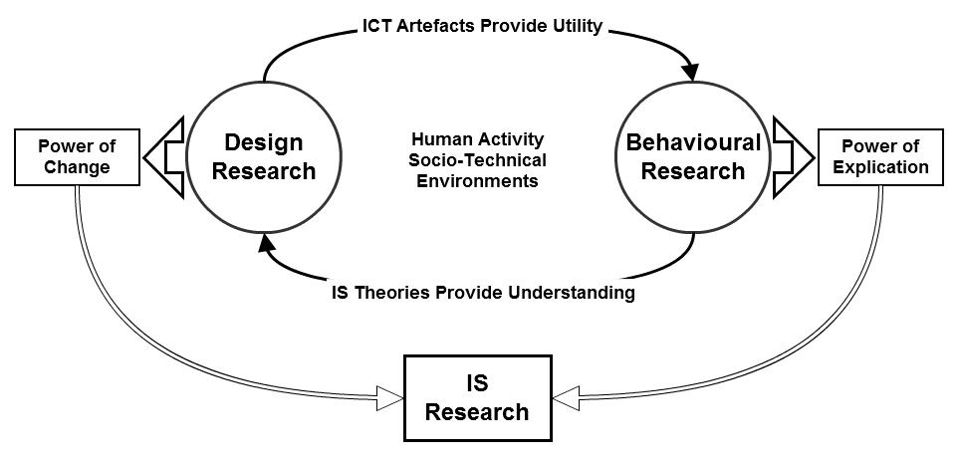

*Figure 2.1.* Complementarity of design science and behavioural science research, modified from an initial proposition of Hevner and Chatterjee (2010, p. 11)

As illustrated, DSR supports utility through the creation and evaluation of ICT artefacts, whereas BSR is responsible for generating theories to predict or explain phenomena relating to the implementation of the ICT artefact within certain contexts (Alan R. Hevner et al., 2004).

In this research, the major research question concerns “how can an e-learning system that facilitates effective self-regulated learning in a phonetic transcription blended learning environment be designed and implemented?” E-learning is by nature an applied research discipline. Any e-learning application is produced specifically to address a particular educational need; that is, this type of application is developed to resolve a particular educational purpose or learning requirement, and is thus limited to the solution of the problems arising from this context (Nunes & Fowell, 1996). This puts the research clearly on the design science avenue of the IS research paradigms. Thus, DSR can be considered the most suitable approach for the research methodology, whereby the IS theories are visited via behavioural research in order to generate the ICT artefact and solve the problem currently defined in the field; moreover, this approach can yield accompanying knowledge and design theories throughout the process of the research. Through a contextualisation of DSR into IS, the outcomes and process of the methodology will be elaborated in relation to the philosophical reasoning behind them.

## Reviewing the DSR process

Communicable knowledge is generally recognised as the research goal of every discipline. Unfolding a research methodology should begin by understanding the knowledge flows within its process. Hevner’s dual research cycle model coincided in Owen’s (1998) earlier work that generalised how knowledge is generated and accumulated (Figure 2.2) in disciplines concerning design activity. Owen regarded the processes whereby knowledge is built or used as “channels”, which suggested the actions of research. Design takes place in a “knowledge using process”, whereas behavioural research represents a “knowledge building process”. Knowledge can be generated from both the channels and accumulated throughout the repetition of the cycle.

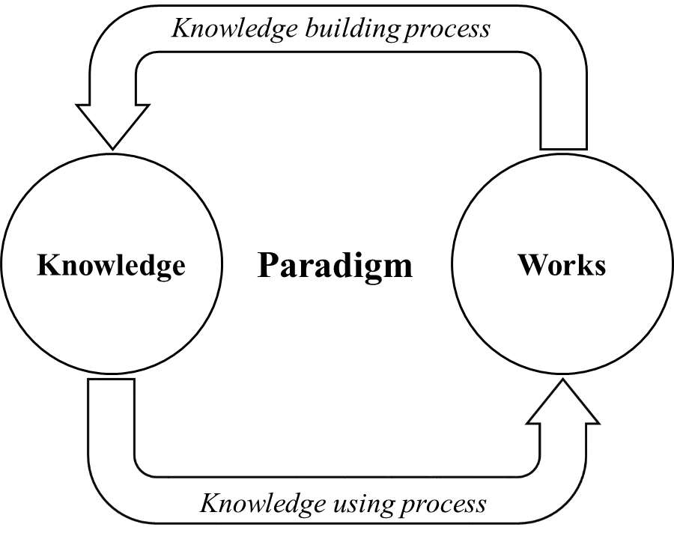

*Figure 2.2.* The general model for generating and accumulating knowledge (adapted from Owen, 1998, p. 11)

In order to elaborate by what means knowledge is generated in DSR, it is necessary to establish a research framework. In the field of DSR, there is no generally accepted process model that provides a unified research framework (Winter, 2008). Nevertheless, many pioneering researchers have produced excellent descriptions and diagrams of the DSR process that can be consulted (Cole, Purao, Rossi, & Sein, 2005; Eekels & Roozenburg, 1991; Alan R. Hevner, 2007; Alan R. Hevner et al., 2004; March & Smith, 1995; Nunamaker, Chen, & Purdin, 1991; Peffers, Tuunanen, Rothenberger, & Chatterjee, 2008; Rossi & Sein, 2003; Takeda, Veerkamp, Tomiyama, & Yoshikawa, 1990; Walls et al., 1992). Among all the contributions, there is a consensus about the inherently iterative nature of DSR. From Simon’s (1996) enlightening research onwards, design process has been generalised as a cycle of generating alternatives and testing them against requirements and constraints.

March and Smith’s (1995) work designated “build” and “evaluate” as the two basic activities at the heart of design science. Many more sophisticated process models can be found in others’ publications. A systematic review of most of the representative papers and presentations has been presented by Peffers et al. (2008), in which they synthesised the possible components of a DSR methodology process in order to identify the common elements. The series of steps designated by Peffers et al. (2008) are as follows:

**Step 1: Problem identification and motivation**

Although some researchers argue that problem identification should be excluded from the design process (Walls et al., 1992), most researchers suggest an initial stage of problem identification before embarking on the generation or building of the artefact or alternatives. The significance of a meaningful research question or problem to be solved is at the core of all disciplines. For DSR, a clearly identified research problem provides the focus throughout the development process (Nunamaker et al., 1991). Ideal problem definition requires awareness of both the state of the problem and the importance of its solution (Peffers et al., 2008).

**Step 2: Define the objectives for a solution/suggestion**

Peffers et al. (2008) see objectives of a solution as what is commonly defined as “requirements” in engineering fields (Eekels & Roozenburg, 1991; Nunamaker et al., 1991). Takeda et al. (1990) termed this stage as “suggestion” in which the key ideas needed to solve the identified problem are suggested. The significance of requirements specification is widely recognised in ICT developments. Nevertheless, the step of defining requirements (or objectives/suggestions) is neglected or only implicit in some models (Cole et al., 2005; Rossi & Sein, 2003). The definition of requirements is based on knowledge of the problem and functional feasibility (Peffers et al., 2008). Additionally, some researchers emphasise the understanding of environmental context and how that may cause the requirements to vary (Alan R. Hevner et al., 2004).

**Step 3: Design and development**

The design and development of the artefact are the core activities in DSR. The process of design and development is explicitly separated in some elaborate models (Eekels & Roozenburg, 1991; Nunamaker et al., 1991). In others, the design step is merged with the requirements specification as a combined effort which delivers feasible design alternatives (Takeda et al., 1990). However, some researchers such as Hevner (2007) concentrate more on the integrated cycle of design and evaluation activities, proposing the cooperation and interaction of both core activities instead of their division into discrete elements. The design activity determines the required functionality of the artefact and its architecture, and the development activity manages the practical methods by which the artefact is actualised (Peffers et al., 2008). Performing preferred design and development involves theories that help to optimise the achievement of the possible solution (Cole et al., 2005; Peffers et al., 2008; Rossi & Sein, 2003).

**Step 4: Demonstration**

The act of demonstration is commonly adopted to test/evaluate artefacts in the form of a prototype (March & Storey, 2008). Since this act attempts to present and approve the feasibility of the prototype artefact through solving one or more given tasks which may occur in real circumstances, some researchers have given a different name to it, for instance simulation (Eekels & Roozenburg, 1991) or implementation (Nunamaker et al., 1991). Although Peffers et al. (2008) separate the act of demonstration from a more formal evaluation, many researchers regard it as an inseparable part of the evaluation phase (Cole et al., 2005; Alan R. Hevner, 2007; Nunamaker et al., 1991; Takeda et al., 1990).

**Step 5: Evaluation**

In general, the comparison of predefined design objectives to practically observed results from the demonstration activity is the most commonly suggested device to evaluate an artefact (Eekels & Roozenburg, 1991; Nunamaker et al., 1991; Peffers et al., 2008; Takeda et al., 1990). Researchers have proposed various methods to measure the capacity of the artefact; examples are functional comparison, satisfaction surveys, client feedback, or simulations, along with quantifiable measures such as response time or availability (Peffers et al., 2008). The result of the evaluation stage is significant in the way of producing new problems (Takeda et al., 1990). Due to the iterative nature of design, new problems can lead to a new design cycle which involves further development and refinement, and even the discovery of a new theory to explain observed new phenomena (Nunamaker et al., 1991).

**Step 6: Conclusion and communication.**

Research aims to produce transferable knowledge which is to be shared and generalised beyond the field of study. Many researchers disregard the step to diffuse the knowledge gained from the design activities. To accomplish the DSR process, however, the phase of communication is strongly advocated by Hevner et al. (2004). They claim that DSR should “be presented both to technology-oriented as well as management-oriented audiences” (Alan R. Hevner et al., 2004, p. 90: 90). By presenting both the utility of the artefact and the accumulated knowledge, this phase benefits both practitioners and researchers respectively.

The authors of this reference process model (Peffers et al. (2008) emphasise that possible variations of the model can be adopted. The naming and regrouping of the research steps, and sometimes even the sequential order of the research activities, may be changed in specific cases depending on the different objectives and contexts of the research.

## Cognitive processes of DSR

Understanding the research process specification discussed above serves the carriage of knowledge flows in the DSR paradigm. Pertaining to the specified research activities, the reasoning approach of DSR is revealed within each stage, where the creative effort that aims at generating new knowledge throughout the entirety of the research is suggested. In Figure 2.3, adapted from the paper of Takeda et al. (1990, p. 45), the model of cognitive processes is represented.

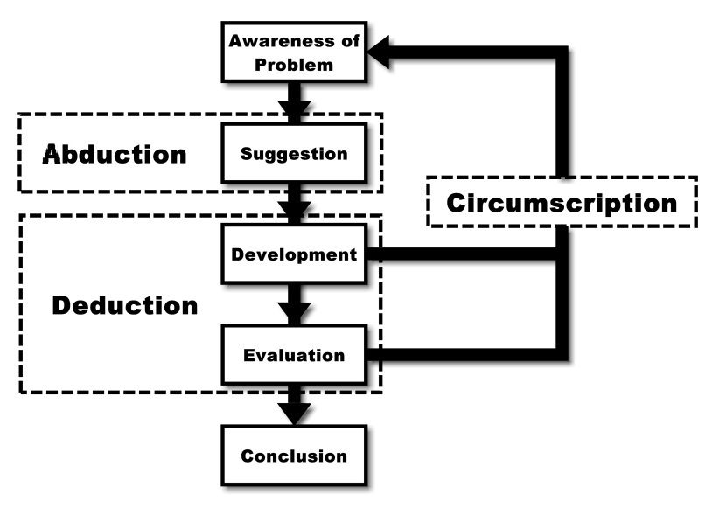

*Figure 2.3.* The model of cognitive processes in DSR adapted from Takeda et al. (adapted from 1990, p. 45)

As suggested by Takeda et al. (1990), and widely accepted in the IS context (V Vaishnavi et al., 2004/2017), the design science paradigm utilises three types of logical procedures, namely “abduction”, “deduction” and “circumscription”,in an iterative fashion that is determined by the nature of the design process. An explanation of each of these cognitive processes and their implementation in the DSR process are presented as follows.

### Abductive reasoning

Coined by Charles Sanders Peirce, abductive reasoning was first introduced as a resemblance to the cognitive activity of “guessing” (Peirce & Houser, 1998). More specifically, abduction serves as a logical mode of inference that seeks the hypothetical explanation of an observed fact. Peirce elaborated this type of inference: “The surprising fact, C, is observed. But if A were true, C would be a matter of course. Hence, there is reason to suspect that A is true” (Peirce, 1974 : Paragraph 189). This indicates the abducted reason A to be determined as a sufficient but not necessary cause of the fact C. As argued by Peirce, the quality of the abductive result is determined not only on the sufficiency of A for explaining C, but also on A being among the most economical explanations for C. Thus, the effort made to define such an inference is put in its simplest and most likely form, which is commonly interpreted as the “inference to the best explanation” (Sober, 2012).

It should be noted that abductive reasoning does not encompass induction, where the emergent observation of a surprising problem is not required as an initiative and no novel ideas are proposed though the process (Peirce, 1997). Whereas more observation of facts is sought to test a hypothesis in the inductive reasoning, in abductive reasoning the hypothesis results from retroductive attempts to account for the facts (L. Cohen, Manion, & Morrison, 2011; Peirce, 1997).

Through the incorporation of this reasoning on the DSR platform, in the suggestion stage of the research, an attempt should be made to identify the causes of the current problems defined in the first stage of the research. Certain hypothetical results should be examined for their qualities of simplification and economy according to pre-existing theories and background knowledge of the problem area, while keeping the emphasis on the situation-improving nature of the research. The resulting suggestions would then lead to a tentative design of the artefact in order to address the problem. Based on the characteristics of the abductive reasoning approach, Takeda et al. (1990) have maintained that it allows the possibility of the expansion of the designer’s thought, whereby creative efforts on solving the problem are prominently emphasised, albeit they are based on the prerequisite knowledge in the design context.

### Deductive reasoning

Deductive reasoning is the process whereby premises are used to deduce an argument whose logical conclusion is linked with the premises (Sternberg, 2011). In this process, the attempted argument asserts that the concluded results are the necessary consequences of the premises. In the social sciences, deduction is traditionally the process of testing existing theories in the research-bonded context for acquiring justified conclusions (L. Cohen et al., 2011). To be more specific, deductive research starts by reviewing theories related to the focused research problem, and then generates a hypothesis based on such theories and specified contextual premises as investigated in the research field. This hypothesis is then examined through observations via data collection and analysis in the course of research to yield findings. The process ends with a justified conclusion that confirms or rejects the theory (Bryman, 2008).

In DSR, the deductive reasoning process is utilised mainly through the design, development and evaluation stages of the artefact (Takeda et al., 1990). After the abductive procedure in the suggestion stage of the research, the design of the artefact is proposed as the hypothetical solution of the defined problem. This initial design is based on the previously visited design theories and subject-related knowledge in the field of research. The artefact is then developed, demonstrated and evaluated based on such theoretical guidelines, where contextual specification would occur in the process that serves to test premises. DSR would then conclude with the fitness and competency of the resulting artefact to generate knowledge within the specific research area. Unlike in natural and behavioural research paradigms, the confirmation or rejection of the existing theories could be partially concluded in DSR. This is largely because of the special circumstances in design science whereby the situational factors for each research problem are unique (V Vaishnavi et al., 2004/2017).

### Circumscription

After understanding abduction and deduction within a DSR process, the consequential necessity of circumscription is then suggested in regard to both. In DSR, the initial suggested solution to the identified problem is not normally qualified perfectly throughout the tests. In fact, most of the time the tentative design will display its unfitness or incompetence during the development and evaluation stages. Such occurring observations are not seen as failures or errors in DSR, but rather are considered opportunities for the accumulation of new knowledge (V Vaishnavi et al., 2004/2017). As shown in Figure 2.3, circumscription happens when the observations during development and evaluation collide with the corresponding existing knowledge. The conflict then results in additional information that is used both to identify the emergent problem and to suggest an improved design, thereby allowing a new round of the research process (Takeda et al., 1990). It should also be noted that the design in the previous round is not fully discarded but is partially revised based on the specific circumscription.

Instead of a research paradigm, the term circumscription as defined by John McCarthy (1980) as a “rule of conjecture” (p. 2). The reasoning of circumscription limits the possibilities that cause either an occurring problem or the incapability of the proposed solution within the readily available understanding of the chosen theories. A relatively simplified interpretation of this concept put into a DSR situation is presented by Vaishnavi and Kuechler (2004/2017): “the design science researcher learns or discovers when things don’t work ‘according to theory.’” According to this reasoning, it is assumed that all knowledge is only completely available within the situational context that it originally fits into. This allows DSR researchers to detect and analyse the inconsistency between existing theories and the researched situation in order to generate understanding which can only be acquired through the construction of the specified artefact. Circumscription is thus of great importance in a DSR process with regards to knowledge contribution.

The emergent circumscriptions in DSR consequently result in the cyclic nature of design processes. The information gained through such reasoning does not only provide new design knowledge but also initiates a new iteration of research activities where more opportunities on knowledge gathering would be available. The new problem defined through circumscription in the deductive part of the research leads to a new attempt in abduction, which is later examined again in the deduction process, closing up the research cycle. Final reflection and implication are achieved in the conclusion stage of DSR, where the overall contribution of knowledge is abstracted from previous research cycles. These results encompass different types of outcomes of DSR, which are yielded from the different stages and types of reasoning discussed above.

## Intended outcomes of DSR

Having analysed DSR’s research processes and knowledge-generating approaches, it is important to discuss the tangible results of DSR. Along with the various research frameworks, the outcomes of DSR is subject to much debate (Winter, 2008). One of the most widely acknowledged theories is that of March and Smith (1995), who have classified four types of product that can be derived from DSR: constructs, models, methods and instantiations. These products can be briefly summarised as follows:

* Constructs – basic vocabulary formed by the single concepts of a domain.
* Models – the description of relationships among certain constructs.
* Methods – operating procedures to perform a task based on underlying constructs and possibly their models.
* Instantiations – the realisation of a proposed artefact which operationalises constructs, models and methods.

From March and Smith’s (1995) explanation, there are certain dependencies between the research outcomes. This can be illustrated by Figure 2.4 in which the latter outcomes are generated from the prior ones.

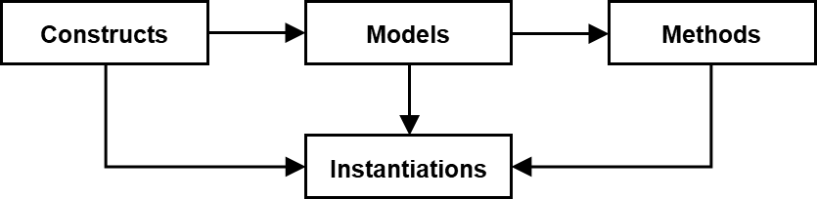

*Figure 2.4.* Relationship between the outcomes of DSR (based on March & Smith, 1995)

Based on or referring to the seminal viewpoint that March and Smith have presented, many other researchers have provided different or enhanced understandings of DSR outcomes. Purao (2002) and Rossi and Sein (2003) extended the list of outcomes by adding a fifth contribution of DSR – emergent theories. They proposed the possibility of building better theories through DSR activities. On the one hand, the methodological construction of DSR can be considered as the process of theorising which potentially presents beneficial explanations or justifications to different research domains. On the other hand, the implemented artefact itself can be viewed as the characterisation of its components and their relationships, which means the artefact is able to contribute theorising as it functions (V Vaishnavi & Kuechler, 2005; V. K. Vaishnavi & Kuechler, 2015). The significance of design theories as an outcome of DSR has also been emphasised by many other researchers (D E Avison & Fitzgerald, 2003; Orlikowski & Iacono, 2001; Winter, 2008). This will be further discussed in Chapter 4 with the main outcome of the DSR – the resulting artefact – and in Chapter 6 with the knowledge contribution of this research as well as the theorisation of the artefacts.

## Conducting DSR in this project – the research design

The process of DSR discussed in the previous sections provides a set of stages which form the structure of the present research. Each stage should contribute to achieving the research objectives. The research objectives (ROs) are thus revisited below, where the stages in the DSR model are purposefully bounded in order to address these objectives. The specific activities to be undertaken in this research for each DSR stage are also presented, which overall form the entire research design.

1. To investigate the research context and explore the potential of an e-learning component in a blended learning course design reflecting the characteristics of the teaching and learning of phonetic transcription.
2. To examine and understand the DSR methodology and to develop methods for its implementation in the research context.
3. To undertake a literature review to identify an appropriate pedagogical strategy for the e-learning system and to examine factors that determine its performance.

**Research Activity: Identification of Needs / Awareness of Problems**

The first three research objectives can be addressed in the problem identification and motivation stages in the DSR process model. In this particular project, the need for pedagogical improvement in the speech and language therapy course is investigated first in order to acquire the prerequisite background understanding. A research proposal is then generated based on the characteristics of phonetic transcription teaching and learning. This research proposes the self-regulated e-learning system that serves as a component in the blended learning environment of the taught module. In this proposal, the methodological approach of the research is determined. An examination of the methodology and methods adopted in its implementation is then conducted. The reason this investigation of methodology precedes the literature review is because of the special characteristics of DSR. Given the pragmatic nature of DSR, the literature review needs to be informed by the intention of the design. Its endeavour can then be carried out more purposefully.

After that, the role of the design artefact and its pedagogical potentials can be examined through a comprehensive literature review in the subject area, in which established knowledge and theories can form the basis of and guide for the design of the artefact. Information gathered both from field investigation and from the literature review – learning theories in phonetic transcription and implementation of educational technology, would then be analysed in order to acquire a sufficient understanding for addressing the identified research objectives.

Speech and language therapy and information systems are disciplines remote from one another. Meetings in person with the instructors in the course were hence arranged in order to gain a better understanding of the requirements. For the sake of satisfactory comprehension on both sides, thorough discussion and brainstorming were carried out. A brief structure chart and use cases were generated for illustrating learning needs with their underpinning concepts. This stage of research involved understanding and accommodating the perspectives from the subject discipline.

1. To decide design features of an e-learning system in order to achieve the pedagogical goal.
2. To develop a testable prototype of the e-learning system.

**Research Activity: Suggestion of a Solution**

Following the acquisition of subject-related knowledge and the field investigation, the research problem and the requirements for the artefact can be fully identified. A tentative design was then made in order to suggest the solution process of the DSR model. Activities oriented towards the research objective were still maintained. To identify the specific factors that allow the proposed e-learning system to optimise users’ learning, more understanding of theories of e-learning systems and their roles in blended learning environments was required. Such understanding was achieved through a more comprehensive literature review concerning pedagogy and the use of the system. Based on this, a conceptual suggestion of a solution was then given.

The tentative design was based on the requirements yielded from the needs identification step. After analysing and discussing the data previously collected, an initial design of the application was formed and presented to the instructors with suggestions of the solutions for each specific requirement. A brief conceptualisation of the application was presented to the instructor. After further discussion and amendment of the design, the initial requirements were considered to be addressed in the first prototype. The relationship and interactions of the fundamental elements in the system were then illustrated through the creation of activity diagrams, which defined the abstract structure of the e-learning system. From a practical perspective, this step primarily served the presentation of the system designer’s opinions in order to gain feedback from the potential users (in this case represented by the instructors). Moreover, by addressing the research objective in this stage, the identified factors not only led to the conceptual design of the system, but also provided criteria on which the following evaluation stage could be based.

**Research Activity: Design and Development of the System**

The formal design and development of the e-learning component in the blended learning environment should then be carried out after identification of the prerequisite knowledge. Concerning the limitations of this doctoral research, where time and labour are too constrained to allow full research cycles of DSR, it was proposed to utilise a prototyping approach in a Rapid Application Development (RAD) fashion. The adoption of a prototyping approach is discussed later in this chapter, so here only brief comments will be made. Prototype meetings were frequently held between the designer and the instructors. While each prototype was delivered, further requirements and the internal test results of last prototype were discussed. Amendments could then be made on the next prototype for the application to evolve. By adopting web technologies like PHP, HTML and JavaScript, the prototypes were partly completed in each cycle.

The meetings held for the artefact prototypes to be examined served the purpose of revealing circumscriptions in the DSR process. This allowed emergent knowledge gained through the developmental stages to feed back in order to identify new requirements. Better understanding about teaching and learning phonetic transcription, especially regarding learners’ self-regulation through e-learning, could then result from the process. The research objective of fulfilling pedagogical needs by designing and developing the artefact prototype was hence addressed.

1. To collect data from users to understand the use of the e-learning system.

**Research Activity: Demonstration and Evaluation of the System**

After many prototype cycles in the previous design and development stage, the stabilised version of the e-learning system was completed. The established application was formally introduced to the students in the phonetic transcription module. The use of the system was demonstrated with regards to its role as a component in the blended learning environment. The students were then provided with the system as a voluntary tool for learning phonetic transcription for an academic semester. A formal external evaluation (by the students) of the artefact should hereby take place. Systematic evaluation methods were proposed in this stage to provide a more comprehensive understanding of the end users’ experience and system use, namely the students’ learning with the self-regulated e-learning system. Since the scope of the research allowed only one entire cycle of DSR, the formal evaluation of the system was of great significance for yielding detailed and confident research findings. A mixed research method was thus adopted which combined quantitative and qualitative data collection and analysis. The method is introduced and discussed further later in this chapter.

A questionnaire survey and structured interviews were conducted sequentially with the students on the speech and language therapy course. The data were collected concerning their learning experience and satisfaction with the e-learning system. These data were then statistically analysed and integrated to yield an observational account of the system use in the research findings. From the evaluation of the system, the design can be validated by its successful performance. The pedagogical hypothesis embodied by the system can thus be verified. From this process, the design theory of the resulting artefact can be formulated to link its design with the requirements it fulfils. Through the abstraction and theorisation of the design, generalisable knowledge contributions of this DSR are yielded. These research objectives could hence be fully addressed in this stage of DSR.

1. To formulate the theoretical hypothesis of the resulting artefact based on the abstraction of its design.
2. To discuss the findings and identify the key factors influencing the learning experience with the e-learning component incorporated in the blended learning environment.
3. To reflect on the theoretical basis that guided the design so that the potential of the e-learning system in facilitating SRL is understood.
4. To reflect on the pedagogical proposal behind the design of the e-learning system.
5. To reflect on the DSR methodology and its implementation in the research context.
6. To suggest guidelines and directions for a potential next DSR cycle for the artefact

**Research Activity: Conclusion and Communication**

The final research objectives are directly associated with the discussion of the research findings. After collecting and analysing data in the evaluation stage, different types of research findings could be yielded. Firstly, the instantiation of the designed and developed artefact itself, constituted by its infrastructural constructs, models and methods, were delivered from the research process as one of the main findings that addressed the research question. The abstraction of these artefacts can be seen also to be generalisable. Secondly, the evaluation processes of the designed artefact can provide opportunities for understanding the system use by the students. This is then discussed with the theoretical basis examined in the literature that guided the design. This discussion can help identify the factors influencing the learning experience of phonetic transcription with the system. These attempts were made both during the prototyping cycles and in the final user evaluation. Through the deductive reasoning process in the stages of design, development and evaluation, the hypothetical solution to the problem – namely, the pedagogical proposal behind the design artefact – was suggested. Design brief for the next cycle of DSR is concluded in order to bring validation of such pedagogical proposal as well as realisation of the circumscriptions. These would both serve the accumulation of knowledge from the DSR process. Finally, therefore, an effective approach of design and development of an e-learning component in a blended learning environment is realised within the context of specified pedagogical goals. The implementation of DSR methodology in this research is evaluated. All outcomes of the research should produce contribution to generalisable knowledge that can be communicated to the subject domains. The research objectives could hence be fully addressed.

The manifestation of this stage of DSR in the present research includes the findings, discussion and conclusion components. Results were yielded from the examination of prototypes, analysis of formally collected data, and reflections on the circumscriptions. Interpreting these results formed rich and extensive findings that were integrated and discussed as a whole in order to produce desired conclusions. The research questions are addressed in the discussion of the findings and a closure of the research cycle is brought in the research conclusion.

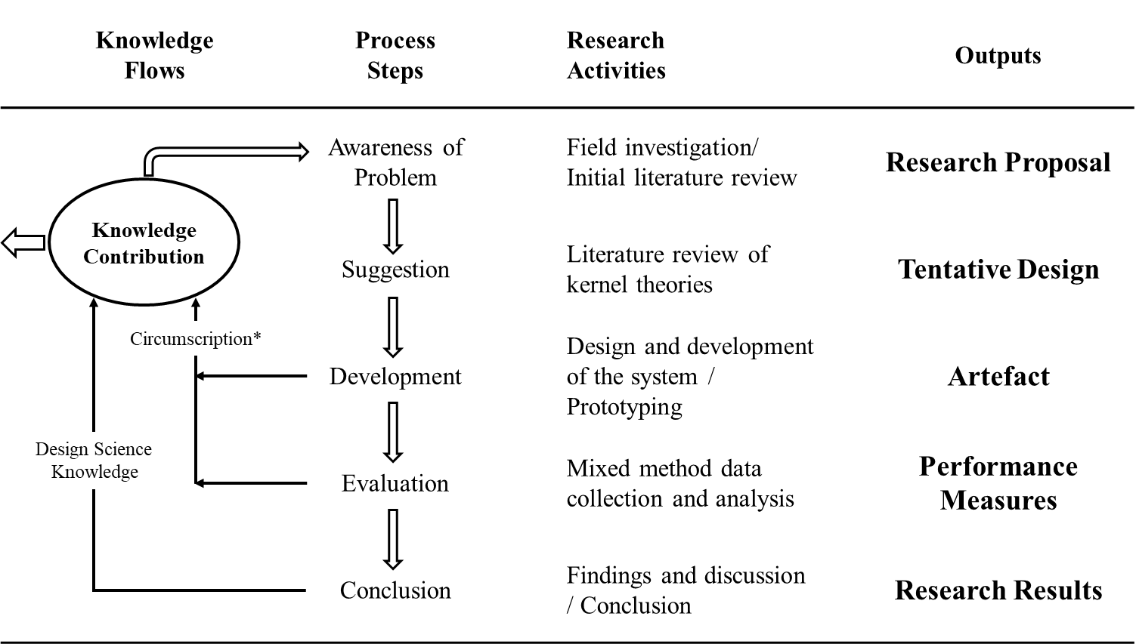

*Figure 2.5.* Diagram of the research design with activities and intended outcomes (adapted from V Vaishnavi et al., 2004/2017, p. 8)

Generated from the preceding discussion, the implementation of the DSR paradigm in this research results in the research design shown in Figure 2.5. This diagram illustrates the research activities related to the DSR processes, along with the intended research outcomes and knowledge contribution. In the following sections, the role of prototyping and the mixed method in the evaluation stage are elaborated. The rationale for adopting these approaches is discussed in addition to their specific implementations in this research.

## System development method – Prototyping

### Software process models

In view of the central position of the development of an artefact in DSR, the software process models are inevitably required to be taken into consideration. In the conventions of software engineering, prescriptive process models are commonly recommended for adoption for the sake of bringing order to chaos, controlling quality of the outcomes, and improving production efficiency (Pressman, 2005). Relating to DSR, a software process model not only concerns the development stage but also reflects all its components onto the DSR steps. Pressman (2005) has pointed out that all prescriptive models accommodate a generic framework which is composed of shared traditional activities: communication, planning, modelling, construction and deployment. These activities seem to precisely map the DSR process.

Although the different models share the same or a similar group of activities, each has its particular characteristics that focus on one or some of the activities and, moreover, apply them in a distinct fashion. The categorisation of software process models varies among experts in the field. From Royce’s (1970) “classic life-cycle”(which is later known as the waterfall model)to Martin’s interpretation of Rapid Application Development (RAD), various models have been introduced and implemented. Finding a suitable model for a specific project is a matter of measuring the circumstances. This project germinated from an idea of a phonetician who had barely any expertise on how techniques would function and what realistic result should be expected. On the other side, the researcher new to the term “phonetics” need to commence the design and development of the system. The situation quite explicitly led to the answer: a prototyping model was adopted.

Interpretations of the prototyping model differ in minor ways. Some classify it with evolutionary developing processes (Pressman, 2005; Sommerville, 1996, 2007), whereas others also claim its potential as an incremental model (Hughes & Cotterell, 1999). Regardless of how the model is categorised, the nature of prototyping provides certain advantages for situations to which it is suited. When the design requirements are not explicitly identified, the significance of an initial prototype is evident. The prototype plays a role of facilitating effective communication between developer and user (Pressman, 2005). Since the initial prototype represents the limited understanding of the developer, the users are then aware of what modifications need to be applied. The prototyping model can be conducted in different ways. Variation of the model is commonly recommended in order to optimise its effectiveness.

### The prototyping model and variations

Concerning the choice of a software process model, the plan should include not only which model is selected but also how the model is applied (Hughes & Cotterell, 1999). For every different problem, there is a way of adopting a process model in which the requirements are most effectively fulfilled. Variations of prototyping were presented by engineers and scholars while retaining the evolving and iterative nature of the method. In Sommerville’s (2007) interpretation of prototyping, he regarded the prototype as an experimental tool. While experimenting with the system users, developer can “hence develop a better requirements definition”(p. 68). In that sense, the requirements specification in prototyping resulted from the collective perspective both of the system designer and of the instructors in the field of phonetic transcription. The proposal to conduct prototyping in this project therefore arose. An interactive prototyping model managed to be delivered through the course.

The prototyping model had its root in interactivity, in order to bring understanding to all participants. In this particular project, the user had no clear anticipation of how the functions could be achieved by adopting specific technologies, whereas the design of the system was limited to ideas and brief assumptions. After the developer’s perception of the concepts involved in this project, proposals were evoked and presented from the technical perspectives. These proposals could be delivered in form of oral or written communication, or in the form of prototypes. Further justification of the adoption of this prototyping method is provided through a reflection on constructivist epistemology. Constructivism suggests that understanding is only meaningful when it fits the context in which it is constrained (Von Glasersfeld, 1989b). More precisely, interactions in this model provide the representation and exchange of contextual constraints from both the disciplinary and the technical aspects. By circumscribing the limits, and exploring and locating the possibilities, the intersection would eventually be achieved.

The advantages of the prototyping model are commonly stated, such as its suitability to small- and medium-sized projects (Sommerville, 2007), the benefits it brings to communication and user involvement (Hughes & Cotterell, 1999), and its superiority when designing an interface-centred interactive system (Sommerville, 1996). The suitability of its variation in the project is hence evident. The drawbacks and problems of the model have also been noted by Sommerville (1996), which include the deficient priority of organisational scale requirements, a dynamic and thus unstable structure, and the visibility of development to the management level of a project. However, these potential disadvantages were minimal in this specific project. Beyond its appropriateness to the scale of the project, the variation of the process model provided opportunities for prototypes to be preconditioned and structured in a more anticipated approach.

## Evaluation method – Mixed method

The method used to construct evaluation of the system in this research was a mixed method that combines quantitative and qualitative approaches. Reviewing the objectives of this doctoral research, the factors conducive to the performance of the e-learning system in order to optimise learning effects needed to be identified. Moreover, defining how the system would interact with the blended learning environment was also a question to be answered through the evaluation process. To seek the answers, it was essential to acquire the perspectives of the system users. After gathering users’ thoughts and concerns, a more systematic round of data collection could then be conducted to further explain the identified factors that influenced the system quality. The rationale for the choice of a mixed method is presented in the next three subsections.

### Quantitative approach

When a quantitative approach is used as a research strategy, it represents one or some of three properties: objectivistic, positivistic and deductive (Bryman, 2008). The quantitative part of the evaluation is expected to result in measurable perceptions that users have towards the e-learning system. According to Bryman (2008), measurement is meant to deliver “more precise estimates of the degree of relationship between concepts” (p. 144). The positivistic epistemology hence functions as data are being used to ascertain precise differences and relationships that exist objectively. Also through rigorous quantitative data analysis, deductive outcomes can be attained to verify the successfulness of the system.

### Qualitative approach

In contrast to a quantitative approach, a qualitative approach is normally constructionist, interpretivist and inductivist (Bryman, 2008). After understanding the measure and relationships between the factors that influence the learning quality, such observations would be examined explanatorily with individuals. Ontologically, such a result is constructed through the interactions between individuals rather than being an objectively existing phenomenon. Epistemologically, to acquire people’s understanding and thoughts, an examination of the interpretation of this context is required. Interpretivist approaches to acquiring meanings respect the differences between individuals and treat the subjectivity of each individual equally (Bryman, 2008). Adopting a qualitative approach is therefore of great importance to provide confirmation and explanation for the quantitative findings.

### Why mix?

The deductive nature of quantitative approaches led to the verification of a theoretical hypothesis which involved the elements and factors influencing the performance of the system. Namely in this research the pedagogical proposal is to be tested through its implementation in the system. To fully address the research question and build up a framework that is generalisable, the influential factors should be examined with precision. It was important to adopt a quantitative approach in order to measure the significance of the factors and demonstrate their relationships. By considering the user group as a whole, the hypothesis would be tested to form the theory and framework. The deduction part of evaluation is then delivered through this step. However, to bring more comprehensive results that is not only rigorous but also inspiring, another layer of investigation is suggested.

Understanding the context of the research is an essential requirement for research quality. Phonetic transcription is part of a domain professionally specific knowledge and concepts that are remote from IS expertise. However, the researcher needs to learn and employ these concepts and vocabularies. Including qualitative data in this research would thus be conducive to a systematic comprehension of the field.

The employment of this e-learning system has entailed certain changes to the course design and pedagogical strategy. The quality of the students’ learning experience was therefore altered correspondingly. To answer the research questions, such changes introduced by the system need to be examined. Factors leading to benefits, or perhaps even some drawbacks, are outcomes to be explained. Conducting qualitative approach as following is preferable for further perceiving users’ thoughts about the system.

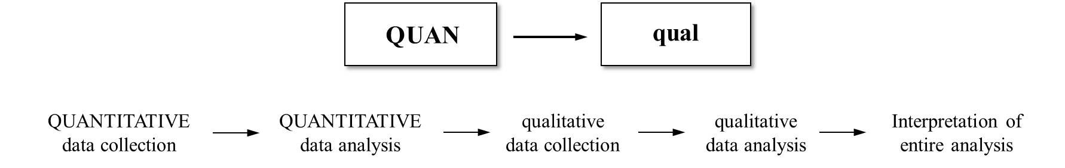

*Figure 2.6.* Sequential Explanatory Design Strategy (reproduced from Creswell, 2009, p. 209)

As a result of the considerations, the design of the evaluation method corresponded with a Sequential Explanatory Strategy model (Creswell, 2009). As illustrated in Figure 2.6, the priority was given to the quantitative phase of the method, which was then followed by a phase of qualitative data collection and analysis. The final findings were reached through the interpretation of the entire data analysis. Morgan (1998) stated the importance of the qualitative phase as its role in interpreting the measurement derived from the quantitative phase. Furthermore, the significance of the mixed approach is its ability to generalise quantitative findings through qualitative analysis. A systematic and generalisable framework can therefore be delivered with this choice of design.

## Data collection and analysis

The data collection methods of this research were decided in relation to the evaluation methods. Self-completion questionnaires were conducted for a large sample of students and structured interviews with a smaller group of students followed.

### Self-completion questionnaires

A discussion on the theoretical model of questionnaire design was brought before the data collection. The influential factors of the system were briefly interpreted in their properties and origins, the measurement of their significances and the relationship between these factors were under investigation through the quantitative questionnaires. The self-completion questionnaire has advantages in its efficiency when collecting data from a large-sized sample. Since the e-learning system had a relatively small group of users, each student was sent a questionnaire to complete. This secured the integrity of information and the viability of the quantitative data.

The questionnaires used mainly closed questions in order to provide precise information. Dividing the questions into sections allowed students to build links between questions while thinking of the same factors that influenced their learning experience. For those factors that could possibly be unclear to some students, explicit descriptions were provided for each section to assist understanding. Moreover, clear instructions for response presentation were given to students throughout the entire questionnaire.

### Likert scale

The Likert scale was invented in 1932 by the psychologist Rensis Likert (Likert, 1932). In his founding work, Likert distinctively presented a format of scoring method that associate each scale item to a range of responses. Such distinction grants the Likert scale its merit comparing to other methods in investigating underlying phenomenon and its variations (Carifio & Perla, 2007). The questionnaire respondents are asked to describe their agreement or disagreement on each question/item. A symmetric scale featuring options from the extreme agreement to extreme disagreement is provided. This given range of options thus captures the intensity of the respondents’ feelings (Burns & Burns, 2008). The summary of all items that are associated with the rang options form a Likert scale questionnaire. Notably all such questions in the scale should have equal distance between them, quoted as: “all items are assumed to be replications of each other or in other words items are considered to be parallel instruments” (Alphen, Halfens, Hasman, & Imbos, 1994, p. 197).

Scholarly attention has been paid to determining the number of items in a Likert scale. A 7-point Likert scale has been recommended in order to minimise respondents’ uncertainty, which can arise if fewer points are adopted (Matell & Jacoby, 1972). Other research has also advocated the 7-point rating scale as suitable for maximising the information extracted while minimising respondents’ confusion and unnecessary exhaustion through long questionnaires (Green & Rao, 1970). Subsequent research has evidenced that the number of categories in an ordinal scale stops yielding differing reliability on data after passing the 7-point fence (Cicchetti, Shoinralter, & Tyrer, 1985). The conclusion can be drawn that a Likert scale with seven or more categories could be treated as a continuous scale representing an interval level of measurement, that is, it could be considered that there are equivalent intervals between each category (Labovitz, 1967).

### Open questions in questionnaires

There are many reasons to include a few open-ended questions in the questionnaire. As Patton (2002) has commented: “The purpose of gathering responses to open-ended questions is to enable the researcher to understand and capture the points of view of other people without predetermining those points of view through prior selection of questionnaire categories.” (Patton, 2002). Open questions allow the respondents to express their opinions in their own words (De Vaus, 2002). This leads to more freedom to provide information and potentially more precision in experience description (Bethlehem, 2009).

The disadvantages of open questions in questionnaire surveys can be pronounced in some cases. De Vaus (2002) has cautioned: “Open-ended questions should be kept to a minimum and, where possible, placed towards the end of the questionnaire” (De Vaus, 2002). Based on the spontaneous and boundary-free nature of open questions, answers provided by respondents might be vague or obscure (Bethlehem, 2009). Open questions can also create problems for processing of the data, since human error could play a tricky role (e.g., illegible handwriting). Moreover, the wording of an answer that a particular respondent chooses may not be feasibly defined with certainty, since different individuals will have different vocabularies to some extent (Bethlehem, 2009).

However, in this research, most of the drawbacks of open questions could be considered to fall within acceptable limits. The chosen respondents were mature students who were being trained to undertake professional tasks. Most of the students were highly self-engaged and motivated within the learning environment. Also, the questions were bounded with the specific tool utilised within a highly specified field for learning. Students therefore shared a great proportion of the vocabulary that concerns the subject. Indeed, after conducting the questionnaire survey, the outputs have shown very positive results from the adoption of these open-ended questions.

### Confirmatory and explanatory structured interviews

Structured interviews encourage a great amount of conversation between researcher and interviewees while securing a focus on productive topics. In qualitative interviews, the interviewees’ perspectives are central to the investigation. Their perceptions of reality are elaborately demanded, so that even “‘rambling’ or going off at tangents is often encouraged – it gives insight into what the interviewee sees as relevant and important ”(Bryman, 2008, p. 437). The interview structure is conducted in a flexible fashion which allows more space for interviewees to express their thoughts without restriction.

A structured interview contains a list of closed questions and moderately specified topics to be addressed. To enrich the result yielded from the interview, strictly specific questions and topic suggestions should be avoided. Interview questions should reflect a certain degree of generality as long as it keeps the conversation relevant to the subject during the interview. Questions not on the list can also be asked if new factors or concepts occur in an interviewee’s descriptions. Such encouragements offer valuable opportunities for the researcher to achieve a more comprehensive understanding.

## Ethical considerations

As this research involved human participation and personal data, it was crucial to consider the ethical issues. As first outlined by Diener and Crandall (1978), transgression of ethical principles in social research generally comprise four main areas: (1) harm to participants; (2) lack of informed consent; (3) invasion of privacy; and (4) deception. The conduct of the present research aimed to completely avoid these ethical offences.

In accordance with the ethics policy of the University of Sheffield (2018), where this research was undertaken, a research ethics review proposal was submitted and approved prior to the data collection (see Appendices 1 and 2). The participants surveyed and interviewed were recruited from the Department of Speech and Language Therapy at Birmingham City University (BCU). A research ethics review was also undertaken at BCU by the faculty ethics committee (Birmingham City University, 2019a). The research was approved by the ethics committee. The management of human participation in this research followed the ethical principles in social science research.

First, the resulting artefact and research participation did not have the potential to cause harm to humans for obvious reasons. Secondly, the use of the PSST system and the participation in this research were completely voluntary. Students were provided with detailed information about the research process. Consent forms were signed before the interviews. The participants were told that they could withdraw from this project at any time during the research. These practices are in line with the guidelines set out by Bryman (2012). Thirdly, the information about participants was kept totally confidential. The participants’ names were coded in the report and their personal information was hidden in a password-protected archive. Finally, complete transparency and honesty with the participants guided the data collection process. The students were told about nature and intentions of the research project, including any potential use of their data.

In terms of special ethical issues relating to this specific topic, the instructor in the phonetic transcription course was consulted for her expertise. She confirmed that the design, development and implementation of the resulting system and the collection of participants’ data were completely appropriate. Within the UK context, the checklist provided by the Economic and Social Research Council (2015) was adopted to examine the appropriateness and quality of the ethics of this research. It can be confirmed that this research avoided all potential ethical transgressions.

# **Literature Review**

The literature review in a Design Science Research (DSR) serves the purpose of providing guidance and inspiration for the design of the resulting artefact (Gregor & Hevner, 2013). For an innovative design approach, it often requires considering the perspectives of stakeholders from different academic and practical backgrounds. More specifically, this research project by its nature induces multidisciplinary cooperation. Therefore, a systematic study of theories from different research areas can be expected. In the DSR literature, these theories are commonly referred to as kernel theories, as defined by Walls et al. (1992), for they can provide a knowledge basis to be consulted in the identification of design requirements and the design suggestion. The goal of the resulting artefact is to fit into its applied environment, to serve its specified users, and to function on the coordination of its constitutes. In this chapter, the literature of learning theories, phonetic transcription learning, educational technology, educational psychology and instructional design will be examined in order to achieve the aforementioned goals.

## Understanding learning – Learning theories

There is a long history of debates over the definition of learning in educational psychology (T. Anderson & Dron, 2011; D. R. Garrison & Anderson, 2011). The debates reached their height of intensity in the last century, throughout which various schools of thoughts were proposed and developed. The activity of instructional design can be seen to have gone through a paradigm shift from a focus on how to teach to one on how people learn (Januszewski & Molenda, 2013). The study of such conceptual frameworks by which the conditions of learning are understood come from the realm of learning theories (Illeris, 2018). Learning theories are thus commonly put at the centre of educational technology research and development.

In the general field of education, the very focus on “learning” itself is worth noting. The examination of learning phenomena was not by default at the centre of instructional design. Effort was concentrated mostly on teaching techniques and delivery of education instead of trying to understand how human learning functions (Januszewski & Molenda, 2013; Dale H Schunk, 2012). Thanks to the development of psychology and cognitive science in the 20th century, the mechanism of human learning was first scientifically and systematically investigated through a number of different lenses.

The term “learning” is generally considered too broad to be encapsulated in simple definitions (Dale H Schunk, 2012). Nowadays, in the field of educational technology, learning is usually bound with an authoritative connotation of understanding, productive or active use as opposed to mere knowledge retention or “surface learning” (Januszewski & Molenda, 2013, p. 6). This emphasis indicates a shift towards understanding the concept of learning in an increasingly broad way.

“Learning is an enduring change in behaviour, or in the capacity to behave in a given fashion, which results from practice or other forms of experience” (Dale H Schunk, 2012, p. 3): as one of the most cited definitions in learning theories in the current decade, this quotation reveals that educators still maintain a high level of regard for the behavioural aspect of learning. Schunk elaborated the definition further by emphasising three constituent criteria for learning: change, endurance, and experience. Change in behaviour is the observable part of learning, from which the learning process can then be inferred. Such a change is expected to last for a significant period of time rather than to be temporary or instant. And, finally, only a change that occurs through experience – whether the experience is internal or external – can qualify as learning.

From this last observation, a further discussion of the nature of learning can be drawn. The aspects of learning can be understood by examining two types of phenomena: the responsive behavioural change against the external environment; and the cognitive process internal to the learner. It appears to be a convention in instructional literature to divide learning theories into major schools, famously as behaviourism, cognitivism and constructivism (T. Anderson & Dron, 2011; Cooper, 1993; Duffy & Jonassen, 2013; Ertmer & Newby, 2013; Dale H Schunk, 2012). The learning process is viewed differently from these distinct perspectives, as the following sections will elaborate. It is also worth noting the existence of other schools, like social constructivism and connectivism, which are however not discussed in this research due to their limited relevance to it.

### Learning as behavioural responses – behaviourism psychology

Behaviourism was, several decades ago, the pre-eminent pedagogical theory (T. Anderson & Dron, 2011). Although the constructivist approach has eclipsed behaviourism and currently dominates the educational landscape, many have their doubts over adopting an exclusively constructivist perspective as the most suitable pedagogy for all cases. The viability of the behaviourist approach is still generally emphasised, and this is particularly noticeable in some specific fields.

There is no generally agreed definition of behaviourism. Various branches of behaviourism emphasise differing aspects and their theories have evolved in diverse ways. From Watson’s (1913) “methodological behaviourism” to Skinner’s (1938) “radical behaviourism”, the philosophical perspectives of behaviourists evolved from centralising natural science methods to the acceptance of human feelings and states of mind. Nevertheless, despite disagreements among leading thinkers, there are certain beliefs that most behaviourists hold. The following aspects are widely regarded as constituting the central principles of behaviourism:

* There is a single, complete, correct structure of the world which is constructed by entities, properties and relations (Bichelmeyer & Hsu, 1999; Duffy & Jonassen, 1992; Lakoff, 1987).
* Knowledge is acquired independently with inner mental states (Baum, 1994; Boghossian, 2006).
* The core subject of behaviourism is the focus of the measurable relations between external stimuli and behavioural responses (Skinner, 1938; Watson, 1913).

The most important aspect to discuss in relation to the pedagogical epistemology of behaviourism are the roles of instructor and learner. Influenced by B.F. Skinner’s theories, Scheurman (1998) regarded teachers as transmitters who break knowledge or information into organised fragments that can then be presented to students in planned ways. Lessons or learning tasks operate as behavioural conditioning upon learners, the result being a specific type of behaviour. Instructors provide stimuli that affect learners in a desired way. Learners are thus viewed as receivers of instruction and responders to physical stimuli (Boghossian, 2006; Scheurman, 1998).

In the history of psychology, behaviourism as a school has long had a notorious reputation. Simplistic, mechanical, based on animal experiments, anti-humanistic: the list goes on for the negative connotations of behaviourist psychology (Illeris, 2018). Another common criticism of radical behaviourist learning theories is its neglect, and even denial, of the learners’ affective aspects (e.g., emotions, motivations) involved in learning (Illeris, 2018). However, the criticism displays a weakness in behaviourism that is likely to have little impact on this specific research. Moreover, behaviourist insights still have their role in the contemporary educational context, and further examination may justify using them.

### Learning as understanding – cognitivist psychology

Viewed as a distinct set of thought as well as widely regarded as a rival school to behaviourism, cognitivists’ understanding of the human mind turns away from the mere focus on behavioural changes to the inner thinking process (Ertmer & Newby, 2013). Cognitive psychologists came to prominence in the 1950s, a period often now referred to as the “cognitive revolution” (Cooper, 1993).

The blossom of cognitive sciences after the 1970s can be attributed to the early scientific attempts to discover the structure of the human mind beyond behavioural analysis (Illeris, 2018). Rooted in his developmental psychology studies on children learning, Jean Piaget (2005) provided a theoretical view of knowledge acquisition. Learning happens when new experiential information is taken by the learner and fitted into his or her pre-existing cognitive structures (*schemata*), or the current schemata are modified to accommodate conflicting experience; these processes are termed “assimilation” and “accommodation” respectively. From this point on, the human mind is understood from a systems’ view according to which the cognitive process of learning are analysed as the interaction between input and memory, and behavioural changes as output. The cognitive psychology of learning and working memories can then build on this infrastructure.

### Learning as constructing – constructivist learning theory

Constructivism has recently contended with cognitivism in the great dichotomy with behaviourism. Built on cognitivist psychology, constructivism is associated not only with learning theories concerning “how people learn”, but also with an epistemological perspective that attempts to understand the nature of knowledge (Hein, 1991). Like behaviourism, there are many different types of constructivism. Among the variations, von Glasersfeld (1989b) summarised the two main principles that constructivists assert: first, that “[k]nowledge is not passively received but actively built up by the cognizing subject”; and second, that “the function of cognition is adaptive and serves the organization of the experiential world, not the discovery of ontological reality” (p. 162). Other scholars extend the general beliefs of constructivists and present a more comprehensive view. Duffy and Jonassen (1992) indicated that, although constructivists admit the objective existence of the real world, they argue that meanings are constructed by us instead of existing independently. Meanings differ from each other because of the various ways we perceive the world. The search for and construction of meanings through learners’ subjective experiences becomes what is called knowledge (Bichelmeyer & Hsu, 1999; Boghossian, 2006).

Whereas behaviourists view learning as the acquisition of objective knowledge, constructivists view learning as the process by which individuals construct their own knowledge from their prior experience. In this sense, instruction is viewed as the support that teachers provide for learners to construct knowledge (Bichelmeyer & Hsu, 1999). In Scheurman’s (1998) comparison of behaviourism and constructivism, the role of the teacher in constructivism is that of a facilitator to and collaborator with students. Teachers provide students with guidance and collaborate with them to assimilate information. Furthermore, teachers should assist students to develop their own reflection on reality in the process of instruction. In the constructivist view, therefore, learners are the subject of learning, and they are able to construct knowledge on their own through facilitated experience and skills (Duffy & Jonassen, 1992; Scheurman, 1998).

### A synthesis of learning theories in the research context

The amount and type of instructional guidance that can realise optimal effectiveness and efficiency of learning, performance and transfer are widely discussed by scholars. Radical constructivists like von Glasersfeld (1989a) claim that the behaviourist approach of instructing and learning only applies well when “the goal is students’ reliable replication of an observable behaviour” (p. 131). One of the implications of this view is that the status of “understanding” seems to be disregarded by the behaviourist approach. Boghossian (2006) has pointed out that the reason why behaviourists do not regard knowledge as subjective lies with behaviourism’s philosophical roots in positivism, where the dualism between subject and object does not even necessarily exist. Subjective elements are considered to be artificial and may divert individuals from the understanding of objective reality.

A teacher-centred strategy, or direct-instruction model, is normally bound up with behaviourist learning theories since it is premised on the idea that knowledge is directly transmitted from instructors to learners. Hirsch (2001) suggested that criticisms of behaviourist pedagogies seem to have their roots in the appreciation of the “natural process” of learning, something paramount to constructivists (p. 14). Consequently, he argued that traditional pedagogies are criticised mainly because of their “artificial” outlook on learning since they are supposed to be essentially made of imposed procedures that condition behaviours (Hirsch, 2001). In contrast to behaviourists, constructivists argue that the effectiveness of learning occurs only when knowledge is constructed from learners’ own experiences. The support provided by instructors cannot be too prescriptive or directive, and should therefore necessarily be limited (Jonassen, 1991)

Learning as a complicated phenomenon has various aspects that cannot be fully addressed by a single theory. It is difficult to brand learning theories and models clearly as behaviourism or constructivism, since both ideologies have contributed to our understanding of human psychology and both are still relevant and fruitful in various scientific fields. Also, theorists and instructors often borrow from differing theories and incorporate various schools of thoughts in their practice of resolving research problems (Dale H Schunk, 2012). After careful investigation of the particular research subject matter, a synthesised understanding through learning theories can be achieved.

The debate between the schools has largely related to their epistemological beliefs. However, the evaluation of instructional designs remains primarily based on empirical results. Amid the controversy over instructional methods in practice, most scholars seem to hold that both behaviourism and constructivism have their merits in different respects (Richard E. Clark, 2009; Fletcher, 2009). Neither should be rejected or embraced absolutely. Instead, situating different theories into their adaptive domains is the key to achieving effective learning. This is especially prominent in e-learning programmes, as course designers are encouraged to find the ideal combination of behaviourism and constructivism (Carr-Chellman & Duchastel, 2000). A behaviour change in the students in the phonetic transcription module is clearly expected, while knowledge and cognitive change are also fundamental in assessing students’ mastery.

## The specifics of phonetic transcription learning

After the examination of learning phenomena in general, the unique context of this research was investigated through the related literature. Phonetic transcription as the focus of learning in the current research context, as well as its specific characteristics, were reviewed.

### The cognitive nature of phonetic transcription

In Chapter 1, background information about phonetic transcription was investigated. The phonetic transcription skill is commonly taught along with other knowledge, such as basic acoustic phonetics and the anatomy and physiology of the vocal tract (Mompeán, Ashby, & Fraser, 2011). These areas of knowledge serve both as background information for speech and language therapist training and to enable better understanding of the phonetic mechanism. The phonetic transcription skill itself involves the recognition and discrimination of spoken sounds and phonetic notations, as well as the correlation between the sounds and notations (Howard & Heselwood, 2002). The intended learning outcome should be considered as both a behavioural change and a cognitive achievement.

Phonetic transcription learning is traditionally drill and practice based. It normally takes months of mechanical drilling to master this skill (Munson, Edwards, Schellinger, Beckman, & Meyer, 2010). This is due to the associative conditioning necessary for building the connection between the sounds and symbols. This may put phonetic transcription learning purely into the realm of behaviourist instructions. However, the knowledge aspect of the subject matter can be significant too.

In the educational context, the word “knowledge” is sometimes used in a narrow sense to communicate more tangible practical meaning. In the orthodox Bloom’s taxonomy, the educational objective category “knowledge” was defined as including “those behaviors and test situations which emphasize the remembering, either by recognition or recall, of ideas, material, or phenomena” (Bloom, Engelhart, Furst, Hill, & Krathwohl, 1956, p. 62). In this regard, the recognition of spoken sounds can be seen as an educational goal type of knowledge.

When treating acoustic input, the students need to ignore the spelling system of the English language and to be able to recognise the fine details in spoken sounds. This attention to phonetic details needs to be explicit, which means that, apart from conditioning an automatic response to the sounds, understanding of the knowledge is required in the learning of the phonetic transcription (Munson et al., 2010).

### Content of phonetic transcription learning

Phonetic transcription learning normally starts with the learning of phonetic theory and factual knowledge in phonology (Howard & Heselwood, 2002). These areas of knowledge are both a prerequisite of and supplemental to practical phonetics. The element in this set of knowledge that is most directly related to the transcription skill is the IPA phonetic symbols for sound representation (International Phonetic Association, 1999). Students in a phonetic transcription course need to be able to memorise and differentiate between these symbols and their categorisation, which then allows them to associate the symbols with their corresponding sounds later in the learning. Apart from the explicit factual knowledge, implicit knowledge plays a more important role in transcription training.

*Phonological awareness* can be considered as an umbrella term that encompasses a multilevel set of skills. In general terms, these skills allow the listener to break down spoken words into smaller units (Gillon, 2004; Goswami & Bryant, 2016). Levels of phonological awareness are defined according to the hierarchy of sound structure. The sound structure of a spoken word can be described according to its syllabic structure, its onset-rime structure, and finally its phoneme (or segmental) structure (Gillon, 2004). Although sound structure can be technical, the awareness of it is automatically learned by most people. The general awareness of sound segments is developed during childhood (Anthony & Lonigan, 2004). However, in the context of speech and language therapy, the phonological knowledge and analytical skills require a much higher level of phonological awareness. The spoken sounds need close attention in order to analyse single sound units (phonemes) in detail.

The ability to attend to the phonemes in spoken words, which is also known as “phonemic awareness”, is considered an important subset of phonological awareness (Goswami & Bryant, 2016). The skills related to phonemic awareness are regarded as possessing the highest importance in the context of phonetic transcription (Robinson, Mahurin, & Justus, 2011). When transcribing, such skills include segmenting the words, and noticing, recognising, discriminating and manipulating the individual phonemes in a heard speech. The training of phonetic transcription skill generally centres on the enhancement of phonemic awareness.

### Practices and conventions of phonetic transcription learning

The main traditional training of phonetic transcription is through ear-training dictation, whereby the students write down, using phonetic symbols, the sound sequence that the instructor produces (M. Ashby, Maidment, & Abberton, 1996). This process normally requires a classroom environment that has relatively limited space. Additionally, phonetic transcription training is known to be labour-intensive (Bruijn, Nunes, Fang, Pathak, & Zhou, 2011). Traditional instruction requires a tremendous amount of effort and time from the instructor. Because of this, a major obstacle in the teaching of transcription is its lack of individualised instruction to cater for different learning needs.

Real-life fieldwork practice is generally encouraged in transcription training (M. Ashby, House, Huckvale, Maidment, & Yanagisawa, 2007). Learning materials closely resembling real language are promoted in exercises. This is in accordance with the constructivist learning principle, according to which students discover through their own experience what is reality-relevant (Mompeán et al., 2011).

An additional aspect of phonetic transcription learning is that the pronunciation of the sounds helps with the learning of transcription skills (M. Ashby & Maidment, 2005). By attempting to produce the difference between similar sounds, learners can improve their ability to distinguish the sounds when hearing them (Ladefoged, 1995). It can thus benefit students who learn to transcribe sounds into phonetic symbols also to practise pronouncing these symbols. Indeed, such pronunciation practice is recommended the Royal College of Speech and Language Therapists to be included in the curriculum (RCSLT, 2018). An additional reason to support pronunciation training is that by pronouncing unfamiliar sounds that do not exist in regular English speech, the practitioner can gain insight and empathy with their patients who may find speaking normal sounds inherently challenging (Howard & Heselwood, 2002).

### Particular difficulties of phonetic transcription learning

Not all sounds are equally easy to transcribe. Some are significantly more difficult to recognise and to distinguish from similar ones (Howard & Heselwood, 2002). This leads to the partition of time and effort spent on different learning content. The sound items that are less intuitively familiar to the learners may require a much higher amount of training.

One particular difficulty in phonetic transcription is to distinguish two or more extremely similar sounds(M. Ashby & Maidment, 2005). The difficulties of transcribing certain sounds can be shared by most people, but they also depend on individual situations. While there are particular groups of sounds that are difficult for most students, each student can find certain items problematic in their own case. The need to facilitate learning that accords with individually specified difficulties is both apparent and hard to meet (Bruijn et al., 2011). Beneficial use of educational technologies can thus be sought to address these difficulties.

## Educational technology and E-learning

Accepting the ever-evolving conception of the field of educational technology, the Association for Educational Communications and Technology (AECT) provides the following definition: “Educational technology is the study and ethical practice of facilitating learning and improving performance by creating, using, and managing appropriate technological processes and resources” (Januszewski & Molenda, 2013, p. 1). The AECT further explains the conception with an emphasis on “facilitating” with regard to the contemporary paradigm of learner-centred learning theories. Therefore, the role of educational technology is, in this cognitive and constructivist sense, “more facilitative than controlling” (ibid., p.4). The learner’s ownership of this process is centred as the educational perspective shifts from teaching to learning. From this root point, instructional design in an electronic age is less about direct delivery and more about creating an environment for learners to explore (Januszewski & Molenda, 2013; Dale H Schunk, 2012). In other words, the design of instructional routines is replaced by the design of the facilitating environment. In the following sections the interplay of technology and pedagogy will be further discussed with related literature.

### Technology and pedagogy

It has long been seen that there are two determining forces of modern educational models: technology and pedagogy. Both seem to have separate characteristics that exert different influences on the effects of the learning process. While many consider technological advancements merely instrumental under the instructional orders, other educators think of education as defined by the very means that deliver and mediate the instructions (D. R. Garrison & Anderson, 2011). This latter view is often taken to evoke Marshall McLuhan’s argument that “the medium is the message” (1964). In weaker terms, technology influences its usage via facilitation and limitation; teaching methods and materials are the content projected through this lens. In stronger terms, these media ultimately form and configure the experience of every learner as “extensions of our human senses”.

Anderson and Dron (2011) provided a reconciling account of the dichotomy. A middle ground between technological and pedagogical determinism was promoted, which states that the two should always be expected to interact with each other in generating a synergy, as if “intertwined in a dance: the technology sets the beat and creates the music while the pedagogy defines the moves” (p. 81). Only when the instructional method matches the media in which it is embodied does it provide improvement in learning. Thus, with the emergence of new technology comes the requirement for apt instruction.

While this synergy between new media and novel instructional methods is supported by abundant evidence in practical research, the matching of the two also possesses great significance. It was very frequently found in early e-learning practices that new technologies were not used with novel instructional methods but only to replicate existing teaching activities (Blin & Munro, 2008; Kirkwood & Price, 2014). This could result in inefficient use of technology. As suggested by a large-scale meta-analysis, web-based instruction has an effective advantage over traditional classroom-only teaching when directed under specified online training strategies, while no significant difference is observed when the instructional method remains the same (Sitzmann, Kraiger, Stewart, & Wisher, 2006). This effect is more pronounced when instructional design does not fit the new technology. Pedagogical considerations should, therefore, be part of the examination of the characteristics of educational technologies.

### Technology-enhanced learning / E-learning

The term “e-learning” had its public appearance earlier than 2000 and has come to be commonly used in academia. It is generally considered too broad for a simple definition. In fact, various educational terms can be found overlapping with the concept and are often used interchangeably with e-learning; these include “online learning”, “web-based learning/training”, “distance learning”, and so on (Guri-Rosenblit & Gros, 2011; Moore, Dickson-Deane, & Galyen, 2011). In a general sense, when accompanied by other “e” concepts, e-learning is often loosely referred to as learning with technology, with an emphasis on training that involves the Internet (D. R. Garrison & Anderson, 2011; Harden, 2001). Clark and Mayer (2016) defined e-learning as instruction delivered through a digital device while promoting the potential diversity of the content and method. Differing from traditional instructional methods, e-learning has its specific strengths and weaknesses; these aspects will be discussed in this section.

Although the advancement of ICT brings benefits in many areas, there remain weaknesses in its current state. These can be either because e-learning cannot yet match traditional instruction in a particular area, or because some learning activities are still difficult to achieve by means of e-learning. However, it should be made clear that e-learning is not a single educational model that carries a fixed set of aspects. Instead, typical characteristics of e-learning are commonly abstracted from a number of different technologies. Advantages and drawbacks are often dependent on the specific use of technology and its circumstances, which should be kept in mind when investigating the phenomena.

#### Asynchronous and synchronous learning

The first and arguably most fundamental difference between e-learning and classroom learning is the intrinsic accessibility of the media. ICT is able to provide instruction to learners unable to, or who choose not to, attend face-to-face (Means, Toyama, Murphy, & Baki, 2013). Most online learning technologies are thus termed *asynchronous*, which means students are able to access the learning experience independent of a fixed time and place. Despite the existence of *synchronous* e-learning methods (e.g., virtual classroom, videoconferencing), asynchrony is frequently associated with online learning in general and has become its signature feature (D. R. Garrison & Anderson, 2011; Hrastinski, 2008).

Asynchronous learning programmes can promote great flexibility and freedom. The removal of time and space barriers makes possible a learning experience according to learners’ own availability (Enoch & Soker, 2006). Learners may have difficulty participating in real-time learning due to personal reasons such as family responsibilities or childcare. E-learning avenues can provide learning opportunities in such situations that would otherwise be unfeasible (Sullivan, 2001). Each learner is different in their learning style, disposition, temporal state, or simply schedule. Traditional classrooms often have to modify their learning to accommodate these differences, which can frustrate learners at the extremes of the learning spectrum (Allan, 2007; J.-H. Wu, Tennyson, & Hsia, 2010). Some subjects rely on continual comprehension of sequential knowledge. Failure to understand one step in an algebra lecture may make the rest of the lesson impossible to understand (Adams et al., 2009; Birch & Burnett, 2009). Additionally, when not pressured by time and immediacy, students are provided with a chance to view problems more objectively and reflectively, which results in deep and meaningful understanding (D Randy Garrison & Kanuka, 2004). Technologies that support asynchronous learning have shown their success in enabling students to control their own learning time and pace.

Synchronous learning, on the other hand, supports students with beneficial social interactions and real-time answers to questions (Hrastinski, 2008). These supports are suggested to reduce learners’ isolation and frustration through the course of learning while promoting peer collaboration (Means et al., 2013). It is, however, commonly received wisdom that synchronous learning is the weak spot in e-learning courses, particularly where traditional face-to-face learning experiences provide better results (Haythornthwaite & Andrews, 2011; Summers, Waigandt, & Whittaker, 2005).

#### The social factor

In-person interactions are considered to be an advantageous element of traditional learning environments. Peer support in both study and life is also a significant consideration in the learning experience. Online learning approaches generally tend to provide poor support or lack this dimension entirely (López-Pérez, Pérez-López, & Rodríguez-Ariza, 2011). Some studies have also shown that students are less satisfied when receiving feedback online than from in-person communication (Summers et al., 2005). However, some argue that indirect interaction can have its own benefits. Shy students who feel uncomfortable speaking in a classroom may participant more willingly in an online discussion (Saunders & Chester, 2008; Sullivan, 2001). Other social factors, such as ethnicity, age, and gender, that may trigger prejudice or anxiety are also reduced (Bowman, 2001). Indeed, one of the major reasons for educational institutions to adopt web-based instruction is to facilitate marginal student groups, either socially or geographically (Enoch & Soker, 2006).

A crucial differing factor of e-learning is its necessary dependency on a learner-centred principle. This is rooted in the distant instructional medium that serves information transmission. Learners in an e-learning environment are required to engage with the learning material actively (Birch & Burnett, 2009). This active participation is often seen to result in frequent practice and thus to yield a better performance outcome (Sitzmann et al., 2006). In addition, such positive effects can be obtained when students are given more control over their learning. The learning technology thus both encourages and challenges students to become self-regulated, constructive and independent, which contributes to a richer learning experience (Birch & Burnett, 2009).

However, some argue that the media alone is not able to make students become self-regulated and independent spontaneously (Guri-Rosenblit & Gros, 2011). They suggest that the limitations of e-learning venues should be understood and that the potential resolution in instructional design should be carefully examined.

Additionally, the instructor’s proficiency in controlling the traditional classroom, adapting to situations and even his or her personal influence are unavailable in e-learning environments (Hamid, 2001). The responsibility, and often pressure, belong more to the students and the e-learning designers. Sometimes students may find themselves helpless without sufficient guidance and support through their e-learning experience (Guri-Rosenblit & Gros, 2011). Also, students adapting to online learning can display some inadequacy of self-regulation skills, including time management and rigour (Keramidas, 2012).

#### Content and delivery

As a consequence of the absence of a real-time instructor, the content of the instruction carries a much greater weight in e-learning designs(Hamid, 2001). Without help from an adaptive/controlling teacher, adaptability relies on the learners themselves. While allowing freedom and autonomy, e-learning content should be generated to allow students to actively adapt to situations.

In addition, many argue for the significance of the context of the content in e-learning, namely the design of the learning experience (D. R. Garrison & Anderson, 2011). They claim that mere convenient and limitless information would not be able to embody a high-quality learning process. What makes e-learning uniquely effective is its capability to integrate both instructional content and its contextual representation. Moreover, a poorly designed learning process can undermine technological advancement. For example, some critical light has been cast on the early fashion of computer-based training, whose programmes were inflexible and lacked the necessary interaction (Driscoll, 2010). This criticism particularly pointed to the training tools with fixed drills and objectives embodied in a typical pure behaviourist design.

Other concerns about e-learning content delivery relate to the inherent diversity and potential overuse of multimedia technology, which may result in unwanted diversion from the main content or to cognitive overload (Moreno & Mayer, 2007). As a result of such concerns, more recent e-learning theory development has focused on the delivery of the learning content, namely the design of the e-learning environment, in order to provide clear guidance for effective learning enhancement (Ruth C Clark & Mayer, 2016). In Section 3, the practicality of these design theories will be examined.

It is thus worth investigating the right match between technology and the instructional content. For instance, a difference is observed between online and classroom instruction when examining their potency in teaching distinct types of knowledge. Studies have found declarative knowledge to be more effectively delivered by online means than by traditional methods, while procedural knowledge is gained more effectively face to face (Sitzmann et al., 2006).

#### Technology readiness

One straightforward aspect of e-learning, and one likely to be required of any technology, is the essential skill prerequisite to use the tool. Numerous studies have addressed the issues of adopting new technologies (Davis, 1989; Sauers & Walker, 2004; Teo, 2011; Venkatesh, Morris, Davis, & Davis, 2003).

The central factor in Davis’s classic Technology Acceptance Model is *perceived ease of use* of a certain technology, which decisively influences users’ attitude and, consequently, their intention to adapt (1985). This point is frequently considered more important than, and indeed affecting, the mere usefulness of the technology. Literature from both educational technology and information systems has paid significant attention to users’ readiness to exploit new technology. Inspired by psychological frameworks such as social cognitive theory, determinants like technology self-efficacy and external technical support have been defined for examining users’ adoptive behaviours (Venkatesh, 2000).

The attitude towards technology plays a decisive role in the engagement of both instructors and learners (Birch & Burnett, 2009; G. Singh & Hardaker, 2014). Technology engagement may also be carried over to provoke activation on similar media. It has been observed that students involved in direct online learning instruction are much more likely to actively exploit the learning management system provided with the course (Sauers & Walker, 2004).

Another factor regarding technology readiness is the demographic dimension, namely age and gender. Not only are older people seen to be more reluctant to adopt new technology, but also senior instructors have more concerns in making changes to their teaching (Baym, 2015). The digital divide can also be seen among students. Differences in age, gender or ethnicity may be correlated with different levels of technology confidence and satisfaction, which result in inequity (Enoch & Soker, 2006). The extent of this effect has, however, been reducing rapidly in recent years and it may not remain significant as the population of “digital natives” grows.

#### Cost-effectiveness

It is widely stated that the superiority of e-learning is in its cost-effectiveness. The indefinite reduction in time and effort spent by instructors can be realised through reproducible and disseminated delivery of ICT (Means et al., 2013). The potential saving due to e-learning implementations is expected to be substantial, especially in the long run, when initial expenses have been recuperated and teaching spaces are spared for other use (Bowen, Chingos, Lack, & Nygren, 2014). In addition, learning through an online course significantly reduces the ancillary costs for students compared with traditional settings (Nguyen, 2015). This may serve as a factor that greatly encourages the shift from face-to-face to e-learning.

However, technology prerequisites may be a barrier for instructors. Aside from the requirement to learn the skills for generating e-learning material, sheer effort and time dedicated to preparing such courses may significantly exceed what was needed for traditional classes (Birch & Burnett, 2009; Bowman, 2001). More advanced e-learning models demand frequent updates of material and constant maintenance, which can be overwhelming for the instructional designers. This echoes the point about choosing the appropriate technology and instruction for the specific situation.

#### Motivation and commitment

E-learning alone is seen to have weaknesses in relation to students’ motivation and commitment. Online programmes, in general, rely heavily on learners’ self-motivation and self-regulation (Keramidas, 2012; C.-H. Wang, Shannon, & Ross, 2013). Autonomy and accountability come as two sides to the same coin. The motivational aspect of e-learning is influenced by the individual student’s characteristics. Observably, mature and determined students are not only more engaged but also more likely to persist with an online course. The independent learning skills of such students are suggested to benefit more from online learning (Harmon, Alpert, & Lambrinos, 2014). This further suggests the potential benefits of the e-learning tool in this course.

## Blended learning environment

As examined in the previous section, e-learning has strengths in many areas while still being inferior to the face-to-face method in some aspects. Many have considered the two means of instruction to have complementary properties. The concept of *blended learning* has thus been promoted and championed by practitioners and scholars.

### Need for a blended learning environment

Over a long period of time, syntheses of previous research on distance learning programmes have shown relatively little difference in effectiveness between pure online courses and classroom courses. In fact, after the examination of an extensive body of studies which compare the effectiveness of instrumental media in education, Thomas Russell (2001) famously concluded with the observation of a “No Significant Difference Phenomenon”. As a supportive finding of distant learning effectiveness, the observation was intended to validate different instructional media and technology as they do not compromise learning if properly conducted. Interestingly, some may see the result in a different light and infer a different implication, namely: if the technology does not bring better learning, why should educators be bothered adopting it? (Conger, 2005)

Several studies have evaluated the criticism of e-learning’s effectiveness. The taken-for-granted technological enhancement in learning has been questioned and inspected (Guri-Rosenblit & Gros, 2011; Kirkwood & Price, 2014). Some find that even differences in learning results between online and face-to-face methods are non-significant, and that students can be less satisfied in an online setting of the same course (Summers et al., 2005).

As discussed in the aspects of e-learning (Section 2.2.1), there are intrinsic traits of ICT that make it worth adopting for educational purposes. Moreover, besides the hard-technological capabilities, the pedagogical design incorporating such components can be more important in influencing the learning outcome. Clark (1994) argued in his widely cited declaration that “media will never influence learning” that it is not delivery media but the instructional method and informational content that determines learning results. The development of new instructional techniques facilitated by emergent technology in the last decade has reached some advancement in the e-learning field. In a more recent meta-analysis which investigated the results of over 1,000 practical research studies, a modest advantage was found in online learning over traditional methods (Means, Toyama, Murphy, Bakia, & Jones, 2009). Furthermore, the learning outcomes are seen to be much enhanced when online elements are adopted with traditional instruction remaining present. Numerous other studies have also reported that a significant advancement was observed when e-learning means are combined with a face-to-face learning experience in a blended learning environment (Means et al., 2013; Sitzmann et al., 2006; Zhao, Lei, Yan, Lai, & Tan, 2005). Therefore, there are calls for blended learning to be a next step in the progress of instructional design.

A significant note should be added to blended learning designs, namely its resource heaviness. Many studies have shown that blended learning settings generally involve additional instructional material, which means more time and effort in course preparation (Means et al., 2013). The same is true for the students: blended learning tends to require more time for study in comparison to face-to-face or e-learning courses. This may be due to the richness of typical blended learning designs where more interactive activities are involved (Means et al., 2013). Additionally, blended learning by its nature requires expertise in different media; teachers often find themselves overwhelmed by having to manage a course both in the classroom and online, and prefer to stick with one rather than the other (Birch & Burnett, 2009).

However, a simulation of the long-term cost of blended learning adoption shows a potential saving due to its freeing of labour and place occupation (Bowen et al., 2014). More importantly, the flexible scheduling possibilities of blended learning environments would eventually be able to accommodate many more students than traditional means, and to do so with no significant increase in cost and human effort. Therefore, blended learning has benefits due to its optimisation of resource use (Graham, 2013; López-Pérez et al., 2011).

### Defining the blend

An observation of three different views of blended learning has been reported from examining an extensive body of early literature (Bonk & Graham, 2006). In the literature, the term “blended learning” was defined variously as the combination of (1) instructional modalities (or delivery media), (2) instructional methods, and (3) online and face-to-face instruction. As the authors further noted, the first two propositions echo the debate between media and method centralisms (see Section 2.1 above), which are not sufficient to contain all blended learning practices. As a result, the third view of blended learning is commonly taken as a more accurate account of the concept and is one that is shared by mainstream scholars. Thus, blended learning is defined as the blending of instruction from traditional face-to-face learning and distributed learning, with an emphasis on computer-based and online technologies (D Randy Garrison & Kanuka, 2004; Charles R. Graham, 2006). Like the term “e-learning”, other names are sometimes used in place of blended learning (e.g., “hybrid”, “mixed-mode”); however, these are commonly understood as referring to the same concept (Picciano, Dziuban, & Graham, 2013).

In order to enhance learning, e-learning technology can be incorporated into blended learning settings in different fashions. Kirkwood and Price defined three major types of blending in relation to traditional instruction, namely that new technologies can be used to replicate, supplement or transform existing teaching practices (Kirkwood & Price, 2014).

Often when technology is adopted in an educational context, the implementation is driven by emerging technology rather than by genuinely identified instructional need (Kirkwood & Price, 2014). The technology is adopted for its own sake, as that alone will make the demanded changes happen in learning. Therefore, when the adopted technology makes an enhancement in learning, what is often left unclear is whether it was due to the changed made to the instructional method or to the implementation of technology. From the literature discussed in Section 2.1, the argument can be made that technology is to serve authentic pedagogical needs instead of being used for its own sake. Instruction design is what ultimately drives the adaptation of technologies, not vice versa.

### Blended learning elements and components

Based on the concrete understanding of the properties of ICT and the face-to-face learning experience, meaningful blending should make use of the most desirable aspects from both worlds (D Randy Garrison & Kanuka, 2004). Whether conducted through e-learning or traditional methods, effective blended learning consists of certain elements that grant a quality learning experience and outcome. Various frameworks of instructional components have been proposed for a blended learning environment.

In their seminal work, Garrison and Kanuka (2004) suggested a division of blended learning components based on their theoretical framework of *Community of Inquiry* (CoI) which consists of three dimensions of learning: cognitive presence, social presence, and teaching presence. Table 3.1 below shows the original categorisation of the educationally relevant activities and example indicators.

| **Elements** | **Categories** | **Indicators (examples only)** |
| --- | --- | --- |
| **Cognitive Presence** | Triggering Event | Sense of puzzlement |
| Exploration | Information exchange |
| Integration | Connecting ideas |
| Resolution | Apply new ideas |
| **Social Presence** | Emotional Expression | Emotions |
| Open Communication | Risk-free expression |
| Group Cohesion | Encouraging collaboration |
| **Teaching Presence** | Instructional Management | Defining and initiating discussion topics |
| Building Understanding | Sharing personal meaning |
| Direct Instruction | Focusing discussion |

*Table 3.1.* Components of the Community of Inquiry (reproduced from D Randy Garrison, Anderson, & Archer, 1999, p. 89)

The brief descriptions of these elements and their main activities given as follows are based on an integrated and updated version of the definitions in (D Randy Garrison, Cleveland-Innes, & Fung, 2010):

* Cognitive presence

The reflective process of learning and inquiry. There are four phases to cognitive presence: (1) defining a problem or task; (2) exploring relevant information/knowledge; (3) understanding and integrating ideas; and (4) testing plausible solutions.

* Social presence

The mediating social variable between the cognitive and teaching presences. Social presence focuses the participants’ ability to identify with the community, establish purposeful communication and develop interpersonal relationships by projecting personal characteristics.

* Teaching presence

The design, facilitation and direction of cognitive and social processes in order to produce desired learning outcomes. The responsibility of teaching presence consists of: (1) designing curriculum content, learning activities and timelines; (2) monitoring and managing students’ collaboration and reflection; and (3) diagnosing learning needs and providing timely feedback.

The CoI model has been further developed over the years. One important addition was contributed by Shea and Bidjerano (2010). They suggested a fourth dimension be added to the framework: “learner presence”, which represents the self-regulation of online learners (see Figure 3.1).

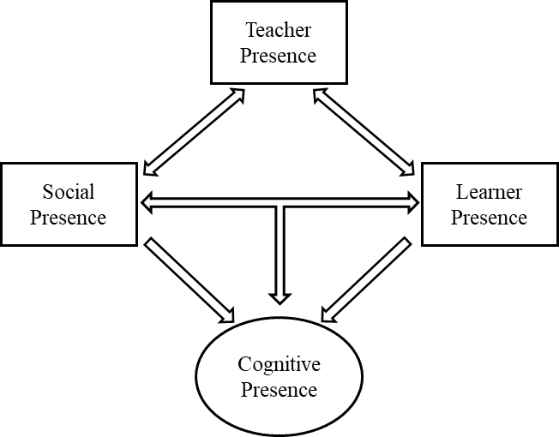

*Figure 3.1.* revised CoI model with the addition of “learner presence” (reproduced from Shea & Bidjerano, 2010, p. 1727)

This added element encompasses the *self-efficacy* of learners when conducting online self-regulated learning, which is moderated by meta-cognitive, behavioural and motivational aspects. Derived from Bandura’s (1986) social cognitive theory, Shea and Bidjerano emphasised the conceptself-efficacy when examining the blended learning experience. The original compass of cognitive presence is seen as insufficient to address the self-reflective aspects of learning. Learning presence is hence introduced to elaborate the online learner self-regulation dimension in the learning matrix.

#### Position of web-based learning system in the blend

As the strengths and weaknesses of e-learning media have been investigated in previous sections, the value of an online learning system in a blended learning environment became clearer. It is reported that early online learning designs focused mostly on the instructor’s perspective, while the self-regulation aspect from the learners’ perspective was generally neglected (Fisher & Baird, 2005). In the previous section, the value of an online SRL component in the blended learning is emphasised. The position of an e-learning system in the course can thus be discussed.

A web-based learning environment is known to have characteristics that allow a great degree of customisation through providing learners with control over their learning (Piccoli, Ahmad, & Ives, 2001). Furthermore, such ownership of learning generally leads to the successful promotion of SRL (Chang, 2010). This effect is further claimed to be specifically significant in language-related learning, which suits the case of this project. It is worth noting that while online learning is seen to support self-regulation, it also depends on the students’ basic autonomy. A key factor of online learning is its reliance on the students’ willingness and ability to actively participate in learning by themselves (C.-H. Wang et al., 2013). The relationship between e-learning and SRL is a reciprocal one.

Automated practice is also a particular strength of web-based tools. Clark and Mayer (2016) explicitly emphasised e-learning’s role in professional training that focuses on skills and performance improvement. This can be related to the previously investigated cost-effectiveness of e-learning implementation. The proper role of a web-based learning system in a blended learning environment thus emerges from this discussion.

#### Support of other components in blended learning environment

Small group projects, student-guided discussions and peer evaluation are effective methods that help students gain self-regulation skills (Fisher & Baird, 2005). An important aspect of this is that the instructor is conscious about leaving students room for their own exploration, since key to self-regulation in learning is the intrinsic motivation generated by the learners themselves.

However, leaving students to initiate the SRL all by themselves could be questionable. Although it is within the constructivist spirit of instruction to encourage free exploration in learning, limitations of such approaches should also be noticed. Many discovery-based instruction designs are said to present too little information for students to make a proper construction of knowledge (Richard E. Clark, 2009). This detrimental effect is more pronounced if the students are new to the discipline and lack prior knowledge (schemas) to assimilate new information (Kirschner, Sweller, & Clark, 2006). Sufficient information is thus recommended before the learners have the expertise to sustain their internal guidance. This highlights the importance of other blended learning components in supporting the e-learning system.

## Self-regulated learning

Self-regulated learning (SRL) has become in recent decades one of the most prominent educational frameworks for explaining learners’ performance and generating effective practical implications (Panadero, 2017). In general, SRL is not narrowly defined; rather, it is regarded as an umbrella term that encompasses a series of core processes, including *goal setting*, *metacognition* and *self-assessment* (Loyens, Magda, & Rikers, 2008).

Various models of SRL have been formulated. Different activities are described, but several central stages are shared by these models. Four key steps are identified in most of the literature: (1) defining tasks; (2) setting goals and planning; (3) enacting strategies; and (4) monitoring and reflecting (Saks & Leijen, 2014). One of the most popular SRL models is the cyclical model of Zimmerman (2000), in which he grouped the key activities of SRL into three phases: forethought, performance, and self-reflection. The model received some tweaks in a later version (see Figure 3.2) with a few more strategies being added to the performance phase with an emphasis on *metacognition* (Zimmerman & Moylan, 2009).

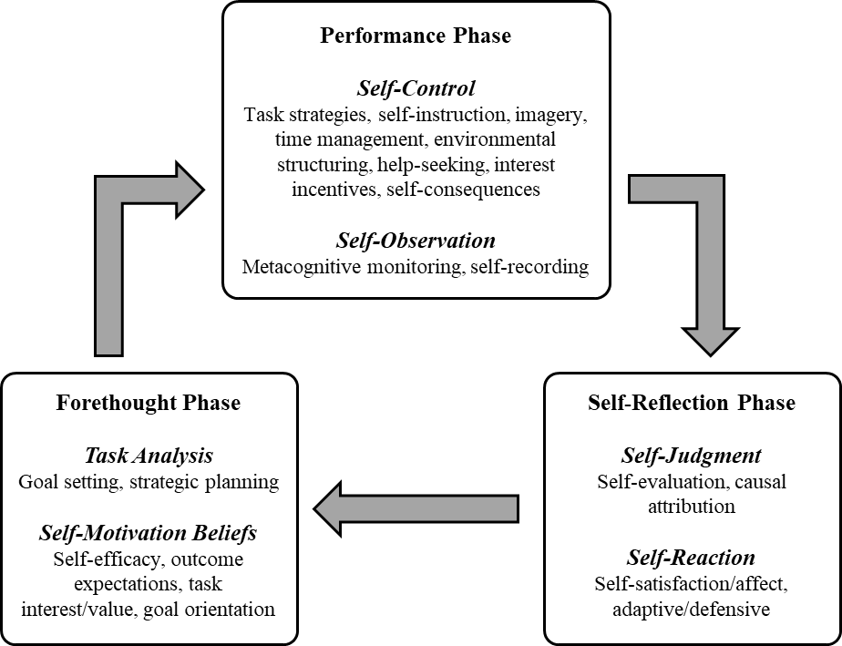

*Figure 3.2.* Zimmerman’s cyclical phase model of self-regulation (reproduced from Zimmerman & Moylan, 2009, p. 300)

In terms of scale, this is different from the more macro-level management of learning such as in self-directed learning. SRL aims to focus on behavioural and motivational self-regulation within a course-scaled, teacher-directed campus environment (Saks & Leijen, 2014). With the structure introduced, the answer of how to guide students to become self-regulated in learning and the means to improve SRL effectiveness should be sought.

### Learners’ self-regulation in learning

Zimmerman (2000) has described three important characteristics of self-regulated learners: (1) they adopt a variety of adaptive strategies for self-regulation; (2) they possess high self-efficacy; (3) they set different goals for themselves. In his later work, Zimmerman (2008) also emphasised the proactive qualities that can be typically found in self-regulated students. These proactive students display self-initiative and perseverance in learning, and they can modify their strategies according to the situation. These qualities are suggested as the results of preferable perceived self-efficacy and metacognitive strategies (Dale H. Schunk & Zimmerman, 2007). From this investigation, the key concepts and factors of self-regulation are introduced.

SRL is often seen as a skill in itself, namely the learning skill of knowing “how to learn” (Kitsantas & Dabbagh, 2010). The benefits of gaining this learning skill include being able to persist through difficulties and to stay concentrated in learning.

There are various ways that self-regulation can be improved in learning. A systematic review of the effectiveness of SRL in the past decade has found that strategies promoting metacognition, time management, effort regulation (persistence) and critical thinking are predictive of learning success (Broadbent & Poon, 2015).

More specifically, in the context of e-learning systems, empirical results indicate that perceived satisfaction towards e-learning and perceived usefulness of e-learning are significant predictors of students’ self-regulation (Liaw & Huang, 2013). Consequently, it can be suggested that the ICT quality is worth considering in the design of the e-learning SRL component. This dimension in understanding the performance of a self-regulated e-learning application can thus be important.

Two essential processes are considered to be at the core of students’ self-regulation: self-motivation and metacognition (Zimmerman & Labuhn, 2012). In educational psychology, self-motivation is largely related to the key concept of self-efficacy. These concepts are examined in the following sections.

#### Self-efficacy

For a learner to achieve effective self-regulation in learning, means and resources need to be provided. Facilitation of students’ development of self-motivation and self-guidance is required, rather than just relying on their mere willpower (Bandura, 1986). The concept of self-efficacy has played a major role in describing self-regulatory behaviours of individuals since its first development. Self-efficacy is concerned with one’s expectation of their own control over their motivation and behaviour required to achieve goals in a social environment (Bandura, 1977). By believing in this capacity, people can make their decisions about certain activities that lead to an intended outcome. Self-efficacy may affect a series of behavioural factors including persistence in the face of difficulties, self-encouragement, and stress levels in taxing situations (Bandura, 1990). Self-efficacy is considered a central factor in SRL, where its motivational aspects are closely related with the specific goal performance. It has been shown empirically that it not only encourages students in learning, but it also improves students’ self-regulation processes and overall learning achievement (Honicke & Broadbent, 2016; Panadero, 2017; Zimmerman, 2013).

In Bandura’s original model, the expectation of one’s self-efficacy is derived from, and influenced by, four principal sources: performance accomplishments, vicarious experience, verbal persuasion, and physiological states (Bandura, 1977). It is suggested that interventions from these dimensions can improve the individual’s self-efficacy towards prescribed tasks. Among these sources, performance accomplishment (also known as *mastery experience* or *enactive attainment*) is noted as the most dominant force (McAlister, Perry, & Parcel, 2008). This experience is induced by enabling the learner to succeed in achievable but increasingly challenging tasks in the direction of desired performance. Vicarious experience is another strong influence on self-efficacy, which is attained by an individual through *social modelling*, whereby people gain confidence from being shown that other people can do it. It is thus recommended to provide learners with detailed demonstrations of complex tasks with easy and simple steps (Bandura, 1977). Verbal persuasion refers to positive social feedback from instructors or peers. Finally, the physiological states and emotional responses experienced through performance of tasks also have an impact on self-efficacy.

Self-efficacy is specifically important in the field of instructional design. Many empirical studies have demonstrated the positive influence of self-efficacy on academic outcomes (Honicke & Broadbent, 2016). Also, induction of self-efficacy in SRL especially contributes to the success of an e-learning system. A successful e-learning model displays an empirically significant relationship between a learner’s self-efficacy in learning-oriented self-regulation (which is called the e-learner’s self-regulatory efficacy) and the perception of learning environment quality (Lee & Lee, 2008). This effect will consequently influence a student’s satisfaction with the learning experience and eventually the learning outcomes.

Self-efficacy is improved along with other main factors of SRL. A recent systematic review of empirical literature has shown that the main factors that give rise to academic self-efficacy include conscious and deliberate goal setting, metacognitive effort regulation, and deep processing strategies (Honicke & Broadbent, 2016). Strategies to promote these aspects of students’ learning experience can thus be focused in order to provide preferable academic results.

#### Metacognition

Flavell (1979) gave metacognition a widely acknowledged definition as “knowledge and cognition about cognitive phenomena” (p. 906). The concept has subsequently been tightly connected with SRL, specifically through cognitive monitoring and regulation. It is generally regarded as a crucial process when the learner monitors and controls their cognitive activities, the optimisation of which can lead to improvement of learning (Serra & Metcalfe, 2009).

Additionally, self-regulatory and metacognitive skills are seen to have a mutually beneficial relationship (Vovides, Sanchez-Alonso, Mitropoulou, & Nickmans, 2007). To put this more strongly, they depend on each other to function. To further specify, three types of metacognitive process are noticed in highly self-regulated students: self-observation, self-judgment, and self-reaction (Zimmerman, 2000). These processes can be seen to be performed in a cyclical fashion, according to which the students make adjustments to their learning activities. Such adaptive learning behaviour is a key consideration in the facilitation of SRL.

The adaptive learning behaviour can also serve to encourage students in their learning through self-motivation. Zimmerman and Moylan (2009) explain that SRL happens when the metacognitive process intersects with motivational beliefs. The cooperative relationship between self-efficacy and metacognition is thus indicated in SRL.

Cues for self-monitoring behaviours are found to enhance students’ metacognitive skills. Small activities like recording the learning time and place can be encouraged to provide significant improvement in metacognition (Chang, 2010).

### The role of practice

#### Drill and practice

A major component in phonetic transcription learning is practice. However, incorporating practice in e-learning under a constructivist guideline is not easy. Drill and practice is generally perceived as a representative method of behaviourist pedagogy. The reason for its close association with behaviourism is mostly due to its stimulus–response pattern, reinforcement implementation, and attached necessity of repetition (Ornstein, 1990). Consequently, the method has been frequently criticised in the context of the eclipse of behaviourist pedagogies. The pejorative name “drill and kill”, as applied by its critics, associates the approach with an unmotivated, simplistic and restrictive form of learning (Fletcher, 2009; Warschauer, 1996).

Nevertheless, counter-arguments have been made that defend drill and practice. Ornstein (1990) has maintained that in many cases of learning, certain basic and simple knowledge and skills are required as the prerequisites for implementing more complex and difficult tasks. Drill and practice is here considered to be especially effective, since it provides adequate learning and mastery of such prerequisites. Heward (2003) echoed this point by validating the “rote fashion” of carrying out drill and practice, particularly to develop students’ fluency in performing the “tool skills” that they need for complex tasks and problem solving. He also regarded the constructivist idea of facilitating even basic skills through the construction of learners’ own meanings throughout active problem solving as “placing the cart before the horse” (p. 191).

Further justification of drill and practice, especially when it is conducted within e-learning technologies, looks to its remarkable cost-effectiveness. Early experimental evidence suggests the clear cost-effective superiority of computer-based drill and practice among alternative types of instruction (Fletcher, Hawley, and Piele (1990).

In language-related learning, practice centred programmes remain relevant for the most part. It is argued that learners can obtain a sense of security when revising independently with drill and practice approaches (A. Walker & White, 2013). This style of training is also considered as highly effective in achieving accuracy in focused learning objectives where phonetic transcription learning obviously fits (ibid.).

The practice of a certain skill is recommended to be implemented in a way that resembles the final use of the skill. Drill and practice methods are sometimes criticised on this ground. For example, in language acquisition, mechanical drills on speech production are not an effective practice because the skill of speaking is ultimately for communicating meaning instead of imitating sounds (VanPatten & Benati, 2015). This is not, however, a valid criticism in relation to the subject of this research, since the pragmatic end of phonetic transcription is the skill of recognising and transcribing auditory sounds, which directly conforms to the designed practice activities.

#### Skill acquisition theory

The learning of phonetic transcription on the course involves the acquisition not only of knowledge but also of the transcription skill. DeKeyser (2015) proposed that language skills are like other general skills that benefit greatly from practice. In his Skill Acquisition Theory, cognitive knowledge is distinguished from knowledge of skills (procedural knowledge). The learning of such knowledge goes through three distinct stages of development, namely *declarative*, *procedural* and *automatic*.

Solid evidence from as early as the 1980s has shown that human’s long-term memory is divided into two distinct types: explicit memory (“know that”) and implicit memory (“know how”) (e.g., N. J. Cohen & Squire, 1980; Graf & Schacter, 1985). Explicit memory, also known as declarative memory, refers to the conscious knowledge of a certain piece of information about facts or experiences, which can be retrieved and described. On the other hand, implicit memory, which is alternatively called procedural memory, is associated with unconscious mental processing that can only be assessed by behavioural performance, which is tacit and not articulable (J. R. Anderson, 2013; Taatgen, Huss, Dickison, & Anderson, 2008). Whereas the declarative memory stores most of the “surface knowledge”, the procedural memory is in charge of mastery of skills.

Skill Acquisition Theory suggests that the relevant declarative knowledge can be effectively transformed into procedural knowledge via “acting on” this information and turning it into behaviour. This process is known as the *proceduralisation* of knowledge (DeKeyser, 2015). Empirical results show that knowledge can be stored as declarative memory at a fast rate, which can be achieved with one or very few exposures (Ullman, 2015). In contrast, the learning in the procedural system would be considerably slower and require an extended amount of practice.

After procedural knowledge has been achieved by way of a basic level of skill mastery, continuous practice as reinforcement of the behaviour would then lead to a gradual process named *automatisation* (DeKeyser, 2015). As the process of knowledge becomes automatic, the skill performance is changed from a slow and declarative knowledge that prescribes execution into a smooth, spontaneous and rapid behaviour. Both the speed and the quality of such behaviour will be improved. This is in accordance with some language learning research results (VanPatten & Benati, 2015). In practice, the accuracy and fluency of language skills are found to relate to each other: that is, the speed of processing language items increases with improved accuracy.

One criticism of the practical value of the Skill Acquisition Theory is its limited effectiveness with only a narrow range of learners; more specifically, the engaged learners are expected to be mature and highly motivated, and to focus on a skill with a relatively simple structure in the early stages of learning (VanPatten & Benati, 2015). The current research project, however, seems to fit well into the category.

### The role of Assessment

#### Classification of assessment and its relation with learning

Traditionally, there are two major types of assessment, which are defined by Scriven (1967) as formative and summative assessments. Generally speaking, the former is conducted throughout the course, whereas the latter is conducted at the end of the course. The characteristics of the pair can be presented as follows:

**Formative assessments –** Throughout learning, flexible forms, formal or informal, suggesting

**Summative assessments –** End of a period, typically grades and marks, determining

As a famous quotation by Robert Stake states: “When the cook tastes the soup, that’s formative. When a guest tastes the soup, that’s summative” (Scriven, 1991).

The categorisation of assessments in learning has been furthered by Earl (2012). He described formative assessment as the assessment *for* learning and summative assessment as the assessment *of* learning. Additionally, **self-assessment** has been introduced as a third category, and is considered to be assessment *as* learning. This suggests that when assessment is conducted by the learners, such practice itself results in a learning effect. Bull and McKenna (2003) also distinguished self-assessment from the formative assessment in their categories of computer-assisted assessment methods, although they mentioned that formative assessment could be monitored by a tutor or be conducted purely by students themselves.

The relationship between assessment and learning has been an interesting topic in the field of educational technology. It is a conventional assumption that assessment can be set as a drive for learning (Mclachlan, 2006). Moreover, formative assessments in general provide students with a measure of progress from a standardised view. By self-assessing, a learner can gain a clearer awareness of progress as well as momentum for further improvement. The motivational influence of self-assessment in SRL is especially strong. Various studies have demonstrated the positive effect of self-assessment on learners’ self-regulatory strategies and self-efficacy (Panadero, Jonsson, & Botella, 2017; Sitzmann, Ely, Brown, & Bauer, 2010). Self-assessment is, therefore, considered to play a crucial role in students’ reflection and self-regulation of learning, in so far as such assessments are treated as an important tool to foster the active regulatory process in meta-cognition (Dann, 2014).

Formative assessment through testing can be intrinsically beneficial to learning. Empirical results show that the inclusion of testing results in better knowledge retention and general learning outcomes compared with an equal amount of time spent only on practising (Kromann, Jensen, & Ringsted, 2009). This *testing effect* is also found to be particularly pronounced for skills learning. Repeated testing provided with feedback is also reported to enhance long-term information retention (Larsen, Butler, & Roediger III, 2009). In this light, testing is considered not only as an assessment device but also as an important learning tool.

#### Computer-assisted assessment (CAA)

Assessment in a blended learning environment can be assisted by ICT for many reasons. The automation provided by computer programs could significantly reduce human effort in providing results to both students and lecturers. This may result in increased frequency of assessment and feedback that can motivate students to continue practising (Bull & McKenna, 2003; Csapó, Ainley, Bennett, Latour, & Law, 2012). The multimedia capacity of ICTs also broadens the range of feasible assessments, allowing for the possibility of more test methods (Ruth C Clark & Mayer, 2016). CAA is produced by objective means, which eliminates human error and bias in judgments, in the process improving the outcome precision and consistency (Bull & McKenna, 2003).

Among various delivery venues, formative assessment is seen to be most effective when provided through computer-based tools (Kingston & Nash, 2011). Additionally, such CAA delivery is found to be particularly suitable for professional development in language-related subjects (ibid.). Empirical results have displayed that online formative assessment significantly contributes to the reduction of test anxiety, which leads to improved performance (Cassady & Gridley, 2005).

#### Feedback strategies

Feedback-giving strategies are essential to the implementation of CAA. This aspect should also be considered within the context of online SRL system components in a blended learning environment. Hattie and Timperley (2007) categorised different types of feedback into four levels of feedback: (1) about the task, (2) about the processing of the task, (3) about self-regulation, and (4) about the self as a person. They argued that the most effective feedback strategy employs the first three types of feedback consecutively, and the fourth (about self as a person) is the least effective type. To elaborate, feedback should be provided to the student in a way that moves them from evaluating their task completion, to assessing their processing of the task, and then to an evaluation of their self-regulation (ibid., p. 91). As different levels of feedback are generated, students can advance towards a more effective and deeper learning process. The second and third type of feedback involve some degree of metacognitive self-reflection. For example, the feedback about the processing of the task may help students re-strategise their learning. This point echoes with the metacognitive habit and adaptive skills found in self-regulated learners (Zimmerman, 2000).

A widely cited work by Nicol and Macfarlane-Dick (2006) formulated seven principles of feedback practice with the emphasis on improving learners’ self-regulation:

1. “helps clarify what good performance is (goals, criteria, expected standards);
2. facilitates the development of self-assessment (reflection) in learning;
3. delivers high quality information to students about their learning;
4. encourages teacher and peer dialogue around learning;
5. encourages positive motivational beliefs and self‐esteem;
6. provides opportunities to close the gap between current and desired performance;
7. provides information to teachers that can be used to help shape teaching.” (Nicol & Macfarlane-Dick, 2006, p. 205)

These principles apply to both feedback provided by an external source (an instructor or e-learning system) and feedback that generated internally from the learners. Hattie and Timperley (2007) emphasised the role of the internal feedback that the students use to self-assess. The capability and willingness of creating such feedback are determinant to the effectiveness of the students’ learning and self-regulation. Practice in self-assessment is of critical importance in providing self-regulatory feedbacks.

An additional note should be added here about the positivity of the feedback. It is generally agreed that negative feedback should be avoided in instructional implementations (Nicol & Macfarlane-Dick, 2006). This is especially important in behaviouristic methods like drill and practice. As Skinner (1971) famously said: ”A person who has been punished is not thereby simply less inclined to behave in a given way; at best, he learns how to avoid punishment.” However, Hattie and Timperley (2007) have introduced nuances to this point by arguing that negative feedback can be effective at the level of the self. In other words, self-regulated students can see such feedback as a challenge that leads to their self-control and modification of their learning strategy (Black & Wiliam, 2009). However, this effect is claimed to be beneficial only for students who possess a fair degree of self-efficacy of learning. In addition, the negative feedback should also be given carefully to ensure that it is not obscure and that it presents sufficient explanation (Hattie & Timperley, 2007).

Nonetheless, the choice of feedback delivery is also sensitive to the characteristics of the learning subject. In the context of phonetic transcription, instant feedback is particularly recommended for the exercises (Mompeán et al., 2011). This is suggested to reduce the students’ uncertainty and anxiety in the exercise. Moreover, when the training is focused on the atomisation of a cognitive skill, immediate corrective feedback without further explanation is seen to be sufficient to improve accuracy (Schweizer, Plessner, Kahlert, & Brand, 2011). Different feedback delivery methods should thus be considered in relation to the specific learning and training situations.

## Existing applications for practical phonetics

There are a number of e-learning tools to support Phonetic transcription learning and training today . Existing tools and systems available to the general public can be found online. In this section, a range of different applications for practical phonetics are reviewed. This helps both to identify the gap in the field of phonetic transcription e-learning and to understand how the intended artefact created in this research can offer unique contributions.

Applications that help with phonetic transcription teaching and learning are developed to provide different types of assistance. For example, a number of applications have been produced to assist students with learning the phonological knowledge required before embarking on training in practical phonetic skills such as transcription and production. Phonetic Flash is a typical example of this type of application (Maidment, 2001). It provides students with exercises in the form of computer-generated flash cards that drill their knowledge about the phonemic classifiers of the phonemes. From this, students can gain a level of familiarity with the phonetic symbols and their categorisation.

Multimedia IPA charts for IPA characters are another type of tool frequently used in phonetics courses. These online tools feature an interactive chart of IPA phoneme symbols. By clicking on the phoneme symbols on an IPA chart, the corresponding sound is played, or, in some cases, a video is played of the speaker producing the sound. A few examples of this type of application are discussed in the following paragraphs.

An “interactive clickable IPA chart” is featured on the official website of the IPA. Audio recordings, a transcription function and technical information about the symbols are provided in a pop-up window when a user clicks on characters in the chart (Deroń, 2018). Each symbol is provided with a set of sound recordings produced by four different speakers.

Other typical designs of multimedia IPA charts are Eric Armstrong’s Voice & Speech (2006) and the IPA chart produced by the linguistics department at the University of Victoria (Esling, 2018). In this type of chart, a sound is immediately played once a phoneme symbol is clicked. This design provides faster and more direct feedback to the user, which is regarded as beneficial for associative learning.

In these IPA charts, the phoneme symbols are classified into a range of categories according to their articulation characteristics. Through using the multimedia IPA charts, the students can gain familiarity with the IPA characters and their corresponding sounds, as well as with the classification of these phonemes. It is common practice, therefore, for phonetics courses to provide students with multimedia IPA charts as a fundamental learning resource. Some online systems for phonetic transcription learning have developed their own version of multimedia IPA charts, such as IPA Online at Newcastle University (Khattab & Docherty, 2011).

More specific requirements are sometimes defined by instructors of phonetic transcription too. Automated Phonetic Transcription Grading Tool (APT-GT) is an online application that automates the grading of students’ phonetic transcription exercises (Atkins, Seals, & Bailey, 2019). The issue identified in this project was the limitation in providing students with immediate feedback due to the lack of sufficient human resources. The application was thus deployed to overcome this limitation and meet the students’ feedback requirements.

The most common need for an e-learning application in phonetics learning is to provide transcription exercises. A variety of the most commonly used tools found online have been examined and reviewed. In table 3.2, the pedagogical features of these applications are summarised.



*Table 3.2.* Features of commonly used systems in phonetic transcription learning

Table 3.2 indicates that most of the e-learning tools for phonetic transcription training are web-based. This is unsurprising given the convenience and global accessibility of web-based applications. Some inherent attributes of web-based systems are also seen in most of these applications. Due to the self-learning nature of this type of application, most of them facilitate students with some form of self-assessment. The feedback to students’ exercises produced by these systems is normally automated and immediate, thereby making the most of the advantages of e-learning. However, not all the applications contain a wide range of learning items. And only three of the eight applications reviewed offer levels of progression in exercises, with the other five applications focusing on only one type of exercise material.

Another significant gap in the current applications used for phonetic transcription learning and training is that the exercises are all fixed as pre-set sequences of items. None of the applications examined provides students with a capability to customise their learning to meet their individual learning needs and difficulties. Features that encourage self-regulated learning are also very rare in these applications. Two of the applications reviewed actually provide some features that partially support self-regulation in learning, but each of them has their own limitations.

Both Webfon and the University of Sheffield Phonetics systems require students to transcribe and write down answers by themselves, which promote self-control in self-regulated learning through environmental structuring (S. Bates, Matthews, & Eagles, 2011; G. Walker, 2018). However, the Webfon website provides only a few pre-set sequences of exercise. The limited complexity of the exercises does not enable students to perform their learning and training in a self-regulated manner. Crucial aspects in self-regulation, such as goal setting and self-reflection, are not facilitated. In the case of the University of Sheffield IPA learning tool, a set of exercise sequences are centred on the multimedia IPA chart in the system. The students are asked to execute the exercises completely by themselves, including finding the training items in the IPA charts, playing the sounds and checking the answers manually. Little facilitation is provided by the e-learning system, which does not make the most of the advantages of e-learning approaches. Although the design requires students’ self-regulation, it also involves too much task-irrelevant effort.

None of the examined systems has sound production exercises included. Most practical phonetics courses seem to prefer completely separating phonetic pronunciation from the transcription exercises. It is suggested that exercises in phonetic speech production are beneficial to phonetic transcription learning and training, as discussed in the literature reviewed early in this chapter. The lack of such exercises can thus be seen as a gap in the existing phonetic transcription training applications.

Another notable phenomenon is that although the design and development of e-learning applications in phonetic transcription training is not rare, such applications are rarely discussed in the academic literature (M. Ashby, 2008). Few publications in recent years report the design process and the pedagogical consideration of a phonetic transcription learning system. The discussion and theorisation of such efforts can, therefore, be regarded as neglected. The present research aims to fill this gap in the field, and to consider the design and development of e-learning applications from both a practical and a theoretical perspective.

## State of the art in Educational Technology

There have been huge advances in educational technologies in recent decades. Bond, Zawacki‐Richter, and Nichols (2019) analysed papers published in the British Journal of Educational Technology (BJET) between 1970 and 2018, and summarised the main issues and key themes for each decade. The dominant technology used for educational purposes has shifted from the multimedia and audio-visual tools in the 1970s and 1980s to computer-based applications and online learning in the 1990s, which later evolved into online collaborative learning since 2000. The analysis has shown that the key themes in BJET papers in the current decade are learning analytics and mobile collaborative learning, which focus on end-user personal technology and, especially, on mobile device technologies.

According to another review of journal papers from 2002 to 2014 in the field of educational technology, collaborative learning, problem-based learning and mobile learning were the most frequently examined learning approaches, along with computer-assisted learning (Baydas, Kucuk, Yilmaz, Aydemir, & Goktas, 2015). More sophisticated instructional models for online learning and blended learning have been further developed and examined. Popular examples include mobile collaborative learning (Kukulska-Hulme & Viberg, 2018) and flipped classroom (Lo & Hew, 2017). While no particular prescribed technologies are required for these instructional models, emphasis has been put on publicly accessible ICT tools like mobile phones and tablets. Mobile learning has shown generally promising results for both PK-12 and higher education (Crompton, Burke, & Gregory, 2017; Pimmer, Mateescu, & Gröhbiel, 2016). The benefits of mobile learning are also seen to be more notable when it is implemented according to instructionist/behaviourist approaches to learning. This makes mobile learning a suitable candidate for phonetic transcription learning and training.

A flipped class is implemented when traditional classroom activities (e.g., instructor presentation) are provided to students at home through educational technology, and traditional home activities (e.g., homework) are brought to and facilitated in classrooms (Bergmann & Sams, 2012). The flipped classroom is generally considered representative of learner-centred instructional models where the instructors facilitate the students’ learning. Specific advantages like increased learner satisfaction, engagement, and motivation are frequently reported in addition to the general improvement in the learning performance of the learners (Akçayır & Akçayır, 2018).

Three-dimensional (3-D) virtual environments first appeared a decade ago and are gaining increasing attention in the field of educational technology. More specifically, 3-D virtual learning environments (VLEs) have been adopted in many instructional settings in recent years. Dalgarno and Lee (2010) summarised five areas that 3-D VLEs can facilitate: (1) enhancement of special knowledge representation; (2) learning tasks that are impractical or impossible in the real world; (3) increasing motivation and engagement; (4) transfer of learnt knowledge and skills to real situations; (5) improvement of learning collaboration. These aspects can presumably benefit the learning and training of phonetic transcription skills. Increasing scholarly attention has been directed towards virtual reality (VR) technology in recent years, particularly after the commercialisation of easily accessible later generations of VR headsets (Freina & Ott, 2015). However, a later review conducted more specifically on the educational use of VR head-mounted displays has suggested that the technology seems more limited in its ability to help with special and visual knowledge learning, psychomotor skills training and emotional controlling (Jensen & Konradsen, 2018).

Developed in parallel with VR, augmented reality (AR) technology has also received some attention from researchers. AR is defined as a technology which overlays simulated components into the real world. It has the following features: (1) virtual and real objects coexist in a real environment; (2) the objects have real time interactions; (3) the real and virtual objects are aligned with each other (Azuma et al., 2001). Although applications with AR technology have been discussed over more than two decades, it has only recently been implemented in educational settings (Cheng & Tsai, 2013). Reported positive outcomes of adopting AR in instruction often include improved learning performance and motivation to learn. Other benefits, such as enhanced engagement and perceived enjoyment of learning, are also reported, which echo the research conducted on VR educational tools (Chen, Liu, Cheng, & Huang, 2017).

Educational games and virtual worlds have also been emergent trends in learning environment research in the present decade. Academic attention to these areas has been found to be second only to the previously prevailing computer/web tools and multimedia learning (Baydas et al., 2015). Digital games have been employed in various educational cases and have shown promising results in improving learning. Serious games (those that use entertainment for educational purposes) have proven effective in comparison with non-game conditions (D. B. Clark, Tanner-Smith, & Killingsworth, 2016). Interest in adopting game mechanics in education forms a spectrum from the inclusion of gamification features in the design of e-learning applications, to all-encompassing virtual world game systems like Second Life (Gallego, Bueno, & Noyes, 2016). Educational games, mobile apps and virtual simulations have demonstrated great potential to promote learning results and, more specifically, to enhance the gratification of the learners (McCoy, Lewis, & Dalton, 2016). The research and development of gamification is one of the fasting growing areas in the field of educational technology.

The large amount of user data collected from online learning tools and the recent advancement of big data processing methods have enabled new practices in the field of educational technology, namely Learning Analytics (LA) and Educational Data Mining (EDM). LA and EDM are closely related areas in educational technology research and practice, and they involve the computerised and automated analysis of large collections of educational data in order to understand and optimise learning and its environment (Papamitsiou & Economides, 2014). Research and development in these areas have given rise to more complicated systems and derivative technologies, such as Intelligent Tutoring Systems (ITS), user modelling, and adaptive personalisation. From such emergent technologies that apply LA and EDM methods, a set of outcomes is intended that will help improve learning. For example, from the prediction modelling method, the students’ knowledge of a specified topic may be inferred, which also provides a long-term prediction of their learning and future preferences. Adaptive learning routes and automated feedback can also be generated through ITS and provided to individual learners as personalised learning (Baker & Inventado, 2016). Constructivist instruction designs can, therefore, more particularly benefit from these methods in practice.

## Conclusion

This chapter began by investigating the broad understanding of human learning as presented in learning theories. This provided the context for supporting effective learning. The investigation then focused on the particular subject matter of the research problem: phonetic transcription learning. By examining the characteristics of the learning subject, specific aims of the improvement in learning can be yielded. To decide how e-learning can be employed to achieve the identified goals, aspects of e-learning technologies were then discussed in detail. This led to consideration of the blended learning environment in which the e-learning tool is embedded. From this point, the role of e-learning in the course could be clearly defined. SRL was then decided to be the main aim of the intended e-learning system. More specific activities in SRL that are essential to the e-learning system design have been examined, and the importance and characteristics of practice and assessment further understood.

This knowledge from the literature constitutes a main source of guidance for the design of the intended artefact. In the next chapter, the design process will be presented following the ideas learned in this literature review. The requirements for the artefact design will be identified, and the design suggestion will then be outlined. Following this, the chapter will present a detailed description of the artefact as a main outcome of this research.

# Design of the System

## Design in design science research

The e-learning system in this research was named *Phonetics Student Self-Learning Tests* (PSST) by the teachers of the phonetic transcription module. The system will be referred to by this abbreviation in this thesis. In this chapter, the design process of the PSST system and the potential knowledge contribution according to the design science research (DSR) methodology are discussed.

Gregor and Hevner (2013) defined a matrix of DSR project contexts and discussed the potential knowledge contribution related to these different types of research projects (see Figure 4.1). In this framework, four types of DSR research are differentiated: invention, improvement, exaptation, and routine design. As illustrated in the matrix, the solution domain axis indicates the maturity of existing solutions to the research problem. The other axis was originally labelled “application domain maturity” and later interpreted as “problem domain maturity” by V Vaishnavi et al. (2004/2017), as presented in the figure. This axis indicates the maturity of understanding of the problem. This matrix helps the researcher to define aims and research goals in a DSR project, taking into consideration its context.

Phonetic transcription learning has been established as a field for a few decades. However, the instructional methods used in the field have predominantly been limited to a traditional instructivist style (Munson et al., 2010). Additionally, the teaching and learning of phonetic transcription have only recently begun to benefit from a range of more flexible educational technologies, especially in the area of e-learning (M. Ashby, 2008). The aim of this research is to find an innovative implementation of an e-learning component in a blended learning course design that follows constructivist pedagogical principles. There is no existing solution in the field of phonetic transcription teaching and learning. An exploratory approach to achieve this research aim is thus apt in this context. Therefore, this research fits the invention domain of the DSR project context framework. Its knowledge contribution is considered accordingly.

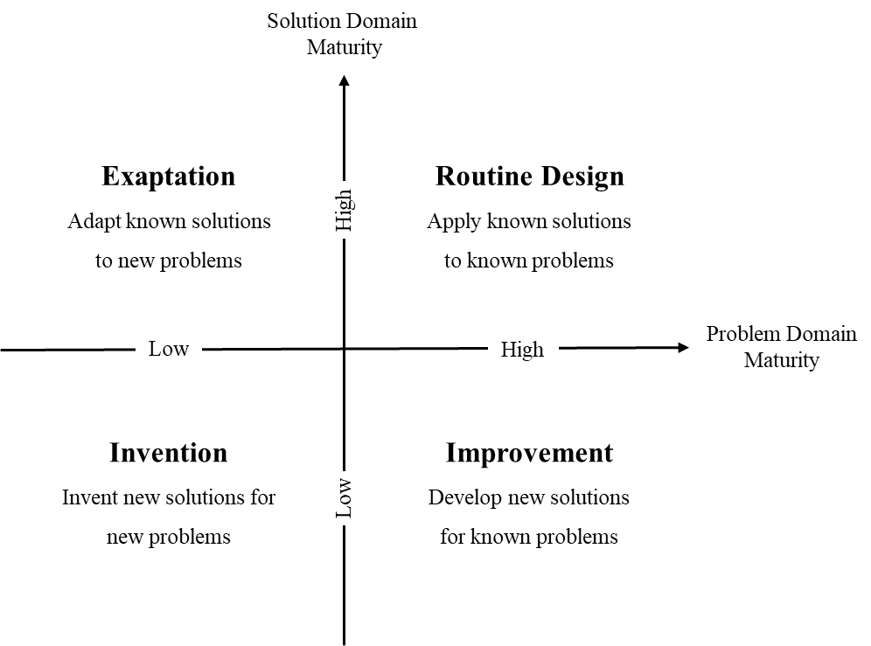

*Figure 4.1.* DSR project context framework (adapted from Gregor & Hevner, 2013, p. 345)

As Gregor and Hevner (2013) indicated, new solutions to new problems aim to result in original and interesting applications. A key contribution is the conceptualisation of the problem. Phonetic transcription skill has long been seen as a matter of instructor-led behaviouristic training. The aim of addressing its learning in a learner-centred constructivist style has not previously been undertaken. Hence, this newly defined problem requires an exploratory effort in the research process. Given the lack of an existing solution, previous knowledge consulted in the form of kernel theories tend to be broader and not directly practical. The design has to be based on the understanding of the more fundamental natural phenomena of learning and tacit knowledge.

In this type of DSR project, the instantiation (i.e., the resulting artefact) plays a central role in the research outcomes. Most inventions in DSR projects result in a material artefact (Gregor & Hevner, 2013, p. 346). Additionally, DSR tries to explore novel possibilities that may or may not result in ideal performance. Due to the uncertainties in the solution design, knowledge generation in this type of research is typically from prescriptive to descriptive knowledge. In other words, the artefact is the attempt to address the novel problem, and, by evaluating and reflection on its performance, descriptive and potential explanatory knowledge can be yielded.

The design process of the PSST system is presented in the following section, after which the resulting construction is described and demonstrated. The design will serve as an object for evaluation and a lens through which to observe the interaction between the learners and the technology in the fulfilment of the research goals.

## The Development of the PSST System

This section provides a descriptive account of the development process of the PSST system. The development model was decided during the first few meetings of the project, and a Rapid Application Development (RAD) incorporating prototyping was adapted according to the circumstances of this project (Hughes & Cotterell, 1999). The project began with an initiation meeting, after which the field investigation and literature review were carried out to inform the design decisions that were made in a second meeting. This meeting then led to three cycles of prototyping (i.e., mock-ups, prototype 1 and prototype 2). As shown in the Figure 4.2, a finished functioning system resulted at the end of the development process and was ready for formal evaluation.

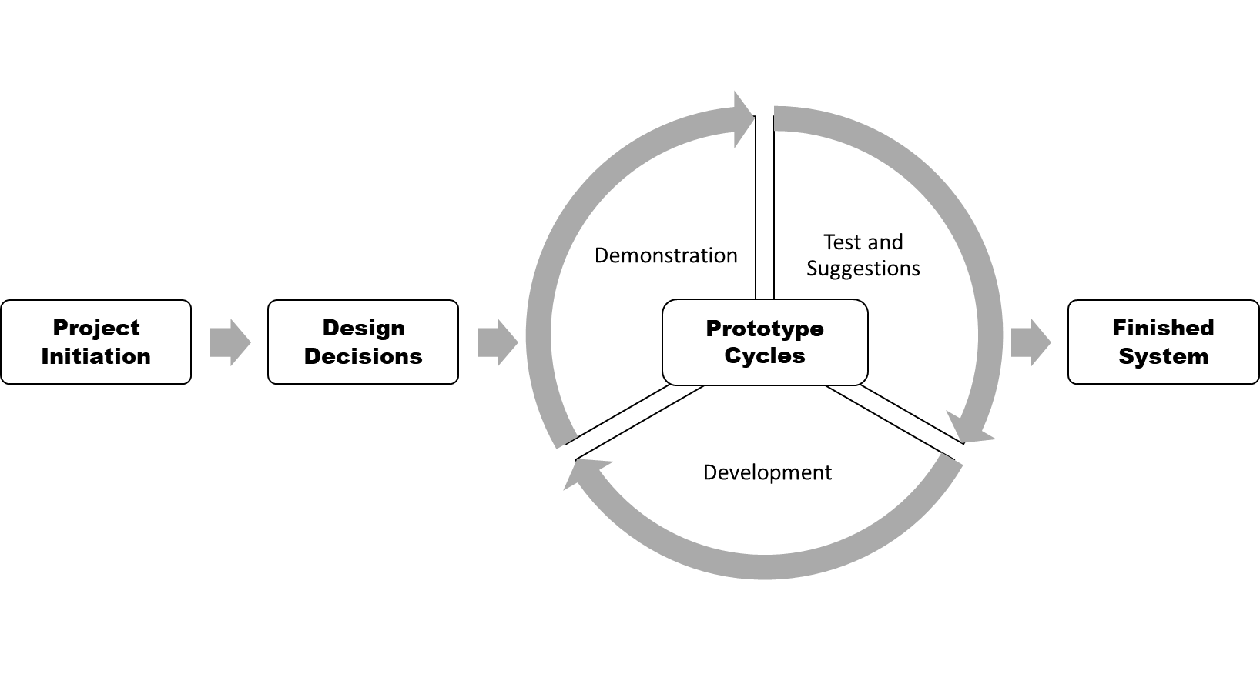

*Figure 4.2.* Development stages of PSST

Five main meetings marked the milestones of the design and development process, each of which is described later in this section, along with the subsequent development activities. The RAD prototyping development methodology is reflected on at the end of this section.

### Meeting 1: Project initiation

A project-initiating meeting between the system designer and the instructor in phonetics was held in order to clarify the common interests of both stakeholders, the most important of which was the creation of an e-learning artefact.

The module coordinator of foundations in phonetics at Birmingham City University (BCU) first introduced the context of the project to the group. This information related to the field of speech and language therapy, the student cohort and the course on phonetics. The basis for understanding practical phonetics and its teaching and learning were introduced to the e-learning system designer, covering areas such as vocal sound production, the International Phonetic Alphabet (IPA) and phonetic classification. The instructor proceeded to provide the details of the instructional practices in the course pre-project. The blended learning environment of the phonetic transcription course consisted of traditional lectures, digital learning materials and small-group practical workshops. The instructor expressed the intention to accommodate an e-learning system within the current setup, with the main motive being to reduce the considerable time and effort required from the instructors.

The primary requirement specified here by the phonetics instructor was, therefore, the computerised automation of the phonetic transcription exercises that had previously been delivered manually. Such exercises were directed through voice dictations provided by the teachers in the classroom. They then provided students with the corresponding answers in phonetic symbols displayed on a screen. There were existing computerised tools that stored sound items and their phonetic transcriptions. The instructor thus inquired about the idea of an online archive where dictated sounds could be stored as digital items and reused indefinitely. A design decision was, therefore, made first to create a database for storing the various sound items and their corresponding phonetic transcriptions.

Another important aspect discussed between the instructor and the designer was the platform inside which the e-learning system nests. The instructor stated that the student cohort who would use the system did not necessarily share the same preferences in their digital technology use. This potentially would lead to the difficulty of providing different installation methods for operational system comparability. For the system to be accessible across platforms and devices, an installed software might not have been suitable. In addition, the design principle for e-learning accessibility is to take advantage of online platforms that avoid time and location restrictions. A web-based system was thus suggested by the designer to be the medium of the learning materials, as such a system would be accessible anywhere from most personal digital devices.

This meeting led to further discussion on the potential of an e-learning system to improve the learning and training of practical phonetics. From the researcher’s perspective as a participant in the project, the innovative aspect of the artefact was of more interest. This meant that the resulting artefact would not be designed and developed as a mere digitalisation of the learning material and automation of the sound dictation. The exploratory design approach of this e-learning system should allow attempts to identify novel problems in the wider field of this research. The instructor demonstrated a few existing systems that were used at the time for phonetic transcription training. These systems all provided only traditional computerised drilling, whereby learning items were stored and retrieved for simple iterative exercises. Individualisation of students’ learning was not facilitated by these systems. The idea of exercise customisation in the practice of phonetic transcription was then brought into the discussion. This led to the planning of the second meeting at which further functionalities of the e-learning system would be discussed. The second project meeting was to take place a month after the first meeting; during the interval between meetings, the researcher initiated a pre-development investigation, including a literature review, and produced a research proposal.

### Pre-development investigation

A literature review and further field investigation were carried out before the second meeting. From consulting literature on constructivist learning theory, the design principles of the system were initially established. For example, the e-learning system was planned to promote an open learning experience and to enhance learner-centredness and learning individualisation. The instructor and the system were intended to play facilitating roles instead of fixed, dictating ones. The advantages and drawbacks of e-learning applications were also examined. The design and development process could thus be conducted in light of considerations of such characteristics. Literature on teaching and learning practical phonetics was also examined. The current pedagogical methods used in the field mostly consist of oral dictation and drilling. This is commonly reported as being extremely laborious and time-consuming. Next, existing e-learning tools were reviewed comprehensively. Phonetic learning that meets learners’ individual needs was not found in those applications. The visible gap of providing learner-centred instruction was found to leave room for innovation in the design of the e-learning system. A brief design of an application that would facilitate customisable phonetic exercises was conceptualised.

### Meeting 2: Main design decisions

In the second project meeting, the researcher reported the progress in reviewing the literature, which had led to the adoption of constructivist learning theory. This suggested the instructor should take a pedagogical approach that centres on the students. The system designer demonstrated the feasibility of exercise customisation in a web-based e-learning system. Both of the stakeholders then agreed on this decision. The required specifications that allow such customisation were discussed in the meeting. Prerequisites of customisable phonetic exercises include categorisation and specification of the learning material, which are sound items in this project. These items are classified into main categories that reflect difficulty levels of learning progression. The instructor’s expertise was thus required to provide the characteristics of the learning items. The development decision made here was to store the sound items in a database with specified metadata labelling of relevant categories and subcategories. The material files consisted of four main different categories of sounds: phonemes, English words, nonsense words, and connected speech. Each category of items was further classified according to the items’ specific qualities, such as whether an item contains a monophthong vowel or a diphthong vowel. The decision made here was to enable the students to tailor their exercises with precision, so that their individual learning needs were met and were in accordance with their learning progression. The level of categorisation of items was then discussed in the meeting and a menu tree was drawn and agreed by both of the stakeholders.

The system development methodology was discussed by the stakeholders. In order to enhance interactivity for interdisciplinary collaboration while allowing agility and flexibility, prototyping in a RAD fashion was suggested by the researcher to be the development method. The exploratory nature of this design project also required risk reduction, which could be achieved through frequently produced and tested mock-ups and prototypes. This was agreed by the phonetics instructor.

The project then proceeded to the first development stage. Another meeting was arranged for the demonstration of the first mock-ups before the first prototype of the artefact went into development. The meeting for system mock-ups would be held two months later.

### Mock-ups development

In the first development stage, the designer set up an Apache Web Server on an Ubuntu operation system. MySQL and PHP were also installed for database operations. A few tests were carried out by the designer to make sure the platform functioned well. The researcher then designed and developed interactive mock-ups for the system menu. The researcher continued to consult academic literature for e-learning design insights.

During this period, the lecturer was requested to produce recordings of exercise sounds. These sound files were required to be paired with detailed labelling for later database entry.

### Meeting 3: Mock-ups

Prior to the first prototype of the e-learning system a meeting was held once a few mock-up menus had been produced by the system designer. Figures 4.3 and 4.4 display the system menus for exercise customisation.

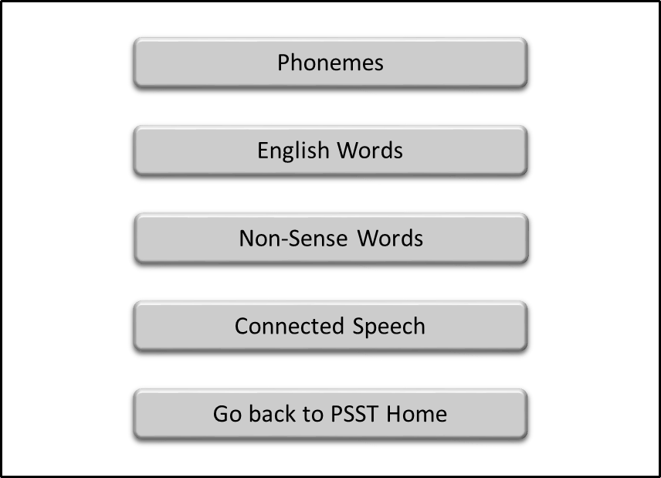

*Figure 4.3.* Main menu mock-up

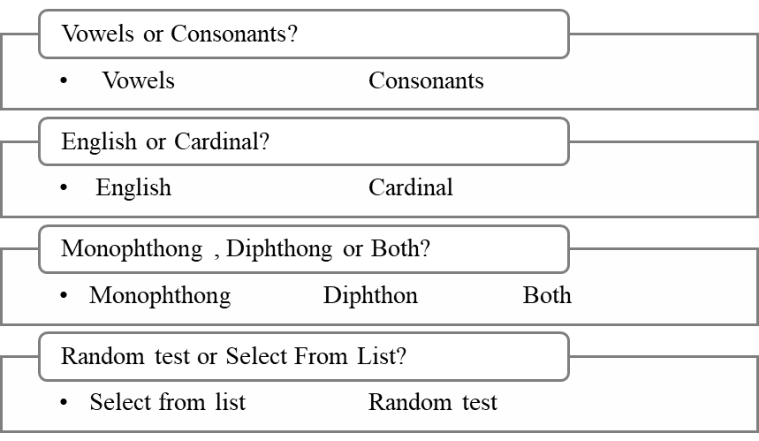

*Figure 4.4.* Customisation menu mock-up

The system designer proposed a feature that would simplify and clarify the site interface. The customisation menu in the mock-up displayed too many options at once, which might confuse and overwhelm users. It was therefore decided that the menu should display one level of options at a time, with the next level of options being enabled by selecting one of the options at the previous level. This feature could significantly reduce the complexity of the interface, hence leading to better usability.

Another core aspect discussed in the first prototype meeting was to provide students with more opportunities for self-assessment. After further consultation of the literature on feedback and assessment, a system function was suggested by the researcher. Adding variety to feedback provision in the system was considered so that students would be enabled to perform both drill exercises and self-testing. This feature could be realised by a relatively simple design, whereby the transcription answers to each sound item would be optionally provided after each test item or at the end of a series of items. Through this design decision, another dimension of the learner-centredness was added to the system. This feature was agreed by the instructor. The first prototype meeting was then planned by both stakeholders to take place after a month of development.

### Development of prototype 1

The development of the first prototype of the PSST system was carried out after the previous meeting. An initial functional interface was constructed with early test items stored in the database. The system had three main constructional parts: the phonetic transcription exercise, the phonetic pronunciation exercise, and the database administration interface. The pronunciation exercise part shared structural similarities with the transcription part. And the database administration interface provided convenient means for instructors to add and update learning materials within the system. Given the interest of this research, only the development of the transcription exercise part of the system was demonstrated. As shown in Figures 4.5 and 4.6, the functional interface of the system menus was readily accessible via an Internet browser.

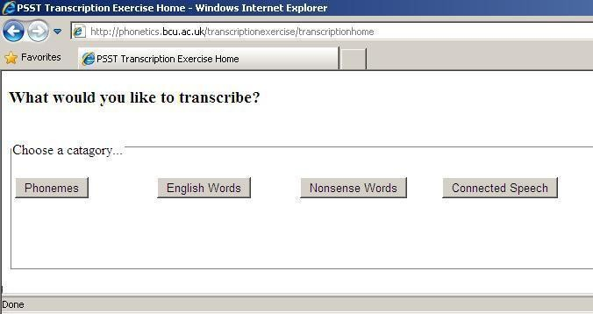

*Figure 4.5.* Prototype 1 – main menu

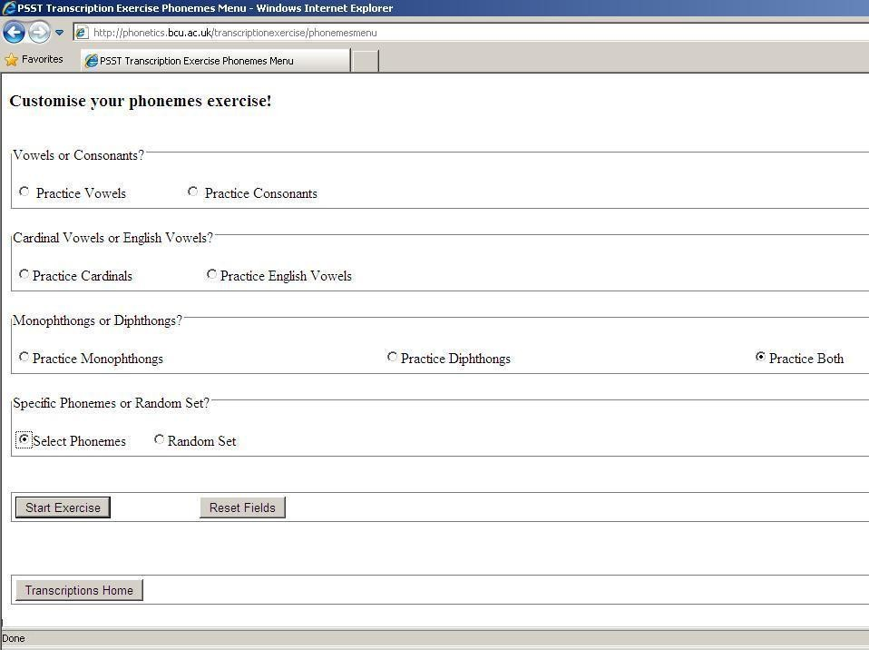

*Figure 4.6.* Prototype 1 – exercise customisation menu

Developing the first prototype of the system revealed several technical issues. First, the IPA contains uncommon symbols that were not displayed correctly with regular typefaces. Secondly, the sound-playing function was realised through a QuickTime player. This required the user to download and install the plug-in upon playing the sound for the exercises. This was considered inflexible and inconvenient for the students. So, an alternative playback function was sought by using the default Media Player commonly available in most operational systems. Finally, the test mode that had been decided in the previous meeting was realised through a concatenation function of the default player. This feature necessitated the sound items to be played continuously. For better control of the exercise, more playback functions, such as pausing and going back to the previous sound, were thought to be suitable in this situation. These problems were noted and were to be reported to the instructor in the first prototype meeting.

### Meeting 4: Prototype 1

The first prototype was uploaded to the server before the meeting. The instructor was able to test the prototype system and note any problems and further development requirements. During the prototype meeting, these notes were discussed with the researcher.

The technical problems encountered during the first prototype development were reported to the phonetics instructor. These were discussed in the meeting and solutions were sought. The display typeface for IPA symbols was suggested by the instructor. The technical typeface Doulos SIL was then adopted for this purpose. The QuickTime player installation was thought unsuitable for the system and it was agreed that the Media Player alternative should be the sound player for the system. Finally, the playback function was thought insufficiently sophisticated for carrying out smooth customisation of exercises. More functions to play back the exercise sound items were required by the instructor, and it was noted that these should be easy to use. The decision was made by the researcher that these features could be achieved through JavaScript coded playback buttons. Each of these buttons should be coded individually to fulfil the specified playback activity, like skipping to the next sound, pausing or repeating the sound. This design both enhanced the functionality and reduced the complexity.

Other minor improvements of the prototype were also suggested by the instructor in the meeting. One example was adding “return to main menu” buttons for better navigation in the system. Another example was to make the length of the exercise customisable via a drop-down menu (Figure 4.7). The instructor suggested that this should be changed. It was considered more suitable for the user to be able to have any number of questions in customising their exercises.

The second prototype meeting was planned to take place after three weeks of development.

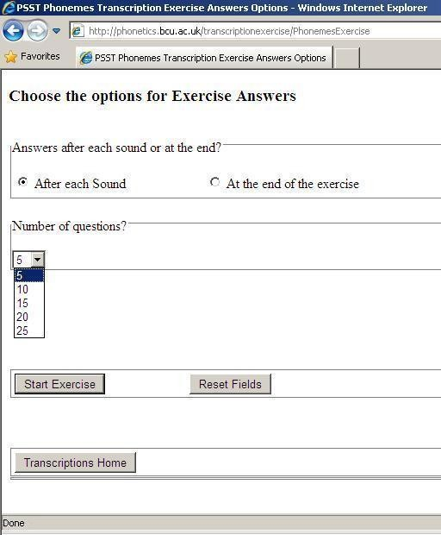

*Figure 4.7.* Prototype 1 - answer display options

### Development of prototype 2

The first prototype of the PSST was planned to serve the purpose of realising the main functionality of the system. Prototype 2 was then intended to be a relatively complete system ready for final consistency testing and debugging. Since the sound files in different categories were mostly produced for a testable system, the researcher could complete the database input in prototype 2 and provide a full-scale functioning system.

At this point, a decision was made to further the user-centred design principle. To allow the users voluntary use of the system, instructional text guiding the user through the system was provided. It was also important for the self-guided use of the system to be accompanied by an intuitive and minimalist interface design for better usability.

The interface of the PSST system was fully designed and developed in light of HCI design principles. The exercise item selection and answer display options were tested by the designer for debugging before the delivery of prototype 2. The prototype was then uploaded for the user testing provided by the instructor.

### Meeting 5: Prototype 2

The second prototype test result was very positive from the instructor. The instructional test that guided the students through the exercises was approved. Tweaks to the interface design were suggested by the instructor. Additional usability features were also advised for the final prototype before evaluation. For example, a navigation bar under the website banner was proposed for better user mobility within the system. The playback functions embedded in the media player, as shown in the prototype 2 screen shots, were considered less intuitive and not in line with the other control features of the interface design. Accordingly, they were changed into buttons with specific actions displayed in text. Such changes to the interface design were intended to ensure that the system better facilitated users without the users needing external help or guidance to use the system. A few screen shots of the system before the final prototype was finalised are provided below.

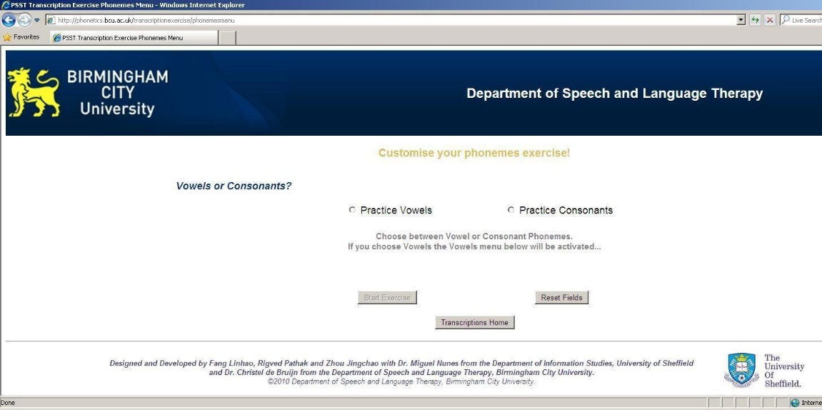

*Figure 4.8.* Prototype 2 – customisation screen

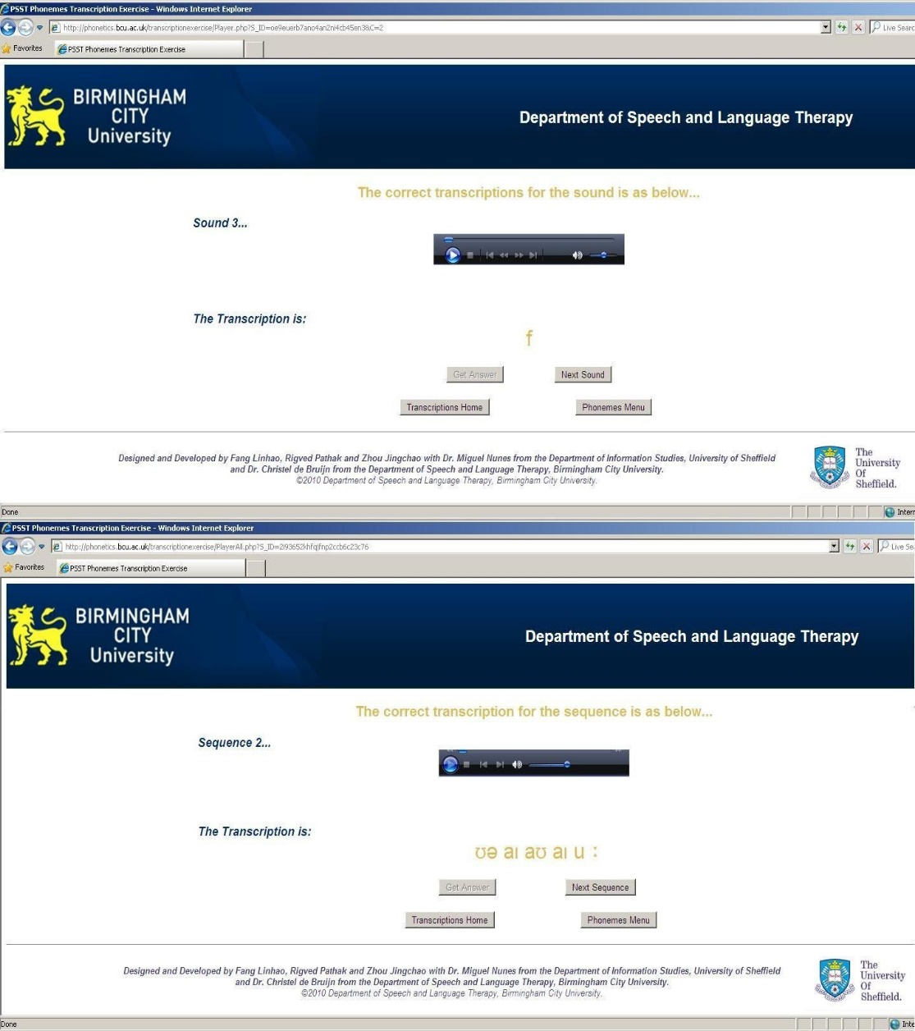

*Figure 4.9.* Prototype 2 – phonetic transcription exercise page

### Development of the finished system

Following the second prototype meeting, the system was developed to reach its final stage. The finalisation of the system was to include consistency checking and the debugging process. The look and feel of the system interface were also smoothed at this point. A proof-reader was hired to check all the text in the system. The buttons and spacing on the frontend were properly resized after discussion with the instructor. It should be noted that several sub-prototype meetings were held through Skype video chats. These short meetings served to refine the details and resolve technical errors in the final stage of prototype development.

### Final thoughts of the development process of the PSST

The adaption of the RAD prototyping method was demonstrated in this section. The requirements for development were identified after the first meeting and were refined in each of the subsequent meetings. Both the phonetics instructor and the system designer made suggestions about these requirements. This enabled efficient collaboration and exchange of knowledge between interdisciplinary stakeholders. The phonetics and teaching expertise provided by the phonetics instructor, and the knowledge about ICT and information system design and development provided by the IS researcher, complemented each other, thereby helping to achieve a comprehensive understanding of any problems and the solutions to them.

One main drawback of the development process of the PSST was the lack of direct involvement of end users. The RAD approach is based on a user-centred design principle which encourages direct engagement by the users with the design process. However, the system was designed and developed outside the semester of the phonetics course, so the students were not on campus. This meant that direct participation by speech and language therapy students was not possible. The instructor consulted a few students informally throughout the testing of the PSST prototypes. This was not, however, documented; rather, it was only reported verbally by the instructor. Ideally, the RAD prototyping approach should be carried out with first-hand in-depth interaction with the end users of the final system.

Additionally, the iterative prototyping cycles served to reduce the risks in the development of the artefact in this exploratory project. Parts of the system were developed, tested and refined in an incremental manner. This enhanced both the stability and the agility of the process, enabling new design decisions to be realised and tested swiftly. The sub-prototype meetings at the finalisation stage of the development allowed frequent information exchange between the user and the developer. This was especially helpful for debugging and consistency checking of the system. Since small details are usually more time-consuming towards the end of a project, informal minor reporting of the system testing results can significantly reduce the time and effort expended.

The RAD prototyping method thus appears to have been beneficial to the interdisciplinary design project and to have encouraged innovativeness. In the following section, the design process and outcomes of the PSST are further discussed in accordance with the framework proposed by Walls et al. (1992), as the design requirements and features were conceptualised for to make a theoretical contribution to DSR.

## Instantiation: The resulting system

One of the major outcomes of this DSR research is design instantiation. An instantiation is “the realization of an artefact in its environment” (March & Smith, 1995, p. 258). This section describes the final developed system and demonstrates its operation with screenshots.

### Description and demonstration of the artefact

The central function of the PSST system is to facilitate students’ learning with transcription and pronunciation activities. The basic form of the facilitation of transcription learning is to provide students with exercise items (sounds), and feedback (correct transcriptions of the sounds). By manipulating how these items and feedback are chosen and given, the system can support various different learning behaviours that fulfil the meta-requirements of the design.

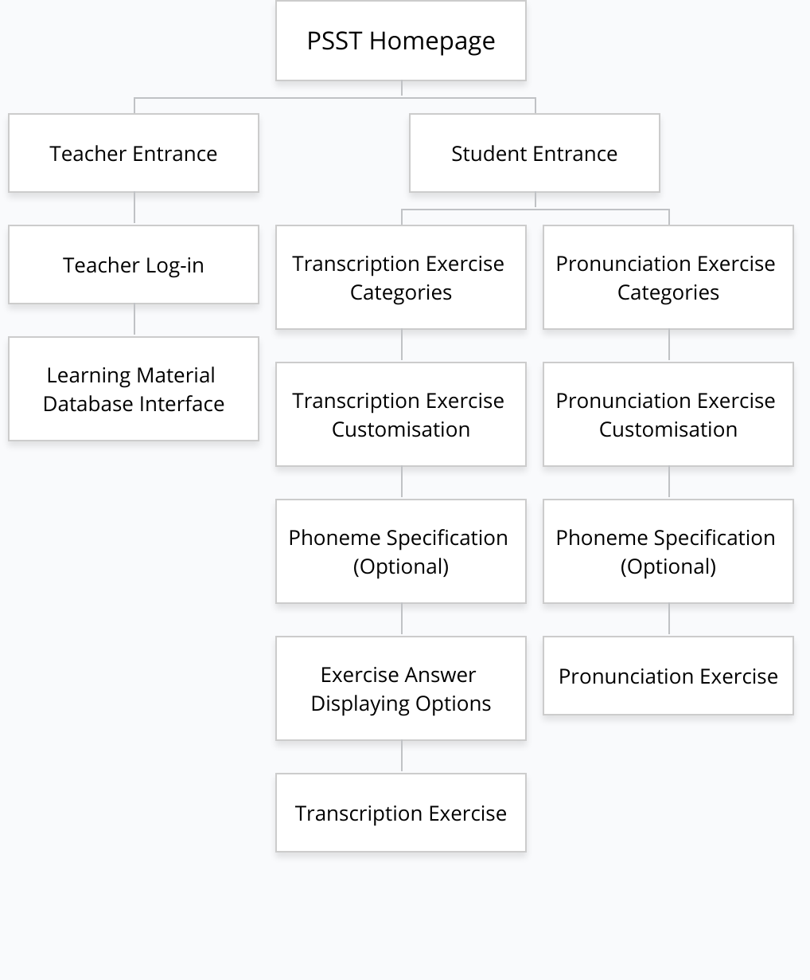

*Figure 4.10.* Hierarchy diagram of PSST system

The hierarchical structure of the PSST system is presented in Figure 4.10. There are different main levels of the system, with more detailed choices to make within some of these levels. Each box in Figure 4.10 represents a webpage in the system. These pages are elaborated in the following subsections.

#### Homepage and item categories

As illustrated in Figure 4.10, the PSST contains two main areas at the first level: Student Entrance and Teacher Entrance. The choice between the two areas is displayed on the homepage of the PSST (see Figure 4.11). The student entrance leads the students to the transcription and pronunciation exercise pages that are presented later. The teacher entrance links to a user interface of the database where the exercise items are stored. This enables the teachers to add and modify the learning materials in the system directly and easily. The pathway is through a password-protected login page. Since the focus of this research is on the learner’s perspective, the teachers’ area of the system is not further elaborated.

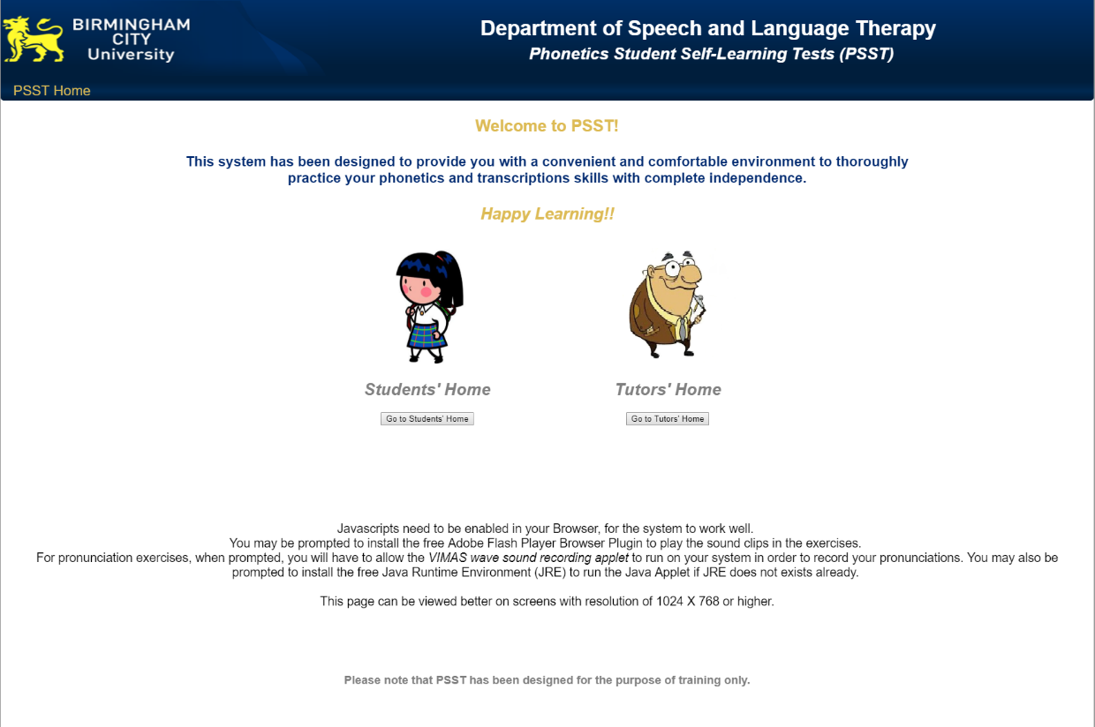

*Figure 4.11.* Homepage of PSST

Additional information about the technology involved in the system can be found on the frontpage of the system. This informs the users about the technological requirements for using PSST and potentially occurring prompts to meet those requirements. This information is provided with the aim of assisting the user to learn how to use the system without any external guidance.

The “Students’ Home” button leads to the next level (“Students’ Exercises Home”) of the system, where transcription and pronunciation exercises are introduced for selection (see Figure 4.12). Within each of these areas the exercises are designed to be maximally customisable. To realise this, the exercise items are divided into different main categories, each of which is further divided into a wide range of subcategories. This enables the students to make choices from a comprehensive set of options on the exercise items for different types of learning. The hierarchy of these categories and subcategories is illustrated in Figure 4.13.

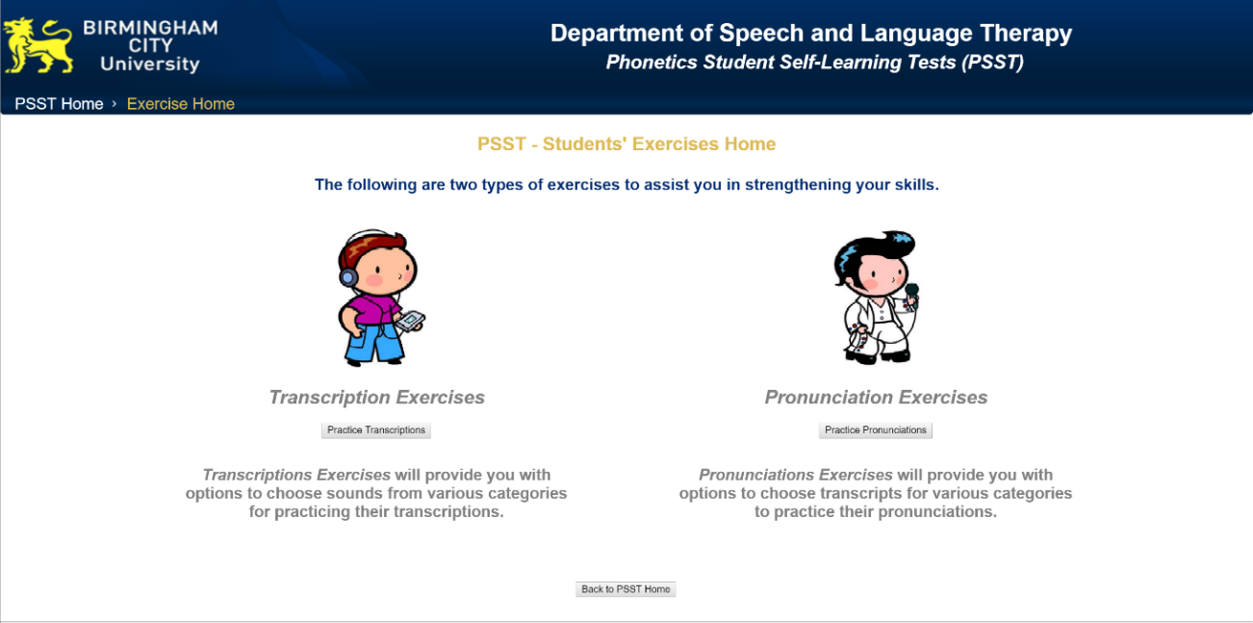

*Figure 4.12.* Students’ Exercises homepage

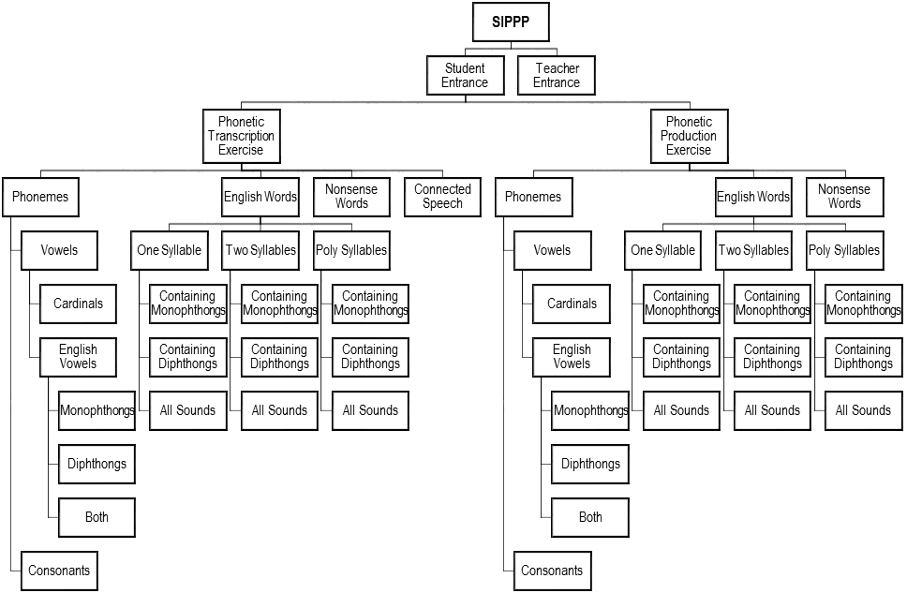

*Figure 4.13.* Category hierarchy of exercise items in PSST

As this hierarchy shows, the main categories of phonetic transcription exercises are Phonemes, English Words, Nonsense Words, and Connected Speech. Note that the pronunciation exercises contain only the first three main categories, since connected speech is inapplicable to phonetic pronunciation practice. The sound items in the Phonemes and English Words categories are further divided into subcategories. Such categorisation is decided by the course instructors and is based on the phonetic characteristics of the sound items. For example, each phoneme sound can be categorised as a vowel or a consonant. A vowel sound can also be an English vowel or a cardinal vowel. English vowels can be further differentiated into monophthongs (single vowel sound) and diphthongs (two vowels in a single syllable). Subcategories in the English Words category are related to the phonetic qualities of a phoneme that constitutes the sound of the word. For example, an English word that consists of two syllables, with at least one monophthong vowel in the sound, will be categorised as “containing monophthongs” under “one syllable”.

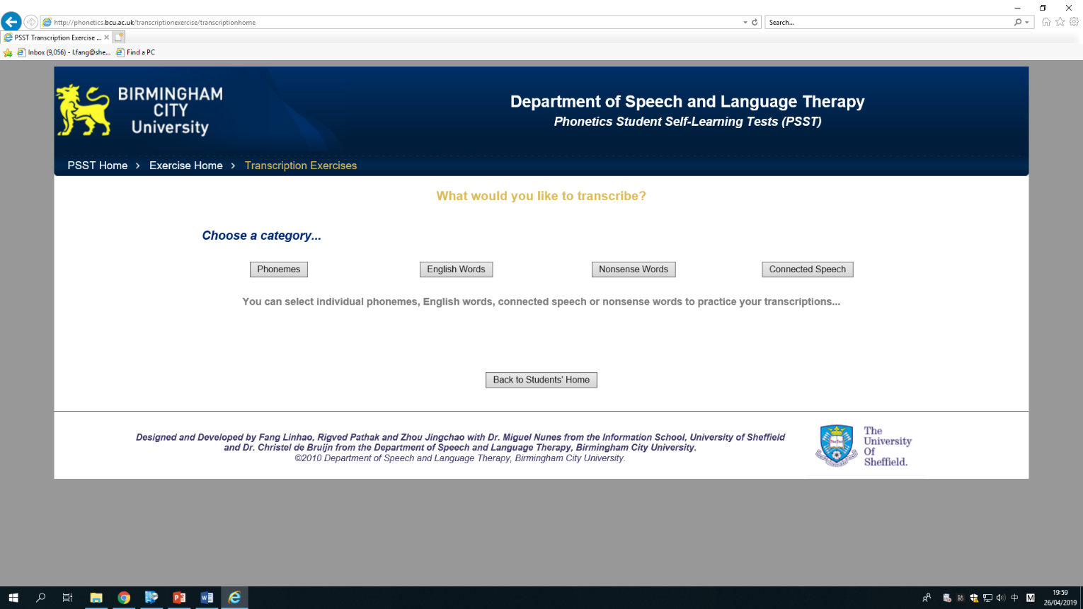

*Figure 4.14.* Transcription Exercise categories selection

The main categories for these items are selected on the page shown in Figure 4.14. These categories are distinguished based on their potential representation of different learning stages. For example, students are introduced to the individual phonemes before more complex items that contain more phonemes.

#### Customisation of exercise items

The buttons lead to the main exercise customisation pages for each exercise category. An example customisation page in the English Words exercises is demonstrated in Figure 4.15.

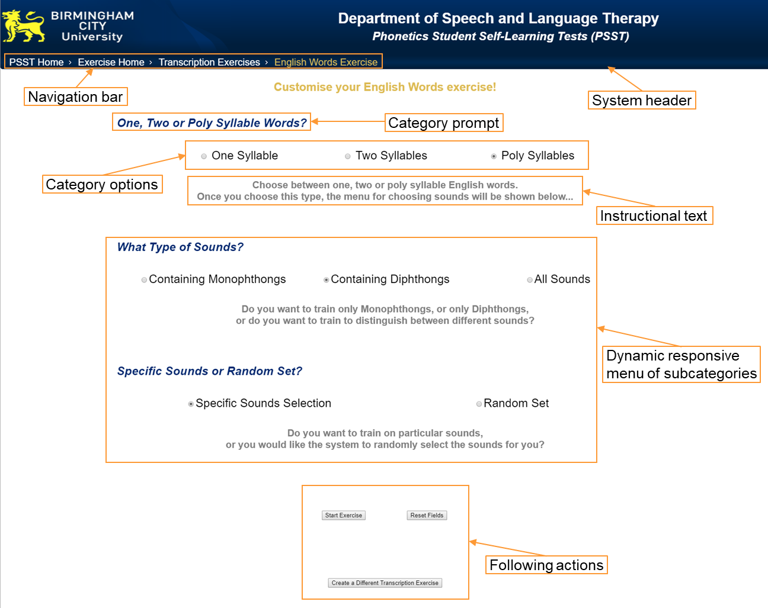

*Figure 4.15.* Exercise customisation page example (English Words)

The screenshot shows the different components of the customisation page. At the centre of the page is a dynamic responsive menu designed specifically for the subcategory options. In order to reduce the perceived complexity of the customisation and to increase the clarity of the options’ hierarchy, the category options are displayed one level at a time. An example of the operation of this dynamic responsive menu is demonstrated in Figure 4.16.

As demonstrated in the screenshots, when a user enters the English Words exercise customisation page, she/he is displayed a category prompt that asks her/him to choose between vowels or consonants. After the user ticks the checkbox, another level of subcategory options is displayed. The user may then make another choice and goes to the next level, before all the choices are made and the “Start Exercise” button is available to activate the exercise.

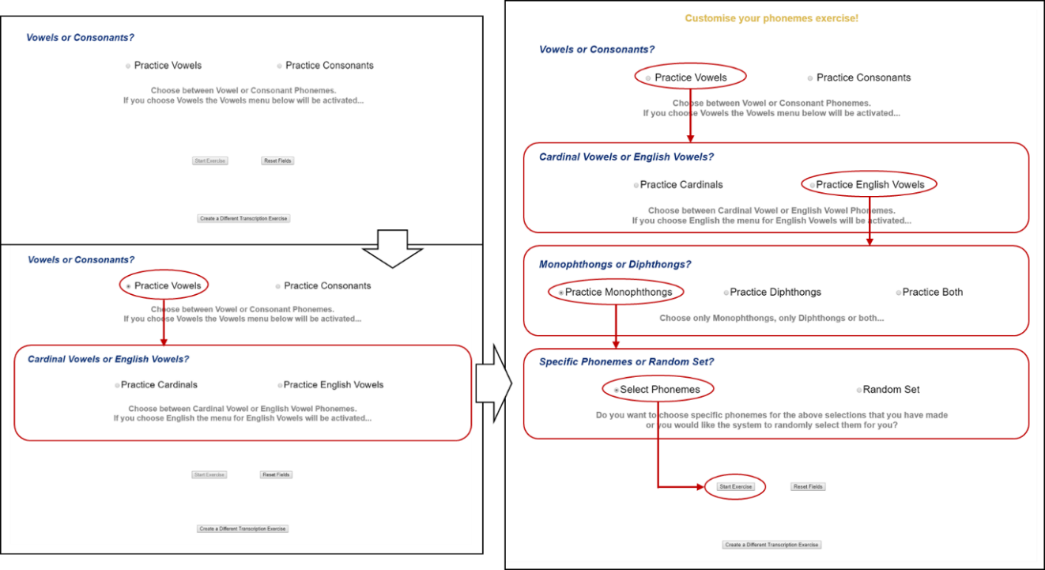

*Figure 4.16.* Example of a dynamic responsive menu operation with Phonemes

In order for the students to understand how to use this menu easily, instructional text is provided alongside the page. The navigation bar and buttons for subsequent actions (shown in Figure 4.15) allow the students to quickly move within the system, such as when they want to go back to previous pages or to make different choices.

The last selection on the customisation page is between “Specific Sound Selection” (or “Select Phonemes” in the Phonemes category) and “Random set” of exercise sounds. The former option is designed to further the customisability of the exercises by enabling students to specify the exact phonemes contained in the exercise items. This specification enables the students to focus their training on sounds that present particular obstacles to them. This option links to a page where one or more phoneme charts are displayed according to the previous configuration in the customisation page. From these charts the students can pick one or more phonemes that the sound recordings will contain. Examples of these phoneme charts are demonstrated in Figure 4.17.

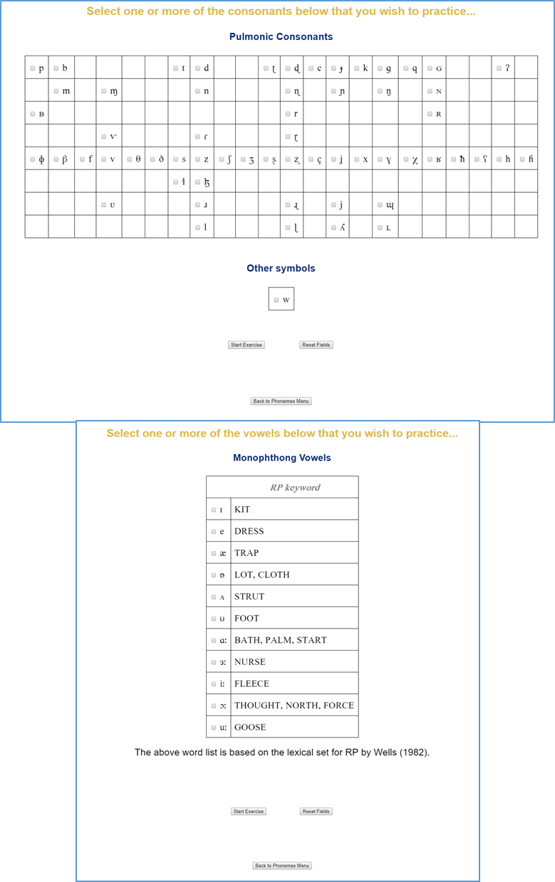

*Figure 4.17.* Examples of phoneme specification charts

The special alignment of symbols in some charts is to be noted here. For example, the consonants are displayed in accordance with the IPA standard chart, where the columns and rows of the symbols indicate sounds that belong to specific groups. Displaying the symbols this way is to ensure that the students can navigate and find the desired symbols more easily.

#### Exercise answer displaying options

The final stage of exercise customisation is the Exercise Answer Displaying Options. This page is displayed after the student selects either the “random set” on the customisation page or the phoneme chart specification (as shown in Figure 4.10). These options are designed for the system to enable different types of learning behaviours. As the meta-requirements defined, the system should facilitate learners’ SRL of phonetic transcription while providing an avenue for self-assessment. The system is designed to be used for both learning and self-testing, either for practice or for assessment. However, one main goal of the design of PSST is to maximise learners’ freedom and ownership of learning. The design aims to provide students with opportunities to explore different types of learning activity without prescribing fixed learning modes.

The feature of different feedback options is designed specifically for these reasons. On this page (Figure 4.18), the students can choose between receiving the answer after each sound has been played, or receiving all the answers after a sequence of sounds has been played. In the latter option, the student can further decide how many sound items will be contained in the exercise series. These simple options may, by using different combinations, enable a variety of types of exercise.

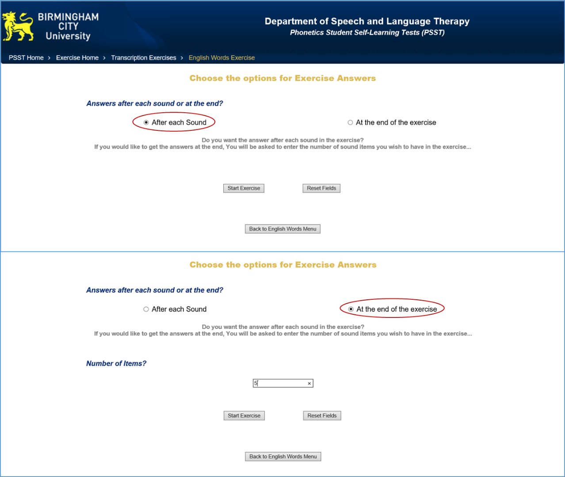

*Figure 4.18.* Page for Exercise Answer Displaying Options

#### Phonetic transcription exercise

The transcription exercise page is then created after the answer displaying choice is made. Figure 4.19 shows the page before and after the answer is provided. The system plays a sound after the user hits the play button. The user is prompted here to write down their transcription. The design encourages the student to use pen and paper for transcribing. This is intended, because phonetic transcription needs to be carried out in this manner in real life. The training of the skill should aim to mimic real-life situations in which the skill is applied.

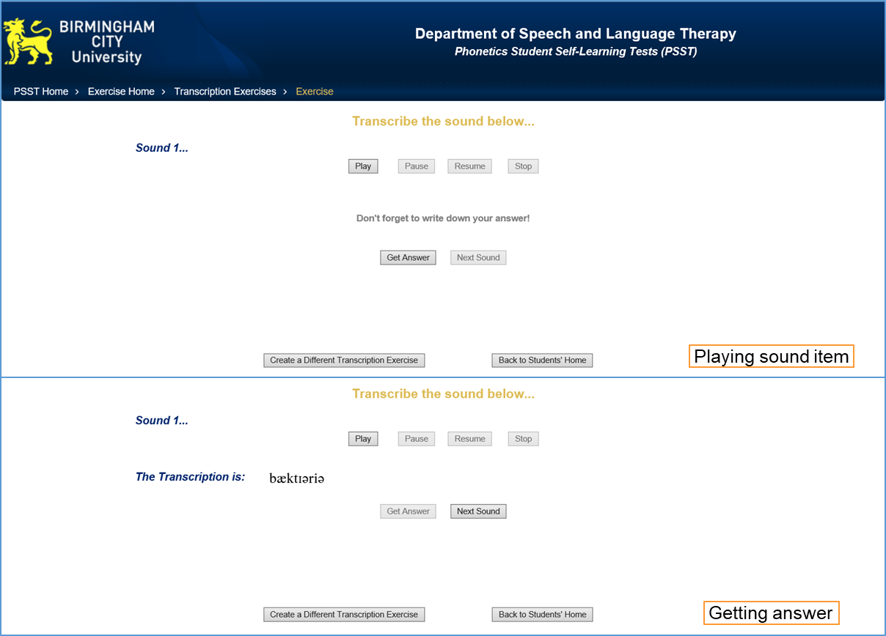

*Figure 4.19.* Transcription exercise page (answer displayed after each sound)

The sound can be played as many times as the user wishes. The user can then receive the transcription of the sound by clicking on the “Get Answer” button. The sound can also be replayed after the answer is displayed. The button “Next Sound” that leads to the next item is only enabled after the user has presented the answer. Small features like this can enhance ease of use by avoiding user misclicks.

A demonstration of the transcription exercise page following the option of displaying answers after a sequence of sounds is presented in Figure 4.20. The playback buttons allow students to go back and forth with the items before the sequence is ended. Students can choose to pause and replay a previous sound if they wish. The answers for each of the sounds played in the sequence are presented in a list labelled with numbers.

It should be noted that a minimalist style is intended for the exercise pages as well as for the entire system. Only a few necessary playback function buttons are displayed while the user is transcribing the sounds. This design decision aimed to minimise students’ distractions while learning with the technology.

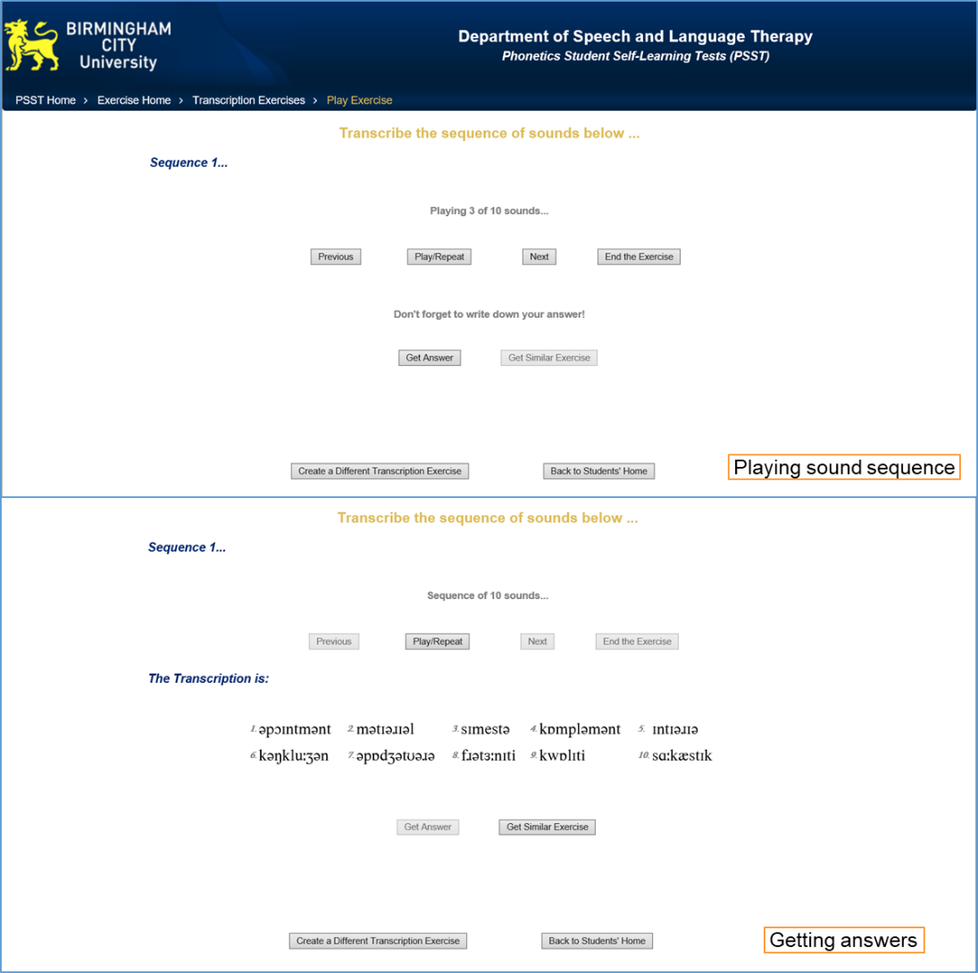

*Figure 4.20.* Transcription exercise page (answers displayed after a sequence of 10 sounds)

#### Phonetic pronunciation exercise

The phonetic pronunciation exercises have the same item customisation functionalities as the transcription exercises have. However, this side of the system does not have an answer displaying option due to the inapplicability of such an option. The exercise page is generated directly after the phoneme specification or a random set is selected.

The exercise page is presented in Figure 4.21. The square at the centre of the page encloses an embedded sound recorder. The phonetic transcription is displayed for the user to pronounce. By clicking the “Start Recording” button, the recorder starts to record sounds the user produces. After the “Stop Recording” button is clicked, the sound is temporarily stored in the system for the user to play back. The user can then play the standard pronunciation (the standard sound items recorded by the instructors for the transcription exercises) and their own recorded pronunciation. By comparing the pronunciations, the user can hear the difference and improve their pronunciation. The phonetic pronunciation exercise is intended to enhance students’ learning of phonetic transcription.

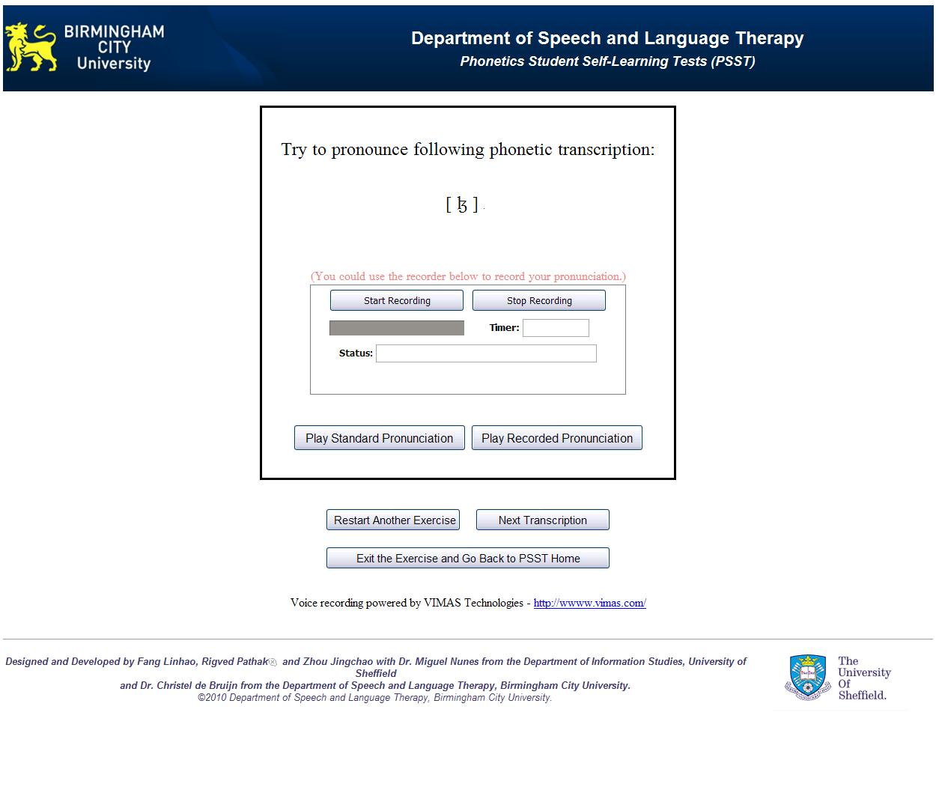

*Figure 4.21.* Pronunciation exercise page

### Technological parameters

PSST is built entirely with free and open-source software. The system is hosted on a web server named Apache HTTP Server. The server runs on a Linux distribution operating system called Ubuntu. A MySQL database was set up for storing and organising the learning materials in the system. These include the sound recordings of the exercise items, their relevant attributes (e.g., category labels like “vowel” or “consonant”) and their corresponding transcription symbols. The main programming languages involved in the coding of the web-based system include HTML, CSS, JavaScript, and PHP. HTML and CSS are employed to manage the display and styling of the webpages in the system. JavaScript is responsible for providing scripting for user interface interactions (e.g., button functions, menu activities). PHP is used to manipulate database activities from the server end (e.g., to generate queries to search for specified recordings in the database).

Sound recordings in the exercises are played through Adobe Flash. This requires the Adobe Flash Player to be installed at the user’s end, which is readily available for most web browsers. The voice recording functionalities in the pronunciation exercises are realised by the employment of a Java applet named VIMAS WAV. This applet provides a set of functions that allows the user to record and play back their pronunciations. The applet requires Java Runtime Environment to be installed on the user’s device. Additionally, the exercise page will display a prompt for the recorder applet to be installed when the user first visits the system.

# Abstract outcomes and Evaluation Findings

## Abstraction of system design

After presenting the design and development process of the physical artefact, the abstract components of the design are extracted. The design process is viewed differently in DSR than it is in industrial design. In regards to the importance of theoretical aspects of the research outcomes and their generalisability, the design of the artefact requires some level of abstraction (Kuechler & Vaishnavi, 2012). Industrial designs are intended to be reproduced identically with the aim of quality control and risk management. The DSR approach, on the other hand, aims to yield a solution that can be applied to similar problems. Therefore, for the design of the resulting artefact to be generalisable and communicated, it needs to be abstracted in a way that is applicable to a class of situations rather than only to a particular case.

Walls et al. (1992) originally introduced the concepts of *meta-requirements* and *meta-design* in DSR methodology. In order to be able to produce generalisable knowledge from an artefact, the meta-requirements describe a “class of goals” (instead of a single goal) in solving the defined problem, and the meta-design describes “a class of artefacts hypothesised to meet the meta-requirements” (ibid., p. 43). The instantiation in the form of the resulting artefact manifests the fulfilment of the meta-requirements by the meta-design, the theorisation of which can thus be communicated as a DSR research outcome (2004; Walls et al., 1992). Knowledge contribution in form of *design theories* are yielded through the prescribed realisation of the relationship between such meta-requirements and meta-design.

It is to be noted that Walls *et al.* have also suggested the possibility of forming these design theories by adding *testable design product hypotheses* to the meta-design before the creation of the artefact, which are to be verified through the evaluation. However, according to Gregor and Hevner (2013), the invention type of DSR commonly requires an exploratory process, where such formalisation of design theory hypotheses may not be suitable before observing the performance of the resulting artefact. Therefore, in this section, the abstract components of the artefact design are extracted from analysing the design process of the system presented in Chapter 4 and revisiting literatures reviewed. These components are presented by defining broad meta-requirements and suggesting corresponding meta-design features. The theoretical contributions are discussed in more detail in the discussion chapter where the artefact performance is evaluated and discussed.

### Defining meta-requirements

As a result of the literature review of kernel theories and the previous field investigation of the phonetic transcription module, a set of general meta-requirements of the aimed artefact were defined. The context of this artefact’s implementation should be noted first. In order to provide a comprehensive course for phonetic transcription knowledge and skill, a blended learning environment was adopted.

In line with constructivist learning theory, the blend was designed to centre on the “learner presence” component in support of learner-centredness and students’ ownership of learning. The intended artefact of this DSR was thus designed and developed to serve this role. Following this guiding principle, the meta-requirements were defined as listed below. These main meta-requirements (presented as MRs) are further elaborated with the more detailed requirements discussed in the literature review results. Rationales for their definition are also discussed.

**MR-1:** The artefact should benefit phonetic transcription learning by e-learning means.

In the literature review chapter, the characteristics of e-learning methods were investigated and inherent advantages of specific e-learning implementations were examined. The main aim of this research project is to facilitate and enhance phonetic transcription learning by e-learning means. The artefact was thus expected to make use of the strengths of such educational technologies.

For example, an essential advantage of implementing e-learning is its cost-effectiveness, which includes reduction in the costs of both human resources and materials. Therefore, the artefact should be expected to reduce the resource expenditure in learning (e.g., time and effort) by instructors and students.

Other benefits of implementing e-learning – such as its improvement of learning flexibility, learner-centredness, and accessibility – are discussed in the literature review. The design should aim to realise such benefits. Additionally, the resulting technology should aim to provide students with a satisfactory user experience. Usability aspects, such as ease of use, learnability and user friendliness, should be considered.

**MR-2:** The artefact should facilitate effective self-regulated learning for phonetic transcription students.

Constructivist learning theory is the guiding principle for facilitating learning in this research project. At the centre of constructivist instructional design are a set of preferences which are believed to result in effective learning. Among these preferences are the learner’s ownership of learning, self-regulation and self-construction of learning. The artefact should play the central role in the blended learning environment and should be focused on satisfying these goals. Facilitating self-regulated learning (SRL) of phonetic transcription is thus the main meta-requirement for the system. The design should aim to enhance core factors in SRL like self-efficacy and meta-cognition in the learning of phonetic transcription. In addition, skill practice is crucially important in phonetic transcription learning. The implementation of practice in SRL is thus required for the system.

Additionally, self-regulation comprises a set of discrete skills (e.g., goal-setting, self-control, self-monitoring). Such skills can be improved by engaging with SRL. The intended artefact should be designed with consideration of these aspects in mind.

**MR-3:** The artefact should facilitate effective self-assessment for phonetic transcription students.

The importance of formative assessment and, in particular, self-assessment is emphasised in the educational literature. These forms of learning assessment are especially well supported by e-learning methods. Additionally, self-reflection also plays a major role in the SRL process. However, because of the special role of formative assessment both within and outside the SRL context, this meta-requirement is defined separately from MR-2. The resulting e-learning artefact is thus expected to assist self-assessment in phonetic transcription learning.

**MR-4:** The system shouldfacilitate phonetic pronunciation practice.

An additional meta-requirement is defined with regards to the characteristics of phonetic transcription learning. Phonetic pronunciation skills are considered significantly beneficial to the learning of phonetic transcription. Supporting the training in these skills using e-learning is thus an important part of the system.

### Suggesting meta-design features

In this section, the meta-design features corresponding to the meta-requirements are suggested. As discussed above, the design process of the PSST system has an inventive nature. The existing solution domain of the defined problem is very limited. There is no explicit guidance that can be consulted for suggesting the meta-design features of the system. Rather, suggestions for these features were produced by the process of *abduction* which is further discussed in the methodology chapter (Takeda et al., 1990). The kernel theories of learning phenomena were examined to inform the design of the artefact. This knowledge was also accompanied by *tacit theories* (“informal, experience-based insights and intuitions”) in order to guide the design (V Vaishnavi et al., 2004/2017).

It should be noted that, because of the exploratory quality of this project, the meta-requirements and meta-design features do not need to be in a one-to-one relationship. The design theory to be developed was intended to link the meta-design and the meta-requirements in a more general manner. In order to match the meta-design with the abstraction of meta-requirements, a few central meta-design principles (MDs) of the resulting artefact will be defined first. More specific meta-design features (in bullet points beneath each MD), and their rationales, are elaborated under each of these principles.

**MD-1:** Open implementation of a web-based system.

In line with constructivist pedagogy, openness as a main quality of the e-learning system was proposed in the design. The system should aim to provide an exploratory learning experience for the students. Easy and intuitive facilitation of such exploration should be manifested by the design. This meta-design principle focuses on the implementation of the system instead of its constructional components.

* Web-based e-learning system with universal accessibility

Most benefits of implementing e-learning technologies can be realised through web-based technology. This technology was thus chosen to be the substrate of the e-learning component. Online systems are accessible anywhere and anytime. Also, learning materials are digitalised in the system and they are reusable over time. These aspects can substantially reduce the time and effort of instructors and students.

Additionally, web-based tools are easily used without further technological complications such as installation or requirements for special equipment. The technological-readiness requirement for the learners is also low. Reduction in users’ frustration can lead to a better experience and higher self-motivation. The universal accessibility and convenience of a web-based system can also enhance user satisfaction, which results in effective learning.

* Voluntary use of the system

Instructor and instructional technologies in constructivist courses are facilitators. The system is an open tool for the students to use voluntarily. Students are also encouraged to explore the system and find ways to use it that best fit their needs (see MD-3). As the use of the artefact is neither compulsory nor prescribed, it can also provide an experimental aspect for the research, since the voluntary system use can explain the effectiveness of the design.

* Facilitation of self-guided system use

The usability of the system is emphasised in MR-1, which is due both to the constructivist nature of the design and to its open implementation. Since the users are free explorers in the system, they need to be facilitated with clear guidance to its functionality. Introductory information should be provided for the user to navigate through the system with ease. The operations should be as clear and simple as possible.

* Minimalist interface design (according to the e-learning design theory)

Given the importance of clear and simple operations, the system should have a minimalist interface. According to the advice of Ruth C Clark and Mayer (2016) on effective e-learning application design, unnecessary distraction on the instructional pages – specifically, visual information not directly related to the learning activities –should be avoided. This is particularly important for an exploratory e-learning tool, as the students may be more easily confused or distracted.

**MD-2:** Self-testing for learning and self-assessment

After the introduction of the theoretical knowledge of phonetic transcription in the classroom lectures, students need to learn the phonetic symbols and particular sounds. This process largely involves two types of knowledge: recognition and association. The students need to recognise the symbols and the sounds, and they need to be able to link them correctly. This requires repeated learning and practice activities. The system was thus designed to facilitate such activities through testing.

* Testing as learning

Exercises in the system are presented in the form of tests. Exercise items are presented to the user as questions, and feedback in the form of the corresponding answers to the items are given afterwards. This form of instruction can support both recognition and association.

* Examination format of testing as self-assessment

The system is required to be responsible for providing students with formative assessment in the form of self-assessment. This was designed to facilitate the students’ SRL. The testing format is varied in the design to simulate an examination format; specifically, this involves presenting the feedback at the end of an entire testing event. Options for the format of feedback display are provided to the user. The user can thus perform self-assessment through the system by self-examining.

This design is also in line with the non-prescriptive principle. The system is not explicitly divided into different prescribed “modes”. Rather, the student is provided with a continuum of different test lengths to choose from. In this way, various learning effects can result. The design thus aims to facilitate both the flexibility and the potential complexity of learning and self-assessment.

* Pronunciation exercise

An additional pronunciation exercise component was designed for the system in order to respond to MR-4. This was also designed to be supported by the self-testing function. A reverse application of the transcription testing – whereby students are presented with the phonetic transcription and given the corresponding sound as feedback afterwards – can support students with the pronunciation exercise.

**MD-3:** Maximised customisability in learning

Maximising customisability of self-generated exercises and tests is suggested, with the aim of providing students with maximal freedom and control in learning. The customisation of the exercise also encourages students to practise self-regulation skills in their learning, as a result of which their self-efficacy of learning with the system can be improved.

* Self-directed use of the system

Constructivist learning theory indicates that genuine learning emerges through an individual’s self-construction of the learning experience. This feature is thus specifically suggested, with the emphasis on the spontaneity and autonomy of the students’ learning. To encourage students’ self-regulation in learning, skills like self-control and self-monitoring can be supported by students’ spontaneous creation of exercises. Without supervision and fixed instruction, the learner needs to be able to find a way of using the system that best fits their learning needs. It should be noted that students’ self-regulation is the desired result of the meta-design, and the feature of self-directed use is differentiated from it to focus more on the self-construction and initiation of learning.

* Wide range of categories of learning items

For the exercise to have maximal customisation, the learning materials should be categorised into a wide range of options. The students can thus tailor the exercises freely. This feature is especially important in the context of phonetic transcription learning. The categorisation of sound items is part of the factual knowledge with which students need to familiarise themselves, and this can be reinforced by customising the exercises.

* Detailed specification of exercise items

A main strength of asynchronous e-learning is that it can support individualised learning. The system design should thus include detailed specification of learning items after more generic categories. Additionally, in phonetic transcription learning, some particular sounds can be particularly difficult for learners, and such difficulties can differ between individuals. This further supports the suggestion of specification of learning items in the exercises.

* Reduction of complexity through interface design

A particular aspect of this meta-design principle is the potentially complex operations of the customisation. Increased complexity may cause confusion and frustration for the system users. Therefore, the delivery of these functions needs to be considered with care. Specifically, the perceived complication can be reduced by better interface design in the artefact. The options available to users are presented one level after another. Such a design means that users can have a clear vision of the choices they make while at the same time enjoying the benefits of customisability.

### Meta-design as DSR outcome

The meta-design and the artefact’s abstract components that follow from it are an important outcome of the DSR. These design suggestions can be mapped with the DSR products in the framework formulated by March and Smith (1995). By making use of simple technological building blocks (*constructs*) like charts and buttons, meta-design features as design *models* are constructed. These models are implemented in accordance with the meta-design principles, which can be seen as *methods* in their framework. Finally, the situated physical *instantiation* of this meta-design is the resulting system.

It should be noted that this mapping does not necessarily lead to equivalents. Although March and Smith have mentioned that the constructs, models and methods can be conceptual instead of physical creations, they were referring to more concrete design specifications that describe the artefact. The meta-design components in the present research context still possess a higher level of abstraction. Such abstraction allows the meta-design to be a much more generalisable research outcome that can be communicated and adapted to other fields.

## Quantitative data collection

In this section, the process of quantitative data collection is presented after the discussion on the theoretical model of questionnaire design. Data analysis is then carried out including the descriptive results and the more comprehensive inferential statistics.

### Theoretical model of quantitative data collection

The definition of usability varies between scholars and researchers; however, despite disagreements over the details, there is a sufficient level of consensus that allows research on system usability to yield meaningful results. One widely acknowledged definition, with accompanying related concepts for system evaluation, is as follows:

* Usability: Extent to which a product can be used by specified users to achieve specified goals with effectiveness, efficiency and satisfaction in a specified context of use.
* Effectiveness: Accuracy and completeness with which users achieve specified goals.
* Efficiency: Resources expended in relation to the accuracy and completeness with which users achieve goals.
* Satisfaction: Freedom from discomfort, and positive attitudes towards the use of the product.
* Context of use: Users, tasks, equipment (hardware, software and materials), and the physical and social environments in which a product is used.

(ISO, 1998)

Many researchers consider that a conventional approach to information system evaluation is based largely on the opinions of the technical stakeholders (e.g., Kao, 1998; Karat, 1988; Smith & Williams, 1999). In contrast, a criterion suggested by Shee and Wang (2008) focuses on the particularities of Web-based E-Learning Systems (WELS). This evaluation model appreciates the opinions of the end users of the IS, and many have emphasised the key role of users’ viewpoints in the IS and IS service fields (Jiang, Klein, Roan, & Lin, 2001). User satisfaction is thus often put at the centre of system assessment (Delone & McLean, 2003; Melone, 1990; Raymond, 1987). In this research, the end users of the PSST system were the learners, or more precisely e-learners. Their attitude towards the system and satisfaction in learning are of the greatest importance in evaluating the system.

Shee and Wang (2008) built their model based on several previous system evaluation instruments. Their references include Bailey and Pearson (1983), with their 39-item measurement of information system user satisfaction, and Ives, Olson, and Baroudi (1983), with their user information satisfaction scale. Their more comprehensive inclusion of thoughts on developing a WELS scale is from educational psychology, where user satisfaction was analysed with details of human-computer interactions (e.g., Cashin & Downey, 1992; P. A. Cohen, 1981; Marsh, 1991). A comprehensive yet more compact hierarchy was suggested containing a total of 13 items, which is applicable to measuring e-learner satisfaction within the following dimensions: learner interface, learning community, content and personalisation (see Figure 5.1).

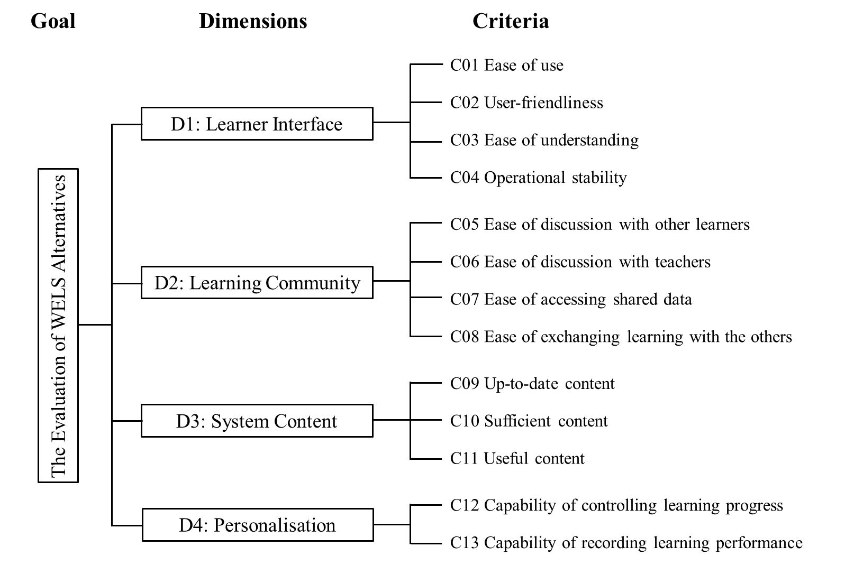

*Figure 5.1.* The hierarchy structure for evaluating WELS (reproduced from Shee & Wang, 2008, p. 898).

Another widely referred model of e-learner satisfaction evaluation is based on a systematic literature review of Sun et al. (2008). In their model, the previously established works, including the technology acceptance aspects (Ajzen & Fishbein, 1977; Davis, Bagozzi, & Warshaw, 1989; Oliver, 1980), and the expectation and conﬁrmation aspects (Bhattacherjee, 2001; Lin, Wu, & Tsai, 2005; J. Wu, Tsai, Chen, & Wu, 2006) were reviewed, discussed, and finally integrated into a framework which contains six dimensions to define e-learner satisfaction (Figure 5.2).

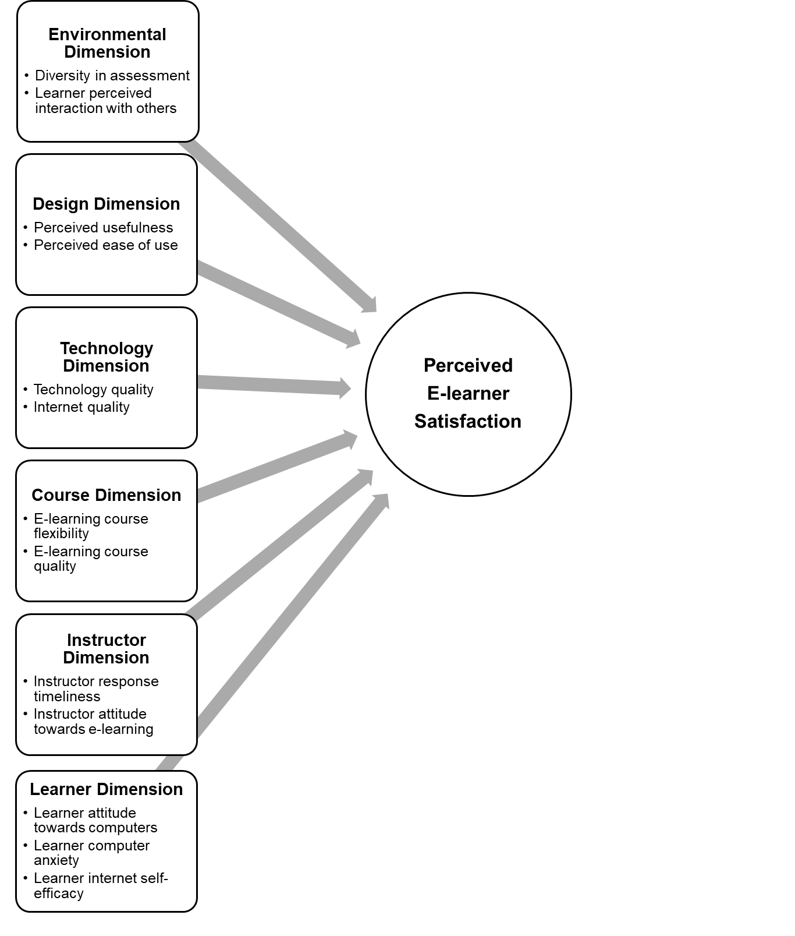

*Figure 5.2.* Framework of perceived e-learner satisfaction (reproduced from Sun et al., 2008, p. 1185)

The evaluation of the PSST system will then be based on the theoretical model yielded from the previously discussed approaches. Figure 5.3 shows a detailed structure on which the questionnaires will be designed.

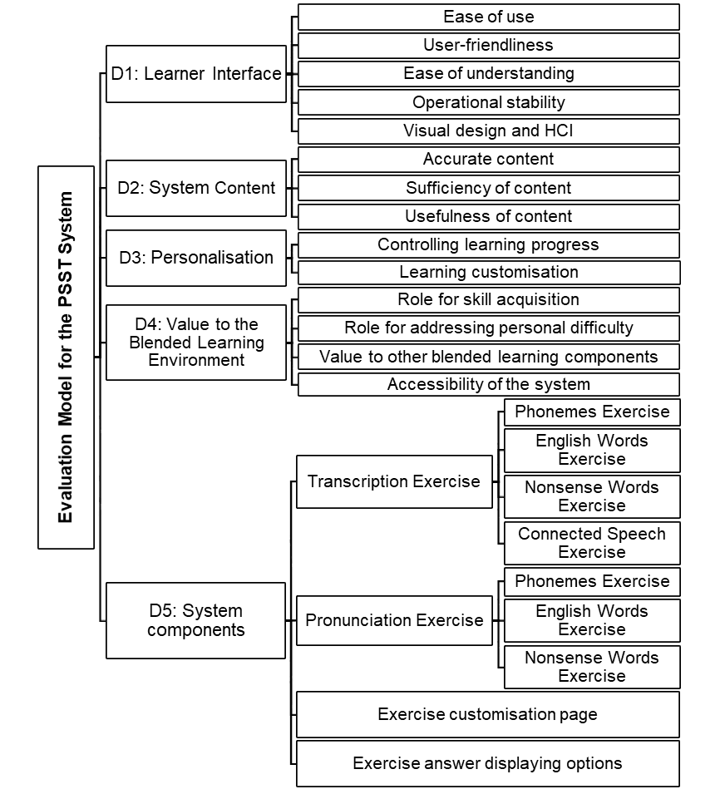

*Figure 5.3.* Theoretical model to use for designing PSST system evaluation questionnaire

### Quantitative data collection set-up

The quantitative data was collected through adopting a questionnaire survey. The questionnaire design contains six sections, each of which is included according to the theoretical discussion in the previous section. In the first five sections of the questionnaire, 32 closed-ended questions are presented in the form of a seven-point Likert scale. The sections are yielded from the theoretical model constructed in the previous section (Figure 5.3). The five closed-ended sections are in accordance with the five evaluation dimensions in the theoretical model, viz.: 1. Learner interface, 2. Content of the system, 3. Personalisation, 4. Value of the system in learning, 5. Learning experience with the PSST system. Each section consists of several questions according to the branches of each dimension in the model.

A Likert scale format questionnaire was adopted for the closed-ended questions. Each question presents a statement regarding an attitude or opinion towards the PSST system that the user may or may not agree with. Then the respondents are asked to rate their level of agreement or disagreement on each of the statements based on a symmetric 1-to-7 scale: 1. Strongly disagree, 2. Disagree, 3. Slightly disagree, 4. Neutral, 5. Slightly agree, 6. Agree, 7. Strongly agree. (In the original questionnaire, the scale points were actually reversed, so that 1 stood for strongly agree and 7 for strongly disagree. This was based on the purpose of respondents’ engagement insurance, which is discussed in the methodology chapter. The scale was later recoded for a clearer and more standardised statistical analysis.)

Three open-ended questions are placed after the 32 Likert scale items. The purpose of including open-ended questions was to provide further freedom for the respondents to express their experience and opinion in their own words. Without predetermined points of views through previously selected categories, the users’ specific perspectives could then be captured more clearly. The discussion of open-ended question with details in the previous section suggests the placement of open-ended questions is beneficial, though it should be limited. Towards the end of the questionnaire, the respondents are asked to further provide information on the problems they want to point out, the specific features of the system they demand, and any other suggestions they have about the system. The answers to these three questions were afterwards coded into statistical notations in order to be analysed and discussed both quantitatively and qualitatively.

### Quantitative data collection

A total number of 55 students enrolled on the Phonetics Transcription module in their first year of the Speech and Language Therapy course. The questionnaires were distributed to and received from 52 students who attended the department on the day of data collection. No sampling was involved in this quantitative data collection. Considering the small and inevitable difference between the entirety of possible respondents and the practical completion, the statistical data could be treated as from the population.

## Descriptive results

In this section, the descriptive statistical analysis of the questionnaire will be reported. All 52 students who were asked to take the survey completed the questionnaire. The 32 Likert scale items were almost fully completed, with only one missing value in Question 24. The missing value will be investigated in a later section. Three open-ended questions received a decent amount of responses. A summary of the questionnaire completion is presented in Table 5.1.

|  |  |  |  |  |  |  |
| --- | --- | --- | --- | --- | --- | --- |
| **Case Processing Summary** | | | | | | |
|  | Cases | | | | | |
| Reported | | Not Reported | | Total | |
| N | Percent | N | Percent | N | Percent |
| Is there any problem with the system you want to point out? | 38 | 73.1 | 14 | 26.9 | 52 | 100.0 |
| Is there any other specific feature you want from the system? | 19 | 36.5 | 33 | 63.5 | 52 | 100.0 |
| Please write any additional opinion or suggestion about the system if you have one. | 10 | 19.2 | 42 | 80.8 | 52 | 100.0 |
| Students did not provide any answer to open-ended questions | 11 | 21.2 | 41 | 78.8 | 52 | 100.0 |

*Table 5.1.* Case summary of open-ended question completion

Table 5.1 shows that 21.2% (11 students) of all respondents did not provide any answers to the open-ended questions. Therefore, a large majority of students (78.8%) were willing to give their opinions in their own words. In response to the question asking about problems they encountered with the system, 73.1% of respondents replied, while 36.5% of respondents specified their demands for system features and 19.2% gave additional suggestions. This level of completion provides relatively comprehensive information that can be drawn on. The open-ended questions will be analysed with respect to both their quantitative and qualitative properties.

### Scores of survey questions

Table 5.2 summarises the scores for each question in the questionnaire. The score has been calculated from the mean value of the Likert scale items. A minimum score a single question can receive is 1, which represents the lowest score. This score is given to a question when the student “strongly disagrees” with the statement, such as “I find PSST system easy to use”. The three items that received the lowest scores (mean < 5) are highlighted in the table.

The standard deviation (SD) shown in the table is a measure of data dispersion. It represents the variability of the data value assigned to the item. The higher the SD value of a question, the more its answers vary. This value thus implies that there were different attitudes among the students towards a certain aspect of the system. The items with the highest SD value in this survey are highlighted in the table (SD ≥ 1.58). These items display a relatively high level of controversy in certain parts of the system. The bar chart in Figure 5.4 is a more detailed presentation of the score options’ distribution for each item in the questionnaire.

|  |  |  |  |  |
| --- | --- | --- | --- | --- |
|  | N | Survey Question | Mean Score | Std. Deviation |
| Section 1: Learner Interface | 1 | Ease of Use | 6.18 | 0.95 |
| 2 | User-friendliness | 6.06 | 1.05 |
| 3 | Ease of Understanding | 6.22 | 0.94 |
| 4 | Operational Stability | 5.18 | 1.55 |
| 5 | Visual Design and HCI | 5.67 | 1.14 |
| 6 | Instructional Text | 6.10 | 0.76 |
| 7 | Responding Speed of the Website | 5.92 | 1.09 |
| Section 2: System Content | 8 | Accuracy of Content | 5.16 | 1.55 |
| 9 | Sufficiency of Content | 4.94 | 1.48 |
| 10 | Usefulness of Content | 6.18 | 1.24 |
| Section 3: Personalisation | 11 | Controlling Learning Progress | 5.71 | 1.15 |
| 12 | Learning Customisation | 5.14 | 1.60 |
| Section 4: Value to the Blended-learning Environment | 13 | Role for Skill Acquisition | 5.55 | 1.14 |
| 14 | Addressing Personal Difficulty | 5.41 | 1.39 |
| 15 | Value Added to Lectures | 5.02 | 1.46 |
| 16 | Value Added to Workshops | 4.86 | 1.59 |
| 17 | Value Added to Revision | 6.25 | 0.84 |
| 18 | Accessibility of the System | 5.31 | 1.69 |
| Section 5: System Components | 19 | Main Entrance Page | 5.57 | 1.32 |
| 20 | Student Home Page | 5.69 | 1.29 |
| 21 | Phonemes Transcription Exercise | 6.22 | 0.97 |
| 22 | English Words Transcription Exercise | 6.31 | 0.95 |
| 23 | Nonsense Words Transcription Exercise | 5.92 | 1.21 |
| 24 | Connected Speech Transcription Exercise | 3.36 | 2.35 |
| 25 | Transcription Exercise Customisation | 6.06 | 1.07 |
| 26 | Transcription Exercise Answer Options | 6.53 | 0.83 |
| 27 | Helpfulness of Transcription Exercise | 6.51 | 0.64 |
| 28 | Phonemes Pronunciation Exercise | 5.69 | 1.52 |
| 29 | English Words Pronunciation Exercise | 5.51 | 1.58 |
| 30 | Nonsense Words Pronunciation Exercise | 5.27 | 1.64 |
| 31 | Pronunciation Exercise Customisation | 5.39 | 1.51 |
| 32 | Helpfulness of Pronunciation Exercise | 5.47 | 1.42 |

*Table 5.2.* Score of questionnaire items and data dispersion

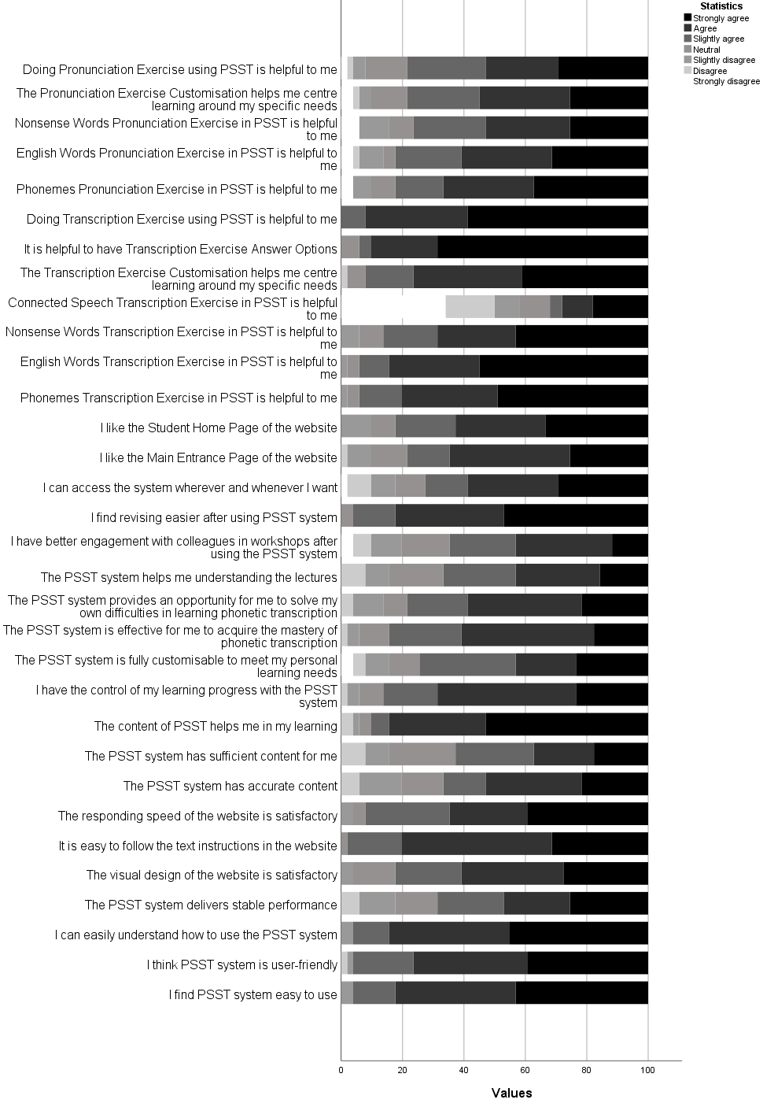

*Figure 5.4.* Distribution of questionnaire item responses

Most of the items (29 out of 32 questions) in the survey received an average score of 5 and above. This means that most students’ responses to the questions fell into the range of “agree” and “highly agree”. This result provides strong evidence of the PSST system’s positive reception. The overall satisfaction of the students is manifest from this survey. However, there are a few questions that received relatively lower scores, as highlighted in the table.

The detailed descriptive statistics of these questions are provided in the following section for a deeper analysis.

### Low score items in the questionnaire

#### Sufficiency of content (Question 9)

|  |  |  |  |  |
| --- | --- | --- | --- | --- |
|  | | | | |
|  | | | Statistic | Std. Error |
| The PSST system has sufficient content for me | Mean | | 4.9231 | .20338 |
| 95% Confidence interval for mean | Lower bound | 4.5148 |  |
| Upper bound | 5.3314 |  |
| 5% Trimmed mean | | 4.9701 |  |
| Median | | 5.0000 |  |
| Variance | | 2.151 |  |
| Std. Deviation | | 1.46657 |  |
| Minimum | | 2.00 |  |
| Maximum | | 7.00 |  |
| Range | | 5.00 |  |
| Interquartile range | | 2.00 |  |
| Skewness | | -.289 | .330 |
| Kurtosis | | -.628 | .650 |

*Table 5.3.* Descriptive results for Question 9

Table 5.3 shows the results of the question regarding the content sufficiency. A significantly lower average score is represented in the responses (mean=4.9231). This average is fractionally lower than the least satisfactory option (“Slightly agree”). The data is moderately spread out (SD=1.46657, IQR=2), with a limited lean on the positive side (skewness=-0.289). Although the output indicates a lower score on average, a detailed description of data distribution should be analysed to find an explanation.

|  |  |  |  |  |
| --- | --- | --- | --- | --- |
| **The PSST system has sufficient content for me** | | | | |
|  | | Frequency | Percent | Cumulative Percent |
|  | Strongly agree | 9 | 17.6 | 17.6 |
| Agree | 10 | 19.6 | 37.3 |
| Slightly agree | 13 | 25.5 | 62.7 |
| Neutral | 11 | 21.6 | 84.3 |
| Slightly disagree | 4 | 7.8 | 92.2 |
| Disagree | 4 | 7.8 | 100.0 |
| Total | 51 | 100.0 |  |

*Table 5.4.* Response frequencies for Question 9

Table 5.4 presents the data distribution for Question 9. In total, the positive responses add up to 62.7%. However, this part of the data distribution is leaning towards the negative side of the scale. The option “Slightly agree” was most frequently chosen (25.5%), while the other positive options were chosen by fewer students (19.6% on “agree”, 17.6% on “strongly agree”). An unusually high number of respondents took a neutral position (21.6%, 11 out of 51). The uncertainty about system content sufficiency was, therefore, pronounced. Responses on the disagreement side were given by 15.38% of students, while half of these respondents (7.8% of total) responded “disagree”. This could denote a relatively extensive concern that the system did not have enough content.

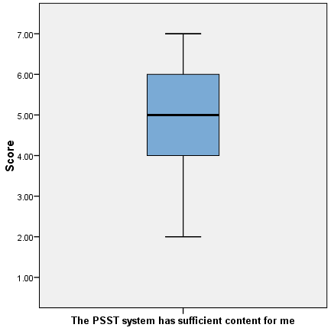

*Figure 5.5.* Box plot for Question 9

From the box plot of Question 9 (Figure 5.5), the variability of the output is shown. The data is expanded fairly evenly throughout most of the scale (from scores 2 to 7). With the median close to the middle of the scale, quartiles have similar coverage in the plot. This suggests that the result is a generic phenomenon that applies to most respondents. Correspondingly, no outlier is definable in this data output. The general concern about the system content, together with the observed aspect in the previous question, could lead to a demand for improvement of the system in the learning content section. This issue should be further explored with more detailed and qualitative data.

#### Value added to workshops (Question 16)

|  |  |  |  |  |
| --- | --- | --- | --- | --- |
| **Descriptive Results** | | | | |
|  | | | Statistic | Std. Error |
| I have better engagement with colleagues in workshops after using the PSST system | Mean | | 4.8654 | .21802 |
| 95% Confidence interval for mean | Lower bound | 4.4277 |  |
| Upper bound | 5.3031 |  |
| 5% Trimmed mean | | 4.9487 |  |
| Median | | 5.0000 |  |
| Variance | | 2.472 |  |
| Std. Deviation | | 1.57217 |  |
| Minimum | | 1.00 |  |
| Maximum | | 7.00 |  |
| Range | | 6.00 |  |
| Interquartile range | | 2.00 |  |
| Skewness | | -.745 | .330 |
| Kurtosis | | -.063 | .650 |

*Table 5.5.* Descriptive results for Question 16

Question 16 asked the students whether, after using the system, they had better interaction with colleagues in the phonetics workshops, which is one of the components of the blended learning environment. Table 5.5 lists the descriptive results yielded from the data on this question. It can be seen that the participants gave a significantly lower average score on this question (mean=4.8654). Although the median is on score 5 (“Slightly agree”), both mean and trimmed mean are below the least positive score. Extreme values towards the lower end were reported as well (minimum=1). The data has a relatively large dispersion across the full scale (SD=1.57217, IQR=2, range=6). From the kurtosis value (-0.063) it can be seen that the data distribution curve is close to a normal distribution. This generalises the problem suggested in the data. The data still has a slight tendency towards the positive side (skewness=-0.745).

|  |  |  |  |  |
| --- | --- | --- | --- | --- |
| **I have better engagement with colleagues in workshops after using the PSST system** | | | | |
|  | | Frequency | Percent | Cumulative Percent |
|  | Strongly agree | 6 | 11.8 | 11.8 |
| Agree | 16 | 31.4 | 43.1 |
| Slightly agree | 11 | 21.6 | 64.7 |
| Neutral | 8 | 15.7 | 80.4 |
| Slightly disagree | 5 | 9.8 | 90.2 |
| Disagree | 3 | 5.9 | 96.1 |
| Strongly disagree | 2 | 3.9 | 100.0 |
| Total | 51 | 100.0 |  |

*Table 5.6.* Response frequencies for Question 16

Table 5.6 shows how the data is distributed for Question 16. The data is focused on the response “Agree” (31.4%). However, only 11.8% responded with the “Strongly agree” option, which is significantly lower than “Slightly agree” (21.06%). It is worth noting that the neutral option received a relatively large number of votes (15.7%, 8 out of 52). Hesitation and ambiguity could thus be implicit. Ten out of 51 students gave negative responses (19.6%), which is significant given the survey’s small scope. A general tendency towards disagreeing with the statement is evident. Two respondents (3.9%) expressed extreme disagreement with the question by recording the minimum score 1. The rare occurrence of extremely low values in this survey is worth exploring with care. However, due to the limitation of descriptive results, the reason for the problem remains uncertain. Investigation needs to be undertaken through further data analysis.

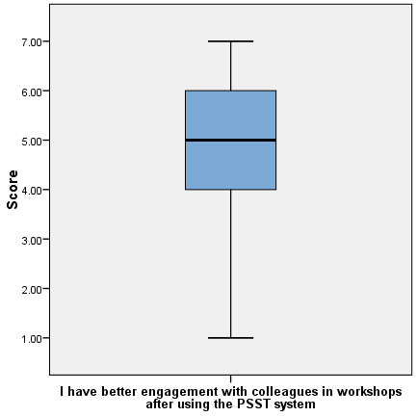

*Figure 5.6.* Box plot for Question 16

The box plot for Question 16 is presented in Figure 5.6. As the histogram clearly shows, the data distribution represents a generalised phenomenon. The quartiles are thus stretched out along the entire scale (scores 1 to 7). The negative responses constitute one whole quartile (Q1). Consequently, no outlier can be defined. The proportion of participants who had problems with this question is significant and further analysis is a necessity.

#### Connected speech transcription exercise (Question 24)

|  |  |  |  |  |
| --- | --- | --- | --- | --- |
| **Descriptive Results** | | | | |
|  | | | Statistic | Std. Error |
| Connected Speech Transcription Exercise in PSST is helpful to me | Mean | | 3.3529 | .32639 |
| 95% Confidence interval for mean | Lower bound | 2.6974 |  |
| Upper bound | 4.0085 |  |
| 5% Trimmed mean | | 3.2810 |  |
| Median | | 3.0000 |  |
| Variance | | 5.433 |  |
| Std. Deviation | | 2.33087 |  |
| Minimum | | 1.00 |  |
| Maximum | | 7.00 |  |
| Range | | 6.00 |  |
| Interquartile range | | 5.00 |  |
| Skewness | | .490 | .333 |
| Kurtosis | | -1.354 | .656 |

*Table 5.7.* Descriptive results for Question 24

Connected speech is the final category in the Transcription Exercise section of the PSST system. The descriptive results of this question are summarised in Table 5.7. From the results, it is apparent that the output from this question is considerably diverse. The lowest average score of the entire survey was given to this question (mean=3.3529), which is also significantly lower than the second lowest average score (4.8654 for Question 16). All measures of the central tendency on this item are on the negative side of the scale (median=3, 5% trimmed mean=3.2810). The data is also remarkably dispersed (SD=2.33087, IQR=5), with a full coverage of the scale (range=6). An unusual positive skewness is reported by the data, which suggests a stronger tendency towards the negative end of the scale (skewness=0.490). The kurtosis further states the abnormality of the distribution with a negative value with high absolute value (kurtosis=-1.354). As a whole, the feedback for this question indicates that there was a serious problem related to this category of the exercise. Further investigation is necessary.

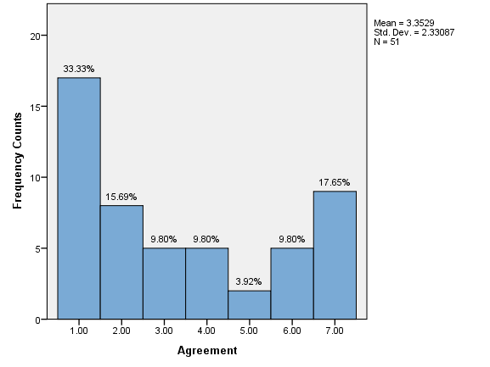

*Figure 5.7.* Connected Speech Transcription Exercise in PSST is helpful to me

The histogram in Figure 5.7 shows the distribution for Question 24. From the diagram, it is clear that the distribution of data for this question is very unusual. The curve of the data resembles a bilateral model, where two peaks of the data can be observed. It is worth mentioning that the output of this question contains the only missing value (from Case 30) of the entire survey, so only 51 respondents gave their opinions. “Strongly disagree”, which is commonly absent in many questions, spikes to be the highest voted option in this question (33.33%, 17 out of 51). The other peak of the data, which is much lower in size, is located at the other end of the scale (9 out of 51, 17.65% on “Strongly agree”). The number of respondents giving the highest score is only one more than the second lowest option of the scale (8 out of 51, 15.69% on “Disagree”). Cumulatively, 58.82% responses were negative and 31.37% were positive, making the ratio between agreement and disagreement 1:1.875. The disagreement on this aspect is almost double the agreement. Five students (9.80%) gave neutral responses to the question, which fills the gap between the two sides. From the inverse curve of the data, it can be suggested that no general consensus was achieved towards this category of the exercise. Though disagreement is greater than agreement, the inclination on the agreement side and the number of high value votes are still significant. The variety of the users’ opinions on this aspect was extensive. This leads to a complication of the issue that can only be explained by in-depth qualitative data analysis.

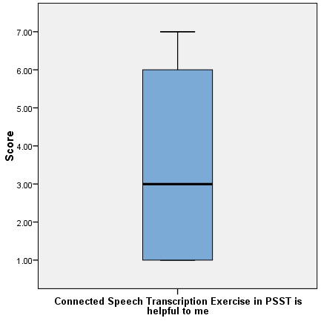

*Figure 5.8.* Box plot for Question 24

The box plot in Figure 5.8 could provide further insights into the descriptive results of Question 24. The bilateral structure of the data is pronounced in the box plot. The two quartiles at the ends (Q1 and Q4) have their concentration of supporters, where they stick to the extreme values (score 1 and scores 6-7 respectively). However, the rest of the respondents, who cumulatively amounted to 49.01% in the previous histogram, make up the middle two quartiles that extend across almost the entire scale (scores 1 to 6). Therefore, half the respondents are at the extremes, while the other half vary between more moderate options. There is no outlier in this item, since the entire scale is covered by a full variety of opinions. Excessive degree of diversity is shown on the answers given to the English Words transcription exercise. This complex issue necessitates exploration of the qualitative data. Different stories could be told by the students.

### Learners personal opinions – open questions

As shown in Table 5.1 in section 5.3 (on the general completion of questionnaires), the question “Is there any problem with the system you want to point out?” received 38 responses from the 52 participating students (73.1%). And the second question, “Is there any other specific feature you want from the system?”, received 19 responses (36.5%). The final open question, “Please write any additional opinion or suggestion about the system if you have any”, collected ten responses (19.2%) from the students.

The responses to the open questions were coded and categorised through observation. Nineteen codes were generated in this process. A frequency analysis was then carried out. Table 5.8 displays the coded responses and their total counts from the open questions. These questions were designed to collect the students’ opinions on existing problems in the current system and on potential future features expected in an improved system. However, students could use the question slots interchangeably. Therefore, the codes were divided between problems and suggestions, and they will be analysed and discussed separately according to this division in the following sections.

|  |  |  |  |
| --- | --- | --- | --- |
| **Code No.** | **Coded Responses** | **N** | **Sum** |
| 1 | Connected speech exercise is not working / has no answer. | 52 | 32 |
| 2 | Displaying wrong answer for exercise (occasionally) / Contents should be more accurate. | 52 | 7 |
| 3 | Exercises are repetitive / Not enough exercise items. | 52 | 5 |
| 4 | Nonsense words are too few / lack of variation. | 52 | 5 |
| 5 | Provision of videos / being able to see the pronouncer's face/mouth. | 52 | 5 |
| 6 | Mobile device accessibility. | 52 | 3 |
| 7 | Look of the system is not good enough / Looks dull. | 52 | 3 |
| 8 | Mock test with a variety of different exercise items and automatic marking. | 52 | 2 |
| 9 | A variety of pronouncers. | 52 | 2 |
| 10 | Provision of progress tracker / record / log. | 52 | 2 |
| 11 | Some vowels sound no different from each other. | 52 | 1 |
| 12 | Choosing individual phonemes is fiddly. | 52 | 1 |
| 13 | Some symbols are unclear. | 52 | 1 |
| 14 | Sometimes system does not repeat the sound. | 52 | 1 |
| 15 | Play sound when clicking on the phonemes. | 52 | 1 |
| 16 | Ability to input transcription (for automatic marking). | 52 | 1 |
| 17 | More categories to choose exercise between. | 52 | 1 |
| 18 | Automatic transcription of the inputted word. | 52 | 1 |
| 19 | No answer. | 52 | 11 |

*Table 5.8.* Table of coded responses to open questions

#### Learners’ problems with the current system

Nine codes out of 18 were categorised as reported problems with the system. The reported frequencies of the coded responses concerning the problems are presented in Table 5.9. These data served not only as an explanatory tool, but also as a guideline for the subsequent qualitative data collection. The codes were categorised in accordance with the sections in the structured interview script, as an addition to each main question in the interview. Doing this allowed the qualitative data collection to focus more on the explanatory function of specific occurrences of problems, thus yielding richer results in the findings.

|  |  |  |  |  |
| --- | --- | --- | --- | --- |
| **Code No.** | **Coded Responses on Problems** | **N** | **Sum** | **Percent** |
| 1 | Connected speech exercise is not working / has no answer. | 52 | 32 | 61.54% |
| 2 | Displaying wrong answer for exercise (occasionally) / Contents should be more accurate. | 52 | 7 | 13.46% |
| 3 | Exercises are repetitive / Not enough exercise items. | 52 | 5 | 9.62% |
| 4 | Nonsense words are too few / lack of variation. | 52 | 5 | 9.62% |
| 7 | Look of the system is not good enough / Looks dull. | 52 | 3 | 5.77% |
| 11 | Some vowels sound no different from each other. | 52 | 1 | 1.92% |
| 12 | Choosing individual phonemes is fiddly. | 52 | 1 | 1.92% |
| 13 | Some symbols are unclear. | 52 | 1 | 1.92% |
| 14 | Sometimes system does not repeat the sound. | 52 | 1 | 1.92% |

*Table 5.9.* Coded responses on problems of the current system

More than half the respondents (32 out of 52 students, 61.54%) reported that the Connected Speech exercise did not work or did not display any answer (code 1). This provided a quick explanation for the extremely abnormal data distribution observed in Question 24 (“Connected Speech Transcription Exercise in PSST is helpful to me”), in particular explaining the significantly high number of votes towards the dissatisfaction end of the scale (58.82% negative responses). However, it remained unexplained why distribution was bilaterally distributed, since a moderate number of students actually voted on the agreement side (31.37% positive responses). The exploration of reasons behind this distribution necessitated qualitative data analysis.

The second most common opinion collected through the open questions concerned the accuracy of the answers provided by the system (code 2). Seven respondents (13.46%) recorded that the system occasionally displayed a wrong answer for an exercise or expressed concern over the general accuracy of the system. This aligns with the quantitative data collected for Question 8 (“The PSST system has accurate content”), on which there was a noticeable general hesitation reflected in the data distribution. While 19.23% respondents gave negative responses to the question, nearly half the students (40.38%) selected the neutral option and the options either side of it. It seemed, therefore, that this was not an accidental occurrence; more likely, it was a general phenomenon. It could be concluded that the content accuracy of the system was one of the most important areas of focus for the improvement work.

Two other codes among the responses can be considered as relating to the accuracy of the system content. Code 11 (“Some vowels sound no different from each other”) and code 13 (“Some symbols are unclear”) both indicate concerns relating to content accuracy. Each response was, however, reported by only one student, suggesting a differentiation in phrasing the experience.

Code 3 (“Exercises are repetitive/Not enough exercise items”) and code 4 (“Nonsense words are too few/lack of variation”) both refer to the lack of learning material/exercise items. Each of the codes received five reports (9.62%), which can be considered significant in open question enquiries. The data yielded by Question 9 (“the PSST system has sufficient content for me”) revealed that the average score for the question was only slightly lower than the least positive degree of agreement (mean=4.9231). The highest and second highest number of votes were assigned to the “Slightly agree” and “neutral” options (25% and 23.08% respectively); more than half the students were thus within the hesitation area on this question. Moreover, a significant percentage of students (38.46%) gave non-positive responses. This indicates a significant concern about the sufficiency of the system’s content. A number of students reported that exercise items were repetitive/reoccurring and that there was a lack of variation, especially in the Nonsense Words category. This confirmed the dissatisfaction observed in the quantitative data analysis. Enhancement of content sufficiency was thus crucial in the implementation of further development or amendment of the system.

Although codes 3 and 4 represented concerns in the same category, they were coded into different entries. This was due to the quantitative findings of the previous section. Question 23 (“Nonsense Words Transcription Exercise in PSST is helpful to me”), which focused on the Nonsense Word transcription category, received a moderately high average score (mean=5.9038); however, this was still noticeably lower than the previous two questions, which enquired about the students’ attitudes towards the Phoneme and the English Words categories, both of which received extremely high satisfaction scores (means of 6.2308 and 6.3269 respectively). A certain level of dissatisfaction with the Nonsense Words transcription category was, therefore, indicated. The responses to the open question provided an explanation for this. On the other hand, it might also be inferred that the lack of learning material was a particular concern in the Nonsense Words category of the Transcription Exercises. Therefore, the responses were coded separately but both were categorised under the system contents section. In the interview script, this would be designed as an addition that follows the system content question. Further analysis could then be undertaken on the interview results.

The final problem-focused code that received multiple responses was code 7 (“Look of the system is not good enough/Looks dull”). In the quantitative analysis, the question about the visual design of the system received only a moderate score (mean=5.6731). Nine out of 52 respondents (17.31%) gave non-positive responses, and the positive responses centred on the “Agree” option, the middle degree of satisfaction, indicating the users’ opinion that the look of the system was improvable. However, the look of a system is assumed never to be able to perfectly satisfy every user since personal tastes can vary significantly between individuals. But further exploration of this area should not be neglected. This concern was then designed as the additional question under the Learner Interface section of the interview script. Based on that, a more sophisticated understanding of users’ opinions on the system’s visual design will therefore be revealed.

In addition, code 14 (“Sometimes system does not repeat the sound”) was reported by one student. This problem seemed to occur very rarely since it was only reported once. However, it required a closer look. This response could be categorised within the system performance stability sub-area of the Learner Interface section. In the qualitative findings, the system stability question (Question 4) received only a moderately lower score (mean=5.2115), while 30.8% of the students did not give a positive response. This had already highlighted a certain level of concern about the system’s performance. The one report here slightly reaffirmed the possibility that there were problems with the system performance. The interviews would then ask about the detailed experience of those learners who might have encountered stability issues, as the additional questions followed the Learner Interface question.

Finally, one open question response pointed out that “Choosing individual phonemes is fiddly” (code 12). This raised the previously noted issue (Question 12) with the system customisation. Question 12 received a relatively lower average score (mean=5.1731), with most of its responses on the “Slightly agree” option (30.77%). This suggested that some needs of the users in relation to the customisation capability of the system remained unfulfilled. While the reasons behind this result might be various, this response to the open question might have clarified one of the issues. The dissatisfaction with the exercise customisation was further asked under the Personalisation section. A fuller picture of learners’ opinion on this issue should then be able to appear.

Table 5.10 presents the final categorisation of the codes reported for the problematic areas. Follow-up questions would then allow the qualitative data to confirm and explain the previously analysed quantitative data. Curiously, the Learning Experience with Pronunciation Exercises section did not receive any specific report in the open question responses, despite clear concern being indicated in the quantitative data. Additional questions about the different attitudes towards Transcription Exercises and the Pronunciation Exercises would still be designed as part of the interview script in order to seek an explanation for this.

#### Learners’ suggestions

Some students presented their suggestions on the potential features that they would expect in the system. The responses expressing these suggestions were coded into nine aspects. These nine codes and their frequencies are displayed in 37. In a similar way to the responses collected in the problem part, these open question responses would serve the structured interview design. However, because the functions/features mentioned in the suggestions did not exist in the current system, they provided limited value to the system evaluation process. Thus, they will be selectively mentioned and then discussed in the final section of the interview script, which concerns potential new features.

|  |  |  |
| --- | --- | --- |
| **Categories** | **Code No.** | **Coded Responses on Problems** |
| Learner interface | 7 | Look of the system is not good enough / Looks dull. |
| 14 | Sometimes system does not repeat the sound. |
| Content of the system | 2 | Displaying wrong answer for exercise (occasionally) / Contents should be more accurate. |
| 11 | Some vowels sound no different from each other. |
| 13 | Some symbols are unclear. |
| 3 | Exercises are repetitive / Not enough exercise items. |
| 4 | Nonsense words are too few / Lack of variation. |
| Personalisation | 12 | Choosing individual phonemes is fiddly. |
| Value of the system in learning |  | N/A |
| Learning experience with Transcription Exercises | 1 | Connected speech exercise is not working / has no answer. |
| Learning experience with Pronunciation Exercises |  | N/A |

*Table 5.10.* Categorisation of problems reported in open questions

|  |  |  |  |  |
| --- | --- | --- | --- | --- |
| **Code No.** | **Coded Responses on Suggestions** | **N** | **Sum** | **Percent** |
| 5 | Provision of videos / being able to see the pronouncer’s face/mouth. | 52 | 5 | 9.62% |
| 6 | Mobile device accessibility. | 52 | 3 | 5.77% |
| 8 | Mock test with a variety of different exercise items and automatic marking. | 52 | 2 | 3.85% |
| 9 | A variety of pronouncers. | 52 | 2 | 3.85% |
| 10 | Provision of progress tracker / record / log. | 52 | 2 | 3.85% |
| 15 | Play sound when clicking on the phonemes. | 52 | 1 | 1.92% |
| 16 | Ability to input transcription (for automatic marking). | 52 | 1 | 1.92% |
| 17 | More categories to choose exercise between. | 52 | 1 | 1.92% |
| 18 | Automatic transcription of the inputted word. | 52 | 1 | 1.92% |

*Table 5.11.* Coded responses on suggestions of new features

Although the suggestions generally provided little understanding of students’ experience with the current system, their expectation of the future system may indicate their attitudes towards their utilisation of the system. The aspects shown in Table 5.11 yield some findings about students’ unaddressed learning needs. Since the expectation of additional features of the system was understandably miscellaneous, they were mentioned much less frequently than the problem reporting codes. However, a few of the suggestions did occur repeatedly among students. These more frequently mentioned aspects were to be specifically asked in the interview so that they could be explored and understood further.

Five respondents (9.62%) suggested that the provision of videos would be helpful to their learning. Some responses specifically pointed out that videos could show the pronouncers’ mouth when the transcriptions are produced. These could be linked with the system’s content learning material and would improve customisability. Both of these aspects actually received relatively lower scores in the quantitative data; the reasons for this might be partially explained by this recommendation. Mobile device accessibility was mentioned by three students (5.77%). The responses to the question concerning the accessibility of the system (Question 18) had shown some mild but general satisfaction among the students. It is understandable that users might want improved system accessibility through a more mobile device friendly version. However, the concept of accessibility covers different aspects of the system that do not exclusively relate to mobile devices. More exploration should be attempted through the qualitative data analysis.

Another three aspects were expressed by more than one student. “Mock test”, “Progress Tracking” and “variety of pronouncers” each received two reports in the questionnaires. These features presented significant challenges in the development of the system. Technical difficulties could partially prevent the complete fulfilment of these features. However, the suggestions indicate that the students’ needs might be better achieved and could lead to further improvement of the system. Some of the needs could possibly be addressed through other more technically feasible approaches. The actual feasibility and details of these expectations would thus be discussed with the students in the interview.

A few more suggestions were also brought up by the open question responses. Codes 15-18 were mentioned only once in question responses. Some of these aspects were partial features that would be added to the system when other major functions had been implemented (“sound when clicking on phonemes”, “transcription input method”). Others are either beyond the scope of the entire course design (“more exercise categories”) or impossible to achieve (“automatic transcription”) at the current technological stage. These features would, therefore, not be included in the interview transcript design, due to both their inappropriateness and rarity.

## Statistical inference

In this part, the quantitative data collected from the questionnaires will be analysed through inferential statistical tests. The following sections will start with the reliability report of the data based on interpreting the Cronbach’s Alpha coefficient. The inter-question correlations will be carried out by analysing Pearson’s correlation coefficient. Finally, a conclusive summary will be presented.

### Reliability of data – Cronbach’s alpha

It is essential to measure and discuss the internal consistency reliability of the data. The measurement of the reliability of data in this research will be the Cronbach’s Alpha coefficient (Cronbach, 1951). Cronbach’s Alpha is generally reputed to be the most widely used tool to examine the internal consistency reliability of quantitative data in social sciences (Peterson, 1994; Santos, 1999; Tavakol & Dennick, 2011). It is also commonly acknowledged by scholars as the most important statistic to implement in scales or tests (Cortina, 1993; DeVellis, 2011; Gliem & Gliem, 2003). Therefore, the coefficient and related statistics were calculated. The results are represented and discussed in the following section.

Cronbach’s Alpha reliability coefficient has its range between the values 0 and 1. Although there is a possibility of the value being lower than 0, a meaningful result would not be properly represented in such cases due to a clear misconduct of the test (Thompson, 2002). The value of the coefficient represents the internal consistency of the items in the scale. A value close to 1 indicates consistency throughout the scale and reliability of the collected data. The standard evaluation of Cronbach’s Alpha has been discussed repeatedly by scholars. One of the most referenced criteria is that of Nunnally et al. (1967), and it has been echoed by many subsequent researchers as a general rule of thumb (Cortina, 1993; Peterson, 1994; Santos, 1999; Tavakol & Dennick, 2011). This general recommendation of Cronbach’s Alpha states that a minimal value of 0.5-0.6 is acceptable for preliminary researches; later, Nunnally recommended 0.7 as the level (Nunnally, 1975).

Subsequent researchers have further evaluated the recommendation of the reliability coefficient. More detailed standards and recommended criteria have been developed. One of the more widely adopted recommendations is from George & Mallery’s (2013) hierarchy. It states that the value of Cronbach’s Alpha indicates the reliability of the data as 0.9 – *Excellent*, 0.8 – *Good*, 0.7 – *Acceptable*, 0.6 – *Questionable*, 0.5 – *Poor*, <0.5 – *Unacceptable*. Some research has also pointed out that a significantly high Alpha value is not always the best goal, since it could imply the abuse of the duplicated items across the scale or an unnecessary length of the scale (DeVellis, 2011; Streiner, 2003). Therefore, an Alpha value relatively close to 0.9 would be considered optimal in most cases.

In Table 5.12, the computed Cronbach’s Alpha for this scale is shown as 0.876. Based on the criteria mentioned previously, this value lies between the level of *Good* and *Excellent*. This clearly indicates the overall reliability of the scale. The Cronbach’s Alpha based on standardised items would be considered only when individual scale items are not scaled the same (Gliem & Gliem, 2003). Hence, it will not be further discussed here.

|  |  |  |
| --- | --- | --- |
| **Reliability Statistics** | | |
| Cronbach’s Alpha | Cronbach’s Alpha based on standardised items | N of Items |
| .876 | .898 | 32 |

*Table 5.12.* Computed Cronbach’s reliability coefficients

The following Table 5.13 displays the reliability statistics of each item, and their relationship with the total score and the entire scale. The most important indicator in the table is the *Cronbach’s Alpha if Item Deleted*, which is commonly reported and analysed with the reliability coefficient (Gliem & Gliem, 2003). This column in the table represents the internal consistency measure if the item is dropped from the scale. A significant difference between this value and the Cronbach’s Alpha for the entire scale leads to the suggestion of removing the item from the scale due to its poorer correlation with the scale. In this scale, there are two items that have a higher value of *Cronbach’s Alpha if Item Deleted* than the overall Alpha. They are Item 24 (“Connected Speech Transcription Exercise in PSST is helpful to me”) and Item 30 (“Nonsense Words Pronunciation Exercise in PSST is helpful to me”). Deleting the item on the Connected Speech Transcription Exercise would result in a 0.010 increase in the Cronbach’s Alpha and deleting the Nonsense Word Pronunciation Exercise item would increase the Alpha by 0.007. The resulting Alphas are not, therefore, considered remarkably significant. However, the scores still indicate problems related to these items. The purpose of this Likert scale was not only to assess the capability of the system for user satisfaction, but also to evaluate the current system and to explore possible improvements to the existing problematic areas. Therefore, the problems related were deserving of further investigation. It specifically applies to the Connected Speech item, which displayed its abnormal data distribution in the descriptive analysis. Students tended to express a general dissatisfaction towards this aspect, with unknown influential factors hidden behind it. This aspect would be addressed with particular emphasis in the qualitative data collection. On the other hand, the Nonsense Words Pronunciation Exercise item received a score of 5.2308 in the questionnaire (question 30). This score was not, however, one of the lowest in the scale. This implies a curious concern about the item, specifically because of the different attitudes the students expressed towards it. More exploration of this area of the system would be required.

|  |  |  |  |  |  |
| --- | --- | --- | --- | --- | --- |
| **Item-Total Statistics** | | | | | |
| Item No. | Scale Mean if Item Deleted | Scale Variance if Item Deleted | Corrected Item-Total Correlation | Squared Multiple Correlation | Cronbach's Alpha if Item Deleted |
| Item 1 | 174.7255 | 344.003 | 0.604 | 0.952 | 0.869 |
| Item 2 | 174.8431 | 344.015 | 0.544 | 0.958 | 0.87 |
| Item 3 | 174.6863 | 347.46 | 0.508 | 0.936 | 0.871 |
| Item 4 | 175.6667 | 351.667 | **0.208\*** | 0.615 | 0.877 |
| Item 5 | 175.2549 | 346.594 | 0.438 | 0.869 | 0.872 |
| Item 6 | 174.8235 | 349.748 | 0.573 | 0.849 | 0.871 |
| Item 7 | 174.9804 | 352.34 | 0.31 | 0.89 | 0.874 |
| Item 8 | 175.6863 | 332.9 | 0.541 | 0.821 | 0.869 |
| Item 9 | 175.9608 | 341.638 | 0.411 | 0.806 | 0.872 |
| Item 10 | 174.7059 | 343.492 | 0.458 | 0.823 | 0.871 |
| Item 11 | 175.1569 | 343.175 | 0.504 | 0.836 | 0.87 |
| Item 12 | 175.6471 | 330.713 | 0.607 | 0.882 | 0.867 |
| Item 13 | 175.2941 | 353.172 | **0.294\*** | 0.728 | 0.874 |
| Item 14 | 175.4314 | 336.97 | 0.536 | 0.818 | 0.869 |
| Item 15 | 175.902 | 337.21 | 0.509 | 0.789 | 0.87 |
| Item 16 | 176.0588 | 336.736 | 0.466 | 0.768 | 0.871 |
| Item 17 | 174.6471 | 351.153 | 0.454 | 0.8 | 0.872 |
| Item 18 | 175.5294 | 343.854 | 0.31 | 0.7 | 0.875 |
| Item 19 | 175.3529 | 335.153 | 0.617 | 0.932 | 0.868 |
| Item 20 | 175.2157 | 336.973 | 0.584 | 0.887 | 0.868 |
| Item 21 | 174.6275 | 349.238 | 0.471 | 0.926 | 0.872 |
| Item 22 | 174.5686 | 349.61 | 0.442 | 0.932 | 0.872 |
| Item 23 | 174.9608 | 350.558 | 0.32 | 0.78 | 0.874 |
| Item 24 | 177.549 | 351.293 | **0.109\*** | 0.628 | **0.886\*** |
| Item 25 | 174.8431 | 340.935 | 0.614 | 0.856 | 0.869 |
| Item 26 | 174.3725 | 354.798 | 0.343 | 0.631 | 0.874 |
| Item 27 | 174.3922 | 352.243 | 0.562 | 0.764 | 0.872 |
| Item 28 | 175.2157 | 343.773 | 0.359 | 0.949 | 0.873 |
| Item 29 | 175.3922 | 343.163 | 0.352 | 0.93 | 0.874 |
| Item 30 | 175.6471 | 361.793 | **0.027\*** | 0.761 | **0.883\*** |
| Item 31 | 175.451 | 343.573 | 0.363 | 0.927 | 0.873 |
| Item 32 | 175.3725 | 343.038 | 0.403 | 0.795 | 0.872 |

*Table 5.13.* Item-total reliability statistics

Another important indicator in Table 5.13 is the Corrected Item-Total Correlationcolumn. These values represent the correlation between each individual item and the total summated score of the whole scale (Field, 2013). A lower value of Corrected Item-Total Correlation detects the problematic item that does not correlate with the entire scale consistently. A general rule of thumb of this value is that if it is lower than 0.30, removing the item from the scale should be considered (De Vaus, 2002; Field, 2013). In this scale, four items have a low correlation with the total score. Their values are: 0.208 for Item 4 (“The PSST system delivers stable performance”), 0.294 for Item 13 (“The PSST system is effective for me to acquire the mastery of phonetic transcription”), 0.109 for Item 24 (“Connected Speech Transcription Exercise in PSST is helpful to me”) and 0.027 for Item 30 (“Nonsense Words Pronunciation Exercise in PSST is helpful to me”). As discussed above, the correlation problems of items 24 and 30 resulted in the reduction of the Cronbach’s Alpha for the whole scale. This is reinforced by this statistical indicator of Item-Total Correlation, and particularly for the Nonsense Pronunciation Exercise (item 30), which received a score of 0.027. This indicates its irrelevance to the rest of the scale. The reason behind this is not clear from the analysis of quantitative data, so qualitative data analysis would be required to yield understanding.

Another item with a lower correlation with the rest of the scale is the question of system performance stability (question 4). This question has a mean score of 5.2115 in the descriptive analysis. While the score was relatively lower than average, it did not represent significant disapproval of the aspect of the system. However, the issue with system performance stability has been observed and discussed in the previous sections both from a quantitative perspective and a partially qualitative perspective (open question results). These results were hereby echoed by the item-total correlation, which implied specific reasons behind the problem that may not necessarily relate to most of the rest of the scale. Further exploration in the more detailed inter-item correlation analysis and the qualitative interview data was suggested.

Finally, the item 13 on system effectiveness also indicated slight problems. The score this item received from the questionnaire was 5.5577 (Question 13), which is actually a moderate score in the scale. The findings were curious, since the score of Item-Total Correlation implies that the pattern of students’ attitudes towards this aspect was relatively different from the rest of the scale. Although the correlation score was only 0.006 lower than the recommended acceptance value, this still indicated the need for further attention to the question. Inter-item correlations should be further discovered and analysed in order to generate more detailed observation of the data. This will be conducted in the next section in form of Pearson’s R analysis.

As mentioned previously, a common statistical practice applied to the scale type of evaluation approaches is to remove the items that have a lower *Corrected Item-Total Correlation* than the threshold value, which is 0.20 as suggested by Everitt & Skrondal (2010) and more commonly 0.30 by Field (2013). Many other researchers suggest removing any item that has a *Cronbach’s Alpha if Item Deleted* score higher than the total Alpha coefficient of the scale (DeVellis, 2011; Gliem & Gliem, 2003). Both of these practices are conducted in order to achieve a higher internal consistency of the scale. These statistics are also utilised to present a confirmed final result of a scale or test. However, this was not the primary focus of this research. The practices carried out above with the Cronbach’s Alpha and related Item-Total statistics were meant to bring exploration of problematic areas and to achieve a better understanding of the respondents’ attitudes. These provided guidance for the following qualitative data collection where the quantitative results were echoed, confirmed and explained. Although the improved Cronbach’s Alpha will not be discussed in detail, the calculated result is presented in Table 5.14. The final value of Cronbach’s Alpha is 0.893, after dropping four items that have their Corrected Item-Total Correlation lower than 0.30. This Alpha is higher than the Alpha calculated for the entire scale by 0.017, which is not considered significant in this case. This could also be an indication of unnecessary removal of the less correlated items.

|  |  |  |  |
| --- | --- | --- | --- |
| **Reliability Statistics** | | | |
| Cronbach's Alpha After Deleting Items with Low Item-Total Correlation Value | N of Items |
| .893 | 28 |

*Table 5.14.* Cronbach’s Alpha after four items deleted

Finally, after examining the internal consistency and the reliability of the dataset, a summary of all items with their scores is represented in Table 5.15. A *Final Score* or *Total Score* of the Likert scale is calculated by simply dividing summated item means by the number of items (De Vaus, 2002). The total score of this Likert scale is 5.653, which represents a position between the “Slightly agree” and the “Agree” options in the scale. This score is usually used as a raw representation of the overall result of the scale. In this research, the overall satisfaction of the respondents is hence close to the higher end of the scale, which positively proved the usefulness of the system. However, this score is not much further used in the quantitative data analysis. This is because the questionnaire was designed to consist of five quantitative sections. Although intersectional correlations may exist, the analysis focuses more on the intersectional correlation and comparisons. Also, specific areas that have potential interactions between questions have been mentioned in the previous analysis. These suggest a less meaningful comparison between certain item means and the total score. However, the score could still be used as a rough estimation of the results in more generic cases.

|  |  |  |  |  |  |  |  |
| --- | --- | --- | --- | --- | --- | --- | --- |
| **Summary Item Statistics** | | | | | | | |
|  | Mean | Minimum | Maximum | Range | Maximum / Minimum | Variance | N of Items |
| Item Means | 5.653 | 3.353 | 6.529 | 3.176 | 1.947 | .388 | 32 |
| Item Variances | 1.734 | .415 | 5.433 | 5.018 | 13.095 | .953 | 32 |
| Inter-Item Covariances | .313 | -.924 | 2.163 | 3.087 | -2.342 | .127 | 32 |
| Inter-Item Correlations | .217 | -.294 | .931 | 1.225 | -3.169 | .043 | 32 |

*Table 5.15.* Summary scores of the scale

Other results might also be observed from Table 5.15. Although the collected data received a generally high reliability score, there is a noticeable diversity among item results. The item variances range from 0.415 to 5.433, with a 13.095 max/min ratio. This indicates the distribution of certain items were significantly distinct from others. Inter-item covariances are then predictably low in this case, which is 0.313. The lowest inter-item covariance is -0.924, which means that completely different data distributions between the items exist in this scale. Also, the average inter-item correlation is 0.217, which is surprisingly low considering the overall internal consistency of the scale is adequately high (Cronbach’s Alpha = 0.876). From these observations, one assumption might be made, which is that the majority of the items in the scales correlate with each other moderately well, and that there are outlier items in the scale that bring down the average correlations. It is then more important to look into the inter-question correlations in detail to acquire a deeper understanding. In the following section, the inferential statistical method of Pearson’s R is adopted to elaborate the special correlations between the scale items.

### Inter-question correlations – Pearson’s R

In order to discover the correlations between the questions in the questionnaire, an inferential statistics method should be conducted. A *Correlation Coefficient* is thus desirable to enable advanced analysis of the relationship between the scale items (De Vaus, 2002). The correlation coefficient is defined as “an index that quantifies the linear relationship between a pair of variables” (Everitt & Skrondal, 2010, p. 107). Common correlation coefficients used in social sciences include the Pearson’s product-moment correlation coefficient (known as the Pearson’s R), the Spearman’s rank correlation coefficient (known as the Spearman’s rho) and the Kendall tau rank correlation coefficient (known as the Kendall’s tau) (J. Cohen, Cohen, West, & Aiken, 2003). These coefficients have their strength in differentiated types of data, where the Pearson’s R measures the linear correlation between items in a parametric data model and the Spearman’s rho and Kendall’s tau are non-parametric measures of *Rank Correlation* (the relationship between ranks of the ordinal variables, not their observed values) (J. Cohen et al., 2003; Everitt & Skrondal, 2010).

There are debates between scholars about choosing appropriate correlation coefficients for Likert Scales (Norman, 2010). Based on different perspectives of whether the Likert scale should be treated as a level of ordinal measurement or interval measurement, different statistical approaches are suggested. It was discussed in the methodology chapter that the Likert scale design in this research allowed adequacy for an interval level of measurement. Accordingly, parametric statistics were adopted to analyse the quantitative data. Furthermore, many researchers experimented with the parametric and non-parametric methods with the Likert scale and found the exceeding robustness of Pearson’s R over other coefficients (Norman, 2010). Therefore, the Pearson’s R was adopted to discover the inter-item correlations in the scale.

The Pearson’s correlation coefficient ranges between -1 and 1; a positive value represents positive correlation between items and vice versa. The absolute value of the coefficient indicates the strength of the correlation, where a value of 0 indicates a non-observable linear relationship between the two variables (Everitt & Skrondal, 2010). Guidelines for interpreting Pearson’s R based on its value size have been offered by researchers. Perhaps the most widely referred convention is from Cohen (1988). In his work, he classifies the absolute value of Pearson’s R as indicating: 0.1 = weak or small correlation, 0.3 = moderate correlation, 0.5 = strong or large correlation. These values could be used to generate a general understanding of the correlation strength between the scale items. However, Cohen (1988) has also mentioned that the correlation coefficient should be interpreted based on the specific context and purposes of the test; such observation criteria is, therefore, only a rough suggestion and should not be taken too strictly.

In Appendix 8, the full table of calculated Pearson’s R of the entire scale is presented. From the table it can be observed that the majority of the items have decent correlation with the others, while several particular items display significantly lower association with the rest of the scale. This proves the assumption generated in the previous section on reliability analysis. In the following sections, variables which have obvious lower correlations with other variables will be observed and discussed respectively. Problem areas, and the reasons behind them, will be identified.

1. **Variable 4 – “The PSST system delivers stable performance”**

It is observable from the Pearson’s correlation table that the variable of system performance stability appears to be one of the least correlated items in the scale. Only three moderate correlations are defined. These correlations are measured with a significance level of 0.05 (0.01<p<0.05), which is also the comparatively lower significance (for higher level of significance, p<=0.01) for inter-item correlations in this scale. However, through the analysis of these correlations, some insight into the item’s irrelevance could be acquired.

* 1. Correlation with “The PSST system has accurate content”

The first significant correlation of the item of system performance stability is with the item concerning the system content accuracy (variable 8, r=0.339, p=0.14). In the descriptive data analysis, both questions are noted as potentially problematic aspects of the system. Although the mean score of the two items are only moderately low (mean=5.2115 and 5.1923 respectively), they both have a more spread-out data distribution. For both questions, a majority of respondents expressed a noticeable degree of hesitation by voting for the neutral option or the options next to the midline (Figures 4.10 and 4.18). Specifically, in the open question analysis section, there were seven responses directly expressing an experience with inaccurate content, particularly on the occasional display of wrong answers in the exercises. The correlation coefficient thus provides an opportunity for interpretation, namely that the system stability is associated with the content accuracy in students’ learning experience. This may also imply that when inaccurate content is found in the exercises, the user might consider it a fault of system performance. Hence, this might explain the lower satisfaction on system stability.

* 1. Correlation with “The PSST system has sufficient content for me”

The system stability question also correlates significantly with the question of system content sufficiency (variable 9, r=0.309, p=0.026). As discussed in the descriptive questionnaire analysis, the question of sufficiency of system content reveals a relatively higher degree of dissatisfaction among users (mean=4.9231). Not only does the item receive an average score that is below the “Slightly agree” option, but the data distribution also indicates a high level of hesitation and uncertainty of the users. Almost a quarter of all respondents selected the neutral option; including the adjacent options, the amount accumulated to more than half (Table 5.4). Moreover, in the open question section, the lack of system content received 10 reports, with half of them emphasising the Nonsense Words category. Additionally, the most reported problem and the first concerned question, which is the Connected Speech exercise, could also be considered an issue of system content sufficiency. As one of the confirmed major problems of the current system, the system content sufficiency aspect is one of the only aspects that influenced the users’ attitude towards the system stability. This inference, together with the previous association between the item and the system content accuracy, provide a clearer picture of the cause of dissatisfaction.

* 1. Correlation with “The PSST system is fully customisable to meet my personal learning needs”

A curious correlation is defined between the system’s customisability and its performance stability (variable 12, r=0.332, p=0.016). Referring back to the descriptive results, the customisability question received a moderately lower score (mean=5.1731), which only raised a slight concern about this aspect. However, it is also noticeable that the data distribution in this question is comparatively abnormal. The “Slightly agree” option received the highest number of votes (30.77%) of all options. The implied reluctance resembles similar findings in the system stability question and the system content questions. It is difficult to interpret a direct association between system performance and customisability, where the issues are caused by different aspects of the system (i.e., technical and structural respectively). However, some assumption might be made when relating this with the other two correlated items. In the open question section, the responses which pointed out the lack of exercise contents were often worded in ways suggesting unsatisfied needs (e.g., “need more nonsense words”, “need answer to connected speech”). These unsatisfied learning needs of the students might explain the inability to customise exercises in ways that meet students’ personal learning goals. Thus, the connection between these items could be deduced. However, further confirmation would be needed by analysing the correlation between the system content items and the customisation items.

In conclusion, since performance stability was apparently not an independent aspect of the system, different aspects of the system were likely to influence the attitude of the users towards this question. Based on the lower item-total correlation observed with this scale item, together with the hesitation implied in the descriptive results, a clearer explanation could then be deduced, namely that users would have certain degree of dissatisfaction with the system performance without being specifically sure what directly caused this. This is also confirmed by the fact that all items correlating with the system stability share a common characteristic of having a high amount of hesitant responses. These uncertain feelings about the cause are likely associated with the problems of the contents of the system, both its accuracy and sufficiency. Furthermore, the open question results implied the relationship between the system customisability and the content sufficiency, which is also echoed by the correlation measures. These aspects are therefore linked together with much better understanding through the statistical inferences.

1. **Variable 9 – “The PSST system has sufficient content for me”**

The item of system content sufficiency has relatively more correlations with the rest of the scale items. From observing the correlation table, seven significant correlations are found for this variable, three of which are significant at the 0.01 level, with the rest at the 0.05 level. Although this item is comparatively more consistent with the whole scale, it is of critical importance to bring detailed analysis to some of these correlations. More specifically, of the correlations there are two which are close to the degree of “strong correlation” according to Cohen’s (1988) criteria. The following discussion will thus mainly focus on these two correlated items. Additionally, the relationship between the two questions concerning the system content quality should also be examined, where a moderate correlation exists.

* 1. Correlation with “The PSST system is fully customisable to meet my personal learning needs”

The item of system customisability is close to strongly correlating with the system content sufficiency (variable 12, r=0.480, p<0.001). As discussed in the previous variable correlations, the association between the insufficient system contents and the doubts about the system customisability is hereby confirmed. This result echoes clearly with the previous analysis of both descriptive results and open questions. In the descriptive results, both items have their highest voted score as 5 (“Slightly agree”) and a fairly high dispersion in data distribution. The open questions responses display a general concern about the lack of content, specifically in the Nonsense Words transcription exercise category. Also, the Connected Speech category is reported by the majority of the students to have no answer. These all limit the choices of the students to customise their exercise for their personal learning needs. Furthermore, echoing the previous discussions, it could then be further demonstrated that this correlation would influence the users’ attitude towards the system performance stability.

* 1. Correlation with “The PSST system provides an opportunity for me to solve my own difficulties in learning phonetic transcription”

The highest correlation coefficient value of this item is assigned with the item addressing user’s personal difficulty (variable 14, r=0.507, p<0.001). This correlation is just strong enough to be classified as a “large correlation”. In the descriptive analysis, the question of the system’s role in addressing users’ difficulties actually achieved a moderate score (mean=5.4423). A noticeable feature of the data distribution could be that the second highest score received significantly more votes than the highest (36.54% and 23.08% respectively). This suggests scope for improvement in this aspect of the system. More specifically, the boxplot shows five outliers for this question, which means that this item has one of the highest numbers of outliers in the scale. With regards to this correlation, it might be assumed, therefore, that the students who had lower or imperfect satisfaction with this item were likely to have had unaddressed specific difficulties in learning phonetic transcription, which in this case was caused by the insufficient learning contents. Nonsense words and connected speech in the transcription exercises play important roles in the students’ revision and general learning. The opportunity to solve their own difficulties was thus limited by the lack of learning content. This further emphasised the seriousness of the problem in the system content section.

* 1. Correlation with “The PSST system has accurate content”

Finally, there is a significant correlation between the content accuracy and content sufficiency (variable 8, r=0.324, p=0.019). Despite the slightly weaker association between the two items, this still links to the system performance aspect. In the open question section, almost all the students who reported the content accuracy problem (wrong answers being displayed) also reported the missing connected speech answer problem. It suggests that these aspects normally combined as the negative influence in their learning experience, which could then result in dissatisfaction with the system performance.

To sum up, there are significant correlations between each pair of the four variables of system performance stability, system customisability, system contents accuracy and sufficiency. These correlations draw a picture that could provide a rich explanation of the general dissatisfaction towards the system performance aspect and its irrelevance in the scale. For the learning content aspects, more evidence has proven their importance in the system: sufficient content itself could largely influence students’ feelings about customising their learning and solving their own learning difficulties. Learning materials could hereby conclusively be defined as one of the most important aspects of an e-learning system.

1. **Variable 13 – “The PSST system is effective for me to acquire the mastery of phonetic transcription”**

The effectiveness of the system for acquiring the mastery of phonetic transcription is one of the core aspects of the system that determines the user experience. It plays a central role in the system evaluation and possesses remarkable weight. Therefore, it is of great importance to explore the correlations with this item to discover the determiners and influencing factors of the system effectiveness. The system effectiveness question received a moderately high and steady score in the questionnaire (mean=5.5577, variance=1.271). This is close to the overall statistics of the scale. However, only a few items in the scale seem to have direct correlation with this question. Six significant correlations are defined by the Pearson’s R value, with only two of them at the significant level of 0.01. Also, only one correlation has a “strong” degree of correlation, and three are at the “moderate” level of correlation strength. Thus, according to the statistical inference, these four correlations have the most direct influence on system effectiveness in learning. The major characteristics of a successful e-learning tool could be better understood through analysing these correlations.

* 1. Correlation with “The PSST system is fully customisable to meet my personal learning needs”

The system customisability has a nearly strong correlation with the system effectiveness item (variable 12, r=0.422, p=0.002). As discussed in the descriptive analysis, an obvious trait in the data distribution of the question of system effectiveness is that it has a remarkable peak at the score of “Agree” (44.23%). This percentage is exceedingly larger than the votes for the highest score. It represents a general satisfaction with effectiveness, while also indicating scope for improvement to the system. This trait is similarly found in the customisability question, where the votes tended more towards the slightly lower scores. Here, the correlation between the two questions suggests that the system effectiveness could be improved through enhancing its customisability. This correlation is the second strongest of those linked to effectiveness, right after the influence of the capability in user difficulty solving.

* 1. Correlation with “The PSST system provides an opportunity for me to solve my own difficulties in learning phonetic transcription”

The system effectiveness in students’ learning has the strongest correlation with the aspect of solving students’ own difficulties in learning phonetic transcriptions (variable 14, r=0.502, p<0.001). Statistically, this can be defined as a large correlation at the maximum level of significance. The two questions have their average score and dispersion noticeably close to each other (question13/14, mean=5.5577/5.4423, variance=1.271/1.938). The distribution of the quantitative data from these two questions also resemble each other to a great degree. Both questions have their highest number of votes at the “Agree” level, leaving space for amelioration in this aspect of the system. This correlation further confirms the close connection between these system factors. It can, then, be fairly confidently concluded that the ability of the system to address students’ own difficulties in their learning has the greatest effect on the effectiveness of the system. This finding is firm enough to define one of the most important determiners of a successful e-learning system.

* 1. Correlations with “The PSST system has accurate content” and “The content of PSST helps me in my learning”

Apart from the most direct correlations for the system effectiveness, there are also two other items that appear to have a significant influence on this aspect. Both of these links are at a significance level of 0.05 and are strong enough to be defined as moderate correlations (variable 8, r=0.339, p=0.014; variable 10, r=3.329, p=0.017). These aspects of the system again emphasise the importance of the system contents, especially on the quality side. It is worth noticing that the question of general helpfulness of the system contents received an extremely good score in the questionnaire (Question 10, mean=6.1923). More than half the students chose the highest level of satisfaction on the scale (53.85%). This data distribution differs from the other items correlated with the system effectiveness. However, the connection between these items is still revealed by the Pearson’s correlation coefficient. This, together with the other correlations with the system content accuracy, presents a clearer overall picture by confirming the determinative power of the quality of system contents on the system effectiveness.

From the above discussion, the major determinative factors for the system effectiveness are found. The capability to address students’ specific difficulties appears to play the crucial role in the learning of phonetic transcriptions. A fully customisable system is also of great significance. It is also worth mentioning that the correlation between these two items, which both correlate strongly with the system effectiveness, is remarkably strong as well (variable 12 and 14, r=0.606, p<0.001). This connection is actually the strongest among all correlations for both items. Additionally, in the descriptive results, all three items shared a trait of displaying the potential for improvement, specifically near the highest satisfaction degrees. These observations clearly accord with the correlation analysis discussed in this section, reinforcing the conclusion. The determinative roles of customisability and difficulty-addressing are at the top of the hierarchy in the delivery of an effective e-learning system. Furthermore, the additional findings on the influence of the system content quality are also worth careful consideration. An apparent association indicates the significance of the system content in supporting the effectiveness of the overall system performance. This echoes the previous correlation findings that the items concerning the system contents are clearly associated with exercise customisability and difficulty-addressing. All these correlations create a much fuller image of the network between the main aspects of the system. These rich findings could be of decisive importance in relation to the future improvement of the system.

1. **Variable 23 – “Nonsense Words Transcription Exercise in PSST is helpful to me”**

Two major problems of the system, observed through both quantitative data and the open questions in the questionnaires, concern the Nonsense Words and the Connected Speech categories of the Transcription Exercises. These areas appear to have fewer correlations with the rest of the scale items, specifically the Connected Speech category. The following discussion will cover these particular issues, with an attempt to discover their influence on other system aspects.

The Nonsense Words transcription category question in the descriptive results received a high average score (Question 23, mean=5.9038). The distribution of the data does not appear to be particularly problematic. Positive responses were given by 86.54% of respondents, while 42.31% selected the highest score “Strongly agree”. This leads to the confusion of its irrelevance with the rest of the scale. In the open question section, five reports directly pointed out the problem in this area, namely that the exercise items were considered too few and repetitive. Other reports also indirectly pointed to the repetitiveness. This could help understand the item’s correlation with others. According to the Pearson’s correlation table, the Nonsense Words category in Transcription Exercises correlates with six scale items, only two of which are at the significance level of 0.01. Therefore, these two correlations will be discussed below in order to clarify the interaction between the Nonsense Words transcription problems and the related system aspects.

* 1. Correlation with “The content of PSST helps me in my learning”

A moderate correlation can be defined between the Nonsense Words Transcription item and the general content helpfulness item (variable 10, r=0.367, p=0.008). An obvious consensus on the satisfaction towards the general contents of the system emerges from the descriptive analysis (Question 10, mean=6.1923). The Nonsense Words transcription category, on the other hand, received a noticeably lower score than the previous two categories in the Transcription Exercises (Question 23, mean=5.9038). However, the difference between the two items was small. Both appear to indicate general agreement among the respondents. It is intuitively sensible that the general usefulness of system content would correlate with one specific component of it. Nonetheless, item 10 has a fair number of correlations with other items, and the one with the Nonsense Words transcription category is actually on the smaller side. From this observation, no conclusive findings could be defined apart from the apparent usefulness of the Nonsense Words category in the Transcription Exercises.

* 1. Correlation with “The PSST system is fully customisable to meet my personal learning needs”

A slightly stronger correlation is found with the system customisability item (variable 12, r=0.383, p=0.005). The system’s capability in customisation has a close correlation with several content-related items in the previous analysis. As mentioned above, both items appear to have slight problems relating to them. The correlation could then be used to generate causational assumptions in certain situations. The discussed tendency of dissatisfaction towards the customisability question could be further explained by its connection with the lack of Nonsense Words exercise items. However, this result is not firmly concluded, since the factors that cause dissatisfaction in the system customisability are various.

From the discussion of correlations above, few further findings are yielded. The Nonsense Words in the Transcription Exercise seems to have a special property among the concerns. The reason for it being relatively isolated from the rest of the scale remains imperfectly understood. The limitation of quantitative data in this case is pronounced, so qualitative data analysis is required for this aspect.

1. **Variable 23 – “Connected Speech Transcription Exercise in PSST is helpful to me”**

The most problematic item of the scale is apparently the Connected Speech Transcription Exercise. Both quantitative data and the open questions reveal dissatisfaction from the vast majority of the students. The Connected Speech exercise is one of the items that has the least correlation with the rest of the scale. Only two weak correlations at significance level of 0.05 and one moderate correlation at significance level of 0.01 can be defined. The problem with this item is seemingly isolated from the other areas of the system. The weak correlations with the visual design item (variable 5, r=-0.294, p=0.036) and the English Words Pronunciation Exercise item (variable 29, r=-0.298, p=0.034) are not significantly different from the many weaker correlations found with other items in the scale. Also, they do not appear to contribute meaningfully to the understanding of the Connected Speech issue. A curiously notable phenomenon is the more significant correlation the item has with the Nonsense Words Pronunciation Exercises. An attempt to explore their relationship is presented below.

* 1. Correlation with “Nonsense Words Pronunciation Exercise in PSST is helpful to me”

The two completely different exercises, Connected Speech Transcription Exercise and the Nonsense Words Pronunciation Exercise, are defined as statistically correlating with each other according to the Pearson’s R coefficient (variable 30, r=0.416, p=0.002). The Connected Speech Transcription Exercise has the lowest score in the entire scale, and is not even close to the second lowest item (Question 24, mean=3.3529). The majority of students gave negative responses on this category (58.82%). On the other side, the Nonsense Words Pronunciation Exercise only has a moderate score (Question 30, mean=5.2308). The data distribution is interesting. The data for the Nonsense Words Pronunciation question has a significant sub-peak point at the “Slightly disagree” option (11.54%), which makes its distribution resemble a bilateral model to a small degree. This echoes with the data distribution of the Connected Speech question, which displays a clear and largely bilateral model (Figure 5.7). This shared property makes the two items special and less related to other items on the scale. From the open question results, it is clear that Connected Speech is not working for the vast majority of the students due to the missing answers to the exercises. This could imply that a similar situation also occurs in the Nonsense Words Pronunciation Exercises. However, no conclusive results could be generated from this stage of analysis. Interviews would, therefore, be required to yield a clear explanation.

1. **Variable 28-32 – Pronunciation Exercises questions**

The last part of the discussion of inter-item correlations concerns the Pronunciation Exercise items, which present an obvious and interesting phenomenon in the correlation matrix. The five items on the Pronunciation Exercise component of the system have nearly no correlation with any other items in the scale, yet they closely correlate with each other. Looking at the bottom-right corner of the correlation matrix table, the correlations between each pair of the Pronunciation Exercise items are found. Most of these correlations have a high significance level (p<0.01), and all are moderately strong to very strong correlations according to their R value.

This entire section of the system is seemingly disconnected with the rest of the system. The issue with the Pronunciation Exercises was observed and discussed in the descriptive data analysis. Although the questions received average scores (questions 28-32, mean=5.2308-5.7115), the results are generally poorer by comparison with their counterparts in the Transcription Exercises (with the exception of the missing Connected Speech). Also, all the questions in the Pronunciation Exercise section have comparatively high dispersion in their data (variance=2.020-2.730). This possibly indicates some confusion and hesitation among the users when answering the questions. However, they apparently share many common properties within the Pronunciation Exercise section, apart from confusing the students. Differing from the Transcription Exercise categories, there is no clearly observable distinction in students’ attitudes towards different categories in the Pronunciation Exercise section. This is clearly shown both in the descriptive and the correlation analysis. However, the categories apparently should have different roles in solving students’ learning difficulties according to the Transcription Exercise results. An assumption could, therefore, be made that the students seem not to have significantly engaged with the Pronunciation Exercises in the PSST system. This could provide an explanation of these closely inter-correlated items.

Although the Pronunciation Exercise items do not show a clear involvement with the students’ learning, it is worth noting the correlation between the items of “Doing Pronunciation Exercise using PSST is helpful to me” and “The PSST system provides an opportunity for me to solve my own difficulties in learning phonetic transcription” (variable 32 and 14, r=0.352, p=0.011). This is one of the only significant correlations found with the Pronunciation Exercise items where they are associated with other scale items. It also has a moderate level of strength. Although weaker than the other influencing factors to the learning difficulty solving item, this still means that the Pronunciation Exercise has its role in the system. It can be suggested, therefore, that being able to do the Pronunciation Exercises may provide students with an opportunity to solve their learning difficulties, although perhaps in special situations.

Despite the discussion above about the issue of Pronunciation Exercises, the actual situation of this section in the system, and in the students’ learning experience, remains unclear. This will lead to an entire section in the interview script, where the understanding of this part of the system will be explored in detail.

## Qualitative findings

Twelve students volunteered to participate in the structured interviews. Nine face-to-face sessions were arranged with the volunteering participants within the campus of the Birmingham City University. All these sessions were recorded by a professional recorder and a smartphone application served as a back-up plan. The other three interviews were conducted through online voice call sessions utilising Skype. These online sessions were recorded using a conversation recording application attached to Skype. Unfortunately, the recording of one of the online interviews was damaged by connection and technical problems, which makes the data from this interview unavailable. Consequently, eleven interviews were recorded in total. These were then fully transcribed for analysis.

The interview was structured into eight parts. Introductory questions on general feelings were followed by seven sections structured in accordance with the questionnaire sections (the seventh section paralleled the open questions section). Each section aimed to yield confirmatory and explanatory findings to complement and enrich the quantitative findings.

### General feeling of the phonetic transcription learning and the PSST system

Q: Studying phonetic transcription must be quite a unique experience that differs from other subjects. Would you please say a bit about learning phonetic transcription?

The first thing that most of the interview participants said about learning phonetic transcription is its specialness. Almost every interviewee mentioned its similarity to learning a new type of language. The similarity applies also with the previous experience of learning another language, with some students expressing the benefits of having such experience prior to learning phonetic transcriptions.

“…completely different from anything that I’ve done before.” (S7) “…very different to the English sounds…” (S10)

“…almost like learning another language you know.” (S1)

“…like learning a foreign language.” (S2)

“…knowing a little bit French helped in that way…” (S2)

Learning phonetic transcription is apparently very difficult due to how much it is distinct from other subjects. All the participating students expressed a strong feeling on the difficulty to learn it. Specifically, emphasis was put on the beginning of the learning process, which the students found the most frustrating. Students’ enjoyment of learning this subject seemed to be largely determined by the level of frustration they felt through the learning experience. Students who had feelings of progress from practices expressed their enhanced interest in learning the subject. Enhanced motivation and interest were significantly related to the sense of success that the students felt in progressing.

“…definitely a very steep learning curve because it was quite different.” (S4)

“…umm… it’s very very difficult.” (S2)

“…it was a bit of a shock to start with…” (S7)

“…to start with, it was kind of frustrating…” (S9)

“…if I worked harder to get practised it a lot, it came to me a lot easier then…” (S2)

“…it was tough to know the basics… once you’ve got that, then everything seemed easyish or enjoyable to learn.” (S3)

“…when I got things right I thought ‘yes!’” (S8)

“… I found it challenging but then I could see myself succeed. So it was rewarding in that aspect.” (S6)

While many students found the subject initially unenjoyable and frustrating to learn, a few interviewees enjoyed learning right from the beginning. Two students mentioned their personal interest and strength in linguistic learning, which made the subject particularly attractive and easier for them. This echoes with the similarity between the learning of phonetic transcriptions and language learning. This finding suggests that linguistic learning theories might possess a fair level of generalisability in the field of phonetics.

Q: How do you feel about PSST system in general?

● Do you enjoy using the system?

● Do you find the system useful?

● Will you still use this system in your future development?

Every student interviewed expressed their immediate appreciation of the PSST system. Using the system in their learning of phonetic transcriptions was apparently enjoyable. Many interviewees came up with their first positive impressions about the system in relation to different aspects. The most mentioned aspects that make for an enjoyable learning experience included ease of use, helpfulness and user friendliness.

“…very easy to get around, Very user friendly…” (S1)

“’Ah! That’s what I wanted’… it was brilliant… really good, really helpful…” (S3)

“…it was easy to use and everything.” (S8)

On the other hand, several students followed up with some concerns about the system, which they thought influenced their enjoyment of the learning experience. Technical problems were reported by a few students, including glitches and inaccessibility. Some also mentioned the generally reported problems that were revealed in the questionnaires, like the Nonsense Words issue and the Pronunciation Exercises, etc. Certain areas were then investigated in the interviews in more depth.

“…it had glitches and small problems…” (S2)

“There were the word transcriptions must be thrown off…” (S4)

“…my broadband at home stopped me from accessing it…” (S4)

“… all my computers at home had problems getting it to work…” (S5)

When asked about the usefulness of the system, all students gave positive responses. Many of them also mentioned their main type of use of the system, which is for revision and exam preparation. This helps to confirm the system’s role in the blended learning environment, and its main interaction with the other learning components. The reinforcement aspect of the e-learning tool was also emphasised by several students, who thought the continuous practices were especially essential in this type of skill learning. One student also mentioned the usefulness of the system in building her confidence through a feeling of progression when using it.

On the other hand, an unexpected situation was also brought up by some students. Three of the interviewees reported that they had at times been using other e-learning tools, either as a complement or as a substitute to the system, especially at the beginning of their learning. Two students felt that the PSST system was not as helpful at the beginning, because they thought a more basic knowledge base was required before stepping right into the exercises. They used another tool in the initial stages of their learning, one which contains an IPA chart that displays all the phonemes in the alphabet. This chart provides a video demonstration of the phoneme when the user clicks on the individual symbols. These features would be particularly helpful, especially in the introductory stage of phonetic transcription learning. This also echoes with the suggested features in the open questions of the questionnaire. Video demonstration and a responsive alphabet chart are expected to be future features of the system, if further improvement is conducted. One student used a mobile app alongside the PSST system. She found this app could provide better accessibility and flexibility to her learning. She mentioned that she could have a quick practice whenever and wherever she wanted, while the PSST system required a bit of time to set up the exercises. This was also mentioned by a few respondents to the open questions. A mobile version of the system is worth considering. However, towards the end of their learning of phonetic transcriptions, all these students expressed the uniqueness of the PSST system in assisting their revision, which was designed to be the main use of the tool.

Students were also asked whether or not they would come back to the system in the future. Again, all interviewees gave a positive response to this question. Most of the students explained that, although they have passed their exams, they would need to practise more before their placements in the coming years. Many students stated that the system was the best way for them to refresh their skills and familiarity on phonetic transcription, which is essential in their career. Another good reason for them to use this system in their future development is that the system is an open and free tool online, which apparently makes their life easier.

“…I could see me coming back to it…” (S2)

“…when I need to refresh, I will go back, definitely.” (S7)

“…to make sure that I’m always keeping up with it…” (S12)

“…it’s really good that it’s available freely on the Internet…” (S4)

From these findings, it could be said that the user group of the PSST system is growing every year, since the previous students would be using it in their career in order to practise. Further improvement and development of the system is hence more meaningful. Problematic areas need to be fixed and new features should be introduced in the future system to maintain its usefulness.

### Section on learner interface

Q: What do you feel about the interface of the system?

● Do you feel it easy to use / user friendly?

● Is it easy to understand how to use the system (clear text instructions)?

● Does the system provide stable performance?

● Do you like the visual design of the system?

General satisfaction was reported by the interviewees towards the system interface. The responses confirmed the good questionnaire results on the learner interface section. Almost all students immediately expressed their agreement on the ease of use and user friendliness question. Many provided brief explanations on how they found the system easy to use and user friendly. Most of the students stated that the system interface was simple and clear for them to understand. This might be noted as a successful factor in designing professional training tools. They also found the navigation was easy, which was directly mentioned in multiple sessions. Another important aspect of the system interface is the self-service ability. Many students emphasised that they did not need any help in using the system even for the first time, which was regarded extremely positively.

“There’s not too much information… overwhelming you…” (S1)

“It’s just simple.” (S3)

“I found it quite easy to navigate.” (S5)

“I managed it perfectly fine by myself.” (S2)

“I didn’t need any help at all…” (S8)

However, there was slight concern among users who were not particularly familiar with the subject. A very few students found the system required some minimal prerequisites to use effectively. This was likely due to unfamiliarity with phonetics or with the techniques for using a web-based system.

“It took me a while to get used to it” (S4)

“…you would need a little bit of basic knowledge to be able to navigate your way around.” (S6)

The instructional text was designed specifically to address such concerns. When the students were asked about the texts, different types of responses emerged. The majority of students stated that they did not really need the instructional text to begin with, since the options were simple enough for them to understand. However, some found the texts very helpful, especially when they first encountered the system. Also, many students clearly stated that although they didn’t need the texts themselves, it felt necessary to retain them in the system for those who did need them. Again, almost all students thought the texts would be unnecessary once they had learnt the system. This suggests that the instructional text could be reduced, or perhaps put on a separate web page to reduce the busy-ness of the interface.

“I did… (read the texts) … once I have it familiar I wouldn’t…” (S1)

“I didn’t even read it because it was very straightforward.” (S6)

“It’s kind of self-explanatory… it’s useful that it’s there just in case.” (S5)

“I don’t think I’ve ever read them… but I don’t find it like an eyesore.” (S12)

“…definitely keep them there…” (S3)

One aspect of the system interface particularly praised by several students is the dynamic responsive menu design on the exercise customisation page. Since there are plenty of layers and different combinations between the options that provide full customisation, this design of the menu display was considered crucial and especially helpful. Some students specifically pointed out its usefulness and the frustration of being overrun by overwhelming information.

“I think it takes time when you were around all of the bits…” (S2)

“…it’s good that it comes up a piece at a time…” (S7)

Concerning the system performance stability, most students expressed a general acceptance of this aspect, while reporting occurrences of problems that they encountered in their learning with the system. A variety of events were reported through the interviews, which are further detailed in the discussion of specific follow-up questions. The visual design of the system received a relatively lower score in the interface section of the questionnaire results. This suggests the need for further explanation. The visual design sub-question here did get brief satisfactory responses from the interviewees. However, it could still be better comprehended by the follow-up question, where more diverse opinions could be elicited. Also, the sub-questions on system performance stability and visual design were asked close to the two follow-up questions that specifically emphasise the issues exposed in the questionnaire analysis. These aspects are, therefore, discussed together in the following part.

#### Issue of system performance stability

Q: According to the questionnaire results, the stability of the system has had some negative responses. Would you please talk a bit on this based on your own experience?

Most students agreed that the system worked fairly well most of the time. However, almost every interviewee stated that they occasionally encountered some issues with the system performance. Very few performance problems were pointed out by more than one interviewee. Three students mentioned that the system was occasionally not accessible or would not load, although these occasions were reported as very rare. Two students suspected that this issue may have been caused by the university server, since they never had problems accessing the system at home. On the other hand, some students mentioned that they had difficulty accessing the system from their home, but had have no problem using it on campus. One student reported that the inaccessibility of the system seemed to be caused by the parental control features on her personal computer. These unclear and seemingly conflicting reports of problems would unfortunately not contribute much guidance to the improvement of the system. The nature of digital technology at the current stage determines the existence of imperfection in system performance. Rare cases of glitch and error are ubiquitous among systems. However, the amount of malfunctioning could definitely be reduced through a dedicated effort at testing and debugging the system, which is, however, limited on this particular project. Nonetheless, the findings could still suggest that the accessibility of the system is considered one of the important factors that influence users’ feeling towards the system performance, something that was not clearly defined in the quantitative results.

Other technical problems that could be classified within the system performance issue were various but much less reported. Rare problems that happened to some interviewees’ individual experience included: “sometimes no answer is displayed after exercise”, “wrong answer displayed for English Words transcription exercise”, “unselected items appear in exercise”, “page displayed out of proportion on some device”. Although these occasions were stated by the reporting interviewees to be very rare, they are more specific and could provide guidance for targeted debugging. They could then be listed for future improvement and development of the system.

Some students seem to have had difficulty describing or recalling the particular situation of the glitches that they encountered, which meant they had only an unspecific, rough image of the system performance fault. These observations might, therefore, explain the dispersion of the data collected in the questionnaire. A certain level of hesitation was observed from the data, which was possibly caused by user uncertainty when referring to unfamiliar technical aspects.

Finally, a majority of interviewed students, when asked about system performance stability, pointed out the issue of the Connected Speech Transcription Exercise. Almost all the responses stated that the answers in the exercise were not available, and one student said there was not even the sound of the speech. Explanation was provided by several students, who had been told by the module teachers that learning materials for this category had not been completely developed. Many students also expressed the crucial significance of the Connected Speech Transcription Exercises. It was reported as one of the essential practices to focus on, especially towards the latter stages in their study of phonetic transcriptions. The undeveloped material was thus much needed by the students, resulting in the high level of dissatisfaction about this aspect. A few students also mentioned the lack of nonsense words in the transcription exercise. The exercise was reported as very repetitive after a relatively short period of time.

The question of system performance stability in the questionnaire was assigned within the system interface section. It was designed to obtain users’ attitude towards the system’s technical capability and consistency. However, the data collected about this question were largely associated with the content quality of the system. This was previously discovered from the inferential statistics and is here confirmed by the qualitative results. This could be due to students misunderstanding the concept or to ambiguity in the wording of the question. Deducing from the background of the speech and language therapy students, limited familiarity with technical concepts could exist. This should have been considered before wording the questions in the questionnaire. A lesson learnt here would be to use simpler and more direct wordings on specific questionnaire items.

Apart from the various reports on the system performance stability, two interviewees stated not to have encountered any technical problem with the system.

#### Issue of visual design

Q: According to the questionnaire results, some of the students have pointed out the look of the system is needed to be improved. Would you please give your own opinion on this?

The question of visual design in the questionnaire results had an above average score in the scale. It was, however, comparatively lower in the user interface section. The scope for improvement is seen from the quantitative data. This follow-up question in the interview was designed to provide a more in-depth understanding of students’ opinions on this aspect. In order to extract more detailed opinions, students were asked for their views on the visual design, their preference in styles, and their specific suggestions on details.

All interviewees expressed a general appreciation of the current look of the system. Many thought that the system looked good enough as it was and nothing much could be improved. But more students expressed slight opinions on the system’s look. However, they generally did not seem to care about the visual design aspect of the system as much as they did other aspects. Frequently mentioned advantages of the current design of the system included its consistency with the BCU website design, the clarity of the look, simplicity, etc. The disadvantages included being “old school”, a bit heavy on text, etc. However, there was not much consensus about the visual design aspect. Students remained subjective and distinct in relation to this area.

“…it shows it does belong to BCU.”(S1)

“It’s a bit basic perhaps. You know I’m used to sort of using very expensive corporate websites.” (S2)

“…as long as it’s logical and it’s clear, then it’s fine.” (S6)

“…it seems very simple… a bit old school maybe…” (S8)

“…the cartoons make it seem a little… less dull.” (S12)

When the students were asked to choose an art style between professional and friendly fashions, strikingly diverse and distinct responses were recorded. Each student had a personal preference with a reason distinct from those of other students. Some representative examples are listed below.

“…bit more professional looking… because the university’s own website is quite corporate-professional looking…” (S2)

“it might not be as appealing to use… if it looked professional, people might be a bit scared… make it a bit more colourful…” (S3).

“…professional is just what you want really…” (S4)

“…it’s not kind of heavy academic and difficult… it was nice to have something kind of a bit lighter and a bit more fun…” (S7)

“…if it was too professional, I’d be a bit like ‘oh my god’… ‘it’s too scary’ kind of things.” (S8)

“…slightly more professional. So it kind of feels that you can trust it more…” (S9)

“… it’s very subjective, isn’t it? ... to me… it doesn’t matter.” (S10)

It was indeed very subjective, and this echoed the relatively high data dispersion in the quantitative results on this question. Although the user group of the PSST system was highly homogeneous in their professional development experiences, their perspectives on visual preference were notably diverse. It is, therefore, not important to get tangled up with the fashion style of the system. More attention should be put on improving usability through the interface design.

“it works really well… I’d rather have that than have a website that looks wonderful but doesn’t work what well.” (S2)

The question asking for specific suggestions of details acquired a fairly rich result. A list of suggestions on interface design improvement were defined, namely: (1) yellow font and white background is hard to read for visual impaired user; (2) contents in customisation page should be more compact to reduce scrolling; (3) buttons should be bigger for easier clicking; (4) instructional text could be taken out for clarity; (5) use buttons instead of tick boxes for phoneme chart selection; (6) improve design consistency between component pages in the system. When it comes to the usability improvement opinions, they were surprisingly consistent among the interviewees. Most of these listed items were suggested by several students. None of the suggestions conflicted with each other, unlike in the style question. This confirmed the homogeneity of the user group, and it suggests a potentially high degree of generalisability on the theories concluded in such research.

### Section on system contents

Q: **How do you feel about the contents of the system?**

**● Does the system have accurate contents?**

**● Does the system have enough contents?**

**● Do you think the contents of the system are all helpful to you?**

Overall satisfaction was reported by the interviewees. Most initially expressed their appreciation of the contents of the PSST system without specifying significant problems. However, some interviewees implied that there would be situations that needed to be improved. More details were discovered with the sub-questions.

It is notable that two interviewees mentioned one aspect of the system with this general impression question. They pointed out that it would be better to have more than one voice for the pronunciation of the exercise items. One explained that in their final exams the test items would be produced by a different person, so having a variety of different voices in the exercises would help exam preparation.

Additionally, some students expressed their opinion on the pronouncer’s accent in the exercise items. One interviewee found that some of the items in the system sounded different from what she had been taught in the lectures, which was felt to stem from an accent that differs from received pronunciation. However, another student appreciated the accent in the exercise items, since she found the English accent better resembled received pronunciation, which she deemed to be better than the common American accents she found in the average online tools available.

“…recorded the sound with an accent… differ slightly from the RP forms…” (S1)

“…lot of the other resources and apps that weren't there for the international things… something available tended to come from the American websites…” (S4)

“… [referring to the item producer of PSST] it’s just how it should be. Not like she’s got accents on the words.” (S4)

This finding is interesting for suggesting that the accent in the exercise items appears to have a role in influencing users’ satisfaction. This could be particularly significant in phonetic transcription learning. Since it is not like general language learning, the specific production of a phonetic transcription would have its technical quality varied between different accents. In this case, the benefits of an additional variety of different pronouncers could be further confirmed.

Concerning the accuracy of the exercise items, students reported slightly differing attitudes. Four students firmly claimed their trust in the system content accuracy, six expressed their overall satisfaction but with slight concerns about occasional errors they found, and one student directly stated her dissatisfaction with the content accuracy. The most common accuracy issue was the mismatch between a played sound and the displayed phonetic transcription (in other words, the question and the answer of a transcription exercise). Five interviewees stated that they encountered such errors. Wrong answers displayed after an exercise were reported to happen on rare occasions. Some students specified the locations of mismatching cases: two of them encountered it in the English Words Transcription exercises and one student found it in the Nonsense Word exercises. This phenomenon was general enough to cause the results in the questionnaire analysis, which is hereby confirmed. On the other hand, three students claimed that they never encountered any inaccurate items in their learning experience with the PSST system. Notably, while some students affirmed, based on their knowledge, that they were certain the answer was wrong for the exercises, other students would check with other online tools when they were unsure about whether or not it was the system presenting a wrong answer. The tool they usually used was an IPA alphabet chart or a general wiki page.

Comparatively more intense needs were heard concerning the sufficiency of the system contents. Only four out of the 11 interviewees said that the content sufficiency was “good enough”. Fairly strong feelings of needing more items to practise were generally expressed. The majority of the interviewed students (seven out of 11) claimed that they found the Nonsense Words transcription exercises tended to lack items. Many interviewees mentioned that it was because the Nonsense Words were the most used part of the system to them, that they found this area particularly difficult. Thus, the need for more exercise items was greatly intensified. A feeling of repetitive exercises was generally present. Many stated that this situation became increasingly problematic to them once they became more used to the exercises. Some students elaborated that after exercising with the category for a period of time, they felt that they had learnt the sounds by heart. Instead of discriminating between different sounds and generating correspondence between the sound and the transcription, the behaviourist conditioning appeared to occur automatically before the exercise took effect.

“… I knew which one it was gonna be before she got the end of the word.” (S2)

“… you get to know what’s gonna come up… it’s not retesting any knowledge…” (S3)

“… then you feel like you are cheating… huehuehue…” (S6)

Some students also pointed out the influence of the voice in this situation. One said that if the items were produced by the same voice, then the familiarity of the voice takes over the sound pattern, making the feeling of repetition even stronger. This requires additional attention on both the variability of exercise items and the variety of types and patterns of those items. Apart from the lack of Nonsense Words items, two students also mentioned their needs in the English Words content. They deemed the reason for this was so that they could recognise the words. Therefore, the exercises became too familiar and repetitive soon after. This mirrors the situation in the Nonsense Words category. Diverse learning materials are hence confirmed as having great significance, especially in behaviouristic types of learning. Therefore, this could also be generalised to other learning subjects, like linguistic learning. These findings confirm the open question results and provide opportunities for more in-depth understanding of the situation in the students’ learning experience.

Other than the exercise items, other contents of the system are also needed by the students. Several students stated that it would be helpful to have more information provided about the exercise items, particularly the Phonemes. This type of information was deemed to help them to explain the exercise results, which could induce better understanding on the sound-transcription correlation.

“I want to know why it’s wrong and why that’s right… I don’t necessarily know where in the mouth it’s being formed.” (S7)

“…it shows you how the articulation is made. So I could get that in depth… it kind of highlights the problems…” (S10)

This accords with the suggestion from the questionnaires that video materials should be provided. The interviews give more reasons for multimedia enrichment of the system, not only for more variety, but also for more effective learning.

An additional aspect was also mentioned by two students. In the final exam, the students are tested with a class of sounds that resembles child speech. This is of great practical significance since many students will go on to the area of childhood speech in their future careers. However, adding more categories to the system requires additional effort and time on both the development and instructor side. The addition of this component will be considered if further development of the system is planned.

To explain the differentiation between system categories in regard to content importance, interviewees were asked about the usefulness of the system contents with an emphasis on category comparison. The students were encouraged to report their thoughts on the content quality for different categories. This led to a richer set of results from the interviews.

Five students claimed that they found all categories to be equally helpful and useful in their learning of phonetic transcriptions. Most of the interviewees stated that, according to their needs, they use some categories much more often than the rest of the system. A few students described how they practise with only certain categories in the system, ignoring the others completely. According to the students’ responses, the most useful category for their transcription learning was the Nonsense Words. Five students stated that they used the system mainly for the Nonsense Words exercises. This further explains the need for more Nonsense Words exercise items, since the students practise with these more frequently. Far fewer students said that they use the system more for the Phonemes or the English Words transcription exercises. Two students found themselves using the system mostly for the vowels (cardinal vowels in particular) in the Phoneme category, since they found the sounds especially challenging to learn. Only one student used the English Words for her main learning activity.

The usefulness and helpfulness of the exercise items seem to depend largely on students’ views of their difficulty. Many students explained that they used the most challenging areas of the system much more than the rest. This explains why many interviewees rarely practised with the English Words, since they believed they could achieve only limited improvement in their skill in this area.

It is worth mentioning that a few students claimed that they have never used the Phoneme exercise in the PSST system. Instead, they found it is more efficient to use an IPA alphabet chart for the phonemes, where they could get an immediate link between the sounds and the phonetic transcriptions. Six students mentioned that they had been using an IPA alphabet chart as a complementary tool to check the sound of the phonetic transcription, or as a parallel to the PSST system exercises, especially when they were uncertain about an exercise result. They believed that the Phoneme exercise was not efficient enough for quick retrieval of the sound-transcription correlations. Some students also emphasised the instructional function of such a chart, where detailed information about the transcription is provided for theoretical learning purposes. For example, the way it displays the video presenting how a particular sound is produced, and the involvement of different parts of the mouth and throat, is considered highly beneficial for the student to understand and gain familiarity with the sound and its transcription. This reaffirms the significance of the instructional information and video demonstration (as discussed above), which would be considered among the first additions to the future system.

Although it was mentioned previously in some interviews, some students re-emphasised their needs in relation to the Connected Speech Transcription Exercises. The students generally thought that Connected Speech is one of the most practically important types of exercise they need, specifically in regard to their future development, since the connected speech transcription is perhaps the most required skills in their professional careers. This need becomes stronger in the later stage of their learning. One student found the content of the system specifically helpful because it provides different level of difficulties in learning phonetic transcriptions. She perceived the different steps from the phonemes to the connected speech, in which her skill of transcribing had been gradually built up. Moreover, a few students stated that they used the Connected Speech for practising without any given answer. The essential and irreplaceable role of Connected Speech exercise in the system is further confirmed.

#### Issue of inaccurate exercise contents

**Q: According to the questionnaire results, some of the students have pointed out that the system occasionally gives wrong answers for the transcription exercises. Could you please relate your own experience about this?**

The follow-up questions were designed to further encourage the interviewees to talk about their personal experience on the specific problems that were identified from the questionnaire analysis. This was also meant to help students recall their experiences with the problematic areas. Through such an approach, more explanatory findings could be extracted from the interviews. However, for highly common concerns of the system, little could be further brought up. Since the students would have much clearer ideas about these common issues, they would spontaneously express most of their experiences in the previous questions. This perspective was later noticed during the interview courses. Therefore, some of the follow-up questions were asked directly after the students had expressed their feeling about the problem area for the first set of sub-questions. This could bring an immediate stimulus for students to bring up more explanations.

In this case, most students claimed that they had essentially covered their experiences with the occasional wrong answer in the transcription exercises. Little was further stated apart from confirming their previous opinions. There was, however, some additional information recalled by a few students. These interviewees additionally mentioned that when they had been using the previously mentioned IPA alphabet chart tool with the PSST system for the Phoneme exercises, they tended to trust the IPA chart more than the system. When a difference appeared between the results from the pair, they would prefer to use the demonstration from the chart. This was because they found the IPA chart to be more dedicated to the specialty of phonemes. Furthermore, one interviewee mentioned that after finding differences between the two tools, she stopped using the PSST system for the phonemes, feeling it would not be worthwhile. In her experience, the IPA chart tool was sufficiently competent for learning the phonemes. Together with some suggestions found in the open questions of the questionnaire, there is considerable scope for improvement in the Phonemes component of the PSST system. Further details could be discovered from the later sections dedicated to this area.

#### Issue of insufficient exercise contents

Q: **According to the questionnaire results, some of the students have mentioned that there are not enough items to practise (especially the Nonsense Words). Could you please tell your own opinion on this?**

Again, most students thought they had already related their experience concerning the insufficiency of the system contents in the previous sub-question. Some students recalled a bit more of their encounters with the repetitive Nonsense Words items. A relationship between the intense need for more exercise items in this category and its difficulty was again established in the conversation.

Some students provided additional opinion on this issue. One student stated that she did not find the Nonsense Words exercise to be repetitive because she was not familiar with the unknown sounds. This might, however, have been due to her limited experience in practising with the nonsense words, since she mostly practised with the English Words category. Her view was, however, echoed by another interviewee, who stated that, because the nonsense words were extremely difficult for her, she did not experience the feeling of knowing the answer beforehand. Another point worth noting was raised by a student who stated that the exercises should be repetitive, since this is the nature of drilling. She also expressed that she felt less need than other students to practise with more items since the category was challenging enough for her to keep learning and improve. This actually reinforced the correlation between the strength of learning needs and content sufficiency in an opposite way.

### Section on personalisation

Q: **How do you think this system works in terms of personalisation for students?**

**● Do you feel that you can control your learning progress with the system?**

**●** Is the system customisable enough to meet your personal learning needs?

Most students felt the concept of progress control to be ambiguous. Almost no student directly replied to the question in regard to controlling the learning progress. Three students did mention that they had not really felt that the system was helping them to track their progress. One student stated that she could feel a sense of progress with the system. The question was designed to test the ability by which the student could self-assess with the exercises and know where they were during the learning process. However, the wording of the question could have been more straightforward (which could equally apply to the questionnaire question).

In relation to assessment through exercises and self-testing, almost every student claimed that they tested themselves in their learning with the system. The testing was done mostly through self-assessment. Most of the interviewees reported that they would use a pen and a paper to mark themselves manually after exercises. Some also mentioned that they kept their progress manually too, which normally included their exercise content, scores, personal weaknesses, etc. Only one student claimed that she never tested herself through the system. By practising with exercises, she felt that she knew where she was in the learning without needing to self-test.

These practices were certainly useful in maintaining self-awareness of progress in learning. The students found this was essential in their learning of phonetic transcription. Therefore, it led to the need for system improvement. Most of the interviewees pointed out that it would be particularly helpful to have the system keep their progress records, especially in a personal account built into the system. One suggested that it would be highly convenient to link their university account to the system, so their learning progress would be kept with their profiles. Some also mentioned the need for recording exercise preferences, since they felt it took some effort to set up the exercises through a fiddly customisation process every time. It would be useful for the system to remember what types of exercises they usually did and to lead them straight into the practices the next time they used the system. One student suggested an automatic statistical report that would present a graphical progress analysis. All these suggestions were very sensible for a decent amelioration of the system. However, this aspect would not necessarily be among the most vital improvements. However, it confirms that the system works the way it was designed to at this stage of development. The progress of learning is certainly achievable from the exercises and self-assessment features.

Appreciation for the customisability of the system was generally expressed by the interviewees. Most students stated their overall appreciation of the various exercise categories and options. The ability to manipulate the system to focus on their personal learning needs and weaknesses was also greatly valued by the majority of the students. The results confirmed the success of the system in this aspect. When asked about potential improvements to the customisation, little opinion was expressed. However, a few students came up with several ideas that may increase the customisability of the system. Three students suggested subcategories for difficulty levels. One of them said that there could be different levels of difficulties to separate exercise items even further. However, another student stated that it would be too fiddly to have more categories to choose between. These opinions do not necessarily provide much better understanding of this aspect. The follow-up question was thus asked to further elicit explanations from the students.

#### Issue of system’s customisability

Q: **According to the questionnaire results, the capability of customisation of the system has had some negative responses. Would you please talk a bit on this based on your own experience?**

Customisability was the core concept in the design of the PSST system. It was expected to be the outstanding strength of the system. However, the question of customisability received a moderately low satisfactory score in the questionnaire analysis. Most students gave a response to the satisfaction level of “Slightly agree”. Therefore, explanatory answers needed to be explored in relation to this.

“I think the choices really… suit everybody.” (S3)

“… definitely customisable and I could definitely build up according to what I needed to learn…” (S6)

“…there was enough choice for everything…” (S7)

“…it’s hard to say that it could be any more…” (S8)

The customisability of the PSST system was substantially applauded by every single student interviewed. Most of them found that it already has everything that they would expect in this aspect. The question was further emphasised for students to recall why they voted for a lower score in the questionnaire.

Some opinions were expressed eventually, which could make reasonable explanatory results. A very interesting perspective was brought up by two of the interviewees, namely that, since the customisation question was nested under the Personalisation section of the questionnaire, students might have felt about it differently. According to one student, the sense of customisation, which was fulfilled very well by the system, could be considered as significantly different from the sense of personalisation. In terms of personalisation, the system would be expected to enable personalised features, which could include personal account and profile, etc. Taking that into account, the students could have thought that the system was not adequate in its personalisation, and hence gave a lower score to the question. This could explain the questionnaire result to a certain degree.

A more convincing explanation, however, was discovered through the responses of some interviewees. When asked what could influence their satisfaction towards the system customisability, several students pointed out that the only thing they needed, but were not able to choose in the system, was the Connected Speech Transcription Exercise. They stated that it was because of the unavailable material in this part of the system, that they felt the system was less customisable for their personal learning needs. This finding immediately conforms with previous analysis results. The need for Connected Speech is repeated here. The sense of a strong correlation between the customisation and system contents is reinforced. Students’ satisfaction on customisability was largely influenced by the quality of the system’s learning materials. This again puts the learning materials at the centre of importance for an e-learning system. Other aspects should mostly centre on the essential contents.

A few other students offered their ideas as well. One student mentioned that she would expect to be able to choose a category of Child Speech. Another student said she never used the Pronunciation Exercise component of the system. Again, these opinions relate to the contents side of the system. The confirmatory findings in this question are pronounced.

### Section on system value in blended learning

Q: **How do you feel the value of the system in your learning of phonetics?**

**●** Do you think the system is effective and efficient as an e-learning application?

**●** Do you feel the system provides a unique opportunity for you to solve your own difficulty compared with other e-learning tools?

**●** As a web-based application, do you feel the system is fully accessible?

**●** Do you feel the system helps you in relation to other learning activities you have in the module (lectures, revision, and engagement in workshop)?

As an e-learning application, the PSST system plays a role that is different from other components in the blended learning course design. Students were asked specifically about this aspect to keep the emphasis on the special value of the e-learning component that contributes to the blended learning environment.

Almost all the interviewed students immediately expressed their appreciation of the effectiveness and efficiency of the system. The most valuable aspect of the system as an e-learning application was widely stated by the students to be its accessibility. A significant majority of the interviewees emphasised the benefit of the e-learning system based on the freedom of time and space that it promotes. A few students specifically pointed out that it saves much time and effort when compared to the classroom exercises that they have in the lectures.

Secondly, many students highlighted the customisability of the system. E-learning systems generally provide a higher level of customisability and flexibility compared with traditional learning approaches. In the PSST system, this aspect was purposefully enhanced and emphasised, making it one of the unique strengths of the system. This was generally echoed by the students. Apart from providing the ability to focus on their specific learning needs, some students also mentioned that it allowed them to practise at their own pace. This was said to be very flexible and time saving, since they would not need to wait for the answer to be given, as they would in lectures. The aspect of self-pacing of e-learning systems is thus promoted.

Lastly, some students specified the value of the system in the blended learning course environment. Two students directly stated that the system worked specifically well alongside the other course components. The complementarity of the system was, therefore, confirmed. Most students found that the system helped most when they used it for their revision. The PSST system in this case was accepted as the supplementary part in the blended learning design, where other components are responsible for the provision of the background theoretical knowledge.

Some students also suggested ways to improve the system concerning conventional aspects of e-learning applications. One student mentioned that it would be great if the system could be available without requiring an Internet connection. Web-based systems have their advantages on global accessibility, which could act as a drawback when Internet connection is a limiting factor. An offline version of the PSST system could address this limitation. Another point brought up was that there was too much the user needs to do to set up an exercise. This concern has already been mentioned. This coexisting issue with the benefits of high-degree customisability could be practically reduced through pre-set exercise options. In this case, user accounts with preference saving functions would be a primary solution.

In addition to the original question in the questionnaire, the interviewees were asked about the uniqueness of the system in comparison with other e-learning tools that they may have used. This was planned to encourage students to consider the uniqueness of the PSST system with a clearer understanding. While confirming that the system possessed unique value to them, many students stated that they had never used other e-learning systems with their phonetic transcription module. They explained that, since the system adequately fulfilled all their needs for the component in their learning, it was not necessary to look for other assistance.

“…better than anything else I could have used.” (S2)

“I don’t think there was anything else available like this… it must be sort of filling up the gap in the market…” (S4)

“…really it was crucial… there were various websites…definitely not as customisable as this….” (S6)

“I haven’t looked but I haven’t needed to… I had everything that I needed in this… it was perfect for that.” (S7)

As the quotes here show, when compared with other applications the interviewee might have had experience with, most students expressed their preference for the PSST system, applauding its uniqueness. Eight out of 11 students clearly confirmed that the PSST system was the best that they could have used for their phonetic transcription learning. Different explanations were given in their interviews. Many students highlighted the advantage of PSST in customisation, through which they could tailor their learning with the various specifications. Secondly, the PSST system was designed especially to fit into the course as a blended learning component. Several students emphasised this point, confirming the system’s role as a complement to other course components. One student also mentioned that she found other systems contain more errors and that only this system could really be used for practical exercises.

On the other hand, two students brought up some disadvantages of the PSST compared with the IPA chart tool they have used. The chart was claimed to be more agile in terms of checking particular phonetic transcriptions. The simple design allows for fast retrieval of basic information, and the videos demonstrate better (it was claimed) with sound production. More explanatory information could be provided for background knowledge about this. These aspects are considered to be particularly important in the early stages of learning, when a lot of repetitive actions are needed to familiarise students with the basic sounds. Finally, one student said the system was not quite unique without the Connected Speech category being completed. This re-emphasised the special position of the Connected Speech exercise and the importance of learning materials in an e-learning application.

Since accessibility was confirmed as one of the most important aspects of an e-learning application, the interviews specifically focused on this area in a sub-question. Concerning the general accessibility of the PSST system, a positive consensus was expressed by the majority of the interviewees. Most students stated that they did not find any particular difficulty in accessing the system the way they wanted. It is worth noting that almost all of them claimed that they mainly used the system on their PCs and laptops at home. Some mentioned that they tried to access the system through a mobile device, such as a smartphone or a tablet, but discovered that the system could not be properly accessed in this way, with the exception of one student who reported using the system on her iPod and iPad. Mobile device friendliness was expected by the students. Many of the students expressed their expectation of using the system through their phone or tablet, making the system more convenient. This could be considered one of the planned improvements in future versions of the system.

In addition to mobile compatibility, another accessibility need was raised by the students. Several interviewees stated that their common way to open the PSST system was by clicking on the provided link in their university online learning environment (Moodle). This required steps to get through before the link shows up, which the students consistently found inconvenient. It is thus suggested by some of the students that it would be helpful to have a quicker and simpler way to access the system link, such as a short URL address or simpler name to search. This could be of certain importance, since the students would need to use the system in the future when they would no longer have access to their university accounts. Improvement in this aspect could also help in the generalisation and communication of the system for the public.

Finally in this section, the system’s value as a blended learning component was examined. In order to investigate the interactions between the components of the blended learning environment, it was a prerequisite to understand the role of each participant. In the course design, the classroom lectures are delivered to provide instructions on theoretical backgrounds for students to learn the basic elements before they can conduct practical exercises. This knowledge includes anatomy of sound production, taxonomy of sound classes, techniques of transcribing sound into symbols, etc. After the students are taught the prerequisite knowledge, they can then use the PSST system to obtain familiarity with the sounds and actually transcribe them in exercises. Similar practices are demonstrated and implemented in the small group workshops as another component of the blended learning environment. The actual interaction between these components was asked in the interviews in regard to students’ experiences. While the sub-questions acquired initial impressions from the interviewees, more details and explanations were yielded through the follow-up questions that focused specifically on the situation of lectures and workshops. The findings are thus discussed together in the following subsections.

#### Issue of interaction with lectures

Q: **According to the questionnaire results, the capability of the system to help you understand the lectures has had some negative responses. Would you please talk a bit on this based on your own experience?**

While some of the interviewees mentioned that they found the PSST system helped them with their lectures, more students stated that no significant assistance to the lectures can be achieved from the system. Many mentioned that the PSST system helped little in preparation to the lectures, since the lectures are dedicated to the theoretical knowledge of the phonetic transcription. Two students directly said that they felt that the system and the lectures are separate things which do not necessarily collaborate much with each other. However, more students found the correlation between the system and the lectures, but in a different way. Since the system was designed to provide an opportunity for students to practise transcribing sounds, the theoretical knowledge taught in the lectures is a prerequisite for such practices. After the lectures, the students would use the system to reinforce what they had learnt during the lectures, mostly from a practical aspect. The system, therefore, became meaningful as a complementary practical back-up to the lectures, rather than it bringing better understanding. Therefore, as pointed out by a few interviewees, it could be considered that the system does help and cooperate with the lectures, but from a different angle. In the questionnaire, the question was phrased to imply that the system might improve lecture understanding, which in this case was disagreed with by many students to an extent. The interview, therefore, explained the lower score of the item in the quantitative data.

Two students again stated that they used the system almost entirely for their revision, where it worked to provide reinforcement on skill mastery. Also, one student stated that she would prepare for the lectures, but with the IPA chart application, where the sound-transcription correlations are more clearly demonstrated with basic theoretical information attached with demonstration. This links closely to some other suggestions from the interviewees on improving the relationship between lectures and the system. A few students mentioned that the system, in addition to testing skills, could provide more information on the theoretical perspective, where the knowledge taught in the lectures could be reviewed for reinforcement. Moreover, the additional information could provide students not only with the chance to revise the basic knowledge, but also with explanations when they are uncertain with the exercise results (as suggested in previous sections). The increment of the system in targeted areas could hence be helpful for enhancing the complementarity between blended learning components. Additionally, one student suggested that there could be demonstrations of the system in lectures, with examples of various uses of the system provided. This could teach and encourage students to fully optimise the utilisation of the system in ways that suit their specific learning needs. This brought attention to the delivery of the PSST system in the course. Further explanation of the issue of the unsatisfactory interaction between blended learning components was revealed.

One important discovery was made in the interviews to further explain the less effective cooperation between the system and other components in the blended learning environment. The students enrolled in the phonetic transcription module were divided into two teaching groups with different instructors. While one group of students were officially introduced to the system and were encouraged to use it as an assisting application, the other group were not formally led by the instructor. The former group of students were also consistently reminded of the tool, with demonstrations of how it would help with their learning; the latter group was not. This presents another clear explanation of the issue of interaction with lectures that was observed in the questionnaire results. From this finding, it can be concluded that the initial external motivation and guidance provided from the instructor plays an essential role in improving the concordance of blended learning components, especially in regard to self-learning tools. Web-based self-learning components require a fairly high degree of autonomy on the part of students; encouragement and frequent reminders from the teacher could help the learners maintain engagement with such tools. Teachers on such courses should be mindful of the structure of the blended learning environment when delivering instructions. It can be concluded, therefore, that this is of high significance in the implementation of a blended learning course.

#### Issue of interaction with group workshops

Q: According to the questionnaire results, the capability of the system to help you engage with colleagues in the workshops has had some negative responses. Would you please talk a bit on this based on your own experience?

In the questionnaire analysis of the aspect concerning the cooperation between the system and the small group workshops, the satisfaction level was observed to be significantly lower when compared to other areas of the system. This was explored in the interview intentionally to gain an in-depth understanding. Different from the explanation yielded in the previous follow-up question on complementarity with lectures, the workshops that lack interaction with the PSST system seem to have their specific reason as less correlated. The discussion below aims to bring a fuller picture.

The majority of interviewees stated that they felt no significant interaction between the use of the PSST system and the small group workshops on their course. As described by the students, the workshops were set to deliver practices led by the instructor on phonetic transcription. Short exercises and demonstrations were normally implemented in such workshops. The instructor would present students with different sounds to discriminate and test the students with dictation exercises. Common difficulties would be reported by the students to obtain clarification from the instructor during the sessions. To a certain extent, this resembles the exercises that the students would perform themselves with the PSST system, although with the obvious difference that workshop exercises were led by instructions. One important opinion mentioned by many students was that in the workshops there was mostly instructor-student interaction rather than interaction between students. Students generally stated that they felt that the practices of phonetic transcription in this case felt more like an individual activity that they would carry out by themselves instead of interactively or collaboratively. This points out a previous misunderstanding of the nature of the workshops. The question in the questionnaire could hence be considered slightly off-topic. From this clearer understanding of the situation, the interviews were then redirected to focus more on interaction between colleagues.

When asked whether they would raise the topic of using the PSST system with colleagues, most students gave a positive response. However, this type of conversation was generally held privately in their leisure time. No organised session for exchanging the experience of using the system was held. The students generally stated that the system was hardly ever brought up as a topic in the small group workshops, which could be due to the way the workshops were conducted. However, despite the missing direct relationship between the system and the workshops, the interactions carried out informally between the students did appear to have a positive influence in optimising the use of the system. The majority of the interviewees described how they have talked about the learning experience with the PSST system outside of class with their colleagues. Some of them also mentioned that they would occasionally do the exercises together with friends. The benefits of exchanging learning experiences were generally presented, with students exchanging advice and techniques for optimising the use of the system.

This finding relates back to the small group workshops and their relationship with the e-learning application. A few students actually mentioned that they could feel the correlation between the PSST system and the workshops, in a positive way. Three students mentioned that they felt more confident in the workshop practical sessions after using the system, since they would be more prepared to get tested on similar practice. This could confirm the system’s value in relation to the workshop component. Another important finding was in relation to the influence of the instructor. Several students stated that the instructor would demonstrate exercises with the PSST system in the workshops as examples, although only on fairly rare occasions. Clearly this type of demonstration only applied to one group of the students, since the other group led by another teacher had no direct introduction to the system. This again strongly confirms the previous finding on the role of instructor in the blended learning environment. Optimisation of complementarity between different components in a course design certainly requires intentional instruction and guidance.

In respect to the explanation of the questionnaire result on this aspect, a much clearer understanding of the situation was achieved. An apparent lesson learnt from the question result of the lecture and workshop interactivities could be concluded. While complete understanding of the actual situation in the researched field may not be fully achieved before conducting the data collection, more comprehensive field investigation should be carefully conducted to acquire details of real-life circumstances. Different perspectives should also be noted in this case, with information coming from both instructors and students. However, the research managed to minimise the effect on misunderstanding and confusion by applying the mixed research method, where this qualitative counterpart complements the quantitative findings to bring confirmatory and explanatory results, making the final findings as a whole much richer, clearer and more reliable.

### Section on learning experience with the Transcription exercises

Q: **Now, could you please talk a bit about your learning experience with the Transcription Exercises?**

**● Do you think all the four categories of the exercise are helpful (Phonemes, English Words, Nonsense Words, Connected speech)?**

**● How do you feel about the exercise items customisation in the transcription exercise?**

**● How do you feel about the exercise answer display options?**

**● How do you feel about the Transcription Exercise page?**

In the following two questions, the students’ personal learning experience with the two parts of the PSST system was investigated. Students’ opinions of each area in these parts on the executive level are collected with in-depth details. Some of the more concerned areas have already been covered in the previous discussion. In these sections, overlapping results will only be briefly recalled and more focus will be put on the additional discoveries.

When asked if the different categories are all useful in their learning, five of the interviewed students stated that they found the categories equally useful, while the rest of the students put significantly more attention on certain categories than on others. Most of the students who found all categories useful stated that they followed a clear plan for progression. They tended to start with the Phonemes and work towards the more difficult English Words and Nonsense Words as their skill in transcription gradually built up. On the other hand, those students who preferred to stay with one or two specific categories expressed their more specifically purposed goal when using the system, concentrating on what they normally focus on heavily or on the category that they found the most difficult. The division between the fairly distinct types of system use shows convincing evidence of the system’s constructivist properties. The students are hereby seen to have an opportunity to construct their own way of learning which they found most beneficial to their particular needs.

Out of the 11 interviewees, four stated that they found the Phonemes category specifically useful to them, especially in the early stages of their learning. This echoes previous findings. However, five students directly mentioned that they barely used the Phonemes in the PSST system but used the IPA chart website instead. Their reasons for preferring the IPA chart have been re-emphasised; these include the provision of videos and immediate feedback with clickable transcription buttons. These features were deemed to offer more convenience and efficiency to the students in their early stage of learning, when they needed more demonstration and quick drilling to build up familiarity with the sound-symbol correlation. However, some of the students who primarily used the PSST system also explained their preference. Most of them claimed that after the initial understanding and accommodation of the sounds and their associated symbols, their particular learning difficulty emerged. The difficulties were generally stated to be discriminating specific sounds that are aurally close to each other, such as the fricative cardinal vowels. They then mentioned that the system enables them to practise on just these problematic sounds, something that the IPA chart does not enable. This clearly confirms the unique advantage of the PSST system on targeted practices and its strength in addressing individual learning needs. However, it also revealed the weakness of constructivist learning that can be found in many similar situations, whereby the students could be missing the potential benefits that they would acquire from the system. However, as discovered and confirmed in the previous findings, this could be significantly improved by the complementary blended learning components, whereby the instructor is responsible for providing guidelines and demonstrations to inspire the students, especially in the initial learning stages. The importance of the blended learning environment for incorporating the e-learning component is clearly reaffirmed.

The English Words and Nonsense Words categories were claimed to be the most useful components of the system by many students. This was again explained by the students as due to the increasing demand on the more difficult exercises after a certain point in their phonetic transcription learning. When students were gradually building up their familiarity with the basic sounds and symbols, they tended to find the previous categories easier and moved onto transcribing the more complicated sound structures for complete mastery of the skill. While six students specifically stated that they mainly used the Nonsense Words towards the examination, only one student said that she used mostly the English Words according to her personal preference. One reason given by a student on the less used English Words was that the English Words and the Connected Speech were the major parts in the workshop practices. This situation could be considered as a slight overlapping between the system and the workshops. However, the intense complication in the categories, especially the Connected Speech transcription, would require significantly more guidance and demonstration, which could be complement by the face-to-face instruction in the workshops.

The demand for more system contents was re-emphasised by several students, specifically for the Nonsense Words. Also, a few students again brought up the importance of the Child Speech class of exercise, which is tested in their final examination on phonetic transcription. Child Speech is stated to be different from the Connected Speech and the Nonsense Words for its special form. Children often have different types of difficulty producing sounds and speech to those of adults, so the transcription should be treated with special care. This aspect should be taken into account in the further development of the system, when appropriate learning materials are prepared. Most of the students expressed their attitudes on the incomplete Connected Speech category. This will be discussed in the follow-up question with more details collected.

The interviews then collected the students’ opinions on each layer of the system, namely the different webpages that display the menus and the exercises. The customisation page consisting of the dynamic responsive menu options for users to choose their type of exercise items received an overall positive response. Most students stated that they found the page very helpful. The main advantage of the menu was considered to be its extensive customisability, which enables students to practise on particular areas while being able to adjust the difficulty of their exercises. Some students pointed out that this had specifically smoothed out their learning progression, since they could make the steps in their learning gradual and stable. However, several students also mentioned that the options were slightly fiddly to choose from. This was indicated as especially observable in the phonemes chart, where dozens of phonemes are presented on one page for them to select. This situation is, however, difficult to adjust for improvement due to the volume of the phonemes and the nature of their transcription. Some advice on the user interface was, however, given by some students that would improve the user friendliness of such areas. This advice will be listed in a following paragraph together with other executive suggestions on pages in the system.

The page of the answer display options enables students to use the system in two distinct manners, namely to give an answer “after each sound” for an immediate drilling exercise, and to give all answers “at the end of the exercise” for the self-test feature. Generally, all the interviewed students praised the usefulness of the options. Most of the interviewees stated that they utilised both options to fulfil their learning needs. Students tended to use the first option at the beginning of their learning to reinforce the correlation between the sounds and their transcriptions, and the second option for self-examination towards the end of their course. This result reflects clearly the original design of the system feature; it therefore confirms the successful delivery of this functionality. Nonetheless, several students mentioned in their interviews that they put most of their efforts on the “after each sound” option. The reason given for this was that students who were less confident with their answers would tend to require the access of the correcting feedback immediately after they had attempted the transcription. Doing so allows for direct reinforcement on the sound-transcription correlation, which is considered to be a more secure path, since they could have forgotten sounds played earlier in a series of sounds and therefore lost the chance of generating direct links with the correct transcription. Also, some students mentioned that they were afraid of reinforcing their wrong answers with the sounds during the process of practising a series of items. This is inevitable in regard to the nature of self-testing. It is hence understandable why the second option was less used. Moreover, this represents the role of the system in the students’ learning of phonetic transcription, which is primarily as a drill and practice tool for the mastery of the skill.

Concerning the users’ experience on executive implementation of their exercises with the system, many suggestions were made by the interviews. Students offered their advice on the interface aspects of the different pages in the system. The advice and opinions are listed as follows:

Exercise customisation page:

* Instructional texts should be bigger (S7)
* Instructional texts are too much (S1, S2)
* Put “help” button for displaying instructional texts (S6)
* Use buttons instead of tick boxes (S6, S7, S8)
* Bigger phoneme symbols for easier selection (S8, S12)
* “Select all of one type” function in phonemes chart (S12)

Answer display options page:

* Buttons should be bigger (S3)

Exercise page:

* Provide videos for the sounds (S2, S5)
* Buttons should be bigger (S3, S7)
* Put shapes on replay buttons (S4, S7)
* Position of items and buttons should be more intuitive (S4)
* More advanced replay options and speed adjustment (S2, S6)
* Display answers in a clear list instead of the grid (S8)
* The page should be more colourful (S12)
* Move “end the exercise” to the side to prevent misclicking (S9)

Some of these suggestions were found in the open questions of the questionnaire and the interview scripts (as previously discussed). These suggestions were recorded for the preparation of further development of the system. It should be noted that some of the suggestions conflict with one other, which may lead to further cycles of suggestion, design and evaluation of the system.

#### Issue of Connected Speech Transcription Exercises

Q: **According to the questionnaire results, the Connected Speech exercise does not seem to be working fine. Would you please give your own opinion on this? Would it be very helpful if the Connected Speech exercise was complete?**

Although the general explanation of the problem in the Connected Speech category of the system was provided through previous qualitative findings, more exploration was attempted through this specific question given its particular importance in the students’ learning. When asked about the attitudes towards the category, most of the interviewees expressed their regrets about the missing answers. It was claimed to increase the value of the PSST system significantly if the Connected Speech part was complete. The importance of the category was reaffirmed with its unique attributes. This is not only because connected speech is the most difficult type of object to transcribe due to its complicated structure, but also because it embodies the real-life clinical situation in the users’ professional practices. It is also claimed to be significantly different from the transcription in other categories for its special qualities, such as the conjoint sounds when two words are linked together. Moreover, the final goal of phonetic transcription learning is largely related to the capability of transcribing patients’ speech in a continuous manner, so the Connected Speech category encloses the learning process at the highest level.

In regard to the crucial role of connected speech transcribing, many students mentioned that they attempted to practise it through the system. Six of the 11 interviewees directly asserted that they had done some transcription exercises with the connected speech sounds in the system even without being provided the answers. While some of them found the practice still helpful to a certain extent, most found it pointless after a few attempts, since the reinforcement effect was not present due to the missing feedback. Another obvious reason for the students to have such intense demand on the Connected Speech category is that this type of transcription constitutes a significant component of their final examination. The direct and substantial focus on the examination was generally expressed throughout the interviews by almost all students. The immediate relationship between the PSST system and the examination was observed frequently in the conversations, and this will be discussed more thoroughly in the next question on the Pronunciation Exercises part of the system, where clearer discoveries are made.

### Section on learning experience with the Pronunciation exercises

Q: **Now, could you please talk a bit about your learning experience with the Pronunciation Exercises?**

**● Do you think the three categories of the exercise are helpful (Phonemes, English Words, Nonsense Words)?**

**● How do you feel about the exercise items customisation in the Pronunciation Exercise?**

**● How do you feel about the pronunciation recorder in the Pronunciation Exercise?**

**Q: According to the questionnaire results, the Pronunciation Exercise part of the system tended to have slightly worse responses compared to the transcription exercise. What do you think about this? Could you say a bit about your own experience in using the Pronunciation Exercise?**

The Pronunciation Exercise portal in the PSST system raised great concerns in the questionnaire outputs. The data collected for this area was generally and significantly lower than for the Transcription Exercise counterpart. The larger dispersion observed in the data distribution implies a general uncertainty about the aspects. Moreover, tests on the question results yielded from this part of the system revealed an extremely limited correlation with the rest of the questions. These quantitative results led to the confusion of understanding how this part actually worked in the students’ learning experience. There was a consequent demand for imperative explanation from the qualitative data. Discoveries and discussions of the interview results on this issue are presented here.

Immediate explanatory responses were received when the interviewees were asked about their experience with the Pronunciation Exercise part of the PSST system. Different circumstances were reported by the students. While two of them found that the exercise page of this part was not working due to technical issues, three students practised the exercises with no technical problems. But for the most part, the other six interviewees claimed that they never looked into this area of the system at all.

Firstly, the technical issue of the Pronunciation Exercise was related to the JAVA applet recorder, which was embedded on the exercise page in order to record the student’s pronunciation of the provided phonetic transcription. This was designed to enable the students to listen to their own voice in comparison with the standard pronunciation of the given transcription. The students could then generate an understanding of how the sound should be produced, which would reinforce their familiarity with the sounds and their correlated transcriptions. However, the students reported having the technical issue whereby they were asked, but failed, to download the JAVA environment, which is the prerequisite of the JAVA applet. This issue was once noticed in the development of the system as something that could happen in Internet browsers other than Microsoft Internet Explorer. Such a situation could be considered one of the unavoidable technical limitations with the system development. However, it could be minimised with the provision of a note on the front page of the system, advising students to use IE as their browser in order to avoid certain issues. The lesson learnt here is that the students may not have adequate technical awareness, so a more detailed guideline could have been prepared. This aspect should, therefore, be considered in the further development of the system.

Despite the rare case of the technical issue, the major reason for students’ general neglect of the Pronunciation Exercise component is that, without exception, all the students claimed that they had never been introduced to the pronunciation part of the exercises in the system. The instructor only mentioned the Transcription Exercise half of the system to the students on the course. Students were generally not aware of the supposed use of the Pronunciation Exercises. A few students did mention that they had looked into the area previously, but did not know if it could be used as part of their learning of phonetic transcriptions. Only one student stated that she actually utilised the exercises for her learning and found it helpful (as it was designed to be). The process of the Pronunciation Exercise was then demonstrated to the students in the interviews to inquire about their attitudes towards it.

“It’s probably something I’d have moved on to if I’ve had more time.” (S4)

“…without any awareness of… I would have used that if I’ve known that was there.” (S6)

“…if I’d known that’s what it would have done, I’d have used it.” (S8)

“It sounds really really good… now seeing it, I kind of wished I had used it.” (S12)

As the quotes show, many students expressed the view that they would have found the exercises helpful in their learning of the phonetic transcriptions with certainty. Some of them directly pointed out that they would have wanted the instructor on the course to introduce and demonstrate this part of the system officially. The potential use of this part of the system was thought to be neglected due to the lack of an initial guideline. This again strongly echoes the previous findings on the important role of the instructor in initiating the operation of the learning components in the blended learning environment. Moreover, a clear limitation of constructivist learning is hereby confirmed to exist within particular contexts. Unprepared students put into a new learning circumstance appear to require a certain inceptive introduction and guidance, preferably with a demonstration. This seems to be necessary for initiating the learning activities and motivations of the students when they embark on a new subject. The potential of the constructivist learning pattern could therefore be achieved.

Concerning the expected value of the Pronunciation Exercises in students’ learning of phonetic transcription, broad agreement on its theoretical benefits were asserted.

“…because it helps you to reinforce your learning by pronouncing it yourself.” (S1)

“…when I’ve learnt the sounds myself, I found it easy to remember them and then to transcribe them. So, something like that would be really useful.” (S5)

“…when I’ve been learning… one of the ways that I did it was by copying and learning to pronounce them.” (S6)

“…from using it yourself… that makes a lot of sense… I was pronouncing it myself then it probably would’ve helped to reinforce.” (S7)

“Because I always pronounce things different… but I can’t tell why I’m saying it different. So obviously if you can hit the buttons and compare with the standardised one… that would be definitely useful.” (S8)

“…would have used it more. Because if you know how to pronounce it in your mouth, you can kind of figure out… you know that information because you can tell where it’s in your mouth. Rather than just kind of learning it as that’s what it’s called.” (S9)

“… my best way was by thinking about the place of articulation and making sure that was all aligned.” (S12)

Interviewees generally expressed their understanding of the role of pronunciation practices in their learning of phonetic transcription. As shown in the transcript quotes, the production of the sounds in accordance with their transcription would help the students to gain significant familiarity with the correlation between the two sides. Also, the reinforcement of the articulation theories is clearly one important aspect of phonetics study. By producing the specific sounds themselves, students would construct a much deeper understanding, which could then be verified with the given feedback as the standardised answer. This consensus also largely conformed with the literature on the learning theories in the subject. The design and inclusion of this part of the system is evidently significant. This finding largely explained the finding of the quantitative data analysis. The uncertainty towards the pronunciation component and its scarce correlation with other aspects of the system is hence explained.

Nevertheless, two students also mentioned their additional thoughts on the non-use of the Pronunciation Exercises. They stated that the pronunciation part of the system would have limited value and usage compared to the transcription side regardless, because the production of the sounds was not a part of their final examination.

“…Because in our exam we don’t get a pronunciation part. So we don’t have to say it.” (S3)

“…it’d still be useful to keep it on there. But in terms of revision it wasn’t needed as much… because we didn't need to. It was just transcription in our exam.” (S3)

“We didn’t have a speaking element to our exam, so it didn’t kind of.... bother me.” (S7)

This important clue reflects an extensive phenomenon observed from all of the interviews, namely the students’ dedicated focus on their examination. From every interview, the essentially decisive role of the examination was repeatedly expressed by the interviewee. This appeared throughout the interviews and most frequently with the responses to questions on the practical aspects of the system. Most of the students tended to think that their use of the PSST system was mainly, if not entirely, for exam preparation. When asked about the purpose and reason of using the PSST system in general, or in particular aspects, students would very often solely emphasise revision for their exam. The exam appears to be at the absolute centre of their learning goals.

“...I think I found it the most effective way to revise for the phonetics exam.” (S1)

“… I think that was more realistic in terms of our exam.” (S3)

“…I think it just depends what exam you have, so... what you’ve been asked to do.” (S3)

“I found it useful especially when I was preparing the exam itself...” (S5)

“I don't think I would pass my exam without this.” (S5)

“…I’m just thinking about what we had to do in our exam.” (S6)

“I didn’t use it initially … but certainly I used it a lot when I was revising for our exam.” (S7)

“… I did go in, like every day, for my exam, to use it.” (S8)

“… was just really really useful, especially for the exam.” (S9)

“…I do trust the system. And I did really well in my exam.” (S12)

From such observations, it can be confirmed that the students had very clear learning goals and fairly fixed plans to follow in order to achieve those goals. As analysed in the project introduction, the target users of this system, namely the students in the phonetic transcription module, are principally homogeneous. This is not only because they are all studying the same subject, but also because of their communal objective. The students enrolled in this course are training for careers as specialised professionals. The shared aim of being a qualified speech and linguistic therapist after their clinical placement would induce a regulated pathway to follow. Therefore, the students are largely motivated for this primary purpose and gravitate towards explicit routine. The motivation is narrowly provided by the demand to pass the examination, which in this case results in less additional exploration of the learning process. This confirms the clarified and irreplaceable role of the PSST system in the blended learning course design. Such findings could confirm the effectiveness and efficiency of adopting the blended learning model in order to fulfil the students’ specific needs. The cooperation between each component in the model is also proven to be of crucial significance. However, certain limitation on the constructivist aspects of the system could hence be apparent. The full potential value of the system might not be recognised. This implies the need for improvement in the delivery of other blended learning components so as to incorporate the system in a way that optimises its use in the students’ learning process, which could then benefit the overall result of the course.

### Expected new features and additional opinions

Q: **Now, could you please talk a bit about the potential new features that you would like to have in the system?**

The additional features and contents expected of the PSST system were asked in general and in particular in relation to the common suggestions collected from the open questions in the questionnaires. In this section of the interview, such opinions were readdressed with more focus. Many students mentioned their ideas on certain features of the system in previous interview sections. All these perspectives and advice will be arranged and discussed collectively in the following analysis. In order to present a clearer and more comprehensive integration of these results, the thoughts are differentiated into lists that correspond to initiative and passive opinions. The initiative opinions list presents the ideas that the students proposed proactively in the interviews. In the follow-up question, the thoughts and opinions towards the pre-collected common suggestions were elicited from the students. These attitudes are presented in the list as the passive opinions of the students when they were asked about the certain features. The numbers of the students and their rationales are also presented to provide a more systematic view yielded from the interviews.

|  |  |  |
| --- | --- | --- |
| **Main feature suggested** | **Reasons and additional thoughts on main features** | **Respondent students** |
| **Provision of videos in Phonemes category** | Because we have videos in our exam. | S8 |
| Seeing the mouth allows better understanding of the articulation of the sounds. | S2, S5, S7, S8, S9 |
| Add videos to other categories would also be helpful. | S1 |
| **Use buttons with immediate answers in the phonemes chart** | Like in the IPA tool, for quicker access and easy drilling. | S1, S10 |
| **Provision of theoretical information of the transcriptions** | As taught on the lectures, they help with revision as a whole. | S3, S7, S8 |
| **Mobile app version of the system** | For generally improved accessibility. | S4 |
| **Provisions of sounds from different pronouncers** | N/A | S2 |
| **The function to track user progress** | Could be as simple as somewhere to record the marks. | S2 |
| **Personal accounts for users** | Log in to see the progress and use saved exercise preference. | S2, S4, S6, S7, S9, S12 |
| **Add Child Speech category** | It is part of the exam. | S3, S10, S12 |
| **Pre-built exercises/tests** | Contains common difficult sounds to practise on. | S6 |
| **Small quizzes and games feature** | Only exercises tend to get boring. | S8 |
| **Allow competition with colleagues** | Improve encouragement and motivation. | S12 |
| **Sound effects on feedbacks** | N/A | S12 |

*Table 5.16.* Initiative thoughts on suggested features

From the Table 5.16, it can be seen that the students tended to emphasise a few particular features. The most frequently suggested feature is the provision of videos on exercise items. This echoes the results collected from the questionnaire open questions, where video content was the most reported suggestion. Apart from the reasons of the resemblance to real-life situations and the exams, the most important aspect of the videos is the allowance of visual cognition. Apparently, the students achieved a consensus on the benefits of visual perception for helping their understanding and familiarisation of the spoken sounds. The clarity of how the articulation of the sound is practically achieved and the additional multimedia information that assists memorisation were put forward based on the students’ own learning experience. This finding is thus further confirmed and could be concluded as providing better understanding in the field of phonetics learning.

Features that coexist with the videos in the IPA chart tool were also frequently raised in this section. The factual knowledge and information that cooperate with the provision of the videos and transcriptions would form a holistic structure that would allow the students to capture the full picture of the basics. The connections between different types of content in the early stage of learning is affirmed to be significant for creating a firm and comprehensive foundation for their further practice. These features are deemed to work with especial effectiveness when they are performed in a rapid drilling fashion. The reports on the feature of instant feedback (“*Use buttons with immediate answers in the phonemes chart*”) further proved that the students tend to benefit more from such practice in the introductory stage of their learning, namely the learning of the phonemes.

The convenience of using the system is another major area that was suggested for improvement. While the overall strength of the system’s customisability proved of great value to the students’ learning, the accompanying drawback of the decrease in convenience could emerge. Setting up the exercises with every use of the system appeared to be fiddly for the students, especially when they used the system often. This downside could be effectively reduced by a preference recording feature, or, as suggested by many, the “*Personal accounts for users*”. This was claimed not only to provide quicker and more efficient access to the exercises, but also to give the sense of personalisation, which would help the students become more motivated in their learning with the system.

**Q: In the questionnaire, there are several features that have been suggested by some of the students. Could you give me your opinion about these features that came out strongly in the questionnaire?**

**● Provision of videos instead of sounds in exercises**

**● Mobile device accessibility**

**● Test feature (transcription input methods / auto-marking)**

**● Progress tracker (strength and weakness log)**

**● A variety of pronouncers/voices for the sounds**

After the students provided their initiative demands on the additional features of the system, they generally stated no particular concerns elsewhere. In order to achieve a more comprehensive understanding of the entire student community in this project, the common suggestions collected through the questionnaires were asked of the interviewees afterwards. This approach served as a reminder to the interviewees on the potential benefits that could be gained based on their colleagues’ ideas. Also, a detailed rationale behind these features could be acquired through in-person conversations, which would allow a deeper comprehension of the students’ reasons on how would these features actually affect their learning. Furthermore, it allows the discovery of different opinions from various perspectives, since some of the students may have their own concerns finding the commonly suggested features effective. Thus, the responses are divided into *Positive responses* and *Negative responses*,with the interviewees’ personal reasoning and thoughts towards each suggested feature. Table 5.17 lists the results collected from this question of the interview with details.

| **Suggested features** | **Reasons and thoughts of positive responses** | **Respondent students** |
| --- | --- | --- |
| **Provision of video (Positive responses)** | It resembles real-life clinical situation. | S4 |
| Because we have videos in our exam. | S3, S6 |
| Seeing the mouth allows better understanding of the articulation of the sounds. | S3 |
| It would be better to display videos only after exercise for explanation. | S7 |
| **Provision of video (Negative responses)** | I don’t find it necessary. | S12 |
| **Mobile device accessibility (Positive responses)** | Would be generally helpful. | S6, S10 |
| For global accessibility, convenient and quick exercises. | S1, S4, S5, S8, S9, S12 |
| Offline version could be helpful when no Internet. | S9 |
| Because everybody is mobile nowadays. | S3 |
| **Mobile device accessibility (Negative responses)** | I don’t think it would be as good as a website. | S2 |
| I only do concentrated and extended exercises. | S7 |
| **Test feature including transcription input method and auto-marking (Positive responses)** | It sounds helpful. | S1, S7, S8, S10 |
| **Test feature including transcription input method and auto-marking (Negative responses)** | I prefer to mark myself, it helps reinforcement. | S2, S4 |
| Would be too complicated. | S3 |
| Writing the symbols down helps to learn them. | S5, S9 |
| Would be fiddly, writing answers down is quicker. | S6 |
| **Progress tracker and personal account (Positive responses)** | It would be helpful. | S1, S6, S8 |
| It helps with reminding your weaknesses and strengths. | S4, S5, S7 |
| **Progress tracker and personal account (Negative responses)** | Not necessary, I know my own progress better. | S3 |
| **A variety of pronouncers (Positive responses)** | It would be helpful. | S1 |
| Because only one voice is boring. | S2 |
| The original pronouncer has a slight accent. | S3 |
| It would be more practically close to real-life clinical situations. | S6, S8 |
| I can have more chances to understand the sound when I get confused. | S7, S9 |
| **A variety of pronouncers (Negative responses)** | Would be confusing for beginners. Could be better to have the option when in advanced level. | S1, S4, S5, S6 |

*Table 5.17.* Passive opinions on common proposed features

It can be seen from the list that the community suggestions on the additional features of the system received distinct opinions from different interviewees. While most of the features were supported by the majority of the interviewees, some of the features are revealed to raise particular concerns with understandable reasoning. Further understanding on students’ reasoning behind the functionalities are yielded through the interactive communication facilitated by the interviews. Many of the thoughts and reasons from the students were found and discussed in the previous question sections. However, some different opinions on certain items emerging from this section are worth noting, in particular those relating to the negative responses to some features.

One of the most noticeable contrary trends could be seen in the responses to the “*Test feature including transcription input method and auto-marking*”. More interviewees expressed opposing opinions than agreement with the suggestion. The students who appeared to find the test feature helpful generally did not provide further thoughts behind their attitudes, while the negative respondents clearly stated their reasoning. The test function would require the students to submit their answers through a relatively complicated input method due to the special forms of the phonetic transcriptions. This could create unnecessary inconvenience and time-consuming processes. The students could imagine that would cause a fiddly experience which would adversely affect their learning experience when doing the exercises. More importantly, many students pointed out the approach they had been using with the current system has practical benefits. Writing down the phonetic transcription of each sound was claimed to be not only quicker and easier, but also helpful for reinforcing their memorisation of the transcriptions. This was further explained to be of significant importance, since the action of writing down the symbols can grant students a more practical feeling of learning them. Moreover, in the clinical practices in their future career, the skill of transcribing sounds by hand has to be mastered. The system is hence helpful in providing an opportunity to practise this particular aspect and to achieve a more comprehensive understanding. The test feature could thus be considered not appropriate to implement in the future system.

Another interesting result from the list are the responses given to the feature of “*A variety of pronouncers*”. Some clear reasons were provided by a few students on the positive side, while others only gave relatively ambiguous and trivial thoughts. The benefits of including various pronouncers for the exercise items could be deduced from their resemblance to clinical situations in which patients with different accents and voices would be encountered by the practitioners. Additionally, two students believed such a feature would help to give them more chances to get the pronounced sounds by different voices. However, considering the learning and exercising aspects of the system, more students actually expressed, with reasons, their concern about such an addition to the contents. At the learning stage of the phonetic transcriptions, one of the most important skills to acquire is to build the sound and symbol correlation. Different pronunciations could hence cause serious confusion and interrupt with associating the sounds and the symbols in the learner’s mind. This could particularly impact the early stages of phonetic transcriptions learning. Therefore, further advice was given by many students with the negative responses. Although it could be beneficial in acquiring advanced mastery of transcribing, it also requires adequate prerequisite skills as a basis to promote its effectiveness. If the inclusion of different pronouncers is considered, it should be separate from the current structure of the system, where an advanced level or category in exercises could be appropriate. The findings from this question have not only provided a chance to make a clear decision about the future development of the system, but have also drawn meaningful inspiration on teaching and learning of phonetic transcriptions.

In this section, the qualitative findings on the functionality of the system provided an important basis for the decisions about implementing further development to the system. More importantly, these findings show that it is not always advantageous to include more functions and automation in an e-learning system. This is especially insightful for the design and development of e-learning systems. In this project particularly, the advantage of adopting a constructivist approach to delivering the learning experience could actually be negatively impacted by the inclusion of unnecessary automation. The true needs of the students should and could only be achieved through in-depth investigation and analysis. Conventional beliefs in complete automation could hence be challenged by situational user demands. Furthermore, the findings could clearly confirm the advantage of using a mixed method approach in evaluating information systems. The consecutive qualitative data is of great importance for the interpretation of the quantitative data previously collected. The limits in the nature of the quantitative data could hence be largely overcome with the assistance of explanatory and confirmative interviews. The conclusion drawn from the research is positively influenced by the combination of quantitative and qualitative data analysis and, as a result, is significantly richer and more accurate.

Another lesson was also learnt from the practical approach adopted in the additional feature questions. Interactive conversations between the interviewer and the interviewees were conducted through asking both semi-open questions (initiative thoughts on additional features) and more structured questions (opinions on existing suggestions). This interviewing approach allowed the interviewee to get more actively engaged in a brainstorming type of mental stage, where the users partially assume the role of a designer of the system. Hence, the understanding between each stakeholder in the collaboration is much improved. The interaction provides more opportunities for both the designer side and the user side to achieve comprehension of each other, which is generally a challenging obstacle to overcome in the design and development of an information system.

**Q: About the PSST system and your own learning experience, what else would you want to talk about?**

The last question of the interview plays the role of an epilogue. This question was meant to enclose the conversation with the provision of an opportunity to state any additional thoughts the students may still have. Most of the students generously expressed their gratitude to the PSST system.

“I really liked just the general personalisation of it.” (S1)

“I just love it. Hue hue…” (S3)

“You’ve done a really good job designing it as it is… well done. Hue hue...” (S4)

“I found it really useful. I’m glad that I can get a chance to tell you about it.” (S7)

“… it helped me a lot… I’d use it all the time…” (S8)

“… I found this system to be really useful… and it feels like that there’s a lot of potential.” (S12)

The overall experience with the system is confirmed by the interviewees to be largely satisfactory. Echoing the results collected from the quantitative data analysis, the apparent success of the system in providing a better learning experience can be firmly concluded.

# Discussion

## Research outcomes in design science

As introduced in the methodology chapter, research in the field of information systems (IS) can be seen to consist of two distinct and complementary paradigms: design science, and behavioural (natural) science (Alan R Hevner & Chatterjee, 2010; March & Smith, 1995). Research in natural science aims to produce descriptive and explanatory accounts of phenomena, while design science tries to devise artefacts to achieve its goals. Instead of observing and providing explanations of behavioural phenomena, design science researchers aim to intervene in the problem area with the resulting design (March & Storey, 2008). The research outcomes of DSR are nonetheless a controversial matter among scholars in the DSR literature.

### The knowledge contribution in DSR

First, there is a consensus that the created artefacts are the core outcomes of DSR (V Vaishnavi et al., 2004/2017). As defined in the framework of March and Smith (1995), such artefacts can be abstract (i.e., constructs, models, methods) or concrete (i.e., instantiation). The design instantiation, namely the material artefact, is considered by many to be the most important outcome of a DSR project (Alan R. Hevner et al., 2004; March & Smith, 1995). It is through the design of the artefact that a definite solution to the research question is presented.

However, other work in the DSR literature suggests some level of abstraction and generalisation of the artefact through theoretical contributions (Venable, 2006). Apart from the physical artefact, outcomes of DSR may exceed the particular design and yield generalisable contributions. DSR is not the same as industrial design despite the central role of the resulting artefact. It can be clearly distinguished from routine design in the following ways:

1. Unlike being based on user requirements as in routine design, the problem in DSR is not explicitly identified. Rather, it is often open and allows for creativity.
2. Routine designs aim to minimise risk by focusing on definite previous experience and state-of-practice techniques. DSR encourages innovative attempts at resolving the problem, even though these are not normally the safest choices.
3. Routine designs end at the fulfilment of user requirements. DSR may also aim to make a generalisable and communicable knowledge contribution (Gregor & Hevner, 2013; V Vaishnavi et al., 2004/2017).

The outcomes of DSR may possess different degrees of abstraction. For example, a ready-made material artefact instantiation is less abstract than the framework or architecture of its components (Gregor & Hevner, 2013). In this sense, as argued by March and Smith (1995), the types of artefacts they suggest are themselves knowledge contributions of DSR and the term “theory” should be reserved for natural science. This is echoed by Alan R. Hevner et al. (2004) who consider the resulting artefacts to be the main or only contribution of DSR. However, some argue that the abstraction of the context-specific artefacts may yield theoretical constructions that can be further generalisable (Purao, 2002; Rossi & Sein, 2003).

Walls et al. (1992) proposed the concept of Information Systems Design Theory (ISDT) in their influential work on DSR theorisation. They also claimed that such design theory should be considered the central outcome of a DSR, where the physical artefact serves as a “test” of this theory. This view was criticised by Gregor and Jones (2007) for lacking the “consideration of the importance of the resulting artefact, as stressed in the design science literature” (p. 320). While recognising the importance of both the artefact and its theorisation, they have summarised and categorised the phenomena of interest of DSR into three types: (1) instantiation or material artefacts, (2) abstract artefacts, and (3) human understanding of the artefacts. From this third point, Gregor and Jones (2007) further developed the concept of design theory and promoted it as an abstract outcome of DSR in the field of IS. Many other scholars have also contributed to theorisation in DSR, and their ideas are discussed in the next section.

### Theorisation in DSR

Unlike in natural science research, in DSR the phenomenon of interest is not discovered in the natural world, but rather lies within the newly created artefact. DSR is “concerned not with the necessary but with the contingent – not with how things are but with how they might be – in short, with design” (H. A. Simon, 1996, p. xii). Moreover, unlike descriptive and explanatory natural science theories, design theories *prescribe* methods for solving problems in the form of artefacts (Gregor & Hevner, 2013). However, a design theory can be analogously likened to a natural science theory. When a natural science theory presents a descriptive explanation of a phenomenon in the form of “if action *A* happens in a context then result *B* will follow”, a design theory provides an implicative prescriptive statement in the form of “if a system is constructed according to the (design) theoretical prescription, then that system will behave (or have outputs) as specified in the theory” (V. K. Vaishnavi & Kuechler, 2015, p. 22). Gregor (2006), in his taxonomy of IS theories, categorised such theories as *theory for design and action*, with an emphasis put on its prescriptive nature. A theoretical prescription is defined as a special prediction of the existence of some functioning artefact according to the design. In other words, the predictive content of the design theory is that the system behaves in the specified way it was designed to behave and achieves the problem-solving goal.

The relationship between the design and the behaviour of the artefact is thus at the heart of the definition of design theory. In this regard, the resulting system is the instantiation and embodiment of the theoretical construction of its design. As described in the DSR reasoning process framework of Takeda et al. (1990), the suggested design can be seen as a hypothetical solution to meeting the identified requirements. The solution is deductively examined and verified through the evaluation process of the artefact. In other words, a positive evaluation result can grant a certain degree of validation not only to the material artefact but also to its abstraction – the design theory. Gregor and Jones (2007) advocated the inclusion of such validation as a component of the design theory. It is in this way that a design theory becomes more generalisable and learnable, since the design is allowed to evolve and to be both adopted and adapted. A range of new situations could then benefit from the results of a DSR outside its original project context.

The propositional statement of the design theory links the abstraction of its design (meta-design) with its requirements (meta-requirements) (Walls et al., 1992). Some researchers have suggested that the proposition should be formalised before the artefact is developed so that it can serve as a testable hypothesis for the evaluation (Kuechler & Vaishnavi, 2012). However, as discussed in Chapter 4, this particular research project is defined as an *invention* type of design. Due to the explorative nature of the design process, explicit hypotheses are not applicable before the observation of system performance (Gregor & Hevner, 2013). The propositional statement of the design theory is thus presented after discussing the evaluation results of the system.

### Explaining the design theory

As suggested by Gregor and Jones (2007), understanding of the resulting artefact is the final phenomenon of interest in DSR. In this regard, some scholars suggest that the theoretical contribution of DSR should contain non only prescriptive but also explanatory content (Kuechler & Vaishnavi, 2012; Venable, 2006). More specifically, the contribution can involve an explanation of how and why the design solution succeeds in a certain context.

The term *kernel theories*, as originally defined by Walls et al. (1992), are “theories from natural science, social sciences and mathematics” that are consulted in the emergence of the design. Such theories are explored in the literature review in this research. The concept was adapted by Gregor and Jones (2007) to include any informal knowledge and experience-based intuitions that can inspire the design and development of the artefact. These intuitions constitute *justificatory knowledge*. Such justificatory knowledge serves as both a theoretical and a practical reference that informs the construction of the artefact (Gregor & Hevner, 2013). It is argued that by reflecting on the underlying justificatory knowledge and its link to the design, the success of the artefact can be explained (Gregor & Jones, 2007).

The explanatory account related to the design theory is represented in different ways by scholars in the DSR literature. While some include kernel theory or justificatory knowledge as a component of their design theory, Kuechler and Vaishnavi (2012) specified another type of theoretical contribution, naming it design relevant explanatory/predictive theories (DREPTs). The DREPTs are differentiated from design theory in their framework as another type of mid-range theory. They argue that such explanatory knowledge can be achieved by associating the inductively collected reports of artefact use to the underpinning kernel theories. It is through such knowledge that the behaviour of the artefact and its underlining natural and social phenomena are bridged (see Figure 6.1).

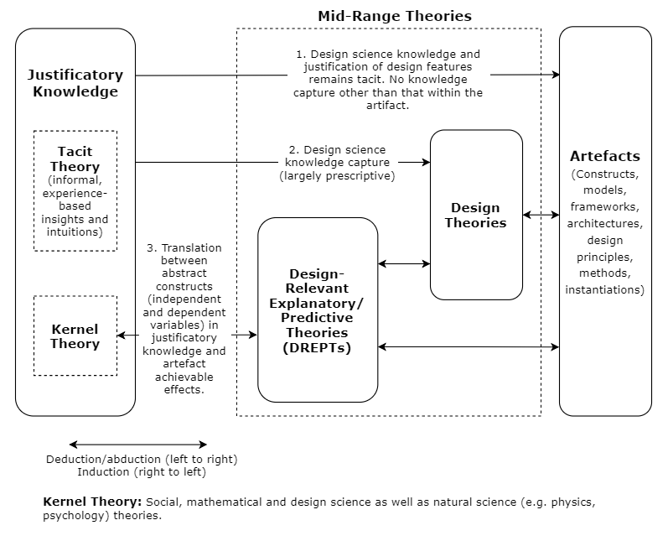

*Figure 6.1.* Framework for theory development in DSR (adapted from V Vaishnavi et al., 2004/2017, p. 20)

The idea of this inductively generated explanation has been adopted in this research. Since the current research project takes an exploratory approach with the aim of creating an inventive solution to the identified problem, the explanatory account of the design theory is not theorised in definitive and concrete terms. Rather, the observational findings will be discussed in a reflective manner whereby some kernel theories are revisited to explain the design.

Finally, in this framework, the results may also be related to and discussed with the more central and seminal kernel theories which served as the broad design principle of the solution, which in this case is the constructivist implementation of the system. The discussion of the findings in DSR would hence contain different levels of outcomes, from reported use and explanation of its performance to the implicative reflection on its kernel theories.

### Chapter structure

This chapter discusses the findings of the research in order to yield knowledge in the theoretical realm of the DSR contribution. As mentioned above, such knowledge outcomes are presented in accordance with the different depths of viewing perspective as well as the level of abstraction: reported evaluation, design theory and its explanatory account and reflection on the constructivist design principle. Each section possesses a higher level of abstraction.

Also, since the design theory is in the form of “how to do something”, the method used to design and develop the system can be part of the contribution (Gregor & Jones, 2007). This type of DSR outcome may include the presentation and discussion of the technical construction of the resulting e-learning system (such as program codes and algorithms, technical aspects of the database and website, functionality and interface design, and so on). However, the most relevant facets concerning the purpose and scope of this research are its educational content, the interaction with the students, and the delivery of learning. Therefore, the design is described and referenced not in terms of software engineering or algorithm development but more in terms of instructional design.

This chapter is structured as follows. In Section 2, the behaviour of the PSST system will be presented in a descriptive manner that is derived from the findings. The evaluation of the system will be discussed after this. Both quantitative and qualitative findings will be discussed together to provide an integrated validation of the system while noting the emergent issues in its performance. This serves as the verification of the hypothetical solution (meta-design) in this DSR; that is, it evaluates the functional soundness of the system and its ability to fulfil the meta-requirements. At the end of this section, the resulting design theory from the abstract artefacts is presented in the form of a propositional statement.

From this evaluation, the behaviour of the system will be understood from its use by the system’s end users. The findings can be discussed together with the justificatory knowledge that guided the design of the system. Based on this reasoning, Section 3 discusses the explanation of the effect of the system on the users’ learning. An explanatory account is resulted from this discussion linking the success of the design to its theoretical basis. The meta-design features contained in the design theory are discussed with the underpinning kernel theories.

Leading on from this, reflection on the successful implementation of the system may feed back to the kernel theories about the natural phenomena of learning in constructivism. This part of the discussion can be broad and implicit, but it can also be implicative and inspirational for future research in the field. This discussion will be presented in Section 4.

Finally, the chapter concludes in Section 5 with a discussion of the choice of DSR in addressing the research problem. This section also aims to yield a contribution to the methodology through its contextualised implementation in this research.

## Discussion of system use and evaluation

As discussed in the first section, the evaluation of the resulting artefact provides a validation of the DSR outcomes. These outcomes include the material instantiation of the design and the abstract artefacts (meta-design principles and features). Through the manifest fulfilment of the meta-requirements in the evaluation, the abstract artefacts can thus receive a generalisability outside the context of this research project. Three types of evaluative results can be yielded from the findings:

1. Measurement of learners’ satisfaction

Learners’ satisfaction is at the centre of the evaluation model, the measurement of which reflects how successful the resulting system is. Different sections in the evaluation model provided detailed measurement of users’ satisfaction towards each part of the system. This measurement was provided by the quantitative findings and further confirmed by the qualitative findings.

1. Learners’ explanation of quantitative measurement

In the qualitative findings, students gave explanations of their scoring of the system parts in the form of students’ opinions of the system in each section of the evaluation model.

1. Users’ report of system use and learning behaviour

From the interpretation of the integrated quantitative and qualitative findings, a descriptive account of students’ use of the system and their learning behaviour in the course can emerge.

In order to better discuss the evaluation of the system, the reported learning behaviour through the students’ use of the PSST system is presented first in this section. V Vaishnavi et al. (2004/2017) explained that the functioning artefact itself may be seen as a manifestation of the success of its design. From this descriptive account, the cause-and-effect relationship between the system design and resulting use can become evident.

The learners’ reflection on the quantitative measurement is then discussed in the following evaluation section. Together, these evaluative results can evince the fulfilment of the meta-requirements. These results give rise to the formation of the verified design theory.

### Resulting system use and learning behaviour

The PSST system is designed to serve as an e-learning tool for students in the phonetic transcription module to support self-regulated learning (SRL), practice and self-assessment. The system is also the central component of a blended learning environment which was set up for the phonetic course. As discussed in the design chapter, the implementation of the system follows a principle of openness. In this course, students are offered PSST as an optional tool for them to use voluntarily. Only a brief demonstration of the system was given to the students as initial guidance. No explicit instruction or prescribed use of the system is assigned to the students. Hence, the reported use of the system by each learner exhibits the successful facilitation of their genuine leaning needs in the context, which can thereby serve as evidence for the validation of the system design.

In the qualitative data, the students shared their typical use cases of the system in their learning. A diverse range of uses of the system can be seen from the findings. Specifically, students’ learning tasks with the system can be seen to possess different levels of difficulties. According to the literature reviewed on the kernel theories of learning, these use cases of the system are defined into three different types of learning: familiarisation, self-regulated exercise, and self-assessment. This division is not only based on the particular activities that the students perform but also the purposive mindsets they have for the learning tasks.

Additionally, these different types of system use cases can be seen to have been performed by the students in a progressive manner. As the complexity and difficulty of the learning subject improves, the students move from one level of learning to another. An example of such progression is thus presented afterwards. This result can thus provide a comprehensive understanding of the various learning behaviour of the learners with the provision of the e-learning system.

#### Familiarisation through drilling

When the students began the phonetic transcription module, they were given lectures on the general theoretical knowledge related to phonetic transcription, including basic phonology, articulatory gestures of speech sounds and their classification. Such knowledge helps the students to understand the difference and differentiation between the various sounds and how they are transcribed. It was generally reported by the students that at the beginning the phonetic course a lot of learning was done via repeatedly going through the different phonemes (sound elements) in order to become familiar with the different sounds and to associate them with the corresponding symbols. The phoneme category in the PSST system was approached by some students to perform this activity. Students would go through the phoneme menu and select the phonemes they needed to become more familiar with, and they would listen to them while checking their transcriptions immediately. It is to be noted that when students performed this activity, they did not write down the transcriptions of the sound items. Therefore, this use case is distinguished from the practice testing through exercises. This drilling method is typically found in behaviourist instructions for associative learning. This use of the system, however, was not the preferred method for many students. This issue will be discussed in detail in the evaluation section.

#### Self-regulated exercises (practice testing)

All students interviewed have reported their use of the system for self-regulated exercises. Typical use cases of the system for exercising included different steps. Students would first go through the entire range of learning materials by each subcategory via random exercises generated in the system. From this exploratory learning activity, their weaknesses could be diagnosed. The learning would then become more specifically focused on the targeted weaknesses of the learner. Customisation could then enable the students to practise on specified items. This type of exercise through self-testing was normally carried out through the option to get the answer “after each sound” but not exclusively. Some students took the exercises in a more test-like session. This use of the system accorded with the system design as the practice testing aspect.

#### Self-assessment

Some students performed self-testing not only in order to practise, but also for self-assessment. A student would typically choose a broader category of testing items and select the option to get the feedback “at the end of the exercise”. Through this configuration, students created for themselves a self-generated exam. The answers were then written down for marking. The student would also keep the score of the test as a progress record. This served their self-judgment and self-reflection on learning. The student could then make changes to their learning goals in response to their learning progress. The self-assessment was in this sense a different type of use of the system from that of practice testing. This procedure is of great significance in SRL.

#### Example of progression in learning behaviours

As students advanced in the learning of phonetic transcription, the use of the system typically shifted from an early learning stage to later ones. First, students might generate drills with a particular category of items or a specified set of items. This provided them with initial familiarisation with the sounds to be learned. Second, the students found particular difficult items in a group of newly encountered sounds and chose to focus on these sounds to overcome a specific difficulty. This involved deciding and specifying the learning items that were more difficult for the student. Sometimes it was a strange sound that is not readily recognisable by the student, or sometimes it was two or more similar sounds for the student to distinguish between. At this level of learning, students initiated self-diagnostic searches, then set goals and made plans to address the identified weakness. And finally, most students expressed the view that the PSST system helped them the most in preparation for their final exam of the phonetics course. The last stage of learning normally involved students’ self-assessment in holistic revision. At this point, the students examined themselves and kept records of their progress. They could then reflect on their revision and make adjustments to it. From these findings, it is clear that the system was able to function according to its design. The performance and quality of the e-learning system can be discussed further with details from its evaluation.

### Role of evaluation in DSR

In the literature review chapter, various factors, theories and models of e-learning, blended learning and, specifically, SRL were investigated. To serve the needs of the DSR approach, these aspects from the literature were reviewed in order to guide the design of PSST. In addition, the design was inspired by synthesising ideas from a number of works in relation to SRL and self-assessment. Unlike in the behavioural science research paradigm of IS, such ideas extracted from the literature were not simply “tested” by empirical activities. Rather, in a DSR, they were organised creatively to inspire the design and development of the resulting artefact (Alan R Hevner & Chatterjee, 2010).

Nevertheless, in DSR, the artefact design and its expected use were a lens through which the perspective of learning behaviour can be obtained. Therefore, by virtue of the evaluation of the PSST system that was presented in the findings chapter, it is possible to suggest that some of these theoretical constructs have received a degree of validation, especially in the specific context of SRL of phonetic transcription. The deductive evaluation of the e-learning system thus aims to assess how well the system worked, instead of how and why the system succeeded. However, inductive synthesis of system use and specific learner’s opinions are also presented to provide insights for understanding the performance of the system. These are further discussed with the kernel theories in the following section on the explanatory account of the design theory.

It should be noted that the evaluation of novel artefacts that follow innovative designs can be more of the demonstration of feasibility. Such “proof-of-concept” evaluation can be sufficient in verifying the significant effect that the artefact brings to the project (Gregor & Hevner, 2013). Therefore, such verification does not take the form of precise measurement or testing of existing theory; instead, it possesses reflective and suggestive qualities.

Furthermore, the value of various system design features derived from the literature and identified in the system evaluation model (Figure 5.3) were confirmed, as evidenced by the high marks they got in the quantitative study, such as for ease of use, user-friendliness, useful content, capability of controlling the learning process, capability of recording learning performance, capability of learning customisation, and effectiveness of proficiency acquirement. The positive results of its evaluation may therefore validate the design of the system and allows its abstraction to be generalised. Such abstraction can then serve back to the theoretical knowledge pool from where the design drew its inspiration. At the end of the evaluation process, a validation of the meta-design’s fulfilment of the meta-requirements, as defined in Chapter 4, is the result. The deductive process of DSR is hence finished and the design as a hypothetical solution to the defined research problem is tested and verified. This leads to the formation of the design theory statement, which links the meta-requirements with the meta-design principles that aimed to meet them.

#### Model of evaluation – e-learning system success

Since the evaluation of the e-l1earning system was conducted mostly based on interests in the field of IS, the evaluation model is discussed in relation with the factors in relevant IS frameworks in this section. The rationale of consulting an IS perspective in the evaluation process is given.

It is difficult to measure learning. Specifically, in the case of this research project, the invention of the artefact aims not only to improve learning effectiveness and efficiency in phonetic transcription, but also to transform a traditionally behaviouristic pedagogy into a constructivist one. No existing metrics for learning provide satisfactory measurement of such change. The focus of the evaluation accords with contemporary instructional design, in which the learner’s perception is put at the centre of investigation (Illeris, 2018; Januszewski & Molenda, 2013). Therefore, the evaluation of the artefact in this research focused on the central value in the constructivist learning theory: learner’s satisfaction.

The theoretical model used to evaluate the PSST system was derived mainly from two e-learning system evaluation models used in the field of IS (Shee & Wang, 2008; Sun et al., 2008). The adoption of the IS perspective in investigating and evaluating the e-learning system is discussed in the findings chapter. This was in order to observe the phenomena derived from the implementation of the artefact from the understanding of the interaction between technology and human behaviour. It was also to emphasise the role of the artefact in the interaction between pedagogy and technology (T. Anderson & Dron, 2011).

Both evaluation models consulted in this research consider learners’ satisfaction as the ultimate goal and measure of the success of an e-learning system. The emphasis on the central role of user satisfaction is derived from a few technology user behaviour models generally used in the field of IS.

In particular, the information system success model is a common predecessor of these e-learning evaluation models. A few factors are seen as determinants of user satisfaction in information systems. The independent variables are Information Quality, System Quality and Service Quality, which have their effect on the dependent variables of Intention to Use/Use, User Satisfaction and Net Benefits. These dependant factors also interactively influence each other (Delone & McLean, 2003).The dimensions of the evaluation model used in this research can be mapped with the independent variables in the IS success model. They are discussed in the following section in relation to some of the underpinning IS theories.

#### System Quality

The system quality dimension of the information system success is measured by the first section of the questionnaire on learner interface. DeLone and McLean (1992) originally assigned the measurement of this dimension to reflect the “more engineering-oriented performance characteristics” of the system. In the context of this research, this can be translated into interface design and system performance. The quality of the system is hence represented by the measurement of the interface design section of the questionnaire.

#### Information Quality

Information quality in this specific context of an e-learning application can be seen as the learning materials used in the exercises. These were tested in the system content section of the questionnaire. More specifically, they were tested for their timeliness, sufficiency and usefulness, which are among the most commonly tested qualities of the information content of a system (Delone & McLean, 2003; Petter & McLean, 2009).

#### Service quality

Delone and McLean (2003) extended their early information system success model with the dimension of service quality, which in the IS context relates to the support provided peripherally to the end users of the system. This dimension has been translated differently into the e-learning domain in different cases. For example, Y.-S. Wang, Wang, and Shee (2007) measured the interaction between the developers of the e-learning system and the users during and after the development. And Holsapple and Lee‐Post (2006) defined service quality in their e-learning success model as the desirable characteristics of student-instructor interactions. However, these variables were less available and relevant in the context of the PSST system, since the system was constructed for SRL and the instructor’s involvement is minor. Nonetheless, the students were provided with technical and pedagogical support to use the system. In particular, this construct can be considered against the background of the blended learning environment that incorporates the e-learning tool with intended synergy. The section in the questionnaire on the value added to the blended learning environment can hence provide an insightful understanding of this dimension of the information system.

### Discussion of system evaluation findings

To produce a comprehensive evaluation of the system’s performance, quantitative and qualitative findings are integrated and interpreted together. In this section, these findings are discussed within the evaluation model of e-learning success. Such discussions are presented according to the order of the components of the model.

#### Learner Interface

This section of the quantitative findings displayed an overall highly positive measurement of learners’ attitude towards the PSST system. Among the first four dimensions of learners’ satisfaction, the learner interface had the highest mean score of the questions. The outstanding scores of the quality of ease of use, user-friendliness and ease of understanding (agree – highly agree) exhibit the great potency of the system with regard to instructional delivery and usability of the technology.

One important factor that is measured in various success models is the system stability, which in the case of this research received a below average score. This is specifically salient in comparison with the other system quality factors. The relatively negative response towards system stability is consistent throughout the data set, which means the occurrence of technical errors can be prevalent among students. This is further confirmed in the interviews as many students experienced occasional technical problems. However, this finding can be further investigated with the insights generated from other findings.

Firstly, in the question of the interview set for addressing this particular issue of stability, some students provided contradictory and vague responses in their descriptions of the technical problems they faced. This may indicate that some of them were not completely familiar with the technology involved in the use of the system. The students are mature professionals trained to work with speech-impaired patients, and they do not necessarily possess background experience with computer and internet technology. This may suggest a further factor that can be measured with regards to the use of e-learning tools, which is the influence of technology readiness.

Secondly, some responses to the question involved the reporting of the problem with the content of the system. More specifically, the Connected Speech category of learning material in the phonetic transcription exercise was reported to have no answer after the question items. This was due to an in-progress development of learning content by the instructors of the course. Despite the reasonable dissatisfaction among students towards this particular area, this finding reinforces the importance of information content in determining users’ satisfaction. Moreover, the influence of information quality on the system quality is clearly seen in the findings, both from the quantitative correlation between the questionnaire items and from the qualitative explanations. Although the impact of system quality on information quality has been reported, the effect is rarely seen the other way around (Gorla, Somers, & Wong, 2010).

It is worth noting that the visual interface design style received a relatively lower score than the other highly related design aspects of the system. This did not seem to impact the perceived system quality, which had a low correlation with the ease-of-use aspects of the system. Indeed, in their interview responses, students did not seem to have a clear impression of the visual style affecting their learning. This specific point seems to disagree with some previous observations on the e-learning system interface style (Hasan & Ahmed, 2007). Potentially, the users of the PSST system are comparatively more professional, so practical efficiency and functionality are more crucial than visual style to them, as indicated by some students interviewed. Additionally, no consensus was derived from the students on the preference of visual style. However, some common practical suggestions were mentioned by the students which echoed with the literature on interface design. In particular, the colour and fonts were salient visual aspects of the system design (Nathan, Yeow, & Murugesan, 2008). Guidance, clarity and speed also highly correlated with this aspect, which also agreed with the literature.

#### System Content

The system content section is of great significance in the evaluation of the PSST system. Evaluative data received in this area is mixed. The usefulness of the system content was greatly appreciated by the students, and the question on this received one of the highest scores on the questionnaire. However, the accuracy and sufficiency of content appear to have been questioned in the qualitative findings.

The content accuracy of the PSST system received a below average score with relatively high standard deviation. It was also the second most frequently reported issue in the open question section of the questionnaire. Although the consequent score is still above 5 (slightly agree), in comparison to other aspects it indicated a fairly common student concern. Some students reported occasional appearances of mismatching answers while others did not. This implies the relative rarity of the potential inaccurate items in the system. However, for a system largely used for exam preparation, the sensitivity on accuracy is very high. Moreover, one point worth noting is that some students expressed mistrust of the answer where occasional mismatches were perceived. They would then consult other resources to check the right answer. This may cause a negative impact on the use of the system and their learning. The trust aspect also seems a relevant dimension which could have been tested in the evaluation.

A more pronounced issue reflected by this section is the sufficiency of content. This question received the third lowest score, with a mean below “slightly agree”, and it was also reported several times in the open question section of the questionnaire. Most students expressed that their satisfaction of using the system was affected by the lack of test items in the system, especially in the category of Nonsense Words, which is an important category in this context as the nonsense words were the most necessary part for many of the students due to the difficulty in transcribing them and their inclusion in the final exam. Where the learning needs are particularly high, the importance of content quality is more prominent.

The variety of the test items is also an important factor mentioned by many students. In this case, the sounds to transcribe in the system were produced by one instructor, whereas both the final exam and the sounds required for transcription in reality will be produced by people who have different voice qualities and accents. This emphasises the goal of practice design in mimicking the situation where the skill is applied in a real situation (Fisher & Baird, 2005)。 Also, insufficient variety in the practice items will result in students’ habituation of the repeated drill pattern, which both decreases satisfaction and minimises the effectiveness of the practice. This point was also reported by the students about the lack of test items, which agrees with previous literature.

Another significant finding of the content sufficiency is its correlation with the customisation item in the questionnaire. The highest correlations found in relation to the content sufficiency are the customisability of the system and the system’s role in solving personal difficulties in learning. This point is consistent with the previous literature concerning e-learning customisation which finds that content quality and sufficiency are particularly crucial in practice-focused e-learning applications (D. R. Garrison & Anderson, 2011).

Some students proposed other types of learning content. More categories of test items were suggested in order to match better with the examination. More importantly, some mentioned that the answers could come with theoretical explanations of the way certain sounds are transcribed. In this case, they would like to be helped more with the “why” question when they were practising. Although the realisation of this aspect may encounter significant technical challenges, this is particularly worthy of attention. Since the system was designed according to a constructivist principle, understanding through active construction of knowledge was promoted.

The influence of the content of the PSST system can also be seen in other sections of the evaluation. This largely overarching effect supports the essential role of the learning content in e-learning system design. Therefore, the information quality, namely the learning material content, can be regarded as the most important factor in the PSST system that influences the learners’ satisfaction. This could be generalisable to all e-learning applications that involve drill and practice and customisation.

#### Customisation (personalisation)

The personalisation section in the evaluation of the PSST system was specifically adopted for its core design principle, namely a constructivist learner-centred application. Web-based learning systems are particularly potent in facilitating learners’ personalisation (Piccoli et al., 2001). It has been suggested that this is tested on the system’s capacity to support learners in controlling their learning and recording their performance (Shee & Wang, 2008). The test result of these aspects in the quantitative findings displayed some level of dissatisfaction, particularly for the question on customisation. However, the qualitative findings provided some explanation of this result.

The first question “I have the control of my learning progress with the PSST system” was mentioned by some students in the interviews to be ambiguous, especially about the notion of progress control. The system was designed to supply students with a test mode where the answers are displayed after a series of exercise items. This feature was used as designed by most of the students interviewed. Students would manually record their answers and mark themselves on their performance. The marks were kept by some students to track their progress over time. However, the practice of progress recording was not prevalent among the students.

While the students who actually kept their marks reported the helpfulness of self-regulated progress tracking, many students mentioned their unwillingness to do it manually. It was further suggested that the system keep test records automatically, which was also reported in the open question responses. The system was designed to encourage student self-regulation through minimal additional activities like writing down answers and keeping marks. However, the progress tracking aspect seems less usable in this specific context. A potential explanation is that, since the self-tests are configured each time by students to address a temporary testing need, the test may not need to be generated again. Also, the configuration of the same test can require extra work that is irrelevant to the learning itself.

The customisability of the system received a score below average in the questionnaires. However, the qualitative findings provide further insight into this issue. In the interviews, students generally expressed their appreciation of the system’s customisability. It seems that this particular aspect was widely praised despite the findings of the quantitative results.

The potential problem of customisability was re-examined in a separate interview question to ensure the issue is well understood. The finding indicates the possible misunderstanding of the question by the students. The questionnaire item for this factor reads: “the PSST system is fully customisable to meet my personal learning needs”. This may suggest the wording of the question was partially the cause of the below average score (slightly agree – agree), as there were parts of the system that remained in development, so not all student needs were fully addressed. This is further confirmed by the report on the missing answers in the Connected Speech category.

This finding echoes previous findings in the section on system content. Insufficiency of learning content will result in significant impairment in customisation (R.C. Clark & Mayer, 2007). It also seems particularly visible in SRL.

#### Value to the blended learning environment

This section was specifically designed for testing the PSST’s role in the blended learning environment and its synergy with other instructional components of the course. By integrating the quantitative and qualitative findings in this section, a clear and comprehensive picture of the blended learning situation in the course can be produced.

The major perceived role of the PSST system in the course was clearly in relation to revision preparation. An apparent consensus on its effectiveness in helping the students’ revision can be seen in both questionnaire and interview results. As an e-learning tool on the course, the system was perceived by the students to be highly effective and efficient. This was particularly associated with the flexible access of the website. As the students’ exercise were freed from time and space limitations, the system provided a much more effective learning experience than that of the synchronous practice in the classroom. An essential strength of successful web-based tools is its flexibility and convenience (Enoch & Soker, 2006). The PSST system has realised this through its design and implementation.

The benefit of the asynchronous learning experience with PSST is further emphasised in its synergy with customisability. The system’s high flexibility in responding to students’ learning needs is shown to be helpful in these aspects. Moreover, by facilitating self-paced learning, the system allowed students to have much fuller control over their learning and practising. This feature was generally promoted as it supported students in addressing their problems with deeper reflection and more meaningful learning results (D Randy Garrison & Kanuka, 2004).

With regard to the interactivity between PSST and other components in the blended learning environment, the situation seems more complicated. The quantitative findings displayed relatively low scores for the students’ agreement on the PSST’s positive influence on classroom lectures and small-group workshops.

Students generally failed to associate the learning experience with the e-learning system and the taught lectures. Rather, the phonological knowledge taught in the lectures was seen as separate from the practice done via PSST. Hence, the relationship between the lectures and the system was mainly complementary rather than cooperative. Some other findings show students’ expectation that the system would provide factual knowledge like phonological roots and articulatory gestures with the test items and answers in the PSST. This may not only help clarify for students the reason for the answers, but it might also provide the learners with a further opportunity to reinforce the factual knowledge.

Students did not generally think that the PSST system improved their interaction with colleagues in small-group workshops. The explanation provided in the qualitative findings suggests that the students did not really interact with each other when learning the phonetic transcription. The interpersonal activities largely consisted only of instructor-student interactions. However, the students generally expressed that they shared their experience of the system with other colleagues. This is known to be beneficial to the system use from a blended learning perspective (Wilson & Smilanich, 2005). According to previous observations, e-learning systems are not particularly well suited to enhance the learning community (Summers et al., 2005). Additionally, in the evaluation mode of Shee and Wang (2008) from which the questionnaire was adapted, the learning community dimension was found to possess the least importance relative to the other evaluative dimensions of a web-based learning system. This was seen in the case of the PSST system too.

Although the direct interactivity between the PSST system and the other components in the blended learning environment are not notable, the positive influence of the system in the course is apparent. Students generally reported that they gained mastery from practising phonetic skills using the system, which resulted in their confidence in lectures and workshops. The anxiety towards summative assessment was considerably reduced by the self-assessment process as students practised in preparation for the final exam.

Another important finding is that the students displayed significant difference in the use of the system with the presence of formal demonstration. The students who were introduced to the system by the instructor generally exhibited higher engagement with the system and a wider range of usage. Moreover, the demonstration of the PSST seemed to prompt diversity of system, which resulted in an wider range of use as reported. This can be linked with the synergy between blended learning components, as initial guidance of effective practice should be provided in different forms. From an IS perspective, the service quality determined users’ satisfaction directly, which also resulted in net benefits gained from using the technology (Delone & McLean, 2003). Thus, the introductory demonstration of the system exerted significant influence on its use.

#### Constructional components of the PSST system (Learning experience with the system)

In this section, the PSST system is evaluated with regard to each of its constructional parts. The quantitative results informed the questions in the interviews. Combining the quantitative and qualitative findings for each part of the system, they can be discussed with the theoretical aspects of the system evaluated above. This is intended to enable an assessment of each of these parts and an understanding of their relationship with the overall performance of the e-learning system. Overall, almost every aspect of the phonetic transcription exercise in the PSST system received remarkably high scores (agree – strongly agree) with the main exception of the Connected Speech category.

All of the categories of exercise items in the phonetic transcription part of the system are very valuable according to the students interviewed. Most of the students used every category in their learning and practising. Remarkably, many students explicitly described how they used the system to follow a plan of progression. The phonemes were used at the beginning of the course when related knowledge was taught, and gradually the students moved onto English Words and Nonsense Words as their skills in previous categories advanced. Therefore, the self-regulation of their learning was facilitated and encouraged by the PSST system.

Students differed in the value they attached to each category, especially as the course proceeded. Some students found the Phonemes category to be the most helpful, while other students considered English or Nonsense Words the most helpful. The demands of the exercise in the more difficult categories increased towards the end of the programme. Usually, the students eventually focused on the much more specific areas of their weaknesses. This finding reinforced the role of the PSST system as blended learning, mainly for revision. More specifically, the system helped self-regulated revision that focused on addressing individual difficulties.

The content in the Nonsense Words category was still under development. The students could, however, still practise transcription with the items in that section without being provided with correct answers. This part of the system was still deliberately evaluated in order to acquire insight into its potential and an understanding of students’ learning behaviour. Practising transcription with connected speech was generally seen as very useful and it was highly anticipated by the students. The importance of connected speech items can be attributed to two main reasons. First, it is significantly more difficult than other categories that require more time to practice. Second, it simulates real-life situations in which professionals transcribe more connected speech from patients. Some students found that even practising without provided answers could still help their learning of phonetic transcription. This reinforces the pivotal value of the instructional content in e-learning systems.

Customisation in the PSST was achieved through a selection between a range of different subcategories of the exercise items. This selection was facilitated by a dynamic responsive menu which was highly praised by the students. The choice of the design made the configuration of exercise items both comprehensive and clear. On the other hand, some selection pages were reported to be overly complex, such as the phonemes selection chart. This may be due to the nature of the multiplicity of phonetic items. However, the crucial role of simplification is clearly echoed in achieving a user-friendly design (Ruth C Clark & Mayer, 2016).

Finally, the answer displaying options between receiving answer after one test sound or a series of sounds was considered the most outstanding feature of the system. This page received the highest score among all items in the questionnaire and its success was further confirmed by the interview results. This design was intended to provide students with opportunities of doing exercises in different modes, namely a practice mode and a test mode. Most students described their spontaneous use of this feature in accordance with the design intention. This is a core feature that enables students’ self-regulation in learning and, specifically, self-assessment. Further discussion of this aspect will be presented in the following sections.

#### The case of the Pronunciation Exercises

The pronunciation exercises were designed to provide a complementary dimension for acquiring phonetic transcription skills, since both the literature on phonetic learning and the course instructors suggested that it supports learning phonetic transcription. However, the findings reveal students’ general neglect of this aspect of the system. This was found to be largely due to a technical difficulty for many students where an applet is required to perform tasks in pronunciation exercises. However, some students expressed an indifferent attitude towards this part of the system as they were not introduced to it, nor were they encouraged to use it. This is also related to the highly exam-driven motives of the students on this course as revealed by the interviews.

After a brief demonstration of their functionalities in the interviews, the pronunciation exercises received far more positive responses. Most students agreed that practising in this section would help their learning of phonetic transcriptions. Many students reported their own attempts to practise pronunciation exercises without the system. This agrees with the suggestion that phonetic skills can be improved by increased phonological awareness (Gillon, 2004). The potential of this side of the PSST system can be significant, provided there is technical accessibility and a demonstrative introduction.

#### User-suggested functions

The PSST system served as a platform where tentative ideas could be tested conceptually. New functions were thought of as additions to the existing system. Ideas available for discussion were derived from open-ended questions in the questionnaire. Such open questions led to the free discussion towards the end of the interviews. Some student requests were frequent, which could suggest potential improvement of the system. The most discussed functions were:

* Personal account to log into, which keeps records of learning progress and configurations of exercise.
* More mobile-friendly design, possibly a smart phone app.
* A variety of voices and accents for the exercise sound items.

These suggestions all lead to a more accurate simulation of real-life situations. Which could be of significance in SRL.

### Design theory statement

From the reported system use and the evaluation of the system discussed in this section, the fulfilment of the meta-requirements defined in Chapter 4 is verified. A propositional statement of design theory can result from bridging the meta-design with the meta-requirements it fulfils:

**Design theory:** An open e-learning system for customisable, self-generated tests can facilitate effective self-learning and self-assessment in phonetic transcription learning.

This statement includes only the first three meta-requirements. This is due to the absence of system use in the pronunciation exercises discussed earlier. However, this aspect will still be discussed and tentative explanations will be presented in the next section. Also, the meta-design is represented in this theoretical statement as referring to its principles. Since the system is a complicated combination of all the features functioning together that resulted in the satisfaction of the meta-requirements, the design theory is better represented as an inclusive one. However, explanatory accounts of this design theory discussed in the next section can provide more detailed insights into the functioning of these meta-design features.

## Explanatory discussion of the Design Theory

The components of the resulting design theory have been presented in previous parts of this thesis: the meta-requirements and meta-design were outlined and defined in Chapter 4, and the theoretical statement was discussed in the early sections of this chapter and were followed by the evaluation and validation components. In this section, the explanatory component of the design theory will be presented.

As discussed in section 1 of this chapter, the verified prescriptive knowledge resulted in the evaluation process of the system can be examined by revisiting and connecting with the kernel theories that inspired the design. From this process, the relationship between design action and the resulting goal can be abstracted to a theoretical cause-and-effect relationship. In other words, such discussion may explain how and why the system succeeded. This design relevant explanatory account can thus map the specific design of the system to the more general learning phenomena.

This section first discusses the core design features derived from the SRL and self-assessment literature. This is followed by discussion of the interaction of components in the blended learning course environment. Finally, the design is discussed in relation to the specific context of phonetic transcription learning.

### Potentials for Self-regulated learning

SRL is a key concept for the e-learning design of PSST. It underpins learner-centredness in accordance with a learning environment based on constructivism. The design of PSST was intended to facilitate and promote students’ SRL and their self-regulation skills, the benefits of which were discussed in the literature review. This section discusses the findings along with the SRL literature to explore the potential of PSST in facilitating SRL. Such discoveries can produce guidelines that lead to a future DSR cycle of the system.

#### Facilitating SRL stages

Overall, the students in the phonetic transcription module reported obvious signs of self-regulation through their voluntary learning with PSST. From this finding, it can be suggested that SRL is potentially facilitated by the system. It has been argued that effective SRL design principles should involve promotion of a set of self-regulatory activities in learning. According to various widely accepted sources, these activities often include goal setting, strategy planning, self-motivation, self-control, self-monitoring/observation, self-judgment, and self-reflection (Abrami, Bernard, Bures, Borokhovski, & Tamim, 2011; Saks & Leijen, 2014; Zimmerman & Moylan, 2009). Signs of all these activities were reported by the students who used the system. It can thus be argued that the particular design features that can support these activities have the potential to facilitate learners’ effective SRL and to benefit their learning as a whole. The design features that enabled these behaviours can also be abstracted to suggest general knowledge that could be applied beyond the case of PSST. These aspects are discussed separately below.

##### Goal setting and self-motivation

Goal setting and planning are claimed to be key activities in SRL that induce depth of learning by introducing complexity (Winne, 2018). Three factors are regarded as crucial in these activities for promoting complexity in SRL tasks: (1) number of standards comprising a goal; (2) number of goals; and (3) dependencies among goals (ibid., p. 13). These factors can be seen as supported by the system design. First, in relation to (1), the different types of system use reported by the students indicate a variety of different standards in their learning goals. The provision of a full range of learning material categories in PSST and the phoneme specification charts provided students with all possible combinations of practice items. Such a configuration allowed the students to make the smallest increments in their progress. In relation to (2), the dynamic responsive menu design for the subcategories of practice items allowed students to have a clear hierarchy of different potential goals leading to specified planning. Finally, in relation to (3), students need to develop the more basic skills of transcribing simpler sounds (phonemes and short words) before moving onto the more complicated tasks. The dependencies among such learning tasks can thus support integration of the learned knowledge. These results suggest that providing a full range of learning items with exhaustive categorisation can lead to preferable goal-setting complexity for learners and so may enhance SRL.

Self-motivation is another crucial aspect suggested in the first stage of SRL. It is widely accepted that at the centre of self-motivational beliefs is the perception of self-efficacy (Zimmerman, Bandura, & Martinez-Pons, 1992; Zimmerman & Moylan, 2009). This refers to the student’s specific beliefs about his or her ability to perform each step in planned learning to achieve set goals. From the students’ accounts of their learning with the system, relatively high self-efficacy can be perceived. In particular, students’ self-efficacy can be seen as being related to the content quality part of the system. For parts of the system that have insufficient content (i.e., nonsense words, connected speech) or relatively poorer content, students had less belief that they could experience effective learning. Lack of learning material can thus result in a lack of self-motivation.

Fisher and Baird (2005) have suggested that a central source of self-motivation is the relevance of the learning in the real world. Students on the phonetic transcription module are generally conscious about their future practice in clinical speech and language therapy. This may provide them with the intrinsic motivation to help initiate their SRL of phonetic transcription. Moreover, the exercise was intentionally designed to simulate the real-life situation through various features (e.g., real-language items, hand-transcribing). Positive responses towards these features suggest a correlation between real-world relevance of training and learners’ self-motivation.

##### Self-control and self-observation

Instead of preparing a fixed pre-set exercise to direct the students’ application of their skills, PSST aimed to provide an open environment for students to explore. This may be responsible for a set of adaptive self-control activities of the students. Some common self-control methods suggested to improve self-regulation, such as task strategy, time management and environmental structuring (Zimmerman & Moylan, 2009), can be seen as relevant to use of the system. In particular, environmental structuring is claimed to increase the effectiveness of learners’ immediate environments. PSST was intentionally designed to encourage students using paper and pen to record their phonetic transcription answers in their tests. Not only does this reinforce students’ habit of self-control, but it also helps the students prepare for real-life clinical practice. More importantly in the e-learning context, the students are required to make use of the digital environment to construct their learning experience. The openness of the system use allows and encourages the students to manage their learning time and define their task strategies. This type of implementation of the e-learning system may thus have the potential to enhance students’ self-control skills in SRL.

Time management cues have also been shown to be particularly important in SRL for promoting self-control (Broadbent & Poon, 2015; C.-H. Wang et al., 2013). It is suggested that students set up a particular time and space dedicated to online learning by themselves. The PSST system was introduced to the students with an emphasis on this aspect but without a fixed instruction. Benefiting from the universal accessibility of the web-based system, students set their schedules freely according to their individual needs and convenience. The web-based learning platform may thus be a possible resource for improving self-control skills.

Help-seeking is sometimes seen as an important SRL activity of the learners and one that should be supported by the instructor (Richardson, Abraham, & Bond, 2012). This aspect has not, however, been strongly associated with e-learning achievement in empirical results (Broadbent & Poon, 2015). The students in this research did not generally report a need to seek help during their learning with the PSST system. Moreover, the user-friendliness of the system was highly appreciated, which could reduce the students’ need for extra help from the instructor. From this reflection, it can be argued that the help-seeking need in SRL may be reduced by a usable interface design.

Adaptability is also worth noting when trying to induce regulation of learning. Self-control, such as in following a plan, should be considered with a certain degree of flexibility to enable adaptive learning activities. This is especially significant in constructivist learning theory. Self-observation is thus of importance for self-control strategies to be adapted based on students’ individual outcomes. Zimmerman and Moylan (2009) emphasised two main types of self-observation: metacognitive monitoring and self-recording. The former refers to the informal tracking of one’s learning process, while the latter refers to the formal record-keeping of one’s performance and progress. Many students in the project reported their execution of these activities while learning with PSST. However, whereas most of the students actively engaged with metacognitive monitoring, only a few actually kept a record of their progress. In addition, a frequently suggested feature by the students was for the system to keep a progress record for each user. This may suggest the significance of including facilitation of self-recording in the improved system.

##### Self-judgment and self-reflection

Self-assessment provides students with an opportunity to identify accountability themselves. It has been argued that by monitoring and assessing their learning progress, students acquire a sense of ownership that in turn generates motivation (Fisher & Baird, 2005). In their use of the PSST system, many students discovered that the self-generated tests enabled them to gain a clear vision of their learning outcomes and progress. From this it can be seen that the self-test aspect of the system may have a role in providing learner ownership.

More importantly, the students generally had confidence to carry out SRL with the system after some initial use of it. This represents the fulfilment of positive self-satisfaction in the self-reflection phase of SRL (Zimmerman & Moylan, 2009). Moreover, the *adaptive decisions* factor in the SRL model of Zimmerman refers to the willingness of learners to continue or modify their learning strategy in future learning. Such willingness was reported by most of the students using PSST. This result indicates the system’s potential to provide students with effective self-evaluation of their performance.

Finally, according to the literature, positive self-reflections can feed back to the cyclical process of SRL as enhanced self-efficacy, which further improves willingness and effectiveness of future learning (Bandura, 1990; Zimmerman et al., 1992; Zimmerman & Moylan, 2009). Most of the students wished to return to the PSST system after graduating from the course in order to help with their clinical practice and refresh their knowledge. The feedback effect of positive self-reflection can thus also be a mechanism for the system to support SRL.

#### Practice in SRL

Heward (2003) has justified the use of rote practice, particularly for developing prerequisite skills that precede more complicated learning. In the case of phonetic transcription learning, the familiarisation with phonemes is seen to particularly benefit from learners’ drill and practice. This finding supports the usefulness of drilling, especially on elemental skills and knowledge.

A remarkable finding was that the students expressed an explicit preference for minimalist repetitions when it comes to associative learning of the basic elements in the skill mastery. Many students used an IPA chart tool to gain familiarity with the phonemes at the beginning of the course. The IPA was preferred over PSST because it provided instant feedback and required less configuration. In this sense, some students voluntarily chose to drill with even more mechanical repetition and found it more useful.

This can be seen to accord with some previous literature that found behaviourist drilling to be especially effective in the acquisition of the basic stimulus-response associations (Ornstein, 1990). Such associations are often required to precede more complex skills or understanding in the learning of various subjects (Heward, 2003). Constructivist-inspired instruction may have its limitations in these areas, especially the exploration-heavy approaches (Kirschner et al., 2006).

The students’ preference for simpler rote drilling can be further discussed, particularly in light of the theoretical literature. Although some students pointed out that rote drilling is convenient when familiarising themselves with phoneme items (by using the IPA chart tool), more students appreciated actually generating focused exercises and tests in this category with the PSST system. Instead of sheer mechanical rote drilling on the association between sound units and symbols, the transcription exercises and tests of phonemes have been specifically shown to be of significance before learning and training with more complicated sound items (Howard & Heselwood, 2002). P. Ashby et al. (1995) set out several good reasons for phonemic transcription training, including that such training will help students with: (1) word segmentation skills; (2) sound identification and discrimination; (3) replacing the English spelling system; and (4) recognising the difference between individual sounds and their appearance in connected speech. Furthermore, this type of exercise can prepare students with the learning pattern before moving onto a more complex category in the system. Therefore, the training style in the PSST system on the phoneme items can be seen to provide the opportunity for the students to obtain nuances like these more than they could do with the alternative tools. However, the provision of a minimalist sound-symbol correlation chart could still be provided so that the learner is offered options that they may prefer in different stages.

Although existing e-learning systems commonly adopt a drill and practice approach to phonetic transcription learning, most of them still use predetermined sequences of exercises or focus on one particular sound (M. Ashby & Maidment, 2005; Munson et al., 2010). PSST, by contrast, enables students to generate exercises to address their particular difficulty. In PSST, the feature is realised by providing students with highly customisable exercises. With evidence of several successfully applied practice programmes, Fletcher (2009) has summarised their success factors as the adjustment of “content, sequence, difficulty and pace for individual learners”. The PSST system is not only customisable in all these dimensions, but also possesses more extensive individualisation. Such customisability allows students to practise in a way that suits them best, which is in line with the constructivist promotion of learners’ ownership of learning.

#### Self-assessment and meta-cognition

It has been suggested that formative assessment provides intrinsic benefits to learning (Kromann et al., 2009). In other words, when students receive formative feedback, their understanding is improved despite learning time being unchanged. A core feature of the PSST system is that it provides students with the ability to decide the test items sequence and answer display options. With this facility, students are effectively supported to conduct self-assessment from self-generated tests. Many students highly appreciated the capacity of PSST in enabling self-assessment, which greatly helped them in their revision. The learning enhancement through formative assessment is suggested by this result.

Earl (2012) emphasised the role of self-assessment in the learning process. Generating exercises oneself according to one’s progressive learning needs (needs and difficulties that change throughout the learning process) allows students to reflect on their cognitive activities. Such metacognitive awareness will then lead to the better understanding of their cognitive status in learning phonetic transcription, as well as to greater clarity about what stops them from combing through the complexity of real-world problems (transcribing sounds in a live situation) and being able to untangle it themselves (Vovides et al., 2007).

In this regard, the customisation and generation of the exercises become part of the learning/revision strategy planning for the students. The problem-solving nature of this task (design self-tests) enables students to actively reflect on their learning experience and to construct meta-knowledge about their competence in phonetic transcription. They can thus acquire the ability to prepare themselves in response to specific situations. The self-learning tool could therefore provide students with more opportunities to handle their self-regulation in learning, which would, in turn, promote better use of the system itself.

Additionally, Hattie and Timperley (2007) emphasised the role of the internal feedback that the students use to self-assess. The capability and willingness of creating such feedback determine the effectiveness of the students’ learning. This type of feedback also has the potential to promote self-regulation strategies that result in significant enhancement of their future learning. These key self-assessment aspects of PSST will require more systematic assessment in a future cycle of the DSR process.

### Blended learning environment

The PSST system is designed with the consideration of the blended learning environment and especially the interplay between its components. The design of the phonetic transcription module itself is also guided by blended learning theories to accommodate the system as one of its core components. However, the findings have indicated that the interactions between blended learning components are fairly limited in this research context. This could be due to various characteristics of the learning subject. Nonetheless, resulting system use concerning some aspects of the blended learning course can still be discussed in order to explain special findings.

#### Teacher and peers

Shea and Bidjerano (2010) suggested that the instructor in blended learning environments has a stronger role in influencing students’ self-efficacy. This is seen as a strength of blended learning, and the instructors’ positive feedback to students’ performance is encouraged.

Another role of the teacher in phonetic transcription e-learning is to develop reusable learning materials (M. Ashby et al., 2007). As the learning content of an e-learning system is of great importance, such development is key to the quality of e-learning. The teacher should, therefore, cooperate with the system and facilitate the e-learning experience as a whole.

A systematic review has found that peer learning as a SRL strategy has significant advantage in e-learning context, which is suggested to be prioritised (Broadbent & Poon, 2015). However, the students in the phonetic transcription module generally did not express the significance of peer learning experience. Although this could be due to the characteristics of the learning contents of the course, the social presence is found to be a main weakness of this blended learning environment. Further attempts to improve this aspect should be considered in the future development.

#### Washback effect of formative assessment

Encouragement of collaboration and interaction in a blended learning programme can be impacted by the assessment setting of the course. Besides providing students with motivation, summative assessment is also reported as sometimes making students to equate learning with exam preparing (Mclachlan, 2006). This is said to be especially pronounced in high-stakes testing, and when the assessment has a closed-end structure (A. Walker & White, 2013, p. 131). If the exam result trumps other learning objectives, technical attempts in areas other than the direct improvement of the scores may discourage teachers from adopting them and be resisted by the students.

The findings of this research agree with this washback effect. The students generally expressed their concentration on the exam results, and the PSST system was used most heavily for their revision. Although social activities like sharing of the peer experience related to the system were encouraged, the students did not seem to engage very actively with aspect irrelevant to the exam. The case of pronunciation exercises can also be seen as a manifestation of this effect. Many students explicitly reported their indifference towards exercising phonetic pronunciation, due to it not being tested in the final examination.

#### Importance of demonstrative guidance

Instructors in blended learning settings generally bear the responsibility of helping to initiate the use of technology and self-regulation. This is also claimed to be especially important in a constructivist course design (Fisher & Baird, 2005). The PSST system was designed to be understood fairly easily by the learners themselves, so the initiation of using the system should not necessarily be an obstacle. However, a strong finding revealed the importance of the role of an instructor in this context. The students who received formal demonstration of the system gained significantly more insight into the system’s potential, which then led to their relatively deeper exploitation of the system features. This is concordant with empirical results in previous research. Dignath and Büttner (2008) concluded that the instructor has a significant role in promoting SRL through intended intervention. It is also suggested that specific training of teachers to conduct such instruction is appropriate. This should be noted both for blended learning implementation and the introduction of e-learning systems.

Additionally, the ease of use of an e-learning application is shown to be improved by the introduction phase. Abrami et al. (2011) suggested that task analysis involving goal setting and planning prompts should be included with the demonstration of the application. This can also be accompanied by reinforcement of self-motivation beliefs, namely forethoughts of self-efficacy and outcome expectations. Such a practice is proposed to facilitate better initiation of students’ use of the e-learning tool as well as to help their self-regulatory behaviours.

### The specifics of phonetic transcription learning

A few findings concerning the special characteristics of phonetic transcription learning are discussed following.

#### Learning Item Categories

Unlike most previous systems which contain only a limited range of content categories, in PSST the whole range of relevant categories of learning material (from phoneme to connected speech) was offered. Following Gillon (2004), this made it possible to provide overarching phonological awareness training. In addition, these categories are further divided into subcategories. Such categorisation enables the learner to choose items specific to particular difficulties in mastering the relevant skills they might have, such as in distinguishing similar sounds. Moreover, by navigating through these categories of sounds, the students are prompted to the framework in which different sounds are classified. This would then help them to analyse their performance and specify their weaknesses. This focus on individual difference can be particularly beneficial in phonetic transcription learning, as the difficulty of sound items can vary strongly between learners (Howard & Heselwood, 2002).

One problem found with regard to the provision of full-spectrum categorisation is that the options can be overly complex and confusing. A minority of the students reported that the structure of the system was a little too complex. However, the final design of the system tried to address this problem with a dynamic responsive menu that allowed students to select items without being overwhelmed by the complexity. The evidence that this interface optimisation helped reduce complexity and confusion is observable in the questionnaire results and confirmed by the qualitative findings. Some students directly complimented this feature in the interviews. The minimalist interface design principle derived from the e-learning design theory of Ruth C Clark and Mayer (2016) is hence validated.

#### Simulating real life situation

Real-life simulation is generally recommended in the field of phonetic transcription (M. Ashby et al., 2007). Most phonetic systems require users to input answers or to select from options on the screen. PSST encourages them to write down the answers manually. On the surface this seems less advanced, but it was demonstrated to be effective in encouraging students to practise producing transcription and to gain more familiarity with the symbols, and it made the exercise a more realistic task. This enables learners to gain competency at the level of real-world practice so that they are ready for professional situations. In order to effectively realise this feature, various tests were conducted to simulate real situations. The system was then designed to deliver feedback in a precise way that allows students to naturally follow the exercise with pen and paper. Confirmation of the value of this was strong. When asked about their preferences in the interviews, most students preferred this way of recording an answer. Various clear reasons were also given that echoed the design rationale, including the inconvenience of the input method and the benefit of practising transcription.

## Reflection on the theoretical principles

The creation of the PSST system is intended as an inventive solution to the identified research problem of assisting phonetic transcription learning. The research comprising the literature review started from understanding human learning as a natural phenomenon. This has led to the broad theoretical basis that underpins the understanding of learning and instruction, educational technology and the interaction between them. Ultimately, the design of the system was based on these theoretical investigations. The successful implementation of the system can be seen as a tool enabling reflection on these central theoretical principles. From the reported user behaviour and use of the system, a better understanding of the broader natural phenomenon can be provided. In this section, the controversial relationship between technology and instruction in the field of e-learning is first discussed in the context of this research. Then, the constructivist learning theory and its essential influence on the design of the PSST system are discussed.

### Relationship between technology and instruction

This research contributes to the debate about the relationship between technology and pedagogy. As many empirical results have demonstrated, the media itself is not the sole determinant of the learning effect and quality (Kirkwood & Price, 2014). In fact, technology adoption itself can be problematic in various situations. This is manifest in the literature and is confirmed by the findings of this research. The learning is driven mainly by the activities suggested and directed by the effective instructional design.

However, the rejection of technological determinism does not diminish the essential role of ICT in educational settings. The technological tool should be seen as providing an instructional opportunity that it would not be possible otherwise to realise. In this respect, technology enables advanced and progressive pedagogy to emerge. It is this facilitation of instructional methods that signifies the uniqueness and advancement of e-learning and blended learning settings.

Students allowed to control their learning autonomously are not tied to the very media with which they are supposed to be practising. Rather, they harness what they can obtain to fulfil their own learning goals. The instruction in this SRL serves as a demonstrator and general guide.

### Constructivist design

The suggestion of the design started from an examination of the epistemological understanding of learning. How students obtain their knowledge was investigated before the more explicit inquiry into educational technology in the literature review. The importance of this underlying understanding can be argued to suggest an innovative design. The channels through which students achieve knowledge and skills can determine the learning quality and experience (Von Glasersfeld, 1989b). The successful implementation of PSST shows that the focus on epistemology was justified.

The SRL system was designed according to constructivist learning principles. Beyond the digitisation of the learning activity that offers efficiency, the constructivist style of learning encouraged by the system makes it different from conventional e-learning systems in drill-heavy disciplines like phonetic transcription learning. The constructivist aspects of the design and implementation of PSST are discussed in the following sections.

#### Novel implementation of drill and practice

Behaviourist learning applications have been criticised in the literature as being robotic, dull and demotivating (Heward, 2003; Hirsch, 2001). In particular, the stereotype of drill and practice is often presented by critics as “a ‘drill-and-skill’, test-driven system in which students are treated as passive receptacles rather than active learners” (Kohn, 1998, p. 197). This supposed failing of drill and practice applications is imputed to the radical behaviourist model in which they were formerly conducted. However, the defence of the tool, rather than how it is used, has been made by other authors such as Heward (2003): “Of course, drill and practice can be conducted in ways that render it pointless, a waste of time, and frustrating for children. Research has shown, however, that when properly conducted, drill and practice is a consistently effective teaching method” (p. 191). Drill and practice is a tool that, depending on how it is applied, can be effective or ineffective. Hence, it is of crucial importance to consider how drill and practice is to be applied. The provocative connotations on drill and practice applications are challenged in this research, where an innovative way of implementing such a model allows it to be aligned with constructivist learning theories. Based on this main rationale, features and functionalities were thought through, discussed and designed. Following the pragmatic principle in DSR, the solution aimed to be both effective and economical.

As discussed in the previous sections, this main pedagogical proposal with various dedicated constructivist features was tested through evaluation. The quantitative data analysis suggests the overall success of this proposal. This was further confirmed by the interview findings. Thus, the system served its purpose as designed. Students reported their spontaneous use the system in different ways for addressing their individual learning challenges, confirming that customisability is a valued design principle of such systems, and supporting the underlying constructivist assumptions to shape learning to the individual learner’s needs.

According to constructivism, knowledge is constructed by learners on their own. In the process of construction, knowledge is not only built, but also constantly tested by learners’ experiences (Bodner, 1986). Tests mean that the knowledge built must be viable. The viability of knowledge has been continuously contended by von Glasersfeld (1981, 1982, 1989a, 1989b; 1983) in his numerous works. Knowledge is only viable as long as it performs satisfactorily in the experiential context in which it is built. In von Glasersfeld’s words, knowledge should “fit” rather than “match” the reality. The replacement of “match” by “fit” reflects the belief that reality is perceived differently by learners depending on their individual experiences, and that there is, therefore, no shared reality between learners. Thus, the learning experience with the PSST system was viewed differently among the students. The framework of actions that students take when using the system was not structured according to a single fixed form. The students’ use of PSST suggests a diversity not only in terms of learning activities and preferences, but also in terms of the understanding of the learned knowledge.

#### The role of facilitators

The ability to construct effective learning plans requires a certain amount of prerequisite knowledge and sustained guidance. Constructivists argue that teachers should not suggest learning plans to learners. In fact, constructivists doubt the very feasibility of teachers transmitting learning plans to students (Fletcher, 2009). Instead, the purpose of instruction is to provide opportunities for the development of students’ abilities so that the students can construct and adapt their own learning plans to respond to distinct situations (Duffy & Jonassen, 1992). Generally, constructivists discard the explicit-instruction or instructor-centred learning models. Hence, the role of the teacher is often considered to be that of a facilitator (Bodner, 1986; Oxford, 1997; Savery & Duffy, 1995; Scheurman, 1998; M. A. Simon & Schifter, 1991). In this course, both teacher and the e-learning system should be considered as constructivist facilitators. Whereas a teacher or instructor provides didactic instruction or proceduralised thinking in a traditional classroom phonetic course, the facilitators in this project support students’ independence to construct and challenge their own thinking through SRL. As Barrows (1992) has indicated, the determinant facilitating activities are to help students become independent learners.

#### The role of the learner

One of the design principles of PSST and its surrounding environment was the promotion of constructivist learner-centredness. The most significant change in the shift from behaviourist to constructivist learning theories, and arguably the defining difference between the two theories, is often seen as the changed role of the learner (Boghossian, 2006; M. A. Simon & Schifter, 1991). The constructivist belief that reality exists independently, but that its understanding is constructed by individuals, puts the learner at the centre of learning. Jonassen (1991) argued that learners’ understanding and interpretation of reality is rooted in, and constrained by, their own experience. Therefore, what they get from such processes is “individualistic” to some extent (p. 11). This implies that learners’ learning behaviour is based on their internal context, which consists of personal background, needs and interests. Respecting learners’ individualities is therefore central. In this course design, a rich variety of options on, among other things, materials, manners, and sequences of learning were given to students. Students were encouraged to conduct their learning in an explorative and self-regulated fashion. This enabled them to take sufficient control and to obtain ownership of their own construction of meanings.

Attention was paid to learners’ constructing activities in this course. Whereas behaviourists view students as unreflective recipients and responders, constructivists argue that they actively build meanings. Consequently, instead of imposing rules, sequential procedures, structured tests and judgmental reinforcements, the phonetic course adopted the constructivist approach to encourage learners to engage in open-ended and self-directed learning. Savery and Duffy (1995) have emphasised the right and responsibility of learners to construct not only meanings but also how to build meanings. This aspect is manifest through the promotion of learner’s self-regulation skills in the learning with the system.

In this respect, the PSST system differentiates itself from the many traditional applications of drill and practice. The pedagogical role of the PSST system is not that of a traditional testing system. Students are fostered to conduct autonomous self-assessment throughout the course. Via self-assessment, students can adapt their learning needs and practise patterns for achieving goals.

Another advantage of conducting self-directed learning lies in its inherent motivational aspects. Von Glasersfeld (1983) claimed that the primary resource for individuals’ motivation is self-assessment and self-generated reinforcement, whereby learners can establish their own goals and strive to achieve those goals themselves. The motivation comes with the acknowledgement of the resulting difference the learner makes, which exceeds any external motivators.

Interactions between learner and facilitator, and among the learners themselves, are also advocated by constructivists. Although there is no shared understanding of reality among individuals, compatibility of the different understandings can be found (Savery & Duffy, 1995). Von Glasersfeld (1989a) stated that such compatibility can help inform instructors about students’ learning progress. By interacting with students and encouraging interaction between students, teachers will be substantially aware of where students are and what is needed to provide further guidance and facilitation. The aspect of PSST that promotes such interaction is represented by the complementary components in the blended learning environment. Within small group tutorials, students are challenged by the teacher on their current stage of learning and encouraged to interact with peers. The findings have suggested that the students generally have a lower awareness of the role of PSST in such interactions. However, from the overall use of the system in assisting their learning, the significance of the PSST system in the blended learning environment can be explored: it may trigger interactions by providing a shared learning context and situation.

#### Concerns of constructivist design

A noticeable drawback of constructivist e-learning design can be the lack of sufficient guidance. The PSST system was designed with consideration of its expected use. Despite the anticipated extent of this use, some students did not fully realise the potential of the system. This may due to the lack of clarity in its designed affordances, but, more specifically in this case, due to the absence of demonstration.

Clear instructional guidance, especially in the early stage of the learning process, is evidentially crucial in yielding positive results (Kirschner et al., 2006; Mayer, 2004). The findings on the different usages of the system between two classes agreed on the point. Students who received a clear demonstration of the system were reported to have achieved more benefit as a result of thorough exploitation, whereas those who did not receive this demonstration did not fully utilise the potential of the system’s functions.

## An evaluation of DSR as an approach for addressing the research problem

The research problem was addressed with a DSR approach. Hypotheses were generated in the design stage of the research process, where abductive reasoning encouraged creative thinking. The design of the artefact was both inspired by theoretical ideas from the literature and instantiated with economic concerns. The hypotheses were then tested through the use of the system, the success of which was measured by the QUAN-qual evaluation. Justification of the DSR approach in addressing the current research problem can be discussed with specific reference to the findings.

### Strength compared to behaviour science research

The discussion of the findings demonstrates that the DSR methodology takes a distinct path from the more observational behaviour science research (BSR) approach. Instead of the attempt to understand certain unexplained phenomena in BSR, a DSR approach is centred on making a change to the current situation. This approach encourages novel solutions to be sought through abductive reasoning, which then leads to the theorisation of such creative effort. Creative suggestions can be seen to have derived partly inspired by the literature and partly from the abductive design process itself. The rigorous evaluation presented in the findings then serves as the empirical evidence that verifies the design of the artefact. Hence it yields both an instantiation in the form of artefact and theoretical knowledge, which provides the complement to BSR research and completes the dichotomous research cycle.

Concerning the observational knowledge production, DSR can offer a different perspective of looking at the subject area. Generalisable properties and qualities of technology are generally produced through BSR approaches. However, the context where ICT is implemented is highly specific in each single case. Through the creation of a contextualised application, there is a novel opportunity to observe the specificity of both the context and the ICT adaptation. The created artefact displays the possible interactions that it can afford the users. A new theoretical proposal is thus embodied in the resulting system, which in turn allows the theoretical proposal to be subject to experiment. Through each of its functional parts, the design decisions are validated and conclusions are drawn.

### Drill and practice in constructivist design

With its inherently iterative nature, the drill and practice model is conventionally deemed to be typically performed on a behaviourist platform. Extensive criticisms are provoked by the model due to the shackles of behaviourism to which it is chained. Nevertheless, many negative connotations bound with drill and practice can be avoided by conducting the model in a different way. This challenge can be better responded to by the innovative nature of the DSR approach. In our proposal, a drill and practice application is carried out in an open-ended approach that borrows beneficial notions from constructivist learning theories.

This proposal is embodied by the self-learning PSST system, which suggests that a drill and practice approach has the potential to be conducted in a constructivist way. To avoid imposing direct and explicit instruction upon the use of the system, students can be provided with an expansive environment in which they can construct their own understanding. There should not be strict and narrow procedures determined for learners to follow. In order to fulfil their individual learning needs, learners are expected and encouraged to build their own ways of constructing meaning and understanding of a situation. Teachers on the course should perform like facilitators rather than instructors; they should provide help and guidance for students’ development of their learning independence. The entire course design encompassing the SRL system corresponds to a constructivist perspective to a considerable degree, according to which learner-centredness and learners’ ownership of learning are fully advocated. PSST plays a role not as a testing system, but as an exploratory learning environment in which students are facilitated to generate self-assessment and self-reinforcement. Additionally, as a supplementary component, regular interactions between student and teacher and between the students themselves are of importance. Such interactions fulfil two missions: they inform teachers about students’ level of development; and they provide opportunities for students to construct knowledge cooperatively with peers.

Considering the characteristics of this research project, the strength of DSR was well exploited through its implementation. The resulting invention has suggested a new way of facilitating phonetic transcription learning, which can also be generalisable beyond the research context. This solution does not simply improve the current standard in phonetic transcription learning and training, but it also fundamentally transforms the pedagogical model. A successful implementation of the DSR methodology can thus be confirmed.

# Conclusion

## Research summary

This research began by investigating the teaching practices carried out in the Speech and Language Therapy course at Birmingham City University. The previous mode of delivery of the phonetic transcription module was based on traditional classroom lectures and small-group workshops. With the ICTs readily available at the time of the research, the potential an e-learning system could offer the module was assessed in-depth. The research has been successfully conducted and it has yielded rich results. This section summarises the research process outlined in each of the chapters in this thesis.

In the introduction chapter, the background of the research field was presented, including e-learning and blended learning technologies especially self-learning and web-based systems. The research project was also introduced. The existing situation of the phonetic transcription module was presented. The special properties of phonetic transcriptions to be considered when applying teaching and learning theories were then briefly discussed. In the context of such initial information, the problem in phonetic transcription learning was identified and the research questions and research objectives were defined. Expected contributions of the research were also considered based on the RQs and ROs.

The research design was conducted following the approach of Design Science Research (DSR). An explanation and justification of the methodology was set out in Chapter 2. The standard research process was examined by consulting the DSR literature. Deeper understanding of the methodological reasoning process and expected DSR outcomes were presented and discussed. From the investigation of the methodology, its intended implementation within this research context was presented as the research design. The research activities in this DSR effort were planned so that they could achieve the research objectives. Next, the methods used in this DSR project for the design, development and evaluation of the artefact were examined. This contextually specific implementation of DSR can then yield a methodological contribution as part of the later reflection on it.

Following the discussion of methodology, a comprehensive review of literature was set out in Chapter 3. Due to the exploratory nature of this research in seeking an innovative solution, a broad focus was planned to guide the literature investigation. The chapter started by investigating behaviourist and constructivist epistemologies and learning theories. E-learning and blended learning design theories were then explored at a general level, before a more specific examination was undertaken of self-regulated learning (SRL). The state of the art in education technology was examined. In addition, the existing tools for the teaching and learning of phonetic transcription were reviewed to discover the gap in the current market. This work provided the theoretical basis that guided and inspired the design and development of the resulting e-learning system.

In Chapter 4, the practical aspect of design and development of the artefact was presented. The different stages of the design and development process were described, and the design decisions and the context in which they were made were elaborated. The adoption of the RAD style prototyping method was discussed, and the execution of this method was reflected on. As a result of the development effort, the explicit description of the resulting PSST system, a main outcome of the research, was presented.

In Chapter 5, the design process was revisited from the perspective of abstraction. In light of the analysis of the design and development process and the literature review, a set of abstract meta-requirements of the intended artefact were identified with the aim of addressing the research problem. A meta-design was then suggested, based both on the theories examined in the literature and on the informal knowledge of different stakeholders during the design stages. This design was presented at different levels of abstraction for different types/levels of generalisability. After this, the findings yielded from the evaluation process of the system were presented. To conduct the comprehensive evaluation of the system, a mixed method was adopted corresponding to a Sequential Explanatory Strategy where a quantitative component is followed by a complementary qualitative one. The quantitative data was collected through a questionnaire survey utilising Likert scale and open-ended questions. The resulting data was fully analysed to serve as the basis for the collection of qualitative data by structured interviews. The qualitative results confirmed and further explained the quantitative findings.

The findings from both the quantitative and the qualitative methods were then integrated and interpreted. Chapter 6 presented the discussion of these findings. The integrated findings provided both a measurement of the effectiveness of the system through learners’ satisfaction, and an observation of the system use and the students’ learning behaviours. This observation was then discussed in relation to the explanation of the system’s performance as yielded by the theoretical basis of the system’s design. The results granted generalisability to the system design that enables it to be adapted beyond the particular research context. Also, this hypothetical explanatory account of the system use enabled exploration of the potential that this type of system possesses, specifically in facilitating SRL. This discovery later led to the plan for another cycle of the DSR, with a focus on SRL facilitation and systematic assessment thereof. Knowledge contribution to furthering the understanding of the learning phenomena in e-learning context was discussed. From these research processes, the research questions of the project were answered, which are briefly summarised below.

**RQ-1: Can an e-learning system that improves learning for phonetic transcription be designed and developed?**

The resulting e-learning system, PSST, was embedded as the central component in a blended learning environment for a phonetic transcription module. In its materialisation, this artefact instantiates the solution to the identified research problem. This solution was tested through a formal evaluation process which adopted a mixed-methods sequential explanatory design. The satisfactory results from the evaluation verified the hypothesised improvement in phonetic transcription learning that the system provides. This result proves that the proposed goal – drill and practice self-guided e-learning with customisability – is feasible and effectively achieved through the designed artefact. From this validation of its design and implementation, this research question has received a positive answer by the resulting artefact.

**RQ-2:** **What abstract components of the system enable it to satisfy the requirements for effective e-learning of phonetic transcription?**

The design and development process of the artefact were analysed to provide abstraction and generalisability. After identifying the specific goals of the design in the form of meta-requirements, the design of the PSST system was suggested. The design decisions were summarised and abstracted as meta-design principles and features. These are the abstract components of the design instantiation, and they describe the properties of the artefact. Through the evaluation of the materialised system, the abstract design components were tested to satisfy the requirements. The validation of this meta-design can thus support the generalisability of its constituent elements. For example, the system’s customisability, openness and self-test methods can be adopted and adapted beyond the context of this research. The successful implementation of the resulting e-learning system has validated that the meta-requirements are met by the meta-design. The cause–effect relationship between the meta-design features and the system performance can be confirmed. This relationship is discussed with the kernel theories consulted in the literature, which guided and inspired the design. This process yields a significant knowledge contribution that stems from this research using the DSR process.

**RQ-3: What potential does the e-learning system have for facilitating SRL of phonetic transcription?**

From the discussion of the qualitative findings, there was an explanatory attempt to explore the design’s success. This explanation sought to understand the interaction between the designed system and the students’ learning behaviour as they used it. Such understanding was discussed with the literature on SRL to yield insights about the potential of this e-learning system to facilitate SRL under the pedagogical principles of constructivism. Reflection on such aspects was provided in the discussion chapter. The discovered potential may then lead to further improvement of the system, enabling another round of the DSR cycle.

**RQ-4:** **What are the design guidelines of an e-learning system for facilitating SRL of phonetic transcription in a further DSR cycle?**

The findings yielded from the system evaluation were discussed with the literature on SRL and constructivist pedagogy, as mentioned above. The system also received a series of suggestions for improvement from the learners. These aspects can be used to identify the design requirements for the next generation of the PSST system. The guidelines for the next cycle of DSR are concluded in a design brief presented later in this chapter. This design brief is considered a main contribution of this research, because the exploratory approach has led to the enabling and specification of the further iterations of design and development. In addition, the interaction between the complementary parts in the blended learning environment were also investigated. Improvement of the system and its demonstration in terms of a blended learning component were identified. This also contributes to the design guidelines for the future system.

**RQ-5: Is DSR an effective methodology for investigating this problem?**

The DSR approach was successful in addressing the research questions where a solution was required and improvement sought. Excelling in problem-focused situations, DSR encourages a creative yet rigorous endeavour that is able to produce research outcomes in various fields. The exploratory execution of this research has benefited from the encouragement of creativity in the DSR methodology. The novel problem identified in the research project was thus provided with an inventive solution and guidelines for future design. It is also important to emphasise its original characteristics as an academic paradigm rather than as a merely practical engineering approach. Rich knowledge and theoretical contributions have been yielded from the abstraction and discussion of the resulting design artefact. The pragmatic fashion in which the design and development of the e-learning system was carried out has encouraged effective interactions between different parties of the project. These results both justify and further develop the DSR approach by applying it in a specific context.

### Re-evaluation of research questions and reflection on the design process

The DSR methodology and its exploratory implementation in this research project has led to novel results. However, limitations of this approach and its execution in this research project could also exist. This section discusses the re-evaluation of the research questions and the reflection on the project

This research initially aimed at a novel solution to the identified problem of facilitating self-regulated learning of phonetic transcription. However, due to the limitations of this research project, the original expectations and the final outcomes were not perfectly aligned. The first problem encountered in the development of the system was the insufficiency of learning materials. Due to such materials not being provided in a timely way, some parts of the system were not fully functional as designed. This limited the customisability of the exercises and the facilitation of self-regulated learning. Preparation and planning of learning materials are thus crucial for this type of project, and this should definitely be considered when planning design activities.

Secondly, the evaluation of the system could not provide enough evidence to validate the hypothetical standpoint, namely the constructivist pedagogy and self-regulation in e-learning. This was partially due to the limited access to the data, because the students could not be approached for closer observation or experimental methods. The process was not possible given the scale of this research project during the data collection period. Another reason why the evidence collected was not strong enough was due to the evaluation model selected. It was decided that the metrics and interview structure would focus on the learners’ satisfaction towards the system. This aimed to focus on the learner-centredness of the constructivist learning theory. However, this was considered to insufficiently support the claim of SRL facilitation. For the hypothesis to be tested, more specific assessment, such as direct observation or experiments, are necessary. This resulted in the current research endeavour being a potential exploration rather than a hypothesis validation.

The DSR approach is considered to thrive in cycles, through which its strength and advantages can be more maximised (Goes, 2014). This research achieved smaller design and development cycles through RAD prototyping. But a whole other round of a DSR cycle involving further literature review, full-scale development, implementation, and testing with different evaluation approach would be infeasible given the scale of this research. The research questions, as determined within the original plan, were thus compromised. The reflection on this research can thus serve as valuable lessons for future research projects that adopt an exploratory DSR approach.

## Research contributions

This research makes a number of contributions to knowledge. In this section, the research contributions are represented in three parts. Firstly, the section of methodological contributions reconsiders the merit of the DSR paradigm in the field of IS. Secondly the theoretical contribution arising from the main research findings is explained. And lastly the other contributions concluded for related subjects that this interdisciplinary research are provided.

### Methodological contributions

As discussed in the methodology chapter, contrasting yet complementary research paradigms in IS studies have their distinct roles in deriving intellectual contributions. Namely, Behavioural Science Research (BSR) contributes to the knowledge pool through its capacity in explaining behavioural phenomena whilst DSR approach provides utility to make changes in such phenomena that complement the IS research cycle (Alan R Hevner & Chatterjee, 2010). Studying a research problem from a perspective of the BSR paradigm is often considered a conventional approach, where the research examines present technologies within a specified context. The DSR paradigm adopted in this research took a different approach to investigating the research problem. The designing of an artefact is itself a means for understanding and addressing the researched problem. Despite being considered at the centre of the innovative effort of IS, misunderstanding of the DSR methodology still exists (Goes, 2014). By improving the grasp of its approach, the merit of this pathway is argued for in this research.

The epistemological basis of DSR is often neglected. A pragmatic process of abduction is carried out in the tentative design of an artefact which is intended to embody the solution to an identified problem. This approach is different from the generally practiced inductive approach in IS research. Abductive reasoning necessarily initiates the research process bearing in mind a defined problem in the design context (Peirce, 1997). The pragmatist nature of the reasoning path can thus give the design a situation-improving rationale. Based on this rationale, a hypothetical solution can then be suggested. Moreover, making a creative intervention is another key element of abduction. For a novel problem that is not well defined and understood within current knowledge, solutions require creative effort guided by the broad understanding of the contextual phenomena. Then, among the numerous possible suggestions from the initial abduction, the principles of simplicity and economy provide guidance in determining the resulting final design (Sober, 2012). The resulting artefact is considered an embodiment of the theoretical hypothesis of the design, which is demonstrated and tested in an evaluation process. This evaluation deductively verifies the validity of the solution by examining the design’s fulfilment of the requirements. As it consists of these two pathways of reasoning, the methodology can thus be both innovative and rigorous when properly conducted.

DSR is recommended in specific research areas when creativity and pragmatism are key (Takeda et al., 1990). E-learning design and development is a particularly appropriate context for exploiting such an approach. As D. R. Garrison and Anderson (2011) suggest, the missions of e-learning development in this century include not only the improvement of teaching effectiveness, but also the transformation of current approaches in education and learning. The phonetic transcription learning context was thus seen as an appropriate challenge for such a mission. With the strength of DSR, genuine inventive instructional design can be sought to transform the current situation. The successful result of the research has justified the adoption and implementation of this methodology.

This project was classified as an invention type of design in the DSR outcomes framework of Gregor and Hevner (2013), for it explored a newly identified problem domain with no existing solution (see Figure 4.1). This type of research effort depends on a broader vision to identify the relevant requirements that the artefact has to meet. An exploratory approach was adopted in investigating the kernel theories which both guided the requirements identification and inspired the design principles of the artefact. The literature review was initiated from a first-principle perspective of understanding the learning phenomena. By gradually narrowing down the focus in the examination of educational technology, the factors in the instructional design for the resulting system emerged. These factors informed the meta-design principles and features of the artefact.

In addition to the exploratory implementation of DSR, this research also contributed suggestions to its adaptation. As discussed in the methodology chapter, the DSR process has a cyclical nature, whereby the solution design can be challenged upon encountering a newly defined problem that emerges from the artefact’s development or use (see Figure 2.3). The emergence of these problems (circumscriptions) can then lead to another round of DSR. Due to the limited scale of this research project, a full round of design, development and evaluation process was not feasible. However, the rigour of research and perfection of the result artefact was not willingly sacrificed. The design and development of the PSST system adopted a RAD prototyping method in which the researcher closely interacted with the practitioners in the field – that is, the teachers of the phonetic transcription module. Each prototype of the system went through all the cyclical activities in the DSR process: the identification of the emergent problem, the suggestion of a solution, development/improvement, and evaluation. These activities were performed in a rapid, interactive fashion between the researcher and the teachers. This allowed the design to benefit from expertise across different fields related to the project. These short cycles proved highly effective for this particular interdisciplinary project. With this adaptation, the methodology was amended to better fit the research context, where comprehensive and rigorous results were achieved without significant increase in time spent. This adaptive implementation of the DSR approach is thus concluded as a side contribution to the methodology. Its adoption in similar contexts can be generalisable.

### DSR contributions to knowledge

Because of the interdisciplinary nature of this research project, perspectives were drawn from different fields, including phonetic transcription, educational technology, educational psychology and instructional design. Despite the core position of e-learning and blended learning, the pedagogical proposal that the designed system embodies is put at the centre of the contributions of this research. However, the knowledge and theoretical outcomes of the research are not necessarily limited to this core idea. These contributions to knowledge are presented and discussed in this section.

In line with many design scientists, the resultant artefact of the study is in itself a major knowledge outcome of the research (March & Smith, 1995; Purao, 2002; Vijay Vaishnavi & Kuechler, 2004). This knowledge contribution of the research is demonstrable and testable in the artefact’s very operation. The effective design and construction of the system are required to precede its successful realisation. Thus, the instantiation is capable of standing alone in demonstrating the worth of the functional design. In summary, the PSST system is presented as one of the main contributions of the research.

In this application of DSR, the system is delivered both in material and abstract forms, respectively embodied by the actual website/software and the meta-design principles and features suggested in Chapter 4. The design of the PSST system and its explicit structure was described and demonstrated. This description of the system structure also introduced its constructive components, namely the constructs, models and methods as introduced in the framework of March and Smith (1995).

The PSST system can be considered a major contribution to the study of DSR study because it instantiates an exploratory design attempt to the main research problem. However, this research is of interest at a theoretical level too. As suggested by many recent participants in DSR methodology development, outcomes of this type of research effort can extend to abstract artefacts, conceptualisation and design theories (Purao, 2002; Rossi & Sein, 2003; V. K. Vaishnavi & Kuechler, 2015). In line with the abstract artefact outcomes suggested by Walls et al. (1992), the design suggestion was presented in the form of meta-design principles and meta-design features. This abstraction of the designed artefact possesses a higher level of generalisability, which allows it to be adopted outside the specific context of this project.

Before the tentative design was suggested, a set of meta-requirements were identified from the field investigation and literature review, which linked the broad goal of the artefact with further specifications. The advantages of e-learning applications were emphasised as an aim of the design. The common advantages enabled by ICTs in teaching and learning should first be achieved by the resulting digital system. Facilitating customisable self-learning and self-assessment was decided to be the main role for the system in the blended learning course. In addition, this was to be realised by taking a constructivist pedagogical perspective with the aim of supporting students’ SRL behaviours. The self-assessment aspect in learning was especially emphasised as a meta-requirement. In contrast to other types of assessment, self-assessment excels at improving self-efficacy and metacognitive skills, which are also key factors for students’ self-regulation of learning (Panadero et al., 2017). The identification of these meta-requirements is itself a theoretical contribution of this research. Positive evaluation of the system use which demonstrates learners’ satisfaction can support the generalisation of these meta-requirements as system design aims for the application of similar values to those embodied by this system.

The meta-design of the PSST system incorporates three main principles: open implementation, self-testing, and maximised customisability. These meta-design principles were suggested in response not only to the identified meta-requirements, but also, more tentatively, to the broader constructivist pedagogical goal. The meta-design was further specified into meta-design features under each principle. It was through these abstract features of the artefact that the meta-requirements were addressed pragmatically. Both the principles and features in this meta-design realised their instantiation in the PSST system. Observational results derived from the evaluation process have demonstrated the successful satisfaction of the meta-requirements. Therefore, the meta-design and its components have been validated in this DSR process and can be generalised as knowledge outcomes of this research.

Furthermore, from the verification of the fulfilment of the meta-requirements, the design can be theorised in the format of a prescriptive design theory. A propositional statement of the design theory from this DSR effort was formulated after the evaluation results were discussed. This design theory links the meta-requirements with the satisfying meta-design in a cause–effect relationship, which is derived from the system design and its performance. It can thus be adoptable and adaptable by a class of artefact designs that aim to pursue similar goals to those of this research project. This design theory is a central theoretical contribution of this DSR effort.

The relationship between system design and performance was later more comprehensively discussed in relation to the justificatory knowledge that guided the design. This was in order to generate answers about how effective the system is and, more importantly, why it is effective. The discussion produced an explanatory account for why the meta-design has resulted in its satisfactory performance. This discussion can provide further insights into the relationship between the technology, its implementation and the students’ learning behaviour with it. This understanding contributes to the fields of instructional design, e-learning implementation, and blended learning environments.

Further reflection on the initial pedagogical proposal – a constructivist-inspired design for drill and practice – was presented. This proposed pedagogical approach was reviewed along with evaluation of the results of the system. Reflecting on this aspect has resulted in an insightful understanding of e-learning’s potential to transform the learning experience when implemented properly. As discussed in what follows, the novel pedagogical hypothesis yielded from the e-learning system is, therefore, another contribution of this research.

Drill and practice has been embraced in computer-aided learning designs for decades. It excels in delivery of efficacy and efficiency in skill-oriented learning (Hannafin & Peck, 1988; Siegel & DiBello, 1980). However, with its behaviourist nature it is associated not only with positive results but also has a pejorative reputation, namely as dull, repetitive and boring. In order to increase the familiarity of the activities being practised, users are often restricted to a fixed set of predefined activities. The learning process can therefore become an uninteresting, unchangeable and numbing experience.

In contrast, discussion of instructional design in recent years focuses on constructivist-based pedagogies, where the emphasis is put on the learners. Individualised construction of knowledge is given increasing attention and promotion. Blended learning environment designs are particularly effective at fulfilling such need and are therefore advocated. Conventional computer-aided learning systems alone, especially the ones utilising the drill and practice model, could hardly fit into such a framework. To benefit pedagogically from both behaviourist and constructivist worlds with minimal sacrifice is the main theoretical foundation of the PSST system and its encompassing blended learning course design.

The pedagogical proposal of the system design is that necessary repetitive practice in a subject like phonetic transcription can be implemented in a way that benefits from the advantages of individualisation. The proposed adaptation aims at combining the beneficial characteristics of both behaviourism and constructivism to create a new type of e-learning system implementation. Students on this phonetic transcription module were not instructed in but facilitated to use the PSST system. The use of the system was completely voluntary and open. Students explored the system to find the best way of using it to fit their learning needs. The PSST system also encouraged the students to initiate exercises and assessment by themselves. As self-regulation in learning is itself an important skill, the system should aim both to enable and to promote this practice.

Moreover, in PSST system, the learners are provided not only with a wide range of categorised learning materials, but also with the chance to specify particular exercise items that precisely address their learning needs. By inheriting the fundamental aspects of the drill and practice tests, the strength of computer-aided learning is conserved, specifically the efficiency in mastery acquisition and the cost-effectiveness. In addition, the beauty of the constructivist implementation is manifest in the freedom it allows the users. Through the control and monitoring of their own learning behaviours, students may therefore gain ownership of their learning. The constructivist instructional design principle may thus be satisfied.

The blended learning environment where the PSST system was embedded is also an area of interest in this research. The role played by the e-learning system in the course and the supportive effect that the course design may provide to optimise the system’s performance were both investigated. Thanks to the strength of the mixed methods evaluation, rich results were yielded to help understand the interaction between blended learning course components. It can be seen in the system evaluation that the role of PSST in the blended learning environment is both central and connective. Phonetic transcription learning, along with other common skill-focused subjects, heavily rely on consistent practice. The self-learning system that prioritises and optimises such practice is fundamental on the course. Factual knowledge of phonology is also seen to be attached to the practical experience. According to constructivist learning theory, knowledge construction is rooted in and limited by the learner’s individual experience (Jonassen, 1991). The PSST system aims to provide such a platform to centralise learning based on students’ own experiences. Moreover, the strengths of web-based technology in facilitating learning are drawn on by the PSST system. Its accessibility, flexibility and cost-effectiveness facilitate effective learning beyond the course context. Students expressed a willingness to come back to the system to practise self-learning for their professional development.

On the other hand, the blended learning environment design is also crucial in supporting and incorporating the e-learning component. Before the self-assessment of phonetic transcription can be initiated, prerequisite knowledge is taught in classroom lectures. Such theoretical knowledge is better communicated by face-to-face means with live demonstration and explanation. Where e-learning systems show their relative drawbacks is in introducing such knowledge, the classroom remains the best place to provide this. It is to be noted that in a constructivist approach, a necessary theoretical basis should still be provided at the beginning of the course (Kirschner et al., 2006). This helps to build a stable foundation for learners potentially to proceed with their exploration in the subsequent SRL. The small group workshops where students engage with their peers provide a social presence within the blended learning. Although the results for the direct cooperation between these workshops and the system were seen as being limited, it can be argued from the discussion that the learning experience with the system provided the students with a common ground on which to share their experience. The overall enhancement to the blended learning environment was suggested.

### Contributions to related subjects

This research also contributes to fields of related subjects that are interconnected through this DSR work. In view of the design nature of the research, a design and development method of an e-learning system for interdisciplinary projects is proposed. In addition, concerning the specific area of the teaching and learning of phonetic transcription, knowledge gained from the research are presented and reflected on in this section.

The methodical construction of an artefact is proposed to be an outcome of some scholars in the DSR literature (V. K. Vaishnavi & Kuechler, 2015). Walls et al. (1992) have proposed the *design method* used in the design and development process to be one of the knowledge contributions in DSR. However, this view has been challenged by some other scholars in the field as being unnecessary (Gregor & Jones, 2007). The research interest in this project has mainly focused on instructional design and e-learning implementation. The method used through the design process has thus not been elaborated as a main contribution. However, from the description and discussion of its implementation in the methodology chapter, some summary can be provided here to suggest implicative knowledge gained in the process. This may benefit other research and practice that shares similarities with this project context.

As mentioned above, the adopted and adapted system development method featured an interactive prototyping approach conducted in a RAD fashion. The method was chosen according to the characteristics of this project, namely its interdisciplinary and innovative characteristics. Facilitation of effective communication between distinct disciplines was achieved from this approach. The design method provided exactly the facility to bridge between the fields of education, IS and phonetic transcription that allowed quick and clear understandings between different professional groups.

Moreover, in a way different from routine software development, limitations identified during development, known as circumscriptions, are embraced and encouraged in DSR design process. Such circumscriptions were recognised as opportunities for innovativeness and better understanding of the novel problem. The interactive prototype meetings grasped this opportunity and rendered the usually difficult communication between the developer and users into an advantageous and fruitful effort. Its execution in this research is, therefore, another contribution: this design and development method can be recommended to other interdisciplinary DSR projects similar to this one.

Last but not least, the research findings also contributed to the more specific area of phonetic transcription teaching and learning. The special characteristics of phonetic learning practices were examined and carefully identified through the DSR process. Knowledge of effective phonetic transcription learning through current ICTs resulted from the analysis of the research data. From a central focus on e-learning system design, this knowledge of phonetic transcription learning was acquired accumulatively. These results include discussion on interface design, HCI issues, and cognitive aspects of phonetic learning. An example is the phonetic pronunciation exercise in the PSST system. A clear tendency of learners to wish to practise pronunciation so that they could familiarise themselves with sounds was expressed in the qualitative findings. This agrees with a previous hypothesis in learners’ acquisition of phonetic transcription skills. Even though the system component for pronunciation exercise did not deliver the expected function, knowledge was still gained from such investigation as enabled by the e-learning system. This result also echoes the previously mentioned merits of the DSR approach.

## Design brief for next DSR cycle

Due to the nature of the DSR approach and its process in this research, the current PSST serves not as a completely finished system, but as an enabler of and a guide to a further cycle of DSR design and development. As a main outcome of this research, the design brief for an improved PSST system that can follow directly is suggested in this section. Practical implications yielded by the findings and discussion, based on the stages of the next DSR process of design, development and evaluation, are also discussed.

### Design guidelines

As indicated in the discussion of the findings, there are several areas in the current PSST system that have room for improvement. This can also be coupled with the suggestions and recommendations made directly by the users of the system. These aspects constitute practical implications for the next iteration of the DSR process. In addition, this research has explored the novel potential of the system, specifically in relation to the pedagogical proposal of constructivism. This potential can be realised in the next generation of the system, and its validity can be tested. The aspects that provide guidelines for the next DSR cycle are outlined in what follows.

* Improving content sufficiency and quality

The survey data, which was confirmed by the interviews, revealed that the learners suggested that the learning material is of essential importance in executing e-learning. The quality and quantity of the actual content of an e-learning system need to be examined and verified with great care. As the basic functional ingredient of the system, the content largely determines the usefulness of the final artefact and the users’ satisfaction. Content quality, decided by the learning material, is closely linked with the customisability of the system. As was explained in the qualitative data analysis, lack of variation in learning items directly results in the inflexibility of the system, which in turn compromises user satisfaction. This is particularly apparent when applying the drill and practice model. The students reported that unchanging repetitions of exercises would not only bring boredom but also significantly reduce learning effectiveness.

A significant limit of the current version of the PSST is the lack of sufficient content in some parts of the system, specifically the nonsense word items and the answers in the connected speech category. Finalisation of these parts of the system is, therefore, the first requirement for the next iteration of DSR to address.

* Simplifying operations

A consensus about the design of multi-media learning systems is that operational simplicity is central to user experience and should not be compromised in pursuit of complicated functionalities (Ruth C Clark & Mayer, 2016). Fiddly procedures are seen to discourage learners’ motivation in using the self-learning system and to create unnecessary distractions. This effectively reduces the attention of the user, thereby preventing them from learning more voluntarily. As reported by some students, the customisation process of exercises in the system occasionally felt intricate. This issue can be addressed in different ways, such as interface optimisation and reduction of compulsory options. One suggestion to achieve this while improving the system’s functionality is through creating a personal account. This may address the issues of operational complication and the requirement for progress tracking.

* Mobile learning

Also revealed by the quantitative findings is that accessibility is another major advantage of e-learning and specifically skill-acquiring activities. This was echoed and explained by the interview results: frequent and persistent practice is key for familiarity-based cognition in phonetic learning. An e-learning system would provide much less benefit without being accessible anytime and anywhere. Mobile adaptation is thus strongly suggested for the future PSST system.

* Facilitating SRL

As the explanatory account in the discussion chapter suggests, SRL facilitation can be a great potential of the PSST system. Students’ reports on their use of the current version of PSST include a series of activities that imply self-regulation in learning. This is a central exploratory focus of this research, and it leads to the hypothesis of SRL facilitation by the e-learning system. The next DSR design process can thus be guided by the SRL model. As considered in this research, the cyclical model of Zimmerman and Moylan (2009) suggests three main phases and six types of self-regulatory activities. Close resemblance of these activities has been reported by the students in their use of the system. The facilitation and encouragement of such activities can be set as the main guidelines for the design of the next generation of the PSST system. More technical suggestions can arise from the evaluation of the current version and from the suggestions made by the users, as considered in the following.

* Phonetic aspects

As shown by the qualitative findings, students generally find phonetic pronunciation beneficial in improving phonetic awareness. Thus, it can be recommended to retain the pronunciation element in the phonetic transcription module. Production of an unfamiliar sound allows the leaner to be introduced to the sound more tangibly. This type of exercise, along with transcribing the sounds and speech patterns, would provide students with a more comprehensive perception of intended knowledge and skill. As revealed by the qualitative findings, the ignorance of the pronunciation exercises in the PSST system was likely due to a lack of a formal introduction to the function. Consequently, it is suggested that an initial demonstration of the system should be provided in the future. This can initiate students’ engagement with the system in particular and self-learning in general. Students should be clearly aware of the existence and role of the e-learning component in their course. It was seen in the findings that some students did not explore the system as much as others did. A self-guided system is relatively limited in exhibiting its full potential to a self-motivated student. Demonstrating different operational pathways would provide students with opportunities to make the most of the entire system. This could also significantly increase the effectiveness of students’ SRL.

### Development guidelines

Derived from the descriptive account of the development process in Chapter 4, and from the reflection on this process, the following suggestions can be made about the development methodology of the PSST system in the next cycle of DSR.

* RAD prototyping

The method used in the development of the first DSR cycle has shown some strengths which can be continued in the next iteration. The RAD prototyping meetings were shown to have advantages in encouraging creativity and opening up opportunities. This aspect was prominent during the development of the PSST. It can be generalised that the effect is more pronounced when the method is applied with participants from relatively distinct fields.

Experiences in system design and development can be concluded from the system building work undertaken in the study. It is clear that the visualisation of mock-ups and initial prototypes in early meetings is necessary. This is particularly true when participants in a project are from diverse fields. Other tools that enable visual presentation of ideas can also be utilised, such as structural cloud charts and activity diagrams.

* Direct user consultation

Lessons learned from the system development suggest that various test agents should be included in the final phase of the system development. As a user-centric approach, RAD thrives with direct user involvement. End users should be consulted throughout the prototyping process. An e-learning system, especially a web-based one, requires thorough testing and debugging for stability, performance and, more importantly, user experience. Testing should be done by different people who possess different levels of technical competence, as well as from all access points that users are likely to employ.

This aspect is especially important for self-guided use of a system. As observed in the evaluation stage, simplicity and clarity are key qualities in HCI designs. E-learning system users tend not to be especially well equipped for implicit operation or conventional system complexity. The user interface should aim to be designed and developed so that it is intuitive and corresponds to natural information processing habits.

### Evaluation guidelines

Due to the various limitations of the first cycle of the DSR and the scale of this research, the evaluation process of the current PSST system remains at the stage of investigating the level of students’ general satisfaction towards the system and self-reported system use. In the next DSR iteration, which will identify more specific requirements and test the theoretical hypotheses, the evaluation criteria ought to be reconsidered. Methods that directly assess the extent of SRL should be adopted, such as observational instruments (Perry, VandeKamp, Mercer, & Nordby, 2002) or a systematic mixed method approach based on self-reporting (Pintrich, Wolters, & Baxter, 2000). Such measurement methods should be sufficiently rigorous for testing and validating the hypotheses formed in this first cycle of design and development.

## Limitations of the research

A number of limitations of this research are considered in order to help define and evaluate the achievements made. These limitations are discussed and presented in three main categories in this section. From examining these limitations, a starting point for considering potential future research in this area is provided.

### Scope depth by time and effort

Firstly, this research has its limitations in its scope and depth arising from the limited time and human effort available to undertake it. As discussed in the methodology chapter, a DSR can benefit from a cyclic framework, where the research procedures are carried out once again after defining new problems through circumscriptions (see Figure 2.3). Given the available time and effort available to this research, however, it was not feasible to carry out another entire research cycle. This research could not support multiple complete cycles of the DSR process with formal evaluation, which requires rounds of mass collection of user data.

In future research, a second full DSR cycle could thus be undertaken based on the design guidelines concluded in this research. Changes to the system that were recommended in the findings could be applied, which can enable a second round of system evaluation.

### Interdisciplinary understanding

Learning activities in general are an area not well understood among academics. Key philosophical questions continue to be debated in the field. Testing a teaching and learning approach for its efficiency and effectiveness is significantly limited by the incomplete understanding and, consequently, by the immeasurability of the concepts themselves. The model chosen for evaluation in this project was an e-learning success model derived from an IS perspective. This model provided measurement of students’ satisfaction towards an e-learning application. Despite its strength in understanding the learner’s attitude towards the technology, it has limitations in providing a more comprehensive measurement or understanding of the students’ learning behaviour.

Phonetic transcription and its related fields are highly expertise-dependent in terms of teaching and learning. The mastery of transcription skills involves cognitive processes that are understood better with personal experience in practical activities. Such experience can only be acquired through actual exercises in phonetic transcription learning, and access to this experience was limited by the available time and effort of the researcher. Communication between the researcher as an e-learning system designer/developer and the phoneticians could thus be a limitation due to the lack of shared references.

In addition, available emergent technologies and their potential implementation were not familiar to the phonetic stakeholders and the system users. The evaluation process in the RAD prototyping cycles were limited by users’ lack of understanding of the technological structure. This can also be an issue in the final evaluation of the system. Although the interaction and communication between the system designer and interviewed users were deliberately enhanced by inserting open questions, participants’ general understanding of ICT and awareness of available tools could still be a limiting factor.

### Unavailable data

Data required to evaluate the system, and to make comparisons between its potential different versions was not possible to acquire due to the practical realities of the project context. The students of the Speech and Language Therapy enrolled in the course every year spent one semester undertaking the phonetic transcription module. Although some of them claimed that they would come back to the system after their course is finished to reinforce their transcription skills, the major period of time for the users to learn with the system in a structured way was limited to the module. No student previously experienced learning phonetic transcriptions without the e-learning system. There is thus no experimental observation to testify to the difference the system made to the learning of phonetic transcription, in comparison to the traditional teaching and learning processes. This concern could also apply to the potential changes that can be made to the system in its future versions, where students will not be available to compare the system versions in order to tell whether or not the suggested changes made a preferable difference.

## Suggestions for future research

Future research possibilities can be suggested from the outcomes of this research. These are for works that address the limitations of this research in order to produce a fuller picture of the research area. In addition, research can be conducted in order to broaden and deepen the investigation of the research problem.

Alternative points of view could also be considered in generating future research proposals. The rate of technological development and use in the field of e-learning is significant and accelerating, which creates potential opportunities for further research. The suggestions on such works are categorised below.

### Continuation of the DSR cycles

As mentioned in the design brief above, it is recommended that there be a second full cycle of the DSR process in future research. Subsequent cycles of the DSR process would allow a solution to the research problem to progressively evolve through modifications. Such future research and design activities would result not only in a further practical improvement to the course, but also in a richer and more comprehensive understanding of the research field. Feature changes suggested in the findings could be applied in future versions of the PSST system. These would allow further cycles of the DSR process to be conducted. Verification of whether the changes satisfy the design purposes better than the current version of the system does would then facilitate confirmation or amendment of the existing theories.

In addition to the changes made to the e-learning system, modification of the blended learning module could also be conducted to accommodate the revised system and its related theory of use. The solution could then be tested in relation both to the actual delivery of the e-learning system and to the cooperation opportunities it provides to the larger learning environment.

### Potential improvements on design and development methods

It is recommended that different design attempts are made that emphasise the practical experience of the system designer. The lack of a comprehensive understanding of the end-users’ experience restricts the system designers to their own pre-set vision of the problem. Therefore, potential improvements could be attempted through different system design approaches.

Furthermore, various system development methods could be used in future research. From the altered perspectives of the designer suggested above, different system-developing models could be tested for their suitability. More comprehensive development paths could plausibly be adopted in future research.

### Consideration of different pedagogies

Pedagogical theories and practices have evolved rapidly in recent decades. With new advances in cognitive science, how people acquire knowledge and skill mastery is better understood. This progress reveals new possibilities in learning facilitation. For example, refinements in instructional designs, like situated learning or advanced experimental learning models, could provide new opportunities. Different theories of knowledge acquisition and skill development can also be examined to facilitate more effective and efficient learning. Future research in this area could be based on teaching and learning approaches that are rooted in the aforementioned emerging theories. Fundamental changes to the system design and to the field of phonetic transcription learning can be expected.

### Adoption of new generation of technologies

Last but not least, the essential role of ICT in this research and its related areas, namely e-learning and blended learning, should be considered for its potential in future research. The state of the art of educational technology is significantly different from when the PSST system was first designed. With emergent tools and new findings about how to use them, future research can seek novel opportunities for solving the problem. As reviewed in Chapter 3, scholarly attention has been focused on new methods introduced in the field of educational technology in the current decade. Examples include mobile collaborative learning, flipped classroom, virtual reality, gamification, learning analytics, and educational data mining. Many of these technologies have displayed potential qualities for self-regulated phonetic transcription learning that previous tools could not offer. However, not every emergent tool is suitable self-regulated learning of phonetic transcription. Consequently, the characteristics of these tools need to be further examined.

Mobile learning has been widely welcomed by higher education instructional designers (Pimmer et al., 2016). It is notable that mobile learning is observed to benefit instructionist approaches, where the software delivers the instruction directly, more than it does other approaches.

In addition, recent social changes in relation to technological advances could be considered in future research. Different ways of learning delivery through various media and online communities can result in novel and interesting research outcomes. Networked learning communities, inclusion of social media, and links between courses and practical external entities (e.g., feedback from experienced professionals) are all developments that could provide new opportunities for e-learning facilitation.

# Bibliography

Abrami, P. C., Bernard, R. M., Bures, E. M., Borokhovski, E., & Tamim, R. M. (2011). Interaction in distance education and online learning: Using evidence and theory to improve practice. *Journal of Computing in Higher Education, 23*(2-3), 82-103.

Adams, J. M., Hanesiak, R., Morgan, G., Owston, R., Lupshenyuk, D., & Mills, L. (2009). Blended learning for soft skills development: Testing a Four-Level Framework for Integrating Work and Learning to Maximize Personal Practice and Job Performance. Retrieved from

Ajzen, I., & Fishbein, M. (1977). Attitude-behavior relations: A theoretical analysis and review of empirical research. *Psychological Bulletin, 84*(5), 888-918.

Akçayır, G., & Akçayır, M. (2018). The flipped classroom: A review of its advantages and challenges. *Computers & Education, 126*, 334-345.

Allan, B. (2007). *Blended learning: Tools for teaching and training*: Facet Publishing.

Alphen, A., Halfens, R., Hasman, A., & Imbos, T. (1994). Likert or Rasch? Nothing is more applicable than good theory. *Journal of Advanced Nursing, 20*(1), 196-201.

Anderson, J. R. (2013). *The Architecture of Cognition*: Psychology Press.

Anderson, T., & Dron, J. (2011). Three Generations of Distance Education Pedagogy. *International Review of Research in Open and Distance Learning, 12*(3), 80-97.

Anthony, J. L., & Lonigan, C. J. (2004). The nature of phonological awareness: Converging evidence from four studies of preschool and early grade school children. *Journal of Educational Psychology, 96*(1), 43.

Armstrong, E. (2006). Voice & Speech Source: IPA charts. Retrieved from <http://www.yorku.ca/earmstro/ipa/>

Ashby, M. (2008). New directions in learning, teaching and assessment for phonetics. *Estudios de fonética experimental, 17*, 18-44.

Ashby, M., House, J., Huckvale, M., Maidment, J., & Yanagisawa, K. (2007, 6-10 August). *A distance e-learning course in phonetics.* Paper presented at the International Congress of Phonetic Sciences (ICPhS), Saarbrücken, Germany.

Ashby, M., & Maidment, J. (2005). *Introducing phonetic science*: Cambridge University Press.

Ashby, M., Maidment, J., & Abberton, E. (1996). Analytic listening: a new approach to ear-training. *Speech, Hearing and Language, 9*(1), 10-10.

Ashby, P., Ashby, M. G., Baldwin, J., Homes, F., House, J., & Maidment, J. (1995). *Broad Transcription in Phonetic Training.* Paper presented at the International Congress of Phonetic Sciences (ICPhS), Stockholm, Sweden.

Atkins, M. S., Seals, C., & Bailey, D. (2019). At the Intersection of Applied Sciences: Integrated Learning Models in Computer Science and Software Engineering and Communication Disorders. *Science Education & Civic Engagement, 11*(1), 37-43.

Avison, D. E., & Elliot, S. (2006). Scoping the discipline of Information Systems. In J. L. King & K. Lyytinen (Eds.), *Information Systems: The State of the Field* (pp. 3-18). Chichester, England: John Wiley & Sons.

Avison, D. E., & Fitzgerald, G. (2003). *Information Systems Development: Methodologies, Techniques and Tools* (3rd ed. ed.). London: McGraw-Hill.

Azuma, R., Baillot, Y., Behringer, R., Feiner, S., Julier, S., & MacIntyre, B. (2001). Recent advances in augmented reality. *IEEE computer graphics and applications, 21*(6), 34-47.

Bailey, J. E., & Pearson, S. W. (1983). Development of a tool for measuring and analyzing computer user satisfaction. *Management Science, 29*(5), 530-545.

Baker, R. S., & Inventado, P. S. (2016). Educational data mining and learning analytics: Potentials and possibilities for online education. In G. Veletsianos (Ed.), *Emergence and Innovation in Digital Learning* (pp. 83-98). Edmonton, CA: AU Press, Athabasca University.

Ball, M. J., Rahilly, J., & Tench, P. (1996). *The Phonetic Transcription of Disordered Speech*. San Diego: Singular Publishing Group.

Bandura, A. (1977). Self-efficacy: toward a unifying theory of behavioral change. *Psychological Review, 84*(2), 191-215.

Bandura, A. (1986). *Social Foundations of Thought and Action: A Social Cognitive Theory* (Vol. 1986): Englewood Cliffs, NJ: Prentice Hall.

Bandura, A. (1990). Perceived self-efficacy in the exercise of control over AIDS infection. *Evaluation and program planning, 13*(1), 9-17.

Barrows, H. S. (1992). *The Tutorial Process*. Springfield, IL: Southern Illinois University School of Medicine.

Bates, A. W. (2005). *Technology, Distributed Learning and Distance Education* (2nd ed.). New York: RoutledgeFalmer.

Bates, S., Matthews, B., & Eagles, A. (2011). Webfon: phonetic transcription self-study programme. Retrieved from <https://elearning.marjon.ac.uk/ptsp/>

Baum, W. M. (1994). *Understanding Behaviorism: Science, Behavior, and Culture*. New York: HarperCollins College Publishers.

Baydas, O., Kucuk, S., Yilmaz, R. M., Aydemir, M., & Goktas, Y. (2015). Educational technology research trends from 2002 to 2014. *Scientometrics, 105*(1), 709-725.

Baym, N. K. (2015). *Personal connections in the digital age*: John Wiley & Sons.

Bergmann, J., & Sams, A. (2012). *Flip your classroom: Reach every student in every class every day*: International society for technology in education.

Bernhardt, B., & Stoel-Gammon, C. (1994). Nonlinear phonology: Introduction and clinical application. *Journal of Speech, Language, and Hearing Research, 37*(1), 123-143.

Bethlehem, J. (2009). *Applied survey methods: A statistical perspective* (Vol. 558): John Wiley & Sons.

Bhattacherjee, A. (2001). Understanding information systems continuance: an expectation-confirmation model. *MIS Quarterly*, 351-370.

Bichelmeyer, B. A., & Hsu, Y.-c. (1999, 10-14 Feburary). *Individually-Guided Education and Problem-Based Learning: A comparison of Pedagogical Approaches From Different Epistemological Views.* Paper presented at the Selected Research and Development Papers Presented at the National Convention of the Association for Educational Communications and Technology (AECT), Houston, TX.

Birch, D., & Burnett, B. (2009). Bringing academics on board: Encouraging institution-wide diffusion of e-learning environments. *Australasian Journal of Educational Technology, 25*(1).

Birmingham City University. (2019a). Birmingham City University's Research Ethical Framework. Retrieved from <https://www.bcu.ac.uk/research/office>

Birmingham City University. (2019b). Speech and Language Therapy - BSc (Hons) - 2020/21 Entry. Retrieved from <https://www.bcu.ac.uk/courses/speech-and-language-therapy-bsc-hons-2020-21>

Black, P., & Wiliam, D. (2009). Developing the theory of formative assessment. *Educational Assessment, Evaluation and Accountability(formerly: Journal of Personnel Evaluation in Education), 21*(1), 5. doi:10.1007/s11092-008-9068-5

Blin, F., & Munro, M. (2008). Why hasn’t technology disrupted academics’ teaching practices? Understanding resistance to change through the lens of activity theory. *Computers & Education, 50*(2), 475-490.

Bloom, B. S., Engelhart, M. D., Furst, E. J., Hill, W. H., & Krathwohl, D. R. (1956). *Taxonomy of Educational Objectives: The Classification of Educational Goals. Handbook I: Cognitive Domain* (B. S. Bloom Ed.). New York: David McKay.

Bodner, G. M. (1986). Constructivism: A Theory of Knowledge. *Journal of Chemical Education, 63*, 873-878.

Boghossian, P. (2006). Behaviorism, Construnctivism, and Socratic Pedagogy. *Educational Philosophy and Theory, 38*(6), 713-722.

Bond, M., Zawacki‐Richter, O., & Nichols, M. (2019). Revisiting five decades of educational technology research: A content and authorship analysis of the British Journal of Educational Technology. *British Journal of Educational Technology, 50*(1), 12-63.

Bonk, C. J., & Graham, C. R. (2006). *The Handbook of Blended Learning: Global Perspectives, Local Designs*: John Wiley & Sons.

Bowen, W. G., Chingos, M. M., Lack, K. A., & Nygren, T. I. (2014). Interactive learning online at public universities: Evidence from a six‐campus randomized trial. *Journal of Policy Analysis and Management, 33*(1), 94-111.

Bowman, J. P. (2001). The third wave: Swimming against the tide. *Business Communication Quarterly, 64*(2), 87-91.

Broadbent, J., & Poon, W. L. (2015). Self-regulated learning strategies & academic achievement in online higher education learning environments: A systematic review. *The Internet and Higher Education, 27*, 1-13.

Bruijn, C. d., Nunes, M. B., Fang, L., Pathak, R., & Zhou, J. (2011). *A System for Independent E-learning of Practical Phonetics*. Paper presented at the International Congress of Phonetic Sciences (ICPhS), Hong Kong.

Bryman, A. (2008). *Social Research Methods* (3rd ed.). Newyork: Oxford University Press.

Bryman, A. (2012). *Social Research Methods* (4th ed.). Hongkong: Oxford university press.

Bull, J., & McKenna, C. (2003). *A Blueprint for Computer-Assisted Assessment*: Routledge.

Burns, A., & Burns, R. (2008). *Basic Marketing Research* (2nd ed.). New Jersey: Pearson Education.

Carifio, J., & Perla, R. J. (2007). Ten common misunderstandings, misconceptions, persistent myths and urban legends about Likert scales and Likert response formats and their antidotes. *Journal of Social Sciences, 3*(3), 106-116.

Carr-Chellman, A., & Duchastel, P. (2000). The ideal online course. *British Journal of Educational Technology, 31*(3), 229-241. doi:Doi 10.1111/1467-8535.00154

Cashin, W. E., & Downey, R. G. (1992). Using global student rating items for summative evaluation. *Journal of Educational Psychology, 84*(4), 563.

Cassady, J. C., & Gridley, B. E. (2005). The effects of online formative and summative assessment on test anxiety and performance. *The Journal of Technology, Learning and Assessment, 4*(1).

Chang, M.-M. (2010). Effects of self-monitoring on web-based language learner's performance and motivation. *CALICO Journal, 27*(2), 298-310.

Chen, P., Liu, X., Cheng, W., & Huang, R. (2017). A review of using Augmented Reality in Education from 2011 to 2016 *Innovations in smart learning* (pp. 13-18): Springer.

Cheng, K.-H., & Tsai, C.-C. (2013). Affordances of Augmented Reality in Science Learning: Suggestions for Future Research. *Journal of Science Education and Technology, 22*(4), 449-462. doi:10.1007/s10956-012-9405-9

Chou, C., & Tsai, C.-C. (2002). Developing web-based curricula: Issues and challenges. *Journal of Curriculum Studies, 34*(6), 623-636.

Cicchetti, D. V., Shoinralter, D., & Tyrer, P. J. (1985). The effect of number of rating scale categories on levels of interrater reliability: A Monte Carlo investigation. *Applied Psychological Measurement, 9*(1), 31-36.

Clark, D. B., Tanner-Smith, E. E., & Killingsworth, S. S. (2016). Digital games, design, and learning: A systematic review and meta-analysis. *Review of educational research, 86*(1), 79-122.

Clark, R. C., & Mayer, R. E. (2007). *E-Learning and the Science of Instruction: Proven Guidelines for Consumers and Designers of Multimedia Learning* ( 2nd ed.). Washington D.C.: Pfeiffer.

Clark, R. C., & Mayer, R. E. (2016). *E-learning and the Science of Instruction: Proven Guidelines for Consumers and Designers of Multimedia learning* (4th ed.). Hoboken, NJ: John Wiley & Sons.

Clark, R. E. (1994). Media will never influence learning. *Educational technology research and development, 42*(2), 21-29.

Clark, R. E. (2009). How Much and What Type of Guidance is Optimal for Learning from Instruction? In S. Tobias & T. M. Duffy (Eds.), *Constructivist Instruction: Success or Failure?* (pp. 158-183). New York/Abingdon: Routledge.

Cohen, J. (1988). *Statistical Power Analysis for the Behavioral Sciences* (2nd ed.): Routledge.

Cohen, J., Cohen, P., West, S. G., & Aiken, L. S. (2003). *Applied Multiple Regression/Correlation Analysis for the Behavioral Sciences* (3rd ed.): Routledge.

Cohen, L., Manion, L., & Morrison, K. (2011). *Research Methods in Education* (7th ed.): Routledge.

Cohen, N. J., & Squire, L. R. (1980). Preserved learning and retention of pattern-analyzing skill in amnesia: Dissociation of knowing how and knowing that. *Science, 210*(4466), 207-210.

Cohen, P. A. (1981). Student ratings of instruction and student achievement. *Review of Educational Research, 51*(3), 291-309.

Cole, R., Purao, S., Rossi, M., & Sein, M. K. (2005, 11-14 December 2005). *Being proactive: where action research meets design research.* Paper presented at the Twenty-Sixth International Conference on Information Systems, Las Vegas, NV, USA.

Conger, S. B. (2005). If there is no significant difference, why should we care. *The journal of Educators Online, 2*(2), 1-4.

Cooper, P. A. (1993). Paradigm shifts in designed instruction: From behaviorism to cognitivism to constructivism. *Educational Technology, 33*(5), 12-19.

Cortina, J. M. (1993). What Is Coefficient Alpha? An Examination of Theory and Applications. *Journal of Applied Psychology, 78*(1), 98-104.

Creswell, J. W. (2009). *Research Design: Qualitative, Quantitative, and Mixed Methods Approaches* (3rd ed.). London, UK: Sage Publications, Inc.

Crompton, H., Burke, D., & Gregory, K. H. (2017). The use of mobile learning in PK-12 education: A systematic review. *Computers & Education, 110*, 51-63.

Cronbach, L. J. (1951). Coefficient alpha and the internal structure of tests. *Psychometrika, 16*(3), 297–334.

Csapó, B., Ainley, J., Bennett, R. E., Latour, T., & Law, N. (2012). Technological issues for computer-based assessment *Assessment and teaching of 21st century skills* (pp. 143-230): Springer.

Dalgarno, B., & Lee, M. J. (2010). What are the learning affordances of 3‐D virtual environments? *British Journal of Educational Technology, 41*(1), 10-32.

Dann, R. (2014). Assessment as learning: blurring the boundaries of assessment and learning for theory, policy and practice. *Assessment in Education: Principles, Policy & Practice, 21*(2), 149-166.

Davis, F. D. (1985). *A technology acceptance model for empirically testing new end-user information systems: Theory and results.* Massachusetts Institute of Technology.

Davis, F. D. (1989). Perceived usefulness, perceived ease of use, and user acceptance of information technology. *MIS Quarterly*, 319-340.

Davis, F. D., Bagozzi, R. P., & Warshaw, P. R. (1989). User acceptance of computer technology: a comparison of two theoretical models. *Management Science, 35*(8), 982-1003.

De Vaus, D. (2002). *Surveys in Social Research* (5th ed.). NSW, Australia: Allen & Unwin.

DeKeyser, R. (2015). Skill acquisition theory. In B. VanPatten & J. Williams (Eds.), *Theories in second language acquisition: An introduction* (2nd ed., Vol. 97113, pp. 94-112). Mahwah, NJ: Lawrence Erlbaum.

DeLone, W. H., & McLean, E. R. (1992). Information systems success: The quest for the dependent variable. *Information Systems Research, 3*(1), 60-95.

Delone, W. H., & McLean, E. R. (2003). The DeLone and McLean model of information systems success: a ten-year update. *Journal of Management Information Systems, 19*(4), 9-30.

Deroń, M. (2018). IPA 2018 i-charts Retrieved from <https://linguistics.ucla.edu/people/keating/IPA/inter_chart_2018/IPA_2018.html>

DeRouin, R. E., Fritzsche, B. A., & Salas, E. (2004). Optimizing e-learning: Research-based guidelines for learner-controlled training. *Human Resource Management, 43*(2-3), 147-162.

DeVellis, R. F. (2011). *Scale Development: Theory and Applications* (3rd ed.): SAGE Publications, Inc.

Diener, E., & Crandall, R. (1978). *Ethics in social and behavioral research*: U Chicago Press.

Dignath, C., & Büttner, G. (2008). Components of fostering self-regulated learning among students. A meta-analysis on intervention studies at primary and secondary school level. *Metacognition and Learning, 3*(3), 231-264.

Driscoll, M. (2010). *Web-based training: Creating e-learning experiences*: John Wiley & Sons.

Duffy, T. M., & Jonassen, D. H. (1992). Constructivism: New Implications for Instructional Technology. In T. M. Duffy & D. H. Jonassen (Eds.), *Constructivism and the Technology of Instruction: A Conversation* (pp. 1-16). Hillsdale, New Jersey: Lawrence Erlbaum Associates.

Duffy, T. M., & Jonassen, D. H. (2013). *Constructivism and The Technology of Instruction: A Conversation*. New York: Routledge.

Earl, L. M. (2012). *Assessment as Learning: Using Classroom Assessment to Maximize Student Learning* (2nd ed.): Corwin Press.

Economic and Social Research Council. (2015). ESRC Framework for research ethics. Retrieved from <https://esrc.ukri.org/files/funding/guidance-for-applicants/esrc-framework-for-research-ethics-2015/>

Eekels, J., & Roozenburg, N. F. M. (1991). A methodological comparison of the structures of scientific research and engineering design: their similarities and differences. *Design Studies, 12*(4), 197-203.

Enoch, Y., & Soker, Z. (2006). Age, gender, ethnicity and the digital divide: university students’ use of web‐based instruction. *Open Learning: The Journal of Open, Distance and e-Learning, 21*(2), 99-110. doi:10.1080/02680510600713045

Ertmer, P. A., & Newby, T. J. (2013). Behaviorism, cognitivism, constructivism: Comparing critical features from an instructional design perspective. *Performance Improvement Quarterly, 26*(2), 43-71.

Esling, J. H. (2018). Multimedia IPA chart. Retrieved from <http://web.uvic.ca/ling/data/IPAlab/IPAlab.htm>

Everitt, B. S., & Skrondal, A. (2010). *The Cambridge Dictionary of Statistics* (4th ed.). Cambridge, UK: Cambridge University Press.

Field, A. (2013). *Discovering Statistics Using IBM SPSS Statistics* (4th ed.): SAGE Publications Ltd.

Fisher, M., & Baird, D. E. (2005). Online learning design that fosters student support, self-regulation, and retention. *Campus-wide information systems, 22*(2), 88-107.

Flavell, J. H. (1979). Metacognition and cognitive monitoring: A new area of cognitive–developmental inquiry. *American Psychologist, 34*(10), 906.

Fletcher, J. D. (2009). From Behaviorism to Constructivism: A Philosophical Journey from Drill and Practice to Situated Learning. In S. Tobias & T. M. Duffy (Eds.), *Constructivist Instruction: Success or Failure?* (pp. 242-263). New York/Abingdon: Routledge.

Fletcher, J. D., Hawley, D. E., & Piele, P. K. (1990). Costs, Effects, and Utility of Microcomputer Assisted Instruction in the Classroom. *American Educational Research Journal, 27*, 783-806.

Freina, L., & Ott, M. (2015). *A literature review on immersive virtual reality in education: state of the art and perspectives.* Paper presented at the The International Scientific Conference eLearning and Software for Education.

Gallego, M. D., Bueno, S., & Noyes, J. (2016). Second Life adoption in education: A motivational model based on Uses and Gratifications theory. *Computers & Education, 100*, 81-93.

Garrison, D. R., & Anderson, T. (2011). *E-Learning in the 21st Century: A Framework for Research and Practice* (2nd ed.). London and New York: RoutledgeFalmer.

Garrison, D. R., Anderson, T., & Archer, W. (1999). Critical inquiry in a text-based environment: Computer conferencing in higher education. *The Internet and Higher Education, 2*(2-3), 87-105.

Garrison, D. R., Cleveland-Innes, M., & Fung, T. S. (2010). Exploring causal relationships among teaching, cognitive and social presence: Student perceptions of the community of inquiry framework. *The Internet and Higher Education, 13*(1-2), 31-36.

Garrison, D. R., & Kanuka, H. (2004). Blended learning: Uncovering its transformative potential in higher education. *The Internet and Higher Education, 7*(2), 95-105.

George, D., & Mallery, P. (2013). *IBM SPSS Statistics 21 Step by Step: A Simple Guide and Reference* (13 ed.): Routledge.

Gillon, G. T. (2004). *Phonological Awareness: From Research to Practice*. New York: Guilford Press.

Gliem, J. A., & Gliem, R. R. (2003). *Calculating, Interpreting, and Reporting Cronbach's Alpha Reliability Coefficient for Likert-Type Scales*. Paper presented at the Midwest Research to Practice Conference in Adult, Continuing, and Community Education, The Ohio State University, Columbus, OH.

Goes, P. B. (2014). Editor's Comments: Design Science Research in Top Information Systems Journals. *MIS Quarterly, 38*(1), iii-viii.

Gorla, N., Somers, T. M., & Wong, B. (2010). Organizational impact of system quality, information quality, and service quality. *The Journal of Strategic Information Systems, 19*(3), 207-228.

Goswami, U., & Bryant, P. (2016). *Phonological Skills and Learning To Read* (Classic ed.). New York, NY: Routledge.

Graf, P., & Schacter, D. L. (1985). Implicit and explicit memory for new associations in normal and amnesic subjects. *Journal of Experimental Psychology: Learning, memory, and cognition, 11*(3), 501.

Graham, C. R. (2006). Blended learning systems: definition, current trends, and future directions. In C. J. Bonk & C. R. Graham (Eds.), *Handbook of Blended Learning: Global Perspectives, Local Designs* (pp. 3-21). San Francisco: Pfeiffer.

Graham, C. R. (2006). Blended Learning Systems: Definition, Current Trends, and Future Directions. In C. J. Bonk & C. R. Graham (Eds.), *The Handbook of Blended Learning: Global Perspectives, Local Designs*. San Francisco: Pfeiffer.

Graham, C. R. (2013). Emerging practice and research in blended learning *Handbook of distance education* (Vol. 3, pp. 333-350).

Graham, C. R., Allen, S., & Ure, D. (2003). *Blended learning environments: A review of the research literature*. Unpublished manuscript. Provo, UT.

Green, P. E., & Rao, V. R. (1970). Rating scales and information recovery. How many scales and response categories to use? *The Journal of Marketing, 34*(3), 33-39.

Gregor, S. (2006). The nature of theory in information systems. *MIS Quarterly*, 611-642.

Gregor, S., & Hevner, A. R. (2013). Positioning and presenting design science research for maximum impact. *MIS Quarterly, 37*(2), 337-355.

Gregor, S., & Jones, D. (2007). The anatomy of a design theory. *Journal of the Association for Information systems, 8*(5).

Guri-Rosenblit, S., & Gros, B. (2011). E-learning: Confusing terminology, research gaps and inherent challenges. *International Journal of E-Learning & Distance Education, 25*(1).

Hall, B. (1997). *The Web-Based Training Cookbook*. New York: John Wiley & Sons, Inc.

Hamid, A. A. (2001). E-learning: is it the “e” or the learning that matters? *The Internet and Higher Education, 4*(3-4), 311-316.

Hannafin, M. J., & Peck, K. L. (1988). *The Design, Development, and Evaluation of Instructional Software*. Indianapolis, IN, USA: Macmillan Publishing Company.

Harden, M. D., RM. (2001). E is for everything–e-learning? *Medical Teacher, 23*(5), 441-444.

Harmon, O. R., Alpert, W. T., & Lambrinos, J. (2014). Testing the effect of hybrid lecture delivery on learning outcomes. *MERLOT Journal of Online Learning and Teaching, 10*(1), 112-121.

Hasan, B., & Ahmed, M. U. (2007). Effects of interface style on user perceptions and behavioral intention to use computer systems. *Computers in Human Behavior, 23*(6), 3025-3037.

Hattie, J., & Timperley, H. (2007). The power of feedback. *Review of Educational Research, 77*(1), 81-112.

Haythornthwaite, C., & Andrews, R. (2011). *E-learning Theory and Practice*: Sage Publications.

Hein, G. E. (1991). *Constructivist Learning Theory*. Paper presented at the The Museum and the Needs of People: CECA (International Committee of Museum Educators) Conference, Jerusalem Israel. <http://www.exploratorium.edu/ifi/resources/research/constructivistlearning.html>

Hevner, A. R. (2007). A three cycle view of design science research. *Scandinavian Journal of Information Systems, 19*(2), 87-92.

Hevner, A. R., & Chatterjee, S. (2010). *Design Research in Information Systems: Theory and Practice*. New York: Springer.

Hevner, A. R., March, S. T., Park, J., & Ram, S. (2004). Design science in information systems research. *MIS Quarterly, 28*(1), 75-105.

Heward, W. L. (2003). Ten Faulty Notions About Teaching and Learning That Hinder the Effectiveness of Special Education. *The Journal of Special Education, 36*(4), 186-205. doi:Doi 10.1177/002246690303600401

Hirsch, E. D. (2001). The Roots of the Education Wars. In T. Loveless (Ed.), *The Great Curriculum Debate: How should We Teach Reading and Math?* (pp. 13-24). Washington, D. C.: The Bookings Institution.

Holsapple, C. W., & Lee‐Post, A. (2006). Defining, assessing, and promoting e‐learning success: An information systems perspective. *Decision sciences journal of innovative education, 4*(1), 67-85.

Honicke, T., & Broadbent, J. (2016). The influence of academic self-efficacy on academic performance: A systematic review. *Educational Research Review, 17*, 63-84. doi:<https://doi.org/10.1016/j.edurev.2015.11.002>

Howard, S. J., & Heselwood, B. C. (2002). Learning and Teaching phonetic Transcription for Clinical Purposes. *Clinical Linguistics and Phonetics, 16*(5), 371-401.

Hrastinski, S. (2008). Asynchronous and synchronous e-learning. *Educause Quarterly, 31*(4), 51-55.

Hughes, B., & Cotterell, M. (1999). *Software Project Management* (2nd ed.). Maidenhead, England: McGraw-Hill.

Illeris, K. (2018). An Overview of the History of Learning Theory. *European Journal of Education, 53*(1), 86-101.

International Phonetic Association. (1999). *Handbook of the International Phonetic Association: A Guide to the Use of the International Phonetic Alphabet*: Cambridge University Press.

ISO. (1998). 9241. Ergonomic requirements for office work with visual display terminals (VDTs) *Part 11: Guidance on usability* (Vol. 45).

Ives, B., Olson, M. H., & Baroudi, J. J. (1983). The measurement of user information satisfaction. *Communications of the ACM, 26*(10), 785-793.

Januszewski, A., & Molenda, M. (2013). *Educational Technology: A Definition with Commentary*: Routledge.

Jensen, L., & Konradsen, F. (2018). A review of the use of virtual reality head-mounted displays in education and training. *Education and Information Technologies, 23*(4), 1515-1529. doi:10.1007/s10639-017-9676-0

Jiang, J. J., Klein, G., Roan, J., & Lin, J. T. (2001). IS service performance: self-perceptions and user perceptions. *Information and Management, 38*(8), 499-506.

Jonassen, D. H. (1991). Objectivism versus Constructivism: Do We Need a New Philosophical Paradigm? *Educational Technology, Research and Development, 39*(3), 5-14.

Jones, D. (1956). *The Pronunciation of English* (4th ed.). Cambridge: Cambridge University Press.

Kao, C. (1998). Performance of several nonlinear programming software packages on microcomputers. *Computers and Operations Research, 25*(10), 807-816.

Karat, J. (1988). Software evaluation methodologies. In M. Helander (Ed.), *Handbook of human-computer interaction* (pp. 891-903). Amsterdam, Netherland: Elsevier Science.

Keramidas, C. G. (2012). Are undergraduate students ready for online learning? A comparison of online and face-to-face sections of a course. *Rural Special Education Quarterly, 31*(4), 25-32.

Khattab, G., & Docherty, G. (2011). IPA online: Online resources for practical phonetics. Retrieved from <http://teaching.ncl.ac.uk/ipa/>

Kingston, N., & Nash, B. (2011). Formative assessment: A meta‐analysis and a call for research. *Educational measurement: Issues and practice, 30*(4), 28-37.

Kirkwood, A., & Price, L. (2014). Technology-enhanced learning and teaching in higher education: what is ‘enhanced’and how do we know? A critical literature review. *Learning, Media and Technology, 39*(1), 6-36.

Kirschner, P. A., Sweller, J., & Clark, R. E. (2006). Why minimal guidance during instruction does not work: An analysis of the failure of constructivist, discovery, problem-based, experiential, and inquiry-based teaching. *Educational psychologist, 41*(2), 75-86.

Kitsantas, A., & Dabbagh, N. (2010). *Learning to Learn with Integrative Learning Technologies (ILT): A Practical Guide for Academic Success*. Charlotte, NC, USA: IAP.

Kohn, A. (1998). *What to Look for in a Classroom ... and Other Essays*. San Francisco, CA: Jossey-Bass.

Kromann, C. B., Jensen, M. L., & Ringsted, C. (2009). The effect of testing on skills learning. *Medical Education, 43*(1), 21-27.

Kruse, K. (2002). The benefits and drawbacks of e-learning. Retrieved from <http://www.acsu.buffalo.edu/~marissac/online_learning.docx>

Kuechler, W., & Vaishnavi, V. (2012). A framework for theory development in design science research: multiple perspectives. *Journal of the Association for Information Systems, 13*(6), 395.

Kukulska-Hulme, A., & Viberg, O. (2018). Mobile collaborative language learning: State of the art. *British Journal of Educational Technology, 49*(2), 207-218.

Labovitz, S. (1967). Some observations on measurement and statistics. *Social Forces, 46*(2), 151-160.

Ladefoged, P. (1995). *Developing Phonetic Skills*. Paper presented at the The 13th International Congress of Phonetic Sciences, Stockholm.

Ladefoged, P. (2003). *Phonetic Data Analysis: An Instruction to Fieldwork and Instrumental Techniques*. Oxford: Blackwell Publishing.

Lakoff, G. (1987). *Women, Fire and Dangerous Things: What Categories Reveal about the Mind*. Chicago: University of Chicago Press.

Larsen, D. P., Butler, A. C., & Roediger III, H. L. (2009). Repeated testing improves long‐term retention relative to repeated study: a randomised controlled trial. *Medical Education, 43*(12), 1174-1181.

Lee, J.-K., & Lee, W.-K. (2008). The relationship of e-Learner’s self-regulatory efficacy and perception of e-Learning environmental quality. *Computers in Human Behavior, 24*(1), 32-47.

Liaw, S.-S., & Huang, H.-M. (2013). Perceived satisfaction, perceived usefulness and interactive learning environments as predictors to self-regulation in e-learning environments. *Computers & Education, 60*(1), 14-24.

Likert, R. (1932). A technique for the measurement of attitudes. *Archives of psychology*.

Lin, C. S., Wu, S., & Tsai, R. J. (2005). Integrating perceived playfulness into expectation-confirmation model for web portal context. *Information and Management, 42*(5), 683-693.

Lo, C. K., & Hew, K. F. (2017). A critical review of flipped classroom challenges in K-12 education: possible solutions and recommendations for future research. *Research and Practice in Technology Enhanced Learning, 12*(1), 4. doi:10.1186/s41039-016-0044-2

López-Pérez, M. V., Pérez-López, M. C., & Rodríguez-Ariza, L. (2011). Blended learning in higher education: Students’ perceptions and their relation to outcomes. *Computers & education, 56*(3), 818-826.

Loyens, S. M. M., Magda, J., & Rikers, R. M. J. P. (2008). Self-Directed Learning in Problem-Based Learning and its Relationships with Self-Regulated Learning. *Educational Psychology Review, 20*(4), 411-427. doi:10.1007/s10648-008-9082-7

Maidment, J. (2001). Phonetic Flash. Retrieved from <https://www.phon.ucl.ac.uk/home/johnm/flash/flashin.htm>

March, S. T., & Smith, G. F. (1995). Design and natural science research on information technology. *Decision Support Systems, 15*, 251-266.

March, S. T., & Storey, V. C. (2008). Design science in the information systems discipline: an introduction to the special issue on design science research. *MIS Quarterly, 32*(4), 725-730.

Marsh, H. W. (1991). Multidimensional students' evaluations of teaching effectiveness: a test of alternative higher-order structures *Journal of educational Psychology, 83*(2), 285-296.

Matell, M. S., & Jacoby, J. (1972). Is there an optimal number of alternatives for Likert-scale items? Effects of testing time and scale properties. *Journal of Applied Psychology, 56*(6), 506-509.

Mayer, R. E. (2004). Should there be a three-strikes rule against pure discovery learning? *American Psychologist, 59*(1), 14.

McAlister, A. L., Perry, C. L., & Parcel, G. S. (2008). How individuals, environments, and health behavior interact: Social cognitive theory. In K. Glanz, B. K. Rimer, & K. Viswanath (Eds.), *Health behavior and health education: theory, research, and practice* (4th ed., pp. 169-188): John Wiley & Sons.

McCarthy, J. (1980). Circumscription - A form of non-monotonic reasoning. *Artificial intelligence, 13*(1-2), 27-39.

McCoy, L., Lewis, J. H., & Dalton, D. (2016). Gamification and multimedia for medical education: a landscape review. *J Am Osteopath Assoc, 116*(1), 22-34.

Mclachlan, J. C. (2006). The relationship between assessment and learning. *Medical Education, 40*(8), 716-717.

McLuhan, M. H. (1964). *Understanding Media: The Extensions of Man*. New York: McGraw-Hill.

McMahon, A. (2002). *An Introduction to English Phonology*. Edinburgh: Edinburgh University press Ltd.

Means, B., Toyama, Y., Murphy, R., & Baki, M. (2013). The effectiveness of online and blended learning: A meta-analysis of the empirical literature. *Teachers College Record, 115*(3), 1-47.

Means, B., Toyama, Y., Murphy, R., Bakia, M., & Jones, K. (2009). *Evaluation of evidence-based practices in online learning: A meta-analysis and review of online learning studies*. Retrieved from

Melone, N. P. (1990). A theoretical assessment of the user-satisfaction construct in information systems research. *Management Science, 36*(1), 76-91.

Mompeán, J. A., Ashby, M., & Fraser, H. (2011, 17-21 August). *Phonetics Teaching and Learning: An Overview of Recent Trends and Directions.* Paper presented at the International Congress of Phonetic Sciences (ICPhS), Hong Kong.

Moore, J. L., Dickson-Deane, C., & Galyen, K. (2011). e-Learning, online learning, and distance learning environments: Are they the same? *The Internet and Higher Education, 14*(2), 129-135.

Moreno, R., & Mayer, R. (2007). Interactive multimodal learning environments. *Educational psychology review, 19*(3), 309-326.

Morgan, D. L. (1998). Practical strategies for combining qualitative and quantitative methods: Applications to health research. *Qualitative Health Research, 8*(3), 362-376.

Munson, B., Edwards, J., Schellinger, S. K., Beckman, M. E., & Meyer, M. K. (2010). Deconstructing phonetic transcription: Covert contrast, perceptual bias, and an extraterrestrial view of Vox Humana. *Clinical Linguistics and Phonetics, 24*(4-5), 245-260.

Nathan, R. J., Yeow, P. H., & Murugesan, S. (2008). Key usability factors of service-oriented web sites for students: an empirical study. *Online Information Review, 32*(3), 302-324.

Neri, A., Cucchiarini, C., Strik, H., & Boves, L. (2002). The pedagogy-technology interface in computer assisted pronunciation training. *Computer Assisted Language Learning, 15*(5), 441-467.

Nguyen, T. (2015). The effectiveness of online learning: Beyond no significant difference and future horizons. *MERLOT Journal of Online Learning and Teaching, 11*(2), 309-319.

Nicol, D. J., & Macfarlane-Dick, D. (2006). Formative assessment and self‐regulated learning: A model and seven principles of good feedback practice. *Studies in Higher Education, 31*(2), 199-218.

Norman, G. (2010). Likert Scales, Levels of Measurement and the "Laws" of Statistics. *Advances in Health Sciences Education, 15*(5), 625-632.

Nunamaker, J. F., Chen, M., & Purdin, T. D. M. (1991). Systems development in information systems research. *Journal of Management Information Systems, 7*(3), 89-106.

Nunes, J. M., & Fowell, S. P. (1996). Developing educational hypermedia applications: a methodological approach. *Information Research, 1*(1), 2-2.

Nunnally, J. C. (1975). Psychometric Theory - 25 Years Ago and Now. *Educational Researcher, 4*(10), 7-14+19-21.

Nunnally, J. C., Bernstein, I. H., & Berge, J. M. t. (1967). *Psychometric Theory* (Vol. 226): New York: McGraw-Hill.

Oliver, R. L. (1980). A cognitive model of the antecedents and consequences of satisfaction decisions. *Journal of Marketing Research*, 460-469.

Orlikowski, W. J., & Iacono, C. S. (2001). Desperately seeking the 'IT' in IT research: a call to theorizing the IT artifact. *Information Systems Research, 12*(2), 121-134.

Ornstein, A. C. (1990). Practice and Drill: Implications for Learning *Institutionalized Learning in America* (pp. 95-106). New Brunswick, NJ: Transaction Publishers.

Owen, C. L. (1998). Design research: building the knowledge base. *Design Studies, 19*(1), 9-20.

Oxford, R. L. (1997). Shape-Shifting, Substance, and Teacher Education Applications. *Peabody Journal of Education, 72*(1), 35-66.

Panadero, E. (2017). A review of self-regulated learning: six models and four directions for research. *Frontiers in psychology, 8*, 422.

Panadero, E., Jonsson, A., & Botella, J. (2017). Effects of self-assessment on self-regulated learning and self-efficacy: Four meta-analyses. *Educational Research Review, 22*, 74-98.

Papamitsiou, Z., & Economides, A. A. (2014). Learning analytics and educational data mining in practice: A systematic literature review of empirical evidence. *Journal of Educational Technology & Society, 17*(4), 49-64.

Patton, M. Q. (2002). *Qualitative Research and Evaluation Methods* (3rd ed.). London, UK: Sage Publications, Inc.

Peffers, K., Tuunanen, T., Rothenberger, M. A., & Chatterjee, S. (2008). A design science research methodology for information systems research. *Journal of Management Information Systems, 24*(3), 45-77.

Peirce, C. S. (1974). *Collected Papers of Charles Sanders Peirce* (Vol. 5). Cambridge, MA, USA: Harvard University Press.

Peirce, C. S. (1997). *Pragmatism as a Principle and Method of Right Thinking: The 1903 Harvard Lectures on Pragmatism* (P. A. Turrisi Ed.). New York: State University of New York Press.

Peirce, C. S., & Houser, N. (1998). *The essential Peirce: Selected Philosophical Writings*. Bloominton, IN, USA: Indiana University Press.

Perry, N. E., VandeKamp, K. O., Mercer, L. K., & Nordby, C. J. (2002). Investigating teacher-student interactions that foster self-regulated learning. *Educational psychologist, 37*(1), 5-15.

Peterson, R. A. (1994). A Meta-analysis of Cronbach's Coefficient Alpha. *Journal of Consumer Research, 21*(2), 381-391.

Petter, S., & McLean, E. R. (2009). A meta-analytic assessment of the DeLone and McLean IS success model: An examination of IS success at the individual level. *Information and Management, 46*(3), 159-166.

Piaget, J. (2005). *The Psychology of Intelligence*: Taylor & Francis e-Library.

Picciano, A. G., Dziuban, C. D., & Graham, C. R. (2013). *Blended Learning: Research Perspectives* (Vol. 2): Routledge.

Piccoli, G., Ahmad, R., & Ives, B. (2001). Web-based virtual learning environments: A research framework and a preliminary assessment of effectiveness in basic IT skills training. *MIS Quarterly*, 401-426.

Pimmer, C., Mateescu, M., & Gröhbiel, U. (2016). Mobile and ubiquitous learning in higher education settings. A systematic review of empirical studies. *Computers in Human Behavior, 63*, 490-501.

Pintrich, P. R., Wolters, C. A., & Baxter, G. P. (2000). 2. assessing metacognition and self-regulated learning.

Pressman, R. S. (2005). *Software Engineering: A Practitioner's Approach* (6th ed.). New York: McGraw-Hill.

Purao, S. (2002). *Design Research in the Technology of Information Systems: Truth or Dare*. Department of Computer Information Systems. Georgia State University. Atlanta.

Raymond, L. (1987). Validating and applying user satisfaction as a measure of MIS success in small organizations. *Information and Management, 12*(4), 173-179.

RCSLT. (2018). RCSLT Curriculum Guidance for the pre-registration education of speech and language therapists. Retrieved from <https://www.rcslt.org/about/Courses_and_training/curriculum_guidelines>

Richardson, M., Abraham, C., & Bond, R. (2012). Psychological correlates of university students' academic performance: A systematic review and meta-analysis. *Psychological Bulletin, 138*(2), 353.

Robinson, G. C., Mahurin, S. L., & Justus, B. (2011). Predicting Difficulties in Learning Phonetic Transcription: Phonemic Awareness Screening for Beginning Speech-Language Pathology Students. *Contemporary Issues in Communication Science & Disorders, 38*.

Rosenberg, M. J. (2006). *Beyond E-Learning: Approaches & Technologies to Enhance Organizational Knowledge, Learning, & Performance*. Washington D.C.: Pfeiffer.

Rossett, A., & Frazee, R. V. (2006). *Blended Learning Opportunities*. Retrieved from New York: <http://webzoom.freewebs.com/educlass/documents/WhitePaper_BlendLearn.pdf>

Rossi, M., & Sein, M. K. (2003). Design Research Workshop: a Proactive Research Approach. Retrieved from <http://www.cis.gsu.edu/~emonod/epistemology/Sein%20and%20Rossi%20-%20design%20research%20-%20IRIS.pdf>

Royce, W. W. (1970). *Managing the development of large software systems.* Paper presented at the IEEE WESCON, Los Angeles, CA.

Russell, T. L. (2001). *The No Significant Difference Phenomenon: A Comparative Research Annotated Bibliography on Technology for Distance Education* (5th ed.): AL: International Distance Education Certification Center.

Saks, K., & Leijen, Ä. (2014). Distinguishing self-directed and self-regulated learning and measuring them in the e-learning context. *Procedia-Social and Behavioral Sciences, 112*, 190-198.

Santos, J. R. A. (1999). Cronbach's Alpha: A Tool for Assessing the Reliability of Scales. *Journal of Extension, 37*(2), 1-5.

Sauers, D., & Walker, R. C. (2004). A comparison of traditional and technology-assisted instructional methods in the business communication classroom. *Business Communication Quarterly, 67*(4), 430-442.

Saunders, P. L., & Chester, A. (2008). Shyness and the internet: Social problem or panacea? *Computers in human behavior, 24*(6), 2649-2658.

Savery, J. R., & Duffy, T. M. (1995). Problem Based Learning: An Instructional Model and its Constructivist Framework. *Educational Technology, 35*, 31-38.

Scheurman, G. (1998). From Behaviorist to Constructivist Teaching. *Social Education, 62*(1), 6-9.

Schreurs, J., & Al-Zoubi, A. (2007). *A blended Learning Concept for guided self-instruction*. Paper presented at the International Conference on Interactive Mobile & Computer Aided Learning, Amman, Jordan.

Schunk, D. H. (2012). *Learning Theories: An Educational Perspective* (6th ed.): Pearson.

Schunk, D. H., & Zimmerman, B. J. (2007). Influencing children's self-efficacy and self-regulation of reading and writing through modeling. *Reading & writing quarterly, 23*(1), 7-25.

Schweizer, G., Plessner, H., Kahlert, D., & Brand, R. (2011). A Video-Based Training Method for Improving Soccer Referees’ Intuitive Decision-Making Skills. *Journal of Applied Sport Psychology, 23*(4), 429-442. doi:10.1080/10413200.2011.555346

Scriven, M. (1967). The methodology of evaluation. In R. Tyler, R. Gagne, & M. Scriven (Eds.), *Perspectives on Curriculum Evaluation*. Chicago: Rand McNally and Co.

Scriven, M. (1991). *Evaluation Thesaurus*: Sage.

Serra, M. J., & Metcalfe, J. (2009). Effective Implementation of Metacognition. In D. J. Hacker, J. Dunlosky, & A. C. Graesser (Eds.), *Handbook of Metacognition in Education* (pp. 278-298). New York, NY: Routledge.

Shea, P., & Bidjerano, T. (2010). Learning presence: Towards a theory of self-efficacy, self-regulation, and the development of a communities of inquiry in online and blended learning environments. *Computers & Education, 55*(4), 1721-1731.

Shee, D. Y., & Wang, Y.-S. (2008). Multi-Criteria Evaluation of the Web-based E-Learning System: A Methodology Based on Learner Satisfaction and its Applications. *Computers & Education, 50*(3), 894-905.

Siegel, M. A., & DiBello, L. V. (1980). *Optimization of Computerized Drills: An Instructional Approach*. Paper presented at the the annual meeting of the American Educational Research Association, Boston, MA.

Simon, H. A. (1996). *The Sciences of the Artificial* (3rd ed.). Cambridge, MA: MIT Press.

Simon, M. A., & Schifter, D. (1991). Towards a Constructivist Perspective: An Intervention Study of Mathematics Teacher. *Educational Studies in Mathematics, 22*(4), 309-331.

Singh, G., & Hardaker, G. (2014). Barriers and enablers to adoption and diffusion of eLearning: A systematic review of the literature–a need for an integrative approach. *Education+ Training, 56*(2/3), 105-121.

Singh, H. (2003). Building effective blended learning programs. *Educational Technology, 43*(6), 51-54.

Sitzmann, T., Ely, K., Brown, K. G., & Bauer, K. N. (2010). Self-assessment of knowledge: A cognitive learning or affective measure? *Academy of Management Learning & Education, 9*(2), 169-191.

Sitzmann, T., Kraiger, K., Stewart, D., & Wisher, R. (2006). The comparative effectiveness of web‐based and classroom instruction: A meta‐analysis. *Personnel psychology, 59*(3), 623-664.

Skinner, B. F. (1938). *The Behavior of Organisms: an Experimental Analysis*. New York: Appleton-Century-Crofts.

Skinner, B. F. (1971). *Beyond Freedom and Dignity*. New York: Knopf.

Smith, C. U., & Williams, L. G. (1999). A performance model interchange format. *Journal of Systems and Software, 49*(1), 63-80.

Sober, E. (2012). *Core Questions in Philosophy: A Text with Readings* (6th ed.). London: Pearson Education.

Sommerville, I. (1996). Software Process Models. *ACM Computing Surveys, 28*(1), 269-271.

Sommerville, I. (2007). *Software Engineering*. Harlow, England: Pearson Education.

Sternberg, R. J. (2011). *Cognitive Psychology* (6th ed.). Belmont, USA: Wadsworth Publishing Co Inc.

Streiner, D. L. (2003). Starting at the Beginning: An Interoduction to Coefficient Alpha and Internal Consistency. *Journal of Personality Assessment, 80*(1), 99-103.

Sullivan, P. (2001). Gender differences and the online classroom: Male and female college students evaluate their experiences. *Community College Journal of Research &Practice, 25*(10), 805-818.

Summers, J. J., Waigandt, A., & Whittaker, T. A. (2005). A comparison of student achievement and satisfaction in an online versus a traditional face-to-face statistics class. *Innovative Higher Education, 29*(3), 233-250.

Sun, P.-C., Tsai, R. J., Finger, G., Chen, Y.-Y., & Yeh, D. (2008). What Drives a Successful E-Learning? An Empirical Investigation

of the Critical Factors Inﬂuencing Learner Satisfaction. *Computers & Education, 50*(4), 1183-1202.

Taatgen, N. A., Huss, D., Dickison, D., & Anderson, J. R. (2008). The acquisition of robust and flexible cognitive skills. *Journal of Experimental Psychology: General, 137*(3), 548.

Takeda, H., Veerkamp, P., Tomiyama, T., & Yoshikawa, H. (1990). Modeling design processes. *AI Magazine, 11*(4), 37-48.

Tavakol, M., & Dennick, R. (2011). Making sense of Cronbach's alpha. *International Journal of Medical Education, 2*, 53-55.

Teo, T. (2011). Factors influencing teachers’ intention to use technology: Model development and test. *Computers & Education, 57*(4), 2432-2440.

The University of Sheffield. (2018). Research Ethics: General Principles and Statements. Retrieved from <https://www.sheffield.ac.uk/rs/ethicsandintegrity/ethicspolicy/general-principles/homepage>

Thompson, B. (2002). *Score Reliability: Contemporary Thinking on Reliability Issues*: SAGE Publications, Inc.

Ullman, M. T. (2015). The declarative/procedural model: a neurobiological model of language learning, knowledge, and use *Neurobiology of Language* (pp. 953-968): Elsevier.

Vaishnavi, V., & Kuechler, B. (2004, November 15, 2015). Design Science Research in Information Systems. Retrieved from <http://desrist.org/design-research-in-information-systems/>

Vaishnavi, V., & Kuechler, W. (2005). Design Research in Information Systems. Retrieved from <http://desrist.org/design-research-in-information-systems>

Vaishnavi, V., Kuechler, W., & Peter, S. (2004/2017, 20, December, 2017). Design Science Research in Information Systems. Retrieved from <http://www.desrist.org/design-research-in-information-systems/>

Vaishnavi, V. K., & Kuechler, W. (2015). *Design Science Research Methods and Patterns: Innovating Information and Communication Technology*: Crc Press.

VanPatten, B., & Benati, A. G. (2015). *Key Terms in Second Language Acquisition* (2nd ed.): Bloomsbury Publishing.

Venable, J. (2006, February 24-25). *The role of theory and theorising in design science research.* Paper presented at the the 1st International Conference on Design Science in Information Systems and Technology (DESRIST 2006), Claremont, CA. .

Venkatesh, V. (2000). Determinants of perceived ease of use: Integrating control, intrinsic motivation, and emotion into the technology acceptance model. *Information Systems Research, 11*(4), 342-365.

Venkatesh, V., Morris, M. G., Davis, G. B., & Davis, F. D. (2003). User acceptance of information technology: Toward a unified view. *MIS Quarterly*, 425-478.

Von Glasersfeld, E. (1981). The Concepts of Adaptation and Viability in a Constructivist Theory of Knowledge. In I. E. Sigel, D. M. Brodzinsky, & R. M. Golinkoff (Eds.), *Piagetian Theory and Research* (pp. 87-95). Hillsdale, NJ: Erlbaum.

Von Glasersfeld, E. (1982). An Interpretation of Piaget's Constructivism. *Revue Internationale de Philosophie, 36*(4), 612-635.

Von Glasersfeld, E. (1989a). Cognition, Construction of Knowledge, and Teaching. *Synthese, 80*, 121-140.

Von Glasersfeld, E. (1989b). Constructivism in Education. In T. Husen & T. N. Postlethwaite (Eds.), *The International Encyclopedia of Education* (Vol. 1, Supplement, pp. 162-163). Oxford/New York: Pergamon Press.

Von Glasersfeld, E., & Cobb, P. (1983). Knowledge as Environmental Fit. *Man-Environment Systems, 13*(5), 216-224.

Vovides, Y., Sanchez-Alonso, S., Mitropoulou, V., & Nickmans, G. (2007). The use of e-learning course management systems to support learning strategies and to improve self-regulated learning. *Educational Research Review, 2*(1), 64-74.

Walker, A., & White, G. (2013). *Technology Enhanced Language Learning: Connecting theory and practice*: Oxford University Press.

Walker, G. (2018). Learning the International Phonetic Alphabet. Retrieved from <http://learnipa.group.shef.ac.uk/>

Walls, J. G., Widermeyer, G. R., & El Sawy, O. A. (2004). Assessing information system design theory in perspective: how useful was our 1992 initial rendition? *Journal of Information Technology Theory and Application (JITTA), 6*(2), 43-58.

Walls, J. G., Widmeyer, G. R., & El Sawy, O. A. (1992). Building an information system design theory for Vigilant EIS. *Information Systems Research, 3*(1), 36-59.

Wang, C.-H., Shannon, D. M., & Ross, M. E. (2013). Students’ characteristics, self-regulated learning, technology self-efficacy, and course outcomes in online learning. *Distance Education, 34*(3), 302-323.

Wang, Y.-S., Wang, H.-Y., & Shee, D. Y. (2007). Measuring e-learning systems success in an organizational context: Scale development and validation. *Computers in Human Behavior, 23*(4), 1792-1808.

Warschauer, M. (1996). Computer Assisted Language Learning: An Introduction. In S. Fotos (Ed.), *Multimedia Language Teaching* (pp. 3-20). Tokyo: Logos International.

Watson, J. B. (1913). Psychology as the Behaviorist Views it. *Psychological Review, 20*, 158-177.

Wilson, D., & Smilanich, E. M. (2005). *The Other Blended Learning: A Classroom-Centered Approach*. San Francisco: Pfeiffer.

Winne, P. H. (2018). Theorizing and researching levels of processing in self‐regulated learning. *British Journal of Educational Psychology, 88*(1), 9-20.

Winter, R. (2008). Design science research in Europe. *European Journal of Information Systems, 17*, 470-475.

Wu, J.-H., Tennyson, R. D., & Hsia, T.-L. (2010). A study of student satisfaction in a blended e-learning system environment. *Computers & Education, 55*(1), 155-164.

Wu, J., Tsai, R. J., Chen, C. C., & Wu, Y. (2006). An integrative model to predict the continuance use of electronic learning systems: hints for teaching. *International Journal on E-Learning, 5*(2), 287.

Zhao, Y., Lei, J., Yan, B., Lai, C., & Tan, H. S. (2005). What makes the difference? A practical analysis of research on the effectiveness of distance education. *Teachers College Record, 107*(8), 1836.

Zimmerman, B. J. (2000). Attaining self-regulation: A social cognitive perspective. In M. Boekaerts, P. R. Pintrich, & M. Zeidner (Eds.), *Handbook of Self-Regulation* (pp. 13-40). San Diego, CA: Academic Press.

Zimmerman, B. J. (2008). Investigating self-regulation and motivation: Historical background, methodological developments, and future prospects. *American Educational Research Journal, 45*(1), 166-183.

Zimmerman, B. J. (2013). Theories of self-regulated learning and academic achievement: An overview and analysis. In B. J. Zimmerman & D. H. Schunk (Eds.), *Self-regulated learning and academic achievement: Theoretical perspectives* (pp. 10-45): Routledge.

Zimmerman, B. J., Bandura, A., & Martinez-Pons, M. (1992). Self-motivation for academic attainment: The role of self-efficacy beliefs and personal goal setting. *American Educational Research Journal, 29*(3), 663-676.

Zimmerman, B. J., & Labuhn, A. S. (2012). Self-regulation of learning: Process approaches to personal development.

Zimmerman, B. J., & Moylan, A. R. (2009). Self-regulation: Where metacognition and motivation intersect. In D. J. Hacker, J. Dunlosky, & A. C. Graesser (Eds.), *Handbook of metacognition in education* (pp. 299-315). New York, NY: Routledge.

# Appendices

Appendix 1. Research Ethics Review Proposal

**The University of Sheffield.**

**Information School**

**Proposal for**

**Research Ethics Review**

|  |  |  |  |  |
| --- | --- | --- | --- | --- |
| **Students** | |  | **Staff** | |
| **This proposal submitted by:** | | **This proposal is for:** | |
|  | Undergraduate |  | Specific research project |
|  | Postgraduate (Taught) – PGT |  | Generic research project |
| X | Postgraduate (Research) – PGR | This project is funded by: | |
|  | |  | |

|  |  |  |  |
| --- | --- | --- | --- |
| **Project Title:** | **Conception, Design and Development of a Self-Regulated E-Learning Component of a Phonetics Blended learning Environment** | | |
| **Start Date:** | October 2011 | **End Date:** | October 2014 |

|  |  |
| --- | --- |
| **Principal Investigator (PI):**  *(student for supervised UG/PGT/PGR research)* | Linhao Fang |
| **Email:** | L.Fang@sheffield.ac.uk |

|  |  |
| --- | --- |
| **Supervisor:**  ***(if PI is a student)*** | Dr Miguel Baptista Nunes |
| **Email:** | j.m.nunes@sheffield.ac.uk |

|  |  |
| --- | --- |
| **Indicate if the research: (*put an X in front of all that apply*)** | |
|  | Involves adults with mental incapacity or mental illness, or those unable to make a personal decision |
|  | Involves prisoners or others in custodial care (e.g. young offenders) |
|  | Involves children or young people aged under 18 years of age |
|  | Involves highly sensitive topics such as ‘race’ or ethnicity; political opinion; religious, spiritual or other beliefs; physical or mental health conditions; sexuality; abuse (child, adult); nudity and the body; criminal activities; political asylum; conflict situations; and personal violence. |

|  |  |
| --- | --- |
| **Please indicate by inserting an “X” in the left hand box that you are conversant with the University’s policy on the handling of human participants and their data.** | |
| X | **We confirm that we have read the current version of the University of Sheffield *Ethics Policy Governing Research Involving Human Participants, Personal Data and Human Tissue*, as shown on the University’s research ethics website at:** [**www.sheffield.ac.uk/ris/other/gov-ethics/ethicspolicy**](http://www.sheffield.ac.uk/ris/other/gov-ethics/ethicspolicy) |

**Part B. Summary of the Research**

|  |
| --- |
| **B1. Briefly summarise the project’s aims and objectives:**  (This must be in language comprehensible to a layperson and should take no more than one-half page. Provide enough information so that the reviewer can understand the intent of the research) |

**Summary:**

1) Examining the role of self-regulated e-learning component and its potentials in a blended learning course design concerning the characteristics of phonetic transcriptions teaching and learning.

2) Identifying the factors which would conduce to the performance of the e-learning system to optimise learning experience.

3) Designing and developing the self-regulated e-learning component of the blended learning environment based on the identified factors.

4) Evaluating the e-learning system based on how well it fulfils the students’ learning needs.

5) Analysing the results of evaluation of the e-learning system and concluding the feasible improvements to be applied on the system.

6) Applying the improvements to the e-learning system with situational redesigning and redevelopment if needed.

7) Concluding the benefits of a self-regulated e-learning component to optimise the learning experience within the blended learning environment.

8) Suggesting an effective model that can be used in designing and developing a self-regulated e-learning component in a blended learning course design.

|  |
| --- |
| **B2. Methodology:**  Provide a broad overview of the methodology in no more than one-half page. |

**Overview of Methods:**

The methodology adopted in this study throughout designing and developing the e-learning system is a Design Science Research (DSR) approach.

The DSR process is constructed of the following steps:

Step 1: Problem identification and motivation.

Step 2: Define the objectives for a solution.

Step 3: Design and development.

Step 4: Demonstration.

Step 5: Evaluation.

Step 6: Communication.

The initial design and development of the system was conducted adopting a variation of prototyping model which is the interactive rapid prototyping. Adopting this proposed variation of prototyping model allows dynamic interaction between the phonetic teaching stakeholder and the developer which significantly increases the understanding of the user requirements.

The method used to implement evaluation of the system in this research is proposed to be a mixed method that combines qualitative and quantitative approaches. Qualitative semi-structured interviews will be followed by self-completion questionnaires. After the users’ thoughts and concerns are derived through qualitative data analysis, quantitative data collection can then be conducted. It is used to generate a framework where the factors identified from qualitative data are weighted and linked together. Hence the entire method would then provide a more comprehensive understanding of the how the system is being used and its impact on students learning experiences.

|  |
| --- |
| **If more than one method, e.g., survey, interview, etc. is used, please respond to the questions in Section C for each method. That is, if you are using both a survey and interviews, duplicate the page and answer the questions for each method; you need not duplicate the information, and may simply indicate, “see previous section.”** |
| **C1. Briefly describe how each method will be applied** |

**Method (e.g., survey, interview, observation, experiment):**

Semi-structured interview

**Description – how will you apply the method?**

Semi-structured interviews will be conducted with students who have used the SIPPP system and volunteered to participant (up to 1/3 of count) from the Department of Speech and Language Therapy in Birmingham City University. Each interview will take 30-60 minutes and will be audio recorded.

|  |
| --- |
| **About your Participants** |

**C2. Who will be potential participants?**

Students who have used the SIPPP system and volunteered to participant from the Department of Speech and Language Therapy in Birmingham City University

**C3. How will the potential participants be identified and recruited?**

The participants will be approached at the Department of Speech and Language Therapy in Birmingham City University. A brief introduction of the research will be given after a classroom lecture. Interviews will then be arranged with voluntary participants at their convenience.

**C4. What is the potential for physical and/or psychological harm / distress to participants?**

There is no identified physical or psychological harm or distress resulting from the interview process.

**C5. Will informed consent be obtained from the participants?**

|  |  |
| --- | --- |
| **X** | **Yes** |
|  | **No** |

**If Yes, please explain how informed consent will be obtained?**

All potential participants will be provided with the information sheet together with the consent form before the data collection. This will ensure potential participants receive detailed information about all aspects pertaining to the development of the research project, including: (i) aims and objectives; (ii) research methodologies; (iii) possible constraints; (iv) researcher and or institution responsible for the investigation; (v) potential risks and benefits of the study; (vi) participation requirements; (viii) and measures in place to ensure confidentiality of private data. Sufficient time will be allowed for the participants to develop proper judgement regarding participation. Informed consent will be obtained in free and voluntary circumstances. Potential informants will be notified that they have the right to withdraw from the study at any time, without providing an explanation.

**If No, please explain why you need to do this, and how the participants will be de-briefed?**

**C6. Will financial / in kind payments (other than reasonable expenses and compensation for time) be offered to participants?** (Indicate how much and on what basis this has been decided)

No.

|  |
| --- |
| **About the Data** |

**C7. What measures will be put in place to ensure confidentiality of personal data, where appropriate?**

Participants will be introduced to the measures set in place to ensure confidentiality of disclosed data, both verbally and through reading the Research Information Sheet. They will also be requested to sign the informed consent form. All the information that is collected about participants, as well as any information that participants give during the course of the research will be kept strictly confidential. Participants will not be identified in any reports or publications. During analysis of data collected in the semi-structured interview stage, participants will be assigned a number allowing complete anonymity. Participants’ conversation content but not their names will be recorded and transcribed, with all records being kept for a period of 5 years with the researcher or the project supervisor in a secure place. After this period all transcripts will be destroyed.

**C8. Will the research involve the production of recorded media such as audio/video recordings, computer**

**logs, eye tracking?**

Yes.

**If yes, how will you ensure that there is a clear agreement with participants as to how these recorded media may be stored, used, and (if appropriate) destroyed?**

Participants will have time to read the Research Information Sheet, in which detailed information concerning how digital records of discussion will be stored, used and destroyed. Audio recordings of discussions made during this research will moreover be subject to participants’ informed consent and used only for transcription and analysis purposes. No other use will be made of them without the participant’s written permission, and no one excluding the researcher and his supervisor will be allowed access to the original recordings. Audio recordings and all digital documentation will be stored in a password protected account accessible only by a user account for the researcher. Back-ups will be made on removable storage and located within a lockable cabinet or else onto password protected networks at the University. All electronic files will be stored in a password protected account for a period of 5 years.

**C9. If the data is being retained for future re-used, please explain the scope of re-use (and indicate how the participant(s) will be informed of that use).**

Audio data is only used for transcription. The original data will not be reused after the study is completed.

|  |
| --- |
| **About the Procedure** |

**C10. Does your research raise any issues of personal safety for you or other researchers involved in the project (especially if taking place outside working hours or off University premises)? If so, please explain how it will be managed.**

No.

|  |
| --- |
| **C1. Briefly describe how each method will be applied** |

**Method (e.g., survey, interview, observation, experiment):**

Self-completion questionnaires

**Description – how will you apply the method?**

Self-completion questionnaires will be generated and printed. The copies of the questionnaire will be distributed to the participants for completion.

|  |
| --- |
| **About your Participants** |

**C2. Who will be potential participants?**

Students who have used the SIPPP system.

**C3. How will the potential participants be identified and recruited?**

The questionnaires will be distributed to the students during the break time of a lecture.

**C4. What is the potential for physical and/or psychological harm / distress to participants?**

See previous section.

**C5. Will informed consent be obtained from the participants?**

|  |  |
| --- | --- |
| **X** | **Yes** |
|  | **No** |

**If Yes, please explain how informed consent will be obtained?**

A consent form will be attached to each questionnaire.

**If No, please explain why you need to do this, and how the participants will be de-briefed?**

**C6. Will financial / in kind payments (other than reasonable expenses and compensation for time) be offered to participants?** (Indicate how much and on what basis this has been decided)

See previous section.

|  |
| --- |
| **About the Data** |

**C7. What measures will be put in place to ensure confidentiality of personal data, where appropriate?**

Participants will be introduced to the measures set in place to ensure confidentiality of disclosed data, both verbally and through reading the information sheet. They will also be requested to sign the informed consent form. All the information that is collected about participants, as well as any information that participants give during the course of the research will be kept strictly confidential. Participants will not be identified in any reports or publications. During analysis of data collected in the survey, participants will be assigned a number allowing complete anonymity. Participants’ records will be kept for a period of 5 years with the researcher or the project supervisor in a secure place. After this period all transcripts will be destroyed

**C8. Will the research involve the production of recorded media such as audio/video recordings, computer**

**logs, eye tracking?**

No.

**If yes, how will you ensure that there is a clear agreement with participants as to how these recorded media may be stored, used, and (if appropriate) destroyed?**

N/A

**C9. If the data is being retained for future re-used, please explain the scope of re-use (and indicate how the participant(s) will be informed of that use).**

The original data will not be reused after the study is completed

|  |
| --- |
| **About the Procedure** |

**C10. Does your research raise any issues of personal safety for you or other researchers involved in the project (especially if taking place outside working hours or off University premises)? If so, please explain how it will be managed.**

No.

**Research Ethics Review**

**Declaration**

**Title of Research Project: Conception, Design and Development of a Self-Regulated E-Learning Component of a Phonetics Blended learning Environment**

We confirm our responsibility to deliver the research project in accordance with the University of Sheffield’s policies and procedures, which include the University’s ‘*Financial Regulations*’, ‘*Good Research Practice Standards’* and the ‘*Ethics Policy Governing Research Involving Human Participants, Personal Data and Human Tissue’* (Ethics Policy) and, where externally funded, with the terms and conditions of the research funder.

**In submitting this research ethics application form I am also confirming that:**

* The form is accurate to the best of our knowledge and belief.
* The project will abide by the University’s Ethics Policy.
* There is no potential material interest that may, or may appear to, impair the independence and objectivity of researchers conducting this project.
* Subject to the research being approved, we undertake to adhere to the project protocol without unagreed deviation and to comply with any conditions set out in the letter from the University ethics reviewers notifying me of this.
* We undertake to inform the ethics reviewers of significant changes to the protocol (by contacting our academic department’s Ethics Coordinator in the first instance).
* we are aware of our responsibility to be up to date and comply with the requirements of the law and relevant guidelines relating to security and confidentiality of personal data, including the need to register when necessary with the appropriate Data Protection Officer (within the University the Data Protection Officer is based in CiCS).
* We understand that the project, including research records and data, may be subject to inspection for audit purposes, if required in future.
* We understand that personal data about us as researchers in this form will be held by those involved in the ethics review procedure (e.g. the Ethics Administrator and/or ethics reviewers) and that this will be managed according to Data Protection Act principles.
* If this is an application for a ‘generic’ project all the individual projects that fit under the generic project are compatible with this application.
* **We understand that this project cannot be submitted for ethics approval in more than one department, and that if I wish to appeal against the decision made, this must be done through the original department.**

**Name of the Student (if applicable):**

**Linhao Fang**

**Name of Principal Investigator (or the Supervisor):**

**Dr Miguel Baptista Nunes**

**Date: 24/06/2013**

Appendix 2. Research Ethics Approval Letter

Information School Research Ethics Panel

Letter of Approval

Date: 11th July 2013

TO: Linhao Fang

The Information School Research Ethics Panel has examined the following application:

Title: Conception, Design and Development of a Self-Regulated E-Learning Component of a Phonetics Blended learning Environment

Submitted by: Linhao Fang

And found the proposed research involving human participants to be in accordance with the University of Sheffield’s policies and procedures, which include the University’s ‘*Financial Regulations*’, ‘*Good Research Practice Standards’* and the ‘*Ethics Policy Governing Research Involving Human Participants, Personal Data and Human Tissue’* (Ethics Policy).

This letter is the official record of ethics approval by the School, and should accompany any formal requests for evidence of research ethics approval.

Effective Date: 11th July 2013

Dr Angela Lin

Research Ethics Coordinator

Appendix 3. Consent and Information Form

|  |  |
| --- | --- |
| **The University of Sheffield.**  **Information School** | **Conception, Design and Development of a Self-Regulated E-Learning Component of a Phonetics Blended learning Environment** |

|  |
| --- |
| **Researchers** |

|  |  |  |
| --- | --- | --- |
| First name: Linhao  Last Name: Fang |  |  |
| Post: Information School  The University of Sheffield  Room 224, Regent Court  211 Portobello Street  Sheffield S1 4DP, UK  Department: Information School | | |
| Email: L.Fang@sheffield.ac.uk  Telephone: +44 7547036675 | | |

|  |
| --- |
| **Purpose of the research** |

The major objective of this research is to examine the role of a self-regulated e-learning component and its potentials in a blended learning course design concerning the characteristics of phonetic transcriptions teaching and learning. Additionally the model in which the comprehensive pedagogical requirements are fulfilled when designing and developing an e-learning system will be generated.

|  |
| --- |
| **Who will be participating?** |

The participants will be the students in Department of Speech and Language Therapy from Birmingham City University.

|  |
| --- |
| **What will you be asked to do?** |

We will ask you to participate in a semi-structured interview may last 30 to 60 minutes, during which you will be asked to speak openly about your experience of using the system and any thoughts and perspectives that you have about it.

|  |
| --- |
| **What are the potential risks of participating?** |

Your participation in this study does not imply any identifiable risks or disadvantages. As the identity and affiliation of participants will not be recorded, there is minimal risk that the study will constitute an invasion of your privacy. Questions were designed as not cause harm, anguish or discomfort. If you feel uncomfortable answering any of the questions, feel free to express your concerns. You are, of course, free to decline to answer such questions. You are moreover encouraged to refrain from disclosing any information that you may consider defamatory, incriminating, or otherwise sensitive.

|  |
| --- |
| **What data will we collect?** |

The interview will be audio recorded.

|  |
| --- |
| **What will we do with the data?** |

The recordings of your activities made during this research will be subject to participants’ informed consent and used only for transcription and analysis purposes. No other use will be made of them without the participant’s written permission, and no one excluding the researcher and his supervisor will be allowed access to the original recordings. Recordings and all digital documentation will be stored in a password protected account accessible by a user account for the researcher. Back-ups will be onto removable storage located within a lockable cabinet or else onto password protected networks at the University. All electronic files will be stored in a password protected account for a period of 5 years.

|  |
| --- |
| **Will my participation be confidential?** |

All the information that is collected about you, as well as any information that you give during the course of the research will be kept strictly confidential, as ensured to all participants in the consent form. You will not be able to be identified in any reports or publications. During analysis, you will be assigned a number allowing complete anonymity. Your discussion but not your name will be recorded and transcribed, with all records being kept for a period of 5 years with the researcher or the project supervisor in a secure place. After this period all transcripts will be destroyed.

|  |
| --- |
| **What will happen to the results of the research project?** |

The results of this research will be published in a doctoral thesis. Information gained during the research project may additionally be published, in the form of interview transcripts, in academic journals, books and conference papers; and used for subsequent research. In all of the aforementioned circumstances, the participant’s name, affiliation and position title will never be used in relation to any of the information provided. Participants will be notified upon publication of results in the doctoral thesis, and copies will be forwarded upon request.

I confirm that I have read and understand the description of the research project, and that I have had an opportunity to ask questions about the project.

I understand that my participation is voluntary and that I am free to withdraw at any time without any negative consequences.

I understand that I may decline to answer any particular question or questions, or to do any of the activities. If I stop participating at all time, all of my data will be purged.

I understand that my responses will be kept strictly confidential, that my name or identity will not be linked to any research materials, and that I will not be identified or identifiable in any report or reports that result from the research.

I give permission for the research team members to have access to my anonymised responses.

I give permission for the research team to re-use my data for future research as specified above.

I agree to take part in the research project as described above.

|  |  |  |
| --- | --- | --- |
|  |  |  |
| Participant Name (Please print) |  | Participant Signature |
| Linhao Fang |  |  |
| Researcher Name (Please print) |  | Researcher Signature |
| Date | | |

|  |
| --- |
| **Note: If you have any difficulties with, or wish to voice concern about, any aspect of your participation in this study, please contact Dr. Angela Lin, Research Ethics Coordinator, Information School, The University of Sheffield (**[**ischool_ethics@sheffield.ac.uk**](mailto:ischool_ethics@sheffield.ac.uk)**), or to the University Registrar and Secretary.** |

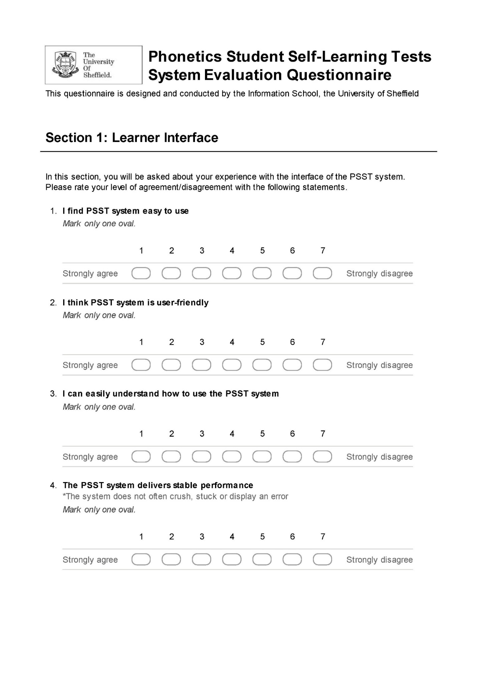Appendix 4. PSST System Evaluation Questionnaire

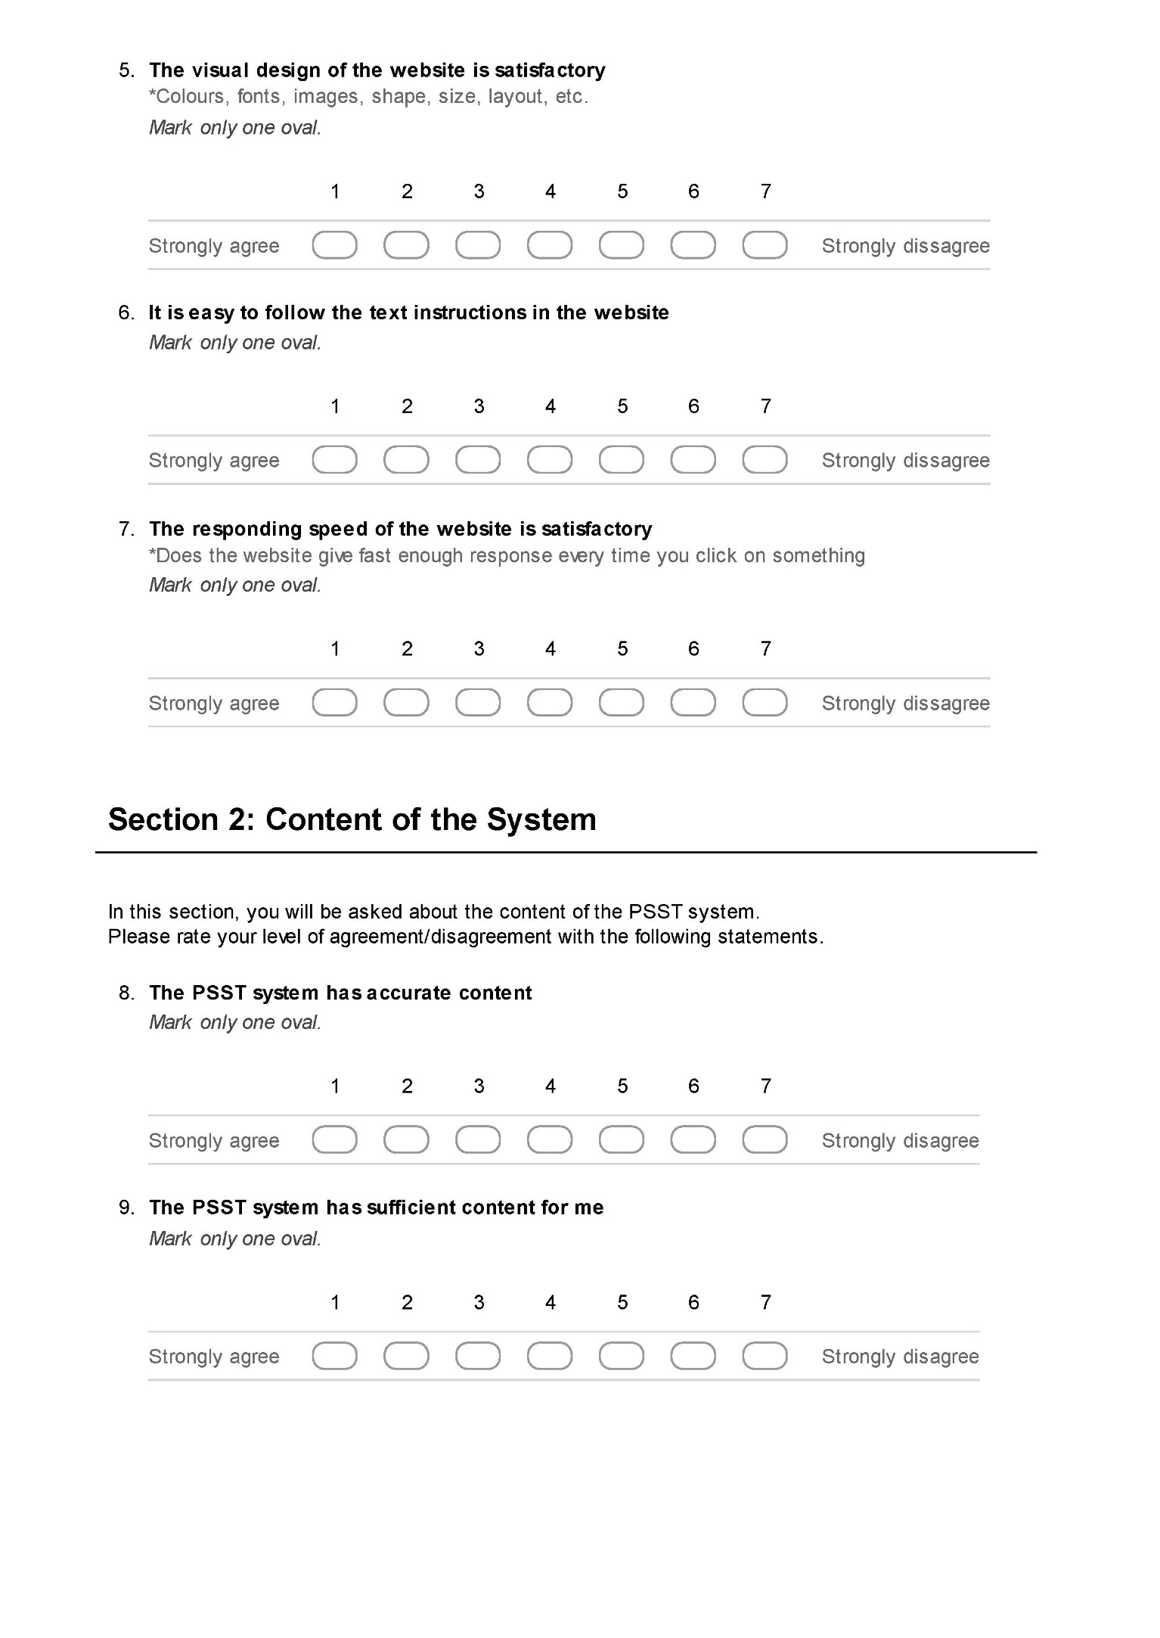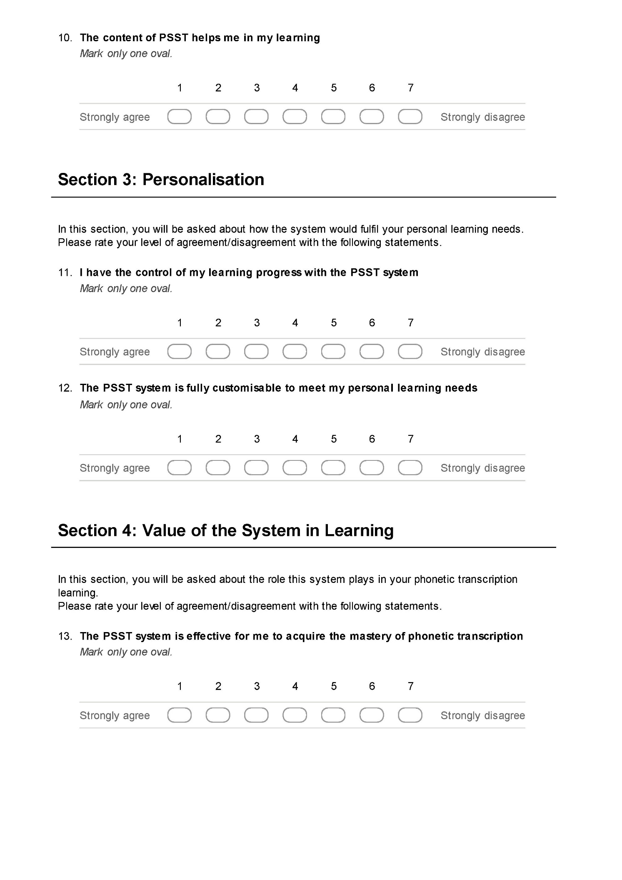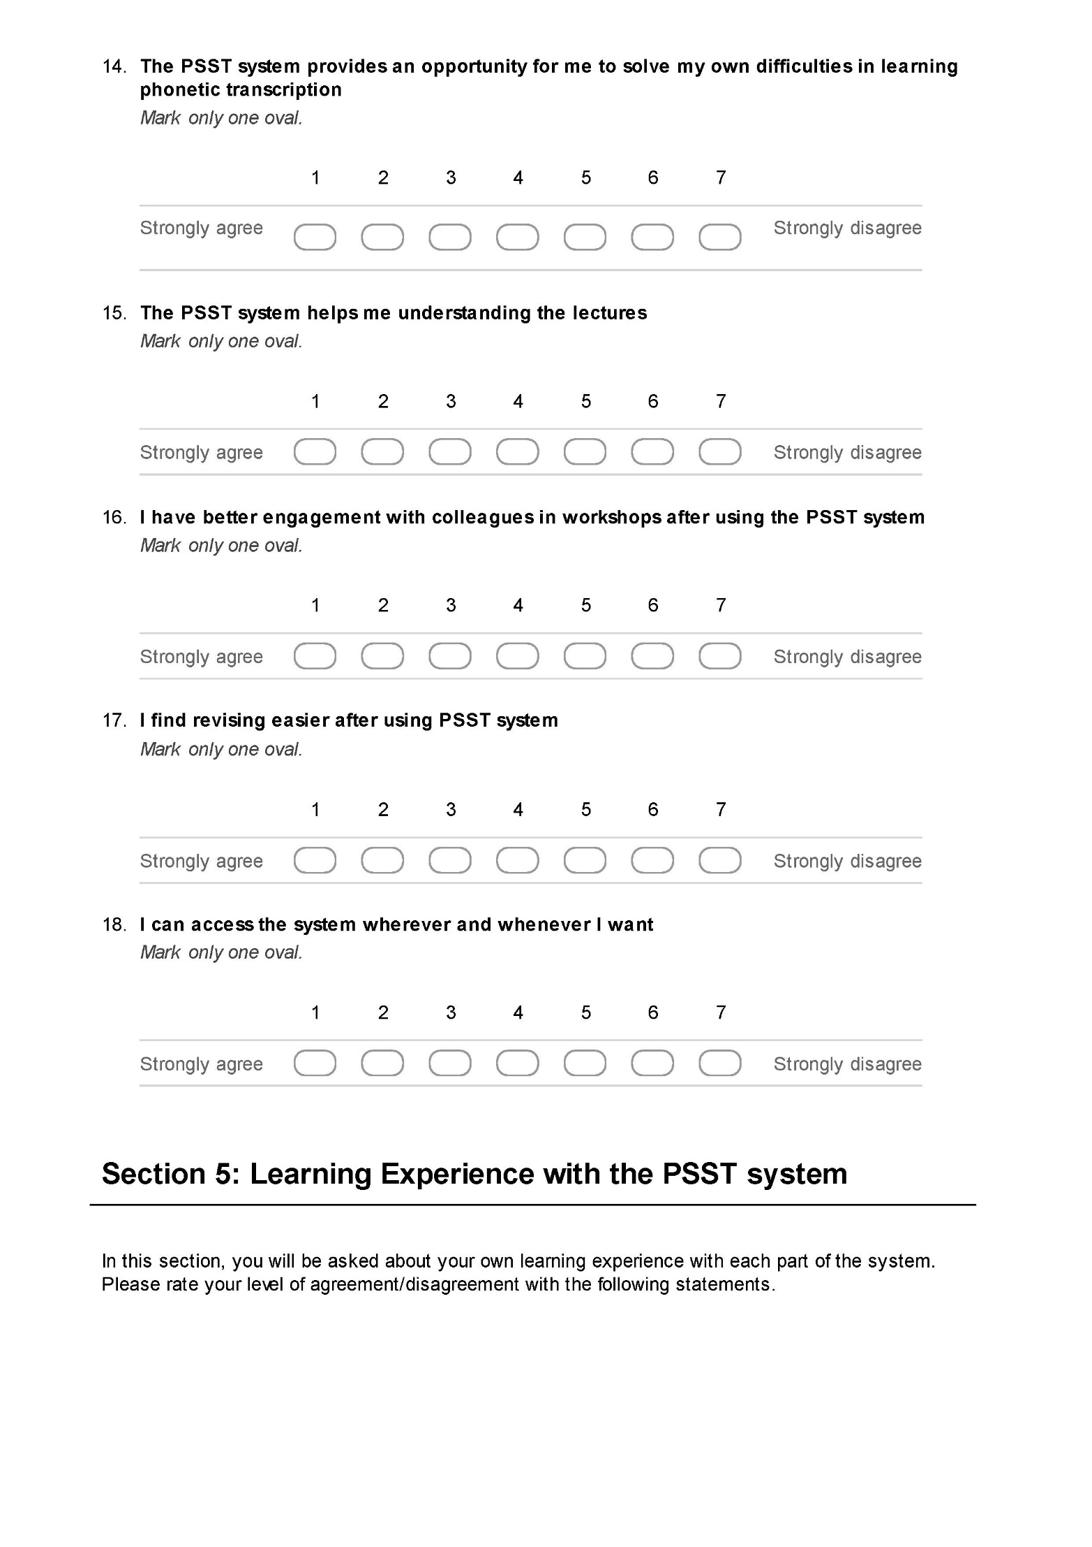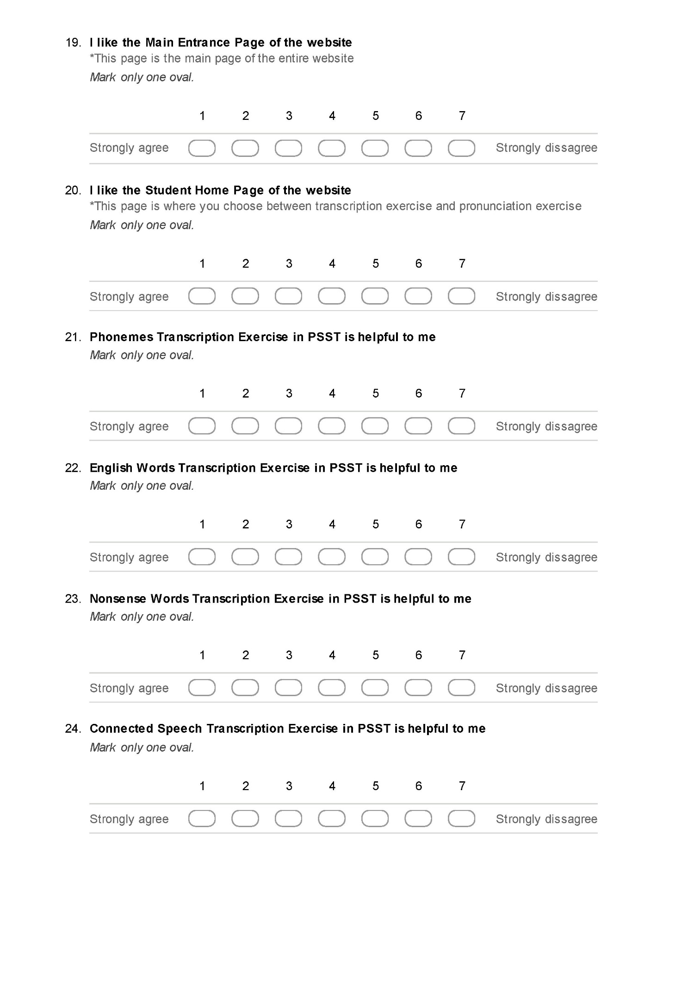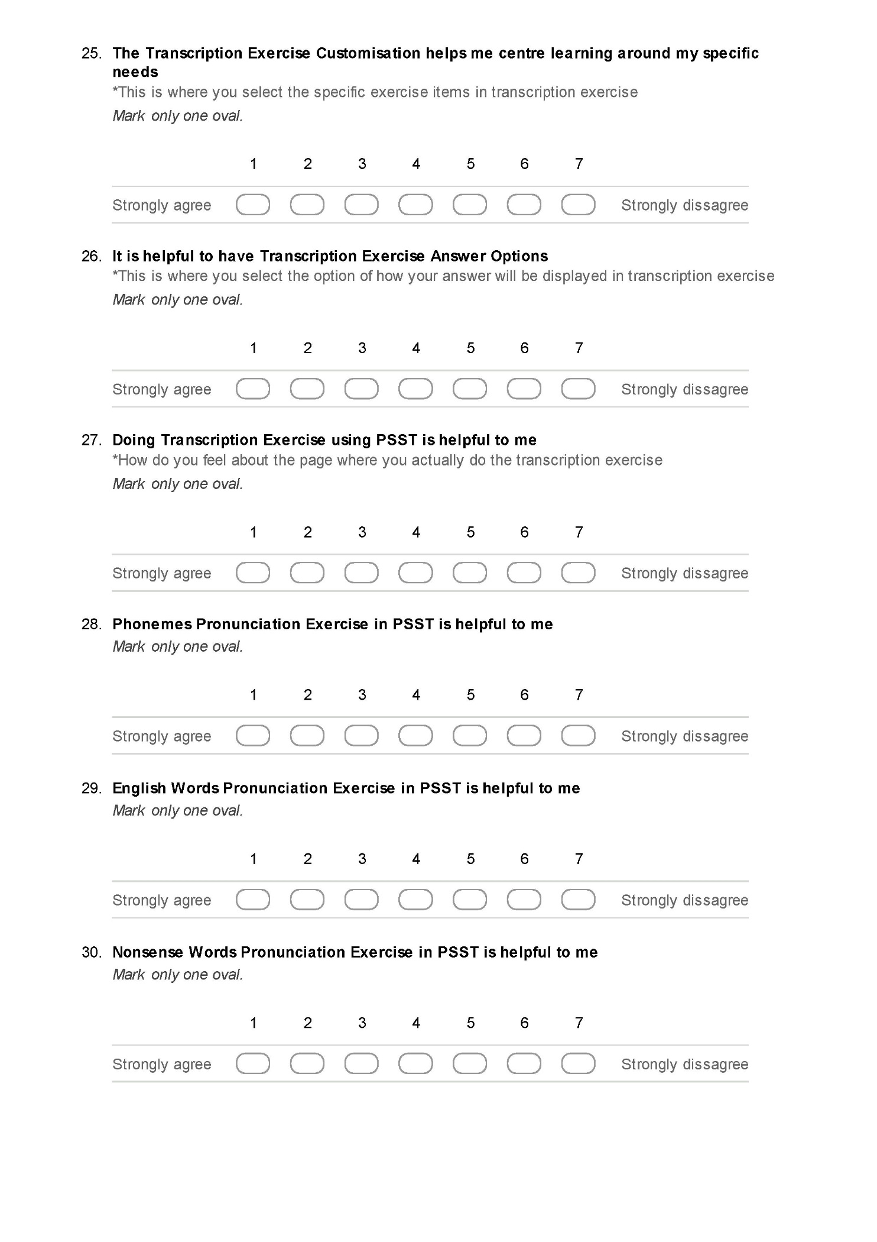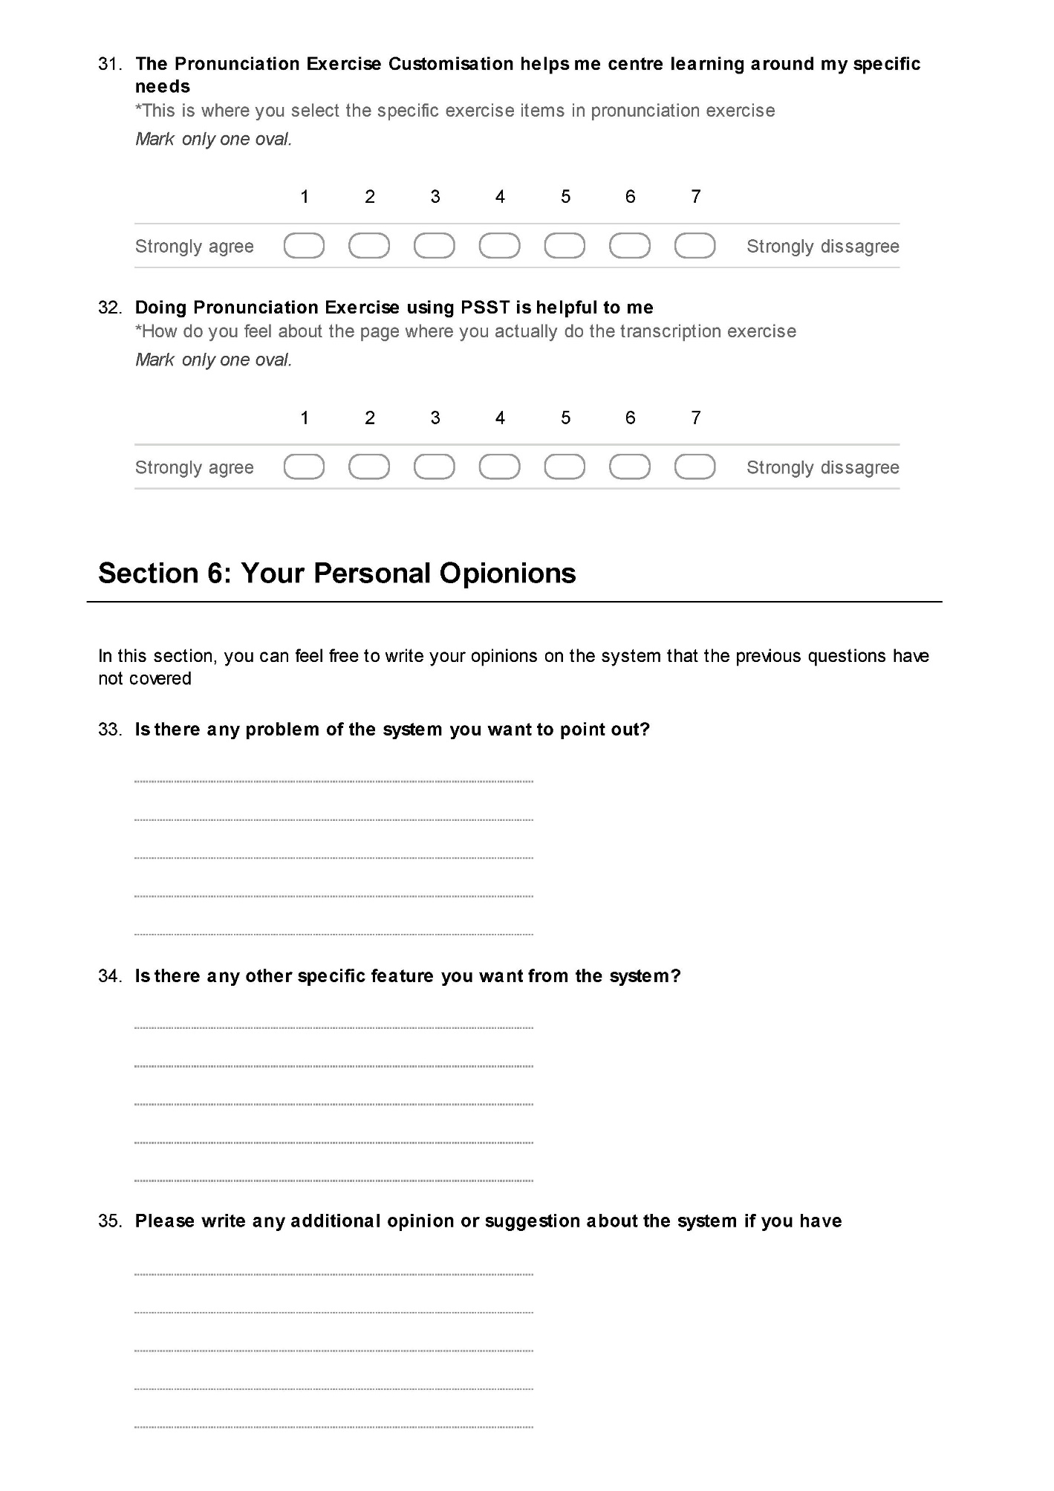

Appendix 5. Interview Script

**Icebreaking:**

|  |
| --- |
| 1. Studying phonetic transcriptions must be quite a unique experience that differs from other subjects. Would you please tell a bit about learning phonetic transcriptions? |
|  |

|  |
| --- |
| 1. How do you feel about PSST system in general?  * Do you enjoy using the system? * Do you find the system useful? * Will you still use this system in your future development? |
|  |

**Main Questions:**

|  |
| --- |
| 1. What do you feel about the interface of the system?  * Do you feel it easy to use (user-friendly)? * Is it easy to understand how to use the system (text instruction clear)? * Does the system provide stable performance? * Do you like the visual design of the system? |
|  |
| * 1. According to the questionnaire results, the stability of the system has had some negative responses. Would you please talk a bit on this based on your own experience? |
|  |
| * 1. According to the questionnaire results, some of the students have pointed out the look of the system is needed to be improved. Would you please give your own opinion on this? |
|  |

|  |
| --- |
| 1. How do you feel about the contents of the system?  * Does the system have accurate contents? * Does the system have enough contents? * Do you think the contents of the system is helpful to you? |
|  |
| * 1. According to the questionnaire results, some of the students have pointed out that the system occasionally gives wrong answer for the transcription exercises. Could you please tell your own experience about this? |
|  |
| * 1. According to the questionnaire results, some of the students have mentioned that there are not enough items to practice (especially the non-sense words). Could you please tell your own opinion on this? |
|  |

|  |
| --- |
| 1. How do you think this system works in terms of personalisation for students?  * Do you feel that you can control your learning progress with the system? * Is the system customisable enough to meet your personal learning needs? |
|  |
| * 1. According to the questionnaire results, the capability of customisation of the system has had some negative responses. Would you please talk a bit on this based on your own experience? |
|  |

|  |
| --- |
| 1. How do you feel the value of the system in your learning of phonetics?  * Do you think the system is effective and efficient as an e-learning application? * Do you feel the system provides a unique opportunity for you to solve your own difficulty? * Do you feel the system helps you in relation with other learning activity you have in the module (lectures, revision, and engagement in workshop)? * As a web-based application, do you feel the system is fully accessible? |
|  |
| * 1. According to the questionnaire results, the capability of the system to help you understanding the lectures has had some negative responses. Would you please talk a bit on this based on your own experience? |
|  |
| * 1. According to the questionnaire results, the capability of the system to help you engage the colleagues in the workshops has had some negative responses. Would you please talk a bit on this based on your own experience? |
|  |

|  |
| --- |
| 1. Now, could you please talk a bit about your learning experience with the Transcription Exercises?  * Do you think the 4 categories of the exercise are helpful (phonemes, English words, Nonsense words, Connected speech)? * How do you feel about the exercise items customisation in the transcription exercise? * How do you feel about the exercise answer display options? * How do you feel about the transcription exercise page? |
|  |
| * 1. According to the questionnaire results, the connected speech exercise does not seem to be working fine. Would you please tell your own opinion on this? Would it be very helpful if the connected speech exercise would be complete? |
|  |

|  |
| --- |
| 1. Now, could you please talk a bit about your learning experience with the Pronunciation Exercises?  * Do you think the 3 categories of the exercise are helpful (phonemes, English words, Nonsense words)? * How do you feel about the exercise items customisation in the pronunciation exercise? * How do you feel about the pronunciation recorder in the pronunciation exercise? |
|  |
| * 1. According to the questionnaire results, the pronunciation exercise part of the system tended to have slightly worse responses compare to the transcription exercise. What do you think about this? Could you tell a bit about your own experience in using the pronunciation exercise? |
|  |

|  |
| --- |
| 1. Now, could you please talk a bit about the potential new features that you would like to have in the system? |
|  |
| * 1. In the questionnaire, there are several features that have been suggested by some of the students. Could you give me your opinion about these features that came out strongly in the questionnaire? * Provision of videos instead of sounds in exercises; * Mobile device accessibility; * Test feature (transcription input methods / auto-marking); * Progress tracker (strength and weakness log); * A variety of pronouncers / voices for the sounds; |
|  |

**Conclusion Question:**

|  |
| --- |
| 1. About the PSST system and your own learning experience, what else would you want to tell about? |
|  |

Appendix 6. List of Publications

Fang, L., Nunes, M. B. & Bruijn, C. (2012) A Discussion of a Constructivist Application for Phonetics Transcription E-Learning Using Drill-and-Practice, *GIAMS 2012*. Shanghai, China.

Fang, L., Nunes, M. B. & Bruijn, C. (2012) Drill-and-Practice is not Necessarily a Pejorative Approach: An Example of its Successful Application as a Self-learning Component of a Phonetics Blended Learning Environment, *EdMedia - World Conference on Educational Multimedia, Hypermedia and Telecommunications*. Denver, Colorado, USA, 26 June 2012. AACE.

Bruijn, C. d., Nunes, M. B., Fang, L., Pathak, R. & Zhou, J. (2011) A System for Independent E-learning of Practical Phonetics, *ICPhS XVII.* Hong Kong, 17-21 August 2011.

Nunes, M. B., Fang, L., Peng, G., Zhou, J., Clegg, J., Rohde, C. C. & Spencer, S. (2014) Developing a Multi-purpose E-Learning Application for Speech and Language Therapy Students and Professionals Using a Design Science Research Approach, in Rocha, Á., Correia, A. M., Tan, F. B. & Stroetmann, K. A. (eds), New Perspectives in Information Systems and Technologies, Volume 2. Advances in Intelligent Systems and ComputingSpringer International Publishing, 227-237.

Appendix 7. Case Summaries of Open Questions

|  |  |  |  |
| --- | --- | --- | --- |
|  | **Is there any problem of the system you want to point out** | **Is there any other specific feature you want from the system** | **Please write any additional opinion or suggestion about the system if you have** |
| **1** | The Connected Speech option doesn't work! | The ability to track progress over time. The ability to see the speaker's face in the transcription exercises. A wide variety of speakers. | N/A |
| **2** | No answer to the Connected Speech. Lack of variation for Nonsense Words. | N/A | Very helpful. |
| **3** | The Connected Speech didn't have any answers. | Answers for Connected Speech. More words to practice. Same kept coming up. | N/A |
| **4** | Can you access it on phones and tablets as well? | N/A | N/A |
| **5** | Occasionally the answer provided was clearly not what the pronunciation was. | N/A | N/A |
| **6** | When I selected sounds to focus on, it would still display other phonemes in the answer which was confusing! | N/A | N/A |
| **7** | No answer for Connected Speech. | I would prefer video files to audio files. | N/A |
| **8** | Some (approx. 2) were incorrect. Connected speech had no answers. | Maybe a mock test that incorporates a variety of types of words / connected speech. | Use on iphone. |
| **9** | N/A | N/A | N/A |
| **10** | N/A | N/A | N/A |
| **11** | That Connected Speech didn't work. Some of the vowels sounds the same (possibly because you can't see the mouth). | Chances to hear the sounds by just clicking on them (like the Sheffield IPA one). | N/A |
| **12** | Connected speech answers. | "Test feature" perhaps include symbols to type answer + are given score. rather than self marking. | N/A |
| **13** | Connected speech didn't provide answers. | N/A | N/A |
| **14** | At times it appeared to give answers which seemed to be clearly wrong. The Connected Speech did not have answers. | N/A | N/A |
| **15** | Connected speech didn't have answers. Some answers didn't seem right / I didn't agree with. | N/A | Different voices. |
| **16** | Connected speech had no answers. | N/A | N/A |
| **17** | Connected speech didn't work. | N/A | N/A |
| **18** | On the Connected Speech part it doesn't show you the answer so you can't know if you were right or not. It was down (didn't work) a couple of times. | N/A |  |
| **19** | Connected speech was not complete with answers. | More variety of words, phonemes, etc. There tended to be repetitions after a while. | N/A |
| **20** | The answers for Connected Speech never came up. | A larger variety of words / sentences. Could be seen as repetitive. | How it looks could be changed. Seems old, not new. |
| **21** | N/A | N/A | N/A |
| **22** | N/A | N/A | N/A |
| **23** | Although it may not be developed yet, there were no answers to the Connected Speech exercises. | N/A | N/A |
| **24** | The answers of Connected Speech weren't present. Choosing each individual phoneme was fiddly. | Able to categorise. e.g., Choose fricatives, or plosives etc. | N/A |
| **25** | N/A | Video clips of pronunciation - show articulators. | N/A |
| **26** | N/A | N/A | N/A |
| **27** | Connected speech did not work. | An iphone app so I can access anywhere if I have 5 mins spare. | N/A |
| **28** | No Connected Speech - which was a very important part of our learning. | Connected speech. | It is important it is all accurate. As any incorrect information (i.e., transcriptions etc.) is problematic. |
| **29** | N/A | N/A | Update the home page to look more interesting. |
| **30** | N/A | N/A | N/A |
| **31** | N/A | N/A | N/A |
| **32** | Connected speech would not give the answers, would display N/A. Some symbols weren't clear. | A log of my progress weak/strong areas. | N/A |
| **33** | No answers to the Connected Speech section. | If I could put in a word + website would transcribe it for me - in RP. | N/A |
| **34** | No answers were available on Connected Speech PSST. | N/A | N/A |
| **35** | N/A | N/A | N/A |
| **36** | No answer for the Connected Speech exercise. Repetitive exercises. | N/A | N/A |
| **37** | N/A | Accompanying videos highlighting where and how the sound is formed within the oral cavity would be a useful aid in pronunciation exercises. | N/A |
| **38** | Sometimes the system wouldn't repeat a sound where you asked it to. | N/A | N/A |
| **39** | Connected speech - could not get answer. | A key area where this could be improved is by doing videos to accompany the transcription so you can see the mouth shape, wherever it is dental or labiodental etc. | Videos. |
| **40** | Connected speech didn't have answers - didn't help me learn. Need more nonsense words as they started to become the same after a while | N/A | N/A |
| **41** | Needs more nonsense words. Very repetitive. Transcriptions of Connected Speech. | Transcriptions of connected speech. | N/A |
| **42** | There weren't any answers to Connected Speech transcription. | N/A | N/A |
| **43** | Connected speech doesn't give the answers. | N/A | N/A |
| **44** | Need more nonsense words as soon learnt them by heart. Needed answers to Connected Speech. | Connected speech answers. | N/A |
| **45** | N/A | N/A | Keep up the good work, thank you! |
| **46** | The layout + look is slightly dull - makes it harder to want to go on it. | N/A | N/A |
| **47** | Connected speech wasn't available at the time. | Need more nonsense words. | Helped with my learning and revision. |
| **48** | Sometimes the correct answer did not match with the examples given. | N/A | N/A |
| **49** | Connected speech did not work + would have been useful. | N/A | N/A |
| **50** | Connected speech didn't work. | N/A | N/A |
| **51** | N/A | N/A | N/A |
| **52** | N/A | N/A | N/A |
| **Total** | 38 | 19 | 10 |

Appendix 8. Pearson’s R Correlation Table

|  |  |  |  |  |  |  |  |  |  |  |  |  |  |  |  |  |  |  |  |  |  |  |  |  |  |  |  |  |  |  |  |  |  |
| --- | --- | --- | --- | --- | --- | --- | --- | --- | --- | --- | --- | --- | --- | --- | --- | --- | --- | --- | --- | --- | --- | --- | --- | --- | --- | --- | --- | --- | --- | --- | --- | --- | --- |
| **Correlations - Pearson's R** | | | | | | | | | | | | | | | | | | | | | | | | | | | | | | | | | |
|  | | **Var1** | **Var2** | **Var3** | **Var4** | **Var5** | **Var6** | **Var7** | **Var8** | **Var9** | **Var10** | **Var11** | **Var12** | **Var13** | **Var14** | **Var15** | **Var16** | **Var17** | **Var18** | **Var19** | **Var20** | **Var21** | **Var22** | **Var23** | **Var24** | **Var25** | **Var26** | **Var27** | **Var28** | **Var29** | **Var30** | **Var31** | **Var32** |
| **Var1** | Pearson Correlation | 1 | **.932\*\*** | **.891\*\*** | .158 | **.333\*** | **.580\*\*** | **.389\*\*** | **.358\*\*** | .025 | **.518\*\*** | .244 | **.389\*\*** | .044 | .157 | **.278\*** | **.346\*** | **.448\*\*** | **.336\*** | **.431\*\*** | **.398\*\*** | .122 | .213 | .204 | -.020 | **.683\*\*** | **.389\*\*** | **.573\*\*** | -.042 | -.044 | -.154 | **.256** | .203 |
| Sig. (2-tailed) |  | .000 | .000 | .263 | .016 | .000 | .004 | .009 | .861 | .000 | .081 | .004 | .755 | .267 | .046 | .012 | .001 | .015 | .001 | .003 | .389 | .130 | .147 | .891 | .000 | .004 | .000 | .765 | .755 | .277 | .067 | .148 |
| **Var2** | Pearson Correlation | **.932\*\*** | 1 | **.878\*\*** | .123 | **.336\*** | **.618\*\*** | **.382\*\*** | .255 | .017 | **.489\*\*** | .196 | **.354\*\*** | -.004 | .111 | .217 | **.317\*** | **.421\*\*** | .218 | **.442\*\*** | **.410\*\*** | .099 | .252 | .161 | -.050 | **.665\*\*** | **.427\*\*** | **.554\*\*** | -.048 | -.073 | -.169 | .215 | .238 |
| Sig. (2-tailed) | .000 |  | .000 | .386 | .015 | .000 | .005 | .068 | .906 | .000 | .164 | .010 | .978 | .434 | .122 | .022 | .002 | .121 | .001 | .003 | .485 | .071 | .254 | .729 | .000 | .002 | .000 | .737 | .606 | .230 | .126 | .090 |
| **Var3** | Pearson Correlation | **.891\*\*** | **.878\*\*** | 1 | .033 | .238 | **.580\*\*** | **.299\*** | **.330\*** | .013 | **.483\*\*** | **.274\*** | **.323\*** | -.068 | .085 | .137 | **.392\*\*** | **.513\*\*** | **.306\*** | **.369\*\*** | **.379\*\*** | .092 | .266 | .106 | -.044 | **.628\*\*** | **.315\*** | **.577\*\*** | -.062 | -.098 | -.199 | .192 | .176 |
| Sig. (2-tailed) | .000 | .000 |  | .816 | .090 | .000 | .031 | .017 | .927 | .000 | .049 | .019 | .631 | .548 | .335 | .004 | .000 | .027 | .007 | .006 | .519 | .056 | .455 | .757 | .000 | .023 | .000 | .660 | .487 | .158 | .174 | .213 |
| **Var4** | Pearson Correlation | .158 | .123 | .033 | 1 | -.071 | -.018 | .042 | **.339\*** | **.309\*** | .121 | .240 | **.332\*** | -.002 | .137 | .118 | -.109 | -.179 | .218 | .171 | .159 | .111 | -.021 | -.073 | .247 | .204 | -.014 | -.113 | .077 | .001 | -.104 | .095 | .058 |
| Sig. (2-tailed) | .263 | .386 | .816 |  | .615 | .900 | .767 | .014 | .026 | .391 | .087 | .016 | .992 | .331 | .405 | .443 | .203 | .120 | .225 | .261 | .433 | .880 | .609 | .081 | .147 | .921 | .427 | .589 | .997 | .465 | .504 | .684 |
| **Var5** | Pearson Correlation | **.333\*** | **.336\*** | .238 | -.071 | 1 | **.709\*\*** | **.444\*\*** | **.280\*** | .197 | .144 | .231 | .096 | **.299\*** | .230 | **.460\*\*** | **.624\*\*** | **.382\*\*** | **.296\*** | **.529\*\*** | **.539\*\*** | .160 | .230 | .105 | **-.294\*** | **.282\*** | **.401\*\*** | **.427\*\*** | -.022 | -.009 | -.189 | -.169 | .030 |
| Sig. (2-tailed) | .016 | .015 | .090 | .615 |  | .000 | .001 | .044 | .162 | .310 | .100 | .497 | .031 | .101 | .001 | .000 | .005 | .033 | .000 | .000 | .256 | .101 | .457 | .036 | .043 | .003 | .002 | .878 | .948 | .179 | .230 | .830 |
| **Var6** | Pearson Correlation | **.580\*\*** | **.618\*\*** | **.580\*\*** | -.018 | **.709\*\*** | 1 | **.511\*\*** | **.270** | .239 | .255 | .167 | .166 | .075 | .203 | **.339\*** | **.628\*\*** | **.394\*\*** | **.314\*** | **.565\*\*** | **.497\*\*** | **.214** | **.316\*** | .119 | -.074 | **.508\*\*** | **.390\*\*** | **.507\*\*** | -.010 | .022 | -.145 | -.037 | .138 |
| Sig. (2-tailed) | .000 | .000 | .000 | .900 | .000 |  | .000 | .053 | .088 | .068 | .238 | .241 | .599 | .148 | .014 | .000 | .004 | .023 | .000 | .000 | .128 | .023 | .401 | .606 | .000 | .004 | .000 | .946 | .878 | .304 | .796 | .328 |
| **Var7** | Pearson Correlation | **.389\*\*** | **.382\*\*** | **.299\*** | .042 | **.444\*\*** | **.511\*\*** | 1 | **.306\*** | .120 | .124 | -.013 | .084 | .090 | .249 | **.495\*\*** | **.441\*\*** | .166 | -.042 | .148 | **.322\*** | **.218** | .209 | .085 | -.012 | **.342\*** | **.317\*** | **.352\*** | -.165 | -.027 | -.242 | -.222 | -.133 |
| Sig. (2-tailed) | .004 | .005 | .031 | .767 | .001 | .000 |  | .027 | .398 | .379 | .930 | .553 | .524 | .075 | .000 | .001 | .239 | .767 | .296 | .020 | .120 | .137 | .550 | .931 | .013 | .022 | .011 | .244 | .849 | .083 | .113 | .349 |
| **Var8** | Pearson Correlation | **.358\*\*** | .255 | **.330\*** | **.339\*** | **.280\*** | **.270** | **.306\*** | 1 | **.324\*** | **.478\*\*** | **.366\*\*** | **.409\*\*** | **.339\*** | **.375\*\*** | **.437\*\*** | **.443\*\*** | **.482\*\*** | .175 | .224 | **.301\*** | **.336\*** | .076 | .010 | .094 | **.464\*\*** | .207 | .212 | .107 | .037 | -.185 | .173 | .080 |
| Sig. (2-tailed) | .009 | .068 | .017 | .014 | .044 | .053 | .027 |  | .019 | .000 | .008 | .003 | .014 | .006 | .001 | .001 | .000 | .215 | .110 | .030 | .015 | .591 | .944 | .513 | .001 | .141 | .132 | .450 | .796 | .189 | .221 | .575 |
| **Var9** | Pearson Correlation | .025 | .017 | .013 | **.309\*** | .197 | .239 | .120 | **.324\*** | 1 | .203 | **.334\*** | **.480\*\*** | .145 | **.507\*\*** | **.277\*** | .234 | .001 | .114 | **.362\*\*** | .258 | .166 | .174 | .239 | .227 | .205 | .116 | .043 | .122 | .103 | .032 | -.038 | .085 |
| Sig. (2-tailed) | .861 | .906 | .927 | .026 | .162 | .088 | .398 | .019 |  | .149 | .015 | .000 | .305 | .000 | .047 | .096 | .993 | .422 | .008 | .065 | .241 | .216 | .088 | .109 | .145 | .415 | .761 | .387 | .467 | .823 | .789 | .551 |
| **Var10** | Pearson Correlation | **.518\*\*** | **.489\*\*** | **.483\*\*** | .121 | .144 | .255 | .124 | **.478\*\*** | .203 | 1 | .242 | **.378\*\*** | **.329\*** | .166 | .257 | .175 | **.438\*\*** | .043 | .173 | .232 | **.390\*\*** | .264 | **.367\*\*** | .113 | **.540\*\*** | **.452\*\*** | **.415\*\*** | -.054 | -.084 | -.185 | .060 | .011 |
| Sig. (2-tailed) | .000 | .000 | .000 | .391 | .310 | .068 | .379 | .000 | .149 |  | .083 | .006 | .017 | .240 | .066 | .215 | .001 | .765 | .220 | .098 | .004 | .059 | .008 | .429 | .000 | .001 | .002 | .706 | .553 | .189 | .670 | .937 |
| **Var11** | Pearson Correlation | .244 | .196 | **.274\*** | .240 | .231 | .167 | -.013 | **.366\*\*** | **.334\*** | .242 | 1 | **.543\*\*** | .178 | **.356\*\*** | **.263** | **.336\*** | **.337\*** | **.480\*\*** | **.326\*** | **.394\*\*** | **.462\*\*** | **.513\*\*** | .051 | -.025 | .224 | .032 | **.298\*** | .190 | .167 | -.213 | .122 | .131 |
| Sig. (2-tailed) | .081 | .164 | .049 | .087 | .100 | .238 | .930 | .008 | .015 | .083 |  | .000 | .208 | .010 | .060 | .015 | .014 | .000 | .018 | .004 | .001 | .000 | .718 | .861 | .110 | .824 | .032 | .177 | .237 | .129 | .387 | .354 |
| **Var12** | Pearson Correlation | **.389\*\*** | **.354\*\*** | **.323\*** | **.332\*** | .096 | .166 | .084 | **.409\*\*** | **.480\*\*** | **.378\*\*** | **.543\*\*** | 1 | **.422\*\*** | **.606\*\*** | **.299\*** | .110 | .168 | **.331\*** | **.420\*\*** | **.366\*\*** | .240 | .065 | **.383\*\*** | .088 | **.440\*\*** | .179 | .216 | -.027 | .009 | -.126 | **.284\*** | .254 |
| Sig. (2-tailed) | .004 | .010 | .019 | .016 | .497 | .241 | .553 | .003 | .000 | .006 | .000 |  | .002 | .000 | .031 | .436 | .235 | .016 | .002 | .008 | .086 | .645 | .005 | .541 | .001 | .203 | .125 | .847 | .950 | .373 | .041 | .070 |
| **Var13** | Pearson Correlation | .044 | -.004 | -.068 | -.002 | **.299\*** | .075 | .090 | **.339\*** | .145 | **.329\*** | .178 | **.422\*\*** | 1 | **.502\*\*** | **.298\*** | .098 | .128 | .030 | .124 | .099 | .204 | -.009 | .198 | -.095 | .143 | .176 | .026 | .062 | .103 | -.070 | .204 | .067 |
| Sig. (2-tailed) | .755 | .978 | .631 | .992 | .031 | .599 | .524 | .014 | .305 | .017 | .208 | .002 |  | .000 | .032 | .487 | .367 | .830 | .383 | .483 | .146 | .950 | .159 | .507 | .311 | .211 | .857 | .664 | .465 | .620 | .147 | .635 |
| **Var14** | Pearson Correlation | .157 | .111 | .085 | .137 | .230 | .203 | .249 | **.375\*\*** | **.507\*\*** | .166 | **.356\*\*** | **.606\*\*** | **.502\*\*** | 1 | **.572\*\*** | **.270** | .197 | .134 | **.429\*\*** | **.291\*** | .230 | .112 | **.282\*** | -.021 | .228 | .010 | .221 | .174 | .202 | -.020 | .226 | **.352\*** |
| Sig. (2-tailed) | .267 | .434 | .548 | .331 | .101 | .148 | .075 | .006 | .000 | .240 | .010 | .000 | .000 |  | .000 | .053 | .161 | .345 | .001 | .036 | .101 | .431 | .043 | .881 | .104 | .941 | .116 | .219 | .151 | .890 | .107 | .011 |
| **Var15** | Pearson Correlation | **.278\*** | .217 | .137 | .118 | **.460\*\*** | **.339\*** | **.495\*\*** | **.437\*\*** | **.277\*** | .257 | **.263** | **.299\*** | **.298\*** | **.572\*\*** | 1 | **.405\*\*** | .263 | -.013 | **.453\*\*** | **.372\*\*** | **.204** | .176 | **.236** | -.071 | .213 | .145 | **.314\*** | .094 | .102 | -.012 | .019 | .133 |
| Sig. (2-tailed) | .046 | .122 | .335 | .405 | .001 | .014 | .000 | .001 | .047 | .066 | .060 | .031 | .032 | .000 |  | .003 | .059 | .924 | .001 | .007 | .148 | .211 | .092 | .619 | .129 | .304 | .023 | .506 | .472 | .933 | .893 | .348 |
| **Var16** | Pearson Correlation | **.346\*** | **.317\*** | **.392\*\*** | -.109 | **.624\*\*** | **.628\*\*** | **.441\*\*** | **.443\*\*** | .234 | .175 | **.336\*** | .110 | .098 | **.270** | **.405\*\*** | 1 | **.472\*\*** | .217 | **.326\*** | **.435\*\*** | **.332\*** | **.387\*\*** | .076 | -.251 | **.358\*\*** | .192 | **.421\*\*** | .115 | .061 | -.199 | -.017 | .171 |
| Sig. (2-tailed) | .012 | .022 | .004 | .443 | .000 | .000 | .001 | .001 | .096 | .215 | .015 | .436 | .487 | .053 | .003 |  | .000 | .122 | .018 | .001 | .016 | .005 | .594 | .076 | .009 | .172 | .002 | .416 | .665 | .157 | .906 | .225 |
| **Var17** | Pearson Correlation | **.448\*\*** | **.421\*\*** | **.513\*\*** | -.179 | **.382\*\*** | **.394\*\*** | .166 | **.482\*\*** | .001 | **.438\*\*** | **.337\*** | .168 | .128 | .197 | .263 | **.472\*\*** | 1 | **.305\*** | **.391\*\*** | **.416\*\*** | **.381\*\*** | **.331\*** | .064 | -.087 | .261 | .238 | **.571\*\*** | .047 | .051 | -.214 | -.030 | .049 |
| Sig. (2-tailed) | .001 | .002 | .000 | .203 | .005 | .004 | .239 | .000 | .993 | .001 | .014 | .235 | .367 | .161 | .059 | .000 |  | .028 | .004 | .002 | .005 | .017 | .650 | .543 | .062 | .089 | .000 | .742 | .719 | .127 | .835 | .730 |
| **Var18** | Pearson Correlation | **.336\*** | .218 | **.306\*** | .218 | **.296\*** | **.314\*** | -.042 | .175 | .114 | .043 | **.480\*\*** | **.331\*** | .030 | .134 | -.013 | .217 | **.305\*** | 1 | **.459\*\*** | **.389\*\*** | .227 | .137 | -.070 | -.074 | .170 | .004 | **.265** | .032 | .054 | -.191 | .126 | .065 |
| Sig. (2-tailed) | .015 | .121 | .027 | .120 | .033 | .023 | .767 | .215 | .422 | .765 | .000 | .016 | .830 | .345 | .924 | .122 | .028 |  | .001 | .004 | .105 | .334 | .623 | .604 | .227 | .976 | .058 | .821 | .705 | .176 | .375 | .646 |
| **Var19** | Pearson Correlation | **.431\*\*** | **.442\*\*** | **.369\*\*** | .171 | **.529\*\*** | **.565\*\*** | .148 | .224 | **.362\*\*** | .173 | **.326\*** | **.420\*\*** | .124 | **.429\*\*** | **.453\*\*** | **.326\*** | **.391\*\*** | **.459\*\*** | 1 | **.813\*\*** | .142 | .194 | .135 | -.045 | .250 | .197 | **.432\*\*** | .136 | .122 | -.018 | .122 | **.275\*** |
| Sig. (2-tailed) | .001 | .001 | .007 | .225 | .000 | .000 | .296 | .110 | .008 | .220 | .018 | .002 | .383 | .001 | .001 | .018 | .004 | .001 |  | .000 | .316 | .168 | .338 | .752 | .074 | .161 | .001 | .337 | .387 | .902 | .387 | .048 |
| **Var20** | Pearson Correlation | **.398\*\*** | **.410\*\*** | **.379\*\*** | .159 | **.539\*\*** | **.497\*\*** | **.322\*** | **.301\*** | .258 | .232 | **.394\*\*** | **.366\*\*** | .099 | **.291\*** | **.372\*\*** | **.435\*\*** | **.416\*\*** | **.389\*\*** | **.813\*\*** | 1 | **.276\*** | **.305\*** | .057 | -.102 | **.360\*\*** | .259 | **.469\*\*** | .097 | .078 | -.134 | .024 | .187 |
| Sig. (2-tailed) | .003 | .003 | .006 | .261 | .000 | .000 | .020 | .030 | .065 | .098 | .004 | .008 | .483 | .036 | .007 | .001 | .002 | .004 | .000 |  | .048 | .028 | .686 | .475 | .009 | .064 | .000 | .492 | .583 | .344 | .868 | .183 |
| **Var21** | Pearson Correlation | .122 | .099 | .092 | .111 | .160 | **.214** | **.218** | **.336\*** | .166 | **.390\*\*** | **.462\*\*** | .240 | .204 | .230 | **.204** | **.332\*** | **.381\*\*** | .227 | .142 | **.276\*** | 1 | **.757\*\*** | **.289\*** | .019 | **.231** | **.284\*** | **.374\*\*** | **.222** | **.239** | -.034 | -.028 | .072 |
| Sig. (2-tailed) | .389 | .485 | .519 | .433 | .256 | .128 | .120 | .015 | .241 | .004 | .001 | .086 | .146 | .101 | .148 | .016 | .005 | .105 | .316 | .048 |  | .000 | .038 | .893 | .099 | .041 | .006 | .114 | .087 | .810 | .844 | .614 |
| **Var22** | Pearson Correlation | .213 | .252 | .266 | -.021 | .230 | **.316\*** | .209 | .076 | .174 | .264 | **.513\*\*** | .065 | -.009 | .112 | .176 | **.387\*\*** | **.331\*** | .137 | .194 | **.305\*** | **.757\*\*** | 1 | .269 | .036 | .170 | **.272** | **.459\*\*** | **.315\*** | **.353\*** | .026 | -.016 | .241 |
| Sig. (2-tailed) | .130 | .071 | .056 | .880 | .101 | .023 | .137 | .591 | .216 | .059 | .000 | .645 | .950 | .431 | .211 | .005 | .017 | .334 | .168 | .028 | .000 |  | .054 | .802 | .229 | .051 | .001 | .023 | .010 | .854 | .908 | .085 |
| **Var23** | Pearson Correlation | .204 | .161 | .106 | -.073 | .105 | .119 | .085 | .010 | .239 | **.367\*\*** | .051 | **.383\*\*** | .198 | **.282\*** | **.236** | .076 | .064 | -.070 | .135 | .057 | **.289\*** | .269 | 1 | .267 | **.326\*** | **.327\*** | .167 | -.037 | .038 | .247 | .023 | .131 |
| Sig. (2-tailed) | .147 | .254 | .455 | .609 | .457 | .401 | .550 | .944 | .088 | .008 | .718 | .005 | .159 | .043 | .092 | .594 | .650 | .623 | .338 | .686 | .038 | .054 |  | .058 | .018 | .018 | .237 | .795 | .789 | .078 | .873 | .354 |
| **Var24** | Pearson Correlation | -.020 | -.050 | -.044 | .247 | **-.294\*** | -.074 | -.012 | .094 | .227 | .113 | -.025 | .088 | -.095 | -.021 | -.071 | -.251 | -.087 | -.074 | -.045 | -.102 | .019 | .036 | .267 | 1 | .112 | .005 | -.056 | .247 | **.298\*** | **.416\*\*** | .209 | .112 |
| Sig. (2-tailed) | .891 | .729 | .757 | .081 | .036 | .606 | .931 | .513 | .109 | .429 | .861 | .541 | .507 | .881 | .619 | .076 | .543 | .604 | .752 | .475 | .893 | .802 | .058 |  | .433 | .973 | .698 | .081 | .034 | .002 | .141 | .435 |
| **Var25** | Pearson Correlation | **.683\*\*** | **.665\*\*** | **.628\*\*** | .204 | **.282\*** | **.508\*\*** | **.342\*** | **.464\*\*** | .205 | **.540\*\*** | .224 | **.440\*\*** | .143 | .228 | .213 | **.358\*\*** | .261 | .170 | .250 | **.360\*\*** | **.231** | .170 | **.326\*** | .112 | 1 | **.442\*\*** | **.343\*** | .075 | .045 | -.088 | **.296\*** | .208 |
| Sig. (2-tailed) | .000 | .000 | .000 | .147 | .043 | .000 | .013 | .001 | .145 | .000 | .110 | .001 | .311 | .104 | .129 | .009 | .062 | .227 | .074 | .009 | .099 | .229 | .018 | .433 |  | .001 | .013 | .597 | .752 | .533 | .033 | .140 |
| **Var26** | Pearson Correlation | **.389\*\*** | **.427\*\*** | **.315\*** | -.014 | **.401\*\*** | **.390\*\*** | **.317\*** | .207 | .116 | **.452\*\*** | .032 | .179 | .176 | .010 | .145 | .192 | .238 | .004 | .197 | .259 | **.284\*** | **.272** | **.327\*** | .005 | **.442\*\*** | 1 | **.460\*\*** | -.077 | -.046 | -.150 | -.076 | .050 |
| Sig. (2-tailed) | .004 | .002 | .023 | .921 | .003 | .004 | .022 | .141 | .415 | .001 | .824 | .203 | .211 | .941 | .304 | .172 | .089 | .976 | .161 | .064 | .041 | .051 | .018 | .973 | .001 |  | .001 | .587 | .745 | .288 | .593 | .725 |
| **Var27** | Pearson Correlation | **.573\*\*** | **.554\*\*** | **.577\*\*** | -.113 | **.427\*\*** | **.507\*\*** | **.352\*** | .212 | .043 | **.415\*\*** | **.298\*** | .216 | .026 | .221 | **.314\*** | **.421\*\*** | **.571\*\*** | **.265** | **.432\*\*** | **.469\*\*** | **.374\*\*** | **.459\*\*** | .167 | -.056 | **.343\*** | **.460\*\*** | 1 | .137 | .125 | -.004 | .072 | .204 |
| Sig. (2-tailed) | .000 | .000 | .000 | .427 | .002 | .000 | .011 | .132 | .761 | .002 | .032 | .125 | .857 | .116 | .023 | .002 | .000 | .058 | .001 | .000 | .006 | .001 | .237 | .698 | .013 | .001 |  | .332 | .376 | .976 | .611 | .146 |
| **Var28** | Pearson Correlation | -.042 | -.048 | -.062 | .077 | -.022 | -.010 | -.165 | .107 | .122 | -.054 | .190 | -.027 | .062 | .174 | .094 | .115 | .047 | .032 | .136 | .097 | **.222** | **.315\*** | -.037 | .247 | .075 | -.077 | .137 | 1 | **.905\*\*** | **.545\*\*** | **.689\*\*** | **.479\*\*** |
| Sig. (2-tailed) | .765 | .737 | .660 | .589 | .878 | .946 | .244 | .450 | .387 | .706 | .177 | .847 | .664 | .219 | .506 | .416 | .742 | .821 | .337 | .492 | .114 | .023 | .795 | .081 | .597 | .587 | .332 |  | .000 | .000 | .000 | .000 |
| **Var29** | Pearson Correlation | -.044 | -.073 | -.098 | .001 | -.009 | .022 | -.027 | .037 | .103 | -.084 | .167 | .009 | .103 | .202 | .102 | .061 | .051 | .054 | .122 | .078 | **.239** | **.353\*** | .038 | **.298\*** | .045 | -.046 | .125 | **.905\*\*** | 1 | **.516\*\*** | **.618\*\*** | **.437\*\*** |
| Sig. (2-tailed) | .755 | .606 | .487 | .997 | .948 | .878 | .849 | .796 | .467 | .553 | .237 | .950 | .465 | .151 | .472 | .665 | .719 | .705 | .387 | .583 | .087 | .010 | .789 | .034 | .752 | .745 | .376 | .000 |  | .000 | .000 | .001 |
| **Var30** | Pearson Correlation | -.154 | -.169 | -.199 | -.104 | -.189 | -.145 | -.242 | -.185 | .032 | -.185 | -.213 | -.126 | -.070 | -.020 | -.012 | -.199 | -.214 | -.191 | -.018 | -.134 | -.034 | .026 | .247 | **.416\*\*** | -.088 | -.150 | -.004 | **.545\*\*** | **.516\*\*** | 1 | **.486\*\*** | **.342\*** |
| Sig. (2-tailed) | .277 | .230 | .158 | .465 | .179 | .304 | .083 | .189 | .823 | .189 | .129 | .373 | .620 | .890 | .933 | .157 | .127 | .176 | .902 | .344 | .810 | .854 | .078 | .002 | .533 | .288 | .976 | .000 | .000 |  | .000 | .013 |
| **Var31** | Pearson Correlation | **.256** | .215 | .192 | .095 | -.169 | -.037 | -.222 | .173 | -.038 | .060 | .122 | **.284\*** | .204 | .226 | .019 | -.017 | -.030 | .126 | .122 | .024 | -.028 | -.016 | .023 | .209 | **.296\*** | -.076 | .072 | **.689\*\*** | **.618\*\*** | **.486\*\*** | 1 | **.675\*\*** |
| Sig. (2-tailed) | .067 | .126 | .174 | .504 | .230 | .796 | .113 | .221 | .789 | .670 | .387 | .041 | .147 | .107 | .893 | .906 | .835 | .375 | .387 | .868 | .844 | .908 | .873 | .141 | .033 | .593 | .611 | .000 | .000 | .000 |  | .000 |
| **Var32** | Pearson Correlation | .203 | .238 | .176 | .058 | .030 | .138 | -.133 | .080 | .085 | .011 | .131 | .254 | .067 | **.352\*** | .133 | .171 | .049 | .065 | **.275\*** | .187 | .072 | .241 | .131 | .112 | .208 | .050 | .204 | **.479\*\*** | **.437\*\*** | **.342\*** | **.675\*\*** | 1 |
| Sig. (2-tailed) | .148 | .090 | .213 | .684 | .830 | .328 | .349 | .575 | .551 | .937 | .354 | .070 | .635 | .011 | .348 | .225 | .730 | .646 | .048 | .183 | .614 | .085 | .354 | .435 | .140 | .725 | .146 | .000 | .001 | .013 | .000 |  |
| **\*\*. Correlation is significant at the 0.01 level (2-tailed).** | | | | | | | | | | | | | | | | | | | | | | | | | | | | | | | | | |
| **\*. Correlation is significant at the 0.05 level (2-tailed).** | | | | | | | | | | | | | | | | | | | | | | | | | | | | | | | | | |