Quantification of Glacial Ice Mass Loss in the Himalaya since the Little Ice Age

Ethan Lee

Submitted in accordance with the requirements for the degree of
Master of Science by Research

The University of Leeds
School of Geography

August, 2019

The candidate confirms that the work submitted is his own and that appropriate credit has been given where reference has been made to the work of others.

This copy has been supplied on the understanding that it is copyright material and that no quotation from the thesis may be published without proper acknowledgement.

The right of Ethan Lee to be identified as Author of this work has been asserted by him in accordance with the Copyright, Designs and Patents Act 1988.

© 2019 The University of Leeds and Ethan Lee

Acknowledgements
This Master’s by Research Thesis was supervised by Dr. Duncan J. Quincey, Dr. Jonathan L. Carrivick of the University of Leeds and Dr. Simon J. Cook of the Univeristy of Dundee. I would like to give my upmost appreciation and thanks for their mentoring, guidance, advice and expertise which has enabled me to overcome obstacles and complete this thesis. They are a great combination of supervisors to work with, giving their ideas and thoughts which have shaped this thesis throughout its duration. I hope that I would have the pleasure of working with them all again in the future.
I would also like to thank Dr. Ann V. Rowan of the University of Sheffield, for her compiled data of dated moraines within the Himalaya which she allowed me to use. I would also like to thank her for the opportunity to present my research in an oral-presentation at the ‘Holocene change in High Mountain Asia’ session at INQUA 2019, Dublin.
Further, I would like to give a massive thanks to the friends I have made along the way. They have supported me and given me guidance at every state of this project. I would like to give many thanks to, Frances Procter, Richard Fewster, Liam Taylor Andrew Johnson and all of the postgraduate researchers and staff of the School of Geography at the University of Leeds.
Statistical analyses made use of Minitab software. MINITAB® and all other trademarks and logos for the Company's products and services are the exclusive property of Minitab, LLC. All other marks referenced remain the property of their respective owners. See minitab.com for more information.

Abstract
Understanding glacier mass change over time is of critical importance, having both local and global implications, specifically those of water security and of sea-level rise. The Little Ice Age (LIA) was a period of cooler temperatures, causing the last general growth of glaciers globally. Within the Himalaya the LIA maximum occurred ~1300–1600 AD, following which there was a general recession of glacial mass in response to warming temperatures. This study aimed to quantify the magnitude and rate of this recession within the central and eastern Himalaya, using the newly released 8m HMA DEM. The interregional variability of this change was also considered in relation to topographic effects and glacier terminus conditions. Mass change estimates were derived using geomorphological mapping and the reconstruction of palaeo-glacier ablation zones through interpolation techniques. Cumulative area change within the east and central Himalaya was -4,957.9 km² ± 118.5 km² (30.7 ± 0.7%) with a volume change of -287.5 ± 58.9 km³, equivalent to a mass of 244.45 ± 67.17 Gt, accounting for 0.68 ± 0.19 mm SLE. Annually the total mass budget from 1450 AD to 2013 was estimated as 0.43 ± 0.12 Gt yr⁻¹, equating to 0.0012 ± 0.0003 mm yr⁻¹ from glacial melt. It was found that glacier area (during the LIA), maximum elevation, minimum elevation, elevation range, compactness and aspect could explain 42% of the mass change variability seen. Debris-covered glaciers contributed the most to absolute volume change due to their lower average minimum elevations, while lake-terminating glaciers incurred the most average glacier elevation lowering, likely due to thermal undercutting and calving processes. This is the first study of its kind to encompass a large spatial area within the Himalayas since the LIA, presenting a baseline for change within the Himalayas from their last period of growth.

Table of Contents

Acknowledgements iii
Abstract iv
Table of Contents v
List of Tables viii
List of Figures ix
List of Abbreviations xi

1. INTRODUCTION 1

2. LITERATURE REVIEW 1
2.1. The “Little Ice Age” 1
2.2. Contribution to Sea-level Rise 3
2.3. Himalayan Mountains and their Glaciers 5
2.4. General State of Himalayan Glaciers 7
2.5. Glacier Mass Change in the Himalaya 7
2.6. Controls on Himalayan Glacial Dynamics 15
2.6.1. Climatic influences on the Himalayan glaciers 15
2.6.2. Topographic Influences 18
2.6.3. Glacial Debris-cover 20
2.6.4. Proglacial Lakes 21
2.7. Section Summary 22

3. AIMS AND OBJECTIVES 23

4. DATA AND METHODS 24
4.1. Data Sources 24
4.1.1. Glacier Outlines 24
4.1.2. Remotely Sensed Data 24
4.2. Estimates of Mass Loss 25
4.2.1. LIA Mapping and Area Estimation 25
4.2.2. LIA Volume Estimation 27
4.2.3. Contribution to Sea Level Rise 31
4.3. Interpolation of spatially-distributed LIA ice surfaces 31
4.3.1. Natural Neighbour 31
4.3.2. Inverse Distance Weighting 32
4.3.3. Kriging 32
4.3.4. Spline 33
4.4. Determining the most appropriate interpolation method 33
4.4.1. K-fold Cross Validation 34
4.5. Uncertainty Assessment 36
4.5.1. Area Change Uncertainty 36
4.5.2. Volume Change Uncertainty 37
4.6. Influence of Local Factors on Glacial Mass Loss 39
4.6.1. Extracting Topography 39
4.6.2. Statistical Analysis 40
4.6.3. Glacial Terminus Conditions 41

5. RESULTS 43
5.1. Area Change of Glaciers 43
5.2. Volume Change of Glaciers 45
5.3. Topographic Influences 46
5.3.1. Glacier Characteristics 46
5.3.2. Topographic Effects on Volume Change 48
5.3.3. Glacier Terminus Conditions 52

6. DISCUSSION 54
6.1. Comparison of Mapped Glacial LIA Extents 54
6.2. Area Change 56
6.3. Volume Change and Sea Level Contribution 58
6.4. Himalaya Climate Trends 59
6.5. Topographic Influences on Glacier Mass Change 60
6.5.1. Individual Topographic Variables 60
6.5.2. Combined Topographic Variables 62
6.5.3. Influence of Glacier Terminus Conditions 64
6.6. Limitations of this Study 66
7. CONCLUSION 69

List of References 71

Appendix A 92
Appendix B 94
Appendix C 95
Appendix D 96
Appendix E 97
Appendix F 99
Appendix G 100
Appendix H 101
Appendix I 102
Appendix J 103
Appendix K 104
Appendix L 105
Appendix M 106

List of Tables
TABLE | TITLE | PAGE
1 | Mass change studies since LIA | 9
2 | Mass change studies since mid-20th century | 10+11
3 | Mass change studies in past two decades | 13+14
4 | Workflow for palaeo-ablation surface elevation reconstruction | 27
5 | Area change results | 43
6 | Volume change results | 45
7 | Pearson product-moment correlation coefficients Table | 50
8 | VIF from multiple runs of multivariate linear regression | 51
9 | Step-wise multivariate linear regression | 51
10 | Comparison of area change between studies | 57
Appendix A | Complied dated moraines for the LIA by Rowan (2017) | 92
Appendix B | 8m HMA DEM tiles used | 94
Appendix C | Sentinel-2B imagery used | 95
Appendix D | K-fold cross validation data output | 96
Appendix E | Area uncertainty data output following Paul et al. (2013) | 97

List of Figures
FIGURE | TITLE | PAGE
1 | PDF of dated moraine ages in the Himalaya | 2
2 | Map of the locations of dated moraines | 4
3 | Map of three sub regions in the Himalaya | 6
4 | Spatial designations used within this study | 6
5 | Three main circulatory systems which affect the Himalaya | 16
6 | Model for the development of debris-covered glaciers | 21
7 | Flow diagram of methodology | 25
8 | Examples of data used to aid in delineation of glacier LIA extents | 26
9 | Steps used for the reconstruction of palaeo-ablation zone surface elevations | 28
10 | Flow diagram for the k-fold cross validation of interpolation techniques | 35
11 | Example of percentage are change in the Langtang region | 44
12 | Example of volume change since the LIA in the Langtang region | 46
13 | Frequency distributions of topographical variables | 47
14 | Scatter plots of individual linear regressions of the variables | 49
15 | Absolute volume and average elevation change split between glacier terminus conditions and the regions they reside in | 53
16 | Comparison of mapping between this study and Qiao and Yi (2017) | 55
17 | Scatter plot of glacier minimum elevations split by the glacier terminus conditions and their longitudinal positions | 65
Appendix F | Relative area change seen within the West Nepal region | 99
Appendix G | Relative area change seen within the East Nepal region | 100
Appendix H | Relaitve area change seen within the Bhutan region | 101
Appendix I | Volume change seen within the West Nepal region | 102
Appendix J | Volume change seen within the East Nepal region | 103
Appendix K | Volume change seen within the Bhutan region | 104
Appendix L | Boxplots of glacier terminating conditons and their average elevation change to visualise their difference in means | 105
Appendix M | Index map showing the location of comparision regions used within Figure 16 | 106

List of Abbreviations
Little Ice Age – LIA
High Mountain Asia – HMA
Indian Summer Monsoon – ISM
East Asian Summer Monsoon – EASM
Million Years Ago – Ma
Medieval Warming Period – MWP
Anno Domini – AD
El Niño-Southern Oscillation – ENSO
Pacific Decadal Oscillation – PDO
Glacial Lake Outburst Floods – GLOFs
Digital Elevation Model – DEM
Randolph Glacier Inventory – RGI
National Snow and Ice Data Center Distributed Active Archive Centre – NSIDC DAAC
Area-Altitude Balance Ratio – AABR
Equilibrium Line Altitude – ELA
Gigatonnes (ice mass) – Gt
Sea-Level Equivalent – SLE
Natural Neighbour – NN
Inverse Distance Weighting – IDW
Root-mean-square Error – RMSE
Standard Deviation – STD
Variance Inflation Factor – VIF
Patagonian Icefield – PI

- INTRODUCTION
The cryosphere is in a period of rapid change, and mountain glaciers represent the most visible indicator of that change, brought about primarily by climate forcing (Slaymaker and Kelly, 2007; Zemp et al., 2015). There is a general consensus that most glaciers have experienced a negative mass balance since the end of the Little Ice Age (LIA) and that within recent decades the rate of glacier loss has increased with global warming (Benn and Evans, 2010; Vaughan et al., 2013; Maurer et al., 2019).
Throughout the 20th century, the Earth’s temperature has increased by 0.74°C and is set to continue rising in the future (IPCC, 2018). By the mid-21st century it is expected that the Earth’s climate will have warmed to 1.5°C above that of preindustrial time (IPCC, 2018). With this warming, glaciers are expected to continue their retreat and many glaciers are likely to disappear by the end of this century (Nesje et al., 2008; Cogley, 2011; Huss and Fisher, 2016).
Instrumental observations of glacier dynamics are invaluable in understanding a glacier’s interaction with the environment. Such observations are limited within the Himalaya because of the region’s inaccessibility (Bhambri and Bolch, 2009) and generally poor resolution of remote sensing data until the turn of the century (Quincey et al., 2005). Understanding glacier change since the LIA within the Himalaya is important in deriving changes in its climate. Hence, understanding changes in the past can better inform us on the significance of the changes being seen recently and those which shall be seen in the future.

- LITERATURE REVIEW
  - The “Little Ice Age”
The Little Ice Age (LIA) was a period during the Holocene (the last ~11,700 years) characterised by a cooler climate, with an average of -0.2°C and -0.5°C below present temperatures (Mann et al., 1998). The LIA began after the Medieval Warm Period (950 AD to 1250 AD), between 1300 AD and 1850 AD (Mann et al., 2009; Wilson et al., 2016; Rowan, 2017). The temperature variations during this period have been attributed to external forcing factors such as reduced intensity of solar radiation and the increase of atmospheric ash concentration following volcanic eruptions (Lamb, 1977; Groves, 1988, 2004; Lowell, 2000; Miller et al., 2012; Owens et al., 2017). The end of the LIA, generally dated to ~1850 AD (Mann et al., 2009; Wilson et al., 2016; Rowan, 2017) saw a rise in global temperatures, attributed to natural climatic forcing (Engels and van Geel, 2012) enhanced by anthropogenic activities (Painter et al., 2013).
The LIA saw widespread glacial advances within in the European Alps (Rabatel et al., 2005 a; Colucci, 2016; Zumbühl and Nussbaumer, 2018), Scandinavia (Cowling et al., 2001; Moreno-Chamarro et al., 2017), the South American Andes (Kinzl, 1969; Rabatel et al., 2005b, 2006, 2008; Jomelli et al., 2008, 2009), New Zealand (Winkler, 2000; McKinzey, et al., 2004; Lorrey et al., 2014) and the Himalaya (Mayewski, et al., 1980; Owen, 2009; Bolch et al., 2012; Zhu et al., 2013; Murari et al., 2014; Rowan, 2017). While these advances occurred during the same time-period (between the 13th and 19th century), their maximum extents differ between regions due to independent regional climatic variations (Bradley, 1999). Thus, it is unclear to what extent the LIA was a ‘global phenomenon’ due to the lack of robust proxy-climate records outside of Europe (Jones et al., 2009; Rhodes et al., 2012).
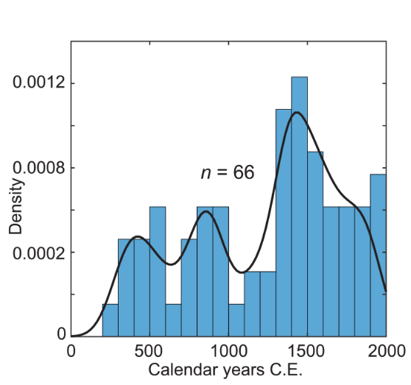
Within the Himalaya, advances have been inferred with the aid of dating techniques of moraines, giving an understanding of their dynamics during the LIA (Rowan, 2017). These dated moraines show three distinct periods of glacial advances (Figure 1); the first ~400 AD, the second ~800–900 AD and the last LIA advance ~1300–1600 AD. When compared with those seen in Europe, these multiple peaks match well (Holzhauser et al., 2005). The LIA maximum within the Himalaya has been suggested to have occurred between ~1300–1600 AD, while the maximum within Europe dated to be between 1300–1800 AD. These dates within the Himalaya coincide, although slightly earlier, with the coldest conditions within the LIA, between 1570–1730 AD (Bradley and Jonest, 1993). These dated moraines, which infer the LIA maximum in the Himalaya, are clustered around specific regions (Figure 2) and cannot give a full understanding of the glacial dynamics seen across the Himalayan range. Multiple studies have discussed an asynchronous retreat of glaciers within the Himalaya (Minora et al., 2013; Chand et al., 2017) and it should be realistic to assume there would also have been an asynchronous advance of glaciers (Owen, 2009). With consideration for the LIA maximum shown by Rowan (2017), the date of 1450 AD will be used for the duration of this study as being indicative of the LIA maximum.
Figure 1: Probability Density Plot of dated moraine ages in the Himalayas from Rowan (2017)

  - Contribution to Sea-level Rise
Melting ice is an important contributing factor to recent 20th and 21st century sea-level rise, being second only to thermal expansion of the oceans (Radic et al., 2007; IPCC, 2013). Since the LIA, glaciers have been in an almost continuous state of retreat, leading to an increased global sea-level. Estimations from coastal and island sea-level measurements have shown a 219 mm increase from 1880 to 2009 at a rate of 1.7 ± 0.2 mm year⁻¹ – this includes both glacial melt and thermal expansion (Church and White, 2011). Since the advent of altimetry and modelling techniques it has been possible to isolate the contribution made by glaciers. The Intergovernmental Panel on Climate Change (IPCC) have estimated that glaciers have contributed to an increase of global sea-level rise of 0.15 ± 0.18 mm yr⁻¹ between 1961 to 2003 and 0.76 ± 0.37 mm yr⁻¹ from 1993 to 2010 (IPCC, 2007; IPCC, 2013), showing the increased rate of change attributed to global warming.
Central to understanding glacial contributions to sea-level rise is the quantification of glacier volumetric changes. Most studies have estimated volume change of glaciers within the Himalaya through geodetic approaches (Bolch et al. 2009; Cogley, 2009; Kääb et al., 2015; King et al., 2017; Bandyopadhyay et al., 2019) however, traditional geodetic approaches (i.e. the process of differencing two time-separated digital elevation models (DEMs)) are not entirely appropriate for assessing changes since the LIA. Such measurements can only be conducted using palaeo-reconstructive techniques, involving a combination of geomorphological mapping and glacial ice surface reconstruction, which can then be differenced with a
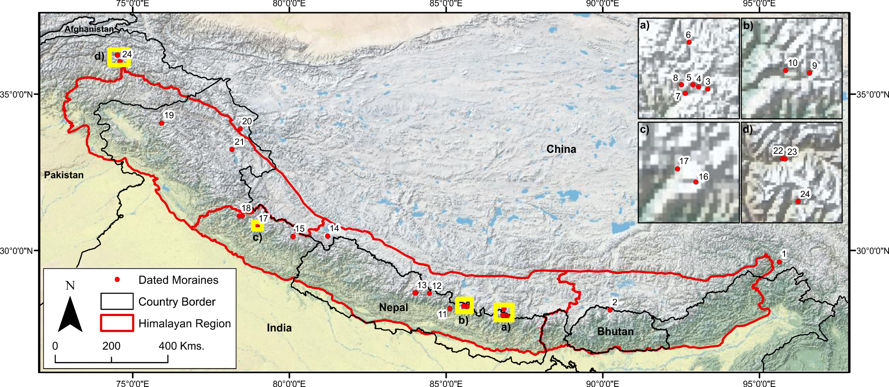
Figure 2: Map of dated moraines (n = 65) summarised in Rowan (2017), with numbered data points linked to appendix A
contemporary DEM. Although estimations by such techniques are prone to uncertainties due to the absence of ‘true’ values, if determinations of LIA moraine and trimline positions are conservative or mapped alongside dated moraines, these estimations can serve as a first-pass assessment of the minimum possible mass change seen since the LIA. Such techniques have previously been used by Glasser et al. (2011) for the Patagonia ice fields, and Carrivick et al. (2019) in northeast Greenland. Both studies act as evidence that this approach can extract realistic volume change estimates from time periods prior to instrumental observations. With the integration of more recent data, they have also shown an acceleration in glacial mass loss rates driven by an increase in global temperatures and changes in precipitation over the past half-century when compared to rates from the LIA (Oerlemans, 2005; Glasser et al., 2011; Carrivick et al., 2019).

  - Himalayan Mountains and their Glaciers
The Himalayan range (Figure 3) covers an area from around 27°00 to 32°50 N and from 78°30 to 95°40 E, extending for 2,400 km, cutting across the borders of Nepal, Bhutan, India, China and Pakistan. It covers an area of ~450,000 km² with a maximum elevation of 8848 m (Mt Everest) and encompassing a number of peaks over 7000 m, making this area one of the most inaccessible locations in the world. The Himalaya can be split into the Western, Central and Eastern Himalaya, which combined includes over 20,000 glaciers (GLIMS, 2005). This study focuses on the Central and Eastern Himalaya, which are the areas most influenced by the monsoons. These two locations will be referred to as the ‘central’ and ‘eastern’ Himalaya within this chapter, while in the results chapter (section 5.0) the regional definitions set out by Brun et al. (2017) will be used; these are the West Nepal (WN), East Nepal (EN) and Bhutan (B) for area change, and the Ganges and Brahmaputra river basins for absolute volume change and sea-level contribution (Figure 4).

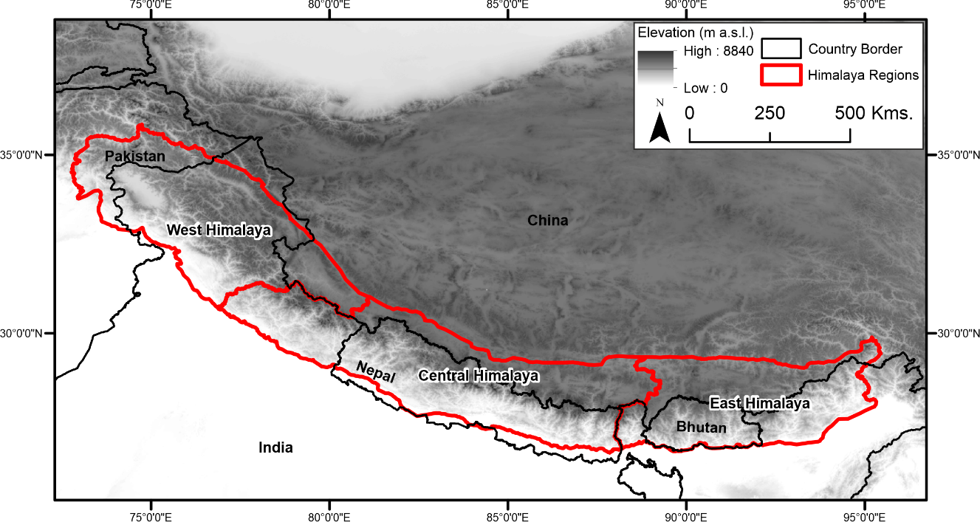
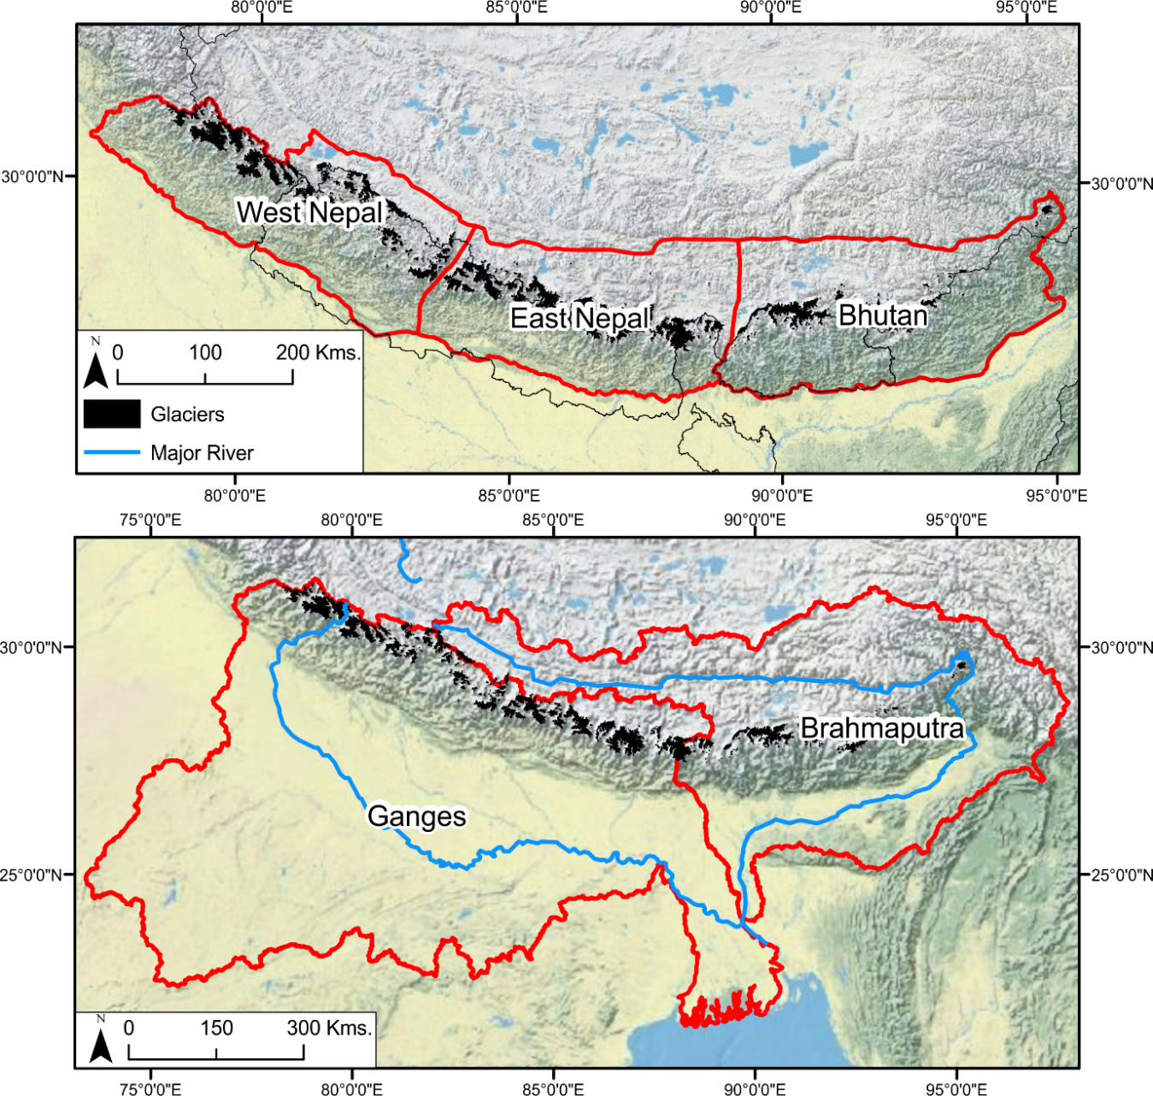
Figure 3: The Himalayan Mountain range with the three main subregions
Figure 4: The study area boundaries of which shall be used within this study as used by Brun et al. (2017)
  - General State of Himalayan Glaciers
The Himalayan glacierized areas are estimated to cover ~40,800 km² (Bolch et al., 2012), making it the third largest area of ice outside Greenland and the Antarctic. Consequently, the Himalayas are commonly referred as the ‘third pole’. Glaciers in the eastern and central Himalaya are ‘summer-accumulation type’, nourished during the summer-monsoon snowfall (Ageta and Higuchi, 1984), while the western Himalaya, including the Karakoram, are ‘winter-accumulation type’, nourished during the winter snowfall (Quincey et al., 2011).
Himalayan glaciers are in a general state of recession and/or thinning (Mayewski et al., 1979; 1980; Salerno et al., 2008; Immerzeel et al., 2010; Bolch et al., 2011; Zhu et al., 2013; Rowan et al., 2015; Rowan, 2018). Glacier change is heterogeneous and asynchronous within and between regions of the Himalaya, linked to local topographical influences (Milnora et al., 2013; Kääb et al., 2015; King et al., 2017). For example, in Bhutan there is a north-south gradient with glaciers on the southern side of the Himalaya retreating faster than the glaciers on the northern side (Kääb, 2005). Also, within the Karakoram, there has been a trend of glacial stability (Hewitt, 2005), or even marginal growth (Brun et al., 2017). This phenomenon is known as the ‘Karakoram Anomaly’, and has been linked to a strengthening of the Westerlies circulation (Hewitt, 2005; Minora et al., 2013; Forsyth et al., 2017).

  - Glacier Mass Change in the Himalaya
The Himalayas have received an increasing amount of attention in the literature due to recent climatic warming and glacial retreat. There are three distinct study periods within the literature, each with their own distinct differences in analysis and study period. Studies concerned with centennial or decadal changes (mid-20th century) generally focus on areal, glacial length and Equilibrium Line Altitude (ELA) changes, while studies concerned within the 21st century tend to focus on volumetric and elevation changes. This plethora of contrasting timescales aids in understanding the changing dynamics of glacial retreat throughout recent history.
Changes since the LIA have received the least amount of attention in the literature. Where studies have examined glacial mass changes since the LIA, they use simple two-dimensional mass change indicators – length and area – and are focussed on small regions within the Himalaya. Studies such as those by Chand et al. (2017) and Loibl et al. (2014) have focused on a singular glacier or massifs respectively. Conversely, Qiao and Yi (2017) examined two-dimensional areal change across the central and eastern Himalaya, using small study regions spaced out along the Himalayan ridge. The findings of these studies are summarised in Table 1, which help to serve as baseline understanding for this study. Overall, the results of these studies show an increasing rate of glacial melt and retreat over time, while topographical factors influence regional variability of glacial retreat producing asynchronous patterns across the range.
The majority of studies in the Himalaya have been concerned with glacial mass changes since the mid-20th century and onward. They tend to follow the same methodological approaches seen in previous studies. Due to their time scales, they can enable an understanding of the changes in mass loss rate within the Himalaya over time in relation to early climatic warming. A range of such studies and their main findings are presented in Table 2. Primary findings have been that of increased glacial change overtime, with Berthier et al. (2007) showing increased mass loss between 1999 to 2004 in the Garhwal Himalaya and Himachal Pradesh, twice that of the mass loss seen between 1977 and 1999. Multiple studies have also noted increased fragmentation of glaciers, with Bajracharya et al. (2014) in Bhutan reporting an increase of glacier numbers by 14.8% between 1980 and 2010 and Ojha et al. (2016) reporting an increase of 5% between 1992 and 2006/10. Other studies have shown a contrasting variability in the rate of ice loss over time; for example Schmidt and Nüsser (2011) showed a decrease in mass loss in the Kang Yatza Massif, Western Himalaya, between 2002 and 2010 compared to previous years in the same region, possibly linked to a strengthening of the Westerlies as has been inferred elsewhere (Mölg et al., 2014).

Main Findings | Average length change was 27% (min 6%, max 58.5%). Larger glaciers (>5000m length and 10km²) less percentage loss. Glaciers facing east on average retreated the most (~27%). Heavy influence of monsoon seasons on glacier dynamics. | Overall area change of 449 km² since LIA (31.2%); most extensive area loss in Qomolangma (44.5 km²). Average retreat of 1.756 km (35%); most extensive retreat in Qomolangma (7.7 km). Average ELA increase by 99m (2.7%); largest change in Qomolangma (313m). | Average glacier recession 2898 ± 50 m (9.2 ± 0.3 m yr⁻¹), average area lost 4 ± 0.6 m² (0.03 ± 0.004 m² yr⁻¹). 1863 to 1906; recession 612 ± 50 m (20.1 ± 0.8 m yr⁻¹), area loss 1.2 ± 0.8 km² (0.03 ± 0.02 km² yr⁻¹). 1906 to 1965; recession 1185.4 ± 50 m (20.1 ± 0.8m yr⁻¹), area loss 1.8 ± 0.52 km² (0.03 ± 0.02 km² yr⁻¹). 1965 to 2014; recession 1100.2 ± 32.1 m (22.5 ± 0.7 m yr⁻¹), area loss 1.1 ± 0.01 km² (0.02 ± 0.0003 km² yr⁻¹)
Study Period | 1850 – 1999 | 1900 – 2014 | 1863 – 2014
Author(s) | Loibl et al., 2014 | Qiao and Yi, 2017 | Chand et al., 2017
Location | Eastern Himalaya, SE Tibet | Central and Western Himalaya | NW Himalaya, India, Himachal Pradesh

Table 1: Mass change studies within the Himalaya with study periods since the Little Ice Age
Main Findings | Since 1980 glacial area loss of 195.5 km² (23.3 ± 0.9%). Glacier numbers increased by 14.8% between 1980 and 2010 – due to fagmentation. Increased melt 1980 to 1990, decreased melt 1990 to 2010. | Bangni and Dunagirl retreat, ~2080 ± 162 m and ~484 ± 38 m. Glacial area loss; ~0.59 ± 0.01 km² and ~0.17 ± 0.007 km². ELA change; ~64 ± 30 m and ~28 m. | Little quantifiable data Khumbu Glacier slight change, Pokhalde Glacier disappeared entirely, Imja Glacier seen pronounced retreat and collapse. | Area decreased 1616.7 ± 247.7 km² in 1992, 1477.8 ± 232.5 km² (-8% -0.5 ± 0.1% yr⁻¹) 2006/10. Number of glaciers increased by 5% due to fragmentation. | Area decrease from 6332 to 5329 km² (16%, 0.41% yr⁻¹). ELA change from 4900 to 5200 m. Increased melting of accumulation snow in the winter months (Oct to Dec). Presence of proglacial lakes, maybe a big influence on glacial retreat. | Reduction in glacier area of 599.9 ± 15.6 km² to 572.5 ± 18.0 km² (-4.6 ± 2.8%). | Area loss in Himachal Himalaya of 21% (0.52% yr⁻¹) faster than Nepal (0.2% yr⁻¹). North-south and east-west gradients, relation to snow shadow zone, monsoonal intensity, supra-glacial debris cover, altitude in accumulation zones and contributions of tributary glaciers.
Study Period | 1980 – 2010 | 1962 – 2013 | 1955 – 2010 | 1992 – 2006/10 | 1962 – 2001/2 | 1968 – 2006 | 1962 – 2008
Author(s) | Bajracharya et al., 2014 | Kumar et al., 2017 | Byers, 2008 | Ojha et al., 2016 | Kulkarni et al., 2011 | Bhambri et al. (2011) | Bhambri and Bolch, 2009
Location | Eastern Himalaya, Bhutan | Central Himalaya, Dhauliganga Basin | Central Himalaya, Nepal, Khumbu | Central Himalaya, Eastern Nepal | Indian Himalaya | Western Himalaya, Garhwal Himalaya | Western Himalaya, Indian Himalaya

Table 2: Mass change studies within the Himalaya with study periods since the mid-20th century
Main Findings | Decreased area of 5%, 1980 to 1990. Increase loss between 4-36%, 1990 to 2000. Most areas stable, 2000 to 2010. General glacial area loss since 1980. | Ice loss rate increased x2 through 1999 – 2004 when compared to 1977 – 1999. | Overall area loss of 5.2% (0.12% yr⁻¹), 0.19 km³ volume loss of debris-covered glaciers. Loss rate of > 0.5 m yr⁻¹ due to stagnation and debris-cover. | Area decrease of 403.9 km² to 384.6 km², loss of 4.9% (0.12% yr⁻¹). Large glaciers, facing south increased due to increase mass. Smaller glaciers on steeper slopes experienced most reduction | Reduction of glacier area from 96.4 to 82.6 km² (14%, 0.3% yr⁻¹). Average ice front retreat of 125m (3 m yr⁻¹). 1991 –to 2002 saw retreat of 0.6% yr⁻¹ then a rate of 0.2% yr⁻¹ between 2002 – 2010. | Reduction in glacier area of 599.9 ± 15.6 km² to 572.5 ± 18.0 km² (-4.6 ± 2.8%). | Only study to focus on Himalaya. Doubling of average rate of mass loss during 2000 – 2016 (-0.43 ± 0.14 m w.e. yr⁻¹), 1975 – 2000 (-0.22 ± 0.13 m w.e. yr⁻¹).
Study Period | 1980 – 2010 | 1977 – 2004 | 1962 – 2002 | 1950s – 1990s | 1969 – 2010 | 1968 – 2006 | 1975 – 2016
Author(s) | Bajracharya et al., 2015 | Berthier et al. (2007) | Bolch et al. (2008) | Salerno et al. (2008) | Schmidt and Nüsser, 2011 | Bhambri et al. (2011) | Maurer et al. (2019)
Location | Western Himalaya, Hindu Kush | Western Himalayas, Himachal Pradesh | Central Himalayas, Khumbu Region | Central Himalaya, Sagarmatha National Park | Western Himalaya, Kang Yatza Massif | Western Himalaya, Garhwal Himalaya | The Himalaya
Table 2: Continued
With an increased interest in sea-level rise and the contributions from glaciers due to recent climatic warming, there has been a step-change in the quality and quantity of studies focussing on calculating mass loss. A number of such studies are summarised in Table 3. With the availability of multi-temporal DEMs, geodetic techniques can be used to estimate elevation and volumetric changes and thus their contribution to sea-level rise. Studies by Brun et al. (2017), Bandyopadhyay et al. ( 2019) and Maurer et al. (2019) are three of the only studies to estimate volume change of glaciers throughout the High Mountain Asia (HMA) and Himalaya. Brun et al. (2017) considered the entire HMA and estimates that glaciers have contributed 0.74 ± 0.14 mm to sea-level rise between 2000 and 2016, while Bandyopadhyay et al. (2019) focussed on the Himalaya alone and showed a contribution of 0.42 ± 0.05 mm of sea-level rise between 2000 and 2014 – equivalent to 56% of the broader HMA sea-level rise contribution. Maurer et al. (2019) on the other hand, studied mass changed across the Himalaya since 1975 to 2016 (cf. Table 2). They found that the Himalaya had contributed 0.58 ± 0.25 mm SLE over the study period. They also noted a doubling of the mass change between 2000 to 2016 compared to the period of 1975 to 2000. This increase in rate has been linked to the dominant driving forces of climate and the presence of lake-terminating glaciers and changes in debris-cover. Other studies have noted pronounced surface lowering of glaciers across the Himalaya, with Kääb et al. (2015) focussing on the Pamir-Karakoram-Himalaya, Rankl and Braun (2016) in the Karakoram, King et al. (2017) in the Everest Region, Vijay and Bruan (2018) in Juammu and Kashmir region and Lovell et al. (2019) in the Annapurna Region, Nepal. This lowering has been linked to the presence of proglacial lakes in contact with glacial ice, supraglacial lakes on debris-covered glaciers enhancing local mass loss, pronounced glacier thinning at the transitional zone between debris-cover and debris-free ice and the presence of surging glaciers in the Karakoram and western Himalaya transporting large volumes of ice to lower elevations.

Main Findings  Table 3: Mass change studies within the Himalaya with study periods over the past two decades | The Jammu and Kashmir (JK) East (Karakoram) glaciers had an elevation change of -0.19 ± 0.22 m yr⁻¹ while JK West (Himalaya) had -0.50 ± 0.28 m yr⁻¹. Link to debris insulation and ice melt from supraglacial lakes. 16 surge-type glaciers in JK East were found. | Elevation change in regions across the Himalaya; Kunlun Shan (Karakoram) ~+0.05 ± 0.07 m yr ⁻¹; Pamir -0.48 ± 0.14 m yr⁻¹; Hindu Kush -0.49 ± 0.10 m yr⁻¹; Karakoram -0.10 ± 0.06 m yr⁻¹; Spiti-Lahaul -0.49 ± 0.12 m yr⁻¹; West Nepal -0.49 ± 0.09 m yr⁻¹; Everest -0.37 ± 0.16 m yr⁻¹; Bhutan -0.89 ± 0.16 m yr⁻¹; Eastern Nyainqêntanglha Shan -1.34 ± 0.29 m yr⁻¹. Mass balance by river basin; Tarim +0.7 ± 1.0 Gt yr⁻¹, Amu Darya -4.0 ± 0.8 Gt yr⁻¹, Indus -7.0 ± 0.8 Gt yr⁻¹, Ganges -4.1 ± 0.6 Gt yr⁻¹, -12.6 ± 1.9 Gt yr⁻¹. | Mass balances and elevation changes of glaciers throughout the Himalaya. Mass balance east and central Himalaya -0.22 ± 0.12 m. w.e. yr⁻¹ to -0.33 ± 0.14 m w.e. yr⁻¹, western Himalaya -0.45 ± 0.16 m w.e. yr⁻¹, central Karakoram +0.10 ± 0.16 m w.e. yr⁻¹, western Pamir +0.14 ± 0.13 m w.e. yr⁻¹. Overall average -0.14 ± 0.08 m w.e. yr⁻¹. Elevation changes; Kunlun Shan +0.17 ± 0.15 m yr⁻¹, Pamir -0.13 ± 0.22 m yr⁻¹, Karakoram -0.12 ± 0.15 m yr⁻¹, Spiti-Lahaul -0.53 ± 0.13 m yr⁻¹, Everest -0.44 ± 0.20 m yr⁻¹, Bhutan -0.89 ± 0.18 m yr⁻¹ and Eastern Nyainqêntanglha -0.30 ± 0.13 m yr⁻¹. | Overall Area change; -0.12 ± 0.04%. Surfacing Lowing: Land Terminating, upper reaches losing most elevation, Dudh Koshi (-1.06 ± 0.10 m yr⁻¹) and Tama Koshi (-1.08 ± 0.12 m yr⁻¹). Lacustrine-terminating, low reaches, average loss of -0.30 m yr⁻¹. Shows where glacier terminates affects elevation-lowering rates. Mass balance; lacustrine terminating glaciers (-0.70 ± 0.26 m w.e. yr⁻¹), land terminating debris covered glaciers (-0.53 ± 0.21 m w.e. yr⁻¹).
Study Period | 2000 – 2012 | 2003 – 2008 | 1999 – 2011 | 2000 – 2015
Author(s) | Vijay and Bruan, 2018 | Kääb et al., 2015 | Gardelle et al., 2013 | King et al., 2017
Location | Western Himalaya, Jammu and Kashmir | Pamir-Karakoram-Himalaya | Pamir-Karakoram-Himalaya | Central Himalaya, Everest Region

Main Findings | Surface elevation: Stable glaciers (-0.09 ± 0.12 m yr⁻¹), advancing glaciers (-0.15 ± 0.12 m yr⁻¹) surge type glaciers (-0.17 ± 0.12 m yr⁻¹). Mass Balance: Stable and advancing glaciers (-0.08 ± 0.10 m w.e. yr⁻¹), surge-type glaciers (-0.17 ± 0.12 m w.e. yr⁻¹). | Found a total sea level contribution of 260.8 ± 56.0 Gt (16.3 ± 3.5 Gt yr⁻¹) around 0.736 ± 0.144 mm (0.046 ± 0.009 mm yr⁻¹). Bhutan -1.0 ± 0.5 Gt yr⁻¹, East Nepal -1.6 ± 1.0 Gt yr⁻¹, Hindu Kush -0.6 ± 0.4 Gt yr⁻¹, Inner TP -1.8 ± 0.9 Gt yr⁻¹, Karakoram -0.5 ± 1.2 Gt yr⁻¹, Kunlun 1.4 ± 0.8 Gt yr⁻¹, Nyainqentanglha -4.0 ± 1.5 Gt yr⁻¹, Pamir Alay -0.1 ± 0.1 Gt yr⁻¹, Pamir -0.6 ± 0.5 Gt yr⁻¹, Spiti Lahaul -2.9 ± 0.7 Gt yr⁻¹, Tien Shan -3.0 ± 2.2 Gt yr⁻¹, West Nepal -1.6 ± 0.4 Gt yr⁻¹. | Mean elevation change across Himalaya was -0.45 ± 0.40 m yr⁻¹ (0.03 ± 0.02 m yr⁻¹), mass budget is -11.24 ± 0.79 Gt yr⁻¹ (0.80 ± 0.05 Gt yr⁻¹). Cumulative mass loss was -154.72 ± 19.04 Gt (11.05 ± 1.36 Gt) this overall contributed 0.42 ± 0.05 mm (0.03 ± 0.004 mm yr⁻¹) of sea-level rise. | Area loss of 41.33 km² (-8.46%), with an average surface elevation change of -0.33 ± 0.22 m yr⁻¹. Fragmentation of glaciers adding 9 glaciers (from 162 glaciers) to the region.
Study Period | 2000 – 2012 | 2000 – 2016 | 2000 – 2014 | 2000 – 2016
Author(s) | Rankl and Braun, 2016 | Brun et al. (2017) | Bandyopadhyay et al. (2019) | Lovell et al. (2019)
Location | Western Himalaya, Karakoram | High Mountain Asia | Trans-Himalaya | Annapurna Region, Nepal
Table 3: Continued
Although in combination there is a broad range of studies available, they all present data at differing temporal and spatial scales, and there remains a clear gap in knowledge pertaining to rates of glacier mass change since the LIA across the broader Himalayan range. Studies that are concerned with the LIA focus on area and glacial length changes or focus on discrete study areas, while studies that examine volume changes tend to be focused on recent changes, without a historical perspective. Bridging this gap is therefore the main aim of this study, to understand long-term mass changes over the entire east and central Himalaya, to better understand their response to changes in temperature and precipitation as well as their contribution to sea-level rise.

  - Controls on Himalayan Glacial Dynamics
Glaciers can be divided into two zones. In the upper part of the glacier, known as the accumulation zone, there is a net gain of mass, principally through snow accumulation. In the lower part of the glacier, known as the ablation zone, there is a net loss in mass, primarily through melt and calving processes (assuming the presence of a proglacial lake). The ELA is a theoretical line where accumulation and ablation are in balance, representing the division between accumulation and ablation areas (Benn and Evans, 2010; Bakke and Nesje, 2011). Unusually, glaciers in the central and eastern Himalaya gain mass in the summer months, whereas glaciers in the western Himalaya gain mass in the winter months. Mass accumulation and ablation is primarily controlled by climate (temperature and precipitation) (Haeberli and Burn, 2002), but also influenced by local factors such topography (Garg et al., 2017; Brun et al., 2019). The remainder of this section will discuss the major controls on Himalayan glacier mass balance, including climate, topography and the presence/abscence of debris-covered and lake-terminating glaciers.

    - Climatic influences on the Himalayan glaciers
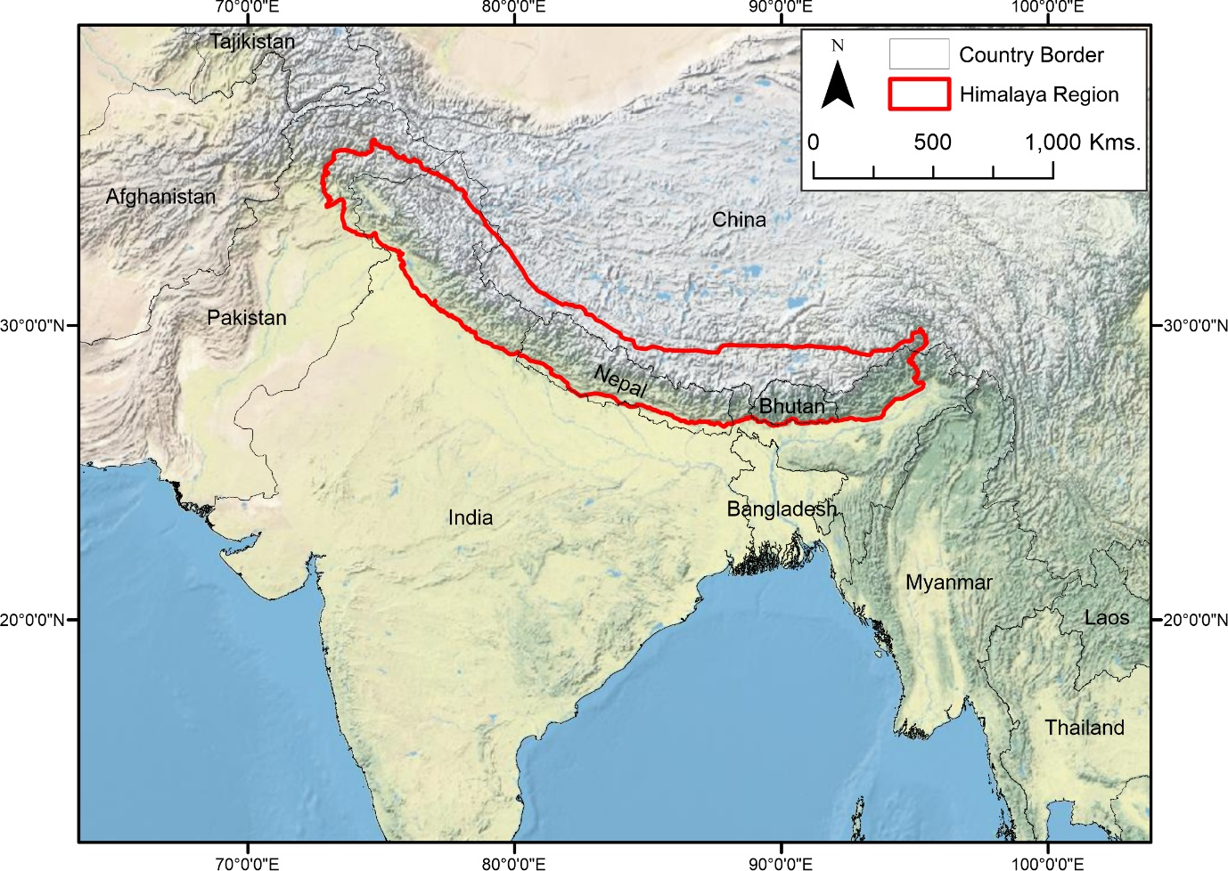
The uplift of the Himalayan Mountains created three main climate circulatory systems seen today; the Indian Summer Monsoon (ISM), the East Asian Summer Monsoon (EASM) and the Westerlies (Zhisheng et al., 2001). These three circulatory systems (Figure 5) are important in supplying the Himalaya with moisture and precipitation to aid in the accumulation of its glaciers (Bolch et al., 2012). These three climatic circulation systems can be split into two main geographical regions of influence.
Figure 5: The Himalayan Mountain’s main circulation systems and their direction of travel
Westerlies
ISM
EASM
The ISM and EASM occur during the summer, bringing precipitation primarily to the central and eastern Himalayan regions (Loibl et al., 2014; Shekhart al., 2017). The ISM brings moisture and precipitation northwards from the Indian Ocean (Zhou and Murtugudde, 2014; Qiao and Yi, 2017), while the EASM moves moisture from the Pacific Ocean over China and Tibet (Molnar et al., 2010). The magnitude of these two circulations can vary on decadal to millennial scales, being influenced by the El Niño-Southern Oscillation (ENSO) and the Pacific Decadal Oscillation (PDO), while they themselves are modulated by solar forcing (Fan et al., 2009; Berkelhammer et al., 2010). During the LIA, due to reduced solar activity, the ISM precipitation was reduced by 30% when compared to modern precipitation averages, leading to drought conditions between the 13th and 17th century (Yadava and Ramesh, 2005; Polanski et al., 2014; Tejavath et al., 2017). More recently the ISM has been further weakened, with decreased precipitation widely accepted as a contributing factor to recent glacial mass loss across the Himalaya (Roxy et al., 2015).
The Westerlies or the ‘Western Disturbance’ is an extratropical storm, which occurs at the middle latitudes of the Northern Hemisphere. It originates over the Mediterranean Sea, Caspian Sea and the Black Sea and moves eastward towards northern India following the westerly jet stream (Kotal et al., 2014; Dimri et al., 2015; Hunt et al., 2018). In the winter, the jet stream is enhanced and drifts further south allowing it to affect the northern reaches of Pakistan and India, which includes the western Himalaya and Karakoram (Schiemann et al., 2009). The Westerlies are thought to be strengthening due to recent climatic warming and are a major contributing factor to the Karakoram Anomaly.
Many studies have investigated warming of the Himalaya over the past few decades or the last century (Prasad et al., 2009; Shrestha and Aryal, 2011; Shrestha et al., 2012; Hoy et al., 2016). Prasad et al. (2009) shows a warming in the Himalaya between 1979 to 2008 of 1.44°C, while a similar amount of warming was seen by Shrestha et al. (2012), showing that between 1982 and 2006, there was a total increase of 1.5°C with an average rate of 0.06°C y⁻¹. Shrestha et al. (2012) further showed that the greatest increase over this period was seen in winter, with an increase of 1.75°C while the minimum increase was seen in summer, as low as 0.75°C. Regionally, warming has been asynchronous, showing an increasing temperature trend of +0.008°C yr⁻¹ between 1901 and 2012 in Bhutan (Hoy et al., 2016), +0.06°C yr⁻¹ between 1977 and 1994 in Nepal (Shrestha and Aryal, 2011) and +0.016°C yr⁻¹ between 1955 and 1996 across the Tibetan Plateau (Liu and Chen, 2000). Although these studies do not coincide in terms of time period, they are common in their identification of warming over recent decades. Miles et al. (2018) suggest that this warming is impacting ice temperatures, with the minimum temperature of the debris-covered Khumbu Glacier measured at 2ºC above annual air temperatures. This implies that with future atmospheric warming even debris-covered glaciers, commonly thought to be insulated from atmospheric effects, will become increasingly impacted, exacerbating their thinning.

    - Topographic Influences
Mountain glaciers occupying the same climatically homogenous regions can respond to climatic change at varying rates, making any generalisation of glacier response to climate change almost impossible, aside from the determination of whether they are losing mass or not (Hoelzle et al., 2003; Salerno et al., 2017). The spatial variation of glacial mass loss from climate change can be attributed to topographic factors (Oerlemans, 2007). These local topographical factors can include; elevation, slope, aspect, and glacier size (Li and Li, 2014; Garg et al., 2017). Many studies have assessed the role of topographic factors on glacier response within the Himalaya, either examining single glaciers (Nainwal et al., 2008; Bhambri et al., 2011; Mehta et al., 2014; Pratap et al., 2015) or a number of glaciers in a single region (e.g. Garg et al. 2017). Furthermore, many papers that consider topographical influences on Himalayan glaciers, have only examined how the glacier setting correlates (or not) with relative area change (%). Although estimates of volume and area are linked (Bahr, 1997), they may not necessarily be completely in-sync with one other. Brun et al. (2019) is one of the few studies to have investigated the topographic and morphological controls on glacial mass balance for the entire HMA, although notably they did not consider glaciers with an area < 2 km².
Altitudinal range is defined here as the difference between a glacier’s maximum and minimum elevation. A glacier may occupy a small altitudinal range, normally in the higher reaches of mountains, or may occupy a large altitudinal range extending from high glacial headwalls, to lower glacial valleys. The longest glacier in the Himalaya, the Gangotri Glacier, is 30 km long and occupies an altitudinal range from ~5500m to ~4000m (Rowan, 2018). Generally, glaciers with large altitudinal ranges are more sensitive to small changes in climate, due to their low reaches being most affected by warming temperatures (Rowan, 2018). Studies have found that in the Himalaya, glaciers at a lower mean altitude are more sensitive to mass loss than glaciers at higher mean altitude (Bhambri et al., 2011; Pandey and Venkataraman, 2013; Garg et al., 2017).
The slope of a glacier is another important metric that can indicate glacier sensitivity to changes in temperature and precipitation. Primarily, surface slope can influence ice velocities (Gantayat et al., 2014), and therefore mass flux (McNabb et al., 2012), and snow accumulation rates through avalanche transport (Mott et al., 2010). Glaciers on steep slopes can sustain higher flow speeds than those on shallow slopes. A number of studies have suggested this is one of the most important factors controlling glacier response to climate change in relation to the advance and retreat of glacier tongues (Jiskoot et al., 2009; Scherler et al., 2011; Salerno et al., 2017). Garg et al. (2017) also show that glaciers within the Himalayas are profoundly affected by slope, finding a strong positive correlation with area loss and surface slope. This finding contrasts with those of Brun et al. (2019) who found that a glacier with a gentler slope incurs more negative mass change.
Glacier aspect has long been recognised as playing a role in the rates of ice accumulation and ablation. Glaciers in the Northern Hemisphere that face north tend to melt less than glaciers facing south due to a decreased input of solar radiation (Singh et al., 2011). Aspect can also control the windward and leeward slope effects of snowfall and snow redistribution (Garg et al., 2017). Within the Himalaya, Garg et al. (2017) found that west-facing glaciers retreated the most, and DeBeer and Sharp (2009) showed that solar radiation plays a key role providing the maximum energy to the glacier surface during the mid-afternoon period, before moving west such that glaciers facing west receive the most solar radiation throughout the day. In contrast however, Brun et al. (2019) did not find glacier aspect to be a significant control on mass change.
Glacier size is often used to indicate how sensitive an ice mass can be to changes in climate. Glaciers that have more mass and are larger in area tend to have longer response times compared to smaller glaciers (Jóhannesson et al., 1989; Mehta et al., 2014; Shukla and Qadir, 2016). Garg et al. (2017) found that there was a positive correlation between glacier size and absolute area change (i.e. that larger glaciers lost more area than smaller glaciers). Relatively speaking however, smaller glaciers (< 5 km²) lost the most percentage area compared to medium (5-10 km²) and large (> 10 km²) glaciers. Huss and Fischer (2016) examined the response of Swiss Alpine glaciers, and found that glaciers with an area of < 0.5 km² are the most sensitive to climatic warming, incurring the highest percentage areal loss. Brun et al. (2019) found that glacier area was not a significant contributor to mass change within the HMA.

    - Glacial Debris-cover
Debris-cover over glaciers can aid in reducing the effects of solar radiation, reducing the melt of glacial ice (Stokes et al., 2007; Pellicciotti et al., 2015; Vincent et al., 2016; Shukla and Qadir, 2016; Garg et al., 2017; Ali et al., 2017). Although thin layers of debris-cover can reduce albedo and increase melt, layers which are 4-5 cm in thickness reduce ablation, while layers 1-2 m metres in thickness can retard glacial melt (Östrem, 1959). This reduction in ablation at the terminus, causes a reduction in ice velocity (Quincey et al., 2009) leading to many Himalayan glaciers to be out of equilibrium with climate and close to or at their LIA extents at low elevations (Rowan, 2017). This cessation in area change however does not mean melting has stopped. Studies have shown that surface lowering continues (Figure 6), primarily due to the formation of supra-glacial ponds, ice cliffs and englacial hydrological processes (Sakai et al., 2002; Buri et al., 2016; Miles et al., 2016; Saleron et al., 2017; Shukla and Garg, 2019). Debris-covered glaciers are common within the Himalaya (Scherlet et al., 2011), due to active uplift creating high rates of erosion, causing large amounts of debris to become transported along the ice surface (Kirkbride and Deline, 2013; Rowan, 2018). Geodetic studies have shown that thinning rates of debris-covered glaciers within HMA are similar to those of debris-free glaciers at similar elevation ranges (Gardelle et al., 2013; Kääb et al., 2012). This appears to contradict the expected reduction in glacial melt of debris-covered glaciers owing to the insulating properties of the mantle, and is a key outstanding question yet to be resolved by studies focussing on glaciers in the HMA (Brun et al., 2019).

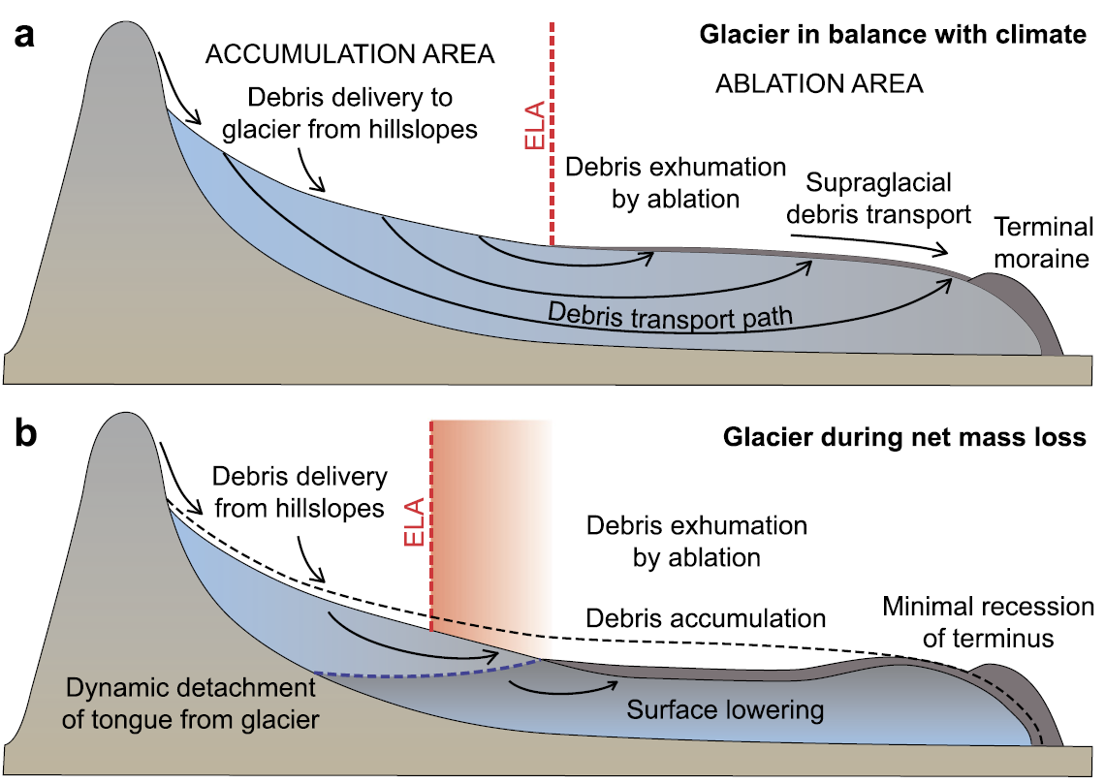
Figure 6: The development of debris-covered glaciers with a) glacier in balance with the climate and b) mass loss under climate warming (Rowan et al., 2015)
    - Proglacial Lakes
Proglacial lakes exert a significant influence on glacier dynamics by affecting their stability and effectively decoupling them from climatic forcing (Carrivick and Tweed, 2013). Proglacial lakes are bodies of water which occur at the periphery of the glacier front and can form via the coalescence of supraglacial lakes and ponds that then become dammed by terminal moraine (Costa and Schutster, 1988; Benn et al., 2012). They are associated with increased glacial mass loss, by subaqueous thermo-erosional melting (Rögl, 2006), calving processes (Sakai et al., 2009) and accelerated ice flow of the ablation zone (King et al., 2018). Failure or overtopping of these dammed lakes can be dangerous to downstream communities causing glacial lake-outburst floods (GLOFs; Clague and Evans, 2000; Wilson et al., 2018). It has been shown by a number of studies in HMA, that glaciers with proglacial lakes have more negative rates of elevation change than land-terminating glaciers, indicating that they play a key role in determining Himalayan glacial dynamics (Gardelle et al., 2013; King et al., 2017).
  - Section Summary
From this extensive literature review, it is evident that Himalayan glaciers saw their maximum growth during the LIA ~1450 AD, a date that will form the baseline date of this study’s analysis. This carries a significant amount of uncertainty however, since dating studies are concentrated in specific regions and may not be indicative of wider Himalayan glacier dynamics during the LIA. Melting from glaciers are of critical importance in the understanding of sea-level rise in relation to recent climatic warming, but there is no long-term baseline against which to measure contemporary changes. Himalayan glaciers have seen a general state of mass loss, with this change being heterogeneous and asynchronous, linked to climatological variations between regions. The asynchronicity within regions is a consequence of topographical factors including differences in glacier elevation, slope, aspect, and glacier size, as well as terminus conditions (i.e. lake- or land-terminating). Debris-covered glaciers may have the potential to show decreased rates of recession, with many glaciers still occupying their LIA positions, however it has been shown that volumetric changes still occur, leading to their rates of mass loss to be similar to those of clean-ice glaciers. Proglacial lakes cause a decoupling of glaciers from their surrounding climate, enhancing glacial mass loss at the terminus through subaqueous thermo-erosional melting, calving processes and accelerated ice flow of the ablation zone. Understanding the importance of each of these controls is critical to making better predictions of future mass loss, which can be gained by first understanding long-term changes in glacier dynamics since the last major period of advance.
- AIMS AND OBJECTIVES
Based on the review above, it is clear that few studies have considered Himalayan glacier mass change since the LIA. Those that do have focussed on small geographical areas and have not been concerned with volumetric changes. There is therefore no long-term baseline record of change with which to compare contemporary measurements of region-wide mass balance. This is the gap in knowledge that this study aims to fill.
With the consideration of past studies, the aims of this study are to:
- Provide a complete inventory of Little Ice Age (1450 to 2013) extents and glacier mass change of the central and eastern Himalaya.
- Investigate and understand spatial variations in glacial mass loss that are evident within climatically homogenous regions in the Himalaya.
These aims will be met by following four primary objectives:
- To delineate the LIA glacier extent using remotely sensed data to identify terminal moraines and erosional trimlines.
- To obtain area change estimations using the delineated LIA glacier extents and contemporary glacier boundaries.
- To reconstruct the surface elevations of glacier ablation zones during the LIA, enabling the estimation of volume (and subsequently mass) change along with glacier contributions to sea-level rise over the period 1450 to 2013.
- To investigate whether differences exist in glacial mass loss due to spatial variations in glacial topography and different glacier terminus conditions.
- DATA AND METHODS

  - Data Sources
    - Glacier Outlines
Contemporary glacier outlines were downloaded from the Randolph Glacier Inventory (RGI) version 6.0 from the Global Land Ice Measurements from Space (GLIMS) website (www.glims.org). These RGI outlines were originally generated by semi-automated and manual classification of satellite imagery acquired between 2000 and 2003, while being continuously updated since their release in 2012. The latest version, used within this study, was released in 2017 with the last edit for the Himalaya region being made in 2013 (RGI Consortium, 2017). A duplicate of these outlines was made and modified to reflect LIA glacier extents.

    - Remotely Sensed Data
To aid in the identification and delineation of LIA moraines, a combination of remotely sensed data was used. The primary reference for identifying LIA moraine crests was the 8m HMA DEM downloaded from the National Snow and Ice Data Center, Distributed Active Archive Center (NSIDC DAAC); DEM tiles used in this study are shown in Appendix B. The 8m HMA DEM was generated from DigitalGlobe satellite imagery throughout a period from the 28th January 2002 to 24th November 2016 covering the Tien Shan, Hindu Kush and the Himalaya (Shean, 2017). The DEM tiles were processed within ArcGIS using the ‘hillshade’ tool, which assisted in highlighting the dominant palaeo-glacier geomorphology. Many regions covered by the DEM had ‘no data’ pixels making mapping of all regions with the 8m HMA DEM impossible. Sentinel-2B satellite data (10 m pixel size) were downloaded from the European Space Agency’s Copernicus Open Access Hub (www.scihub.copernicus.eu), acting as a secondary reference for locations of no data in the DEM; Sentinel-2B tiles used in this study are shown in Appendix C. Imagery was chosen from winter months for the central and eastern Himalaya to limit snow cover that could obscure moraines and erosional trimlines, with true-colour composites being generated for interpretation. In addition, Bing Maps and Google Earth were consulted to add detail in specific areas that were covered by no data pixels in the 8m HMA DEM and covered by cloud in the Sentinel-2B imagery.

  - Estimates of Mass Loss
    - LIA Mapping and Area Estimation
The broad methodological approach adopted in this study is shown in Figure 7. LIA moraines were mapped using glacial geomorphological indicators evident within the imagery, and following the observations of Rowan (2017); LIA moraines are generally distinct across the region, exhibiting higher relief than earlier-Holocene moraines which acted as a barrier to LIA glacier growth. LIA moraines therefore tend to be inset, and those of most prominence close to the current glacier terminus. Adopting the general approach of delineating the moraine crests closest to the glacier terminus yields the most conservative estimate of glacier extent during the LIA. Features were identified by using the hillshaded 8m HMA DEM (Figure 8 a) and optical satellite images (Figure 8 b). Where multiple terminal moraine crests were observed, the most prominent moraine that could be tied into unambiguous trimlines or lateral moraines was delineated as the minimum LIA extent.
Figure 7: Flow diagram of methods used within this study
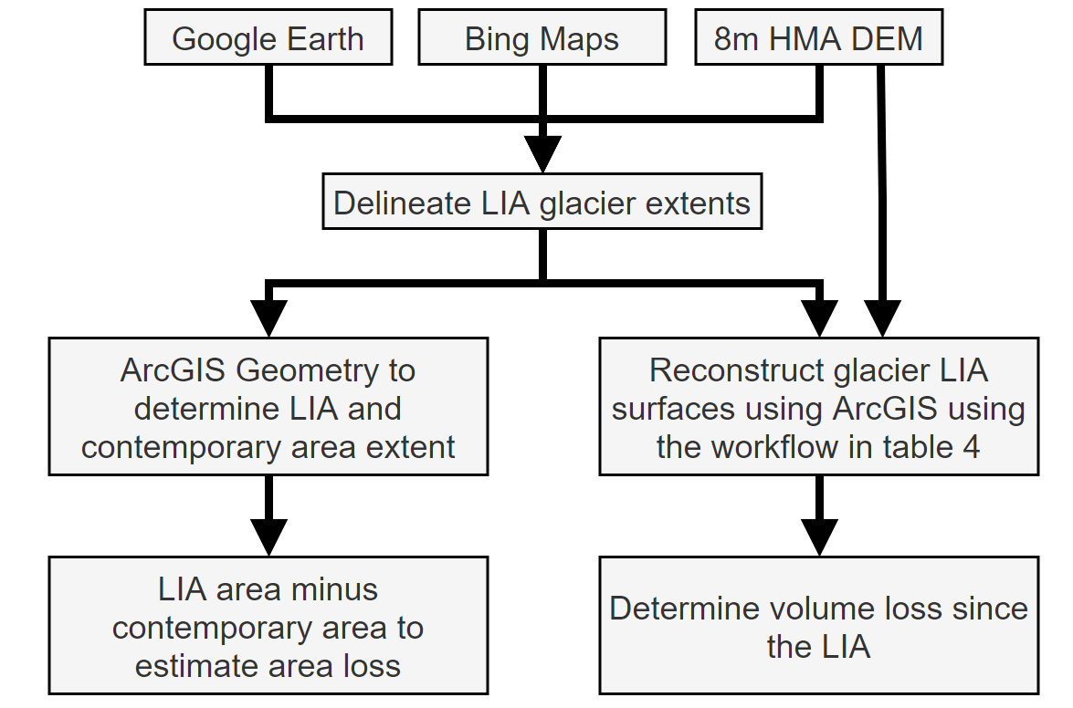
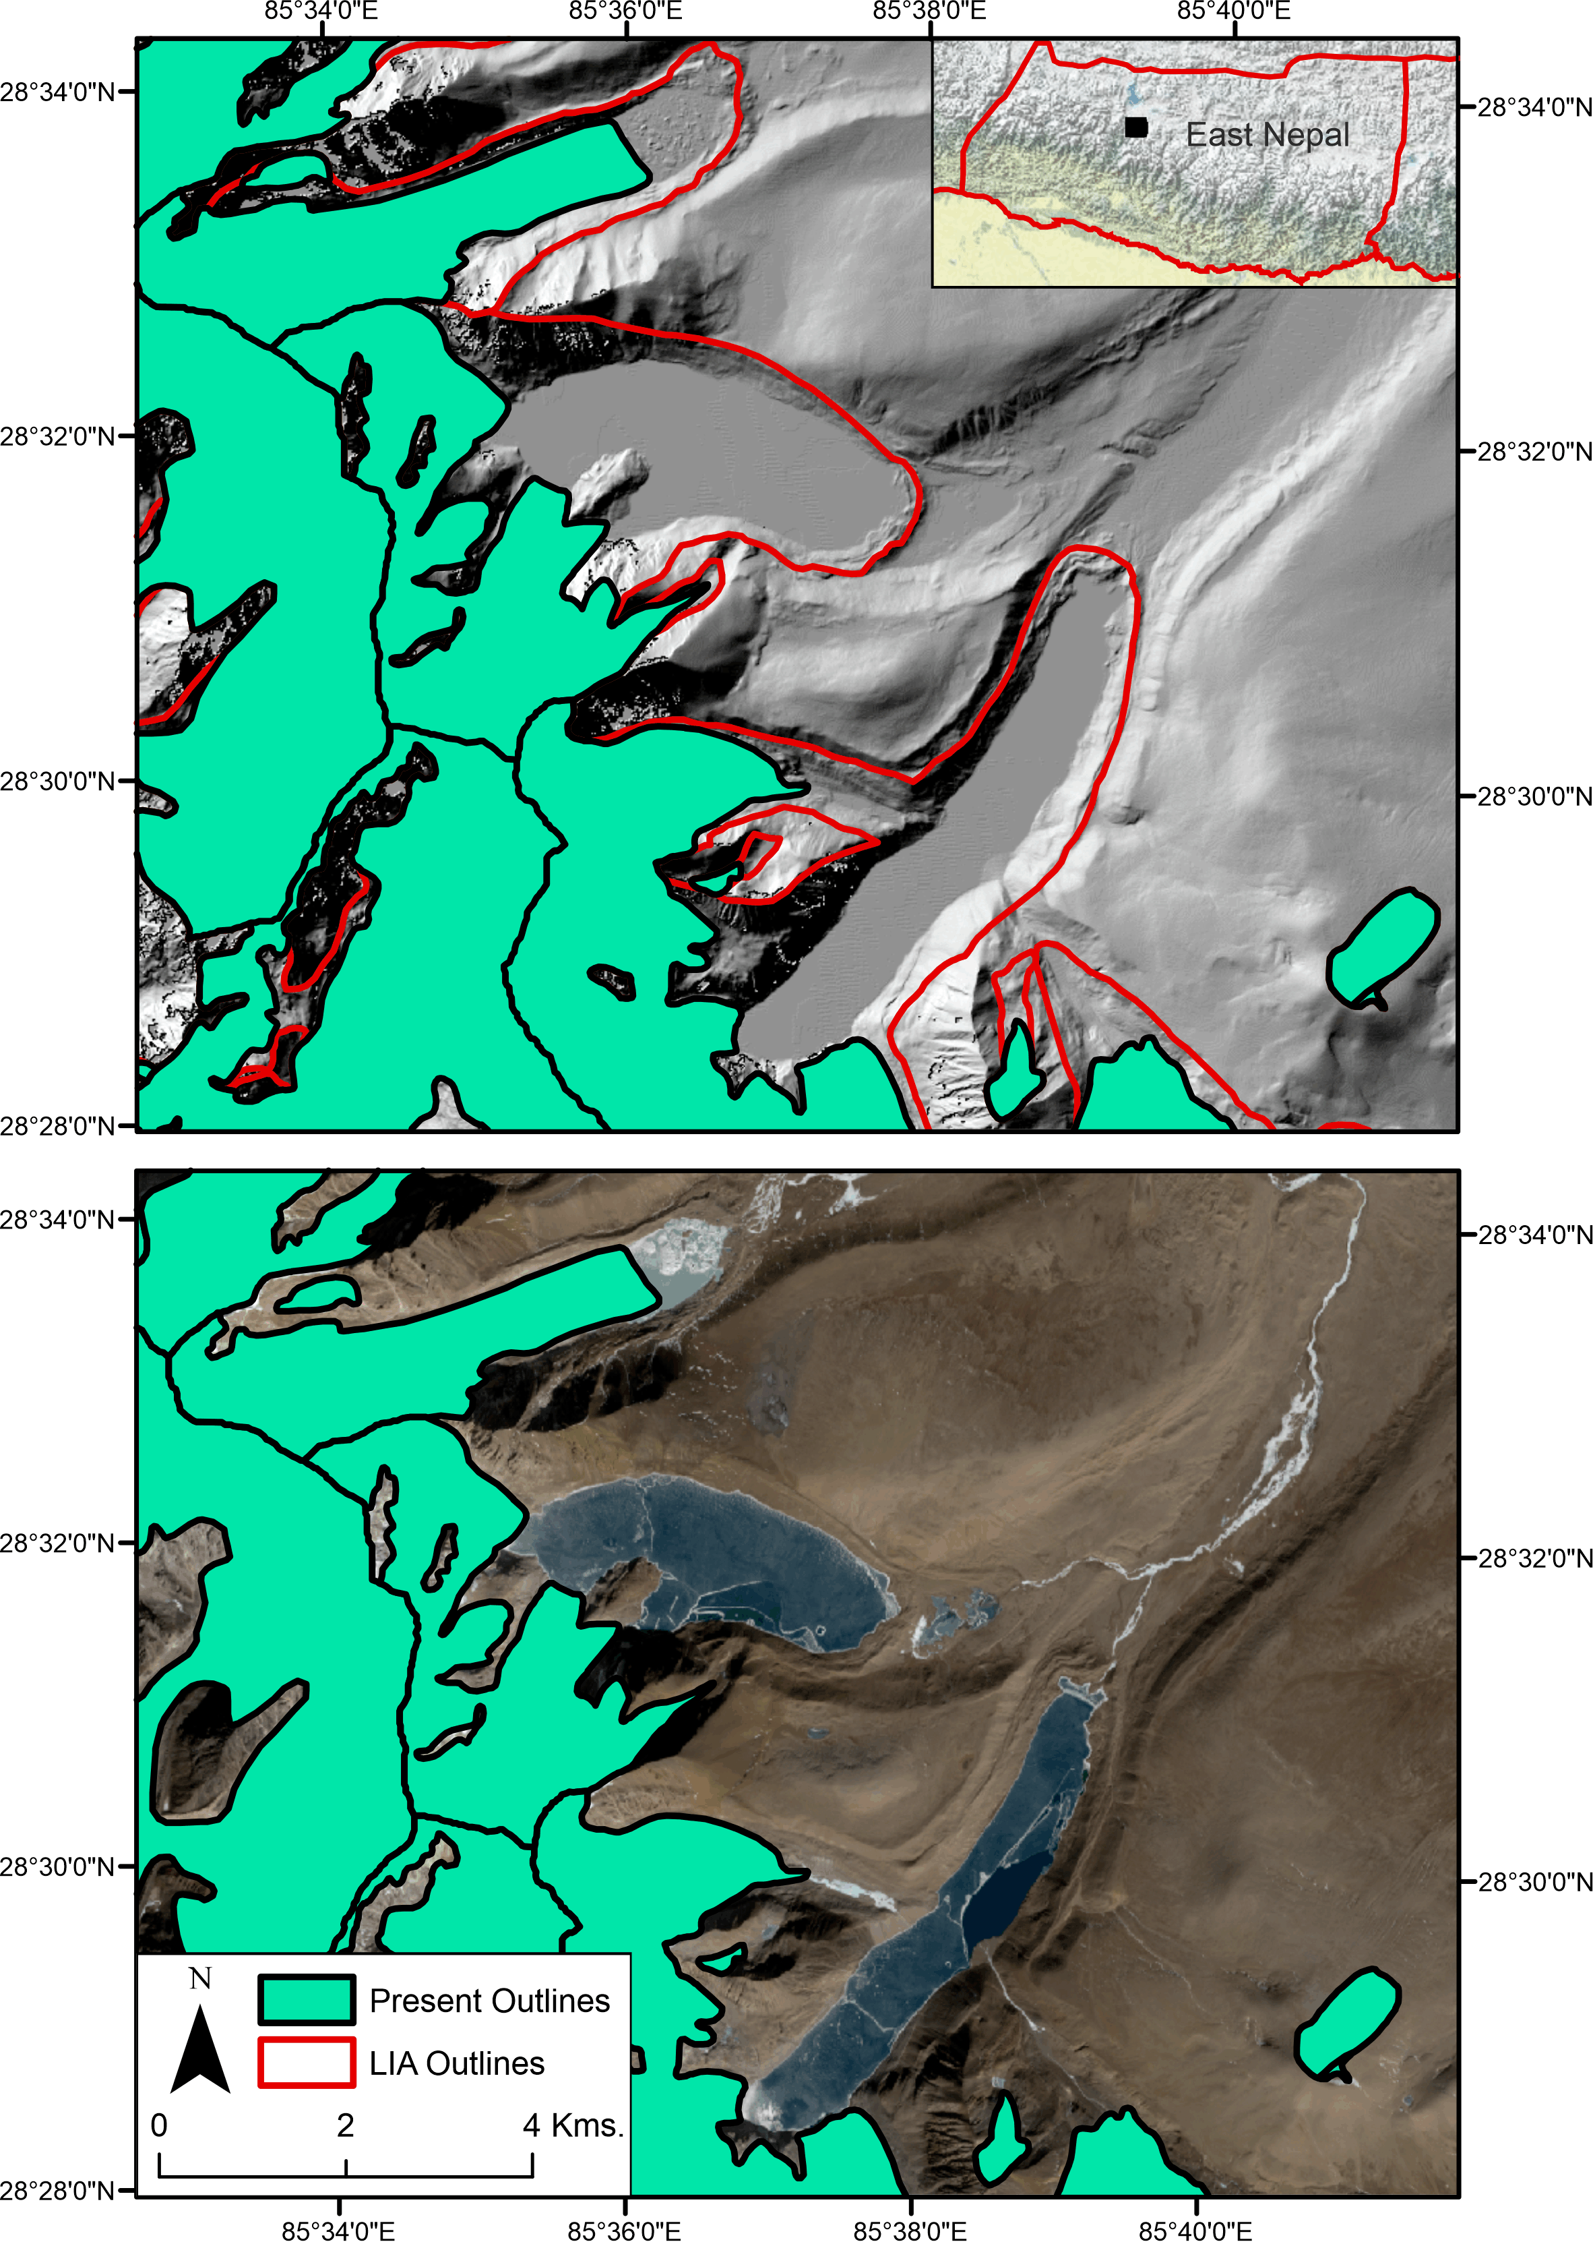
Figure 8: An example of mapping of LIA moraine crests within the Langtang region with location shown by black square in inset map of the East Nepal region a) using the hillshaded DEM, and b) a Sentinel-2B image showing depositional and erosional features (trimlines)
In valleys where no moraines and no trimlines could be clearly identified, mostly as a consequence of paraglacial and hydrological activity having overwritten the glacial geomorphology, they remained unmapped. These voids were accounted for in the final area results by assuming they would have showed similar dynamics to those that were successfully mapped; i.e. the average percentage change of mapped LIA glaciers of a similar size was applied to those glaciers that were not mapped (an increase of + 176% compared to current outlines). In valleys where erosional trimlines or lateral moraines were only present on one side of the valley, the DEM was used to match the elevation of the present moraine to the opposite valley side.
Glacier areas, and subsequently area changes, were determined by using the geometry calculator function in ArcGIS.

- LIA extent polygon and contemporary DEM with same projection in a geodatabase.
- Using the script from Carrivick et al. (2019), modified from Pellitero et al. (2015) to extract palaeo-ablation zones from the LIA polygon. Balance Ratio of 1.75 (Rea et al., 2009). Manually edit paleo-ablation areas to remove erroneous results.
- ‘Extract by mask’ the contemporary DEM with the paleo-ablation zones
- ‘Focal Statistics’, ‘focal maximum’ of 3 cell circle on the extracted DEM.
- ‘Densify’ palaeo-ablation zone shapefile.
- ‘Simplify polygon’ palaeo-ablation zone shapefile.
- ‘Feature vertices to points.’
- ‘Extract values to points’ from the focal max’ed DEM to the vertices.
- ‘Natural Neighbor’ the now extracted DEM values
- ‘Raster calculator’ LIA Ablation Surface minus the original DEM for elevation difference.
- ‘Reclassify’ to remove negative values.
- ‘Zonal statistics’ to determine ‘sum’ elevation change for each glacier.
- ‘Raster calculator’ multiply elevation change by cell size area to extract volume change.
    - LIA Volume Estimation
Estimates of volume change were derived following the same procedure set out by Carrivick et al. (2019) – this workflow is given in Table 4 and an example is shown in Figure 9. The 8m HMA DEM, being the highest resolution DEM of the study area, was used as the primary dataset for the glacier palaeo-ablation zone surface reconstruction.
Table 4: The modified workflow originally set out by Carrivick et al. (2019) for the reconstruction of palaeo-ablation zones and surface elevations
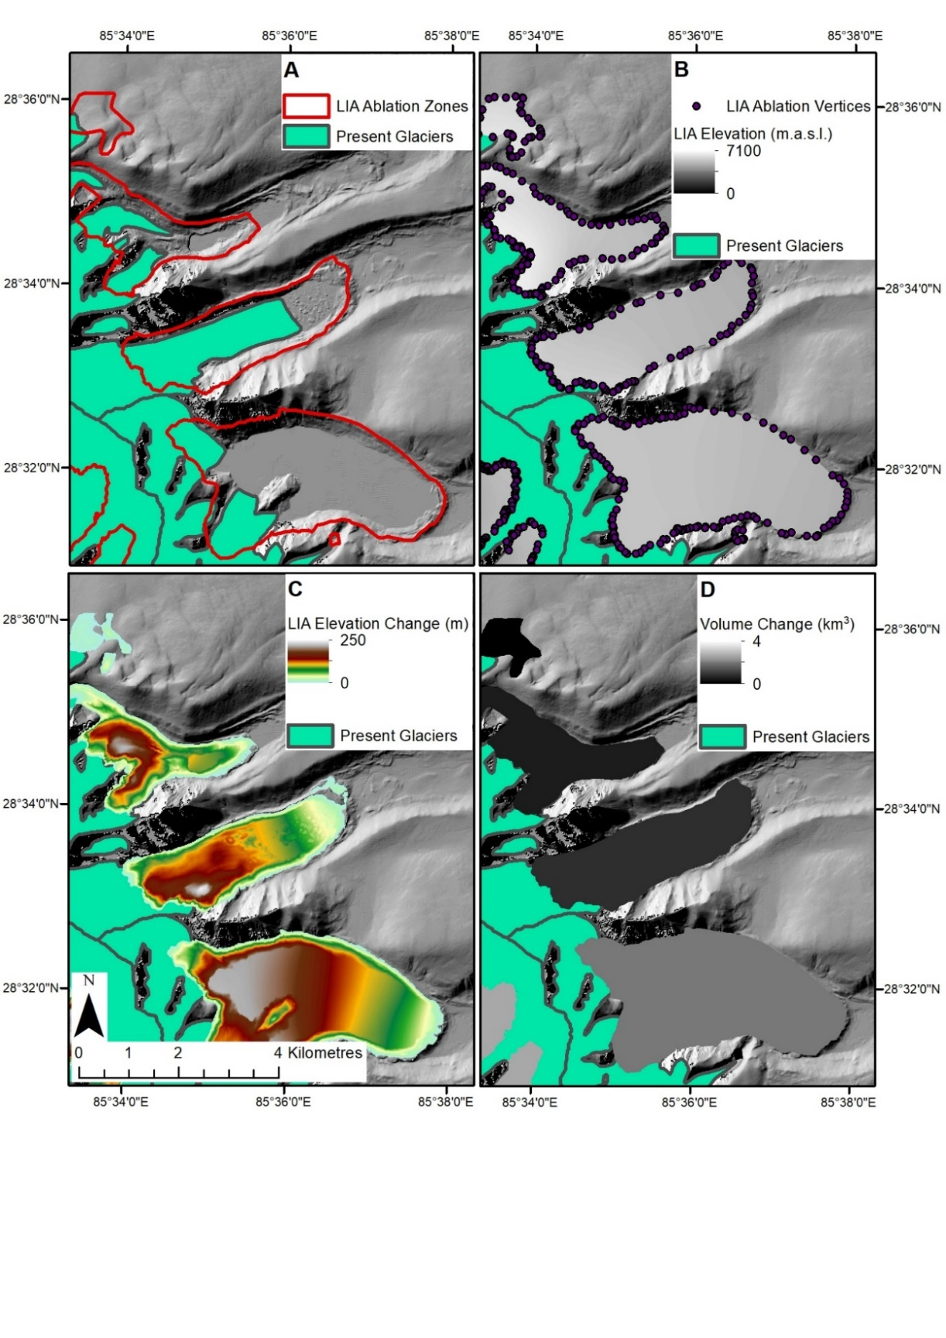
Figure 9: 8m HMA DEM hillshaded with RGI present day glacier outlines in the Langtang region, same location as shown in the inset of Figure 8 with A) extracted LIA glacier palaeo-ablation zones using the code originally by Pellitero et al. (2015), B) the vertices of the ablation zone outline converted to points with elevation from the DEM extracted to those points that were used to reconstruct the surface elevations using natural neighbour interpolation technique, C) the reconstructed LIA palaeo-ablation zone surface elevations differenced with the present day DEM to determine spatially-distributed elevation change and D) the final outputted volume change for the palaeo-ablation zones
Within the 8m HMA DEM, voids exist where the matching algorithm in the DEM extraction method has failed, yielding discrete areas of ‘no data’. To overcome these voids, glaciers that had a no data coverage above 60% were disregarded and removed from the shapefile. The value of 60% was selected following McNabb et al. (2019) who found that above this threshold, the standard deviation of estimated volume change dramatically increases, making interpolations increasingly uncertain. This step removed 966 glaciers from the analysis. Smaller DEM voids were filled using the ‘Elevation Void-fill’ raster function within ArcGIS, using a maximum void-fill of 2000 m. This void-fill function uses a plane fitting interpolation method, using 8 neighbouring points to fill small voids of around 2 pixels, while above this, an inverse distance weighting algorithm is applied (ArcGIS, 2019). Glaciers where no data areas still remained were examined, and removed manually if the missing data covered a large proportion of the ablation area. This accounted for a further 116 glaciers. In total, 1082 glaciers were removed from the analysis, leaving 5159 glaciers from an original dataset of 6241.
ELA estimates were calculated using ArcGIS toolbox Python code created by Pellitero et al. (2015), and modified by Carrivick et al. (2019). The Area-Altitude Balance Ratio (AABR) was used as the primary method for determining the ELA, being the most robust approach for estimating palaeo-glacier ELAs (Osmaston, 2005). The AABR is based on three key assumptions which must be met, i) accumulation and ablation gradients are linear (Rea, 2009), ii) the net ratio between the accumulation and ablation is known and is fixed through time and iii) that topography constrains the glacier which causes a change in elevation of the terminus in relation to climate change (Pellitero et al., 2015). The AABR method requires the glacier surface area (Santos-Gonzalez et al., 2013) and Balance Ratio (BR) to be known. The glacier BR can be calculated using the glacier area, shown in Equation 1 (Furbish and Andrews, 1994; Pellitero et al., 2015):
(1) | $$BR= \frac{{\overline{Z}}_{ac}A_{ac}}{{{\overline{Z}}_{ab}A}_{ab}}$$
where, ${\overline{Z}}_{ac}$ is the area-weighted mean altitude of the accumulation area, $A_{ac}$ is the area of accumulation, ${\overline{Z}}_{ab}$ is the area-weighted mean altitude of the ablation area, and $A_{ab}$ is the area of ablation. The BR for a number of regions around the world where glaciers are present has been complied by Rea (2009), which for the Central Asia (which the Himalayas are situated) the BR was derived as 1.75 ± 0.56.
With a determined BR, the AABR can be used. The glacier surface is divided in to contour belts using a user defined contour interval, usually based on the resolution of the DEM used. For each belt, its surface area is multiplied by its mid-point elevation, with the sum of these values being divided by the total glacier area to produce a preliminary ELA – this is equal to a BR of 1. Using the user defined BR (in this study of 1.75), for each contour belt (starting at the lowest belt) the preliminary ELA is subtracted from the mean belt elevation and is multiplied by the contour belt area. If the resulting value is negative it is multiplied by the BR and is thus determined to be in the ablation zone. This is iterated up the contour belts until it reaches a contour belt where the resulting value changes from being negative to a positive. The mean elevation of this contour belt is then determined to be the palaeo-glacier ELA. All areas that fall below this reconstructed ELA were extracted into a new shapefile, and subsequently considered to represent the palaeo-ablation zone for the glacier.
The resulting polygon vertices were transformed into points and each point was assigned an elevation value based on its position in the 8m HMA DEM. The palaeo-ablation zone surface elevation was derived using a Natural Neighbour interpolation. A full rationale for the use of Natural Neighbour is detailed in section 4.3. The reconstructed surface elevations were then differenced with the modern-day DEM to yield elevation, and subsequently volume, change. To account for those glaciers removed from the analysis due to excessive DEM voids, the volume change result was also scaled. Here, the percentage of pixels not used within each region covered by the glacier ablation zone was taken as the scaling factor; for the Ganges the overall volume change was increased by 5.14%, and for the Brahmaputra it was increased by 19.01%.

    - Contribution to Sea Level Rise
To estimate glacier contribution to sea-level rise since the LIA, the total volume change of all glaciers was quantified and sea-level equivalent (SLE) was calculated using Equation 2 (Davies, 2018):
(2) | $$SLE \left(mm\right)=mass of ice \left(Gt\right)×(\frac{1}{361.8})$$
where the mass of ice (Gt) is the total volume of ice (km³) multiplied by its density, here using an ice density of 850 kg m⁻³ (or 0.850 Gt/km³; Huss, 2013). Ice mass is then multiplied by a conversion factor that accounts for the amount of water required to raise the global sea-level uniformly by 1 mm, which has previously been calculated to be 361.8 Gt. This will then be divided by the number of years between the indentified date of the LIA maximum by Rowan (2017) (1300 – 1600 AD), this studies individual LIA maximum data (1450 AD) and the present day (2013). For all analysis after this, the data of 1450 AD has been used.

  - Interpolation of spatially-distributed LIA ice surfaces
Elevation interpolation is the process of using known data values to aid in estimating elevation values in locations where no such data exist (Erdogan, 2009). The choice of the interpolation approach used can affect the accuracy and quality of an elevation surface produced (Heritage et al., 2009). A range of approaches exist, and the following four were considered for use in this study: i) Natural Neighbour, ii) Inverse Distance Weighting, iii) Kriging and iv) Spline.

    - Natural Neighbour
The Natural Neighbour (NN) interpolation technique, devised by Sibson (1981), is the most commonly used method of interpolation. It finds the closest subset of samples surrounding a point of interest (in this case, a point with no elevation data). It then uses a Triangular Irregular Network (TIN) to identify points that surround the location, and applies a weighting based on their proximity to the point of interest (Sibson, 1981). The result is a smooth surface without any irregularities such as ridges or valleys. By design, the surface passes through all input samples and the interpolated heights are within the range of the sample values provided. Within this study, all default options were accepted for the NN computation.

    - Inverse Distance Weighting
Inverse Distance Weighting (IDW) is a deterministic method for multivariate interpolation. It is based on Tobler’s first law of Geography (Tobler, 1970), i.e. that ‘everything is related to everything else, but near things are more related than distant things’. This means that IDW assumes that each point has an influence on its neighbours, and that this influence decreases linearly with distance. Effectively, it follows that as a point (known here as ‘a’) increases its distance from a second point (b) and moves closer to a third point (c), the influence of point b decreases, while the influence of point c increases. This method of interpolation is exact, in that its interpolated surface will pass through all the input points but will not produce values above the maximum input value. However, it can be susceptible to producing erroneous sinks (Pellitero et al., 2016). This method is best used when there is an even distribution of data points around the area to be interpolated (Childs, 2004). Within this study, IDW was used with its default parameters left as default, with the power set at 2; higher power values tend to create rougher surfaces and vice versa. The number of points that the interpolation used to interpolate the elevation was constant at 12, following the method from Pellitero et al. (2016).

    - Kriging
Kriging is a geostatistical interpolation technique that not only takes the distance of the location to an input elevation point into account (much like IDW), but also the geostatistical relationship between the input points. Kriging assumes there is spatial correlation that can explain variation in a surface. It uses a set number of points within a radius around a point of unknown value to determine its interpolated value (Szypuła, 2016). A key advantage of kriging is that the accuracy of the interpolation is correlated with the number and quality of the sample points used, and it additionally generates error estimates for the unknown points (Erdogan, 2009). The disadvantage of kriging is that it can be computationally intensive and over large areas can take a significant amount of time to create an interpolated elevation surface. Within this study, the method of Pellitero et al. (2016) was adopted; leaving most of the parameters set as default, while using a variable radius to include 5 input points. This determines that the interpolated surface will be created using the nearest 5 points irrespective of the distance they are away from the point.

    - Spline
The Spline interpolation method estimates values by minimizing the surface curvature, creating a smooth single sheet surface that passes through the input points (ESRI, 2019). This method preserves the sample point data, but as it curves its surface to pass through the true height points, values higher and lower than the input value range can be produced. In its basic form, the spline approach uses two conditions on the interpolation, that i) the surface must pass through the data point and ii) the surface must have a minimum curvature. There are two types of spline that are commonly used: Regularized and Tension. Regularized Spline creates a smooth surface that gradually changes; however, the values that are interpolated may lie outside of the range of the input points. Tension Spline creates a rougher surface, but the interpolated values will lie within the range of the input points (Godone and Garnero, 2013). The regularised Spline was used within this study, with all parameters left as their default values.

  - Determining the most appropriate interpolation method
The four interpolation techniques described above were tested to determine their accuracy in predicting elevation at known height point-features; known height points were removed from the DEM, and each interpolation technique was used to predict their elevation. To do this, vertices within the ablation zones were assigned an elevation value extracted from the 8m HMA DEM. A ‘10-fold cross validation’ was then conducted (see next section), using the same interpolated technique 10 times, each with 10% of the points randomly removed for each iteration. The results were then assessed for their ‘closeness of fit’ between the estimated and measured values of the removed points.

    - K-fold Cross Validation
K-fold cross validation is a technique to evaluate predictive models by partitioning the samples of known values into a ‘training set’ which helps train the model, and into a test or ‘validation set’ to evaluate the model. The samples are partitioned into k equal sized samples, k being the number of samples the user wishes to use. With the samples partitioned, one of the sub-samples is left out and the remaining k – 1 are used as the training data. The cross validation is then completed k number of times with each subsample being used once as the validation points. K-fold cross validation can also be undertaken using random sub-samples, using a percentage of the data and repeated k number of times. A 10-fold cross-validation is the most common type of validation used (McLachlan et al., 2004) and is the method which was employed within this study.
Point elevation values were randomly sub-sampled, with 10% of the data being removed for validation each time a new cross-validation was conducted. Differences, or the error, between the observed true elevation height and the interpolated elevation height were calculated using Equation 3. The root-mean-square error (RMSE) for the iteration was calculated using Equation 4. Then the mean RMSE for the interpolation technique was calculated using Equation 5 to assess the technique that had the best ‘closeness of fit’:
(3) | $$E=(e_{pred}- e_{ref})$$
(4) | $${RMSE}_{k}= \sqrt{\frac{\sum_{i=1}^{n}{{(e_{pred}- e_{ref})}^{2}}}{n}}$$
(5) | $$\overline{RMSE}=\frac{\sum_{i=1}^{K}{{RMSE}_{k}}}{K}$$
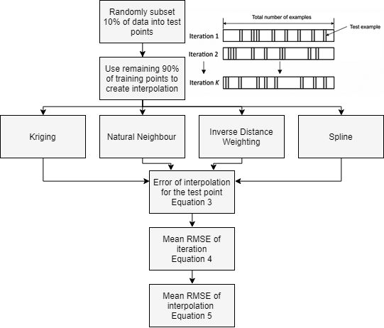
where $E$ is the error between the interpolated $(e_{pred})$ and observed $(e_{ref})$ elevation of the test point. The RMSE is calculated for each iteration $({RMSE}_{k})$ and the mean of the RMSE $(\overline{RMSE})$ is used as the final measure of suitability. The work flow for the 10-fold cross validation is shown in Figure 10.
Figure 10: Workflow of how the interpolation techniques were compared against each other to determine which was the best technique for reconstructing the palaeo-glacier ablation zone surface. The example image of a random k-fold sub-sampling modified from Intrator (2018).
The result of the cross validation displayed in Appendix D, show that NN incurred the lowest RMSE of 10.49, and the lowest mean standard deviation (STD) of 13.18. NN was subsequently chosen as the interpolation method for palaeo-ablation zone reconstruction. Spline was also shown to be acceptable at predicting the points elevation with a mean RMSE of 10.66 and mean STD of 16.14. This however, may be deceptive as the Spline approach allows the interpolated elevation between points to be higher than that of the inputted range of elevation points, yielding erroneous sinks and ridges that effectively compensate for one another in the error calculations.

  - Uncertainty Assessment
    - Area Change Uncertainty
The most common difficulty in mapping glacier extents was in regions where hypothesised LIA moraines had been completely or partially removed by geomorphological processes. In areas where no moraines existed, trimlines or areas of discolouration indicating differences in erosional history were used to approximate the LIA glacier position. In areas where moraines were partly removed, e.g. if a moraine was still present on one side of a glacial valley but not on the other, the elevation of the non-present moraine was matched by the present-moraine elevation on the opposite side. This assumes that, as might be expected from conventional glacier theory, the moraines on each side of the valley were at the same elevation, but of course, may not hold true in all cases. Other problems that affected the mapping process were the presence of ‘no data’ areas within the 8m HMA DEM that covered entire glaciers, or entire regions of glaciation. This was overcome by the use of remotely sensed data such as Sentinel-2B imagery, albeit with a coarser resolution of 10 m, and aerial photography data from Bing Maps and Google Earth. Where mixed image datasources were used, the accuracy with which moraine crests could be pinpointed naturally varied, and these uncertainties are accounted for below.
Secondly, there were a handful of locations where the RGI shapefile was missing small areas of contemporary glacier ice, either through misinterpretation of the present boundary or, in some cases, non-inclusion of small glacierets. For consistency and reproducability, in the case of poorly digitised glacial boundaries, the original RGI shapefile remained unmodified, and therefore inherited small, but largely unquantifiable inaccuracies. Additions were made only in a few cases where substantial areas of glacierised terrain were not mapped in the RGI shapefile, i.e. if an entire glacier was missing.
Thirdly, in some areas, relict moraines were visible but no contemporary glacier could be identified. In these cases, no additional outlines were created as their timing with respect to either the LGM, early-Holocene or the LIA glacier advances could not be definitively established. Allied to this, there is an unquantifiable uncertainty associated with the conservative nature of the methodological approach, and the assumption that the closest crest to the contemporary glacier terminus represents the LIA position.
Finally, there is an inherent uncertainty associated with the (lack of) precision in identifying the moraine crest in each case. To test this, and following the method of Paul et al. (2013), repeat digitisations were made of 50 glaciers 5 times. These 50 glaciers were chosen by portioning the already digitised LIA glaciers into 5 size classes and randomly selecting 10 from each class, thus allowing a range of small and large glaciers to be evaluated. Glacier outlines were then digitised over a number of days to enable a fresh perspective of the user. From this, the standard deviation (STD) and the relative standard deviation (RSV) of the glacier areas could be extracted and used as an indicator of area uncertainty. The average RSV was ± 2.39% (for the full suite of data see Appendix E).

    - Volume Change Uncertainty
In order to estimate uncertainty in glacier volume change, the following contributions were considered: i) voids within the ablation area, ii) relative DEM accuracy and its uncertainty propergation in to the interpolation abd surface differencing and iii) the digitised glacier outlines. Volume change estimates were also converted into Gt of melt-water to estimate contribution to sea-level rise; the uncertainty of assuming an average ice density of glaciers within the Himalayan region was also included.
A primary source of uncertainty is the assumption of glacial melt being limited to only below the ELA (the ablation zone), and assuming no ice melt above the ELA (the accumulation zone). Through visual inspection, little to no surface lowering was seen above the ELA, lending confidence to the assumption that the volume change above the ELA is minimal and thus not included in the uncertainy estimation. Additionally, within the ablation zone there were areas of no data that were void-filled. Because these locations have been void-filled, their elevation is only an estimate of their real world elevation. Of the glaciers that were used in the volume change estimation, the average percentage of void coverage of the ablation zone was used as a proxy for the uncertainty. This gave an uncertainty due to voids in the DEM of ± 6.42%.
A secondary source of uncertainty concerns the relative accuracy (i.e. how a pixel value relates to the one next to it) of the 8m HMA DEM and how its uncertainty can propagate into the interpolation and surface differencing for the volume change estimation. As yet, there is no documentation pertaining to the accuracy of the 8m HMA DEM and an inference of its uncertainty is done by using a DEM generated by similar methods. The 8m HMA DEM was generated using stereo mapping of high-resolution images. This is done by taking two images of the same location along the same ground track (Hirano et al., 2003). Taking into account the method of which the 8m HMA DEM was created, by using a similar study, such as that from Shiramizui et al. (2017), a first-order estimation of its accuracy can be extracted. Shiramizui et al. (2017) created a DEM from the Panchromatic Remote-sensing Instrument for Stereo Mapping (PRISM). Their DEM had an accuracy of 2.80 m over an ice sheet, 4.86 m over individual glaciers and 6.63 m over rock outcrops. For the purpose of this study, the accuracy of 4.86 m over individual glaciers would be similar to the environment seen within the Himalayas. This uncertainty was increased to 5 m to act as a worse case scenario due to any differences in DEM creation methods used between the two DEMs. This was used to act as an indication of the 8m HMA DEM accuracy and its propagation through to the subsequent volumetric change calculations. With the accuracy of the 8m HMA DEM now determined, taking an average-sized glacier of 2.57 km², with an assumed 0.1 m elevation change across the entire glacier, would equal a volume change of 0.1 km³ (similar to that of Carrivick et al., 2019). Using a DEM of ~5 m accuracy would produce an uncertainty of ± 3.89% of the average glacier size. This is increased by a factor of 3; due to using a focal max of 3 pixels for elevation around a vertices of the determined LIA glacier outline (seen in Table 4, step 4). This was done to mitigate any error in the digitised moraine crest which was thus used in the interpolation function. This then increases the uncertainty due to the DEM and its propergation through to the volume change estimation to ± 11.67%.
The final quantification of uncertainy in volume change is therefore the sum of: i) area uncertainy of 2.39%, ii) DEM void uncertainy of 6.42% and iii) DEM accuracy uncertainty and the propergation of its uncertainty through to the volume change estimates equalling 11.67%. This equals an overall uncertainy of 20.48%. There is an additional uncertainty introduced when converting volume to mass. Within this study an ice density of 850 kg m⁻³ is assumed (Huss, 2013). This ice density has a uncertainty of ± 60 kg m⁻³, equalling 7%. This is then added to the overall Gt melt water to produce a final uncertainty for Gt and SLE estimations. This creates an uncertainy for SLE of 27.48%. Remember that this is a worse-case scenario and it is expect that the actual accuracy of the 8m HMA DEM is better then that being used for this calulation.

  - Influence of Local Factors on Glacial Mass Loss
    - Extracting Topography
A selected number of topographic factors were extracted to assess their relationship with glacier mass change seen since the LIA, within the eastern and central Himalaya. Topographic factors were chosen according to their relative importance on the effect of glacial change, as shown in recent literature. The following metrics were derived:
- Glacier area during the LIA (Mehta et al., 2014), derived from the delineated glacier LIA outlines
- Aspect (Bhambri et al., 2011), in degrees was taken directly from the RGIv6 glacial outlines, under the assumption that a glacier’s aspect had not changed since its LIA position, this was then converted to the cosine of the aspect to avoid the non-continuity of values around true-north (i.e. transitioning between 360° and 0°).
- Mean elevation (Li and Li, 2014), derived from averaging the elevation values of the DEM raster cells which fall within the glacier LIA outlines.
- Minimum and Maximum Elevation, and Elevation Range (Dobhal et al., 2008; DeBeer and Sharp, 2009; Bhambri et al., 2011 Davies et al., 2012), representing the minimum and maximum extent of the glaciers respectively, derived from the minimum and minimum DEM raster cells which fall within the glacier LIA outlines. The maximum and minimum elevations were then differenced to create the glacier elevation range.
- Compactness ratio (Garg et al., 2017), defined by a ratio of the area/perimeter of the glacier to the area/perimeter ratio of a circle of the same area, following the same method shown in Allen (1998).
- Debris cover percentage (Kraaijenbrink et al., 2017), derived from a raster of debris-cover over glaciers with a thickness over 50cm sourced from Kraaijenbrink et al. (2017). The percentage of the debris-cover cells which occur over the contemporary outlines was calculated.

    - Statistical Analysis
Statistical analyses were performed in Minitab® Statistical Software 18. All variables that were extracted to represent glacier topography were analysed using; descriptive statistics to provide an understanding of spatially distributed topography of glaciers. Log-corrected linear and multivariate linear regressions were then used, similar to Brun et al. (2019) to determine extracted topographical variables relationship with glacial mass changes since the LIA.
Pre-analysis screening of the data was performed before the final multivariate linear regression. This involved the removal of glaciers with no change in mass (746 removed, 4403 remained), as this would have otherwise caused errors in normalising the data. The data were then assessed for normality using a Shapiro-Wilk’s test (Shapiro and Wilk, 1965) and a histogram with Gaussian curve for visualisation. If any variable was not normally distributed, this was amended by a log 10-transformation. A Pearson product-moment correlation was then used to find any correlation between the variables. In conjunction, the Variance Inflation Factor (VIF) from a preliminary multivariate linear correlation was used to assess multicollinearity of the variables. Variables with a VIF > 10 were determined to have a high degree of multicollinearity. From this, the variable with the highest VIF was removed. The multivariate linear regression was performed again and then the next highest VIF variable was removed. This was repeated until all variables that remained had a VIF < 10. Once the pre-analysis was completed, individual linear regressions were conducted to quantify the significance level of each variable and their influence on glacier volume change. Variables with a significance (p-value) > 0.05 were removed from the analysis.
With the remaining variables, a final multivariate linear regression was performed, using glacier average surface elevation change as the dependant variable. The R² value was used to assess the ‘goodness of fit’ of the model, and the p-value to determine its significance.

    - Glacial Terminus Conditions
It has been shown in studies by King et al. (2017) and Brun et al. (2019) that glacier terminus conditions can affect the rate of glacial mass loss. Within this study, three conditions were selected for each glacier within the central and eastern Himalaya area. These three conditions were, i) clean-ice, ii) lake-terminating or iii) debris-covered. The presence or absence of each condition was assigned by visual interpretation of Sentinel-2B images, along with high-resolution aerial photography from Bing Maps, and the debris-cover raster from Kraaijenbrink et al. (2017). Clean-ice was assigned to glaciers where < 30% of the glacier area was determined to be debris-covered using the debris-cover raster. Lake-terminating was assigned to glacers where a well defined proglacial lake was in contact with the glacial ice. Debris-covered was assigned to glaciers which > 30% was determined to be debris-covered from the debris-cover raster.
An ANOVA was performed on the glacial terminating conditions split between the 3 regions. This was used to understand if there was any statistical difference in their average elevation change. A one-way ANOVA was used for the entire region, while a Tukey multiple pairwise-comparison was used to compare the means of each group within the region itself to the clean-ice glaciers – acting as a ‘control’. Further, to understand if there is any spatial difference in mass changes seen, glaciers were split between their position north or south of the Himalayan ridge. This was done by using a polygon polygon shapefile of the Tibetan Plateau, digitised by Zhang et al. (2002), assuming that if a glacier falls within the digitised polygon of the Tibetan Plateau then it is on the northern side of the Himalayas.

- RESULTS
  - Area Change of Glaciers
As shown in Table 5, the total glacier area for each region was 6,030.0 ± 144.1 km² in the LIA (West Nepal), shrinking to 4,160.9 km² at present day, equating to a decrease of 31.0% (0.06% yr⁻¹); 7,155.4 km² ± 171.0 km² in the LIA (East Nepal) shrinking to 4,993.3 km² at present day, equating to a decrease of 30.2% (0.05% yr⁻¹); and 2,980.7 km² ± 71.2 km² in the LIA (Bhutan) shrinking to 2,054.0 km², equating to a decrease of 31.1% (0.06% yr⁻¹). Overall, the area change of central and eastern Himalayan glaciers from their extent in 1450 AD (16,166.1 ± 386.4 km²) to 2013 (11,208.2 km²), was -4,957.9 km² ± 118.5 km². This is an overall decrease of 30.7 ± 0.7% (0.05 ± 0.001% yr⁻¹) since the LIA to 2013. An example of area percentage change of glaciers seen in the Langtang region of the East Nepal region is shown in Figure 11 with full region maps shown within Appendix F, G and H.
The largest glacier during the LIA in the East Nepal region was RGI60-15.02846, measuring 100.3 ± 2.4 km², and with an area decrease of 17.6%, this also makes it the glacier which incurred the most absolute area change within the East Nepal region. The glacier with the greatest area loss by percentage was RGI60-15.09140, which had a decrease of 99.1% of glacial area, from 2.3 ± 0.05 km² in the LIA to 0.02 km² in 2013. The largest glacier in the LIA for the West Nepal region was the Gangotri Glacier (RGI60-15.06881) being 217.5 ± 5.2 km² in the LIA and shrinking to 188.6 km² in 2013, an area decrease of 13.3%, which is also the glacier which has incurred the most absolute area change in the West Nepal region. The glacier with the greatest areal loss by percentage was RGI60-15.13111, which had a decrease of 95.8%, from 0.6 ± 0.01 km² at the LIA to 0.03 km² in 2013. The biggest glacier during the LIA within the Bhutan region was a glacier not mapped by the RGI but in this study given the ID of 20128, with an area in the LIA of 93.1 ± 2.2 km², and an area decrease of 11.2%. The glacier that incurred the most absolute area change was unmapped in the RGI but in this study given the ID 20124, with a change of 12.6 ± 0.3 km², shrinking from 51.7 ± 1.2 km² in the LIA to 39.1 km² at present day. The glacier with the most ice lost by percentage was RGI60-15.01487, with a decrease of 96.4%, from 4.5 ± 0.1 km² in the LIA to 0.2 km² in 2013.
Region | Area LIA | Area 2013 | Area Change
 | km² | km² | km²
West Nepal | 6,030.0 ± 144.1 | 4,160.9 | -1,869.1 ± 44.7
East Nepal | 7,155.4 ± 171.0 | 4,993.3 | -2,162.1 ± 51.7
Bhutan | 2,980.7 ± 71.2 | 2,054.0 | -926.7 ± 22.1
Total | 16,166.1 ± 386.4 | 11,208.2 | -4,957.9 ± 118.5
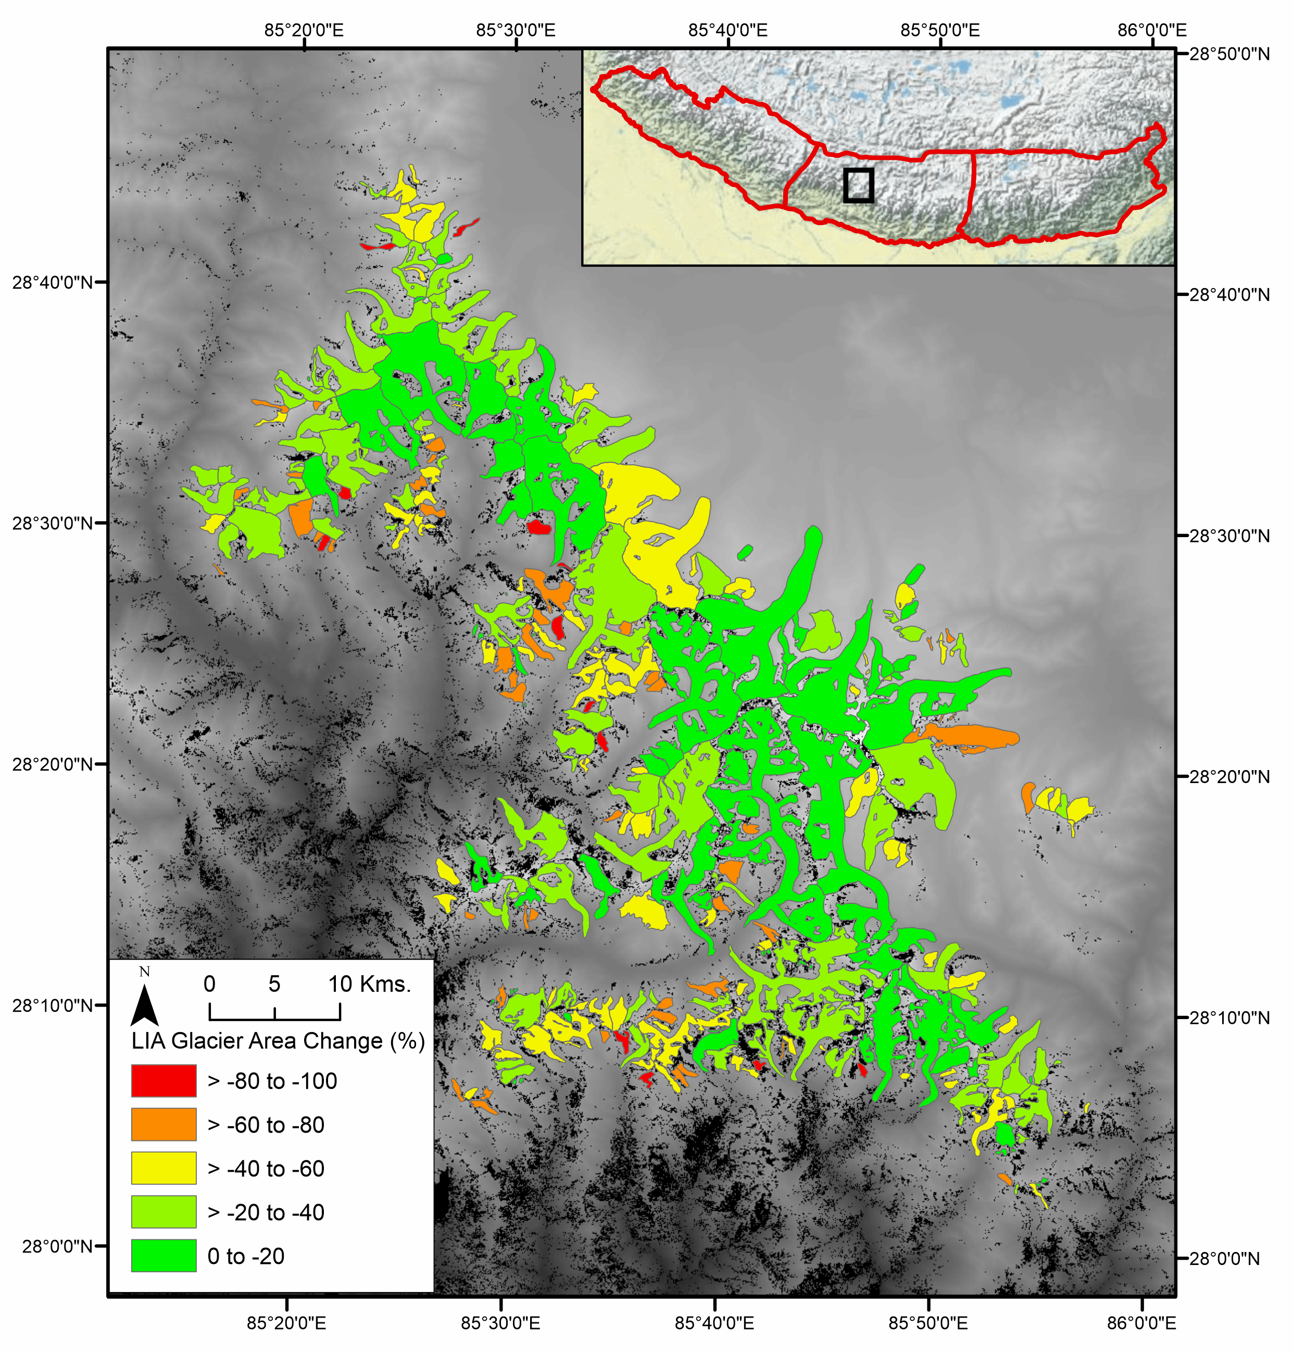
Figure 11: An example of the percentage of area change in the Langtang region in the eastern Nepal region
Table 5: Area change seen within the individual study regions within the central and eastern Himalaya
  - Volume Change of Glaciers
Volumetric changes are shown in Table 6 from 1450 to 2013 and totalled 197.9 ± 40.5 km³ and 89.7 ± 16.2 km³ for the Ganges and Brahmaputra respectively. These two values combined equate to a total volume change of 287.6 ± 58.9 km³ for glaciers within the central and eastern Himalaya. The glacier in the Ganges river basin that has contributed the most in volume loss was RGI60-15.06881, losing 4.0 ± 0.82 km³ of glacial volume since the LIA. The glacier in the Brahmaputra river basin that has contributed the most in volume loss was the Lianggang Glacier (RGI60-15.10718), losing 3.6 ± 0.74 km³ of glacial volume since the LIA. An example of volume change of glaciers seen in the Langtang region within the Ganges river basin is shown in Figure 12 with full region maps shown in Appendix I, J and K (shown in the three regions used for area change due to ease of visualisation).
In terms of mass, glaciers have lost 168.24 ± 46.23 Gt (0.30 ± 0.08 Gt yr⁻¹) and 76.21 ± 20.95 Gt (0.14 ± 0.04 Gt yr⁻¹) for the Ganges and Brahmaputra respectively since 1450 AD. In total this equates to a contribution of 244.45 ± 67.17 Gt (0.43 ± 0.12 Gt yr⁻¹). When converted to SLE, this yields an overall contribution from the central and eastern Himalaya of 0.68 ± 0.19 mm. This converted to a linear trend for the three dates determined to be the LIA maximum; SLE. 0.0010 ± 0.0002 mm yr⁻¹ for 1300 AD to 2013, 0.0016 ± 0.0004 mm yr⁻¹ for 1300 AD to 2013 and 0.0012 ± 0.0003 mm yr⁻¹ for the period 1450 to 2013. The linear trend of 1450 AD to 2013 shall be used for the duration of this study.
Table 6: Volume change seen within the major river basins

Catchment | Volume Change (km³) | Mass of ice  (Gt)
Ganges | 197.9 ± 40.5 | 168.24 ± 46.23
Brahmaputra | 89.7 ± 16.2 | 76.21 ± 20.95
Total | 287.6 ± 58.9 | 244.45 ± 67.17
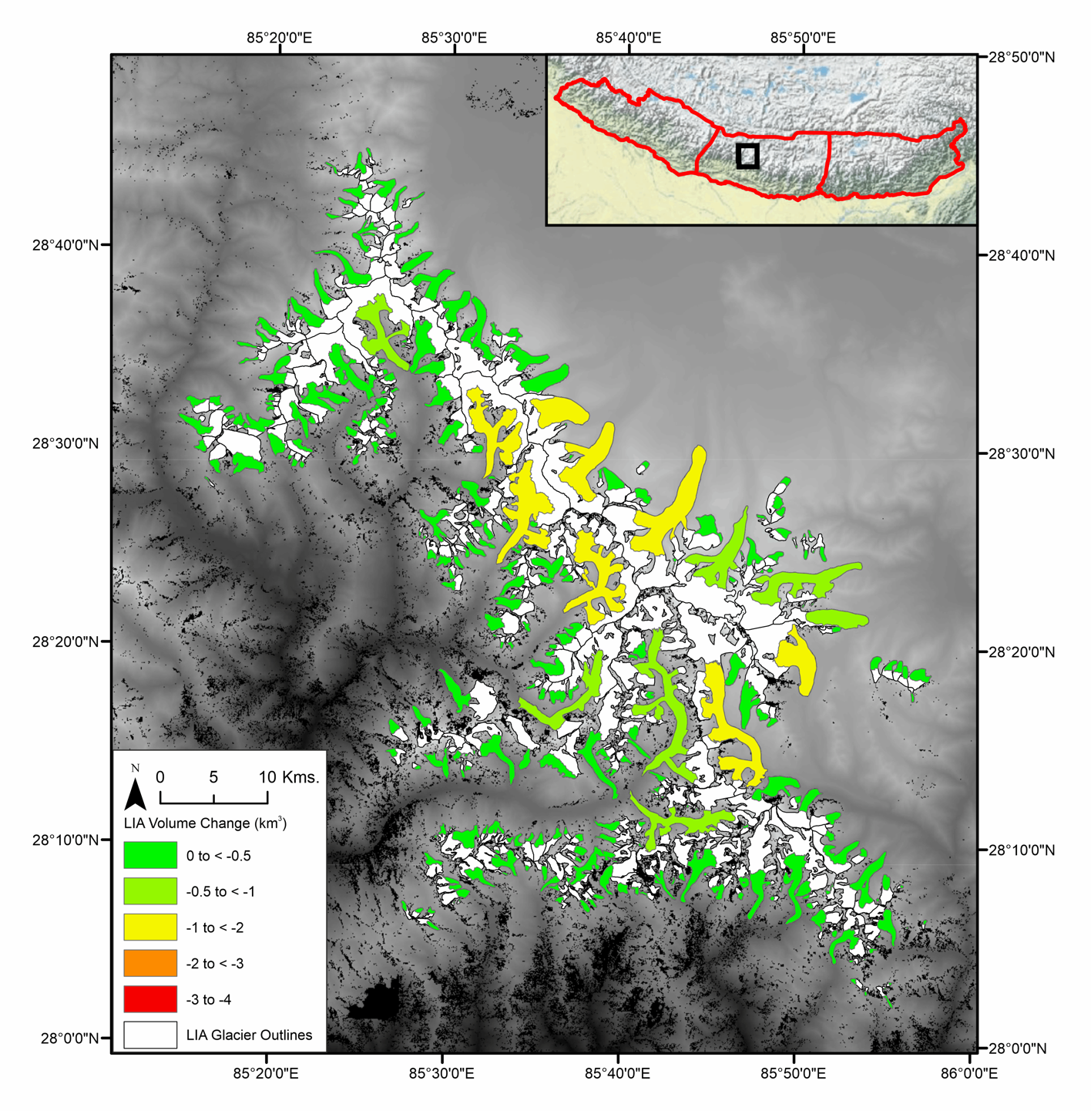
Figure 12: An example of the volume change in the Langtang region in the eastern Nepal region
  - Topographic Influences
    - Glacier Characteristics
Using descriptive statistics (Figure 13) an understanding of the topographic characteristics of the glaciers can be gained. Many glaciers are < 1.0 km² (48%) and the glacier with the largest area being the Gangotri Glacier in West Nepal region at 217 km². Small glaciers occupied higher minimum elevations with a mean of ~5058 m.a.s.l. while larger glaciers occupied lower minimum elevations with a mean of ~4535 m.a.s.l. while the average minimum elevation was 4918 m.a.s.l.. Glacier aspect was measured according to the eight cardinal directions. Most glaciers are orientated north (22%), while the least are oriented south (7.11%). Calculation of the compactness ratio yielded values between 0.09 and 0.96, with the average being 0.62. 53% of glaciers had no glacial debris-cover while 47% had a percentage of glacial debris-cover that was over 50 cm in thickness, at least as indicated using Kraaijenbrink et al. (2017) debris-cover raster.
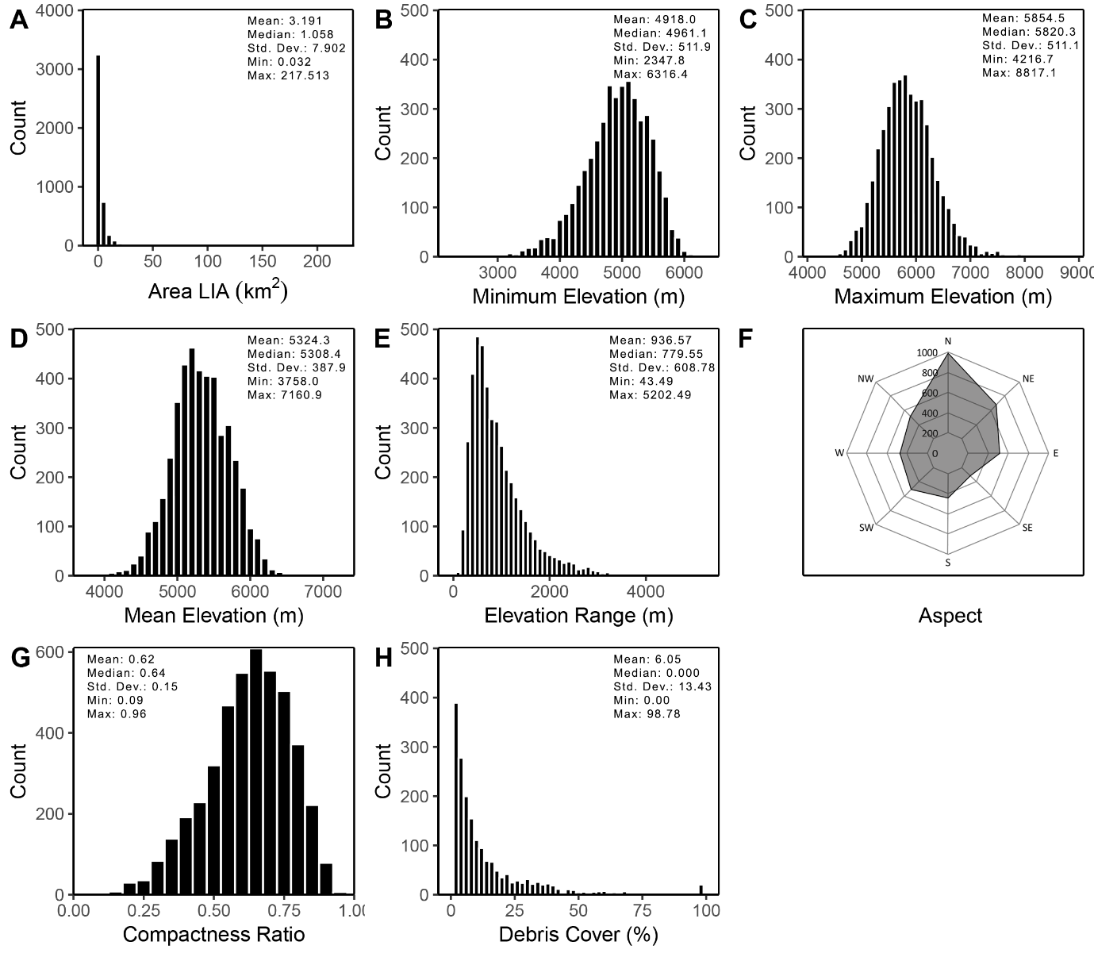
Figure 13: Frequency distributions of the selected topographical variables (n = 4403); A) area, B) minimum elevation, C) maximum elevation, D) mean elevation, E) elevation range, F) aspect, G) compactness ratio and H) debris cover percentage
    - Topographic Effects on Volume Change
Individual linear regressions to test the relationships between measured volume changes and potentially controlling environmental factors are shown in Figure 14. Using absolute volume change, it is shown that glacier area during the LIA (Figure 15 a) is highly correlated with the amount of absolute volume change, with an R² of 0.87. When using average elevation change, it is shown that most variables are weakly correlated or have no significant correlation, with only two topographic variables showing relatively strong relationships. The strongest relationship was seen with area during the LIA (Figure 14 b) with an R² of 0.36. Maximum elevation (Figure 14 e) and elevation range (Figure 14 f) had weaker relationships with average elevation change, with an R² of 0.16 and 0.19 respectively. Compactness index (Figure 14 g) and debris-cover percentage (Figure 14 h) had very weak relationships, with R² of 0.05 and 0.03 respectively. Lastly, mean elevation (Figure 14 c) minimum elevation (Figure 14 d) and the cosine of aspect (Figure 14 i) had no relationship with relative glacier area change with R² < 0.01. Area during the LIA, mean elevation, maximum elevation, elevation range and debris-cover all exhibited positive correlations. Minimum elevation and compactness index showed negative correlations. The cosine of aspect and north or south had no correlation.
According to the Pearson product-moment correlation (Table 7) and the preliminary multivariate linear regression (Table 8) only 6 out of the 9 chosen topographic factors were statistically significant and not auto-correlated with another variable. These were taken forward for inclusion in the multivariate linear regression analysis. The 3 removed variables from the analysis were; mean elevation, and north or south of the Himalaya range, debris-cover. The equation of the final multivariate linear regression is shown in Equation 6:
(6) | $$∆Z=-6.053-0.4910A_{LIA}+1.807 Z_{min}-0.966 Z_{max}+0.3770 Z_{r}+0.03182 As+0.9120 C$$
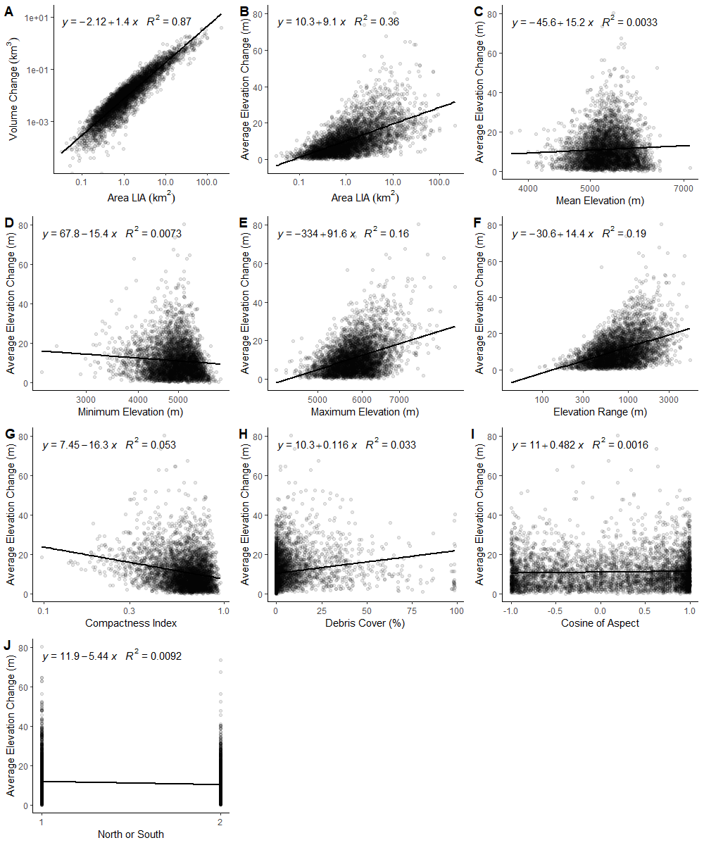
where $∆Z$ is the log-10 value of average elevation change (m), $A_{LIA}$ is the log-10 value of area during the LIA, $Z_{min}$ is the log-10 value of the minimum elevation, $Z_{max}$ is the log-10 value of maximum elevation, $Z_{r}$ is the log-10 value of the elevation range, $As$ is the cosine of the aspect, and $C$ is the log-10 value of compactness ratio of the glacier. The R² of this multivariate linear regression was 0.42 (p = 0.000). Table 9 shows a stepwise of the multivariate linear regression with $A_{LIA}$ and $C$ being the two most influential variables.

Figure 14: Scatter plots of individual linear regression for each glacier (n = 4403) with, A) area LIA vs absolute volume change, and then average glacier surface elevation change vs B) area LIA, C) mean elevation, D) minimum elevation, E) maximum elevation, F) elevation range, G) compactness index, H) debris cover percentage and I) aspect

Debris Cover |  |  |  |  |  |  |  |  | 1.000
Compactness |  |  |  |  |  |  |  | 1.000 | -0.323
Aspect |  |  |  |  |  |  | 1.000 | 0.074 | -0.023
Zrange |  |  |  |  |  | 1.000 | -0.103 | -0.636 | 0.319
Zmean |  |  |  |  | 1.000 | -0.116 | 0.036 | 0.024 | -0.165
Zmax |  |  |  | 1.000 | 0.723 | 0.524 | -0.024 | -0.429 | 0.11
Zmin |  |  | 1.000 | .287 | .810 | -0.57 | 0.102 | -0.367 | -0.268
Volume Change |  | 1.000 | -.100 | .352 | .038 | .438 | .059 | -.239 | .177
Area LIA | 1.000 | .592 | -.363 | .513 | .002 | .756 | -.029 | -.680 | .365
Variables | Area LIA | Volume Change | Zmin | Zmax | Zmean | Zrange | Aspect | Compactness | Debris Cover
Table 7: Pearson product-moment correlation coefficients of topographical variables. Bold numbers show significance (p-value) at < 0.05
 | 1st Run |  | 2nd Run |  | 3rd Run
Variables | VIF | Significance (p-value) | VIF | Significance (p-value) | VIF | Significance (p-value)
Area LIA | 2.98 | 0.000 | 2.94 | 0.000 | 2.86 | 0.000
Zmin | 9.32 | 0.000 | 5.27 | 0.000 | 5.25 | 0.000
Zmax | 10.81 | 0.000 | 5.03 | 0.000 | 5.03 | 0.000
Zmean | 13.35 | 0.000
Zrange | 7.13 | 0.000 | 6.99 | 0.000 | 6.99 | 0.000
Cosine Aspect | 1.08 | 0.003 | 1.02 | 0.000 | 1.02 | 0.000
Compactness | 2.14 | 0.000 | 2.12 | 0.000 | 2.10 | 0.000
Debris Cover | 1.22 | 0.004 | 1.17 | 0.706
Table 8: VIF test for multicollinearity between the variables and significance of the correlation both in the preliminary multivariate linear regression. Bold numbers in VIF column show the variables with a VIF > 10. Bold numbers in significance column show statistically insignificant variables (p-value > 0.05)
Table 9: Multivariate linear regression between the average glacier surface elevation change and the 6 significant topographical factors with their R² after each step of a stepwise regression
 | Stepwise R² values
Topographical variable | 1st Step | 2nd Step | 3rd Step | 4th Step | 5th Step | 6th Step
Area LIA ($A_{LIA}$) | 0.35
Compactness ($C$) |  | 0.40
Minimum Elevation ($Z_{min}$) |  |  | 0.41
Elevation Range ($Z_{r}$) |  |  |  | 0.41
Cosine of Aspect ($As$) |  |  |  |  | 0.42
Maximum Elevation ($Z_{max}$) |  |  |  |  |  | 0.42

    - Glacier Terminus Conditions
For analysis of the impact of glacier terminus conditions, they were separated into different glacier types; clean-ice, debris-covered and lake-terminating. Across both west Nepal and east Nepal debris-covered glaciers accounted for the most absolute volume loss seen, with -35.4 ± 7.3 km³ and -65.1 ± 13.3 km³ respectively. In Bhutan lake-terminating glaciers accounted for the most absolute volume lost (-21.4 ± 4.4 km³; visualized in Figure 15 a). Clean-ice glaciers saw the least amount of elevation change in all regions with an average elevation change of < -10 m with little difference between clean-ice glaciers north and south of the Himalayan ridge in all regions. Lake-terminating glaciers in all regions saw the most average elevation change, with glaciers on the north of the Himalaya experiencing more elevation change than the south in west Nepal (17.9 ± 3.8 m vs -13.8 ± 8.3 m) and Bhutan (-21.8 ± 4.3 m vs -16.6 ± 4.1 m) (Figure 15 b). East Nepal experienced the most elevation change, showing similar results both north and south of the divide (-24.0 ± 5.3 m vs -24 ± 4.9 m). Only in east Nepal was there a clear difference between debris-covered glaciers on either side of the divide, with average lowering of -19.8 ± 5.4 m (north) and -14.8 ± 3.4 m (south) respectively. Using an ANOVA it was shown then when compared to clean-ice, lake-terminating and debris-covered all showed a statistically significant difference with a p-value < 0.001 (represented by *** in Figure 15 b).
The majority of lake-terminating glaciers were observed north of the Himalayan ridge with 252 out of 400 (63%) located there, and 199 (49%) were located in east Nepal. The majority of debris-covered glaciers were observed south of the Himalayan ridge with 372 out of 571 (65%), while 285 (49%) were located in east Nepal.
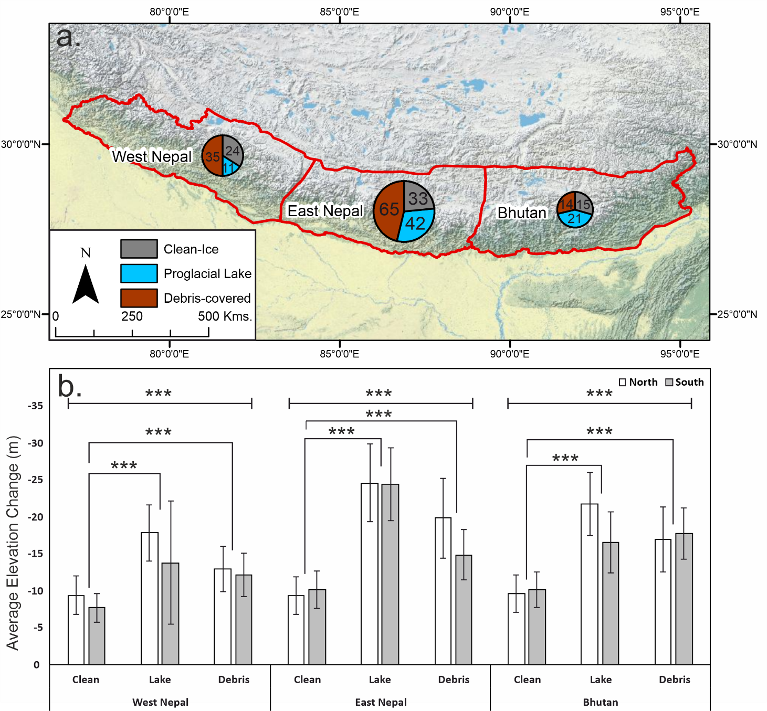
Figure 15: The glacier terminating conditions effects on a) absolute volume loss with proportional sized pie charts with their absolute contribution broken down, and the regions overall volume change in the legend box and b) average elevation change with the results of the ANOVA on how statistically significant the difference is within each region (top line) and between clean-ice and the other two terminating conditions (connecting lines) *** = p-value < 0.001; also compared with if glaciers are either north or south of the Himalayan ridge. In Appendix L are boxplots to visualise the differences off the means
- DISCUSSION
  - Comparison of Mapped Glacial LIA Extents
The moraines produced during the LIA across the central and western Himalaya are well preserved with clear distinct crests. In the absence of moraines, erosional trimlines in most regions were well defined and easily identified. These geomorphological features could be identified by the use of a hillshade 8m HMA DEM, Sentinel-2B remotely sensed imagery and high-resolution images from Bing maps and Google Earth.
The general approach for reconstructing minimum LIA glacial extents and subsequent volume change estimates was first put forward by Glasser et al. (2011) and subsequently adapted by Carrivick et al. (2019). Both studies use fine resolution DEMs or Landsat images to identify and delineate LIA terminal moraines and erosional trimline features. This method of using remotely sensed images has further been found to be effective in identifying LIA moraines and trimlines as seen in Qiao and Yi (2017). Their study used high resolution Google Earth imagery to delineate glacial moraines across the central and western Himalaya digitising the most dominant moraine crest. Where multiple moraines were present, they delineated the closest moraine to the glacier front to provide a conservative estimate of area during the LIA, while this study took the most prominent innermost lateral moraine which visually led onto the terminal moraine closest to the glacier.
Comparing the delineation of LIA moraines between this study and that of Qiao and Yi (2017) (shown in Figure 16), small differences can be identified between the interpretation of different operators. The clearest differences can be observed in the higher reaches of the digitised outlines; generally speaking the current study interprets outlines that extend the accumulation zones further up valley. Other disparities can be identified in locations where glaciers coalesced and have been merged by this study but considered as independent entities by Qiao and Yi (2017). Overall, however, the similarity between the interpretations of each study, derived completely independently from one another, lends confidence that the LIA limit is indeed being correctly delineated in both cases.

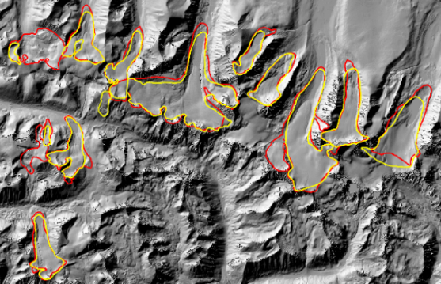
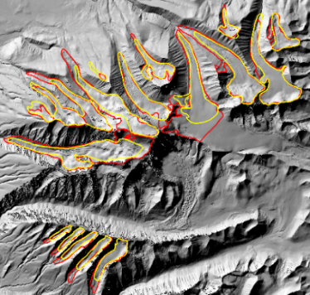
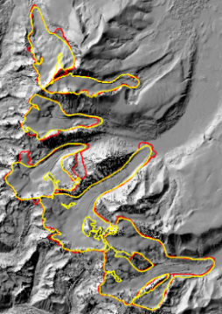
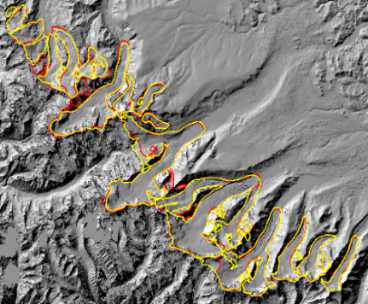
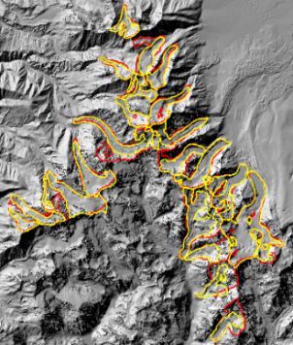
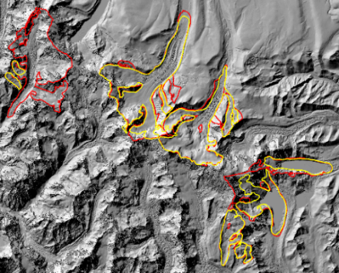
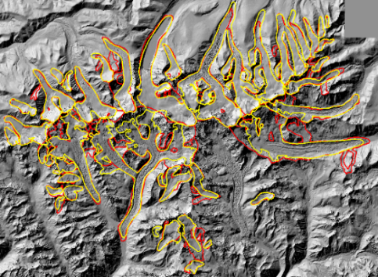
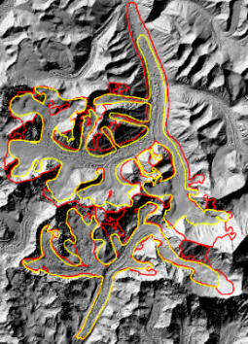
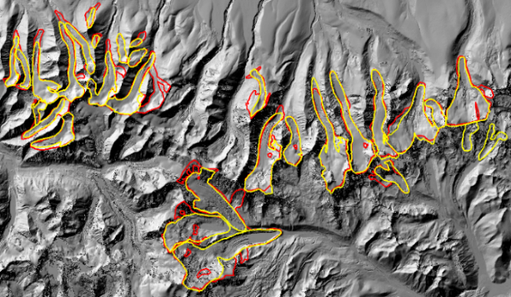
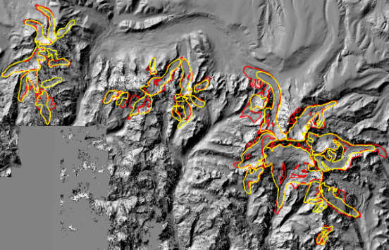
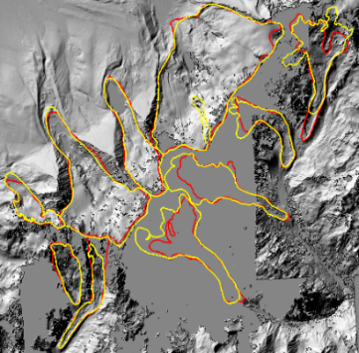
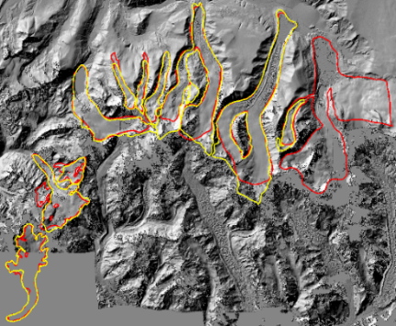
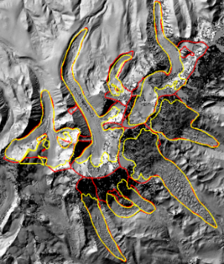
Figure 16: Comparison of this studies LIA glacier margins (red) and Qiao and Yi (2017) (yellow) on the 8m HMA DEM hillshade. This shows locations of agreement and differences in mapping between the studies. Supplementary map in Appendix M shows the locations of the areas shown in this figure a) Naimona'nyi; b) Ganglung Gangri; c) Rachama; d) Kubi Gangri; e) Peiku Gangri; f) Shishapangma; g) Lapche Kang; h) Qomolangma; i) Chorten Nyima Ri; j) Chomo Yummo; k) Kangcheda; l) Kangkar Pünzum; m) Kula Gangri.
a
b
c
d
e
f
g
h

i

j
v
k
v
l
v
m
v
  - Area Change
Glacier area in the central and eastern Himalaya has seen a dramatic reduction since the LIA, with the final area result of 16,166.1 ± 386.4 km² during the LIA shrinking to 11,208.2 km² in 2013, a change of -4,957.9 ± 118.5 km², and in percentage terms, a change of -30.7 ± 0.7% (-0.05 ± 0.001% yr⁻¹). This is one of the first studies to incorporate all glaciers (which are mapped within the RGIv6) within the central and eastern Himalayan regions, giving the widest analysis of glacial mass change to date, compared to many previous studies that have limited their assessments to particular regions (Bolch et al., 2008; Bhambri et al., 2011; Loibl et al., 2014; Chand et al., 2017).
Relative area change did not appear to vary spatially across the separate regions, ranging between 30% and 31%. These results however, do not take into account the exact date when these glaciers began retreating, and assume all glacial retreat was seen after 1450 AD and was continuous. It would be prudent to acknowledge that there would be a heterogeneous response of glaciers due to climate change (Kääb et al., 2012; Gardelle et al., 2013), which is not picked up in this study. Rowan (2017) shows ~1300–1600 AD as being the period of most glacial growth seen via dated moraine samples. The spatial extent of these dated moraines are clustered around individual regions (as shown in Figure 2) and cannot necessarily be taken as being indicative of the entire central and eastern Himalaya. This shows a need for more field sampling across the Himalayan regions to confirm their last period of general advance and to enable the extraction of interregional variations of glacial growth and retreat.
Qiao and Yi (2017) is one of the only studies to have looked at regions across the Himalaya and one of the few to look at area changes since the LIA. When comparing LIA and modern day area estimates (shown in Table 10), their estimates see a marked difference between this study’s respective estimates. This can largely be attributed to differences in the delineated LIA extents, which has been discussed within section 6.1. Differences in modern day estimates are largely a consequence of this study using RGI v6 outlines which are unchanged, while Qiao and Yi (2017) manually delineated their modern day glacier extents. The current study also included glaciers that had detached from their parent glaciers, which were not included in the Qiao and Yi (2017) mapping.
In the absence of other long-term assessments of mass loss, shorter-term studies can provide an interesting perspective on the rates of change in more recent decades. Salerno et al. (2008) working in the Sagarmatha National Park, Ojha et al. (2016) considering all of Nepal, Kulkarni et al. (2011) encompassing the Indian Himalaya and Bajacharya et al. (2014) focussing in Bhutan, all indicate that there has been little change between 1450 AD until the mid-20th century, with their initial area calculations (all around 1960-1980) falling close to or within this study’s LIA area and uncertainty estimates. This indicates a couple of possibilities, i) that much of the glacial ice loss seen, at least within these studied locations, has primarily occurred within the 21st century, or ii) that there are large areas of discrepancy in area estimates which could be a factor of different methods and data sources used. While there are undoubtedly uncertainties in both these previous works and the current study, the similarities between their mid-20th century values and the current study’s LIA assessment lends support to the idea that most glacier recession and/or thinning has occurred over the last 50 years or so.
Table 10: Comparison of this study’s area estimations, and those seen within other studies within similar study areas
Study Area | Author(s) | Their Study (initial) | This Study (1450) | Their Study (ending) | This Study (2013)
Central and Eastern Himalaya | Qiao and Yi (2017) | 1,438.8 km²  (LIA) | 1,736.5 ± 41.5 km² | 989.9 km²  (~2011) | 1233.9 km²
Sagarmatha National Park | Salerno et al. (2008) | 403.9 km²  (1950s) | 341.1 ± 8.2 km² | 384.6 km²  (1990s) | 244.6 km²
Nepal | Ojha et al. (2016) | 1616.7 ± 247.7 km² (1992) | 1821.8 ± 43.5 km² | 1477.8 ± 232.5 km² (2006/10) | 1242.5 km²
Indian Himalaya | Kulkarni et al. (2011) | 2103 km²  (1962) | 2053.7 ± 49.1 km² | 1839 km²  (2001/04) | 1469.1 km²
Bhutan | Bajracharya et al. (2014) | 837.6 ± 28.81 km² (1980) | 903.1 ± 21.6 km² | 642 ± 16.1 km² (2010) | - km²

  - Volume Change and Sea Level Contribution
Volume change estimates and contribution to sea-level rise from the central and eastern Himalaya since the LIA are the first of their kind in the literature. Comparisons of volume change since the LIA are therefore impossible, since no other studies exist. Thus, comparisons are restricted to estimates of volume change and sea-level contribution derived over recent decades, to provide an understanding of the changing rate of loss between the LIA and present day. This study found a region-wide mass loss rate of 0.43 ± 0.12 Gt yr⁻¹ (0.0012 ± 0.0003 mm SLE yr⁻¹) between 1450 AD and 2013. This compared to more contemporary figures of 7.1 ± 2.6 Gt yr⁻¹ (0.02 ± 0.007 mm SLE yr⁻¹) between 2000 and 2016 (Brun et al., 2017), 11.24 ± 0.79 Gt yr⁻¹ (0.03 ± 0.002 mm SLE yr⁻¹) between 2000 and 2016 (Bandyopadhyay et al., 2019), and 5.2 ± 2.2 Gt yr⁻¹ (0.01 ± 0.006 mm SLE yr⁻¹) between 1975 and 2016 (Maurer et al., 2019). From this, it can be inferred that the rate of sea-level contribution in recent decades has increased by ~17 times when compared to this study’s linear rate since the LIA. Maurer et al. (2019) further adds that early 21st century (2000 to 2016) mass loss doubled compared to the late 20th century (1975 to 2000). This doubling has been attributed to recent climatic warming and is an indicator of the future dynamics of Himalayan glaciers.
There are a limited number of studies outside of the Himalaya that have considered LIA mass change of glaciers and their contribution to sea-level rise. Such locations that have been studied are the Patagonian Icefield (PI) (Glasser et al., 2011), northeast Greenland (Carrivick et al. 2019), and Iceland (Fish, 2016). Glasser et al. (2011) found the PI had differing contributions between the North and South PI. The North PI contributed 0.0018 ± 0.0004mm yr⁻¹ since 1870, while the South PI contributed 0.0034 ± 0.0007 mm yr⁻¹ since 1650. Combined, they have contributed ~1.48 ± 0.30 mm SLE since 1650. Although the PI covers ~14,000 km², considerably less than that in the Himalaya, this region has contributed more to sea-level rise. This may be explained by a large proportion of lake and tidewater terminating glaciers in the PI (Willis et al., 2012), while the western side has particularly low elevation glacier termini and rapid turnover rates making it sensitive to air temperature changes (Koppes et al., 2011). The Himalaya on the other hand has a number of glaciers that are debris-covered and land-terminating, with some lake-terminating glaciers, indicating that they have a lower mass turnover rate than that seen in Patagonia, while many are at higher elevations than those seen in the PI. Carrivick et al. (2019) found that the northeast Greenland had contributed 0.006 ± 0.001 mm yr⁻¹ or 0.66 ± 0.13 mm SLE since its LIA maximum (1910). Both Carrivick et al. (2019) and Glasser et al. (2011) found an increase in sea-level rise contribution when comparing LIA rates to more recent late 20th and early 21st century rates in their respective geographical locations.
Fish (2016) used a volume-area scaling method (Bahr et al., 1997) to derive volume loss and sea-level contribution of Icelandic glaciers. Their study found a contribution of 0.02 mm yr⁻¹ (2.67 mm SLE) since Iceland’s LIA maximum in 1890 AD to 2015. This contribution was derived from an area change of 1,398 km², which when scaled to volume showed a loss of 974.26 ± 89.07 km³, with a yearly loss of 7.79 ± 0.71 km³ yr⁻¹. The results of the current study found an area loss of 4,957.9 ± 118.5 km², losing 287.59 ± 58.9 km³ through using geodetic estimates, and yielding empirical measurements similar to both Glasser et al. (2011) and Carrivick et al. (2019). This disparity from Fish (2016) (i.e. finding a smaller area loss but a volume loss from Iceland that is ~3 times that of this study in the Himalaya), could well be due to the known inaccuracies of the volume-area scaling method. Ricera et al. (2015) supports this suggestion, finding that comparing volume-area scaling with different parameters to in-field ice thicknesses, showed an overestimation in glacier volume by 3–4 times real world results. From this, the volume and SLE contribution estimates from Fish (2016) may be considered an overestimation and, because of methodological differences, not directly comparable with this study.

  - Himalaya Climate Trends
This trend of increased rate of glacial mass loss within the mid-20th century is a symptom of climatic warming in the region. It has been shown by a number of studies that climate change in the Himalaya is the primary contributor to glacier mass change both since the LIA and increasingly in recent decades (Prasad et al., 2009; Shrestha and Aryal, 2011; Shrestha et al., 2012; Hoy et al., 2016; Maurer et al., 2019). Prasad et al. (2009) showed warming of 1.5°C in the Himalaya between 1979 and 2008. A similar warming was shown by Shrestha et al. (2012) between 1982 and 2006, with an increase of 1.5°C, 0.06°C yr⁻¹ within the Himalayan region. Hoy et al. (2016) showed a 0.008°C yr⁻¹ temperature change in Bhutan between 1901 to 2010, while Shrestha and Aryal (2011) showed a 0.016°C yr⁻¹ increase in Nepal between 1977 and 1994. These temperature increases appear to have occurred primarily after the mid-20th century, indicating a greater ability for the climate to cause increased glacial melt then that seen prior to the mid-20th century. This would support the comparisons seen in area loss between other studies and this study (Table 10); that most area loss has been seen after the mid-20th century. With increasing climatic warming, glaciers insulated by debris-cover, while still incurring surface elevation lowering, will begin to thin and retreat at an increased rate. Further, Roxy et al. (2015) has shown that due to recent climate change the ISM is weakening, bringing less precipitation and thus less accumulation for glaciers in the central and eastern Himalaya. In the future, if this trend continues, it would be reasonably expected that with the combination of increased average temperatures and decreased precipitation during the accumulation season, there would be a further drastic loss of glacial ice.

  - Topographic Influences on Glacier Mass Change
    - Individual Topographic Variables
Although climate, and thus the monsoons, may be primarily responsible for the general variability of glacier mass change between the central and eastern Himalaya, topographic factors are also likely to play a role in determining intra-regional variability (Li and Li 2014; Garg et al., 2017; Brun et al., 2019). From the individual and multivariate linear regressions this study shows that topographical variables have some control over the volume change seen within the Himalaya.
From the individual linear regressions area during the LIA (Figure 14 a) had a very strong positive correlation with absolute volume change (R² = 0.87). This suggests that the glaciers which have incurred the most volume change were generally the larger glaciers during the LIA. A number of other studies have shown that glacier area has a strong relationship with changes in glacier mass (Allen, 1998; Bhambri et al., 2011; Li and Li, 2014; Garg et al., 2017). However, when correlated with relative area loss, Garg et al. (2017) and Li and Li (2014) saw a strong negative correlation (R² = 0.4 and 0.7 respectively) showing smaller glaciers losing the most relative area. This is of course to be expected given that for the same absolute areal loss smaller glaciers will incur a higher relative loss than a larger counterpart.
The glacier compactness ratio (Figure 14 g), which is derived from the LIA outlines, produced a very weak negative relationship (R² = 0.05) with average elevation change. Other studies such as Garg et al. (2017) found that area changes correlated with compactness ratio produced a strong positive correlation. This disparity may be due to the compactness ratio characterising the morphology of a glacier as well as taking into account its potential mass input from the surrounding environment (Allen, 1998). The current study may not have found a strong relationship between glacier compactness and average elevation change as a consequence of using a three-dimensional metric and not a two-dimensional metric (area) as the dependant variable. The compactness value takes into account the shape of a glacier, and there is an element of autocorrelation between area and shape, while the relationship between compactness and elevation of a glacier is not so direct.
Mean and minimum glacier elevation (Figure 14 c & d) both had the lowest relationship recorded with average elevation change for altitudinal variables (R² = 0.00), showing that they have no obvious relationship with average elevation change of a glacier. It has been noted within other studies that mean elevation is a primary contributing factor for area loss, and that glaciers at higher mean elevations lose less ice due to increased precipitation in the accumulation zone (DeBeer and Sharp, 2009; Li and Li, 2014). Brun et al. (2019) did find a relationship with mean elevation, finding a generally positive correlation (R² = 0.13 to 0.53) depending on the region. For minimum elevation, studies have noted that a glacier which occupies a higher minimum elevation recedes at a slower rate due to suppressed air temperatures (Li et al., 2011: Li and Li, 2014). However, Bhambri et al. (2011) found that small glaciers at higher minimum elevations are receding the fastest as they become increasingly exposed to changes in climate. Lovell et al. (2019), working in the Annapurna region in Nepal, supports the findings of this study, also finding there to be no significant relationship of minimum elevation with mass balance and elevation change.
Maximum elevation and elevation range (Figure 14 e & f) both had positive relationships (R² = 0.16 and 0.19). In contrast, Garg et al. (2017) and Bhambri et al. (2011) found elevation range to have a weak and negative relationship with relative glacier area loss. Lovell et al. (2019) found that within the Annapurna region, maximum elevation saw varying degrees of relationship strength when compared with mass balance and elevation change with an R² between 0.11 and 0.34. However, it should be noted that insufficient data were available to determine a robust relationship in the region.
Debris-cover (Figure 14 h) showed a very weak positive relationship with volume change per area unit (R² = 0.03); a similar relationship was found by Brun et al. (2019) with increased debris-cover showing a slight increase in mass loss. This relationship is perhaps counter intuitive, since glaciers with sufficiently thick debris can insulate the glacier ablation zone, reducing ice ablation (Östrem, 1959). However, glaciers that are debris-covered show little retreat and thus area change, but still exhibit surface lowering (Rowan, 2017; King et al., 2018). This lowering can be amplified by the presence of supraglacial lakes, many of which have been noted on debris-covered glaciers within the Himalaya (Quincey et al., 2007; King et al., 2018). A more in-depth analysis of debris-covered glaciers and their influence on volume change can be seen in section 6.5.3.
Lastly, aspect (Figure 14 i), had no relationship with average elevation change (R² = 0.002). Brun et al. (2019) also found that aspect was not a significant contributor to mass loss in almost all regions of the Himalayas. Further investigation shows that for all aspects, similar magnitudes of average elevation change occurred (~-11m) concurring with these previous findings.

    - Combined Topographic Variables
Tables 7 and 8 showed the multicollinearity of topographic variables for individual glaciers. Pearson’s product moment correlation and VIF indices were used to quantify and identify this multicollinearity. A number of variables have a statistically significant correlation with one another. Most of these are intrinsically linked together (i.e. elevation variables) or are derived from one other (i.e. compactness from area during the LIA). However, some significant correlations are less expected and may yield an interesting insight into glacier mass change variability. For example, glaciers with larger areas during the LIA tend exhibit the highest debris-cover percentage. It is known that many large glaciers in the Himalaya still occupy their LIA positions due to the presence of debris-cover, as this debris-cover limits area changes (Rowan, 2017).
The topographic variables of 4,403 glaciers used within the multivariate analysis explain 42% of the volume change measured in this study. The most significant controlling factors were found to be area during the LIA, maximum elevation, minimum elevation, elevation range, aspect and compactness.
Multiple previous studies have focused on HMA glaciers and the topographic influences on glacier mass loss, mainly focusing on area change (Li and Li, 2014; Garg et al., 2017) while Brun et al. (2019) is one of the only studies to take into account the entire HMA. Within the Indian central Himalaya, Garg et al. (2017) used a sample size of 18 glaciers between 1994 and 2015 and found that the compactness ratio, glacier size, altitude range and mean slope had a cumulative correlation of R² = 0.94 with area change. A sample size of 18 glaciers is clearly not representative of region wide topographic influences, but may serve as a general indication. Li and Li (2014) studied 487 glaciers within the central Tien Shan, since the LIA, and found that two variables (glacier area and mean elevation) could explain 64% of the measured change. Brun et al. (2019) is one of the first studies to take into account topographic and morphological metrics and assess their relationship with glacier mass balance variance seen across HMA, although only using glaciers with an area > 2 km² (54% of glacierized area of the HMA). It was found that slope, mean elevation, debris-cover and avalanche contribution area could explain between 8% and 48% of mass change variance seen within the HMA regions. Brun et al. (2019) showed that the impact of topographic variables is not constant between regions. The findings of this study suggest that they are not even constant within climatologically homogeneous regions.
    - Influence of Glacier Terminus Conditions
Basic data analysis of glacier terminus conditions indicates that debris-covered glaciers have contributed the most to glacier volume loss in west and east Nepal, a trend that is also evident in several recent contemporary studies (e.g. Brun et al., 2019; Maurer et al., 2019). They tend to be the largest glaciers (Figure 15 a) and show greater elevation changes than clean-ice glaciers, although less than lake-terminating glaciers (Figure 15 b). Similar results were reported by Maurer et al. (2019), with debris-covered glaciers exhibiting similar rates of loss to clean-ice glaciers. This is perhaps counter-intuitive, with debris-covered glaciers losing close to or slightly more average elevation than clean ice, but a similar observation to previous studies (Kääb et al., 2012; Gardelle et al., 2013; Brun et al., 2019; Lovell et al., 2019). Lovell et al. (2019) attributed this increase in elevation loss due to enhanced surfacing lowering occurring further up the terminus, near the transitional zone of debris-covered and debris-free ice. Rowan et al. (2015) observed that glaciers with supraglacial lakes and ponds incurred more average elevation change than those without, similar to the observations of Basnet et al. (2013).
This study also found that increased average elevation losses of debris-covered glaciers in comparison to clean-ice glaciers (p-value = < 0.001) could be a consequence of these glaciers persisting at lower elevations than they would without a debris mantle (Figure 17). Due to the insulating effect of debris-cover preventing or slowing glacial retreat, they have been out of equilibrium with their surrounding climate (Anderson and Anderson, 2016) for a long time, but may now have reached a tipping point.
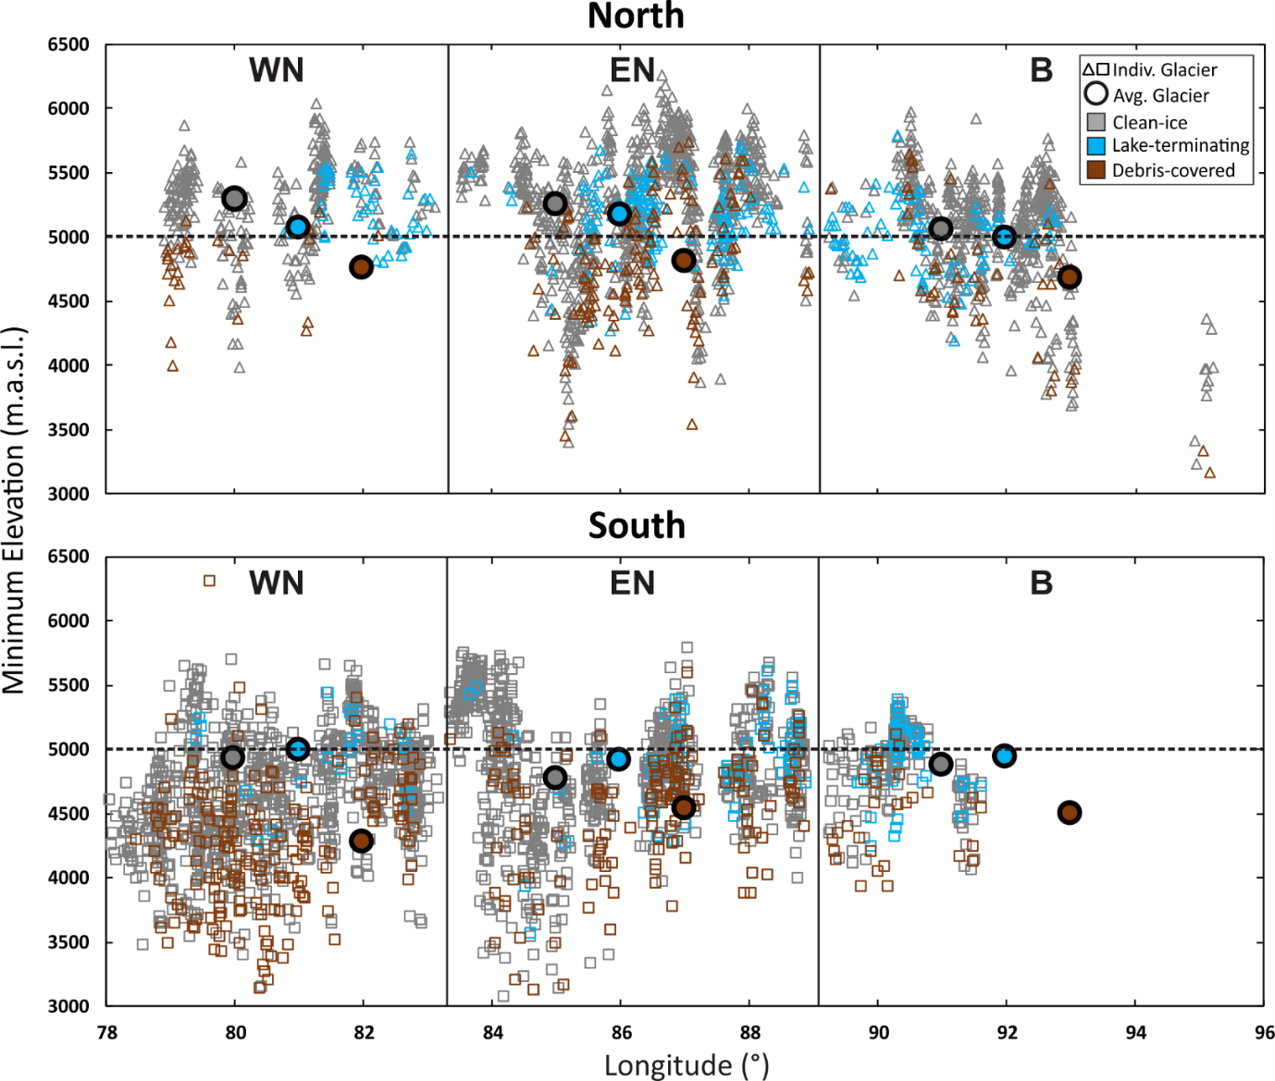
Figure 17: Scatter plot of glaciers with their minimum elevation against their longitudinal positions. Glaciers split between being north or south of the Himalayan ridge and their glacier terminus conditions. The average of each terminating conditions shown in large coloured dot for each studied region. The dashed line corresponds to 5000 m to enable comparison between regions.
In this study lake-terminating glaciers exhibited a statistically signficiant (p-value = < 0.001) increase in their average elevation change when compared to clean-ice glaciers in all regions. When looking at absolute volume change, lake-terminating glaciers exhibited increase volume loss in the East Nepal and Bhutan region when when compared to clean-ice glaciers. The presence of a proglacial lake has been linked to increased mass loss within the Himalaya by a number of previous studies (King et al., 2018; Tsutaki et al., in review, 2018; Brun et al., 2019). The presence of higher mass loss of lake-terminating glaciers in east Nepal was also observed by Maurer et al. (2019; noted as eastern Himalaya in their study). This increased mass loss is linked primarily to thermal undercutting and calving processes (Sakai et al., 2009). These proglacial lakes may also be linked to an increase in velocity of the glacier ablation zone; a ‘drawdown effect’. King et al. (2018) found that proglacial lakes in the Everest region are linked to faster terminus flow velocities in some areas and slower velocities in others. It was noted in this study that most glaciers with very high rates of mass loss were > 2 km² in area and generally supported large, well-developed lakes. This supports the findings of Brun et al. (2019), who stated that the influence of the proglacial lake depends on glacier size and the stage of lake development. Further, most lake-terminating glaciers in the central and eastern Himalaya were located in the central Himalaya, north of the Himalayan ridge. The reason why they appear to be more concentrated in the north is as yet unknown, but could be linked to the difference in slope profile as shown by Kääb (2005) – a shallower and gentler profile in the north promoting water storage, and a steeper slope prevailing in the south more conducive to runoff. To understand the spatial distribution of these lakes, further investigation will need to be undertaken in relation to any topographical or even geological controls which determine the location and formation of these lakes.

  - Limitations of this Study
The RGI is a valuable database that has complied glacier outlines globally in one central system, but it is still not complete with a number of glaciers seen throughout the Himalayan still left unmapped. This study has tried to ensure unmapped glaciers were included by mapping both their contemporary and LIA extents when omitted glaciers were recognised. Although this has been done, a number of glaciers not seen may still be left unmapped. Further, the last update of these glacial outlines was in 2013 and from visual comparison between the outlines and more recent remotely sensed data (DEM, Sentinel-2B and Bing Maps) there has been a considerable amount of change for a number of glaciers. An update to the RGI outlines is needed, with the outlines of this study to include missing glaciers, along with a revaluation of the Himalayan region to ensure a complete and up-to-date database for the wider academic community to use.
The delineation of LIA extents cannot be robustly validated owing to the very limited availability of dated moraines. Those which have been dated are in clustered regions throughout the Himalaya. By adopting a conservative approach, and assuming the most inner moraine crest was created during the LIA, this study has attempted to limit any overestimations. In addition, the general paucity of robust LIA dating makes the date adopted here (1450 AD) open to scrutiny, and perhaps not reflective of the broader range, particularly for those areas which are affected by different climates and circulatory systems.
The omission of glaciers that had entirely disappeared, due to their moraines being overwritten by mass movements or hydrological activites may also lead to an underestimation of glacier area and/or volume. Dating of these moraines in relic glacier cirques are needed to determine if they are LIA or neoglacial in origin.
Given that no elevation data of glaciers within the Himalaya during the LIA are available it is impossible to validate the interpolation approaches used for surface reconstruction. A natural neighbour interpolation technique was determined to be the best method by a k-fold cross validation but other techniques not tested in this study may yield better estimates (e.g. Trend, Spline with Barriers, etc.). Also, this study reconstructed a flat surface which is clearly not realistic, with the ablation zones of glaciers in balance normally exhibiting a convex transverse profile. It could be that reconstructing a convex profile might reflect and produce values more accurate to those which occurred during the LIA. Carrivick et al. (2019) manually digitised centreline elevations which were above the height of the digitised lateral moraines and found little change in the volume estimate (generally < 5%, but +30% for one glacier).
The statistical analyses undertaken here, and in particular the use of a linear regression model, is sensitive to outliers, biases and any uncertainties which may be present within the data. Brun et al. (2019) used a Monte Carlo simulation, taking into account the uncertainties which are inherent of the data and linear model in their study. They found that the uncertainty can be as high as 10%. This suggests that the results of a linear regression model with the use of real-world data, need to be taken with a degree of caution, particularly where the R² values are low or within the uncertainty bounds. Further, the choice of variables used in the linear regression model is a point of limitation. Many variables which are used are not entirely independent. Elevation range is the difference between the maximum and minimum elevation, while compactness is derived partly from area during the LIA, which were all used within the linear regression. It is possible that alternative models may be better suited such as a hierarchical Bayesian approach performed by Jomelli et al. (2015), or a weighted linear model by Garg et al. (2017), although there may still be a degree of correlation between variables.
Lastly when evaluating the influences of glacier terminating conditions, the categories of debris-covered, lake-terminating and clean-ice are somewhat arbitrary and assigned by visual interpretation, along with the debris-cover raster data from Kraaijenbrink et al. (2017). In reality, these conditions are on a continuum and many glaciers are affected by all three conditions to some degree, being debris-covered to varying degrees, terminating into a proglacial lake of varying sizes with some areas of clean ice. However, Brun et al. (2019) showed that different thresholds used to categorise glaciers into their respective terminating conditions have limited influence on the final results.
- CONCLUSION
This is the first study to derive both area and volumetric change estimates for the glaciers of the central and eastern Himalaya since the LIA (1450 AD to 2013). This study has shown that the total area change since the LIA has been -4,957.9 ± 118.5 km², a change of -30.7 ± 0.7% (-0.05 ± 0.001% yr⁻¹). Using geomorphological mapping and interpolation techniques for reconstructing palaeo-ablation zone elevations, the total amount of volume change has been estimated as being 287.6 ± 58.9 km³, equating to a mass of 244.45 ± 67.17 Gt, accounting for 0.68 ± 0.19 mm SLE. The total mass budget from 1450 AD to 2013 was estimated as 0.43 ± 0.12 Gt yr⁻¹, which equates to 0.0012 ± 0.0003 mm yr⁻¹ from Himalayan glacial melt. This knowledge of mass change since the LIA of the central and eastern Himalaya can act as an important baseline. The linear rates of change produced in this study can aid in putting modern rates of change into a longer-term context, enabling comparisons since the last major period of glacier advance.
Through the use of linear models to assess the controls of topographical factors on glacier mass chance since the LIA it has been found that combined they can explain 42% of the mass change variability seen. The predictors which best described the variability were; initial area (i.e. during the LIA), maximum elevation, minimum elevation, elevation range, compactness and aspect. The best predictor of glacier mass change was area during the LIA. In simple terms, the more area a glacier has, the more mass it has to lose. These topographical factors can only explain a proportion of the variability in mass loss seen, thus requiring further investigation for the linkages between that of climate, topography and mass change. At present, however, this is difficult as modelled climate data are coarse in resolution and unlikely to shed any light on glacier-scale variability.
Linking measured changes in mass to glacier terminus conditions showed that in terms of absolute values, debris-covered glaciers contributed the most. This has been linked to specific characteristics of debris-covered glaciers such as them largely being found at lower minimum elevations than clean-ice glaciers and thus being more susceptible to recent climatic warming. Lake-terminating glaciers have a greater than average loss linked to thermal undercutting and calving processes. The effects of proglacial lakes on glacier mass changes have not been studied widely within the Himalayas, bar a small number of studies which study them in limited regional areas (King et al., 2018) or analyse their effects on a very broad scale (Brun et al., 2019). This highlights the need for their effects to be better quantified in future studies, along with assessments on the presence or absence of GLOF hazards.
The values estimated for the loss of mass from the eastern and central Himalayan regions are the first within the literature since the LIA. These were derived from geomorphological mapping and interpolation techniques with no in-situ validation of the moraine locations. This points to the need for more dating of moraines within the Himalayas to aid in determining the date of formation and enable accurate delineation of their past extents (i.e. the LIA). With this information, both the timing of the LIA advance and the rates of change since that time can be assessed with much greater certainty than is currently possible.

List of References
Ageta, Y. and Higuchi, K. 1984. Estimation of Mass Balance Components of a Summer-Accumulation Type Glacier in the Nepal Himalaya. Geografiska Annaler. Series A, Physical Geography, 66 (3), pp. 249-255
Ali, L., Shukla, A. and Romshoo, S. A. 2017. Assessing linkages between spatial facies changes and dimensional variations of glaciers in the upper Indus Basin, western Himalaya. Geomorphology, 284, pp. 115-129
Allen, T. R. 1998. Topographic context of glaciers and perennial snowfields, Glacier National Park, Montana. Geomorphology, 21, pp. 207-2016
Anderson, L. S. and Anderson, R. S. 2016. Modeling debris-covered glaciers: response to steady debris deposition. The Cryosphere, 10, pp. 1105-1124
Bahr, D. B., Meier, M. F. and Peckham, S. D. 1997. The physical basis of glacier volume-area scaling. Journal of Geophysical Research, 102 (B9), pp. 20,355-20,362
Bajracharya, S. R, Maharjan, S. B., Shrestha, F., Guo, W., Liu, S., Immerzeel, W. and Shrestha, B. 2015. The glaciers of the Hindu Kush Himalaya: current status and observed changes from the 1980s to 2010. International Journal of Water Resources Development, 31 (2), pp. 161-173
Bajracharya, S. R., Maharjah, S. B. and Shrestha, F. 2014. The status and decade change of glaciers in Bhutan from the 1980s to 2010 based on satellite data. Annals of Glaciology, 55 (66), pp. 159-166
Bakke, J. and Nesje, A. 2011. Equilibrium-Line Altitude (ELA). In: Singh, V. P., Singh, P., and Haritashya, U. K. (eds) Encyclopedia of Snow, Ice and Glaciers. Netherlands: Springer Netherlands, pp. 268–277
Bandyopadhyay, D., Singh, G., and Kulkarni, A. V. 2019. Glacier elevation and mass changes in Himalayas during 2000–2014. The Cryosphere Discussion, https://doi.org/10.5194/tc-2019-85
Basnett, S., Kulkarni, A. V. and Bolch, T. 2013. The influence of debris-cover and glacial lakes on the recession of glaciers in Sikkim Himalaya, India. Journal of Glaciology, 59 (218), pp. 1035-1046
Benn, D. I. and Evans, D. J. A. 2010. Glaciers and Glaciation, Second edition, Hodder Education, London, pp. 802
Benn, D. I. and Lehmkuhl, F. 2000. Mass balance and equilibrium line altitudes of glaciers in high mountain environments. Quaternary International, 65/66, pp. 15-29.
Benn, D. I., Bolch, T., Hands, K., Gulley, J., Luckan, A., Nicholson, L. I., Quincey, D. J., Thompson, S., Toumi, R. and Wiseman, S. Response of debris-covered glaciers in the Mount Everest region to recent warming, and implications for outburst flood hazards. Earth Science Reviews, 112 (1-2), pp. 156-174
Berthier, E., Arnaud, Y., Kumar, R., Ahmad, S., Wagnon, P. and Chevallier, P. 2007. Remote sensing estimates of glacier mass balances in the Himachal Pradesh (Western Himalayas, India). Remote Sensing of Environment, 108, pp. 327−38.
Bhambri, R. and Bolch, T. 2009. Glacier mapping: a review with special reference to the Indian Himalaya. Progress in Physical Geography, 33 (5), pp. 672-704
Bhambri, R., Bolch, T., Chaujar, R. K. and Kulshreshta, S. C. 2011. Glacier changes in the Garhwal Himalaya, India, from 1968 to 2006 based on remote sensing. Journal of Glaciology, 57, pp. 543-556
Bhardwaj, A., Joshi, P. K., Singh, M. K., Sam, L. and Gupta, R. D. 2014. Mapping Debris-Covered Glaciers and Identifying Factors Affecting the Accuracy. Cold Regions Science and Technology, 106, pp. 161–174
Bolch, R., Kulkarni, A., Kääb, A., Huggle, C., Paul, F., Cogley, J. G., Frey, H., Kargel, J. S., Fujita, K., Scheel, M., Barjracharya, S. and Stoffel, M. 2012. The State and Fate of Himalayan Glaciers. Science, 336 (6079), pp. 310-314
Bolch, T., Buchroithner, M. F., Pieczonka, T. and Kunert, A. 2008: Planimetric and volumetric Glacier changes in Khumbu Himalayas since 1962 using Corona, Landsat TM and ASTER data. Journal of Glaciology, 54, pp. 592–600
Bolch, T., Kamp, U. and Olsenholler, J. 2005. Using ASTER and SRTM DEMs for studying geomorphology and glaciation in high mountain areas. In: Oluic, M., (ed.), New strategies for European remote sensing, Rotterdam: Millpress, pp. 119–27
Bolch, T., Pieczonka, T. and Benn, D. I. 2011. Multi-decadal mass loss of glaciers in the Everest area (Nepal Himalaya) derived from stereo imagery. The Cryosphere, 5, pp. 349-358
Bradley, R. S. 1999. Paleoclimatology: reconstructing climates of the Quaternary Harcourt. Academic Press, San Diego, pp. 610
Bradley, R. S. and Jonest, P. D. 1993. 'Little Ice Age' summer temperature variations: their nature and relevance to recent global warming trends. The Holocene, 3 (4), pp. 367-376
Brun, F., Berthier, E., Wagnon, P., Kääb, A. and Treichler, D. 2017. A spatially resolved estimate of High Mountain Asia glacier mass balances from 2000 to 2016. Nature Geoscience, 10, pp. 668-673
Brun, F., Wagon, P., Berthier, E., Jomelli, V., Maharjan, S. B., Shrestha, F. and Kraaijenbrink, P. D. A. 2019. Heterogeneous Influence of Glacier Morphology on the Mass Balance Variability in High Mountain Asia. Journal of Geophysical Research: Earth Surface, 124, doi: 10.1029/2018JF004838
Buri, P., Pellicciotti, F., Steiner, J., Miles, E. S. and Immerzeel. 2016. A grid-based model of backwasting of supraglacial ice cliffs on debris-covered glaciers. Annals of Glaciology, 57 (71), pp. 199-211
Byers, A. C. 2008. An assessment of contemporary glacier fluctuations in Nepal's Khumbu Himal using repeat photography. Himalayan Journal of Sciences, 4 (6), pp. 21-26
Carrivick, J. L. and Tweed, F. S. 2013. Proglacial lakes: character, behaviour and geological importance. Quaternary Science Reviews, 78, pp. 34-52
Carrivick, J. L., Boston, C. M., King, O., James, W. H. M., Quincey, D. J., Smith, M. W., Grimes, M. and Evans, J. 2019. Accelerated Volume Loss in Glacier Ablation Zones of NE Greenland, Little Ice Age to Present. Geophysical Research Letters, 46, pp. 1476–1484
Chand, P., Sharma, M. C., Bhambri, R., Sangewar, C. V. and Juyal, N. 2017. Reconstructing the pattern of the Bara Shigri Glacier fluctuation since the end of the Little Ice Age, Chandra valley, north-western Himalaya. Mountain Research and Development, 25 (4), pp. 332-340
Childs, C. 2004. Interpolating surfaces in ArcGIS Spatial Analyst. [Online] [Accessed on 02/04/2019] https://www.esri.com/news/arcuser/0704/files/interpolating.pdf
Church, J. A. and White, N. J. 2011. Sea-Level Rise from the Late 19th to the Early 21st Century. Surveys in Geophysics, 32 (4-5), pp. 585-602
Cogley, J. G. 2009. Geodetic and direct mass-balance measurements: comparison and joint analysis. Annals of Glaciology, 50, 96–100
Cogley, J. G. 2011. Present and future states of Himalaya and Karakoram glaciers. Annals of Glaciology, 52 (59), pp. 69-73
Colucci, R. R. 2016. Geomorphic influence on small glacier response to post‐Little Ice Age climate warming: Julian Alps, Europe. Earth Surface Processes and Landforms, 41 (9), pp. 1227-1240
Costa, J. E. and Schuster, R. L. 1988. The formation and failure of natural dams. Geological Society of America Bulletin, 100, pp. 1054-1068
Cowling, S. A., Sykes, M. T. and Bradshaw, R. H. W. 2001. Palaeovegetation-model comparisons, climate change and tree succession in Scandinavia over the past 1500 years. Journal of Ecology, 89, pp. 227-236
Davies, B,. J., Carrivick, J. L., Glasser, N. F., Hambrey, M. J. and Smellie, J. L. 2012. Variable glacier response to atmospheric warming, northern Antarctic Peninsula, 1988-2009. The Cryosphere, 6, pp. 1031-1048
Davies, B. 2018. Calculating glacier ice volumes and sea-level equivalents. AntarcticGlaciers.org [Online] [Accessed on 08/04/2019] http://www.antarcticglaciers.org/glaciers-and-climate/estimating-glacier-contribution-to-sea-level-rise/
DeBeer, C. M. and Sharp, M. J. 2009. Topographic influences on recent changes of very small glaciers in the Monashee Mountains, British Columbia. Canadian Journal of Glaciology, 55 (192), pp. 691-700
Dimri, A. P., Niyogi, D., Barros, A. P., Ridley, J., Mohanty, U. C., Yasunari, T. and Sikka, D. R. 2015. Western disturbances: A review. Reviews of Geophysics, 53 (2), 225-246
Dobhal, D. P., Gergan, J. T. and Thayyen, R. K. 2008. Mass balance studies of the Dokriani Glacier from 1992 to 2000, Garhwal Himalaya, India. Bulletin of Glaciological Research, 25, pp. 9-17
Engels, S and van Geel, B. 2012. The effects of changing solar activity on climate: contributions from palaeoclimatological studies. Journal of Space Weather and Space Climate, 2 (A09), pp. 1 – 9
Erdogan, S. 2009. A comparision of interpolation methods for producing digital elevation models at the field scale. Earth Surface Processes and Landforms, 34, pp. 366-376
ESRI. 2019. How Spline works. ArcGIS Pro. [Online] [Accessed on 02/04/2019] https://pro.arcgis.com/en/pro-app/tool-reference/3d-analyst/how-spline-works.htm
Fan, F., Mann, M. E. and Ammann, C. M. 2009. Understanding changes in the Asian summer monsoon over the past millennium: Insights from a long-term coupled model simulation. Journal of Climate, 22, pp. 1736-1748
Fish, S. 2016. Icelandic Glacial Ice Volume Changes and Its Contribution to Sea Level Rise Since the Little Ice Age Maximum. MSc Thesis, Uppsala Universitet
Furbish, D.J. and Andrews, J.T. 1984. The use of hypsometry to indicate long term stability and response of valley glaciers to changes in mass transfer. Journal of Glaciology, 30(105), pp. 199-211
Gantayat, P, Kulkarni, A. V. and Srinivasan, J. 2014. Estimation of ice thickness using surface velocities and slope: case study at Gangotri Glacier, India. Journal of Glaciology, 60 (220), pp. 277-282
Gardelle, J., Berthier, E., Arnaud, Y. and Kääb, A. 2013. Region-wide glacier mass balances over the Pamir-Karakoram-Himalaya during 1999–2011. The Cryosphere, 7, pp. 1263-1286
Garg, P. K., Shukla, A. and Jasrotia, A. S. 2017. Influence of topography on glacier changes in Himalaya, India. Global and Planetary Change, 155, pp. 196-212
Glasser, N. F., Harrison, S., Jansson, K. N., Anderson, K. and Cowley, A. 2011. Global sea-level contribution from the Patagonian Icefields since the Little Ice Age maximum. Nature Geoscience, 4, pp. 303-307
GLIMS. 2005. GLIMS Glacier Database (updated 2012) (Himalaya). Boulder, CO: National Snow and Ice Data Center.
Godwin-Austen, H. H. 1864. On the glaciers of the Mustagh Range. Journal of Royal Geographical Society, 34, pp. 19–56.
Grove, J. M. 1988. The Little Ice Age. London: Methuen
Grove, J. M. 2004. The Little Ice Age: Ancient and Modern. 2nd Edition. London: Routledge
Haeberli, W. and Burn, C. R. 2002. Natural hazards in forests: Glacier and permafrost effects as related to climate change. In: Environmental Change and Geomorphic Hazards in Forests. IUFRO Research Series (ed. R. C. Sidle). CABI Publishing, Wallingford/New York, pp. 256
Heritage, G. L., Milan, D. J., Large, A. R. G. and Fuller, I. C. 2009. Influence of survey strategy and interpolation model on DEM quality. Geomorphology, 112, pp. 334-344
Hewitt, K. 2005. The Karakoram Anomaly? Glacier Expansion and the ‘Elevation Effect,’ Karakoram Himalaya. Mountain Research and Development, 25 (4), pp. 332-340
Hirano, A., Welch, R. and Lang, H. 2003. Mapping from ASTER stereo image data: DEM validation and accuracy assessment. Journal of Photogrammetry & Remote Sensing, 57, pp. 356-370
Hoelzle, M., Haeberli, W., Dischl, M. and Peschke, W. 2003. Secular glacier mass balances derived from cumulative glacier length changes. Global and Planetary Change, 36 (4), pp. 295-306.
Holzhauser, D., Magny, M and Zumbuühl, H. J. 2005. Glacier and lake-level variations in west-central Europe over the last 3500 years. The Holocene, 15 (6), pp. 789-801
Hoy, A., Katel, O., Thapa, P., Dendup, N. and Matschullat, J. 2016. Climatic changes and their impact on socio-economic sectors in the Bhutan Himalaya: an implementation strategy. Regional Environmental Change, 16 (5), pp. 140-1416
Hunt, K. M. R., Turner, A. G. and Shaffrey, L. C. 2018. The evolution, seasonality and impacts of western disturbances. Quarterly Journal of the Royal Meteorological Society, 144 (710), doi:10.1002/qj.3200
Huss, M. 2012. Extrapolating glacier mass balance to the mountain-range scale: The European Alps 1900–2100. The Cryosphere, 6 (4), pp. 713-727
Huss, M. 2013. Density assumptions for converting geodetic glacier volume change to mass change. The Cryosphere, 7, pp. 877-887
Huss, M. and Fischer, M. 2016. Sensitivity of Very Small Glaciers in the Swiss Alps to Future Climate Change. Frontiers in Earth Science. doi: 10.3389/feart.2016.00034
Immerzeel, W. W., van Beek, L. P. H. and Bierkens, M. D. P. 2010. Climate Change Will Affect the Asian Water Towers. Science, 328 (5984), pp. 1382-1395
Intrator, N. 2018. LECTURE 13: Cross-validation. The Blavatnik School of Computer Science. [Online] [Accessed on 05/04/2019] https://www.cs.tau.ac.il/~nin/Courses/NC05/pr_l13.pdf
IPCC, 2007. Climate Change 2007: The Physical Science Basis. Contribution of Working Group I to the Fourth Assessment Report of the Intergovernmental Panel on Climate Change [Solomon, S., D. Qin, M. Manning, Z. Chen, M. Marquis, K.B. Averyt, M. Tignor and H.L. Miller (eds.)]. Cambridge University Press, Cambridge, United Kingdom and New York, NY, USA, 996 pp.
IPCC, 2013. Climate Change 2013: The Physical Science Basis. Contribution of Working Group I to the Fifth Assessment Report of the Intergovernmental Panel on Climate Change [Stocker, T.F., D. Qin, G.-K. Plattner, M. Tignor, S.K. Allen, J. Boschung, A. Nauels, Y. Xia, V. Bex and P.M. Midgley (eds.)]. Cambridge University Press, Cambridge, United Kingdom and New York, NY, USA, 1535 pp.
IPCC, 2018. Summary for Policymakers. In: Global Warming of 1.5°C. An IPCC Special Report on the impacts of global warming of 1.5°C above pre-industrial levels and related global greenhouse gas emission pathways, in the context of strengthening the global response to the threat of climate change, sustainable development, and efforts to eradicate poverty [Masson-Delmotte, V., P. Zhai, H.-O. Pörtner, D. Roberts, J. Skea, P.R. Shukla, A. Pirani, W. Moufouma-Okia, C. Péan, R. Pidcock, S. Connors, J.B.R. Matthews, Y. Chen, X. Zhou, M.I. Gomis, E. Lonnoy, T. Maycock, M. Tignor, and T. Waterfield (eds.)]. World Meteorological Organization, Geneva, Switzerland, 32 pp.
Jiskoot, H., Curran, C. J., Tessler, D. L. and Shenton, L. R. 2009. Changes in Clemenceau Icefield and Chaba Group glaciers, Canada, related to hypsometry, tributary detachment, length-slope and area-aspect relations. Annals of Glaciology, 50 (53), pp. 133-143.
Jóhannesson, T., Raymond, C. and Waddington, E. D. 1989. Time-scale for adjustment of glaciers to changes in mass balance. Journal of Glaciology, 35 (121), pp. 355-369
Jomelli, V., Favier, V., Rabatel, A., Brunstein, D., Hoffmann,G. and Francou, B. (2009) Fluctuations of glaciers in the tropical Andes over the last millennium and palaeoclimatic implications: A review. Palaeogeography, Palaeoclimatology, Palaeoecology, 281 pp. 269–282
Jomelli, V., Grancher, D., Brunstein, D. and Solomina, O. (2008) Recalibration of the yellow Rhizocarpon growth curve in Cordillera Blanca (Peru) and implications for LIA chronology. Geomorphology, 93, pp. 201–212
Jomelli, V., Pavlova, I., Eckert, N., Grancher, D. and Brunstein, D. 2015. A new hierarchical Bayesian approach to analyse environmental and climatic influence on debris flow occurrence. Geomorphology, 250, pp. 407-421
Jones P. D., Briffa, K. R. and Osborn, T. J. 2009. High-resolution palaeoclimatology of the last millennium: A review of current status and future prospects. The Holocene, 19, pp. 3-49
Kääb, A. 2005. Combination of SRTM3 and repeat ASTER data for deriving alpine glacier flow velocities in the Bhutan Himalaya. Remote Sensing of Environment, 94, pp. 463-474
Kääb, A., Berthier, E., Nuth, C., Gardelle, J. and Arnaud, Y. 2012. Contracting patterns of early twenty-first-century glacier mass change in the Himalaya. Nature, 488 (7412), pp. 495-498
Kääb, A., Treichler, D., Nuth, C. and Berthier, E. 2015. Brief Communication: contending estimates of 2003–2008 glacier mass balance over the Pamir–Karakoram–Himalaya. The Cryosphere, 9 (2), pp. 557-564
King, O., Dehecq, A., Quincey, D. and Carrivick, J. 2018. Contrasting geometric and dynamic evolution of lake and land-terminating glaciers in the central Himalaya. Global and Planetary Change, 167, pp. 46-60
King, O., Quincey, D. J., Carrivick, J. L. and Rowan, A. V. 2017. Spatial variability in mass loss of glaciers in the Everest region, central Himalaya, between 2000 and 2015. The Cryosphere, 11 (1), pp. 407-426
Kinzl, H. 1969. La glaciacion actual y pleistocenica en los Andes centrales. Bol. Soc. Geog. Limas., 81 pp. 198-210
Kirkbride, M. P. and Deline, P. 2013. The formation of supraglacial debris-covers by primary dispersal from transverse englacial debris bands. Earth Surface Processes and Landforms, 38 (15), pp. 1779-1792
Koppes, M., Conway, H., Rasmussen, L. A., and Chernos, M. 2011. Deriving mass balance and calving variations from reanalysis data and sparse observations, Glaciar San Rafael, northern Patagonia, 1950–2005. The Cryosphere, 5, pp. 791–808
Kotal, S. D., Roy, S. S. and Bhowmik, S. K. 2014. Catastrophic heavy rainfall episode over Uttarakhand during 16–18 June 2013 – observational aspects. Current Science, 107, pp. 234-245
Kraaijenbrink, P. D. A., Bierkens, M. D. P., Lutz, A. F. and Immerzeel, W. W. 2017. Impact of a global temperature rise of 1.5 degrees Celsius on Asia’s glaciers. Nature, 549, pp. 257-260
Krivova, N .A. and Solanki, S. K. 2004. Solar variability and global warming: a statistical comparison since 1850. Advances in Space Research, 34 (2), pp. 361-364
Kulkarni, A. V., Rathore, B. P., Singh, S. K. and Bahuguna, I. M. 2011. Understanding changes in the Himalayan cryosphere using remote sensing techniques. International Journal of Remote Sensing, 32 (3), pp. 601-615
Kumar, V., Mehta, M., Mishra, A. and Trivedi, A. 2017. Temporal ﬂuctuations and frontal area change of Bangni and Dunagiriglaciers from 1962 to 2013, Dhauliganga Basin, central Himalaya, India. Geomorphology, 284, pp. 88-98
Lake and Outburst Floods in the Nepal Himalaya. Snow and Glacier Hydrology, 218, pp. 319-330
Lamb, H. H. 1977. Climate: present, past and future 2, climatic history and the future. London: Methuen.
Li, Y. and Li, Y. 2014. Topographic and geometric controls on glacier changes in the central Tien Shan, China, since the Little Ice Age. Annals of Glaciology, 55 (66), pp. 177-186
Liu, X. and Chen, B. 2000. Climatic warming in the Tibetan Plateau during recent decades. International Journal of Climatology, 20 (14), pp. 1729-1742
Loibl, D., Lehmkuhl, F. and Grießinger, J. 2014. Reconstructing glacier retreat since the Little Ice Age in SE Tibet by glacier mapping and equilibrium line altitude calculation. Geomorphology, 214, pp. 22-39
Lorrey, A., Fauchereau, N., Stanton, C., Chappell, P., Phipps, S., Mackintosh, A., Renwick, J., Goodwin, I. and Fowler, A. 2014. The Little Ice Age climate of New Zealand reconstructed from Southern Alps cirque glaciers: a synoptic type approach. Climate Dynamics, 42 (11-12), pp. 3039-3060
Lovell, A. M., Carr, J. R. and Stokes, C. R. 2019. Spatially Variable Glacier Changes in the Annapurna Conservation Area, Nepal, 2000 to 2016. Remote Sensing, 11 (12), https://doi.org/10.3390/rs11121452
Lowell, T. V. 2000. As climate changes, so do glaciers. Proceedings of the National Academy of Science, USA, 97, pp. 1351-1354
Man, W., Zhoi, T. and Jungclaus, J. H. 2012. Simulation of the East Asian Summer Monsoonduring the Last Millennium with the MPI Earth System Model. Journal of Climate, 25, pp. 7852-7866
Mann, M. E, Zhang, Z., Rutherford, S., Bradley, R. S., Hughes, M. K., Shindell, D., Ammann, C., Faluvergi, G. and Ni, F. 2009. Global Signatures and Dynamical Origins of the Little Ice Age and Medieval Climate Anomaly. Science, 326 (1256), pp. 1256-1260
Mann, M. E., Bradley, R. S. and Hughes, M. K. 1998. Global-scale temperature patterns and climate forcing over the past six centuries. Nature. 392, pp. 779-787
Maurer, J. M., Schaefer, J. M., Rupper, S. and Corley, A. 2019. Acceleration of ice loss across the Himalayas over the past 40 years. Science Advances, 5 (6), doi: 10.1126/sciadv.aav7266
Mayewski, P. A. and Jeschke, P. A. 1979. Himalayan and Trans-Himalayan glacier fluctuations since AD 1812. Arctic and Alpine Research, 11 (3), pp. 267-287
Mayewski, P. A., Pregent, G. P., Jeschke, P. A. and Ahman, N. 1980. Himalayan and Trans-Himalayan glacier fluctuations and the South Asian Monsoon record. Arctic and Alpine Research, 12 (2), pp. 171-182
McKinzey, K. M., Lawson, W., Kelly, D. and Hubbard, A. 2004. A revised Little Ice Age chronology of the Franz Josef Glacier, Westland, New Zealand. Journal of the Royal Society of New Zealand, 4, pp. 381-394
McLachlan, G. J., Do, K-A. and Ambroise, C. 2004. Analyzing microarray gene expression data. John Wiley & Sons, New York.
McNabb, R. W., Hock, R., O’Neel, S., Rasmussen, L. A., Ahn, Y., Braun, M., Conway, H., Herreid, S., Jouhin, I., Pfeffer, W. T., Smith, B. E. and Truffer, M. 2012. Using surface velocities to calculate ice thickness and bed topography: a case study at Columbia Glacier, Alaska, USA. Journal of Glaciology, 58 (212), pp. 1151-1164
McNabb, R. W., Nuth, C., Käab, A. and Girod, L. 2019. Sensitivity of glacier volume change estimation of DEM void interpolation. The Cryosphere, 12, pp. 895-910
Mehta, M., Dobhal, D. P., Kasarwani, K., Pratap, B., Kumar, A. and Verma, A. 2014. Monitoring of glacier changes and response time in the Chorabari Glacier, Central Himalaya, Garhwal, India. Current Science, 107 (2), pp. 281-289
Miles, E. K., Hubbard, B., Quincey, D. J., Miles, E. S., Sherpa, T. C., Rowan, A. V. and Doyle, S. H. 2018. Polythermal structure of a Himalayan debris-covered glacier revealed by borehole thermometry. Scientific Reports, 8 (16825), doi:10.1038/s41598-018-34327-5
Miles, E. S., Willies, I., Pellicciotti, F., Steiner, J. F., Buri, P. and Arnold, N. 2016. Refined energy-balance modelling of a supraglacial pond, Langtang Khola, Nepal. Annals of Glaciology, 57 (71), pp. 29-40
Miller, G. H., Geirsdöttir, Å, Zhong, Y., Larsen, D. J., Otto-Bliesner, B. L., Holland, M. M., Bailey, D. A., Refsnider, K. A., Lehman, S. J., Southon, J. R., Anderson, C., Björnsson, H. and Thordarson, T. 2012. Abrupt onset of the Little Ice Age triggered by volcanism and sustained by sea-ice/ocean feedbacks. Geophysical Research Letters, 39 (2), doi:10.1029/2011GL050168
Minora, U., Bocchiola, D., D’Agata,C., Maragno, D., Mayer, C., Lambrecht, A., Mosconi, B., Vuillermoz, E., Senese, A., Compostella, C., Smiraglia, C. and Diolaiuti, G. 2013. 2001-2010 glacier changes in the Central Karakoram National Park: a contribution to evaluate the magnitude and rate of the “Karakoram anomaly.” The Cryosphere Discuss, 7, pp. 2891-2941, doi: 10.5194/tcd-7-2891-2013
Mölg, T., Maussion, F. and Scherer, D. 2014. Mid-latitude westerlies as a driver of glacier variability in monsoonal High Asia. Nature Climate Change, 4, pp. 68-73
Molnar, P., Boos, W. R. and Battisti, D. S. 2010. Orographic Controls on Climate and Palaeoclimate of Asia: Thermal and Mechanical Roles for the Tibetan Plateau. Annual Review of Earth and Planetary Sciences, 38, pp. 77-102
Moreno-Chamarro, E., Zanchettin, D., Lohnman, K., Luterbacher, J. and Jungclaus. 2017. Winter amplification of the European Little Ice Age cooling by the subpolar gyre. Scientific Reports, 7 (9981), doi:10.1038/s41598-017-07969-0
Mott, R., Schirmer, M., Bavay, M., Grünewald, T. and Lehning, M. 2010. Understanding snow-transport processes shaping the mountain snow-cover. The Cyrosphere, 4, pp. 545-559
Murari, M. K., Owen, L. A., Dortch, J. M., Caffee, M. W., Dietsch, C., Funcs, M., Haneberg, W. C., Sharma, M. C. and Townsend-Small, A. 2014. Timing and climatic drivers for glaciation across monsoon-influenced region of the Himalayan-Tibetan orogen. Quaternary Science Reviews, 88, pp. 159-182
Nainwal, H.C., Negi, B. D., Chaudhary, M., Sajwan, K. S. and Gaurav, A. 2008. Temporal changes in rate of recession: evidences from Satopanth and Bhagirath Kharak glaciers, Uttarakhand, using Total Station Survey. Current Science, 94 (5), pp. 653-660.
Nesje, A., Bakke, J., Dahl, S. O., Lie, Ø. And Matthews, J. A. 2008. Norwegian mountain glaciers in the past, present and future. Global and Planetary Change, 60, pp. 10-27
Oerlemans, J. 2005. Extracting a Climate Signal from 169 Glacier Records. Science, 308 (5722), pp. 675–677
Oerlemans, J. 1989. On the response of valley glaciers to climatic changes. In: Glacier Fluctuations and Climatic Change. Springer; Netherlands, pp. 353-371
Oerlemans, J., Dyurgerov, M. and van de Wal, R. S. 2007. Reconstructing the glacier contribution to sea-level rise back to 1850. Cryosphere, 1, pp. 77-97
Ojha, S., Fujita, K., Asahi, K. Sakai, A., Lamsal, D., Nuimura, T. and Nagai, H. 2016. Glacier area shrinkage in eastern Nepal Himalaya since 1992 using high-resolution inventories from aerial photographs and ALOS satellite images. Journal of Glaciology, 62 (233), pp. 512-524
Osmaston, H. 2005. Estimates of glacier equilibrium line altitudes by the area x altitude, the area x altitude balance ratio and the area x altitude balance index methods and their validation. Quaternary International, 138, pp. 22-31.
Östrem, G. 1959. Ice Melting under a Thin Layer of Moraine, and the Existence of Ice Cores in Moraine Ridges. Geografiska Annaler, 41 (4), pp. 228-230
Owen, L. A. 2009. Latest Pleistocene and Holocene glacier fluctuations in the Himalaya and Tibet. Quaternary Science Reviews, 28 (21-22), pp. 2150-2164
Owen, L. A., Caffee, M. W., Bovard, K. R., Finkel, R. C. and Sharma, M. C. 2006. Terrestrial Cosmogenic Nuclide Surface Exposure Dating of the Oldest Glacial Successions in the Himalaya Orogen: Ladakh Range, Northern India. Geological Society of America Bulletin, 118, pp. 383-392
Painter, T. H., Flanner, M. G., Kaser, G., Marzeion, B., VanVuren, R. A. and Abdalati, W. 2013. End of the Little Ice Age in the Alps forced by industrial black carbon. Proceedings of the National Academy of Sciences, USA, 110, (38) pp. 15216-15221
Pandey, P. and Venkataraman, G. 2013. Changes in glaciers of Chandra-Bhaga basin, Himachal Himalaya, India, between 1980 and 2010 measured using remote sensing. International Journal of Remote Sensing, 34 (15), pp. 5584-5597
Paul, F., Barrand, N. E., Baumann, S., Berthier, E., Bolch, T., Casey, K., Frey, H., Joshi, S. P., Konovalov, V., Le Bris, R., Möld, N., Nosenko, G., Nuth, C., Pope, A., Racoviteanu, A., Rastnerm P., Raup, B., Scharrer, K., Steffen S. and Winsvold, S. 2013. On the accuracy of glacier outlines derived from remote-sensing data. Annals of Glaciology, 54 (63), pp. 171-182
Pellicciotti, F., Stephan, C., Miles, E., Herreid, S., Immerzeel, W. W. and Bolch, T. 2015. Mass-balance changes of debris-covered glacier in the Lanjgtang Himal, Nepal, from 1974 to 1999. Journal of Glaciology, 61 (226), pp. 373-386
Pellitero, R., Rea, B. R., Spagnolo, M., Bakke, J., Hughes, P., Ivy-Ochs, S., Lukas, S. and Ribolini, A. 2015. A GIS tool for automatic calculation of glacier equilibrium-line altitudes. Computers and Geosciences, 82, pp. 55-62
Pellitero, R., Rea, B. R., Spagnolo, M., Bakke, J., Ivy-Ochs, S., Few, C. R., Hughes, P., Ribolini, A., Lukas, S. and Renssen, H. 2016. GlaRe, a GIS tool to reconstruct the 3D surface of palaeoglaciers. Computers & Geosciences, 94, pp. 77-85
Polanski, S., Fallah, B., Befort, D. J., Pradsad, S. and Cubasch, U. 2014. Regional moisture change over India during the past Millennium: A comparison of multi-proxy reconstructions and climate model simulations. Global and Planetary Changes, 122, pp. 176-185
Pratap, B., Dobhal, D. P., Mehta, M. and Bhambri, R. 2015. Influence of debris-cover and altitude on glacier surface melting: a case study on Dokriani Glacier, central Himalaya, India. Annals of Glaciology, 56 (70), pp. 9-16.
Qiao, B. and Yi, C. 2017. Reconstruction of Little Ice Age glacier area and equilibrium line attitudes in the central and western Himalaya. Quaternary International, 444 (Part A), pp. 65-75
Quincey, D. J., Braun, M., Glasser, N. F., Bishop, M. P., Hewitt, K. and Luckman, A. 2011. Karakoram glacier surge dynamics. Geophysical Research Letters, 38 (18), doi:10.1029/2011GL049004
Quincey, D. J., Lucas, R. M., Richardson, S. D., Glasser, N. F., Hambrey, M. J. and Reynolds, J/ M. 2005. Optical remote sensing techniques in high-mountain environments: application to glacial hazards. Progress in Physical Geography, 29 (4), pp. 475-505
Quincey, D. J., Richardson, S. D., Luckman, A., Lucas, R. M., Reynolds, J. M., Hambrey, M. J. and Glasser, N. F. 2007. Early recognition of glacial lake hazards in the Himalaya using remote sensing datasets. Global and Planetary Change, 56 (1-2), pp. 137-152
Rabatel, A., Dedieu, J-P and Vincent, C. 2005 a. Using remote sensing data to determine equilibrium-line altitude and mass balance time series: validation on three French glaciers, 1994–2002. Journal of Glaciology, 51 (175), pp. 539-546
Rabatel, A., Jomelli, V., Naveau, P., Francou, B. and Grancher, D. 2005 b. ‘Dating of Little Ice Age glacier fluctuations in the tropical An-des: Charquini glaciers, Bolivia, 16°S, C. R.’ Geoscience, 337, pp. 1311-1322
Rankl, M. and Bruan, M. 2016. Glacier elevation and mass changes over the central Karakoram region estimated from TanDEM-X and SRTM/X-SAR digital elevation models. Annals of Glaciology, 57 (71), pp. 273-281
Rea, B. R. 2009. Defining modern day Area-Altitude Balance Ratios (AABRs) and their use in glacier-climate reconstructions. Quaternary Science Reviews, 28 (3-4), pp. 237-248
RGI Consortium 2017. Randolph Glacier Inventory – A Dataset of Global Glacier Outlines: Version 6.0: Technical Report. Global Land Ice Measurements from Space, Colorado, USA. Digital Media. DOI: https://doi.org/10.7265/N5-RGI-60
Rhodes, R. H., Bertler, N. A. N. and Baker, J. A. 2012. ’Little Ice Age’ climate and oceanic conditions of the Ross Sea, Antarctica from a coastal ice core record. Climate of the Past, 8, pp. 1223-1238
Röhl, K. 2006. Thermo-erosional notch development at fresh-water-calving Tasman Glacier, New Zealand. Journal of Glaciology, 52 (177), pp. 203-213
Rowan, A. V. 2017. The ‘Little Ice Age’ in the Himalaya: A review of glacier advance driven by Northern Hemisphere temperature change.’ The Holocene, 27 (2), pp, 292-308
Rowan, A. V. 2018. Mountain glacier under a changing climate. Geology Today, 34 (4), pp. 134-139
Rowan, A. V., Engholm, D. L., Quincey, D. J. and Glasser, N. F. 2015. Modelling the feedbacks between mass balance, ice flow and debris transport to predict the response to climate change of debris-covered glacier in the Himalaya. Earth and Planetary Science Letters, 430, pp. 427-438
Roxy, M. K., Ritika, K., Terray, P., Mutugudde, R, Ashok, K. and Goswami, B. N. 2015. Drying of Indian subcontinent by rapid Indian Ocean warming and a weakening land-sea thermal gradient. Nature Communications, 6 (7423)
Sakai, A., Nakawo, M. and Fujita, K. 2002. Distribution characteristics and energy balance of ice cliffs on debris-covered glaciers, Nepal Himalaya. Arctic, Antarctic and Alpine Research, 34 (1), pp. 12-19
Sakai, A., Nishimuru, K., Kadota, T. and Takeuchi, N. 2009. Onset of calving at supraglacial lakes on debris-covered glaciers of the Nepal Himalaya. Journal of Glaciology, 55, pp. 909-917
Salerno, F., Buraschi, E., Bruccoleri, D., Tartari, G. and Smiraglia, C. 2008. Glacier surface-area changes in Sagarmartha national park, Nepal, in the second half of the 20th century, by comparison of historical maps. Journal of Glaciology, 54, pp. 738-752,
Salerno, F., Thakuri, S., Tartari, G., Nuimura, T., Sunako, S., Sakai, A. and Fujita, K. 2017. Debris-covered glacier anomaly? Morphological factors controlling changes in the mass balance, surface area, terminus position, and snow line altitude of Himalayan glaciers. Earth and Planetary Science Letters, 471, pp. 19-31.
Santos-González, J., Redondo-Vega, J. M., Gonzálex-Gutiérrez, R. B. and Gómez-Villar, A. 2013. Applying the AABR method to reconstruct equilibrium-line altitudes from the last glacial maximum in the Cantabrian Mountains (SW Europe). Palaeogeogaphy, Palaeoclimatology, Palaeoecology, 387, pp. 185-199
Scherler, D., Bookhagen, B. and Strecker, M.R. 2011. Spatially variable response of Himalayan glaciers to climate change affected by debris-cover. Nature Geoscience, 4 (3), pp. 156-159.
Schiemann, R., Lüthi, D. and Schär, C. 2009. Seasonality and interannual variability of the westerly jet in the Tibetan Plateau region. Journal of Climate, 22, pp. 2940-2957.
Schmidt, S. and Nüsser M. 2011. Changes of High Altitude Glaciers from 1969 to 2010 in the Trans-Himalayan Kang Yatze Massif, Ladakh, Northwest India. Arctic, Antarctic, and Alpine Research, 44 (1), pp. 107-121
Shapiro, S. S. and Wilk, M. B. 1965. An analysis of variance test for normality (complete samples). Biometrika, 52 (3-4), pp. 591-611
Shean, D. 2017. High Mountain Asia 8-meter DEM Mosaics Derived from Optical Imagery, Version 1. Boulder, Colorado USA. NASA National Snow and Ice Data Center Distributed Active Archive Center. doi:https://doi.org/10.5067/KXOVQ9L172S2
Shekhar, M., Bhardwaj, A., Singh, S., Ranhotra, P. S., Bhattacharyya, A., Pal., A. K., Roy, I., Martin-Torres, F. K. and Zorzano, M-P. 2017. Himalayan glaciers experienced significant mass loss during later phase of Little Ice Age. Scientific Reports, 7 (10305), doi: 10.1038/s41598-017-09212-2
Shiramizu, K., Doi, K. and Aoyama, Y. 2017. Generation of a high-accuracy regional DEM based on ALOS/PRISM imagery of East Antarctica. Polar Science, 14, pp. 30-38
Shrestha, A. B. and Aryal, R. 2011. Climate change in Nepal and its impact on Himalayan glaciers. Regional Environmental Change, 11 (1), pp. 65-77
Shrestha, U. B., Gautam, S. and Bawa, K. S. 2012. Widespread Climate Change in the Himalaya and Associated Changes in Local Ecosystems. PLoS ONE, 7 (5), e36741. https://doi.org/10.1371/journal.pone.0036741
Shukla, A. and Garg, P. K. 2019. Evolution of a debris-covered glacier in the western Himalaya during the last four decades (1971–2016): A multiparametric assessment using remote sensing and field observations. Geomorphology, 341, pp. 1-14
Shukla, A. and Qadir, J. 2016. Differential response of glaciers with varying debris-cover extent: evidence from changing glacier parameters. International Journal of Remote Sensing, 37 (11), pp. 2453–2479
Singh, V. P., Singh, P. and Haritashya, U. K. 2011. Snow Hydrology. In: Encyclopedia of Snow, Ice and Glaciers. Netherlands: Springer.
Slaymaker, O. and Kelly, R. E. J. 2007. The Cryosphere and Global Environmental Change. United Kingdom: Blackwell Publishing
Stokes, C. R., Popovin, V., Aleynikov, A., Gurney, S. D. and Shahgedanova, M. 2007. Recent glacier retreat in the Caucasus Mountains, Russia, and associated increase in supraglacial debris-cover and supra-/proglacial lake development. Annals of Glaciology, 46 (1), pp. 195-203
Szypuła, B. 2016. Geomorphometric comparison of DEMs built by difference interpolation methods. Landform Analysis, 32, pp. 45-58
Tejavath, C. T., Ashok, K., Chankraborty, S. and Ramesh, R. 2017. The Indian summer monsoon climate during the Last Millennium, as simulated by the PMIP3. Climate of the Past, doi:10.5194/cp-2017-24
Tobler, W. R. 1970. A computer movie simulating urban growth in the Detroit Region. Economic Geography, 46 (Supplement), pp. 234-240
Tsutaki, S., Fujita, K., Nuimura, T., Sakai, A., Sugiyama, S., Komori, J. and Tshering, P. in review, 2018. Contrasting thinning patterns between lake- and land-terminating glaciers in the Bhutan Himalaya. The Cryosphere Discussions, https://doi.org/10.5194/tc-2018-15
Vaughan, D. G., Comiso, J. C., Allisonm I., Carrasco, J., Kaser, G., Kwok, R., Mote, P., Murray, T., Paul, F., Ren, J., Rignot, E., Solomina, O., Steffen, K and Zhang, T. 2013. Observations: Cryosphere. In: Climate Change 2013: The Physical Science Basis. Contribution of Working Group I to the Fifth Assessment Report of the Intergovernmental
Vijay, S. and Bruan, M. 2018. Early 21st century spatially detailed elevation changes of Jammu and Kashmir glaciers (Karakoram–Himalaya). Global and Planetary Change, 165, pp. 137-146
Vincent, C., Wagnon, P., Shea, J. M., Immerzeel, W. W., Kraaijenbrink, P., Shrestha, D., Soruco, A.,k Arnaud, Y., Brun, F., Berthier, E. and Sherpa, S. F. 2016. Reduced melt on debris-covered glaciers: investigations from Changri Nup Glacier, Nepal. The Cryosphere, 10, pp. 1845-1858
Willis, M. J, Melkonian, A. K., Pritchard, M. E. and Rivera, A. 2012. Ice loss from the Southern Patagonian Ice Field, South America, between 2000 and 2012. Geophysical Research Letters, 49 (17), pp.
Wilson R, Anchukaitis K, Briffa K. R., Büntgen, U., Cook, E., D’Arrigo R., Davi, N., Esper, J., Frank, D., Gunnarson, B., Hegerl, G., Helama, S., Klesse, D., Krusic, P. J., Linderholm, H. W., Myglan, V., Osborn, TY. J., Rydval, M., Schneider, L., Schurer, A., Willes, G., Zhang, P. and Zorita, E. 2016. Last millennium northern hemisphere summer temperatures from tree rings: Part I: The long term context. Quaternary Science Reviews, 134, pp. 1–18.
Wilson, R., Glasser, N. D., Reynolds, J. M., Harrison, S., Anacona, P. I., Schaefer, M. and Shannon, S. 2018. Glacial lakes of the Central and Patagonian Andes. Global and Planetary Change, 162, pp. 275-291
Winkler, S. 2000. The ‘Little Ice Age’ maximum in the Southern Alps, New Zealand: preliminary results at Mueller Glacier. The Holocene, 10 (5), pp. 643-647
Yadava, M. G. and Ramesh, R. R. 2005. Monsoon reconstruction from radiocarbon dated tropical speleothems. The Holocene, 15, pp. 48-59
Zemp, M., Frey, H., Gärtner-Roer, I., Nussbaumer, S. U., Hoelzle, M., Paul, F., Haeberli, W., Denzinger, F., Ahlstrøm, A. P., Anderson, B., Bajracharya, S., Baroni, C., Braun, L. N., Cáceres, B. E., Casassa, G., Cobos, G., Dávila, L. R., Delgado Granados, H., Demuth, M. N., Espizua, L., Fischer, A., Fujita, K., Gadek, B., Ghazanfar, A., Ove Hagen, J., Holmlund, P., Karimi, N., Li, Z., Pelto, M., Pitte, P., Popovnin, V. V., Portocarrero, C. A., Prinz, R., Sangewar, C. V., Severskiy, I., Sigurđsson, O., Soruco, A., Usubaliev, R. and Vincent, C. 2015. Historically unprecedented global glacier decline in the early 21st century. Journal of Glaciology, 61 (228), pp. 745-762
Zhang, Y., Li, B. and Zheng, D. 2002. A discussion on the boundary and area of the Tibetan Plateau in China. Geographical Research, 21 (1), pp. 1-8
Zhisheng, A., Kutabach, J. E., Prell, W. L. and Porter, S. C. 2001. Evolution of Asian Monsoons and Phased Uplift of the Himalaya-Tibetan Plateau since Late Miocene Times. Nature, 411, pp. 62-66
Zhou, L. and Murtugudde, R. 2014. Impact of Northward-Propagating Intrase asonal Variability on the Onset of Indian Summer Monsoon. Journal of Climate, 27, pp. 126-139
Zhu, H., Xu, P., Shao, X. and Luo, H. 2013. Little Ice Age glacier fluctuations reconstructed for the southeastern Tibetan Plateau using tree rings. Quaternary International, 283 pp, 134 – 138
Zumbühl, H. J. and Nussbaumer, S. U. 2018. Little Ice Age glacier history of the Central and Western Alps from pictorial documents. Cuadernos de Investigacion Geografica , 44 (1), pp. 115-136

Appendix A
Rowan (2017) dated moraines
Latitude | Longitude | Altitude | Age | Age error (±) | ID
29.63 | 95.63 | 2950 | 1568 | 131 | 1
29.63 | 95.63 | 2950 | 1532 | 133 | 1
29.63 | 95.63 | 2950 | 511 | 267 | 1
28.09 | 90.23 | 4300 | 326 | 85 | 2
28.09 | 90.23 | 4300 | 297 | 85 | 2
27.91 | 86.95 | 5170 | 900 | 400 | 3
27.91 | 86.95 | 5170 | 1350 | 60 | 3
27.91 | 86.95 | 5170 | 1180 | 151 | 3
27.91 | 86.95 | 5170 | 894 | 130 | 3
27.91 | 86.95 | 5170 | 793 | 112 | 3
27.91 | 86.95 | 5170 | 336 | 214 | 3
27.92 | 86.9 | 4950 | 900 | 200 | 4
27.92 | 86.9 | 5050 | 996 | 228 | 4
27.92 | 86.9 | 5050 | 835 | 205 | 4
27.92 | 86.9 | 5050 | 424 | 216 | 4
27.93 | 86.87 | 5170 | 1366 | 70 | 5
28.13 | 86.85 | 5200 | 1400 | 100 | 6
28.13 | 86.85 | 5200 | 1900 | 100 | 6
28.13 | 86.85 | 5200 | 400 | 100 | 6
27.89 | 86.83 | 4400 | 836 | 178 | 7
27.89 | 86.83 | 4400 | 1487 | 190 | 7
27.93 | 86.81 | 4600 | 1382 | 112 | 8
27.93 | 86.81 | 4900 | 890 | 131 | 8
27.93 | 86.81 | 4600 | 1382 | 112 | 8
27.93 | 86.81 | 4600 | 1418 | 265 | 8
27.93 | 86.81 | 4900 | 1413 | 115 | 8
27.93 | 86.81 | 4900 | 1094 | 131 | 8
27.93 | 86.81 | 4900 | 762 | 226 | 8
27.93 | 86.81 | 4900 | 675 | 107 | 8
27.93 | 86.81 | 4900 | 590 | 187 | 8
27.93 | 86.81 | 4900 | 387 | 249 | 8
28.21 | 85.67 | 4100 | 1369 | 83 | 9
28.22 | 85.56 | 4000 | 1470 | 160 | 10
28.22 | 85.56 | 4000 | 1480 | 160 | 10
28.22 | 85.56 | 4000 | 1350 | 50 | 10
28.22 | 85.56 | 4000 | 1823 | 190 | 10
28.14 | 85.12 | 4600 | 1860 | 525 | 11
28.14 | 85.12 | 4600 | 2000 | 200 | 11
28.63 | 84.47 | 3650 | 1900 | 100 | 12
28.63 | 84.47 | 3650 | 500 | 450 | 12
28.64 | 84.04 | 4400 | 1532 | 60 | 13
28.64 | 84.04 | 4400 | 1670 | 70 | 13
28.64 | 84.01 | 3680 | 1905 | 108 | 13
28.64 | 84.01 | 3680 | 790 | 113 | 13
30.46 | 81.22 | 5500 | 900 | 1300 | 14
30.46 | 81.22 | 5500 | 1600 | 200 | 14
30.45 | 80.12 | 3500 | 590 | 410 | 15
30.45 | 80.12 | 230 0 | 1750 | 50 | 15
30.75 | 79 | 3850 | 1700 | 200 | 16
30.78 | 78.95 | 3600 | 1700 | 170 | 17
30.78 | 78.95 | 3600 | 1400 | 1400 | 17
30.78 | 78.95 | 3600 | 1800 | 180 | 17
31.1 | 78.5 | 4050 | 1700 | 100 | 18
31.1 | 78.5 | 4050 | 1800 | 100 | 18
31.1 | 78.4 | 3600 | 1200 | 100 | 18
31.1 | 78.4 | 3600 | 1600 | 100 | 18
34.07 | 75.93 | 3426 | 1550 | 50 | 19
34.07 | 75.93 | 3426 | 443 | 98 | 19
33.89 | 78.43 | 5375 | 1600 | 100 | 20
33.23 | 78.17 | 5260 | 1400 | 500 | 21
36.25 | 74.52 | 2000 | 1556 | 110 | 22
36.25 | 74.52 | 2000 | 1158 | 128 | 22
36.25 | 74.52 | 2000 | 1293 | 37 | 23
36.04 | 74.6 | 3100 | 1903 | 110 | 24
28.09 | 90.23 | 4300 | 1556 | 40 | 25

Appendix B
DEM Tiles used
Geographic Region | DEM Tile Number
Central Himalaya | HMA_DEM8m_MOS_20170716_tile-536
 | HMA_DEM8m_MOS_20170716_tile-537
 | HMA_DEM8m_MOS_20170716_tile-538
 | HMA_DEM8m_MOS_20170716_tile-539
 | HMA_DEM8m_MOS_20170716_tile-570
 | HMA_DEM8m_MOS_20170716_tile-571
 | HMA_DEM8m_MOS_20170716_tile-572
 | HMA_DEM8m_MOS_20170716_tile-573
 | HMA_DEM8m_MOS_20170716_tile-605
 | HMA_DEM8m_MOS_20170716_tile-606
 | HMA_DEM8m_MOS_20170716_tile-607
 | HMA_DEM8m_MOS_20170716_tile-608
 | HMA_DEM8m_MOS_20170716_tile-640
 | HMA_DEM8m_MOS_20170716_tile-641
 | HMA_DEM8m_MOS_20170716_tile-642
 | HMA_DEM8m_MOS_20170716_tile-643
 | HMA_DEM8m_MOS_20170716_tile-644
 | HMA_DEM8m_MOS_20170716_tile-645
 | HMA_DEM8m_MOS_20170716_tile-675
 | HMA_DEM8m_MOS_20170716_tile-676
 | HMA_DEM8m_MOS_20170716_tile-677
 | HMA_DEM8m_MOS_20170716_tile-678
 | HMA_DEM8m_MOS_20170716_tile-683
Eastern Himalaya | HMA_DEM8m_MOS_20170716_tile-646
 | HMA_DEM8m_MOS_20170716_tile-647
 | HMA_DEM8m_MOS_20170716_tile-648
 | HMA_DEM8m_MOS_20170716_tile-649
 | HMA_DEM8m_MOS_20170716_tile-650
 | HMA_DEM8m_MOS_20170716_tile-651
 | HMA_DEM8m_MOS_20170716_tile-619
 | HMA_DEM8m_MOS_20170716_tile-679
 | HMA_DEM8m_MOS_20170716_tile-680
 | HMA_DEM8m_MOS_20170716_tile-681
 | HMA_DEM8m_MOS_20170716_tile-682
 | HMA_DEM8m_MOS_20170716_tile-716

Appendix C
Sentinel-2B Images used
Sentinel 2-B Tile Code | Sensing Date
S2B_MSIL1C_20180104T051209_N0206_R019_T44RPT_20180104T084848 | 2018-01-04
S2B_MSIL1C_20180111T050149_N0206_R119_T44RQT_20180111T083837 | 2018-01-11
S2B_MSIL1C_20180128T045039_N0206_R076_T45RUL_20180128T074502 | 2018-01-28
S2B_MSIL1C_20180128T045039_N0206_R076_T45RUM_20180128T074502 | 2018-01-28
S2B_MSIL1C_20180128T045039_N0206_R076_T45RVL_20180128T074502 | 2018-01-28
S2B_MSIL1C_20180128T045039_N0206_R076_T45RVM_20180128T074502 | 2018-01-28
S2B_MSIL1C_20180128T045039_N0206_R076_T45RWL_20180128T074502 | 2018-01-28
S2B_MSIL1C_20180128T045039_N0206_R076_T45RWM_20180128T074502 | 2018-01-28
S2B_MSIL1C_20180204T043959_N0206_R033_T45RXL_20180204T072339 | 2018-02-04
S2B_MSIL1C_20180204T043959_N0206_R033_T45RXM_20180204T072339 | 2018-02-04
S2B_MSIL1C_20180210T045929_N0206_R119_T44RQS_20180210T060929 | 2018-02-21
S2B_MSIL1C_20180210T045929_N0206_R119_T45RTM_20180210T060929 | 2018-02-10
S2B_MSIL1C_20180210T045929_N0206_R119_T45RTN_20180210T060 | 2018-02-10
S2B_MSIL1C_20180210T045929_N0206_R119_T45RUM_20180210T060929 | 2018-02-10
S2B_MSIL1C_20180111T050149_N0206_R119_T45RUM_20180111T083837 | 2018-01-11
S2B_MSIL1C_20180118T045119_N0206_R076_T45RVM_20180118T082844 | 2018-01-18
S2B_MSIL1C_20180111T050149_N0206_R119_T45RTM_20180111T083837 | 2018-01-11
S2B_MSIL1C_20180104T051209_N0206_R019_T44RPT_20180104T084848 | 2018-01-04
S2B_MSIL1C_20180111T050149_N0206_R119_T44RQT_20180111T083837 | 2018-01-11

Appendix D
Results of K-Fold Cross Validation for interpolation methods
 | NN |  | IDW |  | Kriging |  | Spline
Iteration | RSME | STD | RMSE | STD | RSME | STD | RSME | STD
1 | 10.39 | 13.73 | 16.75 | 20.91 | 15.63 | 20.83 | 11.07 | 16.02
2 | 10.22 | 12.5 | 16.39 | 21.58 | 15.47 | 19.25 | 10.47 | 17.87
3 | 10.18 | 12.61 | 16.66 | 21.55 | 16.7 | 21.08 | 10.74 | 16.96
4 | 10.77 | 13.98 | 17.07 | 21.76 | 16.48 | 19.73 | 9.98 | 13.16
5 | 10.65 | 13.05 | 15.38 | 18.98 | 15.9 | 19.22 | 10.64 | 18.41
6 | 10.62 | 13.49 | 16.78 | 21.42 | 16.52 | 20.62 | 11.2 | 15.36
7 | 10.35 | 12.6 | 16.84 | 20.04 | 16.25 | 19.71 | 10.59 | 14.62
8 | 10.68 | 13.29 | 17.48 | 22.08 | 16.88 | 21.04 | 11.17 | 20.13
9 | 10.59 | 12.84 | 15.68 | 20.49 | 20.37 | 24.31 | 10.62 | 16.04
10 | 10.47 | 13.68 | 16.85 | 21.3 | 16.17 | 19.06 | 10.08 | 12.87
Mean | 10.49 | 13.18 | 16.59 | 21.01 | 16.63 | 20.49 | 10.66 | 16.14

Appendix E
Area uncertainty estimation using the method used in Paul et al. (2013)
 | Iteration
Glacier Size Class | 1 | 2 | 3 | 4 | 5 | Mean Size (km²) | STD | RSV
5 | 100.30 | 102.65 | 100.00 | 100.23 | 101.32 | 100.90 | 1.10 | 1.09
5 | 92.52 | 92.38 | 91.96 | 91.72 | 91.39 | 91.99 | 0.46 | 0.51
5 | 73.93 | 74.60 | 74.69 | 73.71 | 74.76 | 74.34 | 0.48 | 0.65
5 | 65.99 | 66.67 | 66.85 | 66.11 | 66.74 | 66.47 | 0.39 | 0.59
5 | 64.88 | 63.60 | 65.68 | 64.64 | 63.94 | 64.55 | 0.81 | 1.26
5 | 61.07 | 61.49 | 61.09 | 61.46 | 61.86 | 61.39 | 0.33 | 0.53
5 | 52.02 | 51.82 | 52.75 | 51.57 | 52.06 | 52.04 | 0.44 | 0.85
5 | 51.68 | 52.31 | 50.70 | 51.60 | 51.41 | 51.54 | 0.58 | 1.12
5 | 52.51 | 51.66 | 51.13 | 51.10 | 50.71 | 51.42 | 0.70 | 1.35
5 | 50.36 | 51.25 | 50.92 | 51.04 | 51.61 | 51.04 | 0.46 | 0.90
4 | 45.56 | 45.26 | 44.92 | 44.92 | 44.89 | 45.11 | 0.29 | 0.65
4 | 42.34 | 43.20 | 40.63 | 43.00 | 43.33 | 42.50 | 1.11 | 2.62
4 | 37.59 | 37.46 | 36.32 | 37.38 | 36.27 | 37.00 | 0.65 | 1.76
4 | 35.60 | 33.91 | 35.41 | 35.60 | 35.30 | 35.16 | 0.71 | 2.02
4 | 33.47 | 33.62 | 33.68 | 33.44 | 33.99 | 33.64 | 0.22 | 0.65
4 | 30.34 | 30.66 | 30.85 | 30.57 | 30.91 | 30.66 | 0.23 | 0.75
4 | 29.51 | 29.80 | 29.76 | 29.54 | 29.72 | 29.67 | 0.13 | 0.45
4 | 29.52 | 29.04 | 28.01 | 28.72 | 28.81 | 28.82 | 0.55 | 1.90
4 | 27.83 | 27.98 | 28.26 | 27.80 | 27.88 | 27.95 | 0.18 | 0.65
4 | 26.04 | 26.29 | 24.42 | 26.29 | 26.20 | 25.85 | 0.80 | 3.11
3 | 23.40 | 23.41 | 23.39 | 23.45 | 23.47 | 23.42 | 0.03 | 0.14
3 | 21.78 | 22.08 | 21.94 | 21.74 | 21.66 | 21.84 | 0.17 | 0.76
3 | 21.51 | 21.74 | 21.52 | 21.26 | 21.15 | 21.43 | 0.23 | 1.09
3 | 19.23 | 19.42 | 19.31 | 19.34 | 19.28 | 19.32 | 0.07 | 0.38
3 | 17.15 | 17.34 | 17.56 | 17.38 | 17.79 | 17.44 | 0.24 | 1.38
3 | 13.85 | 13.92 | 13.69 | 13.89 | 13.92 | 13.85 | 0.09 | 0.68
3 | 13.30 | 15.12 | 12.99 | 13.22 | 13.40 | 13.61 | 0.86 | 6.32
3 | 13.51 | 13.63 | 12.04 | 13.05 | 13.25 | 13.09 | 0.63 | 4.84
3 | 12.31 | 12.39 | 12.58 | 12.44 | 12.57 | 12.46 | 0.12 | 0.95
3 | 10.11 | 10.21 | 10.23 | 10.34 | 10.49 | 10.28 | 0.15 | 1.42
2 | 9.75 | 9.78 | 9.71 | 9.68 | 9.75 | 9.74 | 0.04 | 0.39
2 | 9.09 | 8.91 | 9.10 | 9.17 | 9.05 | 9.06 | 0.10 | 1.07
2 | 9.00 | 8.95 | 8.92 | 8.74 | 9.00 | 8.92 | 0.11 | 1.20
2 | 6.29 | 6.57 | 6.54 | 6.61 | 6.33 | 6.47 | 0.15 | 2.27
2 | 6.29 | 6.49 | 6.33 | 6.25 | 6.26 | 6.32 | 0.10 | 1.59
2 | 5.25 | 5.27 | 5.27 | 5.04 | 5.19 | 5.20 | 0.10 | 1.83
2 | 4.58 | 5.41 | 4.57 | 4.85 | 4.68 | 4.82 | 0.35 | 7.22
2 | 3.92 | 4.09 | 4.25 | 3.99 | 4.16 | 4.08 | 0.13 | 3.14
2 | 3.82 | 3.94 | 3.81 | 3.78 | 3.84 | 3.84 | 0.06 | 1.52
2 | 2.93 | 2.85 | 2.98 | 2.86 | 2.87 | 2.90 | 0.05 | 1.83
1 | 1.00 | 1.02 | 1.07 | 1.03 | 1.07 | 1.04 | 0.03 | 3.04
1 | 0.90 | 1.11 | 1.05 | 1.03 | 1.05 | 1.03 | 0.08 | 7.72
1 | 0.97 | 0.97 | 1.02 | 1.01 | 1.03 | 1.00 | 0.03 | 2.76
1 | 0.92 | 1.07 | 1.02 | 0.95 | 0.96 | 0.98 | 0.06 | 6.26
1 | 0.87 | 0.87 | 1.03 | 0.82 | 1.06 | 0.93 | 0.11 | 11.76
1 | 0.85 | 0.92 | 0.84 | 0.87 | 0.85 | 0.87 | 0.03 | 3.87
1 | 0.73 | 0.85 | 0.84 | 0.76 | 0.80 | 0.80 | 0.05 | 6.59
1 | 0.77 | 0.90 | 0.78 | 0.72 | 0.76 | 0.79 | 0.07 | 8.39
1 | 0.79 | 0.82 | 0.75 | 0.75 | 0.82 | 0.79 | 0.03 | 4.18
1 | 0.52 | 0.53 | 0.52 | 0.53 | 0.51 | 0.52 | 0.01 | 1.50
 |  |  |  |  |  | Average | 0.30 | 2.39

Appendix F
Area change seen within the West Nepal Region
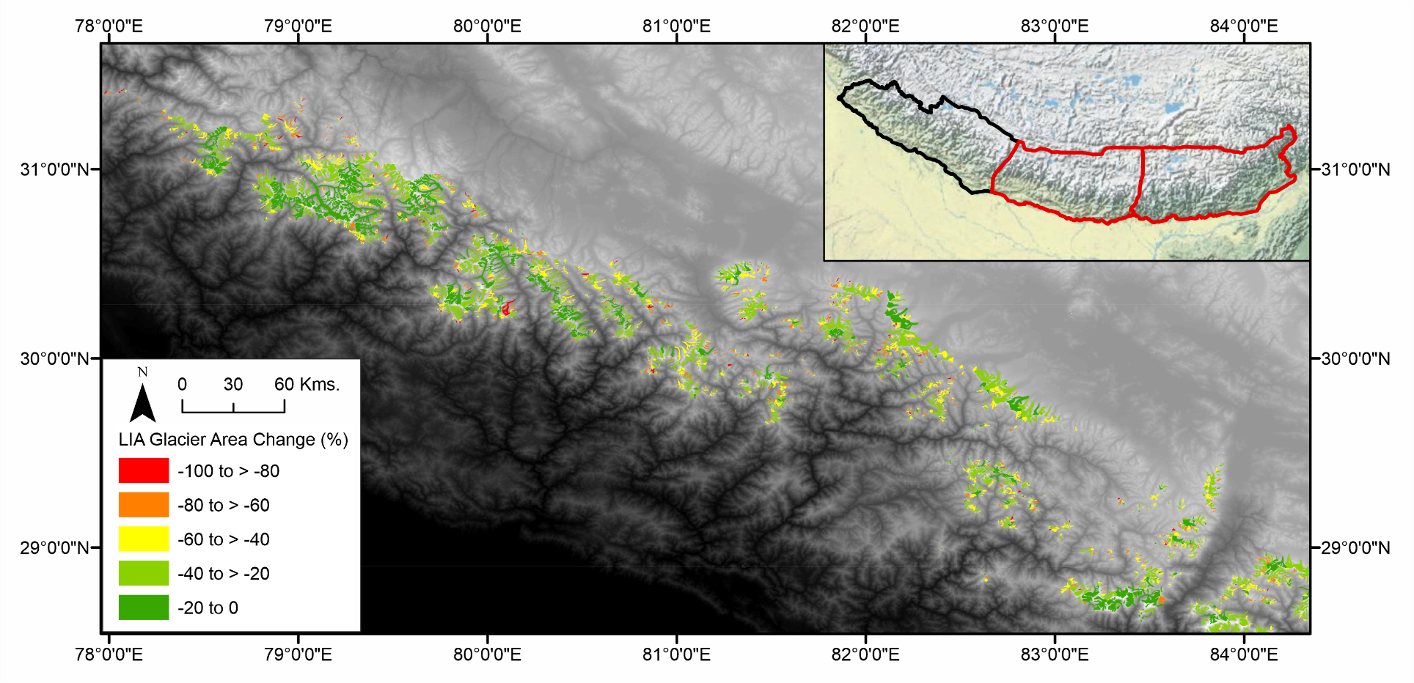

Appendix G
Area change seen within the East Nepal Region
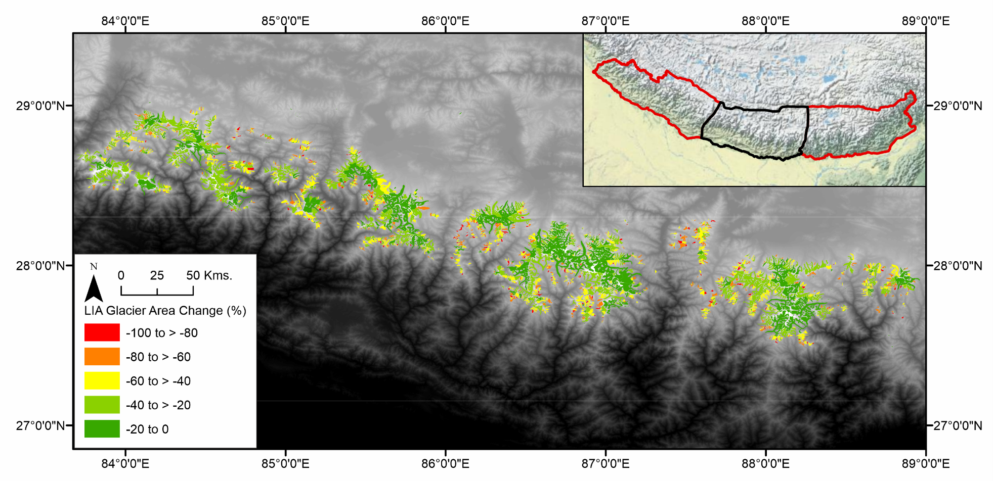

Appendix H
Area change seen within the Bhutan region
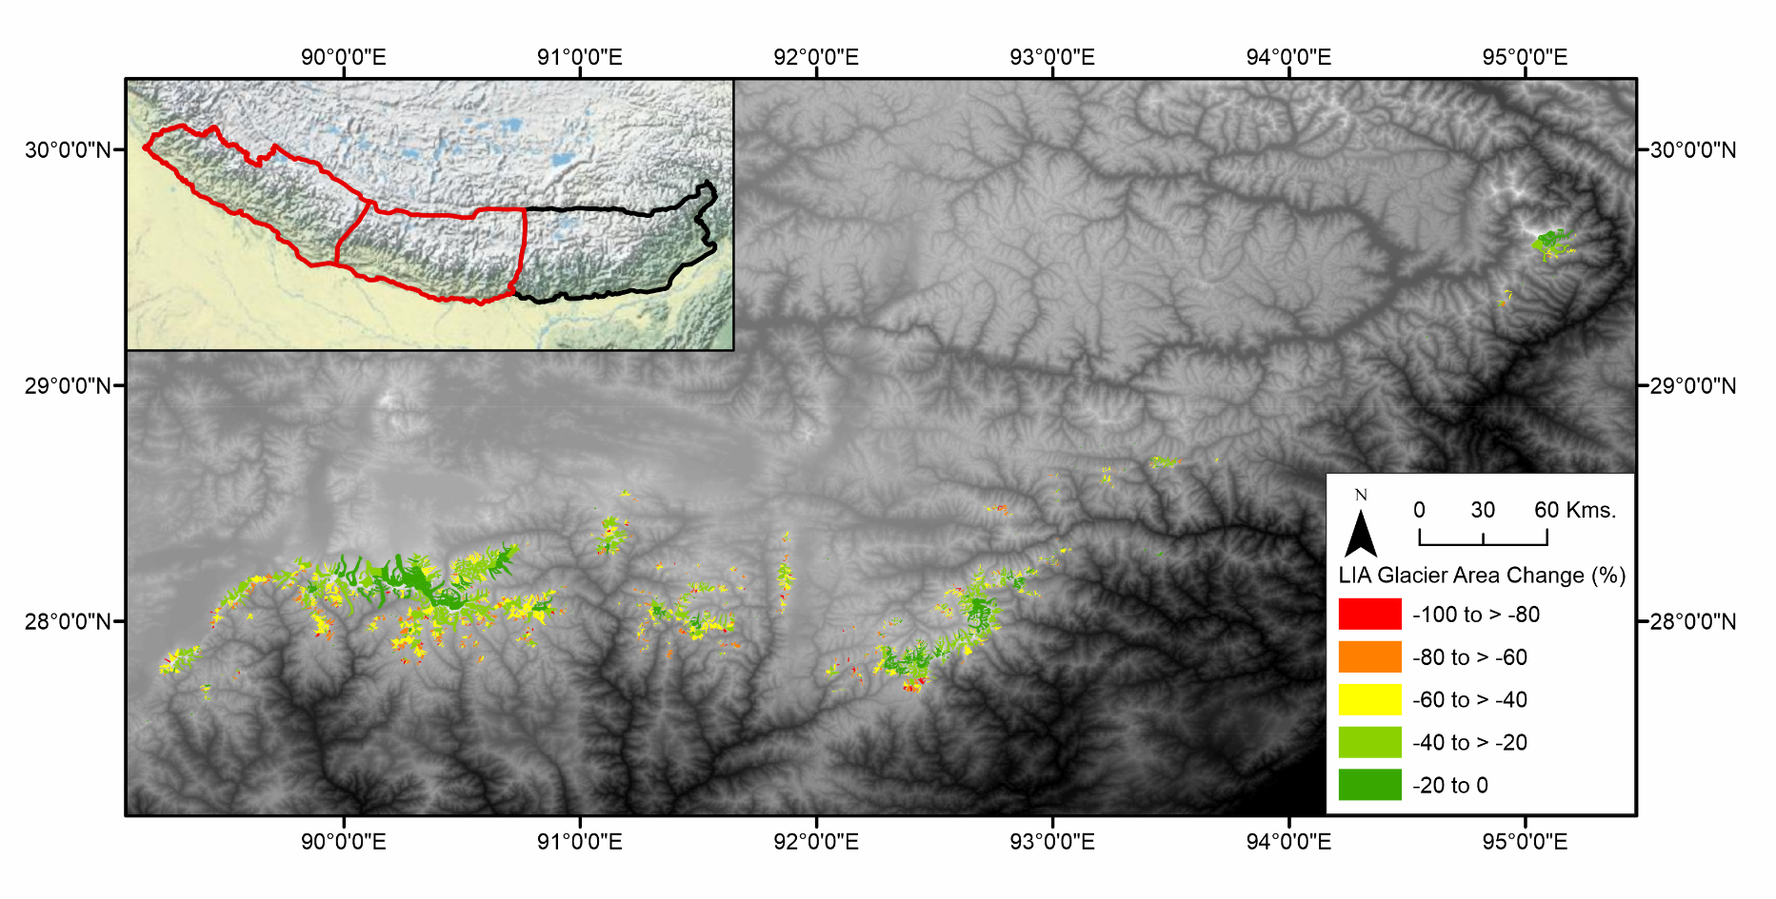

Appendix I
Volume change seen within the West Nepal region
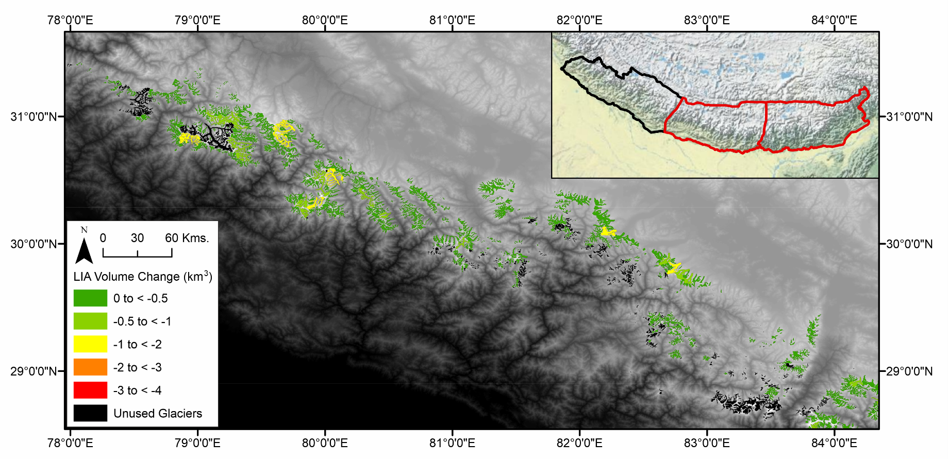

Appendix J
Volume change seen within the East Nepal region
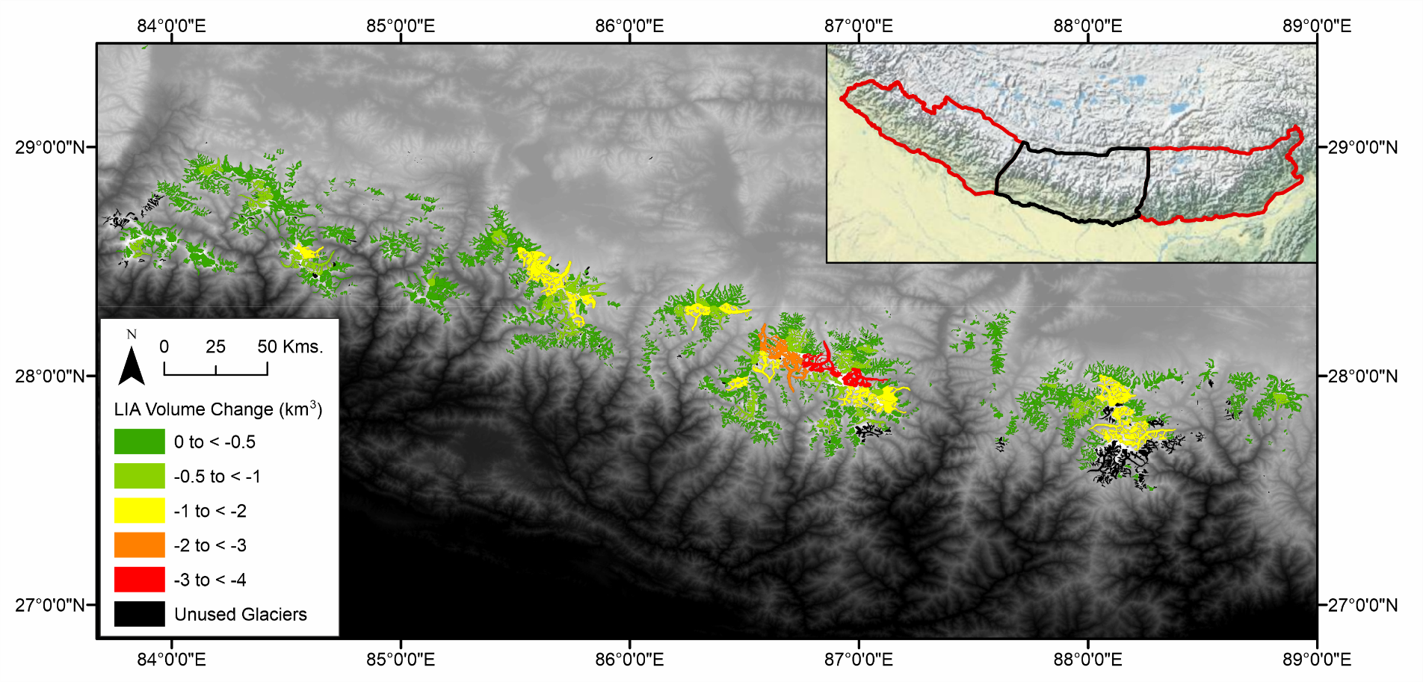

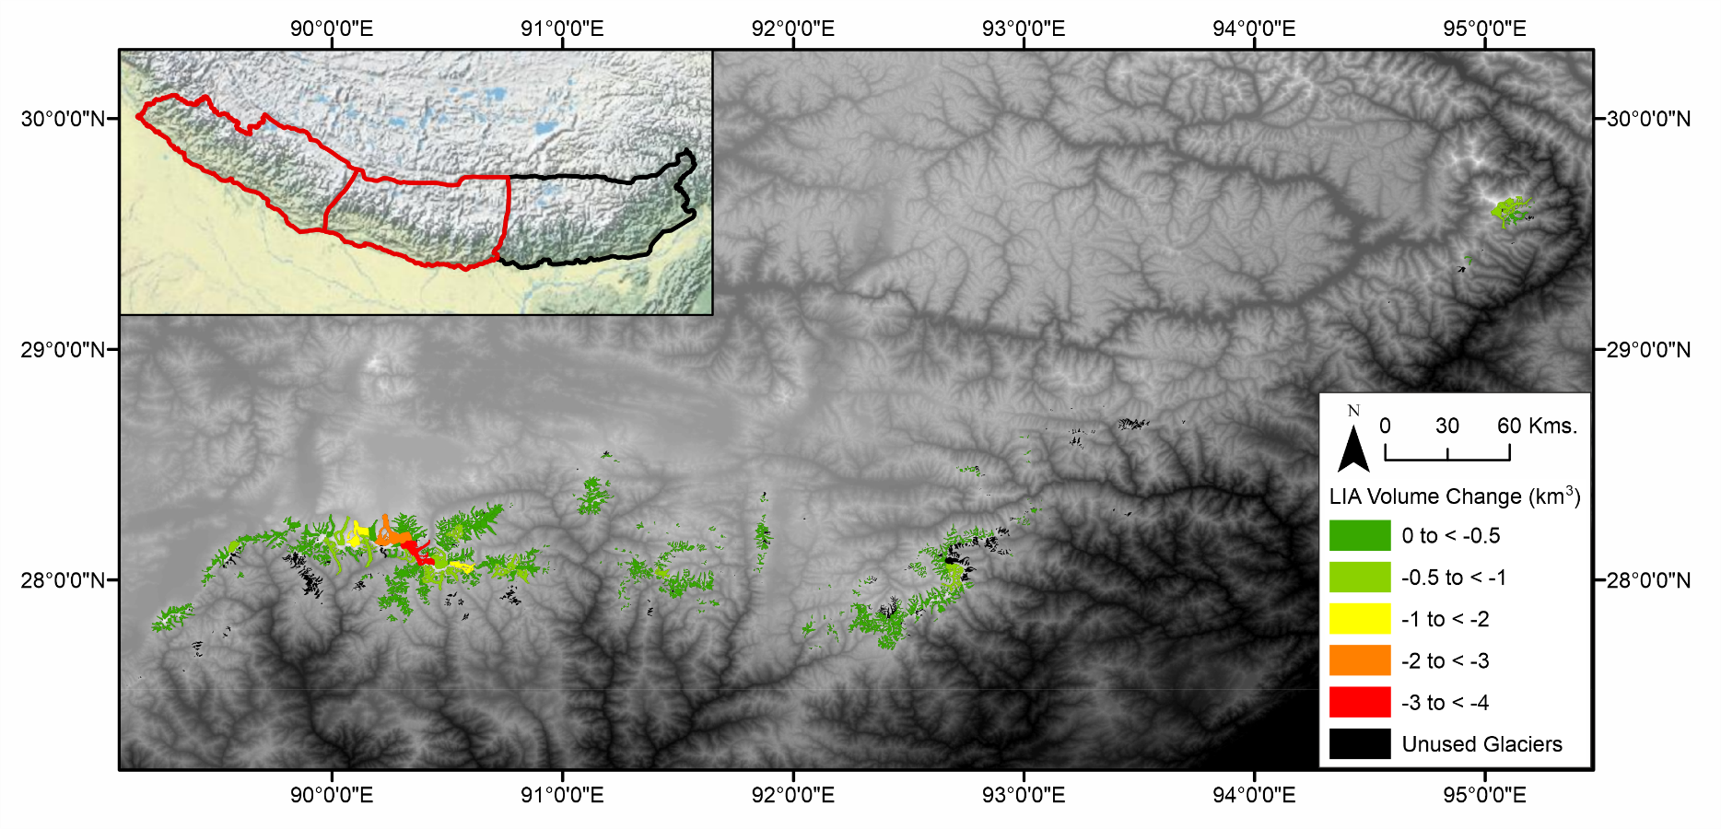
Appendix K
Volume change seen within the Bhutan region

Appendix L
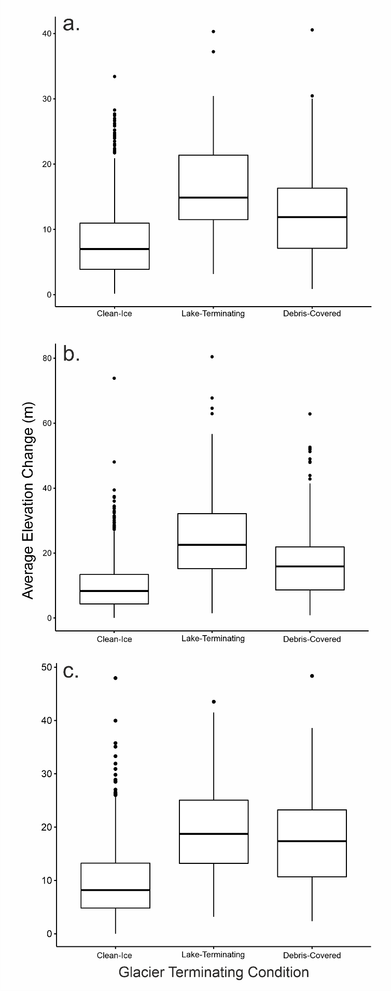
Boxplots of average elevation change to visualise the difference in means which is used in the ANOVA test of difference; a) West Nepal, b) East Nepal, b) Bhutan

Appendix M
Index map for locations shown within Figure 16 (page 54) letters corresponding to those shown in Figure 16
