

The Communicative Development of Deaf Infants and Children

By:

Ciara J Kelly

A thesis submitted in partial fulfilment of the requirements for the degree of Doctor of Philosophy

Department of Psychology
Faculty of Science
University of Sheffield

November 2018

Thesis Abstract
It is well documented that for many deaf children with hearing parents, delays in language development, and language-related areas of development can be expected. It is often considered that a key contributor to delays is the limited access to rich, conversational interaction often experienced by deaf children with hearing parents. Additionally, infant-parent interaction, which is an important contributor to language development, may be negatively impacted by the mismatched nature of the dyad in terms of modality. To investigate the impact of limited access to conversational interactions on the understanding of communicative intentions, Chapter 2 tested the ability to infer the communicative intentions behind a false statement in a comparative study of school-aged deaf children with hearing parents, deaf children with deaf parents, and typically hearing children. Deaf children with hearing parents were significantly delayed in this important aspect of pragmatic development. To explore when the development of communicative skills might start to diverge from typical trajectories, Chapter 3 investigated the communicative skills known to be predictive of language development in deaf infants with hearing parents aged 12 and 18 months, in comparison to demographically matched, typically hearing infants. Deaf infants with hearing parents exhibited delayed trajectories in the communicative skills explored, which diverged from typical trajectories with age. Delays were attributed to the difficulties faced by deaf infant-hearing parent dyads during infant-parent interaction. Taken together, findings from Chapters 2 and 3 highlight the need for intervention during infancy to reduce developmental gaps early. Subsequently, Chapter 4 investigates the feasibility of a parent-based intervention promoting the use of communicative strategies to support infant access to language and infant-parent interaction to subsequently facilitate deaf children’s language development. Findings suggest it is feasible to change parent behaviours; however, further investigation is warranted to refine and improve the intervention process.

Publications, Presentations, and Posters
Kelly, C., Morgan, G., Freeth, M., Siegal, M., & Matthews, D. (2018). Lie or mistake? Deaf and hearing children’s understanding of communicative intentions. Under review The Journal of Deaf Studies and Deaf Education.
Kelly, C. (2018). National Deaf Children’s Society (NDCS) Parent Training Course. Foundations for Language and Communication [Training Manual].
Kelly, C., Matthews, D., Morgan, G., & Siegal, M. (2014). Lie or mistake? Deaf and hearing children’s understanding of beliefs and intentions. Presented at The 2nd International Congress on Family-Centred Early Intervention for Children who are Deaf or Hard of Hearing, Bad Ischl, Austria.
Kelly, C., Matthews, D., Morgan, G., & Siegal, M. (2013). Lie or mistake? Deaf and hearing children’s understanding of beliefs and intentions. Poster presented at The Budapest CEU Conference on Cognitive Development, Budapest, Hungary.
Kelly, C., Matthews, D., Morgan, G., & Siegal, M. (2013). Distinguishing between lies and mistakes: Deaf and hearing children’s understanding of beliefs and intentions. Poster presented at The Child Language Seminary, Manchester, UK.
Kelly, C., Matthews, D., Morgan, G., & Siegal, M. (2013). Lie or mistake? Deaf and hearing children’s understanding of beliefs and intentions. Poster presented at The Society for Research in Child Development, Seattle, Washington.
Kelly, C., Matthews, D., Morgan, G., & Siegal, M. (2012). Lie or mistake? Understanding of intentions and beliefs in deaf and hearing children. Presented at The Division of Development Psychology Annual Conference, Glasgow, Scotland.

Acknowledgements
Firstly, although no longer with us, I would like to thank Professor Michael Siegal without whom this thesis would not have been possible. I will always remember coffee on a sunny afternoon when you happily decided to take me on as a PhD student, and will always appreciate your support, weekly coffees, and thoroughly interesting conversation that got my PhD off to such an excellent start. A heartfelt thank you must also go to my supervisor, Dr Danielle Matthews. I cannot thank you enough for offering to supervise the remaining majority of my PhD, as it is unlikely I could have continued without you taking me on board. Your endless support, kindness, and encouragement throughout my PhD will be forever appreciated. It has been a privilege and a pleasure to work with such a passionate, knowledgeable, and insightful academic. I would also like to thank the rest of my supervisory team, Professor Gary Morgan and Dr Megan Freeth. Gary, thank you for all your feedback and for bringing such a wealth of insight and knowledge to the team. I have learned much from you and appreciate the opportunities you provided along the way that helped me develop as a researcher in childhood deafness. Megan, thank you for all your feedback, collaboration, and support along the way.
To all the teachers, teaching assistants, children, parents, and babies; thank you for generously giving up your time so that the research in this thesis could be undertaken. An additional thank you is in order to the families who welcomed me into their homes and shared their experiences, I learned so much from you and it was an absolute pleasure to meet you all. To all the practitioners and professionals I have met throughout this journey, thank you for sharing your wealth of knowledge and experience. Your insight and feedback was invaluable. I would also like to thank the National Deaf Children’s Society and Sarah Carter in particular, for your support in recruiting families. Without your support, the final two studies in this thesis would not have been possible. It was a pleasure working with you and such a fantastic organisation that shares my passion for the area.
Thank you also to Funds for Women Grants, your Foundation Grant made it possible for me to continue my PhD when I was experiencing difficulties. I must also thank my brilliant team of research assistants; Ben Goude, Christine Hogan, Aoife Howard, and Alex Scott who volunteered their time to delve into the world of coding. All your hard work is very much appreciated. And of course to Sheryl Kennedy, thank you for all your hard work and hours of coding. I thoroughly enjoyed our conversations and collaborating with you.
I absolutely could not have made it through this process without the support of my fellow PhD students, ‘Babylab-ers’ and friends. Jamie, Zoe, Sarah, Colin W, Caroline, Michelle, Ed, Gemma, Patrycja, Dave, Keelan, Lowri, Lily, Emma, Steph, Kiera, Rich and Charlotte, thank you so much for your friendship and support, cups of tea, pub trips, gigs, and hotpot Mario Kart nights! An additional thank you must go to Zoe for the sanctuary of ‘Tweepy Tin’, and to Michelle, Ed and Gemma for your advice, support, and countless stimulating and helpful discussions. And also to Colin C, thank you for starting this journey with me and for your love and support during the first few years of this journey.
To Mum and Dad, I would not be at this point today without you both. I am truly blessed to have you and I am so grateful for all you’ve done to get me here today. Thank you for always being there no matter what. Mum, I will never be able to thank you enough for all you have done and given up for me, the opportunities you’ve provided, your belief in me, and your unwavering love and support. Dad, you have always been there with the perfect fun distraction when it’s needed. Thank you more than I can say for being there as a friend and father, for always supporting me and for your endless love.
And finally, to Alex. I’m not sure I can put into words how much I appreciate all you have done for me. Thank you so much for your love, support, endless PhD discussions, and quite literally keeping me alive with your amazing gourmet skills! I am so lucky to have you as my partner and know you as the fantastic academic are. I would not have reached this point without you.

Table of Contents
Access to Thesis i
Thesis Abstract iii
Publications, Presentations, and Posters v
Acknowledgements vi
Table of Contents ix
Tables xv
Figures xvi
1. The Communicative Development of Deaf Infants and Children: An Overview 1
1.1. Childhood Hearing Loss: Levels, Identification, and Prevalence 1
1.2. Childhood Hearing Loss: Implications for Access to Language and Subsequent Language Development 3
1.3. Implications for Language-Related Areas of Development: Social Cognition 8
1.4. The Role of Infant-Parent Interaction in Child Language Development 14
1.4.1. The Role of the Infant 16
1.4.1.1. Gaze following 16
1.4.2. Communicative gestures 17
1.4.3. Communicative vocalisations 20
1.5. The Role of the Parent 22
1.5.1. Responsiveness 22
1.5.2. Linguistic input 23
1.6. The Impact of Infant Hearing Loss on Infant-Parent interaction 25
1.7. Summary 27
2. Lie or Mistake? Deaf and Hearing Children’s Understanding of Communicative Intentions ……………………………………………………………………………………………………28
2.1. Introduction 28
2.1.1. The Relationship between Pragmatic Reasoning and Mental State Understanding 28
2.1.2. Understanding of Beliefs in Hearing and Deaf Children 29
2.1.3. Pragmatic Development in Deaf Children 33
2.1.4. The Present Study 34
2.2. Method 35
2.2.1. Participants 35
2.2.2. Materials 39
2.2.3. Procedure 39
2.2.4. Coding 42
2.3. Results 43
2.3.1. Performance in Typical Development 43
2.3.2. Performance of Deaf Children with Hearing Parents and Hearing Children 45
2.3.3. Language Age Matching of Participants 48
2.3.4. Comparing the Performance of Deaf Children with Deaf Parents and Hearing Children 51
2.4. Discussion 53
3. The Road to Language Acquisition: Exploring the Communicative Skills of 12- and 18-Month-Old Infants with Hearing Loss 58
3.1. Introduction 59
3.1.1. Pre-linguistic Communicative Skills: Typical Trajectories 61
3.1.1.1. Vocalisations and gestures 61
3.1.1.2. Gaze checking and coordinated communication 63
3.1.2. The Pre-Linguistic Communicative Skills of Deaf Infants with Hearing Parents: Current Knowledge 64
3.1.3. The Present Chapter 68
3.2. Method 70
3.2.1. Recruitment 70
3.2.2. Participants 71
3.2.3. Procedure 77
3.2.3.1. Visit 1 77
3.2.3.1.1. Consent forms and questionnaires 77
3.2.3.1.2. Video recordings 78
3.2.3.1.3. Play sessions 78
3.2.3.2. Visit 2 79
3.2.4. Coding & Measures 80
3.2.4.1. Video recorded play sessions 80
3.2.4.2. Ensuring equal observable coding time across participant videos 80
3.2.4.3. Vocalisations 82
3.2.4.4. Gestures 82
3.2.4.4.1. Pointing 83
3.2.4.4.2. Giving and showing 83
3.2.4.4.3. Conventional gestures 84
3.2.4.5. Gaze to caregiver’s face 84
3.2.4.6. Coordinated behaviours 84
3.2.4.6.1. Gaze coordinated vocalisations 85
3.2.4.6.2. Gaze coordinated gestures 85
3.2.4.6.3. Gesture-vocalisation combinations 85
3.2.4.6.4. Gaze coordinated gesture-vocalisation combinations 85
3.2.4.7. Conventional language: production of words and signs 85
3.2.4.8. Reliabilities 86
3.2.5. Approach to Analysis 86
3.3. Results 87
3.3.1. Comparisons Between Total DIHP and HIHP 87
3.3.2. Comparisons Between DIHP and HIHP at 12 Months 91
3.3.3. Comparisons Between DIHP and HIHP at 18 Months 96
3.3.4. Impact of Age on Communicative Skills in DIHP and HIHP: A Comparison of Trajectories ..……………………………………………..…………………………………96
3.4. Discussion 101
3.4.1. Differences Between DIHP and HIHP at 12 Months 101
3.4.2. Differences Between DIHP and HIHP at 18 Months 102
3.4.3. Impact of Age on Communicative Skills in DIHP and HIHP: An Exploration of Trajectories .……………………………………………………………………………….103
3.4.4. Implications and Future Directions 107
3.4.5. Limitations 109
3.4.6. Summary and Conclusion 110
4. A Parent-Based Intervention Promoting the use of Communicative Strategies during Infant-Parent Interaction to Support Language Development in Infants with Hearing Loss: A Feasibility Study 111
4.1. Introduction 111
4.1.1. Infant-Parent Interaction and its Relationship to Child Language Development 112
4.1.2. Interaction at Risk: Deaf Infant-Hearing Parent Dyads 113
4.1.3. Current Intervention Practice and Problems 117
4.1.4. The Present Chapter 119
4.1.4.1. Development of an intervention to promote the use of specific communication strategies: a rationale 120
4.1.4.1.1. Parent behaviours associated with language development in typical development ..………………………………………………………………………..120
4.1.4.1.2. Deaf parents as models for intervention 124
4.1.4.1.3. Intervention delivery 128
4.1.4.2. Feasibility and Acceptability 128
4.2. Method 130
4.2.1. Participants 130
4.2.2. Research Design 130
4.2.3. Procedure 130
4.2.3.1. Visit 3 131
4.2.4. The Intervention Video 132
4.2.5. Coding & Measures 135
4.2.5.1. Video recorded play sessions 135
4.2.5.1.1. Ensuring equal observable coding time across participant videos per measure .... 136
4.2.5.1.2. Accessibility of language during play 137
4.2.5.1.3. Visual accessibility of language 137
4.2.5.1.4. Aural accessibility of language 138
4.2.5.2. Visual accessibility of language during book reading 139
4.2.5.3. Semantically contingent talk 141
4.2.5.4. Attention getting strategies 142
4.2.5.5. Repetition in child directed speech 144
4.2.5.6. Infant directed sign 144
4.2.5.7. Reliabilities 145
4.2.6. Questionnaires 146
4.2.6.1. Experience using and perceptions of communicative strategies questionnaire …………………………………………………………………………………………..146
4.2.6.2. Acceptability of intervention delivery questionnaire 146
4.2.7. LENA 147
4.2.8. Approach to Analysis 147
4.3. Results 148
4.3.1. Communication Behaviours Pre- and Post-Intervention: Did Parents Change their Behaviours Successfully? 148
4.3.1.1. Visual accessibility of language: parent position 148
4.3.1.2. Aural accessibility of language: parent proximity 151
4.3.1.3. Visual accessibility of language during book reading 153
4.3.1.4. Semantically contingent talk 156
4.3.1.5. Attention getting strategies 159
4.3.1.6. Repetition in infant directed speech 167
4.3.1.7. Infant directed sign 169
4.3.2. Parents’ Experience Using the Communication Strategies 171
4.3.3. Acceptability of Intervention Delivery: The Video 176
4.4. Discussion 178
4.4.1. Feasibility of Behaviour Change 178
4.4.1.1. Attention getting strategies 179
4.4.1.2. Semantically contingent talk 181
4.4.1.3. Infant directed sign 183
4.4.1.4. Visual accessibility of language: parent position 184
4.4.1.5. Aural accessibility of language: parent proximity 185
4.4.1.6. Repetition in infant directed speech 186
4.4.1.7. Attention getting strategies and infant visual attention 186
4.4.2. Acceptability of Intervention Content and Delivery 188
4.4.3. Future Intervention Model: Learning from the Present Chapter 190
4.4.4. Limitations 193
4.4.5. Summary and Conclusion 194
5. General Discussion 195
5.1. Summary of Main Findings 195
5.2. Theoretical and Practical Implications 198
5.3. Limitations and Future Research 202
5.3.1. Further Exploration into the Relationship between Access to Conversational Interaction and Pragmatic Understanding 203
5.3.2. The Need for Longitudinal Studies of the Development of Infant Communicative Skills ………………………………………………………………………………………204
5.3.3. Developing a Parent-Based Intervention to Support the Development of Deaf Infants with Hearing Parents: Next Steps 205
5.4. Conclusion 206
6. References 207
7. Appendices 253
7.1. Appendix A: ‘Communicating with Your Baby’ Script 253

Tables
Table 1 38
Table 2 46
Table 3 49
Table 4 73
Table 5 76
Table 6 88
Table 7 90
Table 8 93
Table 9 95
Table 10 98
Table 11 140
Table 12 150
Table 13 152
Table 14 154
Table 15 157
Table 16 158
Table 17 160
Table 18 162
Table 19 164
Table 20 166
Table 21 168
Table 22 170
Table 23 175
Table 24 176

Figures
Figure 1 44
Figure 2 47
Figure 3 50
Figure 4 52
Figure 5 172

The Communicative Development of Deaf Infants and Children: An Overview
For the majority of children with hearing loss, delays in their language development and language-related areas of development can be expected (Lederberg, Schick, & Spencer, 2013). The present chapter therefore aims to explore aspects of a child’s experience that are typically important for language development, and how the different experiences of deaf children may impact their development in order to ultimately consider how best to close developmental gaps.

Childhood Hearing Loss: Levels, Identification, and Prevalence
Hearing loss is typically classified according to severity, with the World Health Organization (n.d.) identifying levels of hearing loss as: mild (26-40 decibels [dB] hearing level), moderate (41-60 dB hearing level), severe (61-80 dB hearing level), and profound (81 dB hearing level or over). In the United Kingdom (UK) however, classification is slightly different: mild (20-40 dB hearing level), moderate (41-70 dB hearing level), severe (71-95 dB hearing level), and profound (95 dB hearing level or over; British Society of Audiology, n.d.). To place hearing levels into context for the typically hearing reader, conversational speech is approximately 60dB (Meadow-Orlans, 1980). The identification of permanent childhood hearing loss was revolutionised by the introduction of Universal Newborn Hearing Screening (UNHS) in the late 1990s. Until then, children with hearing loss were not identified until approximately their second birthday, with milder hearing loss not being identified until later still (Mace, Wallace, Whan, & Stelmachowicz, 1991; Stein, Jabaley, Spitz, Stoakley, & McGee, 1990). Due to the growing recognition of the importance of early identification and intervention for infants with hearing loss in the 1980s and 1990s, there was a call for universal detection of hearing loss in newborns. In 1993, the National Institutes of Health Consensus Development Conference recommended that all newborns in the United States of America should be screened for hearing loss. In 1994, the Joint Committee on Infant Hearing endorsed UNHS, with the American Academy of Paediatrics endorsing it 1999. Due to advances in technology, UNHS has been implemented and widely adapted since the early 2000s across the majority of the developed world. Implementation occurred in the UK in 2006, with the introduction of the Newborn Hearing Screening Programme (NHSP) initially implemented in 2005 (see Bamford, Uus, & Davis, 2005 for a summary of the evidence of the effectiveness of the initial phase of the programme). Newborn hearing screening typically involves screening for moderate to profound sensorineural hearing loss within the first few weeks of life using either the Otoacoustic Emissions test, or an Automated Auditory Brainstem Response test, or both. This choice depends on a country’s national screening protocol. In the UK, the infant is first screened using the Otoacoustic Emissions test. If the test is failed, infants are then screened using the Automated Auditory Brainstem Response test.
Permanent bilateral childhood hearing loss affects approximately 1 per 1000 live births in developed countries (greater than or equal to 26 dB hearing level in both ears; Butcher, Dezateux, Cortina-Borja, & Knowles, 2018). Similar estimates have been reported for the prevalence of permanent bilateral childhood hearing loss that is greater than or equal to 40dB hearing level in the better ear (Fortnum et al., 2001; Watkin & Baldwin, 2011). Moreover, prevalence continues to increase through infancy typically due to the delayed onset of genetic hearing loss, meningitis or late diagnosis (Bamford et al., 2007; Kral & O’Donoghue, 2010). It is estimated that around 95% of children with hearing loss are born to hearing parents, with the remainder born to deaf parents (Mitchell & Karchmer, 2004). For children in the former group, there exists a wealth of research suggesting that for many, delays in language development can be expected (Lederberg et al., 2013). Although the bulk of this research is focused on children with hearing loss ranging between moderate-severe to profound, there is evidence to suggest that children with mild to moderate hearing loss are also at significant risk of language delay (Delage & Tuller, 2007; Tomblin et al., 2015). For deaf children born to deaf parents (who are native signers), language development typically parallels that of hearing children (Lederberg et al., 2013). Although these differences in language development appear to be characterised by parental hearing status, it is not parental hearing status per se that impacts language development, but rather the implications this may have for a child’s access to, and experience of, their linguistic environment and subsequent developmental outcomes. The following section therefore explores the importance of access to language for subsequent language development, and what parental hearing status might mean for deaf children (i.e., children with hearing loss) in terms of their access to language.

Childhood Hearing Loss: Implications for Access to Language and Subsequent Language Development
From very early in life, hearing infants learn much about language from their auditory environment, even before they are born. After a gestation of just 28 weeks, the human foetus can perceive the intonation and rhythm of their native language (P. Brooks & Kempe, 2012; Saffran, Werker, & Werner, 2006). As a neonate, they can display a preference for speech sounds over both non-speech sounds (Vouloumanos & Werker, 2004) and speech sounds in reverse (Peña et al., 2003). By 6 months, some display a rudimentary awareness of the correspondence between common nouns and their referents (Bergelson & Swingley, 2012), and by 8 months, demonstrate the remarkable ability to segment a continuous stream of nonsense speech into words after just 3 minutes of exposure to an artificial language (Aslin, Saffran, & Newport, 1998). In this far from exhaustive description of infant abilities, it certainly seems to be the case that the young infant learns a substantial amount about their ambient language from their linguistic environment. Indeed, several theories of typical language development emphasise the importance of access to linguistic input for language development (Moeller & Tomblin, 2015b), with a plethora of evidence to suggest that language input plays an important role in the process of language development. For example, in their widely recognised study, Hart and Risley (1995) report that differences in the quantity of linguistic input when infants were between 7 to 36 months significantly contributed to individual differences in later language outcomes. Furthermore, findings from Thiessen, Hill, and Saffran (2005), demonstrate how quality of linguistic input may also play a role in the process of language development. The authors report that differences in the intonation contours of linguistic input is related to infants’ ability to segment words from continuous speech, an important ability for language learning (Kuhl, 2004). It is therefore conceivable that limited access to linguistic input would have consequences for subsequent language learning.
For deaf children with hearing parents (DCHP), the linguistic environment is often a spoken one (Lederberg et al., 2013). As perception of spoken language can be affected by factors such as degree of hearing loss, and the age at which hearing technologies (e.g., cochlear implants and hearing aids) where implemented (Lederberg, 2003), many DCHP experience limitations in their access to a fluent language environment. Encouragingly, these limitations have been reduced in recent years due to improvements in hearing technologies increasing access to the auditory environment for many deaf children (Harkins & Bakke, 2011). Subsequently, the ability to acquire spoken language as has increased for many deaf children (Harkins & Bakke, 2011)., with some children even achieving language skills in some areas at a comparable rate to their typically hearing peers (Hayes, Geers, Treiman, & Moog, 2009; Yoshinaga-Itano, Baca, & Sedey, 2010). Furthermore, since the advent of UNHS, identification and intervention can occur much earlier, with evidence suggesting earlier identification and intervention (including implementation of hearing technologies) has a positive impact on language outcomes (Vohr et al., 2008; Yoshinaga-Itano, Coulter, & Thomson, 2001; Yoshinaga-Itano, Sedey, Coulter, & Mehl, 1998). However, it is important to note that early identification may not guarantee improved language outcomes (Pimperton et al., 2017). Furthermore, although hearing technologies are evidently beneficial, they do not provide the user with a typical listening experience, nor do they guarantee improved language outcomes. For example, although hearing aids are beneficial as they amplify auditory input, they do not render the speech signal fully audible to the majority of deaf children (Bagatto et al., 2011; Stiles, Bentler & McGregor, 2012). Additionally, access to linguistic information will inevitably be reduced during difficult listening environments and periods without amplification.
Cochlear implants (CIs) differ from hearing aids in that they replace the function of the damaged inner ear by delivering auditory signals to the brain (Loizou, 1999). However, similar to hearing aids, the auditory input from CIs does not parallel the quality of input received by typically hearing children (Lederberg et al., 2013). Despite this CIs are also beneficial, particularly for deaf children with profound hearing loss. Historically, access to spoken language was severely limited for children with profound hearing loss (Moores, 2010). With the substantial increase of CIs since their introduction in the 1980s (Raine, 2013; Swanwick & Tsverik, 2007), deaf children with profound hearing loss now have increased opportunity to acquire spoken language (Geers, Moog, Biedenstein, Brenner, & Hayes, 2009; Nicholas & Geers, 2007). In terms of language development, earlier implantation is associated with improved outcomes (Geers et al., 2009), and due to UNHS, early implantation is possible with many infants receiving CIs at around 12 months or younger (Vlastarakos et al., 2010). However, early implantation in itself does not ensure that a child will develop good spoken language skills, and receiving a CI at the age of 1 or 2 years does not ensure that language abilities will be within normal limits, as observed after up to 6 years of CI experience (Caselli, Rinaldi, Varuzza, Giuliani, & Burdo, 2012; Duchesne, Sutton, & Bergeron, 2009). In sum, UNHS and improvements in technology have resulted in significant strides toward improving access to spoken linguistic input and subsequent language outcomes for many deaf children. However, for many children, delays still persist (Lederberg et al., 2013).
An alternative (and/or additional) method to increase access to language for DCHP is the use of sign supported speech. This typically involves simultaneously producing signs alongside spoken language. Thus, the signs are produced based on the word order of the spoken language (and not the signed language, which typically has a different word order). This model was developed in the 1960s by educators of deaf children in order to provide models of the syntactic and semantic structures of spoken language that are visually accessible (Lederberg et al., 2013). Although there is some evidence to suggest that this approach is beneficial for language outcomes (e.g., Connor, Hieber, Arts, & Zwolan, 2000; Robbins, Svirsky, & Kirk, 1997), there is also evidence to suggest this approach may not provide linguistic advantage (Geers, Nicholas, & Sedey, 2003). It therefore remains unclear whether the use of sign supported speech is beneficial for later language outcomes. Finally, for the small number of DCHP learning a natural sign language (typically within a bilingual environment, i.e., children are learning both spoken and sign language; Lederberg et al., 2013), delays in sign language development can also be expected (Hermans, Knoors, & Verhoeven, 2009; see also Mayer & Leigh, 2010). Much like DCHP learning spoken language, DCHP learning a natural sign language can often experience limited access to a fluent language model. However, these limitations are not due to perceptual difficulties, but rather the quality and/or frequency of linguistic input. Given that hearing parents and teachers of deaf children often do not attain fluency in a natural sign language (Arnesen et al., 2008; DeLana, Gentry, & Andrews, 2007), the delays in DCHP’s sign language development are typically attributed to limited (and often later) exposure to a fluent sign language model (Knoors & Marschark, 2012; Spencer & Marschark, 2010).
The linguistic experience of deaf children with deaf parents (DCDP) is typically rather different to DCHP in terms of access to language. As most deaf parents are fluent sign language users, DCDP typically experience unimpeded access to a fluent, language-rich model from birth, much like hearing infants (Lederberg et al., 2013). Furthermore, to negate the possibility of missed language opportunities, deaf parents support their deaf children’s visual perception of language from early infancy (Spencer & Lederberg, 1997; Waxman & Spencer, 1997). In terms of language development, DCDP exposed to fluent sign language from birth exhibit a timetable of language acquisition that parallels their typically developing peers (Meadow-Orlans, Spencer, & Koester, 2004; Schick, 2003). However, it is important to note that not all deaf parents are necessarily fluent sign language users. Although there are relatively few large studies of this group due to the low prevalence of DCDP, some evidence suggests that a minority of deaf parents may not sign. For example, Stuckless and Birch (1997) report from questionnaires on the use of manual communication, that 5 out of 71 (7%) deaf parents of deaf children in their sample did not use a signed language. More recently, Mitchiner (2015) investigated the opinions of deaf parents with children who have cochlear implants on bilingualism in ASL and English. One of the 17 survey respondents reported English as the sole language used at home. Given that this minority likely experiences similar limitations in their access to language as DCHP, it would be interesting to explore the language outcomes of DCDP who are not raised in a fluent sign language environment. It stands to reason that their likely limited access to language would have an impact on their language acquisition (although, several factors that influence access such as hearing technologies would need to be taken into consideration).
Based on extant literature, it is clear that access to language plays a vital role in language acquisition and that for deaf children, parental hearing status can influence the language model to which they are exposed. This can then have implications for accessibility of linguistic input and subsequent language development. There exists a wealth of literature exploring what the differences in access to language and subsequent language development experienced by deaf children might mean for other areas of their development. The following section explores this literature in terms of an important aspect of child development; namely social cognition.

Implications for Language-Related Areas of Development: Social Cognition
In general, social-cognitive development refers to our understanding of the social world, which involves the ability to attribute mental states (e.g., intentions, beliefs, emotions, desires) to ourselves and to others in order to interpret, explain and predict the behaviours of those around us. This understanding is commonly known as “Theory of Mind” (ToM; Doherty, 2009), a term coined by Premack and Woodruff (1978) in their research on this understanding in chimpanzees (see also Hughes, 2011 for a discussion on the broader definitions of ToM, largely driven by differing theoretical perspectives). Theory of mind understanding is vital to all sophisticated forms of social interaction and without it, there would undoubtedly be misunderstandings, conflict and mistrust (Siegal, Frank, Surian, & Hjelmquist, 2011). An important milestone in the development of ToM, and one that has perhaps received the most attention, is the ability to understand false beliefs (i.e., the understanding that an individual’s behaviour is dependent on their own beliefs, even if these are false). Children’s understanding of beliefs develops rapidly in the early years (Apperly, 2010), and by 3 to 5 years of age children can pass tests of false belief understanding (see Wellman, Cross, & Watson, 2001 for a meta-analytic review). However, there is evidence to suggest that the understanding of false beliefs may be present in infancy and toddlerhood, based on their ability to pass “implicit tasks” which rely on gaze behaviour (Onishi & Baillargeon, 2005; Southgate, Senju, & Csibra, 2007). The question of whether or not infants understand false beliefs remains under debate as alternative explanations have been proposed (Perner & Ruffman, 2005), while others conclude that infants may instead be displaying a sensitivity as opposed to the same level of understanding as a 4-year old (Apperly & Butterfill, 2009; Low & Perner, 2012). Furthermore, there is evidence to suggest that initial findings with infants cannot be replicated (Dörrenberg, Rakoczy, & Liszkowski, 2018).
In what seems to be a similar pattern to their language development, evidence suggests that most DCHP are delayed in their ability to pass explicit false belief tasks (Corina & Singleton, 2009; Jones, Gutierrez, & Ludlow, 2015; Morgan & Kegl, 2006; Russell et al., 1998; Schick, De Villiers, De Villiers, & Hoffmeister, 2007) as well as implicit ones (Meristo et al., 2012). Whereas DCDP perform similarly to their hearing peers (Courtin, 2000; Meristo et al., 2007). Furthermore, when task demands are reduced by using minimal verbal instructions such as “thought pictures”, delays still persist for DCHP (Woolfe, Want, & Siegal, 2002). Based on the differences in access to language generally experienced by DCHP and DCDP, one school of thought is that the impeded access to conversational interaction often experienced by DCHP impacts their development of false belief understanding. For example, Remmel and Peters (2009) report that DCHP with CIs performed similarly to their hearing peers (albeit slightly younger peers) on a false belief task, and that time since implantation was associated with task performance more than age at implantation. Findings therefore point to the importance of increased access to conversational interactions for false belief understanding.
Ziv, Most, and Cohen (2013) also report findings to suggest that lack of access to conversational interaction (in this case for signing children who had little access to a signed language) has a negative impact on false belief understanding (see also Meristo et al., 2007). In their assessment of false belief understanding, Ziv et al. (2013) found that Israeli DCDP performed significantly worse than hearing children, and worse than DCHP with cochlear implants (although this latter difference was non-significant). These findings are surprising given that sign language was the main mode of communication for the all the DCDP and their parents. However, many native signing Israeli children typically spend the majority of their day in educational settings from early infancy, where they have limited access to conversations as educators are not proficient in Israeli Sign Language. Furthermore, when sign supporting their speech, educators include invented signs. The authors suggest that the poor performance of DCDP, was likely a result of extensive time spent with limited access to fluent, high quality conversational interaction in their educational settings. Findings therefore strengthen the position that access to fluent conversational interaction is critical to the understanding of others’ beliefs.
In line with the conversational interaction hypothesis, but from a somewhat different perspective, it is also possible that differences in quality of conversational interaction may contribute to differences in the development of false belief understanding. Meins et al. (2002) found a relationship between the use of mental state talk during interactions with infants and their later ToM performance. Specifically, parent “mind-mindedness” (i.e., commenting on their infant’s mental states using mind-related comments that match their child’s concurrent state of mind) when their infants were 6 months was associated with ToM performance when children were 4 years old (see also, Meins et al., 2003). This is an important observation given that interactions between hearing parents and their deaf infants may not run as smoothly as for matched dyads, particularly given hearing parents may be more controlling and directive, and less semantically responsive to their infant’s focus of attention (Ambrose, Walker, Unflat-Berry, Oleson, & Moeller, 2015; Bodner-Johnson & Sass-Leher, 1996; Cheskin, 1982; Spencer & Gutfreund, 1990; Spencer & Meadow‐Orlans, 1996). Thus, it is possible that hearing parents may be less likely to comment on their child’s mental states. Infant-parent interaction is discussed in more depth below and in Chapter 4.
In their exploration of the conversational input of hearing parents to young deaf and hearing children, Morgan et al. (2014) found that hearing parents of deaf infants aged 19 to 28 months, used far less mental state language (i.e., conversations including mental states such as beliefs, thoughts, feelings and intentions) than hearing parents of hearing infants. Furthermore, hearing mother-deaf child dyads experienced less connected conversation (i.e., semantically related turn-taking). It is therefore possible that hearing parents of deaf infants may be less mind-minded; however, this is yet to be empirically explored. Finally, in a similar study to Morgan et al. (2014), Moeller and Schick (2006) found that hearing mothers of deaf 4 to 10 year olds, used fewer mental state terms than hearing mothers of hearing children (aged 4 to 6) and for both groups, the amount of mental state language predicted children’s ToM performance. This relationship held after controlling for effects of child language level and age.
Another school of thought proposes that a child’s own language skills play an important role in ToM performance (Astington & Jenkins, 1999; de Villiers & de Villiers, 2009). For example, children’s proficiency with syntax, semantics and receptive vocabulary have all been associated with false belief task performance (Milligan, Astington, & Dack, 2007). From this viewpoint, it is thought that language provides children with the necessary resources to represent and communicate about false beliefs. Along with their findings that time since cochlear implantation was associated with false belief task performance in DCHP, Remmel and Peters (2009) found that general syntactic proficiency was associated with performance on a false belief task. However, in a similar study, Ketelaar, Rieffe, Wiefferink, and Frijns (2012) report that even with adequate language skills (measured as receptive vocabulary), children with CIs were delayed in their understanding false beliefs. The authors suggest exploring the quality of conversational interaction for children with CIs to investigate if it parallels that of hearing children in a bid to understand why delays persist in children with CIs with adequate language skills. It is important to note that these studies measured different language skills although both syntactic proficiency and receptive vocabulary have been associated with false belief performance (Milligan et al., 2007).
The relationship between language (both in terms of a child’s own language skills and their linguistic environment) and ToM development remains under debate, with several theoretical positions on the relationship between language and ToM (see Astington & Baird, 2005). As summarised by Hughes (2011), “there is potentially a Kaleidoscope of different connections between theory of mind and language, particularly because development in each domain is characterised by striking individual differences” (p. 51). Although a detailed review is beyond the scope of the present chapter, it is clear that language (both in terms of a child’s own language skills and their linguistic environment) plays an important role in a child’s social-cognitive development. Given that DCHP in general experience difficulties in terms of access to language, language development, and social-cognitive development in an interrelated way, an important question is, what does this mean for their pragmatic development?
Pragmatics is the branch of linguistics concerned with understanding language in its social context, and a central aspect of pragmatics is the comprehension of intentions. To understand what people mean by what they say (i.e., to interpret a person’s utterances), an understanding of intentions is required. Based on the work of Grice (1957), several theories of pragmatics since, argue that inferring a speaker’s intentional meaning requires a level of ToM understanding. This is particularly imperative when it comes to interpreting nonliteral language. For example, consider the statement, “I could eat a horse”. The literal meaning of this utterance does not communicate the message, i.e. “I am really hungry”. However, by adding a pragmatic layer, which is the speaker’s intention to express the intensity of their hunger, the true meaning of the utterance becomes clear. Thus, an understanding of embedded complex mental states and the ability to attribute mental states to both speaker and listener is arguably required. To understand jokes, sarcasm, irony, lies, mistakes and so on, a skilled language user will consider aspects of the speaker’s mind by assessing what the speaker thinks, knows and intends to communicate to actively construct the meaning of the speaker’s statement (Filippova, 2014).
Several studies investigating the relationship between children’s mental state understanding and their ability to distinguish between nonliteral utterances suggest that the cognition of communicative intent requires a concept of belief, higher order meta-representational abilities and the ability to infer goals. For example, when investigating 5-year-old children’s ability to distinguish between metaphor and irony, Happé (1993) found that first-order mental state reasoning (i.e., understanding the beliefs of others) was associated with metaphor comprehension. Furthermore, second-order mental state reasoning (i.e., understanding the speaker’s beliefs about the listener’s beliefs) was associated with irony comprehension. The author suggests that communicative competence therefore requires an underlying competence in mental state reasoning. For DCHP who tend to be delayed in their language and social-cognitive development, and typically experience limited access conversational interaction, much less is known about the consequence of these interrelated difficulties for pragmatic development. Therefore, the study reported in Chapter 2 explores this within the context of understanding deception; an aspect of pragmatic reasoning that, to the author’s knowledge, is yet to be investigated experimentally with deaf children.

The Role of Infant-Parent Interaction in Child Language Development
To foreshadow the findings reported in Chapter 2, significant delays in pragmatic development were observed in DCHP in childhood. Thus, the present thesis sought to explore the development of communicative skills in infancy to determine the point at which delays may emerge, particularly as infant communicative skills are associated with later language outcomes (Carpenter, Nagell, Tomasello, Butterworth, & Moore, 1998). During social interaction, both infant and parent play an active role in the infant’s subsequent language development. Indeed, “communication…breeds communication, as the language produced for and by young children fosters subsequent language development” (p. 793). Thus, the following sections introduce the role of infant-parent interaction in language development (in typical development) to consider the potential impact of childhood hearing loss, and the likely need for intervention to support infant-parent interaction.
A child’s language development is thought to be facilitated through dynamic, bidirectional interactions between infant and parent, where both infant and parent behaviours influence one another (Sameroff, 1975, 2009). Thus, when an infant contributes newly developed skills to interaction, the parent responds with behaviours that are sensitive to the developing abilities of their infant, scaffolding interactions that allow the infant to reach a higher level of competency (Bakeman & Adamson, 1984; Bruner, 1983; Papoušek & Bornstein, 1992). Papoušek and Papoušek (1997) describe this transactional nature as the harmonious and mutually rewarding interplay of infantile and parental predispositions. From around 9 months of age, infants and their caregivers typically become able to enter into a particularly important state of engagement referred to as joint attention. This occurs when both infant and caregiver share attention towards the same object or event, with the mutual awareness that they are doing so (Carpenter, 2012).
When engaged in joint attention, infants are better placed to understand the function of language (Bruner, 1983; Tomasello & Farrar, 1986; Tomasello & Todd, 1983). Joint attentional interactions are thought to create a shared referential framework where the infant can experientially ground the linguistic input of their caregivers, making language acquisition possible (Carpenter et al., 1998; Tomasello, 1995). Indeed, there exists a wealth of evidence to suggests that individual differences in the amount of time spent in joint attention and the frequency of episodes of joint attention during the pre-linguistic stage, are strongly related to later language outcomes (Adamson, Bakeman, & Deckner, 2004; Carpenter et al., 1998; Tomasello & Todd, 1983). Furthermore, although commonly studied in relation to language development, joint attention is also thought to play a substantial role in development in general (including social, emotional, and social-cognitive development; Baron-Cohen & Ring, 1994; Depowski, Abaya, Oghalai, & Bortfeld, 2015).
From a socio-pragmatic perspective (Tomasello, 2003), joint attentional skills demonstrate an infant’s emerging understanding of others’ intentions and attention (Tomasello, Carpenter, & Liszkowski, 2007). It is through these social-cognitive skills that infants can form shared attention and intentions with others (Tomasello & Carpenter, 2007), by either responding to their caregiver’s bids for attention (demonstrated by their ability to gaze follow), or initiating joint attention (demonstrated through behaviours such as pointing; Carpenter et al., 1998; Mundy et al., 2007; Mundy & Newell, 2007). An important aspect of these newly emerging, intentionally communicative skills is that they are consistently reported to be associated with later language development (e.g., Morales et al., 2000; Mundy et al., 2007). It is thought that given the salient nature of intentional communication, these behaviours elicit parental responsiveness, which in turn facilitates later language development (Tamis-LeMonda, Kuchirko, & Song, 2014; Yoder & Warren, 1993, 1999). In the following sections both infant and parent contributions to interaction, and their implications for later language are reviewed.

The Role of the Infant
Several communicative skills have been found to predict later language outcomes including infant gaze following, communicative gestures (particularly pointing), and vocalisations.

Gaze following
Around their first birthdays, infants become increasingly able to follow their caregiver’s gaze or point towards an object. Although infants can follow an adult’s head turn to a target at this age regardless of the adult’s perceptual state (eyes open or closed), it is not until 10-11 months that they can differentiate between these two scenarios (R. Brooks & Meltzoff, 2005). The authors argue that it is not until this age that infants are truly gaze following. Around this time infants can also reliably follow a pointing gesture, a skill that is typically consolidated by 18 months (Carpenter et al., 1998). R. Brooks and Meltzoff (2005) found that gaze following behaviour at 10-11 months predicted subsequent language abilities at 18 months. In a similar study, Markus, Mundy, Morales, Delgado, and Yale (2000) report that an infant’s skills in following attention at 12 months predicted their later vocabulary development at 18, 21 and 24 months of age. Furthermore, an infant’s ability to follow the gaze, head turn and/or pointing gesture of their interlocutor between 6 to 18 months significantly predicted language outcomes at 30 months (Morales et al., 2000). Finally, infants who promptly respond to their parent’s encouragement to look at an object at 14 months have larger vocabularies by 18 months (Scott et al., 2013).

Communicative gestures
From around nine months, infants typically start to initiate episodes of joint attention first by showing and giving, and later by pointing. Infants also produce representational gestures, whereby gestures are effectively symbols with stable semantic content that represent a referent, much like words (Bates (1979). In terms of communicative gestures, infant pointing has received the most attention as it is considered by many as the first true form of declarative communication (Tomasello et al., 2007) and predicts later language development (Butterworth, 2003; Colonnesi, Stams, Koster, & Noom, 2010). It is assumed that this relationship holds as the infant’s pointing gesture elicits responses from caregivers which are optimal for word learning (Kishimoto, Shizawa, Yasuda, Hinobayashi, & Minami, 2007). Although emergence varies, with reports ranging from 9 to 15 months of age, there is a general consensus that the pointing gesture emerges around 12 months of age (Camaioni, Perucchini, Bellagamba, & Colonnesi, 2004; Carpenter et al., 1998; Leung & Rheingold, 1981) and is typically consolidated by 18 months (e.g., Carpenter et al., 1998).
There are two main motives behind the communicative point first distinguished by Bates, Camaioni, and Volterra (1975); the imperative and the declarative. Imperative gestures are used by infants to request adult behaviour to achieve a goal, whereas declarative gestures are the infant’s attempt to direct the adult’s attention. Both types are considered to rely on different underlying social-cognitive constructs, and therefore require different cognitive capacities, with imperatives traditionally considered the less sophisticated of the two, as they only require an understanding that others are causal agents, not intentional agents, who can make things happen (Camaioni, 1993). Declaratives on the other hand, have been argued to demonstrate the infant’s understanding that their communicative partners are attentional and intentional beings whose independent mental states can be directed, shared and changed (Liszkowski, Carpenter, Henning, Striano, & Tomasello, 2004; Liszkowski, Carpenter, & Tomasello, 2007, 2008). Findings from Camaioni et al. (2004) suggest that it is 12 to 15-month-old infants’ declarative pointing that is linked to the understanding of others’ intentions and not their imperative pointing (Colonnesi et al., 2010).
In contrast to this theoretical approach, Lüke, Grimminger, Rohlfing, Liszkowski, and Ritterfeld (2017) found that pointing handshape (i.e., open hand or index finger pointing) at 12 months was a better predictor of language development one year later, than the inferred motives of declarative and imperative pointing. Although both imperative and declarative pointing were predictive of language acquisition with no difference between the two, it was index finger points that were the positive predictors (both imperative and declarative). Furthermore, infants who only pointed using their open hand were more likely to show language delay at 2 years of age. In line with this, Liszkowski and Tomasello (2011) found that index finger points (and not open hand points) at 12 months were significantly related to the ability to pass point comprehension tests that required the ability to make inferences about the referential intentions of their social partner. Furthermore, it appears that infants increase their use of index finger points and decrease their use of open hand points with age, and interestingly are inclined to use open hand pointing more for imperative purposes, even when their use of index finger pointing increases (Cochet & Vauclair, 2010).
The communicative gestures of showing and giving objects to a communicative partner are rather understudied in comparison to infant pointing. Yet, in line with socio-pragmatic accounts, there is evidence to suggest that they are precursors to infant pointing, and could therefore be the initial step in the emergence of declarative behaviours. Gives and shows typically emerge around 10 months of age (Cameron‐Faulkner, Theakston, Lieven, & Tomasello, 2015; Carpenter et al., 1998; Caselli, Rinaldi, Stefanini, & Volterra, 2012). Importantly, Cameron‐Faulkner et al. (2015) found a strong relationship between infants’ production of shows and gives and subsequent emerging index finger points. It is therefore conceivable that infant shows and gives may share a similar underlying social-cognitive construct to index finger points, and that the declarative motive may have a developmental trajectory of sorts, with shows and gives representing the initial step.
Given that much like pointing, the aim of the infant’s showing and giving gestures is often (but not always in the case of giving) to share attention to an object of interest with their communicative partner, these gestures will likely elicit a response. As previously discussed, parents’ prompt and contingent responses to their infant’s communicative behaviours are strongly associated with word learning, and are considered important for developing pragmatic understanding of communicative intentions (Tamis-LeMonda et al., 2014). Indeed, Beuker, Rommelse, Donders, & Buitelaar (2013) found that infants who directed attention using showing, giving and pointing (these were collapsed into one group) as young as 9 to 10 months of age, displayed larger expressive vocabulary at 18 months, and larger receptive vocabulary at both 12 and 18 months (see also Donnellan, Bannard, McGillion, Slocombe, & Matthews, 2018 for the predictive value of these gestures).
Another type of intentionally communicative gesture used by infants are representational gestures (Bates, 1979), which are consistent in form, represent specific semantic content, and in this sense, resemble words. They are learned through social routines, emerge around the beginning of the second year of life, and may be related to early vocabulary development (Acredolo & Goodwyn, 1988). Much like first words, representational gestures progressively become decontextualized until they are used in new and varied contexts (Caselli, 1990), providing infants with a pre-linguistic way to convey meanings.

Communicative vocalisations
Although infants vocalise from birth, it is not until around 6 to 8 months of age that their vocalisations become more speech-like, with the onset of canonical babble (e.g., baba; Oller, 1980, 2000). An infant’s repertoire of consonant-vowel (CV) vocalisations continues to expand with age, as they produce variegated babble, where the syllables within an utterance differ in their consonants, vowels or both (Oller, 1980). Vocalisations increase in their speech-like nature from 11 months, when infants begin to significantly increase their use of the most frequent syllables present in the language to which they are exposed (Majorano & D'Odorico, 2011). The production of CV vocalisations is considered to be a necessary prerequisite for language acquisition, especially considering that they are the composite parts required for the production of early words, with several studies demonstrating their predictive value (e.g., McCune & Vihman, 2001; Stoel-Gammon, 1992; see also, Vihman, 1996). Indeed, delayed babble is considered to be a marker of language delay (Oller et al., 2010), with evidence suggesting that infants who have smaller CV inventories tend to be delayed in their expressive language (Paul & Jennings, 1992; Whitehurst, Smith, Fischel, Arnold, & Lonigan, 1991).
Although infant vocalisations are often produced for ‘vocal play’ (i.e., engaging in motoric exploration) from around 9 months of age, infants also demonstrate their emerging social-cognitive skills by producing babble that appears to be intentionally communicative. Papaeliou and Trevarthen (2006) found that when 9- to 11-month-old infants produce a communicative action such pointing, they also produced accompanying vocalisations with different prosodic patterns to the vocalisations accompanying investigative actions (e.g., inspecting an object). These communicative vocalisations tended to have a wider pitch range and shorter duration than the investigative vocalisations. Esteve-Gibert and Prieto (2012) report similar findings, whilst also providing evidence to suggest that within communicative vocalisations, 11-month-old infants use distinct prosodic patterns to convey specific pragmatic functions. When coordinated with gaze, vocalisations are also thought to be intentional, and highly predictive of later language outcomes (Donnellan et al., 2018). Recent evidence suggests that infant vocalisations can also be used to initiate joint attention (Goldstein, Schwade, Briesch, & Syal, 2010). Several studies report findings implicating the role of caregiver responses in early phonological development and the production of first words, suggesting social feedback may function as a mechanism of vocal learning. For example, a predictive relationship between parental contingent responses to infant babble and infant production of CV vocalisations has been reported (Goldstein & Schwade, 2008; Gros‐Louis, West, & King, 2014). Additionally, Tamis‐LeMonda, Bornstein, and Baumwell (2001) report an association between semantically contingent responses to infant vocalisations and expressive language outcomes, while McGillion et al. (2013) found that the amount of semantically and temporally contingent responses at 9.5 months was especially predictive of infant vocabulary at 18 months.
From this review, it seems clear that the role of the infant during interaction is an important one, with pre-linguistic communicative skills not only forming the foundations for later language, but also influencing parent contributions (i.e., contingent responses). Responding to an infant’s communicative attempts relies heavily on the child’s ability and inclination to communicate. Thus, it stands to reason that any delays or deficits in these skills would also likely have a negative impact on interaction and subsequent communicative development. Currently, much less is known about the development of these skills in deaf infants with hearing parents, yet as previously discussed, DCHP are often reported to experience delays in language development. Exploring development of the communicative skills described above in deaf infants with hearing parents is important to further our understanding of why delays in DCHP are prevalent. This is therefore the aim of the study presented in Chapter 3.

The Role of the Parent
Typically, a child’s first and early experiences with language are through infant-parent interaction, leading many to consider parents as first teachers. During interaction, caregivers typically incorporate behaviours that are sensitive to the developing abilities of their infant thus, scaffolding interactions (Bakeman & Adamson, 1984; Bruner, 1983; Papoušek & Bornstein, 1992). The most extensively researched “camps” for parent scaffolding behaviours are interactional style and linguistic input.

Responsiveness
As previously discussed, parental responsiveness to infant behaviours plays an important role in language development (Tamis-LeMonda et al., 2014; Yoder & Warren, 1993, 1999), and is also a key element to establishing and maintaining joint attention (Tamis‐LeMonda et al., 2001). A responsive interactional style is typically defined as responding promptly and contingently to a child’s attentional state and communicative acts (Bornstein, 1989). Responding to a child’s attentional state by adapting speech to refer to the child’s focus of attention (i.e., using semantically contingent talk) sometimes referred to as ‘following-in’ (Carpenter et al., 1998), has been shown to predict language acquisition (Akhtar, Dunham, & Dunham, 1991; McGillion et al., 2013; Rollins, 2003). Conversely, redirecting infant attentional focus has been shown to have a negative impact on early language learning (Tomasello & Farrar, 1986). Similarly, a general directive interactional style is related to slower vocabulary development (Akhtar et al., 1991). Contingent responses to infant gestures may also have predictive value. Miller and Lossia (2013) found that when caregivers responded to their 12-month-olds’ gestures contingently, rather than non-contingently, infants produced more gestures and gesture-vocal combinations. Given that both gesture and gesture-vocal combinations predict language outcomes (e.g., Igualada, Bosch, & Prieto, 2015; Iverson, Capirci, Volterra, & Goldin-Meadow, 2008), increased production of these behaviours could, through further caregiver responsiveness, lead to better language outcomes.

Linguistic input
In terms of linguistic input, there are a number of parent behaviours implicated in infant language development. Infant directed speech (IDS) otherwise referred to as ‘motherese’, ‘parentese’, or ‘babytalk’ is the type of speech caregivers typically use when communicating with their infants. It characterised by alterations in prosody such as a higher pitch, greater pitch variations, and increased rhythmicity, as well as longer pauses, slower tempo, shorter utterances and more repetitions of words and utterances (Fernald, 1989; Fernald & Morikawa, 1993; Fernald & Simon, 1984; Newport, Gleitman, & Gleitman, 1977; Stern, Spieker, Barnett, & MacKain, 1983). This type of speech is thought to play a crucial role in promoting language acquisition as evidence suggests it may facilitate speech discrimination (Liu, Kuhl, & Tsao, 2003; Trainor & Desjardins, 2002), acquisition of syntax (Nelson, Hirsh-Pasek, Jusczyk, & Cassidy, 1989; Soderstrom, Blossom, Foygel, & Morgan, 2008), word segmentation (Thiessen et al., 2005), and word learning (Graf Estes & Hurley, 2013) particularly at the beginnings of language acquisition (Ma, Golinkoff, Houston, & Hirsh-Pasek, 2011).
Furthermore, infant directed speech is also thought to stimulate infant attention to speech more so than adult directed speech (ADS) as infants have a preference for, and listen longer to IDS from early infancy (Cooper & Aslin, 1990; Fernald, 1985), well into their second year of life (McRoberts, McDonough, & Lakusta, 2009) and show a significant increase in their attention to IDS by 18 months (Glenn & Cunningham, 1983). Infant directed speech also stimulates attention to speech in deaf infants with either hearing aids or cochlear implants however, both groups show reduced attention in comparison to their hearing peers (Robertson, von Hapsburg, & Hay, 2013; Wang, Bergeson, & Houston, 2017). Theoretical models such as the Word Recognition and Phonetic Structure Acquisition model (Jusczyk, 1993) and Werker and Curtin’s (2005) developmental framework for infant speech processing, suggest that sustained attention to speech could play an important role in speech perception and spoken language development. Additionally, Houston and Bergeson (2014) suggest that it could be even more important for deaf infants, given that they are faced with potential difficulties recognising and encoding speech due to compromised auditory processing. Considering that IDS promotes attention to speech and likely plays a role in language acquisition, it is plausible that attention to speech could be the mechanism by which IDS facilitates language acquisition (see Graf Estes & Hurley, 2013; Thiessen et al., 2005 for discussions).
The quantity of parent talk and the use of language promoting strategies are other elements of linguistic input thought play a facilitative role in language development. Evidence suggests that quantity of parent talk is important for later language outcomes in terms of: 1) the amount of words an infant hears (Hart & Risley, 1995; Huttenlocher, Haight, Bryk, Seltzer, & Lyons, 1991); 2) the number of different words an infant hears (Rowe, 2012); and 3) the syntactic complexity of parent utterances, measured as mean length of utterance (Hoff & Naigles, 2002). The use of language promoting strategies such as recasts (Fey, Krulik, Loeb, & Proctor-Williams, 1999), expansion, and open-ended questions (McNeill & Fowler, 1999) when children begin to use words and/or phrases are also associated with better language outcomes. Furthermore, they have also been found to be predictive of expressive language growth in deaf children with cochlear implants from pre-implantation (average age 15 months) to three years post-implantation (Cruz, Quittner, Marker, & DesJardin, 2013).

The Impact of Infant Hearing Loss on Infant-Parent interaction
As in typical development, infant-parent interaction also plays an important role in a deaf child’s language development (Marschark, 2007). Indeed, “effective parent-child communication early on, is the single best predictor of success in all areas of deaf children’s development” (Marschark, 2007, p. 5). However, the harmonious interplay of infantile and parental predispositions as described by Papoušek and Papoušek (1997) can be at risk if all “prerequisites” do not function smoothly and if “unfavourable contextual factors intervene” (p. 44). In the case of deaf infant-hearing parent dyads, there are several factors that could intervene. For example, the diagnosis of deafness can bring about feelings of: 1) grief (Kurtzer‐White & Luterman, 2003); 2) stress from conflicting professional opinions in terms of intervention and communication options (Lederberg & Golbach, 2002; Meadow-Orlans, Lee, & Sass-Lehrer, 1995); 3) being overwhelmed by information and decisions relating to communication (i.e., using signed or spoken language), amplification devices, the possibility of cochlear implantation, and education (i.e., mainstream or specialist schooling; Meadow-Orlans, 1980; Meadow-Orlans, Koester, Spencer, & MacTurk, 2004); and 4) helplessness, incompetence, and inadequacy in terms of being able to communicate easily and effectively with their infant (Bodner-Johnson & Sass-Leher, 1996; Meadow-Orlans, Koester, et al., 2004). To put into context, “parents often view the diagnosis of a child’s deafness through a prism determined by their own hearing status. Parents who are deaf may view the diagnosis through a cultural lens, welcoming a child who can easily share their language and culture… Hearing parents typically think of deafness as a disability. Their views are shaped by their desire to share their own language and culture with their child” (Mellon et al., 2015, p. 171).
It is thought that the experience of diagnosis may interfere with parental scaffolding behaviours (Meadow-Orlans, 1995). Indeed, hearing parents of deaf infants are often reported to be less responsive to their child’s attentional state and more controlling, directive, and intrusive, (Ambrose et al., 2015; Bodner-Johnson & Sass-Leher, 1996; Cheskin, 1982; Spencer & Gutfreund, 1990; Spencer & Meadow‐Orlans, 1996), less flexible, less sensitive, and show less positive affect during interactions in comparison to hearing parent-hearing infant dyads (MacTurk, Meadow-Orlans, Koester, & Spencer, 1993; Meadow-Orlans & Steinberg, 1993). Furthermore, Wood (1991) suggests that parental difficulties in scaffolding interactions with their deaf infants, likely plays a role in DCHP’s language delays. In light of the evidence to suggest that many hearing parents face difficulties in scaffolding their deaf infant’s development, the focus of Chapter 4 is to explore the nature of this further. Additionally, Chapter 4 considers an intervention designed to encourage the use of specific strategies that could support parents to scaffold their deaf infant’s later language development, and return interaction to a mutually rewarding trajectory.

Summary
In sum, Chapter 2 first explores pragmatic development in DCHP during childhood. Having observed marked delays at this developmental stage, Chapter 3 explores when and how the development of communicative skills might start to diverge from typical trajectories by observing natural communicative behaviours in infancy (at 12 and 18 months). With the aim of targeting early divergence in DCHP’s language development, Chapter 4 investigates the feasibility of a parent-based behaviour change intervention promoting the use of communicative strategies to facilitate the language development of DCHP.

Lie or Mistake? Deaf and Hearing Children’s Understanding of Communicative Intentions

Introduction
When engaging in a conversation with another person, we frequently make inferences about the communicative intentions behind their utterances. Pragmatics is concerned with understanding language in its social context. Pragmatic skills are increasingly recognised as essential for children’s social wellbeing (Murphy, Faulkner, & Farley, 2014), motivating research aimed at a better understanding of their developmental basis (O’Neill & Matthews, 2014). One important pragmatic skill is the ability to process a false statement by distinguishing whether it was a lie or a statement made in good faith (i.e., a mistake). If a speaker produces a statement that we know to be false, interpreting this speech act depends on gauging the speaker’s knowledge state (their knowledge/ignorance of the false nature of the statement), and making an inference as to whether or not the communicative intention was to deceive. Thus, distinguishing lies from mistakes draws on both Theory of Mind (ToM), and pragmatic language skills. Theory of Mind involves the understanding that others have mental states such as beliefs, desires, knowledge and intentions that can differ from our own. The current study explores the development of this ability in deaf and hearing children with varying levels of language abilities.

The Relationship between Pragmatic Reasoning and Mental State Understanding
To infer a person has made a false statement in good faith, we need to understand their knowledge state (i.e., their ignorance of the true state of affairs). We then need to understand that the intention behind this type of false statement was therefore not to deceive. Conversely, to infer a person has told a lie, we need to understand their knowledge state (i.e., their knowledge of the true state of affairs). We then need to understand that their intention was to create a false belief in the mind of their communicative partner (i.e., to deceive them). Understanding that a false statement was made in good faith could be considered an understanding of first-order mental states (i.e., understanding the beliefs of others). Further, understanding that a false statement was a lie could be considered an understanding of second-order mental states (the speaker knew that the listener did not know that the statement was untrue). Finally, the understanding that other people can have communicative intentions that can influence their behaviour is, in itself, to have mental state understanding. Thus, the process of inferring the communicative intentions behind an utterance requires an understanding of complex mental states (beliefs and intentions). Making a pragmatic inference about a false statement requires an understanding of the knowledge/ignorance states of the speakers. This understanding is necessary, but not sufficient for the second step to occur (inferring the communicative intentions behind the statement). We first review the literature pertinent to the first step, before considering the second, which is the focus of the present study.

Understanding of Beliefs in Hearing and Deaf Children
It is well established that hearing children’s understanding of beliefs undergoes rapid development in the preschool years (for an overview see, Apperly, 2010). However, less is known about what drives this development (Astington & Baird, 2005). Research into the developmental outcomes of deaf children provides evidence to support the conversational-interaction hypothesis. Depending on factors including their parents’ fluency in sign, and early cochlear implantation, deaf children can experience anything from good to very limited access to conversations in the early years. While it is often the case that parental hearing status predicts the performance of deaf children on social-cognitive tasks, the underlying explanation for this lies with the communicative experiences that parents are able to offer their young children, rather than whether the parents are deaf or hearing. Differences among groups of deaf children have been consistently reported by a range of ToM studies (Figueras-Costa & Harris, 2001; Holmer, Heimann, & Rudner, 2016; Jones et al., 2015; Ketelaar et al., 2012; Morgan & Kegl, 2006; C. C. Peterson & Siegal, 1995, 1999, 2000; C. C. Peterson, Wellman, & Liu, 2005; Russell et al., 1998; Schick et al., 2007). These studies have often shown that performance is related to aspects of communication and access to language (signed and/or spoken). While there is some variability across parents of deaf children in general, the literature reports that deaf parents are better able to communicate in the earlier years with their deaf children. Whereas, deaf children with hearing parents (DCHP) often, but not always, experience a reduced access to early conversational interaction and are therefore often delayed in their language acquisition (for a review see, Lederberg et al., 2013).
There is emerging but mixed evidence that early cochlear implantation mitigates the risk of delayed ToM development (Remmel & Peters, 2009; Sundqvist, Lyxell, Jönsson, & Heimann, 2014), which can be explained in terms of the conversational access hypothesis. Increasing early access to hearing technologies such as cochlear implants, means the prevalence and extent of ToM delays is changing. However, continued delays are reported for deaf children with poor language skills and these children are predominantly in the groups with hearing parents. The deaf child population is extremely heterogeneous, and while children with technical interventions such as cochlear implants and hearing aids are also in some sense hearing children, they continue to experience difficulties with aspects of ToM. The communication and intervention choices made by parents and society influence children’s communicative development and preferred language modality in different situations. Deaf children may sign or speak (or both), and may also hear with a cochlear implant or hearing aid. Spoken language development in deaf children with cochlear implants can be very successful, although this is not always the case (Lederberg et al., 2013).
In contrast, deaf children who experience good early conversational interaction do, on the whole, demonstrate appropriate language (Schick, 2003), and ToM development (Courtin, 2000; Courtin & Melot, 2005; Meristo et al., 2007; Woolfe et al., 2002). Again, while parental hearing status is often cited as the explanatory factor, we should be careful to acknowledge the variety of reasons behind this. Deaf parents generally can offer a rich and accessible language input (fluent signed conversations) coupled with sensitivity to the demands of visual interaction (Meristo, Strid, & Hjelmquist, 2016). This enables communication about perspective differences and abstract concepts in similar ways to hearing children. Deaf children who have deaf, native signing parents (DCDP) do not always however, demonstrate appropriate ToM development (e.g., Ziv et al., 2013), which is likely explained by lack of access to high quality conversational interactions in their educational settings from early in life (see also, Tomasuolo, Valeri, Di Renzo, Pasqualetti, & Volterra, 2012). Educational settings are an important source of conversational experience for deaf children. In Ziv et al. (2013), although children attended a special education kindergarten for deaf children, the majority of the educational staff in these education settings are not proficient in sign language and include invented signs when sign supporting their speech (Ziv, Malki & Meir, 2007). Thus, Ziv et al. (2013) argue that children would have spent a large proportion of their waking hours (i.e., their time at kindergarten) in poor quality conversational interactions, which would likely have had a negative impact on their ToM development.
It is also important to note that not all deaf parents use a signed language with their deaf children. Stuckless and Birch (1997) report from questionnaires on the use of manual communication, that 5 out of 71 deaf parents of deaf children in their sample did not use a signed language (see also, Mitchiner, 2015). In sum, deaf children who have limited access to conversation in the early years tend to have a delayed understanding of others’ beliefs when compared to same aged deaf children who have access to fluent sign and hearing children exposed to a fluent and native language. This supports the hypothesis that early access to conversational interactions plays a crucial role in development (Astington & Baird, 2005; Hughes, 2011; Meristo et al., 2016; Moeller & Schick, 2006; Vaccari & Marschark, 1997).
Early access to conversation is important for several reasons. Firstly, the need to co-ordinate attention to make conversation successful emphasises that others have different perspectives (Astington & Baird, 2005; Morisseau, Davies, & Matthews, 2013). Even without explicitly discussing mental states, differences in perspective become clear through misunderstandings and unexpected utterances, and striving to reconcile these could promote the ability to understand the mental states of others. Secondly, during conversation, parents sometimes explicitly talk about abstract concepts including mental states such as beliefs, thoughts, feelings, and intentions. Such terms form approximately 5% of hearing 19- to 28-month-olds’ early conversational input, yet are scarcely found in parent input to DCHP (Morgan et al., 2014). Hearing parents are not always initially proficient in sign language and tend to restrict spoken language conversation to more concrete topics (Morgan et al., 2014). Given their ToM delays and reduced access to conversations, DCHP might also be delayed in their ability to understand communicative intentions.

Pragmatic Development in Deaf Children
Dammeyer (2012) longitudinally studied three deaf children with cochlear implants, finding that despite improvements in speech production and comprehension over time, pragmatic skills like turn taking, responding and repairing, remained areas of pronounced difficulty (see also, Rinaldi, Baruffaldi, Burdo, & Caselli, 2013). Jeanes, Nienhuys, and Rickards (2000) also report difficulty with managing conversational breakdowns through the use of clarification requests. Furthermore, using a pragmatic protocol developed by Prutting and Kittchner (1987), Most, Shina-August, and MeilijsonMost, Shina-August, and Meilijson (2010) found that deaf children (using spoken language only) with cochlear implants showed reduced pragmatic ability at around 7 years of age in comparison to their hearing peers. Such delays could be due to; 1) delayed ‘formal’ language acquisition having an impact on pragmatic abilities; 2) less exposure to a wide variety of pragmatic behaviours and communication strategies, thus less opportunities for incidental learning about the appropriate use of behaviours and strategies; and/or 3) difficulties in understanding the complex mental states and perspectives of others in the context of social interaction.
One aspect of pragmatic competence that should be particularly impaired if mental state understanding is affected, is the understanding of non-literal language including jokes, deception, and irony. Hearing parents of young deaf adults report specific problems with their children’s understanding of non-literal speech (see Gregory, Sheldon, & Bishop, 1995, for jokes & sarcasm). Two more recent studies reported by O'Reilly, Peterson, and Wellman (2014) confirm this, with sarcasm being delayed into adulthood. Deaf children with deaf parents who were early signers, displayed initial delays but later caught up. Sarcasm tasks require understanding that a speaker/signer thought their addressee would know they were not being literal (i.e., second-order ToM), and understanding the ironist’s attitude in producing the statement (Filippova & Astington, 2008). It remains unclear whether DCHP would also experience delays in their understanding of more basic speech acts including the ability to understand deception.
The understanding that a statement is either an intentional lie, or an innocent mistake typically emerges between 3 and 5 years of age for hearing children depending on task demands (Siegal & Peterson, 1996, 1998; Taylor, Lussier, & Maring, 2003) and is known to relate to the development of first-order ToM (Bosco & Gabbatore, 2017). Siegal and Peterson (1996) developed an engaging task that most hearing 3-, 4-, and 5-year-olds are able to pass. Children were shown contaminated food (mouldy bread) and two teddy bears, only one of whom could see the mould. An experimenter concealed the mould with Vegemite (an Australian breakfast spread), again while only one bear was watching and then both bears made false statements to a third party that the contaminated food was acceptable to eat. Children were asked two questions; 1) did each bear know about the mould; and 2) did each bear lie or make a mistake. The former question assessed if children were aware of each bear’s knowledge/ignorance about the status of the bread. The latter gauged whether children could infer if the speaker’s communicative intention was to deceive or not. Of course, in reality the bears have neither mental states nor vision; however, in Siegal and Peterson (1996) most 3- to 5-year-olds attributed these qualities to the toys spontaneously.

The Present Study
The aim of the present study was to investigate whether DCHP were delayed in their ability to draw pragmatic inferences about the communicative intentions behind false statements in comparison to their hearing peers and DCDP. The present study was an extension of Siegal and Peterson (1996) using the same methods, but with different groups of children. As the aim was to determine if children could use their understanding of each bears’ knowledge state to infer the intentions behind the bears’ subsequent false statements, the knowledge state questions were used as control rather than test questions. That is, understanding the knowledge state of each bear was considered a prerequisite for assessing understanding of communicative intentions. We compared the performance on a lie or mistake task involving mouldy bread by three groups: hearing children, DCDP, and DCHP, with these groups matched by chronological age and language age. We predicted that hearing children and DCDP would be able to distinguish a lie from a mistake by 5 years of age. In comparison, DCHP would be significantly delayed in this understanding.

Method

Participants
Fourteen schools in the United Kingdom were invited to take part in the present study: 2 pre-schools, 3 mainstream schools, 1 University Summer Programme, 6 mainstream schools with an integrated resource facility for deaf children, and 2 specialist schools for deaf children. Two of the mainstream schools with an integrated resource facility for deaf children and 1 of the specialist schools for deaf children had taken part in previous research with the same experimenter. The ages targeted were within the ranges reported in the original Siegal and Peterson (1996) study on the development of understanding of lies and mistakes, and with previous ToM related research on deaf children with a range of language learning backgrounds. One mainstream school declined involvement. Ninety-three hearing children, 26 DCHP, and 10 DCDP were included in this study. A further 7 children were excluded because they either failed at least 1 control question (1 DCHP aged 5;3 and 3 hearing children aged 3;9, 4;4 and 5;7), or they had a language age below 3 years and so might not have understood the test questions (3 DCHP aged 5;6, 8;11 and 10;3 with language ages of 2;11, 2;11, and 2;10 respectively). The control questions and methods to establish language-age are described in detail in the next section. All children had informed parental consent to participate. None of the deaf children were reported to have a developmental disorder.
The 93 hearing children (54 girls and 39 boys) were aged between 3;0 and 11;7 (mean = 6;9). They attended either a pre-school, mainstream school, the University Summer Programme, or a mainstream school with an integrated resource facility for deaf children. None of the hearing children were reported to have a developmental disorder, hearing loss or language delay. The 26 DCHP (10 girls and 16 boys) were aged between 6;6 and 11;7 (mean = 9;7) and the 10 DCDP (5 girls and 5 boys) were aged between 4;8 and 11;5 (mean = 8;4). The DCHP and DCDP groups had severe (from 65dB) to profound (over 90dB) bilateral hearing losses. For 25 DCHP participants, deafness was congenital. The remaining 1 DCHP was diagnosed at 18 months. In the DCHP group, 11 children wore bilateral hearing aids, 4 children had bilateral cochlear implants, 4 had unilateral cochlear implants, and 7 had 1 cochlear implant and 1 hearing aid. Age at implantation ranged between 1;6 and 8;2 (mean = 4;5). For all the DCDP, deafness was congenital and all had two deaf parents, with 7 having at least one deaf sibling. These children were fluent BSL users. All the DCDP wore bilateral hearing aids except 1 child who did not use any individual amplification systems due to the severity of his hearing loss. Schools used various modes of communication: spoken English, Sign Supported English (SSE), Total Communication (TC), and British Sign Language (BSL). The DCDP used BSL in school, while DCHP used English with some SSE and TC.
Before testing, schools advised the experimenter what each child’s primary mode of communication was at school and home, and this was used for testing. All DCHP, as advised by teachers, were tested using spoken English by the author. All the DCDP were tested in BSL by a classroom assistant fluent in BSL, in the presence of the first author (whose BSL was sufficient to check the procedure was followed appropriately). Further details can be found in Table 1. This study was approved by the Ethics committee in the Psychology Department at the University of Sheffield.
Table 1
Schools’ Communication Methods and Children’s Primary Mode of Communication
School Type | Schools’ Methods of Communication | Children’s Primary Mode of Communication | DCHP (n) | DCDP (n)
Specialist Facility (n=3) | Spoken English (oral/aural approach only) | Spoken English Only | 5 | NAª
Specialist Facility (n=3) | SSE, BSL and spoken English, where appropriate (child centred approach to communication). Aim is to support development of speech and language | Spoken English Only | 3 | 0
 |  | Spoken English (+SSE) | 5 | 0
 |  | BSL | 0 | 3
 |  | Bilingual | 0 | 3
Specialist School (n=1) | TC, SSE and BSL, offering a child centred approach to communication | Spoken English (+TC) | 2 | 0
 |  | BSL (+some TC) | 0 | 1
 |  | Bilingual | 0 | 1
Specialist School (n=1) | SSE, BSL and spoken English, where appropriate (child centred approach to communication) | Spoken English (+some SSE) | 11 | 0
 |  | BSL | 0 | 2
Note. Modes of communication reported in brackets = children’s secondary mode of communication. Bilingual = BSL and spoken English. ªNo deaf children with deaf parents attended these schools

Materials
The British Picture Vocabulary Scale ll (BPVS II, Dunn, Dunn, Whetton, & Burley, 1997) was used to test the receptive spoken English vocabulary of the DCHP. Following Siegal and Peterson (1996), three teddy bears, mouldy bread, and jam were used for the lies/mistakes test.

Procedure
Each child was tested individually in one session lasting approximately 20 minutes wearing their usual hearing technologies (this was confirmed with either their teacher or classroom assistant). All children participated in the lies/mistakes test with DCHP tested in English and DCDP tested in BSL by a fluent signer, as previously described. The DCDP were not assessed on language since we did not have access to a standardised test of signed vocabulary. However, based on recent performance on sign language assessments at school, teachers were able to report that all the DCDP had age appropriate language. The DCHP were tested on the BPVS II and the lies/mistakes test with the order of tests alternating across participants. It is important to note that a number of issues can arise when testing receptive vocabulary in deaf children (see Prezbindowski & Lederberg, 2003 for a review). For example, the ability to perceptually discriminate the potential answers for each word is not controlled for in receptive tests, which could subsequently underestimate the child’s lexicon. Additionally, receptive tests have not been standardised for children acquiring language in SSE environments, and given tests are presented in order of difficulty based on patterns of development, they may not adequately ‘sample’ deaf children’s lexicon given that it is possible deaf children learn words in a different order.
For the lies/mistakes test, all children were seated at a table alongside the experimenter. Following the original methodology, the experimenter described the task saying/signing, “I am going to tell you a story about 3 teddy bears and then I will ask you a few questions. Is that OK?”. All children consented to continue. The children were then asked to watch/listen carefully to the story. Following this, the experimenter introduced Ben the bear who had his back turned to both experimenter and child, and was reading a book whilst also listening to music through headphones. It was emphasised that Ben could not see or hear the experimenter or the child because he was turned away reading, and listening to music. This ruled out the possibility that the child might believe Ben could somehow witness the scenario. A second bear (of a different colour) was then introduced as Tom, and was placed in front of both child and experimenter as an onlooker. To ensure the child knew that this bear could see and hear events, the experimenter stated, “Tom is watching what we’re doing. He can see and hear us”.
Following the introduction of the bears, the experimenter presented a mouldy piece of bread into the story stating, “Here is a mouldy old piece of bread! Is it OK to eat or not OK to eat?”. Following the child’s response (which was in all cases that it was not OK), the experimenter said, “Let’s put some jam over the mould so we can’t see it. Let’s hide the mould.” The experimenter then stated, “Now, before I go on with the story do you think one of these bears is naughty or not naughty?”. Children were asked this question to determine if they had any preconceptions about either bear. If a child replied that neither bear was naughty, the experimenter continued with the story. If a child said, “yes, one is naughty”, they were then asked, “Which one is naughty?”. If they chose one of the bears, they were then asked, “why?”. For all groups. most children said/signed neither bear was naughty in equal numbers.
The experimenter continued by saying/signing, “Now, let’s get back to the story” and introduced a third teddy bear. “This is a friend who is hungry and would like to eat the bread, he asks if the bread is OK to eat”. Pointing to the bear with his back turned (the uninformed bear) the experimenter stated, “Ben did not see the mould on the bread”. The child was then asked a control question, “Does Ben know about the mould?”. Following the child’s response, the experimenter continued, “Ok, so Ben did not see the mould on the bread. He said that it is OK to eat the bread”. The child was then asked the test question, “Did Ben lie or make a mistake?” Pointing to the onlooker bear the experimenter then stated, “Tom did see the mould on the bread, he was watching us”. The child was then asked a second control question, “Does Tom know about the mould?”. Following the child’s response, the experimenter continued by saying, “Ok, so Tom did see the mould on the bread. He said that it is OK to eat the bread”. This was followed by the test question, “Did Tom lie or make a mistake?”. The control and test questions were counterbalanced for order across participants, and the lie and mistake target responses were alternated across participants (i.e. for half of the trials the experimenter asked, “did [bear’s name] lie or make a mistake?”, whereas for the other half the experimenter asked, “did [bear’s name] make a mistake or lie?”). The experimenter then asked a final test question by pointing between Ben and Tom and saying, “Do you think one of these bears is naughty?”. If a child said yes, they were then asked, “Which one is naughty?”. If the child selected the bear they thought was naughty, they were then asked “Why?”.
There were various ways we checked if children followed the experiment. We used the BPVS II to check whether children were able to understand the language used in the test scenario. Only children who had a language age of 3 years and above were included in analyses. The control questions are considered a prerequisite for making a pragmatic inference about the speaker’s communicative intention (to deceive or not), which is assessed by the lie/mistake test questions. Consequently, children who failed the question “does [bear’s name] know about the mould?”, were not included in the analysis. By asking additional test questions about whether either of the bears were naughty we checked that failure to answer test questions was not because of language. The word ‘naughty’ is a higher frequency word in British child directed speech than the terms ‘lie’ or ‘mistake’ as verified by a corpus search (Theakston, Lieven, Pine, & Rowland, 2001).

Coding
Children’s responses to all questions were scored live by the experimenter (the author). Responses to all test questions by all children in both groups were scored as correct or incorrect. Questions in BSL required only a YES/NO answer and so the same experimenter scored these. Responses to the final test question, “Do you think one of these bears is naughty?”, were coded as correct if the child said yes and selected the onlooker bear in answer to the follow-up question, “Which one is naughty?”. Responses were coded as incorrect if the child stated that yes one was naughty and selected the uniformed bear in answer to the follow-up question, or if the child stated that neither bear was naughty. Justifications as to why either bear was naughty were coded as correct if the child; 1) had identified the onlooker bear in the naughty test question; and 2) explained that the onlooker bear told a lie or had stated that the bread was OK to eat even though it was not. Incorrect justifications included children stating that the uninformed bear was the naughty bear because he wasn’t looking and/or he was listening to music. If children gave no justification, even if they correctly identified the onlooker bear in the naughty test question, justification was coded as incorrect for the purposes of analysis. Finally, an overall score out of 4 was calculated for each child, with 1 point for each test question answered correctly (this included the justification question).
We were unable to carry out inter-coder reliability because during data collection schools did not allow recording of the testing. However, children gave binary responses (i.e., saying either lie or mistake), and there was very little room for qualitative explanation from the children. This meant there was no need for the coder to interpret responses (i.e., it was clear whether the child thought there was a lie or a mistake). Furthermore, the experimenter followed a script for questions.

Results
We first consider the performance of the hearing children before comparing this with DCHP when chronologically age matched. Then we compare the performance of these groups when matched according to language age. Finally, we consider the performance of the smaller group of DCDP.

Performance in Typical Development
Hearing children’s performance on each test question increased with chronological age, and was at ceiling by 7 years of age (see Figure 1). Three logistic regression analyses confirmed that chronological age significantly predicted children’s performance on the mistake test question, (χ²(1) = 16.23, p < .001, Nagelkerke’s R² = .280), the lie test question, ( χ²(1) = 20.99, p < .001, Nagelkerke’s R² = .364), and the naughty test question, (χ²(1) = 34.31, p < .001, Nagelkerke’s R² = .464). Each child’s language age equivalent was derived from their raw scores on the BPVS II. Language age and chronological age were positively correlated, r = .92, p < .001.

Figure 1
Percentage of Hearing Children Correctly Identifying the Mistake, the Lie, and the Naughty Bear as a Function of Chronological Age

Performance of Deaf Children with Hearing Parents and Hearing Children
Each DCHP was matched with a hearing child of the same chronological age (in years and months). Details of this matching are given in Table 2. When matched for chronological age the DCHP group had a significantly lower language age (M = 5.95 years, SD = 1.72 years) than the hearing group (M = 10.25 years, SD = 1.98 years), t(50) = 8.35, p < .001. Figure 2 illustrates the percentage of children correctly answering the test questions as a function of hearing status. Chi-square analyses for each test question revealed a significant association between hearing status and pass rates for the mistake, (χ²(1) = 8.09, p < .001), the lie (χ²(1) = 12.38, p < .001), and the naughty bear post-test questions, (χ²(1) = 19.16, p < .001). Likewise, when comparing children’s total score out of 4, hearing children performed significantly better, (M = 4.00, SD = 0.00), than the DCHP group, (M = 2.15, SD = 1.46), t(25) = 6.44, p < .001.

Table 2
Chronological Age Matching of Participants
 | Hearing Group (n=26) | DCHP Group (n=26)
Mean Chronological Age (SD) | 9 years, 7 months  (1 year, 3 months) | 9 years, 7 months  (1 year, 4 months)
Mean Language Age Equivalent (SD) | 10 years, 4 months  (1 year, 11 months) | 5 years, 11 months  (1 year, 8 months)
Chronological Age Range | 6 years, 6 months – 11 years, 7 months | 6 years, 6 months – 11 years,  7 months
Language Age Equivalent Range | 7 years, 3 months – 15 years, 4 months | 3 years, 0 months – 9 years, 11 months
Note. DCHP = deaf children with hearing parents.

Figure 2
Percentage of Children in Each Group Correctly Identifying the Mistake, the Lie, and the Naughty Bear When Chronologically Age Matched

Note: DCHP = deaf children with hearing parents

Language Age Matching of Participants
To test whether DCHP’s language ability could account for their ability to detect lies and mistakes, each DCHP was matched with a hearing child with the same language age (in years and months) derived from BPVS II (see Table 3). Figure 3 illustrates the percentage of children correctly answering the test question as a function of hearing status. When matched according to language age, Chi-square analyses revealed that there were no significant differences in ability to respond to any of the test questions. Furthermore, a t-test on children’s total score out of 4 revealed that hearing children’s scores (M = 2.77, SD = 1.63), and DCHP’s scores, (M = 2.15, SD = 1.46), were not significantly different, t(50) = 1.43, p = .158 (d = 0.40).

Table 3
Language Age Matching of Participants
 | Hearing Group (n=26) | DCHP Group (n=26)
Mean Language Age Equivalent (SD) | 5 years, 11 months  (1 year, 7 months) | 5 years, 11 months  (1 year, 8 months)
Mean Chronological Age (SD) | 5 years, 5 months  (1 year, 10 months) | 9 years, 7 months  (1 year, 4 months)
Language Age Equivalent Range | 3 years, 3 months – 9 years, 11 months | 3 years, 0 months – 9 years, 11 months
Chronological Age Range | 3 years, 0 months – 9 years, 10 months | 6 years, 6 months – 11 years, 7 months
Note. DCHP = deaf children with hearing parents.

Figure 3
Percentage of Children in Each Group Correctly Identifying the Mistake, the Lie, and the Naughty Bear When Language Age Matched

Note. DCHP = deaf children with hearing parents.

Comparing the Performance of Deaf Children with Deaf Parents and Hearing Children
Figure 4 shows the percentage of correct responses for the 10 DCDP and a group of 10 hearing children who were chronologically age matched to the DCDP. As can be seen, the DCDP follow the same pattern of results as the hearing group.

Figure 4
Percentage of Children in Each Group Correctly Identifying the Mistake, the Lie, and the Naughty Bear
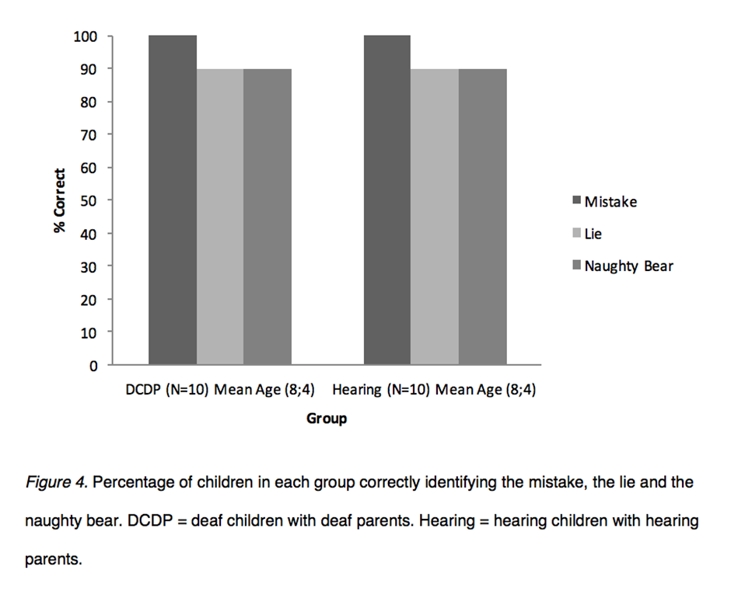
Note. DCHP = deaf children with hearing parents.

Discussion
The present study investigated how language and conversational access is related to deaf and hearing children’s ability to draw pragmatic inferences about the communicative intentions behind false statements concerning distinguishing a lie from a mistake. The hearing children in the current study reached ceiling by 7 years of age in line with previous studies (Siegal & Peterson, 1996). The deaf children with good language, and presumably experience of early communicative interactions with their deaf parents (DCDP), did not differ significantly from age matched hearing children. Although the DCDP group is small, there is clearly a positive role of access to sign language for this group.
However, as predicted, the deaf children with poor language and less successful early conversational interactions as their parents were hearing (DCHP), had substantial difficulty with this task when compared with hearing children of the same chronological age. Language access via sign language can support pragmatic skill development in DCHP only if, of course, parents are able to sign. The diversity of the DCHP group in terms of age of cochlear implantation means that while this group have parents who speak fluently, the deaf children nevertheless experience reduced access to conversations in the spoken language modality. All children included in the analyses had a minimum language age of 3 years and passed control questions indicating they knew which bear was knowledgeable and which was ignorant. Performance was equivalent when DCHP were matched for receptive vocabulary with hearing children. There are two possible interpretations for this set of results.
The first possibility is that the DCHP had difficulty understanding the lexical items specific to the test questions (i.e., the words ‘lie’ and ‘mistake’). On this account, children cannot label the misdemeanours they observe even though they understand the communicative intentions. We were careful to exclude any children with a language age below 3 years for whom a verbal test may not be appropriate. We also included an additional question about which bear was ‘naughty’ in an effort to avoid reliance on the terms ‘lie’ and ‘mistake’. However, DCHP were still delayed in their understanding of the concept of why lies and mistakes differ. Future studies might consider training children in the understanding of the term ‘naughty’ in a different domain (i.e., intentional misdemeanour of a non-ToM variety). One could then be more confident that the lexical item had been understood, and any mistakes were specific to understanding communicative intentions.
We argue a more likely interpretation of the results, is that DCHP have a genuine delay in pragmatic development. Although children were aware of which bear was knowledgeable, they were less able to take the extra step of reasoning about his communicative intentions (i.e., that he was being deliberately deceptive). The most likely explanation for this pragmatic delay would be limited access to conversations involving similar real world scenarios compared to the hearing children and the DCDP (Jeanes et al., 2000; Meristo et al., 2016; Most et al., 2010; Rinaldi et al., 2013). Conversational experience could be effective in three specific ways. First, it could promote the understanding that interlocutors have contrasting perspectives and motives. Second, conversation could provide incidental exposure to lies and mistakes. Third, conversation could include explicit meta-linguistic talk about lying (or being mistaken) and the intentions behind it (Morgan et al., 2014).
When the DCHP were matched for receptive vocabulary with hearing children, the observed discrepancy disappeared. Children’s scores on the vocabulary measure can be seen as a proxy measure for the richness of previous language exposure, albeit a crude one. Previous studies have consistently found that vocabulary comprehension is a predictor of false belief test performance in deaf and hearing children (e.g. Schick et al., 2007). The present study suggests the same is true for the ability to distinguish lies and mistakes. This is consistent with studies of pragmatic ability in typically and atypically developing children, where formal and pragmatic language skills are observed to be correlated (Matthews, Biney, & Abbot-Smith, 2018; Norbury, 2014). It is important to note that 11 of the 26 DCHP did not have cochlear implants, rather bilateral hearing aids. It stands to reason that this group could be particularly limited in terms of access to conversational interaction and their language acquisition. However, although having a cochlear implant means increased access to sound, they do not necessarily ensure language abilities will be within normal limits (see Vlastarakos et al., 2010 for a meta-analytic review of infants with cochlear implants and their outcomes), nor do they ensure typical pragmatic development. Most et al. (2010) found no differences in pragmatic abilities between children with cochlear implants and children with hearing aids in childhood. In the current study, as the majority of children who did have cochlear implants did not receive these early, it is possible that early implanted children may perform better on the task given their early increased access to language. However findings from Rinaldi et al. (2013) suggests that even early implanted DCHP have poor basic pragmatic skills in the first years of life.
It is interesting to note that only one DCHP failed at least one control question (who was excluded as a result) concerning each bear’s knowledge state. These control questions required some social cognitive skill namely being aware that seeing leads to knowing, and conversely not seeing results in ignorance (something that typically occurs around 3 years of age, see Hogrefe, Wimmer, & Perner, 1986; Pratt & Bryant, 1990). This emphasises how more complex reasoning about others’ communicative intentions does not follow as a matter of course (O'Reilly et al., 2014). Being aware of others’ mental states, and using this awareness to make inferences about communicative intentions are separable abilities.
A more detailed measure of children’s communicative experiences with their parents would have provided a clearer profile of each group’s access to conversational interaction. Future studies could ask parents via a questionnaire, how often they communicated with their children about people’s beliefs, intentions and speech acts such as jokes, mistakes, lies, and sarcasm. They could also ask about communication in the home more broadly (the modalities used and the parents' self-assessed fluency). Although the present study reported the modality of the deaf parents, details of the DCHP were restricted to their own primary mode of communication, which provided an insight into their communication modes at home, but not details on the modalities parents were using.
It was the case that the DCDP in this study were reported to have age-appropriate language by their teachers. This would not necessarily be the case for all DCDP in future studies and could impact findings in subsequent research. Findings from the present study that DCDP perform at the same level as hearing children suggest that DCDP might demonstrate a similar developmental trajectory to their hearing peers, and emphasises the vital importance of early accessible language and fluent communication to the establishment of ToM. However, due to the small sample size and that most DCDP were over 7 years, it is difficult to argue that DCDP demonstrate the same developmental trajectory as hearing children without additional data from younger children. Furthermore, to confirm that DCHP did not differ from language matched hearing children we would require a larger sample size (around N = 78 to detect a potential small-medium sized effect with 80% power).
The significant delays in pragmatic development for DCHP highlights that there is a risk that communicative delays can have negative consequences for real world social wellbeing (C. Peterson, Slaughter, Moore, & Wellman, 2016). Although research on how to support early communication skills has been reported (Holzinger, Fellinger, & Beitel, 2011; Moeller, 2000; Rees et al., 2015; Yoshinaga-Itano et al., 1998), it remains quite rare and therefore evidence to inform practitioners on how to support deaf children’s wider social-cognitive development is lacking. This should be a priority for future research.
In sum, DCHP are delayed in their ability to distinguish lies from mistakes. Delayed pragmatic development can have profound consequences for interactions with others, and the current findings along with a growing body of longitudinal and experimental studies suggest that deaf children who have reduced access to early conversational interaction would be particularly vulnerable to this. Future research should consider the viability of interventions to promote conversational interaction for DCHP and test whether such interventions are effective in promoting three areas of development; 1) mental state understanding; 2) formal language; and 3) pragmatics.

The Road to Language Acquisition: Exploring the Communicative Skills of 12- and 18-Month-Old Infants with Hearing Loss
Chapter 1 provides a summary of the delays in language acquisition (as well as social cognitive development) exhibited by many deaf children with hearing parents (DCHP), while Chapter 2 provides an overview and findings suggesting DCHP can often be delayed in several pragmatic skills (i.e., their competence in using and understanding language in its social context). As it is clear these language delays can be expected for many DCHP, attention has shifted towards improving outcomes. To do so however, it is important to develop our understanding of why delays are prevalent. As discussed in Chapter 1, it is well understood in the literature that a child’s language development is influenced by their access to language, but also by contributions from both infant (i.e., their pre-linguistic communicative skills) and parent (i.e., scaffolding behaviours) that interact with one another in a bi-directional way. Thus, exploring these contributions in deaf infant-hearing parent dyads is vital to developing a fuller understanding of the language delays apparent in many DCHP. Indeed, much research has focused on parent contributions within these dyads, with evidence suggesting many hearing parents of deaf infants face difficulties scaffolding their infant’s development. The impact of this on language development is further explored in Chapter 4 in consideration of an intervention to support parent scaffolding. Given that infant pre-linguistic skills not only influence parent contributions, but also form the foundations for later language, any delays or deficits in these skills would also likely have a negative impact on language development. It is therefore important to explore the pre-linguistic abilities of deaf infants with hearing parents (DIHP) to form a complete picture. To date however, this remains relatively underexplored (for the most part) and is therefore the focus of the study presented in this chapter.

Introduction
Towards the end of their first year of life, typically developing infants reach major developmental milestones in terms of their communicative skills, skills which not only pave the way to language acquisition but also demonstrate their emerging understanding of others’ intentions, attention and knowledge, as they themselves become intentional beings (Tomasello et al., 2007). Within the year that follows, infants rapidly develop and hone these skills, and we begin to see their first steps into conventional language as they produce their first words. This increasing communicative competency is initially expressed through the use of communicative vocalisations and gestures. Additionally, when these behaviours become coordinated with gaze to the interlocutor, infants are assumed to have intentional control over communication (Bates, 1976). Thus, during this pre-linguistic time infants, become effective conversational partners with new skills which enable them to initiate and engage in a fundamental aspect of early social development, namely joint attention. This type of interaction involves both infant and caregiver coordinating and sharing attention together, to an object or event of mutual interest (Bakeman & Adamson, 1984; Tomasello, 1995), and is considered to be important for later language development (Tomasello & Farrar, 1986; Tomasello & Todd, 1983), as well as for later social-cognitive development (i.e., understanding of others’ mental states; e.g., Baron-Cohen & Ring, 1994).
It is widely accepted that infant pre-linguistic communicative skills form the foundations for formal language and thus, play an important role in shaping trajectories of language development (Adamson, 1995). Any deficits or delays in these skills would likely have negative consequences for language acquisition. Currently, less is known about the development of early communicative skills among deaf infants with hearing parents (DIHP), yet it is well established that this group tend to be delayed in their language development (see Lederberg et al., 2013 for a review). Indeed, a prominent contributor to these delays is limited access to a language-rich environment. Early identification and subsequent early use of hearing technologies (i.e., hearing aids and cochlear implants) has increased access to auditory information and improved spoken language outcomes for many deaf children (Harkins & Bakke, 2011). However, delays can often persist and vary due to a number of additional factors such as parent communication choices (e.g., auditory-oral or sign supported English), age of identification and intervention, success of hearing technologies, and parental involvement to name a few (Lederberg et al., 2013). For the small number of deaf children with hearing parents learning natural sign language, delays can also be expected (in comparison to deaf children with deaf parents), which are often attributed to lack of proficiency preventing hearing parents from providing a rich, fluent sign language model (Knoors & Marschark, 2012; Spencer & Marschark, 2010).
The road to language acquisition for many deaf children with hearing parents is clearly a difficult one, and would likely be further complicated if delays extend to their pre-linguistic communicative skills. Developing a clearer understanding in terms of the potential contributing factors to deaf children’s delayed language development is important, particularly when considering interventions to improve outcomes. Given that the development of early communicative skills is, for the most part, underexplored in DIHP, the present chapter aims to investigate the extent to which the developmental trajectories of these skills may differ, for DIHP in comparison to their hearing peers. In what follows, we provide a brief overview (see Chapter 1 for a detailed review) of early communicative skills and their predictive value for later language outcomes, before reviewing existing literature on development in DIHP in order to highlight key areas requiring further exploration.

Pre-linguistic Communicative Skills: Typical Trajectories

Vocalisations and gestures
Pre-linguistic vocalisations are important for later language outcomes in terms of both phonological development and communicative skill. From around 6 to 8 months of age, infants take an important step in their phonological development by beginning to produce speech-like consonant-vowel (CV) syllables (i.e., babble; Oller, 1980). This repertoire continues to expand, increase in speech-like nature, and become more characteristic of the infant’s ambient language over the following year (Majorano & D'Odorico, 2011; Oller, 1980, 2000; Stoel-Gammon, 2011). Production of CV syllables is considered to be a necessary prerequisite for language acquisition, given that an infant’s inventory of CV syllables provides them with the necessary building blocks to produce their first words (Stoel-Gammon, 2011). Indeed, age of onset is correlated with onset of first words (McGillion, Herbert, et al., 2017; Stoel-Gammon, 1992). Furthermore, at around 12 months the amount and diversity of CV syllables produced by the infant is predictive of later language skill (Stoel-Gammon, 1992). Specifically, evidence from infants with delayed expressive language suggests a relationship between vocalisations containing true consonants (i.e., all consonants except for glides and glottal stops) and lexical development (Paul & Jennings, 1992; Thal, Oroz, & McCaw, 1995; Whitehurst et al., 1991).
It is also around this age (their first birthday) that infant babble becomes increasingly communicative, evidenced by various markers of intentional communication. For example, Esteve-Gibert and Prieto (2012) provide evidence to suggest that by 11 months, infants use distinct prosodic patterns to convey specific pragmatic functions (see also Papaeliou & Trevarthen, 2006). It is also thought that around this age, gaze to caregiver’s face when vocalising is an indicator that vocalisations are communicative (D'Odorico & Cassibba, 1995), and has been shown to be predictive of language development (Donnellan et al., 2018; Murillo & Belinchón, 2012). Another means through which infants are thought to express their intentional communication is through the use of referential gestures (showing, giving and pointing; Bates, Benigni, Bretherton, Camioni, & Volterra, 1979). Infant pointing has received the most attention as it is considered to be an important social-cognitive and linguistic developmental milestone (marking an intention to share attention – a proto-declarative) that predicts later language development (Carpenter et al., 1998; Colonnesi et al., 2010; Tomasello et al., 2007). Furthermore, some consider infant pointing to be a prerequisite for lexical development (Tomasello, 2008). Reports on emergence of pointing ranges from 9 to 15 months of age however, there is a general consensus that emergence occurs around 12 months of age (Camaioni et al., 2004; Carpenter et al., 1998; Leung & Rheingold, 1981) and is typically consolidated by 18 months (e.g., Carpenter et al., 1998). Both the onset of pointing and the amount of points produced at around 12 months are related to subsequent vocabulary development (R. Brooks & Meltzoff, 2008; Carpenter et al., 1998; Harris, Barlow-Brown, & Chasin, 1995).
The communicative gestures of showing and giving objects to a communicative partner have received much less attention. In terms of emergence, reports indicate this occurs at around 10 months (Cameron‐Faulkner et al., 2015; Carpenter et al., 1998; Caselli, Rinaldi, Stefanini, et al., 2012), with evidence suggesting they are precursors to infant pointing with a similar underlying social-cognitive construct (Cameron‐Faulkner et al., 2015). In terms of predictive value, showing and giving have been observed to predict vocabulary development, albeit less well than infant vocalisations (Donnellan et al., 2018). Furthermore, Beuker et al. (2013) found that infants who directed attention using showing, giving and pointing (collapsed into one group) between 9 and 10 months of age, displayed larger expressive vocabulary at 18 months, and larger receptive vocabulary at both 12 and 18 months. Finally, representational gestures (Bates, 1979) which are consistent in form, represent a referent, and indicate specific semantic content provide infants with a pre-linguistic way to convey meanings. They emerge around the beginning of the second year of life may be related to early vocabulary development (Acredolo & Goodwyn, 1988).

Gaze checking and coordinated communication
Gaze to their caregiver’s face enables infants to establish a communicative link (Farroni, Csibra, Simion, & Johnson, 2002), as well as to perceive paralinguistic features and information about their interlocutor’s attentional state (i.e., their availability and line of sight, which can aid comprehension of the communicative message). Additionally, when coordinated with a communicative behaviour (i.e., vocalisation or gesture), gaze to caregiver’s face can be considered a marker that the infant is being intentionally communicative (Bates et al., 1975; Carpenter et al., 1998). Gaze coordinated communicative behaviours may also be related to later language development. As previously highlighted, gaze coordinated vocalisations at 12 months have been reported to be strongly associated with lexical development at 15 months (Donnellan, 2017; Donnellan et al., 2018; Murillo & Belinchón, 2012). Gestures, particularly referential ones, when coordinated with gaze at 9 and 12 months have also been reported to be associated with later expressive as well as receptive language outcomes (Beuker et al., 2013; Murillo & Belinchón, 2012).
Another type of coordinated communication that has perhaps received the most empirical attention is the co-occurrence of infant gestures and vocalisations. Not only is there evidence to suggest these gesture-vocalisation combinations are intentional (Grünloh & Liszkowski, 2015; Liszkowski, Albrecht, Carpenter, & Tomasello, 2008), there is also evidence to suggest that they are predictive of later language outcomes. For example, Igualada et al. (2015) found that infants’ coordination of deictic gestures and vocalisations at 12 months, significantly predicted expressive vocabulary and grammatical skills at 18 months. When infants shift to the first word stage, this predictive value holds as gesture-word combinations are predicative of the two word stage (Iverson & Goldin-Meadow, 2005). Finally, when coordinated with gaze to caregiver at 12 months, gesture-vocalisation combinations are reported to be a predictor of lexical development (Murillo & Belinchón, 2012).

The Pre-Linguistic Communicative Skills of Deaf Infants with Hearing Parents: Current Knowledge
In one of the few studies to explore DIHP’s pre-linguistic communicative skills, Spencer (1993) reports that DIHP communicate with their mothers at the same rate as HIHP at 12 and 18 months suggesting equal motivation to communicate. It is not until around 3 years of age that differences in communication have been reported to appear. Lederberg and Everhart (1998) found that by 3 years of age, DIHP communicated half as much as HIHP and communicated more through non-linguistic means (i.e., gestures) and less through conventional language in comparison to their hearing peers. Additionally, upon further investigation of the same sample, Lederberg and Everhart (2000) report that the communication of DIHP appears to be more limited in terms of pragmatic function (i.e., communicative use) at 3 years, as well as at 22 months (see also Rinaldi et al., 2013 for similar findings). It is therefore thought that although DIHP are motivated to communicate, their limited conventional language restricts how much they can communicate and the pragmatic functions of their communication (Lederberg & Everhart, 1998, 2000). Although it appears that prior to this stage (i.e., the pre-linguistic stage), DIHP have no difficulties in communicating (Spencer, 1993), the nature of their communication remains unclear specifically in terms of the communicative skills known to be predictive of early language development (as well as widely accepted as markers of intentional communication). Given the evidence to suggest that it is how infants communicate (i.e., their use of communicative tools such as pointing) that is important for language development, a more fine-grained exploration of DIHP communicative skills is warranted.
In Spencer’s (1993) longitudinal study comparing the communicative skills of 18 DIHP (with moderate to profound hearing loss) to 18 HIHP when they were 12 months and 18 months, the author explored a range of communicative skills including gestures and vocalisations. Groups were compared for total number of “preconventional gestures”, which included “pointing directly on object”, “reaching toward object with open hand”, and “angrily swatting at toy offered by mother”. No significant differences between groups were found although DIHP did produce slightly more at 12 and 18 months. Groups were also compared for total number of “conventional gestures with cultural meaning” (i.e, a subgroup of representational gestures; Bates, 1979), which included waving “bye-bye”, shaking head “no”, and “peak-a-boo”, with no significant differences between groups at either age. “Pointing toward object” was included as a category; however, there was no explicit report on infant pointing. Thus, it is unclear if infants were using referential gestures and to what extent. Spencer (1993) did however explore communicative vocalisations and found no significant differences at either age. To be considered intentionally communicative, the vocalisation had to be conventional (e.g., “uh-oh”, “no”, “meow”), or coordinated with either gaze to mother or a gestural communitive act, both of which as previously discussed are predictive of language outcomes. As gaze coordinated vocalisations and gesture-vocalisation combinations were collapsed together with conventional vocalisations, there were no individual reports. Thus, the individual nature of these behaviours between groups is unclear, particularly in terms of coordinated vocalisations. Given that early words has received much attention with evidence suggesting DIHP are delayed (e.g., Moeller et al., 2007), exploring the trajectories of coordinated vocalisations requires separate attention especially given their predictive role in the development of conventional language.
Infant vocalisations were also explored in terms of phonological development, which is the one infant predictor of language development to receive the most empirical attention in DIHP. Hearing infants produced significantly more CV vocalisations than DIHP at 12 and 18 months, which is in line with existing findings (Steffens, Eilers, Fishman, Oller, & Urbano, 1994; Stoel-Gammon, 1988). Finally, gaze coordinated gestures and gaze coordinated gesture-vocalisation combinations were not explored in Spencer’s (1993) study, and although the coordination of gestures and vocalisations were explored, it is unclear if referential gestures were included. The inclusion of referential gestures is particularly important given that when coordinated with a vocalisation, they are predictive of expressive vocabulary and grammatical skills (Igualada et al., 2015).
In a relatively similar study to Spencer (1993), Robinshaw (1996) followed the pattern of communication development in 5 DIHP (with severe to profound hearing loss) and 5 matched HIHP when infants were 6, 9, 12, 15, 18, and 21 months old. In their exploration of intentionally communicative behaviours, the author explored gaze coordinated gestures and gestures coordinated with vocalisations which were collapsed together as a measure of communicative gestures. Rather than frequencies, percentage of sequences of social interaction including communicative gesture were reported within two interaction contexts (a sequence of social interaction was initiated by either a joint activity by caregiver and infant or an initial instance of mutual gaze or joint attention. The sequence was terminated when either infant or caregiver looked away). In the gesture eliciting experimental paradigm, both groups of infants used gesture in coordination with either gaze or vocalisation between 10 and 13 months, with pointing initially dominating for all infants. A slightly higher percentage of interaction including communicative gestures was reported in the HIHP at 12, 15 and 18 months. Similarly, in the context of picture book reading there was a steady increase in the percentage of interaction to include gesture-vocalisation combinations for HIHP from 12 to 18 months. For DIHP however, there was a more gradual transition in use of gesture-vocalisation combinations and an increasing divergence from HIHP with age. Gaze coordinated gestures were not explored in this context given that gaze to caregiver rarely occurred for both groups due to positioning. Although Robinshaw (1996) explored gaze coordinated gestures and gesture-vocalisation combinations with findings suggesting a potential delay, the statistical comparisons between groups were limited to descriptive statistics (i.e., percentages). Moreover, the trajectory of gaze coordinated gestures is less clear as there was no individual exploration of this behaviour. Finally, similar to Spencer (1993), the type of infant gesture used in coordinated communication was not reported (although pointing was listed as an example), and the trajectories of referential gestures (i.e., pointing, showing, giving), and gaze coordinated gesture-vocalisation combinations were not explored.
Taken together, alongside a lack of similar studies, it appears that a number of communicative skills known to be predictive of later language development remain unexplored (i.e., referential gestures and gaze coordinated gesture-vocalisation combinations), while others are limited in their exploration (i.e., gaze coordinated vocalisations and gaze coordinated gestures). Furthermore, Spencer (1993) and Robinshaw (1996) report contrasting findings in relation to gesture-vocalisation combinations (although in both studies these behaviours were collapsed with other behaviours limiting conclusions). Further exploration is therefore imperative to provide a clearer understanding of the developmental trajectories of these communicative skills in DIHP.

The Present Chapter
To address the gaps, limitations, and contrasting findings in the literature, the aim of present study was to conduct a more fine-grained exploration of DIHP’s pre-linguistic communicative skills in comparison to their hearing peers, with specific focus on those behaviours thought to play a role in language development (as well as indicate early social-cognitive skills). Such an exploration is important to gain a clearer understanding of the skills DIHP are using during interaction, and to what extent they are using them (i.e., the magnitude of potential differences). Identifying potential differences could be beneficial in informing current understanding of language delays in DIHP, and allow for interventions to target specific problem areas. Thus, the occurrence of individual types of gesture (i.e., pointing, giving, showing, and representational gestures), gaze coordinated vocalisations, gaze coordinated gestures, gesture-vocalisation combinations, and gaze coordinated gesture-vocalisation combinations were explored in DIHP aged 12 and 18 months during naturalistic parent-infant interaction. Skills were explored in comparison to HIHP matched for age, gender and socio-economic status (SES). Although measured to explore in coordination with other behaviours, a report on use of CV and non-CV vocalisations (i.e., vocalisations not containing any true consonants) is provided to check for equivalence with previous studies. The beginnings of conventional language are explored for the same purpose, as well as to provide a more complete developmental profile of infant transition from the pre-linguistic to first words stage.
Infant gaze to their caregiver’s face was measured to explore its coordination with other behaviours. However, we additionally explore the frequency of infant looks to their caregiver’s face and how much time they spend visually attending to their caregiver’s face during interaction given that, for DIHP in particular, visual attention to their mother’s face has been shown to predict deaf children’s language ability at 18 months (Spencer, Meadow-Orlans, Koester, & Ludwig, 2004). Indeed, not only does the face hold paralinguistic information that could help comprehension of the communicative message, it also allows the infant the opportunity to perceive sign and speech-read, which can enhance speech perception for deaf children (as well as for hearing children, Alegria, Charlier, & Mattys, 1999; Arnold & Köpsel, 1996). Current evidence suggests somewhat mixed findings depending on how gaze is measured. For example, Meadow‐Orlans and Spencer (1996) report gaze alternation defined as switching of attention at least twice between mother and object, occurs much less in DIHP in comparison to HIHP at 9, 12, and 18 months. Robinshaw (1996) on the other hand, report findings to suggest that gaze alternation during free play (measured as one switch) may be similar between groups at 12 months, with HIHP coordinating more at 15 and 18 months. Interestingly, however, there were more similarities between groups in a behaviour eliciting context at 12, 15 and 18 months. Given that gaze alternation is often used to operationalise joint attention (Carpenter et al., 1998; Mundy & Newell, 2007), this likely has implications for both maintenance of joint attention and access to language as gaze alternation allows deaf infants to sequentially, visually attend to an object of mutual interest and their caregiver’s commentary making it easier to observe relations between language and the functions it performs (Swisher, 1992). In specific assessment of visual attention to spoken language, Lederberg and Everhart (1998) report that DIHP visually attended to a similar number of spoken utterances as their hearing counterparts at 22 months, which meant only one third of spoken utterances were visually attended to (see Prendergast & McCollum, 1996 for similar findings in terms of visual attention to sign). Considering the varied findings depending on measure and context, the present chapter reports findings on more general infant looking behaviour during interaction to provide a more global perspective of infant gaze patterns during naturalistic interaction.
Finally, infant communicative skills are often explored in an experimental, behaviour eliciting setting (e.g., Robinshaw, 1996; although note this was in the infants' home), or in a semi-naturalistic setting (e.g., observations of free play in a laboratory; Spencer, 1993). Such settings are a valid and useful means of exploring infant behaviours. For example, behaviour eliciting settings are useful when demonstrating potential competence (i.e., exploring if infants can produce a specific behaviour). However, naturalistic settings can provide important insights into the frequency of spontaneous communicative events. Given that the salient nature of infant communicative behaviours often elicits language facilitating parental responses, which subsequently contributes to the relationship between infant communicative skills and later language development (Yoder & Warren, 1993, 1999), it is important to explore infant communicative skills as they would naturally occur. Doing so provides insight into the potential opportunities available to parents to scaffold communicative development in their typical environment. Thus, the present study used the naturalistic setting of infants’ homes.

Method

Recruitment
Participants were recruited through the National Deaf Children’s Society’s (NDCS) database of families with children with a hearing loss in the United Kingdom, and the Sheffield Service for Deaf and Hearing Impaired Children. Two-hundred and sixty families in the NDCS database received a flyer, either by post or by email, inviting them to take part in research involving the present study and a parent-based intervention reported in Chapter 4. The recruitment process through Sheffield Service for Deaf and Hearing Impaired Children involved providing the same flyers to a team of teachers of the deaf, who then relayed the flyers to the families they support. Those interested in participating contacted the Cognitive Development group at the University of Sheffield directly, and were added to their volunteer database. If parents on the volunteer database were eligible to take part, they were then contacted and provided with an information sheet outlining what their participation would involve.
Eligibility was based on several criteria: prematurity (no more than 3 weeks premature); birth weight (> 2.5 kilograms); bilateral hearing loss (unaided moderate to profound); no other disabilities or developmental delays; and parents without hearing loss. Developmental delays were determined either by parental report (often in relation to a disability or syndrome), or by answers to screening questions on gross motor developmental milestones (age child could crawl and walk alone without support). One family from Sheffield Service for Deaf and Hearing Impaired Children contacted the Cognitive Development group and proceeded to take part. Twenty-six families from the NDCS database contacted the Cognitive Development group and 8 proceeded to take part. The remaining families did not take part for various reasons: 8 were not eligible, 6 decided not to proceed due to time constraints, and 4 initially agreed to take part; however, due to scheduling difficulties, withdrew.

Participants
Of the 9 deaf infant-hearing parent dyads who were eligible, 1 child was excluded as although both parents were bilingual (Mandarin as their first language, English as second), the mother preferred to interact with her infant in Mandarin only. As cultural differences could preclude the accurate coding of gestures, and translation of interaction was beyond the scope of the study, this participant was excluded. The remaining 8 infants participated in the present study. In the 12-month group, 3 were aged 12 months and 1 had just turned 13 months by visit 1 (Mean 1577 days; Range 387 to 403 days), 2 were boys. In the 18-month group, 3 were aged 18 months and 1 had just turned 19 months by visit 1 (Mean 2282 days; Range 559 to 587 days), all were boys. All infants were diagnosed with hearing loss through newborn hearing screening within 3 weeks of birth, and received bilateral hearing aids by 15 weeks. For 1 infant (participant 6), both mother and father participated as they both expressed a desire to take part. Parents were therefore 8 mothers and 1 father. All parents were monolingual (spoken English); however, 4 were learning British Sign Language signs to support spoken English. None of the participating parents had any known serious physical, mental or learning disabilities. See Table 4 for further participant information. Parents’ education level was determined by UK Government guidelines (Department for Education and Learning, n.d.) where 1 = GCSEs (grades D-G), NVQ level 1; 2 = GCSEs (grades A*-C), NVQ level 2; 3 = A levels, NVQ level 3; 4 = NVQ level 4; 5 = NVQ level 5; 6 = Bachelor’s Degree with Honours; 7 = postgraduate degree/certificate/diploma; 8 = Doctorate. This study was approved by the Ethics Committee in the Psychology Department at the University of Sheffield.
Table 4
Participant Characteristics and Background Information
DIHP Participant Number, Gender | 1, M | 6, F | 9, F | 3, M | 7, M | 5, M | 8, M | 4, M
ªAge at 1st Visit | 12m 21d | 12m 25d | 12m 30d | 13m 7d | 18m 12d | 18m 17d | 18m 20d | 19m 9d
Left Ear Loss | Moderate-Severe | Profound | Severe-Profound | Moderate-Severe | Moderate | Severe | Moderate | Moderate
Right Ear Loss | Moderate | Severe | Moderate-Severe | Profound | Moderate | Severe | Severe | Moderate
Age HA Received | 5 weeks | 12 weeks | 9 weeks | 15 weeks | 15 weeks | 12 weeks | 8 weeks | 6 weeks
Siblings | None | None | 2 older (hearing)^{b} | None | None | 1 older (hearing) | None | 1 older (hearing)
Home Communication | Spoken English | Spoken English, some SSE | Spoken English & SSE | Mostly SSE | Spoken English | Spoken English | Spoken English | Spoken English, some SSE
Parent Qualifications | Mother: 6 | Mother: 6 | Mother: 6^{c} | Mother: 5^{c} | Mother: 6 | Mother: 2 | Mother: 8 | Mother: 6^{c}
 | Father: -- | Father: 6 | Father: 6 | Father: 2 | Father: 6 | Father: 3 | Father: 8 | Father: --
Primary Caregiver | Mother | Mother | Mother | Mother | Mother | Mother | Mother | Mother
Other Caregivers | Father | Father | Nanny, Father | Father | Father | Father | Father | Father
Time at Nursery | None | 2 days | None | None | 2 x 0.5 days | None | None | None
Nursey Communication | NA | Spoken English | NA | NA | Spoken English | NA | NA | NA
SES (IMD decile) | 6 | 6 | 7 | 5 | 2 | 4 | 7 | 6
HIHP Participant Number, Gender | 71, M | 60, F | 63, F | 13, M | 40, M | 56, M | 59, M | 146, M
Primary Caregiver | Mother | Mother | Mother | Mother | Mother | Mother | Mother | Mother
Other Caregivers | Father | Father | Father | Father | Father | Father | Father | Father
Time at Nursery | None | None | 3 days | None | 3 x 0.5 days | None | None | 1.5 days
SES (IMD decile) | 6 | 6 | 7 | 5 | 2 | 4 | 7 | 6
Parent Qualifications | Mother: 3 | Mother: 3 | Mother: 6 | Mother: 6 | Mother: 3 | Mother: 6 | Mother: 6 | Mother: 3
 | Father: 3 | Father: 6 | Father: 7 | Father: 3 | Father: 3 | Father: 6 | Father: 1 | Father: 2
Note. SES = Socioeconomic Status. IMD decile = Indices of Multiple Deprivation decile (where areas considered to be within the most deprived 10% of England and Scotland = 1, and areas considered to be within the least deprived 10% of England and Scotland = 10). DIHP = deaf infant with hearing parents. HIHP = hearing infant with hearing parents. HA = hearing aids. SSE = Sign Supported English. -- = missing/incomplete data. ªAge is in months and days. ^{b}Half siblings who do not live in the family home. ^{c}Additional professional qualifications.
Control-group participants were 8 hearing infant-hearing parent dyads who were visited as part of a separate longitudinal study at the University of Sheffield investigating parent infant interaction at 11, 12, 15, 18 and 24 months (see Table 4 for participant characteristics). Data for this group was collected using the same procedure and materials as the present study. All infants were full term (born no more than three weeks before due date), with a birth weight over 2.5 kilograms, and had no known developmental disorders or hearing loss. All parents were mothers, monolingual (spoken English), and none had any known serious physical, mental or learning disabilities. The hearing infants (HIHP) were matched to the DIHP for gender and SES, which was determined using the English and Scottish Indices of Multiple Deprivation (which are based on the area in which participants live i.e., participant postcode). Infants were also matched as closely as possible to the DIHP for age. For further details, see Table 5.
Table 5
Participant Matching
 | Age in Days (Participant Number)
DIHP | 387 (1) | 403 (3) | 587 (4) | 566 (5) | 391 (6) | 559 (7) | 570 (8) | 396 (9)
HIHP Match | 367 | 368 | 563 | 569 | 369 | 567 | 567 | 369

Procedure
Parents were visited three times across one week for the present study, and a feasibility intervention study (reported in Chapter 4), when their infant was around either 12 or 18 months of age. Data for the present study was collected at visit 1, and the first half of visit 2. Visit 1 and 2 were one to two days apart. Prior to the first home visit, parents received an information sheet detailing the three visits, and appointments were arranged for a time that was convenient for the parent and undisruptive to the infant’s routine. In addition to the procedures reported below, psycho-social questionnaires, a Language Environment Analysis (LENA) recording, and a test of gaze following were administered. The questionnaires were collected for an MSc project. Methodological limitations meant LENA and gaze following measures could not be analysed.

Visit 1
The main purpose of visit 1 was to familiarise parents with the procedure, and to increase comparability with the HIHP group as parents in this group experienced the same procedure when their infants were 11 months old. Video and audio data collected at visit 1 was not analysed.

Consent forms and questionnaires
The researcher confirmed that the parent had received the information sheet and gave them the opportunity to ask any questions before asking them to complete a consent form agreeing to their and their infant’s participation. All participants were told that they were taking part in research exploring the communicative development of infants with hearing loss, as well as an intervention designed to support parent-infant communication. Parents were then provided with a demographic questionnaire to complete independently by visit 3. Participants were also given a pack of psycho-social questionnaires presented in an envelope identified only by participant number.

Video recordings
If parents confirmed that they were happy to proceed to the next stage of the visit, 2 x camcorders were assembled on tripods in a room in the family home where parents typically played with their infant (this was either their living room or child’s play room, which varied in size). The camcorders were placed at opposite ends of the room where possible. In cases where this was not possible (due to lack of a suitable surface e.g., child could reach the camera), camcorders were positioned on the best available surfaces that provided good coverage of the play space. Once set-up, recording began. Recordings were made on a SONY HDRCX220 Full HD camcorder, and a SONY HDR-PJ220EB Full HD Camcorder.

Play sessions
The parent and their infant were then video recorded playing together for 30 minutes. The first 15 minutes of the recording were unstructured, where parents were asked to play as they normally would, and to try to remain within the range of the cameras. Aside from this, parents were given no further guidance in structuring the interaction. When this 15 minutes elapsed, the researcher re-entered the room with a set of toys (a soft ball, stacking cups, wooden toy mobile phone, 5 x rubber bath toys and 10 x wooden blocks). Parents were given these toys to play with for 10 minutes. Finally, when 10 minutes elapsed, the researcher re-entered the room with a book (Usborne Touchy-Feely Farmyard Tales, Animal Hide-and-Seek). Parents were given the book to read with their infant for 5 minutes. The researcher left the room for the duration of all recordings.

Visit 2
The researcher set up the same two camcorders on tripods at opposite ends of the room (where possible) and followed the same procedure as visit 1 for the video-recorded play sessions; unstructured play, structured play and book reading. The 5 minutes of book reading was recorded as part of baseline for the intervention study, and was therefore not coded and analysed in the present study. Play sessions were uninterrupted except for a few occasions when either the infant or parent briefly left the room (three cases when the parent briefly left the room [2 DIHP dyads and 1 TD dyad], and one case when the child briefly left the room [1 DIHP]). Any such time was not included for coding.
At the end of the video-recorded play sessions, the researcher administered a questionnaire asking parents to reflect on how representative the recorded interaction was in terms of how they would usually play with their infants. Parents were asked how often they play together in that way (e.g., every day, never), and how typical the video-recorded plays session was on a scale of 0 to 10 (0 being completely different, 10 being exactly the same as usual). The average score across participants was 8.44 (Range: 7-10) indicating that for all parents the video recorded play session was reflective of their typical play. Parents also had the opportunity to note if anything might have made the session difficult, for example, if their child was tired. Three parents reported infant tiredness, 3 reported parent tiredness, 4 reported infant teething, 3 were aware of the cameras, and 1 felt slightly anxious about being videoed. Finally, parents were asked how typical the video-recorded book reading session was on a scale of 0 to 10 (0 being completely different, 10 being exactly the same as usual). The average score across participants was 7.86 (Range: 6-10) indicating that for most parents the video recorded book reading session was reflective of their typical play. Once this was completed, parents then participated in the intervention study.

Coding & Measures

Video recorded play sessions
Audio files (.wav) were extracted from each video-recorded play session using Adobe Premier Pro CS4, to provide a waveform to determine onset and offset of infant vocalisations. The two video files and the audio file were then synchronised and coded using EUDICO Linguistic Annotator software (ELAN; Sloetjes & Wittenburg, 2008). Both unstructured and structured video sessions were coded for all infant behaviour measures. For participant 6, the unstructured video dyad is infant-father and the structured video dyad is infant-mother, as it would have been too demanding for participant 6 to take part twice (one 30-minute session per parent) for the intervention study. All coding was completed by the author. The coding scheme reported in Donnellan (2017) was largely followed with minor adaptations.

Ensuring equal observable coding time across participant videos
Coding commenced from the moment the experimenter left the room for each video session. Coding stopped once 15 minutes had elapsed for unstructured videos and 10 minutes had elapsed for structured videos, or until the experimenter re-entered the room (if this was prior to the session target time). To ensure that each video had equal observable coding time across participants, it was necessary to account for factors that might preclude the coding of a potential infant behaviour, for example, if the infant was out of screen shot making it difficult or impossible to determine if any behaviours occurred. All instances where the infant was out of screen shot (where the infant’s upper body including head/face was not visible on either camera) were annotated as “off-shot”, and no coding occurred within this period. Additionally, any instances where the infant’s arm(s) were not visible (and it was possible that they could have gestured) were annotated as “gesture unavailable”. Finally, all instances where it was not possible to determine if the infant was looking to the caregiver’s face (e.g., their head was obscured) were annotated as “gaze unavailable”. No coding occurred within any period marked as gesture or gaze unavailable to prevent the possibility of missing a coordinated behaviour.
For each video, all periods of off-shot, gesture unavailable and gaze unavailable were added together to determine the total amount of unobservable time. Thus, total observable coding time could be determined for each video. If this fell below 15 minutes for unstructured videos and 10 minutes for structured, extra video was coded where possible to compensate for any unobservable periods. Extra video typically occurred if the video recorded play session overran. If this was not possible and the observable coding time did not reach the target time (i.e., 15 or 10 minutes, play session dependant), then adjusted frequencies of behaviours were calculated and used throughout analyses. This was calculated as follows:
$$Frequency of behaviour x\left(\frac{Target time}{Actual observable time}\right)$$
For unstructured play, the total observable coding time for 4 DIHP and 6 HIHP was below 15 minutes (of the 4 DIHP, 2 had between 14 & 15 minutes, 1 had 13.5 minutes, and 1 had 11 minutes, 11 seconds. Of the 6 HIHP, 4 had between 14 & 15 minutes, 1 had 13 minutes, 40 seconds, and 1 had 11 minutes, 46 seconds). For structured play, total observable coding time for all participants was 10 minutes. Behaviour frequencies from the structured and unstructured sessions were combined for each participant. Thus, the frequencies of each behaviour used in analyses are from the full 25 minutes of video-recorded play.

Vocalisations
Initially, all infant non-vegetative vocalisations were coded. Vegetative vocalisations (e.g., crying, grunts, sighs), laughter and giggling were therefore not coded. This is in line with existing literature exploring gaze coordinated vocalisations (e.g., D'Odorico & Cassibba, 1995; Murillo & Belinchón, 2012). Vocalisations were considered separate if there was a perceivable silence of 200ms or more between them (Donnellan, 2017). Each infant vocalisation was categorised as either CV, non-CV or unclear. If a syllable in the vocalisation contained at least one consonant (C) and one vowel (V), the vocalisation was categorised as a CV vocalisation (in line with studies exploring gaze coordinated vocalisations e.g., Spencer, 1993). Only vocalisations containing true consonants (i.e., all consonants except for glides and glottal stops) were coded, particularly given the evidence from infants with delayed expressive language suggesting a relationship between CV vocalisations containing true consonants and lexical development (Paul & Jennings, 1992; Thal et al., 1995; Whitehurst et al., 1991). This is also in line with existing research (e.g., Donnellan, 2017; McCune & Vihman, 2001). All vocalisations that did not contain a true consonant were coded as non-CV vocalisations. Finally, any vocalisations that could not be determined as either CV or non-CV due factors precluding identification (such as environmental noise or overlap with the parent), were coded as unclear.
Frequencies of each type of vocalisation are reported across groups, as well as the total number of vocalisations (i.e., both CV and non-CV) produced by each group during the play session.

Gestures
All instances of infant pointing, showing, giving and use of representational gestures (specifically conventional ones) were coded. Frequencies of each behaviour are reported individually across groups, as well as the total number of these gestures produced by each group during the play session. Identification of each behaviour is outlined below.

Pointing
The body of literature exploring the pointing gesture tends to focus specifically on index finger pointing given that open hand pointing has not been associated with later language outcomes (Colonnesi et al., 2010; Lüke et al., 2017). Furthermore, not only are index finger points (and not open hand points) predictive of later language acquisition at 12 months, infants who point using their open hand, appear to be at risk for language delay at 2 years of age (Lüke et al., 2017). The index point may also be a better marker of infants’ social cognitive abilities (Liszkowski & Tomasello, 2011). Thus, all instances of index finger points and open hand points were coded. To be considered a point, one or both arms had to be extended, the hand(s) producing the gesture had to be empty, the infant could not be leaning forward, and could not be touching the object or event they were pointing at, all whilst looking at the object or event of interest (Matthews, Behne, Lieven, & Tomasello, 2012; McGillion, Herbert, et al., 2017). Points were categorised as index finger points if the infant’s index finger was clearly separate from the remaining fingers and thumb, which were either partially or entirely curled inwards to the palm, and extended towards the object or event the infant was looking at. Points were categorised as open hand points if the majority of fingers were extended towards the object or event the infant was looking at.

Giving and showing
All instances of gives and shows were coded. To be considered a give gesture, the infant had to hold out an object with one or both arms extended towards their caregiver’s hands (or into the vicinity of the caregiver; Cameron‐Faulkner et al., 2015; Carpenter et al., 1998). To be considered a show gesture, the infant had to hold out an object with one or both arms extended towards their caregiver’s face (Cameron‐Faulkner et al., 2015; Carpenter et al., 1998).

Conventional gestures
A subgroup of representational gestures known as conventional gestures, which are culturally defined were coded. This included but was not limited to, a wave for “bye-bye”, arms stretched upwards towards caregiver for “up”, a head nod for “yes”, and palms up for “all gone”. The total frequency of conventional gestures produced across groups are reported.

Gaze to caregiver’s face
All occurrences where the infant looked to their caregiver’s face were coded. A gaze to caregiver’s face began the instance it was judged that the infant’s gaze reached their caregiver’s face and ended the moment the infant began to look away. For each participant, the length of each look (in seconds) was summed to also provide a report on the total amount of time infants spent looking at their caregiver’s face.

Coordinated behaviours
Once all measures described above were coded, coordinated behaviours were then identified. To qualify as a coordinated behaviour, the target behaviours had to either overlap (completely or in part) or one target behaviour had to occur 1000ms before or after the other target behaviour (Donnellan, 2017; Matthews et al., 2012; Murillo & Belinchón, 2012). For example, in the case of gaze coordinated gestures, infant gaze to caregiver’s face had to overlap with all or part of a gesture or occur within the 1000ms before or after the gesture).

Gaze coordinated vocalisations
Given that gaze coordinated CV vocalisations may be a particularly strong predictor of expressive language (Donnellan, 2017), only instances of gaze coordinated CV vocalisations were identified.

Gaze coordinated gestures
All instances where infant gaze to caregiver was coordinated with a gesture (referential or conventional) were identified.

Gesture-vocalisation combinations
All instances where an infant gesture (referential or conventional) co-occurred with an infant vocalisation (CV or non-CV), following the restrictions described above, were identified.

Gaze coordinated gesture-vocalisation combinations
To be included as a gaze coordinated gesture-vocalisation combination, firstly, an infant gesture (referential or conventional) had to overlap completely or in part with a vocalisation (CV or non-CV) or one of these behaviours had to be produced within the previous or subsequent 1000ms window of the other behaviour (Murillo & Belinchón, 2012). Secondly, gaze to caregiver’s face had to occur during any moment of the gesture-vocalisation combination or in the previous or subsequent 1000ms window of the gesture-vocalisation combination (Murillo & Belinchón, 2012).

Conventional language: production of words and signs
All instances where infants produced a recognisable word were coded and transcribed orthographically according to CHILDES’s CHAT conventions (MacWhinney, 2000). Total word tokens (i.e., the total number of words produced) and total words types (i.e., total number of distinct words produced) are reported. Additionally, as the parents of 4 infants reported using some SSE, infant sign production was also coded for these infants as English translations. Total sign tokens (i.e., the total number of signs produced) and total sign types (i.e., total number of distinct signs produced) are also reported. As the parents using SSE did so to support the development of spoken language, only the production of words was included in comparative analyses as a measure of the beginnings of infants’ target language. Infant use of sign is however, reported individually. The coding of infant sign was completed by the author whose British Sign Language (BSL) was sufficient to identify infant signs.

Reliabilities
A trained research assistant coded 12.5% of the sample (n = 2, i.e., 4 of 32 videos). Infants were one 12-month-old DIHP and one 18-month-old typically hearing infant. Agreement on the frequency of gaze to caregiver, vocalisations, gestures, and behaviour combinations were high (r = .99, r = .99, r = .99, r = .98 respectively). To determine agreed identification of observed behaviours, inter-rater agreement was calculated. Inter-rater agreement was excellent for all behaviours coded including, gaze to caregiver (91%), vocalisations (92%), gestures (94%), and behaviour combinations (82%). For agreed gaze to caregiver behaviours, agreement was high for total time spent looking to caregiver (r = .91). For agreed vocalisations and gestures, Cohen’s Kappa was calculated, which was high for both vocalisations (κ = .81, p < .001) and gestures (κ = .98, p < .001).

Approach to Analysis
Using non-parametric Mann-Whitney U Tests, pairwise comparisons for each observed communicative behaviour were conducted to compare the DIHP and HIHP infants. Given the sample size, the present chapter will report the median as a measure of central tendency rather than the mean (as the median is less vulnerable to outliers). Additionally, Cohen’s r was computed as a non-parametric measure of effect size using a procedure suggested by Fritz, Morris, and Richler (2012) and interpreted using Cohen’s (1988) guidelines (i.e., small effects around r = 0.10, medium effects around r = 0.30 and large effects r ≥ 0.50). Cohen’s r was used as is not vulnerable to outliers and smaller sample sizes (i.e., as opposed to Cohen’s d; Rosenthal, 1994).

Results
Results are reported for three sets of analyses on all outcome measures from: 1) the total sample of DIHP and HIHP; 2) a subset of only 12-month-olds; and finally, 3) a subset of only 18-month-olds.

Comparisons Between Total DIHP and HIHP
Descriptive statistics for the total sample of infants (i.e., 12- and 18-month-olds combined, n = 8 DIHP and 8 HIHP) are presented in Table 6. Note that 5 vocalisations across 3 participants (all HIHP) were unclear and therefore are not included in either CV or non-CV categories but are included in total vocalisations.

Table 6
Descriptive Statistics for Communicative Behaviours (in 25 minutes of play) in Total Sample
 | DIHP |  | HIHP
Variable | Median | Min/Max | Median | Min/Max
Total Gestures | 8.97 | 1-23 | 20.51 | 4-65
Index Finger Points | 0.50 | 0-17 | 2.06 | 0-19
Open Hand Points | 1.00 | 0-3 | 1.08 | 0-2
Gives | 2.51 | 0-12 | 8.56 | 0-26
Shows | 0.00 | 0-6 | 3.62 | 0-16
Conventional Gestures | 1.50 | 0-5 | 1.03 | 0-11
Gaze to CG’s Face | 40.09 | 13-66 | 50.00 | 18-98
Total Time Looking to CG’s Face | 43.21 | 26-124 | 57.05 | 21-193
Total Vocalisations | 145.14 | 92-254 | 190.25 | 48-377
Non-CV Vocalisations | 98.17 | 67-205 | 92.28 | 41-175
CV Vocalisations | 34.37 | 9-154 | 90.15 | 7-199
Word Tokens | 0.67 | 0-29 | 1.53 | 0-75
Word Types | 0.56 | 0-13 | 1.53 | 0-27
Gaze Coordinated CV Voc. | 4.53 | 0-41 | 9.43 | 1-52
Gaze Coordinated Gestures | 1.00 | 0-5 | 1.55 | 1-8
Gesture-Voc. Combinations | 2.50 | 0-8 | 5.64 | 0-20
Gaze Coordinated Gesture-Voc. Combinations | 1.00 | 0-9 | 4.54 | 1-37
Note. CG = caregiver.

Mann-Whitney U Tests were conducted to compare the communicative behaviours of DIHP and HIHP regardless of age. Although the DIHP displayed lower frequencies for the majority of behaviours, no difference reached statistical significance (U’s ≥ 15.50, all p’s ≥ 0.083). However, an analysis of effect size revealed medium-to-large sized differences between DIHP and HIHP on shows and gaze coordinated gesture-vocalisation combinations. We also observed medium sized differences between groups on total number of gestures (i.e., total number of referential and conventional gestures), gives, total time spent looking to caregiver’s face, CV vocalisations, gaze coordinated CV vocalisations, gaze coordinated gestures, and gesture-vocalisation combinations. We observed, small-to-medium sized differences between groups on gaze to caregiver’s face and word types¹. Finally, small sized differences were found between DIHP and HIHP on index finger points, open hand points, vocalisations in total (i.e., total non-CV and CV vocalisations), non-CV vocalisations and word tokens. There were no differences between groups on conventional gestures. In short, the DIHP displayed a lower frequency of almost all behaviours when compared to the HIHP (except for non-CV vocalisations, which were higher in the DIHP group, and open hand points and conventional gestures, which were similar between groups). See Table 7 for an overview of all Mann-Whitney U, and effect size analyses.

Table 7
Statistical Comparison of Communicative Behaviours Between DIHP and HIHP
Variable | U | Z | r
Total Gestures | 19.00 | -1.37 | -0.34
Index Finger Points | 26.00 | -0.66 | -0.16
Open Hand Points | 28.50 | -0.38 | -0.09
Gives | 21.00 | -1.16 | -0.29
Shows | 15.50 | -1.81 | -0.45
Conventional Gestures | 30.00 | -0.22 | -0.05
Gaze to CG’s Face | 23.00 | -0.95 | -0.24
Total Time Looking to CG’s Face | 21.00 | -1.16 | -0.29
Total Vocalisations | 27.00 | -0.53 | -0.13
Non-CV Vocalisations | 26.00 | -0.63 | -0.16
CV Vocalisations | 20.00 | -1.26 | -0.32
Word Tokens | 25.00 | -0.77 | -0.19
Word Types | 24.00 | -0.88 | -0.22
Gaze Coordinated CV Voc. | 20.00 | -1.26 | -0.32
Gaze Coordinated Gestures | 20.00 | -1.30 | -0.32
Gesture-Voc. Combinations | 18.50 | -1.42 | -0.36
Gaze Coordinated Gesture-Voc. Combinations | 17.00 | -1.58 | -0.40
Note. CG = caregiver.

Comparisons Between DIHP and HIHP at 12 Months
Descriptive statistics for the 12-month-old groups are presented in Table 8. Note that 1 vocalisation (by a HIHP) was unclear and therefore not included in either CV or non-CV categories but is included in total vocalisations. Additionally, of the 4 parents who reported they use SSE, 2 infants produced signs during the full play session (for 1 child this was 2 tokens and 2 types, for the other child this was 31 tokens and 8 types). Much like the group differences between the total number of DIHP and HIHP, Mann-Whitney U Tests largely revealed no significant differences between groups at 12 months (ns U’s ≥ 2, p’s ≥ 0.114). However, the DIHP displayed significantly fewer gaze coordinated gesture-vocalisation combinations when compared to the HIHP infants (mean rank = 2.63 and 6.38 respectively, U = 0.50, p = 0.029). In terms of effect size, the DIHP displayed a lower frequency of many behaviours when compared to HIHP. In the large range, DIHP spent less time in total looking to their caregiver’s face, produced fewer shows, gaze coordinated gestures, and much fewer gaze coordinated gesture-vocalisation combinations. In the medium-to-large range, DIHP produced fewer looks to their caregiver’s face, and in the medium range, produced fewer gives, open hand points and gestures in total. In the small-to-medium range, DIHP produced fewer gesture-vocalisation combinations, and in the small range, produced fewer index points. Deaf infants also displayed a higher frequency of some behaviours in comparison to HIHP. The DIHP group produced more non-CV vocalisations, which was a large sized difference, and more conventional gestures and vocalisations in total, with medium-to-large sized differences. Finally, there was no effect size difference between groups at 12 months on CV vocalisations and gaze coordinated CV vocalisations. Nor were there any differences in word types and word tokens, although 12 months is too young to expect any infant to produce words with the kind of frequency that would be readily measured in a 25-minute recording. See Table 9 for an overview of all Mann-Whitney U and effect size analyses.

Table 8
Descriptive Statistics for Communicative Behaviours of 12- and 18-Month-Olds
 |  | 12-month-olds |  | 18-month-olds
Variable | Group | Median | Min/Max | Median | Min/Max
Total Gestures | DIHP | 6.14 | 1-21 | 11.85 | 7-23
 | HIHP | 18.53 | 4-27 | 27.73 | 6-65
Index Finger Points | DIHP | 0.50 | 0-3 | 1.50 | 0-17
 | HIHP | 1.01 | 0-13 | 9.05 | 0-19
Open Hand Points | DIHP | 1.00 | 0-2 | 1.00 | 0-3
 | HIHP | 1.53 | 0-2 | 0.55 | 0-2
Gives | DIHP | 1.02 | 0-12 | 4.01 | 2-7
 | HIHP | 7.55 | 0-19 | 8.56 | 1-26
Shows | DIHP | 0.00 | 0-2 | 0.50 | 0-6
 | HIHP | 1.52 | 0-7 | 6.10 | 0-16
Conventional Gestures | DIHP | 2.51 | 0-5 | 0.50 | 0-4
 | HIHP | 0.50 | 0-2 | 1.80 | 0-11
Gaze to CG’s Face | DIHP | 33.95 | 25-44 | 45.77 | 13-66
 | HIHP | 38.66 | 34-61 | 63.00 | 18-98
Total Time Looking to CG’s Face | DIHP | 37.26 | 26-44 | 61.63 | 31-124
 | HIHP | 49.43 | 33-123 | 91.89 | 21-193
Total Vocalisations | DIHP | 145.14 | 109-192 | 166.54 | 92-254
 | HIHP | 111.23 | 48-174 | 245.83 | 207-377
Non-CV Vocalisations | DIHP | 109.71 | 83-150 | 82.17 | 67-205
 | HIHP | 77.86 | 41-100 | 122.58 | 67-175
CV Vocalisations | DIHP | 34.37 | 9-62 | 35.38 | 18-154
 | HIHP | 32.87 | 7-74 | 139.09 | 106-199
Word Tokens | DIHP | 0.00 | 0-2 | 11.17 | 0-29
 | HIHP | 0.00 | 0-1 | 50.07 | 2-75
Word Types | DIHP | 0.00 | 0-1 | 4.17 | 0-13
 | HIHP | 0.00 | 0-1 | 20.01 | 2-27
Gaze Coordinated CV Voc. | DIHP | 4.05 | 0-9 | 5.00 | 2-41
 | HIHP | 6.06 | 1-8 | 19.73 | 11-52
Gaze Coordinated Gestures | DIHP | 0.50 | 0-5 | 1.50 | 1-2
 | HIHP | 3.06 | 1-8 | 1.55 | 1-3
Gesture-Voc. Combinations | DIHP | 1.50 | 0-4 | 3.00 | 0-8
 | HIHP | 3.05 | 0-7 | 9.89 | 2-20
Gaze Coordinated Gesture-Voc. Combinations | DIHP | 0.00 | 0-1 | 5.17 | 1-9
 | HIHP | 2.55 | 1-6 | 14.20 | 1-37
Note. CG = caregiver.

Table 9
Statistical Comparison of Communicative Behaviours Between DIHP and HIHP at 12 and 18 months
 |  | 12-month-olds |  |  | 18-month-olds
Variable |  | U | Z | r | U | Z | r
Total Gestures |  | 5.00 | -0.87 | -0.31 | 5.00 | -0.87 | -0.31
Index Finger Points |  | 7.00 | -0.31 | -0.11 | 6.00 | -0.59 | -0.21
Open Hand Points |  | 5.00 | -0.88 | -0.31 | 7.00 | -0.30 | -0.11
Gives |  | 5.00 | -0.89 | -0.31 | 5.00 | -0.87 | -0.31
Shows |  | 3.50 | -1.38 | -0.49 | 4.00 | -1.18 | -0.42
Conventional Gestures |  | 4.00 | -1.18 | -0.42 | 5.00 | -0.89 | -0.31
Gaze to CG’s Face |  | 4.00 | -1.15 | -0.41 | 5.00 | -0.87 | -0.31
Total Time Looking to CG’s Face |  | 2.00 | -1.73 | -0.61 | 7.00 | -0.29 | -0.10
Total Vocalisations |  | 4.00 | -1.15 | -0.41 | 3.00 | -1.44 | -0.51
Non-CV Vocalisations |  | 2.00 | -1.73 | -0.61 | 6.00 | -0.58 | -0.20
CV Vocalisations |  | 8.00 | 0.00 | 0.00 | 2.00 | -1.73 | -0.61
Word Tokens |  | 7.50 | -0.19 | -0.07 | 2.00 | -1.73 | -0.61
Word Types |  | 7.50 | -0.19 | -0.07 | 2.00 | -1.73 | -0.61
Gaze Coordinated CV Voc. |  | 8.00 | 0.00 | 0.00 | 3.00 | -1.45 | -0.51
Gaze Coordinated Gestures |  | 3.00 | -1.49 | -0.53 | 6.50 | -0.45 | -0.16
Gesture-Voc. Combinations |  | 5.50 | -0.73 | -0.26 | 3.00 | -1.45 | -0.51
Gaze Coordinated Gesture-Voc. Combinations |  | 0.50* | -2.23 | -0.79 | 5.00 | -0.87 | -0.31
Note. *p < 0.05. CG = caregiver.

Comparisons Between DIHP and HIHP at 18 Months
Descriptive statistics for the 18-month-old groups are presented in Table 8. Note that 4 vocalisations across 2 participants (both HIHP) were unclear and therefore are not included in either CV or non-CV categories but are included in total vocalisations. Pairwise comparisons using Mann-Whitney U Tests revealed no significant differences between 18-month-old DIHP and HIHP (U’s ≥ 2, p’s ≥ 0.114). In terms of effect size, DIHP displayed a lower frequency of behaviours on almost all measures, many of which are in the large sized range. Specifically, the DIHP displayed fewer vocalisations in total, CV vocalisations, word tokens, word types, gaze coordinated CV vocalisations, and gesture-vocalisation combinations. In the medium-to-large sized range, 18-month-old DIHP produced fewer shows, and in the medium sized range produced fewer gives, conventional gestures, gestures in total, looks to their caregiver’s face, and gaze coordinated gesture-vocalisation combinations. In terms of small-to-medium sized differences, DIHP displayed fewer index finger points and non-CV vocalisations. Finally, DIHP spent less time in total looking to their caregiver’s face and produced fewer gaze coordinated gestures, with small sized differences. The 18-month-old DIHP, therefore displayed a lower frequency of behaviours on almost all measures except for open hand points, where they displayed more than the HIHP (small sized difference). For an overview of Mann-Whitney U and effect size analyses, see Table 9.

Impact of Age on Communicative Skills in DIHP and HIHP: A Comparison of Trajectories
The communicative skills of 12- and 18-month-old DIHP were compared, as were the skills of 12- and 18-month-old HIHP. The purpose of these comparisons was to: 1) explore how communicative skills might be different between 12- and 18-month-old DIHP and if these differences follow a similar pattern to the differences between 12- and 18-month-old HIHP; and 2) to compare the magnitude of change in communicative skills between 12- and 18-month-old DIHP and 12- and 18-month-old HIHP, to elucidate any potential differences in the trajectories of skills between DIHP and HIHP. Table 10 provides a summary of descriptive statistics, and Mann-Whitney U and effect size analyses.

Table 10
Descriptive Statistics and Statistical Comparisons of Communicative Behaviours Between the DIHP and HIHP Age Groups
 |  | 12-month-olds | 18-month-olds | Differences Between Age Groups
Communicative Behaviours | Group | Median | Median | U | Z | r
Total Gestures | DIHP | 6.14 | 11.85 | 4.00 | -1.16 | -0.41
 | HIHP | 18.53 | 27.73 | 5.00 | -0.87 | -0.31
Index Finger Points | DIHP | 0.50 | 1.50 | 6.50 | -0.46 | -0.16
 | HIHP | 1.01 | 9.05 | 4.00 | -1.18 | -0.42
Open Hand Points | DIHP | 1.00 | 1.00 | 7.50 | -0.16 | -0.05
 | HIHP | 1.53 | 0.55 | 7.00 | -0.30 | -0.10
Gives | DIHP | 1.02 | 4.01 | 5.00 | -0.87 | -0.31
 | HIHP | 7.55 | 8.56 | 6.50 | -0.44 | -0.15
Shows | DIHP | 0.00 | 0.50 | 6.00 | -0.66 | -0.23
 | HIHP | 1.52 | 6.10 | 5.50 | -0.73 | -0.26
Conventional Gestures | DIHP | 2.51 | 0.50 | 5.00 | -0.89 | -0.31
 | HIHP | 0.50 | 1.80 | 4.00 | -1.18 | -0.42
Gaze to CG’s Face | DIHP | 33.95 | 45.77 | 5.00 | -0.87 | -0.31
 | HIHP | 38.66 | 63.00 | 5.00 | -0.87 | -0.31
Total Time Looking to CG’s Face | DIHP | 37.26 | 61.63 | 3.00 | -1.44 | -0.51
 | HIHP | 49.43 | 91.89 | 6.00 | -0.58 | -0.20
Total Vocalisations | DIHP | 145.14 | 166.54 | 7.00 | -0.29 | -0.10
 | HIHP | 111.23 | 245.83 | 0.00* | -2.31 | -0.82
Non-CV Vocalisations | DIHP | 109.71 | 82.17 | 5.00 | -0.87 | -0.31
 | HIHP | 77.86 | 122.58 | 3.00 | -1.44 | -0.51
CV Vocalisations | DIHP | 34.37 | 35.38 | 7.00 | -0.29 | -0.10
 | HIHP | 32.87 | 139.09 | 0.00* | -2.31 | -0.82
Word Tokens | DIHP | 0.00 | 11.17 | 3.50 | -1.38 | -0.49
 | HIHP | 0.00 | 50.07 | 0.00* | -2.37 | -0.84
Word Types | DIHP | 0.00 | 4.17 | 2.50 | -1.69 | -0.60
 | HIHP | 0.00 | 20.01 | 0.00* | -2.37 | -0.84
Gaze Coordinated CV Voc. | DIHP | 4.05 | 5.00 | 5.00 | -0.87 | -0.31
 | HIHP | 6.06 | 19.73 | 0.00* | -2.31 | -0.82
Gaze Coordinated Gestures | DIHP | 0.50 | 1.50 | 5.00 | -0.89 | -0.32
 | HIHP | 3.06 | 1.55 | 7.00 | -0.30 | -0.10
Gesture-Voc. Combinations | DIHP | 1.50 | 3.00 | 5.50 | -0.73 | -0.26
 | HIHP | 3.05 | 9.89 | 3.00 | -1.44 | -0.51
Gaze Coordinated Gesture-Voc. Combinations | DIHP | 0.00 | 5.17 | 0.50* | -2.23 | -0.79
 | HIHP | 2.55 | 14.20 | 3.00 | -1.44 | -0.51
Note. *p < 0.05. CG = caregiver.

Descriptive statistics reveal that 18-month-old HIHP are producing higher frequencies of the majority of communicative skills compared to the 12-month-old HIHP, with the DIHP groups largely following the same pattern. However, effect sizes reveal that the magnitude of these differences is typically larger between the two HIHP age groups. The difference between the two HIHP age groups for frequency of index finger points and gesture-vocalisation combinations was higher than it was for the DIHP age groups. Moreover, the difference between the HIHP age groups for total vocalisations, CV vocalisations, and gaze coordinated CV vocalisations was significantly higher than it was between the DIHP age groups. For total gestures, shows, and gaze to caregiver’s face, the size of differences between the DIHP age groups and the HIHP age groups were similar. Finally, the difference between the DIHP age groups for gives, total time spent looking to caregiver’s face, and gaze coordinated gesture-vocalisation combinations was in fact higher than it was for the HIHP age groups. Furthermore, the difference between the DIHP age groups for gaze coordinated gesture-vocalisation combinations was significant.
For the remaining four behaviours, DIHP did not follow the same pattern of differences between age groups as the HIHP did. The 18-month-old DIHP were producing fewer conventional gestures and non-CV vocalisations than the 12-month-old DIHP, whereas the 18-month-old HIHP were producing more of these skills than the 12-month-old HIHP. For gaze coordinated gestures, the 18-month-old DIHP produced a higher frequency in comparison the 12-month-old DIHP, whereas the 18-month-old HIHP produced a lower frequency than the 12-month-old HIHP (although this difference was small). Open hand points remained the same between the two DIHP age groups, whereas they were slightly lower in the 18-month-old HIHP in comparison to the 12-month-old HIHP (although this difference was small).

Discussion
The present study aimed to provide a more detailed profile of the developmental trajectories of DIHP’s communicative skills, specifically those known to be predictive of language development, and to explore the extent to which these behaviours differ (if at all) for DIHP in comparison to HIHP of the same age, gender and SES. Based on effect size estimates revealing mostly medium-to-large sized differences between groups for several communicative behaviours, it appears there may be a trend towards developmental delay for DIHP. Upon inspection of the group as a whole, DIHP appear to be producing fewer behaviours than their hearing counterparts regardless of age. While the current sample size meant that few comparisons reached statistical significance, the effect sizes show that this would certainly warrant further investigation.
It is well known that infants’ use of communicative behaviours changes across the pre-linguistic stage. For example, from 12 months infants increase their use of index finger points and decrease their use of open hand points with age (Cochet & Vauclair, 2010), with index finger points predicting later language development (Colonnesi et al., 2010; Lüke et al., 2017). Thus, differences in communicative skills between the 12-month-old groups and 18-month-old groups were explored. As the aim of the present study was to provide a more fine-grained exploration of communicative behaviours, total gestures and total vocalisations are not discussed further (but are presented in the results section to provide a general overview).

Differences Between DIHP and HIHP at 12 Months
Based on effect sizes (not including behaviours in the small sized range) the 12-month-old DIHP spent less time in total looking to their caregiver’s face, and produced fewer looks to their caregiver’s face, shows, gives, open hand points, gaze coordinated gestures, gesture-vocalisation combinations, and significantly fewer gaze coordinated gesture-vocalisation combinations. On the other hand, DIHP produced more conventional gestures, and produced a similar rate of gaze coordinated CV vocalisations and index finger points to HIHP. These findings suggest that at 12 months, DIHP may be communicating using less communicative skills important for language development than HIHP. Moreover, the significant and large sized difference between groups in the production of gaze coordinated gesture-vocalisation combinations would likely have negative implications for DIHP’s language development, given that at this age it is a strong predictor of lexical development (Murillo & Belinchón, 2012).
However, it is important to note that DIHP may be using some skills predictive of language at a similar rate to HIHP at this age. The similar rates of gaze coordinated CV vocalisations and index finger points between groups suggest that although DIHP may have the skills to be intentionally communicative (Bates et al., 1975; Carpenter et al., 1998; Tomasello et al., 2007), they may not be as skilled as HIHP in their intentional control over communication given the lower rates of remaining coordinated behaviours. The finding that DIHP produced a similar amount of CV vocalisations to their hearing peers is interesting as this is not in line with findings from Spencer (1993), which suggested the opposite. Given the relationship between age of amplification and onset of CV vocalisations (Eilers & Oller, 1994), it is possible that the earlier diagnosis of infants in the present study could be a contributing factor to this inconsistency (infants in Spencer’s 1993 study were diagnosed between 1 and 6 months).

Differences Between DIHP and HIHP at 18 Months
With regards to 18-month-old infants, a similar pattern of results emerged. At this age, DIHP produced fewer looks to their caregiver’s face, shows, gives, index finger points, conventional gestures (i.e., all types of gesture were produced less), gesture-vocalisation combinations, gaze coordinated gesture-vocalisation combinations, non-CV vocalisations, CV vocalisations, and gaze coordinated CV vocalisations. On the other hand, the DIHP were using gaze coordinated gestures at a similar rate to HIHP and spent a similar amount of time in total looking to their caregiver’s face (this was less for DIHP in terms of median however, the effect size was small). Thus, it appears that 18-month-old DIHP may also be communicating using fewer communicative behaviours important for language development in comparison to HIHP. However, 12-month-old DIHP used a small number of behaviours at same rate as HIHP, whereas18-month-old DIHP used even fewer behaviours at a similar rate to HIHP. Furthermore, in contrast to comparisons between the 12-month-olds, 18-month-old DIHP produced fewer CV vocalisations in comparison to HIHP of the same age (in line with findings from Spencer, 1993). Taken together, findings suggest there may be more of a divergence between DIHP and HIHP in the use of communicative behaviours with age. The exploration of patterns of development and the magnitude of differences in communicative skills between age groups for both DIHP and HIHP corroborated this.

Impact of Age on Communicative Skills in DIHP and HIHP: An Exploration of Trajectories
In general, the difference in communicative skills was typically larger between the two HIHP age groups suggesting that the developmental gap in communication might be widening for DIHP during the second year of life. This is particularly clear for CV vocalisations and gaze coordinated CV vocalisations, as hearing 18-month-olds produced far more of these behaviours than did 12 month olds (large sized difference), whereas the effect of age for DIHP was much smaller. A potentially slower rate of increase in these behaviours would likely impact language outcomes for DIHP given that the amount of CV vocalisations and use of gaze coordinated CV vocalisations is related to lexical development (Donnellan, 2017; McGillion, Herbert, et al., 2017; Stoel-Gammon, 1992).
It is interesting that there is a larger increase between 12- and 18-month-old DIHP for gives than there is between 12- and 18-month-old HIHP. Exploration of differences between groups at both ages suggests that the 12-month-old HIHP produced more gives than the 12-month-old DIHP, and the 18-month-old HIHP produced more index finger points than the 18-month-old DIHP. As gives may be a precursor to index finger pointing (Cameron‐Faulkner et al., 2015), it is possible that DIHP may be delayed in their progression from the use of gives to the use of index finger points. Thus, at 18 months DIHP may be relying more on gives whilst 18-month-old HIHP have moved on to using more index finger points. This likely has negative implications for DIHP’s language development given the predictive value of index finger points (Colonnesi et al., 2010). These findings also suggest that DIHP may additionally have less sophisticated social-cognitive skills given that gives are considered more cognitively straightforward than index finger points, as the latter involves directing attention to a distal referent (Carpenter et al., 1998).
In terms of patterns of development of infant pointing, HIHP trajectories appear to be more in line with the existing literature that hearing infants increase their use of index finger points and decrease their use of open hand points from 12 months (Cochet & Vauclair, 2010). The differences between the DIHP age groups on the other hand, suggests that open hand points may stay at a similar low rate between ages, with index finger pointing increasing at a much slower rate. This likely also has implications for language development since frequency of open hand pointing is a negative predictor of language development (Donnellan et al., 2018; Lüke et al., 2017), and supports the notion that DIHP may be less sophisticated in their social-cognitive skills given that index finger pointing is thought to be an important form of intentional communication, demonstrating infants’ understanding of intentions and attention (Tomasello et al., 2007).
Another intentionally communicative skill predicative of language development is gaze coordinated gesture-vocalisation combinations (Murillo and Belichnon; 2012). Although DIHP produced this behaviour significantly less frequently at 12 months (large sized difference) and less at 18 months (medium sized difference) in comparison to HIHP, it appears that DIHP may be using a substantially higher amount of gaze coordinated gesture-vocalisation combinations at 18 months in comparison to 12-month-old DIHP. Given that the magnitude of difference between 12- and 18-month-old DIHP was very large and statistically significant, whereas the magnitude of difference between 12- and 18-month-old HIHP was large (and statistically non-significant), it is possible that DIHP may increase the use of this behaviour quite substantially with age. However, despite this, DIHP do not appear to parallel HIHP in the production of gaze coordinated gesture-vocalisation combinations at 18 months.
The looking behaviour of DIHP is of particular interest. Based on medium to large effect sizes, it appears that 12-month-old DIHP look to their caregiver’s face less than HIHP of the same age, with a similar finding between groups at this age for total time spent looking to caregiver’s face. The 18-month-old DIHP also look to their caregiver’s face less than HIHP of the same age however, based on effect size, differences between groups at 18 months for time spent looking to caregiver’s face are small. Findings suggest that 12-month-old DIHP likely visually attend to their caregiver’s face less than HIHP, which is in line with extant literature exploring gaze alternation (Meadow‐Orlans & Spencer, 1996). Eighteen-month-old DIHP may also look to their caregiver’s face less than HIHP however, when they do look to their caregiver’s face they may be looking for much longer than HIHP. Findings exploring impact of age on the frequency of these skills supports this notion as the difference between 12- and 18-month-old DIHP is similar to the difference between 12- and 18-month-old HIHP for looks to caregiver’s face. Yet, the difference between 12- and 18-month-old DIHP in total time spent looking to caregiver’s face is much larger than the difference between 12- and 18-month-old HIHP (i.e., higher frequencies in DIHP and HIHP 18-month-olds but the magnitude of the difference between the DIHP age groups is much larger). It is thought that despite the increased importance of visual attention to their caregiver’s face, DIHP do not appear to independently develop the necessary visual attention skills to visually access language and facilitate joint attention (i.e., heightened use of gaze behaviours; Spencer, 2000). Although findings from the present study support this, they also suggest that 18-month-old DIHP may have learned to look for longer when they do look to their caregiver’s face, potentially due to the reward of linguistic input. To gain a better understanding of this looking pattern, future research could explore if infants are looking longer specifically when their parents are communicating.
When it comes to early word use, the current study suggests that the magnitude of the increase between 12 and 18 months is much larger for HIHP than for DIHP, which is in line with existing literature suggesting DIHP are delayed in their production of early words (Moeller et al, 2007). It is important to note however, that two infants at 12 months produced signs, with one infant being particularly precocious. These infants had therefore progressed to the use of symbols by 12 months. There could be a case for considering children’s conceptual vocabulary (words knowing in English and/or sign). However, the parents using SSE did so to support the development of spoken language, not BSL (as these children were not bimodal bilinguals; although, that is not to say infants would not be able acquire an extensive vocabulary of signs, particularly if they were accessing more signs than speech). Thus, for the purposes of exploring beginnings of formal language in the present chapter, it may be more appropriate to consider the beginnings of the infants’ target formal language (i.e., spoken English).

Implications and Future Directions
The emergence of communicative skills allows infants to initiate and engage in joint attention (Mundy & Newell, 2007), which is an important type of social interaction known to play a role in language development (Tomasello & Farrar, 1986; Tomasello & Todd, 1983). The salient nature of these skills during interaction often elicits parental responses, which are also strongly associated with language development, and are considered important for developing pragmatic understanding of communicative intentions (Tamis-LeMonda et al., 2014; Yoder & Warren, 1993, 1999). Thus, parental responsiveness to their infant’s intentional communication is thought to be an important contributor to the relationship between infant communicative skills and language development (Yoder and Warren 1993, 1999). Delays in the production of communicative behaviours would therefore likely reduce scaffolding opportunities and impact the maintenance of joint attention interaction. Indeed, DIHP appear to spend less time in joint attention in comparison to their hearing peers (Depowski et al., 2015; Gale & Schick, 2009; Prezbindowski, Adamson, & Lederberg, 1998; Spencer et al., 2004; infants in these studies were aged between 18 and 36 months), which could be due (at least in part) to the potential delays in communicative skills reported in the present chapter. Given that DIHP could be delayed in their communicative skills, it is important to consider that these delays could be a contributing factor to their reported delays in formal language. Interventions designed to support the development of DIHP communicative skills could therefore be of great importance.
Hearing parents of deaf infants have been reported to be less responsive and more directive during interactions (Ambrose et al., 2015; Bodner-Johnson & Sass-Leher, 1996; Cheskin, 1982; Spencer & Gutfreund, 1990; Spencer & Meadow‐Orlans, 1996), interventions that are parent-based, targeting parental responsiveness during interaction would likely be beneficial. Experiencing decreased access to parental responsiveness to communicative acts over time could potentially explain why 12-month-old DIHP initially use communicative skills to a lesser degree than HIHP, with differences increasing in magnitude over the subsequent 6 months. For example, caregivers’ verbal responses to infant babble has been shown to predict infant production of CV vocalisations (Goldstein & Schwade, 2008; Gros‐Louis et al., 2014). Furthermore, parental responsiveness to infant gestures at 12 months predicts the production of more gestures and gesture-vocalisation combinations (Miller & Lossia, 2013). Thus, encouraging parental responses that are accessible to DIHP as soon as their fledgling communicative behaviours emerge, could be beneficial in reducing the emerging developmental gaps between DIHP and HIHP.
Parent-based intervention could also provide a means to increase DIHP’s looks to their caregiver’s face. This is one behaviour where a higher frequency of occurrence is likely more important for DIHP, given the predictive value of visual attention to their caregiver’s face for DIHP language development (Spencer et al., 2004). Although findings in the present study suggest DIHP may have learned to look for longer when they look to their caregiver’s face, they do not look as frequently as HIHP at 12 and 18 months. Increasing looks to their caregiver’s face is likely important to decrease the possibility of missing linguistic input, and to support their switching of visual attention between parent commentary and referents during joint attention (Swisher, 1992). To increase the frequency of DIHP’s looks, it is likely that their visual attention may need to be elicited or at least supported. Evidence from research exploring interactions between deaf parents and their deaf infants suggest that by eliciting infants’ visual attention from around 6 months (Koester, Papoušek, & Smith-Gray, 2000), parents can scaffold their infant’s visual attention skills. Findings that deaf infants of deaf parents control their own switches in visual attention by their second year (Harris, Clibbens, Chasin, & Tibbitts, 1989; Lieberman, Hatrak, & Mayberry, 2014), and look significantly more to their caregivers than hearing infants (Lieberman et at, 2014), support this. Taking these findings into account along with the evidence to suggest that hearing parents of deaf infants elicit their infant’s visual attention to a lesser degree than deaf parents (Prendergast & McCollum, 1996), hearing parents of deaf infants may need to be encouraged to elicit or otherwise support their infant’s visual attention. Teaching parents to use attention eliciting or maintaining strategies to support their infant’s visual attention may be highly beneficial in encouraging DIHP to look to their caregiver’s face more during interaction (Waxman & Spencer, 1997).

Limitations
The present study is (to our knowledge) the first study to conduct a fine-grained analysis of pre-linguistic communicative skills in DIHP in comparison to their hearing peers. However, there are some notable limitations. Firstly, the present research is based on a relatively small sample size therefore, findings should be interpreted with caution. Although smaller sample sizes are relatively common in the literature due to the difficulty of recruiting parents with deaf infants (Meadow-Orlans, Spencer, et al., 2004), future studies should aim to recruit larger samples to replicate the present findings, and to draw more robust conclusions. Secondly, the present study explores the trajectories of communicative skills across two ages (12 and 18 months). Although useful insights can be gained from case-control comparisons (i.e. comparing separate groups of DIHP and HIHP at both ages), a stronger, more robust test of the trajectories of communicative skills would be based on longitudinal research. Such designs explore the temporal relationship between putative variables over time and can make stronger conclusions regarding causality (Ployhart & Vandenberg, 2010; Rajulton, 2001).

Summary and Conclusion
Findings from the present study suggests that, not only do DIHP exhibit fewer communicative behaviours at 12 months, they may also increase their use of these skills at a slower rate, indicating a potential growing divergence with age between DIHP and HIHP. Existing literature has suggested that trajectories do not diverge until the onset of formal language, and that these differences are likely specific to the challenge of learning conventional language for deaf children (Lederberg & Everhart, 2000). However, findings from the present study suggest that it is likely that differences in communication emerge during the pre-linguistic stage, specifically in terms of using communicative skills thought to predict language, and that these differences could be contributing to the delays in language development. Parent-based interventions that support parent scaffolding behaviours may be beneficial in closing the developmental gaps between DIHP and HIHP during the pre-linguistic stage, which could subsequently improve the language outcomes of DIHP.

A Parent-Based Intervention Promoting the use of Communicative Strategies during Infant-Parent Interaction to Support Language Development in Infants with Hearing Loss: A Feasibility Study

Introduction
Infant-parent interaction in the early years plays a central role in a child’s language development, indeed “the development of the child is seen as a product of the continuous dynamic interactions of the child and the experience provided by his or her family and social context” (Sameroff & Fiese, 1990, p. 122). For deaf infant-hearing parent (DIHP) dyads however, interaction is at significant risk of disruption (Traci & Koester, 2011). Given that for many infants in this type of dyad, delays in language development can be expected (Lederberg & Everhart, 1998; Lederberg et al., 2013), interventions that equip parents with specific strategies to support infant-parent interaction could therefore be highly beneficial. Research suggests this type of parent-implemented intervention can be effective in improving language outcomes for children with and without disabilities (Roberts & Kaiser, 2011). Although encouraging parents to use specific language intervention strategies is a fairly common approach in the UK, there is variability and inconsistency in practice (Rees et al., 2015). Thus, an intervention that equips parents with specific language strategies for interaction that is consistent across the board, easy to access and widely available could be a highly beneficial means of providing more standardised, foundational support to improve child language outcomes. The present chapter attempts to address the issues in current intervention practice by conducting and assessing the feasibility and acceptability of a low-intensity intervention. We explore a range of caregiver behaviours that tend to be disrupted in DIHP dyads, and assess whether these behaviours are open to change in response to an instructional video. In the following introduction, we first consider the role of parent behaviours during infant-parent interaction in supporting the communicative development of young children. We then consider how these behaviours may be disrupted in DIHP dyads, and the current practice in terms of parent support before introducing the present intervention.

Infant-Parent Interaction and its Relationship to Child Language Development
Based on the transactional model of development (Sameroff & Chandler, 1975; Sameroff & Fiese, 1990, 2000), a child’s communicative development (as well as their cognitive, social and emotional development) is facilitated through dynamic, bidirectional interactions between child and caregiver. During this process, not only does the caregiving environment influence the infant, the infant also influences the caregiving environment (Sameroff, 1975, 2009). As infant behaviours change developmentally and new skills emerge, parents intuitively, subtly and non-consciously respond by modifying their own communicative behaviours (e.g., through changing levels of simplification & redundancy), which ideally suit the developmental needs of the child (Papoušek & Bornstein, 1992; Papoušek & Papoušek, 1987, 1995). These intuitive behaviours scaffold and support further development, thus the infant can progress from existing skills to a higher level of competency. A prominent example involves the onset of intentional communication towards the end of first year of life (see Chapter 1 for a review). Infants develop the ability to initiate and engage in coordinated, triadic social interaction known as joint attention, where child and caregiver coordinate mutual engagement when attending to the same referent (Tomasello, 1995). As infants’ engagement in joint attention is relatively salient, it can elicit further parental responsiveness (i.e., prompt and contingent responses to the child’s exploratory or communicative acts; Bornstein (1989)), which in turn facilitates language development in both hearing and deaf infants (Akhtar et al., 1991; Rollins, 2003; Spencer et al., 2004; Yoder & Warren, 1993, 1999). Thus, anything that disrupts the ability to maintain joint attention and parental responsiveness would most likely have negative implications for language development.

Interaction at Risk: Deaf Infant-Hearing Parent Dyads
The delays in language development experienced by many deaf children could be due in part to the difficulties hearing parents can have in making the appropriate intuitive behavioural adaptations necessary to scaffold skill development, and to support interaction involving an infant with hearing loss (Wood, 1991). These difficulties can manifest in two ways. Firstly, hearing parents of deaf children can often; (1) use intuitive behaviours conducive to an optimal transactional model less frequently; and (2) use behaviours that are not facilitative of interaction or development more frequently. For example, this group tend to be less responsive to their child’s exploratory acts (i.e., commenting on a child’s focus of attention) and more controlling, directive, and intrusive, (Ambrose et al., 2015; Bodner-Johnson & Sass-Leher, 1996; Cheskin, 1982; Spencer & Gutfreund, 1990; Spencer & Meadow‐Orlans, 1996). A directive interactional style including redirecting infant attentional focus might have a negative impact on early language learning (Akhtar et al., 1991; Tomasello & Farrar, 1986). Other studies have also observed less flexibility, less sensitivity, and less positive affect during interactions in comparison to hearing infant-hearing parent dyads (HIHP; MacTurk et al., 1993; Meadow-Orlans & Steinberg, 1993). Behaviours such as intrusiveness and low maternal sensitively can also have a negative impact on infant engagement in joint attention (Peter Hobson, Patrick, Crandell, Garcia Perez, & Lee, 2004).
Secondly, hearing parents can often struggle to accommodate the communicative needs of a deaf infant. Impairment to the auditory modality inevitably increases the importance of the visual modality for language development in deaf infants for two reasons. The first is that the visual modality not only provides access to a signed language and facilitative sign-based communication such as Sign Supported English (SSE), it can also increase access to spoken language. As perception of spoken language can be affected by factors such as degree of hearing loss, and age of amplification and/or cochlear implantation (Lederberg, 2003), visual attention could help negate these accessibility issues by providing the opportunity to speech-read and perceive related paralinguistic information (e.g., facial expressions & body language). Although speech-reading can enhance speech perception for both hearing and deaf children (Arnold & Köpsel, 1996), deaf children tend rely on it more heavily (Seewald, Ross, Giolas, & Yonovitz, 1985).
The second reason is that visual attention could play a highly beneficial role in joint attention and subsequent language learning. Establishing mutual engagement (i.e., joint attention) is more straightforward for a hearing infant as they can simultaneously attend to spoken linguistic input and the referent of joint visual focus, which also makes it easier to map label to referent (optimising opportunity for word learning). A deaf infant likely relying more on the visual modality to gather information about the environment and to perceive corresponding linguistic input (language modality and degree of hearing loss dependant), will instead need to simultaneously manage two competing visual stimuli (Swisher, 1992). Thus, to achieve joint attention and to observe relations between language and referents, many deaf infants will likely need to sequentially attend to both stimuli by regularly coordinating their visual attention between communicative partner and referent (Swisher, 1992). Such visual “attention-switching” (Harris et al., 1989) could also minimise the potential for premature breakdown during joint attention, as the child is more likely to be aware of and be rewarded by their parent’s commentary and responses to their focus of interest and communicative attempts. Furthermore, this increased awareness could subsequently increase infant reciprocal responses, which may in turn reduce the controlling nature of hearing parents of deaf infants (Traci & Koester, 2011). Visual attention to their mother’s face (including social referencing and co-ordinated joint visual attention) has been shown to predict deaf children’s language ability at 18 months (Spencer et al., 2004), emphasising the importance of the visual modality for language development in deaf infants.
Despite the increased importance of the visual modality for deaf infants, many do not appear to independently develop the necessary visual attention skills needed to visually access language and facilitate joint attention (Spencer, 2000). In their study, Lederberg and Everhart (1998) report that deaf infants of hearing parents (aged 22 months) only visually attended to around one third of spoken utterances, a proportion that did not increase with age. A similar pattern has also been reported when linguistic input is signed (Prendergast & McCollum, 1996; Swisher, 1991, 1992). Furthermore, this group can also struggle to coordinate their visual attention during triadic interaction (Swisher, 1992). Thus, to meet the communicative needs of a deaf infant, caregivers will need to be equipped with effective behaviour modifications that; (1) ensure language is visually accessible when communicating (Harris, 2001; Mohay, 2000; Spencer & Harris, 2006; Waxman & Spencer, 1997); and (2) coordinate, sequence and time infant visual attention with linguistic input during episodes of joint attention (Koester, 2001; Swisher, 1992; Waxman & Spencer, 1997). Effective modifications to communicative behaviours will also be beneficial more long term as they can foster visual attention skills early in development (Koester & McCray, 2011). Subsequently, children can learn to look for language and control their own attentional-switches independently. Such skills would be particularly facilitative when infants become more mobile (Swisher, 1992), and would undoubtedly continue to be valuable for social interactions throughout life.
Hearing parents of deaf infants however, often do not ensure their child is visually attending to their responses, (Spencer, Bodner-Johnson, & Gutfreund, 1992), or take advantage of their child’s spontaneous looks to them, and have been shown to make few attempts to gain their child’s visual attention (Prendergast & McCollum, 1996). When this group do try to meet their infants’ communicative needs, they can struggle to make effective behaviour modifications. For example, hearing mothers of deaf infants tend to move objects into their child’s line of vision or direct their child’s visual attention to an object by taping on or pointing to it more so than hearing mothers of hearing infants (Waxman & Spencer, 1997). This runs the risk of redirecting infant attention away from their focus of interest, subsequently missing opportunities for responsiveness. Finally, although hearing parents use more visual or tactile strategies to re-engage their deaf infant’s attention than hearing parents of hearing infants, they tend to rely more heavily on vocalisations (Koester, Karkowski, & Traci, 1998; Koester et al., 2000; Lederberg & Everhart, 1998). It is unclear however, if parents are specifically attempting to elicit their infant’s visual attention (Koester et al., 1998; Koester et al., 2000). Effective behaviour modifications are unlikely to be intuitive for hearing parents given that their habitual communicative experiences differ from their deaf infant’s perceptual processing abilities (Koester, 1992; Koester & McCray, 2011; Prendergast & McCollum, 1996; Waxman & Spencer, 1997). Changing deeply ingrained, habitual communication patterns is very challenging, which may explain why hearing parents struggle to meet their deaf infant’s communicative needs (Jamieson, 1994; Swisher, 1992). Thus, hearing parents of deaf infants will likely need to be taught specific strategies to facilitate visual access to language and scaffold infant attention-switching skills (Waxman & Spencer, 1997). Although these behaviours need to be consciously learned, in time they can become more natural and automatic for both parent and child (Koester, 1992; Vaccari & Marschark, 1997).

Current Intervention Practice and Problems
Given that; (1) many deaf children are at significant risk of delayed language development (Luckner & Cooke, 2010; Moeller & Tomblin, 2015a); (2) parents play a critical role in the transactional model of development; and (3) many hearing parents face difficulties in making the appropriate behavioural adaptations for an optimal model involving a deaf infant, interventions that target parent interaction behaviours seem imperative. Indeed, the importance of working with parents to improve child language outcomes is widely recognised. In their meta-analytic review, Roberts and Kaiser (2011) highlight the effectiveness of early language interventions that train parents to modify behaviours and implement specific strategies in improving the language development of young hearing children with language impairments (there were no deaf infants in the studies included). Furthermore, teaching appropriate communication strategies within naturally occurring activities (i.e., by engaging parents in becoming active agents of change) could also serve to empower parents and enhance their sense of involvement and self-efficacy in developing their child’s language skills (DesJardin, 2006). Both of these factors have been shown to impact parent interaction behaviours (including hearing parents of deaf infants) and subsequent child language outcomes (DesJardin, 2004; DesJardin & Eisenberg, 2007; Teti & Gelfand, 1991). An additional advantage of parent focused intervention is that it will be delivered in the child’s natural environment (Dunst et al., 2001; Roberts & Kaiser, 2011). The importance of working with parents to implement language interventions in their child’s natural environment has extended beyond research and into policy. In the United States, this approach is mandated by The Individuals with Disabilities Education Improvement Act (2004), and although not formalised in law, it is a policy framework in the United Kingdom (UK; see Centre for Excellence and Outcomes in Children and Young People’s Services, 2010; Roulstone, 2012 for reports on policy).
With regard to intervention practices for children with hearing loss in the UK, parents are indeed at the centre of implementation. However, as raised in a government report by the Office for Standards in Education, Children’s Services and Skills (Ofsted), there is concern over variability in the consistency, quality, and availability of services for deaf children (Ofsted, 2012). In terms of availability, a recent campaign report released by the National Deaf Children’s Society (NDCS), revealed that 25% of 509 surveyed parents of deaf children did not receive any general advice on language and communication development (NDCS, 2016). In terms of consistency and quality, Rees et al. (2015) found that there are four main intervention approaches; Auditory Verbal Therapy (see Chowdhry, 2010 for a description), The Hanen Programme (Manolson, 1992), Parent-Child Interaction Therapy (Hembree-Kigin & McNeil, 2013), and guidance from the Monitoring Protocol for deaf babies and children (Department for Education and Skills, 2006). However, only 16 out of 158 practitioners choose to follow one approach. Instead, the vast majority ‘cherry-pick’ strategies from the main approaches to form a composite intervention. Although Rees et al. (2015) found that practitioners tend to select strategies with a strong evidence base (such as responsiveness, time in joint attention and the use of strategies to support child visual attention), this ‘cherry-picking’ approach leads to inconsistent application of intervention across the UK and thus, variability in the advice parents receive.
It is important to recognise variability in advice is necessary to a degree to take into account individual differences in children and families, such as parental choices, degree of hearing loss, stage of development and so forth. Recognising the individual needs and choices of the family conforms to a more family-centred approach, which is the current philosophical underpinning of intervention with young children (Brown & Remine, 2008; Espe‐Sherwindt, 2008). To reduce variability across the UK in terms of the advice parents receive whilst also remaining family-centred, a concession may need to be made by considering a more standardised composite intervention in terms of strategy inclusion, but with a degree of flexibility in application. Investigating the effectiveness of such an intervention would be highly beneficial.

The Present Chapter
The aims of the present chapter are to: (1) attempt to address the issues raised in terms of availability and inconsistency in early language intervention practice, by conducting a low-intensity intervention designed to train hearing parents of deaf infants to modify specific interaction behaviours and implement certain strategies purported to facilitate deaf children’s early language development, in an easily accessible, flexible resource; (2) investigate the feasibility of the intervention in terms of its success in appropriately changing parent behaviours; and (3) investigate the acceptability of the intervention in terms of content and delivery.

Development of an intervention to promote the use of specific communication strategies: a rationale
Interventions that “cherry-pick” strategies can be more effective and beneficial if the chosen strategies are conceptually grounded, informed by evidence, and are well implemented (Rees et al., 2015). The current intervention therefore included strategies informed by evidence suggesting that they may be beneficial in targeting the behaviours of hearing parents in DIHP dyads to support interaction and facilitate language development. Strategies are derived from research into parent behaviours and child outcomes in modality (i.e., hearing status) matched dyads, and are delivered via instructional video that allows for a degree of flexibility in application.

Parent behaviours associated with language development in typical development
There are several natural interaction behaviours which are well documented to have a positive association with language outcomes in typical development. For this reason, they have been used in intervention models with parents of hearing toddlers who have language delays. The model, known as the interactive model of language intervention, instructs parents to use naturalistic interaction strategies thought to promote reciprocal interactions and facilitate communicative development (Girolametto, Pearce, & Weitzman, 1996; Tannock, Girolametto, & Siegel, 1992). As studies investigating the model’s effectiveness report concomitant changes in both adult behaviours and child language development (e.g., Pearce, Girolametto, & Weitzman, 1996; Tannock et al., 1992), it may be of benefit to the present intervention. Programmes that adhere to this model include the well-established Hanen Program for Parents of Children with Language Delays (Manolson, 1992; see also Tannock & Girolametto, 1992 for a review of programmes), elements of which are known to be used by specialists supporting families with a deaf child (Rees et al., 2015).
A central aspect of all programmes including Hanen, involves teaching parents (typically delivered by a speech and language therapist) to modify their interaction style and implement strategies to become more responsive, and less controlling and directive (Tannock & Girolametto, 1992). For example, in most Hanen programmes, speech and language therapists support parents’ application strategies including behaviours that foster frequent episodes of joint attention such as following the child’s lead. Given that this is a precise problem presented by many hearing parents of deaf infants, the present intervention includes strategies to increase parental responsiveness to their deaf infants’ exploratory and communicative acts, in line with existing programmes. As previously discussed, modifying these behaviours is important to scaffold development and facilitate interaction. More specifically, contingent responses to infant focus of attention is a predictor of vocabulary development (Akhtar et al., 1991; Carpenter et al., 1998; Rollins, 2003; Tomasello & Farrar, 1986), contingent responses to infant babble predicts production of consonant-vowel vocalisations and later expressive language outcomes (Goldstein & Schwade, 2008; Gros‐Louis et al., 2014; McGillion et al., 2013; Tamis‐LeMonda et al., 2001), and finally, contingent responses to infant gestures predict increased use of gesture and gesture-vocal combinations respectively (Miller & Lossia, 2013), which is important given their relationship to language outcomes (e.g., Igualada et al., 2015; Iverson et al., 2008). These are important considerations given that deaf infants of hearing parents can often be delayed in these outcomes (see Chapter 3 for a summary). Furthermore, modifying interaction style to a more responsive one has been shown to increase time spent in joint attention (Girolametto, Verbey, & Tannock, 1994), which has a strong relationship with subsequent vocabulary development (Carpenter et al., 1998; Markus et al., 2000; Tomasello & Todd, 1983). For DIHP dyads, joint attention interactions seemingly breakdown prematurely. Evidence suggests that although the frequency of joint attention episodes are equivalent to that of HIHP dyads (Spencer et al., 2004), the amount of time spent in joint attention is much less (Depowski et al., 2015; Gale & Schick, 2009; Prezbindowski et al., 1998; Spencer et al., 2004; infants in these studies were aged between 18 and 36 months). Thus, increasing time spent in joint attention is particularly important for DIHP dyads.
Another central aspect of the model includes modifications to the structural features of linguistic input such as shorter utterances, slower speech tempo and redundancy, which are characteristics of infant directed speech (IDS; Fernald & Morikawa, 1993; Papoušek, Papoušek, & Haekel, 1987; Stern et al., 1983). This type of speech is thought to scaffold infant communicative development (Cross, 1977; Soderstrom, 2007). Furthermore, the prosodic characteristics of IDS are known to stimulate attention to speech in typically developing infants well into their second year of life (Cooper & Aslin, 1990; Fernald, 1985; McRoberts et al., 2009), as well as deaf infants with either hearing aids or cochlear implants (although, both groups show reduced attention in comparison to their hearing peers; Robertson et al., 2013; Wang et al., 2017). Wang, Shafto, and Houston (2018) do report however, that 3 months or more post cochlear implantation, these differences subside. Sustained attention to speech is considered to be important for speech perception and spoken language development in typical development (Jusczyk, 1993; Soderstrom, 2007; Wang et al., 2018; Werker & Curtin, 2005), but even more so for deaf infants (particularly those with cochlear implants) given that they are faced with potential difficulties recognising and encoding speech due to compromised auditory processing (Houston & Bergeson, 2014).
Hearing parents of deaf infants display some variation in aspects of their IDS, such as vowel expansion (Dilley & Bergeson, 2010; Lam & Kitamura, 2010; Wieland, Burnham, Kondaurova, Bergeson, & Dilley, 2015), and rate of syllable production per utterance (Kondaurova, Bergeson, & Xu, 2013). However, hearing parents do tend to adjust the prosodic features of their IDS to deaf infants with cochlear implants in a similar way to hearing parents of hearing infants, but in terms of auditory experience rather than chronological age (Bergeson, Miller, & McCune, 2006; Kondaurova & Bergeson, 2011; Kondaurova et al., 2013; Kondaurova, Bergeson, Xu, & Kitamura, 2015). There is however, less evidence of a similar pattern for deaf infants without cochlear implants. Furthermore, hearing parents of deaf infants in particular are at increased risk of depression (Kushalnagar et al., 2007; Meadow-Orlans, 1995), which may have a negative impact on IDS (Herrera, Reissland, & Shepherd, 2004; Kaplan, Bachorowski, Smoski, & Zinser, 2001). Thus, given the benefits of IDS for speech perception and spoken language development, the reported decreased attention to IDS in deaf infants with hearing aids and CIs, as well as the variance and potential risk to hearing parents’ IDS with deaf infants, it may be beneficial to include IDS as a strategy in the present intervention.
A feature of IDS that is included as a specific strategy in the current intervention, is the use of self-repetition as it likely facilitates language processing and development. For example, Snow (1972) argues that use of exact repetitions (following immediately or within the three proceeding utterances) could increase the opportunity for utterance comprehension as they negate short-term memory limits on utterance processing, by allowing the child more processing time. Exact repetitions however, tend to be used more in IDS towards 6 month olds with a decline over the proceeding 2 years to approximately adult levels (Fernald & Morikawa, 1993; Snow, 1972). Partial repetitions, whereby only part of the utterance is repeated (typically the semantically relevant part), may also be important for language learning as it could facilitate understanding of syntactic structure (Hoff-Ginsberg, 1985; Snow, 1972). Furthermore, partial repetitions that include expansion (i.e., partial repetition of a previous utterance with additional information) could be important for later language growth (Hoff-Ginsberg, 1985). Finally, repetitions that reframe or paraphrase a previous utterance (i.e., repetition of semantic content rather than grammatical units) may increase the opportunity for pragmatic comprehension (Snow, 1972). Although there is limited empirical evidence of a relationship between repetition and later language outcomes in deaf children, it is common in practice to encourage the use of repetition. As a communication strategy, repetition is suggested under the assumption that it allows deaf infants more opportunity to process and comprehend the utterance (Chen, 1999; Fickenscher, Gaffney, & Dickson, 2016; Nottingham Speech & Language Therapy Service, 2008). Encouraging the use of repetition typically comes alongside advice to pause and allow the infant time to process what has been said (e.g. Fickenscher et al., 2016).

Deaf parents as models for intervention
Although strategies central to the interactive model of language intervention are likely beneficial in promoting typical scaffolding behaviours for hearing parents of deaf infants, additional strategies are necessary to meet the communicative needs (i.e. perceptual and attentional needs) of a deaf infant. Given that many deaf parents have grown up with hearing loss, their habitual communicative experiences typically provide them with intuitively appropriate behaviours that are well adapted to meeting the communicative needs of a child with hearing loss, communicative needs which match their own (Koester et al., 2000). Subsequently, deaf parents of deaf infants could serve as an additional source of ideas to inform intervention strategies for hearing parents of deaf infants (Koester & McCray, 2011). To strengthen this argument, Mohay (2000) highlights that the language delays, interaction difficulties and poor educational achievement typically observed in deaf children with hearing parents are not apparent in deaf children with deaf parents.
The intuitively appropriate behaviours of deaf parents place the visual modality at the heart of interaction with deaf infants. Through the use of highly salient sensory channels to elicit and maintain infant visual attention, deaf parents can provide visual access to language, maintain interaction, and subsequently support their deaf infant’s communicative development. To elicit infant attention (and alert the infant to forthcoming communication) deaf parents often use visual and tactile strategies. For example, deaf parents have been found to wave in their child’s line of vision, move into their child’s line of vision, and use touch (such as tapping their child) to elicit visual attention before communicating, more so than hearing parents (Prendergast & McCollum, 1996; Spencer & Lederberg, 1997; Waxman & Spencer, 1997). Deaf parents are also much more persistent than hearing parents in eliciting their infant’s attention by making repeated attempts, and increasing the intensity of their actions with each repetition (Harris & Mohay, 1997). Subsequently, deaf parents tend to be more successful in eliciting their infants’ attention, although it does also result in a greater number of failed attempts (Harris & Mohay, 1997).
Through the use of these accommodative behaviours deaf parents can also support triadic visual attention patterns (i.e., coordinate infant visual attention between object of interest and communicative partner), and scaffold more mature visual attention skills. Such skills allow infants to independently control their own attentional switches and spontaneous looks to their parent (Spencer, 2000; Swisher, 1992; Vaccari & Marschark, 1997). Indeed, developing mature visual attention skills appears to occur through experience of these accommodative behaviours during interaction, as opposed to developing automatically. For example, Spencer (2000) report a relationship between mothers’ use of visual-tactile strategies and infants’ coordinated joint attention (identified as alternation of visual attention between parent and object of mutual interest). Additionally, deaf parents use these strategies when their infants are as young as 6 months of age (Koester et al., 2000), and appear to increase their use when their infants are 12 months (Chasin & Harris, 2008). Deaf parents continue to use these behaviours until their infants can independently switch their gaze between them and the shared focus of attention, usually by the infant’s second year of life (Harris et al., 1989; Lieberman et al., 2014). On the other hand, deaf infants with hearing parents who typically use less accommodative strategies, struggle to coordinate their visual attention during triadic interaction even beyond their second year of life (Swisher, 1992). These accommodative strategies are clearly important for interaction as deaf infants of deaf parents spend more time in joint attention than deaf infants of hearing parents (Prendergast & McCollum, 1996; Spencer, 2000), and are as likely to engage in joint attention as their typically developing hearing peers at 18 months of age (Meadow‐Orlans & Spencer, 1996).
Deaf parents also use visually accommodating strategies when signing to optimise visual accessibility of linguistic input. For example, deaf parents often displace signs into their infant’s line of sight, or on or near the object to which the infant is attending (Erting, Prezioso, & Hynes, 1990; Maestas y Moores, 1980; Mohay, 2000; Pizer & Meier, 2006; Spencer & Lederberg, 1997; Waxman & Spencer, 1997). Doing so additionally provides the infant with the opportunity to make associations between referent and symbol with ease (Spencer & Harris, 2006). Throughout their infants’ second year, deaf parents decrease their use of sign displacement likely due to the development of more mature infant visual attention skills (Harris et al., 1989; Waxman & Spencer, 1997). Parents instead, tend to wait for their child to look to them before signing (Harris, 2001; Spencer et al., 1992). Deaf mothers are significantly much more likely to wait for their infant to look at them before signing or responding to their infant’s focus of attention, and thus tend to be contingent sequentially rather than simultaneously (Spencer et al., 1992; Spencer & Gutfreund, 1990). Although some hearing mothers of deaf infants who sign have been shown to make sign modifications, they tend to do so at a lower frequency to deaf parents and with less success in terms of presenting signs with a salient context in visually accessible way (Harris, 2001; Jamieson, 1994; Waxman & Spencer, 1997).
Deaf parents also make adaptations to their signing that appears to be analogous to the prosodic characteristics of spoken IDS. This “infant-directed signing” (IDSign) is significantly slower in comparison to adult-directed sign, is highly repetitious, contains larger and more exaggerated signs in terms of hand shapes and movements through space, shorter signed utterances, and syntactic simplification (Erting et al., 1990; Harris, 2001; Masataka, 1992, 2000; Pizer & Meier, 2006; Spencer & Lederberg, 1997). Much like IDS, IDSign appears to elicit and sustain infant attention more than adult directed signing, as both deaf and hearing infants look longer at IDSign (Masataka, 1992, 2000). Additionally, slower and larger signs may serve to emphasise segmentation between signs, and provide the infant with signals that are easier to recognise and remember (Spencer & Harris, 2006). When communicating with deaf infants, deaf parents also use more exaggerated facial expressions and affect than hearing parents (Erting et al., 1990). This could increase infant tendency to attend to their mother’s’ face, and help to maintain infant visual attention as infants are likely encouraged to attend to an interesting, communicative face (Meadow-Orlans, Spencer, et al., 2004; Swisher, 1992). Furthermore, exaggerated facial expressions could provide strong cues to parent reactions and a visual replacement for expressions of emotional warmth that is typical in vocal intonation (Chasin & Harris, 2008; Swisher, 1992).

Intervention delivery
Instructional video as a method to deliver an intervention that aims to improve communication strategies may be beneficial in reducing the issues raised in terms of availability and equity of service, as it is easily distributable (e.g., by professionals, clinicians, websites etc.), and can be very accessible. Ease of access can be particularly beneficial for remote families (Brown & Remine, 2008). Furthermore, by its nature, an intervention video can provide some consistency in advice parents receive. Additional benefits of an instructional video include that it is low cost, places the parent at the centre of intervention, and allows for the option to revisit and share the video with the child’s wider network such as other family members. Furthermore, instructional video has been shown to be an effective and acceptable method of intervention delivery (McGillion, Pine, Herbert, & Matthews, 2017; St. Peter et al., 2014). To account for individual differences in children and families, the video is flexible by providing optional strategies depending on communication choice (i.e., use of sign or spoken language only), degree of hearing loss (i.e., striking the balance between use of the visual and auditory modality depending on child’s aural perceptual abilities), and stage of development (although this is more limited to the pre-linguistic infants and infants at the start of symbolic communication).

Feasibility and Acceptability
The second and third aims of the present chapter are to investigate the feasibility and acceptability of the intervention described above. For parent behaviour change interventions to be implemented into routine practice, a number of steps should be taken. Firstly, modifying parent behaviours so that they are better able to support their child’s language development “depends on parents learning and using the strategies with sufficient frequency and accuracy to influence their child’s development” (Roberts & Kaiser, 2011, p. 181). Thus, we initially need to determine whether parent change is feasible for the specific behaviours we are targeting. Furthermore, establishing which behaviours parents can change, could allow future studies to explore mechanisms of change. Currently, although existing family-centred interventions have been shown to improve child language outcomes (Holzinger et al., 2011; Yoshinaga-Itano et al., 1998), the mechanism of change is unclear. As pointed out by Snyder et al. (2006), “It is as important to know how intervention works as it is to document that it works” (p. 43). Thus, by initially measuring the behaviours that do change, future interventions could then delineate which parent behaviours mediate child language outcomes and to what degree, subsequently identifying the most beneficial target parent behaviours to include in interventions designed to improve child language outcomes. The present feasibility study therefore provides a first step in determining which parent behaviours change as a result of the current intervention.
Secondly, behaviour-change interventions can be complex, and their acceptability to the recipients can vary. Ultimately, low acceptability of an intervention can lead to poor engagement, which in turn can lead to reduced efficacy, and increase participant attrition (Sekhon, Cartwright, & Francis, 2017). Furthermore, in recent years the Medical Research Council has increasingly stressed the importance of acceptability in their intervention guidance publications for researchers and research funders (Campbell et al., 2000; Craig et al., 2008; Moore et al., 2015). With these factors in mind, the present chapter explores the feasibility and acceptability of an intervention administered via video, designed to target specific parent behaviours. It is hoped that the present feasibility study will stimulate further research that will eventually lead to a more definitive Randomised Controlled Trial (RCT) from which to recommend a standardised and effective parent-initiated intervention into routine practice.

Method
The Method section in Chapter 3 forms the initial phase (baseline) of the present intervention study. Here, we report the final phase.

Participants
Nine parents and 8 infants took part in the present study (2 of the 9 parents were of the same infant). As all families also took part in the study presented in Chapter 3, the background and characteristics of infant-parent dyads are described there. This study was approved by the Ethics committee in the Psychology Department at the University of Sheffield under the same application for the study presented in Chapter 3.

Research Design
Using a pre- post-intervention cohort design, this feasibility study served to: 1) investigate the effectiveness of an instructional video intervention designed to change multiple parent communicative behaviours simultaneously, i.e., to investigate if an intervention of this design can successfully change multiple parent behaviours in the intended direction; and 2) investigate the acceptably of such an intervention. This design was chosen given the preliminary nature of the study.

Procedure
Parents were visited three times across one week when their infant was around either 12 or 18 months of age. Visit 1 and 2 were one-two days apart, visit 2 and 3 were two days apart. Visit 1 was to familiarise parents with the procedure, whilst the first half of visit 2 provided baseline data for the present study. See Chapter 3 for procedure details. Once the first half of visit 2 was complete, it was confirmed with the parent that they were happy to move on to the second half of the visit; the intervention. Parents were told that they were taking part in a pilot intervention exploring parents’ thoughts on, and experience of using communication strategies that could be beneficial for the later language development of children with hearing loss. Parents were invited to watch the intervention video entitled, “Communicating with Your Baby” on an Apple iPad (further detailed in a following section). After watching the video, parents were asked if they had any questions about the strategies or if they needed any clarification. Then, reiterating the end of the video, parents were asked to try using tips in a few everyday situations, such as playing, book reading, nappy changing, dinner time, bath time, etc. over the following two days. Parents were provided with a leaflet summarising the information presented in the video for reference, and an intervention diary to record each time they tried using the strategies from the video. The diary provided the opportunity to note the activity they were engaged in, the length of time they spent using the strategies, and any thoughts or comments on their experience. An opportunity was provided for parents to ask any questions about the process. Parents were reassured that the researcher would be available to support them and answer any questions during the subsequent period by phone or email.

Visit 3
The researcher then set up the same two camcorders used in visits 1 and 2 on tripods at opposite ends of the room (where possible). The same procedure as visit 1 and 2 for the video-recorded play sessions was followed; unstructured play, structured play and book reading, with the exception that parents were asked to try using the strategies from the intervention video. Play sessions were uninterrupted except for a few occasions when either the infant or parent briefly left the room. Any such time was not included for coding.
At the end of the video-recorded play sessions, the researcher administered the same questionnaire from visit 2, asking parents to reflect on how representative the recorded interaction was in terms of how they would usually play with their infants. Parents were asked how often they play together in that way (e.g., every day, never), and how typical the video-recorded plays session was on a scale of 0 to 10 (0 being completely different, 10 being exactly the same as usual). The average score across participants was 7.44 (Range: 5-10). Parents also had the opportunity to note if anything might have made the session difficult, for example, if their child was tired. Two parents reported infant tiredness, 2 reported infant teething, 1 reported that the situation was unfamiliar, 3 were aware of the cameras, and 1 felt slightly anxious about being videoed. Finally, parents were asked how typical the video-recorded book reading session was on a scale of 0 to 10 (0 being completely different, 10 being exactly the same as usual). The average score across participants was 7.60 (Range: 5-10). The researcher then administered a final questionnaire asking the parent about their experience using the communication strategies. The questionnaire included a section of questions to determine acceptability of the intervention strategies and a section of questions to determine acceptability of the intervention delivery. Finally, the parent was asked to complete a consent form requesting their permission for the use of video and audio recordings for presentations and teaching. At the end of the visit, parents were given the Usborne Touchy-Feely Farmyard Tales, Animal Hide-and-Seek book used during the book reading sessions, and £30 to thank them for taking part.

The Intervention Video
“Communicating with Your Baby” is a 21-minute video that describes strategies to use during interaction with a deaf infant or toddler to support access to language, scaffold developing communication skills, and facilitate interaction. Although advice was suggested for interaction in general, specific emphasis was placed on using these strategies to achieve and maintain joint attention. Strategies were presented in four sections consecutively: ‘Getting Down to Eye Level’, ‘Watching What Your Baby is Focussing on’, ‘Attracting Your Baby’s Attention’, and ‘Responding to Your Baby’s Attempts to Communicate with You’. Care was taken to ensure the video was flexible to parents’ communication choices (e.g., oral-aural, sign, SSE etc.), infant hearing status, and use of hearing technologies (e.g., hearing aids, cochlear implants etc.). For example, the advice to use IDS was described for use in sign and spoken language. The section, ‘Getting Down to Eye Level’, encouraged parents to change their position during interaction to increase their child’s access to language. Parents were asked to try getting down to their child’s eye level in “just the right position” to: 1) make it easier for the child to see their parent’s face, facial expressions, natural gestures, signs (if signing), and to speech-read, thus increasing the opportunity for the child to perceive linguistic input; 2) make it easier for the child to switch attention between their parent’s face and/or signs and focus of interest, thus making it easier to achieve and maintain joint attention; 3) increase the likelihood the child is aware their parent is sharing in their interest; and 4) make it easier for the child to potentially hear their parent (depending on child hearing status and hearing technology use). The section, ‘Watching What Your Baby is Focussing on’, encouraged parents to take a moment to notice their child’s focus of attention and then respond by joining in and commenting on it (i.e., semantically contingent talk). Additionally, parents were encouraged to use repetition when talking and/or signing to their child to allow more time for their child to process linguistic input.
The section, ‘Attracting Your Baby’s Attention’, encouraged parents to: 1) elicit their child’s visual attention before talking and/or signing about their child’s focus of attention. Suggested attention getting methods included calling their child’s name “near and clear”, using touch, waving in their child’s line of vision, moving their head into their child’s line of vision, moving signs into their child’s line of vision, or using a combination of these methods; 2) be at eye level when using attention getting methods so it’s not a strain for their child to look to them; 3) be persistent to increase the likelihood their child would look to them; 4) use animated and positive facial expressions when their child responds by looking to them; 5) use repetition once their child responds by looking to them; 6) stop trying to get their child’s attention if the child shifts focus of attention, and instead “follow-in” to the new focus of attention. Parents were also told a key goal of using attention getters is that the child will learn to look to them independently more often. The section, ‘Responding to Your Baby’s Attempts to Communicate with You’, encouraged parents to look out for their child’s attempts to communicate with them (e.g., gestures) and to respond by talking and/or signing about what their child is communicating about. Parents were told that responding to and talking about their child’s focus of interest is a great way for children to learn new words. Parents were also encouraged to use facial expressions to support what they are saying and/or signing, and to use animated facial expressions to show their interest visually. Finally, parents were asked to try using a child friendly voice by speaking more slowly, with a higher pitch, emphasising words and phrases and speaking in rhythmic, lively way (i.e., IDS), as it helps to elicit babies’ attention to speech. Parents who signed were encouraged to make similar changes by signing more slowly, making signs bigger, and placing signs near the referent.
The script for the video was created using accessible language and reviewed by four experienced specialist Speech and Language Therapists. A female, native English speaker was audio recorded reading the script in an acoustically insulated room using the audio editor and recorder, Audacity (Audacity, 2018). To create the video, several illustrative photographs, video clips, and stills of infants and infant-parent interaction were spliced together over the audio file using the video editing software, Adobe Premiere Pro CS4 (Adobe, 2018). The stills and video clips used as illustrative examples of strategies were selected from recordings of infant-parent interaction collected as part of a study on communication at the Deafness Cognition and Language Research Centre, University College London, for which parents gave their permission.

Coding & Measures

Video recorded play sessions
To provide the waveform needed to identify the onset and offset of parent utterances, audio files (.wav) were extracted from each video-recorded play session using Adobe Premier Pro CS4. The two video files and the audio file were synchronised and coded using EUDICO Linguistic Annotator software (ELAN; Sloetjes & Wittenburg, 2008). All unstructured videos were initially coded for child directed speech (i.e., all speech directed to the child) as the majority of measures are based on parent utterances. Utterances were defined as units of child directed speech “bounded by grammatical closure or a pause of more than 2 seconds or transition in speaker” (Pan, Rowe, Singer, & Snow, 2005, p. 767). Utterances were then transcribed orthographically, following the Child Language Data Exchange System’s (CHILDES) CHAT conventions (MacWhinney, 2000). Transcription included onomatopoeia, evaluative sounds and imitation of infant babble or noises. Unstructured videos were then coded for all measures. As attention getting behaviours occur less frequently these were also coded in the structured videos. Thus, structured videos were only coded for attention getting behaviours, except for participant 6. As the mother (participant 6a) only took part in the structured video, all measures were coded. The father (participant 6b) took part in the unstructured video only. Coding was completed by trained research assistants and a trained MSc student who were blind to visit (i.e., pre- or post-intervention). The author checked all coding.

Ensuring equal observable coding time across participant videos per measure
Coding started from the moment the experimenter left the room for each video session. Coding stopped at 15 minutes for unstructured videos and 10 minutes for structured videos (except for participant 6a who has 15 minutes), or until the experimenter returned to the room (if this was prior to the session target time). To ensure that each video had equal observable coding time for each measure, it was necessary account for factors that might preclude the coding of a potential behaviour. For example, the parent or part of the parent was out of screen shot making it difficult or impossible to determine if a certain behaviour occurred, or the child’s focus of attention was out of shot making it difficult to determine parent contingency. Whilst coding a measure, any period of time that was considered unobservable for that particular measure, was annotated as “off-shot” and no coding of that measure occurred within this period. For each measure in each video, all periods of off-shot were added together to determine the total amount of unobservable time. Thus, for each measure in each video, total observable time could be determined. If this fell below 15 minutes for unstructured videos and 10 minutes for structured videos, extra video was coded where possible to compensate for any off-shot periods. Extra video typically occurred if the video recorded play session overran. If this was not possible and the observable coding time for the measure did not reach the target time (i.e., 15 or 10 minutes, play session dependant), then adjusted frequencies of behaviours were calculated and used throughout analyses. For unstructured videos this was calculated as follows:
$$Frequency of behaviour x\left(\frac{15 minutes}{total observable coding time}\right)$$
For structured videos this was calculated as follows:
$$Frequency of behaviour x\left(\frac{10 minutes}{total observabal coding time}\right)$$

Accessibility of language during play
This was coded in two waves; visual accessibility of language determined by the position of parent in relation to the child, and aural accessibility (which includes an element of visual accessibility) determined by the proximity of the parent in relation to the child.

Visual accessibility of language
To measure parent position (i.e., eye level or not) and the visual accessibility of each parental utterance (i.e., how easy it was for the child to see their parent’s face), a coding scheme was designed by the author and developed using an iterative consensus approach with an independent coder, by piloting a subset of the total sample. Eye level was defined as an overlapping of parent and infant heads (i.e., if the parent’s chin was above the child’s head this was not eye level). Typical eye level positions include child sitting on the floor and parent lying on their stomach face-to-face. Typical not eye level positions include both child and parent sitting on the floor face-to-face, and child sitting on parent’s lap with parent behind child. Utterances were categorised into one of four positions: 1) ‘eye level and face very accessible’, which involved parents being at eye level with minimal effort for the child to see their parent’s face (child only needed to glance or slightly turn/lift head); 2) ‘eye level and face fairly accessible’, which involved parents being at eye level but there was some effort for the child to see their parent’s face (child had fully turn their head to the side); 3) ‘not eye level but face fairly accessible’, which involved parents not being at eye level meaning there was some effort for the child to see their parent’s face (child needs to fully tilt head up or to the side); 4) ‘not eye level and face difficult to access’, which involved parents not being at eye level and a lot of effort for the child to see their parent’s face (child needs to strain upwards, twist body). Category 1 is the target outcome of the intervention as parents are at eye level and in the best position for ease of access. Category 2 was for the occasions when parents were at eye level but were not in the best position to allow for ease of access. Category 3 and 4 were created to distinguish between when parents were not at eye level but there was there was still some ease of access as opposed to when access was difficult. As each utterance was categorised for position and visual accessibility, we calculated the proportion of parent utterances that fell into categories 1 to 4. Observation time for each participant was 15 minutes pre- and post-intervention.

Aural accessibility of language
Parent proximity in relation to their deaf child when speaking is important for aural access to language. It is typical in practice to recommend the use of spoken language within the range of one to two metres of the infant, as this is the optimal range that hearing technologies can access speech clearly (e.g., Hounslow & Richmond Community Healthcare NHS Trust, 2016; NDCS, 2015; Paediatric Audiology Services: Norfolk & Norwich University Hospitals NHS Foundation Trust, 2017). This range is also important for visual access to language given that a closer proximity allows for speech-reading, which can enhance speech perception for deaf children (Alegria et al., 1999; Arnold & Köpsel, 1996), and easier perception of signs. A coding scheme was therefore developed to determine if it is necessary for future interventions to explicitly encourage a proximity of one to two metres when speaking and/or signing by; 1) exploring parent proximity in relation to their infant when communicating at baseline; and 2) exploring whether there are any changes in this measure post-intervention as parents might naturally change their proximity when advised to use the strategy ‘getting down to eye-level’. Parent utterances were categorised into one of four proximities: 1) ‘very close’ whereby the parent was close enough that their child could touch their face; 2) ‘close’ whereby the parent was not ‘very close’ but roughly 1 metre (i.e., at arm’s length) from their child; 3) ‘not close’ whereby the parent was roughly over 1 metre away (more than arm’s length away) but no more than 2 metres away; and 4) ‘far’ whereby the parent was roughly more than 2 metres away from their child. As each utterance was categorised for parent proximity in relation to child, we calculated the proportion of parent utterances that fell into categories 1 to 4. Observation time for each participant was 15 minutes pre- and post-intervention.

Visual accessibility of language during book reading
Visual accessibility of language could potentially be more difficult during book reading as parents often sit with their toddler on their lap whilst reading (Swanwick & Watson, 2005). Parent-infant position during book reading was therefore explored to determine if the ‘getting down to eye level’ strategy was sufficient to encourage position change and thus, whether more explicit position advice might be necessary in future interventions. Measuring visual accessibility of language during book reading involved a global viewing of the entire book reading interaction, which was then coded using a global rating scale based on the fine-grained coding scheme for visual accessibility. As all children did not remain interested in the book for the full 5 minutes, 2 minutes of continuous video-recorded book reading was rated for visual accessibility using a 4-point Likert scale (see Table 11).
Table 11
Visual Accessibility of Language Global Rating Scale
Rating | Definition
1 = Difficult to Access | Parent spends the majority of time not at eye level and in a position such that is it difficult to for the child to access their face e.g. the child needs to strain upwards, twist their body, turn their head more than 90 degrees
2 = Somewhat Accessible | Parent spends the majority of time not at eye level and in a position such that it is fairly easy for the child to access their face e.g. the child needs to look up/tilt head fully or turn head to the side more than 45 degrees
3 = Accessible | Parent spends the majority of time at eye level but in a position that is not always very easy for the child to access their face e.g. the child needs to turn their head to the side more than 45 degrees or turn their head fully to the left or right
4 = Very Accessible | Parent spends the majority of time at eye level and in a position that is very easy for the child to access their face e.g. child only needs to glance up/to the side or slightly look up/to the side (no more than a 45-degree head turn)

Semantically contingent talk
To measure parental responsiveness to infant focus of attention (i.e., the strategy ‘watching what your baby is focussing on’), all caregiver utterances were coded for semantic contingency on the infant’s focus of attention in the 5-second window preceding the utterance onset (Bornstein, Tamis-LeMonda, & Haynes, 1999; Tamis‐LeMonda et al., 2001). In collaboration with S. Kennedy as part of her MSc dissertation, the coding scheme reported in McGillion, Pine, et al. (2017) was further developed and followed with minor adaptations. Adaptations were necessary to account for other aspects of the intervention for example, repetition. In cases where the parent repeated their contingent utterance several times, the time window restriction in which an utterance could be coded as contingent was waived. This was only the case if the child was no longer looking at the referent but was also not focussing on something new (e.g., the child was looking at their parent). Utterances were coded as: 1) ‘contingent’ if they referred to an object the infant was holding and/or looking at, or had referenced by a point, give or show gesture, or if they were related to an activity the infant was engaged in; 2) ‘non-contingent’ if they referred to an object or activity that the child had not attended to within the 5-second time window; 3) ‘other’ if they were not specifically contingent or non-contingent (e.g., place filling expressions such as ‘good girl’, imperatives, saying the child’s name in isolation etc.); 4) ‘imitation’ if they were imitations of any non-lexical sounds made by the infant in the preceding 5 seconds; and 5) ‘inaudible’ if the majority of the utterance could not be transcribed. Observation time for each participant was 15 minutes pre- and post-intervention.
The strategy ‘responding to your baby’s attempts to communicate with you’ was not explicitly coded. However, as this strategy is qualitatively similar to responsiveness to infant focus of attention (as parents were asked to comment on what their child was communicating about and infant communicative acts indicate infant focus of attention), the semantic contingency coding scheme is likely sensitive to parental responsiveness to several communicative acts. The present chapter is therefore unable to report a distinction between the two strategies.

Attention getting strategies
To measure parent attention getting behaviours, a coding scheme was designed by the author, which was partially based on similar studies (e.g., Harris & Mohay, 1997; Waxman & Spencer, 1997) and developed using an iterative consensus approach with an independent coder, by piloting a subset of the total sample. All instances where the parent attempted to elicit their child’s attention by engaging in an ‘attention getting episode’ were coded. An attention getting episode was defined as an attempt to elicit infant attention using attention getting behaviours such as touch. This could be a series of behaviours or the use of one or two. An episode began from the moment the parent used an attention getting behaviour, and ended the moment the parent ceased using an attention getting behaviour. This typically occurred if the child responded or the parent stopped trying to elicit attention. To identify the total number of individual attention getting behaviours used during the video recorded play sessions, the number and type of individual attention getting behaviours within each episode were coded.
To explore whether parents used attention getting episodes as the intervention intended (i.e., for the purpose of redirecting infant attention to self when speaking and/or signing, episodes were categorised according to their function with one of the following codes: ‘directing attention to self or sign’, ‘directing attention to object focus of attention’ (i.e., an object within the child’s focus of attention following the semantic contingency scheme guidelines), ‘directing attention to object non focus of attention’ (i.e., an object that was not within the child’s focus of attention following the semantic contingency scheme guidelines), ‘directing attention to object initiate’ (i.e., directing attention to an object to initiate joint attention, but only when the infant had no focus of attention), ‘behaviour regulation’ (e.g., calling their child’s name to stop a behaviour), ‘unclear’ (motive for attention getting episode was unclear). Episodes where the caregiver’s goal was to direct infant attention to themselves were further coded for success (i.e., whether the infant looked or not), with an ‘off-shot’ category for when the infant was out of shot or when it was difficult to determine infant gaze. Finally, parent persistence in eliciting their infant’s attention was scored as the average number of attention getting behaviours per attention getting episode during the full play session.
Pre-intervention, observation time was 25 minutes for 4 participants. For the remaining participants, adjusted frequencies were used (Participants 1, 3, 6a, 6b, and 7). For participants 1, 3 and 7, onscreen time did not fall below 23 minutes and 28 seconds. For participants 6a and 6b, onscreen time was 15 minutes. Post-intervention, observation time was 25 minutes for 3 participants. For the remaining participants, adjusted frequencies were used (Participants 1, 3, 4, 6a, 6b, and 7). For participants 1, 3, 4 and 7, onscreen time did not fall below 23 minutes and 34 seconds. For participants 6a and 6b, onscreen time was 15 minutes.

Repetition in child directed speech
All instances of parent utterance repetition were identified and categorised according to repetition type with one of the following codes: ‘exact repetition’ (the utterance was repeated verbatim), ‘exact + expansion’ (the utterance was repeated verbatim with additional information), ‘partial repetition’ (one or more major units within an utterance were repeated), ‘partial + expansion’ (one or more major units within an utterance were repeated with additional information), and ‘reframing’ (the repeated utterance reframed or paraphrased the source utterance i.e. repetition of semantic content). The coding scheme was based on similar studies (Andersson, 2016; Hoff-Ginsberg, 1985; Papoušek et al., 1987; Snow, 1972). Repetitions had to occur within three utterances following the source utterance to take into account the limitations of short-term memory (Andersson, 2016; Snow, 1972), with an additional restriction that they had to occur within a time window of 5 seconds. This time limit was chosen based on the literature that suggests a latency window within the range of 2 to 7 seconds between events to allow for detection of links (i.e., the perception of temporal relations between the occurrence of events), given the infant’s limited information processing capacities (Keller, Lohaus, Völker, Cappenberg, & Chasiotis, 1999). Observation time for each participant was 15 minutes.

Infant directed sign
For the five parents who reported that they used SSE, all instances of SSE were coded. Instances of SSE were then coded for occurrence of “accommodative strategies” (Waxman & Spencer, 1997), i.e. occurrence of signs that were adapted to accommodate infant visual attention. There were 3 potential accommodative strategies that instances of SSE could be coded for: ‘sign displacement’, ‘guiding child to make the sign’, and ‘sign in child’s line of vision’. It was not possible to code instances of SSE for similarities to IDS in terms of whether signs were bigger, clearer or slower as this is too subjective and difficult to devise a coding scheme that could detect change. One method to attempt to do so, might be to assess parents’ infant directed sign in terms of the extent to which it differs from the characteristics and constraints of adult directed sign (e.g., consider parent use of signing space). As none of the research assistants had any BSL knowledge, coding of IDSign was completed by the author who was not blind to visit but whose BSL was sufficient. Observation time for each participant was 15 minutes.

Reliabilities
Reliabilities were coded for 11% of the sample by a trained research assistant (there were 9 families with a pre- and a post-intervention video, therefore 18 videos in total. One pre-intervention video was coded for one family, and one post-intervention video was coded for a different family). As contingency, position and proximity were coded for pre-identified child directed utterances, Cohen’s Kappa was calculated. Cohen’s Kappa indicates excellent agreement for contingency (κ = .95, p < .001), position (κ = .97, p < .001), and proximity (κ = .93, p < .001). To determine agreed identification of observed repetition behaviours, inter-rater agreement was calculated, which was high (85%). For agreed repetition behaviours, Cohen’s Kappa was calculated, with substantial agreement (κ = .75, p < .001). To determine agreed identification of observed attention getting episodes, inter-rater agreement was calculated, which was high (89%). Agreement on the frequency of individual attention getters was also high (r = .98). For agreed attention getting episodes, Cohen’s Kappa was calculated for function of episode (κ = .89, p < .001), and outcome of episode (κ = .97, p < .001), which indicates excellent agreement. Guidelines suggested by Viera and Garrewere (2005) were used to interpret Cohen’s Kappa.

Questionnaires
All questionnaires were entered by the author.

Experience using and perceptions of communicative strategies questionnaire
Parents’ experience using, and perceptions of the communicative strategies were evaluated using an eight-item self-administered questionnaire and an intervention diary. The intervention diary allowed parents to record the activities during which they tried the strategies and for how long, as well as any comments or thoughts on trying the tips during the activities. The questionnaire included one item to determine how often parents used the tips in their daily routine, and two items to explore parents’ experience of the communication strategies, pre-intervention (e.g., if they had previously been advised to try any of the strategies). The remainder of the questionnaire explored parents’ feelings towards the intervention strategies (i.e., acceptability of intervention content), and was devised based on similar studies (e.g., Ezell, Justice, & Parsons, 2000; Kronenberger, Pisoni, Henning, Colson, & Hazzard, 2011). Items examined parents’ enjoyment, perceived comfort and ease of strategy use, perceptions regarding how helpful they believed the strategies were, and thoughts on future use, which were measured using eleven-point Likert-scales.

Acceptability of intervention delivery questionnaire
Given the lack of guidelines on how to measure acceptability of tailored interventions or even the level of acceptability necessary to predict behaviour change (Vandelanotte & De Bourdeaudhuij, 2003), a seven-item, self-administered questionnaire was adapted from similar studies (e.g., DeStephano, Flynn, & Brost, 2010; O’Connor & Cranney, 1996) to assess acceptability of intervention delivery (i.e., the instructional video). Six items examined parents’ perceptions of video length and professionality, the amount and clarity of information, the video as a format for intervention delivery and how recommendable the video is, which were measured using eleven-point Likert-scales. Such items tap into concepts that are assumed in the literature to be important for pre-testing intervention materials (Vandelanotte & De Bourdeaudhuij, 2003).The final item was an open-ended question asking parents if they had any thoughts on how the video could be improved.

LENA
The purpose of the LENA recordings was to automatically analyse and segment the audio recording to produce a report on the number of adult words spoken that were at an audible level to the infant. This process requires information on infants’ aided decibel level of hearing loss. As all parents were unable to provide this information, this report was not possible. Therefore, LENA analyses were not performed and LENA is not discussed further.

Approach to Analysis
A combination of descriptive statistics and non-parametric Wilcoxon Signed-Rank Tests were used to investigate parent behaviour change from pre- to post-intervention. Given the sample size, the present chapter will report the median as a measure of central tendency rather than the mean (as the median is less vulnerable to outliers). Additionally, we report Cohen’s r as a non-parametric measure of effect size difference using a procedure suggested by Fritz et al. (2012), and interpreted using Cohen’s (1988) guidelines (i.e., small effects around r = 0.10, medium effects around r = 0.30 and large effects r ≥ 0.50). Cohen’s r was used as is not vulnerable to outliers and smaller sample sizes (i.e., as opposed to Cohen’s d; Rosenthal, 1994). A process diagram was used to demonstrate participant experiences throughout the intervention (i.e., pre-intervention, during the intervention, and post-intervention), with an additional report and descriptive statistics on parent feelings towards the intervention’s communication strategies (i.e., acceptability of intervention content). Finally, descriptive statistics will also be reported to explore the acceptability of the intervention video (i.e., intervention delivery).

Results
In what follows, we first explore feasibility in terms of whether the intervention described in the Method section was successful in changing parents’ communication strategies. We then report parents’ experience of using these strategies pre-intervention, during the intervention itself, and post-intervention. This includes their thoughts and feelings towards the strategies, to explore acceptability of intervention content. Finally, we explore the acceptability of the intervention video as a method of delivery.

Communication Behaviours Pre- and Post-Intervention: Did Parents Change their Behaviours Successfully?

Visual accessibility of language: parent position
Table 12 reports individual parent behaviour change in the percentage of utterances produced at the four levels of visual accessibility. Parents successfully changed their behaviour as a function of the intervention, as the percentage of parent utterances at eye level increased, whilst the percentage of parent utterances that were not at eye level decreased. Specifically, there was a significant increase in the percentage of utterances that were at ‘eye level with face very accessible’ from pre- to post-intervention, with Cohens r indicating a large effect size, (Z = -2.668, p = .008, r = -0.63). There were no significant differences in the percentage of utterances at ‘eye level with face fairly accessible’ between pre- and post-intervention, (Z = -.416, p = .677, r = -0.10). Finally, there was a significant and large sized decrease in the percentage of utterances ‘not-eye level but face fairly accessible’, (Z = -2.310, p = .021, r = -0.54), and a significant, medium-to-large sized decrease in the percentage of utterances ‘not-eye level with face difficult to access’, (Z = -1.956, p = .050, r = -0.46).

Table 12
Percentage of Parental Utterances Produced at 4 Levels of Visual Accessibility Pre- and Post-Intervention
Participant (age in months) | Total Utterances |  | E. L. Very Accessible |  | E. L. Fairly Accessible |  | Not E. L. Fairly  Accessible |  | Not E. L. Difficult to Access
 | Pre | Post | %  Pre | %  Post | %  Pre | %  Post | %  Pre | %  Post | %  Pre | %  Post
1 (12) | 151 | 191 | 3 | 53 | 1 | 6 | 82 | 36 | 14 | 5
6a (12) | 310 | 300 | 24 | 53 | 0 | 8 | 46 | 32 | 30 | 7
6b (12) | 258 | 341 | 15 | 51 | 2 | 4 | 70 | 41 | 13 | 4
9 (12) | 158 | 254 | 2 | 55 | 14 | 4 | 70 | 34 | 14 | 7
3 (13) | 403 | 495 | 22 | 46 | 14 | 9 | 42 | 22 | 22 | 23
7 (18) | 320 | 310 | 24 | 60 | 8 | 9 | 17 | 15 | 51 | 16
5 (18) | 201 | 241 | 14 | 18 | 3 | 10 | 78 | 46 | 5 | 26
8 (18) | 386 | 315 | 36 | 82 | 8 | 3 | 2 | 11 | 54 | 4
4 (19) | 301 | 304 | 13 | 53 | 7 | 8 | 34 | 33 | 46 | 6
Median |  |  | 15 | 53 | 7 | 8 | 46 | 33 | 22 | 7
Note. E. L. = eye level. 6a = mother of infant participant 6. 6b = father of infant participant 6.

Aural accessibility of language: parent proximity
Table 13 presents the percentage of parent utterances produced ‘very close’, ‘close’, ‘not close’, and ‘far’, in relation to their child pre- and post-intervention. Parents increased the percentage of their utterances that were ‘very close’ to their child from pre-intervention to post-intervention, and although this difference did not reach statistical significance, (Z = -1.186, p = .236), analysis of effect size revealed a medium sized difference (r = -0.28). Parents produced proportionally fewer utterances ‘close’ to their child from pre- to post-intervention, a difference that did not reach statistical significance, but was in the medium sized effect range according to Cohens r (Z = -1.246, p = .213, r = -0.29). Finally, there were no statistically significant differences between pre- and post-intervention in terms of the percentage of utterances produced ‘not close’, (Z = 0, p = 1), and the percentage of utterances that were ‘far’ (Z = 0, p = 1).

Table 13
Percentage of Parental Utterances Produced at 4 Levels of Aural/Visual Accessibility Pre- and Post-Intervention
Participant (age in months) | Total Utterances |  | Very Close |  | Close |  | Not Close |  | Far
 | Pre | Post | %  Pre | %  Post | %  Pre | %  Post | %  Pre | %  Post | %  Pre | %  Post
1 (12) | 151 | 191 | 3 | 33 | 80 | 53 | 7 | 10 | 10 | 4
6a (12) | 310 | 300 | 45 | 25 | 54 | 75 | 1 | 0 | 0 | 0
6b (12) | 258 | 341 | 18 | 34 | 82 | 66 | 0 | 0 | 0 | 0
9 (12) | 158 | 254 | 3 | 54 | 92 | 37 | 4 | 9 | 1 | 0
3 (13) | 403 | 495 | 17 | 11 | 68 | 75 | 15 | 11 | 0 | 3
7 (18) | 320 | 310 | 25 | 51 | 58 | 43 | 17 | 6 | 0 | 0
5 (18) | 201 | 241 | 16 | 29 | 84 | 69 | 0 | 0 | 0 | 2
8 (18) | 386 | 315 | 49 | 31 | 38 | 45 | 9 | 10 | 4 | 14
4 (19) | 301 | 304 | 2 | 8 | 91 | 85 | 6 | 7 | 1 | 0
Median |  |  | 17 | 31 | 80 | 66 | 6 | 7 | 0 | 0
Note. 6a = mother of infant participant 6. 6b = father of infant participant 6.

Visual accessibility of language during book reading
Table 14 presents global rating scores of visual accessibility during book reading, including questionnaire data on parents’ typical book reading experiences (i.e., prior to intervention). Parents’ visual accessibility scores during book reading increased from pre- to post-intervention (medians = 1 and 3 respectively). Although this difference did not reach statistical significance (Z = -1.633, p = .102), analysis of effect size revealed a medium-to-large sized difference (r = 0.44).
Table 14
Parental Report on Book Reading Pre-Intervention and Global Rating Scores for Visual Accessibility of Language During Book Reading Pre- and Post-Intervention
 |  |  | Pre-Intervention |  | Post-Intervention
Participant (age in months) | Do you find book reading with your child difficult? | How do you normally sit with your child? | Global Rating | Position | Global Rating | Position
1 (12) | Sometimes – difficult to keep child’s attention | Next to child | 1 | Sitting behind child | 2 | Face-to-face: both sitting on floor
6a (12) | Never | Child on knee (behind child) | 4 | Face-to-face: child sitting on floor, parent lying on floor | 3 | Face-to-face: both sitting on floor, parent lowered head occasionally
6b (12) | -- | -- |  | -- |  | --
9 (12) | Never | Next to child | 2 | Face-to-face: both sitting on floor | 4 | Face-to-face: child sitting on floor, parent lying on floor
3 (13) | Sometimes – difficult to keep child’s attention | Opposite child | 2 | Face-to-face: both sitting on floor | 2 | Face-to-face: both sitting on floor
7 (18) | -- | -- |  | -- |  | --
5 (18) | Sometimes – difficult to get child to sit down | Child on knee  (behind child) | 1 | Sitting behind child | 1 | Sitting behind child
8 (18) | Sometimes – difficult as child loses interest | Child on knee  (behind child) | 1 | Sitting behind child | 4 | Face-to-face, child kneeling, parent sitting on floor
4 (19) | Never | Child on knee  (behind child) | 1 | Sitting behind child | 4 | Face-to-face: child sitting on chair, parent on floor
Note. -- = missing data. 6a = mother of infant participant 6. 6b = father of infant participant 6.

Semantically contingent talk
Table 15 reports the frequency of different types of parental utterances (i.e., contingent, non-contingent, imitation, inaudible, and other) produced pre- and post-intervention, and table 16 reports the percentage of parental utterances that were contingent, non-contingent, imitation, inaudible, and other. Participants demonstrated an increase in the frequency of contingent utterances between pre- and post-intervention. Although this difference is indicative of a medium effect size (r = 0.32), it was not statistically significant (Z = -1.364, p = .173). Participants also demonstrated an increase in the frequency of non-contingent utterances between pre- and post-intervention. This difference was also not statistically significant (Z = -1.127, p = .260) however, analysis of effect size revealed a medium sized difference (r = 0.27). The increase in both contingent and non-contingent utterances, as well as total number of utterances suggests that parents were generally talking more post-intervention and not necessarily more contingently (or non-contingently). To explore this, we re-ran analyses controlling for overall amount of parent speech by using percentages (i.e., percentage of total utterances that were contingent and non-contingent). From pre- to post-intervention, there was an increase in the percentage of utterances that were contingent and non-contingent. However, these differences were both small according to Cohens r, and non-significant for both contingent (Z = -.652, p = .514, r = -0.15), and non-contingent utterances (Z = -.639, p = .523, r = -0.15).
Table 15
Frequency of Parental Utterances Produced Pre- and Post-Intervention and a Breakdown of Utterances by Utterance Type
Participant  (age in months) | Total Utterances |  | ªOther |  | Imitation |  | Inaudible |  | Contingent Utterances |  | Non-contingent Utterances
 | Pre | Post | Pre | Post | Pre | Post | Pre | Post | Pre | Post | Pre | Post
1 (12) | 151 | 193 | 59 | 69 | 4 | 2 | 0 | 0 | 83 | 122 | 5 | 0
6a (12) | 314 | 300 | 164 | 112 | 3 | 3 | 0 | 1 | 145 | 178 | 2 | 6
6b (12) | 258 | 341 | 67 | 120 | 0 | 0 | 4 | 4 | 182 | 202 | 5 | 15
9 (12) | 161 | 262 | 40 | 66 | 0 | 0 | 0 | 0 | 115 | 188 | 6 | 8
3 (13) | 398 | 486 | 173 | 200 | 5 | 8 | 1 | 3 | 214 | 266 | 5 | 9
7 (18) | 323 | 308 | 159 | 96 | 2 | 0 | 3 | 2 | 152 | 209 | 7 | 1
5 (18) | 202 | 242 | 65 | 64 | 0 | 0 | 0 | 1 | 131 | 170 | 6 | 7
8 (18) | 385 | 317 | 48 | 67 | 0 | 1 | 1 | 0 | 336 | 246 | 0 | 3
4 (19) | 302 | 303 | 59 | 74 | 1 | 1 | 1 | 0 | 240 | 217 | 1 | 11
Median |  |  |  |  |  |  |  |  | 152 | 202 | 5 | 7
Note. ªThis category includes the attention getter of calling child’s name.
6a = mother of infant participant 6. 6b = father of infant participant 6.

Table 16
Percentage of Total Utterances that were Contingent and Non-contingent
Participant  (age in months) | Total Utterances |  | % Contingent |  | % Non-contingent |  | % Remaining Categories
 | Pre | Post | Pre | Post | Pre | Post | Pre | Post
1 (12) | 151 | 193 | 55 | 63 | 3 | 0 | 42 | 37
6a (12) | 314 | 300 | 46 | 59 | 1 | 2 | 53 | 39
6b (12) | 258 | 341 | 71 | 59 | 0 | 4 | 29 | 37
9 (12) | 161 | 262 | 71 | 72 | 4 | 3 | 25 | 25
3 (13) | 398 | 486 | 54 | 55 | 1 | 2 | 45 | 43
7 (18) | 323 | 308 | 47 | 68 | 2 | 0 | 51 | 32
5 (18) | 202 | 242 | 65 | 70 | 3 | 3 | 32 | 27
8 (18) | 385 | 317 | 87 | 78 | 0 | 1 | 13 | 21
4 (19) | 302 | 303 | 79 | 72 | 0 | 4 | 21 | 24
Median |  |  | 65 | 68 | 1 | 2
Note. 6a = mother of infant participant 6. 6b = father of infant participant 6.

Attention getting strategies
To explore parent use of communicative behaviours related to infant visual attention, this section first reports the total the number of attention getting episodes, total number of attention getting behaviours used during the play session, and whether parents used any visual-tactile strategies (see table 17). Following this, the function of attention getting episodes are reported (i.e., whether they were used to direct infant visual attention to self or sign, an object within the infant’s focus of attention, an object that was not the infant’s focus of attention, to initiate play, or to regulate behaviour). A category was included for when function was unclear. We then report the outcome of attention getting episodes (i.e., were parents successful or not in redirecting their child’s attention) when the function of the attention getting episode was to direct infant visual attention to self. Finally, we report the persistence of parents’ attention getting episodes.
The frequency of attention getting episodes increased from pre- to post-intervention. This difference was statistically significant and in the large effect size range, (Z = -2.668, p = .008, r = -0.63). Parents also increased their use of attention getting behaviours during the play session from pre- to post-intervention, a difference that was statistically significant and in the large-sized effect range (Z = -2.668, p = .008, r = -0.63). See Table 17 for individual participant frequencies for total number of attention getting episodes, total number of attention getting behaviours, and use of visual-tactile strategies pre- and post-intervention. Additionally, 5 parents used a salient visual strategy post intervention that was not presented as an example in the intervention video. To elicit infant attention to their face when communicating, participants 1, 4, 6a, 7 and 9 moved the object their child was visually attending to, to their face.
Table 17
Frequency of Individual Attention Getting Behaviours, Attention Getting Episodes, and Use of Visual-Tactile Strategies Pre- and Post-Intervention
Participant  (age in months) | Total Attention Getting Episodes |  | Total Individual Attention Getters |  | Use of Visual-Tactile Strategies?
 | Pre | Post | Pre | Post | Pre | Post
1 (12) | 11 | 18 | 22 | 94 | Yes | Yes
6a (12) | 8 | 12 | 9 | 35 | Yes | Yes
6b (12) | 3 | 27 | 5 | 63 | Yes | Yes
9 (12) | 3 | 17 | 5 | 28 | No | Yes
3 (13) | 11 | 12 | 24 | 31 | Yes | Yes
7 (18) | 19 | 22 | 50 | 57 | Yes | Yes
5 (18) | 2 | 5 | 3 | 7 | No | No
8 (18) | 0 | 2 | 0 | 3 | N/A | No
4 (19) | 1 | 23 | 1 | 77 | No | Yes
Median | 3 | 17 | 5 | 35
Note. N/A = Not applicable as didn’t use any attention getters. 6a = mother of infant participant 6. 6b = father of infant participant 6.

To explore whether parents used attention getting episodes as the intervention intended (i.e., for the purpose of redirecting infant attention to self when speaking and/or signing), the function of attention getting episodes is reported in Table 18 as both raw frequencies, and as percentages (i.e., percentage of total attention getting episodes used for each function).
Table 18
Function of Attention Getting Episodes Pre- and Post-Intervention, Raw Frequencies and (%) of Total Attention Getting Episodes
Participant  (age in months) | Self/Sign (%) |  | Object FOA (%) |  | Object Non-FOA (%) |  | Object Initiate (%) |  | Behaviour Regulation (%) |  | Unclear (%)
 | Pre | Post | Pre | Post | Pre | Post | Pre | Post | Pre | Post | Pre | Post
1 (12) | 6 (55) | 12 (67) | 2 (18) | 1 (5) | 2 (18) | 3 (17) | 0 (0) | 0 (0) | 1 (9) | 0 (0) | 0 (0) | 2 (11)
6a (12) | 3 (37) | 10 (83) | 0 (0) | 0 (0) | 2 (25) | 2 (17) | 2 (25) | 0 (0) | 1 (13) | 0 (0) | 0 (0) | 0 (0)
6b (12) | 0 (0) | 13 (48) | 3 (100) | 5 (19) | 0 (0) | 7 (26) | 0 (0) | 0 (0) | 0 (0) | 0 (0) | 0 (0) | 2 (7)
9 (12) | 1 (33) | 11 (65) | 1 (33) | 2 (12) | 1 (33) | 0 (0) | 0 (0) | 1 (6) | 0 (0) | 3 (17) | 0 (0) | 0 (0)
3 (13) | 4 (36) | 6 (50) | 2 (19) | 1 (8) | 4 (36) | 2 (18) | 1 (9) | 1 (8) | 0 (0) | 1 (8) | 0 (0) | 1 (8)
7 (18) | 10 (53) | 5 (23) | 5 (26) | 7 (32) | 1 (5) | 6 (28) | 1 (5) | 1 (4) | 2 (11) | 2 (9) | 0 (0) | 1 (4)
5 (18) | 0 (0) | 1 (20) | 0 (0) | 1 (20) | 1 (50) | 2 (40) | 0 (0) | 0 (0) | 1 (50) | 0 (0) | 0 (0) | 1 (20)
8 (18) | 0 (0) | 1 (50) | 0 (0) | 0 (0) | 0 (0) | 1 (50) | 0 (0) | 0 (0) | 0 (0) | 0 (0) | 0 (0) | 0 (0)
4 (19) | 0 (0) | 23 (100) | 0 (0) | 0 (0) | 0 (0) | 0 (0) | 0 (0) | 0 (0) | 1 (100) | 0 (0) | 0 (0) | 0 (0)
Median | 1 | 10 | 1 | 1 | 1 | 2
Note. FOA = focus of attention. 6a = mother of infant participant 6. 6b = father of infant participant 6.
Using raw counts for analyses, there was a significant and large sized increase in parents’ use of attention getting episodes to direct infant attention to ‘self/sign’ from pre- and post-intervention, (Z = -2.194, p = .028, r = -0.52). With regards to the use of attention getting episodes to redirect infant visual attention to an object that was not the infant’s focus of attention (i.e., ‘object non FOA’), there was an increase between pre- and post-intervention. Although this difference was in the small-to-medium sized range, it was not statistically significant (Z = -1.119, p = .263, r = -0.26). There was an increase between pre- and post-intervention in the use of attention getting episodes to redirect infant visual attention to an object that was in the infant’s focus of attention (i.e., ‘object FOA’). Although there was no median difference, a Wilcoxon Signed-Rank Test and effect size analysis revealed there is a non-significant difference in the medium effect size range, (Z = -1.190, p = .234, r = -0.28). An exploration of mean ranks demonstrated a difference (2.50 pre- and 4.00 post-intervention). Of the attention getting episodes used to redirect infant attention to ‘self/sign’, we report those that were successful, unsuccessful, and off-shot (thus uncertain) as raw counts, as well as percentages (i.e., percentage of total episodes used to redirect attention to ‘self/sign’) in Table 19.

Table 19
Exploring the Frequency and (%) of Attention Getting Episodes Used to Direct Infant Visual Attention to ‘Self/Sign’ that were Successful
Participant (age in months) | Successful (%) |  | Unsuccessful (%) |  | Off-shot (%)
 | Pre | Post | Pre | Post | Pre | Post
1 (12) | 1 (17) | 9 (75) | 4 (66) | 3 (25) | 1 (17) | 0 (0)
6a (12) | 2(67) | 3 (30) | 1 (33) | 7 (70) | 0 (0) | 0 (0)
6b (12) | 0 (0) | 3 (23) | 0 (0) | 10 (77) | 0 (0) | 0 (0)
9 (12) | 0 (0) | 5 (46) | 1 (100) | 4 (36) | 0 (0) | 2 (18)
3 (13) | 1 (25) | 2 (33) | 3 (75) | 3 (50) | 0 (0) | 1 (17)
7 (18) | 2(20) | 1 (20) | 8 (80) | 2 (40) | 0 (0) | 2 (40)
5 (18) | 0 (0) | 0 (0) | 0 (0) | 0 (0) | 0 (0) | 1 (100)
8 (18) | 0 (0) | 1 (100) | 0 (0) | 0 (0) | 0 (0) | 0 (0)
4 (19) | 0 (0) | 12 (52) | 0 (0) | 11 (48) | 0 (0) | 0 (0)
Median | 0 | 3 | 1 | 3
Note. 6a = mother of infant participant 6. 6b = father of infant participant 6.

Using raw frequencies for analyses, the number of successful attention getting episodes with the function of redirecting infant attention to ‘self/sign’ increased from pre- to post-intervention. A Wilcoxon Signed-Ranks Test revealed that this difference was statistically significant and in the large effect size range, (Z = -2.198, p = .028, r = 0.52). There was also an increase in the number of unsuccessful attention getting episodes with the function of redirecting infant attention to ‘self/sign’ from pre- to post-intervention. Although this difference was in the medium effect size range, it did not reach statistical significance, (Z = -1.261, p = .207, r = 0.30). Finally, Table 20 reports the average number of attention getting behaviours per attention getting episode as a score of persistence. Parents significantly increased in persistence when redirecting their infants’ attention from pre- to post-intervention (Z = -2.05, p = .040), a difference that was in the large effect-size range (r = 0.47).

Table 20
Parent Persistence when Redirecting Infant Attention
Participant (age in months) | Average Number of Attention Getters per Episode (Range)
 | Pre | Post
1 (12) | 2 (1-4) | 5 (1-23)
6a (12) | 2 (1-3) | 5 (1-11)
6b (12) | 3 (2-3) | 4 (1-10)
9 (12) | 2 (1-2) | 2 (1-3)
3 (13) | 2 (1-4) | 3 (1-5)
7 (18) | 3 (1-6) | 3 (1-7)
5 (18) | 2 (1-1) | 1 (1-2)
8 (18) | 0 (0-0) | 2 (1-2)
4 (19) | 1 (1-1) | 3 (1-24)
Median | 2 | 3
Note. 6a = mother of infant participant 6. 6b = father of infant participant 6.

Repetition in infant directed speech
Raw counts and the percentage of total utterances that were repetitions are reported in Table 21 for each participant pre- and post-intervention. Parents successfully changed their behaviour as a function of intervention, as the total number of repeated utterances increased pre- to post-intervention (medians = 39 and 48 respectively). A Wilcoxon Signed-Rank Test revealed that this increase was statistically significant (Z = -2.25, p = .024), with Cohens r indicating a large effect size (r = -0.53). To control for overall amount of parental utterances, percentages (i.e., percentage of total utterances) were also analysed. There was a significant increase in the percentage of parental utterances that were repeated (medians = 10 pre- and 14 post-intervention; Z = -2.31, p = .021), with Cohens r indicating a large effect size (r = -0.55). To explore the types of repetition used by parents (i.e., exact, exact + expansion, partial, partial + expansion, reframing), we additionally report raw counts, as well as percentages (i.e., percentage of total repeated utterances) for each type of repetition in Table 21.

Table 21
Total Repetitions (% of total utterances) and Type of Repetitions (% of total repetitions) Used Pre- and Post-Intervention
Participant  (age in months) | Total (%) |  | Exact (%) |  | Exact + Expansion (%) |  | Partial (%) |  | Partial + Expansion (%) |  | Reframing (%)
 | Pre | Post | Pre | Post | Pre | Post | Pre | Post | Pre | Post | Pre | Post
1 (12) | 10 (7) | 25 (13) | 5 (50) | 16 (64) | 0 (0) | 1 (4) | 3 (30) | 5 (20) | 0 (0) | 0 (0) | 2 (20) | 3 (12)
6a (12) | 47 (15) | 43 (14) | 18 (38) | 17 (40) | 1 (2) | 4 (9) | 17 (36) | 17 (40) | 2 (4) | 2 (5) | 9 (19) | 3 (7)
6b (12) | 55 (21) | 84 (25) | 35 (64) | 61 (73) | 2 (4) | 1 (1) | 12 (22) | 17 (20) | 1 (2) | 1 (1) | 5 (9) | 4 (5)
9 (12) | 15 (9) | 61 (23) | 1 (7) | 31 (51) | 0 (0) | 0 (0) | 11 (73) | 23 (38) | 1 (7) | 1 (2) | 2 (13) | 6 (10)
3 (13) | 39 (10) | 57 (12) | 19 (49) | 26 (46) | 0 (0) | 0 (0) | 14 (36) | 20 (35) | 1 (3) | 4 (7) | 5 (13) | 7 (12)
7 (18) | 69 (21) | 80 (26) | 29 (42) | 15 (19) | 2 (3) | 4 (5) | 17 (25) | 33 (41) | 7 (10) | 5 (6) | 14 (20) | 23 (29)
5 (18) | 5 (2) | 15 (6) | 0 (0) | 3 (20) | 0 (0) | 0 (0) | 2 (40) | 10 (67) | 0 (0) | 0 (0) | 3 (60) | 2 (13)
8 (18) | 42 (11) | 32 (10) | 14 (33) | 15 (47) | 6 (14) | 0 (0) | 15 (36) | 10 (31) | 1 (2) | 2 (6) | 6 (14) | 5 (16)
4 (19) | 15 (5) | 48 (16) | 5 (33) | 15 (31) | 0 (0) | 1 (2) | 4 (27) | 26 (54) | 2 (13) | 2 (4) | 4 (27) | 4 (8)
Note. 6a = mother of infant participant 6. 6b = father of infant participant 6.

Infant directed sign
Of the 5 parents who use SSE, we explored if parents adapted their signs to accommodate infant visual attention. Due to the low frequency of these behaviours, we did not run statistical analyses. Table 22 reports raw counts for each infant directed sign behaviour: sign displacement, guiding child to make the sign, and signing in child’s line of vision.

Table 22
Parent Use of Infant Directed Sign when Using Sign Supported English
Participant  (age in months) | SSE |  | Displacement |  | Line of Vision
 | Pre | Post | Pre | Post | Pre | Post
6a (12) | 0 | 5 | 0 | 0 | 0 | 0
6b (12) | 1 | 0 | 0 | 0 | 0 | 0
9 (12) | 2 | 36 | 0 | 0 | 0 | 0
3 (13) | 25 | 42 | 4 | 15 | 1 | 6
4 (19) | 0 | 67 | 0 | 2 | 0 | 9
Note. SSE = Sign Supported English. 6a = mother of infant participant 6. 6b = father of infant participant 6.

Although the intervention did not advise parents who sign to increase their use of SSE, 4 of the 5 parents did so. From pre- to post-intervention, there was a 3500% median increase (medians = 1 and 36 respectively) in the use of SSE. Only 2 parents used infant directed sign behaviours: participant 3, who was using them pre-intervention increased use post-intervention; and participant 4, who did not use any pre-intervention, used all 3 behaviours post-intervention. The same two participants used an additional strategy that was not presented in the intervention video, pointing to the sign referent. Participant 3 increased the use of this behaviour from 5 occurrences pre- to 10 post-intervention. Participant 4 increased use from 0 to 1.

Parents’ Experience Using the Communication Strategies
In this section, we explore parent use of, experience using, and feelings towards the communicative strategies presented in the video. To explore parent use and experience of communicative strategies pre-, during and post-intervention, we report a process evaluation flow diagram in Figure 5. During the intervention, all parents tried using the strategies in their daily routine such as during mealtimes, bath time, playtime, chores, activity trips, shopping and book reading
Figure 5
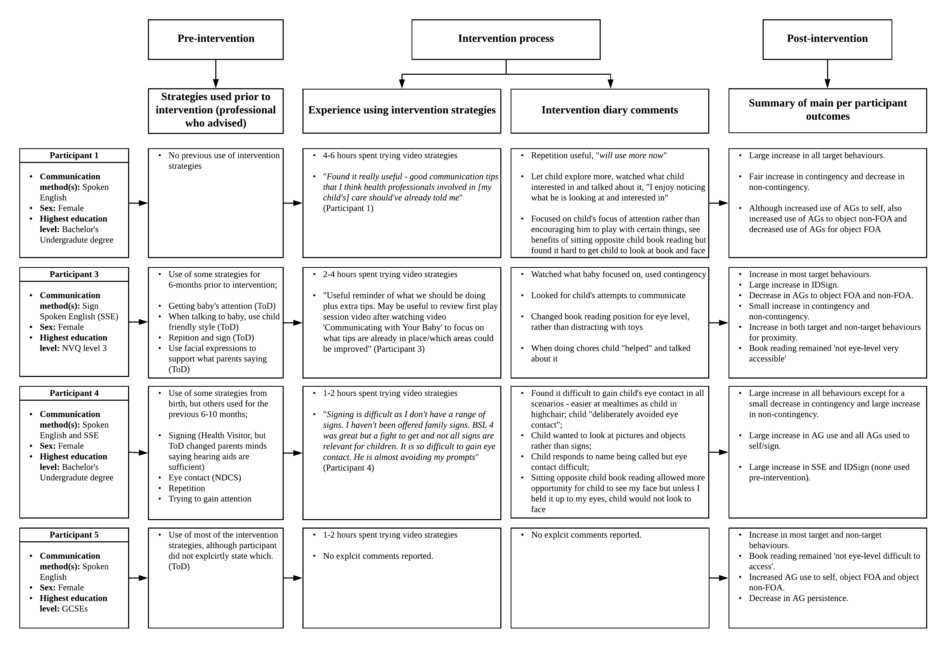A Process Evaluation Flow Diagram Describing Per Participant Experiences of the Intervention Video
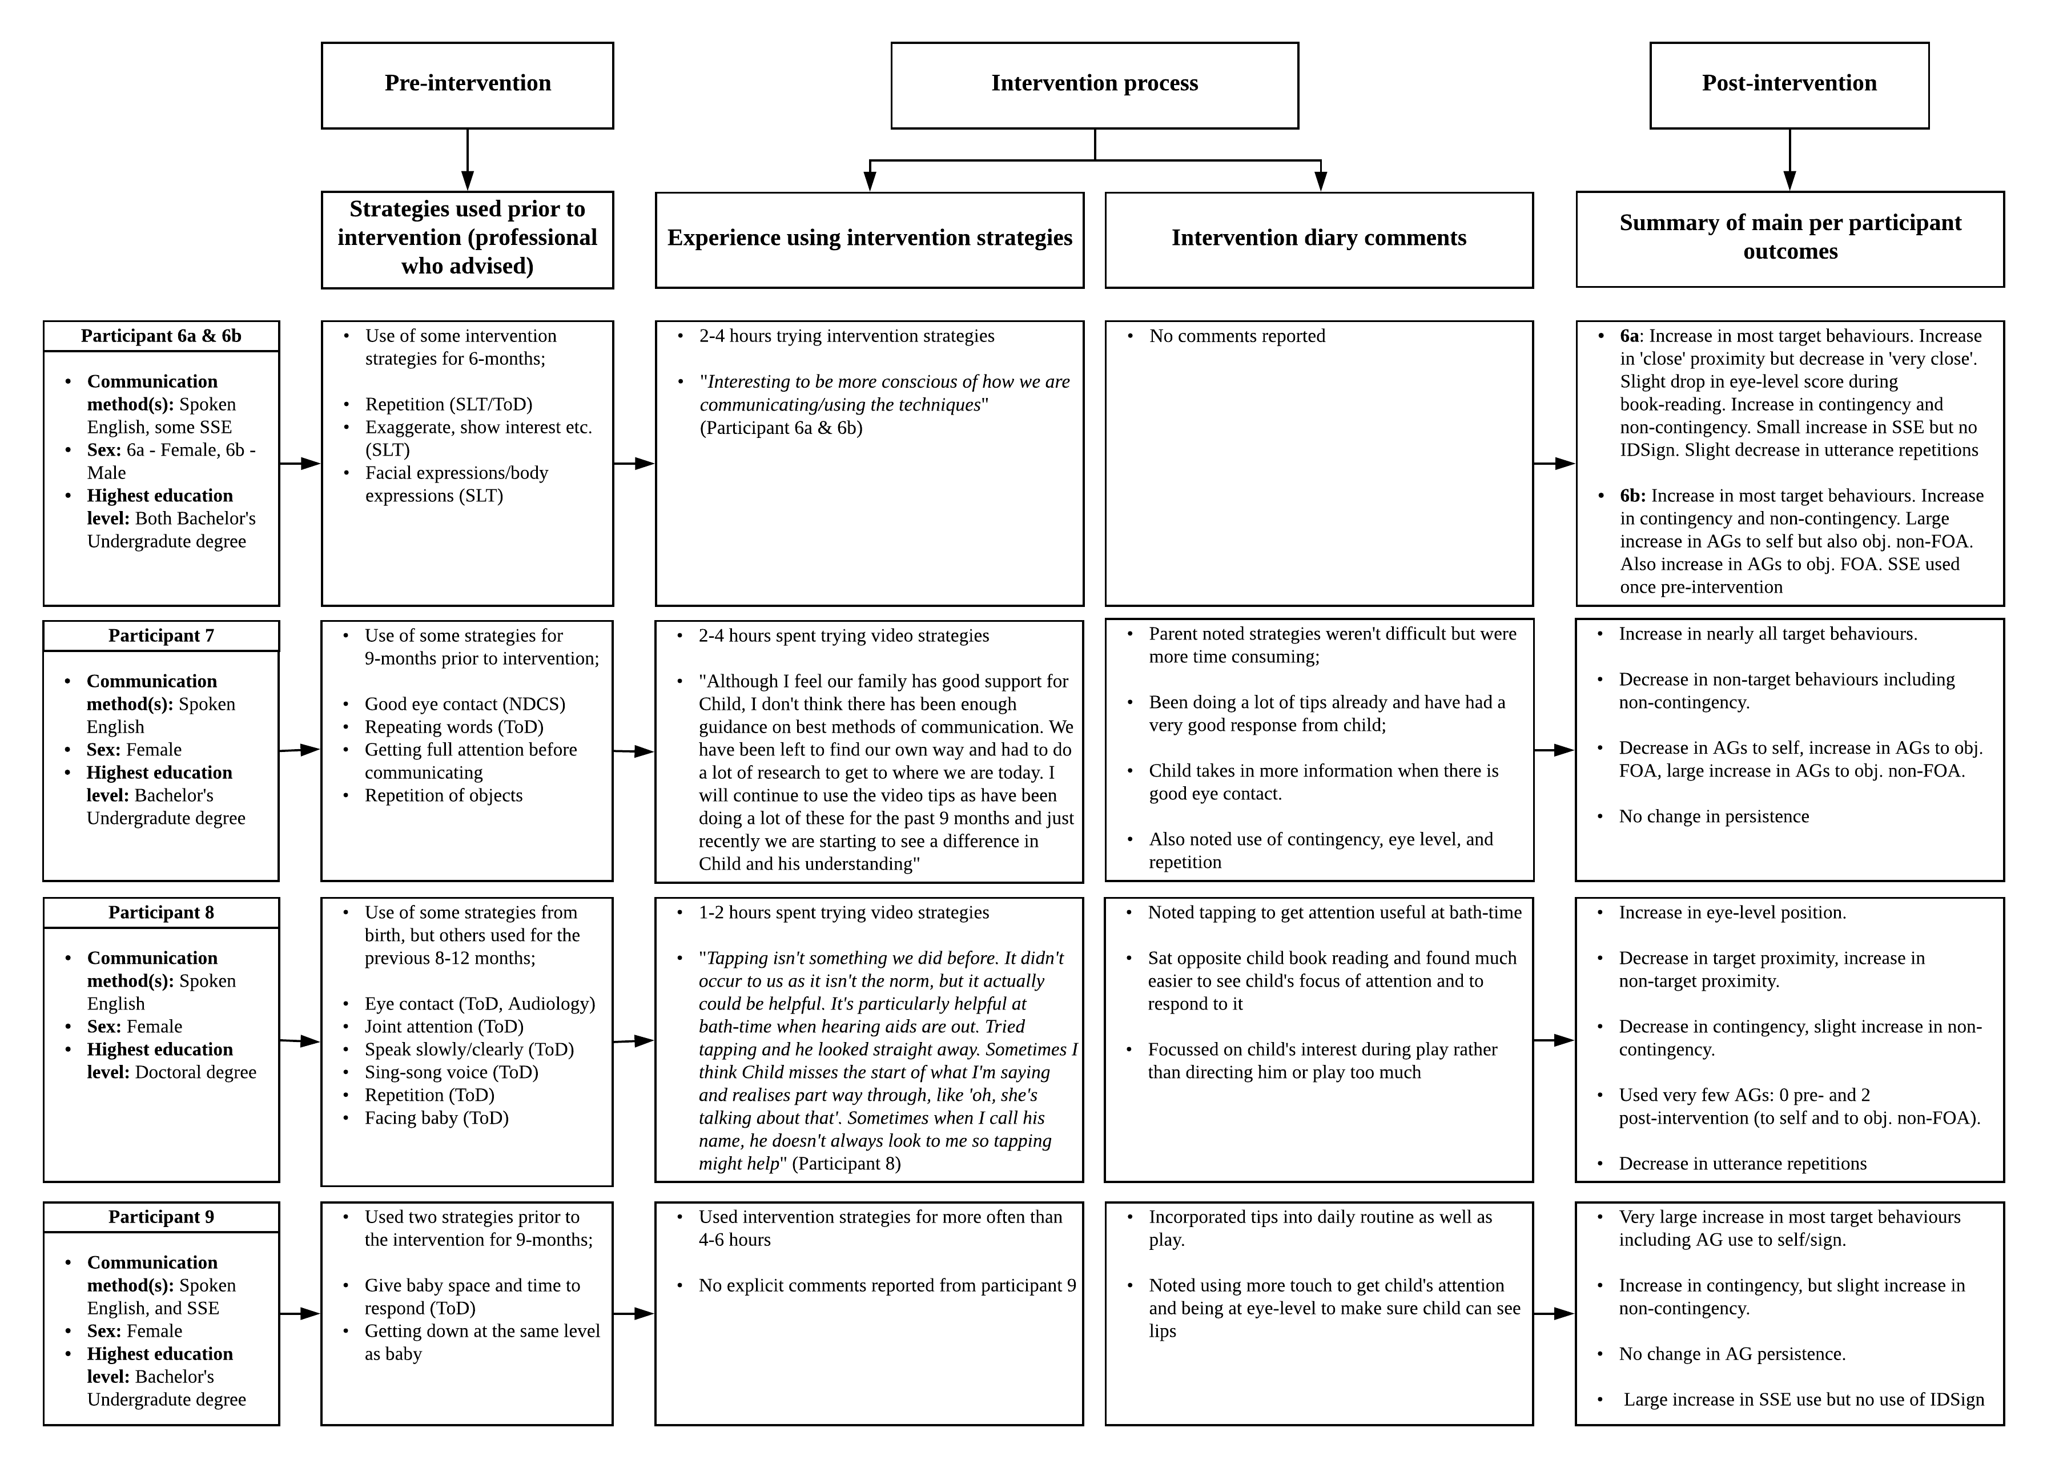

Parents’ feelings towards the communication strategies were generally positive. Likert Scale ratings of 0 to 10 from questionnaire data for 8 participants (parent 6b did not complete the questionnaire; see also Table 23) revealed that: 1) Except for parent 4, all parents enjoyed using the strategies, rating them from 7 to 10 for enjoyment (0 = did not enjoy, 10 = really enjoyed; 2). Parent 4 rated the strategies 4 for enjoyment. 2) Except for parent 4, all parents did not find using the strategies in daily routine difficult, rating them from 0 to 1 (0 = not difficult, 10 = extremely difficult). Parent 4 rated the strategies 9 for difficulty. 3) Except for parent 4, all parents did not feel uncomfortable using the strategies, rating them from 0 to 1 (0 = not at all uncomfortable, 10 = extremely uncomfortable). Parent 4 rated the strategies 9 for discomfort. 4) All parents reported the strategies helped them to communicate with their child, rating them from 7 to 10 for helpfulness (0 = not at all helpful, 10 = extremely helpful). 5) All parents said that they would continue to use the strategies, rating future use 10 (0 = never use again, 10 = definitely use again).

Table 23
Parent Feelings Towards the Communication Strategies
Item | Scale Indicators
 | 0 | 1 | 2 | 3 | 4 | 5 | 6 | 7 | 8 | 9 | 10
Enjoy? | Did not enjoy |  |  |  |  |  |  |  |  |  | Really enjoyed
 |  |  |  |  | 1 |  |  | 1 | 2 | 1 | 3
Difficult? | Not difficult |  |  |  |  |  |  |  |  |  | Extremely difficult
 | 3 | 4 |  |  |  |  |  |  |  | 1
Uncomfortable? | Not at all |  |  |  |  |  |  |  |  |  | Extremely uncomfortable
 | 6 | 1 |  |  |  |  |  |  | 1
Helpful? | Not at all |  |  |  |  |  |  |  |  |  | Extremely helpful
 |  |  |  |  |  |  |  | 4 | 1 | 1 | 2
Future use? | Never |  |  |  |  |  |  |  |  |  | Definitely
 |  |  |  |  |  |  |  |  |  |  | 8

Acceptability of Intervention Delivery: The Video
In general, acceptability of the intervention video was high. As parents 4, 5 and 6b did not complete the section on video acceptability, we report responses from 6 parents (see also Table 24). Likert Scale ratings of 0 to 10 revealed that: 1) 3 parents found the video length acceptable, rating video length 5 (0 = too short, 10 = too long), 3 parents found the video length too long, rating between 6 and 8. 2) 4 parents found the amount of information to be acceptable, rating information amount 5 (0 = too little, 10 = too much), and 2 parents (participants 3 and 8) felt there should be more information, rating amount of information 4 and 2 respectively. 3) All parents found the video easy to understand, rating comprehensibly 9 to 10 (0 = difficult to understand, 10 = easy to understand). 4) All parents reported the video was professional, rating professionality 8 to 10 (0 = not professional, 10 = very professional). 5) All parents agreed that using the video is a good way to provide advice to parents about ways to communicate with their child and ways to encourage their communication, rating agreement with this statement 7 to 10 (0 = strongly disagree, 10 = strongly agree). Finally, 6) except for parent 8, all parents would recommend the video to other parents, rating agreement with recommendation 7 to 10 (0 = strongly disagree, 10 = strongly agree). Parent 8 did not agree or disagree, rating 5.
Responses to the open-ended question asking parents if they thought there are ways the video could be improved were: “more clips!”, “awkward to watch video and keep baby entertained at the same time”, “the clips showing the advice in practice are really useful, for example, watching the parent using repeated, insistent tapping to get her child's attention”, “no. I liked the repetition as it reinforces the point”, “the clips looked a bit dated? The scenarios were a bit un-relatable to me, for example, one mum I think was deaf and they used sign. Could've used a wider variety/number of families perhaps”.
Table 24
Acceptability of the Intervention Video
Item | Scale Indicators
 | 0 | 1 | 2 | 3 | 4 | 5 | 6 | 7 | 8 | 9 | 10
Length? | Too short |  |  |  |  |  |  |  |  |  | Too long
 |  |  |  |  |  | 3 | 1 |  | 2
Amount? | Too little |  |  |  |  |  |  |  |  |  | Too much
 |  |  | 1 |  | 1 | 4
Easy to understand? | Difficult |  |  |  |  |  |  |  |  |  | Easy
 |  |  |  |  |  |  |  |  |  | 1 | 5
Professional? | Not at all |  |  |  |  |  |  |  |  |  | Very
 |  |  |  |  |  |  |  |  | 3 | 1 | 2
Good method to provide advice? | Strongly disagree |  |  |  |  |  |  |  |  |  | Strongly agree
 |  |  |  |  |  |  |  | 1 | 1 |  | 4
Recommend? | Strongly disagree |  |  |  |  |  |  |  |  |  | Strongly agree
 |  |  |  |  |  | 1 |  | 2 | 1 |  | 2
Note. 6a = mother of infant participant 6. 6b = father of infant participant 6.

Discussion
The overarching aim of the present chapter was to take a first exploratory step towards the goal of a standardised, easily accessible and effective parent-initiated intervention that could be implemented in practice. To that end, the aims were to explore the feasibility (in terms of success in appropriately changing parent behaviours) and acceptability of a flexible, instructional intervention video. The video was designed to teach hearing parents of deaf infants to modify specific interaction behaviours, and implement certain strategies purported to facilitate deaf children’s early language development. In general, the intervention was feasible however, there were a few instances where behaviours were adversely affected, such as the appropriate use of attention getting behaviours. Intervention content and delivery was also generally considered to be acceptable however, a few parents raised that implementing strategies can be time-consuming and stressful. Additionally, a small number of parents felt the video itself was somewhat too long with too little information. Findings from the present study suggest several considerations for the future including: 1) pre-intervention assessment; 2) an intervention composed of distinct behaviour change modules as opposed to one video presented to all parents; 3) ongoing assessments to determine the need for further support and guidance; and 4) the use of additional measures to capture related constructs. In what follows we discuss the feasibility of each individual behaviour change before describing a future intervention model based on learning from the present chapter.

Feasibility of Behaviour Change
In general, findings suggest that an instructional video could be a feasible way to change the behaviours included in the present intervention however, instructional video alone may not be appropriate, particularly for certain behaviours.

Attention getting strategies
The instructional video was successful in encouraging parents to use attention-getting behaviours and to be persistent when using them. Parents showed a large and significant increase in the use of attention getters to elicit infant visual attention to themselves. Furthermore, 5 parents (participants 1, 4, 6a, 7 and 9) introduced a visual strategy to elicit infant attention that was not presented in the intervention; they moved the object their child was visually attending to, up towards their face. Such findings further suggest parent ability to incorporate visual-tactile strategies when eliciting their infant’s attention. These positive outcomes however, appear to come at a cost. On exploration of the intention behind the use of attention getting attempts, five parents increased their use of attention getting behaviours to direct infant attention to an object that was not in their infant’s focus of attention. One parent in particular (participant 6b) who was very successful in increasing attention getting attempts to self (from 0 pre-, to 13 post intervention), also increased attempts to an object that was not his child’s focus of attention (from 0 pre-, to 7 post-intervention). These findings are of concern given that redirecting infant attentional focus and being directive in general may have a negative impact on early language learning (Akhtar et al., 1991; Tomasello & Farrar, 1986). This also highlights the difficulty of maintaining a balance when scaffolding joint attention.
Four parents also increased their use of attention getting behaviours to direct infant attention to an object that was in the infant’s focus of attention. Although the use of directive utterances that follow the child’s focus of attention (such as directing the child to complete an action on a toy they are already playing with) appears not to have a negative impact on child vocabulary development (Akhtar et al., 1991), this was not the goal of the intervention. The goal was to encourage parents to elicit infant visual attention to their face when communicating, particularly when following-in, to increase access to language and encourage more attentional switches. Since hearing parents of deaf infants have already been reported to direct infant attention to objects during interaction (Waxman & Spencer, 1997), an unintended increase in their behaviour suggests parents might need further guidance and support with this particular strategy.
Use of attention getting attempts by participant 7 raises an additional concern; that parents who already use attention getting behaviours to direct infant attention to self successfully, may in fact reduce this behaviour post-intervention. Participant 7 decreased attention getting behaviours to elicit infant attention to self by half post-intervention, but also increased these behaviours to direct attention to an object that was not her child’s focus of attention. It is possible that by asking parents to change a behaviour they are already using, could potentially cause the parent to feel the need to change their behaviour in some way, regardless. Particularly if they do not consciously realise they are already using the behaviour or if they lack the confidence to believe they are doing so successfully. The latter could potentially be more likely if a parent has low self-efficacy in terms of supporting their child’s communicative development. Pre-assessing parents could be highly beneficial to determine if parents are already successfully using intervention strategies, and thus whether or not to include training of that particular strategy. Indeed, participant 3 suggests this in her feedback as she stated it would be useful to review the first play session to see what tips are already in place and which areas could be improved. One way to do this could be to watch the pre-intervention video prior to intervention implementation. Another would be to watch the pre-intervention video with parents and highlight examples of strategies used successfully. This is already an existing approach that has been used to promote caregiver responsiveness in deaf infant/toddler-hearing parent dyads (James, Wadnerkar-Kamble & Lam-Cassettari, 2013). Referred to as a strengths-based intervention, the Video Interaction Guidance (VIG) involves a practitioner filming 15-20 minutes of typical infant-parent interaction. Subsequently, the practitioner selects clips of successful interactions to view and discuss with the parent. This provides the parent with an opportunity to receive positive feedback, develop an understanding of their role in their child’s development, and to build their awareness of how to create positive interactions. Furthermore, viewing good examples of their own contingent behaviours during interaction could help parents to envision change. Providing positive feedback and encouragement could have the added benefit of increasing parent self-efficacy beliefs (Mouton & Roskam, 2015).

Semantically contingent talk
Pre-assessment could also be beneficial when encouraging the use of semantically contingent talk. The only two parents that decreased their contingent utterances were the parents who had the highest number of contingent utterances and lowest number of non-contingent utterances pre-intervention. While this could just represent regression to the mean, asking parents to be contingent when they are already doing so rather successfully, may potentially have detrimental effects to those behaviours post-intervention. Thus, pre-assessment could be beneficial to determine whether it is necessary to advise the strategy of contingent talk. The general picture for contingency behaviour change appears to be that both raw and proportional contingent and non-contingent utterances increased post-intervention, although these increases were not statistically significant (medium and small effect sizes respectively). It is important to consider the possibility that these changes could be the product of changes in other intervention behaviours. For example, the use of repetition at the utterance level also increased and could therefore explain why both contingent and non-continent utterances increased (as well as the total number of utterances overall). Thus, patterns may have been the same post-intervention as they were pre-intervention but at an increased rate. Similarly, changes in attention getting behaviours could have had an impact on non-contingent utterances, given that five parents increased their use of attention getting behaviours to direct infant attention to objects that were not their infants’ focus of attention post-intervention. Although beyond the scope of the present intervention due to sample size, future studies with a larger sample size should consider controlling for other intervention behaviours.
A final consideration when including semantic contingency in similar interventions is the addition of a self-efficacy measure. In a secondary analysis of the present study’s primary data set, Kennedy (2018) reports preliminary findings that suggest there may be a relationship between intervention effectiveness in terms of number of contingent words produced during interaction and parent self-efficacy. Indeed, it may be worth considering the relationship between parent self-efficacy and intervention effectiveness in relation to changes in all target behaviours. Furthermore, parent self-efficacy beliefs have been reported to relate to involvement in intervention (Solish & Perry, 2008). With these factors in mind, a measure of self-efficacy could be particularly helpful when it comes to understanding poor intervention effectiveness and involvement such as presented by participant 5. Although participant 5 increased some target behaviours, she also increased most negative behaviours and in some cases, did not change her behaviour. Although self-efficacy could be at play here, it is also important to consider other possibilities. For example, this parent may have believed she was already using the behaviours. Indeed, participant 5 stated that she uses most of the tips with her child, particularly sitting at eye-level. However, participant 5 spent most of the time not at eye-level and in a position that was coded as difficult for visual access to her face during book reading, and also increased her number of utterances during play at this position. In cases such as these, it is possible that further guidance and support is required, which again highlights the need for pre-assessment.

Infant directed sign
Findings in relation to strategies for IDSign also raise the need for pre-assessment. The intervention asked parents who sign to try certain IDSign behaviours during interaction. However, two of the five parents who stated they use sign (participants 4 and 6a), did not do so during the pre-intervention video but did so during the post-intervention video. Furthermore, participant 9 who used very little sign pre-intervention, used much more post-intervention. Participant 4’s comment that she finds signing hard as she has a limited sign range, and has not been given support to learn more child friendly signs, sheds light on the possibility that parents may not wish to use sign but the intervention inadvertently encourages them to do so, or elicits feelings that they should. On the other hand, parents may have simply decided to try IDSign and therefore needed to increase their sign use (note however, very few parents attempted the IDSign behaviours that were coded, but may have attempted the IDSign behaviours that are analogous to IDS). Either way, discussing parent feelings towards the use of sign and whether they would like to try IDSign seems advisable so as the limit any impact on parent choices, as the goal of the intervention was not to change parent communication choices, but to support them. Pre-assessment provides the opportunity to encourage this strategy and determine if additional support alongside instructional video is necessary for those parents who wish to continue using sign. In addition, having several, separate, shorter videos would allow parents to only explore those videos that are adapted to the choices they have made.

Visual accessibility of language: parent position
The strategy of getting down to eye-level may be one that requires less guidance and support to supplement instructional video, given that there was a large and significant increase in the number of parent utterances that were at eye-level and very accessible (i.e., minimal effort for the child to see their parent’s face), with all parents showing some increase. Furthermore, there was a significant decrease in the number of utterances that were not at eye-level. However, participant 5 increased utterances that were not at eye-level but also difficult for her child to access. Participant 8 also increased utterances that were not at eye-level, however her face was ‘fairly accessible’ (e.g., in position such that both parent and child were sitting on the floor facing each other). The increase in utterances that were not produced at eye-level by participants 5 and 8 could be due to infant activity. It is possible that the children of participant 5 and 8 were more mobile post-intervention, making it difficult for parents to maintain a position of eye-level whilst communicating. This is an important consideration for future research. Infants who can crawl or walk will inevitably be more mobile during play. It is therefore very unlikely to eliminate all utterances produced when not at eye-level. Although encouraging parents to be aware of their position and to aim to be at eye-level is important for reducing utterances that are not at eye-level, it is also imperative not to disrupt the natural play experience by encouraging the parent to exert too much control. Parents also changed position during book reading to be more at eye-level and visually accessible. While these differences were not statistically significant they were medium-to-large sized. For a number of parents, the most distinct change during book reading was the shift from a typical position of sitting with their child on their lap (i.e., behind their child and therefore very difficult to access), to a position where their child was in front of them (except for participant 5 who stayed behind her child). These findings suggest a trend towards change in the intended direction during book reading.

Aural accessibility of language: parent proximity
Although it was not a strategy presented in the intervention, parent proximity in relation to their child when communicating was investigated. The aim was to explore if the advice of ‘getting down to eye-level’ subsequently resulted in parents altering their proximity to be nearer their child when communicating, particularly as this is important for infants using amplification systems (and cochlear implants). Although findings were not statistically significant, there appears to be a trend towards an increase in the proportion of utterances produced very close to the infant (i.e., the infant could touch their parent’s face), and interestingly a trend towards a slight decrease in utterances produced roughly 1 metre from the infant. It is possible that parents simply decreased the latter utterances in favour of the former, potentially due to getting down to eye-level. Changing position to lower their head could subsequently result in a closer proximity but likely only when infants are seated or not mobile. Given the large variation in proportion of utterances produced between 1 and 2 metres, and those produced more than 2 metres away (both pre- and post-intervention), it is possible that in many of these instances children were more mobile. Given the inevitable difficulties in managing proximity when children are mobile, it is unclear whether explicitly encouraging parents to aim to be within 2 metres of their infant would help to minimise the proportion of utterances produced further than 2 metres away. As proximity within this distance is considered optimal for access to signs, social partner’s face for speech-reading, and speech when using hearing technologies (Hounslow & Richmond Community Healthcare NHS Trust, 2016; Paediatric Audiology Services: Norfolk & Norwich University Hospitals NHS Foundation Trust, 2017), it would be beneficial to explore the feasibility (and acceptability) of parent proximity as a strategy in future interventions.

Repetition in infant directed speech
Encouraging parents to use repetition in their infant directed speech may be another strategy requiring little to no further guidance and support to supplement the instructional video. The video alone may be sufficient to encourage behaviour change in the intended direction. However, although most parents increased their use of repetition, two participants decreased this behaviour (participant 8 and participant 6a who showed a slight decrease). When taking into account the total number of utterances produced by parents by exploring the proportion of utterances that were repeated, parents 6a and 8 still showed a slight decrease. It is possible that child behaviours may have influenced parent behaviours. For example, given that the intervention suggested increasing repetition to provide more opportunity for infants to perceive what has been said and/or signed, parents may have felt less need to do so if infants were more responsive or visually attending more. Future larger scale studies should consider this possibility by controlling for infant behaviours.

Attention getting strategies and infant visual attention
Finally, responses to parent attempts to elicit infant attention to themselves was explored, to shed some light on how children respond in the immediate to increases in their parents’ attention eliciting behaviours. Children looked to their parents in response significantly more post-intention than they did pre-intervention. The number of unsuccessful attempts to elicit infant attention however also increased, suggesting that increased attempts to elicit infant attention will likely give rise to an increased number of unsuccessful attempts. This is unsurprising given Spencer and Harris’ (2006) findings that deaf parents who elicit infant attention more, also have a greater number of failed attempts. One child (participant 6), had many more unsuccessful responses than successful in comparison to the rest of the group post-intervention. It is possible that due to experience, this child may not yet have learned that parent behaviours such as tapping, are pragmatic tools to direct their attention to perceive linguistic input; they may not have learned to how interpret these explicit behaviours. As Swisher (2000) argues, responding appropriately to attention getting behaviours is not an automatic process and thus, how to respond may not be immediately obvious to the infant; “a tap on the body is not meant to direct the child’s attention to his or her own body, but to the person doing the tapping and usually to their communication…In short, the child must learn that such a signal means ‘look at me’ or ‘pay attention to what is going to come next’” (Swisher, 2000, p. 25). Given that many deaf children of hearing parents may lack experience with these visual attention scaffolding behaviours, introducing them at an earlier age could be beneficial. Doing so would likely provide the child with more experience and opportunity to learn the appropriate response, subsequently increasing the number of successful responses relative to unsuccessful by the time they reach the joint attention stage. Introducing the use of attention getting behaviours to parents when the infants are around 6 months of age could be an optimal time given that this is the age when deaf parents have been found to introduce them (Koester et al., 2000).
When investigating parent use of attention getting behaviours and persistence in using them, future studies would likely benefit from also exploring infant visual attention skills. Consider, if a child does not often independently look to their parent during interaction, the parent would be more likely to increase their use of attention eliciting behaviours post-intervention, and potentially their persistence if their child does not often respond. If, however, a child already substantially looks to their parent independently, the parent may not feel the need to use attention getting behaviours to elicit their child’s attention as they may already have it prior to communicating. Without this additional data, it would be difficult to determine if low attention getting frequencies and little to no changes in use of attention getting behaviours pre- to post-intervention are related to some aspect of the intervention, or if they are related to infant visual attention skills. In the present intervention, participants 5 and 8 represent this difficulty. Participant 8 is particularly interesting as she does not attempt to elicit her child’s attention pre-intervention and does so only twice post intervention. However, in participant 8’s feedback she states: "Tapping isn't something we did before. It didn't occur to us as it isn't the norm, but it actually could be helpful. It's particularly helpful at bath-time when hearing aids are out. Tried tapping and he looked straight away. Sometimes I think [my child] misses the start of what I'm saying and realises part way through, like 'oh, she's talking about that'. Sometimes when I call his name, he doesn't always look to me so tapping might help". Participant 8’s comment suggests she believes eliciting her child’s attention prior to communicating is beneficial however, she attempts to elicit her child’s attention very little during the video recorded sessions. Although beyond the scope of the present study, exploring her child’s visual attention behaviours would likely shed some light on this outcome.

Acceptability of Intervention Content and Delivery
Parent comments stating that the intervention was useful, helpful, not difficult to engage in, and for some encouraged increased awareness of strategy use, suggest the intervention was acceptable. Questionnaire responses, except for participant 4’s, corroborate these comments. For participant 4, responses indicate that the strategies were helpful and that she would likely use them in future however, the remainder of her responses indicate that she did not enjoy trying the strategies, and found them difficult and uncomfortable. Upon exploration of participant 4’s comments, it appears that the use of SSE and attention getting behaviours may underlie the negative responses. Participant 4 stated that signing is difficult due to a limited range of child-appropriate signs, and stressed how difficult it was to get her child’s visual attention, noting that her child "deliberately avoided eye contact" and “is almost avoiding my prompts". Indeed, although participant 4 was very successful in changing her attention getting behaviours, her child was equally as likely to respond unsuccessfully as he was to respond successfully, i.e. participant 4’s child may not be very responsive to parent attempts to elicit attention to self. If participant 4 perceived the unsuccessful attempts as difficult behaviour, which is a possibility based on participant 4’s comments, this is of concern given that perceived difficult behaviour during interaction is related to parent stress (Koester & McCray, 2011). Hearing parents of deaf infants are already at risk of increased stress (Quittner, 1991; Quittner, Glueckauf, & Jackson, 1990; Zaidman-Zait, Most, Tarrasch, Haddad-eid, & Brand, 2015), which, in addition to being unpleasant for the parent, can have a negative impact on their child’s social-emotional development (Hintermair, 2006; Meadow-Orlans, 1995; Quittner, 1991), and could potentially impact general parental responsiveness (Koester & McCray, 2011). As Chess and Thomas (1996) state, “when stresses occur stormy interactions are all too likely” (p.175). It is interesting that the only target behaviour for participant 4 to decrease and the opposing negative behaviour to increase, was contingency. It is possible that a relationship between the use of attention getting behaviours, stress and contingent utterances was at play here. Future research could benefit from exploring potential interactions when administering a multi-behaviour change intervention.
It is evident that participant 4 can modify her behaviours positively in response to the present intervention (except for contingency). However, given that this is a first step towards an intervention that would encourage the use of these modifications long term, finding the use of some strategies unenjoyable, uncomfortable, difficult, and potentially stressful would likely become a barrier to intervention participation. Finding the use of strategies time-consuming (as stated by participant 7) could also become a barrier. Such low acceptability would likely lead to poor engagement, which could in turn lead to reduced efficacy, and increased participant attrition (Sekhon et al., 2017). It is therefore important to consider that even for parents who can successfully change their behaviours, these changes could bring about adverse effects for some. Once parents have initially tried using the strategies for a short period of time, exploring thoughts and feelings about using the strategies could be a critical element of intervention. Detecting potential adverse effects early provides the opportunity to further tailor the intervention and provide additional guidance and support, which is in keeping with a family-centred approach.
In terms of method of intervention delivery, the instructional video was largely considered to be acceptable. All parents felt the video was easy to understand, professional, and a good method to provide advice to parents, with all bar one stating they were likely to recommend it to other parents (participant 8 was not likely or unlikely to recommend it). Three parents did however, lean towards feeling the video was too long, and two parents leaned towards feeling the video contained too little information. One way to address this would be to provide a series of short instructional videos, as opposed to one longer one. Each video would essentially be a module presenting a particular strategy or set of related strategies, such as attention getting behaviours. This also allows scope to add more strategies for parents, which could then be provided as additional separate modules. One large resource segmented into modules provides parents with ample information that does not have to be covered in one session.

Future Intervention Model: Learning from the Present Chapter
Findings from the present intervention provide insight into the potential form and characteristics of future intervention. Specifically, an intervention could have a standardised set of modules for each strategy or set of strategies presented as short instructional videos. To expand the information available to parents, modules based on facilitative language techniques (FLTs; e.g., recasts) could be a potential addition given that they are related to child language outcomes (Fey et al., 1999), including those using cochlear implants (Cruz et al., 2013). Videos would be flexible to suit the individual differences of the infant, family and parent choices (by, for example, providing optional strategies depending on communication choice [i.e., oral-aural, sign, SSE etc.], infant hearing status, and use of hearing technologies [i.e., striking the balance between use of the visual and auditory modality depending on child’s aural perceptual abilities]). When developing videos, it may be important to consider who presents strategy examples (i.e., a deaf or hearing parent). Although deaf parents intuitively use strategies such as attention getting behaviours, it may not be advisable to have deaf parents model these strategies. In the present intervention, one deaf parent modelled a number of strategies typically used by deaf parents. However, in her feedback with regards to the video, participant 1 stated, “The scenarios were a bit un-relatable to me, for example, one mum I think was deaf”. As Koester et al. (2000) cautions, when considering strategies intuitive to deaf parents for intervention, do so with care and awareness of differences between deaf and hearing cultures.
Prior to intervention implementation, parents could be observed and assessed to determine strengths (i.e., the strategies parents are already using with success), areas that potentially require further support, and potential new strategies that could be beneficial to the parent. Observations and assessments would preferably be completed by the family’s existing practitioner (e.g., speech and language therapist or teacher of the deaf). Indeed, the findings of the current study suggest regular professional support would be beneficial. Observations could take the form of video recorded play sessions, and could potentially be used to open discussions with parents about strategies appropriate for the family. Assessments could be via questionnaire or parent interview to explore the needs of the family and family choices particularly in terms of communication. Both observation and assessment provides an additional opportunity to explore what parents believe they are doing and what they are actually doing, to determine any discrepancies and thus, areas that require additional support. Following pre-assessment, practitioners could suggest an appropriate set of modules. Further exploration such as investigations into any potential interactions between intervention strategies could be of benefit to determine when to introduce individual modules and order of delivery. Attention getting behaviours in particular could be a strategy that should be introduced initially, in order to support joint attention and ensure it gets off to a good start before introducing elements of the intervention that focus on language use. Once parents have been introduced to intervention strategies, regular observations (e.g., video-recorded play sessions) and assessments (e.g., questionnaires and parent interview) at various stages throughout the intervention could provide the opportunity to identify any strategies that require additional guidance and support. It would also provide an opportunity to explore acceptability of strategies to determine if there are any potential sources of stress.
Finally, when exploring the feasibility of such an intervention, additional considerations could be of benefit. For example, controlling for infant behaviours, controlling for infant visual attention skills particularly when investigating the efficacy of attention getting strategies, investigating potential relationships between parent self-efficacy beliefs, parent behaviour change and intervention involvement, and exploring interaction between intervention strategies. Additionally, ensuring a representative sample would be ideal. The present intervention was somewhat representative in that the sample contained a father, parents who were oral, parents who signed, infants with different degrees of hearing loss, variation in SES, and variation in terms of the prior advice parents received (e.g., one parent who received no advice in relation to communicating with a deaf infant). However, all participating infants used hearing aids. It would likely be beneficial to include parents of infants who are using cochlear implants to explore feasibility and acceptability in this group. Looking forward, if an intervention such as the one described above is feasible and acceptable, a randomised controlled trial would be the next step towards the goal of a standardised, easily accessible and effective parent-initiated intervention that could be implemented into practice. It would also open the possibility to explore which specific parent behaviours mediate child language outcomes and to what degree.

Limitations
Although the present study demonstrates the potential feasibility and acceptability of a flexible instructional intervention video, there are a number of limitations to consider. Participants 6a and 6b are parents of the same child and therefore not entirely independent participants. However, in this case both parents were shared caregivers and expressed a keen desire that both participate. Exploring the feasibility and acceptability of both parents should be a consideration given that participation of both parents could be a likely occurrence when implementing intervention. Additionally, it is important to explore the impact of such interventions on fathers as this group tend to differ in terms of their interaction behaviours with infants, such as linguistic input (Pancsofar & Vernon-Feagans, 2006; Rowe, Coker, & Pan, 2004). Furthermore, fathers may uniquely scaffold their children's language development (Lamb & Tamis-LeMonda, 2004; Tamis‐LeMonda, Shannon, Cabrera, & Lamb, 2004), and have lower parenting self-efficacy than mothers (Zaidman-Zait et al., 2015). It is also important to note that participant 6a (the mother) had a slightly different play session to the rest of the parents as she participated in the structured video and the father (participant 6b) participated in the unstructured video. For all remaining parents only unstructured videos were coded. As structured videos were only additionally coded for attention getting behaviours for each parent, participants 6a and 6b therefore only had 15 minutes of screen time as opposed to 25. However, to account for this, adjusted frequencies of behaviours were calculated for analyses (see method section for further details).
The intervention presented two types of responsiveness; responding to infant focus of attention and responding to infant communicative acts. The present chapter however, only measures the former, although the coding scheme was sensitive to the latter. The main reason responsiveness to infant communicative acts was not directly measured is that infant communicative acts vary due to individual differences (see Chapter 1 for a summery) and would therefore need to be controlled for. Due to sample size, this was not possible in the present study but should be a consideration for future interventions. Particularly as this type of responsiveness is predictive of child language outcomes (Tamis‐LeMonda et al., 2001; Yoder, McCathren, Warren, & Watson, 2001).

Summary and Conclusion
Overall the video showed promise in terms of encouraging parents to 1) be at eye level where their face was easily accessible visually; 2) be near their infant when speaking (and/or signing); 3) improve visual access to their face during book reading; 4) elicit infant attention themselves; 5) repeat utterances; and 6) adapt signs for their infant. It did not show promise in promoting contingent talk, although it did promote talking more generally. Indeed, the study revealed a likely tension between increasing the use of attention getting behaviours and increasing contingent talk, which may have resulted in an unintended increase in directiveness. This is an important consideration for future interventions. In general, parents found the intervention content and method of delivery to be acceptable. Future improvements would include pre-assessment and subsequent administration of themed modules (i.e., by strategy) deemed appropriate to the parent, with additional guidance and support.

General Discussion
Language acquisition is a crucial milestone in a child’s development. For many deaf children with hearing parents (DCHP) in particular, delays can be expected (Lederberg et al., 2013). These delays are often attributed to limited access to language and reduced exposure to rich interactional and conversational experiences (see Chapter 1 for a review). The present thesis therefore aimed to: 1) explore the impact of this limited experience on the understanding of communicative intentions (an important aspect of pragmatic development) in childhood; 2) investigate if delays in language development take root in infancy by exploring the development of communicative skills in infants; and 3) investigate the feasibility and acceptability of a parent-based behaviour change intervention promoting the use of communicative strategies to facilitate the language development of DCHP. This final thesis chapter will present a summary of the main findings before considering their implications for current theory and practice. Limitations of the present research will then be acknowledged, along with directions for future research.

Summary of Main Findings
Chapter 1 provided a review of the literature describing the limited access to conversational interaction, and subsequent delays in language and social-cognitive development experienced by many DCHP, but not typically by deaf children with deaf parents (DCDP). In view of these findings, Chapter 2 sought to investigate the consequence of these interrelated difficulties for pragmatic development, with specific focus on the role of access to conversational interaction. The ability to infer the communicative intentions behind a false statement was therefore investigated in a comparative study of DCHP, DCDP, and typically hearing children, who as a function of parental hearing status and modality (i.e., fluent spoken or sign language), experienced different levels of access to language. It was found that, not only do typically hearing children master this ability by 7 years of age, DCHP are significantly delayed in comparison to hearing children of the same age. Furthermore, based on a smaller sample of DCDP, this group may be following the same trajectory as their hearing peers. To the knowledge of the author, the study presented in Chapter 2 represents the first empirical investigation into deaf children’s understanding of communicative intentions within the context of understanding deception.
In view of the findings reported in Chapter 2, along with 1) similar existing literature suggesting that DCHP are delayed in other aspects of their understanding of nonliteral language, an important aspect of pragmatic competence (e.g., sarcasm; O'Reilly et al., 2014); and 2) existing literature suggesting DCHP are delayed in their basic pragmatic skills in toddlerhood and childhood (e.g., Jeanes et al., 2000; Lederberg & Everhart, 2000; Rinaldi et al., 2013), it is clear that DCHP tend to experience delays in a wide range of communicative abilities. However, it is unclear in the current literature as to when the development of communicative skills starts to diverge from typical trajectories. Some research suggests that infants communicate on a par with their hearing peers during the pre-linguistic stage (e.g., Spencer, 1993) thus, it was thought that delays in communicative skills do not become apparent until formal language emerges (Lederberg & Everhart, 2000). However, exploration of specific communicative skills which typically emerge around 12 months of age (e.g., Carpenter et al., 1998), and importantly are strongly associated with later language outcomes, has been minimal. Although a small number of studies have included some communicative skills in their general investigation, they lack a fine-grained exploration of a wide range of these skills. To the author’s knowledge, this had yet to be undertaken. Thus, in a comparative study of deaf infants with hearing parents (DIHP) and typically hearing infants, Chapter 3 consisted of a fine-grained analysis of the communicative skills (i.e., an exploration of each skill individually) known to be predictive of later language development. Infants were aged either 12 or 18 months and matched for gender, age, and socio-economic status to control for these possible confounding variables. While the sample size for this hard-to-reach group was small, and we focused on effect sizes rather than p values, Chapter 3 reported that DIHP were delayed in most of the communicative skills at 12 and 18 months in comparison to their hearing peers. Upon further exploration of the trajectories of these skills, findings suggest that the magnitude of differences between DIHP and typically hearing infants at 18 months are larger than the magnitude of differences between groups at 12 months. Chapter 3 therefore suggests a greater divergence with age between DIHP and their hearing peers in the development communicative skills considered to be predictive of later language development.
The delays in many DCHP’s general language and social-cognitive development reported in the literature (reviewed in Chapter 1), alongside the delays in communicative abilities reported in Chapters 2 and 3, point towards the need for intervention. As discussed in Chapters 1 and Chapter 3, a parent-based intervention designed to support infant-parent interaction could play an important role in minimising early developmental divergence. However, before a definitive randomised controlled trial from which to recommend a standardised and effective parent-initiated intervention can be put into routine practice, it is important to determine: 1) the feasibility of changing the parent behaviours targeted in the intervention (Roberts & Kaiser, 2011, p. 181); and 2) the acceptability of the intervention’s content and method of delivery (Sekhon et al., 2017). Thus, using a pre- post-intervention design, Chapter 4 explored the feasibility and acceptability of a low-intensity intervention designed to train hearing parents of deaf infants to modify specific interaction behaviours and implement certain strategies purported to facilitate deaf children’s early language development. The intervention was delivered via instructional video providing an easily accessible, flexible resource to parents. In general, the intervention was feasible as it led to increases in a number of target behaviours for most parents. However, there were a few instances where behaviours were adversely affected, such as the appropriate use of attention getting behaviours and the frequency of contingent responses and this would need to be addressed in any intervention. In terms of acceptability of intervention content and delivery, Chapter 4 reports that the intervention was generally considered to be acceptable. A small number of parents did however, raise that implementing strategies can be time-consuming and stressful, and that the video itself was somewhat too long with too little information.

Theoretical and Practical Implications
The findings reported in Chapters 2 and 3 both point the importance of a child’s access to, and participation in rich conversational interactions for their communicative development. Chapter 2 explored this in childhood with findings suggesting that children who experience limited access to conversational interactions, and delays in their language development, are at risk of developing delayed pragmatic skills in terms of understanding communicative intentions. These findings are in line with the prominent hypothesis that pragmatic skills develop through access to, and participation in, meaningful conversational interactions (Gallaway & Woll, 1994; Jeanes et al., 2000; Most et al., 2010; Rinaldi et al., 2013). Furthermore, findings from Chapter 2 are also consistent with the literature suggesting that formal language is related to the development of pragmatic skills (e.g., Lederberg & Everhart, 2000; Matthews et al., 2018; Most et al., 2010; Norbury, 2014). Given that: 1) access to conversational interaction is important for language development (see Chapter 1); and 2) formal language skills are related to pragmatic abilities, it is plausible that language acts as a mediator whereby access to conversational interactions has an indirect affect (via language) on pragmatic development (Rinaldi et al., 2013). This has similarly been proposed for the relationships between access to conversation interaction, language skills and false belief task performance (Schick et al., 2007). In addition, access to conversational interactions may also have a direct (unmediated) effect on pragmatic development given that conversational interaction provides opportunities to learn about patterns of communication, and could promote the understanding that conversational partners have contrasting perspectives and motives (discussed in Chapter 2).
In a bid to investigate when delays in the development of communicative skills may occur for DCHP, the findings reported in Chapter 3 suggest, for the first time, that delays in a specific set of early communicative skills (i.e., those associated with later language outcomes) may occur prior to the emergence of formal language. Not only do these skills form the foundations for later language development (Adamson, 1995), they also often elicit language facilitating parental responses (i.e., scaffolding behaviours) during infant-parent interaction (Yoder & Warren, 1993). Importantly, these responses are strongly associated with language development, and are considered important for developing pragmatic understanding of communicative intentions (Tamis-LeMonda, Kutchirko and Song, 2014; Yoder and Warren 1993, 1999). Furthermore, parental scaffolding responses are related to increased infant communication, and subsequent opportunities for further scaffolding (e.g., Miller & Lossia, 2013). Thus, if infants are producing these specific communicative behaviours to a lesser degree, the opportunities for parental scaffolding will be reduced, likely resulting in a negative impact on later language outcomes, and pragmatic understanding. Based on existing literature, delays in language outcomes would subsequently have implications for the development of language-related areas including social-cognitive development (Astington & Baird, 2005), and the development of pragmatic skills in childhood (Jeanes et al., 2000; Lederberg & Everhart, 2000).
Importantly, findings from Chapter 3 suggest that during the pre-linguistic stage, the trajectories of DIHP communicative skills diverge from typical development with age. This divergence across time implicates interactional difficulties as a potential contributor, given the important role of the parent in maintaining the reciprocal functioning of infant-parent interaction (via scaffolding beahviours; Sameroff, 2009; Warren & Brady, 2007). Based on existing literature, this may indeed be the case. It has often been reported that hearing parents of deaf infants tend to use less scaffolding behaviours during interactions with their infants (Ambrose et al., 2015; Bodner-Johnson & Sass-Leher, 1996; Cheskin, 1982; Spencer & Gutfreund, 1990; Spencer & Meadow‐Orlans, 1996). This could subsequently reduce infant communication. The cumulative effects of the interaction between fewer infant communicative bids, and fewer parental responses , could explain the divergence of developmental trajectories with age. This is of concern given that over time, this can create a relatively stable interaction pattern that lacks the typical reciprocal functioning of infant-parent interaction important infant development (Warren & Brady, 2007). Finally, in line with Spencer (2000), findings from Chapter 3 suggest that DIHP may not independently develop the necessary visual attention skills to support their visual access to language. However, Chapter 3’s findings do suggest that DIHP may have learned to look for longer when they do look to their caregiver’s face by 18 months, a finding which (to the author’s knowledge) has not been reported. If infants were supported to develop increased looking patterns to their caregiver’s face during interaction, combined this could significantly improve visual access to language.
Taken together, findings from Chapters 2 and 3 point towards the need for intervention that specifically targets access to conversational interactions, and to support parental scaffolding behaviours to optimise the quality of infant-parent interaction. Supporting infant access to conversational interaction during infancy could prevent the breakdown of triadic social interaction (Swisher, 1992) and furthermore, scaffold the development of visual attention skills so that infants learn to more frequently and independently control their own attentional switches (Spencer, 2000). If infants maintain this visual pattern of attention, this could support visual access to conversational interaction in childhood with potential to positively impact pragmatic abilities. Furthermore, supporting parent scaffolding behaviours could also support the development of language and pragmatic understanding of communicative intentions (Tamis-LeMonda, Kutchirko and Song, 2014; Yoder and Warren 1993, 1999).
Chapter 4 presents the findings of such an intervention. Overall, outcomes suggest that it is feasible to change parent behaviours via instructional video. However, there are several caveats to suggest that one instructional video, including several behaviours, without pre-assessment or support may not be an appropriate method of doing so. These caveats include: 1) the findings reported here suggest that if parents are already using a high frequency of target behaviours, encouraging the use of that target behaviour further could result in parents changing their behaviour in the opposite and adverse direction; 2) encouraging the use of attention getting behaviours during interaction may require further support given that several parents additionally increased their tendency to direct infant attention to an object that was not their focus of attention, which can have a negative impact on infant language outcomes (Akhtar et al., 1991; Tomasello & Farrar, 1986); 3) the findings to suggest that for some infants, sudden increased use of attention getting behaviours by parents, may not immediately be successful in encouraging infant’s to look to their parents’ face. As Swisher (2000) argues, responding appropriately to attention getting behaviours is not an automatic process and thus, how to respond may not be immediately obvious to the infant. Thus, infants may need to be introduced the use of attention getting behaviours earlier and progressively as opposed to an immediate and intense exposure; 4) for some parents, changing behaviours could be stressful. For example, trying to elicit infant attention when the infant was not particularly responsive to attempts was found to cause the parent some stress; 5) some parents may believe they were already using target behaviours prior to intervention suggesting need for pre-assessment and the provision of positive feedback; and 6) parents may misinterpret strategies to use when signing as advice to sign, which could impact on feelings about their communication choices and stress.
Finally, findings from Kennedy’s (2018) secondary analyses of the present study’s primary data set, suggest that there may be a relationship between intervention effectiveness (in terms parental contingency) and parent self-efficacy. It may therefore be important to consider the impact of parental self-efficacy when exploring behaviour change outcomes (Solish & Perry, 2008). Overall, findings from Chapter 4 suggests that the intervention in its current form has the potential to change several behaviours; however, it could be improved to better support parent behaviour change (e.g., by tailoring specific modules to parents based on a pre-assessment).

Limitations and Future Research
The research presented in the present thesis provides useful insights into the communicative development of deaf infants and children, as well as preliminary insights into how this development could be supported in infancy in a bid towards closing developmental gaps. However, there are some limitations of note that future research should consider.

Further Exploration into the Relationship between Access to Conversational Interaction and Pragmatic Understanding
The study reported in Chapter 2 suggests that DCHP who have limited access to conversational interaction and delays in formal language development, are subsequently delayed in their ability to understand acts of deception in comparison to their typically hearing and DCDP peers. However, possible limitations are that the small sample size of DCDP, and the lack of a language measure for this DCDP group limits the conclusion that DCDP demonstrate a similar developmental trajectory to their hearing peers. Exploring DCDP’s ability to draw pragmatic inferences about the communicative intentions behind false statements in a larger sample of DCDP, whilst including a measure of language development could provide a clearer understanding of development in this group, and the potential differences between the three groups (i.e., DCHP, DCDP, and typically hearing children).
Additionally, future studies could also consider developing a more robust measure of access to conversational interaction. Although this can be fairly easily measured for typically hearing children with hearing families, and deaf children with deaf parents who are fluent sign language users, it is much more difficult to determine DCHP’s access to conversation interaction, due to individual differences such as level of hearing loss, hearing technologies and parental mode of communication (Lederberg et al., 2013). Any thorough investigation of this would need to take account of the fact that access to conversational interaction is on a continuum of experience, rather than being a binary experience (i.e., have access or not). Given the difficulties in measuring access to conversational interaction, previous studies (including that reported in Chapter 2), have considered vocabulary measures as a proxy for how much rich conversation interaction children have been exposed (Schick et al., 2007). Therefore, future research might consider developing a more direct measure of access to conversational interaction that can record the continuum of experience. One potential measurement method could be through self-reported parental questionnaire reporting the frequency of potential conversational breakdowns and missed communication during interactions. Additionally, as suggested in Chapter 2, questions pertaining more broadly to family communication in the home (the modalities used, and the parents' self-assessed fluency) could also provide a useful insight into the degree of conversational access.

The Need for Longitudinal Studies of the Development of Infant Communicative Skills
Although Chapter 2 provides useful insights into the developmental trajectories of DIHP’s communicative skills (specifically those predictive of language outcomes), there are limitations that limit the conclusions that can be drawn. Firstly, findings were based on cross-sectional comparisons of different groups of 12- and 18-month-olds (i.e. separate groups of DIHP and typically hearing infants were compared at both ages). Although findings suggest between group differences in communicative skills at 12 months diverge over time becoming larger between groups at 18 months, these findings should be taken with caution given that the same cohort of participants was not followed over the measured time points (i.e., from 12 to 18 months). Consequently, the possibility that any observed differences are due to individual differences within the separate samples cannot be ruled out, an issue compounded by the relatively small sample size. Future research might consider implementing a longitudinal design, following the same cohort of DIHP and group of demographically matched peers over time, to allow for an investigation into developmental trajectories within group. Furthermore, this would provide an opportunity to explore skills from the earliest emergence (i.e., 9 months; Carpenter et al., 1998) to explore if divergence begins around this time. Longitudinal methods would also allow for an exploration into the causal impact of the frequency of communicative skills in infancy on subsequent language development for DIHP. Furthermore, incorporating measures of parental responsiveness into a longitudinal design could be beneficial to investigate the role of responsiveness in the development of communicative skills in DIHP.
Given the limited research investigating the development of these communicative skills in DIHP, longitudinal work of this nature would be highly beneficial in elucidating the development of these key skills in DIHP, and the role of the parent in terms supporting these skills. However, given that research employing longitudinal methods typically requires large sample sizes (Basagaña, Liao, & Spiegelman, 2011; Guo, Logan, Glueck, & Muller, 2013), and the fact that recruitment of DIHP dyads is often difficult (Meadow-Orlans, Spencer, et al., 2004), conducting longitudinal research would be challenging. It is worth noting that research in the UK may be particularly difficult as demonstrated in the work of Tait, De Raeve, and Nikolopoulos (2007). Although their study included only infants with cochlear implants, their sample consisted of just 10 DIHP participants after recruiting from two of the largest European cochlear implant centres (these were in the UK and Belgium). This suggests a need for large scale collaboration in order to permit high-quality, focussed studies that also have large sample sizes.

Developing a Parent-Based Intervention to Support the Development of Deaf Infants with Hearing Parents: Next Steps
Finally, the present thesis culminated in an intervention aiming to support infant-parent interaction via instruction video. Specifically, Chapter 4 trained parents to modify specific interaction behaviours, and to implement strategies purported to facilitate DCHP’s early language development. The findings reported in Chapter 4 suggest that, overall, the intervention was feasible; however, there are number of areas that should be refined and revised in the next stages of intervention development (see Chapter 4 for details on revisions). The study described in Chapter 4 suggests a two-step approach to intervention development would be suitable. In step one, the intervention in its current form would require revisions so that the potential adverse effects reported in Chapter 4 would be limited. For example, one adverse finding was that following intervention exposure, some parents subsequently reduced their use of target behaviours that were already appropriately implemented prior to the intervention (e.g., contingency and attention getting behaviours). Therefore, one revision for future interventions would be to add a pre-assessment phase prior to intervention, whereby a profile of parent behaviours is assessed in order to tailor the intervention towards areas where the parent requires additional support. A revised iteration of the intervention based on learning from Chapter 4 should then be subject to a further feasibility assessment, with a view to implementing step two. In step two, a refined intervention should be tested using a randomised pilot trial. In this design, participants would be randomised to receive the revised instructional intervention, or to a waitlist control group, thus providing a more robust test of intervention efficacy (Abbott, 2014; Bell, Whitehead, & Julious, 2018).

Conclusion
Findings from the present thesis suggest that deaf children with hearing parents are delayed in their understanding of communicative intentions in childhood, and are also delayed in their communicative skills during infancy. Taken with a consistent literature suggesting that language deprivation due to hearing loss results in delays not only in language development, but also in other areas of social and cognitive development, findings from the present thesis point to the need for intervention in infancy. Following investigation into the feasibility of a parent-based intervention designed to support infant-parent interactions, and subsequent child development, the present thesis has made a positive stride towards an intervention that could potentially be implemented in routine practice.

References
Abbott, J. H. (2014). The distinction between randomized clinical trials (rcts) and preliminary feasibility and pilot studies: What they are and are not. In: JOSPT, Inc. JOSPT, 1033 North Fairfax Street, Suite 304, Alexandria, VA 22134-1540.
Acredolo, L., & Goodwyn, S. (1988). Symbolic gesturing in normal infants. Child development, 450-466.
Adamson, L. B. (1995). Communication development during infancy. Madison, WI: Brown & Benchmark.
Adamson, L. B., Bakeman, R., & Deckner, D. F. (2004). The development of symbol‐infused joint engagement. Child development, 75(4), 1171-1187.
Adobe. (2018). Adobe premiere pro cs4
Akhtar, N., Dunham, F., & Dunham, P. J. (1991). Directive interactions and early vocabulary development: The role of joint attentional focus. Journal of Child Language, 18(1), 41-49.
Alegria, J., Charlier, B. L., & Mattys, S. (1999). The role of lip-reading and cued speech in the processing of phonological information in french-educated deaf children. European journal of cognitive psychology, 11(4), 451-472.
Ambrose, S. E., Walker, E. A., Unflat-Berry, L. M., Oleson, J. J., & Moeller, M. P. (2015). Quantity and quality of caregivers’ linguistic input to 18-month and 3-year-old children who are hard of hearing. Ear and hearing, 36(0 1), 48S.
Andersson, S. (2016). Verbal contents of repetitions in swedish child-directed speech. Retrieved from https://pdfs.semanticscholar.org/247b/50d686b9f3bde5b8b03b6a1840c644220c7d.pdf
Apperly, I. A. (2010). Mindreaders: The cognitive basis of “theory of mind”. Hove, UK: Psychology Press.
Apperly, I. A., & Butterfill, S. A. (2009). Do humans have two systems to track beliefs and belief-like states? Psychological review, 116(4), 953.
Arnesen, K., Enerstvedt, R. T., Engen, E. A., Engen, T., Høie, G., & Vonen, A. M. (2008). The linguistic milieu of norwegian children with hearing loss. American Annals of the Deaf, 153(1), 65-77.
Arnold, P., & Köpsel, A. (1996). Lipreading, reading and memory of hearing and hearing-impaired children. Scandinavian Audiology, 25(1), 13-20.
Aslin, R. N., Saffran, J. R., & Newport, E. L. (1998). Computation of conditional probability statistics by 8-month-old infants. Psychological science, 9(4), 321-324.
Astington, J. W., & Baird, J. (2005). Why language matters for theory of mind. Oxford, UK: Oxford University Press.
Astington, J. W., & Jenkins, J. M. (1999). A longitudinal study of the relation between language and theory-of-mind development. Developmental psychology, 35(5), 1311.
Audacity. (2018). Audacity(r): Free audio editor and recorder (Version 2.3.0).
Bakeman, R., & Adamson, L. B. (1984). Coordinating attention to people and objects in mother-infant and peer-infant interaction. Child development, 1278-1289.
Bamford, J., Fortnum, H., Bristow, K., Smith, J., Vamvakas, G., Davies, L., . . . Davis, A. (2007). Current practice, accuracy, effectiveness and cost-effectiveness of the school entry hearing screen.
Bamford, J., Uus, K., & Davis, A. (2005). Screening for hearing loss in childhood: Issues, evidence and current approaches in the uk. Journal of Medical Screening, 12(3), 119-124.
Baron-Cohen, S., & Ring, H. (1994). A model of the mindreading system: Neuropsychological and neurobiological perspectives. Origins of an understanding of mind, 183-207.
Basagaña, X., Liao, X., & Spiegelman, D. (2011). Power and sample size calculations for longitudinal studies estimating a main effect of a time-varying exposure. Statistical methods in medical research, 20(5), 471-487 %@ 0962-2802.
Bates, E. (1976). Language and context: The acquisition of pragmatics: Academic Press.
Bates, E. (1979). Intentions, conventions, and symbols. The emergence of symbols: Cognition and communication in infancy, 33-68.
Bates, E., Benigni, L., Bretherton, L., Camioni, L., & Volterra, V. (1979). Cognition and communication from 9-13 months: Correlational findings. In The emergence of symbols: Cognition and communication in infancy (pp. 96–138). New York: NY: Academic Press.
Bates, E., Camaioni, L., & Volterra, V. (1975). The acquisition of performatives prior to speech. Merrill-Palmer Quarterly of Behavior and Development, 21(3), 205-226.
Bell, M. L., Whitehead, A. L., & Julious, S. A. (2018). Guidance for using pilot studies to inform the design of intervention trials with continuous outcomes. Clinical epidemiology, 10, 153.
Bergelson, E., & Swingley, D. (2012). At 6–9 months, human infants know the meanings of many common nouns. Proceedings of the National Academy of Sciences, 109(9), 3253-3258.
Bergeson, T. R., Miller, R. J., & McCune, K. (2006). Mothers' speech to hearing‐impaired infants and children with cochlear implants. Infancy, 10(3), 221-240.
Beuker, K. T., Rommelse, N. N., Donders, R., & Buitelaar, J. K. (2013). Development of early communication skills in the first two years of life. Infant Behavior and Development, 36(1), 71-83.
Bodner-Johnson, B., & Sass-Leher, M. (1996). Concepts and premises in family school relationships, pre college national mission programs. Washington, DC: Gallaudet University.
Bornstein, M. H. (1989). Maternal responsiveness: Characteristics and consequences: Jossey-Bass.
Bornstein, M. H., Tamis-LeMonda, C. S., & Haynes, O. M. (1999). First words in the second year: Continuity, stability, and models of concurrent and predictive correspondence in vocabulary and verbal responsiveness across age and context. Infant Behavior and Development, 22(1), 65-85.
Bosco, F. M., & Gabbatore, I. (2017). Sincere, deceitful, and ironic communicative acts and the role of the theory of mind in childhood. Frontiers in psychology, 8, 21 %@ 1664-1078.
British Society of Audiology. (n.d.). Interpreting the audiogram. Retrieved from https://www.thebsa.org.uk/public-engagement/faqs/
Brooks, P., & Kempe, V. (2012). Language development: John Wiley & Sons.
Brooks, R., & Meltzoff, A. N. (2005). The development of gaze following and its relation to language. Developmental science, 8(6), 535-543.
Brooks, R., & Meltzoff, A. N. (2008). Infant gaze following and pointing predict accelerated vocabulary growth through two years of age: A longitudinal, growth curve modeling study. Journal of Child Language, 35(1), 207-220.
Brown, P. M., & Remine, M. D. (2008). Flexibility of programme delivery in providing effective family-centred intervention for remote families. Deafness & Education International, 10(4), 213-225.
Bruner, J. S. (1983). Child’s talk: Learning to use language. New York, NY: Norton.
Butcher, E., Dezateux, C., Cortina-Borja, M., & Knowles, R. (2018). Prevalence of permanent childhood hearing impairment identified by universal newborn hearing screening: A systematic review and meta-analysis. Revue d'Épidémiologie et de Santé Publique, 66, S313.
Butterworth, G. (2003). Pointing is the royal road to language for babies. Pointing: Where language, culture, and cognition meet, 9-33.
Camaioni, L. (1993). The development of intentional communication. A re-analysis. In L. Camaioni, & Nadel, J. (Eds.) (Ed.), New perspectives in early communicative development. London, UK: Routledge.
Camaioni, L., Perucchini, P., Bellagamba, F., & Colonnesi, C. (2004). The role of declarative pointing in developing a theory of mind. Infancy, 5(3), 291-308.
Cameron‐Faulkner, T., Theakston, A., Lieven, E., & Tomasello, M. (2015). The relationship between infant holdout and gives, and pointing. Infancy, 20(5), 576-586.
Campbell, M., Fitzpatrick, R., Haines, A., Kinmonth, A. L., Sandercock, P., Spiegelhalter, D., & Tyrer, P. (2000). Framework for design and evaluation of complex interventions to improve health. Bmj, 321(7262), 694-696.
Carpenter, M. (2012). Joint attention in humans and animals. In N. Seel (Ed.), Encyclopedia of the sciences of learning (pp. 1663-1664): Springer.
Carpenter, M., Nagell, K., Tomasello, M., Butterworth, G., & Moore, C. (1998). Social cognition, joint attention, and communicative competence from 9 to 15 months of age. Monographs of the society for research in child development, 63(4), i-vi, 1-143.
Caselli, M. C. (1990). Communicative gestures and first words. In E. C. J. Volterra V (Ed.), From gesture to language in hearing and deaf children (pp. 56-67): Springer.
Caselli, M. C., Rinaldi, P., Stefanini, S., & Volterra, V. (2012). Early action and gesture “vocabulary” and its relation with word comprehension and production. Child development, 83(2), 526-542.
Caselli, M. C., Rinaldi, P., Varuzza, C., Giuliani, A., & Burdo, S. (2012). Cochlear implant in the second year of life: Lexical and grammatical outcomes. Journal of Speech, Language, and Hearing Research, 55(2), 382-394.
Centre for Excellence and Outcomes in Children and Young People’s Services. (2010). Grasping the nettle: Early intervention for children, families and communities. Retrieved from https://www.bl.uk/collection-items/grasping-the-nettle-early-intervention-for-children-families-and-communities
Chasin, J., & Harris, M. (2008). The development of visual attention in deaf children in relation to mother's hearing status. Polish Psychological Bulletin, 39(1), 1-8.
Chen, D. (1999). Learning to communicate: Strategies for developing communication with infants whose multiple disabilities include visual impairment and hearing loss. California Deaf-Blind Services: ReSources, 10(5).
Cheskin, A. (1982). The use of language by hearing mothers of deaf children. Journal of Communication Disorders, 15(2), 145-153.
Chess, S., & Thomas, A. (1996). Temperament: Theory and practice. Philadelphia, PA: Brunner/Mazel.
Chowdhry, J. (2010). Auditory verbal therapy. Otorhinolaryngology Clinics: An International Journal, 2 (2), 157-160.
Cochet, H., & Vauclair, J. (2010). Pointing gestures produced by toddlers from 15 to 30 months: Different functions, hand shapes and laterality patterns. Infant Behavior and Development, 33(4), 431-441.
Cohen, J. (1988). Statistical power analysis for the behavioural sciences. New York, NY: Routledge Academic.
Colonnesi, C., Stams, G. J. J., Koster, I., & Noom, M. J. (2010). The relation between pointing and language development: A meta-analysis. Developmental Review, 30(4), 352-366.
Connor, C. M., Hieber, S., Arts, H. A., & Zwolan, T. A. (2000). Speech, vocabulary, and the education of children using cochlear implants: Oral or total communication? Journal of Speech, Language, and Hearing Research, 43(5), 1185-1204.
Cooper, R. P., & Aslin, R. N. (1990). Preference for infant‐directed speech in the first month after birth. Child development, 61(5), 1584-1595.
Corina, D., & Singleton, J. (2009). Developmental social cognitive neuroscience: Insights from deafness. Child development, 80(4), 952-967.
Courtin, C. (2000). The impact of sign language on the cognitive development of deaf children: The case of theories of mind. Journal of Deaf Studies and Deaf Education, 5(3), 266-276.
Courtin, C., & Melot, A. M. (2005). Metacognitive development of deaf children: Lessons from the appearance–reality and false belief tasks. Developmental science, 8(1), 16-25 %@ 1363-1755X.
Craig, P., Dieppe, P., Macintyre, S., Michie, S., Nazareth, I., & Petticrew, M. (2008). Developing and evaluating complex interventions: The new medical research council guidance. Bmj, 337, a1655.
Cross, T. G. (1977). Mothers' speech adjustments: The contribution of selected child listener variables. In C. E. Snow & C. Ferguson (Eds.), Talking to children: Language input and acquisition (pp. 157-188). Cambridge, MA: Cambridge University Press.
Cruz, I., Quittner, A. L., Marker, C., & DesJardin, J. L. (2013). Identification of effective strategies to promote language in deaf children with cochlear implants. Child development, 84(2), 543-559.
D'Odorico, L., & Cassibba, R. (1995). Cross‐sectional study of coordination between infants' gaze and vocalizations towards their mothers. Early Development and Parenting, 4(1), 11-19.
Dammeyer, J. (2012). A longitudinal study of pragmatic language development in three children with cochlear implants. Deafness & Education International, 14(4), 217-232 %@ 1464-3154.
de Villiers, J. G., & de Villiers, P. A. (2009). Complements enable representation of the contents of false beliefs: The evolution of a theory of theory of mind. In S. Foster-Cohen (Ed.), Language acquisition (pp. 169-195). Hampshire, UK: Palgrave Macmillan.
Delage, H., & Tuller, L. (2007). Language development and mild-to-moderate hearing loss: Does language normalize with age? Journal of Speech, Language, and Hearing Research, 50(5), 1300-1313.
DeLana, M., Gentry, A. M., & Andrews, J. (2007). The efficacy of asl/english bilingual education: Considering public schools. American Annals of the Deaf, 152(1), 73-87.
Department for Education and Learning. (n.d.). What qualification levels mean. Retrieved from https://www.gov.uk/what-different-qualification-levels-mean
Department for Education and Skills. (2006). The early support monitoring protocol for deaf babies and children. Retrieved from http://deafeducation.org.uk/wp-content/uploads/2017/02/monitoring_protocol__how_to_use_this_protocol.pdf
Depowski, N., Abaya, H., Oghalai, J., & Bortfeld, H. (2015). Modality use in joint attention between hearing parents and deaf children. Front Psychol, 6, 1556. doi:10.3389/fpsyg.2015.01556
DesJardin, J. L. (2004). Maternal self-efficacy and involvement: Supporting language development in young deaf children with cochlear implants.
DesJardin, J. L. (2006). Family empowerment: Supporting language development in young children who are deaf or hard of hearing. The Volta Review, 106(3), 275.
DesJardin, J. L., & Eisenberg, L. S. (2007). Maternal contributions: Supporting language development in young children with cochlear implants. Ear and hearing, 28(4), 456-469.
DeStephano, C. C., Flynn, P. M., & Brost, B. C. (2010). Somali prenatal education video use in a united states obstetric clinic: A formative evaluation of acceptability. Patient Education and Counseling, 81(1), 137-141.
Dilley, L., & Bergeson, T. (2010). Mothers’ use of exaggerated vowel space in speech to hearing-impaired infants with hearing aids or cochlear implants. Paper presented at the 11th International Conference on Cochlear Implants and Other Implantable Auditory Technologies, Stockholm, Sweden.
Doherty, M. (2009). Theory of mind. Philadelphia, PA: Psychology Press.
Donnellan, E. (2017). Intentional communication in infants and toddlers. PhD thesis. University of Sheffield.
Donnellan, E., Bannard, C., McGillion, M., Slocombe, K., & Matthews, D. (2018). Infants’ intentionally communicative vocalisations elicit responses from caregivers and are the best predictors of the transition to language: A longitudinal investigation of infants’ vocalisations, gestures, and word production. Under Review.
Dörrenberg, S., Rakoczy, H., & Liszkowski, U. (2018). How (not) to measure infant theory of mind: Testing the replicability and validity of four non-verbal measures. Cognitive Development.
Duchesne, L., Sutton, A., & Bergeron, F. (2009). Language achievement in children who received cochlear implants between 1 and 2 years of age: Group trends and individual patterns. Journal of Deaf Studies and Deaf Education, 14(4), 465-485.
Dunn, L., Dunn, L., Whetton, C., & Burley, J. (1997). British picture vocabulary scale ii. Gl assessment: London.
Dunst, C. J., Bruder, M. B., Trivette, C. M., Hamby, D., Raab, M., & McLean, M. (2001). Characteristics and consequences of everyday natural learning opportunities. Topics in Early childhood special education, 21(2), 68-92.
Eilers, R. E., & Oller, D. K. (1994). Infant vocalizations and the early diagnosis of severe hearing impairment. The Journal of pediatrics, 124(2), 199-203.
Erting, C. J., Prezioso, C., & Hynes, M. G. (1990). The interactional context of deaf mother-infant communication. In From gesture to language in hearing and deaf children (pp. 97-106): Springer.
Espe‐Sherwindt, M. (2008). Family‐centred practice: Collaboration, competency and evidence. Support for learning, 23(3), 136-143.
Esteve-Gibert, N., & Prieto, P. (2012). Prosody signals the emergence of intentional communication in the first year of life: Evidence from catalan-babbling infants. Journal of Child Language, 40(5), 919-944.
Ezell, H. K., Justice, L. M., & Parsons, D. (2000). Enhancing the emergent literacy skills of pre-schoolers with communication disorders: A pilot investigation. Child Language Teaching and Therapy, 16(2), 121-140.
Farroni, T., Csibra, G., Simion, F., & Johnson, M. H. (2002). Eye contact detection in humans from birth. Proceedings of the National Academy of Sciences, 99(14), 9602-9605.
Faul, F., Erdfelder, E., Buchner, A., & Lang, A.-G. (2009). Statistical power analyses using g* power 3.1: Tests for correlation and regression analyses. Behavior research methods, 41(4), 1149-1160.
Fernald, A. (1985). Four-month-old infants prefer to listen to motherese. Infant Behavior and Development, 8(2), 181-195.
Fernald, A. (1989). Intonation and communicative intent in mothers' speech to infants: Is the melody the message? Child development, 1497-1510.
Fernald, A., & Morikawa, H. (1993). Common themes and cultural variations in japanese and american mothers' speech to infants. Child development, 64(3), 637-656.
Fernald, A., & Simon, T. (1984). Expanded intonation contours in mothers' speech to newborns. Developmental psychology, 20(1), 104.
Fey, M. E., Krulik, T. E., Loeb, D. F., & Proctor-Williams, K. (1999). Sentence recast use by parents of children with typical language and children with specific language impairment. American Journal of Speech-Language Pathology, 8(3), 273-286.
Fickenscher, S., Gaffney, E., & Dickson, C. (2016). Auditory verbal strategies to build listening and spoken language skills. Retrieved from https://static1.squarespace.com/static/57fd16c8ebbd1a9239395a59/t/595fed04d2b857a3ac64cd83/1499458822323/AVStrategies+Combind+Part+I+%26+II.pdf
Figueras-Costa, B., & Harris, P. (2001). Theory of mind development in deaf children: A nonverbal test of false-belief understanding. Journal of Deaf Studies and Deaf Education, 6(2), 92-102 %@ 1465-7325.
Filippova, E. (2014). Irony production and comprehension. In D. Matthews (Ed.), Pragmatic development in first language acquisition (pp. 261-278). Amsterdam, Netherlands: John Benjamins.
Filippova, E., & Astington, J. W. (2008). Further development in social reasoning revealed in discourse irony understanding. Child development, 79(1), 126-138 %@ 0009-3920.
Fortnum, H. M., Davis, A., Summerfield, A. Q., Marshall, D. H., Davis, A. C., Bamford, J. M., . . . Hind, S. (2001). Prevalence of permanent childhood hearing impairment in the united kingdom and implications for universal neonatal hearing screening: Questionnaire based ascertainment studycommentary: Universal newborn hearing screening: Implications for coordinating and developing services for deaf and hearing impaired children. Bmj, 323(7312), 536.
Fritz, C. O., Morris, P. E., & Richler, J. J. (2012). Effect size estimates: Current use, calculations, and interpretation. Journal of experimental psychology: General, 141(1), 2.
Gale, E., & Schick, B. (2009). Symbol-infused joint attention and language use in mothers with deaf and hearing toddlers. American Annals of the Deaf, 153(5), 484-503. doi:10.1353/aad.0.0066
Gallaway, C., & Woll, B. (1994). Interaction and childhood deafness. In: Cambridge UP.
Geers, A. E., Moog, J. S., Biedenstein, J., Brenner, C., & Hayes, H. (2009). Spoken language scores of children using cochlear implants compared to hearing age-mates at school entry. The Journal of Deaf Studies and Deaf Education, 14(3), 371-385.
Geers, A. E., Nicholas, J. G., & Sedey, A. L. (2003). Language skills of children with early cochlear implantation. Ear and hearing, 24(1), 46S-58S.
Girolametto, L., Pearce, P. S., & Weitzman, E. (1996). Interactive focused stimulation for toddlers with expressive vocabulary delays. Journal of Speech, Language, and Hearing Research, 39(6), 1274-1283.
Girolametto, L., Verbey, M., & Tannock, R. (1994). Improving joint engagement in parent-child interaction: An intervention study. Journal of Early Intervention, 18(2), 155-167.
Glenn, S. M., & Cunningham, C. C. (1983). What do babies listen to most? A developmental study of auditory preferences in nonhandicapped infants and infants with down's syndrome. Developmental psychology, 19(3), 332.
Goldstein, M. H., Schwade, J., Briesch, J., & Syal, S. (2010). Learning while babbling: Prelinguistic object‐directed vocalizations indicate a readiness to learn. Infancy, 15(4), 362-391.
Goldstein, M. H., & Schwade, J. A. (2008). Social feedback to infants' babbling facilitates rapid phonological learning. Psychological science, 19(5), 515-523.
Graf Estes, K., & Hurley, K. (2013). Infant‐directed prosody helps infants map sounds to meanings. Infancy, 18(5), 797-824.
Gregory, S., Sheldon, L., & Bishop, J. (1995). Deaf young people and their families: Developing understanding: Cambridge University Press.
Grice, H. P. (1957). Meaning. The philosophical review, 66(3), 377-388.
Gros‐Louis, J., West, M. J., & King, A. P. (2014). Maternal responsiveness and the development of directed vocalizing in social interactions. Infancy, 19(4), 385-408.
Grünloh, T., & Liszkowski, U. (2015). Prelinguistic vocalizations distinguish pointing acts. Journal of Child Language, 42(6), 1312-1336.
Guo, Y., Logan, H. L., Glueck, D. H., & Muller, K. E. (2013). Selecting a sample size for studies with repeated measures. BMC medical research methodology, 13(1), 100 %@ 1471-2288.
Happé, F. G. (1993). Communicative competence and theory of mind in autism: A test of relevance theory. Cognition, 48(2), 101-119.
Harkins, J. E., & Bakke, M. (2011). Technologies for communication: Status and trends. In M. Marschark & P. Spencer (Eds.), Oxford handbook of deaf studies, language, and education (2 ed., Vol. 1, pp. 425-438). New York, NY: Oxford University Press.
Harris, M. (2001). It's all a matter of timing: Sign visibility and sign reference in deaf and hearing mothers of 18-month-old children. Journal of Deaf Studies and Deaf Education, 6(3), 177-185.
Harris, M., Barlow-Brown, F., & Chasin, J. (1995). The emergence of referential understanding: Pointing and the comprehension of object names. First Language, 15(1), 19-34.
Harris, M., Clibbens, J., Chasin, J., & Tibbitts, R. (1989). The social context of early sign language development. First Language, 9(25), 81-97.
Harris, M., & Mohay, H. (1997). Learning to look in the right place: A comparison of attentional behavior in deaf children with deaf and hearing mothers. The Journal of Deaf Studies and Deaf Education, 2(2), 95-103.
Hart, B., & Risley, T. R. (1995). Meaningful differences in the everyday experience of young american children: Paul H Brookes Publishing.
Hayes, H., Geers, A. E., Treiman, R., & Moog, J. S. (2009). Receptive vocabulary development in deaf children with cochlear implants: Achievement in an intensive auditory-oral educational setting. Ear and hearing, 30(1), 128-135.
Hembree-Kigin, T. L., & McNeil, C. B. (2013). Parent—child interaction therapy: Springer Science & Business Media.
Hermans, D., Knoors, H., & Verhoeven, L. (2009). Assessment of sign language development: The case of deaf children in the netherlands. Journal of Deaf Studies and Deaf Education, 15(2), 107-119.
Herrera, E., Reissland, N., & Shepherd, J. (2004). Maternal touch and maternal child-directed speech: Effects of depressed mood in the postnatal period. Journal of Affective Disorders, 81(1), 29-39.
Hintermair, M. (2006). Parental resources, parental stress, and socioemotional development of deaf and hard of hearing children. The Journal of Deaf Studies and Deaf Education, 11(4), 493-513.
Hoff-Ginsberg, E. (1985). Some contributions of mothers' speech to their children's syntactic growth. Journal of Child Language, 12(2), 367-385.
Hoff, E., & Naigles, L. (2002). How children use input to acquire a lexicon. Child development, 73(2), 418-433.
Hogrefe, G. J., Wimmer, H., & Perner, J. (1986). Ignorance versus false belief: A developmental lag in attribution of epistemic states. Child development, 567-582 %@ 0009-3920.
Holmer, E., Heimann, M., & Rudner, M. (2016). Theory of mind and reading comprehension in deaf and hard-of-hearing signing children. Frontiers in psychology, 7, 854 %@ 1664-1078.
Holzinger, D., Fellinger, J., & Beitel, C. (2011). Early onset of family centred intervention predicts language outcomes in children with hearing loss. International journal of pediatric otorhinolaryngology, 75(2), 256-260.
Hounslow & Richmond Community Healthcare NHS Trust. (2016). Parent handbook for parents and carers of children with a hearing impairment in the london borough of richmond upon thames. Retrieved from file:///C:/Users/User/Downloads/Parent%20Handbook.pdf
Houston, D. M., & Bergeson, T. R. (2014). Hearing versus listening: Attention to speech and its role in language acquisition in deaf infants with cochlear implants. Lingua, 139, 10-25.
Hughes, C. (2011). Social understanding and social lives: From toddlerhood through to the transition to school. Hove, UK: Psychology Press.
Huttenlocher, J., Haight, W., Bryk, A., Seltzer, M., & Lyons, T. (1991). Early vocabulary growth: Relation to language input and gender. Developmental psychology, 27(2), 236.
Igualada, A., Bosch, L., & Prieto, P. (2015). Language development at 18 months is related to multimodal communicative strategies at 12 months. Infant Behavior and Development, 39, 42-52.
Iverson, J. M., Capirci, O., Volterra, V., & Goldin-Meadow, S. (2008). Learning to talk in a gesture-rich world: Early communication in italian vs. American children. First Language, 28(2), 164-181.
Iverson, J. M., & Goldin-Meadow, S. (2005). Gesture paves the way for language development. Psychological science, 16(5), 367-371.
Jamieson, J. R. (1994). Instructional discourse strategies: Differences between hearing and deaf mothers of deaf children. First Language, 14(42-43), 153-171.
Jeanes, R. C., Nienhuys, T. G. W. M., & Rickards, F. W. (2000). The pragmatic skills of profoundly deaf children. Journal of Deaf Studies and Deaf Education, 5(3), 237-247 %@ 1465-7325.
Jones, A. C., Gutierrez, R., & Ludlow, A. K. (2015). Confronting the language barrier: Theory of mind in deaf children. Journal of Communication Disorders, 56, 47-58.
Jusczyk, P. W. (1993). From general to language-specific capacities: The wrapsa model of how speech perception develops. Journal of Phonetics.
Kaplan, P. S., Bachorowski, J. A., Smoski, M. J., & Zinser, M. (2001). Role of clinical diagnosis and medication use in effects of maternal depression on infant‐directed speech. Infancy, 2(4), 537-548.
Keller, H., Lohaus, A., Völker, S., Cappenberg, M., & Chasiotis, A. (1999). Temporal contingency as an independent component of parenting behavior. Child development, 70(2), 474-485.
Ketelaar, L., Rieffe, C., Wiefferink, C. H., & Frijns, J. H. (2012). Does hearing lead to understanding? Theory of mind in toddlers and preschoolers with cochlear implants. Journal of Pediatric Psychology, 37(9), 1041-1050.
Kishimoto, T., Shizawa, Y., Yasuda, J., Hinobayashi, T., & Minami, T. (2007). Do pointing gestures by infants provoke comments from adults? Infant Behavior and Development, 30(4), 562-567.
Knoors, H., & Marschark, M. (2012). Language planning for the 21st century: Revisiting bilingual language policy for deaf children. The Journal of Deaf Studies and Deaf Education, 17(3), 291-305.
Koester, L. S. (1992). Intuitive parenting as a model for understanding parent-infant interactions when one partner is deaf. American Annals of the Deaf, 362-369.
Koester, L. S. (2001). Nonverbal communication between deaf and hearing infants and their parents: A decade of research. Croatian Review of Rehabilitation Research, 37(1), 61-76.
Koester, L. S., Karkowski, A. M., & Traci, M. A. (1998). How do deaf and hearing mothers regain eye contact when their infants look away? American Annals of the Deaf, 5-13.
Koester, L. S., & McCray, N. (2011). Deaf parents as sources of positive development and resilience for deaf infants. In D. Zand & K. Pierce (Eds.), Resilience in deaf children (pp. 65-86). New York, NY: Springer.
Koester, L. S., Papoušek, H., & Smith-Gray, S. (2000). Intuitive parenting, communication, and interaction with deaf infants. The deaf child in the family and at school: Essays in honor of Kathryn P. Meadow-Orlans, 55-71.
Kondaurova, M. V., & Bergeson, T. R. (2011). The effects of age and infant hearing status on maternal use of prosodic cues for clause boundaries in speech. Journal of Speech, Language, and Hearing Research, 54(3), 740-754.
Kondaurova, M. V., Bergeson, T. R., & Xu, H. (2013). Age‐related changes in prosodic features of maternal speech to prelingually deaf infants with cochlear implants. Infancy, 18(5), 825-848.
Kondaurova, M. V., Bergeson, T. R., Xu, H., & Kitamura, C. (2015). Affective properties of mothers' speech to infants with hearing impairment and cochlear implants. Journal of Speech, Language, and Hearing Research, 58(3), 590-600.
Kral, A., & O’Donoghue, G. M. (2010). Profound deafness in childhood. New England Journal of Medicine, 363(15), 1438-1450.
Kronenberger, W. G., Pisoni, D. B., Henning, S. C., Colson, B. G., & Hazzard, L. M. (2011). Working memory training for children with cochlear implants: A pilot study. Journal of Speech, Language, and Hearing Research, 54(4), 1182-1196.
Kuhl, P. K. (2004). Early language acquisition: Cracking the speech code. Nature reviews neuroscience, 5(11), 831.
Kurtzer‐White, E., & Luterman, D. (2003). Families and children with hearing loss: Grief and coping. Developmental Disabilities Research Reviews, 9(4), 232-235.
Kushalnagar, P., Krull, K., Hannay, J., Mehta, P., Caudle, S., & Oghalai, J. (2007). Intelligence, parental depression, and behavior adaptability in deaf children being considered for cochlear implantation. Journal of Deaf Studies and Deaf Education, 12(3), 335-349.
Lam, C., & Kitamura, C. (2010). Maternal interactions with a hearing and hearing-impaired twin: Similarities and differences in speech input, interaction quality, and word production. Journal of Speech, Language, and Hearing Research, 53(3), 543-555.
Lamb, M. E., & Tamis-LeMonda, C. S. (2004). The role of the father: An introduction. In M. E. Lamb (Ed.), The role of the father in child development (4 ed., pp. 1-31). Hoboken, New Jersey: John Wiley & Sons.
Lederberg, A. R. (2003). Expressing meaning: From communicative intent to building a lexicon. In M. Marschark & P. E. Spencer (Eds.), Oxford handbook of deaf studies, language, and education (pp. 247-260). New York: Oxford University Press.
Lederberg, A. R., & Everhart, V. S. (1998). Communication between deaf children and their hearing mothers: The role of language, gesture, and vocalizations. Journal of Speech, Language, and Hearing Research, 41(4), 887-899.
Lederberg, A. R., & Everhart, V. S. (2000). Conversations between deaf children and their hearing mothers: Pragmatic and dialogic characteristics. Journal of Deaf Studies and Deaf Education, 5(4), 303-322.
Lederberg, A. R., & Golbach, T. (2002). Parenting stress and social support in hearing mothers of deaf and hearing children: A longitudinal study. Journal of Deaf Studies and Deaf Education, 7(4), 330-345.
Lederberg, A. R., Schick, B., & Spencer, P. E. (2013). Language and literacy development of deaf and hard-of-hearing children: Successes and challenges. Developmental psychology, 49(1), 15.
Leung, E. H., & Rheingold, H. L. (1981). Development of pointing as a social gesture. Developmental psychology, 17(2), 215.
Lieberman, A. M., Hatrak, M., & Mayberry, R. I. (2014). Learning to look for language: Development of joint attention in young deaf children. Language Learning and Development, 10(1), 19-35.
Liszkowski, U., Albrecht, K., Carpenter, M., & Tomasello, M. (2008). Infants’ visual and auditory communication when a partner is or is not visually attending. Infant Behavior and Development, 31(2), 157-167.
Liszkowski, U., Carpenter, M., Henning, A., Striano, T., & Tomasello, M. (2004). Twelve‐month‐olds point to share attention and interest. Developmental science, 7(3), 297-307.
Liszkowski, U., Carpenter, M., & Tomasello, M. (2007). Pointing out new news, old news, and absent referents at 12 months of age. Developmental science, 10(2).
Liszkowski, U., Carpenter, M., & Tomasello, M. (2008). Twelve-month-olds communicate helpfully and appropriately for knowledgeable and ignorant partners. Cognition, 108(3), 732-739.
Liszkowski, U., & Tomasello, M. (2011). Individual differences in social, cognitive, and morphological aspects of infant pointing. Cognitive Development, 26(1), 16-29.
Liu, H. M., Kuhl, P. K., & Tsao, F. M. (2003). An association between mothers’ speech clarity and infants’ speech discrimination skills. Developmental science, 6(3).
Loizou, P. C. (1999). Introduction to cochlear implants. IEEE Engineering in Medicine and Biology Magazine, 18(1), 32-42.
Low, J., & Perner, J. (2012). Implicit and explicit theory of mind: State of the art. British Journal of Developmental Psychology, 30(1), 1-13.
Luckner, J. L., & Cooke, C. (2010). A summary of the vocabulary research with students who are deaf or hard of hearing. American Annals of the Deaf, 155(1), 38-67.
Lüke, C., Grimminger, A., Rohlfing, K. J., Liszkowski, U., & Ritterfeld, U. (2017). In infants' hands: Identification of preverbal infants at risk for primary language delay. Child development, 88(2), 484-492.
Ma, W., Golinkoff, R. M., Houston, D. M., & Hirsh-Pasek, K. (2011). Word learning in infant-and adult-directed speech. Language Learning and Development, 7(3), 185-201.
Mace, A. L., Wallace, K. L., Whan, M. Q., & Stelmachowicz, P. G. (1991). Relevant factors in the identification of hearing loss. Ear and hearing, 12(4), 287-293.
MacTurk, R. H., Meadow-Orlans, K. P., Koester, L. S., & Spencer, P. E. (1993). Social support, motivation, language, and interaction: A longitudinal study of mothers and deaf infants. American Annals of the Deaf, 19-25.
MacWhinney, B. (2000). The childes project: Tools for analyzing talk: Volume i: Transcription format and programs, volume ii: The database. In: MIT Press.
Maestas y Moores, J. (1980). Early linguistic environment: Interactions of deaf parents with their infants. Sign Language Studies, 1-13.
Majorano, M., & D'Odorico, L. (2011). The transition into ambient language: A longitudinal study of babbling and first word production of italian children. First Language, 31(1), 47-66.
Manolson, A. (1992). It takes two to talk: The hanen program for parents of children with language delays. Toronto: The Hanen Centre [www. hanen. org].
Markus, J., Mundy, P., Morales, M., Delgado, C. E., & Yale, M. (2000). Individual differences in infant skills as predictors of child‐caregiver joint attention and language. Social Development, 9(3), 302-315.
Marschark, M. (2007). Raising and educating a deaf child: A comprehensive guide to the choices, controversies, and decisions faced by parents and educators: Oxford University Press.
Masataka, N. (1992). Motherese in a signed language. Infant Behavior and Development, 15(4), 453-460.
Masataka, N. (2000). The role of modality and input in the earliest stage of language acquisition: Studies of japanese sign language. In C. Chamberlain, J. Morford, & R. Mayberry (Eds.), Language acquisition by eye (pp. 3-24). Mahwah, NJ: L. Erlbaum Publishing.
Matthews, D., Behne, T., Lieven, E., & Tomasello, M. (2012). Origins of the human pointing gesture: A training study. Developmental science, 15(6), 817-829.
Matthews, D., Biney, H., & Abbot-Smith, K. (2018). Individual differences in children’s pragmatic ability: A review of associations with formal language, social cognition, and executive functions. Language Learning and Development, 14(3), 186-223 %@ 1547-5441.
Mayer, C., & Leigh, G. (2010). The changing context for sign bilingual education programs: Issues in language and the development of literacy. International Journal of Bilingual Education and Bilingualism, 13(2), 175-186.
McCune, L., & Vihman, M. M. (2001). Early phonetic and lexical development: A productivity approach. Journal of Speech, Language, and Hearing Research, 44(3), 670-684.
McGillion, M., Herbert, J. S., Pine, J., Vihman, M., DePaolis, R., Keren‐Portnoy, T., & Matthews, D. (2017). What paves the way to conventional language? The predictive value of babble, pointing, and socioeconomic status. Child development, 88(1), 156-166.
McGillion, M., Herbert, J. S., Pine, J. M., Keren-Portnoy, T., Vihman, M. M., & Matthews, D. (2013). Supporting early vocabulary development: What sort of responsiveness matters? IEEE Transactions on Autonomous Mental Development, 5(3), 240-248.
McGillion, M., Pine, J. M., Herbert, J. S., & Matthews, D. (2017). A randomised controlled trial to test the effect of promoting caregiver contingent talk on language development in infants from diverse socioeconomic status backgrounds. Journal of Child Psychology and Psychiatry, 58(10), 1122-1131.
McNeill, J. H., & Fowler, S. A. (1999). Let's talk: Encouraging mother-child conversations during story reading. Journal of Early Intervention, 22(1), 51-69.
McRoberts, G. W., McDonough, C., & Lakusta, L. (2009). The role of verbal repetition in the development of infant speech preferences from 4 to 14 months of age. Infancy, 14(2), 162-194.
Meadow-Orlans, K. P. (1980). Deafness and child development. Berkeley, CA: University of California Press.
Meadow-Orlans, K. P. (1995). Sources of stress for mothers and fathers of deaf and hard of hearing infants. American Annals of the Deaf, 352-357.
Meadow-Orlans, K. P., Koester, L. S., Spencer, P. E., & MacTurk, R. H. (2004). Theoretical rationale for the longitudinal study. In K. P. Meadow-Orlans, P. E. Spencer, & L. S. Koester (Eds.), The world of deaf infants: A longitudinal study (pp. 11-23). New York: Oxford University Press.
Meadow-Orlans, K. P., Lee, K. D., & Sass-Lehrer, M. (1995). Support services for families with children who are deaf: Challenges for professionals. Topics in Early childhood special education, 15(3), 314-334.
Meadow-Orlans, K. P., Spencer, P. E., & Koester, L. S. (2004). The world of deaf infants. New York: Oxford University Press.
Meadow-Orlans, K. P., & Steinberg, A. G. (1993). Effects of infant hearing loss and maternal support on mother-infant interactions at 18 months. Journal of Applied Developmental Psychology, 14(3), 407-426.
Meadow‐Orlans, K. P., & Spencer, P. E. (1996). Maternal sensitivity and the visual attentiveness of children who are deaf. Early Development and Parenting: An International Journal of Research and Practice, 5(4), 213-223.
Meins, E., Fernyhough, C., Wainwright, R., Clark‐Carter, D., Das Gupta, M., Fradley, E., & Tuckey, M. (2003). Pathways to understanding mind: Construct validity and predictive validity of maternal mind‐mindedness. Child development, 74(4), 1194-1211.
Meins, E., Fernyhough, C., Wainwright, R., Das Gupta, M., Fradley, E., & Tuckey, M. (2002). Maternal mind–mindedness and attachment security as predictors of theory of mind understanding. Child development, 73(6), 1715-1726.
Mellon, N. K., Niparko, J. K., Rathmann, C., Mathur, G., Humphries, T., Napoli, D. J., . . . Lantos, J. D. (2015). Should all deaf children learn sign language? Pediatrics, peds. 2014-1632 %@ 0031-4005.
Meristo, M., Falkman, K. W., Hjelmquist, E., Tedoldi, M., Surian, L., & Siegal, M. (2007). Language access and theory of mind reasoning: Evidence from deaf children in bilingual and oralist environments. Developmental psychology, 43(5), 1156.
Meristo, M., Morgan, G., Geraci, A., Iozzi, L., Hjelmquist, E., Surian, L., & Siegal, M. (2012). Belief attribution in deaf and hearing infants. Developmental science, 15(5), 633-640.
Meristo, M., Strid, K., & Hjelmquist, E. (2016). Early conversational environment enables spontaneous belief attribution in deaf children. Cognition, 157, 139-145 %@ 0010-0277.
Miller, J. L., & Lossia, A. K. (2013). Prelinguistic infants’ communicative system: Role of caregiver social feedback. First Language, 33(5), 524-544.
Milligan, K., Astington, J. W., & Dack, L. A. (2007). Language and theory of mind: Meta‐analysis of the relation between language ability and false‐belief understanding. Child development, 78(2), 622-646.
Mitchell, R. E., & Karchmer, M. A. (2004). Chasing the mythical ten percent: Parental hearing status of deaf and hard of hearing students in the united states. Sign Language Studies, 4(2), 138-163.
Mitchiner, J. C. (2015). Deaf parents of cochlear-implanted children: Beliefs on bimodal bilingualism. The Journal of Deaf Studies and Deaf Education, 20(1), 51-66. doi:10.1093/deafed/enu028
Moeller, M. P. (2000). Early intervention and language development in children who are deaf and hard of hearing. Pediatrics, 106(3), e43-e43 %@ 0031-4005.
Moeller, M. P., Hoover, B., Putman, C., Arbataitis, K., Bohnenkamp, G., Peterson, B., . . . Stelmachowicz, P. (2007). Vocalizations of infants with hearing loss compared with infants with normal hearing: Part ii–transition to words. Ear and hearing, 28(5), 628-642.
Moeller, M. P., & Schick, B. (2006). Relations between maternal input and theory of mind understanding in deaf children. Child development, 77(3), 751-766.
Moeller, M. P., & Tomblin, J. B. (2015a). Epilogue: Conclusions and implications for research and practice. Ear and hearing, 36(0 1), 92S.
Moeller, M. P., & Tomblin, J. B. (2015b). An introduction to the outcomes of children with hearing loss study. Ear and hearing, 36(0 1), 4S.
Mohay, H. (2000). Language in sight: Mothers’ strategies for making language visually accessible to deaf children. In P. E. Spencer, C. J. Erting, & M. Marschark (Eds.), The deaf child in the family and at school: Essays in honor of kathryn p. Meadow-orlans (pp. 151-166). Mahwah, New Jersey: Lawrence Erlbaum.
Moore, G. F., Audrey, S., Barker, M., Bond, L., Bonell, C., Hardeman, W., . . . Wight, D. (2015). Process evaluation of complex interventions: Medical research council guidance. Bmj, 350, h1258.
Moores, D. F. (2010). The history of language and communication issues in deaf education. In M. Marshark & P. E. Spencer (Eds.), The oxford handbook of deaf studies, language, and education (pp. 17–30). New York, NY: Oxford University Press.
Morales, M., Mundy, P., Delgado, C. E., Yale, M., Messinger, D., Neal, R., & Schwartz, H. K. (2000). Responding to joint attention across the 6-through 24-month age period and early language acquisition. Journal of Applied Developmental Psychology, 21(3), 283-298.
Morgan, G., & Kegl, J. (2006). Nicaraguan sign language and theory of mind: The issue of critical periods and abilities. Journal of Child Psychology and Psychiatry, 47(8), 811-819.
Morgan, G., Meristo, M., Mann, W., Hjelmquist, E., Surian, L., & Siegal, M. (2014). Mental state language and quality of conversational experience in deaf and hearing children. Cognitive Development, 29, 41-49.
Morisseau, T., Davies, C., & Matthews, D. (2013). How do 3-and 5-year-olds respond to under-and over-informative utterances? Journal of Pragmatics, 59, 26-39 %@ 0378-2166.
Most, T., Shina-August, E., & Meilijson, S. (2010). Pragmatic abilities of children with hearing loss using cochlear implants or hearing aids compared to hearing children. Journal of Deaf Studies and Deaf Education, 15(4), 422-437.
Mouton, B., & Roskam, I. (2015). Confident mothers, easier children: A quasi-experimental manipulation of mothers’ self-efficacy. Journal of Child and Family Studies, 24(8), 2485-2495.
Mundy, P., Block, J., Delgado, C., Pomares, Y., Van Hecke, A. V., & Parlade, M. V. (2007). Individual differences and the development of joint attention in infancy. Child development, 78(3), 938-954.
Mundy, P., & Newell, L. (2007). Attention, joint attention, and social cognition. Current Directions in Psychological Science, 16(5), 269-274.
Murillo, E., & Belinchón, M. (2012). Gestural-vocal coordination: Longitudinal changes and predictive value on early lexical development. Gesture, 12(1), 16-39.
Murphy, S. M., Faulkner, D. M., & Farley, L. R. (2014). The behaviour of young children with social communication disorders during dyadic interaction with peers. Journal of abnormal child psychology, 42(2), 277-289 %@ 0091-0627.
NDCS. (2015). Supporting the achievement of hearing impaired children in early years settings: For professionals working with children aged 0 to 4. Retrieved from file:///C:/Users/User/Downloads/Supporting_the_achievement_of_hearing_impaired_children_in_early_years_settings.pdf
NDCS. (2016). Right from the start. Retrieved from http://www.ndcs.org.uk/right_from_the_start.html
Nelson, D. G. K., Hirsh-Pasek, K., Jusczyk, P. W., & Cassidy, K. W. (1989). How the prosodic cues in motherese might assist language learning. Journal of Child Language, 16(1), 55-68.
Newport, E., Gleitman, H., & Gleitman, L. (1977). Mother, id rather do it myself: Some effects and non-effects of maternal speech style.
Nicholas, J. G., & Geers, A. E. (2007). Will they catch up? The role of age at cochlear implantation in the spoken language development of children with severe to profound hearing loss. Journal of Speech, Language, and Hearing Research, 50(4), 1048-1062.
Norbury, C. F. (2014). Atypical pragmatic development. Pragmatic development in first language acquisition, 10, 343 %@ 9027270449.
Nottingham Speech & Language Therapy Service. (2008). Communication and me: A guide for parents of babies with a hearing loss. Retrieved from https://www.nottinghamshirehealthcare.nhs.uk/download.cfm?doc...pdf&ver=2720
O'Reilly, K., Peterson, C. C., & Wellman, H. M. (2014). Sarcasm and advanced theory of mind understanding in children and adults with prelingual deafness. Developmental psychology, 50(7), 1862 %@ 1939-0599.
O’Connor, A. M., & Cranney, A. (1996). User manual - acceptability. Retrieved from https://decisionaid.ohri.ca/docs/develop/User_Manuals/UM_Acceptability.pdf
O’Neill, D. K., & Matthews, D. (2014). Assessing pragmatic language functioning in young children. Pragmatic development in first language acquisition, 10, 363-386.
Ofsted. (2012). Communication is the key: A good practice survey of services for deaf children. Retrieved from https://www.gov.uk/government/publications/communication-is-the-key
Oller, D. K. (1980). The emergence of the sounds of speech in infancy. In J. F. K. G. H. Yeni-Komshian, C. H. Ferguson (Ed.), Child phonology vol. 1 production (pp. 93–112): New York: Academic Press.
Oller, D. K. (2000). The emergence of the speech capacity. Mahwah: NJ: Lawrence Erlbaum.
Oller, D. K., Niyogi, P., Gray, S., Richards, J., Gilkerson, J., Xu, D., . . . Warren, S. (2010). Automated vocal analysis of naturalistic recordings from children with autism, language delay, and typical development. Proceedings of the National Academy of Sciences, 107(30), 13354-13359.
Onishi, K. H., & Baillargeon, R. (2005). Do 15-month-old infants understand false beliefs? science, 308(5719), 255-258.
Paediatric Audiology Services: Norfolk & Norwich University Hospitals NHS Foundation Trust. (2017). How to look after your child’s hearing aid. Retrieved from http://www.nnuh.nhs.uk/publication/how-to-look-after-your-child-s-hearing-aid/
Pan, B. A., Rowe, M. L., Singer, J. D., & Snow, C. E. (2005). Maternal correlates of growth in toddler vocabulary production in low‐income families. Child development, 76(4), 763-782.
Pancsofar, N., & Vernon-Feagans, L. (2006). Mother and father language input to young children: Contributions to later language development. Journal of Applied Developmental Psychology, 27(6), 571-587.
Papaeliou, C. F., & Trevarthen, C. (2006). Prelinguistic pitch patterns expressing ‘communication’and ‘apprehension’. Journal of Child Language, 33(1), 163-178.
Papoušek, H., & Bornstein, M. H. (1992). Didactic interactions: Intuitive parental support of vocal and verbal development in human infants. In H. Papoušek, U. Jurgens, & M. Papoušek (Eds.), Nonverbal vocal communication: Comparative and developmental approaches (pp. 209-229). New York: Cambridge University Press.
Papoušek, H., & Papoušek, M. (1987). Intuitive parenting: A dialectic counterpart to the infant's integrative competence. In J. Osofsky (Ed.), Handbook of infant development (2nd ed., pp. 669–720). New York: John Wiley & Sons.
Papoušek, H., & Papoušek, M. (1995). Intuitive parenting. In B. M. H. (Ed.), Handbook of parenting: Vol. 2, ecology and biology of parenting (pp. 117–136). Mahwah, New Jersey: Erlbaum.
Papoušek, H., & Papoušek, M. (1997). Fragile aspects of early social integration. Postpartum depression and child development, 35-53.
Papoušek, H., Papoušek, M., & Haekel, M. (1987). Didactic adjustments in fathers' and mothers' speech to their 3-month-old infants. Journal of Psycholinguistic Research, 16(5), 491-516.
Paul, R., & Jennings, P. (1992). Phonological behavior in toddlers with slow expressive language development. Journal of Speech, Language, and Hearing Research, 35(1), 99-107.
Pearce, P. S., Girolametto, L., & Weitzman, E. (1996). The effects of focused stimulation intervention on mothers of late-talking toddlers. Infant Toddler Intervention, 6, 213-228.
Peña, M., Maki, A., Kovac̆ić, D., Dehaene-Lambertz, G., Koizumi, H., Bouquet, F., & Mehler, J. (2003). Sounds and silence: An optical topography study of language recognition at birth. Proceedings of the National Academy of Sciences, 100(20), 11702-11705.
Perner, J., & Ruffman, T. (2005). Infants' insight into the mind: How deep? science, 308(5719), 214-216.
Peter Hobson, R., Patrick, M. P., Crandell, L. E., Garcia Perez, R. M., & Lee, A. (2004). Maternal sensitivity and infant triadic communication. Journal of Child Psychology and Psychiatry, 45(3), 470-480.
Peterson, C., Slaughter, V., Moore, C., & Wellman, H. M. (2016). Peer social skills and theory of mind in children with autism, deafness, or typical development. Developmental psychology, 52(1), 46 %@ 1939-0599.
Peterson, C. C., & Siegal, M. (1995). Deafness, conversation and theory of mind. Journal of Child Psychology and Psychiatry, 36(3), 459-474 %@ 0021-9630.
Peterson, C. C., & Siegal, M. (1999). Representing inner worlds: Theory of mind in autistic, deaf, and normal hearing children. Psychological science, 10(2), 126-129 %@ 0956-7976.
Peterson, C. C., & Siegal, M. (2000). Insights into theory of mind from deafness and autism. Mind & Language, 15(1), 123-145 %@ 0268-1064.
Peterson, C. C., Wellman, H. M., & Liu, D. (2005). Steps in theory‐of‐mind development for children with deafness or autism. Child development, 76(2), 502-517 %@ 0009-3920.
Pimperton, H., Kreppner, J., Mahon, M., Stevenson, J., Terlektsi, E., Worsfold, S., . . . Kennedy, C. R. (2017). Language outcomes in deaf or hard of hearing teenagers who are spoken language users: Effects of universal newborn hearing screening and early confirmation. Ear and hearing, 38(5), 598.
Pizer, G., & Meier, R. P. (2006). Child-directed signing in asl and children’s development of joint attention. Paper presented at the Proceedings of the 9th International conference on theoretical issues in sign language research, 2006, Florianopolis, Brazil, Petropolis, Brazil.
Ployhart, R. E., & Vandenberg, R. J. (2010). Longitudinal research: The theory, design, and analysis of change. Journal of management, 36(1), 94-120.
Pratt, C., & Bryant, P. (1990). Young children understand that looking leads to knowing (so long as they are looking into a single barrel). Child development, 61(4), 973-982.
Premack, D., & Woodruff, G. (1978). Does the chimpanzee have a theory of mind? Behavioral and brain sciences, 1(4), 515-526.
Prendergast, G., & McCollum, A. (1996). Let's talk: The effect of maternal hearing status in interactions with toddlers who are deaf. American Annals of the Deaf, 141, 11-18.
Prezbindowski, A. K., Adamson, L. B., & Lederberg, A. R. (1998). Joint attention in deaf and hearing 22 month-old children and their hearing mothers. Journal of Applied Developmental Psychology, 19(3), 377-387.
Prutting, C. A., & Kittchner, D. M. (1987). A clinical appraisal of the pragmatic aspects of language. Journal of Speech and Hearing Disorders, 52(2), 105-119 %@ 0022-4677.
Quittner, A. L. (1991). Coping with a hearing-impaired child: A model of adjustment to chronic stress. In J. H. Johnson & S. B. Johnson (Eds.), Advances in child health psychology (pp. 206–223). Gainesville, FL: University of Florida Press.
Quittner, A. L., Glueckauf, R. L., & Jackson, D. N. (1990). Chronic parenting stress: Moderating versus mediating effects of social support. Journal of personality and social psychology, 59(6), 1266.
Raine, C. (2013). Cochlear implants in the united kingdom: Awareness and utilization. Cochlear implants international, 14(sup1), S32-S37.
Rajulton, F. (2001). The fundamentals of longitudinal research: An overview. Canadian Studies in Population, 28(2), 169-185.
Rees, R., Mahon, M., Herman, R., Newton, C., Craig, G., & Marriage, J. (2015). Communication interventions for families of pre-school deaf children in the uk. Deafness & Education International, 17(2), 88-100.
Remmel, E., & Peters, K. (2009). Theory of mind and language in children with cochlear implants. Journal of Deaf Studies and Deaf Education, 14(2), 218-236.
Rinaldi, P., Baruffaldi, F., Burdo, S., & Caselli, M. C. (2013). Linguistic and pragmatic skills in toddlers with cochlear implant. International journal of language & communication disorders, 48(6), 715-725.
Robbins, A. M., Svirsky, M., & Kirk, K. I. (1997). Children with implants can speak, but can they communicate? Otolaryngology-Head and Neck Surgery, 117(3), 155-160.
Roberts, M. Y., & Kaiser, A. P. (2011). The effectiveness of parent-implemented language interventions: A meta-analysis. American Journal of Speech-Language Pathology, 20(3), 180-199.
Robertson, S., von Hapsburg, D., & Hay, J. S. (2013). The effect of hearing loss on the perception of infant-and adult-directed speech. Journal of Speech, Language, and Hearing Research, 56(4), 1108-1119.
Robinshaw, H. M. (1996). The pattern of development from non-communicative behaviour to language by hearing impaired and hearing infants. British journal of audiology, 30(3), 177-198.
Rollins, P. R. (2003). Caregivers' contingent comments to 9-month-old infants: Relationships with later language. Applied Psycholinguistics, 24(2), 221-234.
Rosenthal, R. (1994). Parametric measures of effect size. In H. Cooper & L. V. Hedges (Eds.), The handbook of research synthesis (pp. 231-244). New York: Russell Sage Foundation.
Roulstone, S. (2012). Exploring interventions for children and young people with speech, language and communication needs: A study of practice.
Rowe, M. L. (2012). A longitudinal investigation of the role of quantity and quality of child‐directed speech in vocabulary development. Child development, 83(5), 1762-1774.
Rowe, M. L., Coker, D., & Pan, B. A. (2004). A comparison of fathers’ and mothers’ talk to toddlers in low‐income families. Social Development, 13(2), 278-291.
Russell, P., Hosie, J., Gray, C., Scott, C., Hunter, N., Banks, J., & Macaulay, M. (1998). The development of theory of mind in deaf children. The Journal of Child Psychology and Psychiatry and Allied Disciplines, 39(6), 903-910.
Saffran, J. R., Werker, J. F., & Werner, L. A. (2006). The infant's auditory world: Hearing, speech, and the beginnings of language.
Sameroff, A. J. (1975). Transactional models in early social relations. Human development, 18(1-2), 65-79.
Sameroff, A. J. (2009). The transactional model: American Psychological Association.
Sameroff, A. J., & Chandler, M. J. (1975). Reproductive risk and the continuum of caretaking casualty. In H. M. Horowitz FD, Scarr-Salapatek S, Siegel G (Ed.), Review of child development research (pp. 187-244). Chicago: University of Chicago Press.
Sameroff, A. J., & Fiese, B. H. (1990). Transactional regulation and early intervention. In S. J. M. J. P. Shonkoff (Ed.), Handbook of early childhood intervention (pp. 119–149). Cambridge: Cambridge University Press.
Sameroff, A. J., & Fiese, B. H. (2000). Transactional regulation: The developmental ecology of early intervention. In M. S. Shonkoff JP (Ed.), Handbook of early childhood intervention (pp. 135-159). Cambridge, UK: Cambridge University Press.
Schick, B. (2003). The development of american sign language and manually-coded english systems. In M. S. Marschark, Patricia E (Ed.), Oxford handbook of deaf studies, language, and education (pp. 219-231). New York: NY
Oxford University Press.
Schick, B., De Villiers, P. A., De Villiers, J. G., & Hoffmeister, R. (2007). Language and theory of mind: A study of deaf children. Child development, 78(2), 376-396.
Scott, K., Sakkalou, E., Ellis-Davies, K., Hilbrink, E., Hahn, U., & Gattis, M. (2013). Infant contributions to joint attention predict vocabulary development.
Seewald, R. C., Ross, M., Giolas, T. G., & Yonovitz, A. (1985). Primary modality for speech perception in children with normal and impaired hearing. Journal of Speech, Language, and Hearing Research, 28(1), 36-46.
Sekhon, M., Cartwright, M., & Francis, J. J. (2017). Acceptability of healthcare interventions: An overview of reviews and development of a theoretical framework. BMC health services research, 17(1), 88.
Siegal, M., Frank, C. K., Surian, L., & Hjelmquist, E. (2011). Theory of mind and bilingual cognition. In V. Cook & B. Bassetti (Eds.), Language and bilingual cognition (pp. 431-452). New York: NY: Psychology Press.
Siegal, M., & Peterson, C. C. (1996). Breaking the mold: A fresh look at children's understanding of questions about lies and mistakes. Developmental psychology, 32(2), 322 %@ 1939-0599.
Siegal, M., & Peterson, C. C. (1998). Preschoolers' understanding of lies and innocent and negligent mistakes. Developmental psychology, 34(2), 332 %@ 1939-0599.
Sloetjes, H., & Wittenburg, P. (2008). Annotation by category: Elan and iso dcr. Paper presented at the LREC.
Snow, C. E. (1972). Mothers' speech to children learning language. Child development, 549-565.
Snyder, J., Reid, J., Stoolmiller, M., Howe, G., Brown, H., Dagne, G., & Cross, W. (2006). The role of behavior observation in measurement systems for randomized prevention trials. Prevention Science, 7(1), 43-56.
Soderstrom, M. (2007). Beyond babytalk: Re-evaluating the nature and content of speech input to preverbal infants. Developmental Review, 27(4), 501-532.
Soderstrom, M., Blossom, M., Foygel, R., & Morgan, J. L. (2008). Acoustical cues and grammatical units in speech to two preverbal infants. Journal of Child Language, 35(4), 869-902.
Solish, A., & Perry, A. (2008). Parents’ involvement in their children's behavioral intervention programs: Parent and therapist perspectives. Research in Autism Spectrum Disorders, 2(4), 728-738.
Southgate, V., Senju, A., & Csibra, G. (2007). Action anticipation through attribution of false belief by 2-year-olds. Psychological science, 18(7), 587-592.
Spencer, P. E. (1993). Communication behaviors of infants with hearing loss and their hearing mothers. Journal of Speech, Language, and Hearing Research, 36, 311-321.
Spencer, P. E. (2000). Looking without listening: Is audition a prerequisite for normal development of visual attention during infancy? Journal of Deaf Studies and Deaf Education, 5(4), 291-302.
Spencer, P. E., Bodner-Johnson, B. A., & Gutfreund, M. K. (1992). Interacting with infants with a hearing loss: What can we learn from mothers who are deaf? Journal of Early Intervention, 16(1), 64-78.
Spencer, P. E., & Gutfreund, M. (1990). Directiveness in mother-infant interactions. In D. F. M. K. P. Meadow-Orlans (Ed.), Educational and developmental aspects of deafness (pp. 350-365). Washington, DC: Gallaudet University Press.
Spencer, P. E., & Harris, M. (2006). Patterns and effects of language input to deaf infants and toddlers from deaf and hearing mothers. In B. Schick, M. Marschark, & P. E. Spencer (Eds.), Advances in the sign language development of deaf children (pp. 71-101). New York: NY: Oxford University Press.
Spencer, P. E., & Lederberg, A. R. (1997). Different modes, different models: Communication and language of young deaf children and their mothers. In L. Adamson & M. Romski (Eds.), Communication and language acquisition: Discoveries from atypical development (pp. 203-230). Baltimore, MD: Paul H. Brookes Publishing Company.
Spencer, P. E., & Marschark, M. (2010). Evidence-based practice in educating deaf and hard-of-hearing students. New York, NY: Oxford University Press.
Spencer, P. E., Meadow-Orlans, K., Koester, L., & Ludwig, L. (2004). Relationships across developmental domains and over time. In K. Meadow-Orlans, P. Spencer, & K. L (Eds.), The world of deaf infants: A longitudinal study (pp. 205-217). New York: Oxford Univeristy Press.
Spencer, P. E., & Meadow‐Orlans, K. P. (1996). Play, language, and maternal responsiveness: A longitudinal study of deaf and hearing infants. Child development, 67(6), 3176-3191.
St. Peter, C. C., Brunson, L. Y., Cook, J. E., Subramaniam, S., Larson, N. A., Clingan, M., & Poe, S. G. (2014). Adherence to discrete‐trial instruction procedures by rural parents of children with autism. Behavioral Interventions, 29(3), 200-212.
Steffens, M. L., Eilers, R. E., Fishman, L., Oller, D. K., & Urbano, R. C. (1994). Early vocal development in tactually aided children with severe-profound hearing loss. Journal of Speech, Language, and Hearing Research, 37(3), 700-711.
Stein, L. K., Jabaley, T., Spitz, R., Stoakley, D., & McGee, T. (1990). The hearing-impaired infant: Patterns of identification and habilitation revisited. Ear and hearing, 11(3), 201-205.
Stern, D. N., Spieker, S., Barnett, R., & MacKain, K. (1983). The prosody of maternal speech: Infant age and context related changes. Journal of Child Language, 10(1), 1-15.
Stoel-Gammon, C. (1988). Prelinguistic vocalizations of hearing-impaired and normally hearing subjects: A comparison of consonantal inventories. Journal of Speech and Hearing Disorders, 53(3), 302-315.
Stoel-Gammon, C. (1992). Prelinguistic vocal development: Measurement and predictions. Phonological development: Models, research, implications: Timonium, Maryland: York Press.
Stoel-Gammon, C. (2011). Relationships between lexical and phonological development in young children. Journal of Child Language, 38(1), 1-34.
Stuckless, E. R., & Birch, J. W. (1997). The influence of early manual communication on the linguistic development of deaf children. American Annals of the Deaf, 142(3), 71-79.
Sundqvist, A., Lyxell, B., Jönsson, R., & Heimann, M. (2014). Understanding minds: Early cochlear implantation and the development of theory of mind in children with profound hearing impairment. International journal of pediatric otorhinolaryngology, 78(3), 538-544 %@ 0165-5876.
Swanwick, R., & Tsverik, I. (2007). The role of sign language for deaf children with cochlear implants: Good practice in sign bilingual settings. Deafness & Education International, 9(4), 214-231.
Swanwick, R., & Watson, L. (2005). Literacy in the homes of young deaf children: Common and distinct features of spoken language and sign bilingual environments. Journal of Early Childhood Literacy, 5(1), 53-78.
Swisher, M. V. (1991). Conversational interaction between deaf children and their hearing mothers: The role of visual attention. In P. Siple & S. D. Fischer (Eds.), Theoretical issues in sign language research (Vol. 2, pp. 111-134). Chicago: University of Chicago Press.
Swisher, M. V. (1992). The role of parents in developing visual turn-taking in their young deaf children. American Annals of the Deaf, 137(2), 92-100.
Swisher, M. V. (2000). Learning to converse: How deaf mothers support the development of attention and conversational skills in their young deaf children. The deaf child in the family and at school: Essays in honor of Kathryn P. Meadow-Orlans, 21-39.
Tait, M., De Raeve, L., & Nikolopoulos, T. (2007). Deaf children with cochlear implants before the age of 1 year: Comparison of preverbal communication with normally hearing children. International journal of pediatric otorhinolaryngology, 71(10), 1605-1611.
Tamis-LeMonda, C. S., Kuchirko, Y., & Song, L. (2014). Why is infant language learning facilitated by parental responsiveness? Current Directions in Psychological Science, 23(2), 121-126. doi:10.1177/0963721414522813
Tamis‐LeMonda, C. S., Bornstein, M. H., & Baumwell, L. (2001). Maternal responsiveness and children's achievement of language milestones. Child development, 72(3), 748-767.
Tamis‐LeMonda, C. S., Shannon, J. D., Cabrera, N. J., & Lamb, M. E. (2004). Fathers and mothers at play with their 2‐and 3‐year‐olds: Contributions to language and cognitive development. Child development, 75(6), 1806-1820.
Tannock, R., & Girolametto, L. (1992). Reassessing parent-focused language intervention programs. In S. F. Warren & J. E. Reichle (Eds.), Causes and effects in communication and language intervention (Vol. 1, pp. 49-79). Baltimore: Paul H. Brookes Publishing.
Tannock, R., Girolametto, L., & Siegel, L. (1992). Language intervention with children who have developmental delays: Effects of an interactive approach. American journal of mental retardation: AJMR, 97(2), 145-160.
Taylor, M., Lussier, G. L., & Maring, B. L. (2003). The distinction between lying and pretending. Journal of Cognition and Development, 4(3), 299-323 %@ 1524-8372.
Teti, D. M., & Gelfand, D. M. (1991). Behavioral competence among mothers of infants in the first year: The mediational role of maternal self‐efficacy. Child development, 62(5), 918-929.
Thal, D. J., Oroz, M., & McCaw, V. (1995). Phonological and lexical development in normal and late-talking toddlers. Applied Psycholinguistics, 16(4), 407-424.
Theakston, A. L., Lieven, E. V. M., Pine, J. M., & Rowland, C. F. (2001). The role of performance limitations in the acquisition of verb-argument structure: An alternative account. Journal of Child Language, 28(1), 127-152 %@ 1469-7602.
Thiessen, E. D., Hill, E. A., & Saffran, J. R. (2005). Infant‐directed speech facilitates word segmentation. Infancy, 7(1), 53-71.
Tomasello, M. (1995). Joint attention as social cognition. In C. Moore & P. J. Dunham (Eds.), Joint attention: Its origins and role in development (pp. 103-130). Hillsdale: NJ: Erlbaum.
Tomasello, M. (2003). Constructing a language: A usage-based theory of language acquisition. USA: Harvard University Press.
Tomasello, M. (2008). Origins of human communication. Cambridge: The MIT Press.
Tomasello, M., & Carpenter, M. (2007). Shared intentionality. Developmental science, 10(1), 121-125.
Tomasello, M., Carpenter, M., & Liszkowski, U. (2007). A new look at infant pointing. Child development, 78(3), 705-722.
Tomasello, M., & Farrar, M. J. (1986). Joint attention and early language. Child development, 1454-1463.
Tomasello, M., & Todd, J. (1983). Joint attention and lexical acquisition style. First Language, 4(12), 197-211.
Tomasuolo, E., Valeri, G., Di Renzo, A., Pasqualetti, P., & Volterra, V. (2012). Deaf children attending different school environments: Sign language abilities and theory of mind. Journal of Deaf Studies and Deaf Education, 18(1), 12-29 %@ 1465-7325.
Tomblin, J. B., Harrison, M., Ambrose, S. E., Walker, E. A., Oleson, J. J., & Moeller, M. P. (2015). Language outcomes in young children with mild to severe hearing loss. Ear and hearing, 36(0 1), 76S.
Traci, M., & Koester, L. S. (2011). Parent-infant interactions: A transactional approach to understanding the development of deaf infants (Vol. 1). NY: Oxford: Oxford University Press.
Trainor, L. J., & Desjardins, R. N. (2002). Pitch characteristics of infant-directed speech affect infants’ ability to discriminate vowels. Psychonomic Bulletin & Review, 9(2), 335-340.
Vaccari, C., & Marschark, M. (1997). Communication between parents and deaf children: Implications for social‐emotional development. Journal of Child Psychology and Psychiatry, 38(7), 793-801.
Vandelanotte, C., & De Bourdeaudhuij, I. (2003). Acceptability and feasibility of a computer-tailored physical activity intervention using stages of change: Project faith. Health education research, 18(3), 304-317.
Vihman, M. M. (1996). Phonological development: The origins of language in the child: Blackwell Publishing.
Vlastarakos, P. V., Proikas, K., Papacharalampous, G., Exadaktylou, I., Mochloulis, G., & Nikolopoulos, T. P. (2010). Cochlear implantation under the first year of age—the outcomes. A critical systematic review and meta-analysis. International journal of pediatric otorhinolaryngology, 74(2), 119-126.
Vohr, B., Jodoin-Krauzyk, J., Tucker, R., Johnson, M. J., Topol, D., & Ahlgren, M. (2008). Early language outcomes of early-identified infants with permanent hearing loss at 12 to 16 months of age. Pediatrics, 122(3), 535-544.
Vouloumanos, A., & Werker, J. F. (2004). Tuned to the signal: The privileged status of speech for young infants. Developmental science, 7(3), 270-276.
Wang, Y., Bergeson, T. R., & Houston, D. M. (2017). Infant-directed speech enhances attention to speech in deaf infants with cochlear implants. Journal of Speech, Language, and Hearing Research, 60(11), 3321-3333.
Wang, Y., Shafto, C. L., & Houston, D. M. (2018). Attention to speech and spoken language development in deaf children with cochlear implants: A 10‐year longitudinal study. Developmental science, e12677.
Warren, S. F., & Brady, N. C. (2007). The role of maternal responsivity in the development of children with intellectual disabilities. Developmental Disabilities Research Reviews, 13(4), 330-338.
Watkin, P., & Baldwin, M. (2011). Identifying deafness in early childhood: Requirements after the newborn hearing screen. Archives of Disease in Childhood, 96(1), 62-66.
Waxman, R. P., & Spencer, P. E. (1997). What mothers do to support infant visual attention: Sensitivities to age and hearing status. The Journal of Deaf Studies and Deaf Education, 2(2), 104-114.
Wellman, H. M., Cross, D., & Watson, J. (2001). Meta‐analysis of theory‐of‐mind development: The truth about false belief. Child development, 72(3), 655-684.
Werker, J. F., & Curtin, S. (2005). Primir: A developmental framework of infant speech processing. Language Learning and Development, 1(2), 197-234.
Whitehurst, G. J., Smith, M., Fischel, J. E., Arnold, D. S., & Lonigan, C. J. (1991). The continuity of babble and speech in children with specific expressive language delay. Journal of Speech, Language, and Hearing Research, 34(5), 1121-1129.
Wieland, E. A., Burnham, E. B., Kondaurova, M., Bergeson, T. R., & Dilley, L. C. (2015). Vowel space characteristics of speech directed to children with and without hearing loss. Journal of Speech, Language, and Hearing Research, 58(2), 254-267.
Wood, D. (1991). Communication and cognition: How the communication styles of hearing adults may hinder—rather than help—deaf learners. American Annals of the Deaf, 136(3), 247-251.
Woolfe, T., Want, S. C., & Siegal, M. (2002). Signposts to development: Theory of mind in deaf children. Child development, 73(3), 768-778.
World Health Organization. (n.d.). Grades of hearing impairment. Retrieved from http://www.who.int/pbd/deafness/hearing_impairment_grades/en/
Yoder, P. J., McCathren, R. B., Warren, S. F., & Watson, A. L. (2001). Important distinctions in measuring maternal responses to communication in prelinguistic children with disabilities. Communication Disorders Quarterly, 22(3), 135-147.
Yoder, P. J., & Warren, S. F. (1993). Can developmentally delayed children's language development be enhanced through prelinguistic intervention? In A. P. Kaiser & D. B. Gray (Eds.), Enhancing children's communication: Research
foundations for intervention (pp. 35-62). Baltimore: MD: Brookes.
Yoder, P. J., & Warren, S. F. (1999). Maternal responsivity mediates the relationship between prelinguistic intentional communication and later language. Journal of Early Intervention, 22(2), 126-136.
Yoshinaga-Itano, C., Baca, R. L., & Sedey, A. L. (2010). Describing the trajectory of language development in the presence of severe to profound hearing loss: A closer look at children with cochlear implants versus hearing aids. Otology & neurotology: official publication of the American Otological Society, American Neurotology Society [and] European Academy of Otology and Neurotology, 31(8), 1268.
Yoshinaga-Itano, C., Coulter, D., & Thomson, V. (2001). Developmental outcomes of children with hearing loss born in colorado hospitals with and without universal newborn hearing screening programs. Paper presented at the Seminars in Neonatology.
Yoshinaga-Itano, C., Sedey, A. L., Coulter, D. K., & Mehl, A. L. (1998). Language of early-and later-identified children with hearing loss. Pediatrics, 102(5), 1161-1171.
Zaidman-Zait, A., Most, T., Tarrasch, R., Haddad-eid, E., & Brand, D. (2015). The impact of childhood hearing loss on the family: Mothers’ and fathers’ stress and coping resources. Journal of Deaf Studies and Deaf Education, 21(1), 23-33.
Ziv, M., Most, T., & Cohen, S. (2013). Understanding of emotions and false beliefs among hearing children versus deaf children. Journal of Deaf Studies and Deaf Education, 18(2), 161-174.

Appendices

Appendix A: ‘Communicating with Your Baby’ Script
Target audience: Parents of 12- and 18-month-old infants with moderate-to-profound hearing loss.

Welcome to ‘Communicating with Your Baby’, a video about ways to communicate with your baby when having fun in your everyday routine.
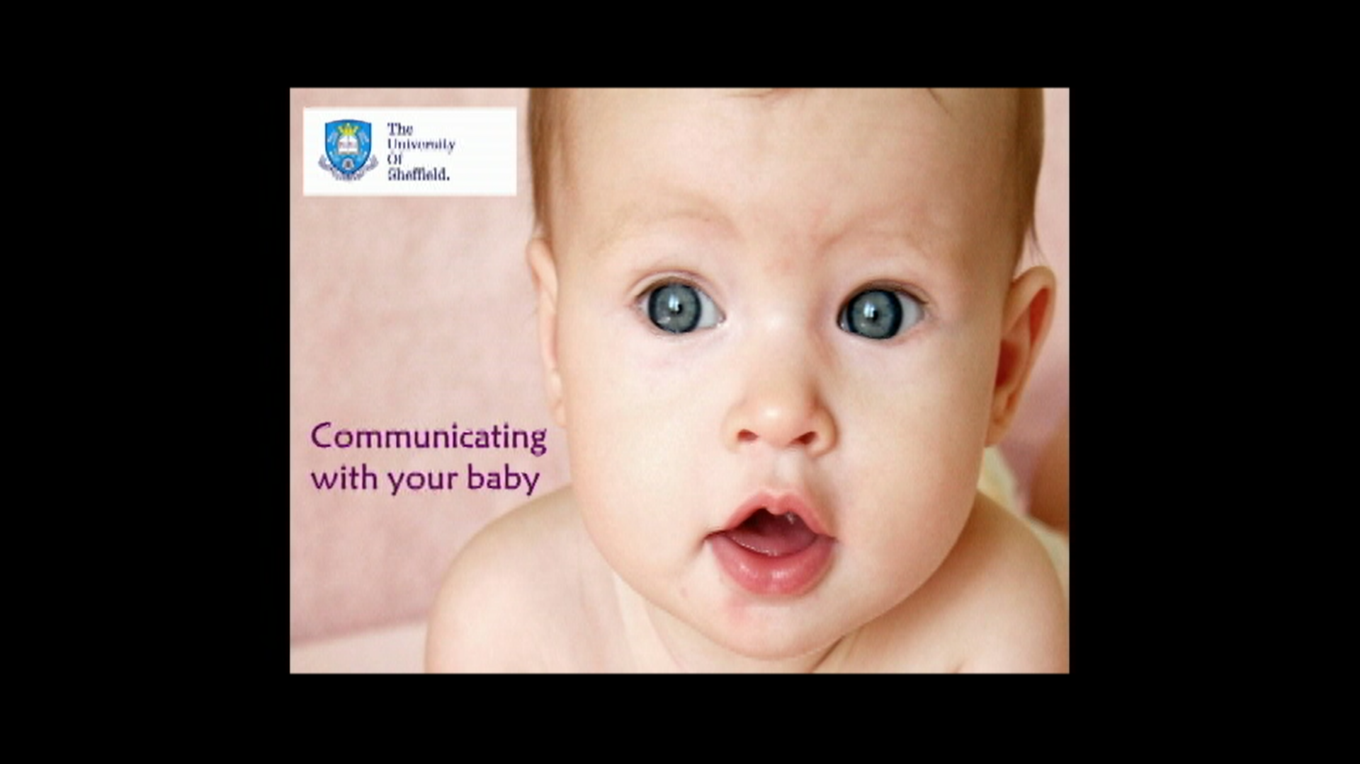

Even before they produce their first words, babies are learning how to communicate with other people. All children, hearing and deaf, learn in different ways. For deaf children, some parts of learning to communicate can be difficult. This video is about the things that we can do to make it easier. It is all about ways to communicate with your baby and ways to encourage their communication. The main ideas about communicating with babies are the same for both deaf and hearing babies, but for a baby with hearing loss, we need to make some adaptations. If some of these adaptations are new to you, and you would like to continue using them, soon they will feel like a natural part of your everyday communication.
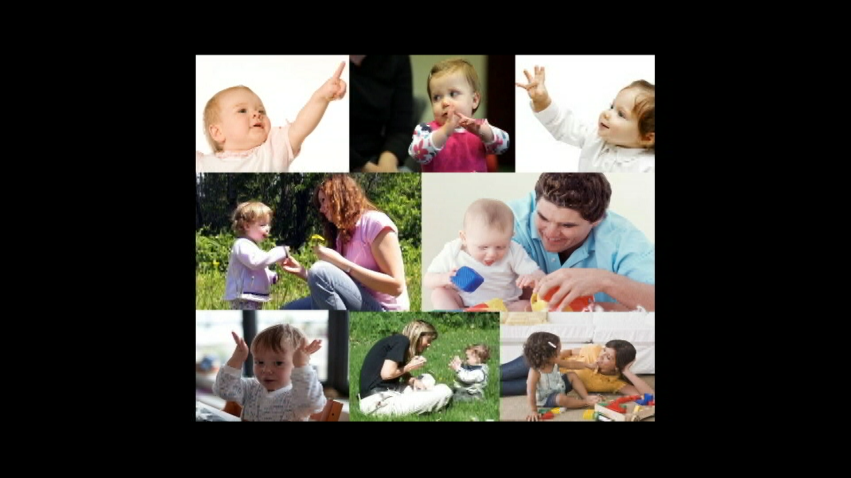

Around their 1st birthday is an exciting time, as babies’ communication skills really improve as they start to want to share what they are interested in with the people around them. A great way to encourage your baby’s developing communication skills is by being in joint attention with your baby. This is when an adult and baby are sharing attention together when focusing on the same object or event. For example, this mother and baby are looking at a picture book together.

Though they have the book in front of them, they may not be paying attention to the same thing. The baby may be looking at the picture of a cow whilst the mother is reading about the horse. So, how do you know you are attending to the same thing? If your baby were to look at the cow, look at you, point to the cow then look back to check you were also looking at the cow, then you are both attending to the cow and more importantly, you both know that the other is attending to the same object. Now you are in joint attention.
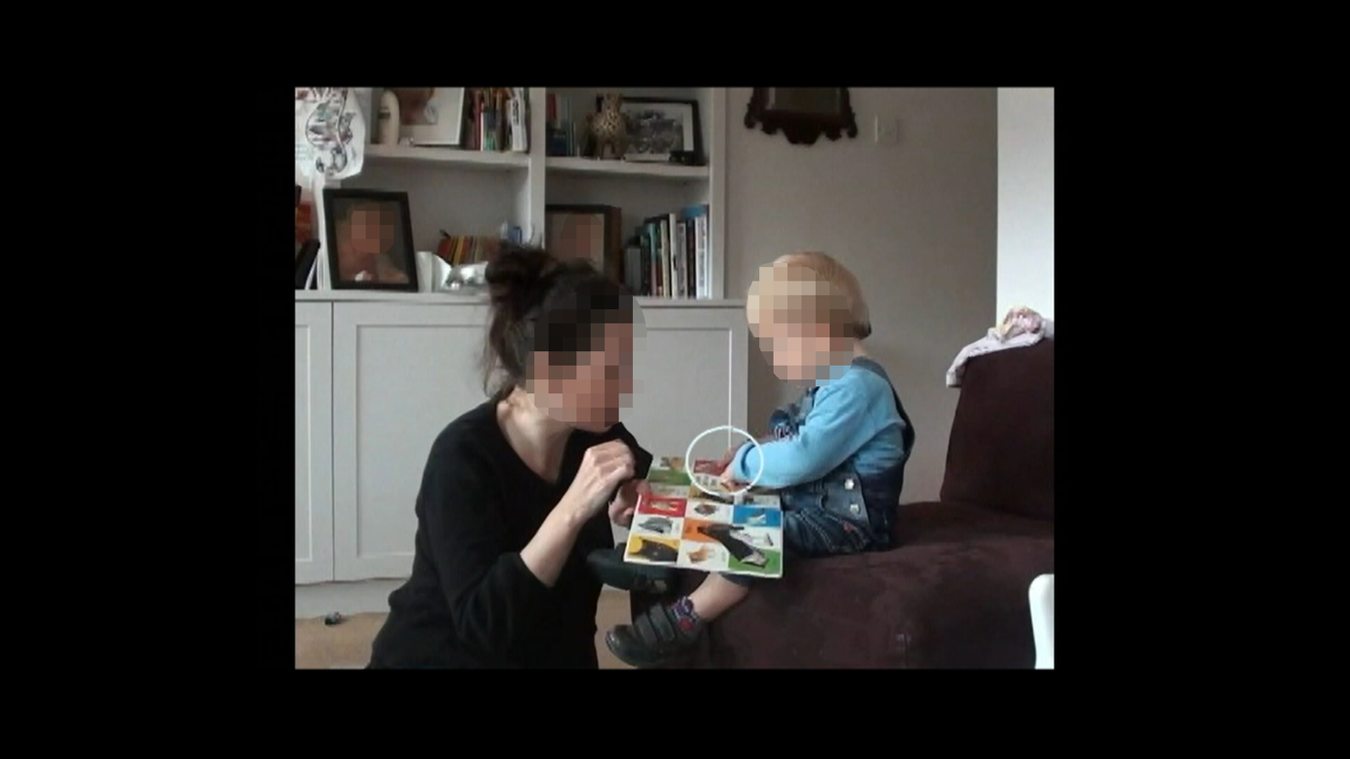

Being in joint attention is a great way for babies to learn language and to further develop their communication skills and social skills. Through joint attention, babies can learn about communication.

The tips in this video are things that you can try to make it easier to be in joint attention with your baby. These tips apply no matter what language you have chosen to use with your child. With the support of your local practitioners, every parent will come to a decision about which language they prefer to use. Some choose speech and natural gestures that we use in everyday communication some choose to sign and some choose to use a combination of both. This video is designed for all parents no matter which language you have chosen to use.
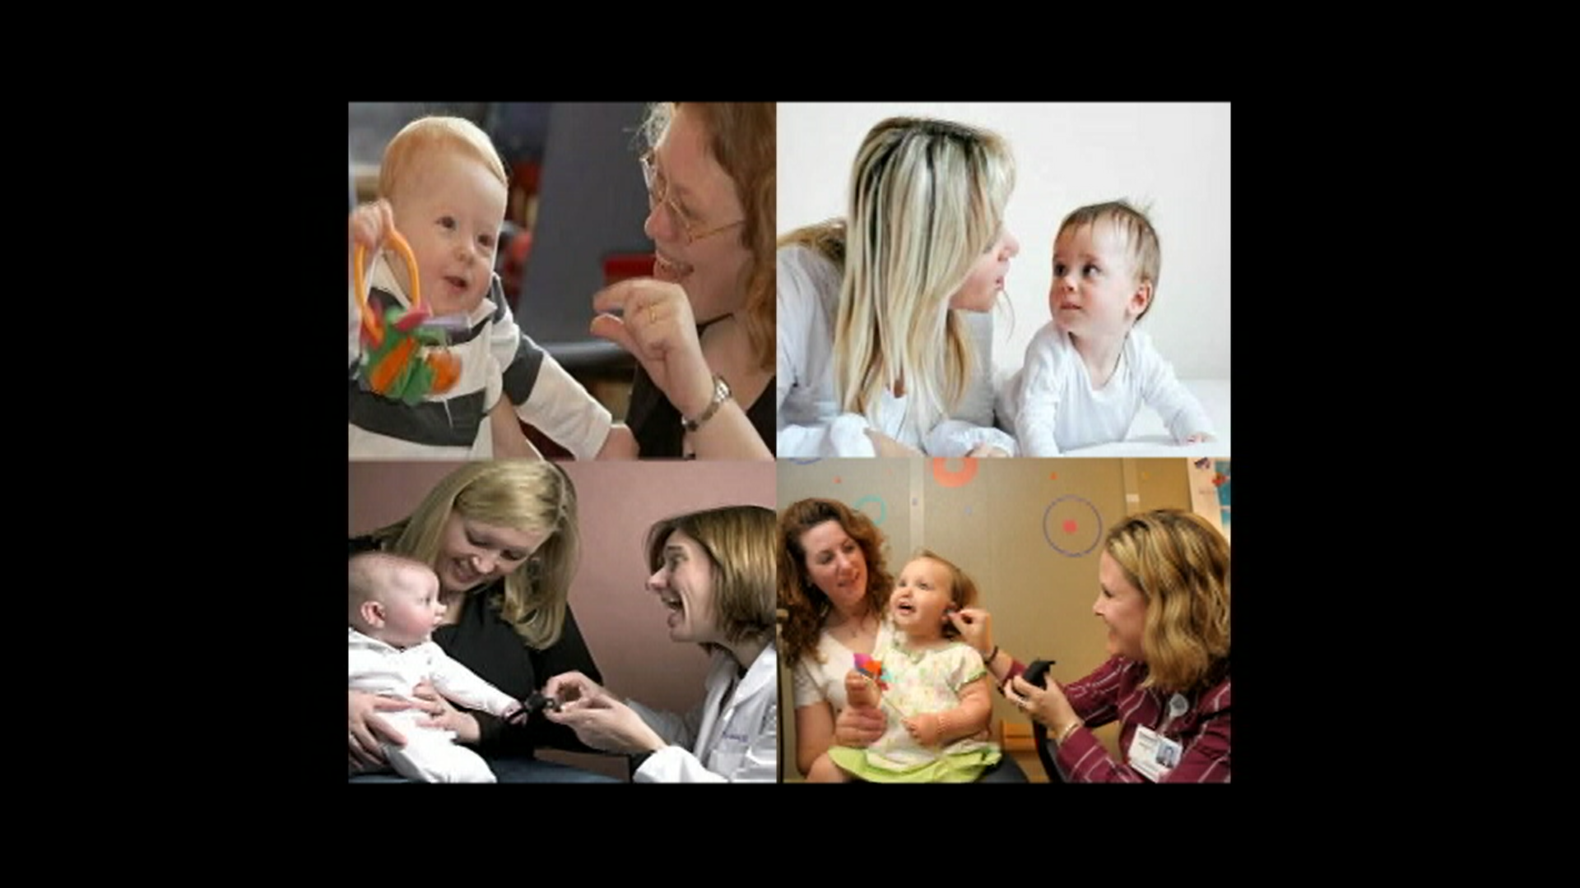

The rest of this video will present tips in four steps:
- Getting down to eye level
- Watching what your baby is focussing on
- Attracting your baby’s attention
- Responding to your baby’s attempts to communicate with you
These tips are to help make it easier to share attention with your baby when focusing on the same object or event – they will make it easier to be in joint attention.
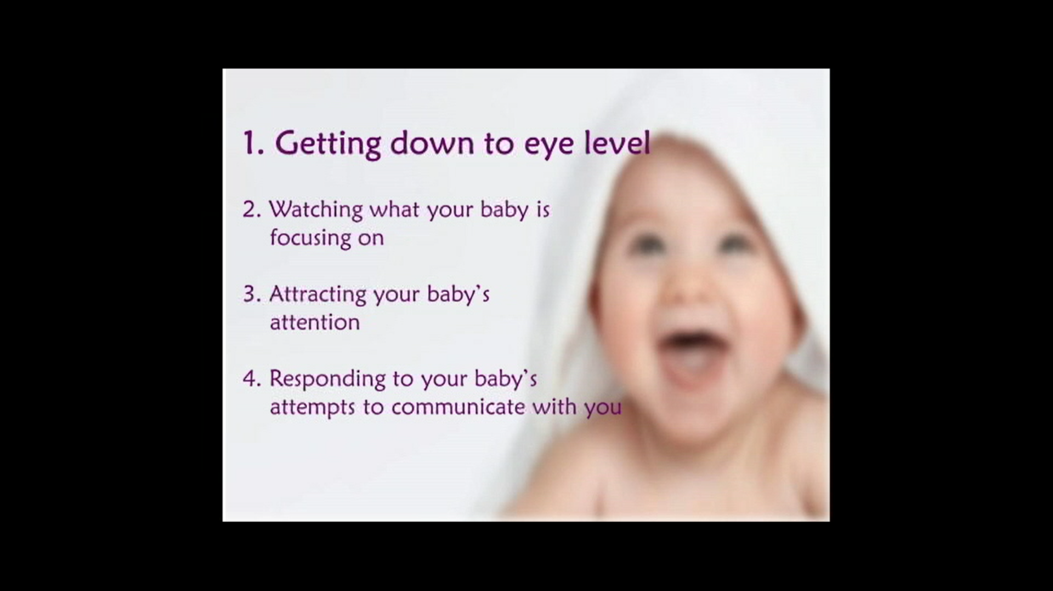

- Getting down to eye level
Eye contact is an important part of communication with all children, and for a deaf child this is even more so as they need to be able to look at you easily whilst you play together. Getting down to your child’s eye level is also great for when you use language. At this level, it will be easier for your child to see your lip patterns and signs, and it will be easier for your child to hear you if they are using hearing technologies, such as cochlear implants or hearing aids. It will also be easier for your baby to see your facial expressions and natural gestures. So the first tip is:
Get down to their eye level
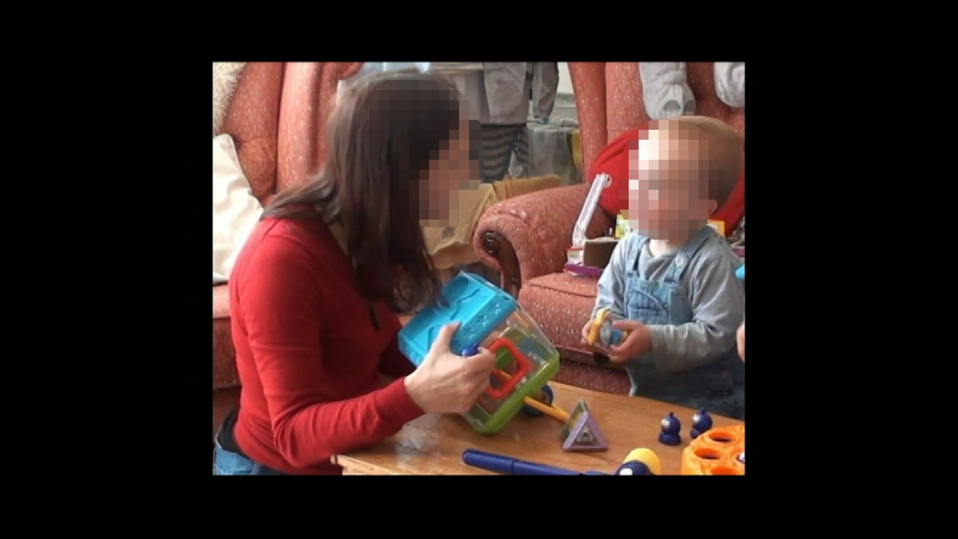
In this photo, you can see that the little boy can see his mum’s face and body easily. The idea is to get in just the right position so that your baby can see your face and hands and can easily switch between looking at what they are playing with and looking at you. Depending on your baby’s hearing status and if they are using hearing technologies, they will also find it easier to hear you. As well as being in your baby’s line of vision, if you can, try to make sure there is light on your face to help your baby see you clearly. Being where your baby can see you easily will make it easier for you and your baby to achieve and maintain joint attention, and have fun together.

The key thing to remember is the importance of visual cues and making eye contact. Your child will know that you are sharing interest in something with them by being able to see your face. Depending on your baby’s hearing status and if they are using hearing technologies, they will also be likely to hear you. Also, to understand what you are saying and/or signing your child needs to look at you.
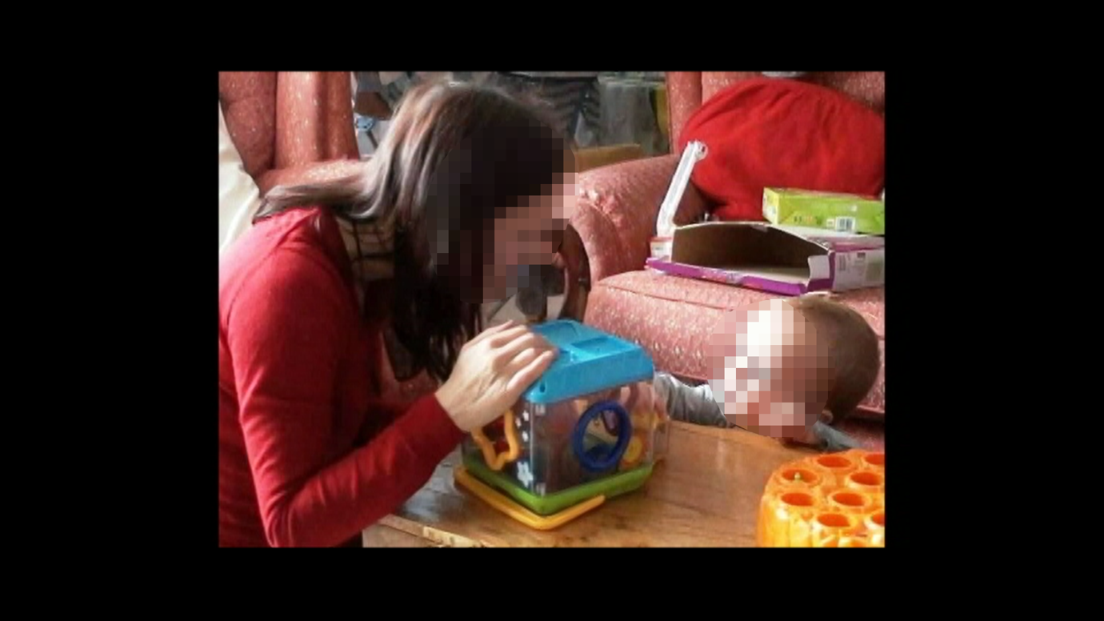

- Watching what your baby is focussing on
As well as getting down to your child’s eye level, it can be a good idea to take a moment to sit back and watch whether something has caught your baby’s attention, try to follow their lead. Communication can be more rewarding for babies if it is about what they are already interested in. We can usually tell that a baby is interested in something if....

…They are looking at it
…They are playing with it, touching it, or moving it around
…Sometimes, they may point at an object, or try to show or give it to you

The second tip is very simple:
Take the time to notice what your baby is focusing on
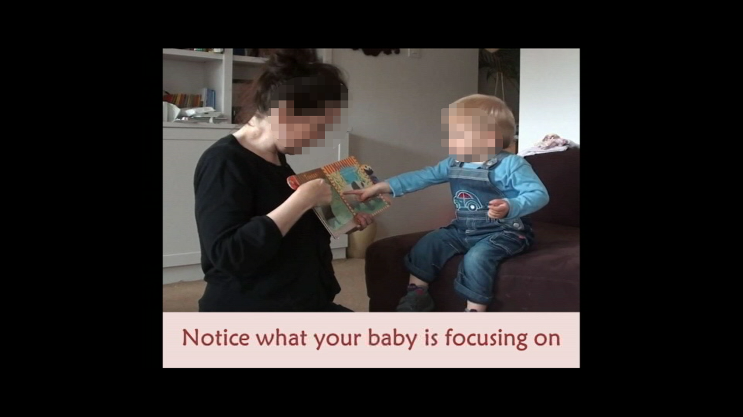
Once you have noticed what your baby is focusing on, you will be able to join in, perhaps by looking at the same thing with them, joining their play, and talking to them about what has already got their attention – this is joint attention.

In this picture, you can see the little boy is playing with a star shaped toy. This is a great opportunity for his mum to start to talk about what he is focussing on, and can also join in his play by helping him find where the star shape fits into his toy.
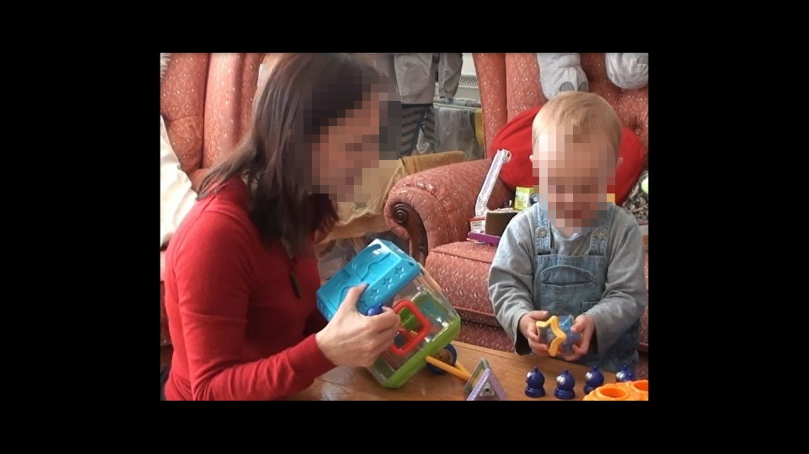
If your baby tries to tell you something about what they are interested in by making speech-like sounds, pointing, or other gestures, you can respond to their attempts using warm facial expressions and by talking or signing about their interest. Also, your baby may need a little more time to process what you are saying and/or signing, so take your time and use lots of repetition.

For your baby to know you are engaged with them and sharing attention with them, they will need to be able to see your face. When you respond to your baby’s interest or attempts to communicate and your baby doesn’t notice that you want to tell them about something, there are a few things you can do to get their attention.

- Getting your child’s attention
When getting your child’s attention, be where your baby can see you clearly. If your baby is using hearing technologies, you will have been given guidance to get your baby’s attention using sound first, for example, by calling their name. This guidance will have been given to develop the use of their hearing technologies. When calling their name, be near your baby and clear when you speak so that your baby can see your face and mouth clearly, and can also process sound depending on their hearing status and whether or not they are using any hearing technologies. If this doesn’t work, or if your child does not wear hearing technologies, you can use other methods to get your child’s attention. These are…
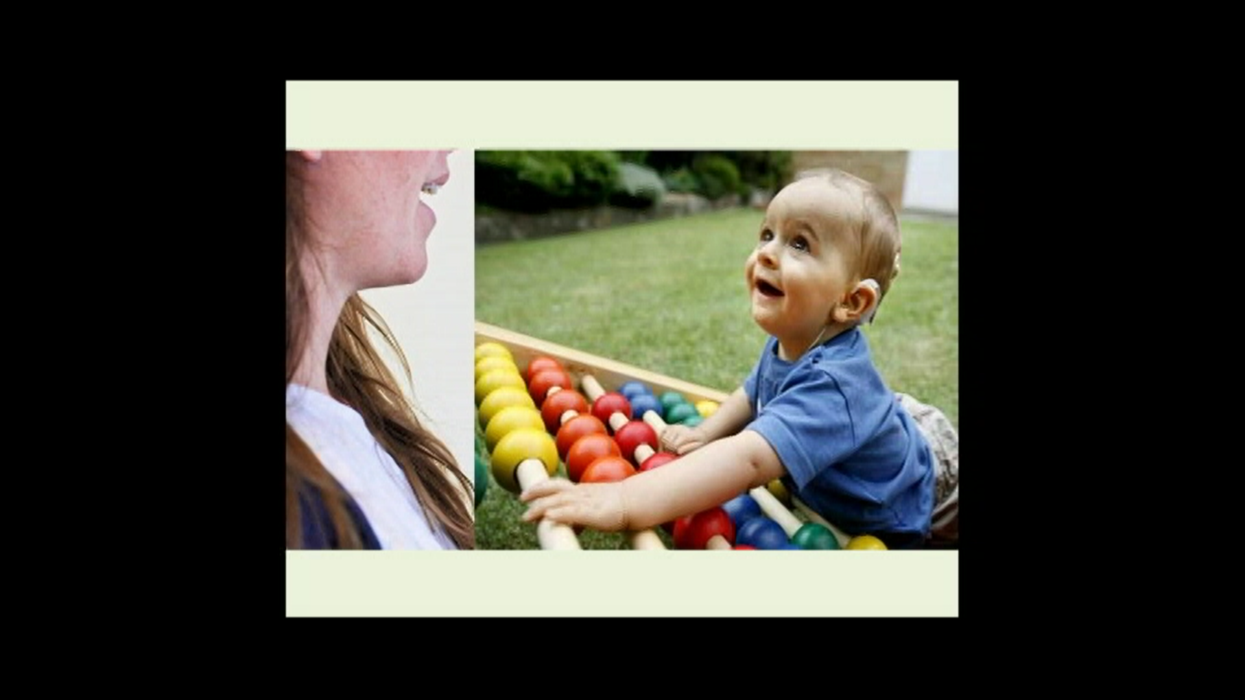

…Moving into your baby’s line of vision
…Waving in your baby’s line of vision
…You can also use touch. Deaf people use touch to get attention much more than hearing people. It can be a great way of letting your child know you want to talk to them.

Tip 3 is: Get your baby’s attention. Call their name near and clear. If your child does not use any hearing technologies and if sound often does not work, then try touch, waving, or moving into their visual space.
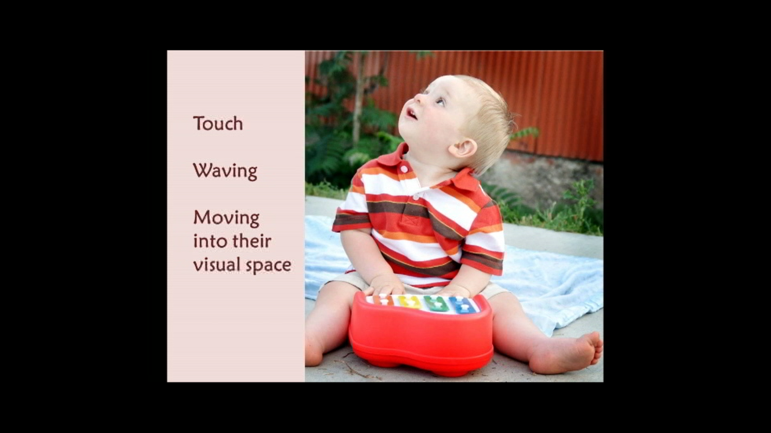

In this video, you will see a mum using touch to get her little boy’s attention…
[Video Clip 1]
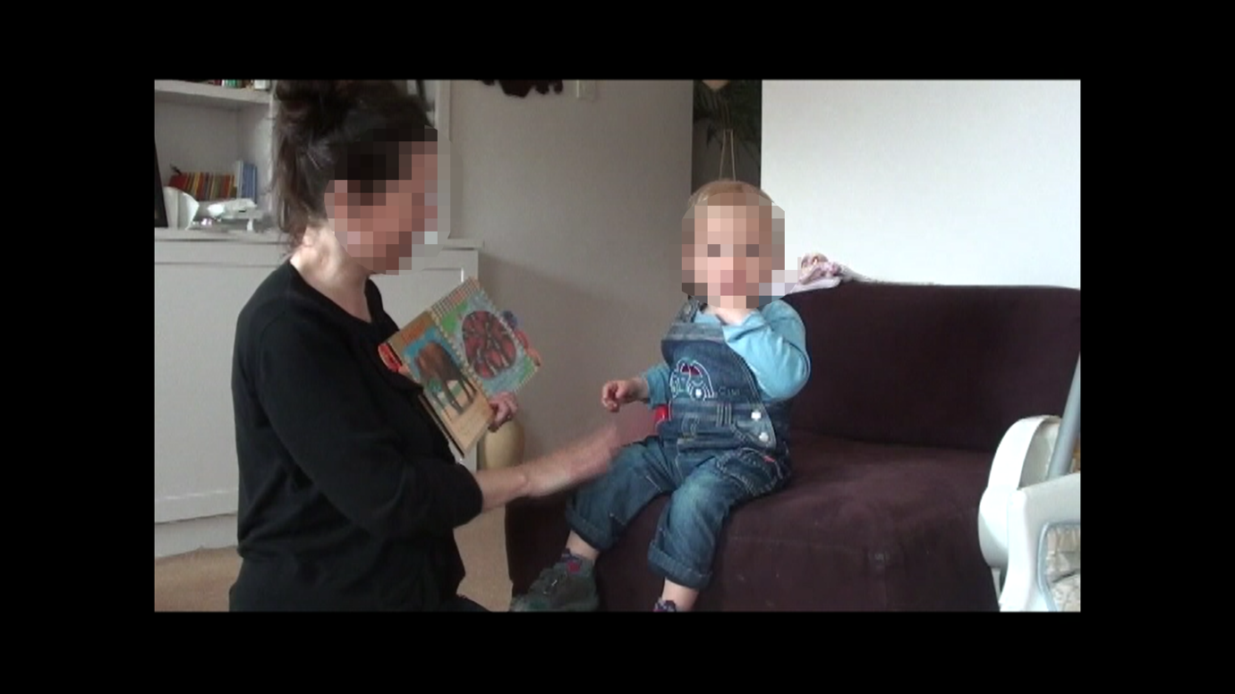

To get attention with touch, you can tap your baby on the shoulder, the arm, and even the leg when they are sitting. Try not to tap your baby if you are behind them where they can’t see you. This could startle your baby and will make it harder for them to respond by looking at you.

To get your baby’s attention by waving, try to wave your hand close to their face and in their field of vision. This is another really good visual cue to let your baby know you want to talk or sign to them. Deaf people do this a lot too.

Get down to your baby’s eye level when using these attention getting methods so it’s not a strain for them to look to you. When your child looks to you in response, show that you are pleased to encourage them to do it again. When your baby is looking at you, try not to get distracted so you can maintain eye contact.

It is worth being persistent when getting your baby’s attention.
[Video Clip 2]
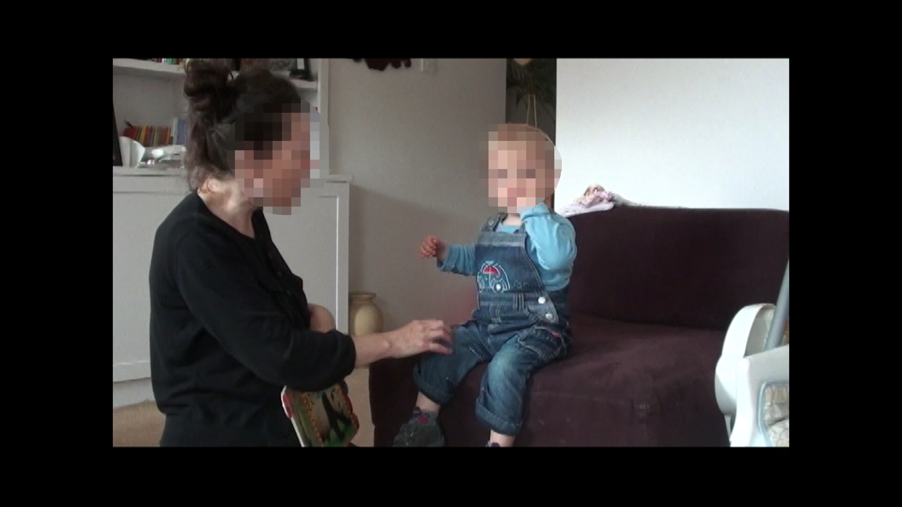
In this clip, the mum taps her son Jimmy, and also says his name until he looks to her. When she has his attention she is then animated in her response to him and points to a picture of a bear saying and signing, ‘bear’.

If you are using touch, sometimes you may need to tap firmly. You can also alternate between sound, touch, and waving in your baby’s field of vision until they look at you. How you use these attention getters will depend on the hearing status of your baby, and whether or not they are using hearing technologies. If you have been advised to use sound first, try using sound to get your baby’s attention by being near and clear. If this doesn’t work, you can try touch, waving, or alternating between all three.

Sometimes these attention getters won’t always work. Even when you persistently try to get your baby’s attention they may not look at you. This is OK too as with all babies, sometimes it is difficult to get their attention, especially when they are looking at something else, as can be seen in the next example:
[Video Clip 3]
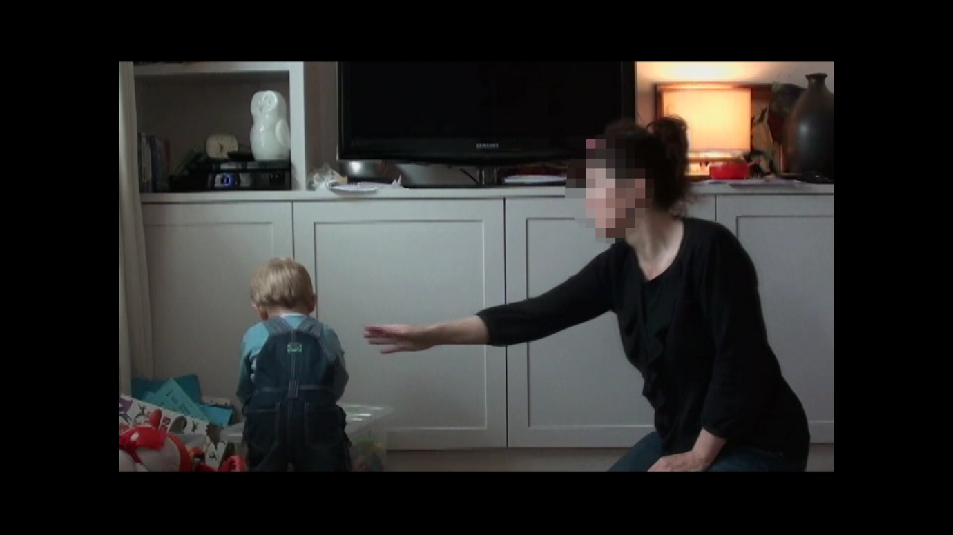
Here Jimmy’s mum tried to get his attention but he was looking at something else and moving away from his mum towards it. As he became interested in something else, this is a really great opportunity to watch what he is focusing on and share attention in what he is interested in.

The main idea is to give these attention getters a try whenever you would like to tell your baby something about what they are interested in. Your baby may not look at you the first 1 or 2 times but if you persist, they will be more likely to look at you. Obviously, this won’t always work and that’s fine. When being persistent at getting your child’s attention, alternate sound, tapping, waving, and even bringing your face into your baby’s field of vision.

If you are signing, you can even put the sign in front of your baby so they will see it and will be more likely to look to you. When they do look to you, you can repeat the sign a few times.
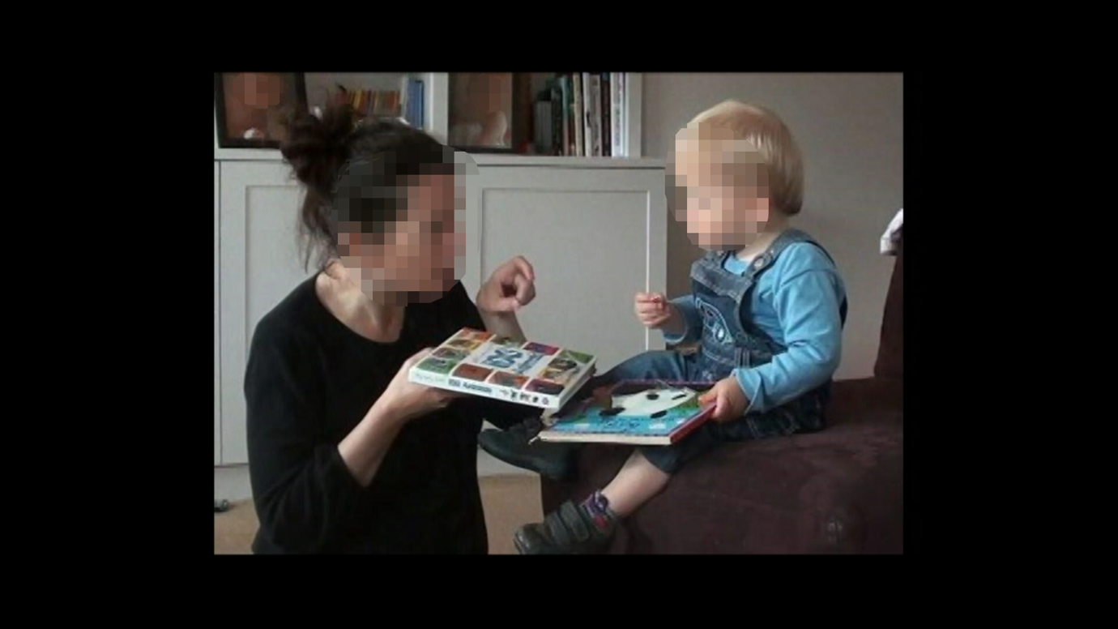

No matter which method you use to get your child’s attention, if they respond by looking at you, try to be animated with excited facial expressions. The idea here is that babies will often need a visual cue that shows you enjoy sharing attention with them. This can be very rewarding for your child. The main aim is for them to learn to look to you more often even when you are not trying to get their attention. Our next section is all about tips for responding to your baby.

- Responding to your baby
As well as getting your baby’s attention, it is important to be on the lookout for when they are trying to get yours, and to respond quickly. They might spontaneously look at you and make eye contact, or use gestures like pointing to direct your attention to the object or event that they are interested in. This is a great opportunity to join in and share in your baby’s interest. You can show your engagement by looking back and forth between your baby and the object they are playing with, and by having animated facial expressions to show your interest and excitement visually. So the fourth tip is:
Respond to your baby’s attempts to communicate with you
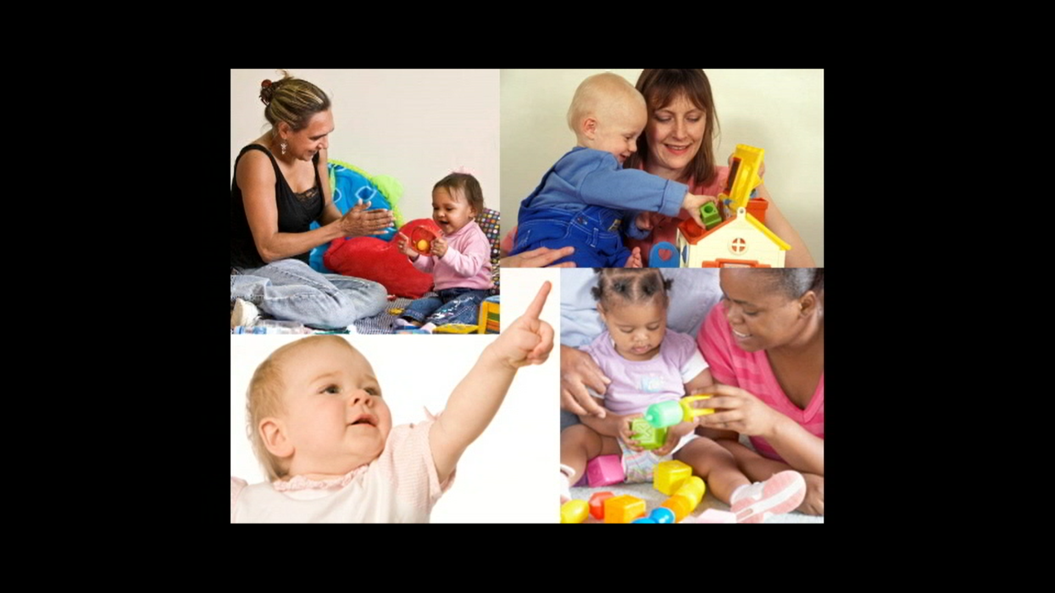

Research suggests that all children find it very rewarding when parents respond to their attempts to communicate. You can also talk or sign to them about what they are focussing on.

In this next clip, the little boy sees a picture of a rhinoceros on his book. He then points to his nose and looks up to his mum to make eye contact. He then pulls at the tab on the book with the picture of the rhino and points to his nose again. His mum notices and in an animated way she says and signs, ‘rhino!’, ‘rhino!’. Here, Jimmy and his mum are sharing attention together as they focus on the picture of a rhinoceros; they are in joint attention and having fun together.
[Video Clip 4]
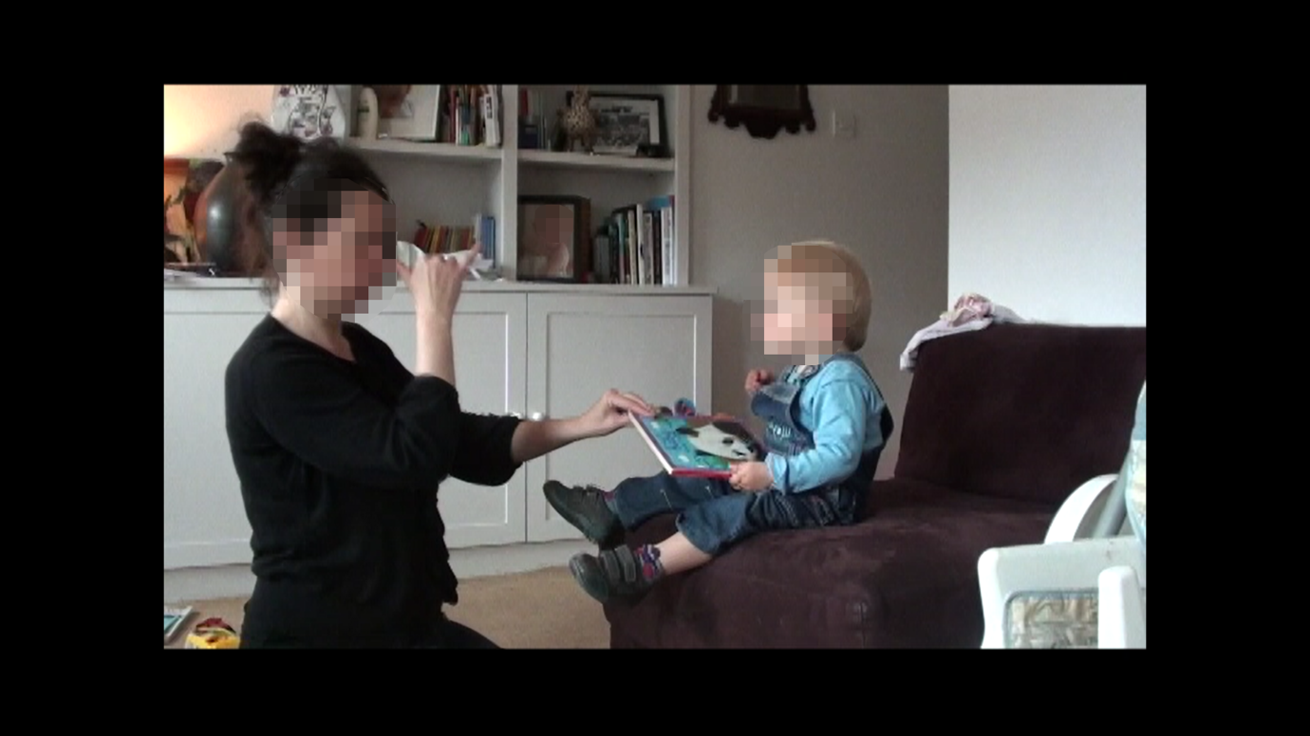

Talking or signing about what your child is interested in is a great way for your child to learn new words. For example, this little boy is looking at the washing machine. If his parent says or signs, ‘washing machine’ while he is interested in it, there is a good chance he would start to learn this word. But, if, while he is looking at the washing machine, his parent is preparing lunch and getting his attention to talk or sign about lunch, there is less chance he would learn the words for lunch foods, since he is not showing an interest in them at that time.
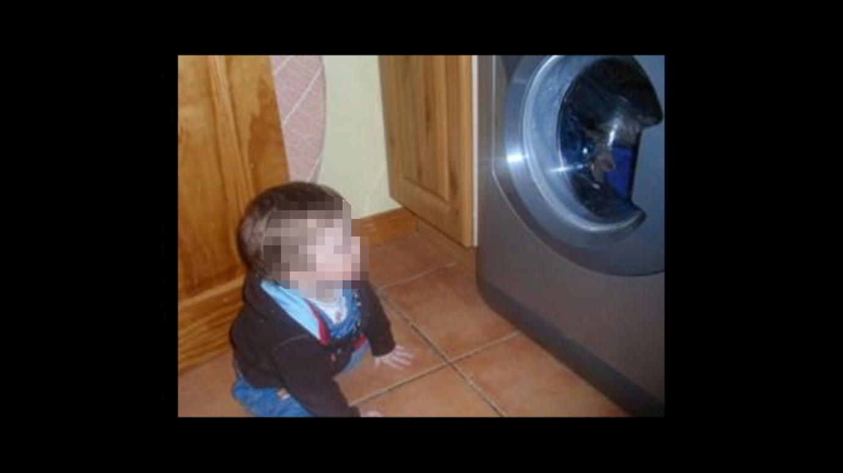
When you are talking or signing about an object or event, use facial expressions to support what you are saying or signing. So if you are saying or signing, “That’s right!” nod your head when you are doing this with lots of smiling.
[Video Clip 5]
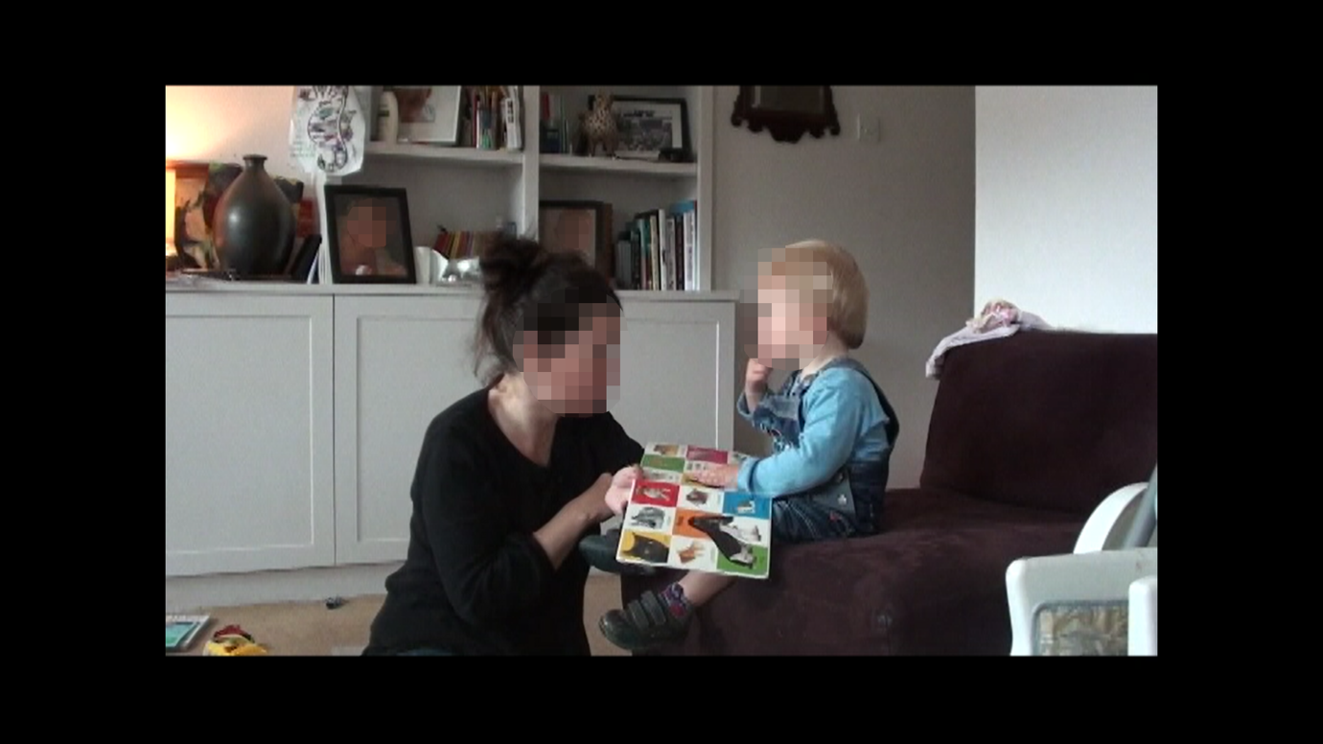

When we talk to babies, we naturally speak in a different way. We make changes to the way we talk to them by speaking slower, in a higher pitch, emphasising words and phrases, and speak in a more rhythmic way. We use a more lively and child friendly voice.
[Video Clip 6]
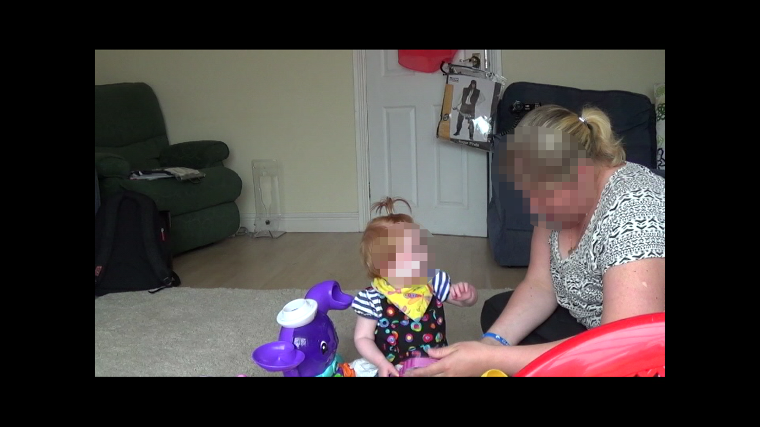

Babies prefer this way of speaking as they find it more interesting. It catches their attention and helps to develop their communication skills. So when you speak to your baby, try using a more child friendly voice.

If you are signing with your baby, you can make similar changes by signing more slowly, making your signs bigger, and placing the signs near the object you are signing about. If you often sign and talk at the same time like Jimmy’s mum, you can bring these tips together.

Putting it all together
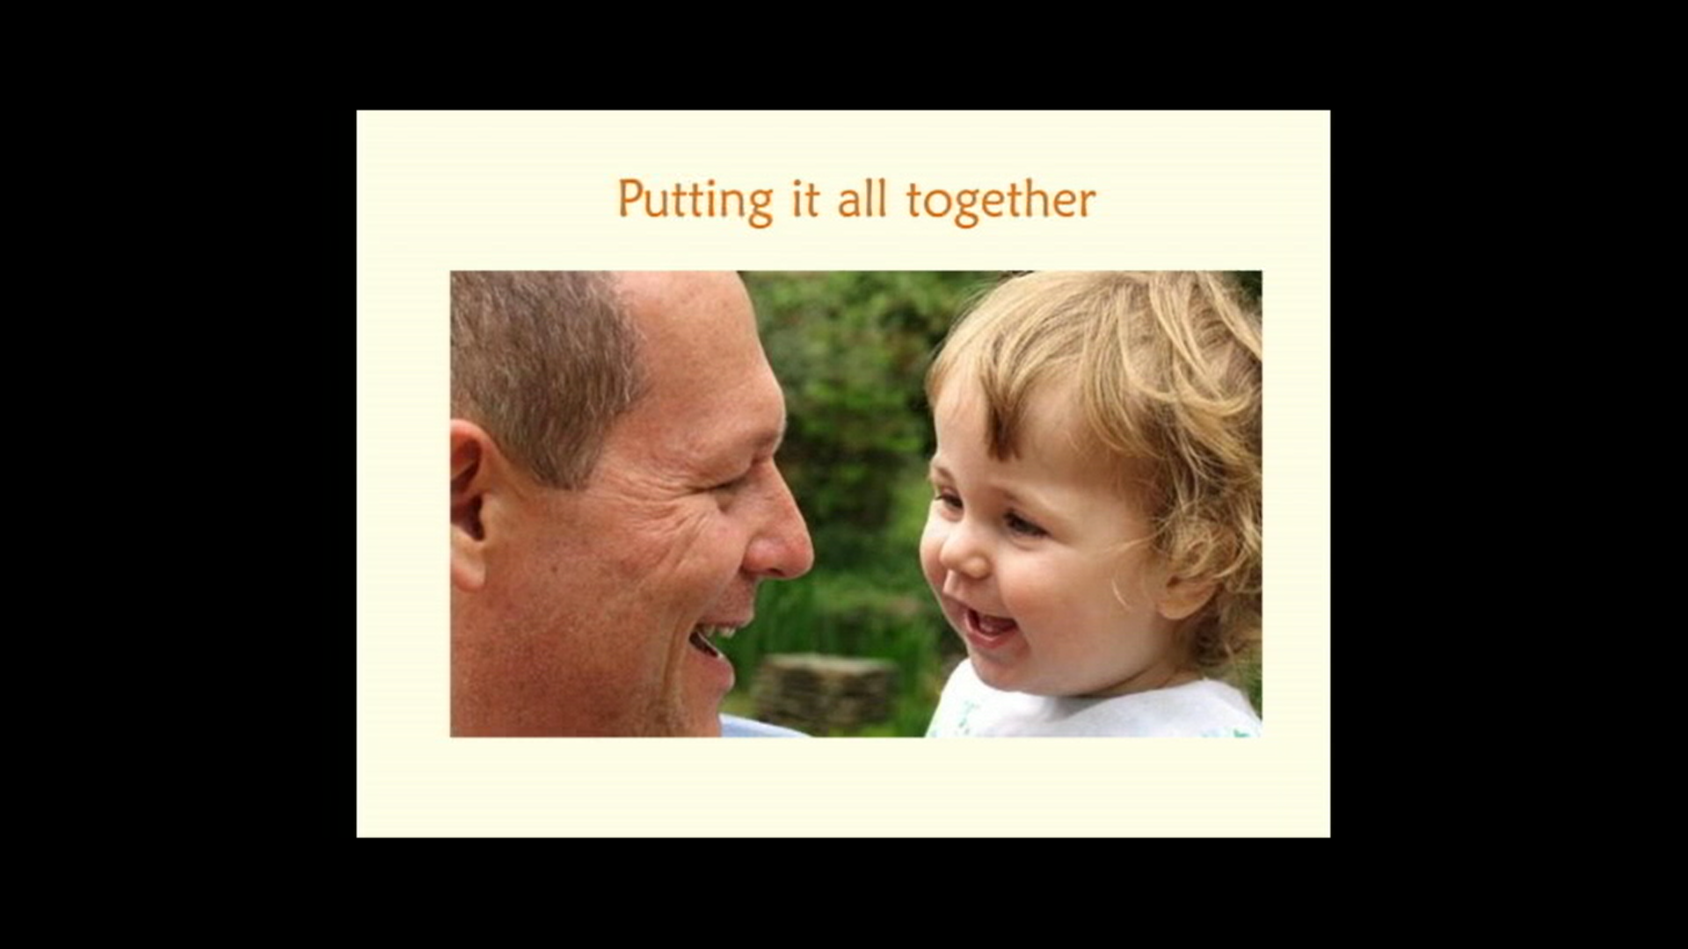

This next section is about putting it all together. Whilst spending time with your baby, pay attention to their eye contact, where they look, where they point, and what they touch. If your baby is interested in something, get their attention to show them that you are interested too and that you want to speak or sign about it. This will also encourage them to do the same with you and will make it easier to be in joint attention with your baby. When talking or signing about an object, first make eye contact by calling their name, tapping and/or waving so your child knows that something will happen. Then point to it, making sure your baby’s eyes follow your finger. Move your finger to the object making sure your baby’s eyes follow. Then look to the object as well. Once your baby’s gaze returns to you, you can then sign or say the word. This way they will know what you are talking or signing about and can then link the sign or word to the object. If you are signing, sign slowly and clearly.

When talking or signing to your baby, repetition is always good as sometimes your baby may miss what you have said or signed.
[Video Clip 7]
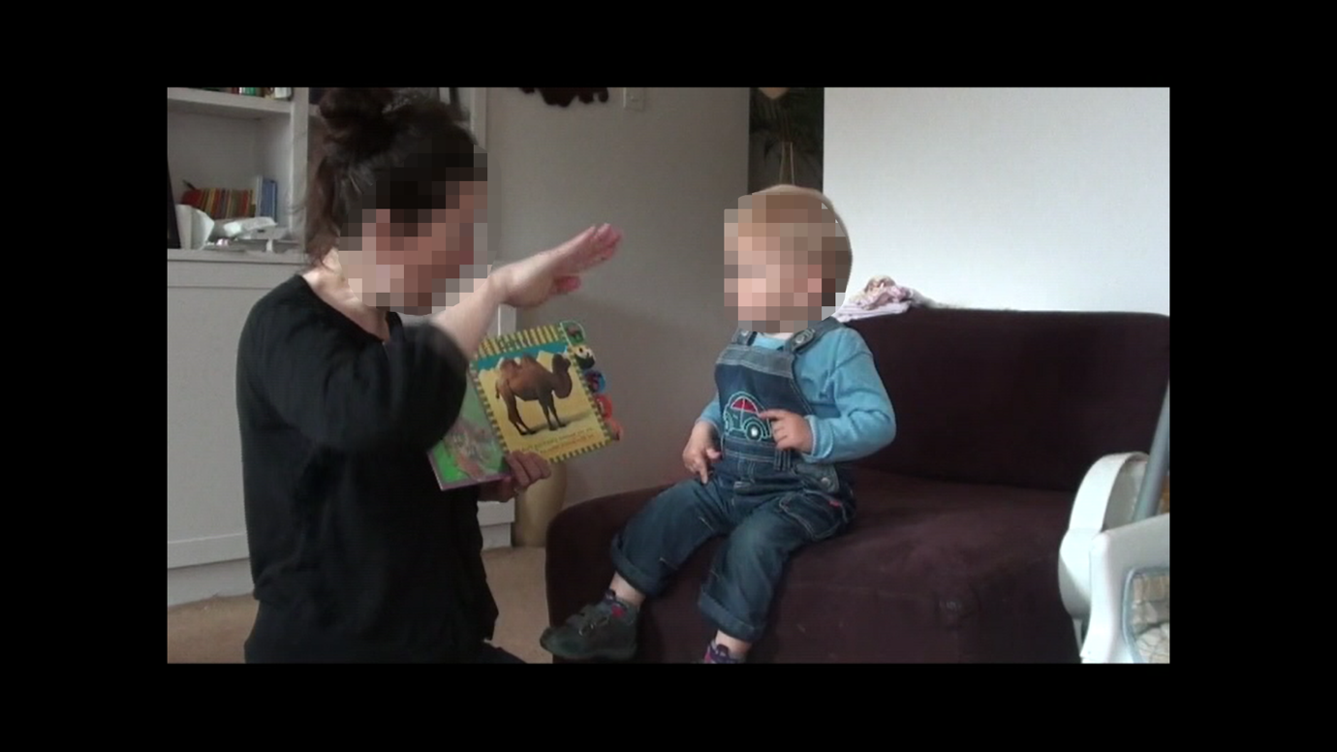

[Video Clip 8]
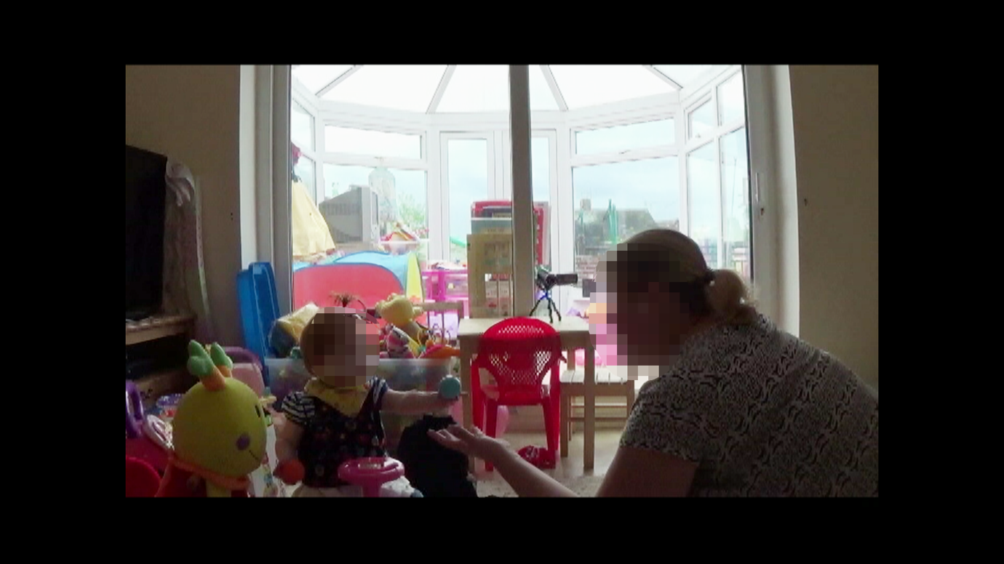
Repeating a word or sign can help make sure your child has seen it and heard it, depending on their hearing status and use of hearing technologies. This will help them to learn and to develop their language skills.

When putting it all together and trying out these tips, remember that you don’t just have to do them whilst playing with your baby. There are many great opportunities to engage and communicate with your child. For example, dinnertime, bath time, and nappy changing. Changing your baby’s nappy is a really great time to engage with your baby as they will be focussed on you. Here you have an opportunity to maintain eye contact and be animated in your facial expressions, and can also to talk or sign to keep your child’s attention. You can also try the tips is this video whist reading a book with your baby, making sure you are sitting in a position where your baby can easily see the book, and your face and hands.
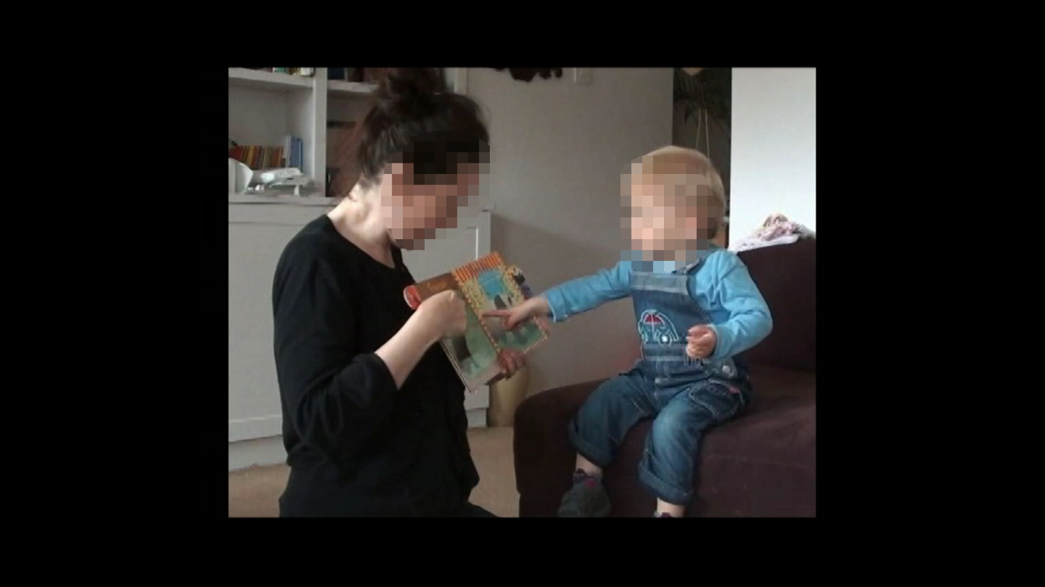

The videos we have just seen are all about ways to make it easier to communicate with your baby and to encourage their communication. These were:

- Getting down to eye level so it is easy for your baby to see you, make eye contact, and hear you if they are using hearing technologies.
- Notice what your baby is focussing on, join in with animated facial expressions, and talk or sign about what they are interested in. To let your child know you are interested and want to tell them something, make sure you get their attention.
- When you want to talk or sign about what your baby is interested in, use attention getters such as calling their name near and clear (particularly if your child is using hearing technologies), tapping, waving close to your baby’s face, moving your face into their line of vision, and placing objects or signs in their field of vision. Be persistent and they will be more likely to look to you.
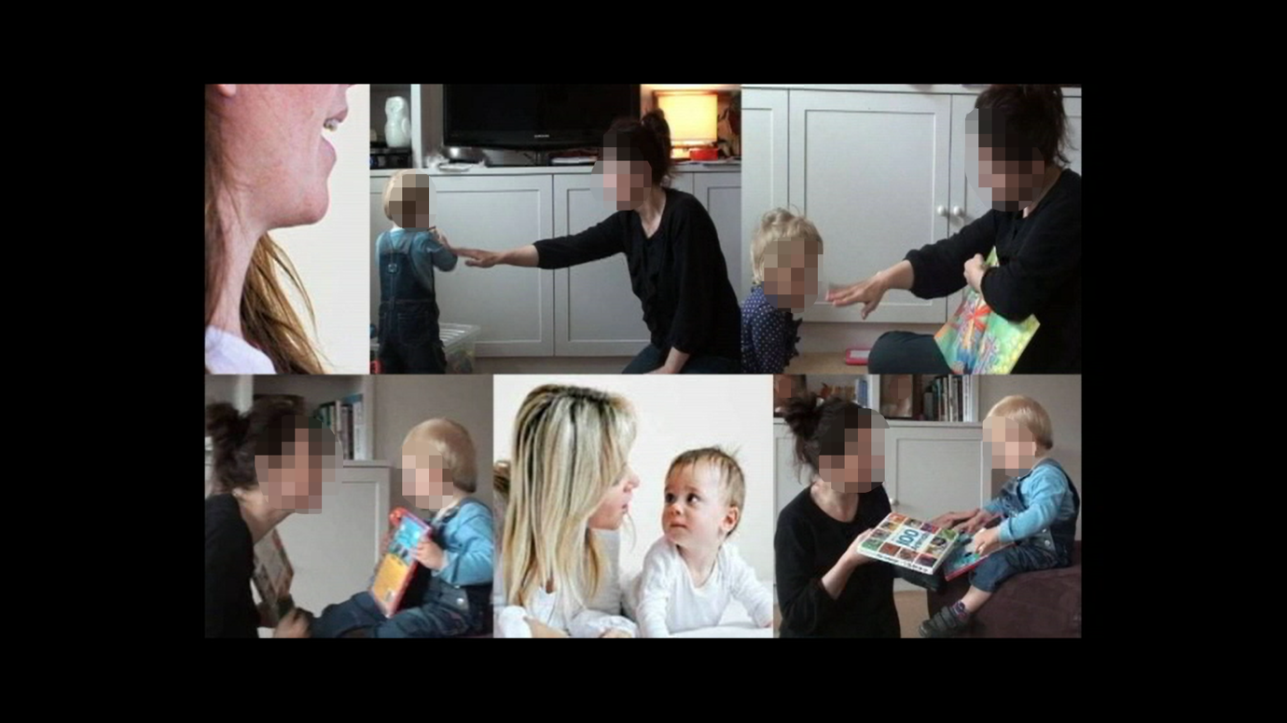
- When they do look at you, respond quickly and with warm, animated facial expressions.
- Keep a lookout for when your baby is trying to get your attention with eye contact and gestures.
- Respond to these by joining in, showing your interest using facial expressions, and by talking or signing to them about what they are showing you or trying to tell you about.
- When you are talking or signing to them, use a more child friendly voice and/or signing style.
- Use lots of repetition when you talk or sign, and use facial expressions to support what you are saying or signing. Also, give your baby a little more time to process what you are saying and/or signing.
- Remember that you can do all of these things in everyday situations with your baby.
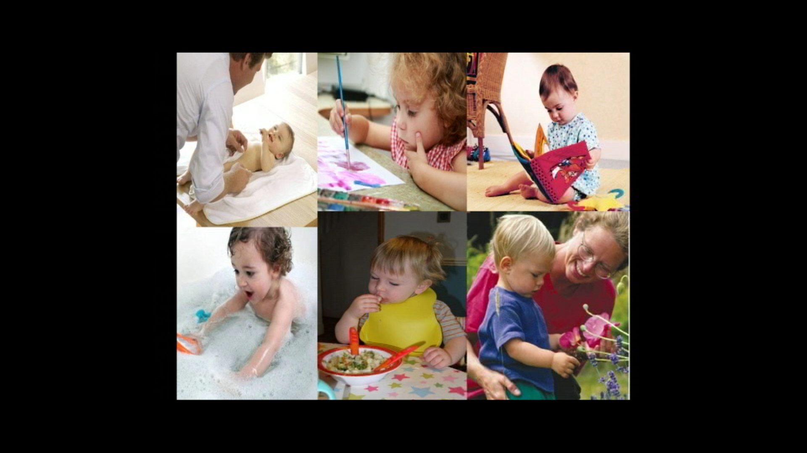

This is what we would like you to try. Try using these tips in situations such as playing with your baby, reading a book, changing their nappy, on the bus, having a meal, or having a bath. We are running this study to see if using these tips makes communication easier.

So, what do you need to do?
We would like you to trying using these tips in a few everyday situations over the next two days. Try using them in any situation you and your baby are involved in. When the researcher comes back to visit, we would like you to try out these tips whilst we video record you and your baby playing together, like today’s recorded play session. We are interested to see if you find this video helpful as we value your thoughts and feelings about the helpfulness of these tips.
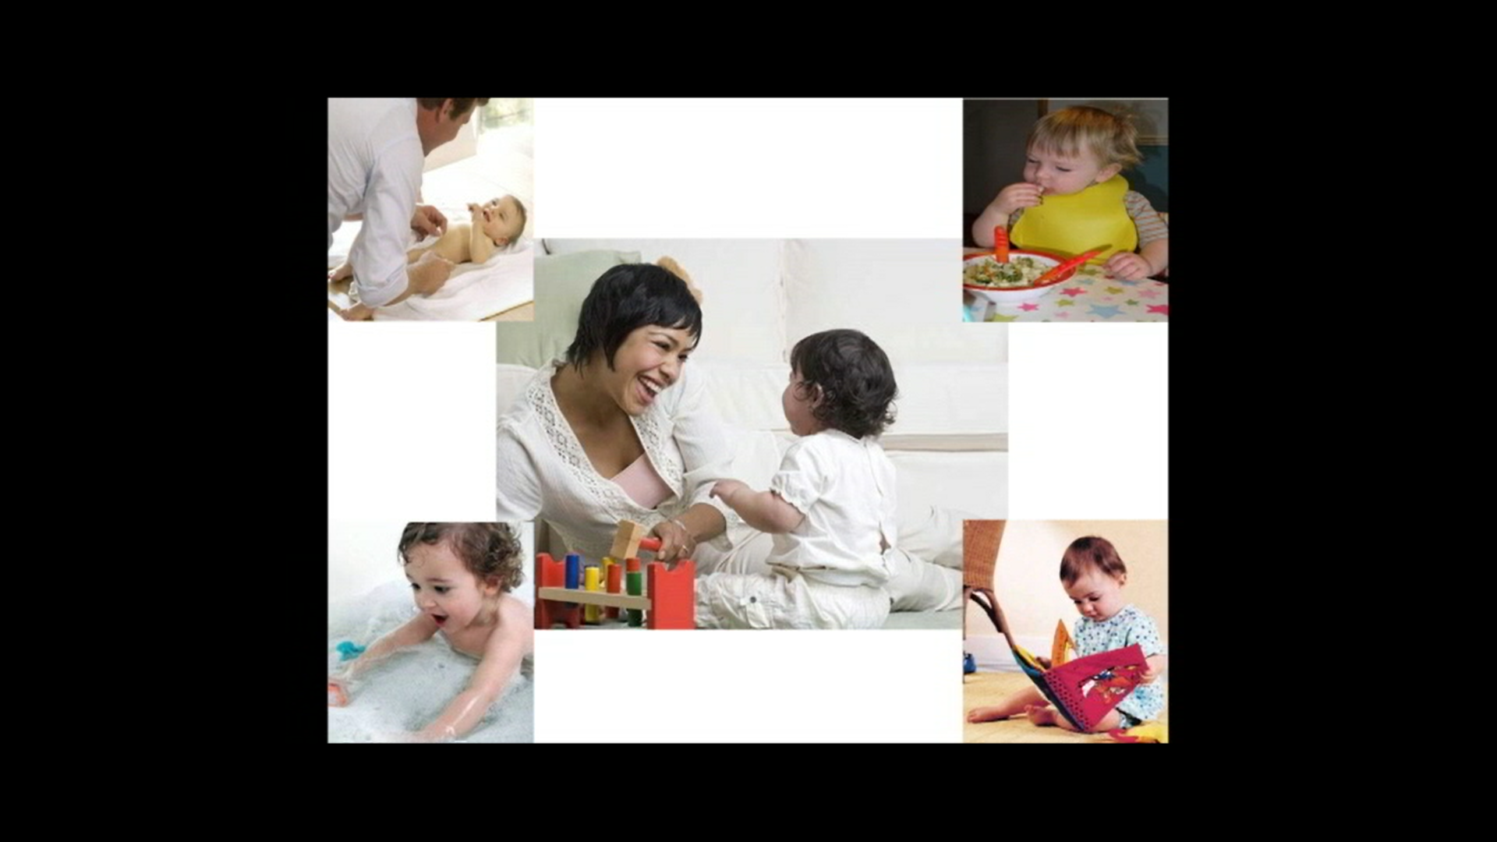

Thank you for your interest in our study. We hope that both you and your baby will have fun taking part!


The total DIHP group and total HIHP group includes infants aged 12 and 18 months. Given that word production is rare at 12 months, this effect size is based on 18-month-old infants and is likely underestimated in comparisons between total groups. Please see 18-month-old comparisons for a more accurate effect size estimate.
Power calculations computed using G*Power (Faul, Erdfelder, Buchner, & Lang, 2009), suggest that in order to detect significant differences in line with those in the present research, a sample size of 21 infants is required for large sized effects, 64 infants for medium sized effects, and 614 infants for small sized effects (required for total group comparisons and the subset comparisons).
There are several factors that could interfere with typical intuitive parenting behaviours, many of which are associated with the diagnosis of deafness. Such a diagnosis is often a shock for hearing parents, and can bring about various reactions including grief, guilt and depression (Meadow-Orlans, 1995), as well as feelings of helplessness, incompetence, and inadequacy in terms of being able to communicate easily and effectively with their infant (Bodner-Johnson & Sass-Leher, 1996; Meadow-Orlans, Koester, et al., 2004). Furthermore, parents often experience stress from conflicting professional opinions in terms of intervention and communication options (Meadow-Orlans et al., 1995) and face overwhelming amounts of information and decisions relating to communication (i.e., using signed or spoken language), amplification devices, the possibility of cochlear implantation, and education (i.e., mainstream or specialist schooling; Meadow-Orlans, 1980; Meadow-Orlans, Koester, et al., 2004).
Although limited, there exists a small number of studies investigating the language outcomes of deaf children whose parents were enrolled in early interventions designed to help family members develop techniques to encourage their child’s communication development (Holzinger et al., 2011; Yoshinaga-Itano et al., 1998). Findings suggest early enrolment has a positive relationship on later child language outcomes. A key problem with these reported studies is that intervention materials are not publically available, therefore making it difficult to replicate and disseminate findings.
Although lack of resources was a factor, the main reason this was not coded is that infant communicative acts vary due to individual differences (see Chapter 3 for a summary) and thus, would need to be controlled for. Due to the small sample size, this is not possible.
So that coding could be conducted by a researcher blind to condition, S. Kennedy coded parental contingency for the present study, which was analysed at the utterance level (i.e., number of contingent utterances) by the present study’s author. Kennedy (2018) conducted a secondary analysis of parental contingency but at the word level (i.e., number of contingent words), and its association to a set of psychosocial measures.

