**A Study of the Behaviour and Conservation of Manta Rays in the Maldives**

Annie Murray

Doctor of Philosophy

University of York

Environment and Geography

February 2019

# **Abstract**

This study of the world’s largest recorded population of Reef Manta Rays (*Mobula alfredi*) uses seven years of photo-ID data and three years of video observations of foraging in the Maldives to investigate social structures at both the large (aggregation) and fine-scale (foraging group), individual foraging flexibility and the impacts of ecotourism management strategies on foraging behaviour.

*M. alfredi* can be observed aggregating in large numbers, yet little is understood about their social interactions. Using social network analysis, I found no evidence of structure within either the large or fine-scale. Individuals showed no preference in either aggregating or foraging with associates. There was no difference among individuals in gregariousness and dyads exhibited low temporal stability. Aggregations and foraging groupings did not appear to be driven by sociality, but by the dispersal of their ephemeral zooplankton prey, with strong fission-fusion dynamics and loose relationships.

Within aggregations, manta rays have been seen to forage in both groups and solo. I examined whether *M. alfredi* adopted specific roles within groups and the drivers of group feeding. Using mixed models, I found that individuals were more likely to forage in groups than solo when food availability was high and smaller general aggregations resulted in larger individual foraging groups. Females were more likely to lead foraging aggregations than males. Variance partitioning models showed low among-individual variance in group size, positioning and leadership, showing that individuals were highly flexible in their foraging behaviour.

Although multitudes of tourists interact with *M. alfredi* annually, few studies have assessed potential disturbance to their natural behaviour. I found significant changes to foraging behaviour resulting from intrusive human behaviours and interactions within 3m. My findings provide a clear evidence-base for the development of a binding code of conduct. This shows that manta rays are behaviourally flexible, with a tolerance to fluctuations in environmental conditions, yet are specifically vulnerable to disruptions to their prey.

Contents

Abstract 2

List of tables 6

List of figures 8

Acknowledgements 13

Declaration 15

Abbreviations and Glossary 16

Chapter One: A study of the sociality, grouping and foraging behaviour and conservation of Manta Rays (*Mobula alfredi*), a general introduction 19

***1.1*** ***Analytical tools for examining social structures on a population level*** 21

*1.1.1 Social structure* 21

*1.1.2 Weighted vs. unweighted networks* 24

*1.1.3 Challenges* 25

*1.1.4 Kinship* 26

*1.1.5 Resource distribution* 27

*1.2* ***How and why animals interact on a group level*** 29

*1.2.1 Group formations* 29

*1.2.2 Interactions* 31

*1.2.3 Fission-fusion* 32

***1.3*** ***Behavioural traits and differences on an individual level*** 33

*1.3.1 State dependent variables* 34

*1.3.2 Personality* 36

***1.4*** ***Manta Rays*** 38

***1.5*** ***Thesis synopsis*** 44

Chapter Two: The influence of foraging on the grouping behaviour of a population of Reef Manta Rays (*Mobula alfredi*) in the Maldives Archipelago. 47

***2.1 Abstract*** 47

***2.2 Introduction*** 48

*2.1.1 Space use and resource dispersal* 49

*2.1.2 Temporal and seasonal variation in sociality* 52

*2.1.3 Individual variation in sociality* 53

*2.1.4 Social network analysis* 54

*2.1.5 Elasmobranch sociality* 55

*2.1.6 Study outline and aims* 57

***2.3 Methods*** 57

*2.3.1 Study Site* 57

*2.3.2 Data Collection* 58

*2.3.3 Statistical analyses* 61

*2.3.4* *Associations between individuals* 63

*2.3.5 Gregariousness* 64

*2.3.6 Temporal stability of relationships* 65

***2.4 Results*** 66

*2.4. 1 Network overview* 66

*2.4. 2 Associations between individuals* 67

*2.4.3 Gregariousness* 73

*2.4.4 Temporal stability of relationships* 77

***2.5 Discussion*** 91

*2.5.1 Resource distribution* 94

*2.5.2 Fluid social structures* 96

*2.5.3 Limitations and future considerations* 97

***2.6 Conclusions*** 100

Chapter Three: Individual flexibility in group foraging behaviour of reef manta rays (*Mobula alfredi*) 102

***3.1 Abstract*** 102

***3.2 Introduction*** 103

***3.3 Methods*** 111

*3.3.1 Study area* 111

*3.2.2 Data Collection* 111

*3.2.3 Video analysis:* 113

*3.2.4 Statistical Analysis* 113

***3.4 Results*** 118

***3.6 Conclusions*** 138

Chapter Four: Protecting the million-dollar mantas; creating an evidence-based code of conduct for manta ray tourism interactions 139

***4.1 Abstract*** 139

***4.2 Introduction*** 140

***4.3 Methods*** 146

*4.3.1 Study Site* 146

*4.3.2 Data Collection* 147

*4.3.3 Video Analysis* 148

*4.3.3 Statistical Analysis* 150

***4.4 Results*** 151

***4.5 Discussion*** 157

***4.6 Conclusions*** 162

Chapter Five: General discussion and conclusions 163

*5.1 Summary of key results* 163

*5.2 Implications of my results* 167

*5.3 Limitations and weaknesses of my study* 170

*5.4 Remaining knowledge gaps* 173

*5.6 Final conclusions* 174

Appendices 176

**Appendix I:** Annual variation in foraging conditions 176

**Appendix III:** Pilot study results for snorkel and dive interactions. 181

**Appendix IV:** Pilot study results for snorkel and dive interactions. 182

**Appendix V:** Pilot study results for snorkel and dive interactions. 183

References 184

# **List of tables**

**Chapter 2**

**Table 2. 1**: Tests for preferred associations within aggregations. Permutation tests with swaps between pairs of associations with 5000 permutations, 100 swaps/permutation. n = 844, n (female: male) = 498:346, n (adult: juvenile) = 515:329. P-values below 0.05 indicate preferred associations 70

**T****able 2. 2**: Tests for preferred associations within Hanifaru Bay foraging groups. Permutation tests with swaps between pairs of associations using 5000 permutations, with 100 swaps/permutation. n = 173, n (female: male) = 124:49, n (adult: juvenile) = 99:74. P-values below 0.05 specify preferred associations. 72

**Table 2. 3**: Effect of demographic factors (sex and age class) and interactions on gregariousness within aggregations. Statistics include estimate (positive, negative -), standard error (*SE (β)*), t value, probability of deviation from a slope of zero (*p*). Statistically significant (sig.) results appear in bold. (n = 844). 74

**Table 2. 4**: Effect of demographic factors (sex and age class) and interactions on gregariousness within foraging groups. Statistics include estimate (positive, negative -), standard error (*SE (β)*), t value, probability of deviation from a slope of zero (*p*). Statistically significant (sig.) results appear in bold. (n = 173). 76

**Chapter 3**

**Table 3. 1:** Models tested to explain group size, position in group and leadership. 114

**Table 3. 2:** Effect of environmental factors on group versus solo foraging behaviour. Statistics include estimate (positive, negative -), standard error (SE), z value, probability of deviation from a slope of zero (*p*). Statistically significant results appear in bold. (n = 3106). 120

**Table 3. 3:** AIC comparisons for all a priori models of abiotic, biotic (within-group) and (external to group) variables for **(a)** group size, **(b)** position in group, **(c)** leadership. Model of best fit (indicated in bold) correspond to the model with lowest AIC values for each response variable. k, number of free parameters for a given model; R2, true repeatability ratio of fixed effects. (n = 1056). 122

**Table 3. 4:** Generalised Linear Mixed Models of best fit for behavioural traits, **(a)** group size, **(b)** position in group, **(c)** leadership and variance components (among (Vi), fixed effect (Vfe), within-individual (Vw)). Statistics include estimate (positive, negative -), standard error (SE), t or z value, probability of deviation from a slope of zero (*p*), variance value and confidence intervals to a 95% level. Statistically significant results appear in bold. (n = 1056). 123

**Table 3. 5:** Generalised Linear Mixed Models the probability of **(a)** anthropogenic injury or **(b)** signs of shark bites varies position in group and group size. Statistics include estimate (positive, negative -), standard error (SE), z value, probability of deviation from a slope of zero (*p*). Statistically significant results appear in bold. (n = 1056). 127

**Chapter 4**

**Table 4. 1:** Definitions for human behaviour observed during interactions. 149

**Table 4. 2:** Definitions for manta ray avoidance reaction behaviours observed during interactions. 149

**Table 4. 3:** Definition for manta ray cessation behaviour observed during interactions. 150

**Table 4. 4:** Cumulative Link Mixed Model of Avoidance Behaviours versus five predictor variables. Statistics include the probability of deviation from a slope of zero (*p*), direction of the trend (positive +, negative -), confidence intervals to a 95% level. (n = 401). Statistically significant results appear in bold. ** Denotes a *p*-value of <0.01. 152

**Table 4. 5:** Cumulative Link Mixed Model of Cessation of feeding versus two predictor variables. Statistics include the probability of deviation from a slope of zero (*p*), direction of the trend (positive +, negative -), confidence intervals to a 95% level. (n = 387). Statistically significant results appear in bold. ** Denotes a *p*-value of <0.01. 155

# **List of figures**

**Chapter 1**

**FIgure 1. 1:** Schematic showing the structure of this thesis and potential sources of variation in sociality at different levels of biological organisation. 20

**Figure 1.2:** Worldwide distribution of Reef Manta Rays – *M. alfredi* (Source: Manta Trust 2016). 41

**Figure 1. 3:** Map of the Maldives Archipelago and Baa Atoll with the research sites and Hanifaru Bay MPA highlighted. 41

**Figure 1. 4**: Reef Manta Ray, *Manta alfredi*, Mass Feeding Event, Hanifaru Bay, 42

**Chapter 2**

**Figure 2. 1:** Identification spots on the ventral surface (Source: Manta Trust 2016). 60

**Figure 2. 2:** The observed network of **(a)** M. *alfredi* in eastern Baa Atollbetween 2010 and 2016. Coefficient estimates for the permuted networks indicate the observed network is not significantly different to random, p = 0.9998. (n = 844). **(b)** Foraging groups in eastern Baa Atoll between 2014 and 2016. Coefficient estimates for the permuted networks indicate the observed network is not significantly different to random, p = 0.9998. (n = 209). **(c)** Foraging groups in Hanifaru Bay MPA between 2014 and 2016. Coefficient estimates for the permuted networks indicate the observed network is not significantly different to random, p = 0.9940. (n = 173). 71

**Figure 2. 3:** Gregariousness (weighted degree centrality) measures for **(a)** sex and **(b)** age classes of *M. alfredi* as calculated using linear models within aggregations*.* The boxplot shows the medians, interquartile ranges (box), upper and lower quartiles (whiskers) and outliers (circles). Coefficient estimates for the permuted networks indicate degree centrality for sex and age classes were not significantly different to random, p = 0.4152 (n = 844). 75

**Figure 2. 4:** Gregariousness (weighted degree centrality) measures for **(a)** sex and **(b)** age classes of *M. alfredi* as calculated using linear models within foraging groups*.* The boxplot shows the medians, interquartile ranges (box), upper and lower quartiles (whiskers) and outliers (circles). Coefficient estimates for the permuted networks indicate degree centrality for sex and age classes were not significantly different to random, p = 0.5170 (n = 173). 77

**Figure 2. 5:** Temporal stability of relationships within aggregations: Lagged rates of association (LRA) for all individuals over year timesteps. Lines show the approximate differences in relation to the tested time lag (1-year). Horizontal dashes indicate approximate standard errors calculated using temporal jackknife method (omitting data points in turn). Red line shows null (random) association rate. (n = 1196). 78

**Figure 2. 6:** Temporal stability of relationships within aggregations: Lagged rates of association (LRA) for **(a)** female, **(b)** male, **(c)** juvenile, **(d)** adults over year timesteps. Lines show the approximate differences between sex and age classes in relation to the tested time lag (1-year). Horizontal dashes indicate approximate standard errors calculated using temporal jackknife method (omitting data points in turn). Red line shows null (random) association rate. (n = 1196). 81

**Figure 2. 7:** Temporal stability of relationships within aggregations: Lagged rates of association (LRA) for all individuals over 30-day timesteps. Lines show the approximate differences in relation to the tested time lag (1-year). Horizontal dashes indicate approximate standard errors calculated using temporal jackknife method (omitting data points in turn). Red line shows null (random) association rate. (n = 1196). 82

**Figure 2. 8:** Temporal stability of relationships within aggregations: Lagged rates of association (LRA) for **(a)** female, **(b)** male, **(c)** adults over 30-day timesteps. Lines show the approximate differences between sex and age classes in relation to the tested time-lag (30-days). Horizontal dashes indicate approximate standard errors calculated using temporal jackknife method (omitting data points in turn). Red line shows null (random) association rate. (n = 1196). 84

**Figure 2. 9:** Temporal stability of relationships within Hanifaru Bay foraging groups: Lagged rates of association (LRA) for all individuals over year timesteps. Lines show the approximate differences in relation to the tested time lag (1-year). Horizontal dashes indicate approximate standard errors calculated using temporal jackknife method (omitting data points in turn). Red line shows null association rate. (n = 292). 85

**Figure 2. 10:** Temporal stability of relationships within Hanifaru Bay foraging groups: Lagged rates of association (LRA) for **(a)** female, **(b)** male, **(c)** juvenile, **(d)** adults over year timesteps. Lines show the approximate differences between sex and age classes in relation to the tested time lag (1-year). Horizontal dashes indicate approximate standard errors calculated using temporal jackknife method (omitting data points in turn). Red line shows null association rate. (n = 292). 86

**Figure 2. 11:** Temporal stability of relationships within Hanifaru Bay foraging groups: Lagged rates of association (LRA) for all individuals over 30-day timesteps. Lines show the approximate differences in relation to the tested time-lag (30-days). Red line shows null association rate. (n = 292). 87

**Figure 2. 12:** Temporal stability of relationships within Hanifaru Bay foraging groups: Lagged rates of association (LRA) for **(a)** female and **(b)** juvenile dyads over 30-day timesteps. Lines show the approximate differences in relation to the tested time-lag (30-days). Red line shows null association rate. (n = 292). 90

**Figure 2. 13:** Standardised lagged association rates (SLAR) for all individuals in aggregations over monthly timesteps across the seven-year research period (48 timesteps). Error bars were calculated using the temporal jackknife technique (omitting data points in turn). Red line shows null association rate. (n = 1196). 91

**Figure 2. 14:** Standardised lagged association rates (SLAR) for all individuals in Hanifaru Bay foraging groups in Hanifaru Bay over monthly timesteps across the three-year research period (18 timesteps). Error bars were calculated using the temporal jackknife technique (omitting data points in turn). Red line shows null association rate. (n = 292). 92

**Chapter 3**

**Figure 3. 1: (a)** Predation injuries and **(b)** fishing line damage to *M. alfredi.* © Guy Stevens, Manta Trust, 2010. 117

**Figure 3. 2:** Group vs. solo GLMMs fixed effects plots for model of best fit. Using AIC criterion, model was best explained by biotic (external to group) variables. Fixed effects, plankton density was statistically significant. (n = 3106). 119

**Figure 3. 3:** Variance of behavioural traits, group size, position in group and leadership explained by among (*Vi*), fixed effect (*Vfe*) and within-individual difference (*Vw*). (n = 1056). 129

**Figure 3. 4:** Effect of **(a)** sex, **(b)** age class and **(c)** plankton density on among (*Vi*) and within-individual variance (*Vw*) in position in group. 131

**Chapter 4**

**Figure 4. 1:** Human-manta interactions. **(a)** Following the code of conduct guidelines, a snorkeller remains calm and still, whilst maintaining a safe distance, allowing the manta ray to control the interaction. **(b)** Disregarding the code of conduct, a snorkeller approaches and touches the manta ray directly during an interaction. © Guy Stevens, Manta Trust 2009, 2010. 146

**Figure 4. 2:** Comparison of reef manta ray (*Mobula alfredi*) responses to differing human behaviour: **(a)** passive observation, **(b)** accidental obstruction, **(c)** diving too near, **(d)** chasing. Numbers above bars represent sample size. (n = 401). 153

**Figure 4. 3:** Comparison of reef manta ray (*Mobula alfredi*) responses to differing human behaviour: (a) in response to estimated closest distance between human and manta ray, and (b) in response to direction of human approach. Numbers above bars represent sample size. (n = 401). 154

**Figure 4. 4:** Percentage of interactions which resulted in cessation of feeding (Stopped) or no change in feeding (No effect) in response to **(a)** Human behaviour: (Passive Observation; Accidental Obstruction; Diving too near/in front; Chasing). **(b)** Direction of human approach: (Side; Front; Behind; Above; Below). (n = 387). Numbers on bars represent sample size. 156

**Figure 4. 5:** Total number of tourists per site per day. The boxplot shows the medians, interquartile ranges (box), upper and lower quartiles (whiskers) and outliers (circles). Kruskal-Wallis test shows a significant difference between the number of humans per site, H = 200.87, p = <2.2e-16. (n = 401). 157

**Appendices**

**Figure A1. 1:** Median aggregation size across study years (2014, 2015, 2016). The boxplot shows the medians, interquartile ranges (box), upper and lower quartiles (whiskers) and outliers (circles). Kruskal-Wallis chi-squared = 1680.4, df = 2, p-value = < 0.05.(n = 401). 177

**Figure A1. 2:** Median plankton density (0 - 4) across study years (2014, 2015, 2016). The boxplot shows the medians, interquartile ranges (box), upper and lower quartiles (whiskers) and outliers (circles). Kruskal-Wallis chi-squared = 424.21, df = 2, p-value < 0.05. (n = 401). 178

**Figure A.3**: **(a)** Snorkel interactions. Mean manta response in reaction to direction of human approach: Behind, Side, Front and Above/Below. (n = 639). **(b)** Dive Interactions Mean manta response in reaction to direction of human approach: Behind, Side, Front and Above/Below. (n = 66). (Data collected from Atkins (2011) and Lynam (2012). 181

**Figure A.4: (a)** Snorkel interactions. Mean manta response in reaction to type of interaction: Passive Interaction, Following, Accidental Obstruction, Diver Bubbles and Intentional Obstruction. (n = 626). **(b)** Dive interactions Mean manta response in reaction to type of interaction: Passive Interaction, Following, Accidental Obstruction, Diver Bubbles and Intentional Obstruction. (n = 66). Data collected from Atkins (2011) and Lynam (2012). 182

**Figure A.5:** **(a)** Snorkel interactions. Mean manta response in reaction to estimated closest distance categories: < 3 metres and > 3 metres. (n = 639). **(b)** Dive interactions (n = 66). (Data collected from Atkins (2011) and Lynam (2012). 183

# **Acknowledgements**

Firstly, I would like to thank my two supervisors Dr. Kathryn Arnold and Prof. Callum Roberts. They have been incredibly helpful throughout my thesis, providing invaluable guidance and insight and went above and beyond to support me throughout. This thesis would not have been possible without the help and input of Dr. Julie Hawkins. I would also like to thank Dr. Daniel Franks for acting on my thesis advisory panel and his vital direction on various aspects of my research, particularly my statistical analysis. Thank you also to Dr Raphaël Royauté for his statistical expertise, patient tutorials and invaluable guidance. Many thanks to Dr. Damien Farine for his direction and assistance in statistical techniques. Thank you to Eleanor Garrud for her meticulous hard work throughout her time working with me on aspects of this study.

I would like to say a special thank you to Dr. Guy Stevens, without whom this thesis would never have been possible. Thank you for encouraging and supporting me from the very beginning and for all the opportunities you have given me. Many thanks also go to my Manager and friend, Niv Froman. Thanks for being a wonderful colleague, for all your support and for making my time in the Maldives so unforgettable and fun.

The Manta Trust and the Maldivian Manta Ray Project (MMRP) allowed me to be a part of a very special team of passionate and dedicated people. Thank you for giving me the opportunity to follow my dreams of working with these incredible and my most loved animals. I feel very lucky to have you as colleagues and of course friends. To all my MMRP colleagues, volunteers, students and apprentices, thank you for your support and assistance with collecting data for this research: Hussain Ahsam, Jade Aldridge, Bec Atkins, Nicola Bassett, Alice Day, Niv Froman, Eleanor Garrud, Koobe Hassam, Simon Hillbourne, Susan Jackson, Katie Lee-Brooks, Ibrahim Lirar, James Leyland, Bex Lynam, Leah Meth, Maeesha Mohamed, Moosa Mohamed, Jamie Piyada Monmaneerat, Stefany Rojas, Joseph Russell, Tamryn Sawers, Beth Taylor, Adam Thol’hath and Prasanna Wijesinghe.

One organisation has been key in supporting the important ongoing work of the MMRP and my thesis research, the Four Seasons Resorts Maldives. I would like to acknowledge the Four Seasons, without whom I would not have been able to collect the field data for this research. Thank you to all the staff at the Four Seasons for their support and friendship throughout my thesis and in particular, the Regional Vice President and General Manager of Landaa Giraavaru, Armando Kraenzlin, thank you for your support. Thank you also goes to the University of York and the Fisheries Society of the British Isles (FSBI) for providing me with financial support which enabled me to partake in conferences and workshops, allowing me to share my work with fellow students and researchers.

I would not have been able to complete this thesis without the incredible love and support from my amazing sisters, family and friends. Thank you for always encouraging and believing in me, and most of all for picking me up and making me laugh.

Finally, I want to say a huge thank you to my Mum and Dad who have always been my biggest cheerleaders and an amazing support network. All those years of you putting up with me kicking and screaming about going to swimming lessons have paid off and set me on the path to where I am today. You passed on your love of the underwater world and adventure to me when I was a little girl and for that I am eternally grateful. Thank you for all your love, patience and for always supporting my dreams.

# **Declaration**

Throughout the process and writing of this thesis, my supervisors, Dr. Kathryn Arnold and Prof. Callum Roberts guided and supported me. Dr. Julie Hawkins was instrumental in thesis design. For Chapter Two, I received statistical assistance from Dr. Daniel Franks, University of York and Dr. Damien Farine, Max Planck Institute for Ornithology. For Chapter Three I received statistical assistance from Dr Raphaël Royauté and for Chapter Four, I worked with Eleanor Garrud in the data collection process and was assisted in statistical planning by Francis Duah, University of York.

I hereby declare that this thesis is my original work and contains no material previously written or published by another person, or submitted in any form for another degree or diploma at any university or institution. I have clearly stated the contribution of others to my thesis above.

I consent to this thesis being made available through the University of York Library under the appropriate UK copyright laws and the University of York regulations.

Annie Murray

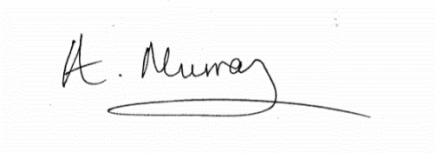

22nd February 2019

# **Abbreviations and Glossary**

* Aggregation – the collective grouping of similar organisms (temporary or permanent), often driven by predator avoidance, increased foraging and movement efficiency (Gueron et al. 1996; Smith et al. 2019). For the purpose of Chapter Two, I specifically define an “aggregation” as all the individuals observed at the same site within a survey.
* Animal personality – among-individual differences in animal behaviour arising from individual differences in state variables, for example body size, energy reserves, boldness, condition etc. which remain consistent over time (Sih et al. 2015).
* Behavioural traits – specific behavioural tendencies, for example aggressiveness, boldness, cooperativeness, impulsivity, sociality etc. (Wolf & Weissing, 2012).
* Foraging groups – A group of individuals belonging to the same species, collected together spatially within a patch in order to feed (Bélisle 1998). For the purpose of Chapter Two, I specifically define “foraging groups” as two or more animals recorded feeding together within close proximity of each other, specifically two body lengths.
* Gregariousness – which is also known as Degree Centrality, is linked to the connections and an individual’s inclination to make associations (Pepper et al. 1999; Whitehead 2008).
* Group –A set of individuals, often of the same species, assembled together with the potential to interact with each other and which are distinct from other clusters of individuals (Wilson 1975; Wey et al. 2007). Key fundamentals to define a group are individuals of a particular species, interacting together within time and space limits (Wilson 1975).
* Group foraging – a behavioural adaptation seen in many marine species which optimises foraging efficiency either directly via coordinated cooperative feeding strategies or indirectly via facilitation (McInnes et al. 2017).
* Leadership – the change in or control of the direction of locomotion by an individual, who is in turn followed by other animals (Krause et al. 2000b).
* Preferred associations – within a social network, individuals which are observed together more than would be expected by chance (Connor et al. 2001; Lusseau 2003).
* Social complexity – the intricacy of a social structure and relationships of individuals living and/or interacting with each other (Wey et al. 2008).
* Social group – individuals associating with conspecifics, actively involving social attraction and proximity from conspecifics (Krause & Ruxton, 2002; Jacoby et al. 2012b).
* Social network analysis (SNA) – an examination of the networks of social ties between individual nodes and their relationships in social groups (Wey et al. 2008)
* Social structure –the networks of social interactions between individuals within a population (Hinde 1976).
* Sociality – defined by Alexander (1974), “Sociality means group-living”, a suite of affiliative social behaviours, cognitive processes and socially related actions including recognition, discrimination and conspecific approaches (Soares et al. 2010; Goodson 2013; Balshine et al. , 2017)
* State-dependent - an individual’s ‘state’ can be interpreted in many ways, but can refer to any features which can influence the individual behaviour to increase fitness, for example age, body size or energy reserves (Clark & Mangel 2000; Wolf & Weissing 2010).
* Temporal stability – a measure of association patterns between dyads/individuals over long-term periods (Krause et al. 2009), also known as lagged association rates (Farine, 2013) .

# **Chapter One: A study of the sociality, grouping and foraging behaviour and conservation of Manta Rays (*Mobula alfredi*), a general introduction**

Marine vertebrates exhibit a range of social strategies, from largely solitary species such as Blue whales (*Balaenoptera musculus*) (Sears et al. 2013; Torres 2013), to species which forage in groups transiently, for example when food is particularly abundant e.g. Whale sharks (*Rhincodon typus*) (de la Parra Venegas et al. 2011; Ramírez‐Macías et al. 2012; Hueter et al. 2013), to those species that spend the majority of their time living in or moving between groups such as bottlenose dolphins (*Tursiops* sp.) (Connor et al. 2000; Janik et al. 2006). There are still knowledge gaps regarding the dynamics of group formation at different temporal and spatial scales for many marine vertebrates and the roles adopted by individuals within groups.

Many reef fish live in shoals consisting of large numbers of unrelated individuals with little recognition of familiar individuals resulting in minimal social structure (Sale 2004). In contrast, many species including Parrotfish exhibit more complex sociality (Hawkins & Roberts, 2003), while cetaceans live within familial groups, relying on the cooperative actions of the group members to ensure foraging and migratory success (Jelinski et al. 2002; Gazda et al. 2005). Other species such as elasmobranchs are not so well understood, but their positively skewed brain to body mass ratio suggests elevated neural capabilities (Northcutt 1977; Hueter et al. 2004; Schluessel 2015). This begs the question, do these highly mobile animals exhibit social structures, form ‘friendships’ or adopt specific roles within groups?

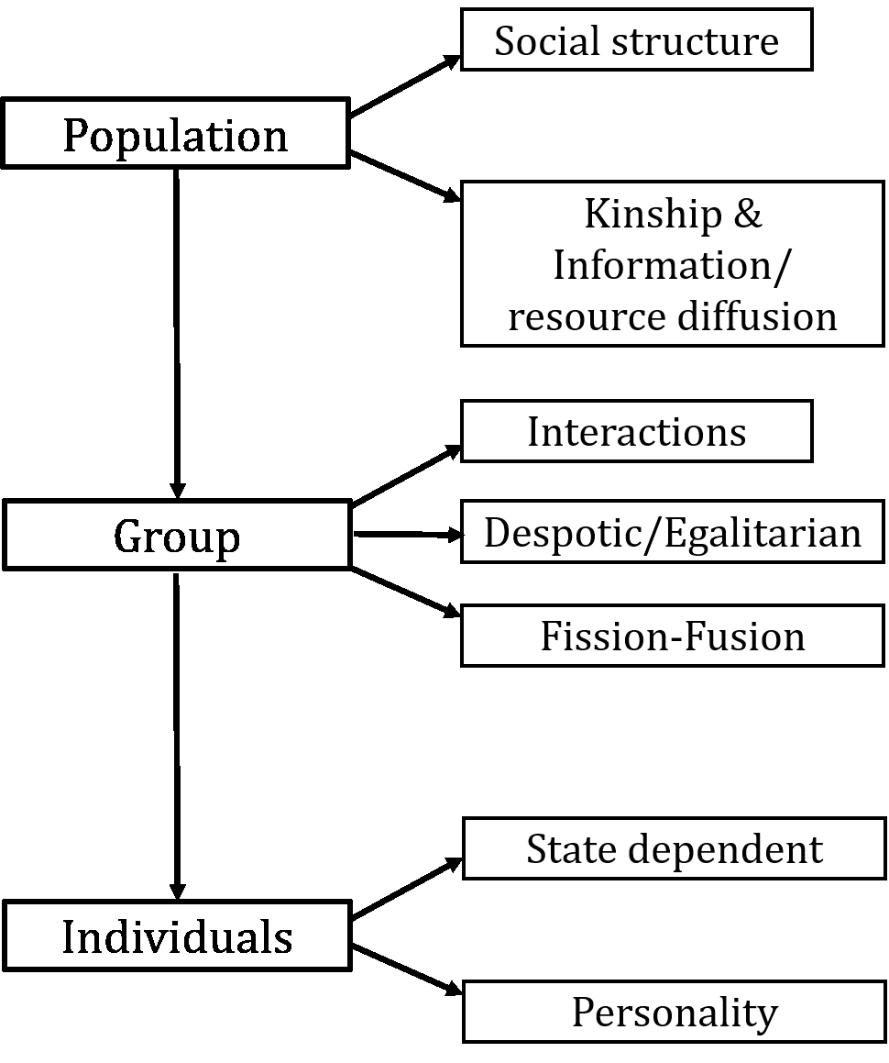In this thesis, I explore patterns of variation in the social behaviour of reef manta rays (*Mobula alfredi*) at different levels of biological organisation, namely the population, group and individual levels (Figure 1.1). I will particularly focus on social interactions during foraging events. In this general introduction, I outline conceptual frameworks that have been developed to explain the differences in social interactions at aggregation and foraging group levels, as well as the individual differences in foraging behaviour (Johnson et al. 2002; Krause & Ruxton 2002; Lusseau & Newman 2004; Conradt & Roper 2005; Sih & Bell 2008; Whitehead 2008; Conradt et al. 2009; Whitehead 2009; King & Cowlishaw 2009; Couzin & Laidre 2009; Dingemanse & Wolf 2010; Duboscq et al. 2016; Seebacher & Krause 2017). Analytical tools associated with these concepts are then applied to test key theories regarding the social behaviour and ecology of a population of manta rays in the Maldives.

Figure 1. 1: Schematic showing the structure of this thesis and potential sources of variation in sociality at different levels of biological organisation.

## ***Analytical tools for examining social structures on a population level***

### *1.1.1 Social structure*

*“Improving our ability to scale up from the individual to the population by establishing why certain patterns of association develop and how inter-individual association patterns affect population-level structure will revolutionise our understanding of the function, evolution, and implications of social organisation”* (Croft et al. 2008).

Study of the social behaviour and structure of animal societies has increased in light of new and powerful analytical tools which allow closer and more complex examination of sociality. Research on non-human organisms and their social relationships has revealed new and unimagined complexities, leading researchers to question the full extent and implications of sociality (Whitehead 2008; de Waal & Tyack 2009; Bergman 2010, 2015; Mackinnon & Fuentes 2011; Aplin et al. 2013). Understanding the social structure of a population allows a better understanding of the social dynamics of animal populations, whilst also offering improved conservation and management approaches as environmental change progresses (Anthony & Blumstein, 2000; Lusseau & Newman, 2004). Social network analysis (SNA) is an analytical concept and toolbox of computational techniques used to examine resource use and exchange amongst individual animals or nodes, and the connections between these individuals which form a network of animals, representing groups (Haythornthwaite 1996). For example, bottlenose dolphins in Doubtful Sounds, New Zealand demonstrate strong connections with fast information exchange, indicating strong network connections (Lusseau 2003). With short links between dyads (a component made up of two individuals) and strong clustering behaviour, information is able to be passed between dyads, even when random individuals are removed (Lusseau 2003; Croft et al. 2005). These strong connections highlight a self-organising community which is able to withstand major disruption through individual removal (death events) and remain unified (Lusseau 2003). SNA allows different levels of interaction to be examined, considering various aspects of animal behaviour including sexual, cooperative and aggressive relations (Krause et al. 2009). Conducting this analysis on different scales of data, i.e. from individual to population level and all in between, allows an insight into how the behaviour of an individual can impact a population as a whole and vice versa (Krause et al. 2009). SNA may also play a key role in the conservation of species targeted by fishing; a full understanding of the social significance of individuals within the structure of a population as a whole may predict the impact felt if said individuals are removed i.e. via targeted fisheries or bycatch (Sutherland 1998; Whitehead 2009). It can also allow closer examination of gene flow, growth rates and dispersal amongst populations (Strier 1997; Whitehead 2009).

SNA provides an insight into the degree of association amongst individuals and the formation of a social structure (Wey et al. 2008). It can also be used to examine information diffusion, signal use, kinship links and the sharing of resources amongst individuals, e.g. food or habitat (Wey et al. 2008). Generating network diagrams and matrices, SNA creates a map of the ties between members of the population and examines the strength of association between specific individuals providing new insights into the social complexity of various species (Wey et al. 2008). In this section, I will introduce factors which affect social structure, namely kinship and cooperative behaviour, non-random spatial distribution and predictability (spatially or temporally) of resources.

When conducting network analysis, one key consideration is sampling and the confounding effect this may have on results. The study of non-human animals presents a common hurdle; incomplete datasets with missing interactions or associations (Hoppitt & Farine 2018), however the use of association indices can counter incomplete records (Cairns & Schwager 1987). Association rates (the number of interactions or associations between dyads) signify a tendency for two nodes to associate or likelihood of being seen together (Hoppitt & Farine 2018). Associations, often resulting from the co-membership of a group, i.e. the individuals observed together, can be used to represent social interactions, which are often more direct, specifically the connections or edges between individuals, for example during grooming or fighting (Krause et al. 2007; James et al. 2009; Rubenstein et al. 2015). Commonly in data collection, associations or interactions are lost due to sampling demand or individuals can be missed altogether (Hoppitt & Farine 2018). Although both are problematic, Franks et al. (2010) found that missed observations between dyads can actually bias edges weights, leading to weak edges within a network being missed which can greatly influence the overall resulting network structure (Granovetter 1973). To reduce such discrepancies, Silk et al. (2015) suggest reducing the overall number of individuals in the network, even conducting hypothesis testing on just 30% of a population and instead maximising the number of observations of each animal (Hoppitt & Farine 2018).

### *1.1.2 Weighted vs. unweighted networks*

Animals assort via passive or active processes; individuals may be actively attracted to others which are similar to themselves, for example, in sex or size (Hoare et al. 2000a; 2000b; Krause et al. 2000; Farine 2013). Linked to cooperation (Pusch et al. 2008) or disease transmission (Ashby & Gupta 2013), this active assortment of behavioural phenotypes is believed to be critical to the development of social network processes (Farine 2013). However, the opposite, dis-assortment or active avoidance is also common, specifically in species which segregate by class (again sex or size), occupying different habitats according to life stages resulting in social association due to increased spatial overlap (Holyoak et al. 2008; Farine 2013). For analytical purposes, assortativity coefficients are a commonly used measurement; the number of associations between similar or dissimilar individuals (Farine 2013). Assortativity is commonly measured in two ways; binary (inferred) or weighted (known) networks. For example, two animals observed together at a site (binary) versus two animals seen interacting with each other (weighted) (Farine 2013). Binary (unweighted) networks measure presence (1) or absence (0) of individuals, however, this approach is subject to errors as it is highly unlikely that we have sufficient data to accurately assign a weight of zero (Whitehead 2008; Croft et al. 2011). Missing the interaction strengths between individuals, this method is considered less accurate (Croft et al. 2011). However, by using repeated measurements, we may examine the proportion of the total number of observations where individuals are observed together, thus reducing the impact which coincidental or rare interactions have on the edge weight strengths within a network (Farine 2013). Thresholding, eliminating or assigning zero to edges above or below a set value, can be used to reduce the limitations of binary networking (James et al. 2009; Lusseau et al. 2009; Farine 2013). Building the network after applying a threshold will enable us to preserve as much of this edge weight information (Croft et al. 2011; Lusseau et al. 2009; Farine 2013).

Within a given network, the links between two nodes can hold important information on the relationship status and is particularly important when tracking disease transmission within a population. A reciprocal or undirected relationship between two nodes is termed as an edge whereas unidirectional or directed links are defined as an arc and these measures can be binary or valued (Dubé et al. 2011). When examining how central a node (individual) is, an undirected network would measure the number of connections an individual node has while a directed network calculates the out- and in-degree (the number of connections initiated from the node and the number of connections a node receives) (Dubé et al. 2011). The use of directed networks is commonly used to model the flow of diseases, tracking the movement of livestock between farms (nodes) in order to trace infected individuals (Dubé et al. 2011).

### *1.1.3 Challenges*

SNA has proven to be a powerful tool, enabling us to unlock aspects of social interaction and organisation however, there remains challenges which researchers face. Firstly, the comparison of networks across different circumstances, be it between species or populations, with issues arising due to data standardisation (Farine & Whitehead 2015). If two separate networks are sampled with comparable contexts and resolution, then accurate comparison is possible however, any differences in data collection methods will result in key differences in the resulting structure which are not based on biological processes (Farine & Whitehead 2015). A second issue to tackle is repeatability. The use of repeated sampling of networks allows us to examine an individuals’ network position to establish whether it is consistent across samples and whether this position is resulting from behavioural, ecological or genetic purposes (Nakagawa & Schielzeth 2010; Wilson et al. 2013; Farine & Whitehead 2015). Thirdly, the use of dynamic network analysis, measuring the temporal influence on network dynamics. Considerations include collating a sufficient dataset which is representative at each temporal marker and the use of suitable statistical tests, including null hypotheses and models which capture the dynamic aspect of the network structure (Pinter-Wollman et al. 2013; Farine & Whitehead 2015). Finally, the descriptive nature of many SNA findings to date which can result in mis-interpretation or false significance placed on the strength of results (James et al. 2009; Farine & Whitehead 2015). To mitigate such interpretational mistakes and clarify results, studies should combine data manipulation, for example the experimental removal of individuals or varying ecological variables, with standard network analysis (Farine & Whitehead 2015). SNA has emerged as a powerful analytical tool which is increasingly being used in ecological studies however, users must be aware of the complexities of such analysis and understand and consider the basics of data collection and network building.

### *1.1.4 Kinship*

  Social interactions and thus social networks are predicted, and indeed observed, to vary with the degree of relatedness between individuals (Silk 2002; Möller et al. 2006). Kin selection can be defined as evolutionary strategies where individuals invest, even at a cost to their own reproduction and survival, in the reproductive success of relatives (Wilson 2005). Kinship has been recognised as explaining variation in the affiliative and cooperative patterns of insects (Kocher et al. 2015; Galbraith et al. 2016a; 2016b), birds (Webb et al. 2012; Silk et al. 2014), fish (Le Vin et al. 2010; Hesse & Thünken 2014) anurans and mammals (Patzenhauerová et al. 2010; Clutton-Brock & Lukas 2012). Chimpanzees (*Pan troglodytes*), for example demonstrate diverse cooperative behaviour through grooming, resource sharing (seen between adults and in females sharing foods with offspring which are too hard for them to obtain) and forming long-term bonds (Boesch & Boesch-Achermann 2000; Muller & Mitani 2005; Gilby & Wrangham 2008; Langergraber et al. 2009; Jaeggi & van Schaik 2011; Silk et al. 2013). That said, affiliation is not solely linked to genetic relatedness (Mitani et al. 2000). However, even in species without parental care, including many fish species, it has been observed that individuals prefer to associate with kin rather than non-kin (Arnold 2000; Hain & Neff 2007; Daniel & Rodd 2015), particularly in high risk scenarios such as when faced with a predator (Ward & Hart 2003; Piyapong et al. 2011; Hesse et al. 2015). Thus, in terms of social networks we would expect to see preferred associations amongst kin, with dyad connections in highly structured communities which are different to what would be found at random.

### *1.1.5 Resource distribution*

Social behaviour and groupings are highly influenced by resource distribution and predictability (Johnson et al. 2002; Hirsch 2011; Mourier et al. 2012; Newsome et al. 2013). Food, water and shelter are key resources which can determine habitat use by species and the size and shape of territories (Johnson et al. 2002). Foraging can be risky, therefore species may adopt particular behaviours to reduce risk, for example avoiding productive feeding grounds in favour of less productive, but safe areas when predator density is highest (Heithaus & Dill 2006). This behaviour is adopted by bottlenose dolphins (*Tursiops aduncus*) when tiger shark (*Galeocerdo cuvier*) abundance was high in Shark Bay, Western Australia (Heithaus & Dill 2006). Species may reduce or stop feeding all together to avoid the risk, as observed in bumble bees avoiding ambush predators (Jones 2010). Another option, resource sharing, has been observed in mammals, insects, and birds (Chapman et al. 2003; Stevens 2004; Stevens & Gilby 2004; Whitlock et al. 2007; da Silva & de Melo 2013). Although resource sharing increases competition, it can result in immediate as well as delayed benefits, for instance status enhancement, increased growth of an offspring, increased resource access, group augmentation, trade and predator avoidance (Stevens & Gilby 2004; Ydenberg 2007; Waite & Field 2007; Ellis & Robinson 2016) and therefore it is observed in group living species. The resource dispersion hypothesis (RDH) may also explain group living (Johnson et al. 2002). Specifically across space and time, if resources are heterogeneously dispersed (patches) then group living may be more beneficial, with numerous individuals benefiting from resource exploitation and sharing (Johnson et al. 2002). Thus, observed patterns of association in social networks could reflect long term relationships based round cooperation in relation to acquiring a resource such as food or simply reflect the fact that individuals happen to congregate in an area of high resource density, e.g. a rich foraging patch, water hole or a lek site. Key to teasing this out is to statistically examine any evidence of connections within observed groups, which will allow us to differentiate between spatial or resource-based associations and true social relationships. For example, within flocks of shorebirds, groups of individuals commonly make short and long-distance migrations together as a unit, suggesting a stable social structure (Conklin & Colwell 2008). This hypothesis was tested in Dunlin during high-tide associations in Humboldt Bay, California, examining co-occurrences and association rates, which ultimately told a different story. Analysis showed fluid membership, with random associations purely due to collective attraction to common roosts, highlighting a highly mobile migratory species where social structure was not beneficial (Conklin & Colwell 2008).

Just as resource dissemination is vital for survival, so is social learning. Learning information which guides behaviour from conspecifics is seen in both plant and animals species (Duboscq et al. 2016). Using social information is more energy efficient than personal information collection and allows individuals to adapt more quickly to their environment, gaining knowledge on resource location, availability and quality, predator avoidance and mate selection (Danchin et al. 2004; Laland 2004; Dall et al. 2005; Kendal et al. 2005; Bonnie & Earley 2007; Taborsky & Oliveira 2012; Duboscq et al. 2016). Examining the structure of a population also helps us to identify ‘information brokers’ or highly connected individuals (Mann & Singh 2015) which lead to a better understanding of a population’s social dynamics.

## ***How and why animals interact on a group level***

### *1.2.1 Group formations*

When defining a “group”, spatial and temporal proximity are key components, with groups forming in response to external factors including predation risk, foraging, mate selection and energy saving (Krause & Ruxton 2002). Defining a group can be problematic as many species are “intermediates”, neither associating with conspecifics or in solitude one hundred percent of the time (Krause & Ruxton 2002). In terms of important biological settings, for example predation, there are key concepts which explain the benefits to group-living, for example the “selfish herd” concept explains the reduced risk of groups; an individual is safer when surrounded by a higher density of conspecifics (Hamilton 1971; Cipriani & Jaffe 2005), or the notion of “many eyes” increasing vigilance to predators or the self-explanatory safety in numbers concept (Krause & Ruxton 2002). But amongst groups, these benefits are weighed against the trade-offs, for example larger groups increase risk dilution but also encounter a surge in resource sharing (Thaker et al. 2010). Grouping is also influenced by environmental factors, i.e. seasonality and resource or habitat quality, which are heterogeneous over space and time therefore, group size and membership often varies and is not uniform in dispersion (Fortin et al. 2009; Thaker et al. 2010). Group size, composition and the context of grouping will impact the individual fitness of animals, with individuals incurring costs, for example within larger groups, animals are exposed to increased parasite load (Jacoby et al. 2012a). Considerations of group size are trade-offs and individual species traits, for example animals living in exposed environments would favour larger groups to reduce predation risk while species living in more structured, protected environments are less visible in smaller groups (Jarman 1974; Pays et al. 2007; Thaker et al. 2010), therefore we must consider species specifically before discussing group formation.

Grouping behaviour is commonly observed in elasmobranch species, including manta rays (*Mobula alfredi, M. birostris*), with gatherings of large numbers of individuals linked to environmental factors including food abundance, seasonality or location (Jacoby et al. 2012a). In manta rays, grouping behaviour can commonly be seen on a large-scale in a small bay located in the Maldives, Hanifaru Bay Marine Protected Area (MPA), with numbers exceeding 200+ individuals during peak grouping events, linked to increased resource accumulation and strong lunar tides (Stevens 2016). Across both benthic and pelagic species, sharks have shown grouping behaviour in both juvenile and adult stages (Economakis & Lobel 1998; Hight & Lowe 2007; Rowat et al. 2007; Guttridge et al. 2009; Jacoby et al. 2012a). What is less known is the social component of grouping in sharks and rays; there is a better understanding of grouping behaviour driven by social attraction amongst teleost and captive species, with a clear indication that shoaling behaviour is a product of predator avoidance (Lachlan et al. 1998; Krause et al. 2000; Hoare et al. 2004; Jacoby et al. 2012a). Springer (1967) discussed the non-random distribution of groups of large sharks and rays, observing co-ordinated co-operative behaviours and size assortment which are now considered symptomatic of social interaction (Jacoby et al. 2012a). Due to the complex nature of collecting empirical data on grouping behaviour in wild populations of elasmobranchs, the study of social attractions and collective behaviour in elasmobranchs is still a burgeoning area of research but it is now recognised that aggregating behaviour, already observed in many shark and ray species, may act as a prerequisite for social grouping (Jacoby et al. 2012a). Hence such species have the potential for socially driven associations, and therefore there is a need for further research.

### *1.2.2 Interactions*

Interactions among individuals and species are driven by behavioural differences and help control population stability (Wolf & Weissing 2012). There are five main categories of interactions in animal ecology, namely competition, predation, parasitism, mutualism and detritivory (Begon et al. 2006). Driving community distribution, abundance and diversity, competition is a key factor in social dynamics (Kaplan & Denno 2007) and an important factor to consider for my study. Competition theory examines the interaction between two or more organisms searching for resources, and predicts that interaction intensity escalates as “density, spatiotemporal co-occurrence and ecological similarity (e.g. feeding guild, phylogenetic relatedness) increases” (Kaplan & Denno 2007). It is also widely theorised that predation is a key factor in group living (Alexander 1974; Strassmann et al. 2014). Group living or social aggregating, even among multiple species, provides predator protection through dilution and vigilance, therefore impacting social dynamics (Byrne & Bates 2007). Thus interactions, concurrently drive and limit group living which provides a variety of benefits including anti-predator protection and dilution of predator risk, increased foraging efficiency, movement efficiency and increased mating success (Krause & Ruxton 2002). At the same time, individuals may have to sacrifice personal preferences and make ‘consensus decisions’ in order to maintain group cohesion (Conradt & Roper 2005; King & Cowlishaw 2009).

### 

### *1.2.3 Fission-fusion*

Group membership can also be fluid. Amongst various species, including many marine, population structure is not necessarily solid, i.e. it changes spatially and/or temporally, with individuals moving within and between clusters, seeing groups split (fission) and/or merge (fusion) (Couzin & Laidre 2009). Fission-fusion is thought to be a solution to fluctuating resources, with fusing individuals drawn to areas of high resources, then splitting when competition is too high (Connor et al. 2000; Wittemyer et al. 2005; Smith et al. 2008; Asensio et al. 2009; Nandini et al. 2017). Species with fission-fusion dynamics demonstrate high within and between population flexibility, therefore group structure can be complex and solely reliant on resource abundance (Strier 2003; Amici et al. 2008; Lunardi & Ferreira 2014; Nandini et al. 2017). Similar to structured groupings, fission-fusion affords both pros and cons; for example, fluctuations in resource levels can cause a surge in group fusion and foraging competition, whilst at the same time providing protection from predators (Couzin & Laidre 2009). Group size is highly reliant on the rate of fission and fusion (Aureli et al. 2008; Couzin 2009). Low fusion leads to unstable groups, secluded individuals amongst a population and the chances of finding larger groups decreases with group size (Couzin & Laidre 2009). Conversely, high fusion rates result in no distinctive group size, commonly seen in pelagic fish and vertebrates (Couzin & Laidre 2009). Fission-fusion dynamics within groups lead to fluid group membership reliant on various components of survival, with a fine balance of the pros and cons of group life, highlighting the flexibility of many species.

## ***Behavioural traits and differences on an individual level***

Groups do not necessarily consist of homogeneous individuals. In nature, groups consist of individuals that vary in their individual ‘state’, social position, personality, leadership tendencies and behavioural traits (Dingemanse et al. 2005; Couzin et al. 2005; Wey et al. 2008; Wolf & Weissing 2010; Dingemanse & Dochtermann 2013; Wolf & Krause 2014). The decisions animals make can be heavily influenced by their individual characteristics, surroundings or experience, with groups made up of a variety of personalities and individuals with differing roles, some adopting leadership while others following roles depending on the particular attributes of the individual (Conradt & Roper 2003; King & Cowlishaw 2009; Wolf & Weissing 2010). Certain animals connect a group due to their association with numerous individuals, including those more peripheral and less connected individuals, acting to direct the flow of information throughout groups (Tanner & Jackson 2012).

### *State dependent variables*

Animals can be characterised by their state, for example variables including age, body size, energy reserves, morphology, available information, surrounding environment and physical and psychological condition (Dall et al. 2004; Wolf & Weissing 2010). These traits restrict and impact which actions an animal can undertake, influencing the costs and benefits of such actions. For example, an individual with low energy reserves is unlikely to devote its limited resources to developing reproductive organs, therefore is unable to reproduce (Dall et al. 2004). The experiences of the individual, such as exposure to stressors or predation risks early in life, may impact behavioural variation amongst animals within the same population, which can have both temporary or permanent effects depending on the individual and the experience (Stamps & Groothuis 2010; Sih 2011; Buwalda et al. 2013; Sih et al. 2015). State-dependent behaviour or phenotypic plasticity is an important social adaptation in animal behaviour and individual states may impact behaviour under numerous contexts hence, state-dependent behaviour has become a key consideration in behavioural studies (Wolf & Weissing 2010; Dingemanse & Wolf 2010).

The sorting of an animal’s position within group living will be dependent on the individual species, but generally certain states play a key role: sex, age, body size, aggression and strength (Chase et al. 2002). The influence of others within a group can also affect the movement of individuals, particularly the motion, position or motion variation (Couzin & Krause 2003; Couzin 2009). “Social forces”, internal (e.g. hunger level) and external motivations (obstacle avoidance) and neighbours’ positions can all impact behavioural responses (Couzin & Krause, 2003). Dominance hierarchies within groups also determine the position and condition of individuals. Often resulting from agonistic interactions over a limited resource, for example food, water or habitat, dominance hierarchies are characterised by either aggression or intimidation which is exerted in order to establish a pecking order for access to said resource (Herberholz et al. 2003). Such hierarchies are observed in many species and can be highly detrimental for the fitness of lower ranking individuals. Within groups, the rank of an individual living in a dominance hierarchy can result in inequalities, for example reduced access to a resource which in turn can lead to a reduced standard of life for that individual (Sapolsky 2015). Stressors felt by individuals can be psychological and physical, thus lowering resistance to stress-related disorders and can affect both low- and high-ranking individuals (Sapolsky 2015). Resource inequalities are present in both despotic (where decisions are taken by a single animal or marginal few individuals (“leader”) with other members (“followers) abiding by this decision (Conradt & Roper 2003; King & Cowlishaw 2009) and consensus (all group members contribute to the decision, independent of their individual identities or social status thus, consensus decisions are reached democratically (Conradt & Roper 2007)) communities, with the latter resulting from clusters of subordinates teaming to gain dominance, as seen in Macaques (Thierry et al. 2004), whereas those within despotic societies are often governed through intimidation by dominants (Sapolsky 2015). Once rank and dominance is obtained, individuals have different means of maintaining power as it may not be a lifelong trait and can vary in relation to the “politics” of a group (de Waal 2007), either through despotic intimidation (seen in rodents and primates) or through aggression (seen in dog and primate species) (Sapolsky 2015). An individual’s position within a group can therefore be vital to survival and can reflect key drivers in social organisation of a group.

### *Personality*

Individuals do not just vary in their state, but also show consistent individual differences in their behaviour which influence their interactions, roles and positions within groups (Dingemanse et al. 2005; Dingemanse & Dochtermann 2013). Within the animal kingdom, Dingemanse et al. (2010) state a common definition of personality as the differences in the mean level of a behaviour of an animal, and over time, these differences remain consistent. This “consistency” is evident when examining an animal’s behaviour and temperament during interactions, for example individuals may consistently favour a behavioural type whether it be aggressive or submissive (Krause et al. 2010). Previously considered as noise in the data, these individual differences have now become a large focus of social studies due to two key findings: (1) behavioural differences are often temporally stable and correlated across various contexts which indicates structure (Sih et al. 2004a; Bell et al. 2009), and (2) structured differences are a common trait across various animal species (Gosling 2001; Sih et al. 2004b; Réale et al. 2007; Wolf & Weissing 2012). Consistent individual differences have been recorded in a fleet of behavioural traits including activity level, aggressiveness, boldness, cooperativeness, dispersal tendency, exploration tendency, docility, fearfulness, impulsivity, responsiveness and sociability (Gosling 2001; Sih et al. 2004a; Réale et al. 2007; Bell et al. 2009; Wolf & Weissing 2012) in reptile, mammal, fish, bird, amphibian, arthropod and mollusc species (Gosling 2001; Sih et al. 2004b; Wolf & Weissing 2012).

In order to gain a more rounded understanding of an individual animal’s personality as opposed to simply a “snapshot” in time, one must also consider all secondary relationships and full network connections (Krause et al. 2010). The close examination of the variability or power relation during interactions, i.e. who plays the focal role and who reciprocates and follows, establishes the presence of hierarchies (Croft et al. 2008). With individual survival at stake, an animal’s position is key; positioning will affect an animal’s growth (Forrester 1990) as well as mating success (Kroon et al. 2000).

The roles adopted by individuals should be closely considered as the actions of each individual may impact the success and/or survival of a group as a whole. So, within these groups, what makes a leader? There are various traits which predispose individuals to adopting a leadership role: age (Hodgkin et al. 2017), previous environmental knowledge (Pillot et al. 2010), individual foraging requirements, often influenced by sexual dimorphism (Conradt 1998), or individual motivation (King & Cowlishaw 2009; Hodgkin et al. 2014). As the group leader, an individual’s position at the front firstly allows it control over the direction of movement and secondly, dominance over group activity (Hodgkin et al. 2014). Examples of leaders throughout ecology show that age and experience shape leadership selection (Hodgkin et al. 2017; Bonanni et al. 2010). With experience often comes environmental knowledge which holds clear benefits for the foraging, mating or migration success of a group; thus these individuals hold leadership traits (age and/or experience, dominance, social abilities or state, e.g. hunger (King & Cowlishaw 2009)) and are more likely to initiate group movement (Hodgkin et al. 2017). Studies have also shown that individuals positioned as leaders who lack the specific knowledge of an area will stop initiating movements, thus allowing a more knowledgeable animal to take over (Hodgkin et al. 2017). Here Hodgkin et al. (2017) imply that leadership is not simply due to some innate trait but can be flexible and mediated by specific environmental knowledge. Leaders may also act to stabilise the group structure; by acting as decision-makers, they maintain group connectivity and police activities, which can fracture when these key individuals are removed (King & Cowlishaw 2009). Hunger itself or the benefits derived from being positioned at the front may become the deciding factor in leadership, with the hungriest animal adopting the leadership role and the individual with higher energy reserves only choosing to follow and forage with the hungrier individual in order to minimise predation risk (King & Cowlishaw 2009). But what happens to leadership selection when the movements and groupings within a population are more fluid, with a constant stream of individuals joining, merging and leaving groups; i.e. fission-fusion? With these mobile populations, leadership is often by chance, with an individual beginning a movement becoming the incidental leader and groups of willing followers positioning behind them (Pillot et al. 2010). Therefore, the assigned leadership within a group depends on the mobility of the group structure itself, the knowledge of its members and the separate needs of the individuals.

## 

## ***Manta Rays***

Belonging to the planktivorous elasmobranch family, Mobulidae, there are two distinct species of manta rays: Reef manta (*Mobula alfredi*) and Oceanic manta (*Mobula birostris*) (Marshall et al. 2009). Although a staple favourite amongst SCUBA divers worldwide (O’Malley et al. 2013) (Figure 1.2), there is much which we still do not understand about manta rays. Both species are classed as vulnerable on the IUCN Red List (Lawson et al. 2017; Marshallet al. 2011); their large size, curious nature and aggregating behaviour leave them highly vulnerable to human threats, i.e. directed fisheries (Jacoby et al. 2012a; Lawson et al. 2017). Mantas are primarily targeted for their branchial filaments – gill rakers – which are used as part of a medicinal tonic, promoted as a traditional remedy on the Asian market (Couturier et al. 2012; Whitcraftet al. 2014; Lawson et al. 2017). The species are also commonly caught as bycatch (Lawson et al. 2017). Due to the high economic rewards for mobulid products, a worrying trend for bycatch fisheries to convert to directed fisheries is on the increase (CMS 2018), therefore with the profitable gill raker trade continuing to grow on the Asian market, now is the critical time to fully understand all aspects of the species.

The social dynamics of manta rays remains unclear, with many topics as yet unexplored, including the presence of social structure within aggregations, individual behavioural traits and significant relationships between individual animals. With a large brain to body mass ratio, manta rays potentially have the neural capacity to issue to address is the formation of social groupings; amongst manta populations, groups of individuals regularly sighted in the same geographic region are common (Stevens 2016). Manta rays are also commonly observed using complex coordinated group feeding strategies (Stevens 2016). Whether these formations are solely due to resource accumulation or if more complex social factors influence grouping remains unknown.

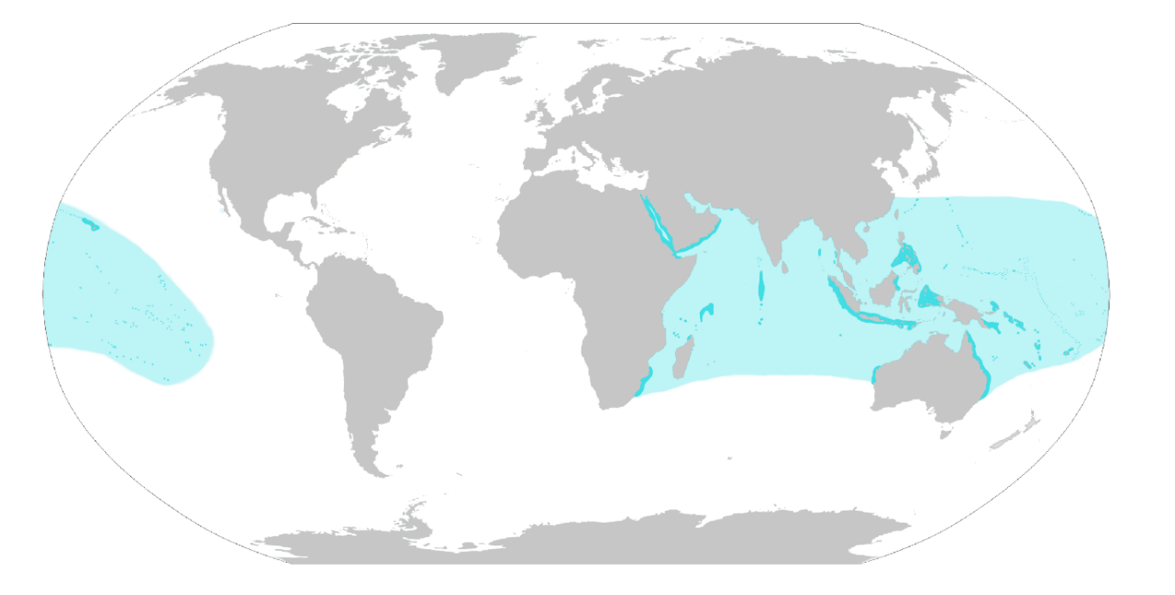Figure 1.2: Worldwide distribution of Reef Manta Rays – *M. alfredi* (Source: Manta Trust 2016).

Historic data collected at the primary study site, Hanifaru Bay MPA (Figure 1.3), Baa Atoll show an increase in manta sightings connected to the strong lunar tides (Stevens 2016). This point is addressed by Johnson et al. (2002), identifying that some animals form aggregations simply to take advantage of a resource which is either limited or restricted to a specific area, i.e. plankton blooms. The pattern of manta sightings in the Maldives is further backed by Guttal and Couzin (2010) who explain that the co-ordinated movement of groupings often follow daily and seasonal shifts. The grouping behaviour of wild elasmobranch populations is a burgeoning area of research (Jacoby et al. 2012b), but little work has been done on recognised manta ray aggregations (Figure 1.4) and movements specifically. The few studies carried out give some interesting indications to possible explanations. Scalloped hammerhead sharks (*Sphyrna lewini*), are believed to be mostly solitary hunters, but large numbers aggregate at certain productive locations such as seamounts (Jacoby 2012a). The same study also noted their fission-fusion tendencies (Jacoby 2012a). These patterns can be identified in localised manta populations, with large numbers of individuals identified over the period of a single feeding event (Stevens 2016). White sharks (*Carcharodon carcharias*) alter their feeding grounds in the Pacific Ocean according to seal pupping seasons to avoid resource reduction (Papastamatiou & Lowe 2012; Weng et al. 2007; Domeier & Nasby-Lucas 2008; Jorgensen et al. 2010).

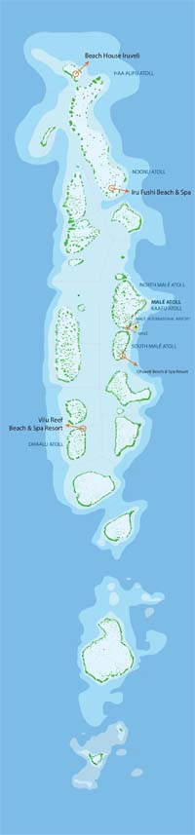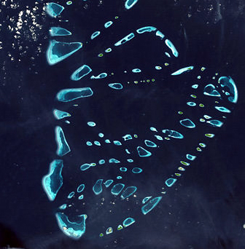

Figure 1. 3: Map of the Maldives Archipelago and Baa Atoll with the research sites and Hanifaru Bay MPA highlighted.

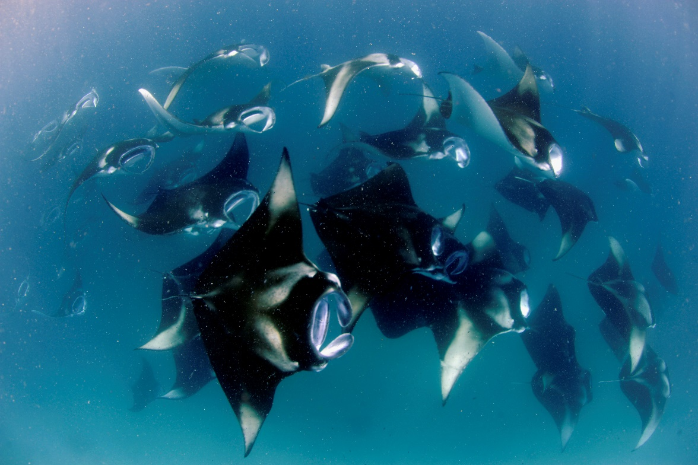

Figure 1. 4: Reef Manta Ray, *M. alfredi*, Mass Feeding Event, Hanifaru Bay,

Baa Atoll, Maldives © Guy Stevens, Manta Trust 2011.

Within certain elasmobranch species, groups show specific clustering patterns (Jacoby et al. 2012a). Like many shark species, juvenile manta rays show site fidelity during their early life stages, as apparent in the discovery of important juvenile habitat for *M. birostris* in the Gulf of Mexico which appears to act as nursery grounds (Stewart et al. 2018). In other elasmobranch species, including sandbar sharks (*Carcharhinus plumbeus*) (Merson & Pratt 2001; Rechisky & Wetherbee 2003; Grubbs & Musick 2007; Grubbs et al. 2007; Heupel et al. 2007), lemon sharks (*Negaprion brevirostris*) (Sundström et al. 2001; Edrén & Gruber 2005; Heupel et al. 2007) and blacktip sharks (*Carcharhinus limbatus*) (Heupel & Hueter 2001; 2002; Heupel & Simpfendorfer 2005; Heupel 2007; Heupel et al. 2007), such areas have been shown to offer more protection to the vulnerable pups from predators (Jacoby et al. 2010). Defined as an area where individuals have reduced predation risks, higher overall juvenile fish densities and increased growth rates than other habitats, nursery habitats provide a safer environment for the more vulnerable juveniles (Heupel, et al. 2007).

*M. alfredi*  foraging strategies are heterogeneous and dependent on the number of individuals present and the type, location and density of prey available (Stevens 2016). Stevens (2016) described eight distinctive behaviours comprised of a mix of group and solo strategies. For example, individuals can be observed independently using straight, surface, somersault, sideways or bottom feeding strategies, using individual tactics to exploit prey (Stevens 2016). In contrast, we also observe group formations including chain, piggy-back and cyclone formations (Stevens, 2016). With zooplankton density and location changes throughout feeding events, manta rays switch between strategies in order to efficiently exploit feeding (Stevens, 2016), exhibiting a level of flexibility. Foraging behaviour occurs at specific sites, making it a key event for reliable sightings. *M. alfredi* are also commonly sighted at cleaning stations, areas of the reef, outcrops or coral bommies (Côté 2000), where individuals aggregate to socialise and have dead, injured skin or ectoparasites removed (O’Shea et al. 2010). The Maldives is one of the few locations in the world which boasts both multiple feeding and cleaning sites, allowing for year-round observations (Stevens 2016).

The demography of groups is not just defined by age, but also sex. There is a female bias in recorded *M. alfredi* populations in eastern Australia and Mozambique (Stevens 2016) with various explanations. Hight and Lowe (2007) discuss the different life-history traits of males versus female elasmobranchs and how this affects their behaviour, with females dedicating a larger portion of their time than males scouting areas with optimum environmental conditions to support gestation or birthing (Hight & Lowe 2007). In the Maldives, a higher number of female than male mantas are re-sighted at feeding or cleaning sites (Stevens 2016). In contrast, males across many elasmobranch species are known to dedicate more of their time than females in search of a mate (Hight & Lowe 2007). This is also evident during the mating periods in the Maldives where the number of manta males sighted at cleaning stations increases; the majority of observed mating behaviour occurs on and around cleaning stations (Marshall & Bennett 2010a; Deakos 2012; Stevens 2016). There is however the potential for observer-bias; as researchers are commonly focused on these specific areas of the reef, therefore they are more likely to observe mating behaviour at cleaning stations.

## ***Thesis synopsis***

Using data collected over an eleven-year period, this thesis reports the findings from an examination of the social structure and behaviours of a large population of *M. alfredi* in the Maldives. My main aim is to investigate manta ray social behaviour, population structure and organisation during key social events, foraging and cleaning. Specifically, I analyse manta rays on (a) an aggregation level and (b) fine-scale foraging group level, to determine whether any social structure is different to expectations from random association. Secondly, among observed foraging groups, I investigate the individual flexibility of foraging behaviour. Finally, I discuss ecotourism strategies for enhancing conservation goals in one of the key ecotourism sites in the world.

With photo-identifications of over 4300 individuals and more than 50,000 unique sightings (Manta Trust 2019), the Maldives population of *M. alfredi* presents a complex and varied population. As yet, no rigorous testing of the social network structure of this large population has been performed. SNA allows me to examine social network connections on varying levels, looking at large-scale analysis of interactions to garner information on subpopulation-level dynamics. In addition, fine-scale data, for example fission-fusion foraging group analysis allows me to examine the social structure of a small sub-section of a population during feeding events, which have been hypothesised as potentially intense social events. This is the theme of Chapter Two. General network testing on (a) aggregations and (b) foraging groups will examine whether the observed network is different to expectations from random associations. Linear models are used to specifically test the gregariousness (degree centrality) of the sex and age classes. Preferred association rates are used to test for differences within the demographics. Finally, a temporal analysis of association rates is used to examine long-term relations. In the Maldives, manta rays are commonly observed grouping in large numbers to feed, displaying various solo and group feeding techniques, discussed by Stevens (2016). Chapter Three examines these groupings observed in the main study area, eastern Baa Atoll, reporting on the feeding behaviour of this sub-population. Using video collected during foraging events over an intense three-year study period, this chapter examines both the environmental and demographic factors affecting group and solo feeding behaviour. I then analyse the structure of groups to highlight patterns of leadership behaviour amongst these group feeders and observe foraging flexibility of individuals during these social events.

Chapter Four reports the first evidence-based analysis and critique of a human-manta interaction Code of Conduct, produced by the research and conservation Non-Government Organisation, the Manta Trust. Using videos captured during tourist swim-with interactions, this chapter aims to link specific human behaviours with the resulting reactions by the manta rays, specifically (1) types of human behaviours during interactions, (2) closest observed distances between manta rays and humans, and (3) direction of human approaches towards animals. Finally, I test inter-site differences in tourist numbers during observations. This study rigorously tests the effect of guidelines published by the Manta Trust ([www.mantatrust.org](http://www.mantatrust.org) & [www.swimwithmantas.org](http://www.swimwithmantas.org)), with the view to providing scientific support for these recommendations to drive increased protective legislation at manta ray aggregation sites globally.

Finally, in the concluding general discussion I draw together my empirical results in order to build a clearer picture of the social organisation of *M. alfredi*. Specifically, I establish whether there is any evidence of structure different to random and any variation in gregariousness or association preferences within population members. As little is known about the organisation of the species, I aim to develop a better understanding of the large and fine-scale connections of this highly mobile species. Gaining an insight into variation in individual foraging behaviour will highlight any key factors affecting overall group movements as well as the individual roles adopted by individuals. Finally, as the popularity of the species, classed as ‘Vulnerable’ on the Red List surges, and our focus shifts from fishing exploitation to ecotourism, I make conservation and management recommendations based on my research.

# **Chapter Two: The influence of foraging on the grouping behaviour of a population of Reef Manta Rays (*Mobula alfredi*) in the Maldives Archipelago.**

## ***2.1 Abstract***

Foraging groups can form in response to ephemeral and or/spatially rich patches of resources. Over time, many species are observed aggregating in specific locations. Where large groups are observed, it can be a challenge to identify all individuals within these large aggregations, but examining these recorded relationships can reveal key social complexities and association patterns. With long-term datasets, we can study repeated interactions amongst the same individuals and test the temporal stability of social associations. Where repeated interactions are present, we can predict that familiarity amongst individuals is possible, especially amongst long-living species who are often recorded forming long-term relationships. However, group structure can be fluid across time or space, with fission-fusion dynamics developing, as members move within and between groups in response to external drivers, for example food availability. Reef manta rays (*Mobula alfredi*) are long-living, large filter-feeding elasmobranchs which aggregate in numbers of over 200 individuals to feed on ephemeral upwellings of their zooplankton prey. Using seven years of sightings data of aggregationsin the Maldives and three years of foraging group data, I conduct the first network analysis on the world’s largest recorded population of *M. alfredi*. Overall, I found no evidence of social structure at either a large scale, within aggregations or small scale within foraging groups. There was no significant difference in association strengths on the population level for aggregations or foraging groups or on either scale within either sex or age classes suggesting that individuals did not have active, preferred associations. Individuals did not exhibit temporal dyadic associations over a year or 30-day period. There was low variation across dyads, indicating no preference for either long- or short-term relationships. Gregariousness did not differ significantly between males and females, or adults and juveniles highlighting no significant difference in sociality within the network. Overall, manta rays exhibited highly fluid, fission-fusion group dynamics. My data indicates that mantas do not form structured societies, and are driven to interact by reasons other than sociality, instead due to resource concentration and spatial and temporal overlap.

***Keywords:*** Structure, Preferred associations, Gregariousness, Temporal stability, *Mobula alfredi*.

## ***2.2 Introduction***

Whether they are transient aggregations formed due to a temporary resource abundance or a more structured long-term unit, group formations can profit individuals through increased feeding and movement efficiency and predator avoidance (Krause & Ruxton 2002; Kutsukake 2009; Mourier et al. 2012; Marras et al. 2015; Meunier 2015). Even species which are considered solitary can sometimes display social assemblages, for example numerous shark species have been observed aggregating (Guttridge et al. 2009; Powter & Gladstone 2009; Jacoby et al. 2012a; Mourier et al. 2012). Group formations can vary with location, season, and individual demographic traits, for example sex, age, status, relatedness and resource abundance (Krause et al. 2000a; Croft et al. 2005; Ruckstuhl 2007; Hirsch 2011; Hirsch et al. 2013). Familiarity and alliances built through long-term associations can benefit individuals through social learning, cooperative behaviour and vigilance (Swaney et al. 2001; Ward et al. 2004b; Kavaliers et al. 2005; Kutsukake 2006; Croft et al. 2006; Gilby & Wrangham 2008; Carter et al. 2009; MacIntosh & Sicotte 2009; Silk et al. 2014). In turn, this affects foraging success and time budgets for individuals (Griffiths et al. 2004). Overall, within-species variation in group living arises.

### *2.1.1 Space use and resource dispersal*

Unlike transient aggregations formed due to temporary resource abundance, social grouping involves complex structure, with individuals actively seeking out other animals to benefit from cooperative alliances (Couzin et al. 2005; Guttal & Couzin 2010; Jacoby et al. 2012b; Mourier et al. 2012). Many species retain a home-range, meaning that site fidelity becomes a key factor in the formation of a group’s social structure, as it may be more beneficial to remain and exploit resources within a specific habitat, therefore individuals repeatedly encounter each other (Wolf et al. 2007). Site fidelity, often varying between sex and age classes, can be influenced by the dispersal of prey or primary production (Anderson et al. 2011a; Jaine et al. 2014; Armstrong et al. 2016; Stevens 2016). Understanding patterns of site fidelity may also afford us a better understanding of the structure of populations and their dynamics (Benhamou 2006; Rich Jr et al. 2006; Knip et al. 2012). Between 2008 and 2010, Mourier et al. (2012) used photo-identification on four communities of blacktip reef sharks (Carcharhinus melanopterus) to explore group associations, revealing that group formation was almost exclusively determined by location, with individuals showing very limited social correspondence between communities (Mourier et al. 2012). This study conflicts with the findings of same-sex segregation amongst shark species due to dimorphism (Sims 2003), instead showing mixed-sex groups found throughout the study (Mourier, et al. 2012). Therefore, spatial range can be a key factor in grouping behaviour in species. In contrast, Killer Whales (*Orcinus orca*) have firm social bonds and highly structured matrilineal social groups (Bigg et al. 1990; Riesch et al. 2006; Ivkovich et al. 2010) which have shown long-term stability regardless of spatial location (Beck et al. 2012). However, Foster et al. (2012) indicated that even these strongly interconnected, stable and closed units have been shown to vary in group size in relation to resource abundance, as when, for instance, the social network of a population of Southern Killer whales became less connected in times of low Chinook salmon (*Oncorhynchus tshawytscha*) abundance. Even highly stable social units can alter in membership over time.

Across time or space, group structure can be fluid, with groups splitting (fission) and merging (fusion) as members move within and among groups (Couzin & Laidre 2009; Lewis et al. 2011; Tsai & Mann, 2013). These fission-fusion dynamics often occur within systems with temporally predictable environmental and intermediate spatial variability (Lee et al. 2007; Sueur et al. 2011; Silk et al. 2014). Not all groups have a complex social structure. A ‘social group’ is defined as an aggregation where social attraction is present (Jacoby et al. 2012a), but some groups are simply the by-product of, for example resource dispersion (Johnson et al. 2002). Resources are not always evenly distributed, but are heterogeneously dispersed in patches, “a discrete and internally homogeneous entity”(Kotlia & Wiens 1990) over space and time, which allow multiple individuals to benefit from the clumped areas of high productivity (Johnson et al. 2002; Newsome et al. 2013). This resource-based segregation has been used to describe the social organisation of some species including ants (*Monomorium sydneyense*) and African lions (*Panthera leo*) (Johnson et al. 2002; Lester et al. 2010; Valeix et al. 2012). The correlation between resource availability and grouping behaviour is well established in the literature, and is seen across a variety of animal social systems, including many terrestrial mammals (Campbell et al. 2006; Sundaresan et al. 2007), cetaceans (Connor et al. 2000; Heithaus & Dill 2002; Parra et al. 2011) and numerous elasmobranch species (Weng et al. 2007; Domeier & Nasby-Lucas 2008; Papastamatiou & Lowe 2012). Patchy or ephemeral resources drive fission-fusion behaviour, for example Corcoran (2006)identified an increase in both the number of animal interactions and the level of site fidelity in Southern stingrays (*Dasyatis Americana*) at a human-supplied feeding site. The level of spatial overlap, even in solitary animals can greatly increase when individuals are drawn to areas of higher resource abundance (Atwood & Weeks 2003; Mourier et al. 2012), increasing levels of interaction and potential associations.

‘Area copying’, where individuals aggregate with other active individuals within a specific location, often with an increased resource abundance can drive the formation of groups (Budden & Wright 2005; Leu et al. 2011; Tanner & Jackson 2012). Individuals actively seeking out conspecifics and other drivers of group formation introduces the idea of group structure and sociality. The complexity (physical structure, i.e. topography) of an environment can in fact encourage ‘cliquey’ social dynamics, as a more structurally complex space limits the transfer of social cues, for example foraging techniques, meaning that individuals with a higher level of association may recognise such cues and thus benefit (Atton et al. 2012; Webster et al. 2013; Atton et al. 2014). Webster et al. (2013) examined the relationship between environmental complexity and group interactions amongst shoals of foraging sticklebacks (*Gasterosteus aculeatus*). Within structured environments, with reduced predator risk, information flow followed the network structure more strongly than within more open environments, indicating that associations have ecological importance within structured as opposed to open environments (Webster et al. 2013). The level of resource dispersion is also limited by the size of a habitat, controlling the rate of interaction amongst group members (Webster et al. 2013). If familiarity amongst group members stems from similar resource exploitation, individuals are more likely to cluster with conspecifics with similar foraging needs for example (Ward et al. 2007; Webster et al. 2008; Atton et al. 2014). This in turn increases the level of re-association, leading to learned recognition through increased contact (Atton et al. 2014). Therefore, when considering social structure, we must also consider the arena species inhabit and how spatial constraints may elevate the flow of information, particularly when the exploitation of resources may influence behavioural traits, for example foraging techniques.

### *2.1.2 Temporal and seasonal variation in sociality*

Seasonal shifts also drive social dynamics, particularly where resource abundance impacts aggregating behaviour and predictable climatic conditions impact and initiate fission-fusion events (Krause & Ruxton 2002; Sueur et al. 2011; Silk et al. 2014). When resources are ephemeral and optimal conditions are seasonal, aggregation sizes and the sociality of a species can be highly variable (Silk et al. 2014). For example, whale sharks (*Rhincodon typus*) are large filter feeders, which opportunistically aggregate in localised areas of high productivity across the globe (Hoffmayer et al. 2007), observed off Western Australia, Djibouti, Taiwan, Japan, the Philippines, Belize and Mexico (Colman 1997; Compagno 2001; Stewart & Wilson 2005; Castro et al. 2007). Although a few aggregations are reported as year-round, others appear seasonally (Castro et al. 2007). Between the months of April and September, several hundred whale sharks aggregate off the Yucatan Peninsula, Mexico to feed on zooplankton blooms formed by seasonal upwellings (Motta et al. 2010). These individuals appear to aggregate together purely in order to exploit the temporary, rich localised feeding opportunity (Hoffmayer et al. 2007). As resources begin to deplete, so do aggregation sizes and group fission occurs.

### *2.1.3 Individual variation in sociality*

Moreover, phenotypic differences (morphological and behavioural) can alter group size, for example divide and fragment groups (fission) as individuals’ behaviour and requirements vary, thus the cost of cohesion increases (Couzin & Krause 2003; Silk et al. 2014). Behaviours including aggression, vigilance, social learning and co-operative behaviour are all influenced by familiarity which develop due to repeated interactions (Palm 2000; Kutsukake 2006; Kavaliers et al. 2005; Gilby & Wrangham 2008; Griffiths et al. 2004; Silk et al. 2014). Such behavioural traits will affect an individual’s foraging success and time budgets which in turn will impact the benefits of maintaining group cohesion (Silk et al. 2014). The same is found when varied physical phenotypes are present, namely fission increases due to heterogeneity in individuals’ physical traits (Couzin & Krause, 2003; Silk et al. 2014). Models have indicated that within groups of fish made up of two different physical phenotypes, fission happened more quickly than when all group members were the same (Silk et al. 2014). Thus, the stability and structure of populations is dependent on both environmental and phenotypic traits. However, as yet we still do not understand the impact of behavioural traits, which thus far have yet to be studied in relation to the grouping behaviour of Reef Manta Rays (*Mobula alfredi*).

### *2.1.4 Social network analysis*

The use of network theory in analysing individual organism interactions (Lusseau & Newman, 2004; Croft et al. 2005; Lusseau et al. 2006; McCowan et al. 2008; Krause et al. 2009; Croft et al. 2011) as measurable “nodes” (Newman 2003; Proulx et al. 2005) has become an increasingly popular analytical tool (Sih et al. 2009). Social network analysis (SNA) examines various levels of behavioural interaction such as sexual, cooperative and aggressive interactions as well as, disease and information dispersal (Croft et al. 2005; Krause et al.2009). Conducting such analyses allows us an insight into the impact of the behaviour of an individual on a population level and vice versa (Krause et al. 2009). Using SNA and tracking the number of times individuals are observed within the same group over numerous surveys, we can create a catalogue of associations, which illustrate the strength of association using the “Gambit of the Group” (GoG) approach (Franks et al. 2010). GoG assumes that each individual observed together at one time are associating equally with every other member within the same group, therefore are generally able to transfer information or share resources equally, therefore the GoG approach maps connections within aggregations (James et al. 2009). The frequency of associations within and between specific individuals, for example sex and age highlights any evidence of preferred associations (Wey et al. 2008). Preferred associations will influence the formation of a social structure (Wey et al. 2008) (where social attraction is active within aggregations or groups (Jacoby et al. 2012b)) on an overall population level, between all individuals and within and between specific categories, for example sex and age. An individual’s network position, for example how connected they are, is influenced by their relationships and those of their conspecifics, and ultimately can impact their sociality, experience, and in turn future success (Krause et al. 2010; Jacoby et al. 2014). We can identify patterns of sociality by examining the ‘degree centrality’ (the gregariousness and the level of connectedness of individuals (Farine & Whitehead 2015)). These interactions can also be constrained or stimulated by their environment (Jacoby et al. 2014). Specific behavioural traits or phenotypic (parasite load, body-length, species or colouration (Krause et al. 2000; Croft et al. 2005)) or physiological characteristics of conspecifics may influence an individual’s predilections for grouping behaviour, which may also change temporally and under different environmental conditions (Krause & Ruxton 2002; Jacoby et al. 2014). Whether interactions are driven by active sociality, through kinship or familiarity, or merely via the increased exposure to associates during aggregating events, varies among species (Barber & Wright 2001; Wiszniewski et al. 2010; Jacoby et al. 2014). These large fission-fusion aggregations will also be likely to be made up of both familiar and unfamiliar individuals (Atton et al. 2014), therefore closer examination of social dynamics will reveal the extent of the social complexity within individual populations.

### *2.1.5 Elasmobranch sociality*

Elasmobranch species are known to demonstrate grouping behaviour, with specific beneficial purposes (Jacoby et al. 2012a; Nosal et al. 2014). Amongst planktivorous species, like the whale sharks mentioned above, aggregations are often seen in relation to ephemeral zooplankton blooms, which are quick to disperse and often heterogeneously spread (Heyman et al. 2001; Dewar et al. 2008; Mourier et al. 2012; Stevens 2016; Murray et al. Chapter Three). Sexual or age-related segregation can increase safety, as juveniles, for example might inhabit shallower, more structured and sheltered areas (Heupel & Simpfendorfer 2005; Duncan & Holland 2006; Guttridge et al. 2012), whilst female-only aggregations may reduce courtship harassment (Sims et al. 2001; Jacoby et al. 2010; Wearmouth et al. 2012) or provide safe and secluded birthing grounds following gestation (Hight & Lowe 2007; Jirik & Lowe 2012; Nosal et al. 2014). Closer examination of network measures, specifically preferred associations can be used to consider whether *M. alfredi* alsofavour within sex or age grouping as observed in other elasmobranch species.

In the Maldives, *M. alfredi* are observed foraging in large aggregations in discrete locations, most notably, Hanifaru Bay marine protected area (MPA) in Baa Atoll (Stevens 2016; Murray et al. Chapter Three). The unique topographic features of the bay, combined with colliding lunar and monsoonal currents draw high densities of zooplankton into this small area, and in turn large aggregations of manta rays and whale sharks (Stevens 2016; Murray et al. Chapter Three). Peak sightings also appear to follow daily and seasonal shifts (Guttal & Couzin 2010; Murray et al. Chapter Three) as seen in other elasmobranch species. Leopard shark (*Triakis semifasciata*) aggregations, for example, fluctuate in accordance to the rising and falling tidal movements, allowing sharks to maintain depth and core temperature consistency, as well as exploiting newly covered intertidal feeding grounds (Ackerman et al. 2000; Carlisle & Starr 2009; 2010; Nosal et al. 2014). It is clear to see the ecological benefits of *M. alfredi* aggregating and forming foraging groups during the optimal conditions at specific locations, i.e. Hanifaru Bay, but whether these groupings have any benefit other than foraging success, for example sociality is yet unknown and analysis of associations and interactions is needed.

### *2.1.6 Study outline and aims*

My study tests the group dynamics and structure of *M. alfredi* in the Maldives on two scales, (a) large aggregations and (b) fine scale foraging groups. Specifically, when controlling for location and time, do manta rays in aggregations or foraging groups in eastern Baa Atoll: (1) show network structure different to random association? (2) Do females differ to males in their association strength, exhibiting preferred associations within their own sex? (3) Do adults differ to juveniles in their association strength? (4) Do females differ to males in their gregariousness, exhibiting a higher level of connectedness? (5) Do adults differ to juveniles in their gregariousness? (6) Across timesteps of (a) One year (to account for fluctuations in manta sightings between seasons); (b) 30 days (to account for hypothesised fluctuations in manta sightings across the calendar months within the six-month season), do females differ to males in their long-term relationships? (7) Do adults differ to juveniles in their long-term relationships?

## ***2.3 Methods***

### *2.3.1 Study Site*

Spread across 870 kilometres (540 miles), the 26 geographical atolls that compose the Maldives Archipelago are situated south-west of India in the Indian Ocean and are home to the world’s largest recorded population of *M. alfredi* (Stevens 2016). The seasonal sightings of *M. alfredi* are heavily influenced by the monsoons (Anderson et al. 2011a). This study was conducted in Baa Atoll, which in 2009, became known globally due to media exposure showcasing the large feeding aggregations of *M. alfredi* and whale sharks which visit the key study site, Hanifaru Bay MPA. During the south-west monsoon (May through November), monsoonal currents and lunar tides produce a back-eddy concentrating the manta’s zooplankton prey into the body of the bay, attracting large numbers of the filter feeding animals (Stevens 2016).

### *2.3.2 Data Collection*

A data collection protocol for standardised information developed by Stevens (2016) was used to develop the Manta Trust’s Maldivian regional branchial database of identified individuals. Manta ray surveys started in the Maldives in 2005, collecting ID images across 155 known feeding and cleaning aggregation sites (Stevens 2016).

#### 2.3.2.1 Aggregations

Due to the concentrated sampling effort and quantity of historical data in eastern Baa Atoll, only these surveys were included. Surveys were conducted whilst either SCUBA diving or free-diving from the dedicated research vessel, at 11 recognised aggregation sites: Andhagiri, Anga Faru, Dharavandhoo Corner, Dharavandhoo Thila, Dhigu Thila, Dhonfanu Faru, Hanifaru Bay MPA, Hanifaru Beyru, Hurai Faru, Reethi Falhu, Veyofushi Falhu. Data were collected during the months of May and November, between 2010 and 2016 and across a variety of times throughout the day, as part of the Maldivian Manta Ray Project (MMRP) daily surveys. Surveys were conducted using either SCUBA or freediving by members of the MMRP research team, with photo-IDs collected ensuring that manta rays’ natural behaviour was not impeded or disturbed. Additional information was recorded when manta rays were observed, for example species, photo-ID, sex, age class, maturity status and behaviour (feeding, cleaning, courtship, cruising) (Stevens 2016).

An “aggregation” was defined as all the individuals observed at the same site within a survey. Aggregation data includes interactions at both foraging and cleaning sites within the area. Total aggregation size was estimated visually in the field and confirmed by verifying identification photos.

When manta rays were observed, researchers free-dived beneath the animals to record the unique ID spots on the ventral surface (Marshall & Pierce 2012), taking care not to impede or alter their behaviour. All photo-ID images were downloaded immediately after surveys and filed according to site; images taken by multiple researchers at a single location were compiled for efficient identification purposes. Manta rays can be individually identified by the unique and unchanging spot markings located on the ventral surface, between the gill slits (Marshall & Pierce 2012; Stevens 2016) (see Figure 2.1). Individual identification was confirmed by matching this pattern with the categorised photographs in the regional branchial database. For every individual positively identified, sex, age class, and behavioural activity (feeding, cleaning, courtship, cruising) during the observation period were recorded.

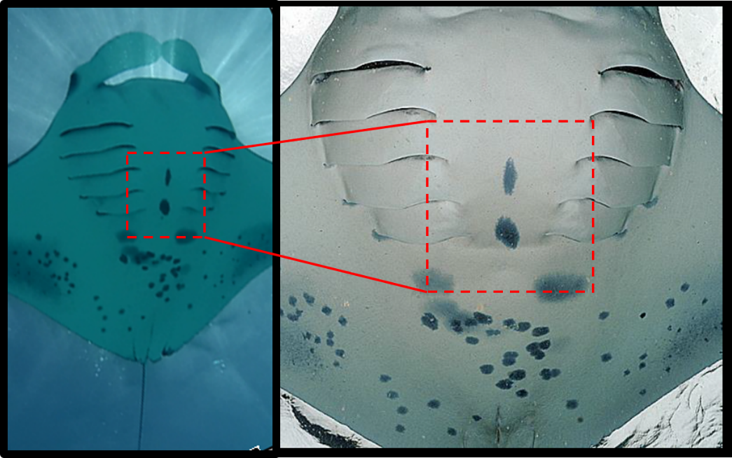

Figure 2. 1: Identification spots on the ventral surface (Source: Manta Trust 2019).

### *2.3.2.2 Hanifaru Bay foraging groups*

I defined “foraging groups” as two or more animals recorded feeding together within two body lengths and the foraging type, either ‘solo or ‘group’ was noted for interaction. Solo feeders, mantas foraging more than two body lengths away from another manta, were also recorded and included in analysis.

Surveys were conducted on 160 days between 26th May and 1st December 2014, 156 days between 1st June and November 30th 2015, and 155 days between 21st May and November 30th in 2016. Data were collected across the day to ensure a broad surveying window. I surveyed foraging at six sites in eastern Baa Atoll: Baathala Kandu, Dhigu Thila, Hanifaru Bay MPA, Hurai Faru, Reethi Falhu and Veyofushi Falhu. Hanifaru Bay MPA was considered the key research site due to the unique environmental conditions and significant number of *M. alfredi* observed foraging seasonally.

The data collection protocol used by Murray et al. (Chapter Three) was used. Video data were collected by free-diving beneath the foraging manta rays, using a GoPro Hero 3, or a Canon PowerShot S110 compact camera.

Only individually identified *M. alfredi* were included in analyses. Using Stevens’ (2016) methods for identification, each animal was identified and sexed. Age-class was noted for each individual.

### *2.3.3 Statistical analyses*

*2.3.3.1 Associations within Aggregations*

Aggregation data were used across all eleven sites in eastern Baa Atoll. An association is defined as interactions and/or communications between individuals in spatial, temporal and/or behavioural metrics (Whitehead 2008; Whitehead & James 2015). To avoid biasing association strengths, only individuals with a minimum of five observations were included in analysis (Aplin et al. 2013). Edge weight and degree distributions, scaling association (edges) between zero (never observed in the same group) and one (always observed in the same groups (Cairns & Schwager 1986; Aplin et al. 2013)) were used to calculate association strengths using the GoG approach (Whitehead & Dufault 1999; Franks et al. 2010; Aplin et al. 2013). I tested whether the observed network was statistically different to random by running 5000 permutation tests on the group-by-individual matrix, controlling for time and location, with 100 swaps on animal ID (Whitehead 1999; 2008; Aplin et al. 2013). Permutations assess whether the observed network is statistically different to randomised networks. For permutation tests, I first calculated the test statistic, in this case the coefficient of variance (CV) for the observed network. The permutation tests create multiple (5000) datasets, scrambling the animal ID in order to calculate a test statistic for each randomised network. These two statistics are then compared, if the observed statistic is less or greater than 97.5%, we can reject the null hypothesis that the permutations had no effect, i.e. if a p-value of 0.05 or less is found, then the observed network is statistically different to random (Whitehead 1997). To estimate a p-value, I calculated the number of times the CV for the observed value was smaller than the CV value of the randomised networks, divided by the number of permutations, plus the observed network, i.e. 5001 (Farine & Whitehead 2015). Analyses were conducted using Asnipe package, version 1.1.19 (Farine 2018) in R 3.0.0 Statistics Package.

#### 2.3.3.2 Associations within Foraging groups

Only foraging data collected at Hanifaru Bay MPA were used for this analysis. To avoid biasing association strengths, only individuals with a minimum of five observations were included in analysis (Aplin et al. 2013). Creating sampling periods of co-occurrences from association data, I generated an association matrix of all individuals observed foraging together within time and space, using a designated sampling period of one day. This was done to ensure independence of each observed group. This matrix records the presence (one) or absence (zero) of an association between dyads within the sampling period. An occurrence matrix, representing the presence of each individual in each sampling period, allowed me to also include observations of lone individuals sighted during a sampling period in the overall network (this is necessary as co-occurrence matrices only analyse associations, not attendance (Farine 2018)). I initially calculated edge weight and degree distributions and created the full eastern Baa Atoll foraging network for the six designated sites. As Hanifaru Bay is recognised as a key foraging site, I repeated this process and created a Hanifaru Bay network. Due to the high number of foraging observations in Hanifaru Bay which make up 80% of all data, all further foraging group analyses were focused on this site alone.

### *2.3.4 Associations between individuals*

Preferred association is defined as individuals which are seen together more than would be expected at random (Lusseau 2003) and is an indicator of individuals preferential companionship. A weighted analysis was used.

#### 2.3.4. 1 Associations between individuals within Aggregations

I tested preferred associations in the observed network statistically using 5000 data stream permutation tests on the group-by-individual matrix, controlling for time and location, with 100 swaps on animal ID (Whitehead 1999; Whitehead 2008; Aplin et al. 2013). Next, using edge weight and degree distributions, I calculated preferred associations within sex and age class. The overall network was subsetted and tests were conducted on the full network, as well as female only, male only, juvenile only and adult only networks to examine within-class variation in preferred associations. P-values signify any significant difference between the CV of the observed network and the coefficient estimates of the 5000 permuted networks (as explained above).

#### 2.3.4. 2 Associations between individuals within foraging groups in eastern Baa Atoll

I tested for preferred associations in the overall eastern Baa Atoll network statistically using data stream permutation tests on the one-day sampling period matrix, controlling for time and location, with 100 swaps on animal ID.

#### 2.3.4. 3 Associations between individuals within Hanifaru Bay foraging groups

The above analyses were repeated on the Hanifaru Bay association matrix of all individuals co-existing within time and space, using a designated sampling period of one day. The overall network was subsetted and tests were conducted on the full network, female only, male only, juvenile only and adult only networks.

*2.3.5 Gregariousness*

Next, I tested each individuals’ gregariousness (also known as degree centrality) by calculating the number of individuals with which they associated with over the specified time period (Aplin et al. 2013). The same methodology was used for both aggregations and foraginggroups).

Using the permutation method proposed by Bejder et al. (1998; Farine 2013), I tested the parameter estimate significance against the null model. A comparisonof the coefficient estimates for the slope of the observed network and the individuals’ weighted degree coefficient estimate for the permuted networks allowed me to test for significance against the randomised data. I then tested whether age class and sex predicted gregariousness by running a linear model with degree centrality as the ‘dependent’ variable (Farine 2013).

*2.3.6 Temporal stability of relationships*

The temporal stability of the population and repeated associations was examined using the lagged rates of association technique (LRAS) (Farine 2013), testing the rate and stability of dyad re-associations across the full study period divided into temporal periods of (a) one year and (b) 30-days. These periods were selected to show fluctuations across the long and short term, i.e. 30-day periods indicate finer scale variation, theorised to be influenced by strong environmental factors within study calendar months, while annual timesteps accounted for the strong influence of the seasonal nature of observations across the sampling period. The same methodology was used for both aggregations and foraging groups*.* By accounting for the frequency of associations between dyads over a specific time lag (*τ*), the lagged rate of association technique achieves results which are statistically akin to those calculated by using simple ratio indexes, using the equation;

$g\left(τ, X,Y\right)=\sum_{j,k|\left(t_{k}{- t}_{j}\right)=τ}{\frac{a_{j}\left(X, Y\right)∙a_{k}\left(X, Y\right)}{a_{j}\left(X, Y\right)∙a_{k}\left(X, Y\right)}}$ (Farine, 2013).

Here, *X* and *Y* represent individuals’ measures, with *aⱼ(X, Y*) the number of *X*  and *Y* dyad observations during the time period *j* and *aₖ (Y,* X) the number of observations of individual *X* during the time period *k* (Farine 2013). A null (random) model was created, presuming there is an equal probability of all individuals associating, as proposed by Whitehead (1995). Plotting the null model indicates whether individuals associate more or less often than expected at random. For this analysis, all individuals were used regardless of the number of observations, as rates can be positively biased if only data from frequently observed individuals are used (Baird & Whitehead 2000; Lusseau et al. 2003). The mean association rate was calculated for dyads per timestep, i.e. one year/30-days and results plotted against the null model for comparison. A mean lagged rate of association of one (the maximum value) would indicate that individuals have a high probability of companionship and to be always sighted together, whereas a value of zero indicates a zero probability of re-association. Standard errors were calculated using a jackknife technique, where each sample is removed one at a time from the dataset to calculate jackknife parameter measures (Whitehead 1997; Farine 2013), indicating variation within the data. This test was then run within sex and age class as these were regarded key biological factors influencing re-association patterns.

Sampling in the wild can lead to certain individuals not being observed during a survey leading to an association reading of zero, however, this does not mean that they were not in fact associating. Therefore, I calculated standardised lagged association rates (SLAR). Using the concept that if individual Y associates with individual X at time point zero of the study, SLARs estimate the average probability that the dyad will be observed associating together again at succeeding time points (Whitehead 2008; Garroway & Broders 2007). This was run testing all individuals. The SLAR was calculated over monthly timesteps for aggregations and foraging groups and results plotted against lag. Standard errors were calculated using a jackknife technique.

## ***2.4 Results***

### *2.4. 1 Network overview*

#### 2.4.1.1 Associations within Aggregations

Between 14th May 2010 and 26th November 2016, 1454 aggregations, ranging in size from one to 242 individuals, were observed across 11 study sites (both foraging and cleaning sites) in eastern Baa Atoll. Sightings included 844 unique individual manta rays over 883 days of data collection. Individuals were observed between five and 190 times, with a median of 15 times.

#### 2.4.1.2. Associations within eastern Baa Atoll foraging groups

Between 25th May 2014 and 26th November 2016, 1774 foraging groups were observed across six sites in eastern Baa Atoll, ranging in size from one to 13 individuals. A total of 209 individual manta rays were observed feeding across 77 days of sampling. Individuals were sighted between five and 74 times, with a median of ten times.

#### 2.4.1.3 Associations within Hanifaru Bay foraging groups

Finally, I analysed data from just the foraging groups recorded at Hanifaru Bay MPA. Across 64 sampling days from 2014 and 2016, 1398 foraging groups were observed, including 173 unique individual manta rays and ranging in size from one to 12 individuals. Individuals were sighted between five and 68 times, with a median of nine times.

### 

### *2.4. 2 Associations between individuals*

### 2.3.2.1 *Associations between individuals* within Aggregations

A social network was constructed for the whole sampling period from 2010 to 2016 using a GoG approach (Whitehead & Dufault 1999; Franks et al. 2010; Aplin et al. 2013), with all individuals observed at the study site per survey classed as aggregation members. I tested the full and subsetted sex and age class networks for preferred associations. Within the whole aggregation network including all individuals, there were no significantly preferred associations amongst individuals different to the null model (p = 0.9998) (Figure 2.2a and Table 2.1a). Analysing the sexes separately, neither females or males (Table 2.1b and c) showed preferred associations. This result was the same when the networks were split into juvenile and adult only networks (Table 2.1d-e), indicating that observed associations within-class resulted from random associations and that all individuals, regardless of sex or age had an equal chance of associating.

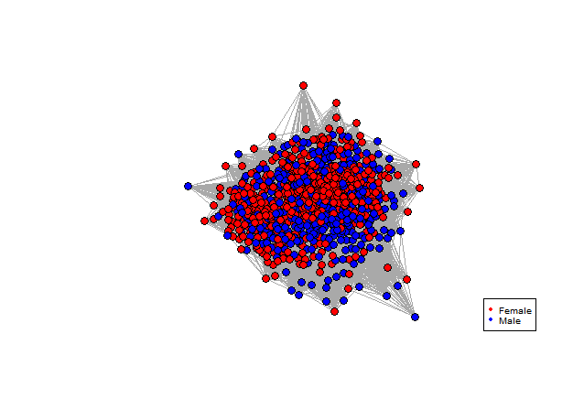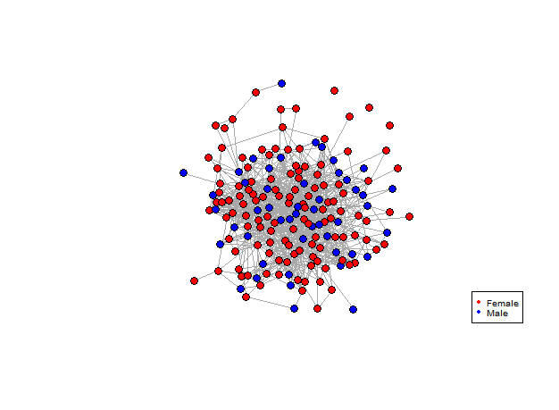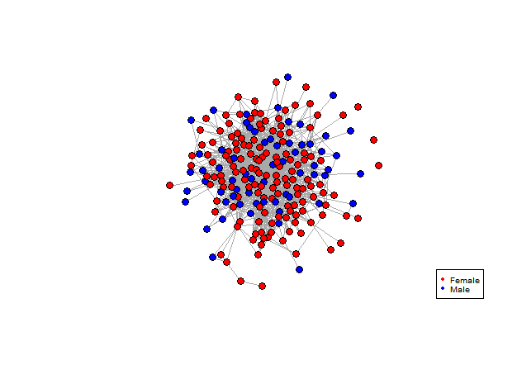

a.

b.



c.

Figure 2. 2: The observed network of (a) *M. alfredi* in eastern Baa Atollbetween 2010 and 2016. Coefficient estimates for the permuted networks indicate the observed network is not significantly different to random, p = 0.9998. (n = 844). (b) Foraging groups in eastern Baa Atoll between 2014 and 2016. Coefficient estimates for the permuted networks indicate the observed network is not significantly different to random, p = 0.9998. (n = 209). (c) Foraging groups in Hanifaru Bay MPA between 2014 and 2016. Coefficient estimates for the permuted networks indicate the observed network is not significantly different to random, p = 0.9940. (n = 173).

Table 2. 1: Tests for preferred associations within aggregations. Permutation tests with swaps between pairs of associations with 5000 permutations, 100 swaps/permutation. n = 844, n (female: male) = 498:346, n (adult: juvenile) = 515:329. P-values below 0.05 indicate preferred affiliations.

|  |  |
| --- | --- |
| Permutations:  Measure: | Controlling for time and location |
| 1. All individuals (n=844)   Coefficient of Variance (Observed: Random)  P-value  Confidence Intervals | 1.4436: 2.5224  p = 0.9998  0.9997 – 0.9999 |
| 1. Females only (n=498)   Coefficient of Variance (Observed: Random)  P-value  Confidence Intervals | 1.3763: 2.2617  p = 0.9996  0.9995 – 0.9997 |
| 1. Males only (n=346)   Coefficient of Variance (Observed: Random)  P-value  Confidence Intervals | 1.5015: 2.9609  p = 0.9998  0.9997 – 0.9999 |
| 1. Adults only (n=515)   Coefficient of Variance (Observed: Random)  P-value  Confidence Intervals | 1.2775: 2.2058  p = 0.9998  0.9997 – 0.9999 |
| 1. Juveniles only (n=329)   Coefficient of Variance (Observed: Random)  P-value  Confidence Intervals | 1.6273: 2.2066  p = 0.9998  0.9997 – 0.9999 |

### 2.3.2.2 *Associations between individuals within eastern Baa Atoll foraging groups*

#### 

#### With a p-value of 0.9998 (CV = 6.501) there was no evidence of preferred associations within the whole eastern Baa Atoll foraging groups network, therefore I can reject the presence of social structure (Figure 2.2b).

### 2.3.2.3 *Associations between individuals within Hanifaru Bay foraging groups*

The Hanifaru Bay foraging social network was constructed using a sampling period approach, constructing an association matrix for co-occurrences using a one-day sampling period. Within the whole foraging group network, coefficient estimates for the permuted networks indicated the observed network was not significantly different to random, p = 0.9940 (Figure 2.2c and Table 2.2a). Splitting the network by sex, neither females or males showed preferred associations (Table 2.2b & c). This indicates no significant preferred associations within the sexes, with no evidence of females significantly associating more with other females and males with other males. This result is reflected within age class, with neither adults or juveniles showing preferred associations (Table 2.2d & e). Overall manta rays did not adopt preferred associations with individuals of the same sex or age class indicating no structural benefits to associating with similar conspecifics.

Table 2. 2: Tests for preferred associations within Hanifaru Bay foraging groups. Permutation tests with swaps between pairs of associations using 5000 permutations, with 100 swaps/permutation. n = 173, n (female: male) = 124:49, n (adult: juvenile) = 99:74. P-values below 0.05 specify preferred associations.

|  |  |
| --- | --- |
| Permutations:  Measure: | Controlling for time |
| 1. All individuals (n=173)   Coefficient of Variance (Observed: Random)  P-value  Confidence Intervals | 4.8689: 5.1829  p = 0.9940  0.9935 – 0.9945 |
| 1. Females only (n=124)   Coefficient of Variance (Observed: Random)  P-value  Confidence Intervals | 4.6429: 4.8632  *p* =0.9974  0.9971 – 0.9977 |
| 1. Males only (n=49)   Coefficient of Variance (Observed: Random)  P-value  Confidence Intervals | 4.6757: 5.3128  *p* = 0.9998  0.9997 – 0.9999 |
| 1. Adults only (n=74)   Coefficient of Variance (Observed: Random)  P-value  Confidence Intervals | 4.4237: 4.7655  *P* = 0.9918  0.9912 – 0.9924 |
| 1. Juveniles only (n=99)   Coefficient of Variance (Observed: Random)  P-value  Confidence Intervals | 5.1859: 5.6804  *p* = 0.9950  0.9945 – 0.9955 |

### *2.4.3 Gregariousness*

#### 2.4.3.1 Gregariousness within Aggregations

A linear model tested the influence of sex and age class on the gregariousness (degree centrality) of individuals in the observed aggregation network. Model results indicated that both demographic classes were significant in the gregariousness of *M. alfredi* butthe interaction between sex and age class proved non-significant. (see Table 2.3). Males had significantly lower degree centrality than females, indicating that females were more gregarious (see Fig 2.3a). This was reflected in the age classes too, with adults showing statistically significantly higher gregariousness than juveniles (see Fig 2.3b). The coefficient estimates for the weighted degree centrality of individuals were tested against the null model to confirm overall significance. With a p-value of 0.4152, there was no significant indication of varying levels of gregariousness different to what is found at random, influenced by sex or age amongst the study population.

Table 2. 3: Effect of demographic factors (sex and age class) and interactions on gregariousness within aggregations. Statistics include estimate (positive, negative -), standard error (*SE (β)*), t value, probability of deviation from a slope of zero (*p*). Statistically significant (sig.) results appear in bold. (n = 844).

|  |  |  |  |  |
| --- | --- | --- | --- | --- |
| Variables | *Coef β* | *SE (β)* | *t* | *Sig.* |
| ***(Intercept)*** | **18.0883** | **0.4958** | **36.482** | **<2e-16** |
| *Sex* |  |  |  |  |
| Female |  |  |  |  |
| **Male** | **-5.7839** | **1.1155** | **-5.185** | **2.71e-07** |
| *Age class* |  |  |  |  |
| Juvenile |  |  |  |  |
| **Adult** | **3.8174** | **0.7233** | **5.278** | **1.67e-07** |
| *Interaction* |  |  |  |  |
| Sex: Age | 1.7608 | 1.328 | 1.330 | 0.184 |

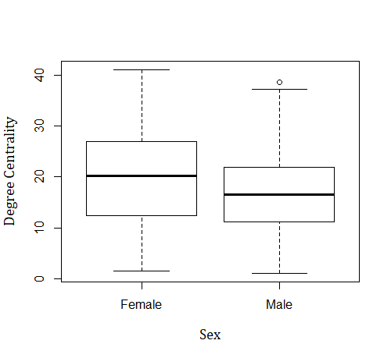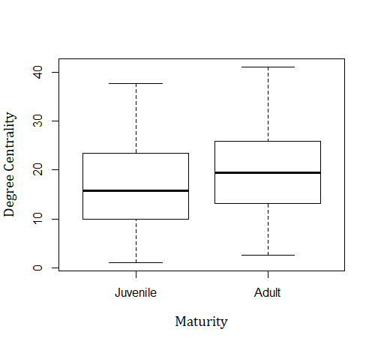

a.

b.



Weighted Degree Centrality

Weighted Degree Centrality

Figure 2. 3: Gregariousness (weighted degree centrality) measures for (a) sex and (b) age classes of *M. alfredi* as calculated using linear models within aggregations*.* The boxplot shows the medians, interquartile ranges (box), upper and lower quartiles (whiskers) and outliers (circles). Coefficient estimates for the permuted networks indicate degree centrality for sex and age classes were not significantly different to random, p = 0.4152 (n = 844).

#### 2.4.3.2 Gregariousness within Hanifaru Bay foraging groups

I tested the influence of sex and age classes on the gregariousness of individuals in the foraging groups network using a linear model. Neither sex or age or the interactions between sex and age were significant in explaining variation in gregariousness of foraging *M. alfredi* (see Table 2.4). The coefficient estimates for the weighted degree centrality of individuals were not significantly different to random (*p* = 0.5170), which indicated that any variation in individual gregariousness of the Hanifaru Bay foraging network is not affected by sex or age class (Fig 2.4a and b).

Table 2. 4: Effect of demographic factors (sex and age class) and interactions on gregariousness within foraging groups. Statistics include estimate (positive, negative -), standard error (*SE (β)*), t value, probability of deviation from a slope of zero (*p*). Statistically significant (sig.) results appear in bold. (n = 173).

|  |  |  |  |  |
| --- | --- | --- | --- | --- |
| Variables | *Coef β* | *SE (β)* | *t* | *Sig.* |
| ***(Intercept)*** | **1.7103** | **0.1295** | **13.202** | **<2e-16** |
| *Sex* |  |  |  |  |
| Female |  |  |  |  |
| Male | 0.3277 | 0.3222 | 1.017 | 0.311 |
| *Age class* |  |  |  |  |
| Juvenile |  |  |  |  |
| Adult | 0.1567 | 0.2253 | 0.695 | 0.488 |
| *Interaction* |  |  |  |  |
| Sex: Age | -0.5725 | 0.4243 | -1.349 | 0.179 |

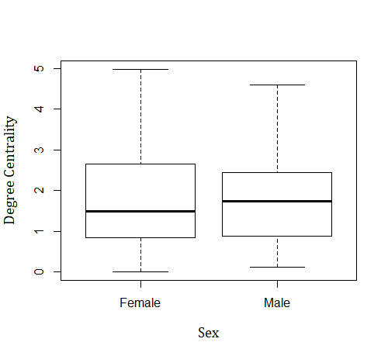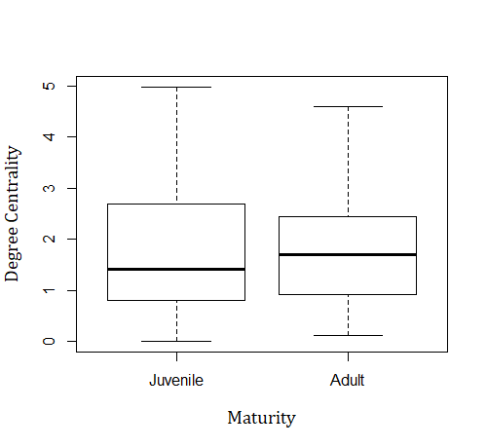

a.

b.



Weighted Degree Centrality

Weighted Degree Centrality

Figure 2. 4: Gregariousness (weighted degree centrality) measures for (a) sex and (b) age classes of *M. alfredi* as calculated using linear models within foraging groups*.* The boxplot shows the medians, interquartile ranges (box), upper and lower quartiles (whiskers) and outliers (circles). Coefficient estimates for the permuted networks indicate degree centrality for sex and age classes were not significantly different to random, p = 0.5170 (n = 173).

### *2.4.4 Temporal stability of relationships*

#### 2.4.4.1 Temporal stability of relationships: Aggregations

I measured the temporal stability of dyad associations of individuals over the seven years of data collection split into (a) annual and (b) 30-day timesteps and compared against the null (random) model. The probability of re-association (repeated observations of dyads) within the whole population, as well as within sex and age classes was low overall across both the annual and 30-day timestep. The probability of re-association for all individuals within aggregations across year timesteps was small, with a mean association probability of 0.060, but remained consistently higher than the null model (Figure 2.5). This result indicates that dyads associated more than expected at random.

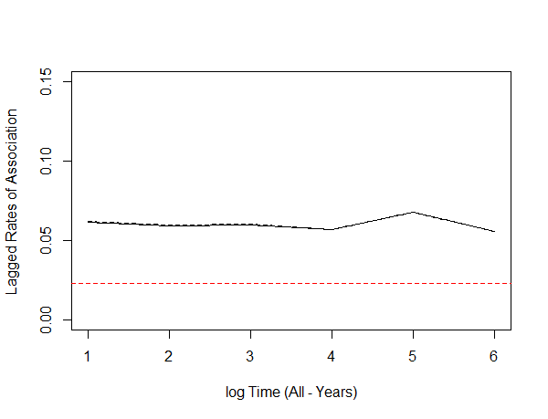

Time (All - Year)

1 2 3 4 5 6

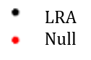

Figure 2. 5: Temporal stability of relationships within aggregations: Lagged rates of association (LRA) for all individuals over year timesteps. Lines show the approximate differences in relation to the tested time lag (1-year). Horizontal dashes indicate approximate standard errors calculated using temporal jackknife method (omitting data points in turn). Red line shows null (random) association rate. (n = 1196).

Over annual timesteps, females had a mean association probability of 0.069, again consistently higher than the null model (Figure 2.6a). Re-association steadily declined across the seven-annual timesteps with a minor peak and drop in associations toward the end of the study period, suggesting a distinct change in the activity and movement of individuals. Males had a lower mean association probability than females, of 0.048 (Figure 2.6b) but were above the null. Annually, juveniles recorded a mean association probability of 0.065, again remaining above the null model (Figure 2.6c). These were steady over time before experiencing a steep decline during the last year of the study period. Adults had a lower mean association probability of 0.060 but had little decline towards the null, indicating associations were different to what is expected at random (see Figure 2.6d). Standard errors were low for all classes, showing low variation across the timesteps.

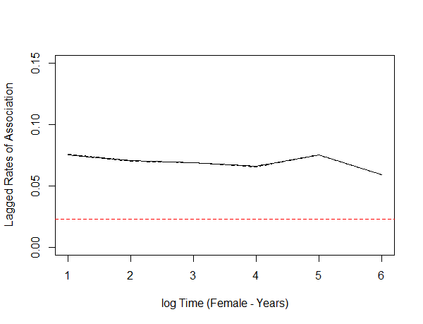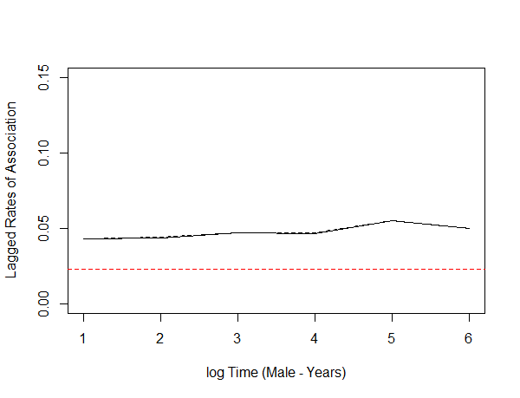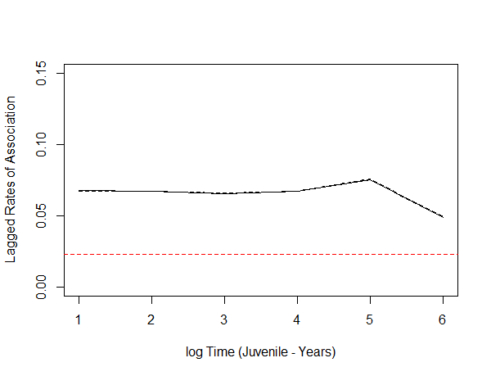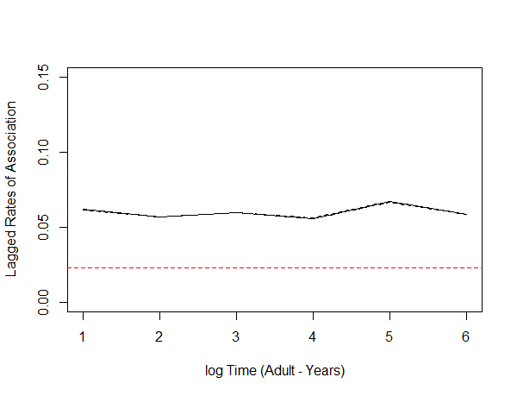

Time (Female - Year)

Time (Male - Year)

Time (Juvenile - Year)

Time (Adult - Year)



1 2 3 4 5 6

1 2 3 4 5 6

1 2 3 4 5 6

1 2 3 4 5 6



a.

b.

d.

c.

Figure 2. 6: Temporal stability of relationships within aggregations: Lagged rates of association (LRA) for (a) female, (b) male, (c) juvenile, (d) adults over year timesteps. Lines show the approximate differences between sex and age classes in relation to the tested time lag (1-year). Horizontal dashes indicate approximate standard errors calculated using temporal jackknife method (omitting data points in turn). Red line shows null (random) association rate. (n = 1196).

Overall, the probability of re-association for all individuals within aggregations across 30-day timesteps was low, with a mean association probability of 0.063, consistently higher than the null model (Figure 2.7).

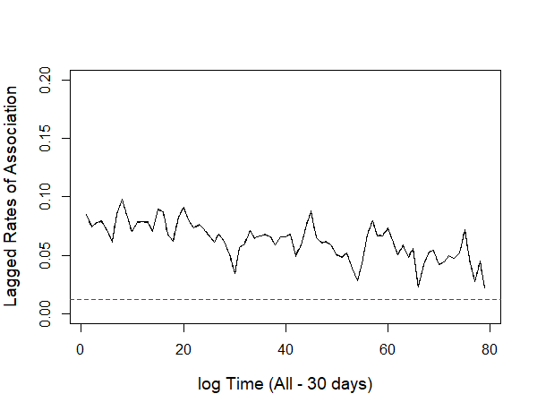

30 600 1200 1800 2400



Time (All - 30 days)



Figure 2. 7: Temporal stability of relationships within aggregations: Lagged rates of association (LRA) for all individuals over 30-day timesteps. Lines show the approximate differences in relation to the tested time lag (30-days). Horizontal dashes indicate approximate standard errors calculated using temporal jackknife method (omitting data points in turn). Red line shows null (random) association rate. (n = 1196).

Over 30-day timesteps, females had a mean association probability of 0.074 and males 0.046 (Figure 2.8a & b). Again, female re-association was consistently higher than the null model, suggesting association more than expected at random. Male re-association probability was generally lower than females, at times dropping towards and below the null model, suggesting periods of random re-association. Juvenile mean rate of association returned a value of *NaN*, which represents individuals which were not observed associating across the timesteps and therefore are not presented below. Adult mean association rate was 0.063, with dips towards but never dropping below the null model, resulting in low but non-random re-association (Figure 2.8c). Again, standard errors were low for all classes across the timesteps. Re-association probability across both sexes and adults appears low across the sampling period but the distinct fluctuations throughout the sampling period indicates discrete changes in manta ray activities and association patterns. These fluctuations in probability appear throughout the timesteps, suggesting re-associations are influenced by variations in manta sightings, with higher probabilities occurring when group sizes are larger.

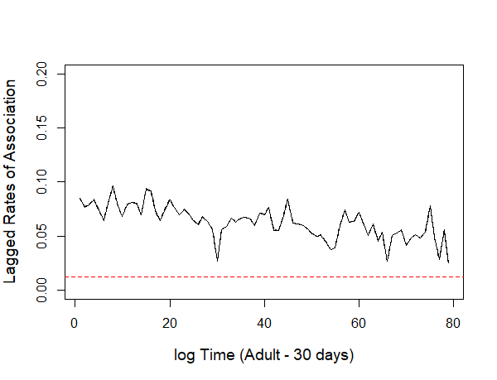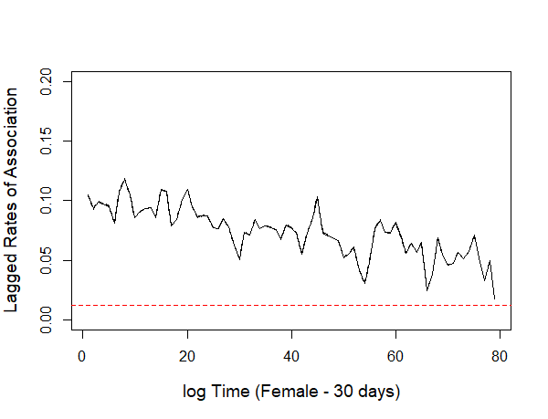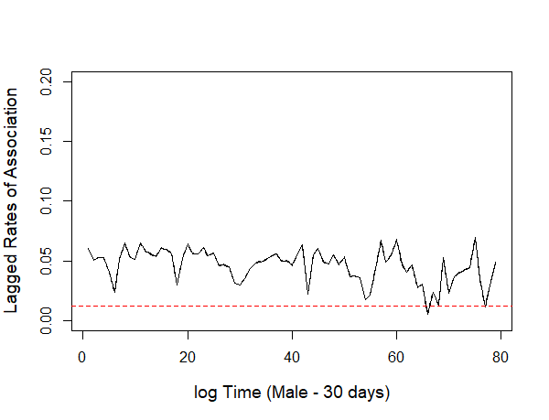

Time (Female - 30 days)

Time (Male - 30 days)



30 600 1200 1800 2400

30 600 1200 1800 2400

30 600 1200 1800 2400

Time (Adult - 30 days)



a.

b.

c.

Figure 2. 8: Temporal stability of relationships within aggregations: Lagged rates of association (LRA) for (a) female, (b) male, (c) adults over 30-day timesteps. Lines show the approximate differences between sex and age classes in relation to the tested time-lag (30-days). Horizontal dashes indicate approximate standard errors calculated using temporal jackknife method (omitting data points in turn). Red line shows null (random) association rate. (n = 1196).

#### 2.4.4.2 Temporal stability of relationships: Hanifaru Bay foraging groups

The probability of re-association for all individuals within foraging groups across year timesteps was low, with a mean association probability of 0.006, below the null model and steadily declining across the entire study period (Figure 2.9). This result indicates that dyads associated at random.

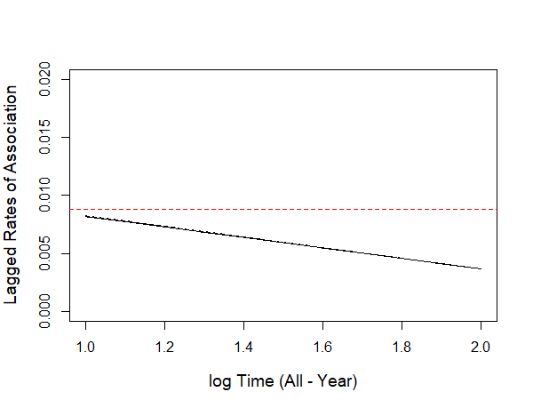

1 2



Time (All - Year)

Figure 2. 9: Temporal stability of relationships within Hanifaru Bay foraging groups: Lagged rates of association (LRA) for all individuals over year timesteps. Lines show the approximate differences in relation to the tested time lag (1-year). Horizontal dashes indicate approximate standard errors calculated using temporal jackknife method (omitting data points in turn). Red line shows null association rate. (n = 292).

The probability of re-association within sexes was low when testing across the three-year study period using both annual and 30-day timesteps. For annual timesteps, females had a mean association probability of 0.010, starting higher then dropping below the null model, indicating non-random re-associations within the three timesteps (Figure 2.10a). Males were below the null model with a zero probability of re-associating across the timesteps (Figure 2.10b). I saw similar results with age class. Annually, juveniles recorded a mean association probability of 0.009, beginning above but then following a slow but steady decline below the null model over the three timesteps indicating random associations (Figure 2.10c). In contrast, adults had an association probability of zero, suggesting no long-term associations (see Figure 2.10d). Standard errors were low for both sex and age class, showing minimal variation across the timesteps. For both females and juveniles, re-association patterns decline to their lowest at the end of the full study period. This decline indicates that dyad association is not long-term and that over extended periods of time, individuals do not maintain relationships. Further study should test shorter time periods, for example a 14-day period, centred between the new and full moon phases, which are the two theorised peak periods for manta sightings. This would consider the link between resource density and manta associations.

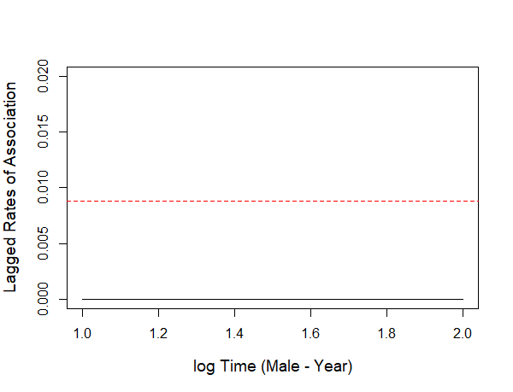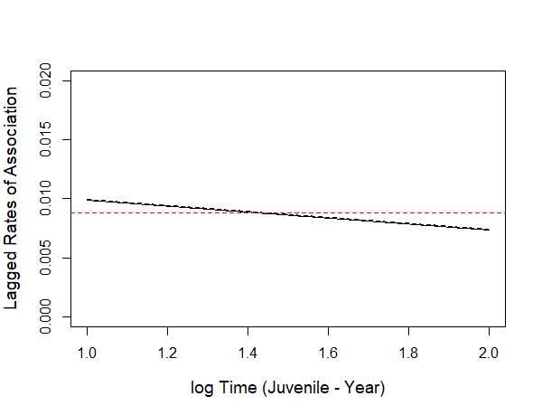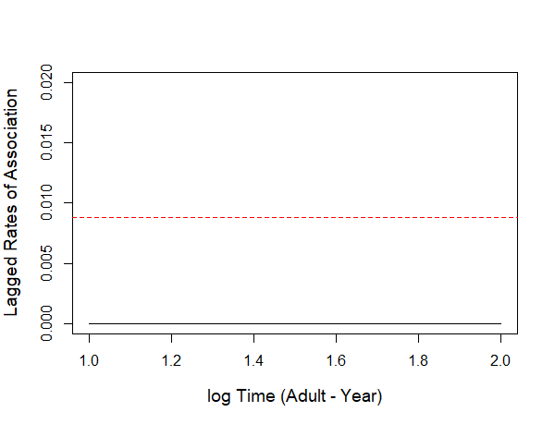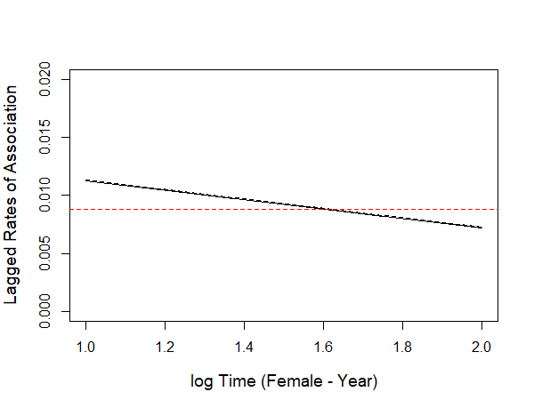

1 2

1 2

1 2

1 2

Time (Adult - Year)

Time (Juvenile - Year)

Time (Female - Year)

Time (Male - Year)



d.

c.

b.

a.

Figure 2. 10: Temporal stability of relationships within Hanifaru Bay foraging groups: Lagged rates of association (LRA) for (a) female, (b) male, (c) juvenile, (d) adults over year timesteps. Lines show the approximate differences between sex and age classes in relation to the tested time lag (1-year). Horizontal dashes indicate approximate standard errors calculated using temporal jackknife method (omitting data points in turn). Red line shows null association rate. (n = 292).

The probability of re-association for all individuals within foraging groups across 30-day timesteps again was low with consistent fluctuations towards and below the null model (Figure 2.11). Dyads had a mean association probability of 0.012. This result indicates association trends decreasing toward random.

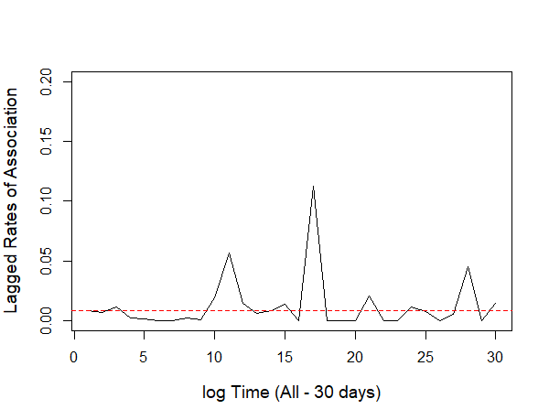

30 180 330 480 630 780 930



Time (All - 30 days)



Figure 2. 11: Temporal stability of relationships within Hanifaru Bay foraging groups: Lagged rates of association (LRA) for all individuals over 30-day timesteps. Lines show the approximate differences in relation to the tested time-lag (30-days). Red line shows null association rate. (n = 292).

Over 30-day timesteps, females had a mean association probability of 0.020 with distinct peaks in re-association but also episodic drops towards and below the null model, suggesting periodic random trends to female dyad re-associations (Figure 2.12a). The probability of re-association increases in variation during the second half of the study period. Conversely, male association rates returned a value of *NaN*, which represents individuals which were not observed associating across the timesteps and therefore are not presented below. Juveniles had a mean association probability of 0.016, with overall lower peaks in re-association than females and fluctuating below the null model, indicating the presence of random re-association (Figure 2.12b). Results again showed distinct fluctuation across the period. Adults, however, returned a value of *NaN,* once again suggesting no association which could be due to the low sample size. Due to low sampling for the 30-day subsetted data, analysis resulted in incomplete standard errors and partial LRAS results, potentially influencing values of *NaN* for males and adults. Re-association rates across both sex and age class were low across the sampling period indicating a low probability that manta rays have long-term associations. The distinct variation observed throughout the study period indicates discrete changes in manta ray movements and association patterns throughout sampling. This variation in re-association could be indicative to the fluctuation in resource dispersion throughout the monthly cycle due to the effects of lunar currents across the season, which are felt strongly in Hanifaru Bay MPA. This could be more rigorously tested in future studies by centring LRAS tests around either a 14-day (to consider the period between new and full moon phases) or a 28-day cycle (to consider the full lunar cycle).

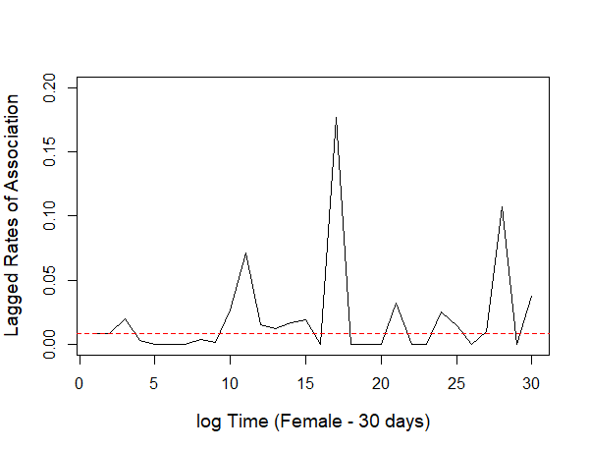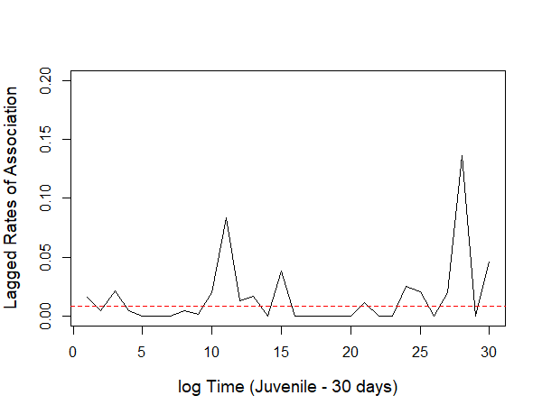

b.

a.



30 180 330 480 630 780 930

30 180 330 480 630 780 930

Time (Female - 30 days)

Time (Juvenile - 30 days)

Figure 2. 12: Temporal stability of relationships within Hanifaru Bay foraging groups: Lagged rates of association (LRA) for (a) female and (b) juvenile dyads over 30-day timesteps. Lines show the approximate differences in relation to the tested time-lag (30-days). Red line shows null association rate. (n = 292).

SLARs across both aggregation and foraging groups for month timesteps were consistently low. Figure 2.13 shows that the probability that dyads within the aggregations will associate together gradually and consistently reduces across the full seven-year research period, eventually dropping below the null. The low and declining probability of associations on an aggregation level indicates that long-term associations are unlikely.

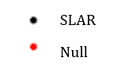

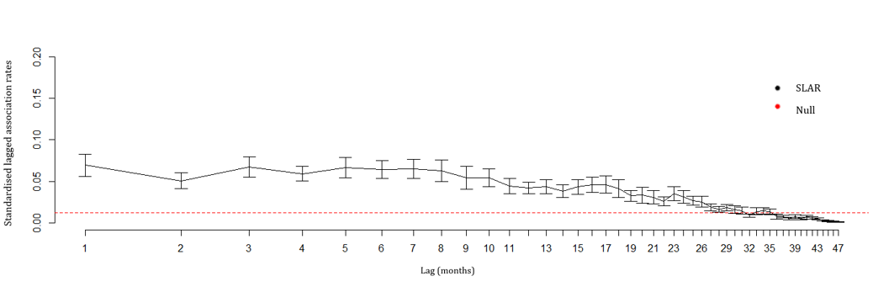

Standardised Lagged Association Rates

Lag (Months)

Figure 2. 13: Standardised lagged association rates (SLAR) for all individuals in aggregations over monthly timesteps across the seven-year research period (48 timesteps). Error bars were calculated using the temporal jackknife technique (omitting data points in turn). Red line shows null association rate. (n = 1196).

Figure 2.14 shows similar results for the foraging groups. A gradual rise in probability is seen throughout season one (months 1-6) but then drops moving into season two (month eight) and remains low until the end of the full research period, periodically dropping below the null. SLARs suggest a lack of long-term associations within both aggregations and foraging groups.

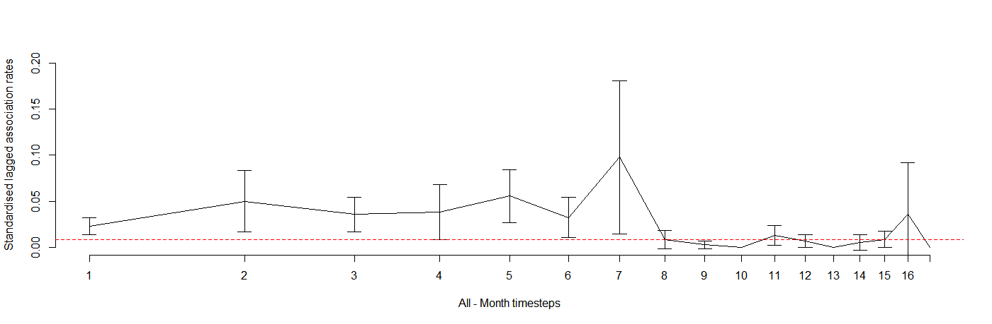

Lag (Months)

Standardised Lagged Association Rates

Figure 2. 14: Standardised lagged association rates (SLAR) for all individuals in Hanifaru Bay foraging groups in Hanifaru Bay over monthly timesteps across the three-year research period (18 timesteps). Error bars were calculated using the temporal jackknife technique (omitting data points in turn). Red line shows null association rate. (n = 292).

## ***2.5 Discussion***

My study demonstrates that there is no clear evidence of social structure different to random in the observed network of *M. alfredi* at an aggregation or foraging group level. Overall, I observed no difference in association strengths on the population level for aggregations or foraging groups on either scale within either sex or age classes which suggests that individuals lacked preferred associations. Individuals showed no difference in gregariousness between males and females, or juveniles and adults and showed low dyad re-association rates across both year and 30-day temporal scales with periods of random association, which further indicates that *M. alfredi* form loose, temporary relationships and overall have fluid dynamics without social structure.

By examining the coefficient of variance for the observed network against the permuted random networks, I could establish a lack of social structure which is also reflected in the absence of preferred associations found in this study. This result suggests that these manta rays aggregate in order to benefit from group activities other than sociality and conspecific associations. Jacoby et al. (2012a) discuss the passive and active processes of animal group formations, with some species actively electing to associate with conspecifics and choosing to adopt their direction of locomotion (Couzin et al. 2005; Guttal & Couzin 2010). Conversely, species movements, on both the small (daily) and large (seasonal) scale can cause individuals to aggregate within overlapping boundaries without actively seeking social interactions (Guttal & Couzin 2010; Jacoby et al. 2012a). Although the observed large and small-scale networks in this study demonstrate fission-fusion dynamics and experience spatial and temporal overlaps, the lack of preferred associations suggests that mantas form aggregations and foraging groups which involve no social attraction, indicating no evidence of social structure. Environmental drivers, for example the abundance or limitation of resources or habitat quality (Johnson et al. 2002) or individuals aggregating for anti-predator benefits (Krause & Ruxton 2002; Kutsukake 2009; Marras et al. 2015; Meunier 2015) may also draw non-social species together within the same areas, resulting in passive associations. As seen in certain elasmobranchs, site-attached behaviours, including resource requirements are present (Jacoby et al. 2012a) and appear a likely reason behind *M. alfredi* aggregations and foraging groups within Baa Atoll. As previously noted, manta ray sightings in the Maldives fluctuate seasonally as zooplankton blooms, the manta rays’ primary food source, are driven by monsoonal currents (Anderson et al. 2011a). Due to passing monsoonal currents, waters become increasingly enriched with nutrients due to the seasonal upwellings and mixing, resulting in phytoplankton blooms on the downward stream of atolls (Anderson et al. 2011a). This in turn, influences high zooplankton biomass, timed in accordance with this rich downward stream, which in turn supports increased manta activity (Anderson et al. 2011a). This study was conducted during the south-west monsoon, when manta ray sightings are generally concentrated on the eastern fringes of atolls, including and particularly densely at the study site, Hanifaru Bay MPA and the surrounding area (Stevens 2016). These results therefore suggest a strong influence of resource dispersion within the research area on the formation of aggregations and foraging groups observed in this study.

For both sex and age classes, there appears to be variation in the association pattern of individuals in both aggregations and foraging groups throughout the sampling periods. As manta ray sightings are seasonally driven, with peaks in sightings related to tidal movements across a monthly period, this result could mark the change in current and resource dispersion, as well as the monsoonal switch, thus driving the alteration in re-association rates. If this was to be repeated, either an overall larger (in terms of sample size as oppose to sampling period length) foraging dataset should be considered to avoid incomplete analyses or alternative, shorter time lags should be selected, for example 14-days, centred between the new and full moon phases. Results from SLARs for both aggregations and foraging groups reduce over the full study periods, which could be explained by the open, fission-fusion dynamics of the species. The lack of strict structure and loose relationships suggest that relationships are not long-term with mantas not actively seeking specific individuals to associate with.

### *2.5.1 Resource distribution*

The heterogeneous nature of zooplankton abundance and dispersal, both temporally and spatially (Greene et al. 1998; Sims et al. 2005) is often key in the movement and ultimately, the social interactions of planktivorous species, including Humpback whales (*Megaptera novaeangliae*) and Basking sharks (*Cetorhinus maximusare*) (Tyack 1981; Sims et al. 2000). The uneven distribution of prey patches leads to both species’ movements being driven to specific locations which are resource-rich, which ultimately has influenced their observed mating behaviour as the two activities, feeding and mating become intrinsically linked (Tyack 1981; Sims et al. 2000). Known to be solitary feeders, basking sharks in south-west England form loose aggregations during the summer season purely due to the dispersion of discrete prey patches (Sims & Quayle 1998; Sims 1999; Sims et al. 2000). This in turn permits rare social interaction and courtship behaviour amongst surface-feeding groups (Sims et al. 2000). Even amongst more socially structured, fission-fusion communities, resource dispersion causes variation in group organisation, for example delphinid species demonstrate disparity in grouping behaviour, often driven by food availability and predation risk (Chapman et al. 1995). Bottlenose dolphins (*Tursiops*) show a high level of fission-fusion behaviour in response to heterogeneous and patchy prey availability, splitting in size when resources are low, reducing intraspecific competition but surging in size to dilute predation risk when resource levels rise (Connor et al. 2000; Heithaus & Dill 2002; Parra et al. 2011). This strong influence of resource dispersion on the grouping behaviour of species, causing social interaction amongst even the most solitary animals strengthens the suggestion that the observed aggregations and foraging groups in this study, which show no evidence of social structure are influenced by resource exploitation. Individuals appear to be drawn together spatially and temporally to exploit their ephemeral prey rather than seeking social interactions.

Here I found that general associations among mantas proved non-significant within both sex and age classes, with low temporal re-association rates, suggesting random rather than sought relations amongst the population. In nature, resources are not often distributed homogenously, therefore animals benefit from tracking the density of a prey patch and dedicating longer periods of time to foraging within richer patches (Thompson et al. 2001; Stenberg & Persson 2005). Considering the non-homogenous nature of zooplankton blooms, I can hypothesise that manta rays exploit the patchy nature of resource dispersion within Baa Atoll, with the caveat that not all observed associations are a true reflection of social ties but are more likely due to the high benefits of exploiting the same territory outweighing the costs of shared resources (Johnson et al. 2002; Lusseau et al. 2006; Wey et al. 2008; Silk et al. 2014). The ephemeral, variable and fleeting blooms of zooplankton, often peaking in density in accordance with natural drivers, e.g. lunar tides, which can be observed within eastern Baa Atoll, and specifically in Hanifaru Bay MPA resemble White & Pickett's (1985)definition*,* a *"patch implies a relatively discrete spatial pattern, but does not establish any constraint on patch size, internal homogeneity or discreteness"*.Periodically, this small area is awash with large volumes of zooplankton, drawn in from the deeper waters outside the atoll by the strong lunar currents, thus attracting large numbers of manta rays and other megafauna to feed on the ephemeral surge in prey (Stevens 2016). Foraging groups here significantly grow before and during high tide when currents are strongest but quickly disperse after the peak tide, with group numbers dwindling (Murray et al. Chapter Three). This result indicates that individuals use these periods primarily to exploit feeding behaviour, thus strengthening the idea of loose relationships sparked by the surge in food availability (Murray et al. Chapter Three).

### *2.5.2 Fluid social structures*

Similar fluidity can be seen in other highly mobile, nonterritorial species, for example Dunlin (*Calidris alpina pacifica*) wintering at Humboldt Bay, California which, like manta rays, can be observed in large numbers but have low co-occurrence rates between dyads, with associations occurring by chance due to shared territory (Conklin & Colwell 2008). Dyads moved between roosts separately, with sporadic associations occurring purely from roost choice as opposed to rigid flock structure (Conklin & Colwell 2008). Therefore, site fidelity and observed co-occurrences and the associations which arise solely from shared territory should be considered. Conklin and Colwell (2008) highlight two converse concepts, firstly, site fidelity itself may fuel grouping behaviour, with similar preferences attracting individuals to the same habitat. However, in contrast, the groupings themselves can result in site fidelity, as sociality drives flocks to remain together in their movement (Conklin & Colwell 2008). As with other pelagic species, female manta rays in this study show higher site fidelity than males (Stevens 2016), showing natal preferences to a particular region, while males travel further (Hueter et al. 2005; Lee et al. 2007; Engelhaupt et al. 2009). Stevens (2016) found significantly higher than average repeat sightings amongst females across both feeding and cleaning sites than males, therefore fidelity is recognised amongst this population to explain the observed grouping within the study area. As an area with high primary productivity, with periods of elevated prey density, the study area is likely to influence site fidelity and migration paths (Anderson et al. 2011a; Jaine et al. 2014; Armstrong et al. 2016; Stevens 2016). Therefore, this study indicates that one explanation for the observed grouping behaviour in aggregations and foraging groups may be that it is a by-product of natal site fidelity demonstrated by female manta rays and of the localised high primary productivity favoured by males as part of their migratory route. However, a definitive answer would require further rigorous testing. These shared primary feeding grounds come with the added benefit of allowing the sexes, who demonstrate different time allocations and fidelity patterns, to invest in vital courtship and mating behaviour (Conklin & Colwell 2008; Stevens et al. 2018).

### *2.5.3 Limitations and future considerations*

My study found no evidence of social structure within the test population; although this is not a definitive answer, any indication of a strong structure would likely have been observed. We must consider whether firstly, the correct variables are being measured, secondly whether they are being measured in the correct way and lastly what other factors may explain structure. The first consideration is that due to photo-ID data collection restrictions, it is unlikely that all individuals are identified during one sampling event. This will mean that key individuals (more gregarious and connected individuals) and associations will not be included in the analysis, a common problem for biologists working in the field (James et al. 2009). A developing and more inclusive sampling method could be to use tracking devices, used on an array of marine species including tag-recapture, automated satellite and acoustic telemetry (Garla et al. 2006; Hart & Hyrenbach 2009). Although such technology produces more accurate and inclusive data sampling, which is likely to increase precision in social network analysis, the major financial, ethical and welfare consideration is a key limitation, meaning that this method remains unavailable to many studies including this one. The use of automated tracking devices would enable network data to be collected away from simply the designated key sites, including cleaning stations and during animal transit outside the relative safety of the inner-atoll waters and in areas where predation risk increases. Kelley et al. (2011) found that under higher risk circumstances, associations increased and a higher-level of connectedness was observed within the structure of shoals of guppies, therefore we could theorise that if the risk of predation was a more important driver than food itself, manta rays may exhibit stronger sociality than observed in this study. Further reflection of relevant factors could be key, for example sub-structure can be influenced by mating choice and status (Sih et al. 2009), relatedness (Rollins et al. 2012; Diaz-aguirre 2018) or the cohort/age of individuals (Carter et al. 2013). To further examine gregariousness, I could test the hierarchy and behavioural differences of individuals, for example bold versus shy individuals and how this affects the frequency of network interactions and ultimately the transfer of information amongst a population, as tested in three-spined sticklebacks (*Gasterosteus aculeatus*) (Pike et al. 2008). Tanner and Jackson (2012) tested behavioural factors and the type of connections made by individual European Shore Crabs, (*Carcinus maenas*) which were shown to maintain the overall social structure of the network (Jacoby et al. 2014). Associating more extensively, the more exploratory individuals acted to connect with the poorly connected individuals, thus acting as “powerbrokers” as their network position allowed the continued flow of information and maintained interactions between all individuals (Scott 2000; Tanner & Jackson 2012). In turn, these social interactions, both “direct” within dyads and “indirect” via associations are thought to influence the emergence of personality (Krause et al. 2010; Jacoby et al. 2014), which has been linked to temporal stability within populations (Aplin et al.2013). Therefore, if this study was to be repeated, a revised and more extensive list of test variables could increase the accuracy of analysis.

Overall, this study has demonstrated a lack of social structure and fission-fusion dynamics of the observed manta rays, confirming the null hypothesis that aggregations and groupings result from random patterns of association. Presumptions of social organisation due to observed cooperative behaviours, including group feeding strategies and size assortment (Myrberg & Gruber 1974; Sims et al. 2000; Jacoby 2012) are understandable as this can be observed in other elasmobranch species, including social preferences amongst juvenile Lemon sharks (*Negaprion brevirostris*), (Guttridge et al. 2011) however, flexibility in manta ray foraging behaviour is known. Murray et al. (Chapter Three) examined grouping and leadership behaviour amongst the test population and found that females were leaders, but age class had no influence in either behaviour and that overall, high within-individual variation explained foraging behaviour. With certain factors, including resource dispersion affecting group size (Krause & Ruxton 2002) and environmental drivers, including seasonality influencing the predictability of fission-fusion dynamics (Sueur et al. 2011; Silk et al. 2014), manta ray aggregations represent a highly dynamic fission-fusion community. Understanding the flexibility and dynamics of such aggregations and foraging groups is important in terms of conservation and future management implications, particularly in species classed as vulnerable, such as manta rays (Parra et al. 2011; Haulsee et al. 2016). Loose community structures, with associations driven by spatiotemporal variation can be difficult to monitor due to their changing size and movements, which in turn can leave proportions of the population more or less vulnerable to natural or anthropogenic threats, making management complex (Haulsee et al. 2016). Although this fission-fusion community lacks strict structure, these interactions remain important to population survival, permitting information and disease exchange, as well as genetic transmission and population fitness (Altizer et al. 2003; Archie et al. 2008; Silk 2007; Parra et al. 2011), making aggregations and groups formed due to foraging a vital behaviour for future individual success and population persistence.

## ***2.6 Conclusions***

My study examined the overall social structure, including spatial and temporal associations and gregariousness of the study population in eastern Baa atoll. I found no evidence of social structure significantly different to random across the large or fine-scale, highlighting a loose social structure and highly dynamic fission-fusion population. As yet, I cannot confirm whether there is structure away from foraging grounds but my results suggest that associations appear to be driven by resource dispersion and habitat use, with site fidelity and foraging behaviour driving the observed aggregations. This lack of rigid structure does have a positive implication however. Due to the loose relationships and open population, foraging efficiency and success could be maintained and would not experience total social disruption if key individuals (more gregarious and connected individuals) were removed. However loose and unstructured the population may be, aggregations and foraging groups remain key to population fitness, especially in light of the increasing anthropogenic threats and changing marine environmental conditions.

# **Chapter Three: Individual flexibility in group foraging behaviour of reef manta rays (*Mobula alfredi*)**

## ***3.1 Abstract***

In spatially and temporally dynamic environments, animals need to vary their foraging strategies to optimise effort and reduce metabolic costs. Group foraging should be beneficial to increase efficiency of resource exploitation but may be costly in terms of intra-specific competition particularly at low prey abundances. This cost-benefit trade-off is likely to vary within and among individuals. Reef manta rays (*Mobula alfredi*) are large filter-feeding elasmobranchs which often aggregate to feed on ephemeral upwellings of their zooplankton prey. I filmed 3106 foraging events involving 343 individually identifiable *M. alfredi* over three years in the Maldives. Within aggregations, individuals fed either solo or in groups, forming feeding chains with a clear leader and between one and eight followers. My study investigated whether various biotic and abiotic factors affected individual foraging strategies. *M. alfredi* were significantly more likely to forage in groups than solo at high zooplankton levels, and at certain locations. Both biotic and abiotic factors contributed to variation in group foraging. Within aggregations, *M. alfredi* foraged in larger groups when more food was available, and when the overall aggregation was relatively small. This suggests that foraging in large groups is more beneficial when food is abundant and/or intra-specific competition is outweighed by the efficiency resulting from the use of group foraging strategies. Females, the larger sex, were more likely to lead foraging groups than males. Notably, I found little evidence of among-individual differences in group foraging, i.e. individuals did not show a high degree of consistency in their group foraging behaviour. For all behavioural traits, residual within-individual variance explained over 55% of the variance. My results indicate that individual *M. alfredi* cannot be classified into foraging types or specialists. Instead, each individual was capable of considerable behavioural flexibility.

***Keywords:*** Foraging, group, position, leadership, variation, *Mobula alfredi*.

## 

## ***3.2 Introduction***

Within spatially and temporally dynamic environments, animals need to vary their foraging strategies to increase feeding efficiency and reduce metabolic costs. Group living provides specific benefits by increasing foraging and movement efficiency, social information exchange and learning (specifically regarding resource patches) and providing cooperative predator defence and reducing predator risk (Thompson et al.1974; Giraldeau & Caraco 2000; Krause & Ruxton 2002; Danchin et al. 2004; Fernández-Juricic et al. 2006; Seppänen et al. 2007; Fortin & Fortin 2009; Kutsukake 2009; Marras et al. 2015; Meunier 2015). However, the costs of intraspecific competition in foraging can lead to groups splitting (Svanback & Bolnick, 2007). These costs of group living include increased detection to predators due to larger versus smaller numbers, higher competition for resources, often more intense in larger groups, with individuals paying the consequences for reduced food intake (Lindström1989; Molvar & Bowyer 1994; Ruxton et al. 1995; Ruxton et al.1995; Hobbs et al.1996; Hebblewhite & Pletscher 2002; Kausrud et al. 2006; Fraser et al. 2006; Fortin & Fortin 2009). This cost-benefit trade-off may vary dynamically within and among individuals reflecting energetic needs, relative position within feeding hierarchies, intra-specific competition and food availability (Morrell & Romey 2008; Fortin & Fortin 2009; Marras et al. 2015; Seebacher & Krause 2017). For example, small Pacific bluefin tuna (*Thunnus orientalis*) expend more energy in order to match the speed of larger individuals and stay with the group during intermittent locomotion (Seebacher et al. 2017); amongst three-spined sticklebacks (*Gasterosteus aculeatus*), bold individuals risked increased predation at the front of groups but benefited from increased growth rates (Ward et al. 2004a). Thus, foraging group membership can be fluid, with multiple options open to individuals, including to leave, being left behind, staying in the group, or dying. Amongst various species (including many marine), group structure is not necessarily fixed, i.e. it changes spatially and/or temporally. Individuals move within and between groups, leading to group splits (fission) and/or merges (fusion) (Couzin & Laidre 2009; Lewis et al. 2011; Tsai & Mann 2013). Environmental factors (including resource abundance) can influence fission-fusion of groups; increasing or decreasing competition (Popa-Lisseanu et al. 2008; Couzin & Laidre 2009; Silk et al. 2014). Thus, an individual’s role (e.g. leader or follower) or position (e.g. at the edge or in the middle) within a group alters with the changing social, biotic and abiotic conditions (Bonanni et al. 2010; David et al. 2011; Fischhoff et al. 2007; Lendvai et al. 2006; Nakayama et al. 2013).

Increasingly, studies are examining what influences the role or position which individuals adopt, including knowledge, state dependence (nutritional or status), age (knowledge) or sex (body size) (Sueur 2011; Lee & Teichroeb 2016). The ‘leading according to need’ theory proposes that food-deprived animals, or those with the highest nutritional needs, will adopt the front position and guide the direction of collective foraging in order to reap the benefits of leadership, including an increased net resource intake and potentially a better quality diet, as seen in other fish species including northern anchovy (*Engraulis mordax*) and Atlantic cod (*Gadus morhua*) (O'Connell 1972; Muruthi et al. 1991; Krause et al. 1992; DeBlois & Rose 1996; Krause et al. 2000b; King & Cowlishaw 2009; Fischhoff et al. 2009; Sueur 2011; Lee & Teichroeb 2016). This theory reflects Eggers (1976) theory that planktivorous fish acquire a higher food intake positioned at the front as opposed to the back. Using dynamic modelling, Rands et al. (2008) synchronised species pair actions and compared their response to environmental factors and energy levels. These theoretical models found that individuals may predominantly act as a leader despite lacking specific leadership traits, including dominance or social abilities (King & Cowlishaw 2009), and that hunger levels as opposed to dominance plays a key role in which animal leads; the hungrier of the two becomes the decision-maker (Rands et al. 2008). These findings support the theory that leading and following may be state-dependent behaviours (Rands et al. 2003). Foragers differ in their hunger states, energy reserves, susceptibility to predators, and parental demands (Nonacs 2000). In theory, fringe positions may be adopted by those hungrier individuals, who travel further and faster, leaving the less hunger-driven and more cohesive group members positioned more safely, inside the group (Krause & Ruxton 2002). Therefore, within and between-individual variation in the propensity to lead and follow (and other behavioural traits) can be predictable. However, leaders may not necessarily be positioned at the front of the group, or remain unpassable, yet they initiate group movement and are followed by others (Lee & Teichroeb 2016). They also often have more strong connections within a social network than peripheral animals (Bode et al. 2011). In some species, individuals with beneficial prior knowledge (e.g. the optimal time or location to move) act as leaders, with conspecifics choosing an informed leader (Hodgkin et al. 2017; McComb et al. 2011; Seeley & Buhrman 1999). Often these leaders are older individuals which have learned knowledge on specific survival strategies (McComb et al. 2011). Amongst killer whales (*Orcinus orca*), females lead collective movements, most prominently with post-reproductively aged individuals leading foraging in years of low food availability, which suggests a benefit of prior ecological knowledge which is key to reproductive success and survival (Brent et al. 2015). Previous ecological knowledge on foraging patches or predation risk allows animals to adapt to ephemeral environmental conditions, driving leadership behaviour (Dall et al. 2005).

Alternatively, within-group biotic factors may influence leadership behaviour amongst individuals, although this will vary between species. Within pairs of free-ranging juvenile lemon sharks (*Negaprion brevirostris*) in Bimini, the Bahamas, there was a preference for a certain individual to lead and these individuals were the significantly larger of the two (Guttridge et al. 2011). This study hypothesised that this preference by juveniles to follower larger (older) sharks was due to the latter’s increased knowledge about local predators and prey as well as habitat (Guttridge et al. 2011). The sorting of an individual’s position and dominance is generally influenced by specific traits, such as sex, age, body size, aggression and strength (Chase et al. 2002). Webster and Hixon (2000) report that larger body size, aggressive behaviour and greater strength are common attributes of high-ranking individuals. In groups of cleaning gobies (*Elacatinus prochilos*) in Barbados, the more dominant individuals, which were larger in size, controlled optimal foraging areas with the highest food abundance. This control led to increased foraging success, while subordinate individuals adopted larger home ranges (Whiteman & Côté 2004). However, dominants do not necessarily lead the group’s movements. Certain individuals may emerge as leaders or ‘decision makers’, having a stronger influence on the ultimate decision whereas others take the more passive role as followers (Bonanni et al. 2010). The social dynamics of a specific group will result in hierarchical development, for example previous interactions and competition will impact the position held by an animal (Hsu & Wolf 1999; Frost et al. 2007; Jolles et al. 2014). Leadership is flexible, but traits such as sex and age might be key in predicting which individuals become leaders, as is often the case in dominance hierarchies.

Many ecology studies treat conspecific individuals as interchangeable, after accounting for biotic factors such as age, sex and other group effects (Bolnick et al. 2003; Yamamoto et al. 2014; Wakefield et al. 2015). However, there is increasing evidence that individuals in many animal populations differ substantially in foraging behaviour (Carneiro et al. 2017; Araújo et al. 2011; Patrick & Weimerskirch 2014; Ceia et al. 2015). Behavioural variation can reduce the extent of intra-specific competition, as well as increasing individual foraging efficiency (Carneiro et al. 2017; Estes et al. 2003; Cook et al. 2006; Kotzerka et al. 2011; Ceia & Ramos 2015). Such behavioural variation amongst individuals which remain consistent over time or contexts, has been defined as ‘personality traits’ (Sih et el. 2004a, b; Réale et al. 2007). These include boldness, aggressiveness, activity, exploration and neophobia when describing, for example responses to novel foods or foraging environments (Gosling 2001; Herborn et al. 2014). When describing consistent individual differences in diet and foraging, these are defined as ‘niche specialisation’ (Britton & Andreou 2016). For example, sexual segregation in foraging behaviour of South Georgian shags (*Leucocarbo georgianus*) is caused by different morphology and physiological performance, namely diving capacity and optimal foraging times, resulting in niche specialisation between the sexes (Bearhop et al. 2006). These concepts are chiefly concerned with differences in individual behavioural traits but within different frameworks, although associated studies can define individual variation using comparable statistical methods (e.g. Cleasby et al. 2015; Araújo et al. 2011). Fundamental is the realisation that residual within-individual variance in behaviour which has previously been labelled ‘random’, in fact might indicate more adaptive phenotypic behaviour which therefore should not be ignored (Westneat et al. 2015). Measurements of boldness in seabirds affects chosen foraging habitat, which in turn results in fitness consequences between the sexes (Patrick & Weimerskirch 2014). Many studies to date have focused on determining whether a behaviour is ‘repeatable’, i.e. demonstrates comparatively low within-individual variance compared to between-individual variance (Bell et al. 2009; Nakagawa & Schielzeth, 2010; Dingemanse & Dochtermann, 2013). This is indicative of a personality trait or a dietary specialism (although a general consensus on repeatability or consistency is yet to be agreed (Cleasby et al. 2015)). In contrast, ‘behavioural plasticity’ or ‘flexibility’ (different responses to environmental changes observed in individuals), stemming from among and within individual behavioural variations is also observed in many populations (Alonzo 2015). The emergence of ‘slow’ (less active or explorative) or ‘fast’ (more explorative or aggressive (Dingemanse & Reale 2005)) personalities can influence an individual’s ability to respond to changing environmental conditions (Herborn et al. 2014; Coppens et al. 2010; Sih & Del Giudice 2012).

Manta rays (*Mobula alfredi,* *M. birostris*) are slow-growing, large-bodied elasmobranchs, which are commonly observed associating in large feeding aggregations (Stevens 2016). Classed as “Vulnerable” on the IUCN’s Red List of Threatened Species (Lawson et al. 2017; Marshall et al. 2011), manta rays fall victim to targeted and by-catch fisheries due to their large size, curious nature and aggregating behaviour (Croll et al. 2016; Lawson et al. 2017). Across global populations, manta rays are also susceptible to shark attacks, with individuals observed with tissue loss due to shark predation (Marshall & Bennett 2010b) as well as boat strikes (Couturier et al. 2012; O’Malley et al. 2013). Aggregations are thought to form to take advantage of a resource which is either limited or restricted to a specific area (Johnson et al. 2002), for example zooplankton blooms. During the months of May to November, large numbers of *M. alfredi* can be observed aggregating to forage in one small bay in Baa Atoll, the Maldives (Stevens 2016). The combination of lunar tides and monsoonal currents work to concentrate high densities of zooplankton into Hanifaru Bay marine protected area (MPA) (Stevens 2016). These aggregations can also often follow daily and seasonal shifts in resource abundance (Guttal & Couzin 2010). An increasing number of studies are examining the grouping behaviour and movements of many wild elasmobranch populations. Blacktip reef sharks (Carcharhinus melanopterus), are known to form non-random groups on coral reefs in Moorea, French Polynesia, actively seeking sociability as well as to exploit resources (Mourier et al. 2012). White sharks (*Carcharodon carcharias*) move between seal rookeries in both California and Mexico offshore into the Pacific Ocean predictably at the end of seal pupping season in response to reduced prey abundance elsewhere (Papastamatiou & Lowe 2012; Weng et al. 2007; Domeier & Nasby-Lucas 2008; Jorgensen et al. 2010).

In this study, I investigated the pattern of individual variation in group foraging behaviour in a wild population of *M. alfredi*, and how this variation was affected by abiotic and biotic factors in Baa Atoll in the Maldives. Overall, I test whether within-group biotic factors (sex, age class and group size), external to group biotic factors (shark bite, anthropogenic injury, plankton density and number of mantas) or abiotic factors (site, time, current strength) influenced foraging behaviour. I addressed five specific questions; (1) What are the effects of abiotic and biotic factors on group and solo foraging behaviour? (2) What are the effects of abiotic and biotic factors on group size, the number of *M. alfredi* sighted in the same mean position within a group and the probability to lead the group? (3) What are the effects of injuries on an individuals’ group position? (4) How much of the variation in group size, position and leadership behaviour was explained by among-individual, and within-individual differences? (5) What are the within and among-individual differences in behavioural traits? I predict the following; (1) *M. alfredi* are more likely to forage in groups at specific sites and at higher plankton densities. (2) Foraging group sizes will vary between sites and increase with higher food availability and stronger currents. (3) Larger bodied individuals adopt positions closer to the front of foraging groups and are more likely to act as leaders.(4) Injured individuals are less likely to be leaders due to being physically compromised. (5) Individuals adjust behavioural traits in response to fluctuating environmental conditions and show among-individual differences.

## ***3.3 Methods***

### *3.3.1 Study area*

The Maldives Archipelago is home to the world’s largest recorded population of *M. alfredi*, with over 4,300 identified individuals (Manta Trust 2019; Stevens 2016). This study was conducted on the sub-population of *M. alfredi* in eastern Baa Atoll (5.1569° N, 73.1335° E). Located 114 km from Malé City, Baa Atoll was designated a UNESCO World Biosphere Reserve in 2011 in part due to the large number of *M. alfredi* which seasonally occur within the atoll.

### *3.2.2 Data Collection*

I collected data on manta ray feeding behaviour as part of the Maldivian Manta Ray Project (MMRP) during the Southwest Monsoon (May to November). Data collection lasted for 160 days between 26th May and 1st December 2014, 156 days between 1st June and November 30th 2015, and 155 days between 21st May and November 30th in 2016 across a variety of times throughout the day. I identified five sites on the eastern side of Baa Atoll that served as the main monitoring spots: Dhigu Thila (5°10'27.38"N 73° 6'28.67"E), Hanifaru Bay MPA (5°10'23.26"N 73° 8'46.17"E), Hurai Faru (5°12'25.87"N 73° 9'42.90"E), Reethi Falhu ( 5°15'8.51"N 73°10'36.47"E) and Veyofushi Falhu (5°14'1.90"N 73° 8'54.23"E).

Due to the restriction on SCUBA diving at the main study site, Hanifaru Bay MPA, all foraging data was collected by free-diving. When I spotted foraging events, I free-dived beneath the animals to video their behaviour and record the unique ID spots on the ventral surface (Marshall & Pierce 2012), taking care not to impede or alter this behaviour. If, on entering the water, more than one *M. alfredi* was observed in the immediate vicinity, I dived in order to be in position before the first animal in the group swam overhead. If the animal was feeding, I filmed continuously until feeding stopped, until the last member of the group passed from sight, or I ran out of breath. I terminated filming once reaching the surface and a clear view of the ventral markings was lost. Clips lasted between 30 and 180 seconds and were collected between depths of five and 16 metres. Feeding events could last up to a few hours, therefore filming was continuous in order to capture any change in foraging behaviour and group rank. I performed all filming using a GoPro Hero 3, or a Canon PowerShot S110 compact camera.

Additional environmental data were also collected. The total number of *M. alfredi* was estimated visually in the field and confirmed by verifying identification photos. A description of type and visual estimation of plankton density was conducted at each site using a scale from zero to two representing low, medium and high density. Current strength was gauged using a scale from zero (None – able to hold position without finning) to three (Strong – unable to maintain position). For future studies, the use of a flow metre would enable a more accurate measurement. See Appendix I for further information on annual variation in environmental factors.

### *3.2.3 Video analysis:*

I only included *M. alfredi* which could be individually identified in analysis. Individuals were identified and sexed using the same methods as Stevens (2016), by examining the unique spot-pattern on the ventral surface and matching this pattern with the categorised photographs in the regional branchial database. For each individual, I noted sex and age class. Unsexed individuals were excluded from analysis.

Foraging type was noted, either ‘solo or ‘group’. For the purpose of this study, I defined group feeding as two or more animals recorded feeding together within two body lengths. All mantas recorded foraging alone i.e. more than two body lengths behind another manta, were also recorded. When group feeding was performed, I recorded the number of individuals involved and the position of each animal in the chain where ‘1’ was the first, ‘2’ the second etc. I recorded the time of each clip centred around high tide.

### *3.2.4 Statistical Analysis*

I conducted analysis using R 3.0.0 Statistics Package, aiming to answer these specific study questions;

*What are the effects of abiotic and biotic factors on group and solo foraging behaviour?*

I ran candidate generalised linear mixed models (GLMMs) with grouping behaviour as the response variable (whether the manta ray was observed foraging in a group, defined as within two body lengths of another ray or solo) against all abiotic and biotic fixed effects, using a Binomial error distribution and animal ID as the random factor (see Table 3.1). Akaike Information Criterion (AIC) function was applied to find the model of best fit and ΔAIC tested the degree of model(s) best fit. I considered the model with the lowest AIC value the best model and models with ΔAIC > 2 a significantly poorer fit. Models with ΔAIC < 2 were considered as having equivalent support compared to the best model (Burnham and Anderson, 2004).

Table 3. 1: Models tested to explain group size (number of manta rays in a group), position in group (the order in which manta rays were observed foraging in an extended line) and leadership (manta ray positioned at the front of the group).

|  |  |
| --- | --- |
| Group size models tested | Additive variables tested |
| Null | - |
| Abiotic | Site, current, time |
| Biotic (external) | Plankton, number of mantas (scaled for control) |
| Abiotic + Biotic (ext) | Site, current, time, plankton, number of mantas (scaled for control) |
| Position in group models tested |  |
| Null | - |
| Abiotic | Site, current, time |
| Biotic (within-group) | Sex, age class, group size (offset) |
| Biotic (external) | Plankton, number of mantas (scaled for control) |
| Abiotic + Biotic (wg) | Site, current, time, sex, age class, group size (offset) |
| Abiotic + Biotic (ext) | Site, current, time, plankton, number of mantas (scaled for control) |
| Biotic (wg) + Biotic (ext) | Sex, age class, plankton, group size (offset), number of mantas |
| Abiotic + Biotic (wg) + Biotic (ext) | Site, current, time, sex, age class, group size, plankton, number of mantas |
| Leadership models tested |  |
| Null | - |
| Abiotic | Time |
| Biotic (within-group) | Sex, age class |
| Biotic (external) | Plankton, shark bite, number of mantas (scaled for control) |
| Abiotic + Biotic (wg) | Time, sex, age class |
| Abiotic + Biotic (ext) | Time, plankton, shark bite, number of mantas (scaled for control) |
| Biotic (wg) + Biotic (ext) | Sex, age class, plankton, shark bite, number of mantas |
| Abiotic + Biotic (wg) + Biotic (ext) | Time, sex, age class, plankton, shark bite, number of mantas |

*What are the effects of abiotic and biotic factors on group size, the number of M. alfredi sighted on the mean position within a group and the probability to lead the group?* (Leadership is defined as the individual initiating movement by adopting the front position of groups (Sueur et al. 2010)).

Variables tested for each behaviour varied due to the intrinsic nature of the behaviour and what made biological sense. Candidate models tested the effect of abiotic and biotic (see Table 2.1) factors by fitting GLMMs in the package lme4 (Bates et al. 2007), for each behavioural trait, group size, position in group and leadership as predictor variable and individual ID as random effects. I applied the AIC function to find the model of best fit and ΔAIC tested the degree of model(s) best fit for each behavioural trait. For this study, “external” biotic factors are considered to be variables affected by the external environment, for example plankton density or the number of manta rays. “Within-group” biotic variables are considered referring to group composition, i.e. sex or age class.

*What effect do injuries have on an individuals’ position in group?*

A separate Binomial GLMM with injury as dependent variable was run to examine whether individuals with or without either shark bites (Figure 3.1a) or anthropogenic injuries (Figure 3.1b) adopted different positions within groups.

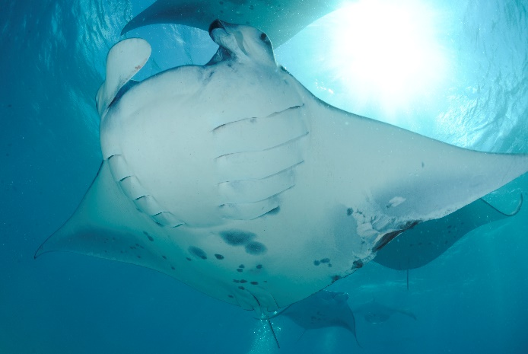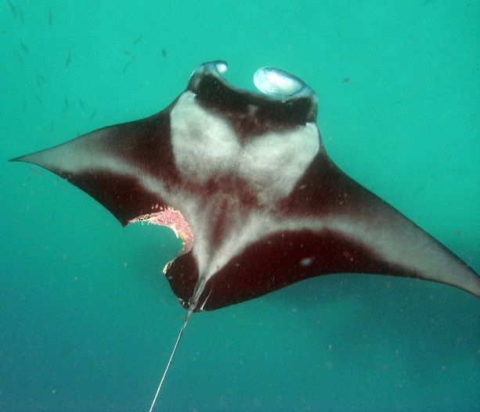

b.

a.

Figure 3. 1: (a) Predation injuries and (b) fishing line damage to *M. alfredi.* © Guy Stevens, Manta Trust, 2010.

*How much of the variation in group size, position and leadership behaviour was explained by among-individual, fixed effect and within-individual differences?*

I calculated ratios of variation explained for each variance component using the rptR package (Nakagawa & Schielzeth 2010). The full abiotic and biotic (within-group and external to group) models were tested using a Poisson error distribution for group size, Gaussian error trait for position in group and leadership using a Binomial error. To check the significance of individual ID on behaviour traits, 1000 permutations were run during analysis to create randomised values for among-individual variation which were compared to the values obtained in the observed data. Behavioural repeatability was calculated for each trait using the formula;

R² = VID/(VID + VFIXED + VW)

Here variance components are represented; among-individual variance (VID), fixed effect variance (VFIXED) and within-individual variance (VW).

*Within and among-individual differences in behavioural traits*

Variance partitioning models were used to determine the relative contribution of among-, within- and fixed effect sources of variation on the position in group. Tests examined variation within sex, age class and plankton density. Due to model suitability, this analysis was only run on position in group.

## ***3.4 Results***

A total of 854 observations were made in 2014, 1,075 in 2015, and 1,177 in 2016. In 2014, 185 individuals, 196 individuals in 2015, and 209 individuals in 2016 were included in the study database. I observed each individual on average five times (SE = 0.4, range = 25) in 2014, six times (SE = 0.4, range = 42) in 2015, and six times (SE = 0.4, range = 35) in 2016. In 2014, 119 females and 66 males were recorded, 132 females and 64 males in 2015, and 133 females and 76 males in 2016. A total of 114 juveniles and 71 adults were recorded in 2014, 101 juveniles and 95 adults in 2015, and 80 juveniles and 129 adults in 2016.

*Group vs. solo foraging behaviour*

In the final model investigating group vs. solo foraging, *M. alfredi* were more likely to forage in groups in 2015 compared with 2014. The GLMM also showed that manta rays were significantly more likely to feed in groups when zooplankton density was higher (Table 3.2) as highlighted in Figure 3.2 where 62% of foraging observations recorded at high plankton densities were in groups compared to 50% group observations at low plankton densities. Group foraging was also less common at the sites Hurai Faru and Reethi Falhu in comparison to Hanifaru Bay. Current strength did not contribute to the final model. Sex and age class were not significant, which indicates that group feeding was more affected by food availability rather than biotic within-group characteristics.

Figure 3. 2: Group vs. solo GLMMs fixed effects plots for model of best fit. Using AIC criterion, model was best explained by biotic (external to group) variables. Fixed effects, plankton density was statistically significant. (n = 3106).

Table 3. 2: Effect of environmental factors on group versus solo foraging behaviour. Statistics include estimate (positive, negative -), standard error (SE), z value, probability of deviation from a slope of zero (*p*). Statistically significant results appear in bold. (n = 3106).

|  |  |  |  |  |
| --- | --- | --- | --- | --- |
| Variables | *Coef β* | *SE (β)* | *Z* | *Sig.* |
| *(Intercept)* | -0.11 | 0.15 | -0.77 | 0.44 |
| *Year* |  |  |  |  |
| 2014 |  |  |  |  |
| **2015** | **0.51** | **0.13** | **4.05** | **5.09×10-5** |
| 2016 | 0.22 | 0.12 | 1.87 | 0.06 |
| *Site* |  |  |  |  |
| Hanifaru Bay |  |  |  |  |
| **Hurai Faru** | **-0.8** | **0.18** | **-4.43** | **9.64E-06** |
| **Reethi Falhu** | **-0.4** | **0.2** | **-2.01** | **0.04** |
| Veyofushi | -0.59 | 0.45 | -1.3 | 0.19 |
| Dhigu Thila | 0 | 0.43 | -0.1 | 0.99 |
| *Plankton density* |  |  |  |  |
| Low |  |  |  |  |
| Medium | 0.21 | 0.13 | 1.58 | 0.11 |
| **High** | **0.49** | **0.13** | **3.71** | **0.00** |

*Effects of biotic and abiotic factors on group feeding traits*

For each of group size, position and leadership traits observed, the null model was ranked lowest. In group size analysis, all variables are significant (see test statistics in Table 3.3a and 3.4a). Larger group sizes were recorded when current strength was ‘weak’, ‘medium’ or ‘strong’, and groups grew as plankton density increased, complimenting group vs. solo models. The largest group sizes were recorded three hours before high tide, steadily decreasing in size thereafter. Smaller general aggregation resulted in larger individual foraging groups, potentially linked to competition.

For position in groups, the abiotic and biotic (ext) model ranked first. The number of manta rays was significant (see test statistics in Table 3.3b and 3.4b), showing that the smaller the foraging group, the more likely individuals were to be near the front as the fewer foraging individuals, the fewer positions there were to be claimed. Time was also significant, with individuals more likely to adopt lower positions prior to high tide, when group sizes were largest. Higher plankton density as well as ‘weak’ and ‘strong’ current strengths showed fewer individuals adopting frontal positions.

Leadership behaviour was most influenced by biotic (wg) model and abiotic + biotic (wg) models which ranked as best fit. The model summary shows that across both models of best fit, females were significantly more likely to adopt the leader position than males (see test statistics in Table 3.3c and Table 3.4c and d respectively).

Table 3. 3: AIC comparisons for all a priori models of abiotic, biotic (within-group) and (external to group) variables for (a) group size, (b) position in group, (c) leadership. Model of best fit (indicated in bold) correspond to the model with lowest AIC values for each response variable. k, number of free parameters for a given model; R2, true repeatability ratio of fixed effects. (n = 1056).

|  |  |  |  |  |  |
| --- | --- | --- | --- | --- | --- |
| Trait | Model | k | AIC | ΔAIC | R2 (fixed effects) |
| a. Group size | |  |  |  |  |
|  | Null | 2 | 4015.7 | 101.3 | 0 |
|  | Abiotic | 9 | 3947.4 | 33.1 | 0.05 |
|  | Biotic (external) | 5 | 3973.2 | 58.8 | 0.05 |
|  | **Abiotic + Biotic (ext)** | **12** | **3914.4** | **0** | **0.08** |
| b. Position in group | |  |  |  |  |
|  | Null | 2 | 3642.2 | 20.7 | 0 |
|  | Abiotic | 10 | 3626.3 | 4.8 | 0.02 |
|  | Biotic (within-group) | 6 | 3719.1 | 97.6 | 0.61 |
|  | Biotic (external) | 2 | 3634.8 | 13.3 | 0.02 |
|  | Abiotic + Biotic (wg) | 13 | 3697.2 | 75.7 | 0.60 |
|  | **Abiotic + Biotic (ext)** | **13** | **3621.5** | **0** | **0.04** |
|  | Biotic (wg) + Biotic (ext) | 9 | 3715.3 | 93.8 | 0.60 |
|  | Abiotic + Biotic (wg) + Biotic (ext) | 16 | 3697.4 | 75.9 | 0.60i |
| c. Leadership | |  |  |  |  |
|  | Null | 2 | 1349.8 | 3.1 | 0 |
|  | Abiotic | 3 | 1351.7 | 5.1 | 0 |
|  | **Biotic (within-group)** | **4** | **1346.7** | **0** | **0.05** |
|  | Biotic (external) | 6 | 1354.6 | 7.9 | 0.02 |
|  | **Abiotic + Biotic (wg)** | **5** | **1348.6** | **2** | **0.05** |
|  | Abiotic + Biotic (ext) | 7 | 1356.5 | 9.9 | 0.02 |
|  | Biotic (wg) + Biotic (ext) | 8 | 1350.9 | 4.2 | 0.07 |
|  | Abiotic + Biotic (wg) + Biotic (ext) | 9 | 1352.8 | 6.2 | 0.07 |

Table 3. 4: Generalised Linear Mixed Models of best fit for behavioural traits, (a) group size, (b) position in group, (c) and (d) leadership and variance components (among (Vi), fixed effect (Vfe), within-individual (Vw)). Statistics include estimate (positive, negative -), standard error (SE), t or z value, probability of deviation from a slope of zero (*p*), variance value and confidence intervals to a 95% level. Statistically significant results appear in bold. (n = 1056).

|  |  |  |  |  |  |  |  |
| --- | --- | --- | --- | --- | --- | --- | --- |
| Trait |  | | | | Random effects | | |
| Terms | Estimate | SE | t/z | *p* | Variance component | Variance | (95% CI) |
| **a. Group size (Abiotic and Biotic external)** | | | | | | | |
| **Intercept** | **1.2688** | **0.0984** | **12.80** | **<2e×10-16** | Vi | 0 | (0 – 0.01) |
|  |  |  |  |  | Vfe | 0.02 | (0.02 – 0.04) |
| None |  |  |  |  | Vw | 0.25 | (0.25 – 0.27) |
| **Current (Weak)** | **0.4097** | **0.09** | **4.66** | **3.13×10-6** |  |  |  |
| **Current (Med)** | **0.2894** | **0.10** | **3.04** | **0.0024** |  |  |  |
| **Current (Strong)** | **0.4435** | **0.11** | **4.12** | **3.78×10-5** |  |  |  |
|  |  |  |  |  |  |  |  |
| **Time (centred)** | **-0.0557** | **0.01** | **-4.34** | **1.40×10-5** |  |  |  |
|  |  |  |  |  |  |  |  |
| Hanifaru Bay |  |  |  |  |  |  |  |
| **Hurai Faru** | **0.1256** | **0.06** | **2.01** | **0.0441** |  |  |  |
| Reethi Falhu | 0.0030 | 0.09 | 0.03 | 0.9731 |  |  |  |
| Dhigu Thila | -0.2360 | 0.12 | -1.94 | 0.0525 |  |  |  |
|  |  |  |  |  |  |  |  |
| **Number of mantas (scaled)** | **-0.0668** | **0.02** | **-3.67** | **0.0002** |  |  |  |
|  |  |  |  |  |  |  |  |
| Plankton (Low) |  |  |  |  |  |  |  |
| **Plankton (Med)** | **0.1398** | **0.06** | **2.50** | **0.0125** |  |  |  |
| **Plankton (High)** | **0.3226** | **0.06** | **5.42** | **5.91×10-8** |  |  |  |
|  |  |  |  |  |  |  |  |
| 1. **Position in group (Abiotic and Biotic external)** | | | | | | | |
| **Intercept** | **1.1820** | **0.2742** | **4.27** | **2.27×10-5** | Vi | 0.07 | (0 – 0.16) |
|  |  |  |  |  | Vfe | 0.07 | (0.05 – 0.14) |
| None |  |  |  |  | Vw | 1.73 | (1.57 – 1.90) |
| **Current (Weak)** | **0.6695** | **0.2495** | **2.63** | **0.0077** |  |  |  |
| Current (Med) | 0.4596 | 0.2706 | 1.67 | 0.0904 |  |  |  |
| **Current (Strong)** | **0.6282** | **0.3068** | **2.04** | **0.0393** |  |  |  |
|  |  |  |  |  |  |  |  |
| **Time (centred)** | **-0.0842** | **0.0352** | **-2.34** | **0.0169** |  |  |  |
|  |  |  |  |  |  |  |  |
| Hanifaru Bay |  |  |  |  |  |  |  |
| Hurai Faru | 0.2271 | 0.1717 | 1.32 | 0.1866 |  |  |  |
| Reethi Falhu | 0.0056 | 0.2370 | 0.04 | 0.9811 |  |  |  |
| Dhigu Thila | -0.3678 | 0.3457 | -1.04 | 0.2883 |  |  |  |
|  |  |  |  |  |  |  |  |
| **Number of mantas (scaled)** | **-0.1340** | **0.0489** | **-2.73** | **0.0063** |  |  |  |
|  |  |  |  |  |  |  |  |
| Plankton (Low) |  |  |  |  |  |  |  |
| Plankton (Med) | 0.2903 | 0.1515 | 1.91 | 0.0557 |  |  |  |
| **Plankton (High)** | **0.6302** | **0.1611** | **3.89** | **0.0001** |  |  |  |
|  |  |  |  |  |  |  |  |
| 1. **Leadership (Biotic within-group)** | | | | | | | |
| **Intercept** | **-0.5100** | **0.1163** | **-4.38** | **1.16×10-5** | Vi | 0.43 | (0.12 – 0.66) |
|  |  |  |  |  | Vfe | 0.05 | (0.01 – 0.18) |
| Sex (Female) |  |  |  |  | Vw | 4.38 | (4.22 – 4.62) |
| **Sex (Male)** | **-0.4785** | **0.1938** | **-2.47** | **0.0135** |  |  |  |
|  |  |  |  |  |  |  |  |
| Age class (Juvenile) |  |  |  |  |  |  |  |
| Age class (Adult) | -0.0229 | 0.1786 | -0.13 | 0.8981 |  |  |  |
|  |  |  |  |  |  |  |  |
| 1. **Leadership (Abiotic and Biotic within-group)** | | | | | | | |
| **Intercept** | **-0.5103** | **0.1162** | **-4.39** | **1.13×10-5** | Vi | 0.43 | (0.11 – 0.70) |
|  |  |  |  |  | Vfe | 0.05 | (0.01 – 0.19) |
| Sex (Female) |  |  |  |  | Vw | 4.38 | (4.21 – 4.63) |
| **Sex (Male)** | **-0.4786** | **0.1935** | **-2.47** | **0.0134** |  |  |  |
|  |  |  |  |  |  |  |  |
| Age class (Juvenile) |  |  |  |  |  |  |  |
| Age class (Adult) | -0.0199 | 0.1801 | -0.11 | 0.9122 |  |  |  |
|  |  |  |  |  |  |  |  |
| Time centred | 0.0061 | 0.0509 | 0.12 | 0.9039 |  |  |  |

*Injuries and group foraging*

Using injuries as the dependent variable, the presence of anthropogenic injuries, for example fish hooks or line was not significantly affected by an individuals’ position in group or group size. However, individuals with shark bites were significantly less likely to adopt frontal positions in groups and were more likely to be present in smaller groups (see test statistics in Table 3.5 b).

Table 3. 5: Generalised Linear Mixed Models the probability of (a) anthropogenic injury or (b) signs of shark bites varies position in group and group size. Statistics include estimate (positive, negative -), standard error (SE), z value, probability of deviation from a slope of zero (*p*). Statistically significant results appear in bold. (n = 1056).

|  |  |  |  |  |
| --- | --- | --- | --- | --- |
| Variables | Estimate | SE | z | *p* |
| 1. **Anthropogenic injury** | | | | |
| Intercept | -14.37 | 1.82 | -7.89 | 3.11×10-15 |
|  |  |  |  |  |
| Position in group | 0.61 | 0.54 | 1.14 | 0.26 |
| Group size | -0.17 | 0.49 | -0.35 | 0.73 |
| 1. **Shark bite** | | | | |
| **Intercept** | **-14.89** | **0.00** | **-8124** | **<2×10-16** |
|  |  |  |  |  |
| **Position in group** | **0.38** | **0.00** | **210** | **<2×10-16** |
| **Group size** | **-0.09** | **0.00** | **-46** | **<2×10-16** |

*Within and among-individual differences in foraging behaviour*

When analysing group size, 58% of variance was explained by within-individual difference and 42% by fixed effect, with zero among-individual variance and thus repeatability. In the model of position in group, 59% of variance was explained by within-individual variation, 38% fixed effect and 3% among-individual variation, therefore low repeatability (Figure 3.2). The leadership model showed the highest among-individual differences and repeatability, explaining 9% of variation. Fixed effects had minimal influence (2%), therefore 90% of variation was explained by unmeasured, within-individual sources (Figure 3.3). Individual ID was non-significant in the models of group size (*p* = 0.999) and position in group (*p* = 0.672) but with group leadership there was a weak but statistically detectable signature of among-individual differences (*p* = 0.001). This result does not indicate repeatability as the degree of flexibility or within-individual variance is assumed to be the same among individuals, but it does show that with all else being equal, some individuals tend to be leading groups more frequently.

Figure 3. 3: Variance of behavioural traits, group size, position in group and leadership explained by among (*Vi*), fixed effect (*Vfe*) and within-individual difference (*Vw*). (n = 1056).

*Within and among-individual differences in behavioural traits*

Variance partitioning models for position in group were used to explain the relative contribution of among-, within- and fixed effect sources of variation. These models showed notable disparity across sex, age class and plankton density. Firstly, males and females showed the same among-individual variance in their adopted position, i.e. sexes were equally repeatable in their behaviour (see test statistics in Figure 3.4a).

Within-individual variation changes with sex, as males showed markedly higher within-individual variance than females, with both sexes showing comparatively higher within- than among-individual variance (Figure 3.4a). This serves as an indicator that individuals are extremely flexible in the positioning they adopt within groups and that this degree of flexibility varies between sexes. Adults had marginally higher among-individual variance than juveniles, i.e. were slightly more repeatable in their positioning behaviour but results remained very low. Juveniles however show a notably higher within-individual variance than adults, again with both age classes exhibiting comparatively higher within- than among-individual variance (Figure 3.4b). Again, this result suggests a potential biological implication in the different results between the age classes which goes beyond simple noise in the data. The plankton density model showed evident differences in among-individual variance, particularly between low and high densities (Figure 3.4c). Higher among-individual variance at low plankton levels shows that individuals were more predictable in their positioning at this density, which notably dropped at high plankton levels. Across the test variables, the within-individual variance is much higher compared to the among-individual difference, showing overall low repeatability and high behavioural flexibility across the test population, with this behaviour influenced by factors which were not explained in the models.

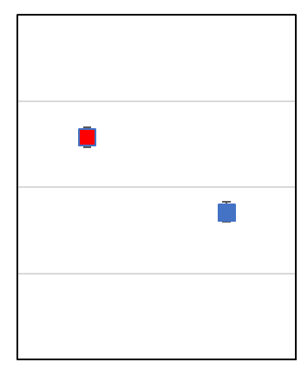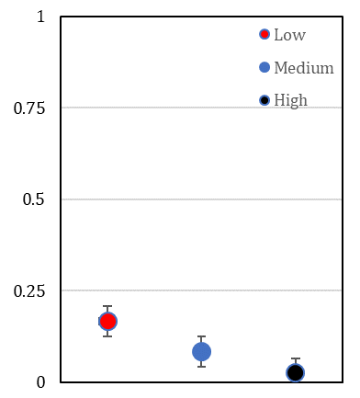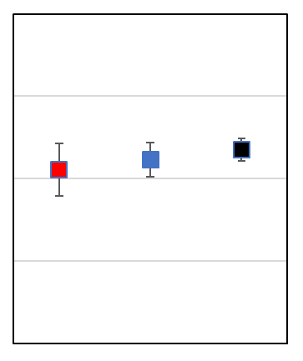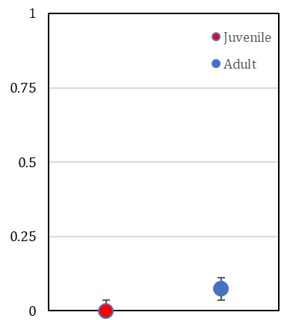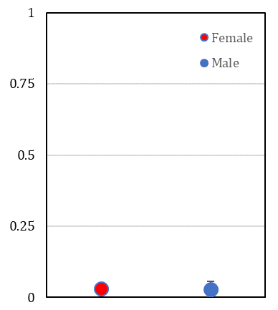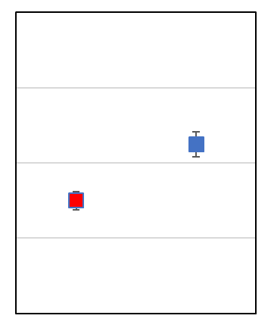

**Variance**

**Plankton density dfregergre7dendensitydensity**

**Age class**

**Sex**

**Vw**

a.

b.

c.

**Vi**

Figure 3. 4: Effect of (a) sex, (b) age class and (c) plankton density on among (*Vi*) and within-individual variance (*Vw*) in position in group. Error bars indicate 95% confidence intervals.

***3.5 Discussion***

*M. alfredi* demonstrated considerable flexibility in individual foraging behaviour. I observed both solo and group feeding behaviour, the latter of which this study shows was significantly influenced by food availability, site and year. Group sizes were highest when there was current and high plankton densities. The largest groups formed three hours before high tide and gradually decreased in size. Smaller overall aggregations resulted in larger foraging groups, with group size varying significantly among sites. Position in group was influenced by the number of manta rays, with individuals adopting more frontal positions when animal numbers were low. Individuals assumed positions towards the back before high tide when groups were largest. Individuals with shark bites were less likely to be at the front of groups and were observed more in smaller groups. Leadership was solely influenced by sex, with females significantly more likely to lead than males. Variation in group size, position in group, and leadership behaviour were all shown to be strongly influenced by residual within-individual factors, explaining over 55% of variation in each trait, along with low repeatability scores which indicated that *M. alfredi* were highly flexible in their foraging behaviour. Individual ID showed weak but statistical significance in the among-individual differences in leadership behaviour, showing that although there is no indication of repeatability in this behaviour as the degree of flexibility (within-individual variance) is assumed to be the same among individuals, when all other factors remain equal, some individuals tend to lead groups more frequently than others.

My study shows a high level of within-individual variation (57.8%), and zero among-individual variance in group size indicating no evidence of specialisation, which is commonly observed in foraging behaviour, migratory routes, diet and foraging site fidelity in marine species (Carneiro et al. 2017; Hoelzel et al. 1989; Staniland et al. 2004; Croxall et al. 2005; Sargeant et al. 2005; Guilford et al. 2011; Patrick et al. 2014). In the Maldives, monsoonal currents drive the movement of zooplankton around the archipelago, with periods of increased food availability in specific areas, thus driving seasonal movements of *M. alfredi* (Anderson et al. 2011a). Specifically, Hanifaru Bay MPA, where I recorded significantly larger group sizes, attracts *M. alfredi* due to the strong lunar currents drawing large volumes of zooplankton from the deeper waters outside the atoll into the shallower inner channel (Stevens 2016). The ephemeral nature of this dense food availability means that these aggregations can be large in size, but are quick to disperse (Stevens 2016). Hence, I showed that group sizes were largest around the peak tide when currents were stronger, dwindling rapidly thereafter. This lack of consistent food availability and patchy distribution supports the suggestion that *M. alfredi* must be flexible, travelling to productive areas and associating with conspecifics potentially to increase feeding efficiency (Sueur et al. 2011). Similar behaviour is seen in Dusky dolphins (*Lagenorhynchus obscurus*) in Admiralty Bay, New Zealand. Travelling up to 275 kilometres seasonally, these dolphins are flexible in their foraging behaviour and feeding grounds, displaying a high degree of fission-fusion with group size and mixing, whilst coordinating and optimising hunting behaviour (Pearson 2009). Notably and similar to *M. alfredi* observed in Baa Atoll, this population appears neither closed or unclosed, as the community fluctuates in size according to the seasonality as animals move and mix in order to exploit optimal foraging and resting conditions (Pearson 2009).

In times of high food availability, *M. alfredi* adopted increased grouping behaviour and group sizes were largest, indicating a benefit to coordinated foraging. Such benefits could include energy saving, hydrodynamic benefits and reduced competition (Stevens 2016). The position in group model showed individuals placing themselves more toward the back of groups when plankton density was highest, suggesting that leadership may not necessarily be optimal and that for certain individuals, it may actually be beneficial in terms of food consumption to be positioned further down the chain. However, my study does highlight a weak significance in animal ID in terms of leadership behaviour, therefore there is a pattern for some individuals to lead more frequently, which may be influenced by previous experience, which may be beneficial for other group foragers. Hemelrijk et al. (2015) examines the theory of hydrodynamic formations benefiting schooling fish, with followers saving energy by using the wake of the leading conspecific to reduce energy expenditure as presented by Weihs (1973). Group leaders have optimal access to prey but will experience the greatest energy expenditure, while animals positioned behind benefit from energy saving while compromising on food intake (Weihs 1973, 1975; Couzin et al. 2002; Krause & Ruxton 2002). The formation of lengthy feeding chains by groups of *M. alfredi,* first described by Stevens (2016), potentially benefit from this energy saving and thus explains the increased group foraging observed under higher food availability in this study. However, *M. alfredi* formed the largest foraging groups when overall aggregations were smallest, indicating that the benefits of coordinated foraging were felt most when competition was lowest.

My study showed that position in group was also highly influenced by the number of manta rays, with the more animals present, the less likely individuals were to be positioned towards the front. However, this result could potentially be due to a simple issue of probability, the more individuals present in a chain, the more “follower” positions available. Individual fitness often relates to within-group spatial position, with fitness costs and benefits driving the position adopted by individuals (Krause 1994; Fischhoff et al. 2007; Barelli et al. 2008). Hirsch (2007) hypothesises that when food resources deplete quickly, foraging success will be found at the front of the group and individuals have higher feeding rates, specifically in fish populations (Krause et al. 1992; Krause 1993). However, this is contested in other studies, suggesting central positions are rewarded as foraging in close proximity to neighbours enhances success, especially when food is spatially or temporally clumped, as well as providing increased predator protection (Hirsch 2007; Robinson 1981; Janson 1985; 1990; van Schaik & Maria 1986; van Noordwijk & van Schaik 1988; Barton 1993; Grant et al. 2002). As *M. alfredi* groups are linear in structure, frontal positions likely expose individuals to the highest food abundance making these places preferable to central positions.

A key motivator to leadership behaviour is individual state, either stemming from a dominant personality or the need to optimise ones’ position, for example to increase nutritional intake, movement capabilities, foraging strategies or reduce predation risk (Jacobs et al. 2008; Hodgkin et al. 2014). My study found sex to be the most important factor in predicting the probability of leading the group, with females dominantly leading foraging groups. Female leadership is evident in other species, for example adult females act as leaders within the southern population of killer whales (Orcinus orca) (Brent et al. 2015) and amongst groups of hamadryas baboons (*Papio hamadryas*). Females influence movement timing and direction (Erhart & Overdorff 1999), with specific females exerting dominance amongst stable groups of ruffed lemurs (*Varecia variegata*) (Overdorff et al. 2005). Female members of the Hanifaru study population show significantly higher site fidelity than males across both feeding and cleaning sites (Stevens 2016) which is not uncommon in pelagic species, as males travel more extensively and females remain close to a natal region (Engelhaupt et al. 2009; Hueter et al. 2005; Lee et al. 2007). My study also showed weak significance in the among-individual variance of individual ID in leadership behaviour, with particular individuals more frequently seen to lead. Consistent leadership, even amongst fission-fusion groups can be beneficial to groups as demonstrated in the small, dynamic population of bottlenose dolphins (*Tursiops truncatus*) in the Lower Florida Keys (Heithaus et al. 2013). During foraging, groups led by consistent leaders were more frequently recorded in areas of higher fish biomass, travelled more direct paths, experienced less leader switches, and had more complex home ranges than groups with non-consistent leaders (Heithaus et al. 2013). Followers benefited from the prior ecological knowledge of the leaders, which appears consistent with my study; select individuals acted as leaders more frequently than others and at specific times, i.e. when resource density was highest, individuals were more likely to be located in a follower position

My study has highlighted the power of using models to measure residual within-individual variance. Using a repeated measures analysis, the residual variance included both the unobserved sources of variation as well as within-individual variance. Although it represents the amount of within-individual variance not represented in statistical models, it can potentially hold strong biological importance (Westneat et al. 2015). The first explanation for high residual within-individual heterogeneity may be incomplete model hypothesis. It is common for statistical models not to include all key explanatory variables for analysis (for example water temperature or turbidity), therefore leaving large amounts of variance unaccounted for (Westneat et al. 2015). The second possible explanation supports the null hypothesis that *M. alfredi* are flexible in their individual foraging behavioural traits. Variance partitioning models for position in groups showed residual variance changed within sex and age class, with elevated male and juvenile variance. This result suggests some biological variation captured in the model, namely that sexes and age classes differ in behavioural flexibility. Behavioural variation can be affected by physical processes leading to ‘passive’ plasticity in individuals (Scheiner 2006), for example fluctuations in prey density will lead to passive plasticity in an animal’s foraging success (Westneat et al. 2015). Secondly, adaptive residual within-individual variation may be present. Traits range from prey responses (the ‘battle of waits’ present between predator and prey (Hugie 2003; Stevens 2016)) to task roles (within cooperative groups, individuals perform different tasks (Bergmüller and Taborsky, 2010)). Finally, trial-and-error learning may be present (where ‘learning rules’ as oppose to evolutionary change, influence phenotypic variation within a population (Franks et al. 2010)). In terms of my study, both plasticity (among-individual variance) and adaptive residual within-individual variation could be influential. The ephemeral nature of zooplankton upwellings which can quickly disperse with the changing tidal currents (Stevens 2016) could lead to flexibility in individuals’ foraging. Finally, this study suggests flexibility in individual foraging behaviour, with individuals sorting themselves by a ‘first come, first serve’ structure (Gerald 2002), adapting their behaviour to successfully feed in a coordinated manner with conspecifics. Unlike other species, potentially there are fewer specific leaders or followers present as an observed phenotype within *M. alfredi* populations. Changes in evolutionary traits come from adaptive plasticity, as over time populations acclimatise and adjust to changes in environmental conditions or variations in traits occur due to heritability, i.e. genetic variation (Alonzo 2015). These adaptive capabilities are beneficial in light of fluctuating environmental conditions which may have strong implications.

## ***3.6 Conclusions***

My study examined the individual flexibility in foraging behaviour in *M. alfredi* over a three-year period. Close examination of group size, position in group and leadership models all show that high levels of residual within-individual variation explain the observed foraging behaviour. There are various potential explanations, firstly that key variables have not been measured and analysed in models, which therefore should be considered for further analysis. Secondly, my results suggest that *M. alfredi* are flexible in their individual foraging behaviour and that coordinated behaviour is potentially driven by a ‘first come, first serve’ process. Understanding this basic structure within feeding aggregations allows us to begin to understand the larger network of social interactions and relationships amongst these animals. This behavioural flexibility could be key to continued foraging success in light of changing environmental conditions as demonstrated in this study.

# **Chapter Four: Protecting the million-dollar mantas; creating an evidence-based code of conduct for manta ray tourism interactions**

## ***4.1 Abstract***

Tourist experiences with charismatic marine megafauna have become increasingly popular since the 1990s. Manta ray tourism is estimated to contribute US$ 140 million annually to the global economy. The multitudes of tourists interacting with manta rays potentially disturb the animals, yet few studies have examined interactions, and none has quantified the effect of human behaviour on feeding manta rays. Using videos collected at feeding sites in the Maldives, I found that of the 401-independent human-manta interactions observed, only 44% complied with existing guidelines for snorkellers during tourism encounters. Human behaviours; accidental obstruction, diving too near/in front, chasing, and approaching from the front, all had a statistically significant negative effect on manta ray behaviour, resulting in feeding cessation, while passive interactions resulted in significantly less disturbance and cessation reactions. A reduction in foraging will be detrimental due to the transient nature of the manta rays’ zooplankton prey. Interactions within three metres significantly increased avoidance behaviours. These findings support the guidelines provided by the Manta Trusts’ code of conduct, which aims to develop legislation in the Maldives and beyond so as to minimise disturbance of manta rays by tourism. My key recommendations aim to ensure that the manta ray tourism industry remains sustainable and non-detrimental to the animals’ natural behaviour.

***Keywords:*** Conservation, Maldives, *Mobula alfredi*, Sustainable tourism, Wildlife tourism.

## ***4.2 Introduction***

Over the last two decades, tourism focused on charismatic marine megafauna such as whales, turtles, sharks and manta rays has become increasingly popular (O’Malley et al. 2013; Gallagher & Hammerschlag 2011; Cisneros-Montemayor & Sumaila 2010; Higham & Lück 2007; Hoyt 2001). Globally, the number of marine mammal tourists more than doubled between 1991 and 1998, rising from over four million to nine million participants, with a 12.1% average increase in whale watching figures in the 1990s (Hoyt 2001). This figure continued to surge by a further 11.3% between 1998 and 2006, demonstrating ever increasing popularity (Hoyt & Iñíguez 2008).

While increased tourism and its network of support resources can generate significant economic benefits (O’Malley et al. 2013; Viannaet al. 2012), concerns exist regarding potential negative impacts on the focal species (Andersonet al. 2011b; Graham 2007; Quiros 2007; Marshall et al. 2011; Kessel et al. 2017). Human impact on marine wildlife can be both direct, such as causing a change to, or stopping, the animal’s natural behaviour, and indirect, by affecting the animal’s fitness through disturbing feeding or cleaning long-term (Quiros 2007; Sorice et al. 2003). Destructive impacts, including habitat damage and loss (Tisdell & Wilson 2002), disruption of animals’ natural behaviour (Williamset al. 2002) and human-induced injuries, including boat strikes (Denkinger et al. 2013; Speed et al. 2008), are becoming more common. Such developments are not compatible with a safe or sustainable industry, an image commonly used as a selling point by operators advertising an eco-friendlier experience to attract potential consumers. Ecotourism is defined as ‘non-consumptive travel with minimal negative impacts that result in increased conservation and sustainability of natural and sociocultural resources and contributes to the well-being of local people’ (Sirakayaet al. 1999, p. 171).

Manta rays (*Mobula alfredi, M. birostris*) are slow-growing, large-bodied animals that have among the lowest fecundity of all elasmobranchs, i.e. reproducing infrequently (Dulvy et al. 2014a; Stevens 2016). Their low rate of reproduction, late maturity, and small size of sub-populations makes these species particularly vulnerable to overexploitation in fisheries and extremely slow to recover from depletion (Dulvyet al. 2014b). Manta ray species are listed on Appendix II of the Convention on International Trade in Endangered Species, Appendices I and II of the Convention on the Conservation of Migratory Species of Wild Animals, and classified as “Vulnerable” on the IUCN’s Red list of Threatened Species (Lawson et al. 2017; Marshall et al. 2011). Regional protection for manta rays has been implemented in certain areas. In 2014, Indonesia announced a ban on fishing manta rays, essentially creating the world’s largest manta ray sanctuary (Ministry of Maritime Affairs and Fisheries 2014). That same year the Maldives included all ray species on its nationwide protected species list, banning the capture, keeping or harming of all ray species (EPA 2014). The most prominent threats to manta rays globally are from directed and bycatch fisheries (Croll et al. 2016; Lawson et al. 2017), primarily driven by increased demand for their gill plates, which are marketed as a pseudo-medicinal health tonic in southeast Asia (Lawsonet al. 2017; Whitcraftet al. 2014).

Manta ray tourism is estimated to contribute US$ 140 million annually to the global economy (O’Malley et al. 2013), but interactions may have a negative effect by disturbing the species’ natural behaviour and degrading their habitat (Venables 2013; Anderson et al. 2011b), while potentially reducing fitness, disrupting reproduction and foraging (Colman 1997; Sorice et al. 2003). Increased human presence has the potential also to induce animal stress (Müllneret al. 2004) and to increase the rate of injuries due to higher boat traffic (Cárdenas-Torreset al. 2007; Stevens et al. 2018). Norman (2005, p. 242-245) noted a reduction in the return rate of whale sharks (*Rhincodon typus*) due to tourist stress and aggravation, while Quiros (2007) observed whale sharks’ rapid diving movements and avoidance reactions in response to tourist presence. Constantine (2001) also recorded increased avoidance behaviour by bottlenose dolphins (*Tursiops truncatus*) in the Bay of Islands, New Zealand, in response to increased tourism and swim-with excursions. Giese (1998) examined the impact of tourists approaching Adélie penguins (*Pygoscelis adeliae*) in Antarctica. Approaches of 5m resulted in elevated heart rates and the cessation of incubation behaviour, with such a period of cooling risking chick survival and hatching success. In comparison, approaches of 30 metres had no effect on either the incubation behaviour or recorded heart rates of penguins (Giese 1998). Such stressors highlight the need to monitor and regulate tourism involving wildlife.

Like many other marine fish and mammals, manta rays adopt group feeding strategies in order to increase feeding efficiency (Stevens 2016). These large aggregations of feeding manta rays also attract a large number of tourists. Anderson et al. (2011b) indicates that manta rays can be interrupted at feeding aggregations by divers and snorkellers, as humans may block the manta rays’ natural feeding routes, startle the manta ray(s) by approaching from behind, or even cause them to stop feeding. Given that aggregations of manta rays are attracted to ephemeral upwellings of zooplankton which disappear with the changing tidal currents, any interruptions to feeding can be predicted to decrease food intake (Stevens 2016). Manta rays are also commonly observed when they visit areas of the reef hosting client fish (commonly various species of wrasse), known as ‘cleaning stations’, to socialise, and to have ectoparasites, dead or injured skin or mucus removed from their bodies (O’Sheaet al. 2010). Humans can also disturb manta ray activities at cleaning stations by approaching the rays too closely, causing the manta rays to leave, and often damaging the fragile coral ecosystem around the cleaning station through poor buoyancy control (Tratalos & Austin 2001). Cleaning stations are important aggregation sites for this species (Stevens et al*.* 2018) and therefore negative impacts on them by humans should be kept to a minimum.

The use of specific guidelines for tourism interactions reduces the negative effects which humans have on animals (Brunnschweiler 2010; Mau 2008; Pierceet al. 2010), and together with interpretative and educational briefings, can also enhance tourists’ experience (Zeppel & Muloin 2008; Quiros 2007). Snorkelling tours in the Ningaloo Marine Park, Australia, set recommended guidelines, limiting boat speed to five knots when within 30 metres of manta rays, and eight knots when within 100 metres, of manta rays ([www.mantaraycoralbay.com.au](http://www.mantaraycoralbay.com.au)). Snorkellers are advised to form a semi-circle two metres behind manta rays, with spotters positioned behind the group ([www.mantaraycoralbay.com.au](http://www.mantaraycoralbay.com.au)). In Queensland, Australia, divers are advised to maintain their distance, remain calm and still, and allow the manta to control the interaction (Project Manta 2012). In some areas of the Maldives a code of conduct developed by the Manta Trust for snorkel interactions is in practice, but the in-water recommendations differ from the Ningaloo recommendations. The approach buffer zone is set at three metres, and positions snorkellers to the side of manta rays so as to remain in their eye line ([www.mantatrust.org](http://www.mantatrust.org)). However, few studies have examined the effect of tourism interactions on manta rays in detail, and no study has yet analysed and quantified the effect of human behaviour on feeding manta rays.

Situated in the Indian Ocean, the Republic of Maldives is widely recognised as a hotspot for marine wildlife interactions, hosting a high abundance of marine megafauna (Caguaet al. 2014). The direct expenditure on whale shark tourism in the Maldives, for example, increased from US$ 2.3 million per annum in 1993 (Anderson & Ahmed 1993) to US$ 9.4 million per annum in 2013 (Cagua et al. 2014). Tourism directed at swimming with manta rays in the Maldives has also increased greatly; estimated to contribute US$ 8.1 million in direct revenue in 2010 (Anderson et al. 2011b), it was valued at US$ 15.4 million in 2013 (O’Malley et al. 2013). Tourism in the Maldives has grown substantially over the last decade, with over 1.2 million visitors in 2016 alone, with a 28% rise in resort, dive liveaboard and guest house occupancy since 2010 (Ministry of Tourism 2016). With this increase in tourism over the last decade, the Maldives now faces increased pressure on its natural resources, including important *M. alfredi* cleaning and feeding sites (for example Hanifaru Bay in Baa Atoll) which are regularly frequented by this species. Increased manta tourism in Baa Atoll over the last decade is evident in more tour operators providing swim-with encounters each year, and by the statistic of over 25,000 manta tourists recorded at sites in eastern Baa Atoll during Maldivian Manta Ray Project (MMRP) surveys from 2010-2016 (MMRP unpublished data). To avoid the risk of damaging this major source of tourism, manta ray activities need to be monitored across all cleaning and feeding aggregation sites nationwide, rather than through isolated management programmes. Such a programme exists at Hanifaru Bay marine protected area (MPA). Hanifaru Bay is regulated by the Maldives Environmental Protection Agency and the Baa Atoll Biosphere Reserve. It became globally famous in 2009 due to media exposure showcasing the feeding aggregations of *M. alfredi* and whale sharks that visit the bay. Regulations now prohibit SCUBA diving within the Bay, with a limit of 80 snorkellers and five boats at one time (<http://en.epa.gov.mv/regulations>), and a required entrance fee ([www.broffice.gov.mv](http://www.broffice.gov.mv)).

Developed from pilot studies, the Manta Trusts’ Maldives code of conduct was the basis of this study, testing the specific recommendations; of maintaining a minimum three-metre distance from animals, remaining calm and still throughout interactions (Figure 4.1a), and only approaching animals from the side, specifically avoiding positioning directly behind or in front of manta rays, i.e. in their blind spot (Figure 4.1b). These guidelines were developed in the Maldives following six years of in-water observations, including a three-year pilot study examining manta behaviour during snorkel trips with tourists (see Appendix II). To mitigate negative anthropogenic impacts on manta rays, researchers joined resort excursions, providing a pre-encounter briefing specifying the above recommendations - which until now have not been rigorously tested. Purely advisory, these guidelines advise tour operators on the appropriate human behaviours to ensure sustainable human-manta encounters. This study rigorously tested the effect of these guidelines, with the view to providing scientific support for these recommendations which will drive increased protective legislation at manta ray aggregation sites globally. This study aims to link specific human behaviours with the resulting reactions by the manta rays, specifically (1) types of human behaviours during interactions, (2) closest observed distances between manta rays and humans, and (3) direction of human approaches towards animals. Finally, I test inter-site differences in tourist numbers.

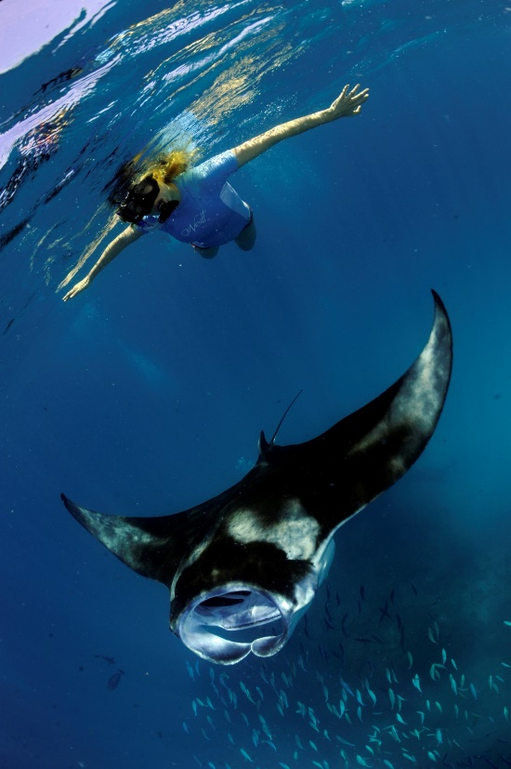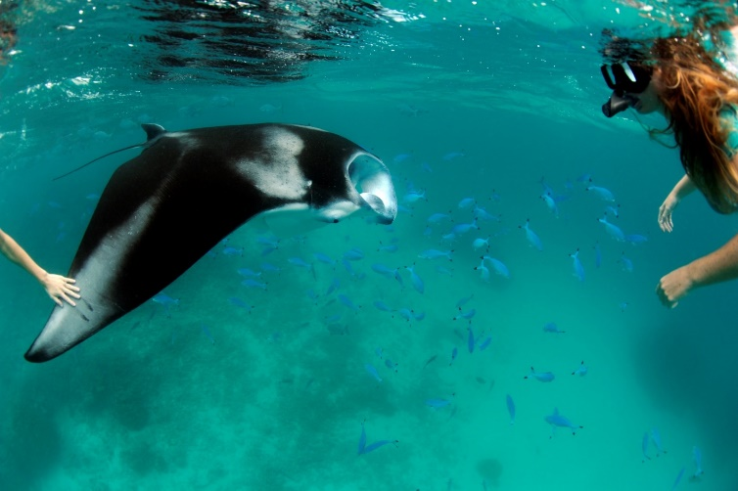

a.

b.

Figure 4. 1: Human-manta interactions. (a) Following the code of conduct guidelines, a snorkeller remains calm and still, whilst maintaining a safe distance, allowing the manta ray to control the interaction. (b) Disregarding the code of conduct, a snorkeller approaches and touches the manta ray directly during an interaction. © Guy Stevens, Manta Trust 2009, 2010.

## ***4.3 Methods***

### *4.3.1 Study Site*

Situated in the Indian Ocean and stretching across 870 kilometres (540 miles), the 26 geographical atolls that make up the Maldives Archipelago are situated south-west of India. The Maldives territorial waters encompass 90,000 km² of ocean, while the land area is only 300 km² (Sea Around Us Project 2014), with the highest natural point above sea level recorded at 2.4 metres. The Maldives hosts the world’s largest population of reef manta rays (*M. alfredi*) with over 4,300 identified individuals (Manta Trust 2019; Stevens 2016).

This study was conducted in Baa Atoll, northwest of the archipelago’s capital island of Malé. During the south-west monsoon (May through November), monsoonal currents and lunar tides produce a back-eddy concentrating the manta’s zooplankton prey into the body of the bay, attracting the filter feeding megafauna in large numbers (Stevens 2016), which in turn attract the majority of the tourist excursions.

### *4.3.2 Data Collection*

Over a three-year period (2010-2012), a pilot study was conducted by the Manta Trust’s MMRP, testing various human approaches and behaviours to examine the resulting response from manta rays, in order to develop the code of conduct for manta ray tourism, published in 2017. The data collection methods which were used in the pilot study (Appendices III-V) were used to establish and implement a protocol for data collection in the current study, including human and manta ray test variables and data analysis procedures (Brooks 2010; Atkins 2011; Lynam 2012). Study data were collected across 47 survey days in July and August 2016 as part of the MMRP daily surveys. Data were collected from feeding aggregation sites within Baa Atoll regularly visited by the MMRP research vessel and tourists, including Hanifaru Bay, Reethi Falhu, Veyofushi Falhu, Dhigu Thila, and Andagiri.

In order to test the code of conduct, interactions between tourists and feeding manta rays were recorded using an SJCAM SJ4000 camera. At each site, a number of variables were collected: current strength, the density of zooplankton, the number of tourist boats, and the total number of people in the water during the observation period (including the researcher). To avoid pseudo-replication, footage was only used if the manta was clearly identifiable. Individuals were identified by examining the unique spot-pattern on the ventral surface; matching this pattern with catalogued photographs in the regional branchial database allows for individual identification and sexing (Marshall & Pierce 2012).

### *4.3.3 Video Analysis*

All video footage was analysed by the primary researcher and was assessed to identify the reactions of manta rays in response to tourist behaviour. Prior to data analyses, a test was created to ensure that researchers could accurately estimate distances between humans and manta rays in video footage. A buoyant yellow life jacket was attached to a rope which was held at one end by a research assistant. The rope was held at 1 m, 2 m, 3 m, 4 m and 5 m lengths successively, and each length was video recorded with the same camera used for data collection, from different angles and distances. Screenshots were then taken from each video at various points. The test comprised of 15 videos and 45 screenshots and involved identifying the distance between the person and the life jacket. The researcher was tested on distance estimation every day until consistently scoring more than 90%. Once this was achieved, testing was conducted three times a week during the two months of data collection to ensure accurate readings when analysing distances in video footage.

During the training period, two researchers viewed each video until both consistently scored videos the same. The remaining video clips were viewed multiple times by the same researcher to ensure a precise analysis of the manta behaviour and to ensure uniformity. Following pilot study observations and initial results, the following test criteria were chosen. An interaction was defined as when a tourist and manta came within ≤5 metres of each other. Distance (<1 m, 1-2 m, 2–3 m, 3–4 m, 4–5 m) was estimated to the closest metre (Brooks 2010; Atkins 2011; Lynam 2012). The categories of human behaviour, avoidance and cessation behaviours are given in Tables 4.1, 4.2 and 4.3 respectively.

Table 4. 1: Definitions for human behaviour observed during interactions.

|  |  |  |
| --- | --- | --- |
| **Human behaviour** | **Definition** | **No. observations** |
| **Passive observation** | *Humans remain still and flat in the water* | 158 |
| **Accidental obstruction** | *Human accidentally obstructs the path of the manta ray or accidentally touches the manta ray* | 83 |
| **Diving too near/in front** | *Human dives too close or directly in front of the manta ray* | 140 |
| **Chasing** | *Human actively chases the manta ray, swimming fast and splashing* | 20 |

Table 4. 2: Definitions for manta ray avoidance reaction behaviours observed during interactions.

|  |  |  |
| --- | --- | --- |
| **Manta ray reaction** | **Definition** | **No. observations** |
| **No response** | *Individual continues with current behaviour* | 255 |
| **Slight reaction** | *Minor direction changes to move away from obstruction* | 68 |
| **Direction change** | *Distinct direction changes to avoid obstruction* | 69 |
| **Avoidance** | *Complete alteration of behaviour to avoid obstruction* | 9 |

Table 4. 3: Definition for manta ray cessation behaviour observed during interactions.

|  |  |  |
| --- | --- | --- |
| **Cessation reaction** | **Definition** | **No. observations** |
| **Yes** | *Manta ray stopped their original behaviour due to human interaction* | 360 |
| **No** | *Manta ray continued their original behaviour despite human interaction* | 27 |

### *4.3.3 Statistical Analysis*

A Cumulative Link Mixed Model (CLMM) was used on the ordinal data to examine the effect of predictor variables on the manta response variable using individual manta-ID as the random effect. A CLMM with a flexible threshold was used to test whether the variables (Human Behaviour, Distance, Position of Human, Direction of Human Approach, Site, Sex and Undisturbed Behaviour) were statistically significant predictors of ‘Manta Response’. Variables which were not statistically significant in the initial model were tested individually; if they proved non-statistically significant, they were not controlled for in future models. As such, the variables ‘Sex’ and ‘Undisturbed Behaviour’ were dropped. As interactions were recorded at a feeding site, a second CLMM was used to test whether the remaining five variables were statistically significant predictors of ‘Cessation of Feeding’ across observations (Table 4.3). The sample size was 387 as 14 records of cessation could not be confirmed. Non-statistically significant variables were removed from the model using stepwise regression; the final model included ‘Human Behaviour’ and ‘Direction of Approach’. The same procedure was followed as described above. The total number of people recorded at each site per day was calculated and a Kruskal-Wallis test used to test for statistical differences in tourist visitation per site, per day.

## ***4.4 Results***

A total of 401 independent human-manta interactions were recorded during July and August of the 2016 south-west monsoon in eastern Baa Atoll. Videos were collected six days a week, at five sites across the data collection period. Passive interactions (n = 158) were the most common human behaviour recorded, while the most intrusive of human behaviours, chasing (n = 20), was the least recorded. Across the 401 interactions, tourists, who should have been briefed on in-water conduct prior to interactions were observed within one metre or closer to the animals during 30.1% of observations, and were recorded observing the recommended three metres or more rule during 44.1% of interactions.

The ‘Human Behaviour’ variable had the strongest influence on manta response, with accidental obstruction, diving too near/in front, and chasing statistically significant in higher levels of response (see statistical outputs in Table 4.4a, Figure 4.2a-d). Estimated distances of 3 - 4 m and 4 - 5 m elicited significantly greater responses, but with a negative trend, meaning that manta rays were less likely to display higher levels of response (i.e. avoidance or flight) in such interactions (Figure 4.3a). Human approaches from underwater were significantly less likely to cause a response in manta rays compared to surface approaches (see in Table 4.4c). The variable ‘Direction of Human Approach’ was also statistically significant, with approaches from the front resulting in higher levels of manta response (see in Table 4.4d, Figure 4.3b). ‘Site’ proved an important influence on manta behaviour, with animals at Veyofushi Falhu exhibiting a statistically significant difference in disturbance behaviour to manta rays at Hanifaru Bay (see in Table 4.3e).

Table 4. 4: Cumulative Link Mixed Model of Avoidance Behaviours (defined in Table 4.2) versus five predictor variables. Statistics include the probability of deviation from a slope of zero (*p*), direction of the trend (positive +, negative -), confidence intervals to a 95% level. (n = 401). Statistically significant results appear in bold. ** Denotes a *p*-value of <0.01.

|  |  |  |  |  |  |
| --- | --- | --- | --- | --- | --- |
| ***Model*** | ***Predictor variables*** | ***Logistic coefficient*** | ***p-value*** | ***Standard error*** | **95% CI** |
|  | | | | | |
| *a) Human behaviour* | | | | | |
|  | Passive interaction |  |  |  |  |
|  | **Accidental obstruction\*\*** | **3.237** | **3.11e-10** | **0.5144** | **2.23 – 4.25** |
|  | **Diving too near\*\*** | **3.255** | **4.09e-09** | **0.5536** | **2.17 – 4.34** |
|  | **Chasing\*\*** | **3.816** | **3.38e-07** | **0.7481** | **2.35 – 5.28** |
|  | | | | | |
| *b) Distance* | | | | | |
|  | < 1 m |  |  |  |  |
|  | 1 - 2 m | - 0.053 | 0.868 | 0.3192 | -0.68 – 0.57 |
|  | 2 - 3 m | - 0.173 | 0.658 | 0.3916 | -0.94 – 0.59 |
|  | **3 - 4 m\*\*** | **- 1.516** | **0.00599** | **0.5517** | **-2.60 - -0.43** |
|  | **4 - 5 m\*\*** | **- 3.737** | **0.00291** | **1.2552** | **-6.20 - -1.28** |
|  |  |  |  |  |  |
| *c) Position of human* | | | | | |
|  | Surface |  |  |  |  |
|  | **Under animal\*\*** | **- 1.349** | **0.00768** | **1.3492** | **-2.34 - -0.36** |
|  | | | | | |
| *d) Direction of human approach* | | | | | |
|  | Side |  |  |  |  |
|  | **Front\*\*** | **1.956** | **4.34e-06** | **4.594** | **1.12 – 2.79** |
|  | Behind | 0.741 | 0.198 | 1.287 | -0.39 – 1.87 |
|  | Above | 1.002 | 0.056 | 1.910 | -0.06 – 2.03 |
|  | Below | - 0.678 | 0.234 | -1.190 | -1.79 – 0.44 |
|  | | | | | |
| *e) Site* | | | | | |
|  | Hanifaru Bay |  |  |  |  |
|  | Andagiri | 2.550 | 0.074 | 1.787 | -0.25 – 5.35 |
|  | **Veyofushi Falhu** | **1.246** | **0.03339** | **2.127** | **0.10 – 2.39** |
|  | Reethi Falhu | 0.798 | 0.071 | 1.805 | -0.07 – 1.67 |
|  | Dhigu Thila | - 0.758 | 0.516 | -0.649 | -3.04 – 1.53 |

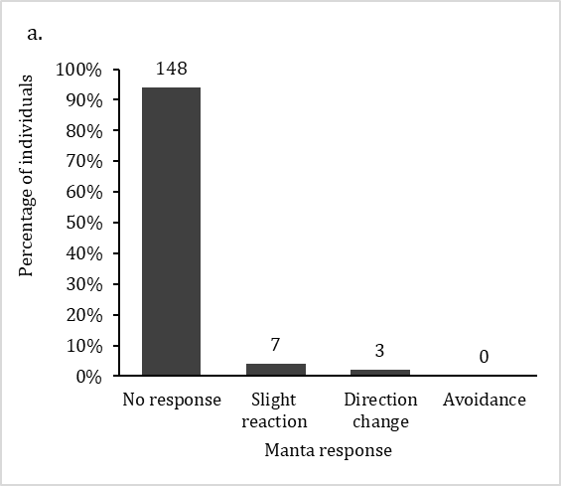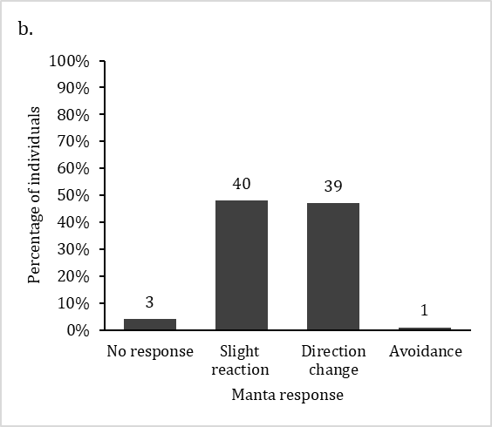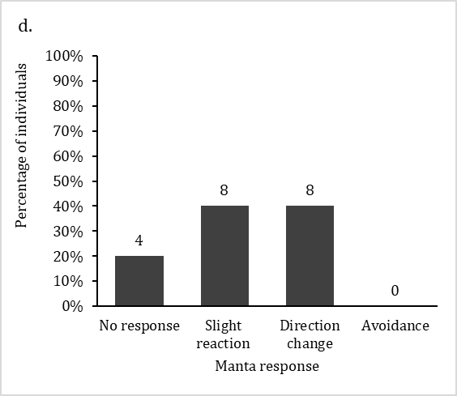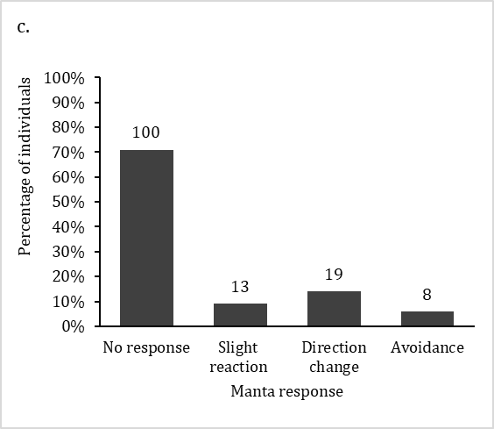

Figure 4. 2: Comparison of reef manta ray (*Mobula alfredi*) responses to differing human behaviour: (a) passive observation, (b) accidental obstruction, (c) diving too near, (d) chasing. Numbers above bars represent sample size. (n = 401).

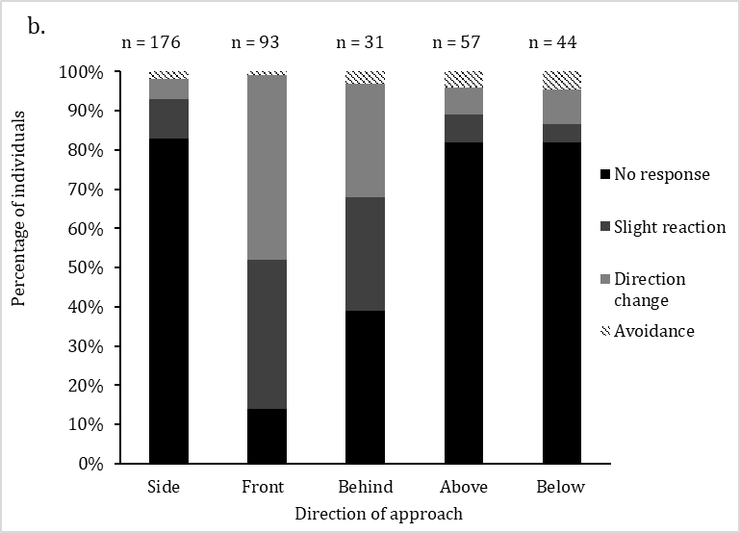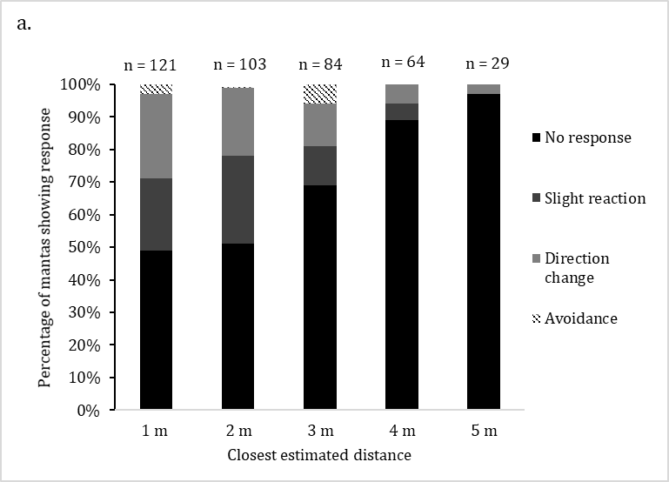

Figure 4. 3: Comparison of reef manta ray (*Mobula alfredi*) responses to differing human behaviour: (a) in response to estimated closest distance between human and manta ray, and (b) in response to direction of human approach. Numbers above bars represent sample size. (n = 401).

In relation to cessation of feeding, ‘Human Behaviour’ had the most influence on manta behaviour: accidental obstruction, diving too near/in front and chasing were statistically significant, with positive associations showing that they resulted in higher levels of response (see in Table 4.5a, Figure 4.4a). Although not statistically significant, compared with human approaches from the side (i.e. within their eye-line), manta rays were more likely to stop feeding when approached from the front (see in Table 4.5b, Figure 4.4b).

Table 4. 5: Cumulative Link Mixed Model of Cessation of feeding versus two predictor variables. Statistics include the probability of deviation from a slope of zero (*p*), direction of the trend (positive +, negative -), confidence intervals to a 95% level. (n = 387). Statistically significant results appear in bold. ** Denotes a *p*-value of <0.01.

|  |  |  |  |  |  |
| --- | --- | --- | --- | --- | --- |
| ***Model*** | ***Predictor variables*** | ***Logistic coefficient*** | **p*-value*** | ***Standard error*** | ***95% CI*** |
|  | | | | | |
| *a) Human behaviour* | | | | | |
|  | Passive interaction |  |  |  |  |
|  | **Accidental obstruction\*\*** | **19.200** | **6.20e-06** | **4.249** | **10.87 – 41.26** |
|  | **Diving too near\*\*** | **18.814** | **4.54e-05** | **4.614** | **9.77 - 27.86** |
|  | **Chasing\*\*** | **21.304** | **3.87e-05** | **5.177** | **11.16 – 31.45** |
|  | | | | | |
| *b) Direction of human approach* | | | | | |
|  | Side |  |  |  |  |
|  | Front | 1.111 | 0.527 | 1.283 | -2.33 – 4.55 |
|  | Behind | 2.830 | 0.185 | 1.062 | -1.36 – 7.02 |
|  | **Above\*\*** | **18.900** | **2.84e-07** | **2.406** | **11.25 – 25.13** |
|  | Below | -0.045 | 0.985 | 0.306 | -4.81 – 4.72 |

Figure 4. 4: Percentage of interactions which resulted in cessation of feeding (Stopped) or no change in feeding (No effect) in response to (a) Human behaviour: (Passive Observation; Accidental Obstruction; Diving too near/in front; Chasing). (b) Direction of human approach: (Side; Front; Behind; Above; Below). (n = 387). Numbers on bars represent sample size.

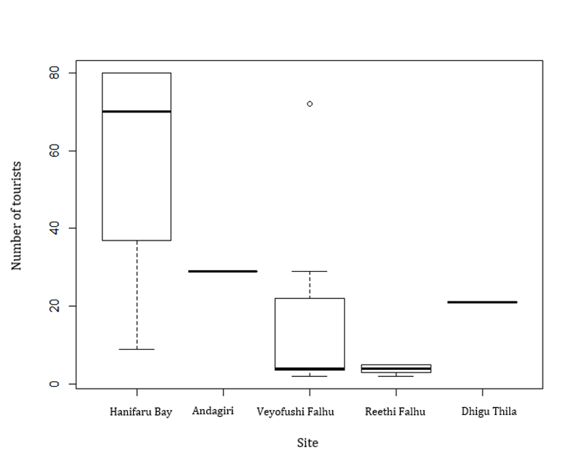

Figure 4. 5: Total number of tourists per site per day. The boxplot shows the medians, interquartile ranges (box), upper and lower quartiles (whiskers) and outliers (circles). Kruskal-Wallis test shows a significant difference between the number of humans per site, H = 200.87, p = <2.2e-16. (n = 401).

Tourist numbers differed significantly across the five sites (see Figure 4.5), with Hanifaru Bay recording a median number of 70 tourists per day, while Reethi Falhu averaged only four daily, Kruskal-Wallis; H = 200.87, *p* = <2.2e-16.

## ***4.5 Discussion***

For wildlife tourism to be sustainable, it must be conducted according to the principles of ‘ecotourism’, in which interactions are intended to exert minimal negative impact on the focal animal (O’Malley et al. 2013). However, increasing concern exists about the negative effect of tourism interactions on species, particularly when no clear management guidelines are in place (Anderson et al. 2011b; Graham 2007; Quiros 2007; Marshall et al 2011 (from Venables 2013)). My data suggest that certain human actions impact manta ray behaviour negatively during interactions. Distance between human and manta, human behaviour, and the position of snorkellers all significantly affected the manta ray’s response (Table 4.4), which in turn is all reflected in the Manta Trust’s code of conduct recommendations. Interactions with humans over the recommended minimum three metres resulted in significantly less avoidance behaviour by the manta rays than at shorter distances, showing that allowing the animals more distance decreases disturbance. During approaches within three metres, the likelihood of avoidance behaviour was 31% but reduced to just 3.4% for interactions between four to five metres. Approaches from the front were also significantly more likely to result in disturbance, which can be explained by the snorkeller blocking the direction of travel and presenting a barrier to the future movement of the manta ray. Approaches from above were also significantly more likely to cause cessation of feeding entirely. Manta rays are unable to see directly above and behind, while their downward, lateral and forward vision is good (Deakos 2010). Therefore, they are more likely to feel threatened and react adversely to an unidentified object approaching from these directions, hence it is recommended to approach from the side to avoid startling the animal.

Accidental obstructions, diving too near/in front and chasing encounters all proved significantly disturbing, causing more cessation of feeding during interactions than passive interactions. Manta ray reactions to the presence of humans were recorded to be higher at sites exploited less by tourism activities compared with sites with more tourists (e.g. Hanifaru Bay), possibly due to lower tourist numbers and non-habituated manta rays, although this variable would need further study.

During my study, snorkellers (who are recommended to be briefed on conduct prior to in-water interactions) passively observed the focal manta rays in only 158 of the 401 interactions (39.4%), with the majority of all tourism interactions therefore showing second-rate compliance to the recommended distance for in-water conduct. Accidental obstructions were observed on 83 interactions (20.7%), for example by touching or blocking the pathway of the manta ray’s travel, but troublingly, during 140 encounters (34.9%), snorkellers were observed deliberately diving near manta rays, while attempting to film or photograph themselves with the animals (#MantaSelfie).

An avoidance response by the manta ray was observed on 36.7% of observations, including behaviour such as slight reaction, direction change or avoidance. A similar result was found from a study in Ningaloo Reef, Western Australia, where feeding *M. alfredi* displayed a behavioural response to snorkellers classified as disturbance in 34.1% of tourism interactions (Venables 2013). Venables (2013) also found that surface splashing by snorkellers significantly increased the likelihood of manta ray behavioural responses. As demonstrated in this study, passive, quiet observations appear to minimise avoidance responses by manta rays.

A further concern during in-water interactions is that human presence stops an animal’s natural behaviour. Human behaviour was a statistically significant factor in the change of manta ray behaviour, with accidental obstructions, diving too near/in front and chasing all proving statistically significant (Table 4.4). Race and Oram’s (2013) study in Goat Island Marine Reserve, New Zealand found that less experienced snorkellers were unable to hold their breath for long periods of time, a factor which could apply to the human behaviour recorded during this study. A lack of snorkeller experience would also explain the quick bolt action of free-divers back to the surface, with little awareness of the manta rays swimming above and around them, which was regularly observed in this study. Such erratic movement and the crossing and blocking of the manta ray’s path has the potential to interrupt its natural behaviour and potentially reduce feeding activity. Another consideration is the impact of human presence at specific sites. For example, the manta rays at Veyofushi Falhu demonstrated significantly increased avoidance reactions compared to other sites. One theory to explain this result is the variation in human visitation between sites and therefore the level of manta habituation to human presence. At Veyofushi Falhu there was a median number of four visitors per day, compared to 70 at Hanifaru Bay (Figure 4.5).

Regionalised action is being taken to encourage sustainable tourist practices, with Australia establishing government approved guidelines for interacting with manta rays (Ningaloo Marine Interactions 2018). Swim-with manta ray interactions at Hanifaru Bay MPA are regulated by the Maldives Environmental Protection Agency and the Baa Atoll Biosphere Reserve, leading to many tour operators providing tourists with pre-encounter briefings. However, over half of observed interactions showed that snorkellers breached these code of conduct recommendations, highlighting the importance of monitoring encounters and having in-water guides and enforcement personnel to regulate tourist behaviour. Penalties for tourist infractions are employed for whale shark interaction in Oslob, the Philippines, ranging from fines up to PHP 2,500 (USD 48.10), to imprisonment (Craven 2012). Previous ecotourism studies have found there to be significant changes in diver behaviour following environmental briefings, with reduced physical contact and damage recorded (Toyoshima & Nadaoka 2015; Medioet al. 1997; Worachananant et al. 2008; Camp & Fraser 2012; Krieger & Chadwick 2013). Even more effective was dive leader intervention, which reduce non-compliant diver behaviour more successfully than briefings alone (Barker & Roberts 2004; Krieger & Chadwick 2013). For this to be effective, a smaller, more manageable group size is recommended, which is defined as ‘small enough so that dive/trip leaders can supervise all members of the group adequately’ (Barker & Roberts 2004, p. 481-489).

Regulating tourism interactions and conducting pre-encounter briefings are key measures with the potential to minimise the effect of humans during tourism interactions (Brunnschweiler 2010; Mau 2008; Pierce et al. 2010), and together with interpretive material can increase tourist satisfaction with the experience (Zeppel & Muloin 2008; Quiros 2007). Findings from my study support the recommendations provided by the Manta Trust’s Best Practice code of conduct for interacting with manta rays (see Appendix II, [www.mantatrust.org](http://www.mantatrust.org) & [www.swimwithmantas.org](http://www.swimwithmantas.org) ).

Further research should investigate the effect of interactions with tourists at manta ray cleaning stations as this research only considered feeding aggregations. The next step will be to extend this study: firstly, to look at the long-term impacts from disturbance to feeding if it continues; secondly, to test statistically whether *M. alfredi* are more likely to show tourist avoidance behaviour when cleaning as opposed to when feeding; thirdly to examine SCUBA interactions and diver behaviour with manta rays. Preliminary results from previous pilot studies have shown a similar pattern to my study, with SCUBA diver approaches made from the front, above, below and behind causing higher animal disturbance responses than approaches from the side, passive interactions and encounters over three metres (see Appendices III-V). Diver bubbles may also block easy access to cleaning stations, the presence of people may potentially shorten the time spent cleaning, and poor buoyancy control can damage the coral reef (Tratalos & Austin 2001).

## ***4.6 Conclusions***

My study rigorously tested the guidelines provided in the Manta Trust’s code of conduct. It confirms and reinforces the guidelines provided to tour operators for in-water interactions with feeding manta rays: (1) to maintain a distance of three metres or more when approaching manta rays; (2) to remain passive throughout interactions avoiding splashing, touching or chasing animals; (3) if approaching animals, always to approach from the side, within the manta ray’s field of vision; (4) to avoid diving directly in front of manta rays, and (5) to ensure that only experienced snorkellers should attempt to free-dive near manta rays. These recommendations should be given to all tourists before taking part in any in-water interactions with manta rays. Tour guides should be vigilant about monitoring and enforcing these recommendations throughout the encounter. Creating nationwide government legislation and effective enforcement based on these recommendations in countries where manta ray tourism activities exist is the next step towards making in-water manta ray encounters a true ecotourism activity. Once achieved, these activities can become a safe and sustainable alternative to fishing these vulnerable species, with long-term financial gains for the local economy and tourism trade.

# **Chapter Five: General discussion and conclusions**

This thesis, a study of the behaviour of the world’s largest recorded population of *M. alfredi* in the Maldives, examined measures of sociality within aggregations and foraging groups, patterns of foraging variation and individuals’ behavioural disturbance and feeding cessation due to the presence of snorkellers.

Chapter Two presents the first social network analysis of this large population. My findings provide a better understanding of the social relationships of this highly mobile species, calculating measures of sociality and testing for any evidence of social structure. Chapter Three furthers our understanding of individual foraging flexibility and the drivers of behavioural variation. Specifically, I tested the relative importance of biotic and abiotic factors in explaining variation in foraging behaviour and the roles adopted by individuals. Finally, Chapter Four tested ecotourism management recommendations in terms of the behavioural responses of manta rays to tourists. In this general discussion, I now summarize my key results and their broader implications for understanding manta ray sociality on both large and fine scales, the flexibility demonstrated during foraging, the behavioural responses of animals to tourists, discuss the limitations and weaknesses of my study, identify remaining knowledge gaps regarding manta ray foraging and social behaviour and draw my final conclusions.

## 

## *5.1 Summary of key results*

Social network analysis has proven to be a key analytical tool for the examination of the network structure of populations and the relationships between individuals (Whitehead 2009). In Chapter Two, I mapped the social structure of manta rays in eastern Baa Atoll at both the large and fine scale, firstly on the aggregation level and then on the smaller scale of foraging groups. I found that there was no clear evidence of social structure different to random in the observed network of *M. alfredi* on either level. My results suggest that my study population of manta rays are unstructured and associate based on spatiotemporal overlaps amongst individuals in response to food availability (Silk et al. 2014). Thus, at Baa Atoll they formed aggregations and foraging groups without social attraction or social group structure. Lacking a network structure at the aggregation and group levels, interactions were probably driven by resource dispersion and habitat use, with site fidelity and foraging behaviour shaping the observed groupings (Connor et al. 2000; Heithaus & Dill 2002; Johnson et al. 2002; Parra et al. 2011; Stewart et al. 2018). Manta rays demonstrated no difference in gregariousness within either sex or age class, with random associations as opposed to preferred companions. With low probability of temporal associations between dyads across both 30-day and annual timesteps, my data suggest that manta rays do not form long-term relationships, at least at these foraging sites, and relationships are loose. My study examined a fraction of the population at a limited number of sites, but my results showed no evidence of social structure different to random amongst the study population of manta rays. Although aggregation and foraging groups appeared open and lacked structure, these aggregations will remain key to individual fitness, potentially also offering social opportunities with benefits including mating prospects, as well as potential information dissemination, which can be done purely coincidentally while carrying out routine activities, i.e. an individuals’ foraging behaviour may attract other individuals to a specific resource or patch (Galef & Giraldeau 2001; Danchin et al. 2004; Dall et al. 2005).

In Chapter Three, I examined in more detail interactions within foraging groups, including variables affecting foraging group size, position within group and leadership behaviour. Overall, manta rays demonstrated considerable flexibility in individual foraging behaviour. Food availability, site and year proved to be significantly associated with group size. Position in group was influenced by manta rays’ group size, with animals assuming more frontal positions when group size was low. Leadership within foraging groups was solely influenced by sex, with females significantly more likely to lead than males. My study went one step further to explain variation in group size, position in group, and leadership behaviour, examining the influence of residual among- and within-individual factors. We no longer simply label such individual variation in behaviour as ‘random noise’ and recognise the potentially strong biological importance of phenotypic variation which, therefore, should not be ignored (Westneat et al. 2015). My study examined the individual flexibility in *M. alfredi* foraging behaviour over a three-year period, with residual within-individual variance explaining over 55% of difference in each trait. Among-individual variance in group size, position and leadership traits was low indicating that there was low repeatability in behaviour. This result suggests that *M. alfredi* are highly flexible in their foraging behaviour and do not show specialisms in foraging. Thus, I suggest that the position of individuals within foraging groups was in general likely to be driven by a ‘first come, first serve’ process (Gerald 2002). Closer testing of leadership behaviour highlighted among-individual differences in individual identity was weakly significant, suggesting that specific individuals acted as leader more frequently than others but would not be classed as consistent leaders. With changing environmental conditions and increased anthropogenic pressure, behavioural flexibility may be key to species’ success (Herborn et al. 2014; Hockings et al. 2015).

Increased fishing pressure on mobulids around the world has resulted in both manta species to be listed as Vulnerable on the Red List of Threatened Species (Lawson et al. 2017), sparking alternative yet still economically beneficial exploitation to be sought (O’Malley et al. 2013). Financially, the largest alternative use is ecotourism, particularly in the Maldives where fishing is prohibited (EPA 2014) and the population is large (Stevens 2016). Although it remains a solution against the killing of animals, tourist-induced disturbance at manta foraging and cleaning sites is a very real and present problem. Chapter Four examined the Manta Trust best practice code of conduct for snorkel interactions, testing variables including human behaviour, distance between human and animal and the direction of approach on manta ray response. Research was conducted at foraging sites, a behaviour which we are able to predict to a certain degree due to the seasonal nature of these ephemeral zooplankton blooms (Stevens 2016). My study confirmed that certain human actions, specifically chasing, accidental obstruction and diving too near/in front impacted manta ray behaviour significantly negatively during interactions and caused cessation of feeding. I also showed that approaches to within three metres and people positioning themselves directly in front of animals were significant causes of disturbance to manta rays. Avoidance behaviour and cessation of feeding could be detrimental to manta welfare as aggregations form to feed on ephemeral upwellings of zooplankton which rapidly disappear when tidal currents change (Stevens 2016), making any interruptions to feeding critical in decreasing food intake. In conclusion, my study makes clear recommendations for in-water interactions with feeding manta rays; (1) maintain a minimum distance of at least three metres, preferably more when approaching, (2) remain passive throughout interactions avoiding splashing, touching or chasing animals, (3) if approaching animals, always approach from the side, within the manta ray’s field of vision, (4) avoid diving directly in front of the animals, and (5) only experienced snorkellers should attempt to free-dive near manta rays. Making such recommendations to tourists prior to in-water interactions, as well as heightened tour guide vigilance and enforcement will enable such practices to remain sustainable for the animals as well as economically beneficial. By providing a rigorous scientific basis for the published code of conduct, I hope that it can be used to generate international government legislation in countries where manta ray tourism activities exist. If this is achieved, manta ray tourism can become a safe and sustainable alternative to fishing, which will produce lasting financial gains for the local economy and tourism trade.

## *5.2 Implications of my results*

So, what conclusions can I draw from these studies? Firstly, although *M. alfredi* can be observed aggregating and foraging together within time and space, such gatherings appear not to be socially driven. There is a flexible membership within aggregations and foraging groups, with individuals amassing and departing with fluidity, demonstrating highly fission-fusion dynamics without social relationships (Sueur et al. 2011). The dispersion of resources, for example prey distribution can affect the schooling behaviour of species, as seen in Trinidadian guppy (*Poecilia reticulata*), with the benefit of grouping including lower perceived predation risk (Morrell et al. 2008). Environmental variability, as seen in the seasonal nature of zooplankton dispersion around the Maldives archipelago (Anderson et al. 2011a) and strongly displayed in Hanifaru Bay MPA (Stevens 2016), is suggested to also influence fission-fusion dynamics. The predictable nature of monsoonal currents and zooplankton blooms within the atoll potentially selects for flexibility in individuals’ sociality, aggregating spatially in relation to the current environmental conditions, i.e. when prey density is high (Morrell et al. 2008). This is also observed in Guinea baboons (*Papio papio*), with group size fluctuating between seasons, with dry season group sizes smaller when resources are more spread out (Patzelt & Zinner 2011), as seen in this population of manta rays.

Although temporal stability of relationships within dyads was low within the sexes, there were distinct differences between males and females, with females demonstrating higher non-random associations. Recognition of familiars amongst females is seen in other fish species, for example guppies (Magurran & Garcia 2000). Females show preferential association with familiars, whilst males prefer to court unfamiliar females, highlighting sexual differences in the benefits of conspecific recognition (Magurran & Garcia 2000). Gilby and Wrangham (2008) found distinct sex differences in association patterns of wild chimpanzees (*Pan troglodytes schweinfurthii*), with significantly stronger associations between male-male dyads compared to female-female dyads. This indicates robust and steady male associations, built on cooperation which appeared to be an important dominance strategy (Gilby & Wrangham 2008). Females however had weak associations but were comparatively as steady as males, suggesting steady group membership as opposed to close associates within groups (Gilby & Wrangham 2008). Overall these results indicate that male associations are more likely to be driven by cooperation, while females are likely a result of foraging behaviour (Gilby & Wrangham 2008). Sexual segregation is also seen in matriarchal societies, as with Sperm whales (*Physeter macrocephalus*), where female groups often adopt different habitats to male cliques and segregate from males for years or even for a life time (Würsig 2017). These systems benefit related individuals through collective responsibilities, with females sharing the monitoring of predation risks to neoantes during deep diving for prey (Würsig 2017). Even though temporal female associations were low in my study population, sexual segregation and recognition described above highlight potential benefits of working and associating with familiars which may influence the difference in association rates within the sexes in this study.

This thesis demonstrated distinct flexibility in *M. alfredi* behaviour. Within animal species, we see behavioural syndromes or coping styles which are relatively stable over time and space (Coppens et al. 2010). In contrast, the ability to be behaviourally flexible and vary activities, i.e. feeding according to changing contexts, for example fluctuating environmental conditions, will enable individuals to alter their behaviour in order to adjust to changing conditions (Coppens et al. 2010). My study showed this in the flexibility adopted by manta rays in the foraging strategies they adopt across feeding events (see also Stevens 2016). Based on the location and density of zooplankton, manta rays switch between strategies, at times switching from group to solo tactics (Stevens 2016) showing responsiveness to their surroundings presumably in order to benefit nutritionally. Additionally, the low among-individual variance found in foraging flexibility in this thesis, specifically group size, position in group and leadership indicate that individuals are capable of adaptability to increase foraging efficiency under different ecological conditions. Such behavioural flexibility in *M. alfredi*, therefore shows an ability to cope with natural changes and pressures, which is important considering the threats facing today’s marine species (Sol & Lefebvre 2000; Sol et al. 2002; Nicolakakis et al. 2003). However, the disturbance and avoidance reactions to specific tourist behaviours observed in this study indicates a potential lack of resilience to human pressure and unregulated presence. As I have shown in this thesis, anthropogenic pressure can negatively affect the natural behaviour of manta rays however, this may be mitigated through education, with clear guidelines and heightened enforcement during human-animal interactions. It is easier to limit than undo damage. Increased research into behavioural changes in response to human presence will help define regulations needed to avoid disturbance. Turning such regulations into legislation will be the crucial next step to managing tourism interactions nationally or internationally.

## *5.3 Limitations and weaknesses of my study*

For biologists working with wild populations in the field, a common problem can be collecting data on all individuals during one sampling period, often missing key individuals and associations (James et al. 2009). As this study used photo-ID and videos as the sampling method, it is likely that I captured a snapshot of social behaviour amongst aggregations and foraging groups (Williams et al. 2017). I also chose specific locations to sample which undoubtedly biased the range of activity seen in the data and therefore the social behaviour collected. This was an unavoidable problem but should be considered when interpreting results. For future studies, the use of satellite tracking devices, which automatically record the presence of individuals, could help eliminate missed data and create a more inclusive dataset which can be used for association analysis, albeit with many fewer individuals sampled due to the expense and complexity of tagging (Eckert & Stewart 2001; Sims et al. 2006; Jacoby et al. 2012a). Using large-scale acoustic receiver arrays would also enable data to be collected at various locations, not simply cleaning or foraging sites, capturing associations when animals are in transit to create a more rounded picture of manta sociality (Jacoby et al. 2012a). A study using a tagged population of manta rays, including all associations across a larger number of sites and behaviours, may enable definitive confirmation or refutation for the presence of social structure.

However, as technology continues to evolve and enables increasingly detailed and accurate data on animal movements and behaviours, we must consider the ethics of using these more invasive practices. There are key questions to ask; should tagging be used if this causes discomfort or injury to the animal, do the benefits outweigh the negative implications of tagging and should tagging be used if this contradicts the wishes of the local community (Cooke et al. 2013)? In light of increased ethical awareness, many tagging-based initiatives use the three R’s framework; Replacement, Reduction and Refinement (Russell & Burch 1959; Bennett et al. 2016). The use of non-animal models to “replace” real animals, a “reduction” in test animal numbers and a “refinement” of protocols and care standards to reduce discomfort or pain for subjects (Russell & Burch 1959; Bennett et al. 2016). With their elevated cognitive capabilities, fish species are considered to have the capacity to feel pain and suffering (Bshary & Brown 2014;Bennett et al. 2016), therefore exposure to invasive tagging methods are often considered with a cost-benefit approach, with the cost sustained by the subject, either on an individual or population level being outweighed by the data/information acquired (Knight 2011). With the extensive work promoting ecotourism as a sustainable alternative to fishing and development of codes of conduct to minimise and mitigate animal disturbance, we must consider the pros and cons of using remote tagging.

Tagging methods have had an unparalleled impact on our range and level of understanding of many marine species and are widely used to examine migration and movement patterns, population size and structure, growth, survival rates as well as behaviour, whilst also highlighting key habitats for conservation and further research (McFarlane et al. 1990; Hazen et al. 2012). However, these devices can have negative impacts for animals, increasing animal drag, impacting locomotive ability, growth, feeding, predator avoidance and even survival (Murray & Fuller 2000; Walker et al. 2012; Bennett et al. 2016). The small number of animals which realistically can be tagged and tracked, as well as the snapshot nature of data means that tagging is often supplemented by further methods, for example stable isotope analysis (Zbinden et al. 2011; Hazen et al. 2012). We must also consider what questions we are trying to answer before deploying such methods, and consider whether such technology is the best approach compared to the more simple, non-invasive, reliable and effective method of animal observation (Mrosovsky 1983). Given the population size, amount of historic data and the questions being asked in this study, the simpler method of photo ID and footage of foraging events may actually prove most effective, capturing real-time interactions between individuals whilst having a lower disturbance impact if data collection is conducted in line with the recommended code of conduct.

A further question is whether we would expect to find social structure either as an artefact of the data collection method or via studying animals across multiple contexts? As we know, sociality is often influenced by predation risk, with safety in numbers proving a key to survival (Hoare et al. 2004; Kelley et al. 2011). For example, Kelley et al. (2011) showed that under a high predation risk, individual guppies had more associations with stronger connectedness than at low risk (Kelley et al. 2011). However, my study was conducted in waters which are theorised as being lower-risk as they are the shallow and protected waters of the inner-atoll, therefore are considered “safer”. Theoretically this would reduce predation risk-related stress and perception of threat, therefore potentially influencing the lack of evident social structure observed however, this has not been explicitly measured in this study therefore can only be hypothesised as an explanation and needs direct analysis

## *5.4 Remaining knowledge gaps*

I have presented a snapshot of manta ray sociality, but the limitations mentioned above mean that we do not have a full understanding of the social network of this particular population, including associations observed during cleaning behaviour and when animals are in transit. In this thesis, I focused specifically on fine-scale foraging groups, but cleaning also offers the opportunity for social interactions with animals aggregating at these key locations (Dewar et al. 2008; Jaine et al. 2012), therefore we cannot conclusively refute any evidence of social structure without examining this aspect of manta ray behaviour. This analysis of the social structure of aggregations and foraging groups tested the effect of sex and age class on various network measures but we still do not know whether other factors including relatedness, personality, hierarchy and mating status has an impact on sociality, gregariousness or temporal stability (Riedel et al. 2011; Rollins et al. 2012; Aplin et al. 2013; Diaz-aguirre 2018).

Manta rays are a popular species amongst SCUBA divers due to their size and the regularity of sightings (O’Malley et al. 2013), and many divers are keen to photograph their behaviour (Kashiwagi et al. 2011). Although this thesis has highlighted key snorkeller behaviours which cause disturbance to mantas during foraging, we are yet to scientifically test the effect of SCUBA interactions on manta rays. Also, we lack data on how human disturbance affects cleaning behaviour. Cleaning is an important activity and manta rays are known to visit specific parts of the reef which act as ‘cleaning stations’ on a regular basis (Dewar et al. 2008; Jaine et al. 2012). As a favourite amongst divers, manta rays’ popularity exposes them to human disturbance including overcrowding (O’Malley et al. 2013); therefore, a better understanding of the impact which human presence at cleaning stations would enable better management of SCUBA activities. Currently, this specific study is being carried out and will complement the snorkeller study presented in this thesis, creating a fully inclusive insight into the effects of marine ecotourism on manta rays.

## *5.6 Final conclusions*

In conclusion, I provide some evidence for the existence of fission-fusion dynamics for this population of *M. alfredi*, demonstrating their flexibility to differing foraging conditions*.* This behavioural flexibility and lack of strong social structure may enable animals to adjust to and endure disruptions to populations. For example, based on the results of the study of this population, I suggest that the removal of particular individuals would be unlikely to cause total disruption to the success of manta foraging aggregations or groups which is seen in other communities (Snijders et al. 2017). Increased anthropogenic pressure takes various forms, with human-induced climate change threatening to disrupt key natural drivers, for example seasonal upwellings of mantas’ transient prey (Bakun et al. 2015). Hence, behavioural flexibility and sensitivity to changing environmental conditions could prove to be an important trait for future foraging success (Herborn et al. 2014; Hockings et al. 2015). Manta rays are also exposed to increased disturbance in the form of human presence at both foraging and cleaning sites, potentially altering tolerance and habituation to humans (Anderson et al. 2011b; O’Malley et al. 2013). This thesis highlights the importance of scientific evidence to support the development of codes of conduct as part of conservation management in areas where wild species are exploited through tourism for financial gain. Strict and clear regulation and rules of conduct are shown to mitigate the disturbance of the natural behaviour of animals during tourist interactions (Quiros 2007) which is imperative in one of the busiest marine tourism hubs in the world. The fluid group membership, behavioural flexibility and lack of evident social structure that I have identified, suggests a population with the ability to adjust to variation in environmental conditions, suggesting a positive resilience which may promote their future success.

# **Appendices**

## **Appendix I:** Annual variation in foraging conditions

I compared biotic (sex, age class, plankton density and number of mantas) and abiotic variables (current strength, site and year) between study years using Kruskal-Wallis tests. Results aided establishing specific variables to include in further analysis.

Kruskal-Wallis tests revealed significant inter-year differences, specifically across the tested environmental variables in 2016;

*Number of manta rays*

Across the three study years, 2016 resulted in a significantly lower number of mantas recorded in aggregations (H (2) = 1680.4, p = <2.2e-16), with a median number of 40 in 2014, 33 in 2015 and 5 in 2016 (see Figure A1.1).

*Plankton density*

Significant variation in plankton density was recorded across study years, (H (2) = 313.3, p = <2.2e-16), with median scores of 2, 2 and 1 over 2014 to 2016 respectively (see Figure A1.2).

*Current strength*

Variation in recorded current strength variation proved significant (H (2) = 1322.3, p = <2.2e-16) with median scores of 3, 1 and 1 over 2014 to 2016 respectively.

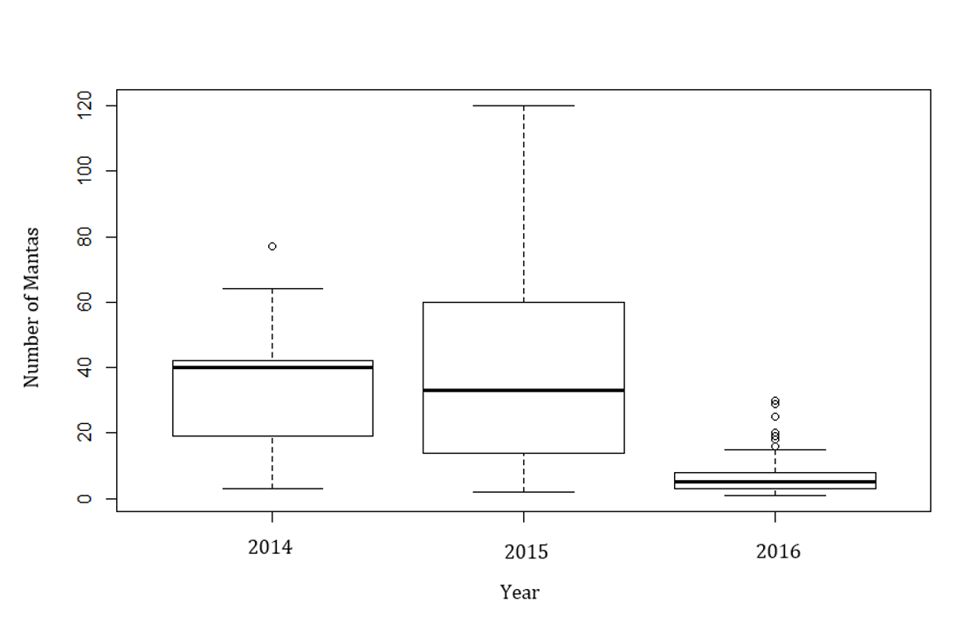

Figure A1. 1**:** Median aggregation size across study years (2014, 2015, 2016). The boxplot shows the medians, interquartile ranges (box), upper and lower quartiles (whiskers) and outliers (circles). Kruskal-Wallis chi-squared = 1680.4, df = 2, p-value = < 0.05. (n = 401).

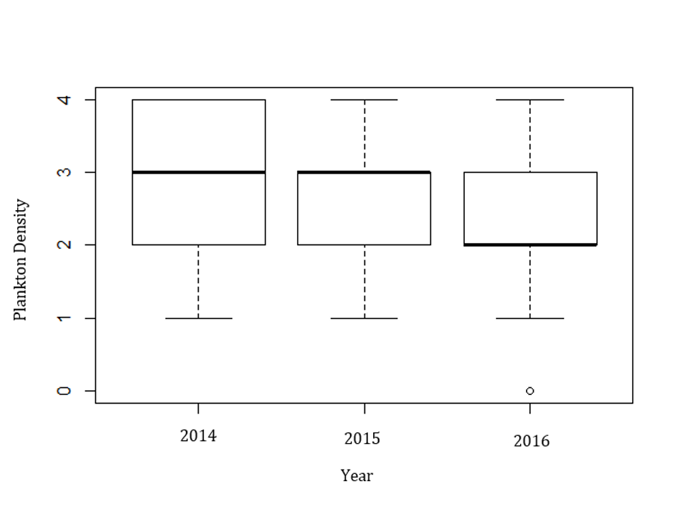

Figure A1. 2: Median plankton density (0 - 4) across study years (2014, 2015, 2016). The boxplot shows the medians, interquartile ranges (box), upper and lower quartiles (whiskers) and outliers (circles). Kruskal-Wallis chi-squared = 424.21, df = 2, p-value < 0.05. (n = 401).

**Appendix II:** The Manta Trust Best Practice Code of Conduct for snorkel interactions. (Source: Manta Trust 2019)

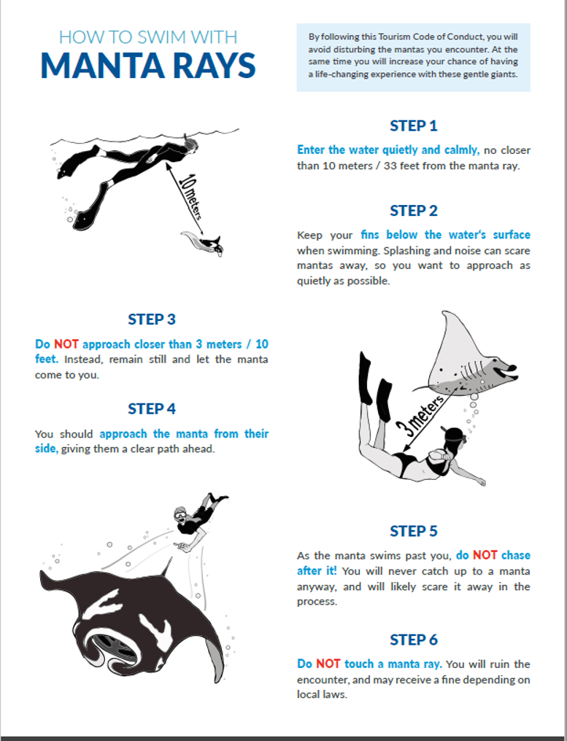

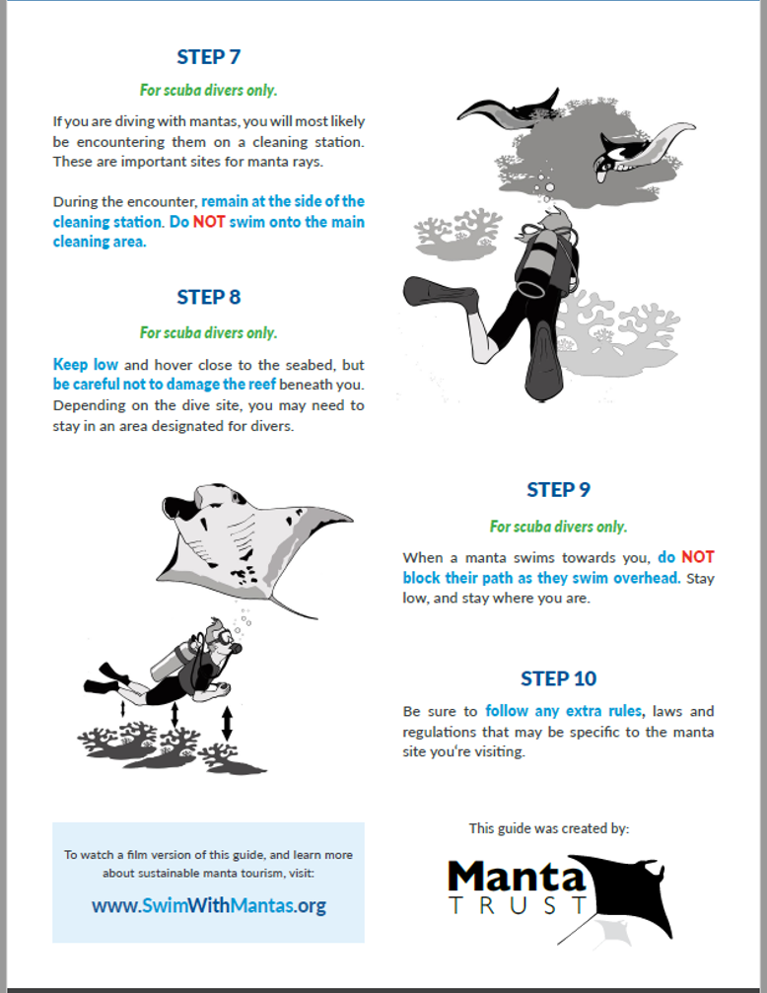

## **Appendix III:** Pilot study results for snorkel and dive interactions.

Figure A.3: (a) Snorkel interactions. Mean manta response in reaction to direction of human approach: Behind, Side, Front and Above/Below. (n = 639). (b) Dive Interactions Mean manta response in reaction to direction of human approach: Behind, Side, Front and Above/Below. (n = 66). (Data collected from Atkins (2011) and Lynam (2012).

## **Appendix IV:** Pilot study results for snorkel and dive interactions.

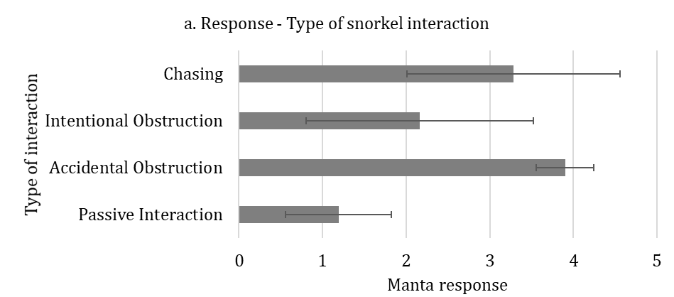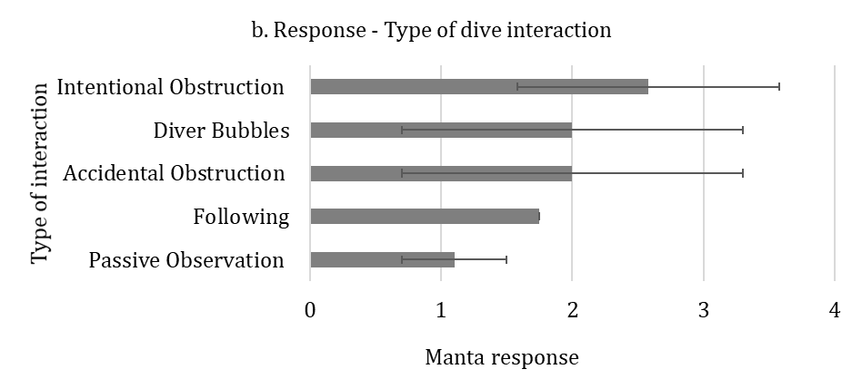

Figure A.4: (a) Snorkel interactions. Mean manta response in reaction to type of interaction: Passive Interaction, Following, Accidental Obstruction, Diver Bubbles and Intentional Obstruction. (n = 626). (b) Dive interactions Mean manta response in reaction to type of interaction: Passive Interaction, Following, Accidental Obstruction, Diver Bubbles and Intentional Obstruction. (n = 66). Data collected from Atkins (2011) and Lynam (2012).

## **Appendix V:** Pilot study results for snorkel and dive interactions.

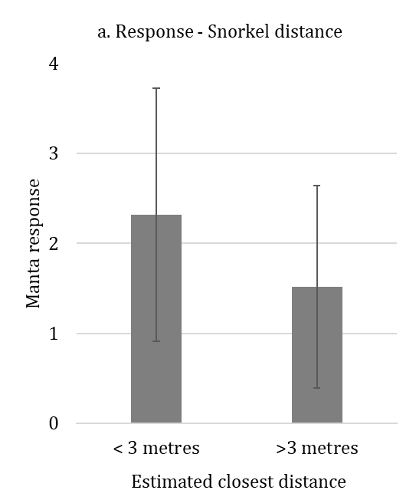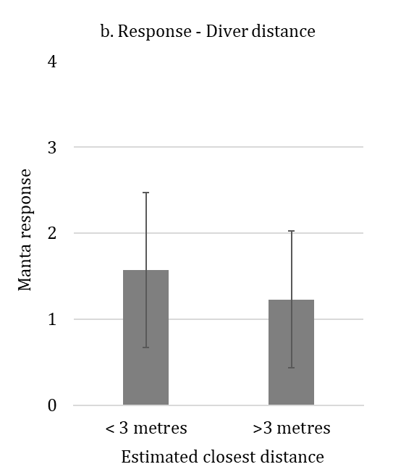

Figure A.5: (a) Snorkel interactions. Mean manta response in reaction to estimated closest distance categories: < 3 metres and > 3 metres. (n = 639). (b) Dive interactions (n = 66). (Data collected from Atkins (2011) and Lynam (2012).

# **References**

Ackerman, J.T., Kondratieff, M.C., Matern, S.A. & Cech, J.J., 2000. Tidal influence on spatial dynamics of leopard sharks, *Triakis semifasciata*, in Tomales Bay, California. *Environmental Biology of Fishes*, 58, pp.33–43.

Alexander, R.D., 1974. The Evolution of Social Behavior Author. *Annual Review of Ecology and Systematics*, 5, pp.325–383.

Alonzo, S.H., 2015. Integrating the how and why of within-individual and among-individual variation and plasticity in behavior. *Current Opinion in Behavioral Sciences*, 6 (December), pp.69–75.

Altizer, S., Nunn, C.L., Thrall, P.H., Gittleman, J.L., Antonovics, J., Cunningham, A.A., Dobson, A.P., Ezenwa, V., Jones, K.E., Pedersen, A.B. & Poss, M., 2003. Social organization and parasite risk in mammals: integrating theory and empirical studies. *Annual Review of Ecology, Evolution, and Systematics*, 34, pp.517–547.

Amici, F., Aureli, F. & Call, J., 2008. Fission-Fusion Dynamics, Behavioral Flexibility, and Inhibitory Control in Primates. *Current Biology*, 18, pp.1415–1419.

Anderson, R.C. & Ahmed, H., 1993. The shark fisheries of the Maldives. *FAO, Rome, and Ministry of Fisheries, Male, Maldives*.

Anderson, R.C., Adam, M.S. & Goes, J.I., 2011a. From monsoons to mantas: Seasonal distribution of *Manta alfredi* in the Maldives. *Fisheries Oceanography*, 20, pp.104–113.

Anderson, R.C., Adam, M.S., Kitchen-Wheeler, A.M. & Stevens, G., 2011b. Extent and economic value of manta ray watching in Maldives. *Tourism in Marine Environments*, 7, pp.15-27.

Anthony, L.L. & Blumstein, D.T., 2000. Integrating behaviour into wildlife conservation: The multiple ways that behaviour can reduce N(e). *Biological Conservation*, 95, pp.303–315.

Aplin, L.M., Farine, D.R., Morand‐Ferron, J., Cole, E.F., Cockburn, A. & Sheldon, B.C., 2013. Individual personalities predict social behaviour in wild networks of great tits (*Parus major*). *Ecology Letters*, 16, pp.1365–1372.

Araújo, M.S., Bolnick, D.I. & Layman, C.A., 2011. The ecological causes of individual specialisation. *Ecology Letters*, 14, pp.948–958.

Archie, E.A., Maldonado, J.E., Hollister‐Smith, J.A., Poole, J.H., Moss, C.J., Fleischer, R.C. & Alberts, S.C., 2008. Fine-scale population genetic structure in a fission-fusion society. *Molecular Ecology*, 17, pp.2666–2679.

Armitage, K.B., 1981. Sociality as a Life-History Tactic of Ground Squirrels Kenneth. *Oecologia*, 48, pp.36–49.

Armstrong, A.O., Armstrong, A.J., Jaine, F.R., Couturier, L.I., Fiora, K., Uribe-Palomino, J., Weeks, S.J., Townsend, K.A., Bennett, M.B. & Richardson, A.J., 2016. Prey Density Threshold and Tidal Influence on Reef Manta Ray Foraging at an Aggregation Site on the Great Barrier Reef. *PLoS ONE*, 11, p.e0153393.

Arnold, K.E., 2000. Kin recognition in rainbowfish (*Melanotaenia eachamensis*): Sex, sibs and shoaling. *Behavioral Ecology and Sociobiology*, 48, pp.385–391.

Asensio, N., Korstjens, A.H. & Aureli, F., 2009. Fissioning minimizes ranging costs in spider monkeys: A multiple-level approach. *Behavioral Ecology and Sociobiology*,

63, pp.649–659.

Ashby, B. & Gupta, S., 2013. Sexually transmitted infections in polygamous mating systems. *Philosophical Transactions of the Royal Society B: Biological Sciences*, 368*,* pp.20120048.

Atkins, R., 2011. *Manta ray (Manta alfredi) tourism in Baa Atoll, Republic of Maldives: human interaction, behavioural impacts and management implications.* MSc Thesis for University of York. Unpublished data.

Atton, N., Hoppitt, W., Webster, M.M., Galef, B.G. & Laland, K.N., 2012. Information flow through three spine stickleback networks without social transmission. *Proceedings of the Royal Society B: Biological Sciences*, 279, pp.4272–4278.

Atton, N., Galef, B.J., Hoppitt, W., Webster, M.M. & Laland, K.N., 2014. Familiarity affects social network structure and discovery of prey patch locations in foraging stickleback shoals. *Proceedings of the Royal Society B: Biological Sciences*, 281, pp.20140579.

Atwood, T.C. & Weeks, Jr., H.P., 2003. Spatial home-range overlap and temporal interaction in eastern coyotes: the influence of pair types and fragmentation. *Canadian Journal of Zoology*, 81, pp.1589–1597.

Aureli, F., Schaffner, C.M., Boesch, C., Bearder, S.K., Call, J., Chapman, C.A., Connor, R., Fiore, A.D., Dunbar, R.I., Henzi, S.P. & Holekamp, K., 2008. Fission-fusion dynamics: new research frameworks. *Current Anthropology*, 49, pp.627-654.

Baa Atoll UNESCO Biosphere Reserve Maldives., 2012. [Online] Available at: http://www.broffice.gov.mv/en/index.php/news-events/24-hanifaru-protection-and-preservation-regulation-2012-r-23-go-into-effect-from-26th-april-2012 [Accessed 13th September 2018].

Baird, R.W. & Whitehead, H., 2000. Social organization of mammal-eating killer whales : group stability and dispersal patterns. 78, pp.2096–2105.

Bakun, A., Black, B.A., Bograd, S.J., Garcia-Reyes, M., Miller, A.J., Rykaczewski, R.R. & Sydeman, W.J., 2015. Anticipated effects of climate change on coastal upwelling ecosystems. *Current Climate Change Reports*, 1, pp.85-93.

Barber, I. & Wright, H.A., 2001. How strong are familiarity preferences in shoaling fish? *Animal Behaviour*, 61, pp.975–979.

Barelli, C., Boesch, C., Heistermann, M. & Reichard, U.H., 2008. Female white-handed gibbons (*Hylobates lar*) lead group movements and have priority of access to food resources. *Behaviour*, 145, pp.965-981.

Barker, N.H. & Roberts, C.M., 2004. Scuba diver behaviour and the management of diving impacts on coral reefs. *Biological Conservation*, 120, pp.481-489.

Barton, R.A., 1993. Sociospatial mechanisms of feeding competition in female olive baboons, *Papio anubis*. *Animal Behaviour*, 46, pp.791–80.

Bates, D., Sarkar, D., Bates, M.D. & Matrix, L., 2007. The lme4 package. *R package version*, 2, pp.74.

Bearhop, S., Phillips, R.A., McGill, R., Cherel, Y., Dawson, D.A. & Croxall, J.P., 2006. Stable isotopes indicate sex-specific and longer-term individual foraging specialosation in diving seabirds. *Marine Ecology Progress Series*, 311, pp.157–164.

Beck, S., Kuningas, S., Esteban, R. & Foote, A.D., 2012. The influence of ecology on sociality in the killer whale (*Orcinus orca*). *Behavioral Ecology*, 23, pp.246–253.

Begon, M., Townsend, C.R. & Harper, J.L., 2006. *Ecology: From Individuals to Ecosystems* 4th edn., Blackwell Science, Oxford.

Bejder, L., Fletcher, D. & Bräger, S., 1998. A method for testing association patterns of social animals. *Animal Behaviour*, 56, pp.719–725.

Bélisle, M., 1998. Foraging group size: models and a test with jaegers kleptoparasitizing terns. *Ecology*, *79*, pp.1922-1938.

Bell, A.M., Hankison, S.J. & Laskowski, K.L., 2009. The repeatability of behaviour: a meta analysis. *Animal Behaviour*, 77, pp.771–783.

Benhamou, S., 2006. Detecting an orientation component in animal paths when the preferred direction is individual-dependent. *Ecology*, 87, pp.518–528.

Bennett, R.H., Ellender, B.R., Mäkinen, T., Miya, T., Pattrick, P., Wasserman, R.J., Woodford, D.J. & Weyl, O.L., 2016. Ethical considerations for field research on fishes. *Koedoe*, 58, pp.1-15.

Bergman, T.J., 2010. Experimental evidence for limited vocal recognition in a wild primate: implications for the social complexity hypothesis. *Proceedings of the Royal Society of London B: Biological Sciences*, 277, pp.3045-3053.

Bergman, T.J. & Beehner, J.C., 2015. Measuring social complexity. *Animal Behaviour*, 103, pp.203-209.

Bergmüller, R. & Taborsky, M., 2010. Animal personality due to social niche specialisation. *Trends in Ecology and Evolution*, 25, pp.504–511.

Bigg, M.A., Olesiuk, P.F., Ellis, G.M., Ford, J.K.B. & Balcomb, K.C., 1990. Social organization and genealogy of resident killer whales (*Orcinus orca*) in the coastal waters of British Columbia and Washington State. *Report of the International Whaling Commission*, 12, pp.383–405.

Bode, N.W.F., Wood, A.J. & Franks, D.W., 2011. The impact of social networks on animal collective motion. *Animal Behaviour*, 82, pp.29–38.

Boesch, C. & Boesch-Achermann, H., 2000. *The chimpanzees of the Taï Forest: Behavioural ecology and evolution.* O. U. P. on Demand., ed., Oxford University Press on Demand.

Bolnick, D.I., Svanbäck, R., Fordyce, J.A., Yang, L.H., Davis, J.M., Hulsey, C.D. & Forister, M.L., 2003. The ecology of individuals: incidence and implications of individual specialization. *The American Naturalist*, 161, pp.1-28.

Bonanni, R., Cafazzo, S., Valsecchi, P. & Natoli, E., 2010. Effect of affiliative and agonistic relationships on leadership behaviour in free-ranging dogs. *Animal Behaviour*, 79, pp.981–991.

Bonnie, K.E. & Earley, R.L., 2007. Expanding the scope for social information use. *Animal Behaviour*, 74, pp.171–181.

Bourjade, M. & Sueur, C., 2010. Shared or unshared consensus for collective movement? Towards methodological concerns. *Behavioural Processes*, 84, pp.648–652.

Brent, L.J.N., 2015. Friends of friends: are indirect connections in social networks important to animal behaviour? *Animal behaviour*, 103, p.211–222.

Brent, L.J., Franks, D.W., Foster, E.A., Balcomb, K.C., Cant, M.A. & Croft, D.P., 2015. Ecological knowledge, leadership, and the evolution of menopause in killer whales. *Current Biology*, 25, pp.746–750.

Britton, J.R. & Andreou, D., 2016. Parasitism as a Driver of Trophic Niche Specialisation. *Trends in Parasitology*, 32, pp.437–445.

Brooks, K., 2010. *Investigating tourism in Hanifaru Bay marine protected area, Maldives.* MSc Thesis for University of York. Unpublished data.

Brunnschweiler, J.M., 2010. The Shark Reef Marine Reserve: a marine tourism project in Fiji involving local communities. *Journal of Sustainable Tourism*, 18, pp.29-42.

Bshary, R. & Brown, C., 2014. Fish cognition. *Current Biology*, *24*, pp. R947-R950.

Budden, A.E. & Wright, J., 2005. Learning during competitive positioning in the nest: Do nestlings use ideal free “foraging” tactics? *Behavioral Ecology and Sociobiology*, 58, pp.227–236.

Burnham, K.P. & Anderson, D.R., 2004. Multimodel inference: Understanding AIC and BIC in model selection. *Sociological Methods and Research*, 33, pp.261–304.

Buwalda, B., Stubbendorff, C., Zickert, N. & Koolhaas, J.M., 2013. Adolescent social stress does not necessarily lead to a compromised adaptive capacity during adulthood: A study on the consequences of social stress in rats. *Neuroscience*, 249, pp.258–270.

Byrne, R.W. & Bates, L.A., 2007. Sociality, Evolution and Cognition. *Current Biology*, 17, pp.714–723.

Cagua, E.F., Collins, N.M., Hancock, J. & Rees, R., 2014. *Visitation and economic impact of whale shark tourism in a Maldivian marine protected area* (No. e360v1). PeerJ PrePrints.

Cairns, S.J. & Schwager, S.J., 1986. A comparison of association indices. *Animal Behaviour*, 35, pp.1454–1469.

Camp, E. & Fraser, D., 2012. Influence of conservation education dive briefings as a management tool on the timing and nature of recreational SCUBA diving impacts on coral reefs. *Ocean & Coastal Management*, 61, pp.30-37.

Campbell, P., Akbar, Z., Adnan, A.M. & Kunz, T.H., 2006. Resource distribution and social structure in harem-forming Old World fruit bats: variations on a polygynous theme. *Animal Behaviour*, 72, pp.687–698.

Cárdenas-Torres, N., Enríquez-Andrade, R. & Rodríguez-Dowdell, N., 2007. Community-based management through ecotourism in Bahia de los Angeles, Mexico. *Fisheries Research*, 84, pp.114-118.

Carlisle, A. & Starr, R., 2009. Habitat use, residency, and seasonal distribution of female leopard sharks *Triakis semifasciata* in Elkhorn Slough, California. *Marine Ecology Progress Series*, 380, pp.213–228.

Carlisle, A.B. & Starr, R.M., 2010. Tidal movements of female leopard sharks (*Triakis semifasciata*) in Elkhorn Slough, California. *Environmental Biology of Fishes*, 89, pp.31–45.

Carneiro, A.P., Bonnet-Lebrun, A.S., Manica, A., Staniland, I.J. & Phillips, R.A., 2017. Methods for detecting and quantifying individual specialisation in movement and foraging strategies of marine predators. *Marine Ecology Progress Series*, 578, pp.151–166.

Carter, A.J., Macdonald, S.L., Thomson, V.A. & Goldizen, A.W., 2009. Structured association patterns and their energetic benefits in female eastern grey kangaroos, *Macropus giganteus*. *Animal Behaviour*, 77, pp.839–846.

Carter, K.D., Brand, R., Carter, J.K., Shorrocks, B. & Goldizen, A.W., 2013. Social networks, long-term associations and age-related sociability of wild giraffes. *Animal Behaviour*, 86, pp.901–910.

Castro, A.L.F., Stewart, B.S., Wilson, S.G., Hueter, R.E., Meekan, M.G., Motta, P.J., Bowen, B.W. & Karl, S.A., 2007. Population genetic structure of Earth’s largest fish, the whale shark (*Rhincodon typus*). *Molecular Ecology*, 16, pp.5183–5192.

Ceia, F.R., Ramos, J.A., Phillips, R.A., Cherel, Y., Jones, D.C., Vieira, R.P. & Xavier, J.C., 2015. Analysis of stable isotope ratios in blood of tracked wandering albatrosses fails to distinguish a δ13C gradient within their winter foraging areas in the southwest Atlantic Ocean. *Rapid Communications in Mass Spectrometry*, 29, pp.2328–2336.

Ceia, F.R. & Ramos, J.A., 2015. Individual specialization in the foraging and feeding strategies of seabirds: a review. *Marine Biology*, 162, pp.1923–1938.

Chapman, C.A., Chapman, L.J. & Wrangham, R.W., 1995. Ecological constraints on group size: an analysis of spider monkey and chimpanzee subgroups. *Behavioral Ecology and Sociobiology*, 36, pp.59-70.

Chapman, R.E., Wang, J. & Bourke, A.F.G., 2003. Genetic analysis of spatial foraging patterns and resource sharing in bumble bee pollinators. *Molecular Ecology*, 12, pp.2801–2808.

Chase, I.D., Tovey, C., Spangler-Martin, D. & Manfredonia, M., 2002. Individual differences versus social dynamics in the formation of animal dominance hierarchies. *Proceedings of the National Academy of Sciences*, 99, pp.5744–5749.

Cisneros-Montemayor, A.M. & Sumaila, U.R., 2010. A global estimate of benefits from ecosystem-based marine recreation: potential impacts and implications for management. *Journal of Bioeconomics*, 12, pp.245-268.

Clark, C.W. & Mangel, M., 2000. *Dynamic state variable models in ecology: methods and applications*. Oxford University Press on Demand.

Cleasby, I.R., Nakagawa, S. & Schielzeth, H., 2015. Quantifying the predictability of behaviour: Statistical approaches for the study of between-individual variation in the within-individual variance. *Methods in Ecology and Evolution*, 6, pp.27–37.

Clutton-Brock, T.H. & Lukas, D., 2012. The evolution of social philopatry and dispersal in female mammals. *Molecular Ecology*, 21, pp.472–492.

Colman, J., 1997. A review of the biology and ecology of the whale shark. *Journal of Fish Biology*, 51, pp.1219–1234.

Compagno, L.J. V., 2001. *Sharks of the world : an annotated and illustrated catalogue of shark species known to date*, Food and Agriculture Organization of the United Nations.

Conklin, J.R. & Colwell, M.A., 2008. Individual associations in a wintering shorebird population: Do Dunlin have friends? *Journal of Field Ornithology*, 79, pp.32–40.

Connor, R.C., Wells, R.S., Mann, J. & Read, A.J., 2000. *The Bottlenose Dolphin.* *Cetacean Societies*, pp.91-125

Connor, R.C., Heithaus, M.R. & Barre, L.M., 2001. Complex social structure, alliance stability and mating access in a bottlenose dolphin “super-alliance.” *Proceedings of the Royal Society B: Biological Sciences*, 268, pp.263–267.

Conradt, L., 1998. Could asynchrony in activity between the sexes cause intersexual social segregation in ruminants? *Proceedings of the Royal Society B: Biological Sciences*, 265, pp.1359–1368.

Conradt, L. & Roper, T.J., 2003. Group decision-making in animals. *Nature*, 421, pp.1996–1999.

Conradt, L. & Roper, T.J., 2005. Consensus decision making in animals. *Trends in Ecology and Evolution*, 20, pp.449–456.

Conradt, L. & Roper, T.J., 2007. Democracy in animals: the evolution of shared group decisions. *Proceedings of the Royal Society B: Biological Sciences*, 274, pp.2317–2326.

Conradt, L., Krause, J., Couzin, I.D. & Roper, T.J., 2009. “Leading According to Need” in Self‐Organizing Groups. *The American Naturalist*, 173, pp.304–312.

Convention on the Conservation of Migratory Species of Wild Animals., 2018. Factsheet: Mobulid Rays. [Online] Available at: https://www.cms.int/en/document/factsheet-mobulid-rays [Accessed 7th February 2019]

Constantine, R., 2001. Increased avoidance of swimmers by wild bottlenose dolphins (*Tursiops truncatus*) due to long‐term exposure to swim‐with‐dolphin tourism. *Marine Mammal Science*, 17, pp.689-702.

Cook, T.R., Cherel, Y. & Tremblay, Y., 2006. Foraging tactics of chick-rearing Crozet shags: individuals display repetitive activity and diving patterns over time. *Polar Biology*, 29, pp.562–569.

Cooke, S.J., Nguyen, V.M., Murchie, K.J., Thiem, J.D., Donaldson, M.R., Hinch, S.G., Brown, R.S. & Fisk, A., 2013. To tag or not to tag: Animal welfare, conservation, and stakeholder considerations in fish tracking studies that use electronic tags. *Journal of International Wildlife Law & Policy*, 16, pp.352-374.

Coppens, C.M., de Boer, S.F. & Koolhaas, J.M., 2010. Coping styles and behavioural flexibility:towards underlying mechanisms. *Philosophical Transactions of the Royal Society B: Biological Sciences*, 365, pp.4021–4028.

Corcoran, M.J., 2006. *The effects of supplemental feeding on the activity space and movement patterns of the Southern stingray, Dasyatis americana, at Grand Cayman, Cayman Islands*. Nova Southeastern University, Fort Lauderdale, FL.

Côté, I.M., 2000. Evolution and ecology of cleaning symbioses in the sea. *Oceanography and Marine Biology*, 38, pp.311–355.

Couturier, L.I.E., Marshall, A.D., Jaine, F.R.A., Kashiwagi, T., Pierce, S.J., Townsend, K.A., Weeks, S.J., Bennett, M.B. & Richardson, A.J., 2012. Biology, ecology and conservation of the Mobulidae. *Journal of Fish Biology*, 80, pp.1075–1119.

Couzin, I.D., 2009. Collective cognition in animal groups. *Trends in Cognitive Sciences*, 13, pp.36–43.

Couzin, I.D., Krause, J., James, R., Ruxton, G.D. & Franks, N.R., 2002. Collective memory and spatial sorting in animal groups. *Journal of Theoretical Biologyology*, 218, pp.1–11.

Couzin, I.D. & Krause, J., 2003. Self-Organization and Collective Behavior in Vertebrates. *Advances in the Study of Behavior*, 32, pp.1–75.

Couzin, I.D., Krause, J., Franks, N.R. & Levin, S.A., 2005. Effective leadership and decision-making in animal groups on the move. *Nature*, 433, pp.513–516.

Couzin, I.D. & Laidre, M.E., 2009. Fission-fusion populations. *Current Biology*, 19, pp.633–635.

Craven, S., 2012. A report on the status of the whale sharks watching tourist industry in Tan-awan, Oslob, Cebu. Retrieved from: Large Marine Vertebrates Project (LAMAVE), Philippines. [Online] Available at: <http://www.moalboal.net/moalboal/images/pdf/oslob-physalus-report.pdf> [Accessed 10th April 2018]

Croft, D.P., James, R., Ward, A.J.W., Botham, M.S., Mawdsley, D. & Krause, J., 2005. Assortative interactions and social networks in fish. *Oecologia*, 143, pp.211–219.

Croft, D.P., James, R., Thomas, P.O.R., Hathaway, C., Mawdsley, D., Laland, K.N. & Krause, J., 2006. Social structure and co-operative interactions in a wild population of guppies (*Poecilia reticulata*). *Behavioral Ecology and Sociobiology*, 59, pp.644–650.

Croft, D.P., James, R. & Krause, J., 2008. *Exploring animal social networks.* Princeton University Press.

Croft, D.P., Madden, J.R., Franks, D.W. & James, R., 2011. Hypothesis testing in animal social networks. *Trends in Ecology and Evolution*, 26, pp.502–507.

Croll, D.A., Dewar, H., Dulvy, N.K., Fernando, D., Francis, M.P., Galván‐Magaña, F., Hall, M., Heinrichs, S., Marshall, A., Mccauley, D. & Newton, K.M., 2016. Vulnerabilities and fisheries impacts: the uncertain future of manta and devil rays. *Aquatic Conservation: Marine and Freshwater Ecosystems*, 26, pp.562-575.

Croxall, J.P., Silk, J.R., Phillips, R.A., Afanasyev, V. & Briggs, D.R., 2005. Global circumnavigations: Tracking year-round ranges of nonbreeding albatrosses. *Science*, 307, pp.249–250.

Dall, S.R., Houston, A.I. & McNamara, J.M., 2004. The behavioural ecology of personality: consistent individual differences from an adaptive perspective. *Ecology Letters*, 7, pp.734-739.

Dall, S.R., Giraldeau, L.A., Olsson, O., McNamara, J.M. & Stephens, D.W., 2005. Information and its use by animals in evolutionary ecology. *Trends in Ecology and Evolution*, 20, pp.187–193.

Danchin, E., Giraldeau, L.A., Valone, T.J. & Wagner, R.H., 2004. Public Information: From Nosy Neighbors to cultural evolution. *Science*, 305, pp.487–49.

Daniel, M.J. & Rodd, F.H., 2015. Female guppies can recognize kin but only avoid incest when previously mated. *Behavioral Ecology*, 27, pp.55–61.

David, M., Cézilly, F. & Giraldeau, L.A., 2011. Personality affects zebra finch feeding success in a producer-scrounger game. *Animal Behaviour*, 82, pp.61–67.

DeBlois, E.M. & Rose, G.A., 1996. Cross-shoal variability in the feeding habits of migrating Atlantic cod (*Gadus morhua*). *Oecologia*, 108, pp.192-196.

Deakos, M.H., 2010. Ecology and social behavior of a resident manta ray (*Manta alfredi*) population off Maui, Hawai'i. *Dissertation Abstracts International*, 72.

Deakos, M.H., 2012. The reproductive ecology of resident manta rays (*Manta alfredi*) off Maui, Hawaii, with an emphasis on body size. *Environmental Biology of Fishes*, 94, pp.443–456.

Denkinger, J., Parra, M., Muñoz, J.P., Carrasco, C., Murillo, J.C., Espinosa, E., Rubianes, F. & Koch, V., 2013. Are boat strikes a threat to sea turtles in the Galapagos Marine Reserve?. *Ocean & Coastal Management*, 80, pp.29-35.

Dewar, H., Mous, P., Domeier, M., Muljadi, A., Pet, J. & Whitty, J., 2008. Movements and site fidelity of the giant manta ray, *Manta birostris*, in the Komodo Marine Park, Indonesia. *Marine Biology*, 155, pp.121–133.

Diaz-aguirre, F., 2018. Kinship influences social bonds among male southern Australian bottlenose dolphins (*Tursiops cf. australis*). *Behavioral Ecology and Sociobiology*, 72, pp.190.

Dingemanse, N. J. & Reale, D., 2005. Natural Selection and Animal Personality. *Behaviour*, 142, pp.1159–1184.

Dingemanse, N.J. & Wolf, M., 2010. Recent models for adaptive personality differences: A review. *Philosophical Transactions of the Royal Society B: Biological Sciences*, 365, pp.3947–3958.

Dingemanse, N.J. & Dochtermann, N.A., 2013. Quantifying individual variation in behaviour: Mixed-effect modelling approaches. *Journal of Animal Ecology*, 82, pp.39–54.

Dingemanse, N.J., Kazem, A.J., Réale, D. & Wright, J., 2010. Behavioural reaction norms: animal personality meets individual plasticity. *Trends in Ecology & Evolution*, 25, pp.81-89.

Domeier, M.L. & Nasby-Lucas, N., 2008. Migration patterns of white sharks *Carcharodon carcharias* tagged at Guadalupe Island, Mexico, and identification of an eastern Pacific shared offshore foraging area. *Marine Ecology Progress Series*, 370, pp.221–237.

Dubé, C., Ribble, C., Kelton, D. & McNab, B., 2011. Introduction to network analysis and its implications for animal disease modelling. *Revue Scientifique et Technique-OIE*, 30, pp.425.

Duboscq, J., Romano, V., MacIntosh, A. & Sueur, C., 2016. Social information transmission in animals: Lessons from studies of diffusion. *Frontiers in Psychology*, 7, pp.1147.

Dulvy, N.K., Fowler, S.L., Musick, J.A., Cavanagh, R.D., Kyne, P.M., Harrison, L.R., Carlson, J.K., Davidson, L.N., Fordham, S.V., Francis, M.P. & Pollock, C.M., 2014a. Extinction risk and conservation of the world’s sharks and rays. *elife*, 3, p.e00590.

Dulvy, N.K., Pardo, S.A., Simpfendorfer, C.A. & Carlson, J.K., 2014b. Diagnosing the dangerous demography of manta rays using life history theory. *PeerJ*, 2, p.e400.

Duncan, K.M. & Holland, K.N., 2006. Habitat use, growth rates and dispersal patterns of juvenile scalloped hammerhead sharks *Sphyrna lewini* in a nursery habitat. *Marine Ecology Progress Series*, 312, pp.211–221.

Dyer, J.R., Ioannou, C.C., Morrell, L.J., Croft, D.P., Couzin, I.D., Waters, D.A. & Krause, J., 2008. Consensus decision making in human crowds. *Animal Behaviour*, 75, pp.461–470.

Eckert, S.A. & Stewart, B.S., 2001. Telemetry and satellite tracking of whale sharks, Rhincodon typus, in the Sea of Cortez, Mexico, and the north Pacific Ocean. In *The behavior and sensory biology of elasmobranch fishes: an anthology in memory of Donald Richard Nelson*. pp. 299-308. Springer, Dordrecht.

Edrén, S.M.C. & Gruber, S.H., 2005. Homing ability of young lemon sharks, *Negaprion brevirostris*. *Environmental Biology of Fishes*, 72, pp.267–281.

Eggers, D.M., 1976. Theoretical effect of schooling by planktivorous fish predators on rate of prey consumption. *Journal of the Fisheries Board of Canada*, 33, pp.1964-1971.

Eibl-Eibesfeldt, I., 1989. Human ethology. Routledge, New York.

Ellis, S. & Robinson, E.J.H., 2016. Internest food sharing within wood ant colonies: Resource redistribution behavior in a complex system. *Behavioral Ecology*, 27, pp.660–668.

Engelhaupt, D., Rus Hoelzel, A., Nicholson, C., Frantzis, A., Mesnick, S., Gero, S., Whitehead, H., Rendell, L., Miller, P., De Stefanis, R. & Canadas, A., 2009. Female philopatry in coastal basins and male dispersion across the North Atlantic in a highly mobile marine species, the sperm whale (*Physeter macrocephalus*). *Molecular Ecology*, 18, pp.4193–4205.

Enviromental Prptection Agency, 2014. Ministry of environment and Energy. Laws and Regulations. [Online] Available at: http://en.epa.gov.mv/regulations Accessed 24th October 2018.

Erhart, E.M. & Overdorff, D.J., 1999. Female coordination of group travel in wild Propithecus and Eulemur. *International Journal of Primatology*, 20, pp.927–940.

Estes, J.A., Riedman, M.L., Staedler, M.M., Tinker, M.T. & Lyon, B.E., 2003. Individual variation in prey selection by sea otters: Patterns, causes and implications. *Journal of Animal Ecology*, 72, pp.144–155.

Farine, D.R., 2013. Animal social network inference and permutations for ecologists in R using asnipe. *Methods in Ecology and Evolution*, 4, pp.1187–1194.

Farine, M.D.R., 2018. Package ‘ asnipe .’

Farine, D.R. & Whitehead, H., 2015. Constructing, conducting and interpreting animal social network analysis. *Journal of Animal Ecology*, 84, pp.1144–1163.

Fernández-Juricic, E., Gilak, N., Mcdonald, J.C., Pithia, P. & Valcarcel, A., 2006. A dynamic method to study the transmission of social foraging information in flocks using robots. *Animal Behaviour*, 71, pp.901-911.

Finkemeier, M.A., Langbein, J. & Puppe, B., 2018. Personality research in mammalian farm animals: concepts, measures, and relationship to welfare. *Frontiers in Veterinary Science*, 5.

Fischhoff, I.R., Sundaresan, S.R., Cordingley, J., Larkin, H.M., Sellier, M.J. & Rubenstein, D.I., 2007. Social relationships and reproductive state influence leadership roles in movements of plains zebra, *Equus burchellii*. *Animal Behaviour*, 73, pp.825–831.

Fischhoff, I.R., Dushoff, J., Sundaresan, S.R., Cordingley, J.E. & Rubenstein, D.I., 2009. Reproductive status influences group size and persistence of bonds in male plains zebra (*Equus burchelli*). *Behavioral Ecology and Sociobiology*, 63, pp.1035–1043.

Forrester, G.E., 1990. Factors influencing the juvenile demography of a coral reef fish. *Ecology*, 71, pp.1666-1681.

Fortin, D. & Fortin, M.E., 2009. Group-size-dependent association between food profitability, predation risk and distribution of free-ranging bison. *Animal Behaviour*, 78, pp.887–892.

Foster, E.A., Franks, D.W., Morrell, L.J., Balcomb, K.C., Parsons, K.M., van Ginneken, A. & Croft, D.P., 2012. Social network correlates of food availability in an endangered population of killer whales, *Orcinus orca*. *Animal Behaviour*, 83, pp.731–736.

Franks, D.W., Ruxton, G.D. & James, R., 2010. Sampling animal association networks with the gambit of the group. *Behavioral Ecology and Sociobiology*, 64, pp.493–503.

Fraser, C.P., Ruxton, G.D. & Broom, M., 2006. Public information and patch estimation for group foragers: a re‐evaluation of patch‐quitting strategies in a patchy environment. *Oikos*, 112, pp.311-321.

Frost, A.J., Winrow-Giffen, A., Ashley, P.J. & Sneddon, L.U., 2007. Plasticity in animal personality traits: Does prior experience alter the degree of boldness? *Proceedings of the Royal Society B: Biological Sciences*, 274, pp.333–339.

Galbraith, D.A., Kocher, S.D., Glenn, T., Albert, I., Hunt, G.J., Strassmann, J.E., Queller, D.C. & Grozinger, C.M., 2016a. Testing the kinship theory of intragenomic conflict in honey bees (*Apis mellifera*). *Proceedings of the National Academy of Sciences*, 113, pp.1020–1025.

Galbraith, D.A., Yi, S. V. & Grozinger, C.M., 2016b. Evaluation of possible proximate mechanisms underlying the kinship theory of intragenomic conflict in social insects. *Integrative and Comparative Biology*, 56, pp.1206–1214.

Galef Jr, B.G. & Giraldeau, L.A., 2001. Social influences on foraging in vertebrates: causal mechanisms and adaptive functions. *Animal Behaviour*, 61, pp.3–15.

Gallagher, A.J. & Hammerschlag, N., 2011. Global shark currency: the distribution, frequency, and economic value of shark ecotourism. *Current Issues in Tourism*, 14, pp.797-812.

Garla, R.C., Chapman, D.D., Wetherbee, B.M. & Shivji, M., 2006. Movement patterns of young Caribbean reef sharks, *Carcharhinus perezi*, at Fernando de Noronha Archipelago, Brazil: the potential of marine protected areas for conservation of a nursery ground. *Marine Biology*, 149, p.189.

Garroway, C.J. & Broders, H.G., 2007. Non- random association patterns at northern long-eared bat maternity roosts. *Canadian Journal of Zoology*, 85, pp.956-964.

Gazda, S.K., Connor, R.C., Edgar, R.K. & Cox, F., 2005. A division of labour with role specialization in group-hunting bottlenose dolphins (*Tursiops truncatus*) off Cedar Key, Florida. *Proceedings of the Royal Society B: Biological Sciences*, 272, pp.135–140.

Gerald, M.S., 2002. The Finding of an Inverse Relationship between Social Dominance and Feeding Priority among Pairs of Unfamiliar Adult Male Vervet Monkeys (*Cercopithecus aethiops sabaeus*). *Primates*, 43, pp.127–132.

Giese, M., 1998. Guidelines for people approaching breeding groups of Adélie penguins (Pygoscelis adeliae). *Polar Record*, 34, pp.287-292.

Gilby, I.C. & Wrangham, R.W., 2008. Association patterns among wild chimpanzees (*Pan troglodytes schweinfurthii*) reflect sex differences in cooperation. *Behavioral Ecology and Sociobiology*, 62, pp.1831–1842.

Giraldeau, L.A. & Caraco, T., 2018. *Social foraging theory*. Princeton University Press.

Gosling, S.D., 2001. From Mice To Men. *Psychological Bulletin*, 127, pp.45.

Graham, R.T., 2007. Whale sharks of the western Caribbean: an overview of current research and conservation efforts and future needs for effective management of the species. *Gulf and Caribbean Research*, 19, pp.149-159.

Granovetter, M.S., 1977. The strength of weak ties. In *Social networks*. pp. 347-367. Academic Press.

Grant, J.W., Girard, I.L., Breau, C. & Weir, L.K., 2002. Influence of food abundance on competitive aggression in juvenile convict cichlids. *Animal Behaviour*, 63, pp.323–330.

Greene, C.H., Wiebe, P.H., Pelkie, C., Benfield, M.C. & Popp, J.M., 1998. Three-dimensional acoustic visualization of zooplankton patchiness. *Deep-Sea Research Part II: Topical Studies in Oceanography*, 45, pp.1201–1217.

Griffiths, S.W., Brockmark, S., Höjesjö, J. & Johnsson, J.I., 2004. Coping with divided attention: the advantage of familiarity. *Proceedings of the Royal Society B: Biological Sciences*, 271, pp.695–699.

Grubbs, R. & Musick, J., 2007. Spatial delineation of summer nursery areas for juvenile sandbar sharks in Chesapeake Bay, Virginia. *American Fisheries Society Symposium*, 50, pp.63.

Grubbs, R.D., Musick, J.A., Conrath, C.L. & Romine, J.G., 2007. Long-Term Movements, Migration, and Temporal Delineation of a Summer Nursery for Juvenile Sandbar Sharks in the Chesapeake Bay Region. *Shark nursery grounds of the Gulf of Mexico and the east coast waters of the United States. American Fisheries Society Symposium* 50, pp.87–107.

Guilford, T., Freeman, R., Boyle, D., Dean, B., Kirk, H., Phillips, R. & Perrins, C., 2011. A dispersive migration in the atlantic Puffin and its implications for migratory navigation. *PLoS ONE*, 6, p.e21336.

Guttal, V. & Couzin, I.D., 2010. Social interactions, information use, and the evolution of collective migration. *Proceedings of the National Academy of Sciences*, 107, pp.16172–16177.

Guttridge, T.L., Gruber, S.H., Gledhill, K.S., Croft, D.P., Sims, D.W. & Krause, J., 2009. Social preferences of juvenile lemon sharks, Negaprion brevirostris. *Animal Behaviour*, 78, pp.543-548.

Guttridge, T.L., Gruber, S.H., DiBattista, J.D., Feldheim, K.A., Croft, D.P., Krause, S. & Krause, J., 2011. Assortative interactions and leadership in a free-ranging population of juvenile lemon shark *Negaprion brevirostris*. *Marine Ecology Progress Series*, 423, pp.235–245.

Guttridge, T.L., Gruber, S.H., Franks, B.R., Kessel, S.T., Gledhill, K.S., Uphill, J., Krause, J. & Sims, D.W., 2012. Deep danger: Intra-specific predation risk influences habitat use and aggregation formation of juvenile lemon sharks *Negaprion brevirostris*. *Marine Ecology Progress Series*, 445, pp.279–291.

Hain, T.J.A. & Neff, B.D., 2007. Multiple paternity and kin recognition mechanisms in a guppy population. *Molecular Ecology*, 16, pp.3938–3946.

Hart, K.M. & Hyrenbach, K.D., 2009. Satellite telemetry of marine megavertebrates: the coming of age of an experimental science. *Endangered Species Research*, 10, pp.9–20.

Haulsee, D.E., Fox, D.A., Breece, M.W., Brown, L.M., Kneebone, J., Skomal, G.B. & Oliver, M.J., 2016. Social Network Analysis Reveals Potential Fission-Fusion Behavior in a Shark. *Scientific Reports*, 6, pp.1–9.

Hawkins, J.P. & Roberts, C.M., 2003. Effects of fishing on sex-changing Caribbean parrotfishes. *Biological Conservation*, 115, pp.213–226.

Haythornthwaite, C., 1996. Social network analysis: An approach and technique for the study of information exchange. *Library & Information Science Research*, 18, pp.323–342.

Hazen, E.L., Maxwell, S.M., Bailey, H., Bograd, S.J., Hamann, M., Gaspar, P., Godley, B.J. & Shillinger, G.L., 2012. Ontogeny in marine tagging and tracking science: technologies and data gaps. *Marine Ecology Progress Series*, 457, pp.221-240.

Hebblewhite, M. & Pletscher, D.H., 2002. Effects of elk group size on predation by wolves. *Canadian Journal of Zoology*, 80, pp.800-809.

Heithaus, M.R. & Dill, L.M., 2002. Food availability and tiger shark predations risk influence bottlenose dolphin habitat use. *Behavioral Ecology*, 83, pp.480–491.

Heithaus, M.R. & Dill, L.M., 2006. Does tiger shark predation risk influence foraging habitat use by bottlenose dolphins at multiple spatial scales? *Oikos*, 114, pp.257–264.

Heithaus, M.R., Lewis, J.S. & Wartzok, D., 2013. Individuals as information sources: Could followers benefit from leaders knowledge? *Behaviour*, 150, pp.635–657.

Hemelrijk, C.K., Reid, D.A.P., Hildenbrandt, H. & Padding, J.T., 2015. The increased efficiency of fish swimming in a school. *Fish and Fisheries*, 16, pp.511–521.

Herberholz, J., Sen, M.M. & Edwards, D.H., 2003. Parallel changes in agonistic and non-agonistic behaviors during dominance hierarchy formation in crayfish. *Journal of Comparative Physiology A*, 189, pp.321–5.

Herborn, K.A., Heidinger, B.J., Alexander, L. & Arnold, K.E., 2014. Personality predicts behavioral flexibility in a fluctuating, natural environment. *Behavioral Ecology*, 25, pp.1374–1379.

Hesse, S. & Thünken, T., 2014. Growth and social behavior in a cichlid fish are affected by social rearing environment and kinship. *Naturwissenschaften*, 101, pp.273–283.

Hesse, S., Anaya‐Rojas, J.M., Frommen, J.G. & Thünken, T., 2015. Kinship reinforces cooperative predator inspection in a cichlid fish. *Journal of Evolutionary Biology*, 28, pp.2088–2096.

Heupel, M.R., 2007. Exiting Terra Ceia Bay: examination of cues stimulating migration from a summer nursery area. *American Fisheries Society.*

Heupel, M.R. & Hueter, R.E., 2001. Use of an automated acoustic telemetry system to passively track juvenile blacktip shark movements. In *Electronic tagging and tracking in marine fisheries*. Springer, Dordrecht, pp. 217–236.

Heupel, M.R. & Hueter, R.E., 2002. Importance of prey density in relation to the movement patterns of juvenile blacktip sharks (*Carcharhinus limbatus*) within a coastal nursery area. *Marine and Freshwater Research*, 53, pp.543–550.

Heupel, M.R. & Simpfendorfer, C.A., 2005. Quantitative analysis of aggregation behavior in juvenile blacktip sharks. *Marine Biology*, 147, pp.1239–1249.

Heupel, M.R., Carlson, J.K. & Simpfendorfer, C.A., 2007. Shark nursery areas: Concepts, definition, characterization and assumptions. *Marine Ecology Progress Series*, 337, pp.287–297.

Heyman, W.D., Graham, R.T., Kjerfve, B. & Johannes, R.E., 2001. Whale sharks *Rhincodon typus* aggregate to feed on fish spawn in Belize. *Marine Ecology Progress Series*, 215, pp.275–282.

Higham, J.E. & Lück, M. eds., 2007. *Marine wildlife and tourism management: Insights from the natural and social sciences*. CABI.

Hight, B. V. & Lowe, C.G., 2007. Elevated body temperatures of adult female leopard sharks, *Triakis semifasciata*, while aggregating in shallow nearshore embayments: Evidence for behavioral thermoregulation? *Journal of Experimental Marine Biology and Ecology*, 352, pp.114–128.

Hinde, R.A., 1976. Interactions, relationships and social structure. *Man*, pp.1-17.

Hirsch, B.T., 2007. Costs and benefits of within-group spatial position: A feeding competition model. *The University of Chicago Press*, 82, pp.9–27.

Hirsch, B.T., 2011. Within-group spatial position in ring-tailed coatis: Balancing predation, feeding competition, and social competition. *Behavioral Ecology and Sociobiology*, 65, pp.391–399.

Hirsch, B.T., Prange, S., Hauver, S.A. & Gehrt, S.D., 2013. Genetic relatedness does not predict racoon social network structure. *Animal Behaviour*, 85, pp.463–470.

Hoare, D.J., Krause, J., Peuhkuri, N. & Godin, J.G., 2000a. Body size and shoaling in fish. *Journal of Fish Biology*, 57, pp.1351-1366.

Hoare, D.J., Ruxton, G.D., Godin, J.G.J. & Krause, J., 2000b. The social organization of free‐ ranging fish shoals. *Oikos*, 89, pp.546-554.

Hoare, D.J., Couzin, I.D., Godin, J.G. & Krause, J., 2004. Context-dependent group size choice in fish. *Animal Behaviour*, 67, pp.155–164.

Hobbs, N.T., Baker, D.L., Bear, G.D. & Bowden, D.C., 1996. Ungulate grazing in sagebrush grassland: mechanisms of resource competition. *Ecological Applications*, 6, pp.200-217.

Hockings, K.J., McLennan, M.R., Carvalho, S., Ancrenaz, M., Bobe, R., Byrne, R.W., Dunbar, R.I., Matsuzawa, T., McGrew, W.C., Williamson, E.A. & Wilson, M.L., 2015. Apes in the Anthropocene: flexibility and survival. *Trends in Ecology & Evolution*, 30, pp.215–222.

Hodgkin, L.K., Symonds, M.R.E. & Elgar, M.A., 2014. Leaders benefit followers in the collective movement of a social sawfly. *Proceedings of the Royal Society B: Biological Sciences*, 281, pp.20141700–20141700.

Hodgkin, L.K., Symonds, M.R.E. & Elgar, M.A., 2017. Leadership through knowledge and experience in a social sawfly. *Animal Behaviour*, 134, pp.177–181.

Hoelzel, A.R., Dorsey, E.M. & Stern, S.J., 1989. The foraging specializations of individual minke whales. *Animal Behaviour*, 38, pp.786–794.

Hoffmayer, E.R., Franks, J.S., Driggers III, W.B., Oswald, K.J. & Quattro, J.M., 2007. Observations of a feeding aggregation of whale sharks, *Rhincodon typus*, in the north central Gulf of Mexico. *Gulf and Caribbean Research*, 19, pp.69-73.

Holyoak, M., Casagrandi, R., Nathan, R., Revilla, E. & Spiegel, O., 2008. Trends and missing parts in the study of movement ecology. *Proceedings of the National Academy of Sciences*, 105, pp. 19060-19065.

Hoppitt, W.J. & Farine, D.R., 2018. Association indices for quantifying social relationships: how to deal with missing observations of individuals or groups. *Animal Behaviour*, 136, pp.227-238.

How to swim with Manta Rays. 2017. [Online] Available at: https://swimwithmantas.org/ [Accessed 30th October 2017].

Hoyt, E., 2001. Whale watching 2001: Worldwide tourism numbers, expenditures, and expanding socioeconomic benefits.

Hoyt, E. & Iñíguez, M., 2008. The state of whale watching in Latin America. *WDCS, Chippenham, UK*.

Hsu, Y. & Wolf, L.L., 1999. The winner and loser effect: Integrating multiple experiences. *Animal Behaviour*, 57, pp.903–910.

Hueter, R.E., Mann, D.A., Maruska, K.P., Sisneros, J.A. & Demski, L.S., 2004. Sensory Biology of Elasmobranchs In: Carrier JC, Musick JA, Heithaus MR, editors. Biology of Sharks and Their Relatives.

Hueter, R.E., Heupel, M.R., Heist, E.J. & Keeney, D.B., 2005. Evidence of philopatry in sharks and implications for the management of shark fisheries. *Journal of Northwest Atlantic Fishery Science*, 35, pp.239–247.

Hueter, R.E., Tyminski, J.P. & de la Parra, R., 2013. Horizontal Movements, Migration Patterns, and Population Structure of Whale Sharks in the Gulf of Mexico and Northwestern Caribbean Sea. *PLoS ONE*, 8, p.e71883.

Hugie, D.M., 2003. The waiting game: A “battle of waits” between predator and prey. *Behavioral Ecology*, 14, pp.807–817.

Ivkovich, T., Filatova, O.A., Burdin, A.M., Sato, H. & Hoyt, E., 2010. The social organization of resident-type killer whales (*Orcinus orca*) in Avacha Gulf, Northwest Pacific, as revealed through association patterns and acoustic similarity. *Mammalian Biology*, 75, pp.198–210.

Jacobs, A., Maumy, M. & Petit, O., 2008. The influence of social organisation on leadership in brown lemurs (*Eulemur fulvus fulvus*) in a controlled environment. *Behavioural Processes*, 79, pp.111–113.

Jacoby, D.M.P., 2012. A network analysis approach to understanding shark behaviour.

Jacoby, D.M.P., Busawon, D.S. & Sims, D.W., 2010. Sex and social networking: The influence of male presence on social structure of female shark groups. *Behavioral Ecology*, 21, pp.808–818.

Jacoby, D.M.P., Croft, D.P. & Sims, D.W., 2012a. Social behaviour in sharks and rays: analysis, patterns and implications for conservation. *Fish and Fisheries*, 13, pp.399–417.

Jacoby, D.M.P., Sims, D.W. & Croft, D.P., 2012b. The effect of familiarity on aggregation and social behaviour in juvenile small spotted catsharks *Scyliorhinus canicula*. *Journal of Fish Biology*, 81, pp.1596–1610.

Jacoby, D.M.P., Fear, L.N., Sims, D.W. & Croft, D.P., 2014. Shark personalities? Repeatability of social network traits in a widely distributed predatory fish. *Behavioral Ecology and Sociobiology*, 68, pp.1995–2003.

Jaeggi, A. V. & van Schaik, C.P., 2011. The evolution of food sharing in primates. *Behavioral Ecology and Sociobiology*, 65, pp.2125–2140.

Jaine, F.R., Couturier, L.I., Weeks, S.J., Townsend, K.A., Bennett, M.B., Fiora, K. & Richardson, A.J., 2012. When giants turn up: sighting trends, environmental influences and habitat use of the manta ray *Manta alfredi* at a coral reef. *PloS One*, 7, p.e46170.

Jaine, F.R.A., Rohner, C.A., Weeks, S.J., Couturier, L.I.E., Bennett, M.B., Townsend, K.A. & Richardson, A.J., 2014. Movements and habitat use of reef manta rays off eastern Australia: offshore excursions, deep diving and eddy affinity revealed by satellite telemetry. *Marine Ecology Progress Series*, 510, pp.73–86.

James, R., Croft, D.P. & Krause, J., 2009. Potential banana skins in animal social network analysis. *Behavioral Ecology and Sociobiology*, 63, pp.989–997.

Janik, V.M., Sayigh, L.S. & Wells, R.S., 2006. Signature whistle shape conveys identity information to bottlenose dolphins. *Proceedings of the National Academy of Sciences*, 103, pp.8293–8297.

Janson, C., 1985. Aggresive competition and individual food consumption in wild brown capuchin monkeys (*Cebus apella*). *Behavioral Ecology and Sociobiology*, 18, pp.125–138.

Janson, C.H., 1990. Ecological Consequences of Individual spatial choices in foraging groups of brown capuchin monkeys, *Cebus apella*. *Animal Behavior*, 40, pp.922–934.

Jelinski, D.E., Krueger, C.C. & Duffus, D.A., 2002. Geostatistical analyses of interactions between killer whales (*Orcinus orca*) and recreational whale-watching boats. *Applied Geography*, 22, pp.393-411.

Jirik, K.E. & Lowe, C.G., 2012. An elasmobranch maternity ward: female round stingrays *Urobatis halleri* use warm, restored estuarine habitat during gestation. *Journal of Fish biology*, 80, p.1227–1245.

Jolles, J.W., Fleetwood-Wilson, A., Nakayama, S., Stumpe, M.C., Johnstone, R.A. & Manica, A., 2014. The role of previous social experience on risk-taking and leadership in three-spined sticklebacks. *Behavioral Ecology*, 25, pp.1395–1401.

Johnson, D.D., Kays, R., Blackwell, P.G. & Macdonald, D.W., 2002. Does the resource dispersion hypothesis explain group living? *Trends in Ecology and Evolution*, 17, pp.563–570.

Jones, E.I., 2010. Optimal foraging when predation risk increases with patch resources: An analysis of pollinators and ambush predators. *Oikos*, 119, pp.835–840.

Jorgensen, S.J., Reeb, C.A., Chapple, T.K., Anderson, S., Perle, C., Van Sommeran, S.R., Fritz-Cope, C., Brown, A.C., Klimley, A.P. & Block, B.A., 2010. Philopatry and migration of Pacific white sharks. *Proceedings of the Royal Society B: Biological Sciences*, 277, pp.679–688.

Kaplan, I. & Denno, R.F., 2007. Interspecific interactions in phytophagous insects revisited: A quantitative assessment of competition theory. *Ecology Letters*, 10, pp.977–994.

Kashiwagi, T., Marshall, A.D., Bennett, M.B. & Ovenden, J.R., 2011. Habitat segregation and mosaic sympatry of the two species of manta ray in the Indian and Pacific Oceans: *Manta alfredi* and *M. birostris*. *Marine Biodiversity Records*, Jun.

Kausrud, K., Mysterud, A., Rekdal, Y., Holand, Ø. & Austrheim, G., 2006. Density‐dependent foraging behaviour of sheep on alpine pastures: effects of scale. *Journal of Zoology*, 270, pp.63-71.

Kavaliers, M., Colwell, D.D. & Choleris, E., 2005. Kinship, familiarity and social status modulate social learning about “micropredators” (biting flies) in deer mice. *Behavioral Ecology and Sociobiology*, 58, pp.60–71.

Kelley, J.L., Morrell, L.J., Inskip, C., Krause, J. & Croft, D.P., 2011. Predation Risk Shapes Social Networks in Fission-Fusion Populations. *PLoS ONE*, 6, p.e24280.

Kendal, R.L., Coolen, I., van Bergen, Y. & Laland, K.N., 2005. Trade-Offs in the Adaptive Use of Social and Asocial Learning. *Advances in the Study of Behavior*, Jan 1, pp.333–379.

Kessel, S.T., Elamin, N.A., Yurkowski, D.J., Chekchak, T., Walter, R.P., Klaus, R., Hill, G. & Hussey, N.E., 2017. Conservation of reef manta rays (*Manta alfredi*) in a UNESCO World Heritage Site: Large-scale island development or sustainable tourism? *PLoS ONE*, 12, p.e0185419.

King, A.J., Douglas, C.M., Huchard, E., Isaac, N.J. & Cowlishaw, G., 2008. Dominance and Affiliation Mediate Despotism in a Social Primate. *Current Biology*, 18, pp.1833–1838.

King, A.J. & Cowlishaw, G., 2009. c. *Communicative and Integrative Biology*, 2, pp.147–150.

King, A.J., Johnson, D.D.P. & Van Vugt, M., 2009. The Origins and Evolution of Leadership. *Current Biology*, 19, pp.R911–R916.

Knight, A., 2011, August. Weighing the costs and benefits of animal experiments. In *Eighth World Congress on Alternatives and Animal Use in the Life Sciences, Alternatives to Animal Experimentation, Proceedings*. pp. 289-294.

Knip, D.M., Heupel, M.R. & Simpfendorfer, C.A., 2012. To roam or to home: Site fidelity in a tropical coastal shark. *Marine Biology*, 159, pp.1647–1657.

Kocher, S.D., Tsuruda, J.M., Gibson, J.D., Emore, C.M., Arechavaleta-Velasco, M.E., Queller, D.C., Strassmann, J.E., Grozinger, C.M., Gribskov, M.R., San Miguel, P. & Westerman, R., 2015. A Search for Parent-of-Origin Effects on Honey Bee Gene Expression. *G3/Genes|Genomes|Genetics*, 5, pp.1657–1662.

Kotzerka, J., Hatch, S.A. & Garthe, S., 2011. Evidence for Foraging-Site Fidelity and Individual Foraging Behavior of Pelagic Cormorants Rearing Chicks in the Gulf of Alaska. *The Condor*, 113, pp.80–88.

Krause, J., 1993. The relationship between foraging and shoal position in a mixed shoal of roach (*Rutilus rutilus*) and chub (*Leuciscus cephalus*): a field study. *Oecologia*, 93, pp.356–359.

Krause, J., 1994. Differential Fitness Returns in Relation To Spatial Position in Groups. *Biological Reviews*, 69, pp.187–206.

Krause, J., Bumann, D. & Todt, D., 1992. Relationship between the position preference and nutritional state of individuals in schools of juvenile roach (*Rutilus rutilus*). *Behavioral Ecology and Sociobiology*, 30, pp.177–180.

Krause, J., Butlin, R.K., Peuhkuri, N. & Pritchard, V.L., 2000a. The social organization of fish shoals: A test of the predictive power of laboratory experiments for the field. *Biological Reviews*, 75, pp.477–501.

Krause, J., Hoare, D., Krause, S., Hemelrijk, C.K. & Rubenstein, D.I., 2000b. Leadership in fish shoals. *Fish and Fisheries*, 1, pp.82–89.

Krause, J. & Ruxton, G.D., 2002. *Living in groups.*, Oxford University Press.

Krause, J., Lusseau, D. & James, R., 2007. ocial network theory in the behavioural sciences : Potential applications Social network theory in the behavioural sciences : potential applications. *Behavioral Ecology and Sociobiology*, 62, pp.15–27.

Krause, J., Lusseau, D. & James, R., 2009. Animal social networks: An introduction. *Behavioral Ecology and Sociobiology*, 63, pp.967–973.

Krause, J., James, R. & Croft, D.P., 2010. Personality in the context of social networks. *Philosophical Transactions of the Royal Society B: Biological Sciences*, 365, pp.4099–4106.

Krieger, J.R. & Chadwick, N.E., 2013. Recreational diving impacts and the use of pre-dive briefings as a management strategy on Florida coral reefs. *Journal of Coastal Conservation*, 17, pp.179-189.

Kroon, F.J., De Graaf, M. & Liley, N.R., 2000. Social organisation and competition for refuges and nest sites in Coryphopterus nicholsii (*Gobiidae*), a temperate protogynous reef fish. *Environmental Biology of Fishes*, 57, pp.401–411.

Kutsukake, N., 2006. The context and quality of social relationships affect vigilance behaviour in wild chimpanzees. *Ethology*, 112, pp.581–591.

Kutsukake, N., 2009. Complexity, dynamics and diversity of sociality in group-living mammals. *Ecological Research*, 24, pp.521–531.

Laland, K.N., 2004. Social learning strategies. *Animal Learning & Behavior*, 32, pp.4–14.

Langergraber, K., Mitani, J. & Vigilant, L., 2009. Kinship and social bonds in female chimpanzees (*Pan troglodytes*). *American Journal of Primatology*, 71, pp.840–851.

Lawson, J.M., Fordham, S.V., O’Malley, M.P., Davidson, L.N., Walls, R.H., Heupel, M.R., Stevens, G., Fernando, D., Budziak, A., Simpfendorfer, C.A. & Ender, I., 2017. Sympathy for the devil: a conservation strategy for devil and manta rays. *PeerJ*, 5, p.e3027.

Lee, P.L.M., Luschi, P. & Hays, G.C., 2007. Detecting female precise natal philopatry in green turtles using assignment methods. *Molecular Ecology*, 16, pp.61–74.

Lee, H.C. & Teichroeb, J.A., 2016. Partially shared consensus decision making and distributed leadership in vervet monkeys: older females lead the group to forage. *American Journal of Physical Anthropology*, 161, pp.580–590.

Lendvai, Á.Z., Liker, A. & Barta, Z., 2006. The effects of energy reserves and dominance on the use of social-foraging strategies in the house sparrow. *Animal Behaviour*, 72, pp.747–752.

Lester, P.J., Stringer, L.D. & Haywood, J., 2010. The role of resource dispersion in promoting the co-occurrence of dominant and subordinate ant species. *Oikos*, 119, pp.659–668.

Leu, S.T., Kappeler, P.M. & Bull, C.M., 2011. The influence of refuge sharing on social behaviour in the lizard *Tiliqua rugosa*. *Behavioral Ecology and Sociobiology*, 65, pp.837–847.

Lewis, J.S., Wartzok, D. & Heithaus, M.R., 2011. Highly dynamic fission-fusion species can exhibit leadership when traveling. *Behavioral Ecology and Sociobiology*, 65, pp.1061–1069.

Lindström, Å., 1989. Finch flock size and risk of hawk predation at a migratory stopover site. *The Auk*, 106, pp.225-232.

Lunardi, D.G. & Ferreira, R.G., 2014. Fission‐fusion dynamics of Guiana dolphin (*Sotalia guianensis*) groups at Pipa Bay, Rio Grande do Norte, Brazil. *Marine Mammal Science*, 30, pp.1401-1416.

Lusseau, D., 2003. The emergent properties of a dolphin social network. *Proceedings of the Royal Society B: Biological Sciences*, 270, pp.S186–S188.

Lusseau, D., 2006. Why do dolphins jump? Interpreting the behavioural repertoire of bottlenose dolphins (*Tursiops sp*.) in Doubtful Sound, New Zealand. *Behavioural Processes*, 73, pp.257–265.

Lusseau, D., 2007. Evidence for social role in a dolphin social network. *Evolutionary Ecology*, 21, pp.357–366.

Lusseau, D., Schneider, K., Boisseau, O.J., Haase, P., Slooten, E. & Dawson, S.M., 2003. The bottlenose dolphin community of Doubtful Sound features a large proportion of long-lasting associations. *Behavioral Ecology and Sociobiology*, 54, pp.396-405.

Lusseau, D. & Newman, M.E.J., 2004. Identifying the role that animals play in their social networks. *Proceedings of the Royal Society B: Biological Sciences*, 271, pp.S477–S481.

Lusseau, D., Wilson, B.E.N., Hammond, P.S., Grellier, K., Durban, J.W., Parsons, K.M., Barton, T.R. & Thompson, P.M., 2006. Quantifying the influence of sociality on population structure in bottlenose dolphins. *Journal of Animal Ecology*, 75, pp.14–24.

Lusseau, D. & Conradt, L., 2009. The emergence of unshared consensus decisions in bottlenose dolphins. *Behavioral Ecology and Sociobiology*, 63, pp.1067–1077.

Lusseau, D., Whitehead, H. & Gero, S., 2009. Incorporating uncertainty into the study of animal social networks. *arXiv preprint arXiv:0903.1519.*

Lynam, R., 2012. *The impacts of tourism on a population of manta rays, Baa Atoll, Republic of Maldives.* MSc Thesis for University of York. Unpublished data.

Macdonald, D.W., 1983. The ecology of carnivore social behaviour. *Nature*, 301, pp.379.

Macdonald, D.W. & Johnson, D.D.P., 2015. Patchwork planet: The resource dispersion hypothesis, society, and the ecology of life. *Journal of Zoology*, 295, pp.75–107.

MacIntosh, A.J.J. & Sicotte, P., 2009. Vigilance in ursine black and white colobus monkeys (*colobus vellerosus*): An examination of the effects of conspecific threat and predation. *American Journal of Primatology*, 71, pp.919–927.

MacKinnon, K.C. & Fuentes, A., 2011. Primates, niche construction, and social complexity: The roles of social cooperation and altruism. In *Origins of Altruism and Cooperation*. Springer, New York, NY., pp. 121–143.

Magurran, A.E. & Garcia, C.M., 2000. Sex differences in behaviour as an indirect consequence of mating system. *Journal of Fish Biology*, 57, pp.839–857.

Mann, J. & Singh, L., 2015. Culture, Diffusion, and Networks in Social Animals. *Emerging Trends in the Social and Behavioral Sciences*, pp.1–16.

Manta Trust. 2019. [Online]. Maldives. Available at: https://www.mantatrust.org/maldives [Accessed 17th February 2019].

Marras, S., Killen, S.S., Lindström, J., McKenzie, D.J., Steffensen, J.F. & Domenici, P., 2015. Fish swimming in schools save energy regardless of their spatial position. *Behavioral Ecology and Sociobiology*, 69, pp.19–226.

Marshall, A.D., Compagno, L.J. & Bennett, M.B., 2009. Redescription of the genus Manta with resurrection of *Manta alfredi* (Krefft, 1868) (Chondrichthyes; Myliobatoidei; Mobulidae). *Zootaxa*, 2301, pp.1-28.

Marshall, A.D. & Bennett, M.B., 2010a. Reproductive ecology of the reef manta ray Manta alfredi in southern Mozambique. *Journal of Fish Biology*, 77, pp.169–190.

Marshall, A.D. & Bennett, M.B., 2010b. The frequency and effect of shark-inflicted bite injuries to the reef manta ray *Manta alfredi*. *African Journal of Marine Science*, 32, pp.573–580.

Marshall, A.D., Bennett, M.B., Kodja, G., Hinojosa-Alvarez, S., Galvan-Magana, F., Harding, M., Stevens, G. & Kashiwagi, T., 2011. Manta birostris. The IUCN Red List of Threatened Species 2011: e. T198921A9108067.

Marshall, A.D. & Pierce, S.J., 2012. The use and abuse of photographic identification in sharks and rays. *Journal of Fish Biology*, 80, pp.1361–1379.

Mau, R., 2008. Managing for conservation and recreation: The Ningaloo whale shark experience. *Journal of Ecotourism*, 7, pp.213-225.

McComb, K., Shannon, G., Durant, S.M., Sayialel, K., Slotow, R., Poole, J. & Moss, C., 2011. Leadership in elephants: the adaptive value of age. *Proceedings of the Royal Society B: Biological Sciences*, 278, pp.3270–3276.

McCowan, B., Anderson, K., Heagarty, A. & Cameron, A., 2008. Utility of social network analysis for primate behavioral management and well-being. *Applied Animal Behaviour Science*, 109, pp.396-405.

McFarlane, G.A., Wydoski, R.S. & Prince, E.D., 1990. External tags and marks. In *Historical review of the development of external tags and marks. American Fisheries Society Symposium.* pp. 9-29.

McInnes, A.M., McGeorge, C., Ginsberg, S., Pichegru, L. & Pistorius, P.A., 2017. Group foraging increases foraging efficiency in a piscivorous diver, the African penguin. *Royal Society Open Science*, *4*, pp.170918.

Medio, D., Ormond, R.F.G. & Pearson, M., 1997. Effect of briefings on rates of damage to corals by scuba divers. *Biological Conservation*, 79, pp.91-95.

Merson, R.R. & Pratt, H.L., 2001. Distribution, movements and growth of young sandbar sharks, *Carcharhinus plumbeus*, in the nursery grounds of Delaware Bay. *Environmental Biology of Fishes*, 61, pp.13–24.

Meunier, J., 2015. Social immunity and the evolution of group living in insects. *Philosophical Transactions of the Royal Society B: Biological Sciences*, 370, pp.20140102–20140102.

Ministry of Maritime Affairs and Fisheries, 2014. Decree Number 4/KEPMEN-KP/2014 issued by Ministry of Maritime Affairs and Fisheries. [Online]. Available at: http://birdsheadseascape.com/download/legislation and legal documents/KEPMEN-KP 4:2014 Perlindungan Manta.pdf [Accessed April 9, 2018].

Ministry of Tourism, 2016. Statistics, Monthly Updates. [Online]. Available at: http://www.tourism.gov.mv/statistics/arrival-updates/ [Accessed 1st November 2017].

Mitani, J.C., Merriwether, D.A. & Zhang, C., 2000. Male affiliation, cooperation and kinship in wild chimpanzees. *Animal Behaviour*, 59, pp.885–893.

Möller, L.M., Beheregaray, L.B., Allen, S.J. & Harcourt, R.G., 2006. Association patterns and kinship in female Indo-Pacific bottlenose dolphins (*Tursiops aduncus*) of southeastern Australia. *Behavioral Ecology and Sociobiology*, 61, pp.109–117.

Molvar, E.M. & Bowyer, R.T., 1994. Costs and benefits of group living in a recently social ungulate: the Alaskan moose. *Journal of Mammalogy*, *75*, pp.621-630.

Morrell, L.J., Croft, D.P., Dyer, J.R., Chapman, B.B., Kelley, J.L., Laland, K.N. & Krause, J., 2008. Association patterns and foraging behaviour in natural and artificial guppy shoals. *Animal Behaviour*, 76, pp.855–864.

Morrell, L.J. & Romey, W.L., 2008. Optimal individual positions within animal groups. *Behavioral Ecology*, 19, pp.909–919.

Motta, P.J., Maslanka, M., Hueter, R.E., Davis, R.L., De la Parra, R., Mulvany, S.L., Habegger, M.L., Strother, J.A., Mara, K.R., Gardiner, J.M. & Tyminski, J.P., 2010. Feeding anatomy, filter-feeding rate, and diet of whale sharks *Rhincodon typus* during surface ram filter feeding off the Yucatan Peninsula, Mexico. *Zoology*, 113, pp.199–212.

Mourier, J., Vercelloni, J. & Planes, S., 2012. Evidence of social communities in a spatially structured network of a free-ranging shark species. *Animal Behaviour*, 83, pp.389–401.

Mrosovsky, N., 1983. Conserving sea turtles. British Herpetological Society, London.

Muller, M.N. & Mitani, J.C., 2005. Conflict and Cooperation in Wild Chimpanzees. *Advances in the Study of Behavior*, 35, pp.275–331.

Murray, D.L. & Fuller, M.R., 2000. A critical review of the effects of marking on the biology of vertebrates. *Research Techniques in Animal Ecology: Controversies and Consequences*, pp.15-64.

Muruthi, P., Altmann, J. & Altmann, S., 1991. Resource base, parity, and reproductive condition affect females’ feeding time and nutrient intake within and between groups of a baboon population. *Oecologia*, 87, pp.467–472.

Myrberg Jr, A.A. & Gruber, S.H., 1974. *The behavior of the bonnethead shark, Sphyrna tiburo.* Copeia, pp.358-374.

Nakagawa, S. & Schielzeth, H., 2010. Repeatability for Gaussian and non-Gaussian data: A practical guide for biologists. *Biological Reviews*, 85, pp.935–956.

Nakayama, S., Stumpe, M.C., Manica, A. & Johnstone, R.A., 2013. Experience overrides personality differences in the tendency to follow but not in the tendency to lead. *Proceedings. Biological sciences/ The Royal Society*, 280, pp.20131724.

Nandini, S., Keerthipriya, P. & Vidya, T.N.C., 2017. Seasonal variation in female Asian elephant social structure in Nagarahole-Bandipur, southern India. *Animal Behaviour*, 134, pp.135–145.

Nettle, D., 2006. The evolution of personality variation in humans and other animals. *American Psychologist*, 61, pp.622–631.

Newman, M.E.J., 2003. Mixing patterns in networks. *Physical Review E*, 67, pp.026126.

Newsome, T.M., Ballard, G.A., Dickman, C.R., Fleming, P.J. & van de Ven, R., 2013. Home Range, activity and sociality of a top predator, the dingo: A test of the resource dispersion hypothesis. *Ecography*, 36, pp.914–925.

Nicolakakis, N., Sol, D. & Lefebvre, L., 2003. Behavioural flexibility predicts species richness in birds , but not extinction risk. *Animal Behaviour*, 65, pp.445–452.

Ningaloo Marine Interactions., 2018. [Online] Available at: http://www.mantaraycoralbay.com.au/wp-content/uploads/2015/02/Manta-Ray-Management-poster.pdf [Accessed 4th April 2018].

Nonacs, P., 2000. State dependent behaviour and the marginal value theorem. *Behavioral Ecology*, 12, pp.71–83.

Norman, B.M., 2005. Whale Shark. In: Fowler, S. L. (Ed.). *Sharks, rays and chimaeras: the status of the Chondrichthyan fishes: status survey (Vol. 63).* IUCN, Gland, Switzerland, pp. 242–245.

Van Noordwijk, M.A. & Van Schaik, C.P., 1988. Scramble and contest in feeding competition among female long-tailed macaques (*Macaca fascicularis*). *Behaviour*, 105, pp.77-98.

Northcutt, R.G., 1977. Elasmobranch central nervous system organization and its possible evolutionary significance. *American Zoologist*, 17, pp.411-429.

Nosal, A.P., Caillat, A., Kisfaludy, E.K., Royer, M.A. & Wegner, N.C., 2014. Aggregation behavior and seasonal philopatry in male and female leopard sharks *Triakis semifasciata* along the open coast of southern California, USA. *Marine Ecology Progress Series*, 499, pp.157–175.

O'Connell, C.P., 1972. The interrelation of biting and filtering in the feeding activity of the northern anchovy (Engraulis mordax). *Journal of the Fisheries Board of Canada*, 29, pp.285-293.

O’Malley, M.P., Lee-Brooks, K. & Medd, H.B., 2013. The Global Economic Impact of Manta Ray Watching Tourism S. Thrush, ed. *PLoS ONE*, 8, p.e65051.

O’Shea, O.R., Kingsford, M.J. & Seymour, J., 2010. Tide-related periodicity of manta rays and sharks to cleaning stations on a coral reef. *Marine and Freshwater Research*, 61, pp.65–73.

Overdorff, D.J., Erhart, E.M. & Mutschler, T., 2005. Does female dominance facilitate feeding priority in black-and-white ruffed lemurs (*Varecia variegata*) in southeastern Madagascar? *American Journal of Primatology*, 66, pp.7–22.

Palm, A.U., 2000. The effects of familiarity on competitive interactions between threespine sticklebacks. *Oikos*, 91, pp.225–232.

Papastamatiou, Y.P. & Lowe, C.G., 2012. An analytical and hypothesis-driven approach to elasmobranch movement studies. *Journal of Fish Biology*, 80, pp.1342–1360.

de la Parra Venegas, R., Hueter, R., Cano, J.G., Tyminski, J., Remolina, J.G., Maslanka, M., Ormos, A., Weigt, L., Carlson, B. & Dove, A., 2011. An unprecedented aggregation of whale sharks, *Rhincodon typus*, in Mexican coastal waters of the Caribbean sea. *PLoS ONE*, 6, p.e18994.

Parra, G.J., Corkeron, P.J. & Arnold, P., 2011. Grouping and fission-fusion dynamics in Australian snubfin and Indo-Pacific humpback dolphins. *Animal Behaviour*, 82, pp.1423–1433.

Patrick, S.C., Bearhop, S., Grémillet, D., Lescroël, A., Grecian, W.J., Bodey, T.W., Hamer, K.C., Wakefield, E., Le Nuz, M. & Votier, S.C., 2014. Individual differences in searching behaviour and spatial foraging consistency in a central place marine predator. *Oikos*, 123, pp.33–40.

Patrick, S.C. & Weimerskirch, H., 2014. Personality, foraging and fitness consequences in a long lived seabird. *PLoS ONE*, 9, p.e87269.

Patzelt, A. & Zinner, D., 2011. Group Composition of Guinea Baboons (*Papio papio*) at a Water Place Suggests a Fluid Social Organization. *International Journal of Primatology*, 32, pp.652–668.

Patzenhauerová, H., Bryja, J. & Šumbera, R., 2010. Kinship structure and mating system in a solitary subterranean rodent, the silvery mole-rat. *Behavioral Ecology and Sociobiology*, 64, pp.757–767.

Pearson, H.C., 2009. Influences on dusky dolphin (*Lagenorhynchus obscurus*) fission-fusion dynamics in Admiralty Bay, New Zealand. *Behavioral Ecology and Sociobiology*, 63, pp.1437–1446.

Pepper, J.W., Mitani, J.C. & Watts, D.P., 1999. General Gregariousness and Specific Social Preferences among Wild Chimpanzees. *International Journal of Primatology*, 20, pp.613–632.

Pierce, S.J., Méndez‐Jiménez, A., Collins, K., Rosero‐Caicedo, M. & Monadjem, A., 2010. Developing a Code of Conduct for whale shark interactions in Mozambique. *Aquatic Conservation: Marine and Freshwater Ecosystems*, 20, pp.782-788.

Pike, T.W., Samanta, M., Lindström, J. & Royle, N.J., 2008. Behavioural phenotype affects social interactions in an animal network. *Proceedings of the Royal Society of London B: Biological Sciences*, 275, pp.2515-2520.

Pillot, M.H., Gautrais, J., Gouello, J., Michelena, P. & Bon, R., 2010. Moving together: Incidental leaders and naïve followers. *Behavioural Processes*, 83, pp.235–241.

Pinter-Wollman, N., Hobson, E.A., Smith, J.E., Edelman, A.J., Shizuka, D., De Silva, S., Waters, J.S., Prager, S.D., Sasaki, T., Wittemyer, G. & Fewell, J., 2013. The dynamics of animal social networks: analytical, conceptual, and theoretical advances. *Behavioral Ecology*, 25, pp.242-255.

Piyapong, C., Butlin, R.K., Faria, J.J., Scruton, K.J., Wang, J. & Krause, J., 2011. Kin assortment in juvenile shoals in wild guppy populations. *Heredity*, 106, pp.749–756.

Pomilla, C. & Rosenbaum, H.C., 2006. Estimates of relatedness in groups of humpback whales (*Megaptera novaeangliae*) on two wintering grounds of the Southern Hemisphere. *Molecular Ecology*, 15, pp.2541–2555.

Popa-Lisseanu, A.G., Bontadina, F., Mora, O. & IbÁñez, C., 2008. Highly structured fission-fusion societies in an aerial-hawking, carnivorous bat. *Animal Behaviour*, 75, pp.471–482.

Powter, D.M. & Gladstone, W., 2009. Habitat-mediated use of space by juvenile and mating adult Port Jackson sharks, *Heterodontus portusjacksoni*, in Eastern Australia. *Pacific Science*, 63, pp.1–14.

Project Manta., 2018. [Online]. Available at: https://sites.google.com/site/projectmantasite/home/diving-with-mantas--code-of-conduct [Accessed 13th September 2018].

Proulx, S.R., Promislow, D.E. & Phillips, P.C., 2005. Network thinking in ecology and evolution. *Trends in Ecology & Evolution*, 20, pp.345-353.

Pusch, A., Weber, S. & Porto, M., 2008. Impact of topology on the dynamical organization of cooperation in the prisoner’s dilemma game. *Physical Review E*, 77*,* pp.036120*.*

Quiros, A.L., 2007. Tourist compliance to a Code of Conduct and the resulting effects on whale shark (*Rhincodon typus*) behavior in Donsol, Philippines. *Fisheries Research*, 84, pp.102-108.

Race, S. & Orams, M., 2013. Marine tourism gone wild: Visitation to New Zealand's most popular marine reserve. *CAUTHE 2013: Tourism and Global Change: On the Edge of Something Big*, pp.663.

Ramírez‐Macías, D., Meekan, M., De La Parra‐Venegas, R., Remolina‐Suárez, F., Trigo‐Mendoza, M. & Vázquez‐Juárez, R., 2012. Patterns in composition, abundance and scarring of whale sharks *Rhincodon typus* near Holbox Island, Mexico. *Journal of Fish Biology*, 80, pp.1401–1416.

Rands, S.A., Cowlishaw, G., Pettifor, R.A., Rowcliffe, J.M. & Johnstone, R.A., 2003. Spontaneous emergence of leaders and followers in foraging pairs. *Nature*, 423, pp.432–434.

Rands, S.A., Cowlishaw, G., Pettifor, R.A., Rowcliffe, J.M. & Johnstone, R.A., 2008. The emergence of leaders and followers in foraging pairs when the qualities of individuals differ. *BMC Evolutionary Biology*, 8, pp.51.

Réale, D., Reader, S.M., Sol, D., McDougall, P.T. & Dingemanse, N.J., 2007. Integrating animal temperament within ecology and evolution. *Biological Reviews*, 82, pp.291–318.

Rechisky, E.L. & Wetherbee, B.M., 2003. Short-term movements of juvenile and neonate sandbar sharks, *Carcharhinus plumbeus*, on their nursery grounds in Delaware Bay. *Environmental Biology of Fishes*, 68, pp.113–128.

Rich Jr, H.B., Carlson, S.M., Chasco, B.E., Briggs, K.C. & Quinn, T.P., 2006. Movements of male sockeye salmon, *Oncorhynchus nerka*, on spawning grounds: Effects of in-stream residency, density and body size. *Animal Behaviour*, 71, pp.971–981.

Riedel, J., Franz, M. & Boesch, C., 2011. How feeding competition determines female chimpanzee gregariousness and ranging in the Taï National Park, Côte d’Ivoire. *American Journal of Primatology*, 73, pp.305–313.

Riesch, R., Ford, J.K.B. & Thomsen, F., 2006. Stability and group specificity of stereotyped whistles in resident killer whales, *Orcinus orca*, off British Columbia. *Animal Behaviour*, 71, pp.79–91.

Robinson, J.G., 1981. Spatial structure in foraging groups of wedge-capped capuchin monkeys *Cebus nigrivittatus*. *Animal Behaviour*, 29, pp.1036–1056.

Rollins, L.A., Browning, L.E., Holleley, C.E., Savage, J.L., Russell, A.F. & Griffith, S.C., 2012. Building genetic networks using relatedness information: a novel approach for the estimation of dispersal and characterization of group structure in social animals. *Molecular Ecology*, 21, pp.1727–1740.

Rubenstein, D.I., Sundaresan, S.R., Fischhoff, I.R., Tantipathananandh, C. & Berger-Wolf, T.Y., 2015. Similar but different: dynamic social network analysis highlights fundamental differences between the fission-fusion societies of two equid species, the Onager and Grevy’s zebra. *PLoS one*, *10*, p.e0138645.

Ruckstuhl, K.E., 2007. Sexual segregation in vertebrates: Proximate and ultimate causes. *Integrative and Comparative Biology*, 47, pp.245–257.

Russell, W.M.S., Burch, R.L. & Hume, C.W., 1959. *The principles of humane experimental technique*. London: Methuen.

Ruxton, G.D., Hall, S.J. & Gurney, W.S.C., 1995. Attraction toward feeding conspecifics when food patches are exhaustible. *The American Naturalist*, *145*, pp.653-660.

Sale, P.F., 2004. Connectivity, Recruitment Variation, and the Structure of Reef Fish Communities. *Integrative and Comparative Biology*, 44, pp.390–399.

Sapolsky, R.M., 2015. The influence of social hierarchy on primate health. *Science*, 308, pp.648–652.

Sargeant, B.L., Mann, J., Berggren, P. & Krützen, M., 2005. Specialization and development of beach hunting, a rare foraging behavior, by wild bottlenose dolphins (*Tursiops sp.*). *Canadian Journal of Zoology*, 83, pp.1400–1410.

van Schaik, C.P. & Maria, A., 1986. The Hidden Costs of Sociality : Intra-Group Variation in Feeding Strategies in Sumatran Long-Tailed Macaques (*Macaca fascicularis*). *Behaviour*, 99, pp.296–315.

Scheiner, S.M., 2006. Genotype-environment interactions and evolution. *Evolutionary genetics: concepts and case studies*, pp.326-338.

Schluessel, V., 2015. Who would have thought that ‘Jaws’ also has brains? Cognitive functions in elasmobranchs. *Animal Cognition*, 18, pp.19-37.

Schmitt, A., Atzwanger, K., Grammer, K. & Schäfer, K. eds., 1997. *New Aspects of Human Ethology*, Plenum Press.

Scott, J., 2000. Social Network Analysis (A Handbook) SAGE Publications. *Thousand Oaks: CA*.

Sea Around Us Project, 2014. EEZ Waters of the Maldives. *Sea Around Us Project*. [Online]. Available at: http://www.seaaroundus.org/eez/462.aspx [Accessed 1st February 2019].

Sears, R., Ramp, C., Douglas, A.B. & Calambokidis, J., 2013. Reproductive parameters of eastern North Pacific blue whales *Balaenoptera musculus*. *Endangered Species Research*, 22, pp.23–31.

Seebacher, F. & Krause, J., 2017. Physiological mechanisms underlying animal social behaviour. *Philosophical Transactions of the Royal Society B: Biological Sciences*, 372, pp.20160231.

Seeley, T.D., 2010. *Honeybee democracy*, Princeton University Press.

Seeley, T.D. & Buhrman, S.C., 1999. Group decision making in swarms of honey bees. *Behavioral Ecology and Sociobiology*, 45, pp.19–31.

Seppänen, J.T., Forsman, J.T., Mönkkönen, M. & Thomson, R.L., 2007. Social information use is a process across time, space, and ecology, reaching heterospecifics. *Ecology*, 88, pp.1622-1633.

Sih, A., 2011. Effects of early stress on behavioral syndromes: an integrated adaptive perspective. *Neuroscience & Biobehavioral Reviews*, 35, pp.1452–1465.

Sih, A., Bell, A. & Johnson, J.C., 2004a. Behavioral syndromes: An ecological and evolutionary overview. *Trends in Ecology and Evolution*, 19, pp.372–378.

Sih, A., Bell, A.M., Johnson, J.C. & Ziemba, R.E., 2004b. Behavioral syndromes: an integrative overview. *The Quarterly Review of Biology*, 79, pp.241–277.

Sih, A. & Bell, A.M., 2008. Chapter 5 Insights for Behavioral Ecology from Behavioral Syndromes. *Advances in the Study of Behavior*, 38, pp.227–281.

Sih, A., Hanser, S.F. & McHugh, K.A., 2009. Social network theory: New insights and issues for behavioral ecologists. *Behavioral Ecology and Sociobiology*, 63, pp.975–988.

Sih, A. & Del Giudice, M., 2012. Linking behavioural syndromes and cognition: a behavioural ecology perspective. *Philosophical Transactions of the Royal Society B: Biological Sciences*, 367, pp.2762–2772.

Sih, A., Mathot, K.J., Moirón, M., Montiglio, P.O., Wolf, M. & Dingemanse, N.J., 2015. Animal personality and state-behaviour feedbacks: A review and guide for empiricists. *Trends in Ecology and Evolution*, 30, pp.50–60.

Silk, J.B., 2002. Kin Selection in Primate Groups. *International Journal of Primatology*, Aug 1;23, pp.849–75.

Silk, J.B., 2007. Social components of fitness in primate groups. *Science*, 317, pp.1347–1351.

Silk, J.B., Brosnan, S.F., Henrich, J., Lambeth, S.P. & Shapiro, S., 2013. Chimpanzees share food for many reasons: The role of kinship, reciprocity, social bonds and harassment on food transfers. *Animal Behaviour*, 85, pp.941–947.

Silk, M.J., Croft, D.P., Tregenza, T. & Bearhop, S., 2014. The importance of fission–fusion social group dynamics in birds. *Ibis*, 156, pp.701-715.

Silk, M.J., Jackson, A.L., Croft, D.P., Colhoun, K. & Bearhop, S., 2015. The consequences of unidentifiable individuals for the analysis of an animal social network. *Animal Behaviour,* 104,pp.1-11.

da Silva, A.M. & de Melo, C., 2013. Overlap and resource sharing in coteries of fruit-eating birds. *Journal of Tropical Ecology*, 29, pp.409–416.

Sims, D.W., 1999. Threshold foraging behaviour of basking sharks on zooplankton: life on an energetic knife-edge? *Proceedings of the Royal Society of London B: Biological Sciences*, 266, pp.1437–1443.

Sims, D.W., 2003. Tractable models for testing theories about natural strategies : foraging behaviour and habitat selection of free-ranging sharks. *Journal of Fish Biology*, 63, pp.53–73.

Sims, D.W. & Quayle, V.A., 1998. Selective foraging behaviour of basking sharks on zooplankton in a small-scale front. *Nature*, 393, pp.460–464.

Sims, D.W., Southall, E.J., Quayle, V.A. & Fox, A.M., 2000. Annual social behaviour of basking sharks associated with coastal front areas. *Proceedings of the Royal Society B: Biological Sciences*, 267, pp.1897–1904.

Sims, D., Nash, J. & Morritt, D., 2001. Movements and activity of male and female dogfish in a tidal sea lough: Alternative behavioural strategies and apparent sexual segregation. *Marine Biology*, 139, pp.1165–1175.

Sims, D.W., Southall, E.J., Tarling, G.A. & Metcalfe, J.D., 2005. Habitat-specific normal and reverse diel vertical migration in the plankton-feeding basking shark. *Journal of Animal Ecology*, 74, pp.755–761.

Sims, D.W., Wearmouth, V.J., Southall, E.J., Hill, J.M., Moore, P., Rawlinson, K., Hutchinson, N., Budd, G.C., Righton, D., Metcalfe, J.D. & Nash, J.P., 2006. Hunt warm, rest cool: bioenergetic strategy underlying diel vertical migration of a benthic shark. *Journal of Animal Ecology*, 75, pp.176-190.

Sirakaya, E., Sasidharan, V. & Sönmez, S., 1999. Redefining ecotourism: The need for a supply-side view. *Journal of Travel Research*, 38, pp.168-172.

Smith, J.E., Kolowski, J.M., Graham, K.E., Dawes, S.E. & Holekamp, K.E., 2008. Social and ecological determinants of fission-fusion dynamics in the spotted hyaena. *Animal Behaviour*, 76, pp.619–636.

Smith, J.E., Estrada, J.R., Richards, H.R., Dawes, S.E., Mitsos, K. & Holekamp, K.E., 2015. Collective movements, leadership and consensus costs at reunions in spotted hyaenas. *Animal Behaviour*, 105, pp.187–200.

Snijders, L., Blumstein, D.T., Stanley, C.R. & Franks, D.W., 2017. Animal social network theory can help wildlife conservation. *Trends in Ecology & Evolution*, 32, pp.567-577.

Sol, D. & Lefebvre, L., 2000. Behavioural Flexibility Predicts Invasion Success in Birds Introduced to New Zealand. *Oikos*, 90, pp.599–605.

Sol, D., Timmermans, S. & Lefebvre, L., 2002. Behavioural flexibility and invasion success in birds. *Animal behaviour*, 63, pp.495–502.

Sorice, M.G., Shafer, C.S. & Scott, D., 2003. Managing endangered species within the use/preservation paradox: understanding and defining harassment of the West Indian manatee (*Trichechus manatus*). *Coastal Management*, 31, pp.319-338.

Speed, C.W., Meekan, M.G., Rowat, D., Pierce, S.J., Marshall, A.D. & Bradshaw, C.J.A., 2008. Scarring patterns and relative mortality rates of Indian Ocean whale sharks. *Journal of Fish Biology*, 72, pp.1488–1503.

Stamps, J.A. & Groothuis, T.G.G., 2010. Developmental perspectives on personality: Implications for ecological and evolutionary studies of individual differences. *Philosophical Transactions of the Royal Society B: Biological Sciences*, 365, pp.4029–4041.

Staniland, I.J., Reid, K. & Boyd, I.L., 2004. Comparing individual and spatial influences on foraging behaviour in Antarctic fur seals *Arctocephalus gazella*. *Marine Ecology Progress Series*, 275, pp.263–274.

Stenberg, M. & Persson, A., 2005. The effects of spatial food distribution and group size on foraging behaviour in a benthic fish. *Behavioural Processes*, 70, pp.41-50.

Stevens, J.R., 2004. The selfish nature of generosity: harassment and food sharing in primates. *Proceedings of the Royal Society of London B: Biological Sciences*, 271, pp.451-456.

Stevens, G.M., 2016. *Conservation and Population Ecology of Manta Rays in the Maldives*. University of York.

Stevens, J.R. & Gilby, I.C., 2004. A conceptual framework for nonkin food sharing: Timing and currency of benefits. *Animal Behaviour*, 67, pp.603–614.

Stevens, G.M., Hawkins, J.P. & Roberts, C.M., 2018. Courtship and mating behaviour of manta rays *Mobula alfredi* and *M. birostris* in the Maldives. *Journal of Fish Biology*, 93, pp.344–359.

Stewart, B.S. & Wilson, S.G., 2005. Threatened fishes of the world: *Rhincodon typus* (Smith 1828) (Rhincodontidae). *Environmental Biology of Fishes*, 74, pp.184–185.

Stewart, J.D., Nuttall, M., Hickerson, E.L. & Johnston, M.A., 2018. Important juvenile manta ray habitat at Flower Garden Banks National Marine Sanctuary in the northwestern Gulf of Mexico. *Marine Biology*, Jul 1;165, pp.111.

Strassmann, J.E., Queller, D.C. & Hughes, C.R., 2014. Predation and the Evolution of Sociality in the Paper Wasp Polistes Bellicosus. *Ecology*, 69, pp.1497–1505.

Strier, K.B., 1997. Behavioral Ecology and Conservation Biology of. *Advances in the Study of Behavior*, 26, pp.101.

Strier, K.B., 2003. Primatology comes of age: 2002 AAPA luncheon address. *American Journal of Physical Anthropology: The Official Publication of the American Association of Physical Anthropologists*, 122, pp.2-13.

Sueur, C., 2011. Group decision-making in chacma baboons: leadership, order and communication during movement. *BMC Ecology*, 11, pp.26.

Sueur, C. & Petit, O., 2008. Shared or unshared consensus decision in macaques? *Behavioural Processes*, 78, pp.84–92.

Sueur, C., Deneubourg, J.L., Petit, O. & Couzin, I.D., 2010. Differences in nutrient requirements imply a non-linear emergence of leaders in animal groups. *PLoS Computational Biology*, 6, pp.1–9.

Sueur, C., King, A.J., Conradt, L., Kerth, G., Lusseau, D., Mettke‐Hofmann, C., Schaffner, C.M., Williams, L., Zinner, D. & Aureli, F., 2011. Collective decision-making and fission-fusion dynamics: A conceptual framework. *Oikos*, 120, pp.1608–1617.

Sumpter, D.J., Krause, J., James, R., Couzin, I.D. & Ward, A.J., 2008. Consensus Decision Making by Fish. *Current Biology*, 18, pp.1773–1777.

Sundaresan, S.R., Fischhoff, I.R., Dushoff, J. & Rubenstein, D.I., 2007. Network metrics reveal differences in social organization between two fission-fusion species, Grevy’s zebra and onager. *Oecologia*, 151, pp.140–149.

Sundström, L.F., Gruber, S.H., Clermont, S.M., Correia, J.P., De Marignac, J.R., Morrissey, J.F., Lowrance, C.R., Thomassen, L. & Oliveira, M.T., 2001. Review of elasmobranch behavioral studies using ultrasonic telemetry with special reference to the lemon shark, Negaprion brevirostris, around Bimini Islands, Bahamas. In *The behavior and sensory biology of elasmobranch fishes: an anthology in memory of Donald Richard Nelson*. pp. 225-250. Springer, Dordrecht.

Sutherland, W.J., 1998. The importance of behavioural studies in conservation biology. *Animal Behaviour*, 56, pp.801–809.

Svanback, R. & Bolnick, D.I., 2007. Intraspecific competition drives increased resource use diversity within a natural population. *Proceedings of the Royal Society B: Biological Sciences*, 274, pp.839–844.

Swaney, W., Kendal, J., Capon, H., Brown, C. & Laland, K.N., 2001. Familiarity facilitates social learning of foraging behaviour in the guppy. *Animal Behaviour*, 62, pp.591-598.

Taborsky, B. & Oliveira, R.F., 2012. Social competence: An evolutionary approach. *Trends in Ecology and Evolution*, 27, pp.679–688.

Tanner, C.J. & Jackson, A.L., 2012. Social structure emerges via the interaction between local ecology and individual behaviour. *Journal of Animal Ecology*, 81, pp.260–267.

Thierry, B., Singh, M. & Kaumanns, W. eds., 2004. *Macaque societies: a model for the study of social organization*, Cambridge University Press.

Thompson, W.A., Vertinsky, I. & Krebs, J.R., 1974. The survival value of flocking in birds: a simulation model. *The Journal of Animal Ecology*, pp.785-820.

Thompson, A.R., Petty, J.T. & Grossman, G.D., 2001. Multi‐scale effects of resource patchiness on foraging behaviour and habitat use by longnose dace, Rhinichthys cataractae. *Freshwater Biology*, 46, pp.145-160.

Tisdell, C. & Wilson, C., 2002. Ecotourism for the survival of sea turtles and other wildlife. *Biodiversity & Conservation*, 11, pp.1521-1538.

Torres, L.G., 2013. Evidence for an unrecognised blue whale foraging ground in New Zealand. *New Zealand Journal of Marine and Freshwater Research*, 47, pp.235–248.

Toyoshima, J. & Nadaoka, K., 2015. Importance of environmental briefing and buoyancy control on reducing negative impacts of SCUBA diving on coral reefs. *Ocean & Coastal Management*, 116, pp.20-26.

Tratalos, J.A. & Austin, T.J., 2001. Impacts of recreational SCUBA diving on coral communities of the Caribbean island of Grand Cayman. *Biological Conservation*, 102, pp.67-75.

Tsai, Y.J.J. & Mann, J., 2013. Dispersal, philopatry, and the role of fission-fusion dynamics in bottlenose dolphins. *Marine Mammal Science*, 29, pp.261–279.

Tyack, P., 1981. Interactions between singing Hawaiian humpback whales and conspecifics nearby. *Behavioral Ecology and Sociobiology*, 8, pp.105–116.

Valeix, M., Loveridge, A.J. & Macdonald, D.W., 2012. Influence of prey dispersion on territory and group size of African lions: A test of the resource dispersion hypothesis. *Ecology*, 93, pp.2490–2496.

Le Vin, A.L., Mable, B.K. & Arnold, K.E., 2010. Kin recognition via phenotype matching in a cooperatively breeding cichlid, *Neolamprologus pulcher*. *Animal Behaviour*, 79, pp.1109–1114.

Van Vugt, M., 2006. Evolutionary Origins of Leadership and Followership. *Personality and Social Psychology Review*, 10, pp.354–371.

Venables, S., 2013. *Short term behavioural responses of manta rays, Manta alfredi, to tourism interactions in Coral Bay, Western Australia* (Doctoral dissertation, Murdoch University).

Vianna, G.M.S., Meekan, M.G., Pannell, D.J., Marsh, S.P. & Meeuwig, J.J., 2012. Socio-economic value and community benefits from shark-diving tourism in Palau: a sustainable use of reef shark populations. *Biological Conservation*, 145, pp.267-277.

de Waal, F., 2007. *Chimpanzee Politics: Power and Sex Among Apes* J. Press, ed., Johns Hopkins Univ. Press, Baltimore, MD,.

de Waal, F.B. & Tyack, P.L. eds., 2009. *Animal social complexity: intelligence, culture, and individualized societies*. Harvard University Press.

Waite, T.A. & Field, K.L., 2007. Foraging with others: games social foragers play. *Foraging: Behavior and Ecology*, pp.331–362.

Wakefield, E.D., Cleasby, I.R., Bearhop, S., Bodey, T.W., Davies, R.D., Miller, P.I., Newton, J., Votier, S.C. & Hamer, K.C., 2015. Long‐term individual foraging site fidelity—why some gannets don't change their spots. *Ecology*, 96, pp.3058-3074.

Walker, K.A., Trites, A.W., Haulena, M. & Weary, D.M., 2012. A review of the effects of different marking and tagging techniques on marine mammals. *Wildlife Research*, 39, pp.15-30.

Ward, A.J.W. & Hart, P.J.B., 2003. The effects of kin and familiarity on interactions between fish. *Fish and Fisheries*, 4, pp.348–358.

Ward, A.J., Thomas, P., Hart, P.J. & Krause, J., 2004a. Correlates of boldness in three-spined sticklebacks (*Gasterosteus aculeatus*). *Behavioural Ecology and Sociobiology*, 55, pp.561–568.

Ward, A.J.W., Hart, P.J.B. & Krause, J., 2004b. Assessment and assortment: how fishes use local and global cues to choose which school to go to. *Proceedings of the Royal Society B: Biological Sciences*, 271, pp.S328–S330.

Ward, A.J.W., Webster, M.M. & Hart, P.J.B., 2007. Social recognition in wild fish populations. *Proceedings of the Royal Society B: Biological Sciences*, 274, pp.1071–1077.

Wearmouth, V.J., Southall, E.J., Morritt, D., Thompson, R.C., Cuthill, I.C., Partridge, J.C. & Sims, D.W., 2012. Year-round sexual harassment as a behavioral mediator of vertebrate population dynamics. *Ecological Monographs*, 82, pp.351–366.

Webb, W.C., Marzluff, J.M. & Hepinstall-Cymerman, J., 2012. Differences in space use by Common Ravens in relation to sex, breeding status, and kinship. *The Condor*, 114, pp.584–594.

Webster, M.S. & Hixon, M.A., 2000. Mechanisms and individual consequences of intraspecific competition in a coral-reef fish. *Marine Ecology Progress Series*, 196, pp.187–194.

Webster, M.M., Adams, E.L. & Laland, K.N., 2008. Diet-specific chemical cues influence association preferences and prey patch use in a shoaling fish. *Animal Behaviour*, 76, pp.17–23.

Webster, M.M., Atton, N., Hoppitt, W.J. & Laland, K.N., 2013. Environmental complexity influences association network structure and network-based diffusion of foraging information in fish shoals. *The American Naturalist*, 181, pp.235-244.

Weihs, D., 1973. Hydromechanics of fish schooling. *Nature*, 241, pp.290.

Weihs, D., 1975. Some hydrodynamical aspects of fish schooling. In *Swimming and Flying in Nature*. pp. 703-718. Springer, Boston, MA.

Weng, K.C., Boustany, A.M., Pyle, P., Anderson, S.D., Brown, A. & Block, B.A., 2007. Migration and habitat of white sharks (*Carcharodon carcharias*) in the eastern Pacific Ocean. *Marine Biology*, 152, pp.877–894.

Westneat, D.F., Wright, J. & Dingemanse, N.J., 2015. The biology hidden inside residual within-individual phenotypic variation. *Biological Reviews*, 90, pp.729–743.

Wey, T., Blumstein, D.T., Shen, W. & Jordán, F., 2008. Social network analysis of animal behaviour: a promising tool for the study of sociality. *Animal Behaviour*, 75, pp.333–344.

Whitcraft, S., O’Malley, M. & Hilton, P., 2014. The Continuing Threat to Manta and Mobula Rays: 2013-14 Market Surveys, Guangzhou, China.

White, P.S. & Pickett, S.T., 1985. Natural disturbance and patch dynamics: An introduction. *The ecology of natural disturbance and patsh dynamics*, pp.3–13.

Whitehead, H.A.L., 1995. Investigating structure and temporal scale in social organisations using identified individuals.pdf. *Behavioral Ecology*, 6, pp.199–208.

Whitehead, H.A.L., 1997. Analysing animal social structure. *Animal Behaviour*, 53, pp.1053–1067.

Whitehead, H.A.L., 1999. Testing association patterns of social animals. *Animal Behaviour*, 57, pp.F26–F29.

Whitehead, H.A.L., 2008. *Analyzing animal societies: quantitative methods for vertebrate social analysis.*, Chicago and London: University of Chicago Press.

Whitehead, H.A.L., 2009. SOCPROG programs: Analysing animal social structures. *Behavioral Ecology and Sociobiology*, 63, pp.765–778.

Whitehead, H.A.L. & Dufault, S., 1999. Techniques for Analyzing Vertebrate Social Structure Using Identified Individuals. *Adv Stud Behav*, 28, pp.3–74.

Whitehead, H.A.L. & James, R., 2015. Generalized affiliation indices extract affiliations from social network data. *Methods in Ecology and Evolution*, 6, pp.836–844.

Whiteman, E.A. & Côté, I.M., 2004. Dominance hierarchies in group-living cleaning gobies: Causes and foraging consequences. *Animal Behaviour*, 67, pp.239–247.

Whitlock, M.C., Davis, B.H. & Yeaman, S., 2007. The costs and benefits of resource sharing: Reciprocity requires resource heterogeneity. *Journal of Evolutionary Biology*, 20, pp.1772–1782.

Williams, R., Trites, A.W. & Bain, D.E., 2002. Behavioural responses of killer whales (*Orcinus orca*) to whale-watching boats: opportunistic observations and experimental approaches. *Journal of Zoology*, 256, pp.255-270.

Williams, R., Ashe, E., Gaut, K., Gryba, R., Moore, J.E., Rexstad, E., Sandilands, D., Steventon, J. & Reeves, R.R., 2017. Animal Counting Toolkit: a practical guide to small-boat surveys for estimating abundance of coastal marine mammals. *Endangered Species Research*, 34, pp.149-165.

Wilson, E.O., 1975. *Sociobiology, the modern synthesis* M. Belknap, Cambridge, ed., Harvard University Press.

Wilson, E.O., 2005. Kin selection as the key to altruism: its rise and fall. *Social Research*, Apr 1, pp.159–166.

Wilson, A.D., Krause, S., Dingemanse, N.J. & Krause, J., 2013. Network position: a key component in the characterization of social personality types. *Behavioral Ecology and Sociobiology*, *67*, pp.163-173.

Wiszniewski, J., Lusseau, D. & Möller, L.M., 2010. Female bisexual kinship ties maintain social cohesion in a dolphin network. *Animal Behaviour*, 80, pp.895–904.

Wittemyer, G., Douglas-Hamilton, I. & Getz, W.M., 2005. The socioecology of elephants: Analysis of the processes creating multitiered social structures. *Animal Behaviour*, 69, pp.1357–1371.

Wolf, M., Van Doorn, G.S., Leimar, O. & Weissing, F.J., 2007. Life-history trade-offs favour the evolution of animal personalities. *Nature*, 447, pp.581–584.

Wolf, M. & Weissing, F.J., 2010. An explanatory framework for adaptive personality differences. *Philosophical Transactions of the Royal Society B: Biological Sciences*, 365, pp.3959–3968.

Wolf, M. & Weissing, F.J., 2012. Animal personalities: Consequences for ecology and evolution. *Trends in Ecology and Evolution*, 27, pp.452–461.

Wolf, M. & Krause, J., 2014. Why personality differences matter for social functioning and social structure. *Trends in Ecology & Evolution*, 29, pp.306–308.

Worachananant, S., Carter, R.W., Hockings, M. & Reopanichkul, P., 2008. Managing the impacts of SCUBA divers on Thailand's coral reefs. *Journal of Sustainable Tourism*, 16, pp.645-663.

Würsig, B., 2017. *Habitats and Biota of the Gulf of Mexico : Before the Deepwater Horizon Oil Spill*, Springer.

Yamamoto, T., Takahashi, A., Sato, K., Oka, N., Yamamoto, M. & Trathan, P.N., 2014. Individual consistency in migratory behaviour of a pelagic seabird. *Behaviour*, 151, pp.683-701.

Ydenberg, R.C., 2007. Provisioning. *Foraging: behaviour and ecology.* University of Chicago Press, Chicago, pp.273–303.

Zbinden, J.A., Bearhop, S., Bradshaw, P., Gill, B., Margaritoulis, D., Newton, J. & Godley, B.J., 2011. Migratory dichotomy and associated phenotypic variation in marine turtles revealed by satellite tracking and stable isotope analysis. *Marine Ecology Progress Series*, 421, pp.291-302.

Zeppel, H. & Muloin, S., 2008. Conservation and education benefits of interpretation on marine wildlife tours. *Tourism in Marine Environments*, 5, pp.215-227.