

Eliciting the views of young people with autism on being spoken for: Exploring ‘voice’.

Linzi Barlow

A thesis submitted in partial fulfilment of the requirements for the degree of
Doctor of Educational and Child Psychology

The University of Sheffield
Faculty of Social Sciences
Department of Education

May 2019
Abstract
Existing research and educational policy stress the importance of the voice of young people. In response to personal experiences as a mother of a child with autism and often speaking for my son, this study explores the views of young people with autism regarding being spoken for using a narrative methodology and thematic analysis. Existing research indicates that social engagement from children with autism would rarely happen without mediation from adults (Bauminger & Shulman, 2003). Calder et al. (2013) stress the need for caution regarding the degree of adult involvement in the social encounters of children with autism. Insider accounts from individuals with autism inform us that being coerced into social interaction can be detrimental. The main aim of the research was to elicit the narratives of young people with autism regarding being spoken for by others in order to generate via thematic analysis the implications to consider when speaking for young people with autism. This research elicited the narratives of five young people with autism who attended an IR provision within a Local Authority in the North of England. Data was collected through individual sessions with each participant using storyboards and activity sheets within a semi-structured interview session and the aid of narrative-oriented prompts.
Themes evoked from this research suggest that adults’ consideration of context is key when speaking for young people with autism. Results highlight the need for adults to be aware of forces of control and power that can impact on perceptions of ability, feelings of anxiety and confidence. Feelings of unhappiness and annoyance were reported by participants when these factors had not been carefully considered. Being sensitive to knowing and understanding the needs of young people with autism is essential. Participants reported positive feelings when the above factors had been considered and being spoken for was carried out sensitively. Being mindful of the implications raised in this study when working with and speaking for young people with autism will help to ensure that we are aiming to work supportively and as advocates for individuals with autism.
Key words: autism; voice; young people; support; pupil views; qualitative research methods; narrative; thematic analysis; professional practice.
Acknowledgements
Thanks go to the participants in my study who were a pleasure to work with and provided so much insight into the notion of being spoken for.
I would also like to thank the staff attending the IR who supported me when visiting and helped to coordinate my sessions with the young people who took part. Thanks goes to my research supervisor Tom Billington who has supported me through reading various drafts of this work and the conversations we have had.
A big thanks goes to my parents and mum-in-law who have supported me with childcare and lots of cups of tea and self-belief.
A special mention to my husband who has had to endure many hours of me being sat in front of the computer and has had lots of patience when mine has ran thin!
Last but not least to my children who set alight my interest in this research area.

Contents list
 | Page
- Introduction  - Background to the research: my experience  - The researcher’s narrative  - Definitions of terminology used | 1  1  1  3
- Literature Review  - Chapter overview  - The importance of ‘voice’  - Autism and its associated challenges  - ‘Voice’ and autism: issues relating to support  2.4.1 Parental influences  2.4.2 Issues relating to professionals’ involvement  2.4.3 Insider accounts  2.4.4 Adolescence  2.4.5 Autism and adolescence  2.4.6 Issues of power and control  2.4.7 Issues with autism awareness: the need to label?  2.4.8 issues with solitude and loneliness: an important distinction  2.4.9 issues of anxiety and confidence: the need for tactful encouragement  2.4.10 Issues with conveying voice  - Operationalising key considerations  2.5.1 Manner and approach: listening and hearing the narratives  - Narrative with young people with autism: pitfalls and potentials  2.6.1 Issues with cognitive ability in research using narrative  2.6.2 Issues of sample size  2.6.3 Consideration of resources that aid the elicitation of narratives  2.6.4 Towards narratives of competence  - Dearth of research: the need for further exploration  - Summary and development of research questions | 4  4  4  6  7  8  11  12  13  14  14  16  16  17  19  19  20  21  21  22  22  25  26  27
- Methodology  - Chapter overview  - Positionality  - Rationale of the research  - Ontological positionality and alignment of an epistemological approach  - Rationale for using narrative as a method and thematic analysis  - Method of data collection: narrative-oriented inquiry  - Thematic analysis  - Research considerations  3.8.1 Justification for conducting qualitative research  3.8.2 The need for reflexivity  3.8.3 Considerations of verifiability and verisimilitude  3.8.4 Considerations of generalisability  - Proposed value of my research  - Summary | 29  29  29  30  30  31  31  33  34  34  34  35  35  36  36
- Procedure  - Chapter overview  - Research design  4.2.1 Visits to the IR  - Outline of the narrative-oriented interview sessions  4.3.1 Booklet  4.3.2 Narrative-oriented prompts and storyboard task  4.3.3 Narrative-oriented prompts and emoji task  4.3.4 Narrative-oriented prompts and experience task  - Ethical considerations  4.4.1 Protecting anonymity  4.4.2 Target sample considerations  4.4.3 Gaining consent  4.4.4 Building rapport  4.4.5 Learning considerations  4.4.6 The right to withdraw  4.4.7 Safeguarding considerations  4.4.8 Environmental considerations  - Pilot study  - Sample and recruitment of participants  - Details of the participants  4.7.1 Introducing Daniel  4.7.2 Introducing Red  4.7.3 Introducing USA  4.7.4 Introducing Cone  4.7.5 Introducing Luke  - Transcription  - Data analysis: using thematic analysis  - Dissemination of the results  - Summary | 37  37  38  38  39  42  42  43  43  45  45  45  46  46  47  47  47  48  48  49  50  50  50  51  51  52  52  53  55  56
- Results  - Chapter overview  - Thematic analysis overview  - Theme 1: parents speaking  5.3.1 Parental intuition  5.3.2 Parental knowledge  5.3.3 Parental anxieties  - Theme 2: ability  5.4.1 Perceptions  5.4.2 Confidence to speak  - Theme 3: anxiety build-up  5.5.1 Fear of the unknown: new experiences  5.5.2 Fear of the unknown: new people  - Theme 4: power and control  5.6.1 Power  5.6.2 Control of information  5.6.3 Permission  5.6.4 Announcing the label  - Theme 5: understanding needs  5.7.1 Getting to know the child or young person  5.7.2 Prep work for an event  5.7.3 School-related  5.7.4 Social skills  - Theme 6: benefits  5.8.1 Support with arranging particulars  5.8.2 Anxiety-alleviating  5.8.3 Support with breaking bad news  - Feelings reported  5.9.1 Results for the emoji activity sheet  5.9.2 Results for the experience activity sheet  - Summary | 57  57  57  59  60  60  60  61  61  63  64  64  65  66  67  68  69  70  71  71  72  72  73  74  74  75  75  76  76  79  83
- Discussion  - Chapter overview  - Theme 1: parents speaking  6.2.1 Parental intuition  6.2.2 Parental knowledge  6.2.3 Parental anxieties  - Theme 2: ability  6.3.1 Perceptions  6.3.2 Confidence to speak  - Theme 3: anxiety build-up  6.4.1 Fear of the unknown: new experiences  6.4.2 Fear of the unknown: new people  - Theme 4: power and control  6.5.1 Power  6.5.2 Control of information  6.5.3 Permission  6.5.4 Announcing the label  - Theme 5: understanding needs  6.6.1 Getting to know the child or young person  6.6.2 Prep work for an event  6.6.3 School-related  6.6.4 Social skills  - Theme 6: benefits  6.7.1 Support with arranging particulars  6.7.2 Anxiety-alleviating  6.7.3 Support with breaking bad news  - Reflections on the data gathered | 84  84  84  84  85  85  87  87  89  89  89  90  92  92  95  96  96  98  98  99  100  101  102  102  103  103  104
- Implications for professional and EP practice  - Chapter overview  - Implications for professional practice  7.2.1 Considerations on the use of different methods to elicit views  7.2.2 Considerations on supporting parents  7.2.3 Considerations on supporting change and alleviating anxiety  7.2.4 Considerations on support in social situations  7.2.5 Considerations on developing social skills  7.2.6 Considerations on the autism label  - Implications for EP practice: ensuring a distinctive contribution  7.3.1 Considerations on making the unfamiliar more familiar  7.3.2 Considerations on promoting awareness as behavior as communication  7.3.3 Considerations on promoting ability and strengths  7.3.4 Considerations on raising awareness of the salience of context  - Strengths of the research  - Value of the research  - Limitations of the research  - Potential future research  - Conclusion: the researcher’s reflections | 106  106  106  106  107  107  108  109  109  110  110  110  111  111  112  112  113  115  116
- References | 118
- Appendices | 125

List of tables
Table number | Page
- Summary of IR visits | 38
- Outline of the semi-structured interview sessions | 41
- Stages of thematic analysis carried out | 54
- Daniel’s responses for the emoji activity sheet | 76
- Red’s responses for the emoji activity sheet | 77
- USA’s responses for the emoji activity sheet | 78
- Cone’s responses for the emoji activity sheet | 78
- Luke’s responses for the emoji activity sheet | 79
- Daniel’s responses for the experience activity sheet | 80
- Red’s responses for the experience activity worksheet | 81
- USA’s responses for the experience activity worksheet | 81
- Cone’s responses for the experience activity worksheet | 82
- Luke’s responses for the experience activity worksheet | 82

List of figures
Figure number | Page
- Vygotsky’s (1978) Zone of Proximal Development theory | 18
- Thematic map of the data gathered | 58
- Thematic map of theme 1 | 59
- Thematic map of theme 2 | 61
- Thematic map of theme 3 | 64
- Thematic map of theme 4 | 66
- Thematic map of theme 5 | 71
- Thematic map of theme 6 | 74

List of appendices
Appendix | Page
- Gantt chart to illustrate research timeline | 125
- Information letter to participants | 126
- Information letter to parents | 132
- Participant consent form | 138
- Parental consent form | 140
- Ethics approval | 142
- Information gathered from the IR | 143
- Narrative prompts used | 144
- Booklet to illustrate ‘being spoken for’ | 145
- Storyboard (blank) | 147
- Emoji activity sheet (blank) | 148
- Experience activity sheet (blank) | 149
- Pilot study information | 150
- Data gathered for Daniel  Daniel’s transcription  Daniel’s storyboard  Daniel’s emoji activity sheet  Daniel’s experience activity sheet | 153  153  159  160  161
- Data gathered for Red  Red’s transcription  Red’s storyboard  Red’s emoji activity sheet  Red’s experience activity sheet | 162  162  167  168  169
- Data gathered for USA  USA’s transcription | 170  170
- Data gathered for Cone  Cone’s transcription  Cone’s emoji activity sheet  Cone’s experience activity sheet | 173  173  177  178
- Data gathered for Luke  Luke’s transcription  Luke’s emoji activity sheet  Luke’s experience activity sheet | 179  179  184  185
- Table of codings | 186
- Research diary | 190
- Photographs of codings, themes and subthemes | 194
- Mind maps | 203

List of abbreviations used
Abbreviation | Meaning
ASD | Autism Spectrum Disorder
CA | Conversation Analysis
DA | Discourse Analysis
DfE | Department for Education
DSM-5 | Diagnostic and Statistical Manual, Fifth Edition
EHCP | Education Health and Care Plan(s)
EP | Educational Psychologist(s)
ICD-10 | International Classification of Diseases, Tenth Edition
ICD-11 | International Classification of Diseases, Eleventh Edition
IPA | Interpretative Phenomenological Analysis
IR | Integrated Resource
NHS | National Health Service
NOI | Narrative Oriented Inquiry
SEND | Special Educational Needs and Disabilities
ToM | Theory of Mind
ZPD | Zone of Proximal Development

- Introduction
I feel it is important to introduce this thesis by sharing my own narrative as a parent of a child with autism from which my research interest stemmed from.

1.1 Background to the research: my experience
This narrative is a reflection upon a particular moment when I spoke for my child during a social encounter; an experience which ignited my interest in carrying out research with young people with autism. In the interests of protecting my son’s identity I will refer to him as ‘Pup’ within my thesis, named after one of his favourite teddies.

1.2 The researcher’s narrative
My narrative reflects upon a particular home-time during the third week of Autumn school term in 2017. I had been feeling anxious about Pup starting at infant school. Friday afternoon was also proving to be very stressful for Pup, as he was very tired by the end of the school week. I had been worried about how he would cope being part of a mainstream setting, as part of his autism difficulty is that he finds loud and busy environments overwhelming. On this particular afternoon, a boy stopped next to us as we were walking away from school. He waved and shouted “bye” to my son. Pup ducked his head and hid behind my back, diving under my coat to cover himself. The boy shouted “bye!” again, and it was at this moment where I intervened in this social interaction by asking Pup “are you going to say bye?”. I then waved at the boy, smiled and shouted “bye” to him.

I reflected a lot about the situation during the evening of that very day. I queried over my reasoning for responding to the boy; was it because I felt sorry for him not getting the response that I wanted my son to give and felt the need to intervene and speak for Pup? I queried whether I had responded in an attempt to ensure that the boy would continue making friendly gestures towards Pup in the future. Contemplating my reasons for intervening in the social situation prompted me to reflect on all the previous times when I have encouraged Pup to greet others, and have spoken for Pup to family members, or have made excuses to others as to why he had not verbally responded to their greetings or questions. It left me curious as to whether this notion of speaking for a child or young person with autism was something that other parents or professionals that work with young people with autism would relate to and often find themselves doing. I wondered what the stories of young people with autism would be in relation to this notion of being spoken for, and what implications these narratives would have in informing professional and EP practice.

As a consequence of this personal experience, my research interest for this thesis lies in exploring the viewpoints of young people with autism with regards to being spoken for. Exploring this concept of being spoken for led me to realise that carrying out research on parents’ and professionals’ accounts of speaking for young people with autism does not provide an insider account of being spoken for from the viewpoint of the child or young person. My curiosity is in exploring the viewpoints of young people with autism that have been spoken for form their own narratives.

The social encounter described above and consequent reflections that ensued have steered this piece of research to explore the notion of being spoken for through the narratives of young people with autism and implications for professional and EP practice. The next chapter will provide an account of existing theories and research concerned with voice, autism, social interaction, insider accounts, and the use of narratives and creative methods to elicit the viewpoints of young people with autism. Due to the complexities that arise in using terminology that is subject to differing interpretations, I have included some definitions that I have ascribed to within this research below to add clarity where these terms have been used and not fully defined in the body of the work.
1.3 Definitions of terminology used
- Being spoken for: I have used this term throughout the thesis to refer to the act of someone else speaking on behalf of a child or young person.
- Young people: I have ascribed to the definition given by the SEND code of practice (2015) and the NSPCC (2019) which state that a young person is anyone under the age of 18. I have used this term throughout the thesis, as the age of the participants ranged from 11 to 17 years of age and in recognition that the SEND code of practice refers to young people as incorporating all those upto the age of 25.
- Experience: I have used the term experience in this work with regard to an occurrence which leaves an impression on someone (Oxford University Press, 2019a). In relation to this thesis, it is the occurrence of being spoken for and whether participants felt that it was a positive, negative or a mixed experience to undergo. This thesis is not an attempt to gather an experiential account, as the constraints of this thesis do not permit for me to fully explore multiple analyses of the data gathered and my principal aim was to gather viewpoints as opposed to lived experiences.
- Feeling: within this thesis I refer to feeling as the emotion experienced, particularly those emotions influenced by others (Cambridge University Press, 2019a).
- Implications: The implications of something are the things likely to happen as a result (Collins, 2019). The implications within this study are the considerations raised by the findings in the final chapter of this thesis that I feel are worth considering implementing into practice when working with young people with autism.
- View: an opinion, idea, belief, or way of thinking about something (Cambridge University Press, 2019b); in the case of this thesis it is the view of being spoken for.

Definitions of ‘autism’ and ‘voice’ have been purposely left out of the above list, as their definitions are incorporated into the main body of the thesis.

- Literature review

2.1 Chapter overview
With the introduction in mind that relates to my own narrative as a parent of a child with autism, this chapter provides an exploration of research concerned with voice, autism, issues and practical considerations to acknowledge when engaging with and capturing the viewpoints of young people with autism. The chapter begins by providing an overview of voice in relation to the multiple forms it can take and the importance of voice. It provides an account of autism and acknowledgement of its associated difficulties. It then amalgamates the concepts of autism and voice by focusing on issues around autism and aspects of voice gathered from insider accounts of autism and research carried out in this area. It addresses some key considerations to reflect upon when carrying out research with young people and explores methods of eliciting voice when working with young people with autism. This chapter concludes with justification for further research in this area, with an outline of the research questions that are addressed in this study.

2.2 The importance of ‘voice’
The concept of ‘voice’ can take on various meanings and is subject to interpretation, thus I feel it is appropriate to state the definition I have ascribed to throughout this thesis. I have adopted a definition based on the descriptions of voice that I have encountered within education research and policy documents during my educational psychology doctoral training. There are some commonly shared notions of what the term ‘voice’ entails. For instance, the SEND code of practice (DfE, 2015) discusses the voice of young people as sharing their views, having choice and control over support offered and participating fully in any decisions concerning them (p.33). Voice is also defined as ‘a particular opinion or attitude expressed’ (Oxford University Press, 2019b). The Children and Families Act 2014 highlights in Part 3 the duty of staff working in local authority to ensure that young people’s voices are represented through support and involvement and ensuring that their views, wishes and feelings are regarded (p.19). As voice is concerned with an expression of views and active participation, it can be both verbal and non-verbal in nature. Verbal methods of communication rely on vocal feedback. Non-verbal methods of communication rely on alternative forms of voice that do not rely on verbal response, such as through gesturing, body language, eye contact (Mundy & Crowson, 1997) or visual information (Charlop & Greenberg, 2009).

The importance of children and young people’s voices being represented is elucidated in Article 12 of The United Nations Convention on the Rights of the Child (UNICEF, 1989), stating that children have the right to express views in matters concerning them and a right to be heard (p5). Listening to young people’s perspectives and working collaboratively on matters concerning them also ensures the promotion of inclusive practices (Pellicano & Stears, 2011). There appears to be many benefits for young people speaking for themselves. Billington (2006a) describes how ‘the ability to communicate via a language which is spontaneous and imaginative can be regarded as the unique characteristic of human being’ (p.133); to deny a child or young person their voice would be an act of dehumanising and ‘othering’ them (Gibson, 2006, p.326).

Children with SEND are more vulnerable to a denial of voice, with disabling barriers existing in the forms of ‘prejudice, discrimination, negative attitudes, denial of opportunities, and lack of support, including support to express views and to be listened to’ (Clarke & Venables, 2004, p.99). In regard to children and young people with SEND, autism is the most cited prime need on EHCPs at 26.9% (DfE, 2017). An overview of autism is provided below, with an account of its associated challenges in social communication and interaction.

2.3 Autism and its associated challenges
The following details a definition of autism, the UK incidence rate, and the typical presentation of autism with its associated challenges. I feel that it is important to acknowledge at this point that due to the nature and constraints of this research I am unable to present all of the complexities that the definition ‘autism’ holds, nor am I able to explore in-depth the many diverse ways that autism can present in different people and cross-cultural differences that exist. It is not my intention to thoroughly study all the complexities, but rather to do justice in exploring autism specifically in relation to my research intentions and research questions. For this purpose, I am going to adhere to the definitions, presentation and main challenges associated with autism generally accepted as commonly shared amongst the autism community (NHS, 2016; The National Autistic Society, 2017a; Autism Speaks, 2017a). in order to account for the differing preferences over language used to describe autism, and in acknowledgement to ‘respect people’s preferences; call people what they want to be called’ (American Psychological Association, 2001, p.63), I will incorporate a mixture of both identity-first (ex. autistic person) and person-first (ex. person with autism) language throughout this thesis.

Autism is commonly characterised by difficulties with communication, engagement in repetitive behaviours and difficulties with social interactions (Autism Speaks, 2017b). Autism diagnoses are generally carried out in the UK using the International Classification of Diseases, Tenth Edition (ICD-10) or the Diagnostic and Statistical Manual, Fifth Edition (DSM-5), with the ICD-10 being the most common diagnostic tool used (The National Autistic Society, 2017b). The newest edition of the ICD (ICD-11) is expected to be in use from 2022 in the UK by member states of the World Health Organisation (WHO) to report health data (WHO, 2018), which is likely to have been influenced significantly by the American DSM-5 manual (The National Autistic Society, 2017b).

The National Autistic Society (2017a) reports that autism affects how individuals perceive the world and their ability to interact socially. Autism cannot be ‘cured’; it is a life-long disability (The National Autistic Society, 2017a). Current figures estimate that there are around 700,000 autistic individuals living in the UK, which now equates to more than 1 in 100 of the UK population (The National Autistic Society, 2017a). Autism is known as a spectrum condition because its impact on individuals varies considerably from one person to another (Autism Society, 2016). Previous aetiologies have suggested that parenting, previous neuropsychological deficits, seasonal factors as well as relationships are causes of autism, although none of these formulations are backed by evidence (Beauchesne et al., 2004, p.57). The cause of autism is still unknown; the current dominant belief held in western societies is that there are a variety of both environmental and multifaceted genetic factors underlying autism (NHS, 2016), suggesting both nature and nurture have a part to play in its onset.

2.4 ‘Voice’ and autism: issues relating to support
One of the defining characteristics of autism is challenges with social interactions (Shattuck et al. 2011). Research using observations highlight that children with autism tend to engage in more parallel play, demonstrate less sharing, and engage in less social conversations when compared to non-autistic peers (Bauminger et al., 2008, p.146). Elements of voice that have been discussed, such as young people sharing their views, interacting socially and participating in matters relating to them are subject to various issues and influences that need to be considered when thinking about how best to support autistic young people. An exploration of different issues that influence the voices and social engagement of young people with autism will be presented, along with the practicalities to consider when researching the voices of young people with autism.

2.4.1 Parental influences
Parents have a deep insight and knowledge of their child’s needs and should be recognised as having a crucial part to play in their child’s progress (Starr & Foy, 2012, p.207; Harris & Goodall, 2008, p.286). Due to the nature of the problems typically encountered in young people with autism, it is assumed that support would be needed to participate socially, with parents often being cited as being a crucial provider of this support (Bauminger & Shulman, 2003, p.83). Perceptions of what entails a parent’s role seems to be a factor in parents’ degree of involvement in their child’s social interactions. For instance, a parent’s perceived role in helping their child with autism to develop friendships could also be a factor in how much or little input from the parent the child is given with regards to social engagement. Calder et al. (2013) describe how some parents feel the need to give direct instruction to their child when engaging in social interactions. Parents in the study reported the need to facilitate social contact and encouraged their autistic child to attend social clubs and activities in an attempt to promote their social skills (p.307).

Although parents have a deep insight into their child’s autism needs, it seems that they can often feel torn about the degree of involvement they should have in their child’s interactions. Perceptions of their child’s solitude can affect their level of intervention. Bauminger & Shulman (2003) found that parents of non-autistic children who were interviewed in their study ‘reported less responsibility for and less involvement in their children’s friendship’ (p.93). This study relied on a single source of information (mothers) in their study (p.94); eliciting the viewpoints of the autistic and non-autistic children may have offered alternative viewpoints to solely that of mothers and could offer further insight into their accounts of parental influence on friendships and social engagement.

Parents experience a mixture of feelings and responses when trying to encourage their autistic child’s social interactions with others; many parents report feeling ‘conflicted about how much they should intervene’ (Calder et al., 2013, p.307). Parents interviewed in Calder et al.’s (2013) study described the fine balance between encouraging their child to engage in social interactions, whilst balancing the stress and anxiety that this places the child under. Parental perceptions of their child’s desires to be social or to be alone seemed to vary. For instance, some parents reported that their child preferred to be alone, with one parent describing their child as existing ‘in his own bubble’ (ibid., p.307). The variable beliefs of parents regarding their child wanting to be alone is likely to have an impact on the level of involvement that parents have on engaging their child with others.

Parents of children with autism are generally at a heightened risk of experiencing greater levels of stress. Sivberg (2002) found that the strain on a family system is higher in families that have a child with autism when compared to families with non-autistic children. External societal sources of stress have an impact on families that have a child with autism, such as a ‘lack of appropriate local services, a lack of sufficient special education services, and those in the health and social services responsible for providing help having only limited knowledge of problems of autism’ (Sivberg, 2002, p.397). In contrast to exclusively studying the mother-child relationship, Sivberg (2002) explored coping behaviour amongst the wider family system. The research found a negative correlation between the level of parental coping and the level of strain on the family system (p.406). Sivberg (2002) suggests that the findings highlight the need to ‘develop and employ as many well-functioning coping strategies as possible’ (p.406), although I feel that rather than laden parents with an extra duty, who already experiencing a large deal of strain, there should be a greater societal movement towards appropriate support for families. Resources, facilities and access to support staff trained in autism awareness should be improved and readily available to ease the strain on families with an autistic child (Higgins et al., 2005). My research will explore the findings of my research in relation to not just what parents should consider, but the implications for professionals and the wider systems at play; professionals, EPs and school changes that would support young people with autism and their families.

Parental metacognition may also be a factor that increases parental anxiety and affects parents’ involvement in their autistic child’s interactions. Calder et al. (2013) documented how one mother commented on her attempts to make her autistic daughter appear as ‘normal’ as possible to her peers (p313), suggesting that parental metacognition in regards to how their child is thought about by others can result in an attempt by parents to ‘normalise’. This notion resonates with the personal narrative that I shared in the introduction; anxiety resulting from my son not responding the way that I wanted him to during a peer interaction. Being aware and reflecting upon the desire for my son to respond ‘typically’ and acknowledging that he had a choice whether to wave back or not leads me to question why I felt the urge to intervene by waving and speaking on his behalf. We seem indoctrinated into a culture whereby silence is made to feel uncomfortable and there are ‘bad sorts of quiet’ (Wood, 2018b, p.15). Whilst in contrast, breaks in speech seem to be important for individuals with autism to enable sufficient processing time to respond. Wood’s (2018a; 2018b) research highlights the need for youngsters with autism to have spaces in conversation. One adult with autism in the research states how non-autistic people often attempt to fill silences and talk for the sake of it, which contradicts the speech style of many individuals with autism. Wood summarises that in effect, ‘it is not so much a question of communication difficulties on the part of autistic people, but of differences in style and content’ (Wood, 2018a, p.263).

Research demonstrates that adults who are involved in the lives of young people with autism feel the need to help equip and empower them with the social skills required to make friendships and maintain them in the long term (Calder et al., 2013, p.313). Calder et al. (2013) reported how both parents and professionals working with autistic children all ‘felt compelled to encourage children with autism to socialise with other children’ (p.313), demonstrating that school staff are also likely to encourage, intervene and play a role in autistic young people’s social interactions, which I will now explore.

2.4.2 Issues relating to professionals’ involvement
Parents cite the crucial role they feel teachers in particular have in creating social encounters and friendship opportunities for their child with autism (Bauminger & Shulman, 2003, p.91). Parents suggested that the following are strategies often adopted by their child’s teacher to facilitate social interaction: identifying children with mutual interests, organising shared activities, teaching social skills, and supporting conflict-resolution situations in order to maintain peer friendships (ibid., p.91). There are various types of school-level interventions targeted towards children and young people with autism that can be categorised into five different groups: environmental modification, child-specific, collateral skills, comprehensive interventions and peer mediated (McConnell, 2002). Current programmes and interventions based in UK schools to promote social engagement for children and young people with autism include: FRIENDS, social stories, ‘typical’ peer mentoring, structured activities and games, and Lego therapy to name but a few of the interventions I have personally encountered during my doctoral training.

Teachers report feeling uncomfortable about children with autism spending time alone. Teachers feel uneasy over children with autism being alone during unstructured times such as breaks and lunches (Calder et al., 2013). Feelings of discomfort experienced by adults supporting children with autism might contribute to the level of encouragement and direction a child may receive to engage with others. Teachers in the study perceived children with autism as needing friendships and requiring the need to spend time with others. Reports of encouraging children with autism to engage in other children’s activities and games were shared, albeit unsuccessful attempts. This association between autism and a perceived need for direct instruction by adults supporting the child is evoked through what parents and professionals often report in research in this area. The following section explores the views of young people with autism from what Williams (1996) describes as an ‘inside-out’ perspective (p.4); narratives as told by individuals with autism from personal experience in order to add further insight via first-hand accounts.

2.4.3 Insider accounts
Billington (2006b) uses the term ‘insider’ accounts to define first-hand accounts of individuals with autism that can be utilised to help professionals understand an autistic individual’s experiences (p.2). Listening to the first-hand perspectives of individuals with autism and working together collaboratively ‘should encourage the genuinely inclusive environment towards which educators aspire’ (Calder et al., 2013, p.313) and help to minimise the power dynamics that exist between young people with autism and the adults who support them.

First-hand narratives from individuals with autism help to present and explain autism by what Hacking (2009) refers to as from the ‘inside’ (p.1467). Insider accounts from autistic individuals provide the audience with more than a mere story; they have the power of ‘creating the language in which to describe the experience of autism’ (Hacking, 2009, p.1467). The strength of insider accounts are that they can help to thicken our understanding of a phenomenon such as autism. As Hacking (2009) suggests, ‘a ‘thick’ kind of human being is coming into being, where once there was only a ‘thin’ one’ (p.1467), highlighting the importance of insider accounts in enriching our understanding of the diversity within the spectrum of autism. Barrett (2006) stresses the importance in sharing autobiographical accounts of young people with autism to school staff in order to elicit conversations that ‘might lead to a richer, If more complex, set of understandings’ (p.96) of autism that can help to shape professional practice. Insider accounts have been incorporated throughout this thesis in order to offer an understanding of autism from first-hand perspectives.

Insider accounts from individuals with autism often imply that power displacement occurs in the lives of young autistic people, who are not often listened to about their own viewpoints. Considerations that need taking into account when supporting young people with autism in engaging socially are complex and need to be balanced accordingly so that support is not replaced by control. As Calder et al. (2013) highlight, it is imperative to aim to gather a ‘solid understanding of how individuals with autism perceive, interpret and experience friendships and social contact’ (p.297) from their first-hand accounts in order to inform how best to deliver guidance, support and intervention. Whilst power displacement may exist for young people with autism, it seems particularly poignant during the years of adolescence when the struggle to become more autonomous and independent occurs for all young people irrespective of autism. The next section explores issues salient during adolescence.

2.4.4 Adolescence
The period of adolescence in an individual’s life is perceived by many as a ‘critical period’ (Hall, 1904, p.1886), often evoking connotations of heightened emotions and angst. Many refer to Hall’s ‘storm and stress’ hypothesis coined from his 1904 work in an attempt to describe the decrease in self-control and increase in sensitivity that is more likely to occur during this phase of life (Arnett, 1999, p.317).

Adolescence is associated with an increase in the following responses: engaging in risky behaviour, mood swings and conflicts with parents and carers (Arnett, 1999, p.317). Hollenstein & Lougheed (2013) argue that the notion of an adolescent storm and stress ‘is neither ubiquitous nor inevitable but probable’ (p.1). It is also worth noting that young people with autism might be more likely to follow a slightly delayed or different trajectory to that of their non-autistic peers due to often being more in need of adult support to develop independence and self-help skills. As Lamash (2018) elucidates, youngsters with autism tend to have poorer independence in daily tasks when compared to their peers (p.1). When a young person with autism reaches adolescence, it may impact on the likelihood of conflict and tensions arising in the experiences of the young person. The next section will explore the complexities encountered specifically in relation to adolescents with autism.

2.4.5 Autism and adolescence
Young people with autism often experience emotional as well as behavioural difficulties around social contexts (Ashburner et al., 2010, p.18). Children with autism do not simply ‘outgrow’ any difficulties with social interactions or communication; Hsiao et al. (2013) state that difficulties commonly experienced by autistic individuals in childhood persist through adolescence and into adulthood (p.255). These emotional and behavioural difficulties tend to be reported by school staff as a youngster with autism develops; Ashburner et al. (2010) found that teachers rated youngsters with autism significantly higher in terms of their emotional and behavioural difficulties compared to that of their non-autistic peers (p.18). Research also indicates that adolescents with autism report higher levels of loneliness compared to control groups of peers only during the time of adolescence (Deckers et al., 2017, p.828), suggesting that autistic youngsters’ perceptions can alter once they reach puberty. Deckers et al. (2017, p.828) found that adolescents with autism generally expressed a greater wish to belong but reported higher levels of social problems and social anxiety; factors which will need to be taken into account when analysing this study’s data, as they are more likely to be heightened for adolescents with autism. Other common difficulties experienced by adolescents that are exacerbated when combined with autism can include poor self-esteem, increased stress and anxiety, heightened awareness of the diagnostic autism label, a perceived difference compared to peers, puberty and the persistence of intense interests (The National Autistic Society, 2018b). The following section explores issues specifically relating to power and control that can be present in the lives of young people with autism.

2.4.6 Issues of power and control
Billington (2006a) discusses a dominant discourse of adult control as being prevalent in society; the notion that a child or young person needs protection from an adult and secondly that they need adult control and instruction (p.2). Teachers in Calder et al.’s (2013) study also reported feeling that they need to teach and give direct instruction to an autistic child (p.309), instructing the child exactly what to say to another child in a social encounter. Also, teachers reported using non-autistic children to also direct the child with autism, which for me raises further concerns that individuals with autism may lose power and autonomy with peers as well as around adults. This seems to indicate a projection of the adult’s need to control and instruct the child with autism through an indirect means of exerting control, via instructing peers to direct and order around the child with autism in playing with them (Calder et al., 2013, p.309).

A high level of intrusion can be found in the lives of families of a child with autism. This invasion of privacy and loss of control echoes the additional struggles an individual with disability experiences in trying to become a more independent person compared to individuals without disabilities (Sivberg, 2002, p.406). It seems that we often allow non-autistic young people to have autonomy over their friendships, but often friendships are enforced upon young people with autism by adults who feel it is in their best interests to be pushed into initiating and reciprocating conversations with others through interventions. This links with Goodley’s (2017) research around ‘disableism’; excluding disabled people from the everyday practices and norms of ‘typicals’, who have more autonomy over their choice of social interactions and friendships. Children with autism are more likely to have intervention rather than education (Runswick-Cole, 2017). It would be interesting to explore how young people with autism view adult-led structured social skills interventions.

In her insider account, Frances Woods spoke of others trying to make her less like herself and more ‘human’ and there were attempts to ‘flood out’ her autism (cited in Katherine Runswick-Cole, 2017). The notion of instructing and means of ‘normalising’ young people with autism seems a didactic and controlling situation that differs from an alternative process where there is a mutual understanding and shared learning between pupil and teacher. Williams (1999) described a time when a teacher of autism once said to her ‘we think it is we who have to teach autistic people…now I see it is us who have so much to learn from them’ (p.172). It is what Goodley, Runswick-Cole and Liddiard (2016) refer to as ‘acknowledging the common humanities of young people’ (p.773) that are universally shared regardless of ability and to respect ‘those human virtues of rights, autonomy and respect whilst also celebrating moments of mutuality, interdependence and a shared commons’ (ibid., p.775).

2.4.7 Issues with autism awareness: the need to label?
The diagnostic label of autism seems to evoke a mixed report of feelings from insider perspectives. In her insider account of growing up as a child with Asperger’s, Sainsbury (2000) discusses how an autism label provides ‘the key to understanding…it lets them know that their problem has a name; and it lets them know that there are others out there like them’ (p.127). Williams (1999) described conflicting emotions of feeling both ‘angered and found’ (p.165) when she realised that she had autism, explaining how ‘the echoed speech, the inability to be touched, the walking on tiptoe, the painfulness of sounds, the spinning and jumping, the rocking and repetition mocked my whole life’ (p.165), but finally made sense for her when she read about autism.

2.4.8 Issues with solitude and loneliness: an important distinction
First-hand accounts of children with autism reported feeling ‘overwhelmed by the expectations of having constantly to engage with other children’ (Calder et al., 2013, p.313). This research used semi-structured interviews to explore friendships of autistic children and found that in general children with autism reported to be satisfied with their friendships, even though their friendships were rated a poorer quality compared to a non-autistic group (p.296). This suggests that even though the friendships that the autistic children had were deemed ‘poorer’, their experience was that this was satisfiable. Autistic children were content with their friendships just the way that they were and felt that the pressure to engage with others imposed by adults was difficult to deal with. This indicates the need to be cautious when working as supportive adults for children and young people with autism, and highlights that ‘not all children with autism want – or perhaps need – the nature and degree of social involvement that non-autistic children desire’ (p.313). Although this study was carried out with a small sample of children (n=23), lowering the generalisability of the results, the lack of generalisability is outbalanced by the richness of qualitative data collected from the three strands of participants (children, parents and teachers) and different methodologies that were utilised in the study.

Bauminger & Kasari (2000) make an important distinction between the desire for solitude and that of loneliness in children and young people with autism. Autistic children reported feeling lonelier compared to their non-autistic peers and had a desire for friendship and social engagement (p.453). This suggests that children with autism feel a struggle to meet their wishes for social interaction independently and may need tactful adult intervention to help engage socially. Sinclair shares an insider perspective on this important distinction, explaining how ‘some of us [referring to autistic people] aren’t interested in the same things the people around us are interested in’ (Sinclair, 2010).

It is apparent from the research and from insider accounts that there is a great importance in listening to what young people with autism have to say regarding social engagement. There is a need to support young people with autism who find particular social situations challenging. However, it seems that effective support for young people with autism involves a tactful balancing act involving provision of social opportunities and encouraging involvement in social situations against allowing the individual an element of free will in choosing whether to engage or not.

2.4.9 Issues of anxiety and confidence: the need for tactful encouragement
Young people with autism often experience high levels of anxiety around social engagement and change. An insider account provided by ‘Rosie’ describes her experience of having autism. Rosie likens new experiences as ‘being dropped into the middle of a desert with no map or direction. No resources or safety. It’s unsettling and at times terrifying’ (National Autistic Society, 2018). Change, even with a known positive outcome, ‘is still a horrible experience for an autistic’ (ibid, 2018). It seems that any element of change, regardless whether the child or young person recognises it as a positive or a negative change, can be just as traumatic.

Supportive adults need to consider how we help sensitively encourage young people with autism to step out of their comfort zones in order to ensure that they reach their full potential. The importance of a child’s social learning environment is stressed in Vygosky’s (1978) sociocultural theory, which discusses the zone of proximal development (ZPD); the actual development of a child and the potential development attainable when knowledgeable others guide the child’s learning (p.86). Below is an illustration of the ZPD:

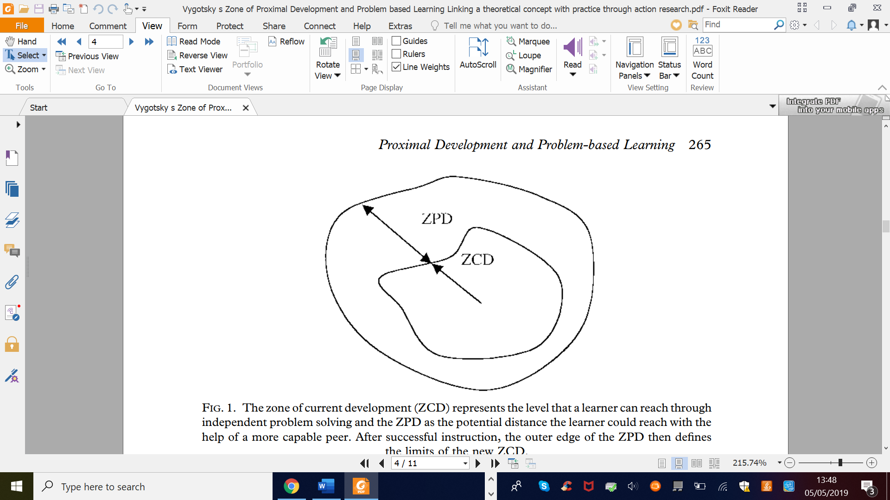
Figure 1 Vygotsky’s (1978) Zone of Proximal Development theory (source Harland, 2003)

Professionals need to have high expectations of all young people and provide advice and support to enable every child to reach their proximal development. This is through the use of what Bruner referred to as ‘scaffolding’, in order to guide young people’s thinking (Bakhurst & Shanker, 2001). In our dominant culture and society there is a lack of affirmative possibilities attached to disabled youngster’s lives (Goodley, Runswick-Cole & Liddiard, 2016, p.770). Instead, we should celebrate the abilities that can be ‘inherently found in any young person’ regardless of disability or non-disability (ibid, p.773).

2.4.10 Issues with conveying voice
Reflecting upon voice, it is important not just to consider what voice is and why it is important, but to consider how voice is conveyed in social situations. One method of conveying the voice of a child or young person is directly through first-hand perspectives, as is the case of ‘insider’ accounts discussed by Billington (2006b). One of our aims as professionals working with young people should be to ascertain how we can support youngsters to speak for themselves if they wish to do so. Another way of conveying voice is through someone else speaking on behalf of the child or young person, and this is where the notion of “being spoken for” that is studied in detail within this piece of research surfaces.

2.5 Operationalising key considerations
Consideration of the practicalities and implications of speaking for young people with autism will be explored, in an effort to ensure that we are aiming to work in a young person’s best interests. The process and mechanics of working with young people with autism is central to this study; without considering the manner and approach that needs to be taken it would be unlikely that I would elicit any data that could be explored. Billington (2006a) raises some key considerations to reflect upon when working with children:
- How do we speak of children?
- How do we speak with children?
- How do we write of children?
- How do we listen to children?
- How do we listen to ourselves [when working with children]?

This study is an attempt to operationalise these key questions that Billington (2006a) poses in consideration of best practice when working for children and young people with autism. In addition to the above questions it also considers the following question and its implications: how do we speak for children?

In order to elicit the viewpoints of young people with autism in regards to being spoken for, it is crucial to ascertain a suitable method and procedure that has considered in detail relevant ethical considerations and is methodologically fit for purpose. Research that has aimed to gather the accounts of young people with autism will now be examined in an attempt for me to present suitable approaches, methods and procedures for eliciting narratives of young people with autism.

2.5.1 Manner and approach: Listening and hearing the narratives
An issue to consider is ensuring that the participants feel comfortable enough to trust working with me as an unfamiliar adult. Attempts at minimising discomfort can be made by meeting with participants before the study commences to introduce myself and explain the research. Adapting the context to meet the needs of the child is paramount (Milton & Sims, 2016). Having some semi-structured interview prompts and use of practical activities within the interviews can help to further create a rapport with participants to feel more at ease and relaxed during the session. Visual prompts are well known as resources to support youngsters with autism in aiding their understanding and ease the pressure of relying solely on following a conversation.

My main research interest lies in exploring the viewpoints of being spoken for, as voiced by the narrative accounts of young people with autism. There is great importance in listening to young people with autism and hearing their accounts in order to help inform and shape professional practice. It seems that in order to not just listen but to hear what is said requires knowledge and understanding. As Savarese surmises, ‘the Frees [speaking people without autism] who understand me know how to hear my dear self’ (Savarese, 2010). I also feel, stemming from my personal experience as a mother of a child with autism, that there is sometimes a need to speak for young people who find social situations challenging, which are likely to be dependent upon contextual factors. However, I recognise that my viewpoints are from a dual stance as a parent and as a trainee educational psychologist. My interest lies in what Billington (2006b) refers to as ‘insider’ accounts (p.2) that can help professionals to explore the viewpoints of young people with autism and narrative as a useful way of eliciting perspective and informing professionals. Kapp (2018) reports the importance of autistic individuals having the opportunity to share ‘unique perspectives on their own lives’ (p.364).

The following studies have researched using narrative with children with autism and highlight the potential difficulties that need careful consideration and illustrate findings gathered from research in this area.

2.6 Narrative with young people with autism: pitfalls and potentials
There are a number of difficulties associated with using narrative with participants who have autism. As Carey (2008) reports, ‘the elicitation of narratives from children with autism is difficult due to their limited use of spontaneous speech and impaired pragmatic abilities’ (p.136). The following issues have to be carefully considered and taken into account when planning how to effectively elicit narratives from participants who have autism.

2.6.1 Issues of cognitive ability in research using narrative
Narrative is ‘a complex task that requires integration of linguistic, cognitive and social skills’ (Norbury & Bishop, 2003, p.288), and studies have demonstrated the difficulties in eliciting narratives with typically developing children younger than 9 years of age (see Berman & Slobin, 1994, cited in Norbury & Bishop, 2003, p.288). Evaluation is viewed as one of the parameters of narratives, and this is most likely to present as a difficulty for individuals with autism, as it involves perceptions of others’ minds to rationalise intentions and emotional states (Norbury & Bishop, 2003, p.290). With this in mind, combined with the potential various other difficulties explored in eliciting narratives from children with social communication difficulties such as autism, my participant sample will be of secondary-aged pupils to heighten the likelihood that participants will be able to reflect on past experiences of being spoken for and share and discuss these narrative accounts. My research will entail working with autistic secondary-aged students in the study whose teachers feel have the cognitive ability to reflect upon prior experiences. Their narrative capabilities may not be representative of the autistic population. However, I am not claiming it to be or striving for it to be the case. Tager-Flusberg & Sullivan (1995) found in their study that linguistic abilities and social cognitive abilities underpin narrative ability, further supporting my rationale for choosing participants who are cognitively able and thus able to reflect and share narrative accounts of being spoken for and a target sample that I can tailor methodology towards within the time and writing constraints of a doctoral thesis.

2.6.2 Issues of sample size
Eliciting the stories of young people with autism and exploring their viewpoints regarding being spoken for is my main interest to examine within this research. Adichie (2009) suggested that the problem of eliciting a single story is not that it is a false account, but that it will somewhat flatten and dampen down the human experience; this research will explore the narratives of five participants with autism in order to gain a more rounded account of the notion of being spoken for.

2.6.3 Consideration of resources that aid the elicitation of narratives
Individuals with autism respond well to contextual information being presented which supports understanding what type of narratives you are requiring and may encourage ‘trigger’ or second narratives about a topic of interest (Carey, 2008, p107). The use of themes to show and discuss beforehand with autistic child participants can help to encourage participants to tell a story of particular interest to the researcher, with pictures or a storyboard to aid understanding (Carey, 2008, p.136). Hence, my rationale for using the ‘being spoken for’ booklet in order to provide some examples that may help prompt particular narratives about being spoken for from the participants. I intend to use a booklet which details being spoken for as a theme to the beginning of our session so that the narratives elicited in the session are more likely to be related to this concept of being spoken for.

Capps et al. (2000) found that typically developing children tend to create longer stories when compared to children with autism. Their study consisted of three groups of participants: one group consisting of participants with autism, one group of participants with developmental delay and one group of typically developing children. Children with autism demonstrated limited understanding of other people’s feelings. Yet, the limited interpretations of internal affective states was not a difficulty solely experienced by those participants labelled with autism; participants with developmental delay also had this difficulty. This suggests that difficulty relating to the mental states of others it is not solely attributable to autism. Some of the participants with autism did reflect on internal states and causality of feelings, such as “the frog ate the bug and made his mouth sad” (Capps et al., 2000, p.199). Typically developing child participants that were involved in the study were able to extend their narratives compared to the other two strands of participants, suggesting that recalling narratives is a difficulty, but not one exclusive to individuals with autism. To support this difficulty, my research will incorporate prompts in order to help extend participants’ narrative accounts, as length of the narratives retold could be a potential difficulty that may arise when participants are reflecting on their previous accounts of being spoken for.

Solomon (2004) noted that ‘in the case of narratives of personal experience, thematically continuous introductions appeared relatively unproblematic’ (p.271). This suggests that introducing example stories that reflect on another child being spoken for in different social contexts and using a narrative-oriented prompt (‘can you tell me about a time…?) can help to open a thematically continuous conversation, with participants reflecting on their own situations of being spoken. It is important to note that the above study is not reflective of all individuals with autism; the research focused on higher-functioning autistic children. Individual differences in the strengths and needs of a young person would have to be considered when considering use of prompts and resources. Using resources such as a booklet and storyboard activity sheets aligns with Williams’ (1999) insider account, whereby she describes how communicating as a child, engaging through ‘communication via objects was safe’ (p.14). Williams described the interactions she had with her grandfather when she was little and how using objects rather than being spoken to directly seemed to be less anxiety inducing.

Some issues that need to be considered are the potential difficulties that participants might encounter with aspects of narrative due to difficulties in emotional literacy and imagination that are typically associated with autism. In order to account for these potential difficulties, previous studies (see Norbury & Bishop, 2003; Tager-Flusberg & Sullivan, 1995) have used ‘fixed-order’ predictable structures to their sessions and used storyboards to help elicit a story, which helped with any difficulties in imagination or understanding of an abstract idea when eliciting narratives from participants with autism. As Carey (2008), noted, this structure can be supportive for when a child with autism might be stuck for any ideas of what to say (p.136), and my research would benefit from having this resource in place in order to support participants in understanding the abstract notion of being spoken for and to give some examples before sharing their own narratives of being spoken for.

Different resources used to elicit both verbal and non-verbal forms of voice can evoke different dilemmas and barriers to young people with autism. Writing narratives can also be viewed as being more of a challenge for some young people with autism (Carey, 2008, p.139), although some participants may struggle more with verbally telling a story. For this reason, I don’t want to solely rely on either form of narrative and will ascertain with each participant how they prefer to share their narrative. If participants want to share a combination of both written and verbal forms of narrative, the resources I use to aid the semi-structured interviews are flexible to accommodate both forms of verbal and non-verbal feedback. There is a common misconception that ‘if a person is using verbal language, it follows that the person is saying what they want to say’ (Higashida, 2014, p.37), highlighting that making sounds with your mouth is not the same thing as communicating what you really want to say. Higashida (2014) believes that an individual with autism’s ‘feelings are the same as everybody else’s, but we can’t find a way to express them’ (p.39). Thus, the resources I will use (booklet, storyboards, activity sheets, narrative prompts) can elicit a combination of oral narrative and written narrative, to account for some participants’ preference for talking and other participants preferring to write down their narratives of being spoken for in order for participants to share their views. It ensures that participants are given a choice of how to respond and narrative prompts are provided in written form (Savarese, 2010).

2.6.4 Towards narratives of competence
A study focusing on strength and competence of children with autism found that participants were able to contribute to narrative discussions regarding both fictional themed narratives and reflecting on personal narratives (Solomon, 2004, p.271). Although, it has to be acknowledged that these conversations took place with family members and not with unfamiliar researchers. It also has to be noted that Solomon’s (2004) research conclusions stress that the data is not generalisable of all individuals on the autism spectrum; the study focused on the abilities of children with autism who were deemed to be ‘higher functioning’ (Solomon, 2004, p.271). However, what it crucially provides is information contradictory to what was, up until recently, the dominant held belief that all individuals with autism lack a theory of mind (ToM) and have weak central coherence (see Baron-Cohen et al., 1985, Baron-Cohen, 1989; Frith & Happe, 2005); research that has proposed that central to autism is a focus on detail, ‘an inability to think about thoughts’ and that autistic individuals appear ‘mindblind’ (Frith & Happe, 2005, p.788-9). Contrary to these deficit model-based notions put forward, narrative research asserts the notion that ‘high-functioning children with ASD are able, in certain contexts, to accommodate other perspectives’ (Carey, 2008, p.107). Imagination and empathy are seen as essential to being able to engage in and extend a narrative discourse. Research focusing on ability and strengths (see Robertson, 2010; Solomon, 2004) are helping to shift the notion of individuals with autism from a deficit lens to offering an alternative strengths-based account, using narrative as an appropriate method to demonstrate competence and ability and share the views of young people with autism. Although these abilities of imagination and empathy were initially presumed to be defunct in individuals with autism, research has demonstrated narrative capabilities of individuals with autism, with Solomon’s (2004) study reporting the proactive engagement of children with autism in narrative activities and demonstrating what can be achieved (p.271).

2.7 Dearth of research: the need for further exploration
Regarding narrative abilities, ‘there has been little work with regard to the use of direct speech in narratives produced by individuals with autism’ (Carey, 2008, p.112), hence the need for further research to look into direct accounts of individuals with autism. There is an overall lack of research that has studied the use of narrative with participants who have autism, with Smith (2008) reporting that there is also a scarcity of studies ‘using narrative to look at aspects of social cognition’ (p.16). An added predicament is that there are mixed findings from the limited amount of studies that have been carried out in this area (Norbury & Bishop, 2003, p.290), highlighting the need for more studies to be conducted in order to broaden our understanding. This dearth of research can be elucidated by the numerous difficulties associated with attempting to elicit narratives from individuals with autism.

Whilst some studies have focused on deficits and lack of ability in individuals with autism with regards to eliciting narratives, my hope is that I can offer an alternative perspective in accordance with strengths-based research (see Robertson, 2010). Whilst there seems to be associated difficulties, I feel that incorporating epistemological considerations in order to accommodate for any potential difficulties ensures that the benefits of gathering narratives of young people with regards to being spoken for can be reaped. My hope is that the findings from this study can help contribute to an increase in awareness and understanding for those supporting individuals with autism.

2.8 Summary and development of research questions
Autism is commonly associated with social communication needs, including difficulties with social interaction. Parents are cited as the main advocates for their autistic child and support them to engage socially, with school staff having a big impact on interventions delivered to increase social engagement. Research indicates that whilst there are benefits in encouraging young people with autism to engage in social interactions, the need to consider issues such as control and elements of power that can impede on any benefits is also necessary. Insider accounts provide us with first-hand perspectives regarding social interactions and help to deepen an understanding of the ways in which others can support social interaction whilst shedding light on ways in which adult involvement can also be intrusive and overwhelming. Narrative has been explored as a suitable methodological approach to elicit voice and provide crucial insight into young people with autism’s viewpoints. Resources that aid the process of eliciting narratives have also been outlined. The following are research questions that I aim to answer in carrying out this research:

- What themes emerge when young people with autism share their narratives of being spoken for?
- What feelings are reported by the participants in relation to being spoken for?
- What are the implications of the research findings in relation to informing professional practice, with particular regard to the work of educational psychologists?

The next chapter will explore my choice of methodological approach in further detail and will provide an account of the considerations I need to make in order to carry out the research in an attempt to answer the above research questions.

- Methodology

3.1 Chapter overview
This chapter comprises of my ontological assumptions and alignment of epistemological considerations in opting for qualitative methods in order to explore the viewpoints of young people with autism. It provides a descriptive account of my use of a narrative oriented inquiry (NOI) approach via semi-structured interview prompts being used to elicit viewpoints accompanied by non-verbal methods. This chapter also provides details of thematic analysis as the choice of analysis for identifying emerging themes from the data. It concludes with research considerations, providing support for my choices of data collection and analysis methods by exploring some distinctions between different methods in order to justify utilising the qualitative approach I have opted for.

3.2 Positionality
As Parker (2005) states, what we often feel is our ‘objective‘ stance can actually be ‘suffused with our own interests and fantasies’ (p.4). I acknowledge that my positionality in this research is influenced by the various experiences and identities I hold. Firstly, that of a researcher for my doctoral studies and previous research for my Masters exploring the use of the Mosaic approach in the early years (Clark & Moss, 2011). Secondly, as a mother of a child diagnosed with autism. Thirdly, as a professional working in both the UK education system and in Kuwait over the last ten years. I have personal experience of feeling the urge to speak and intervene on behalf of my own child during his social interactions, as discussed in the introduction to this thesis. I also have another very communicative child who does not have autism, which leaves me reflecting on the impact of this and whether this makes me worry more about Pup not fitting in because I compare him with my other child’s level of social engagement. It also makes me wonder if it is because I struggle to disassociate and shrug off the concept of special educational needs from the dominant discourses prevalent in our society of being less capable, or more in need of adult assistance and support (Goodley, Runswick-Cole & Liddiard, 2016).

3.3 Rationale of the research
This thesis stems from a parental narrative whereby I reflected on speaking for my own autistic son. The literature review has explored research regarding young people with autism’s social interactions and considerations when working with autistic youngsters. It has also stressed the importance of gathering viewpoints directly from young people with autism. This leads to the purpose of this research in eliciting the narratives of young people with autism on being spoken for. The research will aim to answer the three research questions presented in the literature review by analysing the data using thematic analysis in order to explore what themes emerge when participants shared their narratives of being spoken for, what feelings are reported, and the implications of these on EP and wider professional practice.

3.4 Ontological position and alignment of an epistemological approach
For the purpose of this study I have adopted a critical realist ontological stance as a framework that contains elements of positivist and constructivist ontologies whilst providing an alternative philosophical account (Fletcher, 2017, p.182). Critical realism holds the notion that the nature of reality cannot be reduced to our knowledge of reality, and epistemological understandings make up but a small part of a much deeper reality (Fletcher, 2017, p.182). The nature of society is akin to an ‘open system’, in that the very nature of the social world means we could not possibly account for all extraneous variables and there will always be reflexive and creative properties influencing situations that cannot be fully accounted for (Fletcher, 2017, p.190). Reflecting upon critical realism’s notion of the nature of reality, it seems to offer an ontological position that makes most sense to my beliefs on how we perceive ‘reality’. The ontological stance that reality will inevitably be distorted through our perceptions and all extraneous variables could not be accounted for when studying the social world as we are inherently impulsive and creative beings.

As a consequence of this ontological positionality I have ensured that my epistemological considerations align with a critical realist ontology. My stance as a researcher is to co-construct knowledge through the sessions with participants, opposing the positivist stance of participants as subjects to be studied with their needs and interests disregarded (Barnes, 2001, p.659). My research objectives are to explore and understand young people’s viewpoints of being spoken for, in order to identify any overarching themes that emerge when analysing the data thematically and consider the implications of speaking for young people with autism. As a result, my methodological approach is to use qualitative research methodologies that aim to elicit participants’ views.

3.5 Rationale for using narrative approach as a method and thematic analysis
A combination of creative resources in the form of storyboards and emoji faces alongside semi-structured interview prompts compliment my methodological intent on gathering participants’ views through a combination of aural and visual forms of qualitative data in order to elicit ‘voice’ in a more holistic sense, rather ‘a particular opinion or attitude expressed’. This is in recognition that voice can take a multitude of forms and ensured that the concept of ‘voice’ I adopt in this study is inclusive for those who find it difficult to verbally express themselves. I have also used both verbal and non-verbal methods to elicit ‘voice’ whilst recognising that voice can be both verbal and non-verbal in nature and both forms can give insight into the viewpoints of young people with autism. My prompts for the semi-structured interview sessions have been shaped by narrative oriented questioning in order to elicit the narratives of the young people I worked with during the research sessions.

3.6 Method of data collection: narrative-oriented inquiry
My research objectives are to thematically analyse participant’s narratives of being spoken for and to identify any recurrent themes in their accounts in order to formulate what the implications might be when speaking for young people with autism. I am adopting a qualitative methodology in order to explore the viewpoints of the young people that take part in my study that a quantitative approach would not be able to capture. Use of a narrative approach would ensure that participants are given the opportunity to voice their stories of when they have been spoken for, and I feel that this aligns with my research interests and research questions.

Although there is not one explicit definition of narrative, the key ‘ingredients’ are a connecting of events into a particular sequence to convey meaning and is a term used synonymously with storytelling (Riessman, 2008, p.3). Storytelling ‘plays a crucial role in almost every human activity’ (Hiles & Cermak, 2008, p.149). Stories are woven into human conversations and offer a ‘sense-making process that is fundamental to understanding human reality’ (Hiles & Cermak, 2008, p.149). As Christensen & James (2008) state, ‘the particular methods chosen for a piece of research should be appropriate for the people involved in the study’ (p.3). The reasons behind an event or an action may not be known or understood but can be explored further through the use of narratives (Hiles & Cermak, 2008, p.149). Schafer (1992) suggests that without the mediation of narrative, ‘definitive access to truth and reality cannot be demonstrated’ (p.14). In light of this, I feel that using narrative inquiry to uncover participants’ versions of their truth through narratives will uncover a narrative truth to examine, thematically analyse and reflect upon with regards to being spoken for and its implications.

Within the vast arena of narrative methods, narrative inquiry is a relatively ‘new’ approach (Hiles & Cermak, 2008, p.147). The use of narrative is seen to be beneficial both as a type research method and in professional practice (Billington, 2012, p.318). My interest is in using narrative-oriented interview prompts with the aim of eliciting the stories of young people with autism being spoken for. My aim is to capture participants’ narratives of previous times when they have been spoken for in order to capture viewpoints and offer an insight into what the implications might be when speaking for young people with autism It is ‘the experience of an event that becomes a story’ (Hiles & Cermak, 2008, p.149), as opposed to the event in itself.

NOI can be used in research as an approach to explore phenomena using psychological perspectives (Hiles & Cermak, 2008, p.147). I have opted for this methodology as I feel it is appropriately suited to structuring prompts used in semi-structured interviews that enable me to explore the implications of speaking for young people with autism. Eliciting the narratives of the participants through the use of narrative oriented prompts aligns with my critical realist ontological standpoint, as Bruner refers to narratives containing a dual landscape of the reality of actions and events amalgamated with the mental events of those being researched (Bruner, 1990, p.67).

McAdams (2015) discusses using narrative to aid discovery of a particular issue that might be a psychologically significant situation, in this case the case of young people with autism being spoken for. The process of my research is inductive, as themes identified will be driven from the data collected as opposed to attempting to fit into a preconceived existing theory. However, I also have to acknowledge that I began this research interest with ‘concrete observations of the phenomenon itself’ (McAdams, 2015, p.16) through my experience of particular social situations involving my son. This has led to the consequent development of ways of exploring this phenomenon further and expanding the initial situation involving my son to study the concept of being spoken for with five young people with autism. This experience will also undoubtedly shape how I analyse the data using thematic analysis; the method of data analysis I have opted for and the analysis that I will now detail below.

3.7 Thematic analysis
The method I have chosen to analyse my data is thematic analysis. This is a ‘method for identifying, analysing and reporting patterns (themes) within data’ (Braun & Clarke, 2006, p.79). I have selected to use thematic analysis as my analytical tool of choice in order to detect any themes emerging from the data relating to the participants’ narratives of being spoken for, with the intention of highlighting the implications regarding speaking for children with autism and how it can inform educational psychology and wider professional practice. Narrative methods analysed using thematic analysis (often referred to as thematic narrative analysis) offers a way of interpreting data by scanning across narratives to detect emerging themes (Riessman, 2008, p.53). Thematic analysis will be used after all the interviews have taken place and all data has been collected in order that all of the data is explored to detect themes that span across different sets of the data from each participant. Using thematic analysis will enable me to identify common themes between the narratives of the young people with autism when narrating their accounts of being spoken for. In particular, to identify any commonalities that provide insight into the implications arising by speaking for young people with autism. I intend to follow an explicit process of analysing the data that is collected from participants by using the steps suggested by Braun & Clarke (2006). This choice of data analysis compliments my viewpoint on research as a process, and that elements of the research will change throughout and thus reflexivity is imperative. I have found that keeping a research diary also helps to identify the decisions that I have made and the rationale for those decisions throughout the research process.

3.8 Research considerations

3.8.1 Justification for conducting qualitative research
Quantitative data may show the prevalence of young people with autism being spoken for in various social situations but would not offer insight into the implications of speaking for young people with autism and how this relates to educational psychology practice. This interest of mine in seeking understanding and meaning behind phenomena through qualitative methodologies compliments the ontological assumptions that I hold previously mentioned and justify my epistemological choice.

3.8.2 The need for reflexivity
I feel it is of great importance to adopt reflexivity as a researcher, whilst taking into account the reflexivity of the young people in the research, acknowledging that children are not passive respondents but take part in ‘actively interpreting and shaping the research process’ (Christensen & James, 2008, p.7). This is known as a ‘dual process of reflexivity’ (Christensen & James, 2008, p.6); young people will reflexively relate to me as a white, female, British researcher which has to be acknowledged as a factor that will affect the outcomes of my research.

3.8.3 Considerations of verifiability and verisimilitude
With regards to an epistemological critique, my use of a narrative methodology that is subjective in nature and using a small number of five participants will not uncover a ‘truth’ about the experience of being spoken for. However, this is not my intention. My aim is to uncover a ‘narrative truth’ or what feels true and meaningful for my participants in order to inform educational psychology practice. This relates to Spence’s work on the power behind narratives, as a story can hold a ‘narrative truth’ which can help to facilitate change (1984, p.270). I aim to explore and uncover verisimilitude as opposed to verifiability.

3.8.4 Considerations of generalisability
I aimed to choose the appropriate process and type of methodology in order to capture participants’ narratives in a way that felt veritable and representative of their views. I agree that ‘there is not one true and authentic account of children’s lives to be found, only a diverse range of accounts (Christensen & James, 2008, p.4). My epistemological stance in adopting qualitative data in the form of narratives from a small sample of young people with autism meant that the results are not generalisable to other young people with autism. However, my aim was not for my research findings to be generalisable. My belief is that it can be socially excluding to claim that there exists a representative ‘one voice’ for all young people with autism; this would further marginalise young people with autism that think differently to the supposedly representative and generalised ‘voice’ that is presented as a dominant discourse. Instead, I intended to explore the unique accounts of the young people involved in my study by gathering rich, qualitative data on the implications of speaking for young people with autism, that can help to inform EP practice.

3.9 Proposed value of my research
Narrative can be used as an evaluative tool that explores quality of provision and care by those who work with children perceived to be vulnerable (Billington, 2012, p.318). With this in mind, I hope that exploring the narratives of the young people with autism in my study helps to inform professionals on the implications of speaking for young people with autism. Specifically, to inform professionals’ and particularly educational psychologists’ practise from the perspectives of the young people involved. Using a narrative approach can offer data that encapsulates ‘pragmatic and persuasive responses to deal with life’s events’ (Hiles & Cermak, 2008, p.149). It is in this respect that I hope that the conclusions drawn as a result of adopting narrative combined with thematic analysis are able to offer practical considerations on the implications to reflect upon when speaking on behalf of young people with autism.

3.10 Summary
This methods chapter has detailed my ontological and epistemological alignment within this research in order to achieve the aim of eliciting narratives of young people with autism. It has explored the qualitative method I am using to elicit narratives and explore the viewpoints of participants in regard to being spoken for. It has provided the rationale for the use of narrative oriented prompts alongside non-verbal elicitation methods that aim to gather both verbal and non-verbal feedback in order to accommodate the social communication difficulties that young people with autism typically experience. It has provided an account of the use of thematic analysis, specifically in relation to analysing narrative data. It has concluded with research considerations in order to provide rationale for my choice in eliciting qualitative data that will aid further understanding of the concept of being spoken via narrative.

- Procedure

4.1 Chapter overview
The way in which this research is carried out in order to effectively capture the viewpoints of young people with autism needs be given as much salience as the findings that are gathered. Without having a secure procedure in place that considers how to approach the work with participants, it would be unlikely that this research would elicit any viewpoints; any data for that matter. In this next chapter, I am going to detail the particular design and stages of data collection that were shaped according to each of the participants’ needs in order for this study to collect data via a narrative methodology. It also outlines the ethical considerations that my research identified as needing significant consideration so that participants felt safe and comfortable enough to share their narratives of being spoken for. I will provide information on the target sample and recruitment of participants, along with an account of a pilot study that trialled the methods chosen, transcription details and each stage of thematic analysis I carried out. This chapter concludes with an outline of the intended dissemination of my research findings.

4.2 Research design

4.2.1 Visits to the IR
Below is an overview of all my visits and contacts with participants and staff at the IR:

Table 1: summary of IR visits
Date | Activity | Purpose
23.5.2018 | Meeting with the Head of the IR | Introduce myself to staff; explain main aims of the research; check narrative prompts were accessible for pupils; organise appropriate date to meet with prospective participants
6.6.2018 | Meeting with prospective participants and staff at the IR | Introduce myself to pupils; hand out participant information sheets to talk through; go through the ‘being spoken for’ booklet; hand out participant consent forms for participants to fill in
7.6.2018 | Parental information sheets and consent forms posted out | Parent information sheets and parent consent forms sent out for participants who consented to take part
11.6.2018 | -Meeting with Head of the IR  -Pilot study  -Data gathering sessions | Discussed the intended plan of the sessions and participants that I would be working with based on consent I had received back.  Pilot study session carried out with ‘Glass Tangy Kid’  Sessions carried out with ‘Daniel’ and ‘Red’
15.6.2018 | Data gathering sessions | Sessions carried out with ‘USA’, ‘Luke’ and ‘Cone’

These visits were organised in order to achieve a number of aims. Firstly, so that the participants and I had the opportunity to meet each other beforehand and feel more familiar with each other’s company. Secondly, so that the concept of being spoken for could be introduced a week prior to any data collection to ensure that participants were familiar with the concept I was going to ask them about. Thirdly, to enable the opportunity for staff at the IR to be aware of the details of my research aims and answer any questions they had. These visits also enabled me to meet in person with the head of the IR so that we could initially discuss which pupils she felt would be suitable for participating. Furthermore, a huge benefit of meeting with the Head prior to any data collection was that the Head coordinated the dates and timings of my research availability to the availability of each participant, which made my timings for the individual sessions shaped around the knowledge of which participant was available on what day. I carried out my pilot study and data collection sessions during the research days that we had allocated on our doctoral timetable, which spanned from 5th June to 13th July 2018. I completed the ethics application before he Easter break 2018, and ethics approval was granted (please refer to ethical approval in Appendix 7 of the Appendices section) to begin collecting data during the aforementioned research days. I was able to collect all of the data in June 2018 and this provided me with the opportunity to be able to coordinate sessions for the two participants (Daniel and Red) who were due to leave school mid-June 2018 once their GCSE exams had been completed.

4.3 Outline of the narrative-oriented interview sessions
The design of my session with each participant consisted of a semi-structured interview using a selection of narrative-oriented prompts (please see Appendix 9 or the Appendices). Within the semi-structured interview session was simultaneous use of resources that aimed to open up the conversation with participants and elicited forms of both verbal and non-verbal feedback during the interview session. These resources included the following: drawings, using storyboards to create stories, use of emoji boards and experience activity sheets. The rationale for using these resources was that these had been used and approved to effectively elicit engagement and responses from children and young people with limited or no speech in existing literature (Clark & Moss, 2011) They had been utilised as a way of gathering ‘voice’ in a multitude of forms which do not solely rely on verbal responses, which is an important aspect when working with young people with autism. A table outlining specific details of the data-gathering session held with each participant is shown below. It is colour coded to demonstrate how different tasks in the session provided data to answer each of my three research questions:

Table 2: outline of the semi-structured interview sessions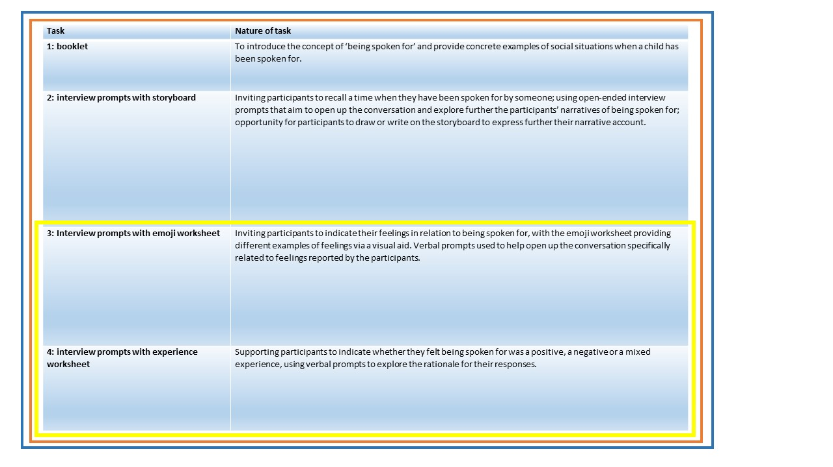

Key
Blue line: data used to inform research question 1
Yellow line: data used to inform research question 2
Orange line: data used to inform research question 3

As the table above illustrates, the data corpus was used to inform research questions 1 and 3. Data gathered specifically during the emoji activity sheet activity and the experience activity sheet activity was used to inform research question 2, as this is particularly concerned with the feelings reported by participants with regards to being spoken for.

4.3.1 Booklet
I wanted participants to have had the opportunity to reflect prior to the start of the sessions regarding the concept of being spoken for, as I feel that this had to be understood before being able to recollect and reflect upon a time when this concept has applied to their lives. In consideration of this, I handed and talked through a booklet with each participant detailing the concept of being spoken for one week before I carried out the narrative sessions. This booklet gave a definition and explained the concept of ‘being spoken for’. It provided some scenarios of a child or young person being spoken for in two different social situations in order to support participants in understanding the concept of being spoken for that I intended to explore with them in the consequent narrative sessions that were held. It also provided me with an opportunity to meet with each participant so that we had met prior to any data collection commencing (the ‘being spoken for’ booklet can be found in Appendix 10 of the Appendices section).

4.3.2 Narrative oriented prompts and storyboard task
I interviewed five participants using interviews with semi-structured prompts that were informed by a narrative approach. Firstly, I worked with participants to carry out a storyboard task in order to illustrate their narratives of being spoken for. I felt that in this sense, participants had the opportunity to recall a time when they have been spoken for through narrative prompts to elicit verbal responses and the storyboard method as an accompanying non-verbal resource to capture non-verbal feedback. The following questions were chosen to provide an opportunity for participants to be able to reflect and recall a time when they felt they had been spoken for:

- Can you tell me about a time when you felt you have been spoken for?
- Can you tell me why you think someone else spoke for you?

The above questions enabled me to collect data that I audio recorded, transcribed and interpreted using thematic analysis in order to identify any themes that emerge when young people with autism share their narratives of being spoken for. The results of this data contributed to answering the first research question; what themes emerge when young people with autism share their narratives of being spoken for?

4.3.3 Narrative oriented prompts and emoji task
Participants took part in a second task which aimed to uncover what feelings are reported in relation to being spoken for. This involved identifying feelings using emoji icons on an activity sheet (please refer to Appendix 12 in Appendices) that the participants felt related to being spoken for. The following narrative oriented prompt was asked during this activity:

- How does it make you feel when others speak for you?

The emoji board also incorporated a blank space so that participants were able to draw or write down an alternative emotion of their choice or write down a response instead.

4.3.4 Narrative oriented prompts and experience task
A third activity involved exploring whether participants thought that being spoken for was a positive experience, a negative experience, or a mixture of the two. A activity sheet with a green happy face, a red sad face, and an amber coloured neutral face were used, along with blank space provided on the activity sheet if participants wanted to illustrate their own response (please refer to Appendix 13 in the Appendices). The following prompt was asked to participants:

- Do you feel that being spoken for is a positive experience, a negative experience, or a mixed experience?
- Can you tell me why you think this?

Participants were reassured that there were no right or wrong answers to this question; that my research is interested in their own views about being spoken for. I also ensured that I pointed to the different faces as I read out the prompt so that participants understood what each face colour represented with regards to being positive, negative or mixed. I also asked participants the following final question in order to provide the opportunity for participants to add anything they felt that they would like me to include:

- Is there anything else that you would like to say?

The second and the third task, combined with any verbal feedback gathered from the task-specific prompts, were used in order to inform my second research question; what feelings are reported by the participants in relation to being spoken for? I used the data gathered from all three activities in order to inform what I believe are the wider implications relating to educational psychology practice when working with young people with autism. This amalgamation of the corpus of data gathered answers my third and final research question; what are the implications of the research findings in relation to informing professional practice, with particular regard to the work of educational psychologists?

4.4 Ethical considerations

4.4.1 Protecting anonymity
Discussing my own experience of speaking for my son who has autism evokes ethical issues regarding maintaining my son’s anonymity and right as an individual to have his information kept confidential. One measure put into place to counteract this is that my son has been given a pseudonym within this research to ensure that he remains anonymous. I feel very strongly that if I do not share my personal experience in a unique position as a mother of a child with autism and as a trainee educational psychologist in order to help shape exploration into this area, it would be a missed opportunity to help inform better practice by understanding further the implications of speaking for young people with autism. Protecting the anonymity of the participants in this study has also been considered, with each participant choosing a pseudonym that they wanted to be referred to by throughout the research.

4.4.2 Target sample considerations
My sample was carefully considered to target young people with autism who were cognitively able to understand the concept of being spoken for and able to share their narratives. Support by my fieldwork supervisor in the local authority where I was based helped me to be able to select the appropriate specialist provision for my study. I also met with support staff in the provision beforehand in order to ascertain suitable participants, preferred methods of communicating views for each of the participants and checking that the narrative-oriented prompts were developmentally apt for each participant that I worked with during the research.

4.4.3 Gaining consent
I met with pupils in the IR beforehand to explain my research using an information sheet and to gain informed consent from any pupils who wanted to take part in my research. I also liaised with the head of the IR to send out letters to gain parental consent and made sure that this was obtained for those participants who wanted to take part. Information sheets were read out by myself to participants before they made a choice over whether to take part or not. Information sheets to parents were also sent home to parents as well as consent forms (please refer to 3,4,5 and 6 of the Appendices).

4.4.4 Building rapport
My original intention was to have a familiar member of staff available to sit in during the sessions with the participants in order to provide reassurance that a familiar adult was present. However, after discussing this idea with the members of staff it was decided for me to ask each participant if they wanted a familiar adult in the room or whether they were comfortable to work individually with me, with a familiar member of staff situated outside of the room in case support was needed. Members of staff felt that each participant would be capable of working individually with me. After weighing up the advantages of having someone familiar to help participants feel more at ease against the possibility that the participants might feel less inclined to share their viewpoints if someone who they have ongoing contact with was listening to their responses. Therefore, I decided that it would be more important for participants to feel comfortable knowing that someone familiar was nearby to support if needed but had the choice to speak to me individually. When given the choice, all five participants asked to work individually with me.

4.4.5 Learning considerations
I had to ensure that I gave participants processing time after verbal prompts were given. Participants needed ample time to respond to different questions and activities in order to be able to process aspects of the session. I asked each participant whether they wanted to carry out the whole session in one go or have it broken into smaller chunks over a period of sessions to allow for sensory or movement breaks. The length of the procedure for each of my participants had to be dependent upon each participants’ individual needs, and so timings were flexible with large enough gaps between the timings of working with each participant to allow for extra processing and sensory break needs. I used a consistent and explicit procedure outlined on a visual timetable, detailing the structure of the session with each participant so that participants were reminded visually of the current task and the consequent tasks to follow. I used reduced instructions and prompts in the sessions by having a script to explain each task. This helped to ensure simple and transparent language was used throughout my time spent with each participant. I shared this script with the head of the IR before carrying out any of the sessions to confirm that the language I intended to use was accessible for the target sample.

4.4.6 The right to withdraw
I made sure that participants were fully informed and aware they could choose to opt out and withdraw from the study at any point during the session and incorporated this information into my script used at the beginning of the sessions.

4.4.7 Safeguarding considerations
I ensured that I worked in accordance with safeguarding policies and procedures within the IR, by knowing who to contact if a safeguarding issue occurred (the designated safeguarding lead) when I visited the IR after the Easter break on some informal visits.

4.4.8 Environmental considerations
My research was carried out in a calm room within the IR setting that participants were already familiar with and used for art lessons. All of the above strategies and considerations mentioned were in alliance with the existing learning, ethical and safeguarding structures already in place at the IR. This ensured that the participants were already familiar with the strategies I used in my research, ensuring that minimum disruption and upset was caused to the participants’ typical and predictable school routine.

4.5 Pilot study
The main objective of my pilot study was to trial out the various qualitative resources and narrative prompts I intended to use in order to determine whether my narrative approach was suitable. It also helped to determine whether the particular resources used (booklet, storyboard, activity sheets) worked effectively in helping to elicit views, and to ensure that they complimented my methodological approach and contributed to answering the research questions that I aimed to address. My pilot study participant was chosen after discussing with staff at the IR who they felt would most struggle in terms of being able to sit and attend to different tasks for upto half an hour. I felt that if I trialled out the methods that I had chosen with a pupil that is deemed as one who would be most likely to struggle in carrying them out it would mean that my approach would be accessible and appropriate for the other participants to be able to complete. The pilot study’s participant chose the pseudonym ‘Glass Tangy Kid’ (please see pilot study details in Appendix 14 of the Appendices section). Throughout this research the five participants will also be referred to by the pseudonyms that they chose at the beginning of their interview session.

4.6 Sample and recruitment of participants
Research was carried out at an IR in the geographical location that I have worked in as a trainee educational psychologist in the North of England. This IR specialised in meeting the needs of children and youngsters with autism. I aimed to target participants that staff at the IR felt had the cognitive ability to reflect on previous situations where they have been spoken for. I felt that this was important in order to address my research questions more so than verbal ability, as my methodological approach is inclusive of participants who may not be able, feel able or choose not to give verbal feedback. The various resources used to aid the elicitation of views ensured that participants were able to reflect upon being spoken for without their expressive speech ability being a barrier to expressing their views. Receptive language ability and the cognitive ability to reflect upon previous social situations were the crucial aspects that the participants required in order to participate, and these aspects were considered through liaising with the specialist staff who work at the IR and were aware of each of the pupils’ abilities.

The participants recruited were between 11 and 17 years of age, due to the age range that the IR accommodated for. The nature of autism as a lifelong condition also means that an individual can be chronologically older than another individual who is younger but more cognitively able to reflect on past situations. Therefore, participants being able to reflect on their experience of being spoken to was a more important consideration in this research than chronological age.

There were five participants who took part; 4 males and 1 female. All participants attended an IR in the North of England and had a diagnosis of autism and an EHCP in place to support their needs. In order for a young person to access the IR, they had to have an EHCP in place along with an autism diagnosis. The IR was adjoined to a mainstream secondary which all five pupils accessed. Each participant had a mixture of time spent in the IR and time spent in mainstream classrooms throughout their timetabled week whilst attending school. The head of the IR informed me that ideally the pupils attending the IR would spend 80% of their timetable in mainstream lessons and 20% of their time in the IR, but this was flexible to suit the particular needs of each pupil. Staff situated in the IR could also accompany pupils and remain in mainstream class to support if needed. Staff would also meet and greet pupils in the mornings and ensure they were picked up safely at the end of each school day. The IR provided life skills work, social skills groups and additional learning support if a pupil was finding a particular learning task difficult. Whilst visiting I also noticed that it provided pupils with a safe haven to return to if they were feeling overwhelmed or angry and observed how Luke returned to the IR to discuss with the staff some conflict he was experiencing with another peer. The sample of participants in this research reflected the monocultural nature of the area in which the IR is situated.

4.7 Details of the participants

4.7.1 Introducing Daniel
Daniel was 17 year-old male in year 11 attending the IR. He was in his second year of attending the IR and the mainstream school. Daniel had been held back a year at school, which made him chronologically a year older than his peers in year 11. Daniel met me during his GCSE study leave. He presented to me as initially a very anxious and shy person who relaxed and became more chatty as we met over the course of the research. Daniel preferred to express himself verbally and through writing and looked to me for reassurance and to check that I understood him throughout the session; he asked repeatedly “do you know what I mean?” and tried to explain parts of his narrative further to aid my understanding. I felt that Daniel gave a lot of careful thought and consideration to his responses in the interviews, as indicated by the amount of pausing and hesitations in his transcript. After meeting Daniel over the course of the research it became apparent to me that Daniel became less anxious as he became more familiar with me and aware of the intentions of my research, which I feel highlights the importance in meeting participants with autism before any data is collected in research.

4.7.2 Introducing Red
Red was a 16 year old year 11 female attending the IR. She was described by staff at the IR as a real “success story” as her confidence was reported to have increased dramatically since attending the IR. What really struck me about Red when I met her was her determination to do well at school and her enthusiasm to contribute to the research. She was adamant that she wanted to meet me even though she had a GCSE exam on the same day and did not want our session together to be moved. Red presented to me as a quiet youngster who really enjoyed and depended on having the staff in the IR to support her and to discuss her exams with. Red preferred to express her views through verbal response and written feedback.

4.7.3 Introducing USA
USA was a year 8 male student attending the IR. He presented to me as a confident youngster who was quick to respond in the interviews and decisive and sure of his views, with his interview only lasting 7 minutes which I feel is indicative of his fast-paced and self-assured nature. He was confident to speak for himself and reported that he felt more comfortable giving verbal feedback rather than engaging in the written or drawing tasks that were offered. USA expressed his views through verbal feedback and was eager to carry out the tasks of the interview session all in one go. I felt that he needed little prompting or reassurance, as he was very self-assured in nature and confident to share his views.

4.7.4 Introducing Cone
Cone was a Year 7 male pupil attending the IR and the youngest of the five participants. Cone presented as the quietest of all the participants, which I feel was in part due to him being the youngest combined with his difficulty in expressive speech. Through our meetings and discussions it occurred to me that Cone was the participant most in need of extra processing time and prompts to help guide the conversation, as he found it difficult sometimes to remember what question had been asked of him and often lost his train of thought. Cone benefitted from being shown the narrative-oriented prompts written down and placed in front of him to reflect upon. Although Cone had difficulty in expressive speech, he preferred to express his views verbally rather than through writing or drawing. His choice of pseudonym illustrates the need for him to have prompts to aid his thinking; he visually scoured the room we were situated in (which was an art room where the walls were covered with drawings) and chose ‘cone’ after he had spotted a picture of a cone.

4.7.5 Introducing Luke
Luke was a Year 10 male pupil attending the IR. Staff had mentioned to me prior to meeting Luke that they felt he was very able to articulate his thoughts verbally and reflect upon prior experiences. On the day of our interview session together Luke had been upset and had arrived back into the IR to talk with staff when he had been timetabled to attend a mainstream lesson. Staff informed me that he was experiencing conflict between his separated parents and this was having an impact on his ability to emotionally regulate and cope in mainstream lessons with peers.

Luke informed me that he disliked drawing and queried whether the interview session required him to draw. Once he was reassured that he could express himself verbally or through writing he was content to still take part in the research. Upon meeting with Luke and reflecting on the responses he gave, Luke presented to me as a pragmatic youngster who was able to give well-reasoned and logical arguments for the benefits as well as what he felt were the negatives of being spoken for. Luke struck me as having some similar personality traits to that of USA; confident and verbally articulate with a dislike of drawing!

  - Transcription
I rejected using detailed notational systems of transcriptions (eg Jefferson, 2004; Curtis & Curtis, 2011), as I felt that this would prove too detailed for the amount of data that I had gathered and would not be explored in-depth for the purposes of this thesis. I opted for an approach of transcribing that was a best-fit for data gathered from 5 participants via semi-structured interviews which ranged from 7 minutes to 25 minutes in length. As a result, audio recordings of the sessions held with participants were transcribed verbatim, but with pauses and murmurs included to indicate to the reader when participants paused during the session to give a sense of when participants had time to think and reflect on what they were saying. All transcripts can be found in the different sections of the Appendices in accordance with each participant (please see 15, 16, 17, 18 and 19 of the Appendices for participants’ data). I chose to include in the transcriptions the discussions held about the booklet with each participant in order to evidence that the concept of being spoken for was reiterated at the beginning of each interview. This helped to ensure for me that participants fully understood the concept of being spoken for before sharing their narratives. I decided to include my own voice during the interview sessions in order to convey the reciprocal nature of the discussions that took place between myself and participant in collaboration. It also demonstrates my influence on the sessions and co-construction of the data collected. The choice of presentation of my transcripts is with a right column to annotate and insert the coding numbers so that the reader is presented with my thought processes as I have been reading through the transcriptions and to illustrate what extracts have been used for the different codings.

4.9 Data analysis: using thematic analysis
I used a six-phase method of thematic analysis used by Braun & Clarke (2006) to analyse the data corpus to ensure that a clear outline of the procedure I adopted is evidenced. I also followed a model of thematic analysis to ensure that my research did not just state what themes emerged but provided a detailed interpretation of the data (Boyatzis, 1998). These phases of thematic analysis spanned four months in total (see Gantt chart for the research’s timeline in Appendix 2 of the Appendices). The structure of this model of thematic analysis that I followed is presented below and includes an account of how each phase was carried out within this particular research:

Table 3: Stages of thematic analysis carried out
Stage and description | Account of how I carried out each phase within this research
Stage 1: Familiarisation with the data  Researcher listens to audio recordings and reads through transcripts to generate initial ideas | Noted down initial salient features around permission and control upon first listening through the audio recordings
Stage 2: Generating initial codes  Coding interesting features across the data set in a systemic fashion | Annotations made on transcriptions (see 15, 16, 17, 18 and 19 of the Appendices for transcriptions for each participant and annotations made)
Stage 3: Searching for themes  Collating codes into themes | Photographs taken of the initial subthemes and how they linked to the themes of positive, negative and balancing factors plotted out on a thematic map using post-it notes (see Appendix 22 of the Appendices) and then typed up into a table (see Appendix 20 of the Appendices).
Stage 4: Reviewing themes  Checking that themes reflect the extracts and produce an accurate thematic map of the data corpus | A major overhaul of the themes and subthemes occurred in December 2018 after noticing that I had imposed themes onto the data rather than noticing what themes emerge. These changes are documented through photographs in Appendix 22 of the Appendices.
Stage 5: Defining and naming themes  Ongoing analysis and refinement; checking the overall story the analysis portrays and labelling themes | The refinement and ongoing changes made to subthemes and themes in my research is evidenced in the research diary (see Appendix 21 of the Appendices).
Stage 6: Producing the report  Selecting extract examples, reflecting back to the research questions and literature review to draw upon in analysis. | This phase was carried out upon writing up my results and discussion chapters and highlighting key extracts on the transcripts used to support my interpretation.

4.10 Dissemination of the results
I intend to make a distinction between not just ‘listening’, but ‘hearing’ the young people in my research (Christensen & James, 2008, p.5). I intend to hear participants’ insights that help to unravel the implications of being spoken for. I acknowledge the irony in that my attempts to explore and share young people’s narratives of being spoken for requires me to speak on their behalf through the process of disseminating the research’s findings via thematic analysis. One way of counteracting this issue could be to ensure that my discussions and presentations of my thesis also incorporate some of the participants’ responses verbatim, so that I am transferring their direct viewpoints into my dissemination to others as voiced, which will accompany identification and justification of overarching themes and the wider implications. I intend to also liaise with the staff at the IR in order to negotiate disseminating my results via a PowerPoint presentation to pupils, staff and parents once the analysis of my data has been completed, which I intend to undertake in Summer term 2019. The data disseminated will be an extracted subset of the information collected from participants in order to ensure that I act as ‘banker’ of the information collected; retaining and sharing what I deem to be valuable and inclusive-promoting data whilst balancing confidentiality aspects of the material (Lewis, 2002, p.112).

4.11 Summary

This chapter has encompassed the design and stages of data collection of this study. It has explored research considerations in relation to ethical issues the research evokes, as well as considerations regarding participant sample and recruitment. This chapter has included information on the pilot study carried out, along with information on each participant who took part in the study. It provides an account of the transcription process and use of thematic analysis. It has concluded with the intended dissemination of my results. A detailed examination of this study’s findings is provided in the following results chapter.

- Results

5.1 Chapter overview
I would like to inform the reader at this point that all of the data presented in this chapter will be discussed in greater length in chapter 6 in relation to existing literature. Research question 3 will be addressed in chapter 7 where implications for professional and educational psychologists’ practice will be explored. This chapter discusses the six themes and eighteen subthemes that emerged from the data collected in the research in order to address research question 1. This will be a commentary that presents the data in order to explain and support the themes and subthemes that have been chosen to encompass the data collected. This chapter will also present findings in relation to research question 2, detailing the data gathered in relation to the feelings reported by participants when being spoken for.

5.2 Thematic analysis overview
All of the data was firstly listened to in order to gain a sense of what seemed salient, and then transcribed and thematically analysed to address research question 1. All of the codings are illustrated on the annotated transcriptions in the Appendices section (see 15, 16, 17, 18 and 19 in the Appendices for transcriptions and annotations made). The codings were grouped into initial subthemes and themes. What struck me when I first listened to the transcriptions, before I visually looked through the transcriptions to code the data, was regarding permission sought or not sought and this has remained as a salient feature throughout the analysis of the data. Interviews ranged from 7 minutes to 25 minutes in length. After transcribing the data gathered from the interviews, further themes emerged from the data when visually reading and sorting through the transcriptions and making notes of anything that struck me as important. Codings annotated onto the transcription papers were consequently written onto separate post-it notes and arranged into groupings of themes and subthemes on a wall in my house. This presentation of the thematic maps acted as a working document that was adapted numerous times, and I arranged the post-its in the home so that I could frequently reflect and swap the post-its about with immediate effect when an idea struck me which influenced where I wanted to position a post-it. The subthemes and themes changed over the course of four months. A detailed account of the changes made and rationale for the changes can be found in the Appendices section (see Appendix 21 for the research diary and Appendix 22 for photographs of thematic maps to illustrate any changes made).

Below is a finalised overview of the themes that emerged when data collected was analysed using thematic analysis to answer research question 1:

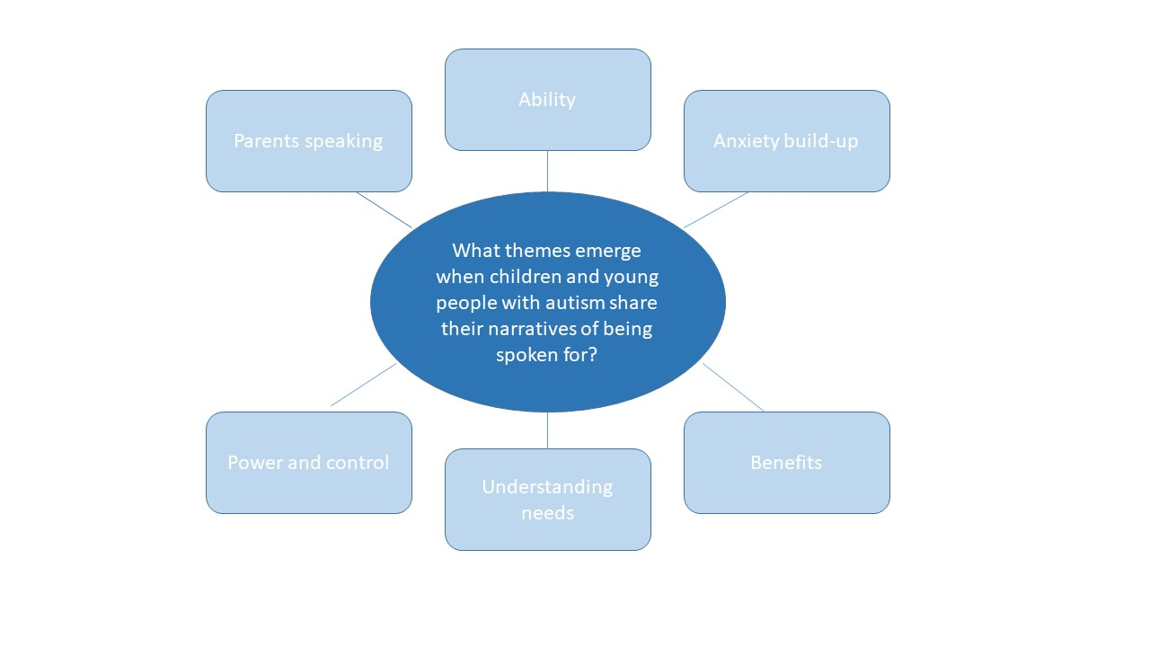
Figure 2 Thematic map of the data gathered
An illustration of the 56 codings, eighteen subthemes and six themes can be found in the Appendices section (please see Appendix 20 of the Appendices), along with a research diary account that details the rationale for the grouping of themes and subthemes that I chose to reflect the data (please see Appendix 21 of the Appendices).

5.3 Theme 1: parents speaking

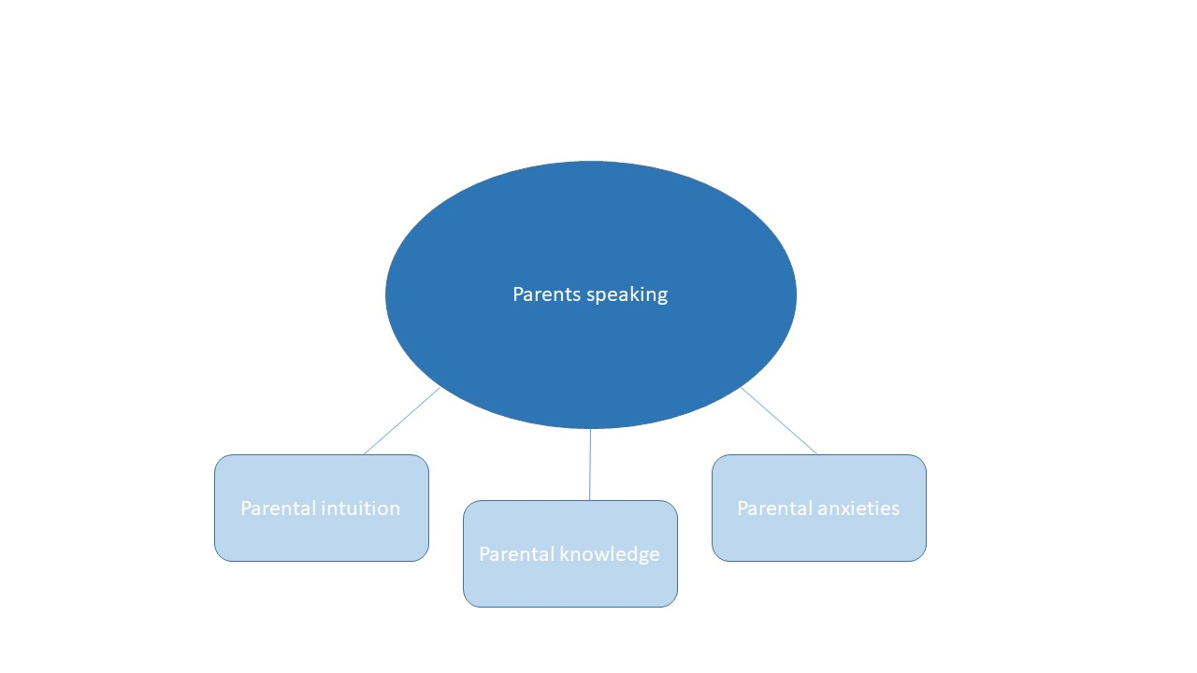
Figure 3 Thematic map of theme 1

Parents speaking emerged as a theme, as all five participants discussed parents speaking on their behalf during the interviews, as evidenced in the transcripts (parents speaking coding number 1). When participants discussed parents speaking on their behalf, three subthemes were evoked; parental knowledge of autism, parental intuition and parental anxieties.

5.3.1 Parental intuition
Daniel discussed that in regard to his mother, “she’s always expected that I’ve had autism and stuff from a very early age before I was diagnosed with it” (Daniel, coding 24 ‘parental intuition’), which relates to parental intuition and parents being attuned to detect the needs of their child. This also indicates how parents are often perceptive of their child’s needs before a diagnosis of autism is necessarily made, indicating a needs-led form of support is crucial rather than a diagnosis-led system. Cone described how his parents have always helped to speak on his behalf, as he has a “hard time thinking of what to say” (Cone, coding 24 ‘parental intuition’). When Luke was asked what people around him have done throughout his life to help him achieve speaking for himself so much, he replied “trusting me to make the right decisions, and such…my mum realises that I have to fend for myself” (Luke, coding 56 ‘parental trust’) indicating that the degree of trust may be linked to levels of control that parents exert over their child.

5.3.2 Parental knowledge
When discussing his mother, Daniel noted that “she knows me a lot so…mmm she would know a lot of stuff about me and my worries and stuff like that” (Daniel, coding 16 ’parental knowledge’). This suggests that parents possess an emotional intelligence about their autistic child and can sense when anxiety is heightening.

5.3.3 Parental anxieties
When discussing his mother speaking for him, Daniel reported the following, “my mum, she’s not very, like, very…let’s just say she’s not very good at me trying new things…worries I think is the right word” (Daniel, coding 6 & 7). Daniel also commented that “She really…tends to take, maybe, sometimes, she takes a lot of things I would do or feel or say to heart” (Daniel, coding 7). These extracts provide an insight into the anxieties experienced by parents of children with autism and implies that parents can often experience anxiety over the same aspects of new experiences and changes that their child endures.
5.4 Theme 2: ability

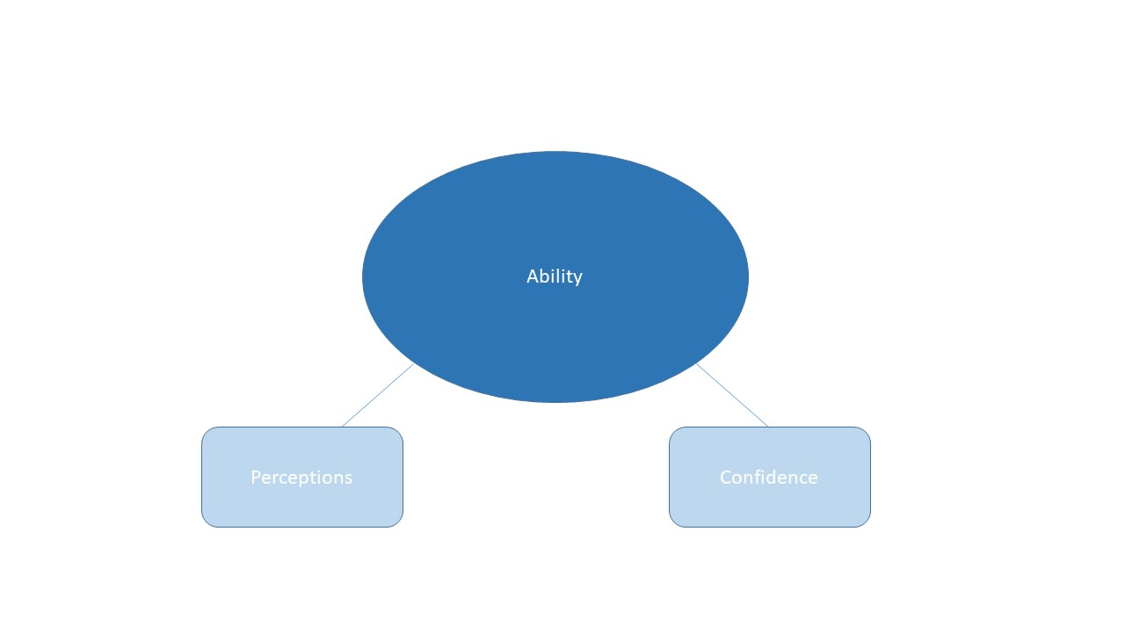
Figure 4 Thematic map of theme 2

Ability has been chosen as another theme, with the findings for this theme and the accompanying subthemes presented below.

5.4.1 Perceptions
When asked for the reason why his mum had spoken for him, Daniel replied “cos I’m like an only child and stuff” (Daniel, coding 15 ‘family dynamics’), indicating that he perceives this to have had an impact on his ability to speak or has been a factor exerting an effect on the relationship dynamic between himself and his mother.

When discussing positive aspects of being spoken for by his mother, Daniel commented that his mother understands and knows him well, adding that “I wouldn’t want to be the one saying it as I wouldn’t know how to phrase it and stuff” (Daniel, coding 25 ‘perceived ability to speak for self’). This is in stark contrast to USA’s high perceived ability to speak for his self; “I’m never really spoken for cos I’m comfortable speaking to people” (USA, coding 25 ‘perceived ability to speak for self’). When asked if those around him spoke for him, USA said “they don’t support me in speaking in any way. I just speak like I say, I can speak fine for myself really” (USA, coding 25 ‘perceived ability to speak for self’). Cone recalled a narrative of his speaking ability when he was younger, stating “I didn’t really used to talk cos when I was younger…when people said hello to me and that, I couldn’t say it, I didn’t, like, say it” (Cone, coding 48 ‘ability to speak). Sharing current perceptions of his ability to speak, Cone commented “I have a hard time thinking of what to say” and seemed to struggle during some parts of our session together to verbalise his answers without extra prompting and providing prompts in written format. Cone commented that he finds being spoken for a mixed experience, although stated that it is positive when he doesn’t know what to say. These findings suggest mixed perceptions of ability to speak for self as reported by participants.

Daniel recalled a time when he was trying to assure his mother of his own abilities. He narrated a previous conversation where he said to his mother “listen you can go I’m alright. Enough. Seriously” (Daniel, coding 11 ‘assuring others of one’s abilities’). This highlights the importance of confidence and self-assuredness on the part of the child or young person in order to attempt to shift others’ perceptions of one’s ability.

When asked if there were any situations when Luke did not feel able to speak for himself, he replied “when it’s trying to break bad news or something I prefer other people to do it, but that’s just a very human thing to do” (Luke, coding 54 ‘normalising tricky situations’). This implies the need to check-in with young people taking part in difficult and sensitive social situations, even if the child or young person generally speaks for themselves.
5.4.2 Confidence to speak
USA expressed confidence in his own ability, commenting that “I’m comfortable speaking to people” and “speaking doesn’t bother me. If I’ve got something to say then I’ll say it, it doesn’t bother me really” (USA, coding 44 ‘confidence to speak’). This implies that the confidence to speak your own views to a range of different people in a variety of contexts is a more important factor than the diagnostics of a label determining whether you have the capability of speaking for yourself or not. Luke was also a participant who seemed very self-assured in his own ability to speak in various situations, commenting “I can speak for myself” (Luke, coding 44 ‘confidence to speak’) and preferred to share all of his narrative verbally rather than writing or drawing to express past times when he had been spoken for. USA reported, “I won’t keep my opinion back on something. So no matter what everybody thinks I’d let them know and that sort of thing” (USA, coding 44 ‘confidence to speak’ and 46 ‘sharing opinions irrespective of others’). This suggests that confidence to speak your mind may be entwined with the level of concern you have for the thoughts of how others perceive you, and that USA felt confident to speak his mind as a result of not being particularly concerned with what others think of him as a result.

5.5 Theme 3: anxiety build-up

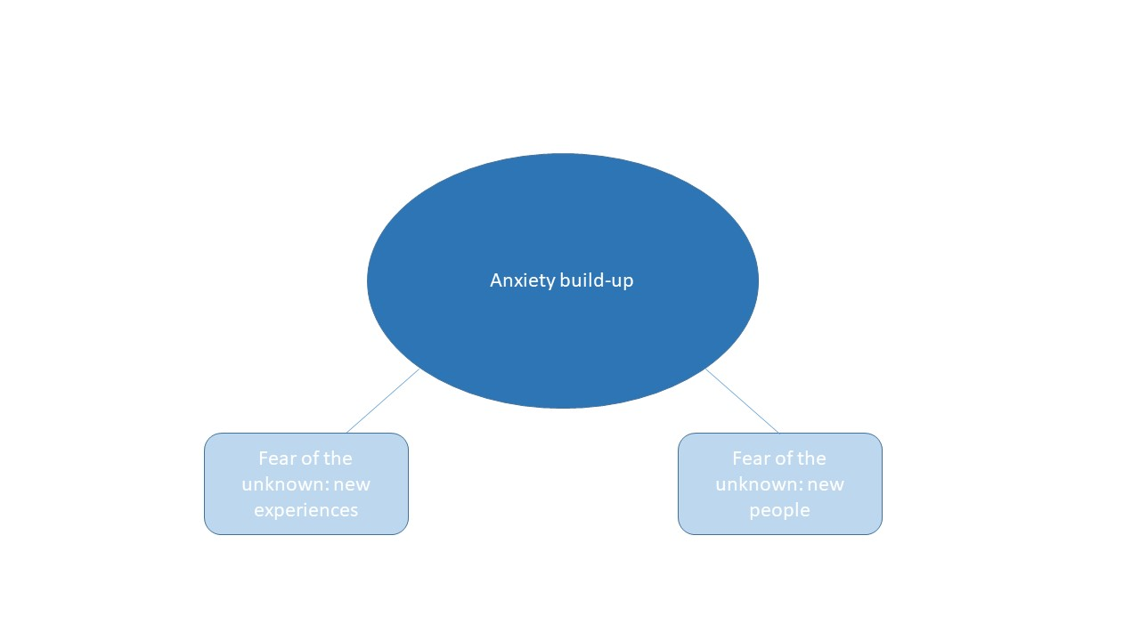
Figure 5 Thematic map of theme 3

Anxiety was identified as stemming from two particular fears of the unknown: new experiences and new people.

5.5.1 Fear of the unknown: new experiences
Red was asked if there were any particular situations where she did not feel able to speak for herself, and she replied “just places that I haven’t been in before…just new surroundings” (Red, coding 4 ‘the unknown: new experiences’). When discussing his first time attending a concert, Daniel reported, “it was my very first one erm I was excited and as the day hit kind of I went nervous” (Daniel, coding 4 ‘the unknown: new experiences’). The issues for Daniel in particular were not knowing whether he was going to be seated or standing, which contributed to his nervousness. Daniel recalled that “I think with this being a new experience, which, still I’m not very good at and I’m in a room filled with people I don’t know” (Daniel, coding 4 ‘the unknown: new experiences’). Knowledge of rules and rule flexibility seemed to be important factors for Daniel, whereby he recalled that at the concert there was “many strict rules” (Daniel, coding 12 ‘rule flexibilities’). As a result, his mother spoke on his behalf to a security guard in order to ascertain whether he could leave at any point during the concert. A fear of getting lost in unfamiliar places emerged as another anxiety-inducing issue, with Daniel recalling himself and his mother getting lost in the stadium at the concert and “I was kind of…err…embarrassing for me” (Daniel, coding 18 ‘fear of public embarrassment’). Daniel, upon describing all of the anxieties that build up in a new situation or around new people, explained how “it all just bundles up into one…into this like one massive problem” (Daniel, coding 27 ‘snowball effect’). This evokes the notion of different anxiety-inducing elements having a ‘snowball effect’ and the sum of anxiety being greater than its parts, which implies the need to break down a child or young person’s thoughts into separate issues that are contributing to their heightened anxiety.

Red explained that she dislikes speaking during EHCP review meetings, as she reported “in case I say something wrong” (Red, coding 40 ‘fear of making mistakes’). This worry over making mistakes needs to be considered when thinking about how we can support young people with autism to practice making mistakes in a safe way and use forms of intervention that explore their thought processes around making mistakes.

5.5.2 Fear of the unknown: new people
Daniel expressed concern regarding what other people think, commenting; “I don’t know if they’re, like, contemplating “ahh, that’s a weird thing to like” and stuff like that” (Daniel, coding 20 ‘fear of others’ perceptions’). In addition to what people might think or react is the fear of what unfamiliar people might say that can lead to anxiety. When asked to explain why he had circled ‘shy’ as a feeling when being spoken for, Daniel rationalised “mainly cos it’s new people, erm, and cos I just don’t know how they would react or feel and stuff” (Daniel, coding 22 ‘fear of the unknown: new people). When discussing speaking in front of professionals at school for an EHCP review meeting, Red also expressed discomfort in speaking in front of unfamiliar people, stating that “I don’t really like speaking for myself in those meetings…if there’s some people in there that’s not, that’s not, that I’m not comfortable with” (Red, coding 39 ‘speaking in front of unfamiliar people’). There also seems to be a fear in reduction of choice and issues of being denied by another at play when considering social engagement with unfamiliar people, with Daniel explaining “it’s…the denial of another person? Cos I don’t like, I don’t really like the word no” (Daniel, coding 26 ‘reduction of choice’).

5.6 Theme 4: power and control

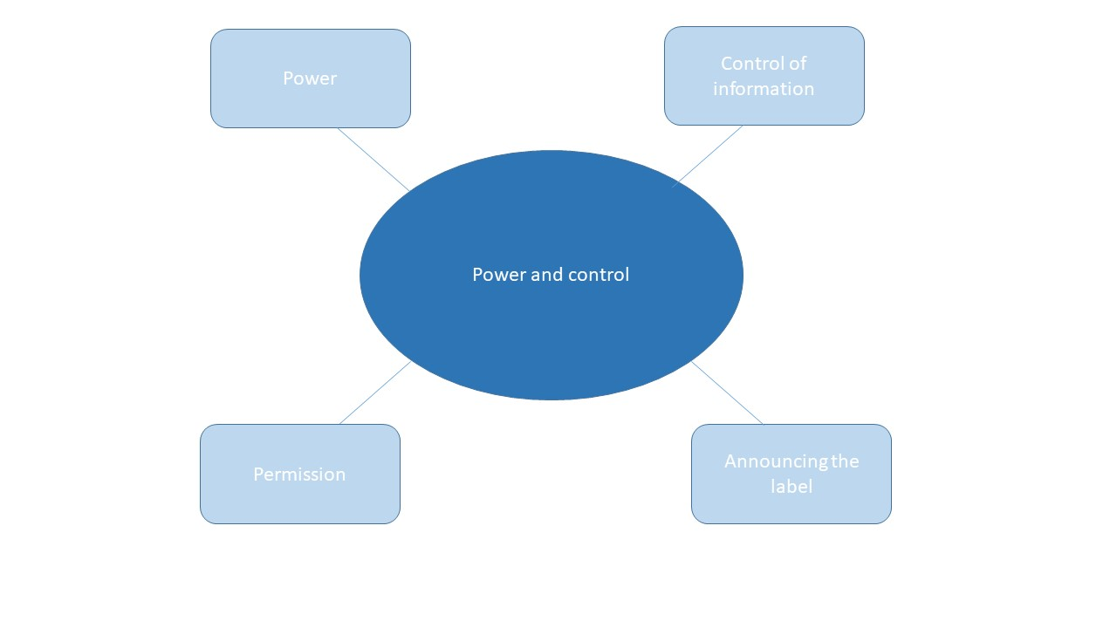
Figure 6 Thematic map of theme 4

5.6.1 Power
Daniel narrative recalled how, at a concert, “me and my mum came to an agreement where, like, she would come in with me and she would wait til, she would basically bring me in and sit me down and stuff” (Daniel, coding 5 ‘negotiating with the speaker’), implying a power displacement in social situations where child competes against their parent for power and increased autonomy and may become more salient as an individual with autism gets older. During our session together, Daniel reported the following of his mother; “she knew I was alright but she like stayed, if you know what I mean?...it got to the point where I had to tell my mum “I’m alright you can go” and she wasn’t really going” (Daniel, coding 10 ’parents letting go’). This raises the need for increased autonomy and support in becoming more independent to occur as a child with autism matures.

In contrast to Daniel’s narrative, Luke depicts how a change in power dynamics has taken place as he has got older, discussing how “for the last four of five years of my life I’ve been very independent. I used to be wrapped in cotton wool, that sort of thing. But it’s got to the point now when my mum realises that I have to fend for myself” (Luke, coding 6,7 and 56). This evokes a positive narrative of parents being able to let go and give power back to their child and foster independence and trust with their child, as opposed to the more controlling and anxious antics that Daniel described of his mother not leaving him when requested to.

USA described how, in regards to someone speaking for him; “if I was there and they knew I could speak then, yeah, I wouldn’t exactly be happy with it” (USA, coding 45 ‘controlling the situation’). USA explained that there are exceptions to someone speaking for him, adding that if the person gave a reason and didn’t butt in rudely when he is speaking then he reported being happy with this. This extract implies that USA would feel power was being stripped away from him in a social situation and that an undermining of his ability to speak for himself would occur if someone spoke on his behalf without any justification for doing so.

Cone described how being spoken for is a mixed experience, as it can be positive when he doesn’t know what to say. However, he described a situation once whereby he “was going to say something and then they just start[ed] talking, not all the time, but it’s happened sometimes, I don’t know, and they just started talking for me’ (Cone, coding 45 ‘controlling the situation’) and circled the unhappy feeling in response to how this situation made him feel. This highlights the need to ensure young people with autism are given ample processing time to speak for themselves and for professionals to endure what might feel like an uncomfortable silence in order to provide opportunities for child voice to be shared.

5.6.2 Control of information
Daniel described how his mum spoke for him to a security guard during a concert and described her antics as “going off…and saying a lot of things and I was like “mum, I’m okay seriously”” (Daniel, coding 13 ‘sharing too much’). Daniel reported feeling anxious that his mum “might say things a little bit too much” (Daniel, coding 13 ‘sharing too much’). Daniel also shared that being spoken for can make him feel embarrassed, explaining that, “it’s like I meet them [new people] for a couple of seconds and then all of a sudden they know, like, that I have like, autism” (Daniel, coding 13 ‘sharing too much’). When discussing being spoken for, Daniel reported “they know the stuff that I like and don’t like, and I don’t even know anything about them, and it’s like…whoah” (Daniel, coding 19 ‘unbalanced information sharing’). The above extracts imply a feeling of loss of control in social situations and a sense of helplessness relating to an oversharing of personal information.

Daniel discussed how he feels his mother can sometimes overshare incorrect information to the extent “where it might be wrong, for example, it’s like “no mum it’s not really like that” and stuff” (Daniel, coding 21 ‘fear of misinformation), and added that he gets “more kind of afraid or anxious about what my mum or anyone would really say erm, in case like they got it wrong” (Daniel, coding 21 ‘fear of misinformation’). This extract highlights that some information shared when being spoken for could also be viewed by the child as incorrect and not representative of their views. This stresses the need to check-in with young people when sharing information regarding them to ensure that they feel it represents them.

Red discussed how her mother would inform the hairdressers of her difficulties, adding that “she usually just tells them in, like, private” (Red, coding 36 ‘sharing information privately’). Red felt that this tactful sharing of information led to unfamiliar people having a better understanding of her needs. This extract demonstrates the salience of the context when speaking of or for young people with autism. The importance of context when speaking for young people with autism will be explored further in the discussion chapter and when exploring the implications of the findings in regards to professional and EP practice.

5.6.3 Permission
Luke mentioned “there’s been times before when I’ve been asked something and someone has spoken for me and I’ve got annoyed” (Luke, coding 45 ‘controlling the situation’). Daniel reported that permission was not sought by his parent when speaking for him. Luke also commented that he finds being spoken for a mixed experience, adding that he would find it negative “if I hadn’t been asked, if I haven’t asked for someone to speak for me” (Luke, coding 14 ‘permission not sought’) but would be fine with it if there was a rationale for being spoken for.

Red recalled a time when a member of staff at the IR asked Red before an annual review “do you want me to speak for you?” (Red, coding 34 ‘Asking for permission’). Red discussed how she had found this approach by a familiar member of staff to be really helpful, as she felt uncomfortable speaking in front of people that she did not know in the meeting. Red reported feeling surprised as a result, “cos I’ve not been expecting for her to that really” and when asked if this was a positive or negative, Red added “no erm it’s a good surprised” (Red, coding 34 ‘asking for permission’).

These extracts suggest that there are factors to seeking permission to speak for young people with autism that are important to consider; firstly seeking permission and secondly by ensuring the youngster is aware that you are available to speak on their behalf if they request it so that choice is offered.

5.6.4 Announcing the label
Daniel described how his mother informed others about his autism, explaining how she commented “oh you know my son’s autistic” (Daniel, coding 8 ‘announcing the label’). Daniel discussed his feelings of anxiety in this particular recount of being spoken for, with worries of oversharing and misinformation being two salient fears as a consequence of his mother speaking on his behalf. “it’s like the second when I meet someone…all of a sudden they know, like, that I have like, autism, and they know the stuff that I like and don’t like, and I don’t even know anything about them, and it’s like…whoah” (Daniel, coding 8 ‘announcing the label’). This narrative of being spoken for was accompanied by a reported feeling of embarrassment for Daniel.

Red shared a positive narrative of how she felt her autism label helped to increase understanding. Red described how, whenever she goes to the hairdressers, her mother is aware “to tell them that I’ve got autism so that they understand” (Red, coding 37 ‘label providing rationale’). When asked if she felt that people knowing of her autism was important, Red replied, “sometimes people think why do I do stuff, so when people know that I’ve got it [autism] then it makes it a bit more better for them to understand” (Red, coding 37 ‘label providing rationale’ and 38 ‘autism awareness’). This feels distinctly different from Daniel’s narrative of his mother announcing his autism to the security guard, which evoked connotations of oversharing, loss of control and a fear of misinformation. Alternatively, Red here is depicting the label of autism as a way of increasing awareness and provides a more tactful way of a parent sharing their child’s difficulties to increase understanding and acceptance of their child’s needs.

5.7 Theme 5: understanding needs

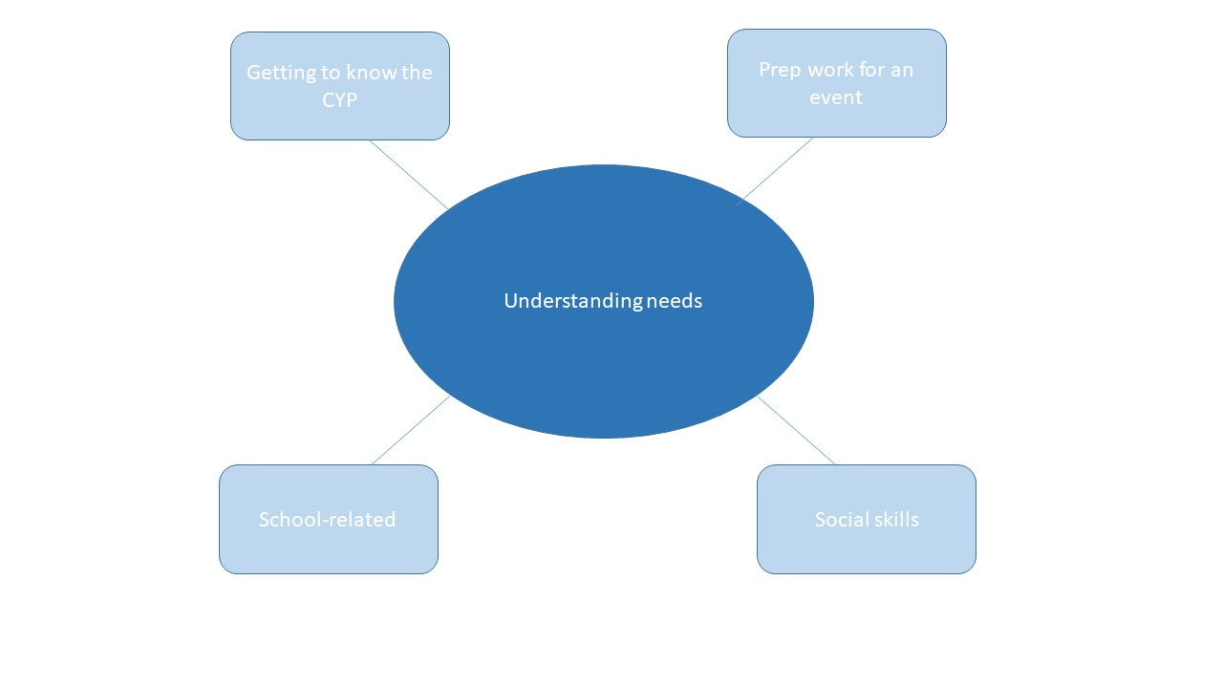
Figure 7 Thematic map of theme 5

5.7.1 Getting to know the child or young person
Cone reported feeling happy when someone speaks on his behalf, explaining “they try and think of what I say, like, try to think of what I would say” (Cone, coding 31 ‘views’). Daniel also described how “it would really help if we had kinda like a talk and everything just to get to know me and stuff so that way they would know my likes and dislikes and…could avoid saying something that I might not, erm, might not be something I agree or disagree with and stuff” (Daniel, codings 29 ‘getting to know the child or young person’, 30 ‘interests’ and 31 ‘views’). These extracts suggest the need for professionals to gather an understanding of the young people’s views and interests that they work with.

Daniel explained in his narrative how his mother “can really see if I’m nervous” (Daniel, coding 17 ‘detecting feelings’), and is able to detect his anxiety heightening; “I think she really did know I was anxious about stuff” (Daniel, coding 17 ‘detecting feelings’). This highlights the emotional intuition that parents and those supporting young people with autism develop and are attuned to. It also provides further support in the importance of professionals getting to know the young people with autism that they support.

5.7.2 Prep work for an event
When discussing what people can do to help Daniel speak for himself, he commented that “if it’s going out somewhere, erm, beforehand it would really help if like we had kinda like a talk” (Daniel, coding 28 ‘prep work for an event’). Red also discussed how her teachers support her to go through some prep questions before annual reviews, stating “we usually do it in like a one-to-one session and then we usually do it in the meeting so then I can get my point of view across as well” (Red, coding 28 ‘prep work for an event’), supporting the notion that discussing new situations beforehand and completing prep work enables youngsters to encounter new situations and share their views in social encounters they find difficult to speak for themselves.

5.7.3 School-related
Red described a narrative related to meetings that take place in schools, such as annual reviews for her EHCP. Cone also reflected upon a situation in primary school in his narrative of being spoken for, recalling how he had attended a meeting with his parents and how his teacher had asked him a question and his parents had to speak for him. Participants recalled narratives relating to school as well as social situations that occur outside of school, which highlights the prevalence for young people with autism being spoken for across different social contexts.

5.7.4 Social skills
When asked what people could do to help Red speak for herself, she replied “probably just social skills and stuff. Like, games and stuff, socialising in groups, yeah” (Red, coding 42 ‘social skills with peers’). Cone describes how his parents were heavily involved in teaching him social skills, commenting that “when people said hello to me and that, I couldn’t say it…my parents had to teach me and tell me “say hello” and that” (Cone, coding 49 ‘teaching of social skills’. Participants spoke positively about the teaching of social skills, highlighting the importance and need to ensure that social skills development is incorporated into the school curriculum using resources and interventions that the child or young person with autism reports as appropriate and beneficial.

5.8 Theme 6: benefits

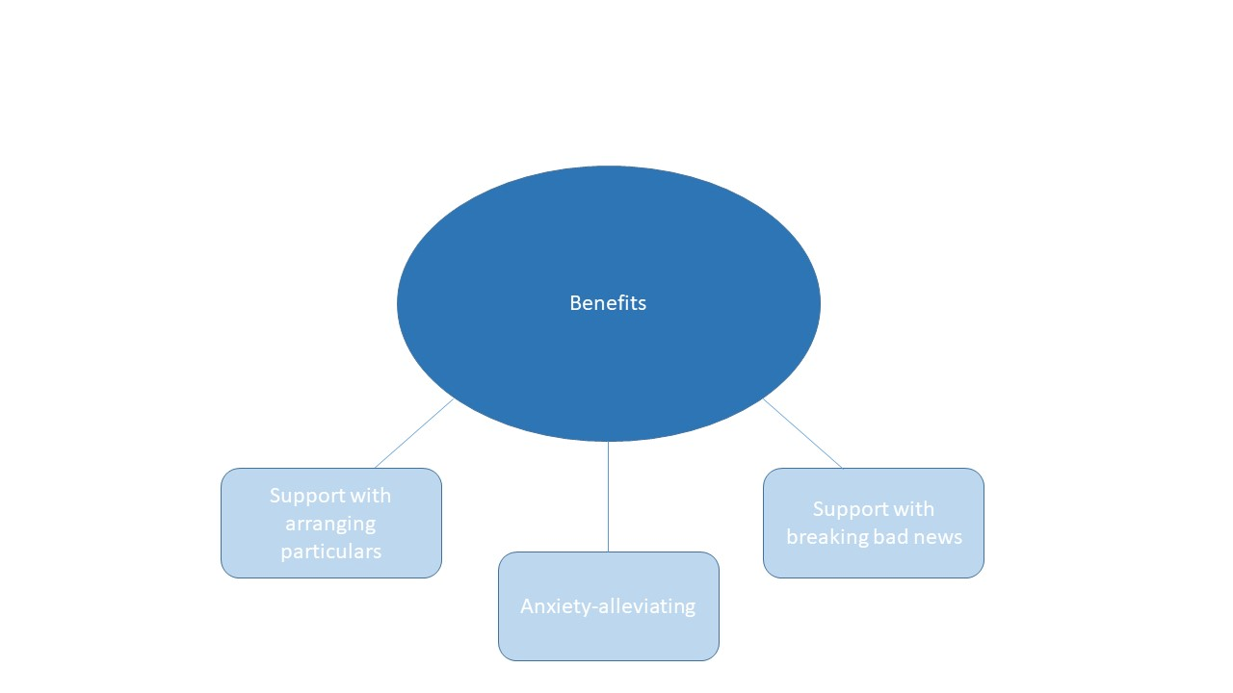
Figure 8 Thematic map of theme 6

5.8.1 Support with arranging particulars
Luke shared a narrative regarding organising the practicalities of meeting his dad. He asked his mum “how about you talk to him and sort it out, and tell me cos then I’d prefer it that way”, and that his mum speaking on his behalf to his dad is “easier, it’s not cos I can’t, it’s just easier an better being said to one person than to two” (Luke, coding 51 ‘parents: sorting out practicalities’). This extract depicts Luke as confident and able to utilise his parents in order to speak for him when arranging events to make it an easier process for him. Luke explained, “I’d ask for someone to speak on my behalf. It’s incredibly rare for someone to speak for me without me asking for them to speak for me” (Luke, coding 52 ‘asking someone to do the talking’).

5.8.2 Anxiety-alleviating
Daniel reported being spoken for as a mixed experience, explaining that with regards to the positives, “it kind of eases my stress or worry about, erm, like for doing things for example” (Daniel, coding 23 ‘anxiety alleviating’). Red reported relaxed as the most pertinent feeling for her when being spoken for, explaining “cos then you have the pressure of speaking taken off you” (Red, coding 23 ‘anxiety alleviating’).

Luke commented that although he speaks for himself across different social contexts he would find it beneficial for someone to speak for him if he had requested it, adding that “if someone was to speak to me in that context, then it’s happy” (Luke, coding 35 ‘grateful for being spoken for’). Luke’s extract implies the importance of choice in being spoken for as being the determining factor, adding that “if someone spoke for me and I didn’t ask to be spoken for then it would be different” (Luke, coding 14 ‘permission not sought’). This highlights the importance in requesting permission and seeking whether the child or young person wants to be spoken for or not beforehand. This also provides choice over being spoken for or speaking for self.

5.8.3 Support with breaking bad news
Luke mentioned a few contexts that he finds difficult to speak in, and whereby someone speaking on his behalf would be of benefit. In particular, he discussed having to break bad news to people as really hard, commenting “I’d prefer other people to do my dirty work, yeah” (Luke, coding 55 ‘dishing the dirt’). Luke made a very interesting comment when discussing sharing bad news, commenting “I prefer other people to do it, but that’s just a very human thing to do” (Luke, coding 53 ‘being the bearer of bad news’). This extract resonated with me as being very poignant; Luke demonstrating an awareness of the shared difficulties of being human and not difficulties encountered exclusive to having autism. This also highlights the needs of all the children and people that we work with, irrespective of differences, to be supported in having their views shared and being given the choice to be spoken for in social situations where they feel they cannot.

5.9 Feelings reported
Research question 2 is also addressed in this chapter by exploring the feelings reported on the emoji activity sheet and through verbal feedback from participants when discussing being spoken for. This was in order that the study examined both the themes that emerged through narratives as well as the feelings reported in relation to the notion of being spoken for. Responses from the activity sheets and verbal feedback are illustrated below.

5.9.1 Results for the emoji activity sheet
The data used to address this aspect of the study was collected through participants’ responses whilst undertaking the emoji activity sheet activity (both verbal and non-verbal responses). Verbal responses can be found as highlighted sections within the transcriptions in the Appendices (please see 15, 16, 17, 18 and 19 of the Appendices). Completed emoji activity sheets have also been included in the Appendices section as forms of non-verbal views elicited from the participants. Four out of the five participants completed the emoji activity sheet; USA did not want to fill in any activity sheets and preferred to feedback verbally instead. Below is an overview of the feelings reported on the emoji activity sheets and verbal responses given when participants were asked how they feel when someone else speaks for them:

Table 4: Daniel’ responses for the emoji activity sheet
Feelings reported on activity sheet | Verbal responses
Embarrassed | “I’m not closed off. Like, I’m very open and stuff. But, erm, it’s like the second when I meet someone if you know what I mean? It’s like I meet them for a couple of seconds and then all of a sudden they know, like, that I have autism, and they know the stuff that I like and don’t like, and I don’t even know anything about them, and it’s like…whoah”
Worried | “I don’t know if they’re, like, contemplating, “ahh, that’s a weird thing to like” and stuff like that so… I do really take things, erm, about other people and stuff, and like I start worrying about it”
Afraid | “afraid would be like me, err, feeling that maybe for example that my mum might go on too long, if that makes any sense? Like, she erm she might say things a little bit too much, to the point where it might get…where it might be wrong”
Shy | “mainly cos it’s new people, erm, and cos I just don’t know how they would react or feel and stuff…I think that’s mainly it”

Table 5: Red’s responses for the emoji activity sheet
Feelings reported on activity sheet | Verbal responses
Relaxed | “it’s just a bit, like, cos then you have the pressure of speaking taken off you”
Calm | “probably just the same as relaxed really…the pressure being taken off speaking”
Surprised | “a bit surprised that someone’s said to me, asked me if I want them to, say Miss [name removed] has asked if she is going to speak for me I’ve been surprised cos I’ve not been expecting for her to say that really, that’s what I mean…a good surprised”

Table 6: USA’s responses for the emoji activity sheet
Feelings reported on activity sheet | Verbal responses
Not applicable (didn’t fill the activity sheet in) | “I’m never really spoken for cos I’m comfortable speaking to people”  “if I was there and they [the speaker] knew I could speak then, yeah, I wouldn’t exactly be happy with it”  “Unless they gave me a reason why and didn’t butt in rudely then yeah I’d be fine”

USA did not feel that he had any particular situation to reflect upon when he had been spoken for, and reported, “I speak for myself anytime, anywhere really”.

Table 7: Cone’s responses for the emoji activity sheet
Feelings reported on activity sheet | Verbal responses
Happy | “because, erm, I don’t know what to say, and they try and think of what I say, like, try to think of what I would say”
Unhappy | “when I was going to say something and then they [speaker] just start talking, not all the time, but it’s happened sometimes, I don’t know, and they just started talking for me”

Table 8: Luke’s responses for the emoji activity sheet
Feelings reported on activity sheet | Verbal responses
Happy | “if someone was to speak for me in that context [referring to his mum speaking on his behalf] then it’s happy. But if someone spoke for me and I didn’t ask to be spoken for then it would be different”  “very happy, cos I’ve asked for it”
Annoyed | “I’d get kind of annoyed. Cos they’d be speaking for me even though I can speak for myself”  “so like there’s been times before when I’ve been asked something and someone has spoken for me and I’ve got annoyed”

A detailed exploration of these responses and how they fit with the rest of the data is included in the discussion section.

5.9.2 Results for the experience activity sheet
Participants were asked to consider whether they felt being spoken for was a positive experience, a negative experience, or a mixed experience of both positives and negatives. I wanted to include this aspect to the research, as although this is not an experiential piece of research that can examine feelings and experiences in-depth, I still wanted to ensure that there were no ambiguities to the narratives told. Including this information into the research enabled me to check with participants whether they felt the concept of being spoken for was a positive, negative or mixed experience overall. This also prompted participants to reflect on other accounts when they have been spoken for, giving me a further insight into the situations when being spoken for might occur and participants’ viewpoints in relation to these situations. Three out of the five participants completed the experience activity sheet; USA preferred to verbally respond and explain rather than write anything down. Luke preferred to talk through his response for this aspect of the study as well. The responses were as follows:

Table 9: Daniel’s responses for the experience activity sheet
Experience reported on activity sheet | Verbal responses
Mixed | “Well, ill start off with good. Erm, it kind of eases my stress or worry about, erm, like for doing things. Cos that person, let’s say it’s my mum, she knows me well enough and personally I could really, I wouldn’t really be worrying about it all that much, cos, again, she knows me a lot…she would know a lot of stuff about me and my worries and stuff like that…it would release a lot of stress out of me because I wouldn’t want to be the one saying it as I wouldn’t know how to phrase it and stuff”  “negative, it’s just the worry. Cos I get a lot of, I have like a lot of thoughts and stuff, like a lot. So I always kinda go “what if they get it wrong?” or “what if this, what if that?”. There’s lots of “what if?” thoughts that go through my head, so, err that makes me more nervous and anxious where it kinda creates a possibility where what happens if they get it wrong”  “just the thought or worry about what the other person is going to say…it all just bundles up into one…into this like one massive problem”

Table 10: Red’s responses for the experience activity sheet
Experience reported on activity sheet | Verbal responses
Mixed | “probably because then some things…it depends…so some things I might want Mrs [name removed] to say but for some things I might not want her to say, because it might not be in the right context that I, that I want it in”

Table 11: USA’s responses for the experience activity sheet
Experience reported on activity sheet | Verbal responses
Not applicable (didn’t fill the activity sheet in) | “If I was there and they knew I could speak then, yeah, I wouldn’t exactly be happy with it. Unless they gave me a reason why and didn’t butt in rudely then yeah I’d be fine”

USA reported that he would find it quite a negative experience for someone to speak on his behalf as he is comfortable speaking for himself, unless he felt there was justification for them to do so.

Table 12: Cone’s responses for the experience activity sheet
Experience reported on activity sheet | Verbal responses
Mixed | A positive experience “when I don’t know what to say”  A negative experience “when I was going to say something and then they [speaker] just start talking, not all the time, but it’s happened sometimes, I don’t know, and they just started talking for me”

Table 13: Luke’s responses for the experience activity sheet
Experience reported on activity sheet | Verbal responses
Not applicable (didn’t fill the activity sheet in) | When asked about his narrative of being spoken for, Luke reported it as a “positive experience”  When asked about other situations he reported “probably negative, if I haven’t been asked, if I haven’t asked for someone to speak for me…so like there’s been times before when I’ve been asked something and someone has spoken for me and I’ve got annoyed”

Luke reported both positive and negative experiences; positive when Luke has asked someone to speak on his behalf and negative if someone had not asked him for permission to speak for him.

5.10 Summary
The results chapter has provided an overview of the data collected in the sessions with all five participants. It has provided an account of the codings that were assigned during the thematic analysis process, and the corresponding grouping of codings into subthemes and themes. Feelings reported by participants in regards to being spoken for have been illustrated. Participants’ responses as to whether they felt being spoken for was a positive, negative or mixed experience have also been displayed. Further exploration of the results, including how they fit into existing literature, is provided in the next chapter.

- Discussion

6.1 Chapter Overview
This chapter will explore the data in greater length in relation to how it fits with existing literature in the field of autism research. This chapter also includes an examination of the results gathered and a reflection on the research’s main aims. It concludes with addressing how the data gathered has informed research questions 1 and 2. I would like to point out to the reader at this stage that an address of research question 3 can be located in the final chapter of this thesis. This is where an in-depth exploration of the implications of the findings for professionals and specifically in relation to educational psychologists to consider are detailed.

6.2 Theme 1: parents speaking

6.2.1 Parental intuition
The way in which participants spoke of their parents’ intuition regarding their needs from a young age links with Hutton & Carron’s (2005) research. This study reported that parents of children with autism have often had serious worries about their child’s needs from very young, but often experienced being referred onto other professionals. Parents were often told either to stop worrying or to return at a later date if difficulties continue, which delayed an earlier diagnosis and exacerbated parental anxieties. As the research suggests, professionals that work in the autism diagnostic process need to consider how to deliver diagnostic information to parents in order to lower parental stress and increase acceptance of their child’s needs. This research also highlights the importance in listening to parents about their child and acknowledging the wealth of knowledge parent have.

Results indicate that parental intuition can be a positive and supportive factor, although care needs to be taken to ensure that parents are mindful of the ways in which their involvement in their child’s social interactions can be helpful and ways that it can have a detrimental effect. The parental anxieties and power imbalances that Daniel shared in his narrative demonstrates that parents can have a detrimental impact when speaking on behalf of their child that can outweigh the positive contribution that parents can make to social situations.

6.2.2 Parental knowledge
Daniel’s narrative elucidates how parents often have a wealth of information and understanding of their child’s needs and emotional states. Kohler (1999) reported how parents tend to be aware of the extensive knowledge they have of their own child and believe that their opinions and expectations of their child should be given more regard and salience than school staff. As Ivey (2004) highlights, parental knowledge is sometimes undervalued and underappreciated, and ‘although parents are expected to play a supporting role in the schools’ efforts, many times they receive little support themselves’ (Ivey, 2004, p.27). Family members should be seen as crucial to their child’s educational process (Ivey, 2004). What is important is that professionals seek to work in partnership with parents to gain an insight into their child’s lives (Starr & Foy, 2012). These studies combined with the research’s results highlight the importance in parents as partners within the education system in order to share their wealth of knowledge and understanding of their child’s abilities and needs.

6.2.3 Parental anxieties
Parental anxieties seemed to stem from parents’ perceptions of the degree of need to speak on their child’s behalf. This coincides with what Reed et al. (2017) found in their study; parenting stress can have a pervasive effect on mothers’ perceptions with regards to their child’s range of abilities and the judgements they make (p.957). Parental stress and parental perceptions of a child’s ability are interrelated; where parental stress is heightened can increase the likelihood of the perceived ability of their child with autism to be lower (Reed et al., 2017). This may explain why parents that are more anxious about their child with autism might be more likely to speak on their behalf and struggle to let go and allow their independence, as Daniel reflected upon in his narrative. Parenting stress can also have a self-fulfilling effect on a child with autism’s learning ability, as parental stress ‘can impede the child’s social and emotional skills and communication ability (Reed et al., 2017, p.952). What I feel is not clear is how parental stress impacts on a child with autism’s social and emotional skills and communication ability; whether the correlation is directional or bi-directional warrants further study.

Parental anxieties resurfaced throughout the sessions with the participants, suggesting that young people with autism are very perceptive to their parents’ anxieties. Calder et al. (2013) found that parents often feel conflicted over the degree of involvement they should have in their autistic child’s social interactions. Jardine (2008) reported that ‘it appears that for some mothers the experience of having a child with autism is relatively more stressful than for others’ (p.32), and this includes parents of children with almost any other forms of disability (Reed et al., 2017, p.952). This study seems to suggest that anxieties are more prevalent in parents of children with autism, which alludes to the need for greater societal awareness of the pressures that parents of children with autism face and how anxieties can be alleviated for family members.

Higher parental anxieties reported in the narratives seemed to correlate with negative experiences of being spoken for and strains between the child or young person and their parent. Sivberg (2002) found a negative correlation between a family member’s level of coping and the level of strain within a family system (p.406). It is important to note that this study emphasises how the source of strain in families of a child with autism is not solely as a result of the child’s difficulties, but from a range of external factors, such as lack of resources and specialist facilities and lack of support from professionals knowledgeable of the difficulties of autism (p.397). Factors that can affect the level of anxiety experienced by parents can be a range of social and environmental factors and not attributable to one main cause. As Willis (2007) reports, parental stress is ‘multi-faceted and linked to features of the coping environment, the individual and the experience itself’ (p.34). Parents of children with autism feel more responsibility and the need to be more involved in their child’s lives (Bauminger & Shulman, 2003). Added responsibilities parents face on an ongoing basis can be ‘struggling with educational choices, such as continuum of services, related services, educational settings, and interventions’ (Ivey, 2004, p.27), which are systemic factors that also need to be considered as having an effect on parental anxiety levels. Sivberg (2002) stressed the importance in parents enhancing their positive coping mechanisms in order to lower the strain experienced (p.406). However, I feel that rather than reflecting on a within-parent problem that needs to change, the study highlights for me the need for systemic change to improve societal awareness and access to support from appropriately trained professionals (Higgins et al., 2005) in order to ease the burden of strain on families of children with autism.

6.3 Theme 2: ability
Ability emerged from the data with regards to both parental perceptions of ability as well as the participants’ assessments of their own abilities and confidence in speaking for themselves. Perceptions and levels of confidence differed between participants, possibly due to autism being such a wide spectrum of abilities and skills. Autism can be described as a ‘cloudy constellation of uneven skills’ (Kapp, 2018, p.364), as opposed to the linear spectrum it is often described as, due to the impact of environmental factors such as appropriateness of support and quality of social experiences that can all exert an effect on ability. What is also important is a promotion of the strengths and competencies of autistic people (Robertson, 2010; Sinclair, 2010).

6.3.1 Perceptions
Daniel recalled being an only child as having an impact on how he has been brought up and perceived by his mother. Willis (2007) suggests that ‘the position of a child within a family can impact on their personality and development’ (p.36). The data suggests that as parental perceptions of ability are lower, the perceived need to speak for the child or young person are greater. Kasari & Sigman (1997) note that ‘it seems likely that caregiver perceptions as well as actual child behaviors [sic] influence caregiver interactive behaviour’ (p.40), with interactions being dominated more by caregivers if parental perceptions of their child’s ability are lower. This may have an impact on the child’s perceptions of being able to speak for themselves independent of adult support.

Parental perceptions of their child’s ability seem to have a great impact on the long-term successes of the child. As Ivey (2004) notes, ‘parental expectations determine many aspects of a child’s education’ (p.27) and heightening parental perceptions of their child can influence the child’s future outcomes and quality of life positively. This would indicate that increasing parental perceptions of ability could have a beneficial impact on the child or young person’s successes. Calder et al. (2013) reported the pressure reported by parents to make their child seem ‘normal’ to others. The solution to this issue would be for professionals to help support parents in identifying strengths and capabilities of the child as well as offer solutions to any issues faced (Robertson, 2010). Parental perception of ability is a factor that professionals need to acknowledge and aim to heighten when working with parents of children with autism.

All of the above points allude to perceived social self-efficacy of the child, as first described by Bandura (1977) and consequently researched a vast number of times by Bandura with many others (see Bandura & Pallak, 1982; Bandura et al., 2003). Self-efficacy is the notion that ‘people process, weigh, and integrate diverse sources of information concerning their capability, and they regulate their choice behaviour and effort expenditure accordingly (Bandura, 1977, p.212). The findings also evoke for me the notion of growth mindset coined by Carol Dweck and attempts to shift thoughts on ability from a fixed to a growth mindset should be considered by parents and professionals supporting young people with autism.

6.3.2 Confidence to speak
Increased confidence seemed to link with the two participants who were used to speaking for themselves in social situations (Luke and USA). It is unclear whether confidence has increased as a result of Luke and USA being used to speaking for themselves, whether their higher confidence has led to them speaking for themselves or whether these factors are bi-directional in nature. The findings raise the question of whether more opportunities to speak for themselves have been available for the more confident participants and whether parental trust and support to increase independence skills is also deemed to be higher in Luke and USA’s parents. Wood (2018a) stresses the need for adults to ensure that children and young people with autism are given ample processing time to respond in a conversation, which in turn will support confidence to speak. Increased confidence was also linked to the two participants (Luke and USA) who stated a preference for verbal feedback rather than non-verbal responses, supporting the need to ensure both verbal and non-verbal methods of eliciting voice are made available in research carried out with young people with autism.

6.4 Theme 3: anxiety build-up
Studies have shown that autism and anxiety are co-morbid; yet it is unclear whether autism ‘causes’ anxiety, or whether the loss of power and control that is often experienced by autistic individuals makes it more likely that their feelings of anxiety are exacerbated by their feelings of helplessness and unpredictability in situations. The theme of anxiety evoked in this research coincides with Savarese’s account of the crippling and debilitating effects that anxiety has on the ability to communicate (Savarese, 2010), and suggests that being exposed to social interaction and becoming familiar can help to lessen the anxiety experienced.

6.4.1 Fear of the unknown: new experiences
Daniel’s recall of the fear of making mistakes in novel experiences links to the following account; Higashida (2014) describes the issue of making even a tiny mistake as ‘a massive deal, as if Heaven and Earth have been turned upside down’ (p.64). There is an awareness of the knowledge that making a mistake is not a big deal, but feeling that it is impossible to keep extreme emotions that accompany making mistakes contained. The notion of new situations building on anxiety levels and having a snowball effect that Daniel alluded to correlates with ‘Karen’s’ account in Sainsbury’s (2000) book, as she reflects that ‘at school and at home, the stress would build up and I would explode. Classic case of the straw that broke the camel’s back’ (p.120). I feel that this links to what is often referred to as ‘meltdowns’ that are experienced by individuals with autism, and the key message for professionals is to explore how we can punctuate this escalation of anxiety build-up before it reaches crisis point.

Williams (1999) describes from an insider account how breaking from routine would feel really overwhelming, adding that it was one thing to ‘drift without direction when one was in total control. It was another thing altogether to break with an established routine to take up an invitation I’d had no part in making even if it was just for one day’ (p.172). This implies that the feeling of a loss of control and uncertainty adds to the build-up of anxiety experienced in new experiences for the young people with autism. The final chapter will explore in more detail how we as professionals can help young people with autism cope with change in a less anxiety-inducing way.

6.4.2 Fear of the unknown: new people
Daniel’s narrative raised connotations of denial by another person. I feel this resonates with the idea of a loss of control in a situation previously discussed in the ‘new experiences’ subtheme above. It evokes a sense of lack in being able to control others. My ontological stance is that as autonomous entities we are all unpredictable and this might seem daunting for those who seek control and find change and unpredictability daunting. My assumption is that this would seem to be more evident when we first meet unfamiliar people, as we have no previous knowledge of them to be able to predict how they are likely to behave towards us. A point to explore further in the final chapter is how professionals can make the experience of meeting new people feel less daunting and more predictable for young people with autism. I will also reflect on some of the strategies I used during my first meetings with the participants at the IR in order to attempt to minimise the anxiety experienced by meeting me as an unfamiliar person.

Daniel’s reflections of his anxiety about what a security guard thought of him demonstrates in my opinion cognitive empathy and evidence of a ToM, which contradicts all of the autism research into a lack of ToM in individuals with autism (see Baron-Cohen et al., 1985; Baron-Cohen, 1989; Frith & Happe, 2005). Daniel’s account suggests that, contrary to past research into ToM deficits, Daniel is demonstrating here an overthinking of social situations which leads to anxiety build-up. This would suggest young people with autism not necessarily lacking the ability to relate to other people’s feelings but can paradoxically assume a habit of overthinking when encountering social situations and meeting new people.

Williams (1999) explained that when she is confronted with new people and novel situations she resorts to letting others do the talking for her (p.173), particularly when confronted by people intent on talking and greeting. As professionals, being aware that young people with autism may be more likely to seek out others speaking on their behalf in novel situations is something that needs to be considered. Supportive adults could ensure that they are available to speak on a child or young person’s behalf when novel situations arise that the youngster feels unable to speak for themselves in.

One implication of the anxieties caused by the unknowns presented above is how can we make situations more predictable and feel safer for young people with autism so that new people and new environments are less anxiety-inducing. The reality is that we cannot always predict what people will say or what happens during a social encounter, but we can help prepare for events and different social situations. The final chapter will examine further what we can do to make situations feel more predictable and feel safer for individuals with autism. There seems to be a negative correlation between the level of power and control the child or young person has in a situation and the level of anxiety build-up. All participants’ anxieties and insider accounts could be linked to a loss of control in a situation and a power displacement occurring, which will be explored further in the next theme.

6.5 Theme 4: power and control

6.5.1 Power
The extract from Daniel (coding: ‘letting go’) demonstrates that despite Daniel insisting that his mum left, she continued to stay against his wishes. The power dynamic occurring in that particular situation feels to me like that of an over-domineering parent, possibly connected to the anxieties that are experienced in supporting independence and trusting the child to make their own decisions as they get older. Kasari & Sigman (1997) reported that ‘caregivers of autistic children may perceive their children as more difficult temperamentally than other children and therefore, use greater control strategies with their child’ (p.41). Parents of children with autism are also more likely to exert physical control of their child from a young age, such as holding them onto their lap whilst playing in an effort to maintain focus of attention (Kasari & Sigman, 1997, p.40). I suspect that as a child grows up, physical control is no longer deemed socially acceptable but more implicit forms of control over social situations are still sought after and implemented by parents in an underlying attempt to protect. Although researchers such as Calder et al. (2013) stress the need to listen and acknowledge the insider accounts of young people with autism (p.297), I feel that the actions of what a youngster with autism may report to be an overprotective parent could be explained by parents of young people with autism often feeling that supervision and a greater element of control is necessary. I feel that there is a tension experienced between a parent’s intuition of their child’s needs and vulnerabilities versus aiming to foster their independence. What could easily be perceived as controlling behaviour may be rooted in parental intuition and in an underlying aim to keep their youngster safe.

Cone reported feeling unhappy in a situation whereby he was about to speak for himself, and in the time it took for him to respond others spoke for him. I feel this account resonates with Higashida’s (2014) description of the difficulties faced when trying to reciprocate conversation; ‘when there’s a gap between what I’m thinking and what I’m saying, it’s because the words coming out of my mouth are the only ones I can access at that time’ (p.33). This suggests that we need to give youngsters with autism the opportunity and processing time to think and speak for themselves. It evokes the notion of uncomfortable silences and ‘bad sorts of quiet’ (Wood, 2018b, p.15) and that as a society we feel anxious when someone does not automatically respond in a conversation. Higashida (2014) discusses how ‘the words we want to say and the words we can say don’t always match that well’ (p.33) and that ‘by the time it’s our turn to speak, the reply we wanted to make has often upped and vanished from our heads’ (p.33). He suggests that the most unhelpful thing for other people to do at this point is to bombard with further questions. Professionals need to allow ample thinking time after asking a question to give the opportunity for the child or young person with autism to respond rather than trying to fill in the void with further questions that can hinder thinking and consequent sharing of views (Wood, 2018a).

Higashida’s (2014) insider account regarding difficulties with conversations reports that ‘I have no problem reading books aloud and singing, but as soon as I try to speak with someone, my words just vanish’ (p.15), suggesting that it is the social element which adds to a child or young person’s ability to speak for themselves. In her insider account as a young person with autism, Williams (1999) described how for her, ‘words were no problem, but other people’s expectations for me to respond to them were’ (p.11), which alludes to a pressure to conform and how expectations from others greatly affects a child or young person’s ability to speak for themselves in social situations. This extract caused me to reflect back on my personal narrative with my son and how my expectations of Pup responding back to a social encounter led to an urge to direct the situation. I feel that this was in order for Pup to fit in with my expectations of him responding back to others, but could potentially have the opposite impact of my desired response. Reflecting on Williams’ account, my expectations may hinder his ability to respond back by exerting pressures and expectations on him. Adults often feel compelled in equipping a child or young person with autism with social skills (Calder et al., 2013). Although social skills support has its benefits, the control elements need to be considered. Billington (2006a) discusses the prevalence of adult control in society, added with the additional struggles for autonomy that individuals with SEND encounter (Sivberg, 2002), and this struggle for more freedom is particularly pertinent during adolescence. Professionals have to ensure that encouraging social skills is balanced with the rights of the child or young person stated in Article 12 to have a choice and a voice in matters affecting them (UNICEF, 1989). This balancing act is something I will consider in more depth in the final chapter, as I feel it is something professionals need to consider when supporting young people with autism.

Williams’ (1999) insider account discusses how the frustration of wanting to but not being able to communicate felt for her; ‘the anxiety of my inner battle was becoming unbearable. I could say words but wanted to communicate. I wanted to express something. I wanted to let something out’ (p.24). Communicating for her in a way that she wanted to express felt so much more important than just verbally responding. This suggests that young people may need the processing time to respond the way that they feel most meaningful and we need to be comfortable with what might feel an uncomfortable silence in order to give the opportunity to speak and respond for themselves meaningfully. As Wood (2018) highlights, autistic individuals can feel puzzled over what they perceive to be non-autistic people’s need to fill in silences and engage in “fluffy chat”, which some autistic participants in her study reported as seeming meaningless and something they did not feel the purpose of engaging in (p.263). It is also important to ensure that the solitude a child or young person with autism may be seeking is allowed for (Bauminger & Kasari, 2000). Reflecting upon my personal narrative, I feel that the notion of non-response is really salient for me as a parent of a child with autism, and one of the main reasons why I felt the need to verbally bridge the silence gap during that particular situation involving another child. I feel that a shift in thinking of silence during conversations from an uncomfortable non-response to a thinking and processing time opportunity would be beneficial. This shift in perception would help allow a child or young person with autism to gain an opportunity to respond themselves and voice their views. Processing time will be explored as a suggestion in the next chapter for professionals to consider when conversing with young people with autism.

Sainsbury (2000) discusses how autistic children taking control in situations can only be made possible if adults supporting the child are able to teach them self-understanding of their autism. A young person with autism learning how others might perceive their behaviour is crucial so the youngster is ‘able to begin to develop their own creative solutions to the problems they may come across, instead of being perpetually dependent on others for help’ (p.127). It suggests that parents who do not encourage this self-awareness and acknowledgement that difficulties faced are genuine can often attempt to protect and shield a young person from exposure to difficult situations. This could prevent the young person from self-awareness, self-understanding and increases the likelihood of ongoing difficulties in developing independence and control; all crucial parts of development during adolescence (The National Autistic Society, 2018b). Parental intuition was considered in a positive manner by participants but needs to be balanced with parents letting their child increase their independence skills and encouraging them to be pushed out of their comfort zones. An increase in independence was also linked to an increase in confidence for the participant to speak for their self.

6.5.2 Control of information
Daniel’s account of his mother oversharing information suggests that an imbalance of information can leave a child or young person with autism feeling exposed and vulnerable. Contrastingly, Red spoke about her mother discreetly speaking to staff working at a hairdressers so that they were aware of her autism and felt that this was helpful for them to understand and be able to rationalise her behaviour as a result. As Red explains very clearly when discussing whether being spoken for is a positive, negative or a mixture of experiences, “it depends…so some things I might want Mrs [name removed] to say but for some things I might not want her to say, because it might not be in the right context that I, that I want it in” (Red, coding 41 ‘striking the right balance’). This highlights that context is key. Without consideration of the appropriateness of information shared with regards to context or listening to the wishes of the child or young person an imbalance of power and anxiety build-up is likely to occur, which is particularly salient during the developmental stage of adolescence when heightened anxiety and conflict with parents is most likely to occur (Arnett, 1999, p.317).

6.5.3 Permission
Participants reported how lack of permission sought to speak on their behalf led to feelings of annoyance, unhappiness and an overall negative experience as a result. USA commented that he “wouldn’t exactly be happy with it” if the speaker knew that he preferred and was able to speak for himself. Luke spoke about how “if someone spoke for me and I didn’t ask to be spoken for then it would be different” and described him feeling annoyed as a result. Cone discussed how when he was going to say something “and then they [speaker] just start talking” and that this has resulted in a negative experience for him. This notion of gaining permission evokes elements of a loss of control and a limit on the choice to speak. Red shared an alternative narrative, whereby her teacher asked if she wanted to be spoken for in a meeting; Red reported feeling surprised and relieved as a result of being asked for permission and given a choice whether she wanted to be spoken for or not. This highlights the need for professionals to gain permission and ask youngsters if they want to be spoken for or supported to speak for their self.

6.5.4 Announcing the label
Upon exploring the narratives of the participants with regards to their autism, it seems to me that there is not one clear picture of the benefits or setbacks that the label of autism holds, and it is subject to the individual experience of all of those who are diagnosed with autism. I feel it necessary to point out that it is not the purpose of this thesis to explore whether I feel the use of a diagnostic label is positive or negative, but rather to acknowledge that there are individuals diagnosed with autism and use the data collected to inform professional practice when working with young people with autism. The following explores the findings gathered in regards to the participants’ autism diagnosis being shared with others.

Red raised how announcing her autism to people can help to explain what she finds difficult and helps to explain her behaviour. This relates to the recent neurodiversity movement whereby autistic individuals publicly announce and celebrate their autism. Neurodiversity is the term referring to the movement taking place in an attempt for autistic individuals to state autism as a part of their identity (Kapp, 2018, p.362). Higashida (2014) discusses how he has sometimes imagined ‘what it would be like if everyone was autistic. If autism was regarded simply as a personality type, things would be so much easier and happier’ (p.16). This indicates how a societal shift into the perceptions of autism as being a difference in personality or thinking (Robertson, 2010) is starting to become more dominant, as opposed to a deficit medicalised model that has been the existing dominant discourse in the UK upto recent. Donna Williams (1999) speaks of the effort to try and ‘fit in’ with societal expectations of social interactions, whereby she adopted a persona she called ‘Carol’, who ‘spoke to people’ and ‘learned to talk at people’ (p.27). Carol ‘could act relatively normal. Smiling, sociable, giggly, she made the perfect dancing doll…In the meantime, Donna had disappeared’ (p.25). This loss of identity by trying to meet expectations of interacting with others demonstrates the cost at stake in pushing young people with autism into ‘acceptable’ means of conversing and for me highlights the importance in celebrating difference and neurodiversity in society.

It seems that to announce a child or young person’s label of autism or whether to keep that information private is a complex matter which depends on the way in which the label is announced, and context again seems to be the key. The most important factor to consider when sharing information about an autistic individual is firstly to gain permission whether the individual wants that information to be shared. Other important factors allude to what is shared, who we share the information with, and an awareness of avoiding oversharing or providing inaccurate information. Another important aspect to consider is how we deliver information to young people about their autism and support them to understand how autism affects them. This is a significant issue to consider during adolescence when young people are likely to become increasingly aware of difference and are becoming more self-aware (Arnett, 1999, p.317), often citing the need to belong (Deckers et al., 2017, p.828). Striking the balance between all of these factors and taking context into account is crucial; what might seem an appropriate place to share information about a child or young person with others in a confidential space may not be appropriate in an open and public space. In the final chapter, I will discuss how professionals should consider these contextual issues when considering what information to share, discussing a young person’s autism and speaking for, of or with young people with autism.

6.6 Theme 5: understanding needs

6.6.1 Getting to know the child or young person
Daniel’s comments suggest that having support that consists of people who are knowledgeable of his needs and potential difficulties and can pick up on feelings in different situations can best help to support him. Kapp (2018) states how research should aim to identify how best to support youngsters with autism ‘to holistically understand their strengths, differences, and needs in an affirmative way that empowers them to constructively face their challenges’ (p.364). Being supported to self-understand ‘is vital if a child is to take control and learn how to manage and work around their problems and make the best use of their strengths’ (Sainsbury, 2000, p.127). So, it seems that in addition to staff getting to know child or young person is the simultaneous process of self-awareness that needs to occur, so that self-awareness of one’s autism and self-help in social situations are promoted.

Higashida (2014) provides an account on the importance of intuition by others in order to be what he describes as a ‘better friend’ (p.16) to a person with autism. As Higashida explains, ‘You can’t judge a person by their looks. But once you know the person’s inner self, both of you can be that much closer’ (2014, p.17). This suggests that it is important to get to know a child or young person so that you understand their views and interests and having the intuition as to whether a situation is likely to make them struggle. Williams (1999) speaks of relatedness, and how tuning into an autistic person’s ‘games’ (p.171) in order to share an experience can help to better understand each other. Savarese (2010) also stresses how understanding is the key to him feeling able to communicate with others. This is what Daniel and Cone expressed as important factors when people are aiming to support them and help them to speak for themselves.

Getting to know a young person’s triggers for anxiety and recognising that appearances can be deceiving when identifying the feelings of young people with autism are important considerations. Williams (1999) discusses how, when she adopted an entire persona she referred to as ‘Carol’ whilst conversing with others, ‘if they laughed, I laughed. They must have thought I was having a great time’ (p.27), indicating that facial expressions or ways of acting do not alone indicate how a person is feeling. I recognise this in my own son, who will frequently laugh and appear giddy when he is finding a situation difficult. Onlookers may view his behaviour as happy and excitable in anticipation of something positive, when this giddiness often indicates to me that he is close to having a meltdown and needs reassurance to stay calm by those who know him well. Noticing these signals of a person’s difficulty when trying to provide tailored support and getting to know a child or young person’s individual needs is imperative and can help to support them best.

6.6.2 Prep work for an event
Higashida (2014) explains the comfort in prompts and cues, suggesting that carrying out an action before being prompted can be extremely tough. Higashida (2014) explains, ‘I can’t ‘switch on’ to the next action until my brain receives the right prompt’ (p.144) and that he seeks others to confirm that his next intended action is appropriate. It appears that there are no generalisable ‘rules’ when helping to support and prep a child or young person with autism, and context needs taking into account in order to determine what support an individual may need in a particular situation. Checking in with the child or young person to identify their wishes and ascertain needs is crucial (which can be done within the prep work carried out before an event), as well as knowledge of the individual and trying to ensure that the power balance is appropriate to match the needs of the child or young person in the particular context you are supporting them in. Professionals should seek permission if the child or young person wants you to speak on their behalf before an event occurs. All of these suggestions are detailed in the final chapter of this thesis for professionals to consider when working with young people with autism.

6.6.3 School-related
Both Red and Cone mentioned being spoken for when attending meetings. Red discussed a member of staff speaking on her behalf when in annual reviews for her EHCP. Cone discussed his parents speaking on his behalf whilst attending a meeting at primary school, which I presume to have been a parents’ evening as it involved just his primary teacher and parents. Research highlights the important contribution that school staff have in young people with autism in voicing their opinions in meetings. Crucially linked to this is the importance in staff knowing the child or young person well, helping them to prep beforehand, and asking whether or not the child or young person wants to speak for themselves or if they want the staff member to speak for them. Red spoke positively about all of these factors and how she was still able to get her views across in meetings with the support of the member of staff prepping beforehand by having her views read out to people in the meeting on her behalf. It seems more important for the child or young person about getting views across in a safe and less anxiety-inducing way rather than verbally speaking for themselves. It appears that participants were happy for others to speak for them as long as it was getting their voice across and not an assumption of their views. Cone felt unhappy when he was not given the opportunity to share his views and when someone spoke on his behalf instead. This resonates with the ZPD theory, which discusses supportive and knowledgeable others helping to support a child or young person to reach their full potential (Vygotsky, 1978) and is applicable to a youngsters’ potential in relation to their social learning. Various ways of scaffolding the child or young person’s learning could enable them to feel able to share their views (Bakhurst & Shanker, 2001). Supporting young people via prep work to elicit their views is mentioned further in the final chapter for professionals to consider as a way of conveying authentic voice as opposed to an assumed voice.

6.6.4 Social skills
Red reflected on the teaching of social skills in the IR, mentioning that social skills were very much taught in the resource. Red recognised these interventions as meeting a need and being beneficial in engaging with. During informal discussion with the head of the IR and staff, it was discussed how staff encouraged young people to engage in cooperative games and would model good manners and politeness as often as possible in order to foster these social skills in the pupils who attend the provision. This suggests that teaching social skills in a safe space where young people with autism are given the opportunity to practice them in a safe and supportive way can be really beneficial. Linked with this is the need for the person who is teaching the social skills to know the child or young person well. Both parents and staff were mentioned by participants as teachers of social skills and that this is beneficial, maybe because both parents and familiar members of staff know the child or young person well and they may feel safer in practicing social skills observed and taught with those closest to them. Support in building confidence as well as social skills also appeared to be important and valued support that were mentioned and factors that impact on both parents and professionals to consider in offering when supporting young people with autism.

Cone’s comments regarding understanding the need to be taught social skills by his parents are very pertinent to the situation between my son and I. Cone suggests that as a result of explicit instruction from his parents as he has grown up, he is more able to respond to others with social greetings easier as a result. This would imply that it may be necessary to directly and explicitly instruct young people with autism in social skills that are typical responses to social situations, through direct instruction, social stories and so forth. I feel it is imperative to take into account what seems to be in the child or young person’s best interests and be a needs-led form of support. However, it indicates that having social skills explicitly taught may be perceived as beneficial by individuals with autism who are engaged in the direct instruction of those social skills.

The above subthemes suggest that it is important to consider prepping before social situations, supporting young people with autism in enhancing their social skills, and getting to know the child or young person well in order to ensure that social encounters run as smoothly and predictably as possible and eliminate preventable anxiety from being experienced. This is what we can contribute to as professionals working with individuals with autism and will be further detailed in the final chapter which will consider the implications of these results in relation to educational psychology practice and wider professional practice when working with young people with autism.

6.7 Theme 6: benefits

6.7.1 Support with arranging particulars
Luke demonstrated an efficient use of others speaking on his behalf in order to make situations and plans in life work out easier. Luke presented to me as confident and able to speak for himself across a range of contexts, which leads me to wonder whether his confidence has an impact on his ability to be able to do this with others.

6.7.2 Anxiety-alleviating
Findings suggest that being spoken for can have a paradoxical effect, in the sense that in one respect it can add to anxiety build-up when feeling over-controlled. In another sense, it could have the benefit of reducing the pressure of having to speak and could therefore be anxiety-alleviating. The effect of being spoken for being anxiety-alleviating was dependent upon a number of other factors that had to be considered by the adult beforehand: permission being sought, and consideration of the context of the situation. Red described ‘relaxed’ as the feeling she associated with when a member of staff spoke for her in a meeting, as she reported that it eased the pressure of having to speak for herself in front of unfamiliar adults. When exploring this further, I noticed that staff in this situation had discreetly and carefully considered how to enable Red to share her views in a way that felt safe for her to do so by prepping her before a meeting. Contrasting this experience to that of Daniel’s narrative when at the concert, and this suggests that being spoken for can have the opposite effect and can result in anxiety build-up when not carried out tactfully and in accordance with context. Careful consideration of how to tactfully speak on behalf of a child or young person with autism and reflecting on the context in which information is shared is crucial and will be explored in the final chapter.

6.7.3 Support with breaking bad news
Luke produced a really intriguing comment which I felt needed further exploration. When discussing the difficulty in breaking bad news to others, he replied ‘but that’s just a very human thing…’. I found this a particularly insightful notion that Luke raises; that he does not relate this difficulty in breaking bad news as something attributable to his autism but rather that he notices this as a commonly shared difficulty that many people find difficult to do irrespective of autism. He highlights here how breaking bad news is a universal issue that everybody finds difficult. I sensed that this is a notion that reflects on some difficulties as being universal and part of being human and not a feature exclusive to any particular condition. It suggests that Luke perceives his autism as not all-encompassing but an aspect of him. This further links to the neurodiversity movement, whereby autism is viewed as a difference in thinking as cited from insider accounts, not from a deficit view of a ‘broken’ person in need of ‘fixing’ (Robertson, 2010).

6.8 Reflections on the data gathered
An overriding factor that I feel runs throughout the data gathered for research questions 1 and 2 seems the most salient aspect for professionals to acknowledge is that of context. Red provides a really insightful response that helps us understand how we might best speak for children in the following extract:

“it depends…so some things I might want Mrs [name removed] to say but for some things I might not want her to say, because it might not be in the right context that I, that I want it in” (Red)

If feel that this extract encompasses a crucial aspect to consider when working with young people with autism; support that is offered needs to be adapted in accordance with the context. Parental and professional considerations of the context was linked to relaxed, calm and surprised feelings reported by Red. The degree of support a child or young person receives from those in the immediate learning environment seems to be influenced by the themes evoked in this study; themes of control, power and permission. Vygotsky’s (1978) ZPD concept suggests that the potential development of a child can be attained in all areas of learning when they are appropriately guided by more knowledgeable others (p.86). Vygotsky’s diagram proposes that the zone around the child and their learning environment are permeable and the child’ ability can expand to their proximal development dependent upon the support the child receives from more knowledgeable others. What I feel this study has evoked is how control, power and permission are forces that influence this zone and impact on the degree that a child feels able to share their voice. Themes that arose in this study relating to internal states of confidence, perceptions and anxiety are exacerbated or alleviated for the child or young person dependent upon the power and control elements at play by those supporting. When considering the operationalisation of Billington’s (2006a) questions to consider how best to work with children these contextual factors and forces at play have to be acknowledged by the professionals concerned. Therefore, in the final chapter when considering the implications for professional practice, I will discuss the need for professionals to acknowledge elements of control and power at play in the context the child or young person is situated in and being sensitive to their needs within the particular context. My third and final research question will be addressed in the next chapter, which details the implications for professional and EP practice in light of the research findings.

- Implications for professional and EP practice

7.1 Chapter overview
The following chapter will address my third and final research question; detailing the implications that can inform professional practice when working with and speaking for young people with autism. I feel it an essential part of the research that the findings and conclusions that have been drawn are not evoked without consideration for what implications arise for professional practice. As Parker (2005) states, narrative oriented research should not merely reflect on past events, but rather it should result in some form of action; ‘for the way we grasp the past has a direct bearing on the way we can break from the present and make the future’ (p.86). In respect of this, the following chapter draws upon professional considerations for practice when speaking for and working with young people with autism in light of the conclusions drawn from the research findings. It attempts to operationalise the concepts around working with children (Billington, 2006a) and specifically addressing the research’s aim of how we might best speak for children and young people with autism.

  - Implications for professional practice

7.2.1 Considerations on the use of different methods to elicit views
Luke demonstrated the need for professionals to use open-ended resources when aiming to elicit views. Luke did not want to draw or write; he preferred to talk instead. Luke commented, “right…bit of a problem with drawing, not gonna lie”, supporting the use of flexible and open-ended resources and methods, such as storyboards, activity sheets and narrative prompts for professionals to consider when supporting the child or young person to share their voice (Clark & Moss, 2011) or for eliciting views to speak on their behalf.

7.2.2 Considerations on supporting parents
This research has highlighted the important influence that the parents of young people with autism have on their social encounters. The results imply that the level of trust, perceptions of ability and confidence that parents have on their child being able to speak has an impact on the degree of control exerted in social situations and levels of parental anxiety. Hastings et al. (2005) explored the coping strategies of 135 parents of pre-school children with autism and found that the parents studied adapted four types of coping strategies: active avoidance coping, problem-focused coping, positive coping and religious/denial coping (p.377). It is important as professionals supporting families to determine what type of coping strategies parents adopt in coping with the demands of their child with autism (Hastings et el., 2005, p.388). Attempts from professionals should be to focus on reducing parents’ use of avoidant coping strategies, aiming on ‘increasing their use of positive coping, perhaps by enhancing their positive perceptions of raising a child with autism’ (Hastings et al., 2005, p.388). Hastings et al. (2005) suggest that determining the coping strategies adopted by parents of children with autism is crucial in supporting and encourage positive coping skills and helping parents to perceive the positive aspects and capabilities of their child (Robertson, 2010) in order to increase the child’s independence skills and ability to speak for self.

7.2.3 Considerations on supporting change and alleviating anxiety
Preparing for change and making events more predictable have emerged from the data as major factors for professionals to consider. The National Autistic Society (2018a) recommends the following to support youngsters with preparing for change: find details about the change, describe the change using clear language, use visual supports, use person-centred practice, structure transition times, make unstructured times more structured and be aware of the signs of anxiety. A youngster referred to as ‘Rosie’ (The National Autistic Society, 2018a) gives some top tips on dealing with change. One tip is to build in periods of safe times during the day which can be tightly planned to help compensate for other times of the day that are more likely to involve unpredicted changes, such as planning meals as opposed to catching public transport, which is a lot more likely to be unpredictable. Another tip is preparing options for ‘plans’ that are likely to change slightly, such as times of meetings and so forth. Seeking support with altering black and white ‘catastrophic’ thinking; Rosie describes how she has a tendency to think that everything has changed when in reality it might be that one small detail of a plan has changed and she feels that support in altering thinking helps with this. Another top tip that Rosie shared is acknowledging that experiencing change is difficult, and lots of bravery is needed to get through it; this acknowledgement of a person’s bravery can be done by the individual and by people supporting. The findings of this study demonstrate the importance in prep work being undertaken, asking for permission to speak on behalf of the youngster, and support from familiar others before a social event occurs. The themes evoked in the study also suggest that being conscious of the information shared about youngsters needs taking into consideration. Taking these practical considerations for supporting change suggested by participants in this study, by the National Autistic Society and Rosie’s insider account before an anxiety-inducing social situation occurs will help to support dealing with change and minimising anxiety.

7.2.4 Considerations on support in social situations
It seems that encouraging children to socially engage in a situation may increase immediate anxiety, but enabling young people with autism to step out of their comfort zone may have a greater effect in reducing anxiety over the long-term. As professionals, it is important to ensure that opportunities are offered for young people with autism to step out of their comfort zone and practice social skills in a safe and supportive manner and enable the opportunity to reflect on how they feel it went afterwards. The results also indicate the importance in noticing signs of anxiety and support being offered by knowledgeable, familiar and trusted professionals.

7.2.5 Considerations on developing social skills
Red’s and Cone’s narratives raised the importance of adult support with developing social skills. Sainsbury’s (2000) insider account also recommends the use of social stories in order to provide explicit instruction through the provision of factual information regarding social situations (p.87). There is great importance in helping young people with autism understand social rules; it is also important to reiterate that there is nothing wrong with ‘not knowing these rules in the first place or for finding them illogical and even crazy at times’ (Sainsbury, 2000, p.88). Reflecting on the belief that children with autism often receive intervention rather than education (Runswick-Cole, 2017), it is crucial therefore to balance the need for supporting the development of social skills against whether or not the child or young person wants to participate in a structured intervention and ensuring choice is given. Red discussed how she felt the IR supported the development of social skills through informal means, such as through games and group work. Professionals providing social skills through these more informal means can support the development of social skills by a less daunting and controlling means.

7.2.6 Considerations on the autism label
There are also implications that professionals involved in the diagnostic process should consider. Having the label of ‘autism’ should be part of a sense-making process that feels appropriate and helpful for the individual labelled and for those who support the person. If is helpful and makes sense, then it can be a good descriptor of an individual and can be used as a way of explaining what the person might find difficult and might need support with. As Hutton & Carron (2005) surmise, ‘the way in which diagnostic information is conveyed to the family can have a long-term influence on parents’ attitudes, families’ level of stress and acceptance, and coping strategies’ (p.180). The way in which the diagnostic process discusses autism has ongoing effects on wellbeing and needs to be a carefully thought through process. Added to this would be a society whereby services are needs-based as opposed to being diagnostically led and a positive reframing and strengths-based account of autism is promoted (Robertson, 2010; Kapp et al., 2013).
  - Implications for EP practice: ensuring a distinctive contribution
Themes arising which centre around understanding needs highlight the importance in supporting young people to have their voices heard whilst being sensitive to issues they face in doing so. The SEND code of practice (DfE, 2015) stresses the need for adults working as advocates and working in partnership with young people to ensure that their voices are heard in matters concerning them (p.33). EPs are well placed for ensuring that we promote the rights and the voices of the young people with autism we are involved with. Below is an outline of some considerations evoked from the findings that relate to educational psychology practice.

7.3.1 Considerations on making the unfamiliar more familiar
As EPs often meet young people with autism that we have not met before, an awareness that new experiences or meeting new people such as ourselves may be a commonly shared anxiety-inducing experience for young people with autism is needed (Savarese, 2010). EPs checking in with the child or young person and introductions taking place beforehand would be helpful if this is potentially going to be a difficulty. Understanding how EPs can make the situation less anxiety-inducing by informing the child or young person beforehand of the EP role and intentions by meeting with them can also create a greater sense of predictability.

7.3.2 Considerations on promoting awareness of behaviour as communication
EPs can also support others who support young people with autism in recognising that behaviour is another form of communication. A child or young person with autism behaving in a particular way is as a result of the situation they are affronted with. As Williams (1999) points out when reflecting back on her own past behaviour, ‘within my own ‘normality’, I behaved accordingly’ (p.175). The key for EPs is to understand and read better into the ways in which a child or young person is communicating their feelings through their behaviour and finding strategies that support the individual which can be conveyed to others.

7.3.3 Considerations on promoting ability and strengths
It is important not to paint a picture of Asperger’s syndrome as a disease (Sainsbury, 2000). It is imperative to promote the positive aspects (Sinclair, 2010). It is also important not to deny the real difficulties that can be involved’ (Sainsbury, 2010, p.127), but this should be done in conjunction with offering solutions (Robertson, 2010). By acknowledging the difficulties faced as genuine, it is consequently possible ‘to go on to build a positive self-image based on acceptance and even celebration of differences’ (Sainsbury, 2000, p.127). As EPs, I feel that we are well placed for being able to convey strengths and abilities of young people with autism as well as communicating their needs, as we are frequently in discussion with parents, school staff and other professionals to be able to contribute to and promote these affirmative possibilities of young people with autism.

7.3.4 Considerations on raising awareness of the salience of context
The biggest implication I feel arising from the findings is how EPs should contribute to raising awareness of contextual issues surrounding social situations for young people with autism. Contextual factors that can impact on the child or young person’s ability to speak for themselves could be in unfamiliar situations, around new people and when sensitive and difficult issues are being shared, such as breaking bad news or discussing autism. Milton & Sims (2016) suggest that young people with autism are often coerced into adapting to fit the context and suggest an alternative of adapting social context to accommodate the needs of the child or young person. EPs can promote the need for professionals to consider adapting the social context and being tactful and sensitive to meet the needs of the child or young person. Offering choices, gaining permission to speak on behalf of the child or young person, as well as considering how to share private details in a tactful manner have all been mentioned as supportive considerations for professionals and parents to adopt, as reported by the participants in this research.

7.4 Strengths of the research
The data collected is from ‘insider accounts’ of being spoken for (Billington, 2006b) and represents the voices of young people with autism who are underrepresented in research and can offer unique perspectives on their lives (Kapp, 2018). The findings of this study have evoked the salience of context and the need to consider factors that impact on the way in which we can support and speak for a child or young person with autism in a beneficial way. My choice of methodology and data analysis in the choices of narrative and thematic analysis has enabled me to collect rich data that helps inform professional practice. In my opinion, practice and research inform one another and are both equally valuable, and I feel that my original intention that I set out to accomplish has been fulfilled in the sense that I have gathered research data that helps to offer implications to reflect and impact on professional practice.

The biggest strength I feel this study encompasses is that it has been able to illustrate the strengths and competencies that the young people with autism involved in this study encompass. I feel that the wealth of viewpoints captured from the participants demonstrates that although there are difficulties in using narrative with individuals with autism (Norbury & Bishop, 2003) the benefits and insights far outweigh the complexities of the research considerations.

7.5 Value of the research
The value of narrative is that it can be used as an evaluative tool in order to explore the quality of provision and care by those who work with children perceived to be vulnerable, as well as for family members (Billington, 2012, p.318). With this in mind, I hope that exploring the implications of speaking for young people with autism can be used to inform professional practice when working with young people with autism. I feel that using a narrative approach in my thesis has enabled the opportunity to offer pragmatic ways to deal with life’s events (Hiles & Cermak, 2008, p.149), specifically with regards to supporting individuals with autism and being aware of the implications of speaking on their behalf.

My intention for the research findings was to offer practical considerations on the implications to consider when working and speaking on behalf of young people with autism, and I hope that I have been able to deliver that with the suggestions that I have made in this chapter. I also hope that the narratives elicited through my research will help to inform educational psychology practice and the practice of other professionals who work with young people with autism, as well as offering an insight for family members who have a child with autism.

The value of this research is that it has helped to shed light on the notion of speaking for young people with autism, and I feel that it has helped us to understand further that speaking for children is not a completely negative or completely beneficial practice. Findings illustrate that it evokes complex ethical issues which have to be scrutinised. The findings as well as their implications are extremely important for professionals to consider when working with children and the notion of speaking for children should be explored in future research to further shed light on the matter.

7.6 Limitations of the research
My involvement, comments and prompts used during the narrative interviews will have undoubtedly influenced the way that the participants recalled their narratives of being spoken for and had an impact on the type of data I collected. For instance, I included a prompt to ensure that I asked participants whether the person who had spoken for them in their narrative account had asked for permission to speak on their behalf. This had led to a subtheme around permission being part of my thesis, whereas permission might never have been mentioned had it not been for my prompt that steered the participants to reflect on whether permission had been gained or not. However, I feel that the usefulness of my prompts outweighed any other effects by helping me to probe further into the narratives that the participants recalled and extended their narrative accounts as they helped to open up discussion.

The emoji and experience activity sheets produced data that had been steered to specifically discuss feelings and experiences in regards to being spoken for, therefore the data produced to address research question 2 was more deductive than inductive, which needs to be acknowledged. I felt necessary in order to ensure that participants reported their feelings in regards to being spoken for whilst being interviewed. Participants may not have mentioned feelings if the session had not guided them to reflect upon their feelings in relation to being spoken for.

The feelings and experiences reported by participants warrant further exploration, which due to the constraints of this piece of work could not be further examined. An interesting future study would be to explore the lived experiences of young people with autism so that emotions and experiences can be thoroughly examined and help us to understand further the lives and experiential accounts of young people with autism in relation to being spoken for.

I have put themes and subthemes and codings according to my interpretations of what the participants have spoken about or demonstrated during the sessions. This has been a constantly changing process and I have had to keep a research diary in order to keep track of my rationale behind moving different subthemes and themes as time has gone on. It is highly likely that if I looked at the data in a year’s time, I would have a different perspective on how to place the data into groups of themes and so forth. An acknowledgement that the data is context-specific and very subjective to interpretation needs to be acknowledged.

The data collected was from a very small group of youngsters whose level of needs meant they accessed an IR where they spent around 80% of their school time in mainstream. The results are not generalisable; the participants in this study may be less likely to be spoken for compared to other young people with autism that have greater cognitive, social and communication difficulties. Within the constraints of the doctorate in only having a restricted time frame (see Gantt chart in Appendix 2 of the Appendices section for the research timeline), it was not possible to be able to attempt at gathering the viewpoints of young people with autism who were less cognitively able to reflect upon the notion of being spoken for as this would have resulted in an increasingly complex trial of different methods and may have resulted in a lack of data to inform the research’s aims. I feel that as professionals we have to keep striving for more innovative inclusive methods that aim to gather the viewpoints of all young people with special educational needs and disability.

7.7 Potential future research
One particular research avenue could be that which explores anxiety longitudinally over time in the lives of young people with autism and how anxiety levels change. Attempting to minimise immediate feelings of anxiety in social situations may get outbalanced by a longer-term anxiety caused by over-controlling adults and lack of independence and autonomy given in social situations.

Further potential future research could be exploring further how to alleviate parental anxiety in order to improve wellbeing for all members of families of children with autism. Hastings et al. (2005) report that ‘relatively little research has focused explicitly on coping in mothers and fathers of children with autism’ (p.377).

This research has brushed the surface of discussing feelings with young people with autism. Future research could explore feelings and experience in more depth to gather further insight into the feelings and experiences of young people in regards to being spoken for. Aligned methodological approaches, such as IPA, could provide insightful data into the experiences of young people with regards to being spoken for.

7.8 Conclusion: the researcher’s reflections
I feel proud that this research has attempted to explore the novel idea of reflecting upon the implications of speaking for young people with autism. The journey I have been on in producing this thesis has highlighted for me how research is a process; things have changed throughout and this highlights the need for reflexivity and the importance that I wrote down my thoughts at each moment to inform and rationalise my decisions. I feel I have also changed as the research has progressed over the last two years and feel that as time has passed, the twin identities that I have as a parent of a child with autism and that of a doctoral researcher have helped to inform one another. My hope is that this research helps to inform and shape other professionals who work with young people with autism so that research can be an act of reflection and change.

Gathering information about feelings relating to being spoken for has been fundamentally difficult, as reflecting on feelings is an aspect that young people with autism commonly find difficult to do (Norbury & Bishop, 2003). However, the data gathered and explanations given by the participants demonstrates that with the aid of visuals and creative resources and methods to elicit narratives enable young people with autism to understand what is being asked and demonstrates capability in giving coherent and rational responses to the notion of being spoken for. This also highlights that young people with autism are capable of reflecting upon their feelings, contrary to past research focusing on deficits and inabilities (Baron-Cohen et al., 1985; Baron-Cohen, 1989; Frith & Happe, 2005). The following quote in my belief sums up this notion of underestimating young people:

“If we are constantly astonished at the child’s perceptiveness, it means that we do not take them seriously” (Janusz Korczak, cited in Clark & Moss, 2011).

My hope is that the findings gathered in this research illustrate the capabilities of young people with autism and prompt further research to gather narratives and viewpoints. The autism community is very underrepresented in existing literature and my research leaves me feeling encouraged as a parent of a child with autism that research can highlight abilities and strengths, and insider accounts and narratives can inform and shape support for young people with autism.

- References
Adichie, C.N. (2009). The danger of a single story. Retrieved 10 May 2019 from www.ted.com/talks/chimamanda_adichie_the_danger_of_a_single_story
American Psychological Association. (2001). Publication manual of the American Psychological Association (5th ed.). Washington: Author.
Arnett, J. (1999). Adolescent storm and stress, reconsidered. American Psychologist, 54(5), p.317-326.
Ashburner, J., Ziviani, J. & Rodger, S. (2010). Surviving in the mainstream: Capacity of children with autism spectrum disorders to perform academically and regulate their emotions and behavior at school. Research in Autism Spectrum Disorders, 4(1), p.18-27.
Autism Society (2016). What is Autism? Retrieved 3 December 2017 from www.autism-society.org/what-is/
Autism Speaks (2017a). DSM-5 Diagnostic Criteria. Retrieved 2 December 2017 from www.autismspeaks.org/what-autism/diagnosis/dsm-5-diagnostic-criteria
Autism Speaks (2017b). Symptoms: What Are the Symptoms of Autism? Retrieved 3 December 2017 from www.autismspeaks.org/what-autism/symptoms
Bakhurst, D. & Shanker, S. (2001). Jerome Bruner [electronic resource]: Language, culture, self. London: Sage.
Bandura, A. (1977). Self-efficacy: Toward a unifying theory of behavioral change. Psychological Review, 84(2), p.191–215.
Bandura, A., Caprara, G., Barbaranelli, C., Gerbino, M. et al. (2003). Role of Affective Self-Regulatory Efficacy in Diverse Spheres of Psychosocial Functioning. Child Development, 74(3), p.769–82.
Bandura, A. & Pallak, M.S. (1982). Self-efficacy mechanism in human agency. American Psychologist, 37(2), p.122–147.
Barnes, I. (2001). Reviewed Work(s): Articulating with Difficulty: Research Voices in Inclusive Education by Peter Clough and Len Barton. British Educational Research Journal, 27(5), p.659–660.
Baron-Cohen, S., Leslie, A. M. & Frith, U. (1985). Does the autistic child have a “theory of mind?” Cognition, 21, p.37–46.
Baron‐Cohen, S. (1989). The Autistic Child's Theory of Mind: A Case of Specific Developmental Delay. Journal of Child Psychology and Psychiatry,30(2), p.285–297.
Barrett, M. (2006). “Like Dynamite Going Off In My Ears”: Using autobiographical accounts of autism with teaching professionals. Educational Psychology in Practice, 22(2), p.95-110.
Bauminger, N. & Kasari, C. (2000). Loneliness and Friendship in High-Functioning Children with Autism. Child Development, 71(2), p.447–456.
Bauminger, N. & Shulman, C. (2003). The development and maintenance of friendship in high-functioning children with autism: Maternal perceptions. Autism, 7(1), p.81–97.
Bauminger, N., Solomon, M., Aviezer, A., Heung, K. et al. (2008). Children with Autism and Their Friends: A Multidimensional Study of Friendship in High-Functioning Autism Spectrum Disorder. Journal of Abnormal Child Psychology, 36(2), p.135–150.
Billington, T. (2006a). Working with Children: Assessment, Representation and Intervention. London: Sage Publications.
Billington, T. (2006b). Working with autistic children and young people: Sense, experience and the challenges for services, policies and practices. Disability & Society, 21(1), p.1–13.
Billington, T. (2012). 'When they're making breakfast they'll talk…': Narrative approaches in the evaluation of Nurture Groups. Journal of Early Childhood Research, 10(3), p.318–331.
Braun, V. & Clarke, V. (2006). Using thematic analysis in psychology.
Qualitative Research in Psychology, 3(2), p.77–101.
Bruner, J. (1990). Acts of meaning (The Jerusalem-Harvard lectures). London: Harvard University Press.
Calder, L., Hill, V. & Pellicano, E. (2013). ‘Sometimes I want to play by myself’: Understanding what friendship means to children with autism in mainstream primary schools. Autism, 17(3), p.296–316.
Cambridge University Press (2019a). Dictionary: Meaning of feeling in English. Retrieved 11 May 2019 from https://dictionary.cambridge.org/dictionary/english/feeling
Cambridge University Press (2019b). Dictionary: Meaning of view in English. Retrieved 11 May 2019 from https://dictionary.cambridge.org/dictionary/english/view
Capps, L., Losh, M. & Thurber, C. (2000). “The Frog Ate the Bug and Made his Mouth Sad”: Narrative Competence in Children with Autism. Journal of Abnormal Child Psychology, 28(2), p.193–204.
Carey, L.J. (2008). Narrative, Autism and Mainstream Secondary Schooling in England: Issues in Assessment, Inclusion and Intervention. Doctoral thesis, Durham University. Available at https://ethos.bl.uk/OrderDetails.do?uin=uk.bl.ethos.487257
Charlop, M.H. & Greenberg, A.L. (2009). Implementing visual strategies during play groups: The promising effects on social communication skills for children with autism. Evidence-Based Communication Assessment and Intervention, 3(3), p.168–173.
Children and Families Act 2014 (Chapter 6). Retrieved 5 May 2019 from https://www.legislation.gov.uk/ukpga/2014/6/contents
Christensen, P. & James, A. (2008). Research with children: Perspectives and practices (2nd edn). London: Routledge.
Clark, A. & Moss, P. (2011). Listening to young children: The mosaic approach (2nd edn). London: National Children’s Bureau.
Clarke, K. & Venables, K. (2004). Including me in: Can we learn from the voice of disabled children? In T. Billington & M. Pomerantz (Eds.) Children at the margins: Supporting children, supporting schools. Stoke on Trent: Trentham Books.
Deckers, A., Muris, P, & Roelofs, J. (2017). Being on Your Own or Feeling Lonely? Loneliness and Other Social Variables in Youths with Autism Spectrum Disorders. Child Psychiatry & Human Development, 48(5), p.828-839.
Department for Education & Department of Health (2015). Special educational needs and disability code of practice: 0 to 25 years. Retrieved 4 May 2019 from www.gov.uk/government/ publications/send-code-of-practice-0-to-25
Department for Education (2017). Special educational needs in England: January 2017. Retrieved 26 November 2017 from www.gov.uk/government/uploads/system/uploads/ attachment_data/file/ 633031/ SFR37_2017_Main_Text.pdf
Fletcher, A.J. (2017). Applying critical realism in qualitative research: methodology meets method. International Journal of Social Research Methodology, 20(2), p.181–194.
Frank, A.W. (2015). Practicing Dialogical Narrative Analysis. In J. Holstein & J. Gubrium (Eds.) Varieties of Narrative Analysis. London: Sage.
Frith, U. & Happé, F. (2005). Autism spectrum disorder. Current Biology,15(19), p.786–790.
Gibson, S. (2006). Beyond a ‘culture of silence’: inclusive education and the liberation of ‘voice’. Disability & Society, 21(4), p.315–329.
Goodley, D., Runswick-Cole, K. & Liddiard, K. (2016). The DisHuman Child. Discourse: Studies in the Cultural Politics of Education, 37(5), p.770–784.
Goodley, D. (2017, November). Storying disability’s potential. In C. Winter (Convenor) Storying the human. Symposium held by the Centre For Critical Psychology and Education & iHuman, The University of Sheffield.
Hacking, I. (2009). Autistic autobiography. Philosophical Transactions of the Royal Society of London, Series B: Biological Sciences, 364(1522), p.1467-1473.
Hall, G.S. (1904). Adolescence, Its Psychology and Its Relation to Physiology, Anthropology. Sociology, Sex, Crime. Religion and Education. Journal of the American Medical Association, XLIII(25), p.1886-1887.
Harland, T. (2003). Vygotsky's Zone of Proximal Development and Problem-based Learning: Linking a theoretical concept with practice through action research. Teaching in
Higher Education, 8(2), p.263–272.
Harris, A. & Goodall, J. (2008). Do parents know they matter? Engaging all parents in learning. Educational Research, 50(3), p.277–289.
Hastings, R.P., Kovshoff, H., Brown, T., Ward, N.J. et al. (2005). Coping strategies in mothers and fathers of pre-school and school-age children with autism. Autism, 9(4), p.377–391.
Have, P.T. (2007). Doing Conversation Analysis (2nd edn). London: Sage.
Higashida, N. (2014). The reason I jump: One boy’s voice from the silence of autism (K.A. Yoshida & D. Mitchell, Trans.). London: Hodder & Stoughton.
Higgins, D., Bailey, S. & Pearce, J. (2005). Factors associated with functioning style and coping strategies of families with a child with an autism spectrum disorder. Autism, 9(2), p.125–137.
Hiles, D. & Cermak, I. (2008). Narrative Psychology. In C. Willig & W. Stainton-Rogers (Eds.) The SAGE handbook of qualitative research in psychology (pp.147–164). London: SAGE.
Hollenstein, T. & Lougheed, J. (2013). Beyond Storm and Stress. American Psychologist, 68(6), p.444-454.
Hsiao, M., Tseng, W., Huang, H. & Gau, S. (2013). Effects of autistic traits on social and school adjustment in children and adolescents: The moderating roles of age and gender. Research in Developmental Disabilities, 34(1), p.254-265.
Hutton, A.M. & Carron, S.L. (2005). Experiences of families with children with autism in rural New England. Focus on autism and other developmental disabilities, 20(3), p.180–189.
Jardine, K.M. (2008). What meaning does raising a child with autism have for parents? A qualitative exploration. Doctoral thesis, University of Edinburgh. Available at https://ethos.bl.uk/OrderDetails. do?uin=uk.bl.ethos.562215
Kapp, S., Gillespie-Lynch, K., Sherman, L., Hutman, T. et al. (2013). Deficit, Difference, or Both? Autism and Neurodiversity. Developmental Psychology, 49(1), p.59–71.
Kapp, S. (2018). Social Support, Well-being, and Quality of Life Among Individuals on the Autism Spectrum. Pediatrics, 141(4), p.362–368.
Kasari, C. & Sigman, M. (1997). Linking Parental Perceptions to Interactions in Young Children with Autism. Journal of Autism and Developmental Disorders, 27(1), p.39–57.
Kohler, F.W. (1999). Examining the services received by young children with autism and their families: a survey of parent responses. Focus on autism and other developmental disabilities, 14(3), p.150–158.
Lamash, L. (2018). Daily routine and autonomy: Identifying independence and desire for autonomy in daily activities among adolescents with autism spectrum disorder. The American Journal of Occupational Therapy, 72(4).
Lewis, A. (2002). Accessing, through Research Interviews, the Views of Children with Difficulties in Learning. Support for Learning, 17(3), p.111–116.
McAdams, D.P. (2015). Exploring Psychological Themes Through Life-Narrative Accounts. In J. Holstein & J. Gubrium (Eds.) Varieties of Narrative Analysis. London: SAGE.
McConnell, S.R. (2002). Interventions To Facilitate Social Interaction for Young Children with Autism: Review of Available Research and Recommendations for Educational Intervention and Future Research. Journal of Autism and Developmental Disorders, 32(5), p.351–72.
Milton, D. & Sims, T. (2016). How is a sense of well-being and belonging constructed in the accounts of autistic adults? Disability & Society, 31(4), p.520–534.
Mundy, P. & Crowson, M. (1997). Joint Attention and Early Social Communication: Implications for Research on Intervention with Autism. Journal of Autism and Developmental Disorders, 27(6), p.653–676.
NHS (2016). Autism spectrum disorder (ASD). Retrieved 3 December 2017 from www.nhs.uk/conditions/autism/
Norbury, C.F. & Bishop, D.V.M. (2003). Narrative skills of children with communication impairments. International journal of language and communication disorders, 38(3), p.287–313.
NSPCC (2019). A child’s legal rights. Retrieved 11 May 2019 from www.nspcc.org.uk/preventing-abuse/child-protection-system/legal-definition-child-rights-law/legal-definitions/
Oxford University Press (2019a). Definition of experience in English. Retrieved 11 May 2019 from https://en.oxforddictionaries.com/definition/experience
Oxford University Press (2019b). Definition of voice in English. Retrieved 4 May 2019 from https://en.oxforddictionaries.com/definition/voice
Parker, I. (2005). Qualitative psychology: Introducing radical research. Maidenhead: Open University Press.
Phillips, L. (2017, November). Principles of storying from Indigenous, critical and feminist perspectives. In C. Winter (Convenor) Storying the human. Symposium held by the Centre For Critical Psychology and Education & iHuman, The University of Sheffield.
Riessman, C. (2008). Narrative Methods for the Human Sciences. London: Sage.
Robertson, S.M. (2010). Neurodiversity, Quality of Life, and Autistic Adults; Shifting Research and Professional Focuses onto Real-Life Challenges. Disability Studies Quarterly, 30(1). Retrieved 10 May 2019 from http://www.dsq-sds.org/article/view/1069/1234
Runswick-Cole, K. (2017, November). Sounds of silence(d): storying inclusion. In C. Winter (Convenor) Storying the human. Symposium held by the Centre For Critical Psychology and Education & iHuman, The University of Sheffield.
Sainsbury, C. (2000). Martian in the Playground. Bristol: Lucky Duck Publishing.
Savarese, J.D. (2010). Communicate with Me. Disability Studies Quarterly, 30(1). Retrieved 11 May 2019 from http://dsq-sds.org/article/view/1051
Schafer, R. (1992). Retelling a life: Narration and dialogue in psychoanalysis. New York: Basic Books.
Shattuck, P.T., Orsmond G.I., Wagner, M. & Cooper, B.P. (2011). Participation in Social Activities among Adolescents with an Autism Spectrum Disorder. PLoS ONE, 6(11), e27176. doi: 10.1371/journal.pone.0027176
Sinclair, J. (2010). Being Autistic Together. Disability Studies Quarterly, 30(1). Retrieved 11 May 2019 from http://dsq-sds.org/article/view/1075/1248
Sivberg, B. (2002). Family system and coping behaviours: a comparison between parents of children with autism spectrum disorder and parents with non-autistic children. Autism. 6(4), p.397–409.
Smith, J.A. (2011). Evaluating the contribution of interpretative phenomenological analysis. Health Psychology Review, 5(1), p.9–27.
Smith, K.L. (2008). Co-construction of Narrative in Verbally Able Children with Autism. Doctoral thesis, University of London. Available at https://ethos.bl.uk/OrderDetails.do?uin=uk.bl.ethos. 631757
Solomon, O. (2004). Narrative Introductions: Discourse Competence of Children with Autistic Spectrum Disorders. Discourse Studies, 6(2), p.253–276.
Spence, D.P. (1984). Narrative truth and historical truth: meaning and interpretation in psychoanalysis. London: WW Norton & Company.
Starr, E. & Foy, J. (2012). In Parents’ Voices: The Education of Children With Autism Spectrum Disorders. Remedial and Special Education, 33(4), p.207–216.
Tager-Flusberg, H. & Sullivan, K. (1995). Attributing mental states to story characters: a comparison of narratives produced by autistic and mentally retarded individuals. Applied Psycholinguistics, 16(3), p.241–256.
The National Autistic Society (2017a). What is autism? Retrieved 2 December 2017 from www.autism.org.uk/about/what-is/autism.aspx
The National Autistic Society (2017b). Autism profiles and diagnostic criteria. Retrieved 2 December 2017 from www.autism.org.uk/about/diagnosis/criteria-changes.aspx
The National Autistic Society (2018a). Dealing with change: courage is not the absence of fear. Retrieved 19 January 2019 from www.autism.org.uk/about/adult-life/resources/the-spectrum/ articles-and-features/issue-97-dealing-with-change.aspx
The National Autistic Society (2018b). Teen Life Programme. Retrieved 9 August 2019 from https://www.autism.org.uk/professionals/teachers/myworldhub/teen-life.aspx
UNICEF (1989). The United Nations Convention on the Rights of the Child. London: Author.
Vygotsky, L. (1978). Mind in society: The development of higher psychological processes [M. Cole, V. John-Steiner & S. Scribner, Trans.]. Massachusetts: Harvard University Press.
Watts, S. & Stenner, P. (2005). Doing Q methodology: Theory, method and interpretation. Qualitative Research in Psychology, 2(1), p.67–91.
Williams, D. (1996). Autism, an inside-out approach: An innovative look at the mechanics of 'autism' and its developmental 'cousins'. London: Jessica Kingsley.
Williams, D. (1999). Nobody nowhere: The remarkable autobiography of an autistic girl. London: Jessica Kingsley.
Willig, C. (2013). Introducing qualitative research in psychology (3rd edn). Maidenhead: Open University Press.
Willis, B. (2007). Listening to Parents of Children with Autistic Spectrum Disorder: Using Interpretative and Critical Research Approaches to consider ‘how parent experiences of bringing up a child with autism can inform professional practice and supervision’. Doctoral thesis, The University of Sheffield. Available at https://ethos.bl.uk/OrderDetails.do?uin=uk.bl.ethos.444282
World Health Organization (2018). Classifications: ICD-11 Timeline. Retrieved 15 February 2019 from www.who.int/classifications/icd/revision/timeline/en/
Wood, R. (2018a). The inclusion of autistic children in the curriculum and assessment in mainstream primary schools. PhD thesis, University of Birmingham. Available at https://ethos.bl.uk/OrderDetails.do?uin=uk.bl.ethos.742613
Wood, R. (2018b). The wrong kind of noise: Understanding and valuing the communication of autistic children in schools. Educational Review, p.1-20.

- Appendices
Appendix 1: Gantt chart to illustrate research timeline
Action | Oct-Dec 17 | Jan-Mar 18 | Apr 18 | Jun 18 | Jul 18 | Aug 18 | Sep 18 | Oct 18 | Nov 18 | Dec 18 | Jan 19 | Feb 19 | Mar 19 | Apr 19 | May 19 | Jun 19 | Jul 19
Critical literature review
Research proposal
Ethics application/approval
Recruitment of participants
Data collection
Transcription process
Thematic analysis of data
Draft methodology/procedure
Results/Discussion
Abstract
Draft thesis prep/hand-in
Amendments period
Final thesis submitted
Preparation for viva

Appendix 2: Information letter to participants

Information Sheet for participants
Please note: this form must be read to the child and discussed with a member of staff.

Hi, my name is Linzi Barlow. I will be visiting your school in July this year to do a project. I would like to invite you to take part in the project, and would like to tell you a bit about myself and give you lots of information about the project that I am going to do at your school.

There is a lot of information to read through, but I want to make sure that you have all of the information that you need to choose whether you want to take part or not.

A bit of information about myself

I like to go walking and swimming with my two children. I love to watch lego star wars and toy story with my family too!

If you see me at your school, please feel free to come and chat to me. The rest of this information sheet tells you more about my project so you can choose whether you would like to take part or not.

- Invitation

You are invited to take part in a project. It is really important for me to tell you all the information about the project so that you understand what the project is and what you will have to do to take part in it it. Please take time to read this information with a member of staff and talk about it if you want to. If there is anything that you do not understand or if you would like more information please ask a member of staff at your school.

- What is the project all about?

This project has been created because I am interested in listening to your ideas about other people speaking for you. I would like the opportunity to sit with you and to chat about your experiences of being spoken for by other people, and to listen to your stories about other people speaking for you. I also would like to find out from you how it makes you feel when other people speak for you, and whether you think it is a positive thing, a negative thing, or a mixture of different feelings that you have when somebody else speaks on your behalf. I hope to work with you on the project in July this year at your school.

- What does “being spoken for” mean?

I have made a booklet for you to look through. This booklet has the title “being spoken for” and gives you examples of how other people might speak for you. I hope that this booklet helps to explain what I mean by “being spoken for” and what I am interested in finding out for you. If you choose to take part in the project, we will chat more about this idea of “being spoken for” to help you understand what I mean before you take part in the project.

- Why have you been chosen?

You have been chosen, along with a couple of other pupils who attend the Integrated Resource that you attend at school. You have been chosen after chatting with school staff, and they thought that you would be able to share with me your experience of being spoken for and how it makes you feel.

- Do you have to take part?

You do not have to take part in this project. You have a choice whether you want to take part or not. If you choose not to participate, or to stop participating whilst taking part in the project, it will involve no penalty or punishment towards you at all.

You will be asked after reading through this information sheet to look at a consent form and choose whether you would like to take part in the project or not. You can keep this information sheet, so that you have all the information about the project to read through and chat about.

- What will you have to do if you take part?

I will either work with you over one full session, for about 30 minutes in total, or you can choose to split this time into two shorter 15-minute sessions. I will make sure that I ask you which one you would prefer to do before we work together on the project. The timing of these sessions is flexible, and if you have more to tell me and our session runs longer than 30 minutes that is fine and we will continue until you have told me all about your experiences of being spoken for.

During our time together, I plan to work with you so that I can listen to your stories about times when other people have spoken for you. I plan to ask you some questions that will help to guide you through sharing you experiences of being spoken for with me. I plan to use storyboards, pictures and small figures so that you can share your ideas with me without having to speak to me. This way, you can share your ideas by either chatting to me, drawing pictures or writing down your ideas.

We will spend some time at the beginning of our session together looking through the “being spoken for” booklet, so that we have some examples to help you remember about what I would like to find out from you.

You will then be asked some questions which will help you to talk about your experiences of being spoken for. You could show this to me by drawing a picture of the situation, or by talking though with me what happened, or you could use the small figures that we will have in the session to show me your experience of being spoken for.

During the next part of the session, I will ask you how it makes you feel when other people speak for you, and the reason why it makes you feel like this. There will be some plain paper for you to draw or write your own feelings or emoji faces if you want to, so that you can explain to me how it makes you feel when someone speaks for you. Here are some examples of emoji faces:

😌 Relieved Face
Pleasantly content. Happy, but not over the top. Feeling a sense of relief over a situation
🙂 Slightly Smiling Face
A face with a slight smile.

🙄 Face With Rolling Eyes
A face with eyes looking upward, indicating an eye-roll. This is used to show dislike or boredom about a situation.
😠 Angry Face
An angry looking face, with a frowning mouth. Shows anger, grumpiness or annoyance at a situation.

All the work that you carry out with me for the project will not have your name or any details of you on it, so your ideas you share with me cannot be traced back to you or to any support staff, family members or friends. I hope that the information I get from you and others who attend your school will help me to understand your experience of being spoken for, and what you think are the effects when other people speak for you.

- What are the possible disadvantages and risks of you taking part?

You may feel uncomfortable talking and working with somebody that you do not know, and who is not a member of staff at your school. If it makes you feel more comfortable, it could be that a member of staff who you are familiar with is able to sit with us during our time together to help you feel more relaxed. If you feel too uncomfortable during our work together, you can choose to not take part, and do not need to give a reason why you no longer want to be involved.

We will be talking about past experiences of someone else speaking for you. This might make you feel upset or angry, and it is okay to feel like this. If you want to discuss your feelings with me whilst the project is taking place you can do this. It might be that I think you look too uncomfortable or upset to take part any more in the project. If I think this is the case, I may chat with you about no longer being involved in the project, because I have to make sure that you are kept safe and are happy to take part in the project throughout the time that I spend working with you.

- What are the possible benefits of you taking part?

I hope that by taking part in this project, it gives you the opportunity to share your ideas about what it feels like to be spoken for, and gives the opportunity for me to be able to share this information with those who work with you. This will help us to understand ways to support yourself and others that take part in the project and to think more about the effects of speaking for children like you who have autism and may find it difficult to speak to other people.

- What if something goes wrong?

Whilst we are working together, all of the information that you give to me will be made anonymous (meaning that your name and anything that would identify you as the person will be deleted). The school staff, school, and anybody else that you discuss (such as family members) will also be kept anonymous, so that anyone reading my report is not aware of which school or people the information has come from. However, if you tell me something that makes me feel that you or someone you know is going to be put at risk of harm, I will have to make this known to a member of staff at your school. If you feel unhappy at any point during our time together, or are unhappy with any part of the project, you can chat to a member of school staff, who is able to pass on your complaint to my tutor who is helping to supervise my project.

- Will my information in this project be kept confidential?

All the information that I collect from you will be kept strictly confidential. You, and the people and schools that you share information about, will not be able to be identified in any reports or publications that I make about this project. All names of participants involved in the project, along with anyone else discussed in our session, will be anonymised (deleted and given another name), the school and the local authority where the project takes place will also be kept confidential.

Records of our session together will be stored in a locked filing cabinet and I am going to type up and anonymise the recordings onto a laptop that is password protected, and can only be accessed by myself. Audio recordings will be destroyed immediately after being typed up.

This information will then be used by myself to type up a large piece of work, known as a thesis, which I hope can be used to help me and others who work with children with autism to better understand the effects of speaking for them. This data will be stored securely on the password protected laptop until I am made aware my thesis has been accepted and has passed (which is expected to occur around September 2019).

This information will also be used in order for me to do a powerpoint presentation to yourself and staff at your school, which you will also be welcome to attend. I will let school staff know when I can do this presentation. I will also be sharing this information with tutors (teachers) and other students in my class at the university that I go to. The information gathered from the project might also be used in a journal (magazine), as I would really like to raise awareness to other people of the importance in listening to young people like yourself who have autism.

How will recorded media be used?

The audio recordings of you that will be made during this project will be used only so that I can type up everything that you have said to me during our session together. You will only be recorded when you are working with me during our one session together. No other use will be made of the recordings, and no one outside the project will be allowed access to these recordings. These audio recordings will be securely locked in a filing cabinet, along with the paperwork collected from the sessions. These audio recordings will be destroyed as soon as I type them up. I will tell you when I am about the switch on the audio recording machine, so that you know when you are being recorded.

- What will happen to the results of the research project?

The results of the project are likely to be finished by September 2019 as a large piece of work, known as a thesis, that I have to complete so that I finish my university course. This thesis will be available online as an electronic, or ‘e-thesis’ that university will have a copy of on their website. Any information that you give by taking part in this project will not be identified in my thesis, any report or publication that might happen as a result of the project.

- Who is organising and funding the project?

I am doing this project as part of my course at The University of Sheffield. When I have finished my course in 2019 next year, it will mean that I will be able to work as an Educational Psychologist, supporting young people with their learning.

- Who has ethically reviewed the project?

This project has been ethically approved by the Education department’s ethics review procedure at The University of Sheffield. This means that I have thought about how to work with you and support you taking part in my project with any risks to your safety or wellbeing being carefully considered.

- Contact for further information

Researcher’s name that is running the project:

Linzi Barlow

Thank you for taking the time to read through this information sheet.

Linzi Barlow
Doctorate in Educational and Child Psychology (DEdCPsy) student
The University of Sheffield

Appendix 3: Information letter to parents

Information Sheet for parents/carers

- Research Project Title: Exploring the implications of speaking for young people with autism using a narrative approach

- Invitation paragraph

Your child has been invited to take part in a research project. It is really important for me to inform you in order for you to understand why the research is being done and what it will involve. Please take time to read the following information carefully and discuss it with others if you wish. Ask us if there is anything that is not clear or if you would like more information. My contact details are at the bottom of this page, if you have any queries you wish to discuss with me or my supervisor. Please take some time to decide whether you wish your child to take part.

- What is the project’s purpose?

This research project has been created as a result of my own experience as a parent of a child with autism, and often feeling the need to speak for him in social situations and wondering what implications this might have for young people with autism, who can often be spoken for due to the social difficulties they experience. I feel that speaking for young people with autism can have both positive and negative effects, however, my aim is to listen to young people’s experiences of being spoken for, and what they feel the implications may be as a result. My project’s aims are to use a narrative (story) approach in order to listen to the experiences of children with autism in relation to being spoken for. My hope is that information gathered from the participants can help to inform staff who work with young people with autism in order to help us understand the effects of speaking for young people with autism, and how to best support. I hope to collect the data required from each child throughout July this year.

- Why has my child been chosen?

Your child has been chosen, along with a maximum of five other participants. Your child has been selected after discussion with support staff that your child has a diagnosis of autism but would be able to reflect on the experience of being spoken for (with the support of visual and communication aids to help elicit your child’s views).

- Does my child have to take part?

Your child taking part in the research is entirely voluntary, and refusal to agree to participate will involve no penalty or loss of benefits to which your child is otherwise entitled to. Your child may discontinue participation at any time without penalty or loss of benefits to which he/she is otherwise entitled.

Your child has already been given an information sheet to keep, and has signed and agreed consent via a consent form that has been spoken through and discussed with a member of staff. However, it is important to note that your child can still withdraw at any time, and will not be asked to give a reason as to why they do not want to continue with the study. It is also important that I gain consent for you as parent/carer of your child for them to take part, and have enclosed an opt-out form within this letter for you to return to school if you are not happy for your child to take part in the study. If I do not hear from you by Wednesday 6th June 2018, I will assume that you are happy for me to work with your child.

- What will happen if my child takes part?

I will either work with your child over one full session, around 30 minutes in duration, or split into two shorter 15-minute slots; I will ask your child which one they would prefer to do. The timings of this session will vary, depending on the needs of your child, such as taking into account any sensory breaks or processing time that they may need. Within this session working with your child, I plan to work one-to-one using a variety of methods in order to gather their narratives (stories) on the experience of being spoken for, and what they feel are the implications of being spoken for. I am going to aim to gather this information through the use of a semi-structured interview, with questions that are focused on guiding your child to discuss their narrative (story) about an experience when they felt they have been spoken for. I also aim to use visual aids and resources, such as storyboards and small figures in order to help your child to communicate their thoughts without having to rely solely on their vocal feedback to me.

I aim to give your child a few examples of what I mean by ‘being spoken for’ before the session begins, so that your child is clear about what type of situation to reflect on. I will then use the same examples at the beginning of the session, in order to remind your child about what I want to find out from them. I am going to do this by using some social stories to work through with your child beforehand, which demonstrate two examples of a young person being spoken for: being spoken for in a meeting with professionals; and being spoken for by a parent during a social encounter (something that I am aware of doing as a parent).

Your child will have the option of using figures to help demonstrate their narrative of when they have experienced being spoken for, or to verbally talk through their experience, or they can draw a picture to illustrate their experience (or a mixture of all three methods of gathering their experience).

The second part of the session will incorporate a plain piece of A4 paper, with emoji faces on. Your child will be asked what emoji face they feel shows their feeling when being spoken for and if they can explain why. There will be space provided on the sheet for your child to draw or write their own feeling or emoji face if they want to, so that they can explain how it makes them feel when they are spoken for. This part of the session is in order for me to gather information on the implications of speaking for children with autism, and what professionals have to consider when speaking for a child with autism and the effects it may have.

My intention is for your child to be able to shed light on the experience of being spoken for from personal experience, as I feel it is crucial to listen to young people with autism with regards to their experience of how best to support their needs. All the data collected from your child will be anonymised, so that data cannot be traced back to them or to any support staff, family members or friends. I hope that the data gathered from your child and others will help to inform better support for young people with regards to being spoken for and having their own voices heard.

- What will my child have to do?

Your child will take part with me in discussing an experience of when they felt they have been spoken for, using the methods and procedure outlined above.

- What are the possible disadvantages and risks of my child taking part?

Your child may feel uncomfortable talking and working with somebody that they do not know, and who is not a member of staff at their school. If it makes your child feel more comfortable, it could be that a member of staff who they are familiar with is able to sit with us during our time together to help them feel more relaxed. If your child feels too uncomfortable during our work together, they can choose to not take part at any point, and do not need to give a reason why they no longer want to be involved.

We will be talking about past experiences of someone else speaking for them. It might be possible that this discussion makes them feel upset or angry, and it will be made clear to participants that it is okay to feel like this. If they want to discuss their feelings with me or a member of staff whilst the project is taking place they can do this.

It also might be the case that I think your child looks too uncomfortable or upset to take part any more in the project. If I think this is the case, I may chat with them about no longer being involved in the project, because my primary concern is that I have to make sure that they are kept safe psychologically as well as physically and are happy to take part in the project throughout the time that I spend working with them.

- What are the possible benefits of my child taking part?

I hope that your child will be able to express their thoughts and feelings around the experience of being spoken for by taking part in the study. I hope that this experience will be a positive one for your child, and that they feel listened to and respected in the project. I aim to share these stories (which will be anonymised) to professionals who work with children with autism, in order to understand the implications of speaking on behalf of young people with autism and how your child and others involved in this research think and feel about others speaking for them. So, whilst there are no immediate benefits for those people participating in the project, it is hoped that this work will help to inform professionals working with young people with autism in trying to find appropriate ways of supporting young people with autism to have their voices listened to in social situations that they find difficult.

- What happens if the research study stops earlier than expected?

I may halt the session with your child if I feel that they are becoming increasingly anxious or agitated and I feel it would be in their best interests to stop the session. Throughout the session with your child, I will monitor body language and signs of stress or agitation, and will stop accordingly if needed. If this occurs, it would be at this point that I will decide whether to continue the session after a break, or whether it would be detrimental for your child to continue in the study and thus would discontinue your child’s participation in order to protect them from severe discomfort or distress through continuing.

- What if something goes wrong?

If at any point during or after your child has engaged in the project you have a complaint that you would like to raise, you can contact the research Supervisor, Tom Billington (details provided below). If you feel a complaint has not been handled satisfactorily, you can contact the University of Sheffield’s registrar and secretary to pursue the complaint further.

- Will my child taking part in this project be kept confidential?

All the information that I collect about your child during the course of the research will be kept strictly confidential. Your child and any other individuals that they may discuss will not be able to be identified in any reports or publications. This will be ensured by anonymising all names of participants, any individuals that are named in the sessions, the setting and the local authority. Recorded media will be transcribed (typed up) and anonymised onto a password protected local authority laptop, which can only be accessed by myself. Audio recordings will be destroyed immediately after being transcribed. The anonymised data will then be analysed for any themes arising which have implications for professionals working with young people with autism. This data will be stored securely on the password protected laptop until I am made aware my thesis has been accepted and has passed (which is expected to occur around September 2019). The anonymised data will also be used in order to present through a powerpoint presentation to pupils and staff at the setting, which you will also be welcome to attend. Details of this will follow, and I will inform staff at the setting of when I intend to do this presentation. I also intend to share my research with fellow trainees and tutors on my doctorate course in July 2019 once my thesis will have been submitted, which will consist of the same presentation that I will deliver to the setting.

Any paperwork that your child fills in (ie the storyboards, emoji boards and so forth) will be locked in a secure filing cabinet. I will ensure that these papers are anonymised by hand, and then I am going to take a photograph of all the anonymised papers. I can then upload them into my thesis as an electronic version and destroy the paper copies immediately after I have done this. My thesis will be available on the internet as an e-thesis, for the Univeristy of Sheffield, and other associates of the university to gain access to online. My thesis will adhere to all of the confidentiality and anonymity protocols already mentioned.

The anonymised data may also be used in a peer-reviewed journal, as part of my greater intention to raise awareness of the importance and value in listening to young people’s experiences who have autism.

Will my child be recorded, and how will the recorded media be used?

The audio recordings of your child’s session made during this research will be used only for analysis so that I can transcribe every account of what was discussed during our time together. No other use will be made of them, and no one outside the project will be allowed access to the original recordings. These audio recordings will be securely locked in a filing cabinet, along with the paperwork collected from the sessions. These audio recordings will be destroyed as soon as I transcribe them.

- What will happen to the results of the research project?

The results of the research are likely to be produced in Autumn 2019, when I hope to have completed my doctoral studies and my thesis should be finished. My thesis will be available as an e-thesis (electronic copy) online, which can be read through a university online portal system. Participants and any individuals mentioned in the study will not be identified in any following thesis, report or publication. I also hope to talk through the results of this research with yourself and your child, along with school staff in the future in order to explain the findings that I gathered and how this affects how we can best represent young people with autism. This powerpoint presentation should be able to go ahead in Spring time 2019 at the school once I have analysed all of the data from the participants in my study.

- Who is organising and funding the research?

I am undertaking this research project as part of the requirements of my doctorate in Educational and Child Psychology (DEdCPsy) at The University of Sheffield. Upon completion, the doctorate will enable me to qualify and work as an Educational Psychologist. The course is ran by tutors from the Education Department at the University, and my project is supervised by one of the tutors on the course, Professor Tom Billington (details provided below).

- Who has ethically reviewed the project?

This project has been ethically approved via the Education department’s ethics review procedure (every academic department either administers the University’s Ethics Review Procedure itself, internally within the department, or accesses the University’s Ethics Review Procedure via a partner department). The University’s Research Ethics Committee monitors the application and delivery of the University’s Ethics Review Procedure across the University.

- Contact for further information

Researcher’s name: Linzi Barlow
Email address: lbarlow@wakefield.gov.uk

Professor Tom Billington (Research supervisor)
t.billington@sheffield.ac.uk
Telephone: 0114 222 8113

Your child will be given a copy of an information sheet that details what the research is about and what will be expected of them, and a signed consent form to keep.
Thank you for taking the time to read through this information sheet.

Linzi Barlow
Doctorate in Educational and Child Psychology (DEdCPsy) student
The University of Sheffield

Appendix 4: Participant consent form
Consent Form for participants

Note: please make sure this form is read through with a member of staff

Project Title: exploring the implications of speaking for young people with autism using a narrative approach

Name of researcher: Linzi Barlow

Project Supervisor: Professor Tom Billington

Please tick all boxes and sign where indicated below:

- I agree that I have had the information sheet read through with me and and understand what is expected of me if I choose to take part.

- I understand that it I my choice to take part or not in the project.

- I understand that I can stop taking part in the project at any time and can choose to withdraw the information I give in the project upto two weeks after taking part.

- I agree for my comments to be written down.

- I agree to the use of audio recording (using a machine to tape and record your discussion in the project) and understand that all recorded information given will be typed up and anonymised (my name and any other personal information removed so that no-one knows they were my comments).

- I agree that I have been given the chance to ask questions about the project.

Data Protection Act
I understand that any information collected from me during this project will be stored on a password protected laptop and will be made anonymous.
I also understand that this consent form will be stored separately from any other information that I give.
I agree for The University of Sheffield using the information from the project for a doctoral thesis, and may be presented in various ways (such as in journals, at conferences, or in presentations). I understand that my information will be used only for these purposes and that my consent given on this form only applies if the University sticks to these rules in order to protect my data.

Your name (please write pupil’s name here) …………………………………

Pupil signature ……………………please tick box if verbal consent has been given

Date …………..

Researcher’s name (print) …………………………………

Researcher’s signature ………………………………… Date ………………..
Thank you for this information. Please let a member of school staff know if you have any questions or worries about the project.

Appendix 5: Parental consent form
Consent Form for parent/carer

Project Title: exploring the implications of speaking for young people with autism using a narrative approach

Name of researcher: Linzi Barlow

Project Supervisor: Professor Tom Billington

Please tick all boxes and sign where indicated below:

- I agree that I have had read through the information sheet.

- I understand that my child can stop taking part in the project at any time and can choose to withdraw the information they give in the project upto two weeks after taking part.

- I agree for my child’s comments to be written down.

- I agree to the use of audio recording (using a machine to tape and record your child’s discussion in the project) and understand that all recorded information given will be typed up and anonymised (my child’s name and any other personal information removed so that no-one knows they were my child’s comments).

- I understand that I can contact the researcher or the research supervisor to ask questions about the project.

Data Protection Act
I understand that any information collected from my child during this project will be stored on a password protected laptop and will be made anonymous.
I also understand that this consent form will be stored separately from any other information that my child gives.
I agree for The University of Sheffield using the information from the project for a doctoral thesis, and may be presented in various ways (such as in journals, at conferences, or in presentations). I understand that my information will be used only for these purposes and that my consent given on this form only applies if the University sticks to these rules in order to protect my child’s data.

Parent/carer signature …………………………………….

Date ………………

Researcher’s name (print) …………………………………

Researcher’s signature ………………………………… Date ………………….
Thank you for this information. Please let a member of school staff know or contact the researcher/research supervisor directly if you have any questions or concerns about the project. Details of the research and supervisor can be found on the research information sheet.

Appendix 6: Ethics approval
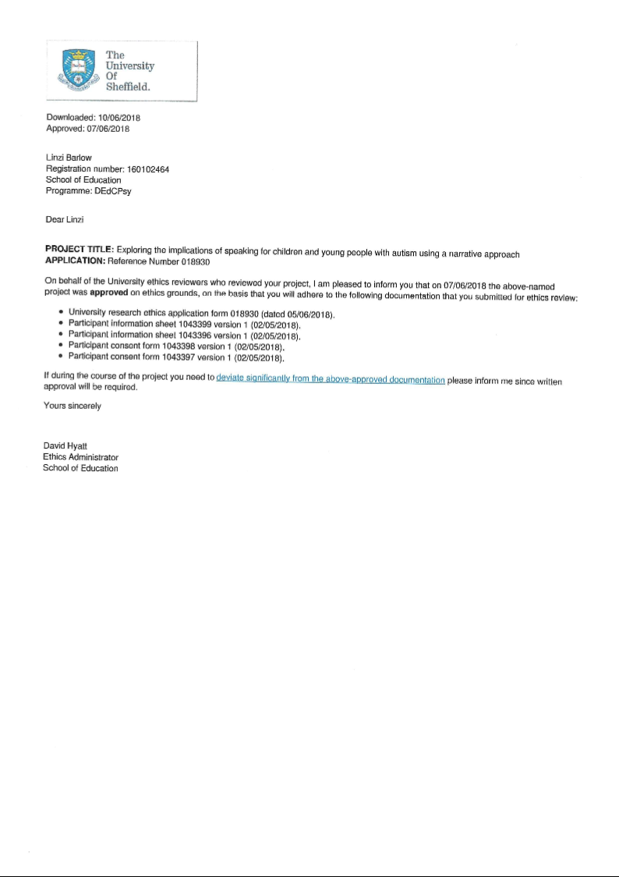

Appendix 7: Information gathered from the IR

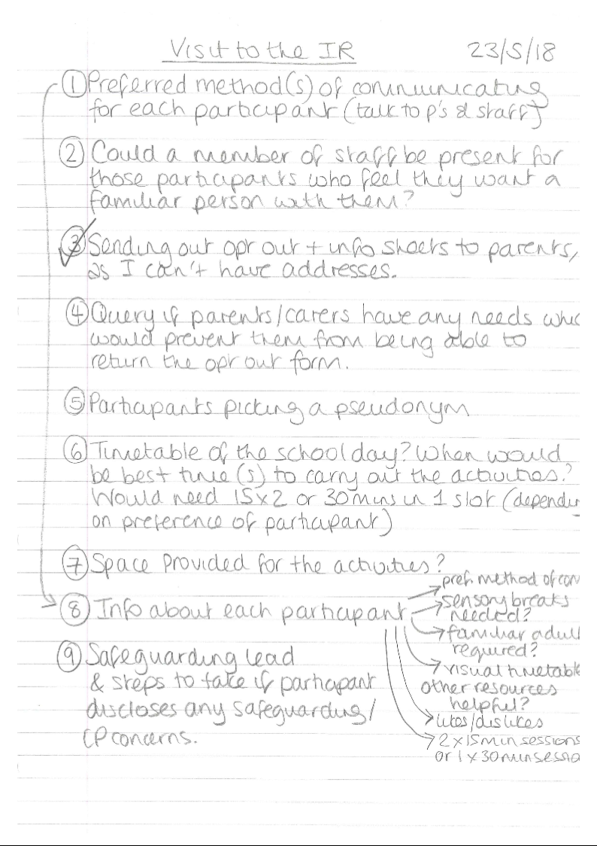

Appendix 8: Narrative prompts used

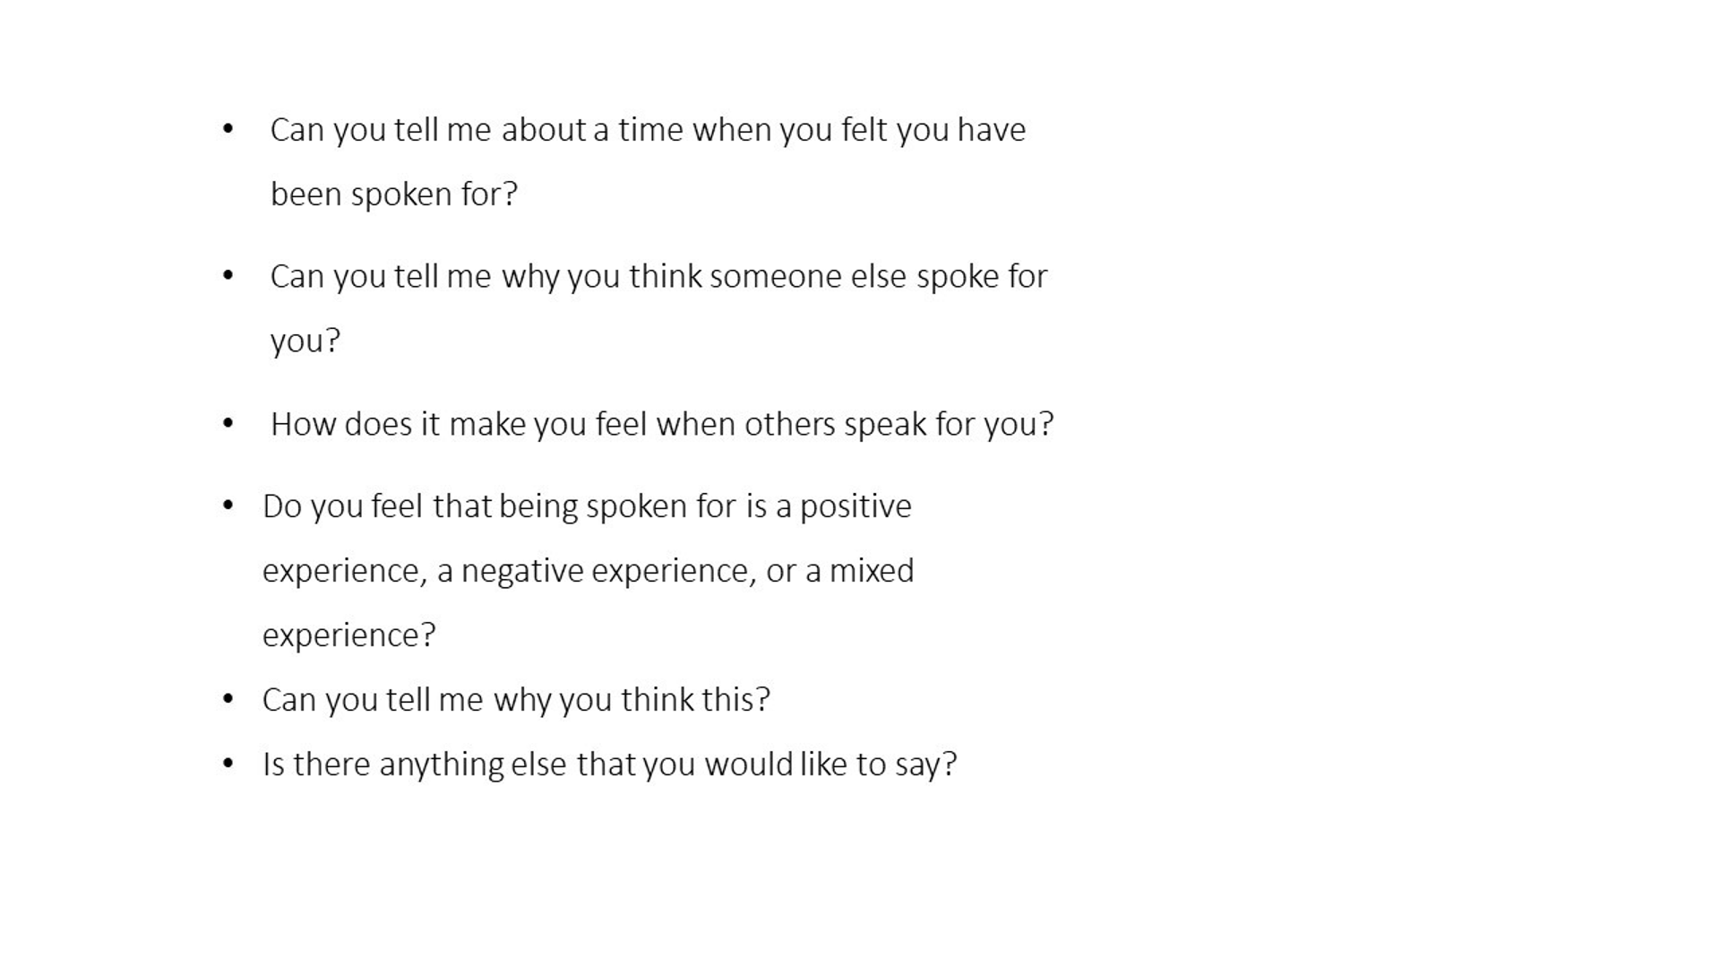

Appendix 9: Booklet illustrating ‘being spoken for’
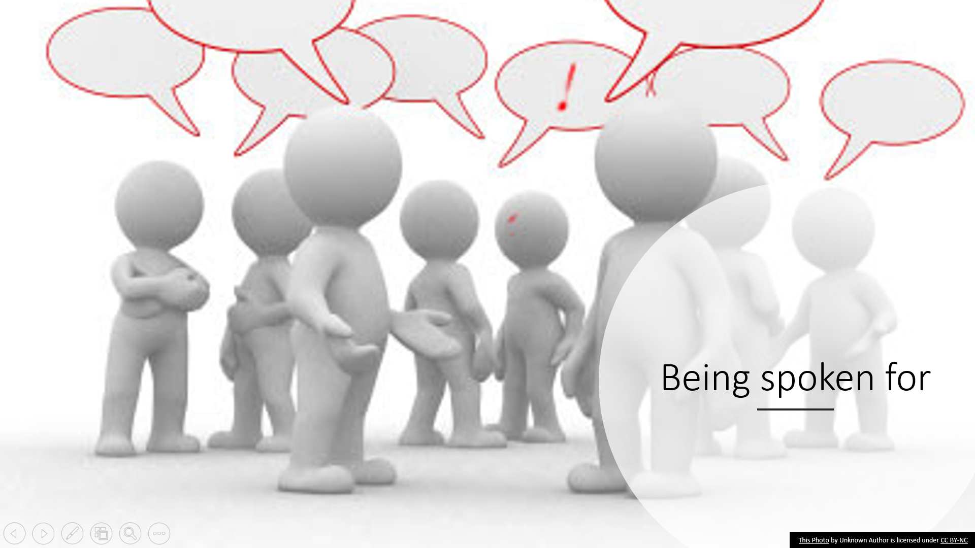
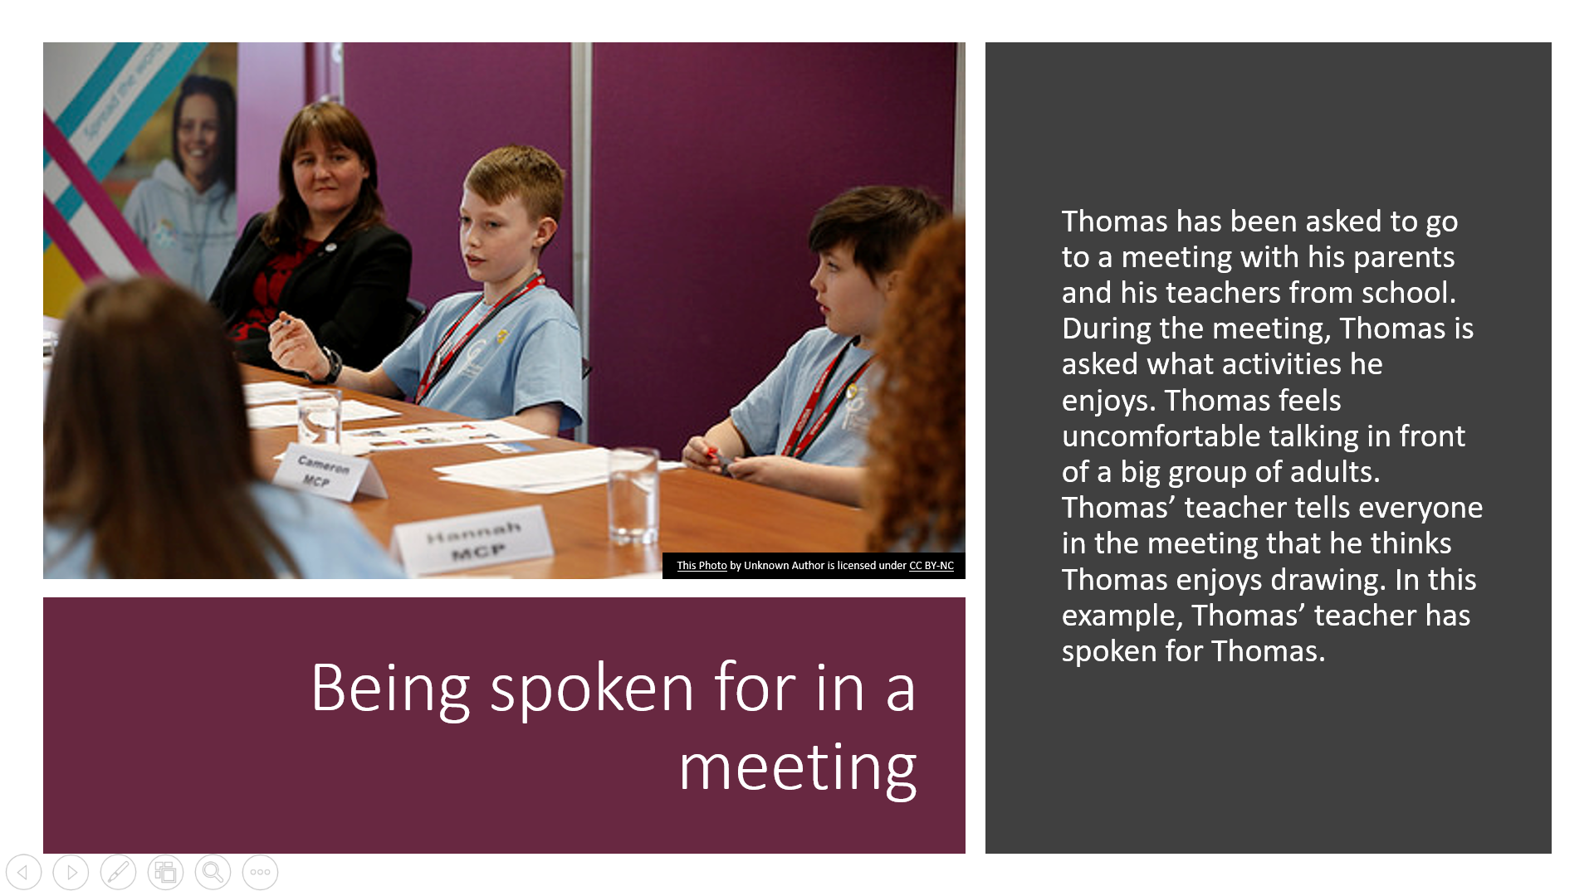
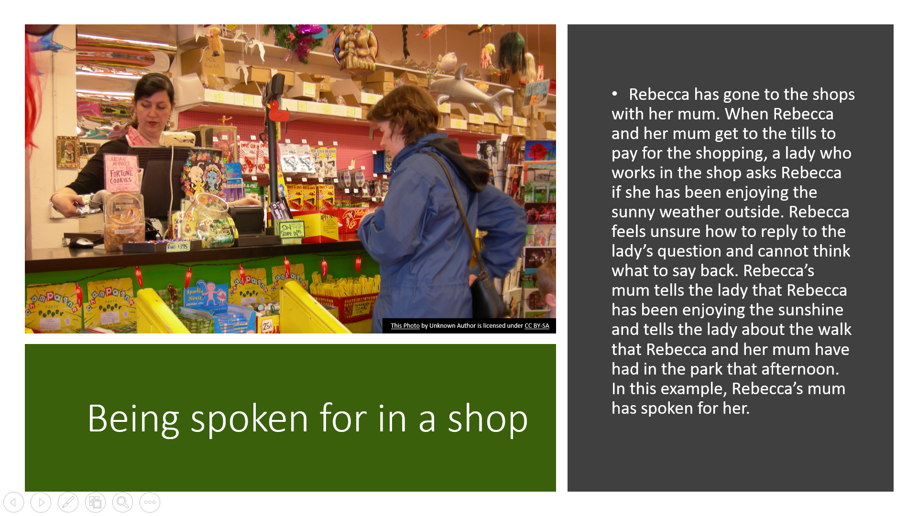

Appendix 10: Storyboard (blank)


Appendix 11: Emoji activity sheet (blank)
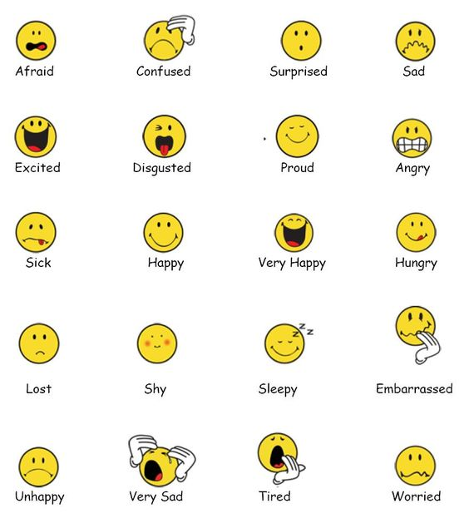

Appendix 13
Appendix 13

Appendix 12: Experience activity sheet (blank)



Appendix 13: Pilot study information
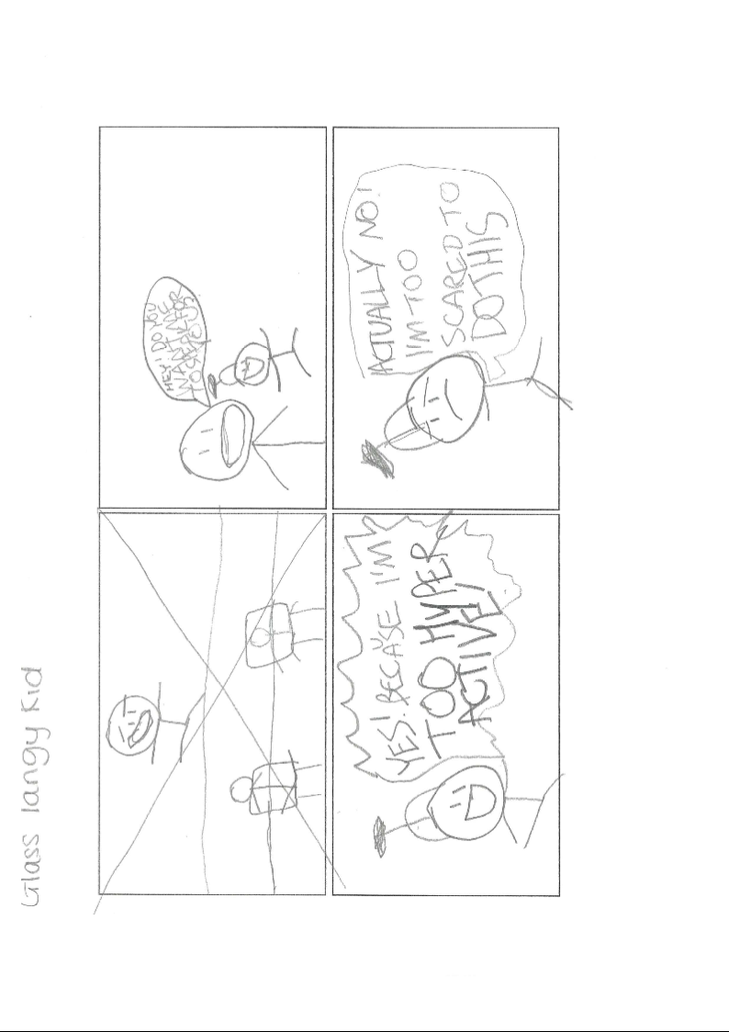
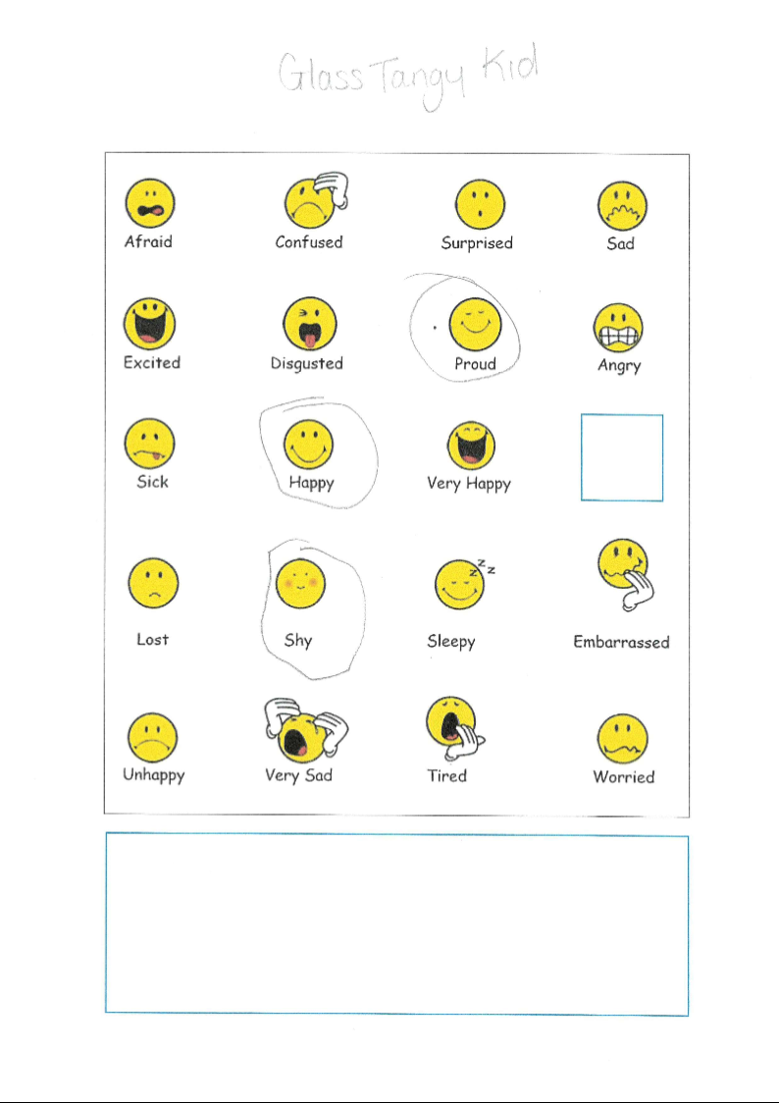
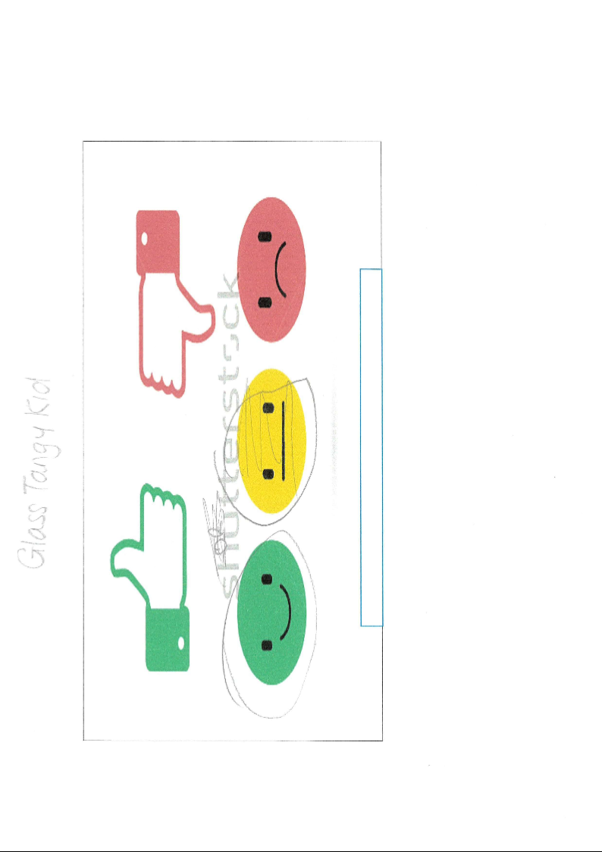
Appendix 14: Data gathered for Daniel
Daniel’s transcription
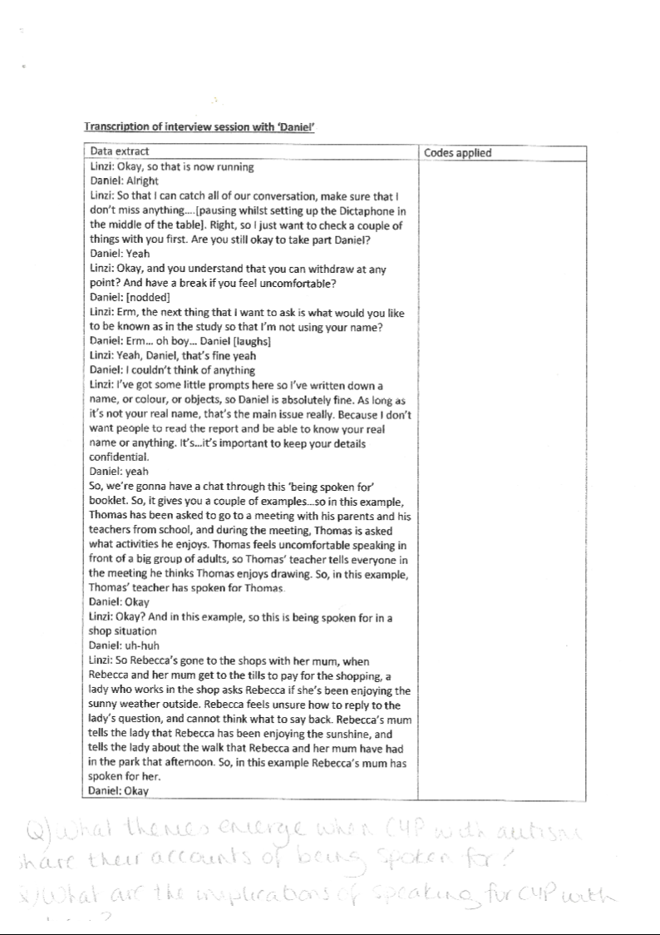
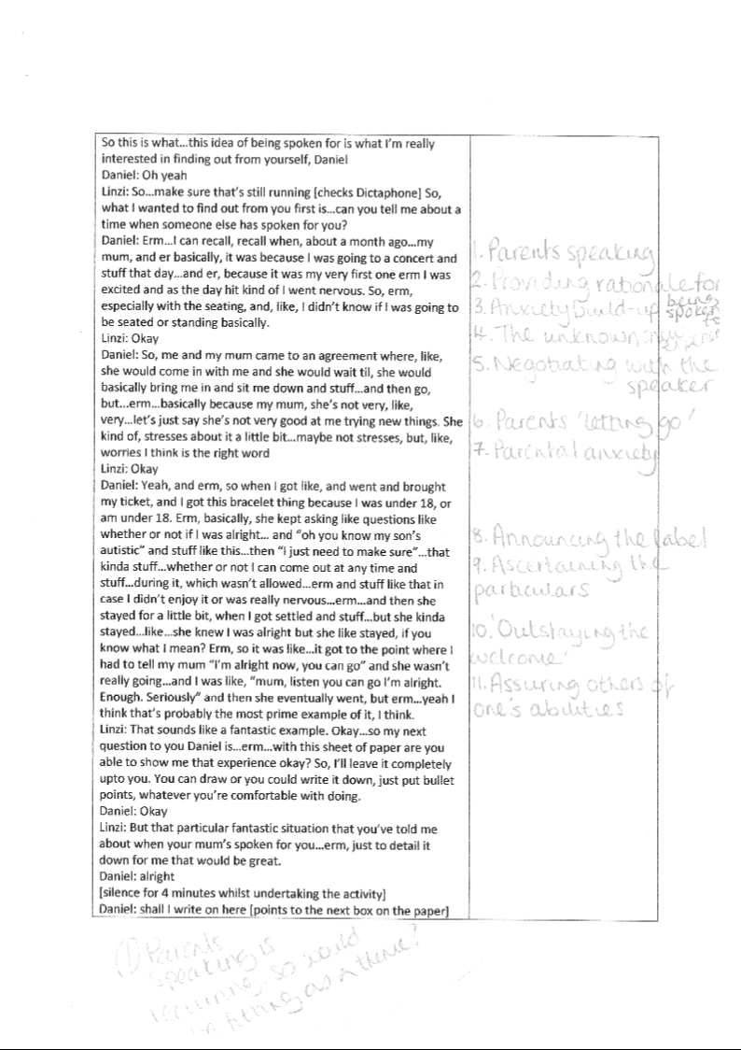
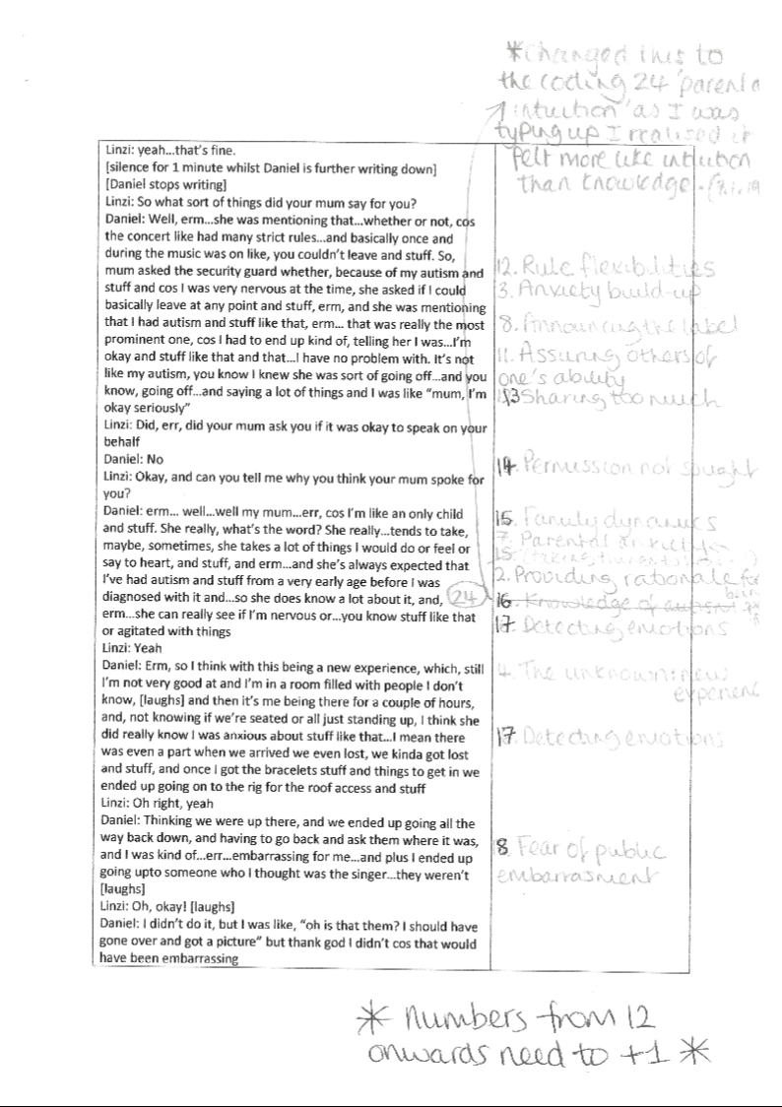
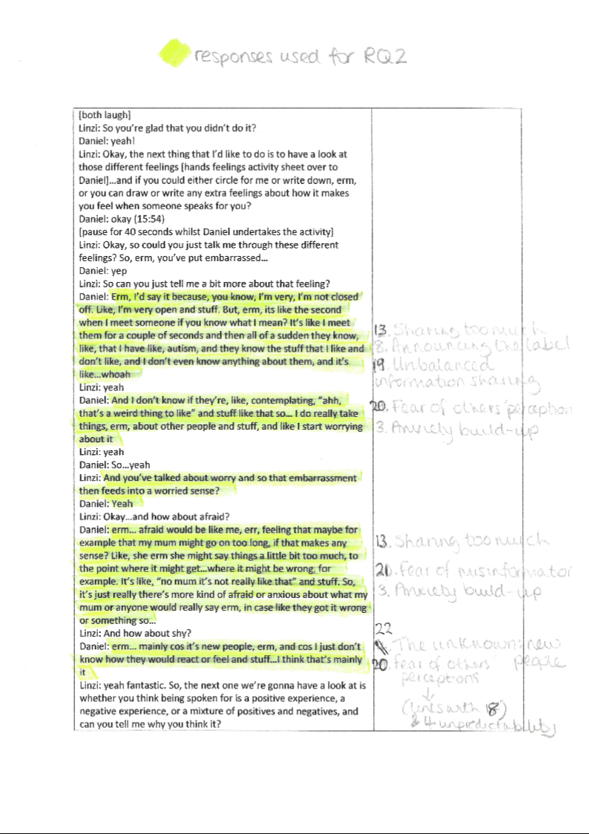
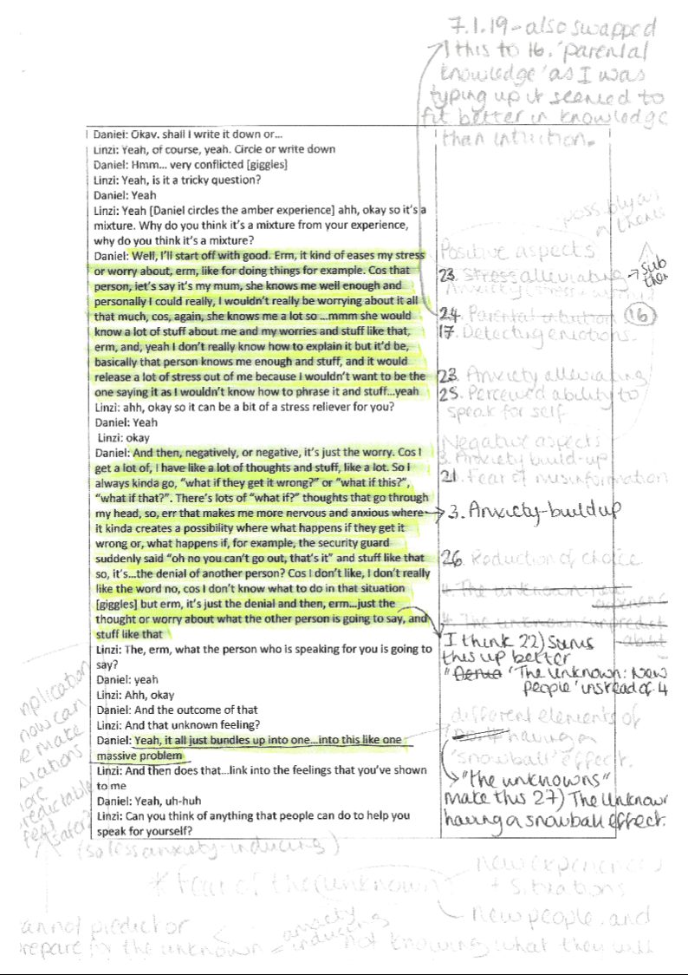
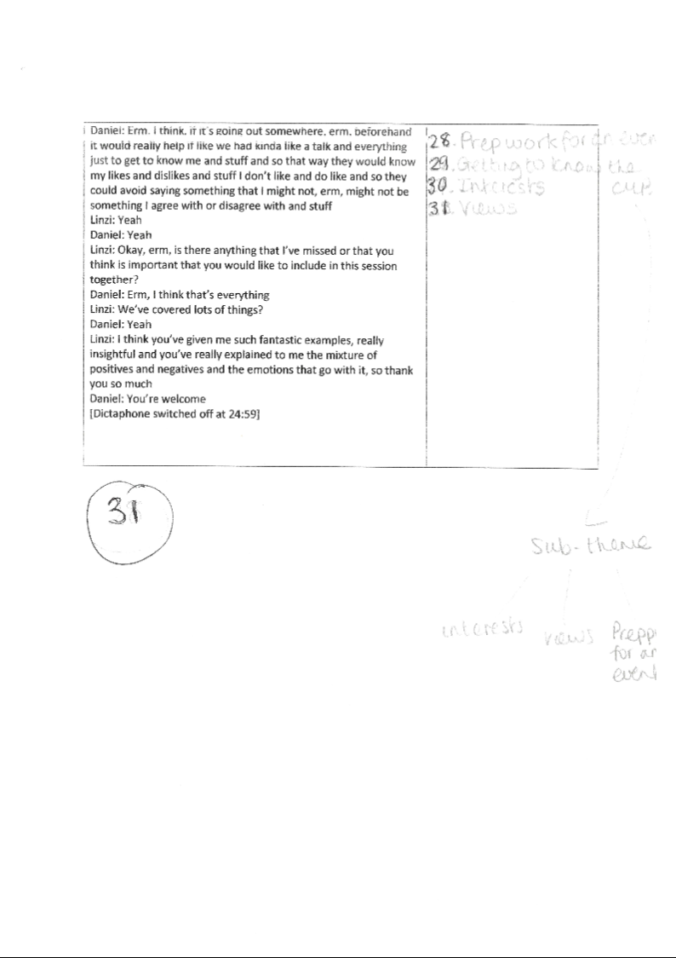
Daniel’s storyboard
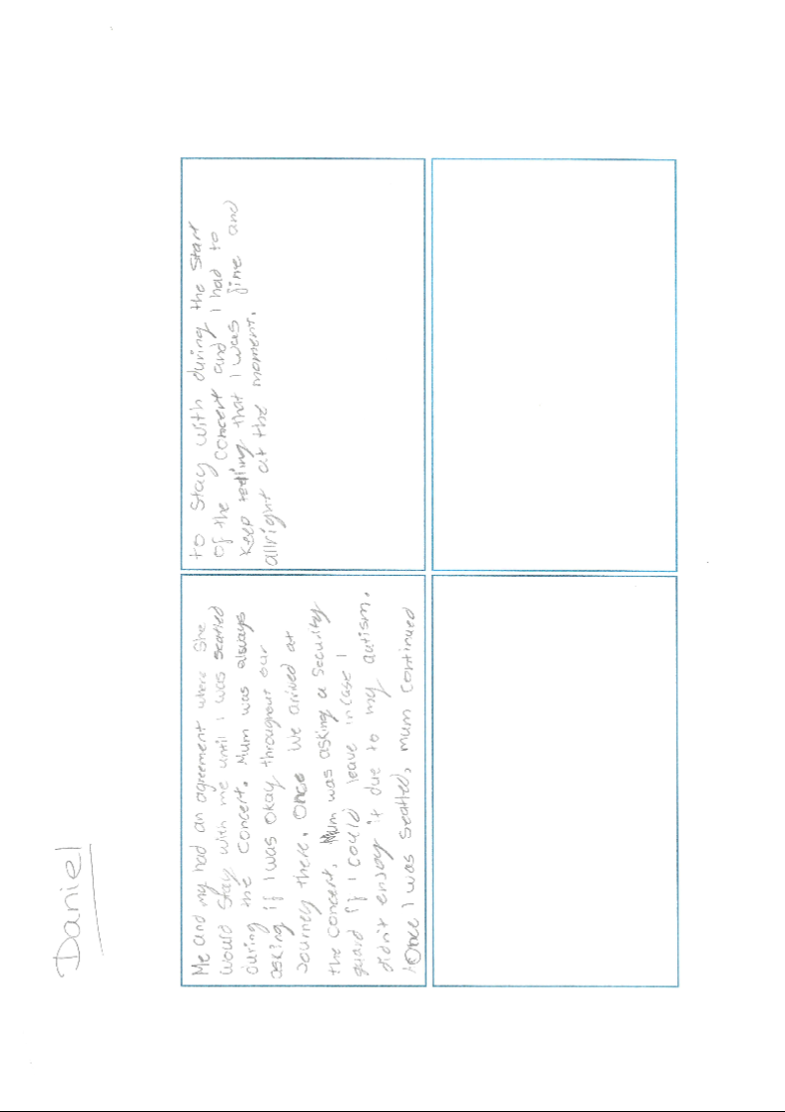

Daniel’s emoji activity sheet
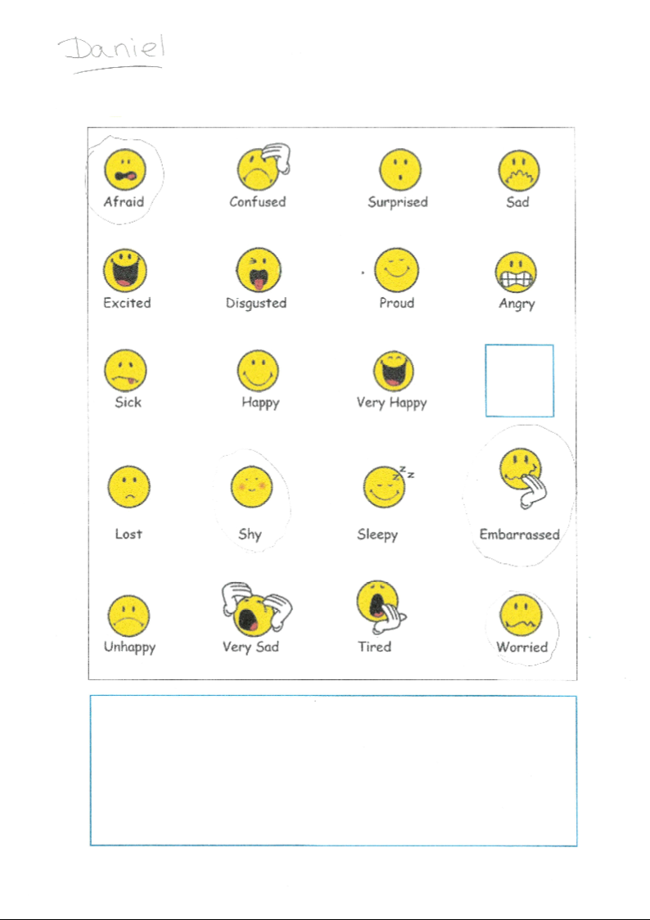

Daniel’s experience activity sheet
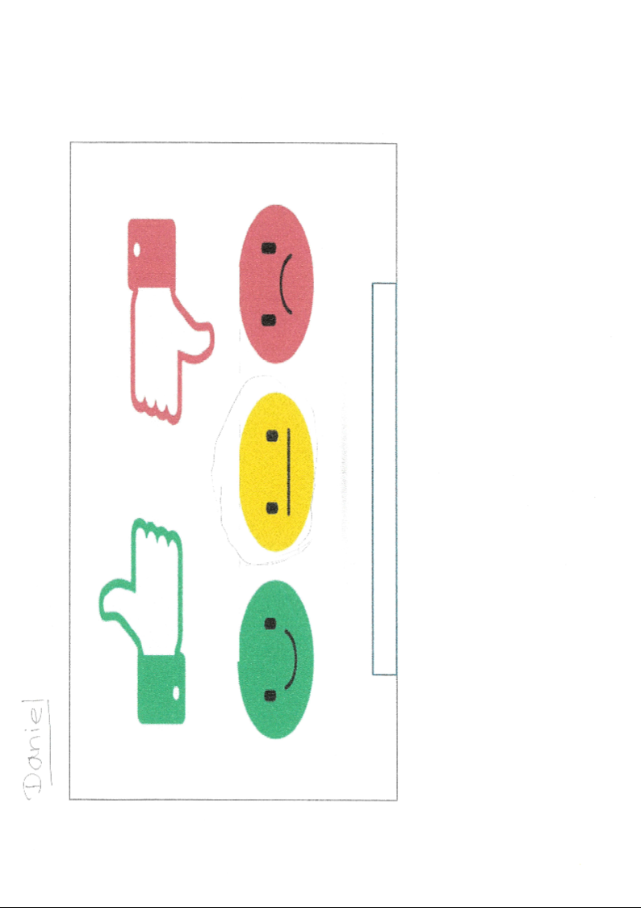
Appendix 15: Data gathered for Red

Red’s transcription
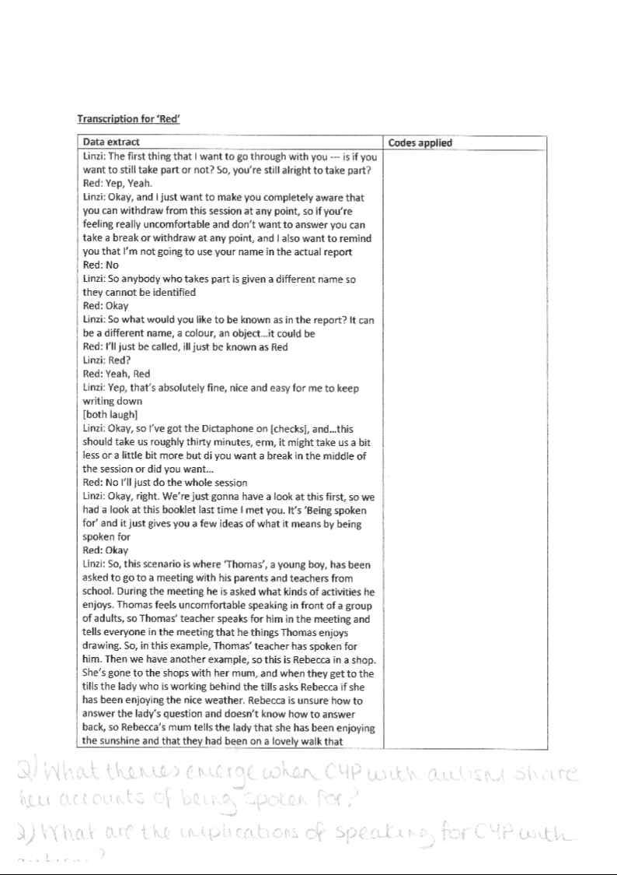
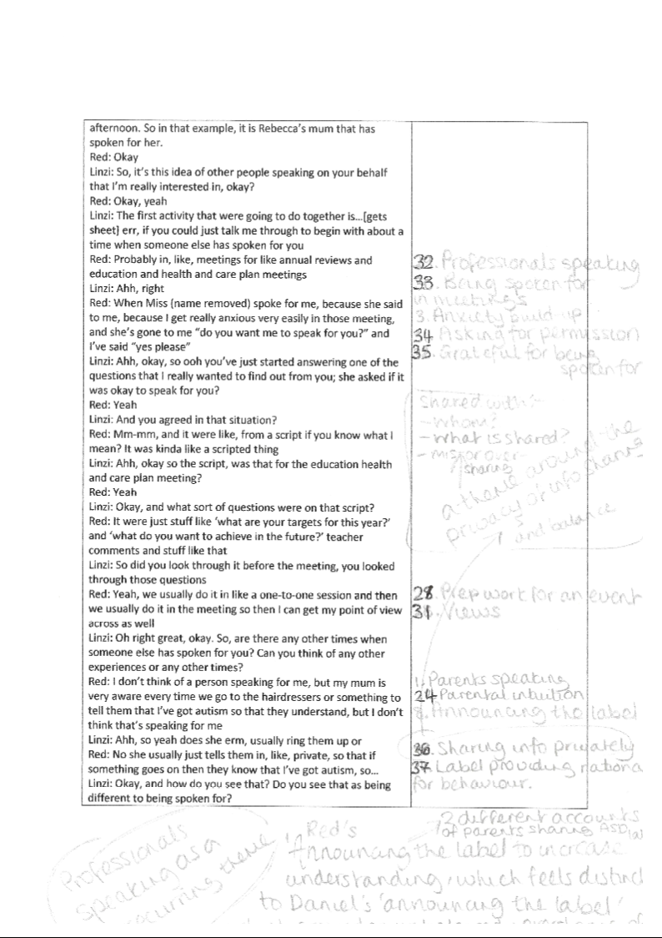
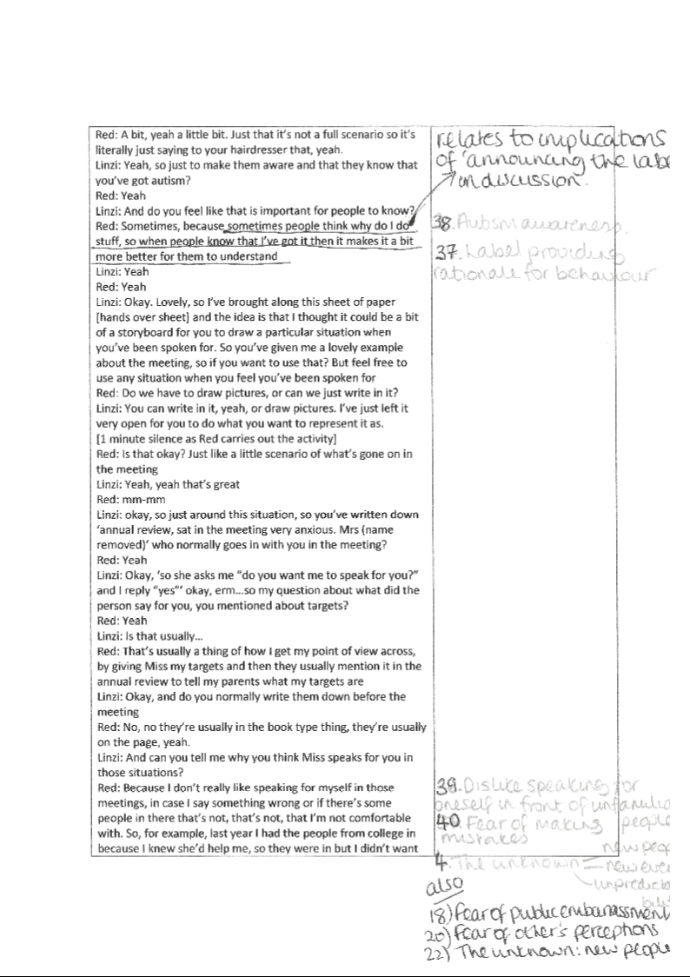
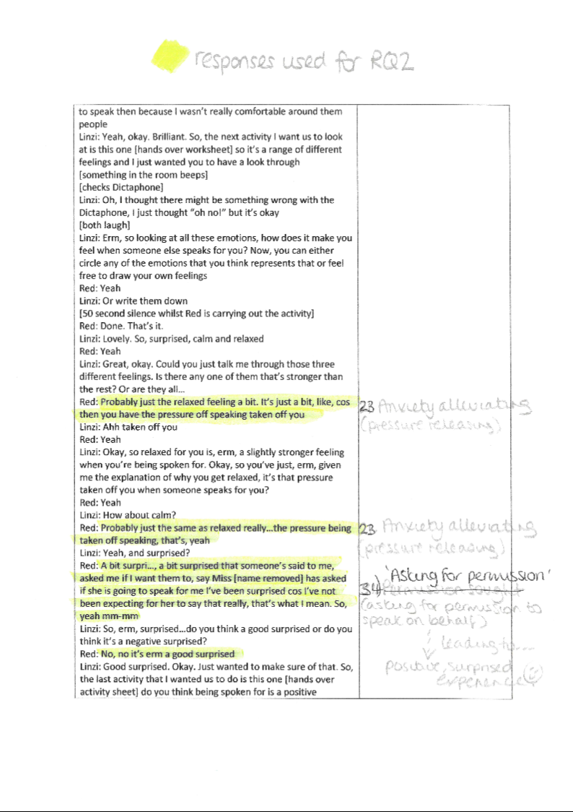
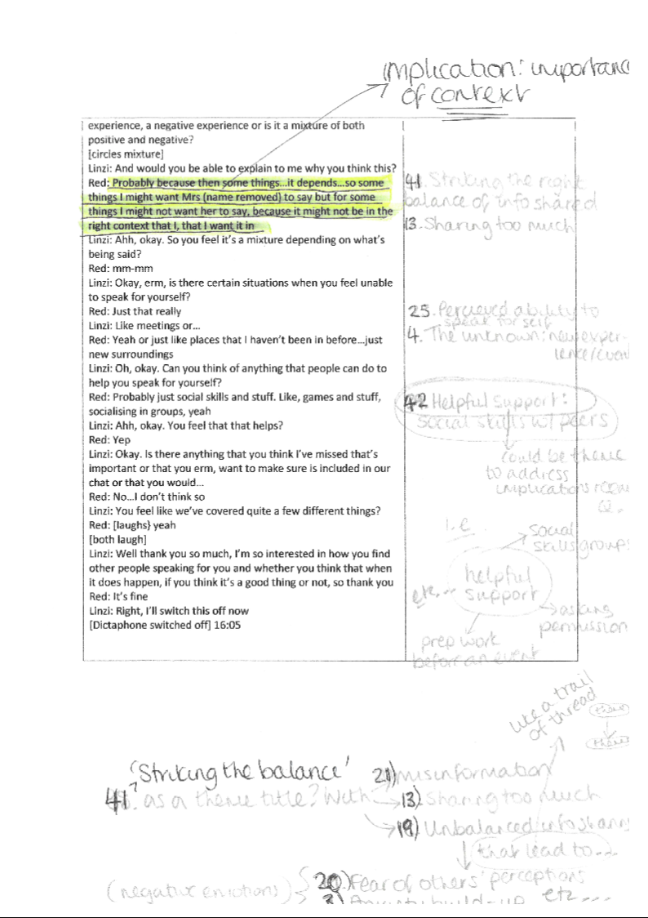
Red’s storyboard

Red’s emoji activity sheet

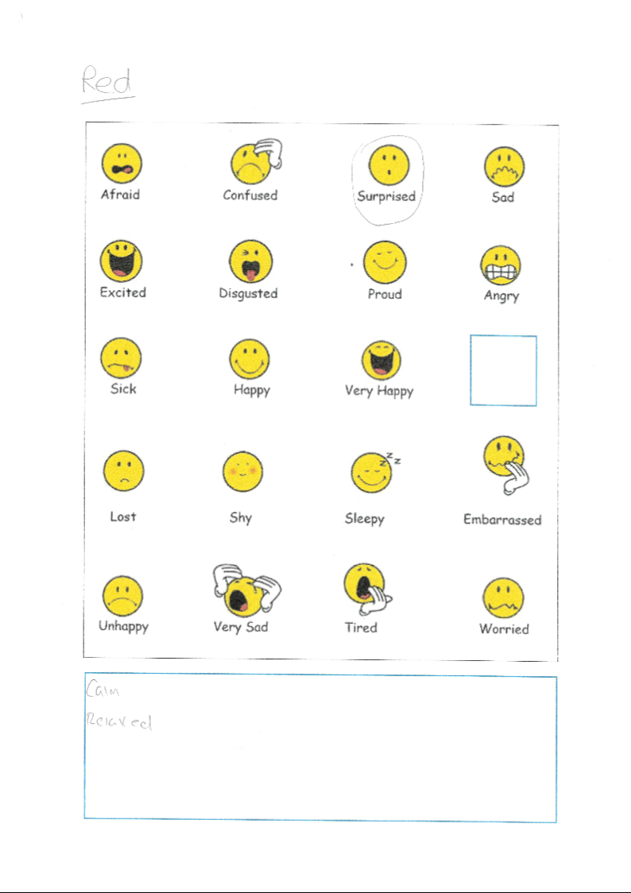

Red’s experience activity sheet

Appendix 16: Data gathered for USA

USA’s transcription
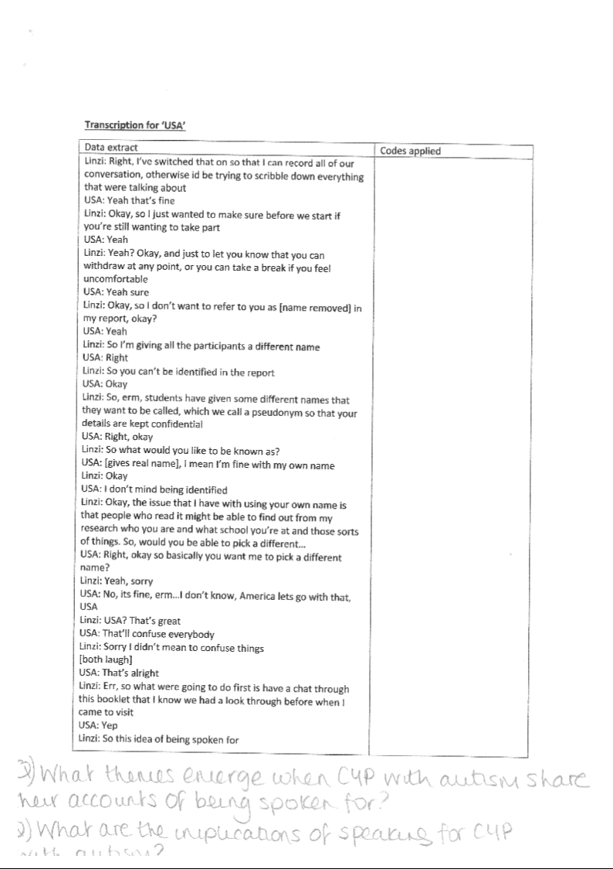
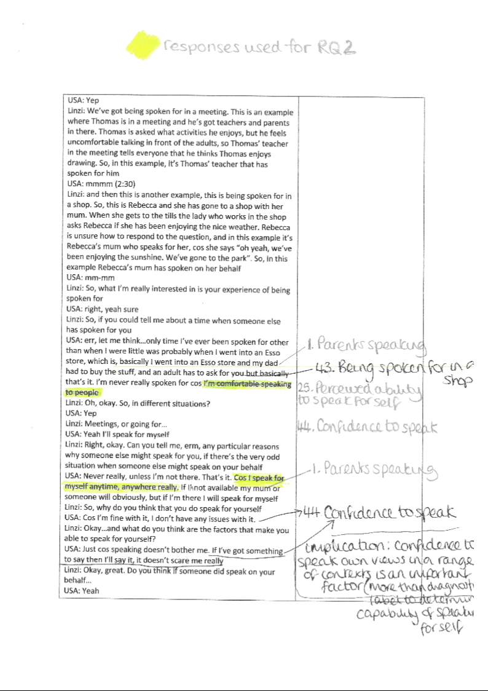
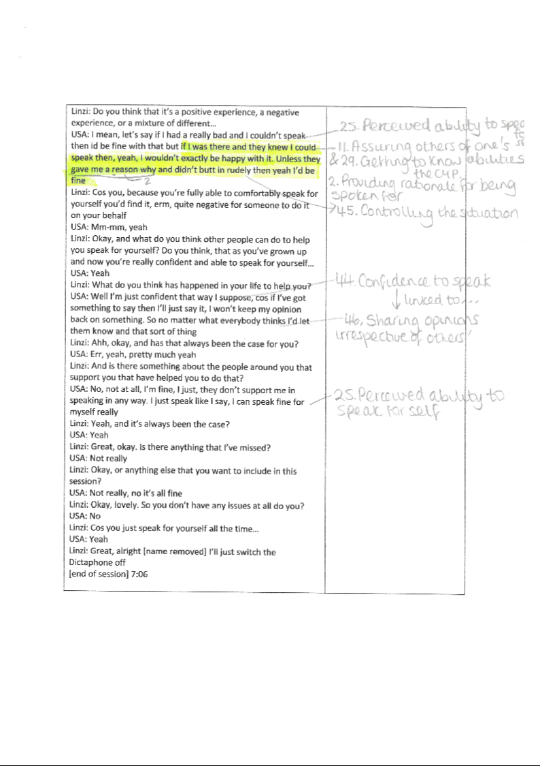
Appendix 17: Data gathered for Cone

Cone’s transcription
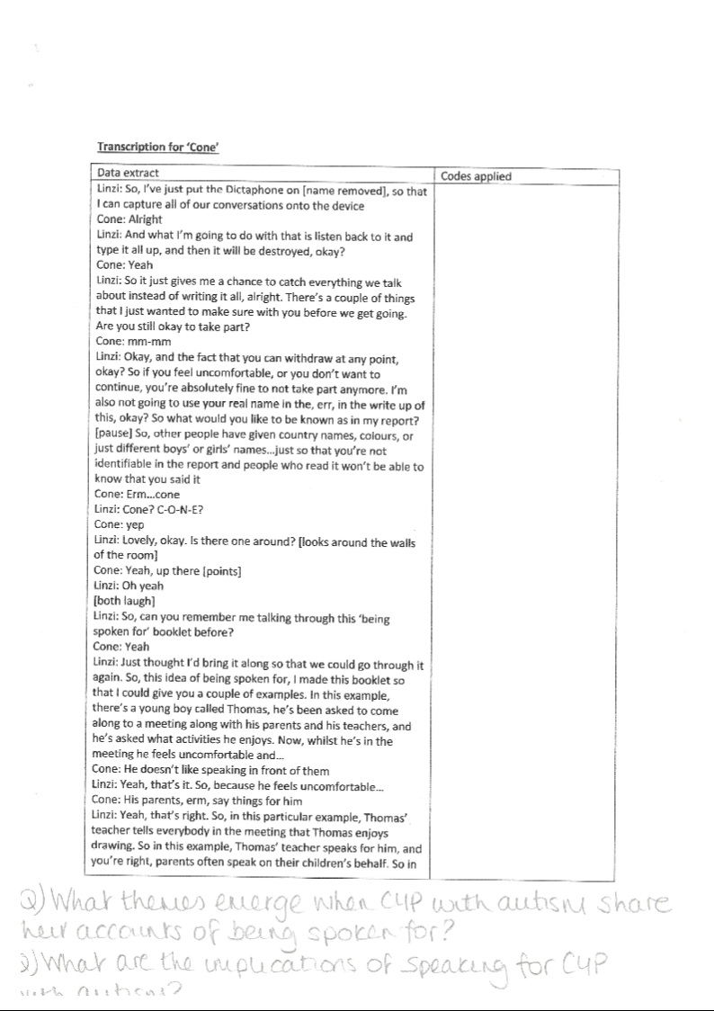
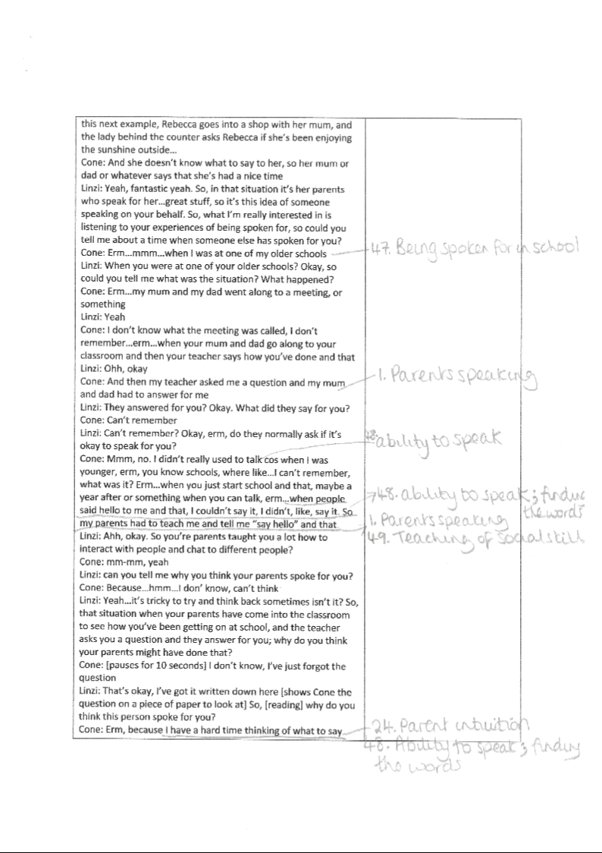
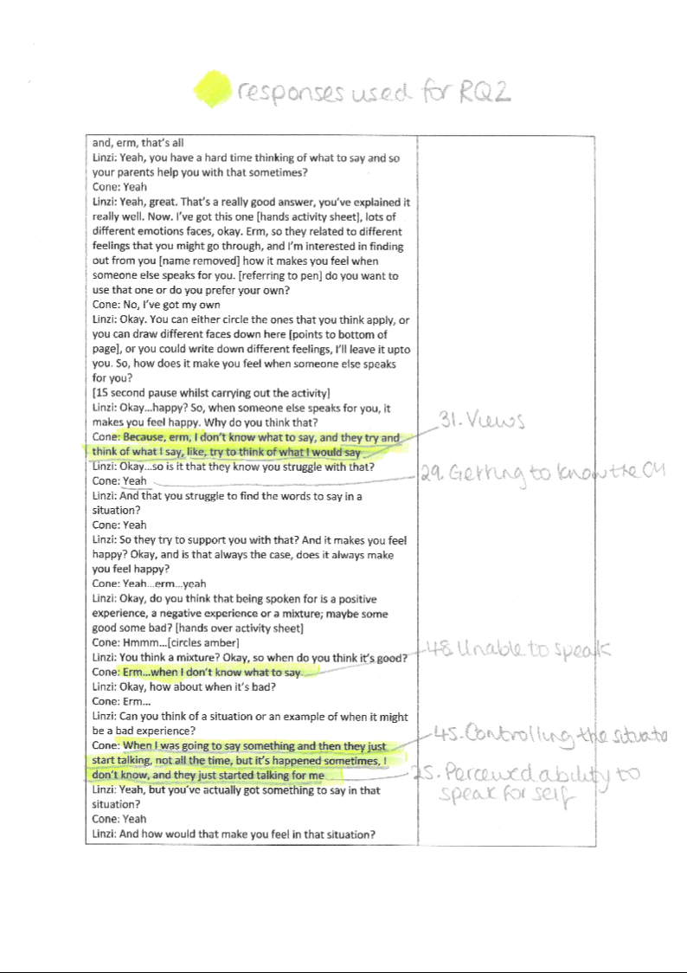
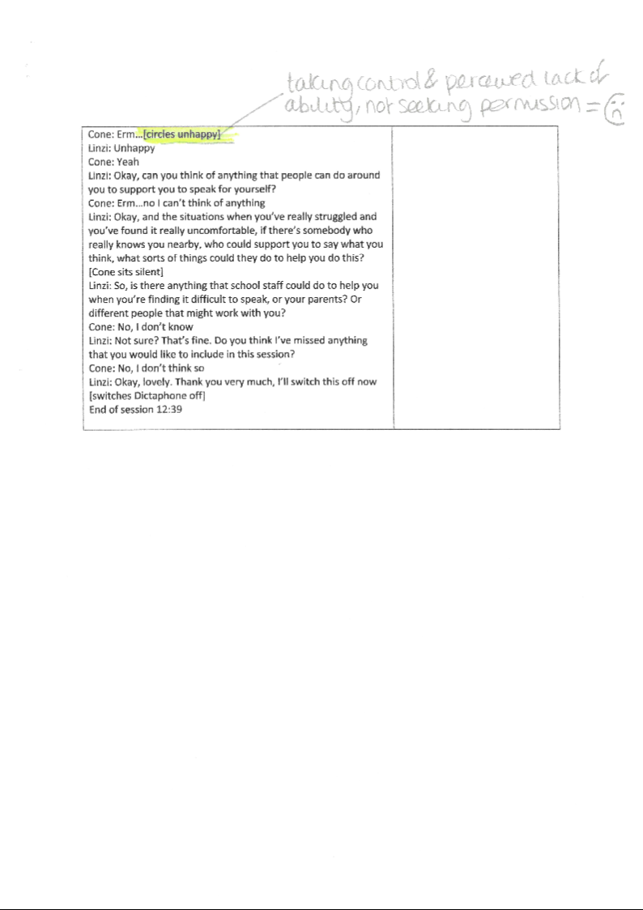
Cone’s emoji activity sheet
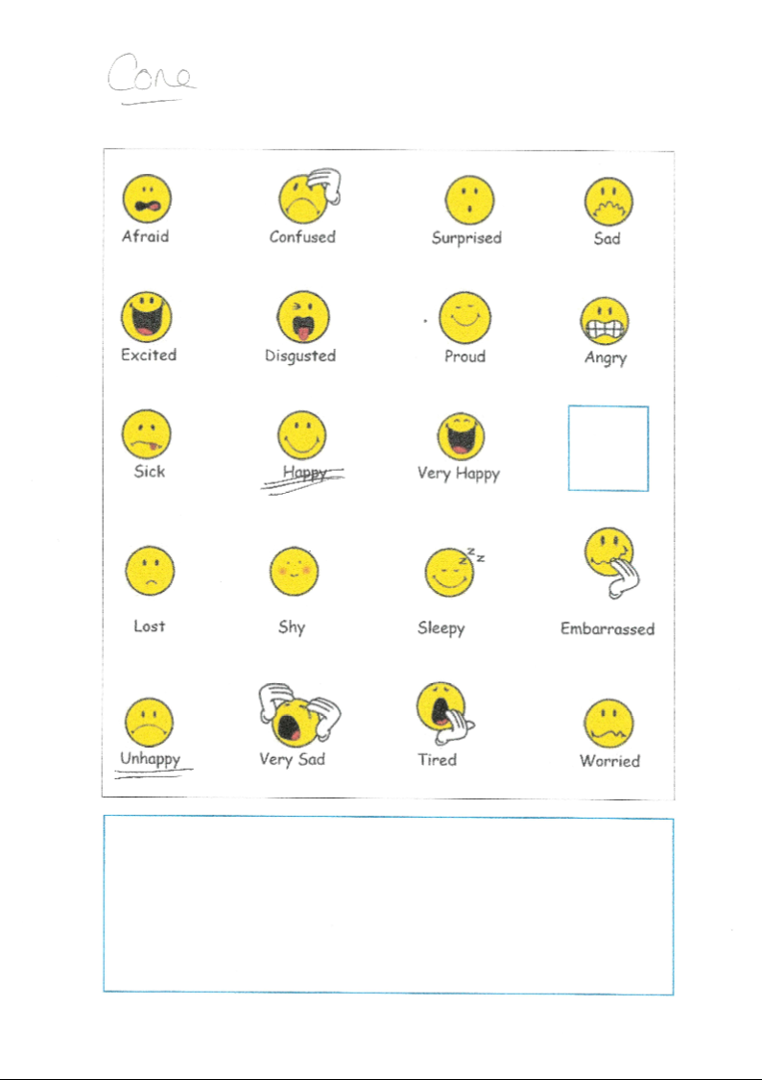

Cone’s experience activity sheet
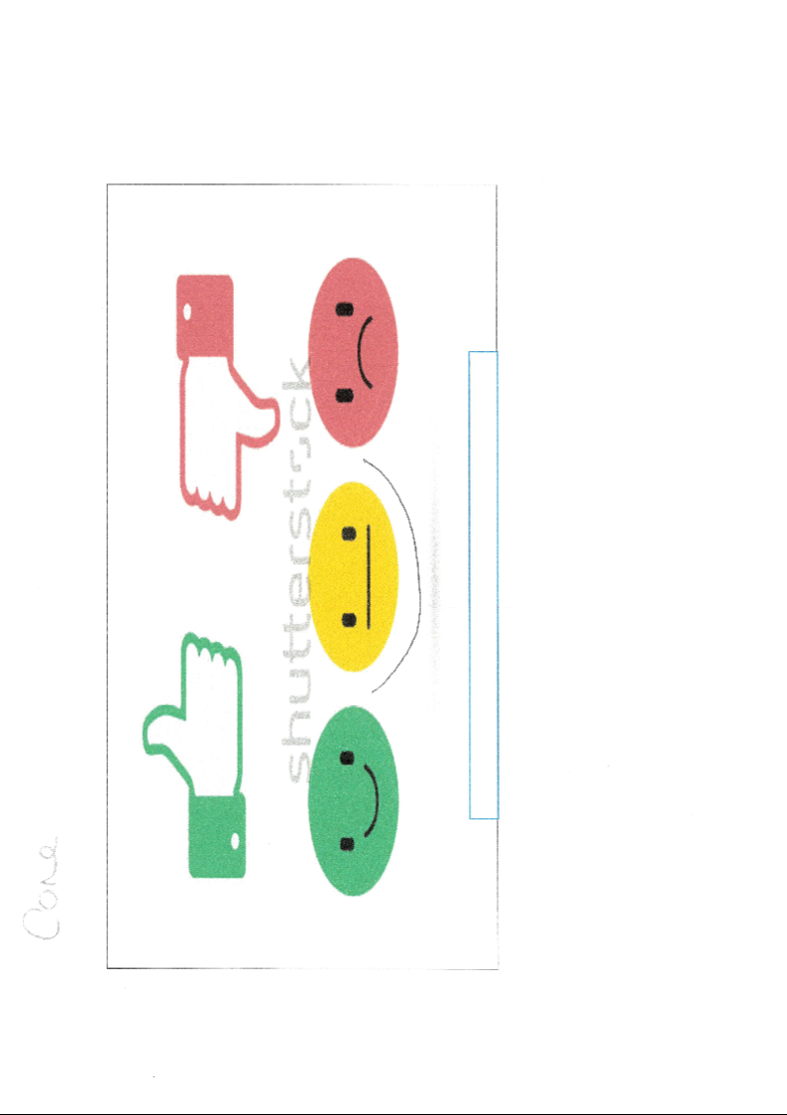

Appendix 18: Data gathered for Luke

Luke’s transcription
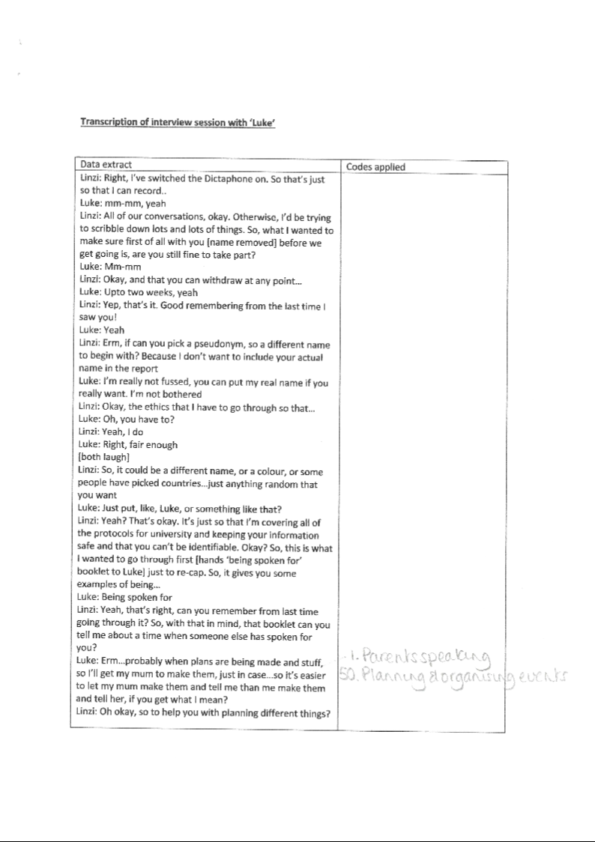
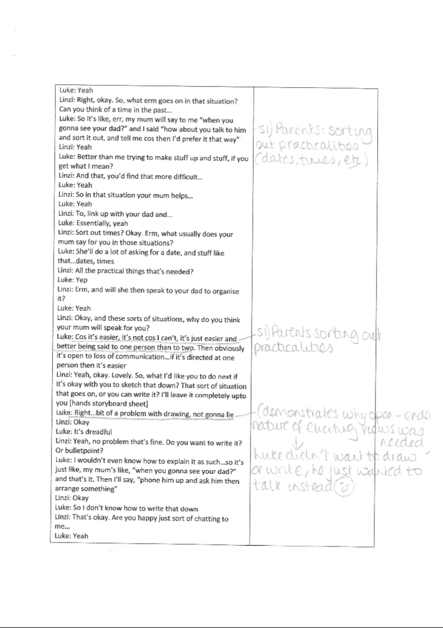
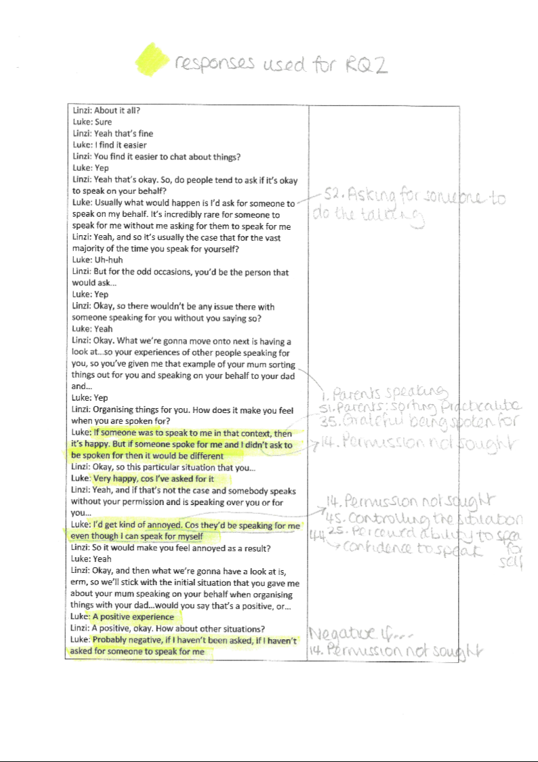
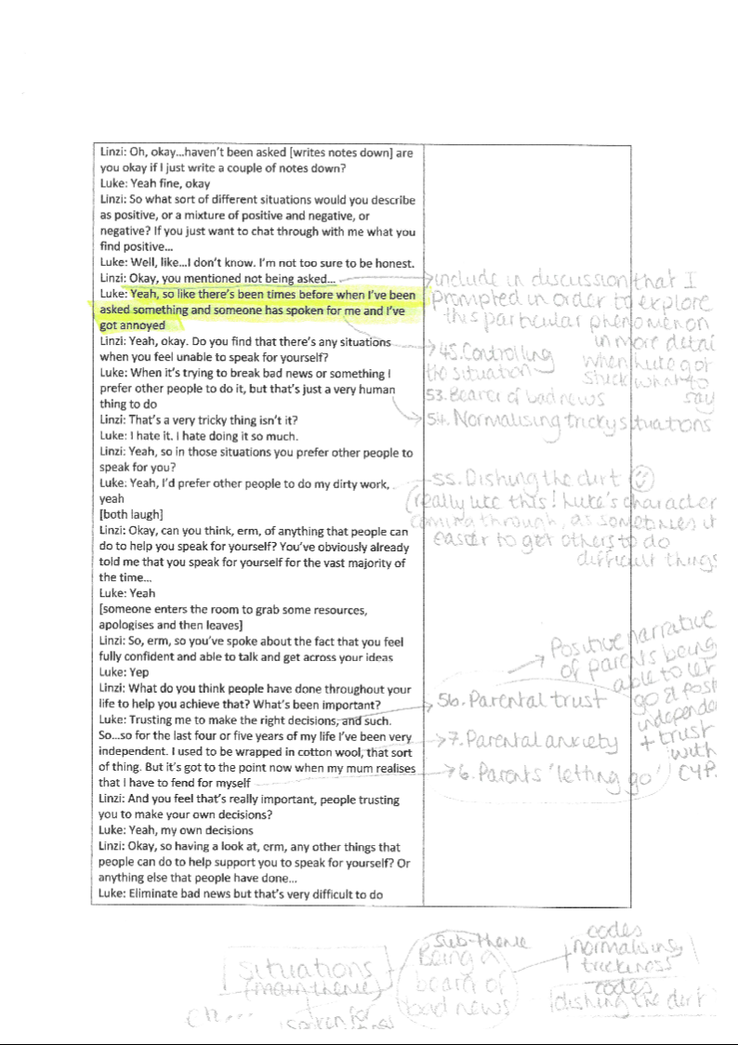

Luke’s emoji activity sheet
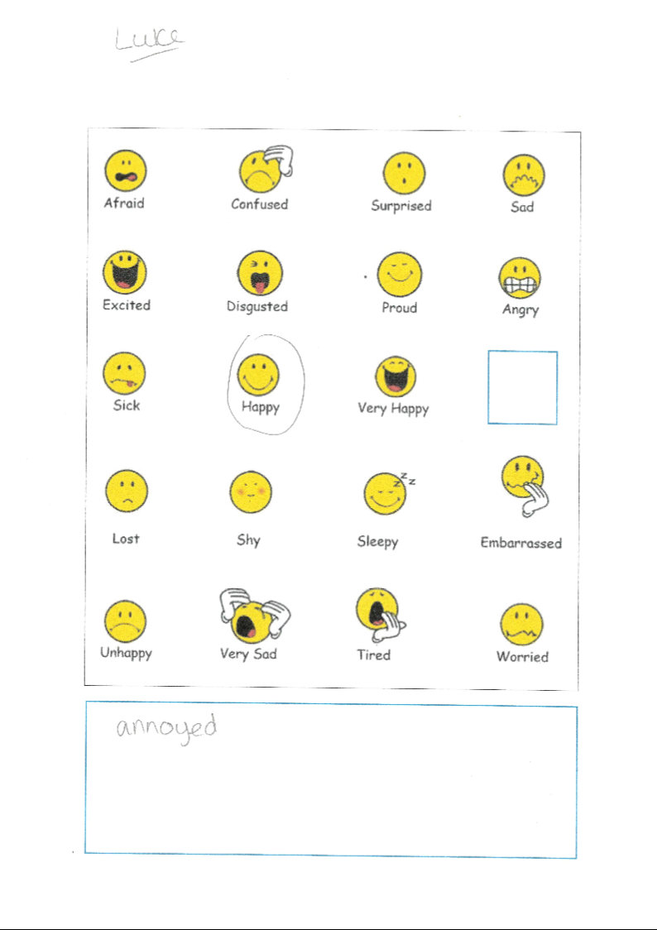

Luke’s experience activity sheet
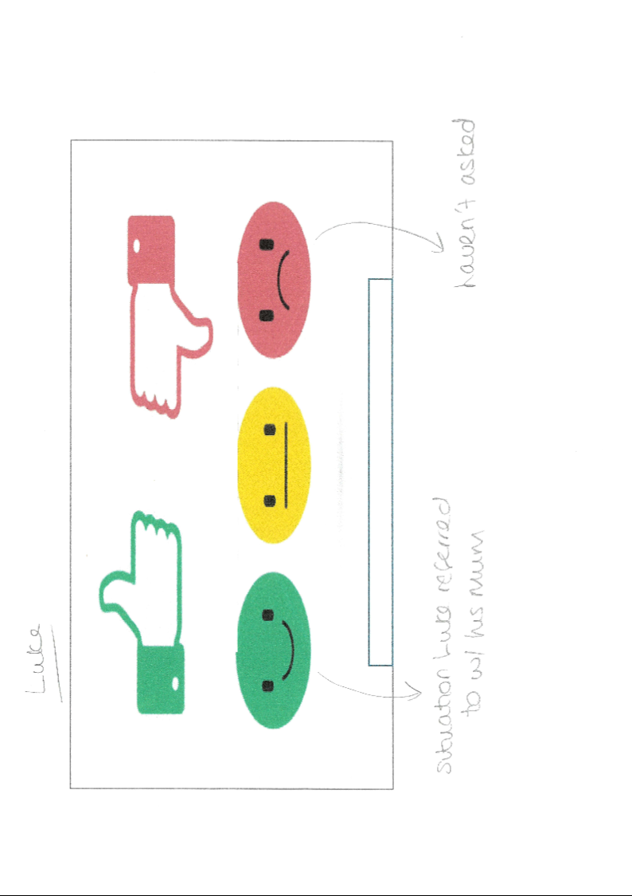

Appendix 19: Table of codings
Coding | Subtheme | Theme
- Parents speaking | Parents speaking | Parents speaking
- Providing rationale for being spoken for | Perceptions | Ability
- Anxiety build-up | Anxiety build-up | Anxiety build-up
- Fear of the unknown: new experiences | Fear of the unknown: new experiences | Anxiety build-up
- Negotiating with the speaker | Power | Power and control
- Parents ‘letting go’ | Parental anxiety | Parents speaking
- Parental anxiety | Parental anxiety | Parents speaking
- Announcing the label | Announcing the label | Autism awareness
- Ascertaining the particulars |  | Benefits
- Outstaying the welcome | Power | Power and control
- Assuring others of one’s abilities | Perceptions | Ability
- Rule flexibilities | Fear of the unknown: new experiences | Anxiety build-up
- Sharing too much | Control of information | Power and control
- Permission not sought | Permission | Power and control
- Family dynamics | Parental intuition | Parents speaking
- Knowledge of autism | Announcing the label | Autism awareness
- Detecting feelings | Getting to know the child or young person | Understanding needs
- Fear of public embarrassment | Fear of the unknown: new people | Anxiety build-up
- Unbalanced information sharing | Control of information | Power and control
- Fear of others’ perceptions | Fear of the unknown: new people | Anxiety build-up
- Fear of misinformation | Control of information | Power and control
- Far of the unknown: new people | Fear of the unknown: new people | Anxiety build-up
- Anxiety alleviating |  | Benefits
- Parental intuition | Parental intuition | Parents speaking
- Perceived ability to speak for self | Perceptions | Ability
- Reduction of choice | Fear of the unknown: new experiences | Anxiety build-up
- Snowball effect | Fear of the unknown: new experiences | Anxiety build-up
- Prep work for an event | Prep work for an event | Understanding needs
- Getting to know the child or young person | Getting to know the child or young person | Understanding needs
- Interests | Getting to know the child or young person | Understanding needs
- Views | Getting to know the child or young person | Understanding needs
- Professionals speaking |  | School-related
- Being spoken for in meetings |  | School-related
- Asking for permission | Permission | Power and control
- Grateful for being spoken for |  | Benefits
- Sharing information privately | Control of information | Power and control
- Label providing rationale | Announcing the label | Autism awareness
- Autism awareness | Announcing the label | Autism awareness
- Speaking in front of unfamiliar people | Fear of the unknown: new people | Anxiety build-up
- Fear of making mistakes | The unknown: new experiences | Anxiety build-up
- Striking the right balance | Control of information | Power and control
- Social skills with peers | Social skills | Understanding needs
- Being spoken for in a shop
- Confidence to speak | Confidence to speak | Ability
- Controlling the situation | Power | Power and control
- Sharing opinions irrespective of others | Confidence to speak | Ability
- Being spoken for in schools | School-related | Understanding needs
- Ability to speak | Perceptions | Ability
- Teaching of social skills | Social skills | Understanding needs
- Planning and organising events | Prep work for an event | Understanding needs
- Parents: sorting out practicalities | Parental intuition | Parents speaking
- Asking for someone to do the talking | Prep work for an event | Understanding needs
- Being the bearer of bad news | Support with breaking bad news | Benefits
- Normalising tricky situations | Perceptions | Ability
- Dishing the dirt |  | Benefits
- Parental trust | Parental intuition | Parents speaking

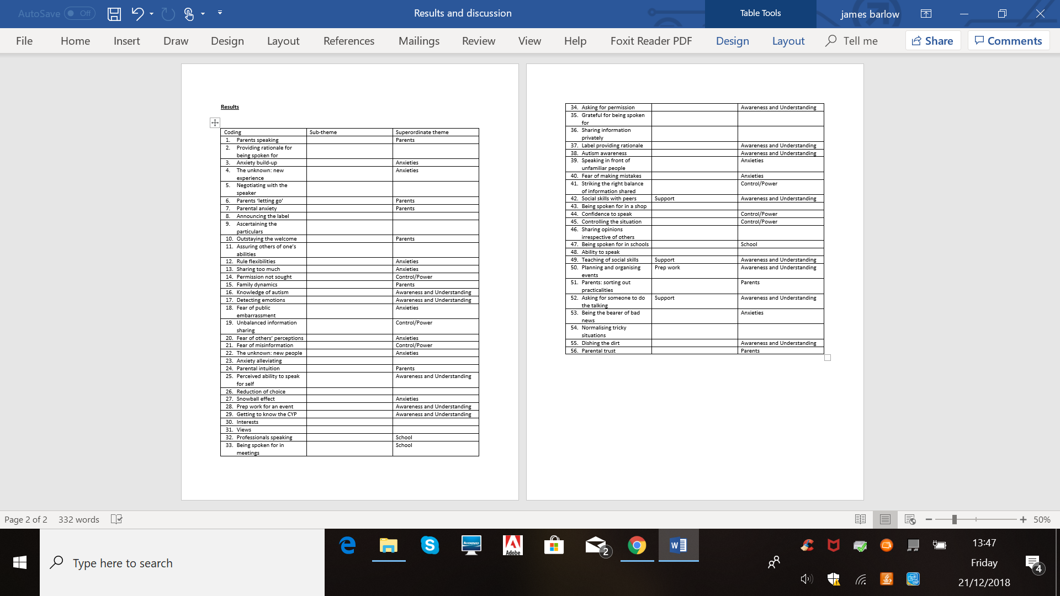

Appendix 20: Research diary

21.12.18: Altering the codings into sub-themes and themes – firstly aimed to group them into overarching (superordinate) themes on the table, and then when I got stuck and needed to use the post-its to visualise ‘best fits’ for some of the codings and identify subordinate themes I rearranged the post-its on the wall.

21.12.18: ones I felt stuck on…
Located the codings in the transcript to try and identify where to place them within the themes or if new themes needed to be created (or a miscellaneous one).
2 – (rationalising being spoken for) put it into Ability and perceptions, as I felt that it was the participant’s perceptions on their abilities and rationalising that thy needed to sometimes be spoken for.
15 – (family dynamics) put it into parents speaking and parental intuition, as I thought that when reflecting back on the transcript it was Daniel discussing how he is the only child and his mum picks up on how he is feeling.
53 - (being the bearer of bad news) decided to place this in the ‘benefits’ theme as the participants is discussing how they hate giving people bad news and find it useful for someone else to do that for them.
54 – (normalising tricky situations) placed this in ability and perceptions, as I felt that in this particular coding the participant is reflecting on the fact that they perceive telling bad news to be a generic difficulty that all people find hard to speak to others about, not just a difficulty because of autism.
55 – (dishing the dirt) decided to place it under a ‘benefits’ theme, which incorporates all of the codings that directly relate to participants’ discussing the upsides of someone else speaking for them in particular situations

On 4.1.2019 I moved coding number 10 ‘outstaying the welcome’ to fit under the power and control superordinate theme and power subordinate theme. As I was typing up I felt it belonged more to the power and control theme more than the parents speaking superordinate theme, as what Daniel is describing is his mum continuing to stay at the concert despite him voicing that he was alright and encouraging her to leave.

On 4.1.2019 I moved coding 15 ‘family dynamics’ to superordinate theme ‘Ability’ and subordinate theme ‘perceptions’, as when I’ve looked at it again, it is not discussing parents, but rather it is Daniel reflecting on being an only child giving an insight into his perceptions of his ability and relationship with his mum as a result of being an only child.

On 4.1.2019 I moved coding 26 ‘reduction of choice’ from subordinate theme ‘fear of the unknown: new experiences’ to subordinate theme ‘fear of the unknown: new people’, as I felt it relate more to people reducing choice rather than a new experience as such.

5.1.19 – coding 16 ‘knowledge of autism’ I have decided to put this as a subordinate theme under the ‘autism awareness’ superordinate theme, as I felt that it did not quite fit under the ‘announcing the label’ alternative subordinate theme; it is explaining instead how a parent can have a deep understanding of their child’s needs before a diagnosis of autism is made.

6.1.19 – moved superordinate theme ‘school-related’ to be a subordinate theme as part of the ‘understanding needs’ superordinate theme – felt that it fitted well in this section as it is discussing staff supporting in meetings.

6.1.19 - I’ve had difficulty finding fitting subordinate themes for the ‘benefits’ superordinate theme section. I’ve found it easier typing up the section and then looking for emerging themes that seem to group the points I’m trying to make, and have come up with the following: support with arranging particulars; anxiety-alleviating; support with breaking bad news.

7.1.19 – once I had typed up the subordinate theme ‘knowledge of autism’ it became apparent that it fitted better into the parents superordinate theme, as it is discussing specifically parental knowledge of autism and links nicely with the ‘parental intuition’ subordinate theme too, rather than being in the ‘autism awareness’ superordinate theme. I also adapted the title to ‘parental knowledge of autism’ to link it in with the ‘parents speaking’ superordinate theme.

7.1.19 – swapped 16 coding and 24 coding extracts, as I felt that the extract where Daniel is explaining his mum knew he had autism from an early age reflected more coding 24 ‘parental intuition’ and the extract where Daniel is saying that his mother knows a lot about him and his worries felt more like fitting in coding 16 ‘parental knowledge’ – so swapped them round when typing it up.

20.2.19 - Moved coding 34 ‘asking for permission’ to power and control, as I felt that it had more connotations of power dynamics and acknowledging whether Red wanted the member of staff to speak on her behalf and fitted better in power and control as a result as opposed to prep work subtheme and understanding needs theme.

20.2.19 - I also changed the name of the subtheme ‘permission not sought’ to ‘permission’ so that it more accurately reflected coding 34 being part of it and discussing both permission being sought and not sought.

20.2.19 – considered moving social skills subtheme to merge with school-related subtheme to ‘bulk up’ the information and then realised that Cone does not discuss social skills in relation to what is taught in a more formal sense at school. He discusses social skills that his parents have taught him, so would not be fitting to put social skills into school-related as it would wash away Cone’s thoughts on the important influence his parents had on teaching him social skills.

20.2.19 – I’ve had seven themes so far throughout my thesis but have decided to merge what was theme 5 ‘autism awareness’ into theme 4 ‘power and control’. This is because the theme ‘autism awareness’ only comprised of one subtheme, which was ‘announcing the label’ and I felt that this subtheme has lots of undercurrents of power and control that relate to control of information and permission, which are under the theme ‘power and control’. As a result, I have moved the theme to form a subtheme under power and control, and have changed its name from ‘autism awareness’ to ‘announcing the label’ in order to reflect its content more accurately. This has left me with 6 themes and 18 subthemes.

Appendix 21: Photographs of codings, themes and subthemes

Photograph of codings taken on 19.11.2018
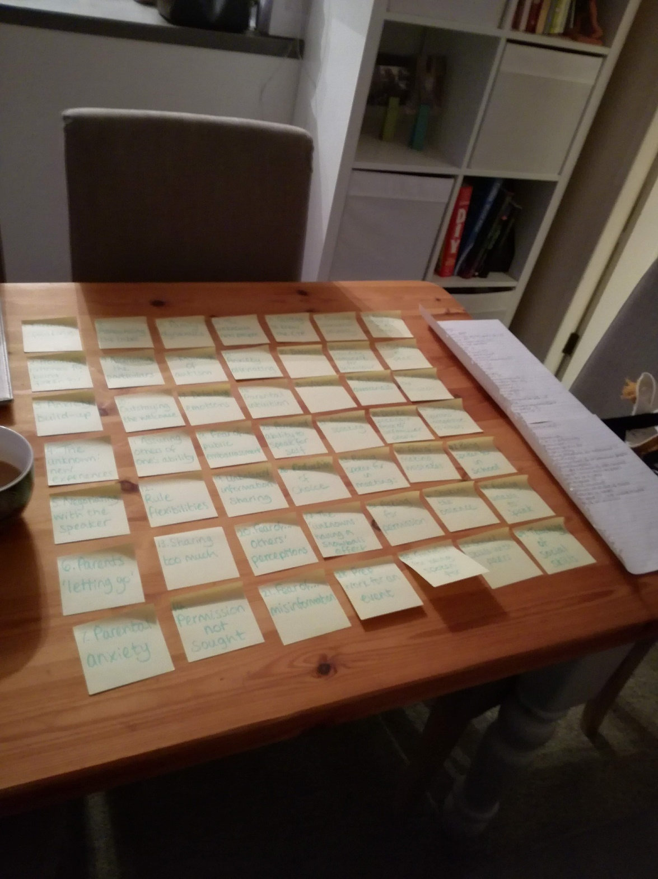

Photograph of the thematic maps made on 14.11.2018
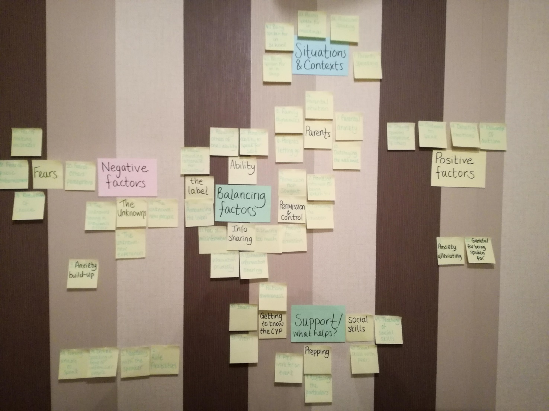

Photographs of changes made to thematic maps on 21.12.2018
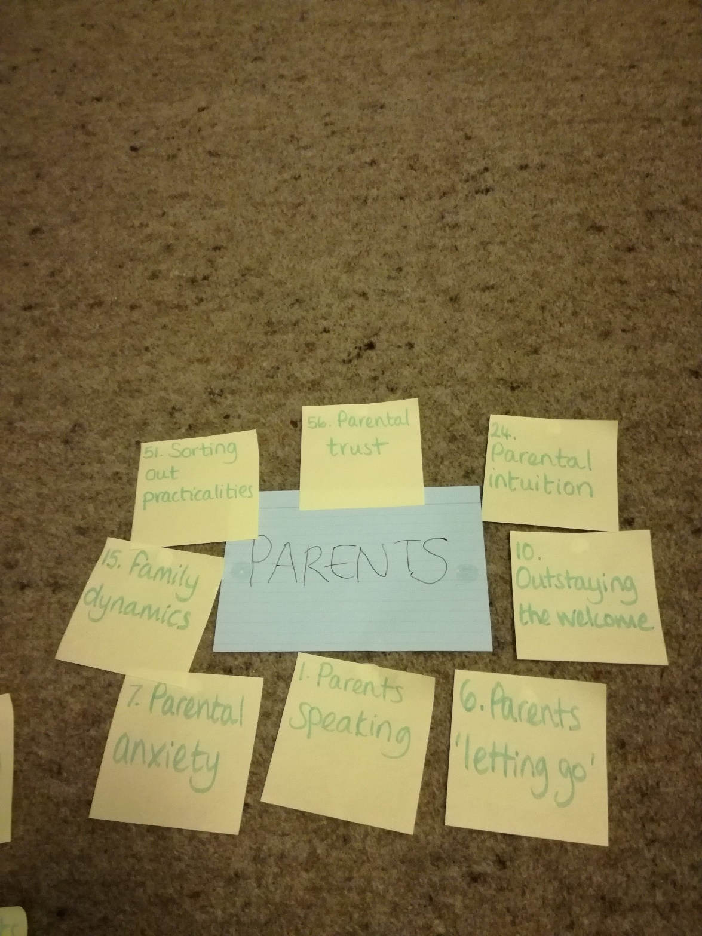

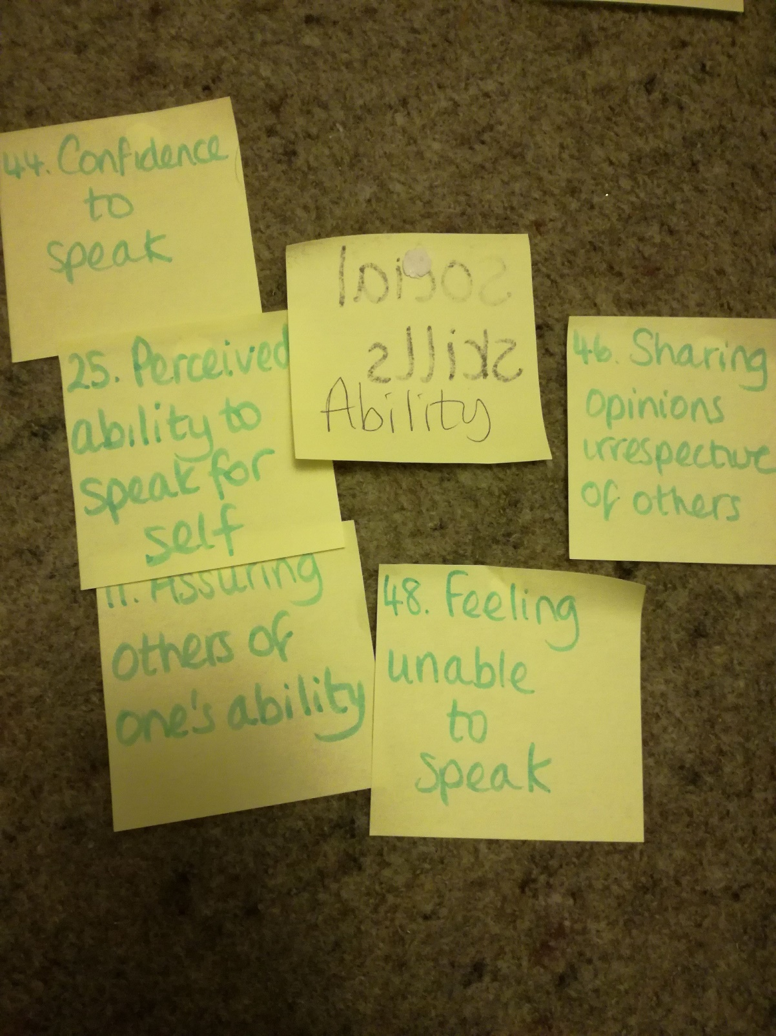

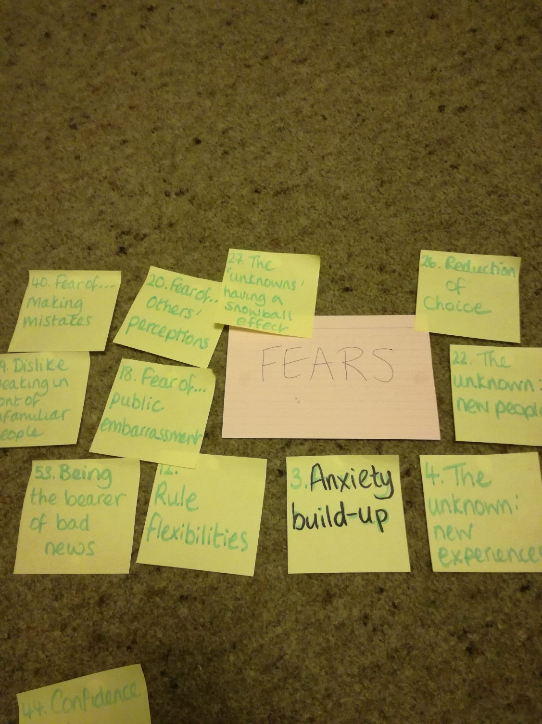

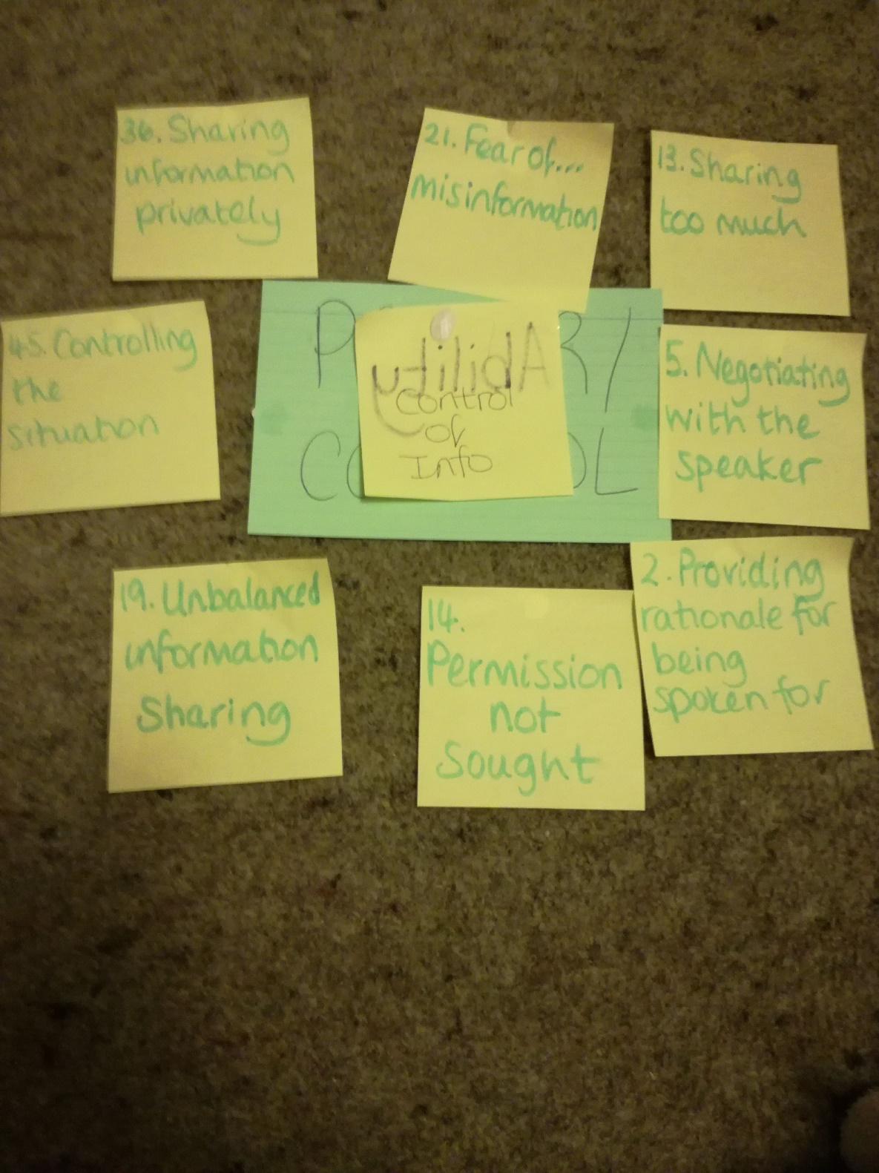

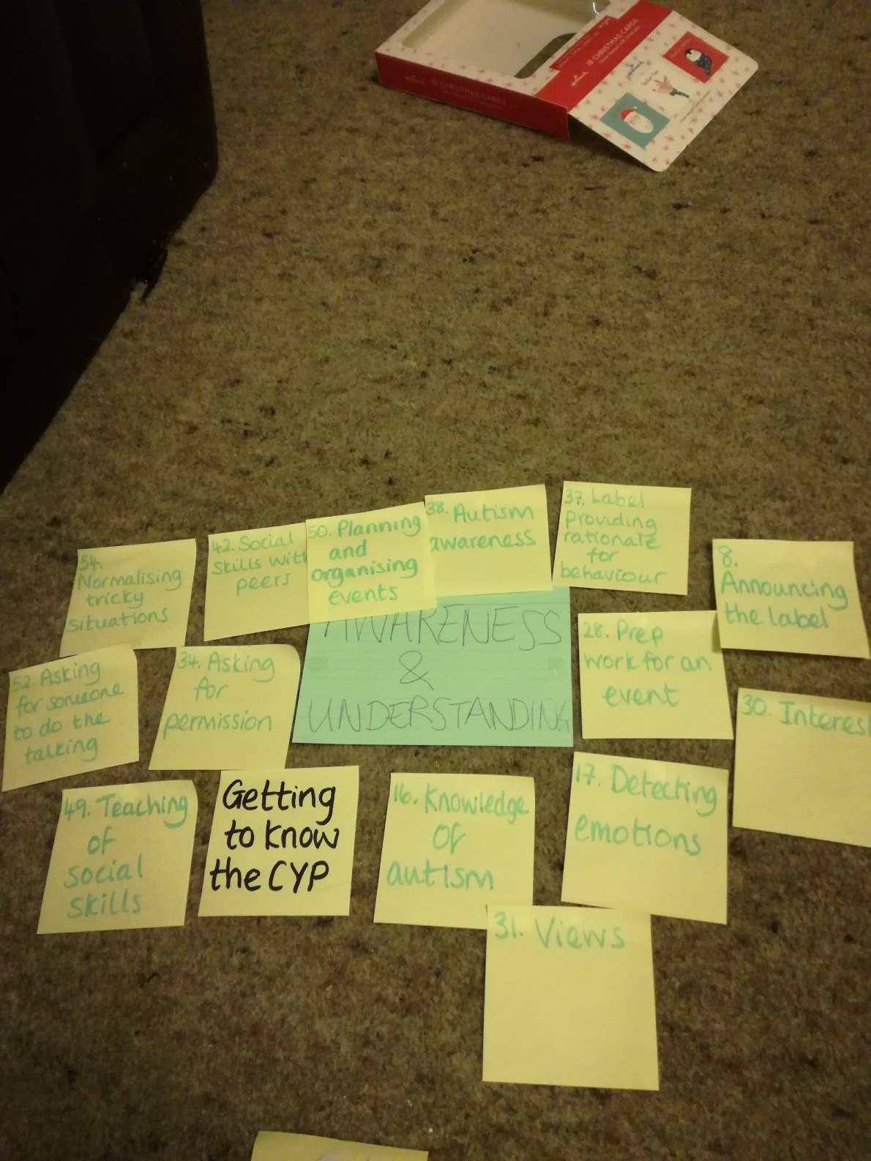

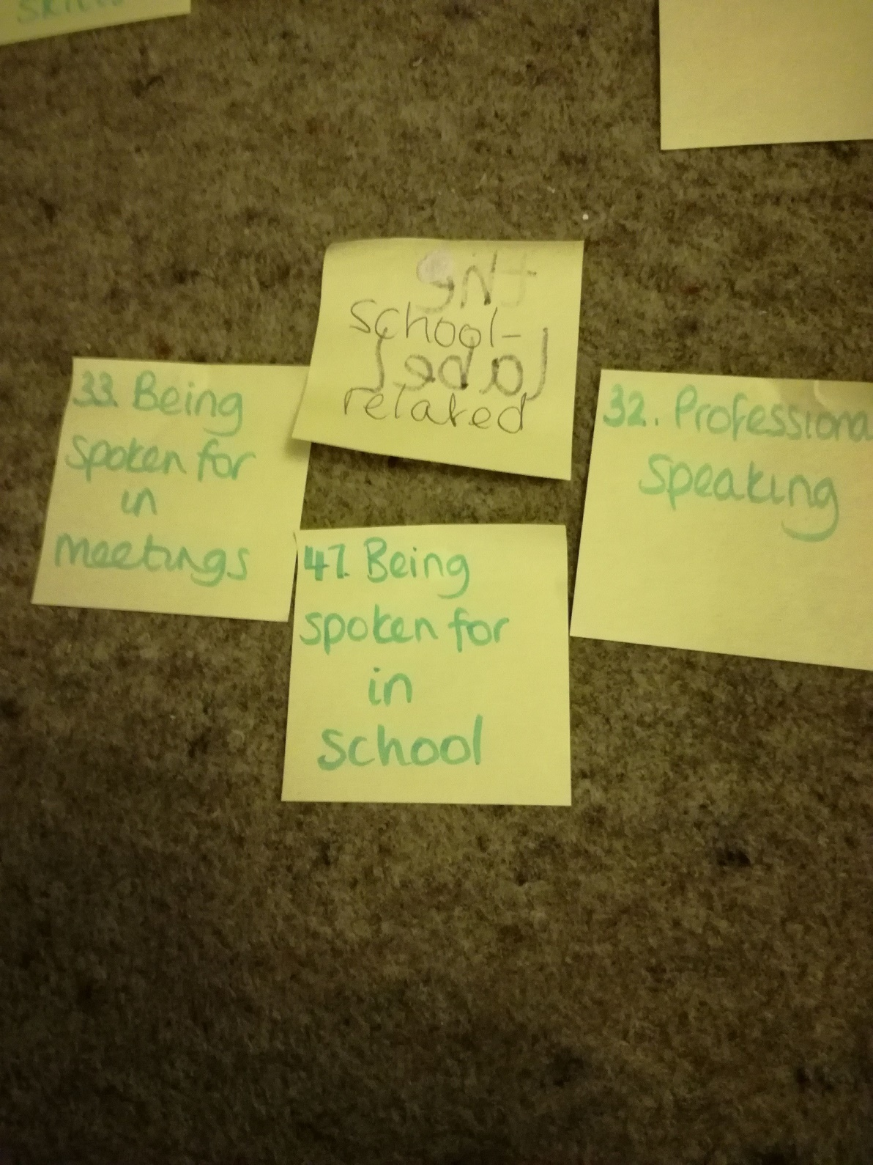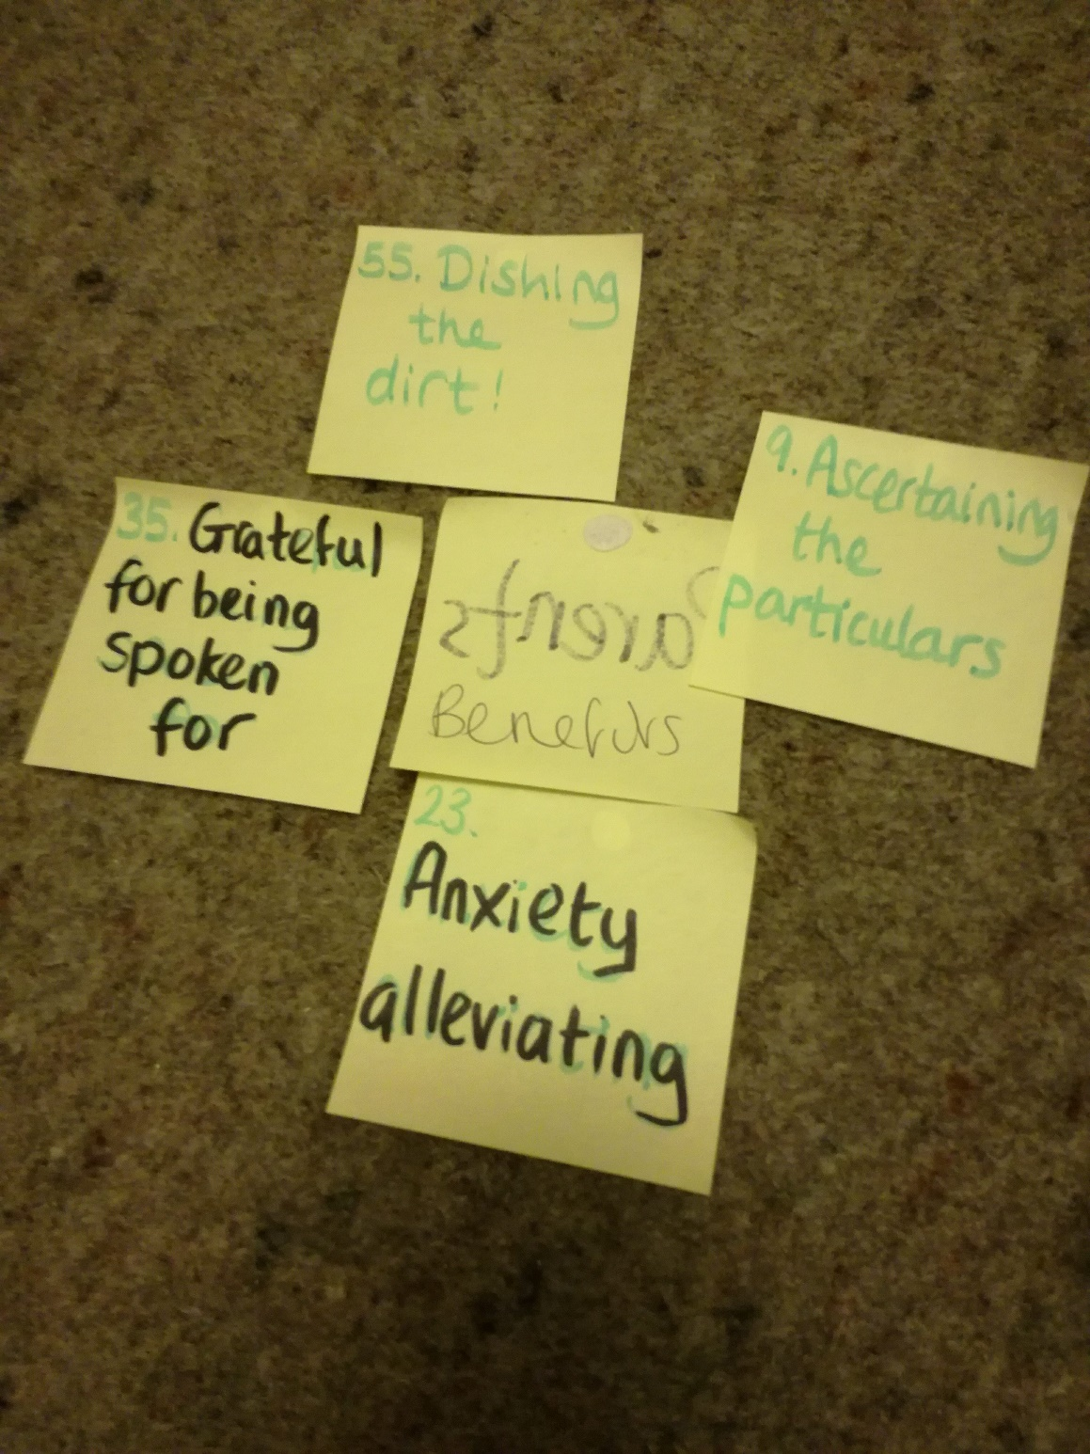

Appendix 22: Mind maps
