

PhD Thesis
Medical School
Name of candidate: Felicity Anne Fletcher
Project Title:
A mixed methods study on simulation-based undergraduate medical education for preparedness for practice from multiple stakeholder perspectives.
Name of Supervisor: Name of Co-Supervisor:
Dr Michelle Marshall Dr Pirashanthie Vivekananda-Schmidt, Mr Derek Rosario

Approval to Re-Submit Thesis:
Signature of Supervisor indicating that he/she has read and approves the re-submission of Thesis:

Signed: Date: ……6/2/19……………………………………

Statement of Probity
I confirm that I shall abide by the University of Sheffield’s regulations on plagiarism and that all written work shall be my own and will not have been PLAGIARISED from other paper-based or electronic sources. Where used, material gathered from other sources will be clearly cited in the text.

Signature: Date: ……6/2/19……………

Name (Print): ………F A FLETCHER………………………………………………………

Contents page
1. Chapter 1: Introduction to thesis 8
1.1. Background to the study 9
1.2. Rationale for the study 10
1.3. Presentation of thesis 11
1.4. Structure of thesis 14
1.5. Aims and Objectives 15
1.6. Research question 17
2. Chapter 2: Literature review 18
2.1. Introduction 19
2.2. Method 20
2.3. Preparedness for practice as a junior doctor 24
2.4. The undergraduate medical curriculum 38
2.5. Simulation in healthcare 54
2.6. Measurement of preparedness: Confidence and competence 63
2.7. Summary 67
2.8. Research question 69
2.9. Overall flow diagram of plan 71
3. Chapter 3: Methodology 72
3.1. Mixed methods research 73
3.1.1. Mixed methods research: quality 78
3.2. Quantitative research methodology 82
3.2.1. Quantitative research: theory 82
3.2.2. Quantitative research: quality, validity and reliability 84
3.2.3. Quantitative research: limitations 87
3.2.4. Quantitative research: sampling 88
3.2.5. Quantitative research: statistical data analysis 89
3.3. Research design: Use of repeated-measures 93
3.4. Qualitative research methodology 97
3.4.1. Qualitative research: theory 97
3.4.2. Qualitative research: Grounded Theory 100
3.4.3. Qualitative research: quality 104
3.4.4. Qualitative research: sampling 110
3.4.5. Qualitative research: limitations 112
3.4.6. Qualitative research: focus groups 113
3.4.7. Qualitative research: interviews 115
3.4.8. Qualitative data: Thematic analysis utilising framework in Nvivo 123
3.5. Triangulation of data 126
3.5.1. Data analysis 128
3.6. Ethics 129
3.7. Summary 129
4. Chapter 4: Pre-pilot study: focus groups with students 131
4.1. Introduction 132
4.2. Aim: Exploring preparedness for practice 132
4.3. Methods 132
4.3.1. Sample 132
4.3.2. Context 132
4.3.3. Setting 133
4.3.4. Topic guide 133
4.3.5. Consent and Research Ethics 135
4.3.6. Conducting focus groups 135
4.4. Results - Emergent themes 142
4.5. Venn diagram as summary 145
4.6. Discussion 147
4.7. Conclusion 149
5. Chapter 5: Design of intervention 150
5.1. Study design 151
5.2. Educational theory related to Simulation-Based Medical Education (SBME) 152
5.3. Curriculum design 161
5.3.1. Foundation Programme curriculum learning outcomes 162
5.3.2. Tomorrow’s Doctors 163
5.3.3. Debriefing 167
5.3.4. Undergraduate simulation expert consensus 171
5.4. Resources required 172
5.5. Outcome measures: Assessment design and validation 173
5.5.1. Development of confidence score tool 174
5.5.2. Development of Formative Assessment tool 177
5.6. Summary 180
6. Chapter 6: Pilot Study 181
6.1. Introduction 182
6.2. Aims and objectives 182
6.3. Methods 183
6.4. Statistical analysis 184
6.5. Results – quantitative – repeated-measures vs. control and intervention 184
6.5.1. The sample 185
6.5.2. Pre-course and post-course confidence scores 186
6.5.3. Distribution of sample 188
6.5.4. Related samples T-test to compare a single group of students under two different conditions 190
6.5.5. One-way repeated-measures Analysis of Variance (ANOVA) over three conditions for the same group 191
6.5.6. Formative assessment results 193
6.5.7. Feedback results from the pilot course 195
6.5.8. Pilot IMASS (intervention) group versus non-IMASS (control) group results 196
6.6. Results – Qualitative – focus groups 200
6.6.1. Focus group findings 200
6.7. Results: Lessons learned from pilot study 207
6.8. Results: Power calculation 208
6.9. Discussion: Key findings from pilot study 211
6.10. Conclusions 217
6.11. Summary 219
7. Chapter 7: Intervention study 220
7.1. Introduction 221
7.2. Part I: Aims and Objectives 223
7.3. Part I: Methods 223
7.3.1. Sample 224
7.3.2. Course 224
7.3.3. Quantitative data collection 225
7.3.4. Statistical analysis 226
7.3.5. Qualitative data collection: focus groups 226
7.3.6. Qualitative data collection: Interviews with national simulation and medical education experts 227
7.3.7. Thematic analysis using framework to triangulate data 236
7.4. Part II: Results: Quantitative 241
7.4.1. Descriptive statistics 241
7.4.2. Principal Component Analysis and Factor Analysis 254
7.4.3. Distribution – tests for normality focusing on overall pre-course confidence 257
7.4.4. ANOVA 258
7.4.5. Analysis of missing values 261
7.4.6. Correlations: Confidence and Performance 262
7.5. Part II: Results: Qualitative: focus groups 267
7.6. Part II: Results: Qualitative: Interviews 275
7.6.1. Preparedness 275
8. Chapter 8 Data triangulation 282
8.1. Introduction 283
8.1.1. Theme 1: Understanding preparedness 285
8.2. Theme 2: Preparing students for clinical practice 295
8.2.1. Practice under pressure 297
8.2.2. Human factors 325
8.2.3. Experiences 350
8.2.4. Clinical reasoning and judgment 357
8.2.5. Clinical cognitive competence 364
8.3. How to design and deliver undergraduate simulation education 375
8.3.1. The debrief 383
8.4. Summary 388
9. Chapter 9: Discussion 389
9.1. Key findings 390
9.2. Preparedness for practice 392
9.3. Clinical cognitive competence development through practice under pressure leading to mastery 403
9.4. Emotion in learning and emotional intelligence 422
9.5. From basic skills to mastery – comparisons with existing educational theory for embedding non-technical skills 427
9.6. Recommendations for best practice guidance for simulation use in the undergraduate curriculum 432
9.7. Limitations of research 437
10. Chapter 10: Conclusions 451
11. Chapter 11: Recommendations for future work 461
12. Bibliography 465
13. Appendices 480
13.1. Influences and their inter-relationships, on the behaviour of newly qualified doctors caring for acutely unwell patients (Tallentire et al., 2011a) 481
13.2. Kolb’s’ cycle of experiential learning 482
13.3. Simulation debriefing and how it fits with Kolb’s experiential learning cycle 483
13.4. Miller’s pyramid of clinical competence 484
13.5. Dreyfus model of skill acquisition 485
13.6. Ethics Approval 486
13.7. IMASS learning outcomes 487
13.8. IMASS Simulation scenarios 491
13.9. Equipment list 504
13.10. IMASS timetable 506
13.11. Study information sheet 507
13.12. Student participant Consent form 509
13.13. Confidence scoring tool 510
13.14. Formative assessment tool 511
13.15. Peer feedback sheet 514
13.16. Feedback sheet 515
13.17. Example of survey money follow-up confidence scoring tool. 516
13.18. Post-It note emergent themes example 518
13.19. Initial focus group thematic analysis – grouping and summary 519
13.20. focus group topic guide 520
13.21. Pilot study SPSS outputs 521
13.22. One way ANOVA SPSS supporting outputs from data for pilot study 522
13.23. Pilot study results SPSS: Intervention group (n=16) versus controls (n=16) 526
13.24. Pre and post-course confidence scores 527
13.25. Communalities for principal component analysis (PCA) 529
13.26. Component matrix for PCA 530
13.27. Tests of normality on baseline confidence scores 532
13.28. ANOVA for 58 students confidence scores over four conditions (completed data) 535
13.29. SPSS outputs detailing planned comparisons between 4 conditions 537
13.30. Analysis of missing values (ANOVA) compared with present values in complete data set 541
13.31. Correlations: Confidence and performance 545
13.32. Development of interview topic guide: 548
13.33. Interview topic guide 549
13.34. Interview information sheet 551
13.35. Framework thematic classification 553
13.36. Framework example with case, summary and original data 554
13.37. Thematic analysis using framework matrix – process – abstract conceptualisation - responsibility and practice under pressure 556
13.38. Practice under pressure 559
13.39. Culture and the hidden curriculum in healthcare 562
13.40. Methods to address culture and the hidden curriculum in healthcare 562
13.41. Human factors 563
13.42. Non-technical skills 564
13.43. Human factors: When and how to teach 565
13.44. Challenges and barriers for simulation-based medical education 566
13.45. Fidelity 570
13.46. Faculty for SBME 571
13.47. Patient safety and SBME 574
13.48. Planning SBME 575
13.49. Roy Adaptation Model 579

Abstract
Title:
Exploring the added value of simulation-based undergraduate medical education for preparedness for practice: a mixed method study.
Medical undergraduates express underpreparedness for Foundation Programme (FP).
Objectives:
Investigate
- Impact of simulation intervention on student confidence for clinical practice;
- Preparedness and value of simulation with medical students and educators.
Methodology:
A mixed methods study. Final year students (n=94) from two UK universities underwent a simulation course with structured debriefing using Sim Man 3G® and part-task trainers. Learning outcomes mapped to Tomorrow’s Doctors (TD) and FP curriculum. Confidence scores in 19 TD and FP mapped domains were collected at four time points: Baseline, pre-course (1 = None, 10 = very confident), immediately post-course (n = 94), one-week post (n = 79) and one month into FP (n = 58). Data analysis was by ANOVA with Bonferroni correction applied (SPSS 21).
Focus groups were conducted with students (n=19) and semi structured interviews (n=10) with UK simulation experts (purposive sampling). Thematic analysis was performed on triangulated data with framework in Nvivo10.
Findings:
Confidence scores increased significantly; post-course (F (2.48,148)=49.98, p = <0.001). Mean baseline confidence score was 5.88 (SD 1.2) (range 3 - 8), immediate post-course mean 7.22 (SD 1) (p<0.001), 7.4 (SD 0.8) at one week (p = 0.655) and 7.8 (SD 1) one month into FP (p = 0.15).
Medical students interpret preparedness as confidence.
Overarching emergent themes were practice under pressure and human factors leading to enhanced self-regulation and competence.
Preparedness was enhanced by understanding the work culture and the hidden curriculum, authentic meaningful interprofessional learning, belonging, mentorship, role modelling, responsibility through experiential and consequence learning and individualised facilitated debriefing.
Conclusions:
Simulation improved preparedness by allowing students to experience complexity, responsibility and practice under graded pressure. Human factors education and embracing complexity supported preparedness through enhancing self-regulation, emotional intelligence and resilience. Guidelines for developing undergraduate simulation curriculum at the correct level of pressure are presented.

Acknowledgements
I would like to thank my supervisors for all of their time support and guidance over the last three years. I would like to thank my family for their support, understanding and patience, particularly my mother looking after our two beautiful boys.
I would like to thank the team at Pinderfields Education centre at MESH in helping me to set up the pilot course and run the subsequent final course, in particular Adam Burns for running the sessions with me over many days.
List of Tables and Figures
Figures
Figure 1-1 List diagram to demonstrate structure of thesis 14
Figure 2-1 Terms used for literature search 20
Figure 2-2 Process diagram to demonstrate initial stages of pilot then final study design 70
Figure 3-1 Visual presentation of procedures for mixed methods design 74
Figure 3-2 Decision matrix for determining mixed methods design (Creswell and Plano Clark, 2007) 75
Figure 4-1 Preparedness for practice - 5th year medical student views from focus groups - Venn diagram 145
Figure 6-1 Differences in pre-course (IMASS simulation intervention) (blue) and post-course confidence scores about starting as a FY1 (red) 185
Figure 6-2 Breakdown in pre- and post-IMASS confidence scores for each of the 19 FP and TD mapped learning outcomes. 187
Figure 6-3 Distribution of baseline pre-course confidence scores in pilot group. 188
Figure 6-4 Repeated-measures confidence scores for pilot study group at baseline pre-course, post-course immediate and at four months, with errors bars representing 95% confidence interval. 191
Figure 6-5 Distribution of formative assessment marks from 80 (minimum) to 139 (maximum). The data is not normally distributed. 192
Figure 6-6 Relationship between pre-course confidence and course performance using formative assessment marks. 193
Figure 6-7 Feedback scores from the course. 194
Figure 6-8 Distribution of confidence scores - control group. 197
Figure 7-1 Final intervention study overview. 221
Figure 7-2 Change in confidence score pre- and post-course (difference) for each of the 19 FP and TD mapped domains. Errors bars represent 95% CI 252
Figure 7-3 Distribution of data for final study baseline pre-course confidence scores 257
Figure 7-4 Change in confidence scores over four different conditions with 95% confidence interval error bars 260
Figure 7-5 Means across the four conditions for overall pre-course confidence for present data analysed (n=58), versus those for missing values with the means for the three conditions as a comparison (n=36) Error bars 95% CI 261
Figure 7-6 Relationship between change in confidence score pre and post-course with formative assessment mark (performance) 265
Figure 7-7 Themes and sub-themes from focus group analysis 266
Figure 7-8 Venn diagram to demonstrate main emergent themes related to 'preparedness' from thematic analysis of UK medical education and simulation expert in-depth interview transcripts 277
Figure 8-1 Conceptual Education Framework 296
Figure 8-2 Hierarchy of skill acquisition 322
Figure 8-3 Eleven stages involved in designing and delivering a SBME intervention 375
Figure 8-4 Stage 8: delivery of a SBME session 380
Figure 8-5 Debriefing for SBME 384
Figure 13-1 Histogram for precourse confidence scores for missing data not analysed (n=36) 541
Figure 13-2 Histogram for precourse confidence scores for analysed data present for all 4 conditions (n=58) 542
Figure 13-3 Scatter plot of data points for correlation between formative assessment mark (performance) and precourse confidence 546
Figure 13-4 Scatter plot of correlation between mean formative assessment mark and mean precourse confidence score 546
Figure 13-5 Thematic framework surrounding 'Practice under pressure' from framework analysis of triangulated qualitative data 560
Figure 13-6 Relationship diagram to summarise culture and the hidden curriculum in healthcare 561
Figure 13-7 Methods to address the culture and hidden curriculum in healthcare 562
Figure 13-8 Human factors 563
Figure 13-9 Non-technical skills from framework analysis of triangulated data 564
Figure 13-10 When and how to teach human factors in healthcare –key themes 565
Figure 13-11 Quality as a main theme related to challenges and barriers for SBME 566
Figure 13-12 Monetary issues surrounding the challenges and barriers of SBME 568
Figure 13-13 Physical issues related to challenges and barriers for SBME – key themes 569
Figure 13-14 Fidelity and SBME – key themes 570
Figure 13-15 Faculty for SBME – key themes 572
Figure 13-16 Patient safety in the context of SBME – key themes 574
Figure 13-17 Planning a simulation-based education intervention – key themes 575
Figure 13-18 Learning outcomes when designing a SBME intervention 576
Figure 13-19 Designing scenarios for SBME 577

Tables
Table 2-1 Inclusion criteria for articles 22
Table 7-1 Gender and confidence scores (n=94) 241
Table 7-2 Formative assessment marks between gender (n=94) 242
Table 7-3 Overall confidence scores between University 1 and 2 students. 243
Table 7-4 Overall pre-course/ baseline confidence scores and formative assessment marks as a marker of performance 244
Table 7-5 Change in pre and post-course confidence score (Q20 difference) compared with formative assessment result 246
Table 7-6 Overall baseline confidence and how prepared students felt one month into FY1 when seeing an acutely unwell patient 248
Table 7-7 Overall baseline confidence compared to how well their undergraduate curriculum has prepared them for FY1. 249
Table 7-8 Overall baseline pre-course confidence and ability to treat a patient with sepsis when one month into FY1. 250
Table 7-9 Level of agreement surrounding awareness of expectations about being a FY1 and self-rated confidence 252
Table 7-10 Principle Component Analysis 256
Table 7-11 Mean overall confidence scores for each of the four conditions, baseline pre-course, post-course, 1 week post-course and 1 month into FY1 259
Table 8-1 Main emergent themes and subthemes from triangulation of data surrounding preparedness 284
Table 13-1 Difference in pre and post-course confidence scores for each of the FP and TD curriculum-mapped domains 527
Table 13-2 Component matrix for Principal component analysis 530
Table 13-3 Descriptive statistics for analysed complete data present across all four conditions for pre and post-course confidence levels 541
Table 13-4 Descriptive statistics for correlation: Performance versus overall pre-course confidence SPSS V21 545
Table 13-5 Pearson correlation coefficient SPSS output: One-tailed 545
Table 13-6 Regression model summary 546

Chapter 1: Introduction to thesis

Background to the study

Over 40% of UK medical graduates do not feel prepared for practice as a Foundation year 1, junior doctor (FY1) and large differences between graduates of different schools have been found (Goldacre et al., 2003, Cave et al., 2007, Burford et al., 2014, Goldacre et al., 2014). The death rates for patients in English hospitals are higher in the first week of August for medical admissions (when new FY1 doctors start and often junior doctors at all levels rotate) than the preceding week (Jen et al., 2009). Though these data do not control for severity of disease, cases and seasonal illness during changeover of new FY1 doctors, issues with patient care quality and rotations have been previously noted (Hirsh et al., 2014). If this is related to preparedness for practice then it is likely that it is influenced by competence as well as confidence. Various initiatives within the undergraduate curricula to support the transition of new graduates are discussed in detail in Chapter 2.
Furthermore, Outcomes for Graduates: Tomorrow’s Doctors initially publised 2009 and updated in 2016, states that ‘the safety of patients and their care must not be put at risk by students’ duties, performance, health or conduct’ (p.31 2009 document). In terms of delivery of teaching, the document recommends that ‘experiential learning in clinical settings, both real and simulated, is important to ensure graduates’ preparedness for Foundation Year One training’ (FY1) (GMC, 2009 p. 53). It is a huge challenge to prepare student doctors for the pressures and stresses of a clinical environment, allowing them the responsibility for decision-making whilst ensuring patient safety.
There is evidence that simulation-based education with deliberate practice is superior to traditional models of medical education in terms of clinical skill acquisition (McGaghie 2011) and that this does transfer into practice (Seymour et al., 2002, Blum et al., 2004). Simulation has been shown to improve adherence to guidelines in resuscitation scenarios (Andreatta et al., 2016, Butter et al., 2010, Wayne et al., 2005, Issenberg et al., 2002, Draycott et al., 2008a). Current literature surrounding the use of simulation to support preparedness for practice is lacking and warrants further exploration.

Rationale for the study

Previous literature and data suggests the need to improve preparedness for clinical practice amongst medical students. The challenge for educators is how best to do this and what is actually meant by preparedness. The General Medical Council (GMC) wants undergraduate programmes to create learning opportunities without compromising quality of care so that graduating doctors have immersion in clinical practice without affecting patient safety. Potentially, simulation can offer a solution, where mistakes can be made without harm to the patients and individual feedback can be given. With discussions to consider bringing forward full registration with the GMC to the point of graduation, it is particularly important.
It is important to explore areas in which students feel less prepared, as well as evidence and educational theory behind simulation in healthcare. This has supported the design of a simulation-based medical education intervention for 5th year medical students to investigate whether training in simulated environments has an impact on preparedness for FY1 and what the added value is for using simulation as an educational methodology.
Practical clinical skills can be improved using simulation over traditional methods, however effect on other vital skills such as ‘judgment under pressure, medical decision-making, situational awareness, teamwork and professional behaviour’ have yet to be explored and these data contribute some understanding to this (McGaghie et al., 2011). One of the largest challenges is proving that simulation-based education improves patient outcomes, though this is fraught with ethical implications for data collection and research. Before we can do this we need to explore the added value of simulation-based medical education as an educational methodology and resource, to allow the opportunity to create guidelines.

Presentation of thesis

‘Chapter One: The Introduction’, initially sets the scene and explores topical challenges in undergraduate medical education, in particular preparedness.
‘Chapter Two: The Literature Review’, explores the data and literature surrounding undergraduate medical curricula changes, preparedness for practice and simulation-based medical education as an intervention, including the evidence and experience as well as highlighting gaps that warrant further exploration.
‘Chapter Three: Methodology’, includes rationale, explanation and justification of the mixed methods approach employed, strategies used to address quality and rigour and reasons for triangulating data for final analysis.
‘Chapter Four’ presents scoping data from initial focus groups to explore the meaning, understanding and interpretation of preparedness for 5th year undergraduate medical students. This ensured that the tools to assess preparedness were grounded in the participant’s own world and views. Methods employed for focus groups are explained in detail to allow transparency and replication. This data informed pilot study design.
‘Chapter Five’ describes the design of the intervention to include resources, equipment, reasons for scenarios selected and learning outcomes to allow for replication.
‘Chapter Six’ presents the pilot study of 23 undergraduate students, which informed a power calculation for the final intervention study.
‘Chapter Seven’ presents the mixed methods findings from the intervention study of 94 final-year UK undergraduate medical students and data from qualitative in-depth interviews from UK simulation and undergraduate education experts. The emergent themes are presented with rich examples.
‘Chapter 8’ presents triangulation of all data brought together into a conceptual framework with regards to the learning potential for undergraduate simulation education and preparedness. Best practice guidance has been developed with a practical guide on how to design and deliver a simulation-based medical educational curriculum to undergraduates.
‘Chapter Nine: Discussion’, allows findings from this study to be explored in comparison with existing literature and educational theory.
‘Chapter Ten’ concludes the main findings of what this study adds to existing knowledge surrounding preparedness for practice and simulation-based education with particular reference to the undergraduate population.
‘Chapter Eleven’ highlights potential future work felt to be of interest from the findings of this study.
Each chapter concludes with a summary, to demonstrate how and why progression occurred onto the next stage. Bibliography and appendices are presented at the end.
The following diagram (Figure 1.1) demonstrates the structure of the thesis as a list of chapters and content. These diagrams are used within the thesis at the start of each new chapter to highlight the point where the reader has reached. The diagram has the current chapter highlighted in red to navigate position and progress.

Structure of thesis

Figure 1-1 List diagram to demonstrate structure of thesis

Aims and Objectives

The overall aim is to understand how best to use simulation in the undergraduate curriculum to train and prepare junior doctors, assess impact, and optimise delivery. The data has informed the development of best practice guidance on planning and delivering a simulation curriculum that can be applied nationally to undergraduate medical education.
Objectives:
- Create, design and deliver a simulation-based intervention.
- Map learning outcomes, confidence assessment and formative assessment to domains set out by the Foundation Programme curriculum and Tomorrow’s Doctors.
- Develop a tool for formative assessment of performance during the simulation session. Validate the tool. Use as a benchmark for performance.
- Run a pilot study using controls (non-intervention) and evaluate repeated confidence levels over time.
- Track impact of simulation-based experience (IMASS) on confidence over time.
- Explore qualitatively preparedness and perceived value of simulation from undergraduate perspective using focus groups.
- Explore qualitatively preparedness and perceived value of simulation from education and simulation experts.
- Conceptualise educational framework.
- Explore the challenges, barriers and practicalities of creating an undergraduate simulation curriculum.
10. Create best practice guidance on the implementation of undergraduate simulation-based education and curriculum design.

Research question

1. What is the impact of a simulation-based intervention for 5th year medical students on preparedness for practice for FY1?
2. What is good practice for developing and implementing a simulation curriculum for undergraduate medical students to support preparedness for practice?
3. What are the views of medical education and simulation experts on what is good practice for developing and implementing an undergraduate simulation curriculum?

Chapter 2: Literature review

Introduction

The GMC (regulatory body for medical practitioners in the UK) annually collects and reports data from all new medical graduates about whether they feel their medical school has prepared them for practice as a junior doctor. The question concerns anticipated subjective preparedness, however it is not clear what is interpreted or meant by ‘preparedness’. This is explored in depth in this study.
A literature review of the current published evidence has been conducted to gain a better understanding of preparedness and why it is important. Exploration of mechanisms and interventions to help support preparedness both at undergraduate level and postgraduate level in the workplace has been undertaken.
A narrative review was conducted owing to the wide range of literature revealed in searches and the emergent complexity. Narrative reviews aim to isolate and summarise published data, avoid duplications, and locate new un-investigated areas to support need for research (Ferrari, 2015). Narrative reviews are said to ‘comprehend the diversity and pluralities of understanding around scholarly research topics and opportunity to reflect and share self-knowledge’ (Jones, 2004, Collins and Fauser, 2005). This review attempted to allow themes to be explored comprehensively and allow reflection, though was not exhaustive (Grant and Booth, 2009). As the review of the literature progressed it became evident that a thematic approach was more appropriate than a systematic review in order to explore the wider field to truly highlight gaps in areas for study. It became apparent that there were gaps in levels of understanding related to preparedness and how to enhance it through education, which led to the foundations of the multistage design of this research. Though both narrative and systematic reviews may include a range in terms of level of evidence as well as type of study, the systematic review aims to ‘provide a qualitative and quantitative analyses of the relevant data’ (Ferrari, 2015). Owing to the broad themes related to preparedness described below it was felt not possible to perform a systematic review without loosing some of the deeper understanding and qualitative aspects. Potential weakness of use of narrative review is that of bias through subjective selection of studies and evaluation biases. There was need for the researcher to be centrally placed and embedded in the research throughout to support understanding, which required an appreciation of preparedness through review of the wide range of studies. Narrative reviews are non reproducible and there can be lack of awareness of assumptions and planning. Attempts to minimise bias were use of inclusion and exclusion criteria (table 2.1) and quality indices recommended by Buckley et al. (2009) as described below. Work from experts known in the field and meta analyses where included to optimise reporting.

Method

The search terms used were ‘medical students’, ‘preparedness’ and ‘simulation’ in medical education. Although medical subject headings (MeSH terms) were used they are not designed for searching medical education articles and as a result they can lead to a large result of potential literature of low relevance. Inclusion criteria were followed as displayed below (Figure 2.1). Initial search was conducted from 1980 until 2013, and then was revised in January 2016 for updated literature. 1980 was used as a starting point to ensure the period of undergraduate education pre and post tomorrows’ doctors document was included and early use of simulation based practice allowed for.

Figure 2-1 Terms used for literature search

Equivalent searches were carried out in 6 databases: Web of Science, Scopus, PubMed, Medline, Google Scholar and the Education Resources Information Centre (ERIC). Table 2.1 demonstrates the inclusion criteria. Original research studies, reviews, commentaries and letters were reviewed. Only studies in English were included and most studies were UK-based, though some key European, Australian and American studies were included to explore the wider global perspective. The reference lists and indexed citations of studies were checked for further relevant studies in case not picked up on electronic searches. Abstracts of identified studies were screened. Initial searches surrounding preparedness revealed 775 articles, which were reduced to 42 when inclusion criteria applied. Simulation based medical education and the undergraduate curriculum revealed 3,160 articles reduced to 41 when inclusion criteria applied. Full texts were reviewed.
Table 2-1 Inclusion criteria for articles
Included if fulfilled | Justification
1. Article contains information on preparedness in the undergraduate curriculum for FY1 | Preparedness in this group is the focus and where challenges lie
2. Article is related to transition from undergraduate medical student to junior doctor | Excludes transitions of different levels of doctor and in different fields to focus attention on this area
3. Article is primary research OR evaluation of educational intervention OR review OR commentary | Important to see broad range of perspectives particularly as subject is complex and have employed mixed methods approach
4. Work is from predominantly UK medical schools | Focus is on preparedness in UK undergraduates, other countries have different curricula, however wider perspective was briefly explored as a comparison
5. Qualitative and quantitative studies are included, reviews, commentaries, meta analyses | To help gain a better understanding of gaps in the literature and areas to explore further and address

Assessment included noting location of study, number of participants and level in training, method of data collection, tool to measure preparedness, details of methods to enhance preparedness and use of simulation to enhance preparedness.
The literature was reviewed and critiqued in line with quality indices recommended by Buckley et al. (2009) and are presented as a narrative review below. Quality indices included clarity of research question, appropriate number in study and selection, use of valid data collection methods, consideration of control of confounding variables, methods of data analysis, whether data supports the conclusions and whether ethical issues were addressed (Buckley et al., 2009). The literature review has been organised into four emergent themes to allow comparison of the literature, presentation of key studies and emphasis of gaps in each area. The themes include preparedness for practice, the undergraduate curriculum, simulation-based medical education and medical student competence and confidence.

Preparedness for practice as a junior doctor

It is a GMC requirement that medical students are ‘properly prepared for their first day as a Pre-Registration House Officer’ (PRHO or FY1) (GMC, 2009). In a small qualitative study (n=28), FY1s that felt well prepared for practice reported a ‘more positive overall experience of the transition’ from medical school to FY1 (Brennan et al., 2010). High levels of stress and burnout (up to 25%) related to high work pressures and responsibility have been reported amongst junior doctors (Alexander et al., 2014, Bogg et al., 2001).
Factors have been explored via retrospective questionnaires from junior doctors in the UK, categorising them into ‘individual’ and ‘organisational’. Those feeling less prepared reported poorer leadership skills, reduced ability to manage uncertainty and prioritisation skills (individual). Organisational workplace factors included ‘perceived lack of support, lack of continuity and poor feedback’. Those feeling well prepared, reported ‘high levels of agreeableness, conscientiousness, empathy and extraversion’ (Alexander et al., 2014). These data were reported from nine studies exploring preparedness, the issue of recall bias is present due to the retrospective design. There are other influences on the ward that may have affected responses and the method of analysis of the papers is not reported. Nevertheless, this paper concludes, preparedness is ‘difficult to quantify’ and emphasises the importance of exploring preparedness from ‘various perspectives (e.g. student, mentor, patient) and at time points’ (Alexander et al., 2014).
Awareness of own limitations as well as capabilities and self-confidence have been reported to contribute to a feeling of preparedness (Tallentire et al., 2011c, Wall et al., 2006, Burford et al., 2014). A relationship between hands-on practical experience and preparedness prior to FY1 has also been described (Cave et al., 2009, Illing et al., 2013).
One report shows that fifty-eight per cent of UK graduates agree that their medical school has prepared them for FY1 (Goldacre et al., 2010). This leaves a significant minority that felt underprepared. Preparedness has been reported to have increased over time in some studies, potentially ascribed to undergraduate curricula changes that occurred in all medical schools between 1998 and 2006 (Cave et al., 2007). However, another study reports a reduction in perceived preparedness from 53% in 2008 to 49% in 2009 (Goldacre et al., 2014). Several attempts have been made to dissect these confusing statistics.
A retrospective postal questionnaire sent to all UK medical graduates with the statement "My experience at medical school has prepared me well for the jobs I have undertaken so far", revealed an increase from 36.3% agreeing with the statement to 50.3% in 2003 and 58.5% in 2005 (Cave et al., 2007). This was a retrospective subjective reported measure of preparedness at risk of recall bias. Self-perceived capability related to ability to undertake the jobs that they have been involved in as a FY1 at one particular time point. Response rates for the questionnaire were initially very good at 67% of the graduating cohort, however in 2005 only 43% of new FY1s responded (Cave et al., 2007). This may not be representative of the whole cohort and there is no information on the preparedness of non-responders.
Whilst Cave et al. (2007) report an ongoing significant variation in preparedness between doctors from different UK medical schools, a later paper by Illing et al. reports no substantial variation between three medical schools (selected for curricular diversity) when comparing preparedness for practice (Illing et al., 2013). There were substantial differences in numbers of FY1s studied in these research papers (Illing et al n = 60, Cave et al n = 2057 in 2005 group). The larger study, that includes all medical schools, is likely to be more representative. Owing to the time difference, the variation may represent changes to the undergraduate curriculum as the student assistantship was introduced in 2009 (TD 2009).
Goldacre et al. (2014) present self-reported preparedness in UK graduates, ranging from 83% to 27%, with 25% of doctors reporting that feeling unprepared had been a ‘serious or medium sized problem for them’. These data were collected following completion of FY1 with response rates around 50%, so may not be fully representative. When the 2008 and 2009 cohorts were combined, 9.3% ‘strongly agreed’ that their medical school prepared them for ‘jobs undertaken so far’ in FY1, 42.1% ‘agreed’, 30% were ‘neutral’, 15.9% ‘disagreed’ and 2.6% ‘strongly disagreed’. Over time there was an increase in preparedness reported from 1999/2000 (36%) to 2005 (58%) but then a reduction to 49% in 2009. The percentage that ‘disagreed’ or ‘strongly disagreed’ that their medical school prepared them has continually reduced within each cohort, which is reassuring, but suggests there is still work to be done (Goldacre et al., 2014).
These studies are good for demonstrating potential patterns but they offer no clear understanding as to why graduates did not feel prepared nor the potential impact on self, patients and their team. In order to learn from data collected about preparedness, it is vital to explore beyond statistics to ensure meaningful assessments and curricular development strategies are fit for purpose.
Goldacre et al. (2014) found medical school to be a ‘significant predictor for preparedness’, with three of the new medical schools in the top six for graduates feeling well prepared. They suggest that ‘early clinical experience, longer clerkships and increased responsibility’, are key features of other programmes that demonstrate increased levels of preparedness amongst junior doctors. They recommend that medical schools seek and analyse feedback from graduates to inform curricula changes to improve preparedness for FY1 (Goldacre et al., 2014).
(Morrow et al., 2012) explore preparedness for practice amongst graduates from three different UK medical schools with diverse curricula (system-based, graduate vs. Problem-based learning (PBL)). Fifty-three aspects of preparedness were explored, informed by focus groups, previous literature reviews and the Tomorrow’s Doctors (2016). A questionnaire sent to medical graduates (response rate 67%, n = 479) asked to rate self-perceived ‘anticipated’ preparedness for FY1 related tasks and situations. A further questionnaire was sent to ward staff involved in working with new FY1s and related to their preparedness in terms of objective capability (n=80 in total). The paper is unclear about when this was sent to staff and whether it was linked to this specific cohort of FY1s starting or just FY1s in general. Team perceptions of preparedness were reported to largely match ‘self-reported perceptions of recent graduates’. Highest levels of preparedness were reported related to ‘working with patients, team, history taking and examination’, and the lowest levels of preparedness for ‘prescribing, more complex practical procedures and applying knowledge about complimentary therapies’ (Morrow et al., 2012).
These questionnaires ask about different things: anticipated subjective self-perception versus objective retrospective demonstrated capability. One could argue that they are not comparable because they are different, however using this triangulated approach may add validity to the use of self-perceived anticipated preparedness as a measure, in that it does seem to be related to performance on the ward. The importance of asking a range of health professionals is supported by the fact that when asked about prescribing, ‘medical and nursing respondents saw FY1s as prepared’, however pharmacists report ‘underpreparedness in a number of elements, witnessing mistakes and near misses in all areas of prescribing’. This demonstrates the importance of triangulation, using a multi-professional technique and highlights the influence of ‘experts’ rather than those with a broader overview.
Also, a focus on knowledge and practical skills risks being a superficial measure of competence for the complexity of being a FY1 in practice. This may help to understand why ‘on paper’ FY1s are ready but that they report underpreparedness. Understanding about risk, near misses and self-correction are vital skills but are a huge challenge to isolate and measure. (Morrow et al., 2012) recommends that there needs to be an increased opportunity for exposure to and experience of the real workplace as well as active participation. This is a clear and obvious message, yet educational quality assurance, what is ‘meaningful’ participation, and facilitation of learning in a clinical environment have not been discussed.
This is a quantitative study of what is essentially a qualitative measure – views, opinions and perceptions, leading to a paucity of rich understanding of how preparedness can be improved.
Tallentire (2011) shares her thoughts from her own research and experience that junior doctors are not trained to manage the: ‘complexity of the hospital environment, manage workload, cope with night shifts, manage stress, acknowledge and reflect on own emotions related to death, professional relationships and patient complaints’. Though this is a self-reported opinion, learning from those with experience of the clinical environment may uncover vital areas for development.
This issue is a challenge internationally. A study of 637 junior doctors in Germany, performed through the use of retrospective questionnaires reports ‘60% of participating doctors felt poorly prepared for postgraduate training’. Deficient skills found to be independently related to self-rated preparedness were ‘treatment and therapy planning’, interpretation of ECGs and endotracheal intubation (Ochsmann et al., 2011). The study focuses on technical skills avoiding the complex non-technical skills, highlighted by Tallentire et al. (2011). This may reflect the complexity of assessment of non-technical skills, or may reflect the lack of perceived importance and value of them in comparison.
Brennan et al. (2010) qualitatively explore the self-reported experience of 28, self-selected, newly qualified doctors (28/186) from one UK foundation school through semi-structured interviews (n=17 repeated interviews, n=10 audio diaries). Graduates report a ‘stressful transition’ due to new ‘responsibility, managing uncertainty, experiencing sudden death of patients, feeling unsupported’ and interprofessional teamwork (Brennan et al., 2010). Increased undergraduate clinical experience was found to reduce stress related to becoming a FY1. Although these data are from a single centre in the UK and less than 20% of the graduates for the cohort, they add a rich description and understanding of the feelings and emotions experienced by FY1s. Recommendations include ‘early clinical environmental exposure’, and ongoing ‘meaningful contact with patients’. Brennan (2010) defines meaningful contact as the student being ’involved in patient care’ rather than just ‘exposed to it’ and that they ‘understand the significance of it’.
Increasing ‘opportunities for students to “act up” as junior doctors’ is recommended, however the team highlight the challenges associated with patient safety (Brennan et al., 2010). Increased supervision was particularly recommended on surgical placements and relating to dying patients. Support was reported as being ‘good in A and E’, and was related to an ‘open attitude of asking for help and teaching’. In this study, the use of audio diaries allowed FY1s to capture immediate post-event reflections - this is unique amongst studies already reviewed. One doctor reported that the audio diary acted as a ‘means to unburden himself from stressful and difficult episodes’. This may suggest that FY1s are not feeling empowered enough nor having the opportunities to create space to ‘unburden’ themselves to their team.
In this study, the team had a clear research question related to ‘experiencing the transition’ to FY1 and how ‘well-prepared they were for their new role’. Eight different researchers facilitated semi-structured interviews, which could pose a potential challenge in standardisation of interviews and confidence that reactions and responses are not linked to different interviewers. Interviews were transcribed by professional transcribers, where it may be possible to lose some of the experience reported by individuals. Thematic indices were designed by the eight researchers, which may challenge consistency, though methods to reduce this such as crosschecking transcripts, coding and analysis were used.
Junior doctors reported a huge leap from ‘classroom’ to ‘workplace’, and the realisation that a ‘small mistake can have severe consequences’. This idea of learning about outcomes or consequences and the impact of the environment are worth considering. Students need to be integrated into the workplace in a safe, supported way or a replica workplace environment as authentic as possible to support this transition. One FY1 states that it is ‘not really possible to create that sort of environment in a non-real kind of situation’, emphasising one of the challenges with using simulated environments.
In terms of uncertainty, this was described related to expectations in their role as well as ‘medical uncertainty’ about diagnosis and treatment’, and when to seek help (Brennan et al., 2010). The junior doctors report on the importance of experiencing team-working, also that ‘some things could only be learnt by just doing the job’. This study, though small, offers a powerful clear insight into areas that can be enhanced to help with preparedness. The researchers conclude that it is normal and expected to experience a ‘healthy level of stress’ in this transition but that the measures mentioned above will aid support and minimise stress (Brennan et al., 2010).
A GMC report (Illing et al., 2008) - referred to previously - reviewed preparedness of medical students from three medical schools for starting practice. The multi-method, prospective, cross-sectional study aimed to explore the extent to which different medical schools prepare their graduates. It was based on 250 interviews, 479 questionnaires, 420 FY1 prescribing assessments, and learning portfolio data.
Illing et al. (2008) found that students felt prepared for basic clinical tasks and were confident in communication skills, but did not feel prepared dealing with acutely ill patients, prescribing, managing workload, and being on call. The study found that preparedness was affected predominantly by external factors, including undergraduate clinical placements, shadowing, induction and the support of others (workplace and home), and partly by internal factors (personality and learning style).
Some aspects, such as adapting to hospital procedures, became apparent after some time working. There was a view that they ‘were not arriving with sufficient ward experience, and that on-the-job experience would increase confidence’. At the end of the F1 year, the overall feeling was that ‘more exposure to acute patients, and the clinical judgment and decision-making involved in their management, would have been useful’ (Illing et al., 2008).
Kellett et al. (2015) report on the retrospective views (focus groups and interviews) of 52 FY1s and 22 clinical supervisors during the first year of FY1. Supervisors reported objectively that they felt the FY1s were ‘well prepared’ but would benefit from more experience with ‘real patients’, as well as opportunities to be responsible and make decisions. FY1s reported feeling unsupported, particularly out of hours, and supervisors felt the FY1s did ‘not access senior support appropriately’. FY1s felt that they ‘lacked confidence in approaching consultants’. Students report having not felt part of a team during clinical placement and that they did not ‘have a position of authority with colleagues’ (Kellett et al., 2015). The FY1s reported feeling unprepared for ‘making diagnoses, prescribing, and acting in an emergency’, and found it difficult to make decisions, prioritise, manage their time, deal with the administration and reported feeling ‘stress and anxiety’ related to the new responsibility they were experiencing. There is evidence to demonstrate that ‘prior clinical experience reduces the stress associated’ with the undergraduate to FY1 transition period (Brennan et al., 2010). Belonging appears to be important.
Undergraduate clinical skills have been criticised in the literature for being taught in a random way and students have been unsure of expectations (Goodfellow and Claydon, 2001). Bogg et al. (Bogg et al., 2001) reported that students wanted further training in practical skills, time management and delegation. Wall et al.(Wall et al., 2006) found that junior doctors and consultants agreed that they were least prepared for decision-making, prescribing, treating and practical skills. They felt most prepared in communication, history taking and teamworking. Jones et al. (2001) reported similar findings with students feeling much less prepared in diagnosing, decision-making, coping with uncertainty, evidence-based medicine and ethical issues.
Tallentire et al. (2012b) concur with these findings through a systematic literature search (265 articles recovered, 10 included in analysis), reporting that UK medical school graduates were least prepared in acute care and prescribing. They report a perception that though preparedness was increasing in some areas, acute care had fallen behind. In addition, that ‘perceived preparedness is important in influencing the behaviour of new graduates’. It is useful in these studies to combine the subjective perception of FY1s with the objective perspective of supervising colleagues to triangulate data.
Cave et al. (2009) and Illing et al. (2013) report that the quantity of ‘hands-on practical experience’ that a junior doctor has before starting work is linked to preparedness. This emphasises the importance of experiential learning throughout the undergraduate curriculum. It is a challenge to expose all medical students to rare events, so equipping them with more generic skills regarding assessment of the unwell patient and strategies to manage stress, awareness of limitations, and how and when to access help are likely to be more important.
Burford et al. (2014) report on questionnaire outcomes from 344 UK graduates starting FY1 about perceived preparedness and exposure to immediate care scenarios in one Trust. They had a high response rate of 91.3% so are representative of results demonstrating an overall perceived feeling of moderate preparedness. Unpreparedness (in > 10%) mostly concerned clinical procedures, communication skills and prescribing. Up to 30% of respondents reported not having had opportunities to prescribe or manage acutely unwell patients, others gaining less than three hands-on experiences, and 12% reported no experience at all. Seventy per cent of respondents had three or more simulation sessions related to acute care patient management suggesting that simulation is accessible in this region. There was a ‘significant difference in preparedness when considered against number of hands-on experiences of acute care’, however this needed to be above at least three to make a difference. In terms of simulation, the overall effect on preparedness was reported as significant but only when respondents had experienced ‘at least five simulation sessions’. Real-life experience was a ‘significant predictor of preparedness’ with a greater influence than simulation (Burford et al., 2014). In this study, respondents were asked just as they were starting as FY1. There are complexities that will have influenced their responses in terms of anxiety, confidence and experiences, in the workplace, individual and at home.
Kassim et al. (2016) report on a cross–sectional study of retrospective preparedness following graduation from two transnational medical schools. A ‘Preparedness for hospital practice questionnaire’ (PHPQ) was used. There was a 43% response rate, and 4% had not started their junior doctor jobs. They concluded that perceived preparedness for hospital practice was strongly associated with early career preparation and medical school career guidance (Kassim et al., 2016). These data were at risk of recall bias, with a small number of responses and variation in time in terms of reporting. This is challenging to interpret and without qualitative exploration of perceptions it is difficult to understand. This study does highlight the importance of career guidance as they found that ‘inadequate career preparation is a key stressor for medical students’ (Kassim et al., 2016).
When exploring preparedness for practice amongst new FY1, Tallentire et al. (2011c) completed a qualitative study of subjective new graduate views and objective educational supervisor views, and compared outcomes. The research used an electronic questionnaire sent to all Edinburgh Medical School graduates with FY1 jobs in Scotland in 2009 and was curriculum-mapped (Tallentire et al., 2011c). This represented 53% of the graduate cohort and was taken following six months of work as a FY1. The questionnaire was sent to all educational supervisors and repeated over two years. FY1s reported feeling most prepared for consultation skills and least prepared for prescribing. Educational supervisors reported preparedness in use of Information Technology and low preparedness for procedural practical tasks, with the lowest ‘unsatisfactory’ score related to provision of ‘immediate care for medical emergencies’. This is a potentially huge patient safety issue.
Free text from respondents was analysed thematically, and when triangulated with educational supervisor views four main themes emerged: ‘knowledge’, ‘skills’, ‘personal attributes’ and ‘familiarity with ward environment’. ‘Knowledge’ encompassed poor pharmacology knowledge, ‘practical prescribing ability’, poor anatomy and physiology knowledge, and difficulty ‘translating knowledge into practice’(Tallentire et al., 2011c). ‘Skills’ represented mostly clinical judgment skills, particularly ‘identification and management of acutely unwell patients’, a concern for both FY1s and supervisors. Non-technical skills (decision-making, prioritisation and taking initiative) were reported as an area of under-preparedness and were deemed as ‘critical day to day aspects’ that FY1s felt they had had no opportunity to learn in their undergraduate degree. Supervisors voiced concern over the amount of ‘stress’ being experienced by FY1s and felt that coping skills could be improved.
‘Personal attributes’ related to lack of confidence reported by both groups. The final theme was ‘familiarity with ward environment’, agreed by both to be important for transition from medical student to FY1. The questionnaire design appeared to have construct and face validity with clear study aims. It is limited to one medical school so is unclear about generalisability. However, the qualitative data and emergent themes add vital richness in understanding experiences of both groups of respondents to allow data triangulation and enhance rigour. Patient safety issues related to under-preparedness for prescribing, non-technical skills and assessment and management of acutely unwell patients concur with other studies described. The study recommends focus is given to ‘acute care, prescribing and procedural skills’ (Tallentire et al., 2011c).
The review of the literature on preparedness as a junior doctor highlights that it is complex and related to exposure and experience - both real-life and simulated - as well as individual factors such as personality traits (Cave et al. (2009)). Potential reasons for the reported lack of preparedness include the impact of the European Working Time Directive resulting in reduced working hours and the breakdown of the team structure, and knowledge of who to escalate problems to (Jones et al., 2001, Wall et al., 2006). Feedback has been shown to be an important correlating factor to a feeling of preparedness (Duns et al., 2008). Furthermore, confidence and preparedness have been shown not to correlate with exam results (Morgan and Cleave-Hogg, 2002). This therefore necessitates careful planning with regards to a measure to assess preparedness, but also an exploration of what is meant or interpreted by preparedness by different groups. There are variations in terms of studies exploring anticipated and retrospective preparedness and it is unclear if these are different and thus comparable. Conclusions that include increased exposure and increased responsibility are clear but not specific on how to achieve this.

The undergraduate medical curriculum

The aim of undergraduate medical education is to produce competent pre-registration house officers (PRHOs) or Foundation Year one (FY1) doctors (Jones et al. 2001). Undergraduate medical curricula have gone through many changes to respond to the outcomes in ‘Tomorrow’s Doctors’, last updated in 2009 (GMC, 2009). This document has been since superseded by ‘Outcomes for Graduates’ (2016), however outcomes remain unchanged. The GMC (2009) states that: ‘doctors must be capable of regularly taking responsibility for difficult decisions in situations of clinical complexity and uncertainty. Recommendations have included opportunities to shadow junior doctors and now focus on development of leadership skills and knowledge of quality improvement. Medical schools are expected to respond to novel ‘scientific developments’ and alterations in ‘societal expectations and values’ (p. 6 - 7.), whilst preparing medical students for lifelong learning and professional development in an ever evolving healthcare climate (Brennan et al., 2010).
Illing et al. (2013) qualitatively explore through focus groups and interviews, the impact of varying medical school curricula to try to understand if this has an impact on preparedness in three diverse medical schools. A prospective, cross sectional study was conducted. Twenty medical students from each medical school (total n = 60) were interviewed at completion of medical school, then four and 12 months into FY1. The final number interviewed at 12 months was 70% of the initial group (n=46). One medical school was purely graduate and the other two mostly undergraduate entries (one with an integrated systems based curriculum, one with a PBL curriculum). The main lack of preparedness was reported as being related to ‘complex communication (with relatives and related to bad news), and managing the duties of a doctor (on-call, acute care, prioritisation and prescribing’).
Clinicians suggested that increased exposure and involvement in clinical encounters on the ward and to complex situations would help with preparedness, but that practice could never fully prepare them for the job. The main linking theme was labelled as ‘on the job learning’, highlighting the importance of learning on a ‘real’ ward with ‘real’ patients. Suggestions focused on improving medical school placement consistency and giving students a role within the clinical team. The research findings informed the GMCs Tomorrow’s Doctors document in recommending the introduction of the student assistantship from 2009.
Both clinical supervisors and undergraduates opine that they need more responsibility at medical school, particularly with decision-making and participating with ‘real patients’ in clinical environments (Burford et al., 2014, Kellett et al., 2015). Some highlight the need to teach and develop vital leadership and management skills, whilst others highlight the need to enhance self-efficacy and self-regulation through education (Leigh, 2008). Suggested improvements to the undergraduate medical curriculum include: more exposure to complex cases and resultant decision-making, ‘more realistic, continuous exposure to patients during placements, more widespread use of simulation, including multi-professional scenarios’, to help improve graduate preparedness for practice (Kellett et al., 2015). Burford et al. (2014) agree that simulation is important but experiences in the workplace are more beneficial.
The student assistantship aims to encourage more active participation with patient care by taking responsibility, under supervision, the performance of the tasks expected of a FY1 (GMC, 2009). Evidence points to the fact that FY1s will be better prepared the more closely their undergraduate curriculum represents their authentic role as a FY1 (Tallentire et al., 2011b). Though Tallentire et al. (2012a) highlight that little work has been done about creating an evidence base to inform curricula outcomes and learning priorities for the assistantship to ensure added value and avoid ‘overcrowding’ of competencies. This study used a questionnaire sent electronically to all FY1s graduating from Edinburgh Medical School in 2010 (n=204) and all educational supervisors (n=100). Response rates were low at 31% and 33% respectively. Educational supervisors rated ‘completion of discharge scripts, task prioritisation and handover’ as the top three areas to prioritise skill development during the assistantship, whilst FY1s ranked practical tasks as their highest learning need. The team hypothesise that these data may be explained through the supervisor prioritising ‘patient flow and administration’ whilst the FY1 view may reflect reduced ‘opportunities to practice practical tasks’ in medical school (Tallentire et al., 2012a). The top three combined priorities for learning opportunities were ‘prescribing, acute care and prioritisation of ward tasks’, which echoes many of the studies previously described. Free text responses revealed ‘out of hours working, administrative tasks and experience of the theatre environment’ to be important to FY1s and supervisors (Tallentire et al., 2012a). This study highlights the importance of multiple stakeholder views to inform curricula development.
Wall et al. (2006) question whether the ‘undergraduate curriculum reforms have concentrated too much on communication skills to the detriment of basic clinical competencies, such as treatment, prescribing and managing emergencies’. Clinical and communication skills are reported to be learnt mainly in a simulated setting with simulated patients (actors or mannequins) because of patient safety concerns (Bleakley and Bligh, 2008).
Jones et al. (2002) report that changing from a more traditional undergraduate curriculum (1998-1999) to a PBL curriculum improved junior doctors’ confidence and preparedness for FY1. The team used questionnaires sent to FY1s (n= 123 (48%) of traditional course graduates, and n= 138 (52%) graduates from the new curriculum) from a single UK medical school, three months into their new job and asked about areas of competence and skills listed in the GMC’s ‘The New Doctor’. Questionnaires were also sent to clinical supervisors.
FY1s rated the PBL course more effective than traditional in 12/19 competencies and 8/13 skills. FY1s from the traditional course rated their understanding of disease processes higher than graduates that experienced the PBL curricular change, though supervisors reported no difference (Jones et al., 2002). These data are potentially affected by recall bias, the groups compared are from different year groups and a single medical school is studied, however it is useful to explore different curricula. Of note, nationally at this time, there was a move to more community-based education in General Practice so this may have influenced data. The response rate included roughly 50% of the year, which is considered reasonable for a questionnaire response.
A further medical school created a PBL curriculum in response to the Tomorrow’s Doctors document (2003 version). Educational supervisors believe this led to more competent doctors who were better prepared for PRHO jobs than previous graduates. This was based on seven interviews despite 161 supervisors being invited to take part. Twenty-three pilot interviews were performed but it is unclear why 16 were excluded (Watmough et al., 2006).
Evans et al. (2006) compared three cohorts of graduates from UK medical schools: one traditional curriculum, one traditional with intercalated degree and one PBL curriculum. Anticipated self-perceived confidence in clinical skills and preparedness were measured and compared with perceived anxiety. Traditional students with intercalations scored equally as high as PBL curriculum students. Both groups scored higher than those on a traditional curriculum. However, absolute anxiety levels were high, and confidence and preparedness in clinical skills poor across all three groups.
In terms of group differences, the PBL group had an additional preparation course and did not intercalate through choice, so there may have been academic and motivational differences between the intercalating traditional group versus the PBL group. The questionnaires were sent out in different years, between 2000 and 2004. It is unclear when they were sent out related to graduation and starting FY1, and whether they were the same time in each case. There were good response rates to questionnaires ranging from 79% to 91% (Evans and Roberts, 2006).
Interestingly other authors disagree that PBL improves preparedness and question the outcomes used to measure effectiveness of PBL as an educational methodology. They raise concern over the resources required (Colliver, 2000, Colliver and Markwell, 2007).
Cave et al. (2009) report on results from a questionnaire posted to all newly qualified doctors (May 2005, n= 5143) to work addresses. Respondents were offered a financial incentive to take part. Despite this, the response rate was low at 43.1%, however there was still a large number represented (n=2062). Forty-two per cent reported feeling under-prepared for FY1, with 15% of respondents reporting feeling ‘poorly’ prepared by their undergraduate curriculum (Cave et al., 2009). There were no relationships between preparedness and graduate entry or gender. When exploring personality traits, those that were conscientious and extrovert were found to be more prepared, and neurotics least prepared. Shadowing, including length and allocated post for FY1, plus PBL were linked to increased reported preparedness. Identification of role models during training revealed a small correlation with preparedness. Experience of the ability to access help as a FY1 and retrospective recall that curriculum felt ‘relevant to real life as a doctor ‘ were statements linked to preparedness (Cave et al., 2009).
The team conclude that ‘much of variance in perceived preparedness remains unexplained’ (77%). It is unclear whether this is because it is difficult to define, understand or measure, and what the relevance is to medical education. The GMC focuses on preparedness for practice almost as a marker of quality for undergraduate curricula. Interestingly in this study, there were no significant correlations between reported preparedness and league table ratings of medical schools from the Times and The Guardian (Cave et al., 2009).
Prescribing recurs as an issue of underpreparedness in the literature. A national prescribing safety assessment has been introduced as a response, which assumes that underpreparedness is mostly due to lack of knowledge rather than anything more complex. Smith et al. (2013) developed a programme in Scotland allowing undergraduates the responsibility to ‘pre-prescribe’ under the safety of a countersignature by a qualified doctor. This enhanced professional development, allowing the making of mistakes and learning from them, without harming patients. One important emergent theme was development of ‘professional identity’ through team interaction (Smith et al., 2013).
Kellett et al. (2015) concur, recommending ‘active participation’, experience and exposure to ‘complex problems’ and ‘life skills training’. They advocate ‘simulation for emergency situations’, and practice of authentic FY1 administrative tasks, handovers and prescribing. Post graduation recommendations are to ensure FY1s are supported with complex patients, receive feedback on performance and have a meaningful departmental induction covering their role holistically (GMC, 2009).
There are plans to bring forward doctors’ registration from the current time point at the end of FY1, to graduation from medical school. This recommendation arose following the Shape of Training review (Greenaway, 2013). This would make it critical that 5th-year medical students are fully prepared and competent. Mattick et al. (2016) qualitatively explored UK stakeholder perspectives regarding this move of registration through interviews (n=87) and focus groups (n=30 groups) with doctors, clinical educators, foundation programme directors, patients, public and government representatives (n=185 individuals). The theme ‘implications for undergraduate medical education’, led to the recommendation that a ‘radical review’ would be required and training may need to be extended. Framework analysis revealed the importance of FY1 as a ‘safety net’ related to patients. There were concerns over potential lack of supervision, discharging patients and increases in stress related to this more independent role out of medical school. Deans felt this achievable through curricula changes, whereas others were not convinced and had patient safety concerns (Mattick et al., 2016).
Requirements to address professionalism and clinical practice whilst embedding students in the workplace during undergraduate training were noted as vital changes. This is a challenge, owing to the difficulties of assessing professionalism and the lack of a role in the clinical environment. The multiple stakeholder views including patients have been important, however on undergraduate curricula changes, there are no comments from FY1s - without explanation.
Workplace-based learning and education should be ‘planned, structured and scaffolded’ with ‘appropriate support and challenge through feedback and integration’ (GMC, 2009, Brennan et al., 2010). ‘Meaningful’ encounters with patients in the clinical environment over time may support the integration and feeling of belonging amongst students. The following studies explore attempts to increase undergraduate responsibility in the workplace.
Other studies that support embedding medical students in clinical practice, say it gives a sense of belonging, responsibility to ‘act up’ (Brennan et al., 2010), whilst being supervised (Hirsh et al., 2014). These studies report improved confidence, competence and professionalism through role modelling (Birden et al., 2015, Passi et al., 2013) as well as ‘patient-centred care’ (Hirsh et al., 2012, Gaufberg et al., 2014).
Developing trust between medical student and supervising team appears to be key. Hirsh et al. (2014) echo this notion in a commentary entitled ‘time to trust’ in an exploration of longitudinal integrated clerkships and entrusted professional activities (‘units of professional practice entrusted to a trainee to execute unsupervised’). Hirsh et al. (2014) highlights the problems with ‘defensive medicine’ and resultant ‘defensive training’ that lead to over-supervision resulting in ‘undermining of trainee development of full responsibility’. The importance of ‘ongoing relationships, continuity, mentoring, feedback and assessment’, are emphasised as vital to the development of professional behaviour and ‘expertise’. The current undergraduate curricula are criticised for employing short rotations that lead to a perception of ‘isolation’, lack of ‘social identity’ and impairment of ‘interprofessional teamwork’ that is thought to be bad for patient care, and education (Hirsh et al., 2014). Longer rotations have been shown to improve quality of care, as well as resident, staff and patient satisfaction through an improved continuity and trust with a team, patients and environment (Hirsh et al., 2014).
Induction training programmes have been shown to improve self-reported preparedness and reduce incidence of self-reported mistakes made by FY1s (Blencowe et al., 2015, Brennan et al., 2010). The shadowing period is a GMC (2009) requirement and an opportunity to help prepare students for FY1. In 2006, Wall found that only 79% of FY1s completed a shadowing period and only 57% in the hospital they were due to work in (Wall et al., 2006). Evans et al. (2004) collected data on 24 newly qualified doctors who underwent a five-day, ward-based induction programme to try to improve their preparedness, confidence and competence for their job in certain practical skills. They completed reflective questionnaires, had formal lectures, as well as extended time shadowing their new team. Twenty-one doctors completed all questionnaires. All perceived their practical skills to be poor. After induction and 1 month into FY1 there was a significant improvement in confidence in skills. Confidence in death certification and prescribing was initially low, deteriorated and only improved after one month into the job.
The group recommend performing objective self-assessment at the beginning of induction to target their training. They conclude that a significant gap exists between confidence and competence provided by undergraduate training and those required for competent professional duties as a doctor. However it is not clear from this study how confidence was measured. There was an increase in competence along with confidence, which could suggest that the two are related. If juniors are not exposed to a death or cardiac arrest during shadowing then it is perhaps unsurprising that confidence falls.
Responsibility and decision-making skills can be limited during the shadowing period because students are not qualified. Shadowing can be extremely variable in the opportunities and experience presented to each student, and which depends on their allocated job. According to the GMC (2009), the shadowing period aims to allow students to ‘become familiar with the facilities, working environment and patterns and to get to know their colleagues and supervisors’. It should also include protected time to apply their medical knowledge through tasks in a working environment and should last ‘at least one week and take place as close to the point of employment as possible’ (GMC, 2009).
Berridge et al. (2007) report on a two-week preparation programme for medical graduates to try to help with the transition to FY1, which acts as an extended shadowing period. Fifty UK medical graduates took part in two different hospitals. The programme combined emergency ‘life support courses, clinical skills training, administrative induction and shadowing the outgoing FY1’. At this pre-registration phase, they were unable to prescribe. Most graduates were from London medical schools (n = 44), with the rest unspecified (n=6). Data on graduate perceptions collected through focus groups and questionnaires were conducted at the start, the end, and one month following the programme.
The team report increased confidence following the programme and into FY1, with shadowing and emergency care rated the most valued tasks. Shadowing did show variation and clinical skills training was more inconsistent. Thematic analysis of focus group data revealed concerns about ‘not coping clinically’ with ‘hands-on work’ the ‘responsibility’ and being ‘alone’. One suggestion was that responsibility could be increased during shadowing to help support the transition to FY1. A solution suggested by graduates was mirroring some international medical schools and UK nurses where final year students are responsible for patients as a ‘caseload’. They suggested ‘obligatory and steadily increased responsibility as a senior medical student was the best way to support the transition’ to FY1 (Berridge et al., 2007). Hirsh et al. (2014) echo this. Graduates reported the need for authentic practice with patients and their development of non-technical skills (‘prioritisation, clinical decision-making and workload management’). The importance of environmental familiarisation was also highlighted (Berridge et al., 2007).
The challenge appears to be standardising the exposure and quality during shadowing to the requirements set out by the GMC (2009). However, it is the rare but important acute emergencies that medical students report needing further training in, as well as the more complex technical skills (Tallentire et al., 2012b).
The quality of life of junior doctors and their mental health and wellbeing is affected by the feeling of being under pressure and overwhelmed which leads to stress (Paice et al., 2002). This study highlights a lack of emotional preparedness when dealing with death and with understanding personal behaviours when stressed and ways to limit the effect of those on encounters with patients, relatives and team members. In the previous studies described above, the reported problem has been with the transition to FY1 from medical school, however this study reports that the most stressful incidents were ‘caused by organisational factors rather than making the transition from student to doctor’. It could be argued that they are all inter-related.
Tallentire et al. (2011b) have created a useful conceptual framework to illustrate the major influences and their inter-relationships on the behaviour of newly qualified doctors caring for acutely unwell patients. This is useful for planning interventions to help with improving preparedness (see Appendix 13.1). The team report on three main emergent themes: ‘Cognitive challenges’, ‘roles and responsibilities and ‘environmental factors’. ‘Cognitive challenges’ including the ‘transfer of knowledge into practice’ and ‘decision-making and uncertainty’. The juniors report knowing ‘what to do but not how to actually do it’, lacking workplace-based practical understanding of equipment, procedures and the environment (Tallentire et al., 2011a). There was a feeling from juniors that unless they knew a patient’s diagnosis, they felt ‘unfamiliar and uncomfortable’ starting treatment. The juniors recognised behaviours they displayed to ‘avoid facing difficult decisions’. This level of cognitive bias potentially has huge implications for patient safety.
In terms of ‘roles and responsibilities’, a subheading of ‘acts and omissions’ showed that juniors were focused on ‘doing no harm’, so reported being more comfortable doing nothing in case a treatment made the patient worse. ‘Identity and expectations’ highlighted issues such as ‘judging themselves against own expectations and perceptions of seniors’ expectations’. A concerning ‘reluctance to call for help’ was described and attributed to ‘role modelling’, fear of being told off for not doing more, and fear of comparison with peers (Tallentire et al., 2011a).
‘Environmental factors’ were divided into ‘medical hierarchy’ with references to ‘military analogies’ and the feeling of not being able to question seniors. ‘Performing under stress’ represented the reported feeling of being ‘overwhelmed and paralysed by the stress of managing an acutely unwell patient’, and experiencing ‘panic’. Seniors described the benefits to going into ‘automatic pilot’ under times of stress, but recognised their support for juniors following stressful events was not good due to ‘lack of time’. This must be addressed.
Tallentire et al. (2011) suggest that a more ‘distributed approach to situation awareness’ may help junior doctors to tolerate the complexity and uncertainty of the clinical environment. They report that simulation as an educational strategy may be more effective if the ‘hierarchical and stressful environment on the ward can be recreated’, and training should include improving awareness of the impact of emotion, effects on behaviour at work, and understanding human failure. Undergraduate and postgraduate training should support development of critical thinking, diagnostic judgment and safety-netting to ensure safe and quality patient care. The complexity of patients needs to be experienced, appreciated and understood by undergraduates. That complexity should be integral to training opportunities to allow the development of cognitive skills to manage such situations.
Decision-making and managing self during stressful situations are linked to human factors as well as safety. Human factors refer to everything within a work environment related to patient care. Stress and distractions can cloud judgment and impair situational awareness.
When exploring decision-making, Croskerry et al. (2014) report on ‘dual process theory’, considered to be the most referred to conceptual framework for understanding cognitive processes that underpin and influence human decision-making. ‘Dual’ refers to two elements of cognitive thought processes. The first is ‘reflexive and autonomous’, related to intuitive, faster thinking that is linked to pattern recognition and application of protocol; and the other slower, more deliberate evidence-based analytic reasoning.
Understanding this is felt to be vital because of its impact and influence on patient safety. Psychological literature supports that humans spend most of their time in the intuitive mode of thinking, where most decision-making errors have been isolated (Croskerry et al., 2014). It is important to move between these two processes and know when to trust one or force oneself into the other. Examples are given through this paper that highlight that fast decisions in the context of an experienced clinician may indeed be analytic, and experience has allowed a level of rapid accurate analysis and accurate diagnosis.
A better understanding of cognitive processes and biases might be key to supporting juniors who are often the first doctors to see a patient, and therefore experience the most diagnostic uncertainty. Once initial assessments and investigations are available, the job of the senior doctor is easier. Croskerry et al. (2014) refer to these as ‘well packaged’ encounters, allowing ‘fast analytic decision to be made’ owing to the fact that ‘all necessary information is available’. They advocate ‘learning about bias, promoting thinking about thinking, promoting critical thinking, promoting vigilant scanning, using interdisciplinary knowledge and expert content knowledge’ (Croskerry et al., 2014).
Further studies exploring decisions made under natural and experimental conditions as well as the ‘many contextual variables in medicine’ are recommended, as well as how this might be applied in medical education. In a letter to Croskerry et al. (2014), Webster (2015) highlights the fact that ‘doctors are human and future work on improving clinical decision-making lies in new practical ways to support and enhance skills and needs to be more than telling them to slow down’. Simulation may act as a resource to allow this.
Simulation in healthcare is being used to train in human factors because it allows mistakes to be made in a safe and controlled environment. It has been shown to reduce error in specialities such as anaesthetics (Flin and Patey, 2009). Though there are many organisational factors that contribute to an error, frontline staff can be trained to be more aware and to reduce ‘active failures’ (‘inadequate handover, failure to monitor, lack of preoperative check, incorrect treatment, not seeking help’) (Mahajan, 2010).

Simulation in healthcare

According to Issenberg et al. (1999), medical simulation is defined as “a person, device, or set of conditions which attempts to present [education and] evaluation problems authentically. The trainee receives performance feedback as if they were in the real situation” (Issenberg et al., 1999). Gaba (2004) describes the goal of simulation as ‘replicating a realistic patient care scenario for the purpose of feedback and assessment allowing learning through experimentation, error and ability to re-run the scenario without harming patients’. Simulation is reproducible, safe and predictable, in contrast to the traditional, ward-based approach (McGaghie et al., 2009). Simulation relies on experiential learning though ‘verbal or physical interaction with the simulated components or patients (Gaba, 1992, Chiniara et al., 2013). Gaba (1992) stresses that ‘no industry in which human lives depend on skilled performance has waited for unequivocal proof of the benefits of simulation before embracing it’. However medicine has been slow to adopt simulation, likely due to traditional views on how medicine should be taught, equipment cost and requiring a suitable environment with faculty available. Initially simulation focussed on the use of mannequins and education centres, however attempts to improve reality have led to in-situ simulation to bring the learning in to actual clinical environments and use of simulated patients either actors or real patients with chronic conditions that can help educate (Chiniara et al., 2013).
Simulation encounters can range from simple part task trainers to learn a procedure to complex communication skills, to large strategic team based educational sessions used to test standard operating procedures, the environment, team dynamics and human factors. Chiniara et al. (2013) describes a framework with four simulation modalities; ‘procedural simulation, computer-based simulation, simulated clinical immersion and simulated patients’, which largely captures the range of approaches to simulation. As such simulation is a complex term interpreted in many different ways by users and educators and is dependent on role and experience. This has the potential to lead to assumptions about what simulation based education will involve and what shape it will take, which may mean opportunities are missed due to inaccurate presumed lack of resource or equipment or more complex areas related to human factors are not enhanced through educational episodes. Indeed cognitive simulation is a form of simulation, where an action or encounter can be mentally rehearsed to try to explore consequences and outcomes to aid learning. This takes time but costs nothing.
There is concern that simulation when delivered in simulation centres can leave out vital elements needed for learning such as interaction with actual patients, relatives and the wider team required for safe patient care (Kneebone, 2016, Fenwick and Dahlgren, 2015, Ma, 2015). This presents the potential risk of dehumanising patients and depersonalisation of care and inability to allow development of rapport with patient, family and team. This concern is emphasised by discussion surrounding ‘technology-focused taxonomy’ that assigns ‘fidelity to the tool itself (simulator), rather than the individual education experience’ (Chiniara et al., 2013). This has been said to ‘underplay the complexity and uncertainty of real-world clinical care’ separating the marriage of ‘technical skills’ from ‘nontechnical skills’ (Kneebone, 2016). In doing this there is reliance on the individual to be able to effectively ‘reintegrate these skills’ otherwise ‘something important might be lost’ (Kneebone, 2009). An additional challenge of using simulation centres is that of cost for the equipment and maintenance and recruitment of separate faculty able to run the centre and equipment.
As such there is a reported need in simulation for ‘recasting it as an educational resource which anyone can design and apply’ with focus on ‘imagination rather than technology’ (Kneebone, 2016). In addition there has been a described lack of ‘articulation of the pedagogy and theory behind simulation-based exercises’ (Ma, 2015, Fenwick and Dahlgren, 2015, Reedy, 2015). This has the risk of an educational resource that should be widely available being under used due to logistical behaviour and uncertainty around learning theory.
Dieckmann et al. (2007), describe simulation as a ‘complex social endeavour’, highlighting the need to consider the ‘physical, semantical and phenomenal’ aspects of realism in simulation. The relationship between physical realism and educational goals is challenged by Dieckmann et al. (2007), highlighting a need for better understanding about what makes an experience feel real and what the impact of that is on learning. Simulation allows deliberate practice which involves ‘repetitive performance of intended cognitive or psychomotor skills in a focussed domain, coupled with rigorous skills assessment’ (Dieckmann et al., 2007). Care must be taken to not allow assessment to over shaddow the learning opportunities offered by simulation through experiential learning and through facilitated debrief.
Overall it is an exciting time for simulation, challenging historic perspectives and the need to explore full educational potential to learn how to enhance utility of simulation to be most beneficial in medical education and education as a whole.
The use of simulation in postgraduate education has been recognised as a valuable educational tool (Gaba and Deanda, 1988). There is data to support the view that simulation-based education does translate into clinical practice with positive effects. In a quantitative meta-analysis by McGaghie et al. (2011) that compares the effectiveness of simulation-based medical education and deliberate practice with traditional methods, the outcomes favouring simulation were ‘powerful, consistent and without exception’ (McGaghie et al., 2011). The team did suggest that the development of best practice guidance on how to deliver optimum simulation-based medical education (SBME) was required and that cost-effectiveness and utility can now be justified. Focus is reported to have now moved on to ‘how it can best be embedded, supported and funded’ (Kneebone, 2016). Studies demonstrate that surgical skills simulators and part task trainers improve performance in the clinical setting (Andreatta et al., 2006, Seymour et al., 2002, Blum et al., 2004), as well as for medical management scenarios and adherence to guidelines in an acute setting to improve quality of patient care (Butter et al., 2010, Wayne et al., 2005, Issenberg et al., 2002, Draycott et al., 2008b, Draycott et al., 2008a). Simulation has been shown to be reliable for teaching communication skills, teamwork and for assessment (Okuda et al., 2009).
Conversely, Gerson et al. (2003) found the use of a state-of the-art virtual reality endoscopy simulator to be inferior to traditional patient-based bedside teaching techniques when training juniors to perform sigmoidoscopy (Gerson and Van Dam, 2003). These variations in the literature support the need for guidelines on best practice for simulation education.
Evidence for the use of simulation in undergraduate medical education is now emerging. Schwartz et al. (2007) reported no significant difference in 102 4th year medical students performance when using simulation versus standard educational case-based methods for teaching acute cardiology. However they did report that a difference in studying strategies and habits outside of medical school could have affected outcomes. In contrast, (Steadman et al., 2006) found SBME with 4th year medical students to be superior to PBL for development of critical assessment skills.
In a systematic review by Laschinger et al. (2008); (23 studies), the effect of simulation on undergraduate knowledge, skills, confidence and satisfaction discovered mixed findings. With knowledge acquisition, some findings were positive, whilst some showed no significant cognitive gain. With skill performance, there were studies showing greater improvement with simulation than a control group as well as those showing no evidence that simulation had an effect on performance. This again highlights the need for guidance to ensure using simulation adds value. Overall, the majority of studies showed a positive effect but that this effect diminished over time, emphasising the importance of continued regular practice.
There was high learner satisfaction with using simulators, with most studies showing an increase in self-reported confidence in skills following simulation education. Though they describe their review as inconclusive, they point out that some studies do show that high-fidelity patient simulation is useful to teach higher-level skills and physiological concepts. They feel that confidence and student enthusiasm for this method of learning is important as it may enhance student understanding. They discuss that one of the threats of simulation is the risk of negative learning, highlighting the importance of trained clinical instructors during the sessions and in debriefing (Laschinger et al., 2008). Bleakley and Bligh (2008) highlight the challenge of transferring learning from simulated practice into real practice.
In terms of simulation and preparedness, a qualitative study evaluating a 16-week acute care spiral curriculum with SBME in a UK hospital, reported that four months into FY1, seven junior doctors ‘did feel prepared for managing a cardiac arrest and an acutely unwell patient upon qualifying’. They reported the benefits of being taught a structured ABCDE approach, having immediate life support training at undergraduate level and learning in a simulated environment (Carling, 2010). Though this is a small cohort of students with no delayed follow-up assessment, it is valuable to have the views of the FY1s in their current posts. It is difficult to say whether this is generalisable to all medical students and it is a retrospective, subjective perception at risk of recall and environmental biases.
Dalgaty et al. (2016) report on outcomes following 17 medical students participating in a ‘Medical Mentorship Programme’ in Scotland. Seven junior doctors were involved in teaching and mentoring. They had a two-hour session focusing on how to be a good mentor, and a three-hour clinical practice session of Objective Structured Clinical Examination (OSCE) based simulation stations. The final three-hour session used simulated OSCE stations and a human factors approach to work on ‘clinical decision-making, prioritisation, team communication and situational awareness’, ending in a facilitated debrief.
Focus group data, analysed using content analysis identified three main themes: ‘benchmarking professional development, the personal value of mentor-mentee relationship and addressing the performance gap’. It was felt that simulation was able to replicate the clinical scenarios in an authentic way and when combined with good mentoring, created effective learning. Mentoring was reported as being useful for ‘emotional support and reassurance’. Simulation was noted to be valuable to students for ‘determining their performance capacity’, which may fit with self-regulation and reflective practice surrounding self-assessed capability.
Though this is a small sample without a control and details on assessment validation, the qualitative aspects offer rich data and the team conclude that the programme had a ‘positive effect on the professional development of medical students’. The study recommends that simulation should be used ‘alongside clinical practice’ and be ‘contextual’ to achieve full potential. ‘Individualistic learning’ as well as mentoring have been highlighted as important areas for preparedness in undergraduate medical students (Dalgaty et al., 2016).
Kneebone (2005) discusses the risk of technological ‘domination of SBME interventions’ over and above the grounding in educational theory and links to the ‘wider world of healthcare’. He calls simulation a ‘necessity’ in the current healthcare climate, though describes one of its weaknesses as the isolation and disconnect that occurs with the use of skills centres. Kneebone concludes that though models such as ‘Kirkpatrick’s four level model’ are useful for planning learning, they are not specific to simulation. He recommends that new or existing simulation should be evaluated by exploring whether they allow for ‘sustained deliberate practice in a safe environment, consolidation and a defined curriculum, access to expert tutors that fade away when no longer needed, map onto real life clinical experience and provide a supportive, learner centred milieu’ (Kneebone, 2005).
Issenberg (2006) concurs, reporting that the best SBME was a product of simulation technology, curriculum integration and prepared teachers, with the opposite leading to a poor experience. McGaghie et al (2009) emphasise this point by stating that ‘simple or sophisticated simulation technology will be ineffective or misused unless faculty members, including physicians and other health professionals, are prepared as simulation educators’ (McGaghie et al., 2009). This highlights the need to invest in good, appropriately trained faculty.
Issenberg et al. (2005) argue that although weak in quality, the published data on high-fidelity simulation does demonstrate facilitation of learning under the right conditions. Ten categories to guide educators in the features and uses of high-fidelity simulations that lead to effective learning include repetitive practice, curriculum integration, range of difficulty level, multiple learning strategies, capturing of clinical variation, a controlled environment, individualised learning, defined outcomes and simulator validity. Motola et al. (2013) support these concepts in a recently published best evidence practical guide that states the importance of ‘determining the outcomes of using simulation and that feedback is critical to effective learning using simulation and should be guided by individual learning needs’. They conclude that ‘simulation-based mastery learning significantly improves skills for all participants, and also leads to skill retention’ (Motola et al., 2013). Debriefing and simulation fits well with Kolb’s experiential learning cycle in that an experience triggers reflection and consolidation of learning (Appendix 13.2). Debriefing should allow candidates to feel safe and supported and allow time for them to relax prior to starting the debriefing because simulation can be stressful especially when fully immersed (Rudolph et al., 2007).
Barsuk et al. (2016) recommend that a simulation-based curriculum should ‘follow a planned, systematic approach fitted to the needs and conditions of a local institutional environment and its learners’. They use ‘advanced cardiac life support skills and transformation to a mastery learning program’ as an example, using the ‘Kern 6-step model involving problem identification and general needs assessment, targeted needs assessment, goals and objectives, educational strategies, implementation, and evaluation and feedback’ (Barsuk et al. 2016). This was a two-year trial on a background of 11 years of studies to evaluate the curriculum effects and outcomes for postgraduate medical doctors.
‘Mastery’ learning and transformation are mentioned with no clear definition or whether it is from a learner or educator perspective. Kneebone (2009) explores this concept and the challenge of defining simplicity and ‘stripping down skills into component parts’. It is mentioned that procedural skills should begin by ‘mastering the basics’. However Kneebone reflects that technical skills are never used in isolation in the clinical environment and that learning is affected by ‘emotional responses and thoughts’ and having to manage ‘uncertainty, anxiety, overload and stress’. Kneebone warns that educators that have passed through stages of transition and training may not be best placed to design educational strategies to support the development of skills for novices because the challenges that they experienced have ‘faded’, and perspectives of novice and expert are ‘radically different’. This highlights the need to include novice views. Kneebone proposes that using a more realistic setting with simulated patients to add the human uncertainty factor, could help support learners understanding how to better manage ‘uncertainty, fear and stress’. It is emphasised that simulation can never substitute a real clinical experience but can be an ‘adjunct allowing deliberate practice in a safe environment for learner and patient (Kneebone, 2009).
It is evident that simulation based education is complex and broad. It can include cognitive simulation, simple tasked based simulation, complex scenarios and team based simulation and the extent of immersion and fidelity appear important. The reported benefit of use of simulation-based education varies in the literature. However, there is clear evidence of the potential to enhance the students experience with regards to preparedness when used as an adjunct.

Measurement of preparedness: Confidence and competence

Preparedness for practice is a challenge to measure. Cave et al. (2009) highlight that though ‘subjective measures of preparedness appear to have good face validity’, there is huge complexity in the ‘relationship between preparedness, competence and confidence’. It is difficult to move away from subjective measures to objective measurement without risking the loss of rich and complex elements such as emotional preparedness. Subjectivity appears important to understanding preparedness and the potential impact on performance. Bandura (1982) emphasises the value and importance of perceptions of ability and self-ratings because they are precursors to behaviour and thus will influence performance.
Self-confidence has been reported as an important contributor to a feeling of preparedness (Tallentire et al., 2011b). Confidence and preparedness are terms that have been used interchangeably for interpreting preparedness in undergraduates (Tallentire et al., 2012b). The scoring of confidence level is subjective and complex but being important for preparedness, warrants further exploration.
Morgan and Cleave-Hogg (2002) looked into whether clinical experience and student levels of confidence were indicators of competence using simulators. They found good correlation between clinical experience and confidence but no correlation between experience, confidence and performance. Some of the tasks (e.g. intubation) could be seen as inappropriate for medical students. The lack of correlation was felt to be due to a lack of validity of the examination itself (McManus et al., 1998b, McManus et al., 1998a) and, or due to quality of the learning through debriefing, instructor enthusiasm and the relevance the medical students have placed on the skills.
The importance of experience through repeated exposure and deliberate practice on confidence and performance is emphasised by Avisar et al. (2013). Medical students two years on from resuscitation training versus one year on, were found to be less prepared and less confident with worse performance (Avisar et al., 2013). Follow-up over time appears important.
Hoppe et al. (2009) highlight the importance of subjective assessment and demonstrate a link between self perceived satisfaction and clinical skills acquired during undergraduate medical education. Gordon (1991) states that ‘valid self-assessment is fundamental to continuing professional competence’, but reports that self-assessment may not represent actual performance. Only when ‘self-assessment goals and training strategies were explicit’ was validity high and improvements over time demonstrated. Gordon (1991) reports that the skill of accurate self-assessment and reflection are assumed and not taught in the undergraduate medical curriculum. Recommendations include effective self-assessment training to develop this skill to help individuals recognise their own strengths and weaknesses. Self-regulation through self-assessment and reflection is thought to be the ‘most distinguishing characteristic of a profession’ and referred to as ‘legitimate autonomy’ by Friedson (1970).
Most studies available are based on medical knowledge as opposed to other more difficult to measure skills such as communication, prioritisation, situational awareness and judgment. In one dated study, a bias towards overconfidence was flagged, and students with poor knowledge were reported as being ‘vastly overconfident’, and those with better knowledge were ‘less overconfident’ (Lichenstein and Fischoff 1977). Another study found a correlation between high self-ratings, high confidence and best predicted medical grades (Kegel-Flom 1975 cited in (Gordon, 1991).
Evans et al. (2004) explore subjective confidence and objective competence in clinical skills (catheterisation, blood pressure measurement, venepuncture and cannulation) of 21 newly qualified medical students from a London medical school before and after a hospital induction. They were volunteers and received payment. It is unclear how confidence was measured but a questionnaire related to FY1 duties is described. Clinical skills were assessed in an OSCE. These data demonstrate initial low confidence in skills for FY1 (particularly prescribing, death certification, drawing up drugs and cannulation), which this time mirrored poor competence in clinical skills with only one of the graduates passing the OSCE stations at the start, seven failed on one of more skills after induction, then all passed one month into FY1. Confidence in prescribing and death certification remained low during shadowing and only increased after one month into the job.
Hirsh et al. (2014) describe competence as ‘a developmental progression under decreasing levels of supervision’ and that making ‘entrustments’ between learner, supervisor, patient and interprofessional team are vital to ‘competency based medical education’. The importance of a gradual reduction in supervision to build ‘trainee self-confidence and trustworthiness in trainees’ is described when considering how to improve medical education for the future.
These studies support that ideas such as pre-prescribing may be an important way to improve skills in this area prior to FY1 (Smith et al., 2013). Evans et al. (2004) conclude that ‘self- and objective assessment at the beginning of induction may allow targeted training and support’ for new FY1s. However the GMC states that FY1s should be prepared for these skills through their undergraduate curriculum. These issues should be addressed at undergraduate level and not left to induction programmes, which should focus on environmental and team familiarisation.

Summary

From this review of the literature it is clear that medical students (over 40% of UK medical graduates) do not feel prepared for clinical practice by their undergraduate curriculum (Goldacre et al., 2010, Cave et al., 2007). It is less clear whether this pattern is increasing or decreasing owing to variability in studies.
Undergraduates appear to be least prepared (subjectively and objectively) for clinical decision-making, acute care management and prioritisation of tasks when under pressure (Tallentire et al., 2012b). Human factors education is important to support clinical decision-making, managing complexity and enhancing patient safety. Multiple perspectives appear to add value when exploring preparedness.
Assessment of preparedness for practice appears to be important because it is used by the GMC to rank medical schools. What is meant and interpreted by preparedness is unclear (anticipated vs. retrospective, subjective vs. objective, confidence vs. capability), leading to a challenge in appropriate measurement. Self-perceived anticipated preparedness does seem to correlate with objective performance in the workplace (Tallentire, 2011, Gordon, 1991, Morgan and Cleave-Hogg, 2002).
Some undergraduate curricula have responded to underpreparedness with altered shadowing programmes, student assistantships and prolonged induction, with mixed success (Blencowe et al., 2015, Evans et al., 2004, Berridge et al., 2007). Almost all studies in the literature recommend increase of workplace learning and more integration into patient care. They highlight issues with patient safety, exposure and quality assurance (Hirsh et al., 2014, Smith et al., 2013). There seems to be development required for medical school curricula, student development and supervisor skills.
The GMC recommends the use of simulated environments and patients to aid experiential learning and highlights the importance of interprofessional learning. With increased technology available for education, particularly high-fidelity simulators, utility and methodology must be evaluated appropriately. The literature demonstrates that SBME does translate into clinical practice with positive effects (McGaghie et al., 2011). A well-designed high fidelity simulation intervention, addressing the requirements by the GMC may be a feasible way of improving undergraduate medical students’ preparedness for practice as a junior doctor.
The focus will be on whether a simulated encounter can be created to try to address these issues and expectations. The literature has emphasised the value of both quantitative and qualitative methods to understand and guide future work.

Research question

This study aimed to address the gap in the literature by asking:
How does a realistic simulation course affect preparedness and confidence of final year medical students for FY1?
Research question: How can simulation be best used in the undergraduate curriculum for supporting preparedness for practice?
In order to meet this aim, supplementary questions were:
- What is meant and understood by preparedness by medical students and clinicians?
- What is the impact of the intervention, using confidence as a surrogate marker of preparedness?
- What is the added value of simulation related to preparedness for practice and the undergraduate curriculum, from student and UK simulation educational expert perspectives?
- Can emergent themes from data triangulation be used to inform a conceptual framework that demonstrates the added value of simulation to the undergraduate medical curriculum?
- Can the conceptual diagram be used to inform the development of best practice guidance for use of simulation in the undergraduate curriculum and influence wider impacts of learning theory for medical undergraduates?

Overall flow diagram of plan

Figure 2-2 Process diagram to demonstrate initial stages of pilot then final study design

Chapter 3: Methodology

Mixed methods research

This study represents a multistage exploratory design conducted from May 2013 to June 2015, with the ‘central objective of a sustained line of enquiry’ surrounding evaluation and exploration of simulation to address preparedness for practice (Creswell, 2015). Using a mixed methods approach has allowed each stage to inform the next as an iterative and dynamic emerging design.
These data and findings are intentionally based on participatory research where stakeholders (students and educational experts) have been actively involved in supporting the development of subsequent study phases.
In using a mixed methods approach (quantitative and qualitative paradigms), as stated by (Bordage, 2007): ‘each approach is useful in it’s own right and is often most productive when complementary’. The rationale for employing mixed methods was to allow course evaluation and depth of understanding of phenomena related to preparedness and simulation whilst enhancing quality.
Mixed methods research can be viewed from a ‘philosophical stance, presented as a methodology’ or can be ‘positioned within a transformative perspective’, (Creswell, 2015). The researcher views concur with those of Creswell, in that the approach has meant the collection, analysis and integration of quantitative (closed-ended) and qualitative (open-ended) data, through the process of triangulation. Conclusions are drawn from ‘the combined strengths of both sets of data to understand the research problem’ (Creswell, 2015 p2). The researcher’s philosophical stance is that of pragmatism or more simply ‘what works’, and then allowing the exploration of how and why it works.
I am a year four urological registrar who has personal experience of undergraduate and postgraduate education and training. I have completed a 12-month simulation and clinical leadership fellowship and a postgraduate certificate in medical education. I have experienced the transition from learner to teacher as a clinical lecturer but remain ever keen to learn from others. I believe that learning is a journey of development and that other people are central to this, particularly in terms of role modelling, the offering of specific individual feedback and support. I remain aware that my own and participant’s beliefs have influenced the data collection, interpretation and conclusions, and believe simulation has a place. Being mindful of my views, as the researcher ensured that questions were framed in a neutral way so that other peoples views were at the forefront and discussion occurred within the supervisory process surrounding this. This research has allowed the exploration of how and where to use simulation to complement the undergraduate medical curriculum and support preparedness.
There has been increased recognition of ‘the advantages of mixing quantitative and qualitative data collection in a single study’ and ‘arguments for why it might be considered a separate research design in social sciences’, though a single definition has been slow to evolve with huge variation in terminology (Creswell and Plano Clark, 2007). Employment of mixed methods has the advantage of potentially ‘neutralising’ or minimising some of the ‘disadvantages of certain methods’ to enhance strength of research undertaken (Creswell and Plano Clark, 2007). In addition social phenomena are known to be fraught with complexity thus requiring potential variation in data collection to aid understanding and explanation.
This study due to the iterative process and emergent complexity surrounding preparedness, and drive to create a larger vision and useful application in medical education, meant the design became complex and multistage. This is presented below (Figure 3.1).

Figure 3-1 Visual presentation of procedures for mixed methods design
Though displayed as a sequential design, focus groups were performed following the intervention and collection of quantitative data for ease of participants and to capture raw feelings. The quantitative data was a repeated measures design as explained later so data collection was initially sequential, then simultaneous at the point of intervention study, then back to sequential with the interviews performed. There was initially equal weight given to qualitative and quantitative data to allow emergence and checking of concepts. However towards the final part of the study the complexity of understanding preparedness and how to enhance it through education and in particular simulation meant that the qualitative data became more important to understanding and abstract conceptualisation.
This study design is presented within the decision matrix as suggested by Creswell and Clark (2007) (Figure 3.2). In this decision matrix, they suggest four factors to aid study design. These are implementation of data collection, the sequence as described above, priority weighting, integration of data and theoretical perspective.
Implementation | Priority | Integration | Theoretical perspective
Sequential – qualitative first  Later - simultaneous | Equal up to completion of intervention study  Later - Qualitative | At data interpretation | Explicit
Figure 3-2 Decision matrix for determining mixed methods design (Creswell and Plano Clark, 2007)
In terms of where this study is located within the taxonomy described by Creswell and Clark (2007), it sits within two taxonomies, a sequential exploratory design and concurrent triangulation design.
Sequential exploratory design describes an initial phase of qualitative data collection, as performed with focus groups to gain insight in to what preparedness meant to help inform the next stage of design, followed by quantitative data collection, from the intervention study. Findings are then integrated to help with understanding the data so suited to ‘explaining and interpreting relationships, to explore a phenomenon’ (Creswell and Plano Clark, 2007). Morgan (1998) recommends this design for ‘testing emergent theory’ and is of particular use where an instrument has been designed and is being assessed.
The ‘concurrent triangulation design’ uses the mixed methodologies to triangulate and assess corroboration between results when merged at the interpretation phase. One of the challenges is the difficulty in making a comparison of the different results when the data is so contrasting though is accepted in the literature (Creswell and Plano Clark, 2007). One issue is that of whether qualitative data analysis software such as Nvivo (computer aided design packages) should be used to support analysis of mixed methods research and this will be discussed in more detail in section 7.3.7.
The benefits of sequential exploratory design are that it is simple to start and describe and offers a visual to the reader, however the stages can take a long time in terms of data collection. It is somewhat a challenge owing to the size of this study to say it is a simple design because as it emerged and developed though an iterative process really the final phases of interviews and abstract conceptualisation concur more with ‘concurrent triangulation’ design.
The study aims to be transformative both at the time for the students passing through the specifically designed education intervention and at completion with new ideas and concepts to help drive change and improvement in medical education to support preparedness for practice.

Mixed methods research: quality

In terms of assessing quality in mixed methods study design, Plano Clark and Ivankova (2016) describe five conceptual frameworks by different researchers. The first from Onwuegbuzie and Johnson (2006) is the ‘legitimation model’ which describes the use of nine domains of quality, including sampling procedures, the balancing of views from ‘insiders’ and ‘outsiders’, observation of the sequence of the qualitative and quantitative data, considering consumer perspectives, political perspectives, mixing of paradigms, inclusion of world views and ensuring transformation of data. They hold the belief and understanding that assessment of quality is a continuous process requiring constant evaluation and exposure of potential threats to quality to allow processes to be as consistent and reliable as possible (Onwuegbuzie and Johnson, 2006).
The second from Leech et al. (2010) is ‘validation framework’ which describes five areas of quality related to the researcher’s background, consistency with design of study, measurement and analysis, validation strategies for qualitative, quantitative and mixed methods research, mostly based on construct validity, social acceptability, use of multiple measures and relevance of process (Leech et al., 2010).
Teddlie and Tashakkori (2009a) describe the ‘integrative framework for inference quality’ sets out four main areas, including suitability to answer the research question, study fidelity, rigour of methodology, study consistency and adequacy of analysis. Interpretive rigour is included as a separate area to include six quality areas that cover consistency with established theories and previous findings, other potential interpretations and credibility of conclusions (Teddlie and Tashakkori, 2009).
O'Cathain (2010) describes the ‘comprehensive framework for assessing quality of mixed methods research’ which lists eight areas of quality to encompass planning, study design, data collection, interpretation, transferability, the quality of reporting the data, and what the data adds to wider understanding and utility (O'Cathain, 2010).
The fifth and final conceptual framework from Curry and Nunez-Smith (2015) is entitled ‘critical appraisal framework for quality in mixed methods studies in health sciences’. It describes six quality domains including the justification of study, quality of design (sampling, data collection, transparency for adherence to standards of data analysis) and integration and quality of reported outcomes (Curry and Nunez-Smith, 2015).
Messick (1995) describes ‘consequential validity’, which represents the extent to which the assessment measure influences student behaviour and learning. Messick argues that reliability, validity, feasibility and acceptability of an educational research project or evaluation may not align with educational impact and this is something to be aware of.
Frambach et al. describe four quality principles applicable to both qualitative and quantitative research, focus remains on quantitative educational research here (Frambach et al., 2013). ‘Truth value of evidence’ is described as ‘internal validity’, which relates to how well the effects recorded are ‘attributed to the independent variable’. Techniques highlighted to enhance quality are to employ a power calculation as completed in this study and give a detailed description of the intervention and educational context so that it is replicable and transparent. Chapter 5 is dedicated to intervention design and underpinning education principles. The third recommendation is to ‘avoid loss of participants or provide information on non-participants’, which has been followed (Frambach et al., 2013). The fourth recommendation is that treatment conditions are standardised. The methods employed to aim for this were use of the same trained faculty, teaching environment, equipment and curriculum-mapped scenarios. A peer-reviewed debriefing model structure from the literature was used to standardise the debriefing delivered and faculty were able to peer review one another (Rudolph et al., 2007). In addition, data collection tools previously validated were standardised and unsystematic variation and biases related to the collection of these data have been discussed above.
The second quality principle described by Frambach et al (2013), ‘applicability of evidence’ or ‘external validity’, relates to how well research study results can be generalised and applied to the rest of the population. Methods to enhance quality in this area include the use of random or ‘stratified sampling’. Sampling is discussed below (section 3.2.4) and because it was important to select 5th year medical students, totally random sampling was not appropriate. The ethics and challenges of trying to randomise medical students are discussed during the sampling section. The second recommendation is to ‘replicate the study in other contexts’, however the gap in the literature is specific to preparedness for practice in 5th year medical students taking up new FY1 posts. Though work has been done about confidence and performance in sport, this is not the focus of the study and would not support the work by taking it into a different context. Using two different medical schools was one method to allow comparison. The final recommendation relates to construct validity, which has been covered previously.
‘Consistency of evidence’ is the third described quality principle and relates to reliability and how similar or consistent results would be if the research methods and study were repeated. Techniques recommended to improve quality include ‘estimation of internal consistency across repeated-measures’ - the author highlights ‘classical test theory’ as a method to achieve this. Estimation of sources of variance affecting measurement through exploring generalisability theory is recommended, and discussion surrounding variation has occurred above. They finally recommend use of ‘item response theory’ to estimate parameters linked to the test, item and participants.
The fourth quality principle - ‘neutrality of evidence’ or ‘objectivity’ - relates to the importance of awareness of biases and attempts to remove them. Techniques related to this domain are emphasised as the use of blind assessors or coders. This was not possible during the research due to the importance of being embedded within the research and the need for consistency of formative assessment, as well as the inability to use a randomised trial due to ethical issues. Anonymisation of respondents was employed and is recommended. Each participant was given a unique identification number and this number used to collect ongoing data across the four conditions. The third technique is described as ‘letting the facts speak for themselves’, which is interpreted as transparency and simplicity in data analysis and presentation with focus on the overall message. The final recommendation under ‘objectivity’ is the maintenance and safeguarding of data for ‘accountability’. All original anonymised data is secure and any identifiable information is stored on an encrypted memory stick that is password protected.
It is hoped that by attempting to address and employ as many of these techniques as possible that the quality of quantitative methodology and data is optimised and where this has not been possible, that there is transparency about why. Quantitative and qualitative research methodologies are discussed in the following sections.

Quantitative research methodology

Quantitative research: theory

Quantitative research involves the collection and analysis of objective, usually numerical measures to study a hypothesis. Aliaga and Gunderson (2000) describe quantitative research as: ‘explaining phenomena by collecting numerical data that are analysed using mathematically based methods (in particular statistics)’, (Cohen et al., 2000). It is possible to collect quantitative data where measures do not lend themselves automatically to numerical form.
Positivism reflects a view that real knowledge is scientific, and can only be derived from scientific methodology that seeks to prove a hypothesis or explain a phenomenon, involving logical, mathematical or statistical proof. Positivism is said to allow generalisations related to scientific natural phenomena due to the belief that ‘science provides the clearest possible ideal of knowledge’ (Cohen et al., 2000).
Cohen et al. (2000) describe four assumptions related to scientific method. The first, ‘determinism’, follows that occurrences of events will have traceable causes and there are relationships and causal links between events and outcomes. ‘Empiricism’ argues that a scientific understanding emerges from ‘evidence from direct experience’, subjectively or objectively explored. ‘Parsimony’ relates to the explanation of outcome needing to be economical with a simple theory rather than a complex one. The fourth, ‘generality’, describes the contrast between ‘concrete particular’ versus ‘abstract general’ knowledge (Cohen et al., 2000).
According to Mouly the researcher begins in an ‘inductive’ process by observation to form a hypothesis, then employs deductive reasoning, which is based on formal logic to assess implications and checks findings with current available evidence or knowledge (‘inductive-deductive’) (Cohen et al., 2000). Douglas, (1973) described the ‘normative model’, which is ‘positivist’, where ‘human behaviour is thought to be rule-governed’ and should be investigated through ‘natural science’ methodologies (Cohen et al., 2000). These methodologies do not assist in the understanding of ‘the subjective world of human experience’ (Cohen et al., 2000).
Normative research sets out to generate a generalised theoretical framework about human behaviour, and then develop scientific methods to test them to aid understanding or improve efficiency of the educational process. Hitchcock and Hughes (1995) describe the ‘eight stage model’ of scientific methodology that begins with a hypothesis or guess. Stage two represents experiment design and isolation of variable. Stage three, correlations and patterns seen, stage four follows with formation of hypotheses and explanations. Stage five is when laws are developed, and stage six when evidence to accept or reject hypothesis is presented. Stage seven represents generalisations, and the final stage – eight - the development of new theories (Cohen et al., 2000).

Quantitative research: quality, validity and reliability

Medical educational research with experimental quantitative design has been described as uncovering relationships through the application of probability and deductive logic to handle uncertainty, in contrast to physical sciences, and that the ‘causal relationship is almost always swimming in a sea of noise’ (Swanick, 2010). Noise relates to confounding variables that are likely to influence outcomes and results. Methods to reduce these include use of controls and power calculations, inclusion criteria for sample size, and considering if a randomised controlled trial could answer the research question. These areas related to methods are described within each relevant Chapter (Chapters 5, 6 and 7).
Controls were used in the pilot study to inform a power calculation. Power relates to whether the study has a large enough sample size to be representative of a particular group. The standard of P <0.05 means that the ‘likelihood of an observed difference arose due to chance is less than 5%’ meaning it is more likely that it has arisen due to the intervention. Power calculations are still considered to be rough estimates, however if a statistically significant difference is noted, the study should be powered sufficiently (Swanick, 2010). Due to variability between individuals, in the final intervention study a separate control group was not used. Instead, the baseline scores for individuals were used as a control with repeated-measures applied to the same cohort.
Though randomised controlled trials are felt to be the highest level of experimental design, it was not possible to randomise students in this setting. It would be unethical to withdraw an extra simulation education session when it has been proven superior to traditional methods (McGaghie et al., 2011). There is also risk that overcomplicating studies in medical education can lead to challenges in future replication.
There are four main areas to focus on with regards to ensuring quality in research. Feasibility and acceptability relate to how easily the data can be collected, how user friendly the tools for data collection are and how acceptable they are to participants. This has been explored through the pilot study and acceptability assessed qualitatively through focus groups, field notes and university ethics approval. The use of undergraduate medical education experts to gain consensus in course design was another important tool to ensure acceptability for 5th year undergraduate medical students and feasibility in terms of time, equipment and facilities.
Teddlie and Tashakkori (2009) advocate four criteria of quality when designing a study: ‘1. Design suitability or appropriateness for answering questions; 2. Design fidelity or adequacy of procedures; 3. Within-design consistency of all components; and 4. Analytic adequacy of data analysis procedures’ (Teddlie and Tashakkori, 2009).
Reliability, a statistical term, refers to ‘ability to consistently differentiate between individual subjects’ (Swanick, 2010; p313). The hope is that differences seen are due to students however there will always be the influence of systematic biases that cannot be entirely eliminated. Generalisability refers to the extent to which ‘scores assigned to individual subjects generalise to the scores assigned in another context e.g. another rater or another time point’ (Swanick, 2010; p312). Development and validation of the confidence scoring and formative assessment tool are explained in Chapter 5.
Validity refers to the ‘trustworthiness’ of a set of data and can be divided into content, criterion and construct validity. Content validity represents how closely and specifically the research tool samples the area of focus. By using the Tomorrow’s Doctors document and the foundation programme curriculum, the confidence-scoring tool had content validity and face validity. In addition, the undergraduate expert consensus group and pilot study allowed content validity to be assessed.
Criterion validity represents the ‘extent to which the measure correlates well with another measure of the same underlying construct’ (Swanick, 2010). There is little published data surrounding confidence and performance and potential correlation. Exploring both simultaneously following the simulation intervention. This potential relationship has been explored subjectively and objectively and is discussed within Chapter 7.
Construct validity describes the extent to which outcomes compare with ‘expectations based on the underlying construct that the tool was intended to measure’ (Swanick, 2010; p313). Construct validity refers to how well the theoretical concept matches up to the measurement used. Initially, review of the literature highlighted preparedness as an issue for new FY1s. This was explored through pre-pilot focus groups as presented in Chapter 4.

Quantitative research: limitations

Positivism and the scientific method have been criticised for having a ‘mechanistic and reducationalist view of nature’ and as such excludes ‘living and inner experience’ (Cohen et al., 2000). Quantitative research could be seen as simplifying life and relationships in order to create order, numerical and mathematical answers, and as such could potentially lose some of the more in-depth relationships, important qualities and potential causal links that may be uncovered using different methodology. Concern has been raised over the control linked to positivism and the assumptions that human behaviour can be explained by science alone, that risks a dehumanisation when interpreting results and conceptualising findings. Anti-positivists argue that ‘individuals’ behaviour can only be understood by the researcher sharing their frame of reference’ (Cohen et al., 2000). Social science is seen more as subjective and inside interpretations rather than outside objective interpretation. It is for this reason that qualitative methods have been employed and data triangulated to allow for a richer understanding of human behaviour observed and discussed within this study.
One of the risks of using quantitative methodology in medical educational research is that of over-simplification to generate a hypothesis that may give ‘insufficient attention to the nature and adequacy of the research question’, thus not capturing the main outcome or aim of the research (Swanick, 2010; p302).

Quantitative research: sampling

Sampling methods for quantitative research can be random or non random. Random sampling ‘gives each of the units in the population targeted a calculable probability of being selected’ (Bowling, 2014; p206). Moser and Kalton (1971) describe six methods of random sampling which include ‘simple random sampling’ – where population members are given a number and selected randomly, ‘systematic random sampling’ – selection from a list where one member is linked and reliant on the previous selected member. ‘Stratified random sampling’ increases the accuracy of the sample by separation into groups then sampling from each group. ‘Cluster sampling’ divides into sub-populations grouped in to clusters, which are then sampled for economic reasons. ‘Multistage sampling’ involves ‘primary sampling units’ within a sample to ‘concentrate fieldwork’ (Bowling, 2014; p208). ‘Sampling with probability proportional to size’ allows for primary sampling units twice the size of others to have twice the chance of selection.
Non-random sampling includes quota sampling, which is stratified and sampled within a geographical group until a pre-decided quota is reached (Bowling, 2014; p208).
Power is making sure the study has a sample size that means one is less likely to assume there is no difference in results when there is (a type II error), due to too small a number of study participants. If a statistically significant difference is demonstrated then the study is said to be adequately powered, however the power calculations do still represent an estimate.
Effect size is important to be considered and is generally labelled as ‘small’ (0.2 or 20% difference of standard deviation), ‘medium’ (0.5 or 50% difference of standard deviation), or ‘large’ (0.8 or 80% difference of standard deviation). A 45% (0.45) difference in standard deviation between two means is felt to be the ‘typical effect size’ observed in educational interventions (Swanick, 2010; p310).

Quantitative research: statistical data analysis

Statistical tests are based on trying to estimate the variation in performance and the quantity that can be attributed to systematic variation versus unsystematic variation.
Initial histograms were useful to demonstrate distribution. These data for overall confidence scores were likely to not be entirely normally distributed owing to the data being a continuous variable.
Another option for exploring the normality of the data was to use standardised residuals to detect outliers that may differ from the main pattern seen in the data. Residuals represent the difference between the model predicted and actual observed outcomes. If a model of analysis fits the data well then residuals are small. Standardised residuals were calculated by converting residuals to a standard deviation score (z score where mean=0 and standard deviation is 1). If a sample is normally distributed then ‘95% of z scores should fall between -1.96 and +1.96, 99% between -2.58 and +2.58 and 99.9% between -3.29 and +3.29’ (Field, 2012; p306).
If the dependent variable (confidence) has been manipulated in a systematic way it is a stronger research tool than observation alone (Field, 2012; p358).
Analysis of Variance (ANOVA) allows the comparison of two means using a general linear model (GLM). It allows ‘comparison of the ratio of systematic variance to unsystematic variance in an experimental study’, known as the F ratio (Field, 2012; p.430).
Using ANOVA, it is important that scores within groups are normally distributed. The first step therefore was to explore the data to check for outliers, normality and homogeneity using histograms and descriptive statistics. Outliers and normality issues must then be corrected. The ANOVA is then applied.
Follow-up tests are used to address hypothesis and if a specific hypothesis is present then planned comparisons are run. If there is no hypothesis then post-hoc tests are completed. Following this, effect size can be calculated (Field, 2012; p460 diagram 11.9).
The F ratio demonstrates whether the ‘model fitted to the data accounts for more variation than extraneous factors’ but does not highlight where the differences between groups lie’. If the F ratio is large and statistically significant then it can be deciphered that ‘one or more of the differences between means are statistically significant’ (Field, 2012; p445). It is then possible to carry out planned contrasts to compare where the differences are.
In repeated-measures ANOVA, the within participant variance between conditions allows the experimental effect to be seen. The variance is made up of the effect of the intervention as well as variation in individual performance. Because the same participants are being used then any differences not due to the experimental manipulation will be due to random factors. This ‘error’ is not related to the experiment and we are unable to control it. The F ratio again compares variation size due to experiment with that of random factors. A large F ratio means that experiment variation is greater than that from random factors so the results are unlikely to have happened if there was not a change in the participants due to the intervention.
ANOVA ‘depends upon the assumption that scores in different conditions are independent’ (Field, 2012; p545). In employing a repeated-measures design, where the measures from each condition are likely to be related because they are from the same participants, this assumption has been ‘violated’, meaning that the F test will no longer be as reliable to interpret. For this reason with a repeated-measures design a further assumption of ‘sphericity’ must be made, which is the assumption that the results between pairs of conditions are likely to be similar.
‘Mauchly’s test’ allows assessment of sphericity, which compares whether the difference between the variance from each of the conditions is equal. It depends upon sample size. If Mauchly’s test is significant (p<0.05), thus demonstrates a significant difference between the ‘variances of differences’, then the assumption of sphericity has not been met and the F statistic is one to be wary of (If the p value is >0.05 then we can safely interpret the F ratio).
When sphericity is violated, in order to control the type 1 error rate or alpha level (the inaccurate rejection of a true null hypothesis or ‘false positive’), Bonferroni’s procedure or correction is reported to be the most appropriate of methods (Field, 2012; p548). The Bonferroni method allows adjustment of the degrees of freedom of the F ratios that have been influenced by the violation. Having spherical data gives a result of 1, non-spherical data has a result of less than 1 and this is used to multiply with the degrees of freedom. When there is sphericity there are no changes (x1), and when there is not there will be changes (x <1) so that the degrees of freedom will reduce. ‘Smaller degrees of freedom make the p-value associated with the F ratio more conservative when sphericity is violated’, which makes the F ratio more ‘conservative’ (Field, 2012; p548). The calculation usually employed for this purpose is the ‘Greenhouse-Geisser’ correction, which takes into account the sphericity and the number of conditions in which there are repeated-measures outcomes (in theses data conditions = 4). It is recommended that when the ‘Greenhouse-Geisser estimate is less than 0.75 then the Greenhouse-Geisser correction should be used’ (Field, 2012) p548).
ANOVA is a univariate approach that depends upon the assumption of sphericity. In the case of violation of the assumption of sphericity, it is possible to use multivariate test statistics (MANOVA), which do not depend upon this. However ‘univariate tests tend to be more powerful than multivariate ones in small samples’, which is why ANOVA was the planned choice for statistical analysis because it was unclear how many participants would drop out between conditions 2 and 4.
Repeated-measures ANOVA was run on IBM SPSS Statistics (Statistical Package for the Social Sciences) V21. Results are presented within Chapter 7, the intervention study.

Research design: Use of repeated-measures

Kerlinger (1970) describes a hypothesis as ‘a conjectural statement of the relationship between two or more variables’ or ‘an educated guess’. Kerlinger states that a good hypothesis requires a statement about relations between variables, carries ‘clear implications for testing the relations’, will add to current knowledge and are economical (Cohen et al., 2000). When embarking on this research, there was a perception that by participating in a curriculum-mapped simulated intervention to recreate ward pressures, students would demonstrate an improvement in preparedness as measured by self-rated confidence. The reason for selecting confidence as the variable tested is discussed during Chapter 4, where initial focus group data is presented. This is an educated guess and when trying to understand human behaviour and reactions to stressful situations it is important to capture outcomes in a scientific, transparent way that can allow repetition.
In employing quantitative methods the study is prospective and experimental which means that the study design is tailored towards answering the research question. This contrasts to correlational studies that are often retrospective and rely on results and data available, which in turn may bias results (Swanick, 2010; p304).
In terms of discovery and the experimental design, the independent variable in this study was time, with repeated-measures over four time points (conditions). A pre-course value was used as a control or baseline for each student, followed by a post-course immediate score, a delayed score at one week and then a further score one month into their FY1 job. This allowed experience and exposure to the reality and expectations of the job. The dependent variable was self-rated confidence scores, mapped to the Foundation Programme curriculum and Tomorrow’s Doctors document (2016) of expectations as a FY1. The dependent variable is ‘observed to change as a consequence of the intervention’ (Swanick, 2010; p.304). Confidence was used as a surrogate marker for subjective preparedness, justified by the emergent concepts from pre-pilot focus groups (Chapter 4).
Repeated-measures study designs on a single group (pre-test, post-test), have been shown in medical education research to be the most commonly employed methodology (32% of 105 studies) (Swanick, 2010; p.305). Utility of a control group that does not receive the intervention in the final study would be unethical and unfair to students (McGaghie et al., 2011). In addition to this, there are differences between participants in terms of personality, knowledge, skills and attitudes, which will act as noise when comparing two separate groups.
The measurement of confidence is subjective but how learners feel is important and if trying to explore a phenomenon surrounding how they interpret their world it is important to get the subjective view, value it and learn from it.
Repeated-measures study design using the same participants and repeating measures over conditions (time) means that external factors such as age, sex, gender, attitude, and personality remain the same in each of the four conditions (1=pre-course, 2=post-course immediate, 3=1 week post-course and 4=1 month into FY1). By introducing the experimental manipulation (the simulation course) between conditions 1 and 2, it is likely that any difference between means for the two conditions are due to the simulation intervention (systematic variation).
Within the repeated-measures design, at the first condition, participants are said to be ‘naïve’, then following the experience they have had, are more aware of expectations and familiar with the assessment process and the dependent measure (the confidence scoring tool). This is said to lead to two sources of systematic variation, the first ‘practice effects’ because of this familiarity with the study and assessment tool. The second, ‘boredom effects’ relates to being fatigued following the first condition. These forms of variation cannot be eradicated but can be ‘counterbalanced’ by altering the order in which participants are exposed to a condition. Within this study the conditions are time intervals and there are no other components of the conditions so it is not possible to use counterbalancing. Therefore this level of variation needs to be accepted and factored in when analysing data (Field, 2012).
If two different groups were used to participate in the two different conditions there would be an increased amount of unsystematic variation even if taken from a similar population (5th year medical students), making it less reliable to interpret the effects as being due to the simulation experimental manipulation. This means that ‘repeated-measures designs have more power to detect effects than independent designs’ (Field, 2012; p17).
Initial plans had been to collect self-reported capability scores however ‘self-reported judgments of competence have been shown to have minimal relationships with observed competence’, so are advised not to be used in isolation (Swanick, 2010; p308). The initial testing of capability scores demonstrated that students were unable to answer about capability especially for tasks they had not been exposed to. They could however rate how confident they felt to perform the task (Chapter 5). The focus group data also demonstrated that students perceived and interpreted preparedness for practice overwhelmingly as how confident they felt (Chapter 5).
Medical students remain underprepared for FY1, simulation with deliberate practice is superior to traditional methods of education. A mixed methods approach was employed to allow exploration of whether simulation could be used to improve preparedness and emergence of rich data to aid understanding surrounding preparedness.

Qualitative research methodology

Qualitative research: theory

Silverman (1993) describes theory as a ‘set of concepts used to define and, or explain some phenomenon’. Gubrium, in (personal correspondence to Silverman (1993) suggests theory allows a framework to assist with understanding and a foundation to begin organising what is already known and understood, and what is not. Naturalistic, qualitative approaches are alternatives to positivist and differ by seeing people as ‘deliberate and creative, making meaning through activity’. They ‘actively construct their social world’ and ‘situations are fluid and changing’. Events should be studied in their ‘natural state’ so that the phenomena being studied are authentic. Rich descriptions are core and situations should be explored ‘through the eyes of the participants’ (Cohen et al., 2000). This allows observation of relationships and social phenomena but also interaction with participants within the environment.
‘Post-positivism’ and ‘constructivism’ are the dominant frameworks used in qualitative theoretical methodology in medical education research. Post-positivism is said to align with the objective beliefs of positivism, where employment of appropriate research techniques will uncover reality. However in addition to this objectivity, post-positivism also embraces and acknowledges the complexity that influences reality, such as human behaviour, individuality, culture and environmental influences. Constructivists argue that reality is derived from the interaction between the ‘researcher and the researched’. They acknowledge the researcher’s interpretation of phenomena as subjective, and due to their unique interaction during the research (Swanick, 2010; p324).
Denzin (2013) stated that qualitative research is a ‘situated activity that locates the observer in the world’. It can be employed where the study of behaviour in social science is required, which does not fit with quantifiable methods such as survey or statistics (Silverman, 2000). Hammersley (1992) described five main preferences for qualitative research to include analysis of words and images, for ‘naturally occurring data, for observations and meanings and for ‘inductive hypothesis generating research’, which ‘rejects natural science as a model’ (p160-72).
Interpretative researchers are said to study individual human behaviour, allow emergent theory to arise, which is ‘grounded in the original data’, in order to explore and understand individual interpretation of the surrounding world’ (Cohen et al., 2000).
Qualitative methodology in educational research aims to reach a deeper understanding of not just whether an educational intervention works, but why, for whom and in which context. In answering these items, theoretical constructs can be drawn upon and any new theory in light of pre-existing ones exposed and shared to transfer understanding to the wider educational community. This information and new theory has the potential to inform curricular changes and best practice guidance, important for educational practice. That said, it is important to note that qualitative research is reported to ‘value situated understanding and theory building’ over and above generalisability unlike some aspects of quantitative methodology (Swanick, 2010; p323).
Denzin and Lincoln describe qualitative paradigms as a ‘basic set of beliefs that guide action that help researchers attribute meaning to research findings’. They describe three elements; epistemology or ‘world view’, ontology meaning ‘beliefs about reality’, and finally methodology meaning ‘tools for data collection and analysis’ (Swanick, 2010; p324).
Tai et al. (2016) describe epistemologies as ‘theories of how we come to know and understand things or ideas’, and describe positivists who rely on scientific data as having only one explanation or ‘truth’. Theorists now believe that the gaining of knowledge is more complex and is developed from participation, particularly with others rather than just from experience. This has been brought into the design of the intervention, and the concept of social constructivism or participating and learning with others, is explored. This provides a variety of perspectives, which contribute to rich data and a deeper understanding about how medical undergraduates learn together within the context of SBME (Tai and Ajjawi, 2016). Tai et al. (2016) describe ontology as the ‘existence of objects and experiences’ and whether the items seen are in fact actually present.
With qualitative research, the researcher is embedded within the environment and context to allow for interaction, observation and a rich understanding of phenomena. For this reason it is said to be important to state one’s individual ‘philosophical stance’ or ‘belief on how things are known, learned about and experienced’. This allows transparency about assumptions and potential biases when research methodology, design, data collection, analysis and results are being read (Tai and Ajjawi, 2016).
Within quantitative data, stance is generally assumed, so considered less important. This researcher holds the belief that knowledge is gained through experience but that there are many other complex inter-related factors to consider. Whilst not claiming to understand them all, I feel that efforts should be made to understand the areas that add depth and quality to learning that is context specific, authentic and tailored to the environment that one will be working in.

Qualitative research: Grounded Theory

Grounded Theory is a method used in qualitative research where-by themes that emerge can then be developed and expanded upon as a process of developing inquiry. Approaches based on Grounded Theory principles have been used in this study to support the development of educational theory that is based on the experiences, beliefs and views of its participants, grounded in the data. This is by no means a pure Grounded Theory study, it employs some of the tools of Grounded Theory to ensure concepts have been developed in line with original data to inform the next stage of the study in an iterative process.
Grounded Theory is used predominantly in social justice research, in the form of interviews. It is during these interviews that themes emerge. Thematic analysis following a saturation of themes allows for the creation of a scaffold on which to expand and explore data further. Glaser and Straus (1967), state that ‘the process of Grounded Theory assumes that researchers through their actions create and build on both the study question as well as the research process’. Lincoln and Denzin (2013) explain Grounded Theory leads to ‘defining relevant processes, demonstrating their contexts, specifying conditions in which they occur, conceptualising their phases, explaining what contributes to stability or change and outlining their consequence’ (Denzin and Lincoln, 2013).
Grounded Theory can allow for thorough analyses of findings that deepen understanding and create trustworthy explanations for the behaviours or actions of a selected group of people. This in turn can lead to the construction of relationships, questions about their interplay, and resultant consequences. It enables the exploration of variation under different conditions and settings (Denzin and Lincoln, 2013). One of the key elements that distinguish Grounded Theory from other types of qualitative inquiry is the simultaneous conduction of data collection and analysis, which then informs further process and inquiry. For this study, emergent themes from the initial focus groups informed the intervention and assessment design. Emergent themes from post-course focus groups informed development and structure of the topic guide for qualitative in-depth interviews with education and simulation experts. These themes, grounded in the original data, were then triangulated and used to cross check fit with original findings, themes and data, in an iterative process. This facilitates a confirmation of trustworthiness in the data and results.
There are three versions of Grounded Theory. The constructivist (Glaser and Strauss) views ‘knowledge as located in time, space and situation’ (Denzin and Lincoln, 2013). The objectivist, while mirroring the construction of emerging concepts, aims for ‘abstract generalisations, independent of time, place and people’ (Denzin and Lincoln, 2013). Post-positivist Grounded Theory (Corbin and Strauss 1990) represents a ‘middle ground’ between the two models, with reduced emphasis on emergent themes by creating pre-planned coding and data framework analysis tools. There is an increased belief in evolution and ‘openness to change’ describing ‘reality as fluid’ (Denzin and Lincoln, 2013). Grounded Theory has been acknowledged as a useful qualitative method to use in mixed methods research.
Mixed methods researchers have been criticised for using this process as a tool to produce outcomes, regardless of the reasons for adopting them (Denzin and Lincoln, 2013). Mixed methods have been used in this research to challenge and confirm findings, reduce single investigator biases and increase generalisability to inform changes to professional practice within undergraduate medical education.
Grounded Theory in practice includes the use of coding, theoretical sampling, saturation, memo-writing and sorting. Coding data for actions allows definition and exploration of what is happening in a particular piece of data or description of interaction or event. Coding for topics and themes allows for a clearer synthesis of data but cannot divide topics as easily as actions do, or display relationships between themes.
Charmaz (2014, 2015) has moved Grounded Theory thinking on, in terms of its construction and abstract conceptualisation. Previous views of ‘theoretical sampling, saturating categories, sorting and integration’, have moved to ‘engagement in theory construction from the start of research through sharpening of comparative analysis and resultant theoretical sampling’(Charmaz, 2015, Charmaz, 2014).
Charmaz (2009, 2014, 2015) describes the importance of ‘co-construction of data’ to explore meaning and the use of multiple data sources to ‘challenge assumptions of objectivity’. She emphasises that researchers should be reflexic and ‘acknowledge relationships with research participants’, which is believed to enhance rigour. Critics of qualitative interviewing suggest that collusion influences participant comments and thus outcomes and interpretations (Miczo, 2003, Silverman, 2007). However Charmaz (2009, 2014, 2015) describes co-construction as a ‘major strength to foster teaching reflexivity about the researcher’s role’, which in turn supports a self-critique of interviewing skills and interview topic guide. Charmaz states that this process of critique exposes and highlights ‘tacit ethical issues, hidden assumptions and taken-for-granted standpoints’ (Charmaz, 2015). Charmaz (2009), advocates line-by-line coding and memo-writing, a form of private note making by the researcher, to make connections and allow comparative analyses and themes to emerge. This is in contrast to previous grounded theorists who advocated initial codes to be kept ‘concrete and descriptive’ (Charmaz, 2015). This constructivist approach has been followed in this study to encourage and allow emergence of new theory.

Qualitative research: quality

Many amongst the research community feel that qualitative research should be analysed by the same means employed for quantitative research. However qualitative data does not lend itself to this. Gall et al. (1996) describe the purpose of qualitative research as: ‘verification of a causal relationship by falsifying a no-relationship hypothesis that recognises the multifaceted interpretations of human experience’. Qualitative research aims to focus on eliciting how people make ‘sense of the world’, and as such creates a ‘discovering experience’ for both participants and researchers (Denzin, 2006).
Lincoln and Denzin describe four criteria to judge the value of qualitative research. These include credibility (internal validity), transferability (external validity), dependability (reliability) and confirmability (objectivity). Rossman and Rallis (1998) make quality judgments in terms of the truth of the research, which depends on how adequately multiple understandings are presented. They suggest that a researcher should gather data over a period of time, share interpretations with participants, design the study as action research, triangulate from several data sources, methods or investigators, and to contextualise the findings to the specific setting.
In terms of rigour, the data must be replicable. Reliability relates to ‘whether a particular research technique will yield the same results if applied repeatedly to the same object’ (Babbie, 1997). The significance of the research relates to its applicability to other situations. Because the world changes so rapidly, research now would be difficult to replicate later, so this remains a challenge. In addition, environmental changes mean that people’s reactions and interpretations will be different for any alteration in day, time and season. In order to remain transparent, reflections and findings that informed the next stage of study design have been included at the end of each chapter.
Issues for qualitative research have been said to be more about transferability, faithfulness and dependability rather than validity and reliability. The expectation of robust research is to provide in depth, rich descriptions that allow readers to decide whether the research is applicable to their wider community (transferability). Trustworthiness relates to how reliable the data is and aiming for neutrality to ensure findings are from participants and not biases or interests of the researcher (Lincoln and Guber 1985). They define reliability by ‘stability, consistency and predictability’.
In terms of credibility, (Patton, 1990) advises that qualitative studies should justify its techniques and methods, how integrity, validity and accuracy of findings have been confirmed. Patton (1990) explains the importance of the researcher’s qualifications and credentials and also in making transparent assumptions made prior to the study. Qualitative researchers agree that truthfulness is essential in qualitative research however they do not all agree that validity and reliability as per quantitative research is applicable in the same way (Lewis, 2009).
Reliability in qualitative research is considered equal to consistency. Research is considered to be reliable if another researcher can reproduce the results. Field notes and memos are important to capture details about study design and process that would allow another researcher to mirror actions in an aim to re-test. Schwandt (2007) describes methods to improve validity in qualitative inquiry such as ‘analysing transcriptions, inter-rater checks on coding, categorisation procedures, detailed information about decision-making and variations in observations’ (Schwandt, 2007).
It was important to be in direct contact with the participants - to embed oneself in the research environment, however in doing this, there was a level of researcher bias and reactivity that is important to be aware of (reflexivity) and consider when interpreting results. Though simulation appears to be an excellent tool for learning for postgraduate students it is unclear whether this is the case for undergraduates. At the time of the study, the researcher did not have a clinical role in University 1 or 2, so participants seemed more open, honest and willing to voice opinions. Though researcher bias was present due to collecting data and teaching, the researcher’s perceived unintimidating nature (due to having no links with students), appeared important in allowing them to speak freely. This was vital to gain a deeper understanding of feelings and views.
External validity relates to generalisability, the concept that an observation found in one group would be observed in the same way in another group at a different time, place and in a specific population (Maxfield, 2001). Constructivists prefer the term transferability instead of generalisability because they feel a researcher should provide an in-depth account of findings that is then left to the reader/research community to decide if these findings or data are transferable.
Objectivity has been replaced by confirmability, which places the emphasis on whether the ‘data are capable of being confirmed’ by the researcher rather than needing large numbers of people to report the same findings (objectivity) (Lewis, 2009, Creswell and Miller, 2000).
Four methods have been suggested to enhance reliability. The first is related to research worker reliability, ensuring that they are familiar with the environment they are working in. Kvale (1996) describes seven areas to address, including: analysis methods (interpretation by different researchers), answer reliability (asking same questions several different ways), coder reliability (asking same thing unbiased), critical checking (critical questions to test story), follow-up questions (collection of rich data), leading questions (to be avoided, inaccurate) and transcription (correct and accurate transcription) (Kvale, 1996).
The second method is variation in observations. The third is the test-retest method where observations are made at differing times and places. It can be useful to check accuracy in previously collected data. The fourth method, described as the split-half method refers to drawing several responses from a participant to the same question by altering how it is asked. The responses should be the same. Mismatching answers can be explored (Lewis, 2009).
Methods employed within this study to improve credibility and trustworthiness include ‘triangulation of data, member-checking and data saturation’ (Tai and Ajjawi, 2016).
Maxwell (1996), when exploring qualitative research, describes five threats to validity. The first relates to descriptive validity, meaning how observations are recorded, described and interpreted. To address this, field notes and memos are kept and Dictaphone recordings of interviews. Interpretation validity relates to the risk of incorrectly interpreting findings. This can be minimised by using open-ended questions that are not misleading. It is essential that the participant’s perspective is represented and not the view of the researcher.
Theory validity relates to accidently or consciously manipulating findings to fit a certain theory. Researcher bias as discussed above could support one theory over another. The importance of highlighting biases allows for a reduction in influences on results. The researcher has no vested interest in ensuring simulation is either useful or not in undergraduate training in University 1 or 2. The researcher enjoys teaching but is aware there are other methods to achieve the same learning. Simulation is expensive and faculty intensive, so evidence would need to be very good to support a national undergraduate curriculum.
Reactivity relates to how much of what is happening is related to researcher presence. Eliminating this is impossible but Maxwell (1996) expresses the importance of being aware of it and how it is affecting what is being observed. The researcher remained aware that reactions of participants might have been reactions to them rather than the intervention. In order to prepare for this role as interviewer, the researcher attended an in-depth interviewing course at the National Centre for Social Research (Nat Cen).
Credibility relates to using a validity checklist to enhance reliability and strengthen validity (Creswell and Miller, 2000, Maxwell, 1996, Guba, 1989). Triangulation has been used to improve validity, which if resulting in the emergence of similar themes, is more reliable than one single method. Because this constitutes single person research, using these methods allows the associated biases to be minimised.
Denzin (1978) describes four types of triangulation. The first is data triangulation, which involves time, space and person. The second is ‘investigator triangulation’, which involves multiple researchers, and the third, theory triangulation involving more than one theoretical scheme in interpreting findings. The fourth is methodological triangulation which is used within this study and involves employing more than one method to gather data (Denzin, 2006). Triangulation allows for the highlighting of themes that do not fit into categories and thus can be used to disprove themes or theories (Creswell and Miller, 2000). Discrepancies in data must be highlighted and explained or explored.
Member checking refers to the opportunity for stakeholders to check data collected, interpretations and conclusions. This allows the opportunity for additional information, corrections and improves credibility through confirmation of data with participants (Guba, 1989).
Prolonged engagement in the field means that the researcher is comfortable in and becomes part of the environment. Having working in Medical School 1 and trained in Hospital 2, the researcher was very comfortable in the environments and with the equipment.
Audit trail is essential to demonstrate robust methodology and data collection. This process includes ‘reviewing memos, logs, journals, field notes, computer files and any other data’ (Lewis, 2009). The researcher had peer reviews with regular supervisor meetings and through sharing results at PhD presentations and contact days. Field notes and research journals are available to view. Feedback from peers is said to be essential to ‘keep the researcher honest’ (Lewis, 2009).

Qualitative research: sampling

Sampling strategy in qualitative research is a vital part of design because it will ‘affect the usefulness of the data collected, the type of analysis possible and the extent of opportunities to draw wider inferences’ (Ritchie et al., 2014; p112). In contrast to quantitative methodology, qualitative sample sizes are generally small to allow for deep exploration of area to be studied. Another contrast is that qualitative sampling involves a ‘non-probability sample’ in that a particular group of people are selected due to their specific qualities. The rigour of a qualitative sample is assessed through its ‘ability to represent specific characteristics prioritised in sample design’ (Ritchie et al., 2014; p113).
Purposive or criterion-based sampling has been used for focus groups and in-depth interviews. Bryman (2012) states that the sample should possess ‘characteristics that allow detailed exploration and understanding of central themes and questions due to be studied’, and as such members are chosen ‘with a purpose’ (Ritchie et al., 2014; p113). Random sampling would not reliably select the appropriate sample of informants.
Convenience sampling, described by Berg and Lune (2012) is used in qualitative research where participants are selected based on availability. The limitations include the challenge to ensure group diversity, however it can be a useful to gain early insight into ideas and concepts for initial planning (Ritchie et al., 2014; p116).
Ritchie et al (2014) describe three features essential for qualitative sampling. The first is ‘use of prescribed selection criteria’, which is described as the sample having ‘symbolic representation’, where characteristics are relevant to the phenomena being studied. They describe the importance of diversity to ‘identify the full range of features associated with the phenomenon being studied’, as well as identifying those elements thought to be most important to allow detailed exploration (Ritchie et al., 2014; p116).
The second feature, sample size, is generally small because if analysis is thorough, the richness of data means there is a lot of information. Data collection is intense and time consuming (Ritchie et al., 2014; p117). The concept of ‘saturation of themes’ relates to exploring emergent themes from data gathered until no new themes appear.
Baker and Edwards (2012) report that the amount of data required depends mostly on factors such as: ‘population heterogeneity’ - if diverse, more interviews are likely to be required; ‘selection criteria number’ - the greater number, the greater sample size required; the number of stakeholders; the ‘type of data collection method’ - interviews versus small group discussions, and finally resources and budget - limit sample size (p117-118).

Qualitative research: limitations

There is risk of bias by employing a social science view as described by Hampden-Turner (1970), who comments that a conservative approach ignores ‘important qualities’ within human behaviour that are individual. He believes this occurs because social scientists focus on the ‘repetitive, predicable, visible person aspects’, which exclude the ‘subjective world’ (Cohen et al., 2000). By employing multiple methods of data collection the researcher hoped to minimise this risk of bias.
Care was taken to get enough data for saturation of themes, but not too much that data analysis was impossible. The use of computer added analysis tools (NVIVO) allowed for transparency and ability for supervisors to cross check emergent themes with ability to go back to the original data.
The ‘Hawthorne’ or observer effect, relates to whether participants would have behaved differently if the researcher was not present (Swanick, 2010; p331). This was considered at every stage of data collection and analysis. Planned steps taken to minimise this were: embedding self into the teaching environment as faculty and sitting with candidates in breaks to allow extra time to build rapport trust and to break down the hierarchy. This recreational time allowed participants to check researcher stance surrounding simulation.
It has been argued that the use of coding qualitative data can oversimplify the complexity of collected data (Swanick, 2010; p332). For this reason it is essential to be able to trace back to original data to provide transparency and a clear audit trail. Member checking, cross checking with peers and constant comparison has allowed this impact to be minimised.
Triangulation has received criticism from Silverman (1970) as being ‘positivistic by assuming multiple data sources are superior to a single data source or instrument’ and by replicating collection ‘violates the principles of emergence, fluidity, uniqueness and specificity’ (Cohen et al., 2000; p115, Denzin and Lincoln, 1998). Lincoln and Guba (1985) argue that multiple theories will not fully explain a particular phenomenon and others argue that ‘methodological triangulation does not necessarily increase validity, reduce bias or bring objectivity’ (Cohen et al., 2000; p115).

Qualitative research: focus groups

Focus groups are described simply as ‘group interviews’ (Morgan, 1997; p 2). The reliance is on the ‘interaction within the group’, based on researcher-generated and shared topics, which leads to ‘data and insights that would be less accessible without the interaction found in a group’ (Morgan, 1997). The data generated ‘are based on verbal communication and spoken narratives’, founded on the understanding that the ‘participants are individuals who actively construct their social worlds and can communicate insight about it verbally’ (Ritchie et al., 2014; p55). The group should represent the population being studied to allow transferability.
The strength of this method lies in the generation of rich accounts and the interplay between group members. Interactions are more likely to lead to a clearer description of an individual’s own frame of reference related to the phenomenon being researched (Ritchie et al., 2014; p213). Participants are able to ‘listen to each other and reflect’ on the discussion, question and clarify, then share their own views and opinions. During this collective process, responses are said to become ‘deeper and more considered’ (Ritchie et al., 2014; p212). Because of this, the environment can become more natural than in a single one-to-one interview.
Group dynamics can influence conversations, so requires management by the facilitator to allow a balanced view and a fair opportunity for all. By running focus groups at the end of each teaching intervention, the students had already built a rapport and learnt to support each other through the scenarios. This trust appeared to allow free-flowing conversation. The focus groups allowed for a safe place to listen to others, challenge own thoughts and allow refinement of views. Ritchie et al. (2014) reports that it can be easier to explain or account for own attitudes when individuals ‘hear different attitudes’ (Ritchie et al. 2014). Focus groups also allow ‘group context to vividly display differences between participants’, which can then be ‘explicitly and deliberately discussed’ (Ritchie et al., 2014; p56).
Silverman (2011) warns that interviewing and focus groups may elevate the ‘experiential as the authentic’, and in doing so may give an over-dramatized account of the phenomenon (Ritchie et al., 2014; p55). Participants (5th year medical students) are key stakeholders so their views surrounding preparedness and simulation are central to understanding the phenomena.
Design of focus groups is presented in Chapter 4 and method for data analysis explained in section 4.5.7. Though focus groups allow for the exploration of individual views, there is less opportunity for deep and detailed individual accounts as there is with a one-to-one interview.

Qualitative research: interviews

In-depth interviews is a methodology employed to ‘generate description and interpretation of people’s social world’ (Ritchie et al., 2014; p178). There is opportunity to probe and discover rich descriptions of phenomena to help the researcher view the topic or social world through the eyes of the interviewee. By selecting interviewees with particular experience in the field, it creates a reassurance that they will be able to offer a clear understanding and a rich insight. This contrasts with the purpose of focus groups, where the group and interactions are acting as a nidus to trigger discussion that clarifies standpoints and views.
Interviewees do interact with the interviewer, but the one-to-one nature allows a more personal level of probing, focus, attention to detail and understanding. The interviewee standpoint is often clear but attempts to understand the roots are vital to appreciate their point of view. Interviews can be described as conversation and may appear that way, however there is a lot more occurring for both interviewee and interviewer. A good interview should cover ‘breadth and depth’ of topics and requires skills from the interviewer and an awareness of the challenges that different interviewees may pose. One area relevant to this research is that of the challenge of interviewing professionals and strategies to manage this. The relationship between interviewee and interviewer is discussed in a separate section below (3.4.3.1).
Multiple methods and data triangulation have been employed in this study to avoid the potential risk of ‘overreliance on interviews as a research method’ (Ritchie et al., 2014; p181).
Ritchie et al. (2014) refers to Silverman’s (2011) description of three different epistemological theories that are linked to interviewing models: positivism, emotionalism and constructionism. Positivism is the belief that ‘knowledge exists’, offers meaning, and is understood by objective experiences described through the interview process. Emotionalism has a romantic view of the participant’s world that goes uncriticised and is accepted as the truth without consideration of interviewee and interviewer relationship and context. Constructionism acknowledges the interview influence on the discovery and creation of knowledge and understanding (Ritchie et al., 2014; p182).
From a researcher stance it has proved important to explore the positive and negative features and views shared by other researchers surrounding interviews.

Interviewer-respondent relationship

Ritchie et al. (2014) state that the interviewee and interviewer relationship may be ‘reciprocal’, ‘interactive’ and ‘non-hierarchical’, moving towards a more ‘collaborative approach’, with shared ‘understanding and meaning’ (Ritchie et al., 2014; p180). The researcher found that owing to the professional nature of interviewees, having often been involved in research themselves, there was occasionally the feeling of the interview being flipped or assumptions made surrounding the researcher’s standpoint regarding simulation, particularly with regard to understanding the added value. Phrases such as ‘as I am sure you agree’, and ‘as I am sure you find’. The positive outcome of this was that interviewees maintained a useful level of respect at the understanding of the researcher and that opportunities for deeper explanations could be sought. However this also became challenging because the assumptions meant that there was a lack of clarity - that if as the researcher ‘you get it’, the concept or phenomenon did not require further explanation. Techniques used included restating ‘for the benefit of the tape, please could you explain that in a bit more detail’, and a re-iteration of the aim of the interview to gain insight into their views and opinions and why they held them.
The other relationship described by Ritchie et al (2014) is that of maintaining ‘distinctive roles’ with no blurring or confusion. However, it is acknowledged that it is important to build a level of trust between interviewer and interviewee so that the conversation flows and does not lead to superficial answers. In learning about how to undertake in-depth interviews, the researcher took part in a two-day course at the National Centre for Social Research in London, where experience was gained as interviewee and interviewer. This was invaluable because the researcher was exposed to the probing and seeking out of in-depth answers, which lead to feelings at times of vulnerability and exposure due to the personal nature of questioning. Though topics were dry such as ‘recycling’, there was still the occasional perception of judgment and risk of feeling keen to please the interviewer. This highlighted the influence of individual internal factors such as personality. Some participants may enjoy being controversial and others may remain collaborative and be keen to agree with the researcher. This makes sharing standpoints a challenge. Sharing does help to build trust because own views are exposed to the interviewee, placing both on a more equal footing. However it may make those keen to please more likely to agree with the interviewer standpoint. Rubin and Rubin (2012) describe ‘responsive interviewing’, in which they emphasise ‘building trust and a relationship’, where interviewing is more conversational and there is more equal participation. When interviewing experienced professional educationalists, they were able to access rich descriptions and examples to back up and explain their standpoint, and they were confident in their skills and credibility, so not influenced by researcher standpoint.
Ritchie highlights the importance of remaining flexible about own ‘position and behaviour’ during the interview process, depending on the ‘purpose of the interview’ (Ritchie et al., 2014; p181). During the interview course attended, the researcher was described as being very ‘professional’, likely owing to years of clinical consultation skills development in the context of patient encounters. This was useful feedback and on reflection was felt this would suit the selected interviewees as they would recognise and be comfortable with this behaviour. However, if further research were to be carried out with non-professionals, this personality influence would need modification to avoid inhibiting conversation and relationship.

Conducting interviews

Ritchie et al. report that it takes ‘at least an hour to gather the right level of depth’ (Ritchie et al., 2014; p206). Due to the focus and concentration required, no more than three interviews are recommended in one day and a good amount of time left between them to allow an overrun and some time out (p207).
In terms of structuring an in-depth interview, Ritchie et al. (2014) describe six stages, which have been used to inform the researcher’s strategy for interview conduction (Ritchie et al., 2014; p186). The first stage entitled ‘arrival and introductions’ was an essential part of the interview, where initial interaction allowed the opportunity to facilitate a good rapport.
The second stage, entitled ‘introducing the research’, began with re-confirming purpose and expectations.
Stage three, ‘beginning the interview’, acts as a platform to gain contextual information and characteristics.
Stage four, ‘during the interview’, was where the participant was navigated through the topic guide, whilst giving them the opportunity to influence and add to the topics. This allowed for the emergence of ‘breadth and depth’ related to the interviewee’s account and dialogue (Ritchie et al., 2014; p188). Ritchie et al. (2014) describe mapping questions and use the metaphor of cartography where initial questions give an idea of the ‘landscape of thought and ideas and how far that stretches, then the depth gives rich and vivid descriptions of the specific details that you may be able to sense, see and feel to aid one’s understanding’. Ritchie et al. (2014) describe the role of probing as the opportunity to ‘explore impacts, effects and consequences, understand underlying values, views or experiences and to clarify’ (Ritchie et al., 2014; p194).
Stage five, ‘ending the interview’, Ritchie et al. (2014) suggest signposting the closure ‘five to ten minutes beforehand’ and aiming to finish on a ‘positive note’. The signposting had the aim of ‘re-energising’ someone if getting tired, allowing them to highlight anything they felt was important that had not been covered so far (‘final points’) and allowing them to re-set their communication skills from in-depth interviewing to normal conversation (Ritchie et al., 2014; p189). Ritchie et al. (2014) also highlight the importance of the time following the completion of the interview entitled ‘stage 6’, which allows thanking of the interviewee, re-iteration about what will happen with the data and how to access further information. Ritchie et al. describe potential ‘doorstep data’ emerging at this point where new and additional thoughts may be shared when reflecting.

Interpreting response

Keats (2000) describes the need to ‘constantly interpret and evaluate the meaning of replies to questions’, due to the ‘dynamic nature of the interviewer-respondent relationship’ (p59). Where respondents are required to conceptualise a complex idea they may ‘ mumble’ or alter their speed of conversation and words may not necessarily convey their feelings and views adequately (Keats, 2000; p59).
Keats (2000) describes some of the challenges that can be experienced with interviewing such as ‘non-cooperation’, ‘inaccuracy in recall’, ‘inconsistency’, ‘lack of verbal skills’, ‘bias’ and ‘conceptual difficulty’ (Keats, 2000).

Reliability and validity in interviewing for research

Reliability in the context of in-depth interviewing relates to the ‘degree of consistency that the interview has for the persons interviewed’ (Keats, 2000; p76). Reliability can be demonstrated by repeating the interview at a different time point or by checking question response by altering the questions. Owing to the fact it was not feasible or acceptable to repeat the interviews mostly due to participant time, the use of variety in questioning during the interviews was employed. Responses were found to be similar especially where: participants were able to share experiences, the answers were found to be grounded in their lives with consistent interpretation, matching responses and viewpoints given each time.
(Keats, 2000) describes the importance of interviewer reliability to ensure consistency (p76). For this reason, to maximise consistency, one researcher completed all interviews. Even with this level of consistency it was important to confirm that the interviewer was following the topic guide and overall proposed structure. It was possible to check this when transcribing the interviews and also when organising and summarising data into the framework matrix, where each row and column for each interview under main themes included comments from each interview. Some comments and summarised notes were longer than others but consistency in covering the topic guide was seen. Multiple methods of recording were also a way of improving reliability, so alongside the audio recording, occasional field notes were made alongside the topic guide, particularly for features such as body language and behaviour that may not have been captured on the tape.
Validity in interviewing relates to ‘how well an instrument (interview output) measures what it is intended to measure’ (Keats, 2000; p77). Construct validity in interviewing relates to how well the questions reflect the ‘constructs’ under investigation. Content validity relates to how thoroughly the ‘questions sample the field of behaviour’. Face validity relates to how the questions are perceived by the respondent in terms of how they interpret what they are concerning (Keats, 2000; p77). Both elements were addressed by designing a topic guide that incorporated themes that had emerged from pilot focus groups, so were grounded in the original data and linked back specifically to the research question. The content validity was assessed through research supervisors, two of whom had experience and expertise in qualitative research and in-depth interviewing, checking over transcripts alongside the topic guide, and themes that had emerged through the analytical process performed by the researcher. The transcripts where selected and checked at random and were felt to demonstrate both content validity and face validity based on the answers given by the respondents, which were relevant and broad, covering all topics.

Qualitative data: Thematic analysis utilising framework in Nvivo

The processes involved in analysing qualitative data can be divided into ‘data management’, followed by ‘abstraction and interpretation’ (Ritchie et al., 2014; p270). The primary approach used in this study was thematic analysis of focus groups, interviews, then all data where ‘clusters and patterns of meaning within the data’ are ‘discovered, interpreted and reported’ (Ritchie et al., 2014; p271). During this iterative process employing constant comparison with previous data, key emergent themes and recognisable topics were noted. Similar themes were grouped and related supporting topics became sub-themes. A more in depth approach was then employed as data was triangulated. This involved mapping themes back to initial data to look for comparisons that were interwoven throughout data. Space to allow time to think was allowed between each stage of interpretation to allow for abstract conceptualisiation and to tap in to personal observations. The specific method used in this study is described in Chapter 7 (7.3.6) with examples in appendices. Braun and Clarke (2006) and Joffe (2012) concur that this process should ‘address the overall research question’ (Ritchie et al., 2014; p271).
Thematic analysis is considered by some, such as Ryan and Bernard (2000) to be more of a general analytical process due to lack of ‘theoretical constructs’ (Ritchie et al., 2014; p271). Along with thematic analysis in this study, an approach based on Grounded Theory was employed, using some of the tools of Grounded Theory only, which is underpinned by theoretical constructs. This process involved the ‘generation of analytic categories and their dimensions, and the identification of relationships between them’ (Ritchie et al., 2014; p271). This approach championed by Charmaz (2006), Glaser and Strauss (1967) and Strauss and Corbin (1998) described collection of qualitative data until ‘saturation’ of themes is experienced as described in sampling. This ‘saturation’ equates to the emergence of no new themes or ideas that will inform or change the shape of the emergent theory that has been discovered or interpreted from the data (Ritchie et al., 2014; p271).
In terms of approaches to the process of qualitative data analysis, Ritchie et al. (2014) describe both Grounded Theory and thematic analysis as ‘substantive approaches’, ‘concerned with capturing and interpreting meanings within the data’ (Ritchie et al., 2014; p272). The meaning interpreted comes from ‘feelings’ and ‘perceptions of events’ through the eyes of the participants (p272). This contrasts to other forms of analysis (e.g. Conversation analysis), which focus on the words or language used.
Miles and Huberman (1994) support this by stating that the aim of qualitative research is to ‘understand the patterns, the recurrences and the whys’ and that ‘just naming and classifying’, ‘is not enough’ (Ritchie et al., 2014; p275). Others expand and describe that in addition to the deep explanations and understanding, there should also be generation of new theory, which this study has aimed to do (Richards and Richards 1994).
The concept of ‘framework matrices’ are based on initial works by Miles and Huberman (1994) as a way of managing the data, to allow the researcher to move between cases (interviews or focus groups) and within cases, and allow the original data to be linked back to and accessed. They were initially designed on paper in the 1980s at the National Centre for Social Research which initially limited the ability to move easily between cases and data, but in 2009, were incorporated into a computer-assisted qualitative data analysis software programme (CAQ-DAS) (NVivo). Using CAQ-DAS for analysis allows data storage all in one place; the summarised information to be linked back to original data stored; development of an ‘analytic structure’ to ‘group’ the data and allows coding of the data within this ‘structure’ and addresses some of the limitations previosuly identified (Ritchie et al., 2014; p288). It is possible to perform framework analysis on paper, but very challenging due to the volume of data, to add new cases or themes and link these back to original data.
Part of the analytic process is generalising from the data, which Hammersley (1992) describes as being ‘empirical’ (‘application to populations beyond the sample study’/ ‘transferability’/‘external validity’) or ‘theoretical’ (‘theory building’/‘wider or universal application’). This research has allowed both levels of generalisability.
The main benefits of using CAQDAS are firstly that of saving time through ability to handle a large amount of data which frees up time for the researcher to ‘think more about meaning’ (Ritchie et al., 2014). Secondly, ability to work as a team from different locations and finally adding rigour through making ‘quality easier to demonstrate’, through the visible interrogation of all data sources (Flick, 2009, Seale, 2010). Others opine that these benefits are limitations and can encourage ‘short-cuts’ in data analysis (Weitzman, 2000). Though some feel CAQDAS can support coding in Grounded Theory, they warn of inability to use in discourse analysis where exploration is required surrounding the way ‘language constructs meaning’ (Coffey and Atkinson, 1996). There is agreement in the literature that the researcher is core to analysis and certainly framework analysis has been employed in this study purely as a data management tool with thematic analysis driven purely by the researcher (FF) immersion into participants’ responses. The advantage of CAQDAS was that it enabled full access to all data and comparisons between interviews and across themes, rather than a reliance on ‘summaries’ which was the case in earlier developments of framework which has since evolved (Gale et al., 2013). The ability to hyperlink from a summarised box in the framework back to the original verbatim text allowed wider coding and ability to display transparency.

Triangulation of data

Cohen et al. (2000) describe triangulation as the ‘use of two or more methods of data collection in the study of some aspect of human behaviour’ (Cohen et al., 2000; p112). Triangulation is a method used in qualitative research with the aim to improve data quality by ‘demonstrating concurrent validity’ (Cohen et al., 2000; p112). It is said to come from the term from ‘cartography, referring to a process of finding one’s position on a map with reference to multiple other mapped positions’ (Swanick, 2010; p331).
Triangulation of the different data collection strategies in this study facilitated an iterative process, where the outcomes from one methodology informed the next. Salient points were picked up on and taken to another level of depth in order to answer the research question, based on the principles of Grounded Theory. This describes the Grounded Theory approach embedded in this research.
The process of triangulation allows the ‘validation’ or ‘enrichment’ of understanding of findings from the data (Ritchie et al., 2014; p58). It may also expose discrepancies, which again can then be explored. The ability to adapt the methods to provide clarity and explanation is unique to qualitative research. In quantitative methodology the interpretation of data once analysed may show patterns, but explanations for results and relationships are reliant on an educated guess from the research team. In using mixed methods, an educated guess to explain findings is not required and as such provides a potentially more robust methodology.
Triangulation in social research offers multiple views to capture and explore the complexity of human behaviour. Scientific research may not always need multiple view points because the understanding may be clear and linked to statistically checked quantitative methods. Relying on one method for exploring complex human behaviour where there are human – human interactions may ‘bias or distort the researcher’s picture of the reality being investigated’ (Cohen et al., 2000; p112). To ensure that emergent findings are not just ‘artefacts of one methodology’ triangulation allows a certain level of reliability when ‘different methods yield similar results’, particularly when more polar and contrasting methods are used. Triangulation has been said to overcome this issue of ‘method boundedness’ by validating outcomes from more than one method to allow correlation (Cohen et al., 2000; p112-113).
Ritchie et al. (2014) describe applications of different qualitative methodologies in terms of ’nature of data’, ‘subject matter’ and ‘study population’, to aid understanding of uses and allow comparison. In-depth interviews are generally used where personal context and accounts are required with in-depth answers. Observation allows an account of what is ‘naturally occurring’ and exposes behaviours that participants may not be aware of. This was very useful in the context of running the teaching intervention, because observed behaviours were noted and the ability to explore those with candidates was facilitated by debriefing and then further through a focus group.

Data analysis

To ensure data were triangulated to enhance richness, framework analysis was employed. This process has been described fully in Chapter 7 to allow replicability. Field notes, case studies, observations, interview and focus group transcripts were uploaded in one place. This allowed quotes to be used and rich descriptions, which were felt to be superior to attributing codes alone.
Though this study employs approaches based on grounded theory to allow emergence from original data using coding and memo writing, this is by no means a pure grounded theory study and does not claim to be. Some contentions surrounding the use of framework analysis exist in the literature (Gale et al., 2013). FF sees the use of framework analysis as purely a data management system to aid analysis allowing ability to summarise and group huge amounts of data produced by this reseach to allow it to be managed and analysed and aim to give the data equal weighting and allow a strategic method to ensure all data gathered is included. The ability to link from summarised work back to original data is a huge benefit when it comes to transparecy, reprodcuibility and ability to trace back themes and data to demonstrate its grounding in original data.

Ethics

Research proposal and plans have successfully passed though the Sheffield University Research Ethics committee and have been approved (Appendix 13.6). Ensuring confidentiality for candidates whilst acting with integrity in any cases of poor performance was highlighted. They were felt unlikely to have probity issues, however were asked to see and discuss with their educational supervisor should this occur.

Summary

This chapter has focused on methodology including quantitative and qualitative theory, to support the mixed methods approach used in this study.
Limitations and quality have been explored. Methods employed will be expanded on in subsequent chapters.
The following four chapters present the components of the intervention study, which include the pre-pilot focus group outcomes, the pilot study and the final intervention study, which includes triangulation of multiple stakeholder views.

Chapter 4: Pre-pilot study: focus groups with students

Introduction

Development of the pilot study involved focus groups, followed by development of the intervention (Chapter 5) and pilot study (Chapter 6).
Each Chapter presents methods, results, discussion and conclusions.

Aim: Exploring preparedness for practice

In order to better understand the perception of preparedness as understood and interpreted by 5th-year medical students, four focus groups were performed.
At this stage in the study, the main topic explored was preparedness.

Methods

Sample

The study population for the pre-pilot focus groups were 5th-year medical students from a single UK university, purposively sampled, which led to four groups of five to six members.

Context

The University is a member of the Russell Group of research-intensive universities with an integrated curriculum, technology enhanced learning and a final year group of 234 medical students. The medical course is 5 years (MBChB).

Setting

Focus groups were conducted in the medical education building linked to the University. Group discussions are said to benefit from having ‘commonality in participants socio-demographic characteristics and relationship to the research topic’ (Ritchie et al., 2014; p57). All members of the focus groups were of equal level and the use of small groups was more personal, allowing individual time to speak, adding to the depth and context of data collected.

Topic guide

Design of focus group questions used the funnel method, where initial open questions become more specific towards the end (‘funnelling’), to allow collection of rich data (Morgan, 1997). An example of the topic guide used for questions is demonstrated in Appendix 13.20. The researcher (FF) conducted training at the National Centre for Social research in london on how to develop a topic guide. Further instruction and guidence was received from the two main research supervisors experienced in focus group facilitation. Challenges experienced were discussed and support given to address these. A peer research student with experience of focus groups was also able to sit in on two focus groups and provide feedback to improve technique.
Multiple similar questions were asked to improve reliability of data. No leading questions were used. The topic guide was useful, however flexibility was key to allow participants to embrace and explore phenomena that naturally occurred in conversation. Initially topics were found to be unstructured but as familiarity developed with the groups, topics and format became more ordered to the researcher and easier to follow. Owing to the homogeneous nature of the participants, these followed similar pathways but still allowed exposure and exploration of differences between participants.
Probing questions, such as ‘can you expand on that?’ and using ‘expectant silences’ encouraged further reflection during the narrowing of the funnelling process, to add depth (Ritchie et al., 2014; p224). Managing dominant members involved using other individual’s names to involve everyone and shift the attention, and using body language to encourage others, thereby ensuring their opinion was noted and valued. For those who were quieter, being open and maintaining good eye contact and positive, open body language was important. Value statements, for example, ‘I would be really interested and would really value your views on this area’, and using their name also proved to be beneficial.
A hugely important part of design involved the process of informed consent and consideration of the related research ethics, both covered in the following section.

Consent and Research Ethics

Consent was sought within the initial consenting process to take part in the course (Appendix 13.11, 13.12). This included initial focus group, course, post-course focus group then follow-up emailed confidence scoring. Each focus group would last 45 minutes.
Consideration was given to any vulnerability of participants, particularly if any students had found the course particularly challenging. The importance of creating a safe and comfortable environment from the start was key and in sharing researchers’ own personal challenges and mistakes, an open forum for discussion was created.
In terms of protecting confidentiality and anonymity, the consent form and introductory letter sent to students prior to the course explained how confidentiality would be maintained with no names being used in data collection (a unique identification number), and no quotations used would allow participants to be recognised if used in thesis or publications (Appendix 13.11, 13.12).

Conducting focus groups

Each focus group aimed for between five and eight participants and one facilitator (the researcher). Focus groups should contain between six to 10 participants (Morgan, 1997, Barbour, 2005, Bowling, 2014). Group sizes were kept as small as possible so that depth of topics could be achieved. In groups larger than eight, there is the increased risk of unequal participation and risk of subgroup formation (Ritchie et al., 2014; p234). The participants were aware that their general views of preparedness and simulation would be explored. Each focus group was allocated 45 minutes to one hour. Focus groups were used to allow ‘interactive exchange’ to explore views, opinions and reflections that may align or contrast to generate data (Brown, 1999, Maa and McCullough, 2006, Bowling, 2014).
Focus groups were run as a single research episode immediately following the course (half-day) to capture views and opinions immediately after the experience, while fresh and easy to recall. Pre-pilot focus groups were run before the course and follow-up longitudinal confidence logs allowed for the capturing of some repeat qualitative views. The groups were facilitated in a private teaching room in the same educational building that the teaching had occurred, for convenience and familiarity. Seats were placed in a circle where the researcher was embedded as an equal. Refreshments were offered. Where recordings were used it was possible to cross check transcripts with co-moderators or faculty. Any recordings were taken on an encrypted device and checked before and after the group.
FF performed all focus groups herself. The challenge of this was the volume of work and fatigue after having run and facilitated the course for the day. The benefits of running focus groups straight after the course was that feelings and emotions were raw and present and students were able to articulate those. They had all been through a facilitated debrief for their encounter so had had time to come out of it if felt to be under pressure and had had time to reflect and gather their thoughts. It was a practical arrangement as students were there and did not need to be recalled, saving time and kept the same groups. They had got to know their group and build a rapport, which made ice breaking quicker and more efficient, as a level of comfort, and trust existed between the groups from the outset. One of the risks of holding them on the same day was fatigue for students if found the course tiring, they may have been less engaged. This was witnessed but was rare. If there had been a delay it would have used more of their time and initial feelings may have been lost from the time taken away from the event. The students had become comfortable talking in front of their group and this created a safe space to share thoughts. If performed on a different day it may mean that groups would have to be mixed which would have altered the dynamic. In addition FF was able to tap in to personal observations from the day to encourage reflection on their experience.
It was a challenge to facilitate different personalities, learning how to manage those that said a lot to slow them down and allow others to speak and those that were quiet. The pilot study was useful for practicing these skills. Though the initial introductory letter had explained the purpose of the focus group the students said they had not given it much thought. This contrasted with the in-depth interviews described in chapter 7 where experts already had thought a lot about the subject and were able to talk freely, with depth and experience with little prompting. The participants in the focus groups would often answer with short sentences and the researcher found it challenging to try and encourage some groups to talk in detail about their interpretation and views.
The researcher tried to create a safe and open space for discussion by sharing own mistakes during the day creating an environment of honesty and openness. Students found it hard to project how they would feel and about preparedness saying we ‘have not done the job so we don’t known what it would be like ‘ (Candidate 3, FG1). This was a challenge to get around but helped support the use of confidence as a surrogate marker of preparedness in this group as described later in this chapter.
The researcher was an active facilitator, asking questions and engaging with the group (Ritchie et al. 2014). An icebreaker was used to begin, asking what previous experience they had had of simulation.
The structure set out by Ritchie et al (2014) was followed when running each focus group (Ritchie et al., 2014; p218 Box 8.1). ‘Scene-setting and ground rules’ (Stage One) allowed the researcher to introduce the focus group and try to make participants feel welcome and relaxed. Informal conversation aided with the process at the start, which then moved to intentions and rules regarding respect for each other’s opinions, not interrupting and confidentiality. Views shared would be anonymised and not shared with others outside of the group in a way that would identify participant’s views. It was also an opportunity to reiterate study aims and reassure them that all views and opinions were valued and that no answer was incorrect.
Stage two - ‘individual introductions’ - acted as an opportunity for the group to speak and listen and highlighted those that may have differences of opinions. It allowed for an introduction, to being probed on some answers, to set the scene and expectations about the researcher’s role. By employing this iterative process and building on previous information, participants appeared comfortable and valued that the researcher was able to recall individual views. Stage two is often where recording devices are switched on. Different reactions were found from each group, some were very comfortable but most were not at all and would glance at the recording device. This contrasts with the educational and simulation experts interviewed (Chapter 7), who were keen to be recorded to capture everything. Where the recorder appeared to be inhibiting discussions, it was switched off and in-depth notes taken, otherwise it was kept running and transcribed. The benefits of recording were that full focus could be placed on the group and the researcher did not feel they might be missing anything. Due to this the researcher was also able to observe everyone and make sure each individual was contributing.
Stage three - ‘the opening topic’ - allowed for the introduction of preparedness for the pre-pilot study focus groups and simulation for the pilot and final intervention study focus groups. In the majority of focus groups this lead to short descriptions of views aimed at the researcher rather than being shared around the group.
Stage four, entitled ‘discussion’, was challenging at first owing to some heated debates and strong dominating members in some groups. Facilitation skills and people management skills were required.
The researcher ensured that they were the only member of faculty in the room. It was believed to have helped that none of the students knew the researcher previously and that the researcher would not have a role in their clinical future jobs. They seemed to be more relaxed by this, sitting with open postures and seeming to talk freely when prompted with good eye contact. It is believed also that having a researcher that has been through the same process as the participants and has prior experience of their world helped with familiarity and trust, both for participants and researcher (Field notes Pilot study). The familiarity and ability to share similar language meant a rapport was quick to develop. There is also a feeling that when an ‘insider’ probes they are doing it because they understand the participant and are generally interested (Ritchie et al., 2014).
The final stage - entitled ‘ending the discussion’ - involved the predefined final topic. Ritchie et al (2014) advise to finish on a ‘positive and completed note’ at the end of the focus group, perhaps summarising positive outcomes and potential ways to improve. With simulation, this was based on what participants felt was good about it and how to achieve this. Signposting the finish is important to participants, particularly when debates have become animated. Questions were used to close, such as ‘is there anything you feel we have left out or that you have not had a chance to say?’ The groups were thanked and opportunity taken to reiterate confidentiality, anonymity and how the data would be handled, presented and shared and any questions addressed (Ritchie et al., 2014; p221).
Focus group outcomes were recorded with a mix of transcriptions, memos and Dictaphone recordings. They were then transcribed verbatim and themes explored. As mentioned above some of the transcriptions had smaller quotes owing to the challenges of students not talking feely with the Dictaphone and FF finding it difficult to keep notes that were entirely verbatim. Because the Dictaphone was such a barrier to discussions it was abandoned mid way through the first focus group and switching to memos and note making. In retrospect it would have been a lot easier to have a second person to make notes to improve verbatim quotes. However as described above the students were a lot more comfortable with just FF present than additional people. They were discussing their vulnerabilities and weaknesses and so the need to create a non-judgemental space was important. Extra people if unfamiliar and the recording device were seen to stifle and inhibit discussion and flow. When it came to transcribing notes, quotes were less in depth, however with analysis it was easy to see the recurrent themes and patterns. Though it was a challenge time wise and concentration wise for FF to conduct all it was felt essential to be embedded in this process to enhance trust, understanding and to support data analysis, interpretation and abstraction. The use of memos and notes actually aided the data analysis stage because it was possible to scan in notes and memos so available on the computer and they could be physically moved around a grouped with ease highlighting common themes in different colours and then regrouping. With hand written notes however it was not possible to lift quotes directly, without re-typing to enter in to thesis to support points and quotes were found to not be as rich as those from in-depth interviews with experts reflecting the difference in purpose and technique. This experience with students contrasted with that with experts as described in chapter 7 who were so familiar with their subject, so confident and credible and used to public speaking that they did not even notice the Dictaphone and almost wanted their comments to be recorded to ensure accuracy of transcription and clarity over views. This is explored further in chapter 7 when discussing in-depth interviews.
Framework analysis - the technique used for data analysis is discussed in detail in section 7.3.7. In allowing fresh and previous data to be organised next to each other in a framework, the ability to compare and contrast data supported the interpretation phase (Appendix 13.36). It must be highlighted that though some tools of grounded theory have been utilised in this study this is by no means a pure grounded theory study and as such should not be viewed through this frame. The tools have been used in an approach to allow emergence of themes through the data in an iterative process, grounded in original data, which should be traceable from the outset. This was to ensure understanding and later stages remained focussed on the views of final year medical students.

Results - Emergent themes

During the pre-pilot focus groups, the students talked overwhelmingly about confidence when describing preparedness. Confidence was the overarching theme that acted as an umbrella theme. The five main emergent sub-themes surrounding preparedness for practice were ‘knowledge’, ‘transference’, ‘skills’, ‘ability’ and ‘expectations’. Results are demonstrated diagrammatically below (Section 4.5).
In terms of preparedness, the students described this as how confident they felt to perform their skills, make decisions, get things correct and generally how confident they felt to be a FY1. This was heavily linked to the expectations they had of being a FY1 and needing to ‘not make mistakes’ or ‘bother seniors’ (focus groups A, B, C, D).
In terms of ‘knowledge’ they described how confident they were to access the knowledge they had from medical school and to ‘remember everything’ (focus groups A, C). They discussed how confident they would feel to apply their knowledge in clinical situations, particularly when under pressure and how this may affect their decision-making. They were concerned about whether their ‘mind would go blank’, not knowing what to do, and the stress related to hierarchical team perceptions (focus groups A, B, D). They were concerned about exposure of a lack of knowledge and that this may undermine their credibility with staff and patients. There was a definite vulnerability and uncertainty surrounding knowledge and this was related in part to perceptions and expectations.
In terms of skills, this theme was interwoven with transference into the clinical environment and ability, which were all linked with confidence. Skills described were decision-making, judgment, insight, ability to self-correct and ability to manage self under pressure, and whether they felt confident to do this. They discussed concerns based on their own limitations, how to recognise them, and know how to get help when managing patients. The students reported feeling happy with clinical practical skills but there was uncertainty about different equipment and how confident they felt to transfer those skills into the clinical environment. It was the non-technical skills and human factors elements they were most concerned about and felt least prepared for.
Transference as a sub-theme, included the concern over transferring knowledge into practice, as students felt that they had been doing more observing and felt less embedded in decision-making and patient care. They were unconfident about how able they would be to do this and they had anxiety over missing a diagnosis or making a mistake (focus groups A, B, C, D).
Ability as a sub-theme, surrounded the student’s perceived performance and competence. It represented a much smaller topic or weighting than confidence, as represented in the diagram below. They had concerns over their ability to ‘be effective’ and ‘self-correct’ as well as when and how to access help (focus groups B, C, D). They were under confident in their ability to assess and manage patients.
Expectations - the final sub-theme - was based on the importance of understanding expectations from senior members of the team and ward team. Again this was linked closely with how confident they felt to meet the assumed expectations and whether these expectations were correct. Unfortunately all too often the students felt their role was to manage the patient and not ‘bother’ the senior team in case they felt they were incompetent; again a huge and potentially dangerous hierarchical influence on behaviour and judgment (focus groups A, B, D).
There was an overall feeling that the undergraduate curriculum had ‘given them the knowledge but not the full skills set to work as a FY1’ (focus groups A, C).

Venn diagram as summary

The Venn diagram below demonstrates 5th year medical student views on their interpretation of preparedness from focus group transcripts and thematic analysis. It demonstrates that overall preparedness was about confidence, ability, skills and application of knowledge. Confidence was central to preparedness and was a subjective feeling. When asked to rate ability to do a task (capability), they always came back to confidence.

Figure 4-1 Preparedness for practice - 5th year medical student views from focus groups - Venn diagram

Discussion

The main findings from pre-pilot focus groups were that 5th year medical students overwhelmingly interpreted preparedness for practice as confidence. This included confidence to perform skills, transfer their skills into practice, confidence in their knowledge and application of it, confidence in their abilities, particularly to self-correct and be competent in assessment and management of patients. This was also linked with expectations and how confident they felt to be able to achieve what they perceived to be expected of them as a FY1.
Preparedness was planned as the measurement tool mapped to Tomorrow’s Doctors document and FP curriculum, however following these initial pre-pilot focus groups, it was clear that participant interpretation of preparedness for practice as a FY1 was interpreted overwhelmingly as confidence and as a subjective self-perceived feeling. The researcher had planned to avoid using confidence as a measure of preparedness owing to the subjective complex nature. There will be many internal and external factors that affect how confident a particular person feels, particularly personality. Questions based on self-rated capability were introduced during these pre-pilot focus groups and a mock self-assessment Likert scale displayed to students to see how able they were to complete it. They struggled to complete ‘self-rated ability for parameters set out by the FP curriculum and Tomorrow’s Doctors, yet interestingly when asked about how confident they felt about the expected curriculum-mapped tasks, they were able to answer that with ease. This was felt by the students to be mostly because they had not always carried out the tasks or procedures with a patient in a clinical environment so were unsure if they would be able to do it but knew how confident they felt about it.
When reflecting upon the Venn diagram where confidence was the overwhelming interpretation of preparedness by the 5th-year medical students, the researcher noted this was core to informing study design. Following on from the contrasting studies surrounding preparedness presented in Chapter Two, where some explored anticipated prospective preparedness and some retrospective preparedness, the researcher felt it was vital to ask about what was linked with the original literature from the GMC preparedness to practice UK national survey, an anticipated prospective measure. For this reason the researcher aimed to use this anticipated prospective measure as a comparison. Confidence was chosen as a surrogate marker of preparedness due to the above findings. It was felt important to explore what would happen over time following an educational intervention designed to support preparedness informed by these pre-pilot focus group outcomes. Scenarios designed embedded the themes and sub-themes from the pre-pilot focus groups. Plans were made to ensure students had opportunities to experience responsibility for patients in a mock clinical environment, that they could experience the transition of skills and application of knowledge, and get to better understand their behaviour under stress. Also whether they could self-correct and how they would access help. They craved experience to test their abilities; opportunities to understand and reflect on their behaviour; and to confirm or challenge pre-held expectations.

Conclusion

The GMC annual UK survey exploring preparedness for practice in UK medical schools is a prospective anticipated subjective and self-reported measure of how prepared the medical students feel for starting FY1. Reported preparedness for practice as a FY1 is low and though increasing, it has been shown in the data that transitions can be difficult times and lead to mistakes and risk patient safety if not supported and managed well (Chapter 2). When designing an educational intervention to see the effect on preparedness for practice then the same measure needed to be used to allow accurate comparison.
The students overwhelmingly interpreted preparedness as confidence and as such this was to be used as a surrogate marker of preparedness for practice during this study, so comparisons to the literature could be drawn.
Simulation has been shown to be superior to other more traditional modes of medical education, but it was unclear how to make the educational intervention address preparedness. Understanding in more detail about where students felt less prepared from the literature and these initial pre-pilot groups was important (McGaghie et al., 2011). These data, as well as the curricula from TD document and FP curriculum, informed the design of scenarios. The design of the educational intervention is explained in the following Chapter.

Chapter 5: Design of intervention

Study design

The literature review, research question, focus group outcomes (Chapter 4) and educational theory for SBME, informed the intervention design. Course design began with a gap analysis and ensuring learning outcomes were mapped to Tomorrow’s Doctors (2016) and the Foundation Programme curriculum (www.foundationprogramme.nhs.uk). Focus group data and analysis informed assessment measures such as self-rated confidence as a surrogate marker for preparedness (Chapter 4) (Appendix 13.13). A formative assessment tool mapped to the learning outcomes and the above curricula was developed for each core domain (Appendix 13.14).
A group of clinical undergraduate educational leads helped to design and develop the assessments for the simulation-based intervention, which were validated. Confidence scores relating to 20 curriculum-mapped outcomes were collected from candidates pre-course, immediately post-course, then at 12 weeks. At this point a control group who had not been involved in the simulation course performed the same confidence rating. These were then compared. This formed the pilot data and allowed a power calculation for the final intervention study. Feedback from students and educators was acted upon and the completed course refined for the final intervention study.

Educational theory related to Simulation-Based Medical Education (SBME)

The rationale for using simulation and this overall approach to support preparedness is informed by the educational literature. Students tend to remember ‘90% of what they do and 10% of what they read’ (Croley and Rothenberg, 2007). This supports simulation as a practical method for learning and fits with the experiential learning cycle described by Kolb (1984) (Appendix 13.2). This model describes that experiences provide opportunity for reflective practice, ‘active experimentation’, and then opportunity to correct or consolidate beliefs and understandings. It describes opportunity to re-experience the situation, to build on skills and put new learned concepts into practice, before beginning the process again. This model is used when teaching faculty about simulation but includes the importance of a facilitated debrief as part of the reflective process to allow tutor input and exploration. The opportunity for active experimentation in a safe environment is safe for patients and for learners.
Reflective learning is another theoretical educational construct that fits with simulation. Schön (1983) describes reflection ‘in-action’ and ‘on-action’, referring to exploring thoughts and feelings during and then following an experience respectively. Reflecting post event allows more time and space to consider behaviour, decision-making and consequences, where as in-action is more direct and intuitive. Schön (1983) challenges the view that ‘formal theoretical knowledge’ contributes little to supporting the management of ‘messy, indeterminate problems of real life’ (Schön, 1983). Simulation certainly allows this and the importance of developing reflective practice to support ‘self-efficacy’, a ‘self-assessment of ability’ to complete a task has been emphasised (Bandura et al., 1977). Bandura et al. (1997) posits that there is a complex relationship between ‘behaviour, the environment and personal factors (personality)’ that influence learning and knowledge. Cognitive theorists refer to this ability as ‘metacognitive capability’, and Bandura opines that judgments of own capability ultimately affect decisions made, performance and overall outcome.
Transformative learning describes the empowerment of learners to seek out new learning and through a process of critical reflective practice, reorganise ideas and knowledge (Mezirow, 1991). Simulation allows the opportunity to build in structured time for reflective practice.
Ericsson’s (2004) exploration of deliberate practice, skill acquisition and expert performance challenges the views of Galton (1869/1979), that innate mechanisms determine mental capacities, and suggests motivation and deliberate practice are key to expert performance (Ericsson, 2004, Galton, 1979). In terms of skills acquisition, the development of initial everyday tasks at an ‘acceptable level’ are believed to begin at novice level, followed by reduction of ‘gross mistakes and smoother performance’, then automaticity of skill where ‘conscious control is lost’ and it becomes difficult to make ‘intentional modifications’. Ericsson challenges this described plateau of skill level or performance peak by describing that experts then drive continual improvement by gaining ‘experience, deliberate practice, deliberate seeking out of training situations’ that push them out of automaticity into a higher challenge level in which the ‘desired goal exceeds current performance level’. The ability for the expert performer to ‘counteract’ automatic behaviours by ‘actively acquiring and refining cognitive mechanism to support continued learning and improvement’ is described (Ericsson, 2004). The importance of role modelling, motivation and development of cognitive strategies are highlighted here and are important to consider when designing an educational intervention and curricula modifications.
Kneebone (2005) has proposed four areas that ‘underpin simulation-based learning’ and the theory behind them. They include ‘gaining and retaining technical proficiency’, mostly related to development of psychomotor skills, on a spectrum of graded complexity. This highlights Ericssons’s theory that practice should be ‘well defined and be followed by detailed immediate feedback and opportunities for improvement’ (Ericsson, 2004). Challenge and overlearning is proposed as a way to compliment motivation to drive continual improvement.
The second area is the ‘place of the expert’ in assisting skill acquisition, where feedback is highlighted as a ‘crucial’ to this process. The importance of developing problem-solving skills in a supportive environment and Bruner’s concept of ‘scaffolding’ are discussed, creating a conceptual ideal of planned construction and a safe environment, then as knowledge and skills are cemented, the planned ability to remove support gradually (Bruner, 1967). This is open to interpretation and every learner is different, so when removing support there may be times required to revisit a particular skill. There is a risk with theoretical frameworks that when applied to a mass audience, drivers such as cost and time are prioritised over individual needs.
The third area is related to ‘professional context’ for learning where observation of experts is moving to more of an ‘apprenticeship model’. This term also suggests the importance of learning within an authentic environment, where professional behaviours are routine and real. Lave and Wenger (1991) describe learners in a position within clinical practice as ‘legitimate peripheral participation’. The importance of ‘culture, activity and social interaction with the environment’, is discussed and explored. The ideas of responsibility and participation concur with focus group outcomes related to preparedness for practice. Culture and the environment must be considered when planning teaching and development of skills. The term ‘peripheral’ suggests the idea of observation rather than active inclusion in an environment, which goes against the idea of development of role and responsibility. However the authors describe the view that learning is fundamentally a social process and learners move from the periphery to the centre of the environment (Lave and Wenger, 1991). They concur with Piaget’s views that much learning comes from peer-to-peer interaction. They also report strong views that apprenticeship models should represent ‘legitimacy’ rather than just ‘teaching’. In terms of the cognitive psychological theory, Lev Vygotsky (1962), a Russian psychologist concurs by emphasising the importance of social interaction and culture on learning, and that ‘communities make meaning’, but focuses more on adults sharing culture, where as Piaget argues that peer development is most important (Vygotsky, 1962). Healthcare providers work in teams and communities and this concept of ‘co-construction’ - of knowledge and skills through peer and team interactions - does resonate and combines both ideas.
The fourth, final area described by (Kneebone, 2005) relates to the emotional or ‘affective component of learning’, one that is given little priority in the literature. Kneebone highlights that within all learning there is a significant affective component whether from a good or bad experience and again that ‘self efficacy’ is key to supporting learner development. He also states that in healthcare areas, ‘learning is a by-product of care’, however effective learning can not be assumed just from being involved in care. He concludes that a key challenge for future development of simulation-based training is to ensure that the ‘emotional climate is explored’ with learners.
In terms of Kolb’s experiential learning cycle (Appendix 13.2, 13.3), simulation fits particularly the concept of active experimentation, the idea of planning and trying out previous knowledge gained. Experiential learning leads to concrete learning with the support of reflective practice, support and feedback and creates a reflective cycle. This is transferable to learning in the clinical environment. The insight that refection offers helps develop transition to expert.
Miller’s pyramid (Appendix 13.4) diagrammatically represents the process of gaining clinical competence. It works from the base, which represents knowledge, then moves into ‘knows how’, when that knowledge can be applied. The top half of the pyramid is concerned with behaviour, or being able to ‘show how’ through simulated or clinical practice. The peak of the pyramid ‘does’, is described as the point at which the individual is practising in the workplace, being observed and is truly performing. The domains alongside these tiers are attitudes, skills and knowledge. The individual at the base of the pyramid is labelled a ‘novice’ and at the peak, an ‘expert’. This concept of ‘expert’ or ‘mastery’ is interesting and suggests individuals are objectively compared with the benchmark of an expert performing. This particular model brings in professional authenticity, which is demonstrated as a transition through novice to expert.
On the face of it this diagram appears simple and clear. Learn facts, apply them, show you can perform in a safe simulated environment then perform on the ward and practice, then you will become an expert. It is difficult to interpret any further steps of complexity within this learning trajectory. Colliver (2002) states that we know ‘very little about how the brain works’ and that certain educational theoretical frameworks rely on this lack of understanding so that they are simply accepted.
Eraut (1994), in describing professional knowledge and competence, refers to the Dreyfus (1981,1984) model of skill acquisition (Appendix 13.5). This puts more emphasis on ‘decision-making and perception’ than actions, which fits more with using simulation to gain competence (Eraut, 1994; p124). This model describes ‘Level 5: Expert’ as someone having an ‘intuitive grasp of situations based on deep tacit understanding’, and employing analytic approaches only when trouble-shooting problems. When complex situations become more automatic the expert has space to also forward plan. This ‘vision’ may represent important clinical leadership skills.
The Dreyfus model (1981,1984) is based on experiential learning and competence achieved through ‘carrying out routine procedures under pressure and to plan ahead’. Eraut (1994) describes how this highlights the importance of recognition and discrimination between tasks and procedures and situational understanding. Automaticity for the routine allows opportunity for thinking and planning ahead and adverse pattern recognition, which facilitates prompt decision-making. The question highlighted here relates to whether these skills can be developed and nurtured early amongst the undergraduate medical student population, rather than requiring years of experience until ‘expert’ status is reached.
Ericsson (2004) highlights the importance of experience and echoes this lack of understanding surrounding the factors responsible for ‘large individual differences in professional achievement’. He describes the ‘overwhelming’ nature of transitioning from education to a ‘professional domain’, then requiring ‘months or years of experience to reach an acceptable level of proficiency to work independently’, this is different to how development of an expert is portrayed within Miller’s pyramid as described above (Appendix 13.4).
(Ericsson, 2004) describes variation in development following attainment of proficiency, with most reaching a ‘stable, average level of performance’ relatively quickly, which may be maintained indefinitely. Ericsson proposes a framework ‘based on the assumption that acquisition and maintenance of expert performance requires engagement in continued deliberate practice’ (Ericsson, 2004). Ericsson describes Galton’s (1869,1979) assumption of a ‘performance limit’, where improvements are seen at the start of skill acquisition but reduce until ‘maximal performance’ is reached. He describes a process where the learner initially attempts to understand a task then as practice continues, they learn to make fewer and fewer mistakes until an ‘acceptable level of performance is reached’ (Ericsson, 2004). There follows a description by scientists that ‘over ten years of experience in a domain is considered as a reliable indicator of expertise’. Ericsson (2004) describes his view that expert performance and continued learning is complex and that individuals adapt their ‘behaviour to performance demands’, which allows an element of automaticity, losing ‘conscious control’. Expert performers then go on to improve through deliberate practice and experience and must ‘avoid and counteract the arrested development’ associated with automated cognition. The expert performer requires motivation as a key component to allow them to search out their own learning needs and push themselves past current level of expertise. This highlights the importance of encouraging self-reflection, planning of own learning and development of self-regulation.
Self-regulated learning refers to taking control of one’s own learning, is guided by motivation to learn, being strategic with individual learning, mapping and monitoring personal progress, including evaluation of learning (Turan et al., 2009). Self-regulation is felt to be an important skill to develop during medical school to encourage lifelong learning, though one study of 949 medical students exploring self-regulation on a validated tool, showed no difference between ’self-regulated learning skills and academic performance’ (Lucieer et al., 2015). They report that the ‘change in self-regulated learning skills is only minor’. There may be a lot more to self-regulation that cannot be captured merely from correlating with academic performance. Skills that are harder to measure such as professionalism, resilience, emotional preparedness and emotional resilience are all areas which are likely to be supported by the nurturing of self-regulation, not just of learning. The team conclude that medical schools should ‘re-examine the curriculum and methods they use to enhance their students’ self-regulated learning skills’ (Lucieer et al., 2015).
Interestingly Colliver (2002) states that ‘educational theory is commonly cited in support of practice recommendations and innovations in medical education, implying that practice is justified if it is theory-based, even though, typically it is unclear whether the theory itself is evidence-based’. He highlights that educational theory is underdeveloped and emphasises the importance of highlighting to stakeholders within medical schools that educational innovations are ‘at best conjecture, not evidence-based science’ (Colliver, 2002).
Medical students when starting as a FY1 on the ward are entering a professional job in a stressful environment and are expected to not make any mistakes that compromise patient safety. They have usually five years of undergraduate education to support this transition. Experience and opportunities for deliberate practice should be explored and addressed within the undergraduate curriculum.
Though educational theory may not be robust enough to base innovative educational interventions on, it does provide a framework to consider how to design an educational intervention. A better understanding of the complexity of skill acquisition may aid the learner and teacher in designing interventions. Focus should be on individual learning and how to support preparedness for the complexity of the clinical environment.

Curriculum design

The intervention included three key stages: development of the course, the debrief, and assessment. In order to develop the simulation course (intervention), learning outcomes were mapped from TD (2009) and the FP curriculum (www.foundationprogramme.nhs.uk). Listed within these documents are the expectations of a junior doctor on day one of work and as continuing good medical practice throughout their career. Medical students must meet these nationally agreed standards at completion of training.

Foundation Programme curriculum learning outcomes

Areas derived from an analysis of TD (2016) and the FP curriculum were combined with themes from focus groups and areas from published literature surrounding FY1 underpreparedness, to design the curriculum. The Foundation programme curriculum (Colleges, 2012) is based upon two documents from the General Medial Council (GMC), the first Good Medical Practice (2006), and the second ‘The Trainee Doctor’ (2011) which builds on the Tomorrow’s Doctors document (2016), a curriculum guide for medical schools. These documents aim to collectively set out ‘positive standards expected of good doctors’ (GMC, 2009). The syllabus is divided up into sections that include: ‘The foundation doctor as a professional and scholar’, which focuses on professionalism, managing time, teamwork, leadership skills and continuing care. Section 2, entitled ‘Relationship and Communication With Patients’, encompasses difficult communication with patients, consent, managing complaints and maintaining a patient focused approach. Section 3, ‘Safety and Clinical Governance’, covers self-management including stress and illness and patient safety through quality and safety improvement. Section 4 ‘Ethical and Legal Issues’ covers confidentiality and legal understanding. Section 5 covers teaching and training. Section 6 covers education and on-going learning and use of evidence-based medicine and guidelines. Section 7 ‘Good Clinical Care’ delineates tasks to make patient safety a priority, such as history and examination, clinical decision-making and diagnosing, reassessment, safe prescribing and use of equipment, infection control, documentation and cross speciality interaction. Section 8 focuses on recognising and managing the acutely unwell patient and encompasses prompt assessment and response, management of pain, sepsis and self-harm. Section 9 is ‘Resuscitation and End of Life Care’, including ‘do not attempt resuscitation’ orders and decisions. Section 10, ‘Patients With Long Term Conditions’, includes discharge planning, nutrition and supporting patients with decision-making, education and health promotion. Section 11 is ‘Investigations’ and the syllabus concludes with section 12 ‘Procedures’.
As discussed above, scenarios designed were informed by these curricular and syllabus outlines to include the acutely unwell patient, sepsis and allow the display and development of as many of the other skills set out in the syllabus to create a forum for discussion and personal development during the debrief.

Tomorrow’s Doctors

Tomorrow’s Doctors last updated in 2016 states the outcomes to be achieved by doctors for registration with the GMC (GMC, 2016). There are four main domains, which mirror those of the FP curriculum. These include: ‘Knowledge, skills, performance’, which includes keeping skills up-to-date and putting patients first. The second ‘safety and quality’, which describes patient protection and speaking up if safety or dignity may be being compromised. The third is ‘Communication, partnership, teamwork’, which includes respect, confidentiality, information gathering and giving and effective communication with patient and team. The final domain 4, is ‘maintaining trust’, which describes being honest, accountable and open. Within this document the GMC states that doctors must be able to ‘take responsibility for difficult decisions in situations of clinical complexity and uncertainty’(GMC, 2009; p4: foreword). These are very challenging outcomes to measure. The GMC states that doctors must ‘demonstrate all outcomes in the TD document in order to be properly prepared for the FP and clinical practice’. The document explains that medical schools do equip graduates for the ‘technical skills’ and ‘scientific knowledge’ required, but lacks guidance on how to achieve skills in complex decision-making and development of non-technical skills. The foreword concludes with the importance of providing clinical leadership and change management to improve standards, but with no guidance on how.
The most relevant paragraphs to this curriculum design include: paragraph 14 ‘Diagnose and manage clinical presentations’, which includes assessment, interpretations of findings, making a differential diagnosis, using an evidence base, managing uncertainty and synthesising a management plan including discharge and end of life care. Also paragraph 15, which concerns communication with patient, carers and the team, and paragraph 16, with delivery of immediate care in an emergency situation including basic life support. Paragraphs 17 and 18 concern the safe prescription of drugs and procedure performance.
Paragraph 21 relates to reflection and lifelong learning, and states that practitioners should ‘continually and systematically reflect on practice and wherever necessary, translate that reflection into action, using improvement techniques and audit appropriately’ (GMC, 2009; Paragraph 21 p.27). Reflection is a challenging skill and again one that needs development. It is difficult to teach and measure.
Paragraph 22 is concerned with teamwork and effective interprofessional working, to include understanding and respect (GMC, 2009). Historically allied health professionals have trained in silos and have been expected to start on the ward with an understanding of roles, responsibilities and respect to work effectively and efficiently as a team. These are complex skills that need time and experience to develop. They have been included in the curriculum to facilitate authentic interprofessional learning.
Following the mapping exercise, scenarios that were selected included: sepsis, anaphylaxis, the deteriorating patient, assessment of the acutely unwell breathless patient, and cardiac arrest, alongside leadership skills, prescribing drugs, fluids and oxygen. Handover, referrals and calls for help were explored. At least one clinical skill was included within each scenario (cannulation, arterial blood gas sampling, catheterisation, venepuncture and blood culture taking). All students had previously been deemed competent in these procedures so the course would facilitate the performance of the tasks in an authentic environment, under pressure.
Candidates performed independently as they would be expected to do as a junior doctor. When unsure of the next management decision they were able to call for help via a telephone and clinicians were able to guide them as members of their senior team.
There are many factors that can interrupt clear thinking such as noise on the ward from staff patients, bleeps and telephones. It is important to have an opportunity to put skills into practice in an authentic environment to learn how to manage and remain safe and effective. Simulation provides the opportunity to bridge this gap to help prepare for the complexity of clinical practice.
It is unclear as to whether faculty members should be in the room with the candidate or outside. Therefore in the pilot study one member of faculty remained in the room to gauge candidate level of anxiety. Prior to starting the course, all had a ten-minute introduction to the high-fidelity simulation environment, so that they were aware of the technical aspects, for example how to call for help and with the mannequin (pulse location and what the computerised heart and lungs sounded like). This has been shown to improve immersion into the simulated environment and lead to successful debriefing (Lewis, 2009). In addition, ensuring ‘personal comfort of participants’, building trust and mutual respect and confidentiality, and agreeing on a ‘fiction contract’ are said to be vital (Dieckmann et al., 2007). Dieckman et al. (2007) describe a fictional contract as an agreement between ‘participants and simulation educators that despite the limitations of the simulator they will make the simulation as real as possible and the mannequin will be treated as a human’.
The timings were divided up so that candidate 1 had 15 minutes of scenario and 15 minutes debrief, followed by candidates 2 and 3, then a 15-minute break then candidates 4 and 5. Following debriefing of candidate 5, all were given a post-course immediate confidence score to repeat and a feedback form. They were then invited to take part in a focus group.

Debriefing

Debriefing has been referred to as ‘the heart and soul of the simulation experience’ (Rall et al., 2000). Gaba (1992) described debriefing as ‘an integral part of the process of any experiential-learning technique’. It is described as a process of analysis and discussion following the experience to allow conscious evaluation of lessons learned (Lederman, 1984, Lederman, 1992). The process of debriefing has been said to maximise learning and facilitation of change, on an individual and systematic level’ (Dieckmann et al., 2009). We have a duty to provide honest constructive feedback and this is a difficult skill. The facilitator needs to help analyse and evaluate candidate thoughts by encouraging active participation and personal exploration. It has been demonstrated that effective performance in simulation is linked to effectiveness of debriefing by trained facilitators (Smith-Jentsch et al., 1998).
There are many models to aid with debriefing that have similarities, though no gold standard model exists. When fully immersed in a scenario it can be stressful and before productive reflection and learning can take place, candidates need to be given time to relax and share anxieties (Rudolph et al., 2007). For this reason, most models stress the importance of allowing time to step out of the simulation mentally and physically. Candidates need to feel safe and supported.
The structural elements required for debriefing are reported as ‘the debriefer, the participants, an experience (the simulation scenario), the impact of experience, recollection, report and time’ (Lederman, 1992). There is no specification on how to divide up time with regard to scenario length versus debriefing, however on courses attended, the timing proportion recommended has been 1:1, emphasising the importance of debriefing.
A refined three-step model has been developed by leading simulation education experts in Cambridge, Massachusetts (Table 1) (Rudolph et al., 2008).
I. REACTIONS | II. UNDERSTANDING | III. SUMMARISE
a. Clear the air | a. Explore what happened | a. Review lessons learned
b. Review the facts | b. Unpack frames through advocacy-inquiry | b. Discuss take-away, lessons learned that will be applied in future events
c. Set the stage for addressing learning objectives | c. Apply good judgment and teach, moving participants to new understanding or skills
 | d. Generalise lessons learned to real situations
Table 1: Three-step model of debriefing as created by leading simulation education experts at Cambridge Massachusetts Centre for Medical Simulation (Rudolph et al., 2008)

In this model Rudolph et al. (2008) recommend that the first stage should allow candidates to come out of the experience. They describe the second phase as an ‘inquiry and analysis phase’, where the candidate will be encouraged to explore further the run of events, delving deeper into their behaviour and reactions to improve insight. They refer to ‘frames’, which are described as ‘assumptions, goals, knowledge base, awareness or mental models that underlie actions’. Rudolph then explores the relationships between frames, actions of candidates and resultant behaviour or outcomes. Rudolph et al. (2008) describe the debriefer as a ‘collaborative problem-solver’, ensuring candidate understanding, clarification of skills and that the evolution of themes is linked in with planned learning outcomes.
One of the most useful and important concepts the researcher has learnt from the work of Rudolph is that of debriefing with ‘good judgment’ (Rudolph et al., 2006, Rudolph et al., 2007). This involves offering an honest and ‘tolerant’ opinion of a candidate’s performance avoiding ‘righteousness or harsh criticism’ as seen with judgmental feedback. They contrast this with non-judgmental feedback, where in trying to maintain relationships, facilitators may try and hide the truth but allow non-verbal communication to express their true feelings. This gives contrasting messages to candidates about their performance. In using good judgment, debriefers should refer to facts, have ‘clear goals and objectives for the case’, and share their opinion in a transparent and honest way. They must ‘value the unique perspective of the learner’, creating a relationship of mutual respect and motivation to learn (Rudolph et al., 2007). Additional factors suggested for ultimate debriefing include creation of a safe and confidential environment, introduction to the simulation, time management, clear learning objectives, and encouragement of self reflection (Lederman, 1992, Rall et al., 2000, Fanning and Gaba, 2007).
This guidance has been considered and employed when structuring the teaching and debriefing sessions to use the best practice advised by simulation experts. A model was developed based on this refined three-step model to include allowing the candidate to relax and diffuse any emotional response, followed by a period of description of the scenario with opportunities to analyse candidate views on what was happening. The final stage allowed for a summary and detailed exploration of learning outcomes, both individual and global course objectives. This was performed using the ‘good judgment approach’ (Rudolph et al., 2007). It was useful to observe other faculty and their interpretation on the three-step model and the difficulty of switching from didactic mode to facilitative debriefing. Faculty should be probing and exploring candidate thoughts and reasons for decisions which is the key to moving forward and a potential catalyst for behavioural change.
Where candidates performed particularly well, it was a challenge knowing how to push them on an individual level. Congratulating them and checking learning outcomes appeared to leave them feeling dissatisfied and emphasised the need to find an individual’s challenge point. The Yerkes-Dodson law (1908) demonstrates the concept that at low levels of stress often people do not learn effectively because they are demotivated and uninspired; at high levels of stress this is also true because they feel overwhelmed and distracted (Chaby et al., 2015, Yerkes and Dodson, 1908). Although completed in 1908, it is apparent in the literature that this model is still widely referred to and relevant. The optimum level of pressure at which an individual will learn will vary, and this stresses the importance of understanding people, behaviour and having emotional intelligence to interpret body language and behavioural cues to know when to adjust pressure. The terms ‘pressure’ and ‘stress’ are used interchangeably here but it is not well understood what the differences are between them or whether indeed this matters. In a study using animal models, it has been shown that rats exposed to chronic stress were better prepared and adapted to perform better under stress than those not exposed (Chaby et al., 2015). It is important to consider how to achieve the correct level of pressure for optimum performance and learning.

Undergraduate simulation expert consensus

In the initial development phase, consultation with undergraduate educational and simulation leads occurred. The team was based at a District General Hospital and affiliated with a regional teaching hospital. They were all consultant medical doctors. It was useful to have the balance of clinical and educational experience when planning realistic scenarios and appropriate assessment.
Following the mapping exercise to the FP curriculum and TD document, gap analysis and the literature, triangulation with pre-pilot focus group outcomes occurred to create an initial curriculum and plan for each scenario (Appendix 13.7). Each scenario included a human factors element, a procedural and communication element, and a patient safety element (Appendix 13.8). Each scenario was set in a mock-simulated clinical environment to include all of the pressures that usually surround each junior doctor on a daily basis to help with authenticity, psychological fidelity and immersion.
Consensus was sought when discussing assessment surrounding what would be expected for an average versus exceptional versus suboptimal FY1. The Likert scales created, mapped to selected curriculum-mapped domains to allow a formative objective assessment of skills. Once scenarios were designed, a pilot with a Foundation doctor took place to ensure they felt appropriate and feasibility of using the formative assessment tool was assessed. No changes were required following this.

Resources required

To run this intervention, two clinicians were present to observe, play the roles of senior team members, guide the technical staff and debrief each candidate following each scenario. Two technical persons were required, one to control the simulation mannequin via a laptop and one to ensure audio-visual technology worked. Some of the candidates were filmed following consent, to explore the use of video. One SimMan 3G® was used, SMOTS® camera systems to allow remote control of the mannequin via wireless connection, two teaching rooms, part-task trainers for catheterisation, cannulation, arterial blood gas sampling, venepuncture and blood cultures were used to save expense with mannequin consumables (Appendix 13.9). Trust guidelines, fluid and drug charts were provided to allow students to act in a realistic fashion and improve awareness of time taken to complete tasks such as prescribing. Investigation results were made available with realistic time delays and allowed students to interpret results. The debriefing sessions acted as a forum to discuss prioritisation and justification of investigations. A timetable is demonstrated in Appendix 13.10.

Outcome measures: Assessment design and validation

Van der Vluten (2005) described that any method of assessment, even those that are less structured and standardised have utility depending on its use. He describes that ‘reliability relates to the reproducibility of the scores obtained from an assessment’ (van der Vleuten and Schuwirth, 2005). He reports that competence is highly dependent on context or content and found that ‘reliability is not conditional on objectivity and standardisation’. He described that as long as sampling is appropriate and there are more subjective evaluations that reliability can be achieved with less standardised assessment situations (van der Vleuten and Schuwirth, 2005). Interestingly he also explores the move to integrate competencies, which is what this course does. There is a view that ‘learning is facilitated when tasks are integrated’ when teaching complex cognitive skills, as is embedded in modern educational theory (van Merrienboer, 1997). Global ratings have been shown to provide a more ‘faithful reflection of expertise than detailed check lists’ (Regehr et al., 1998). Global rating scales have been used in the confidence log tool and formative assessment tools for this reason.
To gain accurate self-assessment measures, reasonable agreement between self-claimed and other validated measures of performance are reported as important (Gordon, 1991).
Content validity was addressed through curriculum mapping, consultation with experts and themes from focus groups of 5th year medical students.

Development of confidence score tool

One of the challenges is the measurement of preparedness for being a FY1, why this is important, and how it equates to performance in the workplace. Self-assessment, direction for learning and reflection are all advocated by TD (GMC, 2009). Self-assessment involves a subjective judgment of a person’s perceived level of current confidence of knowledge (Bandura and Schunk, 1981). It has been shown to be key in identifying areas that require development, for example in performance of technical skills (McLeod et al., 2001). As informed by the pre-pilot focus group outcomes, self-rated confidence scores were used as a surrogate marker for preparedness as a measure of readiness to engage with FY1. Other confidence scoring tools have been validated and proved reliable, so this assessment has been modelled on these validated tools with the input of educational undergraduate leads to confirm construct validity (Vivekananda-Schmidt et al., 2007). There have been studies that show little or no correlation between self-confidence and competence in a particular skill in medical trainees (Barnsley et al., 2004, Liddell and Davidson, 2004). Despite the lack of data to demonstrate a link between confidence and competence, confidence scores have been suggested to mirror competence in female students more than male (Vivekananda-Schmidt et al., 2007). Competence was discussed related to preparedness amongst students (Chapter 4) but preparedness was overwhelmingly interpreted as confidence, which was why it was chosen.
In terms of face and construct validity, the confidence log was developed from consensus with undergraduate education leads with an interest in simulation-based education (Appendix 13.13). To test utility of the confidence tool, 10 5th-year medical students were asked to complete it to check their understanding. This was done by getting them to complete their self-ratings and then explain to the researcher their interpretations and any issues or challenges they had had with completion. They were all happy that they understood the questions and were able to easily mark their perceived confidence on the log. They then repeated the assessment tool two further times on different days at different times and achieved the same results. Though they may have recalled their scores, this would be difficult with 20 parameters.
To test content validity in the confidence-scoring tool, five different grades of trainees or doctors (n=3 in each group) were asked to complete the confidence score. An average of the scores were taken and are displayed in the table below. As shown the scores are higher for the more senior doctor in training as expected.

Parameters GMC | 5th year | FY1 | SHO/CT | Registrar | Consultant
1. Using ABCDE | 6.66 | 7.66 | 8.66 | 10 | 10
2. Recognise need Rx | 6.33 | 8 | 9 | 10 | 10
3. Start treatment | 5.66 | 7.66 | 9.33 | 10 | 10
4. Need for investigations | 5.66 | 7 | 8.66 | 9.66 | 10
5. Need for escalation | 5.33 | 6.66 | 8.66 | 9.66 | 10
6. Crash call | 4.33 | 6.66 | 8.66 | 9.66 | 10
7. Basic life support | 6.33 | 6.66 | 8.66 | 9.66 | 10
8. Informed consent | 4.66 | 6.33 | 8.33 | 9.66 | 10
9. Procedure performance | 6.33 | 7 | 8.66 | 9.66 | 10
10. Safe sharps disposal | 9 | 8.33 | 10 | 10 | 10
11. Interpret results | 6.33 | 6.66 | 8.33 | 10 | 10
12. Documentation | 6.33 | 7 | 8.66 | 9.66 | 10
13. Communication | 6 | 7 | 8.66 | 10 | 10
14. Mx self under stress | 5.3 | 6.66 | 8.66 | 9 | 10
15. Recognise complaint | 5.66 | 7.33 | 8.33 | 10 | 10
16. Verbal hand over | 6 | 7.66 | 9 | 10 | 10
17. Leadership, prioritise | 5.66 | 6.66 | 8 | 9.33 | 10
18. Prescribing | 6.33 | 7 | 9 | 10 | 10
19. Patient safety | 6.66 | 7.66 | 9 | 10 | 10
20. Overall confidence FY1 | 5.66 | 7.33 | 10 | 10 | 10
Table 2: Average confidence scores from three different doctors in training across five different training levels.

Development of Formative Assessment tool

A Formative Assessment Tool (Appendix 13.14) was designed from a consensus group of undergraduate educational leads with an interest in simulation. For each learning outcome it was decided as a group, using a 5-point Likert scale (a psychometric scale used in questionnaires to allow those questioned to rank their responses to statements to scale their level of agreement of disagreement), what would be unacceptable (1), poor (2), acceptable (3), good (4) and excellent (5) for a FY1 in their first week. This was used as a clear method to differentiate between levels of performance and was feasible to mark during each simulation scenario. A final statement asked whether the observer would be happy for this doctor to care for a member of their family. A 5-point Likert scale was used because it offered a simple scale with five different levels to score candidates in detail, it differentiated levels of candidates and was simple to use.
Face validity refers to whether a method appears to test what it has set out to. The formative assessment tool has been designed by a team of educational experts to assess student doctors whose education and training they are involved in. Through consensus the group were happy that the assessment tool tests what it sets out to.
Content validity refers to whether the content covers enough behaviour to be able to say that it is representative for the assessment or method. The formative assessment tool was used to mark a group of 5th-year medical students. Two different markers were used to explore inter-rater reliability. Marks were similar and reliable when marking the same candidate. The assessment did test display of skills mapped to the FP curriculum and TD.
Construct validity refers to the extent to which a practical test actually measures the theory it sets out to. The more senior the doctor, the better they should perform if the assessment has good construct validity. The bar chart below demonstrates the average scores from three candidates at five different levels of training, 3rd year medical student to registrars (Figure 2). Doctors involved in acute care were used. The formative assessment marks demonstrate that the more senior trainee performs better, meaning that the assessment differentiates between level and skill set appropriately.
To improve reliability, on the first day, the formative assessments were double marked and compared. This demonstrated accurate similar scores for each of the candidates. Scores for the overall judgment of whether “happy for him or her to look after a family member” were equal for each candidate.

Figure 2: Formative assessment scores from one simulated scenario for three different Candidates at advancing levels of training from 3rd year medical student to registrar level.
The following diagram demonstrates how the half-day course was structured per 5 candidates.

Summary

This chapter has covered the design of the educational intervention and the processes involved. These areas are highlighted in red text within the flow diagram below.

The following Chapter describes the pilot study.

Chapter 6: Pilot Study

Introduction

Following initial pre-pilot focus groups, and simulation intervention design, a pilot course was run.

Aims and objectives

The aim of the pilot study was to assess feasibility of course and assessments, practical issues with resources required, and authenticity of scenarios and timings.
Objectives were to:
1. Pilot the scenarios with a FY1, seek and act on feedback.
2. Expose areas of challenge such as timekeeping, equipment complications and functionality.
3. To run the course for a pilot group, collect confidence scores pre- and post-course plus formative marks, and explore potential relationships.
4. To compare simulation to control group confidence scores to create a power calculation to inform final study numbers.

Methods

Final year medical students were selected because they report underpreparedness for FY1. The intervention was to assess the effects on confidence and preparedness with starting FY1.
A repeated-measures design was employed for the pilot group of 23 who completed a confidence score across three conditions: pre-course (baseline), post-course (immediate), and at four months (n=16), when they were then compared to a control group who had not completed the IMASS course (n=16). These data were used to run a power calculation to inform numbers required to power the final study.
The intervention (Chapter 5) required a half-day course, requiring five faculty members and resources as described previously. Each student was marked on the formative assessment tool (Appendix 13.14), and peer feedback was encouraged (Appendix 13.15). Focus groups with between four and five students were run for each group following the educational intervention employing the funnel method (Chapter 4). They ran for 45 - 60 minutes and were recorded with a digital device or detailed notes were made, depending on their reaction to the recorded device. Data was transcribed verbatim and analysed employing framework analysis, initially on paper with memo-writing and Post-It notes. Constant comparison was made with previous data. Emergent themes were recorded and connections explored.
Reflections and feedback from expert undergraduate educationalists involved as faculty and participants were sought, and notes kept within a research diary, which is available for review. Any changes suggested were put forward for the final intervention study.
Formal feedback on 13 questions was collected from each student following the course and space left for freehand comments. The feedback form was developed from parameters collected from the initial scoping exercise regarding simulation and preparedness plus other educational courses run at the education centre (13.16).

Statistical analysis

The histograms presented below (Figure 6.3) show that quantitative data distribution was relatively normal, so parametric statistical tests were performed as per advice from the university statistician. The reason for choosing ANOVA for repeated-measures is discussed in Chapter 3. For the final study standardised residuals were performed on the data to see the variation from the mean - this is described in Chapter 7.

Results – quantitative – repeated-measures vs. control and intervention

The results reported within this section are the initial findings of the pilot study.

The sample

For the pilot course, all 5th year medical students from University 1 due to start work at the hospital in closest proximity to the education centre were invited to participate. They would receive the course and teaching irrespective of whether they consented to participate in the research study. All students were provided with an information sheet (Appendix 13.11) and consent form (Appendix 13.12) with time to answer questions about the study.
Inclusion criteria were employed to reduce confounding variables. By selecting 5th year medical students from two medical schools and employing the power calculation for effect, the hope was that these data were transferrable to other medical students in the UK, if not internationally. They are a similar group who have progressed through selection points at medical school, including examinations and professionalism requirements to reach 5th year of medical school, so represent a similar cohort. In using two different medical schools, comparisons could be made to explore potential differences in curricula. As the students at this stage have been signed off as competent in clinical procedures, it was anticipated that the course would allow for the display and application of skills, knowledge and management. They were encouraged to realise their strengths and weakness and how to manage them when trying to perform tasks under pressure (human factors elements).
Twenty-three students were recruited to the pilot study. Two students were unable to attend due to ill health and prior commitments. They were offered a further opportunity to take part but were unable to because of timetabling commitments.

Pre-course and post-course confidence scores

Overall confidence about being a FY1 improved following the course in 83% of candidates (n= 19). Figure 6.1 demonstrates the pre and post-course overall confidence level for each candidate.
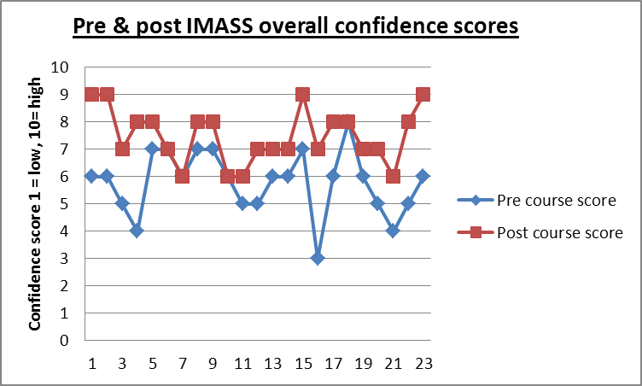
Figure 6-1 Differences in pre-course (IMASS simulation intervention) (blue) and post-course confidence scores about starting as a FY1 (red)
When broken down into the 19 different parameters from the learning outcomes, it became more apparent at what the course is good and not so good at addressing, as well as the variation in baseline confidence for different skills (Figure 6.2). The largest average improvements in confidence scores (self ratings from 1 not confident, to 10 very confident) were for responding to a crash call (+ 3.2), performing verbal referrals and hand over (+ 2.3), leadership, delegation and prioritisation (+ 2.26) and finally, management of self in stressful situations (+ 2.2).
The smallest improvement in confidence scores were for sharps safety (8.5 – 8.8 = +0.3) and patient safety or being a patient advocate (6.6 – 7.6 = +1). However they did show improvement and no areas reduced following the course.
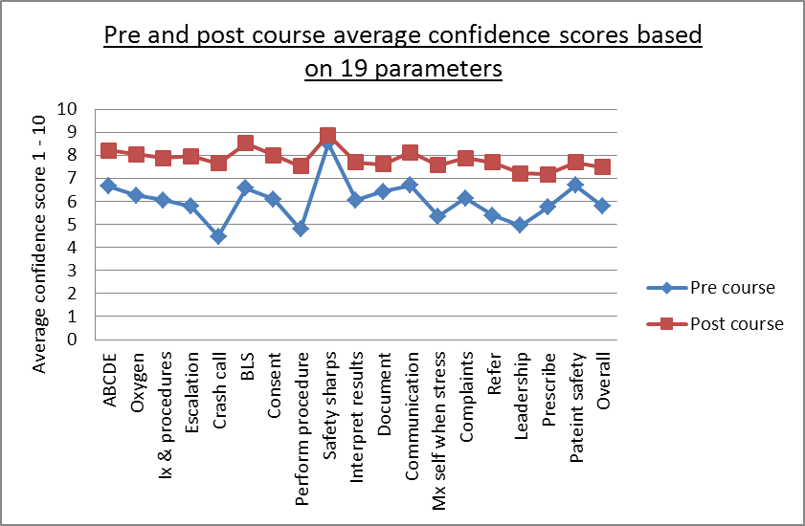
Figure 6-2 Breakdown in pre- and post-IMASS confidence scores for each of the 19 FP and TD mapped learning outcomes.

Distribution of sample
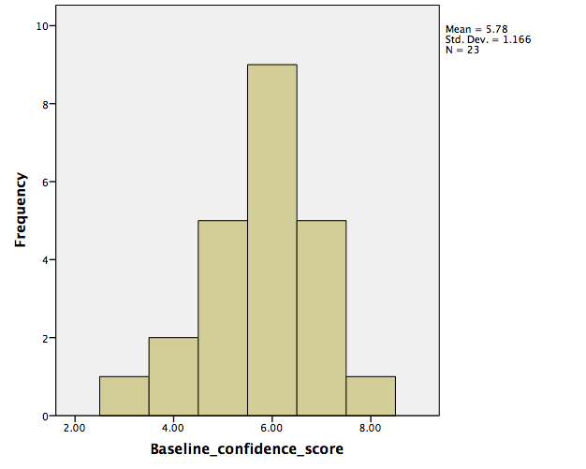
Figure 6-3 Distribution of baseline pre-course confidence scores in pilot group.
The histogram above demonstrates a relatively normal distribution, so a parametric related sample T-test was performed on the baseline pre-course’s and post-course’s immediate values.

Related samples T-test to compare a single group of students under two different conditions

These data were taken from overall confidence scores about being a FY1 before and after the simulation intervention course on the same day.

Paired Samples Statistics
 |  | Mean | N | Std. Deviation | Std. Error Mean
Pair 1 | Baseline confidence score | 5.7826 | 23 | 1.16605 | .24314
 | Postcourse confidence score | 7.4783 | 23 | .99405 | .20727

They demonstrate an increase in average confidence score of 1.69 points on a ten-point Likert scale following the course.
There was a significant increase in confidence immediately following the course compared with baseline confidence score, t (22) = 6.65, p < 0.001. Pre-course mean confidence score was 5.78 (SD = 1.16), and increased to a mean of 7.47 (SD = 0.994) post-course (immediate).

One-way repeated-measures Analysis of Variance (ANOVA) over three conditions for the same group

When analysing the repeated measure at four months, because more than two conditions are present, a repeated-measures one-way ANOVA has been selected to reduce risk of type 1 error. This does, however, use only the 16 cases that have data for all three conditions.
Descriptive Statistics
 | Mean | Std. Deviation | N
Baseline confidence score | 5.8125 | 1.16726 | 16
Post course confidence score | 7.4375 | 1.03078 | 16
Four months post course | 6.1250 | 1.31022 | 16
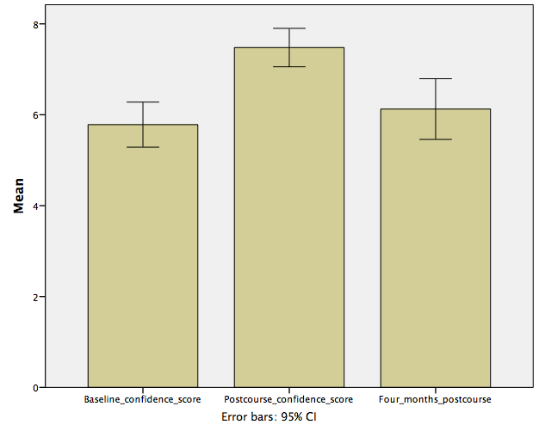
Figure 6-4 Repeated-measures confidence scores for pilot study group at baseline pre-course, post-course immediate and at four months, with errors bars representing 95% confidence interval.
The results show that there was a significant difference in confidence scores across the conditions, F (2,30) = 8.731, p = 0.001. Figure 6.4 demonstrates the pattern of change in confidence scores across the three conditions where it increases post-course, which then reduces again at four months though not quite back to baseline. Mauchly’s W test (df = 2) = 0.798 p = 0.207, was not significant, therefore an assumption of sphericity had not been violated, meaning variance in conditions was not significantly different, so no correction needed to be applied.

Formative assessment results

Formative assessment marks ranged from a minimum of 80 (min score 30) to a maximum of 139 (max score 150) (Figure 6.5). The data did not demonstrate a normal distribution. The majority of candidates scored between 120-129 towards the higher end of the mark scheme.

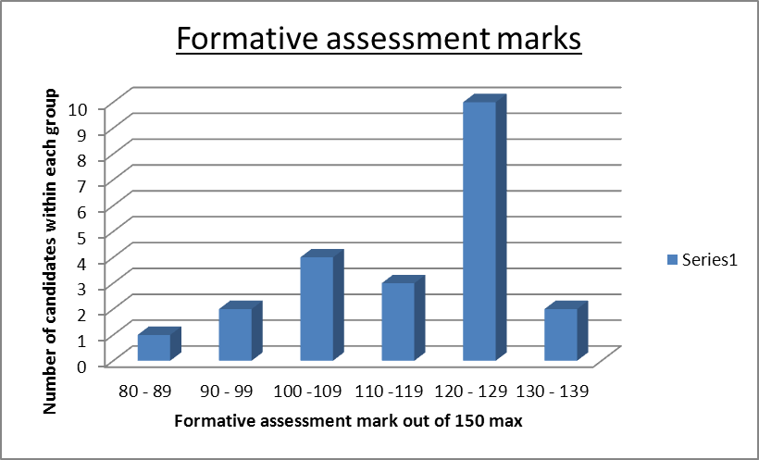
Figure 6-5 Distribution of formative assessment marks from 80 (minimum) to 139 (maximum). The data is not normally distributed.
Formative assessment of whether happy to allow them to care for a member of family (1 = No, 3 = acceptable, could improve, 5 = very happy) revealed 87% scoring a four or five. Thirteen per cent scored three with no significant concerns.
Self-rated confidence and performance as assessed by formative assessment marks (Figure 6.6) demonstrates no visible correlation in this small group. In fact some of the best performers were the least confident and some of the most confident performed the worst. The confidence scores have been modified to fit the same scale as the formative mark so they can be viewed easily on a graph (multiplying by a factor of ten) to expose the patterns seen. In the final study these results will be explored for a correlation though SPSS.
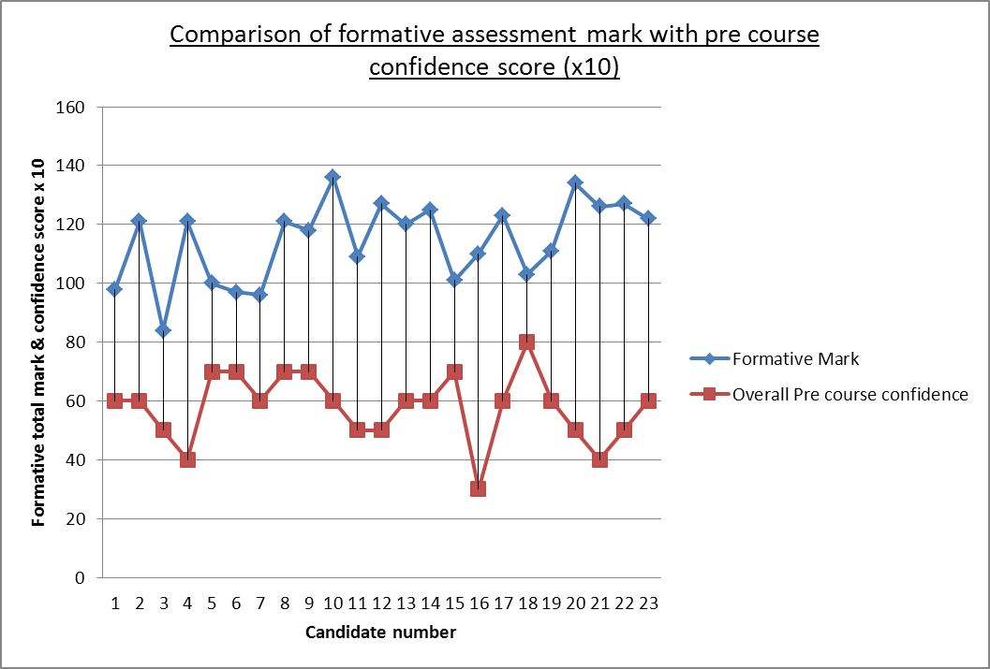
Figure 6-6 Relationship between pre-course confidence and course performance using formative assessment marks.

Feedback results from the pilot course

Feedback was ranked on a five-point Likert scale (1 = strongly disagree, 5 = strongly agree) (Figure 6.7). All students felt they would highly recommend the course to others. The highest rated feedback scores were for improvement in critical thinking, reality of the simulation, assessment of the unwell patient, feeling challenged, the feedback received and being comfortable asking for help. The lowest scores were in understanding prescribing.
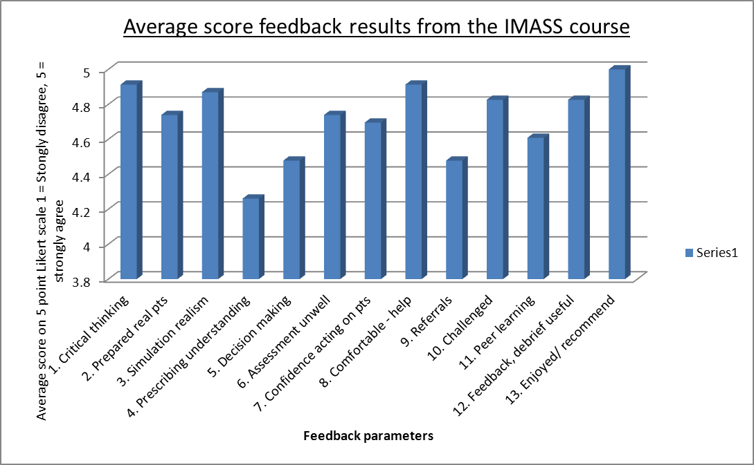
Figure 6-7 Feedback scores from the course.

Pilot IMASS (intervention) group versus non-IMASS (control) group results

Fifty FY1s attended the District General Hospital for a Trust induction prior to commencing their FY1 jobs. This opportunity was taken to explore their views on simulation. The questionnaire was handed out to all 50 FY1s at the start of the induction and collected at lunchtime. 64% responded (n= 32). Fifty per cent had done the IMASS course (n=16) and 50% had not (controls).
Ninety-four per cent of the FY1s had had some simulation training in the past - 90% of the group felt that they strongly agreed that it was a useful tool for learning, 6% agreed and one person (3%) disagreed. That person had had simulation training before but not on the IMASS course. Of those that had done the IMASS course 100% strongly agreed that simulation was useful.
When asked whether they felt prepared for starting FY1 using a 5-point Likert scale, (1= strongly disagree, 2 = disagree, 3 = neutral, 4 = agree, 5 = strongly disagree), the average score in the non-IMASS group was 3.1 and in the IMASS group 3.3. 72% felt neutral about feeling prepared, 25% felt they agreed they felt prepared (4), and 3% felt they disagreed that they were prepared. Of those that felt prepared, 62% of them were in the group that did the IMASS course.
When asked whether they felt undergraduate simulation training was useful, 97% of FY1s agreed (22%) or strongly agreed (75%), 3% (n=1) disagreed and had not done the IMASS course. When asked if simulation training felt realistic, 65% of FY1s agreed (37% agreed, 28% strongly agreed), 71% of those were in the IMASS group.
In terms of confidence about starting as a FY1 on the 10-point confidence log, (1 = not confident at all, 10 = very confident), the average score in the non-IMASS group was 5 (range 3 – 6) and in the IMASS group 6 (range 4 – 8).
When asked for comments about what could help them feel more prepared for FY1, 69% of FY1s made a comment. Views included: more simulation training, acute illness training, team shadowing, being in their actual hospital immediately prior to starting work (including nights, practice organising a ward round and prioritising jobs). They wanted familiarisation with hospital systems, IT and forms to learn the basics in terms of discharges, and online resources in the hospital they would be working in.

Distribution of confidence scores of controls / non-IMASS group

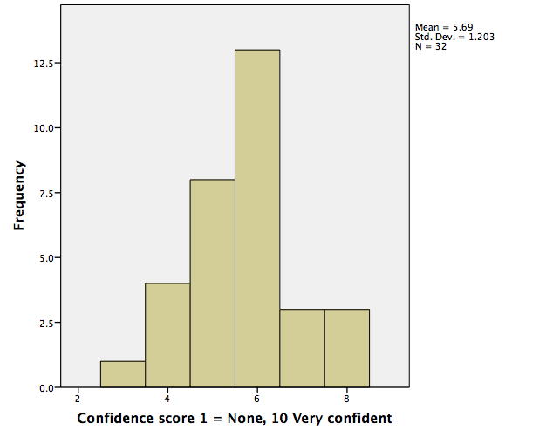
Figure 6-8 Distribution of confidence scores - control group.
This histogram demonstrated a relatively normal distribution thus parametric statistical testing was employed using SPSS V21.

Independent T test for controls (n=16) versus intervention group (n=16)

Group Statistics
 | Group | N | Mean | Std. Deviation
Confidence score 1 = None, 10 Very confident | - Non-IMASS group | 16 | 5.25 | .931
 | IMASS group | 16 | 6.13 | 1.310
There was a significant difference in the confidence scores between the IMASS group and controls (non-IMASS) t (30) = 2.1, p = 0.037 (Appendix 13.21, 13.22, 12.23). Mean confidence score in the control/non-IMASS group was recorded at 5.25 (SD = 0.931) and in the intervention/IMASS group at 6.13 (SD = 1.31). These data were employed to complete a power calculation for the final intervention study.

Results – Qualitative – focus groups

Focus group findings

During the pilot study, a total of four focus groups were run with between five and six students participating in each group. Thematic analysis was performed on data transcripts using the Post-It note method with note-taking and summarising of key points, ideas and themes (Appendices 12.18, 12.19). Seven key themes emerged:
- Simulation experience and leadership skills.
- Realism and challenge.
- Working with others.
- Peer learning and feedback.
- Human Factors Training.
- Use of video.
- Expectations and Escalation.

Simulation experience and leadership skills
Some students had been involved in the ‘RAPID’ course using a basic Advanced Life Support mannequin. They had felt they had got less out of the experience due to having such a large group (up to 15 candidates reported). They felt four in a group was the ideal size to remain engaged all of the time. They reported to have ‘done basic life support but not been in charge or developed leadership skills’, as they were under the impression they would ‘not need to and would not have the skills’ to do so (Pilot focus group 1). There was a shared feeling and view that ‘simulation education like this’ would be useful ‘throughout undergraduate medical training’ to help develop ‘coping skills and prioritisation skills to help prepare for the workplace’ (Pilot focus group 3). Most felt priority should be in 4th and 5th year but could be introduced in 3rd year if students worked in pairs. By 5th year they all felt it was essential to work alone to help them learn how they would act and to make sure they could manage in the workplace independently.
A sub-theme within ‘simulation’, was ‘best practice for simulation’; what was important and worked well; interprofessional learning and teaching; safe environment; faculty appropriately trained; debriefing specific and individual; learning outcomes - some pre-decided, other tailored to group specific questions; and importance of getting the pressure level right - enough to push candidates but not too much for negative learning.
They felt faculty needed experience in simulation training, flexibility in knowledge and teaching skills, and emotional intelligence to adjust the amount of pressure depending on how the candidate was seen to be responding to the simulated environment. This was echoed in the field notes: ‘importance of individual levels of challenge, so that overconfident students were pushed appropriately and those with lower confidence given more support and encouragement’ (Field note 3). Field notes also reflected the importance of one person leading the debrief, that half a day was long enough with groups of 4-5 to allow individual practice. Students preferred mostly to be in another room to their colleagues due to less distraction and the resultant feeling that this was more realistic.
Realism and challenge
They described the scenarios as realistic and felt they were pitched at the correct level. They felt challenged but not overwhelmed, which had been the researcher’s aim. They felt being ‘able to do actual referrals about a patient and get a realistic response as well as performing an actual procedure’ was really helpful, and also to ‘communicate with a patient’ (Pilot focus group 1). It was interesting to note by the researcher that initially the Sim Man was referred to as ‘a mannequin’ at the start of the day but following the course as ‘the patient’, which suggested a good level of immersion (Field notes pilot course).
They reported that the fact the patient could talk was hugely important. As faculty, we saw that students were talking directly to the patient instead of looking to faculty for clues. The group shared the view that it was important that they could ‘touch, feel and see the drugs being given’ and that a ‘realistic response was seen’ when they were given, from patient subjective experience as well as from physiology and signs (Pilot focus group 2).
All students reported that in their scenario they 'felt like a doctor' looking after a patient and this is important and comes back to responsibility. It was important that faculty were immersed and interruptions were genuine and authentic.

Working with others
Students discussed how important it had been for them to work with a nurse in this situation to explore their role and skills and how to work together as a team. Students felt simulation training should include all different disciplines e.g. nurses, medical students, and physiotherapists. They felt that this would allow ‘shared knowledge and an early respect for roles, breaking down barriers and improve awareness’ about other specialities (Pilot focus group 4). Interestingly the nurses that took part also felt the same. They felt they had a ‘better understanding of the level of knowledge and skill of new doctors’ and were ‘surprised at the lack of practical knowledge in some areas’. They said they felt ‘more empowered to speak up to support the juniors in their work’; which was felt to be key for effective teamwork and patient safety (Pilot study field notes).
Peer learning and feedback
All students felt peer feedback was valuable. Some felt they preferred to have the other students sat in the same room but most felt they would have preferred people to be in a different room. Those that preferred the same room felt their peers were being supportive in their presence. One worried that if in another room they may be discussing their management behind their back. One student felt it would have been better to have ‘a dedicated longer amount of time for the students to deliver their feedback to each other’ (Pilot focus group 3). They felt that it would be valuable and important to share their positive feedback in more detail with each other. From field notes made from observations however one episode of negative and inaccurate feedback from a dominant student took a long time to explore and manage. Focus was on correcting their understanding and not on the candidate, which wasted valuable time for the student in the scenario. This was felt to be unconstructive so peer feedback focused on positive aspects and the debriefing was left to the faculty members (Field notes Pilot study).
Human Factors Training
They felt the human factors training, with interruptions and difficult situations was very useful to practice how to ‘manage themselves under pressure’ (Pilot focus group 2). Some students said ‘I have learnt a lot about myself’ (Pilot focus group 2) when watching back scenarios and with the debriefing. They picked up on surprising comments they had made such as ’oh good’ after patient said they were in pain (Pilot field note 2). They felt ‘awful’ when they realised what they had been saying and having time to reflect on this after the scenario was felt to encourage this level of thought and understanding. Field notes made reflected this unique level of potential behavioural change amongst individuals that had only been brought out when challenged and in a stressful situation and when given time to reflect in an open environment (Pilot study field notes).
Use of Video
Some students felt that video review of their performance would be very beneficial to enable them to reflect on their own performance. Though this can be a useful adjunct to delivering feedback supplying a particular specific example of a learning outcome, it is time consuming and there is no current evidence that this is superior to debriefing without video using notes. Interestingly when the groups were put in different rooms and a video link was used, they reported that they preferred this as there was ‘no potential distraction from peers’, and they ‘built more confidence’ as they felt they had been able to ‘get though the scenario and manage the patient independently initially which was what they would be required to do’ (Pilot focus group 4). These coping skills were reported by some as being vital to ‘prepare for FY1’, and made them ‘feel more confident and able to perform’ (Pilot focus group 4).
Expectations and Escalation
There was a feeling that because they had passed Finals, they should be able to ‘manage every patient on their own and know what to do independently’ (Pilot focus groups 2,4). There were mixed views in terms of knowing what was expected of them as a FY1, in particular knowing when to call for help. There were recurrent feelings of ‘fear of not knowing what to do’ (Pilot focus groups 1,3,4) highlighting the need to practice a systems-based approach and coping skills. This leads on to the barrier of calling for help, whereby a lot of the students called for help very late on. When exploring this it was sometimes due to a lack of situational ‘awareness of how unwell the patient was’, other times the feeling of wanting to do everything for the patient before calling, 'shouldn't call for help until done everything' (Pilot focus groups 1,3). There were issues around not wanting ‘seniors to think they were incompetent’ (focus groups 3,4) (Pride), rather than putting the patient’s safety first.

General Comments about the course
Overall the candidates described a positive view of the course. They felt that their ‘confidence in assessment, treatment, management, referrals and handovers had improved’ (Pilot focus groups 1-4). They felt that they would all recommend this course to peers and anyone about to start a FY1 job. Students felt that the key to their realism and preparedness was the fact that ‘in each scenario they had to perform the tasks in real time such as procedures, prescriptions, treatments and reassessments’ (Pilot focus groups 1-4). They felt the course ran to time and feedback/debrief session were coordinated and structured.
One student participant commented that they found the good judgment approach employed in debriefing to be less encouraging than perhaps a more traditional model such as Pendleton’s model when what went well is followed by areas of improvement followed by a summary of what went well at the end. Others were very grateful for an honest and clear message that was personal to them and relating to behaviour. This suggests that flexibility between models and judgment over which will suit certain situation and personality types could be interesting to explore. Another area of challenge was participant focus on knowledge and whether they got things wrong or right, appearing to place less value on the behavioural side.

Results: Lessons learned from pilot study

Post-course discussions and reflections with undergraduate simulation leads and educators concluded that half a day was enough for the students as they reported feeling tired and struggling with a full day. It was an intensive experience and due to the responsibility and challenges it created, the candidates felt ‘drained’. Breaks were essential for this reason and this fits with Maslow’s hierarchy of needs (AH., 1943).
The scenarios were felt to reflect real life challenges in the workplace and to be pitched at the correct level for the students.
Having phone and other interruptions, as well as procedures, was felt to be vital to allow the development of prioritisation skills. One procedure was felt to be suitable per scenario and was felt to reflect the increased teamwork and skills available amongst other professionals on the ward. The scenarios were felt to be suitable lengths and the 50:50 scenario to debrief timings worked well for covering tutor and student generated learning outcomes (Field notes form Pilot study).
It was noted that one person would lead the debrief otherwise it could be confusing to the students and became distracting. It was useful to use a similar structure for the debrief so it was recognisable to students and they knew what to expect. In addition to this it made it easier to join in as a debriefer if invited as well as appraising each other and created better timekeeping.
The importance of building trust was vital and tutors’ ability to share their own mistakes. Field notes revealed that registrars were more comfortable to do this whilst consultants were more likely to share challenging stories of success. This was interesting and may reflect culture change amongst generations or hierarchical impact or be merely personality linked internal influence (Pilot study field notes).

Results: Power calculation

A power calculation using the intervention and non-intervention group was used to inform the number of candidates required to show a significant difference in the groups (n=90). A statistician at the University of Sheffield calculated this value. Usually it is aimed for a power of 0.8 which is equal to an 80% chance of detecting an effect if one genuinely exists (Cohen, 1988). Statistical power relates to the ability of a test to find an effect, or the probability (β) that a given test will find an effect if one exists in the population.
To calculate the power of a test: 1 – Beta is equal to power. If the value is greater or equal to 0.8 one can be confident that there will be sufficient power to detect an effect. In addition to this, if confidence intervals do not overlap then it is said to be possible to conclude that the means come from different populations therefore are significantly different (Cohen, 1988, Snedecor and Cochran, 1980).
Using the two different groups IMASS vs. Non-IMASS n = 16 in each group. There is potential to use the average standard deviation = 1.136 or at worst the higher standard deviation (SD = 1.310). Because the two standard deviations were different, it was unclear whether people with a low confidence score all occur in one group and some high-scoring individuals in that group as well or whether this is just noise owing to the differences between individuals. This may have led to more unsystematic variation (not due to intervention) due to differences between participants.
Power calculation for using the two different groups as calculated by the researcher following online guidance from (www.physicsforums.com) ‘biomath.info Unpaired t-test using http://biomath.info/power/ttest.htm’:
Group 1 mean= 5.25, Group 2 mean= 6.12
Std dev. = 1.13 (average), 1.31 (higher in IMASS group)
Sample size = 28 in each group if use average SD (total 56), 37 in each group with higher SD (total 74)
Find effect size (using group 1: n = 16 and SD of 0.93) – show difference of size of 0.95 = large effect (d = 0.2 small, 0.5 medium, 0.8 large effect)
Alpha prob 0.05
Power 0.8
Because the researcher could not replicate the initial value of 90, producing values lower, they decided to aim for the value calculated by the statistician and aim for a sample size of 90 to power the study.
Due to the differences in standard deviations between the two groups, it was felt by the researcher and team that to capture the difference between conditions over time, it would be more reliable to employ a repeated-measures design. The group acted as the control with baseline scores, so there would be less noise and unsystematic variation affecting results from differences between subjects.

Discussion: Key findings from pilot study

This pilot study aimed to assess the feasibility of the course and assessments which both worked well. It aimed to reveal the effect of the simulation on confidence scores over time and allow a control group to inform a power calculation for the final intervention study (n=90). Eighty-three per cent of final year medical students reported increased in confidence following the course. At three months post course those that did the simulation course felt more confident and prepared than those that did not.
Medical students (over 40% of UK medical graduates) do not feel prepared for clinical practice by their undergraduate curriculum (Cave et al., 2007, Goldacre et al., 2003). The areas students are least prepared are: dealing with acutely ill patients, prescribing, managing workload, and being on call. In response, some undergraduate curriculums have altered shadowing programmes but they are not standardised. The GMC has recommended the use of simulated environments and patients to aid experiential learning and highlights the importance of interprofessional learning (GMC, 2009).
Simulation-based education does translate into clinical practice with positive effects. Within this study, Issenberg’s and Motola’s recommendations from their systematic review were used to guide structuring simulation teaching, in particular the use of clear learning outcomes (Motola et al., 2013). At a national UK simulation conference attended in November 2015 (Association of Simulated Practice in Healthcare ASPiH), there was debate between medical educators as to who should provide the learning outcomes for a simulation session - the learner, peers or faculty. During the pilot course the researcher moved from faculty-led to a mix of learner- and faculty-led learning outcomes to allow individual emergent contextualised outcomes to be addressed in the debrief. Findings concur with multiple authors about the importance of investing in good faculty that are trained in simulation and debriefing techniques for successful learning.
In terms of the research question: ‘How does a realistic simulation course affect preparedness and confidence of 5th year medical students for clinical practice?’, an 83% improvement in confidence scores from pre- and post-course results, suggests that the course did improve preparedness in parameters mapped to the TD and the FP curriculum. The remaining 13% remained stable with no reduction in confidence. This is important because some simulation encounters can be very stressful and cause negative learning. For this reason the balance of realism and pressure used within this study was felt to be correct. The concept of negative learning in simulation has been touched on mainly in papers regarding debriefing methods (Lewis, 2009). Potential methods to avoid this include those described by Dieckman et al. (2007), such as ensuring an effective introduction, clear learning outcomes, a mutual respect for the group, confidentiality and making the simulation as real as possible (Dieckmann et al., 2007). Rudolph (2006) mirrors this advice recommending the use of clear learning outcomes and debriefing with ‘good judgment’ (Rudolph et al., 2007, Rudolph et al., 2006). These concepts were employed in the intervention.
The largest improvements in confidence scores were for parameters essential for patient safety (i.e. responding to a crash call), which are difficult to teach and learn without experiencing it with a real or simulated patient. In an ideal study design, a comparison between the simulated scenarios would be made with the same scenarios with real patients. This would however be unethical and scenarios such as anaphylaxis are so rare, it would be impossible to standardise exposure.
The smallest improvements in confidence scores were for sharps safety, which students already felt highly confident in. This demonstrates either good training in clinical skills in the current curriculum or could reflect oversimplification of clinical skills training with a potential mismatch when transferred into the clinical environment. This was observed when despite feeling confident, some forgot to put sharps away when under pressure and required a prompt, which they were surprised by. This may support the theory that confidence is not reliably linked to performance or that students are not being prepared for the complexity of the real, raw clinical environment. It is also possible that this self-reported confidence level might be inaccurate because of poor situational awareness and lack of insight.
Confidence and performance as assessed by formative assessment marks (Figure 6.6) in this small number of students demonstrates no clear correlation. It is interesting that some of the best performers were the least confident and some of the most confident performed the worst. However no one was considered dangerous or unsafe. This is supported in the literature by a number of studies (Barnsley et al., 2004, Liddell and Davidson, 2004, Leopold et al., 2005). However one study has postulated that ‘confidence is more likely to mirror competence in female students more than male’ (Vivekananda-Schmidt et al., 2007). This is a fascinating area to consider that goes beyond the scope of this study, however developing skills in self-regulation and correction appears to require good reflective skills, emotional intelligence and insight, which have emerged through qualitative data.
The overall assessment of professionalism as a single score showed all students to be safe. There is a question as to whether this is just as reliable as using multiple parameters to score doctors. This however lays open the complexity of how to define and measure professionalism.

The highest rated feedback scores were for improvement in critical thinking, reality of the simulation, assessment of the unwell patient, feeling challenged, feedback received and being comfortable asking for help. In the researcher’s experience, these are challenging elements to teach outside of the simulated environment but are central to supporting preparedness. The unique simulated environment allowed students to problem solve, think critically, make decisions, communicate them and give treatments with an appropriate patient response. It allowed the responsibility of being a doctor in a safe environment with opportunity to experience consequences of actions and explore cognitive processes.

The lowest scores were in understanding prescribing. The students did not feel confident in prescribing and they had many questions that could not be covered due to time constraints. This researcher had hoped it would be a place to put their prescribing theory into practice but they were not at that level. Another method tried was giving peer observers prescriptions and getting them to prescribe the drugs and fluids. Unfortunately this took away from the realistic environment because the doctor has to balance priorities. In addition it meant that peers were less able to concentrate on their colleagues’ performance, thereby compromising feedback. Focus was then placed on prescribing the emergency drugs and time allowed to discuss those only.
At three months, those that did the IMASS group versus controls (non-IMASS) felt more confident and prepared about being a FY1. The confidence score was maintained over time. It was not possible to identify individuals and link their confidence scores and results. This will be done during the final intervention study. Though numbers are small, this group represented 20% of the year and because homogenous, these data may be transferable to the remaining year group and potentially other medical schools.
In terms of realism, 65% agreed simulation felt realistic, 71% of the 65% were in the IMASS group. Learning is optimised by improving immersion through increased reality, stressing the importance of faculty and student effort and agreeing a ‘fiction’ contract (Dieckmann et al., 2007). It is evident that the smaller the groups the better learning opportunities. Optimum group sizes were four to five people.
Students want increased simulation exposure at undergraduate level. It is difficult to know whether this is due to the novelty of simulation, the technology, the small group or whether it is the value unique to simulation. The huge challenge is how to take large year groups of students through this individualised training, which is faculty intensive, using expensive equipment. If lessons can be learnt about how to enhance preparedness through simulation there may be transferrable and generalisable lessons for the education community.
Students had a poor grasp of what was expected of them on day one of FY1 and it is likely that a combination of methods to improve preparedness is required. One of the largest concerns was that students reported they had not worked with nurses before this time in a team based clinical method. They felt this helped hugely with preparedness by allowing shared knowledge, an early respect for roles, breaking down barriers and improved awareness about other specialities.

Conclusions

The course ran well and was perceived to be realistic by students and by undergraduate educational group consensus. Insight into what made the educational intervention feel real was useful to understand how to maintain and recreate this level of fidelity to allow students to feel responsible.
There was a statistically significant difference between confidence as a surrogate marker of preparedness for practice as a FY1 between the control (non-IMASS) and intervention group (IMASS group). It was felt that due to the level of unsystematic variance present between individuals in terms of personality and internal factors that influence behaviour and judgments, it would be better in the final study to use baseline scores from the same individuals as a control. A repeated-measures design would be employed. It was considered unethical to randomise groups to receive or not to receive this level of education, when the literature states that simulation-based learning with deliberate practice is superior to other traditional methods of education.
Challenges regarding normality of distribution of data were highlighted and plans to include assessment of standardised residuals in the final study were made. The power calculation allowed the knowledge that an appropriate number for the final study would be 90 students and it was felt that having more than one institution would be important.
It was felt by the students that they were more supported by peers when in the same room but for those where peers were out of the room they felt less distracted and felt this independence was important to supporting their transition from medical student to FY1. The final study would be run with participants in the clinical simulation area with peers observing remotely.
Peer support was felt by the students to be important so allowing time in the debrief to share positive thoughts was allowed and encouraged. The key to reducing stress and uncertainly was the clear introduction to the equipment, mannequin, environment and team. Openness with sharing own mistakes as faculty and employing the ‘good judgment’ approach to debriefing (Rudolph et al., 2007).

Summary

Initial focus groups surrounding preparedness were vital to ensure the study was asking the same as the GMC survey of reported anticipated subjective under-preparedness by medical students. Overwhelmingly the 5th year medical students interpreted preparedness as self-confidence with curriculum-mapped tasks, so confidence was selected as a measure.
Variations in confidence scores need to reflect the intervention and not noise from investigating different people with individual internal factors and variance. A repeated-measures design has been employed for the final study to reduce this unsystematic variance so that differences should be related more to the intervention.
Detail surrounding added value of simulation to medical students has been explored through focus groups, however other stakeholders views should be sought to allow triangulation and add rigour. Those with medical education and simulation experience in the UK will be approached and interviewed. The purpose of interviewing experts will be to explore in more detail the added value of simulation related to preparedness and how to achieve it.
For this reason there are two aspects: first, the added value of employing simulation as an educational methodology in the undergraduate curriculum with quantitative measures backed up by qualitative views. Second, how to create the added value though fidelity and practical aspects so that other medical schools can access a guide of best practice.

Chapter 7: Intervention study

Introduction

This chapter describes the methods used in the main study, evaluating the simulation course through the repeated-measures design and focus group interviews with final year students. Followed by the interview study with simulation and education experts. The results are then presented. This chapter is divided in to two parts:
- PART I includes aims, objectives and methods.
- PART II presents quantitative and qualitative results.
Chapter 8 presents data triangulation as a separate chapter owing to the volume of data from this multistage mixed methods study.

Figure 7-1 Final intervention study overview.
PART I

Part I: Aims and Objectives

- To run a simulation-based educational intervention informed by the pilot study.
- Evaluate confidence scores across four conditions using a repeated-measures design with baseline scores as the control.
- Evaluate 5th year medical students from two different medical schools.
- Explore preparedness and simulation-based education with medical students and UK medical education and simulation experts.
- To gain a better understanding of the potential of simulation-based medical education in the context of preparedness, from multiple stakeholder perspectives.
- To draw up best practice guidance for medical schools, informed by these data, when designing and delivering a simulation curriculum to support preparedness.

Part I: Methods

Mixed methods were employed, the rationale for which is explained in Chapter 3. Qualitative data (open-ended questions) aimed to understand the quantitative findings, to build on educational theory underpinning SBME, inform best practice guidance and methods to support and improve preparedness.

Sample

In term of sample size, a power calculation was used after the pilot study that compared a group of controls that had not done the course with a group of participants who had done the course. Pre- and post-intervention measures were used. A statistician at the University of Sheffield performed a power calculation with data provided from the pilot study. The number advised was 90 and has been discussed in Chapter 6.

Course

The course and equipment used remained the same as for the pilot intervention described in Chapter 6. Students had access to the study information sheet. Individual informed consent was gained. Ethics approval was obtained (Chapter 3, 13.6).
Students were in groups of four or five. They led on one scenario each, while the other students completed peer observation. Students from University 1 were alone with the patient and team with peers observing from another room, using SMOTS® audio-visual equipment. Students from University 2 were required to remain in the same room due to lack of video debriefing equipment. Following completion of each scenario, all students and faculty were brought together to be involved in the debrief.
Faculty included two clinical debriefers (registrars), one nurse, one technical support member to run the SMOTS® equipment. One faculty member ran the mannequin so could feed back from a patient perspective, and the other facilitated discussion amongst peer observers. They took it in turn to lead on the debrief. Debriefing followed the three-step Rudolph et al. model using the ‘good judgment’ approach (Rudolph et al., 2007), as described in Chapter 5.

Quantitative data collection

Fifth-year medical students were invited for the final study for reasons described in Chapter 6. Two medical schools were chosen for comparison. Both employed a range of lecture-based and problem-based learning. University 1 (n=234) and University 2 (n=237) had similar size final year groups. Most UK medical schools employ a mix of methodologies and these schools were felt to be relatively representative for UK medical schools.
Reasons for the repeated-measures design are explained in Chapters 3 and 6. Confidence scores in the 19 parameters mapped to TD and FP curriculum were collected across four conditions. One immediately pre-course (1), one immediately post-course (2), one week later sent via email on Survey Monkey® (3), and one month into their FY1 jobs (4) (SurveyMonkey, 1999). The one-week and one-month surveys included additional free text questions to reflect on the course and preparedness including capability to perform on the wards (Appendix 13.13, 13.17). Feedback was also collected from the candidates (Appendix 13.16). During the simulated scenarios each candidate was marked using the validated formative assessment tool (Chapter 5) (Appendix 13.14).

Statistical analysis

Statistical analysis was carried out using Statistical Package for the Social Sciences (SPSS 21.0 for Mac). Descriptive statistics were examined and construct validity (extent to which items reflect underlying constructs) was explored through factor analysis explained below (p. 252). Distribution was explored using a histogram and also with standardised residuals, which showed values, when standardised fell between + or – 2 standard deviations from the values so (were normally distributed), so one-way ANOVA was performed on the data. The four conditions for repeated-measures remained pre-course (baseline), post-course (immediate), at one week post-course and one month into FY1. This is described in more detail in Chapter 3.

Qualitative data collection: focus groups

The study population, 5th-year medical students, purposively sampled; 19 group interviews of four to six members (Ritchie et al. 2014). To allow face-to-face interaction, the group had to be located in one place or ‘geographically clustered’. The groups were conducted straight after the teaching sessions to limit disruption. It also allowed for some rich descriptions as emotions and feelings were still fresh in their mind. The topic guide used maintained exploration about preparedness and simulation and was slightly edited to include more specifics on how the simulation interventions should be run (Appendix 13.20).
Each focus group lasted around 40 minutes to one hour, recorded and transcribed verbatim by the researcher adopting the approach described in Chapter 4.

Qualitative data collection: Interviews with national simulation and medical education experts

The rationale for choosing interviews with simulation and education experts at this point in the study are detailed in Chapter 3. Experts were selected through approaching at simulation and educational conferences, snowballing from recommendations from other experts and those highlighted in the literature with peer-reviewed publications in simulation and medical education. Experts were defined as those people involved currently in a position of authority within medical education linked to a medical school and with active experience of simulation and human factors education. Most were leads for simulation and education. Interviews were conducted until saturation of themes was achieved (n=10).

Design/ Structure of interview – topic guide

Views on simulation in the undergraduate medical curriculum as well as preparedness for practice were explored. The feasibility and requirements of rolling out a simulation curriculum was explored, with focus on how to run sessions and potential use in assessment.
Though structure was important to ensure topics were covered, the need for flexibility was vital to allow the emergence of new themes and the interviewee to help ‘shape the content’ (Ritchie et al., 2014; p184). The interview needed to allow space and time for reflection and development of ideas. Recording the interviews allowed verbatim transcription to capture exact language and phrases shared by participants, which was important to uncover meaning.
The researcher found the process of in-depth interviews challenging for a number of reasons. These included: the challenge of actively listening to what was being said whilst asking relevant questions that flowed on from points raised; the ability to hold new terms and ideas to come back to, whilst checking in with the topic guide (Appendix 13.33); and the ability to manage time allocated for the interview and coverall areas, as well as balancing exploration of new emergent concepts.
The topic guide was designed following attendance at the National Centre for Social Research (Nat Cen) ‘In-depth Interviewing’ course, where methods used by the team were shared. Key areas for exploration were identified from the pilot focus groups. These were: preparedness for practice; the added value of simulation; how to structure and run a simulation session; and components of an effective simulation educational session. These main topics were then subdivided into fidelity and human factors under the heading of simulation.
Simulation was explored as a separate entity because it was important to make no objective assumptions that this was interpreted and viewed in the same way by participants. Post-It notes and wall charts were used to place all topics and themes initially, then a careful process of grouping the themes occurred to see where each would fit and the topic guide was created. This was shared with supervisors to ensure that it reflected all main areas and topics, and mapped to the projects aims. Following agreement from supervisors, the topic guide was used for a pilot interview. Particular probes were considered and noted to try and maintain flow and interaction. The pilot interview revealed that most areas were covered well employing the topic guide. However, some new areas were brought up and felt to be important so were included. This iterative process allowed the flexibility required for the ‘Grounded Theory’ approach whereby one piece of data informed the next phase. Examples of the process using Post-It notes are shown (Appendix 13.18)

Consent and Research Ethics

Consent was sought by sending an initial email with an introductory letter explaining the purpose of the interview and inviting them to take part. They had the opportunity to ask questions and decide a suitable place to meet. Eight of the ten interviews were conducted face-to-face, with two conducted using Skype; a web-based video facility, owing to challenges in distance and timetabling.
In terms of protecting confidentiality and anonymity, the introductory letter sent prior explained how confidentiality would be maintained, with no names being used in data collection and a unique identification number being allocated (Appendix 13.34). Quotations used would not allow participants to be recognised if used in the thesis or publications. Audio transcripts were stored on an encrypted device.
Verbal consent was confirmed prior to starting each interview and recorded on the audio file as confirmation. Details were given describing that transcripts would be sent to be checked by interviewees (member checking) to ensure the correct information had been recorded and interpreted. Details of outputs from research were offered to be shared when complete.

Conducting interviews

In terms of practical considerations, the pilot interview lasted 75 minutes, so the interviews were allocated one hour, which was acceptable to interviewees.
The researcher was required to travel across the United Kingdom so only one interview was performed per day due to travelling times. The interview location was decided by the interviewee and on most occasions was conducted in their place of work, face-to-face.
Two of the interviews were conducted online (Skype®). One due to interviewee choice due to working from home with a busy timetable, and the second due to distance.
In terms of structuring an in-depth interview, Ritchie et al. (2014) six stages have been used to inform the researcher’s strategy for interview conduction (Ritchie et al., 2014; p186). The first stage entitled ‘arrival and introductions’ was an essential part of the interview, where initial interaction allowed the opportunity to facilitate a good rapport. The researcher did find this easier with face-to-face interviews rather than Skype, which took longer but was not felt to impair views shared and data gathered. The researcher attempted to be organised by being punctual and having equipment ready, in the hope that the interviewee would reciprocate that behaviour to allow open discussion and trust from the start, which did appear to work. It was important at this point, when stepping into the individual’s work environment, to check that they were comfortable.
The second stage, entitled ‘introducing the research’, began with re-confirming purpose and expectations. These included length of time; that it was personal views and experiences being sought, that questioning would be probing in nature and that transcriptions were stored on an encrypted device; data would be stored securely; and any quotes used would not uncover the identity of the interviewee. Confirmation of consent to perform the interview was gained and consents to record the interview confirmed prior to turning on the device. The device was checked prior to every interview for settings, volume and battery. The voluntary nature of the research and interview was reiterated.
The process of re-introducing aims and objectives allowed some context to allow the interviewee to start thinking about the topics and understand how the interview would flow. Different sections were introduced so there was clarity about what was being discussed.
Stage three, ‘beginning the interview’, acted as a platform to gain contextual information and characteristics such as sex, place of work, job title and particular role and responsibility related to SBME, and undergraduate medical education. It was important to include current and previous roles. This allowed for practice with ‘familiar topics’, and the emergence of particular roles that could trigger discussion and demonstrate active listening. Starting with an open personal question set the stage for the interview and assisted in expectations for the interviewee and interviewer in terms of how easy it would be to probe deeper into personal views (Ritchie et al., 2014; p188).
Stage four, ‘during the interview’, was where the participant was navigated through the topic guide, whilst giving them the opportunity to influence and add to the topics. Open questions were important to allow the participant’s initial feelings to be shared, then closed questions employed to hone in on detail and specifics. Questions needed to be clear but during the first few interviews often participants would check what was being asked by the researcher. Probes were employed to delve deeper into the perceptions of the interviewee and are said to be ‘responsive, follow-up questions which elicit more information, description or explanation’ (Ritchie et al., 2014; p194).
Signposting was used to move the interview on, and when coming to close. The skills that aided the researcher were having an ‘inquiring mind’ and a keen interest in people, in particular huge respect for those interviewed and a familiarity with their professional roles (Ritchie et al., 2014; p185). The art of listening and responding appropriately, as well as an ability to build a good rapport quickly was helpful. In the initial interviews, it was very challenging for the researcher to judge how long to allow a particular topic to run and this became easier with time and practice.
Researcher discipline was required at times during the interviews when some interviewees became conversational. It was important to avoid commenting on answers particularly when some interviewees appeared to be seeking approval or agreement. It was important to re-emphasise that there was not a ‘right or wrong answer’ (Ritchie et al., 2014; p199). Another area of researcher discipline was to make sure that no assumptions were made and to avoid ‘summarising answers’, which can be incorrect and also ‘halt the flow’ of the interview (Ritchie et al., 2014; p198). It is also suggested that the researcher needs to remain ‘empathetically neutral’ during in-depth interviews, being empathetic but not ‘over-involved’. During these interviews the researcher did not find this to be an issue because the topics were not based on personal topics (Ritchie et al., 2014; p201).
Stage five was ‘ending the interview’. The signposting had the aim of ‘re-energising’ someone if getting tired, allowing them to highlight anything they felt was important that had not been covered so far (‘final points’) and allowing them to re-set their communication skills from in-depth interviewing to normal conversation (Ritchie et al., 2014; p189).

Interpreting response

Keats (2000) describes the need to ‘constantly interpret and evaluate the meaning of replies to questions’. This was one of the reasons the interviewer performed all interviews and transcriptions themself. Where gaps or awkward moments were noted, that could be taken into account both during the interview, to explore in more depth and also when summarising the data, to incorporate the ease or unease at how some topics were discussed.
The researcher did not encounter problems with ‘non-cooperation’, ‘inaccuracy in recall’, ‘inconsistency’, ‘lack of verbal skills’, ‘bias’ and ‘conceptual difficulty’, likely owing to the fact that all of those interviewed were confident, due to credibility and experience, to share their views. The main challenges experienced with the respondents were those linked to the fact that they were professionals, and this is elaborated on (Section 7.3.6.5) below.

Interviewing professionals

The main challenge the researcher experienced with interviewing professionals was the embedding of evidence-based medicine as a surrogate for personal views and experiences. This is a product of a scientific, mostly medical background where good medical practice states that all items discussed should have had their evidence-base explored and understood. Questions such as ‘what are your personal views of simulation’ led some to answer, ‘well, this paper by … demonstrated the added value to be… and I agree with that’. This was a challenge as often the depth was related to statistics and not to personal views and did not offer a deep level of experience and understanding. Techniques such as asking for specific examples in their practice were used and allowed them to discuss the evidence and findings and how that influenced their views.
There were assumptions made about the researcher’s standpoint at times where interviewees stated ‘as I am sure you agree’, or ‘as you know’. Clear attempts were required to bring the discussion back to the participant’s views to and add detail to unpick ideas. Phrases such as ‘for the benefit of the tape’, ‘please can you describe your role in detail’, or ‘why do you feel that’ were used. In some interviews, the researcher had to remind the participant on nearly every change of topic that it was their views and opinions that they were after. There was a feeling that because people with credibility in the field of simulation or education were being approached, that they should be aware of the up-to-date evidence and be promoting their knowledge of new literature.
On one occasion one participant was particularly closed in their answers and when probed often just gave the same answer over and over again despite different lines of questioning. They appeared less reflective than some of the others, and as such despite having a research background and having the purpose explained again they were keen to stick to their same answer. At this point the researcher continued through the topic guide to an area they felt more able to discuss, but they still made many assumptions about researcher stance and that was’ just how it was’. After building more of a rapport and finding some common ground it was possible to probe in more depth but it took longer than the other interviews. Techniques employed were mostly from the in-depth interviewing course (Nat Cen) but also from experience of performing the interviews and reflecting on the challenges with supervisors on how they would tackle them. As a result, they did get easier.

Thematic analysis using framework to triangulate data

This process and underpinning theory was introduced in Chapter 3 (3.5.7).
The primary researcher transcribed focus group data as well as interviews. In doing this they were able to fully embed themselves in any subtleties and verbal cues shared. Pauses and emphasis on certain words can change meaning and it was important to get that across in transcripts for the interpretive phase. Field notes and case studies from field note diaries were scanned and uploaded into the computer package NVivo, so that original reflections and data were being used.
In order to organise the data to start bringing together a huge dataset of words and expressions, it was important to generate a list of initial themes (Appendix 13.35). These themes were created by a combination of ‘in vivo’ concepts or specific language or terms used by participants, by labels from the topic guide, which had been informed by previous focus group data and by ‘emergent concepts’ such as ‘fidelity’ (Ritchie et al., 2014; p272). As such, they were grounded in the original data. This constructivist ‘Grounded Theory’ approach, as described by Charmaz (2009, 2014, 2015), allowed more abstract themes from an early stage to support emergent theory (Appendix 13.36, 13.37). There was a divide in overarching themes based on preparedness for practice, the added value of simulation, then how to achieve quality and effective teaching using simulation to inform best practice guidelines in undergraduate medical education.
To verify coding and themes, two research supervisors skilled in qualitative data analysis and methodology were able to crosscheck coding. They read through a selection of transcripts to check codes and themes derived by the researcher. They were in agreement that the process was transparent and themes and codes fitted with original data, and original data could be traced to the tables created to organise data.
Once thematic categories had been devised they were compared back to original data to ensure each concept was represented within the framework. Cross-sectional methods were then employed to organise the data as described by Mason (2002) where the ‘overall common system of labels is applied across the whole dataset and can be used to search and retrieve similar data’ (Ritchie et al., 2014; p273) (Appendices 13.35, 13.36, 13.37).
Ritchie et al. (2014) refer to the process described by Saldana (2009), which was taught at the National Centre for Social Research course attended by the researcher, and involved two cycles of ‘coding’. The first was ‘indexing and sorting’, and the second was ‘categorisation and classification’ (Ritchie et al., 2014; p277). Internal consistency was maintained by having a single researcher producing the themes and categories to allow data to be sorted so that there were no concerns over inter-rater reliability, which would be an issue with more than one ‘coder’. When themes and categories were checked with research supervisors against original data, they felt they aligned and covered the topics exhaustively.
Ritchie et al. (2014) describe that qualitative data analysis should: ‘remain grounded in the original data’ so that those themes that emerge can be constantly compared with previous data; should ‘allow systematic and comprehensive coverage of the data set’ so each piece is given the same time and attention; that the system ‘permits within and between case searches’ and allows exploration of relationships of themes within cases and between cases; and that it ‘affords transparency to others’ so can be replicated and understood by other researchers (Ritchie et al., 2014; p280).
Ritchie et al. describe the formal analysis process moving from data management to the abstraction and interpretation phase, which was the process followed in this study. They report that this starts with ‘familiarisation’ of the researcher with the data, immersing oneself; followed by construction of a ‘framework’ of categories as described above (‘organising’ the data); then ‘indexing and sorting’; ‘reviewing the data’ and checking it aligns with initial framework; then ‘summarising the data’ so is manageable; ‘construction of categories’ (‘describing’ the data); ‘identification of patterns’ and relationships; then ‘accounting for’ patterns to explain phenomena (Ritchie et al., 2014; p281).
Constant comparison was used as a method to check that emergent themes aligned with previous work. This can be seen demonstrated with notes made throughout transcripts as well as highlighted areas within texts with links to previous themes. Examples are placed within the appendices to assist transparency, replicability and support the audit trail (Appendix 13.36). Placing all original data together in one computer aided software package (NVivo 10) and going back over each piece of individual data to check against the developed emergent themes was a way of confirming these. Tabulation of themes and supporting quotes from original data helped when conceptualising patterns and theories. It allowed for comparison with existing theory and emphasis on any new ideas, concepts and theory.
Another method to improve quality was the use of member checking, conducted after each focus group. The main points were summarised back to candidates to check the researcher’s understanding and that interpretations of the findings were aligned with their views to ensure they were trustworthy and true to them. A similar methodology was employed with interview transcripts, which were emailed back to all interviewees to allow any comments and allow them to check that their views had been interpreted correctly and were represented appropriately. All participants were given a number and reassured that there would be nothing to identify them if quotes were used. Very minor changes were required following these processes.
In terms of data management, a framework matrix was created from the number of different cases, the themes and sub-themes (Appendices 13.35, 13.36, 13.37). When data from each case was explored, the relevant piece that linked with a particular theme was summarised to convey the main message into theme and subtheme categories (Appendix 13.36). It was a challenge to ensure that the raw message from the participant or group was conveyed authentically, however using quotes, original language and linking back to the text helped with this process.
When moving to the ‘abstraction and interpretation phase’, the researcher began to look more analytically at the concepts and emergent themes present in the data. Thick descriptions of what was interpreted at this point were key to the analysis process and trying to move towards an understanding. Categories were developed by exploring the differences within each theme heading, about what was being said, and exploration for reasons why (Appendix 13.35). Mapping linkage describes the process of uncovering which elements of the data are linked and relate to each other, which may allow more complex categories or constructs to be created. The explanation process aims to uncover why and how the relationships seen fit together (Ritchie et al., 2014)p285-86).

PART II: Findings

Part II: Results: Quantitative

Ninety-four 5th year medical students from two different UK university medical schools (University 1 n= 59, University 2 n= 35) underwent the same simulation intervention between January 2014 and June 2014 in education centres at two UK District General hospitals.

Descriptive statistics

Sex

Table 7-1 Gender and confidence scores (n=94)
 |  | N | Minimum | Maximum | Mean | Std. Deviation
Male | 20 Overall confidence Pre-course | 27 | 4 | 8 | 5.96 | 1.192
 | Valid N (listwise) | 27
Female | 20 Overall confidence Pre-course | 67 | 3 | 8 | 5.66 | 1.188
 | Valid N (listwise) | 67
Two-thirds of participants were female, representative of current intakes at UK medical schools (Table 7-1). Males had a slightly higher overall mean confidence score at 5.96 (SD 1.192) versus 5.66 (SD 1.188), however comparison may be unreliable with the difference in numbers of males and females.
Table 7-2 Formative assessment marks between gender (n=94)
Descriptive Statistics
Sex M = 0, F = 1 |  | N | Minimum | Maximum | Mean | Std. Deviation
Male | Formative assessment mark | 27 | 84 | 145 | 113.56 | 16.614
 | Valid N (listwise) | 27
Female | Formative assessment mark | 67 | 78 | 146 | 118.28 | 13.134
 | Valid N (listwise) | 67

Females on average scored higher formative marks with a mean of 118.28 (SD 13.13), compared to the males mean score of 113.56 (SD 16.64) (Table 7-2) (13.24)

Comparison between universities:

Table 7-3 Overall confidence scores between University 1 and 2 students.
University attended |  | N | Minimum | Maximum | Mean | Std. Deviation
2 | 20 Overall confidence Pre-course | 35 | 3 | 6 | 4.80 | .933
 | Valid N (listwise) | 35
1 | 20 Overall confidence Pre-course | 59 | 4 | 8 | 6.31 | .951
 | Valid N (listwise) | 59

University 1 students felt on average more confident (mean confidence score 6.31 (SD 0.951)) than University 2 students (mean confidence score 4.8 (SD 0.933)) (Table 7-3). The result may be influenced by the differences in numbers of students and that the course for University 2 was run four months earlier than University 1.

Confidence and performance
Table 7-4 Overall pre-course/ baseline confidence scores and formative assessment marks as a marker of performance
Q20 Overall confidence Pre-course (1 not confident-10 very confident) |  | N | Minimum | Maximum | Mean | Std. Deviation
3 | Formative assessment mark | 4 | 99 | 119 | 109.25 | 8.655
 | Valid N (listwise) | 4
4 | Formative assessment mark | 9 | 104 | 134 | 119.56 | 11.566
 | Valid N (listwise) | 9
5 | Formative assessment mark | 25 | 90 | 141 | 114.40 | 12.787
 | Valid N (listwise) | 25
6 | Formative assessment mark | 30 | 78 | 146 | 119.13 | 15.928
 | Valid N (listwise) | 30
7 | Formative assessment mark | 21 | 95 | 136 | 118.86 | 12.200
 | Valid N (listwise) | 21
8 | Formative assessment mark | 5 | 86 | 145 | 109.60 | 24.946
 | Valid N (listwise) | 5

There seems to be an optimum baseline confidence level for performance as measured by the formative assessment tool in the 19 FP domains (Table 7-4). Between a score of 4-7, mean performance is similar. The mean formative scores for the extremes of confidence (3 or 8) are also similar at 109, suggesting poorer performance is seen in the extremes of self-perceived confidence. However these groups only make up small numbers of between four or five students. Within the group that scored 8 for baseline confidence, there is a large standard deviation suggesting that there is a wide variation of those that are most confident that perform very well and not so well. Whereas in the lower confidence scoring group, they seem to score lower on the whole but all were considered safe and professional. This suggests that confidence is perhaps a lot more complicated when exploring links with performance that is objectively measured.

Table 7-5 Change in pre and post-course confidence score (Q20 difference) compared with formative assessment result
Q20 difference/ change in confidence score pre and post-course |  | N | Minimum | Maximum | Mean | Std. Deviation
-1 | Formative assessment mark | 2 | 102 | 121 | 111.50 | 13.435
 | Valid N (listwise) | 2
0 | Formative assessment mark | 19 | 86 | 145 | 116.63 | 16.208
 | Valid N (listwise) | 19
1 | Formative assessment mark | 34 | 78 | 146 | 118.47 | 14.527
 | Valid N (listwise) | 34
2 | Formative assessment mark | 28 | 90 | 140 | 116.96 | 14.539
 | Valid N (listwise) | 28
3 | Formative assessment mark | 7 | 104 | 127 | 113.00 | 10.017
 | Valid N (listwise) | 7
4 | Formative assessment mark | 4 | 99 | 128 | 114.50 | 13.379
 | Valid N (listwise) | 4

No pattern with change in confidence scores before and after the course was seen when linked to performance, as measured by the formative assessment tool (Table 7-5). The best average performance was seen in those that increased their confidence by one mark. The two students (2/94) that went down in confidence by one mark had the lowest mean formative score. This may be because they had a negative learning experience because of mismatched expectations or other factors. Overall by looking at the largest groups, if an intervention maintains or increases confidence, it appears in these data, to be linked to good performance, hence could be a useful marker to assess an educational intervention. A reduction in confidence appears to be linked with poorer performance. Change in confidence may be difficult to interpret because the maximum score possible is 10.

Table 7-6 Overall baseline confidence and how prepared students felt one month into FY1 when seeing an acutely unwell patient
Q 24: 3 The first time attended acutely unwell patient how prepared felt? |  | N | Minimum | Maximum | Mean | Std. Deviation
Not prepared at all | 20 Overall confidence Pre-course | 1 | 4 | 4 | 4.00 | .
 | Valid N (listwise) | 1
Slightly prepared | 20 Overall confidence Pre-course | 26 | 3 | 8 | 5.69 | 1.408
 | Valid N (listwise) | 26
Prepared | 20 Overall confidence Pre-course | 30 | 3 | 8 | 6.07 | 1.112
 | Valid N (listwise) | 30
Very prepared | 20 Overall confidence Pre-course | 1 | 7 | 7 | 7.00 | .
 | Valid N (listwise) | 1
999 | 20 Overall confidence Pre-course | 36 | 3 | 8 | 5.53 | 1.028
 | Valid N (listwise) | 36

Those that felt the most prepared when seeing an acutely unwell patient for the first time one month into their FY1 job, had the highest baseline confidence scores at the start of the course (Table 7-6). There does appear to be a positive relationship between self-rated confidence and actual preparedness when seeing an unwell patient in the clinical environment. This supports the pre-pilot focus group findings that preparedness is interpreted as confidence so the more prepared they feel the more confident they feel.
Table 7-7 Overall baseline confidence compared to how well their undergraduate curriculum has prepared them for FY1.
Q 21 My undergrad curriculum prepared me for being a FY1 |  | N | Minimum | Maximum | Mean | Std. Deviation
Disagree | 20 Overall confidence Pre-course | 12 | 3 | 7 | 5.08 | 1.084
 | Valid N (listwise) | 12
Agree | 20 Overall confidence Pre-course | 58 | 3 | 8 | 5.69 | 1.217
 | Valid N (listwise) | 58
Strongly agree | 20 Overall confidence Pre-course | 9 | 6 | 8 | 6.78 | .833
 | Valid N (listwise) | 9
999 | 20 Overall confidence Pre-course | 15 | 4 | 8 | 5.87 | .990
 | Valid N (listwise) | 15

Table 7.7 demonstrates that the majority of students, 87% (n=82) felt their undergraduate curriculum had prepared them for FY1, with just 13% disagreeing (n=12). The more they agreed that their undergraduate curriculum had prepared them, the more confident they felt overall (Table 7-7), supporting the use of confidence as a marker of preparedness in this setting.
Table 7-8 Overall baseline pre-course confidence and ability to treat a patient with sepsis when one month into FY1.
Q 25: 7 Since being a FY1 when seeing patient with sepsis |  | N | Minimum | Maximum | Mean | Std. Deviation
Not seen a patient with this | 20 Overall confidence Pre-course | 8 | 3 | 8 | 5.50 | 1.604
 | Valid N (listwise) | 8
Unsure about starting initial treatment | 20 Overall confidence Pre-course | 6 | 4 | 7 | 5.00 | 1.265
 | Valid N (listwise) | 6
Able to start initial treatment | 20 Overall confidence Pre-course | 44 | 3 | 8 | 6.07 | 1.169
 | Valid N (listwise) | 44
999 | 20 Overall confidence Pre-course | 36 | 3 | 8 | 5.53 | 1.028
 | Valid N (listwise) | 36

Of the 58 students that responded one month into their FY1 jobs, 50 students (86%) had seen a patient with sepsis within four weeks of starting work, highlighting the importance and validation of using sepsis for the course (Table 7-8). The majority (44) 75%, were able to start initial treatment, with (n=6) 10% being unsure about starting treatment and the remaining eight not having seen anyone with sepsis. Of note: the group that was able to start treatment had a higher mean confidence score of 6.07 (SD 1.17) compared with the group that were unsure - score of 5 (SD 1.26). The students with missing values were not at any extreme of these groups, with a confidence score in the middle at a mean of 5.53 (SD 1.03). This should be a representative sample, not missing any particular group of extremes that may skew the data.

Expectations about FY1 and confidence

Ninety-five per cent of students agreed (n=68) or strongly agreed (n=7) that they were aware of their expectations as a FY1 at the one-week post-course interval (Table 7-9). Only 5% disagreed (3 disagreed, 1 strongly disagreed). There is a relationship where the more they agreed about awareness of expectations for FY1, the more confident they felt. This builds on the pre-pilot focus group data where students felt strongly that expectations and confidence were heavily linked and related to preparedness. Those with missing values did not belong to any extreme of group, so these data appear representative.

Table 7-9 Level of agreement surrounding awareness of expectations about being a FY1 and self-rated confidence
Q 23 I know what is expected of me as a FY1 |  | N | Minimum | Maximum | Mean | Std. Deviation
Strongly disagree | 20 Overall confidence Pre-course | 1 | 4 | 4 | 4.00 | .
 | Valid N (listwise) | 1
Disagree | 20 Overall confidence Pre-course | 3 | 3 | 6 | 4.67 | 1.528
 | Valid N (listwise) | 3
Agree | 20 Overall confidence Pre-course | 68 | 3 | 8 | 5.69 | 1.200
 | Valid N (listwise) | 68
Strongly agree | 20 Overall confidence Pre-course | 7 | 6 | 8 | 6.71 | .756
 | Valid N (listwise) | 7
999 | 20 Overall confidence Pre-course | 15 | 4 | 8 | 5.87 | .990
 | Valid N (listwise) | 15

Breakdown of 19 parameters comparing change in confidence pre- (condition 1) and post-course (condition 2)

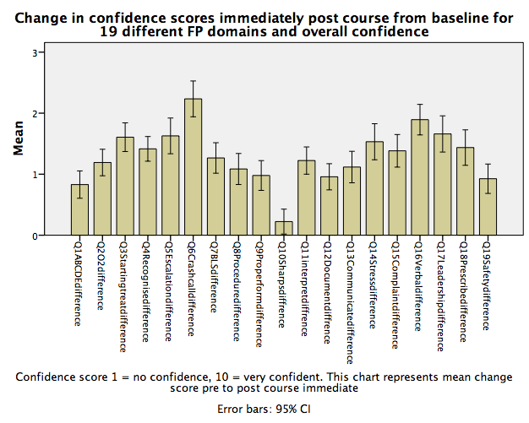
Figure 7-2 Change in confidence score pre- and post-course (difference) for each of the 19 FP and TD mapped domains. Errors bars represent 95% CI
There were no reductions in mean confidence scores for the domains, all increased by varying amounts. The domains with the largest change in confidence from pre- (condition 1) to post-course (condition 2) were responding to a crash call (+2.23 points (SD 1.43)), making verbal referrals (+1.89 points (SD 1.22)), developing leadership skills (+1.66 points (SD 1.44)), escalation of care (+1.63 points (SD 1.43)), starting treatment (+1.61 points (SD 1.14)) and managing self under stress (+1.53 points (SD 1.44)) (Figure 7.2, Appendix 13.24). These mirror the pilot study results and reflect areas that have a huge link with patient safety and are difficult to develop elsewhere in the curriculum.
The smallest changes in confidence were reported in management of sharps (+0.22 points (SD 0.99)), use of ABCDE assessment (+0.83 points (SD 1.09)), patient safety (+0.93 points (SD1.17)), then finally documentation (+0.96 points (SD 1.04)). As with prescribing with the pilot study, it was a challenge to really focus on documentation, owing to time limitations and the other elements required.

Principal Component Analysis and Factor Analysis

Factor Analysis and Principal Component Analysis (PCA) are multivariate techniques for ‘identifying whether the correlations between a set of observed variables stem from their relationship to one or more latent variables (that cannot be measured) in the data’ (Field, 2012). The goal of PCA is to identify those correlations in a set of observed variables that combine into a smaller number of largely independent components. PCA predicts components from the variables that have been measured to identify latent variables by examining the relationship between the observed variables to discover relationships that explain the maximum variance. Factor loadings with values greater than 0.6 with four or more loadings are said to be reliable regardless of size of sample, though sample size is important (Guagagnoli and Velicer 1988, Field, 2012; p684).
In the correlation matrix, values sat between 0.3 and 0.7 (Appendix 13.25, 13.26), meaning no values were found to correlate highly. This suggests that each variable of the confidence score parameters were independent of each other, improving reliability due to the values discriminating.
The table below (7-10) lists the Eigenvalues associated with each factor prior to and after extraction. The Eigenvalues associated with each factor ‘represent the variance explained by that particular factor’, and includes that as a percentage of variance explained, so component 1 explains 52.7% of variance (Field, 2012; p697). The first few components help explain a lot of variance compared to the rest.

Table 7-10 Principle Component Analysis
Total Variance
Component | Initial Eigenvalues |  |  | Extraction Sums of Squared Loadings
 | Total | % of Variance | Cumulative % | Total | % of Variance | Cumulative %
1 | 10.545 | 52.725 | 52.725 | 10.545 | 52.725 | 52.725
2 | 1.343 | 6.715 | 59.440 | 1.343 | 6.715 | 59.440
3 | 1.122 | 5.609 | 65.049 | 1.122 | 5.609 | 65.049
4 | .961 | 4.803 | 69.852
5 | .786 | 3.929 | 73.781
6 | .696 | 3.479 | 77.260
7 | .644 | 3.221 | 80.481
8 | .565 | 2.823 | 83.304
9 | .511 | 2.557 | 85.861
10 | .416 | 2.079 | 87.940
11 | .397 | 1.984 | 89.924
12 | .342 | 1.709 | 91.633
13 | .311 | 1.557 | 93.190
14 | .260 | 1.300 | 94.490
15 | .251 | 1.257 | 95.747
16 | .220 | 1.100 | 96.847
17 | .194 | .971 | 97.819
18 | .163 | .817 | 98.636
19 | .149 | .743 | 99.379
20 | .124 | .621 | 100.000
Extraction Method: Principal Component Analysis.

Appendix 13.26 demonstrates output following extraction where only large values (>1) felt to be of most importance are retained (Kaiser’s criterion, 1960). The use of PCA or Factor Analysis is exploratory and has been used to look for any patterns in the data. Initial analysis was run for Eigenvalues for each factor in the data (n=20). Three factors had Eigenvalues over Kaiser’s criterion of 1 and when combined, explained 65% of the variance. These factors do not appear to be related, so do discriminate when comparing self-rated confidence amongst the curriculum-mapped outputs.

Distribution – tests for normality focusing on overall pre-course confidence
SPSS outputs detailing tests for normality for the baseline confidence scores are demonstrated in Appendix 13.27. Shapiro-Wilk was found to be significant (0.000) thus data is not normally distributed.
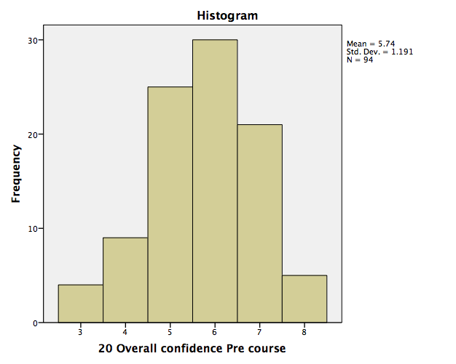
Figure 7-3 Distribution of data for final study baseline pre-course confidence scores
However, the histogram (Figure 7-3), demonstrates a relatively normal distribution. Because of the discrepancy, standardised residuals were performed on the data. This demonstrated that when standardised back to the same mean, the standard deviation for each value was within + or – 2 standard deviations from individual means, so considered to be normally distributed.

ANOVA

The reasons for using Analysis of Variance (ANOVA) for repeated-measures are explained within Chapter 3 (p89). Fifty-eight sets of complete data were analysed, where present for all four conditions. Analysis of missing values is displayed and discussed in the next section.
Table 7-11 Mean overall confidence scores for each of the four conditions, baseline pre-course, post-course, 1 week post-course and 1 month into FY1
 | Mean | Std. Deviation | N
20 Overall confidence Pre-course | 5.88 | 1.272 | 58
20 Overall confidence Post-course immediate | 7.22 | 1.027 | 58
20 Overall confidence Post 1/52 | 7.41 | .859 | 58
20 Overall confidence Post 1/12 FY1 | 7.79 | 1.072 | 58
Table 7-11 demonstrates a pattern of increasing confidence at each condition over time for the 58 students analysed. The largest increase is seen between the pre (5.88, SD 1.27) and post-course (7.22, SD 1.02) confidence score. Report:
Mauchly’s W-test (df = 5) = 0.7 p 0.001 was significant (Appendix 13.28), so assumption of sphericity has been violated, meaning variance in conditions is significantly different so the Greenhouse Geisser correction is used:
F (2.48,148) = 49.98, p <0.001
Significant main effects show that confidence scores vary over time following intervention. Planned comparisons were performed to see where the differences were. The details of these outputs are presented in appendix 13.29 and Figure 7-4 below.
Planned comparisons with Bonferroni correction for repeated testing applied revealed:
Level 1 (pre-course/ baseline) vs. Level 2 (post-course immediate) p <0.001 positive direction, mean difference 1.34 points.
Level 2 (post-course immediate) vs. Level 3 (1 week post-course) p 0.655, no significant change in confidence score, mean increase 0.19 points.
Level 2 (post-course immediate) vs. Level 4 (1/12 into FY1 4-7 months post-course) p 0.019, significant change, mean increase 0.57 points.
Level 3 (post 1 week) vs. Level 4 (1/12 into FY1 4-7 months post-course) p 0.15, no significant change in confidence, mean increase 0.38 points.
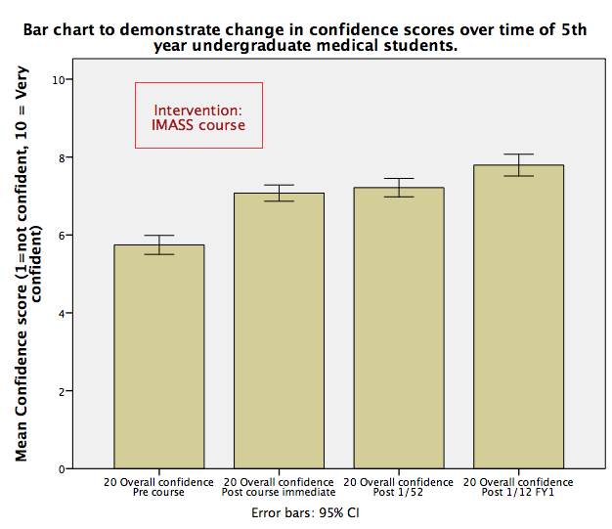
Figure 7-4 Change in confidence scores over four different conditions with 95% confidence interval error bars

Analysis of missing values

There was no significant difference between the means of the two groups of analysed (n=58) vs. missing data (n=36) using the one-way repeated-measures ANOVA, as demonstrated using a t-test to compare means of baseline confidence scores (t (92) = 1.4, p = 0.16) (Appendix 13.30). This means that those participants that did not complete all four measures were not of a different population from the other participants, so the data are likely to be representative and true. However, Levene’s test is not significant demonstrating that variance between groups is unequal. These findings are demonstrated graphically below in a bar chart (Figure 7-5), with 95% confidence intervals.
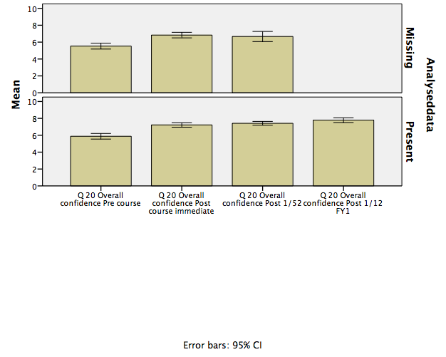
Figure 7-5 Means across the four conditions for overall pre-course confidence for present data analysed (n=58), versus those for missing values with the means for the three conditions as a comparison (n=36) Error bars 95% CI

Correlations: Confidence and Performance

The pilot study demonstrated no clear relationship between confidence and performance. This has been explored more formally using pre-course confidence scores and formative assessment marks for all 94 participants in the final study. Covariance represents whether two variables are associated, in this case self-rated confidence and performance. Standard deviation is used to overcome the issue of difference in measurement scales.
The standardised covariance is known as the correlation coefficient or ‘r’ or Pearson’s correlation coefficient. A coefficient of +1 indicates variables are perfectly positively correlated and -1 a perfect negative relationship, zero indicates no linear relationship. Correlation coefficients do not indicate direction of causality due to the fact there will be influence from other immeasurable variables. Bivariate correlation using the Pearson’s correlation coefficient was explored. It was felt that the more confident a person was the better they would perform particularly under pressure from being observed. Due to this directional hypothesis, specification of a one-tailed test was selected.

The correlation coefficient with other variables r is equal to 0.48; the significance value of 0.325 demonstrates that there is not a significant relationship between these two variables for the 94 students (Appendix 13.31). By squaring the correlation coefficient as above (R squared – coefficient of determination), this measures the ‘amount of variability in one variable that is shared by the other’ (Field, 2012; p276). Self-rated confidence may vary from person to person due to many factors such as personality, emotional intelligence, and how they feel on that day. If added together then it is possible to estimate how much variability is shared by performance. The value of R squared, 0.002 means that 0.2% of the variability in confidence is shared by performance, which is very low and leaves 99.8% of the variability to be accounted for.
Coefficientsª
Model |  | Unstandardised Coefficients |  | Standardised Coefficients | t | Sig.
 |  | B | Std. Error | Beta
1 | (Constant) | 113.649 | 7.331 |  | 15.504 | .000
 | 20 Overall confidence Pre-course | .570 | 1.250 | .048 | .456 | .649
Table 7-12 Regression analysis coefficients

This is a linear regression model, which maintains that outcome can be predicted from a model and is unstandardised, or ‘B’. A B value of 0.57 represents the change in outcome associated with the change in the predictor, or if confidence is increased by 1 then the model predicts that formative assessment mark will increase by 0.57. The t value is not significant (p= 0.649) meaning the result does not represent a genuine effect, this means that self-rated confidence does not make a significant contribution (p= 0.649) to performance as measured by objective formative marks.

The dots on the scatter plot (Appendix 13.31, figure 13.3) represent the observed data points for each value of overall pre-course confidence related to formative assessment scores for individuals. The B value describes the slope.
Regression analysis allows a linear model to be fitted to the data to predict values of an outcome variable from a predictor variable. To calculate the total error in a model, the squared differences between the observed and predicted values of the outcomes are used. The sum of squared errors is used to assess the error in the regression model, the squared differences were huge so the line is not representative of the data. For these data, the F ratio at 0.208 was not significant as p is >0.001, which means that there is greater than 0.1% chance that an F ratio of this value would occur if the null hypothesis were true. This means that the regression model does not predict confidence influencing performance well.
The scatter diagram demonstrates a wide distribution of data points of formative marks gained at different confidence levels. Though there does appear to be a trend towards a positive relationship there are many outliers. Of particular interest are the two candidates who scored themselves at 8/10 in terms of confidence for FY1 and gained two of the lowest formative marks in terms of performance. Also of interest is the score of 6/10 in terms of confidence, which shows the broadest range of formative marks.
A scatter plot (Appendix 13.31) explores the mean formative assessment mark and its relationship with pre-course confidence score. Again a positive trend is seen, with the points of interest in those with the extremes of self-rated confidence, with those scoring 3 and 8 appearing to gain similar mean performance scores. This may be because those with high confidence scores lack insight and those with particularly low confidence are impaired by anxiety.
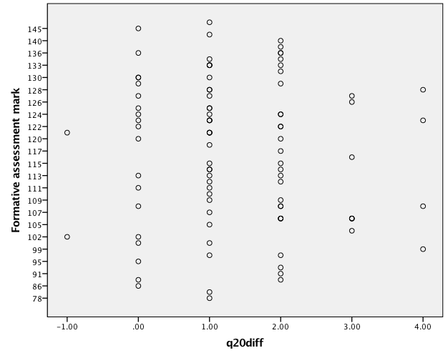
Figure 7-6 Relationship between change in confidence score pre and post-course with formative assessment mark (performance)

Figure 7.6 above, demonstrates a scatter plot exploring the change in confidence scores from pre-course to post-course and relationship to formative assessment marks (individual data points for each candidate). A similar pattern is seen as for overall confidence. Those with the largest or smallest changes do not appear to exhibit a pattern in terms of performance. The limitation of using a 10-point scale for confidence score must be acknowledged due to the capping or ceiling effect at a score of 10, thus anyone starting with a score of 8 could not improve more than 2 points.

Part II: Results: Qualitative: focus groups

Nineteen focus groups were conducted following each half-day course, with 4- 5 participants in each. Two thirds of interviewees were female, representative of intakes at both universities and UK medical schools.
The main emergent themes from thematic analysis echoed those from the pilot study, but with one main overarching theme that came through more powerfully related to preparedness: ‘practice under pressure’. The initial notes made during thematic analysis of focus group data are presented in Appendix 13.19. This followed a process of noting themes; concepts and words on Post-It notes then grouping similar concepts (Appendices 13.18, 13.37). The main themes and subthemes are displayed in the figure below (Figure 7.7).

Figure 7-7 Themes and sub-themes from focus group analysis

These themes were used to construct the initial framework matrix and facilitate triangulation of data (Appendices 12.35, 12.36, 12.37). The matrix was updated through an iterative process to confirm saturation of themes.
Practice under pressure:
A recurring message was that though students are taught well during the undergraduate curriculum (an example was about SBAR (Situation, Background, Assessment, Response) and fluids), they felt that they ‘do not get to put them into practice under pressure and make decisions with regards to them in clinical context’ (focus group 1, Participant 3) to understand the clinical relevance. They felt ‘under prepared in leadership and prioritisation skills’, and they felt that ‘practice with feedback and guidance helped’ this (focus groups 2, Participant 4). There were misconceptions addressed when practising such as: students not wanting to give analgesia to patients when in agony in case it 'masked the pain' so they would no longer be able to assess them. These issues may have only been highlighted because students are working alone with responsibility to make decisions (Case and field notes from intervention study). One student said:
‘I just wanted the beeping to stop as I could not think….. my mind went blank and I did not know what to do, I panicked, now we have been through what to do I know what is expected of me and how to get help’ (focus group 4, Participant 1).
Coping mechanisms for when candidates felt under pressure were discussed and displayed, and included: using a recognisable structure for assessment and intervention, reassessment, slowing down if rushing, physically taking a step back from the situation, speaking out loud to share thoughts and ideas, consideration of available guidelines and resources, and calling for help.
Expectations and Escalation:
There was the described feeling and expectation that because they had passed Finals, they should know how to manage every patient on their own. There were mixed views in terms of knowing what was expected of them as a FY1, in particular knowing when to call for help. There were ‘feelings of fear of not knowing what to do’ (focus group 3, Participant 5).
Students reflected they were slow to call for help, in part due to their lack of situational awareness about the severity of the case. At this point, the calculation of early warning scores helped as students appeared fixated and falsely reassured by ‘normal blood pressures’ - a late sign of deterioration (focus groups 11, Participant 2). The second influence on this theme was due to the impact of hierarchy, the feeling that they should be ‘able to cope’ and would be ‘embarrassed’ if they had to call a senior because they ‘should know what to do’. They were concerned about ‘disturbing seniors unnecessarily’ (focus group 4, Participant 2).
One student in peer review of another student said:
'you should always pretend you are confident and never admit to not knowing what to do' because they felt this was 'weak' and would cause concerns amongst other staff and the patient (focus group 6, Participant 1, Field notes IMASS course day 3).
In terms of leadership skills, there was a feeling that as new doctors they would always need to take the lead until a more senior doctor approached, who would then take over. This led to some misunderstandings with how to work well with nursing colleagues, when some students felt the pressure of having to look as though they were ‘in control’ to the rest of the team (focus groups 9, Participant 3). There were reflections that everyone had different leadership skills and a level of adaptability was required. The feeling of needing to be in charge separated out different personalities, where some made snap decisions and others felt overwhelmed by the responsibility and unclear of expectations that they were ‘allowed’ to give treatment (focus groups 2, Participant 5, FG 16, Participant 3).
When running the final scenario related to a cardiac arrest, there was the sudden realisation that seniority does not necessarily make a better leader. This seemed to result in a level of empowerment amongst the medical students, which was palpable. It appeared to lead to a new found value that though they were junior, they were not ‘useless’ (focus groups10, Participant 1 focus group discussion field notes).
Simulation:
There were discussions around previous experience and what worked well and not so well. Most voiced a want for simulation throughout the undergraduate curriculum but felt that if there were limited resources, it should be prioritised in 4th and 5th year. If it was introduced in the 3rd year, students felt they should work in pairs, but by the 5th year, they all felt it was essential to work alone to help them develop coping skills and understand how they would act and manage under pressure.
A sub-theme within simulation was realism and how important this was for immersion. Aspects that made it feel more real were having the patient talking to them and doing procedures in real time with patient feedback. They felt the scenarios were realistic. Having accurate and correctly timed physiological responses was important, for example blood pressure trending up over time after fluid bolus, or not altering if bleeding or under filled.
‘In previous simulation sessions you would give fluid and the blood pressure would go immediately up which is what I was expecting, so I had not thought that was not normal so was worried when there was no change’ (Focus group 10, Participant 2).
All students 'felt like a doctor' looking after a patient in the scenarios which was felt important to prepare to be responsible.
Best practice for simulation was discussed, what was important and worked well in their opinion and experience. This included: interprofessional learning and teaching; creating a safe environment; faculty appropriately trained, experienced and flexible as well as being receptive to individual student needs; debriefing to be specific and individual; learning outcomes, some pre-decided, others tailored to group specific questions; and importance of getting the pressure level right for each individual.
Human Factors:
Human factors comments were very closely related to performance and practice under pressure. Students that were signed off as competent at cannulation, when performing the task under pressure left tourniquets on and did not put sharps away (field notes). They were shocked by this, saying
'I have never ever, ever done that before and I still can’t believe I did, I must have been distracted, I have never had to try to manage a patient, relative and team before in that situation but I will be aware of the risk next time' (focus group 5, Participant 4).
The need to learn how to 'think straight' under pressure was described to make sure they could act effectively and prevent their ‘mind going blank’ for the patient (focus group 2, Participant 4).
The realisation that seniors wanted to be called to help them was important to them, especially from faculty with clinical credibility.
Confidence was discussed, which they felt was about feeling ‘able to do something on their own, make decisions’, and helped lead to independent critical thinking (focus groups 3, Participant 4). Confidence was considered core to capability. Confidence, resilience and independent thinking were recorded in field notes to be required at all stages to support insight, self-reflection and self-regulation.
Task fixation was an area discussed and generally triggered by performing the procedure in each scenario. It was described as important when doing the procedure until complete, then moving to avoid tunnel vision and risk of labelling a patient with a diagnosis too early.
Behaviour and self-insight
In terms of insight and behavioural change, realising how they acted under pressure was noted to be ‘very interesting and useful’, and sometimes ‘shocking’ or ‘surprising’ (focus group 11, Participant 2). One student physically blocked a relative getting near the bed when under pressure, another swore when they failed to cannulate the patient, others smiled or giggled when the pressure increased - all of which upset the relative and patient.
‘I just saw the relative and I was trying to get to the patient so I tried to block them to get them away…..I have not been in that situation before and I panicked and could not think what else to do and just blocked them…which I realise now made them more angry’ (focus group 12, Participant 3).
The ability to deliver this feedback in real time to the candidate with raw feelings from patient, team and relative was unique and powerful. The impact on rapport was explored in debriefing and methods to recognise behaviours and manage them (Intervention study field and case notes). These cases highlighted the importance of reflection and real time feedback. Students reported that they had had no other opportunity for this level of practice and individual feedback and reflection that they felt would ‘change their behaviour in the future with patients’ (focus group 3, Participant 4).
Interprofessional learning
Interaction with their team and the importance of interprofessional learning was highlighted throughout all focus groups. In particular ‘understanding in practice the roles of others and how to work together well’ (focus group 5, Participant 5).
‘I have never worked with the nurses as a doctor before so was unsure what they are able to do or how to interact best with them, I had not realised at all that I had said ‘my nurse’ and how that had made them feel… I will never do that again’ (focus group 17, Participant 4).
The importance of avoiding poor communication and impact on relationships emerged. One example was: 'my nurse will see to you', a comment made by one of the students. The nurses felt offended and had the opportunity to explain why. The importance of building a rapport with staff was emphasised and understood. Building personal relationships by reminding themselves of names and to be polite even when they were feeling overwhelmed with pressure was noted as important (focus group 3).
Clear communication and the power of sharing concerns and ideas and asking for help from the team were discussed as vital. The nursing team reported this behaviour as making them feel ‘included and valued’, and the combined feeling was that of better and more effective care for the patient (focus group 8, Participant 2).

Part II: Results: Qualitative: Interviews

The main aim of this study was to explore preparedness, to look at ways of trying to improve it, those that exist already and a potential method of using SBME though the design and running of a curriculum-mapped simulation course. The section reports the findings from the interviews conducted with simulation experts.
In terms of demographics for experts (n=10), three were male and seven female. Four were anaesthetic consultants, two were senior nurses with national recognition for education and patient safety, two were medical consultants, one was a general practitioner and one an emergency medicine consultant. Two had been consultants for two years and the rest between 20 to 30 years. All had over five years experience working in medical education and simulation and or human factors education. Eight interviewees were simulation lead for their department. All had peer-reviewed publications concerning medical education and simulation.

Preparedness

There were seven emergent themes (Fig. 7-8):

Knowledge
It was felt that ‘knowledge was the currency’ in medical education and was rewarded and prioritised over other skills that were equally as important, such as leadership, teamwork and communication skills (Interviews 1,8). It was felt that ‘students needed more than just exams’ (Interview 3). What worried a number of doctors was reported as ‘being able to access the right knowledge at the right time’, needing to ‘give the tools to actually think’ because it is not possible to ‘prepare every student for every eventuality’ (Interviews 3,2). The hidden curriculum was felt to:
‘instil a belief that to be a good doctor, you have to have the most amount of knowledge that you possibly can and if you have the right knowledge that you will be good at what you do. We need to stop generating a culture, which rewards knowledge over and above every other characteristic that we value in doctors’ (Interview 8).
Skills
There appeared to be an expectation that some skills could only be learnt ‘on the job’ but due to reductions in exposure and responsibility at undergraduate level this was less possible (Interviews 2,4,7). Non-technical skills were described as having been ‘compartmentalised’ and losing context (Interview 3).
‘In real life you won’t necessarily have a protocol that is going to work perfectly to sort out every situation and so unless you have got good non-technical skills you might not be able to resolve the situation as well and as safely for the patient, with as good outcome……..I think that is so important, it is more important to have the non-technical skills, but I think you really really really need to use them when you are struggling, when you are some way out of your comfort zone to really benefit from them (Interview 1).
It was felt that students were taught practical and communication skills well but there was a lack of ‘context’ and ‘application’ to the work environment (interview 3).
‘In terms of practical procedures, something we did when a medical student, we would take bloods, we would hangout on the wards waiting to do cannulas and bloods, things like that. I wouldn’t say I was particularly brilliant at practical skills when I started and I certainly didn’t have a range of them. In terms of how to actually look after patients, unwell patients, I don’t think I was actually prepared at all. I probably learnt all of that on the job’. (Interview 1)

Capability
Experts talked overwhelmingly about capability in terms of being ‘work ready’, ‘fit to think, fit to act’, and that this should be objectively measured (Interviews 2,3,4). Preparedness was described as being ‘competent to undertake the tasks of the day within a clinical workspace’ (Interview 2). Preparedness was described as being:
‘about people understanding their response in crisis or their response under pressure, and the need to invite the individual to think about their own response in relation to the tasks, the environment, the system, its design, their team members’ (Interview 5).

Figure 7-8 Venn diagram to demonstrate main emergent themes related to 'preparedness' from thematic analysis of UK medical education and simulation expert in-depth interview transcripts
Transference
There was concern about a lack of transference due to missing context and application for the work environment with education, and that students were being turned into ‘non-thinkers’, following protocols (Interview 3). Experts had been trained in ‘the high pressure work environment’ of which they described a lot of ‘exposure’ but also ‘error’ and learning to self-correct over time (Interview 4). It was felt that unless ‘stretched’ by workplace related pressures or ‘having some kind of internal quandary’, there was less learning opportunity (Interviews 1, 2). There was emphasis on the importance of learning about:
‘personal behaviours to manage own stress in an environment, how to use the team more effectively and manage the pressures, learning to use adjuncts such as guidelines and other memory aids’ (Interview 10).
Professionalism
Professionalism was mentioned recurrently by experts, and the idea of the application of knowledge and skills, as well as gaining insight into the clinical conditions of working in a hospital (Interviews 2,3,6).
‘Insight into own capabilities, cultural issues in a hospital, appraisal amongst the post-graduate community and experience' (Interview 2)
The above were described as important aspects to understand and to develop to support preparedness.
The senior educational experts reported not having anyone to check up or discuss what they had done, having to ‘debrief themselves with friends, never being sure whether the learning taken away was correct’ (Interview 7). There was however a description of structure with distinct teams and lines of responsibility so that feedback could be traced back to individuals and a mentoring relationship developed (Interviews 2,7). Concerns were reported over decisions to ‘omit rather than act’ in times of uncertainty amongst current FY1s (Interview 8).
Emotional Preparedness
There was uncertainty over expectations, with descriptions of such being:
‘unrealistic as to what I should have been able to manage on my own and battling on with patients’ (Interview 1).
‘I think there is a whole raft of emotional skills that are required for being a junior doctor that we don’t prepare people adequately for and that is the main cause of underpreparedness. I think emotional underpreparedness is the main cause of distress in Foundation One… there is a feeling that people are being overwhelmed with what they are being asked to do, that they are not equipped to deal with stress, to deal with multiple different people putting demands on them, their time and energy, to deal with night shifts and the pressure that puts you under in terms of sleep deprivation, poor quality sleep, poor decision-making …. you know people… that you are looking after die…and that is something they have never experienced before. But equally when you are a FY1 you make mistakes, and you prescribe a drug that is the wrong drug or the wrong dose and someone gets ill… and you have never experienced that before…everyday you are experiencing new…. emotional challenges and hurdles and experiences that you have never been exposed to before and they are so varied and so frequent that that grinds some people down’ (Interview 8).
‘All of a sudden you just feel that you can not cope with this job, and that is nothing to do with either your medical school training or your competence as a doctor. It is all to do with those other pressures and how well you are equipped to deal with them and how willing you are to speak up about the fact that you are struggling’ (Interview 8).
There was a reported ‘failure to recognise that error is normal and that humans are fallible’, with doctors expressing the need to ‘understand what the ‘rules’ are so that they ‘get it right’, described as ‘part of the culture of medicine’ (Interview 5). It was felt that the ability to ‘build mental models’ was key to supporting preparedness (Interview 9).
Confidence
Experts described that if there was less focus on knowledge - ‘getting things right they would have had more confidence to escalate things sooner’ when a patient was sick (Interview 1,8). Allowing learning when experiencing stress was felt to be important, to ‘support trainees gaining confidence’ in managing acute conditions (Interview 2). It was described that:
'you need to be under pressure to know how well you are equipped to do the right things for your patients' (Interview 2).
Others described preparedness as ‘comfortableness, skill level, confidence and competence’ (Interview 5).
The quantitative data has been useful to display increased confidence that was maintained over time following the educational intervention designed to address under preparedness for FY1 utilising simulation based medical education. Focus groups with undergraduates and interviews with medical education and simulation experts have allowed multiple stake holder perspectives to better understand what preparedness means, where the gaps and educational challenges are in preparing for FY1 and how to consider addressing them through education. The following chapter presents results from data triangulation initially to compare student and expert perspectives and then from all data sources. Theoretical frameworks are presented that were developed through the process of abstract conceptualisation and implications for practice described with focus on deeper exploration of those themes felt to be key to enhancing preparedness.

Chapter 8 Data triangulation

Introduction

This chapter presents the triangulation of data from all sources, including quantitative data, qualitative data, field notes, reflections from the research diary and cases. Thematic analysis was completed and two overarching themes identified: understanding preparedness and preparing students for clinical practice. Each of these overarching themes has a number of further themes and sub themes which are presented, with examples from the data to illustrate and support the theme.
Following presentation of the two overarching themes, implications for medical education practice are considered through a process of abstract conceptualisation. A theoretical educational framework is presented and described, followed by a model for the design and delivery of undergraduate simulation education and a model of the debrief process.
The figure below presents an overview of the chapter structure followed by main themes and subthemes.

Table 8-1 Main emergent themes and subthemes from triangulation of data surrounding preparedness
Overarching theme | Theme | Sub-theme
Understanding preparedness | Realisation
 | Responsibility
 | Recognition
 | Response
 | Performance
Preparing students for clinical practice | Practice under pressure | Practice under pressure, responsibility, level of pressure, skill acquisition  Human factors, patient safety, culture and the hidden curriculum, understanding and changing culture  Belonging, mentorship, contextual consequence learning, fidelity  Knowledge and technical skills, non-technical skills  Cognitive processes
 | Human Factors
 | Experiences
 | Clinical reasoning and Judgment
 | Clinical cognitive competence

Theme 1: Understanding preparedness

Exploring the concept of preparedness was the main aim of this study. Within theme one the findings of the triangulation of data from both the student and expert perspective are reported. Focus is on interpretation and personal experience of preparedness followed by views on the relationship between preparedness and performance. Student data has been triangulated from focus groups, field notes, cases and feedback. Five themes emerged:

Student interpretation was largely based on anticipated preparedness, experience of placements, assistantships, shadowing, simulation courses and talking to peers. The views of experts regarding preparedness were retrospective and generally related to starting as an FY1. For some this was around 12 years ago and others, 30 years.

Realisation
From the student perspective, realisation was heavily related to expectations about being a FY1 in terms of responsibility, the pressure of the clinical environment and the impact their decisions would have on the patients.
‘I did not realise I could start treatment for anaphylaxis……. I knew what the patient needed but was not sure I could start the treatment because I had not done it before so I called to check’ (focus group 8, Participant 1).
They described the feeling of being overloaded with jobs and pressure, and the fact that could lead to their mind going blank. The concept and impact of cognitive overload concerned them.
Experts described the phenomenon of ‘perceived versus actual capability’ with a feeling that actual capability was more important. Realisation represented actual experience of being a FY1 and despite reported increased experience, expectations were still reported to be wrong. They described feeling that they had to manage everything alone (Interview 1).
‘What worries many doctors is about being able to access the right knowledge at the right time. You can’t prepare every student in studying medicine for every eventuality. What you have got to do is give them the tools so they can actually then think’ (Interview 3).
The need for more generic, transferable skills to improve preparedness was highlighted and that perhaps focusing on knowledge as an assessment was not appropriate. Some described that though they had been ‘exposed to a lot’ equating to more potential experience it was not felt that this had helped to prepare them (Interview 7).
‘The more I think about it the more I think…. what is prepared?…you don’t know that until afterwards do you? You know - were you prepared to have a baby? Were you prepared to have a toddler? Were you prepared to become a consultant? …well…no probably I was not fully prepared for any of those things but you manage and you get through and you learn on the job. I think that … it is a very hard concept to define and I think you can ask people how prepared they felt after something but that is overlaid hugely by someone’s clinical competence, by their confidence, by the type of people they worked with in their first post, by the extent to which they felt nurtured and protected, the extent to which they were blamed for errors which occurred. I think that when you ask people - ‘were you prepared?’ what you are asking people really is ‘how did it go?’. If you ask people before they start ‘are you prepared?’, that is meaningless - prepared for what? they don’t even know what they are preparing for because they have not done it. So if you ask people before it is meaningless, if you ask people afterwards it is overlaid by all sorts of barometers of how much they enjoyed or found satisfaction in what it was that they were doing’ (Interview 8).
There were reports that they were taught by ‘humiliation’ and in fact this was the ‘norm’ in medical education (Interviews 4,7).

Responsibility
Students related responsibility to the application of knowledge and skills but also how to access knowledge in times of overload and high stress. They felt a responsibility for decision-making and were aware they would sometimes have to make quick decisions and other times they would have time to think for longer but using their judgment with little experience was felt to be a challenge.
‘I felt like a doctor looking after a patient….. and when they did not improve immediately it was stressful, especially with my treatment plan……but it was good to know I can cope and how to get help’ (Focus group 15, Participant 4).
They had had a snapshot through the course of the consequences of their decision-making and action or inaction on patient outcome. For this reason they felt a responsibility for patient safety and pressure to be a professional, credible member of the clinical team.
Experts described being ‘put on the spot’, suggesting they were not feeling ready or prepared.
‘I felt like I had to be responsible from the beginning of F1. Which was probably not really the case. I sort of felt that as soon as you were on the wards that you were a doctor so that the patients were definitely my responsibility to sort them out you know, yes definitely felt that sense of ‘these are my patients that I need to look after and if I have to stay late to do anything to look after them’ (Interview 1)
Another described a ‘clinical apprenticeship model’ where they had a clear team structure and felt supported (Interview 2). Others described ‘training on the job’ suggesting experiential learning, but a lack of planned debriefing and support. The more junior experts described shadowing, which had been of some help, but it had been ‘too late on’ and would have been more beneficial to have had that level of exposure and experience earlier on (Interview 1). Undertaking a locum was described, but that there was ‘trial and error’ in terms of consequence learning.
There was a more deep and developed perspective on the responsibility of being part of a team. This included the importance of communication skills, leadership as well as followership, and caring about your team. In particular, regularly ‘checking in’ with the team ‘mental models’ or how well everyone was to own and address any problems (Interview 6). This level of appreciation and understanding regarding the importance of good teamwork, is very much a step on from the student perspective, and perhaps the disconnect in supporting the transition to FY1.
Recognition
With students this was about them recognising their own behaviour when they were put under pressure with responsibility for making decisions and their emotional response to it. They described the recognition of how it felt to feel stuck and unsure and how to manage that uncertainty. They described experiencing the challenges within the clinical environment in terms of availability of different equipment, layout, team members and how to cope with that and be effective and safe, which was linked to human factors.
‘I did not know what the nurses were able to help with….. when the monitors were going off I found it hard to concentrate…..I wish I had asked for help sooner but did not want to bother my senior’ (Debrief day 4, University 1)
Experts described a significant influence of teamwork, ‘sharing and agreeing goals’, and how to ‘align team priorities’, to let members know they count and were valued (Interviews 2,6,8). Recognition included recognising own behaviour and personality traits, and how they impacted on others and situations. Then learning how to control emotional responses, to ‘self-correct over time’, linked to reflective practice and development of professional identity (Interviews 3,4,6,8,10). Developing these skills was felt to move the individual to a ‘comfortableness’ associated with a particular skill level that encompassed technical and non-technical skills, teamwork, decision-making and judgment.
‘Healthcare, it always assumes you have to know everything in order to practice but actually science moves on all the time so you will never be on the top of your game so actually you need the other skills, the skills around process, how to work with one another, how to access information, how to make decisions, understanding that standardisation is an effective way of managing cognitive overload.. that actually so much as the patient journey–the patient's experience is quite standard if you approach that as standardised you can ensure the quality of that patient experience and it gives you the head space so that when things go off piste to use your creativity, to use your.. you know, rescue skills’ (Interview 6).
It was felt that this was not just achieved through ‘experience’, but vital to reflect effectively to better understand and regulate oneself (Interviews 2,3,6,8).
Response
Response related to how to get responses from others and how to record them, and how to get what they needed to manage a patient effectively. Response included patient response, in terms of consequences of actions with patient physiology and outcome but also from a practical point of view.
‘I had not realised how long it would take for drugs to take effect, how long it may take the nurses to get or make up the drugs, in other courses it has been instant’ (focus group 3, Participant 4).
There was a risk with simpler experiences of simulation that non-authentic responses had been played out untrue to real life. This emphasised the importance of realistic physiological responses to help build on knowledge, understanding and clinical judgment. The students described the importance of knowing what would happen next and how to check up that an action had been taken and completed, especially in a shift system. This was labelled ‘closing the loop’, and also linked to closing the loop of communication with team and patient but also closing their knowledge and experience loop. This meant they had learnt something, experienced it and played out the consequences. They had time to reflect, consider other options and summarise overall personal learning points and concepts.
Response for experts encompassed consequence learning, which was reported to have occurred through ‘trial and error’ in terms of patient response and outcome. In addition, response or feedback from ‘good leadership and followership’ highlighted the importance of teamwork throughout the complex journey of preparedness. There was a described move from being reactionary to ‘prospective hazard analysis’.
‘One of the other challenges is that the latent conditions for failure, the latent conditions for harm are just everywhere. As human beings as fallible as we are, we are also incredibly resilient and we are compensating and catching stuff all of the time but because we do not do a lot of learning from the no-harm events and how we mitigated it, we don’t absolutely know how we did it… we don’t know…it’s almost like the hidden curricula’ (Interview 6).
Students were aware of patient safety and felt a responsibility for it but could not transpose this depth to forward planning to reduce error and risk. Experts had learnt this ‘on the job’, but to develop these high level coping, safety and teamworking skills as a student, is an advantage for self, team and organisation.
Performance
There were common elements between what students and experts felt to be important for preparedness and performance. Students responded about how well they felt they had been prepared by their undergraduate curriculum for FY1, and experts reflected upon years of clinical experience and their own recalled experience plus current experience with junior doctors.
In terms of preparedness, the importance of experiencing cognitive overload in a clinical authentic setting was felt to be vital. This was to practice under pressure to learn skills to recognise this feeling, then how to access knowledge, skills and help to regain control.
‘I could feel my mind going blank and was so distracted as there was so much going on…..I wanted to switch the monitors off. When I took a step back from the situation I could think more clearly. I have learnt that about myself now and know to try and stop myself getting to that place. To call for help sooner. I am glad I experienced that now and not with a real patient’ (Focus group 12, Participant 4).
Responsibility was felt to be key by both groups and grading this responsibility along with pressure was felt to be important when supporting transition from undergraduate to FY1. Roles within clinical teams as well as through simulation were felt to offer opportunities for this.
‘I was not aware of expectations and what I could and couldn’t do, what decisions I should be making for the patients and who to call if stuck’ (Focus group 5, Participant 3).
Experience was considered to be important but emphasis was put on supervision to allow for meaningful individual debriefing following events.
‘it is about having the judgment, having the confidence, having the experience to say ‘that doesn’t matter, that is superfluous, don’t worry about that’ (interview 6)
Students described a lot of anxiety about dealing with unwell patients.
‘It was ridiculous, I forgot how to do a cannula…..I was so distracted by the patient being unwell and not knowing what was wrong with them, and they seemed to be deteriorating. I wanted the right diagnosis to do the right thing for them’ (Focus group 2, Participant 4).
Experts shared the challenges of dealing with death and unwell patients and the importance of supporting and developing emotional preparedness by incorporating discussions about emotions into the debrief.
‘you remember things that were difficult, there is actually good evidence that you remember hard times and sad times much more than you remember happy times…’ (Interview 8).
Experts highlighted the need to discuss team issues openly, to allow ownership of and responsibility for problems, and to facilitate support for each other (Interviews 6 and 8).
‘If we can get people to a place where we can be that honest about their vulnerabilities you create an honest space where people can have an honest conversation about what is doable and what is not’ (Interview 6).
In terms of performance or capability, the triangulated data moved away from focus on knowledge and skills as a measure of performance to the importance of enhancing skills to self-regulate or ‘self-correct’. This included how that could be enhanced and developed without years of experience and potential ‘trial and error’ (Interviews 2,3,10). The process of facilitated debrief was felt to be core to this, and a very complicated skill that was key to encouraging self-reflection and the development of self-regulation.
‘So for me it’s holding up the mirror to myself and holding up the mirror to what is going on around me and one of the other things I often say to …because I draw lots of parallels with compassionate care giving and human factors like situation awareness’ (Interview 6).
Mentorship and feedback were felt to be critical, and creating a supportive environment to learn with a recognisable team. Feedback was required to support the closed loop nature of effective consequence learning.
‘I gave the correct drug but by the wrong route, I was rushing, I did not need to rush, seeing what happened to the patient and having to deal with that has made me think a lot about how I am and how that might impact on patients. I wont do that again. It was hard explaining my mistake to the patient and family’ (Focus group 8, Participant 4).
It was felt it should remain individual and that facilitated debriefing would encourage students to consider consequences, reflect and try to understand their own behaviour better, as well as understanding the impact on the wider team. Movement from a pure knowledge assessment led onto the importance of demonstrating the application of knowledge and skills in a clinical context, and to embrace the complexity of the clinical environment. This was felt to facilitate authentic prioritisation and clinical judgment without stripping experience or oversimplification with protocols and checklists, which may lead to misjudged expectations.
The recipe for preparedness is complex. Confidence and competence have been placed together to signify the value attributed to them by students and slightly less so by experts. Ability to access knowledge and skills and perform when under pressure is believed to be enhanced by practising under pressure. Students reported that practising under pressure had improved confidence and self-belief, which was felt to be key for safe performance (focus groups 2,4,5,8,13, field notes).
‘I feel more confident that I know how I will react when under pressure, when I need to act, that I know who and how to call for help. If I am, getting stuck it is because I need help, not just because I do not know enough’ (Focus group 16, Participant 3).
One expert described being ‘work ready’ as ‘fit to think, fit to process, fit to act’ which encompasses all stages of preparedness. By using the word ‘fit’ there is the implication that these stages require training, effort and coaching in addition to physical and mental fitness. This links back to emotional preparedness. Getting students ready for practice should involve structured education to support these processes. Thought processing should involve the ability to consider the consequences of different actions (ones learnt, ones experienced), and a consideration of time, whether this requires a fast or slow decision, then the ability to act. Action appears to require understanding of expectations, confidence, self-belief and the ability to employ skills under pressure. The process of closing the loop of learning, self-reflecting, seeking feedback and consolidating personal as well as general lessons are required.

Theme 2: Preparing students for clinical practice

Previous emergent themes have fed into the development through abstract conceptualisation of the following educational theoretical framework (Figure 8.1). As shown, the core and outcome are the development of clinical cognitive competence, the notion of being able to process thoughts and ideas and access knowledge under pressure, to behave safely and effectively. This involved development of mental models and strategic thought processes driven by the experience of a human factors embedded simulated session. To enhance preparedness, SBME should include responsibility, meaningful and authentic interprofessional learning and appropriately graded practice under pressure with facilitated debriefing.
This overarching theme includes 5 themes: practice under pressure, human factors, experiences, clinical reasoning and judgement and clinical cognitive competence, each with sub themes. The framework is included at the beginning to provide a contextual overview of the themes followed by a description of their development, supported by data to illustrate and support the development of each concept.
Practice under pressure when considering preparedness, has been shown to be complex and the ‘art of simulation’ (Interview 2). The second all encompassing theme was opportunity to embed human factors, considering interactions of self with team, environment, equipment and others, including patients and relatives. The 11 subthemes embraced by these two main themes were related to experiences, understanding, personal skills and performance, where an individual moved from a place of potential loss of control to developing understanding and strategies to regain control of situations.
‘Experiences’ include the experience of complexity, of own non-technical skills, of cognitive overload, of loss of situation awareness and of responsibility for own decisions and mistakes.
‘Understanding’ involves own personality, emotional intelligence and emotional preparedness. Understanding that humans are fallible and will make mistakes, understanding the cognitive biases that threaten ability to access knowledge under pressure and perform, understanding own strengths and weaknesses and the value of consequence learning. Finally understanding the influence of hierarchy on own behaviour and decision-making.
This progression through the stages of experience to understanding was felt to inform clinical reasoning and judgment skills and move an individual to a place of control of cognitive biases, distractions, influences, complexity and the ability to think straight. This led to the development of clinical cognitive competence to allow safe and effective decisions and actions. This was felt key to developing powerful reflective skills and self-regulation to support safe and effective professional development (Field notes).
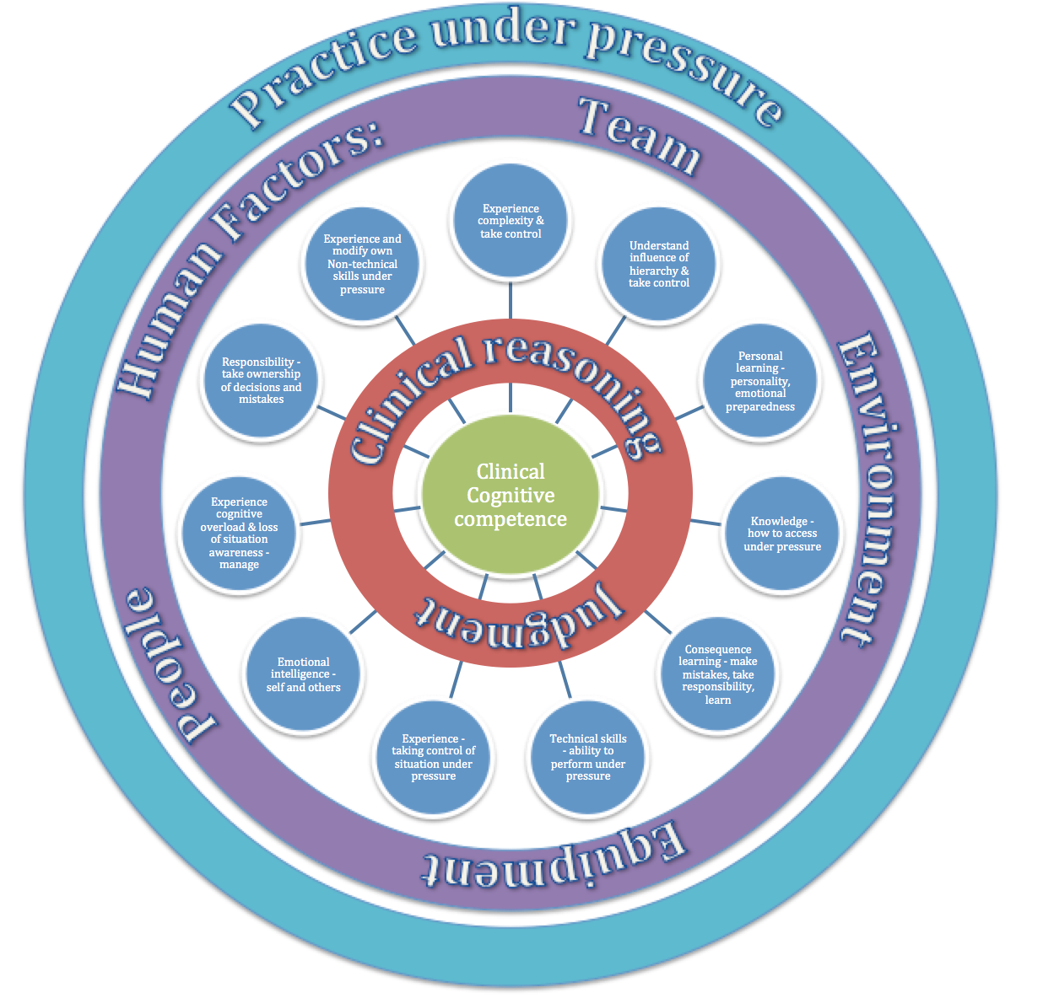
Figure 8-1 Conceptual Education Framework

Practice under pressure

Practice under pressure was felt to be the key to allow emergence of these different personal challenges and behaviours (Interview 2). This allowed individual targeted learning about how to perform better, be more prepared and safer.
‘I think it is important to recreate that pressure and the complexity of the environment, but if you don't need that then the pressure comes in the performance of whatever skill you are trying to simulate and I think there is a pressure in performing knowledge’ (Interview 4).
Grading pressure, skill level and responsibility were felt to be vital, and it was observed that all students had slightly different levels at which they felt challenged (focus groups 2,5,11, Field notes). Getting this level correct for individuals was important to avoid negative learning for those over-stressed and to ensure higher performers were challenged appropriately (Field notes).
‘I got stuck and did not know what to do. Then my senior called to ask how I was. I realise I should have called them, I had not had that responsibility before. I did not know how I would react’ (Focus group 10, Participant 5).
This required a lot of emotional intelligence in interpreting behaviour before, during and after the simulation scenarios and sculpted the debrief (Interviews 2,7,8, field notes).
‘I think there are all sorts of things that you can observe from a behavioural standpoint, the majority of the message that we will convey to another human being comes from tone of voice, body language, eye contact, facial features (Interview 2).
Field notes revealed that it was easier to pick up on this level when a faculty member was in the same room as the scenario but this was found to be a distraction to students. This could be done from outside the room using audio-visual kit, whilst giving the students the independence and responsibility they craved. Interventions when someone was seen to be starting to struggle or sailing though were put in place, such as phone calls of support or increased complexity (Field notes).
The notion of practice under pressure appears key to supporting the transition from undergraduate student to junior doctor, and as such assists in improving preparedness. Initially this was thought to be through improving confidence, as seen with the quantitative data within this study. However, the qualitative exploration and analysis has proved very insightful and offered depth surrounding the other elements that practising under pressure brings. The diagram is complex and this reflects the nature of this theme in the data.
The initial broad division was made related to whether the impact of practice under pressure was on ‘self’ or ‘system’ owing to the wide impact on all interactions whether other individuals or within the environment. System included the NHS as a whole, to include environment, equipment, team and others in the clinical environment.
When considering ‘self’ there were four broad subthemes (Appendix 13.38):
- Cognitive processes.
- Behaviour.
- Judgment and decision-making.
- Performance or actions.

System revealed three subthemes:
- Cognitive process impact.
- Test the system.
- Learn from mistakes.

Cognitive processes
‘Cognitive processes’ are expanded upon in the final section describing clinical cognitive competence.
Behaviour
Behaviour was divided into reactions related to how individuals were found to behave under pressure. Experts discussed the opportunity this gave to explore and modify own behaviour, leading to meaningful behavioural change, which would impact patient safety.
‘I got stuck and went blank, I was quiet and could not do anything, I was almost coached through, learning how to get out of it, using protocols, calling for help, it made me feel I would be able to cope and when a patient is really sick sometimes just need to ask for the crash team upfront, next time I will just call if concerned after initial assessment and not wait as help seemed to take ages but was actually only 5 minutes’ (Focus group 15, Candidate 4).
The second division of behaviour related to experiencing the impact of own behaviours on others. In one scenario a student referred to the nurse as ‘my nurse’, not using their name. There followed some visible disengagement from the nurse who felt ‘devalued’, making her less inclined to help the student (Field notes). The student was not aware of this. This presumed ‘ownership’ of team members rather than equality, felt to be due to cultural hierarchy, had negative effects on their relationship. The ability to increase awareness and understanding of this impact was considered invaluable by all. When under pressure, it appeared easy to forget politeness and a few extra seconds to remind someone of his or her name was important. It demonstrates the importance of respect and responsibility among the team and to allow professionals to feel independent in identity and credibility. This concept of professional identity was fascinating and how it could be so influenced by two words (Field notes from intervention study).
The thematic stems from impact on others related to patient and relatives and the importance of emotional intelligence in detecting fear or concern, from body language. It was found that under pressure, the ability to use emotional intelligence was limited, to allow concentration to be placed on cognitive structure for clarity of thought and decision-making (Field notes from intervention study, focus groups 11, 14). Students and faculty reflected that they learnt the importance of returning to those involved after a stressful event, to allow them to voice and address their concerns. This created the opportunity to enhance rapport by the focused use of emotional intelligence at times of stress. The same was true regarding the team to work towards more effective teamwork. The idea of ‘regular team briefings’ and ‘ownership of issues’ within the team, including personal issues, was voiced, to allow strategies of support to minimise effect on patient care and team dynamic (Interviews 2,6).
‘I use briefings to get everybody on the same page, absolutely get a sense check on what is the Mental Model across the team in terms of what is our priority today? Who has got a distraction? Who has got something that is worrying them, lets get that out on the table and lets own it as a team…it’s there, it’s real so lets own it, that is somebody’s concern. And … really overt communication, regular huddles to cross check that everybody’s okay, check still on the same page, what do we need to do? What risks have emerged in the last hour that we need to mitigate? So a very structured approach to keeping the team focused and keeping the communications open and aligned and alive’ (Interview 6).
When discussed with a colleague, field notes reflected that some clinicians felt that there was no point in asking about problems because there was ‘nothing you could do about it’, indicating potential culture change is required (Field notes post-intervention course).
Judgment and decision-making
The third subtheme related to practice under pressure considering ‘self’ was ‘judgment and decision-making’, further divided into four emergent themes. This is expanded upon in the section below on clinical reasoning and judgment.
Performance and actions
The fourth and final sub-theme related to self and practice under pressure was grouped under ‘performance/actions’, which were more outcomes related, linked to clinical reasoning and justification of actions. This involved ‘closing the loop’ on actions and following up outcomes for personal learning (Interview 1). This was felt to be important for personal learning as well as for patient safety.
‘Team’ include the impact of actions on self as a team member and team leader where required. This was particularly emphasised during the resuscitation scenario where leadership skills were more transparent (Field notes). There was witnessed empowerment of students on realisation that though they were junior, they may have more recent resuscitation skills than senior members of the team, so may be expected to continue as team leader on arrival of a senior. This led to a described feeling of value and professional identity (focus groups 3,4,8,16, field notes form intervention study).
‘I never imagined I would be leading a cardiac arrest, I thought I would just do the bloods, but I realise the skills of being clear and following protocol are needed plus also managing tiredness. I was trying to do chest compressions and I could not think about anything else, when I stood at the end of the bed I could see what was happening and try and guide people’ (Focus group 11, Candidate 5).
Consequence learning re-emerged under the theme of ‘performance’, linked to the ability to discuss what candidates had actually done and why in the facilitated debrief. This was felt to be linked strongly to patient safety. Prioritisation linked back to clinical judgment and there was opportunity to explore how holistic, care and decisions had been through employing a human factors approach (Field notes).
‘So for me it’s holding up the mirror to myself and holding up the mirror to what is going on around me, so when I’m teaching I will say to juniors there are only 3 states of time - past present and future and our capacity to remain present, in the moment, is very challenging’ (Interview 3).
‘We go through ABC like a checklist and I say it in exams without really thinking about it. But today I realised without that structure to re-assess I was lost. I could come back to it and see if there was any improvement, I could call it out and the nurses could then help with observations and then it was easier when I had help’ (Focus group 10, Candidate 5).
Responsibility was the final area in performance and related to ownership of decisions, particularly where a mistake was made. Allowing the student to explain and apologise to patient and family member, was of huge value and struck a real chord when observing as faculty. Field notes revealed one candidate was ‘hit by a wave of guilt and realisation’ when a mistake was made and it appeared to take a while to recover. Following this episode they were a lot more cautious with quick decisions and did double check when they were unsure, rather than feeling an ‘overwhelming pressure to just make a decision’ (focus group 4, Candidate 2). Responsibility included this idea of ‘fitness to make a decision’ and capability. It was linked to the importance of ‘graded responsibility’, so yes, practice under pressure and responsibility were key but it needed to be graded appropriately to level of student and also individuals in terms of emotional resilience, intelligence and confidence.
In term of considering impact of practice under pressure on ‘system’, there were three main sub-themes: cognitive process impact; testing the system and learning from mistakes.
Cognitive process impact
‘Cognitive process impact’ represented the value of learning to analyse risk, moving from retrospective to prospective.
‘I am much better now because I am mature and I am experienced and I understand what the Impacts are on me… and if I compare how I manage situations now from probably when I was much more junior and was not familiar with all of this sort of stuff … I would react, where as now I am much more sensitive to the challenges around me and much more prospective hazard analysis as opposed to reactive, so looking for the risks’ (Interview 6).
Through simulated experience, students were thought to be getting ahead of senior colleagues with years of experience (Interviews 2, 3 and 6 and field notes from intervention study). This was felt to be related to consequence learning (Field notes, interviews 2,6,8), which then moved on to developing skills to ‘self-correct’ and regulate. When connections were triggered with management options, relative safety aspects of each were weighed up to inform clinical judgment (Field notes). These combined concepts were felt to be key to enhancing preparedness and patient safety. This was through improving ‘fitness to think’, clarity in decision-making and justification, whilst enhancing teamwork (Interviews 1,5,6,8, field notes). Fitness to think, self-correction and regulation were thought to be influential in helping support maintenance of situational awareness, allowing time and space to think and reflect in action, to enhance patient safety (Interviews 6,8, field notes).
Test the system
The systemic benefit of using simulation to practice under pressure to the wider NHS or healthcare sector was the opportunity to check new and remaining systems and standard operational procedures (Interviews 2,9,10). A simulated test run can be conducted and evaluated and run again until correct, safe and effective. Strensall, a mock military hospital as an example, allowed testing of environment, kit, as well as teams and individuals before going out into the field (Interview 9).
The ability to make mistakes, learn from imperfections and error through using replica kit and actual teams, moves from the concept of ‘lurching’ from crisis to crisis in the NHS, to informed and tested effective safe systems (Interviews 1,2,6).
‘what we do is a macro simulation where it is in an aircraft hanger in Strensall barracks, York, that was changed into Camp Bastian Hospital where it got reconfigured and it basically tests the whole system, not just testing the clinicians, but the patient would come, and we actually had a chinook simulator outside as well, so the patient would come on the chinook, they would have exactly half an hour of flight time, then they would come off, go in to the hospital, go through the AED, go through to theatre etc and test the system to check the paperwork is right, check everyone knows how to move around, what the process is of getting the patient out. Then you can put command and control things in, so you can have a major incident to divide the teams and you can create some other things such as you have run out of propofol or something. So that is our macro simulation - a validation exercise to check that that field hospital can all go out together and take over the current hospital’ (Interview 9).
This level of leadership and role modelling sends a clear message to staff that they will be supported until ready and equipment and environments will be checked and issues addressed before being used. This level of safety culture would have a huge impact on the overall culture of the NHS. It is important for the new generation to have these behaviours embedded during training. Individual behaviours exposed during times of pressure and stress during the course highlighted this opportunity to allow individuals to have targeted training prior to FY1 (Field notes from intervention study).
There were discussions about minimising complexity through centralised procurement of equipment to improve safety and cost effectiveness (Interviews 2, 6 and 9).
Learn from mistakes
The opportunity to learn from mistakes in a safe environment was felt to have huge benefits to self as well as system. Leading on from testing of standard operating procedures, the opportunity to learn from serious untoward incidents and never events in each Trust was mentioned and seen as an opportunity for simulation (Field notes form intervention study, Interviews 1,2,6,9).
‘one of the other challenges is that the latent conditions for failure, the latent conditions for Harm are just everywhere. As Human Beings as fallible as we are, we are also incredibly resilient and we are compensating and catching stuff all of the time but because we don not do a lot of learning from the no-harm events and how we mitigated it, we don’t absolutely know how we did it… we don’t know…it’s almost like the hidden curricula’ (Interview 6)
In adopting this more open and transparent testing of the system and meaningful learning it was felt that patient safety and satisfaction would be improved. Trusts would have to buy-into and demonstrate this safety culture.
Practice in the clinical environment
Transference of these skills into the real clinical environment was then felt to be very important by students and experts. Methods described included shadowing, apprenticeships, prescribing and taking control of a patient bay, as with the nursing model (Interviews 1,2,6,8, focus groups 2,4,5,9,15).
‘If you are learning a brand new skill for the first time and you are trying to learn a technical process, you learn that in a very abstract methodology to start off with and then you increase the level of fidelity until it becomes very easy to transfer in to real life’ (Interview 10).
Patient journeys were felt to be useful to allow an element of consequence learning and longitudinal integrated clerkships as a model for ‘humanising patients and building relationships’ to create a feeling of responsibility. It was felt by some that medicine had been ‘sanitised’ and patients ‘dehumanised’ by using statistical language and evidence, rather than individual case examples to bring back the emotional responsibility that clinical staff have to their patients (Interview 6).
‘We don’t have a role on the ward and can feel lost, it would be so great to be part of a team and be there with the patients for plans and difficult decisions and conversations. Over night we have no responsibility as a student then full responsibility. It is scary’ (Focus group 6, Participant 5).
This concept continues on the line of graded responsibility and pressure for development of preparedness. There are ethical considerations but these ideas are possible and medical education should learn from others, such as nursing about better ways to prepare. There was a comment that the culture in medical education was ‘protectionist’ and that too much interprofessional input was felt to ‘contaminate it’. This was felt to be a reason why this had not occurred (Interview 6). Responsibility is further explored followed by exploration of level of pressure in SBME.
Responsibility
Responsibility, was hugely significant in relation to preparedness and emerged from nearly every focus group, interview and observation in field notes. Students described the benefit of working alone in 5th year during simulation. They wanted to know whether they could take responsibility for a patient, take control and cope with the situation. Experts described many opportunities where they were made responsible for patients as a medical student, some felt supported by ‘mentoring’ and others felt very unsupported, learning by ‘trial and error’ in a potentially unsafe manner (Interviews 2 and 7).
Students crave and need an appropriate level of responsibility to support preparedness. This should be graded, supported and be safe with a named, trained individual to be responsible for them, so that they have a level of clinical autonomy (focus groups 1-19, field notes, interviews 1,2,4,6,7,8). Responsibility was heavily overlaid by the concepts of belonging, trust and feeling part of the medical team - all found to be important for preparedness and confidence described in the previous section.
There were six emergent subthemes when exploring responsibility within the data. These are explored and explained individually:
- Expectations.
- Transition.
- Ownership.
- Engagement.
- Behavioural understanding under pressure.
- Taking control.
Expectations
Expectations were an area of mismatched understanding when it came to roles in FY1, both for students and more junior experts. Students expressed the need to be alone with a patient and team to allow them to be in charge and experience the responsibility to assess, make decisions and communicate them. This was summarised under ‘personal challenge’ and related to the experience of being in charge of a patient, either simulated for students or real, for experts (focus groups 1-19, Interviews 1,2,4,6,8,9). Responsibility led to the realisation that students would need to rely on their own clinical and assessment skills to inform their judgment to make a decision (Field notes).
‘I felt like a real doctor looking after a patient for the first time, I had not realised what I could make decisions about and which treatments I could start and whether I should ask first, it was so useful to experience this and then know who to call and how to get help and if I was not being clear see the impact of that’ (Focus group 12, Candidate 2).
The stress and emotions related to this level of responsibility were described as overwhelming at times.
‘there is a feeling that people are being overwhelmed with what they are being asked to do, that they are not equipped to deal with stress, to deal with multiple different people putting demands on them - their time and energy, to deal with night shifts and the pressure that puts you under in terms of sleep deprivation, poor quality sleep, poor decision-making and I think that there are all sorts of thing that we could do to better prepare people emotionally….you know people… that you are looking after die…and that is something they have never experienced before. But equally when you are an FY1 you make mistakes, and you prescribe a drug that is the wrong drug or the wrong dose and someone gets ill…and you have never experienced that before…everyday you are experiencing new…. emotional challenges and hurdles and experiences that you have never been exposed to before and they are so varied and so frequent that that grinds some people down’ (Interview 8).
Some students were quick to make decisions and act, while others felt unsure about making a decision, due to their lack of awareness of role and expectations (Field notes final intervention study). This was labelled as ‘emotional challenge’ - felt to be individual and echoed the idea and importance of ‘emotional preparedness’.
Creating a support network and a space to debrief and reflect on the emotional challenges of being a FY1 was considered vital to preparedness, especially when dealing with mistakes and errors.
‘It was odd being responsible and realising my patient was not getting better and initially it felt like a failure, like I did not know enough, now I realise if a patient is not getting better it is because they need escalating’ (Focus group 10, Candidate 3).
Experts described human fallibility and the inevitability of mistakes, highlighting the importance of educating about how to learn form error and employ human factors science to understand prevention (Interviews 6 and 8).
‘I still think that there is still a failure to recognise, and I’m talking generally, there is a failure to recognise that error is normal and that humans are fallible. So we dress it all up in ‘well if you work harder, if you try harder, if we teach you more then you won’t make a mistake. I was talking to some F2s just the other day and they were sharing with me that the greatest challenge for them when they come to a rotation or to a particular placement is understanding what the ‘rules’ are so that they ‘get it right’ as opposed to doing the doctoring’ (Interview 6).
As well as clarity of expectations, knowing how to meet them was key, plus knowing when and how to call for help, and what seniors expected from a phone call (Field notes, focus groups 4,6,7). The misconception that seniors did not want to ‘be bothered’ demonstrated a potential issue with hierarchy and the hidden curriculum, which was corrected at an early stage. Learning from this was vital and was felt would lead to behavioural change by the medical students when on the wards (Field notes, focus groups 1,6,7,9). Having senior members of clinical teams as faculty meant that this could be role modelled in a powerful authentic way, so students were able to trust that they would be listened to and should call early if concerned (Field notes).
‘I was worried about calling my senior in case they thought I did not know enough, I thought they were busy and did not want to disturb them. I now know that they are responsible for the patient too so need to know soon if they are unwell, they would expect to be contacted’ (Focus group 14, Candidate 5).

Transition
Transition was felt to be heavily related to responsibility and the transition from undergraduate, where they felt no responsibility, to overnight, perceived full responsibility on the ward (focus groups 2,7,11,15). It was felt this should be graded to better support this transition and help with preparedness.
‘I thought I was ready to be an FY1 and doing this has made me realise I was not, I was unaware of what was expected of me. I know how it feels now, when I am the first to a patient and I start on nights, it has been really useful to know how to get help and that we may not always know what is wrong with the patient at first’ (Focus group 17, Candidate 4).
Support through apprenticeship models were described as valuable and the idea of ‘scaffolding’, that as students develop within a supported structure, it is withdrawn gradually as they become more independent and competent (Interview 2, field notes).
‘you hope for a personal behavioural change to occur as a response to the event and reflect and discuss it during the debrief, you create a scaffold for the students and then gradually remove it as they get more confident (Interview 2).
This was felt to be individual and reliant on a well-trained and dedicated mentor (Field notes, interviews 1,2,6,8). Out of hours experience was felt to be important to increase exposure to acute events. The hospital was described as ‘different’ at night, with fewer staff and limited availability of resources (Interview 1). Students voiced concern about doing their first night shifts, ‘who would be available?’ and ‘would they be able to cope?’ (Focus groups 2, Candidate 2).
Ownership
Ownership was considered an important subtheme in terms of patients who FY1s were responsible for, their decisions and actions or inactions (Field notes). Ownership of mistakes and how to take responsibility for them by informing and escalating to resolve the problem, then explaining to the patient and family to create an open culture was discussed (Field notes, interviews 2, 6). Experience of dealing with emotions triggered from mistakes was felt to close the loop of learning (Interviews 2,6,8).
Awareness and ownership of personal strengths and weaknesses, including leadership styles was important. This included how to work with others to create effective teamwork and patient care by enhancing strengths and knowing how to recruit help for areas of weakness (Field notes).
‘I said ‘my nurse’ and then couldn’t remember her name, then when I got stressed I was not polite and I got less help. I was so distracted by the patient that I was not thinking about being polite, but I realise it is important for good teamwork and I need to work on that as need all the help I can get’ (Focus group 14, Candidate 3).
‘sometimes it's more about exploring concepts and running short exercises with them on teamwork and communication that explains a particular point we are trying to make about communication. We tell a lot of stories, because stories are what people remember and take away with them. At a very junior level, not being able to speak up is absolutely critical for a foundation doctor or a junior nurse and there are any number of stories that point out if that person had felt more confident in speaking up the patient would not have suffered’ (Interview 2)
This was felt to require reflective practice, emotional intelligence and insight and was brought out well during the facilitated debrief (Field notes). Moving from delivering feedback to facilitating a debrief allowed students the independent thinking and space to discover their own strengths and weaknesses with context specific examples, consequences and strategies to improve (Field notes).
Engagement
Engagement came back to belonging and feeling a responsibility for a team and a valued member of that team (Field notes, focus groups 4,5,14). The concept of shared responsibility was an important realisation for students, remembering their consultant had ultimate responsibility for a patient, so if deteriorating or needing escalation, the team wanted to be involved (Field notes).
‘I called my registrar but they did not help, I did not think that would ever happen, the nurse suggested I call the consultant and the consultant was annoyed with the registrar not me and was glad I had called, I learnt that if I am not happy I should escalate, even though it felt uncomfortable it was the best thing for the patient’ (Focus group 19, Candidate 4).
This feeling of value, role within a team, with a clear line of contact for help were felt to empower students to make decisions, including calling for help. This was seen to impact patient care in that faster decisions to treat or get help were made, in particular getting the ‘crash team’ early when patients were deteriorating (Field notes).
‘We remember things that activated the emotion part of our brains and that we don’t remember things that don’t…and that’s why we all remember our mistakes, for example in clinical practice, because they activated our emotional pathways, neuronal pathways much more than the patients that got better and went home and did well, who we very quickly forget and so I think you remember things that were difficult’ (Interview 8).

Behavioural understanding under pressure
‘Behavioural understanding under pressure’ encompassed the opportunity to experience own behaviour when responsible for a patient.
‘I didn’t realise that sometimes I sound rude when I am panicking and stressed. I also got defensive with the nurses making suggestions as felt like they might think I did not know what I was doing. I did not know what to do, so would have been better to get as much of their help as possible’ (Focus group 10, Candidate 3).
This included discovery of limitations, experience of cognitive overload and the resultant effect on ability to think, make judgments, decisions and act (Field notes). There was a spectrum of behaviours seen, most erring on cautious, taking time to use the evidence presented to make a decisions then accessing help through team, resources and guidelines (Field notes). At the extremes, over confidence and inhibitory behaviour due to complete lack of confidence in skills and decisions had less safe outcomes, demonstrating the risk of fast actions and inactions and consequences (Field notes, case studies).
‘I think it's very much about people understanding their response in crisis or their response under pressure… those sort of simulations invite the individual to think about their own response in relation to the tasks, the environment, the system, it’s design, their team members and invites them to look at that in a much more structured way so that they are more receptive to different ways of working once they understand how they react under pressure’ (Interview 6).
The ability to allow improved self–awareness was felt vital to self-regulation in terms of self–management of decision-making, thought processes and actions, or ‘fit to think, fit to process and fit to act’ (Interview 3). These behavioural elements fed into professionalism and lines of responsibility within NHS teams.
Taking control
The final subtheme relating to responsibility was taking control. This linked with the experience of responsibility, stress of cognitive overload, then employing a cognitive framework to make a judgment and decision to take control of the uncertainty. Taking responsibility for the environment and situation required taking control of self, then the clinical situation (Field notes).
‘You learn to self correct over time and that I suppose the opportunity of modern training is that you have a lower volume of patients but far less tolerance of error. Simulation can kind of recreate the sick patients but have people make their mistakes in a simulated environment, which I guess in my area you didn't, you made your mistakes in the work environment which is not optimal’ (Interview 4).
This was felt to require reflection in action to recognise limitations, recruit others or strategies to support weaknesses, self-management and emotional resilience.
‘I feel like I will not get stuck now when I am stressed, as have a structure for assessment and know when I start to feel stuck I need help and who to call and what to say to get the help I need. We know SBAR, but until I had to call when stressed it is so difficult’ (Focus group 16, Candidate 3).
‘It is all about teaching juniors the way that is appropriate to challenge their seniors because clearly none of us particularly enjoy being challenged by our juniors and none of us want a junior to be rude in the way that they do that. So it’s about teaching them ways to do it and it’s also about changing the culture amongst senior doctors so that it is appropriate and helpful and improves safety. So hierarchy is clearly a massive influence on the way in which people behave…massive’ (Interview 8).

Level of pressure in simulation-based medical education
The concept of practice under pressure recurred throughout these data and the opportunity that SBME created was seen to add value to trainee experience when preparing for practice. The concept of grading this pressure with responsibility and individual learning were highlighted as important, requiring emotional intelligence from faculty to judge this dynamic level. Getting the right level of pressure was seen as a complex challenge, so was explored separately.
Seven main themes emerged related to level of pressure with regards to SBME:
- Optimum level – ‘the art of simulation’.
- Objective ‘right level’.
- Titrated/graded level.
- Personal/individual level.
- Behavioural.
- Know your learners.
- Over-stressed.

Optimum level
The first, ‘optimum level’ was also described as ‘the art of simulation’ (Interviews 2, 3) as this was felt to be a skill that required judgment and expertise. In order to create this optimum level, use of emotional intelligence was felt key with the ability to accurately and rapidly interpret body language, tone of voice, eye contact and behaviour (Interviews 2,3,4,5,7,8,9,10, field notes). The Yerkes-Dodson model was described by one interviewee as a concept of optimum pressure, where below the level a person was unstimulated and over the level, over pressurised with inhibited learning (Interview 2) (Yerkes and Dodson, 1908). The importance of flexibility and reactivity were described because minute-by-minute adjustments were required (Interview 10). The level of pressure was felt to be important to ‘raise catecholamines’ to a ‘real world level’, to make the experience feel real and bring out individual behaviours to learn how to develop and improve effective care (Interview 2). This pressure related to authenticity was felt to be key to immersion and engagement (Field notes).

Objective ‘right level’ & Titrated/graded level
Level of pressure was felt to be gaugeable objectively, to ensure it was the ‘right level’ so candidates were seen to feel challenged and perhaps struggle with ‘internal quandary’.
‘I think you probably don't learn from it unless you are having some kind of internal quandary about what to do’ (Interview 1).
Other terms such as feeling ‘stretched’ and ‘out of their comfort zone’ were used to describe this level, but it was essential that individuals were still seen to be able to perform (Interviews 2,4,8,9,10, field notes). It was felt that by achieving this, candidates would feel responsible and more ready for the pressures of the work environment (Interviews 2,3,4,8,9,10).
‘I felt like a doctor looking after a patient, I felt stressed but could still think, it was useful to get stuck then learn how to get unstuck’ (Focus group 3, Candidate 4).
This appeared to be intuitive for most educationalists who had been junior doctors or ‘in their shoes’ (Interviews 1,8). This was the starting level of pressure then focus moved to titrating of pressure with ongoing exposure.
Titration or grading of pressure linked in with the constructionalist and scaffolding approach suggested by educational experts. It highlighted the nature of the journey of developing skills with ongoing support and development and not just at one level or a single encounter (Interviews 2,3,4,8). This was referred to by one expert as an ‘extension activity’, known well in educational methodology.
‘How did that make me feel when I was so out of, they just say comfort zone a million times, I'm out of my comfort zone, I'm out of my comfort zone. It will be stressful for some of them, it will be different for some of them and it will be challenging for some others. It's not focused on making it stressful it's about putting them under pressure, but putting them under pressure doesn't necessarily in my view go hand in hand with being stressed. I'm differentiating. Telling them wont make any difference to their behaviour. Having an experience may make a difference to their behaviour….. it is a layered skill development. And we may have to scale it up five times in order to get to the point where actually they will all be under pressure (Interview 5).
This highlighted the importance of learning from other fields, sharing knowledge and experience to improve learning opportunities and break away from the reported protectionist status of medical education (Interview 5,6). This triggered discussion about building in cues for candidates to recognise and voice when they were getting stuck. This was felt to be part of the development of building ‘mental models’ to support safe decision-making at times of pressure, to allow cognitive space to recall knowledge and skills and think strategically (Interviews 2,6,8,10, field notes).
Over-stressed
The theme ‘over-stressed’ was reported as the risk of not getting the level of pressure correct, leading to disengagement and candidates to move into ‘survival mode’, where no learning was occurring (Interviews 2,3,8). This was also felt to lead to a loss of fidelity and buy-in from candidates, and was felt to be avoidable by intervening before ineffective behaviour was witnessed (Field notes, interviews 2,3,5,7,9,10).
‘I think you have got to be flexible, because you can’t rigidly apply the scenario because you might leave one person completely floundering and then they just loose all confidence in their ability to cope in the scenario. You have got to be able to provide them with some cues within the scenario that you can use if you see them really, really struggling’ (Interview 1).
This exposed the risk of less experienced faculty and lack of mentorship and peer review. All interviewees felt strongly that this was avoidable and was unethical for learning, as humiliation had been used historically to teach some of them (Interviews 3, 7).
Personal/individual level & Know your learners
Personal or individual level of pressure was felt so important it became a main theme. It was felt to be influenced by personality, knowledge, skills, self-awareness, confidence, and insight and because these elements were unique to each person, that pressure had to be customised accordingly (Interviews 2,4,8,10, field notes from intervention study). Students were seen to exhibit variable behaviour and discuss experience of different time, physical and emotional pressures, which were perceived very differently at an individual level (Field notes from intervention study).
Knowing and understanding learners was reported as being key to aiming and achieving the correct level of pressure during SBME (Interviews 2,3,4,5,6,8,9,10). An understanding of expectations, pre-existing skill and experience was important. The concept of being empathic to learners having been through a similar process was felt to help with connecting faculty to learners, through an iterative process and allowing candidates to feel safe and supported (Interviews 1,2,8,field notes form intervention study).
‘It was nice to have registrars teaching us and sharing their problems, mistakes and experience and to know these are things that can and do happen in real life and how they have learnt to cope’ (Focus group 7, Candidate 1).
This supported belonging.
Behavioural
Behavioural elements that emerged related to level of pressure, and represented the opportunity to experience the cognitive processes that occurred when under pressure. To feel and know how it would affect behaviour and to then explore, discover and be debriefed on strategies to manage those influences (Case studies, focus groups 1-19, field notes). The power of experiencing and discussing the loss of situation awareness and impact that may have on decision-making, safety and care was felt to be vital to improving patient safety (Field notes, interviews 2,4,8,9,10). The opportunity to recognise and apply mental models in times of increased pressure was also cited as important. This allowed candidates to self-correct and take control of situations, to support the transfer of these skills into clinical practice (Interviews 2,3,4,8,10, field notes from intervention study).
‘I feel so much more confident to be able to assess an unwell patient and get help now I have done this, it was hard, I feel tired, but was so useful’ (Focus group 9, Candidate 4).

Skill acquisition
Students felt prepared for performing procedures and sharps safety prior to the course. However some, when under pressure combining assessment, judgment, communication and prioritisation skills, struggled (Field notes). Some neglected their sharps and were shocked, as had been signed off as competent. Many commented that it was difficult to concentrate (focus groups 3,6,7,10,15). This emphasised the need to prepare for the complexity of the clinical environment. Experts felt trainees were only prepared and competent when they could perform the task in the clinical environment on a patient, because it was ‘different’ (Interviews 1,4,7). Human factors encompass this clinical complexity, so should be embedded in a graded approach with skill acquisition, to address this gap as described in the previous section.
The pyramid shape represents the base as the starting point and the journey required to acquire clinical skills (Figure 8.2). This hierarchy emerged through reflection and observation during the simulation intervention and data triangulation considering how we develop and build towards mastery of skills within clinical education. The complexity of skill required while climbing the hierarchy will mean it takes individuals a differing amount of time. The starting point is that an individual can perform a particular simulated skill, aware of which equipment they need and the order of execution. The next layer involves understanding safety elements and how to check the equipment. Then understanding the indications, risks and benefits.

Figure 8-2 Hierarchy of skill acquisition

The following layer builds on this, to include consenting the patient and discussing the risks and benefits. During the course it was interesting to see those that remained at the lower level, happy to receive a job list, not ready to consider whether, for example, a cannula was required and patient risks versus benefits to placing one. If the patient said they were ‘not keen to have another needle’, some students became visibly stressed and stuck (Field notes). The instinct was to insist without considering whether it was required. Allowing the patient time to voice their concerns built a rapport and resulted in a quicker outcome than trying to convince them. This level of challenge to students’ pre-existing ideas was very powerful and moved them to a new level of professional behaviour (Reflections form field notes and debriefing from final intervention study).
The following step combined completion of the skill bringing in human factors elements, influence of environment and experience of resultant cognitive biases. This step moved the individual to a place where they understood the influences and could still function whilst maintaining situation awareness and safety. This involved some prospective analysis with consideration of consequences and outcomes if skill was unsuccessful. Reflections surrounding the emotional element of dealing with potential failure, causing pain to a patient were felt key to supporting resilience and professional identity (Field notes). Reflections recurred about the inevitability of human fallibility, felt central to transparency and openness to enhance safety culture in healthcare (Interviews 6,8).
The next step involved adding time pressure, encouraging individuals to speed up judgments and action whilst remaining safe. Having a mental model for a safety checklist and methods to recruit team support proved key. Students demonstrated ability to recall knowledge and protocols correctly but when time pressure and distractions occurred, they were moved off track, which had a negative impact on outcomes in some circumstances. During debriefing, students reported to ‘panic’ at these times and felt pressured to make a decision. Experts described even in a crisis, taking a few seconds to think and make a judgment was key to staying safe for patients (focus groups 3,8, field notes, Interviews 2,9,10). This was seen to develop during the course so may not require years of experience and exposure to real crises (Field notes from intervention study and interview 2). This could enhance patient safety as well as the mental health of professionals, guarding against extra stress, anxiety and depression.
The top level of the hierarchy involved performing the skill under pressure in a clinical environment, with an acutely unwell patient. This included agitation or anxiety, poor physiology, communication with the patient, extended family and wider team. Understanding roles within the team was vital and building rapport with all needed to be done efficiently for patient care. Allowing focus on the task, employing the mental models practiced and accessed when under less stress was useful. At times students were seen to get frustrated by too many distractions. The debriefing allowed discussion over potential options to help manage the environment, in particular if family members were too distracting, tackling how to approach this without wasting time, leaving the patient and threatening rapport (Field notes).

Human factors

Human factors education emerged as key to supporting preparedness and focused on the environment as well as medical equipment, software (computers, defibrillators) and the people within that environment. The clinical environment was described as ‘complex’, and the equipment within different hospitals hugely variable. One example given regarding equipment was ‘the number of IV pumps we have, and the training load that that generates and the different interfaces that that you could have, because the organisation has 15 different bits of kit’ (Interview 6). These inefficiencies were felt to be at procurement level, so while government policy was being hopefully changed, it was felt, overwhelmingly that the ‘science of human factors’ should be taught to undergraduates and throughout postgraduate training.
‘we’ve got to realise in healthcare that people at the moment don’t even understand the language of human factors, never mind how they can change to make things better in the workplace’ (Interview 2).
Students felt this was the first time they had managed a team and dealt with communication with patient, nursing staff and relatives and felt it was vital to learn how to. When underprepared for this and panic set in, behavioural change was of great interest. One student tried to physically block a relative coming near the patient and could have potentially come to harm. The practicing of managing challenging relative behaviour was vital to try and reduce errors and harm, especially with rapport. This was part of the ‘react’ behaviour, described as the start of learning to ‘prospectively assess risk’ (Interview 6). Students had previously been taught to ‘check for danger’ on approaching a new clinical situation but without understanding human factors, the environment and why it was important. They felt ill equipped to consider what to do next or differently if faced with new situations and environment. This led to a tick box mentality leading to ‘superficial learning’ where there was a lack of understanding (Interviews 2,6 and Field notes from final intervention course).
‘We learn things for the exam and if it is not in the exam it is harder to remember. Being able to go in to a situation and learn to be in charge was so useful, the patient responded to me verbally and with obs which helped me to learn if I had done the right thing or not’ (Focus group 12, Participant 2).
‘I think we should teaching human factors in school as far as I’m concerned, it’s.. they’re life lessons, they’re not just lessons about how to be good health care professionals. It’s about how we work better with our fellow human beings and our environment and the equipment in that environment whether that is at home or in the workplace’ (Interview 2).

The topic and importance of educating and developing skills built on a human factors approaches were evident throughout these data. Interestingly there were huge differences in the interpretation. Students described elements but lacked depth of understanding and were not aware of the term, whilst experts displayed a range of views and ideas. There were seven main emergent themes surrounding human factors: ‘behaviour under pressure’; ‘cognitive skills’; ‘social skills’; ‘human interactions and potential’; ‘holistic/everything’; ‘system and design’, and finally ‘non-technical skills’.
The first theme related to behaviour under pressure and included ‘social’, that is interactions with other team members as well as patients and relatives; ‘cultural’, related to own culture and impact or empathy and understanding of other’s cultures and finally, how to actually ‘perform when under pressure’, including how to modify behaviour to be effective.
The second theme, ‘cognitive skills’ included decision-making, situation awareness, prioritisation, judgement, resource management, how to think, task management and dealing with uncertainty. All of these skills appeared to be related and in some areas dependent on each other and linked to behaviour under pressure. It was described by students that when they felt unsure what to do and there was not a clear diagnosis it was difficult to make a judgement and prioritise management and make decisions. Field notes revealed they appeared comfortable when fixed on a diagnosis but errors were seen when the wrong diagnosis was made. Though decision-making was clearly related to that diagnosis the lack of awareness or capacity to accept the uncertainty or complexity of the clinical environment on occasions led to incorrect management. This could have been potentially unsafe. Resource management was linked to available team, equipment and the environment and discussions surrounding differences at night were highlighted (Interviews 1, 8).
Social skills appeared as a theme related to leadership, communication, teamworking and overall facilitation of patient care. It was felt not to be specific to a particular task. Despite this description of non-technical skills this was actually discussed as a separate theme by most and some again referred to communication skills within that as well as judgement and decision-making. Because there was a lot of debate over whether non-technical skills were part of human factors or whether they stood alone with technical skills they were explored in depth separately and the results are presented below.
Human interactions and potential described the human-to-human interface and ways of strengthening that but also challenges that threaten such as poor communication and the impact of body language (Interviews 2, 3,5). The human-to-equipment interface plus the human-to-environment interface and areas that could fail and go wrong as well as those that could enhance effective working such as equipment checks, time outs and mental checks if something does not appear as it should, were described (Interviews 9,10). The ‘shell model’ was referred to by one expert and used to educate surrounding human factors (Self, Hardware (equipment), Environment, Live wear (team), Live wear (patients) in their practice. There were also links made to the clinical human factors group for definitions (Interviews 2,9,10). Some experts expressed frustration that they were not able to offer a succinct definition because they had not ‘read up on the topic’ suggesting they felt it was really important but very hard to define even by those involved and that have bought into the concept (Interviews 1,8). Others described the human potential to be effective, suggesting that everyone is capable of being more effective if only educated with a human factors approach (Interviews 4,6,9).
One expert described human factors as ‘holistic…everything’ and when asked to explain or expand, continued to repeat these words (Interview 2). This was a challenge when trying to add depth and understanding because such a broad term was hard to decipher and take into account, especially when deciding how to design education that supports learning about human factors. Others found it too complex or difficult to define and there was a feeling that the many definitions could expose the term to criticism and misrepresentation.
The final theme emerged as ‘system and design’ and included the importance of understanding how the system may fail, its flaws to be aware of and to try and learn to prospectively assess and minimise impact from hazards. Poor equipment design and lack of resources were described as challenges to safety and efficiency and the need for education about risk and error was highlighted. It was felt that improving patient safety and efficiency required consideration of humans, the system, equipment and the environment and this linked back to commissioning and procurement and the importance of the support of system leaders. These data have informed the educational models and recommendations for supporting preparedness.
Non-technical skills were either considered to be part of human factors by some or as a separate entity by many. For this reason, the concept was explored separately to ensure that depth of description and reported understanding were displayed accurately and remained true to original data (Section 1.3.4).
Stakeholders were given the opportunity to share their views on how human factors should be taught. (Appendix 13.43). Teaching the science of human factors was felt to be key to developing safe and effective practitioners for the future. Students highlighted the complexities of the clinical environment and how their performance was enhanced by reflecting on behaviours linked to human factors that emerged during simulated scenarios (Field notes).
There was a discrepancy in the understanding of the language of human factors at an expert level, highlighting the challenge of educating junior trainees. This discrepancy was likely due to variation in experience - some had taught human factors programmes and others had little experience. By educating the next generation of health professionals in this way, they may be able to enhance clinical performance through observation, role modelling and effective teamwork. Human factors educational programmes should be delivered across the board to all levels of health professions, including those in management and senior leadership positions.
Seven main themes emerged from analysis of the data surrounding when and how to teach human factors to healthcare professionals. Overwhelmingly amongst most experts and students it was felt that this should be done throughout undergraduate curricula, some experts even felt that because a lot of the skills were ‘life lessons’ they could be taught the principles at school (Interview 2). There was the balanced view that with limited resources education could be focused on final years of undergraduate education, so for medicine years four and five.
Overwhelmingly, the view was that human factors should be ‘embedded into the curricula’ to ensure the education was coordinated and clear, with small and frequent contextualised episodes of learning. There were constructionalist views of starting basic and building on skills so that these skills were ‘titrated’. Simulation was felt to be useful in enabling students to learn about human factors and the term ‘holistic’ was brought in again at this point as a reminder of the complexity of effective and safe patient-centred care (Interviews 1-10, field notes from interventions study).
This concept of titration of skill was expanded on to become a separate theme of ‘layered skill development’, and many parallels with simulation education were drawn. It was felt that the ‘science of human factors’ should be taught at the start to include principles of safe practice, clinical systems and design. There was a view that multiple methods could be used such as workshops, videos and that using resources from other industries, such as the airline industry, could be an effective and efficient option to prevent repetition. The teaching of mental models were felt to be something that experts had developed was felt to be feasible to teach earlier in training at undergraduate level. The importance of teaching technical skills then adding non-technical skills, were described as demonstrated through skills acquisition in section 7.10.2. The re-creation of responsibility and practice under pressure was again highlighted as an important method to employ when building on skills (Interview 1-10, field notes from intervention study).
All stakeholders highlighted interprofessional learning as a must when it came to human factors education. This was recommended from the start of training to ensure authentic, contextualised encounters that build on value and respect for each other and so enhance teamwork. Team feedback and feedback from surrogate patients was felt to be important to allow objective reviews of behaviour and actions.
Role-modelling and personal learning were felt to be a vital part of successful and effective human factors education. This was due to the opportunity to share personal experiences, role modelling openness and transparency through creating an open space to reflect and discuss (Field notes, focus groups 2,4,5,8,11, interviews 1,2,4,6,8). It was felt that faculty, seniors and peers should remain empathic to learners to support their own self-reflection and sense of belonging and that learning should be personal with consideration about how individuals learn (Field notes, interviews 1,2,7,8).
Patient safety -- the final theme – was described as being dependent on human factors education and principles, along with the opportunity to learn how to assess risk and how to try to minimise and manage it. The importance of meaningful learning from serious untoward incidents and learning from others to create a more open culture was emphasised. It was also felt by two individuals that skills should be developed around process and systems to develop clinical leadership skills and awareness of the wider implications to try to address the feeling of learned helplessness discussed when exploring culture and the hidden curriculum (Interviews 1,2,3,6,8,9,10 and field notes from intervention study.
Patient safety in SBME
Patient safety was something that recurred throughout nearly every emergent theme when exploring the triangulated data related to SBME. There were seven main emergent themes linked to opportunities for patient safety education that simulation was felt to bring. These included: self-regulation and personal learning; practice under pressure; meaningful learning opportunities; clarifying expectations for safe practice; prospective hazard/ safety analysis; consequence learning and interprofessional learning (Appendix 13.47).
Self-regulation and personal learning represented the opportunity to experience cognitive overload and biases and their effect on one’s own behaviour, then exploring emotional responses and core beliefs during debriefing. It was then felt that the opportunity and space was created to develop mental models and strategies to use when getting stuck, learning how to piece together a situation and how to manage self under pressure, remain present and move towards a small individual behavioural change to improve patient safety (Interviews 1-10, field notes form intervention study, case studies, focus groups 2,5,10,15).
Practice under pressure has been discussed above as a separate topic but recurs here because of its strong links felt to patient safety. Again the importance of having responsibility appeared to assist in learning more effectively, practice about how to perform and access knowledge to develop fitness to think, work and practice. Discussions over allowing ‘seconds for safety’ and the concept that even in a crisis there are a few seconds to re-group, share concerns and make a plan (Interviews 2,6, field notes, case studies). There was also the unique opportunity through using SBME to practice high-stakes events such as ‘never’ events (Interviews 1-10, field notes from intervention study).
Meaningful learning opportunities included the opportunity to learn from serious untoward incidents, the importance of role modelling from faculty in terms of support and belonging, and the opportunity to learn from one’s own mistakes as well as incident investigation and reporting. Opportunities for human factors and non-technical skills education and application were highlighted, as well as learning from documents such as the Francis report (2013), and by getting real time personal feedback from patients, the team and relatives (Field notes, focus groups 1-5). Valuable opportunities to clarify expectations for safe practice were discussed and included when and how to call for help and escalate care. The understanding that it is not always possible to know what to do and the awareness of one’s own role, expectations as well as other team members and how to work well together were discussed and shared (Interviews 2,6,8,10, field notes from intervention study).
The concept of prospective hazard analysis was discussed related to raising awareness and recruiting help from the team, practice having time outs with the team to share anxiety, clarify equipment, dose, decision and opportunity to set the agenda and practice dangerous scenarios as well as testing systems. Discussion over experience of task fixation then when and how to employ or avoid it was explored (Interviews 2,6,8,9, field notes from intervention study).
Consequence learning encompassed the opportunity to learn from consequences in a simulated environment because it was safe, there was an opportunity to experience outcomes of actions versus inactions, the taking of ownership of decisions and learning from mistakes. There were also case examples of students incorrectly labelling a patient with the wrong diagnosis due to time pressures and a new found appreciation of the complexity of clinical work (Field notes, case studies).
The final theme, interprofessional learning, included the opportunity to understand roles, responsibilities and the interplay of different roles, build trust, respect, rapport and understanding to make teamwork more effective to deliver quality compassionate care (Field notes, focus groups 1-19, interviews 1,2,4,6,7,8,9,10). There was a feeling that teamwork should be valued as much if not more than knowledge and that support to appropriately access and challenge the hierarchy could be practiced through the clarification of plans, speaking up and improving understanding of decisions made (interviews 1-10, field notes from intervention study and focus groups 1-19).

Culture and the hidden curriculum
It was clear from the data that the culture of the NHS did influence students and experts, in particular their perceived hierarchical expectations and values. There were 12 main themes that emerged from the exploration of the hidden curriculum and healthcare culture in the UK (Appendix 12.39):
- Blame culture.
- Failure to learn from mistakes.
- Sanitisation of the NHS.
- Knowledge as currency.
- Hierarchy.
- Ethical erosion.
- Failure to recognise human fallibility.
- Superficial investigation and incident reporting.
- Learned helplessness.
- Public perceptions and expectations.
- Compartmentalised learning.
- Traditional educational models.
The first theme was ‘blame culture’, particularly around lines of responsibility where it was felt that due to the blame culture that still exists, individuals were more likely to not act than to act because it is easy to trace an action or treatment in prescriptions and notes.
I am worried I will make mistakes and my boss will think I don’t know enough’ (Focus group 8, Candidate 4).
‘I think that the way that junior doctors differentiate between an act and an omission is quite important. So when I’ve interviewed juniors about errors they have consistently said that if a patient that has deteriorated, because of something they did, it is more stressful for them and I guess…knocks their confidence much more than someone who deteriorates because of something that they didn’t do….and, I am not sure ethically, that difference is justified.….and, the effect that that has in clinical practice is that people don’t do things… they don’t do anything for fear that they will do something that will make things worse’ (Interview 8).
There was a feeling amongst interviewees that the sharing of mistakes between themselves was a good idea but this was not felt to happen in practice. This was because personal failure was felt to impair the sharing of mistakes, as well as the occasional competitive nature in healthcare culture and a fear of blame and potential damage to careers at any stage. Mistakes therefore were not discussed openly and honestly. This fed into the view that there was a ‘failure to learn from mistakes’ in healthcare which was felt to impair patient safety because people felt ‘judged and ashamed’. This resulted in ‘defensive behaviour ‘ and a concept of continuing to ‘lurch’ from crisis to crisis and ‘decision to decision’ without any perceived time to reflect and learn to improve care and minimise error and harm (Interviews 2,6,8).
‘That is what we teach people, everyday in medical school. We install that idea and that is what they learn - that they just need to have the right knowledge. I believed that as a medical student, and if I knew enough I would be good at the job and no one ever really tells you that you can’t know it all and you’ll never know it all and even when you think you do, there will be people that you do not know what is wrong with them. So I think that when students make mistakes or when they perform badly, their kneejerk reaction is to think that it is because they don’t have enough knowledge. Sometimes it is but often they do have the right knowledge but that they can’t put it in to practice and I think that is where the challenges lie for us as educators - is how we can allow them to act on the knowledge that they do have, the sometimes very extensive knowledge, sometimes much more extensive than mine, how we can allow them to use that in a way that is meaningful to a patient’ (Interview 8).
‘I worry I would not know enough to do the right thing even though I have passed my exams, I worry about not knowing what to do and calling for help and interrupting my seniors and that they might think I don’t know enough’ (Focus group 10, Candidate 3).
The NHS was described as having been ‘sanitised’ due to use of ‘statistical and professional terms’ such as ‘mortality’ rather than ‘deaths’ and this was felt to have ‘dehumanised’ patients and led to some ‘detachment’ and potential ownership and responsibility issues because statistics were easier to accept (Interview 6,8). It was felt that low morale due to understaffing and undervaluing staff had led to a reduced capacity for empathy (Interviews 1,3,6,7,8).
This was also felt to link to the concept and theme of ‘learned helplessness’ – the feeling that individual healthcare workers work for a huge organisation so that they ‘can’t make a difference’, which was felt to be inhibitory to patient safety. It was felt that if staff were unsure what to do they would always ‘omit over acting every time’ because they felt it was safer, which may not be the case. There was also the reported acceptance that ‘people die in hospitals’ which supported the feeling of being helpless to change (Interviews 1,6,8).
‘There is that learned helplessness, that psychological concept of learned helplessness that pervades healthcare, where you think, well what can I do as an individual in a huge organisation to make a difference to safety?’ (Interview 2).
‘Knowledge as currency’ was a recurrent theme where knowledge appeared to be valued over other skills such as teamwork and communication skills. It was felt that this was ‘rewarded’ over these other skills but that it shouldn’t be because of the importance of having a balance of skills to be safe and effective team member. There was also the reported notion that juniors perceived that if they had enough knowledge they will not make a mistake, leading to cognitive biases amid being ‘exposed’ due to lack of knowledge.
‘If we have enough knowledge then hopefully we will not make a mistake’(Focus groups 5, candidate 1).
This was also linked with the view that ‘working harder’ to learn more would lead to fewer mistakes with a complete lack of awareness of the impact and understanding of human factors (Interviews 1,6,8, focus groups 2,4,10).
‘It is a product of our own education system, quite clearly, and from day one, from senior school onwards and throughout university, that the hidden curriculum instils a belief that to be a good doctor, you have to have the most amount of knowledge that you possibly can and if you have the right knowledge that you will be good at what you do and you will make people better because you will know what is wrong with them and if you don’t know what is wrong with them then you can’t make them better, which we all know now is not the case’ (Interview 8).
Students and experts reported a discomfort with uncertainty and the drive to learn more to protect against this feeling as opposed to understanding that dealing with uncertainty and managing complexity is part of normal clinical practice and that learning how to deal with that is more important because it can never be eliminated. The concept of ‘rewarding knowledge’ over other vital skills was felt to be a product of higher education in the UK and something that is role modeled from an early age.
‘Hierarchy’ and its influence was discussed as an important theme related to culture and the hidden curriculum, with students worried about ‘bothering seniors’ so delaying contacting them amid being criticised for interrupting them and also concern over ‘losing pride and respect from them’ (focus groups from final intervention study and field notes reflecting on debriefing). These ‘unclear expectations’ were shared by the students throughout their debriefing and acknowledged by experts through interviews, however some attempts to rectify this by some experts had felt the students had still not responded to openness (Interviews 1,2,3,6,8, focus group 3,5,11,15, field notes from final intervention study).
‘I was unsure when to call for help, I did not want to bother the seniors in case they thought I did not know anything or what to do…. and they are busy’ (Focus group 5, Candidate 4)
Students also reported that they felt ‘threatened by judgmental behaviour surrounding errors and mistakes’ that they may make, this was from experience from their clinical encounters but also assumptions (Focus groups 3, Candidate 3). They also voiced uncertainty about how to ‘access hierarchy’ and when and how it was appropriate, and how to challenge hierarchy if no progress was being made and a situation was deemed unsafe for a patient (Field notes from final intervention study from debriefing post-simulation scenarios).
‘Ethical erosion’ was a theme that related to the reported feeling from both students and experts that juniors ‘lacked a sense of belonging, a team, support and mentorship’. With the fragmentation of teams and shift work, they were ‘unclear about lines of responsibility’, which had the catastrophic effects of ‘disconnection with patients’, disengagement with role and responsibility, which in turn ‘lowered morale and empathy’ (Interviews 1,2,3,4,6,7,8,10, focus groups 2,8, field notes from final intervention study). This was emphasised in field notes related to the added value of simulation using realistic scenarios and clinical faculty that could role model team behaviour and support, and that belonging was key to value and maintaining a good and safe work ethic.
‘Failure to recognise human fallibility’ was felt to be central to the current culture of the NHS, with perceived ‘intolerance of error’ and staff valuing knowledge and rules as if they are protective - that if they ‘know the rules or have enough knowledge they will get it right’ which is known not to be the case.
‘If I learn what a particular consultant wants then I will just do that so that I get it right’ (Focus Group 2, Candidate 5).
There was discussion surrounding the fascinating topic of ‘human resilience’ in that humans were felt to be very good at ‘catching and compensating’ before errors occurred but there was a lack of learning related to that (Interviews 6,8).
‘The latent conditions for failure; the latent conditions for harm are just everywhere. As human beings as fallible as we are, we are also incredibly resilient and we are compensating and catching stuff all of the time but because we do not do a lot of learning from the no-harm events and how we mitigated it, we don’t absolutely know how we did it… we don’t know…it’s almost like the hidden curricula’ (Interview 6).
There was also the link with low morale and learned helplessness leading to the feeling of ‘not being empowered to speak out’ partly related to lack of value but also that it would not make a difference and lead to a risk of career damage through whistle blowing (Interviews 2,3,6,8, focus groups 4, 6, 10).
‘Superficial investigation and incident reporting’ was felt to be a powerful theme and a reason for the current NHS culture. It was felt that it stopped people from speaking up due to the lack of trust, transparency and meaningful change that they had not seen (Interviews 2,6,8). Concerns were voiced over having to wait for the tragedy at the ‘mid-Staffordshire hospital’ to ‘highlight safety’ and that an investigation of error had become ‘reducationalist, superficial and tick box’ in nature, all of which meant that no one was learning from each other (Interviews 2,6,8).
‘Public perceptions and expectations’ as a theme represented the mismatch of perceptions and reality with public views that safety measures are already in place and that government pledges of ‘excellence’ despite reducing resources were felt to be misleading (Interviews 1,6). The public was also reported to have ‘less tolerance of error’, which again led to the concern over judgment surrounding mistakes to juniors (focus groups 3,5, interviews 6,8).
‘You were just thrown into the deep end and you got on with it, and I am sure a lot of it is trial and error which again we are intolerant of nowadays because it is not a particularly efficient way of learning. You need a big volume of patients, and a lot of patients get harmed along the way. So it's not a good way of training, I think it has taken probably to the 2000's to slowly realise that and implement reasonable training processes. I am a big advocate for workplace learning, but there is a tension with learning in the workplace and patient protection, and that is the tension you have to deal with, and times change - necessarily, so that, I mean the whole point of healthcare is that the patient is at the centre so if you are harming patients you are probably missing the point. So learning has had to move towards the newer paradigm, away from patient learning’ (Interview 4).
‘Compartmentalised learning’ represented the views that professions were still ‘learning in silos’ and that there were still ‘stereotypes’ of professions that were damaging and incorrect when new staff was trying to work together in clinical environments. There was felt to be a ‘lack of respect and understanding of different ‘roles and responsibilities’ that led to inefficient teamwork, which was seen during the simulation scenarios (Interviews 6,8, field notes from final intervention study).
‘I never really understood what the nurses can and can’t do until today, we never really train together. They can do a lot more than I thought. (Focus group 12, Candidate 2).
‘We only do it after we train doctors and nurses in their silos’ represented the views that professions were still ‘learning in silos’ and that there were still ‘stereotypes’ of professions that were damaging and incorrect when new staff was trying to work together in clinical environments. and what you can and cannot expect each other to do’ (Interview 2).
This compartmentalisation was also referred to with the separation of technical and non-technical skills and the importance of embedding them and learning them together as displayed in the above skill acquisition diagram developed from triangulated data from this research.
‘I can do cannulas, I am signed off. But today I struggled because I have never had to do one on an unwell patient. It is distracting and was difficult and more risky’ (Focus group 13, Candidate 2).
‘I think the really interesting thing for me is it fundamentally comes down to respect, self-respect and team respect. There is a lot of projection that happens, like ’oh you’re this because you are a nurse’ or ‘you’re this because you are a doctor’. One thing I have always said to juniors when I am working with them is ‘I go to the toilet just like you do, okay, so don’t assume just because I am this, that I know this or I know that. I am as vulnerable as you are.’ If we can get people to a place where we can be that honest about their vulnerabilities you create an honest space where people can have an honest conversation about what is doable and what is not’ (Interview 6).
The final theme of ‘traditional educational models’ related to the issue that traditional models were not felt to ‘encourage reflection and self-correction’, were hierarchical and didactic, where students were not empowered to challenge seniors appropriately (Interviews 6,8 and field notes from final intervention study). A blame culture, intolerance of error and rewarding of knowledge were also felt to be very related to this theme.
‘So I think they get very fixated on diagnosis and find it hard to pull back because of all of these sort of cognitive pathways that they develop about everything stemming from the diagnosis and that is the page in the textbook that they are on and if they are not on a page in the textbook they do not know what on earth to do, so if there is just an undifferentiated sepsis in front of them, or even just an undifferentiated shocked patient they are absolutely paralysed because they don’t have a diagnosis so that is when they are just in a world of uncertainty….. and that is just such an uncomfortable place for them to be, and it’s quite uncomfortable as a consultant to be there but it is unbelievably uncomfortable as a student because no one has ever taught you about how to deal with uncertainty and how to deal with an undifferentiated really sick patient’ (Interview 8).

Understanding and changing culture
Understanding culture and how to respond to it was felt to be important for preparedness and patient safety. For this reason, potential methods to address culture and the hidden curriculum in healthcare were explored, to see if any were appropriate for the undergraduate curriculum. Nine main themes emerged through framework analysis (Appendix 12.40):
‘Allowing access to hierarchy’ was felt to mainly be the responsibility of seniors within healthcare. Access was felt to be achieved by sharing their expectations at the start of jobs so that there was clarity over expectations whilst also remaining open and willing to share their own mistakes to create a culture of openness and honesty.
‘When you shared your mistakes I felt more able to discuss mine and realised there will be more, which is scary, it is how to learn from them and try and stop them happening again’ (Focus group 10, Candidate 3).
The verbalising of decision-making was felt to be key in the development of access to hierarchy so that more junior team members could experience and feel part of the decision-making process and feel they could ask if uncertain at different points.
‘Unless you have got say a consultant who comes on to a ward round and is with a new team and says ‘look, we are all going to muck up, we are all going to make a mistake, this is about how we work together to best effect. You can ring me at any time, this is my number, I am your supervisor, don't hesitate to pick up the phone - I’ve got your back’. Unless they create that tone, unless they create those conditions people have been socialised into thinking ‘I’ve got to sort this, I’ve got to know, it is my responsibility’ (Interview 6).
These elements were linked to valuing team members, role and responsibility, belonging and building trust (Interviews 1,3,6,8, field notes from focus groups and final intervention study).
Due to the importance of expectations, ‘clarity over expectations’ was a separate main theme and felt to be vital that this was extended across all roles within the wider interprofessional team to enhance teamwork and effective care. This area also brought up the importance of equal weighting to action versus inaction in terms of impact on patient safety (Interviews 1,2,6,7,9, field notes from final interventions study, focus groups 5,9).
Methods to ‘address the blame culture’ were heavily overlaid with allowing access to the hierarchy as well as openness, but also included the understanding and acceptance that humans are fallible and will inevitably make errors.
‘I had not understood really what was expected of me so got stuck a few times today, even knowing whether I can start treatments. I made a few mistakes and that was a horrible feeling but I have learnt from them so know how to check and get help in the future’ (Focus Group 16, Participant 1).
This understanding was felt to be key to moving into a prospective phase of risk and hazard analysis to improve patient safety. The importance of having open and transparent methods for sharing and learning from mistakes was also felt to be essential (Interviews 2,3,6,8, 9,10, field notes from final intervention study).
Linked with the themes of belonging and value was the theme of ‘bringing back the team structure’ to establish a clear line of responsibility for patients and so address the so-called ‘ethical erosion’ described above. This was felt necessary to improve morale, as well as to develop mentorship or apprenticeship models and the skills related to this.
‘If you own the decision it is a more powerful learning environment than if you are watching someone else doing it, if you are passively watching or if your decision is distanced from what actually happens. I think this is one of the problems that we are encountering with modern views is that people are very distant from ownership of patients’ (Interview 7).
‘I did feel like a doctor looking after a patient today and I saw what happened to them if I did or didn’t do anything, I have learnt a lot about myself and how difficult it is to think clearly when I get over stressed and then I need help’ (Focus Group 7, Participant 4).
Meaningful ‘learning from mistakes and error’ was felt to be vital to prove that real lessons have been learnt from the tragedy of mid-Staffordshire hospitals and others. The starting point for this was said to be the meaningful investigation of error by dedicated teams and the ability to feed back to all involved in healthcare, locally and nationally and to have the responsibility to demonstrate meaningful change linked to specific events as well as general lessons. It was felt this had to be fed back to commissioners and at a national procurement level for the NHS to put patients first. System leaders and hierarchical committees were judged to be pivotal to the success of these initiatives (Interviews 2, 3,6,8, field notes from focus groups).
‘Meaningful interprofessional learning’ was described as critical in addressing culture within the NHS and was related to the better understanding of roles, responsibilities and expectations. The word ‘meaningful’ was used along with ‘authentic’ and it was reiterated that episodes of group learning should see individuals in their own true roles and running authentic and realistic scenarios with their day-to-day responsibilities and complexities to allow the development of respect, trust, understanding, support and teamworking.
‘We have done interprofessional learning before on tasks but not in our job roles, so still did not understand about working together and roles and responsibilities until today really’ (Focus group 11, Candidate 4).
‘It was quite interesting how they were quite protectionist about what is medical education and they didn’t want it contaminated by being with other professionals, so some of them had embraced interprofessional education but in a very superficial way so… we will give them a mass lecture on… so not the learning with and alongside’ (Interview 6).
It was also felt that these episodes should be regular, curriculum-mapped and debriefed with interprofessional faculty with clinical credibility. It was also felt that these sessions should have human factors and patient safety at the core of their design and implementation (Interviews 1-10, focus groups 1-19, field notes from intervention study).
‘Role modelling at all levels’ was felt to be very important and to allow the opportunity to reward non-technical skills as equal to technical skills and knowledge, share vulnerabilities, anxiety, mistakes and personal stories. This role modelling was felt to be enhanced by encouraging and supporting reflective practice both during inaction and whilst taking action by demonstrating actions and encouraging juniors and peers to reflect on it through the highlighting of its value, and by dedicating time and space to it (Interviews 1,2,3,5,6,8,10, field notes from intervention study).
‘So for me it is very much how do we use group supervision and mentorship to support people in their roles, we focus on the knowledge... what they need to know, as opposed to how they need to perform. We need to spend much more on the ‘how’, because if they can’t manage themselves in these situations it doesn’t matter what their knowledge is, they won’t apply it in the right way’ (Interview 6).
‘Hearing real stories from you guys is scary but interesting and makes you think that could be me and how would I deal with it? (Focus Group 2, Participant 3).
‘Manage public expectations’ was a theme that emerged through the discussion surrounding intolerance of error and the lack of public understanding about the high-risk clinical environment and the concept of human fallibility. There was also the described public perception that there was an existing high level of safety procedures in place. It was felt that there should be transparency about the lack of procedures in place and the lack of learning from error and mistakes to improve safety that currently exists (Interviews 1,2,6,8,9, field notes from intervention study).
The final theme ‘explore human factors informed commissioning and procurement’ highlighted the systematic and high level changes that were felt should be driven to improve patient safety, culture and openness. It was felt that unless powerful leadership was role modelled to value patient safety through human factors approaches and procurement to limit the current huge and unnecessary variation in equipment, then it would be very difficult to make changes at grass root level (Interviews 2,3,4,5,6,8,9,10, field notes from final intervention study).
‘The example I often give to people when I am trying to get them to understand…. if you think about an F1/F2 orientating to a Hospital Trust. If you look at the number of IV pumps we have, and the training load that that generates and the different interfaces that that you could have, because the organisation 15 different bits of kit, if we… if we were commissioning with design in mind we would draw parallels from the ATM and the cashpoint machine…your interface between yourself and the ATM, doesn’t matter where you are in the country, or where you were in the world, it is identical, where you are in the world you might have to press one button to say you want English, but you have a screen ad three buttons either side. So it doesn’t matter who made the machine and what the gubbins is behind the machine, the humans: equipment interface is standard’ (Interview 6).
Learning in silos has been reported over and over at conferences attended (Developing excellence in Medial Education November 2015, Association of Simulated practice in Healthcare November 2015) to be a major issue in impairing teamwork and harm from human factors related complexities in the clinical environment.
‘This is the first time I have worked with a nurse to look after a patient as close as possible to a real situation, I forgot her name and then felt rude, they can do loads and I didn’t realise what they could help with, I thought they would think I was rubbish if I could not do it on my own but they said they appreciated me saying I was stuck and then could help’ (Focus group 4, Participant 4).
No best practice guidance exists about how to ensure interprofessional learning is most effective in undergraduate education. Barriers and challenges surrounding number of students and mismatches between professions and numbers as well as getting through each student and timetabling has led to students reporting that the learning was not always meaningful. This was either because the format did not require them to work in roles to help support their respect and understanding of each other, or because it was superficial and rushed with limited opportunity to reflect and be debriefed together in a facilitated fashion (Interviews 2,3,4,6,8,9,10, field notes from final intervention study).
It has been vital to seek multiple viewpoints through triangulation, so that challenges for undergraduate medical education can be addressed.

Experiences

This theme was about key aspects felt to support enhancing preparedness from previous experiences and those that emerged through participating in the simulation based intervention.
Belonging
Belonging was discussed by both experts and students as being vital to feeling prepared and supported (focus groups 1-10, field notes, interviews 1,3,7,8).
‘We are in the way on the wards, or people can be too sick to see, there are no teams now so it is nice when there is support and someone you know, I worry about making a mistake but during the course other people have shared mistakes and how that feels. It is real’ (Focus group 15, Participant 3).
During the course, peer support via their small community or group was witnessed and strong relationships emerged. Support in congratulating and encouraging each other and acknowledgements when things had been particularly hard, moved students who were quiet at the start, to becoming very open and honest towards the end (Field notes). A big part of this was felt to be due to the safe and open environment created by faculty, by introducing the environment and kit, reassurance about making mistakes and role modelling professional behaviour and openness. Sharing own mistakes, challenges and real examples were key and led to improved authenticity and created belonging within that particular team.
‘I think all of your experience has an effect. You can’t protect everyone from everything. I think you should be as open as you can to being challenged. You want people to immerse themselves in the experience and in a way share it with them as they go through it. So I think that is who I am, we are made up of a lot of experiences both good and bad. One always relates to the awful things that have happened and there have been some really good things that have happened with how I have been taught, so I try and role model those’ (Interview 3).
Credibility amongst faculty was important to offer specific advice and share experiences having been though FY1. There was a powerful observed effect of having broken down the hierarchy between registrars and 5th year students including role modelling, particularly with value to the wider team, including nurses. Inviting them to share their views, what they needed and how they felt the scenario could have been altered or improved proved invaluable.
Mentorship
Mentorship - links back to belonging. The importance of having a support network, particularly for emotional support and preparedness was felt to be vital.
‘It is good to have someone to share their own mistakes and difficulties as it makes it easier to talk about your own or what you are worried about’ (Focus group 18, Participant 1).
Role modelling professional behaviours and openness were described and observed as a key to encouraging belonging and helping students feel supported, and allowing access to the medical hierarchy (focus groups 5,8,11, Interviews 1,2,6,8, field notes). Reflective practice and facilitated debriefing were highlighted as important parts of this process. One expert powerfully likened being a FY1 to their experience of becoming a mother describing that:
‘there is a situational or adaptation element to that process because it is such a hugely emotional and life changing event, not that dissimilar from becoming a doctor’ (Interview 8).
They described support groups and teams in place to check you are coping as a parent, which are not there for FY1s. This concept of learning from other sectors was highlighted again, mostly related to human factors education and emotional support for vulnerable groups of people (Interviews 6 and 8).
‘We often explore emotions and emotional responses to try and get to a place where we are more likely to be able to change behaviour by looking at people’s core beliefs…and that is difficult. the reality is, the big deal, the thing that we are really after, I think, is behaviour change. And we are after behaviour change that feels like it is true to that individual so that they hold on to it and it sticks. To me that is the Mecca for me…so one small change that they believe is true to them and they will continue to go and do, that contributes to patient safety and quality of patient care, that is a massive deal to that individual, and that is something that rarely happens within medical education, so…that will only happen if you can make….if they believe that is true, if it fits their core beliefs, ‘I will do this because it feels true to me’, there is a chance that they will actually do it and it will continue to be done and it wont degrade over three/ six months or a year, two years, they will continue to do it, so that is what I am after’ (Interview 10).
Contextual consequence learning
Contextual consequence learning was related to the authenticity of a clinical scenario with realistic patient responses. Students and experts described the importance of seeing the patient journey through, experiencing the impact of decision-making and actions or inactions, then explaining outcomes to patient and family (Field notes, focus groups 11,15, interviews 1,2,6,8). The experience of making a mistake led to emotions of ‘guilt’, ‘surprise’, such as when leaving tourniquets on after cannulating or not throwing sharps away. The power of having to apologise when mistakes occurred was palpably influential to those involved and observers (Field notes).
‘I made a mistake and gave the wrong drug and the patient got worse because of me, I had to explain that to my patient and their relative and that was really hard, I felt so guilty, but I was honest, they had lots of questions but they were not angry. It was a horrible feeling…… when I was trying to make him better. I was trying to make a quick decision but realise now even if it does need to be a quick decision, I have time to check and checking is important, I will always remember this’ (Focus group 5, Candidate 2).
Those quick to make a decision or to be distracted learnt to slow down and apply a mental model that checked guidelines or their team before proceeding. Those slow to make decisions became empowered to trust their skills, take responsibility and use the team and guidelines to support their judgment (Field notes and case studies). The longitudinal nature of the cases meant they did see outcomes. Understanding and experiencing this was crucial to feeling more prepared (Interviews 6,8, field notes). The patient was a person with a family, with feelings and a vulnerability of being in a hospital, echoing the experiences of experts (Interviews 2,3,7,10).
‘actually science moves on all the time so you will never be on the top of your game so actually you need the other skills, the skills around process, how to work with one another, how to access information, how to make decisions, understanding that standardisation is an effective way of managing cognitive overload.. that actually so much as the patient journey–the patient's experience is quite standard if you approach that was standardised way you can ensure the quality of that patient experience and it gives you the head space so that when things go off piste to use your creativity, to use your.. you know, rescue skills’ (Interview 6).
Creating this level of clinical autonomy allowed students to go through this realisation and support behavioural change, which appeared impossible through observation alone (Field notes, focus groups 3,5,9). Strategies and personal stories from faculty were shared in debriefing.
Experience of clinical complexity and uncertainty were felt key to preparedness. This was largely related to consequence learning and the desire to be more ‘prospective in assessing hazards’ and less ‘reactive’ (Field notes, interviews 2, 6, 8).
‘I think it's very much about people understanding their response in crisis or their response under pressure, simulations invite the individual to think about their own response in relation to the tasks, the environment, the system, it’s design, their team members and invites them to look at that in a much more structured way….. Safety is the absolute limit’ (Interview 6).
‘I left my sharp on the bed when cannulating the patient because I was so distracted. I have never done that before when practicing, but I have never had to cannulate an unwell patient. Initially I thought that would not have happened in real life but I realise now it could. When I am stressed and there is a lot going on, I am now aware I need to pay more attention to sharps and what I am doing’ (Focus group 8, Candidate 3).
The reactivity of some decisions was felt triggered by the pressure of the patient sounding unwell, monitors alarming and peer observation (Field notes). Experiencing cognitive biases was key to understanding how to prevent the distraction (Field notes from intervention study, case studies).

Fidelity in simulation-based medical education
Fidelity was used as a term in the main by experts, and one that students had not come across but could describe, with the importance of initiatives feeling as ‘real to life as possible’ (focus groups 1-19). Seven subthemes emerged. Psychological fidelity was felt to be the most important aspect to create buy-in and authenticity and allow practice under pressure (Appendix 13.45). Most felt and described the importance of SBME feeling real and authentic with ‘real life pressures and distractions’ (Interviews 1,2,3,4,8,10, focus groups 1-19, field notes from intervention study). Students and experts both described the importance of realistic scenarios in supporting this feeling.
‘It made a massive difference having the patient talking to me, it was not like dummies we have used in the past, they had questions and said when something hurt when being examined’ (Focus group 6, Candidate 3).
The term ‘appropriate level’ encompassed views surrounding the correct level of realism for individuals because it was noted that some were able to buy into the experience more easily than others. It was also felt that the appropriate level of fidelity required was determined by the learning outcomes.
Psychological fidelity or ‘buy-in’ from participants was felt to be created by ensuring a dynamic and interactive communication from the mannequins, so having a voice was important.
The impact of faculty and staff buy-in was hugely influential. They needed to take this seriously, remain in their own authentic roles and feel like they were looking after a person. It was important that from the outset faculty had respect towards the mannequin as a person and showed compassion. It was vital that accurate physiological and verbal responses evolved and emerged during scenarios and that scenarios were appropriate (Interviews 1-10, focus groups 1-19, field notes form intervention study). Any episodes that did not include these features created disengagement, disbelief and participants withdrew from the scenario, so any learning became limited (Interviews 1-10). This theme was discussed with passion by experts and was termed ‘avoid undermining fidelity’. It was felt that this was core to any simulation-based educational session to make it successful. Methods included sharing expectations for the session in terms of timings, the programme of events and behavioural expectations including confidentiality. Remaining in their own authentic roles and ensuring a clear introduction was given to the equipment and environment each time was vital (Interviews 2,8,10, field notes).
One particular interviewee held the view that ‘fidelity’ was a term from the literature to refer to the capability and complexity of equipment rather than how real to life the experience was (Interview 5). Most others felt fidelity referred to the experience as a whole, and could be explored with equipment fidelity, environment fidelity, scenario fidelity, with all these elements contributing to overall psychological fidelity. Some also highlighted that even with the most authentic equipment, if faculty and staff did not buy in to it then psychological fidelity would be lost. A few experts shared the view that the overall aim was to change behaviour and whatever level of fidelity required to achieve that for that person was correct (Interviews 8,9,10).
Elements that helped to support equipment fidelity were having a working telephone, having realistic interruptions, performing procedures in real time with authentic equipment and faculty role modelling that the mannequin was a real person to them (focus groups 1-19, interviews 1,2,3,4,8,9,10, field notes from intervention study).

Clinical reasoning and judgment

Knowledge and technical skills
Knowledge and technical skills were highlighted as an important foundation of preparedness, with emphasis on application and accessibility of knowledge.
I knew the treatment on anaphylaxis but when under pressure I chose the wrong strength of adrenaline, I could not think clearly as was panicking. I should have asked for help. I could have asked for the protocol. Now when I get stuck I know different ways of getting help and getting the right information’ (Focus group 8, Participant 4).
‘What worries a number of doctors is about being able to access the right knowledge at the right time. There has been some work done around flexibility in memory and structuring memory, and I think that is why problem based learning was developed was to try and create that flexibility to enable you to access your knowledge more readily, so depending on the circumstances you can think ‘oh, I learnt that from my experience, I learnt that from my lecture’, it’s putting those together into your memory bank’ (Interview 3).
Embedding human factors education into the curriculum and marrying this with skills and knowledge, and graded responsibility and pressure were felt to be key. This included the need to embrace consequence learning and complexity true to the clinical environment to support understanding of expectations.
‘We have never had to do all of this together and be responsible for a patient like this, do the procedure, talk to patient and relatives, assess and treat them and work with nursing staff and our team, we need to practice this. It is hard’ (Focus group 19, Participant 4).
‘You can't replace interactions with patients but there should be that kind of scaffolding approach that we all talk about in medical education. About how we build a scaffold around our students and then gradually remove it as they get more confident. Simulation should be a part of that scaffolding and we should be able to offer our students much more reliably the opportunity to train in a safe simulated environment to develop those skills and levels of confidence before they practise on people…’ (Interview 2).
Non-technical skills
Non-technical skills proved very interrelated and interdependent. There were seven sub themes that emerged: ‘situation awareness’; ‘decision-making’; ‘communication’; ‘effective teamworking’; ‘prioritisation’; ‘leadership’ and finally the ‘need to be developed or taught’ (Appendix 13.42).
Senior experts were more familiar with this term. Younger experts were more familiar with human factors and considered non-technical skills part of human factors. Students had not come across either term but described the importance of learning about both in their descriptions of learning how to think and act under pressure, communicate with team, patients and work within a clinical environment.
Situation awareness included judgement, self-awareness of being out of depth and being aware of limitations. This crossed over with cognitive processes. Cognitive biases were also described by students, which included distractions and learning how to register them to make a judgement about whether they needed to be focused on, referred on to someone else or addressed at the time. There was also the awareness that when distracted the complexity of not losing where they were or getting ‘put off track’ was important (focus group 4,6, field notes from final intervention study).
Decision-making described cognitive biases and how to make safe decisions, considering resources in the environment and how to communicate with others to get the help required to support or make a decision. An example already described was when one student was able to select out loud the correct strength and route for adrenaline administration for anaphylaxis then when given a choice made a snap judgment and decision and selected the wrong one (Case note and field notes from final intervention study).
Communication was referred to as ‘interpersonal skills’, to consider the other people involved in the clinical work environment and the vulnerability of patients relatives and some staff. Descriptions of the importance of clear and effective communication were described with little discussion about how to train and educate to ensure effective communication had been understood and learnt, and then translated into practice. Emotional transference was discussed relating to body language and the impact of sharing concerns and anxiety. Some students felt that voicing anxiety or concern in front of patients and staff was a marker of weakness and would lead to mistrust, whereas other students and experts acknowledged the importance of voicing concerns, anxiety and uncertainty to create openness, trust and recruit help. It was felt that this was key to avoiding being overwhelmed by cognitive biases and becoming ineffective. It was also reported that it was clear form body language and emotional transference when candidates were not happy or aware of what to do and this was anxiety provoking for staff, patients and relatives who could see there was something wrong (Filed notes from final study).
Effective teamworking was linked and related to communication skills and situation awareness. The importance of building relationships and trust was highlighted as vital to create a model of safe, effective care. Understanding of roles, expectations and the ability again to share anxieties and concerns were flagged up as essential to creating effective teamwork.
Prioritisation was linked to clinical judgement and decision-making. Time management was felt to be an area that was important and the opportunity to practice scenarios with authentic physiological responses allowed levels of important consequence learning and a better understanding of whether quick thinking and decision-making was required or more time could be taken to gather evidence. There were limitations with the mannequin at this point because although the physiological interpretation was of an unwell patient, it was not possible for the patient to look clammy and unwell to recreate that concern so vocal cues and physiological changes were required to trigger this (field notes from final intervention study, interview 6).
Leadership skills were felt to be a vital part of non-technical skills and the importance of followership as part of a team and getting the team to follow oneself was also discussed along with the delegation of tasks. Delegation was related strongly to the understanding of roles and responsibilities and the building of trust and respect within a team as well as effective communication.
The final emergent theme related to the education of non-technical skills, and many felt they needed to be developed and taught and could not be assumed. It was felt that these skills did not come naturally to all people and though some were better than others, to improve safety and effective teamworking and care there should be curriculum-mapped appropriate education for non-technical skills for all levels of trainees in all healthcare professions and that learning should take place interprofessionally (Interviews 1,2,3,4,5,6,8,9,10, field notes from intervention study).
Structure and practice for information sharing were considered important, with handovers to colleagues and how to stratify information given to patients and relatives and at what point. It was felt by the students that undergraduate communication skills had focused on history taking and communicating in controlled situations, not involving the team network or in an acute situation.
‘I didn’t know what the nurses could do or how long it took to get the drugs and the pressure of prescribing emergency drugs, so they can be given as soon as possible. I have not had to try and lead a team with an unwell patient, I did not think I would have to do that as an FY1’ (Focus group 9, Participant 3).
In order to improve preparedness, it was felt that development of communication and leadership skills required students to experience and work through stressful authentic situations. Reflection and debriefing were felt core to this process and the ability to gain direct, objective, timely feedback from the patient, relative and nursing staff, invaluable. This created an open, transparent platform for sharing thoughts and feelings to gain a better understanding of individual personal skills and behaviour and from a research perspective. Interprofessional learning throughout this process was felt to be pivotal in allowing co-construction of team skills to learn how to be effective and understand each other’s skills and limitations.
‘We’ve always been thinking about non-technical skills and.. did that person tell the nurse that they needed to call the arrest team? - those sorts of concepts that we weren’t necessarily calling mental models and teaching a better expression of mental models are something that was already happening and I think that they are incredibly valid at an undergraduate level. What fascinates me is, we talk about team training in healthcare but we only do it after we’ve trained doctors and nurses in their silos… we don't train together as undergraduates’ (Interview 2).
Judgment and decision-making were fully embedded with cognitive processes and the importance of having time and space to process clinical assessments, patient background, current status and potential outcomes. The ‘knowledge explosion’ described highlighted the challenge of filtering and using the volume of new knowledge plus available resources to support or refute a decision (Interview 8). Part of this process was making an informed judgment on the time available to make a decision. Through speaking aloud and sharing concerns as a team, students became visibly more efficient, clear and comfortable about when they would need help and which help they would get, an ultimate priority for a junior doctor.
‘I was worried if I asked the nurses for help or said I was not sure they would not trust me but it was actually the opposite, they were really helpful’ (Focus group 7, Participant 4).
It was observed that judgment and decision-making could be supported and made more efficient through practising under pressure in a simulated environment and not solely reliant on ward experience.
In terms of clinical judgment skills related to preparedness, ‘experience influence of culture and hierarchy’ was an area felt by experts to be very important but difficult to recreate (Interviews 3,8). Students felt they had been exposed to the culture within the NHS and most had fears of contacting seniors due to hierarchical influence, with potential to compromise patient safety (focus groups 2,3,6,7,10). Examples of this were where students were late to call for help, mostly due to ‘not wanting to bother busy senior members of the team’, and the expectation of feeling they ‘should be able to cope’ and just ‘get on with it’ (Focus groups 2, Candidate 5). The simulation scenarios exposed these influences and facilitated discussion to correct misconceptions. Strategies were explored and implemented to allow students to assert themselves and learn how to appropriately challenge hierarchy to improve patient safety (Field notes).
The second division related to recognition of limitations, when getting stuck and the impact that had on judgment and decision-making. Recognition was required in order to access help (resources available and the wider team), which was felt, to impact on patient safety (Field notes, focus groups 4,5,10,16). Consequence learning formed a key element under judgment and making decisions to act or omit treatment and the creation of management plans. Consequences included experiencing patient outcomes and discussing other potential outcomes (Field notes). Debriefing gave candidates the opportunity to consider timeframes and responsibility for the patient (Field notes from intervention study, focus group 4,6,7,12 and interview 8).
‘I knew my algorhythms for management but had no idea until we played it out how long it would take for drugs to be made up, given, signed for….and for how long it would take for a response… I have learnt to think ahead about what will be required and what may happen as a result of giving or not giving treatment. Seeing the physiological response was so useful. It was stressful… but I needed to know I could cope’ (Focus group 9, Candidate 2).
Managing complexity was the final area surrounding judgment and has recurred within this framework, emphasising the importance and interrelated nature. The ideas that emerged mirrored those of cognitive processes, in terms of creating a framework for managing complexity, in order to prioritise and allow refinement of skills and judgment.

Clinical cognitive competence

Cognitive processes require development and nurturing through experience and reflection on own behaviour, thoughts and actions. The feeling of ‘getting stuck’ or ‘going blank’ was described by students and experts and was related to cognitive overload and pressure.
‘So I think what you can do with simulation is get people to recognise, not necessarily about emergency things but when they are stuck just even with consulting’ (Interview 3).
‘My mind went blank, I wanted all monitors switched off as found them distracting, I could not think, I just kept thinking I should know what to do but I realise now if I start to feel that I need to get help’ (Focus group 11, Participant 2)
Strategies to manage this were: to share anxieties and uncertainty, summarise interpreted current position to the team, use structures and reassessment. In addition, allowing time to stand back and ‘declare an emergency’ to increase team awareness and recruit support to look for solutions was key (Interviews 2, 9).
‘So you can learn personal behaviours to manage your own stress in an environment, you can learn how to use your team more effectively to manage stress and manage the pressures that are upon you and you can learn to use adjuncts such as guidelines and other memory aids to assist you.
So personal things and simple measures to manage your own stress, well simple mindfulness techniques as I think they are described…to understanding the cognitive processes that you are undergoing, the biases that you are subjected to and how you might avoid those biases.
If you understand that when you are under stress you are likely to loose situational awareness…what does that feel like? how will you know you are loosing situational awareness, what techniques you might put in to your system to avoid loosing situation awareness or….how would you accept that maybe it is true so that you can offer it back to somebody else and use your team to help you deal with that (Interview 10).
It was incredibly powerful for students to experience cognitive biases, which naturally occurred through the course scenarios. These included deciding on a diagnosis and ignoring clinical signs that did not fit, then concluding with the incorrect diagnosis and treatment.
‘I was sure they had had a PE, so yes I was examining but was not really listening as it did not fit with my diagnosis – you should hear air entry with a PE and I couldn’t but thought it was just me getting it wrong as I have never seen a patient with an acute PE. It was important I had a diagnosis so I knew what to do’ (Focus group 5, Participant 3).
Some students asked for the monitor alarms to be ‘switched off’ because they were ‘too distracting’ (Field notes). The consequences were powerful to explore in debriefing. When the students were able to objectively reflect, they started learning how to manage cognitive overload. The temptation was to eliminate anything felt to be overwhelming to free up some mental space. By standing back, employing a structure, considering ‘why’ and troubleshooting, they began to understand it was not always possible to ‘finish’ an assessment neatly.
The emotional stress linked with a patient not getting better was reported as ‘frustrating’ and a ‘personal failure’ because the students felt ‘they should know what to do’ (focus group 10, Participant 5). This was visible through body language and communication, which became interspersed with sighs and frowns. Working through and discussing this frustration was vital and facilitated the sharing of faculty experiences and mistakes. Experts also described as a FY1, the feeling of needing to ‘battle on’ with patients despite lack of improvement. This perception of personal failure, on reflection was felt to be ‘ridiculous’ because ‘sometimes patients just needed escalating’ (Interview 1). This discovery was something that experts had learnt through experience and mistakes, where as the simulated environment had allowed these rich opportunities for students and was safe for patients.
This practice, training, reflection and feedback with role modelling and sharing of mistakes, were felt to be key to allowing the development of ‘fitness to think, process and act’ (Interview 3). Experts did not feel it was implicit; that it needed to be learnt. A lot of memories for experts were emotionally charged with patients and relationships. Descriptions about how they felt were humbling and details were incredibly specific when recounting the experiences. If this level of emotional responsibility for patients could be recreated though simulation it was felt to be of huge benefit. Interestingly students did report to feel ‘like a real FY1 looking after a patient’ (IMASS course feedback). There were also physiological signs and experienced symptoms observed and reported with candidates sweating, pupils dilating, reporting ‘feeling their heart race’ (Field notes form final IMASS course and focus group 4). The ability to run four or five scenarios back-to-back also meant that strategies discussed at each debrief could be put into practice in the next scenario (Experiential Learning).
‘Cognitive processes’ were further divided into ‘how to think’, which included development of a framework, strategy or structure, which in turn came back to the development of individual ‘fitness to think’.
‘I think we don’t have the philosophy right, it is about looking at yourself continuously and wanting to improve yourself continuously and getting that as a frame for coming to simulation days practice’ (Interview 3).
‘We always talk about ‘fit to work’ or ‘prepared to practice’ but I think and would say it is ‘fit to Think’, because we can't predict. When I look back, when I was trained it was a Fairly Traditional Based Curriculum, where you got all the knowledge, then you went and applied it in practice, but at least you knew what you did and did not know. I think It is challenging because of the knowledge explosion and what it is we should be teaching our students is about how to think, because we can’t prepare them for the next 40 years, as we don’t know what's around the corner…Doctors are very intelligent people, we take the cream of school leavers, but sometimes I feel we are turning them into non-thinking machines’ (Interview 3).
‘I thought that I should not call for help until I had done everything, the patient was deteriorating and I started to panic, then I could not think, I could not remember what I should do or how to do it. When the nurse said should I call for help it was very obvious I needed help then I was able to re focus. Now I know that feeling, I know to step out of the situation and get help because the patient is unwell’ (Focus group 7, Candidate 4).
‘Fitness to think’ suggests it requires training, demonstration of a structure and opportunity to practice with the structure under pressure. This pressure allowed ‘cognitive biases’ and human factors elements to emerge and be experienced. The distraction of cognitive biases with attempts to divert from the framework were experienced, then how to reset and return to the structure to stay safe was learnt (Field notes).
‘How to think’ also included ‘flexibility in thought’, in terms of having a structure and awareness of protocols but being flexible enough to know when and how to use them. This was linked to consequence learning, a cognitive timeout or pause to consider options and outcomes and allow oneself to question ‘am I on the right track?’ (Field notes). At this point using a summary of the clinical evidence out loud to immediate team or over the phone seemed to either allow confirmation of likely diagnosis or question it (Field notes).
‘I am not used to saying what I am thinking out load… but when I saw others doing it after debriefing, the nurses helped a lot more as they understoood what they were concerned about and were able to help’ (Focus group 4, Candidate 3).
Having this time and space still allowed for fast thinking and decision-making but informed decisions which were safer. Too much deliberation and fear of ‘getting it wrong’ did sometimes lead to lack of decision-making and delay in treatment (Field notes, focus groups 10, 14). Students were slower to come back to structure or protocol and to call for help. These mechanisms appeared of use to everyone, whether unsure and indecisive, overconfident and easily manipulated by cognitive biases or in the middle (Field notes). Interestingly, cognitive biases affected everyone in different ways, but those students able to make the safest efficient progress were those quick to recognise they were stuck after assessing or openly announcing they were unsure. This triggered an open summary and exploration of evidence to support or refute diagnosis, or to call for help to move on (Field notes and case notes final intervention study).
‘How to access knowledge’ was the second sub-theme related to cognitive processes and was felt to be linked to patient safety and self-protection. Though the students often had the knowledge, when put under pressure and made responsible, some were overwhelmed and said they had ‘gone blank’ or were not sure what to do (Field notes). Once they had practiced in this environment of pressure they could avoid the phase of ‘blankness’ and were aware how it felt entering into it, to pull back and get help earlier (Field notes). This had the impact of reducing stress and the feeling of ‘being alone’ on the job and feeling ‘they should cope’ (focus groups 3, 4).
‘I can do cannulas…I have done them before, I have never left the tourniquet on. I was distracted by everything else and forgot. If I had not done this I would not be aware that could happen to me, so I will make sure I have my own check list to ensure I never do that again. It was stressful, but I needed it to be so now I have a better understanding of the risks’ (Focus group 3, Candidate 2).
The next subtheme ‘experience loss of situational awareness’, highlighted the importance of experiencing this. There had been discussion about the importance of teaching the ‘science of human factors’, which would include this concept. However, actually experiencing the impact of it, then discussing it through debriefing was felt to be hugely powerful to help change behaviour (interview 6 and focus groups 3, 5,10).
‘I was at a crash call yesterday and I saw what everyone did… the number of people…. What needed to happen. Yet when I was faced with my patient about to have a cardiac arrest I did not think to call the crash team…. I think I panicked and went blank….I did not appreciate how unwell they were, how quickly they would deteriorate and how long it may take to get help to arrive. Until I have been under that pressure and practised I would not have known what to do, even though I had observed this the day before’ (Focus group 3, Candidate 5).
It was felt to support development of self-correction and minimise the impact of loss of situation awareness, both linked to patient safety (Field notes, interviews 2,6,8).
‘Experience cognitive overload and biases’ were similar to that above, with the idea that to truly understand these elements they needed to be experienced to create individual and peer learning. Students felt stressed for their colleagues at times and were able to put themselves ‘in their shoes’ when observing, owing to the authenticity of the scenarios and proximity in time to starting as a FY1 (focus group 7). This linked to patient safety, due to being better at managing cognitive overload through having experience of it and knowing how to minimise impact, which was felt to lead to a safer decision-making process and space to make a more careful judgment (Field notes).
‘Apply knowledge’ was felt to be important in that students and experts reported that they had the knowledge but not the experience of putting it into clinical practice (focus groups 1,2,3,9,15, interviews 3,5,7).
‘I know the importance of completing allergy status on a patient and how to work out what fluids to give… but I forgot to do it on this patient and I prescribed antibiotics that they were allergic to. It has made me realise how complex things are on the ward and how much there is to think about. We have not had to do this on the ward and put it all together but in exams I remember….’ (focus group 2, Candidate 2).
Experts felt that their training had lacked feedback on their decisions - and when they were putting their knowledge into practice (Interviews 1,7,8). Using simulation to create an environment to play out decisions and consequences with structured debriefing filled this gap (Interview 7). It was felt it should be an ongoing process but that creating an example of facilitated debrief may encourage students to seek this out during training in clinical practice (Interview 7). Time and resource pressures were highlighted as limiting factors and the obligatory workplace based learning assessments were felt at times to encourage more superficial reflection and didactic feedback (Interviews 1,4,8).
The subthemes within this category included application of knowledge to manage complexity, felt to support skills in prioritisation in a clinical setting. It was felt to represent the importance of being able to ‘synthesise’ pre-gained knowledge in a ‘holistic’ manner, linked to the known complexity of situations, with individual patients with individual needs (Interviews 3,6,7). Post-Final exams, new knowledge would be discovered though experience (focus group 6).
An area of criticism by experts was comparisons of healthcare to the airline industry when discussing complexity and simulation, which they felt were out dated, owing to the complexity of clinical medicine that could not be condensed into mechanical ideas (Interviews 1,3,4,8,9). Interestingly other experts felt lessons could still be learnt and comparisons drawn but knowing where the limitations were, was key (Interviews 1,6,10). There were suggestions that it would be a waste not to learn from years of effective human factors education within the airline industry (Interview 6). It was felt, in relation to application of knowledge and human factors, that learning should take part within an authentic clinical environment, with the equipment likely to be faced with, to understand pitfalls and complexity. This would allow the opportunity to challenge previous experience, and learn how to approach new environments and equipment in a safe, structured way (Interview 6 and field notes form intervention study).
The final subtheme within ‘cognitive processes’ related to ‘objective self-assessment’, felt to offer a unique opportunity to have an individual timely debrief, which facilitated self objective reflection (Field notes, interviews 1,2,4,5,8,9,10). Where video was available or using examples of timing and actions, students were able to be objective about their management and behaviour (Field notes). To be encouraged into a place of objectivity about oneself, appeared to allow some ‘light bulb’ moments, where suddenly individuals realised something about their behaviour that may be detrimental to their performance or effectiveness as a clinician.
‘I did not realise I could give these drugs as an FY1, I called for help and delayed treatment, I am glad I did that now than on the ward and know what is expected of me, I am very cautious and need to double check things but have learnt how to use other resources on the ward like anaphylaxis protocol and where it is to help when I get stuck and want to check’ (Focus group 4, Candidate 2).
‘You as an observer have a different view from the participant and I had a classic case where someone was in an arrest scenario and they picked up adrenaline but they failed to give it for about three minutes I thought, and as a debriefer I thought this is great we can debrief on that about the distraction etc., but when we got to the debrief I said something like ‘why did it take you so long to give it?’ and they said ‘no I gave it straight away’ and how do you get out of that? I'd observed she'd taken a long time and in her experience she'd given it straight away…if you replay that clip and let them see their performance suddenly they are in the perspective of the observer and they can see their performance and you are talking about the same thing, it just hits them suddenly what the issue is without you saying a word. They can be very powerful in that way as long as you use it right’ (Interview 4).
They were able to see the impact and understand it in detail, which was felt to trigger powerful behavioural change (Interviews 2,3,4,5,8,9,10, field notes from final intervention study and focus groups 2,6,8,11,15).
‘so one small change that they believe is true to them and they will continue to go and do, that contributes to patient safety and quality of patient care, that is a massive deal to that individual, and that is something that rarely happens within medical education, so…that will only happen if you can make….if they believe that is true, if it fits their core beliefs, ‘I will do this because it feels true to me’, there is a chance that they will actually do it and it will continue to be done and it wont degrade’ (Interview 10).
This was felt due to the opportunity for consequence learning and reflections on decisions for action versus inaction, and the facilitated debriefing which allowed the opportunity to ‘deconstruct’ the scenarios, explore, ‘reflect and self-correct’, then ‘reconstruct’ the scenario. This linked well into the idea of ‘scaffolding’, learning in a constructionist way (Interviews 3, 2). The richness of this discovery phase was supported hugely by the different perspectives offered to the student, from the patient, the nurses, faculty and peers.
‘It was so useful to be the doctor and look after our patient who was interacting with us and asking questions, then to see how they responded to our actions, then have time after to ask about why and what happened. We never get to do that on the ward and it is so useful’ (Focus group 8, Candidate 4).

Implications for the research question

Practice under pressure, learning from consequences and mistakes appear key for preparedness for practice. Simulation-based education allows this opportunity in a safe environment and facilitates human factors and patient safety education through prospective risk analysis.
This layering or ‘scaffolding’ constructionalist approach of grading complexity, pressure, responsibility and skills, appears from the data, to be pivotal in helping to prepare students for transition to clinical practice. It is likely to be widely applicable to other professions (Interviews 2,3,8,10, focus groups and field notes from final intervention study).
The key features from these data surrounding preparedness suggest that:
- Opportunities need to be offered within the undergraduate curriculum for graded authentic responsibility for medical students.
- This should be through graded practice under pressure in a supported environment with facilitated reflective practice and debriefing, early authentic meaningful interprofessional learning that continues throughout training.
- Human factors education should be embedded within each learning opportunity following a clear explanation about the ‘science’ of human factors and why it is relevant and important.
- Simulation when designed well and integrated fully - as described with this course - offers rich opportunities to support self-regulation and patient safety.

How to design and deliver undergraduate simulation education

In order to move conceptual ideas and emergent themes into a practical and transferable format, focus moved to consolidating lessons learnt from experience of designing and developing this simulation-based intervention. By triangulation with multiple stakeholder views, through framework analysis, a best practice guide has been created for SBME curricular design. The initial diagram presents 11 stages (Figure 8.3). Further diagrams in the appendix explain some of these stages in more detail and are divided into planning, learning outcomes, scenario design and how to run a session (Appendix 13.48).
Stage 1 represents the need for a learning needs analysis to determine which area of the curriculum would benefit from this methodology. Preparedness for practice through practice under pressure, human factors education and opportunities for meaningful interprofessional learning, were felt to be key areas that were a challenge to develop using other methodologies. Those commissioning the education would need to be involved at this stage. In addition, General Medical Council and Health Education England frameworks should be used as developmental foundations, as were used here.
Stage 2, the planning phases, are expanded upon in Appendix 12.48. Consideration is given to when simulation should be used, which was felt to be as early as possible in the undergraduate curriculum (year 1) to introduce concepts with repeated curriculum-mapped episodes from undergraduate into postgraduate training (Framework analysis of triangulated data, field notes).

Figure 8-3 Eleven stages involved in designing and delivering a SBME intervention
‘Where’, included facilities available and locality (education versus simulation centre), as well as feasibility of releasing clinical staff form the ward versus in situ, with its own challenges of transporting equipment, complexity of the ward areas and no guarantee of space (Triangulated data, field notes). Fidelity, was key in terms of environment, equipment and psychological.
‘Who’, included all undergraduates learning interprofessionally in their authentic roles. Personal learning was key, highlighting the importance of learning preferences, remaining empathic to learners and clarification of expectations. It was felt mostly by students but also by some experts that in years 1 to 2, students could work in pairs. From year 3 onwards they should be working one-to-one with the simulated patient and team to develop responsibility, professional identity, teamworking skills and self-regulation (Framework analysis of triangulated data, field notes).
Stage 3 moves into methodology and incorporates learning needs analysis, appropriate curriculum mapping, understanding of experiential learning as well as transitional educational theory. Equipment and fidelity arose here and the importance of ensuring the method of simulation involved creating appropriately graded pressure and the interfaces required, for human factors understanding and education.
Stage 4 included the consideration of ‘time’ in terms of length of simulated sessions, with a maximum of half a day advised for faculty and students. The experience was reported as tiring, when having to employ a lot of concentration exploring behaviours, being facilitative and giving specific examples. Time for environment and mannequin familiarisation was emphasised, to make participants feel comfortable, know what to expect and how to access help, to improve immersion and engagement. It was expressed universally, that the debrief time should be equal to the scenario time, as of equal importance. Time and space were highlighted as important in the debrief, to allow candidates to come out of the simulation experience, then have time to reflect and facilitate their discovery, understanding and learning. Time at the end of each session was felt vital, to consolidate learning outcomes and any key points.
Faculty was included here, in terms of availability and training to quality assure. It was felt that mentoring was key and should be planned in with any new faculty.
Stage 5 (Appendix 13.48) was concerned with learning outcomes, which should be driven by GMC and HEE initiative, curriculum-mapped, contextualised, specific, transparent and clear. It was vital to be honest and clear about what could be achieved in each session and shared with participants. It was felt achievable to aim for a maximum of five learning outcomes per scenario. Two to three may be tutor generated, allowing participant generation and emergence for those remaining. Sharing and aligning learning outcomes with students, allowed openness and negotiation from the start, facilitating trust and respect, felt important for enhancing belonging. Flexibility and reactivity in faculty was felt to be important here and the need to use emotional intelligence and judgment. This supported the move away from protocolised thinking and the tick box mentality that does not embrace the emergence and discovery that simulation allows. Finally the embedding of patient safety values, human factors and technical plus non-technical skills were considered key by all parties, to allow authentic experience of personal challenge and complexity. It was seen to be possible to teach students to be aware, take ownership and learn to take control (Field notes and triangulated data).
Stages 6 to 8 (Appendix 13.48) were concerned with scenario design, revealing an iterative process that required evaluation. It was important to pilot scenarios with appropriate participants and faculty to gain feedback to inform changes required. How students felt did affect how they learnt and engaged, so confidence, empowerment, support and safety were all important to create an effective educational session (Field notes and focus groups). Simple clear learning outcomes began the scenario design process, followed by confirmation of equipment and level of simulation required, including a script for an actor or patient voice. Attention to level of pressure required and prompts to adjust pressure within the scenario were advocated. Faculty required clinical credibility, appropriate level of training and mentoring and minimum number required to ensure interprofessional learning. The scenario was required to be appropriate for the candidate level, to support authenticity and immersion. Peer involvement to encourage critical thinking, decision-making and problem solving was important, for example sharing results and asking peers to interpret and consider what they would do (Field notes). This was easier if in a different room with additional faculty.
Consideration of resources required and cost was key. During this course, part-task trainers were used to perform skills, owing to the expense of mannequin consumables. Any actors had to be credible, with experience of the patient scenario and been well briefed.
Achievement of psychological fidelity in each scenario was discussed and the importance of faculty buy-in. Though a well-written scenario was the foundation, the importance of flexibility and remaining dynamic to participant’s behaviour and actions allowed the scenario to unfold, vital for consequence learning. Finally owing to the ongoing nature of evidence-based practice, those involved in simulation regularly felt this was the time to consider research opportunities (Interviews 2,5,9,10).
Stage 8 represented the delivery of a SBME intervention (Figure 8.4). The starting point involved briefing faculty and actors. An environment and equipment check performed and confirmation on closure method for session and scenarios. Introduction of the session followed, to include the learner or fiction contract surrounding psychological fidelity, the patient would be treated as a patient. There was opportunity to share expectations, ground rules including the duty to report any concerning behaviour. This was followed by environment and mannequin familiarisation (ten minutes), to allow the well patient to be examined, introduce the team and how to call for help. Following this, learning outcomes were shared, negotiated, agreed and aligned allowing discussion about what was achievable. Creation of a safe and comfortable environment was achieved through confidentiality, introduction of all team and faculty, detail of how to call for help.

Figure 8-4 Stage 8: delivery of a SBME session
Scenarios were run with potential audio-visual support depending on the setting. Faculty were required to actively observe and remain perceptive to body language, tone of voice and behaviour, to allow intervention, adjusting pressure and complexity in a tailored manner where required. The faculty member leading the debrief took note of timings of events, with focus on human factors and patient safety, which linked to bookmarked video clips if available. Scenarios were at least 10 minutes in length to allow participants to settle into the environment and make some progress.
It was useful for faculty and peers to reflect in action prior to the close of the scenario about whether learning outcomes have been achieved and areas to focus on in the debrief. This was time to reflect on own mistakes and anecdotes linked to the scenario, to role model openness, create belonging and access to the hierarchy. How to bring in other learners during the debrief was considered.
Closure of the scenario used pre-discussed strategies. It was important to allow a conclusion, either with a referral or handover. If this had not been participant triggered, it was possible to phone or send in faculty.
The key components of the debrief were to allow the participant to unwind and then facilitate discovery and understanding of own behaviour and actions. The use of a model was discussed and the importance of summarising learning outcomes and realigning with the group highlighted. This is expanded upon on section 8.3.1.
The final step was to evaluate the scenario from a faculty point of view to consider whether learning outcomes were achieved and if not why, consider whether the level of pressure had been optimum for learning and discussions on how to improve and adjust prior to re-running.

The debrief

When exploring the debrief for SBME, there were found to be rich conversations from experts and huge value perceived by students. There were seven emergent themes from framework analysis of triangulated data (Figure 8.5):
- Practicalities.
- Purpose.
- Success.
- Faculty challenges.
- Model.
- Method.
- Structure.

Practicalities
The ‘practicalities’ included time management for the scenario with allocated time to allow participants to unwind. Audio-visual tools supported the notion of objective self-assessment and understanding situation awareness. Consideration of space and room layout to the creation of a circle, representing equality and safety. A well-planned scenario and learning outcomes were key to set the stage for an effective debrief. Most felt it was a very complex skill that needed to be developed to facilitate learning and avoid being didactic in the interest of time pressures (Interviews 2,3,10, field notes).
Purpose
‘Purpose’ related to the importance of facilitating the process of discovery and understanding, to aim for personal behavioural change. The opportunity to explore and correct misconceptions as well as encourage reflective practice was felt key. Many experts felt the debrief was where the learning occurred or quoted literature which stated this (Interviews 2,4,9,10). It was felt unethical not to debrief a participant. Another purpose was that of allowing consolidation following an episode of experiential learning, opportunity for peer learning and feedback (community and belonging), as well as opportunity for role modelling professional behaviours (Field notes and triangulated data).
Success
A successful debrief was felt to be occurring when the candidate was doing most of the talking, an open and honest forum for discussion had been created and candidates were seen to be experiencing a deep level of understanding through facilitation of the reflective process (Interviews 2,5,8,10, field notes). In terms of successful outcomes, demonstration of the learner reaching their own conclusions, of achieving the learning outcomes and of an individual specific behavioural change, were felt ultimate achievements.

Figure 8-5 Debriefing for SBME

Faculty challenges
‘Faculty challenges’ included the view by most that debriefing was a high level skill but that with lots of ‘experience becomes natural’ (Interview 2). Faculty skilled in debriefing were generally felt to hold an interest in behaviour and complex cognitive processes in order to feel comfortable exploring others and being able to manage their own. Other skills beneficial in being a good debriefer included active listening skills, a high level of emotional intelligence, honesty, flexibility, a willingness to share own mistakes and challenges, the ability to remain reflective and to encourage conceptualisation. The concept of having an ‘internal supervisor’ to gauge the behaviour of others was also discussed and the need to listen to this (Interview 2).
Models
Use of ‘models’ for debriefing revealed a variety of views, some felt good teachers did not need a model because they were naturally good at exploring ideas and how to get the best learning from participants (Interviews 5, 7). However most felt and had experienced the importance of initially learning using a model, of benefit to self for mapping progress and for students and other faculty to demonstrate a recognisable structure. Those that were against using a model felt they were often too rigid and as with tailoring pressure and complexity to individuals, models did not always suit individual learners, flexibility was key. Overall there was agreement that structure was vital and a model for that reason was useful to teach at the start, however with experience, the facilitation was felt to become a more natural process so that a specific model was not required. The concept of a ‘trajectory of skill development’ was discussed so that faculty would start with a model then move away with experience and adding their influence of the structure (Interviews 2,10).
Method
‘Method’ included the importance of a structure, use of open questions, inclusion of all in the group, and repeated ‘quizzing’ of the group to support critical thinking, engagement and belonging. Language used was felt to be vital using phrases such as ‘how did it feel when?’ and ‘can I just explore with you’ terms and phrases felt and perceived as not being judgmental but very clear and exploratory. The importance of own body language was described and its impact on others. Injection of humour was felt to be important to make the experience enjoyable and lighten the mood. Openness through sharing own mistakes and anecdotes were felt to create an environment of trust and improved awareness surrounding human fallibility.
Structure
Finally in terms of ‘structure’, components of a structured debrief included time to offload initial thoughts and feelings, relaying of the factual story about what happened or run of events. The candidate or a peer depending on the time taken for candidate to off load could do this. By allowing this story to be told, the process of discovery had begun by allowing elements to emerge for the candidate that could then be further explored. Exploration allowed objective and subjective views, and space for self-reflection, key to process the understanding of ideas and challenges. This was followed by an analysis phase where impact of behaviour, decisions and alternatives could be explored supporting the concept of consequence learning. The final area of structure involved the practical and transferable learning lessons to take into practice and how that could be supported, achieved and demonstrated.

Summary

The emergence of such rich and insightful concepts has only been possible through this mixed methods approach with triangulation of data prior to analysis.
The main theoretical framework surrounding the added value of simulation adds to the literature, to help understand why and how it is useful for preparedness and the scope for learning and professional development. The practical guide and best practice advice for designing, developing and then running a simulation curriculum provide a practical guide from an undergraduate perspective.
Simulation is useful for the development of an ability to think clearly, safely and to act accordingly. Simulation facilitates nurturing, role modelling, mentoring and allows practice under pressure in a safe environment.
Debriefing has been emphasised as vital in the learning process and considered an ethical imperative, which brings into the light the issue of using simulation for summative assessment and also the transferability of this concept to other educational methods.

Chapter 9: Discussion

Key findings

- Preparedness is complex and multifactorial, this study adds depth and understanding about what preparedness means to multiple stakeholders.
- This study has emphasised the importance of exploring, understanding and the interpretation of a concept such as preparedness, before being able to interpret and design methods to improve or maintain reported levels.
- Final year medical students interpret preparedness prospectively and overwhelmingly as confidence.
- Medical education and simulation experts interpret preparedness retrospectively and overwhelmingly as competence.
- Simulation-based education has the potential to enhance confidence and preparedness in curriculum-mapped outcomes as previously demonstrated in other studies. This study adds depth and understanding about how to optimise learning in simulation for undergraduate medical students and in particular how to get the level of pressure correct, which adds to the body of knowledge surrounding best practice guidance.
- Understanding culture, the hidden curriculum and expectations have been found to be of great importance for preparedness and transition. This has not been reported by previous studies surrounding preparedness. Employing human factors education and complexity theory were found to be key to addressing this.
- Experiential consequence learning, graded responsibility, practice under pressure and personalised debriefing were shown to allow development and understanding of cognitive processes felt to support self-regulation, preparedness and enhance resilience. It was found to be essential that students were placed at the core of interprofessional interactions and that authentic roles were maintained. These findings contribute further understanding and specific methods to improve preparedness and how to get the right level for an individual and why it is important.
- Preparedness was found to be supported by belonging, mentoring, role modelling, community and team, all of which fed into enhancement of emotional preparedness. This study supports the literature on mentoring and belonging and adds new knowledge and understanding surrounding the importance of emotional preparedness in transition and emotional intelligence in professional development for faculty and undergraduate medical students.
- Through triangulation of multiple stakeholder views this study has built on others that have focused on single groups and emphasised the importance of multiple viewpoints when designing education.
- These findings are based on the undergraduate medical student population, however, through conceptualisation, they are believed more widely applicable to any transition into a complex and high-pressure environment.
These elements will be discussed further and comparisons made to existing knowledge, theory and literature.

Preparedness for practice

The literature highlights particular clinical areas that medical students do not feel prepared for. However there is a lack of depth about what it is that makes students feel underprepared and what preparedness means to various stakeholders. This study addresses these gaps in the literature. Experts viewed preparedness as objective and competence based, in contrast to students, as subjective and related to confidence. This step ensured use of the correct measure to match the interpretation of students studied. This phenomenon may be related to experts viewing preparedness from a retrospective stance of their own experience of FY1 and students viewing preparedness prospectively for starting FY1. The GMC preparedness questionnaire asks about prospective subjective preparedness, so has been used as a benchmark. In this study, the disconnect between knowledge and on paper competence, versus actual performance in an authentic clinical environment has been exposed. Findings suggest we are good at physical task-based preparation and knowledge but fail to support preparedness for complexity, behavioural reactions, emotion and cognitive processes. These elements were discovered through practising under pressure in a supportive environment, with the candidate at the core, taking full responsibility for the patient. This was felt to be where the gap in underpreparedness lies.
Overall confidence was seen to increase following the course with curriculum mapped learning outcomes for FY1. The use of repeated-measures or ‘within subjects’ design does not mean that any changes in confidence scores are definitely attributable to the course, and it can be argued that learners will always benefit from an extra educational session. However the quantitative side has allowed exploration of the relationship between confidence and performance, and focus groups allowed qualitative exploration of personal views to aid understanding of phenomena. There will always be some variation in performance that will not be accounted for by the experimental manipulation caused by unknown factors (unsystematic variation), and this may be influenced by the fact the pre-course scores were collected earlier in the day before the course, and the post-test later in the day, and also how the participants were feeling at the time. With the delayed scores, again there would have been influences on performance and self-perceived confidence, however, because the participants were the same, this limited the unsystematic variation as much as is possible.
In terms of gender, males were found to rate their baseline confidence on average higher than females (Table 7-1; p238). Females were found on average to have higher formative assessment marks (Table 7-2; p239). These differences may be due to the number discrepancy with two thirds of participants female and one third male (representative of UK medical school intake). Or this may be representative of true gender differences. It was beyond the scope of this study to explore this in more depth.
University 1 participants were found to score themselves as more confident than University 2 (Table 7-3; p240). The curricula were similar so this difference is most likely due to the difference in numbers of participants (59 vs. 35 respectively). In addition University 1 participants took part in the course later in the academic year so had taken part in more learning opportunities than University 2. This is again beyond the scope of this study and previous studies have explored curricula differences and preparedness as presented in Chapter 2.
In terms of self-rated confidence and performance, there was seen to be an optimum level of performance with a range of confidence scores from four to seven out of 10. Those at the two extremes of confidence (n=4 participants) demonstrated the poorest performance (Table 7-4; p241). This is a small number so care with interpretation needs to be made, however these people may represent those with less insight at the higher confidence levels and those that are struggling at the lower levels of confidence. It is also of interest that those with low confidence needed a lot more encouragement during scenarios and this highlights the need for personal learning and creating conditions for optimum pressure for individuals to learn (p313 - 318). Those that were over confident and quick to make decisions were noted that when they made a mistake they were more humbled to the responsibility and the consequences of their actions and decisions. Those that were less confident and inhibited by this during the scenarios were seen to doubt their decisions and were unsure of their role and responsibility to instigate treatment (Cases). They were encouraged, supported and clarity over expectations and responsibility helped them to become visibly more vocal, confident and clear.
There was a link between those that increased or maintained confidence performing well and those that reduced in confidence had a poorer performance (n=2). There was a positive correlation with increasing confidence and increasing performance (p241-243). The poor performers are small numbers. The majority support the notion that self-rated confidence is representative of performance and preparedness in the eyes of medical students (Chapter 6; p143-144; Figure 4-1). The change in confidence must be interpreted with care due to the rating scare of 1-10, meaning that some scores cannot be increased.
Those participants that felt most prepared and were able to initiate treatment when they saw an acutely unwell patient one-month in to FY1, were those with the highest baseline confidence (Table 7-8; p247). This quantitative data supports the qualitative data from focus groups on confidence representing preparedness to medical students (p143-144). Though it is self-rated and subjective, these data highlight the importance of confidence related to ability and action in the clinical workplace. Patient outcomes have not been sourced related to that treatment because this goes beyond the scope of this study.
In terms of expectations, 95% of candidates agreed they were aware of expectations for FY1 one week following the course (Table 7-9; p249). Those most aware were also those that were most confident. Awareness of expectations has been emphasised over again with regards to supporting transition in preparing for practice (p283-4, p306).
The largest changes in confidence related to FP and TD mapped domains following the course were in responding to crash call, verbal referrals, developing leadership skills, escalation of care, starting treatment and managing self under stress (Figure 7-2; p250). All of these areas are linked in with human factors, patient safety, managing complexity and areas that can be a challenge to teach and require meaningful interprofessional education opportunities (p268-9, p332-30).
Self-assessment through subjective measures can be criticised in research however through field notes, subjective feelings and interpretations were seen to influence behaviour and ability to think and act. Others concur that self-assessment is core to professional self-regulation (Gordon, 1991, Arnold et al., 1985). It is reported that there has been a ‘failure to explicate the role of self-assessment in a self-regulating profession’ such as healthcare (Eva and Regehr, 2005). Self-assessment is said to be useful to ‘identify strengths and weaknesses’, to facilitate ‘self-limiting in areas of limited competence’, to ‘set appropriate learning goals’ and to ‘act with appropriate confidence’. It acts as a ‘monitor, a mentor and a motivator’ (Eva and Regehr, 2005). Behaviour is complex so when trying to understand preparedness, subjective interpretation must be valued and explored. Other studies that report improved transition from undergraduate to junior doctor are also largely based on subjective measures and relate to opportunities for responsibility (student assistantships, shadowing, prolonged inductions, prescribing), and some simulation interventions (Tallentire et al., 2012a, Smith et al., 2013, Minha et al., 2016, Evans et al., 2004, Ker et al., 2006). This study adds further detail on educational elements that support preparedness and how they can be achieved using simulation as a method.
The graded experiential learning that occurred through this study resembles Kolb’s experiential learning cycle, as it is based on having an experience, reflecting upon it, consolidating learning then practising (Kolb, 1984). However, this study adds further detail, stating the importance of reflection in action to support self-regulation and management. This was achieved through encouraging a candidate into a phase of objective self-assessment where they developed the confidence to question their own actions.
The importance of personal goals, level of pressure and responsibility appeared key to avoiding negative learning. This model is transferable to both simulation and real experiences. Facilitated debrief encouraged the candidate to discover for themselves how to improve, which is more powerful than ‘giving feedback’, which is at risk of being didactic and lacking depth. To develop professional identity and independent practice, having a solid understanding of cognitive processes and to feel comfortable to question oneself, appeared important for self-regulation.
Preparedness was found to be complex, multifactorial and enhanced by experience of graded practice under pressure, belonging and responsibility. Students benefitted from authentic roles and learning interprofessionally in a community. Role modelling and mentoring were found to be key areas that students felt enhanced the feeling of belonging and being supported throughout this study. This is echoed in the work of Lave and Wegner who advocate experienced staff to role model behaviours and demonstrate skills (Lave and Wenger, 1991). Mentoring programmes in the undergraduate curriculum are reported as lacking but are advocated to support professional development, belonging, personal wellbeing, confidence, stress management, resilience and ‘self-actualisation’ (Frei et al., 2010, Wilson et al., 2017). In a further qualitative study, students felt that a mentor provided ‘emotional support and reassurance’ that ‘facilitated the transfer of learning’, and improved their ‘personal confidence, capabilities’ as well as preparation for clinical practice (Dalgaty et al., 2016). Others highlight the importance of connections and community, self-confidence and empathy to support professional identity (Talisman et al., 2015). In this study, belonging was facilitated by having a central authentic legitimate role, creating trust, allowing access to the hierarchy, creating a safe space, sharing own mistakes and role modelling. McKenna et al. (2016) advocate ‘sharing to stimulate deeper connections’, to include ‘personality attributes, life stories and emotions’ to develop respect and trust. Learning in communities has been shown to ‘improve retention and academic success’, improve clinical skills and performance (Smith et al., 2016, Jackson et al., 2009, Whipple et al., 2006). It is recommended that collaborative learning should use ‘challenging, relevant tasks that build shared ownership’ (Scager et al., 2016). These data concur with value of learning in a community, under the conditions of interprofessional learning, peer learning and opportunities to access the hierarchy to share mistakes, whilst learning to respect, understand and trust.
In terms of interprofessional learning, the nursing team felt that when the students made an effort to ‘check in’ with them or ‘summarise what was happening’ they could help and support the students (Field notes form intervention study). The initial anxiety from the students was that this may take up time and they felt the ‘nurses knew what they were doing’, and that they ‘didn’t know what they were doing always and didn’t want it to look like that because it was embarrassing’ (focus group 4, Participant 3). Having this open dialogue and opportunity to discuss this in debriefing and review how effective teamwork was, allowed this to be uncovered as an area that was vital and required conscious effort and attention. Correcting these expectations was important in the group and an opportunity to share that we do not always know what to do in every situation, reassured the students.
Study findings align with the concept of situated learning and legitimate peripheral participation (learning in context, in a specific environment and coparticipating) and the work of Bandura, considering the importance of socialisation in learning, to support the understanding and knowledge surrounding human behaviour (Lave and Wenger, 1991, Bandura, 1986). They share the belief that learning ‘is a process that takes place in a participation framework, not in an individual’s mind’ (Lave and Wenger, 1991; p15). They state that ‘learners eventually participate in communities of practitioners’, so will move from ‘peripheral to full participation’. Developing relationships between experienced people and new learners was also felt to be vital to this construct and echoes the finding in this study surrounding role modelling and opportunity to access hierarchy (Lave and Wenger, 1991; p29). The concept of legitimate peripheral participation is said to allow initial ‘membership’ in a community, where the ‘peripherality requires less demands on time, effort and responsibility for work than for full participants’ (Lave and Wenger, 1991; p110). Areas that resonate with this study are that of belonging, mentorship and graded responsibility. One of the potential risks of legitimate peripheral participation may be a learner moving to observer and not feeling involved or having responsibility. The concepts of altering roles are suggested, which in these data was found to have a negative impact on teamwork and understanding of roles. Without a doubt, learning in context in a situated manner, in a community is the way forward, but this study emphasises that roles and situation must remain authentic to allow emergence of consequences and to gain a deeper understanding about personal and team behaviours.
Responsibility appears to be accepted as implicit in any process of transition. It appears vitally important that medical students are given rich, regular opportunity to experience responsibility in a graded and supported fashion. This allows construction of coping skills to support self-regulation and management to prevent or recognise and manage the cognitive overload that new junior doctors experience. Literature supporting earlier responsibility amongst undergraduate medical students include employing techniques of early prescribing and longitudinal clerkships (Hirsh et al., 2014, Smith et al., 2013). However why they help and are important are not explored in detail, which was of great interest when considering preparedness within this research. Responsibility through managing own learning with facilitation in PBL has been shown to be effective (Jones et al., 2002), though this would go against the underpinning principles of cognitive load theory explored below. This research adds more depth of understanding about the complexity of responsibility, why it is so important and in particular that it is graded to support transition.
Taking responsibility for patients in an authentic way is something the nursing students do very well, and historically final year medical students would work as junior doctors (Interviews 2,7). With the correct levels of supervision in place there could be more allowance for correctly tailored responsibility in the workplace, however pressures on clinical staff are not likely to allow this in the current NHS. This study demonstrates that simulation, if done to a high standard to allow students to feel as though they are managing a real patient, can allow this responsibility. Patient safety issues that have led to fear over giving responsibility to students will remain, unless students are able to be fully supervised with appropriately graded responsibility. Simulation offers a useful alternative to bridge this gap. Another alternative are entrustable professional activities (EPAs) proposed by Olle ten Cate in 2005, ‘essential professional activities that one entrusts a professional to perform’, ‘actively in patient care’ (ten Cate, 2005, Chen et al., 2015). EPAs are said to have a ‘holistic nature’ by combining assessment of ‘knowledge, skills and attitudes’ in the workplace and are being used in undergraduate medical curricula (ten Cate, 2005, ten Cate and Scheele, 2007, Chen et al., 2015). Variation in supervision expectations between graduates and undergraduates are highlighted as well as patient safety implications (Chen et al., 2015). The importance of bringing patients into assessment for EPAs, concurs with the findings in this study in order to add authenticity, responsibility and triangulated objective viewpoints for feedback (Ten Cate, 2017).
The risk of not experiencing responsibility prior to FY1 was highlighted with the student managing anaphylaxis, who knew the correct diagnosis and treatment but did not feel empowered to give adrenaline to save the patient’s life. In delaying treatment, the patient deteriorated and when explored, the student was ‘unsure if they were able to give this treatment’ (Case studies, debriefing field notes). This was felt to be a reflection on self-confidence and uncertainty surrounding expectations of responsibility of a FY1. This emergence of consequence learning was only possible by giving the student responsibility for the patient, practising under authentic pressure and allowing them to discover their behaviour through experience and reflection through debriefing.
The undergraduate curriculum has a responsibility to make expectations for FY1 clear and improve preparedness. It has a duty to create experiences where undergraduate health professionals can experience responsibility and complexity for patients in a graded way, and be incorporated into the clinical team and feel valued, to enhance belonging and preparedness (Section 8.1.1).
Lave and Wegner (1991) opine that learning models should focus on how context stimulates situated thinking rather than the cognitive processes occurring. This research, however, highlights the importance of experiencing and understanding cognitive processes to facilitate construction of coping strategies to learn to take control. At novice level this may just be the realisation of needing help and getting it. This is an important foundation of developing professional behaviour and competence in an authentic role and is less reliant on time and experience, considered to be the main difference between novice and expert.
The key elements discovered as being important to supporting preparedness (Section 8.1.1), can be used when considering design of interventions within a curriculum. Ultimately, the elements described all lead to improved self-regulation and the development of clinical cognitive competence (Section 8.2.5; p361), expanded on in the following section.

Clinical cognitive competence development through practice under pressure leading to mastery

These data supported the emergent development of the theory of clinical cognitive competence devised through data from this project (Figure 8.1; p294), when gaining a better understanding of preparedness for practice for FY1. Clinical cognitive competence encompassed the ability to be ‘fit to think and act’ (Interview 5) and moves away from ‘having the right knowledge’ to the importance of supporting the development of cognitive processes to allow candidates to think and act under pressure. Core to this were episodes of experiential learning that included experiencing complexity, loss of situation awareness, cognitive overload, consequences of own actions and inactions, impact of own behaviours on others and learning to use mental models to take control.
Lave adds the notion that cognitive theory is not just about the brain or mind but also the context and environment including others (Lave and Wenger, 1991). This supports the importance of learning about human factors, which embrace the environment, other people, and equipment, that will be interacted with, within a clinical community of practice.
The importance of experiencing and understanding what happens to one’s thought processes in times of stress and pressure, how to recognise that and move to a place of control was key. These elements required specific discussion and understanding to facilitate potential behavioural change, felt to be the key of a good simulation or education experience (Interview 10). Focus was placed on increasing awareness of the value that simulation can add to the constructs of experiential learning and the key elements that the conditions bring. These included individual learning, emergence, complexity, consequence learning and the cognitive processes that can be developed by increasing awareness and facilitating an opportunity for objective self-reflection, discovery and understanding. In the final intervention study, one student decided a patient with breathlessness had a pulmonary embolism so ignored all clinical findings that pointed to a pneumothorax. This uncovered, as a beautiful example, the effect of cognitive bias and the consequences of incorrect management that would have delayed or complicated definitive correct management. This was explored and ability to learn from the consequences of actions. Learning to trust one’s own clinical judgment appeared to be complicated and take time. It was reflected that any level of trainee or health professional could be at risk of cognitive bias, a valuable lesson.
In a further example, when running through the anaphylaxis scenario, there was a contrast noted between types of students and their decision-making skills. One said out loud the correct dose of adrenaline and route, but when offered a choice of two different strengths, present on a standard arrest trolley, they selected the wrong strength and route, despite having recounted the correct one seconds before. They delivered the incorrect strength via the incorrect route and as a consequence, the patient developed a fast heart rate, high blood pressure with a headache and felt awful despite their tongue swelling decreasing. This demonstrated that when fast decisions need to be made, they need to be cross-checked. The student acknowledged the need to slow down and the importance of checking and confirming with resources available and team support. This rich example allowed powerful learning for the whole group as well as faculty.
In another case for the same scenario, the student was sure of the diagnosis and dose but did not feel able to make the decision due to a lack of clarity surrounding responsibility and role. They watched the patient deteriorate while ringing to confirm that a senior colleague was happy for them to administer the dose. This was interwoven with the complexity of confidence, expectations, experience, responsibility plus potentially some lack of situational awareness. These cases highlight the consequences of action and inaction related to decision-making and treatment decisions. Both concepts are fascinating and emphasise the importance of playing out scenarios so that candidates can learn what their acute reaction is to stress during decision-making. They can then learn to modify their behaviour through slowing down, as in the first case or understanding expectations and being empowered, as in the second case, to improve patient safety (Case notes from field notes June 2014).
Colliver (2002) writes that ‘very little is known about how the brain works, certainly nothing that would inform practice in medical education’. However exploration of metacognition and concepts of brain training, understanding how information is processed, through reflections and observation of behaviour are possible. This can inform and support preparing for practice in complex environments, challenging transitions, in particular where mental toughness and emotional control are paramount to an effective outcome for others in the social world or community of practice (Colliver, 2002, Peters, 2012, Cowden, 2016). This is certainly the case for healthcare, which is indeed a complex and stressful environment. Management of emotions are key and these data demonstrate the importance of discussing emotions, exploring and understanding them related to stress, pressure, challenge and making mistakes. They highlight that emotional control is less about not reacting and more about learning to support each other within the community of a team-based setting, learning to take time to recognise the emotional challenges and have time and space to discuss them. Role modeling, openness and mentoring were again central to this process.
During the simulation experiences, authentic distractions facilitated replication of complexity and emergence of subsequent consequences to support learners discovering and beginning to understand their cognitive and emotional processes. Fraser et al. (2015) argue that the use of ‘dual task simulation’ where distractions are added in, takes away from the learning in simulation, which opposes the findings in this study. These times were felt to replicate the authentic environment at times of crisis, key times that clinical professionals needed to be able to communicate, think and act most effectively to maintain patient safety. This importance of dual task simulation to enhance coping mechanisms, with the complexity of the clinical environment is supported by Adams (2016), who describes the need to use cognitive load theory to inform dual task simulation. Adams (2016) advocates the need for education in task switching at medical school to support development of cognitive skills to improve safety on the wards owing to the fact that distractions are a part of life and the job (Adams, 2016). These data support this and add a guide on how to design and deliver curricula to achieve optimal learning.
Cognitive theory in education has been described as ‘merely a metaphor with extensive vocabulary’ and likened to behaviorism, owing to the fact they both ‘require observation of behaviour to justify theoretical claims’ (Colliver, 2002). Cognitive load theory however, has been found to be ‘highly relevant to teaching in the simulation laboratory and a useful conceptual framework to reference when designing or researching simulation-based education’ (Fraser et al., 2015). Cognitive load theory (CLT), developed in the 1980s, assumes that the ‘human cognitive system has limited working memory’ only able to process ‘two to four elements simultaneously’ (van Merrienboer and Sweller, 2010). It is by nature instructional in design and based on a ‘model of human cognitive architecture’ which has the belief that too much complexity causes overload and impairs learning (van Merrienboer and Sweller, 2010). CLT is said to support understanding why students struggle with ‘mastering complex concepts and developing towards expertise’ (Young et al., 2014).
The three types of cognitive load described are ‘intrinsic load, a direct function of the complexity of the task, extraneous load, processes that do not contribute to learning and germane load, the learning that actually occurs (van Merrienboer and Sweller, 2010). It is said that learners must be able to ‘screen out irrelevant stimuli’ to allow capacity for working memory (Young et al., 2014). Findings from this study add an additional layer of depth to this concept. Students were observed and reflected during their scenarios that the monitor was distracting and some wanted to ‘turn it off’ when the patient was unwell (Field notes). This was of great interest because the monitor was giving vital information about how unwell the patient was. So yes, these findings concur that learners need to screen the sensory environmental information, however they need to be taught how to screen, to learn how to use the information and learn what is irrelevant. This takes time and experience, but FY1s need to be ready on day one. Allowing students to experience cognitive overload and practice under pressure facilitated discussion and experience about how to manage these multiple cues or disturbances in a complex environment. Taking time to step back, summarise, share concerns, allowed clarity and support to know when to get help.
It is noted that novice learners must be treated differently to experts learners and that cognitive load should be minimised to support learning and complexity built once simple tasks have been learnt. The concept of automaticity through deliberate practice, experience and commitment to long term memory is described as a facility to free up capacity in working memory at times of multiple cognitive stimulation (van Merrienboer and Sweller, 2010). Methods for minimising overload include using ‘goal free principles’ to avoid strict learning outcomes (van Merrienboer and Sweller, 2010). This does support the concept of flexibility and emergence of learning outcomes found to be of huge benefit during this research, however in order to create a well designed scenario the starting point was always a learning needs analysis and learning outcome which goes against this concept.
Managing complexity is a skill that FY1s struggle with (Brennan et al., 2010, Kellett et al., 2015, Wall et al., 2006). Complexity is found within the clinical environment, multiple interfaces and interactions as well as the cognitive processing and clinical decision-making. ‘Dual process theory’ is used as a model to aid understanding of the process involved in human decision-making. The dual represents the two potential type of processing, the first is faster ‘intuitive, autonomous or reflexive’, and the second is slower, more ‘analytical deliberative reasoning’, which incorporates more evidence-based analysis (Croskerry et al., 2014, Kahneman, 2011). With experience, knowledge and pattern recognition, it may be that there is a merging of processes, in that analytic thinking can be employed but quickly becoming reflexic due to familiarity and automaticity. On the one hand, this is highly efficient to get treatment pathways started. However labelling a patient with an incorrect diagnosis means resultant management decisions could be very unsafe. This was seen during the course when a patient was diagnosed with a pulmonary embolism when they had a pneumothorax (Field notes, case studies). Of great interest to the researcher was the fact that the candidate was witnessed to ignore the clinical findings that did not support this diagnosis and to focus on those that did. The resultant management decisions were incorrect for the missed diagnosis and actually impaired correct management with safety implications to the patient. The ability to play this scenario out along with its consequences, a debrief, the discovery of the error and subsequent understanding of the power of cognitive biases was hugely important and valuable for the candidate and, to increase awareness and highlight strategies to avoid this happening again. In particular highlighting the importance of paying attention and trusting one’s own clinical examination, the ability to stand back and think, the confidence to question oneself, share challenges and uncertainty with the team and embrace this level of complexity.
Practice points related to cognitive load theory highlight that when task specific cognitive load ‘exceeds the learner’s working memory capacity, performance and learning is impaired’ (Young et al., 2014). These data suggest this occurs because we are not preparing learners for this through a direct experience and understanding of cognitive processes. Methods suggested to avoid overload and impaired performance are to ‘decrease extraneous load by using worked examples’ and the simplification of tasks, with which these findings disagree (Young et al., 2014). These data suggest we need to teach flexibility, problem solving and techniques to manage complexity instead of trying to simplify tasks and learning. This is likely to be responsible in part for the ongoing reported underpreparedness, this ‘dumbing down’ which has direct implications on expectations and responsibility - both key to preparedness (Interview 2, field notes, Chapter 7).
Young et al. (2014) recommend ‘authentic learning tasks, adaptation to the expertise of the learner, feedback’, of which these data concur (authentic practice, personal learning), however emphasis is placed on facilitated debriefing to specify discovery by the learner, rather than feedback from the instructor. It is not possible to alter the complexity of the clinical environment, so it is only ethical to base interventions to support preparedness and learning on the authentic environment and to focus on methods to do this rather than how to simplify learning about it. For these reasons, these findings resonate with the proposed outcome of cognitive continuum theory, which states that ‘the task is to prepare trainees to move between modes of cognitive processing (system one – fast thinking/intuitive; system two- slower analytic/rational thinking), which occur on a continuum (Custers, 2013, Kahneman, 2011).
Starting as a FY1, there is a new environment, new people as part of one’s immediate team as well as wider hospital team, new patients and new equipment and guidelines and protocols. It appears there is an expectation that just by exposing students to cognitive overload, they will work out how to manage it themselves. During this study, feelings of developing a ‘blank mind’ and paralysis were reported by students when overwhelmed (Field notes from debriefing). This is very dangerous in an acute situation with a patient. Medical students all have personality features and experiences that will have sculpted the way they manage themselves in a position of crisis and cognitive overload. The influence of emotional intelligence is discussed below and highlighted as a personality trait. The GMC requires that medical students feel prepared for practice as a FY1. Part of this preparation should include education about cognitive processes and overload, its effects on performance, self (both mentally and physically), and resultant patient safety. Education should allow each student’s performance and behaviour to be explored and personal learning points related to individual personality and leadership skills created and aligned with development of professionalism.
Croskerry et al (2014) report the importance of learning about how to maximise teaching and learning in approaches to reduce error in cognition. For intuitive thinking – ‘making intuition scientific, creating supportive environments for decision-making, minimising conditions that force default to intuitive processing and maximising time/practice in the specialised workplace setting’. For analytical process, they recommend ‘ learning about nature, extent and prevalence of bias, promoting thinking about thinking, carrying out cognitive and affective de-biasing, promoting critical thinking, promoting vigilant scanning, using expert content knowledge, using interdisciplinary knowledge mapping and promoting Bayesian reasoning’ (Croskerry et al., 2014). The case witnessed above would certainly support this in the undergraduate population, and these strategies emerged during debriefing.
In a letter to the editor following this paper, Webster (2015) states that work to improve clinical decision-making should focus on ‘new practical ways to formally support and enhance doctors’ decision-making, which needs to be more substantive than telling doctors to try harder or slow down’ (Webster, 2015). Though improving safety relies on strategic improvement of systems at an organisational level, training and education in human factors and complexity management is also very important (Berwick, 2001). This study demonstrates that simulation offers a practical solution to allow and support improving clinical decision-making, managing self, enhancing leadership and understanding complexity and human factors, in the context of preparing for clinical practice.
Complexity theory brings in the noticing, relationship and interplay between objects, the environment, people as well as meanings and intentions - essentially human factors. The elements are described as emerging in a ‘non-linear’ and unpredictable fashion, and as such complexity theory has relevance and potential application through resonating with the clinical environment. It offers a potential for improving preparedness through informing educational design (Fenwick and Dahlgren, 2015). The need to ‘strive to embrace diversity and complexity, as the starting and end points for educational research, and practice to help health professionals deal with the messiness of the clinical world’, was a sentiment echoed by experts and students in this study (Martimianakis and Albert, 2013) (Interviews 2,3,6,8,10, focus groups 1-19). The concept of employing a human factors approach to learning was felt key to drive culture change and clinical leadership with dynamic and adaptive professionals not overwhelmed by the complexity of the clinical environment.
Complexity theory embraces the emergence of learning outcomes, problems to solve and diversity, and maintains the understanding that ‘uncertainty and unpredictability are assumed’ (Fenwick and Dahlgren, 2015). If oversimplifying the education of medical students to try to protect them from the complexity of the clinical environment, they are being let down and underprepared. This is unfair and unethical. A complex system is described as one which is in a ‘continuous state of indeterminacy and surprise: chance is always operating in the unfolding configurations to present new possibilities’ (Fenwick and Dahlgren, 2015). This study supports the implementation of well-planned integration of complexity theory and human factors into undergraduate education, and the innovation and possibilities this offers students. The emphasis on the ‘capacity to notice, experimentation and attunement (close listening and observing)’ are all features echoed in this study, and highlighted as vital and contributory to developing a clinical cognitive competence and improving preparedness for practice.
Fenwick (2015) describes the importance of ‘nested systems’, which sit with the concept of community, belonging, and situated learning, as described above. They highlight the importance of allowing ‘nested systems’ to be ‘open to disturbance’ - a technique used in the simulation intervention, designed to familiarise students with the experience of being interrupted with authentic distractions. This enabled reflection on one’s own reaction, behaviour and recognition of the impact on outcome of the emerging scenario. Complexity theory treats learning as an ‘emergent, co-participative and co-evolutionary process rather than an individual’s accumulation of knowledge and competencies’ (Fenwick and Dahlgren, 2015, Mennin, 2010). This study supports this as a theoretical construct and echoes these values.
Using a human factors approach would allow an understanding of elements that create the complex clinical environment, and ownership through awareness and prospective hazard analysis. Ultimately this would create a platform by which a medical student can take control of these elements to manage them, improving patient safety. Not facing human factors education head-on is likely to create the feelings of overload, loss of control and learned helplessness (Interview 6). These concepts can inhibit clinical professionals speaking up in the workplace, one of the major issues highlighted in the Francis report.
The emergent hierarchy of skill acquisition (Figure 8.2) builds on Miller’s Pyramid where an individual learning a skill moves from the bottom layer of watching to performing competently (Appendix 13.4). These research findings add to this by demonstrating the importance of layering complexity through authentic practice with human factors embedded education. Emphasis is placed on an authentic clinical environment (simulated or real), then progression with complexity (distractions), complex cognitive processes, an acutely unwell patient and the accompanied cognitive biases. This is grounded in the original data from students reflections of the challenges they faced performing under pressure, the experience the experts described, both personally and training their juniors and reflections from field notes from pilot and final study.
The concept of ‘learning to notice’ has been described by Tanner (2006) as the ‘first requirement of clinical reasoning’, which supports the human factors approach to learning. This includes experience and understanding of situation awareness and the loss of situation awareness, with resultant consequences as a tool to recognise and learn how to manage this. Perceptual acuity describes the ability to ‘see and understand’, and Brenner highlights the issue that all too often professionals are not taught how to ‘learn to use knowledge’ (Benner, 2015). This is echoed in these data where discussion emerged surrounding the problem with knowledge being rewarded over other skills, such as teamwork and communication skills, meaning that having the ‘right knowledge’ may not help in a situation of stress and pressure if one is unable to process thought, access knowledge, think critically and make an effective decision (Section 8.2.4; p354). Lave adds the notion that cognitive theory is not just about the brain or mind but also the context and environment (Lave and Wenger, 1991).
Analysis of triangulated qualitative data surrounding practice under pressure, demonstrated the value of this to complement the quantitative aspect, and the huge challenge in understanding the complex processes involved in learning and preparing for practice in healthcare.
In terms of learning, all elements appeared within a cycle of experience, discovery about self, thoughts, perceptions and actions, then time to reflect. Reflection lead to consideration and discussion of consequences, recognition of strengths and limitations, followed by a new strategy or behavioural change to support more efficient and safer practice individually and as a team (Section 8.2.3; p347-51). This does fit in part with Kolb’s experiential learning cycle (Appendix 13.2) but there appears to be more complexity involved and this is portrayed through the conceptual diagram to bring these ideas together presented in section 8.2.5 (p361). The additional elements that this conceptual framework brings are that of the importance of exploring cognitive processes as well as emotion, an understanding phase and transference into the clinical setting, the impact of actions and inactions bringing in the notion of consequence learning. Detail is added surrounding the grading of practice to include grading of complexity, human factors, pressure and responsibility. The learner remains at the centre throughout the scenario and each team member is involved in their authentic role.
Practice under pressure was vital for bringing out behavioural elements that would not necessarily emerge unless challenged. This provided the opportunity for students to learn when they were entering cognitive overload, to learn to self-regulate and manage their thoughts and cognitive processes, to be aware of cognitive biases in order to manage them, take control and make clear safe and effective decisions.
The Yerkes-Dodson model (1908) goes some way to explain this phenomenon that there is an optimum performance level linked to stress. A too low level of stress and one may disengage and be bored, too high and one may be unable to perform, so the optimum level should be kept (Yerkes and Dodson, 1908). Though this model is very dated, it is still considered relevant in the literature and to simulation and medical education experts. The clinical environment is complex and at time highly stressful. It is not helpful to know that if not at one’s optimum level, one will not perform because this is not an option when caring for another person. The model is an interesting starting point but it is this higher stress level that clinical teams and individuals need to be able to function at.
This is learnt through experience and making mistakes, however realistic simulation education with graded pressure and responsibility with structured debriefing may offer an opportunity to develop these cognitive skills earlier, to make students more efficient and safe at an earlier stage. This study, through triangulated data reveals emergent ideas about how to achieve the correct level of pressure to achieve learning, and an understanding of how to be effective (Section 8.2.3; p313-18). Emotional intelligence was core to this from both learner and faculty perspectives. Achieving the correct level of pressure was found to be personal to each learner and required dynamic interaction from faculty. Transparency surrounding expectations and agreeing shared learning outcomes was key.
Human factors have been evident in all reflections throughout this research. It has been recommended that medical schools include human factors in the curriculum but not how (GMC, 2009). Embedding into simulation-based education allows not only the science to be explored but also the consequences to be played out and outcomes experienced. This creates truly contextualised learning about human factors and the impact on patient care and safety. This study revealed that the language of human factors and non-technical skills is widely interpreted by experts and not well understood by medical students. In order to educate about human factors, this language needs to be understood, transparent and be shared by learners and educators. It was felt that human factors education should begin as early as possible, some even felt this should be at school owing to transferrable life lessons.
Understanding the hidden curriculum and the culture within the NHS was felt to be key to human factors education and changing culture to improve patient safety. Analysis of triangulated data was fascinating (Section 8.2.2; p333). Understanding concepts such as ‘ethical erosion’ including loss of team, belonging, and low morale were key to considering methods to address these and indeed their role and impact on preparedness for practice. Failure to learn from mistakes, a perceived emphasis on knowledge over other skills and described ‘learned helplessness’, were all felt to contribute to the disconnect between expectations, and to influence preparedness and patient safety. These findings are important, grounded in original data and of great practical value when laying out the design of interventions to improve preparedness (Section 8.2 -8.3). The stages were found to be fluid concepts that are interwoven throughout the process of enhancing preparedness. For example, belonging and development of cognitive processes are essential throughout, however they are separated out to highlight the importance of dedicating attention to each and to allow a practical guide.
Learning from other areas of practice such as nursing, appears key, however the hidden curriculum suggests that medicine has been slow to adopt practices from other professions, due to ‘protectionist’ views over concerns of ‘contamination’ of medical education (section 8.2.2). Though it may not be possible to prepare students for every eventuality, new techniques and technologies to develop transferable skills to improve safety should be employed. In this study, using simulation in this way improved confidence linked to known areas of underpreparedness.
Patient safety has been recommended as a theme to be taught within the medical undergraduate curriculum but not how to do this effectively (GMC, 2009). Using simulation to allow experiential learning and faculty to role model powerful behavioural examples to students appeared key to developing a safety culture in the next generation of doctors (p333-47). Throughout this study, opportunities for making and learning from mistakes through consequence learning was a very powerful tool owing to the huge emotional buy-in displayed by some students. Of equal importance was taking responsibility for those consequences and communication with patient, team and relatives. This was linked with the concept of action and inaction, when referring to judgment and decision-making. An interesting display of body language and vocal tone was witnessed when there was uncertainty in deciding management for a patient. The concept of first do no harm may be misinterpreted as ‘do not act’, but doing nothing may be just as harmful. If students are going to understand consequences, they need opportunity to apply their clinical judgment and knowledge, synthesise with evidence-based medicine and be empowered to make treatment decisions for patients. These should be real patients, but with patient safety issues and clinical workplace pressures with supervision, simulated patients allow the opportunity to bridge this gap.
It was vital that treatment effects and responses were played out authentically, with time and physiology. This required pre-planning and clinical experience from faculty. A good consequence reinforced learning; a bad consequence allowed students to explore why it arose, drivers behind decisions and cognitive processes, which then created new learning. Correction of any core misconceptions were made and a supportive environment lead to openness and duty of candour (Francis report recommendation, 2013). Medical students remained fixated on whether they were ‘right or wrong’ (Section 8.2.4; p354). This phenomenon needs to be unpicked, to allow development of the rich cognitive processes required for problem solving clinical cases. Unfortunately the assessment processes felt to drive learning may only reinforce this approach. This leads to the oversimplification of the journey into professionalism, of exploring, understanding and embracing clinical complexity. The anaphylaxis case demonstrated one student reciting the correct dose and route of administration, then put under pressure with a choice, selected the incorrect strength and route. The resultant physiological patient response had to be assessed, interpreted and understood. The participant had to explain to the patient and take ownership of the decision. Altering the physiology in a realistic way was vital to manage the disconnect between the authentic clinical encounter and simulation.
Consequence learning is referred to in psychological literature as ‘operant conditioning’. Operant behaviour is said to emerge relative to the situation and context, linking to the concept of situated learning. Operant conditioning builds on the theory from Ivan Pavlov regarding the modification in behaviour based on positive and negative reinforcement. Experts are said to learn through experience and outcomes. Simulation can be used to recreate rare and challenging events that put students into this phase of consequence learning and reflection. This supports preparedness and patient safety through enhancing coping strategies and teamworking skills.
Aligning with the development of cognitive processes and self-regulatory skills, was the opportunity to develop prospective hazard analysis skills through simulated encounters. Authenticity and psychological fidelity were essential to create the responsibility and pressure to allow these events to occur (Section 8.2.3; p347). This more meaningful experience, exploration and understanding of human fallibility and where error has occurred will prove key to healthcare cultural change.
Medical students are considered novice learners with limited authentic clinical experience, however this study found they were desperate to experience clinical complexity and learn how it felt and how to develop skills in managing it. At present, in the undergraduate medical curriculum, tasks appear divided into technical skills and non-technical skills with the assumption that medical students will suddenly have the ability to merge them and understand the complexity of the clinical environment when going into practice. From observation, reflection and emergent data within this study, students were seen to experience, and then begin to understand and discover these complex cognitive and emotional processes. In addition, the influence of them on their mental state, decision-making, judgment and ability to think and act (Field notes). The researcher concurs that candidates should not become overwhelmed to the point of not learning. However the concept of complexity should be embraced, and introduced at an early stage into the undergraduate curriculum in a graded and responsible fashion, and underpinned by human factors. Detail on the level of pressure and practical support on how to achieve this for an individual have been brought to light through this research (p313-18). Students were able to deal with complexity when able to notice, stand back, vocalise concerns and recruit help within the situation and community they were practicing in. They reported that this made them feel like a junior doctor looking after a patient and feel more prepared (Feedback, field notes).
Cognitive load theory may be useful to support design of simulation for education initiatives, however it should be used in the context of other theories and adapted. This should include the tailoring of pressure to individuals as suggested by this study. Others highlight areas of cognitive load theory that may transfer for use in simulation design (Reedy, 2015). The Yerkes–Dodson law supports the notion that each individual has an optimum level of stress at which they perform at their best (Yerkes and Dodson, 1908). We have learnt that this is linked to emotional intelligence, mental toughness and personality, unique to each individual. There is an ethical imperative to prepare undergraduates for the real clinical environment, to improve coping strategies, resultant mental health and impact patient safety and morale.

Emotion in learning and emotional intelligence

In this study, the importance of emotional support and emotion in learning was emphasised in relation to preparedness. This included emotional preparedness (Interviews 6, 8) and the powerful learning triggered through emotional responses to mistakes or consequences of action or inaction. Emotional intelligence was felt to be key to developing professional identity and teamworking skills. It related to the ability to reflect on actions and interpret behaviour and the responses of others. It was seen to be of equal importance for faculty when interpreting candidate behaviour.
Emotional intelligence is said to represent a ‘set of hierarchically organised core competencies for identifying, processing and regulating emotions’ in self and others (Salovey et al., 2002). Indeed the link between emotional intelligence and cognitive abilities has been described with initial work by Mayer and Slovey (1990). Goleman also reported links between emotional intelligence and ‘adaptive outcomes’ (Goleman, 1995).Two models have been described related to emotional intelligence. The ‘ability model’, related to the capability of ‘applying information provided by emotion to improve cognitive processing’; and ‘mixed models’, which are informed by ‘mental abilities, stable behavioural traits and personality variables’ (Fernández-Berrocal and Checa, 2016). In an editorial by Fernández-Berrocal and Checa (2016), evidence is presented that the ‘managing of emotions is negatively related to impulsivity’, which aligns with cases in this study where pressure lead to impulsive decisions and loss of control by some students (Field notes). The editorial reports that those with greater emotional intelligence ‘perceive more available social support, have implications for divergent thinking and motivational state with contributions to ‘health and wellbeing’, ‘career satisfaction and success’ (Fernández-Berrocal and Checa, 2016).
Enhancing emotional intelligence through simulation with practice under pressure; the emotional journey of taking ownership of decisions, and reflection through facilitated debriefing appear critical to professional development and preparedness. Indeed others support this finding that emotional intelligence is ‘pivotal in determining health and wellbeing in individuals, society’ and daily cognitive and behavioural functioning, with remaining debate about whether it is purely a cognitive phenomenon or related to personality (Zeidner et al., 2012). This study expands on this, by demonstrating that it is possible to allow students to learn about cognitive processes, understand emotional responses and train them to notice, in order to improve self-management.
Described effects of emotional intelligence are said to be linked with cognitive processes, including decision-making, judgment and ‘social process such as seeking social support’, and with the improved ability to ‘adaptively cope with stressors’ through improved ‘self-regulation’ (Zeidner et al., 2012). There has been focus in the literature on the development of resilience and self-regulation amongst medical students and that it may improve preparedness for the uncertainty and changing landscape in the NHS. This study concurs with this view. Zeidner et al. (2012) opine that for a person to be considered resilient they must ‘experience significant threat or severe adversity and achieve positive adaptation - despite threat or risk exposure’. This concept resonates with the experience within this study with observations and reported feelings of anxiety of being given responsibility and having potential ‘lack of knowledge exposed’. Structured debriefing to explore personality and self-management through objective self-reflection, facilitated construction of cognitive and behavioural coping strategies (Section 8.2.5; p361). This was only possible through the recreation of the complexity of the clinical environment and allowing candidates to be central to the experience, and taking full responsibility.
Emotional intelligence is felt to correlate with the ability to cope with ‘disturbing emotions, social demands and challenges, ability to reduce stress and have more effective social coping strategies, to enhance quality of relationships and availability of social support’ (Zeidner et al., 2012). This is clearly transferable when considering the importance of belonging and effective teamwork shown in this study. It also holds significance for impacting on reported poor mental health amongst new doctors, owing to the stress of the clinical environment, feeling overworked, reported lack of support, and uncertainty about responsibility and how to manage stress (Paice et al., 2002, Tallentire, 2011, Brennan et al., 2010). Parallels can be drawn with Roy’s Adaption Model created in 1970 as a nursing conceptual diagram (Appendix 13.49). It represents the need to learn to manage stressful stimuli and the environment through control of physiological and mental coping mechanisms. This study builds on this work by adding a deeper understanding on how to bring out valuable learning opportunities to support development of clinical cognitive competence.
In work related to the study of athletes, emotional intelligence was found to be a significant predictor of ‘mental toughness’, a mediator of ‘coping effectiveness’ (Cowden, 2016). Mental toughness describes attributes which ‘facilitate the pursuit, attainment and maintenance of performance excellence’, which health professionals also strive for. Mentally tougher athletes were reported to display ‘more emotional control’, which required the ‘ability to perceive and understand emergent emotions’ (Cowden, 2016). This discovery phase was supported in this study by structured debrief and emphasised the importance of understanding, rather than just presence of emotional intelligence (Cowden, 2016).
If the undergraduate curriculum can respond by creating learning opportunities that embrace complexity, develop emotional intelligence to support cognitive abilities to adapt and deal with stress, then students should feel more prepared. Though specific task orientated initiatives are useful and outcomes easier to measure, the gap remains in leadership skills, cognitive processing, understanding human factors and own behaviour.
O’Callaghan (2015) reports on the concept of ‘emotional congruence’, highlighting the need through role modelling to ‘attend to the emotional lives of students in a congruent way to how future doctors are taught to attend to the emotional lives of patients’ (O'Callaghan, 2015). They advocate the provision of an ‘emotional landscape that enhances learning’ for both students and patients owing to their parallel experiences of vulnerability and ‘feeling overwhelmed’. They advocate role modelling by responding to the emotions of students explicitly to achieve this, which resonates with these data and the concept of remaining empathic to learners as well as opportunities to enhance emotional intelligence by discovering and debriefing (O'Callaghan, 2015). In order to allow emergence of these concepts through experiential simulated scenarios, it was vital to practice under pressure.

From basic skills to mastery – comparisons with existing educational theory for embedding non-technical skills

In cognitive load theory, the novice is said to become distracted when overloaded with patient condition, the monitors, information and distractions. Mastery skills are said to be developed over time on the wards with experience. However, this study demonstrates the possibility of bringing in these skills using simulation under graded pressure and responsibility, with supported structured debriefing. This was seen to move novices up the learning journey, both subjectively and objectively, so that they felt more ready and able to cope in a clinical environment at times of highest stress.
An important element of mastery is managing cognitive overload. Cognitive load theory suggests there is a huge risk of causing cognitive overload if employing complexity in novice learning. However the impact of experiencing cognitive overload on the actual wards when caring for unwell patients, is hugely dangerous for doctors and patients.
Lave and Wenger (1991), report the view that mastery is not limited to the master but resides in the ‘organisation of the community of practice of which the master is part’. From the experience of the researcher and field notes, mastery is acquiring the combination of skills both technical and non-technical under the broad governing compass of human factors. This requires mastery from the individual in terms of leadership skills as well as flexibility to allow hierarchical access and challenge, plus mastery by all team individuals on a personal and teamworking level. All of these skills need to be nurtured and developed in each member. Each member should be valued as part of the team. To benefit from this form of community learning and support, required being welcomed, with a sense of belonging, role and responsibility.
There needs to be clarity of roles and expectations. Seniors and peers have a key role in ‘scaffolding’, and the ‘co-construction’ of learning development within the healthcare environment or ‘community’. The work of Piaget and Vygotsky resonate with these findings, that peer-to-peer and adults or senior team members are key to cognitive development. Peers often perform as a support network and seniors can act as the driving force to add challenge and an aspect of overlearning. Individual learners then require the motivation and self-direction and regulation to goal set and plan professional development to allow for competence progression. It is a two-way process.
Senior team members require support to develop educational skills, in particular debriefing, to facilitate meaningful reflection within a busy hospital environment. Equally, from medical school, skills related to self-regulation and reflection should be nurtured.
Ericsson’s (2004) exploration of deliberate practice, skill acquisition and expert performance, challenges Galton’s view that innate mechanisms determine mental capacities. Ericsson suggests that motivation and deliberate practice are key to expert performance (Ericsson, 2004). The development of initial everyday tasks at an acceptable level are believed to begin at novice level, followed by a reduction of gross mistakes and smoother performance, then an automaticity of skill where continuous control is lost and it becomes difficult to make intentional modifications. If medical students are exposed to regular deliberate practice under conditions of graded responsibility and pressure, it appears possible to build these mental models to help when exposed to an acute situation to be more safe and effective. One of the drawbacks of automaticity is that if the pattern recognition for a diagnosis or problem is inaccurate, it may be difficult to shift away from this due to cognitive bias (as described in study cases). Learning about cognitive biases and teaching in a more problem-based, rather than a diagnosis-led fashion to increase clinical reasoning and judgment appears key. This notion goes against the groundings of cognitive load theory that advocates the avoidance of problem-based learning at early stages. However, interestingly cognitive load theory suggests avoiding goal-setting for novices because it reduces cognitive load through not working backwards from a planned goal or objective. These data along with the concepts underpinning complexity theory advocate the emergence of learning and learner derived outcomes to allow for the tailoring of a session to individual needs. This was challenging due to the limit of pre-planning that could occur. The concept of emergence in learning complements the notion that a complex environment is associated with uncertainty and unpredictability, which requires dynamism and flexibility to adapt. Teaching and role modelling acceptance and comfort with flexibility and complexity were vital to foster this development and understanding for students.
In the model of skill acquisition developed through triangulation of data in this study (Figure 8.2), the development of mastery or expert performance was considered when an individual was able to manage the task whilst dealing with human factors - related complexity, in an authentic clinical environment. This concurs with the Dreyfus model of skill acquisition proposed by Eraut (Appendix 13.5), whereby the novice moves through five stages to become expert with layering of skills - moving from adherence to rules and poor situational judgment to an expert that does not rely on rules and can employ analytic approaches in new situations to problem solve (Eraut, 1994; p124). The Dreyfus model is based on experiential learning with emphasis on ‘perception and decision-making’, rather than protocols and ‘routinised action’, with the belief that acquiring skills is integral to developing ‘professional action’ (Eraut, 1994). This aligns with findings from this study whereby perception or noticing, understanding and discovery were all felt to be key to developing clinical cognitive competence, and linked to professional behaviour and self-regulation.
Dreyfus and Dreyfus (1986) held the belief that ‘human understanding was a skill akin to knowing how to find one’s way about in the world, rather than knowing a lot of facts and rules’. This aligns with the findings in this study in terms of the importance of consequence learning, allowing flexibility and emergence in learning, and creating a sense of belonging and community. This allowed learners to feel secure and develop skills to manage uncertainty and complexity. The model also concurs with the phenomenon of practice under pressure, prospective planning and risk analysis, on moving through the model.
The model notes the importance of situational awareness and the rapidity at which those with experience can notice and act on anomalies. The movement from novice to expert is referred to as taking years, as it is linked with experience of clinical encounters. However from this study, plus others challenging the introduction of early problem-based learning, it can be argued that even at novice level, the employment of graded pressure, responsibility and complexity can allow these skills to begin developing. This as opposed to allowing collection ad hoc from experience without potential mentoring and debriefing to support self-reflection.
Schön (1983) summarised the need to look for a better understanding of professional expertise by pointing out that ‘practice was implicit in the artistic, intuitive processes which some practitioners bring to situations of uncertainty, instability, uniqueness and value conflict’ (Schon, 1983). Schön is known for openly refuting the technical rationality model of professional knowledge (founded on positivist epistemology), because he felt it did not account for the complexity of real world experiences and practice.
Schön introduced the concepts of reflection in action and on action, both employed by students during their scenarios when trying to make decisions and problem solve. Schön described ‘knowing–in–action’ as tacit, versus reflection in action as a notion that occurs when an experience stands out as abnormal or uncomfortable (Schon, 1983; p28-9). This is said to trigger reflection on how the situation was arrived at, any familiarity then ‘an on-the-spot experiment’, highlighted in this study as consequence learning, experienced and described by students. They felt it was vital for learning to see and experience what happened to a patient as a result of their decision.
When solidifying the opportunities using simulation, considering experiential learning (Kolb 1984: Appendix 13.2), this study found some additional phases that were key to improving learning in the undergraduate population. These were: the addition of an understanding phase to explore consequences; combination of technical and non-technical skills with a human factors approach; grading of pressure, responsibility and complexity to an individual level; facilitated debrief as opposed to just reflection; followed by a self-correction phase during consolidation of learning. This adds more detail to that of Kolb’s experiential learning cycle to aid with development of practical solutions to aid preparedness for practice (Kolb, 1984). The notion of the need to develop ‘tolerance of uncertainty as a key attribute’ in improving preparedness for practice and the transition from undergraduate to FY1 is echoed in other studies (Bleakley and Brennan, 2011).
These data support the embracing and embedding of complexity and opportunities for responsibility in the undergraduate curriculum. Encounters can be well designed, executed with structured debriefing, role modeling and support to pave the way for facilitation of self–regulation and skills to adapt and seek support. These data suggest this should be the future of better preparing students, not theory that suggests complexity is only for the expert.

Recommendations for best practice guidance for simulation use in the undergraduate curriculum

The findings of this study for informing best practice guidance for simulation-based medical education (SBME), echo those published by Motola et al. and McGaghie (Motola et al., 2013, McGaghie et al., 2016). The stages diagram follows the same path highlighting the need for curriculum integration, a learning needs analysis and detail on design and implementation (Figure 8.3).
Owing to the nature of this thesis, it has been possible to expand the level of detail to explore these stages further in the undergraduate population, and in particular clarify terminology as well as the challenges and barriers to solutions for implementing a simulation curriculum.
The notion of the crucial nature of feedback has been carefully and purposefully worded as ‘debriefing’ in this study, owing to the more open, two-way facilitational construct versus the potential unidirectional, didactic concept of ‘feedback’. Evaluation and revisional phases were mirrored in both guidance, highlighting the importance of standardisation and insurance that goals are being met from all stakeholders’ points of view. Motola et al. highlight the need to ‘capture clinical variation’ and ‘present a range of difficulty’ but do not add importance to faculty in terms of role modelling, emotional intelligence and facilitation to ensure individualised learning.
The team do highlight the need for patient safety and patient-centred care and this is echoed in this study with an in-depth exploration of patient safety elements that emerged from triangulated data (Appendix 13.47).
Motola et al. (2013) conclude with the recommendations that further work is required about how best to structure simulation interventions. Though this is a UK perspective and based on undergraduates, it is certainly a start and offers some clear practical guidance with rich evidence to support the learning that has occurred for students and faculty. Motola et al. (2013) recommend that further work surrounding feedback and debriefing to understanding how to ‘optimise learning’ is needed and again this study reveals from a student, experience and expert point of view. In particular those related to emotional intelligence, practice under pressure, community and embedding complexity, human factors and emergence into learning.
This study has not been able to demonstrate the translational science of SBME, in terms of effect on patient outcomes. However it does support evidence that simulation allows behavioural change and opportunity to enhance self-regulation, understanding of behaviours, cognitive processes and biases, that experts had only achieved over time (McGaghie, 2010). If these concepts can be introduced earlier in a graded and scaffolded method, then clinicians of the future may be more able to deal with the complexity of the clinical environment to be safer and more effective for patients.
In terms of design and delivery of simulation educational sessions, some parallels can be drawn with the work of Chiniara et al. who employ instructional design to assist in planning simulation development (Chiniara et al., 2013). They discuss ‘instructional medium, simulation modality, instructional method and presentation’, where presentation represents feedback, fidelity, simulator and team composition’ (Chiniara et al., 2013). There remains a risk however, that forcing simulation on to a rigid model may lead to over-simplification and reduce potential for learning. Chiniara et al (2013) highlight the challenges of gaps in understanding and interpretation of simulation and fidelity. There is paucity in the richness of understanding in the literature, which this study addresses. ‘Immersion’ in this paper relates largely to equipment and environment fidelity, with no comment on the importance of psychological fidelity, which recurred throughout this study as key to buy-in and effective learning over and above equipment fidelity. The team emphasise the need to measure fidelity rather than understand how to achieve it and why that is important to learners, which appears to miss the point (Chiniara et al., 2013). The team highlight the importance of feedback and present it again as a didactic concept, allowing a message to be ‘conveyed’ rather than the facilitation and discovery, found to be so crucial to students in understanding their behaviour in these data.

Confucius is often quoted with regards to simulation and experiential learning surrounding the benefits of ‘doing’; ‘I hear and I forget, I see and I remember, I do and I understand’. This study would add in ‘I undertake a facilitated debrief, discover for myself, and can modify my behaviour through this understanding and self-correct’.

Finally, discussion surrounding learning outcomes is vague and lacks clarity over design and development, which this study does not. The team conclude that that there is ‘great need for an instructional design framework for simulation to support education and future research’, as well as to ‘optimise what simulation has to offer and innovate curricula’ (Chiniara et al., 2013). However as mentioned above forcing simulation into a fixed design model could risk losing the potential added value by oversimplifying and generalising about design and miss the rich opportunities it offers.

Links with existing educational theories are useful to explore to see which bring out the best and maximise opportunities in simulation rather than stifling innovation by not ‘fitting’. The team do highlight that the instructional design framework they have employed, does not include important ‘endeavours such as epistemology of human factors and system dynamics’, which were found in this study to be the overarching requirements to add value to simulation education. Simulation should not be put in a rigid framework that stifles the potential of learning stimulated by the available constructs. That said, a meta analysis has recommended that small to moderate effects have been shown favouring ‘theory predicted instructional design features’ to aid simulation-based educational design, but also highlights the that though studies reveal ‘simulation is effective they do not show what makes it effective’ which this study does (Cook et al., 2013).
More evidence is being published regarding the need for individualised learning, problem-based learning and adult learning principles because they are more effective than traditional models of education (Jones et al., 2002). These educational methodologies transfer responsibility over to students, which offers a way of grading the transition from undergraduate to postgraduate to increase awareness of own strengths and weakness with leadership skills, teamworking, self-motivation and self-regulation.
Creating smaller group sessions and opportunities to give specific individual feedback may help counteract the loss of team-based structure on the wards on clinical placement. It is vital that the medical undergraduates feel a sense of belonging on the wards and careful attention must be given about how to achieve this, EPAs are one solution as is simulation. If this can be nurtured throughout medical school this should result in more grounded, self-directed learners and teamworkers that are able to use their skills to problem solve, think critically and synthesise evidence to help inform decisions and counsel patients.

Limitations of research

One of the limitations and largest personal challenges was that of the size of this study and being completed by myself as a single researcher (FF). There were challenges with having limited personal research experience and having to learn about how to conduct focus groups and interviews, how to design the study and cope with collecting and analysing all of the data gathered. It was difficult to learn all of these new techniques, however this was hugely aided by support from supervisors, dedicating time to reading how to run them and taking part in recognised courses run by the National Centre for Social Research. As a single researcher the volume of data that I gathered was difficult to manage to ensure it was fully interrogated in a systematic way. This was managed by the sequential nature of this study allowing the process of analysis at each stage to produce outcomes to inform the next stage. This also allowed me the ability to return to earlier themes and cross check alignment with initial thematic analysis and that the study remained grounded and true to initial data.
The limitation of this is that of single researcher bias and my potential influence on the data. Though I had a view that simulation had a place, I had had poor and good experiences of simulation and of preparedness when transitioning in to different roles during medical and surgical training. So from that stance I was unsure of what simulation could add, why and how to achieve this and what the experience and views were of others. I remained accepting that not all educational methodologies work for all learners but grew to appreciate the importance of personal learning and tailored education to learner preferences. Though this is a limitation it is also one of the main strengths of this work. It was felt throughout, that to allow the ability to think and explore the data I had to be part of the experiences to feel reactions and changes, to witness body language and responses closely and first hand. This allowed for powerful reflections and ability to remain in the world of the participants. Medical education research is participatory and real world (Cleland, 2017, Cribb and Bignold, 1999). The benefit of being familiar and embedded was the comfort and familiarity that gave to me to be relaxed in the situations, which helped students to relax. They appeared unthreatened and appeared able to talk freely. I had to be careful that assumptions were not made, which did occur with students feeling that because I was teaching using simulation that I strongly believed in it. It was important to emphasise as above that I did believe it had a place but not how and why and that was the area to explore, particularly with whether it could be used to support preparedness. In terms of interactions with experts, again they made assumptions about my stance saying ‘as I’m sure you agree’ and again reiteration about what value simulation can add and how, was emphasised as the area of exploration.
At times being fully embedded in the research could get overwhelming and it was important to take some time and space out of the environment to re-energise thought processes. I underestimated the amount of familiarising and immersion that was required for qualitative data analysis (Gale et al., 2013). Having developed skills in statistical analysis for the quantitative data, which was again a new skill for me, I had been naïve in the amount of organising, filtering, grouping and exploration required for the volume of data generated. By being fully embedded throughout as a single researcher I was able to reach to rich experiences I had been involved in and reflect on case examples which may have displayed contrasting behaviour, then allow time to pick that apart. I was able to understand and experience the people involved in the study and gain a 360-degree appreciation of all elements, which helped with the data interpretation. I was able to reach to my own feelings and those witnessed of others in particular situations. A limitation of this was the affect of recall bias and influences of own interpretation hence the importance and value of triangulation and multiple stakeholder perspectives.
Framework was utilised in Nvivo to help manage this volume of data and without it I would probably still be doing the data analysis now. It is unclear why it has been called ‘framework analysis’ owing to the fact it is really just a computerised grid as first designed for thematic analysis, that allows the bringing together of multiple data sources to manage them in one place. The package does not do thematic analysis for you. It is possible to search for words or items, which can be useful for locating quotes to support thematic analysis, but this is not for analysis. Some may use it to look at word frequencies but for me this belittles all value of qualitative research. It makes what is rich and fascinating become superficial and meaningless. It is not just the words that have been used, it is what is being said or not being said, and how it is said, the emotion, the depth and the passion that comes through in these interviews or focus groups. I have explored others views on computer packages for use in qualitative data analysis to review the contentions and my perception is that of misunderstanding and misrepresentation. Personally I feel that this is a protectionist view by some researchers that are perhaps averse to technology and see it as a threat to rigor and technique whereas my personal experience is the opposite. It allows transparent triangulation of vast quantities of data and different sources, which adds to the power of triangulation. It frees up thinking time and space to consider themes and what is emerging from the data allowing quality time for abstract conceptualisation.
As a senior surgical trainee I have gone though much of educational life with relatively direct and efficient lines of thought, developing rapid problem solving skills for the unwell patient. It took a lot of time and cognitive effort to force myself out of that mode of thinking in to a reflective and open space. At one workshop I was encouraged to go home and ‘open my mind’ and following that was unable to sleep well due to thoughts and ideas pouring in and linking making me realise how structured and managed my thought processes had become. This was a new way of thinking about the world and concepts and was a surprise that took a while to switch back to current mode. Abstract conceptualisation required this open mode, with time and space both in the data and outside of it. When this was recognised it was easier to accept that this could not be a rapid process and a change to usual thought processes had to be embraced. This was a realisation moment that was essential to allow progress in data analysis.
I have tried to make it clear through out that only some tools of grounded theory have been employed in this study and it is by no means a pure grounded theory study. Grounded theory has been introduced and explored in chapter three to explain the tools and where the theory emerged from then tools to facilitate thematic analysis employed throughout data analysis.
In terms of gender, there were more female than male undergraduates in the study groups (67 vs. 27). This was representative of current demographics related to undergraduate medical students, so felt to be acceptable, though acknowledged that some significant gender differences may have been missed or under-represented in males (Sandra and Laura, 2011). Exploration between sexes related to preparedness was beyond the scope of this study but it was important to have representation from both genders to support generalisability and be true to current demographics.
The use of confidence as a marker of self-rated prospective preparedness was attempted to be avoided by trying to employ the concept of self-rated capability as proposed by Bandura (Bandura, 1977). However as described in the design of the intervention (Chapter 5), students were unable to assess and complete capability assessments for items they had not performed. Preparedness has been described as having ‘good face validity’, however no significant correlations between preparedness and published ratings of medical schools in the UK has been demonstrated (Cave et al., 2009). The relationships between preparedness confidence and competence have been found to be complex and not fully described or explained (Fox et al., 2000). Confidence did appear to be related to competence and this is echoed in other studies (Stewart et al., 2000, Schubert et al., 1999). However some refute that self-assessment is linked to competence (Caspi et al., 2006, Gordon, 1991). Self-assessment has been criticised owing to its subjective nature, however self-evaluation has been found to be important for reflection, development of self-regulation and of professional behaviour (Stewart et al., 2000, Eva and Regehr, 2005, Arnold et al., 1985).
Confidence is complex and may not be a linear construct. However, it does provide a marker of readiness to engage and was found to be enhanced through belonging, understanding of expectations and practice with structured debriefing. Confidence is important where; if an individual fails that they will try again. It is likely to be linked to emotional intelligence, mental toughness and improved health and wellbeing. Confidence levels are crucial to new doctors transitioning into unfamiliar settings, though caution is advocated for those less able to evaluate risk. Emphasis was on self-assessment in terms of limitations, strengths and weaknesses, and development of self-regulation. This was through consequence learning and reflection ‘in action’ during scenarios and ‘on action’ during the debrief stage (Schön, 1983). Personal learning occurred and insight in how to use strengths and weaknesses to enhance performance. The message appears that confidence and competence are both important when considering preparedness, development of professional practice and self-regulatory skills. Gordon (1991) reports that because ‘valid self-assessment is fundamental to continuing professional competence’, it should be explicitly taught (Gordon, 1991). Considerations about gender, experience and emotion are highlighted as important when designing interventions, with particular focus on feedback, where overconfidence in ability is suggested due to ‘low-quality or lack of feedback’ (Schwartz and Griffin, 1993, Colbert-Getz et al., 2013).
Two UK universities were explored in this study, yielding different numbers. These were chosen more for practical reasons for the links I had and access to educational teams, facilities and equipment. Students were familiar with the settings and this was important for comfort and security when exposing them to realistic workplace based pressures through recreating of the clinical environment as much as possible. I felt that it would be useful to have two universities to allow an element of comparison and add rigor. There were initial plans to consider running the study in further UK medical schools, however once power had been reached for the quantitative data it was recognised that really the focus was now understanding preparedness through qualitative approaches. In addition, how to achieve it and whether a simulation based curriculum can offer value added support to achieving satisfactory preparedness of future doctors. This could not be answered by more quantitative measures so decision was made for the next stage to be interviews of medial education and simulation experts. Some may query as to whether this stage was necessary in an already large mixed methods study. I feel strongly that it was necessary owing to the need for additional credibility and experience from multiple stakeholders to consider how to integrate simulation education in the undergraduate curriculum to help enhance preparedness. At this stage I only had limited experience of simulation and medical education having only done two years as a clinical lecturer and a year of a simulation and clinical leadership fellowship, compared with the many years experience the interviewees had. To not tap in to this as a resource would have been a lack in my opinion and would have not allowed triangulation of student and other stakeholder perspectives. It was important to have student and expert views because many students were unsure of expectations of FY1 and though some experts interviewed were FY1s a long time ago, they still had direct experience with FY1s and were familiar with what was expected of them on the ward. They had experience in education and the NHS in understanding the complexity of both. Role modelling, leading by example and engagement in my opinion are central to making potential changes so the interviews were felt to be key to the study.
Equal numbers of students and additional universities may have allowed further exploration and comparison of different curricula. The purpose of this study was however, to allow a deeper understanding of preparedness for practice and how that could be enhanced using simulation as an educational methodology. Curricular differences have been addressed in the literature as reviewed in chapter 2. Increase of the quantity of data gathered would have posed challenges to appropriate in-depth analysis within the time frame available.
In terms of the data collection through focus groups, it was a real challenge staying on top of transcribing comments when students made it clear they were not comfortable being recorded. At the point of recognising this it could have been better to have someone trained in short hand to take comments while the focus group was continuing. It was vital that students felt free to talk without consequences to glean true feelings and views. This should have allowed more truth and openness, however it meant it was hard for me to keep track and guide the group, due to simultaneously taking notes and listening to participants who were speaking. One of the benefits of this was that there was a comfort in allowing silences and thinking time while I was making notes allowing time to reflect on each other’s views. If recorded, transcriptions would have been more exact with words and comments, however this would have been at the potential loss of honesty and ability for students to share true thoughts.
On reflection it may have been better to try to get more experience with focus group facilitation as it may have meant I could have improved on data collected. Perhaps an external researcher trained in focus group facilitation could have come to run the focus groups. This would have been off set with the rapport built with myself during the day and more difficulty when analysing the data due to not being present and imbedded and it is difficult to know what would have been more beneficial to ensure the most robust data was collected. Fatigue may have been an issue and influenced the quality of the data owing to the focus groups being run after the courses. The focus groups were run straight after the simulation courses to capture initial feelings and emotion following the intervention and thoughts about preparedness. Also for practical reasons of having the students together it meant the groups were familiar with each other and available. It could be argued that I could have performed less and on a different day so students and I were less tired, but then I may have got only the most motivated people attending rather than being able to sample the whole cohort of students taking part, which was felt to be important.
This research is also about me developing as a researcher and accountability. I certainly feel as though I have developed many skills and experienced many challenges to give me initial skills in both qualitative and quantitative research. In addition I have gained skills as an educator using SBME and in mentoring and supervision of junior doctors, which will be of great value to me as a consultant.
Due to the volume of data and multistage design another large challenge faced was the writing up and to allow my thesis to be appealing to read. I found the qualitative data analysis to be a real journey and felt important to take the reader on that journey, however from an outsider objective point of view this was not felt necessary and was easy to loose the main message with the volume of data. Being so embedded in the research has made it hard to step back from it as it makes sense to me, but having time and space away from the work and further objective feedback has helped me to try and reorganise the results and thesis with the aim of making it clearer.
Utilisation of mixed methods in this study makes so much sense to me, as they both serve such different needs when reviewing impact of an intervention and understanding why and how it works. I have considered whether mixed methods need to be seen in their own right as a separate research technique to qualitative and quantitative. I remain unsure that this is necessary. The main importance appears to be robust study design to address the research question and knowledge of the methods and why each has been selected with strengths and limitations acknowledged. Certainly those in teams and performing qualitative research with large data sets would be missing out hugely if they did not make use of the facilities of data management within framework in Nvivo and I hope previous views shared do not stifle the benefits of this to aid and support rigor and quality in qualitative research. It certainly helped me manage my data and allow transparency over demonstrating my technique for thematic analysis and ability to link back easily to original data for supporting quotes.
In my limited experience of mixed methods research I feel the main focus should be on help to support the writing up of studies that involve mixed methods. Perhaps the taxonomy of ‘Cresswell and Clark’ helps the reader feel there is added rigor and in recognising a design, there is an added comfort and trust. However on the other side there is a risk of making a study fit a taxonomy. Does it weaken the study if it does not fit a particular taxonomy despite transparent robust methods? I find it difficult to understand the importance of making the study fit a particular taxonomy. The areas that emerged were considered and the design was built from the ground up, ensuring that the research question was being addressed and further study stages responded to this. It may be that this taxonomy is too rigid to allow for the flexibility required for an evolving iterative study and that the taxonomy is more suited to simpler study design that do not aim to explore more complex phenomena. Or it may be that because the researcher has little experience in study design and mixed methods that they have failed to make their study fit and this remains a limitation and flaw.
It is important to make clear that a simulation mannequin and education centre were used here to allow consistency with response and ability to perform procedures in real time on the patient which is what happens on the ward, with authentic physiological and verbal responses form the patient. This was essential to bring in real time application of technical and non-technical skills and play out human factors elements to allow them to be experienced by participants and observed by peers. It also allowed for authentic roles with family present, nurses and wider team to allow challenge of hierarchy. I certainly do not see mannequins as the only form of simulation. I see simulation as a vast and open resource to allow repetitive practice with huge potential. I recognise and use cognitive simulation in my daily practice at work. I see the importance of simulated patients but over all see the value and need for practice under pressure, meaningful human factors education and responsibility in supporting preparedness. I do not feel this has to be through simulation and feel it would be better in the authentic environment. However, this does not allow controlled grading of pressure and ease of ability to intervene and tailor pressure and challenge to an individual learner, because patient safety has to remain the top priority. You cannot ethically allow a consequence to be played out on the ward if unsafe just to allow powerful learning. Equally procedures cannot be performed on simulated patients. The reality has to be addressed with which ever means creates the best psychological fidelity to feel responsible for another person.
Simulation is complex, people are complex. This is an area of great interest and passion for me. Yes a mannequin has a plastic interface or ‘hypo realism’ but this study showed psychological fidelity was the most important over everything when it came to authenticity. The key to this was team buy in that this is a real patient you are looking after and then it became real. The importance of introduction to interfaces, environment, equipment and people whether simulated or real were key with clear pre brief and debrief required.
The emotional buy in to this work was unanticipated. With putting everything I had in to it and it being a real passion did at times lead to feelings of fatigue and exposure, which could potentially influence the research. Researcher stance does have an impact and personality, views and interpretation are shared throughout this work. Personal challenge, potential failings and own personal weaknesses have been highlighted though this work and that can lead to a feeling of exposure and vulnerability, again areas I was not prepared for.
It is ironic this study is about preparedness and despite having felt I have learnt many lessons that are transferrable, I have still been left feeling underprepared for many aspects of the processes within this research. It is hoped this will make me stronger and better as an educator and potentially supporting others work and future research.
I have understood how important reflective practice and reflexivity in medical educational research is. The methods utilised require reflection on my experiences as well as about how my strengths and weaknesses impact on interactions with immediate environment as well as with the wider environment. A reflexive approach to the research process allowed me to challenge my own assumptions and potential biases and traditional methods in education. My reflective skills and reflexive approach to medical education research were developed through the continuing conversations with the supervisors as well as through immersion into medical education research practice. I have learnt the importance of valuing others and the need for time and space to be able to reflect. In addition, that reflection is a skill that needs to be learnt and facilitated within an organisation. It can be seen as a potential threat when challenging prevalent techniques, however it should be seen as opportunity to facilitate change, challenge techniques that may be traditional but that do not reflect the current world, culture and social responsibility. There needs to be support, openness and responsibility to facilitate potential change to enhance learning. This has been said to facilitate creative solutions and improve morale (Fook, 2002). Reflexivity is key in finding strategies to question thoughts, assumptions and attitudes to understand own roles and impact on learning and others.

Chapter 10: Conclusions

This study has explored preparedness for practice in final year medical students for FY1, from two UK universities. Simulation as a methodology to support preparedness has been evaluated via a curriculum-mapped course. Simulation and educational expert views allowed data triangulation to offer a rich understanding of preparedness, solutions to enhance preparedness and allow abstract conceptualisation and best practice guidance for medical schools. There are recommendations in the literature to uncover what makes simulation effective, and this study addresses this with focus on preparedness.
Medical students do not feel prepared for practice. Understanding preparedness is of central importance when trying to plan initiatives to enhance and measure it. Initiatives aim to support the transition from undergraduate to doctor in the complex healthcare environment. Despite this little attention has been given to what preparedness means to various stakeholders.
The findings of this project reveal that preparedness is complex and related to: confidence, knowledge, expectations, ability, skills, capability, professionalism, emotional preparedness and transference. Medical students in this cohort interpreted preparedness overwhelmingly as confidence (prospective). Experts viewed preparedness as competence and outcome-based (retrospective). The nine elements deemed key to enhancing preparedness were: knowledge, technical skills, cognitive processes, non-technical skills, human factors, belonging, practice under pressure, practice in the clinical environment, and mentorship. Responsibility and interprofessional learning were vital at every stage.
The question remains whether it is possible to fully prepare all students for FY1. The hospital environment is complex; there are layers of socio-cultural interactions and immense influence of hierarchy and the hidden curriculum. Understanding preparedness in more detail has been key to expose areas and skills that need support and development. Enhancing belonging, understanding cognitive processes, developing leadership skills, nurturing emotional preparedness, facilitating self-assessment and self-regulation were core to this process. The findings support the idea that application of complexity theory and human factors education are important to allow the emergence of these areas through experiential consequence learning.
The development of clinical cognitive competence was felt to be the central outcome and potential that educational strategies within the undergraduate curriculum should seek to achieve, in order to improve preparedness. This finding moves away from procedural and knowledge-based competence, and highlights the essential need to learn to understand cognitive processes and biases within a complex environment.
Simulation as an experiential learning methodology created the opportunity to train the brain to enhance its ability to judge and process a situation, access and apply knowledge and skills under pressure, communicate efficiently and act safely for patients (Clinical Cognitive Competence Model). Simulation created a personal experience with time to reflect both in and on action, with facilitation. It allowed the development, application of and reflection on clinical reasoning, decision-making and prioritisation skills. This was through consequence learning and the opportunity to experience cognitive overload and complexity, followed by movement to take control. There was opportunity to develop skills to challenge hierarchy and enhance awareness and development of emotional intelligence. No previous studies have reported this.
Two types of experts have been described in the literature: ‘experienced non-experts’ (rehearse skills, drills and protocols), and the ‘adaptive expert’ (skilled with problem-solving, new situations) (Bereiter and Scardamalia, 1993). Both elements are required for starting as a new FY1. Adaptive experts are said to ‘seek out new challenges’ and are not overwhelmed by complexity. These theorists highlight the risk of oversimplification of the concept of ‘mastery learning’, as does (Kneebone, 2009). Findings from this study concur in that to say a skill has been truly mastered, the learner should be able to demonstrate the plethora of skills that are fully integral to performance, such as managing patient, team, equipment and environmental complexity - a human factors approach. On the conceptual model of mastery learning, adapted with the addition of non-technical skills and human factors, the idea of ‘experienced non-experts’ would sit with technical skill acquisition and the ‘adaptive expert’ towards the top level, able to embrace the complexity of real life practice. This study has shown that amongst these ‘novice’ learners, it is possible with a carefully planned educational method to enhance and develop the skills required for problem-solving, managing complexity and mastery.
This study confirms earlier work by Tallentire et al and moreover, suggests that though students are being well prepared with practical skills and knowledge, without cognitive and emotional preparation these skills may not be accessed and effective when under the pressure of the complex hospital environment. This study concurs with perspectives shared by Kneebone (2009) that ‘non-technical skills are at least as important’ as technical skills, and that they are not mutually exclusive. There is need to include complexity that allows the ‘process of reintegration of skills’ – technical with non-technical skills in an authentic environment that exposes the learner to the messiness of the environment and the challenges of hierarchy and culture. On a practical level this would include ensuring that practical educational skills at medical school are graded more appropriately by including authentic complexity to include distractions, equipment failure, hierarchical influences and complex communication.
Non-technical skills need to be focused on and enhanced within the undergraduate curriculum, with educational strategies given an equal weighting to knowledge and practical skills. Encounters should put candidates under individualised pressure to ensure they reach their challenge point, experiencing cognitive overload, and learning to manage it.
Interlaced and recurring through these qualitative data was the notion of flexibility, initially amongst faculty allowing emergence of learning outcomes. This reduced the impact of hierarchy and was felt vital for developing adaptability to new situations and consequences, to support resilience. Developing comfort in challenge of own knowledge was an important step to developing professionalism and was achieved through faculty being open to challenge.
Simulation is experiential and transformative learning but this research demonstrates there is more to it, in terms of the potential for self-objective reflection and behavioural change. This occurred through the understanding of complex cognitive processes that emerged through practice under pressure. Individuals gained insight into the impact of their behaviour and personality traits, offering the potential to optimise interactions to enhance efficiency and improve patient safety. This increased self-confidence and self-perceived preparedness for practice.
Mezirow and Schön highlight the importance of experiencing ‘discomfort and uncertainty’ to help move a learner forward in thoughts and beliefs (Mezirow, 1991, Schon, 1983). These study findings support this concept. Experiencing pressure and getting stuck allowed for a new understanding and feeling of confidence, to construct coping strategies or mental models, and to allow clarity of thought and reasoning. These data highlight the challenge of getting the level of pressure correct for an individual, and adds to the literature with practical ways of doing this. Emotional intelligence, social skills and flexibility from faculty were found key to this dynamic process to interpret body language, language, actions and inactions of learners. This should be developed in educational faculty through structured mentoring and peer review. The idea of learning about cognitive strategies, when to stop and stand back and be critical and reflective, and when to trust a more seemingly intuitive decision has been demonstrated and supports the work of (Webster, 2015).
Reviews of simulation-based education have been criticised for focusing more on ‘technological apparatus of high fidelity environment than on pedagogies that can maximise outcomes of these environments’(Fenwick and Dahlgren, 2015). This study has explored and uncovered the elements to support pedagogies and theories, with recommendations and practice guidance on the use of simulation education. They can be transferred to other methodologies to enhance preparedness.
Employing complexity theory and a human factors approach to education in the undergraduate curriculum should help better prepare students for the ‘messiness’ of the clinical environment. It should support self-regulation and enhance health and wellbeing through role modelling and delivering emotional support as well as developing emotional intelligence, known to be linked to mental toughness and resilience.
Experiential learning based on complexity theory and human factors education should be curriculum-mapped and embedded and allow for graded responsibility and pressure. Simulation as an example of one methodology should be delivered regularly with trained facilitators who are peer reviewed and mentored. These findings fit with published guidance in the educational literature (Swanick, 2010, Motola et al., 2013). Training may be delivered locally or nationally to an agreed set of standards that align with GMC requirements. Good facilitative educators with clinical experience and high emotional intelligence make good simulation faculty. Perhaps it is time to look critically at development and education of our educators.
Simulation-based educational sessions should include a human factors element and be designed with patient safety at the core. Sessions should have a planned trajectory in terms of skill acquisition and pressure. Pressure should be graded in increments with faculty using emotional intelligence to intervene and alter pressure for individuals based on their personalised reactions with body language, actions and voice.
In terms of the 12 best practice features suggested by McGaghie et al. (2010), these data concur with: deliberate practice, curriculum mapping, skill acquisition and maintenance, mastery learning, transfer to practice, team training, high stakes training, instructor training and educational and professional context. However they would change ‘feedback’ to ‘debriefing’ and ‘simulation fidelity’ to ‘psychological fidelity’. Team training would be swapped to interprofessional learning and further additions include the importance of the emergence of learning outcomes, consequence learning, responsibility and practice under pressure.
Simulation has been reported to be ‘episodic, locally driven, unsupported by a wider curriculum, ad hoc and driven by enthusiasts on available equipment’ (Kneebone, 2009). These data highlight the fact that many forms of simulation can be employed (cognitive simulation, simple part-task trainers, simulated patients, actors and mannequins), and that psychological fidelity is more important than equipment. This means it should be possible for all medical schools to address these issues with current available resources to run regular, quality simulated sessions with robust educational principles. Sessions do not need to be run in an expensive dedicated simulation centre, although authenticity is key so environment should be optimised.
Structured, timely and facilitative debriefing on the student’s performance was important to help develop individual reflective practice. Self-correction was encouraged through increased awareness of own strengths and weaknesses, learning how to adjust behaviour. Recognition of stress and experience of cognitive overload allowed help and support to be sought before becoming ‘paralysed’ (focus group 4, field notes).
It is widely considered unethical to not debrief a candidate following a simulated experience and it is unclear why this is not the case following every teaching session. Other studies have found with skill acquisition that students must receive feedback otherwise there is ‘no effect on long-term competence’ (Dehmer et al., 2013). This study would support that where possible, educational sessions should include a debriefing session to encourage personal discovery to lead to more powerful learning. This should not be unique to simulation. Educators should be trained and mentored in debriefing because it is a complex skill. Debriefing depicts a more facilitated learning journey where the candidate is doing more talking than their facilitator. This is a huge step away from historic and didactic methods but felt key in supporting self-regulation, Faculty shared stories and personal experiences, creating an open culture through honesty about mistakes, feelings and emotions, believed to help develop emotional resilience.
The project was restricted by use of only two medical school and limited to the UK. The research focused upon preparedness, which was found to be very complex when planning the study outcomes. Ethical considerations precluded the use of a separate control group for the final study.
It can be concluded that there is a need for increased responsibility in the undergraduate curriculum and a need for individualised learning in terms of level of pressure through experiential learning, which must include effective debriefing. Students should be embedded in clinical teams, so student and team feel they belong and a relationship can be built. Allowing graded practice under pressure with authentic graded responsibility is key to enhancing preparedness.
The evidence from this research suggests that the undergraduate curriculum should be evaluated to ensure opportunity for these described elements is maximised to improve preparedness. More needs to be done. Using experiential learning in an authentic clinical environment does not necessarily mean simulation, however while ethical and safety issues remain with grading responsibility in clinical spaces, then simulation designed to the standards described in this study offers a solution. Others concur that ‘performance in the ward can successfully be recreated in simulation (Ker et al., 2006).
Further work needs to address how to integrate further meaningful opportunity for responsibility and interprofessional learning in the undergraduate curriculum and to embed students within the clinical team with a central role.
It would be of interest to explore resilience and emotional preparedness in more detail and effects of varying forms of feedback versus debriefing on learning.

Chapter 11: Recommendations for future work

Responsibility was core to supporting preparedness. Additional methods for creating opportunity for responsibility for medical students in the clinical environment should be explored amongst undergraduate curricula. Methods to allow meaningful interprofessional learning in clinical areas is required and perhaps a comparison of student outcomes with those given additional responsibility with a role on the ward and those not. Qualitative views would be of interest from a student, patient and team perspective about what this adds from an educational and preparedness perspective. It is an exciting time for medical education, with increasing availability for simulation-based learning. I believe it is vital to explore the use of current educational methodology used in undergraduate medical schools to ensure we are better preparing students for clinical practice through allowing authentic role and responsibility. Meaningful interprofessional learning for students being responsible for a patient whether simulated or not appears to be a key aspect to this. If we are to work well together in the clinical environment from day one we need to train well together and break down the current model of learning in silos.
Though it is important to break down skills as we learn at undergraduate level we must make sure we have allowed time for these deconstructed skills to be reconstructed and practiced under pressure prior to being on the ward. We also need to move away from the concept of focussing and rewarding knowledge over other skills that are vital for patient safety and being a good health care professional such as leadership, communication skills, self-regulation and teamwork. Through apprenticeship models that offer personal learning and support it may be that we can improve the reported underpreparedness for FY1.
It would be of interest to explore the personal views of medical students and clinicians when asked what ‘emotional resilience’ and emotional intelligence means to them. To explore if there are valid measurements of this and how this relates to outcomes in terms of burn-out, self-satisfaction, mental health, and how much is felt to be innate. There has been an increase in reported burn out of health care professionals at a time when the health service is in need of retaining quality staff. Concepts such as mentoring and methods to try and improve mental health and well being among staff are advertised within hospitals, however we do not understand the real causes and what methods are effective to address those. Exploration of the work environment and what makes clinical staff feel burnt out are important and how we work together to better understand and address this. It is likely that this will be hugely supported by human factors education and training throughout undergraduate education and this is an area of great interest. Simulation provided an excellent platform to allow this rich human factors embedded experiential learning.
Simulation is a good educational tool but there were polarised views amongst experts when discussing its use as an assessment tool. Methods to standardise could be explored to ensure it is valid and fair without losing the richness and individualised nature of the potential for learning. Use for formative assessment may be preferred. Techniques to allow large numbers of students to experience simulation should not lead to over simplifying what it is capable of. Techniques to create mass simulation based labs where students are encouraged in to a tick box mentality but do not receive debriefing and the personal learning and mentorship possible with this mode of education should be limited.
Further exploration of personalised learning with strategies to decipher optimal individual pressure level to enhance learning, how to create and maintain this would be of interest along with further consideration of the impact of emotion in learning. The Yerkes Dodson model is still referred to and this would be an interesting area to explore and update with an enhanced understanding. There is great interest in self-regulation but no clarity on how to develop this and the impact this has. I have seen this can be developed through personal learning, helping individuals to better understand their reactions to stress and differing levels of pressure. The importance of debriefing and having educators skilled in debriefing appeared key to this.
Clinical leadership and management skills are encouraged and courses mandated at senior trainee levels. Again these are skills that should be developed and nurtured throughout the undergraduate medical education system to help shape future leaders within the NHS and allow for personal development. It is important that the undergraduate curriculum is preparing doctors that are prepared for the work environment to sustain and develop our health care system. It is unclear who makes the best managers within a health care environment. Having a better understanding from an earlier stage is in training I feel is important.
Many of these methods describe understanding of phenomena and areas of complexity that require a potential mixed methods approach. It is important that future researchers particularly in medical education are trained in skills of qualitative research design to allow an improved understanding.

Bibliography

Adams, T. (2016) 'The Application of Cognitive Load Theory to Dual-Task Simulation Training', Simul Healthc, 11(1), pp. 66-7.
AH., M. (1943) 'A theory of human motivation', Psychol Rev, 50, pp. 370-396.
Alexander, C., Cameron, A., Millar, J., Szmidt, N., Hanlon, K. and Cleland, J. (2014) 'Can new doctors be prepared for practice? A review', Clin Teach, 11(3), pp. 188-92.
Andreatta, P. B., Dooley-Hash, S. L., Klotz, J. J., Hauptman, J. G., Biddinger, B. and House, J. B. (2016) 'Retention Curves for Pediatric and Neonatal Intubation Skills After Simulation-Based Training', Pediatr Emerg Care.
Andreatta, P. B., Woodrum, D. T., Birkmeyer, J. D., Yellamanchilli, R. K., Doherty, G. M., Gauger, P. G. and Minter, R. M. (2006) 'Laparoscopic skills are improved with LapMentor (TM) training - Results of a randomized, double-blinded study', Annals of Surgery, 243(6), pp. 854-863.
Arnold, L., Willoughby, T. L. and Calkins, E. V. (1985) 'Self-evaluation in undergraduate medical education: a longitudinal perspective', J Med Educ, 60(1), pp. 21-8.
Avisar, L., Shiyovich, A., Aharonson-Daniel, L. and Nesher, L. (2013) 'Cardiopulmonary Resuscitation Skills Retention and Self-Confidence of Preclinical Medical Students', Israel Medical Association Journal, 15(10), pp. 622-627.
Babbie, E. 1997. The practice of social research. 8th ed. Belmont, CA: Wadsworth.
Bandura, A. (1977) 'Self-efficacy: toward a unifying theory of behavioral change', Psychol Rev, 84(2), pp. 191-215.
Bandura, A. (1982) 'The assessment and predictive generality of self-percepts of efficacy', J Behav Ther Exp Psychiatry, 13(3), pp. 195-9.
Bandura, A. (1986) Social foundations of thought and action. Englewood Cliffs, NJ: Prentice Hall Inc, p. 50 - 107.
Bandura, A., Adams, N. E. and Beyer, J. (1977) 'Cognitive processes mediating behavioral change', J Pers Soc Psychol, 35(3), pp. 125-39.
Bandura, A. and Schunk, D. H. (1981) 'CULTIVATING COMPETENCE, SELF-EFFICACY, AND INTRINSIC INTEREST THROUGH PROXIMAL SELF-MOTIVATION', Journal of Personality and Social Psychology, 41(3), pp. 586-598.
Barbour, R. S. (2005) 'Making sense of focus groups', Med Educ, 39(7), pp. 742-50.
Barnsley, L., Lyon, P. M., Ralston, S. J., Hibbert, E. J., Cunningham, I., Gordon, F. C. and Field, M. J. (2004) 'Clinical skills in junior medical officers: a comparison of self-reported confidence and observed competence', Medical Education, 38(4), pp. 358-367.
Barsuk, J. H., Cohen, E. R., Wayne, D. B., Siddall, V. J. and McGaghie, W. C. (2016) 'Developing a Simulation-Based Mastery Learning Curriculum: Lessons From 11 Years of Advanced Cardiac Life Support', Simul Healthc, 11(1), pp. 52-9.
Benner, P. (2015) The Implications of Teaching and Learning in a Practice: Paying attention to Situated Thinking and Action in Practice. On line. Available at: http://www.educatingnurses.com/the-implications-of-teaching-and-learning-in-a-practice-paying-attention-to-situated-thinking-and-action-in-practice 2016).
Bereiter, C. and Scardamalia, M. (1993) Surpassing Ourselves: An Enquiry Into the Nature and Implications of Expertise. Chicago, Illinois: Open Court.
Berridge, E. J., Freeth, D., Sharpe, J. and Roberts, C. M. (2007) 'Bridging the gap: supporting the transition from medical student to practising doctor--a two-week preparation programme after graduation', Med Teach, 29(2-3), pp. 119-27.
Berwick, D. M. (2001) 'Not again!', BMJ, 322(7281), pp. 247-8.
Birden, H., Barker, J. and Wilson, I. (2015) 'Effectiveness of a rural longitudinal integrated clerkship in preparing medical students for internship', Med Teach, pp. 1-11.
Bleakley, A. and Bligh, J. (2008) 'Students learning from patients: let's get real in medical education', Adv Health Sci Educ Theory Pract, 13, pp. 89 - 107.
Bleakley, A. and Brennan, N. (2011) 'Does undergraduate curriculum design make a difference to readiness to practice as a junior doctor?', Med Teach, 33(6), pp. 459-67.
Blencowe, N. S., Van Hamel, C., Bethune, R. and Aspinall, R. (2015) ''From scared to prepared': targeted structured induction training during the transition from medical school to foundation doctor', Perspect Med Educ, 4(2), pp. 90-2.
Blum, M. G., Powers, T. W. and Sundaresan, S. (2004) 'Bronchoscopy simulator effectively prepares junior residents to competently perform basic clinical bronchoscopy', Annals of Thoracic Surgery, 78(1), pp. 287-291.
Bogg, J., Gibbs, T. and Bundred, P. (2001) 'Training, job demands and mental health of pre-registration house officers', Medical Education, 35(6), pp. 590-595.
Bordage, G. (2007) 'Moving the field forward: going beyond quantitative-qualitative', Acad Med, 82(10 Suppl), pp. S126-8.
Bowling, A. (2014) Research Methods in Health: Investigating health and health services. 4th edn. Berkshire, England New York: Open University Press, Two Penn Plaza.
Brennan, N., Corrigan, O., Allard, J., Archer, J., Barnes, R., Bleakley, A., Collett, T. and de Bere, S. R. (2010) 'The transition from medical student to junior doctor: today's experiences of Tomorrow's Doctors', Med Educ, 44(5), pp. 449-58.
Brown, J. (1999) 'Focus group interviews.', in Crabtree, B. & Miller, W. (eds.) Doing qualitative research. Thousand Oaks, CA.: Sage Publications, pp. 109-124.
Bruner, J. S. (1967) Toward a Theory of Instruction. Cambridge, MA: Harvard University Press.
Buckley, S., Coleman, J., Davison, I., Khan, K. S., Zamora, J., Malick, S., Morley, D., Pollard, D., Ashcroft, T., Popovic, C. and Sayers, J. (2009) 'The educational effects of portfolios on undergraduate student learning: a Best Evidence Medical Education (BEME) systematic review. BEME Guide No. 11', Med Teach, 31(4), pp. 282-98.
Burford, B., Whittle, V. and Vance, G. H. (2014) 'The relationship between medical student learning opportunities and preparedness for practice: a questionnaire study', BMC Med Educ, 14, pp. 223.
Butter, J., McGaghie, W. C., Cohen, E. R., Kaye, M. E. and Wayne, D. B. (2010) 'Simulation-based Mastery Learning Improves Cardiac Auscultation Skills in Medical Students', Journal of General Internal Medicine, 25(8), pp. 780-785.
Carling, J. (2010) 'Are graduate doctors adequately prepared to manage acutely unwell patients?', Clin Teach, 7(2), pp. 102-5.
Caspi, O., McKnight, P., Kruse, L., Cunningham, V., Figueredo, A. J. and Sechrest, L. (2006) 'Evidence-based medicine: discrepancy between perceived competence and actual performance among graduating medical students', Med Teach, 28(4), pp. 318-25.
Cave, J., Goldacre, M., Lambert, T., Woolf, K., Jones, A. and Dacre, J. (2007) 'Newly qualified doctors' views about whether their medical school had trained them well: questionnaire surveys', BMC medical education, 7, pp. 38-38.
Cave, J., Woolf, K., Jones, A. and Dacre, J. (2009) 'Easing the transition from student to doctor: how can medical schools help prepare their graduates for starting work?', Med Teach, 31(5), pp. 403-8.
Chaby, L. E., Sheriff, M. J., Hirrlinger, A. M. and Braithwaite, V. A. (2015) 'Can we understand how developmental stress enhances performance under future threat with the Yerkes-Dodson law?', Commun Integr Biol, 8(3), pp. e1029689.
Charmaz, K. (2009) 'Shifting the grounds: Constructivist grounded theory methods for the twenty-first century', in J. Morse, P.S., J. Corbin, B. Bowers, K. Charmaz & A. Clarke (ed.) Developing grounded theory: The second generation. Walnut Creek, CA: Left Coast Press, pp. 127 - 154.
Charmaz, K. (2014) Constructing grounded theory. London: Sage.
Charmaz, K. (2015) 'Teaching Theory Construction With Initial Grounded Theory Tools: A Reflection on Lessons and Learning', Qual Health Res, 25(12), pp. 1610-22.
Chen, H. C., van den Broek, W. E. and ten Cate, O. (2015) 'The case for use of entrustable professional activities in undergraduate medical education', Acad Med, 90(4), pp. 431-6.
Chiniara, G., Cole, G., Brisbin, K., Huffman, D., Cragg, B., Lamacchia, M., Norman, D. and Canadian Network For Simulation In Healthcare, G. i. W. G. (2013) 'Simulation in healthcare: a taxonomy and a conceptual framework for instructional design and media selection', Med Teach, 35(8), pp. e1380-95.
Cleland, J. A. (2017) 'The qualitative orientation in medical education research', Korean J Med Educ, 29(2), pp. 61-71.
Coffey, A. and Atkinson, P. (1996) Making sense of Qualitative Data: Complementary Research Strategies. London: Sage.
Cohen, J. (1988) Statistical Power Analysis for the Behavioral Sciences. 2nd edn.: Routledge.
Cohen, L., Manion, L. and Morrison, K. (2000) Research Methods in Education. 5th edn. London: RoutledgeFalmer.
Colbert-Getz, J. M., Fleishman, C., Jung, J. and Shilkofski, N. (2013) 'How do gender and anxiety affect students' self-assessment and actual performance on a high-stakes clinical skills examination?', Acad Med, 88(1), pp. 44-8.
Colleges, T. A. o. t. R. (2012) The UK Foundation Programme Curriculum (Accessed: 9th May 2016.
Collins, J. A. and Fauser, B. C. (2005) 'Balancing the strengths of systematic and narrative reviews', Hum Reprod Update, 11(2), pp. 103-4.
Colliver, J. A. (2000) 'Effectiveness of PBL curricula', Med Educ, 34(11), pp. 959-60.
Colliver, J. A. (2002) 'Educational theory and medical education practice: a cautionary note for medical school faculty', Acad Med, 77(12 Pt 1), pp. 1217-20.
Colliver, J. A. and Markwell, S. J. (2007) 'Research on problem-based learning: the need for critical analysis of methods and findings', Med Educ, 41(6), pp. 533-5.
Cook, D. A., Hamstra, S. J., Brydges, R., Zendejas, B., Szostek, J. H., Wang, A. T., Erwin, P. J. and Hatala, R. (2013) 'Comparative effectiveness of instructional design features in simulation-based education: systematic review and meta-analysis', Med Teach, 35(1), pp. e867-98.
Cowden, R. G. (2016) 'Mental Toughness, Emotional Intelligence, and Coping Effectiveness: An Analysis of Construct Interrelatedness Among High-Performing Adolescent Male Athletes', Percept Mot Skills.
Creswell, J. W. (2015) A Concise Introduction to Mixed Methods Research. Thousand Oaks, California, London, New Delhi, Singapore Sage.
Creswell, J. W. and Miller, D. L. (2000) 'Determining validity in qualitative inquiry', Theory into Practice, 39(3), pp. 124-130.
Creswell, J. W. and Plano Clark, V. L. (2007) Designing and conducting mixed methods research. Thousand Oaks, CA: Sage.
Cribb, A. and Bignold, S. (1999) 'Towards the reflexive medical school: The hidden curriculum and medical education research', Studies in Higher Education, 24(2), pp. 195-209.
Croley, W. C. and Rothenberg, D. M. (2007) 'Education of trainees in the intensive care unit', Critical Care Medicine, 35(2), pp. S117-S121.
Croskerry, P., Petrie, D. A., Reilly, J. B. and Tait, G. (2014) 'Deciding about fast and slow decisions', Acad Med, 89(2), pp. 197-200.
Curry, L. A. and Nunez-Smith, M. (2015) Mixed methods in health sciences research: A practical primer. Thousand Oaks, CA: Sage.
Custers, E. J. (2013) 'Medical education and cognitive continuum theory: an alternative perspective on medical problem solving and clinical reasoning', Acad Med, 88(8), pp. 1074-80.
Dalgaty, F., Guthrie, G., Walker, H. and Stirling, K. (2016) 'The value of mentorship in medical education', Clin Teach.
Dehmer, J. J., Amos, K. D., Farrell, T. M., Meyer, A. A., Newton, W. P. and Meyers, M. O. (2013) 'Competence and confidence with basic procedural skills: the experience and opinions of fourth-year medical students at a single institution', Acad Med, 88(5), pp. 682-7.
Denzin, N. (2006) Sociological Methods: A Sourcebook. 5th edn.: Aldine Transaction.
Denzin, N. K. and Lincoln, Y. S. 1998. Collecting and interpreting qualitative material. Thousand Oaks, CA: Sage.
Denzin, N. K. and Lincoln, Y. S. (2013) Strategies of qualitative inquiry. 4th edn. Thousand Oaks, CA: Sage.
Dieckmann, P., Friis, S. M., Lippert, A. and Ostergaard, D. (2009) 'The art and science of debriefing in simulation: Ideal and practice', Medical Teacher, 31(7), pp. E287-E294.
Dieckmann, P., Gaba, D. and Rall, M. (2007) 'Deepening the theoretical foundations of patient simulation as social practice', Simulation in healthcare : journal of the Society for Simulation in Healthcare, 2(3), pp. 183-93.
Draycott, T. J., Crofts, J. F., Ash, J. P., Wilson, L. V., Yard, E., Sibanda, T. and Whitelaw, A. (2008a) 'Improving Neonatal Outcome Through Practical Shoulder Dystocia Training', Obstetrical & Gynecological Survey, 63(11), pp. 683-684.
Draycott, T. J., Crofts, J. F., Ash, J. P., Wilson, L. V., Yard, E., Sibanda, T. and Whitelaw, A. (2008b) 'Improving Neonatal Outcome Through Practical Shoulder Dystocia Training', Obstetrical &amp; Gynecological Survey, 63(11), pp. 683-684.
Duns, G., Weiland, T., Crotty, B., Jolly, B., Cuddihy, H. and Dent, A. (2008) 'Self-rated preparedness of Australian prevocational hospital doctors for emergencies', Emerg Med Australas, 20(2), pp. 144-8.
Eraut, M. (1994) Developing Professional Knowledge and Competence. Oxon: Routledge: Taylor & Francis group.
Ericsson, K. A. (2004) 'Deliberate practice and the acquisition and maintenance of expert performance in medicine and related domains', Acad Med, 79(10 Suppl), pp. S70-81.
Eva, K. W. and Regehr, G. (2005) 'Self-assessment in the health professions: a reformulation and research agenda', Acad Med, 80(10 Suppl), pp. S46-54.
Evans, D. E. and Roberts, C. M. (2006) 'Preparation for practice: how can medical schools better prepare PRHOs?', Med Teach, 28(6), pp. 549-52.
Evans, D. E., Wood, D. F. and Roberts, C. M. (2004) 'The effect of an extended hospital induction on perceived confidence and assessed clinical skills of newly qualified pre-registration house officers', Medical Education, 38(9), pp. 998-1001.
Fanning, R. M. and Gaba, D. M. (2007) 'The role of debriefing in simulation-based learning', Simulation in healthcare : journal of the Society for Simulation in Healthcare, 2(2), pp. 115-25.
Fenwick, T. and Dahlgren, M. A. (2015) 'Towards socio-material approaches in simulation-based education: lessons from complexity theory', Med Educ, 49(4), pp. 359-67.
Fernández-Berrocal, P. and Checa, P. (2016) 'Editorial: Emotional Intelligence and Cognitive Abilities', Front Psychol, 7, pp. 955.
Ferrari, R. (2015) 'Writing narrative style literature reviews', Medical Writing, 24(4), pp. 230 - 235.
Field, A. (2012) Discovering statistics using IBM SPSS statistics. 4th edn. London: SAGE Publications.
Flick, U. (2009) An Introduction to Qualitative Research. 4th edn. London: Sage.
Flin, R. and Patey, R. (2009) 'Improving patient safety through training in non-technical skills', British Medical Journal, 339.
Fook, J. (2002) Social work: Critical theory and Practice. London: Sage.
Fox, R. A., Ingham Clark, C. L., Scotland, A. D. and Dacre, J. E. (2000) 'A study of pre-registration house officers' clinical skills', Med Educ, 34(12), pp. 1007-12.
Frambach, J. M., van der Vleuten, C. P. and Durning, S. J. (2013) 'AM last page. Quality criteria in qualitative and quantitative research', Acad Med, 88(4), pp. 552.
Fraser, K. L., Ayres, P. and Sweller, J. (2015) 'Cognitive Load Theory for the Design of Medical Simulations', Simul Healthc, 10(5), pp. 295-307.
Frei, E., Stamm, M. and Buddeberg-Fischer, B. (2010) 'Mentoring programs for medical students--a review of the PubMed literature 2000-2008', BMC Med Educ, 10, pp. 32.
Friedson, E. (1970) Profession of Medicine. New York: Dodd, Mead and Co., p. 71 - 72.
Gaba, D. M. (1992) 'IMPROVING ANESTHESIOLOGISTS PERFORMANCE BY SIMULATING REALITY', Anesthesiology, 76(4), pp. 491-494.
Gaba, D. M. (2004) 'The future vision of simulation in health care', Quality & Safety in Health Care, 13, pp. I2-I10.
Gaba, D. M. and Deanda, A. (1988) 'A COMPREHENSIVE ANESTHESIA SIMULATION ENVIRONMENT - RECREATING THE OPERATING-ROOM FOR RESEARCH AND TRAINING', Anesthesiology, 69(3), pp. 387-394.
Gale, N. K., Heath, G., Cameron, E., Rashid, S. and Redwood, S. (2013) 'Using the framework method for the analysis of qualitative data in multi-disciplinary health research', BMC Med Res Methodol, 13, pp. 117.
Gall, M. D., Borg, W. R. and Gall, J. P. (1996) Educational research: An introduction. 6th edn. White Plains, NY: Longman.
Galton, F., Sir (1979) Hereditary genius: An inquiry into its laws and consequences. London: Julian Friedman Publishers (Originally published 1969).
Gaufberg, E., Hirsh, D., Krupat, E., Ogur, B., Pelletier, S., Reiff, D. and Bor, D. (2014) 'Into the future: patient-centredness endures in longitudinal integrated clerkship graduates', Med Educ, 48(6), pp. 572-82.
Gerson, L. B. and Van Dam, J. (2003) 'A prospective randomized trial comparing a virtual reality simulator to bedside teaching for training in sigmoidoscopy', Endoscopy, 35(7), pp. 569-575.
GMC (2016) Outcomes for graduates (Tomorrow's Doctors). Available at: http://www.gmc-uk.org/static/documents/content/Outcomes_for_graduates_Dec_16.pdf.
GMC, G. M. C. (2009) Tomorrow's Doctors. Outcomes and standards for undergraduate medical education. On line: London. Available at: http://www.gmc-uk.org/education/undergraduate/tomorrows_doctors_2009.
Goldacre, M. J., Lambert, T., Evans, J. and Turner, G. (2003) 'Preregistration house officers' views on whether their experience at medical school prepared them well for their jobs: national questionnaire survey', British Medical Journal, 326(7397), pp. 1011-1012.
Goldacre, M. J., Lambert, T. W. and Svirko, E. (2014) 'Foundation doctors' views on whether their medical school prepared them well for work: UK graduates of 2008 and 2009', Postgrad Med J, 90(1060), pp. 63-8.
Goldacre, M. J., Taylor, K. and Lambert, T. W. (2010) 'Views of junior doctors about whether their medical school prepared them well for work: questionnaire surveys', Bmc Medical Education, 10.
Goleman, D. (1995) Emotional intelligence: Why it can matter more than IQ. New York: Bantam Books.
Goodfellow, P. B. and Claydon, P. (2001) 'Students sitting medical finals - ready to be house officers?', Journal of the Royal Society of Medicine, 94(10), pp. 516-520.
Gordon, M. J. (1991) 'A review of the validity and accuracy of self-assessments in health professions training', Acad Med, 66(12), pp. 762-9.
Grant, M. J. and Booth, A. (2009) 'A typology of reviews: an analysis of 14 review types and associated methodologies', Health Info Libr J, 26(2), pp. 91-108.
Greenaway, D. (2013) Shape of training: securing the future of excellent patient care. London: General Medical Council. Available at: http://www.shapeoftraining.co.uk/static/documents/content/Shape_of_training_FINAL_Report.pdf_53977887.pdf.
Guba, E. G. 1989. Fourth generation evaluation. In: Lincoln, Y.S. (ed.). Newbury Park, CA: Sage.
Hammersley, M. (1992) What's wrong with Ethnography? Methodological Explorations. London: Routledge.
Hirsh, D., Gaufberg, E., Ogur, B., Cohen, P., Krupat, E., Cox, M., Pelletier, S. and Bor, D. (2012) 'Educational outcomes of the Harvard Medical School-Cambridge integrated clerkship: a way forward for medical education', Acad Med, 87(5), pp. 643-50.
Hirsh, D. A., Holmboe, E. S. and ten Cate, O. (2014) 'Time to trust: longitudinal integrated clerkships and entrustable professional activities', Acad Med, 89(2), pp. 201-4.
Hoppe, A., Persson, E. and Birgegård, G. (2009) 'Medical interns' view of their undergraduate medical education in Uppsala: an alumnus study with clear attitude differences between women and men', Med Teach, 31(5), pp. 426-32.
Illing, J., Peile, E., Morrison, J., Morrow, G., Kergon, C., Burford, B., Spencer, J. and Davies, C. B., Beate (2008) How prepared are medical graduates to begin practice? A comparison of 3 diverse UK medical schools.: General Medical Council.
Illing, J. C., Morrow, G. M., Rothwell nee Kergon, C. R., Burford, B. C., Baldauf, B. K., Davies, C. L., Peile, E. B., Spencer, J. A., Johnson, N., Allen, M. and Morrison, J. (2013) 'Perceptions of UK medical graduates' preparedness for practice: a multi-centre qualitative study reflecting the importance of learning on the job', BMC Med Educ, 13, pp. 34.
Issenberg, S. (2006) 'The scope of simulation-based healthcare education', Sim Healthcare, 1, pp. 203-208.
Issenberg, S. B., McGaghie, W. C., Gordon, D. L., Symes, S., Petrusa, E. R., Hart, I. R. and Harden, R. M. (2002) 'Effectiveness of a cardiology review course for internal medicine residents using simulation technology and deliberate practice', Teaching and Learning in Medicine, 14(4), pp. 223-228.
Issenberg, S. B., McGaghie, W. C., Hart, I. R., Mayer, J. W., Felner, J. M., Petrusa, E. R., Waugh, R. A., Brown, D. D., Safford, R. R., Gessner, I. H., Gordon, D. L. and Ewy, G. A. (1999) 'Simulation technology for health care professional skills training and assessment', Jama-Journal of the American Medical Association, 282(9), pp. 861-866.
Jackson, M. B., Keen, M., Wenrich, M. D., Schaad, D. C., Robins, L. and Goldstein, E. A. (2009) 'Impact of a pre-clinical clinical skills curriculum on student performance in third-year clerkships', J Gen Intern Med, 24(8), pp. 929-33.
Jen, M. H., Bottle, A., Majeed, A., Bell, D. and Aylin, P. (2009) 'Early in-hospital mortality following trainee doctors' first day at work', PLoS One, 4(9), pp. e7103.
Jones, A., McArdle, P. J. and O'Neill, P. A. (2001) 'How well prepared are graduates for the role of pre-registration house officer? A comparison of the perceptions of new graduates and educational supervisors', Medical Education, 35(6), pp. 578-584.
Jones, A., McArdle, P. J. and O'Neill, P. A. (2002) 'Perceptions of how well graduates are prepared for the role of pre-registration house officer: a comparison of outcomes from a traditional and an integrated PBL curriculum', Med Educ, 36(1), pp. 16-25.
Jones, K. (2004) 'Mission Drift in Qualitative Research, or Moving Toward a Systematic Review of Qualitative Studies, Moving Back to a More Systematic Narrative Review', The Qualitative Report, 9, pp. 95-112.
Kahneman, D. (2011) Thinking Fast and Slow. UK: Penguin Random House UK.
Kassim, S. S., McGowan, Y., McGee, H. and Whitford, D. L. (2016) 'Prepared to practice? Perception of career preparation and guidance of recent medical graduates at two campuses of a transnational medical school: a cross-sectional study', BMC Med Educ, 16(1), pp. 56.
Keats, D. m. (2000) Interviewing; A practical guide for students and professionals. Buckingham, Philadelphia: Open University Press.
Kellett, J., Papageorgiou, A., Cavenagh, P., Salter, C., Miles, S. and Leinster, S. J. (2015) 'The preparedness of newly qualified doctors - Views of Foundation doctors and supervisors', Med Teach, 37(10), pp. 949-54.
Ker, J. S., Hesketh, E. A., Anderson, F. and Johnston, D. A. (2006) 'Can a ward simulation exercise achieve the realism that reflects the complexity of everyday practice junior doctors encounter?', Med Teach, 28(4), pp. 330-4.
Kneebone, R. (2005) 'Evaluating clinical simulations for learning procedural skills: a theory-based approach', Acad Med, 80(6), pp. 549-53.
Kneebone, R. (2009) 'Perspective: Simulation and transformational change: the paradox of expertise', Acad Med, 84(7), pp. 954-7.
Kneebone, R. L. (2016) 'Simulation reframed', Adv Simul (Lond), 1, pp. 27.
Kolb, D. A. (1984) Experiential learning: Experience as the source of Learning and Development. Englewood Cliffs, NJ: Prentice Hall Inc.
Kvale, S. 1996. InterViews:An introduction to qualitative research interviewing. Thousand Oaks, CA: Sage.
Laschinger, S., Medves, J., Pulling, C., McGraw, D. R., Waytuck, B., Harrison, M. B. and Gambeta, K. (2008) 'Effectiveness of simulation on health profession students' knowledge, skills, confidence and satisfaction', International journal of evidence-based healthcare, 6(3), pp. 278-302.
Lave, J. and Wenger, E. (1991) Situated Learning: Legitimate peripheral participation. Cambridge: Cambridge University Press
Lederman, L. C. (1984) 'DEBRIEFING - A CRITICAL REEXAMINATION OF THE POSTEXPERIENCE ANALYTIC PROCESS WITH IMPLICATIONS FOR ITS EFFECTIVE USE', Simulation & Gaming, 15(4), pp. 415-431.
Lederman, L. C. (1992) 'DEBRIEFING - TOWARD A SYSTEMATIC ASSESSMENT OF THEORY AND PRACTICE', Simulation & Gaming, 23(2), pp. 145-160.
Leech, N. L., Dellinger, A. B., Brannagan, K. B. and Tanaka, H. (2010) 'Evaluating mixed research studies: A mixed methods approach', Journal of Mixed Methods Research, 4(1), pp. 17-31.
Leigh, G. T. (2008) 'High-fidelity patient simulation and nursing students' self-efficacy: a review of the literature', Int J Nurs Educ Scholarsh, 5, pp. Article 37.
Leopold, S. S., Morgan, H. D., Kadel, N. J., Gardner, G. C., Schaad, D. C. and Wolf, F. M. (2005) 'Impact of educational intervention on confidence and competence in the performance of a simple surgical task', Journal of Bone and Joint Surgery-American Volume, 87A(5), pp. 1031-1037.
Lewis, J. (2009) 'Redefining Qualitative Methods: Believability in the Fifth Moment', International Journal of Qualitative Methods, 8(2), pp. 1 - 13.
Liddell, M. J. and Davidson, S. K. (2004) 'Student attitudes and their academic performance: is there any relationship?', Medical Teacher, 26(1), pp. 52-56.
Lucieer, S. M., Jonker, L., Visscher, C., Rikers, R. M. and Themmen, A. P. (2015) 'Self-regulated learning and academic performance in medical education', Med Teach, pp. 1-9.
Ma, I. W. (2015) 'Embracing complexity: taking the messiness in simulation-based training one step further', Med Educ, 49(4), pp. 346-8.
Maa, A. and McCullough, L. B. (2006) 'Medical education in the public versus the private setting: a qualitative study of medical students' attitudes', Med Teach, 28(4), pp. 351-5.
Mahajan, R. P. (2010) 'Critical incident reporting and learning', British Journal of Anaesthesia, 105(1), pp. 69-75.
Martimianakis, M. A. and Albert, M. (2013) 'Confronting complexity: medical education, social theory and the 'fate of our times'', Med Educ, 47(1), pp. 3-5.
Mattick, K. L., Kaufhold, K., Kelly, N., Cole, J. A., Scheffler, G., Rees, C. E., Bullock, A., G J and Monrouxe, L. V. (2016) 'Implications of aligning full registration of doctors with medical school graduation: a qualitative study of stakeholder perspectives', BMJ Open, (6).
Maxfield, M. G. 2001. Research methods for criminal justice and criminology. In: Babbie, E. (ed.) 3rd ed. Belmont, CA: Wadsworth/ Thomson learning.
Maxwell, J. A. 1996. Qualitative research design: An interactive approach. Thousand Oaks, CA: Sage.
McGaghie, W. C. (2010) 'Medical education research as translational science', Sci Transl Med, 2, pp. 1-3.
McGaghie, W. C., Issenberg, S. B., Cohen, E. R., Barsuk, J. H. and Wayne, D. B. (2011) 'Does Simulation-Based Medical Education With Deliberate Practice Yield Better Results Than Traditional Clinical Education? A Meta-Analytic Comparative Review of the Evidence', Academic Medicine, 86(6), pp. 706-711.
McGaghie, W. C., Issenberg, S. B., Petrusa, E. R. and Scalese, R. J. (2016) 'Revisiting 'A critical review of simulation-based medical education research: 2003-2009'', Med Educ, 50(10), pp. 986-91.
McGaghie, W. C., Siddall, V. J., Mazmanian, P. E. and Myers, J. (2009) 'Lessons for Continuing Medical Education From Simulation Research in Undergraduate and Graduate Medical Education Effectiveness of Continuing Medical Education: American College of Chest Physicians Evidence-Based Educational Guidelines', Chest, 135(3), pp. 62S-68S.
McLeod, P. J., Steinert, Y., Trudel, J. and Gottesman, R. (2001) 'Seven principles for teaching procedural and technical skills', Academic Medicine, 76(10), pp. 1080-1080.
McManus, C., Winder, B. and Richards, P. (1998a) 'Clinical experience and performance in final examinations - Valid methods are needed to assess students - Reply', British Medical Journal, 316(7149), pp. 1984-1985.
McManus, I. C., Richards, P., Winder, B. C. and Sproston, K. A. (1998b) 'Clinical experience, performance in final examinations, and learning style in medical students: prospective study', British Medical Journal, 316(7128), pp. 345-350.
Mennin, S. (2010) 'Self-organisation, integration and curriculum in the complex world of medical education', Med Educ, 44(1), pp. 20-30.
Mezirow, J. (1991) Transformative Dimensions of Adult learning. San Francisco, CA: Jossey-Bass.
Miczo, N. (2003) 'Beyond the "fetishism of words": considerations on the use of the interview to gather chronic illness narratives', Qual Health Res, 13(4), pp. 469-90.
Minha, S., Shefet, D., Sagi, D., Berkenstadt, H. and Ziv, A. (2016) '"See One, Sim One, Do One"- A National Pre-Internship Boot-Camp to Ensure a Safer "Student to Doctor" Transition', PLoS One, 11(3), pp. e0150122.
Morgan, D. L. (1997) Focus groups as qualitative research. Qualitative Research Methods Series 2nd edn. Thousand Oaks, CA: Sage.
Morgan, P. J. and Cleave-Hogg, D. (2002) 'Comparison between medical students' experience, confidence and competence', Medical Education, 36(6), pp. 534-539.
Morrow, G., Johnson, N., Burford, B., Rothwell, C., Spencer, J., Peile, E., Davies, C., Allen, M., Baldauf, B., Morrison, J. and Illing, J. (2012) 'Preparedness for practice: the perceptions of medical graduates and clinical teams', Med Teach, 34(2), pp. 123-35.
Motola, I., Devine, L., Chung, H., Sullivan, J. and Issenberg, B. (2013) 'Simulation in healthcare education: A best evidence practical guide. AMEE Guide No. 82', Medical Teacher, 35, pp. 1511 - 1530.
O'Callaghan, A. (2015) 'When I say … emotional congruence in medical education', Med Educ, 49(4), pp. 357-8.
O'Cathain, A. (2010) 'Assessing the quality of mixed methods research: Toward a comprehensive framework', in Teddlie, A.T.C. (ed.) SAGE handbook of mixed methods in social and behavioural research. 2nd ed. Thousand Oaks, CA: Sage, pp. 531-555.
Ochsmann, E. B., Zier, U., Drexler, H. and Schmid, K. (2011) 'Well prepared for work? Junior doctors' self-assessment after medical education', BMC Med Educ, 11, pp. 99.
Okuda, Y., Bryson, E. O., DeMaria, S., Jr., Jacobson, L., Quinones, J., Shen, B. and Levine, A. I. (2009) 'The Utility of Simulation in Medical Education: What is the Evidence?', Mount Sinai Journal of Medicine, 76(4), pp. 330-343.
Onwuegbuzie, A. J. and Johnson, R. B. (2006) 'The validity issue in mixed research', Research in the schools, 13(1), pp. 48 - 63.
Paice, E., Rutter, H., Wetherell, M., Winder, B. and McManus, I. C. (2002) 'Stressful incidents, stress and coping strategies in the pre-registration house officer year', Med Educ, 36(1), pp. 56-65.
Passi, V., Johnson, S., Peile, E., Wright, S., Hafferty, F. and Johnson, N. (2013) 'Doctor role modelling in medical education: BEME Guide No. 27', Med Teach, 35(9), pp. e1422-36.
Patton, M. Q. (1990) Qualitative evaluation and research methods. 2nd edn. Newbury Park, CA: Sage.
Peters, S. (2012) The Chimp Paradox: The Mind Management Program to Help You Achieve Success, Confidence, and Happiness. Vermilion.
Rall, M., Manser, T. and Howard, S. (2000) 'Key elements of debriefing for simulator training', European Journal of Anaesthesiology, 17, pp. 516-517.
Reedy, G. (2015) 'Using Cognitive Load theory to Inform Simulation Design and Practice', Clinical Simulation in Nursing, 11(8), pp. 355-360.
Regehr, G., MacRae, H., Reznick, R. K. and Szalay, D. (1998) 'Comparing the psychometric properties of checklists and global rating scales for assessing performance on an OSCE-format examination', Academic Medicine, 73(9), pp. 993-997.
Ritchie, J., Lewis, J., McNaughton Nicholls, C. and Ormston, R. (2014) Qualitative Research Practice: A Guide for Social Science Students & Researchers. 2nd edn. Los Angeles, London, New Delhi, Singapore, Washington DC: Sage Publications.
Rossman, R. B. and Rallis, S. F. (1998) Learning in the field: An introduction to Qualitative Research. Thousand Oaks, CA: Sage.
Rudolph, J. W., Simon, R., Dufresne, R. L. and Raemer, D. B. (2006) 'There's no such thing as "nonjudgmental" debriefing: a theory and method for debriefing with good judgment', Simulation in healthcare : journal of the Society for Simulation in Healthcare, 1(1), pp. 49-55.
Rudolph, J. W., Simon, R., Raemer, D. B. and Eppich, W. J. (2008) 'Debriefing as Formative Assessment: Closing Performance Gaps in Medical Education', Academic Emergency Medicine, 15(11), pp. 1010-1016.
Rudolph, J. W., Simon, R., Rivard, P., Dufresne, R. L. and Raemer, D. B. (2007) 'Debriefing with good judgment: combining rigorous feedback with genuine inquiry', Anesthesiology clinics, 25(2), pp. 361-76.
Salovey, P., Mayer, J. D. and Caruso, D. (2002) 'The positive psychology of emotional intelligence', in Snyder, C.R. & Lopez, S.J. (eds.) Handbook of positive psychology. New York: Oxford University Press, pp. 159-171.
Sandra, G. and Laura, B. (2011) 'The shifting landscape: how undergraduate students have changed. In: Cavenagh P, Leinster SJ, Miles S, editors. The changing face of medical education.'. Abingdon: Radcliffe, pp. 51-63.
Scager, K., Boonstra, J., Peeters, T., Vulperhorst, J. and Wiegant, F. (2016) 'Collaborative Learning in Higher Education: Evoking Positive Interdependence', CBE Life Sci Educ, 15(4).
Schon, D. (1983) The Reflective Practitioner. New York: Basic Books.
Schubert, A., Tetzlaff, J. E., Tan, M., Ryckman, J. V. and Mascha, E. (1999) 'Consistency, inter-rater reliability, and validity of 441 consecutive mock oral examinations in anesthesiology: implications for use as a tool for assessment of residents', Anesthesiology, 91(1), pp. 288-98.
Schwandt, T. 2007. The Sage dictionary of qualitative inquiry. 3rd ed. Thousand Oaks, CA: Sage.
Schwartz, L. R., Fernandez, R., Kouyoumjian, S. R., Jones, K. A. and Compton, S. (2007) 'A Randomized comparison trial of case-based learning versus human patient simulation in medical student education', Academic Emergency Medicine, 14(2), pp. 130-137.
Schwartz, S. and Griffin, T. (1993) 'Comparing different types of performance feedback and computer-based instruction in teaching medical students how to diagnose acute abdominal pain', Acad Med, 68(11), pp. 862-4.
Schön, D. (1983) The Reflective Practitioner. New York: Basic Books.
Seale, C. (2010) 'Using computers to analyse qualitative data', in Silverman, D. (ed.) Doing Qualitative Research: a Practical Handbook. 3rd ed. London: Sage, pp. 251 - 267.
Seymour, N. E., Gallagher, A. G., Roman, S. A., O'Brien, M. K., Bansal, V. K., Andersen, D. K. and Satava, R. M. (2002) 'Virtual reality training improves operating room performance - Results of a randomized, double-blinded study', Annals of Surgery, 236(4), pp. 458-464.
Silverman, D. (2000) Doing Qualitative Research; A Practical Handbook. London, Thousand Oaks, New Delhi: Sage publications Ltd.
Silverman, D. (2007) A very short, fairly interesting and reasonably cheap book about qualitative research. London: Sage.
Smith, S. D., Dunham, L., Dekhtyar, M., Dinh, A., Lanken, P. N., Moynahan, K. F., Stuber, M. L. and Skochelak, S. E. (2016) 'Medical Student Perceptions of the Learning Environment: Learning Communities Are Associated With a More Positive Learning Environment in a Multi-Institutional Medical School Study', Acad Med, 91(9), pp. 1263-9.
Smith, S. E., Tallentire, V. R., Cameron, H. S. and Wood, S. M. (2013) 'The effects of contributing to patient care on medical students' workplace learning', Med Educ, 47(12), pp. 1184-96.
Smith-Jentsch, K. A., Zeisig, R. L., Acton, B. and McPherson, J. A. (1998) 'Team dimensional training: A strategy for guided team self correction', in JA, C.-B. & Salas, E. (eds.) Making decisions under stress: Implications for individual and team training. Washington, DC: APA.
Snedecor, G. W. and Cochran, W. G. (1980) Statistical methods. 7th edn. Iowa State Univeristy, Iowa, p. 104.
Steadman, R. H., Coates, W. C., Huang, Y. M., Matevosian, R., Larmon, B. R., McCullough, L. and Ariel, D. (2006) 'Simulation-based training is superior to problem-based learning for the acquisition of critical assessment and management skills', Critical Care Medicine, 34(1), pp. 151-157.
Stewart, J., O'Halloran, C., Barton, J. R., Singleton, S. J., Harrigan, P. and Spencer, J. (2000) 'Clarifying the concepts of confidence and competence to produce appropriate self-evaluation measurement scales', Medical Education, 34(11), pp. 903-909.
SurveyMonkey (1999) Survey Monkey. Available at: https://www.surveymonkey.com/user/sign-in/?
Swanick, T. (2010) Understanding Medical Education. Evidence. theory and practice. West Sussex: Wiley - Blackwell.
Tai, J. and Ajjawi, R. (2016) 'Undertaking and reporting qualitative research', Clin Teach, 13(3), pp. 175-82.
Talisman, N., Harazduk, N., Rush, C., Graves, K. and Haramati, A. (2015) 'The impact of mind-body medicine facilitation on affirming and enhancing professional identity in health care professions faculty', Acad Med, 90(6), pp. 780-4.
Tallentire, V. R. (2011) 'Preparing for practice: what really counts?', Clin Teach, 8(4), pp. 280-1.
Tallentire, V. R., Smith, S. E. and Cameron, H. S. (2012a) 'Designing a purposeful student assistantship', Clin Teach, 9(4), pp. 210-5.
Tallentire, V. R., Smith, S. E., Skinner, J. and Cameron, H. S. (2011a) 'Understanding the behaviour of newly qualified doctors in acute care contexts', Medical Education, 45(10), pp. 995-1005.
Tallentire, V. R., Smith, S. E., Skinner, J. and Cameron, H. S. (2011b) 'Understanding the behaviour of newly qualified doctors in acute care contexts', Med Educ, 45(10), pp. 995-1005.
Tallentire, V. R., Smith, S. E., Skinner, J. and Cameron, H. S. (2012b) 'The preparedness of UK graduates in acute care: a systematic literature review', Postgrad Med J, 88(1041), pp. 365-71.
Tallentire, V. R., Smith, S. E., Wylde, K. and Cameron, H. S. (2011c) 'Are medical graduates ready to face the challenges of Foundation training?', Postgrad Med J, 87(1031), pp. 590-5.
Teddlie, C. and Tashakkori, A. (2009) Foundations of mixed methods research: Integrating quantitative and qualitative approaches in the social and behavioural sciences. Thousand Oaks, CA: Sage.
ten Cate, O. (2005) 'Entrustability of professional activities and competency-based training', Med Educ, 39(12), pp. 1176-7.
Ten Cate, O. (2017) 'Entrustment Decisions: Bringing the Patient Into the Assessment Equation', Acad Med, 92(6), pp. 736-738.
ten Cate, O. and Scheele, F. (2007) 'Competency-based postgraduate training: can we bridge the gap between theory and clinical practice?', Acad Med, 82(6), pp. 542-7.
Turan, S., Demirel, O. and Sayek, I. (2009) 'Metacognitive awareness and self-regulated learning skills of medical students in different medical curricula', Med Teach, 31(10), pp. e477-83.
van der Vleuten, C. P. M. and Schuwirth, L. W. T. (2005) 'Assessing professional competence: from methods to programmes', Medical Education, 39(3), pp. 309-317.
van Merrienboer, J. 1997. Training complex cognitive skills. Englewood Cliffs, New Jersey: Educational Technology Publications.
van Merrienboer, J. J. G. and Sweller, J. (2010) 'Cognitive load theory in health professional education: design principles and strategies', Medical Education, 44(1), pp. 85-93.
Vivekananda-Schmidt, P., Lewis, M., Hassell, A. B., Coady, D., Walker, D., Kay, L., McLean, M. J., Haq, I. and Rahman, A. (2007) 'Validation of MSAT: an instrument to measure medical students' self-assessed confidence in musculoskeletal examination skills', Medical Education, 41(4), pp. 402-410.
Vygotsky, L. (1962) Thought and Language. Cambridge, MA: MIT Press.
Wall, D., Bolshaw, A. and Carolan, J. (2006) 'From undergraduate medical education to pre-registration house officer year: how prepared are students?', Medical Teacher, 28(5), pp. 435-439.
Watmough, S., Taylor, D. and Garden, A. (2006) 'Educational supervisors evaluate the preparedness of graduates from a reformed UK curriculum to work as pre-registration house officers (PRHOs): a qualitative study', Medical Education, 40(10), pp. 995-1001.
Wayne, D. B., Butter, J., Siddall, V. J., Fudala, M. J., Lindquist, L. A., Feinglass, J., Wade, L. D. and McGaghie, W. C. (2005) 'Simulation-based training of internal medicine residents in advanced cardiac life support protocols: A randomized trial', Teaching and Learning in Medicine, 17(3), pp. 210-216.
Webster, C. (2015) 'More on "fast" and "slow" thinking in diagnostic reasoning', Acad Med, 90(1), pp. 3.
Weitzman, E. A. (2000) 'Software and qualitative research', in Denzin, N.K. & Lincoln, Y.S. (eds.) Handbook of Qualitative Research. 2nd ed. Thousand Oaks, CA: Sage, pp. 803 - 820.
Whipple, M. E., Barlow, C. B., Smith, S. and Goldstein, E. A. (2006) 'Early introduction of clinical skills improves medical student comfort at the start of third-year clerkships', Acad Med, 81(10 Suppl), pp. S40-3.
Wilson, G., Larkin, V., Redfern, N., Stewart, J. and Steven, A. (2017) 'Exploring the relationship between mentoring and doctors' health and wellbeing: a narrative review', J R Soc Med, 110(5), pp. 188-197.
Yerkes, R. M. and Dodson, J. D. (1908) 'The relation of strength of stimulus to rapidity of habit-formation', Journal of Comparative Neurology and Psychology, 18, pp. 459-482.
Young, J. Q., Van Merrienboer, J., Durning, S. and Ten Cate, O. (2014) 'Cognitive Load Theory: implications for medical education: AMEE Guide No. 86', Med Teach, 36(5), pp. 371-84.
Zeidner, M., Matthews, G. and Roberts, R. D. (2012) 'The Emotional Intelligence, Health, and Well-Being Nexus: What Have We Learned and What Have We Missed?', Appl Psychol Health Well Being, 4(1), pp. 1-30.

Appendices

Influences and their inter-relationships, on the behaviour of newly qualified doctors caring for acutely unwell patients (Tallentire et al., 2011a)

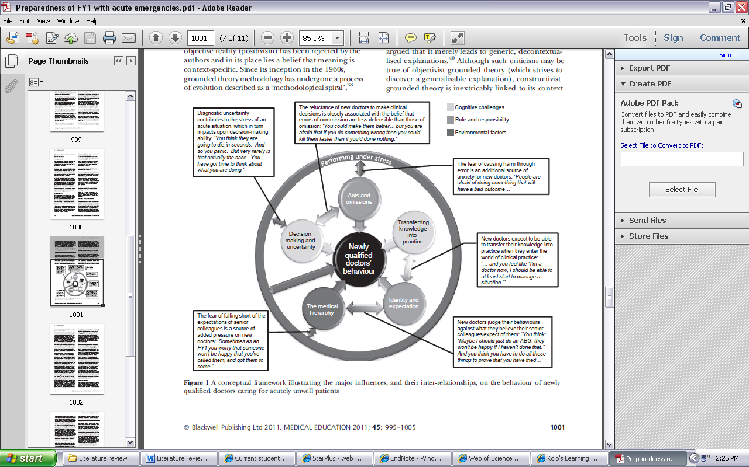
Tallentire et al. has created this excellent framework to illustrate the major influences and their inter-relationships, on the behaviour of newly qualified doctors caring for acutely unwell patients. This is useful for planning interventions to help with improving preparedness. As demonstrated diagnostic uncertainty can lead to stress which can impair decision-making. There is emphasis on the reluctance to make decisions due to the fear of causing harm and the expectations of junior doctors versus consultants of their own performance will vary. This will influence their behaviour and all factors will have an impact on patient safety (Tallentire et al., 2011a).

Kolb’s’ cycle of experiential learning

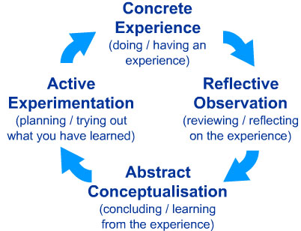
URL: http://www.learningfromexperience.com/images/uploads/process-of-experiential-learning.pdf! (31.05.2006)

Simulation debriefing and how it fits with Kolb’s experiential learning cycle

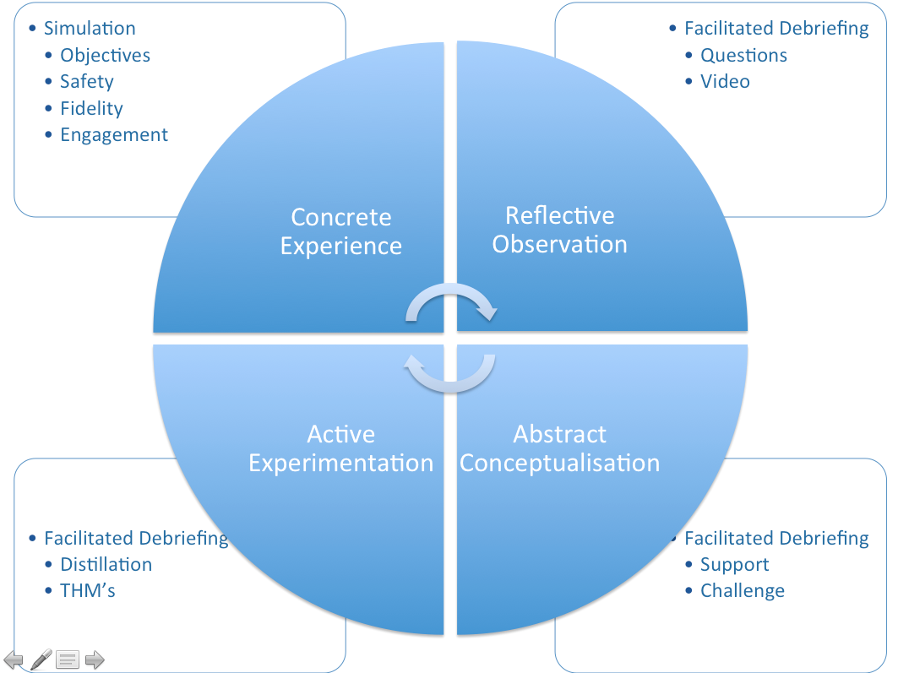

http://www.scsc.scot.nhs.uk/courses/faculty-development from train the trainers in simulation course.
This conceptualised framework demonstrates the importance of facilitated debriefing at three of the four stages of the learning cycle. This emphasises the importance of appropriately trained faculty in knowing how to debrief correctly to allow self-reflection from the student.

Miller’s pyramid of clinical competence

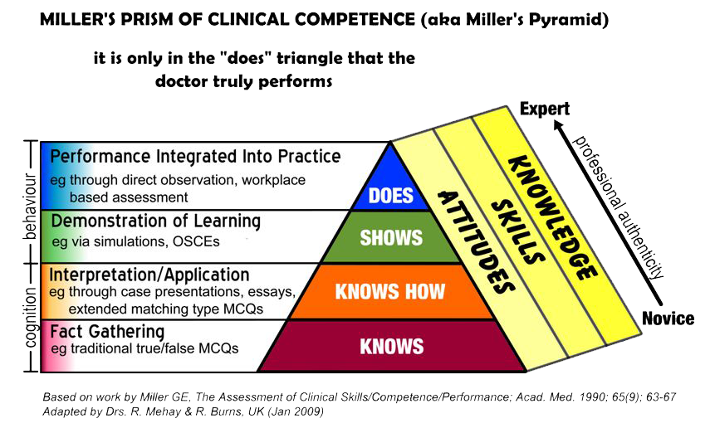
http://www.gp-training.net/training/educational_theory/adult_learning/prism.png accessed 31/5/16

Dreyfus model of skill acquisition

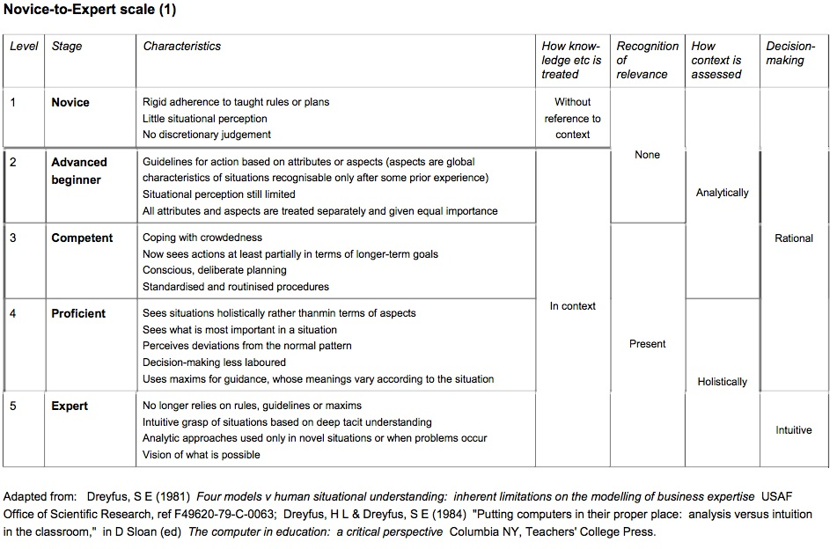
http://victorarias.com.br/images/2013-05-16/1.jpg accessed 1/6/16

Ethics Approval
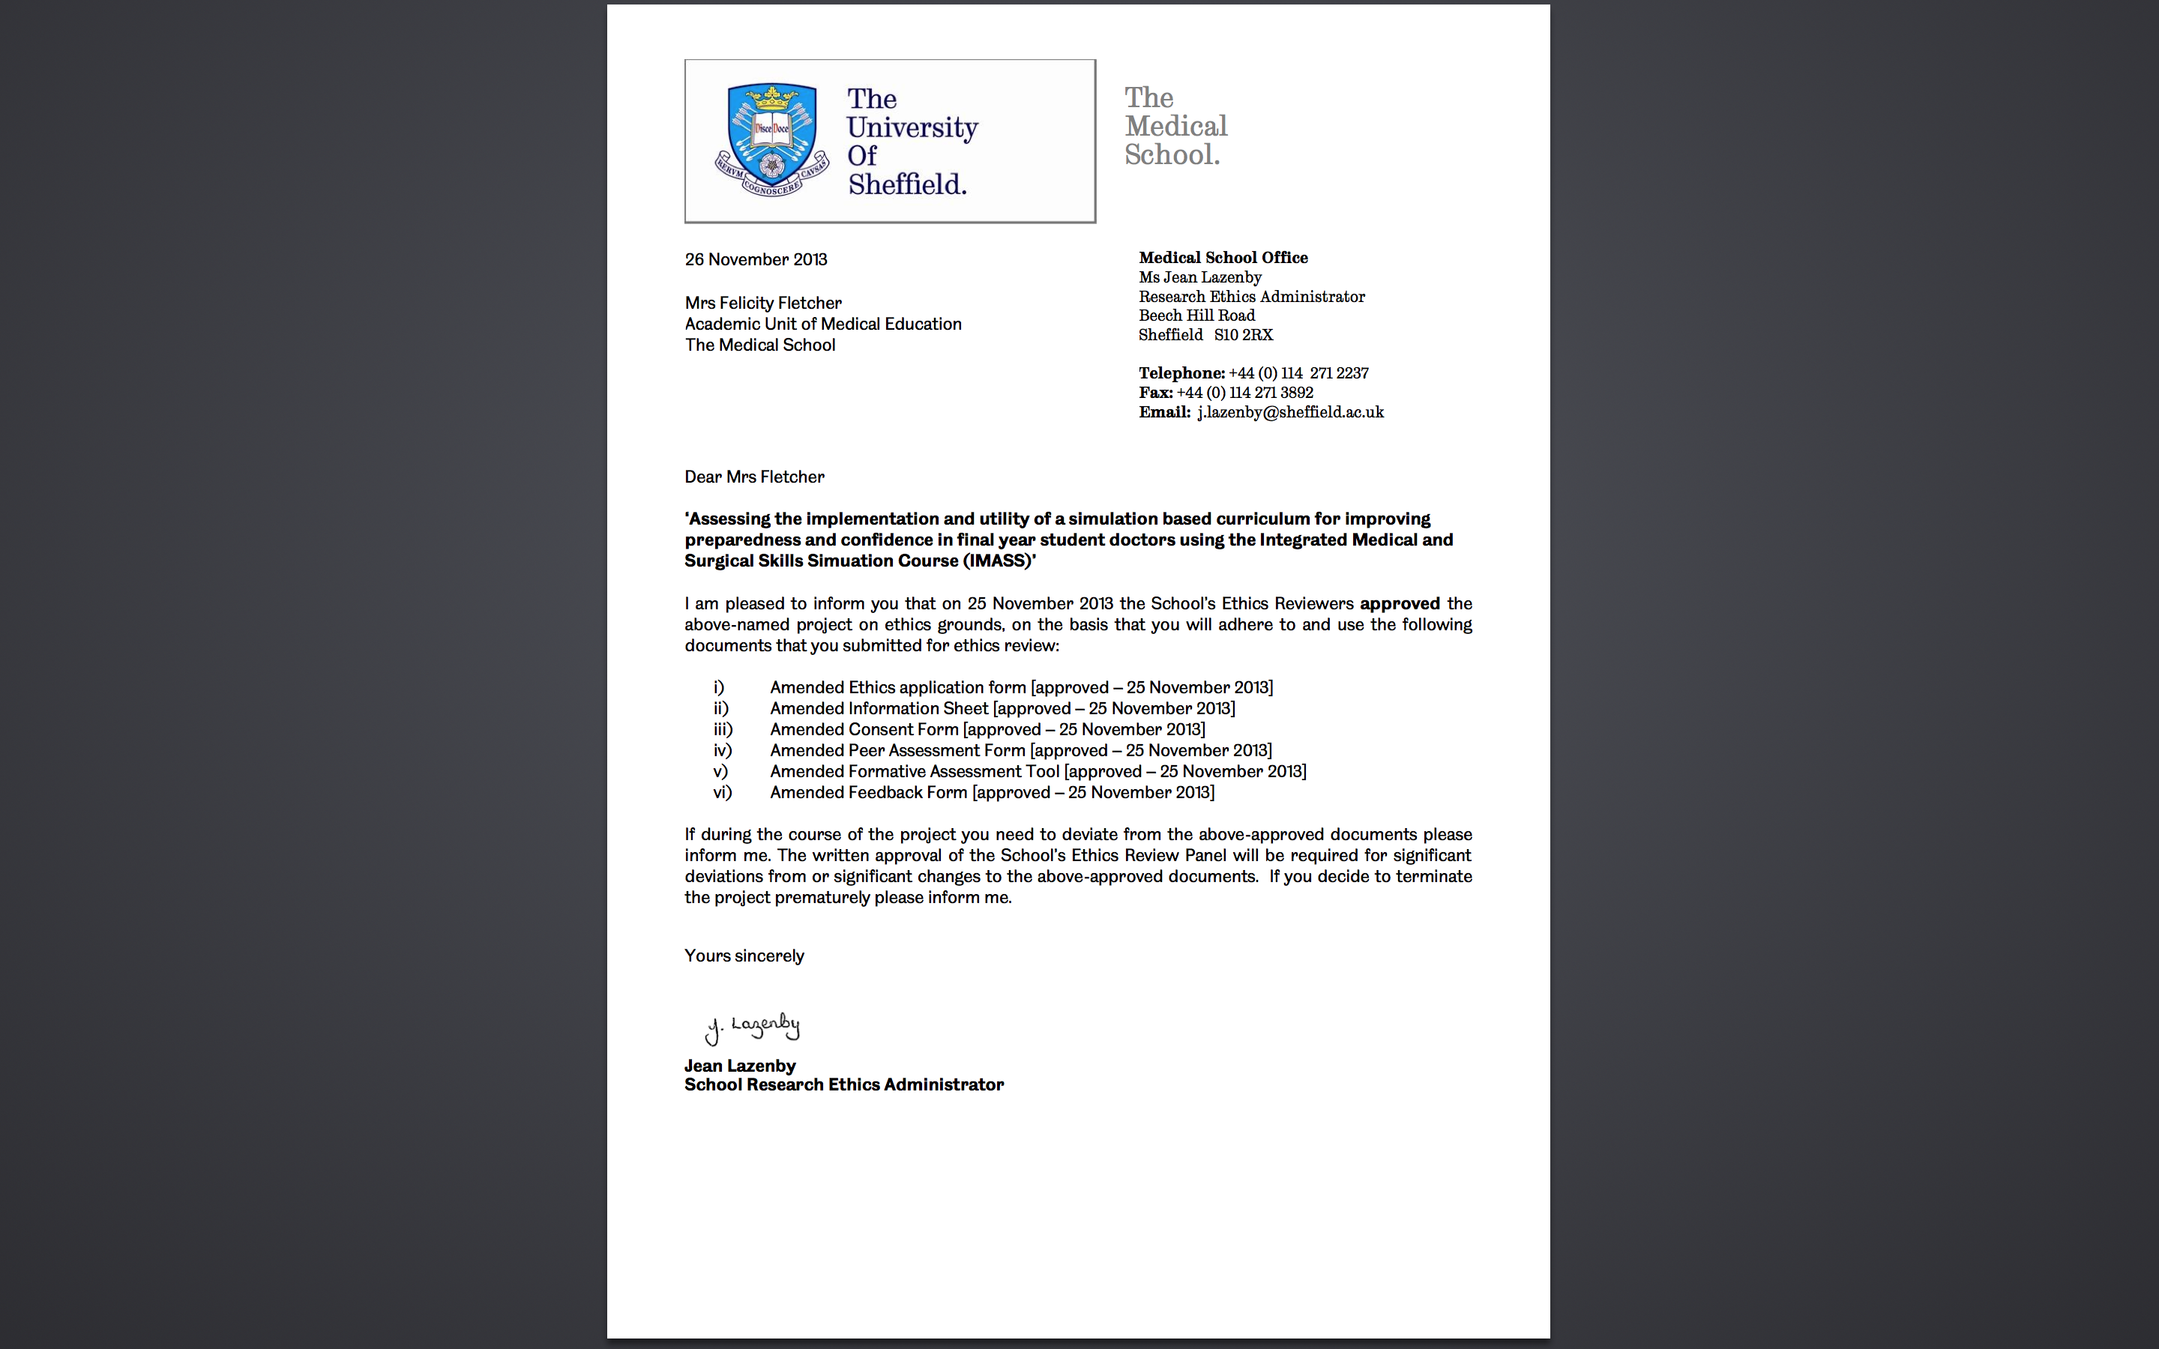

IMASS learning outcomes
Learning outcomes for the IMASS course 2013
In the final year, students must use practical and clinical skills, rehearsing their eventual responsibilities as an F1 doctor. This includes making recommendations for drug prescription, managing acutely ill patients under supervision. Students must be properly prepared for their first F1 post. Undergraduate medical education is part of a continuum of education and training which continues through to post graduate training and continuing professional development. Tomorrows Doctors 2009
- Recognition of the acutely ill patient:

- Assess and recognise severity of a clinical presentation and need for emergency care, diagnose and manage acute medical emergencies.
- Uses ABCDE approach to assess.
- Recognise and start initial management.
- Formulates plan.
- Starts antimicrobials, oxygen and fluid therapy.
- Recognise when needs ABG/ bloods.
- Reassess after treatment, try and prevent deterioration.
- Recognise indicators for ITU/escalation.
- Managing sepsis – sepsis resus bundle www.survivingsepsis.org, takes specimens at timely stage, appropriate antimicrobials.

- Investigations and procedures:

- Perform a range of diagnostic procedures, measure and record the findings, demonstrate correct practice in general aspects of practical procedures. Requests, arranges, interprets, acts upon lab tests, x-rays, urine analysis, ECGs. Correctly identifies NGT placement on x-ray.
- Venepuncture, IV cannulation, safe IV medication and fluid administration, ABG, Blood culture, injection local anaesthetic into skin, IM and SC injection, perform and interpret ECG, perform and interpret peak flow, urethral catheterisation in men and women, airway care and simple adjuncts.
- For tasks –
- Explain procedure and gain valid informed consent.
- Prepare equipment, sterile field, position patient, appropriate pre-procedure analgesia.
- Prepare the skin, ask for help if appropriate,
- Safely dispose of equipment particularly sharps.
- Maintain patient dignity.
- Document procedure, label specimens, ensure adequate post procedure instructions are left/ documented
- Good clinical care:

- Delivers high quality care, asks for help when appropriate.
- Maintains patient safety.
- Obtains accurate history, examination and records findings.
- Makes appropriate differential diagnosis and formulates management plan.
- Takes responsibility for reviews, investigations and completing management plans. Demonstrates use of non-invasive monitoring and correct interpretation.
- Demonstrates good infection control techniques. Records accurately and documents results.
- Makes appropriate referrals.
- Prescribes drugs safely, effectively and economically, plan appropriate drug therapy, provide safe and legal prescription, detect and report adverse drug reactions.
- Keep accurate, legible and complete clinical records. Keep to requirements of confidentiality and data protection legislation

- Relationship and communication with patients and staff:

- Prioritises needs of patients, respects them as individuals, works in partnership in open way.
- Effective empathetic communication.
- Breaks bad news effectively and compassionately.
- Recognise a situation that may lead to a complaint, apologises for errors.
- Obtains appropriate consent for procedures.
- Communicates clearly, sensitively and effectively with patients, relatives, carers, colleagues by listening, sharing responding
- Communicate by spoken, written and electronic methods, communicate appropriately in difficult circumstances
- Be polite, considerate, trustworthy and honest, respect all patients and colleagues
- Work and respect colleagues for effective teamworking to deliver high quality and safe care.

- Safety and Governance:

- Recognise that fatigue and health problems in medical workers can compromise patient care – address accordingly.
- Delivers high quality care.
- Ensures confidentiality and privacy for patients.
- Takes responsibility for and justifies actions.
- Reflects on feedback from teachers and learners.
- Demonstrates professional learning goals/ needs.
- Follows appropriate guidelines, interprets evidence.

- Professionalism:

- Professionalism in the workplace and with interaction with colleagues and Patients.
- Punctual, delegates tasks appropriately.
- Bring accurate information to hand over and indicates priorities.
- Understands role within team, listens to view point of others.
- Demonstrates leadership role in clinical situations.
- Manage time and prioritise tasks

- Resus and end of life care:

- Trained in ILS +/- PLS is doing Paeds. Provide basic first aid and immediate life support.
- Initiate and respond to a crash call.
- Recognise and manage critically ill, peri-arrest patient.
- Understands use of DNAR. Provides high quality end of life care.
- Provide cardiopulmonary resuscitation or direct other team members to carry out resuscitation.

IMASS Simulation scenarios

IMASS course scenarios 4 students within each group. Scenario 5 = BLS.
Scenario 1 Sepsis
Jack Allan 70 year old male. GP referral to surgical assessment unit.
PC: 5 day Hx Dysuria, fevers, rigours, vomiting, 24 hour Hx difficulty voiding, not passed urine for 6 hours
PMHx; Renal stones, benign prostatic enlargement
PSHx: Ureteroscopy
DHx: Allergy to Penicillin. Takes Tamsulosin, recently started Oxybutanin for urinary frequency
Candidate 1:
On arrival clammy and looks unwell, c/o lower abdominal discomfort and right loin pain. There is a student nurse checking his details who can help you. Go and assess and start initial management.
A – talking – Candidate should apply oxygen as looks unwell – correct selection of mask and L of oxygen
B – Chest clear, RR 36
C – HR 120 weak pulse CRT < 2 secs
Ask for OBS – HR 120, BP 90/60, RR 36, Sats 95% Air, Temp 39.4
IV access, bloods, VBG can be done by phlebotomist
HF – during assessment – sister comes to ask for an “urgent TTO, there are no beds and unless you do it now a patient in theatre will get cancelled and it will be your fault” She brings the drug card and TTO for you to do there and then.
D – GCS 15, BM 6, Temp 39.4
E – Palpable mass lower abdomen, tender and tender R loin
Mx – Oxygen, IV access, bloods, cultures, IV fluids, IV Abx – which?
Skill – urethral catheter
Drains 1L pain settles
Reassess BP 100/60, HR 100, Temp 37.5, Sats 99% 15L, RR 20, abdomen soft non tender
Refer to Urology SpR over phone
Hand over to your colleague (Candidate 2) who will take over from you tomorrow morning for the ward round. Sepsis proforma available for review/ guide.
Document in the notes
Candidate 2
You are the FY1 on days. You are handed an MSU result form and bloods from the patient ready for the ward round.
MSU – Ecoli and Proteus Sensitive to Augmentin and Gentamicin
HB 12, WCC 36, Plt 400, Na 140, K 5.0, Urea 7.0, Creat 130. You are told that these results were handed to the night doctor who did not have time to see the patient but acted on them, his drug card had been lost so he had completed another one. You are asked to see the patient urgently as they are complaining of shortness of breath.
Prompts – drug card at end of bed with obs chart showing deterioration from 7am when Augmentin was signed for – drug card has not got the allergy section completed it says ‘unsure’ – bag of drug attached to patient going through labelled Augmentin.
O/A – A – wheezy, half sentences, looks unwell, maintaining airway
B – Wheeze throughout RR 38, c/o chest tightness – apply oxygen
C – HR 100 regular CRT <2secs
Obs – BP 90/50, HR 100, Sats 90% air RR 38
D – BM 5, GCS 15, Temp 37.5
HF – wife rushes in concerned about her husband asking what you have done to make him so unwell – Candidate must manage her and the interruption. He panics more and gets more breathless calling out for help saying he can not breathe. The wife accidently dislodges his only cannula.
Mx – Stop the drug, oxygen, adrenaline, hydrocortisone.
Skill – Cannula
He improves Sats 100% O2, RR 18, BP 120/80, HR 90 – wife comes in wants a full explanation and what you will do to prevent this happening again.
Refer to SPR – ask advice on what to do with antibiotics – advise gentamicin – SpR will ask what the risks are and how you will monitor it
Hand over to the weekend team (Candidate 3)
Document in the notes
Discussion point = incident form reporting/ completion.
Candidate 3:
2 days later you are asked to see the patient due to an ongoing pyrexia despite 48 hours of IV Gentamicin, he still has loin pain and looks unwell. You need to assess him and start initial management.
Prompts – Obs chart showing swinging pyrexia up to 40, associated with a tachycardia. Fluid balance chart UO 20mls/hr for 2 hours
Reassess A – maintain own, full sentences, apply O2
B – ok
C – HR 110 CRT <2secs, warm peripheries, clammy
Obs BP 80/60, HR 110, Sats 95% air, RR 32
D – BM 6, GCS 15, Temp 39.4, OE tender Right loin, catheter in situ, Poor UO 20mls last 2 hours
Mx – oxygen, has IV access, rpt bloods been sent first thing, IV fluids
Skill: Blood cultures
Differential diagnosis – get help – d/w SHO or SpR – advise USS renal – ask you why – exclude blocked infected kidney or renal abscess. Advise d/w microbiology
HF - Discuss with radiology SpR – asks if your SpR has seen the patient ‘how dare you call me before the SpR has seen them. Don’t waste my time – hang up.
Call back - refuse to do an USS – say the patient will not be stable enough in department, hangs up the phone
Discuss micro – advise Tazocin (nb Penicillin allergy) – ask if tazocin is ok? No – re-culture then meropenem – prescribe
Reassess after meropenem and IV fluids
A ok but getting tired, B – clear, C - BP 80/60, HR 120 UO 8mls last one hour – had 5L of fluid in 24 hours – where does patient need to go?
Further tests before calling ITU – Yes ABG – phlebotomy has performed
Interpret ABG result pO2 40, pCO2 3.4, pH 7.2, BE -4, Bic 16
Hand over to ITUand your colleague on for surgery over the weekend (Candidate 4). What will you do about the USS?
Document in the notes
Candidate 4:
The patient had been on ITU –once been stabilised a portable USS was arranged by the urology SpR. It had shown gross right hydronephrosis and a nephrostomy tube had been placed which drained 50mls of pus. It was sent for culture. The nephrostomy had been difficult to place and required multiple attempts at puncture. He has been sent back to the ward because they needed a bed and he seemed to have improved. He was not handed over to any of your team. You are asked to see him because he is short of breath.
Issue –No hand over from ITU
Prompts – Obs chart – temp 37.5 down from 40, HR 110, BP 120/80, RR 40, sats 92% in Air
A – half sentences, c/o difficulty getting is breath – apply oxygen
B – Reduced breath sounds on right, reduced expansion on right, trachea central, mildly increased to percussion on right
C – HR 105 BP 130/80
D – GCS 14 a little drowsy, BM 5
E – neph tube draining pus on right
Management – oxygen, investigate chest
Skill – do an ABG – assess oxygenation and arrange portable CXR
Interpret CXR – right pneumothorax
Refer to respiratory SpR to arrange chest drain placement
Hand over to your SpR –clinical condition and initial management, student should use this opportunity to escalate and discuss patient safety issue of no hand over from ITU
HF – wife in attendance, wants to know what has happened now, what you have done to her husband and what will happen next? Why did he come back to the ward if he was so unwell? Even she could see he was not right? Who allowed this to happen and what are you doing about it? You need to explain to her and the patient what a chest drain is and why it is required and how the procedure will be done. If Candidate is doing well wife will probe about the risks and benefits of the chest drain.
Document in the notes your findings on arrival, your management and your further plans.
Discuss the issue of no hand over to ITU, discuss needle decompression if had been clinically tension pneumothorax.
Formative assessment will include clinical knowledge, control of human factors, teamworking, hand over and referral quality. Feedback will give the Candidate opportunity for self-reflection, will be structured, and will involve peer and assessor feedback.
Scenario 2 : Exacerbation of COPD
All 3 candidates will get the same initial information to read.
Ethel Monogan, 2/2/1923, Hospital number WW2234, 80 year old female lifelong smoker. GP referral to medical assessment unit.
PC: 6 day history of cough productive of green sputum, fever, unwell, short of breath.
Weight 50Kg
PMHx Asthma
DHx Allergy to an antibiotic, not sure which, rash in childhood
Salbutamol inhaler PRN
Becotide 200 II puffs bd
Candidate 1:
You are the FY1 on call, a student nurse is checking in the patient. They are available to help you. You need to assess the patient and start initial management. On arrival she is clammy, unwell and shot of breath.
A – maintaining own but talking in half sentences
B – Wheeze throughout chest, reduced air entry right base.
C – HR 100 regular, CRT < 2 secs
Obs – BP 95/60, HR 100, Sats 89% on Air, RR 38/minute
D – BM 4.6, Temp 38.2, GCS 14/15, a little drowsy
HF – A senior nurse interrupts you with an urgent TTO, she has copied the drugs over, she asks you just to quickly sign it because there are no beds and a patient will be cancelled for theatre, which will be your fault.
E – Abdomen normal, ankles mild oedema
Management – Oxygen 15L non rebreathe, IV access, bloods, cultures, IV Augmentin/ clarithromycin, steroids, nebulisers
Skills – cannula, bloods, cultures
Follow-up – what investigations will you order?
What Oxygen and mask will you leave them on – potentially discuss
Referral to x-ray to arrange CXR out of hours ? interpret CXR
Hand over to the FY1 on call tomorrow – Candidate 2
Candidate 2:
One of the nurses asks you to see Mrs Monogan urgently as she is difficult to rouse. She is in bed. You are handed the obs chart.
Overnight her sats had dropped to 70%, the HCA noticed and put her on 15L of oxygen via a non rebreathe mask, the staff nurse had been sleeping so when rechecked her sats were 99% and she seemed to be comfortable so she left her to sleep and did not disturb the nurse in charge.
A – not maintaining – chin lift/ jaw thrust/ call for help/ oxygen
B – no breath sounds
C – Weak pulse 110bpm
Skill BLS– airway adjunct, - Guedel or NP airway bag and mask ventilation
Obs: BP 90/60, HR 110bpm, Sats 90% while bag mask ventilation, no resp effort
Another F1 turns up - Candidate 3 – hand over to F1 – they offer to take over airway so you can continue.
Check drug card for resp depressants, do ABG
Skill – ABG
HF – leadership to take control of situation, delegate tasks.
Interpret ABG pO2 7, pCO2 8, pH 7.3, BIC 18, BE -5. Type 2 resp failure, compensated resp acidosis
Follow-up – where should the patient go – poor resp effort
Referral ITU SpR they agree to come and see the patient.
Candidate 3:
You are waiting for the ITU SpR. You continue to bag the patient – she starts to cough and spits out her airway then suddenly goes quiet. You need to reassess the patient and start management. You colleague has gone off shift. You have help from a student nurse.
A – no airway
B – No breathing
C – No pulse – Start CPR – call for help – arrest call
BLS skill – 30:2 bag mask ventilation
HF – husband walks in on you doing CPR and tells you to stop because she would not have wanted this. What do you do? There is no DNA form in the notes
Cont BLS – delegate student to airway so can run the BLS - attach defib – PEA – adrenaline and cont BLS algorhythm
No help arrived yet – bleep system is down – what do you do…. Call ITU etc.
Patient starts to show signs of life and wakes up ITU SpR says they are on their way now and to make sure now the patient has responded that they have a catheter
Skill – female catheter
ITU SpR arrives – hand over / make a referral to ITU and hand over to you colleague Candidate 4 who will be ward cover when discharged.
Formative assessment – clinical knowledge, teamworking, human factors – control, leadership, BLS and catheter skills.
Candidate 4:
Mrs Monogan is discharged back from ITU to the ward. You are the ward FY1 on days. She was seen over night because her drug card was lost and her sputum culture has come back showing Strep pneumonia and klebsiella. She has been on oral clarithromycin. She was given a dose of IV Augmentin in the night, this is still hung up but her cannula has tissued, they were waiting for the night doctor to replace it. Most of the antibiotic has gone through.
On arrival – short of breath
A – struggling, talking in half sentences complaining of tight throat – closing up – has angioedema – apply oxygen
B – Wheeze throughout chest, RR 38/min
C - BP 80/60 HR 120 bpm CRT < 2 secs
D – BM 6, GCS / AVPU – alert
Mx – call for help – oxygen, adrenaline
Skill IV access, hydrocortisone and flush
Reassess – improved
Prescribe all of the drugs that you have given and sign for them, correct her allergy status.
HF – husband/ daughter attends – wants to know what you have done to her mother, she has already nearly died once. She asks you not to put her through too much and wants to discuss DNAR. Candidate should discuss DNAR – away from the patient initially
Refer to SpR / consultant and hand over case discussing DNAR – offer opportunity to discuss with seniors.

Equipment list
IMASS long case equipment list 2013
4 days max 32 Candidates.
Faculty and general equipment:
- 1 for sim man voice and on instructor pad,
- 1 facilitator,
- 1 nurse to help with obs etc,
- 1 matron to interrupt/ family member (4)
- 1 telephone
- Audio-visual and video recording facilities
- 1 Sim Man 3G, instructor and patient monitor
- 1 room with projector for Candidates to watch and debrief
- 1 room with Sim Man in
Clinical equipment:
- Oxygen mask – reservoir/ nasal specs/ venturi mask x 1 of each
- Guedel airway x 2 diff sizes, Nasopharyngeal airway x 1
- Box of gloves x 2 (medium and large)
- Tape and cotton wool
- Sterile wash and sterile wipes x 32
- IV fluid bag and giving set x 1
- Small IV bag to be labelled Augmentin with giving set
- IV cannulation pack x 8 and cannulation arm x 1
- Venepuncture set x 8 and arm x 1
- Blood culture pack and bottles x 8 and arm X 1
- ABG set x 8 and arm x 1
- Urethral catheter pack x 1, catheter (x8 – reuse x 1) and catheter model and bag and lignocaine
- Small drain/leg bag to act as nephrostomy bag x 1
- Syringes x 7 10ml labelled – Adrenaline IM dose, saline flush, water for catheter, instillagel, hydrocortisone, IV Antibiotic – Gentamicin, Meropenem
- Wrist labels for patients x 2 so far
Documentation:
- Laminated scenarios for Candidate 1 – 4 (5 if time = BLS)
- TTO x 1 (MAU)
- Drug card x 8 or laminate
- Trust paper/ history sheets x 32
- Fluid prescription charts x 8/ laminate
- Fluid balance charts x 8/ laminate
- Obs charts x 4 and laminate
- Sepsis algorhythm x 1 laminated
Results to laminate:
- ABG results (Candidate 3 and 4 and laminate)
- Blood results (Candidate 2 and laminate)
- MSU results (Candidate 2 and laminate)
- CXR – right pneumothorax
- ECG – sinus tachycardia
Obs and charts to complete for:
- Candidate 2 and 4
- Candidate 3 and fluid balance chart
- Drug card for Candidate 2 with Augmentin as stat dose and allergy section incomplete

IMASS timetable
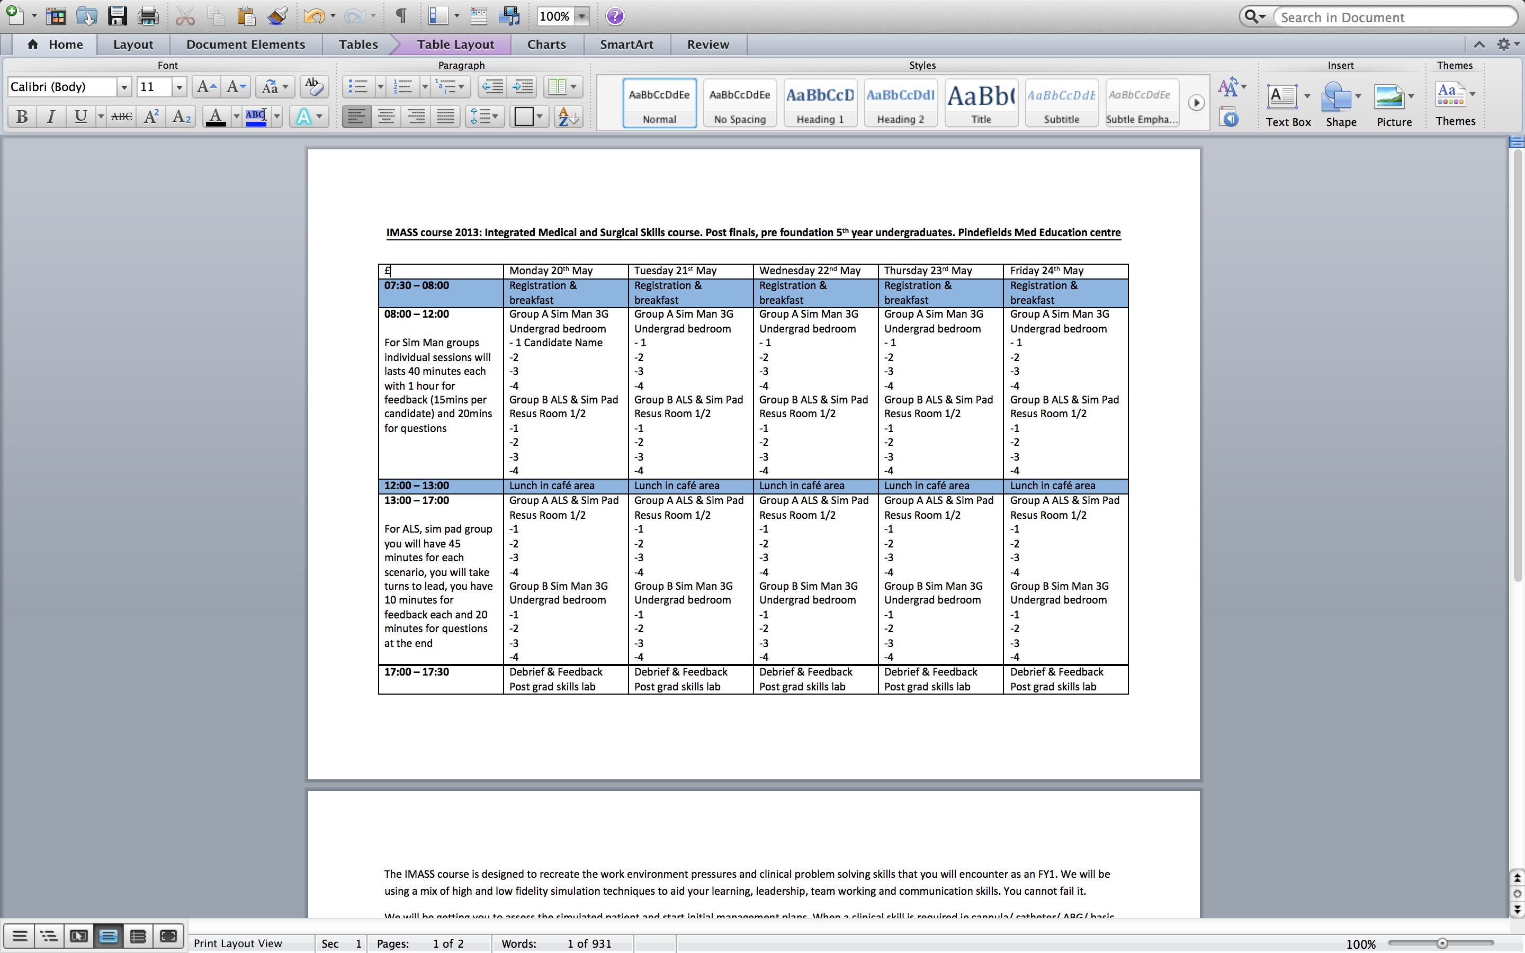

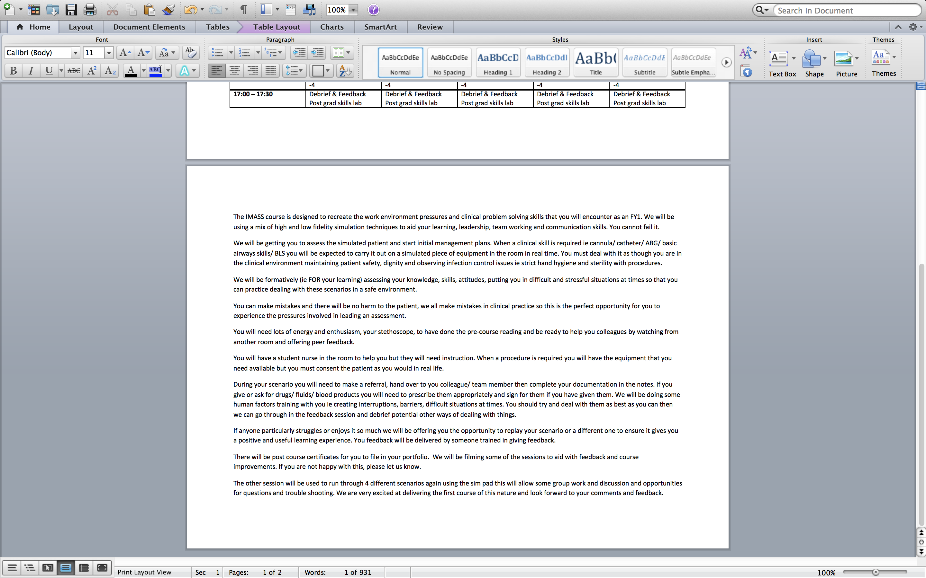

Study information sheet




Student participant Consent form
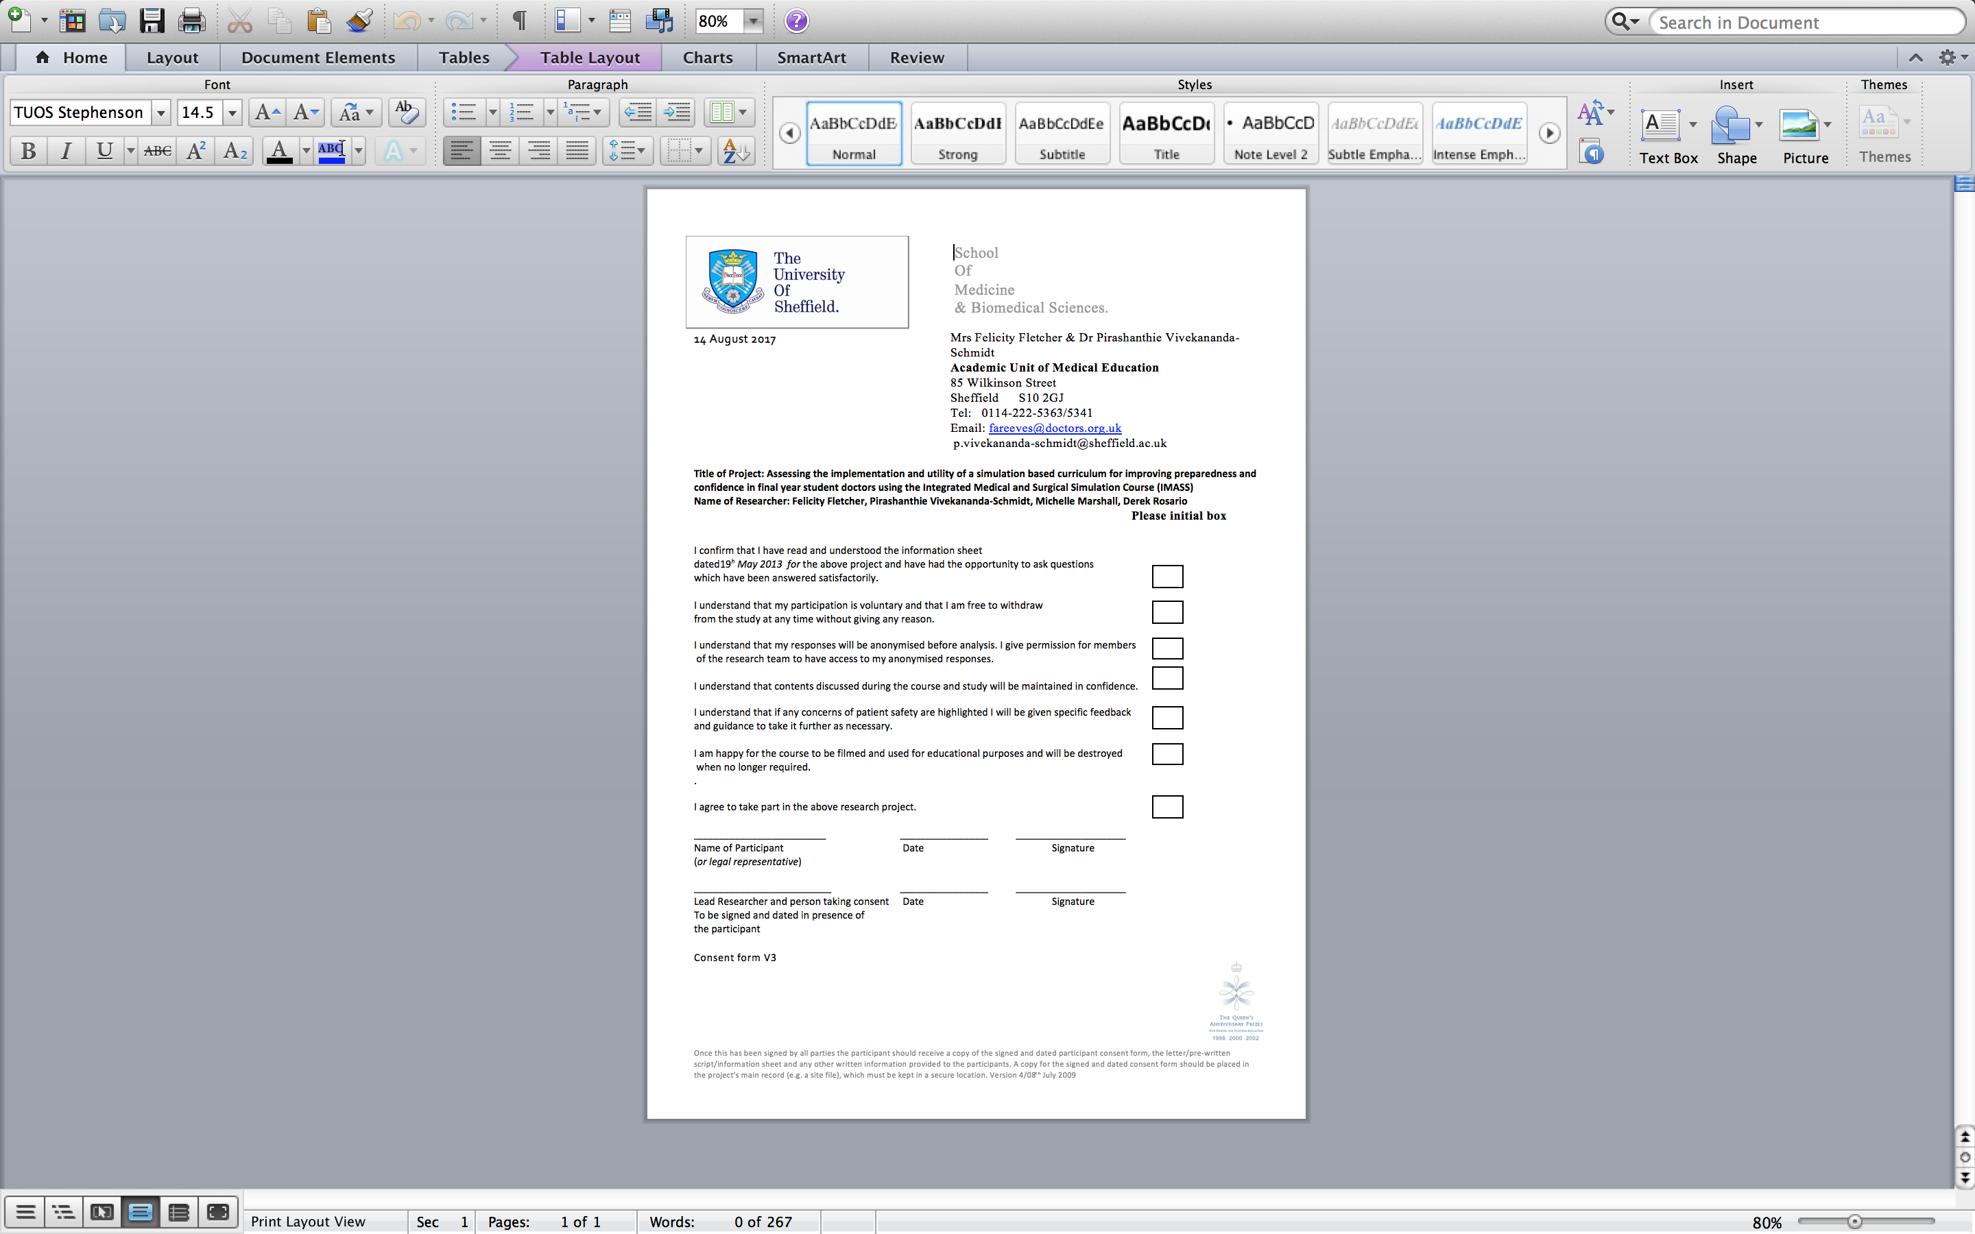

Confidence scoring tool
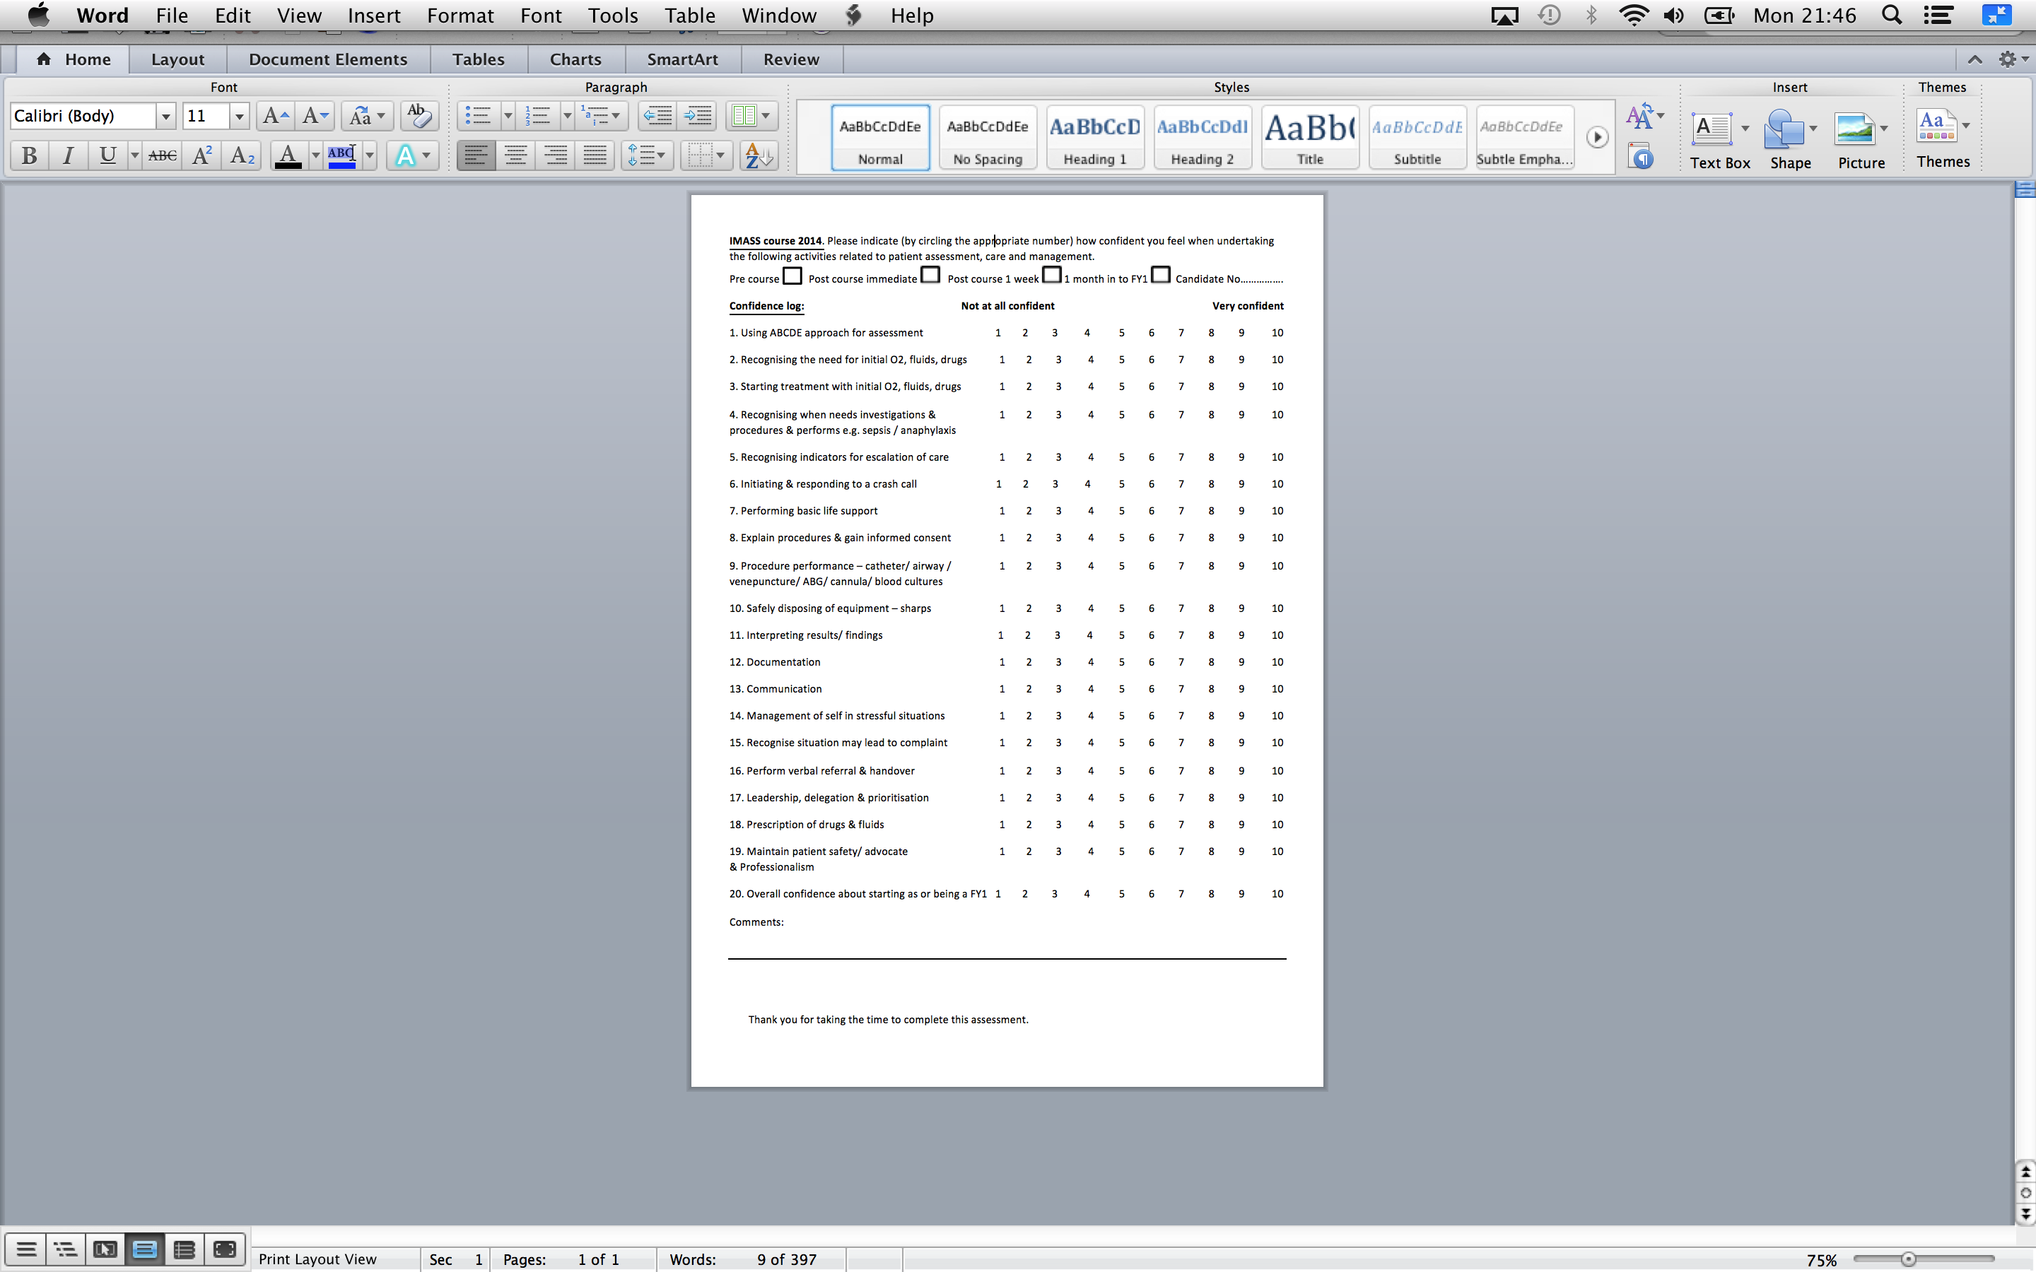

Formative assessment tool
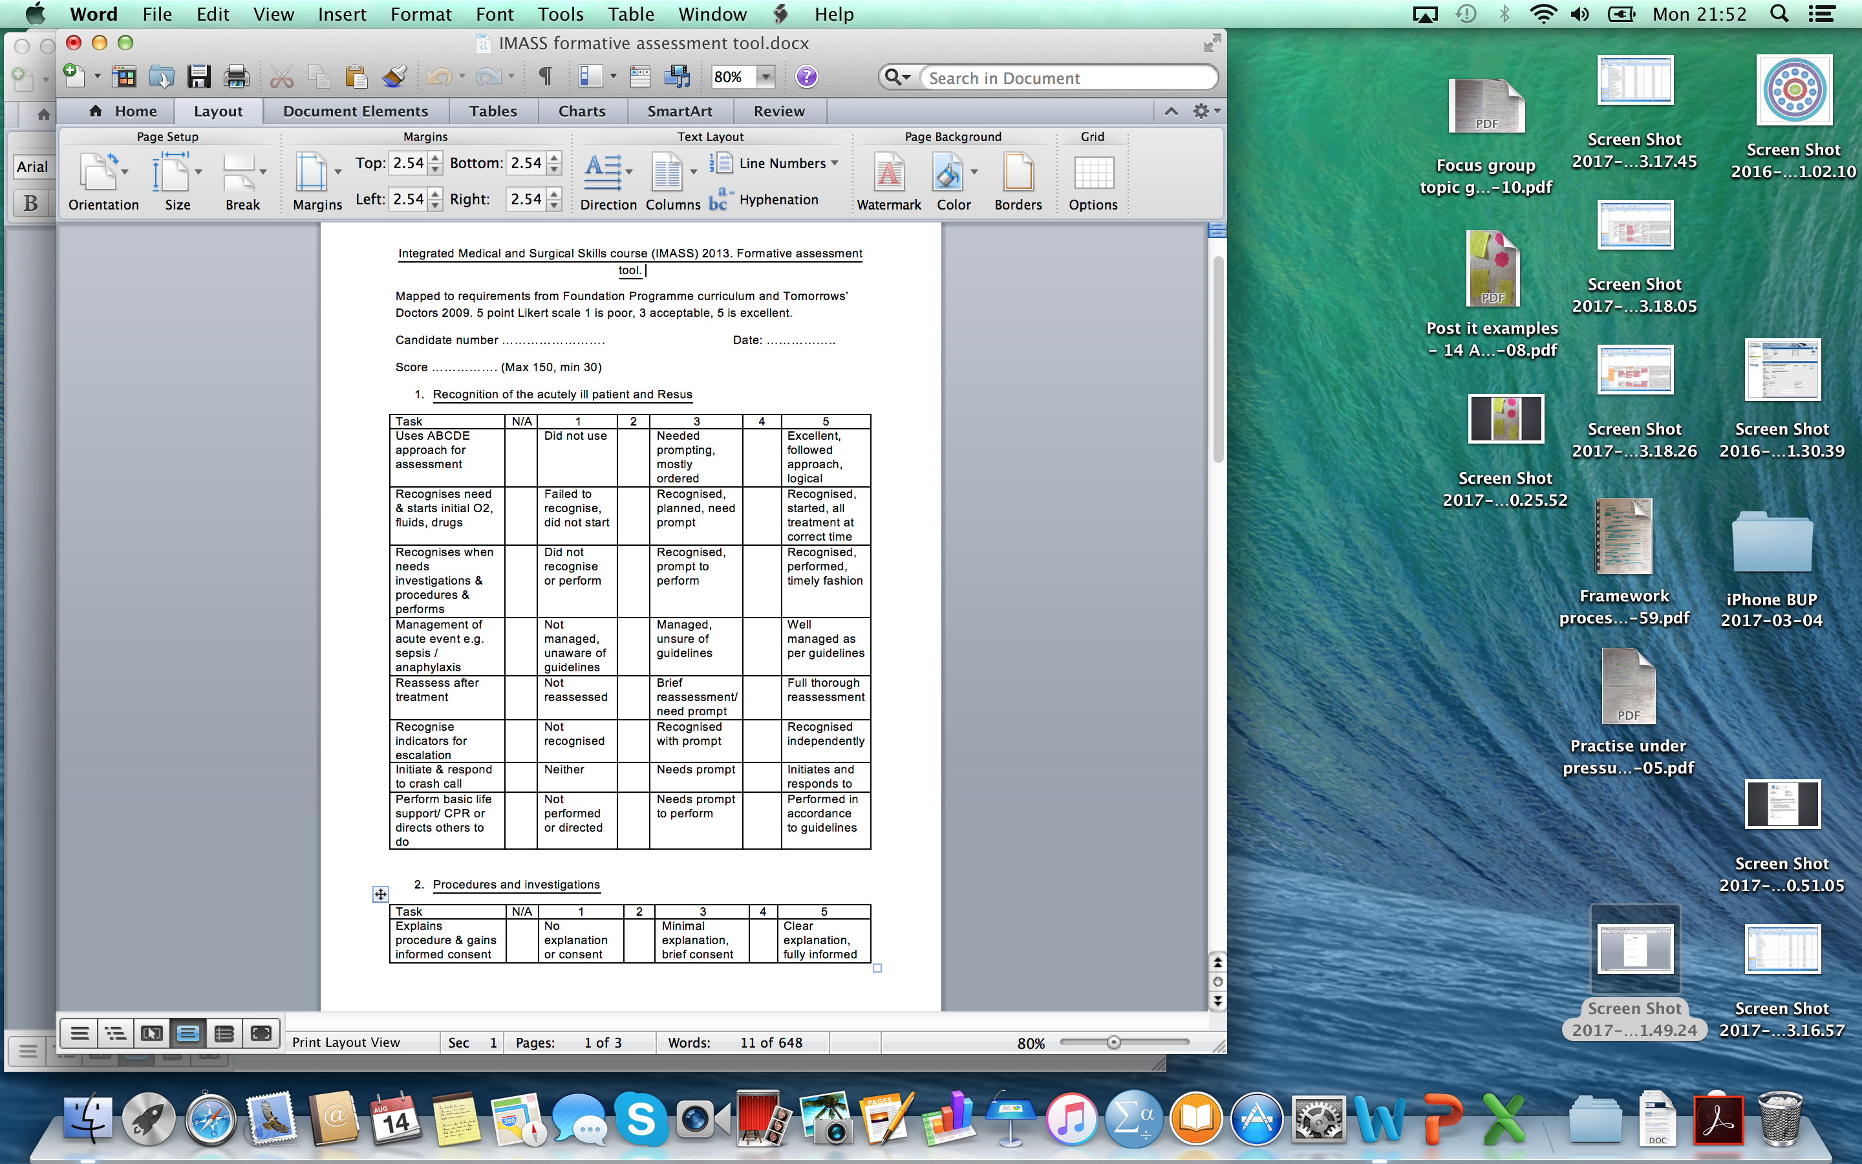
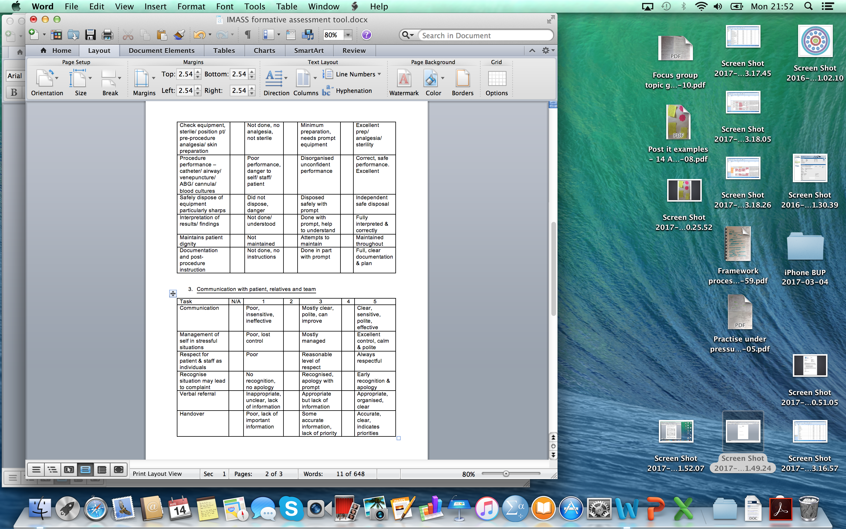

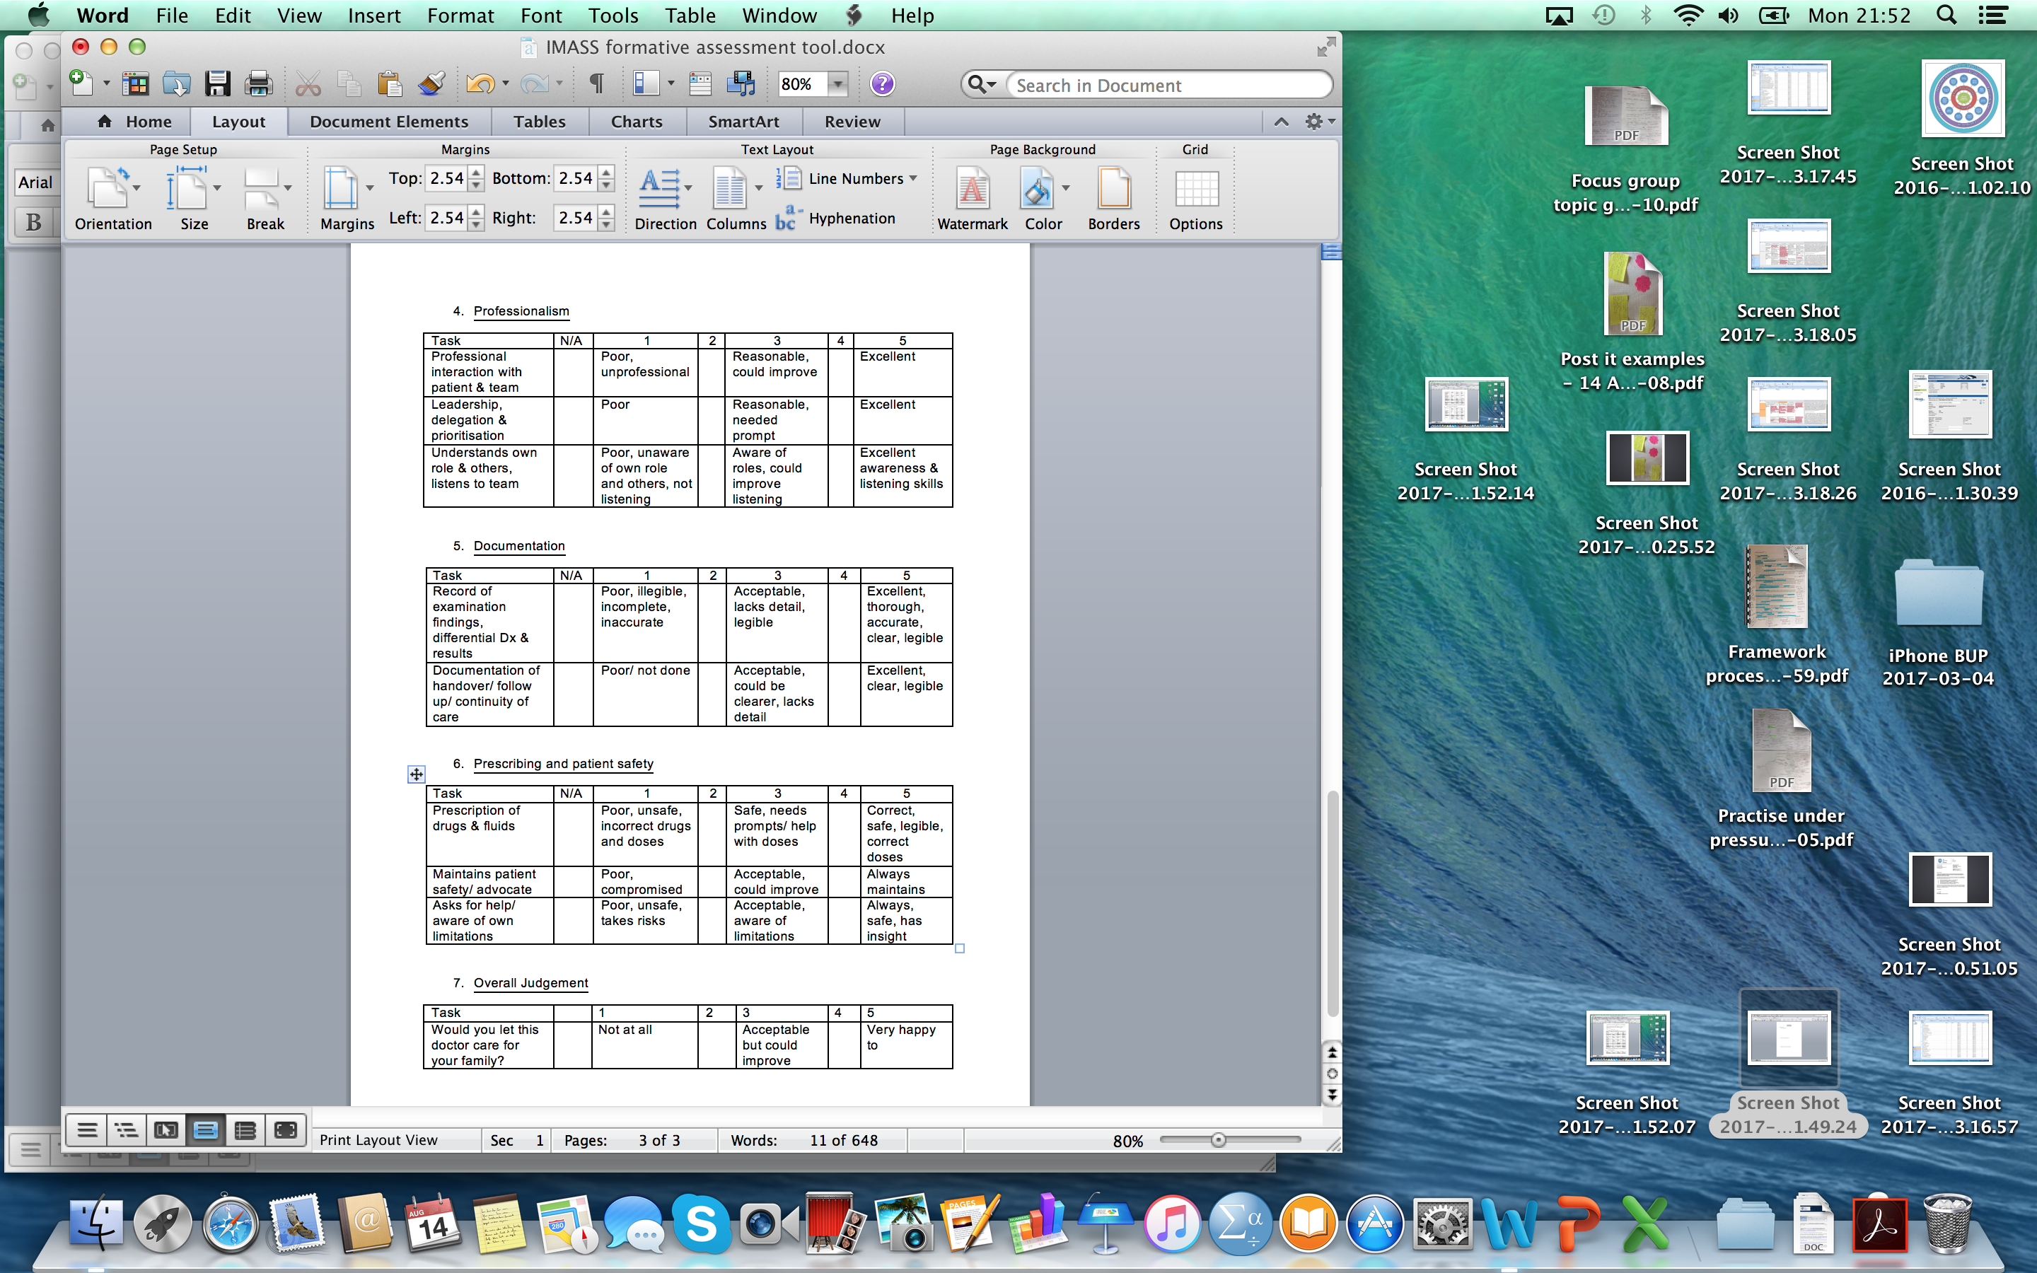

Peer feedback sheet
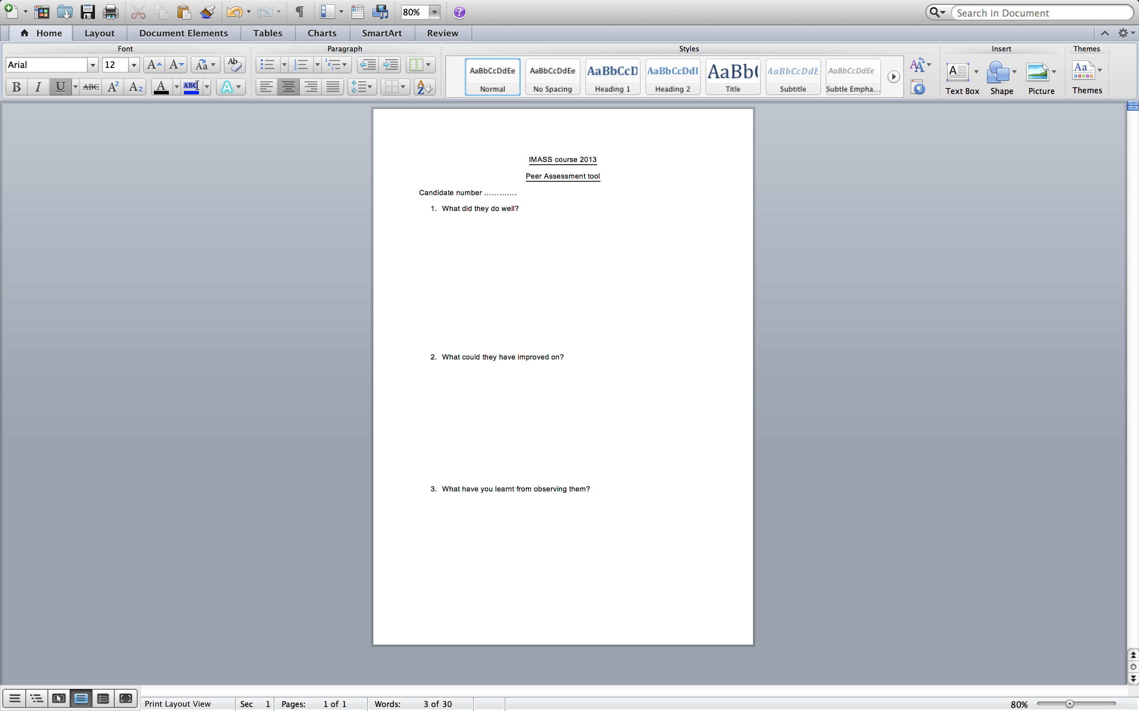

Feedback sheet


Example of survey money follow-up confidence scoring tool.
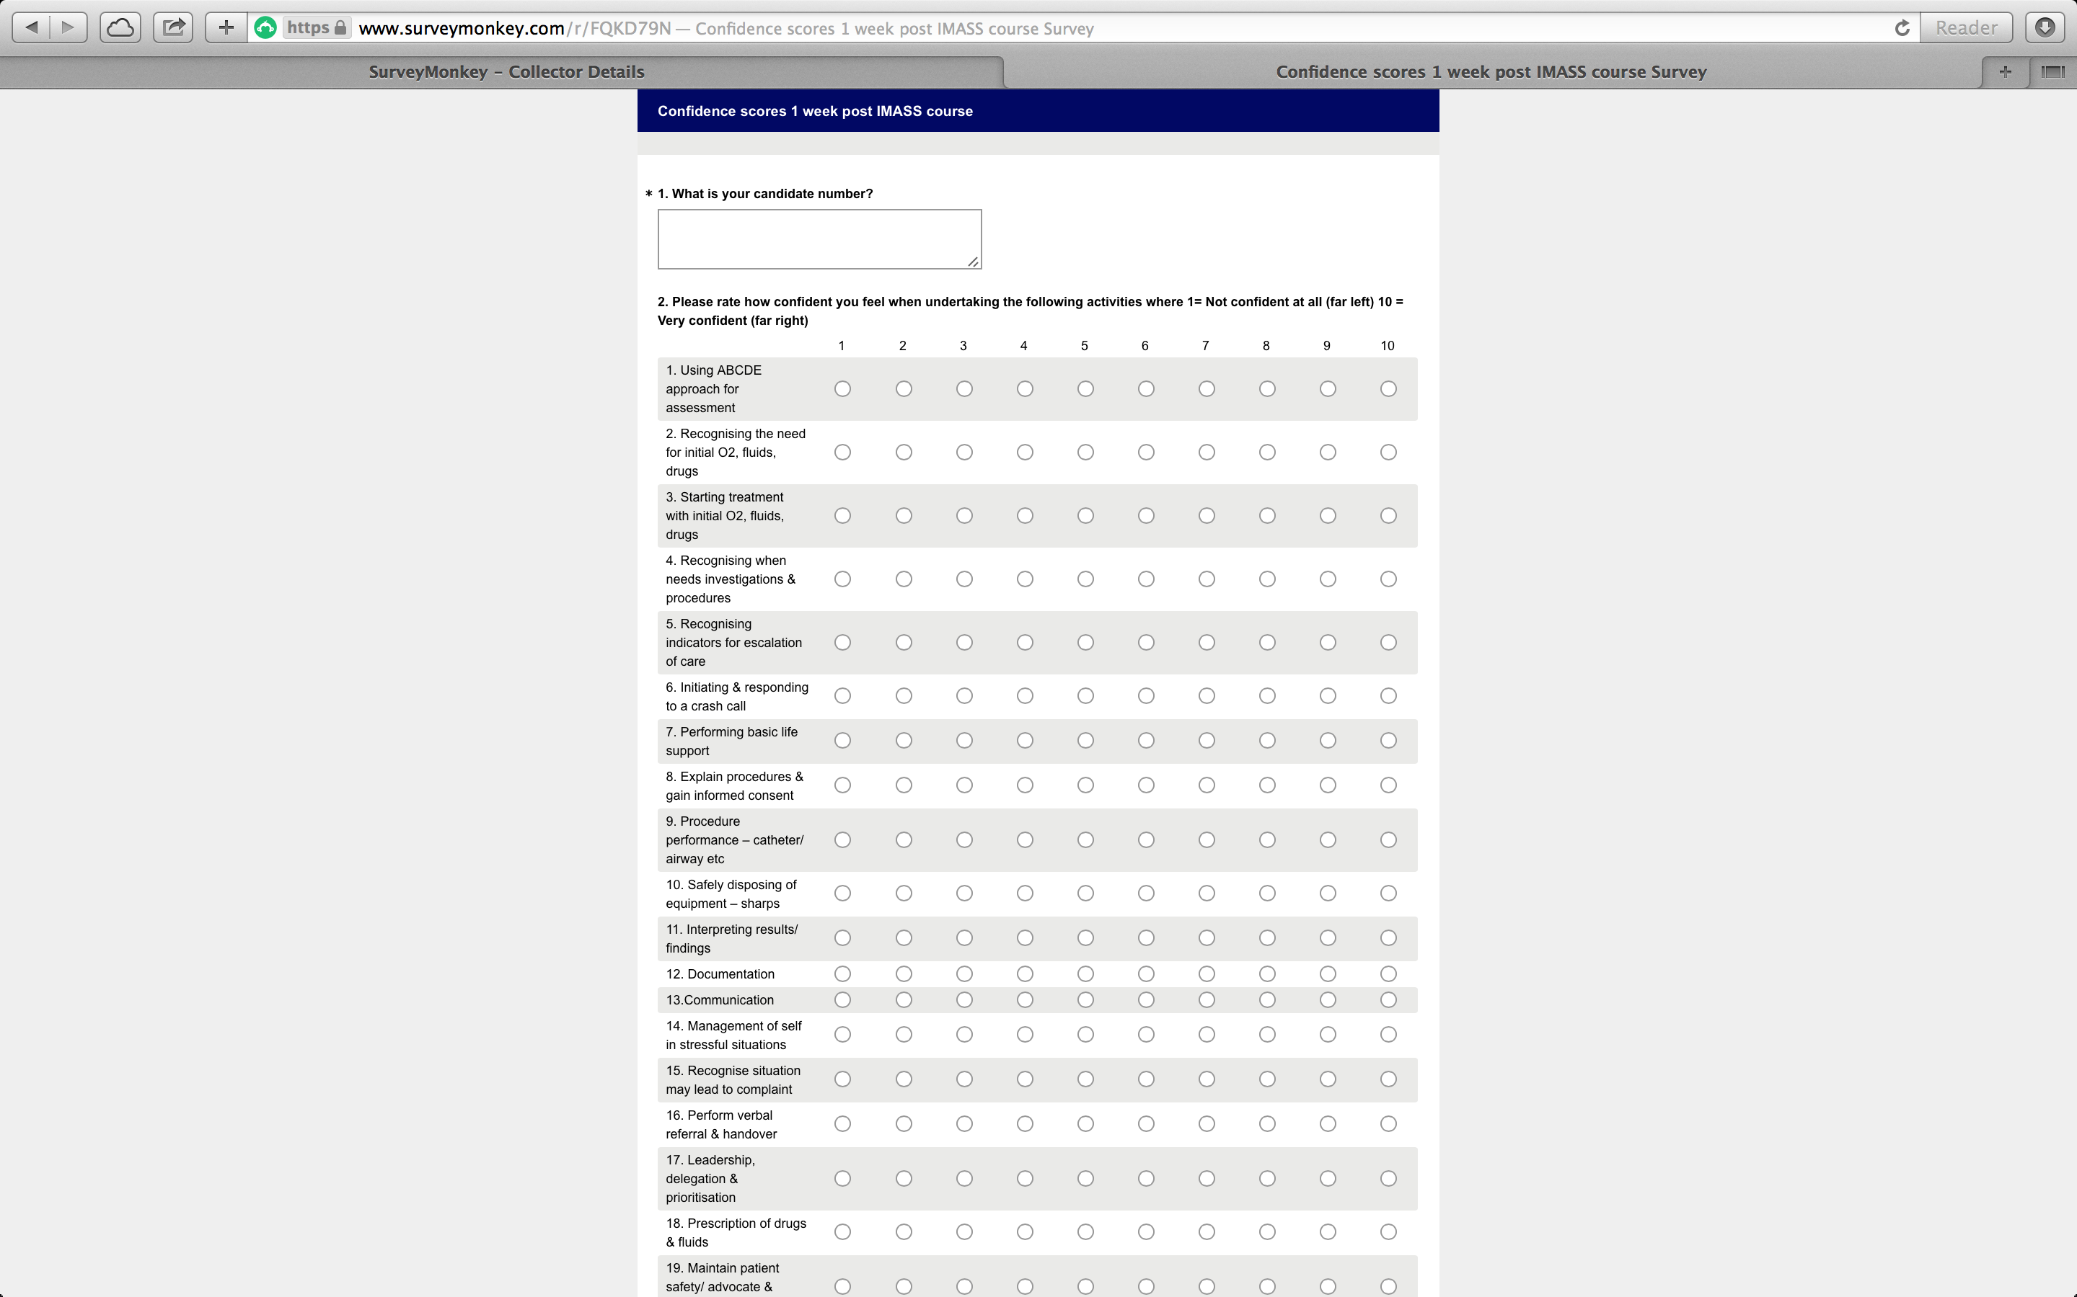
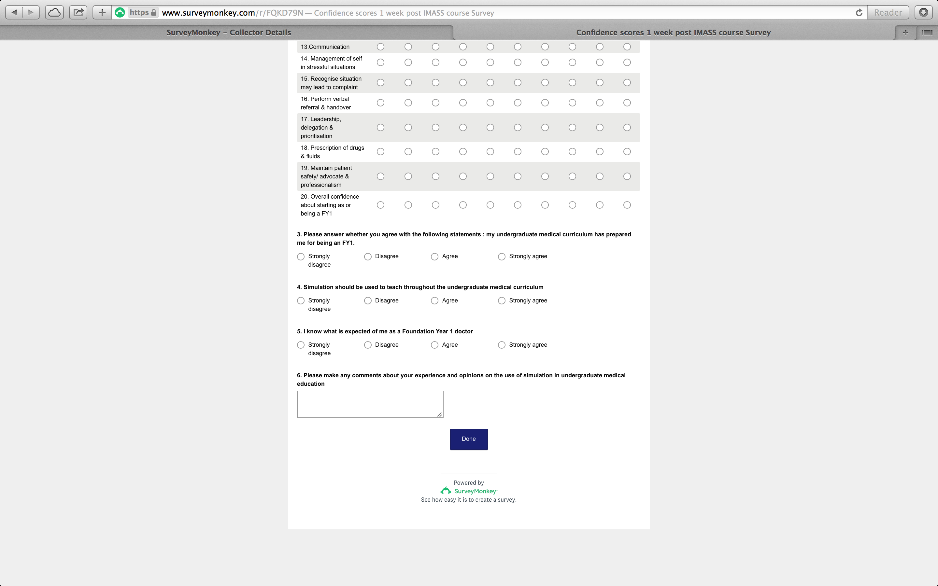

Post-It note emergent themes example
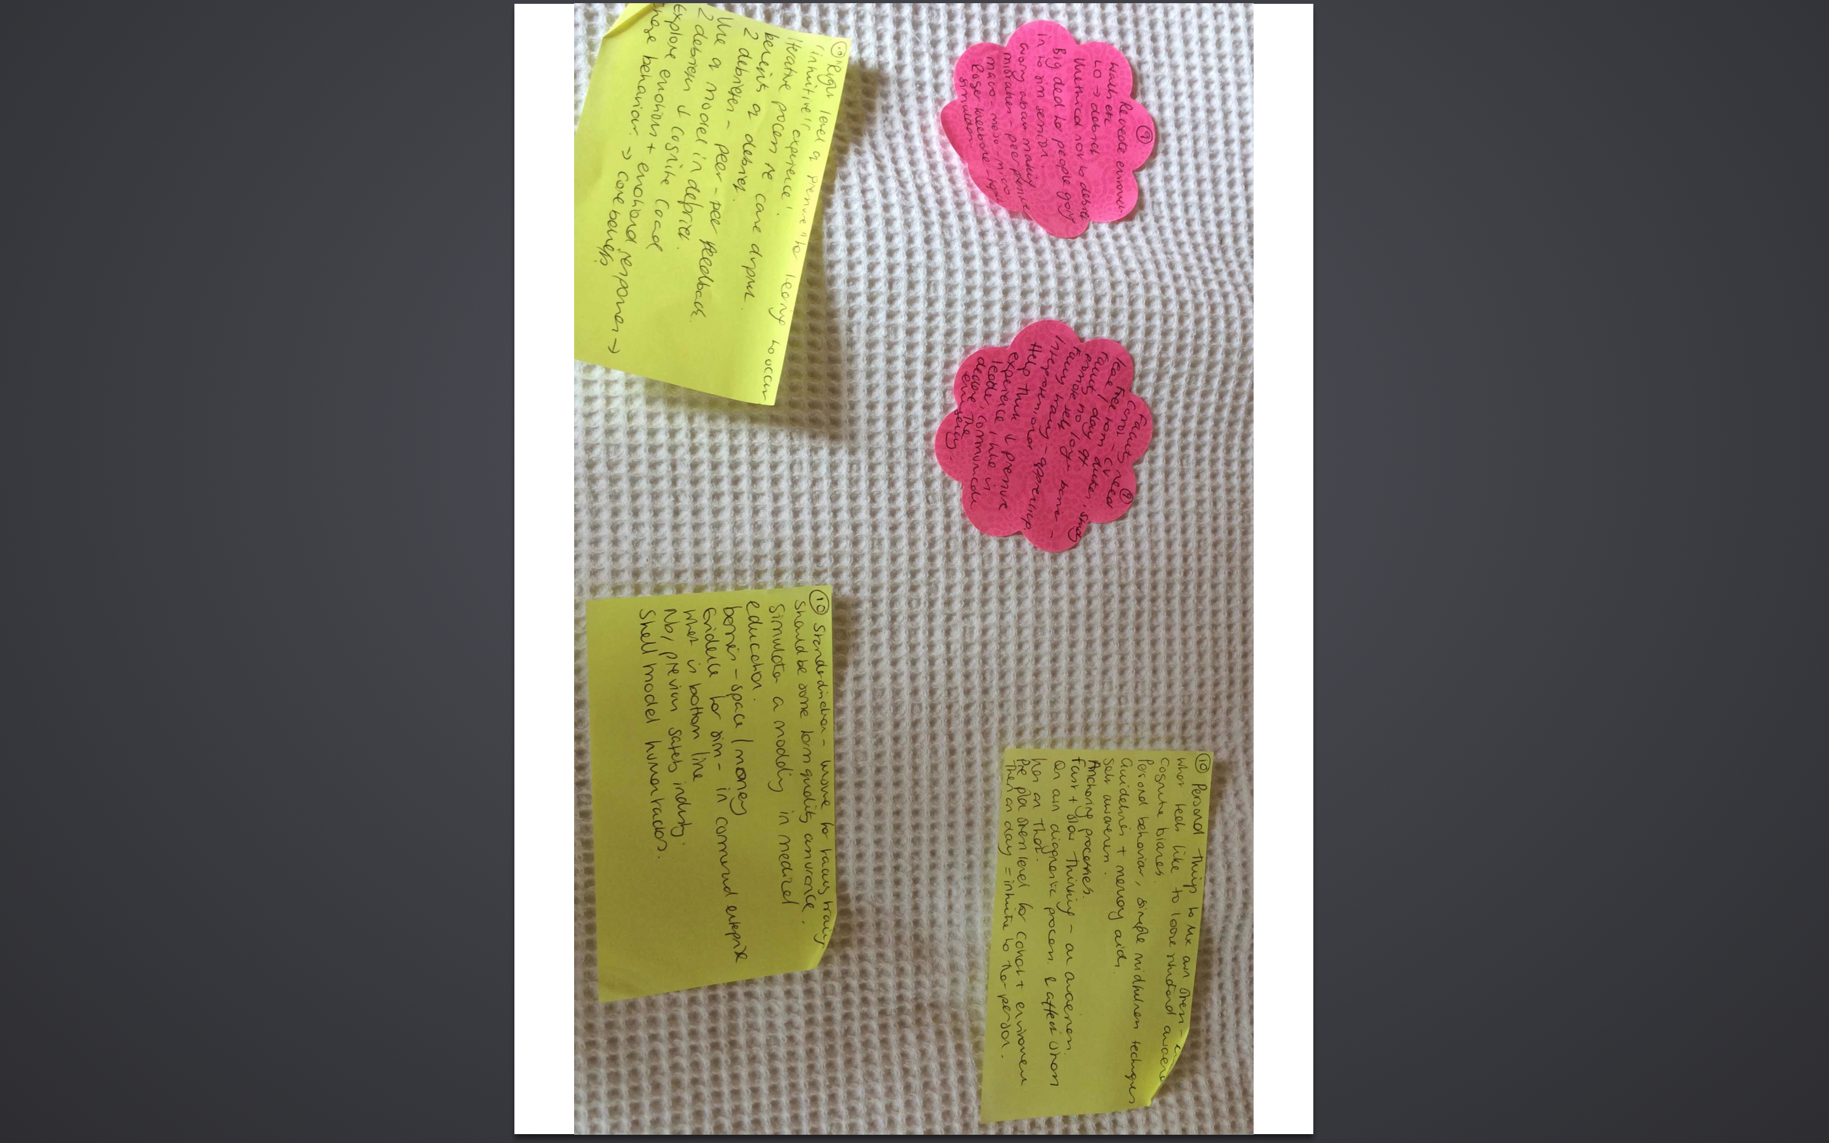

Initial focus group thematic analysis – grouping and summary

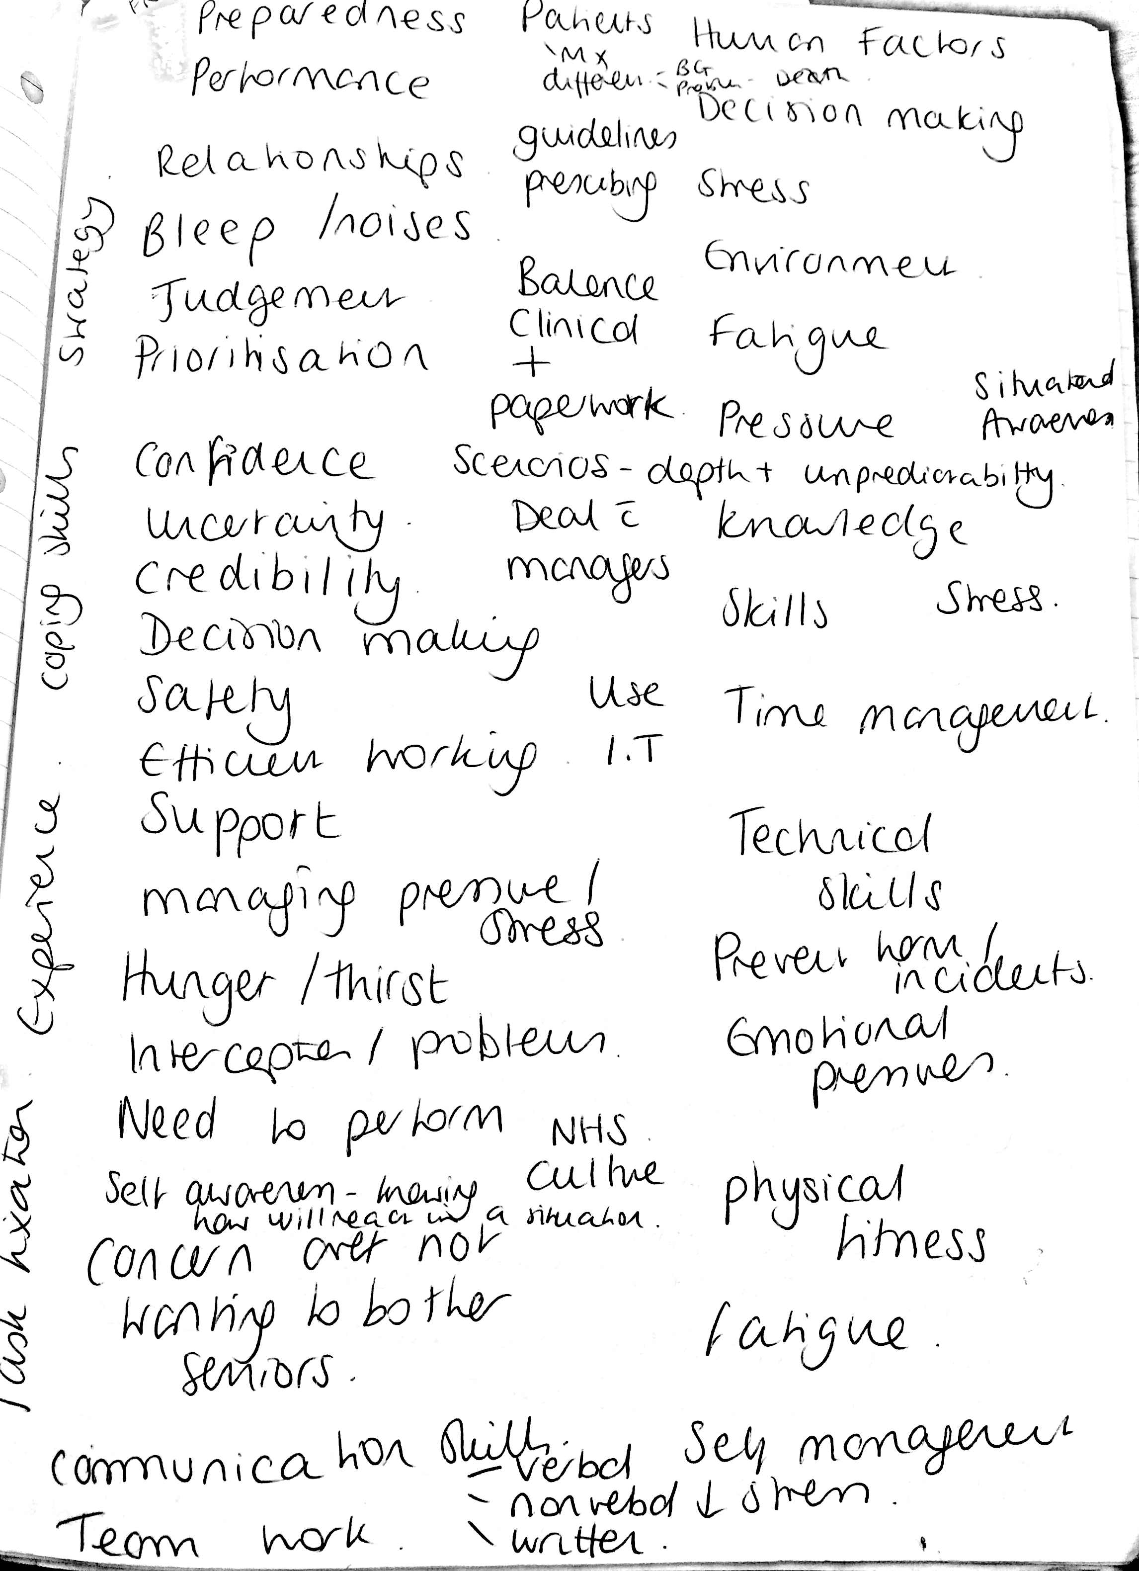

focus group topic guide
focus group Topic Guide F Fletcher PhD
Simulation:
- Previous experience of simulation
- What it means to you - term
- Thoughts about scenarios / day
- Place for simulation in undergraduate curriculum
- Utility and why useful
- What would change
- When to introduce and how
- MDT element
- Use of faculty
- Realism – environment/ scenarios
- Peer feedback and self-assessment
Preparedness
- What means to you personally
- Why important
- What supports preparedness
- How to improve
- Areas of preparedness vs. underpreparedness

Other views/ comments/ concerns

Pilot study SPSS outputs

Paired Samples Test
 |  | Paired Differences |  |  |  |  | t | df | Sig. (2-tailed)
 |  | Mean | Std. Deviation | Std. Error Mean | 95% Confidence Interval of the Difference
 |  |  |  |  | Lower | Upper
Pair 1 | Baseline confidence score – Postcourse confidence score | -1.69565 | 1.22232 | .25487 | -2.22422 | -1.16708 | -6.653 | 22 | .000

One way ANOVA SPSS supporting outputs from data for pilot study

Mauchly's Test of Sphericityª
Within Subjects Effect |  | Mauchly's W | Approx. Chi-Square |  | df | Sig. |  | Epsilon^{b}
 |  |  |  |  |  |  |  | Greenhouse-Geisser | Huynh-Feldt |  | Lower-bound
factor1 |  | .798 | 3.151 |  | 2 | .207 |  | .832 | .924 |  | .500
Tests the null hypothesis that the error covariance matrix of the orthonormalized transformed dependent variables is proportional to an identity matrix.
a. Design: Intercept
Within Subjects Design: factor1
b. May be used to adjust the degrees of freedom for the averaged tests of significance. Corrected tests are displayed in the Tests of Within-Subjects Effects table.
Tests of Within-Subjects Effects

Source |  |  |  | Type III Sum of Squares | df |  | Mean Square |  |  | F | Sig.
factor1 | Sphericity Assumed |  |  | 23.792 | 2 |  | 11.896 |  |  | 8.731 | .001
 | Greenhouse-Geisser |  |  | 23.792 | 1.664 |  | 14.294 |  |  | 8.731 | .002
 | Huynh-Feldt |  |  | 23.792 | 1.847 |  | 12.881 |  |  | 8.731 | .001
 | Lower-bound |  |  | 23.792 | 1.000 |  | 23.792 |  |  | 8.731 | .010
Error(factor1) | Sphericity Assumed |  |  | 40.875 | 30 |  | 1.363
 | Greenhouse-Geisser |  |  | 40.875 | 24.967 |  | 1.637
 | Huynh-Feldt |  |  | 40.875 | 27.706 |  | 1.475
 | Lower-bound |  |  | 40.875 | 15.000 |  | 2.725

Tests of Within-Subjects Contrasts
Source | factor1 | Type III Sum of Squares | df | Mean Square | F | Sig.
factor1 | Level 1 vs. Later | 15.016 | 1 | 15.016 | 12.352 | .003
 | Level 2 vs. Level 3 | 27.563 | 1 | 27.563 | 7.198 | .017
Error(factor1) | Level 1 vs. Later | 18.234 | 15 | 1.216
 | Level 2 vs. Level 3 | 57.438 | 15 | 3.829

Tests of Between-Subjects Effects
Transformed Variable: Average
Source | Type III Sum of Squares | df | Mean Square | F | Sig.
Intercept | 667.361 | 1 | 667.361 | 1413.235 | .000
Error | 7.083 | 15 | .472

Pairwise Comparisons
(I) factor1 | (J) factor1 | Mean Difference (I-J) | Std. Error | Sig.^{b} | 95% Confidence Interval for Difference^{b}
 |  |  |  |  | Lower Bound | Upper Bound
1 | 2 | -1.625* | .328 | .001 | -2.507 | -.743
 | 3 | -.313 | .405 | 1.000 | -1.404 | .779
2 | 1 | 1.625* | .328 | .001 | .743 | 2.507
 | 3 | 1.313 | .489 | .051 | -.005 | 2.630
3 | 1 | .313 | .405 | 1.000 | -.779 | 1.404
 | 2 | -1.313 | .489 | .051 | -2.630 | .005
Based on estimated marginal means
*. The mean difference is significant at the
b. Adjustment for multiple comparisons: Bonferroni.

Pilot study results SPSS: Intervention group (n=16) versus controls (n=16)

Independent Samples Test
 |  | Levene’s Test for Equality of Variance |  | t-test for Equality of Means
 |  | F | Sig. | t | Df | Sig. (2 tailed) | Mean Difference | Std Error Difference | 95% Confidence Interval of the Difference
 |  |  |  |  |  |  |  |  | Lower | Upper
Confidence  0 = none, 10 = very | Equal variance Assumed | 1.491 | 0.232 | -2.178 | 30 | 0.037 | -0.875 | 0.402 | -1.696 | 0.54
 | Equal Variance not assumed |  |  | -2.178 | 27.069 | 0.038 | -0.875 | 0.402 | -1.699

Pre and post-course confidence scores
Table 13-1 Difference in pre and post-course confidence scores for each of the FP and TD curriculum-mapped domains
 | N | Minimum | Maximum | Mean | Std. Deviation
Q1ABCDEdifference | 94 | -3 | 4 | .83 | 1.094
Q2O2difference | 94 | -1 | 5 | 1.19 | 1.060
Q3Startingtreatdifference | 94 | -1 | 4 | 1.61 | 1.147
Q4Recognisedifference | 94 | -1 | 4 | 1.41 | .988
Q5Escalationdifference | 94 | -3 | 5 | 1.63 | 1.429
Q6Crashcalldifference | 94 | -2 | 6 | 2.23 | 1.433
Q7BLSdifference | 94 | -3 | 5 | 1.27 | 1.220
Q8Proceduredifference | 94 | -2 | 4 | 1.09 | 1.241
Q9Properformdifference | 94 | -3 | 4 | .98 | 1.191
Q10Sharpsdiffrence | 94 | -2 | 4 | .22 | .996
Q11interpretdiffrence | 94 | -1 | 4 | 1.22 | 1.089
Q12Documentdiffrence | 94 | -1 | 4 | .96 | 1.046
Q13Communicatedifference | 94 | -1 | 5 | 1.12 | 1.260
Q14Stressdifference | 94 | -2 | 5 | 1.53 | 1.442
Q15Complaintdifference | 94 | -1 | 5 | 1.38 | 1.304
Q16Verbaldifference | 94 | -2 | 4 | 1.89 | 1.222
Q17Leadershipdifference | 94 | -4 | 5 | 1.66 | 1.448
Q18Prescribedifference | 94 | -2 | 7 | 1.44 | 1.418
Q19Safetydifference | 94 | -3 | 4 | .93 | 1.175
Q20difference | 94 | -1 | 4 | 1.33 | 1.081
Valid N (listwise) | 94

Communalities for principal component analysis (PCA)
Communalities
 | Initial | Extraction
1 ABCDE Pre-course | 1.000 | .624
2 Recognise O2, fluids Pre-course | 1.000 | .728
3 Starting treatment Pre-course | 1.000 | .767
4 Recognise and perform procedures Pre-course | 1.000 | .748
5 Escalation Pre-course | 1.000 | .635
6 Crash call Pre-course | 1.000 | .577
7 BLS Pre-course | 1.000 | .532
8 Procedure consent Pre-course | 1.000 | .585
9 Procedure perform Pre-course | 1.000 | .581
10 Sharps Pre-course | 1.000 | .777
11 Interpret results Pre-course | 1.000 | .592
12 Documentation Pre-course | 1.000 | .634
13 Communication Pre-course | 1.000 | .635
14 Stress Management Pre-course | 1.000 | .601
15 Recognise complaint Pre-course | 1.000 | .636
16 Verbal referral Pre-course | 1.000 | .758
17 Leadership Pre-course | 1.000 | .794
18 Prescribing Pre-course | 1.000 | .631
19 Patient safety Pre-course | 1.000 | .553
20 Overall confidence Pre-course | 1.000 | .622
Extraction Method: Principal Component Analysis.

Component matrix for PCA
Table 13-2 Component matrix for Principal component analysis
Component Matrixª
 | Component
 | 1 | 2 | 3
1 ABCDE Pre-course | .723 | -.257 | -.187
2 Recognise O2, fluids Pre-course | .763 | -.286 | -.254
3 Starting treatment Pre-course | .830 | -.222 | -.168
4 Recognise and perform procedures Pre-course | .805 | -.229 | -.217
5 Escalation Pre-course | .765 | .171 | -.145
6 Crash call Pre-course | .732 | -.050 | -.199
7 BLS Pre-course | .672 | -.205 | -.193
8 Procedure consent Pre-course | .589 | .074 | .483
9 Procedure perform Pre-course | .739 | -.084 | .165
10 Sharps Pre-course | .631 | -.394 | .474
11 Interpret results Pre-course | .747 | -.170 | .073
12 Documentation Pre-course | .669 | -.093 | .422
13 Communication Pre-course | .689 | .230 | .328
14 Stress Management Pre-course | .714 | .300 | -.038
15 Recognise complaint Pre-course | .617 | .504 | .035
16 Verbal referral Pre-course | .773 | .401 | -.015
17 Leadership Pre-course | .731 | .485 | -.155
18 Prescribing Pre-course | .780 | .071 | -.132
19 Patient safety Pre-course | .724 | -.116 | .123
20 Overall confidence Pre-course | .777 | -.059 | -.120
Extraction Method: Principal Component Analysis.
a. 3 components extracted.

Tests of normality on baseline confidence scores
Descriptives
 |  |  | Statistic | Std. Error
20 Overall confidence Pre-course | Mean |  | 5.74 | .123
 | 95% Confidence Interval for Mean | Lower Bound | 5.50
 |  | Upper Bound | 5.99
 | 5% Trimmed Mean |  | 5.76
 | Median |  | 6.00
 | Variance |  | 1.418
 | Std. Deviation |  | 1.191
 | Minimum |  | 3
 | Maximum |  | 8
 | Range |  | 5
 | Interquartile Range |  | 2
 | Skewness |  | -.270 | .249
 | Kurtosis |  | -.249 | .493
Skewness close to 0 at -0.27, 0 = no skewness
Kurtosis close to 0 at -0.23
Tests of Normality
 | Kolmogorov-Smirnovª |  |  | Shapiro-Wilk
 | Statistic | df | Sig. | Statistic | df | Sig.
20 Overall confidence Pre-course | .181 | 94 | .000 | .930 | 94 | .000
a. Lilliefors Significance Correction
Shapiro-Wilk = 0.000 = significant thus data is not normally distributed

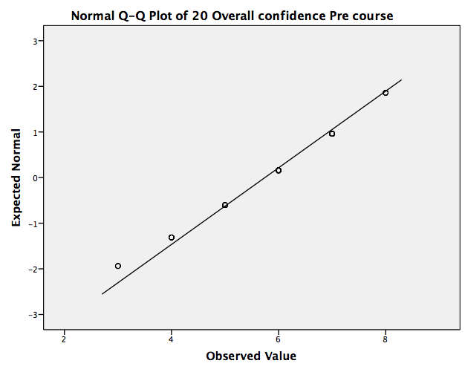

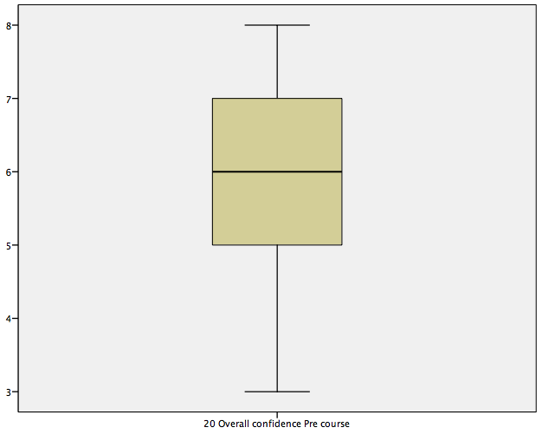

ANOVA for 58 students confidence scores over four conditions (completed data)

Multivariate Testsª
Effect |  | Value | F | Hypothesis df | Error df | Sig.
Confidence score | Pillai's Trace | .670 | 37.154^{b} | 3.000 | 55.000 | .000
 | Wilks' Lambda | .330 | 37.154^{b} | 3.000 | 55.000 | .000
 | Hotelling's Trace | 2.027 | 37.154^{b} | 3.000 | 55.000 | .000
 | Roy's Largest Root | 2.027 | 37.154^{b} | 3.000 | 55.000 | .000

Mauchly's Test of Sphericityª
Within Subjects Effect | Mauchly's W | Approx. Chi-Square | df | Sig. | Epsilon^{b}
 |  |  |  |  | Greenhouse-Geisser | Huynh-Feldt | Lower-bound
Confidence score | .700 | 19.851 | 5 | .001 | .827 | .867 | .333
Tests the null hypothesis that the error covariance matrix of the orthonormalized transformed dependent variables is proportional to an identity matrix.

Tests of Within-Subjects Effects
Source |  | Type III Sum of Squares | df | Mean Square | F | Sig.
Confidence score | Sphericity Assumed | 120.776 | 3 | 40.259 | 49.986 | .000
 | Greenhouse-Geisser | 120.776 | 2.480 | 48.703 | 49.986 | .000
 | Huynh-Feldt | 120.776 | 2.601 | 46.427 | 49.986 | .000
 | Lower-bound | 120.776 | 1.000 | 120.776 | 49.986 | .000
Error (Confidence score) | Sphericity Assumed | 137.724 | 171 | .805
 | Greenhouse-Geisser | 137.724 | 141.351 | .974
 | Huynh-Feldt | 137.724 | 148.282 | .929
 | Lower-bound | 137.724 | 57.000 | 2.416

SPSS outputs detailing planned comparisons between 4 conditions

Tests of Within-Subjects Contrasts
Source | Confidence_ score | Type III Sum of Squares | df | Mean Square | F | Sig.
Confidence score | Level 1 vs. Later | 148.054 | 1 | 148.054 | 114.124 | .000
 | Level 2 vs. Later | 8.345 | 1 | 8.345 | 8.470 | .005
 | Level 3 vs. Level 4 | 8.345 | 1 | 8.345 | 5.305 | .025
Error (Confidence score) | Level 1 vs. Later | 73.946 | 57 | 1.297
 | Level 2 vs. Later | 56.155 | 57 | .985
 | Level 3 vs. Level 4 | 89.655 | 57 | 1.573

Tests of Between-Subjects Effects
Transformed Variable: Average
Source | Type III Sum of Squares | df | Mean Square | F | Sig.
Intercept | 2905.349 | 1 | 2905.349 | 5425.069 | .000
Error | 30.526 | 57 | .536

1. Grand Mean
Measure: MEASURE_1
Mean | Std. Error | 95% Confidence Interval
 |  | Lower Bound | Upper Bound
7.078 | .096 | 6.885 | 7.270

Estimates
Confidence_score | Mean | Std. Error | 95% Confidence Interval
 |  |  | Lower Bound | Upper Bound
1 | 5.879 | .167 | 5.545 | 6.214
2 | 7.224 | .135 | 6.954 | 7.494
3 | 7.414 | .113 | 7.188 | 7.640
4 | 7.793 | .141 | 7.511 | 8.075

Pairwise Comparisons
(I) Confidence score | (J) Confidence score | Mean Difference (I-J) | Std. Error | Sig.^{b} | 95% Confidence Interval for Difference^{b}
 |  |  |  |  | Lower Bound | Upper Bound
1 | 2 | -1.345* | .159 | .000 | -1.778 | -.911
 | 3 | -1.534* | .156 | .000 | -1.961 | -1.108
 | 4 | -1.914* | .206 | .000 | -2.477 | -1.350
2 | 1 | 1.345* | .159 | .000 | .911 | 1.778
 | 3 | -.190 | .117 | .655 | -.508 | .129
 | 4 | -.569* | .184 | .019 | -1.073 | -.065
3 | 1 | 1.534* | .156 | .000 | 1.108 | 1.961
 | 2 | .190 | .117 | .655 | -.129 | .508
 | 4 | -.379 | .165 | .150 | -.829 | .071
4 | 1 | 1.914* | .206 | .000 | 1.350 | 2.477
 | 2 | .569* | .184 | .019 | .065 | 1.073
 | 3 | .379 | .165 | .150 | -.071 | .829
Based on estimated marginal means
*. The mean difference is significant at the
b. Adjustment for multiple comparisons: Bonferroni.

Analysis of missing values (ANOVA) compared with present values in complete data set
Paired Samples Statistics
 |  | Mean | N | Std. Deviation | Std. Error Mean
Pair 1 | Missing 20 Overall confidence Pre-course | 5.53 | 36 | 1.028 | .171
 | Missing 20 Overall confidence Post-course immediate | 6.83 | 36 | .971 | .162

Table 13-3 Descriptive statistics for analysed complete data present across all four conditions for pre and post-course confidence levels
Paired Samples Statistics
 |  | Mean | N | Std. Deviation | Std. Error Mean
Pair 1 | Present 20 Overall confidence Pre-course | 5.88 | 58 | 1.272 | .167
 | Present 20 Overall confidence Post-course immediate | 7.22 | 58 | 1.027 | .135
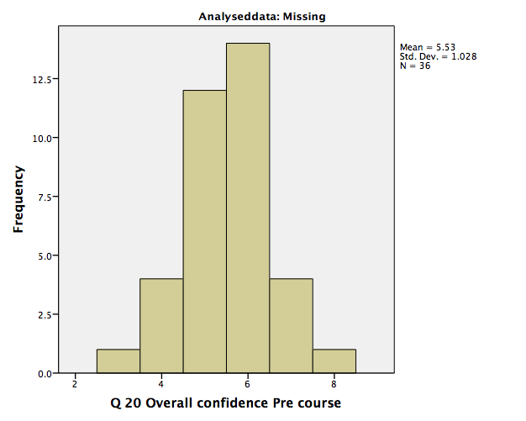
Figure 13-1 Histogram for precourse confidence scores for missing data not analysed (n=36)
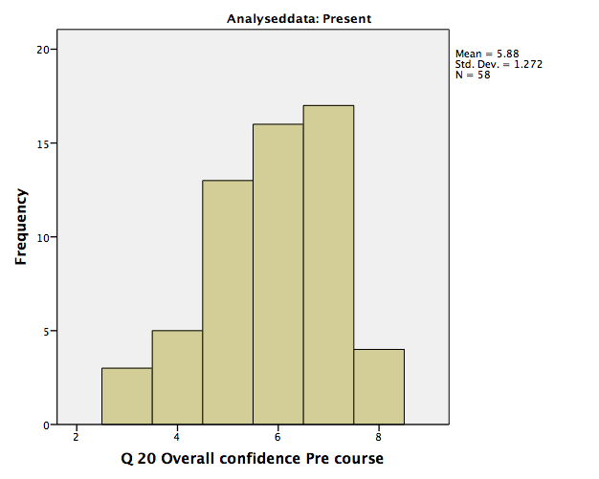
Figure 13-2 Histogram for precourse confidence scores for analysed data present for all 4 conditions (n=58)

Group Statistics
 | Analyseddata | N | Mean | Std. Deviation | Std. Error Mean
Q 20 Overall confidence Pre-course | Missing | 36 | 5.53 | 1.028 | .171
 | Present | 58 | 5.88 | 1.272 | .167

Independent Samples Test
 |  | Levene's Test for Equality of Variances |  | t-test for Equality of Means
 |  | F | Sig. | t | df | Sig. (2-tailed) | Mean Difference | Std. Error Difference | 95% Confidence Interval of the Difference
 |  |  |  |  |  |  |  |  | Lower | Upper
Q 20 Overall confidence Pre-course | Equal variances assumed | 1.565 | .214 | -1.398 | 92 | .165 | -.352 | .251 | -.851 | .148
 | Equal variances not assumed |  |  | -1.470 | 85.632 | .145 | -.352 | .239 | -.827 | .124

Correlations: Confidence and performance
Table 13-4 Descriptive statistics for correlation: Performance versus overall pre-course confidence SPSS V21
Descriptive Statistics
 | Mean | Std. Deviation | N
Formative assessment mark | 116.93 | 14.291 | 94
20 Overall confidence Pre-course | 5.74 | 1.191 | 94
Table 13-5 Pearson correlation coefficient SPSS output: One-tailed
Correlations
 |  | Formative assessment mark | 20 Overall confidence Pre-course
Pearson Correlation | Formative assessment mark | 1.000 | .048
 | 20 Overall confidence Pre-course | .048 | 1.000
Sig. (1-tailed) | Formative assessment mark | . | .325
 | 20 Overall confidence Pre-course | .325 | .
N | Formative assessment mark | 94 | 94
 | 20 Overall confidence Pre-course | 94 | 94

Table 13-6 Regression model summary
Model Summary
Model | R | R Square | Adjusted R Square | Std. Error of the Estimate
1 | .048ª | .002 | -.009 | 14.352
a. Predictors: (Constant), 20 Overall confidence Pre-course

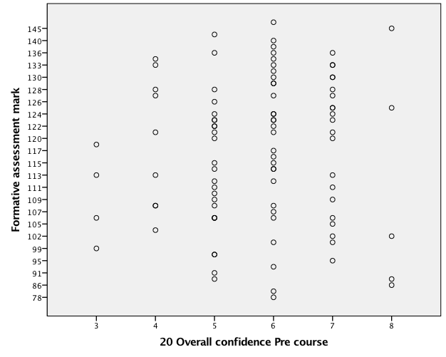

Figure 13-3 Scatter plot of data points for correlation between formative assessment mark (performance) and precourse confidence
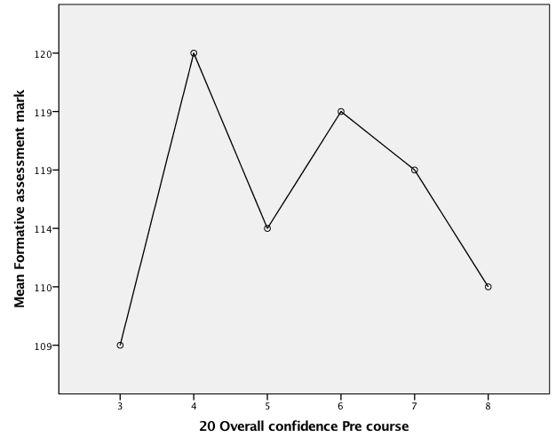
Figure 13-4 Scatter plot of correlation between mean formative assessment mark and mean precourse confidence score

Development of interview topic guide:

Interview topic guide
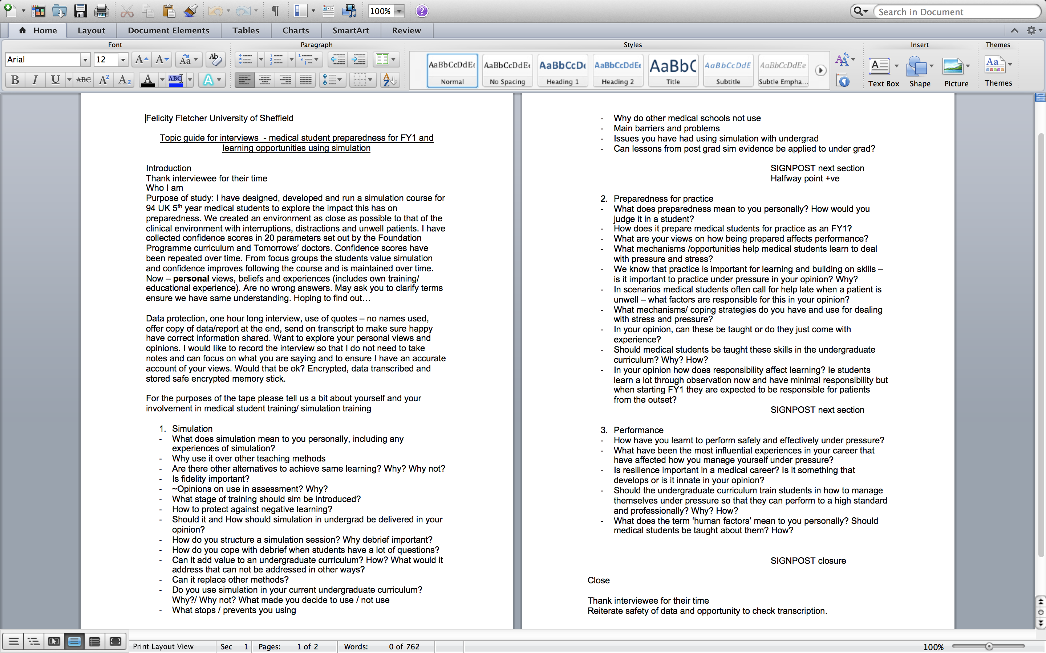

Interview information sheet




Framework thematic classification
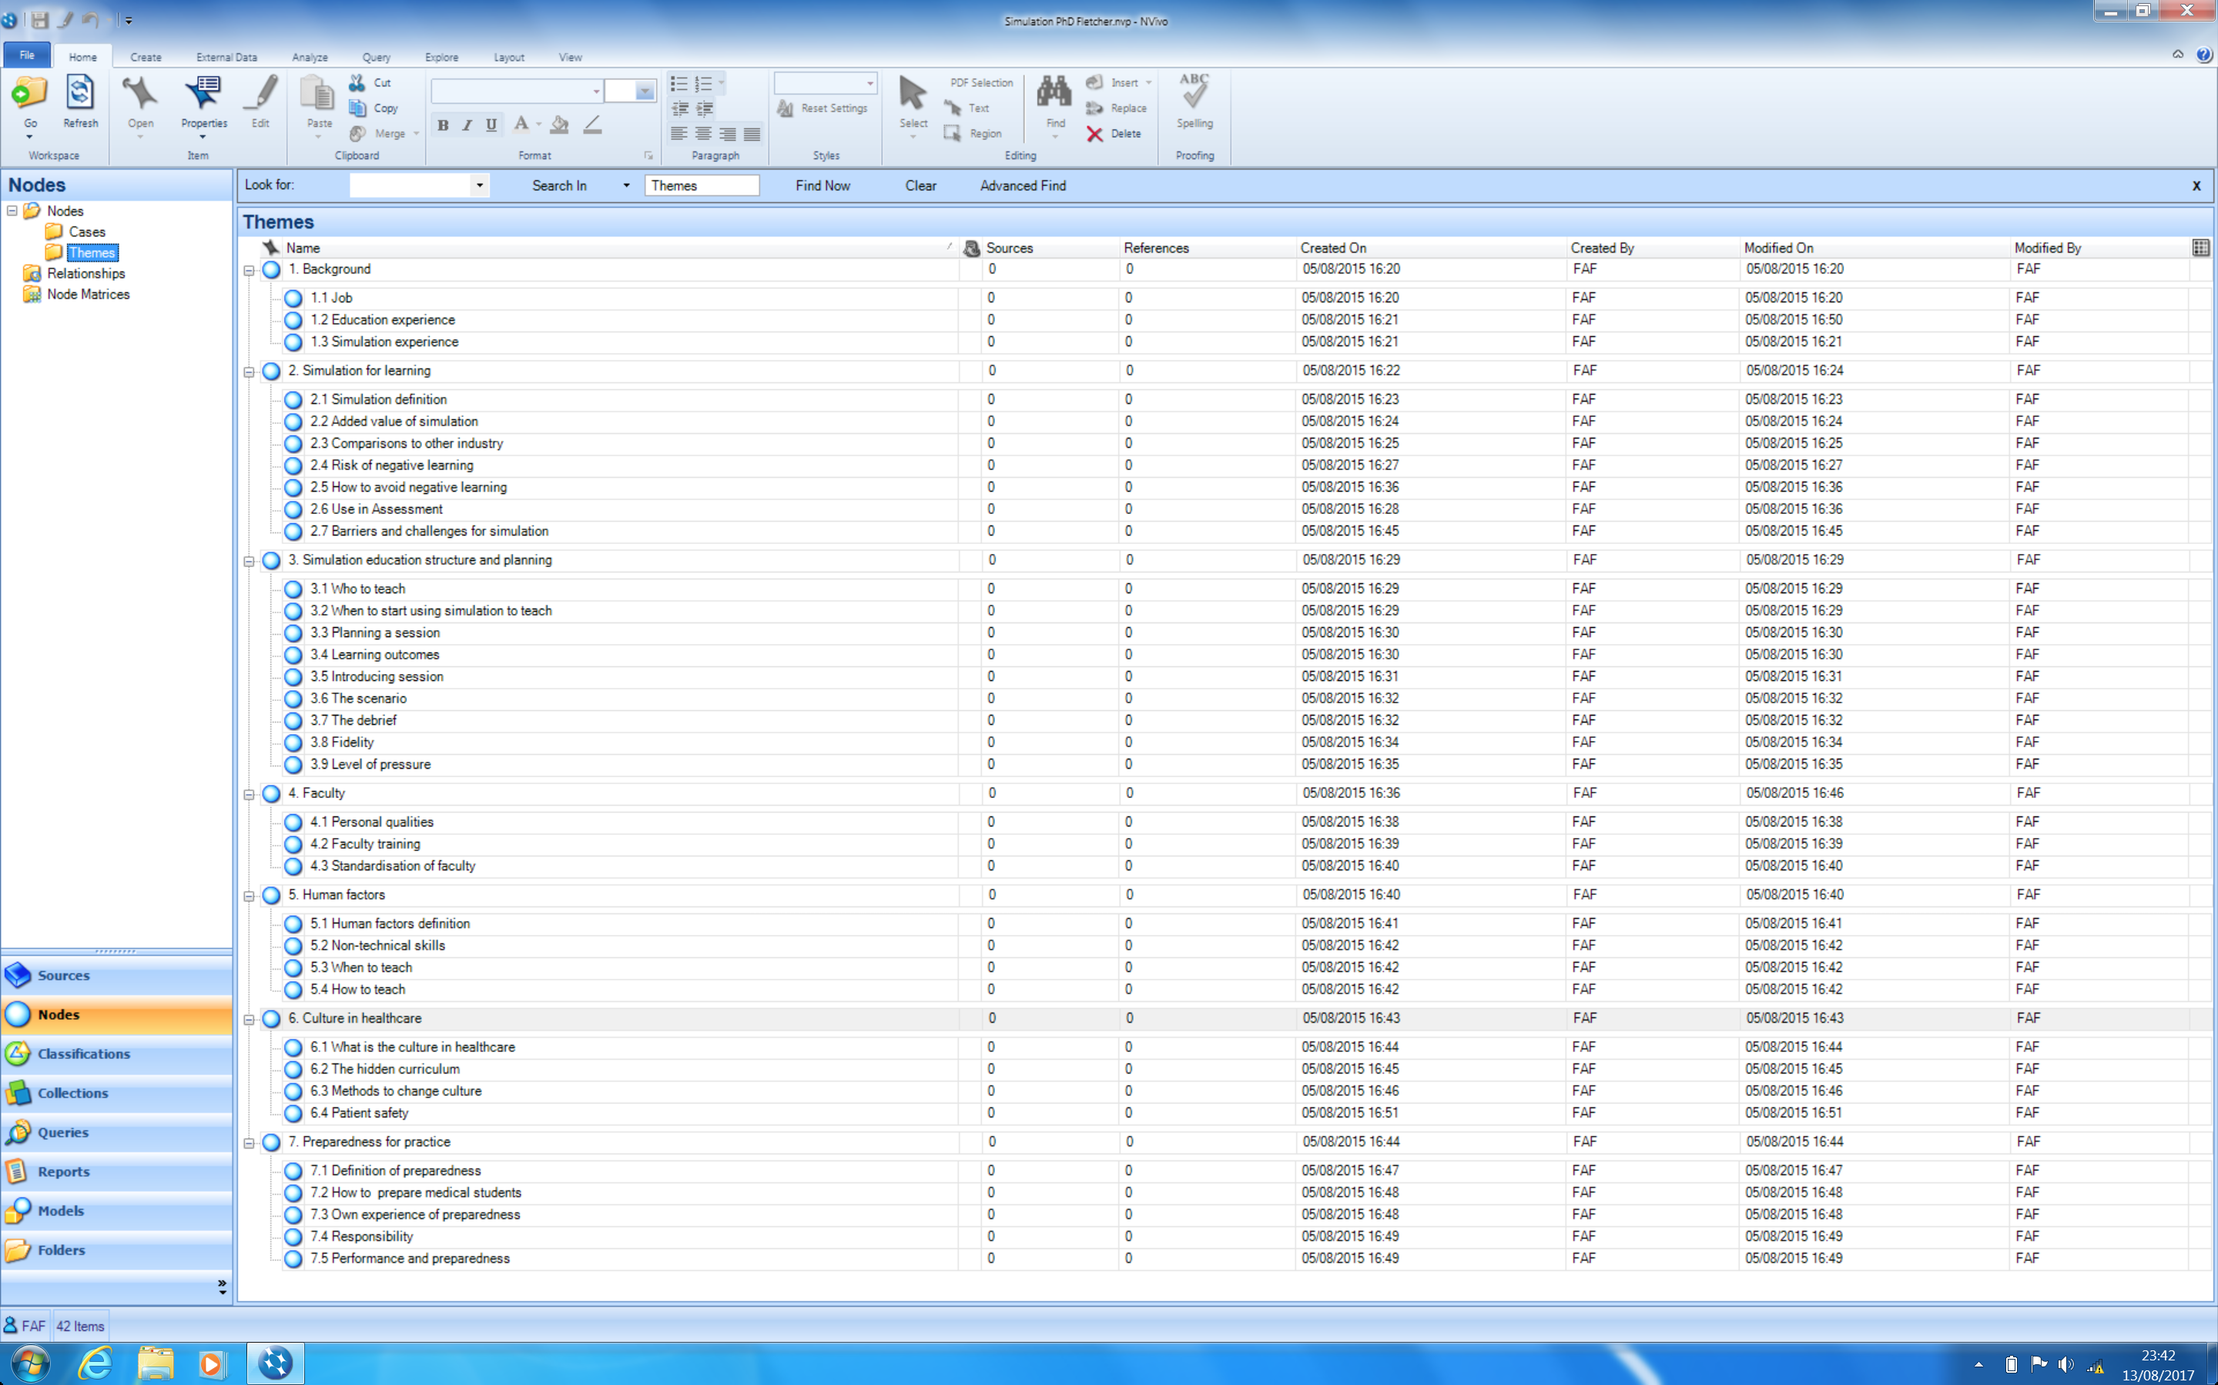

Framework example with case, summary and original data
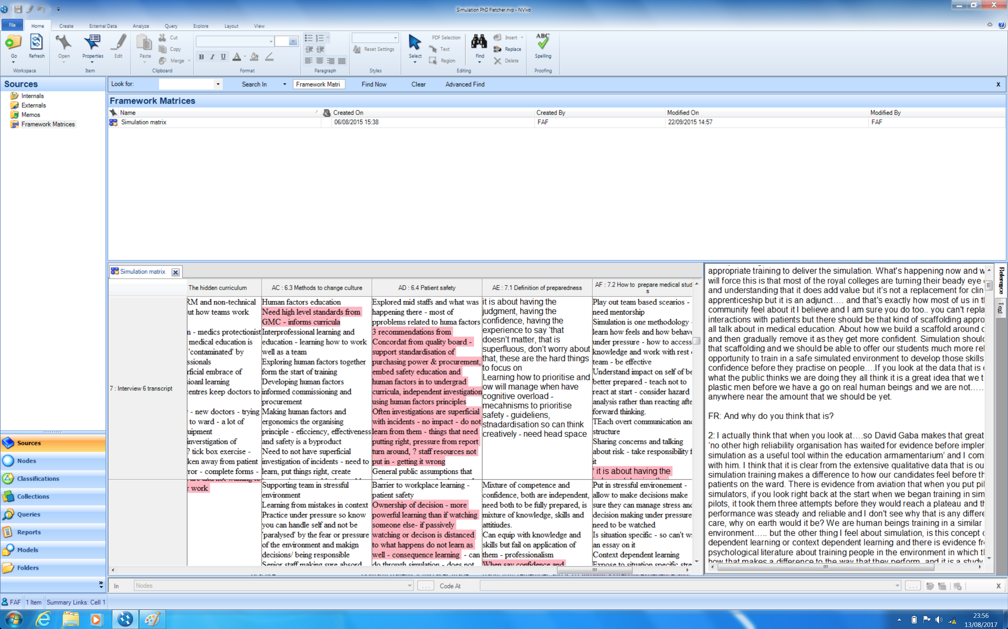

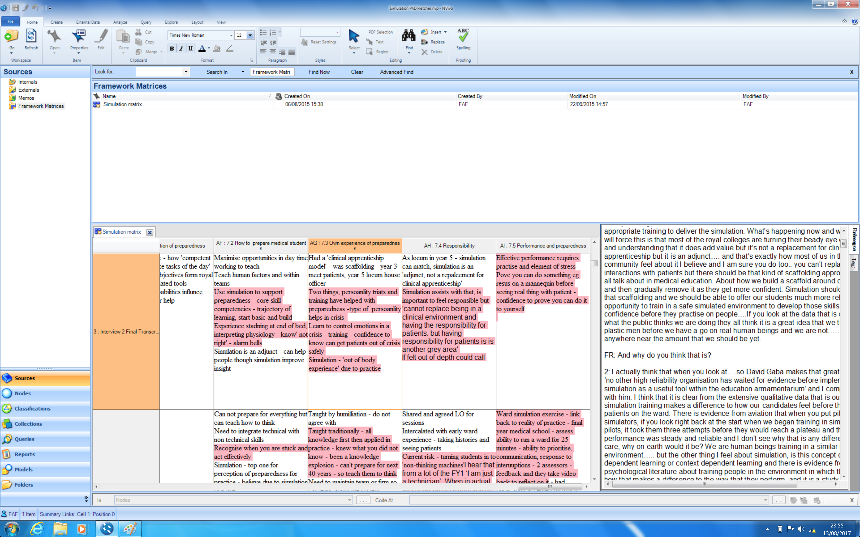

Thematic analysis using framework matrix – process – abstract conceptualisation - responsibility and practice under pressure

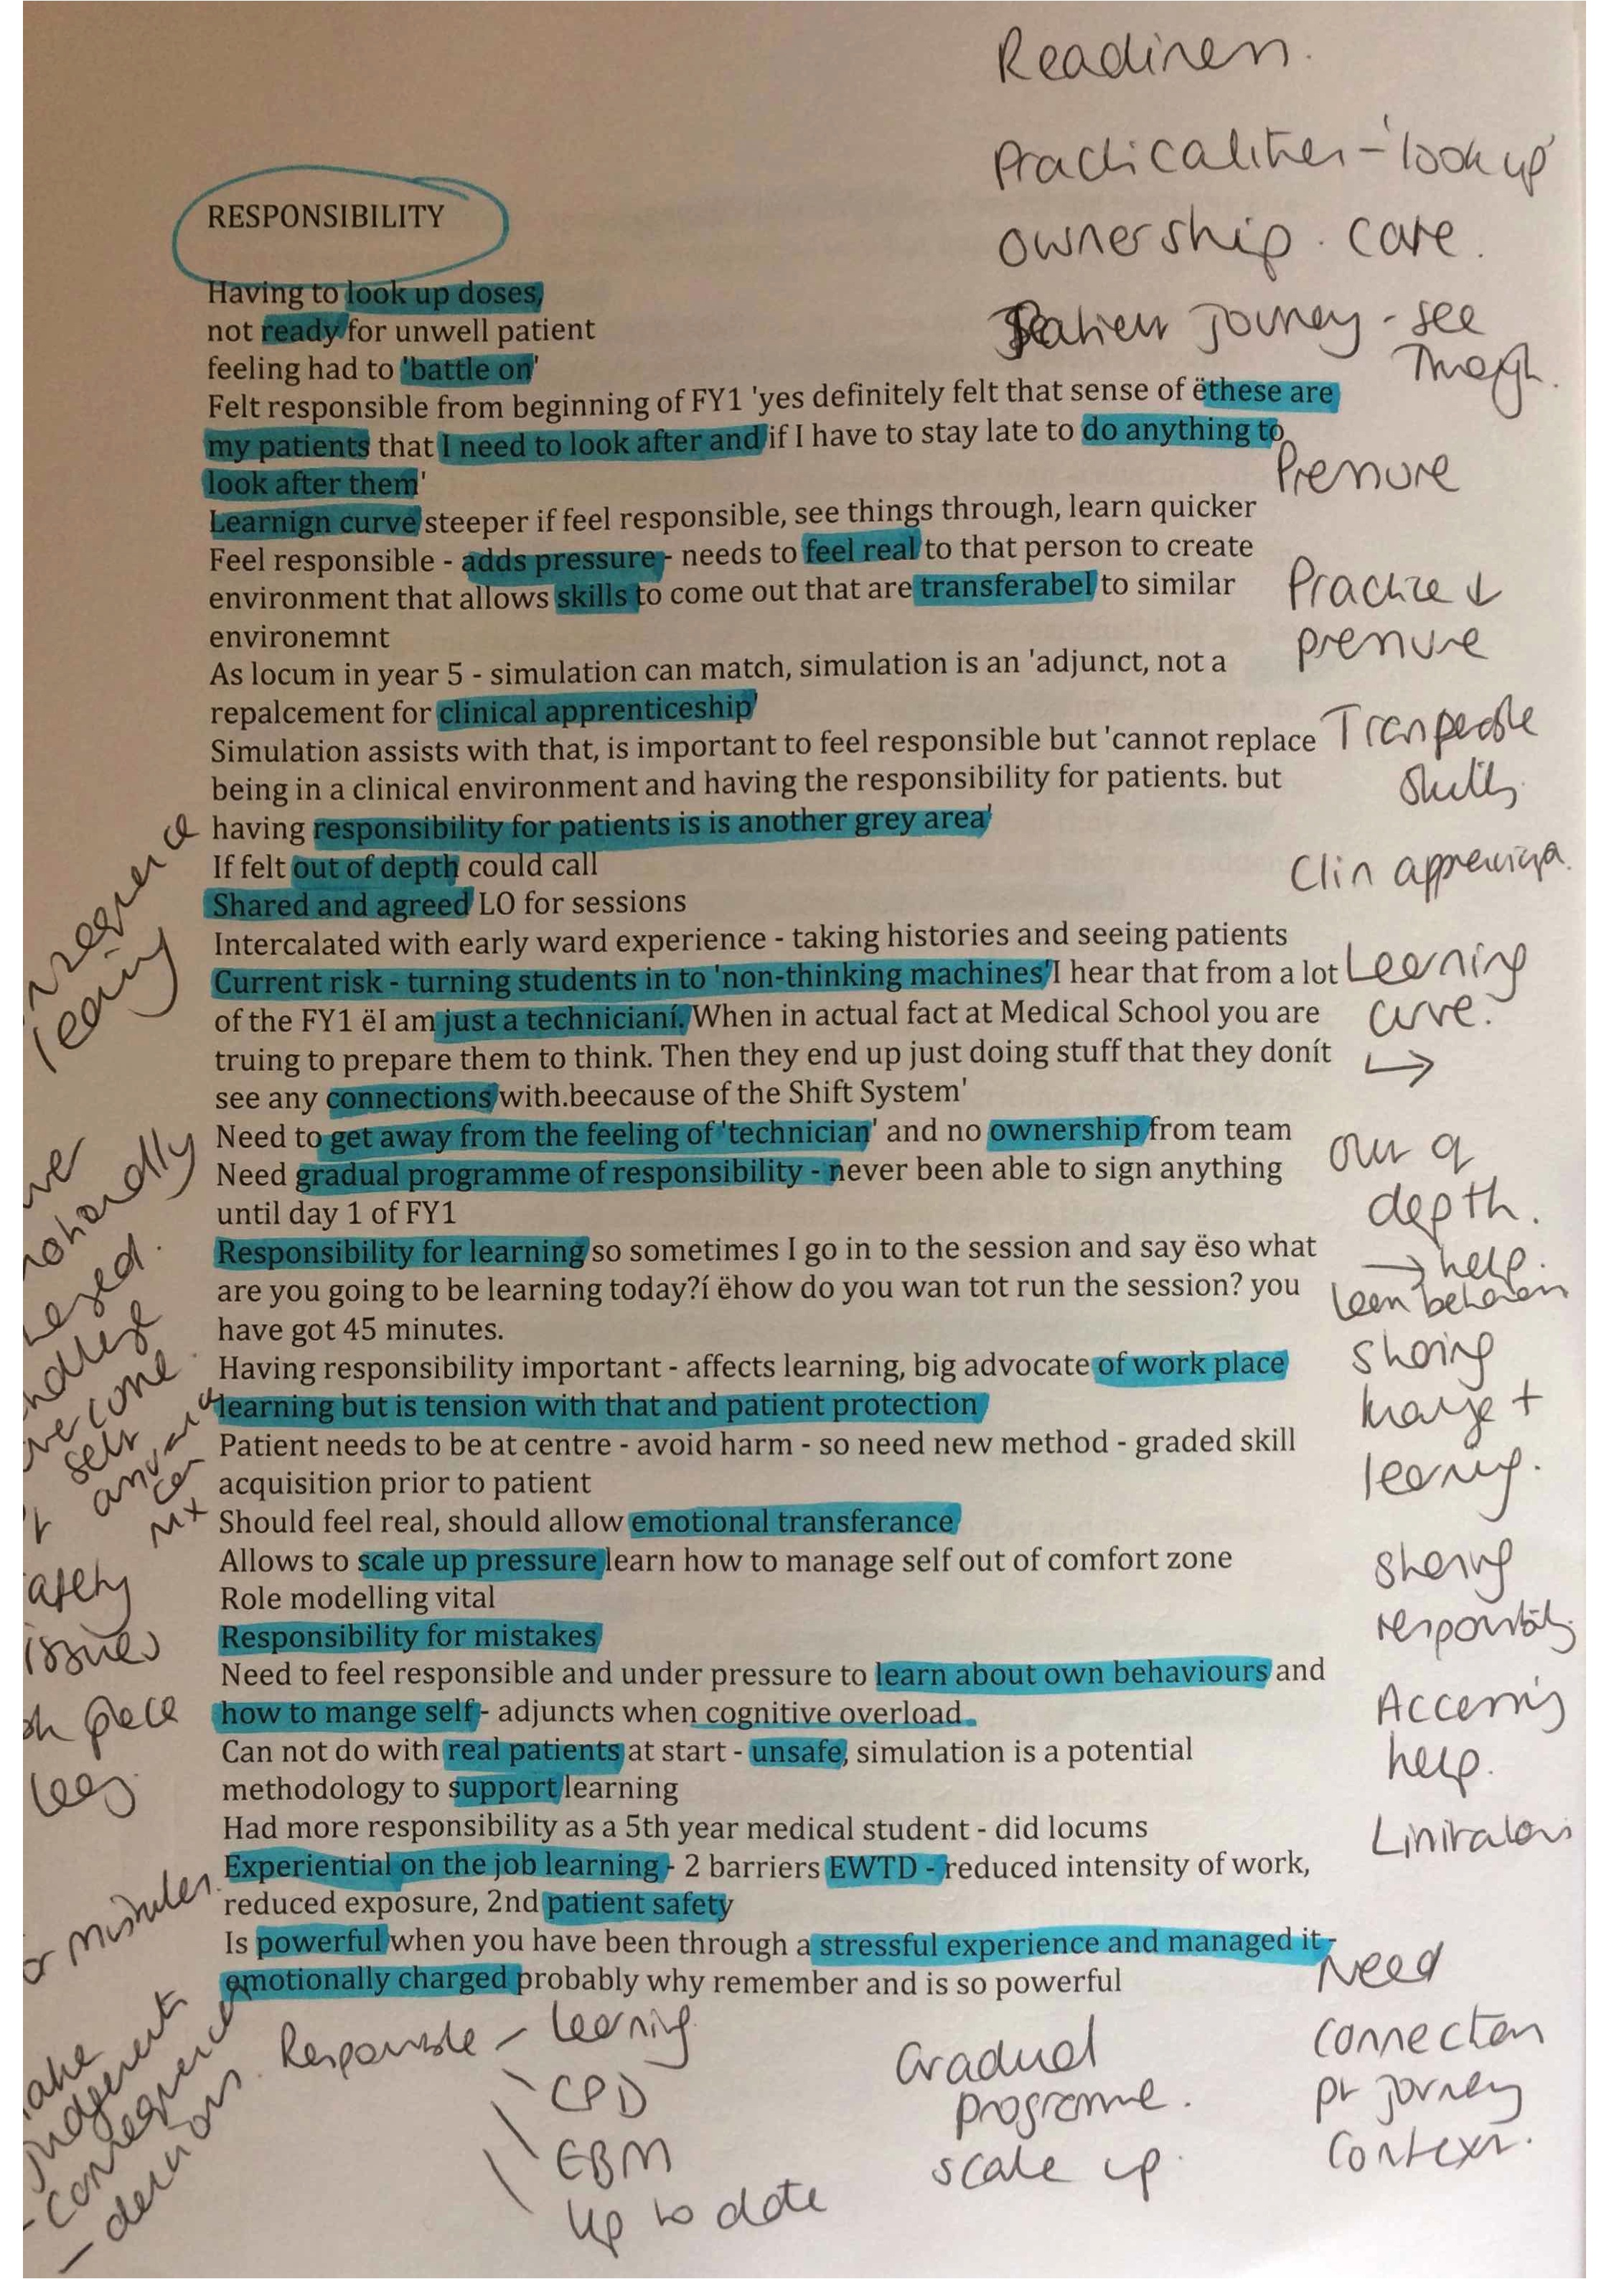
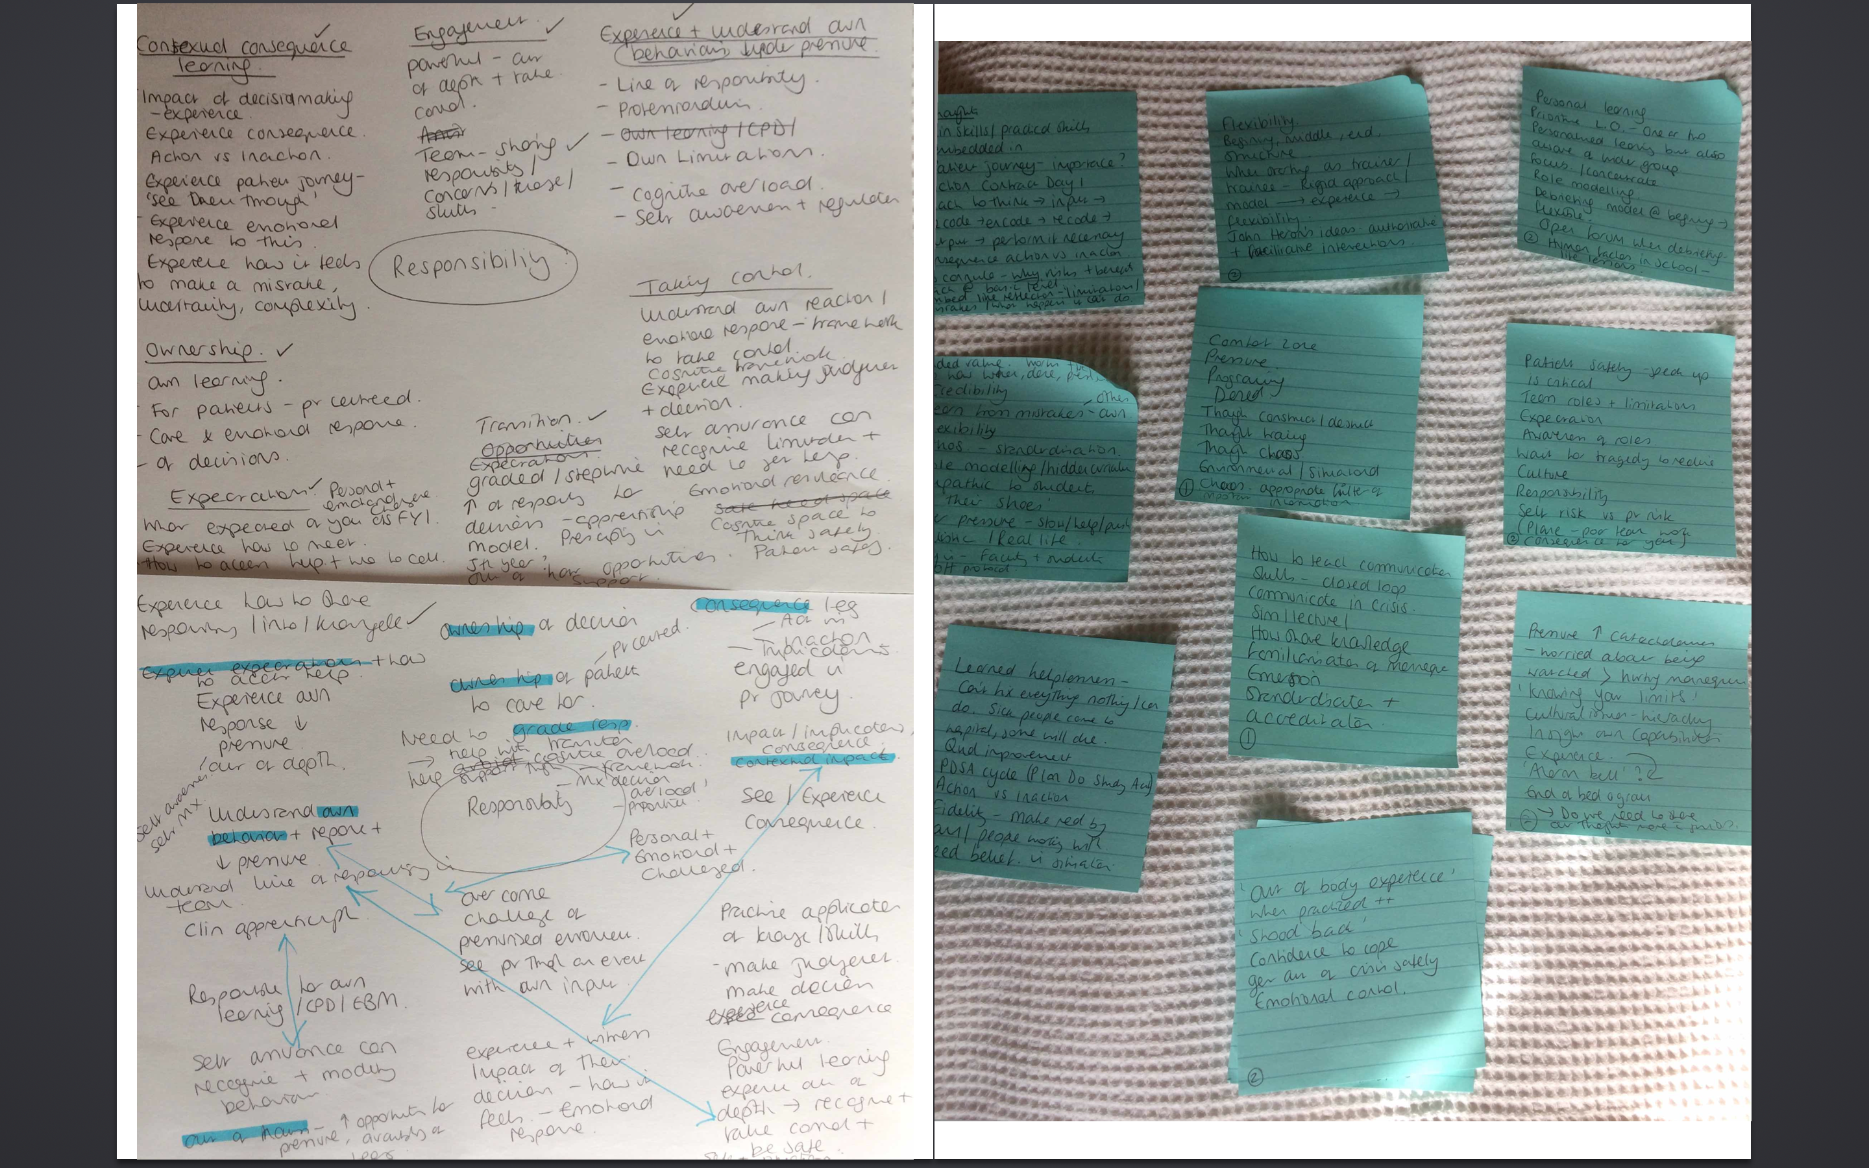

Practice under pressure
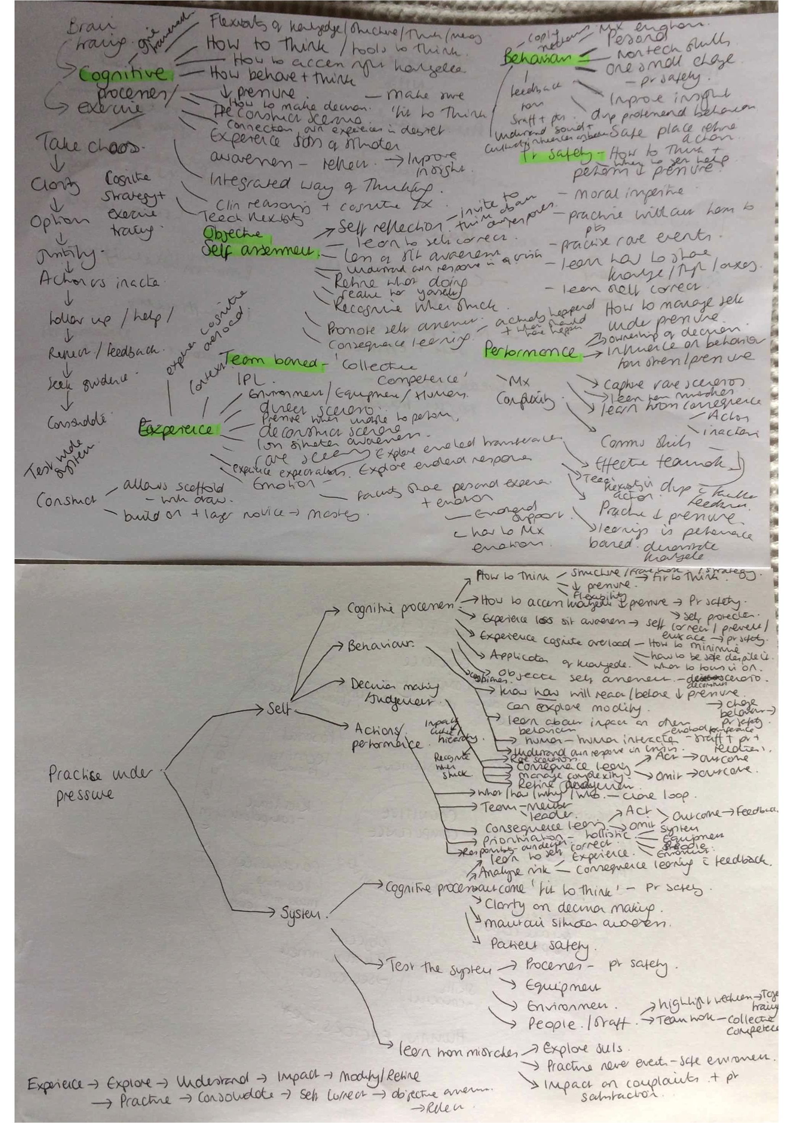

Figure 13-5 Thematic framework surrounding 'Practice under pressure' from framework analysis of triangulated qualitative data

Culture and the hidden curriculum in healthcare

Figure 13-6 Relationship diagram to summarise culture and the hidden curriculum in healthcare

Methods to address culture and the hidden curriculum in healthcare

Figure 13-7 Methods to address the culture and hidden curriculum in healthcare

Human factors

Figure 13-8 Human factors

Non-technical skills

Figure 13-9 Non-technical skills from framework analysis of triangulated data

Human factors: When and how to teach

Figure 13-10 When and how to teach human factors in healthcare –key themes

Challenges and barriers for simulation-based medical education
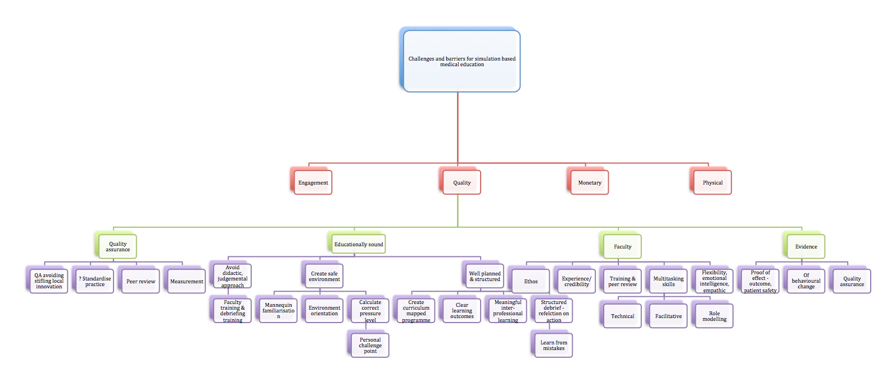
Figure 13-11 Quality as a main theme related to challenges and barriers for SBME
In terms of quality there were four main areas that emerged when analysing triangulated data through the process of framework analysis. The first was quality assurance (QA) and included the challenge of ensuring QA without stifling local innovation. There was debate amongst experts about whether practice needed to be standardised with some feeling this was a vital step and others feeling that the beauty and key to excellent simulation was the rich variety in faculty and their individual traits that they bring. Peer review was felt to be key to supporting and quality assuring simulated practice and some experts described having set this up and the challenges with getting time and resources to support it. The final challenge was measurement of outcomes and effect to satisfy those still searching for evidence and to justify some centres high cost with maintenance and repairs.
The second area was labelled ‘educationally sound’ and was divided into the importance of avoidance of didactic and judgmental approaches through faculty training including how to debrief, creation of a safe environment and good planning and a clear structure for the sessions. Creation of a safe environment involved the steps of familiarisation with the mannequin, equipment and environment, development and sharing of clear learning outcomes, employment of meaningful interprofessional learning and a structured debrief to support reflection on action and how to share and learn from mistakes.
Faculty was subdivided into the importance of ‘ethos’ and having a similar ethos when involved in education, experience and credibility, training and peer review, multitasking skills and the importance of being flexible, empathic to learners hand having a reasonable level of emotional intelligence. The concept of multitasking was felt to be important owing to the skills set required to include technical skills with running the mannequin and equipment, facilitative skills to allow candidates to discover areas of development required themselves and opportunity to role model professional and supportive behaviours (Interview 1-10, field notes form focus groups from intervention study).
The final area linked to quality assurance in many ways was ‘evidence’, again the challenge of proof of effect to represent quality, focusing on patient safety and outcomes which is known to be very difficult to achieve and one area of particular challenge personally experienced with this study. There was also a strong view by many that the added value of simulation was the opportunity for behavioural change to impact efficiency and patient safety but the challenge of measuring and proving behavioural change was seen as a barrier (Interview 2,3,8,9,10).

Figure 13-12 Monetary issues surrounding the challenges and barriers of SBME

Figure 13-13 Physical issues related to challenges and barriers for SBME – key themes

Fidelity

Figure 13-14 Fidelity and SBME – key themes

Faculty for SBME

There were four main themes that emerged related to faculty for SBME, the first ‘knowledge’ related to the importance of awareness of learner’s current stage and curriculum, as well as knowledge of the expectations of the role they were transitioning into. Knowledge and understanding of human factors and non-technical skills, of educational theory were felt to be key. This included experience with planning and facilitating educational sessions and knowledge of the technology and equipment to be used, including limitations of SBME.
Clinical experience and resultant credibility was felt to be important to facilitate the sharing of anecdotes, mistakes, personal experience and an understanding of the pressures and complexity of the clinical environment. It was also felt to be important for understanding the influence of medical hierarchy on behaviour and how to challenge hierarchy appropriately to enhance patient safety.
The personality characteristics felt to be important for making a good educator and in particular a good SBME educator was flexibility, someone who embraces complexity and was dynamic (Field notes, interview 1,2,5,8,9). It was felt that faculty should be empathic to learners, open, honest, unintimidating and be reflective themselves so aware of own strengths and weaknesses and able to share their own mistakes. It was felt that they should enjoy being challenged and have good facilitative and planning skills. Good faculty were described as respectful, a good role model with good communication and teamworking skills but also able to have fun and enjoy sessions because this transferred to learners (Field notes, focus group 2,5,10, interview 2,8,9,10).

Figure 13-15 Faculty for SBME – key themes
The final theme, educational skills felt to benefit faculty for SBME, included holding an interest in behaviour and complex cognitive processes (Interview 2,8,10, field notes). Buy-into simulation as an educational tool was felt to be vital to be able to fully immerse themselves and take it seriously as well as having good debriefing and facilitative skills (Interview 5,8,field notes). It was felt they should have an understanding of how to apply educational theory, plan sessions and have some classroom management skills and experience (Interview 3, field notes). Ability to multitask, work well as part of a team and with technology and embrace human factors as well as the environment were felt to be vital (focus group 1-19, interview 1-10, field notes form intervention study). As described above there was a divide between experts when considering how to train faculty with some holding the view that local training and peer review was practical and achievable with minimal impact on stifling enthusiasm and innovation whilst others voiced the need for standardisation, co-ordinated and centralised national accreditation to try and drive up standards (Interview 2,3,4,5,8,9,10).

Patient safety and SBME

Figure 13-16 Patient safety in the context of SBME – key themes

Planning SBME

Figure 13-17 Planning a simulation-based education intervention – key themes

Figure 13-18 Learning outcomes when designing a SBME intervention

Figure 13-19 Designing scenarios for SBME

Roy Adaptation Model
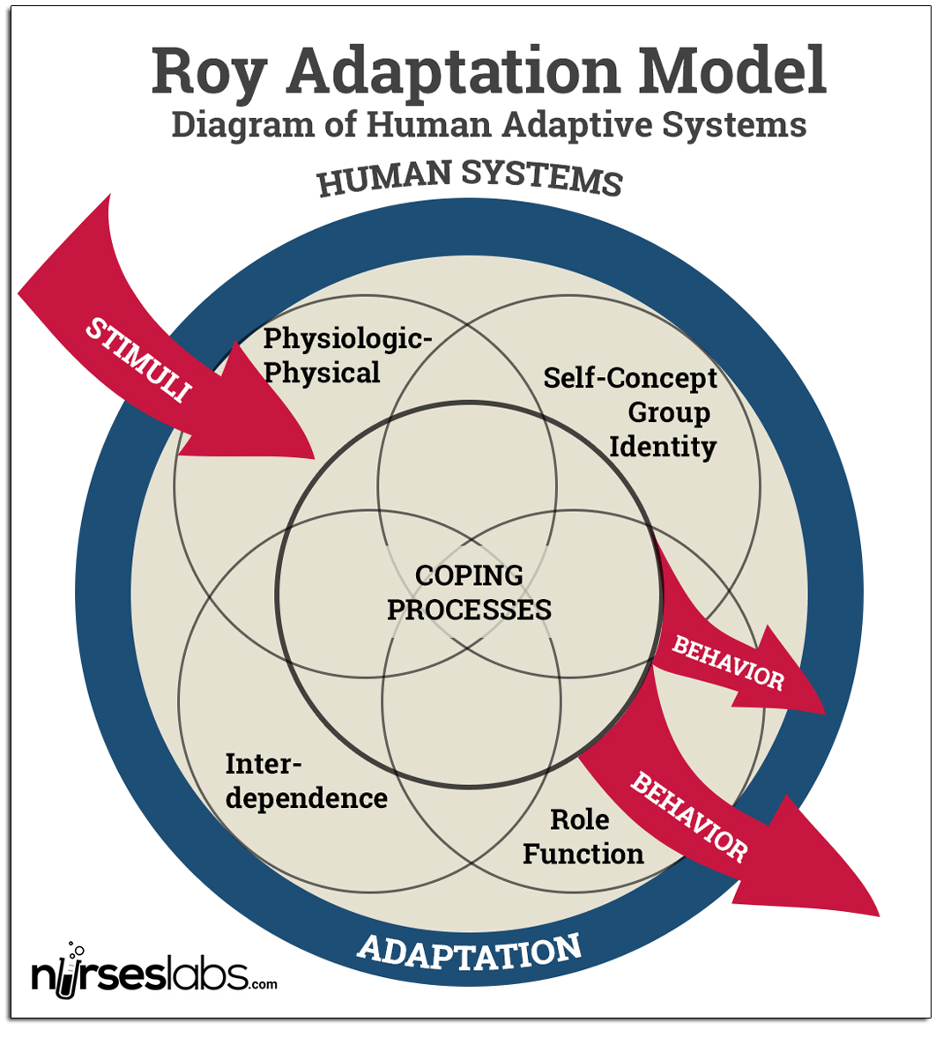
Ref: https://nurseslabs.com/sister-callista-roys-adaptation-model/ last accessed 26/7/17

