

AN INVESTIGATION INTO THE ROLE OF SHORT-CHAIN FATTY ACIDS AND THE ENTEROENDOCRINE SYSTEM IN COLONIC PATHOPHYSIOLOGY

Jonathan Richard Lawson Wild

A thesis submitted in partial fulfilment of the requirements for the degree of
Doctor of Philosophy
The University of Sheffield
Faculty of Medicine, Dentistry and Health

September 2018

To Andrea, George and Joseph

Table of contents

TITLE | PAGE
Acknowledgments | I
Summary of thesis | II
Publications arising from thesis | III
List of abbreviations | IV
List of figures | V
List of tables | V1
Chapter 1: Background | 1
1.1 The Large Intestine: structure and function | 1
1.1.1 General structure of the large intestine | 1
1.1.2 Colonic function | 1
1.1.3 Colonic microstructure | 2-4
1.2 The enteroendocrine system | 4
1.2.1 Overview | 4
1.2.2 The challenge of EECs research | 5-6
1.2.3 Classification of EECs | 6-7
1.2.4 Structural features of EECs | 7-8
1.2.5 Development and differentiation of EECs | 8-12
1.2.6 EECs as luminal chemosensors | 13
1.2.7 EEC distribution and function in the large intestine | 13-16
1.2.8 Colonic EECs and their role in disease states | 16-21
1.3 The colon as a sensory organ | 21
1.3.1 Introduction: gut-brain communication | 21-22
1.3.2 Innervation of the large intestine | 22-23
1.3.3 Intrinsic innervation – the enteric nervous system | 24-25
1.3.4 Extrinsic sympathetic nervous system | 25-26
1.3.5 Extrinsic parasympathetic nervous system | 26-27
1.3.6 Extrinsic sensory innervation of the colon | 27-28
1.3.7 Modulation of colon sensory excitability | 28-29
1.3.8 Influence of EEC hormones on colonic afferent sensitivity | 29-30
1.3.9 Colorectal sensation and visceral pain | 30-32
1.4 Short-chain fatty acids | 32
1.4.1 Dietary fibre, SCFA production and absorption | 32-33
1.4.2 SCFA receptors | 34-35
1.4.3 The role of SCFAs in colonic physiology | 35-37
1.4.4 SCFAs and gastrointestinal diseases | 37-39
1.4.5 SCFAs: algesic or analgesic? | 39-40
1.5 Colorectal cancer | 40
1.5.1 Overview | 40-41
1.5.2 Colorectal carcinogenesis | 41-42
1.5.3 Cancer of the crypt and the origins of the adenoma | 42-43
1.5.4 The adenoma-carcinoma sequence | 43
1.5.5 The molecular basis of colorectal cancer | 43-44
1.5.6 Aberrant signalling pathways | 44-46
1.5.7 Field cancerization | 47
1.5.8 SCFAs and colorectal cancer | 47-48
1.5.9 EECs in colorectal adenocarcinoma | 48-49
1.6 Neuropilin-1 | 49
1.6.1 Overview | 49-50
1.6.2 Neuropilin-1 structure | 50-51
1.6.3 Neuropilin co-receptors | 52
1.6.4 Expression and function of neuropilins in the colon | 52-53
1.6.5 Neuropilins in colorectal cancer | 53-56
1.7 Hypothesis and aims of thesis | 56-57
Chapter 2: The expression of NRP-1 in the normal colonic epithelium | 58
2.1 Introduction | 58
2.2 Hypothesis and aims | 58
2.3 Methods | 59
2.3.1 Human colonic biopsies | 59
2.3.2 Immunomarkers of colonic L- and D-cell subtypes | 59
2.3.3 Strategy to demonstrate colocalisation | 60-61
2.3.4 NRP-1 IHC staining of human colonic epithelium | 61-64
2.3.5 GLP-1 & PYY IHC staining of human colonic epithelium | 64-66
2.3.6 SST IHC staining of human colonic epithelium | 66
2.4 Results | 67
2.4.1 NRP-1 expression is enteroendocrine-like | 67
2.4.2 GLP-1 expression in the human colonic epithelium | 68
2.4.3 SST expression in the normal colonic epithelium | 69
2.4.4 NRP-1 colocalises with a subset of GLP-1 expressing EECs | 70-73
2.5 Discussion | 74-78
Chapter 3: Development of a technique to isolate a single-cell population  of colonic epithelial cells | 79
3.1 Introduction | 79
3.2 Aims | 80
3.3 Methods | 80
3.3.1 IHC staining for NRP-1 in the murine colon | 80-81
3.3.2 Empirical comparison of a strategy to isolate a single cell  population of epithelial cells from the murine colon | 81-86
3.3.3 NRP-1 fluorescence activated staining protocol optimisation | 86-88
3.4 Results | 88
3.4.1 NRP-1 is expressed in the murine colonic epithelium | 88
3.4.2 Expression of NRP-1 in MCF-7 cells by flow cytometry | 89-90
3.4.3 Dissociation of primary murine colonic epithelial cells into a  single cell suspension | 90-92
3.4.4 FACS isolation of NRP-1+ cells from the murine colonic  Epithelium | 93
3.5 Discussion | 94
3.5.1 NRP-1 expression the murine epithelium | 94
3.5.2 Comparison of colonic epithelial dissociation techniques | 94-97
3.5.3 FACS isolation of NRP-1+ cells | 97
3.5.4 Alternative approaches | 97-99
Chapter 4: Patterns of enteroendocrine cell expression in colorectal  carcinogenesis | 100
4.1 Introduction | 100-101
4.2 Hypothesis and aims | 102
4.3 Methods | 103
4.3.1 Human colonic biopsies | 103
4.3.2 Faecal SCFA measurement | 103-104
4.3.3 Overview of dataset and patient characteristics | 104
4.3.4 IHC staining strategy | 104-105
4.3.5 Scoring method | 105-106
4.3.6 Data analysis | 106-107
4.4 Results | 107
4.4.1 Morphology and distribution of EECs in normal and neoplastic  colonic epithelium | 107-113
4.4.2 Crypt scoring and intra & inter-observer reliability | 113
4.4.3 Alterations in EEC population at the mid-sigmoid with disease | 114
4.4.4 Alterations in EECs in the contra-lateral field | 115-116
4.4.5 EEC population dynamics | 116-118
4.4.6 Position of EEC subtypes within the colonic crypts | 118
4.4.7 Crypt cellularity | 118-119
4.4.8 Influence of SCFA level on EEC expression | 119-123
4.5 Discussion | 124
4.5.1 EEC dynamics | 124-126
4.5.2 Altered expression of EECs in neoplastic lesions | 126-127
4.5.3 Comparing my findings with the published literature | 127-129
4.5.4 Further evidence of field effects in colorectal carcinogenesis | 129-130
4.5.5 A pan-colonic field effect? | 130-131
4.5.6 The influence of SCFAs on EEC populations | 131-133
4.5.7 Conclusions | 133-134
Chapter 5: The influence of SCFAs on colonic afferent nerve sensitivity | 135
5.1 Introduction | 135-136
5.2 Hypothesis and aims | 137
5.3 Methods | 1138
5.3.1 Introduction | 138
5.3.2 Ethical approval and animals | 138
5.3.3 Tissue preparation and equipment setup | 139-143
5.3.4 Experimental protocol for afferent nerve recording | 143-145
5.3.5 Influence of SCFAs on spontaneous contractions | 145-146
5.3.6 Isolation and culture of dorsal root ganglia | 146-147
5.3.7 Calcium-imaging | 147-148
5.3.8 Data analysis | 148-150
5.3.9 Statistics | 150
5.4 Results | 151
5.4.1 Methodological development and optimisation of techniques | 151
5.4.2 Baseline activity and PBS time controls | 151-153
5.4.3 Influence of butyrate on colonic afferent sensitivity | 154-157
5.4.4 Influence of acetate on colonic afferent sensitivity | 157-160
5.4.5 Influence of propionate on colonic afferent sensitivity | 160-164
5.4.6 Influence of SCFA mix on colonic afferent sensitivity | 164-168
5.4.7 Comparison of SCFA treatments on colonic afferent mechanosensitivty | 168-170
5.4.8 Influence of SCFAs on baseline afferent discharge | 170-172
5.4.9 Influence of SCFAs on colonic compliance | 173
5.4.10 SCFAs and colonic motility | 174
5.4.11 SCFA induced smooth muscle activity has no effect on afferent  nerve sensitivity | 174-175
5.4.12 Influence of SCFAs on intracellular calcium level of DRGs | 176
5.5 Discussion | 177
5.5.1 Critique of the experimental techniques | 177-181
5.5.2 A role for SCFAs in attenuating visceral nociception | 181-182
5.5.3 Increased potency of butyrate on colonic mechanosensitivity | 182-183
5.5.4 Attenuation of colonic afferent discharge is observed only  following ramp distension | 183-184
5.5.5 The influence of Ca2+ blockade | 184-186
5.5.6 SCFAs influence colonic motility with differential effects between  SCFA subtypes | 186-188
5.5.7 SCFAs do not effect colonic wall compliance in the short-term | 188
5.5.8 Conclusion | 189
Chapter 6: General discussion | 190
6.1 NRP-1 expression in colonic epithelium | 190-191
6.2 The challenge of EEC research and alternative approaches | 192
6.3 Potential roles of NRP-1 in the colonic epithelium | 192-195
6.4 Alteration in EEC population in colorectal carcinogenesis | 195
6.5 Implications of pertubations in EECs in colorectal cancer | 195-196
6.6 Influence of SCFAs on colonic afferent sensitivity | 196-200
6.7 Increasing focus on the microbiome and future perspectives | 201-202
References | VII
Appendix | VIII

I acknowledgements

I would like to thank my supervisors Dr Bernard Corfe, Mr Keith Chapple, Dr Carolyn Staton and Professor David Grundy for giving me the opportunity to undertake this PhD and for their patience and support throughout my studies.
I would also like to thank all the current and past members of the Corfe and Grundy labs for the help and support they have given me throughout my PhD. Special thanks goes to Joey Chowdry for ongoing laboratory guidance and support and to Jenny Globe and Jon Bury (JB) for their assistance with the immunohistochemistry techniques and analysis. Particular thanks also to Ashok Gunawardene (AG) and Ruth Narramore (RN) for their valued input with the immunohistochemistry experiments. I am especially grateful for the support of Donna Daley, Wen Yang, Natasja Barki, and Chris Keating for their help and support with afferent nerve recording and calcium imaging.
Lastly I thank my family for their support and encouragement throughout my career so far. I am indebted to my parents and grandparents for all their hard work and sacrifices that have enabled me to embark on career in surgery and also thank my parents-in-law for their kindness and support. I am grateful to my two sons, George and Joseph, for helping me put things into perspective and finally I thank my wife, Andrea, for her eternal patience and tolerance with my career, and for her love and support over the last twenty years.

II summary of thesis

BACKGROUND: Despite the ability of enteroendocrine cells (EECs) to secrete proliferative and pro-angiogenic factors and their influence on gut innervation, the role of EECs and their interaction with short-chain fatty acids (SCFAs) in colonic carcinogenesis and afferent neuronal sensation is under-investigated. Recent work suggests that SCFA butyrate may exert its anti-neoplastic effect via modulation of co-receptor neuropilin-1 (NRP-1). The aim of this thesis is to investigate alteration of EEC expression in neoplastic colonic epithelium and the influence of SCFAs on EEC populations, to identify the subset of colonic EEC that express NRP-1 and to investigate the influence of SCFAs on colonic sensation.
METHODOLOGY: I performed IHC colocalisation analysis of human colon biopsies stained with NRP-1 and EEC markers. EEC populations were compared in normal, adenoma and adenocarcinoma colonic biopsies and correlated with SCFA concentrations. An in vitro murine model was developed to record the effects of luminally applied SCFAs on colonic afferent nerve firing. Calcium-imaging of DRGs was performed to determine if SCFAs have a direct influence of afferent neuronal excitability.
RESULTS: I determined that NRP-1 is expressed by a subset of colonic EECs and demonstrated altered EEC expression in neoplastic epithelium and alterations in EEC population in the local lesion field with pan-colonic field effects. Afferent nerve recordings reveal that SCFAs have an inhibitory effect on colonic afferent mechanosensitivity, appearing to modulate this indirect effect via the high threshold afferents.
CONCLUSIONS: Altered EEC expression in the neoplastic epithelium and altered relationships with SCFA levels provide additional evidence for a role of EECs and SCFAs in colonic carcinogenesis. Expression of NRP-1 by colonic GLP-1 expressing EECs provides additional insight into the biological role of NRP-1 in the colonic epithelium. Inhibition of colonic afferent mechanosensitivity in a murine model supports the findings observed in human subjects that suggest analgesic properties of SCFAs.

III publications & presentations arising from this thesis

Publications:
Wild JRL, Staton CA, Chapple K, Corfe BM (2011) Neuropilins: Expression and role in the epithelium. Int J Exp Pathol 93(2):81-103

Oral presentations and published abstracts:
Wild JRL, Khan AQ, Xui Li N, Staton C, Chapple K, Corfe B. Neuropilin-1: a predictor of early carcinogenesis in the colonic epithelium. Br J Surg. 2012;99(S4):24
Khan AQ, Wild J, Nai X, Staton C, Brown S, Corfe B. Faecal butyrate levels have different effect on cancer and adenoma tissues. Suggestion of early beneficial role of butyrate during carcinogenesis. Br J Surg. 2012;99(S4):29
Narramore R, Wild J, Corfe B, Staton C, Yu D, Chapple K. Alteration in enteroendocrine cell population in early colonic neoplasia. Int J Surg. 2013; 11(8):624
Wild J, Gunarwardene A, Staton C, Chapple K, Corfe B. Neuropilin-1 is expressed in normal human colonic L-cells cells: an immunohistochemical co-localisation study. Colorectal Dis. 2011;13(S6):44

Poster presentations with published abstracts:
Wild JRL, Staton CA, Chapple KS, Corfe BM. Comparison and optimisation of a strategy to isolate a single cell population of epithelial cells from the crypt compartment of the murine colon. Poster of Distinction. Br J Surg. 2013; 100 (S7): 99

Wild JRL, AR Gunawardene, CA Staton, KS Chapple, BM Corfe. Neuropilin-1 expression in the normal colon is enteroendocrine-like. Br J Surg. 2013; 100 (S7): 123

IV list of abbreviations

5-HT Serotonin
ACF Aberrant crypt foci
AD Afferent discharge
ANS Autonomic nervous system
APC Adenomatous Polyposis Gene
APUD Amine precursor uptake and decarboxylation
ATP adenosine triphosphate
bHLH Basic helix-loop-helix transcription factors
BMI Body mass index
CCK Cholecytokinin
CD Crohn’s disease
CgA Chromogranin-A
CGRP Calcitonin gene-related product
CIMP CpG island methylator phenotype
CIN Chromosomal instability
CNS Central nervous system
COX-2 Cyclo-oxygenase-2
CPMC Colonic peristaltic motor complexes
CRC Colorectal cancer
CSCs Cancer stem cells
DMEM Dulbecco's modified Eagle's medium
DPP-4 Dipeptidyl peptidase 4
DRG Dorsal root ganglia
DTT Dithiothreitol
EC Enterochromaffin
EDTA Ethylenediaminetetraacetic acid
EEC Enteroendocrine cell
EGFR Epidermal growth factor receptor
EGTA Ethyleneglycoltetraacetic acid
ELISA Enzyme-linked immunosorbent assay
EMT Epithelial mesenchymal transition
ENS Enteric nervous system
FAP Familial adenomatous polyposis coli
FDA Food and Drug Agency
FFAR2 Free fatty acid receptor-2
FFAR3 Free fatty acid receptor-3
FISH Fluorescence in situ hybridization
FODMAP Fermentable oligosaccharides, disaccharides, monosaccharides and polyols
FSC Forward scatter
GI Gastrointestinal
GINETs Gastrointestinal neuroendocrine tumours
GIP Gastric inhibitory polypeptide
GLP-1 Glucagon-like peptide-1
GLP-1R Glucagon-like peptise-1 receptor
GLP-2 Glucagon-like peptide-2
GLP-2R Glucagon-like peptise-2 receptor
GFP Green fluorescent protein
GPCR G-protein coupled receptor
GPR-41 G-protein coupled receptor 41
GPR-43 G-protein coupled receptor 43
HBSS⁻ Calcium and magnesium free Hank’s balanced salt solution
HDAC Histone deacetylase
H+E Haematoxylin and eosin
IBD Inflammatory bowel disease
IBS Irritable bowel syndrome
IBS-C Constipation-predominant irritable bowel syndrome
IBS-D Diarrhoea-predominant irritable bowel syndrome
ICC Intra-class correlation co-efficient
IEN Intraepithelial neoplasia
IF Immunofluorescence
IHC Immunohistochemistry / immunohistochemical
IMG Inferior mesenteric ganglia
IPAN Intrinsic primary afferent neuron
ISCs Intestinal stem cells
K_{v} Voltage gated potassium channels
LCM Laser capture microdissection
LDCVs Large dense-core vesicles
Lgr5 Leucine-rich repeated-containing G protein-coupled receptor 5
LSN Lumbar splanchnic nerves
MAPK Mitogen-activated protein kinase
MBP Mechanical bowel preparation
MCT1 Monocarboxylate transporter 1
MIA Mechanoinsensitive afferent
MMC Migrating motor complex
MMR Mismatch repair
MRI Magnetic resonance imaging
MSI Microsatellite instability
Na_{v} Voltage gated sodium channels
NGN3 Neurogenin3
NICE National Institute of Clinical Excellence
NRP-1 Neuropilin-1
NRP-2 Neuropilin-2
PBS Phosphate buffered saline
PCR Polymerase chain reaction
PG Pelvic ganglia
PGDP Pro-glucagon derived peptides
PI3K Phosphoinositide 3'-kinase
PN Pelvic nerves
PYY Peptide YY
RCT Randomised controlled trial
SCFA Short-chain fatty acid
SEMA Semaphorin
SF Scatter factor
SIRS Systemic inflammatory response syndrome
SLMCs Smaller synaptic-like microvesicles
SMC Smooth muscle cell
SMCT1 Sodium coupled monocarboxylate transporter
SPN Sacral parasympathetic nucleus
SSA Sessile serrated adenoma
SSC Side scatter
SST Somatostatin
SSTR Somatostatin receptor
TMA Tissue microarray
TRPV Transient receptor vallanoid channel
TSA Traditional serrated adenoma
VEGF Vascular endothelial growth factor
VGCC Voltage-gated calcium channels
WT Wild-type

V list of figures
___________________________________________________________________________
TITLE | Page
Chapter 1
1.1 The colonic wall | 2
1.2 Schematic representation of the colonic crypt | 4
1.3 Human colonic enterochromaffin cell | 7
1.4 Distribution of EECs in the colonic crypt | 10
1.5 Overview of ECC differentiation | 11
1.6 Distribution of EEC subtypes in the colorectum | 16
1.7 Primary afferent neurons of the gastrointestinal tract | 23
1.8 Extrinsic sensory innervation of the distal colon and rectum | 28
1.9 Colonic SCFA production | 33
1.10 SCFAs in health and disease | 35
1.11 Genes, signalling pathways and growth factors in colorectal carcinogenesis | 46
1.12 NRP-1 structure | 51
1.13 The multiple ligand families of the neuropilins | 52
Chapter 2
2.1 Serial sections | 60
2.2 Optimisation of IHC for NRP-1 staining | 62
2.3 Optimisation of IHC for PYY staining | 65
2.4 NRP-1 expression in the normal colonic epithelium | 67
2.5 GLP-1 expression in the normal colonic epithelium | 68
2.6 SST expression in the normal colonic epithelium | 69
2.7 Colocalisation of NRP-1 with GLP-1 | 71
2.8 IHC serial sections stained for SST and NRP-1 | 72
2.9 Cell counts | 73
2.10 Summary of findings and potential role of NRP-1 | 77
Chapter 3
3.1 Single cell isolation protocol | 84
3.2 NRP-1 expression in the normal mouse colon | 89
3.3 Flow cytometric analysis of NRP-1 expressing MCF7 cells | 90
3.4 H+E stained sections of remnant muse colon following epithelial cell dissociation | 92
3.5 FACS dot plot of NRP-1 staining of isolated murine colonic epithelial cells | 93
Chapter 4
4.1 Colonic crypt scoring | 106
4.2 CgA staining in normal colonic epithelium | 108
4.3 CgA staining in colonic adenocarcinoma | 108
4.4 GLP-1 staining in the contralateral field of an adenoma compared with normal  colonic epithelium | 109
4.5 GLP-1 staining in colonic adenoma | 111
4.6 GLP-1 staining in colonic adenocarcinoma | 111
4.7 SST staining in colonic adenoma | 112
4.8 SST staining in colonic adenocarcinoma | 113
4.9 Bar chart comparing EEC expression in the mid-sigmoid in lesion-free, adenoma  and adenocarcinoma patients | 114
4.10 Bar chart comparing EEC expression in the adenoma field with mid-sigmoid  control | 115
4.11 Bar chart comparing EEC expression in the adenocarcinoma field with mid-  sigmoid control | 116
4.12 Age and faecal SCFA concentration | 120
4.13 Bar chart comparing faecal SCFA concentrations across the diagnostic groups | 121
4.14 Summary of EEC dynamics | 125
Chapter 5
5.1 Tissue preparation and mesenteric nerve dissection | 140
5.2 Schematic diagram representing an in vitro model for the recording of colonic  afferent nerve firing | 145
5.3 Suction electrode with isolated lumbar splanchnic nerve | 142
5.4 Schematic diagram representing the protocol used to record the intracolonic  pressure and afferent nerve firing | 144
5.5 Analysis of afferent nerve activity | 149
5.6 Biphasic increase in afferent discharge on ramp distension | 152
5.7 PBS time control recording | 153
5.8 The influence of butyrate on colonic afferent mechanosensitivity | 155
5.9 The influence of 30mM butyrate on colonic afferent discharge at 60 mmHg | 156
5.10 Pressure-response profiles of colonic multiunit activity comparing PBS to 30mM  Butyrate | 157
5.11 The influence of acetate on colonic afferent mechanosensitivity | 158
5.12 Influence of 30mM acetate on the colonic afferent discharge at 60 mmHg | 169
5.13 Pressure-response profiles of colonic multiunit activity comparing PBS with  30mM acetate | 160
5.14 The influence of propionate on colonic afferent mechanosensitivity | 162
5.15 Influence of 30mM propionate on the colonic afferent discharge at 60 mmHg | 163
5.16 Pressure-response profiles of colonic multiunit activity comparing PBS with  30mM propionate | 164
5.17 The influence of SCFA mix on colonic afferent mechanosensitivity | 165
5.18 Influence of 30mM and 100mM SCFA mix on the colonic afferent discharge at 60  mmHg | 166
5.19 Pressure-response profiles of colonic multiunit activity comparing PBS with  30mM and 100mM SCFA mix | 168
5.20 Comparison of SCFA treatments on colonic afferent mechanosensitivity | 170
5.21 Attenuation of baseline afferent discharge with 30mM and 100mM SCFA mix | 172
5.22 Influence of SCFAs on colonic wall compliance | 173
5.23 Influence of SCFAs on colonic primary motor complexes | 175
5.24 Calcium imaging on isolated DRGs | 176
Chapter 6
6.1 Microbiota-gut-brain communication: hypothesis and future direction | 200

VI list of tables

TITLE | Page
Chapter 1
1.1 EEC subtypes | 6
1.2 Features of EECs found in the large intestine | 14
1.3 Secretory peptides of EECs of the large intestine | 15
Chapter 3
3.1 Comparison of chelation solutions | 87
3.2 Comparison of cell count and viability following 6 different chelation protocols | 95
Chapter 4
4.1 The number of biopsies with IHC and SCFA data available | 108
4.2 Mean age and BMI across the diagnostic groups | 108
4.3 Frequency of luminal epithelial staining with GLP-1 | 114
4.4 Intra- and inter-observer scores | 117
4.5 The relationship between the three EEC subtypes in crypts at the mid-sigmoid  colon in lesion-free patients | 121
4.6 The relationship between the three EEC subtypes at the mid-sigmoid colon and in  the contralateral field in adenoma patients | 121
4.7 The relationship between the three EEC subtypes at the mid-sigmoid colon and the  contralateral field in adenocarcinoma patients | 122
4.8 Faecal SCFA levels in all patients | 123
4.9 SCFA concentrations across diagnostic groups | 124
4.10 Relationship between crypt cellularity and butyrate across diagnostic groups | 125
4.11 Influence of SCFAs on EEC populations | 127
Chapter 5
5.1 Comparison of SCFAs and their influence on colonic afferent mechanosensitivity | 174

Chapter One:
BACKGROUND

1.1 The large intestine: structure and function

1.1.1 General structure of the large intestine
In humans the large intestine begins at the ileo-caecal valve proximally and ends at the anal verge distally. It consists of the colon, rectum and anal canal. The colon itself comprises of the caecum and the ascending, transverse, descending and sigmoid parts of the colon. Reflecting embryological origins, the proximal colon comprises the caecum, ascending and proximal two-thirds of the transverse colon whereas the distal colon comprises the distal third of the transverse colon, the descending colon and the sigmoid colon. The rectum is continuous with the colon where a gradual transition between these two regions of the large intestine is observed. Although anatomically and functionally distinct, the colon and rectum have a similar microstructure and epithelial pathophysiology, hence these two regions are often referred together as the colorectum.

1.1.2 Colonic function
The colon is a dynamic organ that plays an important role in maintaining general health and well-being. Its functions go beyond the standard view that the colon is simply an organ that absorbs water and electrolytes whilst providing a conduit for the orderly disposal of the waste products of digestion. Although digestion and absorption primarily takes place in the upper gastrointestinal (GI) tract, the colon still plays a role in these processes. The colon salvages nutrients from complex carbohydrates that have proved resistant to digestion in the proximal intestine via bacterial fermentation. This process is carried out by members of the 400 or more species of bacteria that colonise the gut with short-chain fatty acids (SCFAs), the main products of the bacterial fermentation of fibre, playing an integral role in colonic health and disease (Hao and Lee, 2004).

1.1.3 Colonic microstructure

Colonic wall
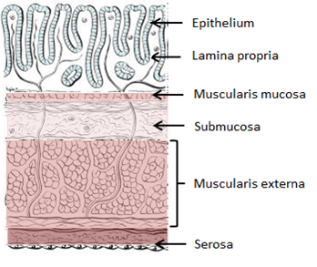
The colonic wall consists of the mucosa, submucosa, muscularis externa and serosa (see figure 1.1). The mucosa consists of the epithelium, lamina propria and muscularis mucosae. The lamina propria comprises of connective tissue that supports the epithelium by forming a specialised pericryptal myofibroblast sheath around each intestinal gland or crypt.
Figure 1.1: The colonic wall. This diagram illustrates the four main layers of the colon; the mucosa (consisting of the epithelium, lamina propria and muscularis mucosa), the submucosa, muscularis externa and the serosa. (Diagram modified from image from www.learnoncology.ca)

The muscularis mucosae, comprising of smooth muscle cells, forms the base of the mucosa. The submucosa is composed of loose connective tissue that contains blood vessels, lymphatics and nerves. The muscularis externa has an outer longitudinal and inner circular layer of smooth muscle. The longitudinal muscle fibres are aggregated to form the distinctive longitudinal bands or taeniae coli in the outermost layer of the colonic wall. These taeniae of the sigmoid colon gradually broaden to merge to give the rectum a continuous external longitudinal muscular coat (Sinnatamby, 2006).

Colonic epithelium and crypt organisation
The epithelial layer of the human colon consists of a single sheet of columnar epithelial cells, which form flask-like invaginations into the surrounding underlying connective tissue of the lamina propria to form the functional unit of the colon – the colonic crypt. Although the colonic epithelium is simple, being a monolayer, each cell is polarized with a basal and apical surface. There are six main differentiated cell types in the colonic epithelium; the absorptive cells (enterocytes) which are responsible for ion exchange, water resorption and other transepithelial transport functions, the mucous secreting goblet cells, the hormone secreting enteroendocrine cells (EECs), microfold (M) cells which overlay lymphoid follicles and play a role in antigen recognition, Paneth cells which play a role in host defence, and stem cells (Standring, 2008).
All cell types within the crypt can be derived from a single stem cell – the so called ‘unitarian theory’ (Cheng and Leblond, 1974) and it is the stem cells that are ultimately responsible for cellular repopulation. The cells in the upper portion of the colonic crypt are the most differentiated and cannot proliferate. These differentiated cells are continuously shed into the lumen from the top of the crypt. High levels of cellular proliferation occurs in the transit-amplifying zone of the mid-crypt which continuously replaces the shed luminal cells. Further towards the base of the crypts are located the stem cells. They are surrounded by the stem cell niche, formed by the stem cells themselves, and the mesenchymal cells that surround the crypt base (see figure 1.2). These pericryptal myofibroblasts produce various ligands and growth factors that control the maintenance of the stem cell habitus and the behaviour, migration and differentiation of the stem cell population (Humphries and Wright, 2008). It appears that cancer can arise following loss of the strict control over proliferation and migration events within the colonic crypt.
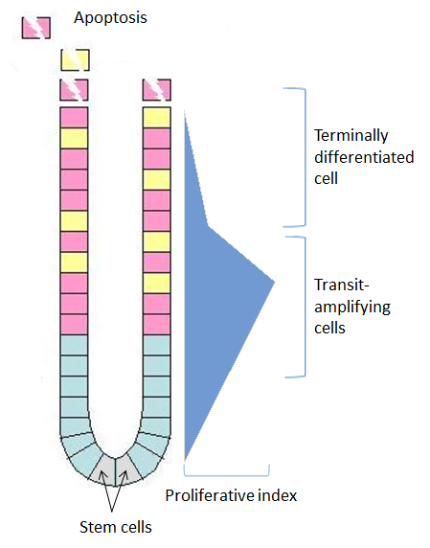

Figure 1.2: Schematic representation of the colonic crypt. Stem cells are located at the base of the crypt within the stem cell niche. The majority of cell proliferation takes place in the transit-amplifying zone of the mid-crypt with terminal differentiation usually occurring distal to this region. The proliferative index is the proportion of cells within the crypt that are undergoing cell division. (Diagram based on figure in review article by McDonald et al, 2006).

1.2 The enteroendocrine system

1.2.1 Overview
EECs, or gut endocrine cells, are specialised epithelial cells that represent only 1% of the total epithelial cell population in the GI tract yet their function is critical to digestive physiology. Although most endocrinology textbooks give GI hormones scant attention, despite the first hormonal pathway recognised being a GI hormone (Bayliss and Starling, 1902), the gut is the largest endocrine organ in the body producing over 30 different hormones (Ahlman and Nilsson, 2001).
In recent years gut hormones have returned under the research spotlight following their association with the dramatic weight loss and diabetes remission seen following bariatric surgery (Holst, 2013). They have been implicated in the regulation of appetite, energy expenditure, glucose homeostasis and lipid metabolism, the local fine tuning of secretion, absorption, motility and mucosal cell proliferation, in addition to influencing the intestinal mucosal immune system (Wu et al., 2013, Drucker, 2016, Psichas et al., 2015, Worthington et al., 2018).
EECs can be regarded as primary chemoreceptors that are ideally situated to sense and respond to environmental, nutrient, and microbial signals by secreting one or more hormones, regulatory peptides or bioactive molecules that activate visceral afferents, adjacent cells or distant targets (Sternini et al., 2008, Drucker, 2016, Murray et al., 2006). It is also clear that, in addition to modulating the secretion of gut peptides, dietary components also modulate transcription and EEC differentiation, which ultimately modifies the gut hormone response (Moran-Ramos et al., 2012). The importance of EEC function is illustrated by loss-of-function mutations in the human neurogenin-3 (NEUROG3) gene, a rare congenital syndrome that presents with failure to thrive, malabsorptive diarrhoea and is characterised by marked pan-intestinal depletion of EEC populations (Wang et al., 2006).

1.2.2 The challenge of EEC research
EECs are difficult to study due to their sparse and irregular localisation in the gut epithelium and as many of their actions are mediated locally via paracrine actions plasma levels of gut hormones do not appear to be helpful in assessing their role and mechanism of release (Raybould, 2010). Therefore the bulk of knowledge gained so far on EEC chemosensing has been gained via transformed cell line data, such as STC-1, GLUTag and BON cell lines. However, recent utilisation of EEC cells tagged with fluorescent protein in transgenic mice has enabled the isolation and study of native EECs, using patch clamping, dynamic calcium imaging and cell sorting techniques, leading to considerable progress in understanding EEC function (Reimann et al., 2008).

1.2.3 Classification of EECs
The enteroendocrine system is remarkably heterogenous, with at least 14 different EEC subtypes characterised (see table 1.1). EECs are traditionally classified based on their main hormonal products by immunhistochemical techniques – their ‘hormonal signature’ (Habib et al., 2012).
Cell type | Localisation | Hormone secreted | Function
G cell | Stomach | Gastrin | Regulation of acid secretion
P/D1 cell | Stomach | Ghrelin | Stimulates appetite
ECL cell | Stomach | Histamine | Regulation of acid secretion
F cell | Pancreas | Pancreatic polypeptide | Regulates pancreatic secretion
β cell | Pancreas | Insulin | Regulates carbohydrate and lipid metabolism
α cell | Pancreas | Glucagon | Promotes gluconeogenesis and glycogenolysis
K cell | Proximal intestine | GIP | Enhances insulin and gastric acid secretion, reduction of LPL activity in adipose tissue
I cell | Proximal intestine | CCK | Gallbladder contraction, stimulates pancreatic enzyme secretion, inhibits food intake
S cell | Proximal intestine | Secretin | Stimulates bicarbonate secretion, inhibits gastric acid secretion, colonic contraction and motility
M cell | Proximal intestine | Motilin | Stimulates gut motility
N cell | Jejunum and ileum | Neurotensin | Gastric acid secretion, biliary secretion, mucosal growth
EC cell | Throughout GI tract | 5-HT | Visceral sensation. Stimulates intestinal motility, secretion and appetite
L cell | Duodenum to rectum | GLP-1, GLP-2, PYY, glicentin, oxyntomodulin | Inhibits gastric acid secretion, gastric emptying and gut motility. Enhances insulin secretion
D cell | Throughout colon | SST | Major inhibitor of digestive exocrine and endocrine function

Table 1.1: EEC subtypes. This table summarises the typical location of EECs in the GI tract, the primary hormones they secrete and their function.

More recent studies have however challenged the traditional classification of EECs that have been based on immunohistochemical (IHC) characteristics, with increasing evidence that there is an overlap of EEC subtypes, with individual EEC types capable of exhibiting a spectrum of hormones, and therefore varying hormonal markers (Egerod et al., 2012, Habib et al., 2012, Grun et al., 2015, Drucker, 2016).

1.2.4 Structural features of EECs
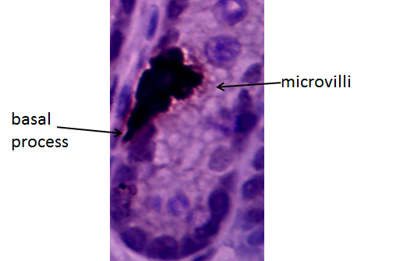
Although cellular morphology varies between subtypes, general features common to most EECs include an apical cytoplasmic process with microvilli that extend towards the luminal surface – so called ‘open cells,’ as opposed to the ‘closed cells’ that do not reach the lumen. EECs have basal processes that extend towards the adjacent epithelial cells (see figure 1.3), from which large dense-core vesicles (LDCVs) are exocytosed (Psichas et al., 2015). Basolaterally released gut hormones activate enteric, vagal and spinal sensory neurones via specific receptors on the nerve endings which lie in the mucosa and submucosa. Gut hormones can also enter the subepithelial space and act in a paracrine manner on neighbouring epithelial cells (Cox, 2007).

Figure 1.3: Human colonic enterochromffin (EC) cell. Immunohistochemical stain displaying microvilli and basal extension over an adjacent enterocyte. x40 magnification.

EEC secretion is also under neural control, with the contents of EEC secretory vesicles being demonstrated to undergo exocytosis in response to cellular membrane depolarisation (Psichas et al., 2015). Intriguingly, the anatomical relationship between connecting individual EECs and enteric neurons is now also thought to be more intimate than previously realised, with cytoplasmic projections from EECs – named neuropods – been shown to directly impinge on enteric neurons, enabling direct synaptic transmission between EECs and enteric nervous system (ENS) (Bohorquez et al., 2015).

1.2.5 Development and differentiation of EECs
The alternative names of EECs – ‘neuroendocrine’ or ‘APUD’ (amine precursor uptake and decarboxylation) cells reflect the previous understanding that EECs, given their expression of markers of neuronal differentiation and having similar ultrastructural properties common to neurons, were first thought to arise from the neural crest, and then to migrate to the gut (Pearse, 1969). Further work has however clearly established that EECs are derived from the endoderm and not the neuroectoderm (Andrew et al., 1998). Certainly the original observations the EECs share features with neurons has assumed new significance following more recent developments that have demonstrated that gut endocrine differentiation is regulated in a similar fashion to neuronal cellular differentiation. As is also seen in the nervous system, and additionally in the immune system, the Notch signalling pathway plays a critical role in endocrine cell fate determination in the intestine (Fre et al., 2005). Another similarity with the nervous system is the relationship between the spatial orientation of EECs and their differentiation process (Sei et al., 2011).

The differentiation process and spatial orientation of EECs
As opposed to endocrine cells in other glands that differentiate early in life and turnover slowly, EECs actively self-renew and differentiate from a large reservoir of stem cells throughout life (Schonhoff et al., 2004). Cell-labelling kinetics, morphological and histological methods have demonstrated that the majority of EECs complete the differentiation process within the crypt and migrate up the crypt-villus axis as mature hormone-producing cells (Cheng, 1974, Aiken et al., 1994, Roth and Gordon, 1990). On reaching the epithelial cuff at the luminal surface mature EECs then undergo apoptosis and are extruded into the lumen (Gordon and Hermiston, 1994). How stem cells are allocated to differentiate into EEC lineage is not completely understood although expression of stable reporter genes in transgenic mice have suggested that EECs differentiate from multipotential progenitor cells rather than individual precursors (Roth et al., 1990, Lopez et al., 1995). It is apparent that the lineage fate decision is made via the Notch signalling pathway which regulates the expression of basic helix-loop-helix (bHLH) factors that control terminal differentiation (Kageyama and Nakanishi, 1997). An important function of Notch signalling is to prevent adjacent cells to the differentiating EEC from adopting the same cell fate – so called lateral inhibition (Artavanis-Tsakonas et al., 1999). Notch signalling is inactive in the differentiated ECC however these same cells activate Notch signals in neighbouring cells thereby blocking endocrine differentiation. This results in a singly dispersed distribution with the specialised EECs often lying in isolation from one another being interspersed by nonendocrine epithelial cells (see figure 1.4).
Murine gene inactivation studies have identified important bHLH factors crucial for EEC differentiation (see figure 1.5). As in neuronal differentiation Math1, neurogenin3 (NGN3) and BETA2 are expressed sequentially during EEC differentiation, representing distinct stages in the differentiation pathway (Schonhoff et al., 2004). Math1 plays an important role in the specification of the secretory lineage (Yang et al., 2001) with NGN3 required for further differentiation into endocrine cell lineage-specific precursor cells. NGN3 expression is restricted to proliferating, immature cells in the intestinal crypts (Jenny et al., 2002).

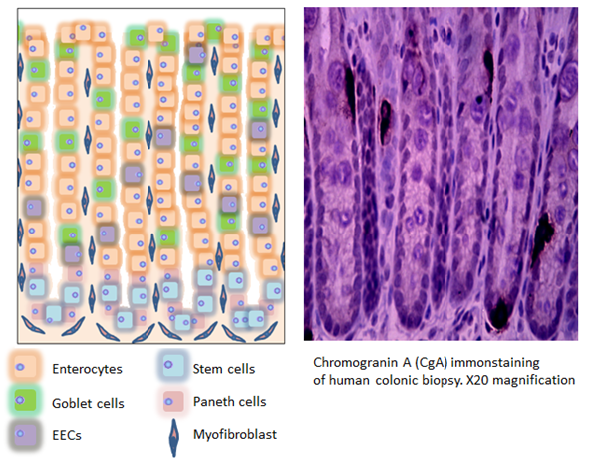

Figure 1.4: Distribution of EECs in the colonic crypt. The scattered distribution of EECs amongst the major cell types of the colonic crypts are depicted in the illustration on the left. Immunohistochemical stained section of normal human colonic epithelium on the right reveals EEC marker Chromogranin-A (CgA) positive cells, also demonstrating their scattered distribution.

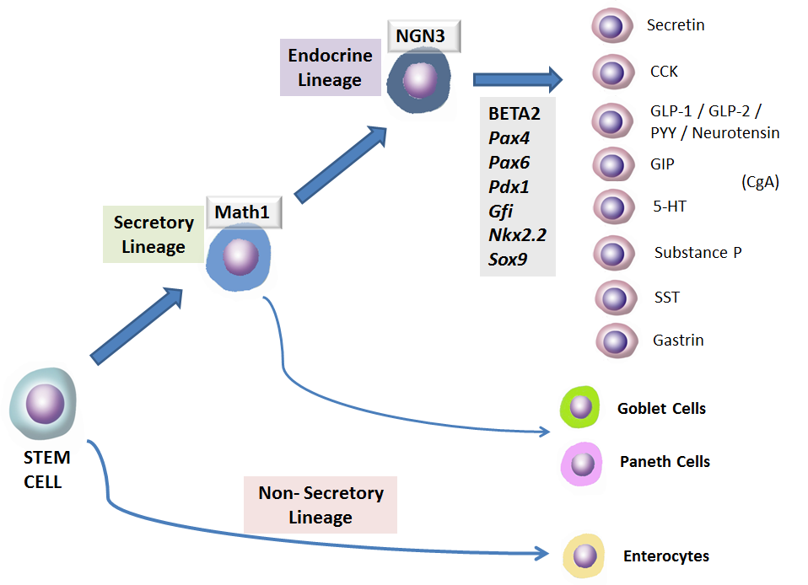

Figure 1.5: Overview of ECC differentiation. Stem cells, located in the crypt bases, differentiate into all four cell types in the intestinal epithelium. Math 1 expression restricts cells to the secretory lineage whereas NGN3 restricts cells to the endocrine lineage. Transcriptional factors, such as BETA 2 and Pax regulate the transcription of specific hormones. Figure based on schematic in review article by (Schonhoff et al., 2004)

Indeed NGN3 has not been identified in cells expressing mature endocrine cell differentiation markers, indicating that it is transiently expressed and is switched off before terminal differentiation (Schwitzgebel et al., 2000). Downstream of NGN3, additional transcription factors control the terminal differentiation of EECs into mature non-proliferating endocrine cells. BETA2 is a regulator of secretin and cholecystokinin (CCK) (Mutoh et al., 1997) with the paired box homeodomain transcription factors Pax 4 and Pax 6 also implicated in endocrine cell differentiation in the GI tract. Pax 4 null mice lack serotonin (5-HT) and somatostatin (SST) in the gastric antrum in addition to most EEC types in the proximal intestine. Pax 6 is thought to be required for normal differentiation of glucagon-like peptide-1 (GLP-1) and glucagon-like peptide-2 (GLP-2) expressing cells in the distal intestine, gastrin and SST-secreting cells in the gastric antrum and gastric inhibitory polypeptide (GIP) secreting cells in the duodenum (Schonhoff et al., 2004). Additional key transcription factors that have been identified also include Gfi (Shroyer et al., 2005), Nkx2.2 (Desai et al., 2008) and Sox9 (Formeister et al., 2009).
It does appear that there is an added degree of complexity to EEC differentiation pathways. Studies have demonstrated alternative bidirectional pathways where multiple neuroendocrine products can be coexpressed in various combinations along the crypt-villus axis (Roth and Gordon, 1990, Aiken and Roth, 1992, Aiken et al., 1994). It has also been demonstrated that a small population of intestinal EECs migrate to the bottom of the crypt from around position +4 (ie. 4 cells up from the crypt base) (Bjerknes and Cheng, 1981) and reside in the Wnt-signalling active zone alongside the Lgr5+ stem cells and Paneth cells (Sei et al., 2011). This EEC subset expresses both stem and postmitotic mature endocrine cell markers with a different phenotype from the other EECs that migrate up towards the villus. High expression of Sox9 has been demonstrated in a subset of EEC that reside below position +4 that coexpress Chromogranin-A (CgA), an immunomarker for EECs (Formeister et al., 2009).
With the distribution of EECs varying considerably along the GI tract it is also likely that differentiation pathways may also differ along the duodenal-colonic axis. IHC studies have further suggested that there are two distinct branches of EEC differentiation in the colon. The first EEC differentiation pathway produces substance P and 5-HT cells which do not colocalise with the human growth hormone (hGH) fusion gene. The second EEC differentiation pathway yields GLP-1, PYY, neurotensin and CCK which does colocalise with hGH. It is therefore likely that EEC phenotypes may be actively regulated by specific transcription factors that determine EEC subsets by controlling the specific coexpression of hormones and therefore EEC localisation within the crypt-villus axis.

1.2.6 EECs as luminal chemosensors
The role of EECs in recognising luminal nutrients causing release of their contents from secretory granules and thus resulting in the initiation of the varied functional responses listed in table 1.3 is gaining increased understanding and scientific interest (Raybould, 2010). Many of these responses result from the activation of intrinsic and extrinsic neuronal visceral afferent pathways with intrinsic and extrinsic sensory neurons mediating the effect of the gut hormones by expressing specific receptors for many of the gut hormones (Dockray, 2003).
Recent work has demonstrated that EECs express several G-protein-coupled receptors (GPCRs) that are thought to play a crucial role in chemosensation (Reimann et al., 2012). The current understanding is that luminal contents activate GPCRs on EECs resulting in downstream signalling activation with elevated intracellular calcium ion concentration and enhanced peptide release. Released peptides may then enter the circulation to act in an endocrine manner, activate intrinsic and extrinsic (mainly vagal) afferent neurons or act locally in a paracrine or autocrine fashion. SCFA receptors have been found to be expressed by EECs in the colon. This is detailed later in this chapter (see section 1.6.2).

1.2.7 EEC distribution and function in the large intestine
Based on IHC and ultrastructural characterisation, there are three main types of EEC in the large intestine; enterochromaffin cells (EC), L-cells and D-cells. The features of these cells, the secretory peptides they release and the physiological effects of these peptides are summarised in tables 1.2 and 1.3. The distribution of colonic EECs varies from the right side of the colon to the rectum (Gunawardene et al., 2011) (see figure 1.6).

Cell type | Distribution | Ultrastructural features | Secretory granules | IHC marker | Secretory products
EC cell | Throughout GI tract, most common EEC subtype | Pyramid shaped, often has slender apical process that reaches luminal surface | 150-500nm; pleomorphic | CgA, 5-HT, Syn, TPH | 5-HT
L cell | Duodenum to rectum, rare proximal to terminal ileum, greatest frequency in rectum | Bottle shaped often has apical process that reaches luminal surface, sometimes have basal process along basement membrane | 200-400nm; round | PYY, GLP-1, GLP-2, oxyntomodulin, glicentin,  (CgA), (Syn) | PYY, GLP-1, GLP-2, oxyntomodulin, glicentin
D cell | Throughout GI tract, least common EEC in rectum | Spindle shaped, often with slender apical process and shorter wider basal extension | 150-300nm; round | SST, (Syn) | SST

Table 1.2: Features of EECs found in the large intestine. This table summarises the three main EEC type found in the colon and rectum and their typical distribution, structural features, secretory products and corresponding immunomarkers.

Secretory peptide | Physiological actions
5-HT | Intestinal motility; propagation of MMCs; intestinal secretion; visceral sensation
SST | Major inhibitory hormone for digestive endocrine and exocrine function; influences colonic peristalsis
GLP-1 | Stimulates insulin release (incretin effect); delays gastric emptying; inhibits gastric acid secretion; appetite suppression
GLP-2 | Stimulates mucosal enterocyte proliferation; adaptive response to short bowel syndrome
PYY | Inhibits gastric emptying and intestinal motility; ileo-colonic brake; inhibits gastric acid secretion and pancreatic exocrine function; appetite suppression; stimulates mucosal enterocyte proliferation
Glicentin | Stimulates mucosal enterocyte proliferation, inhibits gastric emptying
Oxyntomodulin | Inhibits gastric emptying

Table 1.3: Secretory peptides of EECs of the large intestine. This table outlines the main functions of each of the hormones secreted by EECs found in the colon and rectum.
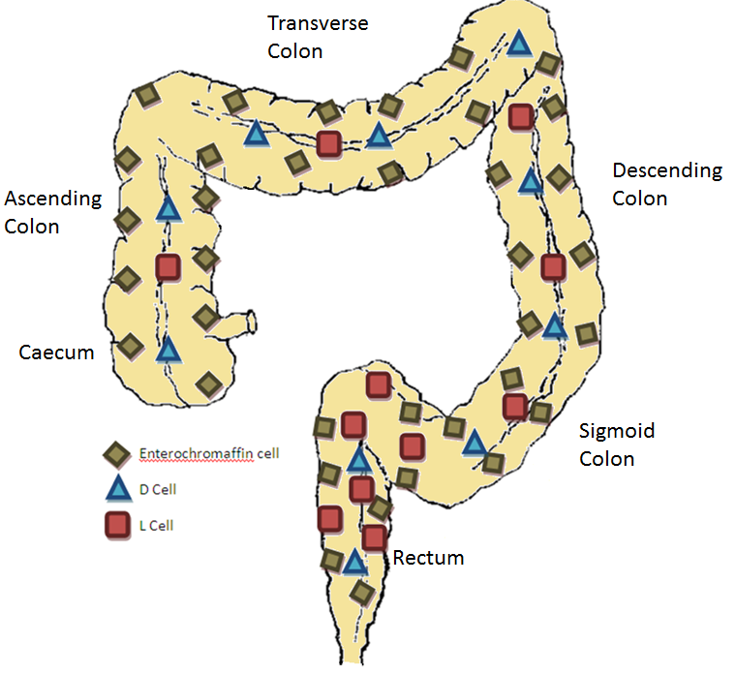

Figure 1.6: Distribution of EEC subtypes in the colorectum. Adapted from review article (Gunawardene et al., 2011).
EC cells are the most abundant EEC of the GI tract from the gastric antrum to the rectum. The number of EC cells is fairly consistent along the length of the colon, however due to a rise in other EEC subtypes in the distal colon and rectum, the proportion of EC cells falls from 70% in the proximal colon to 40% in the rectum (Sjolund et al., 1983). L-cells are uncommon proximal to the terminal ileum from where their frequency increases as one moves distally to peak in numbers in the rectum. D-cells are relatively uncommon, comprising of 3% of the EEC population overall, although they are scattered evenly throughout the colon (Gunawardene et al., 2011).

1.2.8 Colonic EECs and their role in disease states
EEC dysfunction relating to various disease processes is acknowledged although is still poorly understood (Harrison et al., 2013). Reflecting the local paracrine and distant endocrine effects of EEC products, there is an increasing knowledge base that associates colonic EECs with various pathological processes - in both colonic and extra-colonic diseases.

Colorectal neoplasia
The role that colonic EECs may play in colorectal adenocarcinoma is covered in section 1.5.9. Colorectal neuroendocrine tumours (NETs) are a group of uncommon, heterogenous neoplasms, traditionally referred to as carcinoid tumours, which arise from EECs. NETs arising from the colon and rectum have different clinic-pathological characteristics. EC cell NETs tend to occur in the right colon whereas L-cell type NETs are more likely to be found in the rectum. Right-sided colonic NETs have the worst prognosis and have often metastasized at presentation, whereas rectal NETs have a much better prognosis (Yao et al., 2008). Patients with localised NETs are usually treated surgically. However, approximately 40 % of NETs present with metastatic disease at diagnosis and therefore require systemic therapy (Modlin et al., 2008). Somatostatin analogues (SSAs), such as octreotide and lanreotide, were initially developed as antisecretory agents used primarily to palliate hormonal symptoms in metastatic NETs through activation of SST receptors (SSTR) 1,2 and 5 (Cives and Strosberg, 2015). The use of preoperative SSA infusions are also well established in the prevention of carcinoid crisis in patients with known carcinoid syndrome undergoing surgery (Kvols et al., 1985). There is also more recent data emerging to support the role of SSAs as antiproliferative agents with the multicentre randomised double-blind CLARINET trial demonstrating significant prolonged progression free survival in patients with metastatic SSTR+ve enteropancreatic NETs, although only 7% of the patients included in the trial had colorectal-NETs with the majority of study participants having pancreatic and midgut NETs (Caplin et al., 2014). EEC cancers do however remain difficult to treat and are often resistant to chemotherapy regimens. Progress is also limited in the understanding of EEC tumour pathogenesis at a molecular level that may better inform innovative target therapeutics in the future (Drucker, 2016).

Inflammatory bowel disease
The aetiology of inflammatory bowel disease (IBD) is not completely understood with limitations of available treatments. With an estimated 75% of the human body’s immune cells (ICs) present in the GI tract, with ICs lying within close proximity to EECs (Zhang et al., 2012) and EEC hormone receptors expressed on numerous intestinal immune cells, there is increasing interest in EECs as orchestrators of intestinal inflammation (Worthington et al., 2018). Abnormal distribution of EECs and elevation of serum levels of EEC-secreted hormones have been demonstrated in patients and animal models of ulcerative colitis (UC), Crohn’s disease (CD) and lymphocytic colitis (El-Salhy et al., 2017a, Harrison et al., 2013). Although there have been conflicting reports in the literature, in general the cellular expression and secretion of CgA, 5-HT, GLP-1 and GLP-2 appear to increase in IBD, with the number of SST and PPY expressing cells shown to decrease in the colons of IBD patients (El-Salhy et al., 1997, Schmidt et al., 2005, Xiao et al., 2000, El-Salhy et al., 2017a). The EEC system as a target for IBD therapy has been explored, with antagonists of 5-HT receptors 5-HTR3 and 5-HTR7 having shown anti-inflammatory effects in rodent models of human IBD (Furusawa et al., 2013, Kim et al., 2013), and also with the intestinal specific inhibition of 5-HT production also showing promise in pre-clinical studies as a novel therapy for IBD (Levin and van den Brink, 2014).

Irritable bowel syndrome
With their close link to colonic function, its unsurprising that EECs are also thought to play a role in functional bowel disorders such as irritable bowel syndrome (IBS). IBS is a chronic, sometimes disabling, condition defined by symptoms (recurrent abdominal pain associated with bowel disturbance) in the absence of organic disease on routine testing (Ford et al., 2017). IBS is classified into diarrhoea-predominant IBS (IBS-D), constipation predominant IBS (IBS-C) and IBS with mix bowel habit, with the impaired bowel function arising mainly from the colon and to a lesser extent the small bowel. It is a disorder of the gut-brain interaction and is related to visceral hypersensitivity, motility disturbance, altered mucosal and immune function and altered gut microbiota (Mearin et al., 2016).
While there are conflicting findings in the literature, mainly dependent on the method of measurement used and the subtype of IBS, several studies have reported pertubations in EEC expression in the colorectum and alterations in circulating levels of EEC hormones in IBS patients compared with controls (Camilleri, 2014) with colonic EEC populations returning to normal levels following treatment with a low FODMAP (fermentable oligosaccharides, disaccharides, monosaccharides and polyols) diet (Mazzawi et al., 2016).
Receptors to peptides secreted by EECs have also been a target for IBS pharmacotherapies. Stimulation of 5-HT₃ receptors causes smooth muscle contraction, whereas stimulation of 5-HT₄ receptors results in smooth muscle relaxation. A recent systematic review and meta-analysis found that 5-HT₃ receptor antagonists, including alosetron, cilansetron, ramosetron and ondansetron improve IBS symptoms in non-constipated IBS, although such drugs are used in selective patients with severe IBS refractory to conventional therapy due to the rare risk of ischaemic colitis that has been reported with cilansetron and alosetron (Zheng et al., 2017). The 5-HT₄ receptor agonist prucalopride reduces colonic transit time (Emmanuel et al., 2014) and has also been approved for the treatment of chronic idiopathic constipation (Omer and Quigley, 2017). While there has been more focus on 5-HT signalling and IBS, manipulation of SST receptors (see section 1.3.8) and GLP-1 receptors have also revealed potential in the treatment of IBS. A multicentre European trial investigating ROSE-010, a GLP-1 agonist, found it to be a fast and effective analgesic for IBS patients (Hellstrom et al., 2009) with a more recent study finding increased colonic transit time, particularly in the distal colon, in IBS-C patients treated with ROSE-010 (Camilleri et al., 2012). These findings are supported by the work of Li et al who observed decreased levels of serum GLP-1 with a downregulation in expression of GLP-1R in colonic mucosa of patients with IBS-C (Li et al., 2017).

Colonic diverticulitis
Patients with a history of colonic diverticulitis have also exhibited decreased 5-HT transporter (SERT) expression compared with healthy controls, with 5-HT thought to contribute to symptoms of disordered motility following an attack of diverticulitis (Costedio et al., 2008).

Extra-colonic diseases
GLP-1 and PYY are anorectic hormones that are implicated in appetite control with the greatest concentrations of GLP-1 and PYY found in the colon. They are released together following a meal to mediate post-prandial satiety (De Silva and Bloom, 2012). GLP-1 and PYY act in an endocrine fashion on the central nervous system (CNS) at the arcuate nucleus of the hypothalamus and in a paracrine fashion via the vagal-brainstem-hypothalamic pathway resulting in appetite suppression. GLP-1 also inhibits gastric emptying via a vagal afferent-mediated central mechanism (Imeryuz et al., 1997) with PYY also inhibiting gastric emptying and reducing intestinal transit in order to optimise food absorption via the ‘ileal brake’ mechanism (Van Citters and Lin, 1999). Bariatric surgery provides a stimulus to distal L-cells, with post-prandial profiles of GLP-1 and PYY significantly increasing following Roux-en-Y gastric bypass surgery. The increased satiety is therefore thought to contribute to the weight loss experienced by patients undergoing bariatric surgery (Vincent and le Roux, 2008). GLP-1 receptors agonists have been found to be effective for weight reduction, with the GLP-1 receptor agonist liraglutide approved in Europe and USA for the pharmacological management of obesity (Isaacs et al., 2016). The anti-obesity effects of PPY analogues have also been investigated in animal models and early clinical trials (Tan et al., 2017, Batterham et al., 2002, Cegla et al., 2015).
There has been a comprehensive expansion in knowledge with regards the role of GLP-1 in diabetes (Drucker, 2012). GLP-1 has an incretin effect, whereby it directly stimulates the synthesis and secretion of insulin from islet cells. It has been noted that colonic L-cell expression increases in type II diabetics compared with healthy participants (Jorsal et al., 2018). Advances in translational research have resulted in two new classes of drugs that reduce blood glucose levels being approved to treat type 2 diabetes; dipeptidyl peptidase 4 (DPP-4) inhibitors, that lower the degradation of circulating GLP-1, and GLP-1 receptor agonists (Thrasher, 2017, NICE, 2015). GLP-1 has also been found to exert important actions on the cardiovascular system, especially in diabetic patients, in whom it reduces the development and progression of cardiovascular complications (Tate et al., 2015).
Over recent years there has been increasing attention on the GLP-1 signalling pathway and the brain with GLP-1, and GLP-1 mimetic drugs, being found to have a neuroprotective and neurotrophic effect on brain. Interestingly, this has led to increasing work in animal models and in pre-clinical trials on new treatment strategies for neurodegerative disorders such as Alzheimer’s and Parkinson’s disease, through the gut-brain axis (Kim et al., 2017, Tramutola et al., 2017).

1.3 The colon as a sensory organ

1.3.1 Introduction: gut-brain communication
The interaction between the gut and the brain plays an important role in GI function. The concept that the gut and the brain are closely connected is also deeply rooted in our language with gut-brain signalling also thought to be involved in certain feeling states and intuition (James, 1884, Berntson et al., 2003, Mayer, 2011). This relationship was first described by Beaumont in 1833 following his studies of Alexis St. Martin, a man who had developed a gastro-cutaneous fistula following a gunshot to the abdomen. Beaumont observed that changes in the gastric mucosal colour, secretions and motility were affected by Alexis’ emotional state (Beaumont, 1977). The importance of this interaction on the maintenance of normal homeostasis is emphasised when consideration is given to the size and complexity of the ENS, the extent of the intestinal surface area, the size of the population of commensal microorganisms that reside in the gut lumen, the number of immune cells present in the intestines in addition to the influence of the enteroendocrine system. Referred to as the “brain of the gut” (Goyal and Hirano, 1996), the human ENS comprises of between 200 and 600 million neurons - on par with the number of neurones found within the spinal cord (Furness, 2006). The intestinal surface area, approximately 100 times larger than the surface area of the skin (Gallo and Hooper, 2012), contains the largest population of commensal microorganisms from over 50 genera and hundreds of species with 100 times the number of genes than in the human genome (Kurokawa et al., 2007). The emerging biology of gut-brain crosstalk reveals a complex bidirectional communication system that ensures maintenance of GI homeostasis and digestion and also is likely to have various influences on higher cognitive functions, affect, motivation and intuitive decision making, with disturbance of this communication system implicated in a wide range of functional and inflammatory GI disorders, including obesity (Mayer, 2011). This includes top-down modulation of GI function by stress and emotions (Welgan et al., 1988, Khasar et al., 2008, Gopal et al., 2008), via the autonomic system (ANS), the hypothalamic-pituitary-adrenal axis, the sympatho-adrenal axis and the descending monoaminergic pathways (Furness and Costa, 1974, Jaenig, 2006) and bottom-up signalling from visceral afferents to the CNS. This thesis applies focus to mechanisms associated with bottom-up signalling, in particular the extrinsic spinal afferent pathway.

1.3.2 Innervation of the large intestine
Distal bowel function is modulated by two sources: the intrinsic and extrinsic nerves. The intrinsic innervation comprises of the ENS, consisting of neurones with cell bodies within the wall of the gut. The extrinsic innervation, on the other hand, comprises of the sympathetic and vagal-sacral parasympathetic tracts in addition to the extrinsic spinal sensory pathway. GI primary afferent neurons are divided into three subtypes (see figure 1.7). Intrinsic primary afferent neurons (IPANs) have cell bodies and connections that lie entirely within the gut wall. Extrinsic primary afferent neurons have cell bodies that lie within the vagal and dorsal spinal root ganglia. Viscerofugal neurons (nerve cells that project out of the gut wall to prevertebral sympathetic ganglia) represent the third subtype which act as interneurons between the enteric and sympathetic nervous systems.
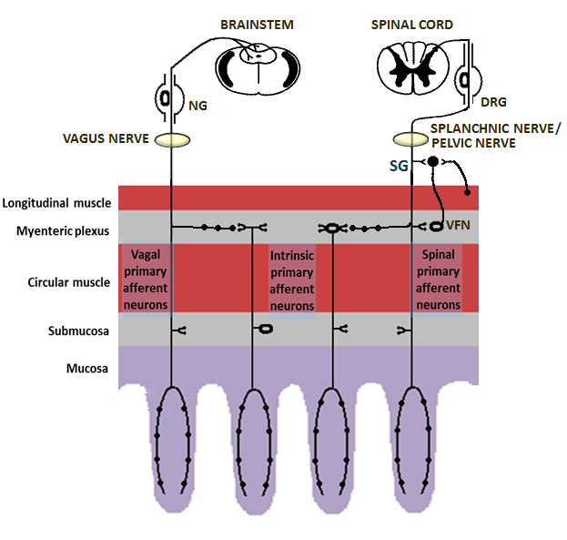

Figure 1.7: Primary afferent neurons of the gastrointestinal tract. The IPANs are confined to the gut wall, with cell bodies in either the submucosal or myenteric plexus. Collaterals of the extrinsic vagal and spinal extrinsic primary afferents run in the enteric ganglia. Cell bodies of the vagal primary afferent neurons lie in the nodose ganglia (NG) and those of the spinal afferents in the dorsal root ganglia (DRG). Viscerofugal neurons (VFN) have cell bodies that lie in the myenteric plexus with fibres that pass through to the sympathetic ganglia (SG) to then project back to the gut. Adapted from a review article (Holzer et al., 2001)

1.3.3 Intrinsic innervation – the enteric nervous system
The colonic ENS regulates and coordinates the activity of the colon via a complex system of neurons and glia that are organised into collections of ganglia and a network of nerve fibres and terminals that innervate the specialised effector cells of the gut wall. The ENS contains as many neurons as the spinal cord (Furness, 2012) and given its structural and neurochemical complexity has given rise to the term ‘brain-in-the-gut’ (Grundy et al., 2000). The ENS utilises the same neurotransmitters as the CNS including acetycholine, substance P, neurokinin A, nitric oxide, adenosine triphosphate (ATP), vasoactive intestinal peptide and pituitary adenyl cyclase-activating peptide (Szmulowicz U, 2011). The ENS consists of IPANS, interneurons and excitatory and inhibitory motor neurons. Although the specialised ‘command’ intrinsic motor neurons receive input from the CNS via the vagal and splanchnic pathways, the integrated reflex microcircuits of the ENS allow it to regulate motility, endocrine secretion, mucosal transport and blood flow, independent of the CNS (Furness et al., 1995, Costa et al., 2000) .
Throughout most of the gut, the ENS consists of intermeshed ganglionated plexuses which lie between the longitudinal and circular smooth muscle layers (the ‘myenteric’ or Auerbach’s plexus) and in the submucosal layer (the ‘submucosal’ or Meissner’s plexus). The submucosal plexus appears to be concerned with mucosal and vasomotor function whereas the myenteric plexus contains mainly motor neurons that project into the circular muscle layer therefore regulating motility.
IPANs are activated by the presence of nutrients in the gut lumen. Three types of stimuli can activate the reflex circuitry of the ENS; chemical composition of the luminal content, mechanical distension of the intestine and mechanical distortion of the mucosa (Bertrand et al., 1997, Furness et al., 1998). The nerve processes of these multipolar neurons branch in the lamina propria with axons extending into the gangionated plexuses supplying terminals to several other nerve cells including other IPANs, interneurons and motor neurons. Therefore the nerve terminals of the IPANs do not extend as far as the gut lumen. Instead EECs, with their apical surfaces exposed to the lumen, act as sensory transducers by releasing peptides from their basolateral surfaces. The intracellular signalling compounds then act in a paracrine fashion on the axonal processes that project into the lamina propria resulting in depolarisation of the IPANs and extrinsic primary afferent neurons. EECs are therefore essential transducers of the integrated reflex microcircuit in the gut.
Several populations of myenteric interneurons have been described (Costa et al., 1996). In the human colon the interneurons tend to have longer projections than motor neurons (Wattchow et al., 1995) and they synapse with other interneurons of the same class thus forming functional chains that can run for considerable distances along the gut, and are thereby responsible for the spatial spread of reflex activity along the colon.
The viscerofugal neurons project out of the gut wall to the prevertebral sympathetic ganglia. Physiological studies confirm that viscerofugal neurons function as interneurons connecting the ENS with the sympathetic nervous system (Kuntz and Richins, 1946). In the distal bowel a proportion of these viscerofugal neurons project to the pelvic ganglia (PG), suggesting they may also activate the parasympathetic pathways (Luckensmeyer and Keast, 1996).

1.3.4 Extrinsic sympathetic nervous system
The sympathetic pathways exert a predominantly inhibitory effect on GI function (Aziz and Thompson, 1998). Although it provides a direct but sparse innervation of the smooth muscle itself, in the main the effect of the sympathetic pathway on motility is by indirect influence on the enteric neuronal circuitry (Brookes et al., 2009). Released noradrenaline, acting on alpha-2 adrenoreceptors, causes presynaptic inhibition on of the enteric circuits and therefore a ‘damping down’ of the enteric motor reflexes.
The gut receives powerful input from neurons in the paravertebral and prevertebral sympathetic ganglia. Although the majority of paravertebral sympathetic neurons are concerned with blood flow, the prevertebral sympathetic neurons have three specific functions in the GI tract (Macrae et al., 1986); vasoconstriction of mesenteric and submucosal arteries and arterioles, the modulation of secretory activity via the submucosal plexus and influence on motility via the myenteric plexus. The sympathetic neurons synaptic drive is received from three major sources. Firstly the preganglionic neurons of the thoraco-lumbar spinal cord provide excitatory input from the CNS. Secondly, viscerofugal neurons provide specific input from the gut wall and thirdly are the collateral branches from the spinal sensory neurons which excite the prevertebral sympathetic neurons. With the spinal afferent neurons functioning as nociceptors, this enables activation of the sympathetic efferent pathway by noxious stimuli resulting in a tendency to slow down gut function.

1.3.5 Extrinsic parasympathetic nervous system
Whilst the upper GI tract receives powerful vagal parasympathetic efferent input, this extends only as far as the distal third of the transverse colon. These parasympathetic fibres reach the colon by following the colonic branches of the superior mesenteric artery (via the ileocolic and middle colic arteries). More distal colonic regions receive little or no innervation from the vagus nerve and instead receive input via the sacral parasympathetic pathways. These arise from the sacral parasympathetic nucleus (SPN), which projects out of the ventral roots of S2-S4 in humans, via the pelvic nerves (PNs), to the pelvic plexus ganglia - referred to as the inferior hypogastric plexus in humans (Brookes et al., 2009). The axons of the SPN either synapse with cholinergic parasympathetic efferent nerve cell bodies in the hypogastric plexus and then project to the gut wall or pass without synapsing via the PNs, hypogastric plexus and rectal nerves to the rectal wall (Olsson et al., 2006).
Within the wall of the rectum the pelvic axons form thick bundles, sometimes known as ‘ascending nerves of the colon,’ that run proximally and distally, distributing the influence of the sacral parasympathetic pathways up and down the distal colon, exciting enteric neurones via nicotinic cholinergic synapses. The parasympathetic system is responsible for the ‘rest and digest’ activities of the body and in the colon it has a role in colonic propulsion activity, in the pan-colonic activity that precedes defaecation (Brookes et al., 2009). In addition there is growing evidence that the vagal afferents of the proximal colon are involved in nutrient sensing and regulation of appetite and glucose metabolism.

1.3.6 Extrinsic sensory innervation of the colon
The proximal colon receives sensory afferents via the vagal nerve however the density of vagal sensory innervation decreases distally (Berthoud et al., 1997) and the majority of the distal colon is innervated by spinal afferent neurons alone, with cell bodies present in the lumbar and sacral dorsal root ganglia (DRG) (Olsson et al., 2006). It is the influence of SCFAs on this spinal afferent pathway which is the focus of chapter 5 of this thesis. The spinal afferent neurons travel in the thoracolumbar or sacral pathways (see figure 1.8). The cell bodies of the thoracolumbar afferent pathway lie in the spinal ganglia peaking at L2/L3. Their axons travel via the lumbar splanchnic nerves (LSNs), passing through the prevertebral sympathetic ganglia – mostly via the inferior mesenteric ganglia (IMG), before reaching the colonic wall via the lumbar colonic nerves. The cell bodies of the sacral afferents lie in the DRG of the sacral segments, peaking at S1/S2. Axons run via the sacral pelvic nerves (PNs), into the PG and into the gut wall via the rectal nerves. In the colonic wall the rectal nerves join the shunt fascicles and project for long distances proximally and distally. A proportion of lumbar colonic afferents run from the IMG into the hypogastric nerves and enter the distal gut wall also via the rectal nerves. Therefore rectal nerves contain mixed population of thoracolumbar and sacral afferents.
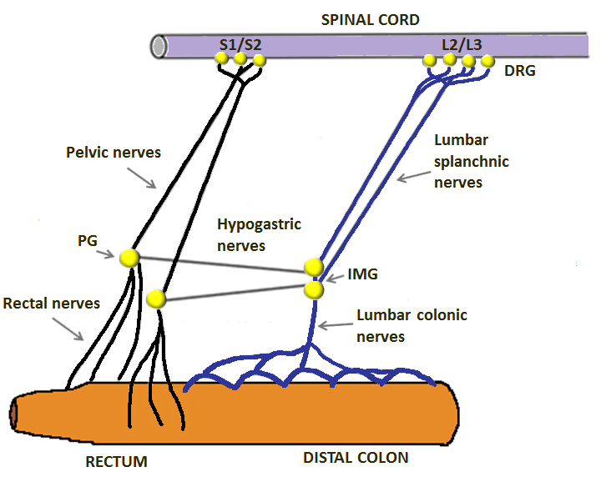
Figure 1.8: Extrinsic sensory innervation of the distal colon and rectum. The distal bowel is innervated by the spinal afferent neurons with cell bodies in the lumbar and sacral dorsal root ganglia (DRG) forming two distinct pathways – the thoracolumbar (blue line) and sacral afferent pathways (black line). Thoracolumbar axons reach the gut wall via lumbar splanchnic nerves, the inferior mesenteric ganglia (IMG) and then lumbar colonic nerves. Axons of the sacral pathway pass via pelvic nerves and pelvic ganglia (PG) to reach the gut wall as rectal nerves. The rectal nerves contain a mixed population of thoracolumbar and sacral afferents as some lumbar colonic afferents run from the IMG through the hypogastric nerves and into the distal gut wall within the rectal nerves. Adapted from article by (Kyloh et al., 2011)

1.3.7 Modulation of colon sensory excitability
Visceral afferents demonstrate a varied response to chemical and mechanical stimuli with excitability determined chiefly by the membrane voltage gated sodium (Na_{v}) and potassium (K_{v}) channels. Na_{v} channels mediate the rapid upstroke of the action potential that follows channel activation and depolarisation. K_{v} channels function to repolarise the cell membrane thereby limiting repetitive firing. Ligand gated channels, including transient receptor vallanoid (TRPV) channels, P2X receptors, 5-HT₃ receptors and GPCRs, protease activated receptors (PARS), glutamate receptors, gamma amino butyric acid type B receptors (GABA_{B}), gasotransmitters, including nitric oxide and hydrogen sulphide, SSTRs, and the satiety hormones (GLP-1, CCK, leptin, and PYY) can all impact the function of these channels, either directly or indirectly and can influence the excitability of visceral afferents resulting in states of visceral hypo- and hypersensitivity (Beyak, 2010).

1.3.8 Influence of EEC hormones on colonic afferent sensitivity
The role that EECs may play in abdominal pain related to IBS were discussed in section 1.2.8. 5-HT receptors are present on colonic afferent nerves and 5-HT is known to increase afferent firing with its effect nearly completely attenuated by selective 5-HT₃ receptor antagonists (Keating et al., 2008). 5-HT is also involved in the perception of colorectal distension with 5-HT₃ antagonists shown to be effective in relieving visceral sensation in response to balloon distension (Spiller, 2002).
Studies have also suggested SST signalling also influences visceral afferent sensitivity with octreotide and a SST₂ receptor agonist both found to inhibit mesenteric afferent firing in a rodent model (Booth et al., 2001). In addition, inhibition of the afferent response to rectal balloon distension had been demonstrated in IBS patients treated with octreotide (Hasler et al., 1994, Schwetz et al., 2004). Mice deficient in the SST₂ gene also demonstrate hyperexcitability with enhanced responses to mechanical and chemical stimuli suggesting that endogenous SST may dampen the excitability of intestinal afferents (Rong et al., 2007).
GLP-1 is known to directly augment vagal afferent activity (Drucker, 2006) with emerging literature pointing to the importance of visceral vagal afferents in appetite suppression and glucose homeostasis (Abbot et al., 2005). Direct physiological recordings from hepatic afferents demonstrate an increase in firing rate in response to GLP-1 (Nishizawa et al.,2000) and preliminary work has demonstrated that GLP-1 increases the firing on extracellular recordings of jejunal afferents (Gaisano et al., 2009). Despite the majority of GLP-1 secreting L-cells residing in the lower GI tract, the direct effects of GLP-1 and PYY on colonic afferent firing remains to be investigated. Interestingly, a study from China has more recently reported that intraperitoneally administered exendin-4, a GLP-1 analogue, attenuates colonic hypersensitivity with a reduction in abdominal withdrawal reflex scores and electromyography signals in rats who had received the exendin-4 treatment compared with controls (Yang et al., 2014).

1.3.9 Colorectal sensation and visceral pain
Although the colorectum has a rich afferent innervation, colorectal sensation remains a poorly understood topic. In the healthy colon, most physiological stimuli go unnoticed with activation of ‘true sensory fibres’ leading to fullness and the conscious awareness of rectal filling being crucial to the maintenance of continence. The role of colonic afferent nerves in colorectal diseases has been appreciated, with alteration in excitability or loss and impairment of colonic afferents observed in IBD, IBS and slow transit constipation (Brookes et al., 2009, Beyak, 2010).
Afferent nerve endings lie within the mucosa, muscularis propria and the serosa, in addition to the mesenteric Pacinian corpuscles (O’Brien, 1996). Recent studies have clearly demonstrated that LSN and PN colonic afferents transmit different patterns of information to the CNS, not only with regards the signalling of mechanical events but also in terms of signalling of chemical activation (Brierley et al., 2005). There are differences in sensory perception following colonic and rectal distension. Rectal-type sensation, which occurs with distension of the bowel wall up to 15cm from the anal verge, is referred to the rectum itself or the sacral region resulting in the desire to pass faeces or flatus. Above 15cm, the colonic-type sensation elicited by distension causes sensation in the lower abdomen perceived as ‘wind pain’ or colic (Goligher and Hughes, 1951). It is thought that rectal sensation may not be perceived unless distension elicits a contraction with in vivo magnetic resonance imaging (MRI) studies revealing more recently that colorectal distension results in a complex mechanical reaction in part due to the unpredictable geometry of the rectal wall (Frokjaer et al., 2005, Frokjaer et al., 2007). Pain, distension, mesenteric traction and noxious mucosal stimuli are discerned via the LSN afferents whereas the PN afferents are concerned with the sensation of rectal fullness and defaecation (Cook and Brookes, 2006). Recordings of the sensory outflow from the distal colon have revealed high threshold mechanosensitive afferents with stretch-sensitive transduction sites on intramural blood vessels (Song et al. 2009). These same intramural sensory nerve endings are also activated by strong contractions of the muscularis externa, thereby mediating the activation of pain pathways caused by intestinal spasm. In contrast, rectal nerve recordings have revealed a distinct population of low threshold mechanosensitive afferents that are exquisitely sensitive to distension and contraction of the surrounding muscle coat, properties that allow the detection of non-noxious distension of the rectum by faecal matter (Brookes et al., 2009).
Visceral pain sensation is modulated via rapidly conducting Aδ fibres, concerned with the more localised ‘discriminative’ pain, and unmyelinated C fibres, that are associated with the more diffuse ‘affective-motivational’ pain that convey sensory information towards the somatosensory cortex via the spinothalamic and spinoreticular tracts and the dorsal column of the spinal cord (Bharucha and Camilleri, 2007). Modulation of visceral sensation occurs at various levels. Spinal enteroenteric reflexes result in changes in the colonic smooth muscle tone which in turn leads to changes in the activation of afferent nerve endings in the bowl wall or mesentery (Parkman et al.,1993). Descending noradrenergic and serotinergic pathways, that arise from the reticular formation, hypothalamus and frontal cortex, project to the dorsal horn of the spinal cord where they modify noxious input from the visceral afferent nerves (Szmulowicz U, 2011). It is here, in the dorsal horn of the spinal cord, where visceral spinal afferent nerves intersect with somatic afferent nerves to produce the phenomenon of referred pain (Moore, 2010).

1.4 Short-chain fatty acids

1.4.1 Dietary fibre, SCFA production and absorption
Although the upper GI tract is primarily responsible for digestion and absorption, the colon also plays an important role in this process by salvaging nutrients, including complex carbohydrates such as dietary fibre that are resistant to digestion and absorption in the proximal intestine. Dietary fibre is such a nutrient, and can be categorised into two main types - soluble and insoluble and divided further into short-chain and long-chain carbohydrates, and fermentable or non-fermentable types (El-Salhy et al., 2017b).
The colon is inhabited by over 400 species of bacteria, the majority of which are obligate anaerobes, existing in symbiosis with the human host during health (Roberfroid et al., 2010). Fermentation of mainly soluble fibre by the colonic bacterial flora produces SCFAs (see figure 1.9), which are 2-carbon to 5-carbon weak acids that represent the major anions in the mammalian large intestine (Szmulowicz U, 2011).
SCFAs in the colon comprise principally of butyrate (20%), propionate (20%) and acetate (60%) (Cummings et al., 1987) with the amount of SCFAs produced in the colon depending on the site of fermentation, the diet composition, gut transit time and the composition of the bacterial microenvironment. Bacterial fermentation of complex carbohydrates mainly occurs in the proximal colon with luminal concentrations of SCFAs decreasing more distally, with the mean total SCFA concentration in the human left colon being 80 mM compared with 131 mM in the caecum (Cummings et al., 1987). Of the three main SCFAs, an in vivo study in rodent colon demonstrated that concentrations of butyrate range from 0-33 mM, acetate 0-58 mM and propionate 0-27mM across periods of starvation and refeeding (Topping and Clifton, 2001). In a human ex vivo study (4 hours post-mortem) concentrations of butyrate ranged from 14.7-24.5 mM, acetate 43.5-63.4 mM and propionate 14.2-26.7 mM (Cummings et al., 1987).
While numerous bacterial strains have been analysed for their SCFA-producing capabilities, Faecalibacterium prausnitzii and Eubacterium rectale/Roseburia have currently received the most attention as butyrogenic bacteria given that they also constitute almost 10% of total bacteria in faecal samples collected from healthy human volunteers (Louis and Flint, 2009).
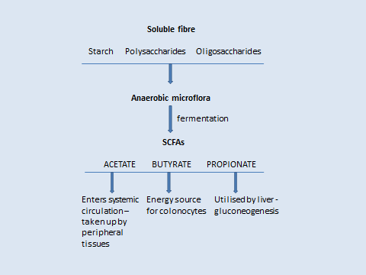
Several mechanisms have been proposed to explain the uptake of SCFA across the apical membrane of the colonocyte. These include direct diffusion of SCFAs in their undissociated lipid soluble form, the SCFA/HCO₃ exchange mechanism and by active transport of the dissociated form by SCFA-transporters - monocarboxylate transporter 1 (MCT1) and sodium coupled monocarboxylate transporter (SMCT1). The SCFAs stimulate the absorption of luminal sodium and therefore water into the colonocyte thereby promoting an anti-diarrhoea effect (Stumpff, 2018).

Figure 1.9: Colonic SCFA production. SCFAs are a sub-group of fatty acids which are produced in the colon by the bacterial fermentation of dietary fibre such as starch, polysaccharides and oligosaccharides. The weak acids are absorbed and incorporated as the basic elements for mucin synthesis, lipogenesis, gluconeogenesis and protein production. In particular propionate is taken up by the liver and utilised in gluconeogenesis. Acetate is also used by the liver to form longer-chain fatty acids, however a significant amount enters the systemic circulation and reaches peripheral tissues. Butyrate acts as the primary energy source for the colonocyte.

1.4.2 SCFA receptors
In 2003, SCFA receptors were identified from orphan GPCRs, specifically GPR41 and GPR43, now renamed as free fatty acid receptor-3 (FFAR3) and free fatty acid receptor-2 (FFRA2) respectively. In vitro, acetate preferentially activates FFAR2, propionate displays similar affinity for FFAR2 and FFAR3, with butyrate preferentially activating FFAR3 (Brown et al., 2003, Le Poul et al., 2003). The Kuwahara group in Japan have characterised the expression of FFAR2 and FFAR3 in the lower GI tract (Karaki et al., 2006, Karaki et al., 2008, Tazoe et al., 2009). These studies demonstrate that, in the human ascending colon, FFAR2 and FFAR3 are expressed, at both mRNA and protein level, in the mucosa only. IHC analysis has revealed FFAR2 and FFAR3 immunoreactivity occurs at low levels in the cytoplasm of all enterocytes, with higher intensity expression in open-type EECs in the crypt bases. The cellular expression of FFAR2 is higher than that of FFAR3 in the human colon. Double staining has revealed that FFAR2 immunoreactive cells colocalise with all PYY-expressing EECs, with no colocalisation demonstrated with 5-HT expressing cells. Similarly, FFAR3 immunoreactive cells also colocalise with PYY-expressing EECs in the human and rat colon with no colocalisation of FFAR3 with FFAR2 and 5-HT in the epithelium. However in the rat colon colocalisation is noted between FFAR3 immunoreactive cells and 5-HT expressing mast cells in the lamina propria. More recently FFAR3 has been noted to be expressed in enteric cholinergic neurones in the rat proximal colon with FFAR3 also expressed in ganglia of the enteric and sensory nervous systems, ie. the submucosal ganglia, myenteric ganglia, DRG and nodose ganglia (Nohr et al., 2013, Nohr et al., 2015). However the physiological function of FFAR3 in these ganglia has not yet been described. Ussing chamber experiments in rat colon have demonstrated an anti-secretory function of SCFAs whereby cholinergic neural reflexes in the ENS were inhibited following FFAR3 activation with acetate and propionate (Kaji et al., 2011). FFAR3 has also been found to colocalise with the neuronal marker PGP9.5 in the wall of the rat portal vein, where it is proposed that propionate may act to regulate intestinal gluconeogenesis via the gut-brain axis (De Vadder et al., 2014).
Overall these findings suggest that SCFA-induced physiological effects may be mediated by the activation of SCFA receptors in the gut. However further studies with selective ligands and new animal models are required to better define the role of FFAR2 and FFAR3 in the colon (Bolognini et al., 2016).

1.4.3 The role of SCFAs in colonic physiology
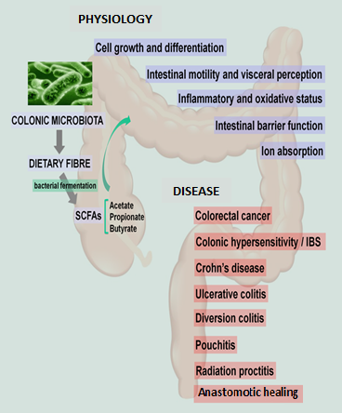
Short chain fatty acids can influence cellular activity through a variety of signalling pathways with butyrate, compared to other SCFAs, considered to have the most important physiological effects on the colonic mucosa (Mortensen and Clausen, 1996). The various functions of SCFAs are summarised in figure 1.10

Figure 1.10: SCFAs in health and disease. A summary of the multiple functions of SCFAs in colonic homeostasis and colorectal pathologies in which SCFAs have been implicated.
Butyrate is the major energy source for the colonocyte, supplying 70-90% of its energy requirements, with the colonocytes receiving nutrients solely from luminal substrates and not from the bloodstream (Szmulowicz U, 2011). Butyrate also modulates several cellular processes essential for colonic homeostasis including; promoting the absorption of water, sodium and chloride from the colon (Hamer et al., 2008), supporting the mucosal barrier function by stimulating mucous secretion (Willemsen et al., 2003), increasing mucosal blood flow (Kvietys and Granger, 1981) and decreasing colonic epithelial permeability (Venkatraman et al., 2003). Butyrate also acts as a signal metabolite influencing epithelial cell proliferation, differentiation and apoptosis (Boren et al., 2003).
Previous studies have investigated the effect of SCFAs on the smooth muscle and neurons of the ENS and how SCFAs might regulate GI motility (Cherbut, 2003, Soret et al., 2010, Hurst et al., 2014). In the rat colon, acetate, propionate and butyrate releases 5-HT, which initiates or augments the peristaltic reflex (Grider and Piland, 2007). Propionate, for example, has been shown to cause the release of PYY and slow intestinal transit (Cherbut et al., 1998). PYY is known as an important mediator of the ‘ileo-colonic brake,’ where unabsorbed nutrients in the lower GI tract trigger the inhibition of motility and secretion in the proximal intestine. It has been suggested that SCFAs within the colonic lumen may influence this process by stimulating the release of PYY from colonic L-cells (Tazoe et al., 2008, Cuche et al., 2000). An examination of the effects of luminal SCFAs on guinea pig colon suggests that luminal SCFAs have differing effects on proximal and distal colonic motility depending on chain length with the net effect of SCFAs on colonic motility likely to depend on the balance of luminal SCFAs (Hurst et al., 2014).
Dietary supplementation with SCFAs has been shown to suppress food intake, reduce weight gain and improve glucose tolerance in rodent models of obesity (Yamashita et al., 2007, Gao et al., 2009) with butyrate and propionate shown to regulate GLP-1 and PYY release and increase the proliferation of colonic EECs (Kaji et al., 2011, Larraufie et al., 2018). In a recent randomised double-blind cross-over trial, luminal colonic infusions of SCFAs in obese male participants was found to increase fat oxidation, energy expenditure in addition to increasing fasting and postprandial circulating PYY levels (Canfora et al., 2017). Future intervention studies to assess the long-term impact on SCFAs on body weight control and glucose metabolism are required.

1.4.4 SCFAs and gastrointestinal diseases
The role of SCFAs in colorectal cancer (CRC) is outlined in section 1.5.8. A summary of colorectal pathologies in which SCFAs are implicated is found in figure 1.10.

Inflammatory bowel disease
Impaired butyrate metabolism has been implicated in IBD (Thibault et al., 2010) with a loss of butyrate-producing bacteria also found in faecal samples and mucosal biopsies of patients with active IBD (Wang et al., 2014). Anti-inflammatory effects of butyrate have also been demonstrated via inhibition of nuclear factor kappa B activation (Ogawa et al., 2003) and also by inducing differentiation of colonic regulatory T (Treg) cells which have a central role in the suppression of inflammation (Furusawa et al., 2013).
With the suggestion that butyrate plays a major role in mucosal repair, possibly related to a nutritional effect accelerating aerobic metabolism and regulating epithelial cell proliferation (Butzner et al., 1996), this has prompted interest in the use of butyrate enemas in the treatment of distal ulcerative colitis (Hamer et al., 2010) and diversion colitis (Luceri et al., 2016), in addition to a single study suggesting a benefit of butyrate enema treatment for chronic pouchitis (de Silva et al., 1989). A recent study on intensive care patients in Japan has also found that concentrations of faecal SCFAs in patients with systemic inflammatory response syndrome (SIRS) were significantly lower than those found in healthy volunteers over a 6-week period suggesting that SCFAs may have a therapeutic potential to help maintain gut mucosal integrity and prevent GI complications associate with critically unwell patients (Yamada et al., 2015).

Anastomotic healing
There has also been interest in butyrate enemas in colorectal anastomotic healing, with luminal butyrate treatment increasing anastomotic bursting strength and reducing the incidence of anastomotic leakage in rat models (Bloemen et al., 2010, Bosmans et al., 2017b). This observation may be due to butyrate’s effect on enhancing epithelial cell integrity or even through increasing collagen synthesis and maturation. Several studies have indicated that butyrate increases the thickness of the colonic mucosal layer via alteration of mucin gene expression (Jung et al., 2015). Bosmans et al suggest that anastomotic strength may be promoted by butyrate treatment as a result of its effect on the colonic mucus layer, given that recently a higher anastomotic leak rate has been demonstrated in mice with an insufficient colonic mucus layer (Muc2-/-) compared with controls (Bosmans et al., 2017a).

Irritable bowel syndrome
A recent meta-analysis of 14 randomised controlled trials (RCTs), including almost 1000 patients concluded that fibre supplementation, especially psyllium, was effective at improving global IBS symptoms compared with placebo (Moayyedi et al., 2014).
The different types of dietary fibre however exhibit marked differences in their chemical properties, and not all types of fibre are beneficial for patients with IBS. FODMAPs are soluble and highly fermentable fibres which can often result in rapid gas production which can lead to bloating and abdominal discomfort. Alternatively, soluble and moderately fermentable dietary fibre, such as psyllium, results in low gas production and less symptoms associated with excessive gas production (El-Salhy et al., 2017b).
Changes in faecal levels of SCFAs have been noted in IBS patients in vivo (Tana et al., 2010) with in vitro fermentation of fibre in patients with IBS-D also shown to produce less SCFA than controls with lower levels of acetate and propionate and elevated levels of butyrate found in patients with IBS-D (Treem et al., 1996). These differences suggest that alteration in SCFA concentrations may be related to the development of GI symptoms. It is not clear whether the abnormalities in SCFA levels observed in both IBS-D and IBS-C are cause or effect. At present it is also uncertain whether it is the altered concentration or composition of SCFAs that are responsible for the transit abnormalities observed in IBS patients or whether the alteration in SCFAs reflect the changes in colonic transit (Camilleri et al., 2016).

1.4.5 SCFAs: algesic or analgesic?
In general, SCFAs are considered to be beneficial to colonic health. However controversy exists as to whether butyrate may cause colonic hypersensitivity (Kannampalli et al., 2011). Butyrate enemas administered to rats over 3 days resulted in colonic hypersensitivity, with a sustained, does-dependant decrease in pain-threshold levels and referred cutaneous mechanical hyperalgesia (Bourdu et al., 2005). Use of this IBS model of non-inflammatory chronic colonic hypersensitivity has raised questions of the therapeutic benefit of dietary fibre and SCFAs in patients with IBS (Vera-Portocarrero LP et al., 2008, Lian B et al., 2010). However in a Dutch study, where physiologically relevant doses (50 and 100 mmol/L⁻¹) of intraluminal butyrate were administered into the distal colon of healthy human subjects, a marked increase in compliance and reduced pain and discomfort was demonstrated, thereby suggesting a beneficial effect of butyrate in disorders characterised by visceral pain (Vanhoutvin et al., 2009). An important factor may be the differences in butyrate concentrations used, with much higher doses used in the rodent models of IBS. When butyrate enemas at lower physiological doses (40 mM) were administered to rats a decrease in colonic pain thresholds in controls was observed, whereas a proprioceptive effect was seen at 240 mM concentrations (Tarrerias et al., 2002).
There has been interest in the use of oral butyrate as a supplementary treatment for IBS. Banasiewicz and colleagues performed a double-blind, randomized, placebo-controlled study in which 66 adult patients with IBS received microcapsulated butyric acid at a dose of 300 mg per day or placebo as an adjunct to standard therapy. At four weeks, there was a statistically significant decrease in the frequency of abdominal pain during defecation in the butyric acid group. In addition, at 12 weeks, there were further decreases in the frequency of spontaneous abdominal pain and postprandial abdominal pain (Banasiewicz et al., 2013). Oral administration of butyrate and a butyrate derivative has also been demonstrated to reduced visceral and neuropathic pain in mice with the effect blocked by glibenclamide, indicating that underpinning mechanisms of the analgesic effect may involve ATP-dependent K+ channels (Russo et al., 2016).

1.5 Colorectal cancer

1.5.1 Overview
Around 30,000 people are diagnosed with CRC each year in England and Wales where it is the second most common cause of cancer death in the UK, accounting for 10% of cancer deaths (NBOCA, 2017). The risk of developing CRC is defined by genetic predisposition and environmental factors. Age is the most important risk factor in sporadic CRC, with 90% of sporadic CRCs occurring in patients over the age of 50 years (Cappell, 2008). Worldwide there were 1.24 million new cases diagnosed in 2008, with CRC incidence rates lowest in Middle Africa and highest in Australasia (Ferlay et al., 2010). The geographical variation in incidence across the world can be attributed to differences in diet and particularly the consumption of red and processed meat, fibre, folate and alcohol. Countries, such as Japan (Matsumura, 2001), who have adopted a rapid ‘westernisation’ of their diet have witnessed a sharp rise in the incidence of CRC (Center et al., 2009), with further epidemiological studies demonstrating a rapid increase in CRC risk in migrants moving from low to high risk countries (Boyle and Langman, 2000). Other risk factors include smoking, high body mass index (BMI) and physical inactivity. Sixty per cent of CRCs arise in the colon and 40% in the rectum, with a rectal cancer defined as a tumour within 15cm of the anal verge on rigid sigmoidoscopy (Bass, 1993).
Approximately 5% of all CRC are due to inherited genetic mutations. Of the remaining 95% that do not fall within the criteria of any inherited CRC syndrome, 20% have a positive family history which may reflect an inherited predisposition or common environmental factors (Power et al., 2010).

1.5.2 Colorectal carcinogenesis
Discoveries over the last 25 years have enhanced our knowledge of the molecular biology of CRC. It is a heterogeneous disease with the phenotype of a colorectal neoplasm a result of multiple interacting genetic and molecular events that occur at different levels driving the initiation, promotion and progression of CRC. CRC is thought to arise from a malignancy-conferring mutation in a stem cell within a crypt (McDonald et al., 2006) which leads to a stepwise progression of genetic aberrations and activation of growth factor pathways resulting in the development of malignant tissue from adenomatous polyps (Fearon and Vogelstein, 1990). Three main CRC pathways that result in malignant transformation have been identified; the Chromosomal Instability Pathway (CIN), the CpG Island Methylator Phenotype (CIMP) pathway and the Microsatellite Instability pathway (MIS). These pathways are not mutually exclusive and some CRCs exhibit features of multiple pathways, however genomic instability plays an integral part in the transformation of normal colorectal mucosa into carcinoma (Al-Sohaily et al., 2012).
Chronic inflammation in the colon can also predispose to malignant transformation with aberrant regulation of prostaglandin signalling an early step in adenomatogenesis. Abnormal responses to inflammation are induced by mitogen-associated upregulation of cyclo-oxygenase-2 (COX-2), which is found to be expressed in the majority of adenomas and CRCs (Hao et al., 1999, Chapple et al., 2000). Inhibition of COX-2 by nonsteroidal anti-inflammatory drugs has been shown to prevent the formation of new, and regression in existing, adenomas (Markowitz, 2007).

1.5.3 Cancer in the crypt and the origins of the adenoma
Neoplasia can essentially be described as the dysregulation of self-renewal (Radtke and Clevers, 2005). As it is the stem cells that have the ability to self-renew it can therefore be assumed that cancer is a stem cell disease (McDonald et al., 2006). Compared to non-stem cells that leave the crypt within 5-7 days, stem cells are one of the few cell types that are sufficiently long-lived to acquire the necessary number of stepwise mutations to transform the normal cell to a malignant one. For the non-stem cell to survive carcinogenesis the mutation would have to alter proliferation, cell-to-cell adhesion and migration simultaneously, which although possible, is highly improbable (McDonald et al., 2006). Tumours contain stem cells themselves, called cancer stem cells (CSCs), which are thought to sustain and increase the tumour cell population via the stem cell pathway (Pinto and Clevers, 2005).
There is continued debate over the origins of colorectal adenomas (Preston et al., 2003). The conventional ‘bottom-up’ theory initiates when a stem cell that has acquired a mutation divides symmetrically resulting in a dysplastic progeny that expands upwards leading to the entire crypt being filled with dysplastic cells (Preston et al., 2003). The Vogelstein group however champion the "top down" theory where colorectal adenomas arise and grow across the mucosal surface then down into the crypts (Shih et al., 2001). In any case these mutated crypts then expand to form aberrant crypt foci (ACF), the earliest identifiable neoplastic lesion in the colon (Bird, 1987) via crypt fission - the longitudinal division of a single crypt into two daughter crypts (Greaves et al., 2006). When a whole crypt is colonised by dysplastic cells it forms a monocryptal adenoma (Nakamura and Kino, 1984), more recently defined as intraepithelial neoplasia (IEN) (Tannapfel et al., 2010).

1.5.4 The adenoma-carcinoma sequence
Most CRCs arise from pre-exiting adenomas. A model of the stepwise genetic aberrations leading to the progression of CRC from adenomatous polyps was first proposed by Fearon and Vogelstein (Fearon and Vogelstein, 1990) and is the main pathway for sporadic carcinogenesis in the colorectum, with approximately 80% of CRCs following this approach (Moran et al., 2010). This transformation is understood to take 10-15 years, providing a therapeutic window to screen and remove these precursor and early malignant lesions. The time to progression is dependent on polyp characteristics; large size (≥10mm), multiple adenomas (≥3), adenomas with ≥25% villous change and adenomas with high grade dysplasia (Winawer et al., 2006) are associated with an increased malignant propensity.

1.5.5 The molecular basis of colorectal cancer
Whilst Fearon & Vogelstein’s concept is still valid, new knowledge has evolved their model and lead to three molecular pathways being characterised; the Chromosomal Instability Pathway (CIN), the CpG Island Methylator Phenotype (CIMP) pathway and the Microsatellite Instability (MIN) pathway. The recently recognised sessile serrated adenomas (SSA) demonstrate distinct molecular and pathological changes not observed in traditional adenomas suggesting that they progress via different pathways (Patai et al., 2013) (see figure 1.11).
The CIN pathway is the most common cause of genomic instability in CRC accounting for around 80% of all cases (Grady and Carethers, 2008). This pathway is associated with a mutation in the Adenomatous Polyposis Coli (APC) gene, a tumour suppressor gene located on chromosome 5q21, often associated with additional deletions on 5q,17p or 18q (Harrison and Benziger, 2011) and mutation of the K-RAS gene.
The MSI pathway is closely related to the Mismatch Repair (MMR) system which recognises and repairs base-pair mismatches during DNA replication. A mutation which impairs the ability of the MMR system to correct these errors will therefore lead to MSI.
In the CRC genome, aberrant methylation occurs in the CpG island rich promoter regions which results in loss of function of tumour suppressor genes, such as MLH1 (Wong et al., 2007). A subgroup of loci appear to be aberrantly methylated together, a phenomenon known as CIMP pathway (Issa, 2004).
It was previously understood that there were only two types of colorectal polyps – adenomas and hyperplastic polyps, with the latter considered to be benign with no malignant potential. New findings have re-classified hyperplastic polyps into a heterogenous group of traditional serrated adenomas (TSAs), sessile serrated adenomas (SSAs) and true hyperplastic polyps (Farris et al., 2008). TSAs and SSAs progress via different pathways, with most carcinomas that arise from TSAs noted to be MSI-low and cancers arising from SSAs noted to be MSI-high. K-RAS mutations are found in 80% of TSAs but are rare in SSAs with SSAs characterised by BRAF mutations and extensive DNA methylation (Harrison and Benziger, 2011).

1.5.6 Aberrant signalling pathways
Various cellular signally pathways, such as Wnt/β-catenin, transforming growth factor- β (TGF-β), Notch and Hedgehog (Hh), are activated or altered as a result of genetic dysregulation in CRC (see figure 1.11). Other pathways critical for the regulation of tumour growth include the epidermal growth factor receptor (EGFR) pathway, the VEGF pathway, the RAS/RAF/mitogen-activated protein kinase (MAPK) cascade and phosphoinositide 3'-kinase (PI3K)/Akt signaling pathways. EGF-R ligation results in trophic effects on intestinal epithelial cells, regulating cell growth, proliferation, survival, invasion, migration and even angiogenesis by activating the MAPK and PI3K pathways. EGFR is overexpressed in nearly 90% of cases of metastatic CRC, with this receptor signalling pathway providing a rationale therapeutic target. Anti-EGFR agents, such as cetuximab, have been developed and approved for adjuvant treatment of metastatic CRC, however as anti-EGFR antibodies are active in wild-type (WT) K-RAS tumours and not in mutant K-RAS tumours, the latter tumour types do not respond to anti-EGFR therapy (Chu, 2009).

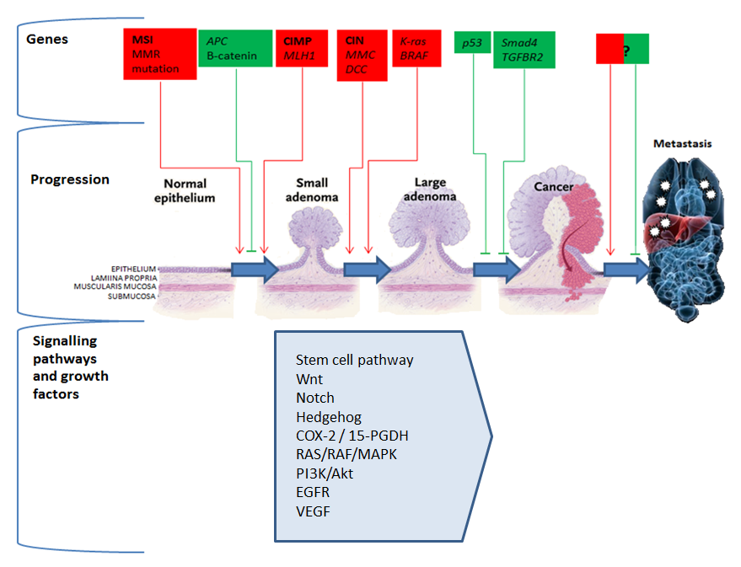

Figure 1.11: Genes, signalling pathways and growth factors that drive the colorectal carcinogenesis. Stepwise genetic aberrations involving tumour suppressor genes (green) and oncogenes (red) lead to the progression of CRC from adenomatous polyps. Three main molecular pathways have been characterised; microsatellite instability pathway (MSI), the CpG island methylator phenotype pathway (CIMP) and the chromosomal instability pathway (CIN). Inherited mutations in the APC gene are known to result in the autosomal dominant disorder familial adenomatous polyposis coli (FAP) which is characterised by the development of numerous adenomatous polyps in the GI tract. The Mutated in Colorectal Cancer (MCC) gene, also located on chromosome 5q, is commonly silenced in CRCs thorough promoter hypermethylation and has been identified as one of the ‘driver genes’ in a murine model of colorectal carcinogenesis (Starr et al., 2009). Loss of 17p is reported in 75% of CRCs but have not been observed in adenomas, suggesting that loss of this segment which contains the tumour suppressor gene p53, is a late event in colorectal carcinogenesis (Vogelstein et al., 1988). The long arm of chromosome 18 contains many candidate tumour suppressor genes including Deleted in Colorectal Cancer (DCC), which plays a role in cell adhesion and migration, and Smad2 and Smad4, which encode for transcription factors involved in the transforming growth factor-β (TGF-β) signalling pathway. Mutations of the proto-oncogene K-RAS are associated with progression of the adenoma-carcinoma sequence. RAS activation influences multiple cellular pathways which control growth, differentiation, survival, cytoskeletal organisation, cell motility and proliferation. Benign adenomas do not express mutated K-RAS, however increased expression is seen in dysplastic polyps with K-RAS mutations seen in over 50% of CRC cases (Harrison and Benziger, 2011). KRAS and BRAF are also associated with the serrated adenoma pathway. Aberrant cell signalling pathways and growth factors involved in initiation and driving disease progression also provide potential therapeutic targets. Genetic and epigenetic changes specific to metastasis have yet to be identified.
(Diagram based on figure in review article by Markowitz, 2007)

1.5.7 Field cancerization
Based on the hypothesis first proposed by Slaughter following observations in the macroscopically normal field around oral squamous cell cancer (Slaughter et al., 1953), field cancerization (also termed field effects or field defect) is the presence of molecular alterations in histologically normal appearing tissue surrounding a neoplastic lesion, thereby representing a very early step in carcinogenesis. Although previously overlooked in CRC, when compared with malignancies from other sites such as in the head and neck, there is an emerging body of evidence demonstrating field effects surrounding macroscopic neoplastic lesions in the colorectum (Jothy et al., 1996, Badvie et al., 2006, (Polley et al., 2006, Yu et al., 2011). Field cancerization in the colorectum may have implications for current practices as removal of adenomas may be inadequate for CRC prevention.

1.5.8 SCFAs and colorectal cancer
Epidemiological studies have demonstrated a lower incidence of CRC in populations with a high dietary fibre intake (Peters et al., 2003, Park et al., 2005, Bingham et al., 2003). Butyrate has been shown to inhibit colorectal carcinogenesis, via regulation of cell cycle, apoptosis and angiogenic pathways, and is therefore thought to underwrite the chemoprotective effect of fibre (Bingham et al., 2003). In vitro studies indicate that physiologically relevant levels of butyrate cause cell cycle arrest, differentiation and apoptosis in a number of CRC cell lines (Yu et al., 2010). This effect is mediated by butyrate’s inhibition of histone deacetylases (HDACs). Inhibition of HDAC activity results in the downregulation of transcription factor Sp1binding and upregulation of Sp3 binding leading to an increase in p21 expression, ultimately causing cell cycle arrest (Davie, 2003) and an increase in Bak expression and apoptosis (Chirakkal et al., 2006). Recently, Cousin and colleagues have demonstrated a synergistic pro-apoptotic effect of SCFAs in combination with TNF-Related Apoptosis-Inducing Ligand (TRAIL), a well-known apoptosis inducer (Cousin et al., 2016).
Butyrate may also exert its anti-cancer effect via VEGF co-receptor NRP-1 (Yu et al., 2010). Recent work has also identified NRP-1 to be expressed in a subset of EECs, with NRP-1+ cells noted to be SCFA responsive. Patient data has also demonstrated that colonic CgA+ cell numbers are influenced by butyrate concentration (Yu et al., 2011). Therefore NRP-1 and EECs may play a pivotal role in the butyrate-mediated alteration of differentiation pathways and in the anti-CRC action of dietary fibre.

1.5.9 EECs in colorectal adenocarcinoma
EEC differentiation in sporadic CRC is well recognised, however its clinical significance remains controversial. It appears that, despite the location of EECs in the colonic crypts, their function as luminal chemosensors and ability to secrete proliferative and pro-angiogenic factors, the role of EECs in colonic carcinogenesis is surprisingly under investigated (Kleist and Poetsch, 2015).
One third of colorectal adenocarcinomas express differentiated EECs (Gulubova and Vlaykova, 2008). It has also been shown that a subset of EECs express VEGF, a proangiogenic factor know to be important in progression to neoplasia (Gulubova and Vlaykova, 2008). In addition, the secretory products of EECs, including 5-HT, PYY, glicentin and GLP-2, have been noted to enhance cellular proliferation of the epithelium. It has therefore been hypothesised that CRCs with an EEC component may possess a proliferative advantage, although results from studies comparing EEC expression with prognosis have been equivocal (Gunawardene et al., 2011). EEC numbers have also been suggested to act as promoters in neoplasia associated with IBD (Gledhill et al., 1986) and there has also been specific interest in the role that EEC precursor cells, with their stem-cell like properties, may have in colorectal carcinogenesis. In a mouse model, NGN3-expressing EEC precursor cells responded to abnormal Wnt signalling by the development of 5-HT-expressing adenomas in the small intestine (Wang et al., 2007) and a subset of colonic EECs have also been found to express the cancer-associated transcription factor Brachyury (Jezkova et al., 2016).
It has been recognised that EEC numbers are altered in the vicinity of colonic neoplasia in humans (Yu et al., 2011) with a murine model of colorectal carcinogenesis also demonstrating a depletion in EEC population in malignant colonic epithelium (Novaes et al., 2016). Interestingly, in the latter study, Novaes and colleagues observed an inverse correlation between the frequency of ACF and EEC numbers and also a correlation with EEC population and intestinal motility in rats with malignant transformation of the colon. This findings offers a potential explanation as to why patients may report a change in bowel habit in early colorectal carcinogenesis. Furthermore, colonic EEC populations also observed to decline in the presence of a distant extra-intestinal tumour in a xenograft mouse model (Cho et al., 2008). This finding suggests that a distant tumour may cause a paraneoplastic effect by secreting a diffusible peptide that can alter the normal regulatory mechanisms for EEC proliferation, and hence offer an explanation of why patients with advanced malignancy, not directly involving the gut, can suffer from GI symptoms such as diarrhoea and constipation (Cho et al., 2008).

1.6 Neuropilin-1

1.6.1 Overview
NRP-1, and the related molecule neuropilin-2 (NRP-2), are transmembrane glycoproteins specific to vertebrates. Originally named A5, NRP-1 was first identified by Fujisawa and colleagues in 1987 (Takagi et al., 1987) when it was identified as an antigen to a monoclonal antibody which bound to neuronal cell-surface proteins in the optic tectum of Xenopus tadpoles. Initially characterized as a neuronal receptor for the class 3 semaphorins (SEMA3), a family of chemorepulsive guidance molecules that repel axons and collapse growth cones, NRP was found to play an essential role in axon growth and guidance. Analysis of mouse chimeras of NRP-1-overexpressing and NRP-1-null mutant mice demonstrated that NRP-1 was essential for normal embryological development of the nervous and cardiovascular systems (Kitsukawa et al., 1995) (Kawasaki et al., 1999). A decade on from when NRP-1 was initially described, it was identified to be a receptor for specific members of the VEGF family of angiogenic cytokines, following which it soon became apparent that the NRP-1 had an important role in physiological and pathological angiogenesis (Staton et al., 2007). NRP-1 is now known to critically regulate cellular adhesion and migration in diverse cell types with NRP-1 interacting directly with multiple integrins to control cellular function and adhesion (Li et al., 2014).
Overexpression of NRP-1 enhances tumour growth, correlates with invasive growth and is associated with poor prognosis in tumours from the GI tract, prostate, lung, ovary and also gliomas, osteosarcomas and melanomas (Handa et al., 2000, Kawakami et al., 2002, Klagsbrun et al., 2002, Bagri et al., 2009). The contribution of NRP-1 and its ligands to tumour growth and metastasis has spurred a strong interest in NRP-1 antagonists used in combination with anti-VEGF-chemotherapy as novel anti-angiogenesis therapies (Geretti and Klagsbrun, 2007). NRP-1’s role as a multi-functional co-receptor with an ability to bind with disparate ligand families has sparked new areas of research implicating NRPs in diverse biological functions including T-cell activation (Sarris et al., 2008) and viral infection (Jin et al., 2010).

1.6.2 Neuropilin-1 structure
NRP-1 is a 120-130 kDa multifunctional single pass transmembrane glycoprotein with identical domain structures, comprising of a large N-terminal extracellular domain, a short transmembrane domain and a small cytoplasmic domain (Pellet-Many et al., 2008). The NRP extracellular region is divided into three domains (see figure 1.12). Deletion analysis of the domains suggests that the a1/a2 and b1/b2 domains are involved in SEMA3 binding to NRP-1 and the b1/b2 is also involved the binding of VEGF₁₆₅ (Gu et al., 2002). Presence of the a1/a2 domain, although not essential, enhances VEGF₁₆₅ binding to NRP-1 (Pellet-Many et al., 2008).

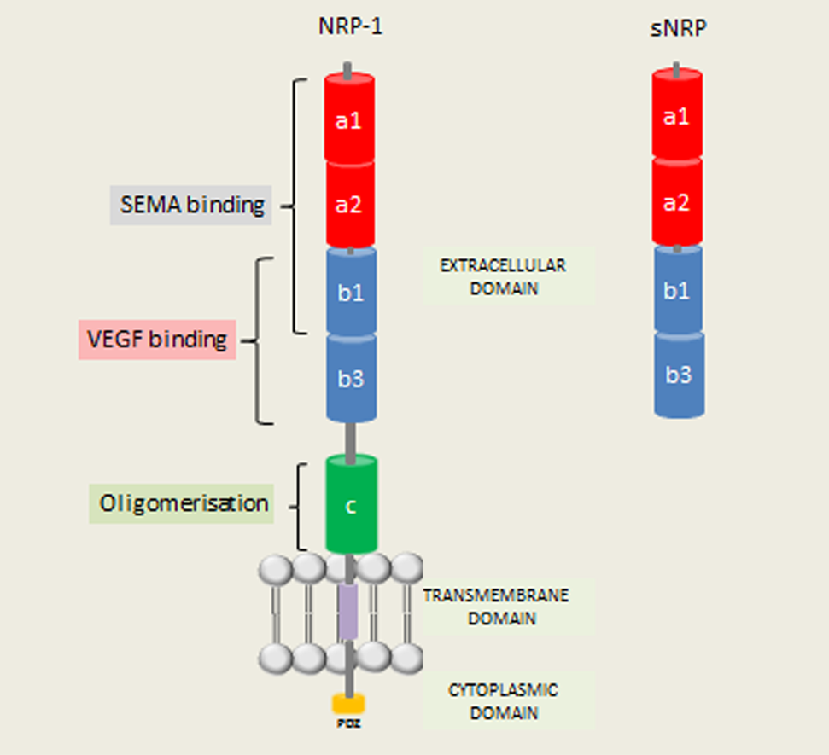

Figure 1.12: NRP-1 structure. In humans, NRP-1 is located on chromosome 10. The NRP-1 domain structure comprises of a large N-terminal extracellular domain (835 aa), a short transmembrane domain (23 aa) and a small cytoplasmic domain (44 aa). The NRP-1 extracellular region is divided into three domains: (i) the a1/a2 (CUB) domain, which is homologous to complement proteins C1r and C1s, (ii) the b1/b2 domain, which is homologous to coagulation factors V and VIII and (iii) the c domain, which is homologous to meprin, A5 and receptor tyrosine phosphatase µ (hence designated MAM). The PDZ-domain binds the neuropilin interacting protein (NIP). Soluble NRP (sNRP), which contain the extracellular a1/a2 and b1/b2 domains, but lack the –c, transmembrane and cytoplasmic domains, function as natural NRP inhibitors. From a review article by Wild J et al, 2012.

1.6.3 Neuropilin co-receptors
NRP-1 functions as a co-receptor, binding to extracellular ligands with high affinity and complexing with other transmembrane receptors to form holoreceptors (Pellet-Many et al., 2008). NRP-1 has the unusual ability to bind with high affinity to multiple ligand families (see figure 1.13). It is well established that NRP-1 is a receptor for both SEMA3 and heparin-binding members of the VEGF family. Recent evidence has revealed that the NRP-1 may also act as a receptor for other growth factors in epithelial cells.

Figure 1.13: The multiple ligand families of the neuropilins. In addition to class III semaphorins and VEGF family, alternative NRP ligands have been discovered, reflecting NRP promiscuous binding and diverse biological roles. From review article by Wild J et al, 2012.

(Nguyen, 2006, Zhao et al., 2007, Wong et al., 2007, Kigel et al., 2008, Syed et al., 2005)

1.6.4 Expression and function of neuropilins in the colon
Initial work demonstrating NRP-1 expression (Hansel et al., 2004, Parikh et al., 2003, Parikh et al., 2004) and NRP-2 expression (Cohen, 2001) in the normal and neoplastic epithelium have provided a platform on which a number of studies investigating NRP’s role in the GI tract have emerged. Furthermore, expression of NRP’s co-receptors and ligands, especially VEGF, has been demonstrated in almost all digestive tract carcinomas (Brown et al., 1993).
Both NRP-1 and NRP-2 are expressed in normal colonic epithelium at both mRNA and protein level (Cohen, 2001, Hansel et al., 2004). In non-neoplastic colonic epithelium, focal expression of NRP-1 and NRP-2 has been demonstrated predominantly at the lateral and apical surfaces of the colonic crypts with the distribution and morphology of NRP positive cells in normal colon and appendix thought to mirror that of EECs. IHC analyses have, however, demonstrated partial colocalisation of NRP-1 (Yu et al., 2011) and NRP-2 (Cohen, 2001) with cells that express CgA. Interestingly, Gulubova et al. have demonstrated that CgA positive endocrine cells in the crypts of normal colonic epithelium contain VEGF in their granules and go on to suggest that VEGF may have a role in the maintenance and control of the permeability of the capillary system around the mucosal glands (Gulubova and Vlaykova, 2008). Away from the colonic epithelium, Hamaji and colleagues, utilising smooth muscle cell (SMC) specific NRP-1 knockout mice, have suggested that NRP-1 may play a role in GI motility, with mice deficient in SMC-specific NRP-1 found to have a significant reduction in colonic length, thinning of colonic smooth muscle and decreased contractility (Yamaji et al., 2015).

1.6.5 Neuropilins in colorectal cancer
NRP-1 is expressed in human colon adenocarcinoma (Parikh et al., 2004, Ochiumi et al., 2006, Kamiya et al., 2006). This was first reported by Parikh et al. who demonstrated with IHC staining that the NRP-1 protein was expressed in all 20 adenocarcinoma specimens studied (Parikh et al., 2004). Immunofluorescent (IF) double staining for NRP-1 and CK-22 (an epithelial cell marker) confirmed NRP-1 expression was localised to the epithelium. This study also showed that overexpression of NRP-1 in human colon adenocarcinoma cells led to a significant increase in tumour growth and tumour vessel count in transfected mice, suggesting that NRP-1 is associated with growth and development of colon adenocarcinoma as well as angiogenesis in vivo. Studies have demonstrated that the intensity and area of NRP-1 expression increases with histological progression from high-grade dysplasia to invasive carcinoma (Hansel et al., 2004, Staton et al., 2013). However further IHC analysis of NRP-1 in normal and adenomatous tissue has revealed a profound difference in expression pattern. Staining changed from higher intensity in singly dispersed cells in the normal tissue to lower intensity staining in large sections of epithelial cells in adenomas, suggesting NRP-1 is dysregulated early in the adenoma-carcinoma sequence (Yu et al., 2011, Staton et al., 2013). High levels of NRP-1 staining in human colorectal carcinoma tissues has been associated with increased proliferation and decreased apoptosis, suggesting that NRP-1 may protect cancer cells from apoptosis (Ochiumi et al., 2006). Increased NRP-1 expression correlates with progression to metastatic disease and prognosis (Ochiumi et al., 2006), suggesting that NRP-1 expression may aid the identification of patients who would benefit from adjuvant chemotherapy. Although these studies provide strong evidence for NRP-1 expression being elevated in colon carcinoma, there is a single contrary report indicating that preserved expression of NRP-1 may be associated with a better prognosis (Kamiya et al., 2006). This association however fails to reach statistical significance and was not independent of disease stage.

Haixia et al. (Haixia et al., 2010) demonstrated mRNA expression of NRP-1, VEGF and SEMA3A in colorectal adenocarcinoma cell lines, with increased ratio of expression of VEGF/SEMA3a ratio when compared to other tumour cell lines. A reduction of SEMA3B mRNA in colorectal carcinomas compared with normal tissue has been reported (Pronina et al., 2009). Reports suggest that SEMA3A may contribute to the progression of colon cancer (Nguyen, 2006, Muller et al., 2007). This may be explained by the interaction of SEMA3A and VEGF, with the dysregulation of SEMA3A expression causing VEGF-driven growth of cancer cells (Catalano et al., 2004). The dysregulation of SEMA3 appears to occur as an early event in colorectal carcinogenesis with Graf et al, having noted a marked loss of noradrenergic and sensory fibres in colorectal adenomas, recently demonstrating that this was accompanied by a marked upregulation of the nerve repellent SEMA3A and SEMA3F (Graf et al., 2011). Positive cytoplasmic staining for both SEMA3A and SEMA3F was present in the epithelial cells of the intercrypt area of tumour free control mucosa with approximately 20% of crypts deemed positive for SEMA3F and less than 5% positive for SEMA3A. The level of expression increased to approximately 75% and 8% of crypts for SEMA3F and SEMA3A respectively in adenomas (Graf et al., 2011).
Although angiogenesis inhibitors targeting the VEGF/VEGF-R pathway, such as bevicuzimab and aflibercept, have shown efficacy in combination with cytotoxic agents in the setting of metastatic disease and are approved by the Food and Drug Administration (FDA) in the USA, they are currently not approved by the National Institute of Clinical Excellence (NICE) in the UK (Jayson et al., 2016, Gollins et al., 2017) due to only a modest survival benefit demonstrated in clinical trials. This is thought to be due to the development of resistance to therapies with several mechanisms of re escape from VEGF/VEGF-R targeted angiogenesis therapies having been identified (Bergers and Hanahan, 2008). There is increasing evidence that NRP-1 is a critical molecule involved in the evasive adaption of CRC cells following VEGF/VEGFR inhibition. Previous work using murine tumour models found that blocking NRP-1 disrupts remodelling of developing vasculature and further reduces tumour growth, suggesting that NRP-1 antibodies may render tumours more responsive to anti-VEGF therapy (Pan et al., 2007). Tomida et al also recently found that inhibition of VEGF-R in CRC cells can drive EMT and cell motility in an NRP-1-dependent manner (Tomida et al., 2017). The potential enhanced antiangiogenic effect of MNRP1685A, a human monoclonal antibody directed against NRP-1, as a single agent and in combination with anti-VEGF therapies, has been under phase I trials in patients with advanced solid tumours, however significant proteinuria in the patient group receiving combined agents was found to be an adverse effect (Xin et al., 2012b, Xin et al., 2012a, Weekes et al., 2014). Interestingly, post hoc analysis of data from a recent phase II RCT comparing anti-VEGF agents in stage IV CRC has revealed that patients with low serum NRP-1 had prolonged disease-free survival thereby suggesting NRP-1 as a potential predictive biomarker to aid selection of patients for anti-VEGF therapy (Benson et al., 2016).
Bevacizumab, an antibody
to vascular endothelial growth factor (VEGF), has been
shown to improve overall and progression-free survival
when used in addition to ﬁrst-line irinotecan (Hurwitz
et al., 2004) and ﬁrst and second-line oxaliplatin-based
combinations (Giantonio et al., 2007; Saltz et al., 2008).
In patients who received bevacizumab during ﬁrst-line
therapy, there is evidence of beneﬁt in continuing this into
second-line therapy (Bennouna et al., 2013). However
bevacizumab is currently not approved by NICE (TA
212) (National Institute for Health and Care Excellence,
2010). Aﬂibercept
Bevacizumab, an antibody
to vascular endothelial growth factor (VEGF), has been
shown to improve overall and progression-free survival
when used in addition to ﬁrst-line irinotecan (Hurwitz
et al., 2004) and ﬁrst and second-line oxaliplatin-based
combinations (Giantonio et al., 2007; Saltz et al., 2008).
In patients who received bevacizumab during ﬁrst-line
therapy, there is evidence of beneﬁt in continuing this into
second-line therapy (Bennouna et al., 2013). However
bevacizumab is currently not approved by NICE (TA
212) (National Institute for Health and Care Excellence,
2010). Aﬂibercept

1.7 Hypothesis and Aims of thesis
There is increasing interest in the influence of colonic microbiota on host homeostasis with dysbiosis causing host disease (Aziz et al., 2013). One underlying mechanism is via the microbial metabolome with colonic-microbial metabolite-host interaction modulating the host cellular function. SCFAs are considered to be one of the chemical mediators to link nutrient status and microbiota with the host through SCFA receptors expressed by colonic EECs. Certainly, compared with the interest shown in EECs by obesity and diabetes, the EEC system has been overlooked by gastroenterologists and researchers concerned with colorectal pathologies such as CRC, IBD, IBS and constipation and further understanding of the mechanisms that determine generation, proliferation and plasticity of EEC populations hold therapeutic promise.
Increasing evidence links SCFAs with a reduced risk of CRC with observations that SCFAs may also influence visceral sensation. Despite EECs ability to secrete proliferative and pro-angiogenic factors and their influence on gut innervation, the role of EECs and specifically their interaction with SCFAs in colonic carcinogenesis and colonic afferent neuronal sensitivity is under-investigated with underlying mechanisms poorly understood. Recent work suggests that the SCFA butyrate may exert is anti-cancer effect via modulation of NRP-1, essential for axonal growth and guidance and for both physiological and pathological angiogenesis, with NRP-1 also been found to be expressed in an unidentifed subset of colonic EECs. While NRP-1 has been extensively studies for its role in neurogenesis and angiogenesis, its potential contribution to the epithelium has not been investigated extensively.

I therefore hypothesised that NRP-1 is expressed by the colonic enteroendocrine L-cell and that EEC numbers are altered in colorectal neoplasia with SCFAs influencing colonic EEC expression. I also hypothesised that SCFAs influence colonic afferent nerve sensitivity.

The main aims of this thesis are to:
1. Identify the EEC subtype that expresses NRP-1.
2. Investigate EEC expression and its relationship with SCFA levels in both the normal
and neoplastic colonic epithelium.
3. Investigate the influence of SCFAs on colonic afferent sensitivity.

This thesis will provide further insights into how SCFAs can affect colonic physiology and disease by enhancing our understanding of the role of the enteroendocrine system and the influence of dietary fibre, the substrate for SCFA production, in colorectal neoplasia and visceral sensation.

Chapter Two:
EXPRESSION OF NRP-1 IN THE NORMAL COLONIC EPITHELIUM

2.1 Introduction
IHC analysis has identified NRP-1 expression in singly dispersed colonic epithelial cells (Hansel et al., 2004) (Ochiumi et al., 2006), with a similar distribution to that of VEGF (Gulubova and Vlaykova, 2008). NRP-1+ cells are also expressed in a small subset of cells that express CgA, a marker of some, but not all, EECs (Yu et al., 2011). Indeed fewer than 10% of CgA+ cells express NRP-1 and fewer than 20% of NRP+ cells express CgA. Given the distribution and morphology of NRP-1+ cells, it may therefore be that NRP-1 is expressed by EECs that do not express CgA, a finding that is supported by the recognition that CgA may be non-reactive to some L and D-cells (Portela-Gomes et al., 1997).

2.2 Hypothesis and Aims
As NRP-1+ cells have been shown to be responsive to SCFAs, and L-cells are known to express SCFA receptors, I hypothesised that NRP-1 is expressed by colonic L cells. In order to test this hypothesis, the aim for this experiment was to perform an IHC colocalisation analysis using an anti-NRP-1 antibody and antibody markers for L- and D-cell subtypes known to present in the lower GI tract.

2.3 Methods

2.3.1 Human colonic biopsies
In order to determine the EEC type expressing NRP-1, an IHC colocalisation analysis was performed on archived formalin fixed colonic tissue previously obtained as part of an existing study investigating the association of dietary fibre and colon carcinogenesis – the FACT study (Corfe et al., 2009). Ethical approval was gained from the North Sheffield Research and Ethics Committee (Ref: 06/Q2308/93). Two colonic biopsies were obtained from the macroscopically normal mid-sigmoid in male patients undergoing routine diagnostic lower GI endoscopy. All patients had received mechanical bowel preparation (MBP). The FACT study included male patients, aged over 40 years of age with normal BMI in order to avoid confounding factors such as menstrual status and oral contraceptive pill usage. Age restriction was chosen to reduce the risk of including individuals with hereditary forms of CRC. Patients with a past medical history of diabetes mellitus, IBD, female patients and smokers were excluded. Biopsies were taken with Radial Jaw 4 2.8mm forceps (Boston Scientific, UK), fixed in formalin and then paraffin embedded before 2-3µm serial sections cut. The sections had been previously stained with haemotoxylin and eosin (H&E) and examined by a consultant pathologist to ensure the epithelium was non-neoplastic.

2.3.2 Immunomarkers of colonic L- and D-cell subtypes
A series of IHC studies have previously demonstrated localisation of pro-glucagon derived peptides (PGDPs) and PYY to intestinal L cells (Bottcher et al., 1984, Fiocca et al., 1987), therefore any of the PGDPs, such as GLP-1 or PYY, are suitable markers for colonic L-cells. Within the GI tract, SST immunorectivity occurs within the muscular layers, where it colocalises with the myenteric plexus, and within the mucosa, where is colocalises with D-cells. SST is therefore a suitable specific marker for intestinal D-cells (Penman et al., 1983).

2.3.3 Strategy to demonstrate colocalisation
IHC protocols were developed for the anti-NRP-1 antibody and antibody markers for GLP-1, PYY and SST. Two candidate markers for the colonic L-cell (GLP-1 and PYY) were investigated and the IHC protocol which provided the optimal staining of the two was selected for use in the colocalisation study. IHC protocols and the quality of staining were approved by a consultant histopathologist.
Biopsies from the mid-sigmoid in twenty patients were used. Staining of serial (adjacent) sections from two separate mid-sigmoid biopsies per patient for GLP-1, NRP-1 and SST was then performed (see figure 2.1).
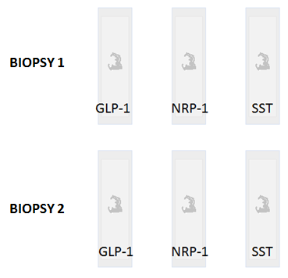

Figure 2.1: Serial sections. Schematic summary of FFPE serial sections of colonic biopsies stained for GLP-1 and SST either side of section stained for NRP-1 in two series of serial sections per patient. This was performed in biopsies from the normal mid-sigmoid colon in 20 patients.

Antibodies used were suitable for application on both human and murine tissue, therefore FFPE sections of C57BL/6 mouse brain (for NRP-1) and pancreas (for GLP-1 and SST), obtained courtesy of Chris Keating (University of Sheffield), were used as positive controls. Stained sections were examined with an Olympus H-2 light microscope (Olympus Ltd, KeyMed, UK) and cells stained positive for GLP-1, NRP-1 and SST were counted. Images were captured (NIS Elements Imaging Software, Nikon, UK) and NRP-1+ cells were compared to GLP-1+ and SST+ cells to assess for colocalisation.
Assessment for colocalisation was performed by two independent observers (JW and AG) and results were compared. Colocalisation was confirmed by the presence of positive staining in the same cell identified on adjacent sections. As counting the frequency of single cells stained with two markers is a subjective assessment, inter and intra observer error was performed.

2.3.4 NRP-1 immunohistochemical staining of human colonic epithelium

Optimisation of staining for NRP-1
An IHC protocol using a rabbit polyclonal anti-NRP-1 antibody (sc-5541, Santa Cruz) had already been developed in previous work (Yu et al., 2011). Despite initial success difficulties were subsequently encountered in obtaining uniform positive staining with a clean background despite strict adherence to the optimised protocol. This was likely to have been as a result of degradation of the Santa Cruz anti-NRP-1 antibody (stored at 4ºC for 30 months since purchase). As this batch of anti-NRP-1 antibody was no longer produced by the manufacturer an alternative anti-NRP-1 antibody was obtained (rabbit monoclonoal anti NRP-1, Abcam ab25998). This protocol was optimised and then used in the final colocalisation study. Weak staining of NRP-1+ cells was seen initially (see figure 2.2A).

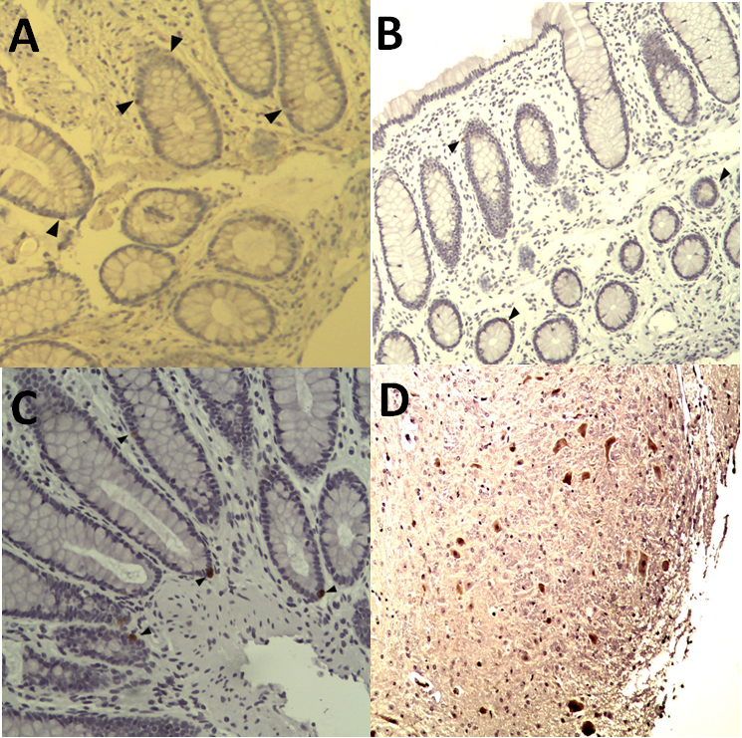

Figure 2.2. Optimisation of IHC for NRP-1 staining. Black arrow-heads indicate staining for NRP-1. A: Weak staining was seen at first despite systematic increases in the primary and antibody concentrations. B: Use of a pressure cooker for antigen-retrieval improved the quality of staining with less tissue damage seen with the microwave method. C: The intensity of positive staining was improved further by increasing the concentration of secondary antibody and the duration of DAB treatment. D: Section of mouse brain (positive control). Images taken at 20x magnification.

Systematic increases in the concentration and incubation time of the primary antibody had little effect on the intensity of staining. However changing the method of heat-mediated antigen retrieval from using a microwave (3 minutes high temperature followed by 7 minutes medium temperature setting) to a steam pressure cooker, increasing the concentration of the secondary antibody to 1:100 dilution and by extending the chromagen substrate (DAB) treatment time from 7 to 10 minutes resulted in good intensity staining of NRP-1+ cells without background staining (see figures 2.2B and 2.2C).

NRP-1 staining protocol
Paraffin embedded sections were dewaxed in two baths of xylene for five minutes each and were twice hydrated in descending dilutions of ethanol: twice times in absolute ethanol (95% and 70%) and twice in deionized water (dH2O) at 3 minutes each. For antigen retrieval tissue sections were heated in a pressure cooker for 2 hours in sodium citrate buffer (pH 6.0) and then allowed to cool for 20 minutes before being treated with 3% hydrogen peroxide for 35 minutes at 37°C to block endogenous peroxidase activity. Tissue sections were washed in phosphate buffered saline (PBS) for 5 minutes prior to blocking of non-specific background staining using 10% goat serum and 10% casein in PBS for 60 minutes at room temperature. Specimens were then incubated with rabbit monoclonal anti-NRP-1 antibody (Abcam, ab25998), at a dilution of 1.5 µg/ml in a humidified chamber and incubated at 4°C overnight. Mouse brain was used as a positive control, and PBS alone (ie. the primary antibody was omitted) for the negative control. Slides were then washed with PBST (1% tween 20 in PBS buffer) twice for 10 minutes each time, treated with secondary antibody (biotinylated goat anti-rabbit 1:100 in 2% blocking sera; VECTOR) and incubated for 60 minutes at room temperature. Specimens were washed with PBST twice for 10 minutes each time and then treated with the VECTASTAIN® ABC kit (Vector laboratories). The ABC kit (Avidin: Biotinylated enzyme Complex) was made according to the manufacturer’s instruction and incubated with the slides for 40 minutes at room temperature in a humidified chamber. Specimens were washed again with PBS twice for 10 minutes each time. Slides were then incubated with 3, 3’diaminobenzidine (DAB) as the chromogen substrate (Vector laboratories) for 10 minutes at room temperature before two 5 minute washes with dH2O. All sections were counterstained with Gill’s haematoxylin (Sigma-Aldrich, Dorset UK) for 30 seconds to visualise cell nuclei and then washed with running tap water for 5 minutes before being dehydrated in ascending dilutions of ethanol towards xylene and mounted in DPX (Sigma-Aldrich, Dorset UK).

2.3.5 GLP-1 & PYY immunohistochemical staining of human colonic

epithelium

Optimisation of staining for GLP-1
Minor adjustments to the dilution of the primary antibody and duration of DAB treatment time were required in order to optimise the staining protocol for GLP-1.

GLP-1 staining protocol
For GLP-1 staining a similar protocol was used as for NRP-1 staining above. Specimens were incubated with rabbit polyclonal anti-GLP-1 antibody (Abcam, ab22625) at a dilution of 1 in 2000 at 4°C overnight and treated with secondary (biotinylated goat anti-rabbit 1:250 in 2% blocking sera; VECTOR) for 60 minutes at room temperature. Mouse pancreas was used as the positive control. Other differences to the protocol included incubation of slides in 3% hydrogen peroxide for 45 minutes and in DAB for 2 minutes.

Optimisation of staining for PYY
Difficulties with heavy background staining were encountered at first. This was addressed by reduction of the primary antibody concentration to 1:2500 concentration, increasing the duration of the blocking steps, reducing the DAB treatment time to 1.5 minutes and utilisation of a pressure cooker as an alternative source of heat for antigen retrieval (see figure 2.3).
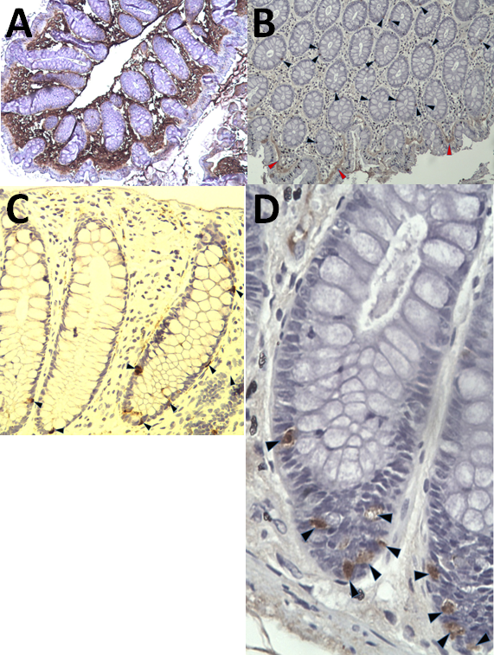
Figure 2.3. Optimisation of IHC for PYY staining. In initial stains a heavy background stain existed (A). A stepwise approach to reduce the concentration of primary and secondary antibodies, increase the blocking steps and reduce DAB incubation led to improved results, with PYY expressed in singly dispersed cells (black arrows in B) although a reduced background stain persisted (red arrow). By using pressure cooker antigen retrieval improved staining was achieved (C). Figure D demonstrates PYY expressing EECs in the crypt base, in keeping with the observation that PYY expression is an early event in colonic EEC differentiation (Upchurch et al., 1996).

Peptide YY (PYY) immunohistochemical staining of FFPE human colonic biopsies
For PYY staining a similar protocol was used as for NRP-1 staining above. Specimens were incubated with rabbit polyclonal anti-PYY (Abcam ab22663) at a dilution of 1 in 2500 at 4°C overnight and treated with secondary (biotinylated goat anti-rabbit 1:300 in 2% blocking sera; VECTOR) for 60 minutes at room temperature. Mouse colon was used as a positive control. Other differences to the protocol included incubation of slides in 3% hydrogen peroxide for 60 minutes and in DAB for 1.5 minutes. Better intensity and reliability of staining was evident with GLP-1 compared with PYY, therefore the anti-GLP-1 antibody was chosen as the L-cell marker ahead of the anti-PYY antibody.

2.3.6 SST immunohistochemical staining of human colonic epithelium

Optimisation of the staining protocol for SST
Stepwise adjustments to the dilution of the primary antibody and duration of DAB treatment time were required to optimise staining. As with previous IHC protocols, changing the method of heat mediated antigen retrieval from a microwave to a steam pressure cooker resulted in cleaner staining and cytosolic staining of high intensity in individually dispersed cells of EEC morphology without any background staining.

SST staining protocol
For SST staining a similar protocol was used as for NRP-1, as described in more detail in section 2.3.4. Specimens were incubated with rabbit polyclonal anti-SST (Abcam ab22682) at a dilution of 1 in 100 at 4°C overnight and treated with secondary (biotinylated goat anti-rabbit 1:250 in 2% blocking sera; VECTOR) for 60 minutes at room temperature. Mouse pancreas was used as a positive control, the slides were incubated in 3% hydrogen peroxide for 45 minutes and treated in DAB for 2.5 minutes.

2.4 Results

2.4.1 NRP-1 expression is enteroendocrine-like
NRP-1 was expressed in 85% (34/40) of colonic biopsies examined. NRP-1+ cells displayed an enteroendocrine-like pattern of expression of singly dispersed epithelial cells which tended to be located in the lower third of the colonic crypts (see figure 2.4).
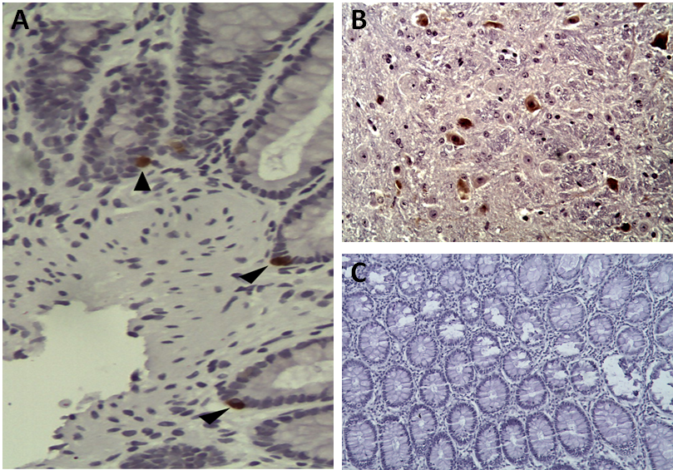
Figure 2.4: NRP-1 expression in the normal colonic epithelium. (A) Black arrows indicate NRP-1+ cells. (B) NRP-1 staining of the positive control, reveals cytoplasmic staining of neuronal cell bodies and projections. (C) Human colonic epithelium, where PBS was used instead of the primary NRP-1 antibody. Images A and B taken at 20x magnification, image C at x10 magnification.

2.4.2 GLP-1 expression in the normal colonic epithelium
GLP-1 was expressed in all biopsies examined. IHC staining for GLP-1 revealed cytosolic staining in well-defined and singly dispersed cells which tended to be located in the lower third of the crypt. Colonic L-cell morphology was clearly observed with GLP-1+ cells demonstrating a flask shaped outline with apical extension towards the crypt surface (see figure 2.5).
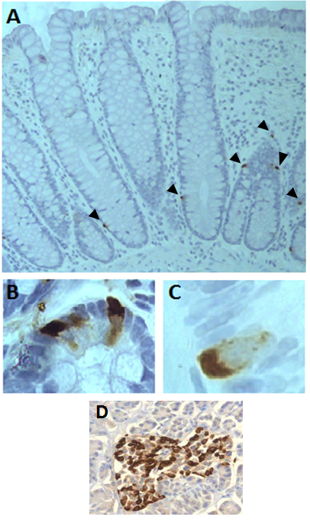

Figure 2.5: GLP-1 expression in the normal colonic epithleium. Anti-GLP-1 staining reveals singly dispersed cells (black arrows) in the lower third of the crypt (A) with typical morphological features of an L-cell including flash like shape (B) and basal staining (C).Islet cells in mouse pancreas, used as the positive control, stained positive for GLP-1 (D). Fig.2.4 A&D x20 magnification, and Fig.2.4 B&C x40 magnification.

2.4.3 SST expression in the normal colonic epithelium
SST was expressed in all biopsies examined (40/40). Staining for SST again revealed singly dispersed cells, as with NRP-1 and GLP-1. There was less of a tendency for SST+ cells to be positioned basally compared with GLP-1+ cells with SST+ cells typically demonstrating slim apical processes. Numerous D-cells also displayed a targetoid like appearance with staining forming a ring around the nucleus (see figure 2.6).
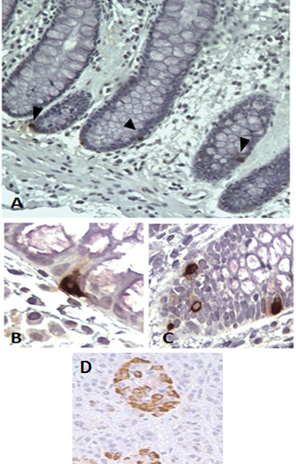

Figure 2.6: SST expression in the normal colonic epithelium. SST+ cells (black arrows) are singly dispersed (A), some displaying slim apical processes (B) and others a targetoid morphology (C). Mouse pancreas (D) was used a positive control. Fig. 2.5A is x20 magnification, and Fig. 2.5B-D x40 magnification.

2.4.4 NRP-1 colocalises with a subset of GLP-1 expressing EECs
GLP-1 expression was highest in the colonic epithelium, with a total of 290 GLP-1+ cells counted across all 40 biopsy sections. This was followed by SST (146 cells) and then NRP-1 (82 cells). Colocalisation of NRP-1 and GLP-1 did occur with 100% agreement for colocalisation between the two independent observers, however this was demonstrated in only a subset of cells (see figures 2.7-2.9). 26% of NRP-1+ cells expressed GLP-1, with only 8% of GLP-1+ cells expressing NRP-1. There was no colocalisation between NRP-1 and SST.
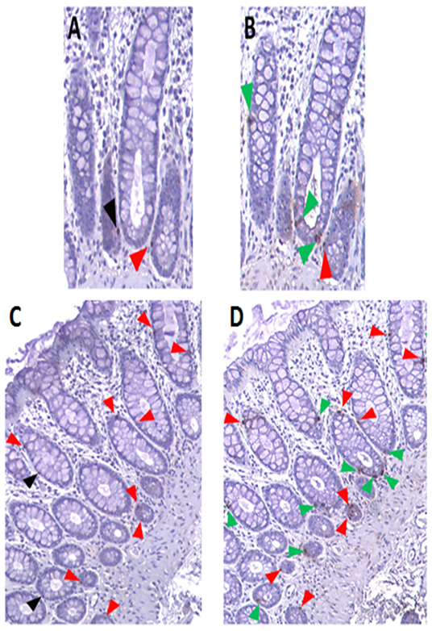
Figure 2.7: Colocalisation of NRP-1 with GLP-1. Analysis of NRP-1 stained serial section (A) and GLP-1 stained serial section (B) reveal partial colocalisation. NRP-1+ cell (black arrow), GLP-1+ cell (green arrows), cell immunoreactive for both NRP-1 and GLP-1 (red arrows). Colocalisation is also present in serial sections C and D, likewise with NRP-1+ cells (black arrows), GLP-1+ cells (green arrows) and cells immunoreactive for both NRP-1 and GLP-1 (red arrow). x20 magnification.

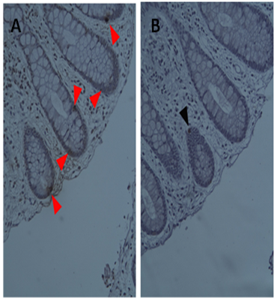

Figure 2.8. IHC serial sections stained for STT (A) and NRP-1 (B). NRP-1+ cell (black arrow) does not colocalise with SST+ cells in any of the sections examined. x20 magnification.

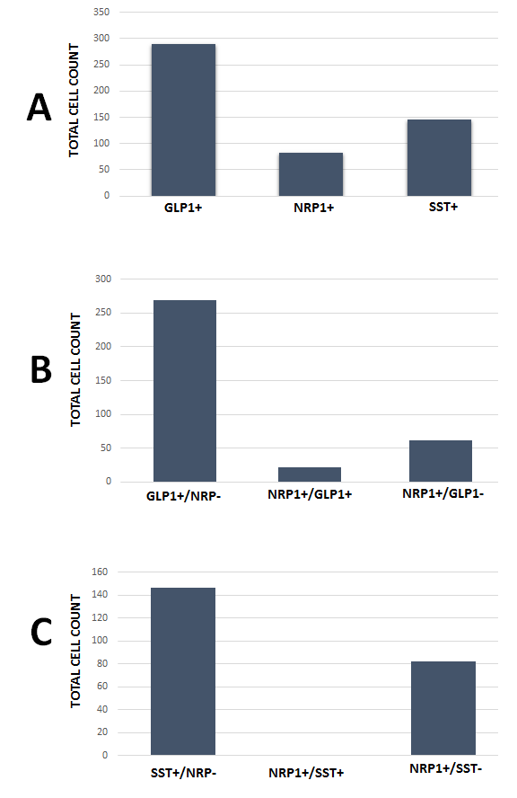

Figure 2.9: Cell counts. Bar chart A illustrates the overall number of GLP-1+, NRP-1+ and SST+ cells counted in all sections. Bar charts B and C demonstrate the proportion of each cell type and colocalisation.

2.5 Discussion
NRP-1 is expressed in a discrete population of singly distributed epithelial cells in the colon which resemble that of EECs, in keeping with previous observations (Yu et al., 2011, Staton et al., 2013). NRP-1+ cells also demonstrate a similar morphology to that of EECs. Previous work has shown that L-cells rarely express CgA (Yu et al., 2011) and, with fewer than 10% of CgA+ cells expressing NRP-1 and fewer than 20% of NRP-1+ cells expressing CgA, I hypothesised that NRP-1 is expressed by L-cells in the colon. This study does demonstrate that NRP-1 is expressed by GLP-1 expressing colonic L-cells. The expression of NRP-1 in colonic EECs does however appear more complex, with only partial co-localisation with GLP-1 observed in this study.
There are limitations of this study. While carefully optimised protocols were developed, using appropriately processed tissue sections, antigen retrieval techniques and detection systems, IHC does have its drawbacks. IHC provides semi-quantitative data at best and can also be influenced by reaction and interpretation bias (Matos et al., 2010). While the NRP-1 antibody used was monoclonal, and therefore more specific, the GLP-1 and SST antibodies used were polyclonal, which may have resulted in some false positive staining.
However there are various strengths to my methodology. A narrow range of patients were recruited with potential confounding factors screened out. The use of appropriate controls and previously validated antibodies in addition to assessment of colocalisation by two independent assessors add further strength to my findings.
In this study I used serial sections of colonic epithelial biopsies in order to demonstrate co-localisation, rather than alternative IHC techniques such as double staining with IF or double IHC staining. The primary reason for utilising serial sections was that the tissue had already been obtained and sections processed as part of a previous study (Corfe et al., 2009). IF would have required me to obtain new fresh snap-frozen cryostat tissue sections as the formalin fixed tissue already available would have caused auto-fluorescence. Double IHC staining was not possible as antibodies for NRP-1, GLP-1 and SST all stain intracellularly and the primary antibodies available were all raised in the same species (rabbit) and were unconjugated, therefore attempting double immunoenzyme staining would have been too problematic. Novel IHC techniques are emerging in order to reduce tissue auto-fluorescence while enhancing antibody signals in order to permit high-quality dual-colour IF images using archival FFPE tissue, however these technique are not widely used and largely remain in development (Viegas et al., 2007, Kajimura et al., 2016).
The use of adjacent serial sections is a widely accepted IHC technique that has been utilised to demonstrate colocalisation in FFPE sections in many tissue types (Krenacs et al., 2010), including in colonic epithelium (Randall et al., 2016) and colonic EECs (Rozengurt et al., 2006, Yu et al., 2011). Although the use of serial sections to examine for colocalisation is considered more laborious and can be problematic for small diameter cells, such as lymphocytes, EEC are a larger cell type, approximately 8-10μm in diameter (Modlin et al., 2006, Bohorquez et al., 2014). The thin (2-3 µm) sections used in this study would be adequate in order for the three serial sections stained for the three antibody markers to include the same individual EEC.
It is conceivable that NRP-1 is expressed in a small subset of EC and L-cells in addition to expression in non-EEC epithelial cell population. However, given that the spatial distribution and morphology of NRP-1+ cells resembles EECs, another explanation is that the colocalisation of NRP-1 with GLP-1 and CgA represents NRP-1 expression in only the mature differentiated EECs. Therefore the proportion of NRP-1+ cells that do not colocalise with either L-cell or D-cell markers may represent post stem cell progenitor cells that have committed to the EEC lineage but have not yet differentiated into mature EECs. NRP-1+ cells are found mainly in the lower third of the crypt where the EEC lineage pre-cursor cells reside (Humphries and Wright, 2008). Given that the sequential expression of the three main bHLH factors (Math1, NGN3 and BETA2) that are switched on and off under the influence of Notch signalling (Schonhoff et al., 2004), represent the three distinct stages of the EEC differentiation pathway, the colocalisation of NGN3, the expression of which is restricted to the proliferating EEC progenitor cells and is not expressed by mature EECs, with NRP-1 warrants further investigation. NRP-1 may therefore be expressed by a post commitment, pre-differentiation phase of post-stem cells.
It is increasingly thought that there is a strong overlap of EEC subtypes based on their hormonal signatures and that EECs may in fact comprise a single cell type within which individual cells exhibit a spectrum of hormones, and therefore varying hormone markers, the expression of which are under the influence of local factors, such as anatomical location along the intestine and exposure to certain luminal nutrients. The EEC phenotype could therefore vary between patients and be influenced by both dietary factors and location along the colon. Researchers in the field of EEC biology have recently challenged the traditional classification of EECs that have been based on IHC characteristics and new concepts of EEC taxonomy are emerging (Drucker, 2016, Fothergill and Furness, 2018, Gribble and Reimann, 2016). There is increasing evidence that EEC subtypes should no longer be defined by a single hormone signature, with alternative classification systems offered including defining EECs by organ, species and multiple hormonal expression (Drucker, 2016). The use of cluster analysis has also been suggested to define EECs based on expression profiles beyond the traditional hormonal signature to include receptor and transcription factor expression (Glass et al., 2017, Haber et al., 2017).
Although a series of IHC studies have confirmed colocalisation between GLP-1 and PYY in the colonic L-cells, other studies have also demonstrated the selective secretion of one hormone, suggesting discrete intracellular mechanisms underpin their release (Plaisancie et al., 1995, Anini et al., 1999). Given that EEC classification appears more complex than initially thought one other possibility is that the NRP-1+ cells represent a previously undefined subset of EECs that only partially colocalises with known markers of differentiated EECs. Figure 2.10 summarises where, across the differentiation pathway, colonic EECs, both mature and undifferentiated, may express NRP-1.

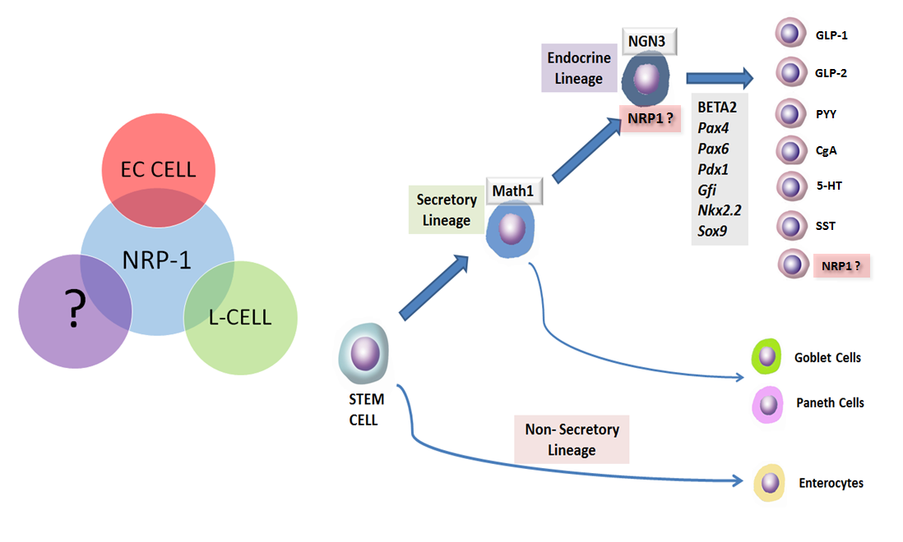Figure 2.10: Summary of findings and potential role of NRP-1. The Venn diagram summarises the findings from this study which demonstrated that NRP-1 is expressed in a subset of both colonic L-cells and EC cells. NRP-1 may be expressed by a new class of mature colonic EEC, or it may be expressed in the post-commitment, pre-differentiation phase of post-stem cells.

Given the limitations of this IHC study in defining the cellular expression of NRP-1 in the colonic epithelium alternative experimental techniques are required in order to determine the exact cell type(s) that express NRP-1 in order to provide additional insights into the physiological relevance of NRP-1 in colonic epithelial and enteroendocrine physiology. This is explored further in chapter 3.

Chapter Three:
DEVELOPMENT OF A TECHNIQUE TO ISOLATE A SINGLE-CELL POPULATION OF COLONIC EPITHELIAL CELLS

3.1 Introduction
Following on from the IHC colocalisation study in chapter 2, an alternative approach was explored in order to identify which colonic epithelial cell type expressed NRP-1. Although there have been no previous reports of NRP-1 expression in the mouse colonic epithelium I planned to isolate NRP-1+ cells from the murine colon using fluorescence activated cell sorting (FACS) in order to then extract RNA from the NRP-1+ cell population and in turn identify the NRP-1+ cell type and information on NRP-1 expressing cell function via gene profiling by performing polymerase chain reaction (PCR) on the extracted RNA.
In order to analyse a primary colonic crypt cell suspension using flow-cytometry or FACS the epithelial cells must first be separated from the underlying lamina propria and then the crypt cells dissociated into a single cell suspension prior to staining with the appropriate antibody-labelled fluorochromes. The most frequently used tissue dissociation techniques, often in combination, are chelating agents, mechanical disruption and proteolytic enzymes (Weiser, 1973, Booth C, 2002). Difficulty exists between obtaining a high yield of cell whilst avoiding irreducible disruption of the cellular membranes and inducing apoptosis caused by the chelation agent and it is unclear which technique is the most effective at producing a single-cell suspension containing a high yield of viable epithelial cells from the mouse colon.

3.2 Aims
The main aims of this study were to:
(a) Determine the IHC expression of NRP-1 in the mouse colonic epithelium.
(b) Perform an empirical comparison of epithelial cell chelation and enzymatic digestion techniques in order to determine the most effective method of obtaining a high yield of viable colonic epithelial cells.
(c) Isolate NRP-1 expressing murine colonic epithelial cells using FACS in order to then perform gene profiling on NRP-1+ cells.

3.3 Methods

3.3.1 IHC staining for NRP-1 in the murine colon
12 week old C57BL/6 (wild-type [WT]) mice (Project licence number PPL 40/3531) were used in accordance with the United Kingdom Animals Scientific Procedures Act (1986). Colons were harvested from mice following cervical dislocation (CD). Faecal contents were flushed from the colon with PBS and the specimen was then fixed in 10% formalin for 24 hours before being transferred to 70% methanol prior to paraffin embedding and sectioning. Blocks were orientated in order to obtain 5µm transverse sections that displayed the hemi-crypts.
The following protocol was developed in order to optimise staining. Paraffin embedded sections were dewaxed in two baths of xylene for five minutes each and then hydrated in descending dilutions of ethanol: twice in absolute ethanol (95%, 70%) and twice in deionized water (dH2O) at 3 minutes each. For antigen retrieval tissue sections were heated in a pressure cooker for 2 hours in sodium citrate buffer (pH 6.0) and allowed to cool for 20 minutes before treatment with 3% hydrogen peroxide for 60 minutes at 37°C in order to block endogenous peroxidase activity. Tissue sections were washed in PBST for 5 minutes on a rocker before blocking non-specific background staining using blocking sera (10% goat serum and 10% casein in PBST) for 60 minutes at room temperature. Specimens were then incubated with rabbit monoclonal anti-NRP-1 antibody (Abcam, ab81321), at a dilution of 1 in 200 in a humidified chamber and then incubated at 4°C overnight. Mouse brain was used as the positive control and PBST for the negative control. Slides were then washed with PBST twice for 10 minutes each time, treated with secondary antibody (biotinylated goat anti-rabbit 1:250 in 2% blocking sera; VECTOR) and incubated for 60 minutes at room temperature. Specimens were washed with TBST twice for 10 minutes each time and then treated with the VECTASTAIN® ABC kit (Vector laboratories). The ABC kit was made according to the manufacturer’s instruction and incubated with the slides for 40 minutes at room temperature in a humidified chamber. Specimens were then washed with PBST twice for 10 minutes each time. Slides were incubated with DAB as the chromogen substrate (Vector laboratories) for 10 minutes at room temperature before two washes with dH2O for 5 minutes. All sections were counterstained with Gill’s haematoxylin (Sigma-Aldrich, Dorset UK) for 30 seconds to visualise cell nuclei and then washed with running tap water for 5 minutes before being dehydrated in ascending dilutions of ethanol towards xylene and then mounted in DPX (Sigma-Aldrich, Dorset UK). Once the IHC protocol was optimised, 5 colonic sections taken from 5 mice were stained with NRP-1.

3.3.2 Empirical comparison of a strategy to isolate a single cell population of epithelial cells from the murine colon

In order to identify an optimal method to yield a single cell suspension of murine colonic epithelial cells, the efficacy of six published chelation methods in yielding viable single murine colonic epithelial cells were directly compared (see table 3.1), in combination with either dispase (Invitrogen) or Accutase® (Stemcell Technologies), for use in FACS analysis of NRP-1+ cells.

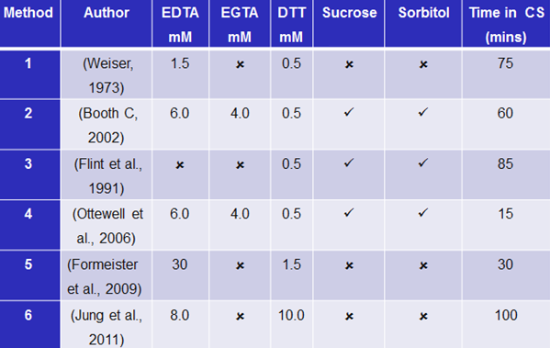
Table 3.1: Comparison of chelating solutions. The main differences between the composition of and incubation times in chelating solution (CS) between six alternative dissociation protocols are outlined. All chelating solutions are made to pH 7.3.

Tissue preparation
Twelve week old C57/BL6 mice were used in accordance with the United Kingdom Animals Scientific Procedures Act (1986). The initial step was standardised for each chelation method compared. Following cervical dislocation, the colon was removed by dividing the colon proximally, just distal to the caecum, and distally at the anorectal junction. The colon was then immediately placed in ice cold magnesium and calcium free Hanks’ balanced solution (HBSS) (Sigma-Aldrich, Dorset, UK). Luminal contents were flushed with HBSS and the colon everted (figure 3.1). A 6cm length of colon, measured from the proximal cut end, was used for each experiment.
From here each method differed in terms of concentration and constituents of chelation solutions used, duration of incubation and use of mechanical disruption. Each chelation solution was standardised at pH 7.3, with all chelation and enzymatic digestions steps carried out at 4°C and room temperature respectively. Following each chelation experiment the remnant colon was fixed in formalin and embedded in paraffin blocks from which 5 evenly spaced 5µm sections were cut and a haematoxylin and eosin (H+E) stain performed to assess the adequacy of epithelium removal. Three animals were used for each of the 12 methods compared (n=36).

Chelation steps
Method 1 (Weiser, 1973)
The colon was incubated in 30mLs of solution A (1.5 mM-ethylenediaminetetraacetic acid (EDTA), 0.5 mM-dithiothreitol (DTT)) for 15 minutes after which the solution is discarded. The colon was then added to 30 mLs of chelation solution B (1.5 mM- KCl, 96 mM- NaCl, 8 mM-KH₂PO₄, 5.6 mM-Na₂HPO₄) and incubated for 60 minutes. The flask was then vigorously shaken by hand for 30 seconds and the cell suspension then pelleted at 2500 rpm for 5 minutes and washed twice in cold PBS.

Method 2 (Booth C, 2002)
The everted colon was incubated in a flask of 30mLs of modified Weiser chelating solution (1.6mM-KCl, 96 mM-NaCl, 8 mM-KH₂PO_{4,} 5.6 mM-Na₂HPO₄, 44 mM-sucrose, 55 mM-D-sorbitol, 6.0 mM-EDTA, 4.0 mM- ethyleneglycoltetraacetic acid (EGTA), 0.5mM-DTT) for 60 minutes. The solution containing the released debris was discarded and then replaced with fresh cold magnesium and calcium free Hanks’ balanced solution (HBSS⁻) and the flask then vigorously shaken by hand for 30 seconds. The contents of the flask were examined under an inverted microscope to assess if any epithelium has been liberated. The incubation was then continued, checking for liberated epithelial cells every 10-15 minutes for 40 minutes. The cell suspension was then pelleted at 2500 rpm 5 minutes and washed twice in cold PBS.

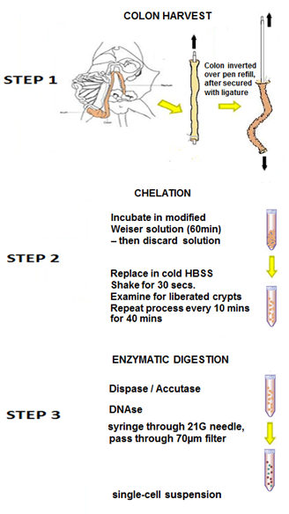

Figure 3.1: Single cell isolation protocol. Step 1: Colon harvest. The mouse colon is excised immediately distal to the caecum and immediately incubated in, and luminal contents flushed with, cold HBSS⁻. The colon is then everted, by securing one end of the colon segment over a pen refill with a suture tie and then pulling the colon along the length of the pen refill to expose the mucosa. Step 2: Chelation. The everted colon is then incubated in chelating solution, at 4°C. The chelation method 2 by Booth et al. is represented in this figure (Booth C, 2002). Step 3: Enzymatic digestion. The released sheets of colonic crypts are dissociated into a single-cell suspension with either dispase or accutase. Applying DNAse and passing the cell suspension via a 21G needle and 70µm filter prevents cell clumping.

Method 3 (Flint et al., 1991)
The everted colon was incubated in 30mLs of solution A (HBSS⁻ with 0.5mM DTT) for 5 minutes under constant agitation. The colon was then transferred to solution B (1.6 mM-KCl, 96 mM-NaCl, 27 mM-Na₃C₆H₃O₇, 8 mM-KH₂PO₄, 5.6 mM-Na₂HPO₄, 44 mM-sucrose, 55 mM-D-sorbitol, 0.5mM-DTT) for 20 minutes after which the solution was discarded and then colon transferred into a flask of fresh solution B. The flask was shaken gently by hand (20 inversions) and the colon was then removed and the contents of the flask pelleted at 2500 rpm for 5 minutes before being washed twice in cold PBS. The colon was then transferred into a flask of fresh solution B and the step repeated until little cellular material is removed. The combined pelleted cells were resuspended in PBS.

Method 4 (Ottewell et al., 2006)
The everted colon was incubated in a flask of modified Weiser solution (1.6 mM-KCl, 96 mM-NaCl, 27 mM-Na₃C₆H₃O₇, 8 mM-KH₂PO₄, 5.6 mM-Na₂HPO₄, 44 mM-sucrose, 6.0 mM-EDTA, 4.0 mM-EGTA, 55 mM-D-sorbitol, 0.5mM-DTT). The contents of the flask were shaken vigorously and transferred to fresh solution for 15 minutes. The cell suspension was then pelleted at 2500 rpm 5 minutes and then washed twice in cold PBS.

Method 5 (Formeister et al., 2009)
The everted colon was incubated in solution A (30mM-EDTA, 1.5 mM-EGTA) for 20 minutes. The solution was discarded and the tissue shaken vigorously in solution B (30mM-EDTA) before being incubated in solution B for a further 10 minutes under constant rotation. The intact colon was removed and the contents of the flask pelleted at 2500 rpm 5 minutes and then washed twice in cold PBS.

Method 6 (Jung et al., 2011)
The everted colon was incubated in solution A (10mM-DTT) for 15 minutes before being transferred to solution B (8mM-EDTA) where it was slowly rotated for 60-75 minutes. The supernatant was replaced by fresh cold PBS and the flash shaken vigorously to yield colonic crypts. The cell suspension was then pelleted at 2500 rpm for 5 minutes and then washed twice in cold PBS.

Enzymatic digestion step
Cell pellets obtained following each chelation method were, in turn, resuspended in 5mLs of HBSS⁻/0.3 U dispase or 5mLs of undiluted Accutase® at 37°C and shaken every 2 minutes for 10 minutes. In the final step, to prevent cell clumping, 5mLs of 5% foetal calf serum (Biosera) and 100 µg of deoxyribonuclease (DNAse) I (Sigma) were added before the cells were gently syringed through a 21G needle (Microlance™) and passed through a 70µm filter. Viable cell counts were measured with a haematocytometer and trypan blue staining.

3.3.3 NRP-1 fluorescence activated staining protocol optimisation
A protocol to stain the cell suspension obtained with anti-NRP-1 antibody was developed, initially using MCF7 cells as a positive control. Both the direct method using anti-NRP-1 antibody conjugated with a fluorochrome and also the indirect methods using a fluorochrome-labelled secondary antibody were compared. Isolated colonic epithelial cells were stained for NRP-1 and FACS performed in order to isolate NRP-1+ cells for subsequent RNA extraction. Gene expression analysis could then be performed to gain further insight into the identification and function of NRP-1+ cells.

Maintenance of MCF7 cells
MCF7 cells were cultured in T75 flasks using RPMI growth media (GIBCO, Invitrogen Paisley, UK) supplemented with 10% heat-deactivated FCS (Biosera, Sussex, U.K.), penicillin (10000 units/mL) and streptomycin (10000 μg/mL) (GIBCO, Invitrogen). Cells were passaged twice weekly to prevent over growth by removing growth medium from the flask and washing cells in the T75 flask using 10mls of PBS. Washed cells were then incubated with 2.5ml of 0.25% trypsin-0.53mM EDTA solution for two minutes at 37°C. Cells were dislodged from the flask and suspended in RPMI growth media. The cell suspension was centrifuged at 400g (Sanyo, Harrier 18/80 Centrifuge). The supernatant was decanted and the remaining cells re-suspended in RPMI growth medium. The suspension was divided into five T75 flasks and the total volume made up to 10mls with growth medium and returned to the incubator.

Protocol for staining MCF-7 cells and isolated colonic epithelial cells with anti-neuropilin-1 for FACS
In order to assess whether the ani-NRP-1 antibody could be effectively conjugated with a fluorochrome, the Lightning-Link™ (Innova Biosciences) PE and PECy7 conjugation kits were used, as per manufacturer’s instructions. Staining with the two conjugated fluorochromes was compared with the indirect method using a secondary antibody. While using the direct approach with a conjugated primary antibody may simplify and shorten the staining protocol and reduce non-specific binding, the use of a secondary antibody in the indirect approach can increase the signal amplification.
MCF7 and primary murine colonic epithelial cells were isolated once at least 80% confluency was achieved. Cells were harvested by trypsinisation, followed by addition of 4mls of PBS containing 10% FCS and subsequent pelleting the cells by centrifugation. Supernatant was poured off and cells washed in cold PBS before being permeabilised with 5mls of 0.1% PBS Tween 20 for 20 minutes. Cells were pelleted by centrifugation and supernatant removed prior to treatment with PBS/10% goat serum/0.3M glycine /0.1% Tween 20 for 30mins at room temperature (RT). At this point cells were counted using a haemocytometer and then resuspended to 1x10⁷ /ml. 100 µl cell suspension was added to each FACS tube and the cells then incubated with the unconjugated primary anti-NRP-1 antibody (or conjugated primary) at a dilution of 1:50 for 30 minutes at RT, followed by three washes in PBS. If an unconjugated primary anti-NRP-1 antibody was used, an additional wash with PBS/10% goat serum/0.3M glycine/0.1%Tween 20 was performed prior to incubation with 1:50 dilution of Alexa Fluor 488 secondary antibody (Invitrogen) for 30 minutes. Cells were washed twice in PBS and kept on ice in the dark prior to analysis. MCF-7 cells were analysed for NRP-1 expression by the FACSCalibur (BD Biosciences) and a cell sort performed to isolate the NRP-1 expressing primary colonic epithelial cells was performed using the FACSort (BD Biosciences). An excitation laser line of 488nm was used with standard filters (530/30 for Alexa Fluor 488, 575/26 for PE and 670/14 for PE-Cy).

3.4 Results

3.4.1 NRP-1 is expressed in the murine colonic epithelium
As in the human colonic epithelium, IHC demonstrated that NRP-1 is expressed in the mouse colon in singly dispersed epithelial cells with the morphology of EECs. NRP-1 was found to be expressed in all 25 sections examined. NRP-1+ cells tended to be in the lower third of the crypts (see figure 3.2). This data confirms that mouse colonic epithelium could potentially be used to further investigate the NRP-1 expressing colonic epithelial cell type.
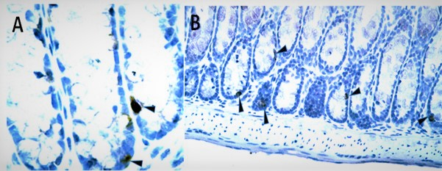
Figure 3.2: NRP-1 expression in the normal mouse colon. NRP-1+ cells marked with black arrows. Fig.30B
x40 magnification, Fig.30C x20.

3.4.2 Expression of NRP-1 in MCF-7 cells by flow-cytometry
NRP-1 expression was demonstrated, as expected, in the MCF7 cell line (see figure 3.3) with a clearly defined single cell population identified. Both methods using conjugated and non-conjugated primary anti-NRP-1 antibody worked well, however the signal obtained from using the Alexa Fluor 488 secondary antibody was stronger than using the conjugated antibodies. Given that NRP-1 is expressed in a very small proportion of cell in the colonic epithelium, the Alexa Fluor 488 secondary protocol was therefore the preferred option to stain isolated primary murine colonic epithelial cells for NRP-1.
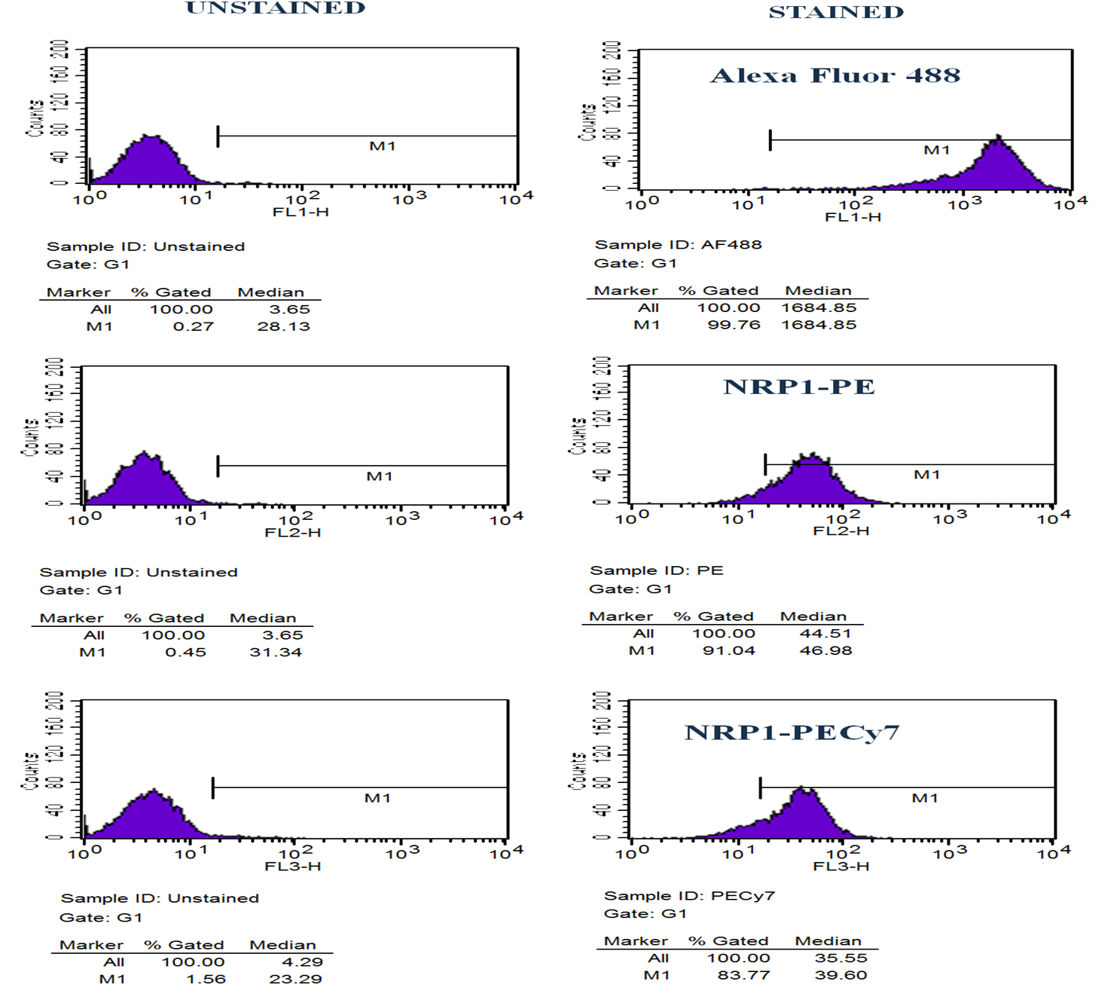
Figure 3.3: Flow cytometric analysis of NRP-1 expressing MCF7 cells. The one-parameter histograms demonstrate the three staining approaches in order to identify NRP-1 expressing MCF7 cells. Cells were stained for NRP-1 using NRP-1 primary antibody followed by the Alexa Fluor 488 secondary antibody (top), NRP-1 primary antibody conjugated with PE (middle) and NRP-1 primary antibody conjugated with PECy7. Cells stained for NRP-1 were compared with unstained cell. A clear right shift is seen with all three staining approaches, however a stronger signal is observed with the Alexa Fluor 488 secondary.

3.4.3 Dissociation of primary murine colonic epithelial cells into a single cell suspension

The chelation step described by Booth et al, which utilises a chelation solution containing 6.0mM EDTA and 4.0mM EGTA, yielded the greatest number of viable single epithelial cells. The viable counts observed in each chelation method, in combination with dispase and accustase, are summarised in table 3.2. Variability in the effectiveness of the different chelation solutions at releasing epithelial sheets from the underlying lamina propria was also demonstrated (see figure 3.4). Using dispase for the enzymatic step was more effective at disaggregating crypts into single cells than accutase. Combining the chelation step by Booth et al with dispase yielded over 3.0x10⁶ cells per colon with 90% viability.
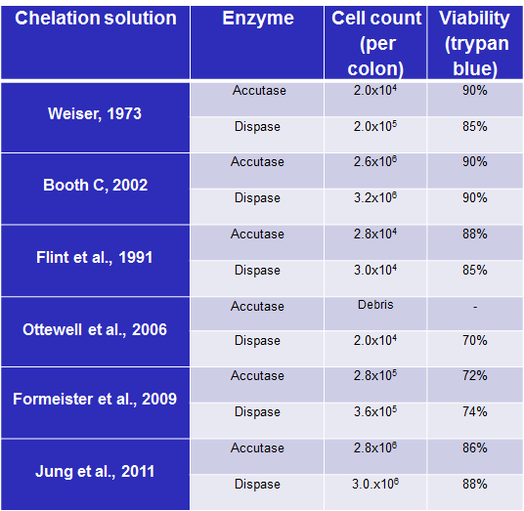

Table 3.2: Comparison of mean cell count and viability following 6 different chelation protocols. The efficacy of six published chelation protocols, combined in turn with dispase and accutase, to yield a viable single cell suspension of murine colonic epithelial cells were directly compared. Mean cell count and mean viability are compared. n=36.

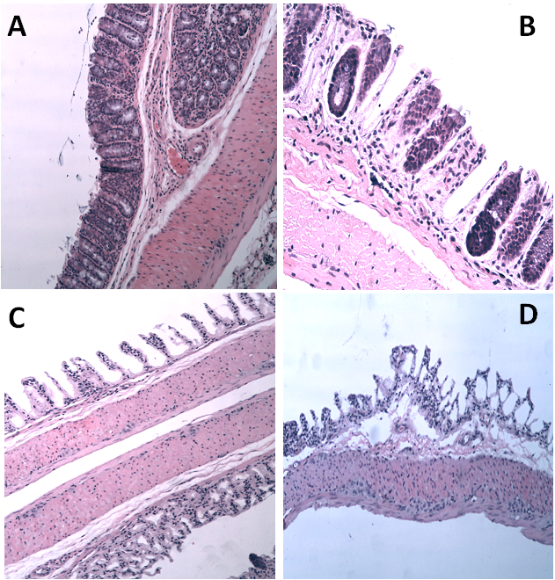
Figure 3.4: H+E stained sections of remnant mouse colon following epithelial cell dissociation.
Representative images indicating the efficacy of the varying cell dissociation techniques in separating colonic crypts from the underlying basement membrane. Figure A demonstrates how virtually all crypts remain in-situ (method 4 – Ottewell et al.). Some improvement in crypt dissociation is seen in figure B (method 6 - Jung et al.). Figure C reveals complete dissociation of colonic crypts with skeletisation of the lamina propria in this representative image, reflecting a higher cell yield (method 2 – Booth et al.). Note how the colon is everted with the submucosa exteriorised and serosa on each side forming a neolumen. Figure D again demonstrates effective dissociation of crypts. However the viability of dissociated cells was poor, reflecting the high concentration of EDTA used with this protocol (method 5 – Formeister et al.). (Images A, C and D x10 objective lens, image B x20 objective lens)

3.4.4 FACS isolation of NRP-1+ cells from the murine colonic epithelium
Booth et al’s method of chelation was used in order to isolate cells to then stain and isolate the NRP-1+ cell population in the mouse colonic epithelium. Unfortunately it became apparent that given the limitations of primary epithelial cell isolation and that NRP-1 expression is a rare event in the colonic epithelium, isolating a NRP-1+ cell population proved insurmountable with too much cellular debris and apoptotic cells present following the staining protocol resulting in general non-specific staining (see figure 3.5).

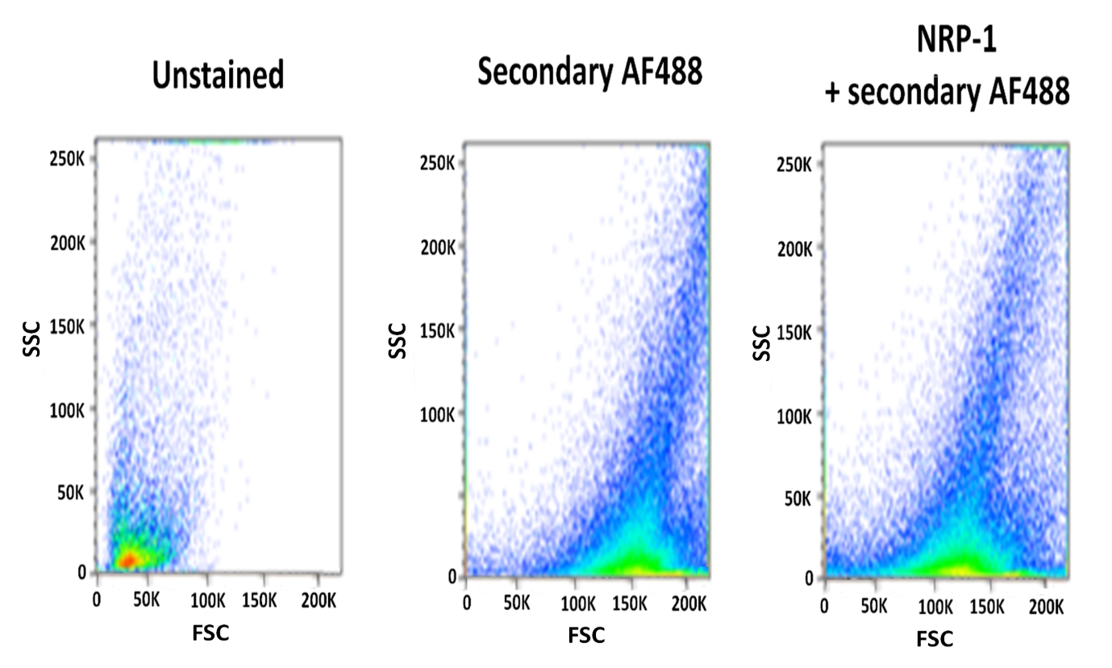
Figure 3.5: FACS dot plot of NRP-1 staining of isolated murine colonic epithelial cells. This figure compares a cells sort with unstained, Alexa Fluor 488 (AF488) secondary antibody only and NRP-1 and AF488. Extensive non-specific staining is apparent, with an almost identical cell population identified with and without the NRP-1 primary antibody. SSC = side scatter. FSC = forward scatter.

3.5 Discussion

3.5.1 NRP-1 expression in the murine epithelium
In this study I demonstrated that NRP-1 is expressed in the colonic epithelium of C57/BL6 mice. NRP-1 expression in the mouse colonic epithelium has not been reported previously. NRP-1 is known to be expressed in murine neurons, endothelial cells (Pellet-Many et al., 2008) and SMCs of the large vessels in mouse embryos (Jubb et al., 2012). Yamaji and colleagues found NRP-1 to be expressed in SMCs of the mouse colon and, by generating SMC-specific Nrp-1 knockout mice (NRP-1^{SMKO}) found that Nrp-1 deficiency in colonic SMCs resulted in GI reduced colonic contractility and constipation (Yamaji et al., 2015). I found that NRP-1 had a similar pattern of expression in the colonic crypts in mice as it does in the human colon, with positive staining of singly dispersed epithelial cells with EEC features.

3.5.2 Comparison of colonic epithelial dissociation techniques
The method described by Booth et al (Booth C, 2002), which utilises a chelation solution containing 6.0mM EDTA and 4.0mM EGTA with a more prolonged incubation time, yielded the greatest number of viable single epithelial cells when compared to other published methods tested.
Milton Weiser developed a method of isolating villous and crypt cells from rat intestines 40 years ago (Weiser, 1973) and since then modifications of the Weiser solution have been developed by others (Booth C, 2002, Formeister et al., 2009). Incubation with chelating agents, the most widely used being EDTA, releases cells from their calcium- and magnesium-dependent interactions with the basement membrane and disrupts the function of the extracellular matrix molecules cadherin and integrins (Chopra et al., 2010). The addition of the anti-mucolytic agent DTT to the chelation solution also counters the adverse effect of mucous on cellular aggregation. Modifications in Booth et al’s method that are likely to enhance the efficacy of the technique include the addition of EGTA, a chelation agent similar to EDTA but with a higher affinity to calcium than magnesium ions (Booth C, 2002) and sorbitol and sucrose, which as energy substrates may contribute to the increased yield of viable epithelial cells (Flint et al., 1991). A prolonged incubation time in the chelation solution will also contribute to the increased number of cells isolated.
I also demonstrated that, when used in combination with chelation and mechanical disruption, the addition of dispase was more effective than Accutase® in increasing the yield of viable single cells. Over the last 30 years, the employment of crude trypsin and collagenase preparations have been the preferred choice for cell dissociation. However trypsin can cause excessive cell membrane damage and target receptor denaturation and collagenase can cause excessive cell aggregation. I opted to compare dispase and accutase in the enzymatic step of my study as they cause less cell membrane damage when compared to the traditional proteolytic enzymes (Bajpai et al., 2008). I would have expected Accutase®, a cell detachment solution that contains a mixture of enzymes with collagenolytic, proteolytic and DNAse activity, to perhaps be more effective than dispase, a bacterial enzyme produced by Bacillus polymyxa, that contains a single protease only. It may be that Accutase®, which is often used for the dissociation of sensitive cell types, was too gentle at dissociating the epithelial cells in the incubation time chosen and may have required a longer digestion period. It may also be that dispase combines more effectively with the DNAse I, which was also given at the end of each protocol in order to prevent cell clumping prior to counting.
While strengths to my methodology include applying a systematic approach to compare several different published dissociation techniques, standardising colon lengths, repeating the experiment three times for each technique and quantifying cell counts and viability, there are several weaknesses to the methods applied in this study. The use of shaking the tissue in the chelation solution is an important aspect of the epithelial removal process, however this step is the most subjective and variable. The result could therefore be skewed by how hard and long the solution was shaken as this was not measured. Although I attempted to evaluate the effectiveness of epithelial removal by performing H+E staining of the remnant mouse colon, this technique is again highly subjective. An alternative approach such as the use of a valid epithelial cell marker (eg. cytokeratin) to stain the remnant colon and quantify the number of cells remaining would have been preferable. I also did not assess the purity of epithelial cell suspension. Despite centrifugation and filtering the dissociated cell suspension, contamination with other cell types, such as lymphocytes, fibroblasts and mesenchymal cells may have occurred. This may have contributed to the difficulties encountered with the staining of the isolated epithelial cells for FACS. Again, an epithelial cell immunomarker could have been used to assess purity of the cell suspension obtained.
It is difficult to compare the results of my study comparing chelation methods to published cell yields due to the multiple contributing factors and heterogeneity of reported studies. The vast majority of published methods involve dissociation of small intestinal epithelial cells as opposed to colonic, and vary in species, number of animals used per protocol and length of intestine used. In my study I standardised the length of colon to an arbitrary 6cm and repeated the experiment three times for each cell dissociation method. Despite this there would certainly be a wide variation in the epithelial surface area per colon and thereby the number of colonic crypts per colon. There would therefore be a potential for a wide variation in the baseline number of colonic epithelial cells available to be isolated per mouse colon.
Ideally human tissue would have been used in this study, as it was in chapter two of this thesis, instead of mouse colon. However obtaining a sufficient yield of colonic EECs would likely require several colonic specimens from patients, which is clearly not practically or ethically appropriate. Expanding a population of colonic epithelial cells from biopsy samples would be a huge technical challenge, especially given that FACS sorted intestinal cells do not appear to survive in culture (Psichas et al., 2017).

3.5.3 FACS isolation of NRP-1+ cells
Although I examined both the indirect and direct fluorochrome staining techniques, there are several other limitations to my methodology which may have contributed to the failure to isolate NRP-1 expressing colonic epithelial cells. Persistent non-specific background staining and cellular debris was likely to have been caused by apoptosis and cellular disruption from the repeated insults in the various cell isolation and staining steps. While Booth et al’s chelation technique combined with enzymatic digestion resulted in a high yield of viable cells this did not provide a suspension of cells from which NRP-1+ cells could be isolated. The prolonged chelation step in Booth et al’s protocol may have caused disruption to the cellular membrane of the colonic epithelial cells resulting in the failure of the anti-NRP-1 antibody to bind to the NRP-1 epitope. This view is supported by the successful staining and FACS sorting of NRP-1+ MCF7 cells. The MCF7 epithelial cells are an established cell line that underwent only a relatively sort exposure to trypsin-EDTA in order to detach the cells adhered to the culture flask.

3.5.4 Alternative approaches
An important factor to consider is the relative rarity of NRP-1+ cells within the colonic epithelial cell population with this experiment highlighting one of the main difficulties of EEC research. A recent 3D microscopic study observed that for every 10,000 epithelial cells in the colon there were only 5.5 PYY-expressing cells (Bohorquez et al., 2014) and it is the dispersed nature of EECs that presents a considerable challenge which has largely prohibited interrogation by single-cell physiological techniques. Over the years, single cell characterisation has been restricted to EEC model cell lines, such as GLUTag, STC-1, NCI-H716, FRIC and AMIC (Kuhre et al., 2016), however these lines are murine and/or tumour derived and are also derived from heterogenous populations of intestinal cells from the entire GI tract. Such EEC lines are therefore not representative of normal colonic EECs and the use of such cell lines would not be appropriate in enabling me to determine the NRP-1 expressing cell type in the normal colonic epithelium.
As an alternative approach, Chougule et al have demonstrated the use of magnetic beads conjugated to EpCAM, a pan-epithelial cell marker, to isolate small intestinal epithelial cells from a primary culture (Chougule et al., 2012). Although trypsinisation to release cells from the culture plates and low concentration of EDTA (1mM) are still required prior to immunomagnetic selection, this method also yields purified epithelial preparations with the additional advantages of avoiding prolonged chelation or enzymatic digestion. Time-consuming sedimentation steps are also not required, resulting in a rapid cell isolation procedure.
Laser capture microdissection (LCM) technologies also offer a novel method of obtaining pure epithelial samples (Funke, 2011). Employing a focussed laser beam to extract the selected cells, the advantage of laser microdissection is the direct control of the cell selection process through direct visualisation under the light microscope. The target cells can be selected according to specific histological morphology or can also be selected via IHC antigen detection or via genotypical identification through in-situ hybridisation. Although LCM can be performed in formalin-fixed tissue, applying this method to frozen tissue provides a more reliable method of extracting high quality RNA from pure epithelial fractions.
In the last decade the Metabolic Research Laboratory group in Cambridge, UK has led the way in EEC research and gut peptide secretion (Reimann et al., 2008), especially with the use of transgenic fluorescent reporter mice expressing green fluorescent protein (GFP) reporter genes targeted to unique EEC subtypes. This approach has facilitated isolation and analysis of enriched purified EEC subpopulations enabling generation of single-cell transcriptomic RNA profiles, forming the basis of over twenty publications from this group (Psichas et al., 2017). Although this technique uses similar enzymatic digestion methods as the ones I have employed, use of fluorescent reporter genes negates the need for staining of cells which resulted in excessive background staining required for FACS in my experiment. Fluorescent reporter mice have been used to isolate small and large intestinal L-cells (Reimann et al., 2008), small intestinal K cells (Parker et al., 2009) and more recently pancreatic D-cells (Adriaenssens et al., 2016). A strategy using this technique would be the best way forward in order to isolate NRP-1 expressing colonic epithelial cells to enable RNA extraction and gene profiling in order to further characterise the NRP-1 expressing colonic cell subtype and investigate the biological relevance of NRP-1 in the colonic epithelium. Practical limitations such as cost, access and availability of expertise in breeding fluorescent reporter mice targeting colonic EEC subtypes, prevent this from being an avenue to pursue within the confines of this thesis.

Chapter four:
PATTERNS OF ENTEROENDOCRINE CELL EXPRESSION IN COLORECTAL CARCINOGENESIS

4.1 Introduction
As previously outlined in section 1.2.8 of this thesis, EECs have also been implicated as having a role in colorectal carcinogenesis (Gunawardene et al., 2011). One third of colorectal adenocarcinomas express differentiated EECs with subset of EECs found to express VEGF (Gulubova and Vlaykova, 2008). It has been recognised that EEC numbers are altered in the vicinity of colonic neoplasia in humans (Yu et al., 2011) with a murine model of colorectal carcinogenesis also demonstrating a depletion in EEC population in malignant colonic epithelium (Novaes et al., 2016). EECs have also been found to express cancer-associated transcription factor Brachyury (Jezkova et al., 2016) with Wang and colleagues also previously demonstrating that activating the Wnt pathways in the early stages of EEC differentiation results in 5-HT expressing adenoma formation (Wang et al., 2007). However, despite the location of EECs in the colonic crypts, their function as luminal chemosensors and ability to secrete proliferative and pro-angiogenic factors, the role of EECs in colonic carcinogenesis remains relatively under investigated (Kleist and Poetsch, 2015).
It is increasingly accepted that SCFAs play an important role in the anti-neoplastic effects of dietary fibre, with butyrate having previously been shown to promote growth arrest, apoptosis and suppression of angiogenesis (Kim et al., 2007, Yu et al., 2010, Chirakkal et al., 2006). However the exact mechanisms that underpin such an effect remain unclear. The SCFA-EEC interaction may play a role. There has been increasing interest in the interaction between SCFAs and EECs, especially as it has become increasingly clear that the SCFA receptors FFAR-2 and FFAR-3 are expressed by EECs (Karaki et al., 2008, Tazoe et al., 2009), as outlined in section 1.4.2. However, the majority of research in this field has focussed on the physiological effects of SCFA-stimulated release of EEC hormones and its metabolic impact, especially in obesity and diabetes (also see section 1.4.3) and the relationship between SCFAs and EECs in the context of CRC remains unknown. Previous work has demonstrated that CgA+ expression is influenced by butyrate level in vivo (Yu et al., 2011). Butyrate also downregulates colonic NRP-1 expression in vitro (Yu et al., 2011), and lastly NRP-1 is known to be expressed in a subset of EECs, as demonstrated in chapter 2 of this thesis.
The SCFA-EEC interaction may therefore play a role in colorectal carcinogenesis and may offer a mechanism that contributes to the anti-neoplastic effect of dietary fibre in CRC and also a potential new chemopreventive and diagnostic target. I therefore investigated whether alterations in ECC population numbers occurs in colorectal carcinogenesis, and if there was any association between SCFA levels and EEC number.

4.2 Hypothesis and aims
I hypothesised that:
- EEC numbers are altered in human neoplastic colonic epithelium
- EEC numbers are altered in the neoplastic lesion field
- SCFAs influence colonic EEC expression

To test this hypothesis the aims of this study were to:
- Characterise changes in cellular morphology and staining patterns in normal, field and neoplastic lesion biopsies
- Compare colonic EEC subtype expression in the normal epithelium of lesion-free patients to the neoplastic epithelium in patients with adenomas and adenocarcinomas
- Compare colonic EEC subtype expression in the lesion field compared to control
- Identify relationships between the EEC subtypes in the normal and field biopsies, including EEC position within the crypt
- Identify alterations in ECC expression and crypt cellularity in relation to faecal SCFA levels
- Investigate the relationship between age and BMI on faecal SCFA levels

4.3 Methods

4.3.1 Human colonic biopsies
This experiment expands on previous work performed in the Corfe laboratory with my study using archived tissue previously collected from patients recruited as part of the FACT observation study (Corfe et al., 2009), as described in section 2.3.1. In this study all patients received MBP prior to lower GI endoscopy where colonic biopsies were obtained in patients from three diagnostic groups; lesion-free patients, those with colonic adenomas and those with colonic adenocarcinoma. A single biopsy from each patient was taken with Radial Jaw 4 2.8mm forceps (Boston Scientific, UK) from three possible sites; from the lesion (adenoma or adenocarcinoma), the contra-lateral field site (ie. the colonic mucosa immediately opposite from the lesion), and from the mid-sigmoid (control site). The mid-sigmoid was chosen as a control site as it is an easily identifiable landmark at endoscopy.
Biopsies were fixed in formalin and then paraffin embedded before 5µm serial sections cut. Sections were stained with haemotoxylin and eosin (H&E) and examined by a consultant histopathologist (Dr J Bury) to confirm the diagnosis of normal colonic epithelium, adenoma or adenocarcinoma and to determine adequate crypt orientation. Those sections with low crypt yield were re-cut.

4.3.2 Faecal SCFA measurement
Data on faecal SCFA levels was also collected previously as part of the FACT Observation study. Patients were asked to provide stool samples two weeks following the endoscopy. Within 3 hours of production, SCFAs were extracted from each stool sample and the absolute level of each SCFA (mmol/L) was determined with gas chromatography in collaboration with Professor Chris Seal, University of Newcastle upon Tyne (Corfe et al., 2009). Data on levels of the three main SCFAs; butyrate, propionate and acetate was analysed in my study in order to assess for any relationship between the SCFA levels and the three diagnostic groups, EEC expression, crypt cellularity and also age and BMI.

4.3.3 overview of dataset and patient characteristics
Biopsies were obtained from 124 patients in total. This included 58 lesion-free patients, 50 patients with colorectal adenomas and 16 patients with colorectal adenocarcinomas (see table 4.1). The mean age of patients was 65.2 years (SD±11.2). Mean BMI was 26.8 (SD±5.0) (see table 2). Due to issues relating to the sampling and processing of biopsies and some patients not providing stool samples, a minority of patients did not have a full set of cell data or SCFA data available (see table 4.1).
Diagnostic groups | IHC stain |  |  |  |  |  |  | SCFA data
 | CgA |  | GLP-1 |  | SST
 | MS | CO | MS | CO | MS | CO
Lesion Free (n=58) | 58 | - | 54 | - | 54 | - | 40
Adenoma (n=50) | 29 | 23 | 48 | 43 | 44 | 39 | 30
Adenocarcinoma (n=16) | 15 | 15 | 14 | 14 | 14 | 16 | 10

Table 4.1. The number of biopsies with IHC and SCFA data available. Biopsies taken from the normal mid-sigmoid (MS) control and from epithelium contralateral (CO) to a neoplastic lesion (if present).

 | All patients  n= 124 | Lesion-free  n= 58 | Adenoma  n= 50 | Cancer  n= 16
Age (years) (mean ± SD) | 65.2 ± 11.2 | 62.2±11.2 | 68.5 ±9.8 | 66.2 ±12.4
BMI (kgm⁻²) (mean ± SD) | 26.8±5.0 | 27.0±5.2 | 25.9 ±3.7 | 28.2±6.5

Table 4.2. Mean age and BMI across the diagnostic groups.

4.3.4 Immunohistochemical staining strategy
The FACT Obs slide series consisted of 20 slides per biopsy per patient. In order to avoid scoring the same crypt twice I selected a pair of slides from each biopsy 10 slides apart. Slides were labelled with randomly assigned numerical identifiers, generated using Excel 2010 (Microsoft, Washington, USA), in order to blind the scoring. I then carried out IHC staining on two pairs of slides from each biopsy for GLP-1 (L-cell marker) and SST (D-cell marker) as per the IHC protocols I had optimised in section 2.2.5 and 2.2.6. Two slides per biopsy had already been stained for CgA (EC cell marker) using the same scoring protocol through previous work undertaken by Dr D. Yu (Yu et al., 2011).

4.3.5 Scoring method
All biopsies had two slides available for scoring for each of the three ECC immunomarkers stained for. Initially the whole section was assessed for inclusion. If the following scoring inclusion criteria was not satisfied then the slide was discounted:
- for a crypt to be considered viable the base and luminal surface had to be identified

- the cryptal epithelium should have a minimum length of 25 cells

- suitable crypts should comprise of a continuous straight line of cells

- a minimum of 5 hemi-crypts could be scored per slide

- a maximum of 10 hemi-crypts (or 5 crypts) were present - if more than 10 hemi-crypts were present then the best quality crypts were chosen

Cell scoring was performed using NIS-Elements (Nikon, Kingston, UK) laboratory image analysis system software (see figure 4.1). This was kindly performed by Ruth Narramore (RN; BMedSci student). All cells in included crypts were manually counted as either negative or positive, at x20 magnification. A positional score was devised in order to determine the distribution of EECs within a colonic crypt. Positively stained cells were defined as being in the lower (1), middle (2) or upper (3) third of the crypt. A combined positional score was then calculated for each EEC subtype; the higher the score equating to a higher position in the crypt. The counts were then recorded in an Excel 2013 database (Microsoft®, Washington, USA). In order to assess intra- and inter-observer reliability of the scoring technique, I scored 50 randomly selected hemi-crypts and compared these scores with RN’s scores. The number of positive cells and total number of cells were assessed to test whether positive cells were identified consistently and whether crypt cellularity varied between scorers. The agreement between the two scorers was assessed using a two-way single measure intra-class correlation co-efficient (ICC).
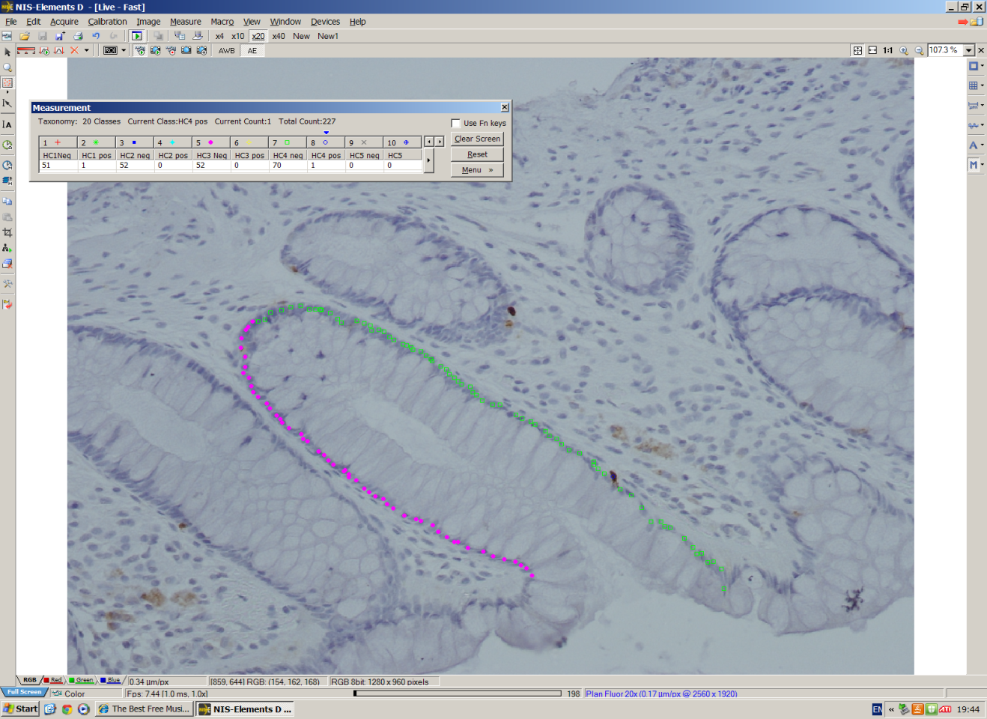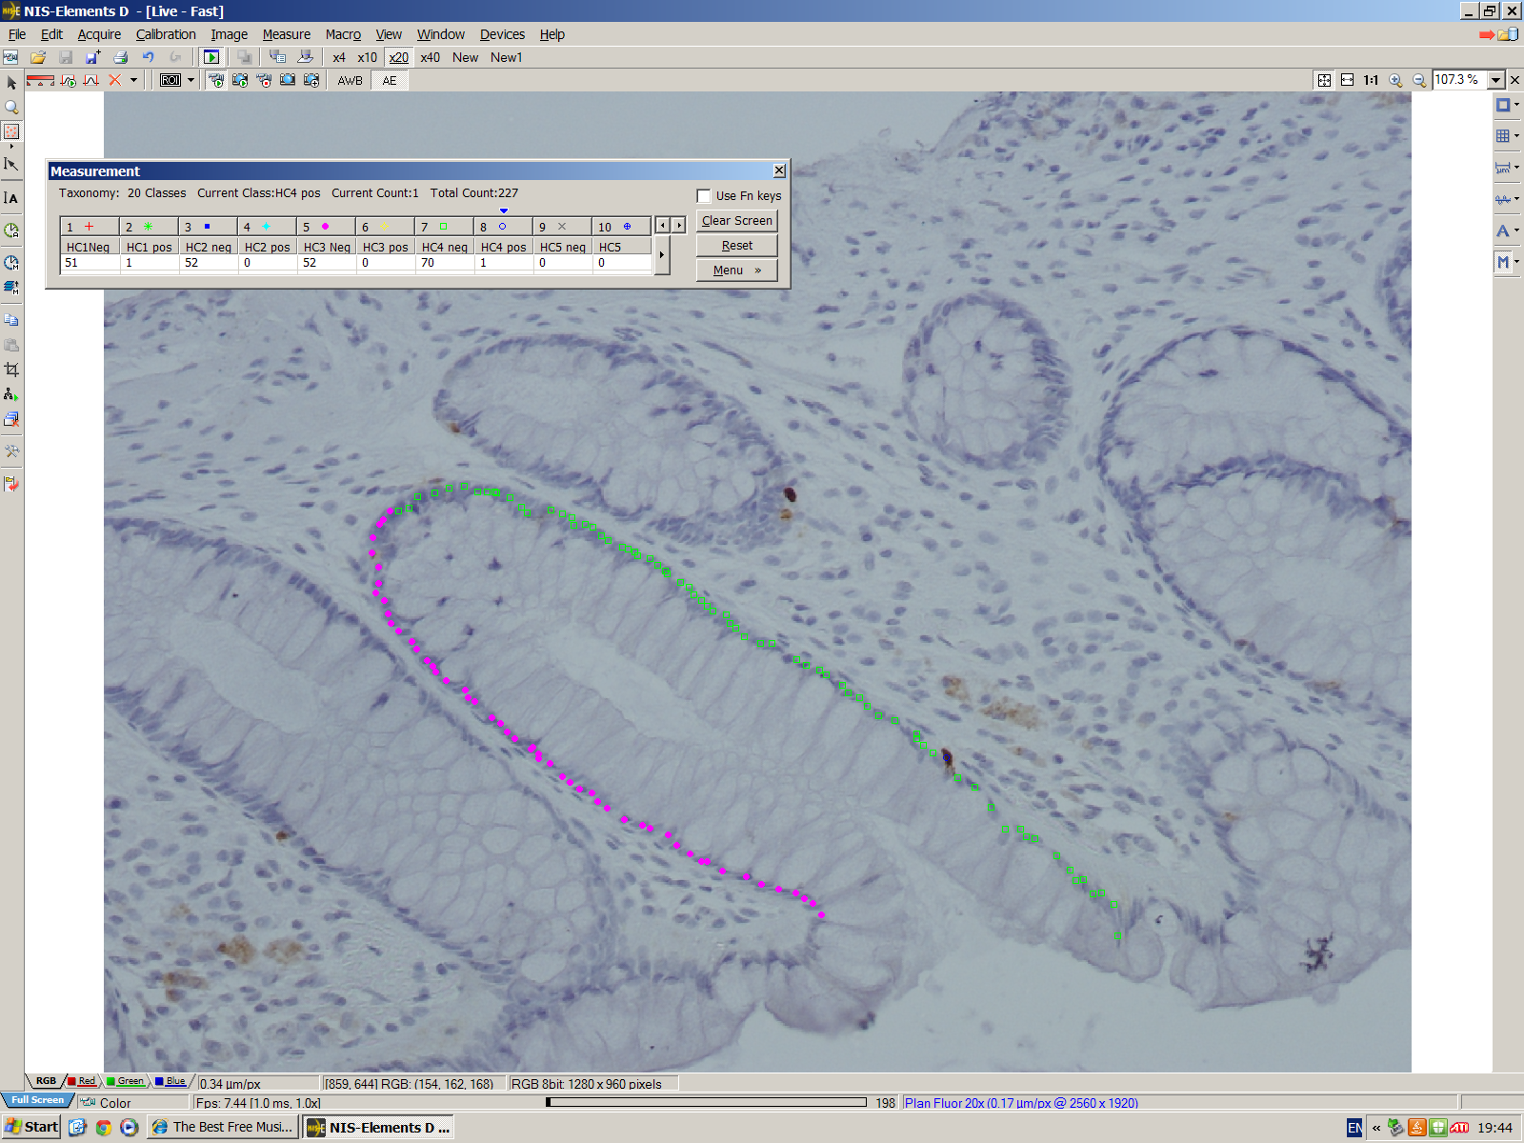
Figure 4.1: Colonic crypt scoring. This screenshot demonstrates the technique used for crypt scoring. NIS-Elements software (Nikon, Kingston, UK) was used to manually count negative and positively stained cells in hemi-crypts. This example demonstrates the cell counts for hemi-crypt number 3 (HC3) and hemi-crypt number 4 (HC4).

4.3.6 Data analysis
I performed a visual assessment of the staining providing descriptive analysis of the morphology and distribution of EEC subtypes. Findings were confirmed by a consultant histopathologist (JB). The number of cells per crypt was used as an outcome measure rather than percentage of positive cells per crypt. Quantitative statistical tests were then employed using SPSS for Windows version 20.0 (IBM Corp, New York, USA). The appropriate statistical test used has been stated in each results section. The level of significance was set at P < 0.05 (* P < 0.05, ** P < 0.01, *** P < 0.001, **** P <0.0001). Statistical support and advice was kindly provided from University of Sheffield Maths and Statistical Help (MASH) service.

4.4 Results

4.4.1 Morphology and distribution of EECs in normal and neoplastic colonic epithelium

Enterochromaffin (CgA+) cells

CgA+ staining was seen in a small number of singly dispersed well-defined cells most often located in the lower half of the crypt, with morphology and distribution consistent with EC cells. Staining appeared granular and sub-nuclear. CgA+ cells were often situated more basally than the surrounding colonocytes (see figure 4.2). The morphology and distribution of cells did not appear to be altered in the field. However, in the adenoma and cancer biopsies CgA+ staining appeared altered. While the crypt architecture was lost in the neoplastic epithelium, CgA+ staining remained localised to occasional singly dispersed cells. The number of CgA+ cells appeared depressed in adenoma and adenocarcinoma biopsies compared to non-neoplastic epithelium (see figure 4.3).
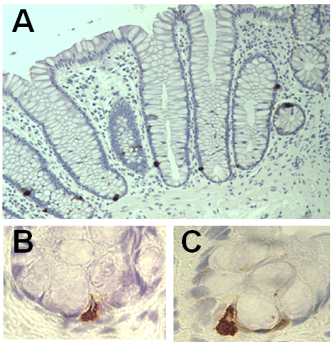

Figure 4.2: CgA staining in normal colonic epithelium. This reveals typical EC distribution (A) with distinctive subnuclear granular staining in pyramidal shaped cells with apical processes extending toward the lumen (B and C). Fig 4.2A x20 magnification, figs. 4.2B and C x40 magnification.

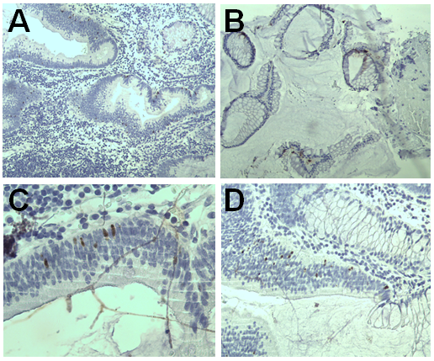

Figure 4.3: CgA staining in colonic adenocarcinoma. Representative sections (A-D) demonstrate that although crypt architecture is lost, CgA+ staining remains localised to singly dispersed cells. x20 magnification.

L-cells (GLP-1+)
The morphology and expression of GLP-1+ cells in normal colonic epithelium has been described in section 2.4.2 earlier in this thesis. Cellular staining within the field biopsies appeared normal in both morphology and distribution, although an increase in non-specific granular staining at the luminal epithelial surface was noted in a number of field biopsies (see figure 4.4). This staining pattern appeared to occur in the field of patients with neoplastic lesions and was not apparent in mid-sigmoid biopsies of lesion free patients. This observation plausibly reflected a genuine change in protein expression. All sections stained for GLP-1 were examined further (see table 4.3) and it was found that the luminal epithelial staining pattern did not occur at greater frequency in the contralateral field biopsies compared to the mid-sigmoid in adenoma and adenocarcinoma groups. The luminal surface staining was also seen in 5.6% of mid-sigmoid biopsies in lesion-free patients, however this occurred at a much lower frequency than in the contralateral field and lesion biopsies in neoplastic where over half (55.7%) of the biopsies demonstrated increased luminal epithelial staining.

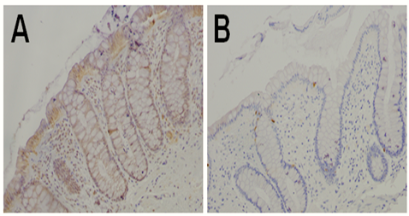

Figure 4.4: GLP-1 staining in the contralateral field of an adenoma compared with normal colonic epithelium. Surface staining of the luminal epithelium in the contralateral field is demonstrated, compared with an absence of luminal staining in the mid-sigmoid epithelium in a lesion-free patient. x20 magnification.

Luminal surface staining present? | Lesion free patients | Adenoma |  | Adenocarcinoma
 | MS | MS | CO | MS | CO
Yes | 3 (5%) | 11 (22%) | 13(22%) | 6 (33%) | 4 (22%)
No | 53 (93%) | 27 (55%) | 20 (34%) | 7 (39%) | 7 (39%)
Not assessable | 1 (2%) | 11 (22%) | 26 (44%) | 5 (27%) | (39%)

Table 4.3: Frequency of luminal epithelial staining with GLP-1. This table outlines the frequency of luminal epithelial staining seen in the mid-sigmoid and contralateral biopsies of the three diagnostic groups. MS= mid-sigmoid, CO = contralateral field.

GLP-1+ immunostaining within adenoma and adenocarcinoma biopsies became more markedly abnormal (see figures 4.5 and 4.6). Where crypt architecture was maintained distribution appeared to be conserved although a number of GLP+ cells were observed in the underlying lamina propria within some cases. In 6 out of 15 biopsies a diffuse increase in staining was noted and suggestive of an increased GLP-1 expression.

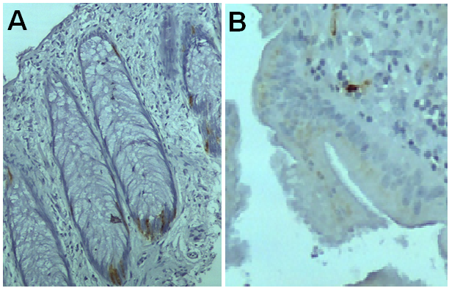

Figure 4.5: GLP-1 staining in colonic adenoma. Where crypt architecture was maintained distribution appeared to be conserved (A). However, although some individual cells remained definable, abnormal staining was seen where cellular morphology and crypt architecture is lost in the adenomatous tissue (B). Figure 4.5A x20 magnification, fig. 4.5B x40 magnification.

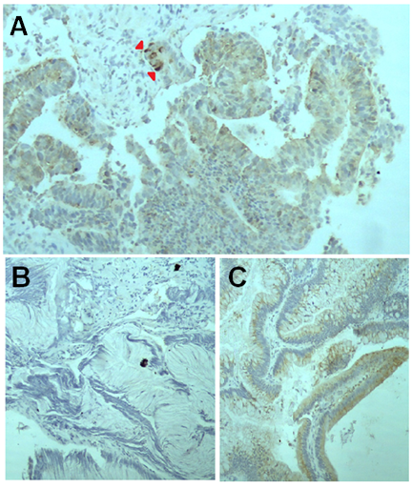

Figure 4.6: GLP-1 staining in colonic adenocarcinoma. Figure A demonstrates diffuse staining with a small number of clustered GLP-1+ cells of undetermined morphology visible (red arrows). Figures B and C show opposing patterns with no staining seen in (B)r and generalised granular staining in (C). x40 magnification.

D-cells (SST+)
The staining pattern of SST in the normal colonic epithelium is described in section 2.4.3. SST immunostaining in the contralateral field was similar to that of mid-sigmoid biopsies in lesion-free individuals, with individually dispersed cells displaying slim apical processes and targetoid features placed basally within the crypts. Where crypt architecture was preserved, SST staining within adenoma biopsies also demonstrated a similar pattern. However as crypt architecture became abnormal SST immunoreactivity was reduced with pale staining (see figure 4.7).
In adenocarcinoma sections, SST immunoreactivity was markedly reduced when compared to non-neoplastic epithelium. On the occasion when staining was present it was observed in small singly dispersed epithelial cells (see figure 4.8).
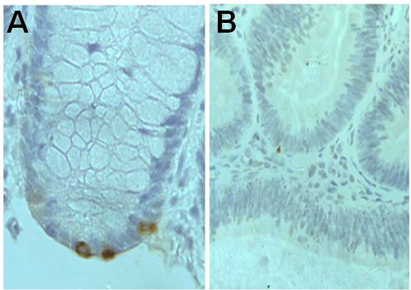

Figure 4.7: SST staining in colonic adenoma. Normal expression of SST is seen in microscopically normal crypts (A). In the abnormal more disorganised crypts in the adenomatous epithelium (B) immunoreactivty of SST is reduced with pale staining suggesting reduced levels of expression. X20 magnification.
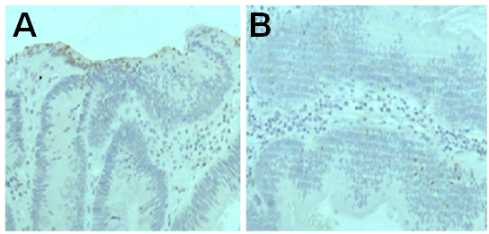

Figure 4.8: SST expression in colonic adenocarcinoma. Reduced levels of SST immunoreactivity are seen, demonstrated by occasional non-specific background staining at the section edge (A) or by small singly dispersed epithelial cells in disorganised crypts (B). x40 magnification.

4.4.2 Crypt scoring and intra & inter-observer reliability

Due to the disrupted crypt architecture in adenomatous and malignant epithelium and infrequency of positive staining cells, scoring of positive cells was not possible in biopsies taken from the lesion themselves. Therefore quantitative analysis of cell counts was performed on mid-sigmoid and field biopsies only.
Both intra- and inter-observer scores showed significant and strong agreement with each other at over 0.8 (see table 4.4).

 | Correlation | P value | 95% CI
Intra-observer reliability | 0.884 | <0.0001 | 0.806<x>0.932
Inter-observer reliability | 0.829 | <0.0001 | 0.720<x>0.898

Table 4.4: Intra- and inter-observer scores. Intra-class correlation co-efficient (ICC) test demonstrates the strength of agreement between observers. Calculation based on comparison of scores of 50 randomly selected hemi-crypts.

4.4.3 Alterations in ECC population at the mid-sigmoid with disease

progression

Significant alterations of EEC populations between normal and neoplastic epithelium were observed. The cell counts of GLP-1 and SST at the mid-sigmoid colon increased from normal to adenoma to adenocarcinoma (GLP-1, P=0.019, SST, P=0.034). Figure 4.9 demonstrates this linear relationship between GLP-1+ and SST+ cell counts through disease progression. CgA cell counts significantly increased comparing normal to adenocarcinoma (P=0.0008), however CgA expression decreased in the mid-sigmoid of adenomatous tissue.

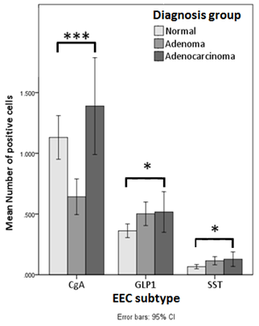

Figure 4.9: Bar chart comparing EEC expression in the mid-sigmoid in lesion-free, adenoma and adenocarcinoma patients. Kruskal-Wallis test was performed to assess the differences in the number of EEC cell types across the three diagnostic groups. Error bars represent 95% confidence intervals. Horizontal bars show statistically significant differences. *** = P<0.001, *= P< 0.05

4.4.4 Alterations in ECCs in the contra-lateral field

A significant decrease in SST+ cell number was demonstrated in the contralateral field biopsies in adenomas compared with normal (control) mid-sigmoid biopsies taken from the same patients (P=0.012). A non-significant decrease in cell number of GLP-1+ and CgA+ cells was also noted (see figure 4.10).
No significant differences were seen in EEC expression between mid-sigmoid and field biopsies in the adenocarcinoma group (see figure 4.11). However if data from adenoma and adenocarcinoma patients was combined a significant decrease (P=0.003) in SST+ cell numbers in the field biopsies contralateral to a neoplastic lesion was observed.
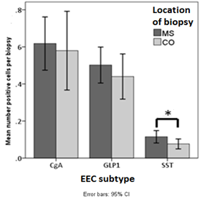

Figure 4.10: Bar chart comparing EEC expression in the adenoma field with mid-sigmoid control. A paired t-test was performed to assess the differences between mean number of positive cells per biopsy of the three ECC subtypes between contralateral and mid-sigmoid biopsies in patients with adenomas. Error bars represent 95% confidence intervals. Horizontal bars indicate significant results. *=P<0.05.

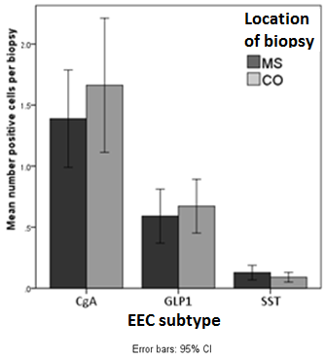

Figure 4.11: Bar chart comparing EEC expression in the adenocarcinoma field with mid-sigmoid control. A paired t-test was performed to assess the differences between mean number of positive cells per biopsy of the three ECC subtypes between contralateral and mid-sigmoid biopsies in patients with adenocarcinoma. Error bars represent 95% confidence intervals. No significant difference were seen.

4.4.5 EEC population dynamics
A significant correlation was observed between the number of GLP-1+ and SST+ cells at the mid-sigmoid in lesion-free, adenoma and adenocarcinoma patients (see tables 4.5-4.7).
There was no statistical relationship between CgA+ and SST+ cell counts in the mid-sigmoid biopsies across all patient group. Similarly, no relationship was seen between CgA+ and GLP-1+ cells form the mid-sigmoid in adenoma patients, however in adenocarcinoma patients a significant relationship was encountered between CgA+ and GLP-1+ cell counts at the mid-sigmoid.
At the field contralateral to neoplastic lesions, alterations in EEC dynamics were observed. In the adenoma field, the significant relationship between GLP-1+ and SST+ cell numbers was maintained, as did the non-correlation between CgA+ and SST+ cell counts. However, a significant relationship between CgA+ and GLP-1+ cell counts was now observed in field contralateral to the adenoma.
In the adenocarcinoma field, the relationship between GLP-1+ and SST+ cell counts in mid-sigmoid controls in all patient groups, and from contralateral adenoma field biopsies, was now lost. A significant relationship between CgA+ and SST+ not seen in any other biopsy site was now observed in the cancer field, with the similar relationship between CgA+ and GLP-1+ cell counts observed in the adenoma field also seen in the adenocarcinoma field.

Lesion free patients (mid-sigmoid)
ECC dynamic | R | P
GLP-1+ ↔ SST+ | 0.497 | 0.00013 ***
CgA+ ↔ GLP-1+ | 0.223 | 0.105
CgA+ ↔ SST+ | 0.154 | 0.267

Table 4.5: The relationship between the three EEC subtypes in crypts at the mid-sigmoid colon in lesion-free patients. Pearson’s correlation. ***=P<0.001

Adenoma patients (contralateral field)
ECC dynamic | R | P
GLP-1+ ↔ SST+ | 0.431 | 0.0061 **
CgA+ ↔ GLP-1+ | 0.531 | 0.0091 **
CgA+ ↔ SST+ | 0.191 | 0.382

Adenoma patients (mid-sigmoid)
ECC dynamic | R | P
GLP-1+ ↔ SST+ | 0.427 | 0.0038 **
CgA+ ↔ GLP-1+ | 0.291 | 0.125
CgA+ ↔ SST+ | 0.257 | 0.178

Table 4.6: The relationship between the three EEC subtypes at the mid-sigmoid colon and in the contralateral field in adenoma patients. Pearson’s correlation. **=P<0.01

Adenocarcinoma patients (mid-sigmoid)
ECC dynamic | R | P
GLP-1+ ↔ SST+ | 0.609 | 0.021 *
CgA+ ↔ GLP-1+ | 0.819 | 0.0003 ***
CgA+ ↔ SST+ | 0.301 | 0.296
Adenocarcinoma patients (contralateral field)
ECC dynamic | R | P
GLP-1+ ↔ SST+ | 0.431 | 0.123
CgA+ ↔ GLP-1+ | 0.621 | 0.017 *
CgA+ ↔ SST+ | 0.656 | 0.007 **

Table 4.7: The relationship between the three EEC subtypes at the mid-sigmoid colon and the contralateral field in adenocarcinoma patients. Pearson’s correlation. *=P<0.05, **=P<0.01, ***=P<0.001

4.4.6 Position of EEC subtypes within the colonic crypts
In lesion-free patients, SST+ cells were found to occupy a lower position in the crypt compared to GLP-1+ cells and CgA+ cell subtypes (median position score = 1.04 vs. 1.56 vs 1.154, P<0.0001). This relationship was maintained in mid-sigmoid biopsies in adenoma patients (median position score = 1.42 vs 1.58 vs 1.61, P=0.004). However in the mid-sigmoid biopsies in patients with adenocarcinoma and in contralateral field biopsies in adenoma and adenocarcinoma patients, there was no difference observed in ECC subtype position.

4.4.7 Crypt cellularity

Difference in cellularity in the field
There was a significantly greater number of cells in contralateral biopsies compared to mid-sigmoid biopsies in the adenocarcinoma group (mean difference 3.9 cells [SD 7.7-0.3] P=0.037). There was no difference in cell numbers seen between the mid-sigmoid and field in the adenoma group (mean difference 1.6 [SD 3.7-0.6] P=0.15).

Cellularity and EEC expression
A positive correlation between GLP-1 expression and crypt cell numbers was observed (r=0.267, P=0.012). No such relationship existed for CgA (r=0.272, P=0.056) and SST (r=0.211, P=0.062).

4.4.8 Influence of SCFA level on ECC expression

SCFA levels
 | Butyrate  mmol/L | Propionate  mmol/L | Acetate  mmol/L
Mean | 5.7 | 6.8 | 24.6
Minimum | 0.6 | 0.5 | 5.6
Maximum | 22.0 | 25.6 | 63.7
SD | 4.49 | 5.01 | 13.61
The concentrations of butyrate, propionate and acetate, in 80 patients, are described in table 4.8 below.

Table 4.8: Faecal SCFA levels in all patients. (SD = standard deviation).

Relationship of SCFA levels with age and body mass index
A significant negative correlation between all three SCFAs and age was observed, with older patients having lower concentrations of faecal SCFAs than younger patients (see figure 4.12). No relationship with SCFA concentration and BMI was evident.
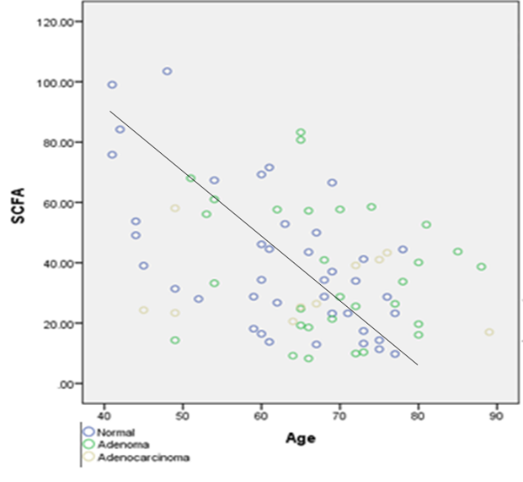

 | Butyrate  mmol | Propionate  mmol | Acetate  mmol | Total SCFA  mmol
r | -0.302** | -0.258* | -0.373** | -0.334**
P | 0.006 | 0.019 | 0.001 | 0.002

Figure 4.12: Age and faecal SCFA concentration. Scatter plot and table demonstrating a negative correlation with age and total faecal SCFA concentration (mmol/L). The Pearson’s coefficient revealed strong correlations with age and SCFA concentration.

SCFA levels in diagnostic groups
There was no relationship observed between SCFA concentrations (both individually and in combination) across the three diagnostic groups (see table 4.9 and figure 4.13).
 | Butyrate mmol/L | Propionate mmol/L | Acetate mmol/L | Total SCFA mmol/L
R | -0.147 | -0.066 | -0.086 | -0.090
P | 0.188 | 0.554 | 0.441 | 0.426

Table 4.9: SCFA concentrations across the diagnostic groups. Spearman’s rank tests comparing mean SCFA concentrations across all patients. No difference were seen between the three diagnostic groups.

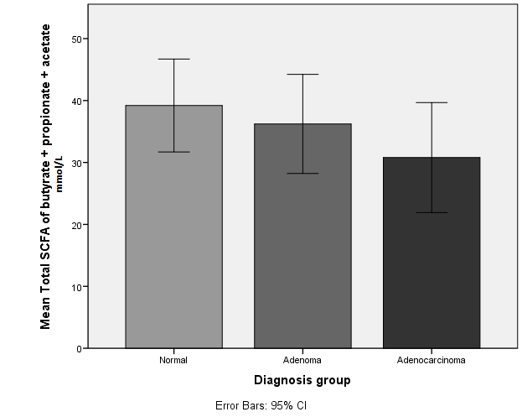

Figure 4.13: Bar chart comparing faecal SCFA concentrations across the three diagnostic groups. This figure demonstrates no difference in total mean concentration of the three main SCFAs (butyrate, propionate and acetate) across the three diagnostic groups (normal, adenoma, adenocarcinoma).

Influence of SCFAs on colonic crypt cellularity
A positive correlation was seen between crypt cellularity and butyrate concentration, but only in lesion-free patients (see table 4.10). There was no association between propionate and acetate concentrations and crypt cellularity.
 | Normal |  | Adenoma |  | Adenocarcinoma
 | r | P | r | P | R | P
MS | 0.203 | 0.036* | -0.010 | 0.930 | -0.101 | 0.601
CO | - | - | 0.030 | 0.805 | -0.143 | 0.467
Combined | - | - | 0.016 | 0.844 | -0.118 | 0.387

Table 4.10: Relationship between crypt cellularity and butyrate across the diagnostic groups. Spearman’s correlation. *= P < 0.05.

Influence of SCFAs on EEC population in lesion-free epithelium
No significant relationship was observed between the concentrations of the three SCFA and the EEC subtype populations in the mid-sigmoid biopsies in the lesion-free group. No correlation between SCFA concentration and the position of the EECs in the colonic crypts was observed.

Influence of SCFAs on EEC population in neoplastic epithelium
Changes in relationships between SCFAs and EEC subtypes between the mid-sigmoid and contralateral field in patients with adenomas was observed (see table 4.11).
Significant results were seen in the adenoma group. While there were no significant correlations between GLP-1 and SST and the three SCFAs in the mid-sigmoid, there was a significant positive correlation seen between GLP-1 expression at the adenoma field and levels of butyrate (r=0.424, P=0.035), propionate (r=0.475, P=0.014) and acetate (r=0.459, P=0.018). A significant positive correlation between SST and butyrate was also demonstrated in the adenoma field.
A weak inverse correlation was seen between CgA and butyrate only in the mid-sigmoid in the adenoma group. This relationship was lost in the field (see table 4.11).
No significant correlations were observed between the EEC subtypes and SCFA concentrations in either the mid-sigmoid or field in the adenocarcinoma group.

Adenoma |  | Mid-sigmoid |  |  | Contralateral field
 |  | Butyrate  mmol/L | Propionate mmol/L | Acetate mmol/L | Butyrate  mmol/L |  | Propionate mmol/L |  | Acetate mmol/L
CgA | r | -0.399 | -0.223 | -0.242 |  | -0.123 |  | -0.146 | -0.100
 | P | 0.035* | 0.253 | 0.215 |  | 0.585 |  | 0.517 | 0.658
GLP-1 | r | 0.031 | 0.212 | 0.093 |  | 0.424 |  | 0.475 | 0.459
 | P | 0.869 | 0.260 | 0.620 |  | 0.035* |  | 0.014* | 0.018*
SST | r | 0.004 | 0.035 | 0.018 |  | 0.358 |  | 0.371 | 0.372
 | P | 0.983 | 0.863 | 0.928 |  | 0.045* |  | 0.081 | 0.080
Adenocarcinoma |  | Mid-sigmoid |  |  |  | Contralateral field
 |  | Butyrate  mmol/L | Propionate mmol/L | Acetate mmol/L |  | Butyrate  mmol/L |  | Propionate mmol/L | Acetate mmol/L
CgA | r | -0.045 | -0.195 | -0.074 |  | 0.164 |  | -0.226 | 0.366
 | P | 0.903 | 0.566 | 0.828 |  | 0.650 |  | 0.503 | 0.268
GLP-1 | r | 0.013 | 0.031 | 0.342 |  | 0.107 |  | 0.553 | 0.423
 | P | 0.973 | 0.523 | 0.333 |  | 0.801 |  | 0.123 | 0.257
SST | r | 0.022 | 0.019 | 0.291 |  | 0.104 |  | 0.052 | 0.303
 | P | 0.956 | 0.962 | 0.415 |  | 0.775 |  | 0.078 | 0.365

Table 4.11: Influence of SCFAs on EEC populations. Correlations between the concentrations of the three SCFAs with mean cell counts of the three EEC subtypes in adenoma and adenocarcinoma (using Pearson’s correlation) groups. Relationships between EEC subtypes and SCFAs are demonstrating, comparing changes at the mid-sigmoid to the contralateral field. *= P< 0.05.

4.5 Discussion
The results described above confirms the hypothesis that EEC number are altered in the neoplastic colonic epithelium compared with lesion-free epithelium. Field effects were demonstrated with pertubations in EEC numbers observed in the epithelial field around neoplastic lesions. An altered relationship between SCFA concentrations and EEC number in the adenoma field was also demonstrated.

4.5.1 ECC dynamics
In the normal colonic epithelium positively stained cells were singly dispersed, consistent with previous reports and supporting the theory of the Notch pathways inducing lateral inhibition of differentiating EECs (Schonhoff, Giel-Moloney et al 2004). The analysis of EEC population dynamics are summarised in figure 4.14.
Here I have demonstrated that a strong relationship of D- and L-cell expression exists in the normal epithelium, with significant relationships seen between these two EEC subtypes seen in the mid-sigmoid biopsies in all three patient groups. This relationship was maintained in the adenoma field but was lost in the adenocarcinoma field. This finding supports previous work which has proposed a mechanism of shared cell lineage between L- and D-cells (Beucher et al., 2012, Ye and Kaestner, 2009) and also supports the use of mid-sigmoid biopsies as a control. Ye and Kaestner (Ye and Kaestner, 2009) demonstrated that intestinal-specific deletion of Foxa1 and Foxa2 alters the differentiation of L- and D-cells with the helix transcription factors Foxa1 and Foxa2 found to be acting upstream of additional transcription factors ISL-1 and Pax6 to control L- and D-cell differentiation in both the small and large intestine. Based on their comprehensive analysis of EECs in the small intestine, utilising knockout mice and lineage tracing processes, Beucher et al (Beucher et al., 2012) also theorised that L- and D-cells may share a common progenitor with their differentiation influenced by the antagonistic effects of the factors Pax4 and Arx. It may be that L- and D-cells are concomitantly expressed due to physiological factors. L- and D-cell products, GLP-1 and SST respectively, act in different ways to slow down digestion, whereas the EC cell product 5-HT increases colonic motility and gastric emptying (Gunawardene et al., 2011). GLP-1 and SST are produced in response to luminal load and it may be that patient specific factors, such as diet, the microbiome and colonic transit favour concomitant L- and D-cell expression.
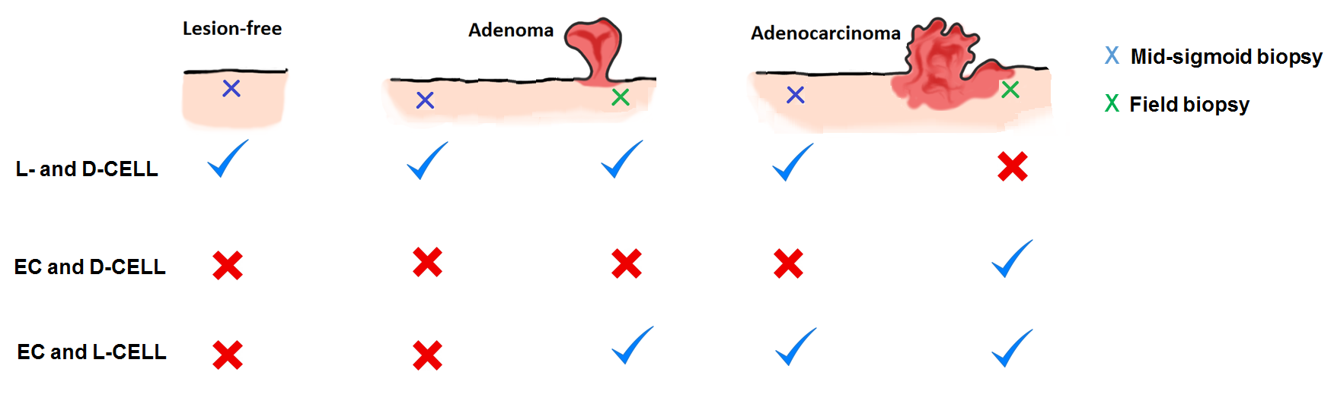
Figure 4.14: Summary of EEC dynamics. The relationships between the three EEC subtypes in mid-sigmoid biopsies in lesion-free patients and in mid-sigmoid and field biopsies in adenoma and adenocarcinoma patients are illustrated. A relationship between L- and D-cells in evident however this is lost in the adenocarcinoma field. Relationships between EC cells and L- and EC and D-cells appear in the neoplastic field suggesting an alteration in EEC differentiation pathways. =significant correlation, X= no correlation.

Additionally, I demonstrated that in the normal colonic epithelium D-cells appear to occupy a lower position in the colonic crypts than L- and EC cells. The majority of EEC complete the differentiation process within the crypt and migrate towards the luminal epithelial cuff where they are eventually shed. It has been noted previously, in the small intestine, that a small population of EEC migrate down towards the bottom of the crypt (Bjerknes and Cheng, 1981, Sei et al., 2011). Paneth cells, normally found in the small intestine, are also noted to migrate downwards and reside in the lower crypt where they are now thought to play a role in the protection of nearby stem cells (Elphick and Mahida, 2005). It is therefore not unreasonable to hypothesise that the D-cells, because of their lower position in the crypt may also play a role in stem cell biology.
In the normal epithelium, a significant relationship was seen between L-cell counts and cellularity. It has been recently demonstrated that activation of GLP-1 receptor signalling promotes gut growth and crypt fission with loss of GLP-1R signalling reducing growth in models of gut hyperplasia (Koehler et al., 2015). In L-cells, GLP-1 also colocalises with GLP-2, which itself is a potent proliferative factor of intestinal epithelial cells (Jasleen et al., 2002). Interestingly, no relationship was observed between cellularity and D- or EC cells. I would have expected D-cells to correlate negatively with cellularity due to SST’s anti-proliferative properties (Leiszter et al., 2015), however this was not observed.

4.5.2 Altered expression of EECs in neoplastic lesions
In the neoplastic colonic epithelium, alterations in the expression of all three EEC subtypes were observed in the adenoma and adenocarcinoma lesion biopsies with a reduction in EEC numbers. This relationship appeared most marked for D-cells. Where EECs were present, their morphology resembled that of the surrounding epithelium by both appearing normal in morphologically normal areas of epithelium and also demonstrating pleomorphism in neoplastic epithelium. However, the finding of a depression in EEC population in neoplastic tissue must be made with caution. Due to the disrupted crypt architecture it was not possible to reliably quantify the number of positive cells in the lesion biopsies as per my scoring criteria. Therefore this finding, based on IHC, is subjective. Quantifying changes in EEC numbers in neoplastic colonic epithelium would require isolating EEC and utilising flow cytometry to count cell populations. However this technique would be very difficult to perform reliably, due to the relative small population of EECs (see discussion in chapter 3).
There was an increase in granular staining at the luminal epithelial surface, noted in 57.6% of sections (in mid-sigmoid, field and lesion) from adenoma and adenocarcinoma patients, compared with 5.6% of mid-sigmoid sections in normal patients. This may represent a pan-colonic increase in GLP-1 expression in patients with neoplastic lesions. However this interpretation must also be made with caution. Again, these findings are subjective or may simply represent non-specific background staining. This staining pattern was also present in normal mucosa, although in a much smaller number of lesion-free patients. To investigate if there is an increased expression of GLP-1 in neoplastic colonic epithelium then other proteins methods, such as Western blots, comparing GLP-1 expression in neoplastic colonic mucosa with non-neoplastic colonic mucosa would be required. However, such techniques require fresh tissue which was not available for this project.
Alternatively, tissue microarray (TMA) technology could provide an effective approach to quantify EEC marker expression in colorectal cancer specimens. TMA is a high-throughput molecular biological technique that enables large-scale analysis using IHC or fluorescence in situ hybridization (FISH) on hundreds of tissue samples simultaneously (Koo et al., 2019). Significantly more specimens would have to be collected prospectively for me to apply this technique to my research questions in this thesis, however this approach would also provide a sufficient number of samples with associated clinical data to power an investigation into other aspects such as whether the stage of colorectal cancer correlates with EEC expression.

4.5.3 Comparing my findings with the published literature
There are a limited number of reports in the literature investigating IHC staining patterns of EEC markers in CRC. In the studies where neoplastic epithelium has been compared to normal controls a decrease in CgA expression was noted in colonic neoplasia, in keeping with the results in my study. Ho et al first observed a decrease in CgA expression in neoplastic colonic epithelium compared with normal epithelium with CgA reactive cells identified in 31% of colonic adenomas and 33% of carcinomas examined (Ho et al., 1989). Ferraro et al also found that CgA was expressed in discrete cells with diffuse staining noted in 16% of colonic cancer specimens analysed (Ferrero et al., 1995). Gulubova et al observed a similar pattern of CgA expression in 34% of CRC specimens examined (Gulubova and Vlaykova, 2008), although in both these studies the findings were not compared to lesion-free controls. Although investigating gastric mucosa, Ikeda et al reported a depression of CgA positive cells in gastric adenocarcinoma compared with normal mucosa (Ikeda et al., 1995).
SST is well established as having an anti-proliferative effect (Leiszter et al., 2015). Previous IHC studies support my findings of a decrease in SST expression in neoplastic colonic epithelium (El-Salhy et al., 1998, Seretis et al., 2004). More recently, Leiszter et al have demonstrated reduced SST mRNA expression in CRC patients in addition to a decrease in SST immunoreactive cells, suggesting that reduced epithelial SST production may contribute to the accelerated and deregulated cell proliferation in CRC. These findings are consistent with the inhibition of cancer cell growth along with the induction of apoptosis observed with octreotide treatment (Leiszter et al., 2015). Evangelou et al have also demonstrated reduced expression of SST receptor subtypes 2 and 5 with CRC stage (Evangelou et al., 2012)
There are inconsistent reports of GLP-1’s role in CRC. GLP-1R has been found to be expressed in some but not all CRC lines (Vangoitsenhoven et al., 2012) and some reports have concluded that GLP-1 promotes colorectal carcinogenesis, whereas others believe GLP-1 to inhibit colon tumour growth (Koehler et al., 2011). Recent years have seen an increase in the use of incretin-based anti-hyperglycaemic agents, such as GLP-1R agonists, as second line therapies in the management of type 2 diabetes. There have been concerns over findings in mouse models where a GLP-1R agonist increases mucosal expansion and colonic polyp growth (Koehler et al., 2015). Although a population-based cohort study in the USA of 5600 patients using GLP-1R agonists did not show any increased short term CRC risk, the study was limited by the short duration of treatment and a short follow-up period of only 6 months (Htoo et al., 2016). There are no published reports of GLP-1 staining in CRC tissue and a single study has reported no expression of GLP-1R in human adenocarcinoma biopsies (Korner et al., 2007). An IHC study investigating GLP-2 receptor (GLP-2R) expression in patients with colorectal neoplasia revealed similar staining patterns as my data on GLP-1 expression (Bengi et al., 2011). Bengi et al took biopsies of normal tissue neighbouring the cancerous lesion or polyps (ie. the ‘field’) in order to act as control tissue. GLP-2R was expressed in a normal EEC-like pattern in the field yet GLP-2R staining was absent in adenomas with increased diffuse staining in 20% of adenocarcinoma specimens. A similar dysregulated staining pattern was seen in previous work when staining colonic neoplasms for NRP-1 (Staton et al., 2013), supporting my finding that NRP-1 is expressed by L-cells and that NRP-1 expressing EECs may play a role in colorectal carcinogenesis.

4.5.4 Further evidence of field effects in colorectal carcinogenesis
This chapter has revealed more evidence to support the theory of field cancerisation (Slaughter et al., 1953). Field effects were observed both in the adjacent field to the lesion with wider pan-colonic field changes observed. Although there were no differences seen in the morphology and distribution of EECs in the lesion field, alterations in EEC population numbers were seen in the contralateral field biopsies when compared with mid-sigmoid controls. Increased cellularity was also observed in the field biopsies compared with the mid-sigmoid. My data also suggests a wider, pan-colonic, field change may be associated with the presence of a neoplastic lesion, as alterations in mid-sigmoid controls were demonstrated in patients with neoplastic lesions elsewhere in the colon compared with mid-sigmoid biopsies from lesion-free patients.
The relationship seen between L- and D cells in the normal epithelium was lost in the adenocarcinoma field. Conversely, additional changes in cell dynamics were observed in the field that were not present in normal epithelium with a positive correlation seen between EC and L cell counts in both adenoma and adenocarcinoma fields. This data indicates a change in EEC differentiation pathways in neoplastic mucosa. This may be due to a factor or factors produced by the adenoma or adenocarcinoma that promotes a shared differentiation pathway between EC and L-cells and alters the shared differentiation pathway of L- and D cells seen in normal epithelium. In this respect it is interesting to note that the Insm1 transcription factor has been shown to promote both EC and L-cell expression in studies on Insm1 mutant mice (Gierl et al., 2006).
A significant reduction in D-cell numbers was observed in the lesion field, which is consistent with the finding of Seretis et al who observed low SST expression in ‘mirror biopsies’ of colorectal adenocarcinoma (Seretis et al., 2004). A reduction of SST expression may result in a flattening of SST’s anti-proliferative influence in the epithelial field surrounding a neoplastic colonic lesion. In normal epithelium, D-cells were found to occupy lower positions in the colonic crypts. This arrangement was lost in the lesion field indicating that organisation of the crypt structure becomes compromised in early carcinogenesis.

4.5.5 A pan-colonic field effect?
Changes in EEC populations were noted in the mid-sigmoid biopsies across the three diagnostic groups. This finding suggests a pan-colonic field effect whereby alterations in EEC populations are not limited to the immediate lesion field, but that the presence of a neoplastic lesion – either an adenomatous polyp or invasive cancer – may produce an alteration in EEC numbers throughout the colon. A similar phenomenon has been observed in mice with xenografted colorectal tumours, with alterations in EEC numbers in the colorectal mucosa distant from the tumour site (Cho et al., 2008).
A linear increase in L- and D-cells was seen at the mid-sigmoid colon in normal to adenoma and then adenocarcinoma groups. The effect was more pronounced with D-cells. A non-linear difference in CgA immunoreactivity was seen with EC cell numbers falling significantly in the mid-sigmoid colon of the adenoma group compared to lesion-free patients. However, in adenocarcinoma patients, EC cells number rose higher than that seen initially in the lesion-free group. One explanation for this is that selective promotion of the L- and D-cell lineages may be due to factors secreted by adenomas, resulting in a corresponding reduction in EC cell numbers.

4.5.6 The influence of SCFAs on EEC populations
No differences were observed between SCFA levels across the three diagnostic groups. Likewise no correlation between faecal SCFA level and EEC numbers was seen in lesion-free patients. This is in contrast to previous studies which have demonstrated altered SCFA content in CRC patient compared with healthy volunteers (Weir et al., 2013). Previous work in the Corfe group identified a weak inverse correlation with EC cells and butyrate in the mid-sigmoid of patients with adenomas (Yu et al., 2011), although no other studies have attempted to investigate EEC pertubations with SCFA levels in vivo. There appears to be stronger evidence of a relationship between fibre and L-cells in the literature, although inconsistent reports of alterations in EEC population in response to dietary fibre may reflect difficulties in investigating EECs. Studies suggest that rats fed with high fibre diets results in an increase in the L-cell population (Kaji et al., 2011, Zhou et al., 2008) however similar studies have noted an increase in colonic EC cells and not L-cells (Sharma and Schumacher, 1996) and a decline in EEC numbers in small intestine with an increase in dietary fibre (McCullogh et al., 1998).
No significant correlations were found between EEC subtypes and SCFAs in either the mid-sigmoid or field in the adenocarcinoma group, although the EC cell population again appeared to have a negative relationship with SCFAs. With only 16 patients included in the adenocarcinoma group the data may have been underpowered to detect any significant change. Overall this data indicates that SCFAs, particularly butyrate, act on L-cells and D-cells in the adenoma field but not in normal epithelium. The opposing way in which butyrate can act on normal versus neoplastic colonocytes, known as the “butyrate paradox” has been previously noted (Velazquez et al., 1996). Overall EEC expression is reduced in the lesion field, especially D-cells. Based on the assumption that reduced epithelial SST production may contribute to the accelerated and dysregulated cell proliferation in colorectal carcinogenesis, a speculative explanation of my findings may be that pre-neoplastic tissue in the field is sensitised to butyrate thereby promoting the anti-proliferative effects of SST in the dysplastic field in order to reduce the risk of progression to invasive malignancy.
Limitations exist in the use of faecal SCFA level as they may not reflect luminal SCFA content in the segment of colon where biopsies were taken. Measuring the level of SCFAs in vivo has been noted to be difficult (den Besten et al., 2013). The final SCFA content in a stool sample is dependent on several factors which may vary between patients, such as dietary fibre consumption, microbial activity and SCFA production, absorption of SCFA by colonocytes and colonic transit time. Although the range of SCFA concentration in this experiment reflects that reported in the literature (Cummings et al., 1987, Topping and Clifton, 2001, McOrist et al., 2011) the mean values of butyrate, propionate and acetate were all much lower than in previous reports. MBP, received by all patients prior to endoscopy, may have influenced the SCFA content in the stool samples received. It has been demonstrated that the gut microbiome is reduced following MBP taking on average fourteen days for bacterial counts being restored, although in some patients this took up to one month (Jalanka et al., 2015). In this study, stool samples were collected two weeks following endoscopy. This may not have given sufficient time for the colonic microbiome and therefore SCFA levels to be restored back to the patient’s normal levels, potentially explaining why the faecal SCFA levels in this study appear to be lower than SFCA levels reported in the literature. MBP also impacts on epithelial proliferation, so may influence EEC populations directly, and had been shown to decrease the intracellular transport of butyrate by downregulating MCT-1 in the colons of Sprague-Dawley rats (Brown et al., 2015). A further limitation to this study was that not all patients returned stool samples for SCFA analysis resulting in 35% of patients not having SCFA data available for analysis.
It was of interest that SCFA levels declined with age across the cohort of patients in this experiment. Although SCFA content was similar between age groups in previous study (Andrieux et al., 2002), the findings of an inverse correlation between age and faecal SCFA level is supported by a study investigating alterations in gut microbiota with age which demonstrated a reduction in butyrate-producing species in the older patients (Biagi et al., 2010). CRC is an age-related disease, thought to be due to the accumulation of mutations over time, and it has also been hypothesised that age-related changes in signalling pathways may suppress butyrate–mediated Wnt hyperactivation and apoptosis, leading to CRC risk (Bordonaro and Lazarova, 2015). A reduction in SCFA content of the faecal stream with age is therefore another factor to consider in further understanding the impact on age and CRC risk.

4.5.7 Conclusions
In general my results suggest that there is a decrease in EEC subtype populations in colonic adenomas and adenocarcinomas and within the epithelial field in close proximity to these neoplastic lesions, with a general increase, aside from EC cells in adenoma patients, in EEC subtype populations in the wider pan-colonic field away from the neoplastic lesion. The pertubations of EEC populations, particularly the depression of D-cells in neoplastic lesions and in their surrounding fields may represent a loss of anti-cancer mechanisms that EECs may offer in the normal epithelium. However, it must be added that while my data demonstrates correlations between EEC population numbers and SCFAs in normal and neoplastic epithelium, it does not prove any causation.
In conclusion, this chapter demonstrates that a disturbance in the colonic EEC system occurs in patients with colorectal carcinogenesis, indicating a potential important role of SST secreting D-cells, populations of which are suppressed in the lesion field where they have a positive correlation with butyrate. Analysis of EEC dynamics supports the concept that L- and D-cells share the same differentiation pathway which differs to that of EC cells. Colonic EC cells also appear to have a divergent response to SCFAs compared to L-and D-cells which exhibit positive correlations with SCFAs in the adenoma field. Certainly the role of EECs in colonic neoplasia appears complex and investigating EECs and colonic SCFAs in vivo remains a challenge. As technologies in faecal metabonomics and human EEC isolation and culture emerge, further research is merited to further characterise the role of EEC and SCFAs in colorectal carcinogenesis.

Chapter Five:

THE INFLUENCE OF SCFAs ON COLONIC AFFERENT NERVE SENSITIVITY

5.1 Introduction
Afferent nerves not only convey information regarding physiology but they also signal pathophysiological processes from sensory organs in the periphery towards the CNS. Altered activity in mesenteric afferents therefore play an important role in the pathophysiology of visceral hypersensitivity and abdominal pain syndromes (Nullens et al., 2016). Controversy exists as to whether butyrate may cause colonic hypersensitivity (Kannampalli et al., 2011). Although a study in human subjects demonstrated analgesic effects of topical butyrate instilled in the colon (Vanhoutvin et al., 2009), butyrate enemas administered to rats can result in colonic hypersensitivity and have therefore been used in models of IBS (Bourdu et al., 2005). It has been reported that sodium butyrate activates jejunal afferent nerves in rats, appearing to have a direct effect on afferent terminals (Lal et al., 2001), whereas studies on anaesthetised pigs demonstrated that SCFAs infused into the terminal ileum reduced or abolished mechanosensivity of ileal visceral afferents (Cuche et al., 2001).
Colonic spinal afferents are known to respond beyond the physiological range and transmit both physiological and noxious levels of stimulation (Grundy, 2004). They are characterised by their response to colonic distention in vivo as either low-threshold or high threshold. Approximately two-thirds of spinal afferents are low-threshold, responding to distension pressures less than 10mmHg, whereas high threshold afferents respond to supraphysiological distension pressures greater than 30mmHg (Sengupta and Gebhart, 1994). This suggests that colonic afferent nerve activity plays an important role in gut sensation in both homeostatic and pathological processes. In addition, greater than 95% of SCFAs that are found in the GI tract are created in and are immediately appropriated by the colon and therefore the influence of SCFAs on colonic afferent sensitivity is likely to be more physiologically important than the effect SCFAs may have on the small intestine. Despite these observations the effect of SCFAs on colonic afferent nerve firing has not been reported.
Given that EECs are known to act as luminal chemosensory tranducers and the short-chain fatty acid receptors FFA2 and FFA3 are expressed by EECs, SCFAs may signal via SCFA receptors (FFA2 and/or FFA3) on EECs resulting in the release of gut peptides that activate colonic afferent fibres in a paracrine manner. Alternatively, as has been indicated from previous work (Lal et al., 2001), SCFAs may act directly on the afferent nerve endings in the submucosa.
In addition to the potential influence of SCFAs on afferent sensitivity, Vanhoutvin and colleagues also demonstrated a reduction in colonic compliance in human subjects following butyrate enema treatment (Vanhoutvin et al., 2009). Altered colonic compliance has been identified as a factor in the pathogenesis in diverticular disease (Mimura et al., 2002), with a heightened perception of colonic distension noted in patients with symptomatic uncomplicated diverticular disease compared with asymptomatic uncomplicated diverticular disease (Clemens et al., 2004). In addition, colonic diverticulae have been found to be present in 42% of fibre-deficient rats compared to fibre-fed rats, with an associated decrease in stool SCFA concentration in the fibre-deficient rats (Wess et al., 1996). The influence of SCFAs on colonic wall compliance therefore warrants further investigation.

Hypothesis and aims
I hypothesised that SCFAs influence colonic afferent nerve sensitivity, the null hypothesis being that luminally applied SCFAs have no effect on colonic afferent nerve activity in an in vitro mouse model.
To test this hypothesis the primary aims were to:
- investigate the effect of different concentrations of luminal applied butyrate, propionate and acetate (singly and in combination) on colonic afferent sensitivity by performing extra-cellular electrophysiological studies using an in vitro mouse model
- assess if SCFAs affect both chemosensitivity and mechanosensitivity
- assess if SCFAs stimulate colonic smooth muscle contraction and if so to investigate if any effect of SCFAs on colonic afferent firing is independent of L-type calcium channel activation
- assess if SCFAs have a direct effect on nerve afferents by investigating the response of cultured DRGs to SCFAs using calcium imaging

The secondary aim was:
- to determine if SCFAs affect colonic compliance

Methods

5.3.1 Introduction
Mesenteric afferent nerve activity can be measured in vitro from an isolated mouse colon mounted in a purpose-built organ bath from which the LSN is isolated (Nullens et al., 2016). This permits a direct assessment of nerve activity adjacent to the colonic segment. Afferent nerve activity can be recorded at baseline, during distension of the colon or following the addition of pharmacological agents delivered intraluminally or serosally. This technique thereby allows the study of the effects specific drugs may have on the peripheral nervous system and the affect certain disease states have on afferent neuronal activity.

5.3.2 Ethical approval and animals
All experiments were performed in accordance with the University of Sheffield's Animal Care Committee under a UK protocol and project licence (Project licence number: PPL 40/3430) following the UK Animals (Scientific Procedures) Act 1986. Male 8-10 week old (25-30g) C57BL/6 mice (Charles River, UK) were used throughout this study. All animals were housed on a 12 hour light–dark cycle in a temperature‐controlled environment (20.5°C) with ad libitum access to standard laboratory rodent chow and tap water. All animal husbandry followed principles of good laboratory practice in compliance with UK laws and regulations. A significant amount of methodological work-up, including refinement of technique and protocol development was required. Intestines were obtained from C57BL/6 mice whose tissue was already being harvested for other research purposes, in keeping with the principle of reduction (Russell, 1995).

5.3.3 Tissue preparation and equipment setup
Animals were killed by cervical dislocation, and their abdominal cavity opened and bathed in 4⁰C Krebs solution that was gassed with carbogen (95% O₂, 5% CO₂).
The abdominal cavity was entered via a midline incision. The distal 6cm of the colorectum and attached mesentery was removed intact along with the attached neurovascular bundle containing the lumbar colonic nerves, the IMG and the LSN. This was removed en-bloc with the retroperitoneal structures and vertebral canal to aid dissection (see figure 5.1). Faecal matter was immediately carefully flushed from the colon with PBS until clear. The tissue was transferred to cold Krebs solution and, following further dissection, the intact colon along with the attached nerve supply was transferred into a Sylgard‐lined organ chamber (volume = 8 ml) which was continually superfused with gassed Krebs solution at a flow rate of 8 ml/min and maintained at 33–34°C. The colonic segment was securely attached with a 4-0 silk suture (Johnson & Johnson, UK) at either end to an input and outlet port. The input port was connected via a two-way tap to a Perfusor VI syringe pump which allowed continuous intraluminal perfusion of PBS at 0.2 ml/min through the colonic segment when the outlet port was open (see figure 5.2). Closure of the tap permitted distension of the colonic segment. The outflow port was connected in series to a pressure transducer (DTXTM plus DT-XX, Becton Dickinson, Singapore) to allow recording of intracolonic pressure both at rest and during distension.

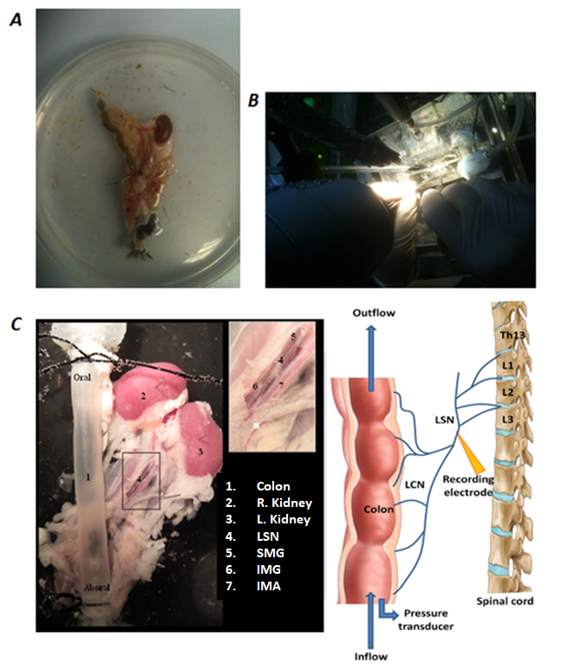
Figure 5.1: Tissue preparation and mesenteric nerve dissection (A) The distal murine colon is removed with attached mesentery and retroperitoneal structures en-bloc. The tissue is then transferred to the organ bath where further dissection, under a dissecting microscope (B), identifies the neurovascular bundle (C) containing the inferior mesenteric ganglion (IMG) and the lumbar splanchnic nerve (LSN). It is the LSN trunk from which afferent nerve recordings are taken (yellow arrow). SMG= superior mesenteric ganglion, IMA= inferior mesenteric artery. Fig. C modified from: (Nullens et al., 2016).

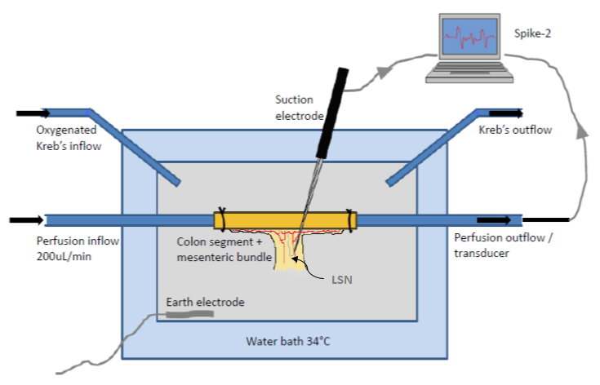
Figure 5.2: Schematic diagram representing an in vitro model for recording of colon afferent nerve firing. The oral end of the colon is attached to the inflow and syringe pump allowing infusion of PBS/SCFAs through the lumen of the colon. The outflow is attached to a pressure transducer to allow monitoring of intracolonic pressure. The lumbar splanchnic nerve (LSN) was identified, dissected and nerve bundles from the LSN inserted into a recording electrode. Action potentials generated were recorded using Spike-2 computer software.

Under a dissecting microscope (Nikon, SMZ645), the LSNs were dissected away from the neurovascular bundle and the nerve sheath surrounding the LSN was stripped back gently in order to expose the nerve trunk. Using fine forceps the nerve trunk was teased apart into bundles. A nerve bundle was then drawn into a suction recording electrode (tip diameter 50-100µm) attached to a Neurolog headstage (NL100, Digitimer Ltd, UK), AC amplifier (NL104) and filter (NL125, band pass 300–4000 Hz) and captured by a computer via a Power 1401 interface and spike2 software (version 5.14, Cambridge Electronic Design, UK) (see figure 5.3).

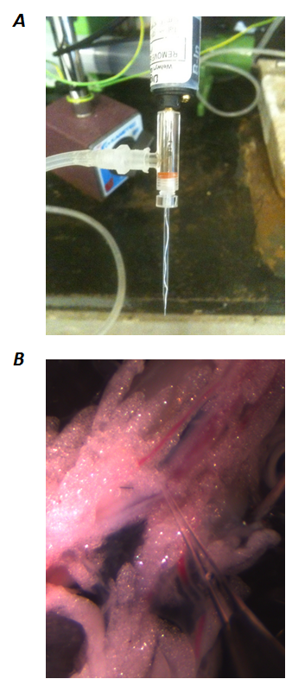

Figure 5.3: Suction electrode with isolated lumbar splanchnic nerve. Once dissected free a nerve bundle from the LSN is then drawn into a suction recording electrode (A) which has a tip diameter of 50-100µm. A photograph of the colonic mesentery (B), taken through the dissecting microscope, shows the LSN bundle drawn into the recording electrode. A small amount of adipose tissue is also drawn up into the tip of the electrode in order to aid reduction of background noise.

Each colonic preparation was stabilised for at least 60 min before any experimental procedures were started. Colonic mechanosensitivity was examined via distending the intestinal segment by closing a tap attached to the outlet port. This allowed the colonic segment to be distended to an intraluminal pressure of 60 mmHg. The tap was then opened, returning the pressure to baseline. This procedure was repeated at regular intervals throughout the course of the experiment to test the reproducibility of the nerve response to ramp distensions and the response during test conditions. Afferent nerve preparations that failed to respond to the test stimuli or became unstable were discarded. SCFAs were luminally applied to the colonic segment via the input port and syringe pump.
Nerve activity was recorded with a Neurolog headstage (NL100, Digitimer) and electrical signals amplified (NL104), filtered (NL125, band pass 200–3000 Hz) and acquired (20 kHz sampling rate) to a personal computer through a Micro 1401 MKII interface running Spike2 software (Cambridge Electronic Design, Cambridge, UK). Measures were taken throughout to ensure sufficient grounding of the suction electrode and recording chamber which was covered in a Faraday cage in order to minimise interfering electrical fields that could impede analysis of the afferent nerve activity.

5.3.4 Experimental protocol for afferent nerve recording
Multiunit nerve recordings were performed both at baseline and during colon distension (see figure 5.4). PBS was used to perfuse the colonic lumen and for the control distensions. Preliminary experiments demonstrated that consistent reproducible stable nerve recordings in excessive of 8 hours duration were obtained while perfusing the colonic lumen with PBS.
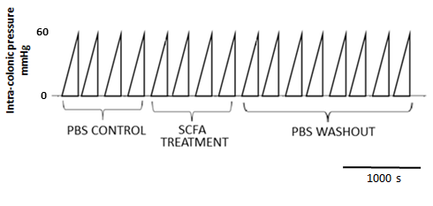

Figure 5.4: Schematic diagram representing the protocol used to record the intracolonic pressure and afferent nerve firing. Once the nerve preparation was deemed stable, the first four ramp distensions with PBS were used as controls. A SCFA was then luminally applied for 1000 seconds with four distensions performed, followed by a washout period with eight further distensions.

Through pilot experiments it was observed that the duration of onset of any effect on afferent nerve firing from SCFAs appeared to take several minutes. In order to ensure stable nerve recordings, ramp distension of the colonic segment was therefore required to be performed at regular intervals several minutes apart. A sufficient interval was also required for the afferent firing to return to baseline following distension, in addition to a period of recording at baseline in order to observe an effect on chemosensitivity at baseline prior to the subsequent ramp distension. It was therefore decided to perform the ramp distensions to 60 mmHg at 1000 second intervals with the SCFA infusion commenced immediately after the end of the preceding control distension. The SCFA treatment was then applied luminally for 4000 seconds over 4 ramp distensions in order to assess the effect of SCFA treatment on mechanosensitivity and compliance. An 8000 second washout period was then recorded. Following some SCFA treatments the firing rate failed to return to the baseline firing rate prior to treatment, indicating desensitisation. In addition to practical time constraints repeated treatments using the same nerve preparation were therefore not possible.
SCFA treatment were made up from sodium butyrate, sodium propionate and sodium acetate salts (Sigma-Aldrich, Dorset UK) and dissolved in PBS. I aimed to assess the effect of physiological concentrations of SCFAs on afferent discharge (AD). My decision on which concentrations of SCFAs to use in my study was based on the colonic concentrations of the three main SCFAs in rodent and human in vivo studies, as outlined in section 1.4.1 of this thesis. I was also informed by findings of pilot studies I had conducted where it was clear that there was no effect on colonic AD with 1mM doses of SCFAs. I also noted the findings of previous work where 10mM of butyrate was reported to activate jejunal afferent firing (Lal et al., 2001). I therefore applied the following SCFA treatments; butyrate 10mM, 30mM; propionate 10mM, 30mM; acetate 10mM, 30mM. I also assessed the effect of a SCFA mix (60:20:20 ratio of acetate, butyrate, propionate) at 10mM, 30mM, and at 100mM to assess if there was an additional effect at a supra-physiological concentration than that normally found in the left colon. Splanchnic afferent nerve recordings from five animals were obtained for each SCFA concentration.
As pH and osmolality can influence afferent nerve firing, the osmolality of all solutions was adjusted to 295-310 mOsm/kg and pH 7. Osmolality was measured using a freezing point osmometer (Advanced Micro Osmometer, Model 3300; Vitech Scientific Ltd, West Sussex, UK).

5.3.5 Influence of SCFA on spontaneous contractions
Previous reports have demonstrated that SCFAs can stimulate colonic smooth muscle contraction (McManus et al., 2002). In vitro recordings of intraluminal pressure were performed in order to monitor the presence of colonic peristaltic motor complexes (CPMCs) in the mouse colon segments and to investigate the influence of luminally applied SCFAs on the CPMCs frequency.
As described previously (Keating et al., 2010), a 6cm segment of distal colon was placed in the organ bath as detailed above. The oral and aboral ends of the colon segment were securely attached to the input and output port of the organ bath, respectively. Motor activity was initiated in the colon segments by an infusion of PBS from the syringe pump until an intraluminal pressure of 5 mmHg was reached. This was achieved by elevating the level of the outflow to an appropriate height as to generate the constant intraluminal pressure of 5 mmHg. Under such conditions, regular aborally propagating waves of contraction develop spontaneously and persist over time. These contractile waves were recorded as changes in intraluminal pressure and were termed CPMCs.
After an equilibration period of approximately 60 mins to ensure CPMC activity had reached a consistent pattern in terms of amplitude and frequency the experimental procedure was started. Following a 30 minute control period, SCFA (30mM solutions of butyrate, propionate and acetate) were luminally applied to the colon segments over a 30 minute treatment period. The frequency of CPMC/min and amplitude of contractions (mmHg) were then measured.
If confirmed that SCFAs did influence CPMC frequency and contractility then the L-type calcium channel blocker nircadipine (3μml, added to both the intraluminal and organ bath perfusate throughout the experiment) would be required to inhibit smooth muscle activity in order to ensure that colonic smooth muscle contractility was not causing any interference with afferent nerve discharge when SCFAs were applied.

5.3.6 Isolation and culture of dorsal root ganglia
Measuring afferent neuronal firing activity only constitutes one relay station in the complex neuronal signalling cascade. The cell bodies of the visceral sensory neurones reside in the DRG and therefore isolated and cultured DRG neurones can also be used to study the molecular mechanisms of nociception and peripheral sensitisation and to determine if SCFAs have a direct effect on neuronal excitation.
Following cervical dislocation, the spinal cord was dissected rapidly. The thoracic and abdominal organs were removed and two bilateral longitudinal incisions were made with scissors just lateral to the spinal column. The skull and tail were removed followed by the remaining paravertebral muscles to expose the spinal column. Mouse DRGs from spinal levels T11-L2 (thoracolumbar) and L6-S1 (lumbosacral) were removed under a dissection microscope and transferred into cold Hanks′ balanced salt solution (HBSS; pH 7.4; Gibco Invitrogen). DRGs were initially digested with cysteine (0.7 mg ml⁻¹, Sigma) and activated papain (4 mg ml⁻¹, Sigma) for 20 min at 37°C followed by incubation with 4 mg ml⁻¹ collagenase (Sigma) and 4.7 mg ml⁻¹ dispase (Sigma) for 20 min at 37°C. Ganglia were then washed with Dulbecco's modified Eagle's medium (DMEM)–F12 tissue culture medium (Gibco) containing 10% fetal bovine serum (Gibco) to stop the enzymatic reaction. Following this stage they were then placed in 0.5 ml tissue culture media and dissociated into single cells by mechanical dissociation 10 times using a plastic Pasteur pipette. The dissociated DRG neurons were plated onto Matrigel‐coated coverslips and incubated for 24 h at 37°C.

5.3.7 Calcium-imaging
DRG neurons were loaded with 4 μm Fura‐2 AM (Life Technologies) for 30 min at 37°C in the dark. Coverslips were then transferred to a customised bath chamber (Series 20, Warner Instruments, Hamden, CT, USA) where they were continuously superfused with DMEM for 30 min at room temperature. DRG neurons were treated for 3 min with 3μM of SCFAs diluted into DMEM and applied via gravity perfusion. Changes in intracellular calcium [Ca²⁺]_{i} were monitored in real time. Excitation lights were generated by an OptoLED light source (Cairn Research Limited, Faversham, UK) and Fura‐2 AM fluorescence was recorded using a digital camera (C4742‐95 Hamamatsu Corp., Sewickley, PA, USA), and acquired to a computer using SimplePCI software (version 6.6.0.0, Hamamatsu Corp.). [Ca²⁺]_{i} mobilisation is represented as the ratio between the fluorescence signal at 340 nm and 380 nm. Responses to SCFAs were normalised against responses to the calcium ionophore ionomycin (5 μm).

5.3.8 Data analysis

Afferent nerve activity
Multi-unit nerve AD was quantified using a spike processor, which counted the number of spikes that crossed a pre-set threshold, with the threshold level for spike counting set at the peak of the smallest identifiable spike. The mean firing frequency (impulses per second; imp s⁻¹) was measured with a time constant of 10 s. Firing rates were measured using a bin width of 1 s. Baseline afferent activity was obtained by averaging the discharge in the 100 s period prior to each distension. The afferent response during distension was calculated by measuring the AD per second during various intracolonic pressures (0,5,10,15,20,25,30,35,40,45,50,55,60 mmHg). This value was then subtracted from the baseline firing to give measure of change in afferent response during distension. The mechanosensitivity at maximal ramp distension was calculated by subtracting the AD at 60mmHg from the mean baseline 100 s prior to the PBS control distensions. The stimulus–response curves (mean AD plotted against intraluminal pressure) were plotted using a customised script program (Cambridge Electronic Design, Cambridge, UK). Afferent nerve firing below a pressure of 20mmHg was defined as low threshold and nerve firing above 20mmHg defined as high threshold (see figure 5.5).
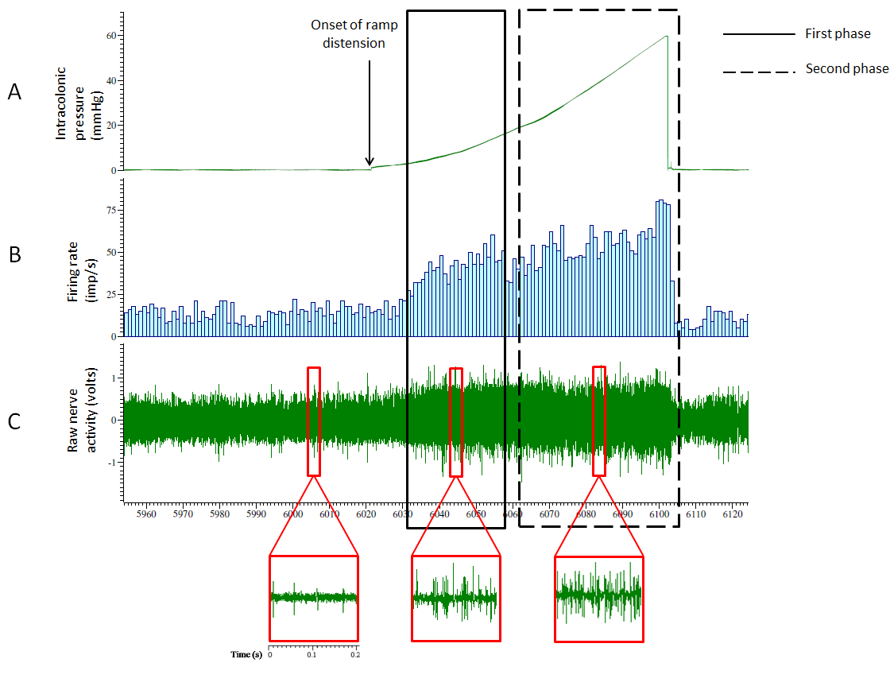
Figure 5.5: Analysis of afferent nerve activity. The afferent response during distension was calculated by measuring the AD per second during various intracolonic pressures (0,5,10,15,20,25,30,35,40,45,50,55,60 mmHg). This value was then subtracted from the baseline firing to give a measure of the change in afferent response during distension. Low threshold afferents are activated in the first phase (0-20mmHg) with high threshold afferents activated in the second phase.

Colonic Compliance
The colonic compliance was calculated from the increase in colonic volume as a function of intracolonic pressure [volume (µl) = Rate (µl min⁻¹) x Time(s)].
The pressure and volume relationship was calculated at various intracolonic pressures during colon filling and determined from the rate of infusion (200µl/min) and the time (s) from the start of the infusion thereby representing a surrogate measure of compliance. This calculation was used to construct a pressure-volume xy plot.

5.3.9 Statistics
All statistical analyses were performed using Prism software (version 7.00; Graphpad Software, San Diego, CA, USA). All data are expressed as means ± 95% CI. Data were analysed using the Students t test and Mann Whitney U test, or by one‐ or two‐way ANOVA with additional post hoc tests performed as appropriate. The level of significance was set at P < 0.05 (* P < 0.05, ** P < 0.01, *** P < 0.001, ****<0.0001).

5.4 RESULTS

5.4.1 Methodology development and optimisation of techniques
Extracellular electrophysiological nerve recordings from colonic afferents are a technically demanding technique to master. Considerable practice was required in order to improve nerve dissection techniques in order to ensure stable, reproducible nerve recording. There was a steep learning curve, requiring approximately 8 months to develop my dissection skills and troubleshoot issues regarding the equipment set-up in order to consistently obtain the required standard of colonic afferent nerve recordings in order to then develop the experimental protocol.

5.4.2 Baseline activity and PBS time controls
Colonic afferent neurons exhibited a mean basal afferent activity of 8.99 ± 0.65 imp s⁻¹ (n=12), which occurred in the absence of any changes in intraluminal pressure. Ramp distensions (0–60 mmHg) of colonic segments induced biphasic increases in afferent nerve discharge corresponding to the activation of low‐ and high‐threshold mechanosensitive afferent fibres. PBS time controls revealed consistent AD with repeated ramp distension every 1000s (see figures 5.6 and 5.7).

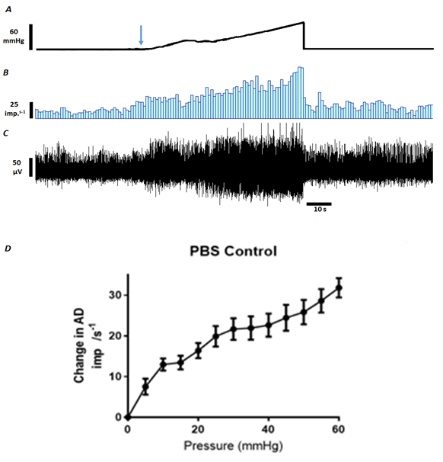

Figure 5.6: Biphasic increase in afferent discharge on ramp distension. A, ramp distension profile - arrow denotes start of ramp distension. B, nerve discharge rate. C, raw recording of whole nerve activity. D, Pressure-response profile of multi-unit AD during ramp distension with PBS. Mean with error bars representing 95% confidence intervals (n=12).

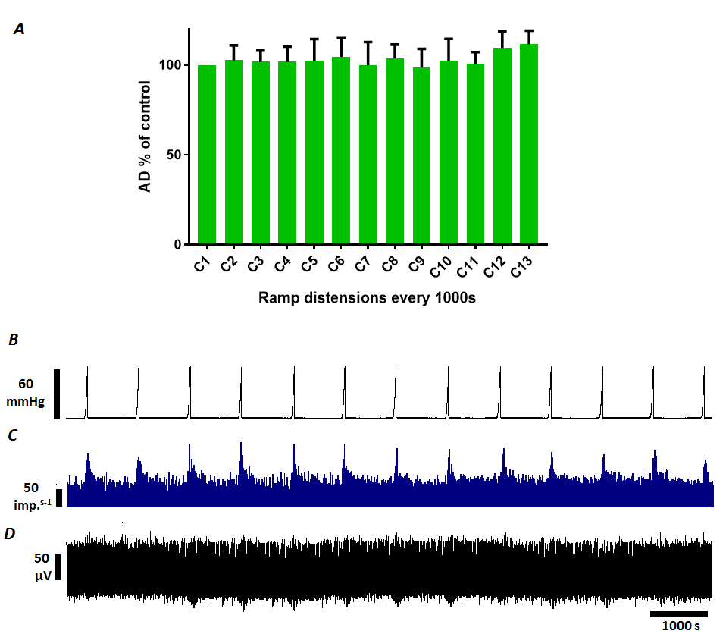

Figure 5.7: PBS time control recording. Ramp distensions of the colonic segment every 1000 seconds result in a consistent pattern of increased splanchnic nerve discharge, n=12. A, AD at 60 mmHg as a % of first control distension (C1). Mean with error bars representing 95% confidence intervals (n=5). B, ramp distension profile. C, nerve discharge rate. D, raw recording of whole nerve activity.

5.4.3 Influence of butyrate on colonic afferent sensitivity
When compared with PBS control (see figure. 5.8), no difference was seen in baseline firing or mechanosensitivity when 10mM concentration of butyrate was applied luminally (F=1.217, P=0.2883, n=5). However at 30mM concentration butyrate significantly inhibited colonic mechanosensitivity with reduced AD over subsequent ramp distensions during the treatment period (F=13.05, P<0.0001, n=5). During the washout period, mechanosensitivity returned towards, but failed to reach, the level of AD at 60mmHg as observed during the initial control distensions. Butyrate at 30mM had no effect on baseline firing in-between distensions.
No difference was seen in the AD following control distensions with PBS with the first distension with 30mM butyrate (mean difference = 10.27%, 95% CI -7.72-28.26, P=0.71). However multiple comparison analysis (see figure 5.9) revealed that the inhibitory effect of 30mM butyrate begins at the second treatment distension with a significant reduction of AD seen at this point (mean difference = 46.45%, 95% CI 28.46-64.44, P<0.0001). Attenuation of the mechanosensitivity continued thorough the third and fourth treatment distensions with the greatest effect seen at the fourth treatment distension (mean difference = 62.71%, 95% CI 44.72-80.7, P<0.0001). The inhibitory effect of 30mM butyrate continued to be observed through the first four washout distensions with a mean difference of 19.83% observed at the fourth washout distension (95% CI 1.84-37.82, P=0.02). Throughout the remainder of the washout period the AD following ramp distension to 60mmHg failed to return to the level of AD observed across the PBS controls. However the difference between PBS control and butyrate treatment did not reach statistical significance on post hoc analysis.

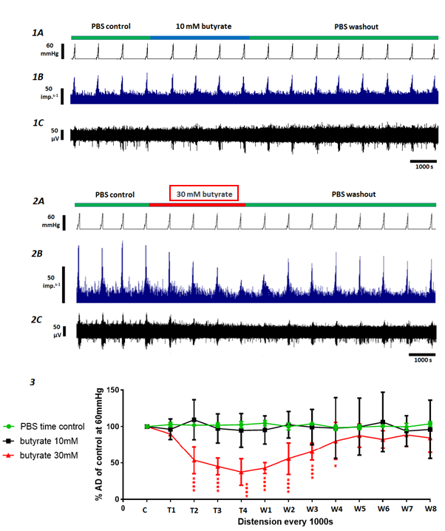
Figure 5.8: The influence of butyrate on colonic afferent mechanosensitivity. Comparing 10mM and 30mM butyrate treatments. 1A and 2A show the distension profiles with ramp distension to 60mmHg performed every 1000s. Four control distensions were initially performed before the luminal perfusion was switched to 10mM butyrate (1A) and 30mM butyrate (2A). This was followed by a washout period of 8 further ramp distensions. Representative examples demonstrate the AD rate (1B and 2B) and the raw recordings of whole nerve activity (1C and 2C). Luminal application of 30mM of butyrate resulting in a significant attenuation of AD at 60mmHg (P<0.0001, n=5) – displayed as a percentage of the mean AD at 60mmHg of PBS control (see figure 3). There was no difference between 10mM butyrate and PBS control (P=0.2883, n=5). During the washout period following application of 30mM of butyrate, mechanosensitivity returned towards, but failed to reach the level of AD at 60mmHg as observed during the initial control distensions (see 2B and 3). Butyrate at 10mM and 30mM had no effect on baseline firing in-between distensions. (Mean with error bars representing 95% confidence intervals, *<0.05, ****<0.0001).
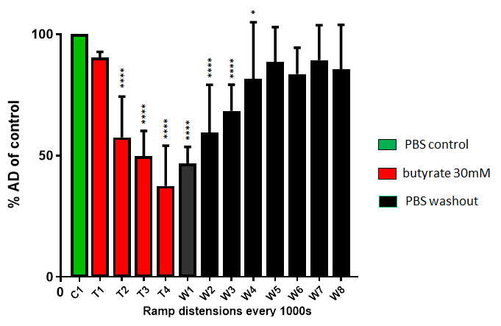
Figure 5.9: The influence of 30mM butyrate on colonic afferent discharge at 60mmHg. Treatment with 30mM butyrate (T1-T4) is compared with PBS control (C1). The inhibitory effect of 30mM butyrate persists for a further four ramp distensions during the PBS washout period, as the AD returns towards the baseline in the second half of the washout period. (n=5, mean with error bars representing 95% confidence intervals, *<0.05, ****<0.0001).

Pressure-discharge response with 30mM butyrate
Comparing the pressure-response profile of multi-unit colonic AD of the fourth treatment distension with the control distension, the pressure-discharge response is attenuated when 30mM butyrate was applied luminally (F=3.5, P=0.0002, n=5). Post hoc analysis revealed a significant reduction in AD when the colon was distended to 30 mmHg with 30mM butyrate compared with PBS control. This indicates that high threshold afferent units are butyrate sensitive (see figure 5.10).

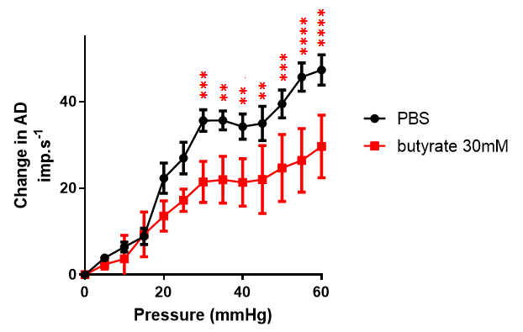

Figure 5.10: Pressure-response profiles of colonic multiunit activity comparing PBS to 30mM butyrate. This compares distension with PBS control and the fourth treatment distension with 30mM butyrate (A). Sidak’s multiple comparisons test reveals significant attenuation of the AD above 30 mmHg indicating that high-threshold afferents are inhibited by butyrate (n=5, mean with error bars representing 95% confidence intervals, * P < 0.05, ** P < 0.01, *** P < 0.001, ****<0.0001).

5.4.4 Influence of acetate on colonic afferent sensitivity
When compared with PBS control no difference was seen in baseline firing or mechanosensitivity when 10mM concentration of acetate was applied luminally (F=0.506, P=0.905, n=5). However at 30mM concentration (see figure 5.11) acetate significantly inhibited colonic mechanosensitivity, with reduced AD over subsequent ramp distensions during the treatment period (F=3.05, P=0.0011, n=5).
Multiple comparison analysis revealed that the inhibitory effect of 30mM acetate is first observed during the third treatment distension (see figure 5.12) with a significant reduction of AD seen at this point (mean difference = 17.39%, 95% CI 3.5-31.25, P=0.0048). The greatest effect with 30mM acetate was observed during the fourth treatment distension (mean difference=34.6%, 95% CI 20.73-48.47, P<0.0001).

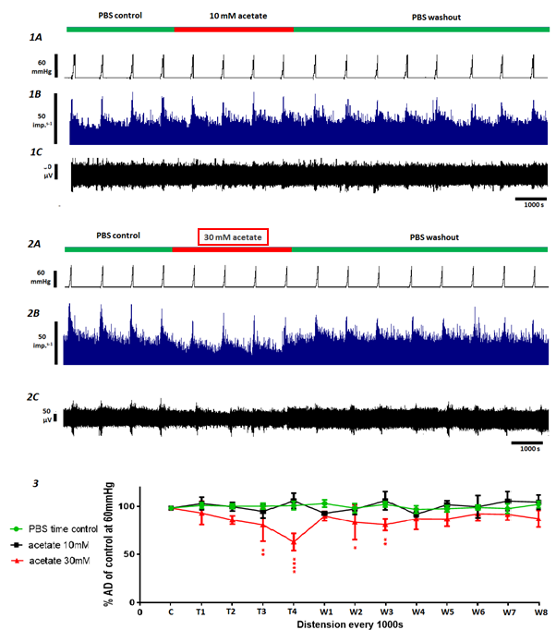 Figure 5.11: The influence of acetate on colonic afferent mechanosensitivity. Comparing 10mM and 30mM acetate treatments. 1A and 2A show the distension profiles with ramp distension to 60mmHg performed every 1000s. Four control distensions were initially performed before the luminal perfusion was switched to 10mM acetate (1A) and 30mM acetate (2A). This was followed by a washout period of 8 further ramp distensions. Representative examples demonstrate the AD rate (1B and 2B) and the raw recordings of whole nerve activity (1C and 2C). Luminal application of 30mM of acetate resulting in a significant attenuation of AD at 60mmHg (P=0.0011, n=5) – displayed as a percentage of the mean AD at 60mmHg of PBS control. There was no difference between 10mM acetate and PBS control (P=0.905, n=5). During the washout period following application of 30mM of acetate, mechanosensitivity returned towards, but failed to reach the level of AD at 60mmHg as observed during the initial control distensions (see 2B and 3). During treatment with 30mM acetate, a reduction of the baseline firing in-between ramp distensions, was observed (see 2B). Following PBS washout this attenuation in the baseline AD returned to level observed during the initial PBS control period. This change in baseline AD was observed in 2 out of 5 nerve recording performed. (Mean with error bars representing 95% confidence intervals, * P < 0.05, ** P < 0.01, ****<0.0001)

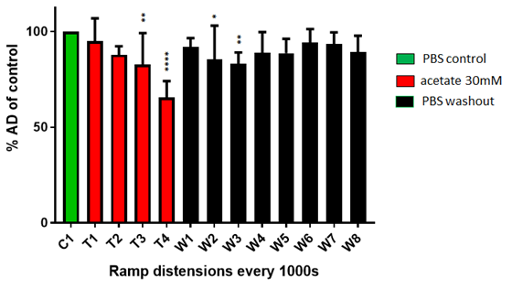
Figure 5.12: Influence of 30mM acetate on the colonic afferent discharge at 60mmHg. Compared with PBS control (C1), luminally applied 30mM acetate (T1-T4) attenuates mechanosensitivity. This is initially observed following the third treatment distension (T3) with the greatest effect observed during T4. The inhibitory effect persists through to the third washout distension (W3) with the AD returning towards the baseline in the second half of the washout period (n=5, *<0.05, ** P < 0.01, ****<0.0001).

Attenuation of mechanosensitivity with 30mM acetate appeared to continue into the initial washout period with significant inhibition of the afferent response during the second and third washout distensions, although no significant difference was seen during the first washout distension. Following the fourth washout distension, AD had returned towards baseline levels.
In addition to inhibiting mechanosensitivity, it was observed that acetate appeared to inhibit baseline afferent nerve firing in-between ramp distensions (see figure 5.11 – 2A+B). This was however only seen in 2 out of 5 nerve recordings performed with 30mM acetate and overall this reduction in baseline firing did not reach significance compared with time controls.

Pressure-discharge response with 30mM acetate
Comparing the pressure-response profile of multi-unit colonic AD of the fourth treatment distension with the control distension, the pressure-discharge response was attenuated when 30mM acetate was applied luminally (F=3.8, P<0.0001, n=5). Post hoc analysis revealed a significant reduction in the AD observed when the colon was distended to 50 mmHg and above with 30mM acetate compared with PBS control (see figure 5.13). This indicates that high threshold afferent units are acetate sensitive.
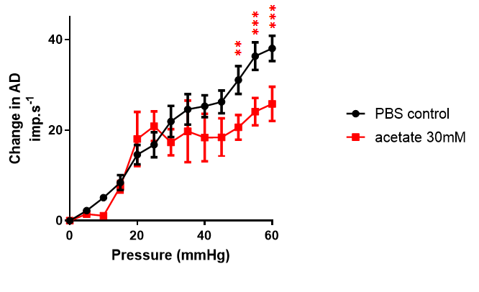
Figure 5.13: Pressure-response profiles of colonic multiunit activity comparing PBS with 30mM acetate. Pressure-response of fourth treatment distension with 30mM acetate. Sidak’s multiple comparisons test reveals significant attenuation of the AD at 50 mmHg indicating that high-threshold afferents are inhibited by acetate (n=5, mean with error bars representing 95% confidence intervals, ** P < 0.01, *** P < 0.001).

5.4.5 Influence of propionate on colonic afferent sensitivity
As was observed with butyrate and acetate, when compared with PBS control, no difference was seen in baseline firing or mechanosensitivity when 10mM concentration of propionate was applied luminally (F=0.503, P=0.901, n=5). However, at 30mM concentration, as can be seen in figure 5.14 and figure 5.15, propionate also inhibited colonic mechanosensitivity, with reduced AD see following the fourth ramp distension during the treatment period (mean difference=17%, CI 3.47-30.52, P=0.0046, n=5). This was the only significant change in afferent response seen on post hoc analysis, with the AD immediately returning to baseline during the washout period.
As with 30mM acetate, a small reduction in the baseline firing in-between ramp distensions was also observed with 30mM propionate. This was observed in 3 out of the 5 nerve recordings performed. However, overall this reduction in baseline firing did not reach significance compared with time controls.

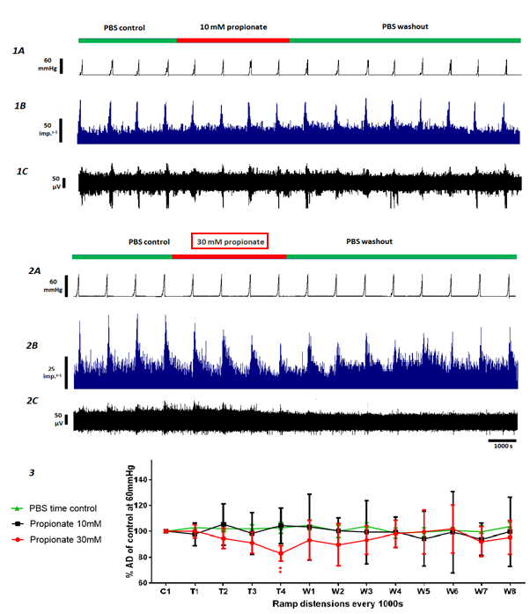
Figure 5.14: The influence of propionate on colonic afferent mechanosensitivity. 1A and 2A show the distension profiles with ramp distension to 60mmHg performed every 1000s. Four control distensions were initially performed before the luminal perfusion was switched to 10mM propionate (1A) and 30mM propionate (2A). This was followed by a washout period of 8 further ramp distensions. Representative examples demonstrate the AD rate (1B and 2B) and the raw recordings of whole nerve activity (1C and 2C). Luminal application of 30mM of propionate resulting in a significant attenuation of AD at 60mmHg (P=0.0011, n=5) – displayed as a percentage of the mean AD at 60mmHg of PBS control. There was no difference between 10mM propionate and PBS control (P=0.905, n=5). During the washout period following application of 30mM of propionate, mechanosensitivity returned towards, the level of AD at 60mmHg as observed during the initial control distensions (see 2B and 3). During treatment with 30mM propionate, a small reduction of the baseline firing in-between ramp distensions, was observed (see 2B). Following PBS washout this attenuation in the baseline AD returned to level observed during the initial PBS control period. This change in baseline AD in-between ramp distensions was observed in 3 out of 5 nerve recording performed. (mean with error bars representing 95% confidence intervals, ** P < 0.01).

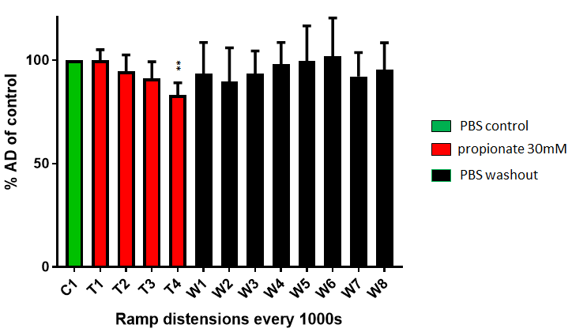

Figure 5.15: Influence of 30mM propionate on the colonic afferent discharge at 60 mmHg. The effect of luminally applied 30mM propionate (T1-T4) on the colonic AD at 60mmHg compared with the AD at 60mmHg during the PBS control (C1). The inhibitory effect of 30mM propionate is observed during the fourth treatment distension (T4) with the AD immediately returning towards the control baseline once when the intraluminal perfusion is switched to PBS in the washout period (W1-8). (n=5, **P < 0.01).

Pressure-discharge response of 30mM propionate
Comparing the pressure-response profile of multi-unit colonic AD of the fourth treatment distension with the control distension (see figure 5.16), the pressure-discharge response was attenuated when 30mM propionate was applied luminally (F=2.03, P=0.0289, n=5). As was seen with butyrate and propionate, multiple comparison analysis revealed a significant reduction in AD once the colon was distended to 55 mmHg and above with 30mM propionate compared with PBS control. This indicates that those afferent units that are propionate sensitive are of the high threshold subtype.

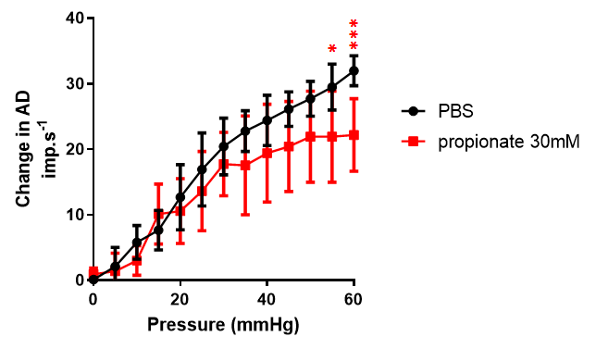

Figure 5.16: Pressure-response profiles of colonic multiunit activity comparing PBS with 30mM propionate. Sidak’s multiple comparisons test reveals significant attenuation of the AD at 55 mmHg indicating that high-threshold afferents are significantly inhibited by 30mM propionate (n=5, mean with error bars representing 95% confidence intervals, * P < 0.05, ** P < 0.01, *** P < 0.001).

5.4.6 Influence of SCFA mix on colonic afferent nerve sensitivity
No effect on AD was observed with luminally applied SCFA10mM concentration (F=0.924, P=0.5264, n=5). However, at 30mM and 100mM concentrations, application of SCFA mix significantly inhibited colonic mechanosensitivity (SCFA30; F=7.722, P<0.0001, n=5 and SCFA100; F= 20.34, P<0.0001, n=5) with reduced AD over subsequent ramp distensions during the treatment period. The attenuation of mechanosensitivty was significantly greater with the 100mM SCFA mix compared with the 30mM SCFA mix (Wilcoxon two-tail, P=0.0024) (see figures 5.17 and 5.18).

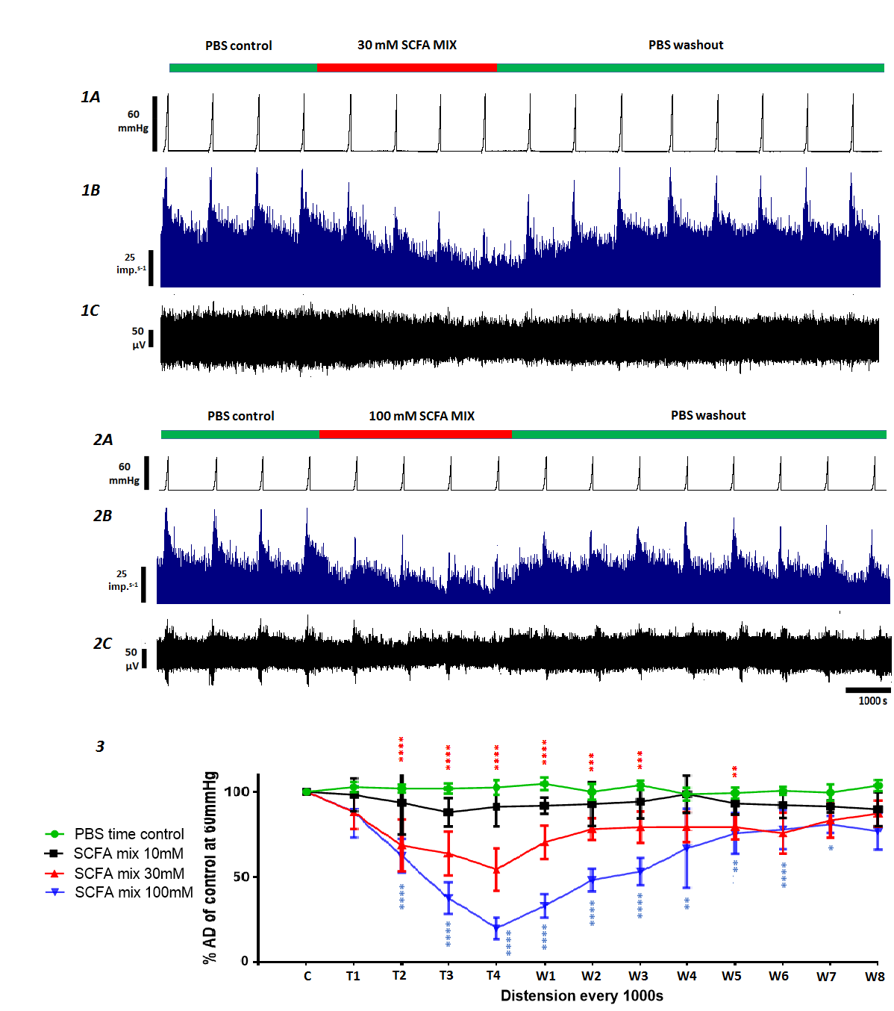
Fig 5.17: The influence of SCFA mix on colonic afferent mechanosensitivity. 1A and 2A show the distension profiles with ramp distension to 60mmHg performed every 1000s. Four control distensions were initially performed before the luminal perfusion was switched to 30mM SCFA mix (1A) and 100mM SCFA mix (2A). This was followed by a washout period of 8 further ramp distensions. Representative examples demonstrate the AD rate (1B and 2B) and the raw recordings of whole nerve activity (1C and 2C). Luminal application of 30mM and 100mM of SCFA mix resulting in a significant attenuation of AD at 60mmHg (P<0.001, n=5) – displayed as a percentage of the mean AD at 60mmHg of the PBS control. (3) There was no difference between 10mM SCFA mix and PBS control (P=0.5.64 n=5). During the washout period following application of SCFA mix, mechanosensitivity returned towards, the level of AD at 60mmHg as observed during the initial control distensions. During treatment with 30mM and 100mM SCFA, attenuation of the baseline firing in-between ramp distensions, was observed (see 2B). Following PBS washout this attenuation in the baseline AD returned to level observed during the initial PBS control period. This change in baseline AD in-between ramp distensions was observed in all the nerve recordings performed with 30mM and 100mM SCFA mix (n=10). (Mean with error bars representing 95% confidence intervals, * P < 0.05, ** P < 0.01, *** P < 0.001, **** P < 0.0001).
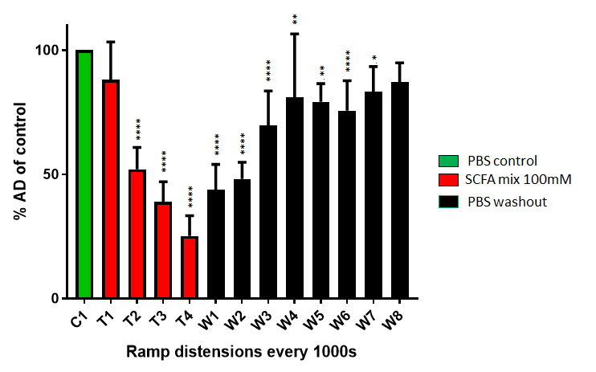
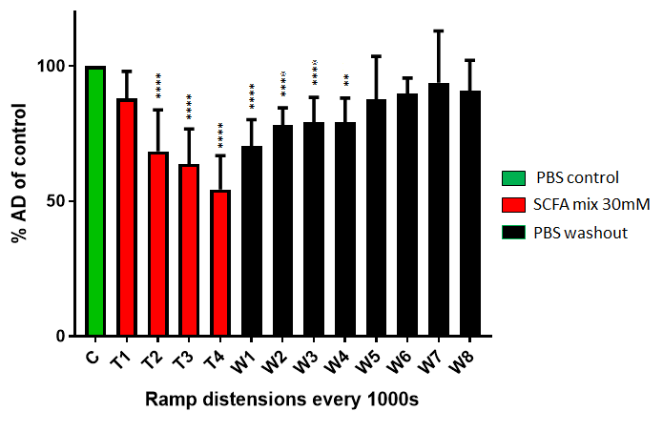
Figure 5.18: Influence of 30mM and 100mM SCFA mix on the colonic afferent discharge at 60 mmHg. Comparing AD at 60mmHg with PBS control (C1) to luminally applied SCFA mix (T1-T4); SCFA30 (a) AND SCFA100 (b). The inhibitory effect of SCFA mix is observed during the second treatment distension (T2) with both 30mM and 100mM treatments. The attenuation in mechanosensitivity persists until halfway through the washout period (W4) following treatment with 30mM SCFA mix and through to the seventh washout distension (W7) following 100mM SCFA mix treatment. (n=5, mean with error bars representing 95% confidence intervals, *<0.05, ** P < 0.01, ****<0.0001).

With the 100mM SCFA mix, attenuation of colonic afferent mechanosensitivity continued throughout the washout period up until the 8th and final ramp distension. Likewise inhibition of mechanosensitivity persisted into the washout period following luminal application of 30mM SCFA mix. However this effect was only seen during the first half of the washout period where subsequent ramp distensions produced an AD equivalent to the initial PBS controls (see figures 5.17 and 5.18).
No change in baseline AD was seen with 10mM SCFA mix. However during the treatment period with both 30mM and 100mM mix concentrations a significant reduction in baseline AD in-between ramp distensions during the treatment period was observed (see figure 5.17).

Pressure-discharge response with SCFA mix
As was found with 30mM treatments with butyrate, acetate and propionate, when the pressure-response profile of AD during the fourth treatment distension was compared with that of the control distension, the pressure-discharge response is attenuated with both 30mM and 100mM SCFA mixes (SCFA30; F=3.5, P=0.0002, n=5 and SCFA100; F=3.5, P=0.0002, n=5) (see figure 5.19). Post hoc analysis reveals a significant reduction in AD observed when the colon is distended to 45 mmHg and above with 30mM SCFA mix and to 25 mmHg with 100mM SCFA mix, compared with PBS control. Again, this reveals that it is the high threshold afferent units that are SCFA sensitive.
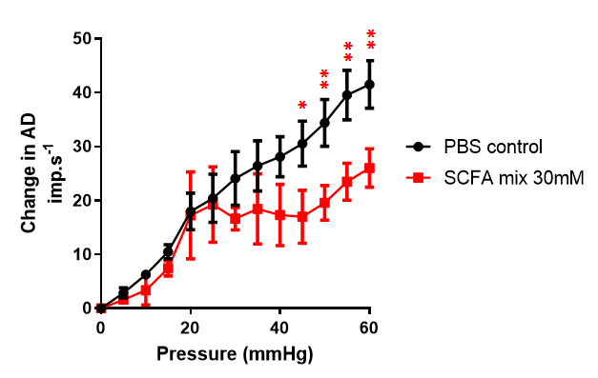
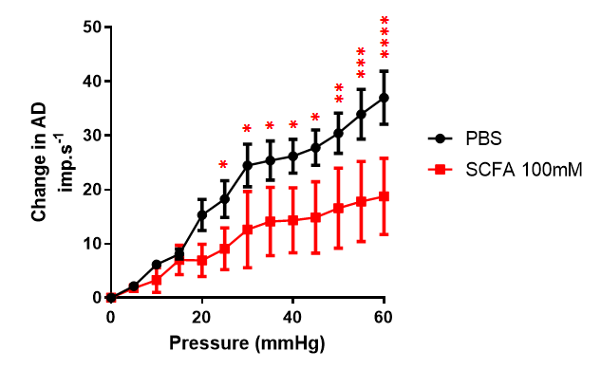
Fig 5.19: Pressure-response profiles of colonic multiunit activity comparing PBS with 30mM and 100mM SCFA mix. Sidak’s multiple comparisons test reveals significant attenuation of the AD at 45mmHg with 30mM SCFA (A) and at 25 mmHg with 100mM SCFA (B) - indicating that high-threshold afferents are inhibited by SCFAs (n=5 for each concentration, mean with error bars representing 95% confidence intervals, * P < 0.05, ** P < 0.01, *** P < 0.001, **** P<0.0001).

5.4.7 Comparison of SCFA treatments on colonic afferent

mechanosensitivity

Multiple comparison tests (n=5 for each SCFA treatment) revealed acetate 30mM, butyrate 30mM, and SCFA mix at both 30mM and 100mM concentrations significantly inhibited colonic afferent mechanosensitivity (P=0.0001) (see figure 5.20). 30mM propionate also resulted in attenuation of AD by the fourth ramp distension (P=0.0101), However, there was no difference observed between PBS control and the 10mM concentrates of butyrate (P=0.6618), acetate (P=0.9851), propionate (P=0.9997) and SCFA mix (P=0.9782).
At 30mM concentrations application of butyrate resulted in a significantly greater inhibition of mechanosensitivity than both acetate (mean difference = 28.11%, CI 10.35-45.86, P<0.0001) and propionate (mean difference = 45.71%, CI 27.95-63.46, P<0.0001). Treatment with 100mM SCFA mix resulted in a more significant attenuation of mechanosensitivity that 30mM SCFA mix (mean difference 34.56%, CI 16.8-52.31, P<0.002). The difference between 30mM butyrate application and both 30mM and 100mM SCFA did not reach statistical significance (see figure 5.20 and table 5.1).

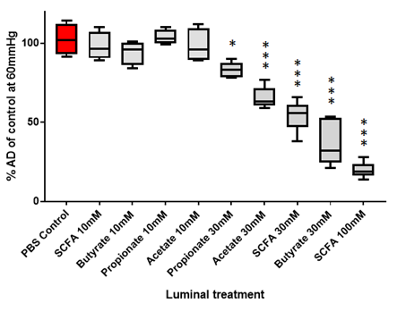
Figure 5.20: Comparison of SCFA treatments on colonic afferent mechanosensitivity. Comparing the peak AD at 60 mmHg following 4000 seconds of treatment with PBS control demonstrates that luminally applied SCFAs significantly reduce colonic afferent mechanosensitivity. This occurs at concentration above 30mM. (n=5 for each SCFA treatment, * P < 0.05, *** P < 0.001).
SCFA being compared | Mean difference (imp s⁻¹) | 95% CI | P value
Propionate 30mM vs. Acetate 30mM | 17.6 | -0.1557 to 35.36 | 0.0526
Propionate 30mM vs. SCFA 30mM | 28.67 | 10.92 to 46.43 | 0.0012
Propionate 30mM vs. Butyrate 30mM | 45.71 | 27.95 to 63.46 | <0.0001
Propionate 30mM vs. SCFA 100mM | 63.23 | 45.47 to 80.99 | <0.0001
Acetate 30mM vs. SCFA 30mM | 11.07 | -6.681 to 28.83 | 0.351
Acetate 30mM vs. Butyrate 30mM | 28.11 | 10.35 to 45.86 | 0.0014
Acetate 30mM vs. SCFA 100mM | 45.63 | 27.87 to 63.39 | <0.0001
SCFA 30mM vs. Butyrate 30mM | 17.03 | -0.7209 to 34.79 | 0.0633
SCFA 30mM vs. SCFA 100mM | 34.56 | 16.8 to 52.31 | 0.0002
Butyrate 30mM vs. SCFA 100mM | 17.52 | -0.2342 to 35.28 | 0.054

Table 5.1: Comparison of SCFAs and their influence on colonic afferent mechanosensitivity.

5.4.8 Influence of SCFAs on baseline afferent discharge
Luminal application of 10mM concentration of all SCFAs did not affect the baseline firing seen in-between ramp distensions. Likewise no change in baseline AD was observed following treatment with 30mM butyrate (F=1.795, P=0.0696). Inhibition of the baseline afferent nerve discharge during the treatment period was observed in two out of five nerve recording performed with 30mM propionate and three out of five recordings performed with 30mM acetate. Overall, however, these findings also did not reach statistical significance (propionate 30mM; F=1.768, P=0.0646, acetate 30mM; F=1.884 P=0.0824).
A significant attenuation of baseline colonic afferent nerve firing was observed during luminal treatment with both 30mM and 100mM concentrations of SCFA mix (SCFA 30mM; F=7.689, P<0.0001, SCFA 100mM; F=9.014, P<0.0001). This occurred following 1000s luminal application of SCFA prior to the second treatment ramp distension. The baseline firing returned to normal following 1000s washout with PBS (see figure 5.21). There was no difference in the inhibition of the baseline colonic AD between 30mM and 100mM SCFA mix (U=63, n₁=n₂=5, P=0.6297).

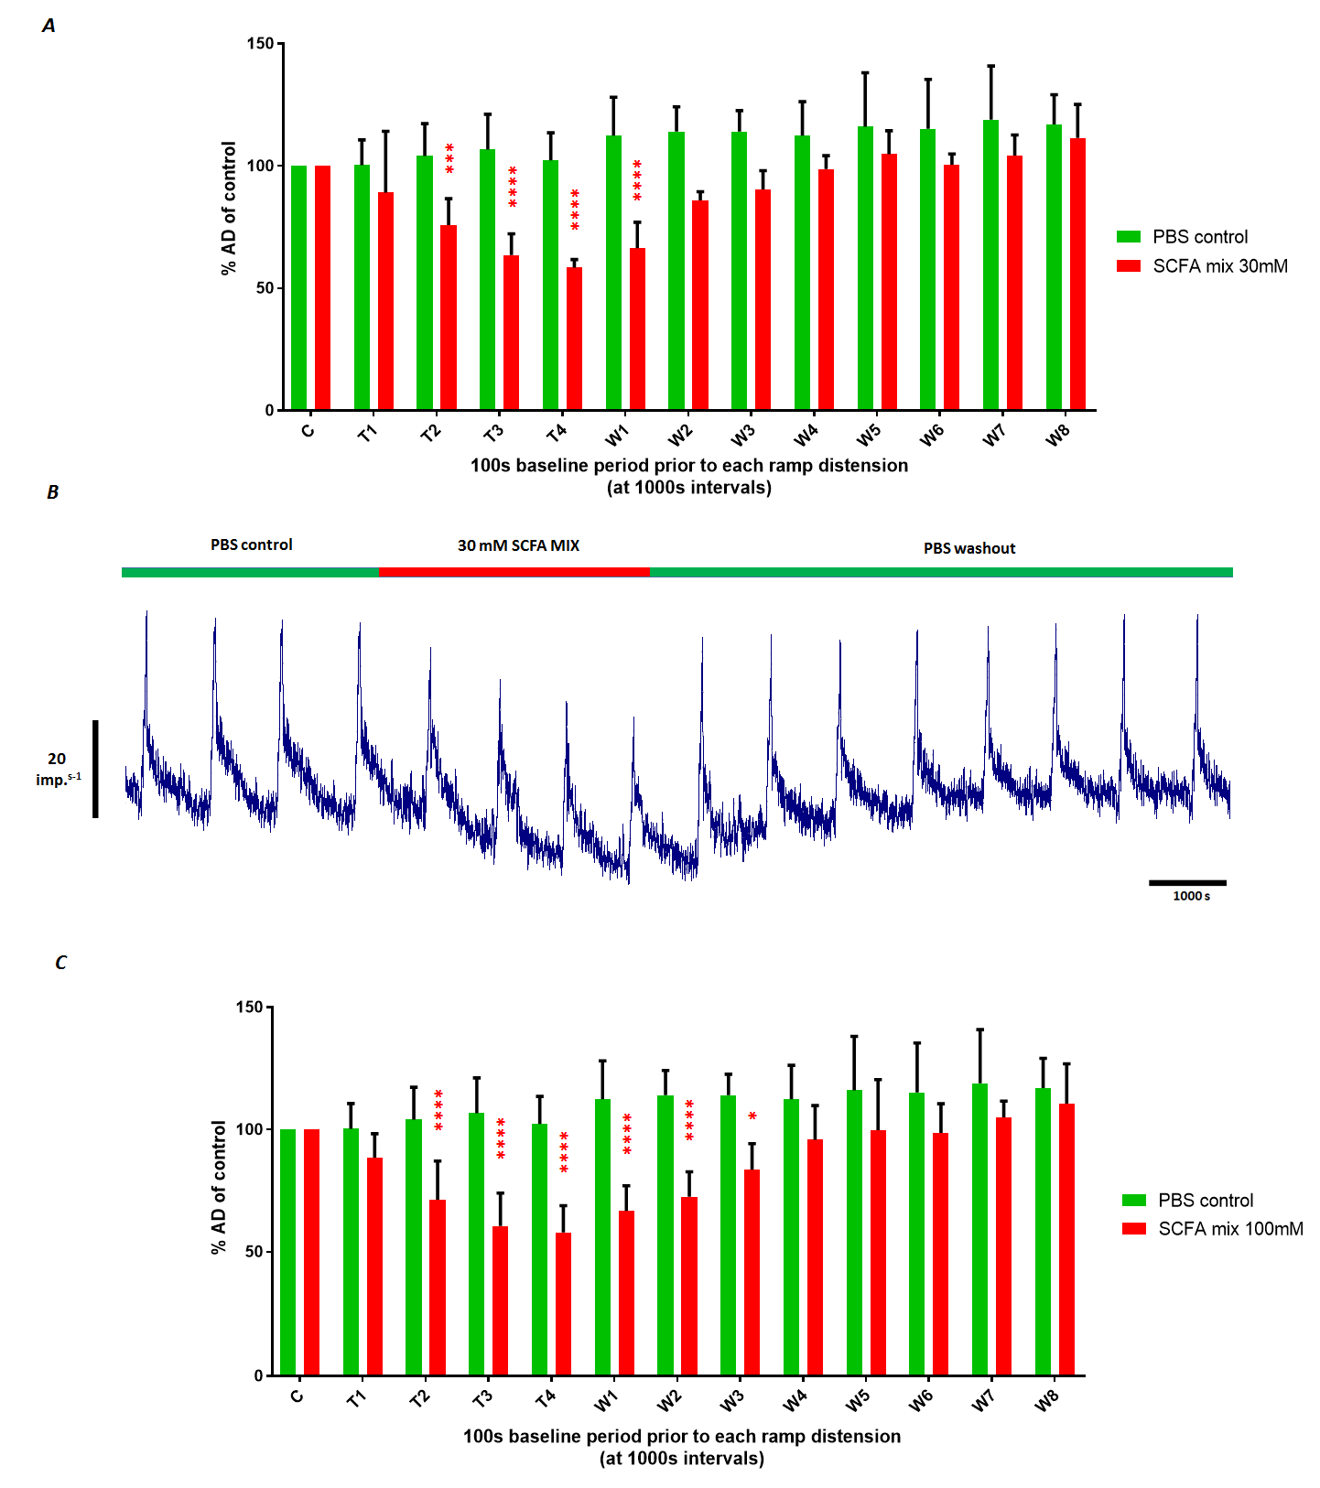
Figure 5.21: Attenuation of baseline afferent discharge with 30mM and 100mM SCFA mix. A representative example demonstrating inhibition of the nerve discharge rate during luminal treatment with 30mM SCFA mix can be seen in fig.B. The baseline AD is calculated from the mean AD across a 100 s period immediately prior to each distension. Baseline AD is significantly inhibited following the first treatment distension for both 30 (A) and 100mM (B) concentrations of SCFA mix. The attenuation in AD persists up until the third washout distension when 100mM SCFA mix is applied, compared with 30mM SCFA mix treatment where the baseline returns to normal prior to the first washout distension (n=5, mean with error bars representing 95% confidence intervals * P < 0.05, *** P < 0.001, **** P<0.0001 ).

5.4.9 Influence of SCFAs on colonic compliance
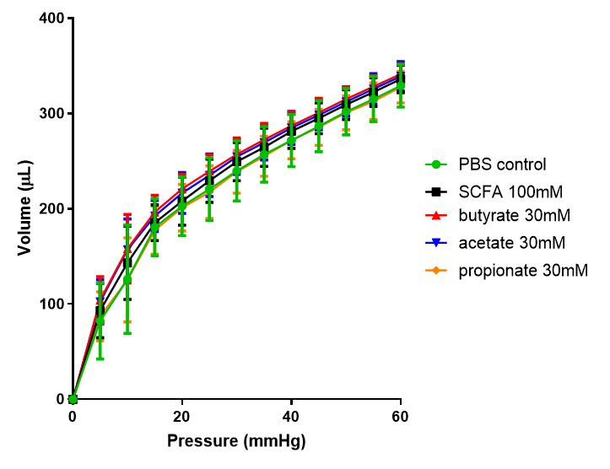
Analysis of pressure-volume relationships between all SCFA treatments (see figure 5.22) demonstrated that luminally applied butyrate, acetate and propionate, both singly and in combination, did not affect colonic wall compliance (F=0.796. P=0.8983, n=3 for each SCFA treatment).
Figure 5.22: Influence of SCFAs on colonic wall compliance. There was no difference in the relationship between perfusion volume and intracolonic pressure between the SCFA treatments and PBS control. (n=3 for each SCFA treatment, mean with error bars representing 95% confidence intervals).

5.4.10 SCFAs and colonic motility
The median number of CPMCs observed following luminal perfusion with PBS was 10 CPMCs/30 mins (n=12, range 8-12). Compared with controls, SCFAs appeared to have a differential effect on motility in the mouse colon (see figure 5.23). Treatment with 30mM butyrate increase the frequency of CPMCs (9.5 v 16.5, P=0.028). Treatment with 30mM propionate and 30mM acetate both appeared to inhibit the frequency of CPMCs, however when compared to PBS controls, this did not reach statistical significance (acetate: 9.5 v 6.5, P=0.057 and propionate: 11 v 7, P=0.0571). If data for the “inhibitory SCFAs” propionate and acetate was combined, statistical significance was achieved (10.5 v 7, P=0.0025).

5.4.11 SCFA induced smooth muscle activity has no effect on afferent nerve sensitivity

In order to investigate for any potential interference of changes in smooth muscle activity on colonic AD sensitivity the influence of 100mM SCFA mix on afferent firing was assessed with (n=5) and without (n=5) the application of nircadipine. There was no difference in the inhibitory effect of 100mM SCFA mix on baseline AD and mechanosensitivity when nircadipine-induced inhibition of smooth muscle activity was achieved compared to when no nircadipine was applied, indicating that the effect of SCFAs on colonic afferent nerve sensitivity is not a result of potential interference from L-type Ca²⁺ channel mediated smooth muscle activity.

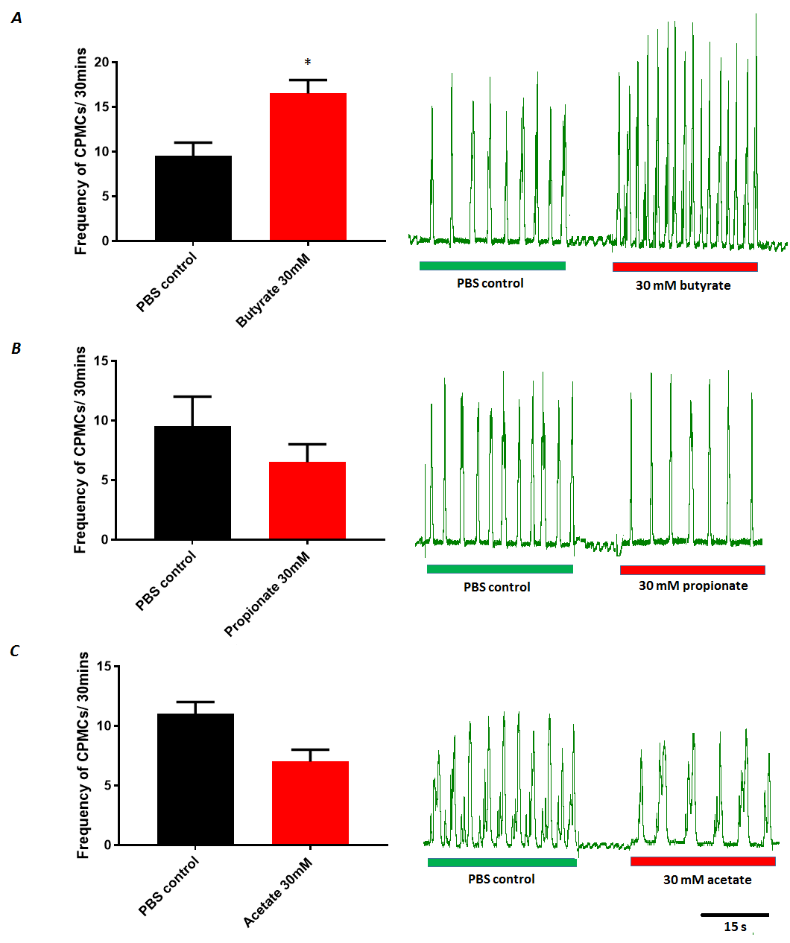
Figure 5.23: Influence of SCFAs on colonic primary motor complexes. (A) Luminal application with 30mM butyrate resulted in a significant increase in the frequency of CPMCs observed over the 30 minute treatment period compared with control. 30mM of both propionate (B) and acetate (C) appeared to result in a decrease in the frequency of CPMCs observed, however this did not reach statistical significance. (* P<0.05)

5.4.12 Influence of SCFAs on intracellular calcium levels of DRGs
Application of butyrate, propionate and acetate to isolated murine DRGs did not evoke a significant change in fluorescence ratio and hence no significant change in calcium influx was detected, compared with time controls. Of the 34 DRGs isolated and treated with butyrate, 2 (6%) of DRGs responded to 3μM butyrate. Treatment of DRGs with propionate or acetate did not mobilise intracellular calcium stores (see figure 5.24).
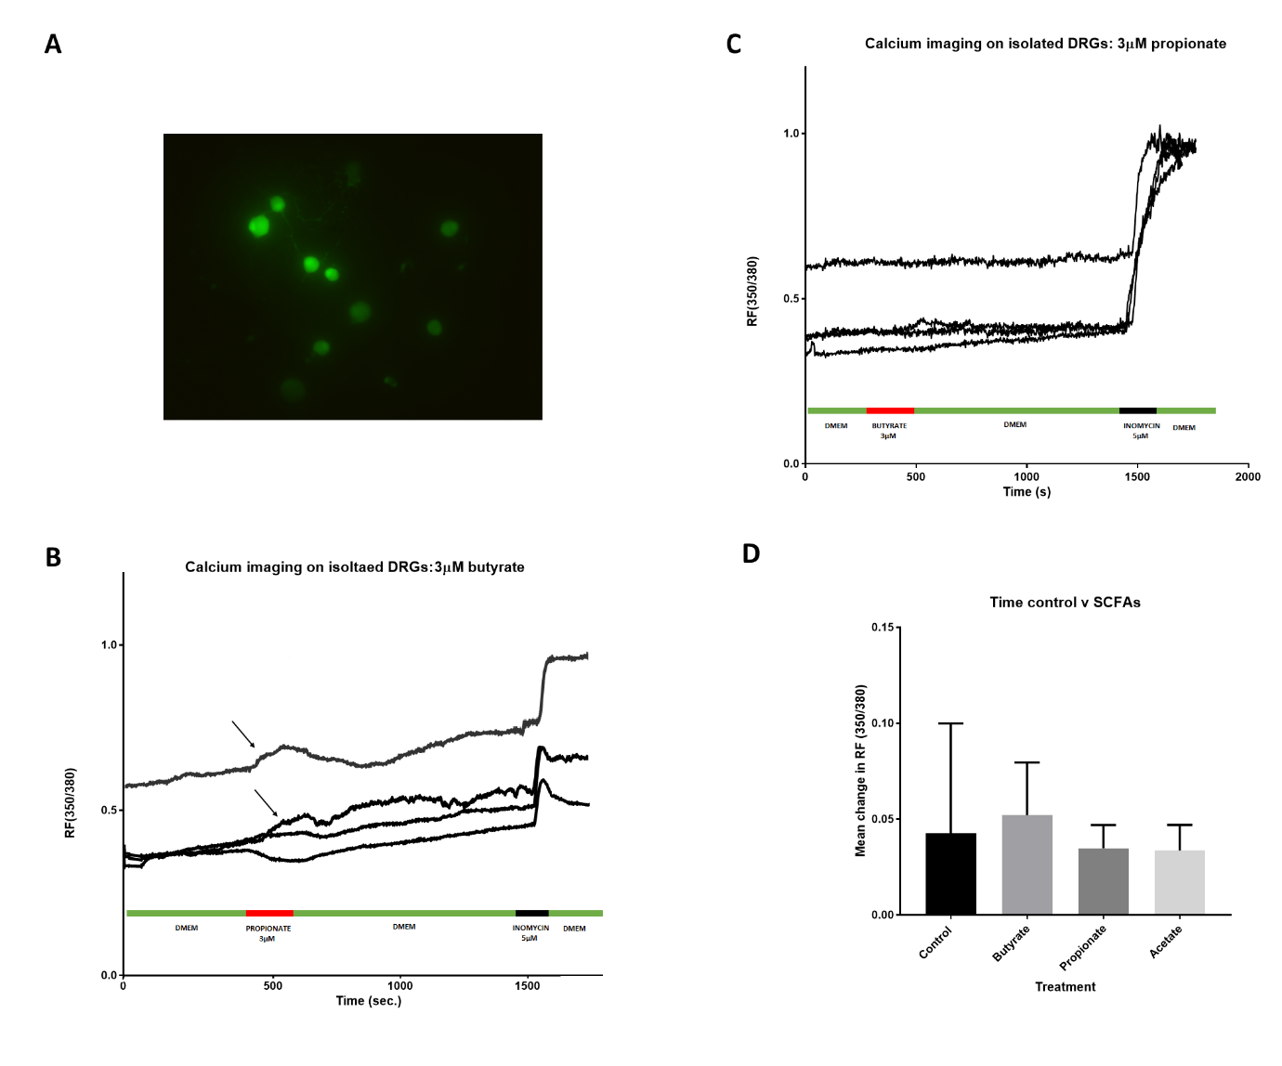

Figure 5.24: Calcium imaging on isolated DRGs. An example of primary isolated DRGs loaded with Fura-2 (2μM). Sample traces demonstrating the response to butyrate (B) and propionate (C). The arrows highlight the traces of the only two DRGs to respond to butyrate, with the remaining 32 DRGs examined not stimulated following application of butyrate. No response was observed following application of propionate (C) and acetate. Figure D summarises the findings that there was no difference in calcium influx in DRGs following treatment with butyrate (n=34 cells), propionate (n=22 cells) and acetate (n=28 cells) compared with time controls (n=25 cells). DRGs were isolated from 12 animals. Values are mean + 95% CI. All results are analysed with One-Way ANOVA.

5.5 DISCUSSION
This study demonstrates, for the first time, that luminally applied SCFAs influence colonic afferent nerve sensitivity in an in vitro mouse model. The null hypothesis is therefore rejected.
Based on findings from previous work investigating the influence of SCFAs on jejunal afferent nerve firing (Lal et al., 2001) and on the use of butyrate to initiate colonic hypersensitivity in rodent models of IBS (Bourdu et al., 2005), it was anticipated that SCFAs may potentiate colonic afferent sensitivity. However, these experiments demonstrate that SCFAs, applied singly and in combination, significantly attenuate colonic afferent nerve mechanosensitivity. Calcium imaging performed on spinal DRGs also suggested that SCFAs have an indirect influence on colonic afferent nerve sensitivity.
5.5.1 Critique of the experimental technique
One of the major advantages of the in vitro splanchnic nerve recording is that colonic afferent nerve activity can be quantified without any modulation from the CNS. This therefore permits the direct effect of locally applied SCFAs on colonic afferent nerve activity. Although steps are required to ensure the in vitro models remained viable this technique produced stable, reliable and reproducible afferent nerve recordings. Compared to an in vivo approach this technique is less time-consuming and does not require the monitoring of vital parameters of an anaesthetised animal (Nullens et al., 2016). However, it must be borne in mind that measuring colonic afferent nerve firing represents only one component in the complex neuronal signalling cascade involved in visceral pain sensation. This study does not address the role of central processes, ie. in the spinal cord and brain, on the potential analgesic effects of colonic SCFAs. Alternative methods to assess this would be to carry out in vivo animal experiments to measure any effect luminally applied SCFAs may have on visceromotor responses, electromyographic signals or on functional brain MRI (Moloney et al., 2015).

Although in vitro colonic afferent nerve recording has its advantages, it remains a technically demanding research technique that requires sound knowledge of basic anatomy and technical training in order to become acquainted with the principles of neuronal electrophysiology. There is therefore a long learning curve, requiring a high level of hand-eye coordination and dexterity, to develop the necessary dissection skills required to identify and isolate colonic nerve afferents to then perform reliable afferent nerve recordings. This is evidenced by the 9 months it took to master the technique. This also limited the number of experiments that I could perform, both due to time and resource limits.
There are two distinct spinal afferent nerve pathways that transmit sensory information from the distal colon and rectum to the spinal cord. These are via the LSNs (thoracolumbar pathway) and PNs (lumbosacral pathway). Although there were no observed changes in low-threshold mechanosensory function in this study, SCFA-mediated inhibition of low-threshold colonic mechanosensory function cannot be ruled out as no recordings were made from the pelvic spinal afferents, which are more tuned to signal physiological based stimuli (Brierley et al., 2004). It may be conceivable that pelvic afferents demonstrate SCFA mediated inhibition of mechanosensitivity at lower thresholds than observed in the splanchnic neurones. Measuring pelvic afferent nerve activity using my experimental set-up would be a technical challenge as the distal colon segment is often secured to the perfusion outflow immediately adjacent to where the PNs are located. An alternative approach, using a flat pinned down sheet of colorectum, has been described to successfully record pelvic afferent nerve firing (Feng and Gebhart, 2015). However this approach was not used in my experiments as the flat sheet of colon cannot be distended, unlike the intact colonic segment used in my study. Although mechanosensitivity can be assessed by applying circumferential stretch to the flat sheet using a computer-controlled force actuator, disruption of the colonic muscular tube due to it being divided longitudinally may lead to inaccurate findings.
It is likely that ramp distension of the colon stimulates different afferent pathways compared with rapid random phasic distensions (Ng et al., 2006). Although in my experiments I assessed colonic afferent nerve sensitivity following ramp distension only, previous researchers have postulated that phasic distension may preferentially stimulate serosal and muscular mechanoreceptors in the large intestine, whereas mucosal mechanoreceptors are stimulated during slow ramp distension (Sloots et al., 2000, Sabate et al., 2002). This supports the use of ramp distension in my study, given my aim to assess the afferent nerve response to luminally applied SCFAs.
There was no strong evidence from the calcium imaging experiments that demonstrated a direct influence of SCFAs on afferent sensitivity. There was certainly no evidence of inhibition of neuronal activity. Two DRG cells responded to SCFA treatment, resulting in an increase in calcium influx and DRG excitability. However this represents only 2% of the DRGs treated with SCFAs. No response was seen in 98% of DRGs treated and therefore cannot be considered significant. This finding appears to conflict with the data generated by patch-clamp recordings by Xu et al who found that superfusion of retrogradely labelled L6-S1 rat DRGs with sodium butyrate stimulated neuronal firing (Xu et al., 2013). In this study however the investigators, in addition to using a different species as the animal model, administered 1mM concentrations of sodium butyrate, which is over 300 fold more concentrated than that was used in my experiment. The concentration chosen in my calcium imaging (3μM) was based on previous experience in the Grundy Laboratory and reflects a more physiologically appropriate concentration. Further work could use higher concentrations of SCFAs for calcium imaging experiments. Pre-treating cultured DRGs with SCFAs over a longer duration and then stimulating DRGs with a drug known to cause excitability, such as capsaicin, could also be a future avenue to assess if DRGs pre-treated with SCFAs demonstrate an attenuated response to capsaicin induced excitation.
In my calcium-imaging experiment, DRG neurones were obtained from DRGs at T11-L2 (thoracolumbar) and L6-S1 levels (lumboscacral). I isolated DRG neurones from these two levels based on previous studies that have identified cell bodies of the sensory neurones of the colorectum at these levels (Robinson et al., 2004, Christianson et al., 2007, Tan et al., 2008, Kyloh et al., 2011). In my study the DRG neurones obtained were unselective and therefore not specific to the colorectum. A proportion of sensory neurones on which calcium imaging was performed therefore are likely to innervate other non-colorectal abdominal and pelvic viscera. In order to obtain colorectal specific DRG neurones retrograde labelling techniques, such as injection of a neuronal tracer, eg. DiI, into the mouse colonic wall, would need to be performed before then sacrificing the animal and isolating DRGs seven days later (Robinson et al., 2004).
More recently the development of ex vivo DRG-gut preparations have enabled single cell electrophysiological characterisation to be combined with studies of DRG cell body morphology and neurochemistry (Brierley et al., 2018). The DRG-gut preparation comprises of individual DRGs in continuity with their associated spinal pathway and colonic segment, thus electrophysiological recordings are obtained from the nerve cell bodies of colonic spinal afferent neurons with their connections to the colon intact. This represents a robust technique of discriminating colon-innervating afferents with morphological and neurochemical characteristics of the nerve cells bodies being directly correlated to mechanosensory and chemosensory characteristics in the colonic mucosa. Although similar techniques have been performed more extensively in cutaneous afferent nerve research (Brierley et al., 2018), only two groups have published data using the DRG-gut preparation to date (Malin et al., 2009, Hibberd et al., 2016). This is a technically challenging technique and is yet to be adopted widely in visceral afferent research, however this technique has great potential and is an approach that could be explored in the future to help further characterise the influence of SCFAs and EEC peptides on colonic afferent nerve sensation.

5.5.2 A role for SCFAs in attenuating visceral nociception
The higher intra-luminal pressures correspond to the onset of the nociceptive response thereby suggesting a role of SCFAs in attenuating nociception. Inhibition of high threshold spinal afferents was observed when all three SCFAs were applied singly at 30mM concentrations. No effect was seen at 10mM.
In general, SCFAs are considered to be beneficial to colonic health. However controversy exists as to whether butyrate may cause colonic hypersensitivity (Kannampalli et al., 2011). Butyrate enemas administered to rats over 3 days resulted in colonic hypersensitivity, with a sustained, dose-dependent decrease in pain-threshold levels and referred cutaneous mechanical hyperalgesia (Bourdu et al., 2005). Use of this IBS model of non-inflammatory chronic colonic hypersensitivity has raised questions of the therapeutic benefit of dietary fibre and SCFAs in patients with IBS (Vera-Portocarrero LP et al., 2008, Lian B et al., 2010). However in a Dutch study, where physiologically relevant doses (50 and 100 mmol/L⁻¹) of intraluminal butyrate were administered into the distal colon of healthy human subjects, a marked increase in compliance, with reduced pain and discomfort levels was demonstrated, thereby suggesting a beneficial effect of butyrate in disorders characterised by visceral pain (Vanhoutvin et al., 2009). An important factor may be the differences in butyrate concentrations used, with much higher doses used in the rodent models of IBS. When butyrate enemas at lower physiological doses (40 mM) were administered to rats a decrease in colonic pain thresholds in controls was observed, whereas a pronociceptive effect was seen at 240 mM concentrations (Tarrerias et al., 2002). This supports the results of my study in which physiological concentration of SCFAs were used, in addition to ensuring that pH, osmolality and temperature were controlled at physiological levels. There has been interest in the use of oral butyrate as a supplementary treatment for IBS. Banasiewicz and colleagues performed a double-blind, randomized, placebo-controlled study in which 66 adult patients with IBS received microcapsulated butyric acid at a dose of 300 mg per day or placebo as an adjunct to standard therapy. At four weeks, there was a statistically significant decrease in the frequency of abdominal pain during defecation in the butyric acid group. In addition, at 12 weeks, there were further decreases in the frequency of spontaneous abdominal pain and postprandial abdominal pain (Banasiewicz et al., 2013). Oral administration of butyrate and a butyrate derivative has also been demonstrated to reduced visceral and neuropathic pain in mice with the effect blocked by glibenclamide, indicating that underpinning mechanisms of the analgesic effect may involve ATP-dependent K+ channels (Russo et al., 2016).

5.5.3 Increased potency of butyrate on colonic mechanosensitivity with
potential synergistic effect of SCFAs in combination

Differences in the effect on colonic afferent nerve firing were demonstrated between the three main SCFAs. Application of butyrate had a more potent effect on the inhibition of colonic mechanosensitivity compared with acetate and propionate, with butyrate resulting in a greater reduction of peak AD during colonic distention following 4000 seconds of luminal application compared with acetate and propionate. Attenuation of mechanosensitivity was observed earlier in the treatment period with butyrate (2nd treatment distension) compared with acetate (3rd treatment distension) and propionate (4th treatment distension). Mechanosensitive afferents were also inhibited at lower distension pressure (30mmHg) compared with acetate (50mmHg) and propionate (55mmHg) and the inhibitory effect of butyrate persisted for a longer duration in the washout period compared with acetate and propionate. Although the difference in peak AD during colonic distention following 4000 seconds of treatment with acetate and propionate did not reach statistical significance, given that the inhibitory effect on mechanosensitivity was more immediate and prolonged with acetate compared with propionate, this indicates that the rank order of the three main SCFAs on colonic afferent nerve inhibition is butyrate > acetate > propionate. To investigate a potential synergistic effect of SCFAs a SCFA mix was used, in a physiologically relevant ratio was 60:20:20 of acetate, butyrate and propionate respectively. When comparing the 30mM treatments there was no difference between the peak AD following 4000 seconds of treatment with 30mM SCFA mix (equivalent to 18mM acetate, 6mM butyrate and 6mM propionate) and 30mM acetate and also when comparing 30mM SCFA mix with 30mM butyrate. While a significant contribution from butyrate in the SCFA mix is likely, given the lower ratio of butyrate in the SCFA mix, my results do suggest that SCFAs act synergistically.
5.5.4 Attenuation of colonic afferent discharge is observed only
following ramp distension
Significant inhibitory effects of luminal SCFAs were only seen once ramp distension of the colonic segment was performed. There was no reduction observed in baseline AD following ramp distension during butyrate treatment however a reduction in baseline firing was seen in half of the recordings performed with acetate and propionate treatment. Although this did not reach statistical significance this observation does suggest a further differing effect of SCFAs of different chain lengths on afferent firing. This conclusion is supported by the reduction in baseline firing during treatment with 30mM and 100mM SCFA mix that was statistically significant. With the higher proportion of acetate used in the SCFA mix, this supports the hypothesis that acetate attenuates the baseline AD. The attenuation in baseline that was only evident following ramp distension suggests that the effect of physiological concentrations of SCFAs on this population of colonic afferent nerves only occurs once the afferents are stimulated by stretching during distension at supra-physiological, or nociceptive pressures. One possible explanation for this phenomena is that the afferents rely on colonic wall distension and stretching of the mucosal folds in order to exposure themselves to luminal SCFAs. However given the results of the calcium imaging experiments casts doubt on SCFAs having a direct effect on DRG sensitivity, this explanation is unlikely. Another possible explanation is that the afferents, that are either sensitive to SCFAs or to a downstream signalling molecule released following ligation of SCFA receptors on EECs, are dormant and only acquire sensitivity to SCFA or EEC products once they have been activated by the mechanical stretch of distension. This is in contrast to the concept of ‘silent afferents’ that have recently been characterised in the pelvic and splanchnic innervations of the mouse colorectum (Feng and Gebhart, 2011). Alternatively referred to as mechanoinsensitive afferents (MIAs), these nociceptors that are silent under normal physiological conditions have the ability to acquire mechanosensitivity following sensitization from an infective or inflammatory agent.

5.5.5 The influence of Ca2+ blockade
No difference was observed in colonic afferent mechanosensitivity following luminal application of SCFA mix with and without nircardipine. The main aim of utilising nircaridipine’s Ca²⁺ channel blockade properties was to remove any potential interference from smooth muscle activity on the nerve recordings. However the concept of Ca²⁺ channel blockade in the context of this experiment is more complex and opens avenues for further research. Calcium influx through voltage-gated calcium channels (VGCC) are centrally important in regulating the exocytotic release of neurotransmitters and hormones from neuroendocrine cells (Nanclares et al., 2017). Therefore L-type Ca²⁺ channel blockade, while inhibiting smooth muscle contraction, may also interfere with the release of hormones such as GLP-1 and PYY from L-cells or SST from D-cells. If considered alone, this would therefore suggest that SCFA induced inhibition of colonic afferent mechanosensitivity is independent of EEC peptide release. However in addition to L-type Ca²⁺ channels, there are numerous other VGCCs, including; N-,P-,Q-, R- and T-type Ca²⁺ channels, as well as voltage-gated sodium channels that are involved in hormone release in EECs (Lomax et al., 1999). These VGCCs are not blocked by nircardipine. Also, while L-type Ca²⁺ channels are mainly responsible for the calcium entry into colonic smooth muscle cells and although nircadipine, a L-type Ca²⁺ channel blocker, is known to significantly inhibit smooth muscle contraction in the normal colon (Boyer et al., 2001), it does not block all the L-type Ca²⁺ channels. There are in fact four isoforms of the a1 poreforming subunit (CaV1.1 to CaV1.4) that are uniquely sensitive to different Ca²⁺ channel blockers (Zuccotti et al., 2011). Nircadipine, a dihydropyridine class of Ca²⁺ blocker, does not equally block all L-type Ca²⁺ channels and at present no highly selective L-type channel modulator is available. Previous research has aimed to determine which VGCC are involved in EEC product secretion. By utilising various Ca²⁺ channel blockers during electrophysiological recordings on cultured murine colonic L-cells, it was demonstrated that GLP-1 secretion was reduced by 16% following L-type Ca²⁺ channel blockade with nifedipine and by 28% follow Q-type Ca²⁺ blockade using ω-conotoxin MVIIC (Rogers et al., 2011). No effect on GLP-1 release from colonic L-cells was seen following P-type Ca²⁺ specific blockade with agatoxin-IVA. Likewise, no inhibition of GLP-1 release was evident following N-type Ca²⁺ channel blockade with ω-conotoxin GVIA and the T-type Ca²⁺ channel blocker NNC55-3096 also did not inhibit GLP-1 secretion.
Little is known regarding the underlying mechanisms and role of Ca²⁺ channels in the release of SST. There is no published data specific to SST secretion from colonic D-cells. Patch-clamp recordings on cultured human pancreatic delta cells by Braun et al (Braun et al., 2009) demonstrated the importance of multiple types of voltage-gated Ca²⁺ channels required for glucose-induced SST secretion. P/Q-type channels were found to be the dominant (66%) high-voltage activated Ca²⁺ channels type in the human delta cell, being closely coupled to exocytosis of the secretory (Braun et al., 2009). Collaborative work between groups in Oxford and Sweden have concluded that R-type Ca²⁺ channels are essential for SST secretion from pancreatic ᵟ-cells and that L-type Ca²⁺ channels may in fact play a very minor role (Zhang et al., 2007). More recent work on chromaffin cells by a group based in Madrid have suggested that the L-type channels control hormone release following prolonged stimuli while fast release is mediated by Ca2+ influx via P/Q channels (Nanclares et al., 2017).
Therefore, while nircardipine may adequately inhibit colonic smooth muscle activity in order to remove any interference with the afferent nerve recording, no conclusions can be sought regarding nircadipine induced L-type Ca2+ channel blockade and its influence on colonic afferent sensitivity in my experiment. Further work with more specific VGCC blockade would be required in order to help determine which VGCC regulated exocytosis of ECC products and if specific VGCC subtypes are involved in SCFA induced attenuation of colonic afferent mechosensitivity.
5.5.6 SCFAs influence colonic motility with differential effects between
SCFA subtypes
This study also revealed that SCFAs influence colonic motility with contrasting effects seen between butyrate, which significantly increased the frequency of CPMCs, as opposed to acetate and propionate which appeared to inhibit the generation of CPMCs. The main aim of this aspect of the study was to assess whether SCFAs influenced baseline smooth muscle contractions (which can generate interference with the afferent nerve recordings) and thereby provide a rationale to investigate if there was any difference in the effect of SCFA on AD in the presence of nircadipine-induced inhibition of smooth muscle activity. The potential inhibitory effect of acetate and propionate did not reach statistical significance. This may be due to the small number of experiments performed and although a more exhaustive investigation could be undertaken to assess the influence of colonic motility in more detail these results do demonstrate an additional role of SCFAs in colonic physiology. The findings in my experiment support those of previous studies (Grider and Piland, 2007, Cherbut et al., 1998, Soret et al., 2010, Suply et al., 2012, Hurst et al., 2014).
Consistent with my findings, butyrate has also been shown to increase propulsion in flat-sheet preparations of rat distal colon by stimulating the release of 5-HT and calcitonin gene-related peptide (CGRP) (Grider and Piland, 2007) and rats fed with diets rich in butyrate producing starch had increased colonic transit time compared with controls (Soret et al., 2010). Topical treatment in vivo with butyrate enemas has also been shown to upregulate the expression of myenteric neurons that mediate the peristalsis and propulsion (Suply et al., 2012).
The differential response between species and action of specific SCFAs has been previously recognised with conflicting studies. While Soret et al also suggest that butyrate, but not propionate or acetate, increased CHAT-positive cholinergic neurons in the ENS and increased colonic circular muscle contraction others have reported that acetate and propionate may also increase colonic motility (Grider and Piland, 2007), with Dass et al also reporting that SCFAs are stimulatory in the rodent distal ileum and inhibitory in the colon (Dass et al., 2007). Previous studies have employed different approaches, some using colon segments, others strips of smooth muscle with or without intact mucosa, as well as different species, which may well contribute to the conclusions that the effects of SCFAs in the colon are both excitatory and inhibitory. More recently, using video recording and spatiotemporal mapping of intact guinea pig colon to visualise motility patterns, Hurst and colleagues showed that intraluminal butyrate augments propulsive colonic activity whereas propionate, and to a lesser degree acetate, decrease colonic motility (Hurst et al., 2014), which supports the findings of my study. While increases and decreases in motility and contractility have been reported in the literature, the distinction between different SCFAs and actions other than motility, such as intestinal gluconeogenesis, T_{reg}-cell differentiation and lipolysis has also been described. These studies, in addition to the findings in this thesis, support the argument that each SCFA generated in the colon is likely to have its own specific effect and that each SCFA needs to be examined separately for its effect on a given physiological action.
5.5.7 SCFAs do not effect colonic wall compliance in the short-term
Analysis of pressure-volume relationship on colonic distension with SCFAs demonstrated that luminally applied SCFAs had no effect colonic wall compliance. Alterations in colonic wall compliance have been implicated in various colorectal disorders, such as chronic constipation and megacolon (O'Dwyer et al., 2015), where compliance is increased, and diverticular disease (Matrana and Margolin, 2009, Mimura et al., 2002) and colitis (Brochard et al., 2015) where compliance can be reduced. Distal colonic compliance in healthy volunteers was found to be reduced following administration of butyrate enemas in Vanhoutvin et al’s randomised double-blind, placebo controlled cross-over study (Vanhoutvin et al., 2009). Possible reasons to explain the difference between Vanhoutvin et al’s result and my own may be due to potential differences in compliance between species, differences in measuring compliance with an ex vivo technique compared with in vivo and, most likely, difference in the duration of treatment. In the human study, butyrate enemas were administered every evening over the course of the one week treatment period compared with 1000s in my experiment. Findings from Wess et al’s study also support the notion that SCFAs may influence compliance over the medium to long term, where increased collagen cross-linking, thought to cause increased rigidity and reduced colonic compliance, was found in the colons of mice fed on a fibre-deficient diet over a eighteen month period (Wess et al., 1996).

5.5.8 Conclusion
In this chapter I have demonstrated for the first time that luminally applied SCFAs at physiological concentrations influence colonic splanchnic afferent nerve sensitivity in an in vitro mouse model. SCFAs inhibit the high threshold spinal afferents indicating that SCFAs play a role in attenuating visceral nociception. Although further work is required to determine the underlying mechanisms involved in SCFA mediated inhibition of colonic mechanosensitivity this research highlights the colonic epithelium as a novel site of pain modulation while adding further insights into the gut-brain axis and the role of dietary fibre and colonic microbiota in modulating visceral sensation.

Chapter six:

GENERAL DISCUSSION

This thesis provides additional insights into the important and diverse roles that SCFAs and the enteroendocrine system play in colonic physiology and disease states ranging from colorectal carcinogenesis to IBS.

6.1 NRP-1 expression in colonic epithelium
In chapter 2 I demonstrated that NRP-1, a co-receptor that plays a role in tumour growth, angiogenesis and metastasis and is known to be downregulated by butyrate, is expressed in the colonic GLP-1 expressing EEC. My findings therefore provide additional insights into the role the EEC system may play in colorectal carcinogenesis. In chapter 3, I also demonstrated, for the first time, that NRP-1 is expressed in the same enteroendocrine-like pattern in mouse colon as in human colonic epithelium.
The expression of NRP-1 in colonic EECs does however appear more complex, with only partial co-localisation with GLP-1 observed in this study. The exact EEC subtype that expresses NRP-1 therefore remains undetermined, as does the role that NRP-1 plays in the normal colonic epithelium. From the time since I completed by IHC colocalisation study there has been increasing evidence that EEC subtype should no longer be defined by a single hormone signature with leaders in the field of EEC research challenging the traditional classification of EECs (Drucker, 2016, Gribble and Reimann, 2016, Fothergill and Furness, 2018). In the future EECs may be classified aided by single-cell cluster analysis based on expression profiles beyond the traditional hormonal signature to include receptor and transcription factor expression (Haber et al., 2017).
Given that EEC classification appears more complex than initially thought one other possibility is that the NRP-1+ cells represent a previously undefined subset of EECs that only partially colocalise with known markers of differentiated EECs. NRP-1 may therefore be expressed by a post commitment, pre-differentiation phase of post-stem cells.
There were several limitations of my investigation to determine the exact cell-type that expresses NRP-1. IHC provides a semi-quantitative approach and can be influenced by reaction and interpretation bias. Despite carefully optimised protocols and appropriate antigen retrieval techniques and detection systems, IHC can result in false-positive staining which may influence results. Instead of using serial sections for my colocalisation study, using a double staining technique with IF may be preferable, although fresh frozen tissue would be required to avoid the issue of auto-fluorescence that is encountered by using formalin fixed tissue that was available for my experiments.
My systematic comparison of published epithelial dissociation techniques demonstrated that the approach described by Booth et al (Booth C, 2002), with the addition of dispase, yielded the greatest number of viable single epithelial cells. However there were limitations in my strategy to the perform FACS isolation of NRP-1+ve cells in order to extract RNA to then in turn perform PCR gene expression profiling that would provide more information on the NRP-1 expressing cell type. The multiple chelation, mechanical and enzymatic dissociation steps that I utilised may have caused excessive apoptosis and cellular disruption resulting in excessive cellular debris and background staining, from which I was unable to consistently obtain a suspension of cells from which NRP-1+ cells could be isolated.

6.2 The challenge of EEC research and alternative approaches
An important factor in the difficulties I encountered is the rarity of NRP-1 expressing EECs within the colonic epithelial compartment. Utilising an epithelial cell immunomarker to both assess purity of the single cell suspensions I was obtaining and to quantify the number of epithelial cells that remained attached to the remnant colon would potentially have also been a more effective approach for me to use. However the challenges I encountered, chiefly as EECs represent a small dispersed subset of cells within the larger epithelial population, highlights how EEC biology remains a difficult research field, and in the past has prohibited the use of primary single-cell based techniques and instead has led to a reliance on murine or tumour derived cell lines. However, with recent advances in transgenic fluorescent reporter mice models to isolate EECs, developments in pluripotent stem-cell technology and the development of human intestinal organoid (HIO) models that contain all the principal epithelial cell types with maintained polarity in a 3D ‘crypt-like’ structure (Petersen et al., 2014, Drucker, 2016), all provide great promise in overcoming the challenges of investigating such a dispersed cell type. The use of magnetic beads conjugated with epithelial cell makers and LCM technologies, which can be used in combination with IHC antigen detection or genotypical identification with in-situ hybridisation offer more reliable approaches to obtain viable, pure yields of single-cell populations of rare cell types. Certainly these developments should all help extend future understanding of the complexities of EEC biology.

6.3 Potential roles of NRP-1 in the colonic epithelium
It is well established that NRP-1 plays an important role in cellular adhesion and migration with several studies supporting the role of NRP-1 in the development and patterning of non-neuronal and non-vascular tissues, including the thymus (Lepelletier et al., 2007), lung branching (Becker et al., 2011), salivary gland development (Chung et al., 2007) and kidney organogenesis (Reidy and Tufro, 2011). It could therefore be speculated that NRP-1 is involved in a similar function in the colonic epithelium.
EECs express several hormones and transcriptional regulators originally characterised in the nervous system which formed the basis of suggestions that EECs migrate from the neural crest (the origin of somatosensory, autonomic neurons and other migrant cell types (Skipper and Lewis, 2000)), with NRP-1 appearing to play a role in neural crest cell differentiation and neuronal cell fate (Schwarz et al., 2009). A series of linage tracing experiments have refuted the notion that EECs originate from the neural crest, demonstrating that all epithelial cells types of the intestinal mucosa, including EECs, are differentiated from pluripotent stem cells from within the crypts and are thus derived from the endoderm (May and Kaestner, 2010). However EECs do express genes with well-established neural functions, including PAX6, islet-1, NeuroD and NGN-3 that are required for the normal differentiation of EECs which suggests a quasi-neural ancestry (Skipper and Lewis, 2000). Studies investigating the Notch-signalling pathway in the intestinal epithelium also reveal a further parallel with neuronal function. Notch signalling controls the bHLH transcription factor-driven differentiation of mature EECs from EEC progenitor cells (May and Kaestner, 2010) and also mediates lateral inhibition of EECs – a cell-to-cell interaction through which a differentiating cell destined for EEC fate prevents its neighbour from differentiating in the same way at the same time, a mechanism well defined in neurogenesis. Aspalter and colleagues have previously demonstrated NRP-1 to be a downstream effector of Notch signalling in angiogenesis (Aspalter et al., 2015) with recent data also suggesting that NRP-1 influences arterial differentiation from pluripotent endothelial stem cells, with NRP-1+ve vascular progenitor cells exhibiting increased gene expression of several Notch pathway-related arterial markers (Kim et al., 2018). One could therefore also speculate that NRP-1 may play role in EEC differentiation, migration and crypt positioning.
Another potential role for NRP-1 in the colonic epithelium may lie in a currently unidentified guidance mechanisms that influences EEC position in relation to colonic mucosal nerve afferents. The NRP-1-SEMA3 interaction governs axonal pathfinding in central and peripheral nerves (Huettl and Huber, 2017) where SEMA3 molecules are thought to diffuse across cells and demarcate it as a “no entry” zone for cell populations expressing NRP-1 in a paracrine manner (Wang et al., 2011b). In addition, VEGF₁₆₄ ligation with NRP-1 is thought to generate a chemoattractant signal for neurones (Fantin et al., 2009) and there has also been interest in NRP-1 and SEMA3s in the ENS with NRP-1 noted to play a role in axonal projections and guidance in the developing gut (Shepherd and Raper, 1999, Anderson et al., 2007).
Bohorquez et al’s intriguing work on the 3D ultrastruture of the murine EEC, which utilised serial block face scanning electron microscopy (SBEM) and confocal microscopy, identified a axon-like basal process of the EEC, termed the ‘neuropod,’ that contained the majority of secretory vesicles and neurofilaments. They also demonstrated a previously unknown physical relationship between the EEC and mucosal-type enteric glia that are located in the lamina propria. Although initially regarded as passive support cells, enteric glia are now appreciated to be actively involved in ENS and epithelial barrier function where they form a cellular and molecular bridge between enteric nerves, EECs, epithelial and immune cells in the gut wall (Sharkey, 2015). Enteric glia have been shown to modulate intestinal epithelial proliferation (Bach-Ngohou et al., 2010). Bohoroquez and colleagues also discovered, through gene analysis performed on FACS sorted PYY-GFP cells, that EECs express four out of the six neurotrophic factor receptors that were probed. Functional studies, utilising a novel in vitro intestinal organoid system, also demonstrated that the neurotrophic factors NGF-β and artemin enhanced the development of neuropods in EECs (Bohorquez et al., 2014). NRP-1 and its ligands SEMA3 and VEGF may also potentially involved in this process, in which NRP-1 expressed by EECs may influence the physical interaction between EEC neuropods and enteric glia and mucosal neuronal afferents.

6.4 Alterations in EEC population in colorectal carcinogenesis
In chapter 4 of this thesis I demonstrated that the enteroendocrine system becomes disrupted in colorectal carcinogenesis. Perturbations in EEC numbers were observed in the neoplastic colonic epithelium. Field effects were also demonstrated with an altered relationship identified between SCFAs concentration and EEC numbers in the adenoma field.
My investigation of alterations in EEC population in colorectal carcinogenesis was based solely on IHC methodology. While this method permits the assessment of EEC marker expression in histologically intact colonic epithelium, this technique is semi-quantitative and the disrupted epithelial architecture seen in neoplastic tissue made assessment of this tissue difficult to interpret. Also, while my findings prove correlations between EEC population numbers and SCFAs in normal and neoplastic epithelium, they do not prove any causation. The smaller sample numbers, especially in adenocarcinoma specimens, may have also underpowered the study resulting in type I errors. Alternative techniques that I could utilise in the future to further characterise perturbation in EEC populations in colorectal carcinogenesis include other protein methods such as Western blots and TMA technology. Isolation of single EECs from neoplastic tissue would also offer an alternative approach, although would be challenging, as discussed above.

6.5 Implications of perturbation in EECs in colorectal carcinogenesis
The pan-colonic upregulation of EEC seen with disease progression may represent an attempt by EECs to maintain homeostasis in a colonic environment deranged by tumour activity. The depression of D-cells in neoplastic lesions and in their surrounding fields may also represent a loss of anti-cancer mechanisms that EEC may offer in the normal epithelium. This suggests a potential important role of SST secreting D-cells, populations of which are suppressed in the lesion field where they have a positive correlation with butyrate. Analysis of EEC dynamics supports the concept that L- and D-cells share the same differentiation pathway which differs to that of EC cells. Colonic EC cells also appear to have a divergent response to SCFAs compared to L-and D-cells which exhibit positive correlations with SCFAs in the adenoma field.
The EEC component of colonic neoplasms may secrete hormones that influence gut motility or factors that can alter water absorption and ion balance which may result in altered colonic function. Although symptoms such as abdominal pain and change in bowel habit can be secondary to bowel obstruction caused by larger tumours, the alteration in EEC populations in patients with neoplastic colonic lesions may potentially contribute to changes in bowel habit reported in patients with non-obstructing colonic adenoma or adenocarcinoma.
The alterations in EEC numbers in the neoplastic lesion field represent another example of field cancerisation in the colorectum. This may have implications for current practices as endoscopic removal of adenomas may not be sufficient for the prevention of cancer. Resection margins may also need re-evaluation. Previous work in our group investigating alterations in keratin expression in the lesion field have suggested that interventions, such as lesion removal and dietary modification, can restore normality (Evans et al., 2015). Chemopreventative strategies, such as increasing dietary fibre intake and probiotics, may therefore have a potential role in maintain colonic EEC populations in order to prevent metachronous disease.

6.6 Influence of SCFAs on colonic afferent sensitivity
Data presented in chapter 5 demonstrated, for the first time, that luminal SCFAs inhibit afferent mechanosensitivity in the mouse colon, indicating that SCFAs may therefore play an important role in colonic nociception. Given that the inhibition in colonic AD is not due to a direct effect of SCFAs on the neuronal afferents, it is likely that the presence of luminal SCFAs results in release of another signalling molecule downstream that may itself act on the colonic afferents resulting in the attenuation of colonic afferent sensitivity. As hypothesised earlier in this thesis, luminal SCFAs may signal via FFA2 and/or FFA3 on colonic EECs resulting in the release of gut peptides that act on colonic afferent fibres in a paracrine manner. GLP-1 and SST have been recently highlighted by Reed and Blackshaw as epithelial derived mediators that may play an inhibitory role in visceral nociception (Reed and Blackshaw, 2014).
While the in vitro lumbar colonic splanchnic nerve afferent recording technique used in my experiment provides a robust, reproducible approach to recording nerve activity from the colonic segment without any modulation from the CNS. However there are some limitations of this technique. This represents only one component of the neuronal signalling cascade that is involved in visceral pain sensation. Additional approaches that could be considered to further assess the influence of SCFAs on all mechanisms of the gut-brain signalling pathway would include in vivo animal experiments to measure the effect of luminally applied SCFAs on viceromotor responses, electromyographic signals or on functional brain MRI. Although my calcium imaging experiments did not reveal any direct effect of SCFAs on afferent sensitivity, I used unselected thoracolumbar and lumbrosacral DRG neurones which may have not being specific to the colorectum. The use of retrograde neuronal labelling techniques or ex vivo intact DRG-gut preparations to measure the excitability of colorectal specific nerve cell bodies could also be considered in future work.

Although abdominal nociception performs an important role in alerting the patient to potential intra-abdominal pathology, disease states characterised by visceral pain, especially IBS and IBD, are important health problems with current available treatment options sub-optimal. A randomised, placebo-controlled double-blinded trial of a novel GLP-1 analog ROSE-010 was shown to reduce acute exacerbations of abdominal pain (Hellstrom et al., 2009). More recently a Japanese group have also reported that another GLP-1 analog, liraglutide, reduces visceral hypersensitivity in a rat model of visceral pain evoked via colonic balloon distension (Nozu et al., 2017). Li and colleagues have also recently demonstrated, with enzyme-linked immunosorbent assay (ELISA) and IHC, a significant reduction in expression of GLP-1 and GLP-1R in rectosigmoid biopsies in patients with constipation-predominant IBS (IBS-C) compared with healthy controls (Li et al., 2017). It has been previously shown that GLP-1 can directly activate vagal afferents in the jejunum (Gaisano et al., 2010). However given that the expression of GLP-1 is greatest in the colorectum, this raises the interesting possibility that SCFA-induced secretion of GLP-1 from colonic L-cells may inhibit colonic spinal afferents responsible for nociceptive transmission (Reed and Blackshaw, 2014).
SST has a largely inhibitory role in several physiological functions in the GI tract and there are several studies that have emerged indicating SST plays an additional role in inhibition of gut afferent sensitivity. SST-R agonists have been shown to inhibit jejunal afferent fibres in an in vivo rat model (Booth et al., 2001) with Rong et al suggesting a tonic inhibitory role of SST in visceral sensitivity after demonstrating that jejunal afferents in knockout mice lacking SST-R2 had augmented responses to both low and high threshold distension (Rong et al., 2007). Previous work in humans revealed that ocreotide inhibited rectal balloon distension in healthy volunteers and IBS patients (Hasler et al., 1993, Hasler et al., 1994) and ocreotide has also been shown to inhibit capsaicin-induced activation of cutaneous sensory nerve afferent in an in vivo rat model (Wang et al., 2011a).
Antagonists to FFAR2 and FFAR3 are still in development and not widely available to date (Bindels et al., 2013). The next step therefore will be to further investigate whether GLP-1 or SST mediates the inhibitory effect of SCFAs on colonic afferent mechanosensitivity by performing further extracellular colonic afferent nerve recordings and utilising the GLP-R antagonist (exendin 9-39) and SST antagonist (cyclosomatostatin) to determine if these drugs abolish the inhibitory effect of SCFA on colonic afferent mechanosensitivity.
It has been previously found that the instillation of intra-vesical VEGF resulted in altered increased visceral sensitivity (Malykhina et al., 2012) and more recently systemic anti-VEGF antibody has been shown to reduce pelvic nociception in a mouse model of cystitis (Lai et al., 2017). Given that VEGF is stored with the secretory vesicles of colonic EECs (Gulubova and Vlaykova, 2008), it would also be interesting to investigate the effect that VEGF may have on colonic afferent sensitivity and compare the effect of anti-VEGF antibody treatment with placebo on colonic visceral sensitivity in a murine model of IBS (see figure 6.1).
Finally, with emerging experience in recording human colon afferent nerve firing using similar extracellular in vitro recording techniques (Ng et al., 2016, Peiris et al., 2011, Jiang et al., 2011, Yu et al., 2016), a longer term aim would be to assess the influence of SCFAs and EEC peptides on human colonic afferent sensitivity using an extracellular in vitro preparation of human colon to determine if the findings in the mouse model translate to human tissue.

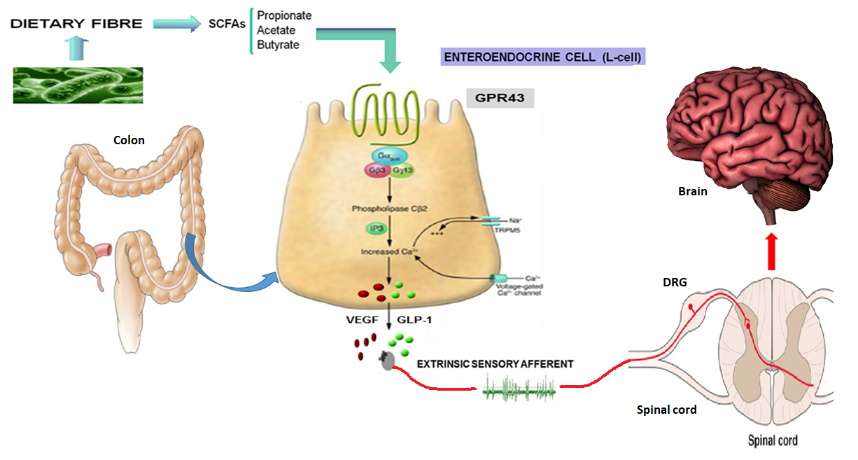
Figure 6.1: Microbiota-gut-brain communication: hypothesis and future direction. SCFAs may influence colonic afferent mechanosensitivity directly. Luminal SCFA sensing by the colonic L-cell may result in downstream signalling to release peptides such as GLP-1 which then act on the spinal sensory afferent endings lying in the submucosa, in turn signalling to the CNS. VEGF could also be a candidate signalling peptide released from the EEC (Figure amended from Sharkey, 2016)

6.7 Increasing focus on the gut microbiome and future perspectives
Between 2013 and 2017, the number of publications focusing on the gut microbiome in intestinal and extra-intestinal diseases numbered almost 13,000 which represents four-fifths of the total number of publications over the last 40 years that investigated this topic (Cani, 2018). In the last five years there has been a surge of interest in the relationship between the gut microbiome in both colorectal cancer (Saus et al., 2019) and in visceral pain (Pusceddu and Gareau, 2018).
Current evidence indicates that gut microbiota-host crosstalk is centred around the enteroendocrine system with microbial-mediated gut hormone release thought to play an important role in host metabolism. Several potential signalling pathways have been suggested including direct recognition of microbial structural components, such as flagella or membrane-bound lipopolysaccharides by toll-like receptors know to be expressed by EECs. Microbial derived molecules, such as bile acids and tryptophan metabolites, may also play a role, however thus far it is SCFAs that have been implicated as the major signaling molecule in gut microbiome-host communication (Martin et al., 2019).
The theory that dysbiosis of the resident colonic flora may create a microenvironment that promotes colorectal tumour development is gaining increasing support (Gagniere et al., 2016, Saus et al., 2019). It is thought that certain microbes may be associated with an increased risk of colorectal cancer, whereas other microbes may mediate a protective phenotype through metabolite production (eg butyrate) or by outcompeting pathogenic bacteria. Diet is one of the most influential factors that shape the human gut microbiome and supplementation of a high fibre diet and butyrate-producing bacteria can reduce colon tumour growth in a mouse model (Donohoe et al., 2014).
With regards the microbiome and visceral pain, studies using germ free mice have demonstrated that commensal bacteria are necessary for the development of adequate pain sensitivity (Amaral et al., 2008) and excitability of gut sensory neurons (McVey Neufeld et al., 2013) and recent findings have linked the microbiota to IBS suggesting the ability of microbes to modulate visceral hypersensitivity and nociception (Pusceddu and Gareau, 2018). Microbial dysbiosis has been demonstrated in patients with IBS with bacterial enteritis known to trigger IBS (Dupont, 2014) however the exact mechanisms underpinning the influence of the gut microbiome on visceral sensation is not known. Given the influence that colonic microbiota has on luminal SCFA levels, my findings in this thesis also provide evidence of a potential mechanism by which colonic microbiota may influence the gut-brain axis and may play a role in disease such as IBS.
Certainly the role of the enteroendocrine system and SCFAs in colonic pathophysiology appears complex and investigating EECs and colonic SCFAs in vivo remains a challenge. As technologies in faecal metabonomics and human EEC isolation and culture emerge, further research is merited to further characterise the role of EEC and their interaction with SCFAs in colonic health and disease. A better knowledge of the relationship between dietary fibre, microbial-derived SCFAs and EECs in colonic pathophysiology may offer new opportunities for the development of therapies targeting the microbiome, such as prebiotics, probiotics, specific antibiotics or faecal transplantation (Schmidt et al., 2018).

VII references

ADRIAENSSENS, A. E., SVENDSEN, B., LAM, B. Y., YEO, G. S., HOLST, J. J., REIMANN, F. & GRIBBLE, F. M. 2016. Transcriptomic profiling of pancreatic alpha, beta and delta cell populations identifies delta cells as a principal target for ghrelin in mouse islets. Diabetologia, 59, 2156-65.
AHLMAN, H. & NILSSON 2001. The gut as the largest endocrine organ in the body. Ann Oncol, 12 Suppl 2, S63-8.
AIKEN, K. D., KISSLINGER, J. A. & ROTH, K. A. 1994. Immunohistochemical studies indicate multiple enteroendocrine cell differentiation pathways in the mouse proximal small intestine. Dev Dyn, 201, 63-70.
AIKEN, K. D. & ROTH, K. A. 1992. Temporal differentiation and migration of substance P, serotonin, and secretin immunoreactive enteroendocrine cells in the mouse proximal small intestine. Dev Dyn, 194, 303-10.
AL-SOHAILY, S., BIANKIN, A., LEONG, R., KOHONEN-CORISH, M. & WARUSAVITARNE, J. 2012. Molecular pathways in colorectal cancer. J Gastroenterol Hepatol.
AMARAL, F. A., SACHS, D., COSTA, V. V., FAGUNDES, C. T., CISALPINO, D., CUNHA, T. M., FERREIRA, S. H., CUNHA, F. Q., SILVA, T. A., NICOLI, J. R., VIEIRA, L. Q., SOUZA, D. G. & TEIXEIRA, M. M. 2008. Commensal microbiota is fundamental for the development of inflammatory pain. Proc Natl Acad Sci U S A, 105, 2193-7.
ANDERSON, R. B., BERGNER, A. J., TANIGUCHI, M., FUJISAWA, H., FORRAI, A., ROBB, L. & YOUNG, H. M. 2007. Effects of different regions of the developing gut on the migration of enteric neural crest-derived cells: a role for Sema3A, but not Sema3F. Dev Biol, 305, 287-99.
ANDREW, A., KRAMER, B. & RAWDON, B. B. 1998. The origin of gut and pancreatic neuroendocrine (APUD) cells--the last word? J Pathol, 186, 117-8.
ANDRIEUX, C., MEMBRE, J. M., CAYUELA, C. & ANTOINE, J. M. 2002. Metabolic characteristics of the faecal microflora in humans from three age groups. Scand J Gastroenterol, 37, 792-8.
ANINI, Y., FU-CHENG, X., CUBER, J. C., KERVRAN, A., CHARIOT, J. & ROZ, C. 1999. Comparison of the postprandial release of peptide YY and proglucagon-derived peptides in the rat. Pflugers Arch, 438, 299-306.
ARTAVANIS-TSAKONAS, S., RAND, M. D. & LAKE, R. J. 1999. Notch signaling: cell fate control and signal integration in development. Science, 284, 770-6.
ASPALTER, I. M., GORDON, E., DUBRAC, A., RAGAB, A., NARLOCH, J., VIZAN, P., GEUDENS, I., COLLINS, R. T., FRANCO, C. A., ABRAHAMS, C. L., THURSTON, G., FRUTTIGER, M., ROSEWELL, I., EICHMANN, A. & GERHARDT, H. 2015. Alk1 and Alk5 inhibition by Nrp1 controls vascular sprouting downstream of Notch. Nat Commun, 6, 7264.
AZIZ, Q., DORE, J., EMMANUEL, A., GUARNER, F. & QUIGLEY, E. M. 2013. Gut microbiota and gastrointestinal health: current concepts and future directions. Neurogastroenterol Motil, 25, 4-15.
AZIZ, Q. & THOMPSON, D. G. 1998. Brain-gut axis in health and disease. Gastroenterology, 114, 559-78.
BACH-NGOHOU, K., MAHE, M. M., AUBERT, P., ABDO, H., BONI, S., BOURREILLE, A., DENIS, M. G., LARDEUX, B., NEUNLIST, M. & MASSON, D. 2010. Enteric glia modulate epithelial cell proliferation and differentiation through 15-deoxy-12,14-prostaglandin J2. J Physiol, 588, 2533-44.
BAGRI, A., TESSIER-LAVIGNE, M. & WATTS, R. J. 2009. Neuropilins in Tumor Biology. Clinical Cancer Research, 15, 1860-1864.
BAJPAI, R., LESPERANCE, J., KIM, M. & TERSKIKH, A. V. 2008. Efficient propagation of single cells Accutase-dissociated human embryonic stem cells. Mol Reprod Dev, 75, 818-27.
BANASIEWICZ, T., KROKOWICZ, L., STOJCEV, Z., KACZMAREK, B. F., KACZMAREK, E., MAIK, J., MARCINIAK, R., KROKOWICZ, P., WALKOWIAK, J. & DREWS, M. 2013. Microencapsulated sodium butyrate reduces the frequency of abdominal pain in patients with irritable bowel syndrome. Colorectal Dis, 15, 204-9.
BASS, B. 1993. Advances in colorectal carcinoma surgery.
BATTERHAM, R. L., COWLEY, M. A., SMALL, C. J., HERZOG, H., COHEN, M. A., DAKIN, C. L., WREN, A. M., BRYNES, A. E., LOW, M. J., GHATEI, M. A., CONE, R. D. & BLOOM, S. R. 2002. Gut hormone PYY(3-36) physiologically inhibits food intake. Nature, 418, 650-4.
BAYLISS, W. M. & STARLING, E. H. 1902. The mechanism of pancreatic secretion. J Physiol, 28, 325-53.
BEAUMONT, W. 1977. Nutrition Classics. Experiments and observations on the gastric juice and the physiology of digestion. By William Beaumont. Plattsburgh. Printed by F. P. Allen. 1833. Nutr Rev, 35, 144-5.
BECKER, P. M., TRAN, T. S., DELANNOY, M. J., HE, C., SHANNON, J. M. & MCGRATH-MORROW, S. 2011. Semaphorin 3A contributes to distal pulmonary epithelial cell differentiation and lung morphogenesis. PLoS One, 6, e27449.
BENGI, G., KAYAHAN, H., AKARSU, M., AYSAL, A., SAGOL, O., MERAL, M. & AKPINAR, H. 2011. Does glucagon like peptide-2 receptor expression have any effect on the development of human colorectal cancer? Turk J Gastroenterol, 22, 388-94.
BENSON, A. B., 3RD, KISS, I., BRIDGEWATER, J., ESKENS, F. A., SASSE, C., VOSSEN, S., CHEN, J., VAN SANT, C., BALL, H. A., KEATING, A. & KRIVOSHIK, A. 2016. BATON-CRC: A Phase II Randomized Trial Comparing Tivozanib Plus mFOLFOX6 with Bevacizumab Plus mFOLFOX6 in Stage IV Metastatic Colorectal Cancer. Clin Cancer Res, 22, 5058-5067.
BERGERS, G. & HANAHAN, D. 2008. Modes of resistance to anti-angiogenic therapy. Nat Rev Cancer, 8, 592-603.
BERNTSON, G. G., SARTER, M. & CACIOPPO, J. T. 2003. Ascending visceral regulation of cortical affective information processing. The European journal of neuroscience, 18, 2103-9.
BERTHOUD, H. R., PATTERSON, L. M., NEUMANN, F. & NEUHUBER, W. L. 1997. Distribution and structure of vagal afferent intraganglionic laminar endings (IGLEs) in the rat gastrointestinal tract. Anat Embryol (Berl), 195, 183-91.
BERTRAND, P. P., KUNZE, W. A., BORNSTEIN, J. C., FURNESS, J. B. & SMITH, M. L. 1997. Analysis of the responses of myenteric neurons in the small intestine to chemical stimulation of the mucosa. Am J Physiol, 273, G422-35.
BEUCHER, A., GJERNES, E., COLLIN, C., COURTNEY, M., MEUNIER, A., COLLOMBAT, P. & GRADWOHL, G. 2012. The homeodomain-containing transcription factors Arx and Pax4 control enteroendocrine subtype specification in mice. PLoS One, 7, e36449.
BEYAK, M. J. 2010. Visceral afferents - determinants and modulation of excitability. Auton Neurosci, 153, 69-78.
BIAGI, E., NYLUND, L., CANDELA, M., OSTAN, R., BUCCI, L., PINI, E., NIKKILA, J., MONTI, D., SATOKARI, R., FRANCESCHI, C., BRIGIDI, P. & DE VOS, W. 2010. Through ageing, and beyond: gut microbiota and inflammatory status in seniors and centenarians. PLoS One, 5, e10667.
BINDELS, L. B., DEWULF, E. M. & DELZENNE, N. M. 2013. GPR43/FFA2: physiopathological relevance and therapeutic prospects. Trends Pharmacol Sci, 34, 226-32.
BINGHAM, S. A., DAY, N. E., LUBEN, R., FERRARI, P., SLIMANI, N., NORAT, T., CLAVEL-CHAPELON, F., KESSE, E., NIETERS, A., BOEING, H., TJONNELAND, A., OVERVAD, K., MARTINEZ, C., DORRONSORO, M., GONZALEZ, C. A., KEY, T. J., TRICHOPOULOU, A., NASKA, A., VINEIS, P., TUMINO, R., KROGH, V., BUENO-DE-MESQUITA, H. B., PEETERS, P. H., BERGLUND, G., HALLMANS, G., LUND, E., SKEIE, G., KAAKS, R. & RIBOLI, E. 2003. Dietary fibre in food and protection against colorectal cancer in the European Prospective Investigation into Cancer and Nutrition (EPIC): an observational study. Lancet, 361, 1496-501.
BIRD, R. P. 1987. Observation and quantification of aberrant crypts in the murine colon treated with a colon carcinogen: preliminary findings. Cancer Lett, 37, 147-51.
BJERKNES, M. & CHENG, H. 1981. The stem-cell zone of the small intestinal epithelium. III. Evidence from columnar, enteroendocrine, and mucous cells in the adult mouse. Am J Anat, 160, 77-91.
BLOEMEN, J. G., SCHREINEMACHER, M. H., DE BRUINE, A. P., BUURMAN, W. A., BOUVY, N. D. & DEJONG, C. H. 2010. Butyrate enemas improve intestinal anastomotic strength in a rat model. Dis Colon Rectum, 53, 1069-75.
BOHORQUEZ, D. V., SAMSA, L. A., ROHOLT, A., MEDICETTY, S., CHANDRA, R. & LIDDLE, R. A. 2014. An enteroendocrine cell-enteric glia connection revealed by 3D electron microscopy. PLoS One, 9, e89881.
BOHORQUEZ, D. V., SHAHID, R. A., ERDMANN, A., KREGER, A. M., WANG, Y., CALAKOS, N., WANG, F. & LIDDLE, R. A. 2015. Neuroepithelial circuit formed by innervation of sensory enteroendocrine cells. J Clin Invest, 125, 782-6.
BOLOGNINI, D., TOBIN, A. B., MILLIGAN, G. & MOSS, C. E. 2016. The Pharmacology and Function of Receptors for Short-Chain Fatty Acids. Mol Pharmacol, 89, 388-98.
BOOTH C, O. S. J. 2002. Isolation and Culture of Intestinal Epithelial Cells. In: FRESHNEY, R. I. A. F. M. (ed.) Culture of Epithelial Cells.
BOOTH, C. E., KIRKUP, A. J., HICKS, G. A., HUMPHREY, P. P. & GRUNDY, D. 2001. Somatostatin sst(2) receptor-mediated inhibition of mesenteric afferent nerves of the jejunum in the anesthetized rat. Gastroenterology, 121, 358-69.
BORDONARO, M. & LAZAROVA, D. L. 2015. Hypothesis: cell signalling influences age-related risk of colorectal cancer. J Cell Mol Med, 19, 74-81.
BOREN, J., LEE, W. N., BASSILIAN, S., CENTELLES, J. J., LIM, S., AHMED, S., BOROS, L. G. & CASCANTE, M. 2003. The stable isotope-based dynamic metabolic profile of butyrate-induced HT29 cell differentiation. J Biol Chem, 278, 28395-402.
BOSMANS, J. W., JONGEN, A. C., BIRCHENOUGH, G. M., NYSTROM, E. E., GIJBELS, M. J., DERIKX, J. P., BOUVY, N. D. & HANSSON, G. C. 2017a. Functional mucous layer and healing of proximal colonic anastomoses in an experimental model. Br J Surg, 104, 619-630.
BOSMANS, J. W., JONGEN, A. C., BOONEN, B. T., VAN RIJN, S., SCOGNAMIGLIO, F., STUCCHI, L., GIJBELS, M. J., MARSICH, E. & BOUVY, N. D. 2017b. Comparison of three different application routes of butyrate to improve colonic anastomotic strength in rats. Int J Colorectal Dis, 32, 305-313.
BOTTCHER, G., SJOLUND, K., EKBLAD, E., HAKANSON, R., SCHWARTZ, T. W. & SUNDLER, F. 1984. Coexistence of peptide YY and glicentin immunoreactivity in endocrine cells of the gut. Regul Pept, 8, 261-6.
BOURDU, S., DAPOIGNY, M., CHAPUY, E., ARTIGUE, F., VASSON, M. P., DECHELOTTE, P., BOMMELAER, G., ESCHALIER, A. & ARDID, D. 2005. Rectal instillation of butyrate provides a novel clinically relevant model of noninflammatory colonic hypersensitivity in rats. Gastroenterology, 128, 1996-2008.
BOYER, J. C., MAGOUS, R., CHRISTEN, M. O., BALMES, J. L. & BALI, J. P. 2001. Contraction of human colonic circular smooth muscle cells is inhibited by the calcium channel blocker pinaverium bromide. Cell Calcium, 29, 429-38.
BOYLE, P. & LANGMAN, J. S. 2000. ABC of colorectal cancer: Epidemiology. BMJ, 321, 805-8.
BRAUN, M., RAMRACHEYA, R., AMISTEN, S., BENGTSSON, M., MORITOH, Y., ZHANG, Q., JOHNSON, P. R. & RORSMAN, P. 2009. Somatostatin release, electrical activity, membrane currents and exocytosis in human pancreatic delta cells. Diabetologia, 52, 1566-78.
BRIERLEY, S. M., CARTER, R., JONES, W., 3RD, XU, L., ROBINSON, D. R., HICKS, G. A., GEBHART, G. F. & BLACKSHAW, L. A. 2005. Differential chemosensory function and receptor expression of splanchnic and pelvic colonic afferents in mice. J Physiol, 567, 267-81.
BRIERLEY, S. M., HIBBERD, T. J. & SPENCER, N. J. 2018. Spinal Afferent Innervation of the Colon and Rectum. Front Cell Neurosci, 12, 467.
BRIERLEY, S. M., JONES, R. C., 3RD, GEBHART, G. F. & BLACKSHAW, L. A. 2004. Splanchnic and pelvic mechanosensory afferents signal different qualities of colonic stimuli in mice. Gastroenterology, 127, 166-78.
BROCHARD, C., SIPROUDHIS, L., ROPERT, A., MALLAK, A., BRETAGNE, J. F. & BOUGUEN, G. 2015. Anorectal dysfunction in patients with ulcerative colitis: impaired adaptation or enhanced perception? Neurogastroenterol Motil, 27, 1032-7.
BROOKES, S. J., DINNING, P. G. & GLADMAN, M. A. 2009. Neuroanatomy and physiology of colorectal function and defaecation: from basic science to human clinical studies. Neurogastroenterol Motil, 21 Suppl 2, 9-19.
BROWN, A. J., GOLDSWORTHY, S. M., BARNES, A. A., EILERT, M. M., TCHEANG, L., DANIELS, D., MUIR, A. I., WIGGLESWORTH, M. J., KINGHORN, I., FRASER, N. J., PIKE, N. B., STRUM, J. C., STEPLEWSKI, K. M., MURDOCK, P. R., HOLDER, J. C., MARSHALL, F. H., SZEKERES, P. G., WILSON, S., IGNAR, D. M., FOORD, S. M., WISE, A. & DOWELL, S. J. 2003. The Orphan G protein-coupled receptors GPR41 and GPR43 are activated by propionate and other short chain carboxylic acids. J Biol Chem, 278, 11312-9.
BROWN, L. F., BERSE, B., JACKMAN, R. W., TOGNAZZI, K., MANSEAU, E. J., SENGER, D. R. & DVORAK, H. F. 1993. Expression of vascular permeability factor (vascular endothelial growth factor) and its receptors in adenocarcinomas of the gastrointestinal tract. Cancer Res, 53, 4727-35.
BROWN, S. R., ALI, M. S., WILLIAMS, M., SWISHER, J. P., RICE, W. V., COVIELLO, L. C., HUITRON, S. S. & DAVIS, K. G. 2015. Cellular changes of the colon after mechanical bowel preparation. J Surg Res, 193, 619-25.
BUTZNER, J. D., PARMAR, R., BELL, C. J. & DALAL, V. 1996. Butyrate enema therapy stimulates mucosal repair in experimental colitis in the rat. Gut, 38, 568-73.
CAMILLERI, M. 2014. Physiological underpinnings of irritable bowel syndrome: neurohormonal mechanisms. J Physiol, 592, 2967-80.
CAMILLERI, M., ODUYEBO, I. & HALAWI, H. 2016. Chemical and molecular factors in irritable bowel syndrome: current knowledge, challenges, and unanswered questions. Am J Physiol Gastrointest Liver Physiol, 311, G777-G784.
CAMILLERI, M., VAZQUEZ-ROQUE, M., ITURRINO, J., BOLDINGH, A., BURTON, D., MCKINZIE, S., WONG, B. S., RAO, A. S., KENNY, E., MANSSON, M. & ZINSMEISTER, A. R. 2012. Effect of a glucagon-like peptide 1 analog, ROSE-010, on GI motor functions in female patients with constipation-predominant irritable bowel syndrome. Am J Physiol Gastrointest Liver Physiol, 303, G120-8.
CANFORA, E. E., VAN DER BEEK, C. M., JOCKEN, J. W. E., GOOSSENS, G. H., HOLST, J. J., OLDE DAMINK, S. W. M., LENAERTS, K., DEJONG, C. H. C. & BLAAK, E. E. 2017. Colonic infusions of short-chain fatty acid mixtures promote energy metabolism in overweight/obese men: a randomized crossover trial. Sci Rep, 7, 2360.
CANI, P. D. 2018. Human gut microbiome: hopes, threats and promises. Gut, 67, 1716-1725.
CAPLIN, M. E., PAVEL, M., CWIKLA, J. B., PHAN, A. T., RADERER, M., SEDLACKOVA, E., CADIOT, G., WOLIN, E. M., CAPDEVILA, J., WALL, L., RINDI, G., LANGLEY, A., MARTINEZ, S., BLUMBERG, J., RUSZNIEWSKI, P. & INVESTIGATORS, C. 2014. Lanreotide in metastatic enteropancreatic neuroendocrine tumors. N Engl J Med, 371, 224-33.
CAPPELL, M. S. 2008. Pathophysiology, clinical presentation, and management of colon cancer. Gastroenterol Clin North Am, 37, 1-24, v.
CATALANO, A., CAPRARI, P., RODILOSSI, S., BETTA, P., CASTELLUCCI, M., CASAZZA, A., TAMAGNONE, L. & PROCOPIO, A. 2004. Cross-talk between vascular endothelial growth factor and semaphorin-3A pathway in the regulation of normal and malignant mesothelial cell proliferation. FASEB J, 18, 358-60.
CEGLA, J., CUENCO, J., MINNION, J., GHOURAB, S., HOSTOMSKA, K., TAN, T. & BLOOM, S. 2015. Pharmacokinetics and pharmacodynamics of subcutaneously administered PYY3-36 and its analogues in vivo. Lancet, 385 Suppl 1, S28.
CENTER, M. M., JEMAL, A. & WARD, E. 2009. International trends in colorectal cancer incidence rates. Cancer Epidemiol Biomarkers Prev, 18, 1688-94.
CHAPPLE, K. S., CARTWRIGHT, E. J., HAWCROFT, G., TISBURY, A., BONIFER, C., SCOTT, N., WINDSOR, A. C., GUILLOU, P. J., MARKHAM, A. F., COLETTA, P. L. & HULL, M. A. 2000. Localization of cyclooxygenase-2 in human sporadic colorectal adenomas. Am J Pathol, 156, 545-53.
CHENG, H. 1974. Origin, differentiation and renewal of the four main epithelial cell types in the mouse small intestine. IV. Paneth cells. Am J Anat, 141, 521-35.
CHENG, H. & LEBLOND, C. P. 1974. Origin, differentiation and renewal of the four main epithelial cell types in the mouse small intestine. V. Unitarian Theory of the origin of the four epithelial cell types. Am J Anat, 141, 537-61.
CHERBUT, C. 2003. Motor effects of short-chain fatty acids and lactate in the gastrointestinal tract. Proc Nutr Soc, 62, 95-9.
CHERBUT, C., FERRIER, L., ROZE, C., ANINI, Y., BLOTTIERE, H., LECANNU, G. & GALMICHE, J. P. 1998. Short-chain fatty acids modify colonic motility through nerves and polypeptide YY release in the rat. Am J Physiol, 275, G1415-22.
CHIRAKKAL, H., LEECH, S. H., BROOKES, K. E., PRAIS, A. L., WABY, J. S. & CORFE, B. M. 2006. Upregulation of BAK by butyrate in the colon is associated with increased Sp3 binding. Oncogene, 25, 7192-200.
CHO, K. H., LEE, H. S. & KU, S. K. 2008. Decrease in intestinal endocrine cells in Balb/c mice with CT-26 carcinoma cells. J Vet Sci, 9, 9-14.
CHOPRA, D. P., DOMBKOWSKI, A. A., STEMMER, P. M. & PARKER, G. C. 2010. Intestinal epithelial cells in vitro. Stem Cells Dev, 19, 131-42.
CHOUGULE, P., HERLENIUS, G., HERNANDEZ, N. M., PATIL, P. B., XU, B. & SUMITRAN-HOLGERSSON, S. 2012. Isolation and characterization of human primary enterocytes from small intestine using a novel method. Scand J Gastroenterol, 47, 1334-43.
CHRISTIANSON, J. A., LIANG, R., USTINOVA, E. E., DAVIS, B. M., FRASER, M. O. & PEZZONE, M. A. 2007. Convergence of bladder and colon sensory innervation occurs at the primary afferent level. Pain, 128, 235-43.
CHU, E. 2009. New Treatment Strategies in Colorectal Cancer.
CHUNG, L., YANG, T. L., HUANG, H. R., HSU, S. M., CHENG, H. J. & HUANG, P. H. 2007. Semaphorin signaling facilitates cleft formation in the developing salivary gland. Development, 134, 2935-45.
CIVES, M. & STROSBERG, J. 2015. The expanding role of somatostatin analogs in gastroenteropancreatic and lung neuroendocrine tumors. Drugs, 75, 847-58.
CLEMENS, C. H., SAMSOM, M., ROELOFS, J., VAN BERGE HENEGOUWEN, G. P. & SMOUT, A. J. 2004. Colorectal visceral perception in diverticular disease. Gut, 53, 717-22.
COHEN, T. 2001. Neuroendocrine Cells along the Digestive Tract Express Neuropilin-2. Biochemical and Biophysical Research Communications, 284, 395-403.
CORFE, B. M., WILLIAMS, E. A., BURY, J. P., RILEY, S. A., CROUCHER, L. J., LAI, D. Y. & EVANS, C. A. 2009. A study protocol to investigate the relationship between dietary fibre intake and fermentation, colon cell turnover, global protein acetylation and early carcinogenesis: the FACT study. BMC Cancer, 9, 332.
COSTA, M., BROOKES, S. J. & HENNIG, G. W. 2000. Anatomy and physiology of the enteric nervous system. Gut, 47 Suppl 4, iv15-9; discussion iv26.
COSTA, M., BROOKES, S. J., STEELE, P. A., GIBBINS, I., BURCHER, E. & KANDIAH, C. J. 1996. Neurochemical classification of myenteric neurons in the guinea-pig ileum. Neuroscience, 75, 949-67.
COSTEDIO, M. M., COATES, M. D., DANIELSON, A. B., BUTTOLPH, T. R., 3RD, BLASZYK, H. J., MAWE, G. M. & HYMAN, N. H. 2008. Serotonin signaling in diverticular disease. J Gastrointest Surg, 12, 1439-45.
COUSIN, F. J., JOUAN-LANHOUET, S., THERET, N., BRENNER, C., JOUAN, E., LE MOIGNE-MULLER, G., DIMANCHE-BOITREL, M. T. & JAN, G. 2016. The probiotic Propionibacterium freudenreichii as a new adjuvant for TRAIL-based therapy in colorectal cancer. Oncotarget, 7, 7161-78.
COX, H. M. 2007. Peptide YY: a neuroendocrine neighbor of note. Peptides, 28, 345-51.
CUCHE, G., BLAT, S. & MALBERT, C. H. 2001. Desensitization of ileal vagal receptors by short-chain fatty acids in pigs. Am J Physiol Gastrointest Liver Physiol, 280, G1013-21.
CUCHE, G., CUBER, J. C. & MALBERT, C. H. 2000. Ileal short-chain fatty acids inhibit gastric motility by a humoral pathway. Am J Physiol Gastrointest Liver Physiol, 279, G925-30.
CUMMINGS, J. H., POMARE, E. W., BRANCH, W. J., NAYLOR, C. P. & MACFARLANE, G. T. 1987. Short chain fatty acids in human large intestine, portal, hepatic and venous blood. Gut, 28, 1221-7.
DASS, N. B., JOHN, A. K., BASSIL, A. K., CRUMBLEY, C. W., SHEHEE, W. R., MAURIO, F. P., MOORE, G. B., TAYLOR, C. M. & SANGER, G. J. 2007. The relationship between the effects of short-chain fatty acids on intestinal motility in vitro and GPR43 receptor activation. Neurogastroenterol Motil, 19, 66-74.
DAVIE, J. R. 2003. Inhibition of histone deacetylase activity by butyrate. J Nutr, 133, 2485S-2493S.
DE SILVA, A. & BLOOM, S. R. 2012. Gut Hormones and Appetite Control: A Focus on PYY and GLP-1 as Therapeutic Targets in Obesity. Gut Liver, 6, 10-20.
DE SILVA, H. J., IRELAND, A., KETTLEWELL, M., MORTENSEN, N. & JEWELL, D. P. 1989. Short-chain fatty acid irrigation in severe pouchitis. N Engl J Med, 321, 1416-7.
DE VADDER, F., KOVATCHEVA-DATCHARY, P., GONCALVES, D., VINERA, J., ZITOUN, C., DUCHAMPT, A., BACKHED, F. & MITHIEUX, G. 2014. Microbiota-generated metabolites promote metabolic benefits via gut-brain neural circuits. Cell, 156, 84-96.
DEN BESTEN, G., VAN EUNEN, K., GROEN, A. K., VENEMA, K., REIJNGOUD, D. J. & BAKKER, B. M. 2013. The role of short-chain fatty acids in the interplay between diet, gut microbiota, and host energy metabolism. J Lipid Res, 54, 2325-40.
DESAI, S., LOOMIS, Z., PUGH-BERNARD, A., SCHRUNK, J., DOYLE, M. J., MINIC, A., MCCOY, E. & SUSSEL, L. 2008. Nkx2.2 regulates cell fate choice in the enteroendocrine cell lineages of the intestine. Dev Biol, 313, 58-66.
DOCKRAY, G. J. 2003. Luminal sensing in the gut: an overview. J Physiol Pharmacol, 54 Suppl 4, 9-17.
DONOHOE, D. R., HOLLEY, D., COLLINS, L. B., MONTGOMERY, S. A., WHITMORE, A. C., HILLHOUSE, A., CURRY, K. P., RENNER, S. W., GREENWALT, A., RYAN, E. P., GODFREY, V., HEISE, M. T., THREADGILL, D. S., HAN, A., SWENBERG, J. A., THREADGILL, D. W. & BULTMAN, S. J. 2014. A gnotobiotic mouse model demonstrates that dietary fiber protects against colorectal tumorigenesis in a microbiota- and butyrate-dependent manner. Cancer Discov, 4, 1387-97.
DRUCKER, D. J. 2012. Essay for the 2011 CIHR/CMAJ award: glucagon-like peptides for metabolic and gastrointestinal disorders. CMAJ, 184, E153-4.
DRUCKER, D. J. 2016. Evolving Concepts and Translational Relevance of Enteroendocrine Cell Biology. J Clin Endocrinol Metab, 101, 778-86.
DUPONT, H. L. 2014. Review article: evidence for the role of gut microbiota in irritable bowel syndrome and its potential influence on therapeutic targets. Aliment Pharmacol Ther, 39, 1033-42.
EGEROD, K. L., ENGELSTOFT, M. S., GRUNDDAL, K. V., NOHR, M. K., SECHER, A., SAKATA, I., PEDERSEN, J., WINDELOV, J. A., FUCHTBAUER, E. M., OLSEN, J., SUNDLER, F., CHRISTENSEN, J. P., WIERUP, N., OLSEN, J. V., HOLST, J. J., ZIGMAN, J. M., POULSEN, S. S. & SCHWARTZ, T. W. 2012. A major lineage of enteroendocrine cells coexpress CCK, secretin, GIP, GLP-1, PYY, and neurotensin but not somatostatin. Endocrinology, 153, 5782-95.
EL-SALHY, M., DANIELSSON, A., STENLING, R. & GRIMELIUS, L. 1997. Colonic endocrine cells in inflammatory bowel disease. J Intern Med, 242, 413-9.
EL-SALHY, M., MAHDAVI, J. & NORRGARD, O. 1998. Colonic endocrine cells in patients with carcinoma of the colon. Eur J Gastroenterol Hepatol, 10, 517-22.
EL-SALHY, M., SOLOMON, T., HAUSKEN, T., GILJA, O. H. & HATLEBAKK, J. G. 2017a. Gastrointestinal neuroendocrine peptides/amines in inflammatory bowel disease. World J Gastroenterol, 23, 5068-5085.
EL-SALHY, M., YSTAD, S. O., MAZZAWI, T. & GUNDERSEN, D. 2017b. Dietary fiber in irritable bowel syndrome (Review). Int J Mol Med, 40, 607-613.
ELPHICK, D. A. & MAHIDA, Y. R. 2005. Paneth cells: their role in innate immunity and inflammatory disease. Gut, 54, 1802-9.
EMMANUEL, A., COOLS, M., VANDEPLASSCHE, L. & KERSTENS, R. 2014. Prucalopride improves bowel function and colonic transit time in patients with chronic constipation: an integrated analysis. Am J Gastroenterol, 109, 887-94.
EVANGELOU, I., PETRAKI, C., MSAOUEL, P., SCORILAS, A., SDROLIA, E., PADAZI, G., KOBOROZOS, V. & KOUTSILIERIS, M. 2012. Immunohistochemical expression of somatostatin receptor subtypes 2 and 5 in colorectal cancer. Eur J Clin Invest, 42, 777-83.
EVANS, C. A., ROSSER, R., WABY, J. S., NOIREL, J., LAI, D., WRIGHT, P. C., WILLIAMS, E. A., RILEY, S. A., BURY, J. P. & CORFE, B. M. 2015. Reduced keratin expression in colorectal neoplasia and associated fields is reversible by diet and resection. BMJ Open Gastroenterol, 2, e000022.
FANTIN, A., MADEN, C. H. & RUHRBERG, C. 2009. Neuropilin ligands in vascular and neuronal patterning. Biochem Soc Trans, 37, 1228-32.
FARRIS, A. B., MISDRAJI, J., SRIVASTAVA, A., MUZIKANSKY, A., DESHPANDE, V., LAUWERS, G. Y. & MINO-KENUDSON, M. 2008. Sessile serrated adenoma: challenging discrimination from other serrated colonic polyps. Am J Surg Pathol, 32, 30-5.
FEARON, E. R. & VOGELSTEIN, B. 1990. A genetic model for colorectal tumorigenesis. Cell, 61, 759-67.
FENG, B. & GEBHART, G. F. 2011. Characterization of silent afferents in the pelvic and splanchnic innervations of the mouse colorectum. Am J Physiol Gastrointest Liver Physiol, 300, G170-80.
FENG, B. & GEBHART, G. F. 2015. In vitro functional characterization of mouse colorectal afferent endings. J Vis Exp, 52310.
FERLAY, J., SHIN, H. R., BRAY, F., FORMAN, D., MATHERS, C. & PARKIN, D. M. 2010. Estimates of worldwide burden of cancer in 2008: GLOBOCAN 2008. Int J Cancer, 127, 2893-917.
FERRERO, S., BUFFA, R., PRUNERI, G., SICCARDI, A. G., PELAGI, M., LEE, A. K., COGGI, G. & BOSARI, S. 1995. The prevalence and clinical significance of chromogranin A and secretogranin II immunoreactivity in colorectal adenocarcinomas. Virchows Arch, 426, 587-92.
FIOCCA, R., RINDI, G., CAPELLA, C., GRIMELIUS, L., POLAK, J. M., SCHWARTZ, T. W., YANAIHARA, N. & SOLCIA, E. 1987. Glucagon, glicentin, proglucagon, PYY, PP and proPP-icosapeptide immunoreactivities of rectal carcinoid tumors and related non-tumor cells. Regul Pept, 17, 9-29.
FLINT, N., COVE, F. L. & EVANS, G. S. 1991. A Low-Temperature Method for the Isolation of Small-Intestinal Epithelium Along the Crypt-Villus Axis. Biochemical Journal, 280, 331-334.
FORD, A. C., LACY, B. E. & TALLEY, N. J. 2017. Irritable Bowel Syndrome. N Engl J Med, 376, 2566-2578.
FORMEISTER, E. J., SIONAS, A. L., LORANCE, D. K., BARKLEY, C. L., LEE, G. H. & MAGNESS, S. T. 2009. Distinct SOX9 levels differentially mark stem/progenitor populations and enteroendocrine cells of the small intestine epithelium. Am J Physiol Gastrointest Liver Physiol, 296, G1108-18.
FOTHERGILL, L. J. & FURNESS, J. B. 2018. Diversity of enteroendocrine cells investigated at cellular and subcellular levels: the need for a new classification scheme. Histochem Cell Biol, 150, 693-702.
FRE, S., HUYGHE, M., MOURIKIS, P., ROBINE, S., LOUVARD, D. & ARTAVANIS-TSAKONAS, S. 2005. Notch signals control the fate of immature progenitor cells in the intestine. Nature, 435, 964-8.
FROKJAER, J. B., LIAO, D., BERGMANN, A., MCMAHON, B. P., STEFFENSEN, E., DREWES, A. M. & GREGERSEN, H. 2005. Three-dimensional biomechanical properties of the human rectum evaluated with magnetic resonance imaging. Neurogastroenterol Motil, 17, 531-40.
FROKJAER, J. B., LIAO, D., STEFFENSEN, E., DIMCEVSKI, G., BERGMANN, A., DREWES, A. M. & GREGERSEN, H. 2007. Geometric and mechanosensory properties of the sigmoid colon evaluated with magnetic resonance imaging. Neurogastroenterol Motil, 19, 253-62.
FUNKE, B. 2011. Laser microdissection of intestinal epithelial cells and downstream analysis. Methods Mol Biol, 755, 189-96.
FURNESS, J. B. 2006. The Enteric Nervous System, Oxford, Blackwell.
FURNESS, J. B. 2012. The enteric nervous system and neurogastroenterology. Nat Rev Gastroenterol Hepatol, 9, 286-94.
FURNESS, J. B. & COSTA, M. 1974. The adrenergic innervation of the gastrointestinal tract. Ergebnisse der Physiologie, biologischen Chemie und experimentellen Pharmakologie, 69, 2-51.
FURNESS, J. B., JOHNSON, P. J., POMPOLO, S. & BORNSTEIN, J. C. 1995. Evidence that enteric motility reflexes can be initiated through entirely intrinsic mechanisms in the guinea-pig small intestine. Neurogastroenterol Motil, 7, 89-96.
FURNESS, J. B., KUNZE, W. A., BERTRAND, P. P., CLERC, N. & BORNSTEIN, J. C. 1998. Intrinsic primary afferent neurons of the intestine. Prog Neurobiol, 54, 1-18.
FURUSAWA, Y., OBATA, Y., FUKUDA, S., ENDO, T. A., NAKATO, G., TAKAHASHI, D., NAKANISHI, Y., UETAKE, C., KATO, K., KATO, T., TAKAHASHI, M., FUKUDA, N. N., MURAKAMI, S., MIYAUCHI, E., HINO, S., ATARASHI, K., ONAWA, S., FUJIMURA, Y., LOCKETT, T., CLARKE, J. M., TOPPING, D. L., TOMITA, M., HORI, S., OHARA, O., MORITA, T., KOSEKI, H., KIKUCHI, J., HONDA, K., HASE, K. & OHNO, H. 2013. Commensal microbe-derived butyrate induces the differentiation of colonic regulatory T cells. Nature, 504, 446-50.
GAGNIERE, J., RAISCH, J., VEZIANT, J., BARNICH, N., BONNET, R., BUC, E., BRINGER, M. A., PEZET, D. & BONNET, M. 2016. Gut microbiota imbalance and colorectal cancer. World J Gastroenterol, 22, 501-18.
GAISANO, G. G., PARK, S. J., DALY, D. M. & BEYAK, M. J. 2010. Glucagon-like peptide-1 inhibits voltage-gated potassium currents in mouse nodose ganglion neurons. Neurogastroenterol Motil, 22, 470-9, e111.
GALLO, R. L. & HOOPER, L. V. 2012. Epithelial antimicrobial defence of the skin and intestine. Nature reviews. Immunology, 12, 503-16.
GAO, Z., YIN, J., ZHANG, J., WARD, R. E., MARTIN, R. J., LEFEVRE, M., CEFALU, W. T. & YE, J. 2009. Butyrate improves insulin sensitivity and increases energy expenditure in mice. Diabetes, 58, 1509-17.
GERETTI, E. & KLAGSBRUN, M. 2007. Neuropilins: novel targets for anti-angiogenesis therapies. Cell Adh Migr, 1, 56-61.
GIERL, M. S., KAROULIAS, N., WENDE, H., STREHLE, M. & BIRCHMEIER, C. 2006. The zinc-finger factor Insm1 (IA-1) is essential for the development of pancreatic beta cells and intestinal endocrine cells. Genes Dev, 20, 2465-78.
GLASS, L. L., CALERO-NIETO, F. J., JAWAID, W., LARRAUFIE, P., KAY, R. G., GOTTGENS, B., REIMANN, F. & GRIBBLE, F. M. 2017. Single-cell RNA-sequencing reveals a distinct population of proglucagon-expressing cells specific to the mouse upper small intestine. Mol Metab, 6, 1296-1303.
GLEDHILL, A., HALL, P. A., CRUSE, J. P. & POLLOCK, D. J. 1986. Enteroendocrine cell hyperplasia, carcinoid tumours and adenocarcinoma in long-standing ulcerative colitis. Histopathology, 10, 501-8.
GOLIGHER, J. C. & HUGHES, E. S. 1951. Sensibility of the rectum and colon. Its role in the mechanism of anal continence. Lancet, 1, 543-7.
GOLLINS, S., MORAN, B., ADAMS, R., CUNNINGHAM, C., BACH, S., MYINT, A. S., RENEHAN, A., KARANDIKAR, S., GOH, V., PREZZI, D., LANGMAN, G., AHMEDZAI, S. & GEH, I. 2017. Association of Coloproctology of Great Britain & Ireland (ACPGBI): Guidelines for the Management of Cancer of the Colon, Rectum and Anus (2017) - Multidisciplinary Management. Colorectal Dis, 19 Suppl 1, 37-66.
GOPAL, R., BIRDSELL, D. & MONROY, F. P. 2008. Regulation of toll-like receptors in intestinal epithelial cells by stress and Toxoplasma gondii infection. Parasite immunology, 30, 563-76.
GORDON, J. I. & HERMISTON, M. L. 1994. Differentiation and self-renewal in the mouse gastrointestinal epithelium. Curr Opin Cell Biol, 6, 795-803.
GOYAL, R. K. & HIRANO, I. 1996. The enteric nervous system. The New England journal of medicine, 334, 1106-15.
GRADY, W. M. & CARETHERS, J. M. 2008. Genomic and epigenetic instability in colorectal cancer pathogenesis. Gastroenterology, 135, 1079-99.
GRAF, N., MCLEAN, M., CAPELLINO, S., SCHOLMERICH, J., MURRAY, G. I., EL-OMAR, E. M. & STRAUB, R. H. 2011. Loss of sensory and noradrenergic innervation in benign colorectal adenomatous polyps - a putative role of semaphorins 3F and 3A. Neurogastroenterol Motil.
GREAVES, L. C., PRESTON, S. L., TADROUS, P. J., TAYLOR, R. W., BARRON, M. J., OUKRIF, D., LEEDHAM, S. J., DEHERAGODA, M., SASIENI, P., NOVELLI, M. R., JANKOWSKI, J. A., TURNBULL, D. M., WRIGHT, N. A. & MCDONALD, S. A. 2006. Mitochondrial DNA mutations are established in human colonic stem cells, and mutated clones expand by crypt fission. Proceedings of the National Academy of Sciences of the United States of America, 103, 714-9.
GRIBBLE, F. M. & REIMANN, F. 2016. Enteroendocrine Cells: Chemosensors in the Intestinal Epithelium. Annu Rev Physiol, 78, 277-99.
GRIDER, J. R. & PILAND, B. E. 2007. The peristaltic reflex induced by short-chain fatty acids is mediated by sequential release of 5-HT and neuronal CGRP but not BDNF. Am J Physiol Gastrointest Liver Physiol, 292, G429-37.
GRUN, D., LYUBIMOVA, A., KESTER, L., WIEBRANDS, K., BASAK, O., SASAKI, N., CLEVERS, H. & VAN OUDENAARDEN, A. 2015. Single-cell messenger RNA sequencing reveals rare intestinal cell types. Nature, 525, 251-5.
GRUNDY, D. 2004. What activates visceral afferents? Gut, 53 Suppl 2, ii5-8.
GRUNDY, D., SCHEMANN, M. & WOOD, J. 2000. A tale of two brains, one little and one big. Neurogastroenterol Motil, 12, 105-11.
GU, C., LIMBERG, B. J., WHITAKER, G. B., PERMAN, B., LEAHY, D. J., ROSENBAUM, J. S., GINTY, D. D. & KOLODKIN, A. L. 2002. Characterization of neuropilin-1 structural features that confer binding to semaphorin 3A and vascular endothelial growth factor 165. J Biol Chem, 277, 18069-76.
GULUBOVA, M. & VLAYKOVA, T. 2008. Chromogranin A-, serotonin-, synaptophysin- and vascular endothelial growth factor-positive endocrine cells and the prognosis of colorectal cancer: An immunohistochemical and ultrastructural study. Journal of Gastroenterology and Hepatology, 23, 1574-1585.
GUNAWARDENE, A. R., CORFE, B. M. & STATON, C. A. 2011. Classification and functions of enteroendocrine cells of the lower gastrointestinal tract. Int J Exp Pathol, 92, 219-31.
HABER, A. L., BITON, M., ROGEL, N., HERBST, R. H., SHEKHAR, K., SMILLIE, C., BURGIN, G., DELOREY, T. M., HOWITT, M. R., KATZ, Y., TIROSH, I., BEYAZ, S., DIONNE, D., ZHANG, M., RAYCHOWDHURY, R., GARRETT, W. S., ROZENBLATT-ROSEN, O., SHI, H. N., YILMAZ, O., XAVIER, R. J. & REGEV, A. 2017. A single-cell survey of the small intestinal epithelium. Nature, 551, 333-339.
HABIB, A. M., RICHARDS, P., CAIRNS, L. S., ROGERS, G. J., BANNON, C. A., PARKER, H. E., MORLEY, T. C., YEO, G. S., REIMANN, F. & GRIBBLE, F. M. 2012. Overlap of endocrine hormone expression in the mouse intestine revealed by transcriptional profiling and flow cytometry. Endocrinology, 153, 3054-65.
HAIXIA, D., JINGSONG, Z., LEI, J., HAIRONG, D., JUN, W., HANG, X. & WEIXIAN, C. 2010. Gene Expression of Neuropilin-1 and Its Receptors, VEGF/Semaphorin 3a, in Normal and Cancer Cells. Cell Biochemistry and Biophysics.
HAMER, H. M., JONKERS, D., VENEMA, K., VANHOUTVIN, S., TROOST, F. J. & BRUMMER, R. J. 2008. Review article: the role of butyrate on colonic function. Aliment Pharmacol Ther, 27, 104-19.
HAMER, H. M., JONKERS, D. M., VANHOUTVIN, S. A., TROOST, F. J., RIJKERS, G., DE BRUINE, A., BAST, A., VENEMA, K. & BRUMMER, R. J. 2010. Effect of butyrate enemas on inflammation and antioxidant status in the colonic mucosa of patients with ulcerative colitis in remission. Clin Nutr, 29, 738-44.
HANDA, A., TOKUNAGA, T., TSUCHIDA, T., LEE, Y. H., KIJIMA, H., YAMAZAKI, H., UEYAMA, Y., FUKUDA, H. & NAKAMURA, M. 2000. Neuropilin-2 expression affects the increased vascularization and is a prognostic factor in osteosarcoma. Int J Oncol, 17, 291-5.
HANSEL, D. E., WILENTZ, R. E., YEO, C. J., SCHULICK, R. D., MONTGOMERY, E. & MAITRA, A. 2004. Expression of neuropilin-1 in high-grade dysplasia, invasive cancer, and metastases of the human gastrointestinal tract. Am J Surg Pathol, 28, 347-56.
HAO, W. L. & LEE, Y. K. 2004. Microflora of the gastrointestinal tract: a review. Methods in molecular biology, 268, 491-502.
HAO, X., BISHOP, A. E., WALLACE, M., WANG, H., WILLCOCKS, T. C., MACLOUF, J., POLAK, J. M., KNIGHT, S. & TALBOT, I. C. 1999. Early expression of cyclo-oxygenase-2 during sporadic colorectal carcinogenesis. J Pathol, 187, 295-301.
HARRISON, E., LAL, S. & MCLAUGHLIN, J. T. 2013. Enteroendocrine cells in gastrointestinal pathophysiology. Curr Opin Pharmacol, 13, 941-5.
HARRISON, S. & BENZIGER, H. 2011. The molecular biology of colorectal carcinoma and its implications: a review. Surgeon, 9, 200-10.
HASLER, W. L., SOUDAH, H. C. & OWYANG, C. 1993. A somatostatin analogue inhibits afferent pathways mediating perception of rectal distention. Gastroenterology, 104, 1390-7.
HASLER, W. L., SOUDAH, H. C. & OWYANG, C. 1994. Somatostatin analog inhibits afferent response to rectal distention in diarrhea-predominant irritable bowel patients. J Pharmacol Exp Ther, 268, 1206-11.
HELLSTROM, P. M., HEIN, J., BYTZER, P., BJORNSSON, E., KRISTENSEN, J. & SCHAMBYE, H. 2009. Clinical trial: the glucagon-like peptide-1 analogue ROSE-010 for management of acute pain in patients with irritable bowel syndrome: a randomized, placebo-controlled, double-blind study. Aliment Pharmacol Ther, 29, 198-206.
HIBBERD, T. J., KESTELL, G. R., KYLOH, M. A., BROOKES, S. J., WATTCHOW, D. A. & SPENCER, N. J. 2016. Identification of different functional types of spinal afferent neurons innervating the mouse large intestine using a novel CGRPalpha transgenic reporter mouse. Am J Physiol Gastrointest Liver Physiol, 310, G561-73.
HO, S. B., ITZKOWITZ, S. H., FRIERA, A. M., JIANG, S. H. & KIM, Y. S. 1989. Cell lineage markers in premalignant and malignant colonic mucosa. Gastroenterology, 97, 392-404.
HOLST, J. J. 2013. Enteroendocrine secretion of gut hormones in diabetes, obesity and after bariatric surgery. Curr Opin Pharmacol, 13, 983-8.
HOLZER, P., MICHL, T., DANZER, M., JOCIC, M., SCHICHO, R. & LIPPE, I. T. 2001. Surveillance of the gastrointestinal mucosa by sensory neurons. J Physiol Pharmacol, 52, 505-21.
HTOO, P. T., BUSE, J. B., GOKHALE, M., MARQUIS, M. A., PATE, V. & STURMER, T. 2016. Effect of glucagon-like peptide-1 receptor agonists and dipeptidyl peptidase-4 inhibitors on colorectal cancer incidence and its precursors. Eur J Clin Pharmacol.
HUETTL, R. E. & HUBER, A. B. 2017. Characterizing Semaphorin-Mediated Effects on Sensory and Motor Axon Pathfinding and Connectivity During Embryonic Development. Methods Mol Biol, 1493, 443-466.
HUMPHRIES, A. & WRIGHT, N. A. 2008. Colonic crypt organization and tumorigenesis. Nat Rev Cancer, 8, 415-24.
HURST, N. R., KENDIG, D. M., MURTHY, K. S. & GRIDER, J. R. 2014. The short chain fatty acids, butyrate and propionate, have differential effects on the motility of the guinea pig colon. Neurogastroenterol Motil, 26, 1586-96.
IKEDA, Y., MORI, M., HARAGUCHI, Y., SASAKI, O. & SUGIMACHI, K. 1995. The incidence of chromogranin A defined endocrine cells decreases with tumour progression in gastric adenocarcinoma. Surg Oncol, 4, 255-60.
IMERYUZ, N., YEGEN, B. C., BOZKURT, A., COSKUN, T., VILLANUEVA-PENACARRILLO, M. L. & ULUSOY, N. B. 1997. Glucagon-like peptide-1 inhibits gastric emptying via vagal afferent-mediated central mechanisms. Am J Physiol, 273, G920-7.
ISAACS, D., PRASAD-REDDY, L. & SRIVASTAVA, S. B. 2016. Role of glucagon-like peptide 1 receptor agonists in management of obesity. Am J Health Syst Pharm, 73, 1493-507.
ISSA, J. P. 2004. CpG island methylator phenotype in cancer. Nat Rev Cancer, 4, 988-93.
JAENIG, W. 2006. The Integrative Action of the Autonomic Nervous System, Cambridge Univ Press, New York.
JALANKA, J., SALONEN, A., SALOJARVI, J., RITARI, J., IMMONEN, O., MARCIANI, L., GOWLAND, P., HOAD, C., GARSED, K., LAM, C., PALVA, A., SPILLER, R. C. & DE VOS, W. M. 2015. Effects of bowel cleansing on the intestinal microbiota. Gut, 64, 1562-8.
JAMES, W. 1884. What is an emotion? Mind, 9, 188-205.
JASLEEN, J., ASHLEY, S. W., SHIMODA, N., ZINNER, M. J. & WHANG, E. E. 2002. Glucagon-like peptide 2 stimulates intestinal epithelial proliferation in vitro. Dig Dis Sci, 47, 1135-40.
JAYSON, G. C., KERBEL, R., ELLIS, L. M. & HARRIS, A. L. 2016. Antiangiogenic therapy in oncology: current status and future directions. Lancet, 388, 518-29.
JENNY, M., UHL, C., ROCHE, C., DULUC, I., GUILLERMIN, V., GUILLEMOT, F., JENSEN, J., KEDINGER, M. & GRADWOHL, G. 2002. Neurogenin3 is differentially required for endocrine cell fate specification in the intestinal and gastric epithelium. EMBO J, 21, 6338-47.
JEZKOVA, J., WILLIAMS, J. S., PINTO, F., SAMMUT, S. J., WILLIAMS, G. T., GOLLINS, S., MCFARLANE, R. J., REIS, R. M. & WAKEMAN, J. A. 2016. Brachyury identifies a class of enteroendocrine cells in normal human intestinal crypts and colorectal cancer. Oncotarget, 7, 11478-86.
JIANG, W., ADAM, I. J., KITSANTA, P., TIERNAN, J., HILL, C., SHORTHOUSE, A. & GRUNDY, D. 2011. 'First-in-man': characterising the mechanosensitivity of human colonic afferents. Gut, 60, 281-2.
JIN, Q., ALKHATIB, B., CORNETTA, K. & ALKHATIB, G. 2010. Alternate receptor usage of neuropilin-1 and glucose transporter protein 1 by the human T cell leukemia virus type 1. Virology, 396, 203-12.
JORSAL, T., RHEE, N. A., PEDERSEN, J., WAHLGREN, C. D., MORTENSEN, B., JEPSEN, S. L., JELSING, J., DALBOGE, L. S., VILMANN, P., HASSAN, H., HENDEL, J. W., POULSEN, S. S., HOLST, J. J., VILSBOLL, T. & KNOP, F. K. 2018. Enteroendocrine K and L cells in healthy and type 2 diabetic individuals. Diabetologia, 61, 284-294.
JUBB, A. M., STRICKLAND, L. A., LIU, S. D., MAK, J., SCHMIDT, M. & KOEPPEN, H. 2012. Neuropilin-1 expression in cancer and development. J Pathol, 226, 50-60.
JUNG, P., SATO, T., MERLOS-SUAREZ, A., BARRIGA, F. M., IGLESIAS, M., ROSSELL, D., AUER, H., GALLARDO, M., BLASCO, M. A., SANCHO, E., CLEVERS, H. & BATLLE, E. 2011. Isolation and in vitro expansion of human colonic stem cells. Nat Med, 17, 1225-7.
JUNG, T. H., PARK, J. H., JEON, W. M. & HAN, K. S. 2015. Butyrate modulates bacterial adherence on LS174T human colorectal cells by stimulating mucin secretion and MAPK signaling pathway. Nutr Res Pract, 9, 343-9.
KAGEYAMA, R. & NAKANISHI, S. 1997. Helix-loop-helix factors in growth and differentiation of the vertebrate nervous system. Curr Opin Genet Dev, 7, 659-65.
KAJI, I., KARAKI, S., TANAKA, R. & KUWAHARA, A. 2011. Density distribution of free fatty acid receptor 2 (FFA2)-expressing and GLP-1-producing enteroendocrine L cells in human and rat lower intestine, and increased cell numbers after ingestion of fructo-oligosaccharide. J Mol Histol, 42, 27-38.
KAJIMURA, J., ITO, R., MANLEY, N. R. & HALE, L. P. 2016. Optimization of Single- and Dual-Color Immunofluorescence Protocols for Formalin-Fixed, Paraffin-Embedded Archival Tissues. J Histochem Cytochem, 64, 112-24.
KAMIYA, T., KAWAKAMI, T., ABE, Y., NISHI, M., ONODA, N., MIYAZAKI, N., OIDA, Y., YAMAZAKI, H., UEYAMA, Y. & NAKAMURA, M. 2006. The preserved expression of neuropilin (NRP) 1 contributes to a better prognosis in colon cancer. Oncol Rep, 15, 369-73.
KARAKI, S., MITSUI, R., HAYASHI, H., KATO, I., SUGIYA, H., IWANAGA, T., FURNESS, J. B. & KUWAHARA, A. 2006. Short-chain fatty acid receptor, GPR43, is expressed by enteroendocrine cells and mucosal mast cells in rat intestine. Cell Tissue Res, 324, 353-60.
KARAKI, S., TAZOE, H., HAYASHI, H., KASHIWABARA, H., TOOYAMA, K., SUZUKI, Y. & KUWAHARA, A. 2008. Expression of the short-chain fatty acid receptor, GPR43, in the human colon. J Mol Histol, 39, 135-42.
KAWAKAMI, T., TOKUNAGA, T., HATANAKA, H., KIJIMA, H., YAMAZAKI, H., ABE, Y., OSAMURA, Y., INOUE, H., UEYAMA, Y. & NAKAMURA, M. 2002. Neuropilin 1 and neuropilin 2 co-expression is significantly correlated with increased vascularity and poor prognosis in nonsmall cell lung carcinoma. Cancer, 95, 2196-2201.
KAWASAKI, T., KITSUKAWA, T., BEKKU, Y., MATSUDA, Y., SANBO, M., YAGI, T. & FUJISAWA, H. 1999. A requirement for neuropilin-1 in embryonic vessel formation. Development, 126, 4895-902.
KEATING, C., BEYAK, M., FOLEY, S., SINGH, G., MARSDEN, C., SPILLER, R. & GRUNDY, D. 2008. Afferent hypersensitivity in a mouse model of post-inflammatory gut dysfunction: role of altered serotonin metabolism. J Physiol, 586, 4517-30.
KEATING, C., MARTINEZ, V., EWART, L., GIBBONS, S., GRUNDY, L., VALENTIN, J. P. & GRUNDY, D. 2010. The validation of an in vitro colonic motility assay as a biomarker for gastrointestinal adverse drug reactions. Toxicol Appl Pharmacol, 245, 299-309.
KHASAR, S. G., BURKHAM, J., DINA, O. A., BROWN, A. S., BOGEN, O., ALESSANDRI-HABER, N., GREEN, P. G., REICHLING, D. B. & LEVINE, J. D. 2008. Stress induces a switch of intracellular signaling in sensory neurons in a model of generalized pain. The Journal of neuroscience : the official journal of the Society for Neuroscience, 28, 5721-30.
KIM, D., LEE, V., DORSEY, T., NIKLASON, L., GUI, L. & DAI, G. 2018. Neuropilin-1 Mediated Arterial Differentiation of Murine Pluripotent Stem Cells. Stem Cells Dev.
KIM, D. S., CHOI, H. I., WANG, Y., LUO, Y., HOFFER, B. J. & GREIG, N. H. 2017. A New Treatment Strategy for Parkinson's Disease through the Gut-Brain Axis: The Glucagon-Like Peptide-1 Receptor Pathway. Cell Transplant, 26, 1560-1571.
KIM, J. J., BRIDLE, B. W., GHIA, J. E., WANG, H., SYED, S. N., MANOCHA, M. M., RENGASAMY, P., SHAJIB, M. S., WAN, Y., HEDLUND, P. B. & KHAN, W. I. 2013. Targeted inhibition of serotonin type 7 (5-HT7) receptor function modulates immune responses and reduces the severity of intestinal inflammation. J Immunol, 190, 4795-804.
KIM, S. H., KIM, K. W. & JEONG, J. W. 2007. Inhibition of hypoxia-induced angiogenesis by sodium butyrate, a histone deacetylase inhibitor, through hypoxia-inducible factor-1alpha suppression. Oncol Rep, 17, 793-7.
KITSUKAWA, T., SHIMONO, A., KAWAKAMI, A., KONDOH, H. & FUJISAWA, H. 1995. Overexpression of a membrane protein, neuropilin, in chimeric mice causes anomalies in the cardiovascular system, nervous system and limbs. Development, 121, 4309-18.
KLAGSBRUN, M., TAKASHIMA, S. & MAMLUK, R. 2002. The role of neuropilin in vascular and tumor biology. Adv Exp Med Biol, 515, 33-48.
KLEIST, B. & POETSCH, M. 2015. Neuroendocrine differentiation: The mysterious fellow of colorectal cancer. World J Gastroenterol, 21, 11740-7.
KOEHLER, J. A., BAGGIO, L. L., YUSTA, B., LONGUET, C., ROWLAND, K. J., CAO, X., HOLLAND, D., BRUBAKER, P. L. & DRUCKER, D. J. 2015. GLP-1R agonists promote normal and neoplastic intestinal growth through mechanisms requiring Fgf7. Cell Metab, 21, 379-91.
KOEHLER, J. A., KAIN, T. & DRUCKER, D. J. 2011. Glucagon-like peptide-1 receptor activation inhibits growth and augments apoptosis in murine CT26 colon cancer cells. Endocrinology, 152, 3362-72.
KOO, M., SQUIRES, J. M., YING, D. & HUANG, J. 2019. Making a Tissue Microarray. Methods Mol Biol, 1897, 313-323.
KORNER, M., STOCKLI, M., WASER, B. & REUBI, J. C. 2007. GLP-1 receptor expression in human tumors and human normal tissues: potential for in vivo targeting. J Nucl Med, 48, 736-43.
KRENACS, T., KRENACS, L. & RAFFELD, M. 2010. Multiple antigen immunostaining procedures. Methods Mol Biol, 588, 281-300.
KUHRE, R. E., WEWER ALBRECHTSEN, N. J., DEACON, C. F., BALK-MOLLER, E., REHFELD, J. F., REIMANN, F., GRIBBLE, F. M. & HOLST, J. J. 2016. Peptide production and secretion in GLUTag, NCI-H716, and STC-1 cells: a comparison to native L-cells. J Mol Endocrinol, 56, 201-11.
KUNTZ, A. & RICHINS, C. A. 1946. The adrenergic factor in reflex inhibition of the sphincter pupillae muscle. Anat Rec, 94, 376.
KUROKAWA, K., ITOH, T., KUWAHARA, T., OSHIMA, K., TOH, H., TOYODA, A., TAKAMI, H., MORITA, H., SHARMA, V. K., SRIVASTAVA, T. P., TAYLOR, T. D., NOGUCHI, H., MORI, H., OGURA, Y., EHRLICH, D. S., ITOH, K., TAKAGI, T., SAKAKI, Y., HAYASHI, T. & HATTORI, M. 2007. Comparative metagenomics revealed commonly enriched gene sets in human gut microbiomes. DNA research : an international journal for rapid publication of reports on genes and genomes, 14, 169-81.
KVIETYS, P. R. & GRANGER, D. N. 1981. Effect of volatile fatty acids on blood flow and oxygen uptake by the dog colon. Gastroenterology, 80, 962-9.
KVOLS, L. K., MARTIN, J. K., MARSH, H. M. & MOERTEL, C. G. 1985. Rapid reversal of carcinoid crisis with a somatostatin analogue. N Engl J Med, 313, 1229-30.
KYLOH, M., NICHOLAS, S., ZAGORODNYUK, V. P., BROOKES, S. J. & SPENCER, N. J. 2011. Identification of the visceral pain pathway activated by noxious colorectal distension in mice. Front Neurosci, 5, 16.
LAI, H. H., SHEN, B., VIJAIRANIA, P., ZHANG, X., VOGT, S. K. & GEREAU, R. W. T. 2017. Anti-vascular endothelial growth factor treatment decreases bladder pain in cyclophosphamide cystitis: a Multidisciplinary Approach to the Study of Chronic Pelvic Pain (MAPP) Research Network animal model study. BJU Int, 120, 576-583.
LAL, S., KIRKUP, A. J., BRUNSDEN, A. M., THOMPSON, D. G. & GRUNDY, D. 2001. Vagal afferent responses to fatty acids of different chain length in the rat. Am J Physiol Gastrointest Liver Physiol, 281, G907-15.
LARRAUFIE, P., MARTIN-GALLAUSIAUX, C., LAPAQUE, N., DORE, J., GRIBBLE, F. M., REIMANN, F. & BLOTTIERE, H. M. 2018. SCFAs strongly stimulate PYY production in human enteroendocrine cells. Sci Rep, 8, 74.
LE POUL, E., LOISON, C., STRUYF, S., SPRINGAEL, J. Y., LANNOY, V., DECOBECQ, M. E., BREZILLON, S., DUPRIEZ, V., VASSART, G., VAN DAMME, J., PARMENTIER, M. & DETHEUX, M. 2003. Functional characterization of human receptors for short chain fatty acids and their role in polymorphonuclear cell activation. J Biol Chem, 278, 25481-9.
LEISZTER, K., SIPOS, F., GALAMB, O., KRENACS, T., VERES, G., WICHMANN, B., FURI, I., KALMAR, A., PATAI, A. V., TOTH, K., VALCZ, G., TULASSAY, Z. & MOLNAR, B. 2015. Promoter hypermethylation-related reduced somatostatin production promotes uncontrolled cell proliferation in colorectal cancer. PLoS One, 10, e0118332.
LEPELLETIER, Y., SMANIOTTO, S., HADJ-SLIMANE, R., VILLA-VERDE, D. M., NOGUEIRA, A. C., DARDENNE, M., HERMINE, O. & SAVINO, W. 2007. Control of human thymocyte migration by Neuropilin-1/Semaphorin-3A-mediated interactions. Proc Natl Acad Sci U S A, 104, 5545-50.
LEVIN, A. D. & VAN DEN BRINK, G. R. 2014. Selective inhibition of mucosal serotonin as treatment for IBD? Gut, 63, 866-7.
LI, X., PARKER, M. W. & VANDER KOOI, C. W. 2014. Control of cellular motility by neuropilin-mediated physical interactions. Biomol Concepts, 5, 157-66.
LI, Z. Y., ZHANG, N., WEN, S., ZHANG, J., SUN, X. L., FAN, X. M. & SUN, Y. H. 2017. Decreased glucagon-like peptide-1 correlates with abdominal pain in patients with constipation-predominant irritable bowel syndrome. Clin Res Hepatol Gastroenterol, 41, 459-465.
LOMAX, R. B., GALLEGO, S., NOVALBOS, J., GARCIA, A. G. & WARHURST, G. 1999. L-Type calcium channels in enterochromaffin cells from guinea pig and human duodenal crypts: an in situ study. Gastroenterology, 117, 1363-9.
LOPEZ, M. J., UPCHURCH, B. H., RINDI, G. & LEITER, A. B. 1995. Studies in transgenic mice reveal potential relationships between secretin-producing cells and other endocrine cell types. J Biol Chem, 270, 885-91.
LOUIS, P. & FLINT, H. J. 2009. Diversity, metabolism and microbial ecology of butyrate-producing bacteria from the human large intestine. FEMS Microbiol Lett, 294, 1-8.
LUCERI, C., FEMIA, A. P., FAZI, M., DI MARTINO, C., ZOLFANELLI, F., DOLARA, P. & TONELLI, F. 2016. Effect of butyrate enemas on gene expression profiles and endoscopic/histopathological scores of diverted colorectal mucosa: A randomized trial. Dig Liver Dis, 48, 27-33.
LUCKENSMEYER, G. B. & KEAST, J. R. 1996. Immunohistochemical characterisation of viscerofugal neurons projecting to the inferior mesenteric and major pelvic ganglia in the male rat. J Auton Nerv Syst, 61, 6-16.
MACRAE, I. M., FURNESS, J. B. & COSTA, M. 1986. Distribution of subgroups of noradrenaline neurons in the coeliac ganglion of the guinea-pig. Cell Tissue Res, 244, 173-80.
MALIN, S. A., CHRISTIANSON, J. A., BIELEFELDT, K. & DAVIS, B. M. 2009. TPRV1 expression defines functionally distinct pelvic colon afferents. J Neurosci, 29, 743-52.
MALYKHINA, A. P., LEI, Q., ERICKSON, C. S., EPSTEIN, M. L., SABAN, M. R., DAVIS, C. A. & SABAN, R. 2012. VEGF induces sensory and motor peripheral plasticity, alters bladder function, and promotes visceral sensitivity. BMC Physiol, 12, 15.
MARKOWITZ, S. D. 2007. Aspirin and colon cancer--targeting prevention? N Engl J Med, 356, 2195-8.
MARTIN, A. M., SUN, E. W., ROGERS, G. B. & KEATING, D. J. 2019. The Influence of the Gut Microbiome on Host Metabolism Through the Regulation of Gut Hormone Release. Front Physiol, 10, 428.
MATOS, L. L., TRUFELLI, D. C., DE MATOS, M. G. & DA SILVA PINHAL, M. A. 2010. Immunohistochemistry as an important tool in biomarkers detection and clinical practice. Biomark Insights, 5, 9-20.
MATRANA, M. R. & MARGOLIN, D. A. 2009. Epidemiology and pathophysiology of diverticular disease. Clin Colon Rectal Surg, 22, 141-6.
MATSUMURA, Y. 2001. Nutrition trends in Japan. Asia Pac J Clin Nutr, 10 Suppl, S40-7.
MAY, C. L. & KAESTNER, K. H. 2010. Gut endocrine cell development. Mol Cell Endocrinol, 323, 70-5.
MAYER, E. A. 2011. Gut feelings: the emerging biology of gut-brain communication. Nature reviews. Neuroscience, 12, 453-66.
MAZZAWI, T., HAUSKEN, T., GUNDERSEN, D. & EL-SALHY, M. 2016. Dietary guidance normalizes large intestinal endocrine cell densities in patients with irritable bowel syndrome. Eur J Clin Nutr, 70, 175-81.
MCCULLOGH, J. S., RATCLIFFE, B., MANDIR, N., CARR, K. E. & GOODLAD, R. A. 1998. Dietary fibre and intestinal microflora: effects on intestinal morphometry and crypt branching. Gut, 42, 799-806.
MCDONALD, S. A., PRESTON, S. L., LOVELL, M. J., WRIGHT, N. A. & JANKOWSKI, J. A. 2006. Mechanisms of disease: from stem cells to colorectal cancer. Nat Clin Pract Gastroenterol Hepatol, 3, 267-74.
MCMANUS, C. M., MICHEL, K. E., SIMON, D. M. & WASHABAU, R. J. 2002. Effect of short-chain fatty acids on contraction of smooth muscle in the canine colon. Am J Vet Res, 63, 295-300.
MCORIST, A. L., MILLER, R. B., BIRD, A. R., KEOGH, J. B., NOAKES, M., TOPPING, D. L. & CONLON, M. A. 2011. Fecal butyrate levels vary widely among individuals but are usually increased by a diet high in resistant starch. J Nutr, 141, 883-9.
MCVEY NEUFELD, K. A., MAO, Y. K., BIENENSTOCK, J., FOSTER, J. A. & KUNZE, W. A. 2013. The microbiome is essential for normal gut intrinsic primary afferent neuron excitability in the mouse. Neurogastroenterol Motil, 25, 183-e88.
MEARIN, F., LACY, B. E., CHANG, L., CHEY, W. D., LEMBO, A. J., SIMREN, M. & SPILLER, R. 2016. Bowel Disorders. Gastroenterology.
MIMURA, T., EMANUEL, A. & KAMM, M. A. 2002. Pathophysiology of diverticular disease. Best Pract Res Clin Gastroenterol, 16, 563-76.
MOAYYEDI, P., QUIGLEY, E. M., LACY, B. E., LEMBO, A. J., SAITO, Y. A., SCHILLER, L. R., SOFFER, E. E., SPIEGEL, B. M. & FORD, A. C. 2014. The effect of fiber supplementation on irritable bowel syndrome: a systematic review and meta-analysis. Am J Gastroenterol, 109, 1367-74.
MODLIN, I. M., KIDD, M., PFRAGNER, R., EICK, G. N. & CHAMPANERIA, M. C. 2006. The functional characterization of normal and neoplastic human enterochromaffin cells. J Clin Endocrinol Metab, 91, 2340-8.
MODLIN, I. M., OBERG, K., CHUNG, D. C., JENSEN, R. T., DE HERDER, W. W., THAKKER, R. V., CAPLIN, M., DELLE FAVE, G., KALTSAS, G. A., KRENNING, E. P., MOSS, S. F., NILSSON, O., RINDI, G., SALAZAR, R., RUSZNIEWSKI, P. & SUNDIN, A. 2008. Gastroenteropancreatic neuroendocrine tumours. Lancet Oncol, 9, 61-72.
MOLONEY, R. D., O'MAHONY, S. M., DINAN, T. G. & CRYAN, J. F. 2015. Stress-induced visceral pain: toward animal models of irritable-bowel syndrome and associated comorbidities. Front Psychiatry, 6, 15.
MORAN-RAMOS, S., TOVAR, A. R. & TORRES, N. 2012. Diet: friend or foe of enteroendocrine cells--how it interacts with enteroendocrine cells. Adv Nutr, 3, 8-20.
MORAN, A., ORTEGA, P., DE JUAN, C., FERNANDEZ-MARCELO, T., FRIAS, C., SANCHEZ-PERNAUTE, A., TORRES, A. J., DIAZ-RUBIO, E., INIESTA, P. & BENITO, M. 2010. Differential colorectal carcinogenesis: Molecular basis and clinical relevance. World J Gastrointest Oncol, 2, 151-8.
MORTENSEN, P. B. & CLAUSEN, M. R. 1996. Short-chain fatty acids in the human colon: relation to gastrointestinal health and disease. Scand J Gastroenterol Suppl, 216, 132-48.
MULLER, M. W., GIESE, N. A., SWIERCZ, J. M., CEYHAN, G. O., ESPOSITO, I., HINZ, U., BUCHLER, P., GIESE, T., BUCHLER, M. W., OFFERMANNS, S. & FRIESS, H. 2007. Association of axon guidance factor semaphorin 3A with poor outcome in pancreatic cancer. Int J Cancer, 121, 2421-33.
MURRAY, C. D., BOOTH, C. E., BULMER, D. C., KAMM, M. A., EMMANUEL, A. V. & WINCHESTER, W. J. 2006. Ghrelin augments afferent response to distension in rat isolated jejunum. Neurogastroenterol Motil, 18, 1112-20.
MUTOH, H., FUNG, B. P., NAYA, F. J., TSAI, M. J., NISHITANI, J. & LEITER, A. B. 1997. The basic helix-loop-helix transcription factor BETA2/NeuroD is expressed in mammalian enteroendocrine cells and activates secretin gene expression. Proceedings of the National Academy of Sciences of the United States of America, 94, 3560-4.
NAKAMURA, S. & KINO, I. 1984. Morphogenesis of minute adenomas in familial polyposis coli. Journal of the National Cancer Institute, 73, 41-9.
NANCLARES, C., BARAIBAR, A. M. & GANDIA, L. 2017. L-type calcium channels in exocytosis and endocytosis of chromaffin cells. Pflugers Arch.
NBOCA 2017. National Bowel Cancer Audit Report.
NG, C., MALCOLM, A., HANSEN, R. & KELLOW, J. E. 2006. Distension technique influences the relationship between colonic and rectal hypersensitivity in irritable bowel syndrome. Neurogastroenterol Motil, 18, 206-10.
NG, K. S., BROOKES, S. J., MONTES-ADRIAN, N. A., MAHNS, D. A. & GLADMAN, M. A. 2016. Electrophysiological characterization of human rectal afferents. Am J Physiol Gastrointest Liver Physiol, 311, G1047-G1055.
NGUYEN, Q. D. 2006. Inhibition of vascular endothelial growth factor (VEGF)-165 and semaphorin 3A-mediated cellular invasion and tumor growth by the VEGF signaling inhibitor ZD4190 in human colon cancer cells and xenografts. Molecular Cancer Therapeutics, 5, 2070-2077.
NICE 2015. Type 2 diabetes in adults: management. NICE guideline [NG 28]. National Institute of Clinical Excellence.
NOHR, M. K., EGEROD, K. L., CHRISTIANSEN, S. H., GILLE, A., OFFERMANNS, S., SCHWARTZ, T. W. & MOLLER, M. 2015. Expression of the short chain fatty acid receptor GPR41/FFAR3 in autonomic and somatic sensory ganglia. Neuroscience, 290, 126-37.
NOHR, M. K., PEDERSEN, M. H., GILLE, A., EGEROD, K. L., ENGELSTOFT, M. S., HUSTED, A. S., SICHLAU, R. M., GRUNDDAL, K. V., POULSEN, S. S., HAN, S., JONES, R. M., OFFERMANNS, S. & SCHWARTZ, T. W. 2013. GPR41/FFAR3 and GPR43/FFAR2 as cosensors for short-chain fatty acids in enteroendocrine cells vs FFAR3 in enteric neurons and FFAR2 in enteric leukocytes. Endocrinology, 154, 3552-64.
NOVAES, R. D., SEQUETTO, P. L., VILELA GONCALVES, R., CUPERTINO, M. C., SANTOS, E. C., MELLO, V. J., ARAUJO, M. R., SILVA, E. & OLIVEIRA, T. T. 2016. Depletion of enteroendocrine and mucus-secreting cells is associated with colorectal carcinogenesis severity and impaired intestinal motility in rats. Microsc Res Tech, 79, 3-13.
NOZU, T., MIYAGISHI, S., KUMEI, S., NOZU, R., TAKAKUSAKI, K. & OKUMURA, T. 2017. A glucagon-like peptide-1 analog, liraglutide improves visceral sensation and gut permeability in rats. J Gastroenterol Hepatol.
NULLENS, S., DEITEREN, A., JIANG, W., KEATING, C., CEULEERS, H., FRANCQUE, S., GRUNDY, D., DE MAN, J. G. & DE WINTER, B. Y. 2016. In Vitro Recording of Mesenteric Afferent Nerve Activity in Mouse Jejunal and Colonic Segments. J Vis Exp.
O'DWYER, R. H., ACOSTA, A., CAMILLERI, M., BURTON, D., BUSCIGLIO, I. & BHARUCHA, A. E. 2015. Clinical Features and Colonic Motor Disturbances in Chronic Megacolon in Adults. Dig Dis Sci, 60, 2398-407.
OCHIUMI, T., KITADAI, Y., TANAKA, S., AKAGI, M., YOSHIHARA, M. & CHAYAMA, K. 2006. Neuropilin-1 is involved in regulation of apoptosis and migration of human colon cancer. Int J Oncol, 29, 105-16.
OGAWA, H., RAFIEE, P., FISHER, P. J., JOHNSON, N. A., OTTERSON, M. F. & BINION, D. G. 2003. Butyrate modulates gene and protein expression in human intestinal endothelial cells. Biochem Biophys Res Commun, 309, 512-9.
OLSSON, C., CHEN, B. N., JONES, S., CHATAWAY, T. K., COSTA, M. & BROOKES, S. J. 2006. Comparison of extrinsic efferent innervation of guinea pig distal colon and rectum. J Comp Neurol, 496, 787-801.
OMER, A. & QUIGLEY, E. M. M. 2017. An update on prucalopride in the treatment of chronic constipation. Therap Adv Gastroenterol, 10, 877-887.
OTTEWELL, P. D., DUCKWORTH, C. A., VARRO, A., DIMALINE, R., WANG, T. C., WATSON, A. J., DOCKRAY, G. J. & PRITCHARD, D. M. 2006. Gastrin increases murine intestinal crypt regeneration following injury. Gastroenterology, 130, 1169-80.
PAN, Q., CHANTHERY, Y., LIANG, W. C., STAWICKI, S., MAK, J., RATHORE, N., TONG, R. K., KOWALSKI, J., YEE, S. F., PACHECO, G., ROSS, S., CHENG, Z., LE COUTER, J., PLOWMAN, G., PEALE, F., KOCH, A. W., WU, Y., BAGRI, A., TESSIER-LAVIGNE, M. & WATTS, R. J. 2007. Blocking neuropilin-1 function has an additive effect with anti-VEGF to inhibit tumor growth. Cancer Cell, 11, 53-67.
PARIKH, A. A., FAN, F., LIU, W. B., AHMAD, S. A., STOELTZING, O., REINMUTH, N., BIELENBERG, D., BUCANA, C. D., KLAGSBRUN, M. & ELLIS, L. M. 2004. Neuropilin-1 in human colon cancer: expression, regulation, and role in induction of angiogenesis. Am J Pathol, 164, 2139-51.
PARIKH, A. A., LIU, W. B., FAN, F., STOELTZING, O., REINMUTH, N., BRUNS, C. J., BUCANA, C. D., EVANS, D. B. & ELLIS, L. M. 2003. Expression and regulation of the novel vascular endothelial growth factor receptor neuropilin-1 by epidermal growth factor in human pancreatic carcinoma. Cancer, 98, 720-9.
PARK, Y., HUNTER, D. J., SPIEGELMAN, D., BERGKVIST, L., BERRINO, F., VAN DEN BRANDT, P. A., BURING, J. E., COLDITZ, G. A., FREUDENHEIM, J. L., FUCHS, C. S., GIOVANNUCCI, E., GOLDBOHM, R. A., GRAHAM, S., HARNACK, L., HARTMAN, A. M., JACOBS, D. R., JR., KATO, I., KROGH, V., LEITZMANN, M. F., MCCULLOUGH, M. L., MILLER, A. B., PIETINEN, P., ROHAN, T. E., SCHATZKIN, A., WILLETT, W. C., WOLK, A., ZELENIUCH-JACQUOTTE, A., ZHANG, S. M. & SMITH-WARNER, S. A. 2005. Dietary fiber intake and risk of colorectal cancer: a pooled analysis of prospective cohort studies. JAMA, 294, 2849-57.
PARKER, H. E., HABIB, A. M., ROGERS, G. J., GRIBBLE, F. M. & REIMANN, F. 2009. Nutrient-dependent secretion of glucose-dependent insulinotropic polypeptide from primary murine K cells. Diabetologia, 52, 289-298.
PATAI, A. V., MOLNAR, B., TULASSAY, Z. & SIPOS, F. 2013. Serrated pathway: alternative route to colorectal cancer. World J Gastroenterol, 19, 607-15.
PEARSE, A. G. 1969. The calcitonin secreting C cells and their relationship to the APUD cell series. J Endocrinol, 45, Suppl:13-4.
PEIRIS, M., BULMER, D. C., BAKER, M. D., BOUNDOUKI, G., SINHA, S., HOBSON, A., LEE, K., AZIZ, Q. & KNOWLES, C. H. 2011. Human visceral afferent recordings: preliminary report. Gut, 60, 204-8.
PELLET-MANY, C., FRANKEL, P., JIA, H. & ZACHARY, I. 2008. Neuropilins: structure, function and role in disease. Biochemical Journal, 411, 211.
PENMAN, E., WASS, J. A., BUTLER, M. G., PENNY, E. S., PRICE, J., WU, P. & REES, L. H. 1983. Distribution and characterisation of immunoreactive somatostatin in human gastrointestinal tract. Regul Pept, 7, 53-65.
PETERS, U., SINHA, R., CHATTERJEE, N., SUBAR, A. F., ZIEGLER, R. G., KULLDORFF, M., BRESALIER, R., WEISSFELD, J. L., FLOOD, A., SCHATZKIN, A. & HAYES, R. B. 2003. Dietary fibre and colorectal adenoma in a colorectal cancer early detection programme. Lancet, 361, 1491-5.
PETERSEN, N., REIMANN, F., BARTFELD, S., FARIN, H. F., RINGNALDA, F. C., VRIES, R. G., VAN DEN BRINK, S., CLEVERS, H., GRIBBLE, F. M. & DE KONING, E. J. 2014. Generation of L cells in mouse and human small intestine organoids. Diabetes, 63, 410-20.
PINTO, D. & CLEVERS, H. 2005. Wnt, stem cells and cancer in the intestine. Biol Cell, 97, 185-96.
PLAISANCIE, P., DUMOULIN, V., CHAYVIALLE, J. A. & CUBER, J. C. 1995. Luminal glucagon-like peptide-1(7-36) amide-releasing factors in the isolated vascularly perfused rat colon. J Endocrinol, 145, 521-6.
POLLEY, A. C., MULHOLLAND, F., PIN, C., WILLIAMS, E. A., BRADBURN, D. M., MILLS, S. J., MATHERS, J. C. & JOHNSON, I. T. 2006. Proteomic analysis reveals field-wide changes in protein expression in the morphologically normal mucosa of patients with colorectal neoplasia. Cancer research, 66, 6553-62.
PORTELA-GOMES, G. M., STRIDSBERG, M., JOHANSSON, H. & GRIMELIUS, L. 1997. Complex co-localization of chromogranins and neurohormones in the human gastrointestinal tract. J Histochem Cytochem, 45, 815-22.
POWER, D. G., GLOGLOWSKI, E. & LIPKIN, S. M. 2010. Clinical genetics of hereditary colorectal cancer. Hematol Oncol Clin North Am, 24, 837-59.
PRESTON, S. L., WONG, W. M., CHAN, A. O., POULSOM, R., JEFFERY, R., GOODLAD, R. A., MANDIR, N., ELIA, G., NOVELLI, M., BODMER, W. F., TOMLINSON, I. P. & WRIGHT, N. A. 2003. Bottom-up histogenesis of colorectal adenomas: origin in the monocryptal adenoma and initial expansion by crypt fission. Cancer Res, 63, 3819-25.
PRONINA, I. V., LOGINOV, V. I., PRASOLOV, V. S., KLIMOV, E. A., KHODYREV, D. S., KAZUBSKAIA, T. P., GAR'KAVTSEVA, R. F., SULIMOVA, G. E. & BRAGA, E. A. 2009. [Alteration of SEMA3B gene expression levels in epithelial tumors]. Mol Biol (Mosk), 43, 439-45.
PSICHAS, A., REIMANN, F. & GRIBBLE, F. M. 2015. Gut chemosensing mechanisms. J Clin Invest, 125, 908-17.
PSICHAS, A., TOLHURST, G., BRIGHTON, C. A., GRIBBLE, F. M. & REIMANN, F. 2017. Mixed Primary Cultures of Murine Small Intestine Intended for the Study of Gut Hormone Secretion and Live Cell Imaging of Enteroendocrine Cells. J Vis Exp.
PUSCEDDU, M. M. & GAREAU, M. G. 2018. Visceral pain: gut microbiota, a new hope? J Biomed Sci, 25, 73.
RADTKE, F. & CLEVERS, H. 2005. Self-renewal and cancer of the gut: two sides of a coin. Science, 307, 1904-9.
RANDALL, K., HENDERSON, N., REENS, J., ECKERSLEY, S., NYSTROM, A. C., SOUTH, M. C., BALENDRAN, C. A., BOTTCHER, G., HUGHES, G. & PRICE, S. A. 2016. Claudin-2 Expression Levels in Ulcerative Colitis: Development and Validation of an In-Situ Hybridisation Assay for Therapeutic Studies. PLoS One, 11, e0162076.
RAYBOULD, H. E. 2010. Gut chemosensing: interactions between gut endocrine cells and visceral afferents. Auton Neurosci, 153, 41-6.
REED, D. E. & BLACKSHAW, L. A. 2014. Inhibition of visceral nociceptors. Front Pharmacol, 5, 72.
REIDY, K. & TUFRO, A. 2011. Semaphorins in kidney development and disease: modulators of ureteric bud branching, vascular morphogenesis, and podocyte-endothelial crosstalk. Pediatr Nephrol, 26, 1407-12.
REIMANN, F., HABIB, A. M., TOLHURST, G., PARKER, H. E., ROGERS, G. J. & GRIBBLE, F. M. 2008. Glucose sensing in L cells: a primary cell study. Cell Metab, 8, 532-9.
REIMANN, F., TOLHURST, G. & GRIBBLE, F. M. 2012. G-protein-coupled receptors in intestinal chemosensation. Cell Metab, 15, 421-31.
ROBERFROID, M., GIBSON, G. R., HOYLES, L., MCCARTNEY, A. L., RASTALL, R., ROWLAND, I., WOLVERS, D., WATZL, B., SZAJEWSKA, H., STAHL, B., GUARNER, F., RESPONDEK, F., WHELAN, K., COXAM, V., DAVICCO, M. J., LEOTOING, L., WITTRANT, Y., DELZENNE, N. M., CANI, P. D., NEYRINCK, A. M. & MEHEUST, A. 2010. Prebiotic effects: metabolic and health benefits. Br J Nutr, 104 Suppl 2, S1-63.
ROBINSON, D. R., MCNAUGHTON, P. A., EVANS, M. L. & HICKS, G. A. 2004. Characterization of the primary spinal afferent innervation of the mouse colon using retrograde labelling. Neurogastroenterol Motil, 16, 113-24.
ROGERS, G. J., TOLHURST, G., RAMZAN, A., HABIB, A. M., PARKER, H. E., GRIBBLE, F. M. & REIMANN, F. 2011. Electrical activity-triggered glucagon-like peptide-1 secretion from primary murine L-cells. J Physiol, 589, 1081-93.
RONG, W., WINCHESTER, W. J. & GRUNDY, D. 2007. Spontaneous hypersensitivity in mesenteric afferent nerves of mice deficient in the sst2 subtype of somatostatin receptor. J Physiol, 581, 779-86.
ROTH, K. A. & GORDON, J. I. 1990. Spatial differentiation of the intestinal epithelium: analysis of enteroendocrine cells containing immunoreactive serotonin, secretin, and substance P in normal and transgenic mice. Proceedings of the National Academy of Sciences of the United States of America, 87, 6408-12.
ROTH, K. A., HERTZ, J. M. & GORDON, J. I. 1990. Mapping enteroendocrine cell populations in transgenic mice reveals an unexpected degree of complexity in cellular differentiation within the gastrointestinal tract. J Cell Biol, 110, 1791-801.
ROZENGURT, N., WU, S. V., CHEN, M. C., HUANG, C., STERNINI, C. & ROZENGURT, E. 2006. Colocalization of the alpha-subunit of gustducin with PYY and GLP-1 in L cells of human colon. Am J Physiol Gastrointest Liver Physiol, 291, G792-802.
RUSSELL, W. M. 1995. The development of the three Rs concept. Altern Lab Anim, 23, 298-304.
RUSSO, R., DE CARO, C., AVAGLIANO, C., CRISTIANO, C., LA RANA, G., MATTACE RASO, G., BERNI CANANI, R., MELI, R. & CALIGNANO, A. 2016. Sodium butyrate and its synthetic amide derivative modulate nociceptive behaviors in mice. Pharmacol Res, 103, 279-91.
SABATE, J. M., GORBATCHEF, C., FLOURIE, B., JIAN, R. & COFFIN, B. 2002. Cholecystokinin octapeptide increases rectal sensitivity to pain in healthy subjects. Neurogastroenterol Motil, 14, 689-95.
SARRIS, M., ANDERSEN, K. G., RANDOW, F., MAYR, L. & BETZ, A. G. 2008. Neuropilin-1 expression on regulatory T cells enhances their interactions with dendritic cells during antigen recognition. Immunity, 28, 402-13.
SAUS, E., IRAOLA-GUZMAN, S., WILLIS, J. R., BRUNET-VEGA, A. & GABALDON, T. 2019. Microbiome and colorectal cancer: Roles in carcinogenesis and clinical potential. Mol Aspects Med.
SCHMIDT, P. T., LJUNG, T., HARTMANN, B., HARE, K. J., HOLST, J. J. & HELLSTROM, P. M. 2005. Tissue levels and post-prandial secretion of the intestinal growth factor, glucagon-like peptide-2, in controls and inflammatory bowel disease: comparison with peptide YY. Eur J Gastroenterol Hepatol, 17, 207-12.
SCHMIDT, T. S. B., RAES, J. & BORK, P. 2018. The Human Gut Microbiome: From Association to Modulation. Cell, 172, 1198-1215.
SCHONHOFF, S. E., GIEL-MOLONEY, M. & LEITER, A. B. 2004. Minireview: Development and differentiation of gut endocrine cells. Endocrinology, 145, 2639-44.
SCHWARZ, Q., MADEN, C. H., VIEIRA, J. M. & RUHRBERG, C. 2009. Neuropilin 1 signaling guides neural crest cells to coordinate pathway choice with cell specification. Proc Natl Acad Sci U S A, 106, 6164-9.
SCHWETZ, I., NALIBOFF, B., MUNAKATA, J., LEMBO, T., CHANG, L., MATIN, K., OHNING, G. & MAYER, E. A. 2004. Anti-hyperalgesic effect of octreotide in patients with irritable bowel syndrome. Aliment Pharmacol Ther, 19, 123-31.
SCHWITZGEBEL, V. M., SCHEEL, D. W., CONNERS, J. R., KALAMARAS, J., LEE, J. E., ANDERSON, D. J., SUSSEL, L., JOHNSON, J. D. & GERMAN, M. S. 2000. Expression of neurogenin3 reveals an islet cell precursor population in the pancreas. Development, 127, 3533-42.
SEI, Y., LU, X., LIOU, A., ZHAO, X. & WANK, S. A. 2011. A stem cell marker-expressing subset of enteroendocrine cells resides at the crypt base in the small intestine. Am J Physiol Gastrointest Liver Physiol, 300, G345-56.
SENGUPTA, J. N. & GEBHART, G. F. 1994. Characterization of mechanosensitive pelvic nerve afferent fibers innervating the colon of the rat. J Neurophysiol, 71, 2046-60.
SERETIS, E. C., AGNANTIS, N. J., GOLEMATIS, V. C. & VOLOUDAKIS-BALATZIS, I. E. 2004. Electron immunocytochemical demonstration of serotonin, vasoactive intestinal polypeptide, bombesin, somatostatin and glucagon in mirror biopsies from primary colorectal adenocarcinoma. J Exp Clin Cancer Res, 23, 477-84.
SHARKEY, K. A. 2015. Emerging roles for enteric glia in gastrointestinal disorders. J Clin Invest, 125, 918-25.
SHARMA, R. & SCHUMACHER, U. 1996. The diet and gut microflora influence the distribution of enteroendocrine cells in the rat intestine. Experientia, 52, 664-70.
SHEPHERD, I. T. & RAPER, J. A. 1999. Collapsin-1/semaphorin D is a repellent for chick ganglion of Remak axons. Dev Biol, 212, 42-53.
SHIH, I. M., WANG, T. L., TRAVERSO, G., ROMANS, K., HAMILTON, S. R., BEN-SASSON, S., KINZLER, K. W. & VOGELSTEIN, B. 2001. Top-down morphogenesis of colorectal tumors. Proc Natl Acad Sci U S A, 98, 2640-5.
SHROYER, N. F., WALLIS, D., VENKEN, K. J., BELLEN, H. J. & ZOGHBI, H. Y. 2005. Gfi1 functions downstream of Math1 to control intestinal secretory cell subtype allocation and differentiation. Genes Dev, 19, 2412-7.
SINNATAMBY, C. 2006. Last's Anatomy. Regional and Applied, Elsevier Ltd.
SJOLUND, K., SANDEN, G., HAKANSON, R. & SUNDLER, F. 1983. Endocrine cells in human intestine: an immunocytochemical study. Gastroenterology, 85, 1120-30.
SKIPPER, M. & LEWIS, J. 2000. Getting to the guts of enteroendocrine differentiation. Nat Genet, 24, 3-4.
SLAUGHTER, D. P., SOUTHWICK, H. W. & SMEJKAL, W. 1953. Field cancerization in oral stratified squamous epithelium; clinical implications of multicentric origin. Cancer, 6, 963-8.
SLOOTS, C. E., FELT-BERSMA, R. J., CUESTA, M. A. & MEUWISSEN, S. G. 2000. Rectal visceral sensitivity in healthy volunteers: influences of gender, age and methods. Neurogastroenterol Motil, 12, 361-8.
SORET, R., CHEVALIER, J., DE COPPET, P., POUPEAU, G., DERKINDEREN, P., SEGAIN, J. P. & NEUNLIST, M. 2010. Short-chain fatty acids regulate the enteric neurons and control gastrointestinal motility in rats. Gastroenterology, 138, 1772-82.
SPILLER, R. 2002. Serotonergic modulating drugs for functional gastrointestinal diseases. Br J Clin Pharmacol, 54, 11-20.
STANDRING, S. (ed.) 2008. Gray's Anatomy: Anatomical Basis of Clinical Practice.
STARR, T. K., ALLAEI, R., SILVERSTEIN, K. A., STAGGS, R. A., SARVER, A. L., BERGEMANN, T. L., GUPTA, M., O'SULLIVAN, M. G., MATISE, I., DUPUY, A. J., COLLIER, L. S., POWERS, S., OBERG, A. L., ASMANN, Y. W., THIBODEAU, S. N., TESSAROLLO, L., COPELAND, N. G., JENKINS, N. A., CORMIER, R. T. & LARGAESPADA, D. A. 2009. A transposon-based genetic screen in mice identifies genes altered in colorectal cancer. Science, 323, 1747-50.
STATON, C. A., KOAY, I., WU, J. M., HOH, L., REED, M. W. & BROWN, N. J. 2013. Neuropilin-1 and neuropilin-2 expression in the adenoma-carcinoma sequence of colorectal cancer. Histopathology, 62, 908-15.
STATON, C. A., KUMAR, I., REED, M. W. R. & BROWN, N. J. 2007. Neuropilins in physiological and pathological angiogenesis. The Journal of Pathology, 212, 237-248.
STERNINI, C., ANSELMI, L. & ROZENGURT, E. 2008. Enteroendocrine cells: a site of 'taste' in gastrointestinal chemosensing. Curr Opin Endocrinol Diabetes Obes, 15, 73-8.
STUMPFF, F. 2018. A look at the smelly side of physiology: transport of short chain fatty acids. Pflugers Arch.
SUPLY, E., DE VRIES, P., SORET, R., COSSAIS, F. & NEUNLIST, M. 2012. Butyrate enemas enhance both cholinergic and nitrergic phenotype of myenteric neurons and neuromuscular transmission in newborn rat colon. Am J Physiol Gastrointest Liver Physiol, 302, G1373-80.
SZMULOWICZ U, H. T. 2011. Colonic Physiology. In: DE, B. (ed.) The ASCRS Textbook of Colon and Rectal Surgery: Second Edition.
TAKAGI, S., TSUJI, T., AMAGAI, T., TAKAMATSU, T. & FUJISAWA, H. 1987. Specific cell surface labels in the visual centers of Xenopus laevis tadpole identified using monoclonal antibodies. Dev Biol, 122, 90-100.
TAN, L. L., BORNSTEIN, J. C. & ANDERSON, C. R. 2008. Distinct chemical classes of medium-sized transient receptor potential channel vanilloid 1-immunoreactive dorsal root ganglion neurons innervate the adult mouse jejunum and colon. Neuroscience, 156, 334-43.
TAN, T., BEHARY, P., THARAKAN, G., MINNION, J., AL-NAJIM, W., ALBRECHTSEN, N. J. W., HOLST, J. J. & BLOOM, S. R. 2017. The Effect of a Subcutaneous Infusion of GLP-1, OXM, and PYY on Energy Intake and Expenditure in Obese Volunteers. J Clin Endocrinol Metab, 102, 2364-2372.
TANA, C., UMESAKI, Y., IMAOKA, A., HANDA, T., KANAZAWA, M. & FUKUDO, S. 2010. Altered profiles of intestinal microbiota and organic acids may be the origin of symptoms in irritable bowel syndrome. Neurogastroenterol Motil, 22, 512-9, e114-5.
TANNAPFEL, A., NEID, M., AUST, D. & BARETTON, G. 2010. The origins of colorectal carcinoma: specific nomenclature for different pathways and precursor lesions. Dtsch Arztebl Int, 107, 760-6.
TARRERIAS, A. L., MILLECAMPS, M., ALLOUI, A., BEAUGHARD, C., KEMENY, J. L., BOURDU, S., BOMMELAER, G., ESCHALIER, A., DAPOIGNY, M. & ARDID, D. 2002. Short-chain fatty acid enemas fail to decrease colonic hypersensitivity and inflammation in TNBS-induced colonic inflammation in rats. Pain, 100, 91-7.
TATE, M., CHONG, A., ROBINSON, E., GREEN, B. D. & GRIEVE, D. J. 2015. Selective targeting of glucagon-like peptide-1 signalling as a novel therapeutic approach for cardiovascular disease in diabetes. Br J Pharmacol, 172, 721-36.
TAZOE, H., OTOMO, Y., KAJI, I., TANAKA, R., KARAKI, S. I. & KUWAHARA, A. 2008. Roles of short-chain fatty acids receptors, GPR41 and GPR43 on colonic functions. J Physiol Pharmacol, 59 Suppl 2, 251-62.
TAZOE, H., OTOMO, Y., KARAKI, S., KATO, I., FUKAMI, Y., TERASAKI, M. & KUWAHARA, A. 2009. Expression of short-chain fatty acid receptor GPR41 in the human colon. Biomed Res, 30, 149-56.
THIBAULT, R., BLACHIER, F., DARCY-VRILLON, B., DE COPPET, P., BOURREILLE, A. & SEGAIN, J. P. 2010. Butyrate utilization by the colonic mucosa in inflammatory bowel diseases: a transport deficiency. Inflamm Bowel Dis, 16, 684-95.
THRASHER, J. 2017. Pharmacologic Management of Type 2 Diabetes Mellitus: Available Therapies. Am J Med, 130, S4-S17.
TOMIDA, C., YAMAGISHI, N., NAGANO, H., UCHIDA, T., OHNO, A., HIRASAKA, K., NIKAWA, T. & TESHIMA-KONDO, S. 2017. Antiangiogenic agent sunitinib induces epithelial to mesenchymal transition and accelerates motility of colorectal cancer cells. J Med Invest, 64, 250-254.
TOPPING, D. L. & CLIFTON, P. M. 2001. Short-chain fatty acids and human colonic function: roles of resistant starch and nonstarch polysaccharides. Physiol Rev, 81, 1031-64.
TRAMUTOLA, A., ARENA, A., CINI, C., BUTTERFIELD, D. A. & BARONE, E. 2017. Modulation of GLP-1 signaling as a novel therapeutic approach in the treatment of Alzheimer's disease pathology. Expert Rev Neurother, 17, 59-75.
TREEM, W. R., AHSAN, N., KASTOFF, G. & HYAMS, J. S. 1996. Fecal short-chain fatty acids in patients with diarrhea-predominant irritable bowel syndrome: in vitro studies of carbohydrate fermentation. Journal of pediatric gastroenterology and nutrition, 23, 280-6.
UPCHURCH, B. H., FUNG, B. P., RINDI, G., RONCO, A. & LEITER, A. B. 1996. Peptide YY expression is an early event in colonic endocrine cell differentiation: evidence from normal and transgenic mice. Development, 122, 1157-63.
VAN CITTERS, G. W. & LIN, H. C. 1999. The ileal brake: a fifteen-year progress report. Curr Gastroenterol Rep, 1, 404-9.
VANGOITSENHOVEN, R., MATHIEU, C. & VAN DER SCHUEREN, B. 2012. GLP1 and cancer: friend or foe? Endocr Relat Cancer, 19, F77-88.
VANHOUTVIN, S. A., TROOST, F. J., KILKENS, T. O., LINDSEY, P. J., HAMER, H. M., JONKERS, D. M., VENEMA, K. & BRUMMER, R. J. 2009. The effects of butyrate enemas on visceral perception in healthy volunteers. Neurogastroenterol Motil, 21, 952-e76.
VELAZQUEZ, O. C., LEDERER, H. M. & ROMBEAU, J. L. 1996. Butyrate and the colonocyte. Implications for neoplasia. Dig Dis Sci, 41, 727-39.
VENKATRAMAN, A., RAMAKRISHNA, B. S., SHAJI, R. V., KUMAR, N. S., PULIMOOD, A. & PATRA, S. 2003. Amelioration of dextran sulfate colitis by butyrate: role of heat shock protein 70 and NF-kappaB. Am J Physiol Gastrointest Liver Physiol, 285, G177-84.
VIEGAS, M. S., MARTINS, T. C., SECO, F. & DO CARMO, A. 2007. An improved and cost-effective methodology for the reduction of autofluorescence in direct immunofluorescence studies on formalin-fixed paraffin-embedded tissues. Eur J Histochem, 51, 59-66.
VINCENT, R. P. & LE ROUX, C. W. 2008. Changes in gut hormones after bariatric surgery. Clin Endocrinol (Oxf), 69, 173-9.
VOGELSTEIN, B., FEARON, E. R., HAMILTON, S. R., KERN, S. E., PREISINGER, A. C., LEPPERT, M., NAKAMURA, Y., WHITE, R., SMITS, A. M. & BOS, J. L. 1988. Genetic alterations during colorectal-tumor development. N Engl J Med, 319, 525-32.
WANG, J., CAO, D. Y., GUO, Y., MA, S. J., LUO, R., PICKAR, J. G. & ZHAO, Y. 2011a. Octreotide inhibits capsaicin-induced activation of C and Adelta afferent fibres in rat hairy skin in vivo. Clin Exp Pharmacol Physiol, 38, 521-7.
WANG, J., CORTINA, G., WU, S. V., TRAN, R., CHO, J. H., TSAI, M. J., BAILEY, T. J., JAMRICH, M., AMENT, M. E., TREEM, W. R., HILL, I. D., VARGAS, J. H., GERSHMAN, G., FARMER, D. G., REYEN, L. & MARTIN, M. G. 2006. Mutant neurogenin-3 in congenital malabsorptive diarrhea. N Engl J Med, 355, 270-80.
WANG, L. L., FAN, Y., ZHOU, F. H., LI, H., ZHANG, Y., MIAO, J. N., GU, H., HUANG, T. C. & YUAN, Z. W. 2011b. Semaphorin 3A expression in the colon of Hirschsprung disease. Birth Defects Res A Clin Mol Teratol, 91, 842-7.
WANG, W., CHEN, L., ZHOU, R., WANG, X., SONG, L., HUANG, S., WANG, G. & XIA, B. 2014. Increased proportions of Bifidobacterium and the Lactobacillus group and loss of butyrate-producing bacteria in inflammatory bowel disease. Journal of clinical microbiology, 52, 398-406.
WANG, Y., GIEL-MOLONEY, M., RINDI, G. & LEITER, A. B. 2007. Enteroendocrine precursors differentiate independently of Wnt and form serotonin expressing adenomas in response to active beta-catenin. Proc Natl Acad Sci U S A, 104, 11328-33.
WATTCHOW, D. A., BROOKES, S. J. & COSTA, M. 1995. The morphology and projections of retrogradely labeled myenteric neurons in the human intestine. Gastroenterology, 109, 866-75.
WEEKES, C. D., BEERAM, M., TOLCHER, A. W., PAPADOPOULOS, K. P., GORE, L., HEGDE, P., XIN, Y., YU, R., SHIH, L. M., XIANG, H., BRACHMANN, R. K. & PATNAIK, A. 2014. A phase I study of the human monoclonal anti-NRP1 antibody MNRP1685A in patients with advanced solid tumors. Invest New Drugs, 32, 653-60.
WEIR, T. L., MANTER, D. K., SHEFLIN, A. M., BARNETT, B. A., HEUBERGER, A. L. & RYAN, E. P. 2013. Stool microbiome and metabolome differences between colorectal cancer patients and healthy adults. PLoS One, 8, e70803.
WEISER, M. M. 1973. Intestinal epithelial cell surface membrane glycoprotein synthesis. II. Glycosyltransferases and endogenous acceptors of the undifferentiated cell surface membrane. J Biol Chem, 248, 2542-8.
WELGAN, P., MESHKINPOUR, H. & BEELER, M. 1988. Effect of anger on colon motor and myoelectric activity in irritable bowel syndrome. Gastroenterology, 94, 1150-6.
WESS, L., EASTWOOD, M. A., EDWARDS, C. A., BUSUTTIL, A. & MILLER, A. 1996. Collagen alteration in an animal model of colonic diverticulosis. Gut, 38, 701-6.
WILLEMSEN, L. E., KOETSIER, M. A., VAN DEVENTER, S. J. & VAN TOL, E. A. 2003. Short chain fatty acids stimulate epithelial mucin 2 expression through differential effects on prostaglandin E(1) and E(2) production by intestinal myofibroblasts. Gut, 52, 1442-7.
WINAWER, S. J., ZAUBER, A. G., FLETCHER, R. H., STILLMAN, J. S., O'BRIEN M, J., LEVIN, B., SMITH, R. A., LIEBERMAN, D. A., BURT, R. W., LEVIN, T. R., BOND, J. H., BROOKS, D., BYERS, T., HYMAN, N., KIRK, L., THORSON, A., SIMMANG, C., JOHNSON, D. & REX, D. K. 2006. Guidelines for colonoscopy surveillance after polypectomy: a consensus update by the US Multi-Society Task Force on Colorectal Cancer and the American Cancer Society. CA Cancer J Clin, 56, 143-59; quiz 184-5.
WONG, J. J., HAWKINS, N. J. & WARD, R. L. 2007. Colorectal cancer: a model for epigenetic tumorigenesis. Gut, 56, 140-8.
WORTHINGTON, J. J., REIMANN, F. & GRIBBLE, F. M. 2018. Enteroendocrine cells-sensory sentinels of the intestinal environment and orchestrators of mucosal immunity. Mucosal Immunol, 11, 3-20.
WU, T., RAYNER, C. K., YOUNG, R. L. & HOROWITZ, M. 2013. Gut motility and enteroendocrine secretion. Curr Opin Pharmacol, 13, 928-34.
XIAO, Q., BOUSHEY, R. P., CINO, M., DRUCKER, D. J. & BRUBAKER, P. L. 2000. Circulating levels of glucagon-like peptide-2 in human subjects with inflammatory bowel disease. Am J Physiol Regul Integr Comp Physiol, 278, R1057-63.
XIN, Y., BAI, S., DAMICO-BEYER, L. A., JIN, D., LIANG, W. C., WU, Y., THEIL, F. P., JOSHI, A., LU, Y., LOWE, J., MAIA, M., BRACHMANN, R. K. & XIANG, H. 2012a. Anti-neuropilin-1 (MNRP1685A): unexpected pharmacokinetic differences across species, from preclinical models to humans. Pharm Res, 29, 2512-21.
XIN, Y., LI, J., WU, J., KINARD, R., WEEKES, C. D., PATNAIK, A., LORUSSO, P., BRACHMANN, R., TONG, R. K., YAN, Y., WATTS, R., BAI, S. & HEGDE, P. S. 2012b. Pharmacokinetic and pharmacodynamic analysis of circulating biomarkers of anti-NRP1, a novel antiangiogenesis agent, in two phase I trials in patients with advanced solid tumors. Clin Cancer Res, 18, 6040-8.
XU, D., WU, X., GRABAUSKAS, G. & OWYANG, C. 2013. Butyrate-induced colonic hypersensitivity is mediated by mitogen-activated protein kinase activation in rat dorsal root ganglia. Gut, 62, 1466-74.
YAMADA, T., SHIMIZU, K., OGURA, H., ASAHARA, T., NOMOTO, K., YAMAKAWA, K., HAMASAKI, T., NAKAHORI, Y., OHNISHI, M., KUWAGATA, Y. & SHIMAZU, T. 2015. Rapid and Sustained Long-Term Decrease of Fecal Short-Chain Fatty Acids in Critically Ill Patients With Systemic Inflammatory Response Syndrome. JPEN J Parenter Enteral Nutr, 39, 569-77.
YAMAJI, M., MAHMOUD, M., EVANS, I. M. & ZACHARY, I. C. 2015. Neuropilin 1 is essential for gastrointestinal smooth muscle contractility and motility in aged mice. PLoS One, 10, e0115563.
YAMASHITA, H., FUJISAWA, K., ITO, E., IDEI, S., KAWAGUCHI, N., KIMOTO, M., HIEMORI, M. & TSUJI, H. 2007. Improvement of obesity and glucose tolerance by acetate in Type 2 diabetic Otsuka Long-Evans Tokushima Fatty (OLETF) rats. Biosci Biotechnol Biochem, 71, 1236-43.
YANG, Q., BERMINGHAM, N. A., FINEGOLD, M. J. & ZOGHBI, H. Y. 2001. Requirement of Math1 for secretory cell lineage commitment in the mouse intestine. Science, 294, 2155-8.
YANG, Y., CUI, X., CHEN, Y., WANG, Y., LI, X., LIN, L. & ZHANG, H. 2014. Exendin-4, an analogue of glucagon-like peptide-1, attenuates hyperalgesia through serotonergic pathways in rats with neonatal colonic sensitivity. J Physiol Pharmacol, 65, 349-57.
YAO, J. C., HASSAN, M., PHAN, A., DAGOHOY, C., LEARY, C., MARES, J. E., ABDALLA, E. K., FLEMING, J. B., VAUTHEY, J. N., RASHID, A. & EVANS, D. B. 2008. One hundred years after "carcinoid": epidemiology of and prognostic factors for neuroendocrine tumors in 35,825 cases in the United States. J Clin Oncol, 26, 3063-72.
YE, D. Z. & KAESTNER, K. H. 2009. Foxa1 and Foxa2 control the differentiation of goblet and enteroendocrine L- and D-cells in mice. Gastroenterology, 137, 2052-62.
YU, D. C., BURY, J. P., TIERNAN, J., WABY, J. S., STATON, C. A. & CORFE, B. M. 2011. Short-chain fatty acid level and field cancerization show opposing associations with enteroendocrine cell number and neuropilin expression in patients with colorectal adenoma. Mol Cancer, 10, 27.
YU, D. C., WABY, J. S., CHIRAKKAL, H., STATON, C. A. & CORFE, B. M. 2010. Butyrate suppresses expression of neuropilin I in colorectal cell lines through inhibition of Sp1 transactivation. Mol Cancer, 9, 276.
YU, Y., DALY, D. M., ADAM, I. J., KITSANTA, P., HILL, C. J., WILD, J., SHORTHOUSE, A., GRUNDY, D. & JIANG, W. 2016. Interplay between mast cells, enterochromaffin cells, and sensory signaling in the aging human bowel. Neurogastroenterol Motil, 28, 1465-79.
ZHANG, Q., BENGTSSON, M., PARTRIDGE, C., SALEHI, A., BRAUN, M., COX, R., ELIASSON, L., JOHNSON, P. R., RENSTROM, E., SCHNEIDER, T., BERGGREN, P. O., GOPEL, S., ASHCROFT, F. M. & RORSMAN, P. 2007. R-type Ca(2+)-channel-evoked CICR regulates glucose-induced somatostatin secretion. Nat Cell Biol, 9, 453-60.
ZHANG, W. J., DUAN, J. Z., LEI, N., XING, H., SHAO, Y. & YANG, G. B. 2012. Cellular bases for interactions between immunocytes and enteroendocrine cells in the intestinal mucosal barrier of rhesus macaques. Cell Tissue Res, 350, 135-41.
ZHENG, Y., YU, T., TANG, Y., XIONG, W., SHEN, X., JIANG, L. & LIN, L. 2017. Efficacy and safety of 5-hydroxytryptamine 3 receptor antagonists in irritable bowel syndrome: A systematic review and meta-analysis of randomized controlled trials. PLoS One, 12, e0172846.
ZHOU, J., MARTIN, R. J., TULLEY, R. T., RAGGIO, A. M., MCCUTCHEON, K. L., SHEN, L., DANNA, S. C., TRIPATHY, S., HEGSTED, M. & KEENAN, M. J. 2008. Dietary resistant starch upregulates total GLP-1 and PYY in a sustained day-long manner through fermentation in rodents. Am J Physiol Endocrinol Metab, 295, E1160-6.
ZUCCOTTI, A., CLEMENTI, S., REINBOTHE, T., TORRENTE, A., VANDAEL, D. H. & PIRONE, A. 2011. Structural and functional differences between L-type calcium channels: crucial issues for future selective targeting. Trends Pharmacol Sci, 32, 366-75.

VIII appendix

Reagents used (not detailed in main text)
Sodium Citrate Buffer 10mM (pH 6) | Composition
Sodium citrate | 1.92g
dH₂O | 1000 mLs
Tween20 | 0.5 mLs

PBS Buffer | Composition
PBS tablets | x50
dH₂O | 1000 mLs

PBST Buffer | Composition
PBS tablets | x50
dH₂O | 1000 mLs
Tween20 | 5 mLs

PBS Buffer | Composition
PBS tablets | x50
dH₂O | 1000 mLs

3% hydrogen peroxide | Composition
30% hydrogen peroxide | 30 mLs
Methanol | 270 mLs

Krebs solution (pH 7.4) | Composition (mM)
NaCl | 120
KCl | 5.9
NaH₂PO₄ | 1.2
MgSO₄ | 1.2
NaHCO₃ | 25
CaCl₂ | 2.5
Glucose | 11.5

