

Appraisals of cognitions and distress: Investigating the effectiveness of psychological interventions to reduce tinnitus distress, and the experience of obsessive intrusive thoughts and involuntary musical imagery

Jennifer Ward

Submitted for the Doctorate in Clinical Psychology

University of Sheffield

May 2018

*This page is left intentionally blank*

**Declaration**

I declare that this work has not been submitted for any other degree at the University of Sheffield or any other institution. This thesis is my own original work and all sources have been referenced accordingly.

**Word Count**

**Literature Review**

Excluding references, tables, and appendices: 7974

Including references, tables, and appendices: 14,809

**Research Report**

Excluding references, tables, and appendices: 7971

Including references, tables, and appendices:14,475

**Total**

Including references, tables, and appendices: 29,284

**Overall Abstract**

Research has indicated that maladaptive appraisals of cognitions and cognitive experiences (such as intrusive thoughts and auditory hallucinations) can maintain distress. Theories suggest this mechanism can explain why such experiences can fall on a continuum from unproblematic to distressing. This thesis focused on three involuntary cognitive experiences prevalent in nonclinical and clinical populations where this mechanism of distress has been hypothesised: tinnitus; obsessive intrusive thoughts (OITs); and involuntary musical imagery (INMI). Evaluation of the effectiveness of psychological interventions to reduce tinnitus distress, and investigation into appraisals of OITs and INMI and what might have influence over these was conducted.

A systematic review and meta-analysis was conducted on 21 studies to identify and evaluate the effectiveness of psychological interventions for reducing tinnitus distress in adults. Large treatment effects emerged for cognitive-behavioural therapy (CBT) in both therapist-delivered and self-help formats. A very large treatment effect emerged for ‘other’ approaches including multidisciplinary combinations of sound therapy techniques with psychological intervention, mindfulness, and psychoeducation. It was concluded that cross-disciplinary combined interventions and those aimed at addressing maladaptive appraisals of tinnitus could facilitate a reduction in distress. Study limitations and clinical implications were discussed.

The empirical chapter investigated OITs and INMI. Ninety-one UK university staff and students completed measures of OIT and INMI appraisal, perceived thought control and self-reported thought suppression. Additionally, the predictive influence of working memory on these measures was also explored. Participants completed a computerised operation span task to test working memory capacity (WMC). Significant relationships emerged between both negative OIT and INMI appraisal. Negative appraisal for both OITs and INMI were significantly associated with low perceived thought control, but this was weak for INMI. Negative OIT appraisal was significantly related to higher self-reported thought suppression. WMC did not significantly explain the variance in these variables. Study limitations and implications for clinical practice were discussed.

In conclusion, the literature review highlighted effectiveness of interventions which challenge maladaptive appraisals in reducing tinnitus distress; and the empirical chapter drew associations between negative appraisals of involuntary cognitions, and beliefs about thought control. Together, the findings suggest commonalities in mechanisms of distress which may be extended across a range of experiences, including those traditionally considered to be unproblematic and which have only recently started to be explored (such as INMI). It is recommended that appraisals of other experiences which can cause distress, and potential interventions which target such appraisals, continue to be explored in future research.

**Acknowledgments**

Firstly, I would like to thank the participants of this study, for kindly volunteering and giving their time to take part in this project.

Thank you to my supervisors, Dr Georgina Rowse, Dr Lisa-Marie Emerson, and Dr Victoria Williamson for their continued support and encouragement throughout the project. Their guidance and expertise have taught me so much.

I would like to thank Nick Firth for his meta-analysis guidance, Dave Saxon for his statistics advice, and Connor Heapy for answering many questions in the beginnings of the project.

Thank you to Dr Victoria Howells, for her continued support as my clinical placement supervisor, words of wisdom, and encouragement throughout the project.

I would like to say a huge thank you to my doctorate course mates, for their kindness throughout this journey.

Finally, I would like to thank my husband, my family, and friends, for always being there for me, giving me the courage to keep going, and for asking interested and enthusiastic questions about my research!

**Table of contents**

Access to thesis…………………………………………………………………………… 3

Declaration………………………………………………………………………………… 6

Word count………………………………………………………………………………… 7

Overall Abstract…………………………………………………………………………… 8

Acknowledgments………………………………………………………………………… 10

**Literature Review**

**Abstract** 17

**Introduction** 19

**Cognitive model** 20

**Psychological interventions** 21

**Rationale and Aim** 24

**Method** 24

**Search strategy** 24

**Inclusion and exclusion criteria** 25

**Study selection** 25

**Data extraction** 27

**Intervention** 28

**Study design** 28

**Outcome measures** 28

**Quality assurance** 29

**Meta-analytic strategy** 30

**Results** 32

**Study characteristics** 32

**Quality appraisal** 32

**Methods and results of studies** 34

**Therapist-delivered CBT interventions** 34

**Guided self-help CBT** 46

*‘***Other’ interventions** 46

**Primary meta-analysis** 47

**Publication bias** 48

**Subgroup analyses for primary meta-analysis on RCT studies** 49

**Secondary meta-analysis on pre-post studies** 50

**Publication bias** 51

**Subgroup analyses for secondary meta-analysis** 52

**Nature of the intervention** 52

**Study design** 54

**Discussion** 54

**Therapist-delivered CBT** 55

**Guided self-help CBT** 56

**‘Other’ or combination interventions** 57

**What factors could be associated with treatment efficacy?** 58

**Intervention** 58

**Control group** 58

**Study quality** 58

**Strengths and limitations** 59

**Clinical implications and future directions** 61

**Conclusion** 62

**References** 64

**Appendix A** 81

**Appendix B.** 82

**Research Report**

**Abstract** 85

**Introduction** 87

**Obsessive intrusive thoughts** 87

**Involuntary musical imagery** 89

**Perceived thought control** 90

**Working memory** 92

**Rationale and current study** 93

**Aims and Hypotheses** 94

**Aims** 94

**Hypotheses** 94

**Method** 95

**Design** 95

**Power analysis** 95

**Participants** 96

**Measures** 96

**Procedure** 101

**Ethics** 102

**Data analysis** 102

**Results** 104

**Missing data** 104

**Data screening** 104

**Sample characteristics** 105

**Descriptive statistics** 106

**Correlation analyses** 106

**Relationship between measures of appraisal** 106

**Hierarchical Multiple Regressions** 107

**Assumptions of regression** 107

**OIT appraisal** 108

**INMI appraisal** 108

**Perceived thought control** 109

**Thought suppression** 110

**Discussion** 111

**Similarities and differences between OITs and INMI** 111

**Cognitive model of distress and the role of appraisal** 113

**Hypothesised Role of Working Memory Capacity** 113

**Strengths and limitations** 114

**Clinical and theoretical implications** 116

**Future directions** 117

**Conclusion** 118

**References** 119

**Appendix A- i** 135

**Appendix A- ii** 137

**Appendix A- iii** 139

**Appendix A- iv** 145

**Appendix A- v** 146

**Appendix B** 147

**Appendix C- i** 148

**Appendix C- ii** 149

**Appendix D- i** 151

**Appendix D- ii** 152

**Appendix F** 153

**Appendix G** 154

**Literature review**

Evaluating the effectiveness of psychological interventions to reduce tinnitus distress: A systematic review and meta-analysis

# **Abstract**

**Objectives:** This systematic review and meta-analysis evaluated the effectiveness of psychological interventions in reducing tinnitus-related distress in adults.

**Methods:** Search terms related to tinnitus psychological interventions identified studies published between June 2014 and November 2017 from PSYCINFO, MEDLINE and SCOPUS databases. Quality appraisal, narrative synthesis, and two meta-analyses were conducted; one for randomised controlled trials (RCTs) and one for pre-post designs with no controls. Studies were categorised into therapist-delivered cognitive behavioural therapy (CBT), self-help guided CBT, or ‘other’ interventions which were heterogeneous in approach including combination approaches of sound therapy with counselling, mindfulness, or psychoeducation.

**Results:** Twenty-one studies were identified, 18 of which provided sufficient data to be included in meta-analysis. Overall, study quality was good. An overall medium treatment effect emerged in reducing tinnitus distress for all RCTs, and a large overall effect for pre-post studies. CBT interventions yielded large treatment effects with very large effects observed for ‘other’ interventions. Subgroup analyses indicated stronger treatment effects when intervention was compared with discussion forum controls, for good quality studies, and for treatments delivered within multi-disciplinary team (MDT) settings.

**Conclusion:** Overall, psychological intervention appears to facilitate reduction in tinnitus distress. Support is given to recommendations for the use of MDT-based combination approaches. It is recommended mechanisms of distress be further explored across other cognitive experiences, and it is recommended further evaluation of psychological interventions for tinnitus be conducted.

**Practitioner points:**

***Clinical implications***

* Findings illustrate the effectiveness of cognitive-behavioural psychotherapies in reducing tinnitus distress, including group-based and self-help based CBT, supporting the need for increased provision of these, including internet-delivered CBT which may widen access to treatment.
* Psychological interventions employing combined multi-disciplinary approaches are also beneficial in reducing tinnitus distress, offering support for stepped-care models.
* The effectiveness of CBT in reducing tinnitus distress could lead one to further explore the cognitive model of tinnitus distress. Such models are applied to other cognitive experiences such as obsessive intrusive thoughts and involuntary musical imagery.

***Limitations***

* Results may only be generalisable to individuals in Western cultures due to all but one study being conducted in the USA or Europe.
* Publication bias is possible in that all studies reviewed were published in English in peer-reviewed journals and are perhaps more likely to have significant data.
* Half of the studies reviewed were non-RCTs, so methodology is less robust due to their lack of control groups.

# **Introduction**

Tinnitus is a condition whereby individuals perceive a ‘ringing’ in their ear in the absence of any externally corresponding sound (Moller, 2003). Tinnitus has been described as one of the most common somatic conditions to affect humanity (McKenna, Handscomb, Hoare, & Hall, 2014). Up to 20% of the general population will experience tinnitus at least once in adult life (Krog, Endhal, & Tambs, 2010), and it is more prevalent in adults than children (Davies & Rafie, 2000). While tinnitus can be unproblematic for many (Golm et al., 2016), some describe their experience as severely distressing (Axelsson & Ringdahl, 1989), indicating tinnitus experience may fall on a continuum of distress. Understanding why tinnitus causes distress in some but not others has been a challenge in research (McKenna et al., 2014).

Tinnitus is considered difficult to treat and can cause significant psychological distress (Hallam, McKenna, & Shurlock, 2004, Andersson & Westin, 2008; Erlandsson & Hallberg, 2008; McKenna et al., 2014). Some causes of tinnitus are exposure to loud noise, ear infections, and head trauma (Hoffman & Reed, 2004). Tinnitus can sometimes take the form of a musical hallucination, where music is perceived in the absence of no external acoustic stimuli (British Tinnitus Association, 2018). Where the root cause of tinnitus may sometimes be treatable, the tinnitus itself often is not (Ivansic et al., 2017), and therefore, its persistence can have a debilitating impact on one’s quality of life (McKenna et al., 2014; Andersson & Westin, 2008; Erlandsson & Hallberg, 2008; Hallam et al., 2004), including sleep problems (Croenlein, Langguth, Geisler, & Hajak, 2007), attention and concentration deficits (Delb et al., 2008; Langguth, Kreuzer, Kleinjung, & De Ridder, 2013), relationship problems (Heller, 2003), and anxiety and depression (Herbert et al., 2012; Andersson, 2002; Kuttila, Kuttila, Le Bell, Alanen, & Suonpaa, 2005; Reynolds, Gardner, & Lee, 2004). People who experience tinnitus distress may also have co-morbid symptoms of anxiety, depression, and insomnia (Mckenna et al., 2014), and studies have reported such co-morbidity can lead to increased risk of suicide (Pridmore, Walter, & Friedland, 2012; Frankenburg & Hegarty, 1994).

Psychoacoustic characteristics of tinnitus (e.g. loudness and pitch) are not related to whether individuals experience it as bothersome or not (Henry & Meikle, 2000; Hiller & Goebel, 2007). Alternative underlying factors may explain why some consider tinnitus to be mildly irritating, yet others experience distress. A cognitive model of tinnitus distress has been postulated in order to explore this.

## **Cognitive model**

The Cognitive Model of tinnitus stipulates negative appraisal of one’s experience influences physiological response to tinnitus, thereby creating a distorted perception of the actual experience (McKenna et al., 2014). This is supported by neurophysiological models of tinnitus which draw links between appraisal and selectively attending to tinnitus, in turn creating a more bothersome experience (Jastreboff, 1993). McKenna et al. (2014) stated negative appraisals reflect a fear that tinnitus is unnatural and may have adverse consequences (such as leading to further psychological difficulties). Wilson and Henry (1998) found individuals experiencing tinnitus endorsed cognitions including hopelessness, despair, and loss of enjoyment. In managing the physiological responses to one’s negative appraisal of tinnitus, individuals may engage in fear-avoidance and safety behaviours, such as escape coping strategies like drug-taking, or thought suppression (Westin et al., 2008; Hesser & Andersson, 2009; Hallberg et al., 1992). Individuals who can overcome avoidance and engage in acceptance-based behaviours such as activity engagement, see more positive outcomes with regards to their tinnitus (Hesser, Westin, & Andersson, 2014).

The cognitive model has also been used to understand distress related to other cognitive experiences, such as intrusive thoughts (Salkovskis, 1985; Clark & Purdon, 1993; Freeston, Rheaume, & Ladoucer, 1996; Rachman, 1998; Taylor et al., 2014) and involuntary musical imagery (Taylor et al., 2014; Gomibuchi, Gomibuchi, Akiyama, Tsuda, & Hayakawa, 2000) which can both be considered other involuntary experiences which may fall on a continuum from unproblematic to distressing. There may be commonalities in mechanisms of distress (e.g. appraisal) between tinnitus and such experiences. Methods by which tinnitus distress has been targeted and treated can support this link between appraisal and distress in tinnitus.

## **Psychological interventions**

*Cognitive behavioural therapy*

Cognitive behavioural therapy (CBT) aims to challenge negative appraisals of tinnitus, and modify unhelpful behaviours such as safety-seeking, avoidance, and selective attention, which are factors associated with tinnitus distress (Weise, Heinecke, & Rief, 2009; Zachriat & Kroner-Herwig, 2004). Group-CBT has been found to significantly reduce scores post-intervention on outcomes of tinnitus-related anxiety and distress (Andersson, Porsaeus, Wiklund, Kaldo, & Larsen, 2005). Recent reviews have synthesised the breadth of evidence suggesting CBT is effective in reducing tinnitus distress. Hesser et al. (2011) reviewed 15 studies where CBT was compared to active controls. Significant mean effect sizes were found demonstrating reductions in tinnitus distress post-intervention. Martina-Devesa et al. (2010) reviewed eight studies and found significant treatment effects post-CBT in improving scores on quality on life measures and depression scores when compared with inactive controls. This was supported in a more recent review of studies published up to 2014 (Zenner et al., 2017).

Internet-delivered CBT (ICBT) with a self-help approach has also emerged (Kaldo-Sandstrom, Larsen, & Andersson, 2004). Hesser et al. (2012) conducted an RCT comparing ICBT and Acceptance and Commitment Therapy (ACT) with controls, finding significant reductions in tinnitus distress following both interventions. However, Abbott et al. (2009) conducted an RCT comparing ICBT with an internet-information-only condition, finding no additional benefits for ICBT. Additionally, Wan Suhailah et al. (2015) reviewed 21 studies and concluded ICBT was not as effective at reducing tinnitus distress as conventional CBT. A review of ICBT and other CBT-based self-help interventions indicated a medium pooled-effect size in reducing tinnitus distress, and depressiveness (Nyenhuis et al., 2013). This was supported by Cima et al. (2014) in their review but with a small effect size. Further evaluation of this treatment type is required to understand these inconsistencies.

*Alternative psychological interventions*

Additionally, mindfulness is becoming more prevalent in tinnitus treatments (Thompson, Hall, Walker, & Hoare, 2016). This involves the shifting of one’s perceptual awareness (Gans, Cole, & Greenberg, 2015). Mindfulness-based-stress-reduction (MBSR) groups have focused on teaching individuals who experience tinnitus the skills to practice mindfulness when their tinnitus is most troubling. Evidence has suggested MBSR can reduce tinnitus distress and be sustainable after one year (Gans, Cole, & Greenberg, 2015). Philippot et al. (2012) conducted an RCT and found mindfulness enhanced treatment effects in reducing negative emotion and rumination with tinnitus at follow-up.

Within the tinnitus literature, combination approaches have been widely evaluated. These involve a mixture of psychological approaches such as CBT, counselling, relaxation, or mindfulness, with audiological therapy. Such interventions are commonly delivered within a multi-disciplinary approach. One such intervention is Tinnitus Retraining Therapy (TRT) based on Jastreboff’s neurophysiological model of tinnitus (1993). TRT uses sound therapy to enable an individual to habituate to tinnitus sound, and directive counselling to challenge unhelpful appraisals of tinnitus (e.g. it is unnatural). Thong, Wong, Junaidah, & Chan (2011) studied the tinnitus experiences of 702 patients and reported that 68% described improvement in tinnitus annoyance post-TRT. Grewal, Spielmann, Jones, and Hussain (2014) reviewed nine RCTs comparing TRT with CBT for tinnitus. They found strong treatment effects for TRT in reducing distress and concluded neither TRT or CBT were superior over the other. Habituation to tinnitus has also been targeted via immersing oneself in virtual-reality (VR) where visual, auditory, and proprioceptive information is integrated (Malinvaud et al., 2016). Techniques of immersion in VR have been shown to be effective in treating other conditions such as anxiety and phobias (for review see Riva, 2005) and pain management (Cole et al., 2009; Murray et al., 2009) and its efficacy in treating tinnitus requires evaluation.

Other combination interdisciplinary approaches to treating tinnitus include music therapy, whereby tinnitus sound is integrated into a musically controllable acoustic process and patients also receive counselling; efficacy of this has been shown in reducing tinnitus distress (Grapp, Hutter, Argstatter, Plinkert, & Bolay, 2013) but requires further evaluation in large samples.

Wan Suhailah et al. (2015) conducted a review of psychological interventions for tinnitus published up to 2013 and concluded a holistic combined treatment approach of audiological and psychological components were particularly effective for tinnitus management. This also supports recommendations by Cima et al. (2014) who concluded from their review that multi-disciplinary approaches including elements of CBT are effective. Conversely, Zenner et al. (2017) reviewed a range of tinnitus treatment modalities including combined approaches (such as TRT), with results indicating sound therapy had no additional benefit to that provided by CBT alone in reducing distress. This highlights some inconsistencies in the conclusions drawn within existing literature.

# **Rationale and Aim**

To the author’s knowledge, the last review conducted by Zenner et al. (2017) evaluated studies published up to 2014. There has not been a meta-analysis evaluating psychological interventions for tinnitus since 2013, where only self-help interventions were evaluated (Nyenhuis et al., 2013), and the last meta-analysis to evaluate a wide range of psychological treatments for tinnitus was in 1999 (Andersson & Lytkkens, 1999). The most recent literature has since developed and improved in line with previous recommendations, and more recently, mindfulness-based CBT interventions have also been trialled to treat tinnitus. A new systematic review and meta-analysis is therefore, needed to evaluate these studies, and the variety of interventions which have been tested since. This may help consolidate discrepancies in conclusions from previous reviews and highlight any consistencies which can be drawn across these studies.

The current review and meta-analyses aimed to update previous reviews and analyse the effects of subgroups of psychological treatments, such as the effects of therapist-delivered CBT, guided self-help CBT, and more holistic interventions (including multi-disciplinary approaches with psychological components) in reducing tinnitus distress in adults.

# **Method**

## **Search strategy**

Studies were identified via specific scientific database searches (PSYCINFO, MEDLINE, SCOPUS) in November 2017. Search terms used to generate results were *CBT, cognitive behavio/ural therapy, self-help, acceptance and commitment therapy, internet based/delivered therapy/treatment, psychotherapy, psychological therapy/treatment/intervention, stress management, relaxation, mindfulness, psychoeducation,* and *hypnosis.* These terms were combined with *tinnitus.* Terms were searched for in keywords, abstracts, and titles of papers and filtered to include studies published between 2014 and 2017. Unpublished databases were searched to identify further literature (White Rose Online) and the Cochrane Library was searched to identify existing reviews into this research area. This process generated 292 papers. An ancestry reference and citation search from the included papers was conducted which yielded no further papers.

## **Inclusion and exclusion criteria**

Studies included in this review must have met seven criteria to be included. First, studies needed to investigate treatment effects on tinnitus specifically, not related conditions (e.g. hyperacusis, or misophonia). Second, studies must have used outcomes measuring tinnitus distress (e.g. emotional, coping, or daily-living difficulties as a result of tinnitus). Third, studies must have tested the effects of interventions by assessing outcomes pre- and post-intervention. This could be using methodology such as repeated-measures or pre-post designs with no controls, or randomised controlled trials. Fourth, interventions must have been psychological in nature, for example, CBT, counselling, relaxation, psychoeducation/coping skills, or mindfulness. This included interventions with components of psychological intervention, for example, TRT consists of both audiological and psychological elements such as counselling and psychoeducation. Fifth, studies must have used adult samples, and sixth, studies must have been published in or translated to English. Finally, studies must have been published in peer-reviewed journals.

## **Study selection**

The PRISMA guidelines for meta-analyses were followed to identify studies for selection (Moher, Liberati, Tetzlaff, Altman, & PRISMA Group, 2009; Figure 1). Initial screens of titles and abstracts led to exclusion of clearly ineligible studies. After 40 duplicates were removed, abstracts, titles, and keywords were searched using the seven inclusion criteria. Of these, 127 papers were excluded due to not being intervention studies, including publications of trial protocols. For example, Beukes et al. (2017a) published a protocol for an RCT investigating the effect of guided internet-based versus face-to-face clinical care in the management of tinnitus. Case studies were excluded, for example, Richter et al. (2017) reported a case study exploring the effects of transcranial magnetic stimulation with CBT to treat tinnitus. Fifty-one papers were reviews or commentaries ranging from prevalence to existing treatment for tinnitus. For example, Folmer, Theodoroff, Martin, and Shi (2015) produced a commentary on whether tinnitus treatments are controversial and futuristic. Thirty-one papers did not investigate tinnitus specifically, for example, Higuera, Errando, and Sorriano-Bru (2015) reported the effects of medical treatment for epidural anaesthesia, and Cavana and Stefano (2015) explored misophonia. Fifteen papers did not use psychological intervention; for example, Ferrari et al. (2015) investigated treatment effects of sulodexide and melatonin medication. Six papers were not published in English in any journal, and one book was excluded. Three papers did not report sufficient data for meta-analyses and authors did not respond to requests for raw data. These papers were disqualified from meta-analyses but included in narrative review and quality appraisal. This left a total of 21 papers for narrative review,18 of which were included in meta-analyses. Table 1 reports characteristics of the included studies.

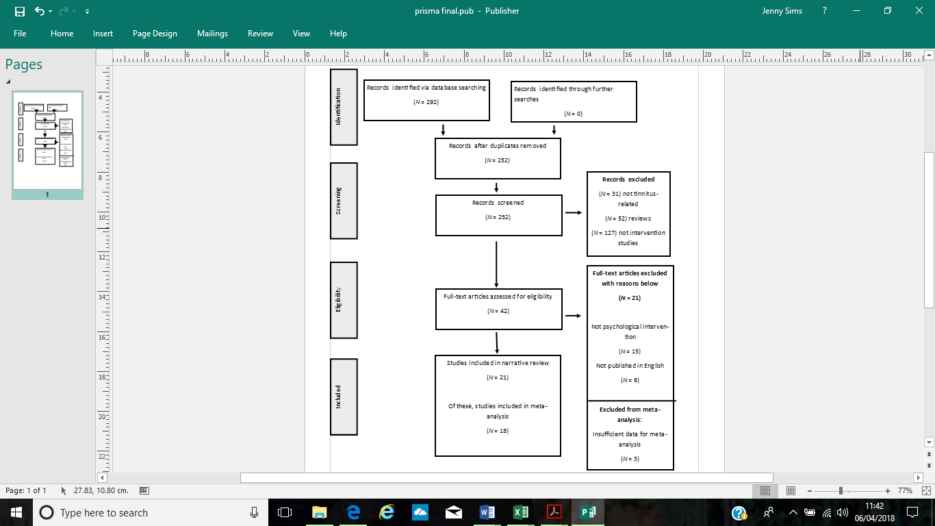

Figure 1. Screening process of studies throughout review using PRISMA guidelines

## **Data extraction**

Data were extracted from studies, such as: authors, year of publication, study design (RCT or pre-post), country of recruitment, sample characteristics, control group, intervention, and outcome measures. Results for primary measures of tinnitus distress were extracted, including treatment effect sizes where reported; in the absence of these, means and standard deviations were extracted and used to calculate effect sizes.

## **Intervention**

Interventions were categorised into three groups to allow for evaluation of the effectiveness of particular treatments on tinnitus outcomes. These were; therapist-delivered CBT (including group-CBT whereby a protocol was clearly followed and delivered by a psychological therapist), guided self-help CBT (including self-help internet-delivered CBT where participants were offered guidance from a therapist), and ‘other’. ‘Other’ was assigned to a mixture of interventions due to alternative interventions being too few to have their own category. Such interventions were relaxation, mindfulness meditation, and psychoeducation. Also, these included combined multidisciplinary interventions such as TRT, music therapy, and sound therapies. Although some of these included elements of a CBT model, studies were only considered ‘other’ if CBT was clearly not the primary intervention. Due to the variety in studies, an independent peer trainee clinical psychologist categorised a random sample (33%; k=6) of the studies into either therapist-delivered CBT, guided self-help CBT, or ‘other’ to ensure inter-rater reliability. Cohen’s Kappa coefficient (*k;* Cohen, 1960) was used to assess level of agreement between assessors due to variables being categorical. Inter-rater agreement was 100%, *k* =1, *p*<0.05.

## **Study design**

Studies were either RCTs where pre-post treatment effects were compared with controls, or they were pre-post study designs where treatment effects of one sample were reported.

## **Outcome measures**

Studies used the following outcomes of tinnitus distress: Tinnitus Handicap Inventory (THI; Newman, Jacobsen, & Spitzer, 1996), Tinnitus Functional Index (TFI; Meikle et al., 2012), Tinnitus Questionnaire (TQ; Hallam, 1996), German Tinnitus Questionnaire (Goebel & Hiller, 1994), Mini-TQ (Hiller & Goebel, 2004), Tinnitus Cognitions Questionnaire (TCQ; Wilson & Henry, 1998), and Tinnitus Reaction Questionnaire (TRQ; Wilson, Henry, Bowen, & Haralambous, 1991). Further properties of these measures can be found in Appendix A.

## **Quality assurance**

All studies were assessed using the Downs and Black Quality Checklist (1998), a 27-item checklist which assesses validity and confounding bias potentially present within randomised and non-randomised studies (Centre for Reviews and Dissemination, 2009). Psychometric properties of the checklist reflect good internal consistency (*KR-20* = .89), inter-rater reliability (*r* = .75) and test-retest reliability (*r* = .88) (Downs & Black,1998). Items 1 to 10 assess reporting quality, items 11-13 assess external validity, items 14-20 assess bias, items 21-26 assess confounding, and item 27 assesses power. In the current review, item 27 was simplified like previous studies where a score of ‘1’ indicated statistical power was reported and ‘0’ if not (Larson, Vos, & Fernandez, 2013; Samoocha, Bruinvels, Elbers, Anema, & Van der Beek, 2010). For all other items (except item 5), a score of ‘1’ signals quality has been met, and ‘0’ indicates it has not (for item 5, a score of ‘2’ signifies quality has been fully met, and ‘1’ signifies it has been partially met). The range of possible score points in the current review was 0-28, where 0-14 indicated poor quality, 15-19 indicated fair quality, 20-25 indicated good quality, and 26-28 indicated excellent quality (O’Connor, 2015). For studies using non-RCT designs, some items were not applicable (items 14, 15, 17, 21, 22, 23, and 24). For these, the possible total score was adjusted to reflect a more accurate percentage. Approximately 20% of the studies (k=5) were quality-assessed by an independent peer trainee clinical psychologist, blind to the author’s ratings. To determine inter-rater reliability, the intra-class correlation (ICC) value was calculated which is recommended for continuous variables (Koo & Li, 2016), using an online R software package (MAVIS: Meta-Analysis via Shiny, version 1.1.3; Hamilton, Aydin, & Mizumoto, 2016). A figure of <0.75 indicates excellent reliability, and 0.5-0.75 good reliability (Fleis, 1986).

# **Meta-analytic strategy**

Due to the difference in study designs, two meta-analyses were conducted to assess effectiveness of psychological interventions in reducing tinnitus distress, first, within RCT studies, and second, within pre-post studies (using no control group). Meta-analyses were conducted using an online R software package (MAVIS, version 1.1.3; Hamilton, Aydin, & Mizumoto, 2016)

For RCT studies, effect sizes (*d;* Cohen, 1988) of change in outcomes pre-and-post intervention compared to controls were obtained for all studies. Where RCTs did not report between-group effect sizes (Conrad et al., 2015; Jasper et al., 2014), the author calculated these by comparing pre- and post-intervention means and standard deviations for intervention and control groups using an online effect size calculator (Lenhard & Lenhard, 2016). Where RCTs compared more than two groups (Conrad et al., 2015; Henry, Stewart, Griest et al., 2016; Jasper et al., 2014), just one comparison of psychological intervention versus control was randomly selected for inclusion in the meta-analysis to prevent duplicate samples being included. Sensitivity analyses were conducted to check that inclusion of a different comparison did not significantly alter results (Pannel, 1997). For RCTs which conducted within-groups analyses (such as in pre-post studies), effect sizes were included in the pre-post meta-analysis, but no duplication of data occurred.

For pre-post studies, effect sizes (*d;* Cohen, 1988) of change in outcomes pre-and-post intervention were also obtained. For studies not reporting effect size or reporting Hedge’s *g*, the means and standard deviations for pre- and post-outcomes were obtained and effect sizes calculated using an online calculator by the author (Lenhard & Lenhard, 2016). Cohen’s (1988) guidance was followed to interpret *d*=0.2 as a ‘small’ effect, *d*=0.5 as ‘medium’, and *d*=0.8 as ‘large’. Studies which did not provide means and standard deviations were not included in the analysis as effect sizes could not be calculated.

A series of subgroup meta-analyses were also conducted using RCTs and pre-post studies. These were pre-planned to evaluate the effects of subgroups according to: treatment type (CBT or ‘other’); control group (wait-list or active controls receiving standard care, alternative treatment, or enrolled in a discussion forum); treatment setting (multi-disciplinary, group, internet, one-to-one); mode of CBT-delivery (therapist-delivered or self-help); study quality (good or fair), and sample size (studies with samples above or below 100 participants).

For each meta-analysis (including subgroup analyses), a random effects model was used to calculate sample-weighted average effect sizes, due to the heterogeneous nature of studies (Borenstein, Hedges, Higgins, & Rothstein, 2009). Confidence intervals and *p* values were also assessed, and forest plots were visually-inspected.

To test heterogeneity, the Q and $I^{2}$ statistics (Higgins & Thompson, 2002) were inspected. A significant Q statistic (*p*<0.05) indicates heterogeneity of effects, more so than can be accounted for by sampling error. The $I^{2}$ value indicates the amount of variance explained by between-study heterogeneity, and can be considered low (25%), moderate (50%), or high (75%) (Higgins, Thompson, Deeks, & Altman, 2003). Publication bias was assessed by inspecting funnel plots, where asymmetrical distribution of individual effects around the mean may indicate publication bias (Sterne et al., 2011). The Egger regression method was also used to assess publication bias (Egger, Smith, Schneider, & Minder, 1997; Sterne et al., 2011), where a significant *t* statistic (*p*<0.05) indicates bias. Additionally, Orwin’s (1983) fail-safe *N* test was conducted to determine the number of studies with a weak effect size (*d*<.10) needed to reduce the overall effect of interventions analysed.

# **Results**

## **Study characteristics**

The characteristics of all 21 studies are presented in Tables 1 and 2. Overall, 21 studies were included in the narrative synthesis review (total sample size *N*=7288). For the first meta-analysis, 11 RCTs were included (total sample size *N*=635). For the second meta-analysis, a total of 18 pre-post studies with 21 treatment groups were included (total sample size=7253).

Across all 21 studies, sample sizes ranged from 13 to 5536. Baseline characteristics indicated participant age ranged from 22 to 90 years. Nineteen studies provided a mean age, ranging from 45 to 61 years. Eighteen studies reported baseline gender ratios, which included 3357 (46%) female participants and 3899 (54%) male participants. Ten (47.6%) studies were conducted in Germany, 4 (19%) in the UK, 4 (19%) in the USA, 1 (4.7%) in the Netherlands, 1 (4.7%) in Japan, and 1 (4.7%) in France.

## **Quality appraisal**

Overall quality ratings can be found in Tables 1 and 2, and an itemised presentation of study quality is presented in Appendix B. Studies were rated as ‘good’ (k=13), ‘fair’ (k=6), or ‘poor’ (k=2). The intra-class correlation coefficient (ICC) was 0.98 indicating excellent inter-rater reliability for quality ratings (Fleis, 1986). Difference in ratings did not alter the overall ‘good’, ‘fair’ or ‘poor’ rating and so agreement was reached to accept the author’s initial ratings.

All RCTs were appraised as ‘good’, with a quality score of at least 20 (Downs & Black, 1998) with no pre-post studies scoring above 17. For items assessing reporting quality, pre-post design studies had the most variability. One study failed to present clear aims, and four did not present enough information pertaining to outcome measures. Two studies did not adequately provide sample characteristics and two did not clearly describe interventions. Only four studies met the criterium for item 5, asking for a list of confounders to be presented. Only one study presented a list of adverse events. Three studies did not present estimates of random variability (e.g. standard deviations and means), four did not present actual *p* values, and four failed to describe participants lost to follow-up.

Concerning external validity, this again was more variable within pre-post design studies. Three studies did not report enough information on whether their samples represented their source population. Interventions offered were generally representative of the treatment setting, however, for studies testing novel therapies or modified approaches (k=8) this was not the case. For RCTs (k=11), few attempts were made to blind participants to treatment group (k=2) or to blind researchers (k=2). Bias was low when assessing for ‘data dredging’, which was made clear by all studies, and all studies using a control group had the same follow-up lengths for both participants and controls (k=11). All studies used appropriate statistical analyses, and all but one study provided enough information to signify reliable treatment compliance. About half the studies reported information to signify accurate and reliable outcome measures were used (k=12).

Concerning confounding, participants and controls were recruited from the same population for all RCTs (k=11). All but one study recruited participants and controls over the same time period. All but one RCT used concealed randomisation. All studies made adequate adjustment for confounders when the main findings were drawn, and just over half the studies took losses to follow-up into account (k=13). Only six studies reported a sample power analysis.

## **Methods and results of studies**

Methodology and results of each study are presented in Tables 1 and 2. Information regarding outcomes of tinnitus distress (not secondary measures) are reported as per the aims of this review.

## **Therapist-delivered CBT interventions**

Across studies employing therapist-delivered CBT (k=6), all were group-delivered, and session number ranged from 8 to 12 weekly sessions. Five studies reported session duration which ranged from 90-120 minutes. Components included: psychoeducation, cognitive restructuring, experiential exercises, and relaxation. Four good quality RCTs investigated treatment effects of therapist-delivered group-CBT (GCBT) compared to controls (Conrad et al., 2015; Jasper et al., 2014; Malinvaud et al., 2016; McKenna, Marks, Hallsworth, & Schaette, 2017a). Across these studies, when comparing with active control groups, such as discussion forum (DF) (Conrad et al., 2015; Jasper et al., 2014) and relaxation (McKenna et al., 2017a), treatment effects favoured GCBT with small to large effect sizes. Malinvaud et al. (2016) compared GCBT with a virtual-reality active control group and although effect size analysis indicated a small treatment effect for GCBT, comparison of THI scores for the two groups yielded no significant difference. Conrad et al. (2015) found GCBT was superior to a DF control group but had comparable effects with internet-CBT (ICBT). Three pre-post studies investigated the effects of GCBT on tinnitus distress (Ivansic et al., 2017; McKenna, Marks, & Vogt, 2017b; Moschen et al., 2015), from which medium to large treatment effects for GCBT emerged. One of these studies was only fair in quality (Moschen et al., 2015).

Table 1. Characteristics of studies included in both narrative synthesis and meta-analysis

| Study and country | Intervention | Control group | | Tinnitus distress primary outcome measure | N | N controls | Effect size (*d*) | | Narrative results | Quality appraisal: total score, %, and rating |
| --- | --- | --- | --- | --- | --- | --- | --- | --- | --- | --- |
| *RCT studies* | | |  | | | | |
| Argstatter  et al., (2015)  Germany | Music therapy within MDT. Included directive counselling, resonance training, intonation training, and tinnitus reconditioning. | Other- individual counselling | | TQ | 146 | 144 | 1.39 | | Compared neuro-music therapy (including counselling) with pure counselling. Repeated-measures ANOVA indicated that for both groups, mean tinnitus distress scores reduced post-intervention by 11.2 points for music therapy, and 2.3 points for counselling alone (*p*< 0.0001). Comparison of music therapy to counselling alone had a large effect size (*d* = 1.39). | 22 (78%)  Good |
| Arif, Sadlier, Rajenderkumar, James, & Tahir, (2017)  UK | Mindfulness | Other- relaxation | | TRQ | 34 | 27 | 0.13 | | Between-groups analyses showed a mean difference on TRQ from pre to post-intervention between the mindfulness group and relaxation group was 8.24 in favour of mindfulness (*p* = 0.047). | 20 (71%)  Good |
| Bauer et al., (2017)  USA | Tinnitus Retraining Therapy (incl. counselling) within MDT | Standard care | | THI | 19 | 19 | 0.45 | | Intention-to-treat and per-protocol analysis was employed, with independent t-tests conducted pre and post-intervention, showing THI score significantly decreased post-intervention for TRT (*p* < 0.000) and for the SC group (*p* < 0.05). | 21 (74%)  Good |
| Beukes et al., (2017b)  UK | Internet CBT: 8-week guided self-help programme via interactive e-learning session. | WLC | | TFI | 73 | 73 | 0.7 | | ITT analysis was employed for missing data. Repeated-measures ANOVA indicated that tinnitus distress reduced post-intervention by 21 points for ICBT, and by 5 points for WLCs indicating a significant difference between-groups (*p*= 0.05). The difference in reduction favoured ICBT with medium-large effect (d *=* 0.7). | 24 (85%)  Good |
| Conrad et al., (2015)  Germany | Group CBT (8 sessions) including psychoeducation, cognitive restructuring, and relaxation.  ICBT (18 modules) including psychoeducation, cognitive restructuring, and relaxation. Guidance was available from a therapist. | Other- Discussion forum | | TCQ-total  (TCQ-TCT, and TCQ-TAC) | 43 | 44 | 0.47 | | Subscales of the TCQ were analysed comparing group-CBT, ICBT, and DF: ANOVA showed a significant main effect of time for TCT (*p*<.001) and TAC (*p*<.001). Main effect of group was not significant for TCT (*p*=.346) or TAC (*p=*.744). ICBT versus DF ANOVA indicated significant time x group interactions (p=.023) but main effect of group was not significant (p=1.21). For GCBT versus DF, ANOVA showed significant time x group interaction (p<.001) but not for main effect of group (p=.472). Effect sizes were calculated for TCQ total score within-groups: score post-ICBT improved (*d*=.75), score post-GCBT improved (*d*=.75) with both being retained at 6 and 12-month follow up.  Note: for the current meta-analysis, one comparison- GCBT vs DF- was selected for inclusion. | 20 (71%)  Good |
| Henry, Stewart, Griest, Kaelin, Zaugg, & Carlson, (2016)  USA | Tinnitus retraining therapy (sound therapy plus counselling)  TM (tinnitus masking; ear-level sound generators fitted)  TED (educational counselling providing information on tinnitus) | WLC | | THI | 34 | 33 | 0.52 | | Repeated-measures ANOVA showed that at 3-months post-intervention, for TRT versus WLC, the mean difference in THI score change was -13.02 (*p<*0.001) with a medium effect size (*d*= 0.52). For TM versus WLC, mean difference in score was -10.99 (*p*=.001, *d*=0.44). For TED versus WLC, mean difference was -6.84 (*p*=0.046, *d*=0.27). The mean difference in scores between TM and TED was not significant (*p*=0.197) or for TRT versus TED (*p*=0.070). Significant mean differences were maintained for all groups versus WLCs at 6 months, but not at 12 or 18 months post-intervention.  Note: for the current meta-analysis, one comparison- TRT vs WLC- was selected for inclusion. | 21 (74%)  Good |
| Henry et al., (2017)  USA | Progressive tinnitus mgmt. MDT-led with audiologist and psychologist. Five weekly workshops covering sound therapy and CBT coping techniques such as: relaxation, activity planning, and cognitive restructuring. | WLC | | TFI | 112 | 119 | 0.36 | | ANOVA and linear mixed model were employed. Interventions were conducted across two sites with site-results and the combined results analysed. At site 1, change in TFI scores for PTM was -6.15 (*p*=.0194) and for WLC was -0.55 (*p*=.9990). At site 2, change in TFI scores for PTM was -6.06 (*p*=.0476) and 3.69 for WLC (*p*=.3802). Combined results indicated scores on TFI significantly reduced in participants who had PTM by 7.67 points more than WLCs (*p* = 0.0005) | 24 (85%)  Good |
| Jasper et al., (2014)  Germany | Group CBT: 10 sessions including psychoeducation, avoidance behaviours, and relapse prevention.  Internet CBT: 12 modules hosted online, including relaxation, positive imagery, cognitive restructuring. Guidance was available from a therapist. | Discussion forum | | THI | 40 | 43 | 1.00 | | Repeated-measures ANOVA indicated significant time x group interaction effects post-intervention on THI in favour of GCBT (n=40) and ICBT (*n*= 38) over DF (n= 43; all *p*<0.001). No significant differences were observed between GCBT and ICBT (all *p*>0.05). Treatment effects remained stable at follow up. | 23 (82%)  Good |
| Malinvaud et al., (2016)  France | Group CBT: Therapist-delivered 8-session with a focus including psychoeducation, cognitive restructuring, and exposure techniques. | Virtual reality: patient was immerged in VR with sensorimotor interaction. Patient completes a task whilst aim is for integration of visual, auditory and proprioceptive information. | | THI | 44 | 50 | 0.37 | | This study also included a WLC group but they were not used for comparison. ANOVA was employed to compare GCBT and VR. Difference between THI sores post-intervention were not significant (*p*=0.062). | 20 (71%)  Good |
| McKenna et al., (2017a)  UK | Mindfulness-based CBT: Therapist-delivered 8-sessions with emphasis on cognitive model of tinnitus and attentional processes. | Relaxation training: 8-sessions Therapist-delivered with focus on psychoeducation and experiential relaxation. | | TQ | 34 | 28 | 0.49 | | Linear mixed modelling was employed. Both groups showed significant reduction in TQ score from pre- to post-treatment but was 6.3 points lower in MCBT group than RT which was significant (*p*=0.016) with a medium effect size (*d*=0.49). Differences at 1 month follow up were not statistically significant but was at 6-month follow up where the adjusted mean score for MCBT was 7.2 points lower than RT (*p*=0.006) with a medium effect size (*d*=0.56). | 23 (82%)  Good |
| Weise et al., (2016)  Germany | Internet CBT: 10-week guided self-help programme including relaxation, exposure to tinnitus, and cognitive restructuring. | Online discussion forum | | THI | 58 | 61 | 0.9 | | Tinnitus distress and associated psychological distress outcomes were investigated. Comparing ICBT with a DF control group, multivariate ANOVA indicated significant main effects for group (*p*=.003), time (*p*<.001), and time X group interaction (*p*<.001) which favoured ICBT. Large between-group effect sizes supported ICBT as the more effective treatment for reducing tinnitus distress. | 22 (78%)  Good |
| *Pre-post studies* |  |  | |  |  |  |  | |  |  |
| Arif et al., (2017)  UK | Mindfulness meditation  Relaxation therapy | -  - | | TRQ  TRQ | 34  27 | -  - | 1.55  1.23 | | See above | See above |
| Argstatter et al., (2015)  Germany | Music therapy  Counselling | -  - | | TQ  TQ | 146  144 | -  - | 0.94  0.32 | | See above | See above |
| Bauer et al., (2017)  USA | Tinnitus Retraining Therapy (incl. counselling)  SC (standard care incl. counselling) | -  - | | THI  THI | 19  19 | -  - | 1.32  0.83 | | See above | See above |
| Conrad et al., (2015)  Germany | ICBT  Group-CBT | -  - | | TCQ  TCQ | 41  43 | -  - | 0.75  0.69 | | See above | See above |
| Ivansic et al., (2017)  Germany | MDT daycare (incl. group therapy- counselling, CBT) | - | | TQ | 308 | - | 1.51 | | Repeated-measures ANOVA showed significant difference in tinnitus annoyance on TQ over time (*F*(4, 304) = 202,201, *p* < 0.001). Post hoc analysis showed large reduction in score from pre to post intervention. | 17 (80%)  Good |
| Jasper et al, (2014)  Germany | Internet CBT  Group CBT | -  - | | THI  THI | 41  43 | -  - | 0.71  0.81 | | See above | See above |
| Malinvaud et al., (2016)  France | Group CBT | - | | THI | 55 | - | 0.81 | | See above | See above |
| Mckenna et al., (2017a)  UK | Relaxation therapy  Mindfulness-based CBT | -  - | | TQ  TQ | 28  34 | -  - | 0.9  1.23 | | See above | See above |
| McKenna et al., (2017b)  UK | Mindfulness-based CBT: 8 sessions including psychoeducation, cognitive model of tinnitus, and meditation practices. | - | | TQ | 182 | - | 0.72 | | Paired samples t-test indicated tinnitus distress reduced significantly from pre to post-intervention (*p*<0.001) with a mean difference of -12.08 points and medium to large effect size (*d*=0.72). Scores remained low at 6-week follow-up (*p*<0.001). | 16 (76%)  Good |
| Moschen et al., (2015)  Germany | Group CBT: 12- sessions c including relaxation, vicious cycle of tinnitus, and attentional factors. | - | | TQ | 68 | - | 0.97 | | A dependent sample t-tests showed significant differences between tinnitus distress (TQ) from pre to post-intervention (*p*<0.001, *g*=-0.876). | 13 (61%)  Fair |
| Ostermann et al., (2016a)  Germany | Combination approach of CBT elements with Auditive Stimulation Therapy: including counselling, progressive muscle relaxation, and attentional management with music therapy. | - | | TQ | 5536 | - | 1.03 | | Modified t-test accounting for regression to the mean was employed. TQ total score reduced by -18.6 points from pre to post-intervention (*p*<0.001) with a large effect. All improvements were sustained at 6 month follow up. Subscales of the TQ showed highly significant improvements for somatic complaints (*d*=0.31), and cognitive distress (*d*=-1.03). | 15 (71%)  Fair |
| Schaaf et al., (2017)  Germany | Neuro-otologic therapy | - | | MTQ | 169 | - | 2.65 | | T tests showed a significant difference between MTQ score pre and post-intervention (*t*(168) = 24.325, *p* < 0.001), which was maintained at follow-up (*t*(168) = 23.298, *p* < 0.001). | 9 (42%)  Poor |
| Seydel et al., (2015)  Germany | Modified tinnitus retraining therapy: including daily acoustic therapy, with daily group CBT | - | | TQ | 130 | - | 0.5 | | The authors’ primary aim was to assess 3-year follow-up outcome data. ANOVA revealed scores on the TQ significantly reduced from pre to post-intervention (p<0.001) which was sustained at 3[year follow-up (p<0.0001). For the current meta-analysis an effect size is reported for TQ score mean difference from pre to post-intervention (*d*=0.5). | 14 (66%)  Fair |
| Wakabayashi et al., (2017)  Japan | Sound therapy with counselling | - | | THI | 100 | - | 0.7 | | For the aims of this study, patients were split into ‘sleep disorder’ (*n* = 66) or ‘normal sleep’ (*n* = 34) groups. No differences were observed on measures of sleep post-intervention. Questionnaire data of all participants showed significant reductions were observed for tinnitus distress (*p* = 0.001). | 14 (66%)  Fair |
| Weise et al., (2016)  Germany | Internet CBT | - | | THI | 62 | - | 1.38 | | See above. | See above |

Table 2. Characteristics of additional studies included in only narrative synthesis

| Study | Intervention | Control | Outcome | N | N controls | Result | Quality appraisal total score, %, and rating |
| --- | --- | --- | --- | --- | --- | --- | --- |
| Ostermann et al., (2016b)  Germany | Tinnitus retraining therapy including counselling | - | THI | 70 | - | Self-evaluation showed TRT significantly improved tinnitus (THI) and facial dysesthesia in 76% of patients. Mean THI score decreased from pre to post-intervention from 67.14% to 32.19% (*p* < 0.05). | 7 (33%)  Poor |
| Roland et al., (2015)  USA | Mindfulness-based stress reduction: 8 sessions including meditation, mindful movements, and psychoeducation. | - | TFI | 13 | - | Following MBSR, Friedman’s test showed a significant difference in median TFI scores ($X^{2}$ (2) = 8.77, *p* = 0.012), from pre to post-intervention. | 12 (57%)  Fair |
| Wagenaar et al., (2016)  Netherlands | Psychoeducational workshop: focusing on cognitive model of tinnitus, stress reactions and maladaptive coping, and identifying self-help interventions. | - | THI | 75 | - | T-tests revealed THI total score did not significantly reduce from pre to post-intervention (*p*=0.25) but this was significant at 12-month follow-up (*p*<0.01). No THI subscale reduced significantly from pre to post-intervention but all were significant at follow-up (all *p*<0.01). | 13 (61%)  Fair |

### **Guided self-help CBT**

Guided self-help interventions were delivered on the internet (k=4). Studies reported number of modules ranging from 12-18 which included topics on applied relaxation, cognitive restructuring, psychoeducation, and experiential exercises. All interventions offered therapist-guidance through feedback, support, and recommendations. Two good quality RCTs compared tinnitus distress outcomes post-guided ICBT with wait-list controls (WLCs) and a DF group (Beukes et al., 2017b; Weise et al., 2016 respectively). Both studies favoured ICBT with medium to large treatment effects. Conrad et al.’s good quality study (2015) reported comparable treatment effects between ICBT and GCBT, and Jasper et al.’s good quality study (2014) indicated a medium-large within-group effect size for ICBT.

### *‘***Other’ interventions**

The characteristics of studies which employed ‘other’ interventions are described in Tables 1 and 2. Across combined interventions, the most common was TRT (k=3; Seydel et al., 2015; Ostermann et al., 2016b; Bauer et al., 2017) where modules including acoustic therapy and counselling were delivered by MDTs including otorhinolaryngology specialists, clinical psychologists, and physiotherapists. Other interventions were virtual-reality (k=1; Malinvaud et al., 2016), neuro-music therapy (k=1, Argstatter et al., 2015), combined auditive stimulation, progressive muscle relaxation with CBT (k=1; Ostermann et al., 2016a), MDT daycare (k=1; Ivansic et al., 2017), neuro-otologic therapy (k=1; Schaaf et al., 2016), and stepped-care psychoeducation (Henry et al., 2017).

Across combined interventions, findings indicated medium to large treatment effects on tinnitus distress from good quality studies (Argstatter et al., 2015; Bauer et al., 2017; Henry et al., 2016; Henry et al., 2017), and also studies fair and poor in quality (Ostermann et al., 2016a; Schaaf et al., 2017; Seydel et al., 2015; Wakabayashi et al., 2017). Ostermann et al. (2016b) reported a 50% reduction in tinnitus distress after 3 months of TRT. Although combination approaches overall yielded treatment effects, Henry et al.’s (2016) study found no significant differences in outcomes between TRT and tinnitus educational counselling alone. Although Ostermann et al. (2016a) used a large sample size, their study was poor in quality.

One good (Arif et al., 2017) and one fair quality study (Roland et al., 2015) employed mindfulness alone. Results indicated small treatment effects in favour of mindfulness on outcomes of tinnitus distress. Within-groups analyses indicated controls receiving relaxation therapy also improved on outcomes of tinnitus distress (Arif et al., 2017) but to a slightly lesser degree than mindfulness meditation.

One fair quality study employed a psychoeducational approach alone (Wagenaar et al., 2016) and found no significant reduction in tinnitus distress immediately post-intervention but did so at 12-month follow up.

## **Primary meta-analysis**

Figure 2 displays the distribution of effect sizes of psychological interventions in reducing tinnitus distress (k=11, n*=*635*)*. The overall sample-weighted average effect size was $d_{+}$ =0.64 (95% confidence intervals; CI: 0.40-0.87). Overall, psychological interventions had a significant medium to large effect on reducing tinnitus distress in line with Cohen’s (1988) criteria. The Q statistic was significant, Q(10) = 47.23, *p* < .0001, $I^{2}$ = 73%, indicating effect sizes obtained from studies were moderately to highly heterogeneous (Higgins & Thompson, 2003).

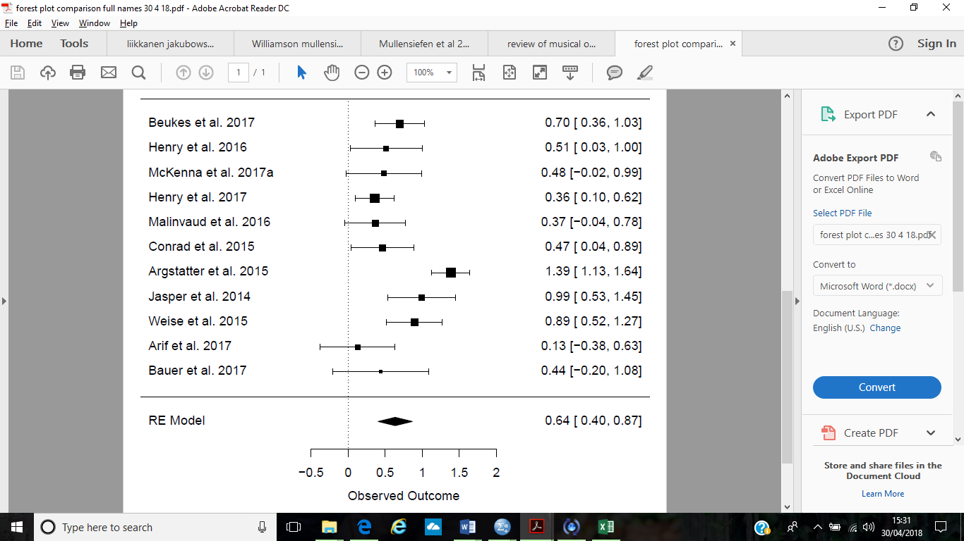

Figure 2. Forest plot to show the distribution of effect sizes in a random effects model meta-analysis of RCTs evaluating the effectiveness of psychological interventions in reducing tinnitus distress. Pooled effect sizes (d+) and confidence intervals are displayed.

## **Publication bias**

Figure 3 presents the funnel plot of effect sizes. Visual inspection of this shows asymmetrical distribution of effect sizes around the mean indicating publication bias. However, the Egger regression test (Egger et al., 1997) was not significant (*t*(9)=-1.37, *p*=0.20) suggesting no publication bias. Orwin’s (1983) fail-safe *N* suggested 11 studies with a trivial effect size (*d*=.10) would be required to discount the finding that psychological interventions are effective in reducing tinnitus distress.

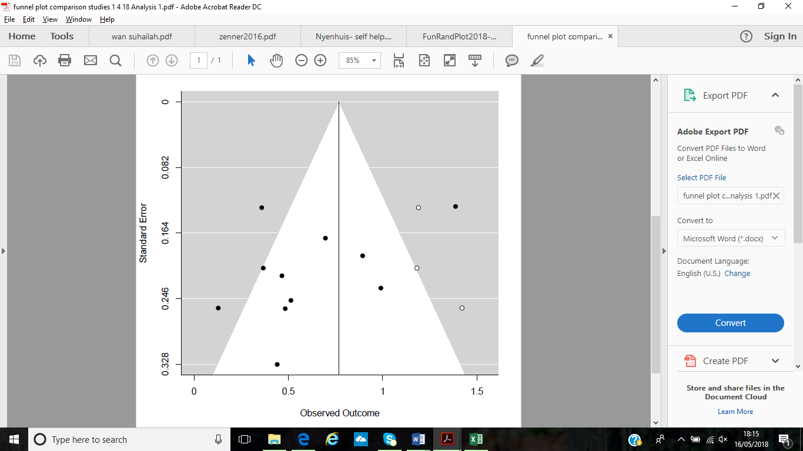

Figure 3. Funnel plot showing the distribution of individual effect sizes around the mean effect size for a meta-analysis of RCT studies evaluating the effectiveness of psychological interventions in reducing tinnitus distress

### **Subgroup analyses for primary meta-analysis on RCT studies**

A subgroup analysis was conducted for RCT studies on treatment type. Medium to medium-large significant treatment effects emerged for both CBT and ‘Other’ interventions ($d_{+}$ = 0.65 and 0.59 respectively). The Qstatistic was significantfor ‘Other’ interventions (Q(4)=39.95, *p*<.001, $I^{2}$ =90%) indicating heterogeneity, but not for CBT (*p*=0.24). A subgroup analysis was also conducted on control group type. Medium to large significant treatment effects emerged for both WLC and Active control subgroups ($d_{+}$*=*0.49 and 0.83 respectively). The Qstatistic was significant for Active controls (Q(7)=37.01, *p*<.000, $I^{2}$ =81%) indicating heterogeneity, but not for WLCs (*p*=0.29) (see Table 3).

|  |  |  |  |  |  |  |
| --- | --- | --- | --- | --- | --- | --- |
| Table 3. Subgroup analyses on RCT studies | | | | | | |
|  | k | N | Q (df) | $I^{2}$ (%) | 95% CI | $$d_{+}$$ |
| *Treatment type* | | | | | | |
| CBT | 6 | 292 | 6.7847 (5) | 26% | 0.28-1.02 | 0.65*** |
| ‘Other’ | 5 | 343 | 39.95*** (4) | 90% | 0.19-1.01 | 0.59** |
| Overall | 11 | 635 | 47.23*** (10) | 79% | 0.35-0.90 | 0.63*** |
|  |  |  |  |  |  |  |
| *Control group type* | | | | | | |
| WLC | 3 | 219 | 2.45 (2) | 18% | 0.05-0.99 | 0.52* |
| Active | 8 | 416 | 37.01*** (7) | 81% | 0.37-0.98 | 0.68*** |
| Overall | 11 | 635 | 47.23*** (10) | 79% | 0.38-0.89 | 0.63*** |
| Note. \**p* < 0.05, \*\**p* < 0.01, \*\*\**p* < 0.001. WLC = waitlist control | | | | | | |

## **Secondary meta-analysis on pre-post studies**

A second meta-analysis was conducted on pre-post studies (k=18, 21 treatment groups, n=7253). Figure 3 displays the forest plot of distribution of pre-post effect sizes. The sample-weighted average effect size of psychological interventions on tinnitus distress was $d_{+}$ =1.02 (95% CI: 0.79 to 1.24), indicating psychological interventions had a significant large effect on outcomes of tinnitus distress in line with Cohen’s (1988) criteria. The Qstatistic was significant, Q(20)=229.2801, *p*<.0001, $I^{2}$ =93%, indicating high heterogeneity (Higgins & Thompson, 2002).

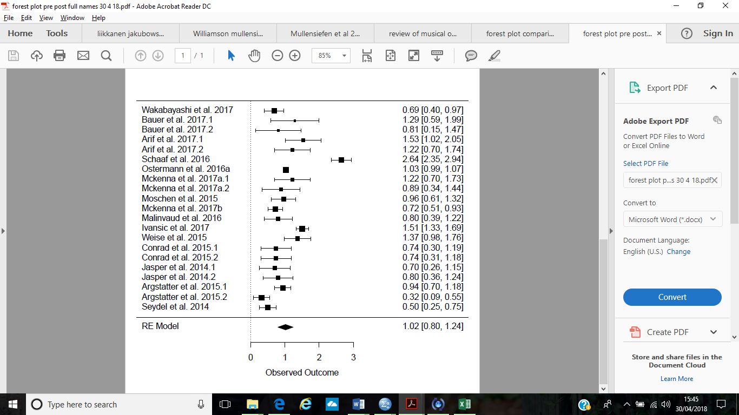

**Figure 4**. Forest plot to show the distribution of effect sizes in a random effects model meta-analysis of pre-post studies evaluating the effectiveness of psychological interventions in reducing tinnitus distress. Pooled effect sizes (d+) and confidence intervals are displayed.

## **Publication bias**

Figure 5 presents the funnel plot of effect sizes. Visual inspection shows asymmetrical distribution of effect sizes around the mean, indicating publication bias. However, the Egger regression test (Egger et al., 1997) was not significant (*t*(19)=-0.10, *p*=0.02) suggesting no publication bias. Fail-safe *N* using Orwin’s formula (1983) indicated 21 studies with a trivial effect size (*d* = 0.10) would be required to discount the overall treatment effect.

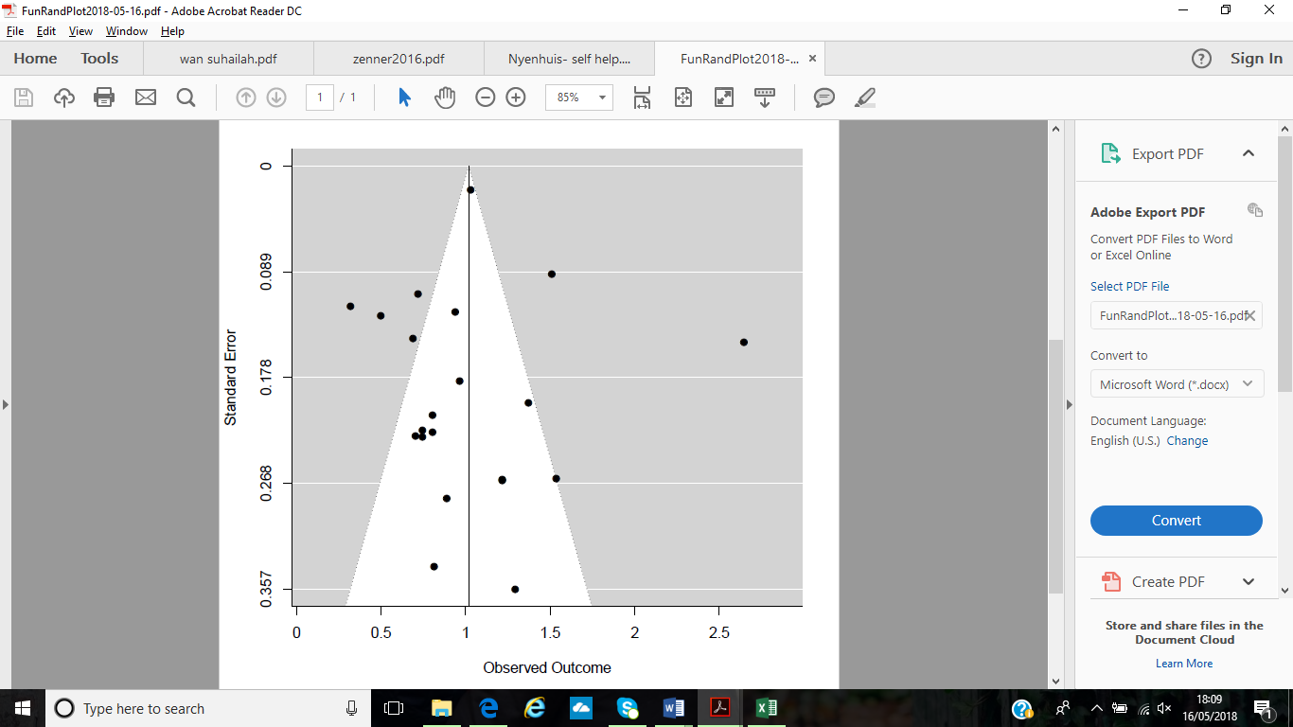

Figure 5. Funnel plot showing the distribution of individual effect sizes around the mean effect size for a meta-analysis of pre-post studies evaluating the effectiveness of psychological interventions in reducing tinnitus distress

## **Subgroup analyses for secondary meta-analysis**

### **Nature of the intervention**

A subgroup analysis of treatment type was conducted on the 18 pre-post studies (with 21 treatment groups, total sample size of n=7253). Large significant treatment effects emerged for both CBT and ‘Other’ subgroups ($d_{+}$ =0.92 and 1.13 respectively). The Qstatistic was significant and indicated heterogeneity for both the CBT (Q(10)=63.46, *p<*.001, $I^{2}$ =84%) and ‘other’ (Q*(*9)=164.85, *p*<.001, $I^{2}$ =95%) subgroups (see Table 4).

A subgroup analysis of treatment setting was conducted, where groups were: MDT, group, internet, and one-to-one. All subgroups yielded significant treatment effects ranging from medium to large to very large ($d_{+}$ =0.87 to 1.18). The Qstatistic was significant and indicated heterogeneity for MDT (Q(7)=167.71, *p<*.001, $I^{2}$ =96%), internet (Q*(*2)=6.45, *p<*.05, $I^{2}$ =69%), and one-to-one (Q(2)=23.53, *p<*.001, $I^{2}$ =91%) subgroups but not for the ‘group’ subgroup (*p*=0.68) (see Table 4).

A subgroup analysis of mode of CBT-delivery was conducted on studies using CBT (k=11, n=1007). Subgroups were therapist-delivered CBT and self-help CBT. Results indicated a large significant effect for therapist-delivered CBT ($d_{+}$ =0.91), but the effect size was non-significant for self-help CBT (*p*=3.04). The Qstatistic was significant for both therapist-delivered (Q(7)=57.06, *p<*.001, $I^{2}$ =88%) and self-help (Q(2)=6.40, *p<*.05, $I^{2}$ =69%) subgroups indicating heterogeneity (see Table 4).

|  |  |  |  |  |  |  |
| --- | --- | --- | --- | --- | --- | --- |
| Table 4. Subgroup analyses on pre-post studies: Nature of intervention | | | | | | |
|  | k | N | Q (df) | $I^{2}$ (%) | 95% CI | $$d_{+}$$ |
| *Treatment type* | | | | | | |
| CBT | 11 | 1007 | 63.46*** (10) | 84% | 0.61-1.22 | 0.92*** |
| ‘Other’ | 10 | 6246 | 164.85*** (9) | 95% | 0.81-1.46 | 1.13*** |
| Overall | 21 | 7253 | 229.28*** (20) | 91% | 0.79-1.24 | 1.02*** |
|  |  |  |  |  |  |  |
| *Treatment setting* | | | | | | |
| MDT | 8 | 6427 | 167.71*** (7) | 96% | 0.84-1.52 | 1.18*** |
| Group | 7 | 451 | 3.95 (6) | 0% | 0.49-1.24 | 0.87*** |
| Internet | 3 | 146 | 6.45* (2) | 69% | 0.38-1.51 | 0.95** |
| One-to-one | 3 | 229 | 23.53*** (2) | 91% | 0.39-1.54 | 0.97*** |
| Overall | 21 | 7253 | 229.28*** (20) | 91% | 0.81-1.23 | 1.02*** |
| *CBT delivery* |  |  |  |  |  |  |
| Therapist-delivered | 8 | 863 | 57.06*** (7) | 88% | 0.60-1.21 | 0.91*** |
| Self-help | 3 | 144 | 6.40* (2) | 69% | 0.43-1.46 | 0.95 |
| Overall | 11 | 1007 | 63.46*** (10) | 84% | 0.66-1.18 | 0.92*** |
| Note. \**p* < 0.05, \*\**p* < 0.01, \*\*\**p* < 0.001. | | | | | | |

### **Study design**

A subgroup analysis on studies which yielded ‘good’ or ‘fair’ appraisals was conducted. Only one study yielded a ‘poor’ appraisal so was excluded from this analysis. Significant medium to large effect sizes emerged for both ‘fair’ and ‘good’ subgroups ($d_{+}$ =0.79-0.96 respectively). The Qstatistic was significant and indicated heterogeneity for the ‘good’ subgroup (Q(15)=86.26, *p<*.001, $I^{2}$ =83%) but not the ‘fair’ subgroup (*p*=1.04) (see Table 5).

A subgroup analysis of large samples (over 100 participants per study) and smaller samples (under 100 participants per study) was conducted. Significant large treatment effects emerged for both ‘above 100’ and ‘below 100’ subgroups ($d_{+}$ =1.04 and 1.00 respectively). The Qstatistic was significant and indicated heterogeneity for the ‘above 100’ subgroup (Q(7)=212.93, *p<*.001, $I^{2}$ =97%) but not for the ‘below 11’ subgroup (*p*=0.19) (see Table 5).

|  |  |  |  |  |  |  |
| --- | --- | --- | --- | --- | --- | --- |
| Table 5. Subgroup analyses on pre-post studies: Study design | | | | | | |
|  | k | *N* | Q (df) | $I^{2}$ (%) | 95% CI | $$d_{+}$$ |
| *Study quality* | | | | | | |
| Fair | 4 | 5833 | 22.44 (3) | 87% | 0.44-1.16 | 0.79*** |
| Good | 16 | 1213 | 86.26*** (15) | 83% | 0.76-1.16 | 0.96*** |
| Overall | 21 |  | 229.28*** (20) | 91% | 0.84-1.19 | 1.02*** |
|  |  |  |  |  |  |  |
| *Sample size* | | | | | | |
| Above 100 | 8 | 6712 | 212.93*** (7) | 97% | 0.73-1.35 | 1.04*** |
| Below 100 | 13 | 503 | 15.99 (12) | 25% | 0.73-1.27 | 1.00*** |
| Overall |  |  |  |  |  |  |
| Note. \**p* < 0.05, \*\**p* < 0.01, \*\*\**p* < 0.001. | | | | | | |

# **Discussion**

The current review systematically evaluated studies investigating the effectiveness of psychological interventions in reducing tinnitus distress. The study search identified 292 papers of which 21 were reviewed. Two separate meta-analyses were conducted to synthesise treatment effects across 18 of these studies; one on RCTs, and one on pre-post non-RCT studies.

Across all studies employing a range of psychological interventions, the findings indicate medium to large treatment effects for reducing tinnitus distress. Due to the heterogeneity across studies evaluated, they will be explored via intervention type.

## **Therapist-delivered CBT**

Although there are common elements of a CBT approach (e.g. cognitive restructuring, psychoeducation), those evaluated in this review varied in number of sessions, duration, and outcomes measured, suggesting findings of the current review must be interpreted with caution. The majority of therapist-delivered CBT interventions were effective in reducing tinnitus distress, supporting findings from previous reviews (Zenner et al., 2017; Cima et al., 2014; Grewal et al., 2014; Jun & Park, 2013; Hesser et al., 2011; Martinez-Devesa et al., 2010). These interventions focused on educating and addressing behavioural responses and cognitive appraisals of tinnitus to reduce distress. This supports the cognitive model of tinnitus, positing that maladaptive appraisal of tinnitus is associated with the maintenance of distress.

On the contrary, some findings suggested GCBT was not significantly better than a virtual-reality comparison group (Malinvaud et al., 2016), and at 6 and 12-month follow-up, GCBT was comparable to self-help guided ICBT (Conrad et al., 2015). This highlights potential for other therapies to yield similar treatment effects. Further research is needed to understand how different interventions may target particular symptoms of tinnitus distress, and CBT may not be considered a ‘one size fits all’ intervention. This may support previous review conclusions that although CBT was effective in reducing tinnitus distress, its delivery as part of an MDT within a combination approach was recommended (Cima et al., 2014, Grewal et al., 2014; Wan Suhailah et al., 2015).

The current review endorsed a broad definition of CBT, allowing for inclusion of recent developments such as mindfulness-based techniques. Medium effect sizes were reported for mindfulness-based CBT with effects maintained at 6-month follow up (McKenna et al., 2017a; McKenna et al., 2017b) which supports existing literature (Philippot et al., 2011). However, further evaluation of this treatment for tinnitus must be explored with more studies.

## **Guided self-help CBT**

The findings indicated guided self-help CBT was effective in reducing tinnitus distress supporting previous review findings (Nyenhuis et al., 2013). Subgroup meta-analyses indicated the pooled-treatment effect for self-help CBT was non-significant, whereas that for therapist-delivered (face-to-face) CBT was significant and large. This contradicts review findings from Nyenhuis et al. (2013) which found small to medium treatment effects for self-help CBT on reducing tinnitus distress, and face-to-face therapy was no better than self-help CBT. However, where Nyenhuis et al. (2013) reviewed ten studies, the current review’s subgroup-analysis included only three studies using self-help CBT. Further evaluation of self-help approaches is therefore needed with more studies.

Additionally, the current review supports evidence that ICBT is effective in reducing tinnitus distress (Hesser et al., 2012; Kaldo et al., 2004; Nyenhuis et al., 2013). Subgroup meta-analyses indicated ICBT had a large pooled-treatment effect, although significance levels were slightly better for group, one-to-one, and MDT subgroups. Further evaluation of delivery modes may elucidate whether one is favoured over another. The effectiveness of ICBT may have practical clinical implications being cheaper to deliver and more accessible to rural areas. Further evaluation of a larger number of such interventions is needed.

## **‘Other’ or combination interventions**

The review findings also suggested combined or MDT interventions may also be effective in reducing tinnitus distress, with a significant medium pooled-treatment effect. This supports recommendations for more holistic treatments for tinnitus (Wan Suhailah et al., 2015; Cima et al., 2014, Grewal et al., 2014). The pooled-effect size for ‘other’ interventions in the second meta-analysis was large, but the high heterogeneity of this group may have impacted this. The range of approaches included music therapy, neuro-otologic counselling, TRT, and interdisciplinary daycare, some of which require further evaluation and replication to support their efficacy. Studies which employed other non-combination interventions, such as mindfulness alone without CBT (Arif et al., 2017; Roland et al., 2015) and psychoeducation (Wagenaar et al., 2016) saw small to no treatment effects on tinnitus distress respectively, suggesting such interventions may be too reductionist in approach. However, due to the small number of these studies analysed, results must be viewed with caution and further evaluation is needed with greater numbers of studies.

Study quality also varied among combined interventions from good, fair, and poor, highlighting variability in methodology. This issue was previously indicated by Thompson et al. (2016), who identified twenty-four different reported psychological treatments of tinnitus. Further, Zenner et al. (2016) reported sixty different treatment modalities for tinnitus, where some of these contained elements of psychological intervention. This emphasises methodological limitations in evaluating such varied approaches, and further evaluation is required to synthesise their key elements. Preferably, such techniques would be tested using robust methodology such as RCT design to increase study quality.

## **What factors could be associated with treatment efficacy?**

### **Intervention**

The first meta-analysis indicated treatment effects did not greatly differ for CBT and ‘other’ subgroups, and all treatment settings (MDT, group, internet, one-to-one) separately yielded significant treatment effects. This suggests no one treatment type or setting can be considered ‘better’ than the other from the findings, this being an area for future statistical analysis. However, the MDT subgroup had a very large effect size, supporting findings recommending more holistic treatments for tinnitus (Wan Suhailah et al., 2015; Zenner et al., 2016).

### **Control group**

Interestingly, findings indicated a slightly stronger treatment effect for interventions when comparing with active treatment controls, than for WLCs. Larger treatment effects when compared to active controls may suggest interventions in these trials were better than those employed in trials comparing with WLCs. Alternatively, it could indicate the active comparator interventions (relaxation, counselling, virtual reality) were less beneficial than being on a waiting-list. This contradicts review findings from Hesser et al. (2011), which indicated actively receiving treatment as a control was better than being on a waiting-list as a control. However, Phillips et al. (2017) evaluated no-intervention periods in controlled trials for psychological treatment for tinnitus and found wait-list controls showed a small but significant improvement in their symptoms over time, which could explain the lesser treatment effect in the current meta-analysis for studies comparing with WLCs.

### **Study quality**

Studies appraised as ‘good’ yielded a large significant pooled effect size. This may indicate such studies employed better interventions. Publication bias may be present, as ‘good’ quality studies are more likely to be published (often RCTs), and treatment effects can appear inflated. It would be recommended future evaluation of studies within grey literature with a range of quality and non-significant results be conducted. Both large and smaller sample sizes yielded large pooled-effect sizes when analysed separately so it remains unclear whether sample size impacted on overall treatment effect.

## **Strengths and limitations**

Findings from the current review must be viewed in consideration of its limitations. Regarding the studies evaluated, 95% were conducted in Europe or the USA, limiting cross-cultural generalisability of treatment effects. Also, non-RCT studies lacked a control group comparison, precluding any causal inferences, and limiting power. A reduction in symptoms may have occurred over time with or without treatment and difference in outcome measures may not conclusively be reflective of treatment effects. Although 62% of studies were appraised as ‘good’ quality, this number could have been higher if the methodological issues had been addressed within studies (such as reporting confounding factors, power analyses, and adverse events). As a strength, outcome measures within each study had good psychometric properties. However, the multiple measures across studies assessing tinnitus distress may call for a consensus to be drawn on one consistent measure.

Limitations within the current review methodology are present. Studies evaluated were all published in peer-reviewed journals and the majority published in English, which can lead to publication bias (Rosenthal, 1979) and an overestimation of treatment effects (Cuijpers, Smit, Bohlmeijer, Hollon, & Andersson, 2010). However, some tests for bias were not significant (Egger’s regression method, 1997), and attempts were made to anticipate and address this issue by searching grey literature and determining a fail-safe *N.* For the RCT meta-analysis, the number of studies needed to discount overall treatment effect was 11; this may be impacted by the small number of studies included in this analysis (k=10). The number was higher for the pre-post meta-analysis (21 studies needed) which may indicate less publication bias.

Further, subgroup analyses should be interpreted with caution as they examine different treatment effects based on groups differing on only one variable, so other factors may be impacting any difference observed (Kent et al., 2010). To categorise intervention type into a large enough subgroup for analysis, anything other than CBT was pooled into one group (‘other’), so this subgroup had a high level of heterogeneity, which limits interpretation of results. Variability in ‘other’ interventions means subgroup analyses could not be completed on them as subgroup sample size would be too small. Additionally, the subgroup analysis of sample size could be considered too simple (subgroups were either samples over 100 or under 100 participants). A subgroup analysis of sample power may have been more useful, but it was not conclusive as to which studies used samples with sufficient power. Future meta-analyses can be conducted with a larger number of studies to address some of these issues.

The heterogeneous characteristics of the studies can conversely, be considered a strength, as it signifies an inclusive approach, where a wide range of psychological interventions were evaluated rather than just CBT as in some previous reviews (Cima et al., 2014; Hesser et al., 2011; Martinez-Devesa et al., 2010). However, inclusion criteria meant studies testing Acceptance and Commitment Therapy (ACT) for tinnitus did not conform to the 2014-2017 publication period, limiting a large area of psychological intervention.

The review’s systematic approach meant no preconceived hypotheses clouded the process of study selection. Also, the quality appraisal (and high level of inter-rater agreement by a second coder on a subsample of papers) provides information on methodology and rigor of studies testing novel psychological approaches, contributing to new evidence-bases. A further strength is this review evaluated up-to-date data (from the last four years) derived from interventions currently being employed in a variety of settings.

# **Clinical implications and future directions**

The finding that CBT interventions are effective in reducing tinnitus distress supports the need for increased provision of CBT for tinnitus. The findings also evidence effectiveness of self-help-based CBT interventions, like those delivered on the internet, and increased provision of such interventions would widen access to treatment. Also, the effectiveness of combined (MDT) approaches to treating tinnitus has implications for treatment delivery across health and psychological settings, calling for more joint-working. Such approaches may translate effectively into existing stepped-care models within health services, where patients can gradually see a variety of multidisciplinary health professionals according to their care-needs and level of distress.

Previous research has indicated that the psychoacoustic elements of tinnitus (e.g. loudness and pitch) are not associated with how distressing experience is, but rather, appraisal is a key factor (Henry & Meikle, 2000; Hiller & Goebel, 2007). The findings may contribute to the wider understanding of appraisals and distress in other cognitive experiences, such as intrusive thoughts (Clark & Purdon, 2005), involuntary musical imagery (INMI) (Taylor et al., 2011), and auditory and visual hallucinations (Mawson, Cohen, & Berry, 2010; Gauntlett-Gilbert & Kuipers, 2005), where one may explore the notion that there are common mechanisms associated with psychological distress across a range of cognitive experiences.

The current findings endorse interventions for tinnitus which challenge maladaptive appraisals, such as CBT. Future evaluation of CBT and other techniques which can challenge maladaptive appraisals, such as in mindfulness and ACT, is therefore recommended. Additionally, further exploration of appraisals across a range of cognitive experiences (such as obsessive intrusive thoughts and INMI) is recommended to strengthen understanding of appraisal and potential mechanisms of distress.

Future studies may also explore tinnitus distress within clinical populations where there are co-morbid psychological difficulties. This may help elucidate why some experience distress with tinnitus and others do not, and if these interventions remain efficacious for those with co-morbid mental health difficulties. Further, although tinnitus is less prevalent in children (Bartnik et al., 2012), there has been an emergence of studies evaluating tinnitus treatment for children, suggesting associations with anxiety (Kim et al., 2012). It may therefore, be beneficial to explore whether the treatment benefits observed in adults could translate to child populations, and vice versa.

# **Conclusion**

This systematic review and meta-analysis evidences how psychological interventions can facilitate reductions in tinnitus distress in adults, supporting the continued provision of psychological treatment within this population. The findings support the use of combination-approach interventions, highlighting the potential benefits of multi-disciplinary approaches in treating tinnitus distress. This review also provides evidence for the effectiveness of CBT interventions in reducing tinnitus distress.Methodological limitations were considered, and further research recommended to conclusively support the proposed clinical and theoretical implications. This includes further evaluation of interventions to address maladaptive appraisals of distressing cognitive experiences, and further exploration of appraisals within such experiences.

# **References**

Abbott, J-A. M., Kaldo, V., Klein, B., Austin, D., Hamilton, C., Piterman, L., Williams, B., & Andersson, G. (2008). A cluster randomised trial of an internet-based intervention program for tinnitus distress in an industrial setting. *Cognitive Behaviour Therapy, 38,* 162-173. doi:10.1080/16506070902763174

Andersson, G. (2002). Psychological aspects of tinnitus and the application of cognitive-behavioral therapy. *Clinical Psychology Review, 22,* 977-990. doi:10.1016/S0272-7358(01)00124-6

Andersson, G., Porsaeus, D., Wiklund, M., Kaldo, V., & Larsen, H. C. (2005). Treatment of tinnitus in the elderly: a controlled trial of cognitive behavior therapy. *International Journal of Audiology, 44,* 671-675. doi:10.1080/14992020500266720

Andersson, G., & Westin, V. (2008). Understanding tinnitus distress: introducing the concepts of moderators and mediators. *International Journal of Audiology, 47,* 106-111. doi:[10.1080/14992020802301670](https://doi.org/10.1080/14992020802301670).

Arif, M., Sadlier, M., Rajenderkumar, D., James, J., & Tahir, T. (2017). A randomised controlled study of mindfulness meditation versus relaxation therapy in the management of tinnitus. *Journal of Laryngology & Otology, 131,* 501-507. doi:10.1017/S002221511700069X

Argstatter, H., Grapp, M., Hutter, E., Plinkert, P. K., Bolay, H-V. (2015). The effectiveness of neuro-music therapy according to the Heidelberg model compared to a single session of educational counselling as treatment for tinnitus: A controlled trial. *Journal of Psychosomatic Research, 78,* 285-292. doi:10.1016/j.jpsychores.2014.08.012.

Axelsson, A., & Ringdahl, A. (1989). Tinnitus- a study of its prevalence and characteristics. *British Journal of Audiology, 23*, 53-62. doi:[10.3109/03005368909077819](https://doi.org/10.3109/03005368909077819)

Bach, P., & Hayes, S. C. (2002). The use of acceptance and commitment therapy to prevent the rehospitalization of psychotic patients: A randomized controlled trial. *Journal of Consulting and Clinical Psychology, 70,* 1129-1139. doi:10.1037//0022-006X.70.5.1129

Bartnik, G., Stepien, A., Raj-Koziak, D., Fabijanska, A., Niedzialek, I., & Skarzynski, H. (2012). Troublesome tinnitus in children: Epidemiology, audiological profile, and preliminary results of treatment. *International Journal of Pediatrics, 2012,* 5. doi:10.1155/2012/945356

Bauer, C. A. (2018). Tinnitus. *The New England Journal of Medicine, 378,* 1224-1231. doi:10.1056/NEJMcp1506631

Bauer, C. A., Berry, J. L., & Brozoski, T. J. (2017). The effect of tinnitus retraining therapy on chronic tinnitus: A controlled trial. *Laryngoscope Investigative Otolaryngology, 2,* 166-177. doi: 10.1002/lio2.76

Beukes, E. W., Baguley, D. M., Allen, P. M., Manchaiah, V., & Andersson, G. (2017a). Guided internet-based versus face-to-face clinical care in the management of tinnitus: study protocol for a multi-centre randomised controlled trial. *Trials, 18.* doi:10.1186/s13063-017-1931-6

Beukes, E. W., Baguley, D. M., Allen, P. M., Manchaiah, V., & Andersson, G. (2017b). Audiologist-guided internet-based cognitive behavior therapy for adults with tinnitus in the United Kingdom: A randomized controlled trial. *Ear and Hearing, 39,* 423-433. doi: 10.1097/AUD.0000000000000505

Borenstein, M., Hedges, L. V., Higgins, J. P. T., & Rothstein, H. R. (2009). *Introduction to meta-analysis.* Chichester, UK: John Wiley & Sons.

British Tinnitus Association. (2018). Musical hallucination (musical tinnitus). Retrieved from https://www.tinnitus.org.uk/musical-hallucination

Brown, F. J., & Hooper, S. (2009). Acceptance and commitment therapy (ACT) with a learning disabled young person experiencing anxious and obsessive thoughts. *Journal of Intellectual Disabilities, 13,* 195-201. doi:10.1177/1744629509346173

Cavanna, A. E., & Seri, S. (2015). Misophonia: current perspectives. *Neuropsychiatric Disease and Treatment, 11,* 2117-2123. doi:10.2147/NDT.S81438

Centre for Reviews and Dissemination. (2009). *Systematic reviews: CRD’s guidance for*

*undertaking reviews in health care.* York, UK: University of York.

Cima, R. F. F., Andersson, G., Schmidt, C. J., & Henry, J. A. (2014). Cognitive-behavioral treatments for tinnitus: A review of the literature. *Journal of the American Academy of Audiology, 25,* 29-61. doi:10.3766/jaaa.25.1.4

Clark, D. A., & Purdon, C. (2009). Mental Control of Unwanted Intrusive Thoughts: A Phenomenological Study of Nonclinical Individuals*. International Journal of Cognitive Therapy*, *2,* 267-281. doi:[10.1521/ijct.2009.2.3.267](https://doi.org/10.1521/ijct.2009.2.3.267)

Cohen, J. (1960). A coefficient of agreement for nominal scales. *Educational and Psychological Measurement, 20,* 37-46. doi:10.1177/001316446002000104

Cohen, J. (1988). *Statistical power analysis for the behavioral sciences*. Hillsdale, N.J: Erlbaum.

Cole, J., Crowle, S., Austwick, G., & Henderson Slater. D. (2009). Exploratory findings with virtual reality for phantom limb pain; from stump motion to agency and analgesia. *Disability and Rehabilitation, 31,* 846-854. doi:[10.1080/09638280802355197](https://doi.org/10.1080/09638280802355197)

Conrad, I., Kleinstauber, M., Jasper, K., Hiller, W., Andersson, G., & Weise, C. (2015). The changeability and predictive value of dysfunctional cognitions in cognitive behavior therapy for chronic tinnitus. *International Journal of Behavioral Medicine, 22,* 239-250. doi:10.1007/s1259-014-9425-3

Cuijpers, P., Smit, F., Bohlmeiier, E., Hollon, S. D., & Andersson, G. (2010). Efficacy of cognitive-behavioural therapy and other psychological treatments for adult depression: meta-analytic study of publication bias. *British Journal of Psychiatry, 196,* 173-178. doi:10.1192/bjp.bp.109.066001

Davies, A., & Rafie, E. A. (2000). Epidemiology of tinnitus. In R. S. Tyler (Ed.), *Tinnitus handbook* (pp. 1–23). San Diego: Singular. Thomson Learning.

Delb, W., Strauss, D. J., Low, Y. F., Siedler, H., Rheinschmitt, A., Wobrock, T., & D’Amelio, R. (2008). Alterations in event related potentials (ERP) associated with tinnitus distress and attention. *Applied Psychophysiology and Biofeedback, 33,* 211-221. dio:10.1007/s10484-008-9065-y

Deshpande, A., Khoja, S., Lorca, J., Mckibbon, A., Rizo, C., Husereau, D., & Jadad, A. (2009). Asynchronous telehealth: A scoping review of analytic studies. *Open Medicine, 3*, 69–91. Retrieved from http://europepmc.org/articles/PMC2765770

Downs, S., & Black, N. (1998). The feasibility of creating a checklist for the assessment of the methodological quality both of randomised and non-randomised studies of health care interventions. *Journal of Epidemiological Community Health, 52*, 377-384. doi:10.1136/jech.52.6.377

Egger, M., Smith, G. D., Schneider, M., & Minder, C. (1997). Bias in meta-analysis detected by a simple, graphical test. *British Medical Journal, 315,* 629–634. doi:10.1136/British Medical Journal.315.7109.629

Erlandsson, S. I., & Hallberg, L. R-M. (2000). Prediction of quality of life in patients with tinnitus. *British Journal of Audiology, 34,* 11-19. doi:10.3109/03005364000000114

Ferrari, G., Agnese, A., Cavallero, A., Delehave, E., Rocchetti, O., Rossi, W., & Tombolini, A. (2015). Medical and surgical treatments for tinnitus: The efficacy of combined treatment with sulodexide and melatonin. *Journal of Neurosurgical Sciences, 59,* 1-9. Retrieved from https://www.researchgate.net/publication/285186448_Medical_and_surgical_treatmets_for_tinnitus_The_efficacy_of_combined_treatment_with_sulodexide_and_melatonin

Fleiss, J. (1986). *The Design and Analysis of Clinical Experiments*. New York, NY: Wiley

Folmer, R. L., Theodoroff, S. M., Martin, W. H., & Shi, Y. (2014). Experimental, controversial, and futuristic treatments for chronic tinnitus. *Journal of the American Academy of Audiology, 25,* 106-125. doi:10.3766/jaaa.25.1.7

Frankenburg, F. R., & Hegarty, J. D. (1994). Tinnitus, psychosis, and suicide. *Archives of International Medicine, 154,* 2371-2375. doi:10.1001/archinte.1994.00420200127015

Freeston, M. H., Rheaume, J., & Ladoucer, R. (1996). Correcting faulty appraisals of obsessional thoughts. *Behaviour Research and Therapy, 34,* 433-446. doi:10.1016/0005-7967(95)00076-3

Gans, J., Cole, M., & Greenberg, B. (2015). Sustained benefit of mindfulness-based tinnitus stress reduction (MBTSR) in adults with chronic tinnitus: a pilot study. *Mindfulness, 6,* 1232-1234. doi:10.1007/s12671-015-0403-x

Gauntlett-Gilbert, J., & Kuipers, E. (2005). Visual hallucinations in psychiatric conditions: Appraisals and their relationship to distress. *British Journal of Clinical Psychology, 44,* 77-87. doi:1[0.1348/014466504x19451](https://doi.org/10.1348/014466504x19451)

Goebel, G., & Hiller, W. (1994). Tinnitus-Fragebogen (TF). Standardinstrument zur Graduiering des Tinnitusschweregrades. Ergebnisse einer Multicenterstudie mit dem Tinnitus-Fragebogen (TF). *HNO, 42*, 166-172. doi:[10.1037/t22709-000](https://doi.org/10.1037/t22709-000)

Golm, D., Schmidt-Samoa, C., Dechent, P., & Kroner-Herwig, B. (2016). Tinnitus-related distress: evidence from fMRI of an emotional stroop task. BMC Ear, Nose and Throat Disorders, 16, 10. doi:10.1186/s12901-016-0029-1

Gomibuchi, T., Gomibuchi, K., Akiyama, T., Tsuda, H., & Hayakawa, T. (2001). Obsession of hearing music: From the viewpoint of Morita theory. *Psychiatry and Clinical Neurosciences, 54,* 203-206. doi:10.1046/j.1440-1819.2000.00659.x

Grapo, M., Hutter, E., Argstatter, H., Plinkert, P. K., & Bolay, H. V. (2013). Neuro-music therapy for recent-onset tinnitus. *SAGE Open, 3,* 1-9. doi:10.1177/215824401348969

Grewal, R., Spielmann, P. M., Jones, S. E. M., & Hussain, S. S. M. (2014). Clinical efficacy of tinnitus retraining therapy and cognitive behavioural therapy in the treatment of subjective tinnitus: a systematic review. *The Journal of Laryngology & Otology, 128,* 1028-1033. doi:10.1017/S0022215114002849

Hallam, R. S. (1996). *Manual of the Tinnitus Questionnaire.* London, UK: Psychological Corporation, Harcourt-Brace.

Hallam, R. S., McKenna, L.., & Shurlock, L. (2004). Tinnitus impairs cognitive efficiency. *International Journal of Audiology, 43,* 218-226. doi:[10.1080/14992020400050030](https://doi.org/10.1080/14992020400050030)

Hallberg, L. R-M., Erlandsson, S. L., & Carlsson, S. G. (1992). Coping strategies used by middle-aged males with noise-induced hearing loss, with and without tinnitus. *Psychology and Health, 7,* 273-288. doi:10.1080/08870449208403157

Hamilton, K. W., Aydin, B., & Mizumoto, A. (2016). *MAVIS: Meta Analysis via Shiny. R package version 1.2.2*. Retrieved from http://kylehamilton.net/shiny/MAVIS/

Heller, A., J. (2003). Classification and epidemiology of tinnitus. *Otolaryngologic Clinics of North America, 36,* 239–48*.* doi:[10.1016/S0030-6665(02)00160-3](http://dx.doi.org/10.1016%2FS0030-6665%2802%2900160-3)

Henry, J. A., & Meikle, M. B. (2000). Psychoacoustic measures of tinnitus. *Journal of the American Academy of Audiology, 11,* 138-155. Retrieved from https://www.audiology.org/sites/default/files/journal/JAAA_11_03_03.pdf

Henry, J. A., Thielman, E. J., Zaugg, T. L., Kaelin, C., Schmidt, C. J., Griest, S., McMillan, G. P., Myers, P., Rivera, I., Baldwin, R., & Carlson, K. (2017). Randomized controlled trial in clinical settings to evaluate effectiveness of coping skills education used with progressive tinnitus management. *Journal of Speech, Language, and Hearing Research, 60,* 1378-1397. doi:10.1044/2016_JSLHR-H-16-0126

Hérbert, S., Canlon, B., Hasson, D., Hanson, L. L. M., Westerlund, H., & Theorell, T. (2012). Tinnitus severity is reduced with reduction of depressive mood-a prospective population study in Sweden. *PLoS One*, *7*. doi:10.1371/journal.pone.0037733

Hesser, H., & Andersson, G. (2009). The role of anxiety sensitivity and behavioural avoidance in tinnitus disability. *International Journal of Audiology, 48*, 295-299. doi:[10.1080/14992020802635325](https://doi.org/10.1080/14992020802635325)

Hesser, H., Gustafsson, T., Lunden, C., Henrikson, O., Fattahi, K., Johnsson, E., Westin, V. Z., Carlbring, P., Maki-Torkko, E., Kaldo, V., & Andersson, G. (2012). A randomized controlled trial of internet-delivered cognitive-behavior therapy and acceptance and commitment therapy in the treatment of tinnitus. *Journal of Consulting and Clinical Psychology, 80,* 649-661. doi:10.1037/a0027021

Hesser, H., Weise, C., Westin, V. Z., & Andersson, G. (2011). A systematic review and meta-analysis of randomized controlled trials of cognitive-behavioral therapy for tinnitus distress. *Clinical Psychology Review, 31,* 545-553. doi:[10.1016/j.cpr.2010.12.006](https://doi.org/10.1016/j.cpr.2010.12.006)

Hesser, H., Westin, V. Z., & Andersson, G. (2014). Acceptance as a mediator in internet-delivered acceptance and commitment therapy and cognitive behavior therapy for tinnitus. *Journal of Behavioural Medicine, 37,* 756-767. doi:10.1007/s10865-013-9525-6

Higgins, J. P. T., & Thompson, S. G. (2002). Quantifying heterogeneity in a meta-analysis. *Statistics in Medicine, 21,* 1539-1558. doi:10.1002/sim.1186

Higgins, J. P. T., Thompson, S. G., Deeks, J. J., & Altman, D. G. (2003). Measuring inconsistency in meta-analyses. *British Medical Journal, 327,* 557-560. doi:10.1136/British Medical Journal.327.7414.55

Higueras, R., Errando, C. L., & Soriano-Bru, J. L. (2015). Epidural anesthesia: Stimulated intravascular test dose with S(+) ketamine, lidocaine and adrenaline. A prospective, randomized, double blind and placebo controlled study. *Revista Espanola de Anestesiologia y Reanimacion, 62,* 64-71. doi:10.1016/j.redare.2014.04.001

Hiller, W., & Goebel, G. (1992). A psychometric study of complaints in chronic tinnitus. *Journal of Psychosomatic Research, 36,* 337-348. doi:[10.1016/0022-3999(92)90070-i](https://doi.org/10.1016/0022-3999(92)90070-i)

Hiller, W., & Goebel, G. (2004). Rapid assessment of tinnitus-related psychological distress using the Mini-TQ. *International Journal of Audiology, 43,* 600-604. Retrieved from https://www.researchgate.net/publication/8008130_Rapid_assessment_of_tinnitus-related_psychological_distress_using_the_Mini-TQ

Hiller, W., & Goebel, G. (2007). When tinnitus loudness and annoyance are discrepant, audiological characteristics and psychological profile. *Audiology and Neuro-Otology, 12,* 391-400. doi:10.1159/000106482

Hoffman, H. J., & Reed, G. W. (2004). Epidemiology of tinnitus. In J. B. Snow (Ed.), *Tinnitus: Theory and management,* (pp. 16-41). Lewiston, NY: BC Decker.

Ivansic, D., Dobel, C., Volk, G. F., Reinhardt, D., Muller, B., Smolenski, U. C., & Guntinas-Lichius, O. (2017). Results of an interdisciplinary day care approach for chronic tinnitus treatment: A prospective study introducing the Jena Interdisciplinary Treatment for tinnitus. *Frontiers in Aging Neuroscience, 9.* doi:10.3389/fnagi.2017.00192

Jasper, K., Weise, C., Conrad, I., Andersson, G, Hiller, W., & Kleinstauber, M. (2014). Internet-based guided self-help versus group cognitive behavioral therapy for chronic tinnitus: A randomized controlled trial. *Psychotherapy & Psychosomatics, 83,* 234-246. doi:10.1159/000360705.

Jastreboff, P. J., & Hazell, J. W. (1993). A neurophysiological approach to tinnitus: clinical implications. *British Journal of Audiology, 27,* 7-17. doi:[10.3109/03005369309077884](https://doi.org/10.3109/03005369309077884)

Jun, H. J., & Park, M. K. (2013). Cognitive behavioral therapy for tinnitus: Evidence and efficacy. *Korean Journal of Audiology, 17,* 101-104. doi:10.7874/kja.2013.17.3.101

Kaldo-Sandstrom, V., Larsen, H. C., & Andersson, G. (2004). Internet-based cognitive-behavioral self-help treatment of tinnitus: Clinical effectiveness and Predictors of Outcome*. American Journal of Audiology, 13,* 185-192. doi:10.1044/1059-0889(2004/023)

Kent, D. M., Rothwell, P. M., Ioannidis, J. P. A., Altman, D. G., & Hayward, R. A. (2010). Assessing and reporting heterogeneity in treatment effects in clinical trials: a proposal. *Trials, 11,* doi:10.1186/1745-6215-11-85

Kim, T. H., Jung, H. J., Kang, S. I., Park, K. T., Choi, J-S., Oh, S-H., & Chang, S. O. (2012). Tinnitus in children: Association with stress and trait anxiety. *Laryngoscope, 122,* 2279-2284. doi:10.1002/lary.23482

Koo, T. K., & Li, M. Y. (2016). A guideline of selecting and reporting intraclass correlation coefficients for reliability research. *15,* 155-163. doi:10.1016/j.jcm.2016.02.012

Krog, N. H., Engdahl, B., & Tambs, K. (2010). The association between tinnitus and mental health in a general population sample: Results from the HUNT study. *Journal of Psychosomatic Research, 69,* 289-298. doi:10.1016/j.jpsychores.2010.03.008

Kuttila, S., Kuttila, M., Le Bell, Y., Alanen, P., & Suonpaa, J. (2004). Recurrent tinnitus and associated ear symptoms in adults. *International Journal of Audiology, 44,* 164-170. doi:10.1080/14992020500057608

Landers, R. N. (2015). [Computing intraclass correlations (ICC) as estimates of interrater reliability in SPSS.](https://thewinnower.com/papers/1113-computing-intraclass-correlations-icc-as-estimates-of-interrater-reliability-in-spss) The Winnower 2. doi:10.15200/winn.143518.81744

Langguth, B., Kreuzer, P. M., Kleinjung, T., & De Ridder, D. (2013). Tinnitus: causes and clinical management. *Lancet Neurology, 12,* 920-930. doi:[10.1016/S1474-4422(13)70160-1](https://doi.org/10.1016/S1474-4422(13)70160-1)

Larson, J. L., Vos, C. M., & Fernandez, D. (2013). Interventions to increase physical activity in people with COPD: Systematic review. *Annual Review of Nursing Research, 31,* 297-326. doi:10.1891/0739-6686.31.297

Lenhard, W. & Lenhard, A. (2016). *Calculation of effect sizes.* Retrieved from https://www.psychometrica.de/effect_size.html. doi:10.13140/RG.2.1.3478.4245

Malinvaud, D., Londero, A., Niarra, R., Peignard, Ph., Warusfel, O., Viaud-Delmon, I., Chatellier, G., & Bonfils, P. (2016). Auditory and visual 3D virtual reality therapy as a new treatment for chronic subjective tinnitus: Results of a randomized controlled trial. *Hearing Research, 333,* 127-135. doi:10.1016/j.heares.2015.12.023

Martinez-Devesa, P., Perera, R., Theodoulou, M., & Waddell, A. (2010). Cognitive behavioural therapy for tinnitus. *Cochrane Database of Systematic Reviews, 9,* doi:10.1002/14651858.CD005233.pub3

Mawson, A., Cohen, K., & Berry, K. (2010). Reviewing evidence for the cognitive model of auditory hallucinations: The relationship between cognitive voice appraisals and distress during psychosis. *Clinical Psychology Review, 30,* 248-258. doi:[10.1016/j.cpr.2009.11.006](https://doi.org/10.1016/j.cpr.2009.11.006)

McKenna, L., Handscomb, L., Hoare, D. J., & Hall, D. A. (2014). A scientific cognitive-behavioral model of tinnitus: novel conceptualizations of tinnitus distress. *Frontiers in Neurology, 5,* 196. doi:10.3389/fneur.2014.00196

McKenna, L., Marks, E. M., Hallsworth, C. A., & Schaette, R. (2017a). Mindfulness-based cognitive therapy as a treatment for chronic tinnitus: A randomized controlled trial. *Psychotherapy & Psychosomatics, 86,* 351-361. doi:10.1159/000478267.

McKenna, L., Marks, E. M., & Vogt, F. (2017b). Mindfulness-based cognitive therapy for chronic tinnitus: Evaluation of benefits in a large sample of patients attending a tinnitus clinic. *Ear & Hearing, 39,* 359-366. doi:10.1097/AUD.0000000000000491

Meikle, M. B., Henry, J. A., Griest, S. E., Stewart, B. J., Abrams, H. B., Mcardle, R. J., Myers, P. W., Newman, C. C., Sandridge, S. L., Turk, D. J., Folmer, R. W., Frederick, E. P., House, J. E., Jacobson, G. H., Kinney, S. M., Martin, W. E., Nagler, S. A., Reich, G. A., Searchfield, G. A., Sweetow, R. A., & Vernon, J. A. (2012). The Tinnitus Functional Index: Development of a new clinical measure for chronic intrusive tinnitus. *Ear and Hearing, 33,* 153-176. doi:10.1097/AUD.0b013e31822f67c0

Moher, D., Liberati, A., Tetzlaff, J., Altman, D. G., (2009). Preferred Reporting Items for Systematic Reviews and Meta-Analyses: The PRISMA Statement. *PLoS Med, 6.* doi:10.1371/journal.pmed1000097

Moller, A. R. (2003). Pathophysiology of tinnitus. *Otolaryngology Clinics of North America, 36*, 249-266. doi:10.1016/S003-6665(02)00170-6

Moschen, R., Riedl, D., Schmidt, A., Kumnig, M., Bliem, Hr., & Rumpold, G. (2015). The development of acceptance of chronic tinnitus in the course of a cognitive-behavioral group therapy. *Psychosomatic Medical Psychotherapy*, *61,* 238-246.

Murray, C. D., Pettifer, S., Howard, T., Patchick, E. L., Caillette, F., Kulkarni, J., & Bamford, C. (2006). The treatment of phantom limb pain using immersive virtual reality: Three case studies. *Disability and Rehabilitation, 29,* 1465-1469. doi:10.1080/09638280601107385

Newman, C. W., Jacobson, G. P., & Spitzer, J. B. (1996). Development of the Tinnitus Handicap Inventory. *Archives of Otolaryngology- Head and Neck Surgery, 122,* 143-148. doi:10.1001/archotol.1996.01890140029007

Nyenhuis, N., Golm, d., & Kroner-Herwig, B. (2013). Review and meta-analysis on the efficacy of self-help interventions in tinnitus, *Cognitive Behaviour Therapy, 42,* 159-169. doi:10.1080/16506073.2013.803496

O’Connor, S. R., Tully, M. A., Ryan, B., Bradley, J. M., Baxter, G.D., McDonough, S. M. (2015). Failure of a numerical quality assessment scale to identify potential risk of bias in a systematic review: a comparison study. *BMC Research Notes*, *8.* doi: 10.1186/s13104-015-1181-1

Orwin, R. G. (1983). A fail-safe N for effect size in meta-analysis. *Journal of Educational Statistics, 8,* 157-159. 10.2307/1164923

Ostermann, T., Boehm, K., & Kusatz, M. (2016a). Evaluation of 5536 patients treated in an integrative outpatient tinnitus treatment center- immediate effects and a modelling approach for sustainability. *BMC Health Services Research, 16,* 377. doi:10.1186/s12913-016-1644-7

Ostermann, K., Lurquin, P., Horoi, M., Cotton, P., Herve, V., & Thill, M. P. (2016b). Somatic tinnitus prevalence and treatment with tinnitus retraining therapy. *Royal Belgian Society of Ear, Nose, Throat, Head, and Neck Surgery, 12,* 59-65. Retrieved from https://www.researchgate.net/publication/299285752_Somatic_tinnitus_prevalence_and_treatment_with_tinnitus_retraining_therapy

Pannell, D. J. (1997). Sensitivity Analysis of Normative Economic Models: Theoretical Framework and Practical Strategies. Agricultural Economics, 16, 139–152. doi:10.1016/S0169-5150(96)01217-0

Philippot, P., Nef, F., Clauw, L., de Romree, M., & Segal, Z. (2011). A randomized controlled trial of mindfulness-based cognitive therapy for treating tinnitus. *Clinical Psychology & Psychotherapy, 19,* 411-419. doi:10.1002/cpp.756

Phillips, J. S., McFerran, D. J., Hall, D. A., & Hoare, D. J. (2017). The natural history of subjective tinnitus in adults: A systematic review and meta-analysis of no intervention periods in controlled trials. *Otology/Neurotology, 128,* doi:10.1002/lary.26607

Pridmore, S., Walter, G., & Friedland. (2012). Tinnitus and suicide. Recent cases on the public record give cause for reconsideration. *Otolaryngology- Head and Neck Surgery, 147,* 193-195. doi:10.1177/0194599812446286

Rachman, S. (1998). A cognitive theory of obsessions: elaborations. *Behaviour Research and Therapy, 36,* 385-401. doi:10.1016/S0005-7967(97)10041-9

Reynolds, P., Gardner, D., & Lee, R. (2004). Tinnitus and psychological morbidity: a cross-sectional study to investigate psychological morbidity in tinnitus patients and its relationship with severity of symptoms and illness perception. *Clinical Otolaryngology Allied Sciences, 29,* 628-624. doi:10.1111/j.1365-2273.2004.00879.x

Richter, K., Acker, J., Miloseva, L., Peter, L., & Niklewski, G. (2017). Management of chronic tinnitus and insomnia with repetitive transcranial magnetic stimulation and cognitive behavioral therapy- A combined approach. *Frontiers in Psychology, 8,* 575. doi:10.3389/fpsyg.2017.00575

Riva, G. (2005). Virtual reality in psychotherapy: Review. *CyberPsychology & Behavior, 8,* 22-230. doi:10.1089/cpb.2005.8.220

Roland, L. T., Lenze, E. J., Hardin, F. M., Kallogjeri, D., Nicklaus, J., Wineland, A. M., Fendell, G., Peelle, J. E., & Piccirillo, J. F. (2015). Effects of mindfulness based stress reduction therapy on subjective bother and neural connectivity in chronic tinnitus. *Otolaryngology- Head and Neck Surgery, 152,* 919-926. doi:10.1177/0194599815571556

Rosenthal, R. (1979). The file drawer problem and tolerance for null results. *Psychological Bulletin, 86*, 638-641. doi:10.1037/0033-2909.86.3.638

Salkovskis, P. (1985). Obsessional-compulsive problems: A cognitive-behavioural analysis. *Behaviour Research and Therapy, 23,* 571-583. doi:10.1016/0005-7967(85)90105-6

Samoocha, D., Bruinvels, D. J., Elbers, N. A., Anema, J. R., & van der Beek, A. J. (2010). Effectiveness of web-based interventions on patient empowerment: A systematic review and meta-analysis. *Journal of Medical Internet Research, 12*. Retrieved from https://www.jmir.org/2010/2/e23/

Seydel, C., Haupt, H., Szczepek, A. J., Hartmann, A., Rose, M., & Mazurek, B. (2015). Three years later: Report on the state of well-being of patients with chronic tinnitus who underwent modified tinnitus retraining therapy. *Audiology & Neurotology, 20,* 26-38. doi:10.1159/000363728

Schaaf, H., Weise, S., & Hesse, G. (2017). Catmenesis results of an inpatient neuro-otologic and psychosomatic tinnitus therapy 1-5 years after discharge. *European Archives of Oto-Rhino-Laryngology, 274,* 701-710. doi:10.1007/s00405-016-4316-7

Sterne, J. A. C., Sutton, A. J., Ioannidis, J. P. A., Terrin, N., Jones, D. R., Lau, J., Carpenter, J., Rucker, G., Harbord, R. M., Schmid, C. H., Tetzlaff, J., Deeks, J. J., Peters, J., Macaskill, P., Schwarzer, G., Duval, S., Altman, D. G., Moher, D., & Higgins, J. P. T. (2011). Recommendations for examining and interpreting funnel plot asymmetry in meta-analyses of randomised controlled trials. *British Medical Journal, 343,* doi:10.1136/British Medical Journal.d4002

Taylor, S., Mckay, D., Miguel, E. C., De Mathis, M. A., Andrade, C., Ahuja, N., Sookman, D., Kwon, J. S., Huh, M. J., Riemann, B. C., Cottraux, J., O’Connor, K., Hale, L. R., Abramowitz, J. S., Fontenelle, L. F., & Storch, E. A. (2014). Musical obsessions: A comprehensive review of neglected clinical phenomena. *Journal of Anxiety Disorders, 28,* 580-589. doi:10.1016/j.janxdis.2014.06.003

Thompson, D. M., Hall, D. A., Walker, D-M., & Hoare, D. J. (2010). Psychological therapy for people with tinnitus: A scoping review of treatment components. *Ear and Hearing, 38,* 149-158. doi:10.1097/AUD.0000000000000363

Thong, J. F., Wong, M. C., Junaidah, S., & Chan, Y. M. (2011). Habituation following tinnitus retraining therapy in tinnitus sufferers. *Otolaryngology- Head and Neck Surgery, 145,* 94-94. doi:10.1177/0194599811416318a168

Wagenaar, O. V. G., Wieringa, <., Mantingh, L., Kramer, S. E., Kok, R. (2016). Preliminary longitudinal results of neuropsychological education as first and sole intervention for new tinnitus patients. *International Tinnitus Journal, 20,* 11-17. doi: 10.5935/0946-5448.20160003

Wakabayashi, S., Saito, H., Oishi, N., Shinden, S., & Ogawa, K. (2017). Effects of tinnitus treatments on sleep disorders in patients with tinnitus. *International Journal of Audiology, 57,* 110-114. doi:10.1080/14992027.2017.1374565

Wan Suhailah, W. H., Mohd Normani, Z., Nik Adilah, N. O., Azizah, O., Aw, C. L., & Zuraida, Z. (2015). The effectiveness of psychological interventions among tinnitus sufferers: A review. *Medical Journal of Malaysia, 70,* 188-197.

Weise, C., Kleinstauber, M., & Andersson, G. (2016). Internet-delivered cognitive-behavior therapy for tinnitus: A randomized controlled trial. *Psychosomatic Medicine, 78,* 501-510. doi: 10.1097/PSY.0000000000000310

Weise, C., Heinecke, K., & Rief, W. (2009). Biofeedback-based behavioral treatment for chronic tinnitus: Results of a randomized controlled trial. *Journal of Consulting and Clinical Psychology, 76,* 1046-1057. doi:10.1037/a0013811

Westin, V., Ostergren, R., & Andersson, G. (2008). The effects of acceptance versus thought suppression for dealing with the intrusiveness of tinnitus. *International Journal of Audiology, 47,* 112-118.doi:10.1080/14992020802301688

Westin, V. Z., Schulin, M., Hesser, H., Karlsson, M., Noe, R. Z., Olofsson, U., Stalby, M., Wisung, G., & Andersson, G. (2011). Acceptance and commitment therapy versus tinnitus retraining therapy in the treatment of tinnitus: A randomised controlled trial. *Behaviour Research and Therapy, 49,* 737-747. doi:10.1016/j.brat.2011.08.001

Wilson, P. H., & Henry, J. L. (1998). Tinnitus Cognitions Questionnaire: Development and psychometric properties of a measure of dysfunctional cognitions associated with tinnitus. *International Tinnitus Journal, 4,* 23-30. Retrieved from www.tinnitusjournal.com/articles/tinnitus-cognitions-questionnairedevelopment-and-psychometric-properties-of-a-measure-of-dysfunctional-cognitions-associated-with-.pdf

Wilson, P. H., Henry, J., Bowen, M., & Haralambous, G. (1991). Tinnitus Reaction Questionnaire: Psychometric properties of a measure of distress associated with tinnitus. *Journal of Speech and Hearing Research, 34,* 197-201. doi:[10.1044/jshr.3401.197](https://doi.org/10.1044/jshr.3401.197)

Zachriat, C., & Kroner-Herwig, B. (2004). Treating chronic tinnitus: comparison of cognitive behavioural and habituation-based treatments. *Cognitive Behaviour Therapy, 33,* 187-198. doi:10.1080/16506070410029568

Zenner, H-P., Delb, W., Kroner-Herwig, B., Jager, B., Peroz, I., Hesser, G., Mazurek, B., Goebel, G., Gerloff, C., Trollmann, R., Biesinger, E., Seidler, H., & Langguth, B. (2017). A multidisciplinary systematic review of the treatment for chronic idiopathic tinnitus. *European Archives of Oto-Rhino-Laryngology, 274,* 2079-2091. doi:10.1007/s00405-016-4401-y

# **Appendix A**

Table A. Properties of outcomes measures for tinnitus distress included in selected studies for analysis.

| Outcome measure | Properties |
| --- | --- |
| Tinnitus Handicap Inventory (THI; Newman et al., 1998) | 25-item measure assessing cognitive and emotional responses to tinnitus. For example, “Does your tinnitus make you angry?”.  Possible answers are ‘yes’ (4 points), ‘sometimes’ (2 points), or ‘no’ (0 points).  Total scores range from 0 to 100 and a higher score reflects a higher tinnitus-related handicap.  A change of 20 points on THI score post-intervention is considered significant (Newman, Sandridge, & Jacobson, 1998).  The THI has an internal consistency reliability of *α* = 0.93 (Newman et al., 1998). |
| Tinnitus Functional Index (TFI; Meikle et al., 2012) | 25-item measure assessing emotional and cognitive responses to tinnitus over the past week. Answers are given on a scale of 0-10 depending on experience. For example, “Over the past week, how anxious or worried has your tinnitus made you feel?”.  Scores ranging from 0 to 250. A higher score reflects greater distress.  Meaningful change on the TFI can be demonstrated with a reduction of 13 points or more (Meikle et al., 2012).  The TFI has an internal consistency score of *a* = 0.8 (Meikle et al., 2012). |
| Tinnitus Questionnaire (Hallam, Jakes, & Hinchcliffe, 2008) | 52-item measure assessing tinnitus-related emotional distress, auditory perceptual difficulties, intrusiveness, sleep disturbances, and somatic complaints on a 3-point scale where possible answer are ‘true’, ‘partly true’, and ‘not true’. For example, “I worry that the noises will give me a nervous breakdown”.  Scores range from 0-104. A higher score reflects greater distress.  Reliable change is a change of 11 points pre to post-intervention.  It has high test-retest reliability and internal consistency, *a* = 0.95 (Ostermann, Boehm, & Kusatz, 2016a). |
| German tinnitus questionnaire (Goebel & Hiller, 1994) | The above TQ has been adapted into German. Internal consistency for this adapted version is excellent, *a* = .94 (Hiller, Goebel, & Rief, 1993). |
| Mini-TQ (Hiller & Goebel, 2004) | 12-item scale measuring emotional and cognitive distress caused by tinnitus, intrusiveness of tinnitus, and sleep disturbance.  Answers are given on a 3-point scale where possible answer are ‘true’, ‘partly true’, and ‘not true’. For example, “My noises are often so bad that I cannot ignore them”.  Total score range is from 0-24. A higher score reflects greater distress.  Internal consistency is excellent, *a* = .87-.90 (Hiller & Goebel, 2004). |
| Tinnitus Cognitions Questionnaire (TCQ; Wilson & Henry, 1998). | 22-item measure assessing dysfunctional tinnitus-related cognitions: catastrophic thinking, and avoidance cognitions. Items are rated on a 5-point scale (0-4) with possible answers being: “never”, “rarely”, “occasionally”, “frequently”, and “very frequently”. For example, “I think my tinnitus is never going to get better”.  Score range is 0-104. A higher score indicates greater distress.  Internal consistency is excellent, *a* = .91 (Wilson & Henry, 1998). |
| Tinnitus Reaction Questionnaire (TRQ; Wilson, Henry, Bowen, & Haralambous, 1991) | 26-item measure assessing personal and social difficulties associated with tinnitus. Items are scored on a 5-point scale (0-4) with possible answers being: “not at all”, “a little of the time”, “some of the time”, “a good deal of the time”, and “almost all of the time”. For example, “My tinnitus has made it hard for me to relax”.  Score range is 0-104. A higher score indicates greater distress.  Internal consistency is excellent, *a* = .96 (Wilson et al., 1991). |

# **Appendix B.**

Quality review table with itemised ratings of the Downs and Blacks Quality Checklist (1998).

**Table B.** Quality appraisal results for each study using the Down and Blacks checklist (1998).

| Studies | Item | | | | | | | | | | | | | | | | | | | | | | | | | | | Total score and quality rating (%) |
| --- | --- | --- | --- | --- | --- | --- | --- | --- | --- | --- | --- | --- | --- | --- | --- | --- | --- | --- | --- | --- | --- | --- | --- | --- | --- | --- | --- | --- |
| 1 | 2 | 3 | 4 | 5 | 6 | 7 | 8 | 9 | 10 | 11 | 12 | 13 | 14 | 15 | 16 | 17 | 18 | 19 | 20 | 21 | 22 | 23 | 24 | 25 | 26 | 27 |
| **Therapist-delivered CBT** | | | | | | | | | | | | | | | | | | | | | | | | | | | | |
| Conrad et al., (2015) |  |  |  |  |  |  |  |  |  |  |  |  |  |  |  |  |  |  |  |  |  |  |  |  |  |  |  | 20 – good quality 71% |
| Ivansic et al., (2017) |  |  |  |  |  |  |  |  |  |  |  |  |  |  |  |  |  |  |  |  |  |  |  |  |  |  |  | 17- good 80% |
| Jasper et al., (2014) |  |  |  |  |  |  |  |  |  |  |  |  |  |  |  |  |  |  |  |  |  |  |  |  |  |  |  | 23- good 82% |
| Malinvaud et al., (2016) |  |  |  |  |  |  |  |  |  |  |  |  |  |  |  |  |  |  |  |  |  |  |  |  |  |  |  | 20 – good 71% |
| Mckenna et al., (2017a) |  |  |  |  |  |  |  |  |  |  |  |  |  |  |  |  |  |  |  |  |  |  |  |  |  |  |  | 23- good 82 % |
| Mckenna et al., (2017b) |  |  |  |  |  |  |  |  |  |  |  |  |  |  |  |  |  |  |  |  |  |  |  |  |  |  |  | 16- good 76% |
| Moschen et al., (2015) |  |  |  |  |  |  |  |  |  |  |  |  |  |  |  |  |  |  |  |  |  |  |  |  |  |  |  | 13- fair 61% |
| **Guided self-help CBT** | | | | | | | | | | | | | | | | | | | | | | | | | | | | |
| Beukes, Baguley, Allen, Manchaiah, Andersson, (2017b) |  |  |  |  |  |  |  |  |  |  |  |  |  |  |  |  |  |  |  |  |  |  |  |  |  |  |  | 24- good 85% |
| Weise, Kleinstauber, & Andersson, (2016) |  |  |  |  |  |  |  |  |  |  |  |  |  |  |  |  |  |  |  |  |  |  |  |  |  |  |  | 22- good 78% |
| **Other: counselling with other multi-disciplinary input** | | | | | | | | | | | | | | | | | | | | | | | | | | | | |
| Argstatter, Grapp, Hutter, Plinkert, & Bolay, (2015) |  |  |  |  |  |  |  |  |  |  |  |  |  |  |  |  |  |  |  |  |  |  |  |  |  |  |  | 22 – good 78% |
| Bauer, Berry, & Brozoski, (2017) |  |  |  |  |  |  |  |  |  |  |  |  |  |  |  |  |  |  |  |  |  |  |  |  |  |  |  | 21 – good 74% |
| Henry et al (2016) |  |  |  |  |  |  |  |  |  |  |  |  |  |  |  |  |  |  |  |  |  |  |  |  |  |  |  | 21 – good 74% |
| Henry et al., (2017) |  |  |  |  |  |  |  |  |  |  |  |  |  |  |  |  |  |  |  |  |  |  |  |  |  |  |  | 24- good 85% |
| Ostermann, Boehm, & Kusatz (2016a) |  |  |  |  |  |  |  |  |  |  |  |  |  |  |  |  |  |  |  |  |  |  |  |  |  |  |  | 15- fair71% |
| Ostermann et al., (2016b) |  |  |  |  |  |  |  |  |  |  |  |  |  |  |  |  |  |  |  |  |  |  |  |  |  |  |  | 7- poor 33% |
| Schaaf, Weise, & Hesse, (2017) |  |  |  |  |  |  |  |  |  |  |  |  |  |  |  |  |  |  |  |  |  |  |  |  |  |  |  | 9- poor 42% |
| Seydel et al., (2015) |  |  |  |  |  |  |  |  |  |  |  |  |  |  |  |  |  |  |  |  |  |  |  |  |  |  |  | 14- fair 66% |
| Wakabayashi, Saito, Oishi, Shinden, & Ogawa, (2017) |  |  |  |  |  |  |  |  |  |  |  |  |  |  |  |  |  |  |  |  |  |  |  |  |  |  |  | 14 – fair 66% |
| **Other: mindfulness-based** | | | | | | | | | | | | | | | | | | | | | | | | | | | | |
| Arif, Sadlier, Rajenderkumar, James, & Tahir, (2017) |  |  |  |  |  |  |  |  |  |  |  |  |  |  |  |  |  |  |  |  |  |  |  |  |  |  |  | 20 – good 71% |
| Roland et al., (2015) |  |  |  |  |  |  |  |  |  |  |  |  |  |  |  |  |  |  |  |  |  |  |  |  |  |  |  | 12- fair 57% |
| **Other: psychoeducation** | | | | | | | | | | | | | | | | | | | | | | | | | | | | |
| Wagenaar, Wieringa, Mantingh, Kramer, & Kok, (2016) |  |  |  |  |  |  |  |  |  |  |  |  |  |  |  |  |  |  |  |  |  |  |  |  |  |  |  | 13 – fair 61% |
| *Note.* Quality analysis results. □ = Full points. □ = No points. □ = Not applicable.  Items scored 1 when criteria were met (item 5 maximum score was 2). Items scored 0 when criteria were not met or not enough information was provided to determine this. Items 1-10 assessed reporting, 11-13 assessed external validity, 14-20 assessed bias, 21-26 assessed confounding , and item 27 assessed power. | | | | | | | | | | | | | | | | | | | | | | | | | | | | |

**Research Report**

An investigation into the relationships between obsessive intrusive thoughts and involuntary musical imagery: Appraisal and the role of working memory

**Abstract**

**Objectives:** This study assessed relationships between appraisal, perceived thought control, and thought suppression in two types of involuntary cognition (IC): obsessive intrusive thoughts (OITs) and involuntary musical imagery (INMI). Also, whether working memory capacity (WMC) had predictive influence on these variables.

**Method:** The study used a quantitative cross-sectional design. Participants were UK university students and staff (*n* = 91). They completed a series of questionnaire measures assessing OIT appraisal, INMI appraisal, perceived thought control and thought suppression. They also completed a computerised test of operation span to measure WMC. Spearman’s rho correlation and hierarchical multiple regression were used to analyse objectives.

**Results:** A small significant relationship emerged between negative OIT and INMI appraisal. These variables also correlated significantly with low perceived thought control, but this relationship was weak for INMI. OIT appraisal was significantly associated with thought suppression. WMC did not significantly predict any of the variables.

**Conclusion:** The significant relationships between appraisal of different ICs suggests commonalities in experience; as one is appraised negatively, so is the other. Results provide information about relationships between appraisals in two types of IC. Weaker relationships between INMI appraisal and thought control may suggest INMI were less distressing than OITs and invited less thought suppression. Clinical implications, limitations, and future directions are discussed.

**Practitioner points:**

* Findings indicate negative experience of ICs (measured by appraisal) are reported in a nonclinical sample. This supports normalisation of ICs, which may challenge maladaptive appraisals that they are ‘abnormal’.
* Significant relationships between negative IC appraisals and low thought control highlight how appraisals could be targeted in therapy, using techniques such as cognitive restructuring, mindfulness, and cognitive defusion.
* Thought suppression was associated with negative OIT appraisal and low perceived thought control, supporting theories suggesting it’s a counter-productive coping strategy. Mindfulness or acceptance-based approaches may be beneficial in challenging thought suppression.

**Limitations:**

* The study’s sample was limited in demographic diversity as it consisted of university students and staff with a mean age of 25 years, and 84% were from the UK.
* Other variables may have impacted results such as demographic factors not measured (e.g. level of education, ethnicity, religion, and co-morbid mental health difficulties).
* The measures used for appraisal in OITs (INPIOS) and INMI (IMIS) differed in structure and scope.

**Introduction**

‘Involuntary cognitions’ (ICs) are thoughts, images, or memories that spontaneously emerge in one’s mind. Most people experience ICs at some point in their lives (Julien, O’Connor, & Aadarma, 2007) and they have been documented within clinical and nonclinical populations. They can be experienced on a continuum from ‘neutral’ and unproblematic, to distressing (Clark & Rhyno, 2005). Examples include mind-wandering (Killingsworth & Gilbert, 2010; Smallwood, O'Connor, Sudbery, & Obonsawin, 2007), involuntary memories (Newby & Moulds, 2011; Hales, Deeprose, Goodwin, & Holmes, 2011), and mind-pops (Kvavilashvili & Mandler, 2004; Elua, Keith, & Kvavilshvili, 2015). The current study will focus on two ICs; obsessive intrusive thoughts (OITs) and involuntary musical imagery (INMI).

**Obsessive intrusive thoughts**

Rachman and de Silva (1978) suggest intrusive thoughts are universally experienced in forms such as impulses, images, and thoughts which spontaneously emerge in one’s mind (Edwards & Dickerson, 1987; Freeston, Ladouceur, Thibodeau, & Gagnon, 1991). Prevalence rates range from 72-100% in the general population where they have been described as easy to dismiss (Belloch, Morillo, Lucero, Cabedo, & Carrio, 2004; Purdon & Clark, 1993; Julien, O’Connor, & Aadarma, 2007). Whereas intrusive thoughts documented in clinical populations have been described as more obsessional in nature (Rachman & de Silva, 1978). These are termed ‘Obsessive intrusive thoughts’ (OITs) and are a key feature of obsessive-compulsive disorder (OCD) (American Psychiatric Association, 2013), existing in the form of persistent and recurrent intrusive ideas, thoughts, or images (OCD-UK, 2018). OITs can be viewed as an extreme variant of everyday, ‘neutrally’ experienced intrusive thoughts (Clark, 2005), supporting the existence of a continuum from ‘neutral’ to distressing (Clark & Rhyno, 2005). Distress has been associated with factors such as being difficult to control, spontaneous, disruptive, and unwanted (Rachman & de Silva, 1978; Rachman, 1981; Freeston & Ladouceur, 1992), and can interfere with task performance and disrupt cognitive activity (Clark & Rhyno, 2005).

A common factor associated with distressing OIT experience is appraisal, or how one interprets or derives meaning from the thought. Appraisals have also been termed ‘metacognitions’ (what we think about our thought experiences) and are suggested to be important factors in the development and maintenance of psychological disorders (Wells & Matthews, 1994). Dysfunctional beliefs and maladaptive appraisals were explored by the Obsessive-Compulsive Cognitions Working Group (OCCWG, 1997). They reported on factors that influenced final appraisal of OITs; these included intolerance of uncertainty, overestimation of threat, inflated personal responsibility, and beliefs about importance of controlling one’s thoughts (see also Belloch et al., 2004). Additionally, perceived consequences of the thought (Purdon, Clark, & Wang, 2003), guilt (Niler & Beck, 1993), and worry the thought may indicate something about personality (Clark & Claybourn, 1997) can impact OIT experience.

Negative appraisal may be explained by the discrepancy between thought content and one’s own values. Langlois, Freeston, and Ladoucer (2000) investigated OITs in a nonclinical sample and found ego-dystonic thoughts (where individual values are violated, such as thinking about harming a stranger) positively correlated with distress. Similarly, Rowa and Purdon (2003) found individuals rated their most upsetting OIT as contradictory to their values, believing they must control it more-so than less upsetting OITs. These findings support cognitive models of OCD, suggesting appraisal of intrusive thoughts can influence and maintain level of distress (Salkovskis, 1985, Clark & Purdon, 1993; Freeston, Rheaume, & Ladoucer, 1996; Rachman, 1998; Taylor, et al., 2014).

**Involuntary musical imagery**

The second IC of interest in the current study is ‘involuntary musical imagery’ (INMI). INMI refers to internal, consciously experienced excerpts of music in absence of external stimuli, which repeat against one’s will or control (Liikannen, 2008; Williamson et al., 2011). They are commonly termed ‘earworms’ (Halpern & Bartlett, 2011; Levitin, 2006) and have been referred to as ‘sticky music’ (Sacks, 2007), ‘involuntary semantic memories’ (Kvavilashvli & Mandler, 2004) and ‘intrusive musical imagery’ (Taylor et. al., 2014). INMI are a universal, persistent, and pervasive experience (Mullensiefen et al, 2014, Liikkanen, 2008; Halpern & Bartlett, 2011; Beaman & Williams, 2010) and at least 85% of the general population experience INMI at least weekly (Bailes, 2007).

The majority of INMI are neutral, unproblematic and even positive, (Beaman & Williams, 2010; Halpern & Bartlett, 2011; Liikkanen, 2008). INMI do not typically involve ego-dystonic material and are not considered aversive (Taylor et al., 2014). Beaman and Williams (2010) conducted a survey and diary study to explore INMI in a nonclinical sample and found content to be different to OITs; they were not considered unpleasant, generally did not cause anxiety and were unlikely to reoccur more than once in a single day (Beaman & Williams, 2010).

Conversely, colloquial descriptions of INMI are often depicted as ‘unwelcome’ and ‘intrusive’, and similarities have been drawn between INMI and repetitive intrusive thoughts experienced with anxiety and depression (Brown, 2015). Liikkanen, Jakubowski, and Toivanen (2015) conducted a large-scale survey within the general population on the social media platform, Twitter, to explore INMI experience. They found on average, INMI were described negatively when compared to non-INMI related experiences.

Variability in INMI appraisal could be explained by a continuum hypothesis. Liikkanen (2012) postulated INMI converges on a continuum of musical imagery phenomena, from everyday ‘neutral’ involuntary music, to pathological experiences such as musical obsessions documented within clinical disorders. Similarly, Beaman and Williams (2010) suggested INMI behave like pathological intrusive thoughts when appraised as unpleasant and distressing, and Sacks (2007) argued INMI can vary from ‘normal’ to ‘pathological’. Further, Taylor et al. (2014) suggested INMI can behave like intrusive thoughts and are a subtype of obsessions. In their review, they reported individuals experiencing INMI as distressing were more likely to express symptoms typical to OCD (such as mysophobia- a fear of dirt and germs).

The expression of a continuum in mental experience highlights similarities between INMI and OITs. Like with OITs, INMI-related distress has been understood using cognitive models, which postulate that a maladaptive appraisal of INMI (e.g. it is abnormal, a sign of lacking self-control, or a sign of some aversive outcome) can lead to unhelpful coping responses, which then serve to maintain the experience (Taylor et al., 2014; Gomibuchi, Gomibuchi, Akiyama, Tsuda, & Hayakawa, 2000). Cognitive models of distress for other cognitive experiences have been widely suggested, such as for auditory and visual hallucinations (Mawson, Cohen, & Berry, 2010; Gauntlett-Gilbert & Kuipers, 2005). The existence of a continuum in both INMI and OIT appraisal may imply a shared underlying meta-experience mechanism. This study will explore this potential mechanism; in order to do so, it is necessary to first identify candidate forms of appraisal that can then be assessed in both experiences.

## **Perceived thought control**

Both OIT and INMI appraisals have been associated with perceived thought control, highlighting a similarity in how individuals experience the two phenomena. People with OCD often report a lack of control over their mental worlds as being linked to their distress (Hermans, Martens, De Cort, Pieters, & Eelen, 2003; Myers & Wells, 2005; Cucchi et al., 2012) and worriers have been shown to believe they cannot control their thoughts (Wells, 1994), which can be considered a reflection of their perceived thought control. Similarly, negative appraisals of INMI (e.g. they are abnormal) are associated with a perceived loss of control and difficulty dismissing the experience (Beaman & Williams, 2013; Williamson & Jilka, 2014; Mullensiefen et al., 2014). Perceived thought control can be considered a dysfunctional belief and type of appraisal itself (Berry & Laskey, 2012) as individuals believe they lack control over their thoughts, and in turn engage in thought control strategies.

Strategies of thought control are commonly reported by individuals with anxiety disorders, including distraction, reappraisal, social control, worry, and punishment (Wells & Davies, 1994), and a wealth of literature documents the use of thought suppression in psychopathology (see reviews by Purdon, 1999 and Rassin, Merckelbach, & Muris, 2000). The Thought Control Ability Questionnaire (TCAQ; Luciano, Algarable, Tomas, & Martinez, 2005) measures perceived thought control, and high scores on this measure have been found to negatively correlate with thought suppression (on the White Bear Suppression Inventory, Wegner & Zanakos, 1994). This indicates individuals with low perceived thought control, engage in more thought suppression (Luciano et al, 2005).

The cognitive-behavioural model of OCD suggests thought suppression is unsuccessful as a coping strategy (Rachman, 1998; Tolin, Abramowitz, Przeworski, & Foa, 2002; Janeck & Calamari, 1999), possibly increasing the frequency of OITs. This supports a theory of thought control proposed by Wegner, Schneider, Carter, and White (1987) which states that becoming aware one has stopped thinking a thought, attention must be returned to that thought. This is documented with INMI, where attempts at suppression have led to more obsessive INMI (Gomibuchi et al., 2000) and longer INMI episodes (Beaman and Williams, 2010). Hence, thought suppression, as a reflection of weak perceived thought control, and its association with thought appraisal, may be a general process underlying both OITs and INMI.

To the author’s knowledge, no study has explored levels of perceived thought control and thought suppression in relation to *both* OITs and INMI in the same individuals. If relationships exist for both types of IC which traditionally fall at opposing ends of a continuum of distress, there may be an underlying factor influencing why some individuals make negative appraisals across different types of ICs. Where perceived thought control appears to play a significant role in how ICs are appraised, studies have explored what might influence actual thought control ability. One such area of exploration has been working memory (WM) due to its associations with thought suppression.

**Working memory**

WM has been defined as the “cognitive system in which memory and attention interact to produce complex cognition” and capacity measures how this system functions within individuals (Shipstead, Harrison, & Engle, 2015). Working memory capacity (WMC) can be explored as a potential mechanism influencing IC experience due to its associations with thought suppression. Better ability to suppress ICs in lab-based tasks has been associated with higher WMC, and low WMC has been associated with increased frequency of ICs (Geraerts, Merckelbach, Jelicic, & Habets, 2007; Brewin & Beaton, 2002; Rosen & Engle, 1998; Brewin & Smart, 2005; Hallion, Ruscio & Jha, 2014; Levinson, Smallwood, & Davidson, 2012; Grisham & Williams, 2013). Such findings provide a link between WMC and thought control, which has been explored using cognitive theories.

Processing efficiency theory (Eysenck & Calvo, 1992) posits that intrusive thoughts require use of additional attentional resources to overcome distraction in task-performance. Similarly, findings indicate when attentional resources are preoccupied, WM span task performance is impaired (Sarason, 1988; Friedman & Miyake, 2004). In support of this, Higher WMC has been associated with fewer intrusive experiences of mind-wandering (Kane et al., 2007; McVay & Kane, 2009; Levinson, Smallwood, & Davidson, 2012; Rummel & Boywitt, 2014). Alternatively, task-performance may be interrupted by negative cognitions, thereby negatively impacting WM (Coy et al., 2011; Klein & Boals, 2001; Stawski, Sliwinski, & Smyth, 2006). Such findings draw relationships between WMC and actual thought control ability. Given the links between IC-related distress, low perceived thought control, and thought suppression, it can therefore, be questioned whether WMC plays a role in IC appraisal.

## **Rationale and current study**

Investigating relationships between appraisals of two ICs could provide information as to the mechanisms of distress which are potentially related to why some individuals generally appraise ICs negatively and seek clinical support for this, where others do not. No existing research draws direct comparison between OITs and INMI in one sample; a necessary step to determine whether there may be individuals who generally make maladaptive appraisals *across* ICs. Investigation of thought control appraisal and strategy is also needed for both OITs and INMI to elucidate how these factors may be related to maladaptive appraisals across these ICs. This may contribute to research which has so far indicated a common mechanism of distress across a range of cognitive experiences, such as tinnitus (McKenna et al., 2014) and visual and auditory hallucinations (Bentall, 1990; Morrison, 1998), emphasising the role of maladaptive appraisals in maintaining distress. Further, to determine whether there may be an underlying factor relating to why some individuals make maladaptive appraisals, the role of WMC will be explored. This has not yet been explored in relation to INMI and OIT appraisal but evidence suggests links with thought suppression. The current research will target these gaps in the literature.

**Aims and Hypotheses**

**Aims**

The current study aimed to compare appraisals of OITs and INMI in a nonclinical sample, including perceived thought control, and self-reported use of thought suppression. Furthermore, the study aimed to investigate whether WMC can explain the variance in these variables for both OITs and INMI.

**Hypotheses**

H1. a). Negative OIT appraisal would significantly correlate with negative INMI appraisal.

b). Low perceived thought control would significantly correlate with negative OIT appraisal and negative INMI appraisal.

d). Greater use of thought suppression would significantly correlate with negative appraisals of OITs, negative appraisals of INMI, and low perceived thought control.

H2. Lower WMC would predict:

a). Negative OIT appraisal

b). Negative INMI appraisal

c). Low perceived thought control

d). Greater self-reported use of thought suppression

**Method**

**Design**

A cross-sectional quantitative design was employed where independent variables were age, gender, obsessive-compulsive symptoms (total score from the Obsessive Compulsive Inventory-Revised; OCI-R; Foa et al., 2002), and WMC score (operation span partial score; Unsworth, Heitz, Shrock, & Engle, 2005). Dependent variables were OIT appraisal (INPIOS Part II-A; Garcia-Soriano, Belloch, Morillo, & Clark, 2011), INMI appraisal (Negative Valence scale of the IMIS; Floridou, Williamson, Stewart & Mullensiefen, 2015), perceived thought control (Thought Control Ability Questionnaire total score; Luciano, Algarable, Tomas, & Martinez, 2005), and thought suppression (White Bear Suppression Inventory total score; Wegner & Zanakos, 1994). Participants completed the study in one laboratory session with two parts: an online survey and a computerised task. Recruitment was carried out in February-March 2017 and data collection March-April 2017.

**Power analysis**

An a priori power analysis was conducted to determine sample size required to prevent type II errors i.e. to prevent acceptance of the null hypothesis when it is false. In a meta-analysis, Snyder, Kaiser, Warren and Heller (2015) reported effect sizes for working memory and inhibition ranging from .3 to .6, which can be considered medium (based on Cohen’s *d,* 1988). With a medium estimated effect size of .15 (based on Cohen’s *f* due to regression analysis), alpha level of .05, estimated statistical power of 80%, and with up to four predictor variables, 84 participants were recommended for this study.

**Participants**

A nonclinical sample of 91 English-speaking staff and students from the University of Sheffield was recruited.Undergraduate psychology students were recruited via the university online research participation system in exchange for course credits. Staff and other (non-psychology under-and post-graduate) students were recruited via email (Appendix Ci), distributed by a volunteer list. Participants consented to participate in both parts of the study and completers were offered entry into a £50 prize draw. Psychology undergraduates were not eligible for this. Participants were required to have a proficient level of English language due to questionnaires being administered in English.

**Measures**

Participants answered four demographic questions: age, gender, nationality, and occupation (staff or student). Age and gender were included as control variables in data analysis. The five questionnaires were then presented in the following fixed order via the online survey platform Qualtrics. Questionnaire measures can be found in Appendix A i-v.

**Thought-Control Ability Questionnaire (TCAQ; Luciano et al., 2005).** This 25-item measure assesses perceived thought control, and contains items such as, *“There are some thoughts that enter my head without me being able to avoid it”.* Items are answered on a 5-point Likert scale from 0 (*strongly disagree*) to 4 (*strongly agree*). As per scoring instructions, total scores were calculated by reverse-coding 16 items, then summing all item-scores. Possible total score range is 0-100. Higher scores reflect greater perceived mental control over intrusions. Original reliability tests indicate excellent internal consistency (α = .92; Luciano et al., 2005), and also for the current sample (α = .93).

**Involuntary Musical Imagery Scale (IMIS; Floridou et al., 2015)**. This 15-item questionnaire assesses INMI via four subscales measuring; INMI appraisal via ‘negative valence’ (7 items), for example, *“my earworms agitate me”;* ‘movement’ (3 items), for example, “*the way I move is in sync with my earworms”;* ‘personal reflections’ (3 items), for example, *“personal issues trigger my earworms”;* and ‘help’ (2 items), for example, *“earworms help me when I’m trying to get things done”.* Participants rated the frequency of each item on a 5-point Likert scale from 1 (*always*) to 5 (*never*). One initial statement asks whether INMI are experienced or not, and if so, the questionnaire is continued. Two additional items measure INMI duration where answers range from ‘less than 5 seconds’ to ‘more than 1 minute’ for INMI length, and range from ‘less than 10 minutes’ to ‘more than 3 hours’ for episode length. As per scoring instructions, items were summed to create total subscale scores. In the current study, ‘negative valence’ was the only score used in data analysis, as a measure of INMI appraisal, and higher scores on this measure reflected less disturbance of INMI (e.g. a score of 5 on item 2 = “INMI are never worrisome”). Possible total score range is 15-75. Possible score range for negative valence is 7-35. Original reliability tests indicate excellent internal consistency (negative valence α = .91, movement α = .88; personal reflections α = .76; help α = .84, Floridou et al., 2015), and also for the current sample (negative valence α = .90; movement α = .87; personal reflections α = .85; help α = .86).

**Obsessional Intrusive Thoughts Inventory (INPIOS)**. Participants’ OITs were measured using the English adaptation of the “Inventario de Pensamientos Intrusos Obsesivos”, Garcia-Soriano, 2008). This 48-item measure is based on the Revised Obsessional Intrusions Inventory (ROIII; Clark & Purdon, 1993) and measures frequency, appraisal, and methods to control OITs described as thoughts, impulses and images of violence, sex, accidents, dirt, and contamination. In Part I participants rate frequency of OITs (48 items) on a 7-point Likert scale from 0 (*never*)to 6 (*always*)*.* For example, *“When around others, and without anyone provoking me, I have had mental intrusions of physically harming strangers or animals”.* In Part II-A participants appraise experience of their most unpleasant OIT from Part I (16 items) on a 5-point Likert scale from 0 (*not at all*) to 4 (*extremely*). For example, *“How anxious do you feel when you have the mental intrusion?”.* Appraisals refer to seven dimensions; unpleasantness, guilt, upset, avoidance of triggers, uncontrollability, unacceptability, and belief the intrusion might occur in real life. In Part II-B, participants rate use of strategies employed to alleviate unpleasantness of OITs (17 items) on a 5-point Likert scale from 0 (*never use this strategy*) to 4 (*always use this strategy*). For example, *“I distract myself by thinking of other things”.* As per scoring instructions, Part II-A appraisal total score was calculated (with item 7 reverse-coded) and a mean score produced. This acted as OIT appraisal score in the current study, where higher scores reflected more negative appraisal. Possible total score range is 0-300 for Part I, 0-64 for Part II-A (OIT appraisal), and 0-72 for Part II-B. Original reliability scores indicate good-excellent internal consistency (α = .83 - .93; Garcia-Soriano et al., 2011), also reflected in the current sample (Part I α = .95; Part II-A α = .89; Part II-B α = .84).

**White Bear Suppression Inventory (WBSI; Wegner & Zanakos, 1994).** This 15-item self-report measure assesses thought suppression, or the deliberate attempt to avoid thinking about unpleasant thoughts, as rated on a 5-point Likert scale from 1 (*strongly disagree*) to 5 (*strongly agree*). For example, *“I wish I could stop thinking of certain things”.*  As per scoring instructions, items were summed to produce a total score, which was used in the current study’s data analysis. Possible total score range is 15-75. Higher scores reflect higher levels of thought suppression. The WBSI has good internal consistency in previous research (α = .89; Muris, Merckelbach, & Horselenberg, 1996), and for the current sample (α = .92).

**Obsessive-Compulsive Inventory-Revised (OCI-R; Foa et al., 2002).** This 18-item short-version of the OCI (Foa, Kozak, Salkovskis, Coles, & Amir, 1998) assesses obsessive-compulsive-type behaviours which have distressed or bothered individuals in the past month on a Likert scale from 0 (*not at all*) to 4 (*extremely*). Items relate to experience in six domains: washing, checking, ordering, obsessing, hoarding, and neutralizing. For example, *“I feel compelled to count when I am doing things”.* As per scoring instructions, items were summed to produce a total score, which was used as a control variable in the current study’s regression analyses. Possible total score range is 0-72. Higher scores on this measure reflect greater distress. The OCI-R has good internal consistency in previous research (ranging between α = .81 and .9; Foa et al., 2011), and for the current sample (α = .92).

**Operation Span Task (OSPAN; Unsworth et al., 2005).** This computerised test assesses WMC, requiring participants to solve a series of mathematical operations whilst simultaneously remembering a series of intermittently presented letters. Participants initially work through three practice sessions. First, a series of letters are presented on screen for 800ms. Participants recall letter-order by clicking the appropriate boxes in a matrix on screen. Second, participants solve mathematical equations as quickly as possible (e.g. *“(1*2) + 1 =?”)*. The programme calculates an average time in which equations are solved during practice. Participants then determine whether a presented number is a ‘True’ or ‘False’ answer to the previous equation (e.g. *“20”: ‘True’ or ‘False’?*)*.* Third, participants complete both letter-span and mathematical equations simultaneously, as is required in the ‘live’ block of trials (Figure 1). In the ‘live’ trial, if participants do not respond to equations within their average time recorded during practice, the trial is counted as an error. After the series of presentations of equations and letters, participants are to recall the series of letters in order, with set sizes ranging from 3 to 7 letters. Three sets of each set size are presented randomly for each participant. In total, each participant views 75 letters and mathematical equations. Feedback is presented following each set (e.g. *“you recalled 3 letters correctly out of 4”).* The computerised version of this task can be downloaded from http://englelab.gatech.edu/ and operates using E-Prime software. Test screens are presented in Figure 1.

For the current study, overall WMC score was derived from the ‘partial score’ as per guidance from Conway et al. (2005). Redick et al. (2012) report test-retest reliability scores are higher for the ‘partial score’ than ‘absolute’ score (.83 and .77 respectively). Conway et al. (2005) suggest discarding data where participants score less than 85% accuracy on mathematical equations to ensure processing accuracy. This was altered to 80% for the current study allowing for inclusion of more participant data, increasing power of the sample. This threshold change did not affect significance levels in the data. Previous studies have used a threshold of 75% (Williamson & Stewart, 2010; Lopez, Previc, Fischer, Heitz, & Engle, 2012). Detail regarding other generated scores of the OSPAN can be found in Appendix B.

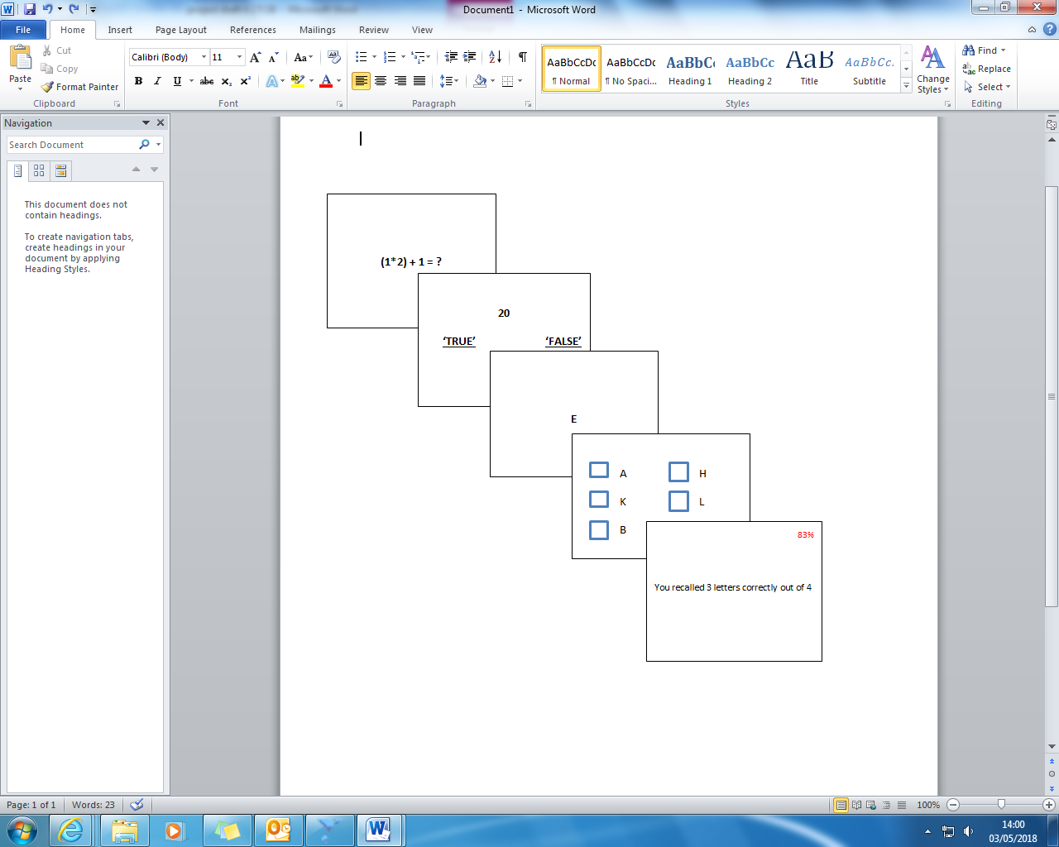

*Figure 1*. OSPAN screens as viewed in the test.

**Procedure**

Participants completed both study parts during one laboratory session on university premises. No other persons other than the experimenter were present during testing.

**Part one.**Participants accessed part one of the study on Qualtrics, on computer (Dell OptiPlex 9010 All-In-One desktop). First, participants viewed detailed information about both parts of the study (Appendix Cii) and were asked to give consent if they wished to participate in both parts by clicking in a specified box. A non-consent response triggered termination of the study. After consenting, participants were presented with each questionnaire. On completion of all five questionnaires, a webpage informed participants that part one was complete and contained debrief information (Appendix Di). Part one took approximately 25 minutes to complete.

**Part two***.* Following completion of part one, the researcher set up the OSPAN on the same computer. The task used E-Prime software. Participants sat between 20–40 inches from the screen; computer screens were 19 inches with a resolution of 1920 x 1080. The computer screen turned red on completion of the task. Participants then informed the researcher and read debrief information (Appendix Dii). Part two took approximately 20 minutes to complete.

On completion, participants eligible for entry into the prize draw provided an email address to be contacted. A winner was randomly selected and notified by email in December 2017.

## **Ethics**

Ethical approval was granted by the University of Sheffield Research Ethics Committee (Appendix F). Participants were provided with study information and provided consent to participate. Non-consent terminated participation. Participants created a unique identifying code for part one which was linked to their part two data to retain anonymity in results. Participants were debriefed after each part of the study (Appendices D i-ii).

**Data analysis**

Results were exported from Qualtrics to SPSS (Version 23) and data prepared for analysis including recoding of items as per scoring manuals. Data were checked for missing values, outliers, and errors.

Data was inspected for normality, skewness, and kurtosis, with visual checks of Q-Q plots and histograms (Cramer, 1998; Cramer & Howitt, 2004; Doane & Seward, 2011). For normality to be assumed, *z* values for skewness and kurtosis should fall between -1.96 and +1.96, and Shapiro-Wilk (Shapiro & Wilk, 1965) and Kolmogorov-Smirnov tests should not be significant (*p*>.05).

Descriptive statistics (means and standard deviations) were calculated for each variable. To assess hypotheses 1a-b, Spearman’s Rho correlations were produced and interpreted using guidance from Cohen (1988) where *r* = .10 to .29 reflects a small effect, *r* = .30 to *r* = .49 reflects medium, and *r* = .50 to *r* = .10 reflects a large effect.

To assess hypotheses 2a-d, four hierarchical multiple regression analyses were conducted, testing whether WMC (independent variable) predicted the variance in the four dependent variables. Preliminary analyses were conducted on regression outputs to check assumptions of normality were not violated. To assess multicollinearity, correlations between WMC and control variables were assessed, where a large effect would indicate multicollinearity (Pallant, 2016). Also, Tolerance values were inspected, which should be above 0.2, and Variance Inflation Factor (VIF) inspected, which should be below 10 (Field, 2013; Pallant, 2012). Normality, linearity, and homoscedasticity of residuals were assessed by inspecting Normal Probability-Plots (P-P) of the Regression Standardised Residuals (which should show an approximate straight diagonal line) and scatterplots, which should reflect a random array of dots (Field, 2013). The Durbin Watson statistic assessed autocorrelation between item responses over time, where the statistic should fall between 1 and 3 to indicate no autocorrelation (Field, 2013). Cook’s and Mahalnobis distances were inspected to identify outliers, where values should fall below 1 and below 15 respectively (Field, 2013).

During regression model building, all control variables (age, gender, OCI-R score) were first entered to determine any significant predictors of the variance in the dependent variable. Significant predictors (*p*<0.05) were retained and those non-significant (*p*>0.05) eliminated. Each hypothesis was tested by generating a hierarchical multiple regression model, where significant control predictors were first entered into the model at step 1, followed by the predictor of interest, ‘WMC’, at step 2. The amount of variance explained by ‘WMC’ when added to the model was inspected $via the R^{2}$ change value.

**Results**

**Missing data**

A small amount of missing data emerged sporadically on some questionnaire items. A statistical test indicated this could be considered random (Little, 1988; *p* = 1.00). Case mean substitution was conducted by replacing missing values with the participant’s mean value for the relevant scale, as reported in previous studies (Raymond, 1986; Downey & King, 1998; Roth, Switzer, & Switzer, 1999; Fox-Wasylyshyn & El-Masri, 2005; Eekhout, de Boer, Twisk, de Vet, & Heymans, 2012).

**Data screening**

Table 1 reports results of normality tests. Data were overall approximately normally distributed, however, thought suppression was skewed and both Shapiro-Wilk and Kolmogorov-Smirnov tests were significant (both *p*<0.05) indicating this variable was not normally distributed. Visual inspection of the Q-Q plots, histograms and boxplots indicated approximately normally distributed data for all variables, however was slightly skewed for INMI appraisal. Correlations confirmed control variables (age, gender, OCI-R score) did not highly correlate indicating no multicollinearity.

|  |  |  |  |  |  |  |
| --- | --- | --- | --- | --- | --- | --- |
| Table 1. Tests of normality for each dependent variable | | | | | | |
| Variable | Skewness  (*SE*) | *Z* value | Kurtosis (*SE*) | *Z* value | Shapiro-Wilk | Kolmogorov-Smirnov value |
| OIT appraisal | 0.19 (.25) | .76 | -.57 (.50) | -1.14 | .34 | .04* |
| INMI appraisal | -.28 (.25) | -1.12 | -.02 (.50) | -.04 | .17 | .2 |
| Perceived thought control | .23 (.25) | 0.92 | -.89 (.50) | -1.78 | .03* | .2 |
| Thought suppression | -.69 (.25) | -2.76∆ | .23 (.50) | 0.46 | .01* | .01* |

**Note.** *p < .05. ∆ Indicates skewed data.

**Sample characteristics**

Ninety-one participants completed the study. One participant had never experienced INMI and did not complete the IMIS so was excluded from analyses. One participant did not complete the OSPAN, and six scored below the minimum 80% threshold and were excluded from relevant analyses. Minimum score for OCI-R was 18, and maximum 72 (*M*=33.67, *SD*=11.95). The recommended clinical cut-off score is 21 indicating on average the sample fell within clinical range of OC symptoms. Table 2 reports descriptives of sample characteristics.

|  |  |  |
| --- | --- | --- |
| Table 2. Descriptive data for demographic participant characteristics | | |
| Variable | N (%) | Mean (SD) |
| *Age*  *Gender* |  | 25.61 (12.57) |
| Male  Female  Prefer not to say | 24 (26.4%)  66 (72.5%)  1 (1.1%) |  |
| *Occupation* |  |  |
| Student  Staff | 59 (64.8%)  32 (35.2%) |  |
| *Nationality* |  |  |
| UK  China  India  Pakistan  Spain  Sweden  Taiwan | 77 (84.6%)  3 (3.3%)  3 (3.3%)  3 (3.3%)  3 (3.3%)  1 (1.1%)  1 (1.1%) |  |

## **Descriptive statistics**

Table 3 presents descriptives for dependent variables. OIT Appraisal score (*M*=1.64, *SD*=0.71) was in line with other samples of UK university students and staff (C. Heapy, personal communication, April, 2018). Previous data for INMI appraisal is not available to draw comparisons (G. Floridou, personal communication, May 2018). Perceived thought control (*M*=44.38, *SD*=15.83) was lower than previous undergraduates (Peterson, Klein, Donnelly, & Renk, 2009), and thought suppression (*M*=51.12, *SD*=11.96) higher than previous undergraduates (Rafnsson & Smari, 2001). Response frequencies (%) for each item of OIT and INMI appraisal measures can be found in Appendix G.

|  |  |  |  |  |
| --- | --- | --- | --- | --- |
| Table 3. Descriptive data for dependent variables | | | | |
| Variable | Minimum | Maximum | Mean | *SD* |
| OIT appraisal | .13 | 3.31 | 1.64 | .71 |
| INMI appraisal | 12 | 35 | 25.37 | 5.14 |
| Perceived thought control | 15 | 81 | 44.38 | 15.83 |
| Thought suppression | 17 | 72 | 51.12 | 11.96 |
| OSPAN Partial score* | 26 | 75 | 59.82 | 9.70 |
| Note. *n=83 | | | | |

**Correlation analyses**

### **Relationship between measures of appraisal**

Table 4 presents a correlation matrix between all main variables. Hypothesis 1a was supported. First, a significant small negative correlation emerged between negative (higher scores) OIT appraisal and negative (lower scores) INMI appraisal. A significant small positive correlation emerged between negative (lower scores) INMI appraisal and lower scores of perceived thought control, and a significant medium negative correlation emerged between negative (higher scores) OIT appraisal and lower scores of perceived thought control. Results indicate both negative appraisal of OITs and INMI are associated with low perceived thought control.

Hypothesis 1b was partially supported, with a significant medium-large positive correlation between high scores of thought suppression and negative (higher scores) OIT appraisal, but this relationship was non-significant with INMI appraisal, indicating high levels of thought suppression are associated with negative appraisal of OITs but not with negative appraisal of INMI. A significant large negative correlation emerged between high scores of thought suppression and low scores of perceived thought control.

|  |  |  |  |
| --- | --- | --- | --- |
| Table 4. Spearman’s rho correlation coefficients between dependent variables | | | |
| Variable | OIT appraisal | INMI appraisal | Perceived thought control |
| OIT appraisal | - | - | - |
| INMI appraisal | -.28** | - | - |
| Thought control | -.57** | .25* | - |
| Thought suppression | .62** | -.18 | -.75** |

**Note**.*p < .05 (2 tailed) **p < .01.

**Hierarchical Multiple Regressions**

### **Assumptions of regression**

Preliminary data screening of residuals indicated WMC did not significantly correlate with OCI-R (control predictor variable) for any regression (*r<*.7), VIF values fell below 10, and Tolerance statistic fell above 0.2, all indicating no multicollinearity. For each regression, the Durbin-Watson statistic fell between 1 and 3, indicating no autocorrelation, and both Mahalnobis and Cook’s distances did not exceed critical values indicating no significant outliers. Visual inspection of P-P plots and scatterplots indicated approximately normally distributed residual data.

### **OIT appraisal**

This first regression analysis tested Hypothesis 2a, whether WMC predicted OIT appraisal. After eliminating age and gender due to no significant contribution to OIT appraisal variance, the model showed OCI-R score explained 44% (***R2***=0.44) of the unique variance in OIT appraisal, *F*(1, 82)=63.95, *p*<.0001. The final model indicated the addition of WMC explained 0% (***R2*** change=.00) more of the unique variance in OIT appraisal, *F change* (1, 80)=.003, *p*=0.96. With the contribution of WMC, the model is not significant (*β*=.005, *p*=0.96) indicating WMC did not significantly predict OIT appraisal. Hypothesis 2a was therefore, rejected. Table 5 presents the unstandardised beta, standard error, and confidence intervals.

|  |  |  |  |  |
| --- | --- | --- | --- | --- |
| Table 5. Hypothesis 2a. Hierarchical multiple regression analyses | | | | |
|  | *OIT Appraisal* | | | |
| Predictor | B | SE | 95% Confidence Interval  Lower Upper | |
| Step 1 |  |  |  |  |
| (Constant) | .308 | .179 | -.049 | .664 |
| OCI-R total | .04*** | .005 | .030 | .050 |
| Step 2 |  |  |  |  |
| (Constant) | .284 | .453 | -.618 | 1.186 |
| OCI-R total | .041** | .005 | .030 | .050 |
| WMC | .000 | .006 | -.012 | .013 |
| **Note***.* n*=83.* *** p < .0001 | | | | |

### **INMI appraisal**

The second regression analysis tested Hypothesis 2b, whether WMC predicted INMI appraisal. In the first instance, no control variables made a significant contribution to INMI Appraisal (age, gender, and OCI-R score), and so the final model showed the contribution of WMC explained .02% (***R2***=.0002) unique variance in INMI appraisal, *F*(1, 82)=1.78, *p*>.05. The model was not significant (*β* =.147, *p*=0.185) indicating WMC did not predict INMI appraisal. Hypothesis 2b was therefore, rejected. Table 6 presents the unstandardised beta, standard error, and confidence intervals.

|  |  |  |  |  |
| --- | --- | --- | --- | --- |
| Table 6. Hypothesis 2b. Hierarchical multiple regression analyses | | | | |
|  | *INMI Appraisal* | | | |
| Predictor | B | SE | 95% Confidence Interval  Lower Upper | |
| Model 1 |  |  |  |  |
| (Constant) | 20.92*** | 3.42 | 14.2 | 27.74 |
| OPSAN | .075 | .056 | -.037 | .187 |
| **Note***.* n*=83.* *** *p* < .0001 | | | | |

### **Perceived thought control**

The third regression analysis tested Hypothesis 2c, whether WMC predicted perceived thought control. After eliminating age and gender due to no significant contribution to variance in perceived thought control, the model indicated OCI-R score explained 41% (***R2***=.41) of the unique variance in perceived thought control, *F*(1, 82)=56.25, *p*<.0001. The addition of WMC to the final model explained 0.7% (***R2***change=0.007) more of the variance in perceived thought control, *F change* (1, 80)=1.017, *p*=.316. The contribution of WMC to the model was not significant (β=.088, *p*=.316) indicating WMC did not predict perceived thought control. Hypothesis 2c was therefore, rejected. Table 7 presents the unstandardised beta, standard error, and confidence intervals.

|  |  |  |  |  |
| --- | --- | --- | --- | --- |
| Table 7. Hypothesis 2c. Hierarchical multiple regression analyses | | | | |
|  | *Perceived thought control* | | | |
| Predictor | B | SE | 95% Confidence Interval  Lower Upper | |
| Model 1 |  |  |  |  |
| (Constant) | 72.070*** | 4.032 | 64.048 | 80.092 |
| OCI-R total | -.847*** | .113 | -1.071 | -.622 |
| Step 2 |  |  |  |  |
| (Constant) | 62.695*** | 10.132 | 42.531 | 82.859 |
| OCI-R total | -.822*** | .116 | -1.052 | -.592 |
| WMC | .143 | .141 | -.139 | .424 |
| **Note***. n=83.* *** p < .0001 | | | | |

### **Thought suppression**

This fourth regression analysis tested Hypothesis 2d by examining whether WMC predicted thought suppression. After eliminating age and gender due to no significant contribution to variance in thought suppression, the model showed OCI-R score explained 31% (*R2*=.31) of the unique variance in thought suppression, *F*(1, 82)=38.189, *p*<.0001. After adding WMC, the final model explained 1.3% (*R2*change=.013) more of the unique variance in thought suppression, *F change* (1, 80)=1.547, *p* >.05*.* The contribution of WMC to the final model was not significant (β=-.116, *p*=.217) indicating WMC did not predict thought suppression. Hypothesis 2d was therefore, rejected. Table 8 presents the unstandardised beta, standard error, and confidence intervals.

|  |  |  |  |  |
| --- | --- | --- | --- | --- |
| Table 8. Hypothesis 2d. Hierarchical multiple regression analyses | | | | |
|  | *Thought suppression* | | | |
| Predictor | B | SE | 95% Confidence Interval  Lower Upper | |
| Model 1 |  |  |  |  |
| (Constant) | 33.865*** | 3.056 | 27.785 | 39.946 |
| OCI-R total | .529*** | .086 | .359 | .699 |
| Step 2 |  |  |  |  |
| (Constant) | 42.599*** | 7.655 | 27.365 | 57.833 |
| OCI-R total | .506*** | .087 | .332 | .679 |
| WMC | -.133 | .107 | -.346 | .080 |
| **Note***.* n*=83.* *** p < .0001 | | | | |

**Discussion**

This study is the first to directly investigate relationships between OITs and INMI and the role of WMC in one nonclinical sample. Consistent with hypotheses, individuals who appraised OITs negatively, appraised INMI negatively and had lower perceived thought control. Also, higher thought suppression was associated with negative OIT appraisal but interestingly, not negative INMI appraisal. Contrary to hypotheses, WMC did not predict IC appraisal, perceived thought control or thought suppression in this sample.

## **Similarities and differences between OITs and INMI**

An interesting feature of this research is the association between OITs and INMI appraisal. Findings are in line with previous research stating both ICs share characteristics, such as being unwanted and difficult to control (Beaman & Williams, 2013; Williamson & Jilka, 2014; Mullensiefen et al., 2014). Although significant, this relationship was weak in strength. Additionally, relationships between OIT appraisal, perceived thought control, and thought suppression were strong, whereas the same relationships for INMI were weak or not significant (for thought suppression). These findings indicate that although OITs and INMI share some commonalities, they may fall at differing points on a continuum of experience; with OITs moving towards the more distressing end, and INMI at the more ‘neutral’ end of the continuum.

Findings indicate INMI were generally not considered unpleasant experiences, contrary to OITs, supporting reports that INMI are unproblematic (Beaman & Williams, 2010; Halpern & Bartlett, 2011; Liikkanen, 2012). It emerged in the current study, that 54% of participants never worried about their INMI (2.4% responded ‘most of the time’), and for OITs one third identified with an unpleasant experience of OITs, indicating a more aversive experience. This may explain why INMI appraisal was not significantly associated with thought suppression in this sample.

The relationships between IC appraisal, perceived thought control, and thought suppression support a breadth of existing research across both OITs and INMI (Purdon & Clark, 1994; Belloch et al., 2004; Luciano et al., 2005; Belloch, Marillo & Garcia-Soriano, 2007; Beaman & Williams, 2013; Williamson & Jilka, 2014; Mullensiefen et al., 2014). The discrepancy within previous studies suggesting INMI are unproblematic in nature, versus anecdotal reports that they are distressing, could therefore, be explained by the appraisals assigned to INMI, and beliefs about thought control, with negative appraisal and low perceived thought control potentially being associated with distress. The findings imply commonalities in experience for both OITs and INMI, even when experience falls on different points on the continuum from unproblematic to distressing. This can be further investigated by exploring how findings contribute to cognitive models of psychological distress.

## **Cognitive model of distress and the role of appraisal**

The current study provides evidence for cognitive models of psychological distress not only within ICs known to cause distress such as OITs, but also for INMI which has largely been considered a more benign experience. The significant relationships between negative appraisal, low perceived thought control, and engagement in thought suppression can contribute to what is understood about mechanisms of distress via cognitive models, which aim to explain distress within other psychological experiences, such as psychotic experiences (Morrison, 1998), anxiety disorders (Wells & Matthews, 1994), and auditory hallucinations (Bentall, 1990). Similarly, this mechanism has been applied to tinnitus-distress (McKenna et al., 2014), which like INMI, involves perceiving sound in the absence of an external acoustic stimuli (Bauer & Brozoski, 2008). The current findings highlight that low perceived thought control is related to negative appraisal of INMI too, a phenomenon with only a recent scientific research base, and which are generally less-distressing experiences. The findings can therefore, offer further information as to how appraisals interact across two different types of IC, which may in turn, support clinical interventions which target maladaptive appraisals in reducing distress.

## **Hypothesised Role of Working Memory Capacity**

A second aim of the current study was to test whether WMC predicted appraisals of INMI and OITs, perceived levels of thought control, and thought suppression. Contrary to hypotheses, WMC did not predict whether ICs were appraised negatively or positively, supporting and extending findings from Brewin and Smart (2005) who found no significant relationship between WMC and OIT appraisal, or with measures of negative mood.

Perceived thought control can be considered a type of appraisal itself (Berry & Laskey, 2012) and so the lack of influence of WMC on this is in line with the other regression findings. The lack of predictability between WMC and thought suppression was more surprising as this contradicts strong positive associations between higher WMC and successful thought suppression (Geraerts et al., 2007; Brewin & Beaton, 2002; Rosen & Engle, 1998; Brewin & Smart, 2005; Hallion et al., 2014; Levinson, Smallwood & Davidson, 2012; Grisham & Williams, 2013). However, previous studies have measured thought suppression in real-time experimental tasks, unlike the current study. Brewin & Beaton (2002) measured thought suppression by asking participants to *not* think of a white bear and report when they failed at this. Similarly, Grisham & Williams (2013) asked participants to suppress a particular target thought. In both studies, lower WMC was associated with poorer thought suppression performance. WMC may therefore, only be relevant when individuals engage in active thought suppression. This supports findings from Grisham and Williams (2013), who found despite WMC being relevant to actual thought suppression, it was not associated with greater distress, but rather, perceived thought control was associated with distress. Further, Brewin and Smart posited the more strategic processes involved in thought suppression (such as WMC) were not relevant in the interaction between negative mood and the frequency of ICs.

The current findings highlight associations between negative OIT appraisal and increased thought suppression, supporting theories that thought suppression can be counterproductive. The lack of relationship with negative INMI appraisal may indicate thought suppression is employed more for ICs considered more distressing. As a counter-productive strategy, this has implications for the maintenance of distress in individuals experiencing ICs, potentially highlighting a need for alternative coping strategies for these individuals.

**Strengths and limitations**

Findings from the current study must be interpreted with caution and viewed in context of its limitations.

A cross-sectional design was appropriate to the exploratory aims of this study, given the absence of previous studies in this area; however, correlational analyses preclude any causal inferences. Furthermore, the operational questionnaires, INPIOS and IMIS, measure appraisal slightly differently. Although both measures assess emotional reactions and control strategies, unlike the INPIOS, the IMIS does not ask about perceived consequences or responsibility beliefs in relation to ICs, most likely due to unproblematic appraisals of INMI reported in previous literature (Beaman & Williams, 2010; Halpern & Bartlett, 2011; Liikkanen, 2012; Taylor et al., 2014). This key difference in the questionnaire structures may partly explain the weak relationship between OIT and INMI appraisals.

Regarding sample power, data from 83 participants were used for regression analyses due to exclusions, one less participant than recommended to achieve sufficient power. Additionally, the study’s sample may present limitations in terms of generalisability. The sample consisted of university staff and students, limiting demographic individual differences (e.g. highly educated individuals with a mean age of 25 years, and the majority from the UK). OITs and INMI are prevalent among different cultures (Clark & Radomsky, 2014; Moulding et al., 2014; Taylor et al., 2014) but age and years of education have been associated with differences in OIT experience cross-culturally (Radomsky et al., 2014). Further, demographic information could have been attained to elucidate other factors potentially impacting results (such as co-morbid mental health difficulties). Trait anxiety could also have been controlled-for due to research showing this construct is associated with varying types of cognitive appraisals (Lee, Park, & Russell, 2018).

The nonclinical sample may limit generalisability of findings to clinical populations. However, Abramowitz et al. (2014) suggests OCI-R scores across clinical and nonclinical samples are not dissimilar (mean *SD* = 11.3 and 12.9 respectively). Also, the current sample mimicked characteristics of clinical samples (high OCI-R scores, low perceived thought control, and high thought suppression). The self-selected sample may explain this; individuals with more OC symptoms and low perceived thought control may be more likely to participate as a way of seeking information and control over their ICs.

Additionally, mean imputation of missing data reduces variability which can lead to biased estimates (Enders, 2010). As missing data in the current study was infrequent and random, mean imputation was recommended as a robust way to manage this (Downey & King, 1998; Roth et al., 1999) and is a common way to manage missing values within self-report questionnaires (Eekhout et al., 2012).

As a strength, this study was the first to assess relationships between OITs and INMI in the same individuals. Further, measures employed all possessed excellent psychometric properties which provide confidence in the findings. Although caution must be taken when drawing implications from one study, further strengths of this study are its theoretical contributions and potential clinical implications.

**Clinical and theoretical implications**

Findings support theories that thought suppression is a counterproductive control strategy (Wegner et al., 1987). They also provide further information as to potential mechanisms of distress such as appraisal, as posited in cognitive models (Clark & Purdon, 1993; Freeston, Rheaume, & Ladouceur, 1996; Rachman, 1998; Taylor, et al., 2014), and emphasise the need for increased provision of clinical interventions which target cognitive appraisals to reduce distress. In this way, beliefs that OITs and INMI are ‘abnormal’ can be challenged, due to the current findings documenting both ICs in the general population. Challenging unhelpful thinking is a key element of CBT, and related approaches such as acceptance and commitment therapy (ACT) may offer alternative strategies such as cognitive defusion and mindfulness to address threat-related beliefs about ICs, including beliefs they must be controlled. Such techniques may also offer alternatives to thought suppression. The effectiveness of cognitive-behavioural therapy (CBT) has been widely evidenced in reducing distress related to other experiences, such as tinnitus (see review from Zenner et al., 2017), for which maladaptive appraisals are theorised to maintain distress (Mckenna et al., 2014). Such reappraisal and acceptance techniques have also been evidenced as effective for managing OITs in anxiety (Brown & Hooper, 2009; Shipherd & Fordiani, 2015), musical obsessions (Taylor et al., 20414; Gomibuchi et al., 2000) and intrusions in psychosis (Bach & Hayes, 2002). It can therefore, be recommended that further testing of such clinical interventions across a range of psychological experiences is conducted.

Furthermore, given the importance of appraisals in distress, one could explore which groups of individuals may be more likely to develop dysfunctional beliefs about their cognitive experiences. Salkovskis (1999) suggested early childhood experiences are linked to development of over-inflated responsibility beliefs. Further, beliefs about oneself being dangerous or careless may lead to meaning being attached to certain intrusions (Doron, Moulding, Kyrios, & Nedeljkovic, 2008; Ferrier & Brewin, 2005).

**Future directions**

Future research may address the current limitations, such as exploring IC appraisals from a more demographically-diverse population. It may also be beneficial for future questionnaire studies to include a forced-response to minimise missing data.

A future study could address differences in how thought suppression has been measured in previous studies. This may be via measuring WMC and inducing OITs and INMI in a lab-based study, where participants are asked to engage in a live thought suppression task. This may help elucidate the role of WMC on appraisals during active thought suppression.

A useful area of future focus may be to explore other potential predictors of dysfunctional beliefs which serve to maintain IC distress. Drawing on the work of Salkovskis (1999), adverse childhood experiences (ACEs) may be explored using standardised measures to test whether relationships exist between ACEs, appraisal, (including perceived thought control), and responsibility beliefs.

Finally, OITs and INMI shared some commonality in terms of appraisals, including perceived thought control. The next logical step in the search for a possible common underlying meta-appraisal mechanism is to test other types of IC for similar relationships. ICs falling at differing points on a continuum, such as mind-wandering and intrusive psychotic experiences could be tested to determine if appraisal is a mechanism of distress, even when one experience is considered ‘neutral’ and the other clinically-distressing.

**Conclusion**

This study is the first to highlight shared relationships between negative appraisal and low perceived thought control across OITs and INMI and emphasises links between thought suppression and negative appraisal. Such findings may contribute to cognitive models positing links between dysfunctional appraisals, distress, and employed coping strategies, accentuating the usefulness of cognitive-focused interventions in treating IC-related distress. Findings also indicated INMI appraisals were less distressing than OITs, suggesting they may fall at the ‘neutral’ end of a continuum of experience.. Findings suggested WMC did not predict maladaptive appraisals of ICs, which was contrary to the hypotheses based on evidence drawing links between WMC and thought suppression. Methodological limitations, clinical implications and future directions were considered.

# **References**

Abramowitz, J. S., Fabricant, L. E., Taylor, S., Deacon, B. J., McKay, D., & Storch, E. A. (2014). The relevance of analogue studies for understanding obsessions and compulsions. *Clinical Psychology Review, 34,* 206–217. doi:10.1016/j.cpr.2014.01.004

American Psychiatric Association. (2013). *Diagnostic statistical manual of mental disorders* (5th ed.; DSM-V). Washington DC, USA: Author.

Bach, P., & Hayes, S. C. (2002). The use of acceptance and commitment therapy to prevent the rehospitalization of psychotic patients: A randomized controlled trial. *Journal of Consulting and Clinical Psychology, 70,* 1129-1139. doi:10.1037//0022-006x.70.5.1129

Bailes, F. (2007). The prevalence and nature of imagined music in the everyday lives of

musical students. *Psychology of Music, 35*, 1-16. doi:10.1177/0305735607077834

Bauer, C., & Brozoski, T. (2008). Tinnitus assessment and treatment: Integrating clinical experiences with the basic science of tinnitus. *Seminars in Hearing, 29,* 371-385. doi:10.1055/s-0028-1095896

Beaman, C. P., & Williams, T. I. (2010). Earworms (stuck song syndrome): Towards a natural history of intrusive thoughts. *British Journal of Psychology*, *101*(4), 637–653. doi:10.1348/000712609x479636

Beaman, C. P., & Williams, T. I. (2013). Individual differences in mental control predict involuntary musical imagery. *Musicae Scientiae, 17,* 398-409. doi:10.1177/1029864913492530

Belloch, A., Morillo, C., & Garcia-Soriano, G. (2007). Strategies to control unwanted intrusive thoughts: Which are relevant and specific in obsessive-compulsive disorder? *Cognitive Therapy and Research, 33,* 75-89. doi:10.1007/s10608-007-9141-2

Belloch, A., Morillo, C., Lucero, M., Cabedo, E., & Carrio, C. (2004). Intrusive thoughts in non-clinical subjects: The role of frequency and unpleasantness on appraisal ratings and control strategies. *Clinical Psychology and Psychotherapy, 11,* 100-110. doi:10.1002/cpp.397

Bennett, S. (2002), Musical Imagery Repetition (MIR). Master’s thesis. Cambridge University: Cambridge.

Bentall, R. P. (1990). The syndromes and symptoms of psychosis: Or why you can’t play twenty questions with the concept of schizophrenia and hope to win. In R. P. Bentall (Ed.), *Reconstructing schizophrenia.* London, UK: Routledge.

Berry, L-M., & Laskey, B. (2012). A review of obsessive intrusive thoughts in the general population. *Journal of Obsessive-Compulsive and Related Disorders, 1,* 125-132. doi:10.1016/j.jocrd.2012.02.002

Borella, E., Carretti, B., Cornoldi, C., & De Ben, R. (2007). Working memory, control of interference and everyday experience of thought interference: when age makes the difference. *Aging Clinical and Experimental Research, 19,* 200-206. doi:10.1007/bf03324690

Brewin, C. R., & Beaton, A. (2002). Thought suppression, intelligence, and working memory capacity. *Behaviour Research and Therapy, 40,* 923-930. doi:10.1016/s0005-7967(01)00127-9

Brewin, C. R., & Smart, L. (2005). Working memory capacity and suppression of intrusive thoughts. *Journal of Behaviour Therapy and Experimental Psychiatry, 36,* 61-68. doi:10.1016/j.jbtep.2004.11.006

Brown, H. (2015). *How do you solve a problem like an earworm?* Retrieved from https://www.scientificamerican.com/article/how-do-you-solve-a-problem-like-an-earworm/

Brown, F. J., & Hooper, S. (2009). Acceptance and commitment therapy (ACT) with a learning disabled young person experiencing anxious and obsessive thoughts. *Journal of Intellectual Disabilities, 13,* 195-201. doi:10.1177/1744629509346173

Clark, D. M. (1986). A cognitive approach to panic. *Behaviour Research and Therapy, 24*, 461–470. doi:10.1016/0005-7967(86)90011-2

Clark, D. A. (2005). *Intrusive thoughts in clinical disorders: Theory research, and treatment*.New York, NY: The Guildford Press

Clark, D. A., & Claybourn, M. (1997). Process characteristics of worry and obsessive intrusive thoughts. *Behaviour Research and Therapy, 35,* 1139-1141. doi:10.1016/s0005-7967(97)80008-3

Clark, D. A., & Purdon, C. (1993). New perspectives for a cognitive theory of obsessions. *Australian Psychologist, 28,* 161-167. doi:10.1080/00050069308258896

Clark D. A., & Purdon, C. (2009). Mental control of unwanted intrusive thoughts: A phenomenological study of nonclinical individuals. *International Journal of Cognitive Therapy, 2,* 267-281. doi:10.1521/ijct.2009.2.3.267

Clark, D. A., Purdon, C., & Wang, A. (2003). The Meta-Cognitive Beliefs Questionnaire: development of a measure of obsessional beliefs. *Behaviour Research and Therapy, 41,* 655-669. doi:10.1016/s0005-7967(02)00032-3

Clark, D. A., & Radomsky, A. S. (2014). Introduction: A global perspective on unwanted intrusive thoughts. *Journal of Obsessive-Compulsive and Related Disorders, 3,* 265-268. doi:10.1016/j.jocrd.2014.02.001

Clark, D. A., & Rhyno, S. (2005). Unwanted intrusive thoughts in non-clinical individuals: Implications for clinical disorders. In Clark, D. A. (2005 Ed.) *Intrusive thoughts in clinical disorders: Theory research, and treatment* (pp. 1-29).New York, NY: The Guildford Press

Cohen, J. (1988). *Statistical power analysis for the behavioral sciences*. Hillsdale, N.J: Erlbaum.

Conway, A. R. A., Kane, M. J., Bunting, M. F., Hambrick, D. Z., Wilhelm, O., & Engle, R. W. (2005). Working memory span tasks: A methodological review and user’s guide. *Psychonomic Bulletin & Review, 12,* 769-786. doi:10.3758/bf03196772

Coy, B., O’Brien, W. H., Tabaczynski, T., Northern, J., & Carels, R. (2011). Associations between evaluation anxiety, cognitive interference and performance on working memory tasks. *Applied Cognitive Psychology, 25,* 823-832. doi:10.1002/acp.1765

Cramer, D. (1998). *Fundamentals statistics for social research.* London, UK: Routledge.

Cramer, D., & Howitt, D. (2004). *The SAGE dictionary of statistics.* London, UK: SAGE.

Cucchi, M., Botttelli, V., Cavadini, D., Ricci, L., Conca, V., Ronchi, P., & Smeraldi, E. (2012). An explorative study on metacognition in obsessive-compulsive disorder and panic disorder. *Comprehensive Psychiatry, 53,* 546-553. doi:10.1016/j.comppsych.2011.09.008

Doane, D. P. & Seward, L. E. (2011). Measuring skewness. *Journal of Statistics Education, 19,* 1-18. doi:10.1080/10691898.2011.11889611

Doron, G., Moulding, R., Kyrios, M., & Nedelikovic, M. (2008). Sensitivity of self-beliefs in obsessive compulsive disorder. *Depression and Anxiety, 25,* 874-884. doi:10.1002/da.20369

Downey, R. G., & King, C. V. (1998). Missing data in Likert ratings: A comparison of replacement methods. *The Journal of General Psychology, 125,* 175-191. doi:10.1080/00221309809595542

Eekhout, I., de Boer, R. M., Twisk, J. W. R., de Vet, H. C. W., & Heymans, M. W. (2012). Missing data. *Epidemiology, 23,* 729-732. doi:10.1097/ede.0b013e3182576cdb

Edwards, S., & Dickerson, M. (1987). Intrusive unwanted thoughts: A two-stage model of control. *British Journal of Medical Psychology, 60,* 317-328. doi:10.1111/j.2044-8341.1987.tb02750.x

Enders, C. K. (2010). *Applied Missing Data Analysis*. New York, NY: The Guilford Press.

Eysenck, M. W., & Calvo, M. G. (1992). Anxiety and performance: The processing efficiency theory. *Cognition & Emotion, 6,* 409-434. doi:10.1080/02699939208409696

Ferrier, S. & Brewin, C.R. (2005). Feared identity and obsessive-compulsive disorder. *Behaviour Research and Therapy, 43*, 1363-1374. doi:10.1016/j.brat.2004.10.005

Field, A. (2013). *Discovering statistics using IBM SPSS Statistics.* London, UK: SAGE.

Foa, E. B., Huppert, J. D., Leilberg, S., Langner, R., Kichic, R., Haicak, G., & Salkovskis, P. M. (2002). The Obsessive-Compulsive Inventory: Development and validation of a short version. *Psychological Assessment, 14,* 485-496. doi:10.1037/1040-3590.14.4.485

Foa, E. B., Kozak, M. J., Salkovskis, P. M., Coles, M. E., & Amir, N. (1998). The validation of a new obsessive-compulsive disorder scale: The Obsessive-Compulsive Inventory. *Psychological Assessment, 10,* 206-214. doi:10.1037/1040-3590.10.3.206

Fox-Wasylyshyn, S. M., & El-Masri, M. M. (2005). Handling missing data in self-report measures. *Research in Nursing & Health, 28,* 488-495. doi:10.1002/nur.20100

Floridou, G. A., Williamson, V. J., Stewart, L., & Mullensiefen, D. (2015). The Involuntary Musical Imagery Scale (IMIS). Retrieved from https://www.gold.ac.uk/media/documents-by-section/departments/psychology/IMIS-pen-&-paper-version-&-scoring-info.pdf

Freeston, M. H., Ladouceur, R., Thibodeau, N., & Gagnon, F. (1991). Cognitive intrusions in a non-clinical population. Response style, subjective experience, and appraisal. *Behaviour Research and Therapy, 29,* 585-597. doi:10.1016/0005-7967(91)90008-q

Freeston, M. H., Rheaume, J., & Ladoucer, R. (1996). Correcting faulty appraisals of obsessional thoughts. *Behaviour Research and Therapy, 34,* 433-446. doi:10.1016/0005-7967(95)00076-3

Friedman, N. P., & Miyake, A. (2004). The relations among inhibition and interference control functions: A latent-variable analysis. *Journal of Experimental Psychology: General, 133,* 101-135. doi:10.1037/0096-3445.133.1.101

Garcia-Soriano, G. (2008). Obsessional intrusive thoughts inventory (INPIOS). Retrieved from PsycTESTS. doi:10.1037/t23131-000

Garcia-Soriano, G., Belloch, A., Morillo, C., & Clark, D. A. (2011). Symptom dimensions in obsessive-compulsive disorder: From normal cognitive intrusions to clinical obsessions. *Journal of Anxiety Disorders, 25,* 474-482.

Geraerts, E., Merckelbach, H., Jelicic, M., & Habets, P. (2007). Suppression of intrusive thoughts and working memory capacity in repressive coping. *The American Journal of Psychology, 120,* 205-218. doi:10.2307/20445395

Gomibuchi, T., Gomibuchi, K., Akiyama, T., Tsuda, H., & Hayakawa, T. (2001). Obsession of hearing music: From the viewpoint of Morita theory. *Psychiatry and Clinical Neurosciences, 54,* 203-206. doi:10.1046/j.1440-1819.2000.00659.x

Grisham, J. R., & Williams, A. D. (2013). Responding to intrusions in obsessive-compulsive disorder: the roles of neuropsychological functioning and beliefs about thoughts. *Journal of Behavioural Therapy and Experimental Psychiatry, 44,* 343-350. doi:10.1016/j.jbtep.2013.01.005. Epub 2013 Feb 8.

Hales, S A., Deeprose, C., Goodwin, G. M., & Holmes, E. A. (2011). Cognitions in bipolar affective disorder and unipolar depression: imagining suicide. *Bipolar Disorders, 13,* 651-661. doi:10.1111/j.1399-5618.2011.00954.x

Hallion, L. S., Ruscio, A-M., & Jha, A. P. (2014). Fractionating the role of executive control in control over worry: A preliminary investigation. *Behaviour Research and Therapy, 54,* 1-6. doi:10.1016/j.brat.2013.12.002

Halpern, A. R., & Bartlett, J. C. (2011). The persistence of musical memories: A descriptive study of earworms. *Music Perception*, *28*, 425–443. doi:10.1525/mp.2011.28.4.425

Hambrick, D. Z., Kane, M. J., & Engle, R. W. (2005). The role of working memory in higher-level cognition: Doman specific versus domain-general perspectives. In R. Sternberg & J. E. Pretz (Eds), *Cognition and intelligence: Identifying the mechanisms of the mind* (pp. 104-121).New York, NY: Cambridge University Press.

Heitz, R. P., Unsworth, N., & Engle, R. W. (2005). Working memory capacity, attentional control, and fluid intelligence. In O. Wilhelm & R. W. Engle (Eds), *Handbook of understanding and measuring intelligence (pp. 61-78).* London, UK: Sage Publications.

Hermans, D., Martens, K., De Cort, K., Pieters, G., & Eelen, P. (2003). Reality monitoring and metacognitive beliefs related to cognitive confidence in obsessive-compulsive disorder. *Behaviour Research and Therapy, 41,* 383-401. doi:10.1016/s0005-7967(02)00015-3

Janeck, A., & Calamari, J. (1999). Thought suppression in obsessive-compulsive disorder. *Cognitive Therapy and Research, 23,* 497-509. doi:10.1023/A:1018720404750

Julien, D., O’Connor, K. P., & Aardema, F. (2007). Intrusive thoughts, obsessions, and appraisals in obsessive compulsive disorder: A critical review. *Clinical Psychology Review, 27,* 366-383. doi:10.1016/j.cpr.2006.12.004

Kane, M. J., Conway, A. R. A., Hambrick, D. Z., & Engle, R. W. (2007). Variation in working memory capacity as variation in executive attention and control. In A. R. A. Conway, C. Jarrold, M. J. Kane, A. Miyake, & J. N. Towse (Eds.), *Variation in working memory* (pp. 21–48). New York, NY: Oxford University Press.

Killingsworth, M. A., & Gilbert, D. T. (2010). A wandering mind is an unhappy mind. *Science, 330,* 932-932. doi:10.1126/science.1192439

Klein, K., & Boals, A. (2001). The relationship of life event stress and working memory capacity. *Applied Cognitive Psychology, 15,* 565-579. doi:10.1002/acp.727

Kvavilashvili, L., & Mandler, G. (2004). Out of one’s mind: A study of involuntary semantic memories. *Cogntive Psychology, 48,* 47-94. doi:10.1016/s0010-0285(03)00115-4

La Elua, K., Keith, R. L., & Kvavilashvili, L. (2015). Increased frequency of invultary semantic memories or mind-pops in schizophrenia: a diary study. *Cognitive Neuropsychiatry, 20,* 502-511. doi:10.1080/13546805.2015.1092431

Langlois, F., Freeston, M. H., & Ladouceur, R. (2000). Differences and similarities between obsessive intrusive thoughts and worry in a non-clinical population: study 1. *Behaviour Research and Therapy, 38,* 157-173. doi:10.1016/s0005-7967(99)00027-3

Lee, S. Y., Park, C. L., & Russell, B. S. (2018). Does distress tolerance interact with trait anxiety to predict challenge or threat appraisals? *Personality and Individual Differences, 132,* 14-19. doi:10.1016/j.paid.2018.05.014

Levinson, D. B., Smallwood, J., & Davidson, R. J. (2012). The Persistence of Thought: Evidence for a Role of Working Memory in the Maintenance of Task-Unrelated Thinking. *Psychological Science, 23,* 375. doi:10.1177/0956797611431465

Levitin, D. J. (2006). *This is your brain on music*. New York, USA: Dutton

Liikanen, L. A. (2008). Music in every mind: Commonality of involuntary musical imagery. In K. Miyazaki, Y. Hiraga, M. Adachi, Y. Nakajima, & M. Tsuzaki (Eds.), *Proceedings of the 10th International Conference on Music Perception and Cognition (ICMPC10)* (pp. 408–412). Japan: Sapporo

Liikkanen, L. (2012) Musical Activities Predispose to Involuntary Musical Imagery. *Psychology of Music*. 40(2), 236-256. doi:10.1177/0305735611406578

Liikkanen, L. A., Jakubowski, K., & Toivanen, J. M. (2015). Catching earworms on Twitter: Using big data to study involuntary musical imagery. *Music Perception: An Interdisciplinary Journal, 33,* 199-216. doi:10.1525/mp.2015.33.2.199

Little, R. (1988). A test of missing completely at random for multivariate data with missing values. *Journal of the American Statistical Association, 83*, 1198–1202. doi:10.2307/2290157

Lopez, N., Previc, F. H., Fischer, J., Heitz, R. P., & Engle, R. W. (2012). Effects of sleep deprivation on cognitive performance by United States Air Force pilots. *Journal of Applied Research in Memory and Cognition, 1,* 27-33. doi:10.1016/j.jarmac.2011.10.002

Luciano, J. V., Algarabel, S., Tomas, J. M., & Martinez, J. L. (2005). Development and validation of the thought control ability questionnaire. *Personality and Individual Differences, 38,* 997-1008. doi:10.1016/j.paid.2004.06.020

McKenna, L., Handscomb, L., Hoare, D. J., & Hall, D. A. (2014). A scientific cognitive-behavioral model of tinnitus: novel conceptualizations of tinnitus distress. *Frontiers in Neurology, 5,* 196. doi:10.3389/fneur.2014.00196

McVay, J. C., & Kane, M. J. (2009). Conducting the train of thought: Working memory capacity, goal neglect, and mind wandering in an executive-control task. *Journal of Experimental Psychology: Learning, Memory, and Cognition, 35,* 196-204. doi:10.1037/a0014104

Morrison, A.P. (1998). A cognitive analysis of the maintenance of auditory hallucinations: Are voices to schizophrenia what bodily sensations are to panic? *Behavioural and Cognitive Psychotherapy, 26,* 289-302. Retrieved from https://www-cambridge-org.sheffield.idm.oclc.org/core/journals/behavioural-and-cognitive-psychotherapy/article/cognitive-analysis-of-the-maintenance-of-auditory-hallucinations-are-voices-to-schizophrenia-what-bodily-sensations-are-to-panic/7947CFAAC58346579FAB55929DA3C76C

Morrison, A. P. (2001). The interpretation of intrusions in psychosis: An integrative cognitive approach to hallucinations and delusions. *Behavioural and Cognitive Psychotherapy, 29,* 257-276. doi:10.1017/s1352465801003010

Moulding, R., Coles, M. E., Abramowitz, J., Alcolado, G. M., Alonso, P., Belloch, A., …Wong, W. (2014). Part 2. They scare because we care: The relationship between obsessive intrusive thoughts and appraisals and control strategies across 15 cities. *Journal of Obsessive-Compulsive and Related Disorders, 3,* 280-291. doi:10.1016/j.jocrd.2014.02.006

Mullensiefen, D., Fry, J., Jones, R., Jilka, S., Stewart, L., & Williamson, V. J. (2014). Individual differences predict patterns in spontaneous involuntary musical imagery. *Music Perception: An Interdisciplinary Journal, 31,* 323-338. doi:10.1525/mp.2014.31.4.323

Muris, P., Merckelbach, H., & Horselenberg, R. (1996). Individual difference in thought suppression. The White Bear Suppression Inventory: Factor structure, reliability, validity and correlates. *Behaviour Research and Therapy, 34,* 501-513. doi:10.1016/0005-7967(96)00005-8

Myers, S. G., & Wells, A. (2005). Obsessive-compulsive symptoms: the contribution of metacognitions and responsibility. *Journal of Anxiety Disorders, 19,* 806-817. doi:10.1016/j.janxdis.2004.09.004

Newby, J. M., & Moulds, M. L. (2011). Do negative appraisals and avoidance of intrusive memories predic depression at six months. *International Journal of Cognitive Therapy, 4,* 178-186. doi:10.1521/ijct.2011.4.2.178

Niler, E. R., & Beck, S. J. (1989). The relationship among guilt, dysphoria, anxiety and obsesions in a normal population. *Behaviour Research and Therapy, 27,* 213-220. doi:10.1016/0005-7967(89)90039-9

Obsessive Compulsive Cognitions Working Group. (1997). Cognitive assessment of obsessive-compulsive disorder. *Behaviour Research and Therapy, 35,* 667-681. doi:10.1016/s0005-7967(97)00017-x

OCD-UK. (2018). *Understanding Obsessive-Compulsive Disorder (OCD).* Retrieved from www.ocduk.org/ocd

Pallant, J. (2016). *SPSS survival manual.* London, UK: Open University Press.

Peterson, R. D., Klein, J., Donnelly, R., & Renk, K. (2009). Predicting psychological symptoms: The role of perceived thought control ability. *Cognitive Behaviour Therapy, 38,* 16-28. doi:10.1080/16506070802561215

Purdon, C. (1999). Thought suppression and psychopathology*. Behaviour Research and Therapy, 37*, 1029–1054. doi:10.1016/s0005-7967(98)00200-9

Purdon, C., & Clark, D. A. (1993). Obsessive intrusive thoughts in nonclinical subjects. Part I. Content and relation with depressive, anxious and obsessional symptoms. *Behaviour Research and Therapy, 31,* 713-720. doi:10.1016/0005-7967(93)90001-b

Rachman, S. (1998). A cognitive theory of obsessions: elaborations. *Behaviour Research and Therapy, 36,* 385-401. doi:10.1016/S0005-7967(97)10041-9

Rachman, S. (1981). Unwanted intrusive cognitions. *Advances in Behaviour Research and Therapy, 3,* 89-99. doi:10.1016/0146-6402(81)90007-2

Rachman, S., & de Silva, P. (1978). Abnormal and normal obsessions. *Behaviour Research and Therapy, 16,* 233-248. doi:10.1016/0005-7967(78)90022-0

Radomsky, A. S., Alcolado, G. M., Abramowitz, J. S., Alonso, P., Belloch, A., Bouvard, M., …Wong, W. (2014). Part 1- You can run but you can’t hide: Intrusive thoughts on six continents. *Journal of Obsessive-Compulsive and Related Disorders, 3,* 269-279. doi:10.1016/j.jocrd.2013.09.002

Rafnsson, F. D., & Smari, J. (2001). Chronic thought suppression and obsessionality: the relationships between the White Bear Suppression Inventory and two inventories of obsessive-compulsive symptoms. *Personality and Individual Differences, 30,* 159-165. doi:10.1016/s0191-8869(00)00020-9

Rassin, E., Merckelbach, H., & Muris, P. (2000). Paradoxical and less paradoxical effects of thought suppression: A critical review. *Clinical Psychology Review, 20,* 973-995. doi:10.1016/S0272-7358(99)00019-7

Raymond, M.R. (1986). Missing data in evaluation research. *Evaluation & the Health Profession, 9*, 395- 420. doi:10.1177/016327878600900401

Redick, T. S., Broadway, J. M., Meier, M. E., Kuriakose, P. S., Unsworth, N., Kane, M. J., & Engle, R. W. (2012). Measuring working memory capacity with automated complex span tasks. *European Journal of Psychological Assessment, 28,* 164-171. doi:10.1027/1015-5759/a000123

Rosen, V. M., & Engle, R. W. (1998). Working memory capacity and suppression. *Journal of Memory and Language, 39,* 418-436. doi:10.1006/jmla.1998.2590

Roth, P. L., Switzer, F. S., & Switzer, D. M. (1999). Missing data in multiple item scales: A Monte Carlo Analysis of missing data techniques. *Organizational Research Methods, 2,* 211-232. doi:10.1177/109442819923001

Rowa, K., & Purdon, C. (2003). Why are certain intrusive thoughts more upsetting than others? *Behavioural and Cognitive Psychotherapy, 31.* doi:10.1017/s1352465803001024

Rummel, J., & Boywitt, C. (2014). Controlling the stream of thought: Working memory capacity predicts adjustment of mind-wandering to situational demands. *Psychonomic Bulletin & Review, 21,* 1309-1315. doi:10.3758/s13423-013-0580-3

Sacks, O. (2007). *Musicophilia: Tales of music and the brain*. New York, USA: Random House.

Salkovskis, P. M. (1985). Obsessional-compulsive problems: A cognitive-behavioural analysis. *Behaviour Research and Therapy, 23,* 571-583. doi:10.1016/0005-7967(85)90105-6

Salkovskis, P. M. (1999). Understanding and treating obsessive-compulsive disorder. *Behaviour Research and Therapy, 37*, S29–S52. doi:10.1016/s0005-7967(99)00049-2

Sarason, I. G. (1988). Anxiety, self-preoccupation and attention. *Anxiety, Stress, and Coping, 1,* 3-8. doi:10.1080/10615808808248215

Shapiro, S. S., & Wilk, M. B. (1965). AN analysis of variance test for normality (complete samples). *Biometrika, 52,* 591-611. doi: 10.2307/2333709

Shipherd, J. C., & Fordiani, J. M. (2015). The application of mindfulness in coping with intrusive thoughts. *Cognitive and Behavioural Practice, 22,* 439-446. doi:10.1016/j.cbpra.2014.06.001

Shipstead, Z., Harrison, T. L., & Engle, R. W. (2015). Working memory capacity and the scope and control of attention. *Attention, Perception, & Psychophysics, 77,* 1863-1880. doi:10.3758/s13414-015-0899-0

Smallwood, J., O’Connor, R. C., Sudbery, M. V., & Obonsawin, M. (2007). Mind-wandering and dysphoria. *Cognition & Emotion, 21,* 816-842. doi:10.1080/02699930600911531

Snyder, H. R., Kaiser, R. H., Warren, S. L., & Heller, W. (2015). Obsessive-compulsive disorder is associated with broad impairments in executive function: a meta-analysis. *Clinical Psychological Science, 3,* 301-330. doi:10.1177/2167702614534210

Stawski, R. S., Sliwinski, M. J., & Smyth, J. M. (2006). Stress-related cognitive interference predicts cognitive function in old age. *Psychology and Aging, 21*, 535–544. doi:10.1037/0882-7974.21.3.535

Taylor, S., Mckay, D., Miguel, E. C., De Mathis, M. A., Andrade, C., Ahuja, N., Sookman, D., …Storch, E. A. (2014). Musical obsessions: A comprehensive review of neglected clinical phenomena. *Journal of Anxiety Disorders, 28,* 580-589. doi:10.1016/j.janxdis.2014.06.003

Tolin, D. F., Abramowitz, J. S., Przeworski, A., & Foa, E. B. (2002). Thought suppression in obsessive-compulsive disorder. *Behaviour Research and Therapy, 40,* 1255-1274. doi:10.1016/s0005-7967(01)00095-x

Unsworth, N., Heitz, R. P., Schrock, J. C., & Engle, R. W. (2005). An automated version of the operation span task. *Behaviour Research Methods, 37,* 498-505. doi:10.3758/bf03192720

Warwick, H. M., & Salkovskis, P. M. (1990). Hypochondriasis. *Behaviour Research and Therapy, 28,* 105–117. doi:10.4324/9780203359365-chapter-four

Wells, A. (2006). The metacognitive model of worry and generalised anxiety disorder. In G. C. Davey & A. Wells (Eds.), *Worry and its psychological disorders* (pp. 177-199). UK: Wiley.

Wells, A., & Davies, M. I. (1994). The Thought Control Questionnaire: A measure of individual differences in the control of unwanted thoughts. *Behaviour Research and Therapy, 32,* 871-878. doi:10.1016/0005-7967(94)90168-6

Wells, A., & Matthews, G. (1994). *Attention and emotion: A clinical perspective*. Hillsdale, NJ: Laurence Erlbaum Associates.

Wegner, D. M. & Zanakos, S. (1994). Chronic thought suppression. *Journal of Personality, 62,* 615-640. doi:10.1111/j.1467-6494.1994.tb00311.x

Wegner, D.M., Schneider, D.J., Carter, S.R., & White, T.L. (1987). Paradoxical effects of thoughts suppression. *Journal of Personality and Social Psychology, 53*, 5–13. Retrieved from www.communicationcache.com/uploads/1/0/8/8/10887248/paradoxical_effects_of_thought_suppression.pdf

Williamson, V. J., Jilka, S. R., Fry, J., Finkel, S., Müllensiefen, D., & Stewart, L. (2011). How do earworms start? Classifying the everyday circumstances of Involuntary Musical Imagery. *Psychology of Music*, *40*, 259–284. doi:10.1177/0305735611418553

Williamson, V. J., & Stewart, L. (2010) Memory for pitch in congenital amusia: Beyond a fine-grained pitch discrimination problem. *Memory, 18,* 657-669. doi:10.1080/09658211.2010.501339

Zenner, H-P., Delb, W., Kroner-Herwig, B., Jager, B., Peroz, I., Hesser, G., Mazurek, B., Goebel, G., Gerloff, C., Trollmann, R., Biesinger, E., Seidler, H., & Langguth, B. (2017). A multidisciplinary systematic review of the treatment for chronic idiopathic tinnitus. *European Archives of Oto-Rhino-Laryngology, 274,* 2079-2091. doi:10.1007/s00405-016-4401-y

# **Appendix A- i**

Thought Control Ability Questionnaire (Luciano et al., 2005)

**Thought Control Ability Questionnaire**

The following statements refer to experiences that people have in their everyday lives. In reference to your experience over the past month, please indicate how much you agree with each of the following statements.

|  |  |  |  |  |
| --- | --- | --- | --- | --- |
| **0**  Strongly disagree | **1**  Disagree | **2**  Neutral or don’t know | **3**  Agree | **4**  Strongly agree |

|  |  |  |  |  |  |  |
| --- | --- | --- | --- | --- | --- | --- |
|  | It is often difficult for me to fall asleep because my mind keeps going over personal problemsa | 0 | 1 | 2 | 3 | 4 |
|  | I often cannot avoid having upsetting thoughtsa | 0 | 1 | 2 | 3 | 4 |
|  | Although some people criticize me unfairly, I can’t help  thinking they might be righta | 0 | 1 | 2 | 3 | 4 |
|  | I manage to have control over my thoughts even when  under stress | 0 | 1 | 2 | 3 | 4 |
|  | I constantly censure my thoughts and actionsa | 0 | 1 | 2 | 3 | 4 |
|  | Any setback overwhelms me, no matter how smalla | 0 | 1 | 2 | 3 | 4 |
|  | I am usually successful when I decide not to think about something | 0 | 1 | 2 | 3 | 4 |
|  | I constantly evaluate whether my thoughts and actions are appropriatea | 0 | 1 | 2 | 3 | 4 |
|  | It is very easy for me to stop having certain thoughts | 0 | 1 | 2 | 3 | 4 |
|  | I feel worried, frustrated or sad for a long time after having an  embarrassing, troublesome or painful experiencea | 0 | 1 | 2 | 3 | 4 |
|  | It is easy for me to free myself of troublesome thoughts | 0 | 1 | 2 | 3 | 4 |
|  | Frequently, some thoughts or images take over my minda | 0 | 1 | 2 | 3 | 4 |
|  | There are negative things in my past that I cannot help rememberinga | 0 | 1 | 2 | 3 | 4 |
|  | There are few things in life that manage to trouble me | 0 | 1 | 2 | 3 | 4 |
|  | I haven’t been able to get the argument I had with (my partner, my  parents, a friend…) out of my head for several daysa | 0 | 1 | 2 | 3 | 4 |
|  | I consider myself a person who is good at controlling positive and negative emotions. | 0 | 1 | 2 | 3 | 4 |
|  | My thoughts control me more than I control thema | 0 | 1 | 2 | 3 | 4 |
|  | There are some thoughts that enter my head without me being able to avoid ita | 0 | 1 | 2 | 3 | 4 |
|  | My thoughts are uncontrollablea | 0 | 1 | 2 | 3 | 4 |
|  | I am not usually overwhelmed by unpleasant thoughts | 0 | 1 | 2 | 3 | 4 |
|  | I am unable to free myself from certain thoughts: e.g. ‘‘I am a failure’’, ‘‘I am useless’’,  ‘‘I am no good at all’’, etca | 0 | 1 | 2 | 3 | 4 |
|  | I think other people have more control over their thoughts than I doa | 0 | 1 | 2 | 3 | 4 |
|  | If I get angry or fight with someone, I can’t stop thinking about it,  and I can hardly work or concentratea | 0 | 1 | 2 | 3 | 4 |
|  | I get rid of uncomfortable thoughts or images almost effortlessly | 0 | 1 | 2 | 3 | 4 |
|  | I have much patience, and I do not lose my composure easily | 0 | 1 | 2 | 3 | 4 |

a Reverse scored items.

# 

# **Appendix A- ii**

Involuntary Musical Imagery Scale (Floridou et al., 2015).

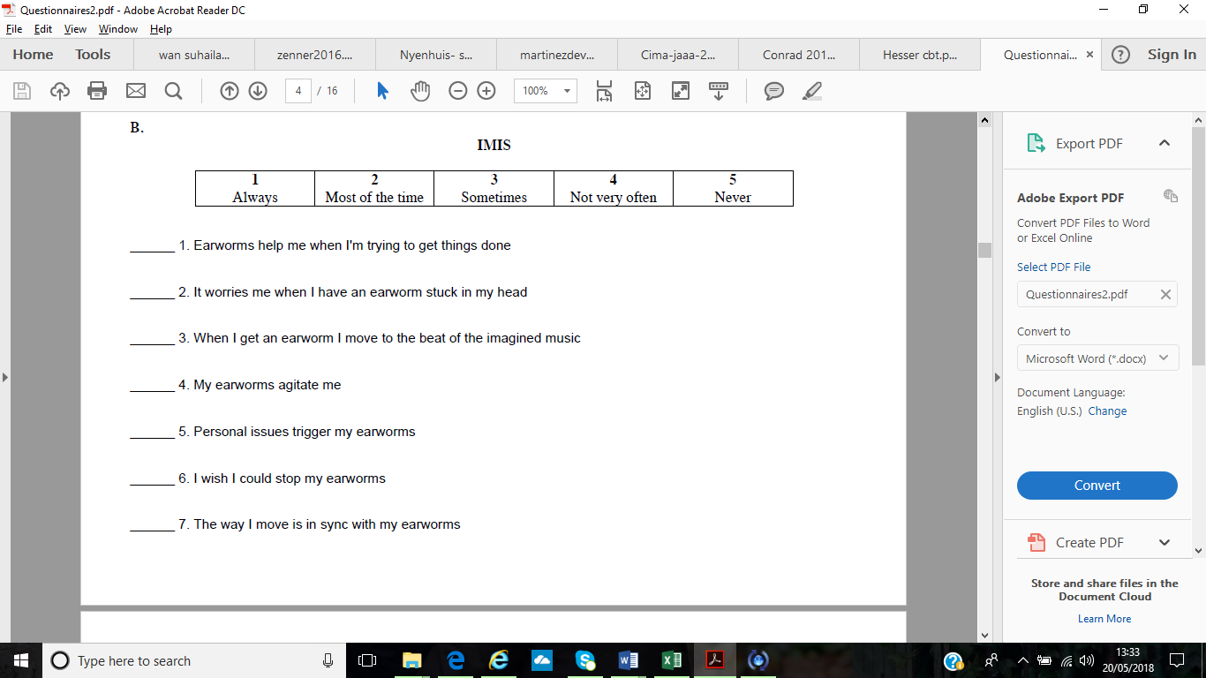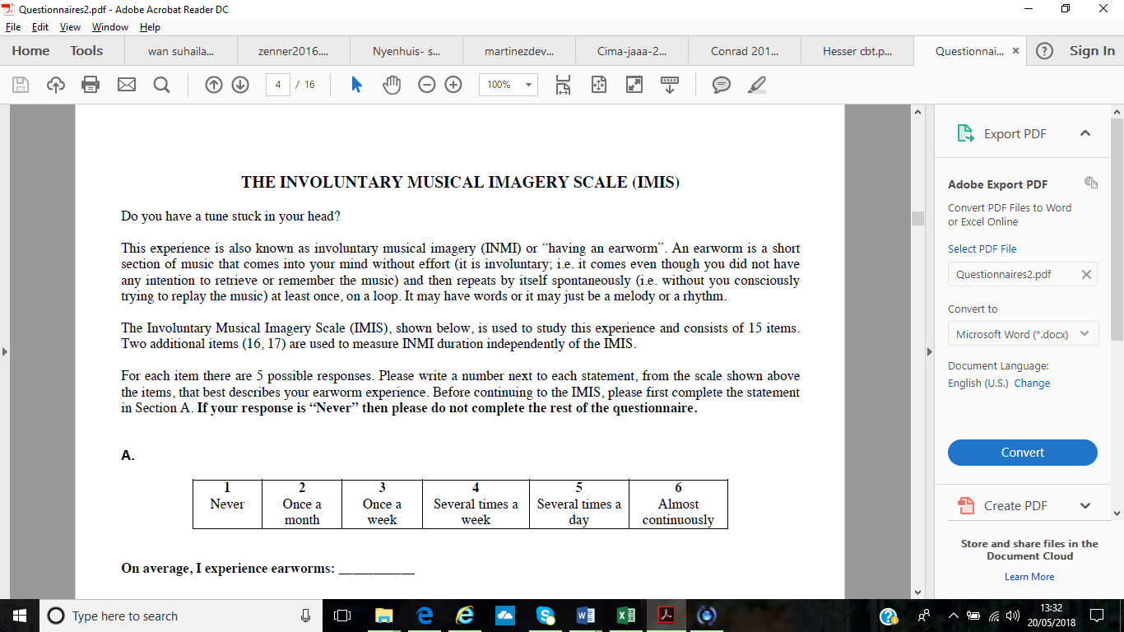

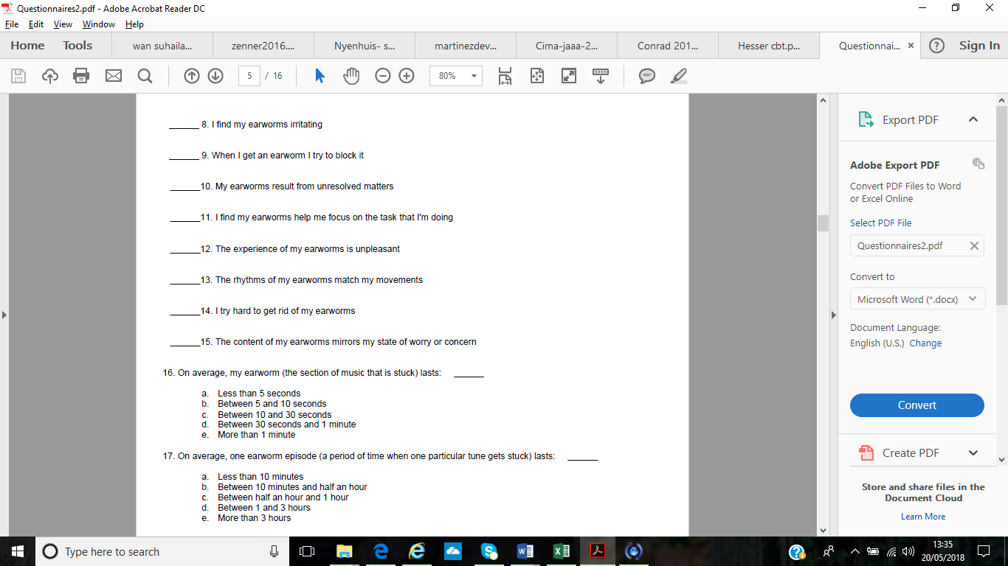

# **Appendix A- iii**

Obsessional Intrusive Thoughts Inventory (Garcia-Soriano et al., 2011).

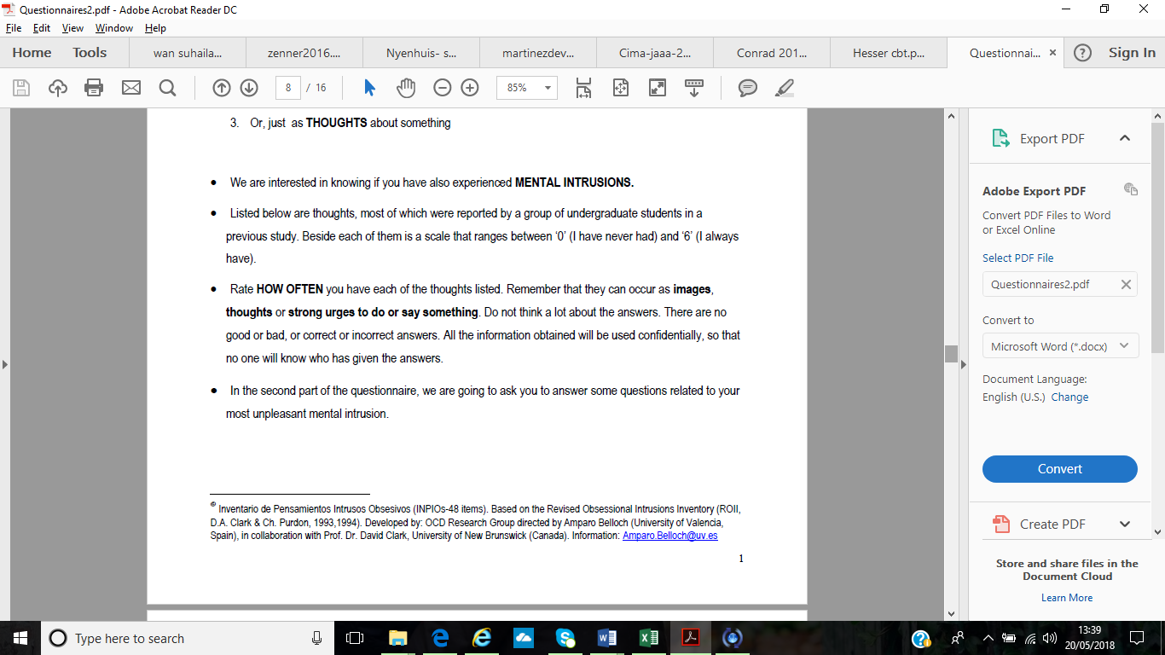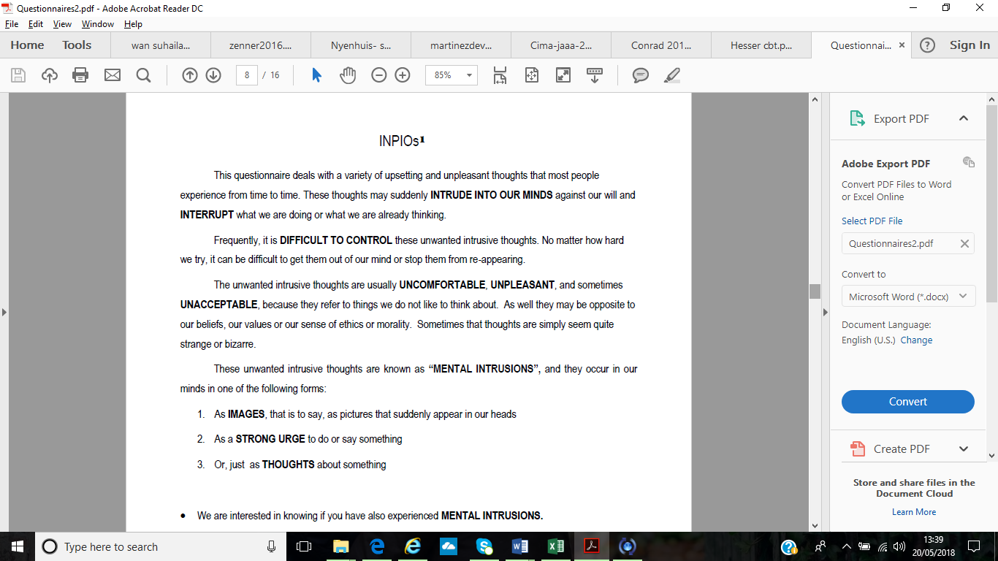

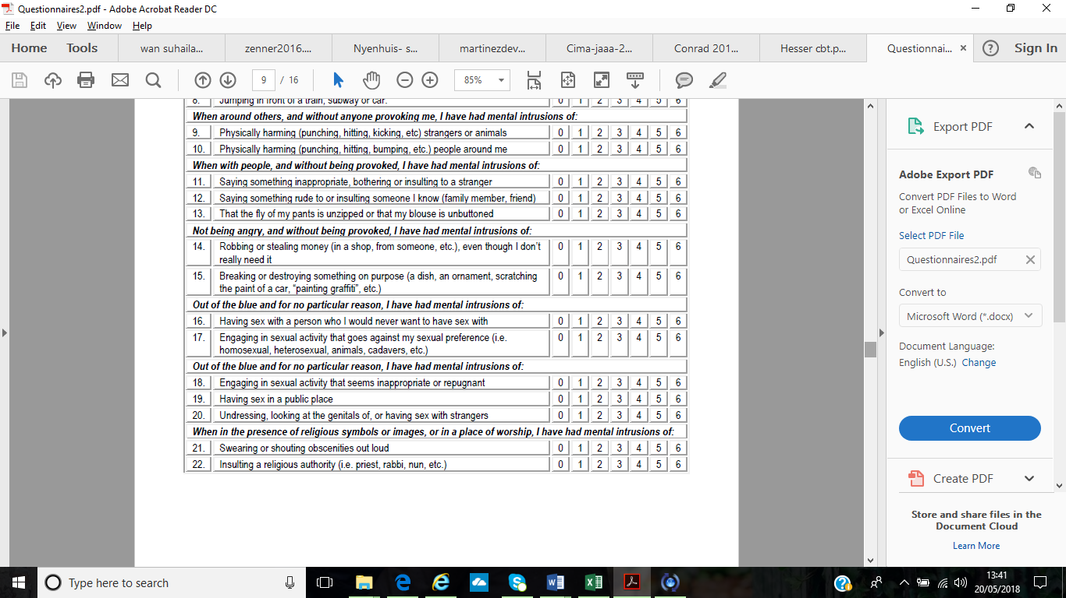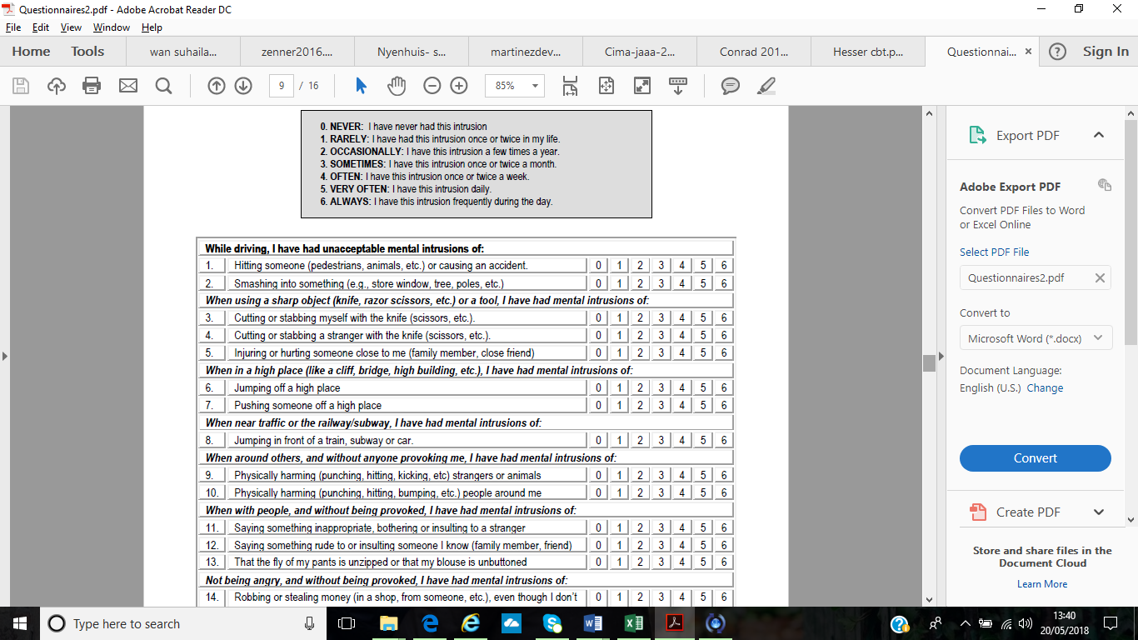

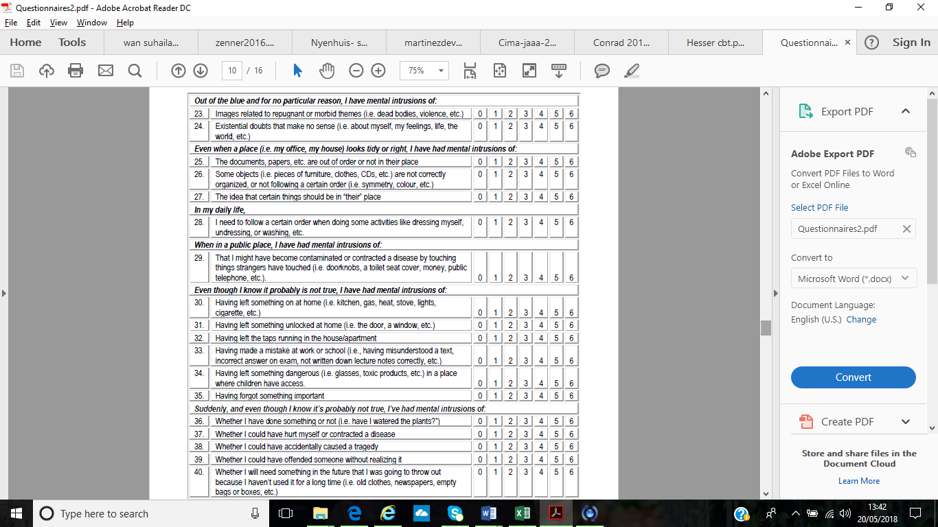

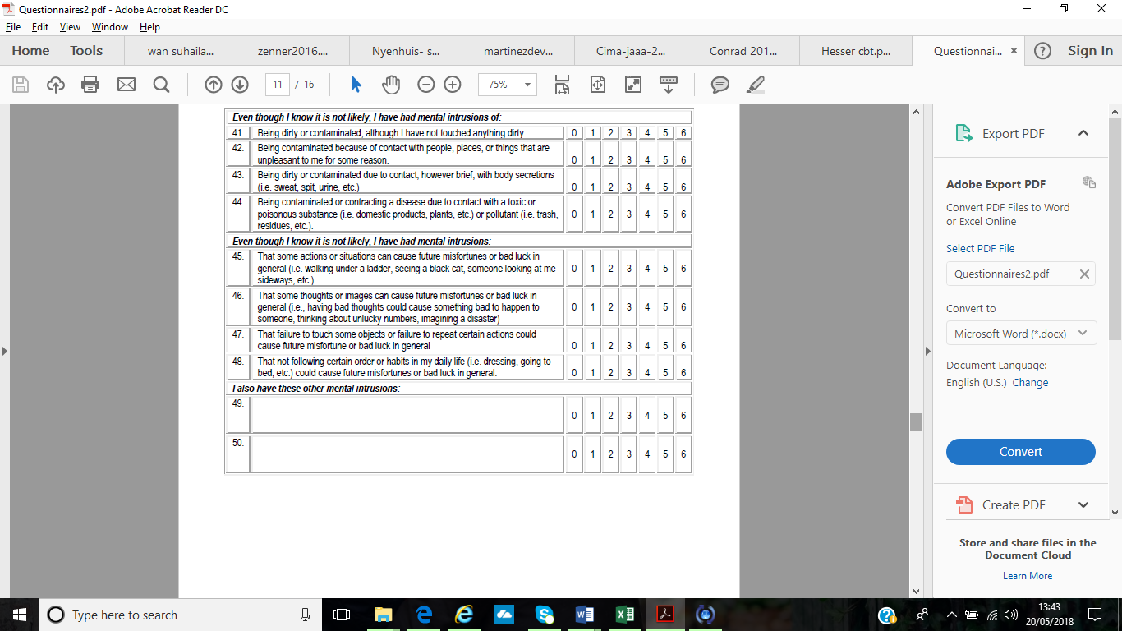

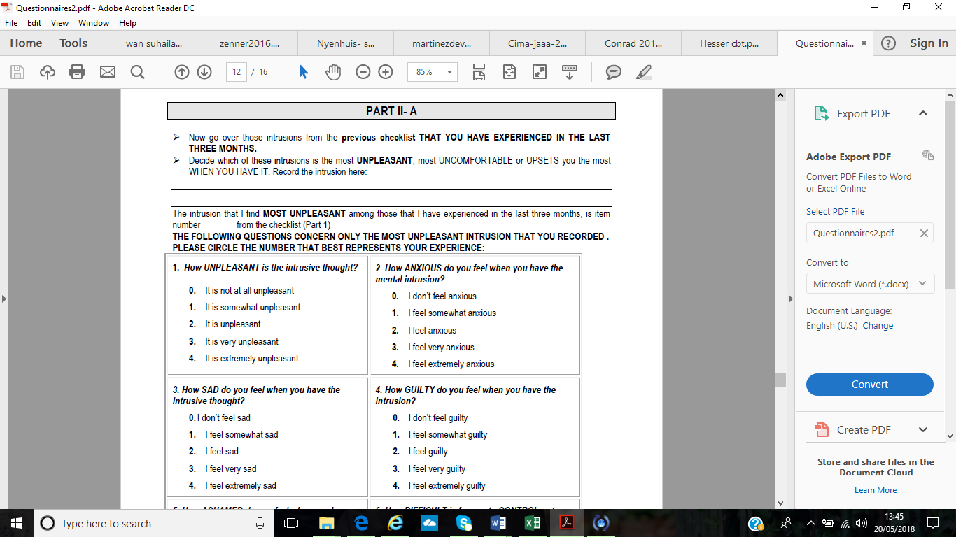

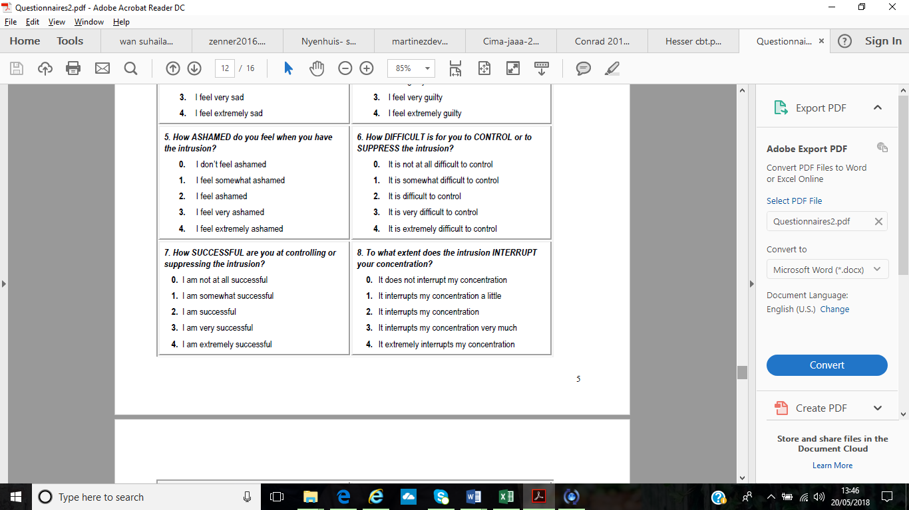

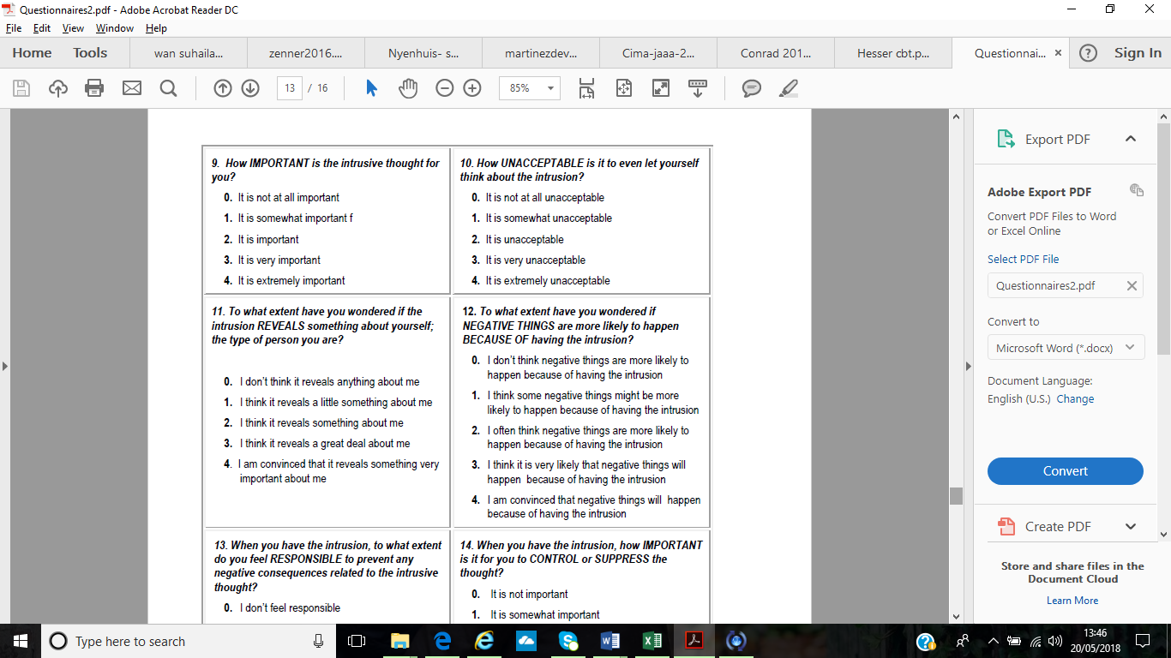

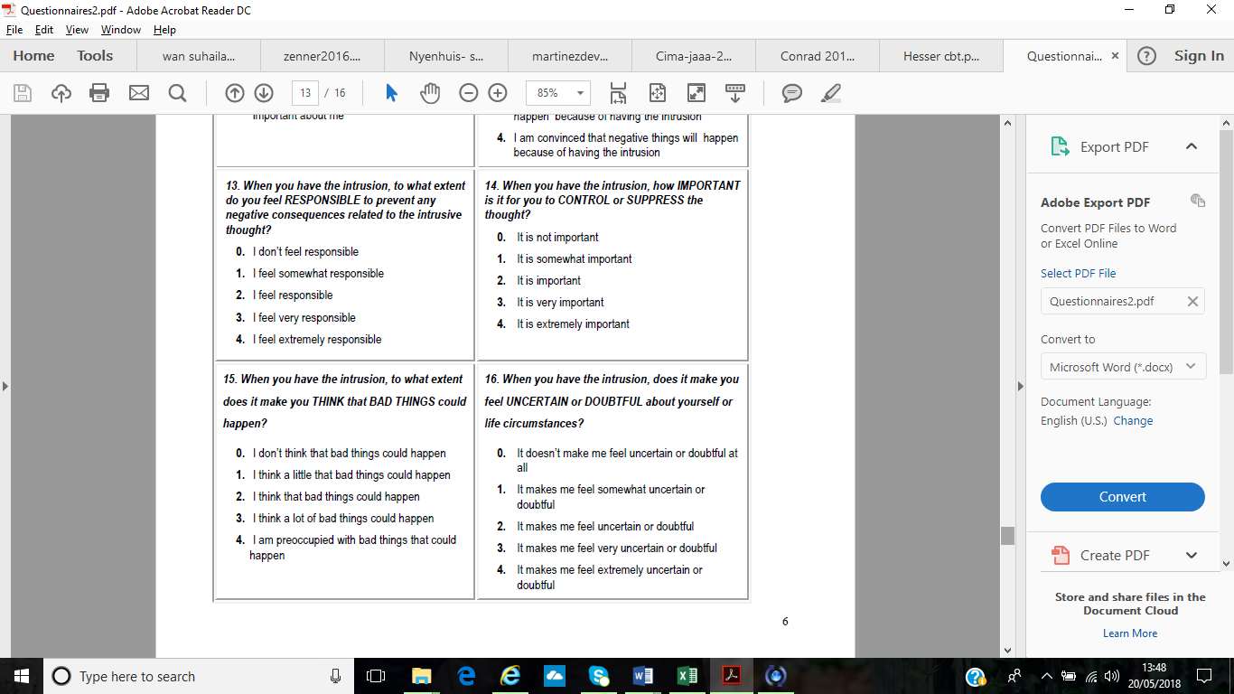

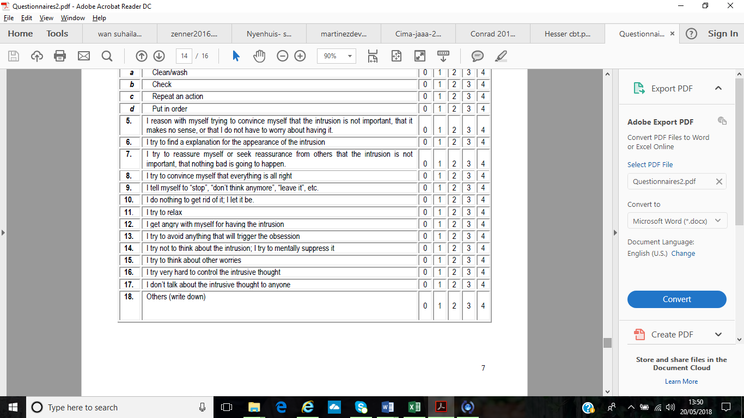 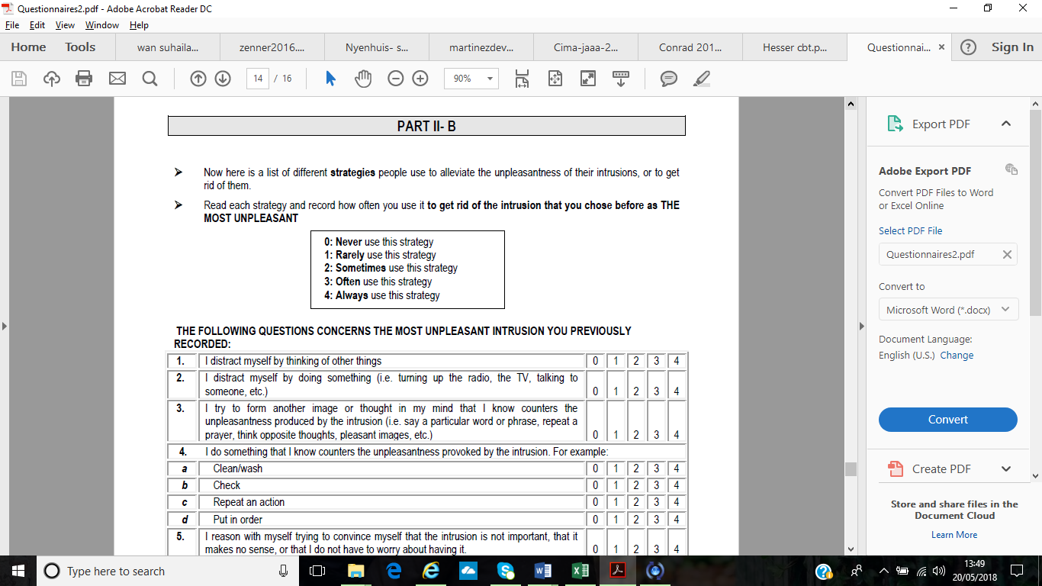

# **Appendix A- iv**

White Bear Suppression Inventory (Wegner & Zanakos, 1994).

**White Bear Suppression Inventory**

|  |  |  |  |  |
| --- | --- | --- | --- | --- |
| **1**  Strongly disagree | **2**  Disagree | **3**  Neutral or don’t know | **4**  Agree | **5**  Strongly agree |

|  |  |  |  |  |  |  |
| --- | --- | --- | --- | --- | --- | --- |
| 1 | I always try to put problems out of mind | 1 | 2 | 3 | 4 | 5 |
| 2 | I have thoughts that I cannot stop | 1 | 2 | 3 | 4 | 5 |
| 3 | There are images that come to mind that I cannot erase | 1 | 2 | 3 | 4 | 5 |
| 4 | My thoughts frequently return to one idea | 1 | 2 | 3 | 4 | 5 |
| 5 | There are thoughts that keep jumping into my head | 1 | 2 | 3 | 4 | 5 |
| 6 | Sometimes I wonder why I have the thoughts I do | 1 | 2 | 3 | 4 | 5 |
| 7 | There are things that I try not to think about | 1 | 2 | 3 | 4 | 5 |
| 8 | There are things I prefer not to think about | 1 | 2 | 3 | 4 | 5 |
| 9 | I have thoughts that I try to avoid | 1 | 2 | 3 | 4 | 5 |
| 10 | I wish I could stop thinking of certain things | 1 | 2 | 3 | 4 | 5 |
| 11 | Sometimes I stay busy just to keep thoughts from intruding my mind | 1 | 2 | 3 | 4 | 5 |
| 12 | I often do things to distract myself from my thoughts | 1 | 2 | 3 | 4 | 5 |
| 13 | There are many thoughts that I have that I don’t tell anyone | 1 | 2 | 3 | 4 | 5 |
| 14 | Sometimes my mind races so fast I wish I could stop it | 1 | 2 | 3 | 4 | 5 |
| 15 | Sometimes I really wish I could stop thinking | 1 | 2 | 3 | 4 | 5 |

**Appendix A- v**

Obsessive-Compulsive Inventory-Revised (Foa et al., 2002).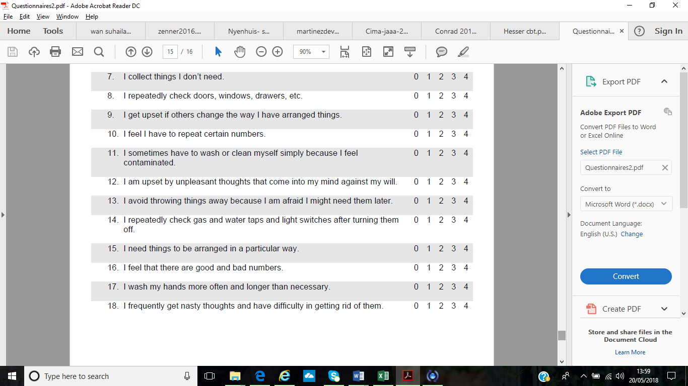

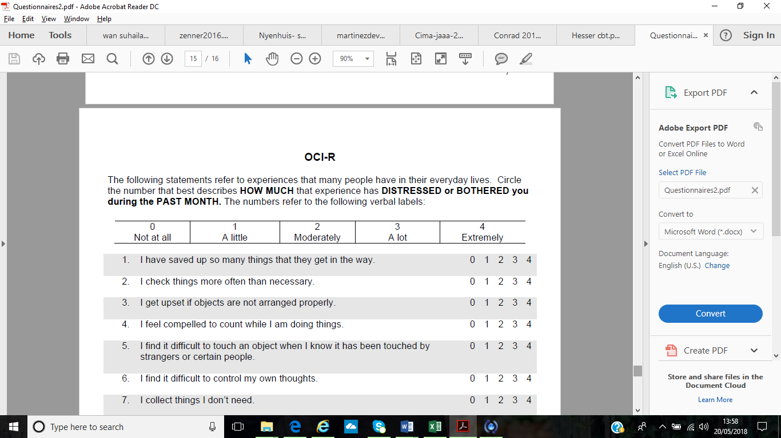

# **Appendix B**

Scores of the OSPAN in full and explanation of each score.

|  |  |  |  |  |
| --- | --- | --- | --- | --- |
| Table 6. Descriptive data for other OSPAN variables | | | | |
|  | Minimum | Maximum | *M* | *SD* |
| Absolute score | 10 | 75 | 44.32 | 15.80 |
| Maths error total | 0 | 15 | 5.51 | 3.19 |
| Maths correct % | 0 | 32 | 7.63 | 5.02 |
| Speed error | 0 | 11 | 1.20 | 1.81 |
| Accuracy error | 0 | 13 | 4.32 | 2.61 |
| *Note. M* = mean, *SD* = standard deviation | | | | |

|  |
| --- |
| **Information pertaining to the OSPAN variables** |
| The OSPAN task generates six scores; ‘absolute score’, ‘partial score’, ‘maths error’, ‘maths error percentage’, ‘speed error’, and ‘accuracy’. The ‘absolute score’ indicates the number of answers completely correct (all letters recalled *and* in the correct order). Conway et al. (2005) state that absolute scores do not account for the fact that the difficulty of a span item can depend on multiple dimensions and merely accepting the most recent correct span item as a person’s overall span ability, means that any longer span items which were recalled correctly, but where processing errors were made, are discarded. The partial score was taken as recommended by Conway et al (2005) and Redick et al (2012). Therefore, the ‘partial score’ is recommended. The ‘partial score’ allows for individual elements of an item to be scored, and therefore credit is given to partly-correct items, for example, credit is assigned when the correct letters are recalled, despite errors in the order of recall. In the current study, the ‘partial score’ is taken as the overall working memory performance score. Other scores generated are ‘Maths error’ (the number of incorrect answers on the mathematical questions) and ‘maths error percentage’ (the percentage of overall accuracy in answering the mathematical questions) (maximum correct maths score = 75). ‘Speed error’ represents the number of answers to maths problems which were not given with the prescribed time, and ‘accuracy error’ represents a wrong answer to a maths problem. |

# **Appendix C- i**

Initial email sent to potential participants.

Dear colleague  
  
My name is Jenny Ward and I am a doctoral clinical psychology student at the University of Sheffield.  I am looking for volunteers to participate in a study exploring the experience of songs and thoughts which intrude into our minds, and what might be linked to this.  
  
The study is open to all staff and students but a high level of English language ability is necessary.  
  
We'd like you to come into the psychology department to complete a 20-minute questionnaire exploring how you experience songs which get stuck in your head - also known as 'earworms'.  You will also answer questions about your experience of random thoughts which pop into your mind.  Some of these thoughts can be distressing, but they are extremely common and people experience these every day.  
  
We'd then like you to complete a 15-minute computer task so we can get an idea of your cognitive functioning.  We're interested to see if this is linked to your experience of earworms and thoughts that pop into your head.  
  
On completion of the study you will be entered into a prize draw to win GBP 50 as a thank you for your participation*.  
  
*Unfortunately, psychology undergraduates who receive course credits for participation in studies can not be entered into the prize draw.  
  
Your participation will offer a valuable contribution to research into involuntary thoughts and help us explore the broad spectrum of how individuals experience this common phenomenon.  
  
Your participation is voluntary and you are free to withdraw at any time, and your information will remain confidential.  
  
This study is being conducted under the supervision of Dr Lisa-Marie Emerson (l.emerson@sheffield.ac.uk) and Dr Victoria Williamson (v.williamson@sheffield.ac.uk) and has received ethical approval from the University of Sheffield Psychology Department Ethics Committee.  
  
If you are interested in taking part or would like more information, please contact me by emailing: jsims2@sheffield.ac.uk.  I will then send you some dates and times and you can decide if you are able to come in and participate.  
  
Many thanks,  
Jenny Ward

# **Appendix C- ii**

Information sheet with consent requested prior to testing.

I am a trainee clinical psychologist and I would like to invite you to participate in this two-part study.  I am working in collaboration with Dr Lisa-Marie Emerson (Department of Clinical Psychology) and Dr Victoria Williamson (Department of Music).

**The study**

*Part One*

Have you ever had a song stuck in your head? The chances are that you have, because this is an extremely common phenomenon.  We’d like to know what your experience is like of having a song stuck in your head- also known as an ‘earworm’.

We’re also interested in looking at the experience of involuntary thoughts which intrude into people’s minds.  Some of these can be distressing, as the same thoughts keep popping into our heads repeatedly, but they are extremely common and people experience these every day.  Some of the questions will ask about unpleasant thoughts which can pop into people’s heads, for example, having thoughts of hurting others.  We’d like to know what that’s like, how you feel about these thoughts and how you try to cope with them.

This will take about 20 minutes.

*Part Two*

We’re also interested in exploring whether a person’s ability to do mental tasks is linked to earworms and involuntary intrusive thoughts.  On completion of the questionnaire, you will be asked to complete a computerised mathematical task.

This will take about 15 minutes.

On completion of both parts of the study, you will receive psychology credits if you are a psychology undergraduate.

Other participants will not receive credits, but will be entered into a prize draw to win £50 as a thank you for your participation.

Your participation is entirely voluntary and you are free to withdraw from the study at any point, by closing down the questionnaire (part 1) or by discontinuing the computer test (part 2).  All the information you provide us with will be treated as strictly confidential and will always remain anonymous.

Prior to participating in this study you will be asked to give yourself a code which will keep your scores anonymous.  Should you wish to withdraw your data after completing the study, you will need to provide your code.

Some of the questions ask about experiences that some people may find distressing. If at any point during the study you feel distressed or concerned about your mental health then please book an appointment to see your GP. Further information and support can be found from the following sources:

Mind

No Panic

OCD action

OCD-UK

Depression Alliance

Anxiety UK

Samaritans

Nightline

If you have any questions about the study, then you can contact the researchers: Jenny Ward (jsims2@sheffield.ac.uk), Dr Lisa-Marie Emerson (l.emerson@sheffield.ac.uk) and Dr Victoria Williamson (v.williamson@sheffield.ac.uk).

This study has been ethically approved by the Department of Psychology, University of Sheffield, ethics review procedure.  
  
If you would like to participate, then please check the box below to confirm that you have read and understood the above information about this study and have had the opportunity to ask questions (by emailing the researchers).  
  
By checking this box you indicate that you understand that participation is voluntary and that you are free to withdraw at any time, without giving any reason, without your legal rights being affected.

|  | I agree to take part in the above study | | | I do not agree to take part in the above study |
| --- | --- | --- | --- | --- |
| PLEASE SELECT ONE RESPONSE |  | | |  |
|  | Current Progress 0% |  |

# **Appendix D- i**

Debrief part one

Thank you for participating in part one of the study, your time is much appreciated. You have answered questions about your experience of involuntary thoughts and ‘earworms’ within the following four questionnaires:

1. Involuntary Musical Imagery Scale: this measured your experience of earworms.
2. Inventario de Pensamientos Intrusos Obsesivos (INPIOS) is based on the Revised Obsessional Intrusions Inventory: this measured your experience of obsessive intrusive thoughts
3. Thought Control Ability Questionnaires: this measured your ability to control intrusive thoughts
4. White Bear Suppression Inventory: this measured your tendency to suppress intrusive thoughts
5. Obsessive Compulsions Inventory-Revised: this measured the severity of obsessive thoughts

We will use your anonymous data to explore the experience of different types of involuntary thoughts, by looking at your scores on each of the questionnaires. We can compare scores between the questionnaires to explore if the experience of involuntary thoughts and ‘earworms’ are similar or different.

Some of the questions ask about experiences that some people may find distressing. If at any point during the study you feel distressed or concerned about your mental health then please book an appointment to see your GP. Further information and support can be found from the following sources:

* [Mind](http://www.mind.org.uk/)
* [No Panic](http://www.nopanic.org.uk)
* [OCD action](http://www.ocdaction.org.uk)
* [OCD-UK](http://www.ocduk.org)
* [Depression Alliance](http://www.depressionalliance.org/)
* [Anxiety UK](https://www.anxietyuk.org.uk/)
* [Samaritans](http://www.samaritans.org)
* [Nightline](http://www.sheffieldnightline.co.uk)

Please email jsims2@sheffield.ac.uk if you have any questions about part one.

Should you wish to make a complaint about anything related to the study, please complete an adverse incident form and contact Richard Hudson (Research and Innovation Service) for guidance on completing this.

You are now invited to participate in part two of the study. Please click below to choose your time and date to attend university to complete part two.

# **Appendix D- ii**

Debrief part two

Thank you for participating in part two of the study. In completing this task, you have provided information on how you use your ‘working memory’ to solve a particular task. Working memory is used when we are asked to perform a mental task, whilst also holding some other information in mind and remembering this. We can now look at your scores on this task, and investigate whether they are related to the scores from your questionnaires. This will help us answer our research question of whether working memory is something which affects the way a person experiences involuntary thoughts and ‘earworms’.

If you have any questions about the study, then you can contact the researchers: Jenny Ward ([jsims2@sheffield.ac.uk](mailto:jsims2@sheffield.ac.uk)), Dr Lisa-Marie Emerson ([l.emerson@sheffield.ac.uk](mailto:l.emerson@sheffield.ac.uk)) and Dr Victoria Williamson ([v.williamson@sheffield.ac.uk](mailto:v.williamson@sheffield.ac.uk)).

Should you wish to make a complaint about anything related to the study, please complete an adverse incident form and contact Richard Hudson (Research and Innovation Service) for guidance on completing this.

As a thank you for your participation, we would like to add your name into a prize draw to win £50. If you would like us to do this, please enter your email address into the box provided.

PLEASE LET THE RESEARCHER KNOW IF YOU WOULD LIKE TO KNOW THE RESULTS OF THE STUDY VIA EMAIL

# **Appendix F**

Ethical approval letter from the University of Sheffield Research Ethics Committee.

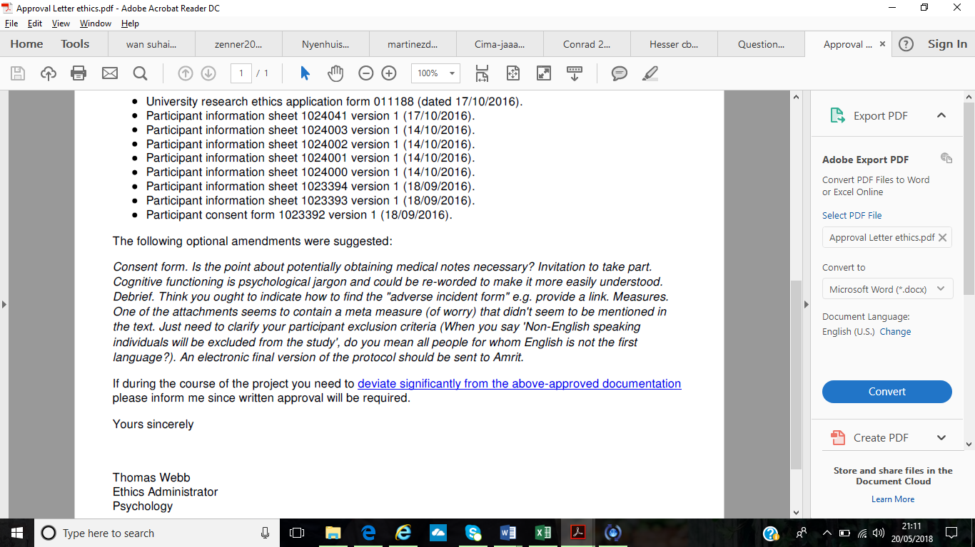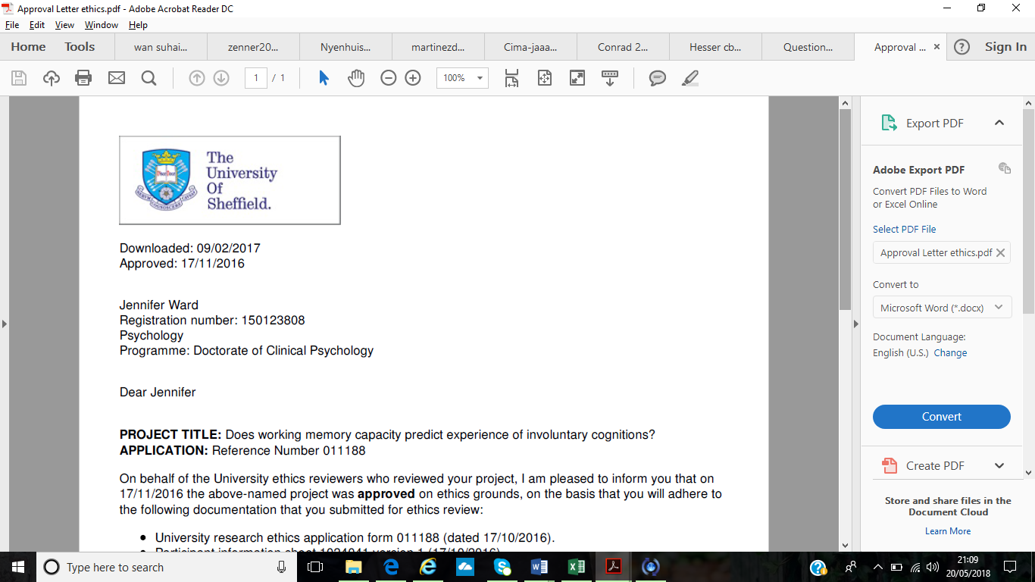

# **Appendix G**

Tables presenting frequency (%) of item responses on the INPIOS (Garcia-Soriano et al., 2011) and IMIS (Floridou et al., 2015).

Table Gi. *Frequency percentages for each item of OIT appraisal measure. Items ask whether the participant’s most upsetting thought makes them feel the following ways.*

|  |  |  |  |  |  |
| --- | --- | --- | --- | --- | --- |
| Item | Not at all (%) | Somewhat  (%) | I feel this  (%) | Very much  (%) | Extremely  (%) |
| 1.Unpleasant | 2.4 | 22.6 | 33.3 | 26.2 | 14.3 |
| 2.Anxious | 9.5 | 25 | 33.3 | 25 | 7.1 |
| 3.Sad | 26.2 | 26.2 | 27.4 | 15.5 | 4.8 |
| 4.Guilty | 28.6 | 23.8 | 16.7 | 21.4 | 9.5 |
| 5.Ashamed | 38.1 | 19 | 22.6 | 15.5 | 4.8 |
| 6.Difficult | 22.6 | 36.9 | 16.7 | 15.5 | 8.3 |
| 7.Successful at controlling | 14.3 | 46.4 | 17.9 | 11.9 | 9.5 |
| 8.Interrupt concentration | 13.1 | 34.5 | 29.8 | 19 | 3.6 |
| 9.How important | 26.2 | 29.8 | 26.2 | 14.3 | 3.6 |
| 10.How unacceptable | 29.8 | 31 | 16.7 | 11.9 | 10.7 |
| 11.Reveals something about me | 14.3 | 26.2 | 33.3 | 22.6 | 3.6 |
| 12.Negative things will happen | 46.4 | 25 | 17.9 | 8.3 | 2.4 |
| 13.How responsible | 23.8 | 21.4 | 33.3 | 13.1 | 8.3 |
| 14.Important to control/suppress | 9.5 | 23.8 | 17.9 | 32.1 | 14.3 |
| 15.Bad things will happen | 25 | 35.7 | 20.2 | 15.5 | 3.6 |
| 16.Uncertain or doubtful | 22.6 | 33.3 | 14.3 | 25 | 4.8 |

Table Gii. *Frequency percentages for each item of INMI appraisal measure. Items ask whether the participant’s earworm experience makes them feel the following ways.*

|  |  |  |  |  |  |
| --- | --- | --- | --- | --- | --- |
| Item | Never  (%) | Not very often (%) | Sometimes  (%) | Most of the time (%) | Always  (%) |
| Agitate me | 13.1 | 34.5 | 42.9 | 8.3 | 1.2 |
| Worries me | 53.6 | 32.1 | 10.7 | 2.4 | 1.2 |
| Wish I could stop | 14.3 | 32.1 | 39.3 | 10.7 | 2.4 |
| Irritating | 9.5 | 21.4 | 56 | 10.7 | 1.2 |
| Try to block it | 8.3 | 35.7 | 34.5 | 16.7 | 3.6 |
| Unpleasant | 31 | 46.4 | 17.9 | 2.4 | 1.2 |
| Try hard to get rid | 19 | 28.6 | 32.1 | 13.1 | 6.0 |