

The role of mindfulness in social anxiety in people living with visible skin conditions

By:
Kerry Montgomery

A thesis submitted in partial fulfilment of the requirements for the degree of
Doctor of Philosophy*

The University of Sheffield
Faculty of Science
Department of Psychology

Submission Date
February 2017

*The results, discussions and conclusions presented herein are identical to those in the printed version. This electronic version of the thesis has been edited solely to ensure conformance with copyright legislation and all excisions are noted in the text. The final, awarded and examined version is available for consultation via the University Library.

Abstract
The research reported in this thesis examined social anxiety in people with visible skin conditions to identify potential targets for intervention. Mindfulness refers to the tendency to pay attention to the present and cultivates a non-judgmental attitude towards experiences. Disengaging from negative patterns of thinking by paying attention to the present, could target rumination which maintains social anxiety.
The findings of Study 1, an interpretative phenomenological analysis (N=10) indicated that social anxiety in people living with visible skin conditions arises as a result of an interaction between negative self-appraisals, fear of negative evaluation and previous reactions of others. Targeting this evaluative process using mindfulness techniques could be beneficial in reducing social anxiety; therefore, Study 2 examined the relationship between mindfulness and psychosocial distress in people with visible skin conditions (N=120). Mindfulness explained 41% of the variance in social anxiety, after controlling for subjective severity. These findings suggest that increasing mindfulness, particularly awareness, and non-judgment of inner experience could reduce social anxiety.
To examine the potential of mindfulness interventions to reduce social anxiety, a systematic review was conducted. Findings highlighted that mindfulness is effective in reducing social anxiety. Potential mechanisms for the effects of mindfulness include reduced reactivity to negative self-referential information and increased attentional control. Study 3 tested the effectiveness of Mindfulness Based Cognitive Therapy (MBCT) for social anxiety in people with visible skin conditions. A multiple baseline single case series was used to examine individual change profiles over time. Reliable and/or clinically significant reductions in social anxiety and at least one other area of psychosocial distress were reported by treatment completers (N = 7). The findings suggest that MBCT is a promising intervention for social anxiety in dermatology patients, and further research is warranted. Feasibility studies may provide important information regarding recruitment and attrition when considering randomised control trials.

TABLE OF CONTENTS
Abstract 2
Contents page 3-5
List of Tables 6
List of figures 7
Publications 8
Acknowledgements 9-10
Chapter 1 The psychological impact of skin conditions 11-28
1.1 Types of skin condition 11-12
1.2 Psychological impact of visible skin conditions 12-19
1.2.1 Anxiety and depression 13-14
1.2.2 Social anxiety 15-17
1.2.3 Reactions of others 17-19
1.2.4 Shame 19-20
1.3 Interventions 21-28
1.3.1 Behavioural interventions 21-22
1.3.2 Psychological interventions 22-28
1.3.2.1 Cognitive behaviour therapy 21
1.3.2.2 Self-help 22-23
1.3.2.3 Individual psychotherapy 23-24
1.3.2.4 Relaxation 25
1.3.2.5 Mindfulness 25-26
1.4 Discussion 26-28
Epsitemological position of the thesis 29-32
Chapter 2 The social experiences of people living with visible skin conditions: An interpretative phenomenological analysis 33-65
2.1 Introduction 33-37
2.2 Method 37-43
2.2.1 Design 37-38
2.2.2 Recruitment procedure 38
2.2.3 Data collection 38-40
2.2.4 Analysis 40-41
2.2.5 Ethical considerations 41
2.2.6 Quality control 42
2.2.7 Reflexivity 42-43
2.3. Results 43-56
2.3.1 Participants 43-44
2.4 Discussion 56-65
2.4.1 Implications for interventions 62-63
2.4.2 Limitations 63-64
2.3.5 Conclusion 64-65
Chapter 3 The relationship between mindfulness, quality of life and psychosocial distress in dermatology patients 66-81
3.1 Introduction 66-68
3.2 Method 68-74
3.2.1 Participants 69
3.2.2 Measures 69-73
3.3 Results 74-77
3.3 Discussion 78-81
3.4.1 Limitations 80
3.4.2 Clinical implications 80
3.4.3 Conclusion 81
Chapter 4 Mindfulness based interventions for social anxiety disorder 82-105
4.1 Introduction 82-85
4.1.1 Mindfulness and social anxiety symptoms 83-84
4.2 Method 85-86
4.2.1 Search strategy 85
4.2.2 Inclusion criteria 85
4.2.3 Methodological quality 86
4.3. Results 86-100
4.3.1 Study Characteristics 86-92
4.3.2 Intervention studies 93-97
4.3.3 Specific mindfulness techniques 97-100
4.4 Discussion 100-105
4.4.1 Future research 104
4.4.2 Conclusion 104-105
Chapter 5 Mindfulness based Cognitive group therapy for social anxiety in people living with visible skin conditions: a single case series 106-154
5.1 Introduction 106-109
5.1.1 hypothesis 109
5.2 Method 109-120
5.2.1 Ethical approval 110
5.2.2 Participants 110-111
5.2.3 Inclusion and exclusion criteria 111-112
5.2.4 Measures 112-115
5.2.5 Intervention 115-118
5.2.6 Treatment integrity 116
5.2.7 Data analysis 118-120
5.3. Results 120-146
5.3.1 Participant characteristics 120-124
5.3.2 Daily measures treatment completers 125-134
5.3.3 Weekly measures 134-140
5.3.4 Clinical and reliable change 140-142
5.3.5 Home practice 143
5.3.6 Treatment integrity 143-144
5.3.7 Attrition 144-146
5.4. discussion 146-154
5.4.1 Attrition 151-152
5.4.2 Home practice 149-150
5.4.3 Clinical implications 151-152
5.4.4 Limitations 152-153
5.5. Conclusion 153-154
Chapter 6 Experiences of MBCT for social anxiety in people living with visible skin conditions 155-182
6.1 Introduction 155-158
6.2 Method 158
6.2.1 Design 158-159
6.2.2 Recruitment 159
6.2.3 Procedure 159
6.2.4 Analysis 159-160
6.2.5 Ethical considerations 160-161
6.2.6 Quality control 161
6.2.7 Reflexivity 161
6.3 Results 163-177
6.4. discussion 177-182
6.4.1 Clinical implications 177
6.4.2 Limitations 182
6.4.3 Conclusion 182
Chapter 7 General discussion 185-195
7.1 Social distress in people living with visible skin conditions 185-187
7.2 Implications for clinical practice 187-188
7.3 Mindfulness and social anxiety 188-190
7.4 The effectiveness of MBCT for social anxiety in people living with visible skin conditions 190-192
7.5 Strengths and limitations 192-194
7.6 Future directions 194-195
7.7 Conclusion 195
References 196-225
Appendix 225-370

List of tables
Chapter 2 The social experiences of people living with visible skin conditions: An interpretative phenomenological analysis 33-65
Table 2.1. Participant characteristics Study 1 44
Table 2.2. Summary of themes 45
Chapter 3 The relationship between mindfulness, quality of life and psychosocial distress in dermatology patients 66-81
Table 3.1 Participant characteristics Study 2 70
Table 3.2 Example items on FFMQ (Baer et al., 2006) 71
Table 3.3. Means, standard deviations and internal reliabilities of variables 71
Table 3.4 Correlations between mindfulness and measures of psychological distress 75
Table 3.5 Summary of regression analysis 77
Chapter 4 Mindfulness based interventions for social anxiety disorder 82-105
Table 4.1 Summary of studies included in systematic review 88-92
Chapter 5 Mindfulness based Cognitive group therapy for social anxiety in people living with visible skin conditions: a single case series……….….. 106-154
Table 5.1 MBCT session outlines 118-119
Table 5.2 Participant characteristics of treatment completers 122-123
Table 5.3 Participant characteristics of participant drop out 124
Table 5.4 TAU U analysis daily question 1 131-132
Table 5.5 TAU U analysis daily question 2 133-134
Table 5.6 Clinical and reliable change in psychosocial distress 142
Chapter 6 Experiences of MBCT for social anxiety in people living with visible skin conditions 155-182
Table 6.1 Participant characteristics study 4 163
Table 6.2 Summary of themes 164

List of Figures
Chapter 1 The psychological impact of skin conditions 11-27
Figure 1.1 Categories of dermatological conditions 12
Figure 1.2 Cognitive model of social phobia (Clark and Wells, 1995) 16
Chapter 2 The social experiences of people living with visible skin conditions: An interpretative phenomenological analysis 33-65
Figure 2.1 Interview schedule 2 39
Chapter 4 Mindfulness based interventions for social anxiety disorder 82-105
Figure 4.1 Search strategy (PRISMA, 2009) 87
Chapter 5 Mindfulness based Cognitive group therapy for social anxiety in people living with visible skin conditions: a single case series……….….. 106-154
Figure 5.1 Recruitment and allocation of participants 114
Figure 5.2 Daily measures for treatment completers 127-130
Figure 5.3 Weekly scores of mindfulness facets 136-138
Figure 5.4 Weekly scores mindfulness and social anxiety 139-140
Figure 5.5 Daily measures: drop out 144-145
Chapter 6 Experiences of MBCT for social anxiety in people living with visible skin conditions 155-182
Figure 6.1 Interview schedule 162

Publications

Montgomery, K., Norman, P., Messenger, A. G., & Thompson, A. R. (2016) The importance of mindfulness in psychosocial distress and quality of life in dermatology patients. British Journal of Dermatology, 175, 930-936. doi: 10.1111/bjd.14719

Montgomery, K., & Thompson, A.R. (In press) The potential role of mindfulness in psychosocial support for dermatology patients. Clinics in Dermatology.

Acknowledgements
There are so many people I would like to thank that I fear my acknowledgements could end up as long as my thesis, but I will do my best. I need to first start by acknowledging the funding of the ESRC which enabled me to carry out the current programme of research. For a very long time I have wanted to work with people living with visible health conditions, and to develop interventions to reduce distress in this population. Five years ago, at what I would say was a particular turning point in my life, I had started volunteering with The Katie Piper Foundation and read Dr. Andrew Thompson’s work. I had not previously considered a career in research; however, after feeling inspired by the work at Sheffield I decided to apply for my PhD, and with Dr. Thompson’s support and encouragement I was successful in receiving funding. I want to say a sincere thanks to my supervisors Dr. Andrew Thompson, Professor Paul Norman and Professor Andrew Messenger. Without your knowledge, support, patience and encouragement I would not be writing my acknowledgements now. It has been an absolute pleasure to work with you all in the last three years and I hope you are happy with the final result.
I would like to thank all my participants, without you there wouldn’t be a thesis! I would also like to thank all the dermatology staff at Sheffield Hallamshire Hospital for their support with recruitment and keeping me entertained when things were moving slowly. I want to thank Sheffield IAPT for their support, which came in many forms, from my wonderful managers Mark Knowles and Helen Corcoran, to Gillian Donohue for kindly reviewing group sessions. A big thank you to Kevin Smith for facilitating the MBCT group; your passion for mindfulness shines through and I await your blog/book!
I have met some inspiring people working with charities to support people with skin conditions so thanks to Changing Faces, Psoriasis Association, Vitiligo Society and The British Association of Skin Camouflage. A special thank you to Jen and Amy at AUK; you not only helped with recruitment but shared your knowledge, and insight (and tea and cake) with me, so thanks for everything!
During my PhD I was lucky to receive funding for an internship and an overseas institution visit. During my internship, I worked with The Katie Piper Foundation. To Ezinna, I want to extend a sincere thank you, for the placement and your support. You have definitely helped me along this three-year journey. During my overseas visit, I spent 10 weeks in Germany under the supervision of Dr Christina Schut. During the 10 -weeks I not only learned so much about the field of psychodermatology from Dr Schut, and Dr Kupfer, but I also had a fantastic time exploring Germany - thanks to all the wonderful people at the Institute for Medical Psychology (Stefanie, Daniella, Lisa, and the rest of the institute) and of course Christina, for making my time in Germany so enjoyable; I’m pleased to have made some wonderful new friends.
I have been incredibly lucky to work in a department with some fantastic PhD students. Harriet and Mel; thanks for all your support, which came in many forms from spa breaks, tea and cake, vodka and wine; you have been amazingly supportive, whilst providing light relief from a heavy work load. To Chloe, Connor, Elaine, Mel, Harriet, Simone and Goita, who have all provided support and encouragement - thank you. Thanks to all my friends who have been so patient and supportive, particularly, Becka, Becca, Michelle and Louise - thanks for all the times we have put the world to rights, I look forward to spending much more time with you now.
Last but never least, I want to say thank you to my family. From the practical things like looking after Gizmo when I’m jetting off away for 10 weeks (sorry Stewart!), to my mum who always makes sure I’m taking care of myself and sending care packages to me even at my age! Daniel, you make me laugh without trying and you provided support in your own way! Dad and Vanessa, after a tough couple of years you have been amazing. Thanks for never letting me doubt myself (for too long). To my wonderful family who are always there when I need you, I want to dedicate this thesis to all of you, and to my grandad; I hope that it would have made him very proud.

Chapter 1. The psychological impact of skin conditions

Skin is the largest organ of the body; having a condition which alters the appearance of the skin can, in some cases, lead to difficulties in psychological and social functioning (The All Parliamentary Group on Skin, 2013). Over 220,000 people in the UK have a skin condition, accounting for the largest number of conditions affecting appearance (Changing Faces, 2008). Approximately 13 million people (24% of the population) in England and Wales visit their GP with a problem related to the skin each year and around 0.8 million (6.1%) are referred to dermatology services (APPGS, 2013). Compared with other major diseases, skin conditions are the most frequent reason for consultations in general practice (Schofield, Fleming, Grindlay, & Williams, 2011).
Several terms can be used to refer to problems associated with the skin: skin disorder, skin condition, skin disease or the specific medical diagnosis. The term skin condition will be used throughout this thesis as it is inclusive and captures a range of problems associated with the skin and hair. The aim of this introductory chapter is to provide an overview of (i) the psychological impact of skin conditions and (ii) psychological interventions for people living with skin conditions.
  - Types of skin condition
Regarding the relationship between skin and psychological factors there are 3 main categories of skin conditions (See Figure 1.1). First, primary psychological conditions refer to psychiatric conditions that manifest via the skin such as trichotillomania. Secondary psychological skin conditions are primary skin conditions which can be precipitated or exacerbated by psychological distress (Taylor, Bewley, & Melidonis, 2006) for example psoriasis (Hunter, Griffiths, & Kleyn, 2013). The third type of skin conditions are psychophysiological conditions which can lead to the development of psychological disorders. Psychological distress can arise as a consequence of living with a skin condition (Taylor et al., 2006); for example, some people living with alopecia areata may experience social anxiety due to concerns about appearance (Tucker, 2009).
The studies within the current programme of research will focus on distress associated with secondary psychological and psychophysiological skin conditions (Figure 1.1). Primary psychological conditions were not included as they may be complicated by other factors such as post-traumatic stress (e.g. burn injury).
Figure 1.1: Categories of dermatological conditions (adapted from Thompson, 2009)
Primary psychological skin conditions

Dermatitis artefacta
Dysmorphobia Trichotillimania
Delusions of parasitosis

Psychophysiological skin conditions

Psoriasis
Acne
Rosacea
Atopic dermatitis

Secondary psychological skin conditions

Vitiligo
Psoriasis
Acne
Alopecia areata

1.2 Psychological impact of visible skin conditions
Whilst some people living with a visible skin condition adjust well, there is a risk that people can experience psychological distress associated with their condition (Thompson, 2009). It is widely acknowledged that people with skin conditions consistently report higher levels of depression and anxiety in comparison to healthy controls (Dalgard et al., 2015; Fortune, Richards, Main, & Griffiths, 2000; Gupta & Gupta, 1996), with suicidal ideation being reported in some studies (Dalgard et al., 2015; Gupta & Gupta, 1996; Cotterill & Cunliffe, 1997).
Research suggests that the objective severity of the skin condition is not an accurate predictor of psychological distress (Evers et al., 2005; Fortune et al., 2000; Perrot, Murray, Lowe, & Mathieson, 2000; Sampogna et al., 2004). These findings suggest that psychosocial factors play an important role in the impact of skin conditions. The relationship between skin conditions and distress is not uni-directional and evidence suggests that stressful life events can trigger or worsen physical symptoms of skin conditions (Brown, 1972; Chui, Chon, & Kimball, 2003; Fortune et al., 2002; Hunter et al., 2013; King & Wilson, 1991; Wittowski, Richards, Griffiths, & Main, 2004; Verhoeven et al., 2009).
The perception of stress as overwhelming can trigger responses by central and peripheral pathways (Hunter, Momen, & Kleyn, 2015). Once the individual believes stress has exceeded their ability to cope it can influence immune function (Lazarus & Folkman, 1984). This physiological response can result in impaired wound healing and altered immune function which can have serious implications for people living with skin conditions. Verhoeven et al. (2008) acknowledged the important role of psychosocial stress in itch, a problematic symptom reported across some patients living with eczema and psoriasis. The biopsychosocial model of itch (Verhoeven et al., 2008) proposed that the interaction between internal (personality factors) and external (stressful events) factors can influence beliefs about illness and behaviours which then increase or decrease itch. Given the role of psychosocial stress in triggering or worsening skin conditions, interventions which support people to develop helpful coping strategies to manage stress may reduce physiological arousal and thus reduce the physical impact of stress.
1.2.1 Anxiety and depression
It has been estimated that for at least a third of dermatology patients, effective management requires the consideration of emotional factors (Gupta & Gupta, 1996; APPGS, 2013). Considering specific conditions during interviews, people with psoriasis reported feeling physically and sexually unattractive (Mckenna & Stern, 1997) but the impact of psoriasis on quality of life appeared to decrease with age (McKenna & Stern, 1997). In a correlational study of people living with psoriasis, pathological worrying was reported to be around 25-30% (Fortune et al., 2000). Pathological worrying was not associated with clinician rated severity, and regression analysis indicated it was associated with beliefs that psoriasis had serious consequences.
Depression, anxiety and thoughts of suicide have been reported in patients with psoriasis (Jowett & Ryan, 1985; Gupta & Gupta, 1998). In interviews, the negative impact of physical discomfort caused by psoriasis, eczema and acne on mood was discussed; however, for many, the social and emotional consequences of living with a visible condition was the most significant contributor to low mood and anxiety (Jowett & Ryan, 1985). Mizara, Papadopoulos, and McBride (2012) examined psychological distress in patients with psoriasis and atopic eczema and found that scores on the Hospital Anxiety and Depression Scale (Zigmond & Snaith, 1983) were suggestive of probable mood disorders. Six maladaptive schemas were identified in which suggested patients perceived themselves as being emotionally deprived, different and isolated, flawed and unlovable, relatively unsuccessful, unable to cope and subjugated (Mizara et al., 2012).
Acne has been found to have a significant adverse effect on psychosocial and emotional health comparable to patients with back pain, arthritis and asthma (Parks et al., 2003). People living with acne have been found to experience depression (Gupta & Gupta, 1996) and increased thoughts of suicide (Cotterill & Cunliffe, 1997). In correlational studies of people living with inflammatory skin conditions (including eczema, acne and psoriasis), higher levels of depression and anxiety were reported in comparison to healthy controls (Ozturk, Deveci, Bagcioglu, Atalay, & Serdar, 2013; Parna, Aluja, and Kingo, 2015). Levels of social anxiety and feelings of rejection in romantic relationships were significantly higher in people living with severe acne in comparison to those with mild acne and healthy controls (Ozturk et al., 2013). In a study of women living with skin conditions affecting the face, rosacea was found to have a significant negative effect on health-related quality of life (Balkrishnan et al., 2006).
Research suggests that people living with alopecia may be at risk of social or work- related problems (Hunt & McHale, 2005). In one study, 66% of patients with alopecia areata presented with psychiatric co-morbidity (Ruiz-Doblado, Carrizosa, & Garcia- Hernandez, 2003) including generalised anxiety and depression. In a systematic review, alopecia areata was found to have a negative impact on self-esteem and to lead to increased levels of depression, anxiety and phobic reaction (Tucker, 2009). A recent meta-analysis of studies of alopecia areata found that people consistently report a negative impact of alopecia on health-related quality of life, particularly in regard to mental health (Rencz et al., 2016). Higher levels of body dissatisfaction and preoccupation with appearance have been reported in men and women living with alopecia, relative to controls (Hunt & McHale, 2004; Cash, 1992; Cash, Price & Savin, 1993), with 40% of women reporting marital problems as a consequence (Hunt & McHale, 2004). Findings suggest that an individual’s own perception of hair loss accounts for 35% of the variance in quality of life in patients with primary cicatricial alopecia (Chiang, Bundy, Griffiths, Paus, & Harries, 2015).
Whilst living with a skin condition can have a range of physical and psychological consequences one of the most commonly reported problems is social anxiety (Leary, Herbst, Exum, & Feldman, 1998; Schneider, Heuft, & Hockman, 2011; Salmon, Kurt, Topcuoglu, & Demircay, 2016).

1.2.2 Social Anxiety
Social anxiety is one of the most frequently reported complaints of individuals with conditions that affect appearance (Kent & Keohane, 2001; Newell & Marks, 2000; Pärna, Aluoja, & Kingo, 2015; Rumsey, Clarke, & White, 2003; Salmon et al., 2016). Leary et al. (1998) found that patients with psoriasis who reported high levels of fear of negative evaluation had greater social difficulties and experienced more negative social consequences. Kent and Keohane (2001) found high levels of fear of negative evaluation in people living with psoriasis that accounted for 26.7% of the variance in quality of life, highlighting the significant impact of social-evaluative concerns. In acne patients, dermatological social anxiety, a measure of apprehension of having one’s skin evaluated was negatively related to intention to engage in sport and exercise, and skin-specific quality of life (Loney, Standage, & Lewis, 2008). The findings suggest that an individuals’ apprehension about having their skin evaluated can act as a barrier to engagement in activity. In a cross-sectional study, adults living with inflammatory skin conditions reported higher levels of social anxiety and panic-agoraphobia symptoms, in comparison to healthy controls; this highlights the impact that living with a visible skin condition can have on social interaction and inter-personal relationships (Parna et al., 2015).
Social anxiety is characterised by a fear of being negatively evaluated by others (Leary, 1983). Cognitive models of social anxiety propose that during social situations, socially anxious individuals become preoccupied with social-evaluative thoughts (Clark & Wells, 1995; Rapee & Heimberg, 1997). This increase in self-focused attention is a key maintenance factor of social anxiety (Clark & Wells, 1995; Rapee & Heimberg, 1997; Morrison & Heimberg, 2013) and prevents individuals from noticing external stimuli that may disconfirm social fears (Clark & Wells, 1995; Spurr & Stopa, 2002). Whilst research has examined the role of self-focused attention in the maintenance of social anxiety, there has been considerably less research examining which aspect of the self attention is focused (Morrison & Heimberg, 2013). In a meta-analysis of attentional bias towards threat in anxiety disorders, Pergamin-Hight, Bakermans-Kranenburg, Van Ijzendoom and Bar-Haim (2015) examined whether disorder-congruent threat led to higher levels of attentional bias than when individuals were presented with disorder incongruent or general threat stimuli. For social anxiety, disorder-congruent threat related to social-evaluative stimuli. Findings highlighted that attentional bias was higher towards disorder-congruent stimuli (d = 0.28) than disorder-incongruent stimuli (e.g. socially anxious individuals presented with trauma-related stimuli) across anxiety disorders.
Figure 1.2. Cognitive model of social phobia (Clark & Wells, 1995)
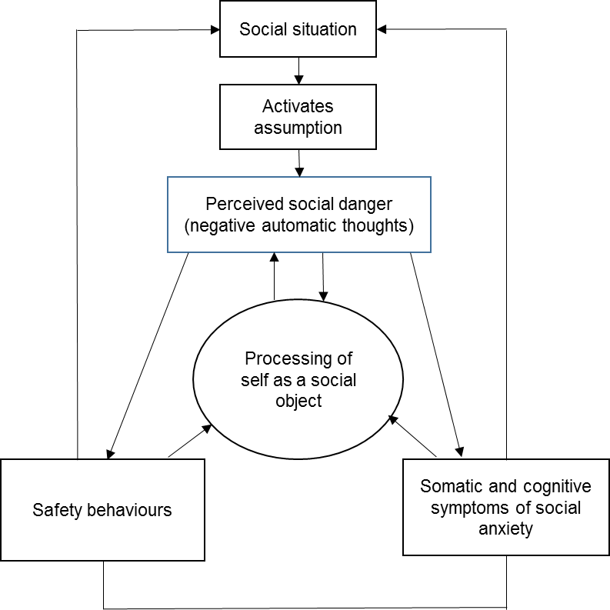
Individuals with social anxiety display attentional bias towards information confirming social fears (Hirsch & Clark, 2004; Morrison & Heimberg, 2013) and away from positive social cues (Taylor, Bomyea, & Amir, 2010). In experimental studies, socially anxious individuals were slower to disengage from disgust faces in comparison to non-anxious controls. However, there was no significant difference in time to dis-engage from happy faces between socially anxious and non-anxious controls (Buckner, Maner, Norman, & Schmidt, 2010). Research has also found that socially anxious individuals are more likely to interpret neutral or ambiguous stimuli as threatening, in comparison to non-anxious controls (Taylor et al., 2010). In an experimental study, socially anxious individuals were compared to non-anxious controls on their interpretation of video clips which contained negative, positive and ambiguous comments related to their belongings (e.g. clothing) or interactions. Socially-anxious individuals interpreted ambiguous comments more negatively than non-anxious controls (Amir, Beard, & Bower, 2005).
In an attempt to reduce or avoid distressing symptoms of social anxiety, individuals may engage in safety behaviours (Clark & Wells, 1995; Rapee & Heimberg, 1997; Heimberg, Brozovich, & Rapee, 2010) which can include avoidance of social situations or engagement in behaviours the individual feels will reduce anxiety (e.g., not speaking during meetings, avoiding eye contact, and not engaging in conversations). Safety behaviours act as self-protection strategies which are perceived as reducing the likelihood of negative social consequences (Clark & Wells, 1995; McManus, Sacadura, & Clark, 2008; Morrison & Heimberg, 2013; Heimberg et al., 2010). People with higher levels of social anxiety have reported using more safety behaviours, more frequently in comparison with people with lower levels of social anxiety (McManus et al., 2008).
It has been proposed that cognitive models of social anxiety (Clark & Wells, 1995) may be usefully applied to people living with visible conditions. This is given similarities between social and avoidance difficulties reported by people with social anxiety and those with conditions affecting appearance (Clarke et al., 2013; Newell & Marks, 2000). Concern about appearance has been found to lead to information processing biases (Altabe & Thompson, 1996; Rosser, Moss, & Rumsey, 2010); these biases are similar to those implicated in social anxiety, in that the world is interpreted in a way that reinforces and maintains appearance concerns (Rosser et al., 2010). Cognitive models of social anxiety need to consider the role of specific appearance-related cognitions and appearance concern in cognitive processing during social situations. In addition, the influence of reactions of others on cognitive processing during social situations needs further examination to determine the applicability of models of social anxiety in people living with visible skin conditions.
1.2.3 Reactions of others
It is well documented that people living with visible skin conditions may experience negative reactions from others including bullying, staring and comments, as a result of the appearance of their skin (Magin, Adams, Heading, Pond, & Smith, 2008; Thompson et al., 2010). A survey by The British Skin foundation found that 47% of people living with a skin condition reported verbal abuse related to their skin condition on one or more occasions (APPGS, 2013). Ryan, Oaten, Stevenson, and Case (2012) examined the prediction that individuals with a facial visible difference would trigger a disease avoidance response similar to the avoidance of individuals with ill health. The results showed that despite the confederates with influenza symptoms being "contagious", participants responded to the confederate with a birth mark in the same way concluding that those with a visible facial birth mark tended to evoke contamination concerns similar to the response to someone who is contagious. In a sample of 514 people living with psoriasis, 73% of respondents reported some degree of stigmatisation (Van Beugen et al., 2016) suggesting that social situations can present a significant challenge to people living with psoriasis.
Stigma refers to the devaluation of a specific attribute by society (Goffman, 1963) and distinctions have been made between enacted and felt stigma (Scrambler & Hopkins, 1986). Enacted stigma refers to cases of actual negative reactions from others, and felt stigma refers to the individual’s own sense of being different and fearing rejection from others as a result of an attribute they view in a negative way. Perceptions of stigmatisation and depression were the most important contributors to psoriasis-related disability, above that of clinical severity and area of involvement (Fortune et al., 2000). Perceptions of stigmatisation alone explained 35% of the variance in psoriasis-related disability (Richards, Fortune, Griffiths, & Main, 2001).
Incidents of stigma highlight the reality of negative reactions towards people living with visible skin conditions (Kent & Keohane, 2001) and may lead to the development of a ‘self-schema’ associated with increased anxiety about social situations related to the expectation of being rejected due to appearance (Kent & Thompson, 2002). Fear of negative evaluation during social situations may be a consequence of having encountered negative reactions from others in the past (Kent & Keohane, 2001), highlighting a need to examine social experiences in the context of how rejection may influence social behaviour (Richman & Leary, 2009).
Richman and Leary (2009) propose that how the individual perceives the rejection experience can predict their behavioural response. Responses can be prosocial (seeking out social contact to restore the relationship following rejection), antisocial (becoming angry and hostile towards others) or socially avoidant (withdrawal from further social contact), or a combination of the three. Whilst antisocial responses are maladaptive and likely to lead to further rejection, all the responses outlined by Richman and Leary (2009) could be viewed as strategies to reduce the impact of the rejection on the individual’s self-esteem. For example, responding aggressively towards the ‘rejecter’ could be motivated by the individual’s sense of wanting to regain control over the situation. This framework will be considered in more detail in Chapter 2 and discussed in the context of people living with skin conditions.
1.2.4 Shame
The perception of oneself as having personal attributes or characteristics which are undesirable to others can lead to feelings of shame (Gilbert & Andrews, 1998). Shame can be internalised, and relate to how the individual feels about their own attributes (Gilbert, 2000) or external which relates to the individuals’ perception of being rejected by others due to particular attributes. Individuals may experience either internal or external shame but the two are highly correlated and often co-occur (Gilbert, 2000). In a sample of patients living with psoriasis, 90% of people reported experiencing shame and embarrassment due to the appearance of their skin (Jowett & Ryan, 1985). Hadshiew, Foitzik, Arck, and Paus (2004), reported that people living with alopecia reported feelings of shame and self-consciousness as a result of the condition, and females reported reduced attractiveness (Cash et al., 1993).
The National Psoriasis Foundation reported that 81% of respondents were embarrassed about others seeing their psoriasis with 57% of people mistakenly believing psoriasis was contagious (Krueger et al., 2001). Feelings of shame as a result of appearance can result in maladaptive coping strategies including concealment of the condition, or avoidance of situations in which the individual feels the condition may be more visible to others (e.g., swimming) (Thompson & Kent, 2001; Thompson et al., 2010; Montgomery, White & Thompson, 2017). Social avoidance may be conceptualised as a strategy to avoid feelings of shame, as this reduces the likelihood of negative reactions from others and stigmatisation.
Shame and social anxiety can be conceptualised as self-conscious emotions, and share an underlying assumption that the individual experiencing these emotions views themselves as inferior, and is overly concerned about the negative perceptions of others (Gilbert, 2000). Models of social anxiety propose that socially anxious individuals engage in a process of evaluating themselves and evaluating the self from the perspective of a critical audience. Attentional and interpretative biases lead to increased sensitivity to rejection cues and behavioural strategies of avoidance of social situations (Clark & Wells, 1995; Rapee & Heimberg, 1997). As highlighted by Gilbert (2000) it is unclear if these processes are specific to social anxiety or may also be used to conceptualise shame. There have been few studies exploring the link between social anxiety and shame; however, it has been proposed that there can be a direct equation between the two (Tangey & Miller, 1996).
One potential difference between shame and social anxiety is that shame can be highly focused on a particular attribute (e.g. appearance of a skin condition) and shame arises when the individual perceives they are likely to be rejected on the basis of this attribute. For people living with a skin condition which is concealed by clothing or in alopecia by a wig, people may experience internal shame in relation to their beliefs about the condition; however, social anxiety may only present if there is a threat to the condition being exposed. In addition, the treatments for social anxiety, which include exposure to social situations which have previously been avoided (Clark & Wells, 1995) can increase feelings of shame if there is an increased likelihood of a particular attribute being ‘exposed’, therefore modifications to social anxiety treatment protocols, where shame is a particular feature may be appropriate. Examining the processes underlying negative social situations in people living with visible skin conditions can therefore offer an opportunity to explore the relationships between negative self-appraisals and reactions of others to examine if social anxiety models can be applied to this population.
Aims of the thesis
The current thesis focuses on social anxiety experienced by people living with skin conditions. Previous studies have identified that social anxiety is a significant problem for people living with skin conditions (Kent & Keohane, 2001; Leary et al., 1998; Newell & Marks, 2000; Pärna, et al., 2015; Rumsey et al., 2003; Salmon et al., 2016) and therefore, there is a need for interventions to reduce social distress in this population. The cognitive processes underlying social anxiety in mental health populations are well documented (Clark & Wells, 1995; Rapee & Heimberg, 1997), and evidenced based treatment models and protocols exist (Clark & Wells, 1995). The current thesis will examine if the cognitive processes underlying social anxiety are applicable to people living with skin conditions, to identify if treatment protocols may be successfully applied to this population and any adaptations that may be required. The social experiences of people living with a visible skin condition will be explored in Study 1 and any conceptual overlap between the concepts of shame and social anxiety will be discussed.

  - Interventions

Given the prevalence of psychological distress in people living with skin conditions it is important that people can access appropriate psychological support. Interventions for people living with skin conditions can be divided into two categories, (i) interventions targeting psychological distress, and (ii) specific behavioural interventions designed to reduce distressing physical symptoms associated with skin conditions (e.g., habit reversal). This chapter will now discuss some of the interventions available to people living with skin conditions. Whilst it is acknowledged that alternative interventions are available (e.g., hypnosis), this overview will focus on interventions which are drawn from psychological theory, or based on behavioural techniques to reduce physical symptoms.
1.3.1 Behavioural interventions
In some skin conditions itch is a prominent and distressing symptom which can lead to scratching and, as a result, breakdown of the skin can occur leading to inflammation and increased risk of infection. In addition to the physical implications, scratching can also result in the skin condition being more visible to others. Habit reversal has been identified as an effective treatment for people living with skin conditions where itch is a problematic symptom (g = 1.05; Lavda, Webb, & Thompson, 2012; Daunton, Bridgett, & Goulding, 2016).
Habit reversal therapy, first introduced to manage atopic eczema, is a combination of behavioural techniques and topical treatments to help people manage the symptoms of itch (Bridgett, 2014). To begin with a patient is guided through psychoeducation around the itch scratch cycle and initial scratching is introduced as a conscious behaviour. However, repeating the behaviour leads it to become habitual and unconscious and so a patient is asked to become more aware of when they scratch by keeping a count of the number of times scratching occurs each day and keeping a diary of the situations and times when scratching most commonly occurs. After initial monitoring and awareness, individuals then begin behaviour modification training which involves replacing scratching behaviours with other more helpful responses.
Studies have highlighted that habit reversal is more effective in reducing scratching and the severity of the skin condition than topical treatments alone. Melin, Frederiksen, Noren, and Swebilius (1986) examined the effectiveness of habit reversal in people living with atopic dermatitis. Participants attending a dermatology outpatient clinic were randomly assigned to two groups where one group received a prescription for a hydrocortisone cream only and the second group received a prescription for the hydrocortisone cream, and in addition attended two sessions of habit reversal. After one month, both groups reported improvements in skin severity and itch; however, the habit reversal group reported significantly higher improvements.
Reducing habitual scratching can have physical and psychological benefits for people living with skin conditions in which itch is a concern. Physically, the skin is less prone to infection and, psychologically, the appearance of the skin should improve increasing self-esteem. However, studies examining the effectiveness of behavioural strategies have focused mainly on improvements in skin severity and reductions in itch (Daunton et al.,2016; Melin, Frederiksen, Noren, & Swebilius, 1986). Further studies are therefore needed to examine the impact of habit reversal on psychological distress. In addition, randomised control trials are required to examine the effectiveness of habit reversal to determine implementation of standardised evidenced based techniques within dermatology practice.
1.3.2 Psychological interventions
The majority of studies of psychological interventions for people living with skin conditions have examined the use of interventions designed to alleviate psychological distress in mental health populations (e.g., cognitive behavioural therapy; CBT), adapting materials to target the specific needs of people living with skin conditions.
1.3.2.1 Cognitive behavioural therapy (CBT)
CBT examines the relationship between thoughts, feelings and behaviours, and how they interact to maintain negative mood states. During CBT individuals become aware of negative thinking styles and learn techniques to challenge negative thoughts and develop more adaptive thinking strategies. Unhelpful behaviours are challenged and more helpful behaviours are integrated into an individual’s daily routine to promote wellbeing and management of distress. CBT can be delivered in a variety of formats including one-to-one sessions, groups, or self-help material. In a meta-analysis of psychological interventions for adults living with skin conditions, CBT based interventions were found to have a medium to large effect size (g = 0.65; Lavda et al., 2012).
In people living with vitiligo, CBT was found to be beneficial, providing strategies to help people cope with the condition (Papadopoulos, Bor, & Legg, 2012). Participants with vitiligo received eight weekly individual CBT sessions, delivered in accordance with Beck’s (1976) CBT model. Following CBT participants reported significant improvements in body image, self-esteem, and skin-specific quality of life. Participants also reported reduced avoidance of situations when the skin condition was visible to others suggesting reductions in social-evaluative concerns.
Fortune et al. (2002) examined whether a CBT based psoriasis symptom management plan could improve psoriasis severity and psychological distress. Participants attended a six-session CBT based programme, consisting of education around physical symptoms, stress reduction exercises and CBT techniques to address maladaptive beliefs about psoriasis. Participants reported significant improvements in anxiety and depression (p’s < .001), psoriasis-related disability and clinical severity (p’s < .001).
Further studies examining the effectiveness of CBT in reducing psychological distress in people living with skin conditions are warranted. In particular, studies exploring helpful aspects of therapy would be beneficial to determine the therapeutic processes responsible for change (Elliot, 2010).
1.3.2.2 Self-help
The National Institute of Clinical Excellence (NICE; 2004) describes self-help as “Self-administered interventions…which make use of a range of books, or a self-help manual that is based on an evidence based intervention” (p. 358). A meta-analysis of self-help treatment for anxiety concluded that self-help was an effective treatment for anxiety disorders (g = 0.78) and should be offered within the stepped care model (Haug, Nordgreen, Ost, & Havik, 2012). Low intensity interventions including self-help are an appropriate first step for people presenting with mild to moderate symptoms of anxiety and depression (NICE, 2009).
Self-administered treatments which require minimal therapist contact can be helpful in providing information and normalising symptoms of psychosocial difficulties associated with skin conditions (Shah, Hunt, Webb, & Thompson, 2014). However, research into the effectiveness of self-help specific to skin conditions is limited.
Bundy et al. (2013) examined the effectiveness of an online CBT based guided self-help intervention for people with psoriasis. The intervention consisted of six online modules examining; self-esteem, thinking styles, low mood and depression, stress and tension, enhancing coping and information about psoriasis, and general management of psoriasis. Participants were encouraged to complete one module per week. Participants with mild to moderate plaque psoriasis were recruited from the community and randomly assigned to the CBT intervention or control group. Results suggested that treatment completers experienced significant reductions in anxiety and improvements in quality of life. However, there are several limitations to this study which should be noted. Treatment completers were reported as those who had completed pre-post intervention measures, and completed between one and six modules. No information was provided on whether the number of modules completed influenced outcomes. In addition, missing data precluded strong recommendations for using online CBT in psoriasis.
Van Beugen et al. (2016) developed an internet-delivered CBT intervention for patients with psoriasis which consisted of five modules focusing on itch, pain, fatigue, depression and social relationships. Participants received support from a psychologist which consisted of personalised written feedback, based on the work completed in the module, each week. Pre-post intervention participants reported improvements in physical functioning (d = 0.36) and daily activities (d = 0.35); however, there was no significant change in anxiety and depression (Van Beugen et al., 2016). Some potential limitations of Van Beugen et al.’s (2016) intervention were the mean duration of the programme (25-weeks) and the inclusion of weekly input from a psychologist, which raises questions regarding the feasibility of implementing of such programmes within the National Health Service.
Shah et al. (2014) examined the potential effectiveness of a social anxiety self-help leaflet to reduce social anxiety in people living with vitiligo. The leaflet was based on simple CBT techniques, including psychoeducation on the maintenance of social anxiety and simple relaxation techniques and participants were asked to read and use the leaflet as frequently as possible over the eight-week intervention period. Participants found the self-help leaflet useful, and 24% reported clinically significant improvement in social anxiety symptoms at the end of the eight-week intervention period.
1.3.2.3 Individual psychotherapy
In comparison to CBT based interventions, individual psychotherapy has been explored to a lesser degree in people living with skin conditions. In a study examining the effectiveness of individual psychotherapy in people living with atopic dermatitis, Linnet and Jemec (2001) randomly allocated participants to a psychotherapy or control condition. The psychotherapy intervention consisted of one-to-one sessions over a six-month period. The intervention focused on perceptions of atopic dermatitis and specific illness cognitions, body image disturbances, and anxiety and depression associated with physical symptoms and chronicity. Following the intervention there were no significant differences between intervention and control groups on clinician-rated severity of the skin condition and anxiety. However, participants reporting higher levels of anxiety at baseline reported greater improvements in anxiety after psychotherapy (F = 34.52, p = <.001). Therefore the findings suggest that individuals with atopic dermatitis reporting higher levels of anxiety are more likely to benefit from individual psychotherapy than those reporting lower levels of anxiety. A limitation of this study was that the participants own perception of the severity of their skin condition was not measured. Whilst psychotherapy may not lead to changes in objective severity it may lead to changes in participants’ perceptions of their ability to manage their symptoms, thus reducing the impact of the skin condition on daily functioning.
1.3.2.4 Relaxation
Given the role of stress in the aetiology and maintenance of skin conditions (Wittowski et al., 2004; Verhoeven et al., 2009), developing techniques to manage the impact of stress on physiological arousal may be beneficial in improving psychological wellbeing and physical symptoms in people living with skin conditions.
One form of arousal reduction which has been used in people living with skin conditions is Biofeedback. Electromyographic (EMG) feedback is used to reduce physiological stress responses by training individuals to gain control over physiological responses during periods of stress using relaxation. Haynes, Wilson, Jaffe, and Britton (1979) used EMG feedback in patients with atopic dermatitis. Patients were given instructions on relaxation and electrodes on the forehead measured physiological responses to stress. Using relaxation in response to stress resulted in improvements in clinical severity (Haynes et al., 1979). Hughes, Brown, Lawlis, and Fulton (1983) used biofeedback relaxation and cognitive imagery in patients with acne vulgaris and found that it was a useful adjunct to dermatological treatment. Participants showed lower levels of muscle tension around the forehead indicating that they had learned the relaxation response.
1.3.2.5 Mindfulness Interventions
Mindfulness originates in Buddhism where it has religious and cultural traditions. It has been adapted for use within western societies and can be taught independent of the religious elements. Mindfulness has been defined as “paying attention in a particular way: on purpose in the present moment and non-judgmentally” (Kabat-Zinn, 1994, p.4). Langer (1992) proposes that mindfulness is a state of “conscious awareness in which the individual is implicitly aware of the context and content of information in a state of openness to novelty” (p.289). In contrast, Mindlessness is the tendency to rely on “categories and distinctions drawn in the past and the individual is context dependent, and as such is oblivious to novel (or alternative) aspects of the situation” (Langer 1992, p.289).
Mindfulness can help people to view thoughts and feelings as transient mental events, thus reducing the tendency to over-identify with experiences (Bishop et al., 2004). This enables individuals to more easily distinguish thoughts from facts. Emotions are based on automatic processes and mindful awareness can identify where automatic responses end and ruminative patterns begin (Williams, 2010).
The two most common Mindfulness interventions are Mindfulness based cognitive therapy (MBCT) and Mindfulness based stress reduction (MBSR). MBCT was derived from the original MBSR programme founded by Kabat-Zinn for people with chronic pain (Kabat-Zinn, 1982) and incorporates elements of CBT, such as the discussion of disorder specific theoretical models. MBCT is recognised as an evidenced-based intervention for people at risk of recurrent depression (NICE, 2004), but recent studies suggest it is also effective in reducing symptoms of other mental health and long-term health conditions including current depression and anxiety (Hofman, Sawyer, Witt & Oh, 2010; Grossman, Niemann, Schmidt, & Walach, 2004). Results suggest that the effectiveness/applicability of mindfulness interventions may not be diagnosis specific, as these interventions address processes which underlie a range of disorders (Hofman et al., 2010), specifically helping individuals to recognise and disengage from habitual patterns of negative thinking. MBSR and MBCT are group based courses during which the principles of mindfulness are taught to participants, and guided enquiry is used to elicit experiences of meditation. Mindfulness interventions have also been incorporated into self-help, consisting of audio meditation practices and mindfulness information. Results suggest mindfulness self-help can lead to significant benefits in psychological health (Cavanagh, Strauss, Forder, & Jones, 2014).
Mindfulness interventions in dermatology have been used to alleviate distress in people living with psoriasis with promising results. Audio-guided meditations used with people undergoing light treatment for psoriasis led to improved rates of skin clearing (Kabat Zinn et al., 1998) and MBCT has been found to improve dermatological quality of life (DLQI) and self-assessed psoriasis severity (Fordham, Griffiths, & Bundy, 2014). However, the mechanism by which mindfulness exerts beneficial effects is not clear from the two dermatological studies to date. Fordham et al. (2014) examined levels of stress pre-post MBCT intervention; however, there was no significant difference in levels of cortisol. This suggests that reductions in physiological arousal via the hypothalamic–pituitary–adrenal axis was not the mechanism of action in reducing skin clearing. Whilst mindfulness can enhance relaxation, thus reducing physiological arousal it is not the only mechanism by which mindfulness exerts effects (Kabat-Zinn et al., 1988; Sedlmeier et al., 2012).
Shapiro, Carlson, Astin, and Freedman (2006) propose that there are various active ingredients which could facilitate change during mindfulness interventions including: social support (group based interventions), relaxation, and cognitive and behavioural changes. Shapiro et al. (2006) suggest that mindfulness interventions which cultivate an approach to experiences whereby individuals intentionally, attend with openness and non-judgment lead to a shift in perspective. The ability to dis-engage from thoughts and view experiences with greater clarity and objectivity is proposed as a meta-mechanism of action termed reprieving (Shapiro et al., 2006). Considering Fordham et al.’s study, changes in skin clearing and skin-specific quality of life may be attributed to changes in how participants’ process information regarding their skin condition; however, this was not measured in the study and it is not possible to draw conclusions. Studies of mindfulness in dermatology have shown promise; however, they focus on psoriasis only, so there is a need to investigate further how mindfulness interventions exert their effects in order to identify how mindfulness may benefit dermatology patients.
1.4 Discussion
This chapter has provided an overview of studies examining psychological distress in people living with skin conditions. Whilst some skin conditions can have unpleasant and distressing physical symptoms which can impact mood, the focus of the current programme of research is on the psychosocial consequences of living with a skin condition that is visible. People living with visible skin conditions have reported negative reactions from others leading to feelings of shame, embarrassment and negative social consequences such as avoidance of social situations. What remains unclear is how negative reactions from others influences cognitive processing in social situations, and whether cognitive models of social anxiety provide an accurate representation of the processes underlying social anxiety for people living with visible skin conditions.
A range of interventions to support people living with skin conditions manage distress have been examined; however, no interventions to date have focused on the cognitive processes underlying social anxiety in people living with skin conditions (Lavda et al., 2012). When developing interventions, it is important to ensure they target the factors which contribute to and maintain distress. Chapter 2 aims to explore participants’ experiences of negative reactions from others during social situations, and how such reactions are interpreted and influence social distress.

Epistemological position of the current thesis

This chapter aims to outline the theoretical assumptions which underlie the research within the current thesis. In particular, this chapter aims to provide a rationale for the use of mixed methods in the context of the overarching aims of the current thesis.
When conducting research, there are underlying philosophical assumptions which relate to the nature of reality and what knowledge is (ontology) and how we understand this reality and gain knowledge (epistemology). The research process reflects how the researcher views the nature of knowledge and how it is generated. Quantitative methods are often adopted by researchers in the natural sciences, and are concerned with objectivity, replicability and causality (Bryman, 1984), viewing knowledge as quantifiable which can be measured free of subjective bias. Qualitative researchers argue that reality is socially constructed (Dures et al., 2010) and individuals are constantly engaged in a sense making process; therefore, knowledge is constructed for particular purposes, in particular contexts, with there being no absolute truth (Crotty, 1998). Of course, these are simplistic categorisations of methods which lie on a continuum in relation to ontological perspectives, which at each extreme highlight the difference between critical realist (quantitative) and social constructivist (qualitative) paradigms.
Mixed methods research
Mixed methods research, which involves the integration of qualitative and quantitative methods, has been increasingly recognised as a major research approach or paradigm (Burke Johnson, Onwuegbuzie, & Turner, 2007), but how can the two methods, being positioned within two conflicting epistemological paradigms, be integrated? Mixed methods research proposes that there are multiple ways of making sense of the world (Dures et al, 2010). In this respect, no single method is superior, and both offer unique ways of providing insight into our understanding of the phenomenon of interest.
Mixed methods is an appropriate methodology when a research question cannot be answered adequately using one method (Bryman, 2006). When research aims to address a number of questions, and has several aims, as is often the case within a thesis, the questions may not by congruent with a particular ontological position. Whilst this may cause tension, it is preferable that the methods chosen are appropriate to answer particular research questions. Mixed methods are widely used in healthcare research (Ostlund et al., 2011), given the flexibility to explore both the ‘what and how’ questions for which qualitative methods are ideally placed to explore, and the direction or cause of effects, which are more appropriately investigated using quantitative methods (Dures et al., 2010). Whilst qualitative and quantitative methods suggest an epistemological incongruence between interpretative and positivist perspectives, it has been argued that mixed methods lie in an epistemological middle ground rooted in pragmatism. The perspective of the current thesis is pragmatic, as methods were chosen which were most appropriate to address specific research questions of interest.
The philosophy of pragmatism
Johnson et al. (2007) propose that mixed methods respect both positivist and constructivist paradigms whilst “seeking a workable middle solution for many research problems of interest” (p. 113; Johnson et al, 2007). Given the different epistemological assumptions of quantitative and qualitative methods, many researchers conceptualise mixed methods as “a powerful third paradigm choice” (p. 129; Burke Johnson, Onwuegbuzie, & Turner, 2007). Pragmatism has been suggested as a philosophical foundation for mixed methods (Yardley & Bishop, 2008). Cresswell (2003) proposes that pragmatism is not tied to one particular epistemological assumption of reality, and instead uses the most appropriate method for the research aims. Others propose that pragmatism acknowledges the distinctions between qualitative and quantitative methods, but views the two as complementary as both produce knowledge that is appropriate for the research aims (Yardley & Bishop, 2015). This is the epistemological position which underlies the current thesis, and indeed a strength of the studies is that despite differences in methods the results complement each other, providing support for the conclusions drawn.
The thesis comprises of four related studies which aimed to explore the relationship between mindfulness and social anxiety in people living with visible skin conditions. The combination of qualitative and quantitative methods provides a insight into (i) the experience of negative social reactions and the cognitive processes involved, (ii) the relationship between mindfulness and psychosocial distress in people living with skin conditions and (iii) the effectiveness and acceptability of MBCT for social anxiety in people living with visible skin conditions The aims of each study and how the methods used contributed to a wider understanding of the phenomenon of concern will now be discussed.
The qualitative studies in this thesis ask ‘how’ and ‘what’ questions in order to provide an insight into the social experiences of people living with visible skin conditions. Study 1 used Interpretative Phenomenological Analysis (Smith, 1996), an idiographic phenomenological approach which aimed to explore the participants own perspective of social situations, and how they interpreted and made sense of negative reactions of others. Identifying the cognitive processes underlying social situations can highlight specific maladaptive cognitions as potential targets for intervention. Epistemologically IPA acknowledges the interpretative element of the researcher’s engagement with participant accounts, but adopts a stance that it is possible to access the participants’ cognitions through a careful and explicit interpretative methodology (Biggerstaff & Thompson, 2008).
Reflexivity is a particularly important aspect of IPA, and indeed all qualitative research, as it acknowledges the role of the researcher within the research process (Shaw, 2010). The researcher should be explicit that the analysis and knowledge generated is a result of an interpretative process on the part of the participant and the researcher. Reflexivity can be a tool through which the researcher acknowledges the double hermeneutic, whereby the researcher is making sense of the participant making sense of their social world. Study 1 provided an important framework for the current thesis, by examining in depth and from the ‘bottom-up’ the nature of social anxiety in people living with visible skin conditions from their perspective. The findings informed the subsequent studies within the thesis and provided a nuanced experiential background to the detailed investigations that followed.
Study 2 aimed to examine the relationship between mindfulness and psychosocial distress. it was appropriate to adopt a quantitative methodology to examine the relationships between these variables and to identify particular targets for intervention. The findings of Study 1 informed the use of measures in Study 2. Social anxiety focused on a specific characteristic- fear of negative evaluation, which was highlighted as a key cognitive process underlying social anxiety in Study 1, and was more relevant than social performance anxiety in this population.
Study 3 examined the effectiveness of mindfulness-based cognitive therapy (MBCT) for social anxiety in people living with visible skin conditions, using quantitative methods to assess psychosocial outcomes pre-and-post intervention. Single case design involves repeated measurement of the variables of interest in order to examine the relationships between social anxiety and mindfulness. This method provides insight into when change occurs and whether changes in mindfulness proceeded changes in social anxiety. Quantitative methods were appropriate in this study as this allows for conclusions regarding the effectiveness of the intervention on psychosocial distress to be drawn. This is particularly relevant when considering the implications of the study for implementation within health care services.
A qualitative study (Study 4) provided insight into participant experiences of MBCT for social anxiety, and aimed to understand the participants own interpretation of the process of change in psychosocial distress. Lewin et al. (2012) suggested that outcome data alone is not sufficient when thinking about implementing health care interventions. In the current National Health Service, outcome data on the numbers of people who benefit from interventions is required, particularly for funding purposes; however, it is important that acceptability is explored, which can include how accessible and feasible interventions are, and this requires either an interpretative element to the research, as adopted in the current mixed methods thesis. The combination of outcome data in Study 3 and thematic analysis of participants experiences of the intervention in Study 4 highlight the benefits of combining qualitative and quantitative methods within research projects by providing an overview of the effectiveness and acceptability of an intervention.
Mixed methods offer a unique opportunity to integrate qualitative and quantitative methods to provide a more comprehensive picture of a particular phenomenon. Subscribing to the philosophical position of pragmatism, the methods used in the current thesis were chosen based on the appropriateness to answer the research questions, and provide insight into the role of mindfulness for social anxiety in people living with visible skin conditions. When thinking about the potential implementation of mindfulness based interventions for dermatology patients, the use of qualitative and quantitative methods in the current thesis provides comprehensive evidence, of the effectiveness of mindfulness interventions, but also the how and why mindfulness may be a useful intervention.
Chapter 2. The social experiences of people living with visible skin conditions: An Interpretative phenomenological analysis

2.1 Introduction
Having a condition which alters the appearance of the skin can, in some cases, lead to difficulties in psychological and social functioning as discussed in Chapter 1 and social anxiety is commonly reported in people living with visible skin conditions (Kent, 2002; Hunt & McHale, 2005; Thompson et al., 2010). Research suggests people living with skin conditions may experience feelings of shame and self-consciousness, and concerns about the perception of others, which influence social interaction (Cash et al., 1993; Hadshiew et al., 2004; Jowett & Ryan, 1995; Thompson et al., 2002). Incidents of stigma experienced by people living with visible skin conditions are well documented (APPGS, 2013; Thompson et al., 2010) with people reporting a range of reactions to their appearance including discrimination, comments and staring (Durres et al., 2011; Jowett & Ryan, 1985; Thompson et al., 2010; Van Beugen et al., 2016). Incidents of stigma may lead to increased anxiety about social situations related to the expectation of being rejected due to the appearance of the skin (Kent & Keohane, 2001; Kent & Thompson, 2002).
Models of social anxiety (Clark & Wells, 1995) have been posited as being useful in designing interventions for people living with visible conditions (Clarke et al., 2013; Kent & Thompson, 2002; Newell 1999; Newell & Marks, 2000). However, what does not appear to have been adequately addressed in current models of social anxiety is the role of negative reactions from others, including how such reactions interact with the individuals’ internal representation of appearance.
Rapee and Heimberg (1997) propose that external indicators of negative evaluation can influence an individuals’ mental representation of the self as seen by the audience and play an important role in the maintenance of social anxiety (Morrison & Heimberg, 2013). An individual’s attention is not focused solely on internal representations of social situations and self-appraisals but also on external indicators of social threat. In this way, the individual engages in a process of evaluating their external environment for sources of negative evaluation (e.g., staring, examining body language). If someone behaves in a way that is perceived to be an indication of negative evaluation, the socially anxious individual then makes an appraisal of how this fits with their own internal representation of themselves. Whilst this may account, in part, for the role of the appearance schema in processing external indicators of negative evaluation, the model does not address the role of previous episodes of stigma and how this influences self-appraisals and current social behaviour. The reality of negative reactions from others towards people living with visible skin conditions suggests it is important to consider alternative models which seek to account for how people respond to a real social threat.
Richman and Leary’s (2009) multi-motive model may provide insight into how people respond to rejection and stigmatisation. Richman and Leary (2009) suggest rejection influences cognitive processing as people become more sensitive to ‘rejection cues’, which has implications for understanding social anxiety in people living with visible skin conditions. Research shows that people who have been rejected are more sensitive to emotional tone in people’s voices and more accurate in reading facial expressions (Pickett, Gardner, & Knowles, 2004) suggesting that rejection or stigmatisation may increase attention to social threat-related information. Within Richman and Leary’s (2009) model, increased attention to social threat may be a consequence of previous stigma and this may explain attentional bias towards appearance-related information displayed by people living with visible conditions (Kent & Thompson, 2001; Moss & Rosser, 2012). In addition, the model may explain social approach or avoidance behaviours reported by people living with visible skin conditions following experiences of social rejection.
Safety behaviours, a key maintenance factor in social anxiety (Clark & Wells, 1995; Rapee & Heimberg, 1997) may create a dilemma for the patient and clinician when working with people living with visible skin conditions. Cognitive models propose that techniques such as behavioural experiments should be used to challenge beliefs that ‘social survival’ is primarily due to safety behaviours, and involve the reduction and elimination of safety behaviours (Clark & Wells, 1995; Morrison & Heimberg, 2013; Rapee & Heimberg, 1997). However, there is evidence that concealment strategies, including wearing a wig, using skin camouflage or wearing clothing to cover the affected skin can increase social confidence and reduce fears of experiencing further episodes of stigma (Thompson et al., 2010; Wiggins et al., 2014). Overall, cognitive models of social anxiety highlight important theoretical questions which need to be addressed to establish the applicability of models to people living with visible skin conditions. Research is warranted to examine the applicability of cognitive models of social anxiety to conditions affecting appearance, including skin conditions, where stigma and negative reactions are present.
More recently there has been consideration of the specific way that cognitive processing during social situations might be affected by specific appearance-related cognitions. Individuals’ reporting high levels of appearance concern can interpret ambiguous stimuli as appearance-related, suggesting a bias in information processing (Altabe & Thompson, 1996; Rosser et al., 2010). Rosser et al. (2010) suggest that high levels of concern about appearance can lead individuals to interpret the world in a way that reinforces and maintains their concern. These studies have implications for people living with visible skin conditions given the self-conscious emotions arising during social situations as a result of appearance (Welsh & Guy, 2009; Hadshiew et al., 2004; Jowett & Ryan, 1995). The impact of specific appearance-related cognitions on cognitive processing during social situations requires further investigation in people living with visible skin conditions.
Examining the social experiences of people living with visible skin conditions can help to identify the factors underlying distress in order to develop appropriate interventions to reduce social anxiety. Qualitative studies of people living with visible skin conditions can provide detailed insights into how people perceive and interpret the social world, and the influence this has on social anxiety. Murray and Rhodes (2011) examined the impact of living with visible acne on adults, using Interpretative Phenomenological Analysis to identify salient aspects of the experience. The findings suggested that visible acne had implications for social interaction and that people engaged in a range of social and avoidance behaviours including having longer hair, to cover acne, and/or social avoidance (Murray & Rhodes, 2011). For people living with visible acne, their outlook and behaviours were influenced by their own perceptions of how visible or ‘unappealing’ the acne was at a particular time (Murray & Rhodes, 2011).
Epidermolysis Bullosa (EB) is a genetic condition which can cause the skin to blister and break down, as a result of friction or rubbing of the skin, leading to painful open wounds (Dures, Morris, Gleeson, & Rumsey, 2011). A qualitative study examining the psychosocial impact of EB found the disabling impact of the condition to be a result of both physical impairments and stigma (Dures et al., 2011). In semi-structured interviews, participants were asked about the impact of EB on daily activities and relationships. Thematic analysis (Braun & Clarke, 2006) identified that participants experienced negative reactions from others due to the appearance of their skin, which led to an increase in self-consciousness, and previous stigma led to subsequent perceived stigma (Dures et al., 2011). Whilst this study provides an important insight into the experiences of people living with a rare skin condition it is unclear how reactions of others influenced cognitive processing. In particular, the relationship between previous stigma and subsequent perceptions of stigma was not closely examined.
Studies of adjustment to skin conditions can provide valuable insight into coping strategies for managing psychosocial distress. Welsh and Guy (2009) examined individual accounts of adjustment to alopecia areata. Participants described initial distress when first diagnosed with alopecia areata which included avoidance of social situations, feelings of shame and self-consciousness and, for women, a feeling that their femininity had been compromised. Participants reported concerns that their alopecia would prevent them participating in social interaction and fears of being rejected because of their hair loss (Welsh & Guy, 2009). However, over time social avoidance reduced as participants adjusted to their hair loss.
Thompson and Broom (2009) investigated participant accounts of positively managing intrusive reactions to visible difference. Positively managing the reactions of others involved managing the internal impact and external impact. Managing the internal impact of intrusive reactions referred to participants’ own adjustment to their condition and integration of their altered appearance within their self-image. Managing the external impact referred to participants’ use of concealment or avoidance strategies as well as their ability to make external attributions for negative comments, thus reducing the impact on the self-image.
Qualitative studies of people living with visible skin conditions have outlined the psychosocial impact of living with conditions that are visible, particularly the role of self-conscious emotions such as social anxiety. However, to date, no studies have focused specifically on participant accounts of social distress. The current study aims to examine experiential accounts of specific social situations in which people living with visible skin conditions experienced negative reactions from others which led to social distress. The current study will use an approach adopted by Thompson and Broom (2009), critical incident interviewing technique (CIIT; Flanagan, 1954), to guide semi-structured interviews. The current study is distinct from Thompson and Broom (2009) as it aims to explore participant experiences of negative reactions during social situations, including how negative reactions are interpreted and influence social distress. In contrast, Thompson and Broom (2009) used a critical incident approach (Flanagan, 1954) to examine specific coping strategies in individuals who identified as positively adjusting to a visible difference.
In the current study, individuals will be asked to provide their account of negative reactions from others, and their thoughts and feelings at the time. Understanding this process has important implications for gaining further understanding of the application of cognitive models to social anxiety in people living with visible skin conditions, and identifying potential targets for psychological intervention to alleviate social distress. Interpretative Phenomenological Analysis (IPA: Smith, 1996) is a highly suitable approach for addressing the aims of this study as it facilitates an in-depth understanding of how living with a visible skin condition influences cognitive processing during social situations. Given the theoretical underpinnings of IPA it is an appropriate approach to studying individuals’ experiences of negative reactions during social situations as it provides an insight into how individuals interpret social encounters, and their interpretation of how this influences cognitive processing and subsequent behaviours.
2.2 Method
2.2.1 Design
IPA (Smith, 1996) is an idiographic approach aimed at getting close to participants’ experiential accounts of situations by examining meaning and processes rather than the objective event (Biggerstaff & Thompson, 2008; Larkin, Watts, & Clifton, 2006). IPA is phenomenological as its main purpose is to understand the individual’s own perspective of the phenomenon of interest, recognising how their inner world is dependent on how they interpret their experiences (Larkin & Thompson, 2012). The second construct of IPA relates to hermeneutics and is concerned with how the individual makes sense of what is happening (Larkin & Thompson, 2012). In the current study IPA will be used to explore participants’ experiences of social situations and how they interpret and make sense of the reactions of others.
2.2.2 Recruitment procedure
Participants were recruited from an adult outpatient dermatology department at a large teaching hospital in the UK. Recruitment was run alongside a questionnaire study (N = 120) (Chapter 3). Participants recruited in the questionnaire study (N = 61) were given information on the interview study (Appendix B) and a ‘consent to contact’ form (Appendix C) to complete if they were interested in taking part. Once the required number of participants for was reached (N = 10), no further information sheets on the study were provided. Participants who expressed interest were contacted by the researcher by phone or email as requested. A purposeful sampling strategy was used and the study inclusion criteria were: being aged 16 or above, having a diagnosis of a visible skin condition, and sufficient English to participate in an interview. The focus of the study was on the social experiences of people living with skin conditions, in particular the experiences of negative reactions from others during social situations. Scarring or other marks to the skin caused by non-dermatological conditions were excluded as they may be complicated by other factors, for example trauma related to injury. Other exclusion criteria included primary psychiatric diagnosis affecting the skin (e.g., trichotillomania, delusions of parasitosis, body dysmorphic disorder), diagnosis of skin cancer or undergoing investigations for skin cancer, and treatment for burns.
2.2.3 Data collection
In the current study semi-structured interviews aimed to explore the phenomena that may trigger any social distress (both psychological and social triggers), as well as a detailed exploration of the psychological processes involved (including cognitive content and processing). At the design stage, two national charities working with people living with visible skin conditions were contacted and asked to provide feedback (from workers and people with lived experience) on the interview schedule to ensure acceptability.
Critical incident interviewing technique (CIIT) (Flanagan, 1954) was incorporated into the semi-structured interview schedule in order to facilitate the exploration of participants experiences of two or three specific social situations (critical incidents). Participants were asked to describe a specific social situation when they experienced a negative reaction or felt upset in connection with their skin condition. Prompts were used to gather further information to create an experiential account of social distress (Figure 2.1). CIIT lends itself well to IPA given that it can be used to facilitate in-depth exploration of one or two critical phenomena under study.
Figure 2.1. Interview schedule
Interview Schedule
1. I would like you to tell me about the last time that you felt upset at a social occasion or in a social situation in connection with your skin condition.
- Can you describe the situation?
- What was said/done?
- How did others respond to this?
- How did you feel when it was mentioned?
2. Is this typical?
3. Can you describe another recent situation where you felt upset at a social occasion or in a social situation in connection with your skin condition?
- How did you feel?
- What went through your mind at the time?
- How did you respond?
4. Can you tell me about specific reactions you have experienced as a result of your skin condition?
- Can we discuss that particular situation where this occurred?
- Who with, particular situations, particular people?
- What thoughts did you have about this, did you think about it after the situation?
5. How have such reactions influenced you?
- Can you tell me more about the situation, what were the worries you had, how long in advance did you start to worry?
- Do you find yourself thinking about it after the event?
- Is it something that you can remember clearly now, does it ever come back into your mind? What did you do after the event; did you speak to anyone about it?
6. Can you tell me what it is like when you meet someone new?
- Have you met anyone new recently?
- Can you tell me about what happened?
- Do you have any worries about meeting someone new?
- Work, relationships, socialising
7. What do you do to manage in the situations we have been talking about?

Participants were interviewed at their own home or in the Department of Psychology, University of Sheffield. Informed consent was obtained (see Appendix C) and each interview lasted between 40 minutes and one hour. The interview schedule was developed using guidelines recommended for IPA (Larkin & Thompson, 2012; Smith, 1996). Interviews were recorded using an encrypted digital recorder, transcribed verbatim by the researcher and analysed using IPA. Each interview was analysed individually using the process outlined by Smith, Flowers, and Larkin (2009). Confidentiality and privacy are important ethical considerations, particularly in qualitative studies when participants are disclosing personal information and in order to ensure that confidentiality and privacy were maintained throughout the analysis pseudonyms were used. Transcripts were checked for personally identifiable information (e.g., names of partners/ family, work places, hospitals or consultants) and this information was removed. Consent was gained for the use of short excerpts from interviews for the purposes of writing up, publications, and teaching.
2.2.4 Analysis
Analysis began at the level of individual interviews; each interview was transcribed by the researcher. During the first stage of analysis each interview was re-read to re-familiarise the researcher with the data and notes were made in the margin of the transcripts of any thoughts or reflections that occurred whilst reading. This ‘free coding’ enabled any initial assumptions, ideas and preconceptions of the data by the researcher to be identified (Larkin & Thompson, 2012). Following this initial reading the free coded manuscript was put to one side and the analysis began with close line by line analysis (coding) of individual transcripts (Larkin, Watts, & Clifton, 2006; see example Appendix D). Each manuscript was annotated to detail objects of concern to participants (e.g., particular social situations, relationships or aspects of the skin condition/appearance), and the meaning participants subscribed to the objects of concern (Larkin & Thompson, 2012).
Following line by line coding, each transcript was re-read to ensure the initial coding was an accurate account of the data. The next stage of analysis involved identifying initial descriptive themes for each transcript. Areas in the individual transcripts where data clustered into themes, or where there was divergence within individual accounts (e.g., participants reporting conflicting views on the importance of their appearance), were identified. Descriptive themes were recorded in a table with line numbers from relevant excerpts of the transcript under the relevant theme. Reflection on the descriptive themes involved looking back at the excerpts and ensuring the themes reflected the participant’s experiential account, going back to the original transcripts as necessary. At this stage, descriptive themes were organised into tables for each individual transcript to enable audit and inform the next stage of analysis. In the next stage, overarching themes were generated through an inductive approach in which the researcher engaged in a process of interpreting participants’ accounts of social experiences and what these might mean to the participant. The researcher’s personal experiences and awareness of psychological theories of social anxiety are relevant to how participant accounts were interpreted. Reflexivity can be defined as the ability to “understand the contribution the researchers’ experiences and circumstances have had in shaping a study and its findings” (Harper & Thompson, 2012, p.6; Shaw, 2010). A discussion of the potential influence of the researcher’s personal experiences is provided in the reflexivity section (see 2.2.7).
A list of overall themes for each transcript was identified and a table, along with the themes, relevant excerpts, and the descriptive and interpretative coding framework was developed to enable an audit of the data to be conducted by the supervisory team. Following individual interview coding, re-occurring themes as well as divergence were identified and compared across multiple transcripts. The overarching themes which re-occurred across participants were reported in a table which included the relevant excerpts from each individual transcript and the interpretative account of each theme.
2.2.5 Ethical considerations
Ethical approval was gained from North East Tyne and Wear South Regional Ethics Committee (see Appendix A). In addition, Thompson and Chambers (2012) have proposed a number of recommendations to ensure ethical practices within qualitative research which were adhered to throughout the research process.
It was important that participants felt able to speak openly about their experiences, which relies on feeling comfortable and supported by the researcher. Discussing sensitive topics, in this case potential cases of stigmatisation, has the potential to trigger upsetting memories and difficult thoughts and feelings. The interview was guided by a researcher with experience of working as a Psychological Wellbeing Practitioner and managing in the moment distress. Participants were given the opportunity to feedback their experiences of the interview at the end, and details of available support were provided in the event of any distress following the interview.
2.2.6 Quality Control
IPA acknowledges the influence of the researcher on findings. To ensure the interviews were a true reflection of the participants’ own experiences, responses were reflected back to the participant to clarify meaning and ensure understanding. The interpretative stage of IPA involves the researcher asking the question of ‘what it means for participants to have these concerns in this context?’ (Larkin et al., 2006), which requires the researcher to draw upon personal and psychological knowledge. The material was organised in a format that allowed the coded data to be traced throughout the analysis (Yardley, 2008; see Appendix E for an example).
An audit of the research process was used to examine the credibility of the data. The audit involves an examination of the coded data to ensure that the process of generating themes was transparent and could be traced back to the original transcripts. Audit allows the reviewer to see how themes were generated and ensures the themes are an accurate representation of the participants’ accounts (Larkin & Thompson, 2012). The audit involved review of (i) original transcripts to examine the interview process, (ii) the coding framework for each individual transcript and (iii) the overall themes. The audit was conducted by the primary supervisor who examined tables and coding of the data to ensure the process was clear. Queries regarding the transcripts and themes were discussed in supervision.
2.2.7 Reflexivity
Reflexivity is an important aspect of qualitative research that involves acknowledging the role of the researcher within the study; this is particularly important when using IPA given the role of the researcher within the interview and interpreting the data. The interaction between the researcher and the participant can be described as a double hermeneutic in which the participant is trying to make sense of their experience and the researcher is seeking to understand this process.
To facilitate the reflexive process, a journal was maintained throughout the study (see Appendix F for an example); this was completed following interviews and when analysing the transcripts. The reflexive journal highlights personal emotional reactions to the content of the information shared with one particularly pertinent issue within the interviews being the participants’ discussion of distressing episodes of stigmatisation. The researcher’s own experience of bullying and stigmatisation as a result of appearance was discussed in supervision to consider the influence of personal experiences on interpretation of the data.
The dual role of the researcher, as both a Psychological Wellbeing Practitioner and a researcher, is an important consideration in the discussion of reflexivity. It can be difficult not to offer participants guidance and support; however, the role of the researcher is inherently different. The challenge was to understand the experience and not to offer intervention. At an analytical level, the researcher has experience of working with people experiencing social anxiety symptoms using cognitive models of social anxiety, which can create a challenge when interpreting data. There is a need to ensure that themes are not identified solely on the basis of how they fit with existing theoretical knowledge to the detriment of allowing novel themes to emerge. The process of reflexivity was facilitated via questioning within supervision. To facilitate this process some excerpts of the reflective diary, the raw data, and the emerging coding frame were shared with the primary supervisor (See example in Appendix E and F)
2.3 Results
2.3.1. Participants
Ten people participated in the study, of which nine were female with a mean age of 51.8 years (SD = 14.6). Eight participants were White British; two participants were British Asian. Hair loss was the most common skin condition (n = 4) followed by eczema (n = 3) psoriasis (n = 2) and sarcoidosis (n = 1). Participants had been living with their skin condition from 3 years to 55 years. A summary of participant characteristics can be found in Table 2.1. All participants were receiving treatment for their skin condition from a Dermatologist and a Dermatology outpatient clinic.
For the participants in this study, social situations were experienced with some concern as to how their skin would be viewed by others. The participants described fearing negative evaluation, and the findings suggested that this occurred as a result of an interaction between both negative self-appraisals and experiences of others as having been critical. Participants described a range of emotional reactions to living with a visible skin condition, mainly focused on self-conscious emotions such as embarrassment and self-disgust as a result of their appearance. They described having adopted specific behaviours aimed at reducing concern about the appearance of their skin condition during social situations. Three main themes were identified: ‘living with a visible skin condition in a critical and appearance conscious world’, ‘the emotional impact of living with a visible skin condition’ and ‘strategies to manage a perceived skin difference in social situations’. A summary of the three main themes and subthemes, and the contribution of participants’ to each theme can be found in Table 2.2.
Table 2.1. Participant characteristics

ID | Ethnicity | Gender | Age | Skin condition | Area of body affected | Duration
1 | Asian British | Female | 25 | Ezcema | Everywhere except trunk | 25 years
2 | White | Female | 43 | Ezcema | Full body | 42 years
3 | White | Female | 56 | Lichen planus | Head | 3 years
4 | Asian British | Female | 42 | Ezcema | Full body | 25 years
5 | White | Female | 47 | Sarcoidosis | Face | 7 years
6 | White | Female | 75 | Psoriasis | Everywhere except feet | 39 years
7 | White | Female | 64 | Alopecia | Head and face | 2.5 years
8 | White | Female | 62 | Female patten hair loss | Head | 28 years
9 | White | Female | 42 | Alopecia | Head and face | 8 years
10 | White | Male | 62 | Psoriasis | Full body | 55 years

Table 2.2. Summary of themes
Theme | Participant
 | 1 | 2 | 3 | 4 | 5 | 6 | 7 | 8 | 9 | 10
- Living with a visible skin condition in a critical and appearance conscious world | X | X | X | X | X | X | X | X | X | X
- Impact of a condition that is visible on social situations | X | X | X | X | X | X | X | X | X | X
- Perceptions of others as judgemental of appearance | X | X | X | X | X | X | X | X |  | X
- Emotional responses to living with a visible skin condition | X | X | X | X | X | X | X | X | X | X
- Self-conscious emotions | X | X | X | X | X | X | X | X | X | X
- Experiences of low mood and anxiety  - Frustration associated with living with a visible skin condition  - Threats to sexuality | X  X  X | X | X  X | X  X | X | X  X | X | X  X |  | X  X
- Experiences of managing the visibility of a skin condition in social situations | X | X | X | X | X | X | X | X | X | X
- Increased attention to the visibility of the skin condition |  | X | X | X |  |  | X | X
- Concealment and avoidance strategies | X | X | X | X | X | X | X | X | X | X

Theme 1: ‘Living with a visible skin condition in a critical and appearance conscious world’
This theme examined participants’ self-appraisals of appearance in the context of a social world where they perceived others to be critical of their appearance. The theme highlights the importance of appearance on the sense of self, with participants giving their account of living with an appearance-altering condition and how this interacts with their views of societal norms. Participants described having thoughts of being ‘different’ in comparison to either other people or to themselves when they did not have the skin condition. Thoughts of being different were reported as being linked not only to the effect of the condition on appearance but also simply to having a persistent long-term skin condition.
Participant 1 described the impact of a change in appearance on her internalised view of herself. This related to her own appraisal of her appearance as being ‘different’.
I’m not as confident as I was before because I know I look weird like it’s not me and that’s the thing that gets me it’s like I don’t look like me (P01)

For other participants’ the dominant negative comparison was between themselves and others, and this comparison led to an internalised view of them being ‘different’.
Part of me goes but you look different and what are they going to think (P02)

Participant 8 reported an expectation that she will be judged as not ‘normal’ as a result of her hair loss. This had an impact on her femininity as a result of the discrepancy with cultural norms for women regarding appearance.
How you look is important (…) it’s to do with femininity and how people present themselves and if you’re so visibly falling short of how people generally look then that’s that is how you’re judged’…. ‘Society requires you to look normal and bald women aren’t normal (P08)

Participants reported negative self-appraisals of appearance and the belief that they would be judged based on the appearance of their skin condition, in particular, that their appearance implies they possess negative attributes (e.g., contagious, stupid). All participants described their skin in a negative way using words such as ‘horrible’, ‘disgusting’, ‘ugly’ and ‘unclean’. Participants’ accounts suggest they feared others did not understand the nature of their skin condition, viewing it to be contagious or a sign of an impairment in intellectual functioning. Participant 4 described a concern that others will make assumptions about intelligence based on appearance.

P: If there’s something wrong with you then people will just automatically assume you’re not as good as they are
I: Ok you say not as good in what kind of way?
P: everyway, in terms of intelligently, especially physically everything I think you’ll be judged on how you’re perceived I guess and it doesn’t matter how well you do your job (P04)

Participant 2 described her belief that others perceived her as less intelligent based on her physical appearance.
P: Because I look different I must be stupid
I: right
P: and I must be thick
I: did somebody say that to you?
P: yeah all the time…. (P02)

1.2 Impact of a condition that is visible on social situations

Participants described specific concerns about living with a condition which is visible to others. Participant 1 described how having a visible condition influenced interaction with others in ways that would not occur if the health condition was not visible.
I think its cos it’s so obvious because my friends who are like have problems on the inside of their body unless they wanna bring it up or tell you about it they don’t have to cos you can’t see it (..) whereas with me it’s there you can see it its instantly a topic of conversation that everyone is welcome to join (P01)
Participant 5 described her skin condition having more impact on her mood than a mastectomy. The participant felt this was a result of the mastectomy only being visible to herself and her husband. This might suggest that who the participant is interacting with is important when thinking about levels of anxiety. In line with participant 1, it suggests that visibility is an important factor within social situations.
I felt worse about the fact that my facial appearance had changed than I did about the fact that I’d had a mastectomy … because that’s not on show you know, nobody’s seen that apart from me and my husband (P05)

Participant 8 described worries about the condition being visible to others and it being on her mind when she was getting ready, with sorting her hair being “the most vital thing I do”. This suggests that having a condition which is visible presents a challenge within social situations that is distinct from other conditions which are not visible.

I: Do you worry about it being visible to other people?
P: Oh yes all the time
I: So when you are getting ready is that something that goes through your mind?
P: Yes, the last thing I do is sort my hair out, it’s the most vital thing I do (P08)

1.3 Perceptions of others as judgemental of appearance

Participants’ negative self-appraisals and perceptions of themselves as different influenced their perceptions of how they would be perceived by others, who they viewed as likely to make appearance-related judgements. Participants appeared to make judgements of how others would respond to them based on their appearance, and in particular, their skin condition. Participant 8 described being nervous about how others may respond to her based on her skin condition.
I would be nervous that they might say something like I don’t have to listen to some sort of bald woman …those sort of people that would stoop to that kind of remark’ (P08)

Participants 4 described how the visibility of her skin condition influenced interacting with others, particularly when meeting new people. In the excerpt below the participant’s own appraisal of her appearance appeared to influenced her perception of how she will be perceived by others.
When you're in certain situations where you feel nervous or whatever or there are you are meeting someone important for the first time in your life and you know your skins playing up you have the nerves you know they're going to see you they're gonna see this blotchy face you know certain thoughts are gonna run through their heads (P04)

Whilst participants described fears of people making appearance related judgements, they also reported specific incidents in which they experienced negative reactions from others. The following excerpts examine participants’ perceptions of these reactions and how this influenced subsequent social interaction. Participant 2 gave her account of people staring at her when she went swimming as a result of her visible skin condition. The excerpt suggests that previous incidents in which participant 2 experienced negative reactions influenced fears of negative evaluation and led to avoidance of activity, in this case swimming.
P: I know people are going to stare at me I know they are going to look at me
I: Has that happened before?
P: Yeah, yeah it has
I: Has anybody said anything?
P: No they just stare at me which is horrible
I: And so because of that you don’t feel comfortable swimming is that the only thing it really holds you back from swimming?
P: My looks yeah absolutely (P02)
Participant 3 described a situation where a man made a comment about her wig and the impact this had on her behaviour, as a result of fears of further negative reactions.
Well one guy got “oo you’ve got a wig on ant ya?” I said and so what you know, but it’s really upsetting so I dint go out for a few weeks you know it did put me off going out (P03)

For participant 3 this was the only negative social encounter she reported during the interview despite high levels of appearance-related anxiety, suggesting that anxiety is related to the salience of the event, rather than the frequency of comments. Participant 5 described how a negative social experience influenced self-appraisal, suggesting she possessed a negative view of her appearance that was confirmed by the social interaction.
One guy once asked me in a queue for Tesco if I’d fallen down and I thought no but you could well be in a minute mate (…) I just wanted to say it’s got nothing to do with you I felt you stupid man you’ve got no idea. I was upset and just annoyed really and it’s just the small things compound the thoughts in your head about how you look (P05)

Participant 6 gave her account of children’s reactions suggesting her appearance was masculine rather than feminine. Given participant 6’s own appraisal of her appearance as unfeminine, reactions of others are likely to compound these thoughts, and increase fears of negative evaluation.
Because I have small children around the house I didn’t always wear my wig or my headscarf so like if friends came round and like children always used to ask questions and they always used to say you look like a man you’ve got no hair (P06)

Participants 2 and 4 described the substantial impact of living with a visible condition in childhood and ‘bullying’ they experienced as a result. Both participants experienced onset as young children, and both found it difficult to cover their condition. The interview schedule involved asking participants questions about specific ‘recent’ social situations; however, for these participants events that occurred in childhood were important and they chose to share these experiences. Participant 2 described a specific negative social encounter at school, the impact this had on her at the time, and how this continues to affect her now.
There was a situation at school that will stay in my mind as long as I live and that was when it came to games, or you know PE, we had to get changed in communal changing rooms, one girl looked at me and she put fingers up in a cross… she did that and it really infused itself into my brain I will never forget that feeling never, as long as I live, it was horrible, absolutely horrible, I felt (pause) like dirt…I’m 43 and it still affects me in fact there’s some parts of school that’s so emotional that it just upsets me (P02)

Participant 2 described how current social situations trigger memories of what happened at school.
I felt like they were putting their fingers up and going oh my god you know you’ve got the plague (P02)

In the excerpt below participant 2 described a recent social encounter at the gym. Participant 2 described how the instructor approached her due to concern which triggered feelings of being back in school.
It still made me feel anxious afterwards, still made me feel uncomfortable I still felt like I was at school and people were staring at me and I still do now (P02)

The excerpts from Participant 2 suggest that her previous interpretations of negative reactions from others influenced cognitive processing in current social situations. Participant 4 also provided her account of a difficult social situation at school, feeling this was a ‘defining moment’ for her. It suggests the ‘defining moment’ may relate to how Participant 4 internalised this comment.
She was like err that’s horrible and then she says you have that kind of thing and sometimes I think I don’t know if a moment like that becomes defining for you I think that it does to a degree (P04)

2. Emotional responses to living with a visible skin condition

Participants' described a range of emotional responses to their skin condition. Theme 1 examined participants’ negative self-appraisals of appearance and the view of themselves as being ‘different’. Negative self-appraisals appeared to interact with fears of negative evaluation from others who they perceived would make judgements related to appearance.
The current theme will examine the role of self-conscious emotions. Self-conscious emotions were triggered by thoughts regarding the appearance of their skin condition. Participants also experienced low mood and anxiety as a consequence of their skin condition highlighting the psychosocial impact of living with a visible skin condition. The appearance of the skin condition influenced perceptions of attractiveness and femininity and for some participants had an impact on intimate relationships.
2.1 Self-conscious emotions

Self-conscious emotions were triggered in response to participants’ concerns regarding the visibility of their skin condition. Participant 8 reported being self-conscious about her hair loss as a result of her perception of it being noticeable.
I was in my early 30’s it was quite noticeable it was very thin on top (….) I was very very self-conscious about it (P08)

Participant accounts suggested that appearance concerns were present across different situations, for example for Participant 4, thoughts about her husband seeing her eczema triggered fears of him viewing the condition with ‘disgust’.
I didn’t like him (husband) seeing it I don’t think he liked seeing it I’m sure he was disgusted by it I think (P04)

Participants described embarrassment as a result of the appearance of their skin condition. Participant 8 reported feeling that she was letting her husband down due to her hair loss.
I was embarrassed by it and I suppose I felt I was letting my husband down by not looking as I should (P08)

The impact of skin conditions across a range of situations is further highlighted by Participant 1 who described her changed appearance as a result of eczema as being on her mind all the time, not just during social situations.
I’d say It bothers me all the of the time I’m always thinking about it
(…) like it never like, literally all of the time, whenever I’m out I know I don’t look like me if that makes sense and like that bothers me all the time (P01)

Self-conscious emotions, triggered in situations where participants perceived appearance to be salient, prompted the use of concealment strategies, as described in the excerpt below by Participant 6. Concealment strategies will be further explored in Theme 3; however, they are relevant to the discussion of self-conscious emotions given that their use appears to mitigate feelings of embarrassment and fears of what other people might think.
The only way I’ve dealt with it is cover it up not letting people look at it (P06)

2.2 Experiences of low mood and anxiety

The excerpt below from Participant 4 suggested that even at times when the condition was not as visible to others she experienced physical sensations that impacted her mood.
Depressed probably isn’t too strong a word but you become very aware of the fact that there’s something not right even though people might not always be able to see it you can feel it (P04)

Participant 8 described becoming upset when seeing her alopecia during a social situation which triggered negative thoughts about her appearance.
I went into the ladies and em when I was washing my hands there was a mirror above me and there was a window streaming in on me and all I could see was my scalp and I just burst into tears and I didn’t want to go out of the ladies again cos I just thought this is what I’ve looked like all day (P08)

Low mood had an impact on participants’ social activity, for Participant 3, it led to social avoidance.
I’ d feel really low I’d feel like I wouldn’t want to go out when I first had it and it were bad before I could get the prescriptions for the wigs I dint go out I didn’t go out (P03)

Participant 2 described anxiety when her skin was red, which resulted in wanting to avoid social situations.
It becomes I become more anxious when I’ve gone very red in me face when I get that redness I definitely have real problems with that I don’t really want to be in a social situation I’d rather just be at home so people can’t see me (P02)

2.3 Frustration associated with living with a visible skin condition

Participants described times when they felt annoyed or agitated as a result of their skin condition. For Participant 1 this was triggered by a change in her appearance and the frustration was directed towards having to live with the skin condition.
I don’t look like me like I don’t I’ve never really thought about how I looked it’s never bothered me but the fact that it’s not me annoys me more than what it actually is if that makes sense (P01)

Participant 10 also reported frustration at having a skin condition throughout his life.
It’s always been a bug bear with me all me bloody life (P10)

Participant accounts also suggested that the reactions of others could lead to frustration directed at the individual making the comment.
Do you know what people always do that really annoys me like this has happened quite a few times where people have tried to give me tips on how to wax my tash without having the irritation (P01)

Participant 7 described a social situation in which someone assumed she had cancer and told her about their experiences.
I was sort of agitated but I didn’t just want to walk away cos I thought that was rude I think just like why are you stopping me in the street and telling me all of this when that’s not what it is and I’m just trying to do my shopping (P07)

Theme 3 will examine the strategies used by participants to manage concerns about the appearance of their skin; as will be discussed, using such strategies helped participants to manage the emotional impact of their skin condition.
2.4. Threats to sexuality

Given the participants’ accounts of negative self-appraisals and self-conscious emotions, the impact of visible skin conditions on views of attractiveness is unsurprising. In the excerpts below participants described the impact of living with a visible skin condition on their views of femininity and attractiveness. Participant 3 reported feelings of reduced femininity, and suggested that this was due in part to hair loss being a male characteristic.
You associate baldness with men not with women and with being a bit bald dunt make me feel attractive (P03)

This is supported by the excerpt below in which Participant 3 described how appraisals of comments from men influenced her perception of attractiveness. Participant 3 reported that comments from females would not influence self-appraisals in the same way suggesting her views of attractiveness were based on the reactions of men.
I: Men in particular?
P: Yeah you know oh she’s got a wig on an that you know I mean women aren’t bothered are they there’s a lot of women that wear wigs (…..) I don’t think women judge you as much as men do if you know what I mean (….) I just think its pull you down, belittle you where as women you think, it doesn’t bother me if a woman says oh you’ve got a wig on it dunt bother me so what if a man says it I feel I suppose it’s well it is you feel being attracted attractive you know because you know you see us women they just accept it (P03)

Participant 6 reported reduced attractiveness as a result of her psoriasis.
I felt that no one could ever fancy me (P06)
Participant 10 reported that living with psoriasis led to worries when dating.
When I've met other women in past I suppose, I think that’s about it
I: is that when you've been dating?
P: yeah
I: so its difficult when dating?
P: yeah
I: what was going through your mind?
P: erm might they think its something I've got that they might catch (P10)

Participant 1 described how living with eczema led to difficulties in intimate relationships due to the appearance of her skin as being ‘sore’.
So the guy I was seeing in (home town) I’ve been seeing him for years err but err when it flared up really badly on my skin he was just scared he’d hurt me cos it looked so painful and so sore and he was like I don’t want to hurt you and I was like (pretend cry) laughs I’m fine stop treating me like I’m made of like cotton wool like I’m not (P01)

Theme 3: Experiences of managing the visibility of a skin condition in social situations
Participants reported two main strategies to manage concern about the appearance of their skin condition within social situations: concealment and avoidance. Concealment was not perceived as a choice and participants explicitly stated that they used these strategies to avoid comments from others and to reduce feelings of being ‘exposed’. Participants expressed the belief that concealment of the skin condition increased their ability to cope with social interaction. The accounts of concealment and avoidance strategies suggest these strategies were employed to reduce the impact of these negative emotions, and to conceal a condition they appraise as ‘disgusting’ and ‘unsightly’ from others. First this theme will explore participants accounts of increased attention towards the visibility of their skin condition in social situations.
3.1 Increased attention to the visibility of the skin condition

The excerpts below from Participant 8 suggested an increased attention towards the visibility of her skin condition, and avoidance of things she thought might highlight the condition (e.g. the lights). Participant 8 reported changes in her behaviour (e.g. leaning away from lights) and being more concerned with the noticeability of her hair loss than the social task.
When I looked at people I was always watching where their eyes went if they were focusing on me or looking at the top of my head I was completely preoccupied with it (P08)

I was sitting waiting for our group to have to go up and I was looking at these spot lights and thinking where am I going to sit I’m going to have to get to that stage first in order to be sitting in the corner out of these lights but I couldn’t we ended up on the table and everybody was leaning in to the table to discuss and I was doing this (leans back) cos I knew if I was leaning in the spot light would be on the top of my head so it looked as if I was disengaged from what was going on…. I suppose I was more concerned about the light shining on the top of my head than what was going on (P08)

Participant 7 described how choosing to focus on the current situation, in this case what her children were doing, led to reductions in thoughts about appearance.
I think as well because you’re focusing on what the children are doing or something else you don’t sort of think about your appearance as much (P07)

For Participant 2, the perception that others were not noticing her skin condition reduced the focus of attention on her eczema.
It’s almost like I’d forgotten about my skin temporarily like it didn’t matter cos it didn’t matter to them they hadn’t even noticed (P02)
3.2 Concealment and avoidance strategies

To manage concerns about their skin condition being visible to others during social situations participants described using concealment and avoidance as coping strategies. Participant 3 described avoidance of social situations, and compares this to how she felt before her hair loss.
Before I used to go out and not think about going out I never used to rain, hail, snow never used to need an excuse but now I find meself not wanting to put meself in that situation as much now not wanting to go out (P03)

Participant 2 discussed using online chat rooms to make friends as it reduced appearance anxiety. This highlights avoidance of social situations, but also how Participant 2 has adapted to her anxiety so she maintains social contact and friendship in ways that do not trigger appearance anxiety.
I: What was different about that than going out and meeting people face to face?
P: cos they weren’t able to see me… so I was more confident and much more comfortable with that situation and I made some friends (P02)

Some participants employed safety behaviours to reduce concerns about the visibility of her skin condition during social situations, for example Participant 8 avoided lighting.
If I went into a restaurant I would always look for a dark corner I would always look where the lighting was I didn’t want a light shining directly on my head, I would keep away from windows it just kind of ruled my life really (P08)

In the excerpt below Participant 5 describes wearing a wig to avoid questions from others.
At the beginning it was quite difficult cos I didn’t expect people to come up to me where as obviously that’s one of the reasons I wore a wig cos I got fed up with people asking questions (P05)

Participants also described making clothing choices specifically to conceal their skin condition.
It does restrict you know I don’t wear short sleeved shirts; I’ve never worn short sleeved shirts since I were 15 I try to cover it up (P10)

Participant 10 described clothing choices as restricted which suggests he did not feel covering his psoriasis was a choice. Participant 4 recalled shopping for a skirt to cover her eczema suggesting how important it was to her to cover her skin.
I remember trying to find a skirt that was long enough to cover my legs so people couldn’t see it (at school). it was the ideal skirt for me for that last year at school because it meant my legs could breathe people couldn’t see the eczema underneath (P04)
2.4 Discussion

The current study examined the social experiences of people living with visible skin conditions, focusing on specific incidents of negative reactions from others. Quantitative studies have highlighted high levels of social anxiety for people living with skin conditions (Kent & Keohane, 2001; Leary et al., 1998); however, qualitative studies allow for a detailed exploration of the specific concerns experienced by people living with visible skin conditions and this is likely to be helpful in considering how interventions might need to be modified to reduce social anxiety in this population.

Overall, the current findings suggest that social anxiety and skin-specific distress reported by people living with skin conditions occurs as a result of an interaction between negative self-appraisals of appearance driven by participants’ interpretation of hegemonic concepts of skin normality and views of the self as ‘different’, fears of negative evaluation based on appearance and perceptions of negative reactions from others. Participants described a range of emotions arising as a consequence of living with a visible skin condition, in particular, self-conscious emotions (e.g. shame and social anxiety). Fears of negative reactions from others based on appearance were mitigated using concealment and/or avoidance strategies. The findings of the current study have implications for our understanding of the social experiences of people living with visible skin conditions which can be used to identify targets for intervention.

Three themes were identified ‘appraising self as different in a critical and appearance conscious world’, ‘ Emotional responses to living with a visible skin condition’ and ‘experiences of managing the visibility of a skin condition in social situations’.

The first theme, ‘appraising self as different in a critical and appearance conscious world’ examined self-appraisals of appearance and participants’ accounts of critical others. Participants’ accounts of negative self-appraisals are in line with previous studies of people living with visible skin conditions (Jowett & Ryan, 1985; Murray & Rhodes, 2005; Thompson et al., 2010). Accounts of skin conditions being viewed as a potential sign of contagion were also reported in the current study by participants living with psoriasis and eczema, and support previous findings (Krueger et al., 2001).

Participant accounts regarding how they would be perceived by others were in line with Dion, Berscheid and Walster’s (1972) findings. Participants believed that those who were perceived as ‘attractive’ were viewed as possessing more positive personal attributes. Specifically, participants felt they were perceived as less intelligent as a result of their appearance, which is consistent with meta-analyses of appearance (Eagly, Ashmore, Makhijani, & Longo, 1991). In relation to appearance participants describe a discrepancy between how they look and how they should look, which is related to cultural stereotypes (‘ought’ self). These findings support Higgins (1987) self-discrepancy theory which suggests that the self-concept consists of the actual self (the internal representation of the attributes that you believe you possess), the ideal self (the internal representation of the attributes you would like to possess) and ‘ought’ self (the attributes you believe you should possess), with different discrepancies leading to different outcomes. Thompson and Kent (2001) proposed that the presence of discrepancies and the degree of importance the individual attributes to the discrepancy are important when considering the psychological impact of a visible condition.

There is now considerable literature suggesting that people living with visible skin conditions are stigmatised on the basis of their appearance, both from accounts of people living with skin conditions (APPGS, 2013; Jowett & Ryan, 1985; Thompson et al., 2010), and studies of how people respond to those living with a visible difference (Rumsey et al., 1982; Stone & Wright, 2011). The current study used a critical incident interviewing technique (Flanagan, 1954) to examine participant experiential accounts of specific incidents of negative reactions from others and how these reactions were interpreted. Scrambler and Hopkins (1986) suggested two forms of stigma which can occur: ‘enacted’ stigma which refers to incidents when individuals are subject to social rejection, and ‘felt’ stigma, where individuals anticipate social rejection. Participants gave their own interpretations of negative reactions from others; however, as participants have experienced the event and engaged in an interpretative ‘sense making’ process, the findings are based on the participants’ own interpretative accounts following this process. Participants’ fears of negative evaluation from critical others on the basis of the appearance of their skin condition may be conceptualised as ‘felt stigma’. The findings of the current study suggest that ‘felt stigma’ arises as a result of an interaction between negative self-appraisals of appearance, and previous negative reactions from others.

Overall, the findings of Theme one support previous research highlighting the role of the appearance schema in cognitive processing (Altabe & Thompson, 1996; Kent & Thompson, 2001; Moss & Carr, 2004; Rosser et al., 2009). Moss and Carr (2004) proposed that the centrality of appearance to the individual influenced the frequency of appearance-related cognitions. In the current study, appearance was a central aspect of concern to participants’ during social situations. Social situations acted as a trigger to bringing negative self-appraisals of appearance into conscious awareness, leading to an interaction with fears of negative evaluation from critical others and negative reactions from others. In contrast, in participants with visible differences who identified as positively managing negative reactions, appearance was not a central concern and other aspects of the self were identified as equally important (Thompson & Broom, 2009). The current findings have implications when examining social situations in which appearance is perceived to have a higher impact (e.g., dating and socialising) as these situations are likely to trigger higher levels of distress.

Cognitive processing during social situations was found to be appearance-specific. Participants did not describe any concerns about their ability to interact with others or worries about social skills. This finding suggests that concern about appearance during social situations may be a distinct aspect of social anxiety, and highlights a need to target internal representations of appearance and the perceived importance of appearance (Moss & Carr, 2004; Moss & Rosser, 2012) to reduce social distress in people living with visible skin conditions. Internal presentations of appearance were explored further in Theme two.

Theme two explored the emotional responses to living with a visible skin condition. The perception of oneself as having personal attributes or characteristics which are undesirable to others can lead to feelings of shame (Gilbert & Andrews 1998), a self-conscious emotion that has been consistently reported by people living with a range of visible skin conditions (Dures et al., 2011; Hadshiew et al., 2004; Jowett & Ryan, 1995; Thompson et al., 2010). In the current study participants described a range of self-conscious emotions including embarrassment and self-disgust in relation to their skin condition. It is proposed that self-disgust operates within the social context (Powell et al., 2015) in which aspects of the self are viewed as ‘disgusting’ to others and internalised to self-disgust. Whilst self-disgust can relate to physical or character/behavioural aspects of the self, the findings of the current study suggest that people living with visible skin conditions perceive that their personal characteristics will be viewed more negatively as a result of appearance.

Self-conscious emotions were experienced as a result of fears of negative evaluation which were themselves based on the participants’ own appraisal of their appearance. In some cases, previous negative reactions from others served to confirm participants’ negative self-appraisals and increase self-consciousness during social situations.
The current study highlights that shame is an important target for intervention in people living with visible skin conditions. Feelings of being ‘different’ and self-appraisals of appearance as ‘disgusting’ suggest participants are experiencing shame, viewing themselves as undesirable to others (Gilbert & Andrews, 1998); therefore, targeting shame may reduce social avoidance and concealment behaviours.

Theme two also examined participants’ frustrations at living with a visible skin condition. Frustrations were concerned with adjusting to a change in appearance, and negative reactions from others. Advice from others was also seen as a source of frustration, along with questioning and negative comments. The current findings are in line with previous studies, in which advice was seen as a source of frustration in people living with acne (Pruthi & Babu, 2012). In addition, higher levels of anger have been reported by people living with psoriasis in comparison to healthy controls (Conrad et al., 2008). However, causal relationships cannot be determined from correlational studies and further qualitative research is needed to explore participants’ experiences of anger and frustration to determine the impact on functioning.

The findings of the current study highlight that visible skin conditions can have a significant impact on intimate relationships. This was related to the participants’ negative appraisals of appearance, being ‘unattractive’ and feeling ‘embarrassed’, or fearing a partner would be ‘disgusted’ by their skin condition. In addition, worries regarding the perception of the skin condition as contagious influenced dating. The current findings support previous studies which have examined the impact of skin conditions on intimate relationships. In interviews with people living with acne, psoriasis and eczema, Magin et al. (2010) found that the effects of skin conditions on sexual health and wellbeing were related to self-esteem and sexual self-image. In women living with alopecia, 40% reported experiencing marital problems as a result of their hair loss (Hunt & McHale, 2004). In a large-scale survey, 71.3 % of people living with psoriasis reported that the condition had led to sexual problems (Sampogna et al., 2007).

However, despite the significant impact on intimacy reported by people living with a range of appearance altering conditions, this issue is often ignored by health professionals (Sharratt, 2015; Sampogna et al., 2007). To date, there are relatively few studies examining the impact of skin conditions on intimacy and sexual functioning. Further studies are needed to examine the impact of self-appraisals on intimate relationships in people living with visible skin conditions.

Theme three examined participants experiences of managing a visible skin condition in social situations. The current findings suggest that individuals choose to conceal attributes they believe will be discredited by others (Goffman, 1963). The findings suggest the belief that attributes would be viewed in a negative way by others is based on negative self-appraisals, self-conscious emotions (including shame) in relation to the appearance of the skin, and how previous negative reactions from others have been interpreted and internalised. Participants expressed the belief that concealment of the skin condition and the use of behavioural strategies (e.g., sitting in dark corners) increased their ability to cope with social interaction, suggesting that they act as self-protection strategies to avoid unwanted reactions (Prior & Khandaroo, 2015; Thompson et al., 2010; Welsh & Guy, 2009).

Concealment also served to reduce self-consciousness in social situations by reducing the visibility of the skin condition. Concealment also reduced, in the participants’ view, the perceived discrepancy between the actual and ought self (Higgins, 1987), but whilst concealment has been found to be a short-term coping strategy (Prior & Khadaroo, 2015) it has been proposed that in the longer term it can be associated with shame and social anxiety (Thompson, 2005). Concealment can also lead to anxiety about being ‘found out’ given fears of social rejection if the ‘discredited’ attribute, in this case the skin condition, became known (Gilbert, 2000a).

Cognitive models of social anxiety suggest that avoidance and concealment act as safety behaviours and maintain social anxiety (Clark & Wells, 1995; Rapee & Heimberg, 1997); however, reducing the use of safety behaviours may increase the risk of rejection and stigmatisation. It is proposed that safety behaviours may be more accurately conceptualised as ‘strategies to control threats to rejection and stigmatisation’ in people living with visible skin conditions.

The current findings have a number of implications for how social anxiety is conceptualised and how interventions may be tailored for people living with visible skin conditions. The findings of the current study suggest that there are crucial aspects of the social experience of people living with visible skin conditions that Clark and Wells (1995) model of social anxiety does not adequately address. Namely, how self-appraisals, fear of negative evaluation and reactions of others interact to influence cognitive processing and behaviour in social situations. Previous and current episodes of stigma are not accounted for within cognitive models. The current findings suggest that a complex interaction occurs in which social situations are processed in the context of self-appraisals and previous negative reactions from others which influence social fears. People living with visible skin conditions who have experienced stigma may be more sensitive to social threat cues (Richman & Leary, 2009). Rapee and Heimberg (1997) acknowledge ‘external indicators of negative evaluation’; however, this does not address the impact of previous negative reactions, and the current findings suggest they play an important part in how social information is processed and how individuals respond to rejection (Leary & Richman, 2009).

Leary and Richman’s (2009) model provides insight into reactions towards stigma and interpersonal rejection, outlining several ways an individual may respond. Prosocial responses to rejection experiences involve a “heightened desire for social connections” (Richman & Leary, 2009, p.368). Participants described a range of responses to perceived stigmatisation, which can be conceptualised by Richman and Leary’s (2009) multi-motive model. Concealment strategies may act as a strategy to increase acceptance from others, by concealing the attribute which is perceived to lead to a risk of rejection. Antisocial responses relate to feelings of anger at being rejected, and can lead to aggression. Participants’ accounts of their reactions to comments suggest that several participants experienced anger and frustration towards those making comments. Withdrawal and avoidance relates to the motive to avoid further social rejection by withdrawing from social situations, or avoiding situations in which it is perceived that stigmatisation will occur. The model also proposes that factors such as social support, the context in which stigma occurs, and personality factors need to be considered when thinking about how people respond to stigmatising experiences.

2.4.1 Implications for interventions

The current findings have implications for interventions with people living with visible skin conditions. Cognitive processing during social situations involves an interaction between self-appraisals, fear of negative evaluation and negative reactions from others. These processes lead to strategies to manage concerns about appearance including concealment and avoidance. Whilst psychological interventions have focused on the application of social anxiety models in this population, the current findings suggest that interventions targeting the role of self-conscious emotions such as shame and self-disgust should be considered as targets for intervention given high levels of distress reported. Social anxiety interventions could be modified to target shame when negative self-appraisals of the self dominate the clinical picture (Gilbert, 2000). Interventions involving the development of self-compassion (Gilbert, 2009), for example Compassion Focused Therapy (CFT; Gilbert, 2000b) and mindfulness (Neff & Germer, 2013), which focus on learning to approach the self with a non-judgmental attitude and with understanding and kindness, may be beneficial in reducing negative self-appraisals.

Participants’ accounts of previous socially traumatic events suggest that past memories influence cognitive processing during current social situations. Recent research has highlighted similarities between socially traumatic events and post-traumatic stress symptoms (Clark et al., 2006). Wild, Hackman and Clark (2007) propose that negative images are triggered by social situations that contain cues matching the previous socially traumatic event, which then heightens anxiety symptoms and act as a reminder of previous social danger. Clark et al. (2006) have recently incorporated imagery scripting into therapy for social anxiety, and studies have reported reductions in negative social beliefs and social anxiety symptoms (Wild et al., 2007).

IPA lends itself to exploring the individual’s own interpretation of social experiences and the findings provide an insight into how negative reactions from others have been internalised and the influence this has on self-appraisal and fears of negative evaluation. The findings suggest that the provision of interventions to facilitate the processing of prior episodes of discrimination and intrusive reactions would be beneficial for people living with visible conditions given the risk of the development of affective distress associated with stigmatisation. Imagery re-scripting, aimed at addressing negative self-images linked to earlier socially traumatic events, is an area for further exploration in people living with visible skin conditions.

2.4.2 Limitations

The current study has a number of limitations which should be noted. First, IPA studies are usually carried out on a homogeneous sample; however, there was variability in the skin conditions participants experienced, and some of the self-appraisals and reactions of others were condition-specific suggesting the inclusion criteria created some divergence in the accounts. Second, CIIT (Flanagan, 1954) was used to generate accounts of specific recent social situations; however, some participants chose to focus on social encounters from childhood which had particular significance to them. The divergence in accounts of stigma could have been reduced using inclusion criteria which selected participants based on previous episodes of enacted stigma. Third, as with the majority of previous research, the participants were predominantly female and further qualitative studies are needed that seek to investigate the experience of males with skin conditions.

The reflexive journal kept by the researcher throughout the current study highlights a number of points which have relevance to IPA study. First, the dual role of the researcher as a Psychological Wellbeing Practitioner and a researcher created a challenge in ensuring the interview was not akin to a clinical assessment. This was managed through reflection on interviews and being mindful throughout the interview process. Second, given the researcher has personal experience of living with a visible difference, this may have influenced participants’ engagement and disclosure; however, this was not explored in the interviews. Third, from the researcher’s perspective, it was important to ensure negative reactions of others were captured, and initially led to the development of a theme of ‘actual negative reactions’ to signify the importance of this theme. On review, this was addressed and incorporated within Theme one as an account of participants’ interpretations and perceptions of stigma. Fourth, it is important to consider the researcher’s background in psychology as this may have influenced the interpretation of the participants’ accounts, for example, participants describing increased attention towards their skin condition was initially conceptualised as self-focused attention and attentional biases. These psychological concepts may not be recognised by participants if they were to reflect on the results of the study. The potential influence of the researchers’ background and personal experiences was managed through reflection of the excerpts and resulting themes by the researcher and reviewers.

2.4.3 Conclusion

This study is the first to purposively focus on peoples’ experience of internal cognitive processes and their broader experience during negative social situations. The findings provide insight into how people living with visible skin conditions interpret and appraise social encounters and how this influences thoughts and behaviours. Social situations for people living with a visible skin condition can be challenging and there are a number of internal and external factors that need to be considered when supporting individuals. The study highlights the need for further research into the cognitive processes underlying social anxiety in people who have experienced stigma as a result of a visible skin condition using longitudinal studies to examine changes in how stigma is processed over time. In addition, the role of shame and self-disgust in social anxiety for people living with visible skin conditions is an area for further exploration.

The current study focused on factors which lead to and maintain social distress in people living with visible skin conditions. It is important to also examine the factors which are related to psychological wellbeing in order to identify potential targets for interventions to help people adjust positively to living with visible skin conditions. Social distress in people living with visible skin conditions appears to be triggered by an interaction between self-appraisals, fear of negative evaluation and negative reactions from others; an evaluative process in which people seek to make sense of their experiences. Mindfulness, as discussed in Chapter 1 relates to the tendency to be aware of the present moment without judgement, with an attitude of openness and curiosity. Recognising and dis-engaging from negative patterns of thinking which maintain social anxiety as outlined in Study 1, may be beneficial in reducing social anxiety in people living with visible skin conditions. In order to identify whether Mindfulness may be an appropriate intervention, Study 2 aims to examine the relationship between mindfulness and psychosocial distress to identify if increasing levels of mindfulness is a potential target for intervention to reduce social distress.

Chapter 3. The relationship between mindfulness, quality of life and psychosocial distress in dermatology patients.

3.1 Introduction
Living with a visible skin condition can lead to a range of psychosocial consequences such as anxiety (Fortune et al., 2000; Mizara et al., 2012), depression (Gupta & Gupta, 1996; Gupta, Gupta, Chen & Johnson, 2005) and reduced quality of life (Harlow, Poyner, Finlay, & Dykes, 2000; De Korte, Mombers, Bos, & Sprangers, 2004), and objective severity of the condition is not consistently related to psychological distress (Evers et al., 2005; Fortune et al., 2002; Sampogna et al., 2004). Social anxiety is a common problem for people living with visible skin conditions, which is unsurprising given the reality to negative reactions from others (APPGS; 2014; Hrehorów et al., 2012; Pärna et al., 2015). For people living with a visible skin condition there is a real risk of experiencing actual negative reactions from others (Thompson et al., 2002). People have reported cases of discrimination such as being asked to leave public places (Ginsburg & Link, 1993).
Social anxiety is known to be associated with specific forms of cognitive processing such as attentional and appraisal biases whereby the individual is at risk of misinterpreting responses of others (Altabe & Thompson, 1996; Clark & Wells, 1995; Rapee & Heimberg, 1997). Psoriasis patients have been found to demonstrate biases towards negative self-referential words (e.g., embarrass, ugly), reactions of others (e.g., ridicule, whisper) and condition-specific information (e.g., itching, messy) in comparison to controls (Fortune et al., 2003). In an eye-tracking study people living with acne exhibited an attentional bias towards acne lesions in comparison to controls (Lee et al., 2014). Given the prevalence of social anxiety in people living with visible skin conditions and the potential role of attentional and interpretative bias in maintaining negative mood states, interventions that reduce attentional bias are likely to be beneficial.
Despite the clear need, access to psychological interventions within dermatology in general is limited (APPGS, 2013). A meta-analysis of psychological interventions for dermatology patients identified a medium effect size (g = 0.54; Lavda et al., 2012); however, the interventions that have been tested are largely limited to specific behavioural techniques (e.g., habit reversal). Relatively few interventions have targeted social anxiety, despite this being a common problem reported by people living with skin conditions. The present study aims to examine the extent to which mindfulness can explain levels of distress, particularly distress associated with self-consciousness (shame and social anxiety) in people living with skin conditions.
Mindfulness, which refers to an awareness of present moment experiences with a non-judgmental attitude (Kabat Zinn, 1994), has been shown to be positively correlated with wellbeing and negatively associated with distress in general, clinical, and meditating and non-meditating samples (Baer, Smith, Hopkins, Krietemeyer, & Toney, 2006; Baer et al., 2008; Bowlin & Baer, 2012; Desrosiers, Vine, Klemonski, & Nolen-Hoeksema, 2013). Correlational studies suggest that individuals experiencing social anxiety who report higher levels of mindfulness are less likely to experience symptoms of social anxiety (Schmertz, Masuda, & Anderson, 2012; Hayes-Skelton & Graham, 2013).
Moreover, recent studies examining mindfulness interventions for social anxiety suggest that increasing levels of mindfulness could reduce social distress (Goldin, Ramel, & Gross, 2009; Goldin et al., 2016; Koszycki, Benger, Shlik, & Bradwejn, 2007). In addition, mindfulness-based interventions have been shown to be effective in alleviating both physical and psychological symptoms associated with a variety of long term health conditions (Grossman et al., 2004). Mindfulness interventions have been previously used in patients living with psoriasis with promising results (Kabat-Zinn et al., 1988; Fordham et al., 2014). However, to date, interventions have focused only on people living with psoriasis, and only measured one particular characteristic of mindfulness ‘present moment awareness’.
Whilst present moment awareness is a crucial element of mindfulness, awareness alone does not account for other essential components when considering the definition proposed by Kabat-Zinn (1994) “paying attention in a particular way: on purpose, in the present moment, non-judgmentally to the unfolding experience”. In particular, it does not account for the ability to approach experiences without judgement or to dis-engage from habitual patterns of negative thinking. Baer et al. (2006) proposed that mindfulness consists of five distinct facets. ‘Observing’ relates to a tendency to notice internal and external sensations and Acting with awareness concerns the extent to which individuals feel able to attend to the present moment which is in contrast to “automatic pilot” a state used to refer to ‘mind wandering’. ‘Describing’, relates to labeling internal experiences in words and has shown positive correlations with emotional intelligence and negative associations with dissociation (Baer et al., 2006). ‘Non-judgment of inner experiences’ concerns the ability to take a non-evaluative stance towards thoughts and the ability to approach thoughts without judgement has been shown to reduce rumination (Teasdale, Segal, & Williams, 1995). Finally, ‘non-reactivity to inner experience’ refers to the tendency to allow thoughts to come and go without responding and is positively related to self-compassion (Baer et al., 2006). The five-facet measure of mindfulness (FFMQ; Baer et al., 2006) allows a more detailed examination of the relationship between mindfulness and distress.
The current study aimed to examine the extent to which mindfulness can explain levels of distress, particularly those associated with self-consciousness (shame and social anxiety) in people living with visible skin conditions. In addition, the relationship between mindfulness and psychosocial distress will be explored to determine how particular facets of mindfulness related to distress. It was hypothesised that higher levels of mindfulness would be associated with lower levels of social anxiety, anxiety, depression, and skin shame, and with better skin-specific quality of life.
3.2 Method
Ethical approval was gained from the National Health Service, Tyne and Wear South regional ethics committee (see Appendix A). Participants were recruited from the Dermatology Department at the Royal Hallamshire Hospital, Sheffield, UK. An initial power analysis indicated that 112 participants would be required to be able to detect a medium effect size (f² =.0.12) in a regression analysis with five predictors (mindfulness subscales), with power set at .80 and alpha set at .05 (Cohen 1992). Adding four additional covariates (e.g., demographic and condition-specific variables), the power analysis indicated that 138 participants would be required. Dermatology staff (nursing staff and Dermatologists) identified and approached potential participants according to the inclusion/exclusion criteria. The inclusion criteria were: having a visible condition which affects the skin such as psoriasis, eczema, dermatitis, acne and hair disorders (male pattern baldness and alopecia), having sufficient spoken and written English to complete questionnaires and to give informed consent, and being aged 16 or over. As the study focused on skin disease, scarring or other marks to the skin caused by non-dermatological conditions were excluded as they may be complicated by other factors, for example trauma related to injury. Other exclusion criteria were: primary psychiatric diagnosis affecting skin (e.g., trichotillomania, delusions of parasitosis, body dysmorphic disorder), diagnosis of skin cancer or undergoing investigations for skin cancer, treatment for burns and scarring resulting from surgical intervention or injury
Participants who expressed an interest in participating were introduced to the researcher to discuss the study information sheet and obtain informed consent (see Appendix F and G). Participants were given the opportunity to complete the questionnaires while in the clinic or take the questionnaires home and return using a free post envelope.
3.2.1 Participants
Of the 180 participants approached, 120 agreed to participate in the research (66.6% response rate). The participants were predominantly female and Caucasian. The most frequently reported skin conditions were psoriasis, eczema-related, alopecia and acne-related. Participants who did not report their skin condition might not have yet been provided with their diagnosis. Full details of the sample can be found in Table 3.1.
3.2.2 Measures
Mindfulness
Mindfulness was assessed using the Five Facet Mindfulness Questionnaire (FFMQ: Baer et al., 2006; see Appendix H). The measure comprises 39 items measuring five facets of mindfulness: Act with awareness, Observe, Describe, Non-judgment of inner experiences, and Non-reactivity to inner experiences (for example items see Table 3.2). Items are rated on a five point Likert scale. The individual subscales had good reliability in this sample (Table 3.3).

Table 3.1. Participant characteristics
 |  | N | %
Skin condition | Psoriasis | 25 | 20.8
Skin condition | Eczema, dermatitis, purigo and nethertons syndrome | 22 | 18.3
Skin condition | Alopecia | 20 | 16.7
Skin condition | Acne, rosacea and dissecting cellulitis | 19 | 15.8
Skin condition | Other | 17 | 14.2
Skin condition | Not reported | 9 | 7.5
Skin condition | Other inflammatory skin conditions | 8 | 6.7
Gender | Female | 84 | 70
Gender | Male | 35 | 29.2
Gender | Not reported | 1 | 0.8
Ethnicity | White | 104 | 86.7
Ethnicity | Asian or Asian British | 5 | 4.2
Ethnicity | Other | 8 | 6.7
Ethnicity | Not reported | 2 | 1.7
Ethnicity | Black or Black British | 1 | 0.8
 |  | M | SD
Age (in years) |  | 45.92 | 18.41
Age of Onset (in years) |  | 13.59 | 14.74

Subjective severity
In order to examine participants’ perceptions of the severity of their skin condition, visibility, and impact on daily life, participants were asked to indicate, on five-point scales, the extent to which they felt their skin condition affected their life, how visible it was, and whether they received negative comments. Scores on these items were summed to provide a total score. Participants also reported the area of the body affected (See Appendix H).
Table 3.2. Example items on FFMQ (Baer et al., 2006)
Mindfulness facet | Example question
Observe | When I’m walking, I deliberately notice the sensations of my body moving
Describe | I’m good at finding words to describe my feelings.
Acting with awareness | When I do things, my mind wanders off and I’m easily distracted
Non-judgment of inner experience | I criticize myself for having irrational or inappropriate emotions
Non-reactivity to inner experience | I perceive my feelings and emotions without having to react to them

Table 3.3. Means, Standard Deviations and Internal Reliabilities of the Main Study Variables
 | M | SD | Alpha
Skin shame | 69.59 | 17.98 | .92
Social anxiety | 20.77 | 8.73 | .95
Depression | 4.80 | 3.80 | .81
Anxiety | 7.85 | 4.44 | .84
Dermatology quality of life | 8.00 | 7.14 | .89
Describe | 26.55 | 6.01 | .83
Awareness | 29.22 | 6.12 | .87
Non-judgment | 29.54 | 6.93 | .89
Non-react | 20.38 | 6.13 | .86
Observe | 22.56 | 6.23 | .77

Skin Shame
The Skin Shame Scale (SSS: Scott, 2004; see Appendix H) measures an individual’s personal experience of skin distress. It is based on models of shame relating to dermatology and disfigurement and consists of 24 questions rated on five-point response scales. It has been reported to be a reliable (Cronbach’s alpha = .92) and valid measure (Kellett, 2002; Kent & Thompson, 2002).
Social Anxiety
The Brief Fear of Negative Evaluation straight forward items (BFNE-S: Carleton, Collimore, McCabe, & Antony, 2011; Rodebaugh et al., 2004; Weeks et al, 2005; see Appendix H) was used to assess social anxiety. It consists of eight statements which participants are asked to rate on five-point response scales. Weeks et al. (2005) reported Cronbach’s alpha for clinical, control and combined samples of .92, .90, and .96 respectively. A cut off score of 25 was used to identify individuals experiencing symptoms of social anxiety disorder (Carleton et al., 2011).
Anxiety and Depression
The Hospital Anxiety and Depression Scale (HADS: Zigmond & Snaith, 1983; see Appendix H) comprises of seven items assessing anxiety and seven items assessing depression, rated on four-point response scales. Individuals can score between 0-21. A score of eight or above on either scale indicates presence of anxiety or depression symptoms, with 15 or above indicating severe anxiety or depression symptoms (Zigmond & Snaith, 1983). It has been widely used in psychiatric, primary care and general populations (Snaith, 2003). It has good psychometric properties (Cronbach alpha for anxiety = .83, and depression = .80; Snaith, 2003).
Dermatology Quality of Life
The Dermatology Quality of Life Index (DLQI: Finlay & Khan, 1994; see Appendix H) consists of 10 items concerning the impact of the skin condition over the last week rated on four-point response scales. Items relate to symptoms and feelings, daily activity, leisure, work/school, personal relationships and side effects of treatment. A total score is used to quantify impact of the skin condition. Scores range from 0-30; a score of 2-5 indicates a small effect, 6-10 a moderate effect, 11-20 a very large effect and 21-30 an extremely large effect on the patient’s life. From 1994-2007 the DLQI was used within 33 different skin conditions, in 32 different countries and was available in 55 languages (Basra, Fenech, Gatt, Salek, & Finlay, 2008). The DLQI has good validity, reliability and responsiveness to change. Cronbach’s alpha ranges between .75 - .92. (Basra et al., 2008).
Data analysis
First, data were analysed to determine clinically significant levels of anxiety, depression and social anxiety using clinical cut-off scores. Second, associations were tested between demographic variables (age, gender, ethnicity), clinical variables (type of skin condition, area of body affected, subjective severity), mindfulness and psychosocial distress (social anxiety, anxiety, depression, skin shame, and dermatological quality of life) using independent t-tests and Pearson correlations as appropriate. Third, hierarchical regressions were conducted to examine the amount of variance in psychosocial distress explained by the five facets of mindfulness. Demographic and clinical variables found to be associated with psychological distress were entered at step one, followed by the five facets of mindfulness at step two.
Tests were carried out to check the assumptions underlying the statistical tests used (see Appendix I for results). For independent t-tests, visual inspection of histograms indicated data was largely normally distributed, with slight negative skew on dermatology quality of life. Tests to assess normality (Kolmogorov-Smirnov test) and homogeneity of variances (Levene’s test for equality of variances) revealed no concerns. For Pearson correlation coefficients, scatter plots were inspected to check for non-linear associations and for the presence of outliers. For the multiple regression analyses, seven assumptions were checked. First, analysis of the standardised residuals was carried out which showed that the data contained no significant outliers. Second, multicollinearity was assessed by examination of collinearity statistics (VIF and tolerance) and revealed no concerns. Third, the assumption of independent errors as indicated by the Durbin - Watson test was assessed and, again, revealed no concerns. Fourth, scatter plots of the standardised residuals were inspected to check the assumptions of linearity, normality and homoscedasticity. None of the scatter plots raised concerns (see Appendix I for results).
Regarding the management of missing data, participants were required to complete at least 75% of the items on each measure for their scores to be included in analyses. Scale scores for each measure were computed by taking the average of all available scores on the questionnaire. Where participants completed less than 75% of items on a measure, their scores excluded from the analysis.
3.3 Results
Associations with Psychological Distress
Associations between age, gender, onset of skin condition, type of skin condition, and psychological outcomes were examined. Age was the only demographic variable significantly correlated with psychosocial distress. Age was negatively associated with social anxiety, r(117) = -.29, p = .002, dermatology quality of life, r(113) = -.21, p = .025, and skin shame, r(116) = -.25, p = .007, suggesting psychosocial distress decreases with age (see Appendix J for scatter plots). The onset of the skin condition, which related to approximately how long ago participants were diagnosed with a skin condition, was positively associated with one facet of mindfulness, ‘non-reactivity to inner experience’, r (114) = .24, p = .012, other facets of mindfulness were not significantly associated with the onset of the skin condition (see Appendix I).
Scores on outcome variables were examined to establish prevalence of anxiety, depression, social anxiety and skin specific quality of life. For depression, 77% reported no symptoms, 14% reported mild, 5% moderate and 2.5% severe symptoms of depression. For anxiety, 47% reported no symptoms, 22% mild, 23% moderate and 6% severe symptoms. Clinically significant levels of social anxiety were reported by 33.4% of the sample. Over half the sample (51.7%) reported the skin condition having some effect on their quality of life with 26.7% reporting a very large or extremely large effect.
Subjective severity
Subjective severity was significantly positively correlated with skin shame, r(117) = .65, p < .001, depression, r(118) = .49, p < .001, anxiety, r(119) = .42, p < .001, dermatology quality of life, r(114) = .66, p < .001, and social anxiety, r(118) = .41, p < .001. Thus, higher levels of subjective severity were related to higher levels of psychosocial distress.
Area of body affected by skin condition
Participants who indicated that their skin condition affected their head had significantly higher levels of social anxiety, t(116) = 2.44, p = .03, and higher levels of depression, t(116) = 2.46, p = .02. Participants whose skin condition affected their arms t(112) = 3.07, p = .003, hands t(112) = 4.232, p < .001, legs t(112) = 3.565, p = .001 and feet t(112) = 2.296, p = .024, reported significantly lower dermatological quality of life. Participants whose skin condition affected their arms reported significantly higher levels of depression, t(116) = 2.22, p = .028.
Mindfulness and psychosocial distress
Correlations between mindfulness and measures of psychological distress are presented in Table 3.4. The results highlight different patterns of associations between individual facets of mindfulness and psychosocial distress. ‘Describe’, ‘acting with awareness’, and ‘non-judgment of inner experience’ were negatively correlated with all measures of psychological distress. Higher levels of mindfulness on these three facets were related to lower levels of skin shame, social anxiety, anxiety, depression and dermatological quality of life. ‘Observe’ was positively correlated with social anxiety and anxiety. ‘Non-reactivity to inner experience’ was not significantly correlated with any of the dependent variables
Table 3.4. Correlations between mindfulness and measures of psychological distress
 | Skin Shame | Social anxiety | Anxiety | Depression | Quality of life
Describe | -.33** | -.37** | -.28** | -.27** | -.22*
Observe | .07 | .24* | .19* | .13 | .12
Act aware | -.37** | -.64** | -.65** | -.46** | -.22*
Non- React | -.05 | .03 | -.04 | -.06 | -.11
Non-Judge | -.35** | -.63** | -.53** | -.42** | -.25**
Note. * p < .05. ** p < .01. *** p < .001
Regression analyses
A series of hierarchical regression analyses was conducted to examine the amount of variance in psychological outcomes explained by the five facets of mindfulness (see Table 3.5). As subjective severity was significantly correlated with all the psychological outcomes, it was controlled for in the regression analyses. The regression analyses were repeated controlling for other demographic variables correlated with specific outcomes; however, the results were unchanged. For the sake of brevity and consistency only the analyses controlling for subjective severity are reported.
After controlling for subjective severity, mindfulness explained additional variance in skin shame, ΔR² = .13, ΔF(5,101) = 5.56, p < .001, social anxiety, ΔR² = .41, ΔF(5,101) = 20.09, p < .001, anxiety, ΔR² = .39, ΔF(5,101) = 20.09, p < .001, depression, ΔR² = .19, ΔF(5,100) = 6.06, p < .001, and dermatology quality of life, ΔR² = .06 ΔF(5,99) = 2.31, p = .05. ‘acting with awareness’ was the most consistent predictor and was significant in all regression analyses except for quality of life. In addition, ‘Describe’ was a significant predictor of skin shame, ‘Observe’ was a significant predictor of quality of life, and Non-judge was a significant predictor of social anxiety.
Table 3.5. Summary of regression analyses of variables predicting psychological outcomes
Step |  | Skin Shame |  |  | Social Anxiety |  |  | Anxiety |  |  | Depression |  |  | Quality of life
Step |  | β | Β |  | Β | β |  | β | Β |  | Β | β |  | β | β
1. | Subjective Severity | .64*** |  | .58*** | .44*** |  | .30*** | .41*** |  | .28*** | .45*** |  | .36*** | .66*** | .63***
2. | Describe |  |  | -.23** |  |  | -.12 |  |  | -.06 |  |  | -.07 |  | -.14
 | Observe |  |  | .02 |  |  | .03 |  |  | .09 |  |  | .08 |  | .19*
 | Act Aware |  |  | -.19* |  |  | -.38*** |  |  | -.53* |  |  | -.32** |  | -.09
 | Non-React |  |  | -.001 |  |  | -.09 |  |  | -.18* |  |  | -.13 |  | -.13
 | Non-Judge |  |  | -.04 |  |  | -.26*** |  |  | -.13 |  |  | -.11 |  | .03
 | ΔR² | .42*** .13*** |  |  | .19*** .41*** |  |  | .17*** .39*** |  |  | .20*** .19*** |  |  | .44*** .06*

Note. * p < .05. ** p < .01. *** p < .001
3.4 Discussion
This study examined the relationship between mindfulness, quality of life and psychosocial distress in people living with visible skin conditions. The results support the hypothesis that people living with visible skin conditions who report higher levels of mindfulness report lower levels of psychosocial distress.
Regression analyses indicated that mindfulness explained 6-41% of the variance in psychosocial distress after controlling for subjective severity of the skin condition. Higher levels of present moment awareness and non-judgment of inner experience were both associated with lower levels of social anxiety. The results suggest that individuals with high levels of social anxiety are more likely to be on “automatic pilot”, paying less attention to the present moment. Acting with awareness could reduce the tendency to engage in rumination, found to maintain psychological distress (Teasdale et al., 1995).
The findings provide support for cognitive models of social anxiety which suggest that attentional bias is a key factor in maintaining distress (Clark & Wells, 1995, Rapee & Heimberg, 1997). Considering the findings of Study 1, for people living with skin conditions attentional bias during social situations is concerned with appearance-related information. Social situations trigger appearance-related cognitions, and individuals engage in a process of evaluating themselves in the context of their social environment. Attentional bias towards social stimuli that are perceived as being relevant to appearance is displayed (Altabe & Thompson, 1996; Thompson & Kent, 2001; Moss & Carr, 2004); thus, the individuals becomes disengaged from the present moment.
Following social situations people who are socially anxious are likely to engage in a ruminative process of evaluating their performance (Post-event processing, PEP: Brozovich & Heimberg, 2008). In people living with visible skin conditions, PEP is likely to be focused on appearance relevant information, given they do not describe social performance fears (Study 1). In social anxiety, PEP involves a post-mortem of how the individual perceived (i) the social event, (ii) feedback from others and (iii) their own thoughts about their performance. As these types of thoughts have a judgemental and evaluative element it is unsurprising that lower levels of non-judgment of experience were related to higher levels of social anxiety.
Individuals reporting higher levels of awareness also reported lower levels of depression and anxiety. With regards to depression, Teasdale et al. (1995) proposed that if cognitive resources are deployed in the present moment this decreases the resources available for ruminative processing. This could explain the mechanism by which acting with awareness might operate, although this supposition requires further investigation.
Participants reporting higher ‘non-reactivity to experience’ experienced lower levels of anxiety. Previous studies suggest that non-reactivity is a key component of mindfulness as it relates to an individual’s ability to inhibit habitual responses to negative emotions (Paul, Stanton, Greeson, Smoski & Wong, 2013). Non-reactivity may be particularly relevant for dermatology patients who experience distressing physical symptoms related to their condition. Psychoeducation on anxiety symptoms to reduce the tendency to respond in a negative way (e.g., activating a fight or flight response to physical symptoms) would be beneficial. Lower levels of awareness were related to higher levels of skin shame, suggesting that participants are acting on “automatic pilot” and more likely to engage with habitual patterns of negative thinking characteristic of depressive mood states (Baer et al., 2008). The relationship between ‘Describe’ and skin shame may suggest that individuals who are able to describe and relate to the appearance of their skin in an objective manner are likely to experience lower levels of skin shame.
Whilst mindfulness was significantly associated with quality of life the pattern of results differed from other psychosocial variables. ‘Observe’ was not related in the direction expected as higher scores on ‘Observe’ related to a higher degree of impairment in quality of life. This may be particularly relevant to dermatology patients given that they may be experiencing unpleasant physical sensations due to their condition (e.g., itch, burning sensations) or be using unpleasant emollients or treatments (e.g., topical steroids, coal tar soaps or steroid injections). Observing symptoms, in the absence of other mindfulness facets including non-judgment, may heighten awareness of unpleasant physical symptoms which negatively impacts quality of life.

3.4.1 Limitations
The current study had a number of limitations that should be noted. First, the cross-sectional design of this study precludes strong conclusions being drawn about the direction of effects. Longitudinal and interventional studies are required to address this issue. Second, although studies suggest that objective severity is not an accurate indicator of distress (Kimball et al., 2005; Thompson & Kent, 2001), as all measures used were self-report future studies might seek to gain clinician ratings of severity. Third, as the sample was predominantly white Caucasian some caution should be exhibited about the generalisability of the findings given that previous research has highlighted cultural differences in response to skin conditions (Thompson et al, 2010). Furthermore, the small number of male participants prevented an examination of gender differences in the relationship between psychosocial distress and mindfulness. Finally, the fact that the sample was drawn from a specialist dermatology clinic also places boundaries on the generalisability of the results to community samples.
3.4.2 Clinical implications
Overall, the different pattern of relationships between mindfulness facets and psychosocial distress suggests that not all aspects of mindfulness may be important targets for modification in psychological interventions. Nevertheless, the results suggest that mindfulness interventions could be beneficial for people experiencing psychosocial distress and living with a visible skin condition. MBCT is a treatment recommended by the National Institute of Clinical Excellence (2004) for people at risk of relapse in depression; however, in participants living with visible skin conditions mindfulness explained more variance in social anxiety and anxiety than in depression. This suggests that in people living with skin conditions mindfulness may be a more effective intervention for people experiencing social anxiety. Specifically, the findings suggest that individuals with social anxiety may benefit from using mindfulness to (i) bring attention to the present moment and reduce ruminative processes characteristic of “automatic pilot” and (ii) reduce the tendency of automatically judging the content of thoughts.

3.4.3 Conclusion
The current study examined the relationship between mindfulness and psychosocial distress in people living with visible skin conditions. Identifying the factors associated with improved wellbeing and psychosocial distress provides insight into the factors which can be targeted in interventions to improve psychosocial distress in people living with visible skin conditions. Higher levels of mindfulness were associated with improved psychological wellbeing which supports previous studies (Baer et al., 2006), and lower levels of mindfulness were associated with increased social anxiety, depression and anxiety. The findings suggest that mindfulness is a potential target for interventions to reduce distress, particularly social anxiety, in people living with visible skin conditions. The Medical Research Council guidelines for evaluating complex interventions propose that identifying the evidence base is a key element in the process of developing interventions (Craig et al., 2008). Therefore, in order to develop a mindfulness intervention for social anxiety in people living with visible skin conditions it is necessary to examine the current evidence base on mindfulness interventions for social anxiety. A systematic review to examine the effectiveness of mindfulness-based interventions for social anxiety disorder will be described in Chapter 4. The review aims to examine changes in levels of mindfulness and psychosocial distress to identify potential mechanisms of action. Experimental studies were included in the review, as the studies explored changes in how people process self-relevant information following mindfulness interventions, to examine changes in the processing of positive and negative self-views. This information can provide insight into changes in cognitive processing of negative self-relevant information following mindfulness based interventions.

Chapter 4. Mindfulness-Based Interventions for Social Anxiety Disorder

4.1 Introduction
Social anxiety disorder (SAD) is defined as a marked and persistent fear of social or performance situations, when exposure to the situation almost invariably provokes an immediate anxiety response (American Psychiatric Association, 2013). Social situations trigger an increase in self-focused attention and negative self-focused thoughts, with rumination playing a pivotal role in the maintenance of the disorder (Clark & Wells, 1995; Chen, Ehlers, Clark, & Mansell, 2002; Lucock & Salkovskis, 1988; Rapee & Heimberg, 1997).
SAD is one of the most persistent and prevalent anxiety disorders, with lifetime prevalence rates in Europe ranging between 3.9%-13.7% (Pilling, Mayo-Wilson, Kew, Taylor, & Clark, 2013). Despite people with social anxiety often reporting high levels of depression (Schneier, Johnson, Hornig, Liebowitz, & Weissman, 1992), only around half seek treatment (Pilling et al., 2013) and symptoms often persist unless treated (Clark & Wells, 1995).
Cognitive models of SAD emphasise the role of self-focused attention and attention to threat-related social cues in the maintenance of social anxiety (Clark & Wells, 1995; Rapee & Heimberg, 1997). During social situations people with social anxiety are biased towards information confirming their social fear and biased away from positive social cues (Chen et al., 2002). They view their ‘audience’ as critical observers (Leary, Kowalski, & Campbell, 1988) which leads to anxious thoughts and physiological symptoms of anxiety. As attention is focused on distressing symptoms the individual can become disengaged from the social task at hand (Rapee & Heimberg, 1997). Given the role of attentional bias in the maintenance of SAD (Clark & Wells, 1995), and possibly in appearance-specific concerns in people living with visible skin conditions (as reported in Studies 1 and 2), interventions targeting these cognitive processes may be particularly beneficial.

4.1.1 Mindfulness and Social Anxiety Symptoms
Theoretically, mindfulness-based interventions (MBIs) could be beneficial for people living with SAD by providing techniques to reduce attentional bias towards threat-related social cues (Rapee & Heimberg, 1997). Approaching situations with an open and non-judgmental attitude can help individuals to recognise negative patterns of thinking and disengage from ruminative process which maintain distress (Segal, Williams, & Teasdale, 2002). Mindfulness interventions may be beneficial to reduce the habitual tendency to engage in rumination (Teasdale et al., 2001) as thoughts are viewed as transient mental events rather than objective truth (Fennell, 2004), reducing the tendency to over-identify with negative patterns of thinking.
Post-event processing (PEP) is a key characteristic of social anxiety during which individuals engage in a process of analysing their performance and perceived reaction from others (Brozovich & Heimberg, 2008). Due to the distress experienced during social situations and PEP further social situations may be avoided, which maintains social anxiety symptoms (Clark & Wells, 1995). Mindfulness interventions have been found to increase tolerance of negative thoughts and feelings (Segal et al., 2002) thus reducing the tendency to control or avoid unpleasant thoughts which can maintain social anxiety symptoms (Hayes-Skelton & Graham, 2013).
Correlational studies have examined the relationship between mindfulness and social anxiety. Schmertz et al. (2012) reported a significant negative relationship between social anxiety and mindfulness in a clinical sample of people experiencing SAD, such that higher levels of mindfulness were associated with lower levels of social anxiety. Cognitive appraisals about the likelihood and cost of a negative outcome partially mediated this relationship, in that the perception of a high probability of a negative social outcome leading to significant negative social consequences was related to higher levels of social anxiety and lower levels of mindfulness. Whilst causal relationships cannot be determined due to the cross-sectional nature of the study, the results suggest that individuals who respond to anxiety provoking situations mindfully are less likely to report social anxiety symptoms including rumination and PEP.
Hayes-Skelton and Graham (2013) examined the relationship between mindfulness, cognitive reappraisal and social anxiety symptoms in a student sample. There was a significant negative correlation between mindfulness and social anxiety, and mindfulness was positively correlated with de-centering. Mindfulness was correlated with cognitive re-appraisal; however, the correlation was not large enough to suggest that mindfulness and reappraisal assess the same construct. This suggests that (i) there may be a degree of overlap between mindfulness interventions and cognitive therapy, and (ii) mindfulness may be a useful therapeutic tool to assist with reappraisal in the context of social anxiety treatment.
In Chapter 3 it was reported that there was a significant negative relationship between mindfulness and social anxiety symptoms in a sample of dermatology outpatients. The facets of ‘acting with awareness’ and ‘non-judgment of inner experiences’ facets were significantly positively associated with social anxiety suggesting that cultivating these two facets of mindfulness could be beneficial in reducing social anxiety in dermatology patients.
Herbert, Gershkovich, and Forman (2014) suggested that mindfulness interventions could be classified into two categories mindfulness; (i) meditation-based programmes including meta-cognitive approaches (MBCT: mindfulness based cognitive therapy, MBSR: mindfulness based stress reduction) and (ii) behaviour analytic approaches (MAGT: Mindfulness and acceptance-based group therapy, ACT: acceptance and commitment therapy). Meditation-based programmes cultivate present focused attention and a non-judgmental attitude towards experiences using formal meditation practice. Whilst MBCT incorporates features of cognitive therapy, including the introduction of the disorder specific cognitive models, meditation remains the focal aspect of therapy. Behaviour analytic approaches focus primarily on experiential acceptance and do not incorporate formal meditation practice.
Both approaches share similarities in their focus on experience in contrast to traditional CBT approaches that focus on the content of cognitions; however, there are key differences which should be considered, including the use of formal meditation and the level of therapist’s levels of training in meditation. Norton, Abbott, Norberg, and Hunt (2015) recently carried out a systematic review of mindfulness. However, they included both meditation-based and behaviour analytic approaches, despite each having different theoretical underpinnings and using different therapeutic techniques. Whilst Norton et al. (2015) acknowledge the differences between meditation based and behaviour analytic approaches, the review nevertheless included both and as a consequence it is difficult to ascertain which therapeutic approach and techniques led to change.
Overall, Norton et al. (2015) reported that MABT interventions were effective in reducing social anxiety symptoms; however, CBT remained the gold standard intervention for social anxiety. The current review focuses solely on the effectiveness of meditation-based programmes (MBCT/MBSR) in reducing social anxiety symptoms, in contrast to the review by Norton et al. (2015).
There is a strong theoretical rationale, and supporting correlational data, for applying mindfulness interventions to reduce social anxiety symptoms. The present study therefore reports a systematic review examining the effectiveness of mindfulness-based interventions (MBIs) and experimental studies using specific mindfulness-based techniques derived directly from meditation-based approaches for SAD.
4.2 Method
4.2.1 Search Strategy
Systematic literature searches were conducted using the following databases: Scopus, Swetwise Online, Medline, Sciverse Science Direct, Web of Science, Taylor and Francis online, APA, Sage Journals, Wiley Online, Psychinfo, and Google Scholar using the search term ‘mindfulness’ combined with ‘social anxiety’, ‘social phobia’, ‘SAD’, ‘generalised social anxiety’ and ‘fear of negative evaluation’, from the first available date until November 2016. Ancestry and Citation searches were also conducted. Abstracts were read and reviewed against the inclusion and exclusion criteria, suitable studies were then read and the key information placed in an extraction table to facilitate appraisal. Figure 4.1 outlines the search strategy (see Appendix K for PRISMA checklist).
Eight intervention studies and five experimental studies used a sample of participants with a diagnosis of SAD, one study used a sample of participants with heterogeneous anxiety disorders, including SAD. This study was included as the authors examined differences in outcomes based on the specific anxiety diagnosis; therefore, information on participants with SAD was available. A further two studies included SAD within the sample of participants with anxiety disorders, however no information was available on whether the anxiety diagnosis influenced treatment outcome therefore these studies were excluded from the review.
4.2.2 Inclusion Criteria
Studies were selected for inclusion if they (i) used a sample of participants with SAD, (ii) recruited a sample of adults aged over 18, (iii) employed a meditation-based programme using mindfulness as a standalone intervention (excluding behaviour analytic approaches), and (iv) in the case of experimental studies, employed a mindfulness intervention derived from a meditation-based programme (i.e. MBCT/MBSR). Studies were required to be reported in English in peer reviewed journals.
4.2.3 Methodological Quality
Studies selected for inclusion were rated according to criteria to assess randomised and non-randomised studies outlined by Downs and Black (1998). Each paper was rated on quality of reporting, external validity, internal validity (bias and confounding) and power (scored on whether the study was sufficiently powered to detect a medium effect size given the sample size) and then given a total score.
To check the reliability of the ratings, five of the thirteen studies were selected randomly by a second and third rater who rated each study with the same checklist. Scores were compared and a high level of agreement was reached (98%). Any disagreements were resolved through discussion.
4.3 Results
4.3.1 Study Characteristics
Three hundred and three papers were screened and 13 papers met the inclusion criteria (Figure 4.1). The review reports eight intervention papers and five experimental papers. The studies are summarised in Table 4.1, presented in accordance with the type of design used. All studies suggested mindfulness could be a useful strategy to reduce attentional bias in social anxiety, highlighting a similar theoretical rationale across studies.

Figure 4.1. Search Strategy (PRISMA, 2009)
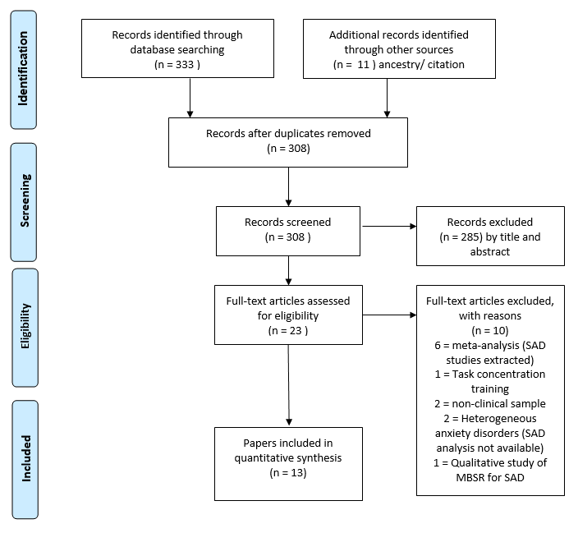
Symptoms of SAD were established using diagnostic assessment based on the Diagnostic and Statistical Manual of Mental Disorders IV (American Psychiatric Association, 2013) criteria for SAD, including the Anxiety Disorder Interview Schedule for DSM-IV (ADIS; DiNardo, Brown, & Barlow, 1994), International Neuropsychiatric Interview for DSM-IV (MINI; Sheehan et al., 1998), Structured Clinical Interview for DSM IV (SCID; First & Gibbon, 2004), SCID 2.0; for DSM IV Axis I disorders (First, Spitzer, Gibbon, & Williams, 2002). One study (Hatamian & Ghorbani, 2016) used the Liebowitz social anxiety scale (Liebowitz, 1987) to determine the presence of social anxiety, using the clinical cut-offs for the scales.

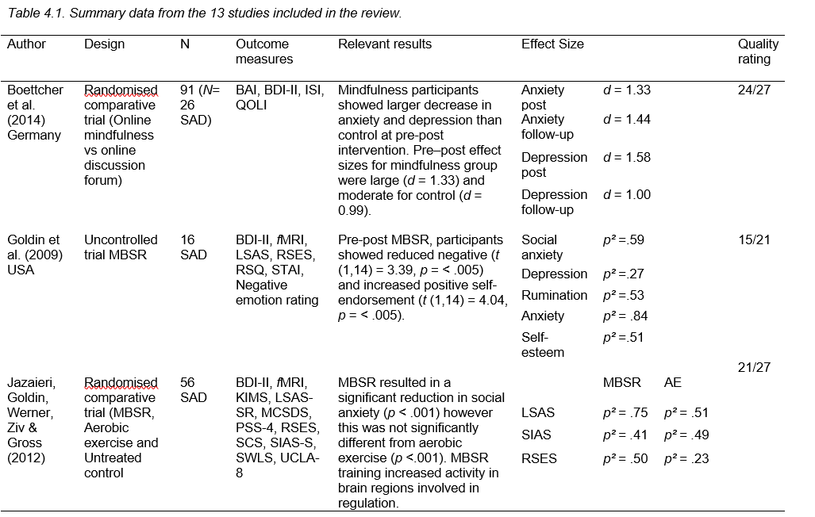
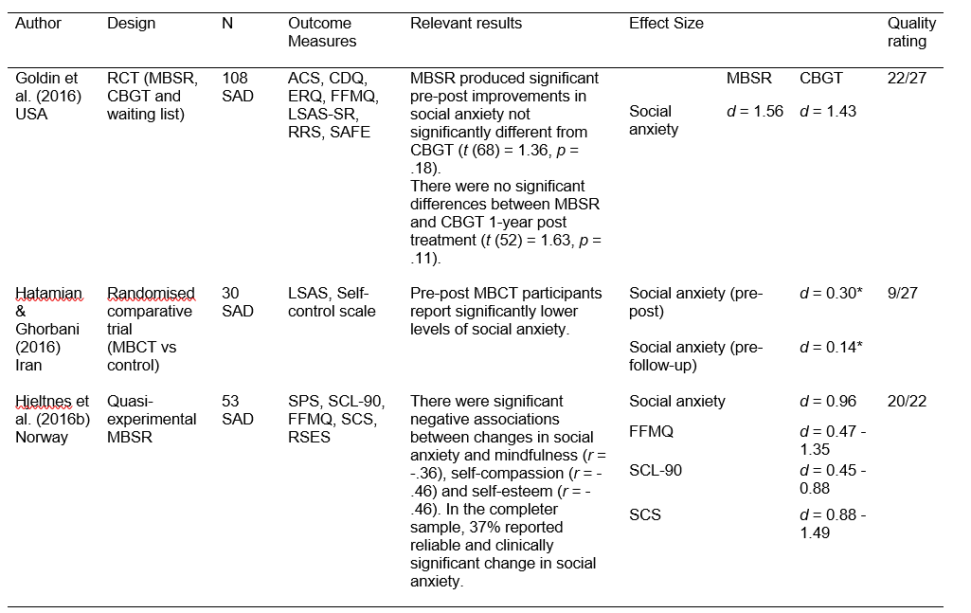
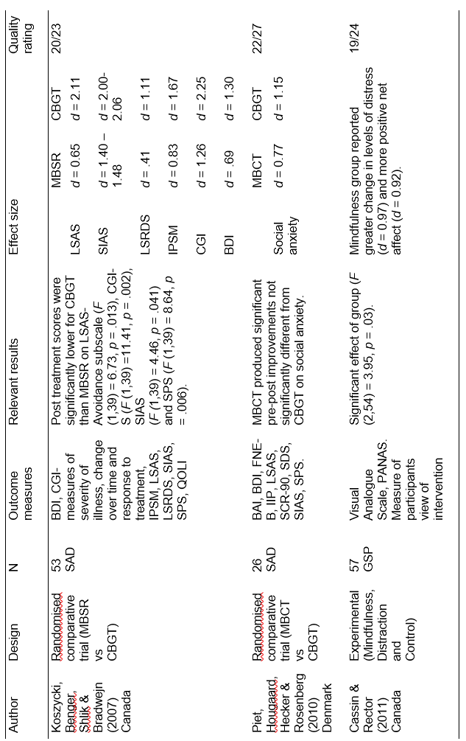
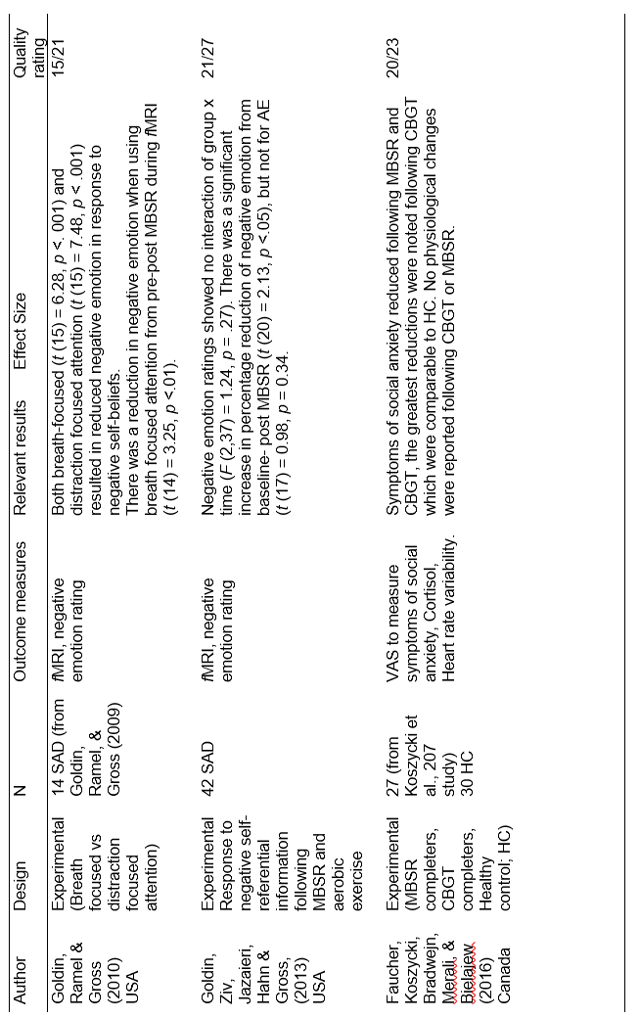
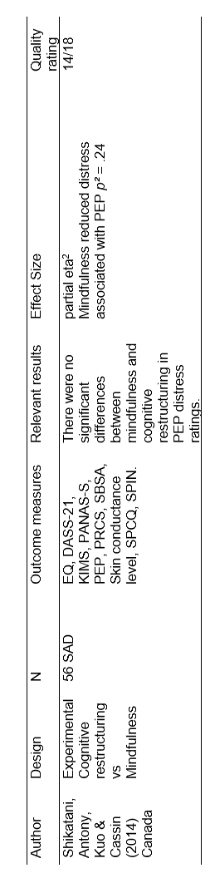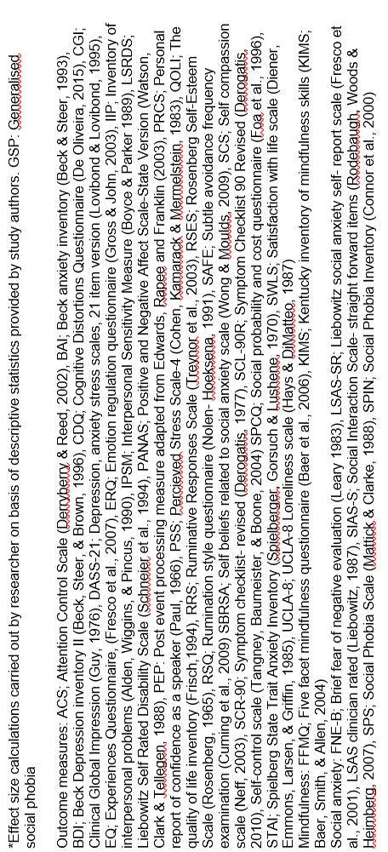
4.3.2 Intervention studies
Eight studies examined the effectiveness of MBIs for SAD. MBIs were effective in reducing symptoms of SAD in all eight studies. Three studies compared MBIs to Cognitive behavioural group therapy (CBGT). MBSR and MBCT aim to teach individuals to mindfully observe and accept thoughts whereas CBT teaches individuals to reappraise and modify their thought content. In the three studies comparing MBCT/MBSR and CBGT interventions for SAD, one study found CBGT to be superior (Koszycki et al., 2007) and two studies reported no significant differences between the interventions (Goldin et al., 2016; Piet et al., 2010). When MBSR was compared to an aerobic exercise intervention no significant difference between groups in social anxiety symptoms was reported (Jazaieri et al., 2012). Two studies examined the effectiveness of MBSR (Goldin et al., 2009; Hleltnes et al., 2017) and reported significant reductions in social anxiety post intervention. Hatamian and Ghorbani (2016) reported significant reductions in social anxiety following MBCT in comparison with a control group. The final study (Boettcher et al., 2014) compared an online mindfulness intervention to an online discussion forum and a control group.
Assessment of the methodological quality of intervention studies revealed that external validity was difficult to determine. Six of the eight intervention studies did not report sufficient details regarding intervention integrity (Boettcher et al., 2014, Goldin et al., 2009, Hatamian & Ghorbani, 2016; Hjeltnes et al., 2016b; Jazaieri, et al., 2012, Koszycki, et al., 2007). In some cases, studies failed to report intervention integrity, other studies reported assessment of integrity; however, the authors failed to provide details of how session recordings were rated. In contrast, Goldin et al. (2016) provided details of how sessions were rated by an independent rater to establish integrity of both MBSR and MBCT. The difficulties determining intervention integrity and randomisation methods could influence replication of studies. Reporting quality of the studies was high in seven of the eight intervention studies with details provided on confounding variables and sufficient information on analysis. In one study reporting of statistical data was poor, and the statistical data did not appear to match the conclusions drawn by the authors (Hatamian & Ghorbani, 2016).
Considering individual studies, two studies in this review examined the effectiveness of MBIs for young adults (18-25 years) experiencing SAD (Hjeltnes et al., 2016b; Piet et al., 2010). Hjeltnes et al. (2016b) delivered the MBSR programme in accordance with the Centre for Mindfulness Guidelines (Blacker, Meleo-Meyer, Kabat-Zinn & Santorelli, 2009). Following MBSR 37% of participants reported clinically significant reductions in social anxiety symptoms. Reductions in social anxiety were significantly correlated with increases in mindfulness (r = -.36). Using the FFMQ allowed investigation of how specific facets of mindfulness related to changes in social anxiety, and results indicated differential patterns of change in facets of mindfulness. Non-judgment (d = 1.21) and non-reactivity to inner experiences (d = 1.11) showed the largest effect sizes of all mindfulness facets. Participants also reported significant increases in self-compassion (d = 0.88 – 1.49), particularly self-kindness (d = 1.33). In the context of social anxiety, the authors suggest that MBSR is a useful intervention to address self-focused attention and critical self-appraisal. The findings suggest that MBSR may increase acceptance of the self, and ability to tolerate negative experiences. There are several limitations to Hjeltnes et al.’s (2016b) study which are noted by the authors, including the lack of control group and follow-up which limits conclusions regarding the long-term effectiveness of MBSR. In addition, groups were delivered by different facilitators; but the authors do not discuss potential therapist effects or any differences between the groups in terms of outcomes. In addition, treatment fidelity was not examined.
Piet et al. (2010) conducted a cross-over study comparing MBCT to CBGT for young adults diagnosed with social phobia. MBCT was delivered according to the manual by Segal et al. (2002) for chronic depression with amendments for psychoeducation around social anxiety. Whilst the study states that the mindfulness instructor was highly experienced, the level of training was not specified. MBCT and CBGT led to significant improvements in social anxiety symptoms from pre-to post intervention, with no significant differences between the two interventions on any of the outcome variables. In addition, participants reported high levels of satisfaction with both MBCT and CBGT with no significant difference in satisfaction ratings between the two interventions. The results suggest that MBCT was as effective as CBGT in reducing symptoms of SAD.
In contrast, Koszycki et al. (2007) found both CBGT and MBSR produced clinically meaningful change in levels of social anxiety, although CBGT reductions in symptoms were larger. MBSR was as effective as CBGT in improving mood and quality of life. MBSR was delivered in accordance to the manual developed by Kabat-Zinn and Santorelli (1993). The MBSR facilitator had experience of delivering MBSR in public and community health centres but no previous experience of working with people with SAD. The CBGT facilitator was an experienced CBT therapist; therefore, there are differences in the level of training and experience which could have influenced the study findings.
In a study of students with social anxiety (identified by LSAS scores), Hatamian and Ghorbani (2016) reported that MBCT was effective in reducing symptoms of social anxiety, pre-post intervention in comparison with a control group. Whilst the authors report significant results, calculation of Cohen’s d suggests a small effect of the intervention (pre-post d = 0.30; pre-follow-up d = 0.14). Findings show that whilst participants experienced a reduction in social anxiety symptoms, the mean scores remained within the clinical range for social anxiety on the LSAS, suggesting change was not clinically significant. It is important to note that there are several methodological and reporting problems with this study. First, the authors reported that the MBCT intervention was adapted from Younesi and Bogar (2008); however, the intervention is not readily available, and differences in session summaries and lengths makes comparison between studies difficult. In addition, the authors do not give a clear rationale for their hypotheses or the proposed mechanism of action through which mindfulness may exert its effects on social anxiety and the introduction seems to focus more on generalised anxiety than social anxiety. Finally, mindfulness was not measured and therefore it is unclear whether changes in social anxiety are a result of increased levels of mindfulness.
Jazaieri et al. (2012) compared MBSR against an active aerobic exercise control. MBSR sessions were delivered by one of seven facilitators with an average of 15.7 years of MBSR teaching experience. The aerobic exercise control group was instructed to complete a minimum of two individual exercise sessions a week and one group session per week with no therapist involvement. Both MBSR and aerobic exercise resulted in significant reductions in social anxiety symptoms (Table 4.1), with no significant difference between groups (all ps >.16) on measures of social anxiety and depression. Self-esteem increased within the exercise intervention but there were no significant increases following MBSR. Little is known about the effectiveness of exercise on reducing symptoms of SAD. These findings could be a result of engagement with the exercise intervention leading to increases in social interaction and reduced social avoidance. However, this is speculative and further studies should consider mediation analyses to determine the mechanisms of change within mindfulness and exercise interventions.
Whilst studies have examined treatment outcome, it is important to examine the psychological mechanisms of action. Goldin et al. (2009) examined the effects of MBSR on changes in clinical symptoms and behavioural and neural changes in self-referential processing. Following participation in an eight-week MBSR intervention, participants experienced significant decreases in social anxiety, depression, rumination and state anxiety. To examine the potential mechanisms of action, a self-referential processing task was used pre-post MBSR to investigate the impact of MBSR training on how information related to the self is processed in participants with SAD.
Cognitive models of SAD suggest there is an increase in self-focused attention during social situations, and socially anxious individuals are likely to show bias towards negative self-referential information and view the audience as critical observers (Clark & Wells, 1995; Rapee & Heimberg, 1997). Following MBSR, participants endorsed fewer negative social traits, yet there was an increase in neural responses during processing of negative self-relevant information in brain regions associated with allocation of attention (left inferior parietal lobule and medial precuneus) (Goldin et al., 2009). This suggests that MBSR generates changes at a neural level in the processing of negative self-relevant information. In addition, reductions in endorsement of negative self-views suggest that MBSR reduces bias towards negative self-referential information in people living with SAD.
Goldin et al. (2016) continued to examine the efficacy of MBSR for SAD in a RCT comparing MBSR to CBGT and a waiting list. The study reports no significant difference between MBSR and CBGT in social anxiety symptom reduction; however, there was a significant difference between both groups and the waiting list. There was no significant difference in clinical improvement in social anxiety symptoms at one-year follow-up for MBSR and CBGT. To determine mechanisms of change, intervention groups were compared on a range of CBT related processes (avoidance behaviours, cognitive reappraisal, and cognitive distortions) and MBSR related processes (attention focusing, attention shifting and rumination). With the exception of avoidance behaviours, there was no significant difference between MBSR and CBGT which suggests a level of conceptual overlap between the two therapies. This is supported by meditation results which suggest shared psychological mechanisms of change.
Boettcher et al. (2014) examined the potential of delivering mindfulness interventions using an internet-based programme compared to a closed discussion online forum. The sample comprised participants with a range of anxiety disorders, including SAD. Specific anxiety diagnosis did not predict change in anxiety or moderate the treatment effects. The online mindfulness intervention consisted of eight mindfulness modules comprising of instructive audio files of mindfulness exercises and a total of sixteen hours of mindfulness exercises over eight weeks. Participants had no therapist contact. Participants reported a significant decrease in levels of their principle anxiety diagnosis, depression and insomnia following the online mindfulness intervention, with improvements in anxiety and insomnia stable at six-month follow-up. This study is distinct from the previous mindfulness interventions discussed due to the method of delivery. The mindfulness intervention was delivered online with no therapist contact. Any group therapeutic effect would not apply to online interventions. Participants were given no opportunity for guided inquiry which is a significant part of group mindfulness course making comparisons with group interventions difficult.
4.3.3 Specific mindfulness techniques.
Overall five experimental studies were identified. Two experimental studies examined the use of specific mindfulness techniques for people experiencing social anxiety symptoms. Study quality of the experimental studies was high in terms of reporting and analysis (Downs & Black, 1998); however, internal and external validity were low given the experimental induction occurred in a laboratory setting.
Cassin and Rector (2011) examined two meta-cognitive strategies implicated in reducing PEP: mindfulness and distraction. The PEP induction involved participants being asked to think about a specific social situation where they felt nervous, anxious or embarrassed; participants were then left to think about this situation for five minutes. All participants experienced an increase in distress following PEP induction as rated on a visual analogue scale. Following PEP, participants in the mindfulness condition were instructed to focus attention on the breath in a task modelled from published mindful breathing exercises (Kabat-Zinn, 1990; Segal et al., 2002; Williams, Teasdale, Segal, & Kabat-Zinn, 2007). Participants in the distraction condition were asked to focus their attention on something unrelated to the task, purposefully turning their attention away. Participants in the control condition were instructed to ‘think as they usually would’. In line with predictions, participants in the mindfulness condition reported a significant reduction in distress over a five-minute period, and more positive net affect than the control group; however, the reduction in distress (and increase in positive affect) was no different to that found in the distraction group. The findings suggest that a brief mindfulness task is helpful to people experiencing distress associated with PEP, but no more so than using distraction.
Shikatani, Antony, Kuo and Cassin (2014) asked participants to first perform a speech as a PEP induction, before being assigned to mindfulness, cognitive restructuring or a control condition. In the cognitive restructuring condition participants were given psychoeducation and brief teaching on challenging negative thoughts. The mindfulness condition involved participants being first introduced to a definition of mindfulness, followed by a three-minute guided meditation on noticing the breath, and three seven- minute mindfulness exercises adapted from structured mindfulness programmes (e.g., Segal et al., 2002). Both mindfulness and cognitive restructuring significantly reduced post-event processing, but with no significant difference between the two conditions.
Three experimental studies were carried out with participants who had completed an MBSR or MBCT intervention. Faucher et al. (2016) examined differences between MBSR and CBGT treatment completers on subjective social anxiety ratings and physiological responses were assessed using a stressful speaking task. Participants who completed an earlier trial (Koszycki et al., 2007) were asked to complete a speech task pre-and post-intervention. The speech task involved participants preparing a ten-minute speech on a topic of their choice, and being told the speech would be videoed and evaluated by two raters. Visual analogue scales were used to measure subjective ratings of anxiety pre-and post-task. Cortisol was measured at various time points pre-and post-task and heart rate variability was measured via ECG monitors throughout the task. The results of MBSR, CBGT and healthy controls were compared and pre-post scores on social anxiety ratings improved following MBSR and CBGT with the CBGT completers reporting the most significant improvements, comparable with healthy controls. Post-intervention (MBSR and CBGT) participants reported fewer SAD symptoms during the speaking task; however, as the authors suggest, without a measure of mindfulness it is unclear whether increases in mindfulness following MBSR led to the decrease in social anxiety symptoms.
There were no significant differences at pre-post treatment in any of the groups (MBSR, CBGT and healthy controls) in cortisol response or heart rate variability. Only heart rate variability and subjective ratings of social anxiety were elevated during the speaking task. The authors propose that the non-significant difference between healthy controls and participants with SAD in cortisol levels during the social stress task may be due to a different physiological response to social evaluative situations, suggesting other biomarkers may be more sensitive to a short social stress task. Overall, the results suggest that MBSR resulted in reduced subjective social distress ratings during a social speaking task. CBGT showed a greater reduction in distress ratings which supports the findings of the trial (Koszycki et al., 2007).
In a follow-up to Goldin et al.’s (2009) study which examined changes in the processing of self-referential information following MBSR, Goldin and Gross (2010) investigated changes in emotional reactivity to self-referential information following MBSR. Reductions in negative emotion were found when implementing a mindfulness strategy (breath-focused attention) during functional magnetic resonance imaging (fMRI), compared with the distraction condition, suggesting reduced emotional reactivity when redirecting attention to the breath. There was no significant change in negative emotion pre- to post-MBSR when participants were not engaged with breath-focused or distraction-focused attention, suggesting that reactions to negative self-beliefs could be due to an over-learned response to attend to negative self-referential information (Goldin & Gross, 2010). The findings suggest that MBSR may be a useful intervention to learn strategies to reduce emotional reactivity, which may in turn reduce avoidance of social situations.
To examine the influence of MBSR training on emotion regulation further, Goldin et al. (2013) examined emotion regulation pre-and post-MBSR and aerobic exercise using fMRI (Goldin, Ziv, Jazaieri, Hahn, & Gross, 2013), in order to identify changes at a neural level. Reductions in emotional reactivity to negative self-referential information were reported pre-post MBSR which were not significantly different from reductions experienced by the aerobic activity group. Whole brain analysis highlighted increased activity in brain regions involved in cognitive regulation following MBSR (Goldin et al., 2013) (medial pre-frontal cortex, bilateral dorsolateral pre-frontal cortex, left ventrolateral pre-frontal cortex) and attention regulation (right dorsal medial lateral pre-frontal cortex, posterior cingulate cortex/precuneus, inferior parietal lobule: Fan, McCandliss, Fossella, Flombaum, & Posner, 2005). Increases in dorsal medial pre-frontal cortex activation during negative self-processing were related to decreases in social anxiety symptoms. The changes in attention regulation, which are apparent at a neural level, suggest that the ability to utilise attentional regulation strategies could be a mechanism of action during MBSR.
4.4 Discussion
This review focuses specifically on MBIs, characterised as meditation-based interventions for social anxiety symptoms. Overall, the findings of the current review suggest that MBIs show promise in reducing clinically significant levels of social anxiety. However, further research is needed to explore the mechanisms underlying reductions in distress, and their applicability in different samples, including people living with visible skin conditions.
Results from eight intervention studies demonstrated that MBIs (MBCT, MBSR and internet-delivered mindfulness) are effective in reducing social anxiety symptoms with studies reporting medium to large effect sizes (d = 0.77 - 1.56); however, intervention studies report different rates of clinically significant change in social anxiety. Koszycki et al. (2009) report less than 10% improvement in social anxiety following MBSR, whereas, Jazaieri et al. (2012) and Hjeltnes et al. (2016b) report clinically significant change in up to 25% and 37% of participants respectively. Exploring participant characteristics may be beneficial to examine the differences in treatment outcomes across studies to improve our understanding of what type of patients benefit from MBIs for SAD.
Two comparative trials found no significant differences between MBCT/ MBSR and CBGT in social anxiety symptom reduction (Goldin et al., 2016; Piet et al., 2010) whilst Koszycki et al. (2007) found CBGT to be superior to MBSR. In one other comparative trial, no significant differences were found between MBSR and aerobic exercise (Jazaieri et al., 2012) and when compared to a control group, MBCT participants reported significant improvements in social anxiety symptoms (Hatamian & Ghorbani, 2016). Comparative trial findings suggest that MBIs do not lead to reductions above those experienced in CBGT; therefore, CBGT remains the gold standard treatment for SAD. The findings also suggest that further studies examining the effects of aerobic exercise interventions on SAD would be beneficial.
The drop-out rates reported in randomised comparative studies between MBCT/MBSR and CBGT did not differ significantly which suggests that people find the mindfulness practices engaging and beneficial. The interventions discussed used a group format, with the exception of the computerised mindfulness programme (Boettcher et al., 2014) where participants engaged with the programme individually. It is difficult to compare one-to-one and group-based mindfulness interventions as the method of delivery may have an impact on outcomes.
One of the main methodological issues with the interventions in the current review relates to the measurement of mindfulness. Five out of eight intervention studies did not include a measure of mindfulness; therefore, it is unclear whether changes in social anxiety symptoms are a result of increased mindfulness. In the studies that did include a measure of mindfulness these measures were administered pre-and post-intervention which also has implications when drawing conclusions as it is unclear whether changes in mindfulness preceded changes in social anxiety. Hjeltnes et al. (2016b) provided a comprehensive summary of the relationships between social anxiety and facets of mindfulness, which suggests that participants experienced the highest levels of positive change in non-judgment and non-reactivity to inner experience. The findings suggest that participants experienced increases in mindfulness and self-compassion following MBSR, which were associated with reductions in social anxiety. The theoretical implications of these findings suggest that MBIs which reduce engagement with self-critical thoughts, promote acceptance and increase tolerance of negative emotional states, are beneficial to people experiencing social anxiety.
Experimental studies highlighted the potential for using brief mindfulness interventions to reduce PEP and associated distress. One study examined differential effects of structured interventions (CBGT vs MBSR) for SAD, and the findings suggest that following MBSR and CBGT participants experienced reductions in social anxiety severity ratings during a social stress speech task. However, changes in cortisol and heart rate response following the interventions were not significant suggesting that reductions in physiological arousal did not lead to reductions in subjective severity ratings.
Short mindfulness exercises with minimal therapist contact lend themselves well to adaptation for interventions that might be delivered via self-help (Webster, Thompson, Webb, & Sheeran, 2014). However, without explicitly measuring mindfulness it is difficult to ascertain whether changes in mindfulness are linked to reductions in distress. Studies also need to collect follow-up data to provide information on the sustainability of the brief exercises in reducing PEP. Whilst Cassin and Rector (2011) reported null findings between specific mindfulness techniques and distraction in distress as a result of post-event processing, the literature suggests that distraction can maintain social anxiety symptoms (Clark & Wells, 1995) and is therefore a detrimental technique to employ.
Changes in positive and negative self-views following MBSR (Goldin et al., 2013) highlight the potential of using this intervention for people with social anxiety who show bias towards negative self-relevant information during social situations (Clark & Wells, 1995). Being able to regulate emotions using MBSR is helpful in reducing distress associated with social anxiety as it provides a tool for participants to manage difficult social encounters, which may reduce avoidance. Neural changes following MBSR offer preliminary support that mindfulness interventions, used for people experiencing SAD, can be effective in changing the focus of attention and relationship with thoughts. Results from neuroimaging provide strong evidence for the underlying mechanisms through which MBIs are hypothesised to operate.
CBGT is the recommended treatment for SAD and has a strong evidence base. However, MBIs have demonstrated significant improvements in social anxiety and these are often equivalent to CBGT, which suggests further methodologically rigorous studies are required to further investigate the effectiveness of mindfulness for social anxiety symptoms/SAD. Study quality was variable (Table 4.1). Whilst the majority of studies reported clearly the interventions under test and included appropriate analysis, intervention integrity was difficult to establish in several intervention studies.
It is important to acknowledge that comparisons between the intervention studies discussed are complicated by differences in length of intervention, length and monitoring of between-session practice, therapist training and experience. Carmody and Baer (2008) found that extent of home practice was significantly correlated with facets of mindfulness (except for describing). It raises the question of whether the reduction in mindfulness practice would have an impact on efficacy of the intervention. With some programmes recommending 45 minutes of daily meditation practice (Segal et al, 2002), further research is necessary to identify an optimal level of meditation practice and acceptability of home practices for SAD. To date, no standardised mindfulness programme has been developed for the treatment of social anxiety. Currently, the standard MBCT format used to treat patients at risk of depressive relapse is delivered over eight weekly two and a half hour sessions with a full day silent retreat and incorporates daily meditation practice (Kabat-Zinn, 1982). This format is also used in MBSR which is becoming increasingly popular within community settings.
Another limitation is the lack of clarity regarding experience level of therapists delivering the interventions which was not specified in all studies. Koszycki et al. (2007) noted that the MBSR therapist in their study was not a mental health practitioner and had no previous experience of working with SAD, in contrast to the CBGT therapist who had a background in cognitive behavioural therapy for anxiety disorders. Kabat-Zinn (1990) proposed that the quality of mindfulness teaching was a key ingredient in the successful delivery of the intervention; however, there is no clear evidence base regarding the level of competence required to teach mindfulness and how this relates to participant outcomes (Crane, Kuyken, Hastings, Rothwell, & Williams, 2010). The current studies included in this review did not examine therapist effects; however, this should be considered for further research, particularly when comparing therapeutic treatments delivered by therapists with different levels of mental health training and experience.
Mediation analysis is useful to examine mechanisms of change. The results of Goldin et al. (2016) suggest that reappraisal frequency, mindfulness skills, attention focusing, attention shifting, and decreases in safety behaviours and cognitive distortions mediate the effect of MBSR. This suggests that whilst mindfulness may not directly focus on cognitive reappraisal or distortions this is something experienced by participants. The findings suggest overlap between the mechanisms of action for CBGT and MBSR; however, further mediation studies are required before strong conclusions can be made. Future studies should examine the process of change in levels of mindfulness, using more frequent measurement of the variables of interest to establish the temporal precedence of mindfulness.
4.4.1 Future research
Based on the review findings, four key recommendations for future research are proposed. First, the relationship between different facets of mindfulness and social anxiety symptoms requires further exploration to identify whether specific aspects of mindfulness may mediate the effects of MBIs on social anxiety symptoms. Second, future studies need to examine the time course of treatment effects by carrying out more frequent measurement of mindfulness. The studies reported in the current review only examined pre-post change. Third, studies should establish sustainability of intervention effects, i.e., are individuals able to continue using mindfulness following the intervention and do meditation practices need to be used on an ongoing basis to be effective? Fourth, qualitative studies would be helpful to examine participants’ experiences of receiving mindfulness interventions for symptoms of social anxiety in order to examine acceptability and usability of interventions with a clinical population. This would also allow for exploration of group or therapist contact and their influence on outcomes. Qualitative methods would also allow researchers to examine reasons for drop-out during MBIs in more detail. Given the effectiveness of mindfulness interventions in reducing social anxiety, there is a rationale for exploring the effectiveness of mindfulness in reducing social anxiety in people living with visible skin conditions.
4.4.2 Conclusion
The findings of this review indicate that MBIs may offer a viable treatment option for treating SAD, providing a unique opportunity to extend the range of interventions available to patients. The findings of the current review are in line with Norton et al.’s review of mindfulness and acceptance-based approaches for SAD which also found no strong evidence to suggest the use of MBIs instead of CBGT. However, there are still a proportion of patients who do not respond to CBT (Rodebaugh, Holaway, & Heimberg, 2004); therefore, alternative interventions should be available and the findings of the current review suggest that MBIs are effective in reducing symptoms of SAD. People with SAD under utilise mental health services (Magee, Eaton, Wittchen, Mcgonagle, & Kessler, 1996); however, with mindfulness interventions being delivered by professionals in community settings, this could reduce stigma associated with help seeking through traditional healthcare channels, and reduce the cost and growing waiting lists associated with the provision of one to one psychological interventions. Future research is needed to examine the active ingredient of mindfulness responsible for eliciting clinical change in SAD to inform clinical practice in this area.
Considering the findings of Study 1 and Study 2, the current review provides additional evidence to warrant examining the use of mindfulness interventions for social anxiety in people living with visible skin conditions. In Study 3, the effectiveness of group Mindfulness-based Cognitive Therapy for social anxiety in people living with visible skin conditions will be examined. Whilst mindfulness interventions have been used previously in dermatology with positive results (Fordham et al., 2014; Kabat-Zinn et al., 1998), the impact of mindfulness on reducing social distress and appearance-related concerns reported by people living with visible skin conditions has not previously been explored.
Study 3 aims to address the recommendations for future research outlined in the current review, and extend on the findings of Kabat-Zinn et al (1998) and Fordham et al. (2014). The relationship between changes in mindfulness and psychological distress has only been examined pre-and-post in dermatology patients, which as discussed in the current review, does not allow temporal precedence to be determined. Therefore, Study 3 will examine participants’ individual change profiles over time using single case design, and explore how changes in specific facets of mindfulness relate to changes in social anxiety.

Chapter 5. Mindfulness based cognitive group therapy for social anxiety in people living with visible skin conditions. A single case series.

5.1 Introduction
So far, the current thesis has examined the social experiences of people living with visible skin conditions to identify potential targets for intervention. Study 1 suggests that social distress involves an interaction between self-appraisals, fear of negative evaluation from critical others and previous negative reactions. The findings of Study 1 suggest that targeting negative self-appraisals which involve a negative evaluation of the appearance of the skin may reduce social distress. In Study 2, the relationship between mindfulness and psychosocial distress was examined and findings demonstrate that higher levels of mindfulness, particularly the abilities to approach experiences without judgement and to focus on the present moment, were associated with lower levels of social anxiety. The preceding chapter contained a systematic review which examined the effectiveness of mindfulness interventions for social anxiety, whilst exploring the theoretical underpinnings and the mechanisms of action.
Systematic review findings suggest that structured mindfulness interventions (MBSR/ MBCT) can lead to reductions in negative self-referential processing and increased attentional control (Goldin et al., 2013). These findings have particular relevance to people living with visible skin conditions given the high levels of shame and negative self-appraisals reported (Chapter 2; Jowett & Ryan, 1985; Kellett & Gilbert, 2001; Kelly, Zuroff, & Shapira, 2009; Lahousen et al., 2016). To date, no interventions have examined the use of mindfulness interventions to address appearance concerns and social anxiety for people with visible skin conditions.
The National Institute of Clinical Excellence (NICE, 2013) recommends the use of CBT for SAD. CBT incorporates techniques such as cognitive restructuring and behavioural experiments to support individuals in identifying distorted cognitions and challenging the reality of the negative beliefs. However, psychological factors and processes contributing to social anxiety in people living with skin conditions might subtlety differ from those typically found in social anxiety disorder as they are likely to be associated with the potential for actual stigmatisation (Pärna et al., 2015). In people living with visible skin conditions, cognitions are focused on appearance-related concerns, rather than performance fears (Study 1) which suggests that interventions should target specific fears of negative evaluation and attentional bias towards appearance-related social threat cues (Altabe & Thompson, 1996).
Mindfulness encourages a move away from conceptual modes of thinking, in which we seek to make interpretations and judgements of experiences, and cultivates a move towards a ‘being mode’ in which attention is paid to experience and reactions to experience (Williams, 2010). Mindfulness involves paying attention to all experiences, positive and negative, without attempts to change or evaluate what is happening; therefore, reducing experiential avoidance of unpleasant mood and physical states (Bishop et al., 2004).
Considering the social experiences of people living with visible skin conditions, whilst negative reactions from others may occur, mindfulness interventions may reduce the tendency to over-identify with negative thoughts and self-appraisals (Goldin et al., 2013), which may potentially reduce distress and encourage a shift in attention towards the social task at hand. Mindfulness interventions do not address the content of thoughts, but instead focus on observing experiences without judgement. In addition, learning techniques to manage distress may be beneficial in improving self-efficacy in dealing with negative reactions from others.
The theoretical basis for the use of mindfulness for social anxiety has been discussed and mindfulness interventions have been shown to be effective in reducing symptoms of SAD (Chapter 4). Mindfulness may be beneficial for dermatology patients through reducing the bodies physiological response to stress. Hunter et al. (2015) proposed that the individual’s response to stress as overwhelming activates the Hypothalamic Pituitary Adrenal Axis (HPA axis) and the immune system is influenced by cortisol output from the HPA. The physiological response to stress can result in impaired immune functioning and impaired wound healing (Hunter et al., 2015). Fordham et al. (2014) examined whether MBCT led to reductions in cortisol in psoriasis patients pre-post intervention; however, whilst participants reported reductions in psoriasis severity, there was no significant difference in cortisol levels pre-post intervention, suggesting this was not the mechanism leading to change in physical symptoms. Kabat- Zinn et al. (1998) reported improved rates of skin clearing when audio guided meditations were used as an adjunct to light therapy; however, the authors did not examine potential mechanisms of action.
The two published studies of mindfulness interventions in dermatology to date suggest this type of intervention may reduce physical symptoms of psoriasis (Kabat-Zinn et al., 1998; Fordham et al., 2014); however, further studies are needed to examine the effectiveness of mindfulness in reducing psychological distress in people with a range of skin conditions. Studies also need to examine the potential mechanisms of change by which mindfulness exerts its effects. Whilst a potential physiological mechanism of change has been explored by Fordham et al. (2014) the focus of the current programme of research has been on processes underlying social anxiety and therefore the current study will explore changes in psychological variables following a mindfulness intervention.
The current study
The current study aims to examine the effectiveness of group MBCT in reducing social anxiety, anxiety, depression and improving skin-specific quality of life in people living with a visible skin conditions. Social anxiety will be explored on two levels; fear of negative evaluation, and specific anxious cognitions identified by participants which are activated during social situations. A systematic review of mindfulness interventions for social anxiety suggested a number of limitations to previous studies (Chapter 4). First, a significant number of studies of mindfulness interventions did not measure mindfulness, and second, where measures of mindfulness were taken these were pre-and post. Measuring levels of mindfulness pre-and post-intervention can provide useful information regarding the development of mindfulness skills; however, these results provide little information on the underlying mechanisms by which mindfulness exerts its effects, or the individual’s experiences of developing and cultivating mindfulness skills (Allen, Bromley, Kuyken, & Sonnenberg, 2009).
To address these limitations, the current study will explore the effectiveness of MBCT using a multiple baseline single case design, incorporating a baseline phase (A), intervention phase (B) and four-week follow-up phase (C). Single case designs, sometimes known as ‘n of 1’ studies have been advocated in a number of fields including medicine (Schork, 2015) and intervention development in health psychology (Naughton & Johnston, 2014). Single case design requires repeated measurement of the variables of interest and allows for changes in mindfulness and social anxiety to be examined over time which is helpful in establishing temporal precedence. The design can be used to demonstrate proof of concept (Shadish, 2014) when there is insufficient evidence to warrant a large scale RCT, for example in the early stages of intervention development (Schork, 2015; Shadish, 2014). Single case designs may also highlight feasibility issues, for example problems with measurement or difficulties recruiting sufficient participants, which can then inform subsequent study development.
The group MBCT programme developed by Segal et al. (2013) ‘Mindfulness-based cognitive therapy for depression’ will be delivered to people living with visible skin conditions and clinically significant levels of social anxiety. Adaptations to the programme will be made to incorporate psychoeducation relevant to social anxiety.
5.1.1 Hypothesis
The hypotheses tested in the current study were;
- There will be an increase in levels of mindfulness during the intervention phase (B) and follow-up phase (C) in comparison to baseline (A)
- There will be a significant decrease in levels of social anxiety at end of intervention phase (B) and follow-up phase (C) compared to baseline phase (A)
- There will be a significant decrease in levels of anxiety and depression at end of intervention phase (B) and follow-up phase (C) compared to baseline phase (A)
- There will be a significant increase in scores on dermatology quality of life at the end of intervention phase (B) and follow-up phase (C) compared to baseline phase (A)
5.2 Method
There are various methods which can be used within single case designs, the most common being reversal design and multiple baseline (Smith, 2012); however, all methods involve the repeated measurement of the variable of interest, to detect the effects of the intervention on the primary outcome. Multiple baseline single case design involves participants being randomised to one of three baseline periods (2, 3, or 4 weeks) during which they receive no psychological intervention; thereby participants act as their own control. A multiple baseline single case design was chosen as random allocation of participants to different baseline periods allows treatment effects to be observed whilst providing some control over alternative explanations for any observed behaviour change (Kratochwill et al., 2010). Multiple baseline design increases internal validity by providing control over potential maturation and history effects (Kratochwill et al., 2010; Parker, Vannest, Davis, & Sauber, 2011).

In the current study, data from individual participants will be analysed, and the data will then be aggregated to provide information on the overall group response to treatment. The current study was designed and analysed in accordance with ‘The single case reporting guideline in behavioural interventions 2016 statement’ (SCRIBE; Tate et al., 2016).
5.2.1 Ethical approval
Ethical approval for the study was gained from the National Health Service, North West Preston Ethics Review Committee (see Appendix A). Permission was sought from participants to inform their GP and dermatologist of their participation in the study, and if there were any concerns regarding their wellbeing (see Appendix L). Risk was monitored throughout the study and any concerns regarding risk were recorded on an adverse events form (see Appendix M) and reported to the participant’s GP and the researcher’s supervisory team. Monitoring of any adverse effects was conducted in line with the University of Sheffield ethics procedure and any adverse event was reported as soon as possible after the event occurred, and within a 24-hour period.
5.2.2 Participants
Participants were recruited from three sources: an NHS outpatient dermatology clinic, the University of Sheffield staff and student volunteer list, and charities working with people living with visible skin conditions (Psoriasis Association and Alopecia UK) (see Appendix N for information sheet). The MBCT implementation guidelines (2012) state that MBCT was developed for one trained therapist to facilitate a group of between 8 -15 participants; therefore, the study sought to recruit a minimum of 8 and maximum of 15 participants.
Five participants were recruited over a period of three months from an adult out-patient dermatology clinic. Between 16 December 2015 and 3 January 2016, 20 people (F = 16, M = 4) responded to an email to the University of Sheffield staff and student volunteer list expressing interest in the study. After sending further information on the study, including times and dates, and checking eligibility seven people were eligible to participate (F = 5, M = 2). The study was advertised via skin charities and one person contacted the researcher for further information. All 13 people who were eligible attended a screening interview (see Appendix O). Following the screening interview all 13 people were eligible to commence the study and gave informed consent to participate (Appendix N).
Social anxiety symptoms and any co-morbid mental health problems were assessed during the screening interview using the Mini-International Neuropsychiatric Interview for Diagnostic and Statistical Manual of Mental Health Disorders IV (Sheehan et al., 1998). The MINI is a structured clinical interview and assesses 17 DSM IV axis I disorders, and takes approximately 15 minutes to administer. It was administered by the researcher who had undertaken the training provided to use the interview schedule. The interview schedule has been widely used in clinical research (Sheehan et al., 1998). Sheehan et al. (1998) examined reliability, sensitivity and specificity in a clinical population against the Structured Clinical Interview for Diagnostic Disorders (SCID) and found the MINI was equivalent in performance. Concordance for social anxiety was .66 with positive predictive values of >.70 and negative predictive values of >.90. Participants were asked if they experienced any suicidal thoughts and about any recent episodes of self-harm and/or hospital admissions due to mental health. In addition, the screening interview was used to discuss the group format and participants were asked if they were able to attend all eight group sessions and commit sufficient time to carrying out between session meditation practice.
5.2.3 Inclusion and exclusion criteria
Participants were required to be aged 16 and over, have a diagnosis of a visible dermatological condition which was the main presenting physical health problem, and sufficient English to participate in group sessions and discussion. As the focus of the current study was on visible skin conditions, potential participants with scarring or other marks to the skin caused by non-dermatological conditions, primary psychiatric diagnosis affecting skin (e.g., trichotillomania, delusions of parasitosis, body dysmorphic disorder), diagnosis of skin cancer/ undergoing investigations for skin cancer, and treatment for burns were excluded as these conditions may be complicated by other factors. Potential participants were excluded if they were living with a skin condition that was secondary to another physical health problem (e.g. arthritis, cancer, chronic pain) or if they were engaging in psychological therapy. Inclusion and exclusion criteria were discussed with dermatology staff to enable them to identify participants during dermatology consultations. Thirteen participants were eligible to participate in the study; however, one participant dropped out prior to randomisation. Therefore, 12 participants were randomised using a random number generator (see Appendix P) to a baseline period (A) of two, three or four weeks (Figure 5.1).
5.2.4 Measures

Single case design requires repeated measurement of the variables of interest. The main variables of interest in the current study were mindfulness and social anxiety; therefore, the study used idiographic measures of social anxiety, administered daily.
Changes in social anxiety scores after the introduction of the intervention (during intervention and/or follow-up) across participants, using a staggered baseline allows conclusions to be drawn regarding whether the changes are a result of the intervention as opposed to extraneous co-existing events.

A psychometric measure of social anxiety and mindfulness was administered each week throughout baseline, intervention and follow-up. To reduce participant burden a short 15-item version of the FFMQ mindfulness questionnaire (Baer, Carmody, & Hunsinger, 2012; see Appendix Q) was used as a weekly measure. The study also aimed to measure secondary outcome variables; depression, anxiety and dermatology quality of life using validated questionnaires (see Appendix H). These variables were measured at the initial interview, start of baseline, start of intervention, end of intervention and follow-up.

Participants completed daily idiographic measures by text message. Measures at other time points were administered by email link to a Qualtrics survey. One participant opted to complete measures in a paper booklet which was provided at the beginning of the study and dates when the questionnaires should be completed were provided in the booklet.
Idiographic daily measures of social anxiety
During the screening interview participants were asked to think about symptoms of social anxiety they experienced daily. Through discussion each participant generated two symptoms of social anxiety they experienced on a daily basis and were asked to rate the severity of this symptom on a scale of 0-100. The two questions were administered daily via text message using Txttools. Txttools operates in line with the Data Protection Act 1998 (member of the Data Protection Society, registration number Z9166783) to ensure that information is held safely and securely. Txttools is a web application used to send texts to mobile phones and responses were sent to the researcher’s University of Sheffield password protected email account. All participants were informed that the text messaging system was not to be used if they were experiencing distress.
Weekly measurement
Social anxiety
The Brief Fear of Negative Evaluation straight forward items (BFNE-S: Carleton et al., 2011; Rodebaugh et al., 2004; Weeks et al., 2005; see Appendix H) was used to assess social anxiety. This brief version consists of eight questions and has good construct validity and internal consistency in clinical samples (Collins et al., 2005; Kent & Keohane, 2001). Weeks et al. (2005) reported Cronbach’s alpha for clinical, control and combined samples of .92, .90, and .96 respectively. A cut off score of 25 was used to identify individuals experiencing symptoms of social anxiety disorder (Carleton et al., 2011).
Weekly mindfulness
An abbreviated 15-item version (Baer, Carmody, & Hunsinger, 2012) of the FFMQ (Baer et al., 2006; see Appendix O) was used to measure mindfulness each week. Three items which had the highest factor loadings on each of the five facets included in

Figure 5.1: Recruitment and allocation of participants
Enrollment
Assessed for eligibility (n = 26)
Excluded (n = 13)
♦ Not meeting inclusion criteria (n = 12)
♦ Declined to participate (n = 1)

Interviewed: eligible (n = 13)
Randomized (n = 12)

Allocation
Allocated to 4-week baseline (n = 4)
♦ Started intervention (n = 4)
♦ Drop-out (n =1) after group 1 due to time commitment

Allocated to 3-week baseline (n =4)
♦ Started intervention (n = 3)
♦ Did not commence group (n = 2) due to work commitments and problems with ill-health
♦ Drop out (n =1) after group 2 reported intervention was not suitable

Allocated to 2-week baseline (n = 4)
♦ Started intervention (n = 4)
♦ Drop out (n =2), 1 after group 3 due to work commitments. 1 after group 5 not report reason (did not respond to contact).

Follow-Up
Lost to follow-up (n = 1) Did not complete follow-up measure

Analysis

Treatment completers (n = 7)
Lost to follow-up (n = 1)
Drop out analysis (n = 6)

the Five Facet Mindfulness Questionnaire (Baer et al., 2006), were included in the abbreviated scale, and rated on 5-point Likert response scales. The abbreviated questionnaire has been used to measure change in mindfulness during an MBSR course (Baer at al., 2012). Cronbach alphas for the 15-item FFMQ total score are between .80 - .85 (Baer et al., 2012)
Secondary outcome measures
Measures assessed at initial interview, start of baseline, start of intervention, end of intervention and at four-week follow-up included:
Mindfulness
The Five Facet Mindfulness Questionnaire (FFMQ: Baer, Smith, Hopkins, Krietemeyer, & Toney, 2006) which assesses five facets of mindfulness: observing, describing, acting with awareness, non-judging and non-reactivity. The questionnaire consists of 39 items rated on a five-point Likert scale. The FFMQ has shown adequate to good psychometric properties in meditating and non-meditating samples and in the general population (Cronbach alpha between .72 - .92 for all facets; Baer et al., 2008).
Anxiety and depression
The Hospital Anxiety and Depression Scale (HADS: Zigmond & Snaith, 1983; see Appendix H) is a widely used measure of anxiety and depression. It has been used to assess symptom severity of anxiety and depression in samples of psychiatric, primary care and general populations (Snaith, 2003). It has good psychometric properties (Cronbach alpha for anxiety .83, and depression .80; Snaith, 2003).
Dermatology quality of life
The Dermatology Quality of Life Index (DLQI: Findlay & Khan, 1994; see Appendix H) consists of 10 questions concerning the impact of the skin condition over the last week. Participants are asked to rate each question on a four point Likert scale. Questions relate to symptoms and feelings, daily activity, leisure, work/school, personal relationships and side effects of treatment. A total score is used to quantify impact of the skin condition.
Mindfulness practice log
Participants were asked to complete a mindfulness practice log to record daily mindfulness practice undertaken during the eight-week MBCT intervention (see Appendix P). Participants were asked to record the number of minutes of meditation practice, the type of meditation practice (body scan, sitting meditation, mindful movement, three-minute breathing space and mindful activity). Weekly mindfulness practice logs were provided in the MBCT intervention handbook (reproduced with permission from Segal et al., 2013).
5.2.5 Intervention
Participants attended weekly 2.5-hour sessions over 8 weeks. Sessions were adapted (by the researcher and supervisory team) from ‘Mindfulness-based cognitive therapy for depression’ (Segal et al., 2013; see Table 5.1. See Appendix S for detailed session outlines). Adaptations to the MBCT programme were made to incorporate psychoeducational material on social anxiety. Session handouts and meditations were reproduced with permission from Guilford Press (see Appendix R). A booklet was produced for all participants (see Appendix R) including CDs of meditation practices reproduced with permission from Guilford Press.
Sessions 1 to 4 focused on present moment awareness. Sessions 5 to 8 examined thoughts, introducing people to the concept of letting thoughts be without pressure to change them. Self-care and planning for sustaining mindfulness practice after the course was examined through Sessions 5 to 8. In addition to weekly sessions, the MBCT programme participants were advised to carry out home practice and engage in meditation on six out of seven days a week to complement their learning (Segal et al., 2013). Participants were asked to note their meditation practice to examine the relationship between home practice and psychological outcomes.
5.2.6 Treatment Integrity
Teasdale, Segal, and Williams (2003) outlined considerations for adaptation of the MBCT programme to other mental health conditions. They proposed that MBCT should be conducted by practitioners who have formulated views of the disorders they are treating and an idea how mindfulness can be helpful for the disorder. The intervention was delivered by a trained MBCT facilitator, working as an accredited (by the British Association of Behavioural and Cognitive Psychotherapists) CBT therapist within NHS services. The facilitator had 25 years’ experience as a CBT therapist, six years of personal practice of mindfulness, a post graduate qualification in MBCT from Sheffield Hallam University, and two years’ experience of facilitating mindfulness groups. The researcher was not present in group sessions but was available at the venue in case any difficulties were to arise or participants had any questions in relation to study conduct. The mindfulness-based interventions teaching and assessment criteria (Crane et al., 2012) developed by Bangor, Exeter and Oxford Mindfulness centres was used to assess teaching competence and adherence to the MBCT protocol. Two MBCT sessions were recorded and reviewed by an independent CBT and MBCT trained therapist (see Appendix T).

5.2.7 Data Analysis
Idiographic daily measures
Visual analysis of daily measures was used to examine variability and trend followed by statistical analysis using TAU-U (Vannest, Parker, Davis, & Suaber, 2011 see example Appendix U). Analysis was carried out using the online programme www.singlecaseresearch.org/calculators/tau-u. TAU U is a combination of Kendall Tau and Mann Whitney U non-parametric tests and gives a percentage of non-overlap of data points between different phases to examine if there is a significant change in scores from the baseline phase compared to when the intervention is introduced. A significant difference between phases indicates that social anxiety scores in each phase are significantly different, and depending on the direction of the effect this indicates whether the intervention is effective in reducing social anxiety symptoms.
TAU-U makes minimal data assumptions and calculates trend in the data. Serial dependency, a known problem with single case design refers to the violation of the assumption of independent observations (data points). This has been found to affect only 5% of studies that have used the TAU-U method (Parker et al., 2011). TAU-U gives an effect size and standard error to allow for aggregation across cases so that results for individual participants, as well as the aggregated effect for the group can be reported. TAU U analysis was carried out individually for the two daily measures and differences between phases on idiographic social anxiety scores were examined. Graphical representations were used to compare baseline, intervention and follow-up phases and used to identify if the visual analysis was comparable to statistical results.
Table 5.1. MBCT session outlines
Session | Theme | Session outline
1 | Awareness and automatic pilot  This session aims to describe automatic pilot and how this can affect thoughts and feelings. | - Introduction to the session & group  - Awareness exercise  - Body Scan and group reflection
2 | Living in our heads  Explores mind wandering and introduces participants to paying attention to what is really happening. | - Introduction of social anxiety model (Clark & Wells, 1995). Discussion of how self-focused attention maintains social anxiety and how becoming aware using mindfulness fits into this. Body Scan Practice and group reflection  - Thoughts and feelings exercise
3 | Gathering the scattered mind  How struggling to change the problem can lead to rumination and further distress. | - Seeing or hearing exercise. Practice of being with noticing sounds and sights without labelling or naming  - Mindful movement and group reflection  - Sitting practice
4 | Recognising aversion  Mindfulness offers a way of staying present by giving another place from which to view things; to help take a wider perspective and relate differently to experience. | - Forty-minute Sitting Meditation – awareness of breath, body, sound, thoughts  - Thoughts people have in social situations based on Social Phobia Inventory questions/ DSM IV criteria for social anxiety.
Session | Session theme | Session outline
5 | Allowing / Letting Be  Explores how participants can relate differently to experiences. | - Sitting meditation  - Exercise – embodying the approach to difficult experiences  - Breathing Space and group reflection. Using the Breathing Space for coping
6 | Thoughts are not Facts  Relating differently to thoughts. This involves being able to see negative mood as a passing state of mind. | - 30- to 40-minute sitting meditation  - Reintroduce social anxiety model. Moods, thoughts and alternative viewpoints  - Breathing Space and group reflection
7 | Taking care of yourself  Being able to respond more promptly and effectively to negative mood states involves learning about personal warning signs. | - 40-minute sitting meditation  - Links between activity and mood.  - Plan how to best schedule identified nourishing activities, and to respond to draining activities, including using the 3-minute Breathing Space as gathering & focusing.  - Early warning signs and Action Steps. Identifying actions to deal with the threat of relapse or recurrence.
8 | Maintaining and extending learning  How can we take care of ourselves and maintain wellbeing? | - Review of the whole course: what has been learnt. Discuss how to keep up momentum and discipline in both formal and informal practice.

Weekly measures
Weekly measures of social anxiety and mindfulness were examined using graphical representations of scores to determine if there was a relationship between social anxiety and mindfulness.
Reliable and clinically significant change
Baseline, intervention and follow-up measures of social anxiety, anxiety, depression and quality of life were examined to determine whether individual participants met criteria for (i) clinically significant change and (ii) reliable change (Jacobson & Traux, 1991). Clinical change was determined by a shift in scores below the clinical cut-off on the measure. Reliable change refers to change which is greater than the standard error of the measurement and was calculated using Jacobson and Traux (1991) Reliable Change Index.
Planned drop out analysis
In single case design there is a high probability of missing data points; however, the frequency of measurement in single case designs minimises the impact that a small amount of missing data might have on the final analysis. Participant drop out was recorded, including characteristics of participants who dropped out, timings and data collected prior to drop-out.
5.3 Results
5.3.1 Participant characteristics
Data for all participants who were eligible following initial interview is presented in Tables 5.2 and 5.3. Participants were aged between 17 and 52 (M = 32.23 SD = 11.9). Participants were predominately female (n = 10) and White British (84.6%). Participants reported a range of skin conditions, with alopecia and acne being the most common. Twelve participants were randomised to a baseline condition, one participant (13) dropped-out prior to randomisation and one participant (8) dropped out following the baseline period. Eleven participants started the group, and three participants dropped out (session 1 drop-out n = 1, session 2 drop-out n = 1, session 5 drop-out n = 1). All participants who dropped out of the group were recruited via the University volunteer list. All participants recruited via the NHS who started the group completed the group (n = 4).
Characteristics of treatment completers (Table 5.2) and those that dropped-out (Table 5.3) were examined to determine any differences in severity at baseline. The mean age of treatment completers was 36.2 years (SD = 14.12) and the mean age of participants lost to drop-out was 27.5 years (SD = 7.12). Treatment completers reported slightly higher levels of social anxiety than non-completers (completers Median= 37, non-completers Median = 35) and anxiety (completers Median = 13, non-completers Median = 10). There was little variation in levels of depression (completers Median = 7, non-completers Median = 8.5) or dermatology quality of life (completers Median = 14, non-completers Median = 11.5) reported at initial interview.
5.3.2 Daily measures: Treatment completers
Participants completed two daily idiographic measures rating the severity of two symptoms of social anxiety. Visual analysis of question 1 daily measures (Figure 5.2) identified variability during the baseline phase for participants 1,2,4 and 7. Participants 3,5 and 6 reported stable levels of social anxiety during the baseline phase. Despite variability in levels of social anxiety during the intervention phase there was a tendency towards lower levels of social anxiety across participants during the intervention and/or follow-up phase.
Visual analysis identifies a tendency towards lower levels of distress for Participant 1 and Participant 4 towards the end of the intervention. Participant 3 reports an initial decrease in social anxiety symptoms at the start of the intervention, this begins to increase towards the end of the intervention; however, during follow-up social anxiety scores begin to reduce. Social anxiety symptoms at follow-up are more stable in comparison to the baseline phase across all participants. Reductions in social anxiety are maintained at follow-up with Participants 1, 3 and 4 reporting further reductions during this period.

Table 5.2. Participant Characteristics of treatment completers
ID | Age | Ethnicity | Gender | Skin condition | MINI | Psychotropic medication | Sessions attended | Scores on psychometric measures at initial interview
1 | 49 | White British | F | Bechet’s | Depressive episode current, GAD, GSP | Yes | 6 | Social anxiety | 39
 |  |  |  |  |  |  |  | Anxiety | 15
 |  |  |  |  |  |  |  | Depression | 12
 |  |  |  |  |  |  |  | DLQI | 12
2 | 33 | White British | F | Alopecia | GAD, GSP | No | 6 | Social anxiety | 38
 |  |  |  |  |  |  |  | Anxiety | 9
 |  |  |  |  |  |  |  | Depression | 11
 |  |  |  |  |  |  |  | DLQI | 14
3 | 52 | White British | F | Alopecia & Eczema | Depressive episode current, GSP | Yes | 5 | Social anxiety | 27
 |  |  |  |  |  |  |  | Anxiety | 7
 |  |  |  |  |  |  |  | Depression | 6
 |  |  |  |  |  |  |  | DLQI | 16
4 | 17 | White British | M | Acne | Depressive episode current, GSP, GAD | No | 8 | Social anxiety | 31
 |  |  |  |  |  |  |  | Anxiety | 14
 |  |  |  |  |  |  |  | Depression | 7
 |  |  |  |  |  |  |  | DLQI | 10
5 | 33 | White British | F | Rosacea | GSP, GAD | Yes | 5 | Social anxiety | 40
 |  |  |  |  |  |  |  | Anxiety | 13
 |  |  |  |  |  |  |  | Depression | 7
 |  |  |  |  |  |  |  | DLQI | 18
GAD: Generalised anxiety disorder, GSD: Generalised social phobia

Table 5.2 continued. Participant Characteristics of treatment completers
ID | Age | Ethnicity | Gender | Skin condition | MINI | Psychotropic medication | Sessions attended | Scores on psychometric measures at initial interview
6 | 49 | White British | F | Psoriasis | Depressive episode current, GAD, GSP | Yes | 6 | Social anxiety | 28
 |  |  |  |  |  |  |  | Anxiety | 13
 |  |  |  |  |  |  |  | Depression | 10
 |  |  |  |  |  |  |  | DLQI | 13
7 | 21 | White British | M | Eczema | GSP | No | 7 | Social anxiety | 37
 |  |  |  |  |  |  |  | Anxiety | 8
 |  |  |  |  |  |  |  | Depression | 7
 |  |  |  |  |  |  |  | DLQI | 14
GAD: Generalised anxiety disorder, GSD: Generalised social phobia, DLQI: Dermatology Quality of Life Index

Table 5.3. Participant characteristics of participants drop out
ID | Age | Ethnicity | Gender | Skin condition | MINI | Psychotropic medication | Sessions attended | Scores at initial interview |  | Start of intervention | Score at drop out
8 | 23 | White British | F | Alopecia | GSP | No | Did not start | Social anxiety | 27
 |  |  |  |  |  |  |  | Anxiety | 7
 |  |  |  |  |  |  |  | Depression | 6
 |  |  |  |  |  |  |  | DLQI | 16
9 | 24 | White British | F | Acne | Depressive episode current, GSP, GAD | No | 2 | Social anxiety | 34 | 34 | 31
 |  |  |  |  |  |  |  | Anxiety | 10 | 10
 |  |  |  |  |  |  |  | Depression | 11 | 12
 |  |  |  |  |  |  |  | DLQI | 10 | 10
10 | 23 | Chinese | M | Acne | Depressive episode current, GSP, GAD | No | 1 | Social anxiety | 36 | 36 | 36
 |  |  |  |  |  |  |  | Anxiety | 10 | 12
 |  |  |  |  |  |  |  | Depression | 12 | 11
 |  |  |  |  |  |  |  | DLQI | 12 | 11
11 | 41 | White British | F | Cystic Acne | GSP | No | 2 | Social anxiety | 25 | 36 | 30
 |  |  |  |  |  |  |  | Anxiety | 3 | 10
 |  |  |  |  |  |  |  | Depression | 5 | 14
 |  |  |  |  |  |  |  | DLQI | 10 | 9
12 | 30 | Not recorded | F | Vitiligo | Depressive episode current, GSP, GAD | No | 3 | Social anxiety | 36 | 36 | 31
 |  |  |  |  |  |  |  | Anxiety | 12 | 9
 |  |  |  |  |  |  |  | Depression | 11 | 7
 |  |  |  |  |  |  |  | DLQI | 11 | 12
13 | 24 | White British | F | Keratosis Pilaris | GSP | No | Did not start | Social anxiety | 36
 |  |  |  |  |  |  |  | Anxiety | 10
 |  |  |  |  |  |  |  | Depression | 4
 |  |  |  |  |  |  |  | DLQI | 12

Visual analysis of question 2 (Figure 5.2) indicates a similar pattern of results to question 1. Baseline variability exists in Participant 1, 2, 4 and 7 with participants 3, 5 and 6 showing stability throughout the baseline period. For Participant 1 variability in social anxiety suggests no effect during the intervention phase; however, there is a visual trend towards lower social anxiety symptoms during follow-up. Visual analysis of participants 2, 4, 5, 6 and 7 suggest a tendency towards lower social anxiety symptoms during the intervention phase. Participant 3 experienced a decrease in symptoms followed by an increase towards the end of the intervention, which reduced during the follow-up phase. Thus, visual analysis revealed that all participants who completed the intervention demonstrated improvements in social anxiety during intervention and/or follow-up on question 1 and question 2 of the daily idiographic measures.

TAU-U analysis of daily measures supports the visual analysis (Table 5.4 and Table 5.5; Appendix S). Considering analysis of individual participants across questions 1 and 2, with the exception of Participant 3, all participants reported significant reductions in social anxiety when baseline scores were compared with intervention and follow-up scores (Table 5.4 and Table 5.5).

Figure 2. Daily measures treatment completers
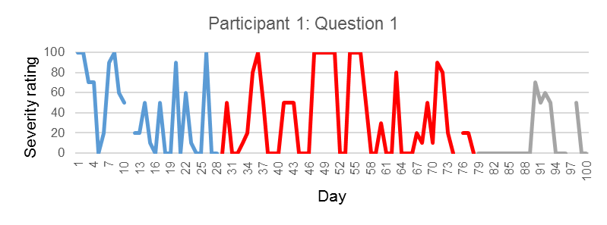
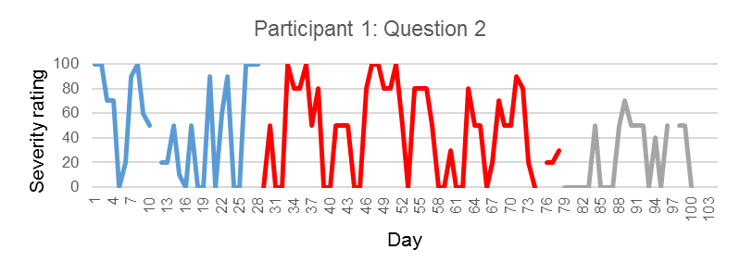
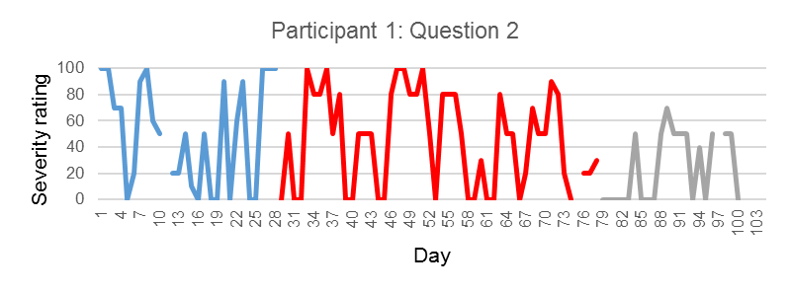

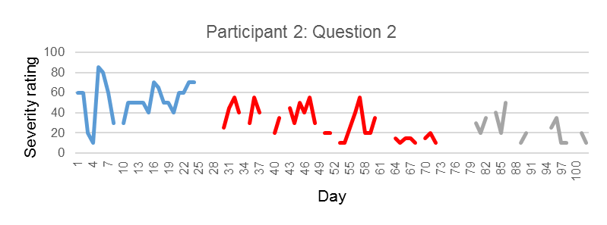
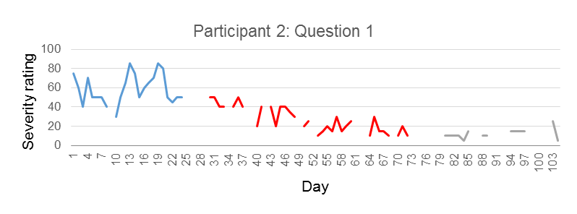

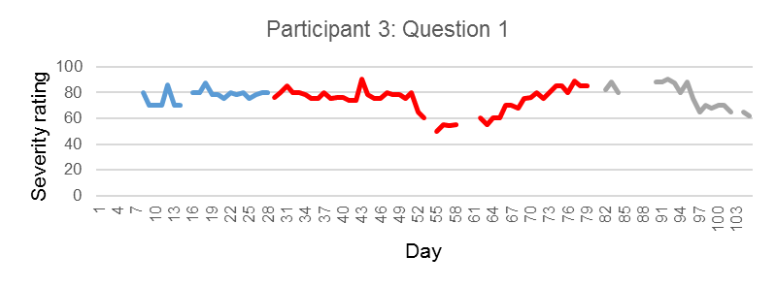
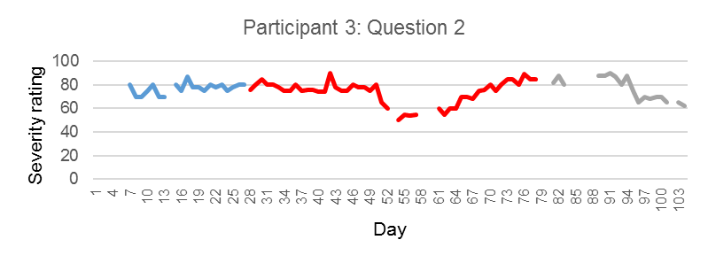
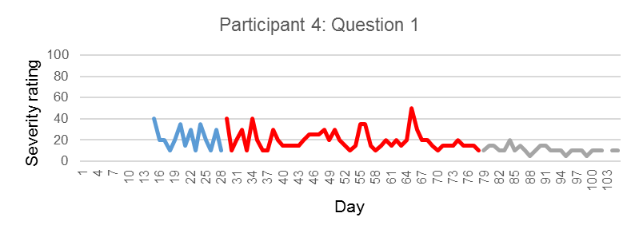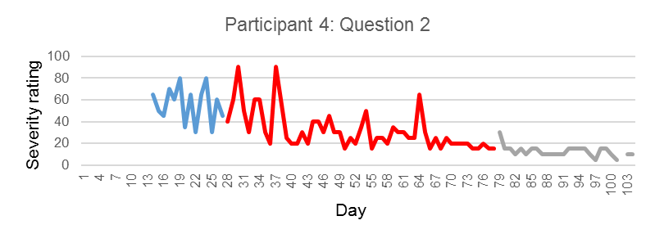
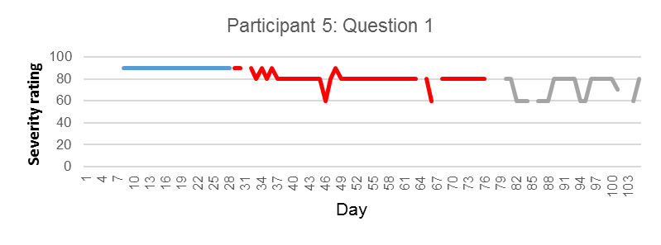
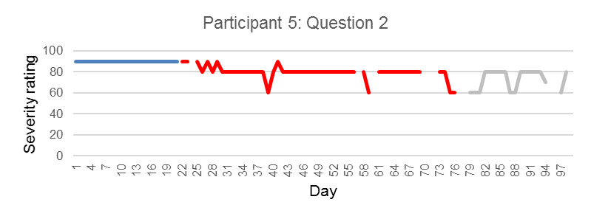

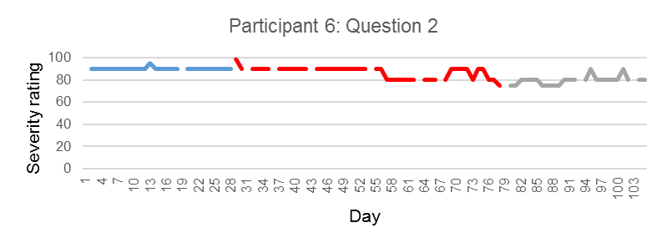
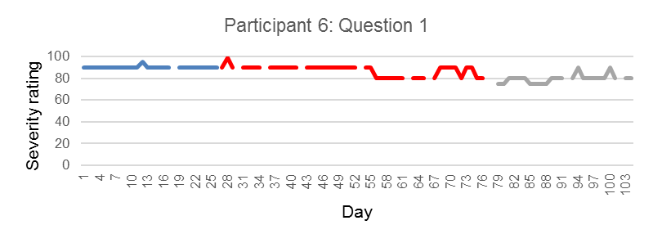

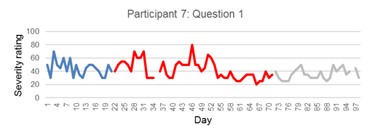
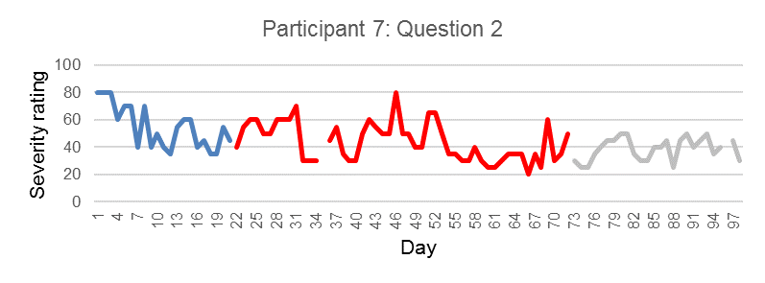

Table 5.4. TAU U analysis daily question 1

ID |  | Tau | SDTau | p | CI (95%)
1‘I have worried about other people judging me’ | Baseline-Intervention | -0.07 | 0.14 | 0.61 | -0.343 <> 0.203
1‘I have worried about other people judging me’ | Baseline –Follow-up | -0.45 | 0.17 | 0.008** | -0.781<>-0.115
1‘I have worried about other people judging me’ | Intervention-follow-up | -0.36 | 0.15 | 0.01** | -0.657<>-0.062
2‘I have worried about other people looking at me’ | Baseline-Intervention | -0.68 | 0.15 | 0.000*** | -0.98 <> -0.379
2‘I have worried about other people looking at me’ | Baseline- Follow-up | -0.79 | 0.19 | 0.000*** | -1.166<>-0.412
2‘I have worried about other people looking at me’ | Intervention-Follow-up | -0.16 | 0.18 | 0.37 | -0.510<>0.192
3 ‘I worry that people are staring at me because of how I look’ | Baseline-Intervention | -0.19 | 0.15 | 0.20 | -0.502<> 0.109
 | Baseline-Follow-up | 0.06 | 0.18 | 0.73 | -1.345<>0.655
 | Intervention-Follow-up | 0.21 | 0.15 | -0.18 | -0.095 < > 0.516
4 ‘I have been concerned with my appearance/presentation’ | Baseline-Intervention | -0.09 | 0.17 | 0.60 | -0.435 <> 0.255
4 ‘I have been concerned with my appearance/presentation’ | Baseline-Follow-up | -0.65 | 0.19 | 0.0008*** | -0.300<>-0.425
4 ‘I have been concerned with my appearance/presentation’ | Intervention-Follow-up | -0.72 | 0.14 | 0.000*** | -0.996<>-0.445
5‘I worry about what other people are thinking of me’ | Baseline-Intervention | -0.87 | 0.15 | 0.000*** | -1.168 <> -0.565
5‘I worry about what other people are thinking of me’ | Baseline-Follow-up | -1 | 0.17 | 0.000*** | -1.345<>-0.655
5‘I worry about what other people are thinking of me’ | Intervention-Follow-up | -0.46 | 0.14 | 0.002** | -0.756<>-0.172
6 ‘I worry about people looking at my skin’ | Baseline-Intervention | -0.32 | 0.14 | 0.02* | -0.603 <> -0.039
6 ‘I worry about people looking at my skin’ | Baseline-Follow-up | -0.91 | 0.16 | 0.000*** | -0.773 <> -0.102
6 ‘I worry about people looking at my skin’ | Intervention-Follow-up | -0.65 | 0.14 | 0.000*** | -0.948<>-0.370

Table 5.4. TAU U analysis daily question 1

ID |  | TAU | SDtau | p | CI 95%
7 ‘I worry that people are looking at me’ | Baseline-Intervention | -0.10 | 0.15 | 0.50 | -0.399 <> 0.195
7 ‘I worry that people are looking at me’ | Baseline-Follow-up | -0.43 | 0.17 | 0.01** | -1.243 <> -0.596
7 ‘I worry that people are looking at me’ | Intervention-Follow-up | -0.26 | 0.14 | 0.07 | -0.535 <> 0.018
Weighted average | Baseline-Intervention | -0.33 |  | 0.000*** | -0.446 <> -0.218
Weighted average | Baseline-Follow-up | -0.54 |  | 0.000*** | -0.6877<> -0.3970
Weighted average | Intervention-Follow-up | -0.34 |  | 0.000*** | -0.4515<>-0.2365

** p > .05, *p > .001,** p > .000

Table 5.5. TAU U analysis daily measures question 2

ID |  | Tau | SDTau | p | CI (95%)
1‘I have worried about speaking in front of other people’ | Baseline-Intervention | -0.09 | 0.14 | 0.511 | -0.364<>0.182
1‘I have worried about speaking in front of other people’ | Baseline –Follow-up | -0.41 | 0.17 | 0.01** | -0.745<>0.080
1‘I have worried about speaking in front of other people’ | Intervention-follow-up | -0.35 | 0.15 | 0.01 | -0.651<>-0.056
2 ‘My anxiety has led t concern about needing the toilet when I am out’ | Baseline-Intervention | -0.88 | 0.15 | 0.000** | -1.186<>-0.585
 | Baseline- Follow-up | -1 | 0.19 | 0.000*** | -1.377<>0.623
 | Intervention-Follow-up | -0.65 | 0.18 | 0.0003*** | -1.007<> -0.304
3 ‘I worry about skin break outs and how this affects how I look to others’ | Baseline-Intervention | -0.13 | 0.15 | 0.38 | -0.439<>0.169
 | Baseline-Follow-up | 0.04 | 0.19 | 0.84 | -0.330<>0.404
 | Intervention-Follow-up | -0.88 | 0.16 | 0.29 | -0.143<>0.477
4 ‘I worry about what other people think of me’ | Baseline-Intervention | -0.71 | 0.17 | 0.0001*** | -1.054<>-0.366
4 ‘I worry about what other people think of me’ | Baseline-Follow-up | -0.99 | 0.19 | 0.000*** | -1.377<>-0.612
4 ‘I worry about what other people think of me’ | Intervention-Follow-up | -0.88 | 0.14 | 0.000*** | 1.160<>-0.693
5 ‘I worry about going out without make-up’ | Baseline-Intervention | -0.87 | 0.15 | 0.000*** | -1.168<>-0.565
5 ‘I worry about going out without make-up’ | Baseline-Follow-up | -1 | 0.18 | 0.000*** | -1.345<>0.655
5 ‘I worry about going out without make-up’ | Intervention-Follow-up | -0.46 | 0.15 | 0.001** | -0.756<> -0.172
6 ‘I have avoided social situations’ | Baseline-Intervention | -0.19 | 0.14 | 0.19 | -0.469<>0.095
6 ‘I have avoided social situations’ | Baseline-Follow-up | -0.77 | 0.16 | 0.000*** | -1.096<> -0.449
6 ‘I have avoided social situations’ | Intervention-Follow-up | -0.62 | 0.15 | 0.000*** | -0.910<>-0.332

Table 5.5. TAU U analysis daily measures question 2
ID |  | TAU | SDtau | p | CI 95%
7 ‘I worry about what other people think of my appearance’ | Baseline-Intervention | -0.32 | 0.15 | 0.04* | -0.618<>-0.014
7 ‘I worry about what other people think of my appearance’ | Baseline-Follow-up | -0.55 | 0.17 | 0.001*** | -0.890<> -0.210
7 ‘I worry about what other people think of my appearance’ | Intervention-Follow-up | -0.62 | 0.15 | 0.000*** | -0.910<> -0.332
Weighted average | Baseline-Intervention | -0.44 |  | 0.000*** | -0.558 <> - 0.330
Weighted average | Baseline-Follow-up | -0.43 |  | 0.000*** | -0.800<> 0.533
Weighted average | Intervention-Follow-up | -0.35 |  | 0.000*** | -0.468 <> -0.242
** p > .05, * p > .001, ** p > .000
5.3.3 Weekly measures

Changes in weekly mindfulness scores were examined to determine levels of change in different facets of mindfulness (Figure 5.3). Multiple baseline single case design enables analysis of when change occurs across participants, and a staggered baseline can enable conclusions to be drawn on whether changes in mindfulness occur as a result of maturation, or when the intervention is introduced.

Participant 1 reported the highest levels of change in the mindfulness facet ‘Awareness’ during the intervention and follow-up phases in comparison to (i) other facets of mindfulness and (ii) to the baseline reported levels of ‘Awareness’. Participant 2 reported higher levels of change in ‘non-judgment’ and ‘non-reactivity’ during the intervention phase. Associated increases in mindfulness and decreases in social anxiety suggest that non-judgment and non-reactivity played a particularly important role in reductions in social anxiety. Participant 3 also reported the highest level of change in ‘non-judgment’ relative to baseline. The rise in non-judgment, particularly during the follow-up phase is related to decreases in increases in mindfulness and decreases in social anxiety reported during follow-up. Given that across participants allocated to different baselines the changes occurred when the intervention had been introduced we can conclude that it is likely the change is a result of the intervention as opposed to maturation or history effects.

Participant 4 reported the largest increase in ‘nonjudgement’, with some changes in non-reactivity during intervention and follow-up relative to baseline. Increases in ‘non-judgment’ were associated with reductions in social anxiety. Participant 5 reported an initial reduction in mindfulness scores at the beginning of the intervention (week 5 corresponding to week 2 of the intervention). Scores increased towards the end of the intervention; however, there was little change in scores relative to the initial scores reported at week 4. Participant 6 reported increases in ‘observe’ and ‘awareness’ facets relative to baseline scores. There was little change in ‘describe’, ‘non-judgment’, and ‘awareness’ facets. Participant 7 reported the largest increase in ‘non-reactivity’ relative to baseline scores.

Visual analysis of weekly measures of social anxiety and mindfulness (Figure 5.4) highlights a differential pattern of change in levels of mindfulness and social anxiety across participants. Participant 1 reported an increase in mindfulness scores at week 7 of the intervention; however, Participants 2 and 3 report increases from the start of the intervention. Participant 3 reports an initial increase in mindfulness; however, this drops and starts to rise again later in the intervention. The changes in mindfulness scores for Participants 5 and 6 occur later in the intervention at week 6 and week 5 respectively. Overall, visual analysis of social anxiety and total mindfulness scores suggests with the exception of Participants 1 and 7 a noticeable trend whereby increases in mindfulness are related to subsequent decreases in social anxiety (Figure 5.4).

Figure 5.3. Weekly scores of mindfulness facets
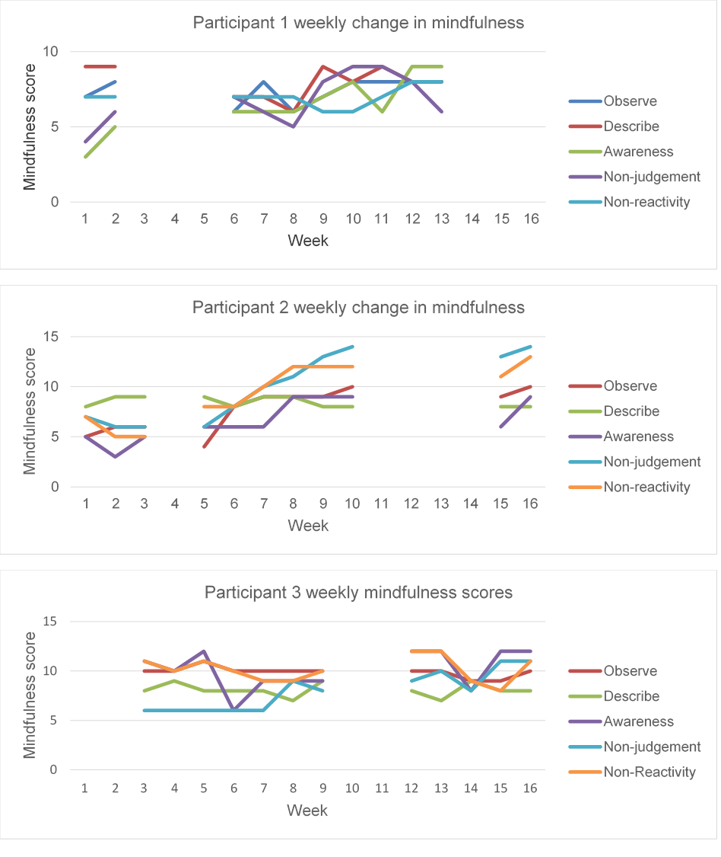

Figure 5.3. Weekly scores on mindfulness facets
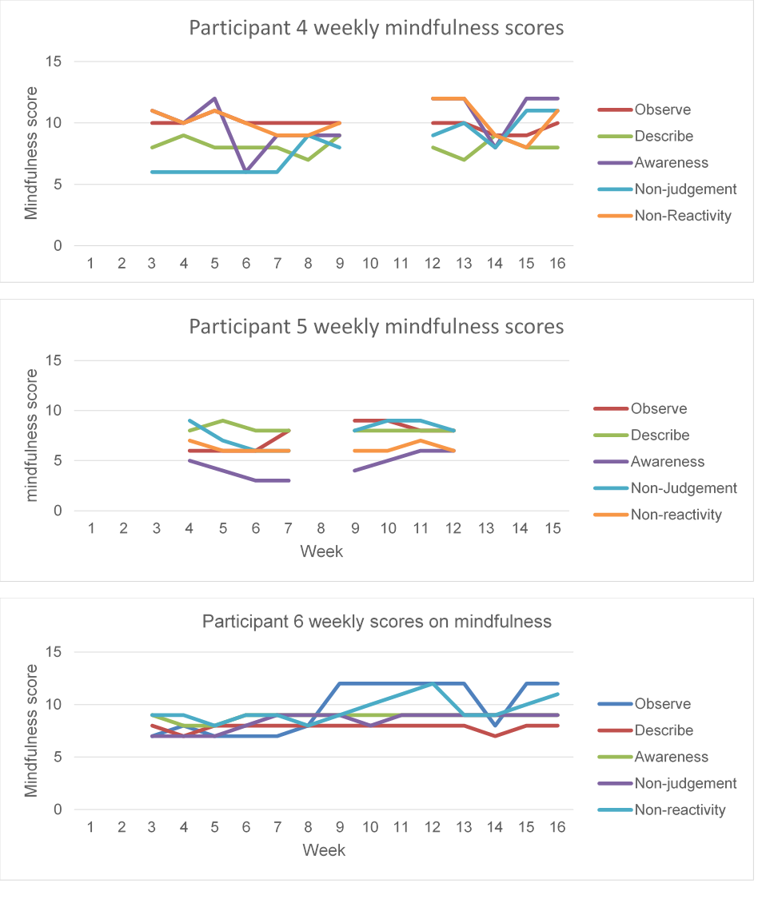

Figure 5.3. Weekly scores on mindfulness facets
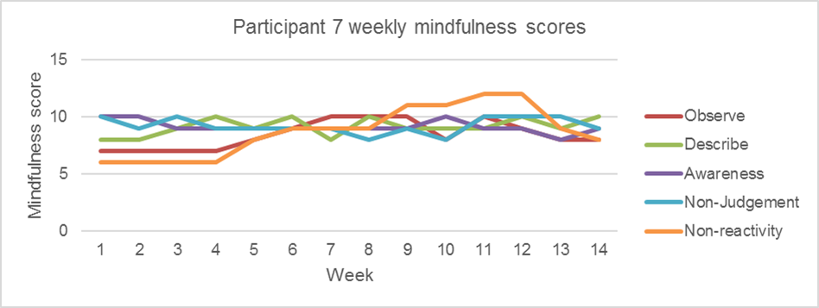

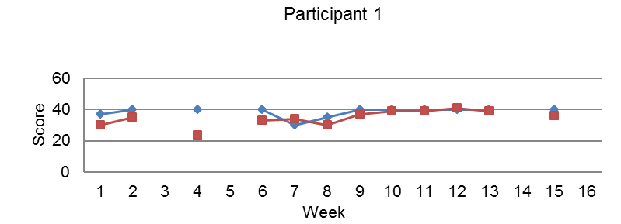
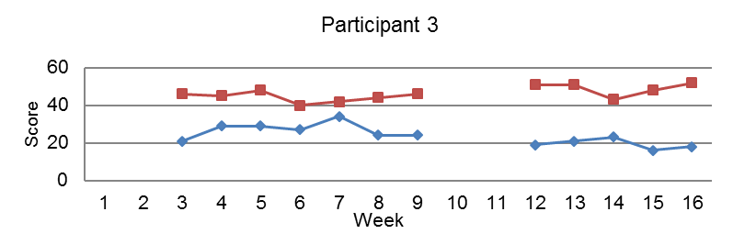
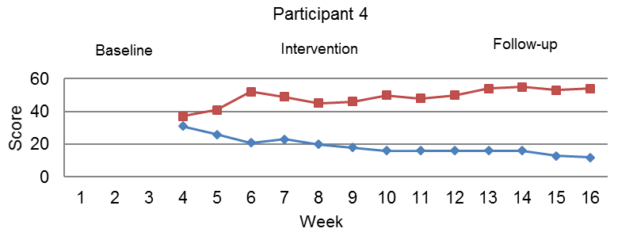
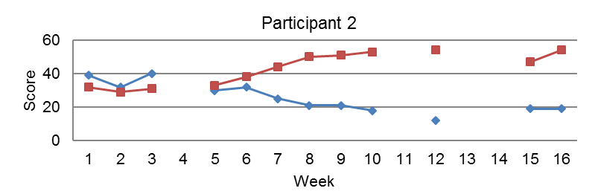
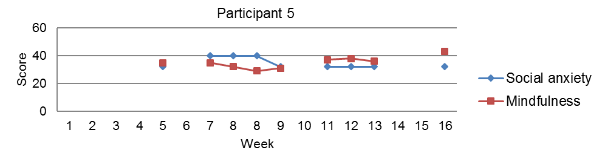
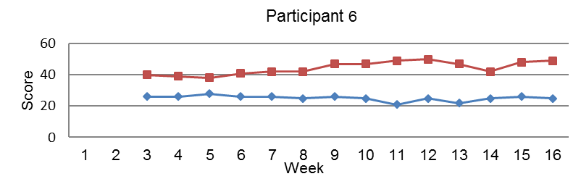
Figure 5.4. Weekly scores of treatment completers on mindfulness and social anxiety.
Baseline
Intervention
Follow-up

Figure 5.4. Weekly scores of treatment completers on mindfulness and social anxiety.
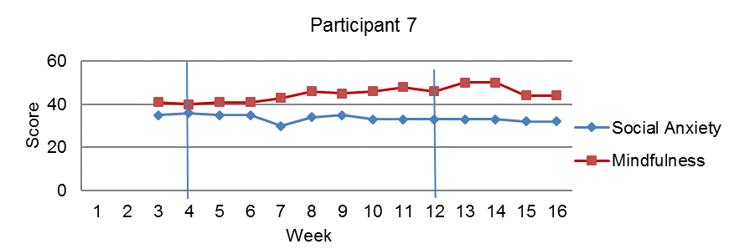
5.3.4 Clinical and Reliable change
For social anxiety symptoms, a reduction of at least 5 points on the BFNE-S was taken to indicate reliable change, using the Reliable Change Calculation. A score of < 25 on the BFNE-S was taken to indicate clinically significant change (Carleton et al., 2011). All participants reported reliable improvement in social anxiety symptoms at intervention or follow-up, with five participants meeting criteria for clinically significant change at end of intervention or follow-up (Table 5.6).

A score change of at least 5 points on HADS-Anxiety indicated reliable change in anxiety symptoms, and a score of < 8 was taken to indicate clinically significant change (Zigmond & Snaith, 1983). Four participants met criteria for reliable change in anxiety symptoms, with Participants 2, 3, 4, and 5 meeting criteria for clinically significant change. Participant 3 reported a slight increase in anxiety symptoms pre-post intervention; however, this change was not significant.

For depression, a reduction of at least 4 points on HADS-Depression indicated reliable change in symptoms of depression, and a score of < 8 is taken to indicate clinically significant change (Zigmond & Snaith, 1983). With the exception of participants 3 and 7, Participants reported symptoms of depression at the start of the intervention which reduced at end of intervention and were maintained at follow-up. Participant 3 reported an increase in symptoms of depression prior to the intervention; which showed some reduction at the end of the intervention, but did not return to start of baseline level. Participant 7 reported an increase (> 1 point) in depression at the end of intervention; however, this reduced at follow-up to meet criteria for reliable and clinically significant change. In summary, all participants reported clinical and/or reliable change on at least one measure of psychosocial distress pre-post intervention.

Table 5.6. Clinical and reliable change in psychosocial distress
ID |  | Social anxiety | Anxiety | Depression | Dermatology quality of life
1 | Start of Baseline | 35ª | 12ª | 5^{a, a} | 19ª
 | Start of intervention | 33ª | 10ª | 8^{a,a} | 15^{b}
 | End of Intervention | 39ª | 10ª | 2^{b, b} | 12^{b}
 | Follow up | 32^{b} | 10ª | 5 | 12^{b}
2 | Start of Baseline | 40^{a, a} | 17^{a, a} | 12^{a, a} | 12ª
 | Start of intervention | 40^{a, a} | 10^{a, a} | 4^{b. b} | 12ª
 | End of Intervention | 16^{b, b} | 6^{b, b} | 2^{b,b} | 2^{b}
 | Follow up | 18^{b, b} | 2^{b, b} | 2^{b, b} | 2^{b}
3 | Start of Baseline | 29^{a,a} | 6^{a,a} | 6^{a, a} | 16ª
 | Start of intervention | 29^{a, a} | 12^{b,b} | 12^{b, b} | 21^{b}
 | End of Intervention | 23^{b, b} | 9^{b, b} | 8^{b, b} | 20^{b}
 | Follow up | - | - | - | -
4 | Start of Baseline | 32^{a, a} | 13^{a, a} | 7 | 11ª
 | Start of intervention | 33^{a, b} | 14^{a, a} | 8^{a, a} | 8^{b}
 | End of Intervention | 16^{b, b} | 5^{b, b} | 3^{b, b} | 3^{b}
 | Follow up | 14^{b, b} | 3^{b, b} | 2^{b, b} | 3^{b}
5 | Start of Baseline | 40^{a,a} | 13^{a, a} | 6ª | 18ª
 | Start of intervention | 32^{b} | 11^{b} | 4 | 4^{b}
 | End of Intervention  Follow-up | 32^{b}  25^{b,b} | 5^{b, b}  4^{b,b} | 5  1^{b} | 14^{b}  12^{b}
6 | Start of Baseline | 35^{a, a} | 14 | 12^{a,a} | 16 ª
 | Start of intervention | 35^{a, a} | 11 | 12^{a, a} | 15ª
 | End of Intervention | 26^{b, a} | 10 | 10^{a, a} | 16ª
 | Follow up | 25^{b, b} | 13 | 6^{b, b} | 26^{b}
7 | Start of Baseline | 37ª | 6 | 7ª | 10ª
 | Start of intervention | 30^{b} | 10 | 4ª | 4^{b}
 | End of Intervention | 33 | 9 | 9^{a, a} | 7ª
 | Follow up | 31^{b} | 10 | 2^{b, b} | 6^{b}
Scores in different subscript (a, b) in blue indicate reliable change. Scores in different subscript (a, b) in red indicate clinically significant change.

Clinical change in dermatological quality of life was defined as a change of four score points on the DLQI (Basra, Salek, Camilleri, Sturkey & Finlay, 2015). All participants reported clinically significant change, from pre-post intervention. For five participants this change resulted in a reduction in distress associated with their skin condition; however, participants three and six reported an increase in the subjective severity of their skin condition.

5.3.5 Home practice

Participants were asked to complete home practice logs to measure between session meditation (Segal et al., 2013). Only four participants completed the home practice logs, three completers and one participant who dropped out at session 2. Participant 10 reported that she felt the intervention was not suitable for her, as it triggered high levels of self-criticism during the meditation practice. The practice log details feelings of ‘criticism’, and a ‘sense of failure’ when using meditation. Participant 10 reported completing 3 hours and 45 minutes of meditation on 5 of the 6 days proposed for meditation practice in week 1 (Segal et al., 2013).

Participants 2, 4 and 7 returned the home practice logs. Participant 4 was the only participant to fully complete practice logs from week 1-8 of the intervention. Participant 2 completed weeks 1-5 and participant 7 completed weeks 1-3. Participant 2 completed a total of 3 hours and 4 minutes of formal meditation out of the recommended 21 hours of meditation (week 1 -5). Participant 4 completed 21 hours and 10 minutes of the recommended 21.5 hours (M = 2.6 hours a week) of meditation (week 1-8). Participant 7 completed a total of 7 hours 53 minutes of meditation of the recommended 12.8 hours (sessions 1-3).

5.3.6 Treatment integrity

Two of the MBCT group sessions were recorded and reviewed by an independent CBT and MBCT therapist to ensure treatment fidelity according to the mindfulness-based interventions teaching and assessment criteria (Crane et al., 2012). Sessions were rated on a 1-6 scale (1= Incompetent, 2= Beginner, 3= Advanced Beginner, 4= Competent, 5= Proficient, 6= Advanced) across six domains including relational skills, embodiment of mindfulness, and guiding practice. For session 4 the MBCT facilitator was rated
competent and proficient across domains with a total session score of 25 (maximum rating 36). For session 8, the MBCT facilitator was rated competent and proficient in the majority of domains. In two domains (coverage of curriculum and enquiry) an ‘advanced beginner’ score was given. On discussion with the independent rater these scores related to aspects of the course adapted to incorporate material on social anxiety, rather than depression. Overall, session ratings were acceptable, and the MBCT therapist adhered to protocol (see Appendix R).

5.3.7 Attrition

The most common reason for drop-out was other commitments and time pressures including work and study. Participant 10 reported that the intervention was not suitable for her. During session 2 she became upset and spoke with the researcher. During this time, she discussed difficulties with meditation, including thoughts she was not doing it right, and she also stated that during the meditation she became more preoccupied with negative thoughts concerning how she looked, which she reported contributed to her experiencing a deterioration in her mood. The procedure for managing adverse events was followed and, in line with ethical guidelines, the GP was informed. No adverse effects of the intervention were reported when Participant 10 was contacted after leaving the group.

Daily measures were available for four participants who began the baseline phase (Figure 5.5). Participant 9 did not begin the intervention phase; therefore, data is only available for the baseline phase. Participant 11 did not complete question 2, and therefore data was only available for question 1. The three participants who started the intervention experienced a decrease during the intervention phase on at least one of the specific social anxiety symptoms they chose to target relative to the baseline phase. Participant 9 did not begin the intervention; however, they did report a reduction during the baseline period in the two daily measures of social anxiety.

Figure 5.5. Daily measures of social anxiety completed prior to drop out for participants starting the baseline period.
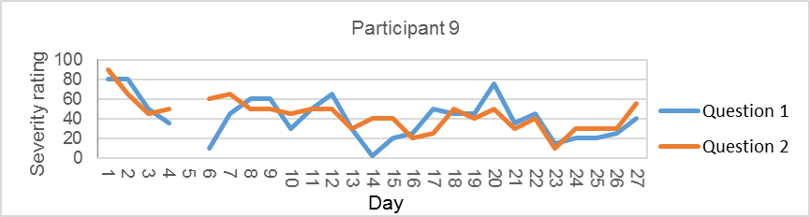
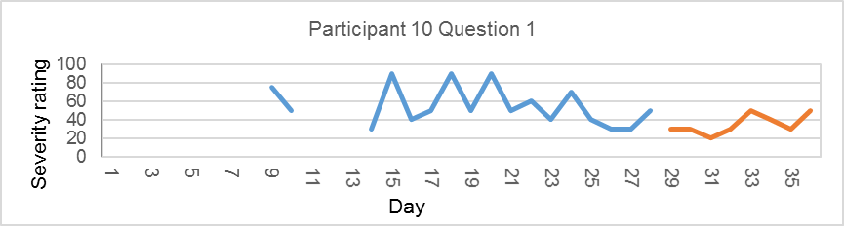
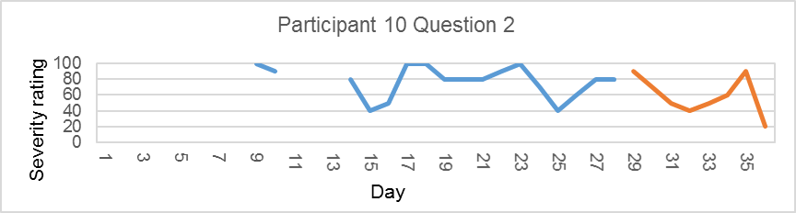
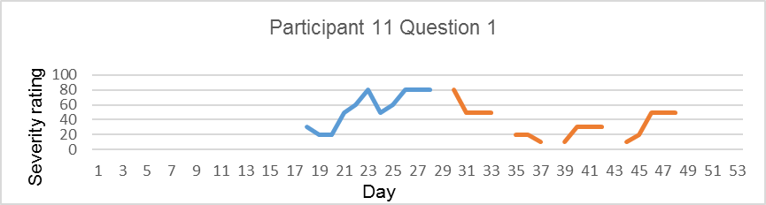
Baseline
Intervention

Figure 5.5. Daily measures of social anxiety completed prior to drop out for participants starting the baseline period.
Baseline
Intervention

5.4 Discussion

The current study aimed to examine the effectiveness of group MBCT for social anxiety in people living with visible skin conditions. Multiple baseline single case design involves the use of a staggered baseline, whereby participants are randomly allocated to different baseline phases before the introduction of the intervention. A staggered baseline enabled analysis of when change occurred across participants and whether change occurred when the intervention was introduced or at alternative time points. This design allows researchers to rule out alternative explanations for symptom change such as maturation. It is difficult to rule out extraneous variables such as changes in life changes for one participant. Where change consistently occurs when the intervention is introduced across participants allocated to different baseline periods it is more likely this change occurred as a result of the intervention rather than history or maturation effects. The results of the current study indicate that participants who completed the MBCT group experienced clinical and reliable change in at least one measure of psychosocial distress.

Significant reductions in daily social anxiety symptom severity were reported across six out of seven treatment completers. Participants reported reductions in worries regarding appearance and how they were perceived by others during social situations. The findings of the current study suggest that for treatment completers the intervention was effective in reducing social-evaluative concerns which are a key symptom of social anxiety (Clark & Wells, 1995; Rapee & Heimberg, 1997). In addition, the findings suggest that the MBCT intervention was effective in reducing specific appearance-related anxiety for people living with visible skin conditions. Considering specific appearance-related cognitions, six out of seven participants reported worry about others looking at them, or the appearance of their skin to others. The concerns reported are consistent with the findings of Study 1 and previous studies which suggest appearance concern is a common problem in people living with visible skin conditions (McKenna & Stern, 1997; Ozturn et al., 2013; Thompson et al., 2010).

Considering maintenance factors in social anxiety evidence suggests people pay more attention to negative self-relevant information which does not allow for disconfirmation of negative self-beliefs (Chen et al., 2002; Clark & Wells, 1995; Rapee & Heimberg, 1997). For people living with conditions affecting appearance, appearance specific schemas can lead to social anxiety and sensitivity to social rejection (Kent & Thompson, 2002). As found in Study 1, social distress in people living with visible skin conditions is experienced as an interaction between self-appraisal, negative reactions of others and fears of negative evaluation, a process in which an individual engages in an interpretative and evaluative process of themselves in the context of the social environment. Using MBCT, participants are taught to view thoughts as transient mental events (Fennell, 2004) and learn how to disengage from ruminative processes.

Weekly measurement of individual facets of mindfulness highlighted differential patterns of change between participants. All participants reported change in mindfulness during the intervention phase; however, two facets showed more change; ‘non-judgment of experience’ and ‘non-reactivity to inner experience’. These findings are consistent with Hjeltnes et al.’s (2016) findings with participants reporting increased non-judgment and non-reactivity to inner experiences following MBSR. Considering the findings of Study 2, non-judgment of inner experience and awareness were the two facets significantly associated with social anxiety. The findings of the current study and Study 2 suggest that non-judgment of inner experiences is an important facet of mindfulness to be integrated within interventions for social anxiety.

Non-judgment of inner experience refers to the ability to take a non-evaluative stance towards thoughts and feelings (Baer et al., 2008). Thoughts are acknowledged, without judgment, reducing the likelihood of making negative predictions and interpretations of experiences (Kabat-Zinn, 1990). The findings of Study 1 suggested that self-appraisals of appearance and previous negative reactions from others led participants to make negative predictions and assumptions regarding the likelihood of further negative reactions from others. Considering Kabat-Zinn’s (1990) definition of non-judgment of inner experiences, this suggests participants in Study 1, displayed low levels of non-judgment during social situations. In the current study, anxious thoughts related to worries of being judged by others and worry about appearance, consistent with the findings of Study 1. The current findings show that increases in ‘non-judgment’, experienced as a result of engagement in the MBCT intervention, are related to reductions in social anxiety which suggests that reductions in evaluative thought processes may reduce social and appearance anxiety.

A number of participants reported increases in ‘non-reactivity’, the ability to allow thoughts, feelings and physical sensations to come and go without reacting to them. Higher levels of ‘non-reactivity’ have been correlated with lower levels of rumination and less negative bias (Paul et al., 2013). Neuroimaging has identified a negative correlation between levels of ‘non-reactivity and left anterior insula activity when inhibiting and engaging in negative stimuli during a mindfulness task (Paul et al., 2013). These findings suggest that ‘non-reactivity’ can reduce negative bias by reducing automatic responding to negative stimuli, evidenced by insula activation (Paul et al., 2013). Reducing the tendency to judge experiences may be beneficial in reducing anxiety triggered by social situations as individuals are less likely to attribute a ‘threat’ interpretation to the experience.

Higher levels of ‘non-reactivity’ may also reduce experiential avoidance, in which people may be unwilling to experience negative or unpleasant experiences and engage in attempts to alter the experience in order to reduce distress (Hayes & Feldman, 2004). Safety behaviours refer to attempts to reduce social distress for example by avoiding social situations and may maintain symptoms of social anxiety (Clark & Wells, 1995). MBCT brings participants into contact with all aspects of experience, positive and negative, to enable people to reduce habitual patterns of reactivity to experiences and instead approach experience with an attitude of curiosity. Cognitively, coming into contact with unpleasant experiences can help people to challenge the belief that they are unable to tolerate distress. Whilst the theoretical rationale for the increase in non-judgment and non-reactivity following MBCT has been discussed, further studies are required to measure the impact of MBCT on these cognitive and behavioural mechanisms (e.g., measures of experiential avoidance and self-compassion). In addition, qualitative studies to examine the application of increased mindfulness skills in everyday life would offer valuable insight into mindfulness interventions including the active ingredient responsible for change across individual participants.

Previous studies of mindfulness interventions in social anxiety have measured levels of mindfulness pre-post intervention (Goldin et al., 2012) or have not measured levels of mindfulness (Koszycki et al., 2007) which makes identifying the point of change difficult. Weekly measures of mindfulness and social anxiety suggest that reductions in social anxiety were associated with increases in mindfulness and change appeared to occur simultaneously. The findings suggest that mindfulness is multi-faceted, with participants experiencing different levels of change in individual facets throughout the MBCT intervention. Participants reported increases in awareness during the intervention; however, changes in other facets were greater. This supports the use of the Five-Facet Mindfulness Questionnaire (Baer et al., 2006) as an alternative to single facet measures, such as the Mindfulness Attention and Awareness Scale (Brown & Ryan, 2003). The current findings also suggest it may be helpful to target specific facets of mindfulness for example, non-judgment of inner experiences, when designing interventions for people living with visible skin conditions.

With the exception of one participant, participants who completed the intervention reported clinical and reliable change in symptoms of depression at the end of the intervention or at follow-up. Four participants reported clinically significant reductions in anxiety symptoms. One participant reported significant increases in symptoms of depression and anxiety at the end of the intervention; however, scores were not completed at follow-up. Participant feedback identified that during the intervention period this participant (three) experienced significant life changes, including starting and ending a new job, which had increased anxiety, and coming to terms with a relationship breakdown. These factors may have contributed to increases in anxiety and depression.

Overall, the current results support the effectiveness of MBCT in reducing current depression which is in line with previous studies (Strauss, Cavanagh, Oliver, & Pettman, 2014). Mindfulness interventions have been found to reduce rumination which is a key characteristic in maintaining depressive mood states (Segal et al., 2002). Acknowledging negative thoughts as they arise can help people to disengage in habitual thinking patterns. Negative thoughts are often past or future-focused and mindfulness techniques enable participants to bring their attention to the present moment. The reduction in symptoms of depression reported in the current study differ from one other MBCT study conducted in psoriasis patients, where no significant improvements were reported pre-post MBCT on the same measure of anxiety and depression (Fordham et al., 2014).

Improvements in skin-specific quality of life were reported by four participants; however, two participants reported a reduction in quality of life. Improvements in quality of life were reported in the absence of objective change in the skin condition, and no new dermatological treatments were started during the study period. On discussion of the results with individual participants, they acknowledged there had been no physical improvements in their skin condition, for example Participant 2 had alopecia and had noted no new hair growth. Two participants reported a reduction in quality of life; however, in spite of worsening symptoms and increased visibility of their skin condition, both participants reported improvements in social anxiety. Concerns about the appearance of their skin reduced, along with self-evaluative concerns. This suggests that responding mindfully to negative thoughts can improve symptoms of social anxiety in the absence of changes in the physical aspects of the skin condition.

5.4.1 Attrition

Overall study attrition was high; however, most of the attrition occurred prior to the intervention commencing suggesting that participants who attended found the group acceptable, as once the intervention had started only three participants left the group. It may also suggest that time commitments need further discussion at the initial assessment to determine any potential conflicts with attendance.

Attrition in the current study was comparable to the attrition reported in Fordham et al.’s (2015) study of MBCT for psoriasis patients. Fordham et al. (2015) recruited thirteen participants with seven participants starting the MBCT group, and one participant dropping out during the group. However, attrition rates in the current study were higher than those reported in previous studies of mindfulness interventions in people with social anxiety (15-18% Hjetnes et al., 2016; Jazaieri et al., 2012; Koszycki et al., 2007). To investigate potential explanations for attrition in the current study baseline characteristics of completers and drop outs were examined; however, there were no notable differences, with completers reporting slightly higher levels of social anxiety. This suggests that differences in levels of distress were not a predictor of drop-out. All participants who dropped out were recruited via the University volunteer list which may suggest recruitment method was a factor influencing drop-out. All participants recruited via the NHS completed the course which suggests the MBCT intervention would be an acceptable treatment option to offer patients attending dermatology clinics.

Participants who dropped out of the intervention reported some improvements in daily social anxiety symptom severity during the intervention phase suggesting that the intervention did not have a detrimental effect on social anxiety symptoms. One participant who dropped out at Session two reported not finding the intervention helpful, and finding meditation difficult due to self-critical thoughts. Dobkin, Irving, and Amar (2010) reported that it can be challenging and upsetting to pay attention to difficulties for a sustained period of time. A significant number of long term meditators have been found to report at least one adverse event during meditations (62.9%) including boredom, anxiety, increased negativity and being more judgmental towards oneself (Shapiro, 1992) suggesting caution should be exercised when considering MBCT for people who are high in self-criticism.

5.4.2 Home practice

Home practice was assessed using practice logs; however, only four participants returned completed practice logs at the end of the intervention. As the number returned was low it was difficult to draw conclusions on how home practice related to changes in mindfulness and psychosocial distress in the current study. The two participants who completed the home practice logs to at least week 5, were the two who reported the most significant improvements in social anxiety, depression and anxiety. This suggests that completing the home practice records may highlight a commitment to the intervention and may contribute to reduced distress and improved outcomes in MBCT.

Feedback from participants who did not return the mindful practice logs suggested they completed home practice on two to three days a week, and used the three-minute breathing space ‘as and when’. Carmody and Baer (2008) reported a significant positive correlation between formal meditation practice and degree of change in levels of mindfulness and psychological wellbeing. Informal practice (being mindful in everyday activity) was not significantly associated with psychological wellbeing and mindfulness. This suggests people should engage with formal practice to see beneficial reductions in distress (Carmody & Baer, 2008). Further research is needed to examine the relationship between home practice and reductions in social distress; however, the current results may suggest that completing home practice diaries highlights a commitment to mindfulness practice.

5.4.3 Clinical implications

The current study is the first single case series of group MBCT for social anxiety, and the first to examine the use of MBCT for social anxiety in people living with a visible skin condition. The results suggest that group MBCT could be an effective intervention to reduce distress, particularly social anxiety and depression, in people living with visible skin conditions. The findings also suggest that MBCT may reduce concern about appearance which occurs as a result of living with a visible skin condition. These findings may be transferable to people who report concern about the visibility of other health conditions. Increases in mindfulness were associated with decreases in social anxiety symptoms throughout the intervention and follow-up period.

Non-judgment and non-reactivity to inner experiences were particularly important to participants in the current study, with increases in these facets associated with decreases in social anxiety symptoms. Non-judgment was significantly associated with social anxiety in Study 2; suggesting this facet of mindfulness is a target for intervention for social anxiety in people with visible skin conditions. In Study 1 awareness was also identified as a target for intervention in social anxiety; however, the results of the current study suggest that increased awareness was not consistently related to reductions in social anxiety across participants. Further studies are required to examine changes in facets of mindfulness following MBCT in a larger sample. The current study findings suggest that tailoring interventions to focus on non-judgment of inner experiences and non-reactivity to inner experiences may be beneficial. The current findings suggest that MBCT can lead to improvements in skin-related distress in the absence of improvements in physical health. Overall, the current study suggests group MBCT is an acceptable intervention, which could be offered to primary care dermatology patients experiencing psychosocial distress.

5.4.4 Limitations

There are a number of limitations to the current study which need to be considered when interpreting the findings. First, the current study is a small n study, therefore the small sample limits the generalisability of the findings. Whilst comparisons between participants in the study provide inter-subject replication, further studies with larger samples are required to replicate the findings. Despite limitations which arise with small n studies, this design was appropriate given the aim of the study was to gather in-depth information to examine the relationship between mindfulness and social anxiety. Single case design allows for this in-depth investigation, and provides insight into appropriate measurement when considering randomised controlled trials.

Second, there was considerable variability in the idiosyncratic measure scores during the baseline phase reported by a number of participants. A stable baseline in single case design is preferable as this enables change during the intervention period to be attributed to the introduction of the intervention (Kratochwill et al., 2010). However, people living with social anxiety often experience variability in symptoms given that symptoms occur during social situations (American Psychiatric Association, 2013)
and avoidance of social situations is a key maintenance factor (Clark & Wells, 1995; Rapee & Heimberg, 1997). Further studies may seek to measure social anxiety symptoms only when they are triggered during social situations. Avoidance of social situations could be measured to determine impact of the anxiety symptoms. Despite variability in baseline measurement for some participants, which continued during intervention and follow-up, symptom severity showed a downward trend suggesting that despite variability there was an overall reduction in symptom severity during the intervention and follow-up phase.

Third, the length of follow-up does not allow for the sustainability of mindfulness practice to be established. A longer follow-up period should be considered in future studies to determine if participants continue to use meditation and if improvements in mood are sustained. Fourth, as only four participants returned their home practice logs it was not possible to determine how or if home practice contributed to changes in levels of distress or mindfulness. However, two of the three treatment completers who returned the home practice logs experienced the greatest reductions in levels of distress. In addition to home practice, it might be that other aspects of the group intervention such as normalisation played a role in facilitating change. The low return rate may be due to difficulties completing the practice logs, or participants finding the logs too burdensome. In future studies use of daily text messages may be beneficial to ask people how much meditation practice they completed each day. Participants can then respond with a total number of hours spent meditating; this may reduce burden on participants.

Fifth, the intervention was delivered by one facilitator and without a comparison group it is difficult to determine if the same effects would be achieved with a different therapist. To control for this the intervention was adapted from a manualised programme developed by Segal et al. (2013), and sessions were recorded and rated by an independent MBCT therapist to ensure the intervention was carried out in accordance with the maualised programme and mindfulness good practice guidelines (Crane et al., 2012). However, the study does not control for therapist effects such as charisma and empathy, and further studies should consider a comparison group with a different facilitator.

5.5. Conclusion

The current study extends on the work of Kabat-Zinn et al. (1988) and Fordham et al. (2014), and builds on the previous studies reported in this thesis to suggest that mindfulness interventions can be beneficial for people living with visible skin conditions. The positive findings of the current study suggest further research examining the use of MBCT in dermatology patients reporting psychosocial distress, particularly social anxiety and depression, is warranted. A randomised control trial is now warranted to examine the effectiveness of group MBCT for people living with visible skin conditions and experiencing psychosocial distress. The RCT should aim to address therapist effects by running two MBCT groups with different facilitators. A treatment as usual group may be the most appropriate control condition, given that access to psychological therapies in dermatology is currently limited.

When making decisions regarding the implementation of health interventions, evidence on effectiveness alone is not sufficient (Lewin et al., 2012) and qualitative methods should be considered within the framework of design and evaluation of complex interventions (Campbell et al., 2000). Information on the acceptability of interventions is required to understand participants’ experiences of interventions and factors that may influence implementation. Qualitative research can offer a valuable insight into the individuals’ experiences of interventions and acceptability whilst enabling a detailed exploration of how and why change occurs (Elliot, 2010).
As the current study is the first to examine the effectiveness of MBCT for social anxiety in people living with visible skin conditions, there is a need to examine participants’ experiences of the intervention to ensure it is acceptable for this population. In addition, it is important to examine how the learning from the MBCT intervention was implemented in everyday life to see how mindfulness techniques led to reductions in distress. In the next chapter, participants’ experiences of the MBCT intervention will be explored using their own results from the intervention study to examine their interpretation of changes in psychosocial distress and mindfulness

Chapter 6. The perceived processes and impact of MBCT for social anxiety in people living with visible skin conditions

6.1 Introduction
As outlined in Chapters 4 and 5, mindfulness based interventions for social anxiety disorder have shown promise in reducing symptoms of social anxiety, and psychological distress. MBCT interventions focus on developing an awareness of habitual patterns of negative thoughts, feelings, and sensations and how they maintain negative mood states. A key element of mindfulness is meditation, through which individuals can learn how to approach thoughts with clarity, objectivity (Shapiro, Carlson, Astin, & Freedman, 2006), and from a non-judgmental stance. Segal et al. (2002) suggested that learning mindfulness skills can reduce the tendency to over-identify with negative experiences which lead to rumination and maintain distress in depression; however, these processes can be seen as trans-diagnostic, underlying a range of disorders, including social anxiety.
The research reported in this thesis aimed to explore the cognitive processes underlying social distress in people living with visible skin conditions, and identify potential interventions which may be beneficial in reducing social distress. The theoretical basis of mindfulness interventions for social anxiety were explored in Chapter 4 and findings from Studies 1 and 2 suggested that mindfulness may target processes underlying social distress in people living with visible skin conditions, specifically over-identification with negative self-appraisals, fears of negative evaluation and potential bias in processing threat related social cues. Study 3 examined the effectiveness of MBCT for social anxiety in people living with visible skin conditions and findings suggested that the intervention has potential in reducing social anxiety, appearance related concerns, depression, anxiety and skin specific quality of life. However, further research is warranted to explore participant experiences and the acceptability of MBCT to examine the potential for implementing mindfulness interventions in dermatology.
A number of qualitative studies have examined the experiences of people who have engaged with MBCT interventions. In a qualitative content analysis Hertenstein et al. (2012) found that MBCT was an acceptable intervention for people living with obsessive compulsive disorder (OCD). In particular, participants found the three-minute breathing space to be helpful for reducing OCD symptoms. Participants were able to allow intrusive thoughts to come and go by bringing attention to the present moment. Participants also reported an increased willingness to tolerate unpleasant emotions (Hertenstein et al., 2012).
Participants at risk of relapse in depression reported that MBCT enabled them to (i) become more aware of signs of relapse and (ii) develop tools to manage distress, thus increasing feelings of control over their depression (Allen et al., 2009). The actions taken to manage signs of relapse included the deliberate shifting of attention away from a negative self-focus (Allen et al., 2009). Participants also reported that they felt able to put thoughts into perspective. Participants with health anxiety also reported that MBCT allowed them to develop a different relationship with thoughts, in particular higher levels of acceptance of anxious health-related thoughts (Surawy, Mcmanus, Muse, & Williams, 2014). Encouragingly, despite key characteristics of health anxiety being avoidance and misrepresentation of physical sensations, bodily awareness exercises were not found to increase symptoms of health anxiety (Williams, McManus, Muse, & Williams 2011). In a study of people with active depression and anxiety, MBCT was found to be acceptable and beneficial (Finucane & Mercer, 2006). In particular, participants reported developing methods of managing in the moment anxiety (Finucane & Mercer, 2006).
Overall, qualitative studies exploring participants’ experiences of mindfulness interventions across a range of disorders suggest that the intervention can be beneficial in changing the individuals’ relationship with dysfunctional patterns of thinking (obsessions, negative thinking, health-related worries) and developing more adaptive ways of responding to experiences. Findings also suggest that the group format of MBCT and MBSR can play a role in reducing stigma in relation to depression (Allen et al., 2009) as participants are around others with shared experience.
It is also important to explore any negative experiences or difficulties associated with mindfulness to determine if adapting interventions to target specific disorders may be beneficial or where mindfulness interventions may not be beneficial. In addition, establishing the characteristics of people who experience difficulties or respond well to mindfulness interventions can provide clinicians with important information regarding referral criteria. For example, Hertenstein et al. (2012) reported that some participants felt a mismatch between wanting to be free of OCD symptoms and the longer-term nature of cultivating mindfulness skills. Difficulties with home practice have been reported, including boredom and impatience with the longer meditations (Suraway et al., 2014; Williams et al., 2011). Finucane and Mercer (2006) reported that the eight-week intervention for people living with active depression and anxiety was viewed as too short by some participants and the group format also had a negative impact for one participant, who felt it was claustrophobic.
To date, only one study has examined participants’ experiences of mindfulness for social anxiety. Hjeltnes et al. (2016a) interviewed participants who reported the highest and lowest levels of social anxiety symptom change following MBSR. Using a two-staged mixed methods design, high and low treatment responders were identified based on levels of symptom change in social anxiety. Seven participants in each group were interviewed and responses were analysed using thematic analysis (Binder et al., 2012). The overall themes describing participants’ experiences were represented as dimensional continuities representing both high and low treatment responders. Participants who reported high levels of change in social anxiety reported wanting to make an active effort to change their problem, and feeling able to actively engage and use mindfulness skills. Participants reporting lower levels of change reported wanting to change, but not feeling ready and struggling with motivation to engage in the intervention.
The group “acted as both a safe environment and a source of anxiety” (Hjeltnes et al., 2016a, p.9). Whilst participants reported that it was beneficial to meet others with social anxiety, the group experience was again represented as a dimensional continuity. For those who reported higher levels of change in social anxiety the group environment acted as a way to model social situations. Participants with lower levels of symptom change reported feeling exposed and vulnerable in the group, and becoming anxious during group discussions.
Regarding specific mindfulness skills, participants with high levels of symptom change learned new ways of engaging with unpleasant experiences. Those with lower levels struggled with the mindfulness techniques as they became more aware of difficult sensations and the exercises became a source of frustration, with people feeling they were not doing them right. At the end of the course participants with high levels of symptom change reported improvements in social situations, whereas those low in symptom change reported continued avoidance of social interaction.
The current study aimed to explore participants’ experiences of an MBCT group intervention for social anxiety in people living with visible skin conditions. To date, this is the first study to examine the effectiveness of MBCT for social anxiety in a dermatology sample. To facilitate the discussion of change in psychosocial distress during interviews participants were presented with their individual change scores on measures of social anxiety, depression, anxiety, skin specific quality of life and mindfulness taken throughout the MBCT intervention study to identify areas of change and to explore the participants’ attributions for the change. The use of mindfulness during social situations was explored to determine how participants applied mindfulness techniques to their everyday life and if the techniques resulted in change in thoughts and behaviours. The acceptability of MBCT for social anxiety in people living with visible skin conditions was also explored to examine the potential for implementation of MBCT in dermatology.
6.2 Method
6.2.1 Design
The main aim of the current study was to examine participants’ experiences of MBCT for social anxiety in people living with visible skin conditions, focusing on the acceptability of the intervention and the process of change participants experienced as a result of the intervention. Given the applied nature of this research and the implications for psychological interventions in dermatology, thematic analysis was used to interpret key features of participants’ experiences (Braun & Clarke 2014).
Thematic analysis is a method used to “identify, analyse and report patterns within data” (Braun & Clarke, 2006, p.76) to explain a particular phenomenon of interest. Unlike other qualitative methods it is not tied to a particular epistemological assumption, and is instead related to the specific research aims of the study. Thematic analysis is appropriate as it allows detailed, reflective, first person accounts of participants’ experiences of MBCT. This method has been previously used to examine participants’ experiences of MBCT for depression (Allen et al., 2009). An inductive approach was used to generate themes and subthemes which were identified as relevant to the participants’ experience of the intervention.
6.2.2 Recruitment
Participants in the current study completed an MBCT intervention for social anxiety in people living with visible skin conditions (Chapter 5). All participants recruited to the MBCT intervention were made aware that following the intervention they would be invited to attend an optional four-week follow-up interview. Participants who completed the intervention (N = 7) were provided with information on the interview and a consent form (see Appendix V). All participants who completed the intervention gave informed consent to be interviewed and interviews were arranged to take place four weeks after the last MBCT group.
6.2.3 Procedure
All participants consented to a follow-up interview and interviews were carried out either at the University of Sheffield or the participants’ own homes. Interviews lasted approximately 40 minutes. Interviews incorporated aspects of the change interview (Elliot, Slatick, & Urman, 2001) to examine key therapeutic processes the participant attributed to changes in mood (see Figure 6.1). Participants were presented with their scores on measures of psychosocial distress (social anxiety, anxiety, depression and skin specific quality of life) and mindfulness completed during the study period (Study 3), and asked to reflect on any changes that occurred. Showing participants scores on measures allowed them to reflect on any change throughout the study period. A number of open ended questions and probes (when necessary) to elicit an accurate presentation of the participants’ experiences of the MBCT intervention and home practice were used to guide the interview.
6.2.4 Analysis
Interviews were recorded using an encrypted digital recorder and transcribed verbatim by the student researcher. Following transcription interviews were analysed using QSR International's NVivo 11 qualitative data analysis Software (2015). To maintain confidentiality, personally identifiable characteristics were removed from the transcripts. Following initial reading of all interviews, line by line analysis of individual interviews was carried out to identify salient aspects of the participants’ accounts, resulting in a list of initial codes representing the data (Braun & Clarke, 2006). The initial codes were then organised into themes which aimed to represent the initial codes in a meaningful way, for example, all codes related to the facilitator of the intervention were organized into one sub-theme ‘MBCT facilitator’, which was later incorporated into the overall theme - experiences of MBCT. Themes contained both implicit (e.g., when participants make reference to specific phenomenon without explicitly labelling it) and explicit content (e.g., when participants labelled their specific experiences), which relates to the interpretive nature of thematic analysis in that the researcher identifies the explicit meaning of the participant account. Following review and refinement of themes, an over-arching thematic framework which identified the themes across all participants was established (example analysis can be found in Appendix W).
6.2.5 Ethical considerations
Ethical approval was gained from North West Preston Research Ethics Committee (See appendix A). In line with Study 1, the ethical guidelines for qualitative research were adhered to throughout the research (Thompson & Chambers, 2012). Participants were provided with information on the follow-up interviews and advised the interview was optional, with no obligation to take part. All participants expressed an interest in the study and discussing their individual scores with the researcher. Participants were made aware that all information was confidential and no personally identifiable information would be used within the study or subsequent publications. Participants were made aware that if the researcher had any concerns regarding their mood during the interview their GP would be contacted. GP details for all participants were collected at the beginning of the MBCT intervention and were held in a password protected file by the researcher in case of any adverse events. An information sheet containing numbers for support if participants experienced distress was made available to all participants in the interview.
All participants reported clinically significant levels of social anxiety at the beginning of the MBCT intervention, with some participants reporting symptoms of depression and anxiety. Therefore, the current study involved talking about potentially difficult thoughts and feelings that can arise as a result of social anxiety, anxiety and depression. The interviews were conducted by a researcher with a background working in mental health as a Psychological Wellbeing Practitioner and experience of managing in the moment distress which may arise when discussing psychosocial distress.
6.2.6 Quality Control
Research using thematic analysis has been criticised in the past for failing to provide sufficient detail of how data was analysed (Braun & Clarke, 2006). In the current study, the stages of thematic analysis proposed by Braun and Clarke (2006) were used to illustrate how the analysis was conducted. Transparency of reporting is essential for determining the validity of qualitative research (Cresswell & Miller, 2000) and was established by an audit of the research process. Yardley (2000) proposed a number of criteria for evaluating qualitative research which was adhered to when collecting and analysing the data, including transparency of data collection and analysis and reflexivity. An audit of the qualitative data analysis was carried out by an independent researcher at the University of Sheffield. An initial review of the analysis was carried out by the primary supervisor to ensure the analysis had been conducted in line with the guidelines of thematic analysis (Braun & Clarke, 2006). The audit involved a review of the original transcripts to ensure the researcher had captured salient aspects of the participants’ experiences, and a review of the coding framework to ensure the themes reflected participants’ experiences.
6.2.7 Reflexivity
Reflexivity acknowledges the role of the researcher within the research process and the particular views and assumptions which the researcher brings to the study as a result of their own personal experiences. Whilst the researcher had not been present during the MBCT group, the researcher was present at the beginning, during breaks and at the end of the intervention over the eight weeks. During the study period the researcher had contact with participants over 16 weeks. In this time participants shared experiences of the group and change with the researcher which may have influenced questioning during the follow-up interviews. The time period also meant a less formal relationship was established between participants and the researcher which may have influenced disclosure during interviews.
Figure 6.1. Interview Schedule.
Interview
Acceptability of intervention
1.2. How did you find the techniques that we used in the group?
Prompts Were there any challenges? How did this fit with your expectations? How would you describe this experience to other people? Did you notice any differences between how you felt when you had used meditation, and times when you did not engage with the practices as often?
1.3. How did you find the between session tasks?
Prompts: Were there any barriers to doing the tasks? Did you notice differences when you did engage with these tasks than when you did not?
1.4. Would you suggest any changes to the course?
1.5 Do you feel you will continue to use anything from the course?
Experiences of group therapy
1.6. How did you find being part of the group?
Prompts: Did you initially have any concerns about being part of a group? Was there anything helpful about being part of a group? Was there anything unhelpful about being part of a group?
Experience of change
1.7. Have you noticed any changes from the group?
1.8. Can you tell me about any times when you have applied mindfulness techniques?
Prompts: What mindfulness techniques did you use? How did you feel after using mindfulness? Would you be able to talk more about this? What did you notice before you started using mindfulness, what led you to start using mindfulness in this situation?
2.1. What was it about this particular session? What was significant about this? Did you notice any changes in physical symptoms, feelings, thoughts or behaviours?
Participants will be shown a graphical representation of their completed psychometric measures from baseline, intervention and follow up.
Change during therapy
2.2. Could you talk about anything you feel may have led to changes in the scores at these points?
2.3 Looking at the scores is there anything else you have noticed or would like to add?

6.3 Results

Participants were aged between 17 and 52 (M = 32.23, SD = 11.9). Five of the participants were female and all were White British although they reported a range of visible skin conditions. Participants attended a minimum of five MBCT sessions, with reasons for non-attendance being due to illness (Table 6.1).

Table 6.1 Participant characteristics

ID | Age | Ethnicity | Gender | Skin condition | Sessions attended
1 | 49 | White British | F | Bechet’s | 6
2 | 33 | White British | F | Alopecia | 6
3 | 52 | White British | F | Alopecia and eczema | 5
4 | 17 | White British | M | Acne | 8
5 | 33 | White British | F | Rosacea | 5
6 | 49 | White British | F | Psoriasis | 6
7 | 21 | White British | M | Ezcema | 7

Three main themes were identified. Theme one examined participants’ views of the acceptability of the MBCT intervention, including aspects such as session length, timings, how initial expectations were met, experiences of being in a group intervention, and the participants’ ‘take home message’. Theme two examined participants’ experiences of change in psychosocial distress. Whilst the study focused on social anxiety, participants described change in levels of anxiety, depression and skin specific quality of life which are explored within this theme. Theme three examined participants’ experience of change in mindfulness. This theme incorporated participants’ experiences of using mindfulness within their everyday life, engagement in the home practice and participants’ views of the sustainability of mindfulness. A summary of the main themes and subthemes, and how each participant contributes to the themes, can be found in Table 6.2.

Table 6.2. Summary of themes

Theme | 1 | 2 | 3 | 4 | 5 | 6 | 7
- Acceptability of the intervention | X | X | X | X | X | X | X
- Experiences of group-based intervention | X | X | X | X | X | X | X
1.2 Take home message | X | X | X | X | X | X | X
- Experiences of change in psychosocial distress | X | X | X | X | X | X | X
2.1 Experiences of change in social anxiety symptoms | X | X | X | X | X | X | X
2.2 Experiences of change in skin-specific distress  2.3 Experiences of change in anxiety and low mood | X | X  X | X  X | X  X | X  X | X  X | X  X
- Experiences of change in mindfulness | X | X | X | X | X | X | X
3.1 Changes in self-compassion | X | X | X | X | X | X | X
- Experiences of meditation | X | X | X | X | X | X | X

Theme 1. Acceptability of the intervention

Participants described the intervention as ‘positive’, ‘useful’ and ‘helpful’. The structure of the (weekly 2.5 hour sessions) was acceptable and beneficial in establishing a formal framework course in which to learn mindfulness.
I don’t think so I think everything was the building and everything was lovely no I thought it was fine absolutely fine (P01)

Participant 5 who suggested a change in the timing of the group.
I think it’s always going to be difficult when you have to do it after work time cos that’s what you have to do cos that’s the only time that people can come but then it means that you don’t get in until like 10 o clock (P05)

A break was incorporated into the intervention and participants felt this was beneficial.
I think it just made it more friendly more informal (P04)

Several participants suggested that a follow-up group or groups would have been beneficial to encourage continued practice.
I mean it wouldn’t have to be every week it could just be once a month, something to aim to (P06)

To address the acceptability of the intervention it is important to consider participants’ expectations before starting the MBCT group. Most participants reported no prior experience of mindfulness, two participants reported prior experience in the form of meditation at the end of yoga classes. Participant 5 was the only participant who had previously tried using a structured mindfulness intervention and described her experience in the excerpt below.
It was an online version, you pay, it’s like £60 and its basically this but you do it yourself online so they give you the mp3 and they give you diaries and its actually really very similar but I basically gave up after the second week because I just couldn’t I didn’t have the discipline (P05)

Participant 5 highlighted the need for discipline to engage with an online, self-directed course; however, she reported similar difficulties with engagement in the current course.
I’ve been really annoyed at myself for not attending all of the sessions because things just came up…with everything that’s been going on in the last 8 weeks its juts been a crazy time… I don’t want to get into berating myself but I know that I think it would be helpful to go through some of it again (P05)

Other participants had no previous experience of mindfulness and therefore were unsure what to expect, with all participants reporting that it exceeded their expectations.
It was better than I thought it was going to be to be fair, I didn’t know if it would all be a little bit sort of lot of talking at us you know and the science behind it but you know we got straight in to it the first night there was no messing (P01)

I’ve never had anything like that before and it was very different and I think it’s just a new way of like learning about the way I work and kind of getting a deeper feel for that (P07)
All participants provided positive feedback on the facilitator’s manner and style describing the facilitator as ‘empathic’, ‘calming’ and knowledgeable’.
I think as well he seems to kind of what’s the word yeah well empathetic of everyone’s experience, I don’t know how emotionally he can get involved but he really did seem to care about the things we were going through (P07)

He was just so engaging, he listened, he was very supportive I mean there were two or three sessions where people sort of really spoke quite openly about the stuff that’s been going on in their lives which would have been very difficult he was really supportive of them and I think he got the best out of everybody as well (P01)

1.1 Experience of a group-based intervention

Participants described initial reservations about attending a group, including concern about what others would think of them. However, once attending the group these initial reservations appeared to dissipate and participants described the group as supportive. In the excerpt below, Participant 2 described the group as ‘powerful’:
It was a nice bunch of people and nobody really hogged the conversation and yeah I think it was really powerful the group (P02)

Participant 7 described how being part of a group of people potentially provided motivation to make his own changes.
You look at other people and even though they’re struggling with it, they’re still here, there still attempting to change the way they think they’ve still got determination and desire yeah to address the way they perceive their own skin (P07)

Whilst all participants reported finding the group intervention beneficial, two participants reported making unhelpful comparisons with others in regard to their progress as described in the excerpt below from Participant 5.
You kind of get a bit thinking that you’re not doing as well as other people because other people would talk about how many times they’ve done the practice or how good they were finding it or whatever and say if you’d had a frustrating week where you’d not managed to do it much or your like I don’t get this then you’d be kind of like oh I’m not doing it right or I’m not you know like why are they getting that out of this and I’m not (P05)
For Participant 5, comparisons with others led to feelings of self-criticism that she ‘wasn’t doing it right’ in regards to the meditation. A similar experience was reported by Participant 7 in the excerpt below.
I think hearing some people what they got out of each session and I was like woah I’m not feeling this what’s going on you know why are they getting these like major epiphany and I’m not getting it (P07)
However, in spite of this Participant 5 felt the group provided a supportive environment suggesting the comparisons did not have a negative impact on the participants experiences of the group based intervention.
‘Everyone there has got some kind of similar problem to me then your automatically hopefully in a more supportive environment (P05)

1.2 Take home message

The excerpts below describe participants’ ‘take home message’ from the intervention. Participant 2 reported that the MBCT intervention had changed her life, in particular learning that ‘thoughts are just thoughts’ was a ‘powerful’ learning point. This is consistent with the teachings of mindfulness, as participants are introduced to the concept of viewing thoughts as transient mental events that are not representative of objective reality.
I feel like my life has changed that’s a very emotional and powerful point…It was so powerful I suppose to be told there just thoughts I’ve had them my whole life but they’re just thoughts and I think the way he (facilitator) was saying things in the first sessions they were going in, I could hear myself thinking them throughout the remaining weeks (P02)
Participant 6 reported previous engagement with psychological therapies and finding MBCT more beneficial. Similar to Participant 2, the excerpt below from Participant 6 described how learning to view thoughts from a more objective standpoint was helpful:
I prefer this because its more real it’s more what I would do I don’t know if I’m explaining that, it’s easier for me to do it how I have been doing, rather than thinking right I will write it in a book then I can look after cos for me I had to write my negative and then put three positives and it just didn’t make sense cos when my minds down I can’t find three positives and this isn’t asking me to do this, it’s just asking me to rationalise what’s real and what’s not (P06)

For Participant 4, learning how thoughts, feelings and behaviours can lead to negative mood states was beneficial.
Why I do the things I do why I think the way I think and why that’s made me feel so low (P04)

Participant 1 described the impact of meditation practice on worry, noting a reduction in physical symptoms:
Because I am constantly, fretting about something and I know what that
does to your body physically, and there’s always something at the back of me mind what should I do, should I be doing this should I be doing that, and I just worry and when I’m doing that (meditation) I know I’m not worrying or I’m trying not to worry cos you know your mind does wander so it must be doing me good, my body must be calming down (P01)

Participant 7 reported that whilst social anxiety was still a problem, learning techniques to feel more equipped to manage distress was helpful.
The only comment I can make is that it’s definitely helped me like little bits and like in most things pretty much but its more just like feeling equipped to deal with stuff even if the actual things you’re dealing with aren’t improving you know and I think that’s the really good thing (P07)
Two participants described challenging aspects of engagement in MBCT. Participant 3 described how the focus of the intervention on social anxiety in skin conditions led to an increase in thoughts about her eczema. Whilst this was challenging it suggests the intervention reduced experiential avoidance, and through acknowledging difficult experiences participants may then develop adaptive coping strategies.
I mean it definitely helped me, also at the same time it focused in on my skin so there was that element to it so that was a real test so where you could ignore at certain times, when you’re doing a study about your skin and social anxiety it brings it to the fore, to the front of your head and your kind of, you have to acknowledge it (P03)

Participant 5 attended 5 sessions, but felt she engaged with only 40% of the intervention as engagement in home practice was low. Participant 5’s overall perception of the intervention was that it demonstrated potential for being beneficial.
I’ve probably engaged with the whole thing maybe like 40% so I think I’ve only kind of got a snap shot of the whole picture but it’s enough to kind of demonstrate to me that it’s got a lot of potential for being very helpful, and even kind of with the very limited amount that I’ve done its still enough to demonstrate that it works (P05)

Overall, Theme 1 examined the acceptability of group MBCT for social anxiety in people living with visible skin conditions. Participants felt the intervention was acceptable, and whilst the group format initially created some anxiety, overall, participants felt that being around others experiencing similar problems was helpful. Participants had a positive view of mindfulness and found the course useful, in particular changing their relationship with thoughts and learning to view thoughts more objectively was beneficial.

Theme 2: Experiences of change in psychosocial distress.

Participants were asked to provide their account of any changes they experienced in psychosocial distress, and specifically in social anxiety using their individual scores on the psychometric measures of social anxiety, anxiety, depression and skin-specific quality of life completed throughout the 16-week study period.

2.1 Experiences of change in social anxiety symptoms

With regards to social anxiety, participants’ reductions in fears of negative evaluation and changes in behaviour suggested increased social confidence. In the excerpt below, Participant 1 described her experiences of change in social anxiety; specifically, she described being aware of worries about what others thought of her, but being able to dis-engage from negative thoughts:
I have changed the way I’m thinking professionally, I am always worse when I’m at work its work when it gets me but I’ve started to be a bit more gung ho about doing things you know when I’ve been tasked to do something rather than worrying about what’s gonna go wrong and what people are going to think of me I’m like, just do it and if anything goes wrong what’s the worst thing that can happen you just learn from it and I am I am more laid back about work (P01)

Participant 6 reported reduced avoidance of activities where her skin condition was visible to others, and acknowledged the value of activities.
Although I have a couple of episodes with panic attacks when I’ve been out but then I know then that’s cos my skin is worse than it’s been for years but even so I still well I’ve still kept going to yoga, and I’ve kept thinking my skin is falling all over the floor, it’s like being at a wedding (laughs), and I probably wouldn’t have carried on if I just didn’t think well, they might be looking at me like that and thinking like that but that’s up to them let people think that if they want and I want to do this for me (P06)

In the excerpt below, Participant 2 described improvements in social anxiety which were associated with increased mindfulness, specifically, ‘non-judgment’.
I think maybe after the 3rd, 4th session somewhere round then I would just leave and be walking really slowly and really calmly and I would just look at people and I would be like just non-judgmental, like oh look at those people over there, and it was just such a calm feeling that I’d never had before (P02)

Adopting a ‘non-judgmental’ stance was explored with Participant 2 given the importance of this facet of mindfulness to Participant 2. The excerpt below suggested that the intervention helped her to identify ‘judgemental’ patterns of thinking, and reduce reactivity to these thoughts.
I: so do you think non-judgment is important in social anxiety?
P: yes, definitely because I think because, obviously I can’t read other people’s thoughts but I know that I naturally judge and I don’t like it I don’t like that I do it but I constantly am so I am constantly judging people and so you know then you believe everyone else is doing it about me and then so if you learn well you don’t have to judge you don’t have to make a judgement about your thought or make a judgement about whatever (P02)
Participant 7 described the use of specific mindfulness techniques in social situations. Whilst Participant 7 did not report a reduction of ‘in the moment’ anxiety, he felt that his mind was not as focused on the anxiety symptoms.
In like seminars and stuff, where I’m like I know it’s gonna be me, I’m talking in the next ten minutes or something you know, I’m using it then … just the kind of back to the breath like feel it come in and out and in and out and just feel that you’re here, just the three-minute breathing space essentially…I don’t go through the process like chronologically or whatever, I didn’t necessarily think it helped in terms of actually lowering stuff but then it did take my mind off it so is that helping in effect (P07)

Participant 4 reported improvement in social anxiety symptoms, and this was explored to determine what changes he had noticed. The excerpt below suggested improvements in social confidence and interaction.
I: what tells you that its (social anxiety) improved how do you know?
P: well cos I’m more myself when I talk to people now I’m not afraid to tell them what I’m interested in like I don’t feel like I have to fit in or whatever (P04)

Participant 4 reported previous experiences of bullying at school due to his skin condition, which led to feeling low, and worry about going to school. Whilst a direct comparison wasn’t possible, the excerpt below suggests Participant 4 experienced a change in mood.
I don’t really think like that anymore but I’m not at school any more so it’s hard to, but I think at college I’m not like that (P04)
Participant 7 reported experiencing changes, but did not notice a significant change in social anxiety.
I’ve noticed changes but it’s not been crazy (P07)

2.2 Experiences of change in skin-specific distress

Given the intervention aimed to test the effectiveness of social anxiety in people living with visible skin conditions, experiences of change in participants’ perceptions of their skin condition were explored. Participant 5 described wearing make-up as a result of previous negative reactions from others related to her appearance. In the excerpt below participant 5 described using the three-minute breathing space which enabled her to go into a shop without make-up on, suggesting a reduction in concealment and avoidance behaviours.
I think it is probably an ingrained thing kind of learned behaviour because of experiences at school and bullying (P05)

I’ll just stay in the car I’ve got no make-up on so I can’t go in, and I remember thinking ok just do the you know the three-minute thing so I kind of did a mini version of that and it just allowed me to kind of step outside of it a little but and just see it for what it was and just go in (P05)

During the intervention Participant 1 reported considerable variation in the severity of daily social anxiety symptoms. Participant 1 suggested that social anxiety symptoms had reduced and she was not experiencing increases in social anxiety symptom severity during social situations at follow-up.
I: do you feel like this has continued (shown variation in scores)
P: No I don’t, I think I’m applying my mind differently to worrying about things so it’s probably more plateau (P01)

In the excerpt below Participant 6 described a reduction in anxiety and scratching behaviours associated with increased awareness of physical sensations.
I’d get into bed and it were in my stomach (anxiety) and I dint know what to do with myself, and then the other night I just thought not again and I realised it was because I was itching and I was getting myself so worked up with itching that I was fetching anxiety on but once I’d noticed the link between the two it stopped so I’m still itching but I’m not going to bed thinking I’m not gonna be able to sleep, I’ve stopped it.. when I am positive in my head I can think right it’s an itch ignore it, it’ll go but it depends where I am (P06)

Participant 6 described a worsening of her psoriasis and an improvement in social anxiety symptoms. This was explored with Participant 6 to determine her perception of these changes.
P: I just think well I can’t do anything about it so and I’ve managed well, I’ve managed to just think, I can either socially isolate myself or try and carry on regardless…
I: So it’s interesting that your skin condition has worsened but your anxiety has gone down?
P: Yeah and I really believe it’s down to the mindfulness (P06)

The excerpt from participant 6 suggested that she attributed improvements in social anxiety to the mindfulness intervention. In particular, she described a more accepting attitude towards her symptoms and reductions in avoidance. However, for Participant 3, eczema created a barrier to engagement with mindfulness as described in the excerpt below.

I find that when I get itchy my itch takes precedence unfortunately…when I itch it makes you think oo that’s so much better but then you’ve aggravated it and that kind of wins (P03)

Participant 2 reported no physical changes in her alopecia; however, she noted changes in her attitude towards the condition.
Three or four months ago I was just deadly afraid of my wig coming off in public or somebody being able to tell I was wearing a wig and of course that leads you wanting to stay at home doesn’t it, and not go outside and just being self-conscious all the time, you know people are looking at me… I’m welling up thinking about it, it’ just so powerful to me cos that’s what I do I constantly comparing, I think now I don’t really care so much I’ve been wearing just a hat outside and people might be thinking oh go she doesn’t look like she’s got any hair ok, but it’s not such a big deal.. but partly that could be me coming to terms with the disease anyway but I should think quite a lot of it is down to ‘they’re just thoughts (P02)

Participant 2 attributed changes in her attitude towards her alopecia and reductions in avoidance to coming to terms with the condition and engagement in the MBCT intervention. Participant 5 reported that his acne had fluctuated throughout the intervention, but described it as being ‘bad’ at the time of the follow-up interview. Despite noticing worsening of physical symptoms, Participant 5 reported improvements in worry regarding his appearance which had an impact on dating.
I: The main worry you said was getting mocked and people making comments about your spots, and you were avoiding dating because you were sceptical and had low confidence
P: oh yeah
I: has that changed?
P: That’s definitely changed, well its not that I date but I’m not afraid to now, this is quite bad cos I actually want to focus on my work at the minute (P05)

2.3. Experiences of change in low mood and anxiety

Although the primary aim of the intervention was to examine the effectiveness of MBCT in reducing social anxiety in people living with visible skin conditions, it was important to examine the influence of the intervention on mood in general. This theme will now explore participant accounts of change in symptoms of depression and anxiety. Participant 1 found mindfulness beneficial to reduce negative thinking, using present moment awareness exercises.
I: so how do you apply the mindfulness to those situations when you’re worrying
P: just concentrate on the moment bring it back to like I’ve recognised that I’m having these negative thoughts so stop, it’s like when you’re actually doing the meditation and your mind wanders its bringing it back to your body and your breathing concentrating on something other than what you’re worrying about (P01)

Participant 6 reported that others had noticed a change, saying she was ‘calmer’, and she had also noted a change in behaviour.
I love reading and I’ve not been able to read for about two year, and I’ve read five books in a fortnight (P06)

In the excerpt below Participant 2 described changes in anxiety and self-consciousness and recognising how maladaptive coping strategies may have led to worsening of symptoms. Using mindful breathing exercises appeared to reduce anxiety and self-consciousness.
I’ve kind of been anxious and self-conscious my whole adult life and I’m 32 so it’s kind of a long time and I’ve got into habit which I naively thought were helping me .. so my old coping mechanisms were how can I get out of situations to make myself feel better, whereas the meditation taught me to go inwards and focus on my breathing which I’ve never done before (P02)

In addition, Participant 2 also noted changes in her irritable bowel symptoms following the intervention.
I definitely haven’t had any bad attacks relating to the IBS you know so sometimes maybe like before Christmas I would be in the car driving and I would be like I need to go to the toilet and I would just panic and oh good and really painful my stomach would knot but I don’t get any of that now (P02)

Overall, participants reported reductions in fears of negative evaluation and increased confidence in social situations. This included reductions in avoidance and concealment strategies which participants previously engaged in as a result of their skin condition. Participants reported improvement in low mood, anxiety, and improvements in wellbeing including improved sleep and increased engagement in enjoyable activity.

Theme 3: Experience of change in mindfulness

This theme aimed to examine changes in mindfulness reported by participants. Overall participants described changes in their relationship with negative thoughts, particularly being able to recognise the transient nature of thoughts. With regards to the facets of mindfulness the excerpts suggested an increased awareness of negative patterns of thinking and non-reactivity which related to being able to observe thoughts without habitually responding. Participants also described approaching thoughts from a non-judgmental stance. In the excerpt below Participant 5 reported increased awareness which related to being able to notice her worries and ‘step-back’.

It just helped with my awareness day to day, it’s not like I don’t think it instantly meant I wasn’t worrying about things but it just helps you kind of step back a little bit and just more kind of being more analytical of the white noise rather than being completely in it (P05)

Participant 5 described how she had applied mindfulness to her everyday life, and in stressful situations. In particular, she suggested that ‘noticing’ had become a more automatic coping strategy.
I’m becoming better at noticing things so I’m its become more automatic.. like walking to work and kind of thinking right I am going to focus on such and such and I know like the feeling of my feet on the floor and the sound of whatever it will just happen, so noticing things has become more automatic and its more of a reflex to, if I’m in a stressful situation to get into that zone as a king of its become more of a go to thing for coping (P05)
In the excerpt below, Participant 7 described an awareness of how negative thoughts arise. Being able to recognise this negative mood state was a positive aspect of mindfulness for him.
I think I really did understand wow it’s all about that noticing I noticed when I was having a negative thought way before I usually would and it wouldn’t necessary be that I could notice it and watch it go it was just like oh, I’m in a bit of a rut here you know having a bad time and like I think being able to sense that and that comes from perseverance so I think that was important for sure (P07)

In the excerpt below, Participant 2 described how her relationship with negative thoughts had changed.
I need to step away and see them as just thoughts, they’re not harmful and everyone has them and it was that that was the real penny drop moment’ (P02)

3.1. Changes in self-compassion

In the excerpt, Participant 2 described how initially the intervention triggered self-critical thoughts in the excerpt below.
Just thinking well how do I do this, what’s the rule book for meditation, am I doing it right and if I’m not what do I do better (P02)

However, these self-critical thoughts were balanced with the development of ‘kind’ thoughts, suggesting that whilst self-compassion is not explicitly taught on the MBCT course, participants experienced increased kindness towards themselves.
Just the sort of kind thoughts, you know kindness to yourself, cradling yourself like a baby (P02)

For other participants, engaging in the intervention acted as a challenge, as described by participant 3 in the excerpt below.
Trying to put it in a routine was difficult, I didn’t think I was worth the time (P03)

However, despite this initial challenge Participant 3 described being able to give herself more time, which suggested an increase in self-compassion.
Managing the thoughts it helped, cos I felt like I was being kinder to myself and less critical when I started mindfulness (P03)

Participant 4 described himself as a perfectionist, and critical if he did not meet his expectations. Following the intervention Participant 4 described an increase in self-acceptance and self-compassion.
If I had an expectation for something and I dint meet that expectation then I felt I beat myself up sort of thing… I think I’m more self-accepting and maybe more compassionate for others and stuff… and I think myself as well (P04)

3.2 Experiences of meditation

Participants described positive and negative experiences of mindfulness meditation, along with a number of challenges to engagement in home practice. Participant 1 and Participant 3 described positive experiences of meditation.
I felt calmer afterwards when I did you know, when I had a good session or what have you, I do feel calmer and more relaxed (P01)

Participant 3 also reported improvement in mood when engaging with meditation.
I: did you find a difference when you meditated more with your mood to when you did it less
P: yeah I was calmer yeah more focused when I did it more (P03)

However, participant 3 said she was more engaged with the shorter meditations described below.
I was good on eating and meals and the three minutes and the self-check’

Participant 5 felt that meditation became easier with practice.
Meditation itself feels less weird it comes more naturally and it’s kind of less of a struggle its easier every time you do it.. I do feel like they help me in a more practical way like I think it’s a lot easier to incorporate little things like little and often is much more doable (P05)
Overall, participants appeared to find the shorter meditations easier to incorporate into their daily life. Whilst participants reported initial engagement in the 40 and 50 minute meditations this decreased towards the end of the intervention as described by Participants 2 and 6 in the excerpts below.
I started off being very disciplined I think and I kind of stick to 6 days a week and maybe not 40 minutes but a good 20-30 minutes (P02)

I’d say between three and four days a week like properly but then like as we learnt to do them I could shorten it I found that I could even do it at work (P06)

All participants described barriers to engagement with home practice, for some participants this related to finding time. Participant 5’s struggles with home practice are described in the excerpt below, and included difficulties with motivation to do meditation and falling asleep.
It almost became like a kind of dis-incentive cos the amount of times that I would do the exercise and then fall asleep (P05)
Participant 7 described finding the meditations physically uncomfortable on occasions.
There were times when I was like five or ten minutes through and just kind of like, this is actually physically hurting I’m gonna stop now and do something different you know (P07)

Participant 7 also described the practices as not being mentally stimulating enough.
The practice is literally just to concentrate on your breath I just find it difficult, not mentally stimulating enough I suppose, and obviously I don’t know what to compare it to (P07)

In terms of sustainability of the practice, all participants reported reductions in mindfulness meditation following the end of the intervention. For several participants, using the shorter mindfulness meditations was beneficial and felt easier to sustain in everyday life.
I will be honest since I’ve stopped going I’ve not put anything into practice half as much, I mean I’m aware of it and aware of stuff and I when I get that moment I’m like right I’ll just take a few minutes here and put it into practice (P01)

This experience was also reported by Participant 2.
I haven’t been doing probably any meditation since we finished, well, no formal meditation but during the day if I’m anxious and I just stop and drop to my stomach and feel my stomach coming in and out so I sort of assimilated that sort of behaviour (P02)

Participants were asked about their plans to continue using mindfulness, all participants described an intention to continue. Participant 1 described needing to structure her time to fit in practice.

There’s only me that can do it, there’s only be that can be more rigid set a time or something but no it’s I need to do it (P01)

Participant 3 said that she would find it beneficial to do another course as described in the excerpt below. Participant 3 had difficulties downloading the meditations to her phone, and suggested that she would look at the obstacles to ensure she could engage.
If another course came up I would do it and I would put the effort into getting everything working and getting all my technology up to date so I could get it so there was no obstacles (P03)

Theme 3 examined participant experiences of change in mindfulness. Participants described changes in their relationship with thoughts. In particular, being able to view thoughts more objectively and reduce reactivity to negative thoughts was beneficial. Participants reported increased self-compassion as they had learned to approach themselves with kindness. There were barriers to meditation for several participants, particularly in terms of finding time to carry out the formal meditations. Participants reported finding the shorter meditations beneficial and easier to incorporate into their daily routine.

6.4 Discussion
To date, only one study has examined participant experiences of a mindfulness intervention for social anxiety (Hjeltnes et al., 2016a); therefore, little is known about the participants’ experiences and acceptability of mindfulness interventions for social anxiety. The current study findings suggest that MBCT is an acceptable intervention for social anxiety in people living with visible skin conditions. Developing mindfulness skills, particularly becoming more aware of negative patterns of thinking and reducing engagement with negative thoughts, was beneficial in reducing symptoms of social anxiety, anxiety and depression. Difficulties engaging in home practice were reported across participants, in particular, difficulty integrating longer meditations into daily routines. Participants described shorter meditations being more beneficial suggesting a review of home practice recommendations in future studies. Issues regarding the sustainability of mindfulness practice were highlighted.
Theme one examined participants’ views of the intervention, including the course structure, content and delivery of the intervention. Overall, the intervention was acceptable to participants. Participants described initial anxiety about the group format; however, once starting the group it was viewed as positive, providing a supportive environment. The group format of MBCT has been reported to be a normalising and validating experience across previous studies (Finucane & Mercer, 2006; Surawy et al., 2014), and the current study supports these findings.
Regarding course delivery, participants expressed positive views of the facilitators style and attitude. The influence of the therapist on treatment outcomes has been explored, and patients who see ‘better’ therapists have a better probability of clinical improvement (Baldwin & Imel, 2013). In addition, therapists’ interpersonal skills have been found to play a role in treatment outcomes (Anderson, McClintock, Himawan, Song, & Patterson, 2016). Previous studies suggest that the group-format and therapist characteristics can influence treatment outcomes and further studies of mindfulness interventions should investigate these factors further.
Theme two explored participants’ experience of change in psychosocial distress. Following the MBCT intervention all participants reported clinically significant change in at least one area of psychosocial distress (social anxiety, anxiety, depression and skin specific quality of life; Study 3). Experiences of change were explored to determine if scores on psychometric measures of distress were an accurate reflection of change, and if changes were attributed to aspects of the intervention or other lifestyle factors. Regarding social anxiety, participants reported reduced engagement with negative patterns of thinking which characterise social anxiety. Thoughts concerning the reaction of others were acknowledged; however, participants’ accounts suggest an awareness of the thoughts, rather than habitually responding. Reduced avoidance and increased confidence in social situations was reported.
For the majority of participants’, social anxiety was triggered by negative self-appraisals regarding the appearance of their skin condition and worry about the reaction of others. The findings suggest that participants experienced a change in their attitude towards their skin condition. Specific examples from participants suggested they felt more confident going out socially, were less worried about the reactions of others towards their appearance, and increased engagement with activities they enjoyed. Participant accounts of improvements in social anxiety symptoms are consistent with previous studies of mindfulness based interventions for both social anxiety and in people living with psoriasis (Fordham et al., 2015; Hjeltnes et al., 2016a). Whilst Fordham et al. (2015) did not specifically target social anxiety, psoriasis patients reported feeling more confident and sociable following the MBCT intervention. The current findings suggest that MBCT could reduce social distress associated with a range of visible skin conditions.
The impact of MBCT on physical symptoms differed across participants, with one participant reporting a reduction in scratching, whilst another felt that itch sensations reduced engagement with mindfulness. Experiences of change in skin specific quality of life were attributed to a change in attitude rather than physiological change. The current study supports Fordham et al.’s (2015) findings that participants experienced a change in their reaction towards their skin condition; however, in the current study this was observed across different skin conditions. In terms of overall mood, participants described reductions in worry and feeling calmer. One participant reported reductions in irritable bowel symptoms which is in line with previous research suggesting mindfulness interventions are effective in reducing symptoms of irritable bowel syndrome (Gaylord et al., 2011)
Theme three examined changes in mindfulness. Overall, the current findings suggest that changes in how participants approached and processed negative thoughts led to improvements in psychosocial distress. Considering the facets of mindfulness proposed by Baer et al. (2006), participants’ described increased awareness of negative patterns of thinking. Mindfulness techniques, including the ‘three-minute breathing space’ and consciously bringing attention to the present moment, were used to disengage from ‘in the moment’ negative thinking. Intentionally redirecting attention away from negative patterns of thinking has also been reported following a mindfulness intervention for depression (Allen et al., 2009). This finding is consistent with Study 1 as ‘awareness’ was significantly negatively associated with social anxiety, anxiety and depression. Increased awareness was reported across several participants in Study 3 following an MBCT intervention; however, non-judgment of inner experiences appeared to be more significant for social anxiety across the group.
Reductions in worry about the reactions of others appeared to indicate a non-judgmental stance towards negative thoughts; participants described this as seeing thoughts as ‘just thoughts’. This disengagement from negative patterns of thinking appeared to reduce habitual cognitive and behavioural responses to distress, in the form of reduced rumination, and reduced avoidance. The findings of the current study support the findings of the studies in the current thesis. Non-judgment of inner experiences was significantly negatively associated with social anxiety (Study 2) and following the MBCT intervention (Study 3), participants’ reported increases in ‘non-judgment of inner experiences’ which were related to reductions in social anxiety. The findings of the studies within the current thesis suggest that ‘non-judgment of inner experiences’ is a target for interventions to reduce social anxiety in people living with visible skin conditions. Participants also reported that MBCT allowed them to develop alternative coping strategies for managing distress, suggesting they had acknowledged maladaptive strategies they current used and implement mindfulness techniques.
Increases in self-compassion were also noted as an outcome of MBCT. Participants’ accounts suggested that as a consequence of MBCT, they were able to approach themselves with kindness and care, which is likely to reduce negative self-appraisals. Previous studies have identified high correlations between mindfulness and self-compassion (r = .69; Woods & Proeve, 2014). Neff (2003) proposed that self-compassion requires a non-judgmental stance; therefore, the findings of the current study suggest participants may be becoming more compassionate towards themselves. Woods and Proeve (2014) proposed that approaching experiences with a nonjudgmental and accepting attitude contrasts with self-focused attention, a process of evaluating the self within the social context (Clark & Wells, 1995) which maintains social anxiety (Clark & Wells, 1995). This provides further support of the use of MBCT in the treatment of social anxiety symptoms.

However, findings also suggest that initially the intervention triggered self-critical thoughts, in terms of not doing the meditations right, not making progress in comparison to others, or not being worth the time. Neff (2013) described mindfulness, as opposed to over-identifying with thoughts, as a key component of self-compassion (Neff, 2003). A mindful-self compassion programme has been shown to reduce levels of depression, anxiety and stress (Neff, 2003). This suggests increases in self-compassion may play a role in reducing social anxiety, depression and anxiety and is an area for further research in people living with visible skin conditions, given the current findings.

Whilst participants described positive experiences of the MBCT intervention, it is important to note the difficulties reported with regards to engagement with home practice. In particular, finding time was noted as a barrier to engagement in home practice. This finding raises questions regarding participants’ motivation to practice, and the time commitment to home practice. Segal et al. (2013) proposed that participants should practice for 40-50 minutes 6 days a week as part of the MBCT programme from which the current intervention was adapted. This is a commitment over and above other psychological interventions. Participants in the current study found it difficult to achieve six days of 40-50 minute meditations; however, they reported frequent use of the three-minute breathing space, and mindful activity which they were able to sustain in the follow-up period.

Engagement in home practice has been found to be significantly positively associated with psychological wellbeing outcomes in mindfulness interventions (Carmody & Baer, 2008). However, participants in the current study reported that short mindfulness techniques were beneficial which contrasts with Carmody and Baer’s (2008) findings. The amount of home practice participants engaged with is unclear in the current study, and non-completion of home practice logs is a limitation of the intervention study (Study 3). Therefore, it is difficult to draw firm conclusions regarding the relationship between home practice and outcomes in people living with visible skin conditions experiencing social anxiety.
Regarding sustainability of mindfulness, the current findings suggest that after completing the group intervention, participants spent less time practicing formal meditations, with some participants reporting that they had not engaged in any formal meditation during the four-week follow-up period. However, participants described being ‘aware’ of mindfulness, and being able to identify negative thinking. Participants felt that by using shorter mindfulness techniques they were able to bring their attention to the present moment and disengage from negative thinking. Considering the difficulties with engagement in formal meditations during the intervention and follow-up, the current findings suggest that further studies are required to explore the optimal level of practice.
6.4.1 Clinical implications
The current findings suggest that MBCT for social anxiety in people living with visible skin conditions was acceptable. Participants were able to apply mindfulness techniques to address their difficulties and found it helpful. Examining participants’ accounts of change suggests that increasing awareness of negative thoughts, and reducing over-identification with negative patterns of thinking reduced social anxiety symptoms, specifically concern about the reactions of others regarding their skin condition. Throughout the research reported in this thesis, fear of negative evaluation has been consistently reported as a trigger to social distress in people living with visible skin conditions and findings suggest that MBCT has potential to reduce anxiety regarding fear of negative evaluation. Reductions in avoidance and concealment behaviours were reported by several participants, suggesting participants felt able to tolerate and manage distress. The current findings suggest that MBCT targets cognitive processes which maintain social anxiety in people living with visible skin conditions (Clark & Wells, 1995; Rapee & Heimberg, 1997); however, further studies are required to investigate these propositions further.
6.4.2 Limitations
The current study has a number of limitations which should be noted. First, the interviews were conducted by the researcher who had established a relationship with participants over the 16-week study period. This may have led to participants wanting to express socially desirable responses. Second, regarding reflexivity, having known participants over the 16-week period, the researcher was aware of aspects of the participants’ lives which may have changed questioning during interviews in comparison to if the researcher had no previous contact with participants. This was managed through using a semi-structured interview; however, further studies should consider interviews being conducted by an independent researcher. Third, the current study explored the experiences of treatment completers and therefore does not provide information on why people may drop-out of mindfulness interventions. Further studies should seek to address this limitation, given that characteristics of drop-out may provide essential information on how interventions may be tailored to meet the needs of particular populations or characteristics of people who are not suitable for mindfulness-based interventions.
6.4.3 Conclusion
The findings of the current qualitative study support the findings of Study 3 which reported that MBCT was effective in reducing social distress in people living with visible skin conditions. The current study is an important step in the process of developing interventions within dermatology and the findings suggest that the MBCT intervention was acceptable to participants, whilst highlighting a number of considerations for further intervention studies. The findings of the current programme of research suggest that a randomised control trial is warranted in order to establish effectiveness of the intervention.

Chapter 7. General Discussion

The research reported in this thesis has examined the social experiences and prevalence of social anxiety in people living with visible skin conditions and identified targets for intervention. Chapter 1 provided an overview of the psychological consequences of living with a visible skin condition and some of the current interventions available to dermatology patients experiencing distress. Despite social anxiety being a commonly reported problem, psychological interventions for people living with skin conditions do not address the cognitive processes underlying social distress (Lavda et al., 2012). Given the reality of negative reactions from others reported by people living with skin conditions (APPGS, 2013; Jowett & Ryan, 1985; Krueger et al., 2001; Thompson et al., 2010), Study 1 aimed to explore participant accounts of specific social situations in which people experienced negative reactions from others to explore the cognitive processes underlying social distress in more detail.
The findings of Study 1 suggested that social distress arises as a result of an interaction between negative self-appraisals, fears of negative evaluation from a critical audience and previous reactions from others. This interaction can be characterised as an evaluative process in which individuals make judgments regarding how they will be perceived by others. Interventions which target this process could be beneficial in reducing social distress in people living with visible skin conditions.
The relationship between mindfulness and psychosocial distress in people living with visible skin conditions was investigated in Study 2 to determine if mindfulness, the ability to pay attention to the present moment, with an attitude of non-judgment towards experiences, could target cognitive processes underlying social distress. Study 2 found that mindfulness explained 41% of the variance in social anxiety in people living with visible skin conditions, after controlling for subjective severity of the skin condition. Mindfulness also explained between 6-39% of the variance across skin specific quality of life, skin shame, anxiety, and depression.
Considering the individual facets of mindfulness, lower levels of social anxiety were related to higher reported levels of present moment awareness and the ability to approach inner experiences from a ‘non-judgmental’ stance. Being able to recognise and dis-engage from negative patterns of thinking in which judgments and interpretations are made, and focus attention on the present moment, could be beneficial to people living with visible skin conditions who experience social distress.
Chapter 4 examined the current literature on the effectiveness of mindfulness interventions for social anxiety. Findings from the systematic review suggested that mindfulness interventions are effective in reducing symptoms of social anxiety disorder, and experimental studies suggested that the mechanism of action could be reduced engagement with negative self-referential thoughts (Goldin et al., 2009). The main limitation of the studies included in the review was that mindfulness was either not measured at all or only examined pre-post mindfulness intervention. This limitation was addressed in Study 3.
The third study, reported in chapter 5, examined the effectiveness of group MBCT in reducing social anxiety in people living with visible skin conditions. Using a multiple baseline single case design allowed for repeated measurement of social anxiety symptoms over a 16-week period. In this unique study participant intervention scores were compared to their individual baseline (pre-intervention) scores to identify if symptoms reduced following the introduction of an MBCT intervention provided by a trained therapist. Visual analysis of daily social anxiety symptoms suggested that participants experienced a reduction in symptom severity, and given that the majority of participants reported appearance related anxiety the intervention was effective in targeting appearance related social distress. Visual analysis of mindfulness and social anxiety suggested that reductions in social anxiety were associated with increases in mindfulness. In particular, the facets of non-judgment and non-reactivity to inner experience appeared to be most significant across the group. Overall, participants who completed the MBCT intervention in Study 3 reported clinical and/or reliable change in social anxiety and at least one other area of psychological distress.
When developing interventions and considering implementation within health care services, it is important to examine participants’ views of the acceptability of interventions (Campbell et al., 2000). Study 4 examined the experiences of participants who had completed the MBCT intervention and, overall, the findings suggested the intervention was acceptable and participants were able to use the course learning and techniques to reduce social anxiety. In addition, participants also reported reductions in worry and improvements in mood which supports the quantitative data in Study 3. The findings of Study 4 highlighted potential barriers to engagement with mindfulness interventions, including the sustainability of longer formal meditations during and following mindfulness-based interventions. However, participants used the shorter mindfulness techniques and described that “just being aware” was helpful. This suggests that a state of mind in which participants are aware of negative thoughts, but not actively engaged in rumination was beneficial in reducing social anxiety.
Overall, the results of Study 3 and 4 suggest that MBCT is an effective intervention in reducing social distress, and appearance-related anxiety in people living with visible skin conditions. The Study 4 findings suggest mindfulness techniques could be applied in everyday life to reduce social distress and appearance anxiety. The findings of Study 2 and Studies 3 and 4 show that one particular facet of mindfulness ‘non-judgment of inner experiences’ was consistently related to social anxiety, with higher levels of non-judgment related to lower levels of social anxiety. These findings suggest this facet of mindfulness is a particular target for interventions to reduce social anxiety in people living with visible skin conditions.
Each chapter contains a discussion of the implications of individual studies, along with study limitations and directions for future research. This general discussion will discuss the overall findings in the context of the wider literature and how this thesis contributes to knowledge of social anxiety in people living with visible skin conditions.
7.1 Social distress in people living with visible skin conditions
The findings from Study 1 suggest that ‘social anxiety’ does not adequately conceptualise the social experience of people living with visible skin conditions. Social distress was related to skin-specific appearance concerns which triggered self-conscious emotions regarding the visibility of the condition to others. Negative self-appraisals and previous reactions of others influenced social distress by increasing fears of negative evaluation and the perceived likelihood of negative reactions. The implications of the findings of Study 1 will now be discussed in relation to social anxiety models, as these are currently used to understand social distress in people with conditions affecting appearance (Clarke et al., 2013).
Considering cognitive models of social anxiety (Clark & Wells, 1995; Rapee & Heimberg, 1997) it appears that crucial aspects of the social experience of people living with visible skin conditions are not accounted for. Study 1 findings are consistent with previous studies of people living with visible differences, and people living with social anxiety, in highlighting an attentional bias in processing social information (Altabe & Thompson, 1996; Bar-Haim et al., 2007; Heimberg et al., 2010; Kent & Thompson, 2001; Moss & Carr, 2004; Moss & Rosser, 2012; Rosser et al., 2010). However, in contrast to the social evaluative concerns reported by people with social anxiety, the social distress described by people living with visible skin conditions was related to concern about appearance. Skin-specific appearance concern led to increased sensitivity to appearance-related social threat cues and the use of concealment strategies to reduce self-consciousness during social situations. Leary and Richman’s (2009) multi-motive model provides a useful framework to understand the influences of stigmatisation and increased concern regarding the likelihood of negative reactions following incidents of stigma. In the context of the multi-motive model, concealment strategies could be seen as an attempt to gain social approval through reducing the likelihood of negative reactions from others.
Overall, cognitive models of social anxiety do not adequately account for the reactions of others, or self-conscious emotions arising as a result of skin-specific appearance concerns which can motivate the use concealment in people living with visible conditions. The Appearance Research Collaboration provide an important theoretical framework to understand the experience of social distress in people living with visible skin conditions (Clarke et al., 2013). Findings of a series of studies by the Appearance Research Collaboration (Clarke et al., 2013) suggest that appearance-specific cognitions influence how people living with visible conditions perceive and interpret their social world. In this sense the individuals representation of appearance which comprises of information regarding self-discrepancies (Higgins, 1987), the importance of appearance (Cash, 2002; Moss & Carr, 2004), and perceived visibility of the condition, is activated by a triggering event (e.g. a social situation). The attentional and interpretative bias reported by people living with visible skin conditions occurs as a product of the interaction between the appearance schema and the social environment. Overall, Study 1 findings build on the existing work examining the impact of living with a visible condition and suggest that social anxiety models need to be modified for this population. In particular, models need to target skin-specific appraisals of appearance, and negative reactions from others, to reduce social distress in people living with visible skin conditions.
To target negative self-appraisals which lead to self-conscious emotions, including shame and self-disgust, interventions focusing on the development of self-compassion (Gilbert, 2000; 2009) may be beneficial. Considering the role of negative reactions from others, more recent research on interventions for social anxiety considers the influence of previous socially ‘traumatic’ events (e.g. stigma) and how memories of past events may be triggered by social situations which contain cues matching the previous event (Wild et al., 2007). There is evidence in Study 1 that episodes of stigma influenced appraisal of social threat in current situations which suggests interventions targeting socially traumatic events would be beneficial. Imagery re-scripting techniques aim to change unpleasant memories of previous incidents (Stopa, 2009). Imagery re-scripting may be used to target appraisals of previous social situations and assist the individual in re-processing their experience to enable a more adaptive appraisal of the event. This technique has been used in samples of people with social phobia, whereby a critical social incident was the target of intervention. The findings suggest this technique has potential in reducing social anxiety (Wild et al 2007, 2008; Wild & Clark, 2011). This is a potential area for exploration in people living with visible skin conditions experiencing social distress associated with previous episodes of stigma.
7.2 Implications for clinical practice.
In clinical settings, in order to understand the presenting problem, it is important to ask the relevant questions. Questionnaires therefore serve as a valuable tool in understanding levels of distress, and the impact of distress on functioning. Questionnaires examining appearance related anxiety specifically such as The Derriford Appearance Scale (Carr, Harris & James, 2000) or the Social Appearance Anxiety Scale (Hart et al., 2008), may be more appropriate to understand social distress in people living with visible skin conditions.
Given that participants reported confidence in their social skills and anxiety was triggered by appearance specific cognitions, social skills training (Robinson, Rumsey, & Partridge, 1996) which focuses on increasing confidence in social interaction skills may not target the underlying social distress in people living with visible skin conditions. Another approach could be to target how individuals process social information. Social anxiety is an evaluative process in which individuals make interpretations of themselves and others and judgments of the current social situation based on previous experiences. Developing mindfulness skills which include the ability to adopt a non-judgmental stance towards experiences could be beneficial.
Mindfulness skills are incorporated within other therapies, including Acceptance and Commitment Therapy (ACT; Hayes 1986). One of the six core principles of ACT involves being in the present moment and promotes nonjudgmental contact with experiences (thoughts and feelings) as they occur. ACT has been found to be a beneficial treatment for social anxiety disorder (Dalrymple & Herbert, 2007) and is a different approach to traditional CBT in that it encourages people to disengage from the struggle with negative thinking, and instead focus on actions that are in line with their values. In the context of the current studies, ACT may be beneficial for people living with visible skin conditions by helping them to adjust to a condition which affects their appearance, and accept that there may be elements of their condition that are unpleasant. Considering the findings of the current PhD and the conceptual overlap between mindfulness and ACT further research could examine the effectiveness of mindfulness and acceptance based interventions in people living with visible skin conditions to target negative self-appraisals and experiential avoidance of social situations.
7.3 Mindfulness and social anxiety
Study 2 findings support the application of mindfulness interventions in dermatology. Higher levels of mindfulness were associated with lower levels of psychosocial distress, in particular social anxiety. Social anxiety in people living with visible skin conditions has been related to fears of negative evaluation; therefore, the fear of negative evaluation questionnaire was used (BFNE-S: Carleton et al., 2011; Rodebaugh et al, 2004; Weeks et al, 2005) as an alternative to measures examining social performance fears (Connor et al, 2000). The significant negative associations between mindfulness, particularly non-judgment of inner experiences and present moment awareness, and social anxiety suggest that those who are able to approach thoughts from a non-judgmental stance, and can focus attention on the present moment (in contrast to mind wandering), experience lower levels of fear of negative evaluation. This finding suggests that cultivating mindfulness, particularly these two facets, would be beneficial for people experiencing high levels of fear of negative evaluation.
Mindfulness also explained a significant proportion of the variance in anxiety, depression, skin shame, and skin specific quality of life; however, the relationship between facets of mindfulness and distress was not consistent across variables. The finding that specific facets of mindfulness are more significant for particular mood states may suggest that interventions need to target specific facets of mindfulness when targeting specific disorders. For example, people living with visible skin conditions experiencing anxiety may benefit from interventions tailored towards increasing levels of present moment awareness and ‘non-reactivity to inner experiences’.
Study 2 adds to the existing literature in providing information on the facets of wellbeing associated with psychological distress in dermatology patients. In regard to the wider literature on mindfulness, the different pattern of relationships between facets of mindfulness and distress supports the proposal of mindfulness as a multi-facet construct and the use of multi-facet measures (Baer et al., 2006). The study also provides further support for the use of mindfulness interventions to alleviate distress in dermatology patients (Kabat-Zinn et al., 1988; Fordham et al., 2014). When considering applying interventions to populations, it is important to first examine whether the intervention would lead to improvements in distress. By demonstrating that higher levels of mindfulness are associated with lower levels of distress, Study 2 provides support in testing the effectiveness of a mindfulness intervention. Given that mindfulness explained the most variance in social anxiety, it also provides a theoretical justification for targeting social anxiety.
Whilst Study 1 and Study 2 provide a theoretical justification for the use of mindfulness interventions to target social distress in people living with visible skin conditions, a systematic review of the effectiveness of mindfulness for social anxiety was conducted to ascertain if this was a viable intervention. Studies testing specific mindfulness techniques suggested that reductions in negative self-referential processing were reported following Mindfulness-based Stress Reduction (Goldin et al., 2009; 2010). In addition to reductions in processing, participants reported reduced emotional reactivity to negative self-referential stimuli (Goldin et al., 2013). Neuroimaging studies highlighted changes in functioning which suggest an increased ability to regulate attention following Mindfulness-based Stress Reduction (MBSR) (Goldin et al., 2009; 2010; 2013). The findings of the studies testing specific mindfulness techniques provide valuable insight into the potential mechanisms by which mindfulness may exert its effect on social anxiety symptoms. Considering Study 1 findings, negative self-appraisal is an important aspect of social distress for people living with visible skin conditions; therefore, interventions which aim to reduce reactivity to, and habitual processing of, negative self-referential information could be beneficial. In addition, an increased ability to regulate attention could reduce engagement with negative patterns of thinking, characteristic of social anxiety, by redirecting attention to the present moment.
The systematic review findings suggest that mindfulness-based interventions are effective for reducing symptoms of social anxiety; however, they are not more effective than cognitive behavioural therapy interventions, which remain the gold standard. There are a number of reasons to examine the effectiveness of alternative interventions. First, as highlighted in Study 1, the cognitive model of social anxiety does not capture key aspects of social distress experienced, which may raise questions regarding applicability to this population and second, it is important to identify alternative therapies given that some people do not respond to CBT (Rodebaugh et al., 2004).
7.4 The effectiveness of Mindfulness-based Cognitive Therapy (MBCT) for social anxiety in people living with visible skin conditions
Study 3 tested the effectiveness of group MBCT in reducing levels of clinically significant social anxiety in people living with visible skin conditions using a multiple baseline single case design. The main factor determining the choice of MBCT above MBSR was the implementation of MBCT within the NHS. NICE (2004) guidelines recommend the use of MBCT as an intervention for people at risk of relapse from depression. To date, MBCT is not recommended by the NHS across disorders; however, it is deemed an acceptable programme for administration within NHS services, removing a potential barrier to implementation. In addition, Sheffield Health and Social Care trust run a rolling programme of MBCT for people at risk of relapse for depression, providing access to trained facilitators.
Following the intervention all completers reported improvement in symptoms of social anxiety, which were reliable and/or clinically significant. Daily worries regarding how they were judged by others reduced significantly in six out of seven treatment completers. For six out of seven participants, appearance anxiety was the predominant concern. Visual analysis of study findings indicates that increases in mindfulness were associated with decreases in social anxiety. The findings on skin specific quality of life highlight a differential pattern of results across participants. Interestingly, participants who noted their condition was more severe at the end of the intervention phase reported improvements in social anxiety. These findings support the implementation of psychological support in dermatology, given that improvements in quality of life and reductions in the impact of the skin condition can be seen in the absence of notable improvement in the condition.
Study 4 may shed some light on these findings. Follow-up interviews examined participants’ experiences of the MBCT intervention and its acceptability. Considering participants with worsening skin symptoms, one reported reduced social avoidance and a change in thinking regarding how others might perceive her stating “if they look that’s their problem, I’m doing this for me”. Results on daily measures of social anxiety suggest that worry about the appearance of the skin condition reduced following the intervention, despite reporting the condition was more visible to others. A potential explanation for this finding is reduced emotional reactivity and engagement with negative self-appraisals, as reported in other studies of MBSR for social anxiety (Goldin et al., 2013). The improvements in skin specific quality of life reported in the absence of physical improvements were explored in follow-up interviews and the findings suggested that participants experienced a change in their attitude towards their condition, which are in line with Fordham et al.’s (2015) MBCT follow-up study findings in psoriasis patients.
In Study 4 several participants described being “kinder” towards themselves, suggesting there had been increases in self-compassion. Self-compassion refers to having an accepting and caring attitude towards oneself (Neff, 2003). Mindfulness has been identified as a key component of self-compassion (Neff, 2013), given that to be self-compassionate requires an individual to take a balanced approach to negative thoughts and emotions, and a willingness to observe negative experiences with openness. Previous studies have identified that the self-judgement facet of the self -compassion scale is an important predictor of psychological health (Van Dam, Sheppard, Forsyth, & Earlywine, 2011). Considering social anxiety, people with SAD reported significantly less self-compassion than healthy controls, which suggests self-compassion is an important target for intervention in SAD (Werner et al., 2011).
Whilst self-compassion relates to many of the theoretical and practical elements of mindfulness (Van Dam et al., 2011), there are differences between the two. Being ‘mindful’ requires a non-judgemental stance towards all experiences; however, whilst this is a necessary element, self-compassion requires the individual to approach the self with a caring attitude. If we consider the work of Neff (2003; 2013) we could consider mindfulness as an essential step towards developing self-compassion. Further studies are required to investigate the relationship between mindfulness and self-compassion pre-post MBCT.
Follow-up interviews with treatment completers highlighted reduced avoidance of social activities and reductions in concealment strategies. Participant accounts suggest these outcomes were achieved through reducing engagement with negative self-critical thoughts, thus increasing social confidence. Participants also developed skills in using mindfulness at times when they experienced anxiety. Whilst reductions in avoidance and concealment would be targeted by CBT interventions, different therapeutic techniques would be used to achieve these outcomes. The findings of Study 3 and Study 4 suggest that MBCT targets processes underlying social distress which overlap with CBT models; however, the therapeutic techniques used to elicit change differ between the two interventions.
Study 3 and Study 4 provide support for previous studies of the effectiveness of mindfulness interventions for social anxiety (Boettcher et al., 2014; Goldin et al., (2009); Goldin et al., 2016; Jazaieri et al., 2012; Hatamian & Ghorbani, 2016; Hjeltnes et al., 2016b, Koszycki et al., 2007; Piet et al., 2010) and extend on the current evidence base of psychological interventions in dermatology.
7.5 Strengths and limitations
There are a number of limitations which should be noted when drawing conclusions from the research reported in the current thesis. Considering Study 1, IPA studies seek to recruit a homogenous sample in order to draw conclusions from a specific population which share characteristics; however, the participants in Study 1 reported a range of skin conditions, and varying degrees of social anxiety were reported. This can create difficulties when drawing conclusions regarding the sample, and divergence exists within themes.
The main limitation of Study 2 was the cross-sectional nature of the study which limits conclusions regarding causality and the direction of the effects between mindfulness and social anxiety. Study 3 was the most challenging study to conduct in terms of recruitment and data collection with recruitment from NHS clinics being particularly difficult. Dermatologists reported that the group nature of the intervention was a barrier to engagement for several patients approached in the dermatology clinic who were interested in mindfulness but not in a group based intervention. The location and timings were also difficult for some potential participants with whom the researcher met in the dermatology department, with some participants unable to attend due to child care issues in the evening.
During Study 3 participants were asked to complete a range of measures at different frequencies, and to complete a daily log of mindfulness practice. At the end of the intervention only four participants returned home practice logs. Self-report in follow-up interviews suggested that participants who did not return their practice log had engaged with formal meditation two to three times a week, and informal meditations more frequently; however, this data cannot be used to draw conclusions regarding the impact of home practice on treatment outcomes. A potential way to address this problem could be to send text reminders to participants to complete home practice logs, or to use text messaging as a way of recording home practice. Text messaging was used to collect daily measures and with missing data being low this suggests it was an acceptable and effective method of collecting data.
Considering reflexivity, follow-up interviews were conducted by the researcher who had been in contact with participants throughout the 16-week study period. A relationship was established whereby participants felt comfortable with the researcher and shared accounts of living with a visible skin condition, and details of their relationships, work, hobbies and interests, during the 16-week study period. On reflection, a more informal relationship was established between the researcher and the participants. This did not impact boundaries in terms of contact outside of the group, unless related to the study, and a semi-structured interview was used to elicit accounts of participants’ experiences. However, it may have influenced responses in the follow-up interviews and potentially influenced the questioning style of the researcher. Taking these factors into consideration, further studies may seek to have an independent researcher conduct follow-up interviews to eliminate any potential source of bias.
There are a number of strengths of the current programme of research. First, the studies reported in this thesis provide new insights into the social experiences of people living with visible skin conditions and the use of mindfulness interventions for social distress in this population. Whilst the studies support previous mindfulness studies within dermatology (Fordham et al., 2014; Kabat-Zinn et al., 1988), this thesis extends on knowledge in psychodermatology, providing evidence for how facets of mindfulness relate to psychosocial distress, and the potential mechanisms through which mindfulness may exert its effects in dermatology patients. In addition to extending knowledge within psychodermatology, this study also adds to the literature on people living with visible difference. Although the research reported in this thesis has explored skin conditions specifically, appearance concerns are reported across a range of visible health conditions and therefore MBCT may usefully target distress underlying appearance anxiety in people living with a range of visible health conditions.
A mixed methods design has been adopted, using both quantitative and qualitative methods. Cresswell (2014) defines mixed methods as an approach which integrates both quantitative and qualitative data to provide a better understanding of the problem under study. In the research reported in this thesis, qualitative data in Study 1 and Study 4 complemented the quantitative data in Studies 2 and 3. Multiple baseline single case design was used in Study 3 to examine the process of change in levels of distress and mindfulness over the 16-week study period. As highlighted in the systematic review of mindfulness interventions, changes in social anxiety and mindfulness have previously only been measured pre-and post-intervention which does not provide adequate information on the temporal process of change, and if change in mindfulness proceeded change in distress. Single case design can address this limitation by examining the process of change at regular time points. Pre-post designs do not permit this close investigation. Given Study 3 is the first study to examine the effectiveness of MBCT for social anxiety in visible skin conditions, it is important to understand how change occurs. Whilst it can be argued that it can be difficult to generate conclusions based on individual cases (and a small group when results are aggregated), single case studies provide important information regarding change, and the results can inform larger scale trials.
The findings of Study 4 suggest that further research should examine home practice, guidelines for meditation given participant feedback on the difficulties of integrating formal meditation practice into their daily routine. Examining factors identified by participants as barriers to engagement are an important consideration when developing health care interventions (Campbell et al., 2000).
7.6 Future directions
It has been widely acknowledged that psychological support in dermatology services is limited (APPGS, 2013), despite the prevalence of psychosocial distress reported by dermatology patients. Research in dermatology needs to focus on the development of interventions which can be implemented within the context of the budget constraints of the NHS. Whilst it is encouraging to see research into psychological interventions for dermatology patients, the main question needs to be whether interventions have the potential for implementation, or whether the associated costs or structure of services would create barriers. One-to-one psychotherapy is not always achievable in the current NHS climate and therefore group MBCT may offer a cost-effective alternative which has the potential to reduce waiting times and provide support at the time it is most needed. This is not to suggest that one-to-one psychological support is not needed, and indeed for some people, group based interventions are not appropriate; therefore, screening patients for suitability is essential.
Further research is required to examine the impact of stigma over time on social anxiety in people living with visible skin conditions. Interventions aimed at reducing the impact of stigma including imagery re-scripting may be beneficial. In addition, societal interventions are needed to improve public understanding of skin conditions, and charities such as Changing Faces are crucial in improving public perception of people living with visible health conditions.
Given the positive results of the MBCT intervention for social anxiety in people living with visible skin conditions, further research examining MBCT as an intervention for dermatology is warranted. Given the results of Study 4 suggesting increases in self-compassion experienced as a result of the intervention, future trials should consider measuring self-compassion.
A randomised control trial of MBCT for social anxiety in people living with visible skin conditions may be the next step to examine effectiveness. However, given the difficulties in recruiting to intervention studies, a feasibility study to gather further information regarding suitability and determine any issues regarding recruitment or attrition may provide insight into the challenges of a fully powered Randomised Control Trial. Qualitative studies should be considered alongside RCTs to learn more about participants’ experiences of interventions as these studies can provide important information regarding the characteristics of participants who benefit from interventions, and those who may not. Studies should seek to examine the experiences of participants who drop-out of interventions as this can also provide important information related to acceptability of interventions.
7.7 Conclusion
The research reported in this thesis aimed to examine social anxiety in people living with visible skin conditions and identify potential targets for intervention. Study 1 identified that social situations trigger an evaluative thought process in which the individual processes information regarding their own view of appearance, fears of negative reaction from critical others, and previous reactions from others. Mindfulness was identified as a potential target for intervention, given the focus of interventions on dis-engaging from negative patterns of thinking by focusing attention to the present moment. Findings suggest MBCT is an effective and acceptable intervention in reducing social distress, distress associated with social anxiety, anxiety and depression. Future research examining the effectiveness of MBCT in dermatology is warranted.

References
Abbott, M. J., & Rapee, R. M. (2004). Post-event rumination and negative self-appraisal in social phobia before and after treatment. Journal of Abnormal Psychology, 113, 136-144. doi: 10.1037/0021-843X.113.1.136
Alden, L. E., Wiggins, J. S. & Pincus, A. L. (1990). Construction of circumplex scales for the inventory of interpersonal problems. Journal of Personality Assessment, 55, 521–536. doi: 10.1080/00223891.1990.9674088
Allen, M., Bromley, A., Kuyken, W., & Sonnenberg, S. J. (2009). Participants' experiences of mindfulness-based cognitive therapy: “it changed me in just about every way possible”. Behavioural and Cognitive Psychotherapy, 37, 413-430. doi: 10.1017/S135246580999004X
All Parliamentary Group on Skin (2013) The Psychological and social impact of skin diseases on people’s lives. London. Retrieved from http://www.appgs.co.uk/publication/the-psychological-and-social-impact-of-skin-diseases-on-peoples-lives-final-report-2013/
Altabe, M., & Thompson, J. K. (1996). Body image: A cognitive self-schema construct? Cognitive Therapy and Research, 20, 171-193. doi 10.1007/bf02228033
American Psychiatric Association. (2013). Diagnostic and statistical manual of mental disorders (4th ed.). Arlington, VA: American Psychiatric Publishing.
Amir, N., Beard, C., & Bower, E. (2005). Interpretation bias and social anxiety. Cognitive therapy and Research, 29. 433-443. doi: 10.1007/s10608-005-2834-5
Anderson, T., McClintock, A. S., Himawan, L., Song, X., & Patterson, C. L. (2016). A prospective study of therapist facilitative interpersonal skills as a predictor of treatment outcome. Journal of consulting and clinical psychology, 84, 57-66. doi: 10.1037/ccp0000060
Baer, R. A., Carmody, J., & Hunsinger, M. (2012). Weekly change in mindfulness and perceived stress in a mindfulness‐based stress reduction program. Journal of Clinical Psychology, 68, 755-765. doi: 10.1002/jclp.21865
Baer, R.A., Smith., G.T., & Allen, K.B. (2004) Assessment of mindfulness by self-report: The Kentucky inventory of mindfulness skills, Assessment, 11. 191-206. doi: 10.1177/1073191104268029
Baer, R. A., Smith, G.T., Hopkins, J., Krietemeyer,J., & Toney, L. (2006). Using Self Report assessment methods to explore facets of mindfulness. Assessment, 13, 27-45. doi:10.177/1073191105283504
Baer, R. A., Smith, G. T., Lykins, E., Button, D., Krietemeyer, J., Sauer, S., . . . Williams, J. M. (2008). Construct validity of the five facet mindfulness questionnaire in meditating and nonmeditating samples. Assessment, 3. 329-342. doi:10.1177/1073191107313003
Balaban, Ö. D., Atagün, M. İ., Özgüven, H. D., & Özsan, H. H. (2011). Psychiatric morbidity in patients with vitiligo. Dusunen Adam, 24, 306. doi: 10.5350/DAJPN2011240406
Baldwin, S. A., & Imel, Z. E. (2013). Therapist effects: Findings and methods. In D. Saxon & M. Barkham (2012). Patterns of therapist variability: Therapist effects and the contribution of patient severity and risk. Journal of Consulting and Clinical Psychology, 80, 535. doi: 10.1037/a0028898
Balkrishnan, R., McMichael, A. J., Hu, J. Y., Camacho, F. T., Shew, K. R., Bouloc, A., ... & Feldman, S. R. (2006). Correlates of health‐related quality of life in women with severe facial blemishes. International Journal of Dermatology, 45, 111-115. doi: 10.1111/j.1365-4632.2004.02371.x
Basra, M. K. A., Fenech, R., Gatt, R.M., Salek,.S., & Finlay, A.Y. . (2008). The Dermatology Life Quality Index 1994-2007: A comprehensive review of validation data and clinical results. British Journal of Dermatology, 159, 997-1035. doi:10.1111/j.1365-2133.2008.08832.x
Basra, M. K. A., Salek, M. S., Camilleri, L., Sturkey, R., & Finlay, A. Y. (2015). Determining the minimal clinically important difference and responsiveness of the Dermatology Life Quality Index (DLQI): further data. Dermatology, 230, 27-33. doi: 10.1159/000365390
Beck, A. T. & Steer, R. A. (1993). Beck anxiety inventory manual. San Antonio, TX: Psychological Corporation.
Beck, A. T., Steer, R. A. & Brown, G. K. (1996). Manual for the revised Beck Depression Inventory. San Antonio. TX: The Psychological Corporation.
Beidel, D. C., Rao, P. A., Scharfstein, L., Wong, N., & Alfano, C. A. (2010). Social skills and social phobia: An investigation of DSM-IV subtypes. Behaviour Research and Therapy, 48, 992–1001. doi:10.1016/j.brat.2010.06.005
Biggerstaff, D., & Thompson, A. R. (2008). Interpretative phenomenological analysis (IPA): A qualitative methodology of choice in healthcare research. Qualitative research in psychology, 5, 214-224. doi: 10.1080/14780880802314304
Binder, P. E., Holgersen, H., & Moltu, C. (2012). Staying close and reflexive: An explorative and reflexive approach to qualitative research on psychotherapy. Nordic Journal of Psychology, 64, 103–117. doi:10.1080/19012276.2012.726815
Bishop, S. R., Lau, M., Shapiro, S., Carlson, L., Anderson, N. D., Carmody, J., ... & Devins, G. (2004). Mindfulness: A proposed operational definition. Clinical psychology: Science and practice, 11, 230-241. doi: 10.1093/clipsy.bph077
Blacker, M., Meleo-Meyer, F., Kabat-Zinn, J., & Santorelli, S. (2009). Stress reduction clinic mindfulness-based stress reduction (MBSR) curriculum guide. Center for Mindfulness in Medicine, Health Care and Society, University of Massachusetts Medical School
Boettcher, J., Åström, V., Påhlsson, D., Schenström, O., Andersson, G., & Carlbring, P. (2014). Internet-Based Mindfulness Treatment for Anxiety Disorders: A Randomized Controlled Trial. Behavior Therapy, 45, 241–253. doi: 10.1016/j.beth.2013.11.003
Boswell, J. F., Sauer-Zavala, S. E., Gallagher, M. W., Delgado, N. K., & Barlow, D. H. (2012). Readiness to change as a moderator of outcome in transdiagnostic treatment. Psychotherapy Research, 22, 570-578. doi: 10.1080/10503307.2012.688884
Bowlin, S. L., & Baer, R. A. (2012). Relationships between mindfulness, self-control, and psychological functioning. Personality and Individual Differences, 3, 411-415. doi:10.1016/j.paid.2011.10.050
Boyce, P., & Parker, G. (1989). Development of a scale to measure interpersonal sensitivity. Australian and New Zealand Journal of Psychiatry, 23, 341–351. doi: 10.3109/00048678909068291
Braun, V., & Clarke, V. (2006). Using thematic analysis in psychology. Qualitative research in psychology, 3, 77-101. doi: 10.1191/1478088706qp063oa
Bridgett, C. (2014). Habit reversal therapy: a behavioural approach to atopic eczema and other skin conditions. Practical Psychodermatology, 66-71.
Brown, D. G. (1972). Stress as a precipitant factor of eczema. Journal of Psychosomatic Research, 16, 321-327. doi: 10.1016/0022-3999(72)90084-0
Brown, B. C., McKenna, S. P., Siddhi, K., McGrouther, D. A., & Bayat, A. (2008). The hidden cost of skin scars: quality of life after skin scarring. Journal of Plastic, Reconstructive & Aesthetic Surgery, 61, 1049-1058. doi:10.1016/j.bjps.2008.03.020
Brown, K. W., & Ryan, R. M. (2003). The benefits of being present: mindfulness and its role in psychological well-being. Journal of personality and social psychology, 84, 822. doi: 10.1037/0022-3514.84.4.822
Brozovich, F., & Heimberg, R.G. (2008). An analysis of post event processing in social anxiety disorder. Clinical Psychology Review, 28, 891-903. doi 10.1002/jclp.22132
Bryman, A. (1984). The Debate about Quantitative and Qualitative Research: A Question of Method or Epistemology? The British Journal of Sociology, 35, 75-92. doi:10.2307/590553
Buckner, J.D., Maner, J.K. & Schmidt, N.B. (2010). Difficulty dis-engaging attention from social threat in social anxiety. Cognitive Therapy Research, 34. 99-105. doi:10.1007/s10608-008-9205-y
Bundy, C., Pinder, B., Bucci, S., Reeves, D., Griffiths, C. E. M., & Tarrier, N. (2013). A novel, web‐based, psychological intervention for people with psoriasis: the electronic Targeted Intervention for Psoriasis (eTIPs) study. British Journal of Dermatology, 169, 329-336. doi: 10.1111/bjd.12350
Burke Johnson, R., Onwuegbuzie, A.J., Turner, L.A. (2007). Towards a definition of mixed methods research. Journal of mixed methods research, 1. 112-133. doi: 10.1177/1558689806298224
Campbell, M., Fitzpatrick, R., Haines, A., & Kinmonth, A. L. (2000). Framework for design and evaluation of complex interventions to improve health. British Medical Journal, 321, 694-696. doi: 10.1136/bmj.321.7262.694
Carleton, R. N., Collimore, K.C., McCabe, R.E., & Antony, M.M. (2011). Addressing revisions to the Brief Fear of Negative Evaluation Scale: Measuring fear of negative evaluation across anxiety and mood disorders. Journal of Anxiety Disorders, 25, 822-828. doi: 10.1016/j.janxdis.2011.04.002
Carmody, J., & Baer, R. (2008). Relationships between mindfulness practice and levels of mindfulness, medical and psychological symptoms and well-being in a mindfulness-based stress reduction program. Journal of Behavioral Medicine, 31, 23-33. doi: 10.1007/s10865-007-9130-7. doi: 10.1002/jclp.21865
Carmody, J., & Baer, R. A. (2008). Relationships between mindfulness practice and levels of mindfulness, medical and psychological symptoms and well-being in a mindfulness-based stress reduction program. Journal of behavioral medicine, 31, 23-33.10.1016/j.ctcp.2009.01.002
Carr, T., Harris, D., & James, C. (2000). The Derriford Appearance Scale (DAS‐59): A new scale to measure individual responses to living with problems of appearance. British Journal of Health Psychology, 5, 201-215. doi: 10.1348/135910700168865
Cash, T. F. (1992). The psychological effects of androgenetic alopecia in men. Journal of the American Academy of Dermatology, 26, 926-931. doi: 10.1016/0190-9622(92)70134-2
Cash, T. F., Price, V. H., & Savin, R. C. (1993). Psychological effects of androgenetic alopecia on women: comparisons with balding men and with female control subjects. Journal of the American Academy of Dermatology, 29, 568-575. doi: 10.1016/0190-9622(93)70223-G
Cassin, S. E., & Rector, N. A. (2011). Mindfulness and the Attenuation of Post-Event Processing in Social Phobia: An Experimental Investigation. Cognitive Behaviour Therapy, 40, 267-278. doi: 10.1080/16506073.2011.614275
Cavanagh, K., Strauss, C., Forder, L., & Jones, F. (2014). Can mindfulness and acceptance be learnt by self-help? A systematic review and meta-analysis of mindfulness and acceptance-based self-help interventions. Clinical Psychology Review, 34, 118-129. doi: 10.1016/j.cpr.2014.01.001
Chen, Y. P., Ehlers, A., Clark, D. M., & Mansell, W. (2002). Patients with generalized social phobia direct their attention away from faces. Behaviour Research and Therapy, 40, 677-687. doi:10.1016/S0005-7967(01)00086-9
Chiang, Y. Z., Bundy, C., Griffiths, C. E. M., Paus, R., & Harries, M. J. (2015). The role of beliefs: lessons from a pilot study on illness perception, psychological distress and quality of life in patients with primary cicatricial alopecia. British Journal of Dermatology, 172, 130-137. doi: 10.1111/bjd.13259
Chiu, A., Chon, S. Y., & Kimball, A. B. (2003). The response of skin disease to stress: changes in the severity of acne vulgaris as affected by examination stress. Archives of dermatology, 139, 897-900. doi: 10.1001/archderm.139.7.897
Clark, D. M., Ehlers, A., Hackmann, A., McManus, F., Fennell, M., Grey, N., ... & Wild, J. (2006). Cognitive therapy versus exposure and applied relaxation in social phobia: A randomized controlled trial. Journal of consulting and clinical psychology, 74, 568. doi: 10.1037/0022-006X.74.3.568
Clarke, A., Thompson, A.R., Jenkinson, E., Rumsey, N., Newell, R (2013). CBT for appearance anxiety: Psychosocial interventions for anxiety due to visible difference. London: Wiley
Clark, D. M., & Wells, A. (1995). A cognitive model of social phobia. In R.G. Heimberg, M.R. Liebowitz, D.A. Hope, & F.R. Schneier (Eds). (1995). Social phobia: Diagnosis, assessment, and treatment, (pp. 69-93). New York, NY, US: Guilford
Cotterill, J. A., & Cunliffe, W. J. (1997). Suicide in dermatological patients. British Journal of Dermatology, 246-250. doi:10.1046/j.1365-2133.1997.18131897.x
Connor, K. M., Davidson, J. R., Churchill, L. E., Sherwood, A., Weisler, R. H., & Foa, E. (2000). Psychometric properties of the social phobia inventory (SPIN). The British Journal of Psychiatry, 176, 379-386. doi: 10.1192/bjp.176.4.379
Craig, P., Dieppe, P., Macintyre, S., Michie, S., Nazareth, I., & Petticrew, M. (2008). Developing and evaluating complex interventions: the new Medical Research Council guidance. British Medical Journal, 337. doi: 10.1136/bmj.a1655
Crane, R., Kuyken, W., Hastings, R., Rothwell, N., & Williams, J. M. (2010). Training Teachers to Deliver Mindfulness-Based Interventions: Learning from the UK Experience. Mindfulness, 1, 74-86. doi: 10.1007/s12671-010-0010-9
Creswell, J. W. (2014). A concise introduction to mixed methods research. Sage Publications.
Creswell, J. W., & Miller, D. L. (2000). Determining validity in qualitative inquiry. Theory into practice, 39, 124-130. doi: 10.1207/s15430421tip3903_2
Critical Appraisal Skills Porgramme (CASP). (2014). CASP Qualitative Checklist. Retrieved from http://www.casp-uk.net/
Crotty, M. (1998). The foundations of social research. Meaning and perspective in the research process. London. Sage.
Cuming, S., Rapee, R. M., Kemp, N., Abbott, M. J., Peters, L., & Gaston, J. E. (2009). A self-report measure of subtle avoidance and safety behaviors relevant to social anxiety: Development and psychometric properties. Journal of Anxiety Disorders, 23, 879-883. doi:10.1016/j.janxdis.2009.05.002
Dalgard, F. J., Gieler, U., Tomas-Aragones, L., Lien, L., Poot, F., Jemec, G. B., ... & Evers, A. W. (2015). The psychological burden of skin diseases: a cross-sectional multicenter study among dermatological out-patients in 13 European countries. Journal of Investigative Dermatology, 135, 984-991. doi: 10.1038/jid.2014.530
Daunton, A., Bridgett, C., & Goulding, J. M. (2016). Habit reversal for refractory atopic dermatitis: a review. The British Journal of Dermatology, 174, 657-659. doi:10.1111/bjd.14176
De Oliveira, I. R. (2015) Trial-Based Cognitive Therapy: A Manual for Clinicians. New York (NY): Routledge.
De Korte, J., Mombers, F. M., Bos, J. D., & Sprangers, M. A. (2004). Quality of life in patients with psoriasis: a systematic literature review. Journal of Investigative Dermatology Symposium Proceedings, 9, 140-147. doi: 10.1046/j.1087-0024.2003.09110.x
Derryberry, D., & Reed, M. A. (2002). Anxiety-related attentional biases and their regulation by attentional control. Journal of abnormal psychology, 111, 225. doi.org/10.1037/0021-843X.111.2.225
Derogatis, L. R. (1977). SCL-90-R: Administration, scoring, and procedures manual. Clinical Psychometric Research. Baltimore
Derogatis, L.R. (2010). Symptom Checklist-90-Revised. The Corsini encyclopedia of psychology and behavioural science.
Desrosiers, A., Vine, V., Klemanski, D. H., & Nolen-Hoeksema, S. (2013). Mindfulness and emotion regulation in depression and anxiety: common and distinct mechanisms of action. Depression and Anxiety, 654-661. doi:10.1002/da.22124
Diener, E. D., Emmons, R. A., Larsen, R. J., & Griffin, S. (1985). The satisfaction with life scale. Journal of personality assessment, 49, 71-75. doi10.1207/s15327752jpa4901_13
DiNardo, P. A., Brown, T. A., & Barlow, D. H. (1994). Anxiety Disorders Interview Schedule for DSM-IV (ADIS-IV). Albany, NY: Graywind Publications
Dion, K., Berscheid, E., & Walster, E. (1972). What is beautiful is good. Journal of personality and social psychology, 24, 285. doi: 10.1037/h0033731
Dobkin, P. L., Irving, J. A., & Amar, S. (2012). For whom may participation in a mindfulness-based stress reduction program be contraindicated? Mindfulness, 3, 44-50. doi: 10.1007/s12671-011-0079-9
Downs, S. H., & Black, N. (1998). The feasibility of creating a checklist for the assessment of the methodological quality both of randomised and non-randomised studies of health care interventions. Journal of Epidemiology and Community Health, 52, 377-384.
Dures, E., Morris, M., Gleeson, K., & Rumsey, N. (2011). The psychosocial impact of epidermolysis bullosa. Qualitative health research, 21. 771-782. doi: 10.1177/1049732311400431
Eagly, A. H., Ashmore, R. D., Makhijani, M. G., & Longo, L. C. (1991). What is beautiful is good, but…: A meta-analytic review of research on the physical attractiveness stereotype. Psychological bulletin, 110. doi: 10.1037/0033-2909.110.1.109
Edwards, S.L, Rapee, R., & Franklin, L. (2003) Post event rumination and recall bias for social performance event in high and low socially anxious individuals. Cognitive therapy and research, 27. 603-617. doi:10.1023/A:1026395526858
Elliott, R. (2010). Psychotherapy change process research: Realizing the promise. Psychotherapy research, 20, 123-135. doi: 10.1080/10503300903470743
Elliott, R., Slatick, E., & Urman, M. (2001). Qualitative change process research on psychotherapy: Alternative strategies. In D. Harper & A. Thompson (Eds.) (2012). Qualitative research methods in mental health & psychotherapy: An introduction for students & practitioners. (pp. 69-81). Chichester, UK: Wiley-Blackwells.
Evers, A. W. M., Lu, Y., Duller, P., Van Der Valk, P. G. M., Kraaimaat, F. W., & Van De Kerkhof, P. C. M. (2005). Common burden of chronic skin diseases? Contributors to psychological distress in adults with psoriasis and atopic dermatitis. British Journal of Dermatology, 152, 1275-1281. doi: 10.1111/j.1365-2133.2005.06565.x
Fan, J., McCandliss, B. D., Fossella, J., Flombaum, J. I., & Posner, M. I. (2005). The activation of attentional networks. Neuroimage, 26, 471-479. doi: 10.1016/j.neuroimage.2005.02.004
Faucher, J., Koszycki, D., Bradwejn, J., Merali, Z., & Bielajew, C. (2016). Effects of CBT versus MBSR treatment on social stress reactions in social anxiety disorder. Mindfulness, 7, 514-526. doi: 10.1007/s12671-015-0486-4
Fennell, M. J. (2004). Depression, low self-esteem and mindfulness. Behaviour Research and Therapy, 42, 1053-1067. doi: 10.1016/j.brat.2004.03.002
Finlay, A. Y., & Khan, G. K. (1994). Dermatology Life Quality Index (DLQI)--a simple practical measure for routine clinical use. Clinical and Experimental Dermatology, 210-216. doi:10.1111/j.1365-2230.1994.tb01167.x
Finucane, A., & Mercer, S. W. (2006). An exploratory mixed methods study of the acceptability and effectiveness of mindfulness-based cognitive therapy for patients with active depression and anxiety in primary care. BMC Psychiatry, 6, 1-14. doi: 10.1186/1471-244X-6-14
First, M. B., Gibbon, M., Spitzer, R. L. & Williams, B. W. (1997). Structured clinical interview for DSM-IV personality disorders, SCID-II. Washington, DC: American Psychiatric Press.
Flanagan, J. C. (1954). The critical incident technique. Psychological bulletin, 51, 327. doi.org/10.1037/h0061470
Foa, E. B., Franklin, M. E., Perry, K. J., & Herbert, J. D. (1996). Cognitive biases in generalized social phobia. Journal of abnormal psychology, 105, 433. doi.org/10.1037/0021-843X.105.3.433
Fordham, B., Griffiths, C. E., & Bundy, C. (2014). A pilot study examining mindfulness-based cognitive therapy in psoriasis. Psychological Health and Medicine, 20, 121-127. doi: 10.1080/13548506.2014.902483
Fordham, B. A., Nelson, P., Griffiths, C. E. M., & Bundy, C. (2015). The acceptability and usefulness of mindfulness‐based cognitive therapy for people living with psoriasis: a qualitative study. British Journal of Dermatology, 172, 823-825. doi: 10.1111/bjd.13333
Fortune, D. G., Richards, H. L., Corrin, A., Taylor, R. J., Griffiths, C. E., & Main, C. J. (2003). Attentional bias for psoriasis-specific and psychosocial threat in patients with psoriasis. Journal of behavioral medicine, 26, 211-224. doi: 10.1023/A:1023408503807
Fortune, D. G., Richards, H. L., Kirby, B., Bowcock, S., Main, C. J., & Griffiths, C.E.M. (2002). A cognitive-behavioural symptom management programme as an adjunct in psoriasis therapy. British Journal of Dermatology, 146, 458-465. doi: 10.1046/j.1365-2133.2002.04622.x
Fortune, D. G., Richards, H. L., Main, C. J., & Griffiths, C.E. (2000). Pathological worrying, illness perceptions and disease severity in patients with psoriasis. British Journal of Health Psychology, 5, 71-82. doi:10.1348/135910700168775
Fresco, D. M., Coles, M. E., Heimberg, R. G., Liebowitz, M. R., Hami, S., Stein, M. B., & Goetz, D. (2001). The Liebowitz Social Anxiety Scale: a comparison of the psychometric properties of self-report and clinician-administered formats. Psychological Medicine, 31, 1025-1035. doi: doi:10.1017/S0033291701004056
Fresco, D., Moore, M., Van Dulman, M., Segal, Z., Ma, S., & Teasdale, J & Williams, M. (2007). Initial psychometric properties of the experiences questionnaire: validation of a self-report measure of decentering. Behavior Therapy, 38, 234–246. doi: 10.1016/j.beth.2006.08.003
Frisch, M. B. (1994). Manual and treatment guide for the Quality of life Inventory. Minneapolis, MN: NCS Pearson, Inc.
Fresco, D. M., Coles, M. E., Heimberg, R. G., Liebowitz, M. R., Hami, S., Stein, M. B., & Goetz, D. (2001). The Liebowitz Social Anxiety Scale: a comparison of the psychometric properties of self-report and clinician-administered formats. Psychological Medicine, 31, 1025-1035. doi: 10.1017/S0033291701004056
Fresco, D., Moore, M., Van Dulman, M., Segal, Z., Ma, S., & Teasdale, J & Williams, M. (2007). Initial psychometric properties of the experiences questionnaire: validation of a self-report measure of decentering. Behavior Therapy, 38, 234–246. doi: 10.1016/j.beth.2006.08.003
Gaylord, S. A., Palsson, O. S., Garland, E. L., Faurot, K. R., Coble, R. S., Mann, J. D., ... & Whitehead, W. E. (2011). Mindfulness training reduces the severity of irritable bowel syndrome in women: results of a randomized controlled trial. The American journal of gastroenterology, 106, 1678-1688. doi: 10.1038/ajg.2011.184
Germer, C. K., & Neff, K. D. (2013). Self‐compassion in clinical practice. Journal of Clinical Psychology, 69, 856-867. doi: 10.1002/jclp.22021
Gilbert, P. (1997). The evolution of social attractiveness and its role in shame, humiliation, guilt and therapy. British Journal of Medical Psychology, 70, 113-147. doi: 10.1111/j.2044-8341.1997.tb01893.x
Gilbert, P. (2000). The relationship of shame, social anxiety and depression: The role of the evaluation of social rank. Clinical Psychology & Psychotherapy, 7, 174-189. doi: 10.1002/1099-0879(200007)7:3<174:AID-CPP236>3.0.CO;2-U
Gilbert, P. (2009). Introducing compassion-focused therapy. Advances in psychiatric treatment, 15, 199-208. doi: 10.1192/apt.bp.107.005264
Gilbert, P. E., & Andrews, B. E. (1998). Shame: Interpersonal behavior, psychopathology, and culture. New York: Oxford University Press.
Ginsburg, I. H., & Link, B. G. (1993). Psychosocial consequences of rejection and stigma feelings in psoriasis patients. International journal of dermatology, 32, 587-591. doi: 10.1111/j.1365-4362.1993.tb05031.x
Goffman, E. (1963) Stigma: Notes on the Management of Spoiled Identity, New York: Simon & Schuster
Goldin, P. R., & Gross, J. J. (2010). Effects of Mindfulness-Based Stress Reduction (MBSR) on Emotion Regulation in Social Anxiety Disorder. Emotion, 10, 83-91. doi: 10.1037/a0018441
Goldin, P., Ramel, W., & Gross, J. (2009). Mindfulness meditation training and self-referential processing in social anxiety disorder: Behavioral and neural effects. Journal of Cognitive Psychotherapy, 23, 242-256. doi: 10.1891/0889-8391.23.3.242
Gross, J. J., & John, O. P. (2003). Individual differences in two emotion regulation processes: implications for affect, relationships, and well-being. Journal of personality and social psychology, 85, 348. doi.org/10.1037/0022-3514.85.2.348
Goldin, P. R., Morrison, A., Jazaieri, H., Brozovich, F., Heimberg, R., & Gross, J. J. (2016). Group CBT versus MBSR for social anxiety disorder: A randomized controlled trial. Journal of consulting and clinical psychology, 84, 427. doi: 10.1037/ccp0000092
Goldin, P., Ziv, M., Jazaieri, H., Hahn, K., & Gross, J. J. (2013). MBSR aerobic exercise in social anxiety: fMRI of emotion regulation of negative self-beliefs. Social Cognitive and Affective Neuroscience, 8, 65-72. doi: 10.1093/scan/nss054
Goldin, P., Ziv, M., Jazaieri, H., & Gross, J. J. (2012). Randomized controlled trial of mindfulness-based stress reduction versus aerobic exercise: effects on the self-referential brain network in social anxiety disorder. Frontiers in Human Neuroscience, 6. doi: 10.3389/fnhum.2012.00295
Grossman, P., Niemann, L., Schmidt, S., & Walach, H. (2004). Mindfulness-based stress reduction and health benefits: A meta-analysis. Journal of psychosomatic research, 57, 35-43. doi: 10.1016/S0022-3999(03)00573-7
Gupta, M. A., & Gupta, A. K. (1996). Psychodermatology: an update. Journal of the American Academy of Dermatology, 34, 1030-1046. doi:10.1016/S0190-9622(96)90284-4. doi: 10.1080/15325020490890633
Gupta, M. A., Gupta, A. K., Chen, S. J., & Johnson, A. M. (2005). Comorbidity of rosacea and depression: an analysis of the National Ambulatory Medical Care Survey and National Hospital Ambulatory Care Survey—outpatient department data collected by the US National Center for Health Statistics from 1995 to 2002. British Journal of Dermatology, 153, 1176-1181. doi: 10.1111/j.1365-2133.2005.06895.x
Guy, W. (1976). ECDEU assessment manual for psychopharmacology-revised (pp. 218–222). NIMH Psychopharmacology Research Branch, Division of Extramural Research Programs.
Hadshiew, I. M., Foitzik, K., Arck, P. C., & Paus, R. (2004). Burden of hair loss: stress and the underestimated psychosocial impact of telogen effluvium and androgenetic alopecia. Journal of investigative dermatology, 123, 455-457. doi: 10.1111/j.0022-202X.2004.23237.x
Hale, E. D., Treharne, G. J., Norton, Y., Lyons, A. C., Douglas, K. M. J., Erb, N., & Kitas, G. D. (2006). ‘Concealing the evidence’: the importance of appearance concerns for patients with systemic lupus erythematosus. Lupus, 15, 532-540. doi: 10.1191/0961203306lu2310xx
Harlow, D., Poyner, T., Finlay, A. Y., & Dykes, P. J. (2000). Impaired quality of life of adults with skin disease in primary care. British Journal of Dermatology, 143, 979-982. doi: 10.1046/j.1365-2133.2000.03830.x
Harper, D., & Thompson, A. R. (Eds.). (2011). Qualitative research methods in mental health and psychotherapy: A guide for students and practitioners. Hoboken, New Jersey: Wiley-Blackwell
Hart, T. A., Flora, D. B., Palyo, S. A., Fresco, D. M., Holle, C., & Heimberg, R. G. (2008). Development and examination of the social appearance anxiety scale. Assessment,15, 48-59. doi: 10.1177/1073191107306673
Hatamian, F., & Ghorbani, M. (2016). The Effectiveness of Mindfulness-Based Cognitive Therapy on Severity of Social Anxiety and Self-Control People with Social Anxiety Symptoms. Mediterranean Journal of Social Sciences, 7, 231. doi: 10.5901/mjss.2016.v7n4S2p231
Haug, T., Nordgreen, T., Öst, L. G., & Havik, O. E. (2012). Self-help treatment of anxiety disorders: a meta-analysis and meta-regression of effects and potential moderators. Clinical psychology review, 32, 425-445. doi: 10.1016/j.cpr.2012.04.002
Hayes, A. M., & Feldman, G. (2004). Clarifying the construct of mindfulness in the context of emotion regulation and the process of change in therapy. Clinical Psychology: Science and Practice, 11, 255-262. doi: 10.1093/clipsy.bph080
Hayes-Skelton, S., & Graham, J. (2013). Decentering as a common link among mindfulness, cognitive reappraisal, and social anxiety. Behavioural and Cognitive Psychotherapy, 41, 317-328. doi:10.1017/S1352465812000902
Haynes, S. N., Wilson, C. C., Jaffe, P. G., & Britton, B. T. (1979). Biofeedback treatment of atopic dermatitis. Biofeedback and Self-regulation, 4, 195-209. doi: 10.1007/BF00998821
Hays, R. D., & DiMatteo, M. R. (1987). A short-form measure of loneliness. Journal of personality assessment, 51, 69-81. doi10.1207/s15327752jpa5101_6
Heimberg, R. C., Brozovich, F. A., & Rapee, R. M. (2010). A cognitive behavioral model of social anxiety disorder: Update and extension. In S. G. Hofmann & P. M. DiBartolo (Eds.), Social anxiety: Clinical, developmental, and social perspectives. (pp. 395–422). San Diego, CA: Elsevier Academic Press
Herbert, J., Gershkovich, M., & Forman, E. (2014). Acceptance and mindfulness-based therapies for social anxiety disorder. In J. W. Weeks (Ed.), The Wiley Blackwell handbook of social anxiety disorder (pp. 588–607). Hoboken: John Wiley & Sons, Ltd.
Hertenstein, E., Rose, N., Voderholzer, U., Heidenreich, T., Nissen, C., Thiel, N., ... & Külz, A. K. (2012). Mindfulness-based cognitive therapy in obsessive-compulsive disorder–A qualitative study on patients’ experiences. BMC psychiatry, 12. doi: 10.1186/1471-244X-12-185
Hirsch, C. R., & Clark, D. M. (2004). Information-processing bias in social phobia. Clinical psychology review, 24, 799-825. doi: 10.1016/j.cpr.2004.07.005
Hjeltnes, A., Moltu, C., Schanche, E., Jansen, Y., Per-Einar Binder. (2016). Both sides of the story: Exploring how improved and less-improved participants experience mindfulness-based stress reduction for social anxiety disorder. Psychotherapy Research. 1-17.doi:10.1080/10503307.2016.1169330
Hjeltnes, A., Molde, H., Schanche, E., Vøllestad, J., Lillebostad Svendsen, J., Moltu, C., & Binder, P. E. (2016). An open trial of mindfulness‐based stress reduction for young adults with social anxiety disorder. Scandinavian journal of psychology, 58, 80-90. doi: 10.1111/sjop.12342
Hofmann, S. G., Sawyer, A. T., Witt, A. A., & Oh, D. (2010). The effect of mindfulness-based therapy on anxiety and depression: A meta-analytic review. Journal of consulting and clinical psychology, 78, 169. doi: 10.1037/a0018555
Hrehorów, E., Salomon, J., Matusiak, U., Reich, A., & Szepietowski, J. C. (2012). Patients with psoriasis feel stigmatized. Acta Dermato-venereologica, 92, 67-72. doi: 10.2340/00015555-1193
Hughes, H., Lawlis, G. F., Brown, B. W., & Fulton, J. E. (1983). Treatment of acne vulgaris by biofeedback relaxation and cognitive imagery. Journal of Psychosomatic Research, 27, 185-191. doi: 10.1016/0022-3999(83)90021-1
Hunter, H. J. A., Griffiths, C. E. M., & Kleyn, C. E. (2013). Does psychosocial stress play a role in the exacerbation of psoriasis?. British Journal of Dermatology, 169, 965-974. doi: 10.1111/bjd.12478
Hunter, H. J. A., Momen, S. E., & Kleyn, C. E. (2015). The impact of psychosocial stress on healthy skin. Clinical and experimental dermatology, 40, 540-546. doi: 10.1111/ced.12582
Jacobson, N. S., & Truax, P. (1991). Clinical significance: a statistical approach to defining meaningful change in psychotherapy research. Journal of Consulting and Clinical Psychology, 59, 12. doi: 10.1037/0022-006X.59.1.12
Jazaieri, H., Goldin, P., Werner, K., Ziv, M., & Gross, J. (2012) A randomised trial of MBSR versus aerobic exercise for social anxiety disorder. Journal of Clinical Psychology, 68, 715-731. doi: 10.1002/jclp.21863
Jowett, S., & Ryan, T. (1985). Skin disease and handicap: an analysis of the impact of skin conditions. Social Science & Medicine, 20, 425-429. doi: 10.1016/0277-9536(85)90021-8
Kabat-Zinn, J. (1982). An outpatient program in behavioral medicine for chronic pain patients based on the practice of mindfulness meditation: Theoretical considerations and preliminary results. General Hospital Psychiatry, 4, 33-47. doi: 10.1016/0163-8343(82)90026-3
Kabat-Zinn, J. (1990). Full catastrophe living. New York, NY: Delta Trade.
Kabat- Zinn, J. (1994). Wherever you go, there you are. New York: Hyperion.
Kabat-Zinn, J., & Santorelli, S. (1993). Mindfulness-based stress reduction professional training resource manual.
Kabat- Zinn, J., Wheeler, E., Light, T., Skillings, A., Scharf, M., Cropley, T., & Bernhard, J. (1998). Influence of a Mindfulness Meditation Based Stress Reduction Intervention on rates of skin clearing in patients with moderate to severe Psoriasis undergoing Phototherapy (UVB) and Photochemotherapy (PUVA). Psychosomatic Medicine, 60, 625-632. Retrieved from http://beomindfulhealth.ie/wp-content/uploads/2015/10/Psoriasis-Study-Mindfulness.pdf
Kellett, S. (2002). Shame focused acne: A biopsycho-social conceptualisation and treatment rationale. In P. Gilbert & J. Miles (Eds.), Body Shame: Conceptualisation, Research and treatment (pp. 135-154). East Sussex: Routledge.
Kellett, S., & Gilbert, P. (2001). Acne: A biopsychosocial and evolutionary perspective with a focus on shame. British Journal of Health Psychology, 6, 1-24. doi: 10.1348/135910701169025
Kelly, A. C., Zuroff, D. C., & Shapira, L. B. (2009). Soothing oneself and resisting self-attacks: The treatment of two intrapersonal deficits in depression vulnerability. Cognitive Therapy and Research, 33, 301-313. doi: 10.1007/s10608-008-9202-1
Kent, G., & Keohane, S. (2001). Social anxiety and disfigurement: the moderating effects of fear of negative evaluation and past experience. British Journal of Clinical Psychology, 40, 23-34. doi: 10.1348/014466501163454
Kent, G., & Thompson, A. R. (2002). The development and maintenance of shame in disfigurement. Body shame: Conceptualisation, research and treatment, 103-116.
Kimball, A. B., Jacobson, C., Weiss, S., Vreeland, M. G., & Wu, Y. (2005). The psychosocial burden of psoriasis. American journal of clinical dermatology, 6, 383-392. doi: 10.2165/00128071-200506060-00005
King, R. M., & Wilson, G. V. (1991). Use of a diary technique to investigate psychosomatic relations in atopic dermatitis. Journal of psychosomatic research, 35, 697-706. doi: 10.1016/0022-3999(91)90120-D
Koszycki, D., Benger, M., Shlik, J., & Bradwejn, J. (2007). Randomized trial of a meditation-based stress reduction program and cognitive behavior therapy in generalized social anxiety disorder. Behaviour Research and Therapy, 45, 2518-2526. doi:10.1016/j.brat.2007.04.011
Kratochwill, T. R., Hitchcock, J., Horner, R. H., Levin, J. R., Odom, S. L., Rindskopf, D. M., & Shadish, W. R. (2010). Single-case designs technical documentation. What works clearinghouse. Retrieved from http://files.eric.ed.gov/fulltext/ED510743.pdf
Krueger, G., Koo, J., Lebwohl, M., Menter, A., Stern, R. S., & Rolstad, T. (2001). The impact of psoriasis on quality of life: results of a 1998 National Psoriasis Foundation patient-membership survey. Archives of Dermatology, 137, 280-284. doi:10-1001/pubs.Arch Dermatol.-ISSN-0003-987x-137-3-dst0024.
Lahousen, T., Kupfer, J., Gieler, U., Hofer, A., Linder, M. D., & Schut, C. (2016). Differences Between Psoriasis Patients and Skin-healthy Controls Concerning Appraisal of Touching, Shame and Disgust. Acta Dermato Venereologica, 217, 78-82. doi: 10.2340/00015555-2373
Langer, E. J. (1992). Matters of mind: Mindfulness/mindlessness in perspective. Consciousness and cognition, 1, 289-305. doi:10.1016/1053-8100(92)90066-J
Larkin, M., Watts, S., & Clifton, E. (2006). Giving voice and making sense in interpretative phenomenological analysis. Qualitative research in psychology, 3, 102-120. doi: 10.1191/1478088706qp062oa
Lavda, A.C., Webb, T., & Thompson, A.R. (2012) A meta-analysis of the effectiveness of psychological interventions for adults with skin conditions. British Journal of Dermatology, 167. 970-979. doi: 10.1111/j.1365-2133.2012.11183.x
Lazarus, R. S., & Folkman, S. (1984). Stress, appraisal, and coping. Springer publishing company.
Leary, M. R. (1983). A brief version of the Fear of Negative Evaluation Scale. Personality and Social Psychology Bulletin, 9, 371-375. doi: 10.1177/0146167283093007
Leary, M. R., Kowalski, R. M., & Campbell, C. D. (1988). Self-presentational concerns and social anxiety: The role of generalized impression expectancies. Journal of Research in Personality, 22, 308-321. doi: 10.1016/0092-6566(88)90032-3
Leary, M. R., Rapp, S. R., Herbst, K. C., Exum, M. L., & Feldman, S. R. (1998). Interpersonal concerns and psychological difficulties of psoriasis patients: effects of disease severity and fear of negative evaluation. Health psychology, 17, 530.
Lee, I. S., Lee, A. R., Lee, H., Park, H. J., Chung, S. Y., Wallraven, C., ... & Chae, Y. (2014). Psychological distress and attentional bias toward acne lesions in patients with acne. Psychology, health & medicine, 19, 680-686. doi: 10.1080/13548506.2014.880493
Lewin, S., Bosch-Capblanch, X., Oliver, S., Akl, E. A., Vist, G. E., Lavis, J. N., ... & Tugwell, P. (2012). Guidance for evidence-informed policies about health systems: assessing how much confidence to place in the research evidence. PLoS Med, 9. doi: 10.1371/journal.pmed.1001187
Liebowitz, M. R. (1987). Social phobia. Modern Problems in Pharmacopsychiatry, 22, 141–173. In Goldin, P., Ramel, W., & Gross, J. (2009). Mindfulness meditation training and self-referential processing in social anxiety disorder: Behavioral and neural effects. Journal of Cognitive Psychotherapy, 23, 242-256. doi: 10.1891/0889-8391.23.3.242
Linnet, J., Jemec, G. (2001). Anxiety level and severity of skin condition predicts outcome of psychotherapy in atopic dermatitis patients. International Journal of Dermatology, 40. 632- 636. doi: 10.1111/j.1365-2133.2012.11183.x/epdf
Loney, T., Standage, M., & Lewis, S. (2008). Not Just skin Deep. Psychosocial Effects of Dermatological-related Social Anxiety in a Sample of Acne Patients. Journal of Health Psychology, 13, 47-54. doi:10.1177/1359105307084311
Lovibond, P.F., & Lovibond, S.H. (1995) The structure of negative emotional states: comparison of the Depression Anxiety Stress Scales (DASS) with the Beck Depression and Anxiety Inventories. Behaviour Research and Therapy, 33, 335-343. doi: 10.1016/0005-7967(94)00075-U
Lucock, M. and Salkovskis, P. (1988) Cognitive factors in social anxiety and its treatment. Behaviour Research and Therapy, 26, 297-302. doi: 10.1016/0005-7967(88)90081-2

Magee, E. (1996). Kessler,W.J., Magee, W.W., Eaton, H.U., Wittchen, K,A., McGonagle, & Kessler, R.C. Agoraphobia, simple phobia, and social phobia in the National Comorbidity Survey, Archives of General Psychiatry, 53, 159-168. doi:10.1001/archpsyc.1996.01830020077009
Magin, P., Adams, J., Heading, G., Pond, D. and Smith, W. (2008), Experiences of appearance-related teasing and bullying in skin diseases and their psychological sequelae: results of a qualitative study. Scandinavian Journal of Caring Sciences, 22. 430–436. doi:10.1111/j.1471-6712.2007.00547.x
Mattick, R. P., & Clarke, J. C. (1988). Development and validation of measures of social phobia scrutiny fear and social interaction anxiety. Behavior Research and Therapy, 36, 455–470. doi: 10.1016/S0005-7967(97)10031-6
McKenna, K., & Stern, R. (1997). The impact of psoriasis on the quality of life of patients from the 16-center PUVA follow-up cohort. Journal of the American Academy of Dermatology, 36, 388-394. doi:10.1016/S0190-9622(97)80214-9
McManus, F., Sacadura, C., Clark, D.M. (2008). Why social anxiety persists: An experimental investigation of the role of safety behaviours as a maintaining factor. Journal of Behaviour Therapy and Experimental Psychiatry, 39. 147-161. doi: 10.1016/j.jbtep.2006.12.002
Melin, L., Frederiksen, T., Noren, P., & Swebilius, B. G. (1986). Behavioural treatment of scratching in patients with atopic dermatitis. British journal of Dermatology, 115, 467-474. doi: 10.1111/j.1365-2133.1986.tb06241.x
Mizara, A., Papadopoulos, L., & McBride, S. R. (2012). Core beliefs and psychological distress in patients with psoriasis and atopic eczema attending secondary care: the role of schemas in chronic skin disease. British Journal of Dermatology, 166, 986-993. doi:10.1111/j.1365-2133.2011.10799.x
Moher, D., Liberati, A., Tetzlaff, J., & Altman, D. G. (2009). Preferred Reporting Items for Systematic Reviews and Meta-Analyses: The PRISMA statement. Annals of Internal Medicine, 151, 264-269. doi: 10.7326/0003-4819-151-4-200908180-00135
Montgomery, K., Norman, P., Messenger, A. G., & Thompson, A. R. (2016). The importance of mindfulness in psychosocial distress and quality of life in dermatology patients. British Journal of Dermatology, 175, 930-936. doi: 10.1111/bjd.14719
Montgomery K, White C, Thompson A. (2017). A mixed methods survey of social anxiety, anxiety, depression and wig use in alopecia. BMJ Open. doi: 10.1136/bmjopen-2016-015468
Morrison, A. S., & Heimberg, R. G. (2013). Social anxiety and social anxiety disorder. Annual Review of Clinical Psychology, 9, 249-274. doi: 10.1146/annurev-clinpsy-050212-185631
Moss, T., & Carr, T. (2004). Understanding adjustment to disfigurement: The role of the self-concept. Psychology and Health, 6. 737-748. doi: 10.1080/08870440410001722967
Moss, T., & Rosser, B. (2012). Adult psychosocial adjustment to visible differences: physical and psychological predictors of variation. In N. Rumsey & D. Harcourt (Eds). The Oxford Handbook of the Psychology of Appearance. (pp. 273- 292). Oxford: Oxford University Press
Murray, C. D., & Rhodes, K. (2005). Nobody likes damaged goods: the experience of adult visible acne. British Journal of Health Psychology, 10, 183-202. doi: 10.1348/135910705X26128
National Institute of Clinical Excellence. (2004) Depression: Management of depression of primary and secondary care. Clinical guideline 23. London: Department of Health
National Institute for Health and Care Excellence. (2009) Anxiety: management of anxiety (panic disorder, with or without agoraphobia, and generalised anxiety disorder) in adults in primary, secondary and community care. Clinical Guideline 22 (amended). London: Department of Health.
National Institute of Health and Care Excellence. (2013) Social anxiety disorder: recognition, assessment and treatment. Clinical guideline 159. London. Department of Health.
Naughton, F., & Johnston, D. (2014). A starter kit for undertaking n-of-1 trials. European Health Psychologist, 16, 196-205. Retrieved from http://www.ehps.net/ehp/index.php/contents/article/viewFile/ehp.v16.i5.p196/12
Neff, K. D. (2003). The development and validation of a scale to measure self-compassion. Self and identity, 2, 223-250. doi: 10.1080/15298860309027
Neff, K. D., & Germer, C. K. (2013). A pilot study and randomized controlled trial of the mindful self‐compassion program. Journal of clinical psychology, 69, 28-44. doi: 10.1002/jclp.21923
Newell, R. J. (1999). Altered body image: a fear‐avoidance model of psycho‐social difficulties following disfigurement. Journal of Advanced Nursing, 30, 1230-1238. DOI: 10.1046/j.1365-2648.1999.01185.x
Newell, R., & Marks, I. (2000). Phobic nature of social difficulty in facially disfigured people. The British Journal of Psychiatry, 176, 177-181. doi: 10.1192/bjp.176.2.177
Nolen-Hoeksema, S. (1991). Responses to depression and their effects on the duration of depressive episodes. Journal of Abnormal Psychology, 100, 569–582. doi: 10.1037/0021-843X.100.4.569
Norton, A. R., Abbott, M. J., Norberg, M. M., & Hunt, C. (2015). A Systematic Review of Mindfulness and Acceptance‐Based Treatments for Social Anxiety Disorder. Journal of clinical psychology, 71, 283-301. doi: 10.1002/jclp.22144
Özturk, A., Deveci, E., Bagcioglu, E., Atalay, F., & Serdar, Z. (2013). Anxiety, depression, social phobia, and quality of life in Turkish patients with acne and their relationships with the severity of acne. Turkish Journal of Medical Sciences, 43, 660-666. doi:10.3906/sag-1208-65
Papadopoulos, L., Bor, R., & Legg, C. (1999). Coping with the disfiguring effects of vitiligo: A preliminary investigation into the effects of cognitive‐behavioural therapy. British Journal of Medical Psychology, 72, 385-396. doi: 10.1348/000711299160077
Parker, R. I., Vannest, K. J., Davis, J. L., & Sauber, S. B. (2011). Combining nonoverlap and trend for single-case research: Tau-U. Behavior Therapy, 42, 284-299. doi: 10.1016/j.beth.2010.08.006
Parks, L., Balkrishnan, R., Hamel-Gariepy, L., & Feldman, S. R. (2003). The importance of skin disease as assessed by "willingness-to-pay". Journal of Cutaneous Medicine and Surgery, 7, 369-371. doi:10.1007/s10227-002-0145-y
Pärna, E., Aluoja, A., & Kingo, K. (2015). Quality of life and emotional state in chronic skin disease. Acta Dermato-Venereologica, 95, 312-316. doi: 10.2340/00015555-1920
Partridge J, & Julian D., (2008) ‘The incidence and prevalence of disfigurement’. Changing Faces. London
Paul, N. A., Stanton, S. J., Greeson, J. M., Smoski, M. J., & Wang, L. (2013). Psychological and neural mechanisms of trait mindfulness in reducing depression vulnerability. Social Cognitive and Affective Neuroscience, 8, 56-64. doi:10.1093/scan/nss070
Pergamin-Hight, L., Naim, R., Bakermans-Kranenburg, M. J., van IJzendoorn, M. H., & Bar-Haim, Y. (2015). Content specificity of attention bias to threat in anxiety disorders: a meta-analysis. Clinical psychology review, 35, 10-18. doi: 10.1016/j.cpr.2014.10.005
Perrott, S. B., Murray, A. H., Lowe, J., & Mathieson, C. M. (2000). The psychosocial impact of psoriasis: physical severity, quality of life, and stigmatization. Physiology & behavior, 70, 567-571. doi: 10.1016/S0031-9384(00)00290-0
Pickett, C. L., Gardner, W. L., & Knowles, M. (2004). Getting a cue: The need to belong and enhanced sensitivity to social cues. Personality and Social Psychology Bulletin, 30(9), 1095-1107. doi: 10.1177/0146167203262085
Piet, J., Hougaard, E., Hecksher, M. S., & Rosenberg, N. K. (2010). A randomized pilot study of mindfulness-based cognitive therapy and group cognitive-behavioral therapy for young adults with social phobia. Scandinavian Journal of Psychology, 51, 403-410. doi: 10.1111/j.1467-9450.2009.00801.x
Pilling, S., Mayo-Wilson, E., Mavranezouli, I., Kew, K., Taylor, C., & Clark, D. (2013) Recognition, assessment and treatment of social anxiety disorder: summary of NICE guidance. British Medical Journal, 346, doi: 10.1136/bmj.f2541
Powell, P. A., Overton, P. G., & Simpson, J. (Eds.). (2014). The revolting self: perspectives on the psychological, social, and clinical implications of self-directed disgust. karnac books.
Prior, J. and Khadaroo, A., 2015. 'I sort of balance it out'. Living with facial acne in emerging adulthood. Journal of Health Psychology, 20. 154-1165. doi: 10.1177/1359105313509842
Prochaska, J. O., & DiClemente, C. C. (2005). The transtheoretical approach. Handbook of psychotherapy integration, 2, 147-171.
QSR International Pty Ltd. (2015) NVivo qualitative data analysis Software; Version 11
Rapee, R. M. (1995). Descriptive psychopathology of social phobia. Social phobia: Diagnosis, assessment, and treatment, pp. 41-66. New York. Guilford Press
Rapee, R. M., & Heimberg, R. G. (1997). A cognitive-behavioral model of anxiety in social phobia. Behaviour research and therapy, 35, 741-756. doi: 10.1016/S0005-7967(97)00022-3
Rencz, F., Gulácsi, L., Péntek, M., Wikonkál, N., Baji, P., & Brodszky, V. (2016). Alopecia areata and health‐related quality of life: a systematic review and meta‐analysis. British Journal of Dermatology, 175, 561-571. doi: 10.1111/bjd.14497
Richards, H. L., Fortune, D. G., Griffiths, C. E., & Main, C. J. (2001). The contribution of perceptions of stigmatisation to disability in patients with psoriasis. Journal of Psychosomatic Research, 50, 11-15. doi: 10.1016/S0022-3999(00)00210-5
Richman, L. S., & Leary, M. R. (2009). Reactions to Discrimination, Stigmatization, Ostracism, and Other Forms of Interpersonal Rejection: A Multimotive Model. Psychological Review, 116, 365-383. doi: 10.1037/a0015250
Robinson, E., Rumsey, N., & Partridge, J. (1996). An evaluation of the impact of social interaction skills training for facially disfigured people. British journal of plastic surgery, 49, 281-289. doi: 10.1016/S0007-1226(96)90156-3
Rodebaugh, T., Holaway, R., & Heimberg, R. (2004). The treatment of social anxiety disorder. Clinical Psychology Review, 24, 883–908. doi: 10.1016/j.cpr.2004.07.007
Rodebaugh, T. L., Woods, C. M., & Heimberg, R. G. (2007). The reverse of social anxiety is not always the opposite: The reverse-scored items of the Social Interaction Anxiety Scale do not belong. Behavior Therapy, 38, 192-206. doi:10.1016/j.beth.2006.08.001
Rodebaugh, T. L., Woods, C. M., Thissen, D. M., Heimberg, R. G., Chambless, D. L., & Rapee, R. M. (2004). More information from fewer questions: the factor structure and item properties of the original and brief fear of negative evaluation scale. Psychological Assessment, 169-181. doi:10.1037/1040-3590.16.2.169
Rosenberg, M. (1965). Society and the adolescent self-image. Princeton, NJ: Princeton University Press.
Rosser, B. A., Moss, T., & Rumsey, N. (2010). Attentional and interpretative biases in appearance concern: An investigation of biases in appearance-related information processing. Body Image, 7, 251-254. doi: 10.1016/j.bodyim.2010.02.007
Ruiz‐Doblado, S., Carrizosa, A., & García‐Hernández, M. J. (2003). Alopecia areata: psychiatric comorbidity and adjustment to illness. International journal of dermatology, 42, 434-437. doi: 10.1046/j.1365-4362.2003.01340.x
Rumsey, N. (2002). Body image & congenital conditions with visible differences. In T. F. Cash & T. Pruzinsky (Eds.), Body image: A handbook of theory, research, and clinical practice (pp. 226–233). New York: Guilford.
Rumsey, N., Bull, R., & Gahagan, D. (1982). The Effect of Facial Disfigurement on the Proxemic Behavior of the General Public. Journal of Applied Social Psychology, 12, 137-150. doi: 10.1111/j.1559-1816.1982.tb00855.x
Rumsey, N., Clarke, A., & White, P. (2003). Exploring the psychosocial concerns of outpatients with disfiguring conditions. Journal of wound care, 12, 247-252. doi: 10.12968/jowc.2003.12.7.26515
Rumsey, N., Clarke, A., White, P., Wyn‐Williams, M., & Garlick, W. (2004). Altered body image: appearance‐related concerns of people with visible disfigurement. Journal of advanced nursing, 48, 443-453. doi: 10.1111/j.1365-2648.2004.03227.x
Ryan, S., Oaten, M., Stevenson, R. J., & Case, T. I. (2012). Facial disfigurement is treated like an infectious disease. Evolution and Human Behavior, 33, 639-646. doi: 10.1016/j.evolhumbehav.2012.04.001
Salmon, A., Kurt, E., Topcuoglu, V., & Demircay, Z. (2016). Social anxiety and quality of life in vitiligo and acne patients with facial involvement: a cross-sectional study. American Journal Clinical Dermatology. [Epub ahead of print] doi: 10.1007/s40257-016-0172-x
Sampogna, F., Picardi, A., Chren, M. M., Melchi, C. F., Pasquini, P., Masini, C., & Abeni, D. (2004). Association between poorer quality of life and psychiatric morbidity in patients with different dermatological conditions. Psychosomatic medicine, 66, 620-624. doi: 10.1097/01.psy.0000132869.96872.b
Schork, N. J. (2015). Personalized medicine: time for one-person trials. Nature, 520, 609-11. doi: 10.1038/520609a
Scott, C. (2004). Understanding psychodermatological distress. Constructing a skin shame scale. Unpublished thesis: University of Sheffield.
Schmertz, S. K., Masuda, A., & Anderson, P. L. (2012a). Cognitive Processes Mediate the Relation Between Mindfulness and Social Anxiety Within a Clinical Sample. Journal of Clinical Psychology, 68, 362-371. doi:10.1002/jclp.20861
Schneider, G., Heuft, G., & Hockmann, J. (2013). Determinants of social anxiety and social avoidance in psoriasis outpatients. Journal of the European Academy of Dermatology and Venereology, 383-386. doi:10.1111/j.1468-3083.2011.04307.x
Schofield, J. K., Fleming, D., Grindlay, D., & Williams, H. (2011). Skin conditions are the commonest new reason people present to general practitioners in England and Wales. British Journal of Dermatology, 165, 1044-1050. doi: 10.1111/j.1365-2133.2011.10464.x
Schneier, F. R., Johnson, J., Hornig, C. D., Liebowitz, M. R., & Weissman, M. M. (1992). Social phobia: comorbidity and morbidity in an epidemiologic sample. Archives of General Psychiatry, 49, 282-288.
Sedlmeier, P., Eberth, J., Schwarz, M., Zimmermann, D., Haarig, F., Jaeger, S., & Kunze, S. (2012). The psychological effects of meditation: A meta-analysis. Psychological bulletin, 138, 1139 doi: 10.1037/a0028168
Segal, Z., Williams, M., & Teasdale, J. (2002). Mindfulness Based Cognitive Therapy for Depression. A new approach to preventing relapse. New York, NY: Guildford Press.
Shapiro, D. H. (1992). Adverse effects of meditation: a preliminary investigation of long-term meditators. International Journal of Psychosomatics, 39. 62-67.
Shapiro, S. L., Carlson, L. E., Astin, J. A., & Freedman, B. (2006). Mechanisms of mindfulness. Journal of clinical psychology, 62, 373-386.doi: 10.1002/jclp.20237
Shikatani, B., Antony, M.M., Kuo, J.R., Cassin, S.E. (2014) The impact of cognitive restructuring and mindfulness strategies on post event processing and affect in social anxiety disorder. Journal of Anxiety Disorders, 28. 570-579. doi: 10.1016/j.janxdis.2014.05.012
Shadish, W. R. (2014). Analysis and meta-analysis of single-case designs: An introduction. Journal of school psychology, 52, 109-122. doi: 10.1177/0963721414524773
Shah, R. B. (2014). Psychological Assessment and Interventions for People with Skin Disease. In Bewley, A., Taylor, R. E., Reichenberg, J. S., & Magid, M. (Eds.). (2014). Practical psychodermatology (pp. 40-49). John Wiley & Sons.
Shah, R., Hunt, J., Webb, T. L., & Thompson, A. R. (2014). Starting to develop self‐help for social anxiety associated with vitiligo: using clinical significance to measure the potential effectiveness of enhanced psychological self‐help. British Journal of Dermatology, 171, 332-337. doi: 10.1111/bjd.12990
Shaw, R. (2010). Embedding reflexivity within experiential qualitative psychology. Qualitative research in psychology, 7, 233- 243. doi: 10.1080/14780880802699092
Sheehan, D., Lecrubier, Y., Harnett-Sheehan, K., Amoriam, P., Janavs, J., Weiller, E., et al. (1998). The Mini International Neuropsychiatric Interview (M.I.N.I): The development and validation of a structured diagnostic psychiatric interview. Journal of Clinical Psychiatry, 59, 22–23. doi: 10.1016/S0924-9338(99)80239-9
Sheehan, D. V., Lecrubier, Y., Sheehan, K. H., Janavs, J., Weiller, E., Keskiner, A., ... & Dunbar, G. C. (1997). The validity of the Mini International Neuropsychiatric Interview (MINI) according to the SCID-P and its reliability. European Psychiatry, 12, 232-241. doi: 10.1016/S0924-9338(97)83297-X
Smith, J. A. (1996). Beyond the divide between cognition and discourse: Using interpretative phenomenological analysis in health psychology. Psychology and health, 11, 261-271. doi:10.1080/08870449608400256
Smith, J. D. (2012). Single-case experimental designs: A systematic review of published research and current standards. Psychological Methods, 17, 510. doi: 10.1037/a0029312
Smith, J., Flowers, P., & Larkin, M. (2009). Interpretative Phoneomological Analysis: theory, method and research. London: Sage Publications
Snaith, R. P. (2003). The Hospital Anxiety and Depression Scale. Health and quality of life outcomes, 29. doi:10.1186/1477-7525-1-29
Spencer, L., & Ritchie, J. (2012). In pursuit of quality. In Harper, D., & Thompson, A. R. (Eds.). (2011). Qualitative research methods in mental health and psychotherapy: A guide for students and practitioners (pp. 225-242). Hoboken, New Jersey: Wiley-Blackwell
Spielberger, C. D., Gorsuch, R. L., & Lushene, R. E. (1970). Manual for the State-Trait Anxiety Inventory. Palo Alto, CA: Consulting Psychologist Press.
Spurr, J.M., & Stopa, L. (2002) Self focused attention in social phobia and social anxiety. Clinical Psychology Review, 22. 947- 975. doi: 10.1016/S0272-7358(02)00107-1
Stone, A., & Wright, T. (2012). Evaluations of people depicted with facial disfigurement compared to those with mobility impairment. Basic and Applied Social Psychology, 34, 212-225. doi: 10.1080/01973533.2012.674420
Strauss, C., Cavanagh, K., Oliver, A., & Pettman, D. (2014). Mindfulness-based interventions for people diagnosed with a current episode of an anxiety or depressive disorder: a meta-analysis of randomised controlled trials. PLoS One, 9, e96110. doi: 10.1371/journal.pone.0096110
Surawy, C., McManus, F., Muse, K., & Williams, J. M. G. (2015). Mindfulness-based cognitive therapy (MBCT) for health anxiety (hypochondriasis): rationale, implementation and case illustration. Mindfulness, 6, 382-392. doi: 10.1007/s12671-013-0271-1
Tangney, J. P., Baumeister, R. F., & Boone, A. L. (2004). High self‐control predicts good adjustment, less pathology, better grades, and interpersonal success. Journal of personality, 72, 271-324. doi: 10.1111/j.0022-3506.2004.00263.x
Tangney, J.P., & Miller, R.S. (1996). Are shame, guilt and embarrassment distinct emotions? Journal of Personality and Social Psychology 70: 1256–1269. doi: 10.1037/0022-3514.70.6.1256
Tate, R. L., Perdices, M., Rosenkoetter, U., Shadish, W., Vohra, S., Barlow, D. H., ... & Sampson, M. (2016). The Single-Case Reporting Guideline. BEhavioural Interventions (SCRIBE) 2016 Statement. Aphasiology, 37, 862-876. doi: 10.1080/02687038.2016.1178022
Taylor, R. E., Bewley, A., & Melidonis, N. (2006). Psychodermatology. Psychiatry, 5, 81-84. doi: 10.1383/psyt.2006.5.3.81
Taylor, C.T., Bomyea, J., & Amir, N. (2010). Attentional bias away from positive social information mediates the link between social anxiety and anxiety vulnerability to a social stressor. Journal of Anxiety Disorders, 24. 403-408. doi: 10.1016/j.janxdis.2010.02.004
Teasdale, J. D., Scott, J., Moore, R. G., Hayhurst, H., Pope, M., & Paykel, E. S. (2001). How does cognitive therapy prevent relapse in residual depression? Evidence from a controlled trial. Journal of consulting and clinical psychology, 69. 347-357. doi: 10.1037/0022-006X.69.3.347
Teasdale, J. D., Segal, Z., & Williams, J. M. (1995). How does cognitive therapy prevent depressive relapse and why should attentional control (mindfulness) training help? Behaviour Research and Therapy, 25-39. doi:10.1016/0005-7967(94)E0011-7
Teasdale, J. D., Segal, Z. V., & Williams, J. M. G. (2003). Mindfulness training and problem formulation. Clinical psychology: Science and practice, 10, 157-160. doi: 10.1093/clipsy.bpg017
Thompson AR (2005) Coping with chronic skin conditions: Factors important in explaining individual variation in adjustment In C. Walker & L. Papadopoulos (Ed.), Psychodermatology (pp. 57-71). Cambridge: Cambridge University Press
Thompson, A. (2009). Psychosocial impact of skin conditions. Dermatology Nursing, 8, 43-48. Retrieved from http://www.bdng.org.uk/wp-content/uploads/2015/06/DermNursingfinal.pdf
Thompson, A. R., & Broom, L. (2009). Positively managing intrusive reactions to disfigurement: an interpretative phenomenological analysis of naturalistic coping. Diversity in Health & Care, 6. 171-180. Retrieved from http://diversityhealthcare.imedpub.com/positively-managing-intrusive-reactions-to-disfigurement-an-interpretative-phenomenological-analysis-of-naturalistic-coping.pdf
Thompson, A. R., & Chambers, E. (2012). Ethical issues in qualitative mental health research. In D. Harper, D., & A.R. Thompson(Eds.). (2011). Qualitative research methods in mental health and psychotherapy: A guide for students and practitioners (pp. 225-242). Hoboken, New Jersey: Wiley-Blackwell
Thompson, A. R., Clarke, S. A., Newell, R. J., Gawkrodger, D. J., & The Appearance Research, C. (2010). Vitiligo linked to stigmatization in British South Asian women: a qualitative study of the experiences of living with vitiligo. British Journal of Dermatology, 481-486. doi:10.1111/j.1365-2133.2010.09828.x
Thompson, A., & Kent, G. (2001). Adjusting to disfigurement: processes involved in dealing with being visibly different. Clinical psychology review, 21, 663-682. doi: 10.1016/S0272-7358(00)00056-8
Thompson, A. R., Kent, G., & Smith, J. A. (2002). Living with vitiligo: Dealing with difference. British Journal of Health Psychology, 7, 213-225. DOI: 10.1348/135910702169457
Treynor, W., Gonzalez, R., & Nolen-Hoeksema, S. (2003). Rumination reconsidered: A psychometric analysis. Cognitive therapy and research, 27, 247-259. doi: 10.1023/A:1023910315561
UK network of Mindfulness Teacher Training Organisations. (April 2015). Good Practice Guidance for Teachers. Retrieved from http://www.mindfulnessteachersuk.org.uk/pdf/UK%20MB%20teacher%20GPG%202015%20final%202.pdf
Van Beugen, S., Maas, J., van Laarhoven, A. I., Galesloot, T. E., Rinck, M., Becker, E. S., ... & Evers, A. W. (2016). Implicit stigmatization-related biases in individuals with skin conditions and their significant others. Health Psychology, 35, 861. doi: 10.1037/hea0000404
Van Dam, N.T, Sheppard, S.C, Forsyth, J.P., & Earlywine, M. (2010). Self compassion is a better predictor than mindfulness of symptom severity and quality of life in mixed anxiety and depression. Journal of anxiety disorders, 25. 123- 130. doi: 10.1016/j.janxdis.2010.08.011
Verhoeven, E. W., De Klerk, S., Kraaimaat, F. W., Van De Kerkhof, P., De Jong, E. M., & Evers, A. W. (2008). Biopsychosocial mechanisms of chronic itch in patients with skin diseases: a review. Acta dermato-venereologica, 88, 211-218. doi: 10.2340/00015555-0452
Watson, D., Clark, L. A., & Tellegen, A. (1988). Development and validation of brief measures of positive and negative affect: The PANAS scale. Journal of Personality and Social Psychology, 54, 1063–1070. doi: 10.1037/0022-3514.54.6.1063
Webster, R., Thompson, A. R., Webb, T. L., & Sheeran, P. (2014). Self-help treatments and stepped care. In P. Emmelkamp & T. Ehring (Eds.), The Wiley Handbook of Anxiety Disorders (pp. 1242-1255). London: Wiley.
Weeks, J. W., Heimberg, R. G., Fresco, D. M., Hart, T. A., Turk, C. L., Schneier, F. R., & Liebowitz, M. R. (2005). Empirical validation and psychometric evaluation of the Brief Fear of Negative Evaluation Scale in patients with social anxiety disorder. Psychological Assessment, 179-190. doi:10.1037/1040-3590.17.2.179
Welsh, N., & Guy, A. (2009). The lived experience of alopecia areata: a qualitative study. Body Image, 6, 194-200. doi: 10.1016/j.bodyim.2009.03.004
Werner, K. H., Jazaieri, H., Goldin, P. R., Ziv, M., Heimberg, R. G., & Gross, J. J. (2012). Self-compassion and social anxiety disorder. Anxiety, Stress & Coping, 25, 543-558.
Wiggins, S., Moore-Millar, K., & Thomson, A. (2014). Can you pull it off? Appearance modifying behaviours adopted by wig users with alopecia in social interactions. Body image, 11, 156-166. doi: 10.1016/j.bodyim.2014.01.004
Williams, J. M. G. (2010). Mindfulness and psychological process. Emotion, 10, 1. doi: 10.1037/a0018360
Williams, M. J., McManus, F., Muse, K., & Williams, J. M. G. (2011). Mindfulness‐based cognitive therapy for severe health anxiety (hypochondriasis): An interpretative phenomenological analysis of patients’ experiences. British Journal of Clinical Psychology, 50, 379-397. doi: 10.1111/j.2044-8260.2010.02000.x
Wild, J., Hackmann, A., & Clark, D. M. (2007). When the present visits the past: Updating traumatic memories in social phobia. Journal of Behavior Therapy and Experimental Psychiatry, 38, 386-401. doi: 10.1016/j.jbtep.2007.07.003
Williams, J. M. G. (2010). Mindfulness and psychological process. Emotion, 10, 1. doi: 10.1037/a0018360
Williams, F., Gannon, K., & Soon, K. (2011). The experiences of young people with epidermolysis bullosa simplex: A qualitative study. Journal of health psychology, 16. 701-710. doi: 10.1177/1359105310387954
Williams, M., Teasdale, J., Segal, Z., & Kabat-Zinn, J. (2007). The Mindful Way through Depression: Freeing Yourself from Chronic Unhappiness. Guilford Press.
Wittkowski, A., Richards, H. L., Griffiths, C. E., & Main, C. J. (2004). The impact of psychological and clinical factors on quality of life in individuals with atopic dermatitis. Journal of psychosomatic research, 57, 195-200. doi: 10.1016/S0022-3999(03)00572-5
Wong, Q.J.J., & Moulds, M.L. (2009) Impact of rumination versus distraction on anxiety and maladaptive self-beliefs in socially anxious individuals. Behaviour Research and Therapy, 47. 861-867. doi: 10.1016/j.brat.2009.06.014
Woods, H., & Proeve, M. (2014). Relationships of mindfulness, self-compassion, and meditation experience with shame-proneness. Journal of Cognitive Psychotherapy, 28, 20-33. doi: 10.1891/0889-8391.28.1.20
Yardley, L. (2000). Dilemmas in qualitative health research. Psychology and health, 15, 215-228. doi: 10.1080/08870440008400302
Yardley, L. (2008). Demonstrating validity in qualitative psychology. In J.A. Smith (Ed.) Qualitative psychology: A practical guide to research methods, pp. 235-251. London: Sage Publications Ltd
Yardley, L., & Bishop, F. (2008). Mixing qualitative and quantitative methods: A pragmatic approach. The Sage handbook of qualitative research in psychology, 352-370.
Yardley, L., & Bishop, F. (2015). Using mixed methods in health research. Benefits and challenges. British Journal of Health Psychology, 20. 1-4 doi: 10.1111/bjhp.12126
Zigmond, A. S., & Snaith, R. P. (1983). The hospital anxiety and depression scale. Acta Psychiatrica Scandinavica, 361-370. doi.org/10.1111/j.1600-0447.1983.tb0

Appendix

Appendix: table of contents

Appendix A. Ethical approval for all studies 226-238
NHS Ethical approval Study 1 and 2 226-232
NHS ethical approval Study 3 233-234
Confirmation of study inclusion in NHS portfolio 235-238
Appendix B. Information sheet Study 1 239-241
Appendix C. Consent forms Study 1 242-243
Appendix D. IPA example coding 244-245
Appendix E. Example interview transcripts in themes 246-250
Appendix F. Reflexive diary Study 1 251-255
Appendix g. Information sheet and consent form Study 2 256-259
Appendix H. Questionnaires Study 2 260-270
Demographic Questionnaire 260
Brief Fear of Negative Evaluation (Carleton et al., 2011; Rodebaugh et al., 2004; Weeks et al, 2005 261
Skin Shame Scale (Scott, 2004) 262-263
Dermatology Quality of Life Index (Finlay & Khan, 1994) 264
Five Facet Mindfulness Questionnaire (FFMQ; Baer et al., 2006) 265-267
Hospital Anxiety and Depression Scale (HADS; Zigmond & Snaith, 1983) 268
Permissions to use HADS 269-270
Appendix I. Statistical tests/ assumptions Study 2 272- 287
Appendix j Scatterplots Study 2 288
Appendix K. PRISMA Checklist (Moher, Liberati, Tetzlaff, & Altman, 2009) 289-292
Appendix L. Permission to contact GP and GP letters for Study 3 293-295
Appendix M. Adverse events reporting form 296-297
Appendix N. Information sheet and consent form Study 3 298-302
Appendix O. Screening interview Study 3 checklist 303
Appendix P. Randomisation using random number generator 304
Appendix Q. 15 item weekly FFMQ (Baer et al., 2012) 305
Appendix R. Mindfulness-based Cognitive Therapy Course Handbook 306-350
Appendix S. Session outlines for MBCT intervention 351-355
Appendix T. Independent MBCT session ratings Study 3. 356-360
Appendix U. TAU U analysis question 1 example output 361-363
Appendix V. Information sheet and consent form Study 4 364-367
Appendix W. Nvivo thematic analysis example 368-369
Appendix A. Ethical approval study 1 and Study 2

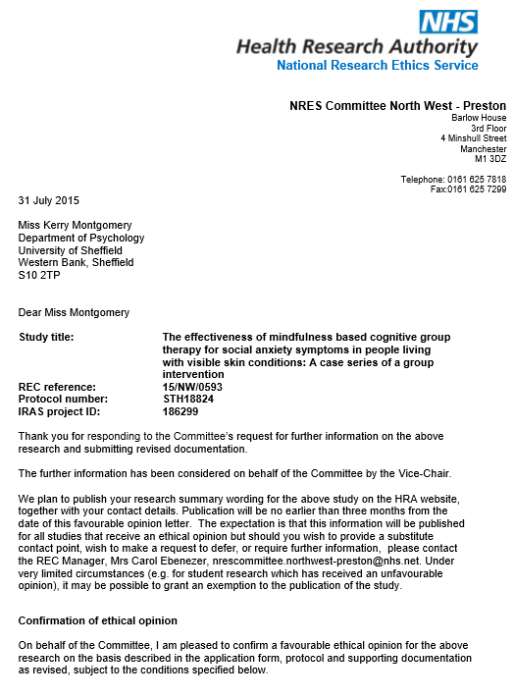

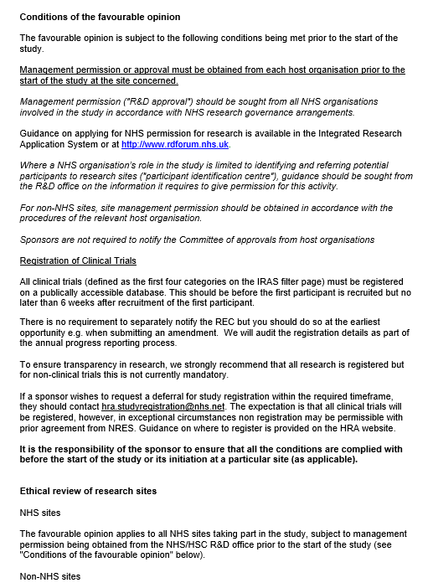

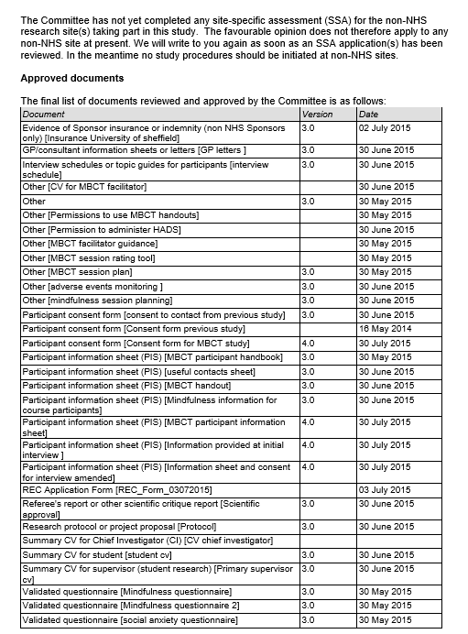

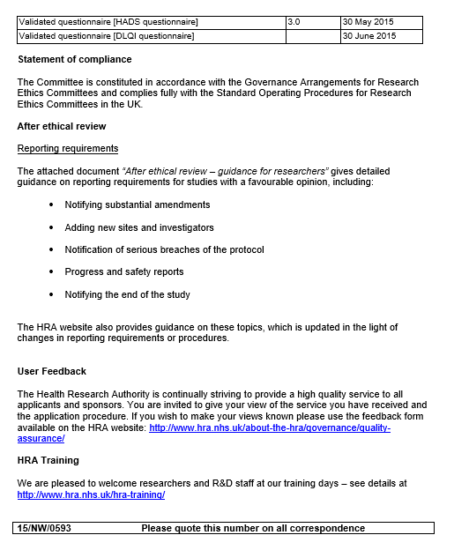
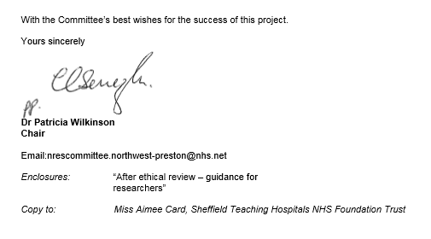

Ethical Approval Study 3.

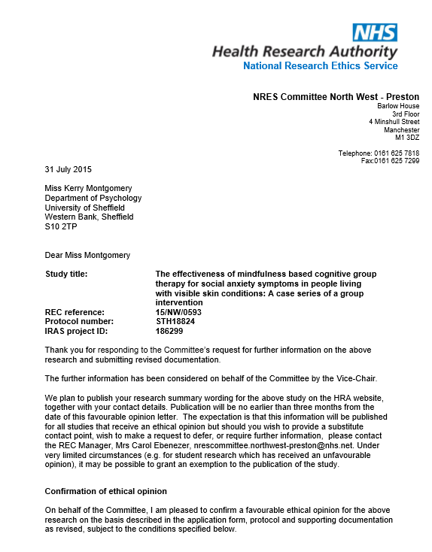

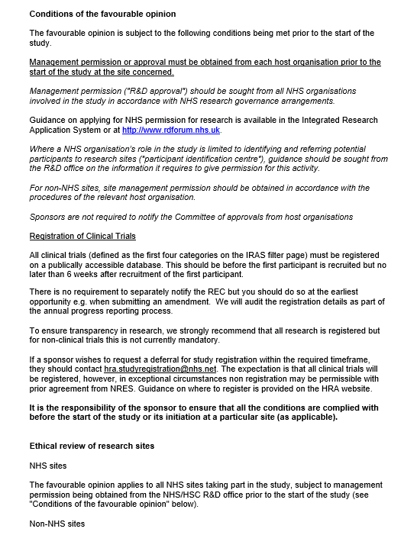

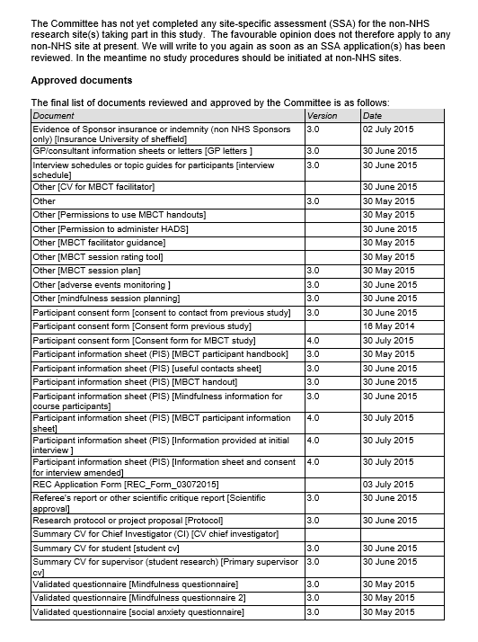

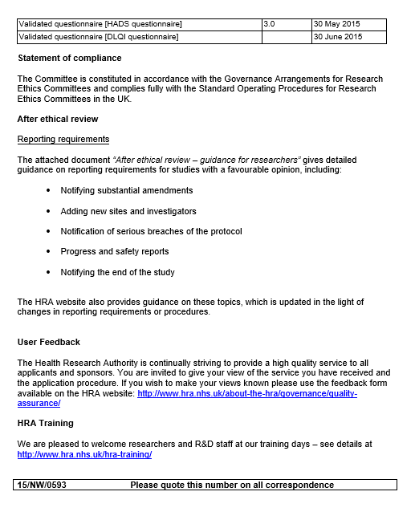



Confirmation of Study inclusion on NIHR portfolio (Study 1,2 and 3)

Dear Miss Montgomery
Re: Mindfulness and visible skin conditions
IRAS Ref: 147184 Study ID: 17058
We are pleased to inform you that the above study has been assessed as eligible for consideration for CRN support. This study has been included on the National Institute for Health Research Clinical Research Network (NIHR CRN) Portfolio. Your unique Portfolio Study ID number is detailed above and can be used to search for the record for this study on the NIHR CRN Portfolio.
The NIHR is committed to providing the CRN support requirements needed for your study to be successfully delivered in the NHS, this includes access to a local network of dedicated, skilled research support staff including research nurses and other allied health professionals, who can help identify eligible patients, arrange consent to participate in the study and monitor patients as they progress through the study. Other ways of ensuring the success of the study in the NHS include access to pharmacy, imaging and pathology services and the possibility of securing protected time for NHS staff to conduct research.
The Clinical Research Network comprises of 15 Local Clinical Research Networks that cover the length and breadth of England. Each Local Clinical Research Network delivers research across 30 clinical Specialties. Your study will be supported by the Clinical Research Network and its associated Specialties, which are here to support you throughout the life of your study and can provide you with help and advice if you encounter any problems which adversely affect the start-up and subsequent recruitment into the study.
Your study has been allocated to the NIHR Clinical Research Network: Yorkshire & Humber. Information on how to access CRN support can be found on the website:
http://www.crn.nihr.ac.uk/yorkshire-and-humber/

Your study has been allocated to the NIHR Clinical Research Network: Dermatology.
Information on this Specialty can be found on the website at
http://www.crn.nihr.ac.uk/dermatology/
and an up-to-date contacts list here:
http://www.crn.nihr.ac.uk/dermatology/contacts/

Recruitment Data
If your study is accessing CRN support, you are required to upload recruitment data on a monthly basis. This is essential to ensuring that the NIHR can report accurately to the Department of Health the number of people actively participating in research. Recruitment data is measured against key performance indicators which are used to monitor the success of the Clinical Research Network and will feed into the process of allocating future funding for NHS infrastructure for research to Clinical Research Networks. This ensures that infrastructure resources are directed to where they are required for the most patient benefit. The reporting of recruitment data also helps the Specialty to identify studies which are struggling to recruit and to provide support for these studies. If you are required to upload recruitment data you will be sent instructions on how to do this.
International Standard Randomised Controlled Trial Number (ISRCTN)
One of the Department of Health’s policies is to encourage transparency and promote public access to information about research and research findings affecting health and social care. Accordingly, the Department of Health strongly encourages voluntary registration of both interventional and observational clinical research studies on its preferred public register, the International Standard Randomised Controlled Trial Number (ISRCTN) Register, which is the World Health Organization’s primary registry for the UK and is administered by Current Controlled Trials Ltd.
The NIHR Clinical Research Network has developed a process which enables automatic and seamless registration of all new UK Clinical Research Network (UK CRN) Portfolio studies via the UK CRN Portfolio.
New non-commercial studies with an interventional component included on the National Institute for Health Research (NIHR) Clinical Research Network (CRN) Portfolio, which are not currently registered with ISRCTN or ClincalTrials.gov, will be registered ‘free’ if they choose to register via the UK CRN Portfolio functionality.
Observational, industry-sponsored and devolved administrations studies (i.e. studies without English sites) are encouraged to use the UK CRN Portfolio functionality to register with the ISRCTN; however for these studies ISRCTN registration will incur a fee payable by the relevant organisation/company and invoiced directly from Current Controlled Trials Ltd.
To register for an ISRCTN via the UK CRN Portfolio functionality, log onto the Portfolio database via https://portal.ukcrn.org.uk/login/ and select ‘yes I wish to register for an ISRCTN’ and complete the extended minimum dataset required for ISRCTN registration.
The details of your study will be forwarded to Current Controlled Trials and the ISRCTN editorial team will contact you in due course. Please do not apply directly to Current Controlled Trials if you are registering for an ISRCTN via the UK CRN Portfolio.
Acknowledgement of Clinical Research Network support
Acknowledgement of Network support must be made when publishing study findings.
It is your responsibility to ensure that the following standard text is used to acknowledge the support of the Clinical Research Network when publishing your study findings in peer-review journals, or any other form of publication:
[Research team or organisation] acknowledge the support of the National Institute for Health Research Clinical Research Network.

Please do not hesitate to contact the CRN Portfolio team should you require further information. Email: portfolio.crnH@nihr.ac.uk

Best Wishes
Jonathan Gower
Dr Jonathan Gower
Research Delivery Director

National Institute for Health Research Clinical Research Network
16 Clarendon Place, Leeds, LS2 9JY

Tel: 0113 343 0401
Fax: 0113 343 1928
Email: jonathan.gower@nihr.ac.uk

Web: www.crn.nihr.ac.uk

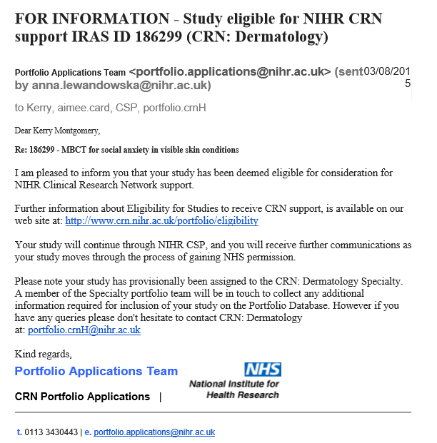

Appendix B: Information sheet Study 1


Department of Psychology.
University of Sheffield
Western Bank
Sheffield S10 2TP
Telephone: 0114 2226553
kmontgomery1@sheffield.ac.uk



Title: Examining the relationship between social distress and mindfulness in chronic skin conditions

We would like to invite you to take part in this research study. This information sheet tells you more about why the research is being done and what it involves for you. Please take the time to read this information carefully. Any information that is not clear, please ask the researcher or a member of clinical staff in the department.
What is the purpose of this study?
This study aims to look at the experience of social distress in people with skin conditions and the impact this has on wellbeing.
Studies have found that for some people, living with a skin condition can lead to reduced wellbeing. We hope to use the results from this study to develop an intervention aimed at improving social distress for people experiencing skin conditions. You have been invited to take part in this research because you have a diagnosed skin condition.
Who is conducting the study?
This study is being conducted by Kerry Montgomery who is a postgraduate student. The project is supervised by Dr Andrew Thompson and Professor Paul Norman from the University of Sheffield and Professor Andrew Messenger (Department of Dermatology, Hallamshire Hospital)
What does the research involve?
The study would involve an interview with Kerry where you will be asked questions about your experiences of living with a skin condition. These interviews will be tape recorded and transcribed. Short quotes may be taken from the interviews for use in publications or teaching, these will be anonymised so they cannot be linked to you. The interview should take no longer than 60 minutes. You can stop the interview at any time. If you decide during the interview you no longer wish to participate you can ask to withdraw from the study. This will not affect your treatment in the Dermatology department in any way.
Where will this take place?
The interviews may take place at the Clinical Psychology Department, University of Sheffield, or in your home depending on your preference.
Do I have to take part?
Not at all, there is no obligation to take part and refusal to do so will not affect your treatment in any way
What happens to my information?
All the information you give will be confidential. It will be used only for the purposes of this study. The interviews will be anonymised after data collection so that your responses cannot be linked to you. We are interested in people with skin conditions as a group, not as individuals.
What will happen to the results of this research?
The findings of this research will form part of a PhD for a student within the University of Sheffield. They may also be submitted for publication in an academic journal. However, your personal responses will be in no way identifiable in either of these sources.
Has this research been approved?
Yes. All research in the NHS is looked at by independent group of people, called a Research Ethics Committee to protect your safety, rights, wellbeing and dignity. This study has been reviewed and given favourable opinion by Sunderland Research Ethics Committee.
Concerns and complaints
If you have any concerns about the study, you may contact the researcher directly. Contact details are at the top of this letter. If you have any complaints about any aspect of the research please discuss these with the academic supervisor - Dr Andrew Thompson in the first instance (Tel: 0114 2226637). Alternatively, If you have any cause to complain about any aspect of the way in which you have been approached or treated during the course of this study, the normal National Health Service complaints mechanisms are available to you and are not compromised in any way because you have taken part in a research study. If you wish to make a complaint you can contact Patient Services Team via phone 0114 271 2400, email on PST@sth.nhs.uk, or in person in the Patient Partnership Department on B Floor, Royal Hallamshire Hospital. If you have any further questions please contact Kerry Montgomery. Details are at the top of the information sheet.

Appendix C. Consent to contact form Study 1

Department of Psychology.
University of Sheffield
Western Bank
Sheffield S10 2TP
Telephone: 0114 2226553
kmontgomery1@sheffield.ac.uk

Title of Project: Mindfulness and psychosocial functioning in visible skin conditions
Name of Researcher: Kerry Montgomery
Please tick as appropriate

I do not wish to receive any further information about this study

I would like to receive feedback on the results of this study.

................................................... ........................................ ..........................
Name Signature Date
contact details. Email/ Post
……………………………………………………………………………………………………………………………………………………………………………………………………

Appendix C. Consent form Study 1

Department of Psychology.
University of Sheffield
Western Bank
Sheffield S10 2TP
Telephone: 0114 2226553
kmontgomery1@sheffield.ac.uk

CONSENT FORM
Title of Project: Mindfulness and psychosocial functioning in visible skin conditions
Name of Researcher: Kerry Montgomery
Please tick the box if you are happy with the statement.
1. I confirm that I have had the opportunity to ask questions about the study

2. I understand that the interviews will be recorded on an encrypted digital recorder
and that the files will be deleted after our participation

3. I understand that anonymised data will be used in the write up of this study
and short quotes may be used in publications, presentations or teaching

3. I understand that I am free to withdraw from the study at any time

4. I agree to take part in the study

................................................... ................................... .................................
Name Signature Date

................................................... ........................................ ...............................
Name of Researcher Signature Date

Appendix D. IPA example line by line coding

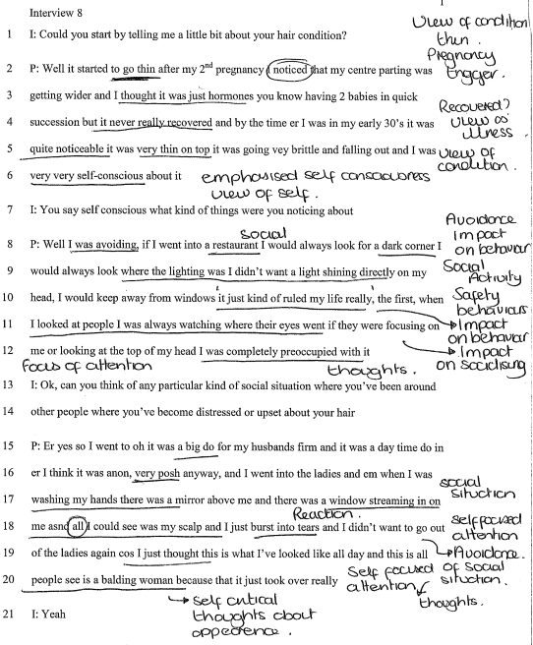

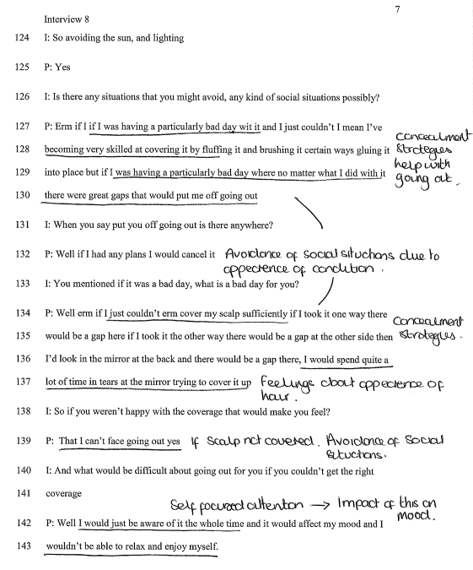

Appendix F. Reflexive journal

Reflective journal
Summary
I felt that I established good rapport with the participants, however at times I found it challenging not to offer guidance or support around some of the unhelpful thinking styles participants described. I felt I wanted to offer reassurance that appearance was not of focal importance, however I refrained from this, given the nature of the interviews.
- The nature of IPA studies is to select a homogeneous sample and I think one limitation of this study is that the participants were quite different in their presentation. Another limitation is that the study looked at social anxiety symptoms, and it covered a lot of cognitive processes, further research may wish to consider looking at just one or two processes in more detail. The CIT was easier to use with participants who had experienced difficult social experiences, however was harder to implement when people had not had these experiences. It seemed that for participants who had not experienced negative reactions they attributed this to using concealment strategies.
- When others made comments, even if the participants felt angry or upset they did not say anything, instead ignoring the comment. I wondered what this might mean to levels of shame, do they prefer to distract attention from it Do they feel they deserve the comments? In terms of my own experiences I had times of feeling very embarrassed if anyone made a comment, particularly if I was with others who I wasn’t close to, I worried about how they might feel that this comment had been made and felt particularly awkward on their behalf.
In terms of reflexivity it is important to establish what the interviewer brings to the interviews, in terms of stand point and personal experiences. As a young woman, with a visible condition, although not a skin condition, I could empathise with the experiences described by participants. Although I think its important to note that many people will have experienced bullying related to their appearance at some point in their life and therefore most people will bring their own experiences to this type of research. I think I had an expectation that comments from others resulted in social anxiety type symptoms, and I think this is something not covered enough in the current literature and I wanted to look at how comments from others affected people with visible conditions.
I am unsure if having a visible condition myself may have helped participants open up about their experiences, as this wasn’t something I asked about. Whilst I recognise that I bring a certain set of beliefs and values to the research keeping a diary has allowed me to reflect on this and ensure that my own views do not affected the interpretation of the data. The audit process carried out by the first supervisor and discussions during supervision has allowed me to reflect on the findings and show how I came to the conclusions and generated the themes.
Participant 1 Interview
I feel the most significant finding from this interview was that participant 1 struggled with adjusting to her altered appearance. We discussed how the skin condition had started at a particularly stressful period in her life, and despite discussing these difficulties the participant used humour throughout. It felt in some ways that the humour was to deflect from the seriousness of the situations and how low she had felt. It was interesting to hear participant 1 reflect on her experiences of working in a clothes shop, in my own experience of going into what are considered ‘trendy’ clothes shops, staff are wearing the latest clothing range with make-up and hair done. Participant 1’s account of how important appearance is in this industry confirmed a lot of my feelings about it, that it can leave you feeling a bit deflated when you come out of those types of shops.
In terms of the interview schedule participant 1 used concealment strategies particularly, make-up (note: not camouflage) to avoid people making comments about her appearance and therefore she felt she hadn’t had negative reactions as such. She did describe difficulties managing people asking how she was, or offering advice, feeling that by having a visible condition it almost made her ‘public property’, that because the condition was visible it was open to discussion and this was frustrating for her. I felt that for participant 1 the main feeling was one of frustration, with others and with the uncertainty of her condition.
Participant 2 Interview
This was a particularly challenging interview as participant 2 described some very difficult experiences of bullying in her childhood. It was very sad to listen to her speaking about how as a child she was made to feel useless and not as good as other people due to her appearance. These experiences of bullying had a significant impact on her life and self-concept. When describing the scenarios, I noticed that I started to think about how the symptoms she described were somewhat similar to those experienced by people living with PTSD. Social situations triggered memories, and imagery of past experiences, and the emotions connected to the event started to re-surface. It also sounded like previous experiences had led her to feel somewhat uncomfortable around younger people, with worries that they would hold similar views, essentially generalising her experiences to become vigilant around younger people.
Participant 2’s skin condition was noticeable on her face and hands when we met, and I didn’t feel that she had over-emphasised the visibility of the condition.
I could empathise with participant 2’s experiences of bullying and negative reactions, and I could understand how it influenced her mood. I started to consider how our discussion highlighted that participant 2 had reacted in quite an understandable way considering how she had been treated by others, particularly at school. She did not appear socially anxious, and was in a job that required a lot of social interaction and presentations, so it didn’t really seem to fit with symptoms of social anxiety. It seemed very situation specific, when she felt others could judge her based on her appearance. Again, a point I could relate to, particularly when meeting new people, or when interacting with people who I felt were making appearance related judgements- it’s a hard thing to quantify this, whether it’s a feeling, or from eye contact of the other individual, it just feels that people are making appearance judgements. I think that participant 2 was quite emotional in the interview so this created a challenge in asking further questions about this. I felt like in some ways I wanted to shut down some of the conversations, particularly around the past, to protect the participant from becoming upset.
The questions this interview raised for me were whether previous reactions were playing a causal role in social anxiety, in the same way as a traumatic event can trigger PTSD.
Participant 3
Participant 3 appeared very distressed about her alopecia. She felt angry at professionals and it felt like she was unable to accept the condition and I think this came across in her interview. It was quite difficult to talk about professionals with Participant 3 as she had a very negative view and I found this quite difficult. It seems see needed someone to be angry at, understandably given her situation.
I think one of the striking differences between participant 3 and from my own experiences, was that for me things have been relatively static, unless I had surgery, in which case there was a period of time to adjust, however participant 3 had to manage a lot of uncertainty. Would things get better or not? it felt like she was angry that these answers were not available, and she couldn’t understand. I suppose it’s difficult to understand that given the medical advances that we are no closer to finding causes and cures for her type of alopecia.
On reflection of all the interviews I found this the most difficult as it was apparent that participant 3 held some dysfunctional beliefs about her appearance and the medical profession. This was the interview that I found it most challenging not to slip into clinical mode, as I wanted to help the participant to reflect on her views as there was little evidence to support her beliefs.
Participant 4
Participant 4 had visible eczema on her face and hands. I felt like we got on well during the interview and I really liked participant 4 as a person. She appeared to have had a lot of difficulties in her childhood as a result of having eczema- both the physical aspects of the condition and the visibility. It was interesting that participant 4 felt that things had changed over time- that children are now more accepting than when she was younger. I found it difficult to use the critical incident interviewing technique as it felt like the participants’ agenda was more to reflect on the general difficulties of living with skin conditions, and she did spend a great deal of time talking about views of society. It was important to allow the participant to talk- and the conversation focused on past experiences rather than recent stigma/reactions.
Participant 5
Participant 5’s condition affected her nose, which she said without makeup would be red and purple in colour- today however it was not noticeably red, but was a little swollen. She tells me that the condition has improved recently so it wasn’t as visible as it has been. I felt like this interview went well, I found it easy to talk to participant 5 and she was able to reflect on her experiences in social situations. For participant 5 she seemed to find it difficult to be around people she hadn’t seen for a while, and new people- but didn’t feel the condition affected her when it was just her and her family. I thought this was quite important, as it appeared to be more about the people she was around rather than social anxiety. If she felt judged on her appearance this triggered her anxiety. In terms of recent incidents of stigma, participant 5 described an incident where she was in a supermarket and someone made a comment. It was interesting to explore this with her; however, on reflection I feel I could have explored why she didn’t tell the person how she really felt about this comment (angry).
Participant 6
Participant 6 had psoriasis covered by her clothes. The critical incident interviewing technique was difficult in this interview as participant 6 had not experienced any recent episodes of social anxiety initially, however on further discussion she did talk about times when she had covered her hands when paying for things, and covering up when on holiday. For participant 6 it sounded like her coping strategy was covering up, keeping her body covered so others could not see or comment. This appeared to be due to her own view that the condition looked unpleasant so she seemed to project this view on to how others might respond to her. I felt like I could have explored this further, I think I didn’t at the time because participant 6 had her agenda of discussing how important the medical treatment was for her. In particular, participant 6 found it very difficult to watch her son suffering with psoriatic arthritis and she spent time talking about her guilt. It was difficult to move the conversation on from this and therefore the discussion of social experiences was not explored as thoroughly as it could have been.
Participant 7
During the interview we explored reactions from others, and how participant 7 felt angry when people asked about her hair loss. This emotional reaction was not expressed- and the situations were avoided afterwards. I felt that the interview went well, and a good rapport was established. After going through the interview I could have explored anxiety before and after the social situations in more detail to determine more worries that triggered the avoidance.
Participant 8
Participant 8 had visible hair loss, she was not wearing a wig during the interview, visibly her hair looked thinning with some patches of hair loss. I could understand that she felt the condition was visible to others. I felt the interview went well, and there was good rapport. Participant 8 told me that she hadn’t spoken to anyone about her hair loss before, and it wasn’t something she liked to talk about with family or friends, I felt some pressure in making sure it was a positive experience for her. There appeared to be a mix of actual reactions and perceived reactions from participant 8. In particular children had made comments about her hair loss and this drew attention to it. On reflection of this interview I think it started to make me question the impact of comments from others, that it increased thoughts/ attention to the condition, when the participant hadn’t been thinking about it previously.
Participant 8 did become upset during the interview and described some unhelpful coping strategies and beliefs about her appearance, it became difficult not to offer support or advice during the interview, however participant 7 had made it very clear that she hadn’t spoken about her condition and therefore may not respond favourably to any offers of talking therapies. I did leave information on how to access support at the end of the interview during the de-brief.
Participant 9
Participant 9 did not describe symptoms of social anxiety. She interpreted comments from others in a different way, that people were intrigued. Participant 9 felt that comments validated her experiences and gave her the opportunity to share the experience. On reflection, this was something quite different from my experiences, and indeed what I had expected from these interviews. I think I spent quite a bit of time asking the participant if there had been any negative experiences, and instead I should have explored how the interpretation changed the response to the comments. This interview definitely offered some insight into the differences between coping with negative reactions and not coping. In the main, it seems that interpretation of comments is very important.
Participant 10
Participant 10 had psoriasis that was only visible under clothing, the participant wore long sleeved clothing during the interview. The participant did not describe incidents of negative reactions from others outside of his childhood, but felt that the reason for this was concealing the condition. The participants’ confidence was attributed to concealment strategies. I think it would have been helpful for me to explore this further however, when I asked about how he would have felt without covering up the participant didn’t feel able to even contemplate this, probably a result of using this strategy for so long.

Appendix G. Participant information sheet and consent form: Study 2.

Department of Psychology.
University of Sheffield
Western Bank
Sheffield S10 2TP
Telephone: 0114 2226553
kmontgomery1@sheffield.ac.uk

Participant Information Sheet
Title: Examining the relationship between social distress and mindfulness in individuals experiencing skin conditions
We would like to invite you to take part in this research study. This information sheet tells you more about why the research is being done and what it involves for you. Please take the time to read this information carefully. Any information that is not clear, please ask the researcher or a member of clinical staff in the department.
What is the purpose of this study?
This study aims to look at the experience of social distress in people with skin conditions and the impact this has on wellbeing. Studies have found that for some people, living with a skin condition can lead to reduced wellbeing. We hope to use the results from this study to develop an intervention aimed at improving social distress for people experiencing skin conditions. You have been invited to take part in this research because you have a diagnosed skin condition.
What does the research involve?
You will be asked to complete the questionnaires in this pack. This should take approximately 20-30 minutes. Each questionnaire has brief instructions on how to fill it in. If you are unsure how to answer any questions do not worry, these can be left blank and you can move on to the next.
Do I have to take part in the research?
Participation is voluntary. If you do not wish to take part in this study this will not impact the care you receive.
What happens to my information?
All the information you give will be confidential. It will be used only for the purposes of this study. The questionnaires will be anonymised after data collection so that your responses cannot be linked to you. We are interested in people with skin conditions as a group, not as individuals.
What should I do if I need to talk to someone, or I am feeling upset?
If participating in this study makes you want to talk to somebody you can speak with your consultant or your GP. The researcher will be available to speak to in the department and can give details of where you can receive further support.
If you express any suicidal feelings or the researcher has concerns about your safety this information will be passed to your consultant.
Concerns and complaints
If you have any concerns about the study, you may contact the researcher directly. Contact details are at the top of this letter. If you have any complaints about any aspect of the research please discuss these with the academic supervisor - Dr Andrew Thompson in the first instance (Tel: 0114 2226637).
Alternatively, If you have any cause to complain about any aspect of the way in which you have been approached or treated during the course of this study, the normal National Health Service complaints mechanisms are available to you and are not compromised in any way because you have taken part in a research study. If you wish to make a complaint you can contact Patient Services Team via phone 0114 271 2400, email on PST@sth.nhs.uk, or in person in the Patient Partnership Department on B Floor, Royal Hallamshire Hospital.
What will happen to the results of this research?
The findings of this research will form part of a PhD for a student within the University of Sheffield. They may also be submitted for publication in an academic journal. However, your personal responses will be in no way identifiable in either of these sources.
Has this research been approved?
Yes. All research in the NHS is looked at by independent group of people, called a Research Ethics Committee to protect your safety, rights, wellbeing and dignity. This study has been reviewed and given favourable opinion by North Sheffield Research Ethics Committee, and the Ethics Sub-Committee at the University of Sheffield.
Contact
If you have any further questions please contact Kerry Montgomery. Details are at the top of the information sheet.

Consent form Study 2
Department of Psychology.
University of Sheffield
Western Bank
Sheffield S10 2TP
Telephone: 0114 2226553
kmontgomery1@sheffield.ac.uk

Title of Project: Mindfulness and psychosocial functioning in visible skin conditions
Name of Researcher: Kerry Montgomery
Please tick the box if you are happy with the statement.
- I confirm that I have read and understand the information sheet and have
had the opportunity to ask any questions I may have.
- I understand my participation is voluntary and I can withdraw at any time
and this will not affect my medical care or legal rights.
- I understand that the information I give will remain confidential
and used only for the purposes of the study
- I give permission for my medical notes to be viewed by the researcher
to obtain details about my skin condition.

I agree to take part in this study

................................................... ........................................ …………………
Name Signature Date

................................................... ......................................... ...........................
Name of Researcher Signature Date

Appendix H. Questionnaires study 2.

Demographic Questionnaire

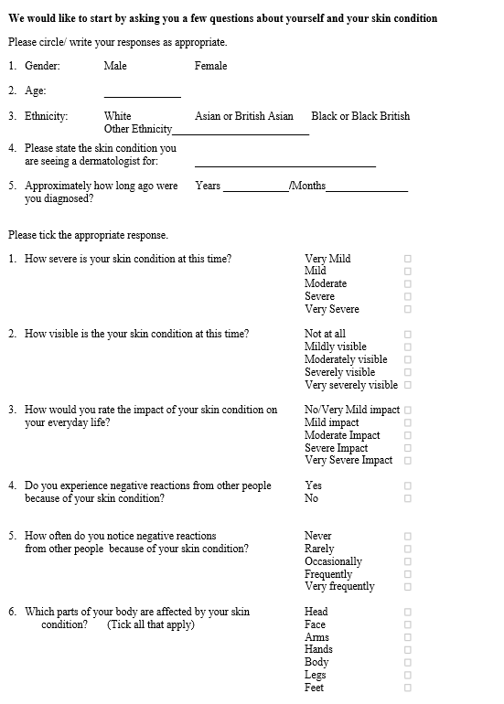

Appendix J. Permission to inform GP and letters to GP: Study 3

 | Department Of Psychology.  Clinical Psychology Unit.
Clinical Psychology Unit  Department of Psychology  University of Sheffield  Western Bank  Sheffield S10 2TP UK | Email:kmontgomery1@sheffield.ac.uk

Participant GP details

I give permission for the researcher to notify my GP that I am participating in a research study titled “The effectiveness of mindfulness based cognitive group therapy for social anxiety symptoms in people living with visible skin conditions: A single case series”.

I give my permission for the researcher to contact my GP if they have concerns about my wellbeing. I understand that it is my responsibility to let the researcher know if my GP details change during the course of the group.

Participant name:

Name of GP:

Address of GP practice:

Telephone number of GP practice

I understand that these details will be stored confidentially by the researcher until I have completed the mindfulness based cognitive therapy group.

Name…………………………………………………………………………………….
Signed…………………………………………………………………………………….
Date……………………………………………………………………………………….
Researcher signature………………………………………………………………………

Department Of Psychology.
Clinical Psychology Unit.

Clinical Psychology Unit  Department of Psychology  University of Sheffield  Western Bank  Sheffield S10 2TP UK | Email:kmontgomery1@sheffield.ac.uk

Dear ………….. (insert GP name)
I am writing to inform you that your patient …………………….. (insert name) has consented to participate in a research study being carried out by the University of Sheffield Psychology department and sponsored by Sheffield Teaching Hospitals.
The study will involve attending a Mindfulness based cognitive therapy group for people with skin conditions experiencing symptoms of social anxiety. This study has obtained ethical approval from NHS ethics (insert full details when approval obtained)
The group will run for 8 weeks and consists of 2.5 hour weekly classes. The group will be facilitated by a Cognitive behavioural therapist currently working within Sheffield Improving Access to Psychological Therapies service (IAPT). The study is being carried out by Kerry Montgomery as part of a PhD project and is supervised by Dr Andrew Thompson (Clinical Psychology Unit) and Professor Paul Norman (Department of Psychology) from the University of Sheffield and Professor Andrew Messenger, consultant dermatologist at Sheffield Hallamshire Hospital.
If you have any concerns regarding ……….(insert name) participating in the study please contact Kerry Montgomery on the number above. If we have any concerns regarding ……… wellbeing during the study we will inform you.
Yours Sincerely

Kerry Montgomery, PhD Researcher.

Letter to GP when participant completes the group.
Department Of Psychology.
Clinical Psychology Unit.

Clinical Psychology Unit  Department of Psychology  University of Sheffield  Western Bank  Sheffield S10 2TP UK | Email:kmontgomery1@sheffield.ac.uk

Dear …………………. (insert name)

I am writing to let you know that your patient ……………………(name) has now completed/ has left the Mindfulness based cognitive therapy group. …………….(Patient name) has attended …. out of 8 sessions. This group was aimed at people with skin conditions experiencing symptoms of social anxiety.
Please do not hesitate to contact me on the number above if you have any questions or concerns.
Yours Sincerely

Kerry Montgomery
PhD researcher

Appendix K. Adverse events reporting form

Adverse Event Report Form
1. Research Project Title:
2. 6 digit URMS number:
3. Principal/Chief Investigator:
4. Academic Department/School:
5. Who initially discovered the adverse event?
- When was the adverse event reported to the Principal/Chief Investigator and supervisor?

- When was the adverse event reported to the dermatology department and Department of psychology

7B. When was the event reported to NHS ethics committee
7C. Was the participants GP informed?
How was this information passed on
When was this information passed on?

- When did the adverse event actually occur?

9. Where did it happen?

10. What actually happened and what was the impact of the adverse event?

11. Why did the adverse event occur?

12. Describe what action(s) have been taken to address the impact of this specific adverse event:

13. Describe what action(s) have been taken or are planned to limit the risk of a similar event re-occurring (add any general notes here to qualify the information given elsewhere in the report):
Agreed and authorised by:
Name of Principal/Chief Investigator:  Insert name here  Signature: | Date: insert date here
Name of Head of Department  Insert name here  Signature: | Date: insert date here

Adapted from The University of Sheffield, Adverse events monitoring form. Guidance Notes:
Due to the nature of the study adverse events will be reported as soon after the event as possible, and within a 24 hour period.

Appendix L. Information Sheet Study 3.
Department Of Psychology.
Clinical Psychology Unit.

Clinical Psychology Unit  Department of Psychology  University of Sheffield  Western Bank  Sheffield S10 2TP UK | Kerry Montgomery  Email: kmontgomery1@sheffield.ac.uk

Participant Information Sheet
The effectiveness of mindfulness based cognitive group therapy for social anxiety symptoms in people living with visible skin conditions: A single case series.
We would like to invite you to take part in this research study. This information sheet tells you more about why the research is being done and what it involves for you.
Please take the time to read this information carefully.
What are the aims of this research?
Mindfulness based cognitive therapy has been found to be helpful for people with a range of difficulties including depression and long-term health conditions. The aim of this research is to examine if the group is helpful for people experiencing social anxiety who are living with a visible skin condition.
What is social anxiety?
Feeling anxious about a social situation is common and most people experience some level of social anxiety from time to time. Examples of social situations that may cause us to feel anxious are:
- Starting a new job, school or University and meeting a new team of people
- Ordering food in a restaurant
- Speaking to people you don’t know
Social anxiety is very natural in these situations; however, it becomes a problem when people find that they are avoiding doing things, or the anxiety is very distressing. People who experience social anxiety often believe that they will be judged negatively by other people. If you have noticed that you are experiencing any of the symptoms described, the mindfulness based cognitive therapy group offers the opportunity to learn ways to manage these symptoms. This could reduce the impact they have on your life.
What is mindfulness based cognitive therapy?
In a car we can sometimes drive for miles “on automatic pilot” without really being aware of what we are doing. We could be at work but thinking about a situation at home, or having coffee with a friend but not really listening to what they are saying. People often use the phrase ‘sorry I was miles away’. This is very common; our thoughts often drift away from what is happening in the present moment to things that may be causing us stress and worry.
If we are having coffee with a friend we might notice someone looking at us and our thoughts drift off to worries about what they are thinking leading to anxiety. So what can we do about this? Mindfulness based cognitive group therapy aims to help us bring our attention back to the present moment. We do this by becoming aware of where our attention is. Think about the situation above, we are having coffee with a friend and suddenly we start to worry about what other people around us are thinking. At the group you will use mindfulness techniques, to recognise that your thoughts have drifted away and how to bring your attention back to the present situation.
The group is based on Mindfulness based cognitive therapy for depression by Zindel Segal, Mark Williams and John Teasdale (2002). This course is currently run by the National Health Service and is featured in the National Institute of Clinical Excellence (NICE) guidelines as an effective treatment for people at risk of relapsed depression. Research has shown promise in using MBCT for people with social anxiety symptoms.
How will Mindfulness based cognitive therapy be helpful to you?
Clinical studies of hundreds of patients have shown that MBCT can significantly reduce the risk of depression returning. As you read the list below you will see how some of these things would be helpful when experiencing social anxiety symptoms.
Here are some things that participants in past groups have reported:
- I became aware of the workings of my mind.
- I could recognize that I have choices other than slipping back into old patterns.
- I learned to taker a kinder, more gentle attitude toward myself.
- I learned how to put less effort into “fixing” things.
- I learned how to focus on the here and now.
What does the research involve?
The research would involve attending an 8 week Mindfulness based cognitive therapy group. The group will have a maximum of 15 people and be facilitated by a trained Mindfulness based cognitive therapy practitioner. The group is held weekly and lasts for 2.5 hours. The group is free to attend and reasonable travel expenses will be paid. Refreshments at the group will be provided.
You will also be asked to complete two daily measures rating your social anxiety, this will take less than a minute to complete. Each week you will be asked to complete two questionnaires which will take approximately 5 minutes to complete. This allows us to see if you are noticing any changes in your mood.
What if I have concerns about attending a group?
It can be very daunting to attend a group, especially as you may feel anxious in situations with people you don’t know. Take some comfort that lots of people feel this way so you will not be alone. It is a small group and you will not be expected to speak if you do not feel comfortable doing so. People in the group will all be experiencing a visible skin condition and symptoms of social anxiety. Whilst no two people are the same there will be similarities in the experiences you may have had. Groups have been shown to be a useful and effective way of helping people to manage social anxiety symptoms. If you have any concerns about being in a group you can speak with Kerry Montgomery who will be happy to discuss these concerns with you.
Who is conducting the study?
This study is being conducted by Kerry Montgomery who is a PhD student. The project is supervised by Dr Andrew Thompson and Professor Paul Norman from the University of Sheffield and Professor Andrew Messenger (Department of Dermatology, Hallamshire Hospital). The group will be run by a cognitive behavioural therapist who has training in mindfulness based cognitive therapy. The researcher will be available before and after the group if you have any questions or concerns.
Am I eligible to take part?
If, after reading this information sheet you are interested in hearing more about the research please complete the attached expression of interest. The researcher will then contact you to discuss the study in more detail. You are under no obligation to take part if you complete the expression of interest form. It just allows Kerry to answer any further questions or concerns you might have.
Do I have to take part?
Not at all, there is no obligation to take part and refusal to do so will not affect your treatment in any way.
Can I withdraw from the study?
You can withdraw from the study at any time and this will not affect your treatment in any way. Any data collected prior to withdrawal from the study will be retained.
What happens to my information?
All the information you give will be confidential. It will be used only for the purposes of this study.
What will happen to the results of this research?
The findings of this research will form part of a PhD for a student within the University of Sheffield. They may also be submitted for publication in an academic journal. However, your personal responses will be in no way identifiable in either of these sources.
Has this research been approved?
Yes. All research in the NHS is looked at by independent group of people, called a Research Ethics Committee to protect your safety, rights, wellbeing and dignity. This study has been reviewed and given favourable opinion by North West Preston Research Ethics Committee.
Concerns and complaints
If you have any concerns about the study, you may contact Kerry directly. Contact details are at the top of this letter. Alternatively, If you have any cause to complain about any aspect of the way in which you have been approached or treated during the course of this study, the normal National Health Service complaints mechanisms are available to you and are not compromised in any way because you have taken part in a research study. If you wish to make a complaint you can contact Patient Services Team via phone 0114 271 2400, email on PST@sth.nhs.uk, or in person in the Patient Partnership Department on B Floor, Royal Hallamshire Hospital and the Huntsman main entrance on C Floor at the Northern General Hospital. Otherwise you can use the normal University complaints procedure and contact the: Registrar and Secretary's Office, University of Sheffield, Firth Court, Western Bank, Sheffield S10 2TN.
Contact
If you have any further questions please contact Kerry Montgomery. Details are at the top of the information sheet.
If you would like to hear more about this research please complete the information below and return to Kerry Montgomery in the freepost envelope provided.
___________________________________________________________________
Expression of interest
Title of Project: Mindfulness based cognitive therapy for social anxiety symptoms in people living with visible skin conditions
Name of Researcher: Kerry Montgomery
I give consent for Kerry Montgomery to contact me to hear more about this research.
................................................... ........................................ ..........................
Name Signature Date
My contact number is ………………………………………………………………..
The best time to contact me is ………………………………………………………..
The best day to contact me is…………………………………………………………
Alternatively you can email your details to kmontgomery1@sheffield.ac.uk

Consent form Study 3
Department Of Psychology.
Clinical Psychology Unit.

Clinical Psychology Unit  Department of Psychology  University of Sheffield  Western Bank  Sheffield S10 2TP UK | Email: kmontgomery1@sheffield.ac.uk
CONSENT FORM: The effectiveness of mindfulness based cognitive group therapy for social anxiety symptoms in people living with visible skin conditions: A single case series.
Please initial the box if you are happy with the statement.
- I confirm that I have had the opportunity to ask questions about the study

2. I confirm that I have read and understand the pre-course booklet which contains
information on confidentiality.

3. I understand that the information I share will be kept confidential unless I
disclose that I am at risk or a risk to someone else, in this case the researcher
will contact my GP
4. I understand that information shared by myself and other participants
should not be discussed outside of the group.

5. I understand that I am free to withdraw from the study at any time

................................................... ........................................ ..........................
Name Signature Date
.................................................. ......................................... .........................
Name of Researcher Signature Date

Appendix M. Screening interview
Screening interview checklist
Participant name……………………………………………………………………………
Inclusion criteria
The skin condition is the individual’s primary health concern and they are not currently experiencing other long term physical health problems which are not managed.
Able to attend all 8 group sessions
Willing to commit sufficient time to carrying out the practice.
Exclusion criteria
Recent severe life events such as deliberate self-harm, hospital admission or psychotic episode (last 12 months)
Active thoughts of suicide
Active thoughts of self-harm
Currently engaged with other psychological talking therapies or due to start during the 16 week study period.
Brief fear of negative evaluation score
MINI

Appendix N. Randomisation using random number generator
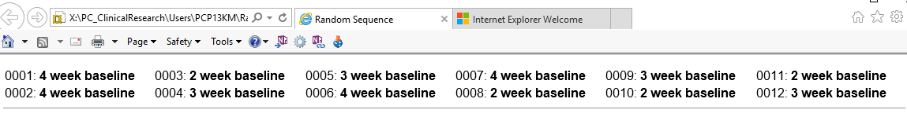

Appendix R. Independent ratings Study 3.
Assessing mindfulness-based teacher competence

Teacher: Kevin Smith

Session number: 4 and 8

Assessor: Gill Donohoe

Date of assessment: 12/12/2016

Type of assessment: Audio

Signed: 

Mindfulness based interventions teaching assessment criteria: Session 4
Domain | Key features | Incompetent  1 | Beginner  2 | Advanced beginner  3 | Competent  4 | Proficient  5 | Advanced  6
Coverage, pacing, and organisation of session curriculum | Adherence to curriculum  Responsiveness and flexibility to adhering  Appropriateness of themes and content  Organisation of teacher  Session flow and pacing |  |  |  | X
Relational skills | Authenticity and potency  Connection and acceptance  Compassion and warmth  Curiosity and respect  Mutuality |  |  |  |  | X
Embodiment of mindfulness | Present moment focus  Present moment responsiveness  Calm and alertness  Altitudinal foundations  Person of the teacher |  |  |  | X
Guiding mindfulness practices | Language- precise and spacious  Key learning for each practice available  Elements to consider when guiding |  |  |  | X
Conveying course themes through interactive inquiry and didactic teaching | Experiential focus  Layers within the inquiry process  Conveying learning  Teaching skills  Fluency |  |  |  | X
Holding the group learning environment | Learning container  Group development  Common humanity  Leadership style |  |  |  | X

Mindfulness based interventions teaching assessment criteria: Session 8
Domain | Key features | Incompetent  1 | Beginner  2 | Advanced beginner  3 | Competent  4 | Proficient  5 | Advanced  6
Coverage, pacing, and organisation of session curriculum | Adherence to curriculum  Responsiveness and flexibility to adhering  Appropriateness of themes and content  Organisation of teacher  Session flow and pacing |  |  | X
Relational skills | Authenticity and potency  Connection and acceptance  Compassion and warmth  Curiosity and respect  Mutuality |  |  |  |  | X
Embodiment of mindfulness | Present moment focus  Present moment responsiveness  Calm and alertness  Altitudinal foundations  Person of the teacher |  |  |  | X

Guiding mindfulness practices | Language- precise and spacious  Key learning for each practice available  Elements to consider when guiding |  |  |  | X
Conveying course themes through interactive inquiry and didactic teaching | Experiential focus  Layers within the inquiry process  Conveying learning  Teaching skills  Fluency |  |  | X
Holding the group learning environment | Learning container  Group development  Common humanity  Leadership style |  |  |  | X

Appendix T. Information sheet and consent form Study 4
Department Of Psychology.
Clinical Psychology Unit.

Clinical Psychology Unit  Department of Psychology  University of Sheffield  Western Bank  Sheffield S10 2TP UK | Telephone: 0114 2226504  Email: kmontgomery1@sheffield.ac.uk
Participant Information Sheet
We would like to invite you to take part in a one-to-one interview. This information sheet tells you more about why the interview and what it involves for you. Please take the time to read this information carefully.
What is the purpose of this interview?
The interview is an opportunity to discuss your experiences of the Mindfulness based cognitive therapy group. It is helpful for us to find out what was helpful or unhelpful about the group and your personal experiences of using mindfulness.
Who is conducting the study?
This study is being conducted by Kerry Montgomery who is a PhD student. The project is supervised by Dr Andrew Thompson and Professor Paul Norman from the University of Sheffield and Professor Andrew Messenger (Department of Dermatology, Hallamshire Hospital)
What does the research involve?
The study would involve an interview with Kerry where you will be asked questions about your experiences of the mindfulness based cognitive therapy group. This will involve looking back at the questionnaires you completed during the 8-week course and looking at any changes in the scores. The interview will be tape recorded and transcribed. Short quotes may be taken from the interviews for use in publications or teaching, these will be anonymised so they cannot be linked to you. The interview should take no longer than 60 minutes. You can stop the interview at any time.
Where will this take place?
The interviews may take place at the Clinical Psychology Unit, Department of Psyhcology, University of Sheffield, or in your home depending on your preference.
Do I have to take part?
Not at all, there is no obligation to take part and refusal to do so will not affect your treatment in any way.
What happens to my information?
All the information you give will be confidential. It will be used only for the purposes of this study. The interviews will be anonymised after data collection so that your responses cannot be linked to you. We are interested in people with skin conditions as a group, not as individuals.
What will happen to the results of this research?
The findings of this research will form part of a PhD for a student at the University of Sheffield. They may also be submitted for publication in an academic journal. However, your personal responses will be in no way identifiable in either of these sources.
Has this research been approved?
Yes. All research in the NHS is looked at by independent group of people, called a Research Ethics Committee to protect your safety, rights, wellbeing and dignity. This study has been reviewed and given favourable opinion by North West- Preston Research Ethics Committee.
Concerns and complaints
If you have any concerns about the study, you may contact Kerry directly. Contact details are at the top of this letter.
Alternatively, if you have any cause to complain about any aspect of the way in which you have been approached or treated during the course of this study, the normal National Health Service complaints mechanisms are available to you and are not compromised in any way because you have taken part in a research study. If you wish to make a complaint you can contact Patient Services Team via phone 0114 271 2400, email on PST@sth.nhs.uk, or in person in the Patient Partnership Department on B Floor, Royal Hallamshire Hospital and the Huntsman main entrance on C Floor at the Northern General Hospital.
Otherwise you can use the normal University complaints procedure and contact the Registrar and Secretary's Office, University of Sheffield, Firth Court, Western Bank, Sheffield S10 2TN.
Contact
If you have any further questions please contact Kerry Montgomery. Details are at the top of the information sheet.

Appendix T. Consent form for Interview Study 4

Department Of Psychology.
Clinical Psychology Unit.

Clinical Psychology Unit  Department of Psychology  University of Sheffield  Western Bank  Sheffield S10 2TP UK | Kerry Montgomery  Email: kmontgomery1@sheffield.ac.uk
CONSENT FORM. Title of Project: Mindfulness and psychosocial functioning in visible skin conditions
Name of Researcher: Kerry Montgomery
Please initial the box if you agree with the statement.
- I confirm that I have read ‘Participant information sheet: Interview’
(Version 4.0 Thursday 30th July 2015) and had the opportunity to ask questions
about the study.
- I understand that the interviews will be recorded on an encrypted digital recorder and that the files will be deleted after participation.
- I understand that anonymised data will be used in the write up of this study and short quotes may be used in publications, presentations or teaching.
- I understand that I am free to withdraw from the study at any time.

- I agree to take part in the study

................................................... .................................... ................................
Name Signature Date
................................................. .................................... ................................
Name of Researcher Signature Date

Appendix U. Nvivo thematic analysis

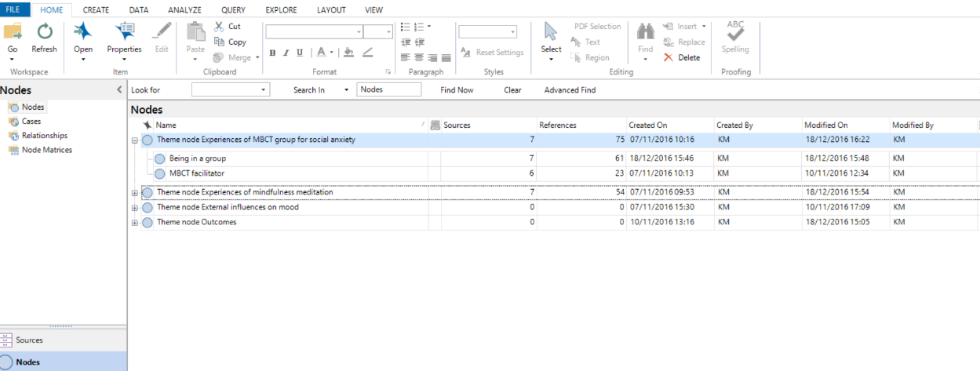

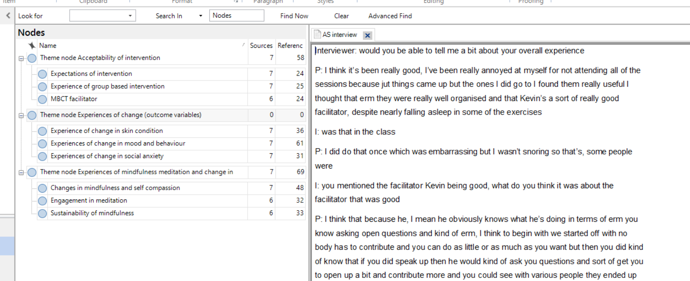

Example NVivo coding
Acceptability of MBCT
<Internals\\AS interview> - § 8 references coded [4.85% Coverage]

Reference 1 - 0.08% Coverage

P: I think it’s been really good,
Reference 2 - 0.35% Coverage

the ones I did go to I found them really useful I thought that erm they were really well organised and that Kevin’s a sort of really good facilitator,
Reference 3 - 0.75% Coverage

almost like the internal critic so erm, whereas that’s normally not a helpful thing I think just having that kind of I don’t know I suppose it just puts more of a formal framework around things rather than like you know your new year’s resolution that you don’t keep its more of a kind of you know you’re in a programme
Reference 4 - 1.25% Coverage

every now and then just has problems with health anxiety but he is diagnosed with OCD so he uses it for that kind of thing and just generally for kind of I don’t know if maybe that’s why it’s more it works better for him cos his brains wired slightly differently whereas I have problems with depression and anxiety he has a slightly different like he has a lot of checking and reassurance seeking behaviours and that kind of thing erm and the mindfulness seems to work really well for him so yeah he’s much more enthusiastic about it
Reference 5 - 0.87% Coverage

as I say because I’ve probably engaged with the whole thing maybe like 40% erm, so I think I’ve only kind of got a snap shot of the whole picture what could be there but it’s enough to kind of demonstrate to me that it’s got a lot of potential for being very helpful, and even kind of with the very limited amount that I’ve done its still enough to demonstrate that it works
Reference 6 - 0.97% Coverage

I guess like 2 hours is a long time but I don’t know how you would get in what you need to get in, otherwise, it’s better to have you to come for 2 hours than two sets, and yeah I think its there’s its always going to be difficult when you have to do it after work time erm cos that’s what you have to do cos that’s the only time that people can come but then it means that you don’t get in until like 10 o clock erm
Reference 7 - 0.52% Coverage

in an ideal world I would be doing it during work time I would be doing it 10-12 you know in a morning but that couldn’t happen erm so within the kind of constraints that you have I think that’s all that you can really do,
Reference 8 - 0.06% Coverage

I think it was really good
<Internals\\AT follow-up interview> - § 9 references coded [5.56% Coverage]

Reference 1 - 0.45% Coverage

I found it really really interesting I found it very very beneficial and I looked forward to them and I do miss it I do honestly
Reference 2 - 0.97% Coverage

it’s like anything everybody knows you know that you shouldn’t do this and you shouldn’t do that and you shouldn’t do the other but being able to go somewhere and be able to spend time once a week actually doing it it sort of brings it all back it makes you concentrate on it
Reference 3 - 0.24% Coverage

I enjoyed it, especially in the classes, I found it… no I enjoyed it
Reference 4 - 0.41% Coverage

I: and what makes you think that it’s done you good, what are the signs of that?
P: cos I know the science behind it
Reference 5 - 2.01% Coverage

because I am constantly, fretting about something and I know what that does to your body physically, and there’s always something at the back of me mind what should I do, should I be doing this should I be doing that, it’s like sat here now, I’m probably gonna get done, but I won’t it’s like you’re a grown up NAME you’re a professional and I’m like oh I’m gonna get done for doing this and I just worry and when I’m doing that I know I’m not worrying or I’m trying not to worry cos you know your mind does wander so it must be doing me good, my body must be calming down
Reference 6 - 0.43% Coverage

I don’t think so I think everything was the er building and everything was lovely no I thought it was fine absolutely fine
Reference 7 - 0.11% Coverage

I just wish it was still going
Reference 8 - 0.63% Coverage

it gets you away from all that and you just have that 40-50 minutes off thinking about getting rid of it and thinking about yourself and I said it really works, it really helps you
I thought it was excellent and I’d like it to continue, it was good I right enjoyed it

