Modelling Paediatric Bones: Estimating mechanical strength of paediatric femurs using a personalised computational modelling technique.

Gabrielle Natasha Williams

Supervisor: Dr Xinshan Li
Co-supervisor: Professor Marco Viceconti

Department: Mechanical Engineering
Degree: MPhil
Submission date: September 2016

Abstract:
Forty four million children, under the age of 15, in Europe have been physically abused, as suggested by a 2013 report (World Health Organization, 2013); with children under the age of three being more prevalent to repeated abuse as they can’t narrate the incident themselves (Ravichandiran, et al., 2010). However assessing the mechanisms of these injuries and determining which are accidental, depends largely on clinician’s judgement, for which there is little reliable evidence. More accurate diagnoses can be made by quantitatively analysing the forces required to fracture these bones by creating individualised biomechanical models of bones. The aim of this project is to investigate the fracture mechanism of paediatric femurs using personalised finite element modelling. Thirty computational models of the femur were created using CT. Each model was subjected to four point bending simulations and the force to failure was estimated. It was found that the force to fracture increases as the age, weight and height increases. In the future, further mechanical simulations can be applied to these models and the process repeated for the tibia, and the predicted results can be used to compare against injury data collected in the clinic in order to further develop this modelling framework.

Acknowledgements

- Thank you to my supervisor Dr Xinshan Li and co-supervisor Professor Marco Viceconti for all their help and support.
- Thank you to Dr Yongtao Lu for his additional help and support.
- In conjunction with – Dr Amaka C. Offiah, University of Sheffield. Sheffield Children’s Hospital.
- Special thanks to Rebecca Ward, Marta Cohen, Hana Alloub and Sheffield Children’s Hospital for data collection.
- Thanks to ANSYS and EPSRC for financial support.
- And finally, a massive thank you to my family and friends, all over the globe, who have supported me on this incredibly long, but unforgettably great, journey as a student, which has finally come to an end – I did it!! You have been there for the highs and the lows, the laughs and the tears, and there are so many memories which I’ll never forget!! It’s been the best of times, but adult life here I come!! I couldn’t have done it without you all, so thank you!!

Contents
Acknowledgements 3
1. Introduction 5
2. Literature Review 12
2.1 Anatomy of paediatric bones. 12
2.2 Previous computational models. 18
3. Materials and Methods 21
3.1 Theories of Finite Elasticity. 22
3.2 Generation of the finite element models 28
3.2.1 Image segmentation 28
3.2.2 Estimation of femur and segmented shaft length 30
3.2.3 Mesh Generation 32
3.2.4 Mechanical property/ Young’s modulus estimation. 32
3.2.5 Definition of local reference system 33
3.2.6 Definition of boundary conditions and mechanical simulation 34
4. Results 36
3.1 Bending 42
5. Discussion 47
6. Conclusions and future work 51
7. References 53
Appendix 1: Additional injury data 59

Introduction

One in four children, aged 11-17 years, in the United Kingdom have been physically abused (Radford, et al., 2011), however these cases are dealt with by the authorities, without the knowledge of the public, untill one dire case, normally resulting in the death of a child, will be brought to the attention of the media. Currently when children are injured and brought into the hospital, the assessment of their injuries and determination of whether the injuries are accidental or not, depends largely on clinician’s experience, which are subjective. Furthermore, there are no set specific guidelines for the clinicians to follow.
There are several factors which need to be taken into consideration when analysing bone fractures: the trauma itself, and the bone’s response to the trauma. Levine’s 2002 study (Levine, 2002) regarding injuries to the extremities explored these factors. It concluded that by understanding the biomechanics of extremity injuries, it can help in determining the trauma that caused a particular injury, whereas understanding how the bones respond to loads that cause failure (fractures), can help us to understand the forces that cause the actual damage (Levine, 2002). Both of these factors need to be considered when investigating paediatric bone fractures. The modelling of bones will provide a tool to analyse the bone’s response to load, whereas collecting data regarding how the injuries occurred, will help provide input for the biomechanical model. Investigation in both concepts is needed to get a full picture of the injury.
Bone fractures in the United Kingdom account for approximately 10% - 25% of accidents in children, according to studies carried out in 2004 and 2007 (Cooper, et al., 2004; Rennie, et al., 2007). A study including approximately 6% of the population, showed that fractures are more prevalent in boys (161.6/10,000 person-years) than girls (102.9/10,000 person-years) (Cooper, et al., 2004). In a study of 382 children aged 2-14 years, it was found that 41.6% of fractures occurred at home (Valerio, et al., 2010), and 25% of injuries in children aged 12 months or younger are inflicted (Baker, et al., 2015).
There are many activities and mechanisms that can cause a fracture: falls, collision with an object and sports. A study carried out in Sweden in 2010 (Hedstrom, et al., 2010) regarding the mechanisms of injury showed that there are 6 main groups of mechanisms. In order of prevalence from high to low they are: fall on the same plane; collision with/struck by physical object or another person or animal; fall between planes; traffic; downhill fall; crushed or cut or stuck. Any mechanisms not covered by one of these groups was classified as other.
This particular study does not clarify whether the 3% classed as other are unexplained or not. However a study carried out of children presenting to the two paediatric units in Edinburgh in 2000, showed two interesting tables (Tables 1 and 2), below are the adapted versions (Rennie, et al., 2007):
Table 1: The mechanism of injury in conjunction with the prevalence (Rennie, et al., 2007).
Mechanism of injury | Prevalence (%)
Fall below bed height | 37.4
Blunt trauma | 18.8
Falls from above bed height | 17.2
Sports | 12.1
Road traffic accidents | 6.7
Twist | 4.2
Falls down stairs or slopes | 2.4
Stress, insufficiency or pathological fractures | 0.5
Unknown cause | 0.5

Table 2: The basic epidemiology for each type of blunt trauma in conjunction with the prevalence (Rennie, et al., 2007).
Type of blunt trauma | Prevalence (%)
Crush | 20.3
Flexion/extension | 16.4
Direct blow | 11.3
Assault | 0.5

This study breaks down the most prevalent mechanisms of injury into 8 categories. These categories are different to that of the Swedish study; however in similarity, as can be seen in table 1, 0.5% (Rennie, et al., 2007) had an unknown cause. This study, in comparison with the study from Sweden, does not state whether the 0.5% classed as other are unexplained. However, the advantage of this earlier study in Edinburgh, is that the 18.8% of injuries categorised as blunt trauma in table 1, are broken down further into sub categories, as shown in table 2. This information is of interest to us, as can be seen in table 2, 0.5% of the blunt trauma’s recorded are as a result of an assault (Rennie, et al., 2007); with relevance to this study, a potential marker of child abuse. However there is no evidence to suggest that the other types of blunt trauma are accidental or non accidental and if the other other 51.5% not accounted for, are due to some other mechniams or just unknown. This could provide important information with regards to the type of forces which could result in injury. A clinical report from the American Academy of Paediatrics suggests that out of the 8-12% of fractures that account for paediatric injury, 12-20% of these were caused by physical abuse in infants and toddlers (Flaherty, et al., 2014). A similar study was carried out in the Sydney’s Children’s hospital focusing on long bone fractures in 2004; 31 of these children (Taitz, et al., 2004) were found to have suspicions of being subjected to child abuse.
Diagnosing child abuse is, and always has been, a hard task for physicians to broach; as a misdiagnoses either way can have dire consequences. If a case of non-accidental injury is diagnosed as child abuse, it can be emotionally devastating to the family (Kocher & Ditchel, 2011) as the child would be unnecessarily removed from the home by Child Protective Services. Whereas if a case of child abuse is not diagnosed, it is six times (Hindley, et al., 2006) more likely that the child will be subjected to additional abuse. A study in America carried out in 2009, showed that up to 20% (Ravichandiran, et al., 2010) of cases of child abuse, under the age of three years, are at first diagnosed as non-accidental injury or noted as other causes. A more recent study carried out in Australia in 2011, suggests that if undetected the re-injury rate is as high as 50% (Pandya, et al., 2011) with a mortality rate of 10% (Pandya, et al., 2011). A systematic review of available research based in the United Kingdom was carried out in 2004, which backs up the Australian findings of a reoccurrence rate of abuse of up to 50% (Hindley, et al., 2006).
In the United Kingdom, general guidelines for the physicians to follow in suspected cases of child abuse do exist; the clinical presentation and radiographic survey are used to make a medical-surgical evaluation, regarding the information presented (Fassier, et al., 2013), however there is no current objective method of correlating the history given by the carer(s) with the identified injury(ies). Fractures in infants and young children are categorised as either accident or non-accidental, i.e. abusive. Currently when a child is injured and brought into the hospital, assessment of these injuries and hence, determining which are accidental and which are not, depends largely on clinician’s experience, which can be subjective as there are limited set guidelines to follow; whether the narrative given could link to the resulting fracture is mainly down to the individual’s perception.
Currently the National Institute for Health and Care Excellence (NICE) has a guidance process outline consisting of 5 steps for physicians to follow when a juvenile is brought into accident and emergency (NICE, 2009). A basic five step summary of this can be seen below:
- Listen and observe
- Seek an explanation
- Record
- Consider, suspect or exclude maltreatment
- Record
The narration of the sequence of events leading to the injury, the listening and observing stage, is the first chance the clinician gets to interact with the family in question, and thus plays a substantial role in the diagnosis for or against child abuse. Younger children, age 18 months and below, are therefore more prevalent to abuse as they can’t narrate the incident themselves, due to their mental development level and the carer may be withholding the truth; approximately 80% (Flaherty, et al., 2014) of all resulting child abuse fractures occur in children younger than 18 months. The review also stated that approximately one quarter of fractures in children under the age of 1 are caused by child abuse.
The child could also have been brought in by a carer other than the one who inflicted the injury and thus the narration of events may not be fully clear even if the injury was accidental. Abusers are also good at hiding the abuse and presenting the injury with another mechanism which at first glance is compatible with the clinical signs. In a study carried out to review the abdominal injuries of 156 children (Ledbetter, et al., 1988), 11% had been abused. Of this number 35 % had no signs of prior abuse and only 65% of those whose had been abused showed physical signs. Age of the child is also an important factor; a 2004 (Brown & Fisher, 2004) study found that those under the age of one were more likely to have a femur fracture that was non-accidental rather than accidental, due to the nature of them being unable to take part in high energy activities as they are only capable of small, low energy movements, unlike running and high energy activities of older children, and hence the movements involved in causing that particular fracture are not possible.
Table 3 shows the number of femur fractures in children in the United States of America, from which it was concluded that femur fractures are just as prevalent in those under the age of one as children of other ages, although there are only a few plausible explanations for children of this young age, the main and most obvious explanation, as concluded by the study, being non-accidental injury (Brown & Fisher, 2004).
Table 3: US Population Estimation for Femur Fractures in Children, by Year of Age (Brown & Fisher, 2004).
No. of Femur Fractures |  |  | Femur Fractures per 100 000 (95% Confidence interval)
Age.y | Male | Female | Total | Male | Female | Total
<1 | 849 | 763 | 1612 | 44 (39,49) | 41 (37,46) | 43 (39,46)
1 | 759 | 485 | 1244 | 40 (35,44) | 26 (22,30) | 33 (30,36)
2 | 1126 | 449 | 1575 | 58 (53,63) | 24 (21, 28) | 42 (38,45)
3 | 889 | 349 | 1238 | 45 (40,50) | 19 (15, 22) | 32 (29,35)
4 | 680 | 307 | 987 | 34 (29,38) | 16 (13, 19) | 25 (23,27)
5 | 622 | 342 | 964 | 30 (26, 34) | 17 (14, 20) | 24 (22,26)

When “seeking an explanation”, the clinician takes into account the medical history of the child in question along with the developmental stage of the chid, in conjunction with the narrative of the story from both the career and child if applicable. If an alerting feature is flagged, if the stories don’t corroborate or other injuries are also discovered, during the fourth stage, the possibilities of other causes are also considered.
There are other factors which could affect a child’s prevalence to injury and hence non-accidental injury hasn’t been stated as the only plausible explanation for a femur injury for those under the age of one, in table 3 above. Syndromes, metabolic disorders and systemic disease (Flaherty, et al., 2014) are also factors that could increase a child’s prevalence to a fracture without any abuse occurring.
For instance Osteogenesis imperfecta (Taitz, 1987), more commonly known as brittle bone disease. Diagnosis of such diseases are complex, however there is usually some family history of fractures, often in the long bone shafts, so namely the femur, radius, ulna and tibia (Flaherty, et al., 2014). Other disorders and syndromes that could lead to more frequent injury include vitamin D deficiency, osteomyelitis, fractures secondary to demineralization from disease, scurvy, copper deficiency, Menkes disease, systemic disease and temporary and brittle bone disease (Flaherty, et al., 2014). It is also currently in debate as to whether premature birth (Wood, et al., 2013) and childhood obesity (Rana, et al., 2009) could also be factors which could affect bone fracture causality without any child abuse occurring.
Once these other factors are ruled out the problem is then proving/disproving the guardian’s narration of the series of events with regards to the resulting fracture. Biomechanical properties of bone dictate that a certain level of force, or load, applied in a specific mechanism, are necessary in order to result in a particular type of bone fracture. It is here that this project would play an important role. By creating finite element models, to simulate the mechanical response of paediatric long bones under different loading conditions, we can see how the bone will behave under certain loading conditions; i.e. given the guardian’s narrative, in terms of the force and loading conditions the bone is subjected to, is the resulting fracture of the bone, apparent in the same way/place as the model predicts when the same loading conditions are applied. This information would give us quantitative data regarding how paediatric bones behave under specific loading conditions. This information will help clinicians in the diagnostic process. If the model fracture and the actual fracture don’t align, it would give the physicians reason to be seriously concerned regarding the child and hence pursue the matter further with child protective services; the models could also be potentially used by clinicians as solid evidence for/against abuse in court, as they would have quantitative information.
There are various types of forces which could result in a trauma such as a bone break. This has already been touched upon, in the introduction, by discussion of previous studies into child abuse; however to summarise there are certain types of force mechanisms which can result in a fracture injury. These are, a compression fracture due to a crush injury, bending of the limb too far in either direction resulting in a flexion or extension injury and a rotational fracture; all of these can be the result of a direct force to the limb or due to indirect force such as a fall or push. By looking at these different types of mechanisms, it can help inform not only this project but future projects to apply more realistic boundary conditions to represent scenarios in vivo.
Therefore, this project aims to create individualised biomechanical models of juvenile femurs, aged 0 to 3 years old, in order to quantitatively analyse the forces required to cause fracture under 4-point bending simulations. It is hoped that in the future, these models will be able to predict the type of injury based on the mechanisms narrated by the carer, and by comparing the predicted results with the clinical observation, we could provide quantitative information regarding the feasibility of the described narrative. This would allow more quantitative information to be provided to the clinicians to help the diagnosis in suspected child abuse cases.

Literature Review

2.1 Anatomy of paediatric bones.
Growth and development is continuous and hence it makes sense that the anatomy of paediatric bones is different to that of adults. Anatomical growth is sporadic and non-uniform (Huelke, 1998); growth and development of the body occurs in predictable trends, which have been analysed over time.
With regards to this project, we are interested in juvenile bones, as the understanding of these is minimal compared to that of adults. We are interested in both the anatomical and mechanical difference between juvenile and adult bones, and hence, the development that occurs in the transition from birth to that of a young child, approximately under 5 years of age.
The femur is made up of three prominent sections, the diaphysis or long shaft, metaphysis and epiphysis (Pierce, et al., 2004); the latter two being below and above the growth plate (Clarke, 2008). These sections have different biomechanical properties due to the difference in structural and material composition. Bones are made up of two basic bone tissue types; cortical bone and trabecular bone also known as compact or spongy/cancellous bone, respectively. Cortical, outer bone, is dense and surrounds the marrow space (Clarke, 2008) making up the diaphysis (Bartel, et al., 2006); whereas the less dense trabecular bone is found in the metaphyseal and epiphyseal regions (Bartel, et al., 2006) (see Figure 1).

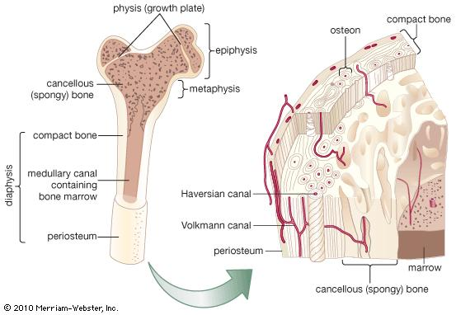
Figure 1: The different sections of a femur, the diaphysis, metaphysis and epiphysis with regards to the growth plate are shown on the left. The internal structure of bone is highlighted on the right. (Encyclopaedia Britannica, 2015)
The microstructure arrangement and hence the mechanical properties differ between the two different bone categories. The main difference is the degree of porosity (Pierce, et al., 2004); cortical bone being denser is therefore less porous and vice versa for trabecular bone. Both cortical bone and trabecular bone are made up of osteons; the underlying hierarchical level of the structure is very similar, however there are differences in the composition. Cortical bone is made up of ortical osteons known as Haversian systems (Eriksen, et al., 1994). They are cylindrical, forming a branching network to distribute nutrients, made up of concentric rings of lamellae (Pierce, et al., 2004; Bartel, et al., 2006). Trabecular bone is made up of packet osteons, or trabeculae, consisting of a network of plates and rods (Clarke, 2008) interspersed in the bone marrow compartment. As cortical bone is less porous and has a lower bone remodelling rate than on the free surface of the trabeculae, a high rate of mineralization occurs, thus resulting in a greater degree of stiffness (Clarke, 2008; Huelke, 1998; Pierce, et al., 2004). It is this degree of mineralization, along with the different osteon arrangements, that result in the different mechanical properties of the two bones types; hence different young’s modulus values (Rho, et al., 1993). This difference in material properties, hence the density of the bone, affects the material properties of the bone and thus the forces it can withhold before breakage occurs (Leichter, et al., 1982).
Juvenile bones are not fully formed, i.e. the growth plates and main bone shaft are prominent. With regards to the material properties and bone structure, juvenile bones are in a constant state of change (Ross & Abel, 2011), resulting in large anatomical and morphological variations in the juvenile skeleton across different age ranges. These differences are mainly due to two things; the 450 ossification centres (Ross & Abel, 2011) that are present in the juvenile skeleton and the lower osteoid density of the juvenile bones themselves (The Royal Children's Hospital Melbourne, 2015). As age increases the ossification centres ossify and fuse to form the bones that make up the adult skeleton. The distal ossification develops into the distal epiphysis, however the proximal ossification which ultimately becomes the proximal epiphysis is not apparent until a few months after birth (Li, et al., 2015). The osteoid density of bones also increases with age, as the percentage of area occupied by the Haversian canals decreases, reducing porosity and hence increasing strength.
These factors have to be taken into consideration when carrying out the finite element modelling. Most of our scans have a clear distal ossification centre, however the proximal ossification centre will not be visible on most of the younger cases until about 6 months old, and hence has to be approximated. The difference in the bone shaft and growth plates can be seen in figure 2 below:
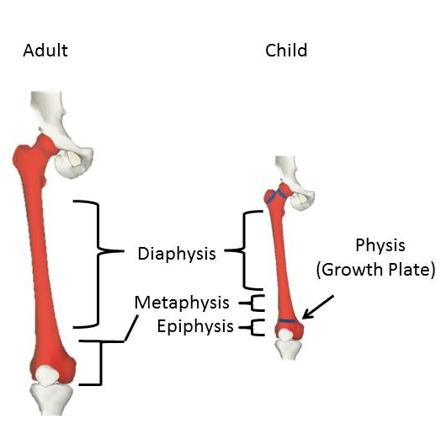
Figure 2: Comparison of the anatomical difference of the adult and child femur. The right picture highlights the growth plates of the juvenile femur.
The information below discusses the morphological development of the femur, as this is where the focus has been at the beginning stages of this project. The development of juvenile femurs is a staggered process which is not completed until around 16-20 years of age. The table below outlines this development for children up to age five years, as this is the cohort which we are currently interested in:
Table 4: Summary of femur development in children from birth to 5 years of age (Scheuer & Black, 2000).
Age | Femur development
Birth (40 weeks) | Bone shaft and distal epiphysis apparent.
1 year | Secondary centre for femoral head appears
2-5 years | Secondary centre for greater trochanter appears.
3-4 years | Proximal epiphysis hemispherical and recognizable.
3-5 years | Distal epiphysis takes characteristic shape.

Figure 3 below outlines these detailed different anatomical parts of the femur:

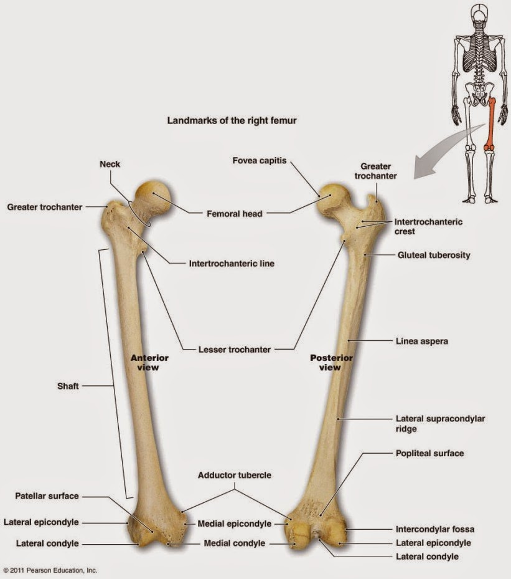
Figure 3: Anatomical Landmarks of the femur (ehealth, 2015)
As the development of the femur is such a staggered process, the mechanical properties will also change depending on the developmental stage. In terms of this project, we are only currently interested in those aged 0-3 years, as these children aren’t capable of narrating the series of events leading to the injury. With this in mind, it is the development of the proximal epiphysis and the secondary centres for the femoral and greater trochanter which, in conjunction with the degree of mineralisation and the femoral shaft itself, which will have an effect upon the mechanical properties of the femoral data.
When calculating the bone length, there is an element of informed judgment which has to be used on those cases where the proximal ossification centre isn’t present. As the bone length is approximated, this could cause problems, with the resulting force to failure results of the models as they will not be entirely accurate. This estimation of bone length could also have an effect upon the results when the models are scaled up/down depending on the given age of a child being investigated; i.e. when trying to predict how/where an injury would occur from a given narrative using our models, the place of fracture could potentially be misjudged as the given loading conditions would be applied to a bone of a slightly different length to that of the actual subject. Further, more detailed, research into the scaling up and down of the models could be carried out, as there is a collection of juvenile bones in Dundee, the Scheuer Collection (University of Dundee, 2015), which could be used for anatomical referencing.
However by calculating the bone length in the same way, on all models, the difference will not only be minimal but also consistent across all models, so will not have an effect upon trends shown by the resulting force to failure values.
Through research of previous literature, the main difference between adult and child bones has been highlighted. Juvenile bones have different mechanical properties and morphology resulting in a lower mineralization content, hence a lower degree of stiffness, resulting in a higher degree of elasticity (Ogle, et al., 1995) to their adult counterparts. However, this increase in elasticity means that in relation to adult bones, paediatric bones can absorb more energy before a fracture occurs; i.e. it takes a higher energy yield to cause a permanent deformation (Currey & Butler, 1975; Hirsch & Evans, 1965). These differences mean those current models available to predict fracture mechanism in adults can’t be applied directly to that of children; the difference in the bone material properties has to be taken into consideration. This is done by estimating the bone material properties of the individual subjects from the CT scans. The CT scans are calibrated using the European Spine phantom and the Young’s modulus estimated through a series of relationships regarding the gray scale values, CT density, apparent bone density and ash density (Morgan, et al., 2003; Schileo, et al., 2008a; Schileo, et al., 2008b; Taddei, et al., 2004; Zannoni, et al., 1998). More information and discussion regarding this can be seen in the materials and methods section, section 3.
A local reference system was created to take into account the anatomical features that readily existed on juvenile bones, as the reference system used for the adult bones can’t be used, due to the anatomical differences between and adult and child femurs; this is again discussed in further detail in the materials and methods section, section 3.
To sum up, there are some anatomical differences between adult and children’s femurs due to growth and development. These differences will affect the mechanical properties of the bone and therefore adult and juvenile bones cannot be considered identical. In this study, method for creation of adult long bone models will be adapted for that of juveniles. Further details are discussed in section 2.2 below.

2.2 Previous computational models.
The finite element method for modelling adult long bones, as described by Schileo et al., in the paper “Subject-specific finite element models implementing a maximum principal strain criterion are able to estimate failure risk and fracture location on human femurs tested in vitro” (Schileo, et al., 2008b), is well-established and validated (Zannoni, et al., 1998; Taddei, et al., 2004; Schileo, et al., 2008a; Schileo, et al., 2008b). Finite element models are created, by using CT images to create 3D models that are a close approximation of the real bone. These studies established and validated a semi-automated approach to do this for adult bones, by relating a linear relationship between the grayscale value and the CT density and in turn estimate the Young’s Modulus. In depth information regarding this can be seen in the methods section equations 24 – 27. This calibration results in models, with each mesh element containing accurate information regarding the material properties derived from bone tissue density at that specific element location (Zannoni, et al., 1998). This in turn, results in models containing accurate information regarding both the bone morphology and the tissue density.
However, in contrast mechanical data on children is very scarce (Li, et al., 2015), mainly due to ethical and cultural issues. There are only eleven studies which have been carried out on juvenile bones, all of which focus mainly on the mechanical properties of just the cortical bones and all except one, are over 20 years old. The table below outlines these studies with regards to the year they were carried out and the child’s ages being reviewed.
Table 5: Previous studies carried out on the mechanical properties of juvenile bones.
Author | Age of subject studied (years) | Bone type studied | Bone of interest
(Hirsch & Evans, 1965) | 0-14 | Cortical | Femur
(Weaver, 1966) | 2-87 | Cortical | Fibula, tibia, ulna, ilium
(Vinz, 1969) (Vinz, 1970) (Vinz, 1972) | 0-85 | Cortical | Femur
(Yamanda, 1970) | 10-79 | Cortical | Femur
(Currey & Butler, 1975) | 2-14 | Cortical | Femur
(Currey & Pond, 1989) | 3-5 | Cortical | Femur
(Currey, et al., 1996) | 4-82 | Cortical | Femur
(Ohman, et al., 2011) | 4-15 | Cortical | Femur, tibia

The study by Ohman et al. (2011) showed a strong correlation between Young’s modulus and ash density (R² = 86-91%). These findings were in agreement with Currey et al. (1996)’s study where a high correlation between age and ash density (R² = 74%) was found. Ohman et al.’s study, which found that the difference in mechanical strength between paediatric and adult bones is correlated to ash density, suggested that methods used for modelling adult bones could be adapted to model juvenile bones.
Therefore, the well-established approach of modelling adult bones (Zannoni, et al., 1998; Schileo, et al., 2008a; Schileo, et al., 2008b; Taddei, et al., 2004) was applied to paediatric bones in this project. However, changes have to be made to the models because both the material properties and anatomy of pre-adolescent bone, which could affect the basic biomechanics (Pierce, et al., 2004), are different to those of adults. Intrinsic factors, the material properties and bone structure, and the extrinsic factors, such as loading force (type, direction, location and magnitude) have to be considered in the biomechanical models.
It is these models, upon which it is hoped in the future, predictions regarding fracture occurrence and position can be made from a given narrative of how the accident occurred. This narrative will result in a set of credentials with regards to force magnitude and load direction which can be applied to the model in question to give a predicted outcome; this outcome can then be compared to that presented and thus analysis regarding the feasibility of the narrative can be made.

Materials and Methods

Ethical consent was acquired prior to scanning of the subjects at the Sheffield Children’s Hospital. The local research ethics committee approved this study and the study was registered with the local Research and Development Department, study registration number CA11024 (Li, et al., 2015).
A previous preliminary project was carried out in 2015 (Li, et al., 2015), which focused on the investigation of the biophysics of the right femur in 15 children aged 0-3 years old. It was concluded that the structural and mechanical properties of paediatric femurs can be captured using the CT modelling approach (Li, et al., 2015). The current project is an extension of Li et al’s work, and carried out segmentation/mesh generation on 20 further cases from the datasets, as well as carrying out four-point bending on these cases. Five of these further cases could not be completed due to early pre-processing problems, such as incomplete CT scans, which left a total of 15 new cases. These results have then been compiled together, to create the full dataset of 30, so that further analysis on the results as a whole can be carried out. By having a bigger data set it will enrich the biomechanical information derived previously. The methods discussed below are based on those specifically carried out for the 30 resulting femur models and four-point bending simulation; four – point bending is used as it allows for uniform distribution between the two loading nodes.
As already discussed, the basic method behind the idea for both the primary project and this current project is based upon the well-established finite element analysis approach used for adult femurs (Schileo, et al., 2008a; Schileo, et al., 2008b). This approach for adults has been well validated in terms of in vitro experiments, with regards to investigating the fracture mechanisms of the femur under various loading conditions (Schileo, et al., 2007; Cristofolini, et al., 2010; Grassi, et al., 2012); the ideas and methods behind this approach will be applied to that of juvenile bones. The main difference between adult and juvenile models, being the landmarks available and the resulting reference system; this is explained further within the methods section below.
In order to carry out finite element analysis of juvenile bones, we assume that the bone is a continuum. It is isotropic and homogeneous. Firstly, bone on the tissue level is a porous material (Burr & Allen, 2014; Martin, et al., 2015), however on the organ scale which we are studying, bone can be considered to be a continuum and can therefore by making this assumption, be modelled as such (Harrigan, et al., 1988; Bartel, et al., 2006; Martin, et al., 2015). Bone is globally anisotropic, however locally it is isotropic (Bartel, et al., 2006), which means as we are only interested in the mineralised sections of the bone we can model it as such, i.e. the bone has identical properties in all directions. In succession we are modelling the bone as a homogeneous material as the variations in the microstructure resulting in heterogeneity won’t affect the models at the scale of representation.

3.1 Theories of Finite Elasticity.
Finite element analysis (FEA), is a numerical method to find approximate solutions, with high accuracy, to engineering problems related to living organisms and inert objects. It was first used in the 1950s and has since become a prominent part of engineering and mechanical research (Morgan & Bouxsein, 2005); it is the most common method of solving solid mechanics (Viceconti, 2011). It is a computational method to obtain information concerning the response of a physical system, when it is subjected to certain loading conditions or factors, such as material properties and geometric properties by computational methods (Szabo & Babuska, 1991).
The physical structure of the model is broken down into smaller sections, or finite building blocks, called elements, which are connected to each other by referencing points, or nodes. The elements and nodes are collectively known as the mesh. An example of these elements/nodes/mesh can be seen below:

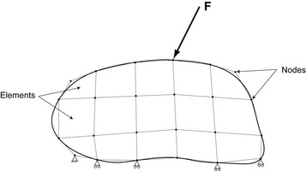

Figure 4: Schematic illustration of a finite element model, depicting the discretization of the object into a collection of elements and nodes, along with the associated boundary conditions; these are indicated by the triangles at the bottom of the diagram (Morgan & Bouxsein, 2005).
When a force (F) is applied to the model, deformation of the elements, and hence nodes, occurs in response; by computing this displacement, the resulting strain that has occurred throughout the model can be calculated.
This displacement depends on two other necessary additional types of information (Morgan & Bouxsein, 2005):
- The boundary conditions: so the applied loads/displacements.
- The material properties of the model in question: the Young’s Modulus (Modulus of elasticity) and Poisson’s ratio for each element.
The computer program analysis takes into account the object’s geometry, the boundary conditions, mechanical properties and the applied load, to generate a resulting matrix equation for each element, which are then collated, resulting in a global matrix equation for the structure in question. This is then solved for displacements and the resulting values are in turn used to compute the stress and strain distribution for the entire model.
To do this, the governing equations and physical laws of each element are transformed into algebraic equations which are solved numerically.
These governing equations are formulated by partial differential equations (Viceconti, 2011):
(1)
Where is the displacement and ∏ is the total potential energy of the body, which is defined as (Viceconti, 2011):
(2)
where is the volume, is the external surfaces, is the elastic constant, is the gravitational pull and is the strain energy density function. The first integral is the volumetric integral of the strain energy density, the second is the work of the volume forces and the third is the work of the surface forces.
Equation 2 is written in the functional form, this can be rewritten in the variational form below (Viceconti, 2011):
(3)
If all forces acting upon the body in question are conservatives, we can express the displacement vector field that minimizes Equation 3, where the external actions subjected upon the body are donated as volume actions () and the surface actions () (Viceconti, 2011):
(4)
The theory of elasticity as governed by Hooke’s law, tells us that for strain energy density, the following applies (Viceconti, 2011):
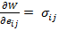 (5)
where is the stress tensor, and is the Cauchy strain tensor ( = 1..3 and = 1…3). Putting these equations together give the following (Viceconti, 2011):
(6)
where is volume actions and is surface actions. This has reduced the numerical solution of elasticity, to this variational form; in order to solve this, the displacement vector field which minimizes this form is found in a numerical solution.
To carry this out mathematically, it is best to transform all key quantities into vector form, where is the volume forces, which the body in question is subjected too, is the surface forces and is a system of concentrated forces (Viceconti, 2011).
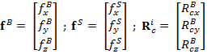 (7)
Each point of the body’s displacement with respect to the original, undeformed, configuration is described as (Viceconti, 2011):
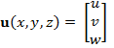 (8)
As we are dealing with bone deformation and displacement, we have assumed that they are small, hence the following applies in terms of mathematical equations; small deformation theory assumes that the first derivatives of displacement are so small that the squares and products of the derivatives, compared to the linear terms, are negligible (Khennane, 2013).
Stresses and strains are interrelated, through constitutive equations, which describe the macroscopic behaviour resulting from the internal constitution of the material itself (Khennane, 2013); it is not one but several equations which make up this explanation as materials exhibit a range of behaviours over their whole body deformation. When a three-dimensional shape is subjected to an external force, and is at the same time constrained, internal forces result such that, every point in the loaded structure has three mutually perpendicular principal strain/stress directions (Martin, et al., 2015); the 1st principal strain being the most extreme value of the normal strain possible in the material. The stresses can be written and the reduced strain tensor in its diagonal form is shown below (Khennane, 2013):
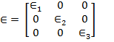 (9)

where are the principal strains and roots of the characteristic equation of the tensor (Khennane, 2013):
(10)
where
These invariants can also be expressed in terms of (Khennane, 2013):
(11)
(12)
(13)
However by taking the moments about the axis passing through the origin, only 6 independent components result. Therefore the infinitesimal or small strain tensor can be written in index form, with displacement vector,, which is assumed to be continuous functions of the coordinates ,, where t = time, so , = (Khennane, 2013; Viceconti, 2011):
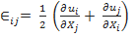 (14)
And the resulting small strain tensor is written in vector form as shown below (Viceconti, 2011):
(15)
where ; 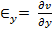 ;
and 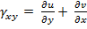 ; 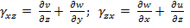
The small stress tensor can also be written as a vector as shown below (Viceconti, 2011):
(16)
Where = normal stress and = shear stress.
By combining equations 15 and 16, Hooke’s law of elasticity can be rewritten as (Viceconti, 2011):
. (17)
Where is the 6 x 6 elasticity matrix and is the strain tensor. As we are dealing with an isotropic material we can express the 9 non-null elements as a function of Young’s modulus () and Poisson’s ration () (Viceconti, 2011):
(18)
(19)
(20)
where 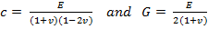 (A Lamѐ constant: material dependent quantity)
The primary characteristics of the finite element model are contained by the stiffness matrix, as it represents the system of linear equations, which themselves, in turn, contain the geometric and material behaviour information, which signifies the elements’ resulting deformation when a load is applied; its inherent properties. These linear equations are solved in order to obtain an approximate solution to the differential equation.
When a computational problem is static, i.e. the body in question is constrained, an equilibrium equation as shown below, is solved for (Viceconti, 2011):
(21)
where is the stiffness matrix and is the displacement and is the global forces’ resultant. This is the most important equation of finite element modelling as it relates the nodal displacement vector and the resulting forces; it is the equation which is solved for numerically. These equations combined are used to approximate the nodal displacement and in turn approximate the displacements, stress and strains at every point in the body (Viceconti, 2011).
This degree of approximation depends up on the size of the elements making up the body, as the stiffness matrix approximates the true body stiffness as the element number tends to infinity and hence the element size tends to zero (Viceconti, 2011). Furthermore, the smaller the elements the higher the chance of an accurate interpolation of the spatial gradients of displacement, stress and strain over the element volume by the finite-order polynomials. This is why convergence analysis is important as you ideally want the smallest elements possible whilst keeping computing time at a reasonable length. We use the Gaussian quadrature method in Ansys to solve for these equations as it gives a high accuracy to low computing effort ratio.
We also assume linear elastic deformation in the simulation (Cowen, 2013; Burr & Allen, 2014); the theory of small deformation states that for deformations that are so small, that they are smaller than the dimensions of the body itself, the geometry and the resulting properties of that body can be assumed to be unchanged in the process of deformation (Slaughter, 2002).

3.2 Generation of the finite element models
This stage of the project involves using basic CT images which have been previously obtained from the Sheffield Children’s Hospital and using them to create finite element models.
Post mortem CT scans were collected at the Sheffield Children’s Hospital. The data set currently consists of 35 whole body CT scans from a GE Lightspeed 64-slice CT scanner, with an image resolution of 0.625 x 0.625 x 0.625 mm³. However there were issues with some aspects of the CT data for 5 of the 35, as they didn’t contain full CT images of the limbs of interest, which has therefore prevented an accurate pre-processing. This has left 15 male and 15 female under the age of 3. The age of all the data sets were corrected for prematurity, with 40 weeks counted as full term, and then rounded to the nearest age in weeks; i.e. 11days = 2 weeks or 3 months = 12 weeks. All data was anonymized for the purpose of this study.

3.2.1 Image segmentation
ITK-snap version 3.0 (Yushkevich & Gerig, 2015) was used for this. Segmentation of the right femur was carried out on the new data sets, to add to the 15 cases already segmented by Li et al’s study (Li, et al., 2015). The CT files were imported as Dicom files. Some data sets were reduced in size in terms of the number of CT slides, to include just the slides corresponding to the thigh, which include the femur, before importing them into ITK-snap, as the files were too big for the software to handle. This size reduction was done by using a free downloadable software called Image J (Rasband, 2015) to view the scans and therefore determine which file selection was necessary in order to include the information wanted; i.e. the femur. To carry out the segmentation the automatic algorithm, “snake tool” was used; this allows for automatic segmentation by selecting the region of interest. The threshold value to depict the ossified bone and hence, account for boundary pixels containing both bony and soft tissues varied depending on the individual. The paintbrush tool was used to tidy up the automatic segmentation by filling in any holes/removing unwanted parts, in order for the segmentation to be as accurate, in terms of geometry, as possible. This gives the outlines of the bones that are used for the rest of the work; however only the ossified bones were considered as the cartilage cannot be distinctly differentiated from the surrounding soft tissue in the CT. Due to the changes in the bones as they developed, it was important to ensure that the segmentations of the bones were accurate, as a mistake at this primary stage would cause problems throughout the subsequent modelling stages and hence have a potentially big impact on the results. To reduce this as much as possible, extreme care was taken at this stage to ensure the segmentations were as accurate in the geometry as possible. To ensure this, all of the segmentations were carefully checked, in terms of geometry, by lining up the segmentation with the original images in ITK-snap. An example of this can be seen below:

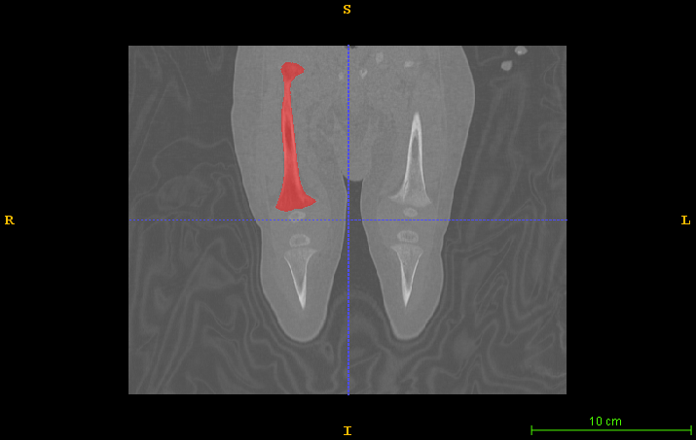

Figure 5: Segmented image shown in red of the right femur of a 9 week old male, overlapped with the original CT scan.
The segmentation was saved as a VTK file and the mesh exported as a STl file. The distal ossification centre was segmented separately; the same occurred with the proximal ossification centre if it was visble.

3.2.2 Estimation of femur and segmented shaft length
LHP-builder was used to create a reference coordinate system as the conventional coordinate system in adults cannot be used due to the lack of proximal epiphyses (Wu, et al., 2002). The VTK file of the segmentation and the original CT scan were read in and checked that the segmentation lined up with the original scan. The femur length was then estimated by creating reference points, or landmarks, at both the proximal and distal ossification centres and estimating the length between the two. These coordinates were exported and saved as they are used at a later stage in the Matlab code when determining the force to failure.
The distal ossification centre is present at birth and therefore easy to identify. However, as the proximal ossification centre does not appear until later, this is approximated using the bony boundaries; namely the proximal femur and the acetabulum, this can be seen below:
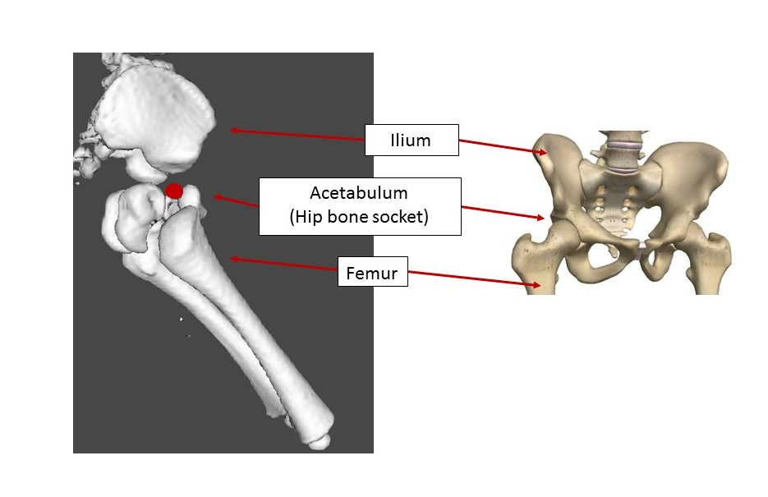

Figure 6: Adapted diagram showing the bony boundaries of a 14 week old subject, with relation to the bone shaft in the sagittal view, and a computerised diagram of the fully formed bones in the frontal plane for comparison. The red dot indicates the estimated proximal ossification centre which is the midpoint between the acetabulum and the bone shaft (Back & Body Medical, 2015) (Li, et al., 2015).
To estimate the length of the femoral shaft, containing the mineralised bone, the previous landmarks of the distal ossification centre and the proximal ossification centre were used to estimate 75% and 25% of the total length, respectively. A cross-sectional plane was placed at each of these points. Four landmarks were placed in this plane to represent the extremity in the medial, lateral, anteriorly and posterior directions. A line joined between the respective pairs, the medial and lateral landmarks and the anterior and posterior landmarks, was added, in order to locate the centroid of each plane. This process was repeated for both the 25% plane and the 75% plane; the distance between the two centroids is the length of the bone segment that will be used to carry out the bending simulation, being referred to as the diaphyseal length. The picture below illustrates this:
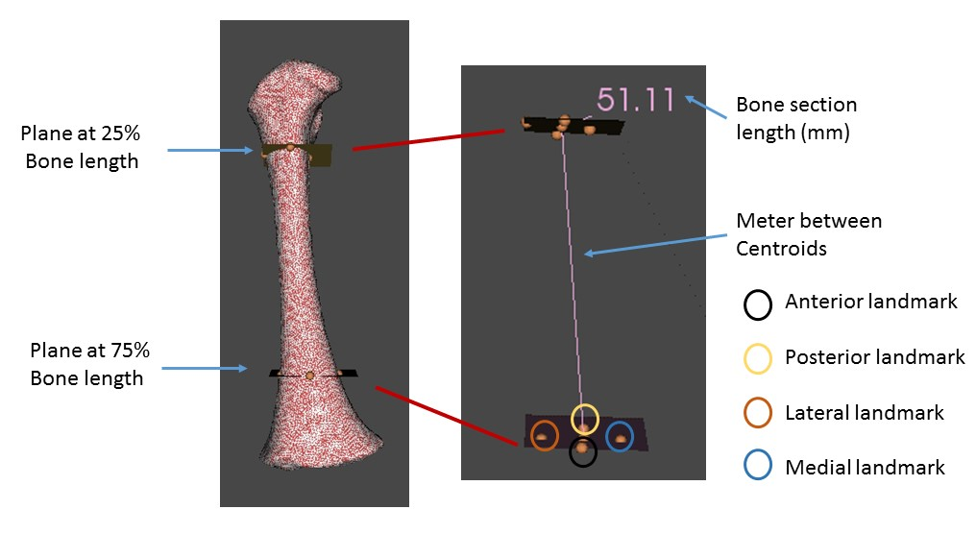
Figure 7: Diagram showing the different landmarks applied to the models in order to calculate the length of the mineralised femoral shaft.

3.2.3 Mesh Generation
Ansys ICEM and Ansys ADPL are used to create the finite element mesh. The STL geometry files were imported into Ansys ICEM, where the maximum global element size was defined to be proportional to the femoral length, based on the convergence analysis (Li, et al., 2015), and a mesh made up of triangular elements created using the software. The mesh was then imported into Ansys ADPL in order to create a 10-node tetrahedral mesh. This file was saved as an IGES and CDB file. The number of nodes of the finite element meshes used in this study ranged between 369871 and 809066. The preliminary study (Li, et al., 2015) carried out mesh convergence analysis on femurs of various lengths due to the continuous change in bone size with child age. In future projects, convergence studies should, potentially, be carried out on all bone sizes, as the convergence could be widely different for all bone lengths. This should be investigated before future work is carried out.

3.2.4 Mechanical property/ Young’s modulus estimation.
The mechanical properties, (or Young’s Modulus), of the bone is estimated from the grayscale of the CT images using BONEMAT3 (Schileo, et al., 2008a) in the LHP Builder. The configuration file was adapted depending on the X-ray tube current setting used; 60mA or 100mA. The corresponding equations for the two different currents are as follows:
60mA: y = 0.7035x - 11.85 (22)
100mA: y = 0.7079x - 12.223 (23)
This results in a finite element mesh of the femur containing personalized mechanical properties, as each element of the mesh contains the averaged Young’s Modulus from the surrounding pixels of the original CT scan (Li, et al., 2015; Schileo, et al., 2008a).
The European Spine Phantom calibrates the CT scans, and a linear relationship relates the gray scale value (gray) and the CT density ):
(24)
The apparent bone density is then estimated based on the following equation which relates CT density to ash density derived from the investigations of finite element analysis for adult bones (Schileo, et al., 2008a):
+ 0.07895 (25)
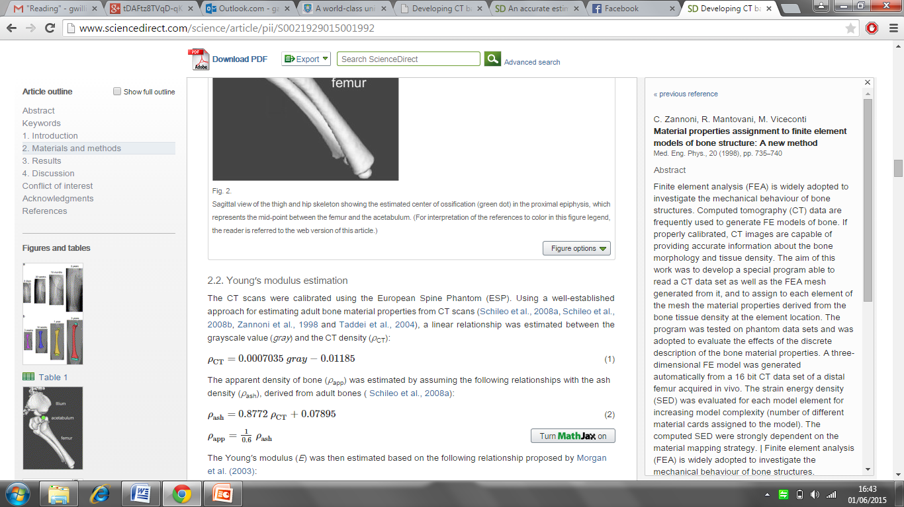 (26)
Young’s Modulus is estimated based on the relationship proposed in 2003 (Morgan, et al., 2003) between bone density and ash density:
(27)
The resulting mesh was exported as an Ansys input file to Ansys ADPL for mechanical simulation.

3.2.5 Definition of local reference system
As explained earlier, a local reference system needs to be created for the paediatric bone in order to accommodate for their unique anatomy. A previous preliminary study carried out in early 2015 (Li, et al., 2015), concluded that the proximal and distal ossification centres were the most reliable landmarks. The same points are used again in this study. The middle point between the distal and proximal ossifications centres is defined as the origin of the reference system. The x direction points from the origin vertically to the distal ossification centre. The y direction points from the origin medially to the proximal ossification centre. The z direction is perpendicular to the x-y plane (see Figure 8).
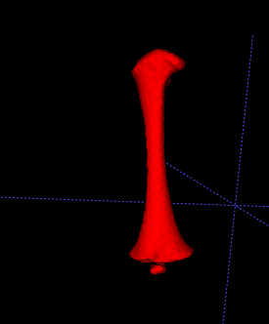
Distal Ossification centre
Proximal Ossification centre (estimated as described above, as subject is only 9 weeks old.)
X
Y
Figure 8: Local reference system for modelling as shown above for a 9 week old male subject.

3.2.6 Definition of boundary conditions and mechanical simulation
Four point bending was applied to the femoral model. For the four point bending simulation, boundary constraints were applied, to mimic the experimental setting of four-point bending, by isolating the middle section (mineralised region) of the femoral shaft, which represents 50% of the total length. The lowest nodes in the y direction at the ends of the shaft were assumed as the support points. In conjunction the nodes at the ends of the shaft were constrained so that there was partial translation permitted in the x, y and z directions; forces of equal magnitude were applied across the shaft section. In order to obtain a range of loading orientations, the femur was rotated every 10 degrees around the shaft and the simulation repeated. For each orientation, the maximum first and third principal strains were analysed. Figures 9 and 10 below, show the region of interest and indicate both the boundary constraints applied to the models and the forces applied during 4 point bending simulations.
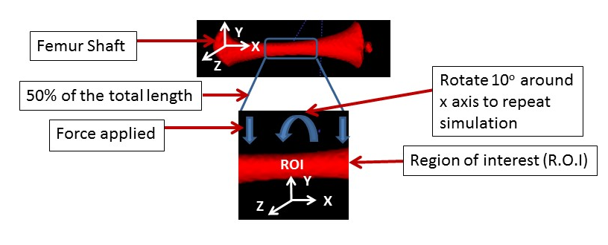
XC
Figure 9: Region of interest (ROI), of the bone model, as illustrated on a 9 week old male subject.
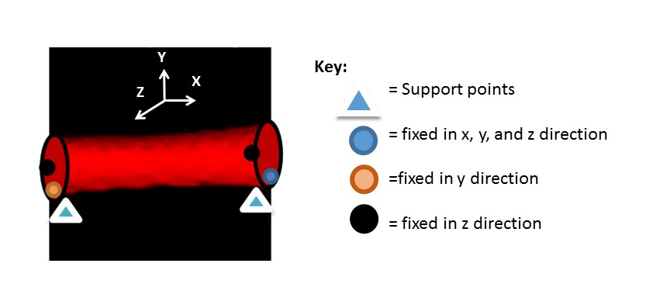
Figure 10: Boundary constraints applied to the femur in 4 point bending simulations.
Force to failure, or the force to “fracture” the bone, was estimated when the first principal strain reached a maximum of 0.73% in the region of interest (Bayraktara, et al., 2004; Li, et al., 2015). These results were obtained by running finite element simulation at increments of 10 newtons until the failure results reached the threshold value. This process was carried out for all the subjects and the force was recorded as the predicted fracture force; these results were viewed using MATLAB.
YC

Results

The work carried out so far using finite element models has given further insight into the clinical problem regarding pediatric bone fractures and the potential which computational simulation has to help in reducing the manual error in solving this problem. These results would help to provide robust information to the physicians regarding pediatric long bone fractures. The original research output, showed that models can be created from the given CT scans and simulation run on the resulting models. Table 6 below provides a summary of the current dataset:
Table 6: Results for the current dataset. (Note: SUDS = sudden unexpected death in infancy, SIDS = sudden infant death syndrome, Corrected Age = age corrected for prematurity at birth, 40 weeks classified as full term.)
Case No. | Cause of death | Corrected Age (weeks) | Gender | Weight (g) | Height (cm) | Femur length (cm) | Force to failure (N) | Diaphyseal Length (cm) | AP Diameter (mm) | ML Diameter (mm)
1 | SIDS | 0 | F | 3075 | 51 | 7.49 | 210 | 4.329 | 8.42 | 7.62
2 | Pneumonia Pertussis | 0 | M | 3300 | 51 | 7.96 | 140 | 4.282 | 6.46 | 6.67
3 | Unascertained | 0 | F | 2590 | 54 | 8.33 | 130 | 4.218 | 6.84 | 6.37
4 | 1a Sepsis 1b: necrotising enterocolitis | 1 | F | 3265 | 56 | 8.67 | 250 | 4.445 | 8.72 | 7.93
5 | Early sudden neonatal collapse leading to Hypoxic ischaemic encephalopathy | 1 | F | 3585 | 57 | 8.5 | 180 | 4.179 | 7.38 | 7.12
6 | Unascertained | 2 | F | 2248 | 47 | 7.74 | 120 | 3.978 | 5.49 | 5.65
7 | Hypoplastic left heart syndrome | 2 | F | 4005 | 59.5 | 8.46 | 270 | 4.604 | 8.29 | 7.69
8 | Persistent hypertension of the newborn | 2 | M | 3655 | 55 | 8.05 | 250 | 4.277 | 7.99 | 7.34
9 | Unascertained | 3 | M | 3240 | 53 | 8.53 | 160 | 4.31 | 6.74 | 7.07
10 | Superior sagittal sinus haemorrhage Aplasia cutis congenita | 4 | F | 2830 | 53 | 8.44 | 110 | 4.463 | 5.73 | 5.91
11 | S Aureus sepsis | 4 | F | 4185 | 59 | 8.75 | 170 | 4.552 | 6.92 | 6.68
12 | Unascertained | 7 | M | 4400 | 55 | 9.05 | 240 | 4.827 | 8.16 | 8.42
13 | Cri-du-Chat syndrome and Chromosome 3 duplication | 8 | F | 3825 | 51 | 8.67 | 150 | 4.195 | 7.29 | 6.95
14 | SIDS | 9 | M | 5260 | 63 | 10.1 | 270 | 5.111 | 8.16 | 8.06
15 | Severe acute bronchopneumonia | 10 | M | 7565 | 68 | 10.515 | 350 | 6.02 | 9.55 | 9.39
16 | SIDS | 11 | M | 5500 | 58 | 9.64 | 170 | 4.981 | 8.88 | 8.06
17 | Unascertained | 12 | F | 5890 | 63 | 10.81 | 300 | 5.44 | 9.91 | 9.69
18 | SIDS | 12 | F | 6375 | 67 | 11.14 | 220 | 5.562 | 8.97 | 8.64
19 | Subdural haemorrhage and brain oedema | 12 | M | 6530 | 66 | 9.99 | 270 | 5.488 | 9.35 | 9.67
20 | Unascertained | 12 | F | 5890 | 63 | 10.79 | 330 | 5.575 | 9.68 | 10.17
21 | Unascertained | 14 | M | 6505 | 62 | 10.62 | 300 | 5.74 | 8.75 | 9.32
22 | Cardiomyopathy | 14 | M | 4525 | 60 | 9.6 | 160 | 5.054 | 6.97 | 7.24
23 | SIDS | 16 | M | 3850 | 60 | 9.63 | 160 | 5.257 | 6.84 | 7.63
24 | Unascertained | 16 | F | 5790 | 65 | 10.93 | 360 | 5.364 | 9.46 | 9.3
25 | SIDS | 24 | M | 7025 | 69 | 11.85 | 290 | 5.111 | 10.22 | 9.54
26 | SUDI | 40 | M | 7145 | 66 | 11 | 170 | 5.448 | 9.44 | 8.77
27 | Sudden Infant death in Childhood | 48 | M | 12980 | 82.6 | 15.26 | 600 | 7.482 | 12.78 | 11.93
28 | Sudden death in childhood | 48 | M | 10940 | 79 | 15.17 | 420 | 7.479 | 11.29 | 12.14
29 | Inhalation of products of combustion | 96 | F | 13130 | 92 | 18.45 | 670 | 9.211 | 13.57 | 13.68
30 | Head injury - Non accidental Injury | 144 | F | 17500 | 102.5 | 22.41 | 1040 | 10.811 | 17.04 | 16.28

Below I will address each stage of the results obtained in the same order as the described in the methods section. Of the current data set containing 30 whole body CT scans, there are 15 male subjects and 15 female subjects, ranging in age from 0 -3 years, (0-144weeks). As expected with developing juveniles, the anatomy and size of the femur bones changed as the age increased. This finding is in line with the data quoted by Scheuer and Black, with regards to average femur lengths of children aged 2 months-18 years (Scheuer & Black, 2000).

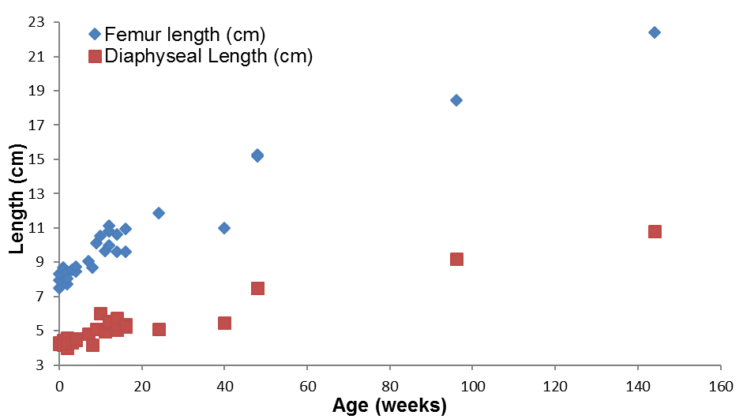
1 year old
2 years old
3 years old
Figure 11: Graph showing femur and diaphyseal length with regards to the subject’s age. Purple brackets indicate the one, two and three year old subjects.
Figure 11 shows that both the femur length and diaphyseal length increase with age. This trend is the same when comparing femur length with the weight and height of the subjects, as shown in figures 12 and 13:

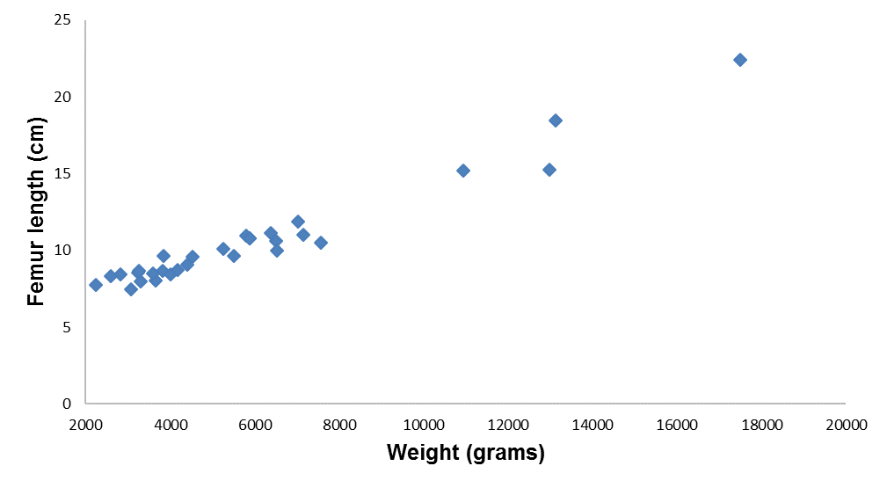
Figure 12: Graph showing femur length with respect to the subject’s weight.

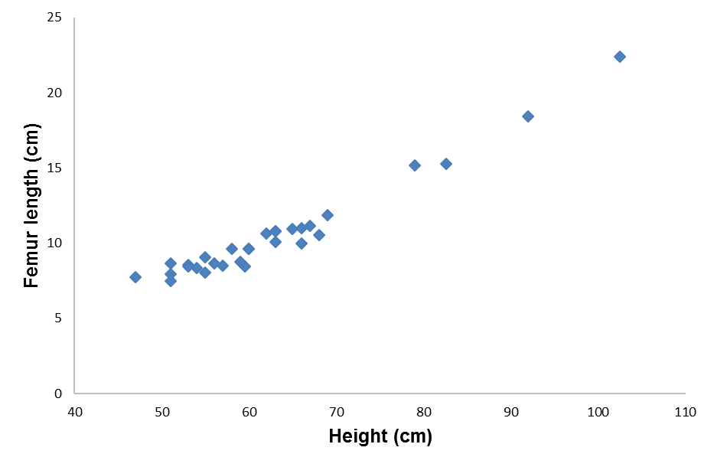
Figure 13: Graph showing femur length with respect to the subject’s height.
Both of these graphs show a generalised trend; the femur length increases with the height and weight of the subjects. Figure 12 shows a potential outlier, indicated by the red circle. Case number 27, shows a subject with a weight of 12980g but only a femur length of 15.26cm. Looking at the other results you would expect this to be higher; however given that we have only four subjects with a weight value higher than 8000g and the information that we have, we can provide no definitive reason for this lower value. Therefore it cannot be said for certain that this value is an anomaly. Further histological and medical studies would have to be carried out in order to find such an explanation and more subjects in this weight range studied.
Below is a sample of 7 of the subjects showing the change in the anatomy from 0 weeks to 3 years, in terms of the shape of the femur bones, in both the CT scan and resulting segmentation:
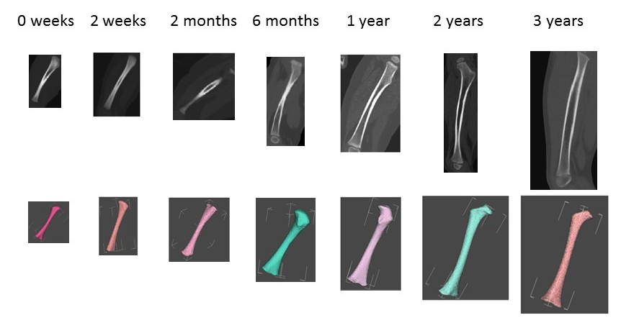
Figure 14: CT scan and segmentation comparison (not to scale).
Figure 14 shows the change in anatomy of the femur as age increases from birth up to 3 years of age. By quantifying the scans and resulting meshes it was found that the geometry and certain aspects of the bones develop with age, such as the proximal ossification centre and the bone shaft itself in terms of size.
As previously described, a local reference system was created based on the bony boundaries, to compensate for the changes in the ossification centres with age. The picture below shows the difference in distal and proximal ossification centres as age increases:

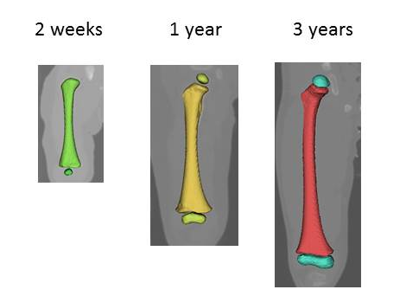
Figure 15: Difference in ossification centres visible with age increase.
A cross section of the Young’s modulus in the cortical bone is illustrated below. The value of the Young’s modulus ranged from 200 to 20000 MPa, where cortical bone is shown in red and the less mineralised bone and bone marrow are shown in blue.
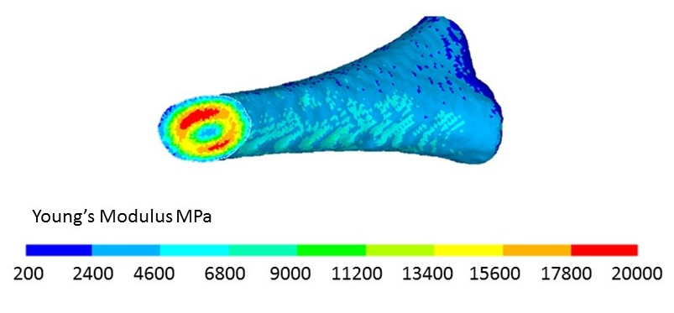
Young’s modulus (MPa)
Figure 16: An example of the resulting young’s modulus that is present in the bone shaft of a 12 day old subject.
The distribution of the elastic (Young’s) Modulus in the femurs across the age range is illustrated in figure 17. Young’s Modulus becomes differentiated across the bone shaft with age; the development of stiff cortical bone at the periphery of the diaphysis is reflected, while the bone marrow cavity takes place in the middle. It has been shown that normal biomechanical and anatomical differentiation are interdependent (Li, et al., 2015).
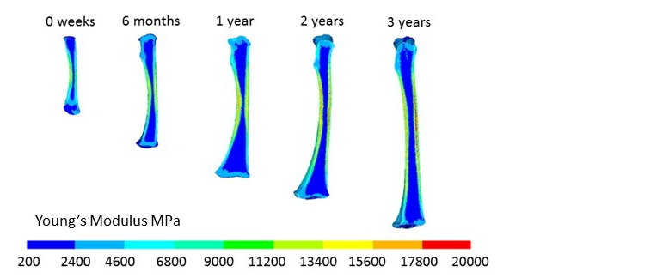
Figure 17: Sagittal view of the Young’s modulus in a selection of subjects, to show differentiation with an increase in age (not to scale).
The comparison of the Young’s Modulus across the bone shaft as age increases showed that it becomes more differentiated. This is in agreement with the findings of the preliminary study (Li, et al., 2015) which showed that bone density becomes more differentiated across the bone shaft as age increases. These reflect the development of stiff cortical bone at the periphery of the diaphysis while the bone marrow cavity takes place in the middle. From this it can be concluded that the biomechanical and anatomical differentiation of the femoral bones are interdependent of each other.

3.1 Bending
The resulting force to failure values for all the data sets, in age order, as dictated from the created FEA models, can be seen in table 6.
Figure 18 shows the force to failure results from all subjects with respect to their age as predicted from the FE models. The resulting link between age and the force needed to “fracture” the bones will help with filling in the age gaps in the data. Specifically the gaps present between 6 months and 1 year, 2 years and 3 years old; however this is a small data set so more samples are needed. The previously mentioned Scheuer collection (University of Dundee, 2015) could help fill in the age gaps with regards to the anatomical measurements. To give an idea when viewing the results, 200 Newtons = approximately a crate (20kg) and 1000 Newtons = approximately equivalent to a large man (100kg) falling on the limb.

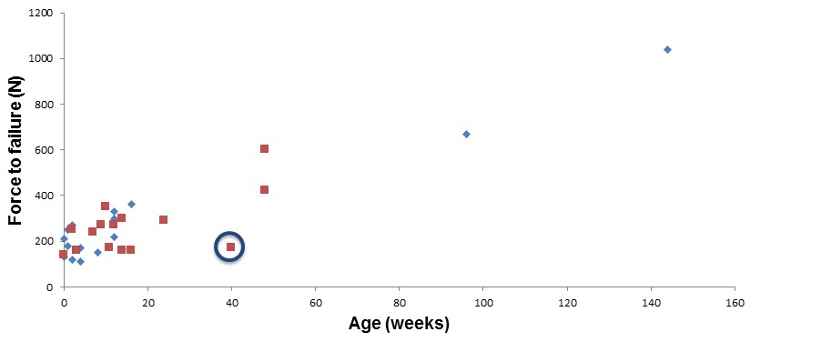
Figure 18: Subject age verses the force to cause the bone to “fracture”.
The graph above, figure 18, shows that the force to failure increases with age. The relationship appears to be linear. However, due to the small number of cases, it is difficult to confirm. An obvious outlier is case number 26, highlighted by the blue circle, a subject aged at 40 weeks, with a slightly lower force compared to others in similar age range. This subject had a lower percentile value in both weight (9th Percentile) and height (2nd percentile). This indicates that the subject is slow in overall growth and development, which is likely to contribute to the lower predicted force.
As one would notice, figure 18 shows a lot of individuals aged between 0 and 16 weeks. This area is therefore zoomed in below to show the data distribution. Figure 19 appears to show a form of biomodal distribution, however the pattern could also be due to random variation. Further investigation is required in order to determine if there is indeed a pattern.
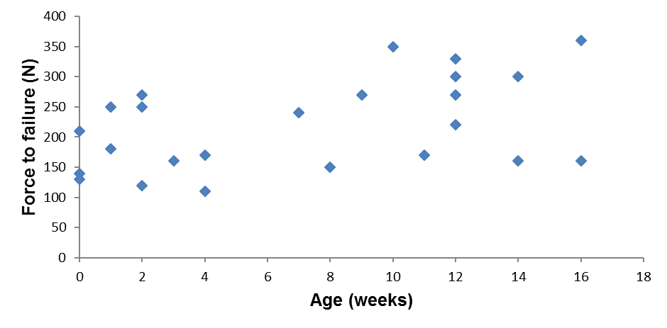
Figure 19: Zoomed in force to “failure” graph (aged 0 -16 weeks).
Similar plots are generated for force to failure versus weight and height (Figures 20 and 21). Both figures show a positive relationship. This is expected, as one would assume that the weight and height increase proportionally to age and skeleton maturity.
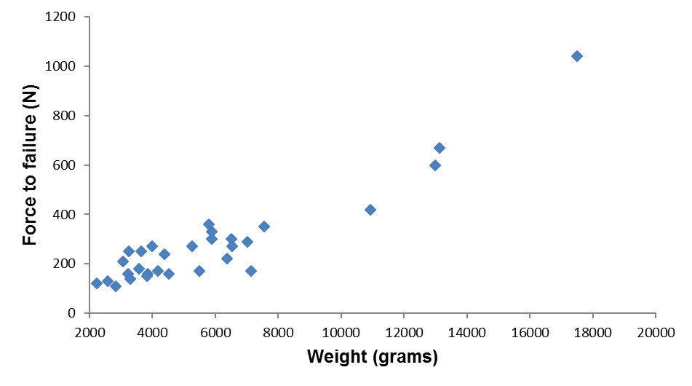
Figure 20: Subject force to failure versus weight.
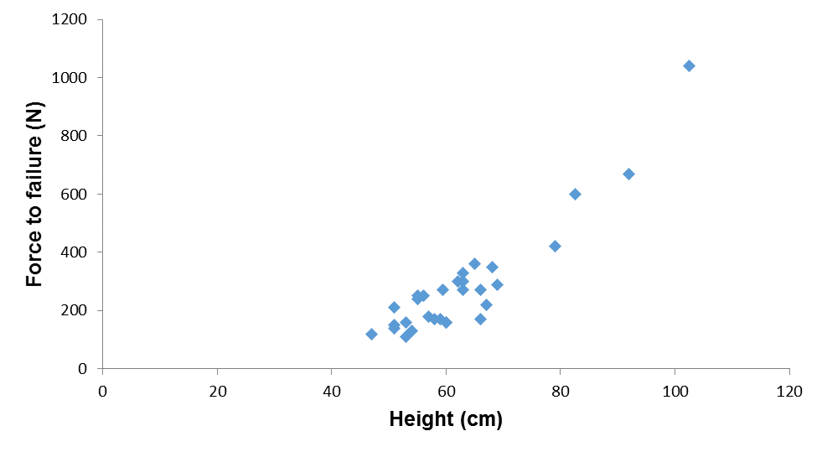
Figure 21: Subject force to failure versus height.
Figures 22 and 23 show the Anterior-Posterior (AP) diameter and the Medial-lateral (ML) diameter, respectively, at the mid shaft versus age. Both figures show that the AP and ML diameters at the mid-shaft increase with age. There is one potential outlier, case 26, again highlighted by the blue circle. As discussed before, this subject also has a lower force to failure, lower weight and lower height. The lower AP and ML values confirm a delayed growth and development, as suggested before.
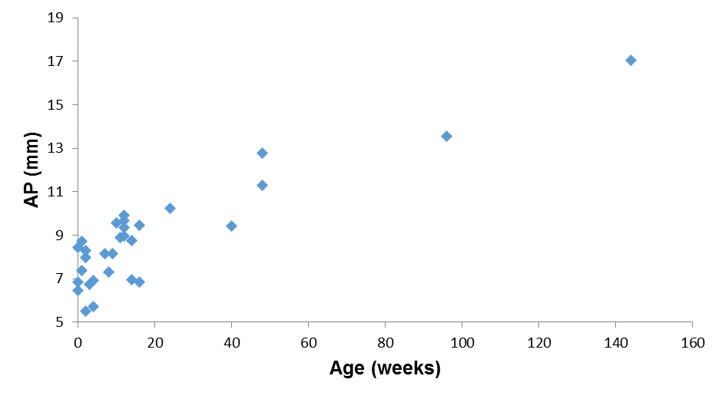
Figure 22: Anterior-Posterior diameter at the mid shaft verses subject age.
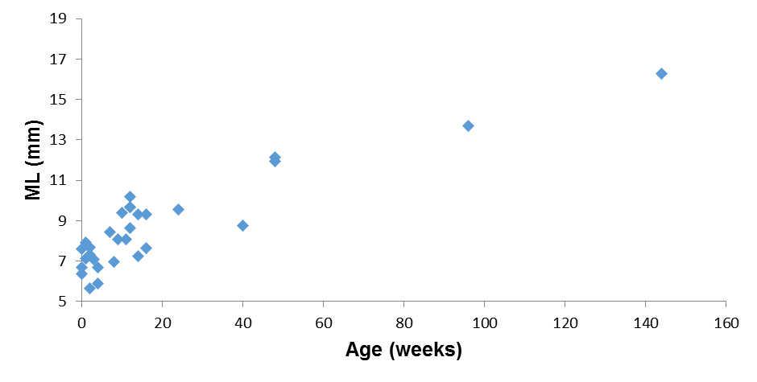
Figure 23: Medial-lateral diameter at the mid shaft verses subject age.
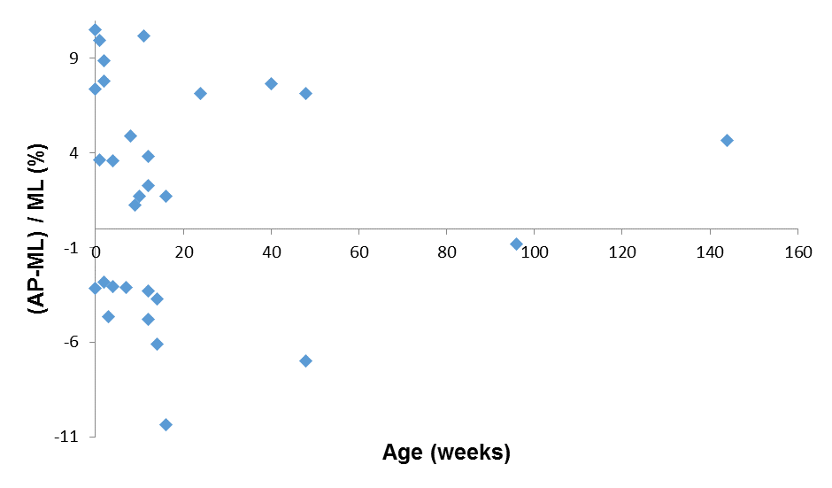
Figure 24: Anterior-Posterior diameter minus Medial-lateral diameter, divided by the Medial-Lateral diameter as a percentage ratio in the mid-shaft, against the age for all subjects.
The mid femoral shaft diameters shown as a percentage ratio with regards to the medial lateral diameter versus age are shown in Figure 24. These results don’t show a strong positive or negative trend with regards to age and as such no specific conclusion can be drawn.

Discussion

The well-established CT based computational framework, used in adults, was adapted here, by creating an appropriate reference system, to create a further 15 personalised femoral models, and to carry out further analysis of all 30 cases, to build upon the work carried out by Li, et al., (Li, et al., 2015). The geometry (including the changes in morphology with age) and material properties of the individual subjects were successfully captured by the models.

The analysis of the results, found that the force to “fracture” under bending increased with age; with an average value of 160 N at zero weeks of age to 1040 N at 3 years/144 weeks of age. However after further analysis of the results, it can be easily seen that age isn’t a sole indicator for development. Some older subjects had a lower force to failure value than their younger counterparts; for example case number 12, aged at 7 weeks has a predicted force to failure of 240 N but case number 13, aged at 8 weeks has a predicted force to failure of 150 N. It is suggested that age is not the sole determinant for bone development. Other factors affect skeletal development. These include rate of development, prematurity, vitamin D deficiency, medical history, ethnic origin etc (Office of the Surgeon General (US), 2004).
The information that we currently have access to means we can look at these cases with regards to age, height and weight. By studying this information it can be seen that weight and height are both a factor, for example both cases 21 and 22 are both age 14 weeks, however one has a weight and height of 6505g/62cm respectively and the other has a weight and height of 4525g/60cm respectively. Case 21, has the higher values in terms of these demographical parameters and force to failure value. The value of the femur length and AP and ML diameters at the midshaft are also higher for case 21. This therefore supplies a sound explanation as to why although both cases are the same age, the force to failure values differ. This information tells us that although age is a good indicator when it comes to the force to failure of long bones in juveniles, the height and weight of the individuals, affects the femur length and AP/ML diameter and hence in turn, force to failure value. However as the model is currently set up, age, weight and height are cofounding factors, so although we can compare the given data, we can’t tear these factors apart into their individual entities with regards to force to failure results. Therefore if a full modelling frame work is set up in the future, a better way to analyse the data could be to look at the moment rather than the force.
Physical activity of the child and its physical stage of development, crawling/walking, may also play a role in the bone development of the femur (Cardadeiro, et al., 2012; McKay & Smith, 2008; Wallace, et al., 2013). More background research of the subjects in question needs to be done to establish, if in fact, the unexpected results are due to other factors, and if so, is there a correlation between the two, i.e. is the difference due to normal human variation development, or are the results actually outliers, which would mean they should not be included in the analysis of the results as a whole.
There are currently only 30 subjects in the datasets, with most of the subjects in the age range of 0 – 16 weeks, therefore it is hoped that this on-going post-mortem study will collect more data over time in order to fill in the major age gap between 16 weeks and 3 years where we only have 6 subjects. This will help to support our findings. However the results that we do have to date, suggest that there is a correlation between the bone’s geometry, mechanical properties and the force to failure of the bone; i.e. we know that the force to failure values will be affected by bone geometries and mechanical properties, and the geometry of the bones change with age. However, there seems to be a large amount of variation in terms of the rate of development among children in early years. Hence, age may not be representative of bone maturity and mechanical strength. This may pose further challenges when we try to apply this tool to child abuse, as we need to use additional information other than age. This could be a percentile of height and weight, or some measure of gross motility through a questionnaire, for example.
These findings provide unique information that will be essential in estimating the compatibility of observed fractures with the description of the accident, where abuse is suspected.
There are however limitations to the project. The main limitation relating to the fact that the bone modulus of elasticity is estimated from CT scans based upon recent findings (Ohman 2011), which concluded that the difference in mechanical strength between paediatric and adult bones is correlated to ash density. However the youngest subject in the 2011 study (Ohman, et al., 2011) is 4 years old and the oldest subject in this study is 3 years old. The other study which drew similar conclusions and hence used as evidence in order to accept the relationship between bone strength and ash density, was carried out in 1996 (Currey, et al., 1996). Therefore we need to treat these findings with caution and consequently more research needs to be done in order to fully investigate the CT to bone density relationship in juvenile bones.
Another limitation of the project is that changes of bone at tissue level are not considered. The degree of mineralization, bone matrix structure and collagen composition all impact the biomechanical properties and hence the yield strength of the subject (Bartel, et al., 2006). Soft tissue or the non-mineralised region of the bone is not represented by the models. This tissue type makes up a large percentage, of the paediatric long bones but its effect upon the strength, and hence force to failure of the bones, is not taken into account. This could be further investigated in the future by including the cartilage region by, for example, using MRI scans in conjunction with CT scans, and including both structures in the finite element model.
The other major limitation of the project is that the bone in question, the femur, is treated as an isolated bone; when in fact in vivo it is not. The femur, acts as an anchor and attachment for many muscles and ligaments (Drake, et al., 2005); it is a small part of a much greater structure. The surrounding soft tissues will have an effect on the boundary constraints and they will also absorb a small amount of the energy that hits this bone, these factors were not considered within our models, and as such are two elements which would need to be examined in the future. This effect of the surrounding soft tissues, could be investigated in the future, by considering the appropriate boundary conditions applied to the model in order to capture the soft tissue effect.
The four point bending simulation, applied to the models, is idealised; it is applied in a precise direction. However real life is not ideal. Falls and injuries occur in a mismatch way so the force applied in these physical occurrences will not be as exact and idealised as the models in the project. However, on the other hand, the four point bending simulation could correspond to the scenario of a sharp object hitting the bone from the side; so therefore does have real life implications. Again this is something that would have to be investigated further, should the models be successful in this ideal environment, more information regarding how they could be adapted to a wider representation of in vivo would have to be carried out, and hence the models adapted accordingly.
Four point bending only represents one force mechanism; compression of a bone and torsion or a rotational injury, also need to be modelled in order to address a full range of potential child abuse cases. In some cases the injury could also be the result of more than one mechanism. By looking at these other fracture mechanisms, and combination mechanisms, a wider, more true to life representation of child abuse injuries could be represented.
The data from the Sheffield Children’s hospital Accident and Emergency department, see Appendix 1, can be used to help confirm the reliability of the finite element models; however direct comparison will not be able to be made, as the data from the accident and emergency department is on children age 6 – 15 years as opposed to the models age of 0 – 3 years. One possibility is to use the Scheuer Collection (University of Dundee, 2015) to help fill in the gaps with regard to the anatomical difference in the model ages. The two QCT scans carried out on uninjured limbs in the accident and emergency department will also help, as models of these may be able to be made so that a direct comparison between the mechanics of the accident that occurred, and the resulting fracture can be made. This will comprise a much later part of the project and therefore more substantial research regarding the use of this data will be determined at a later point.

Conclusions and future work

In conclusion, this study showed that CT-based finite element modelling can be used to capture personalized geometry and mechanical properties of long bones for very young children. All of the information above, with regard to the mathematics behind the modelling and the assumptions that have been made, have successfully been used to create paediatric bone models of the femur, from CT images. Finite element analysis can provide quantitative information to assist the diagnosis of accidental injury and physical abuse in the long term. In the short term, this project is the starting point to create a preliminary modelling framework for juvenile long bones. This work needs to be extended to other long bones in order to secure better validation and establish a concrete framework for finite element analysis for personalised modelling of paediatric long bones. This will help to predict the fracture mechanism/failure loads of juvenile bones under specific conditions, and hence, potentially help to improve the diagnostic procedure.
The current methods also need to be adapted in order to run compression and torsion simulations on the femur models, as well as running all three types of mechanical simulations on other long bones, such as the tibia and the radius. This will result in a variety of models to be applied to the model verification stage and thus, combined, will result in an in-depth and rigorous analysis and tool. This can then be used to help investigate accidental versus non-accidental injuries and predicted risk of fracture in a clinical setting.
There is the potential to use this work as a basis for other applications:
- To build towards the creation of a virtual child model and provide quantitative information on growth and development from a very young age, where there is scarce information in the literature.
- Research into heterogeneous material properties, bone-cartilage interactions.
- To be used to study various childhood bone pathologies such as osteogenesis imperfecta.

This work is an important first step towards creating a modelling framework for paediatric long bones. The long-term goal of this research is to give physicians a quantitative tool to help establish whether or not the presenting injury was accidental or non-accidental, and hence improving the diagnoses for suspected child abuse.

References

Back & Body Medical, 2015. Back & Body medical: Ilium. [Online]
Available at: http://www.backandbodyny.com/tag/ilium/
[Accessed 28th December 2015].
Baker, R., Orton, E., Tata, L. & Kendrick, D., 2015. Risk Factors for Long-bone Fractures in Children up to 5 Years of Age. Archives of Disease in Childhood, 100(5), pp. 432-437.
Barsch, G., David, K. & Beyers, P., 1982. Type I osteogenesis imperfecta, a non-functional allele for proalpha 1(1) chains of type I collagen. PNAS, Volume 79, pp. 3938-3842.
Bartel, D. L., Davy, D. T. & Keaveny, T. M., 2006. Orthopaedic Biomechanics: Mechanics and design in Musculoskeletal Systems. USA: Pearson Education, Inc..
Bayraktara, H., Morgan, E., Niebur., Morris., G., Wong, E., & Keaveny, T., 2004. Comparison of the elastic and yield properties of human femoral trabecular and cortical bone tissue. Journal of Biomechanics, Volume 37, pp. 27-35.
Brown, D. & Fisher, E., 2004. Femur Fractures in Infants and Young Children. Am J Public Health, 94(4), pp. 558-560.
Burr, D. B. & Allen, M. R., 2014. Basic and applied bone biology. Indiana:USA: Academic press: Elsevier .
Cardadeiro, G., Baptista F., Ornelas R., Janz K. F. & Sardinha L. B., 2012. Sex Specific Association of Physical Activity on Proximal Femur BMD in 9 to 10 Year-Old Children. PLoS ONE, 7(11): e50657.
Chu, M., Williams, C., Pepe, G., Hirsch, J., Prockop, D., & Ramires, F., 1983. Internal deletion of a collagen gene in a perinatal lethal form of osteogenesis imperfecta. Nature, Volume 304, pp. 78-70.
Clarke, B., 2008. Normal Bone Anatomy and Physiology. Clinical Journal of the American Society of Nephrology, 3(3), pp. 131-139.
Cooper, C., Dennison, E., Leufkens, H., Bishop, N., & Van Staa, T., 2004. Epidemiology of childhood fractures in Britain: a study using the general practice research database. Journal of Bone and Mineral Research, 19(12), pp. 1976-1982.
Cowen, S. C., 2013. Continuum Mechanics of Anisotropic Materials. New York: Springer Science.
Cristofolini, L., Schileo, E., Juszczyk, M., Taddei, F., Martelli, S. & Viceconti, N., 2010. Mechanical testing of bones: the positive synergy of finite-element models and in vitro experiments. Philos. Trans. R. Soc. A. Math., Phys. Eng. Sci., Volume 368, pp. 2725-2763.
Currey, D. J., Brear, K. & Zioupos, P., 1996. The effects of ageing and changes in mineral content in degrading the toughness of human femora. Journal of Biomechanics, Volume 29, pp. 257-260.
Currey, D. J. & Pond, M. C., 1989. Mechanical properties of very young bonein th eaxis deer and humans. Journal of Zoology , Volume 210, pp. 59-67.
Currey, J. D. & Butler, G., 1975. The mechanical properties of bone tissue in children. The Journal of Bone and Joint Surgery, 57(A), pp. 810-814.
Daffner, R. H. & Pavlov, H., 1992. Stress fractures: current concepts.. American Journal of Roentgenology, 159(2), pp. 245-252.
Dickson, L., Pihlajaniemi, T. & Deal, S., 1984. Nuclease SI mapping of a homozygous mutation in the carboxypeptide-coding region of the pro-alpha. PNAS, Volume 81, pp. 4525-4528.
Drake, R., Vogl, W. & Mitchell, A., 2005. Grays Anatomy for students. 1st ed. Philidelphia: Elsevier.
ehealth, 2015. e health ideas. [Online]
Available at: http://www.ehealthideas.com/2014/09/femur-diagram.html
[Accessed 19th December 2015].
Encyclopaedia Britannica, 2015. Metaphysis. [Online]
Available at: http://www.britannica.com/science/metaphysis
[Accessed 15 Decmber 2015].
Eriksen, E., Axelrod, D. & Melsen, F., 1994. Bone Histomorphometry,. New York: Raven Press.
Fassier, A., Gaucherand, P. & Kohler, R., 2013. Fractures in children younger than 18 months. Orthopaedics & Traumatology: Surgery & Rsearch, 99(s), pp. 160-170.
Flaherty, E., Perez-Rossello, J., Levine, M. & Hennrikus, W., 2014. Evaluating Children With Fractures for Child Physical Abuse. Pediatrics, 133(2), pp. 477-489.
Grassi, L., Schileio, E., Taddie, F., Zani, L., Juszczyk, M., Cristofolini, L., & Viceconti, M., 2012. Accuracy of finite element predictions in sideways load configurations for the proximal human femur. Journal of Biomechanics , Volume 45, pp. 394-399.
Harrigan, T., Jasty, M., Mann, R. & Harris, W., 1988. Limitations of the continuum assumption in cancellous bone. Journal of Biomechanics, 21(4), pp. 269-275.
Hedstrom, E., Svensson, O., Bergstrom, U. & Michno, P., 2010. Epidemiology of fractures in children and adolescents. Acta Orthopaedica, 81(1), pp. 148-153.
Hindley, N., Ramchandani, P. & Jones, D., 2006. Risk factors for recurrence of maltreatment: a systematic review. Archives of Disease in Childhood, 91(9), pp. 744-752.
Hirsch, C. & Evans, F. G., 1965. Studies on some physical properties of infant compact bone. Acta Orthopedica Scandinavia, Volume 35, pp. 300-313.
Huelke, D., 1998. An Overview of Anatomical Considerations of Infants and Children in the Adult World of Automobile Safety Design. Association for the Advancemnt of Automotive Medicine, Volume 42, pp. 93-113.
Khennane, A., 2013. Introduction to Finte Element Analysis using Matlab and Abaqus. Boca Raton: Taylor & Francis Group.
Kocher, S. & Ditchel, L., 2011. Osteogenesis imperfecta misdiagnosed as child abus. Journal of pediatric Orthopedics, 20(6), pp. 440-443.
Ledbetter, D. et al., 1988. Diagnostic and Surgical Implications of Child Abuse. Jama Surgery, 123(9), pp. 1101-1105.
Leichter, I. et al., 1982. The relationship between bone density, mineral content, and mechanical strength in the femoral neck. Clinical Orthopaedics and Related Research,, Volume 163, pp. 272-281.
Levine, R. S., 2002. Injury to the extremities. Accidental injury: biomechanics and prevention, pp. 491-522.
Li, X. et al., 2015. Developing CT based computational models of pediatric femurs. Journal of Biomechanics, Volume 48, pp. 2034-2040.
Martin, R. B., Burr, D. B., Sharkey, N. A. & Fyhrie, D. P., 2015. Skeletal Tissue Mechanics. 2nd ed. New York: Springer Science.
McCalden, R. W., McGeough, J. A. & Court-Brown, C. M., 1997. Age-Related Changes in the Compressive Strength of Cancellous Bone. The Journal of Bone and Joint Surgery, 79-A(3), pp. 421-427.
McKay, H. & Smith, E., 2008. Winning the battle against childhood physical inactivity: The key to bone strength?. Journal of bone and mineral research , 23(7), pp. 980-985.
Morgan, E., Bayraktar, H. & Keaveny, T., 2003. Trabecular bone modulud-density relationships depend on anatomic site. Journal of Biomechanics, Volume 36, pp. 897-904.
Morgan, E. & Bouxsein, M., 2005. Use of finite element analysis to assess bone strength. BoneKEy-Osteovision, Volume 2, pp. 8-19.
Neal, M. K., 2013. Growth Plate Injuries. [Online]
Available at: https://forms.kosairchildrenshospital.com/mobile.cfm?id=764&action=detail&ref=74815
[Accessed 15 December 2015].
NICE, 2009. When to suspect child maltreatment, UK: NICE.
Office of the Surgeon General (US), 2004. Bone Health and Osteoporosis: A Report of the Surgeon General.. Rockville (MD): Office of the Surgeon General (US).
Ogle, G. D. et al., 1995. Body-composition assessment by dual-energy X-ray absorptiometry in subjects aged 4–26 y. American Journal of Clinical Nutrition, Volume 61, pp. 746-753.
Ohman, C. et al., 2011. Compressive behaviour of child and adult cortical bone. Bone, Volume 49, pp. 769-776.
Pandya, N., Kamath, A. & Hosalkar, H., 2011. Unexplained Fractures: Child Abuse or Bone Disease. Clinical Orthopaedics and Related Research, Volume 469, pp. 805-812.
Pierce, M. C., Bertocci, G. E., Vogeley, E. & Moreland, M. S., 2004. Invited Review - Evaluating long bone fractures in children: a biomechanical approach with illustrative cases. Child Abuse & Neglect, Volume 28, pp. 505-524.
Radford, L. et al., 2011. Child Abuse and Neglect in the UK Today, London: NSPCC.
Rana, A. et al., 2009. Childhood obesity: a risk factor for injuries observed at a level-1 trauma center. Journal of Pediatric Surgery, 44(8), pp. 1601-1605.
Rasband, W., 2015. ImageJ. [Online]
Available at: http://imagej.nih.gov/ij/ [Accessed 2015 Decemeber 2015].
Ravichandiran, N., Schuh, S., Bejuk, M., Al-Harthy, N., Schouldice, M., Au, H., & Boutis, K., 2010. Delayed Identification of Pediatric Abuse-Related Fractures. Pediatrics , 125(1), pp. 60-66.
Rennie, L., Court-Brown, C., Mok, J. & Beattie, T., 2007. The epidemiology of fractures in children. Injury, 38(8), pp. 913-922.
Rho, J. Y., Ashman, R. B. & Turner, C. H., 1993. Young's modulus of trabecular and cortical bone material: Ultrasonic and microtensile measurements. Journal of Biomechanics , 26(2), pp. 111-119.
Ross, A. H. & Abel, S. M., 2011. The Juvenile Skeleton in Forensic Abuse Investigations. 1st ed. Carolina: Humana Press.
Scheuer, L. & Black, S., 2000. Developmental Juvenile Osteology. Oxford: Elesvier.
Schileo, E. et al., 2008a. An accurate estimation of bone density improves the accuracy of subject-specific finite element models. Journal of Biomechanics, Volume 41, p. 2483–2491.
Schileo, E., Taddei, F., Cristofolini, L. & Viceconti, M., 2008b. Subject-specific finite element modles implementing a maximum principal strain criterion are able to estimate failure risk and fracture location on human femurs tested in vitro. Journal of Biomechanics, Volume 41, pp. 356-367.
Schileo, E. et al., 2007. Subject-specific finite element models can accurately predict strain levels in long bones.. Journal of Biomechanics, Volume 40, pp. 2982-2989.
Singh, A. P., 2015. Bone and Spine anatomy. [Online]
Available at: http://boneandspine.com/hip-joint-anatomy/ [Accessed 19th December 2015].
Slaughter, W. S., 2002. The Linearized Theory of Elasticity. illustrrated ed. Boston: Birkhäuser .
Szabo, B. & Babuska, I., 1991. Finite Element Analysis. USA: John Wiley and sons, Inc.
Taddei, F., Pancanti, A. & Viceconti, M., 2004. An improved method for the automatic mapping of computed tomography numbers onto finite element models. Medical Engineering & Physics, Volume 26, pp. 61-69.
Taitz, J., Moran, K. & O'Meara, M., 2004. Long bone fractures in children under 3 years of age: Is abuse being missed in Emergency Department presentations?. Journal of Paediatrics and Child Health, 40(4), pp. 170-174.
Taitz, L., 1987. Child abuse and osteogenesis. British Medial Journal, Volume 295, pp. 1082-1083.
The Royal Children's Hospital Melbourne, 2015. Biomechanical differences between adult and child. [Online]
Available at: http://www.rch.org.au/fracture-education/biomechanics/Biomechanical_differences_between_adult_and_child/
[Accessed 10 March 2015].
University of Dundee, 2015. Anatomical Collections. [Online]
Available at: http://cahid.dundee.ac.uk/facilities-services/anatomical-collections
[Accessed 10 February 2015].
Valerio, G. et al., 2010. Pattern of fractures across pediatric age groups: analysis of individual and lifestyle factors. BMC Public Health, 10(656).
Viceconti, M., 2011. Multiscale Modelling of the Skeletal System. New York: Cambridge University Press.
Vinz, H., 1969. Die festigkeitsmechanischen Grundlagen der typischen Frakturformen des Kindesalters. Zentralblatt Chir, Volume 94, pp. 1509-1515.
Vinz, H., 1970. Die Anderung der Festikeitseigenschaften des kompakten Knochengewebes im Laufe der Altersentwicklung. Gegenbaurs Morphol. Jahrb., Volume 115, pp. 257-272.
Vinz, H., 1972. Die Festigheit der reinen Knochensubstanz. Naherungsverfahren zur Bestimmung der auf den hohlraumfreien Querschnitt bezogenen Festigkeit von Knochengewebe. Gegenbaurs Morphol. Jahrb., Volume 117, pp. 453-460.
Wallace, J. I. et al., 2013. Physical activity engendering loads from diverse directions augments the growing skeleton. Journal of musculoskeletal & neuronal interactions, Volume 13, pp. 283-288.
Weaver, K. J., 1966. The microscopic hardness of bone. The journal of bone and joint surgery, 48(2), pp. 273-288.
Wood, C., Wood, A., Harker, C. & Embleton, N., 2013. Bone Mineral Density and Osteoporosis after Preterm Birth: The Role of Early Life Factors and Nutrition. International Journal of Endocrinology, p. 7 pages.
World Health Organization, 2001. International Center for Assault Prevention. [Online]
Available at: http://www.internationalcap.org/abuse_statistics.html
[Accessed 18 February 2015].
World Health Organization, 2013. World Health Statistics, Global: World Health Organization.
Wu, G. et al., 2002. ISB recommendation on definitions of joint coordinate system of various joints for the reporting of human joint motion—part I: ankle, hip, and spine. Journal of Biomechanics, Volume 35, pp. 543-548.
Yamanda, T., 1970. Strength of Biological Materials. In: Evans, F.G. (Ed.), ed. Baltimore: Williams and Wilkins Co., Baltimore, MD..
Yushkevich, P. & Gerig, G., 2015. ITK-snap. [Online]
Available at: http://www.itksnap.org/pmwiki/pmwiki.php
[Accessed 21 Decemebr 2015].
Zannoni, C., Mantovani, R. & Viceconti, M., 1998. Material properties assignment to finite element models of bone structures: a new method. Medical Engineering & Physics, Volume 20, pp. 735-740.

Appendix 1: Additional injury data

There are some additional data collected at the Sheffield Children’s Hospital Accident and Emergency department by a BSC medical student. An example of the data collected can be seen in the table below:
Table 7: Types of data collected.
Study Number
Age (years) | Joint injured
Gender | How injury occurred
Ethnicity | Surface Injury occurred on
Weight (kg) | Material of clothes worn when injury occurred
Height (m) | Location of impact
BMI | Body position before injury
BMI centile | Body position after injury
Pubertal score | Speed of injury
Length of Injured Limb | Direction of accident
Size of Injured area if applicable | Lifestyle

This study involved 100 children with wrist or ankle injuries, aged 6-15. These children have the capabilities to clearly narrate the method of injury in conjunction with the carer. Before participation the candidates were asked if they had previously injured the uninjured limb, if they had they could not participate, as the models need to be made from 'normal' limb scans. The dataset contains scans (mainly X-ray and two low dose peripheral CT scans), injury details (e.g. which limb and specific position of fracture on the limb), and mechanism of injury (e.g. activity being carried out and surface where the injury occurred), as well as patient information/lifestyle (BMI, calcium/vitamin D intake). Two children had a verity CT scan of the uninjured limb; these can be used in the future to create finite element analysis models.

