Application of Small Swirling Jets in Fluidised Beds
  - A thesis submitted in partial fulfilment of the requirements for the degree of Doctor of Philosophy

  - Donald Edward Willey
  - April 2016

  - The University of Sheffield
  - Faculty of Engineering
  - Department of Chemical and Biological Engineering

  - Carol
  - In Memory

Abstract
This thesis provides an analysis of the effects of introducing a novel flow regime into fluidised beds, where swirling structures interact with particles of a similar scale. The motivation behind the work is to investigate the potential of increasing the efficiency of a widespread industrial process by a system that is readily scaled up and possible to retrofit.
It begins by providing a review of the scientific literature around swirl flows and fluidised beds, explaining the reasoning behind the research hypothesis and the flow mechanisms in the inventive principle. This covers the background and utilisation of swirling and helical flow structures, followed by the principles of fluidised beds.
The research hypothesis was tested empirically on a specially constructed pilot scale rig designed to provide a range of different flow regimes. The apparatus required advanced manufacturing methods and design was guided by Finite Element Analysis to ensure the desired flow regimes were achieved. The empirical studies with the apparatus were backed up through numerical modelling of the pseudo one dimensional fluidised bed, that is, the interaction between one jet and one particle.
The empirical studies indicate a significant change in the behaviour of the fluidised bed between the novel flow regime and the standard design control. It was found that the novel flow resulted in improved gas distribution and the creation of smaller bubbles, improving the gas-solid interaction demonstrated by 2% lower bed expansion, 18% shorter drying times, 29% increased bubble frequency and minimal difference in total bubble volume.
The numerical model shows change in the direction of momentum transfer and reduced heat transfer rate as the intensity of novel flow conditioning increases. This results in the particle being drawn towards an individual jet by a recirculation zone and a more even spread of heat throughout the gaseous phase.
The evidence presented shows that by the introduction of a novel flow conditioning to fluidised beds results in significantly improved gas distribution across the system, leading to improved mixing between the gas and solid phases and resultantly a more efficient process.
Table of Contents
1 Introduction 1
1.1 Introduction 2
1.2 Motivation 2
1.2.1 Aim 3
1.2.2 Objectives 3
1.3 Thesis Layout 3
2 Literature Review 4
2.1 Introduction 5
2.2 Swirling and Helical Flows 5
2.2.1 Turbulent Flow Characteristics 5
2.2.2 Swirling Flow 7
2.2.3 Helical Flow 12
2.3 Fluidised beds 13
2.3.1 Background and Application 13
2.3.2 General features 14
2.3.3 Velocity of Fluidisation 15
2.3.4 Characteristics of Fluidisation 16
2.3.5 Bubble Characteristics 18
2.3.6 Slugging 22
2.3.7 Turbulence and Fast Fluidisation 23
2.3.8 Particle Entrainment 24
2.3.9 Particle Mixing 24
2.3.10 Particle Segregation 24
2.3.11 Viscosity of the bed 24
2.3.12 Gas distribution 25
2.3.13 Fluidised Bed Drying 26
2.4 Swirl Flows in Fluidised beds 28
3 Design & Commissioning 30
3.1 Introduction 31
3.1.1 Design principles 31
3.1.2 Process Overview 32
3.2 Fluidised Bed 33
3.2.1 Plenum 33
3.2.2 Diffuser Plates 34
3.2.3 Windboxes 45
3.3 Additional Equipment 46
3.3.1 Air Supply and Control System 46
3.3.2 Instrumentation and Heating 47
3.3.3 Ancillary Equipment 48
3.4 Commissioning 49
4 Characterisation 51
4.1 Introduction 52
4.2 Materials 52
4.2.1 Media 52
4.3 Methods 53
4.3.1 Experimental Procedure 54
4.4 Results 55
4.4.1 Diffuser Characterisation 55
4.4.2 Pressure Drop 56
4.4.3 Bed Expansion 60
4.5 Discussion 65
4.5.1 Diffuser Performance 65
4.5.2 Effect on Pressure Drop 65
4.5.3 Effect on Expansion 66
4.5.4 Minimum fluidisation Velocity 67
4.5.5 Statistical Significance 68
4.6 Conclusions 69
5 Drying & Void Analysis 71
5.1 Introduction 72
5.2 Materials 72
5.2.1 Media 72
5.3 Methods 73
5.3.1 Sampling 73
5.3.2 Fluid Velocity Measurement 74
5.3.3 Void Monitoring 74
5.3.4 Experimental Procedure 75
5.4 Results 76
5.4.1 Drying 76
5.4.2 Void Analysis 79
5.5 Analysis and Discussion 83
5.5.1 Drying 83
5.5.2 Void Analysis 87
5.6 Conclusions 89
6 Numerical Modelling 90
6.1 Introduction 91
6.2 Model Definition 91
6.2.1 Geometry 92
6.2.2 Materials 93
6.3 Numerical Procedure and Conditions 93
6.3.1 Momentum Transfer Study Equations 93
6.3.2 Heat Transfer Study Equations 94
6.3.3 Moving Mesh 94
6.4 Boundary Conditions 94
6.4.1 Inlet 95
6.4.2 Wall 96
6.4.3 Outlet 96
6.5 Modelling Assumptions 96
6.5.1 Initial Conditions 97
6.6 Mesh Refinement 98
6.6.1 Momentum Transfer 98
6.6.2 Heat Transfer 99
6.6.3 Selected Mesh 101
6.6.4 Solver Configuration 102
6.6.5 Momentum Transfer 102
6.6.6 Heat Transfer 102
6.7 Results 102
6.7.1 Transfer of Momentum 102
6.7.2 Transfer of Heat 113
6.8 Analysis and Discussion 120
6.8.1 Momentum Transfer 120
6.8.2 Heat Transfer 124
6.9 Conclusions 126
7 Conclusions 127
7.1 Research Conclusions 128
7.2 Direction of Future Research 129
Bibliography 131
Appendix I 137
Appendix II 146
Appendix III 153
AIII.1 Characterisation Experiments 154
AIII.1.1 Start up Procedure 154
AIII.1.2 Shut Down Procedure 154
AIII.1.2 Pressure Drop 154
AIII.1.4 Bed Expansion 154
AIII.2 Drying Experiments 155
AIII.2.1 Preparation 155
AIII.2.2 Start Up 155
AIII.2.3 Experiment 155
AIII.2.4 Shut Down 155
AIII.3 Void Analysis Experiments 156
AIII.3.1 Preparation and Start Up 156
AIII.3.2 Experiment 156
AIII.3.3 Shut Down 156

List of Figures
Figure 2.1: The energy cascade mechanism (Regunath 2007) 2
Figure 2.2: Theta as a function of vane angle and flow direction 5
Figure 2.3: Velocity components for flows with different swirl at the exit of a nozzle 6
Figure 2.4: Comparative visualisation of jet streamline at lower swirl (left) and higher swirl (right) numbers 7
Figure 2.5: Flow field section through the middle of a swirling jet 7
Figure 2.6: Stages of fluidisation, increased air flow from left to right 10
Figure 2.7: Behaviour of normal and abnormal particulate phases 13
Figure 2.8: Classification of particles, based on Geldart (1973) 13
Figure 2.9: Bubble characteristics, from (Fogler and Gurmen 2008) 15
Figure 2.10: Gas streamlines near a bubble at different velocities 16
Figure 2.11: Spherical cap bubble schematic 21
Figure 2.12: Difference in drying rates between porous and non-porous media 23
Figure 3.1: Pneumatic flow diagram 28
Figure 3.2: Isometric projection of plenum 30
Figure 3.3: Isometric projection of single piece diffuser plate 31
Figure 3.4: Isometric projection of diffuser plate assembly 31
Figure 3.5: Nozzle layout 32
Figure 3.6: Isometric projection of helical forcers: Non-swirl, low swirl, high swirl 33
Figure 3.7: Modelled fluid region geometry around high swirl forcer 34
Figure 3.8: Boundary conditions of model 35
Figure 3.9: Swirl number at nozzle versus degrees of freedom in model 37
Figure 3.10: Graphical illustration of final mesh on low swirl forcer 37
Figure 3.12: 2D Velocity magnitude (ms⁻¹) at low swirl helical forcer axis 39
Figure 3.13: High swirl forcer velocity components at nozzle 40
Figure 3.14: Low swirl forcer velocity components 40
Figure 3.15: Isometric projections of windbox assemblies 41
Figure 3.16: Commissioning with polystyrene balls 45
Figure 4.2: Pressure drop across the different diffusers 52
Figure 4.3: Pressure drop across media and diffuser 150mm mung bean media 53
Figure 4.4: Inferred pressure drop across media 150mm mung bean media 54
Figure 4.5: Pressure drop across media and diffuser 80mm millet seed media 55
Figure 4.6: Inferred pressure drop across media 80mm millet seed media 55
Figure 4.7: Bed expansion with 150mm mung bean media 57
Figure 4.8: High swirl and plain nozzle diffusers at 150mm 57
Figure 4.9: Plain nozzle and plain nozzle with high dP diffusers at 150mm 58
Figure 4.10: Expansion with 80mm millet seed media 59
Figure 4.11: High swirl and plain nozzle diffusers at 80mm 60
Figure 4.12: Plain nozzle and plain nozzle with high dP diffusers at 80mm 60
Figure 5.1: Experimental setup for void analysis 71
Figure 5.2: Drying curve for flow rate of 1.8U_{mf} 73
Figure 5.3: Drying curve for flow rate of 1.5 U_{mf} 73
Figure 5.4: Adjusted drying curve for flow rate of 1.8U_{mf} 74
Figure 5.5: Adjusted drying curve for flow rate of 1.5U_{mf} 74
Figure 5.7: Bubble frequency at different flowrates 76
Figure 5.8: Frequency of void fraction at 1.2U_{mf}: plain nozzle 77
Figure 5.9: Frequency of void fraction at 1.2U_{mf}: high-swirl 77
Figure 5.10: Frequency of void fraction at 1.3U_{mf}: plain nozzle 78
Figure 5.11: Frequency of void fraction at 1.3U_{mf}: high-swirl 78
Figure 5.12: Spout forming along windbox wall 81
Figure 5.13: De-husking of mung beans 82
Figure 5.14: Fluidised bed separation in to two zones 83
Figure 5.15: Comparison of bubble size and frequency: left plain nozzle, right high-swirl 84
Figure 6.1: Model geometry 88
Figure 6.2: Numerical model geometry, measurements in mm, axial symmetry at r=0. 89
Figure 6.3: Swirl number versus degrees of freedom 95
Figure 6.4: Temperature ratio variation in time at different mesh sizes 96
Figure 6.5: Mesh refinement at t = 0.99 s 96
Figure 6.6: Illustration of selected mesh 97
Figure 6.7: Momentum of particle versus time 99
Figure 6.8: Axial force exerted by jet 100
Figure 6.9: Velocity magnitude profile of fluid and solid regions at S=0, t=3ms 101
Figure 6.10: Velocity magnitude profile of fluid and solid regions at S=0, t=6ms 101
Figure 6.11: Velocity magnitude profile of fluid and solid regions at S=0, t=9ms 102
Figure 6.12: Velocity magnitude profile of fluid and solid regions at S=0, t=12ms 102
Figure 6.13: Velocity magnitude profile of fluid and solid regions at S=0.4, t=3ms 103
Figure 6.14: Velocity magnitude profile of fluid and solid regions at S=0.4, t=6ms 103
Figure 6.15: Velocity magnitude profile of fluid and solid regions at S=0.4, t=9ms 104
Figure 6.17: Velocity magnitude profile of fluid and solid regions at S=0.8, t=3ms 105
Figure 6.18: Velocity magnitude profile of fluid and solid regions at S=0.8, t=6ms 105
Figure 6.19: Velocity magnitude profile of fluid and solid regions at S=0.8, t=9ms 106
Figure 6.20: Velocity magnitude profile of fluid and solid regions at S=0.8, t=12ms 106
Figure 6.22: Velocity magnitude profile of fluid and solid regions at S=1.0, t=6ms 107
Figure 6.23: Velocity magnitude profile of fluid and solid regions at S=1.0, t=9ms 108
Figure 6.24: Velocity magnitude profile of fluid and solid regions at S=1.0, t=12ms 108
Figure 6.25: Particle mean temperature versus time jet swirl 109
Figure 6.26: Mean particle temperature versus time, S=0.0 110
Figure 6.27: Mean particle temperature versus time, S=0.6 111
Figure 6.28: Temperature of particle and fluid, 1.5mm gap between particle and nozzle, S=0, t=1s 112
Figure 6.29: Velocity magnitude of fluid, 1.5mm gap between particle and nozzle, S=0, t=1s 112
Figure 6.30: Temperature of particle and fluid, 0.5mm gap between particle and nozzle, S=0.6, t=1s 113
Figure 6.31: Velocity magnitude of fluid, 0.5mm gap between particle and nozzle, S=0.6, t=1s 113
Figure 6.32: Temperature of particle and fluid, 1.5mm gap between particle and nozzle, S=0.6, t=1s 114
Figure 6.33: Velocity magnitude of fluid, 1.5mm gap between particle and nozzle, S=0.6, t=1s 114
Figure 6.34: Temperature of particle and fluid, 2.5mm gap between particle and nozzle, S=0.6, t=1s 115
Figure 6.35: Velocity magnitude of fluid, 2.5mm gap between particle and nozzle, S=0.6, t=1s 115
Figure 6.36: Velocity magnitude of jet with particle at S=0.4 t = 0.012s 118
Figure 6.37: Velocity magnitude of jet without particle at S=0.4 t = 0.012s 118
Figure AI.0.1 Plenum 134
Figure AI.0.2: Diffuser holder 135
Figure AI.0.3: 3D half diffuser arrangement 136
Figure AI.0.4: High pressure drop diffuser 137
Figure AI.0.5: Windbox flange 138
Figure AI.0.6: 2D Windbox flange 139
Figure AI.0.7: Windbox 140
Figure AI.0.8: 2D Windbox 141
Figure AII.0.1: 50mm mung bean bed expansion 143
Figure AII.0.2: 100mm mung bean bed expansion 143
Figure AII.0.3: 150mm mung bean bed expansion 144
Figure AII.0.4: 50mm mung bean pressure drop 144
Figure AII.0.5: 100mm mung bean pressure drop 145
Figure AII.0.6: 150mm mung bean pressure drop 145
Figure AII.0.7: 40mm millet seed expansion 146
Figure AII.0.8: 80mm millet seed expansion 146
Figure AII.0.9: 120mm millet seed expansion 147
Figure AII.0.10: 40mm millet seed pressure drop 147
Figure AII.0.11: 80mm millet seed pressure drop 148
Figure AII.0.12: 120mm millet seed pressure drop 148

List of Tables
Table 3.1: Finalised mesh properties 36
Table 3.2: Modelling results 38
Table 4.1: Physical properties of media used in experiments 49
Table 4.2: Experimental measurement points 50
Table 4.3: Bed expansion compared to high swirl diffuser 56
Table 4.5: Values of U_{mf} by different methods 63
Table 4.6: T-Test results for comparison of data sets: Mung bean expansion 64
Table 4.7: T-Test results for comparison of data sets: Millet seed expansion 64
Table 5.1: Physical properties of media used in experiments 69
Table 5.2: Drying rate constants 75
Table 6.1: Model boundary conditions 91
Table 6.2: Velocity components at inlet 92
Table 6.3: Final mesh used after refinement 97
Table 6.5: Average rate of temperature change 109
Table 6.6: Average rate of temperature change 110

Nomenclature
Symbol | Description | Units
a | Acceleration | m s⁻²
A_{c} | Cross sectional area | m²
A_{o} | Area per distributor plate nozzle | m²
C | Permeability | m²
C_{p} | Specific heat capacity | kJ kg⁻¹ K⁻¹
d | Characteristic length | m
D | Bed diameter | M
d_{b} | Bubble diameter | m
d_{p} | Particle diameter | m
F | Volume force vector | N
G_{x} | Axial flux of axial momentum | N
G_{θ} | Axial flux of swirl momentum | Nm
h | Helical density | m s⁻²
H | Helicity | m² s⁻²
h | Bed depth | m
H_{L} | Critical bed height | m
H_{mf} | Bed height at incipient fluidisation | m
k | Thermal conductivity | W m⁻¹ K⁻¹
k_{cb} | Cloud-bubble mass transfer coefficient | m s⁻¹
k_{eb} | Emulsion-bubble mass transfer coefficient | m s⁻¹
k_{ec} | Emulsion-cloud mass transfer coefficient | m s⁻¹
M | Moisture content | gH₂O/g
m | Mass | kg
M₀ | Initial moisture content | gH₂O/g
n_{d} | Number of holes in distributor plate | n/a
n_{s} | Slug frequency | Hz
P | Momentum | Kg m s⁻¹
p | Pressure | Pa
Q | Heat source | W m⁻²
q | Heat flux vector | W
r | Radial coordinate | m
R | Nozzle radius | m
Re | Reynolds number | n/a
S | Swirl number | n/a
T | Temperature | K
t | Time | s
U | Velocity magnitude | m s⁻¹
u | Velocity component in x | m s⁻¹
u | Velocity vector | m s⁻¹
U_{mb} | Minimum bubbling velocity | m s⁻¹
U_{mf} | Minimum fluidisation velocity | m s⁻¹
v | Velocity component in r | m s⁻¹
V | Volume | m³
V_{b} | Bubble cap volume | m³
w | Velocity component in θ | m s⁻¹
x | Axial coordinate | m
$$D$$ | Molecular diffusivity | m² s⁻¹
µ | Viscosity | Pa s
ε | Void fraction | n/a
θ | Rotational coordinate/angle | rad
κ | Reaction rate constant | -
ρ | Density | kg m⁻³
ρ_{g} | Density of fluid | kg m⁻³
ρ_{s} | Density of solids | kg m⁻³
σ | Stress | Pa
τ | Stress tensor | Pa
φ | Angle of helicity | rad
ω | Vorticity | Hz

Introduction

Introduction
This thesis focuses on the novel combination of two well established and developed technologies, namely swirl flow and fluidised beds. Whilst swirl flows on the scale of the fluidised bed have been researched and developed the application of swirl flows on the scale of media in the fluidised bed is a new field in engineering research with only one published paper at the time of writing (Aworinde et al. 2015).
Swirl flows are widely used in industrial applications where they provide demonstrably better mixing than alternative flow fields in fluids, such as in combustion where they produce fewer NO_{X} emissions due to dispersive mixing effects (Gupta et al. 1984).
Fluidisation and fluidised bed reactors are widely used across almost every process industry (Zenz 1978). Despite widespread use, the method of introducing the fluid to reactors in industrial scale fluidisation has remained largely unchanged since its large scale commercial adoption around the 1940s in the catalytic cracking process (Matheson et al. 1949). This is despite a range of lab bench scale systems designed to improve gas distribution (Masaki et al. 1997, Geldart and Baeyens 1985, Choudhary and Choudhary 2005). This is because the majority of such systems rely on moving parts or pulsation of gas flow which proves challenging to scale up to industrial processes. One of the simplest ways to overcome the scale up issue is by considering the design of the gas distribution plate itself. The concept explored in this thesis is to introduce miniaturised swirl flow forcers in the distribution plate, which would be a readily scalable and novel design.

Motivation
Should the introduction of swirl flow improve the gas distribution and quality of fluidisation it may also increase the process efficiency. The wide scale global adoption of fluidised beds not only makes this a potentially economically attractive prospect, dependent on the cost-benefit analysis, but may help in effort to reduce the impact of climate change by reducing energy use and hence carbon dioxide and equivalent emissions.
Climate change is a significant concern according to the United Nations Intergovernmental Panel on Climate Change (Forster et al. 2007). In order to reduce the impact of climate change, energy savings in process industries may play a significant role in meeting international targets on CO₂ reduction. By producing a small reduction in energy use during fluidised bed processing it may be possible to provide a significant global energy saving and therefore CO₂ reduction due to the scale of the industry.

Aim
The objective of this work is to determine if, and how, the introduction of swirl flow on the same scale as particles in a fluidised bed will affect the quality of fluidisation.

Objectives
The objectives of the thesis to achieve the above aim are:
- Design and construction of a fluidised bed that allows for novel flow conditioning at the diffuser outlet.
- Characterisation of experimental apparatus with a range of particles and flow conditions against controls
- Analysis of voids within fluidised media under different flow conditions
- Experimentation to investigate transfer rates of moisture from media to gas during drying.
- Computational modelling of the pseudo one dimensional fluidised bed to investigate momentum and heat transfer between gas and fluidised particle

Thesis Layout
This thesis consists of five core chapters, together with introductory and concluding chapters and associated appendices. The main core chapters which follow cover in order:
- A review of the current scientific literature and the state of the art in regards to fluidised beds, swirl flows and the combination of both in the same process.
- The design, construction and commissioning of a pilot scale fluidised bed apparatus that produces small scale swirl flow fields at the distributor plate.
- Characterisation of the fluidised bed apparatus, measuring pressure drop and bed expansion under different flow regimes and with different fluidised media.
- Further investigation into bed dynamics and behaviour under different flow regimes through media drying and void analysis techniques.
- Computational modelling of the interaction between a single jet and particle in the empirically studied system to analyse the pseudo 1D bed process.
The work is followed by a general conclusion, combining the main points of learning, to concisely present the discoveries and implications of this thesis. This is followed by appendices which detail the experimental apparatus used and comprehensive results from empirical studies.

Literature Review

Introduction
This review of academic literature demonstrates the core principles and state of the art behind swirling fluid flows and the fluidised bed industrial process. At the end of this chapter a review of where the fields combine in instances of where swirl flow has been used in fluidised beds is conducted. Focussing especially on where swirl flows emanate from the nozzles of the distributor plate, which is a recent field in engineering with only one paper published in the area.

Swirling and Helical Flows
This section considers the scientific background and current understanding of swirling and helical fluid flows. This includes mathematical description of flow fields, characterisation and generation techniques.

Turbulent Flow Characteristics
Whilst swirl flows may be laminar they are more commonly found within the turbulent regime. This is because laminar flow is characterised by low velocities without lateral mixing, and the introduction of rotation inherent in swirl flows, tends to encourage dispersive mixing effects throughout the fluid. Turbulent flow is characteristic of the majority of flows found in nature and engineering applications.
The quality of turbulence is governed by a non-dimensional quality known as the Reynolds Number, developed following observation of flow along a pipe and the transition from laminar flow to turbulence (Reynolds 1883). The Reynolds number is the ratio of inertial to viscous forces and defined as:
$Re= \frac{ρUd}{μ}$ (2.1)
Where: ρ is fluid density, U velocity, d characteristic length and µ kinematic viscosity.
It is the magnitude of the Reynolds number that determines the quality of a fluid flow. Lower values indicate a tendency towards laminar flow fields and higher values towards turbulence. The Reynolds number at which the transition between laminar and turbulent flow occurs is dependent on fluid properties and the geometry the fluid interacts with. Turbulent flow is chaotic process which is composed of vortices, also known as eddies, in the flow field. An eddy is a flow feature that exhibits a rotational aspect and has a velocity, length and timescale across a wide range. Turbulent flow dissipates energy by the breakdown of larger eddies through vortex stretching, which transfers kinetic energy to smaller eddies. As eddies get smaller the viscous forces of the fluid become more dominant in determining flow behaviour and energy is dispersed as heat when the eddies decay. The mechanism of vortex stretching and energy dissipation is known as the energy cascade, depicted in Figure 2.1 below.
Figure 2.1: The energy cascade mechanism (Regunath 2007)
A thorough description of turbulent flow was produced by Tennekes & Lumley (1972), there key findings on the characteristic features are summarised below:
- Turbulence is a property of the flow itself, not of the fluid. Fluid molecular properties do not affect turbulence unlike laminar flow.
- Turbulence is chaotic, that is, the velocity randomly alters across spatial dimensions and time. This results in short scale randomised vorticity.
- Turbulence is diffusive and leads to rapid fluid mixing. This increases heat, momentum and mass fluxes across the fluid. In multiphase flow this leads to better mixing between the different phases.
- Turbulence contains features over a wide range of spatial scales, the range increases with Reynolds number. The largest scale features contain the majority of the flow’s kinetic energy.
- Turbulent flow dissipates kinetic energy by the energy cascade mechanism, transferring kinetic energy from larger scale features to smaller scale and leading to ultimate dissipation as heat.
- The minimum size of features in turbulent flow is determined by fluid viscosity. The minimum size is generally more than one order of magnitude greater than the molecular mean free path.
- Turbulent flow is always three dimensional. Two dimensional flow does not allow for vortex stretching as the passive convection of vorticity is inhibited preventing the energy cascade mechanism, and destroys any turbulence. That is turbulence is inherently unsteady and is described by the Navier-Stokes equation, which can be derived as a form of the Cauchy momentum equation:

$\frac{d}{dt}(ρu)+∇∙(ρu×u+pI)=∇∙τ+ρa$ (2.2)

Where: u is the velocity vector, ρ - density, p - pressure, τ - stress tensor, a - acceleration. I denotes the identity matrix.

Swirling Flow
As previously described turbulent flow inherently contains vortices, such that the flow has some rotational aspect. This can be extrapolated to larger flow structures, in turbulent and laminar regimes, such that when a rotational velocity component is added to a fluid flow it forms a swirling motion. Swirling flows are described in this section including methods of generation and mathematical descriptors.

Applications and Occurrence
Swirling flows are common throughout nature where they appear in weather formation such as tornadoes and hurricanes. The motion appears at small scales; such as a whirlpool as water runs down a plughole, through to the galactic scale where it is found in the motion of galaxies such as our own milky way.
These swirling formations can be advantageous for the engineer due to the better mixing effects they present and are widely exploited for use in a range of applications such as combustion where it aids flame stability and mixing (Gupta et al. 1984).

Generation Techniques
There are a wide variety of methods of producing swirling flows, they are broadly categorised as either active or passive generation. The classification is largely dependent on whether the generation method is static, or influences the flow field through methods such as rotational machinery or other mechanisms. Active generation of swirl flow has the advantage of being able to adjust flow properties by altering the system configuration, opposed to passive systems where the flow characteristics cannot be altered and are defined by the component geometries. Active generation methods employing the use of rotating machinery have been widely researched and developed, from early methods using rotating pipes (Rose 1962, Pratte & Keffer 1972) to systems incorporating features such as converging nozzles (Mehta et al. 1991). Other methods include mechanisms such as rotating diffusers to produce laminar swirl flows (Billant et al. 1998).
Other studied active generation techniques include tangential injection of fluid to an axial flow, a method that is capable of producing intense swirl. By altering the ratio of tangential flow to axial flow the intensity of swirl and flow field can be altered and accurately controlled (Chigier & Chervinsky 1967). Further, by adjusting flow rates it is possible to influence the quality of the swirl flow generated independently of the axial-tangential velocity ratio (Taghavi et al. 1989).
More exotic and recent methods of producing and controlling swirl flow patterns and structures have also been developed. Such as a system using acoustic excitation of jets to manipulate the flow field (Tesar et al. 2005).
Passive generation of swirl flows utilises geometric features to disrupt and alter the flow paths before a nozzle. While all sharing the same principle the geometric arrangements of such devices varies significantly including methods from simple structures such as twisted tapes (Smithburg & Landis 1964) and guide vanes (Lilley 1999, Sislan & Cosworth 1986), through to more complex arrangements such as helical rifling (Kohler & Kastner 1986) and coil insets (Rahai & Wong 2002).
The intensity of the swirl is governed predominantly on the angle or pitch of the feature used to induce swirl flows. All passive methods of generating swirl can result in different flow fields, which are affected predominantly by the flow forcer geometry and the inlet flow conditions.

Description of Swirl Flow
Swirl flow is characterised by two non-dimensional values, the Reynolds number and Swirl Number. Swirl number, S, is a measure of the intensity of swirl in a flow field and defined as the axial flux of angular momentum, G_{θ}, divided by the product of axial flux of axial momentum, G_{x}, and nozzle radius, R:
$S=\frac{G_{θ}}{RG_{x}}$ (2.3)
Working in cylindrical coordinate system (x, r, θ):
$G_{θ}=2π\int_{0}^{R}{ρ\overline{uw}}r^{2}dr$ (2.4)
$G_{x}=2π\int_{0}^{R}{ρ{\overline{u'}}^{2}r}dr$ (2.5)
$R$ - Nozzle radius
$u,v,w$ - Velocity components in $x,r, θ$ directions
$ρ$ - Mean density
This definition means that swirl can be given as either a positive or negative value depending on chirality of the flow, convention follows that positive values are applied to right-handed flows and negative to left-handed. Flow is categorised as high swirl if S exceeds 0.6 or low swirl if it is below 0.4. Between these two values the flow may have attributes of either high or low swirl flows, described later, depending on the method of generation and initial flow field (Gupta et al. 1984).
Calculating the swirl number from equation 2.3 above requires a method of accurately measuring the velocity components of the flow field. This is not always a practicable approach and a more practical method may be to calculate the swirl number from an empirical derivation for flow across guide vanes for many passive swirl generation methods (Gupta et al. 1984):
$S≈2/3\tan{θ}$ (2.6)
Where θ is the angle between the axial flow direction and the direction of the vane tip. This is illustrated in Figure 2.2 below.
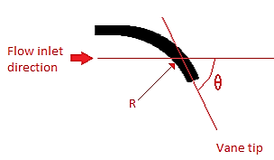
Figure 2.2: Theta as a function of vane angle and flow direction
The intensity of swirl flow has been shown empirically to affect a range of flow properties applicable to engineering. The majority of studies are based around combustion of fuels which is perhaps the most widespread application of swirl flow. Some of the ways swirl affects the flow field include (Gupta et al. 1984):
- Jet growth
- Entrainment and decay rates
- Flame magnitude and shape
- Flame stability
- Combustion intensity
The swirl number is analogous to the effect on the shape and growth of the jet downstream of a nozzle. As the swirl number of a jet increases the velocity of flow changes, with greatest velocity magnitudes observed towards the edge of nozzle.
The velocity components of jets with different swirl number are illustrated below in a plot reproduced from Gupta et al. (1984).

Figure 2.3: Velocity components for flows with different swirl at the exit of a nozzle
These velocity profiles result in the jets appearing to spread wider and rotate faster as swirl intensity increases. The path a particle would trace on a low and swirl jet is illustrated in Figure 2.4 below showing visually how increasing swirl intensity affects a jet as it exits a nozzle.
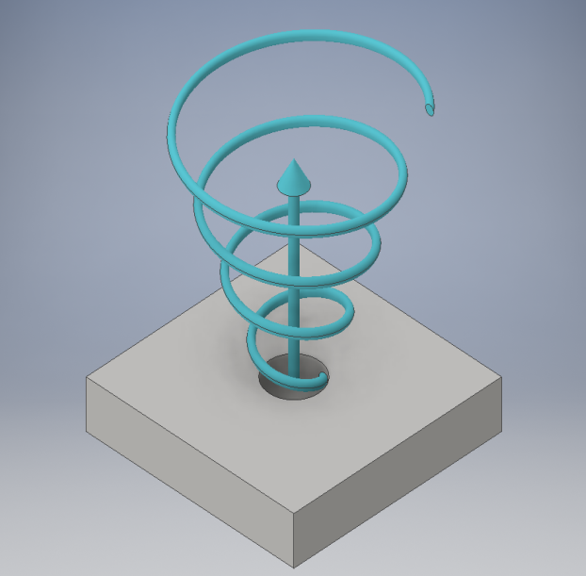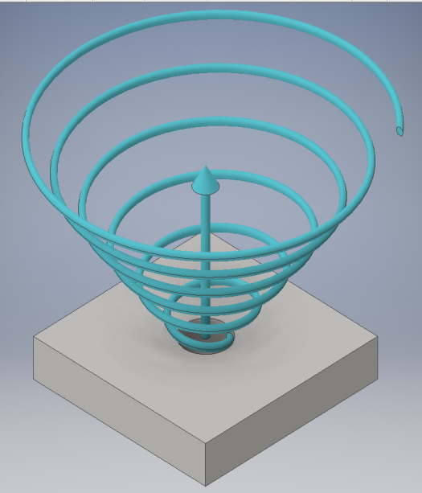
Figure 2.4: Comparative visualisation of jet streamline at lower swirl (left) and higher swirl (right) numbers
Under high swirl flows, where S is 0.6 or greater, recirculation zones occur close to the axis of the jet as fluid is drawn towards the nozzle. This is caused by adverse axial pressure which is set up by the gradients of static pressure through the flow field.
The recirculation flow is exploited in combustion where it is used to introduce hot combustion products back into the flame and to create a region of localised reduced velocity which matches flame speed. This prevents flame lift off and helps preheat the fuel before combustion improving flame stability and reaction intensity.
The recirculation zones in a high swirl jet are illustrated below in Figure 2.5. The figure consists of a greyscale velocity magnitude background, with paler colours signifying greater velocity. The red arrow field indicates velocity direction.
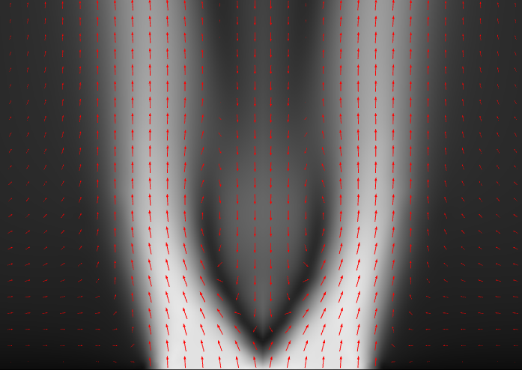
Figure 2.5: Flow field section through the middle of a swirling jet
In low swirl flows, where S is less than 0.4, the curvature of the streamlines is less severe and radial jet spreading is significantly reduced compared to high swirl flows. Despite this jet spreading is not generally as low as non-swirling jets, and it can be observed that radial jet spreading is up to two times greater than pure axial flow.
The adverse pressure gradients in swirling flow increase the flow Reynolds Number locally and due to the nature of turbulence, as earlier described, result in improved mixing within the jet. As the jet develops downstream the swirl number deteriorates, reducing the rate of radial spreading and turbulence until the flow field can be approximated to a non-swirling jet.

Helical Flow
Whilst swirl flow can exist without an axial component, most swirl flows proceed in an axial direction and may as such be referred to as helical flows. In this instance the fluid rotates about an axis coincident with the main flow velocity vector resulting in a coil like motion.

Description of Helical Flow
Mathematically helicity of a flow can be represented as a combination of the vorticity and velocity components. The helical density, h, of a fluid is the scalar of local vorticity, ω, and velocity, u, vectors.
$h=ω∙u$ (2.7)
ω is defined as curl of velocity, such that:
$ω=∇×U$ (2.8)
Helicity, H, is the integral of the scalar product of velocity and vorticity vectors over volume, V:
$H=\int{u∙ω}dV$ (2.9)
Helicity and helical density are pseudo scalar variables, like swirl flow, and are given a positive or negative value dependent on the chirality of the flow. Convention follows that right handed flows are positive value, whereas left handed chirality is negative.
Flows with helicity greater than zero occur naturally under atmospheric conditions as well as in engineered scenarios. Examples of such natural flows include updraft regions in swirling thunderstorms where helical density is commonly in the region of 0.1ms⁻² through to tornadoes where the helical density is up to two orders of magnitude larger, approaching 10ms⁻² (Moffatt & Tsinober 1992).

Fluidised beds
Fluidised beds are a system that passes a fluid up through small solid particles in a tank. The fluid transfers momentum to the solid media and overcomes gravitational forces which results in the mixture behaving in a manner apparently similar to a fluid. Such systems are utilised widely throughout many industries including: combustion (Oka 2003), granulation for pharmaceutical and food products (Vervaet & Remon 2005) and petrochemical industries in applications such as catalytic cracking (Gates et al. 1979).

Background and Application
Gas-solid fluidisation has been exploited in industrial processes since the 1920s when it was first utilised in the Winkler process to gasify coal (Grace et al 2008). Through the 20th century the process of fluidisation became widespread throughout many applications resulting in the situation where;
“Fluidisation […] has touched almost every process industry.” (Zenz 1978)
While fluidised beds are only one type of a range of reactor designs for gas-solid reaction engineering, they are commonly used due to them having numerous significant advantages over alternative systems, namely: (Yates 1983)
- Particles are in constant motion reducing stagnation.
- Homogenous mixing is readily achieved.
- The bed can be considered an isothermal system.
- Mechanical transfer of the solid phase is usually straightforward.
Despite these advantages there are some drawbacks which other systems are designed to overcome, predominantly:
- Particle motion results in abrasive wear of equipment.
- Very fine particles are readily lost from the process equipment.
- Fluid can bypass the solid phase through bubbling reducing process efficiency.
- Upscale of laboratory equipment to industrial application can prove problematic.

General features
A fluidised bed mainly consists of a tank which contains a solid particulate media. A fluid, typically gaseous, is passed through a distribution plate into the tank, overcoming the effects of gravity and causing the media to behave in a fashion similar to a liquid. The region above the fluidised media is referred to as the freeboard.
As the fluid velocity is increased the emulsion of fluid and solid media begins bubbling, as fluid flow rate increases the bed will begin to slug and eventually result in pneumatic conveyance of the media. See figure 2.6.
Following sections of this chapter describe the mechanisms and phenomena observed in fluidised beds. The focus is on particles of 0.5mm or larger as this is the area of interest for the experimental work presented in the later chapters of this thesis.
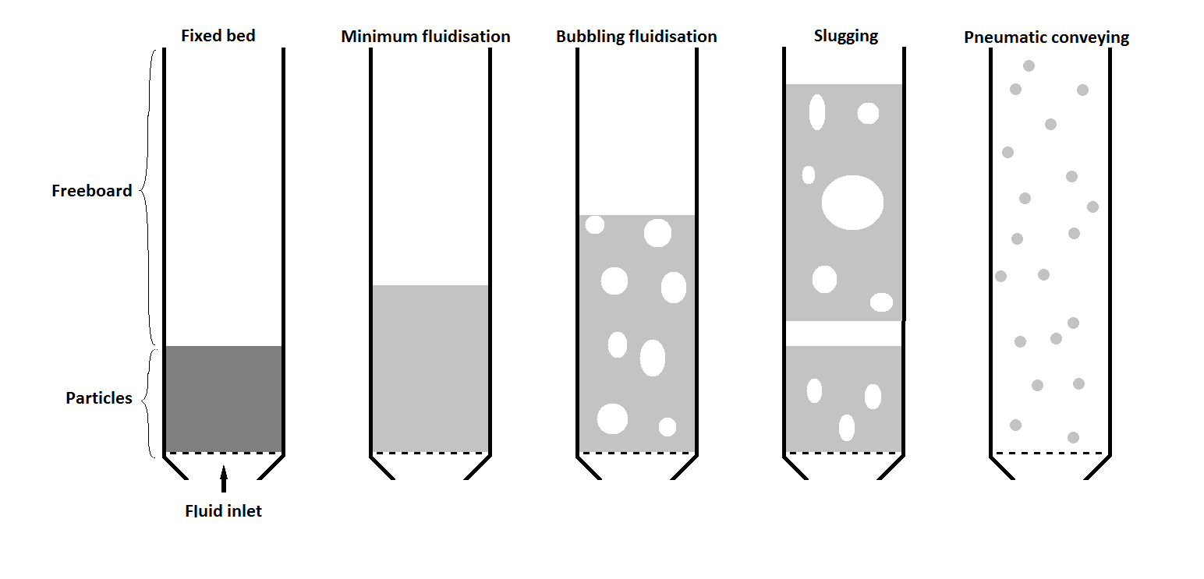
Figure 2.6: Stages of fluidisation, increased air flow from left to right

Types of Fluidised Bed
The basic fluidised bed consists of relatively low gas velocities passing up through particles in a tank, known as a windbox, resulting in fluidisation. This type of fluidisation is called stationary or bubbling fluidisation as the particles remain contained in the windbox with the possibility of entraining some fine particles within the gas.
Under higher gas velocities recirculating fluidised beds are often used where particles that are conveyed out of the system are re-introduced by an external system. This allows for processing of particles by size in a continuous process.
Another type of set up is the annular fluidised bed, which consists of a large central nozzle which introduces gas at high velocities surrounded by an annular distribution plate that fluidises the media at lower velocities. This produces effective mixing within the bulk of the fluidised bed, which is similar to the external loop in the recirculating fluidised bed.
Other variations on these designs exist such as using excitation mechanisms including pulsed air or mechanical vibration. All of these methods are intended to provide better particle mixing across the reactor.

Velocity of Fluidisation
The flow rate of the fluid in a gas-solid fluidised bed is frequently given as a quantity known as the ‘superficial gas velocity’. This value is the average vertical velocity across the fluidised bed cross section. As fluid passes through the media it remains static and under the effect of gravity below a certain superficial gas velocity, as the fluid flow exceeds this point known as the ‘minimum fluidisation velocity’ (U_{mf}) the bed expands as the particles begin to move. This is caused by the particles separating as the fluid passes between them and drag forces overcoming gravitational effects.
When operating a fluidised bed it is common practice to operate in excess of U_{mf} to ensure a homogenous expansion of the bed across the system and overcome the effects of channelling or spouts resulting in excessive gas bypass of the system. As a result when designing a fluidised bed it is important to know U_{mf} for the proposed system to ensure adequate fluid flow can be provided.
Gas velocity when rising through a porous medium is dependent on the pressure drop across the medium under laminar flow, described by Darcy’s law as:
$U=C\frac{∆p}{h}$ (2.10)
Where; U is gas velocity, Δp is pressure drop through the bed, C permeability and h depth.
Permeability is a function of the system based on the void fraction and fluid viscosity. Combining the permeability function with Hagen-Poiseuille equation for flow through cylindrical tubes provides a method for determining U_{mf} when assuming spherical particles (Kozeny 1927). This method was adapted to provide a more accurate solution to determining U_{mf} by considering more realistic flow paths through a fluidised bed (Carman 1937) resulting in the Carman-Kozeny equation:
$U_{mf}=\frac{ε^{3}}{{180\left(1-ε\right)}^{2}}∙\frac{d_{p}^{2}}{μ}∙\frac{∆p}{h}$ (2.11)
Where; ε is void fraction, d_{p} particle diameter and µ fluid viscosity.
As this equation is based on Darcy’s law it is only accurate under laminar flow conditions, which in fluidised beds mainly occurs when particles are smaller than 150µm. Instances where fluidisation is achieved with turbulent gas flow, such as larger particles, require energy losses within the fluid to be taken into consideration to ensure accuracy. This has been achieved by combining the Carman-Kozeny equation with the Ergun equation and empirical observations to yield the following equation which is based solely on physical properties of the particles and fluid (Wen and Yu 1966):
$U_{mf}=\frac{μ}{d_{p}ρ_{g}}{\left({33.7}^{2}+0.0408\frac{gρ_{g}d_{p}^{3}\left(ρ_{s}-ρ_{g}\right)}{μ^{2}}\right)}^{0.5}-33.7∙\frac{μ}{d_{p}ρ_{g}}$ (2.12)
Where: g is acceleration due to gravity, ρ_{s} density of particulate phase and ρ_{g} density of fluid phase.

Characteristics of Fluidisation
As the velocity of the fluid through the media is linked to bed expansion, so too is the pressure drop across the media. In the ‘normal’ instance pressure drop increases linearly with superficial gas velocity up to where velocity equals U_{mf}, at fluid velocities beyond U_{mf} the pressure drop across the bed remains constant. Conversely the bed depth remains static below U_{mf} then begins to increase linearly with superficial gas velocity beyond this value and begin bubbling.
There is also the ‘abnormal’ form of fluidisation where these behaviours are slightly altered. This results in pressure drop across the media continuing to rise beyond U_{mf} for a period before settling to a consistent value. Bed expansion is also affected where the bed begins expanding in a linear fashion, before it partially collapses then begins expanding linearly with superficial gas velocity again. Figure 2.7 illustrates the difference between normal and abnormal fluidisation.
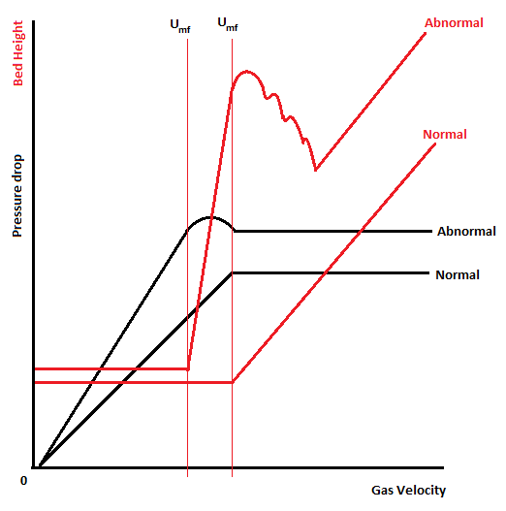
Figure 2.7: Behaviour of normal and abnormal particulate phases
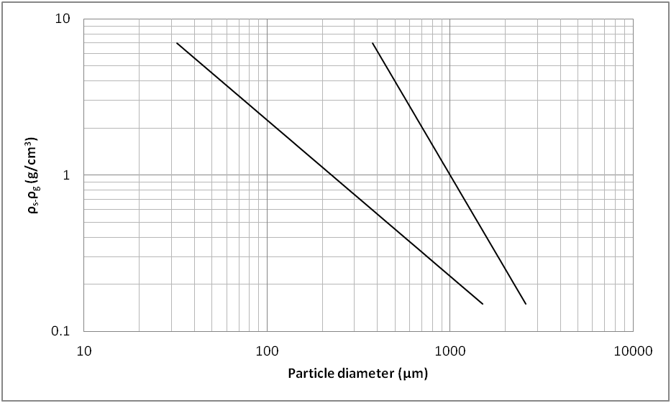
Group D
Group B
Group A
Group C
Figure 2.8: Classification of particles, based on Geldart (1973)
The form of fluidisation is governed by particle size and density based on the Geldart classification of particles (Geldart 1973) which splits particles into four separate groups; A, B, C and D. The distinction between groups A and C is diffuse as shown in Figure 2.8 where it illustrated by a dashed line. The Geldart groups are described below:
- Aeratable: Particles which behave in an ‘abnormal’ manner. They often have increased void fraction in the particle-fluid emulsion as superficial gas velocity increases. Minimum bubbling velocity (U_{mb}) of group A particles is higher than the U_{mf} and the readily formed bubbles rise significantly faster than the emulsion gas.
- Bubble-ready: Particles that behave in the ‘normal’ manner. U_{mb} is not significantly higher than U_{mf} and may be coincident. The emulsion void fraction is relatively consistent across the range of usual fluidisation velocities. Like group A particles, bubbles in group B particles rise faster than the gas in the emulsion.
- Cohesive: Very fine particles, frequently having low sphericity and resultantly difficult to fluidise as channelling becomes a significant issue.
- Spoutable: Large and/or dense particles which are capable of being fluidised. Fluid in the emulsion rises rapidly and bubbles rise slower than those in group A or B particles.

Bubble Characteristics
When fluid flow exceeds U_{mf} fluidised beds begin to bubble as mentioned above. In this instance the bubbles are visually similar to gaseous bubbles in liquids but are more accurately described as voids. The main difference is the lack of a defined boundary in the fluidised media which is replaced by a gradient in particle density from the centre of the bubble to the emulsion phase known as the cloud.
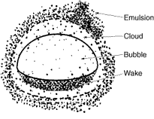
Figure 2.9: Bubble characteristics, from (Fogler and Gurmen 2008)
The effect of the cloud is that the gas diffusion rate between bubble and emulsion is much higher than in a gas-liquid bubble because the boundary is much more permeable. This is important in analysing gas-solid interaction in reacting fluidised beds to determine gas bypass volumes.
As the bubble rises a wake of particles follows the path of the bubble which provides the primary mechanism of particle mixing in a fluidised bed. This provides the juxtaposition that producing more bubbles will result in ‘better’ mixing but that they will also lead to higher gas bypass in turn reducing efficiency. Balancing these effects to produce an effective process is a key task in designing a fluidised bed.
In order to study the bubbles and their effect on mixing simple methods such as pseudo 2D fluidised beds may be used. The pseudo 2D bed consists of two parallel plates with a narrow offset only a few particles thick. The effect of particle interactions with the walls changes the shape of the bubbles, so that whilst providing an approximation of bubble behaviour for a given system a better understanding and accurate representation of a system may be achieved by using techniques such as x-ray tomography (Yates 1983).

Two Phase Theory
The two phase theory model of fluidised beds states that there is an emulsion phase formed by the solids and the volumetric flow rate of gas required to reach U_{mf}, and there is a second phase of bubbles or voids created by the excess gas (Toomey and Johnstone (1952).
Empirical observation of the hydrodynamic properties of fluidised beds reveals a more complex process, resulting in the model being adapted to describe the spherical and semi-spherical shapes of bubbles surrounded by clouds of low particle density (Davidson and Harrison 1963).
The modified two phase model has been experimentally verified (Makkawi and Ocone 2007) and refined to incorporate the emulsion phase reducing in particle density at high gas flow rates (Yates 1983).

Motion in Bubble Vicinity
The motion of gas in the fluidised bed around bubbles varies significantly based on the bubble rise velocity compared to the superficial gas velocity. If the bubble rise velocity is lower than the superficial gas velocity gas passes out of the emulsion phase and through the bubble.
Conversely when the bubble rises faster than the superficial gas velocity gas is held up in the bubble as it recirculates around the bubble and the cloud. The greater the ratio the more gas that is held up in the bubble, and the smaller the cloud becomes, which leads to increased rates of gas bypass due to poor mixing and gas-particle interaction.
When bubble speed is matched to superficial gas velocity the gas passes through the emulsion phase and the bubble. The streamlines of gas flow for the three different scenarios are presented in Figure 2.10 below.
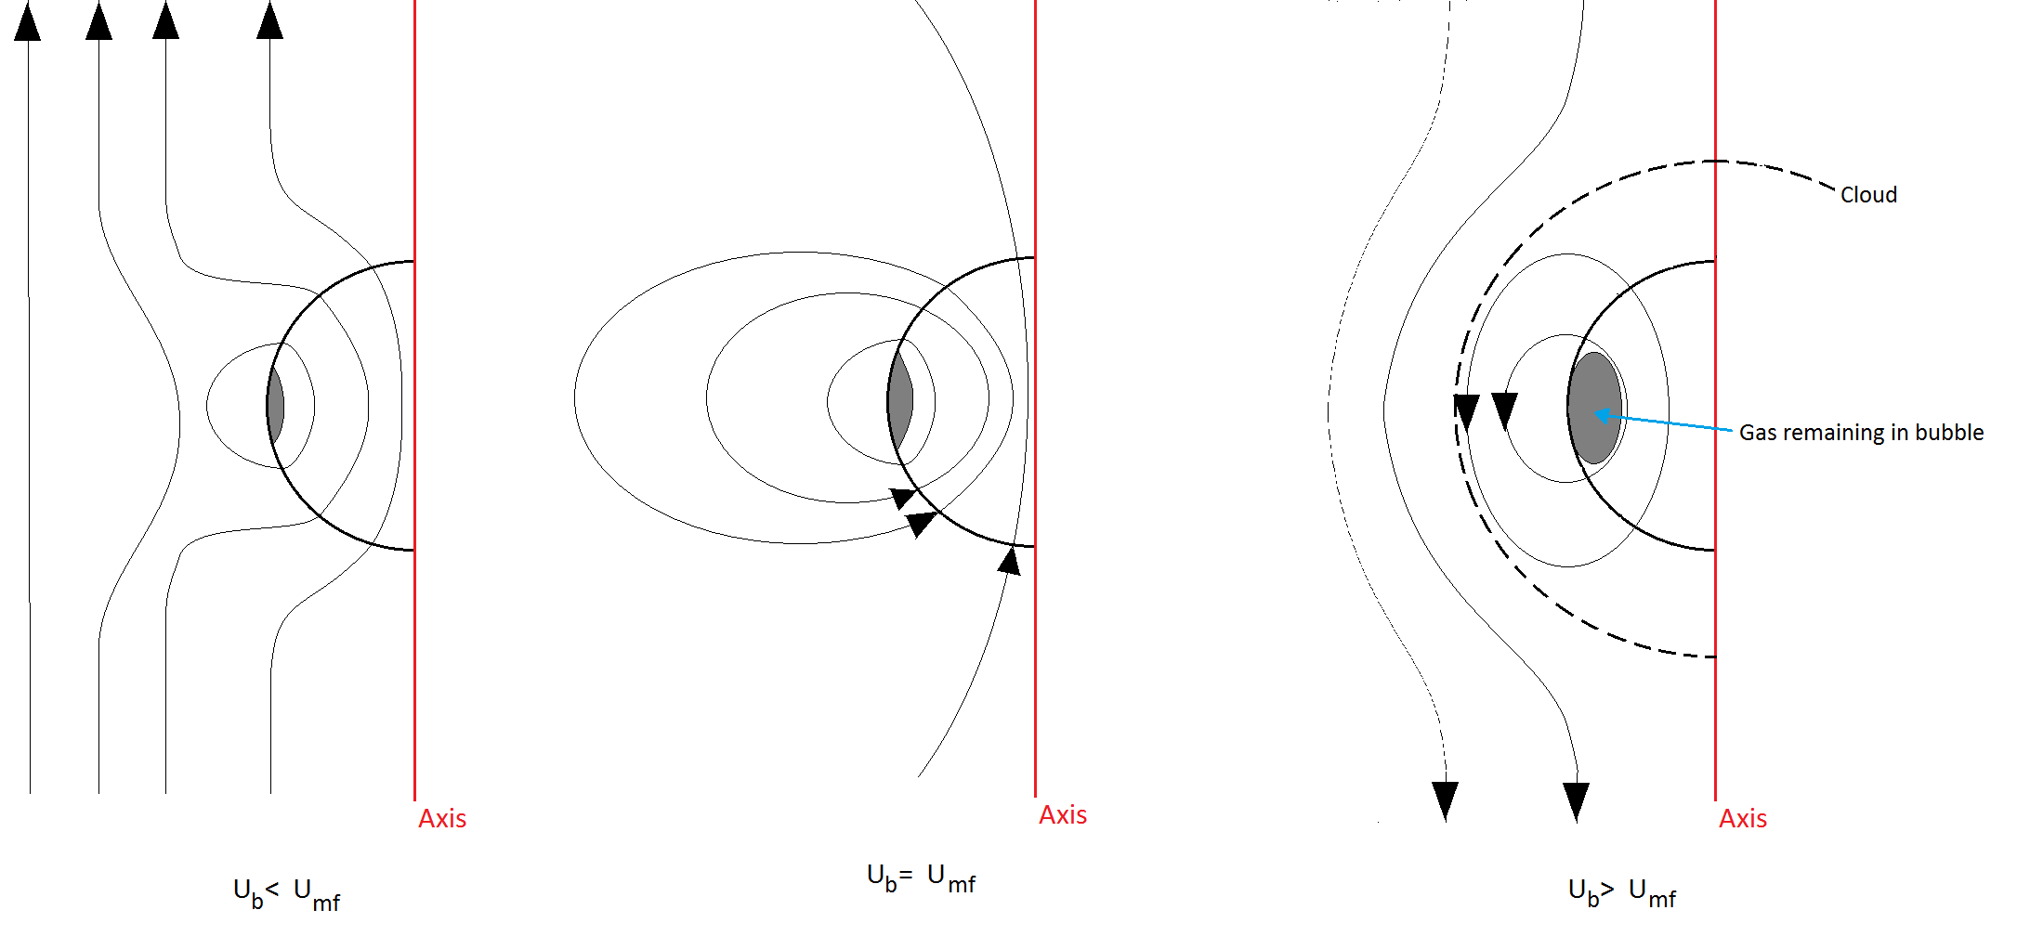
Figure 2.10: Gas streamlines near a bubble at different velocities

Bubble Velocity
The velocity at which a bubble rises through a fluidised bed is directly proportional to the gas-particle contact time. Therefore to reduce the bubble rise velocity is to reduce the volume of gas bypass and thereby increase the process efficiency. The mean bubble rise velocity can be given theoretically (Davidson and Harrison 1963) as below:
${\overline{U}}_{b}=\left(U-U_{mf}\right)+0.711\sqrt{gd_{b}}$ (2.13)
Where; U_{b} is bubble velocity and d_{b} is bubble diameter.
This method of determining bubble rise velocity is reliant on knowing the bubble diameter. This can be problematic in practice as the bubble diameter is affected by a range of operational parameters. This includes factors such as windbox and distributor plate geometries, location of the bubble in the bed and effects of any internal features.
Empirical observation of fluidised beds has observed that it is possible to predict bubble size at the bottom of fluidised beds that use a perforate plate for an air distributor. This can be achieved within ±50% when bed diameter is between 0.3 to 1.3 metres, and +100%/-60% for beds between 0.07 to 0.3 metres in diameter (Mori and Wen 1975).
Minimum bubble diameter is given as:
$d_{b_min}=0.347{\left(\frac{A_{c}\left(U-U_{mf}\right)}{n_{d}}\right)}^{0.4}$ (2.14)
And maximum bubble diameter as:
$d_{b_max}=0.652{\left(A_{c}\left(U-U_{mf}\right)\right)}^{0.4}$ (2.15)
Where; A_{c} is bed cross sectional area in cm², n_{d} the number of holes in the distributor plate, and velocities are measured in cm/s and bubble diameter in cm.

Coalescence
As bubbles rise at different rates based on their size sometimes multiple smaller bubbles will interact with each other and coalesce into larger bubbles. Coalescence then occurs when a trailing bubble collides with a leading bubble to produce a singular bubble of the combined volume. This process occurs in four stages (Sit and Grace 1981):
- Approach: The cap of the trailing bubble meets the wake of the leading bubble.
- Encroachment: The trailing bubble moves through the wake of the leading bubble.
- Coalescing: The point at which bubbles have merged but are not stable.
- Post coalescence: The bubble settles into a stable geometry.
Because coalescence leads to bubbles growing and the process happens as bubbles rise through the bed, the size of bubbles at a given location bears a relationship to the height of that point above the distribution plate. This relationship can be described by the following equation (Yates 1983):
$d_{b}=\frac{0.54{\left(U-U_{mf}\right)}^{0.4}{(h+4\sqrt{A_{0}})}^{0.8}}{g^{0.2}}$ (2.16)
Where; h is height above distributor plate and A_{o} area per distributor nozzle, i.e. effectively zero for a porous plate.

Bubbles in Large Particle Beds
The description of bubbles in fluidised beds to this point has been largely focussed on the literature which is predominantly based around Geldart group A and B particles. Whilst these principles generally hold true in larger denser particles, Geldart group D, there are some key differences in their behaviour (Yates 1983).
As larger particle have a higher U_{mf} than smaller particles the gas in the emulsion phase can be higher than the bubble’s rise velocity. This increases gas-particle interaction reducing gas bypass.
The higher emulsion phase gas velocity prevents formation of a cloud around the bubble as gas flows easily between particles and across the bubble void.
Bubble growth occurs mainly by horizontal coalescence opposed to vertical coalescence. These differences are generally more pronounced in the pseudo 2D fluidised bed when studying bubbles, and care must be taken when extrapolating effects to the 3D system.

Slugging
When a fluidised bed is either narrow or deep enough, bubble coalescence can lead to an effect known as slugging at high enough superficial gas velocities. Slugging refers to the instance when the diameter of the bubble matches the diameter of the bed. The slugs behave differently to ‘normal’ bubbles in a fluidised bed and rise at much slower velocities causing them to maintain growing due to continuing coalescence.
The slugs can form either axi-symmetrically where they have a parabolic profile, common in Geldart group A particles, or as ‘flat nosed’ slugs, more common in larger denser particles. The flat nosed slugs can break down into smaller bubbles and frequently leave ‘pockets’ of gas at the windbox wall. These wall slugs unlike other kinds do not span the width of the fluidised bed.
The critical height of fluidised bed where slugs may be formed has been derived from empirical observation (Baeyens and Geldart 1974) and is related to bed diameter by the following equation:
$H_{L}=60D^{0.175}$ (2.17)
Where H_{L} is critical height, and D diameter where both measurements are given in centimetres. The empirical observations also show the excess gas flow required to initiate slugging when the bed height is beneath H_{L} is given as:
$U-U_{mf}=0.07\sqrt{gD}+0.0016(H_{L}-H_{mf})$ (2.18)
For beds greater than H_{L} this simplifies:
$U-U_{mf}=0.07\sqrt{gD}$ (2.19)
And the frequency of slug formation n_{s} is given as:
$n_{s}=\frac{0.35}{k}∙\sqrt{\frac{g}{D}}$ (2.20)
Where k is an empirically derived constant.
The value of n_{s} tends towards a limit as the bed height increases. This means that k can be readily calculated when the bed height is greater than H_{L}.
Slugging is a common factor in lab bench scale fluidised beds due to their smaller geometry and poses an issue when scaling up the process as the system is more likely to operate in the free bubbling regime. This may result in significantly different gas-solid contact leading to plant failure on scale up. Therefore it is important to determine how slugging effects will differ between the two scales to reduce operational issues.

Turbulence and Fast Fluidisation
When the superficial gas velocity exceeds the velocities at which slugging occurs further fluidisation regimes may occur. These regimes are known as turbulent fluidisation and fast fluidisation respectively. As gas velocity continues to increase beyond these regimes fluidisation moves into pneumatic conveyance. The phrase turbulent fluidisation does not refer directly to the quality of the gas in the fluidised bed, but rather to the holistic process and the motion of multiphase particle-gas emulsion.
Transition from slugging to turbulent fluidisation is distinct with a minimal range of superficial gas velocities between the two, as the fluidisation regime progresses to fast fluidisation, both regimes are characterised by two main effects. The first is the turbulent particle motion and the second is that the difference between slip velocity and particle terminal velocity is at least an order of magnitude. Slip velocity U_{sl} is defined as:
$U_{sl}=\frac{U_{g}}{ε}-U_{p}$ (2.21)
Where U_{g} is gas velocity and U_{p} particle velocity.
Because fast fluidisation only occurs where slip velocities are far in excess of the particle’s terminal velocity the fluidisation regime can only be readily achieved when the particles form stable agglomerated groups which result in significant back mixing effects (Yerushalmi et al. 1976). Without these stable groups and at greater gas velocities a dilute phase regime is created which is predominantly used for pneumatic conveying of materials.

Particle Entrainment
It is evident that as gas velocity increases so too does the height of a fluidised bed, and that smaller particles are fluidised at lower flow rates. If the fluid velocity is great enough to overcome the free fall velocity particles may be blown above the surface of the fluidised bed into the freeboard and out of the system, an effect known as entrainment. The smaller the particle the more likely it is to become entrained and removed from the system, additionally larger particles may be carried into the freeboard before falling back to the emulsion phase creating a gradient of particle density across the freeboard for any system.

Particle Mixing
Where particles have a diameter greater than 100µm the primary particle mixing mechanism is through movement of particles by bubbling. This is caused by particles drifting in the wake of the bubble and rising up behind it before being deposited on the surface of the fluidised bed and are reintroduced into the emulsion. A bubble will move an approximate volume of particles equal to 25% to 35% of its volume (Rowe 1973).
Therefore, to achieve homogenous mixing across a fluidised bed it is important to ensure that bubbles form equally across the bed by an even gas distribution across the bottom of the bed. If air flow is not evenly distributed stagnation zones and preferential flow paths may become established leading to localised recirculation of particles and reducing mixing.

Particle Segregation
When the media in a fluidised bed consists of particles across a range of scales it will frequently result in their segregation with larger denser particles towards the lower parts of the bed and lighter smaller particles at the top.
Empirical observations have shown that density is significant factor in how particles segregate. For example, particles with similar density but where diameter varies by up to an order of magnitude may still mix uniformly (Yates 1983).

Viscosity of the bed
As there are similarities between the behaviour of a fluidised bed and the behaviour of liquids, it can prove advantageous to describe the emulsion phase hydrodynamics with a viscosity term. The nature of the emulsion being a mix of fluid and solid means that determining bed viscosity by instrumentation is rarely accurate as the measurement affects the flow distribution. Resultantly indirect methods of determining emulsion viscosity are preferred.
One method of determining viscosity that is based on the shape of spherical cap bubbles (Grace 1970) is still used as one of the more reliable methods (Yang 2003). This method is based on measuring the included angle of the bubble to determine the emulsion Reynolds number as below:
${Re}_{b}=23e^{-0.004θ} 200°< θ<260°$ (2.22)
By linking in the equivalent bubble diameter, which is given as:
$D_{e}={\left(\frac{6V_{b}}{π}\right)}^{1/3}$ (2.23)
The viscosity of the bed is estimated to be:
$μ=\frac{D_{e}U_{b}ρ_{s}(1-ε_{mf})}{{Re}_{b}}$ (2.24)
Where: Re_{b} is the bubble Reynolds number, θ the included bubble angle, V_{b} the bubble cap volume, D_{e} the effective bubble diameter, U_{b} bubble velocity, ρ_{s} the solids density, and ε_{mf} voidage at minimum fluidisation.
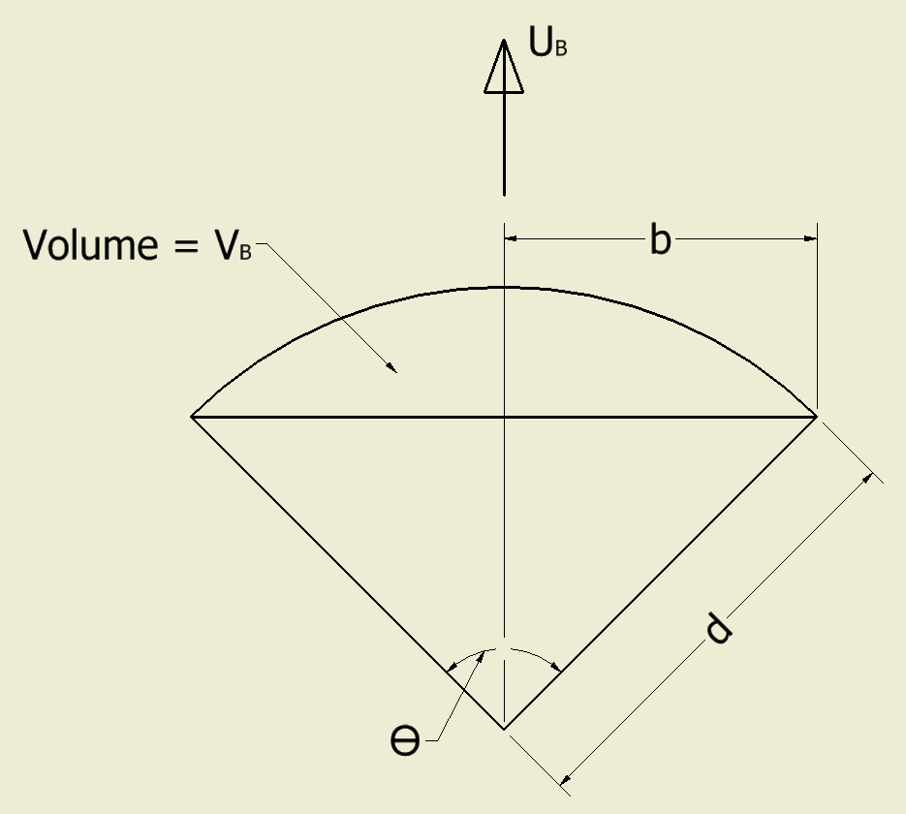
Figure 2.11: Spherical cap bubble schematic

Gas distribution
When gas is introduced into a fluidised bed it should be evenly distributed to prevent dead spots which are not fluidised or localised areas that bubble excessively. At lab bench scale this is often done with a porous ceramic or sintered metal plate, at larger scales the material properties of such distributors make them unsuitable or liable to fracture. As a result it is common to use metal plates with regular discrete holes. These are sometime equipped with bubble caps or tuyeres to prevent back flow of solids into the plenum (Yates 1983). In order to ensure even flow distribution across the base of the bed and through the distribution plate they are normally designed with a high associated pressure drop, which in turn requires higher energy input to overcome and provide fluidisation.
In order to prevent premature bubble coalescence the gap between the pores must also be sufficient, in the order of one and a half times the average bubble diameter above the plate (Zenz 1968). This is described mathematically where the distance between pores in a distribution plate, x, should be:
$x=\frac{D_{0}}{0.0192}\left(log\left[3.52H_{f}ρ_{B}\right]-1.3\right)$ (2.25)
Where: D₀ is pore diameter, H_{f} fluidised bed height, and ρ_{B} bed density.

Fluidised Bed Drying
The characteristic high gas-solid contact of fluidised beds makes them an effective process for quickly drying particles in a range of industries. Such particles that are dried by fluidised beds are diverse and include minerals, cement, coal and foodstuffs (Green and Perry 2007, Mowla and Montazeri 2000). The fluidised bed has received widespread use for drying as it provides the opportunity to accurately control the quantity of moisture removed and the ability to simultaneous classify particles by size and remove unwanted fines.
During drying in a fluidised bed there are a number of complex interactions occurring simultaneously between the solid and gaseous phases, including unsteady heat and mass transfer. As the heat and mass transfer are linked to the temperature gradient and Reynolds number of the gas different energy and mass balance mechanisms are involved.

Drying Rate Profiles
The drying profile, which is the moisture content of a particle plotted against time, of a fluidised bed behaves differently depending on whether the particles are porous or non-porous. Non-porous particles dry rapidly at a linear rate until the process is complete when gas and solid moisture content is in equilibrium. This is a single stage drying process driven by the moisture differential between solid and gas.
Porous media behaves differently as the drying process is two staged. The first stage which is dominated by moisture removal from the surface of the particles results in initial rapid moisture removal. This is followed by a secondary phase where moisture diffuses from the centre of the particle to its surface, driven by a moisture gradient created by the removal of surface moisture. The single phase drying process for non-porous media and two phase process for porous media are illustrated below.
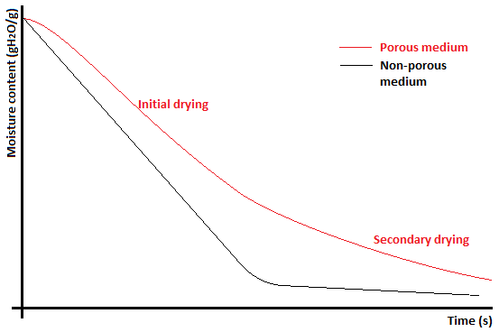
Figure 2.12: Difference in drying rates between porous and non-porous media

Mass Transfer
The mass transfer coefficient in fluidised bed drying is affected by a range of variables including the moisture content and bubble characteristics. As a result the different phases of the fluidised bed: Bubble, cloud and emulsion, are all important in determining the mass transfer rate (Makkawi and Ocone 2011).
Ciesielczyk and Iwanowski (2006) developed a model based on empirical results to predict the drying rate for non-porous particles across the bubble-cloud interface. The mass transfer coefficient across the bubble-cloud boundary is defined as:
$k_{cb}=4.5\left(\frac{U_{mf}}{d_{b}}\right)+5.85\left(\frac{D^{0.5}g^{0.25}}{d_{b}^{1.25}}\right)$ (2.26)
Where; k_{cb} is cloud-bubble mass transfer coefficient, $D$ molecular diffusivity, and d_{b} bubble diameter. d_{b} is given as:
$\frac{d_{b,m}-d_{b}}{d_{b,m}-d_{b,0}}=e^{-\frac{H_{mf}}{D_{c}}}$ (2.27)
Where: d_{b,m} is maximum bubble size, d_{b,0} bubble size at distributor plate, H_{mf} height of the bed at incipient fluidisation, and D_{c} cloud diameter. Note that:
$d_{b,m}=1.636\left(D_{c}\left(U-U_{mf}\right)\right)$ (2.28)
$d_{b,0}=0.376{(U-U_{mf})}^{2}$ (2.29)
The mass transfer coefficient between emulsion and bubble cloud k_{ec} is given by Makkawi and Ocone (2011) as:
$k_{ec}=6.77\sqrt{\frac{Dε_{mf}u_{b}}{d_{b}^{3}}}$ (2.30)
This results in the total mass transfer rate between a bubble and the emulsion, k_{eb}, being given as:
$\frac{1}{k_{eb}}=\frac{1}{k_{cb}}+\frac{1}{k_{ec}}$ (2.31)
The models built to describe mass transfer between a bubble and the surrounding emulsion rely on assumptions which introduce uncertainty. Therefore it is important to provide experimental verification of a given system to accurately characterise it.

Swirl Flows in Fluidised beds
In an effort to improve gas distribution in fluidised beds different systems have been employed, including pulsing the air supply (Wong & Baird 1971) and adding swirling motion to the bulk of the solids in the fluidised bed (Sreenivasan & Raghavan 2002, Zhu & Lee 2005). However one area that has not been studied until recently is the introduction of swirling flow from a distributor plate nozzle into the fluidised bed.
By understanding bed dynamics and swirling flows it is possible to combine the two together into a system that may improve two of the significant issues with fluidised beds; industrial scale up and gas bypass. By using swirling flows to condition the gas distribution across the bottom of a fluidised bed it may be possible to improve the quality of fluidisation by exploiting the spread of the jet to produce a more even flow field. This has the potential to reduce gas bypass and improve process efficiencies without the high pressure drop associated with distribution plates commonly used in industrial applications. The academic literature on this topic is minimal with the author only able to find one existing paper on the subject (Aworinde et al. 2015).
The work of Aworwinde et al. presents the case that the introduction of swirl flow at the distributor plate can have beneficial effects on gas distribution and fluidisation characteristics. The key findings of the paper based on fluidising poppy seeds with a jet diameter of 10mm are:
- Swirling flow presents better gas-solid contact compared to the control.
- Bubble volume lowers as swirl intensity increases.
- Bubble formation frequency is lower under swirl flow compared to the control.
- Jets form at the fluidised bed diffuser in an asymmetric fashion under high swirl flow compared to axi-symmetric formation under control conditions.
- Swirling flow stabilises the jet resulting in deeper penetration into the bed.
- The pressure drop associated with establishing swirl flow fields is significant and results in higher operational costs.
The results provide a clear indication of how small scale swirling flows may be beneficial in industrial fluidised beds. However two key questions remain unanswered by the paper, namely:
- What is the impact of an array of swirlers in close proximity, such that the jets interact with each other in a fluidised bed?
- What is the relationship between jet diameter and particle size?
By answering these questions it may be possible to optimise the quality of fluidisation aided by the introduction of small scale swirling flows.

Design & Commissioning

Introduction
This chapter provides information on the work undertaken in the design and construction of a fluidised bed utilising a series of novel distribution plates. The experimental equipment detailed here was used throughout all of the experiments described in the later chapters of this thesis.
The design project is based on a conventional fluidised bed with modifications applied to ensure adaptability to a variety of operational parameters and conditions. This was done so as to provide a resilient range of usage and compatibility with a variety of tools and methods, both those used and other foreseeable methods.

Design principles
The research hypothesis of this thesis considers the interaction between jets and particles of a similar scale. Resultantly the decision was taken to base the core design of the fluidised bed apparatus on the work by Inaba et al. (2007) which considers drying of barley. This was considered appropriate as the authors use a diffuser plate of spaced 2mm diameter holes, each 5.8mm away from its neighbour. This is a viable space in which to construct a miniaturised helical jet forcer through laser sintering, also known as 3D printing, manufacturing methods and thereby fulfil the research criteria.
Instead of constructing the more common circular fluidised bed the decision was taken to construct a square section bed allowing for optical clarity. This decision was taken for future studies to make use of techniques such as laser based Particle Imaging Velocimetry without having to correct for distortion and lensing effects (Regunath 2007) without having to construct additional apparatus. Further it allows for the cost effective use of high temperature resistant borosilicate glass instead of polymer based materials giving the option to run under a wider range of conditions.
A modular design principle was undertaken to allow for easy swap out and replacement of components so that research could be undertaken for a wide variety of processes and not just the food drying experiments that are the main focus of this thesis. This allows the equipment to be adapted for other experimental regimes such as combustion studies with the correct modifications.

Process Overview
The fluidised bed process consists of an air supply and control system to the plenum. This then passes through a diffuser plate which delivers the desired flow regime to the particulate media in the fluidised bed.
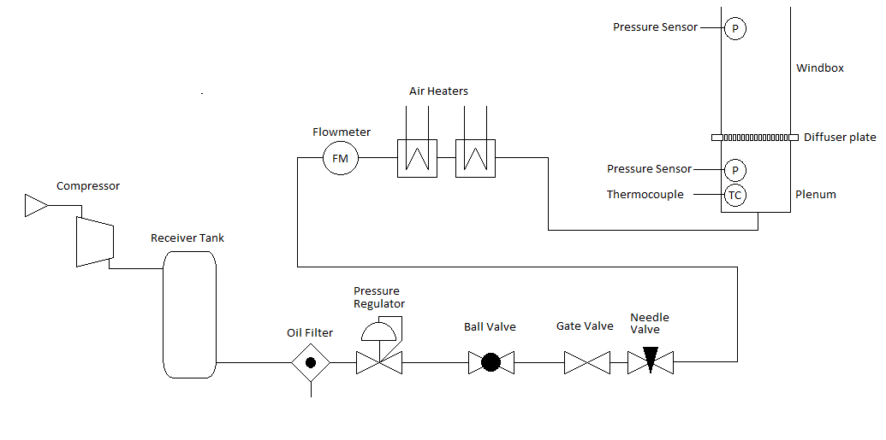
Figure 3.1: Pneumatic flow diagram
Air is first compressed and sent to a receiver tank, which has a safety release valve set to 100 psi. Air is released from the receiver at the required rate, passing first through an oil filter to remove any contaminants in the pipeline and then a pressure regulator to avoid damaging any equipment downstream. Coarse flow control is provided by a gate valve, and fine flow control by a needle valve. Flow rate is measured by a hot wire flow meter and then passed through two air heaters to deliver air at the required temperature before it enters the plenum of the fluidised bed.
Figure 3.1 above details the process schematic via a pneumatic flow diagram for the experimental equipment. In addition to the pneumatic system thermocouples and pressure transducer are located in the plenum and the tank and connected to a data logger. The two air heaters are controlled by a single PID controller which prevents overheating.

Fluidised Bed
The main components of the fluidised bed are detailed below. This includes the plenum, diffuser plates and windboxes. Detailed engineering drawings of all these components can be found in Appendix 1 of this thesis. All components were designed to be modular and bolted together with sealing O-rings to minimise air leakage and losses.

Plenum
The plenum is situated between the diffuser and windbox, it allows for the flow field to fully develop and equalise before passing through the diffuser plate. The plenum was constructed of welded stainless steel sheet.

Geometry
The geometry of the plenum is based on the work of Litz et al. (1972) where dimensions are given for a vertical gas entry:
$D_{E}>\frac{D_{P}}{36} H_{P}=3\left(D_{P}-D_{E}\right)$ (3.1)
$D_{E}<\frac{D_{P}}{36} H_{P}=100D_{E}$ (3.2)
Where: D_{E} is diameter of the plenum entry, D_{P} is diameter of the plenum and H_{P} is height of the plenum.
As the inlet D_{E} is 41.9mm, based on a 1.5” BSP pipe fitting and the mean hydraulic diameter of the plenum, D_{P}, is 200mm, based on a 200mm by 200mm square cross section. D_{E} > D_{P}/36 and therefore the plenum should be a minimum height of 474.3mm. This informed the decision to create a plenum with a depth of 500mm.
To allow for instrumentation inside the plenum three ¼” BSPG fittings were welded onto the outside 60mm beneath the plenum exit. One of the fitting was centralised on the plenum wall and the other two offset by 40mm to either side. ¼” BSPG plugs were used to seal the ports when instruments were not attached. Addittionally a groove was cut into the plenum flange for an O-ring seal to minimise air losses.
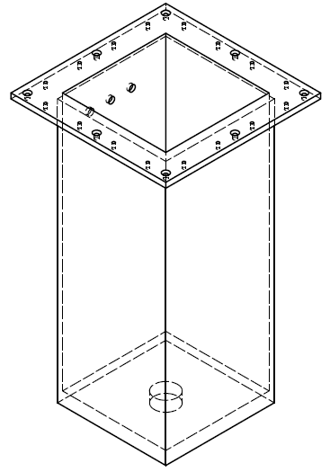
Figure 3.2: Isometric projection of plenum

Diffuser Plates
Four separate diffuser plates were produced to be used with the fluidised bed rig. Each diffuser consisted of a 34 by 34 grid of nozzles for a total of 1156 individual outlets in a 200mm by 200mm square array pattern. The centre to centre distance of each outlet was 5.8mm. Each diffuser was design to provided separate flow fields downstream, which were:
- High swirl flow, where S is 0.6 or greater
- Low swirl flow, where S is 0.4 or lower
- Non swirling flow with a low associated pressure drop
- Non swirling flow with a high associated pressure drop
The decision for producing two non-swirling plates with different associated pressure drop was to be able to investigate the effect diffuser pressure drop has on bed behaviour in isolation to the effect of helical flow. This is an important factor in the research as helical flow forcers necessarily produce a pressure drop that increases with swirl intensity (Li and Tomita 1994).
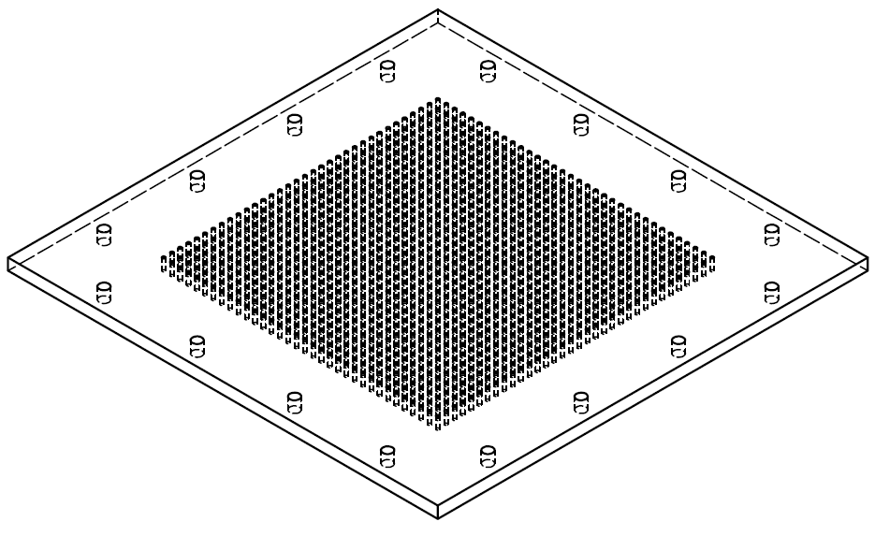
Figure 3.3: Isometric projection of single piece diffuser plate
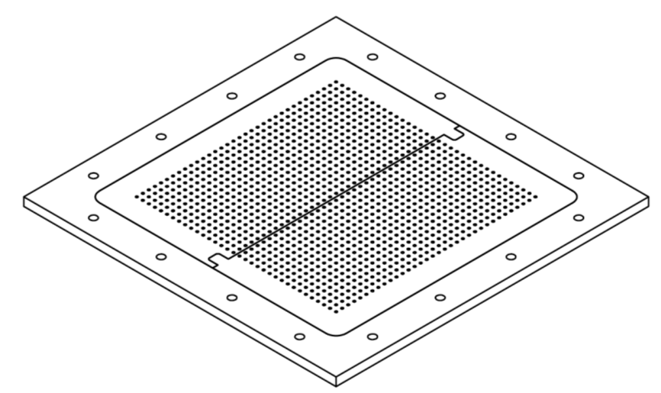
Figure 3.4: Isometric projection of diffuser plate assembly

Materials
The non-swirling diffuser plate with high associated pressure drop was constructed from a single aluminium sheet with 2mm diameter through holes drilled as detailed in the pattern in the section below. This diffuser was produced by CNC machining, coded from a CAD drawing produced in Autodesk Inventor 2013.
The remaining diffuser plates were constructed of nylon and produced by laser sintering. This was necessary due to the fine spiral shaped geometries, detailed later, which require the use of non-conventional machining methods. These diffusers were produced in two half sections due to size constraints of the 3D sintering process utilised and placed in an aluminium holder which was produced by CNC machining.
The nylon diffuser plates were produced in close collaboration with the Advanced Additive Manufacturing (AdAM) group at the University of Sheffield, Department of Mechanical Engineering. The decision was taken to use nylon laser sintering as it is low cost for producing single prototypes, enables a high degree of geometric precision when using ‘virgin’ powder, is inert and non-reactive, and can be produced rapidly. This enabled the author of the report to test a range of designs before considering the production in alternative materials that meet more demanding operational criteria such as metals for high temperatures in processes such as combustion.
The author supplied .STP format CAD files created in Autodesk Inventor 2013 to the AdAM group who checked the design and produced the laser sintered components in a single batch. Each diffuser was sintered in two sections to allow it to fit adequately in the range of the sintering device and to minimise geometric distortion from heat warping.

Geometry
The complete diffuser assemblies each consisting of two sintered nylon sections secured in an aluminium holder measure 300mm by 300mm with a depth of 8mm. The single piece non-swirl diffuser with high associated pressure drop consists of a single piece of aluminium 300mm by 300mm with a depth of 8mm.
All the diffusers have an array of 1156 nozzles, arranged in a 34 by 34 square grid. Each nozzle is 2mm diameter and 5.8mm away from its immediate neighbours as show in Figure 3.5 below.
R 1.0
5.8
5.8
Figure 3.5: Nozzle layout
The aluminium diffuser consisted of straight 2mm through holes for each nozzle; however the sintered diffusers had a more complex geometry. Each nozzle on a sintered diffuser consisted of a 4mm high 4.8mm diameter cylindrical hole, with or without guide vanes as appropriate for helical forcing. The diameter then tapered to a 2mm diameter hole over a distance of 2.5mm.
The helical forcing vanes consist of two channels around a central 1mm diameter column. The low swirl helical forcer vanes undergo one complete rotation in a distance of 4mm and the high swirl helical forcer vanes undergo one and a half rotations in a distance of 4mm. See Figure 3.6 below for an illustration of different geometries.
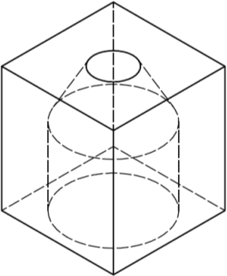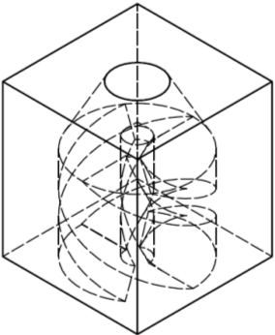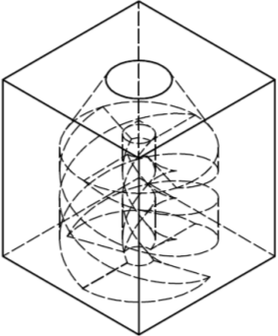
Figure 3.6: Isometric projection of helical forcers: Non-swirl, low swirl, high swirl

Calculation of Swirl Number
In order to ascertain if the geometry of individual helical flow forcers produces the desired swirl intensity, the swirl number of the flow at the nozzle outlet was calculated using Computational Fluid Dynamics (CFD). The calculation was conducted using finite element numerical modelling with the COMSOL Multiphysics 5.0 software package, which works on the Galerkin finite element method. This was conducted before fabrication of diffusers and whilst cannot be relied upon for accurate analysis of the swirl number, was considered appropriate for providing an estimation to inform the design decisions.

Geometry
The geometries created in Autodesk Inventor 2013 as mentioned above were imported into the COMSOL Multiphysics 5.0 software. A solid block was created around the imported geometry and a Boolean difference operation applied to leave a fluid region the inverse of the forcer and a region above and below. This geometry is illustrated in Figure 3.7.
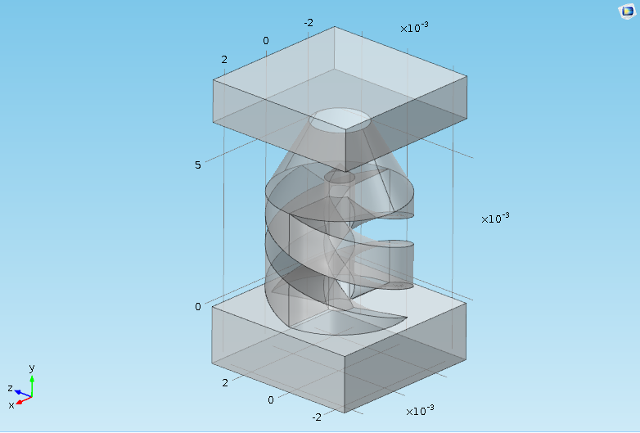
Figure 3.7: Modelled fluid region geometry around high swirl forcer

Materials
The material domain used in the model was air, using material properties at standard temperature and pressure.

Model Physics
The model was based around time independent, single phase laminar flow. Laminar flow was chosen based on the assumption that the fine geometry of the helical forcer would produce a low Reynolds number. Whilst the flow is likely to become turbulent downstream of the nozzle it is the velocity profile at the nozzle plane which is of interest. Initial investigation showed that the model would converge under time independent laminar flow.
In order to obtain the velocity profile at the nozzle of the helical forcer the model solved the Navier-Stokes equation, of the form:
$ρ\left(u∙∇\right)u=∇∙\left[-pI+μ\left(∇u+{\left(∇u\right)}^{T}\right)-\frac{2}{3}μ\left(∇∙u\right)I\right]+F$ (3.3)
And applied the continuity equation:
$∇∙\left(ρu\right)=0$ (3.4)
Where: u is the velocity vector, ρ - density, p - pressure, µ - viscosity, F - volume force vector. T denotes the transpose matrix and I the identity matrix.

Model Parameters
The model boundary conditions are indicated in Figure 3.8 below. The blue arrow indicates the flow inlet was set as a uniform profile normal to the plane with a velocity of 0.8ms⁻¹, a value corresponding with the superficial gas velocity in the experimental program.
The red arrows indicate the model outlets. The boundaries were set to a pressure of 0bar gauge. All other boundaries in the model were set as stationary non slip walls.
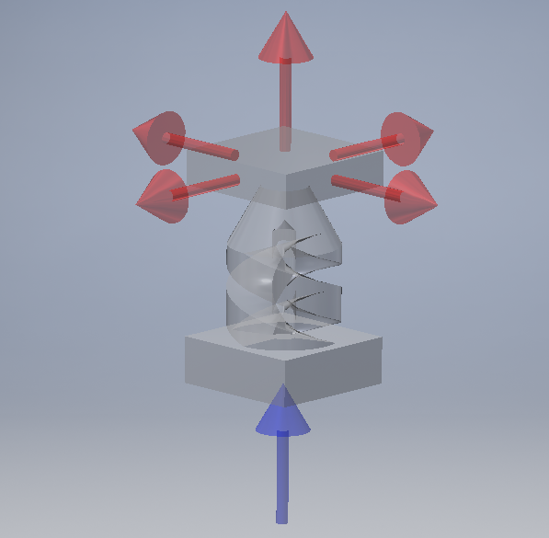
Figure 3.8: Boundary conditions of model

Model Assumptions
A number of assumptions were made in building the model, these include:
- Walls of the helical forcer do not deform due to the force applied by the fluid.
- The flow is adiabatic.
- Flow is consistently within the laminar regime.
- Adjacent nozzles do not significantly affect flow through the nozzle of interest. Whilst this is an approach with potential issues the amount of computational expense that would be incurred by including the impact of adjacent nozzles was considered inappropriate for the project timescales.

Model Solver
A time independent stationary solution solver was used to model the flow through the helical forcers. The solver utilised a fully coupled direct linear method, coupling pressure and volume, with a solution tolerance of 5∙10⁻⁴ scaled across the dependent variables. The problem was considered solved when the residual error reached a value of less than 0.001.

Mesh Refinement
In order to ensure the solution was mesh independent a refinement study was conducted. This analysed the swirl number at the nozzle against a range of tetrahedral mesh sizes for both the high and low swirl helical forcers. Results of the study are shown in Figure 3.9.
The term degrees of freedom, is the product of the number of mesh nodes and the number of dependent variables. It is notable that whilst the swirl number stabilises for the low swirl helical forcer geometry as the number of degrees of freedom increase, the swirl number for the high swirl forcer continues to increase gradually approaching an asymptote.
The mesh refinement study results led to the following mesh parameters being used as presented in Table 3.1 below. The mesh is illustrated in Figure 3.10 below.
Table 3.1: Finalised mesh properties
Mesh Property | Value
Model degrees of freedom | 2.05x10⁶
Maximum element size | 0.133 mm
Minimum element size | 8.6x10⁻³ mm
Maximum growth rate | 1.08
Curvature factor | 0.3
Boundary layers | 2
Boundary layer stretching factor | 1.2

Figure 3.9: Swirl number at nozzle versus degrees of freedom in model
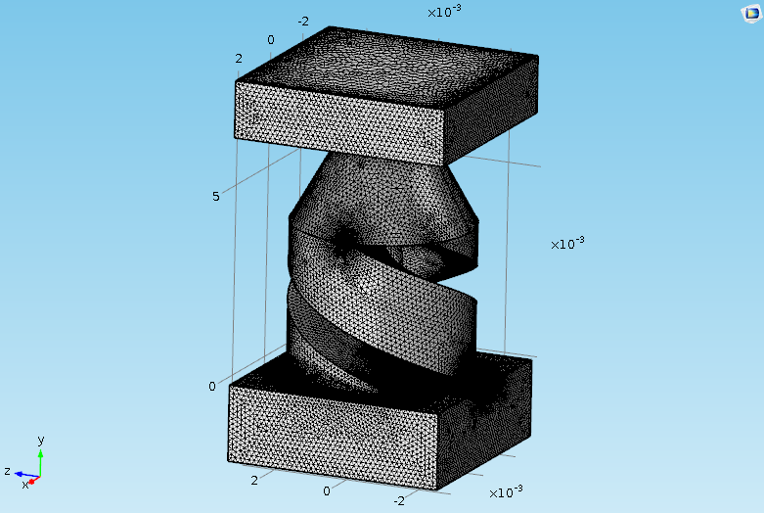
Figure 3.10: Graphical illustration of final mesh on low swirl forcer

Post-processing and results
To determine the swirl number of the jet G_{θ} and G_{X}, from equations 2.3 and 2.4 respectively, were calculated along the X and Z axis of the model at the nozzle. Note that the forcer was orientated axially along the Y axis. This allowed calculation of S in the two different directions, which was then averaged to give the design swirl number.
Table 3.2: Modelling results
 | High swirl forcer | Low swirl forcer
Maximum S | 0.65 | 0.42
Minimum S | 0.63 | 0.40
Average | 0.64 | 0.41

Additional post processing indicates that the flows exhibit typical properties of high and low swirl respectively. The high swirl helical forcer exhibits a strong recirculation zone and a typical low swirl jet profile is evident for the low swirl helical forcer. This is depicted below where the velocity magnitude is plotted on a 2D plane through the helical forcer axis.
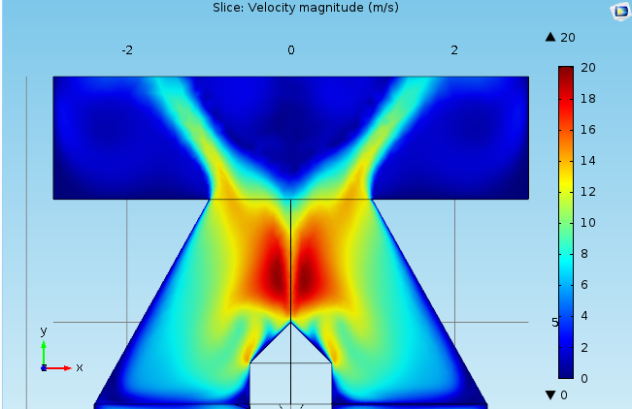
Figure 3.11: 2D Velocity magnitude (ms⁻¹) at high swirl helical forcer axis
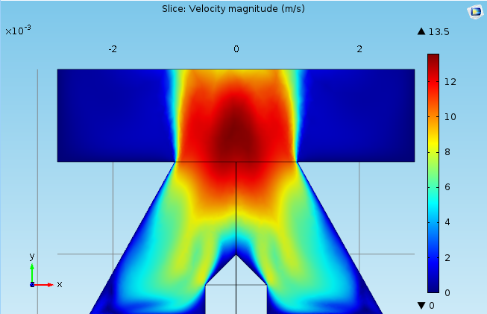
Figure 3.12: 2D Velocity magnitude (ms⁻¹) at low swirl helical forcer axis
When plotting the velocity components at the nozzle outlet it can be seen that the recirculation zone establishes above the nozzle itself. That said the velocity components indicate a lower axial velocity at the centre of the nozzle compared to the edge indicating the effect of the recirculation zone above. The remaining velocity components for the high and low swirl forcer both behave as predicted by the literature.
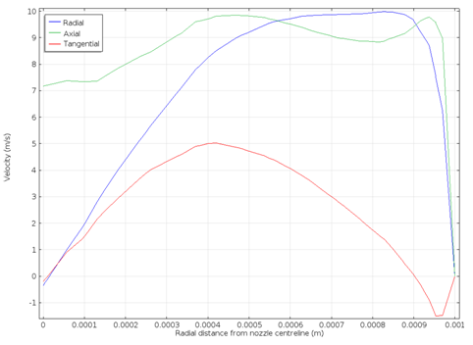
Figure 3.13: High swirl forcer velocity components at nozzle

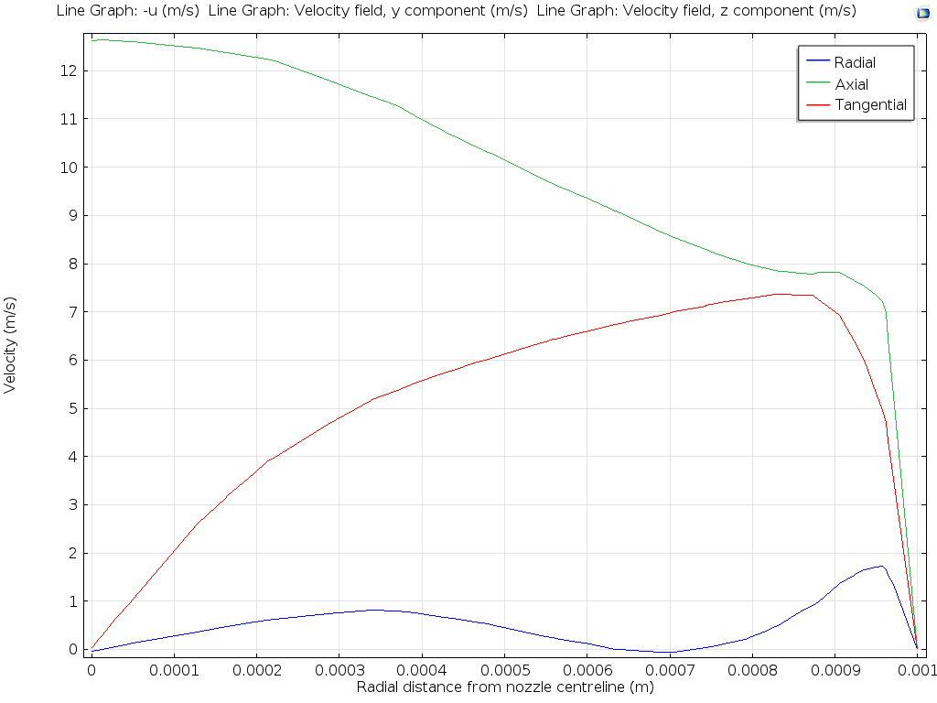
Figure 3.14: Low swirl forcer velocity components

Windboxes
Two windboxes were designed as part of the rig; a square cross sectional windbox for the core experiments and a thin cross sectional, pseudo 2D, windbox for investigation of bubble dynamics in the fluidised bed. Each windbox had a scale attached to the outside to allow accurate reading of bed depth.

Materials
The pseudo 2D windbox and its supporting flange were constructed out of transparent acrylic sheet as bubble dynamics were only to be studied at low temperatures. The acrylic was glued and sealed with a transparent silicone sealant to allow visual clarity.
The conventional square cross section windbox design was constructed of borosilicate glass, secured into an aluminium flange with high temperature resistant glue and sealed with high temperature resistant silicone sealant.
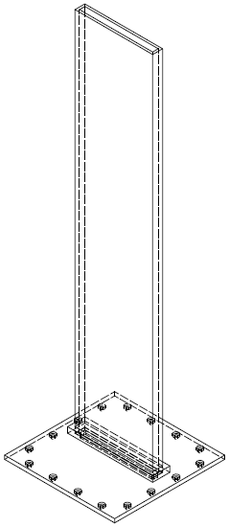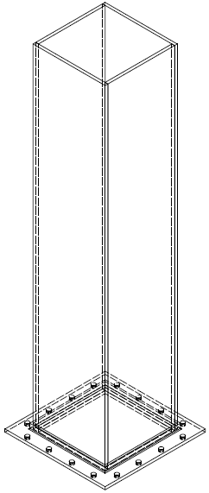
Figure 3.15: Isometric projections of windbox assemblies
The advantage of the 2D windbox is that it allows for clear visualisation on bubble formation without the use of expensive apparatus, such as x-ray tomography. This provides a way of conducting analysis on the dynamics of the fluidised bed in a cost sensitive manner. The main disadvantages are that the 2D bed prevents particles moving transversely across the bed, thereby inhibiting mixing, and that friction along the sidewalls affects particle motion. This means that it is not a direct representation of the 3D bed it represents, but instead a proxy that can be used to observe and inform how operational parameters affect general trends and qualities of fluidisation.

Geometry
The flanges into which each windbox was secured measured 300mm by 300mm. The opening for the pseudo 2D windbox was 15mm by 200mm at an offset designed to centre the opening over two rows of diffuser nozzles. The conventional windbox flange had a centralised 200mm by 200mm opening. Addittionally the windbox flanges had grooves for an O-ring seals to minimise air losses.
The pseudo 2D windbox consisted of 8mm acrylic sheet set into a tank open at the top and bottom measuring 1000mm high 216mm wide 32mm depth.
The conventional windbox consisted of 4mm glass sheet set into a tank open at the top and bottom measuring 1000mm high 208mm wide by 208mm depth.

Additional Equipment
A range of additional equipment detailed in the process diagram before and other items associated with the fluidised bed is detailed in this section of Chapter 3. This is sectioned into the air supply and control system, instrumentation and heating, and other ancillary equipment.

Air Supply and Control System

Compressors
Air was delivered from one of two compressors depending on required flow rate. For flows of up to 120m³hr⁻¹ a Hydrovane HV15 rotary vane type compressor was utilised. Air flow in excess of 120m³hr⁻¹ up to 220m³hr⁻¹ was supplied by the 1936 CompAir Broomwade machine at the University of Sheffield Harpur Hill facility.

Receiver tank
Air from the compressors was passed to a receiver tank that was charged to a pressure of 100 PSI before running the fluidised bed. The receiver tank featured a safety overpressure release valve.

Oil filter
In order to supply clean air and prevent contamination entering the flow control system and fluidised bed a Parker domnick hunter OIL-X EVOLUTION high efficiency compressed air filter was included in the system. The filter is designed to remove oil and water aerosols in addition to solid particulates.

Pressure Regulator
In order to prevent over pressurisation damaging sensitive equipment a Norgren Olympian pressure regulator was installed. The regulator had an operating range of 0.4 to 8 bar and was installed on the 1.5” BSP pipe run from the compressor to the fluidised bed.

Valves
In order to control the flow rate to the fluidised bed two valves were used in series. Coarse control was provided by a gate valve upstream of a needle valve that was used to provide fine flow control adjustments. The valves were included on 1.5” BSP pipe run from the compressors to the fluidised bed plenum.
In addition to the flow control valves an emergency shut off ball valve was also included in the system.

Flow meter
Flow measurement was provided by a Beko technologies METPOINT® FLM compact hot wire flow meter attached to a BSP 1.5” pipe section, the flow meter is capable of measuring flow rates in the range of 42 to 28,800 m³hr⁻¹. For lower rates the flow meter was swapped out of the pipe system for a rotameter calibrated for flows between 100 to 500 l min⁻¹.

Instrumentation and Heating
A data logger was fabricated by the technical staff at University of Sheffield, Department of Chemical and Biological engineering. The data logger was able to monitor readings from two thermocouples and two pressure transducers.
A PID dual heater control was also produced by the technical staff at University of Sheffield, Department of Chemical and Biological engineering. The controller provided power to two heaters and monitored thermocouples to prevent heater overheat and maintain correct air temperature in the plenum of the fluidised bed.
Temperature readings were provided by K type thermocouples. One was situated in the plenum to monitor the inlet air temperature to the fluidised bed. Thermocouples were also applied to each air heater to prevent overheating apparatus.
Two process air heaters were used to heat the air supplied to the fluidised bed as required. The heaters were Omega AHF-14240 with a power output of 2kW. Air leakages from the housings and power cables were sealed with a high temperature resistant silicone.
The equipment associated with the fluidised bed included two pressure transducers, one in the plenum and one in the windbox to measure the pressure drop across the particles. The transducers were Omega PXM319 series pressure transmitters with a range 0-70mBar gauge.

Ancillary Equipment
In addition to ambient room lighting additional requirements were supplied by two 110 volt and one 240 volt halogen lamps. The lighting was on manoeuvrable tripods to position in the location needed. It was primarily used for reducing exposure times when using photographic equipment.
Photographic equipment consisted of a Panasonic Lumix DMC-FZ8 digital camera with a 4GB memory capacity. The camera incorporated inbuilt image stabilisation and autofocus software. A 3 point tripod was used in conjunction with the camera.
The fluidised bed assembly was bolted together and secured on a table which had an opening for the plenum to drop into. The mass was supported on the table by the plenum flange.
A sampling tool was produced consisting of a 54mm outer diameter aluminium cylinder with a 2mm wall thickness and an internal depth of 50mm. The tool was suspended from a thin steel rod with a hinge mechanism for ease of sample collection and emptying.
An oven was also utilised for the experimental regime to dry media. This was a VWR DRY-Line DL53 natural convection drying oven. The oven was capable of heating from +5ºC above ambient temperature to 220ºC.

Commissioning
To ensure safe working of the fluidised bed it was commissioned ensuring all components were correctly integrated into the design and full operational capacity was achieved.
Initial testing of the design consisted of using the air supply system with heaters disengaged to test flow through the system and to identify any air leakage. It was identified that the apparatus was capable of sustaining flow rates in excess of 280m³hr⁻¹, approximately 30% greater than experimental requirements. Any minor leaks at joins were rectified by ensuring the correct torque had been applied to all fittings.
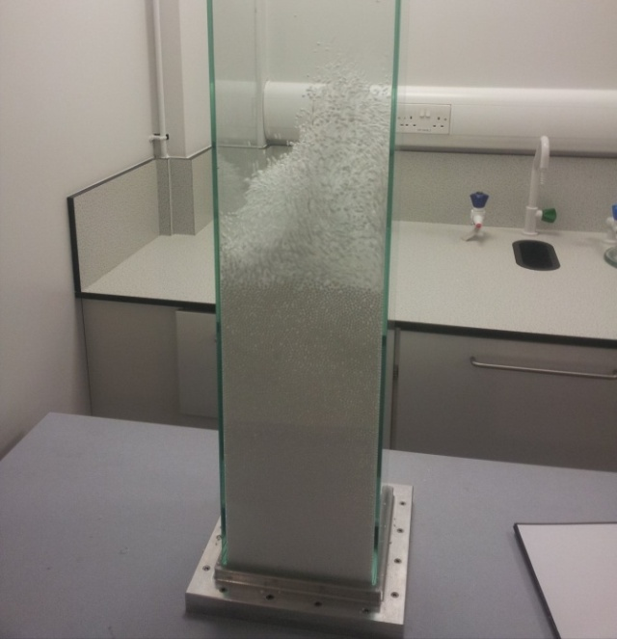
Figure 3.16: Commissioning with polystyrene balls
These results were then replicated with the lower capacity Hydrovane compressor loaded with polystyrene balls between 3mm to 6mm diameter, chosen for ease of fluidisation. It was found the maximum flow rate which could be sustained was approximately 120m³hr⁻¹. The valves were used to control the flow and it was found with the flow meter that flow could be controlled within ±0.5m³hr⁻¹.
Following initial commissioning instruments were connected, tested and calibrated. The instruments excepting the thermocouples were then removed for commissioning of the heaters. The heaters were programmed to cut off when they reached an external temperature of 70ºC, it was found that a desired temperature of 50ºC could be reached within 20 seconds at flow rates of 200m³hr⁻¹ or higher and maintained within 1ºC.
Finial commissioning activities were run with the particles to be used in the experimental program; mung beans and millet seed. It was confirmed that the apparatus could perform as desired in regard to flow supply, throughput and control.
The following two chapters detail the experimental program followed with the apparatus listed in this chapter, present the results and findings.

Characterisation

Introduction
This chapter provides details of experiments undertaken to characterise the fluidised bed experimental equipment described in chapter 2 of this thesis. The experimental program considers determining the pressure drop cost of initiating helical flow into the fluidised bed, the pressure drop across media under different flow regimes, and media expansion under different flow regimes.
The four distinct flow regimes are:
- High swirl helical jets where S = 0.64.
- Low swirl helical jets where S = 0.41.
- Non swirl plain nozzle jets
- Non swirl plain nozzle jets with high associated pressure drop
This chapter presents data that is representative of trends seen across the experimental program rather than the full experimental data, in order to ensure clarity. For readers interested in the complete data, figures depicting results from all experiments can be found in Appendix II.

Materials
The experimental apparatus is fully listed in Chapter 2 of this thesis. An overview of experimental methods is provided in Section 4.3 with full details in Appendix III.
In addition to the aforementioned equipment two particulate media, mung beans and millet seed, were used in the fluidised bed. The fluidisation gas was ambient air supplied from the compressors.

Media
Two types of particle media were used to characterise the bed. These were mung beans and millet seed. The particles were chosen as they are large enough to prevent them entering the fluidised bed plenum through the distributor plate, and are suitable for use in drying experiments, see Chapter 5.
The physical properties of the media are listed in Table 4.1 below. Values for the millet seed were taken from the work of Jain and Bal (1996) and the values for the mung beans from Unal et al. (2008).

Table 4.1: Physical properties of media used in experiments
Property | Mung bean | Millet Seed
Mean largest dimension | 5.145 mm | 2.984 mm
Mean shortest dimension | 3.537 mm | 1.824 mm
Geometric mean diameter | 4.090 mm | 1.843 mm
Sphericity | 0.795 | 0.9425
True density | 1230 kg/m³ | 1591 kg/m³
Bulk density | 821.3 kg/m³ | 853.6 kg/m³
Porosity | 46.57% | 46.3%
Angle of repose | 25.87° | 23º

Using these properties it is possible to calculate the theoretical value of U_{mf} by the Wen and Yu (1966) method. This provides the value of U_{mf} for mung beans as 0.92ms⁻¹ and millet seed as 0.48ms⁻¹. The density and arithmetic mean diameter values classify both media as Geldart Group D particles (Geldart 1973).

Methods
Experimental methods in the bed characterisation experiments are overviews in this section where pressure drop across diffuser, fluidised media and the bed expansion were measured. . Figure 4.1 below shows the general experimental setup used across all characterisation experiments.
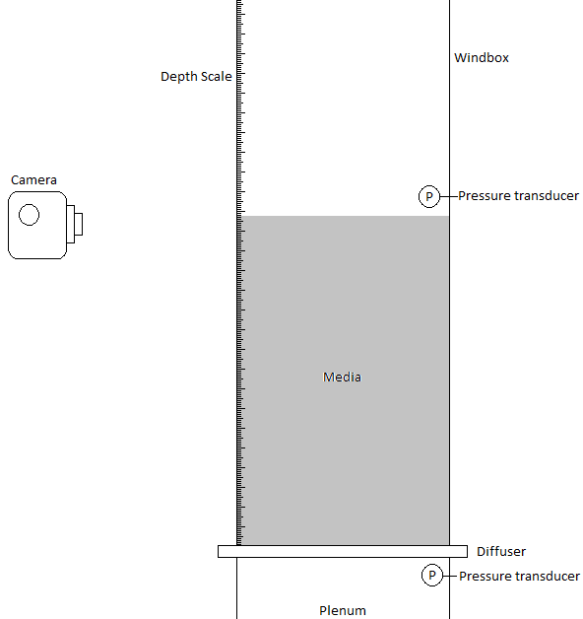
Figure 4.1: General experimental setup
For the millet based experiments a 550µm stainless steel mesh was placed over the plain nozzle diffusers to prevent the media entering the plenum. The fine geometry of the helical forcer diffuser vanes prevented millet seed passing through them.
Readings for experiments were taken at a number of flow rates as shown in Table 4.2 below. The superficial gas velocity is given as the average velocity across the windbox cross section, an area of 0.04m².
Table 4.2: Experimental measurement points
Reading No. | Mung bean |  | Millet seed
Reading No. | Flow rate (m³hr⁻¹) | Superficial gas velocity (ms⁻¹) | Flow rate (m³hr⁻¹) | Superficial gas velocity (ms⁻¹)
0 | 0 | 0 | 0 | 0
1 | 10 | 0.07 | 10 | 0.07
2 | 20 | 0.14 | 20 | 0.14
3 | 30 | 0.21 | 30 | 0.21
4 | 40 | 0.28 | 40 | 0.28
5 | 50 | 0.35 | 50 | 0.35
6 | 60 | 0.42 | 55* | 0.38*
7 | 70 | 0.49 | 60 | 0.42
8 | 80 | 0.56 | 65* | 0.45*
9 | 90 | 0.63 | 70 | 0.49
10 | 100 | 0.69 | 75* | 0.52*
11 | 110 | 0.76 | 80 | 0.56
12 | 120 | 0.83 | 85* | 0.59*
13 | 130 | 0.90 | 90 | 0.63
14 | 140 | 0.97 | 95* | 0.66*
15 | 150 | 1.04 | 100 | 0.69
16 | 160 | 1.11
17 | 170 | 1.18
18 | 180 | 1.25
19 | 190 | 1.32
20 | 200 | 1.39
*Point only measured for bed expansion experiments

Experimental Procedure
The experimental protocol began by assembling and testing the apparatus for air leaks and to ensure it was working correctly before each run.
Coarse control of the flow rate for bed expansion and pressure drop was achieved using the gate valve and fine control by adjusting the needle valve. The camera was kept level with the bed height when taking photographs to record bed depth.
On the end of an experimental run the air supply to the fluidised bed was cut off at the ball at the valves. Before leaving the apparatus unattended the compressor was shut down and the system depressurised.
A full stage by stage guide to the procedures followed for the different experiments, start up and shut down methods can be found in Appendix III.

Results
Results are presented for the initial diffuser characterisation, followed by pressure drop experiments and finally bed expansion experiments.

Diffuser Characterisation
Initial characterisation was conducted on the different diffuser plates to establish the pressure drop cost associated with producing helical flow. Pressure readings were taken above and below the diffuser plate and the difference recorded at superficial gas velocities up to 1.4ms⁻¹.
The results are presented in Figure 4.2, where it can be seen pressure drop behaves in the predicted manner. Where the plain nozzle diffuser has the lowest pressure drop cost followed by the low swirl and plain high pressure drop nozzle diffusers which are closely matched to each other. Generation of the high swirl flow has a significantly greater pressure drop cost compared to the other diffusers.

Figure 4.2: Pressure drop across the different diffusers

Pressure Drop
This section details the data and trends observed for when measuring pressure drop across the fluidised bed. Mung bean media was measured at depths of 50mm, 100mm and 150mm. Millet seed media was measured at depths of 40mm, 80mm and 120mm.

Mung Bean Media
Figure 4.3 below plots the pressure drop across a static bed depth of 150mm against superficial gas velocity. It is evident that pressure drop continues to rise beyond the point of fluidisation for all diffusers apart from the plain nozzle diffuser. This trend remains across all tested bed depths; that is depths of 50mm and 100mm.
It is noted that the plot includes the pressure drop of the diffuser and fluidised media.

Figure 4.3: Pressure drop across media and diffuser 150mm mung bean media
To obtain the pressure drop across the media alone the pressure drop data for each diffuser plate at the relevant gas velocity is subtracted from Figure 4.3 and presented in Figure 4.4. This is the inferred pressure drop across the fluidised media. This analysis indicates that pressure drop across the media is consistent and independent of the diffuser used. This trend was observed across all bed depths tested. Variation in readings is primarily caused by the precision of data logger which was only able to give readings at 1mBar increments.

Figure 4.4: Inferred pressure drop across media 150mm mung bean media

Millet Seed Media
The quality of trends associated with pressure drop across the millet seed media is similar to the trends observed in the mung bean media. However, as the diffuser pressure drop is insignificant for gas velocities under 0.5 ms⁻¹ the continued increase in pressure drop was less significant, due to the minimum fluidisation velocity of 0.48ms⁻¹. Figure 4.5 represents pressure drop across diffuser and millet seed media at a depth of 80mm. Data at bed depths of 40mm and 120mm follows the same trends.
Running the same analysis to infer the pressure drop across the media indicates that pressure drop across the media is consistent and independent of the diffuser used, see Figure 4.6. The resolution of the instrumentation used is primarily responsible for the variance seen in results between the different experiments.

Figure 4.5: Pressure drop across media and diffuser 80mm millet seed media

Figure 4.6: Inferred pressure drop across media 80mm millet seed media

Bed Expansion
This section details the data and trends observed for when measuring media expansion in the fluidised bed. Mung bean media was measured at depths of 50mm, 100mm and 150mm. Millet seed media was measured at depths of 40mm, 80mm and 120mm. All of the errors bars on figures in this section are set at ±1 standard deviation.

Mung Bean Media
The characteristic trend observed across all bed expansion experiments with mung bean media is the introduction of swirl flow reducing bed expansion. Expansion was observed at gas velocities of 0.83ms⁻¹ and above, which was significantly lower than the predicted value of U_{mf} at 0.92ms⁻¹.
The results indicate throughout all three experimental depths (50mm, 100mm and 150mm) that there is minimal difference in bed expansion between the plain nozzle diffuser and the plain nozzle high pressure drop diffuser. There is a clear trend across all three experimental bed depths that the high swirl diffuser results in a statistically significant lower bed expansion than any other diffuser. The low swirl diffuser produces marginally lower bed expansion than both the plain nozzle and plain nozzle with high pressure drop diffusers.
Table 4.3: Bed expansion compared to high swirl diffuser
Depth | Average level above high swirl diffuser at all velocities above U_{mf}
Depth | Low swirl | Plain nozzle | Plain - high dP
50mm | 2.5mm | 3.3mm | 4.4mm
100mm | 1.4mm | 2.3mm | 3.1mm
150mm | 1.8mm | 4.0mm | 3.6mm

The three figures below show data from the experiments with a static bed depth of 150mm of mung beans. Figure 4.7 shows the results from all four diffusers. Figure 4.8 highlights the difference between the high swirl diffuser and the plain nozzle diffuser. Figure 4.9 shows the similarities between the plain nozzle and plain nozzle with high associated pressure drop diffusers.

Figure 4.7: Bed expansion with 150mm mung bean media

Figure 4.8: High swirl and plain nozzle diffusers at 150mm

Figure 4.9: Plain nozzle and plain nozzle with high dP diffusers at 150mm

Millet Seed Media
The results of the bed expansion experiments with millet seed follow a similar trend to that seen under the mung bean experiments where swirl flow results in lower bed expansion and the pressure drop of the diffuser has no significant impact. Expansion was observed at a gas velocity of 0.35ms⁻¹, lower than the predicted value of U_{mf} at 0.48ms⁻¹.
Expansion with the low swirl diffuser when fluidising millet seed is consistently lower across all bed depths studied. The remaining three diffusers show little statistical difference in bed expansion under fluidisation.
Table 4.4: Bed expansion compared to high swirl diffuser
Depth | Average bed depth increase compared to high swirl
Depth | Low swirl | Plain nozzle | Plain nozzle high ΔP
40mm | 1.9mm | 2.7mm | 1.1mm
80mm | 1.5mm | 2.4mm | 1.7mm
120mm | 0.5mm | 1.0mm | 0.6mm

The three figures below show data from the experiments with a static bed depth of 80mm of mung beans. Figure 4.10 shows the results from all four diffusers. Figure 4.11 the high swirl and the plain nozzle diffusers. Figure 4.12 the plain nozzle and plain nozzle with high associated pressure drop diffusers.

Figure 4.10: Expansion with 80mm millet seed media

Figure 4.11: High swirl and plain nozzle diffusers at 80mm

Figure 4.12: Plain nozzle and plain nozzle with high dP diffusers at 80mm

Discussion
The trends in the data mentioned above along with causes and effects of these trends are discussed throughout this section.

Diffuser Performance
The diffusers all behave in a predictable way as would be expected from the literature surrounding the theory of producing helical flows. That is; the pressure drop cost associated with producing swirl flow increases with swirl intensity as secondary flows establish and velocity magnitudes increase compared to direct axial flow (Li and Tomita 1994). In addition the narrow geometries in the high swirl and low swirl diffusers add to the effect of pressure drop cost, evidenced by the difference in pressure drop across the two non-swirling diffusers which is the direct result of narrower channels.
In comparison to the only other paper in the field of swirling nozzle diffusers in fluidised beds, by Aworinde et al (2015), the pressure drop cost associated with producing swirl flow is significantly lower for the diffusers used in this thesis.
Aworinde et al. (2015) reports a pressure drop of approximately 25mBar at a flow rate of 3l/min through their nozzle, at the same superficial gas velocity this work finds that the high swirl diffuser produces a pressure drop of 12mBar. It is likely that the lower pressure drop in this work is achieved through utilising a greater quantity of smaller nozzles opposed to larger ones. However, without detailed knowledge of the authors’ apparatus, or the swirl intensity produced, it is not possible to provide a thorough analysis, especially in a new field of engineering where a wide range of designs and methods may have unknown impacts and effects.

Effect on Pressure Drop
The results indicate that regardless of the flow regime employed pressure drop across the media remains similar. This result is inferred rather than a direct measurement, as the pressure transducers are located in the plenum and above the media. To infer the pressure drop across the media the results from the diffuser performance experiment are subtracted from the pressure drop experiments. This indicates that the different flow regimes do not affect pressure drop across the media.
By inferring the pressure drop across the media the results indicate that the pressure remains constant when the gas velocity is approximately equal to the calculated value of U_{mf}. This result matches the literature closely and indicates that whilst an increased pressure drop cost is required to generate helical jets at the diffuser, the different flow regimes do not have an appreciable effect on the pressure required for fluidisation.
Further analysis indicates that the predicted value of U_{mf} is close to the empirically observed value when it is inferred by the stabilisation of pressure drop across the fluidised bed. U_{mf} for mung beans was predicted at 0.92ms⁻¹ where experimental data indicates pressure drop across mung bean media stabilises at approximately 0.90ms⁻¹. U_{mf} for millet seed was predicted at 0.48ms⁻¹ and data indicates pressure stabilisation at gas velocities exceeding 0.42ms⁻¹. It is noted readings were taken at approximately 0.07ms⁻¹ increments.

Effect on Expansion
The most obvious trend from the bed expansion experiments is the lower bed height when using the high swirl diffuser for any given media and superficial gas velocity in excess of U_{mf}. The lower bed expansion effectively means that the bed is of a smaller volume.
During experimentation it was generally observed that around the point of insipient fluidisation the plain nozzle diffusers exhibited highly localised effects such as spouting. This was less evident in the swirling diffusers which appeared to produce a more even fluidisation quality across the bed.
The most obvious explanation for the reduced bed volume is the reduction of bubble volume under swirl flow caused by a more homogenous gas distribution. This hypothesis is supported by the work of Aworinde et al. (2015) who demonstrate swirl flows from nozzles in fluidised beds reduce both bubble volume and frequency. However it is noted that this work differs substantially by utilising an array of swirling nozzles instead of a singular nozzle and that the particle size and jet diameter are matched in this work but differ by more than an order of magnitude in the work by Aworinde et al.
The work in this chapter expands on their work by demonstrating the differences of high and low swirl flows, and the effect of producing a jet with a diameter similar to, or smaller than, that of the particle.
The results in this chapter indicate that the low swirl diffuser is not significantly different to the plain nozzle high pressure drop diffuser for any of the millet based experiments, and produces minimal reduced expansion for the mung bean experiments. The nozzle was 0.26mm wider than the millet seed and 2.09mm narrower than the mung bean media. This indicates that low swirl only has a significant effect on particles larger than the jet diameter but that high swirl has a demonstrable effect on particles both larger and smaller than the jet diameter.
The effect of the relationship between particle diameter and jet diameter is also apparent for high swirl flow. Expansion of the mung bean media is consistently lower than that of millet, signifying that jets with a diameter smaller than the particles produce a ‘more even’ fluidisation quality. This follows the hypothesis of reduced bubble volume and frequency by introducing swirl flow. Also shown is that the effects of the recirculation zones established in high swirl flows and the greater jet spread are effective at reducing bed volume.
The radial growth and recirculation zones associated with high swirl jets are considered by the author to provide better fluidisation quality by improving the gas distribution. It is shown in Chapter 6 that swirling jets can draw particles in towards them against the mean axial flow. It is believed that this inhibits the nucleation zone of bubbles and helps reduce the frequency of bubble formation. The wide jet spread creates an even flow of air across the bottom of the bed which contributes to homogenous flow across the bed and reduces localised fluidisation at gas velocities close to U_{mf} allowing for fewer dead zones.
The implications of improved fluidisation are lower rates of gas bypass. This in turn means that less gas is required and reagents in the gas are more likely to react with the particles. This hypothesis is tested in the next chapter of this thesis which considers particle drying under different flow regimes.

Minimum fluidisation Velocity
Comparing the minimum fluidisation velocity derived from the bed expansion experiments it is significantly lower than the calculated value, or the value derived from pressure drop stabilisation as shown in Table 4.5.
Table 4.5: Values of U_{mf} by different methods
U_{mf} | Mung Bean | Millet Seed
Calculated | 0.92 ms⁻¹ | 0.48 ms⁻¹
Pressure drop stabilisation | 0.97 ms⁻¹ | 0.49 ms⁻¹
Initial expansion | 0.83 ms⁻¹ | 0.35 ms⁻¹

This phenomenon is most likely caused by packing of the media as it is loaded into to the experimental apparatus. If the media has been agitated it will effectively ‘pack down’ reducing in bulk volume as individual particles orientate themselves to reduce the void ratio in the bed. To mitigate this effect it would be preferable to fluidise the media after loading and slowly reduce the gas flow rate to zero. However when attempting this during experiments the surface of the bed would not settle uniformly, but have a range of peaks and troughs presenting significant difficulties in determining bed depth.

Statistical Significance
The different data sets for the bed expansion were compared to each other utilising the T-Test method to determine statistical difference between them. The test was carried under a two tailed, paired array conditions. Table 4.6 provides the values of mung bean expansion data sets and Table 4.7 of millet seed data sets. A result of under 0.05 indicates data sets are significantly statistically different. The value indicates the probability of the data sets being from experiments under the same conditions.
Table 4.6: T-Test results for comparison of data sets: Mung bean expansion
50mm depth of mung beans
Diffuser | Low Swirl | Non Swirl | Non Swirl High ΔP
High Swirl | 0.001 | 0.002 | 0.001
Low swirl | - | 0.007 | 0.002
Non Swirl | - | - | 0.006
100mm depth of mung beans
Diffuser | Low Swirl | Non Swirl | Non Swirl High ΔP
High Swirl | 0.007 | 0.002 | 0.002
Low swirl | - | 0.004 | 0.005
Non Swirl | - | - | 0.098
150mm depth of mung beans
Diffuser | Low Swirl | Non Swirl | Non Swirl High ΔP
High Swirl | 0.023 | 0.001 | 0.002
Low swirl | - | 0.003 | 0.002
Non Swirl | - | - | 0.065
,
Table 4.7: T-Test results for comparison of data sets: Millet seed expansion
40mm depth of millet seed
Diffuser | Low Swirl | Non Swirl | Non Swirl High ΔP
High Swirl | 0.000 | 0.000 | 0.001
Low swirl | - | 0.046 | 0.200
Non Swirl | - | - | 0.006
80mm depth of millet seed
Diffuser | Low Swirl | Non Swirl | Non Swirl High ΔP
High Swirl | 0.001 | 0.000 | 0.000
Low swirl | - | 0.029 | 0.290
Non Swirl | - | - | 0.115
120mm depth of millet seed
Diffuser | Low Swirl | Non Swirl | Non Swirl High ΔP
High Swirl | 0.010 | 0.000 | 0.000
Low swirl | - | 0.046 | 0.118
Non Swirl | - | - | 0.274
The results in Table 4.6 indicate that there is a strong difference of both the high and low swirl diffusers when compared to each other and to the other diffusers used in the experimental work. It is also shown that at low bed depths the difference in expansion between the plain nozzle diffuser and the high pressure drop diffuser is significant but becomes less so as bed depth is increased beyond a certain point.
Table 4.7 indicates that the high swirl flow regime is consistently independent of other data sets, and that the difference in expansion between the plain nozzle diffuser and the high pressure drop diffuser is significant at low bed depths but becomes less so as bed depth increases. Both of these trends are similar to the results from Table 4.6.
However, the low swirl flow behaves differently. Whilst it is similar in that the data sets are independent of the plain nozzle diffuser and high pressure drop diffuser, it is not statistically different from the diffuser with high associated pressure drop. This shows a relationship between the intensity of the flow conditioning, jet diameter and particle size on the rate of bed expansion, whereby if swirl intensity is not strong enough the effect becomes negligible at small particle sizes.

Conclusions
The diffusers all behave in a manner consistent with the literature and exhibit lower pressure drops for the given application than seen elsewhere in a very new field of engineering.
Pressure drop across fluidised media is independent of the flow regime, or the intensity of the swirl from each diffuser.
Packing effects affect the apparent minimum fluidisation velocity of particles, and therefore it is more appropriate to establish U_{mf} from the observed pressure drop across the fluidised media.
Predicting U_{mf} from the literature and pressure drop provides a consistent result. Initial bed expansion is seen at lower superficial gas velocities and it is proposed this is caused by ‘packing’ of the media.
Swirling flow where the jet diameter is similar or smaller than the particle diameter reduces bed expansion. Notably the higher the swirl number of the jet, the greater the effect on reducing bed volume compared to non-swirling flow.
The pressure drop associated with the diffuser does not have a significant impact on the quality of fluidisation across the bed.
Reduced bed volume from introducing swirling flow is indicative of reduced bubble volume and frequency as proposed by Aworinde et al. (2015) and therefore results in less gas bypass. However there are significant differences between the two bodies of work and the mechanisms of swirl flow in fluidised beds may be different depending on jet scale as indicated by the difference in results for the range of media used in characterisation.

Drying & Void Analysis

Introduction
This Chapter follows on from the characterisation work of Chapter 4 and develops the understanding of bed mechanics and application to engineering problems. The main body of this work covers drying experiments, where it is hypothesised that the apparent better gas distribution leads to lower gas bypass and improved moisture removal rates from the fluidised media. To investigate the hypothesis experiments were carried out at the following conditions:
- 1.5 times the minimum fluidisation velocity for dry particle with the high swirl distributor plate and plain nozzle distributor plate.
- 1.8 times the minimum fluidisation velocity for dry particle with the high swirl distributor plate and plain nozzle distributor plate.
Each of the four experimental conditions above was run five separate times. Each experiment lasted two and a half hours. All of these experiments were run in the conventional, 3D, fluidised bed apparatus.
The hypothesis of lower gas bypass is intrinsically linked to reducing the volume or the quantity of bubbles or voids in a fluidised bed. To investigate the bubbles in the fluidised bed video analysis of a pseudo 2D fluidised bed was conducted to analyse frequency of bubble formation and void fraction under different flow conditions and gas velocities.

Materials
The experimental apparatus is fully listed in Chapter 2 of this thesis and experimental methods are described in Section 5.3. In this chapter only one particulate media, mung beans, was used in the fluidised bed. The fluidisation gas was ambient air heated to 45ºC supplied from the compressors for the drying experiments.

Media
The particulate media used in this chapter is the mung beans as presented previously in Chapter 4 of this thesis. The particles were chosen for showing the broadest range of results during bed characterisation and that they absorb water thus making them suitable for use in drying experiments.
The physical properties of the media are listed in Table 5.1 below, reproduced from Chapter 4. Values are taken from Unal et al. (2008). The data shows that as the grain absorbs moisture it expands and becomes denser; in contrast the bulk density decreases. As the work of Unal et al. (2008) only considers moisture content up to approximately 18% and the soaked beans in this work have a moisture content of 50% or greater it is not accurate to extrapolate the findings to this range. It is also noted that differing growing conditions and heritage between the mung beans studied by Unal et al. (2008) and those used in this study may result in differing physical characteristics.
However, it can be inferred that as grain size increases significantly with moisture content the minimum fluidisation velocity also increases. This means that as the media dries and reduces in volume the fluidised bed will become more turbulent. Note that the terminology of turbulence here does not apply to the gas velocities observed in the fluidised bed directly but instead to the general motion of the particles in the fluidised bed as presented in Chapter 2 of this thesis
Table 5.1: Physical properties of media used in experiments
Property | Moisture Content
Property | 7.28% | 17.77%
Mean largest dimension | 5.145 mm | 6.199 mm
Mean shortest dimension | 3.537 mm | 4.223 mm
Geometric mean diameter | 4.090 mm | 4.893 mm
Sphericity | 0.795 | 0.789
True density | 1230 kg/m³ | 1456.7 kg/m³
Bulk density | 821.3 kg/m³ | 754.2 kg/m³

Methods
The methods involved in this experiment are detailed below, including: Correcting flow velocity to provide an accurate measurement, sampling technique and experimental procedure.

Sampling
Samples were removed from the top central location of the particles in the fluidised bed using the tool described in chapter 3 of this work. The samples were taken so that they filled the tool halfway. The average mass of wet particles withdrawn was 14.2g with a standard deviation of 3.2g. Withdrawn samples were immediately placed into open polyethylene terephthalate containers of pre-recorded mass and the combined mass of container and sample recorded within 30 seconds of sample withdrawal to reduce the impact of continued moisture loss. The masses were recorded to within 0.1g.
Following drying of the sample in its container for a period of 24 hours in a natural convection drying oven at a temperature of 60ºC the mass was recorded again to determine the moisture content of each sample.

Fluid Velocity Measurement
As the air supplied to the fluidised bed is heated, and volumetric flow rate is measured before it passes through the heaters, it is necessary to determine how gas expansion under heating affects the superficial gas velocity.
Applying the ideal gas law:
$pV=nRT$ (5.1)
If n remains constant the relationship of gas before (1) and after (2) heating can be described as:
$\frac{p_{1}V_{1}}{T_{1}}=\frac{p_{2}V_{2}}{T_{2}}$ (5.2)
As the change in pressure is negligible, that is p₁ ≈ p₂ then the equation can be rearranged as:
$V_{2}=\frac{T_{2}}{T_{1}}V_{1}$ (5.3)
Taking the time differential of the volume, that is volumetric flow rate, allows for a simple method of calculating the gas volume passing through the windbox and therefore the superficial gas velocity.

Void Monitoring
The experiment for void analysis was set up as depicted in Figure 5.1. Video images were recorded at 30 frames per second in qVGA format. To enable the bubbles to contrast with the darker colour of the beans lighting was applied at the back of the tank to which a light diffuser was applied. This produced the effect of light bubbles against dark media giving a strong contrast between particles and voids allowing a greater accuracy in automated analysis techniques.
Void fraction was calculated in the Matlab R2012a software package by importing the videos for each experiment. Each video frame was converted into a threshold level image to allow the calculation of void area in pixels, a data series was produced with each datum corresponding to the void volume for a specific frame.
Bubble frequency was analysed manually by running the video at a rate 3.75 frames per second and recording the number of bubbles formed in a 10 second period (300 frames) between 5 minutes and 5 minutes 10 seconds. This was repeated for each video.
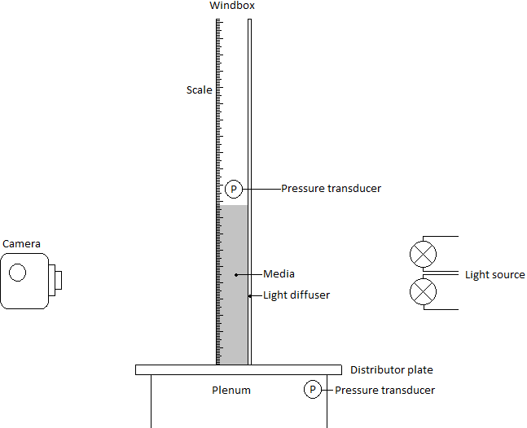
Figure 5.1: Experimental setup for void analysis

Experimental Procedure
A full stage by stage guide to experimental procedures used for the experiments can be found in Appendix III. What follows is a brief description of the methods used for both drying and void analysis experiments.

Drying Experiments
Following pressurisation of the system wet media was loaded into the fluidised bed. The flow was then initiated and adjusted to the required value followed by starting the heaters.
When the plenum temperature reached the set point of 45ºC the timer was started and the first sample taken. Samples were taken at regular intervals until the end of the experimental run.
Immediately after sampling the contents were placed into a container of known mass, and total mass of container and sample recorded. Samples were dried in a natural convection drying oven for 24 hours before re-weighting to establish the moisture content at time of sampling.

Void Analysis
Media was loaded into the 2D windbox to a depth of 150mm before airflow was initiated. The flow rate was then set at the required value before recording a 10, 1 minute long video segments.

Results

Drying
The results are detailed in the following 4 figures. Figure 5.2 and Figure 5.3 show the drying curves at 1.8 times and 1.5 times the minimum fluidisation velocity of dry particles.
Despite the procedure for drying being standardised the initial moisture content of the mung beans varied between experiments. Possible causes for this are detailed in the discussion and analysis section of this chapter.
In order to provide a fair comparison of drying rates between the high swirl and non-swirl diffusers, the data sets were standardised. This was done by altering the each set such that the initial reading was at a defined moisture content. Readings for each set taken before the defined moisture content was reached were discarded.
The defined moisture contents were:
- 1.0gH₂O/g at 1.8 U_{mf}
- 0.45gH₂O/g at 1.5 U_{mf}
These figures were chosen as by this stage of the drying process the fluidised bed was behaving homogenously.
The drying curves from the adjusted data are presented in Figures 5.4 and 5.5. Error bars in all figures are set at ±1 standard deviation.

Figure 5.2: Drying curve for flow rate of 1.8U_{mf}

Figure 5.3: Drying curve for flow rate of 1.5 U_{mf}

Figure 5.4: Adjusted drying curve for flow rate of 1.8U_{mf}

Figure 5.5: Adjusted drying curve for flow rate of 1.5U_{mf}
Moisture content variance with time in Figures 5.4 and 5.5 can be expressed by applying first order kinetics analysis as:
$M=M_{0}e^{-kt}$ (5.4)
Where; M is moisture content, M₀ initial moisture content, t time and k is considered the reaction rate constant. The implication of this equation is that the higher the value of k, the shorter the drying period. By taking the natural logarithm of the equation the rate constant k can be expressed as:
$-kt=ln⁡\left(\frac{M}{M_{0}}\right)$ (5.5 )
By graphing the moisture content variance with time, as in Figures 5.4 and 5.5, k can be determined. The values of k are shown in Table 5.2 which clearly indicates that the time taken to dry under non swirl flow during the initial and drying phases is consistently longer than under swirl flow conditions. However, it also shows that there is minimal difference in drying times during the secondary drying phase.
Table 5.2: Drying rate constants
Conditions | Kappa
Conditions | Initial drying | Secondary Drying
S = 0.64, U_{mf} = 1.8 | 435 x10⁻⁶ | 329 x10⁻⁶
S = 0, U_{mf} = 1.8 | 358 x10⁻⁶ | 333 x10⁻⁶
S = 0.64, U_{mf} = 1.5 | 793 x10⁻⁶ | 299 x10⁻⁶
S = 0, U_{mf} = 1.5 | 712 x10⁻⁶ | 304 x10⁻⁶

Void Analysis
Figures 5.6 and 5.7 below present the data from the video image analysis. Figure 5.6 shows how the average void fraction per frame varied by altering the flow conditioning and gas velocity. Figure 5.7 shows how bubble formation frequency changed by altering the flow conditioning and gas velocity.
The data is taken at flow rates of 1.2 and 1.3 times U_{mf}, error bars on the figures set at ±1 standard deviation.
Histograms that show the number of frames by void fraction are presented in Figures 5.8 to 5.11.

Figure 5.6: Void fraction by area

Figure 5.7: Bubble frequency at different flow rates
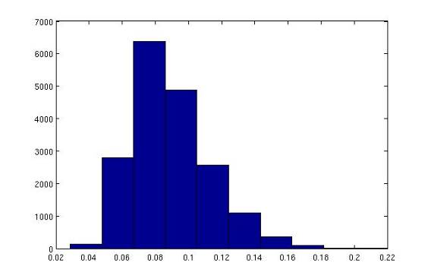
Void fraction
Count
Figure 5.8: Frequency of void fraction at 1.2U_{mf}: plain nozzle
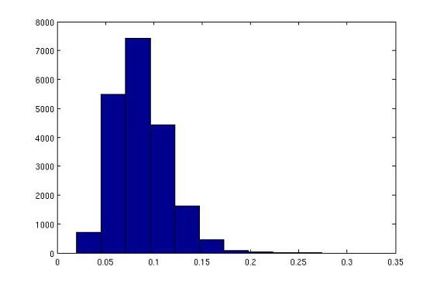
Count
Void fraction
Figure 5.9: Frequency of void fraction at 1.2U_{mf}: high-swirl
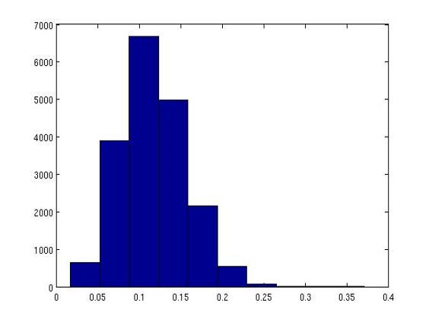
Count
Void fraction
Figure 5.10: Frequency of void fraction at 1.3U_{mf}: plain nozzle
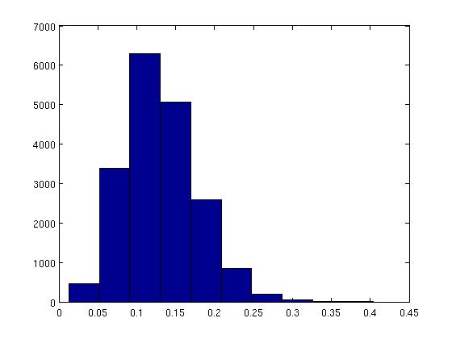
Void fraction
Count
Figure 5.11: Frequency of void fraction at 1.3U_{mf}: high-swirl

Analysis and Discussion

Drying
The raw data from the drying experiments show two significant issues in providing a fair analysis of the two flow regimes studied. The first is an initial period where there is an apparent lack of drying, followed by a significant drop in media moisture content, particularly at the lower flow rate of 1.5 times U_{mf}. The second is variation in initial moisture content between different experimental runs, leading to a large difference in moisture content.
The first issue of a ‘shelf’ feature on the drying profile is caused by the change in the media’s U_{mf} as it dries. The saturated particles are larger in size than dry particles because of the absorbed moisture. As U_{mf} is defined by particle size and density (Wen and Yu 1966) it is higher for the saturated particles than the dry particles. This effectively results in the particles not being properly fluidised when moisture content is high, especially as superficial gas velocity drops. This is because larger particles typically require higher fluidisation velocities compared to smaller particles of a similar density.
This leads to removal of moisture from the bottom of the fluidised bed without particle mixing. As samples are taken from the bed surface the drying at this location is initially minimal as the gas is close to 100% relative humidity, whilst particles at the base of the bed begin to dry and shrink in size. After a period the gas contains less moisture as it rises and can then remove moisture from the upper regions of the fluidised bed. Particles then shrink and fluidise, and hence mix properly. This causes a sudden drop in the apparent moisture content, whereas bulk moisture content has been reducing across the bed as a whole but not at the sample location near the top of the fluidised bed.
The second issue of varying initial moisture content in media at the beginning of each experimental run is likely to be the result of experimental protocol, with a variety of factors influencing it. Such factors include:
- Loss of moisture in the period between draining and experiment initiation varying with atmospheric conditions such as local humidity and temperature. This was minimised by storing the beans in a sealed container.
- Time taken to set up and initiate experiments.
- Time for heaters to reach temperature set point.
- Surface moisture content, or droplets of water on surface of the particle.
In order to provide a fair comparison the adjusted drying curves were produced as shown in Figures 5.4 and 5.5. These figures indicate that the introduction of swirl flow results in a reduction in drying time.
At 1.8 times U_{mf} it was found that swirl flow results in an 18% reduction in drying time during the initial drying phase and a 1% increase in time during the secondary drying phase. This is based on the value of kappa in Table 5.2.
At 1.5 times U_{mf} it was found that swirl flow results in a 10% reduction in drying time during the initial drying phase and a 1% increase in time during the secondary drying phase. This is based on the value of kappa in Table 5.2.
The reduction in drying time indicates a better gas-particle interaction rate with the high-swirl distribution plate. The hypothesis of improved gas distribution caused by swirling jets agrees with the work of Aworinde et al. (2015) who show that swirl flow reduces both bubble volume and frequency. This leads to lower gas bypass rates meaning that moisture can be transferred from the media to the fluid in the bed at a greater rate, and thus reduce the time taken to dry the media. The increase in drying time during the secondary drying phase is in the order of 1% and can be considered negligible. The lack of difference in drying time is the result of the loss of surface moisture from the particles, and the rate constant of moisture loss being governed by the rate moisture is transported from the centre to the edge of the particle.
It is noted that the range of data from the experiments is wide with overlap in results between swirling and axial flow regimes. Therefore the improvement in drying time is not necessarily robust and demonstrable in all scenarios, but only as a general case. Many of the reasons for this variation are best described from the experimental observations of bed behaviour.

Observations on Bed Behaviour
A number of key observations on the behaviour of the fluidised bed were made during the experimental procedure for particle drying. These include: Spouting/channelling, removal of bean husks and bed splitting into two zones.
During the initial drying period it was observed that transient spouts readily formed and led to gas channelling in the fluidised bed causing gas bypass. It was noted that this appeared more prevalent when using the air distributor plate with the plain nozzle compared to the high swirl inducing distributor plate. This is a visual indicator of swirl flow creating a more even flow field across the bed and inhibiting spouts. By reducing spouts and channelling there is less gas bypass, which allows more air to absorb moisture from particles and thereby improve the drying rate.
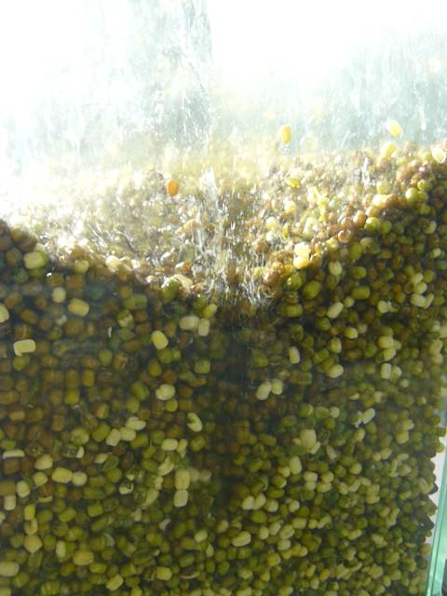
Figure 5.12: Spout forming along windbox wall
De-husking of the mung beans occurred during the drying process. It was observed on some of the sampled media which hadn’t fully de-husked, that the husk split as it reduced in size through drying faster than the mung bean kernel. It appeared that husk removal was independent of distributor plate used. The means to accurately confirm rate of husk removal were not available during the experimental program.
At the flow rate of 1.8U_{mf} the removed husks were pneumatically conveyed out of the windbox, but at the lower flow rate the husks were fluidised in a layer above the remaining media as depicted in Figure 5.13.
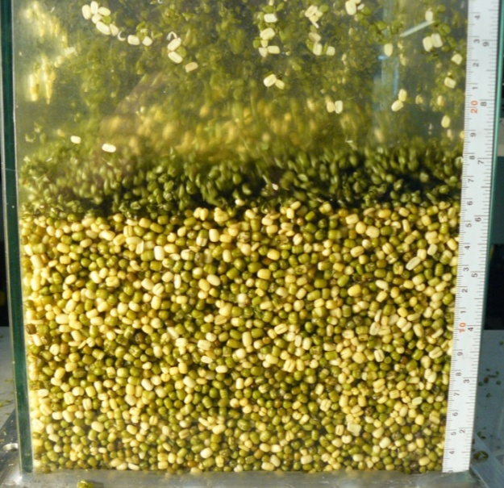
Figure 5.13: De-husking of mung beans
The removal of husks at the flow rate of 1.5U_{mf} may have an influence on the results as the sampling method may result in substantially different quantities of separated husks being withdrawn as the experimental program progressed. As the husks are significantly thinner than the kernel the diffusion of moisture content to the surface and its subsequent removal is faster than that of the mung bean kernel. This would result in artificially ‘drier’ readings. The comparative mass of husks to kernels is very large such that it would take a large fraction of separated husks to significantly alter the moisture content value. However, this process may explain some of the variation observed in the experimental results.
Of observational interest was the occasional instance of the fluidised bed to split into two distinct and separate regions. This occurred during the initial drying period as earlier described in this section. The two regions consisted of a static un-fluidised region above a drier fluidised region approximately 40 to 50mm deep. The two regions were consistently separated by a large static void. See Figure 5.14.
There was a complete lack of particle movement within the static region and it is proposed that the phenomenon was caused by the stiction of beans against the windbox walls and the inter particle forces holding the beans together. The region was able to maintain stability for a time as the larger particle dimensions caused by swelling requiring a higher superficial gas velocity to achieve fluidisation, thereby inhibiting breakdown.
The fluidised region below indicates that gas is removing moisture from the media and becoming saturated, therefore not removing further moisture from the static region downstream. This observation supports the reasoning given above for the shelf like initial drying period observed in experiments at lower superficial gas velocities.
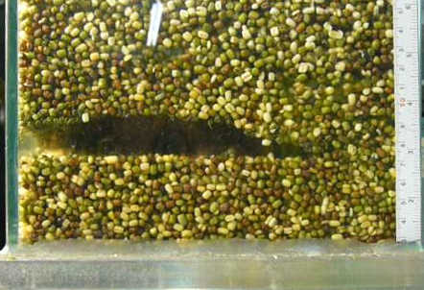
Figure 5.14: Fluidised bed separation in to two zones

Void Analysis
The video analysis of void formation shows two clear results: Bubble frequency is increased by the introduction of swirl flow and increasing fluid velocity, void fraction does not vary significantly with flow regime but increases with fluid velocity. The variations between the data sets for void fraction are demonstrably statistically insignificant when undergoing Student’s T-test returning a probability of 1.00 that the data sets are not significantly different to each other. The bubble frequency data sets return T-test values of much less than 0.01, with a flow rate of 1.2U_{mf} P=0.0012 and at 1.3U_{mf} P=0.0003.
These results indicate that whilst the void fraction does not vary the gas particle interface area does. The effect of constant void fraction but greater bubble frequency under high-swirl flow indicates the formation of smaller bubbles. This is illustrated in Figure 5.15 which displays the first frames from two videos at 1.2 times U_{mf}. The left hand image with larger bubbles is characteristic of the plain nozzle distribution plate and the right hand image with a greater number of smaller bubbles is characteristic of the high-swirl distribution plate.
As smaller bubbles have a greater surface area to volume ratio than larger bubbles the effect is less gas bypass when using the high-swirl flow distribution plate. This provides a mechanism for the reduced drying times reported in the relevant parts of this chapter. These results match with the rest of this body of work in supporting the hypothesis that the introduction of swirling flow leads to improved gas distribution across the fluidised bed.
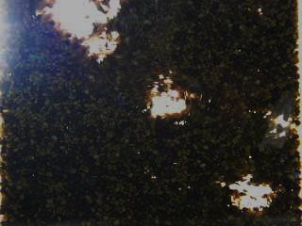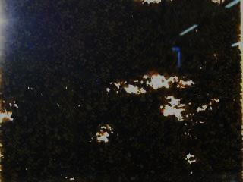
Figure 5.15: Comparison of bubble size and frequency: left plain nozzle, right high-swirl
It was observed that aside from creating smaller bubbles, the location of bubble formation and their movement was different between the two different flow regimes. This includes under high-swirl flow a tendency for bubbles to form a few centimetres above the distribution plate, in contrast to being formed at the nozzles of the plain nozzle plate, and for the bubbles to be more evenly distributed across the width of the bed leading to less bubble coalescence.
A full investigation into the motion of bubbles in the fluidised bed is beyond the remit of this work and is considered an area where further study would be of great benefit in aiding comprehensive understand of the fluidised bed dynamics.
These results provide a different result to the work of Aworinde et al. (2015) which states that increasing intensity of swirl reduces both bubble volume, i.e. void fraction, and frequency of formation. There are a number of critical differences between this work and that of Aworinde et al. (2015), namely:
- This work concerns swirl flow where jet diameter is closely matched to diameter of particle. Aworinde et al. consider a jet with diameter of 10mm interacting with poppy seeds which have a diameter of approximately 0.5mm.
- Aworinde et al. consider the effect of a singular swirling jet in a fluidised bed. This work considers an array of jet in close proximity to each other.
As a result it is apparent that the scale between jet and particle, and the interaction of an array of jets has a significant impact on the behaviour of the fluidised bed and the formation of bubbles and their volume.

Conclusions
This chapter has gone beyond the simple characterisation of the fluidised bed and attempted to provide an understanding of some of the dynamics at play. This has been achieved through analysis of the transfer of mass from particle to fluid in drying experiments, and video analysis of void regions in the system.
It has been found that despite a number of factors affecting results there is an appreciable difference in the time taken to dry particles in the fluidised bed between the two tested flow regimes. The high swirl diffuser shows a reduction in drying time compared to the non swirl diffuser of approximately 9% to 18% which increases as gas velocity increases.
It was found that the void fraction of the bed does not significantly change with flow regime, but that the introduction of high-swirl flow leads to the formation of smaller bubbles producing better gas-particle contact. This is the result of the larger surface area to volume ratio of smaller bubbles.
All of the results from these experiments indicate a more equal distribution of gas at the distributor plate when swirl flow is introduced. The improved distribution results in lower gas bypass rates which is consistent with the literature on the subject matter. However, the results differ to other studies in how swirl flow affects the formation of voids. This work indicates void fraction is independent of flow regime but other work shows reduced void fraction with a single swirling jet that is significantly larger in diameter than the particles. This difference shows that the dynamics of the scales in the system and the interaction of multiple jets in proximity to each other are not yet fully understood.

Numerical Modelling

Introduction
The experimental results given in Chapters 3 and 4 indicate that diffuser nozzle jet properties have a critical effect on the overall dynamics of the fluidised bed. In order to provide a deeper understanding of the potential mechanisms and dynamics working in the system it was determined that numerical modelling of jet-particle interaction could provide insight.
Accordingly a numerical model was constructed and two studies conducted, investigating transfer of momentum and transfer of heat from jet to particle. This includes:
- Consideration of the transfer of momentum from jet to particle when swirl number varies and when distance between particle and nozzle varies.
- How transfer of heat from jet to particle varies with swirl number and distance between particle and nozzle.
The numerical model was constructed in COMSOL Multiphysics 5.0 software, which utilises the finite element method to solve the defined problem.
The modelling of the interactions between swirling jets and particles has been well established through many works such as Görres et al. (1995) and Zhou (2000), although it should be noted that these papers focus primarily on particles significantly smaller than the jet. Other works such as the experimental study by Alekseenko et al. (2007) have focused on the effect of a swirling jet interaction with an impingent plate. This leaves a gap in the literature concerning the modelling of swirling jets and particles on a similar scale to each other.
Recent advances in the precision and refinement of advanced manufacturing methods such as laser sintering (Lin et al. 2013), now allow the construction of physical parts capable of producing particle-jet interactions where both are on the same scale. As a result with the technology now available to conduct such physical experiments the modelling of the interaction becomes of scientific value.

Model Definition
The model considers a perfectly spherical nylon particle and a jet which comes from a small nozzle. The jet is modelled with the same absolute flow rate across a range of different swirl intensities from S = 0 to S = 1.
The study on transfer of momentum considers the particle under gravitational acceleration towards the jet and utilises a moving mesh to allow the particle to displace from its original location.
This study is simulated over a period of 12ms, in which time the particle under free fall would drop approximately 1mm. This decision was taken to prevent the particle interacting with the diffuser plate and to provide a suitable computational time. Modelling in the momentum transfer study required adaptive re-meshing of the model at each time step to account for particle movement; this incurred a significant cost in computational time.
The transfer of heat study considers the jet interacting with a stationary particle suspended in the fluid. This is required due to the longer modelling duration required to transfer heat from jet to particle. This study is simulated over a period of 1s.

Geometry
The geometry for both numerical models was the same, and is based around the diffuser outlet from the apparatus in Chapter 3, such that a 2mm diameter jet interacts with a 3mm diameter particle. This is illustrated in Figure 6.1 below.
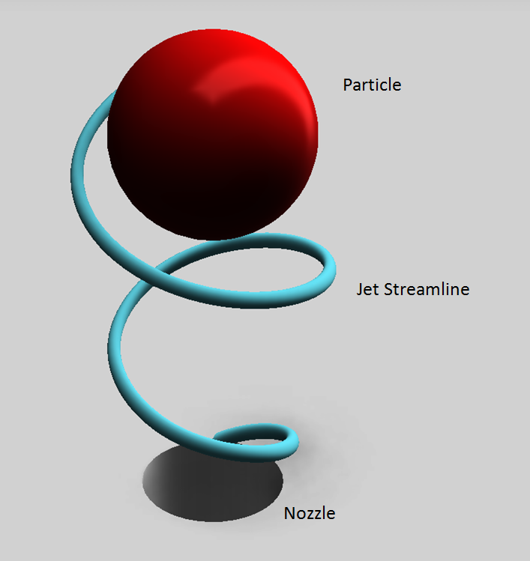
Figure 6.1: Model geometry
The model was created as a 2D axi-symmetric system, with rotational symmetry about the vertical centreline of the particle and nozzle. A diagram is presented along with the boundary conditions in Section 6.4, Figure 6.2.

Materials
The fluid domain of the model used material properties for air at standard temperature and pressure. The solid domain used material properties for nylon 6-6 at standard temperature and pressure.

Numerical Procedure and Conditions
The momentum transfer model was built around fluid-structure interaction, and the heat transfer study around heat transfer in fluids and solids.

Momentum Transfer Study Equations
The model was constructed with a two way coupling of the forces interacting between particle and fluid. The coupling considers deformations in both the fluid and solid phases taking into account the effect they have on each other. The fluid regime was based on single phase, compressible laminar flow principles.
Fluid motion was modelled by the transient Navier-Stokes equation, a variation on the time independent equation (See equation 3.3). The fluid equation is given in the form of:
$$ρ\frac{∂u_{fluid}}{∂t}+ρ\left(u_{fluid}∙∇\right)u_{fluid}=$$
$∇∙\left[-pI+μ\left(∇u_{fluid}+{\left(u_{fluid}\right)}^{T}\right)-\frac{2}{3}μ\left(∇∙u_{fluid}\right)I\right]+F$ (6.1)
The continuity equation below was also applied to the model:
$\frac{∂ρ}{∂t}+∇∙\left(ρu_{fluid}\right)=0$ (6.2)
The solid domain was modelled with the following equation:
$ρ\frac{∂^{2}u_{solid}}{∂t^{2}}-∇∙σ=FV$ (6.3)
Where: u is the velocity vector, t - time, ρ - density, p - pressure, µ - viscosity, F - volume force vector, σ - stress, V - volume. T denotes the transpose matrix and I the identity matrix.

Heat Transfer Study Equations
The heat transfer study was constructed as a single phase compressible laminar flow model, and heat transfer was modelled on convection, conduction and radiation.
For modelling the fluid velocity in the heat transfer study, equation 6.1 and the continuity equation 6.2 were applied. Additionally the heat transfer within the fluid domain, solid domain and across the fluid-solid boundary is described by the following equation:
$ρC_{p}\frac{∂T}{∂t}+ρC_{p}u∙∇T+∇∙q=Q$ (6.4)
Where the heat flux q is given by Fourier’s law of heat conduction as:
$q=-k∇T$ (6.5)
Where: ρ is density, C_{p} - specific heat capacity, T - temperature, t - time, u - velocity vector, k - thermal conductivity, Q - heat source, q - heat flux vector

Moving Mesh
As the transfer of momentum study necessarily involves the solid domain passing through the fluid domain it is important to consider the effect on the mesh. To accommodate the movement of the particle a moving mesh was applied.
The moving mesh as implemented by allowing free deformation of mesh nodes was allowed through the solid and fluid domains, where displacement was coupled with velocity field of solid domain. A mesh displacement of 0, i.e. preventing any deformation, was applied at the model boundaries.

Boundary Conditions
The numerical model is in a 2D axi-symmetric coordinate system with r, z and φ vectors. r and z measurements are given in mm and φ is given in degrees. The geometry is split into two domains, one fluid and one solid. This is depicted in Figure 6.2 where the solid region is the semi-spherical region highlighted in grey and the remaining region fluid is white.
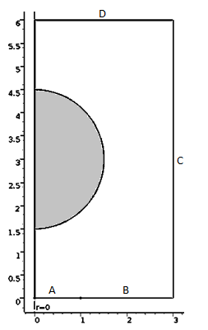
Figure 6.2: Numerical model geometry, measurements in mm, axial symmetry at r=0.

Rotational symmetry is around the axis r=0, other boundary conditions are applied as listed in Table 6.1.
Table 6.1: Model boundary conditions
Boundary | Condition
A | Fluid inlet
B | Non slip, stationary wall
C, D | Outlet

Inlet
Boundary A in Figure 6.2 was set as the fluid inlet for both numerical model studies. The inlet condition was a specified velocity field which was altered based on the desired swirl number with a net flow into the modelled domain.
Inlet velocity was set to a magnitude of 11.21 ms⁻¹ which corresponds to a superficial gas velocity across the entire fluidised bed of 1ms⁻¹. The Z and φ velocity components were altered as necessary to provide a range of swirl intensities as shown in Table 6.1 below

Table 6.2: Velocity components at inlet
Swirl Number | Φ component (ms⁻¹) | Z component (ms⁻¹)
0.0 | 0.00 | 11.21
0.2 | 3.22 | 10.74
0.4 | 5.77 | 9.61
0.6 | 7.50 | 8.33
0.8 | 8.61 | 7.18
1.0 | 9.33 | 6.22

For the heat transfer study the inlet temperature was set to 400K. In the momentum transfer study inlet temperature was 293.15K.

Wall
Boundary B, as labelled in Figure 6.2, was modelled as a non-slip, non-deforming wall in both numerical model studies. In the momentum transfer study the boundary had a prescribed mesh displacement of zero to prevent deformation.
In the heat transfer study the boundary was modelled as perfectly insulated.

Outlet
Boundaries C and D in Figure 6.2 were set as the outlet for fluid flow in both studies. The fluid outlet was a specified pressure condition. The pressure condition was set to a gauge pressure of 0Pa.
For the heat transfer model convective heat transfer across the boundaries allowed for. In the momentum transfer study the outlet boundaries had a prescribed mesh displacement of zero to prevent deformation.

Modelling Assumptions
In constructing the numerical mode a number of assumptions and simplifications were made to reduce computational expense. These include general assumptions and those specific to the momentum and heat transfer studies. General assumptions include:
- Modelling in a 2D axi-symmetric spatial regime is indicative of the flow pattern in the 3D regime. This includes the ability to model forces and effects normal to the 2D plane allowing for the incorporation of swirl flow (COMSOL 2014).
- Laminar flow modelling is appropriate. Basic analysis of the Reynolds number suggests it is in the region of 1x10³, and thus justified.
- Flow enters in a uniform profile at the inlet and exits at atmospheric pressure.
- The particle is perfectly spherical and centred directly above the nozzle.
Assumptions specific to the momentum transfer study include:
- Gravitational effects on the gas are negligible and are therefore only applied to the particle.
- The low particle velocities and relative velocity to the gas flow render drag effects to be negligible. In free fall through a vacuum, over the simulated period maximum particle velocity would be 0.118ms⁻¹.
- The process is adiabatic
Assumptions used in the heat transfer study:
- The particle is stationary and suspended above the nozzle. This allows for effective modelling across a greater time period to analyse heat transfer dynamics based on the jet profile.
- The heat profile of the jet is uniform at the inlet.

The diffuser is perfectly insulated and there is no heat transfer across the boundary. Initial Conditions

Fluid Domain
The initial velocity field of the fluid domain was set to 0ms⁻¹. This was to ensure that only the effects of the swirling jet were represented and not the superficial gas velocity of the fluidised bed. This is because the superficial gas velocity is not representative of fluid flow at the nozzle of a diffuser. Initial temperature for both studies was set at 293.15K.

Solid Domain
Initial velocity of the particle was set to 0ms⁻¹. This was chosen to represent the release of a particle, rather than it approaching at terminal velocity, which is a more likely scenario to be encountered in a fluidised bed and one that prevents the particle reaching the model boundaries. This also allows for drag forces to be considered as negligible, due to the low particle velocity for the study duration.
For the momentum transfer study gravity was represented by a force of 159.5µN on the particle, corresponding to the Earth’s gravitational field and the mass of a 3mm diameter nylon sphere. The force was applied in the negative z direction forcing the particle towards the nozzle. In both studies the solid domain temperature was set to 293.15K.

Mesh Refinement
To ensure that the model provided a mesh independent solution, a mesh refinement study was conducted. This was done for both the momentum transfer and heat transfer studies.

Momentum Transfer
The momentum transfer study used an automatically software generated, unstructured triangular mesh in the fluid and solid domains. Structured quadrilateral boundary layer meshing along wall boundaries and the solid-fluid interface were applied to model. The boundary layer mesh was two elements deep.
Seven different triangular mesh sizes were modelled during the mesh refinement study. The lowest mesh resolution was 720 elements, and the maximum mesh resolution 39,844 elements.
The results of study are presented in Figure 6.3, which plots the model degrees of freedom; defined as the product of model dependent variables and number of elements, versus swirl number at 0.5mm above the nozzle.
The result of the mesh refinement study for this model led the author to select the second highest model mesh resolution of 19,936 elements. While the result indicate that swirl number was continuing to change with increasing the resolution, the computational expense incurred proved prohibitive when the solution at the selected resolution was within 98% of the asymptote value for an infinite mesh resolution.

Figure 6.3: Swirl number versus degrees of freedom

Heat Transfer
The heat transfer mesh refinement study utilised the same mesh resolutions and structure as the momentum transfer mesh refinement study. The results of the refinement study are presented in Figures 6.4 and 6.5.
Figure 6.4 shows the ratio of particle surface temperature to particle volume temperature versus time for the different mesh resolutions.
Figure 6.5 shows the particle surface temperature to volume temperature ratio at t=0.99 versus model degrees of freedom. Degrees of freedom, like in Figure 6.3, is defined as the product of model dependent variables and number of elements. The value of t=0.99s was chosen as it is at this point there is the largest range in the study solutions.
Following the mesh refinement studies for the heat transfer model, the mesh resolution of 19,936 elements was chosen for as it exhibited a mesh independent solution, and was within 1% of the next resolution step of 39,844 elements. This is the same mesh as chosen for the momentum transfer mesh refinement study.

720
1386
2100
3520
8464
19936
39844
Mesh Resolution
(no. of elements)

Figure 6.4: Temperature ratio variation in time at different mesh sizes

Figure 6.5: Mesh refinement at t = 0.99 s

Selected Mesh
The final mesh used for both of the studies in this chapter is shown in Figure 6.6 and details listed in Table 6.2 below.
Table 6.3: Final mesh used after refinement
Mesh Property | Fluid | Solid
Maximum element size | 0.102 mm | 0.296mm
Minimum element size | 0.0029mm | 0.001mm
Maximum growth rate | 1.13 | 1.25
Curvature factor | 0.3 | 0.25
Boundary layers | 2 | N/A
First boundary layer thickness | 0.0536mm | N/A
Boundary layer stretching factor | 1.2 | N/A

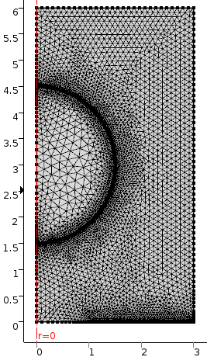
Figure 6.6: Illustration of selected mesh

Solver Configuration

Momentum Transfer
A time dependent two way coupled solver was used to model the simulation over time with the duration of 12ms in increments of 1ms. The coupled dependent variables were fluid pressure and the velocity field of both fluid and solid domains.
The solver utilised a fully coupled direct linear method with a solution tolerance of 5∙10⁻⁴, scaled across dependent variables.

Heat Transfer
A time dependent segregated solver was implemented for the heat transfer study, over a period of 1s in 10ms increments. The dependent variables were pressure, temperature and velocity field for both fluid and solid domains.
The solver utilised a segregated linear method with a solution tolerance of 5∙10⁻⁴, scaled across dependent variables.

Results
This section reports the results of the model validation by swirl number analysis, the study on transfer of momentum and the study on heat transfer.

Transfer of Momentum
The momentum of the particle was evaluated by considering the particle velocity at each time step in the model. As the mass of the particle is known, momentum is calculated as:
$P=mu$ (6.6)
Where: P is momentum, m – mass, and u – velocity.
By plotting the momentum of the particle at each time step it is possible to determine the rate of momentum change.
A number of figures detailing results from the momentum transfer study are shown below. Figure 6.7 plots particle momentum against time for each swirl number. The results show that the rate of momentum change is linear over the studied time scale. The implication is that the overall force acting on the particle is constant.

Figure 6.7: Momentum of particle versus time
By considering the gravitational force it is possible to determine the force acting on the particle from the jet. Figure 6.8 plots the force exerted by the jet in the Z direction against the jet swirl number. Note that negative values correspond to the jet accelerating the particle in the opposite direction of mean axial flow, i.e. towards the jet and in the same direction as gravitational pull.

Figure 6.8: Axial force exerted by jet
The following Figures, 6.9 through to 6.24 show jet evolution at the time periods of 3, 6, 9 and 12ms for swirl numbers of S = 0, S = 0.4, S = 0.8 and S = 1.0r respectively. The fluid colour scale represents velocity magnitude and the solid colour scale represents particle velocity.
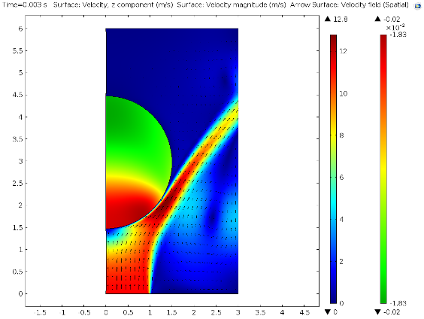
Figure 6.9: Velocity magnitude profile of fluid and solid regions at S=0, t=3ms
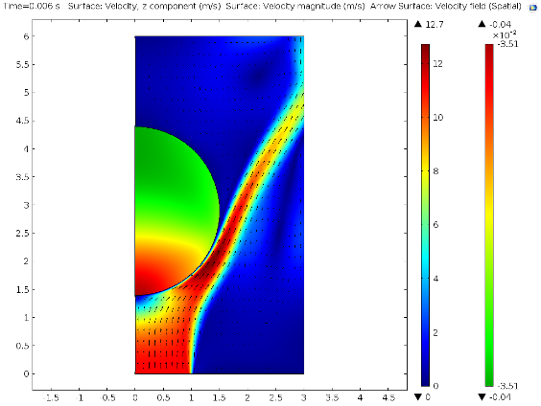
Figure 6.10: Velocity magnitude profile of fluid and solid regions at S=0, t=6ms
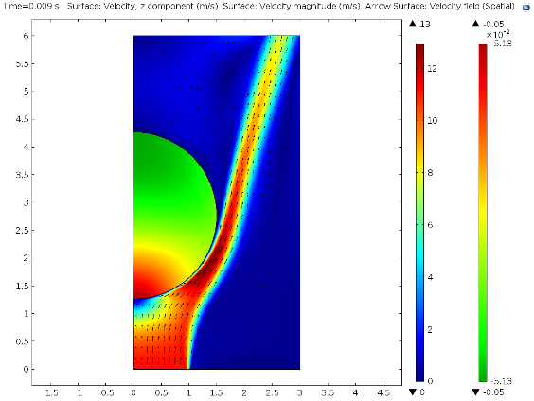
Figure 6.11: Velocity magnitude profile of fluid and solid regions at S=0, t=9ms
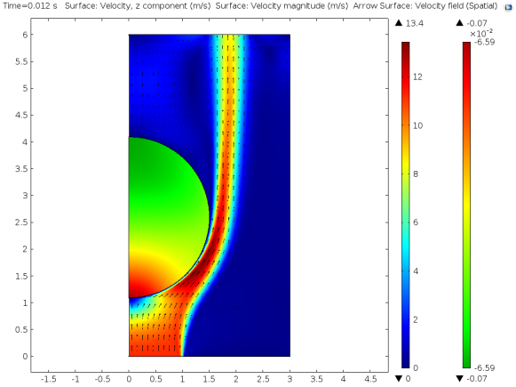
Figure 6.12: Velocity magnitude profile of fluid and solid regions at S=0, t=12ms
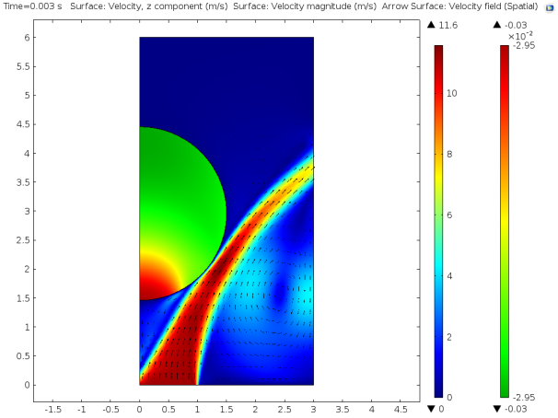
Figure 6.13: Velocity magnitude profile of fluid and solid regions at S=0.4, t=3ms
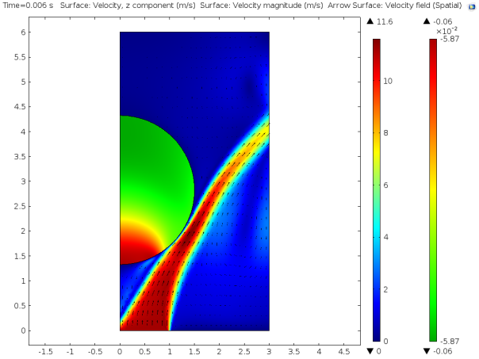
Figure 6.14: Velocity magnitude profile of fluid and solid regions at S=0.4, t=6ms
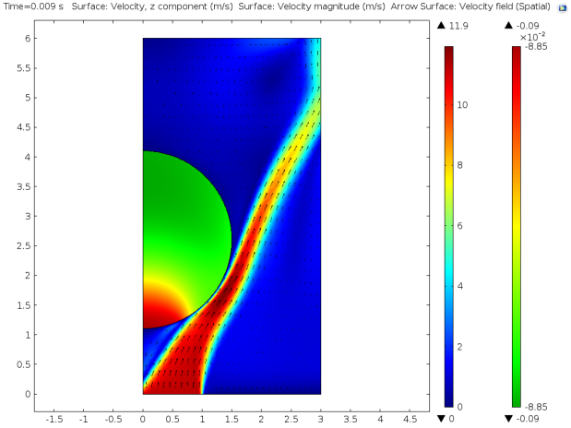
Figure 6.15: Velocity magnitude profile of fluid and solid regions at S=0.4, t=9ms
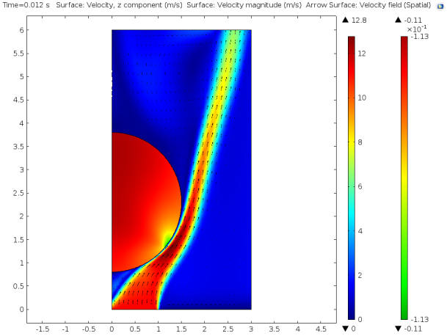
Figure 6.16: Velocity magnitude profile of fluid and solid regions at S=0.4, t=12ms
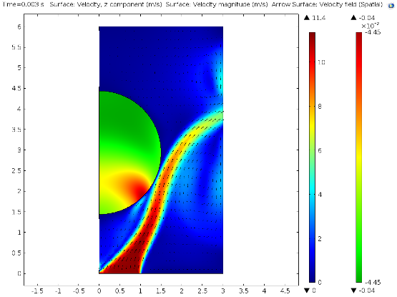
Figure 6.17: Velocity magnitude profile of fluid and solid regions at S=0.8, t=3ms
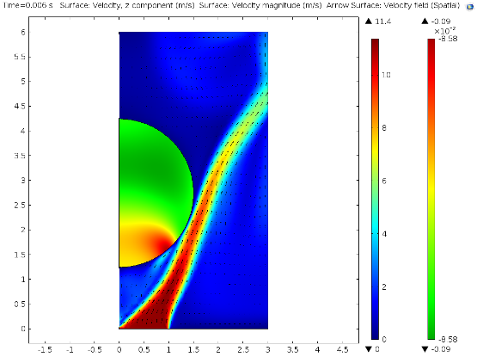
Figure 6.18: Velocity magnitude profile of fluid and solid regions at S=0.8, t=6ms
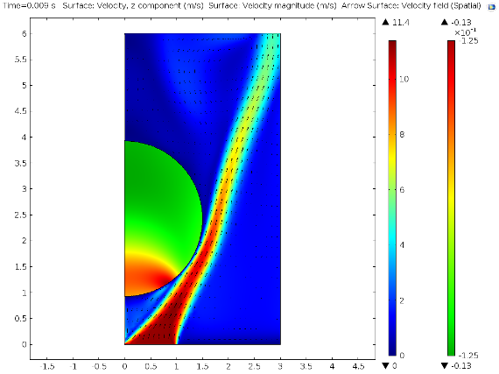
Figure 6.19: Velocity magnitude profile of fluid and solid regions at S=0.8, t=9ms
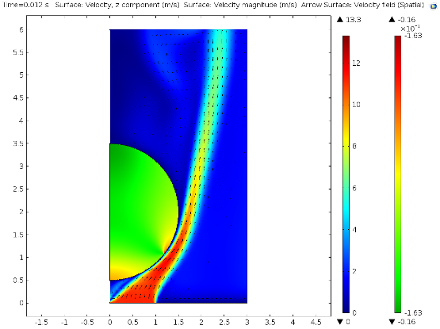
Figure 6.20: Velocity magnitude profile of fluid and solid regions at S=0.8, t=12ms
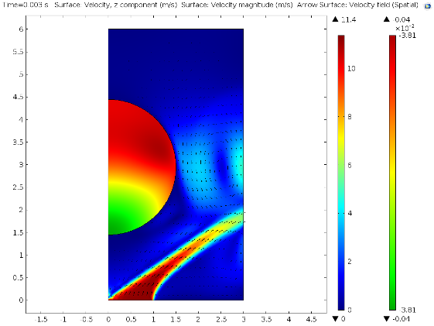
Figure 6.21: Velocity magnitude profile of fluid and solid regions at S=1.0, t=3ms

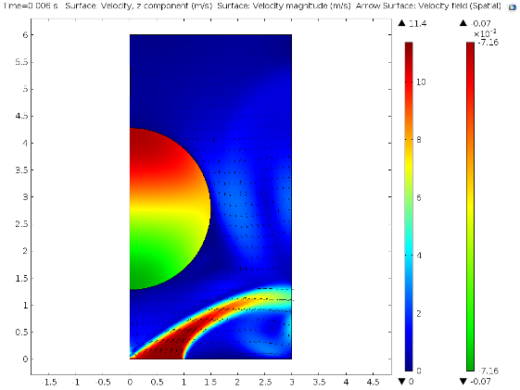
Figure 6.22: Velocity magnitude profile of fluid and solid regions at S=1.0, t=6ms
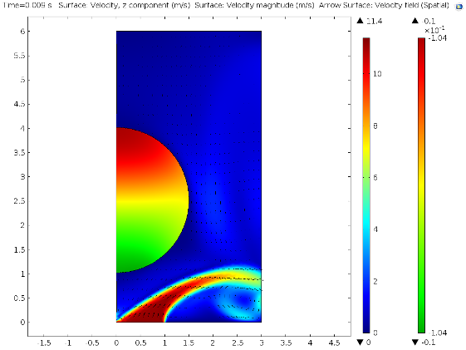
Figure 6.23: Velocity magnitude profile of fluid and solid regions at S=1.0, t=9ms

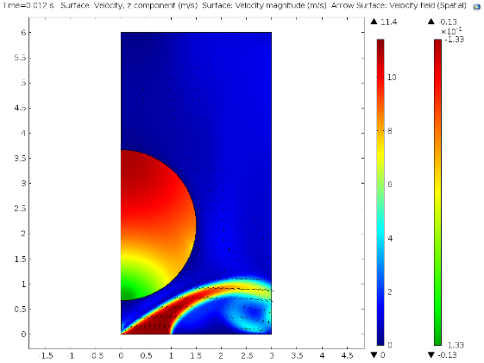
Figure 6.24: Velocity magnitude profile of fluid and solid regions at S=1.0, t=12ms

Transfer of Heat
The following figures detail the results from the heat transfer study. Figure 6.13 plots particle temperature against time for a range of swirl numbers. At this point there is a minimum distance of 1.5mm between the particle and nozzle, such that the geometry in Figure 6.1 is employed. As the rate of temperature change is constant across the study period the results are also presented in Table 6.4.
Table 6.5: Average rate of temperature change
Swirl Number | dT/dt (Ks⁻¹)
0.0 | 15.82
0.2 | 13.83
0.4 | 8.60
0.6 | 7.08
0.8 | 4.25
1.0 | 0.60

Swirl number
Figure 6.25: Average particle temperature versus time for different jet swirl numbers
Figures 6.14 and 6.15 plot the mean particle temperature against time across a range of distances between particle and nozzle for jets with swirl numbers of S=0 and S=0.6 respectively. These values are tabulated below.
Table 6.6: Average rate of temperature change
Minimum gap between particle and nozzle (mm) | dT/dt (Ks⁻¹)
Minimum gap between particle and nozzle (mm) | S = 0.0 | S = 0.6
0.5 | 17.97 | 11.07
1.0 | 16.46 | 7.15
1.5 | 15.82 | 7.08
2.0 | 15.60 | 7.52
2.5 | 15.22 | 1.06

Distance from nozzle to particle (mm)
Figure 6.26: Average particle temperature versus time at S=0.0 for a range of particle heights above the nozzle
Distance from nozzle to particle (mm)
Figure 6.27: Average particle temperature versus time at S=0.6 for a range of particle heights above the nozzle
The following plots in Figures 6.28 to 6.35 show the temperature and velocity profiles at selected points of interest throughout the heat transfer study.
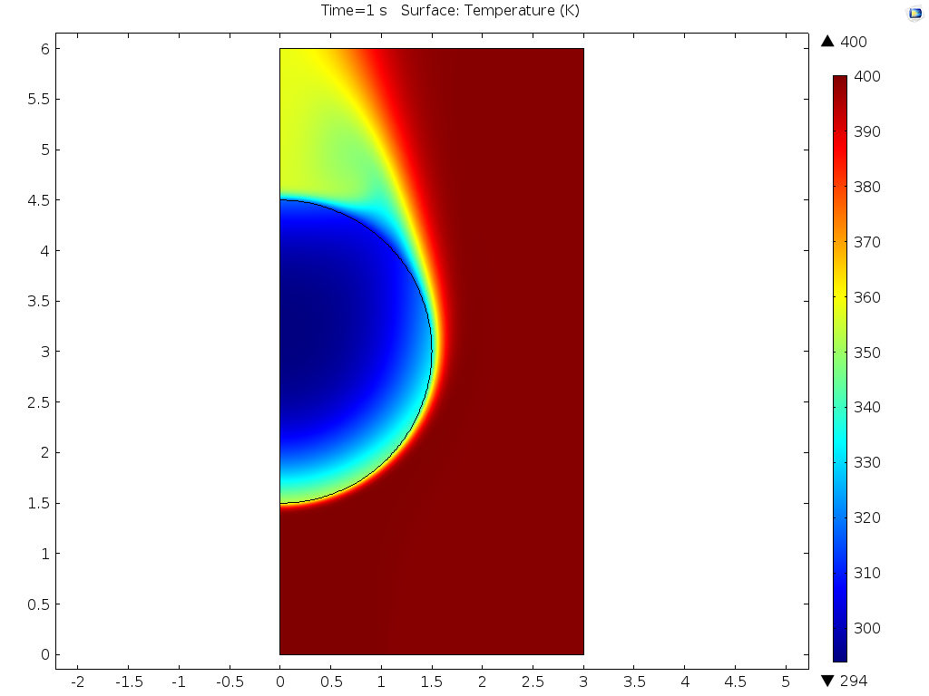
Figure 6.28: Temperature of particle and fluid, 1.5mm gap between particle and nozzle, S=0, t=1s
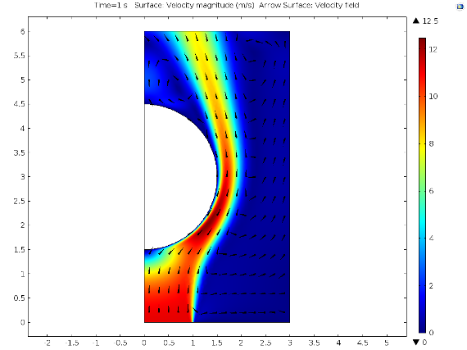
Figure 6.29: Velocity magnitude of fluid, 1.5mm gap between particle and nozzle, S=0, t=1s
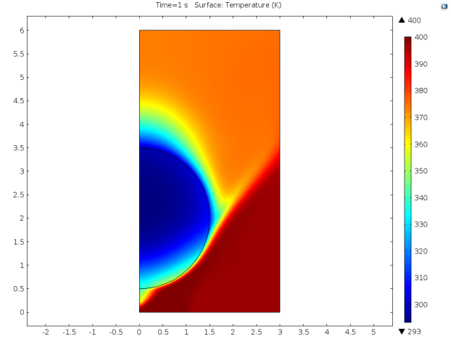
Figure 6.30: Temperature of particle and fluid, 0.5mm gap between particle and nozzle, S=0.6, t=1s
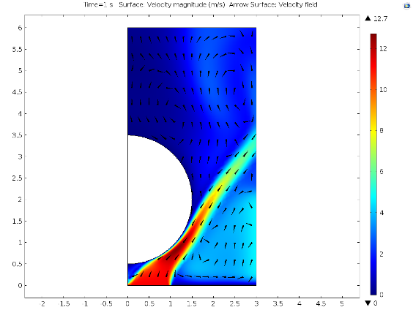
Figure 6.31: Velocity magnitude of fluid, 0.5mm gap between particle and nozzle, S=0.6, t=1s
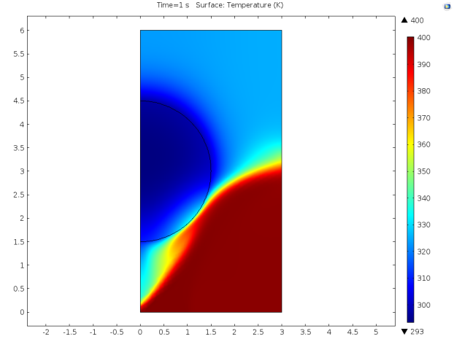
Figure 6.32: Temperature of particle and fluid, 1.5mm gap between particle and nozzle, S=0.6, t=1s
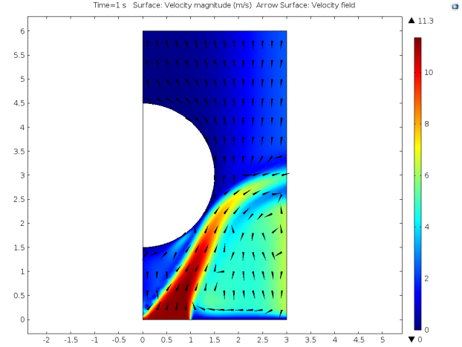
Figure 6.33: Velocity magnitude of fluid, 1.5mm gap between particle and nozzle, S=0.6, t=1s
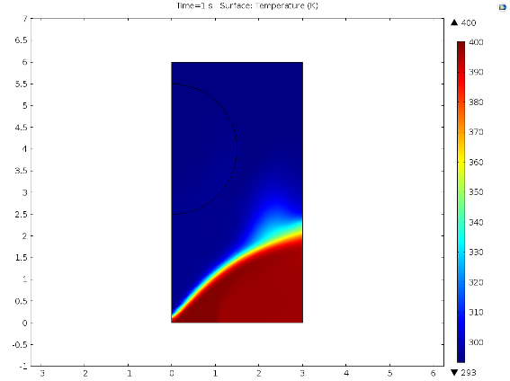
Figure 6.34: Temperature of particle and fluid, 2.5mm gap between particle and nozzle, S=0.6, t=1s
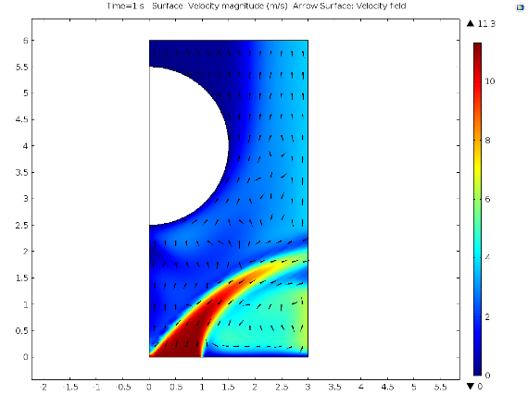
Figure 6.35: Velocity magnitude of fluid, 2.5mm gap between particle and nozzle, S=0.6, t=1s

Analysis and Discussion
This section of Chapter 6 discusses the results of the numerical model and the studies conducted, analysing trends and comparing them to the empirical trends observed in Chapters 4 and 5.

Momentum Transfer

Relationship Between Swirl and Momentum Transfer
The results clearly show a direct relationship between the swirl number of the jet and the axial momentum of the particle as seen in Figure 6.7. This figure indicates that momentum changes in a pseudo-linear fashion over the study duration and therefore that the force from the jet on the particle is effectively constant over the 12ms period. If the study were continued over a greater time period the force exerted on the particle would vary as the gap between particle and nozzle is either reduced, increasing gas velocity and pressure gradients, or as the distance increases and the jet disperses.
In Figure 6.7 a line has been plotted for the momentum of a particle under free fall in a vacuum for comparison. This shows that for swirl numbers higher than 0.4 the particle gains momentum, indicating the jet is drawing the particle downwards, against the mean axial velocity component. For swirl numbers lower than 0.4 the axial momentum of the particle is reduced indicating that the jet is pushing against the particle. Despite the effects of the jet the momentum value remains positive indicating that gravitational force is dominant as it continues to force the particle towards the nozzle. In the study where the swirl number is 0.4 the momentum profile closely matches that of the particle in free fall.
In Figure 6.8 the force exerted by the jet, independent of gravitational pull, is plotted against swirl number. Force is plotted in the Z vector; therefore a negative value is towards the nozzle and a positive value away from the nozzle. The force varies over a range of 131µN between +70µN and –61µN. This compares to the gravitational pull on the particle of 159.5µN. Between swirl numbers of 0 and 0.8 there is an almost linear relationship between swirl number and force exerted by the jet. Against this trend there is a rapid drop of in force applied by the jet at S=1. This is effectively caused by the jet spreading before it interacts with the particle and the downward force being primarily caused by the recirculation zone of high swirl jets.

Jet Shape and Effects
Figures 6.9 through 6.12 demonstrate how the shape of the jet, and flow patterns affect the transfer of axial momentum to the particle by showing how the jet develops. The figures show the jet at the time periods of 3ms, 6ms, 9ms and 12ms for S=0.0, 0.4, 0.8 and 1.0.
In Figure 6.9, where S=0.0 the jet can be seen to pass around the particle with a stagnation zone at the point the jet and particle connect, as the jet develops it follows the particle wall due to the Coanda effect. A very similar trend is observed when S=0.2 with a delay of 1 to 2ms in the time taken for the jet to ‘wrap’ around the particle. This shows clearly that the impinging jet tries to force the particle away but fails to overcome gravitational pull as the gas bypasses around the sides of the particle.
The same phenomenon may be expected for all low-swirl flows where there is generally an absence of a recirculation zone. However, the model predicts that is not the case where S=0.4, which is typically categorised as low swirl flow. Figure 6.10 indicates that this is largely caused by the bow wave effect of the falling particle forcing gas towards the nozzle and creating a recirculation effect. This is demonstrated by repeating the study without the particle; see Figure 6.20, where the particle is absent and therefore recirculation zone is considerably smaller across the jet diameter.
This recirculation effect tries to pull the particle downwards as the main jet stream forces the particle away. These forces are effectively balanced and so the particle behaves in manner similar to as if it were in free fall. It should be noted though that the particle will develop a tangential momentum in the φ direction despite the equalisation of forces in the Z direction.
Figure 6.36: Velocity magnitude of jet with particle at S=0.4 t = 0.012s
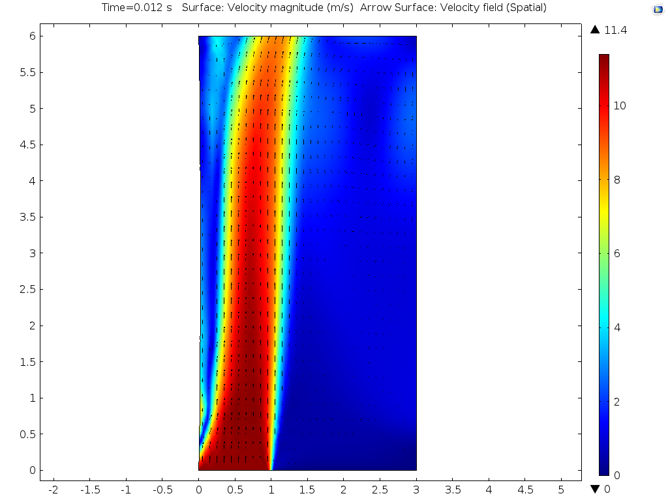
Figure 6.37: Velocity magnitude of jet without particle at S=0.4 t = 0.012s
Where S=0.8 in Figure 6.11 a clear recirculation zone is formed. Much like the lower swirl numbers the jet attaches to the particle wall due to the Coanda effect and the interaction of the main jet stream tries to force the particle away from the nozzle, despite the fact the jet has a strong pull effect on the particle overall. This is caused by the jet shape matching the diameter of the particle due to the wider angle of spreading. The result is that the outward force is exerted over a much smaller area than the inward force and so the net effect is that the particle is ‘pulled’ in towards the jet.
The contrast then is where S=1.0 but exhibits a weak pull. Figure 6.12 shows the cause for this is that the jet spreads wide before interacting with the particle. This means that the recirculation zone can draw in gas around the edges of the particle which does not result in the low recirculation zone pressures seen at the slightly higher swirl numbers. The absence of the partial vacuum is therefore responsible for the weaker ‘pull’ force.

Implications of Study
It is important to draw the distinction between the simple case presented by the numerical model and the chaotic randomised process inside a fluidised bed. While the model presents a single particle perfectly aligned with a single nozzle the process in the fluidised bed has particles in many different alignments with the nozzles interacting with each other.
The main implication of the numerical model is that as swirl flow increases, radial jet spread is increased. The increased radial spread means that each jet is likely to interact with more particles and less likely to force a particle out of the way, which leads to spout formation in the fluidised bed. Analogies can be seen between this theory and the empirical evidence presented by Aworinde et al. (2015) which indicated that swirl flow at nozzles leads to better gas distribution across a fluidised bed, and under certain conditions lower jet penetration.

Applicability to Empirical Observations
The momentum transfer study yields interesting results, and the observations are compatible with the observed empirical trends in Chapter 4, where higher swirl leads to lower bed expansion. Despite this there are a number of issues that prevent the model being employed for quantitative predictions.
The primary issue lies within the code used in the software package, as it is not possible to analyse axial momentum change and possible effects it has. This is because the coding does not allow the solid domain to rotate about the axis of symmetry.
The second issue is that the effect of running nozzles adjacent to each other is not considered. The numerical model may overestimate the consequences as jets will interact with particles off-centre from the nozzles. This will affect flow patterns and potential ‘cancel out’ the effect adjacent jets have on each other. Therefore the study on momentum transfer fulfils its purpose in analysing the effect of jet shape on fluidisation by comparing empirical and modelled trends.

Heat Transfer

Variation with Swirl Number
Of note is the observation that the rate of temperature change, and therefore heat transfer from jet to particle varies significantly with the swirl number of the jet. As the angle of jet spread increases with the jet swirl number, so the contact area between jet and particle decreases. This means that the amount of hot fluid coming into contact with the particle decreases and therefore the overall heat transfer diminishes. This is taken to the extreme case where S=1.0 as the jet spreads without contacting the particle, thus the predominant effect is drawing cold air into the recirculation zone across the particle boundary. The effective result is a negligible amount of heat energy transfer between the fluid and solid domains.
It is important to note that the trends from the numerical model study are based on a single particle-jet interaction and therefore not necessarily closely representative of the fluidised bed process as a whole.

Variation with Distance
The study clearly shows that the closer a particle is to the nozzle the greater the rate of temperature change. This trend is prevalent both at S=0.0 and S=0.6, the two swirl numbers studied where particle height was varied.
There is minimal attenuation of the rate of temperature change when S=0.0 as the particle is moved away. In contrast, when S=0.6, there is a sudden drop in the rate of temperature change between heights of 0.5mm and 1mm; from 1mm to 2mm the transfer rate is effectively constant and as the height reaches 2.5mm the transfer rate drops dramatically.
Figures 6.16 through 6.19 show the temperature and gas velocity profiles at the point when t=1s. They clearly show how the heat transfer rate is linked directly to the contact patch between jet and particle. In Figure 6.16 where S=0.0 the jet has attached to the particle wall and so is able to transfer a greater amount of heat to the particle. Figures 6.17 and 6.18 show how the introduction of high swirl seemingly prevents the jet from attaching to the particle wall thereby limiting the contact patch and rate of heat transfer. As the particle is studied at the maximum height in Figure 6.19 the jet fails to interact with the particle and as a result there is almost no transfer of heat from the jet to the particle.
The model however is limited in that it doesn’t account for adjacent jets that would interact with each other. This will result in a greater mean velocity in the Z direction as hot gas would be entering the model along boundary C. The implication, which matches with all the other work in this thesis, is that swirling jets result in a more homogenous gas distribution across the bed than non-swirling jets.

Implications of Study and Applicability
The results of the study imply that as the intensity of swirl flow increases there is an inverse relationship whereby the transfer of heat to nearby particles is decreased. The implication of the reduced particle temperature caused by the introduction of swirl flow is that drying rates would be reduced. Comparing this observation to the trends in Chapter 5, where the introduction of swirl flows indicates an improved drying mechanism, reveals that the heat transfer rate between jet and individual particle is relatively insignificant to the overall fluidised bed mechanics for deep beds. In the fluidised bed jets bypass enough particles moving in a randomised chaotic manner to interact effectively and transfer effectively the same amount of heat across the bed regardless of swirl number, although this might not prove to be the case in very thin fluidised beds.
The other critical issue with the study is the fixed particle. As shown in the momentum transfer study increasing the swirl number of the jet increases the relative gas velocity and therefore the amount of heat energy that passes the particle. The falling particle also affects the gas flow paths differently to the effect of the jet impinging on a spherical surface.
As the difference in heat transfer rates are within a very broad range these effects are unlikely to be significant enough to mitigate the difference and achieve the seen drying profile of the fluidised bed. It is therefore proposed that individual jet dynamics are insignificant to the holistic process and that the improved gas distribution across the bed by introducing swirl flow results in lower gas bypass and therefore more effective drying.

Conclusions
The main finding of the momentum transfer study is the ability of a high swirl number jet to effectively ‘pull’ a particle in the opposite direction to the mean axial flow. This effect is strongest when the main jet stream passes the particle on a tangent and reduces the outward force. This results in the pull from the jet’s recirculation zone to produce a force approximately 38% greater than gravitational pull alone.
Swirling jets appear to have lower propensity to attach to the particle wall in line with the Coanda effect leading the jet to widen more than a non swirl jet interacting with a particle. This will lead to better gas distribution across a fluidised bed.
The improved gas distribution theory matches the empirical results in this work and data from the available literature in the field.
The individual interaction between jet and particle in the heat transfer study is of interest but results do not accurately match empirical trends across a fluidised bed (Chapter 5) and therefore it is implied the modelled effects are negligible on the holistic process.

Conclusions

Research Conclusions
The aim of this thesis was to determine whether the introduction of small scale swirling jets into the bottom of a fluidised bed affects the quality of fluidisation. The work described throughout the previous chapters demonstrates that it does having met the objectives of the work.
By using modern manufacturing methods it proved possible to construct a fluidised bed with novel gas flow fields at the distribution plate. This produced the formation of swirling flows on the same order of scale as the particles in the fluidised bed and was carried out at pilot plant scale. CFD modelling proved capable in evaluating the geometries to be used in diffuser plates to ensure that the flow field met specification. Characterisation of the fluidised bed showed that expansion is reduced as swirl intensity increases for particles sizes both the same diameter and slightly larger than the diffuser orifices. The characterisation studies also showed that pressure drop across the fluidised media remains unchanged across the range of flow conditions tested. However, there is a cost in pressure drop across the diffuser plate associated with producing swirl flow, due to the narrow geometries required to guide the fluid.
The analysis of void formation in the fluidised bed indicates that the total void fraction is not significantly affected by the intensity of swirl introduced at the diffuser plate. The results also show that the frequency of void formation increases with swirl number. This shows that increasing the intensity of the flow conditioning produces smaller bubbles, leading to improved gas-particle contact throughout the fluidised bed.
By running drying experiments on the fluidised bed it was possible to provide a proxy as to how the intensity of flow conditioning affects the transfer of heat and mass between gas and particle phases. It was found that the introduction of swirl flow at the diffuser in a fluidised bed significantly reduces the particle drying rates compared to the control. Empirical evidence indicates that it is possible to reduce the time taken to reach defined particle moisture content by up to 18%. It was also shown that increasing superficial gas velocity results in a greater reduction in processing time. These results signify that there is better particle-gas contact, and so the transfer of moisture from particle to gas is increased, as the intensity of flow conditioning increases.
Computational modelling of the pseudo one dimensional system was conducted to investigate the effects of flow condition on the transfer of momentum and heat between gas and particle. It was found that increasing flow conditioning creates a recirculation zone in the swirling jets and effectively ‘pulls’ particles in the opposite direction of the mean axial flow. The study on heat transfer found that increasing flow conditioning reduces the transfer of heat from gas to particle, which may result in a more even transfer of heat across the fluidised bed.
Overall the results all clearly indicate that the introduction of swirl flow at the diffuser plate into the bottom of a fluidised bed results in improved quality of gas distribution with lower rates of gas bypass.

Direction of Future Research
The work in this document identifies that the characteristics of the jet at the diffuser plate have an impact on the size and quantity of bubbles in a fluidised bed. By altering the swirl number the volume of individual bubbles can be reduced, thereby increasing gas-particle contact.
To determine an accurate relationship and optimise the process further research is needed into the inter-relationship of various operational parameters and how they affect each other. Namely, how the quantity and volume of bubbles in a fluidised bed is affected by:
- Jet diameter
- Swirl number of jets
- Distance between diffuser outlets
- Superficial gas velocity
- Particle geometry
It is the author’s opinion that should a relationship between the above parameters be empirically derived, it would provide a useful tool for improving the gas-particle contact in fluidised beds and result in increased process efficiencies as demonstrated by the work in this thesis.
Additionally to prove the effectiveness of introducing the flow conditioning further studies could be conducted on a wider range of applications where fluidised beds are used. Some examples include: combustion in small scale combined heat and power plants, particle granulation in pharmaceuticals, or freezing in food production.
Further to the above suggestions, there is a wide variety of possible parameters to investigate which may hold promise for future developments. Being a new field of study there are many unknowns, which presents a great opportunity for development and the integration of novel ideas. Some potential ideas, to name but a few, include: Altering the chirality of neighbouring jets, angling jet nozzles to provide an additional large scale swirling motion, altering the 3D shape of the diffuser such as convex or concave dishing, or the effect of introducing additional vibratory effects.

Bibliography

Adrian, R.J. (1991). Particle-imaging techniques for experimental fluid mechanics. Annual review of fluid mechanics, 23, 261-304
André, J.C. Lesieur, M. (1977). Influence of helicity on the evolution of isotropic turbulence at high Reynolds number. Journal of Fluid Mechanics, 81, 187–207.
Aworinde, S. M., Holland, D. J., & Davidson, J. F. (2015). Investigation of a swirling flow nozzle for a fluidised bed gas distributor. Chemical Engineering Science, 132, 22-31
Baeyens, J., Geldart, D., (1974). An Investigation into Slugging Fluidized Beds. Chemical Engineering Science, 29, 255-265
Billant, P. Chomaz, J.M. Huerre, P. (1998). Experimental study of vortex breakdown in swirling jets. Journal of Fluid Mechanics, 376, 183–219.
Carman, P.C., (1927). Fluid flow through granular beds, Transactions of the institute of chemical engineers, 15, 150
Chigier, N.A. Chervinsky, A. (1967). Experimental investigation of swirling vortex motion in jets. Journal of Applied Mechanics, 445–451.
Choudhary, V. R., & Choudhary, T. V. (2005). U.S. Patent No. 6,894,183. Washington, DC: U.S. Patent and Trademark Office.
Ciesielczyk, W., Iwanowski, J., (2006) Analysis of fluidized bed drying kinetics on the basis of interphase mass transfer coefficient. Drying technology24. 1153-1157
Dantec Dynamics A/S (2013). Measurement Principles of PIV. Web based article, retrieved on 18/12/2013. http://www.dantecdynamics.com/measurement-principles-of-piv
Davidson, J.F., Harrison, D., (1963). Fluidised particles, Cambridge University Press, New York
Fogler and Gurmen (2008). 12. Diffusion and Reaction in Porous Catalysts, 12.3 Fluidized Bed Reactors, Web article; http://www.umich.edu/~elements/12chap/html/12prof2a.htm retrieved 06/05/14
Forster, P. Ramaswamy, V. Artaxo, P. Berntsen, T. Betts, R. Fahey, D.W. Haywood, J. Lean, J. Lowe, D.C. Myhre, G. Nganga, J. Prinn, R. Raga, G. Schulz, M. Van Dorland, R. (2007). Climate Change 2007: The Physical Science Basis. Contribution of Working Group I to the Fourth Assessment Report of the Intergovernmental Panel on Climate Change: Changes in Atmospheric Constituents and in Radiative Forcing. Solomon, S. Qin, D. Manning, M. Chen, Z. Marquis, M. Averyt, K.B. Tignor, M. Miller, H.L. (eds.). Cambridge University Press, Cambridge, United Kingdom and New York, NY, USA.
Gates, B. C., Katzer, J. R., & Schuit, G. C. (1979). Chemistry of catalytic processes (Vol. 464). New York: McGraw-Hill.
Geldart, D. (1973). Types of Gas Fluidization. Powder technology, 7. 285-292
Geldart, D., & Baeyens, J. (1985). The design of distributors for gas-fluidized beds. Powder Technology, 42(1), 67-78.
Grace, J.R. (1970). The viscosity of fluidized beds. Can. J. Chem. Eng., 48, 30–33
Grace, John R.; Leckner, Bo; Zhu, Jesse; Cheng, Yi (2008), "Fluidized Beds", in Clayton T. Crow, Multiphase Flow Handbook, CRC Press, p. 5:71, doi:10.1201/9781420040470.ch5, ISBN 978-1-4200-4047-0,
Green, D.W., Perry, R.H. (2007) Perry’s Chemical Engineers Handbook, 8th Edition, McGraw-Hill 17-20
Gupta, A.K. Lilley, D.G. Syred, N. (1984). Swirl Flows. Abacus press, Tunbridge Wells, England
Inaba, H. Husain, S. Horibe, A. Haruki, N. (2007). Heat and mass transfer analysis of fluidized bed grain drying. Memoirs of the faculty of engineering, Okayama University, 41. 52-62
Keane, R.D. Adrian, R.J. (1990). Optimization of particle image velocimeters. Part i: double-pulsed systems. Measurement Science technology, 1, 1202-1215.
Khomenko, G.A. Zimmerman, W.B. (1994). Large scale structure evolution and mixing due to small scale helical forcing in a compressible viscous fluid. In J. Redondo & O. Metais, eds., Mixing in Geophysical Flows, 233-248, UPC Barcelona Press.
Kohler, W. Kastner, W. (1986) Heat transfer and pressure loss in rifled tubes. Proc. 8th Int. Heat Transfer Conf., San Francisco. Vol. 5
Kozeny, J., (1927). Ueber kapillare Leitung des Wassers im Boden, Sitzungsber Akad. Wiss., Wien, 136(2a): 271-306
Kraichnan, R.H. (1973). Helical turbulence and absolute equilibrium. Journal of Fluid Mechanics, 59, 745–752.
Levich, E. Tsinober, A. (1983a). Helical structures, fractal dimensions and renormalization-group approach in homogeneous turbulence. Physics Letters, 96A, 292–298.
Levich, E. Tsinober, A. (1983b). On the role of helical structures in three dimensional turbulent flow. Physics Letters A, 93, 293–297.
Li, H., & Tomita, Y. (1994). Characteristics of swirling flow in a circular pipe. Journal of Fluids Engineering, 116(2), 370-373
Lilley, D.G. (1999). Annular vane swirler performance. Journal of Propulsion and Power, 15, 248–252.
Makkawi Y., Ocone R., (2011). Mass transfer in multiphase systems and its applications (El-Amin M. ed.) 23 Mass transfer in fluidized bed drying of moist particulate. INTECH 525-548
Makkawi, Y., Ocone, R. (2007). Intergration of ECT measurements with hydrodynamic modelling of conventional gas-solid bubbling bed. Chemical engineering science, 4304-4315.
Masaki, T., Kawano, S., Saitoh, Y., & Ijiri, H. (1997). U.S. Patent No. 5,599,513. Washington, DC: U.S. Patent and Trademark Office.
Matheson G. L., Herbst W. A., Holt P. H. (1949) Characteristics of Fluid-Solid Systems. Industrial & Engineering Chemistry 41 (6), 1098-1104
Mehta, R.D. Wood, D.H. Clausen, P.D. (1991). Some effects of swirl on turbulent mixing layer development. Physics of Fluids, 3, 2716–2724.
Melling, A. (1997). Tracer particles and seeding for particle image velocimetry. Measurement Science Technology, 8, 1406-1416.
Moffatt, H.K. Tsinober, A. (1992). Helicity in laminar and turbulent flow. Annual Review of Fluid Mechanics, 24, 281–312.
Molezzi, M.J. Dutton, J.C. (1993). Applications of particle image velocimetry in high-speed separated flows. American institute of aeronautics and astronautics, 31(3), 438-446.
Mori, S., Wen, C.Y., (1975). Estimation of bubble diameter in gaseous fluidized beds. AIChE J., 21: 109–115
Mowla, D., Montazeri, H., (2000). Drying of Particles in Batch Fluidized Beds. J. Aerosol Sci 31 (Suppl. 1): 793-794
Oka, S. (2003). Fluidized bed combustion. CRC Press.
Orlandi, P. (1997). Helicity fluctuations and turbulent energy production in rotating and non-rotating pipes. Physics of Fluids, 9, 2045–2056.
Prasad, A.K. (2000). Particle image velocimetry. Current Science, 79(1), 51-60.
Pratte, B.D. Keffer, J.F. (1972). The swirling turbulent jet. Journal of Basic Engineering, 94, 739–747.
Raffel, M. Willert, C.E. Kompenhans, J. (1998). Particle image velocimetry: A practical guide. Springer-verlag Berlin Heidelberg.
Rahai, H.R. Wong, T.W. (2002). Velocity field characteristics of turbulent jets from round tubes with coil inserts. Applied Thermal Engineering, 22, 1037–1045.
Regunath, G.S. (2007). Measurements and investigation of helicity in turbulent swirling flow. PhD Thesis, University of Sheffield.
Reynolds, O. (1883). An experimental investigation of the circumstances which determine whether the motion of water shall be direct or sinuous, and of the law of resistance in parallel channels. Proceedings of the Royal Society of London, 35, 84–99.
Rose, W.G. (1962). A swirling round turbulent jet. Journal of Applied Mechanics, 29, 616-625.
Rowe, P.N., (1973). Estimation of solids circulation rate in a bubbling fluidised bed, Chemical Engineering Science, 28(3), 979-980.
Sislan, J.P. Cusworth, R.A. (1986). Measurements of mean velocity and turbulent intensities in a free isothermal swirling jet. AIAA Journal, 24, 303–309.
Sit, S.P., Grace, J.R. (1981). Effect of bubble interaction on interphase mass transfer in gas fluidised beds. Chemical engineering science 36:2, 327-335
Smith, C.R. Seal, C.V. Praisner, T.J. Sabatino, D.R. (2000), Hydrogen bubble visualisation. Flow visualisation: techniques and examples (Smits, A.J. Lim T.T. eds.) Imperial College Press, London
Smith, E. Pongjet, P. (2008) Review of Ranque–Hilsch effects in vortex tubes. Renewable and Sustainable Energy Reviews, 12(7) 1822-1842
Smithberg, E. Landis, F. (1964). Friction and forced convection heat-transfer characteristics in tubes with twisted tape swirl generators. Journal of Heat Transfer, 86, 39.
Sreenivasan, B., & Raghavan, V. R. (2002). Hydrodynamics of a swirling fluidised bed. Chemical Engineering and Processing: Process Intensification, 41(2), 99-106.
Sreenivasan, B., & Raghavan, V. R. (2002). Hydrodynamics of a swirling fluidised bed. Chemical Engineering and Processing: Process Intensification, 41(2), 99-106.
Stanislas, A. Monnier, J.C. (1997). Particle aspects of image recording in particle image velocimetry. Measurement Science Technology, 8, 1417-1426.
Taghavi, R. Rice, E.J. Farokhi, S. (1989). Large amplitude acoustic excitation of swirling turbulent jets. AIAA Paper 890-970.
Tennekes, H. Lumley, J.L. (1972). A First Course in Turbulence. Cambridge, MIT Press.
Tesar V., Zimmerman W.B.J., Regunath G. (2005) Helical instability structures in swirling jets. The 8th International Symposium on Fluid Control, Measurement and Visualization, 221-B
Tesař, V. Hung, C.H. Zimmerman, W.B. (2006). No-moving-part hybrid-synthetic jet actuator. Sensors and Actuators A: Physical 125(2). 159-169.
Toomey, R.D., Johnstone, H.F. (1952). Gaseous fluidization of solid particles. Chem Eng Prog. 48220-226
Vervaet, C., & Remon, J. P. (2005). Continuous granulation in the pharmaceutical industry. Chemical Engineering Science, 60(14), 3949-3957
Wen, C.Y., Yu, Y.H., (1966). A generalized method for predicting the minimum fluidization velocity, A.I.Ch.E. Journal 12, 610-612
Westerweel, J. (1993). Digital particle image velocimetry – theory and application. PhD thesis, Delft: Delft University press.
Wong, H. W., & Baird, M. H. I. (1971). Fluidisation in a pulsed gas flow. The Chemical Engineering Journal, 2(2), 104-113.
Yang, W.C., (2003). Handbook of Fluidization and Fluid-Particle Systems, Taylor and Francis
Yates, J.G. (1983). Fundamentals of Fluidized-bed Chemical Processes, Butterworths, Thethford Press Limited.
Yerushalmi, J., Turner, D.H., Squires, A.M., (1976). The fast fluidized bed, I&EC Proc Des Dev, 15, 47-52
Zandi, M. (2006). Progress report on Merging Swirl Burner Research Project May 2006. Department of Chemical and Process Engineering, the University of Sheffield.
Zenz, F. A., (1968), Proceedings of Tripartite Chemical Engineers Conference, Montreal, Sept. 25
Zenz, F.A., (1978), Encyclopaedia of Chemical technology, 3rd edn. 10, 548. Kirk Olhmer
Zhu, S., & Lee, S. W. (2005). Co-combustion performance of poultry wastes and natural gas in the advanced Swirling Fluidized Bed Combustor (SFBC). Waste management, 25(5), 511-518.
Zimmerman, W.B. (1996a). Fluctuations in passive scalar concentration convected by a helical flow in a conducting fluid. Physics of Fluids, 8, 1631–1642.
Zimmerman, W.B. (1996b). Fluctuations in passive tracers due to mixing by coherent structures in isotropic, homogeneous, helical turbulence. IChemE Symposium Series, 213-224.

Appendix I
  - Engineering Drawings of Fluidised Bed
Figure AI.1 Plenum
Figure AI.2: Diffuser holder
Figure AI.3: 3D half diffuser arrangement
Figure AI.4: High pressure drop diffuser
Figure AI.5: Windbox flange
Figure AI.6: 2D Windbox flange
Figure AI.7: Windbox
Figure AI.8: 2D Windbox

Appendix II
  - Plots of Full Characterisation Data

Figure AII.1: 50mm mung bean bed expansion

Figure AII.2: 100mm mung bean bed expansion

Figure AII.3: 150mm mung bean bed expansion

Figure AII.4: 50mm mung bean pressure drop

Figure AII.5: 100mm mung bean pressure drop

Figure AII.6: 150mm mung bean pressure drop

Figure AII.7: 40mm millet seed expansion

Figure AII.8: 80mm millet seed expansion

Figure AII.9: 120mm millet seed expansion

Figure AII.10: 40mm millet seed pressure drop

Figure AII.11: 80mm millet seed pressure drop

Figure AII.12: 120mm millet seed pressure drop

Appendix III
  - Experimental Protocols

AIII.1 Characterisation Experiments

AIII.1.1 Start up Procedure
- Assemble apparatus with required diffuser
- Confirm pressure regulator settings
- Turn on instrumentation
- Ensure ball valve and gate valve are shut
- Adjust needle valve to midpoint position
- Start compressor and charge pressure vessel to required pressure
- Load media into apparatus via windbox exit to required depth
- Initiate desired experiment

AIII.1.2 Shut Down Procedure
- Close of ball valve
- Shut down compressor
- Remove pressure from line by re-opening ball valve and draining air through apparatus
- Close of ball valve and gate valve
- Shut down instrumentation
- Adjust needle valve to midpoint position
- Remove media from windbox
- Disassemble apparatus and place windbox and diffuser in storage area

AIII.1.2 Pressure Drop
- Follow start up procedure
- Adjust flow rate to required value
- Record readings on pressure transducers
- Repeat steps 2 and 3 until final measurement taken
- Follow shut down procedure

AIII.1.4 Bed Expansion
Bed expansion experiments were conducted using the following procedure:
- Follow start up procedure
- Adjust flow rate to required value
- Adjust camera level to be horizontal with depth of media
- Take photograph to record media depth
- Repeat steps 2 to 4 until final measurement taken
- Follow shut down procedure

AIII.2 Drying Experiments

AIII.2.1 Preparation
- Sterilise beans in microwave to prevent germination, 800W for 10 minutes
- Soak beans for 24 hours submerged in water at room temperature
- Drain beans and store in sealed container to prevent change in moisture content
- Assemble apparatus with required distributor plate

AIII.2.2 Start Up
- Confirm pressure regulator settings
- Turn on instrumentation
- Ensure ball valve and gate valve are shut
- Adjust needle valve to midpoint position
- Start compressor and charge pressure vessel to required pressure

AIII.2.3 Experiment
- Load wet media into apparatus via windbox to a depth of 200 to 210mm
- Adjust flow rate to required value
- Start heaters
- When air temperature in plenum reaches 45ºC start timer
- Take samples at 5 minute intervals from t=0 minutes to t=100 minutes and record mass immediately on withdrawing sample
- Take samples at 10 minute intervals from t=110 minutes to t=150 minutes and record mass immediately on withdrawing sample
- Places samples in drying oven set to 60ºC

AIII.2.4 Shut Down
- Close of ball valve
- Shut down compressor
- Remove pressure from line by re-opening ball valve and draining air through apparatus
- Close of ball valve and gate valve
- Shut down instrumentation
- Adjust needle valve to midpoint position
- Remove media from windbox
- Disassemble apparatus and place windbox and diffuser in storage area
- Record dry mass of samples after 24 hours in drying oven

AIII.3 Void Analysis Experiments

AIII.3.1 Preparation and Start Up
- Assemble 2D windbox with required diffuser
- Confirm pressure regulator settings
- Turn on instrumentation
- Ensure ball valve and gate valve are shut
- Adjust needle valve to midpoint position
- Start compressor and charge pressure vessel to required pressure

AIII.3.2 Experiment
- Load media into apparatus via windbox to a depth of 150mm
- Adjust flow rate to required value
- Record 10 of 1 minute intervals with camera
- Repeat steps 8 and 9 as required

AIII.3.3 Shut Down
- Close ball valve
- Shut down compressor
- Remove pressure from line by re-opening ball valve and draining air through apparatus
- Close ball valve and gate valve
- Shut down instrumentation
- Adjust needle valve to midpoint position
- Remove media from windbox
- Disassemble apparatus and place windbox and distributor plate in storage area

