APPENDIX C

Light and Form in the new British Library by Colin St John Wilson

The new British Library at King’s Cross St Pancras in London opened in 1997 as a descendant of the ‘Other Tradition’ of Modernism. The architect Colin St John Wilson, otherwise known as Sandy Wilson follows the other tradition of Modernism originally established by architects such as Aalto, Scharoun, Asplund, etc. against the rise of Postmodernism (Wilson 2000). This humane approach to Modern architecture is not only reflected in the adoption of organic forms that are responsive to growth and change, but also in the repertoire of sensuous materials such as leather, marble, wood and bronze which are particularly responsive to human presence and touch (Wilson 1998). The humane quality of the interior space of the building is particularly emphasised by employing natural light in harmony with artificial light in its variety of effects to give sense and meaning to the space. This article attempts to introduce and analyze the interior space of this building in terms of the creative lighting.

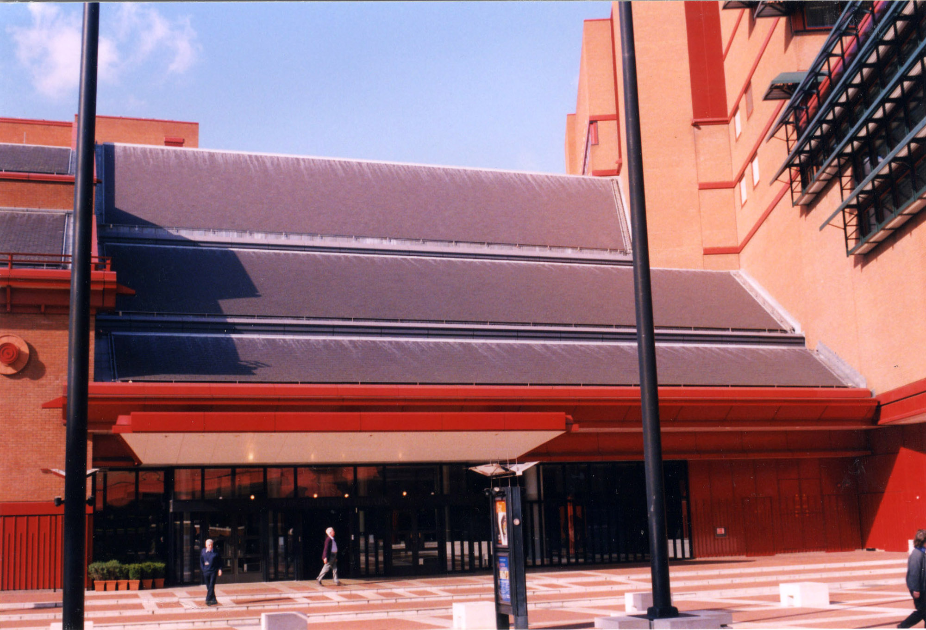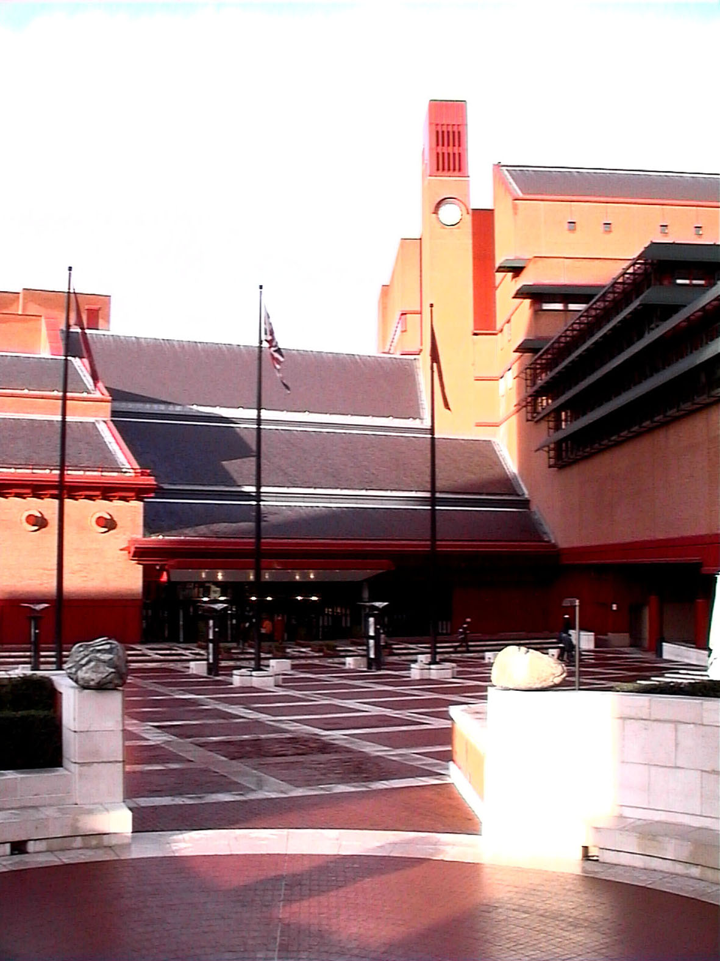
Fig 1. Entrance View Fig 2. Entrance Piazza

The first impression while arriving the building is a symphony of light and space. The sources of natural light in the entrance hall are hidden from the viewer’s eyes and may arouse the natural curiosity of the beholder.

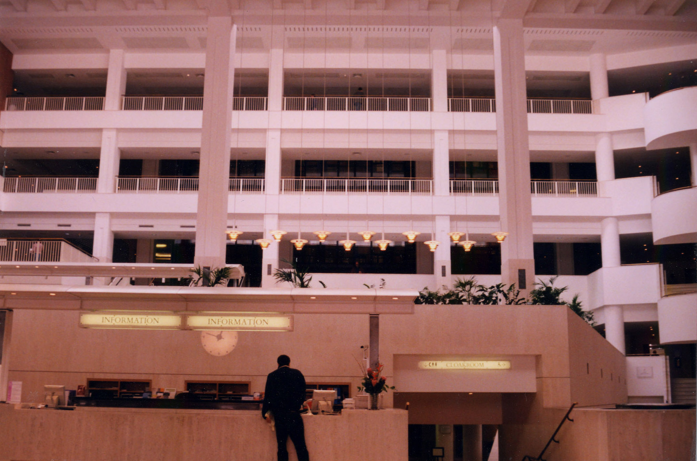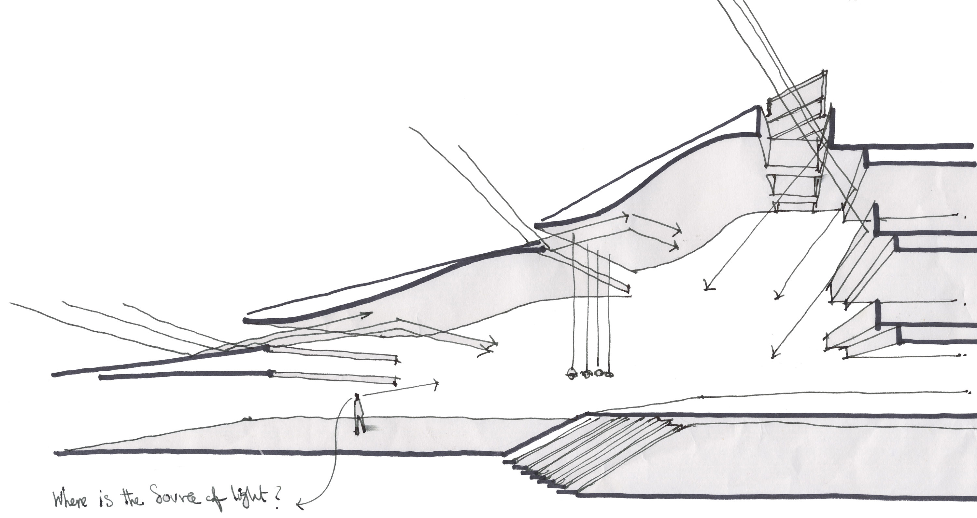
Fig 3. View from Entrance hall Fig 4. How natural light penetrates the entrance hall
Light and form seems inseparable in the process of perception since we see forms in light and also light within forms. The forms that we see in a building, and the way that we see them, are due to the way in which light is admitted by the form as well as the way in which the form then models the light admitted (Millet 1996). Form is revealed by light, but the quality of its revelation to the human eye is due to the nature of the form, and in this case the particular different types of geometry of the form.

In the entrance hall both subdued and sharp shading are created by the play of light and form. Curved ceilings in the entrance hall soften the light and likewise the light emphasises the contours of the ceiling. The curved forms allow light to play on the surface and the nature of daylight reveals a different appearance of the form, moment by moment. This play of form under the changing light, as Le Corbusier points out in his writings, breaks the monotony of space and thus enriching the perception of space.

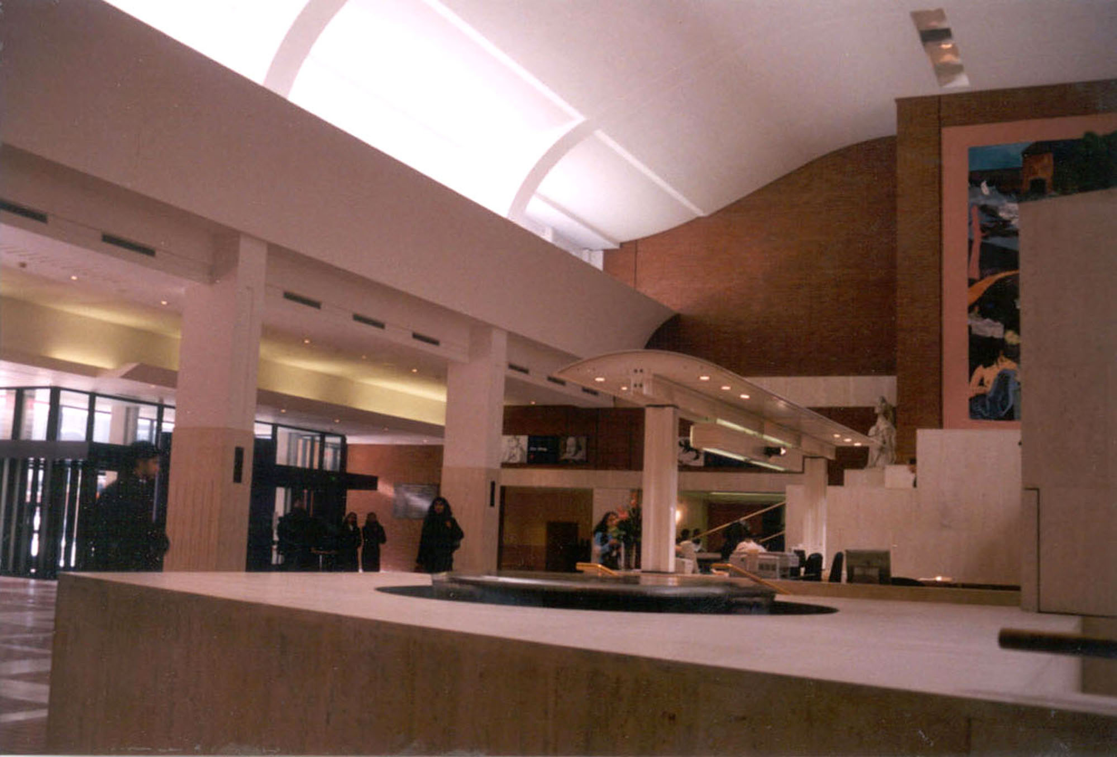
Fig 5. Curved ceiling and how light is subdued on the surface moderately

By contrast, the projection and recession of stair like forms result in sharp shadows. The shading of this type of geometry articulates every part of the form and the surfaces are distinguished from the other whilst with curved forms dissolve forms into each other. It would seem that the architect’s intention was to interweave these two different types of geometry and their respective lighting qualities in the entrance hall in order to enhance the people’s experience of the space.

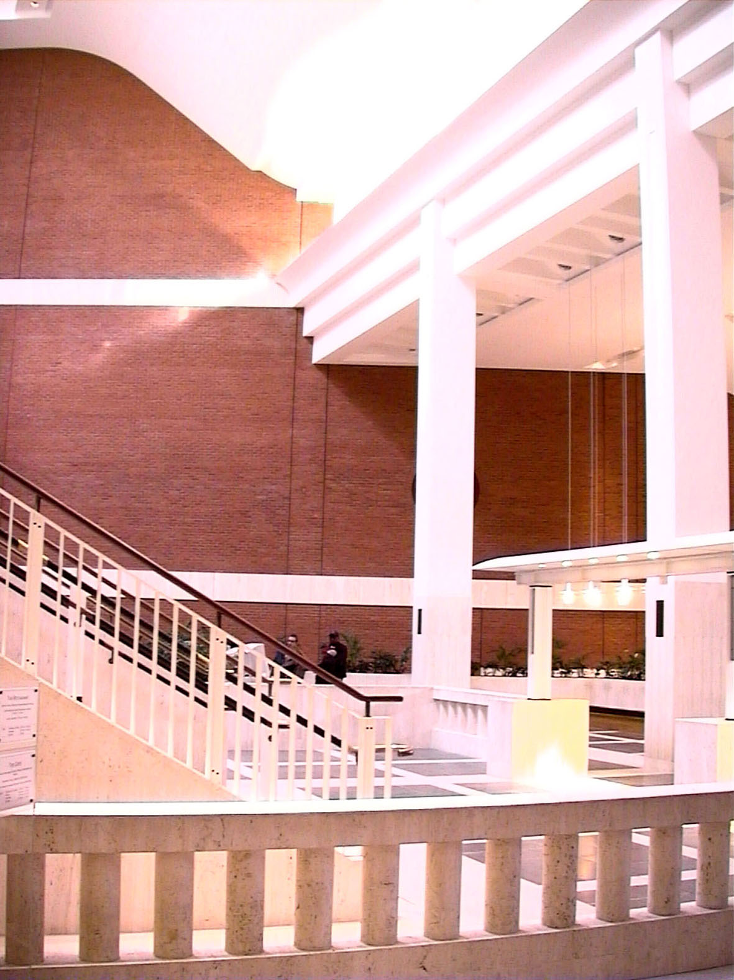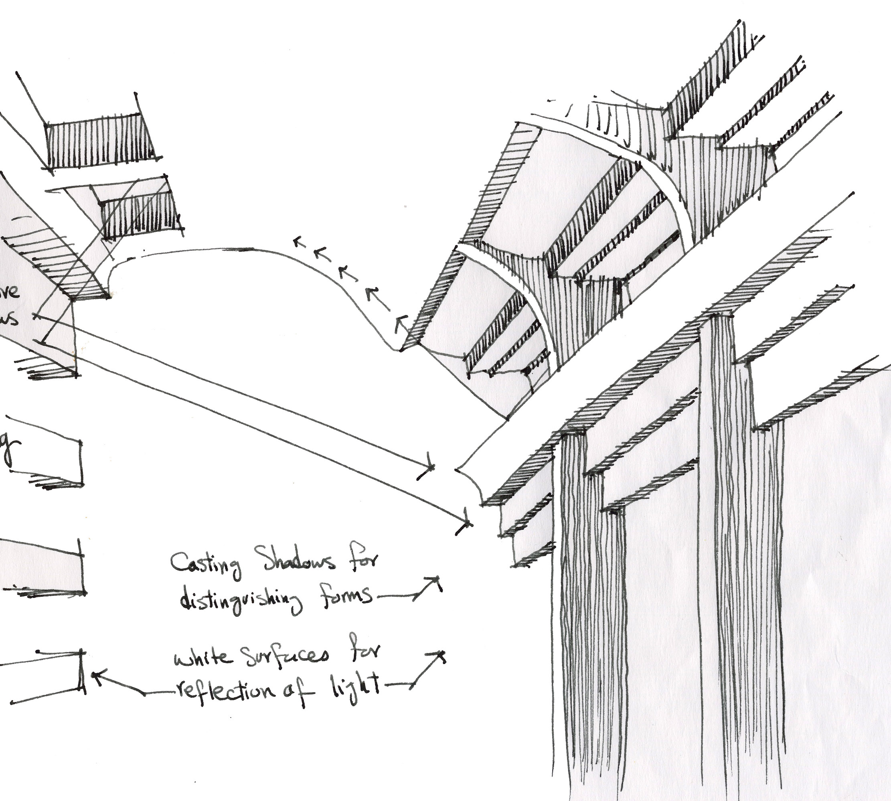
Fig 6. step-like form in contrast with curved ceiling developing different light and shade

In the hands of the creative architect natural light is like paint to create live plates of shadows changing under different daylight conditions. The deep walls of the high skylight appear to be a blank canvas for the variant geometric shadows which pulsates the interior with life and excitement.

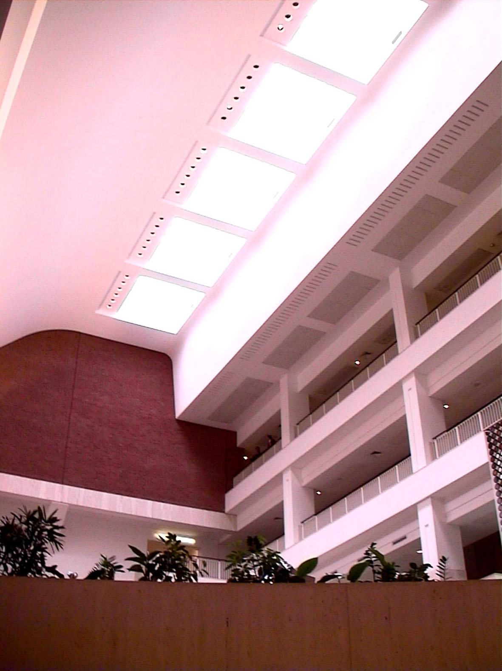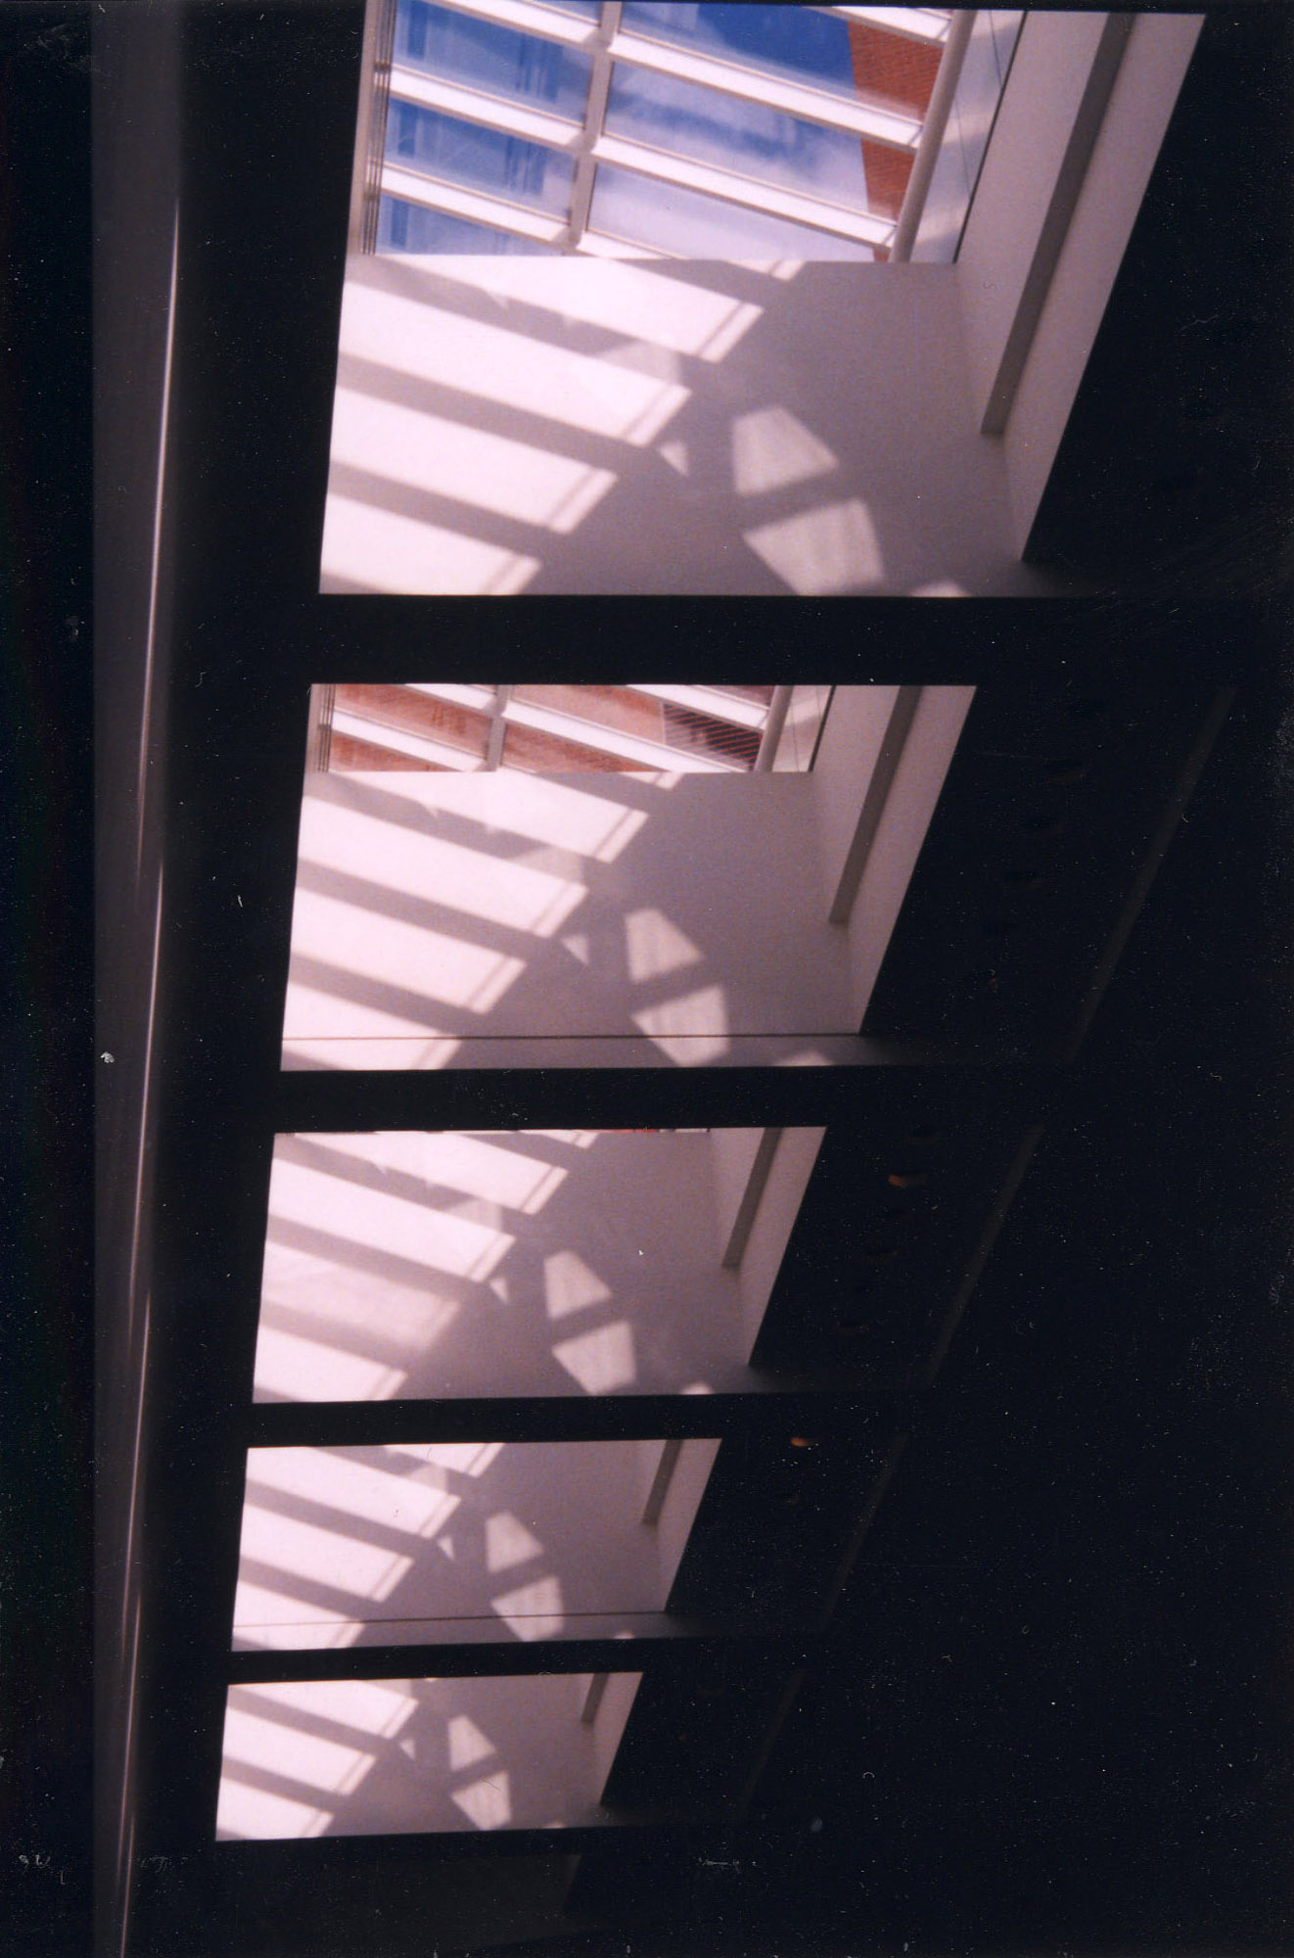
Fig 7. Deep skylight at the climax of the space and its different looks under varying daylight conditions

Artificial light is also employed as creatively as natural light in this building and they appear to mix together harmoniously in lofty public spaces to create an intimate atmosphere. Daylight is mostly introduced at the highest point of the public spaces (entrance hall, restaurant and reading rooms), whereas, artificial lights hang from the ceiling by long thin wires lower down. The changing quality of daylight in the high zone of these spaces as the background and the constant quality of illumination produced by electric lights as the foreground create a dramatic effect of privacy even in a lofty public space.

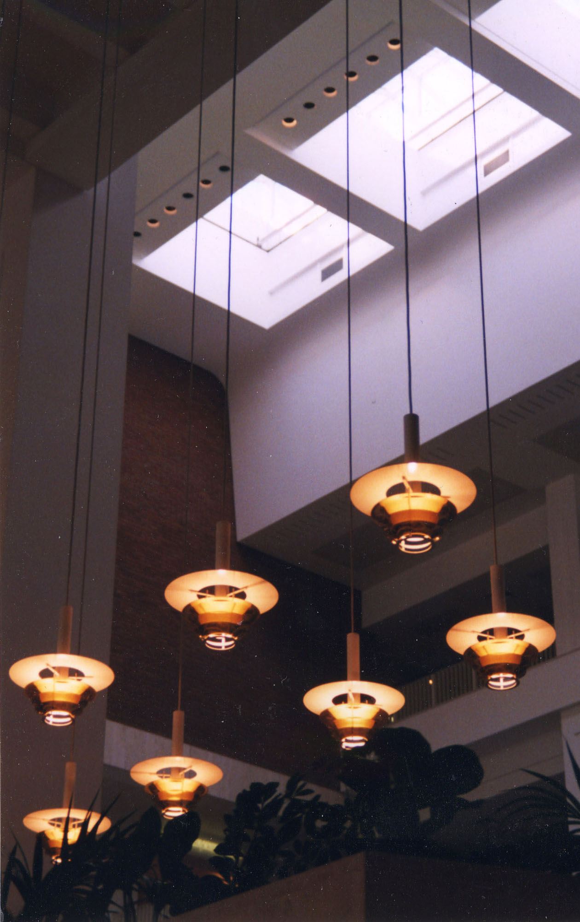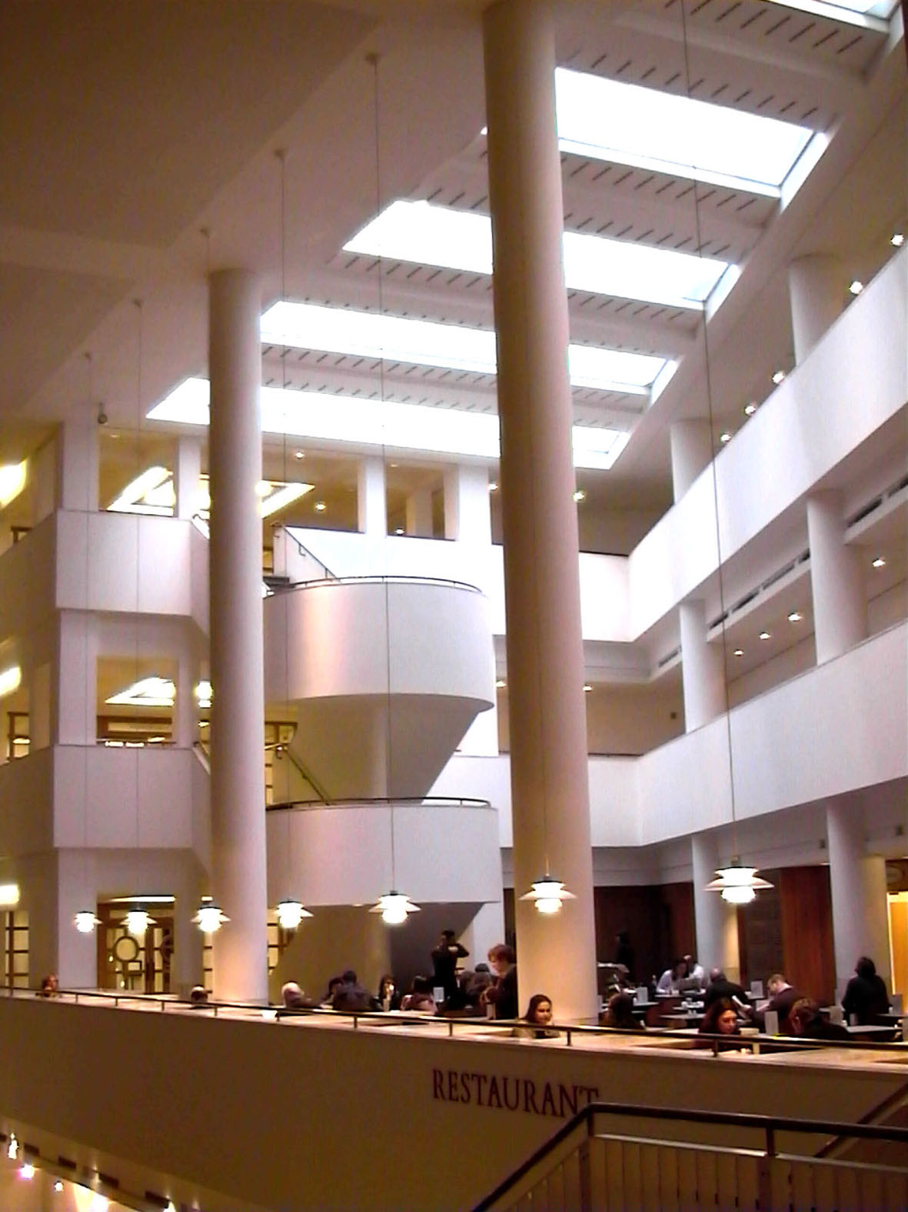
Fig 8. Foreground artificial lights and background daylight in public spaces (entrance hall/ Restaurant)

In more private spaces and the circulation areas whereas daylight can not penetrate the building artificial lights have been studied and designed appropriately to give specific meaning and effect to the space. In corridors linear electric light spots develop a sense of movement to fulfil its function, while in ‘stop space’ the focused soft light of the indirect lighting fixtures helps people to focus on their choice of direction.

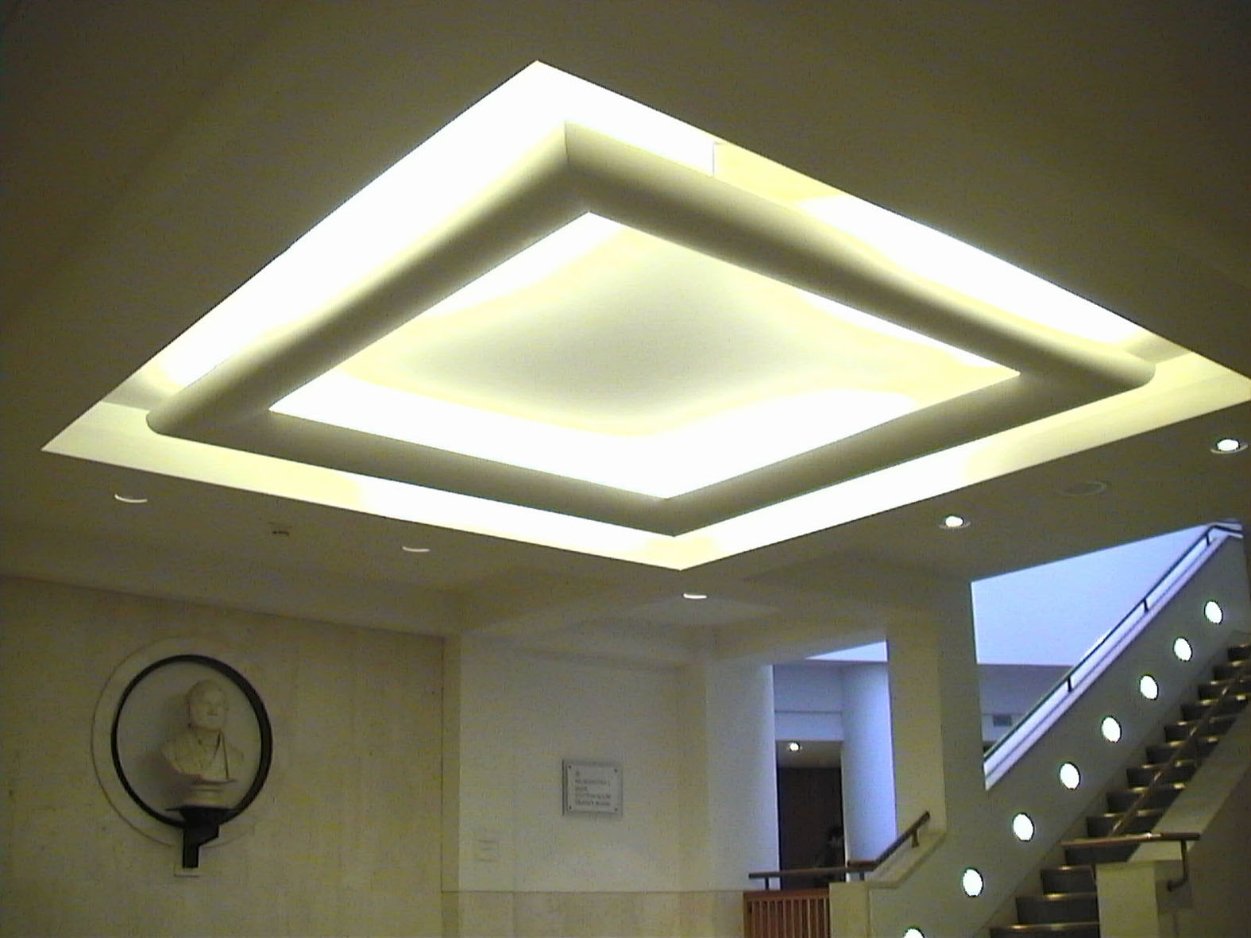
Fig 9. A ‘stop space’ in front of the humanities reading room

The intention behind this articled was to introduce the interior space of the new British Library in terms of designing creative light to enrich the emotional and sensual experience of space, although there are a number of other aspects such as material and detailing that could be explored for the sake of more humane attitude to architecture. In summary, it would seem that light in the new British Library is a culmination to the experience of a humane architecture.

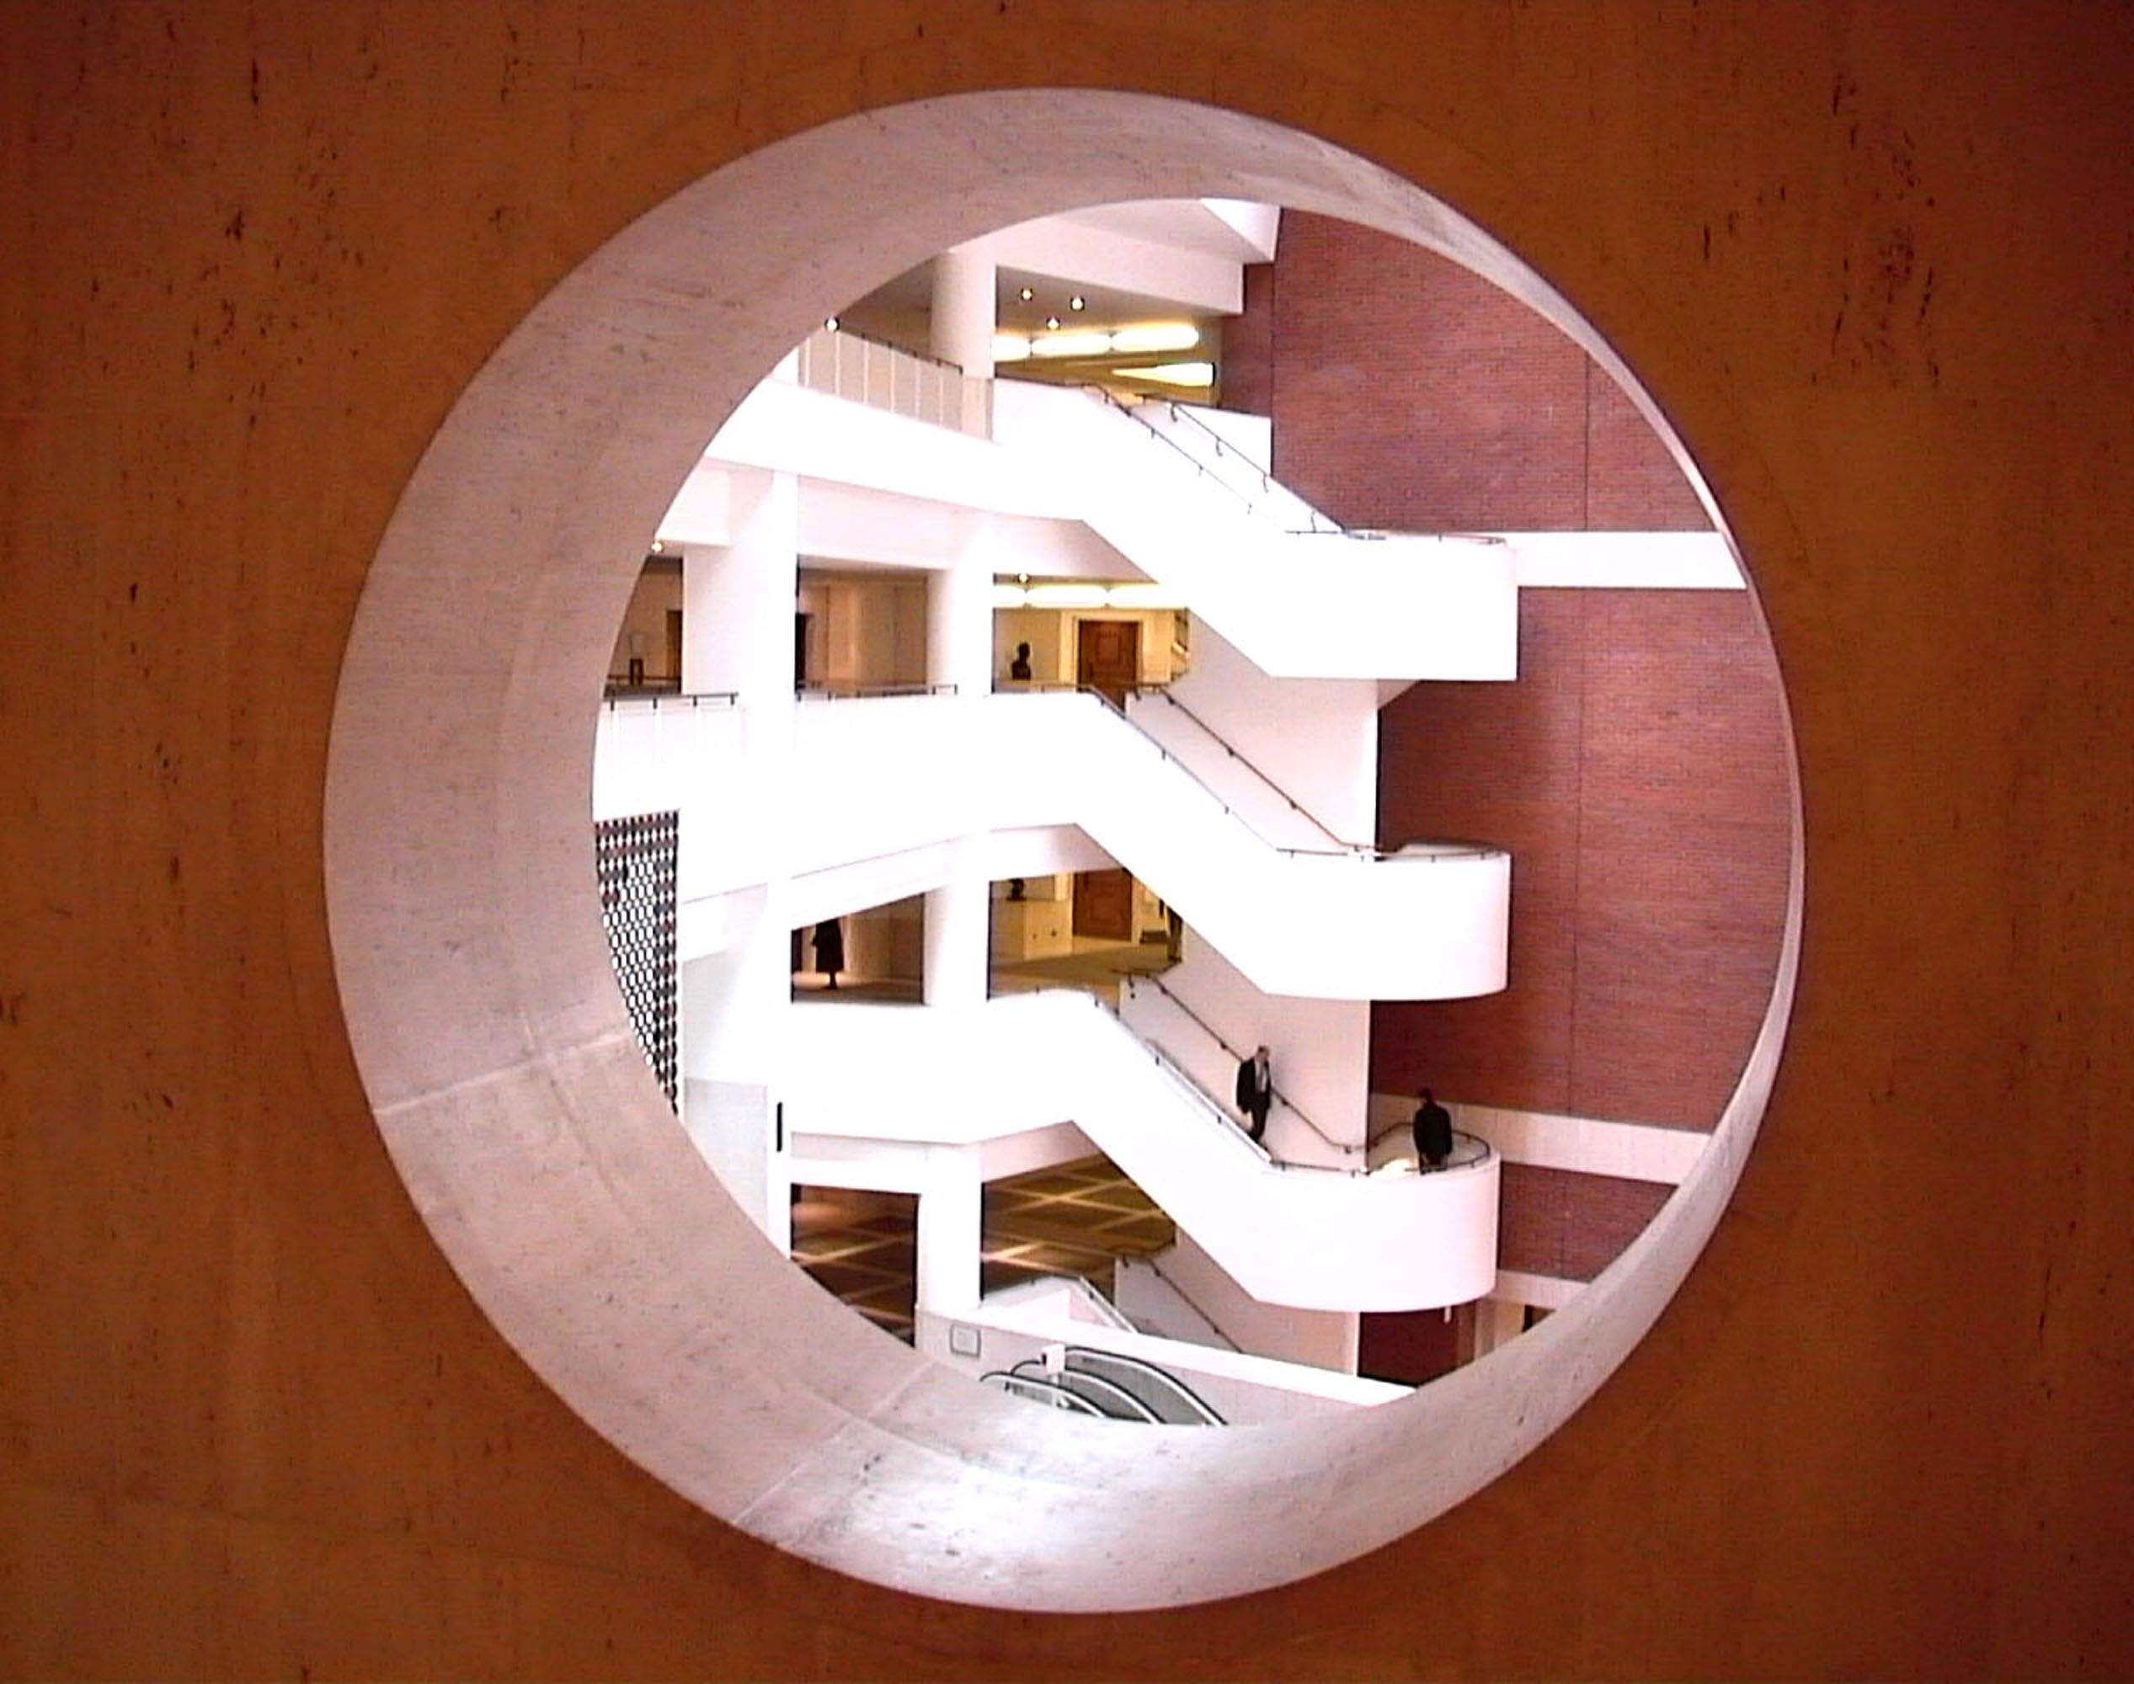
Fig 10. View through a hole in the corridor wall

NB. All photos and drawings are prepared by the author. The assistance of Professor Anthony C. Antoniades in editing the article is also gratefully acknowledged.

Reference:

Millet, M. S. (1996). Light Revealing Architecture. New York, Van Nostrand Reinhold.

Wilson, C. S. J. (1998). The Design and Construction of the British Library. Cambridge, University Press.

Wilson, C. S. J. (2000). Architectural Reflections: Studies in the philosophy and practice of architecture. Manchester, New York, Manchester University Press.

