Theme D1.15 New methods for enhanced bioremediation of organic compounds
STIMULATING IN SITU BIOREMEDIATION IN ELECTRON ACCEPTOR-LIMITED ZONES BY NITRATE DELIVERY USING ELECTROKINETICS IN A MODEL SCALE AQUIFER
Richard Gill¹, Steven Rolfe², Michael Harbottle³, Jonathan Smith⁴ and Steven Thornton¹
¹ University of Sheffield, Kroto Research Institute S3 7HQ; ² University of Sheffield, Dept of Animal and Plant Sciences, Western Bank, S10 2TN; ³ Cardiff University, Newport Road CF24 0DE, ⁴ Shell Global Solutions, Lange Kleiweg 40, 2288 GK Rijswijk, The Netherlands
Keywords: electrokinetics, bioremediation, heterogeneity, electromigration
Abstract
Contamination of soil and groundwater by organic chemicals requires cost-effective and sustainable solutions to protect human health and the environment. One potential option is a coupling of two technologies - electrokinetics and bioremediation. Electrokinetics is the application of a direct current to the subsurface to initiate remote transport processes, whereas bioremediation is the use of microorganisms to transform contaminants into less harmful substances. Combining the two approaches can enhance the in situ biodegradation of contaminants, by increasing the supply of electron acceptors that may otherwise limit bioremediation. This paper outlines current research on the use of these technologies for the in situ bioremediation of contaminants in physically heterogeneous systems with variable permeability where hydraulic techniques are not suitable, to better understand the processes that occur at the field-scale.
Introduction
Land contaminated by anthropogenic activities is of global concern and where potential for exposure to harmful substances occurs there is a potential risk to human and environmental health. Bioremediation has long been applied as a cost-effective and sustainable means to treat contamination; it is the process whereby microorganisms convert the contaminants into less harmful substances. Broadly, it falls into two types: ex situ for treatment of excavated material, mainly used in pollution source removal, and in situ for treatment of sites with limited access, where less disturbance is desirable and an extended timescale of remediation is acceptable (CIRIA, 2002). Bioremediation requires favourable environmental conditions and interactions at the microscale level between microorganisms, contaminants, nutrients and electron acceptors (Sturman et al., 1995). Thus, biodegradation rates are limited by bioavailability - the contact between microorganisms and the relevant substances; and bioaccessibility - the yield of components from the environment that are potentially accessible to the microorganisms (Semple et al., 2004).
These limitations can be overcome by coupling bioremediation with electrokinetics (EK), a remediation technology in which a direct current is applied to the subsurface to induce specific transport phenomena (Figure 1 and Figure 2), namely: (1) electromigration - the movement of charged ions in solution; (2) electroosmosis - the bulk movement of fluid through pores (most prevalent in clays); and (3) electrophoresis - the movement of charged suspended particles. EK is particularly effective when applied to low permeability porous media as these transport phenomena are independent of pore size, for example, a suitable electrical potential gradient can induce an electroosmotic pore fluid flux several orders of magnitude higher than a hydraulic gradient in clay sediments (Cherepy & Wildenschild, 2003). EK is also characterised by reactions that occur at the electrodes, the most important of which is the electrolysis of water (Virkutyte et al., 2002):
Anode (oxidising) $H_{2}O →2H^{+}+\frac{1}{2} O_{2}\left(g\right)+ 2e^{-}$
Cathode (reducing) $2H_{2}O+2e^{-}→2OH^{-}+H_{2}\left(g\right)$

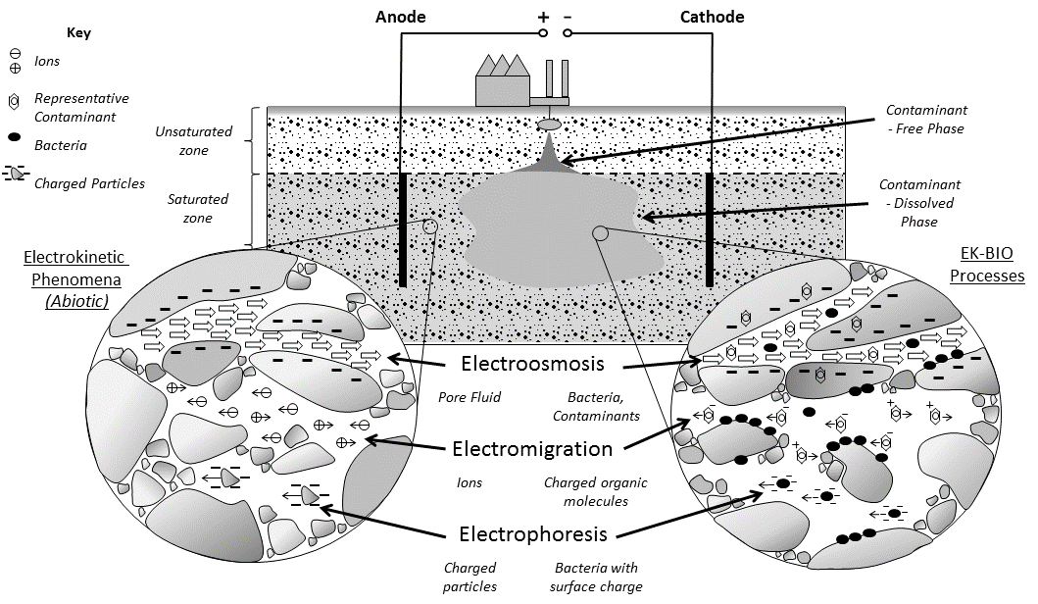
Figure 1. Illustrative conceptual model of electrokinetic-enhanced bioremediation for dissolved-phase organic substances in groundwater under a direct current. Close ups illustrate electrokinetic transport phenomena under abiotic conditions outside the contaminated area and under biotic conditions within the contaminated zone.

These processes influence bioremediation (Figure 1) by: electroosmosis and electrophoresis of microorganisms (Wick et al., 2004); electromigration and electroosmosis of contaminants (Luo et al., 2005; Niqui-Arroyo et al., 2006); and electromigration of ionic nutrients and electron acceptors (Thevanayagam & Rishindran, 1998). This has the effect of making bioaccessible compounds in the environment more bioavailable to microorganisms (Wick, 2009), thus overcoming mass transfer limitations, enhancing the efficiency of bioremediation and potentially widening its application to more sites. In addition, the electrolysis of water has shown to have a noticeable effect on the indigenous microbial community, by the generation of pH fronts that initiate stress responses (Lear et al., 2004). Therefore, it is important to control these pH changes to maintain the viability of the active degrader species (Harbottle et al., 2009).
This paper describes research undertaken to investigate the use of EK to enhance the delivery of electron acceptors into physically heterogeneous subsurface environments to stimulate in situ bioremediation. To date, the bulk of research on EK-enhanced biostimulation has focused on different amendments such as nutrients e.g. phosphate (Lee et al., 2007), electron acceptors e.g. nitrate and sulphate (Lohner et al., 2008a) and electron donors e.g. lactate (Wu et al., 2007) under relatively homogeneous conditions such as uniform clays (Thevanayagam & Rishindran, 1998) and sands (Lohner et al., 2008a). Knowledge of how EK processes develop within physically heterogeneous systems is crucial for expanding the technology successfully to contamination scenarios in many field settings. Studies in the literature of EK applications to physically heterogeneous systems include examples moving charged substances into low permeability zones by electromigration (Reynolds et al., 2008) and where electroosmosis is applied to remove retarded organic molecules (such as phenanthrene) out of clay (Saichek & Reddy, 2005). However neither of these studies incorporated transformation processes involved with bioremediation, although there are modelling studies that examine the migration of permanganate into a low permeability zone contaminated by PCE (Wu et al., 2012a).
The main transport mechanism in EK-biostimulation studies is electromigration and factors which influence this are shown in Figure 2. They include geochemical, electrochemical and biological factors. Electromigration can be defined numerically as (Acar & Alshawabkeh, 1993):
$J_{j}^{m}=u_{j}^{*}{ c}_{j} ∇(-E)$ (1)
Where $J_{j}^{m}$ is the electromigration flux (mmol cm⁻² s⁻¹); $u_{j}^{*}$ and c_{j} are the effective ionic mobility (cm² V⁻¹ s⁻¹) and the molar concentration of a substance respectively and E is the change electrical potential (V cm⁻¹). The main geochemical factor is the amount of clay and organic matter in the soil, since both components have an associated surface charge (Acar et al., 1995). This can result in adsorption of amendments to particle surfaces, retarding migration (Elektrowicz & Boeva, 1996) and the generation of an electroosmotic flow, typically from anode to cathode. This can oppose the electromigration of negatively-charged amendments, reducing the amendment penetration (Wu et al., 2007) and also present a flux of contaminants into the amendment front. The hydraulic conductivity of a sediment is a function of its interconnected porosity (Freeze & Cherry, 1979) and, with the tortuosity factor, directly influence the effective ionic mobility of an ion (an important electrochemical factor) (Acar & Alshawabkeh, 1993):
$u_{j}^{*}=u_{j} τ n$ (2)
where$u_{j}$, is the ionic mobility of an ion at infinite dilution (cm² V⁻¹ s⁻¹), $τ$ is the tortuosity and $n$ is the porosity.
As shown in equation 1 and Figure 2 the main electrochemical factor which influences the electromigration rate is the voltage gradient over distance, which is inversely proportional to the electrical conductivity. Typically in past EK experiments this gradient is assumed to be linear (Thevanayagam & Rishindran, 1998), but the relationship between voltage gradient - electromigration - electrical conductivity is more dynamic and can result in a non-uniform distribution of amendment in the system (Wu et al., 2012b). Amendment losses due to dissociation and precipitation are mainly influenced by pH fluctuations from electrolysis as well as the amendment chemical characteristics. For example, above pH 9 ammonium ion (NH₄⁺) speciation changes:
$${NH}_{4}^{+}+OH^{-}↔{NH}_{3}+H_{2}O$$
producing uncharged ammonia, which is not subject to electromigration and reduces the electrical conductivity of the pore fluid (Lohner et al., 2008a).
When using electrokinetics to mobilise and redistribute amendments for bioremediation, the rate of addition must be equal to or greater than the rate of microbial consumption, otherwise microbial growth at the periphery may be excessive and hinder further migration into the bulk of the system (Rabbi et al., 2000). This is controlled by increasing the voltage gradient and or inlet concentration to increase the amendment flux within the system (Wu et al., 2007). However, a potential limiting force on amendment addition rate in systems with a high clay content is electroosmosis. Electroosmosis has a transport flux an order of magnitude lower than electromigration (Thevanayagam & Rishindran, 1998) and is therefore relatively insignificant in most cases (Pamukcu, 2009). However, for biostimulation any opposing solute flux may reduce the amendment mass transfer rate and efficiency of bioremediation.
The main premise of the research described herein is articulated by the interactions shown in Figure 2. It involves deducing the geochemical factors, which affect the electromigration of solutes in low permeability zones within a heterogeneous system and their resulting control on bioremediation. The aim is to use electromigration of electron acceptors as amendments to stimulate biodegradation of organic contaminants present in low permeability zones within a physically heterogeneous setting. Focus will be given to the properties of low permeability zones that influence amendment penetration, such as clay content and porosity.
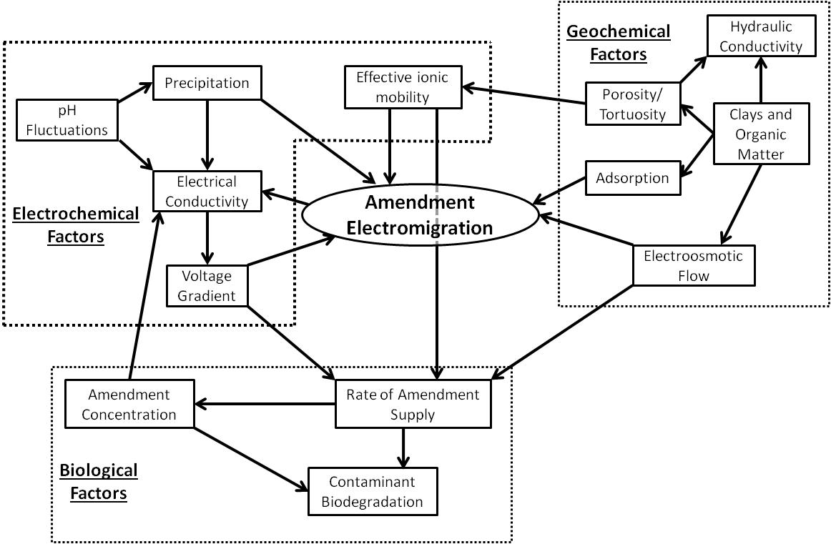
Figure 2. Interactions between geochemical, electrochemical and biological factors that influence electromigration of amendments in the context of EK-biostimulation. The direction of the arrow indicates which factor influences which.

Experimental Methods
An experimental bench-top system was developed to meet certain criteria that allow it to be used as a small-scale physical model of a heterogeneous aquifer system to evaluate EK phenomena in porous media. These criteria include:
- Anaerobic and saturated conditions - representative of a contaminated aquifer in which biodegradation occurs;
- Able to host and test homogeneous and heterogeneous sediment configurations;
- Able to induce hydrodynamic flow to represent groundwater by generating a hydraulic head difference between electrode chambers; and
- High sampling resolution based on the density of ports on the sides of the reactor.
The variables which are fixed within the experiments include:
- Toluene as the single substrate to represent a model organic contaminant dissolved from an LNAPL;
- Nitrate as the primary amendment, which is well characterised as a terminal electron acceptor in toluene biodegradation (Jørgensen et al., 1995) and in EK literature (Eid et al., 2000);
- Sand obtained from a quarry to represent a relatively high permeability test material typical of UK aquifer sediments;
- Clay/sand mixes to represent a physically heterogeneous porous media with spatially variable permeability in different configurations;
- Synthetic groundwater developed to represent a model UK groundwater composition;
- Use of a single well characterised toluene degrader, Thauera Aromatica (Biegert et al., 1996) in biologically active experiments to compare with an enriched microbial community; and
- Graphite electrodes and a recirculation system will be used to generate an electric field, neutralise pH changes at each electrode and make nitrate available for electromigration.
Electrode
Electrode chamber top
Power connection
Electrode chamber
Sediment chamber
Electrode chamber
Circulation fluid in
Fluid in/ overflow
Fluid in/ out
N₂ sparge
Gas vent
= Sample Port
= Voltage probe port
Figure 3. Schematic (side view) of the experimental reactor with features based on designs from Mao et al., 2012. Within the sediment middle chamber the dark section represents the test zone containing the physically heterogeneous porous media, surrounded by more permeable host sand on either side (lighter areas).

Preliminary Results
Experiments conducted to date have focussed on testing the reactor design, operation and performance using relatively simple systems. The results from an example experiment are presented below to demonstrate the compatibility of the experimental data with similar results in the literature. The experiment was conducted to enhance the migration of nitrate through the reactors when filled with fine glass beads (diameter 0.5 mm) with a porosity of 0.4 and hydraulic conductivity of 3.4 x10⁻⁵ m s⁻¹. The electrodes were made of graphite and a linear voltage gradient of 1 V cm⁻¹ was applied across the system. There was no mechanism to control the pH changes at the electrode, although fluid from the cathode chamber was circulated between a reservoir tank containing 746 mg L⁻¹ nitrate. A reactor with no electric field was run in parallel as a control.
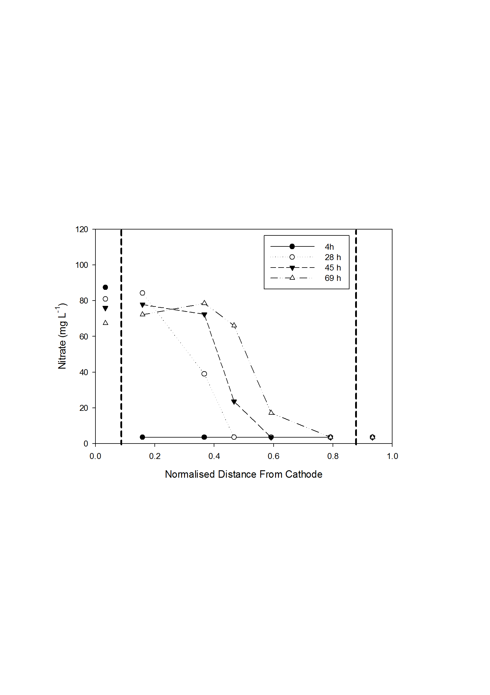
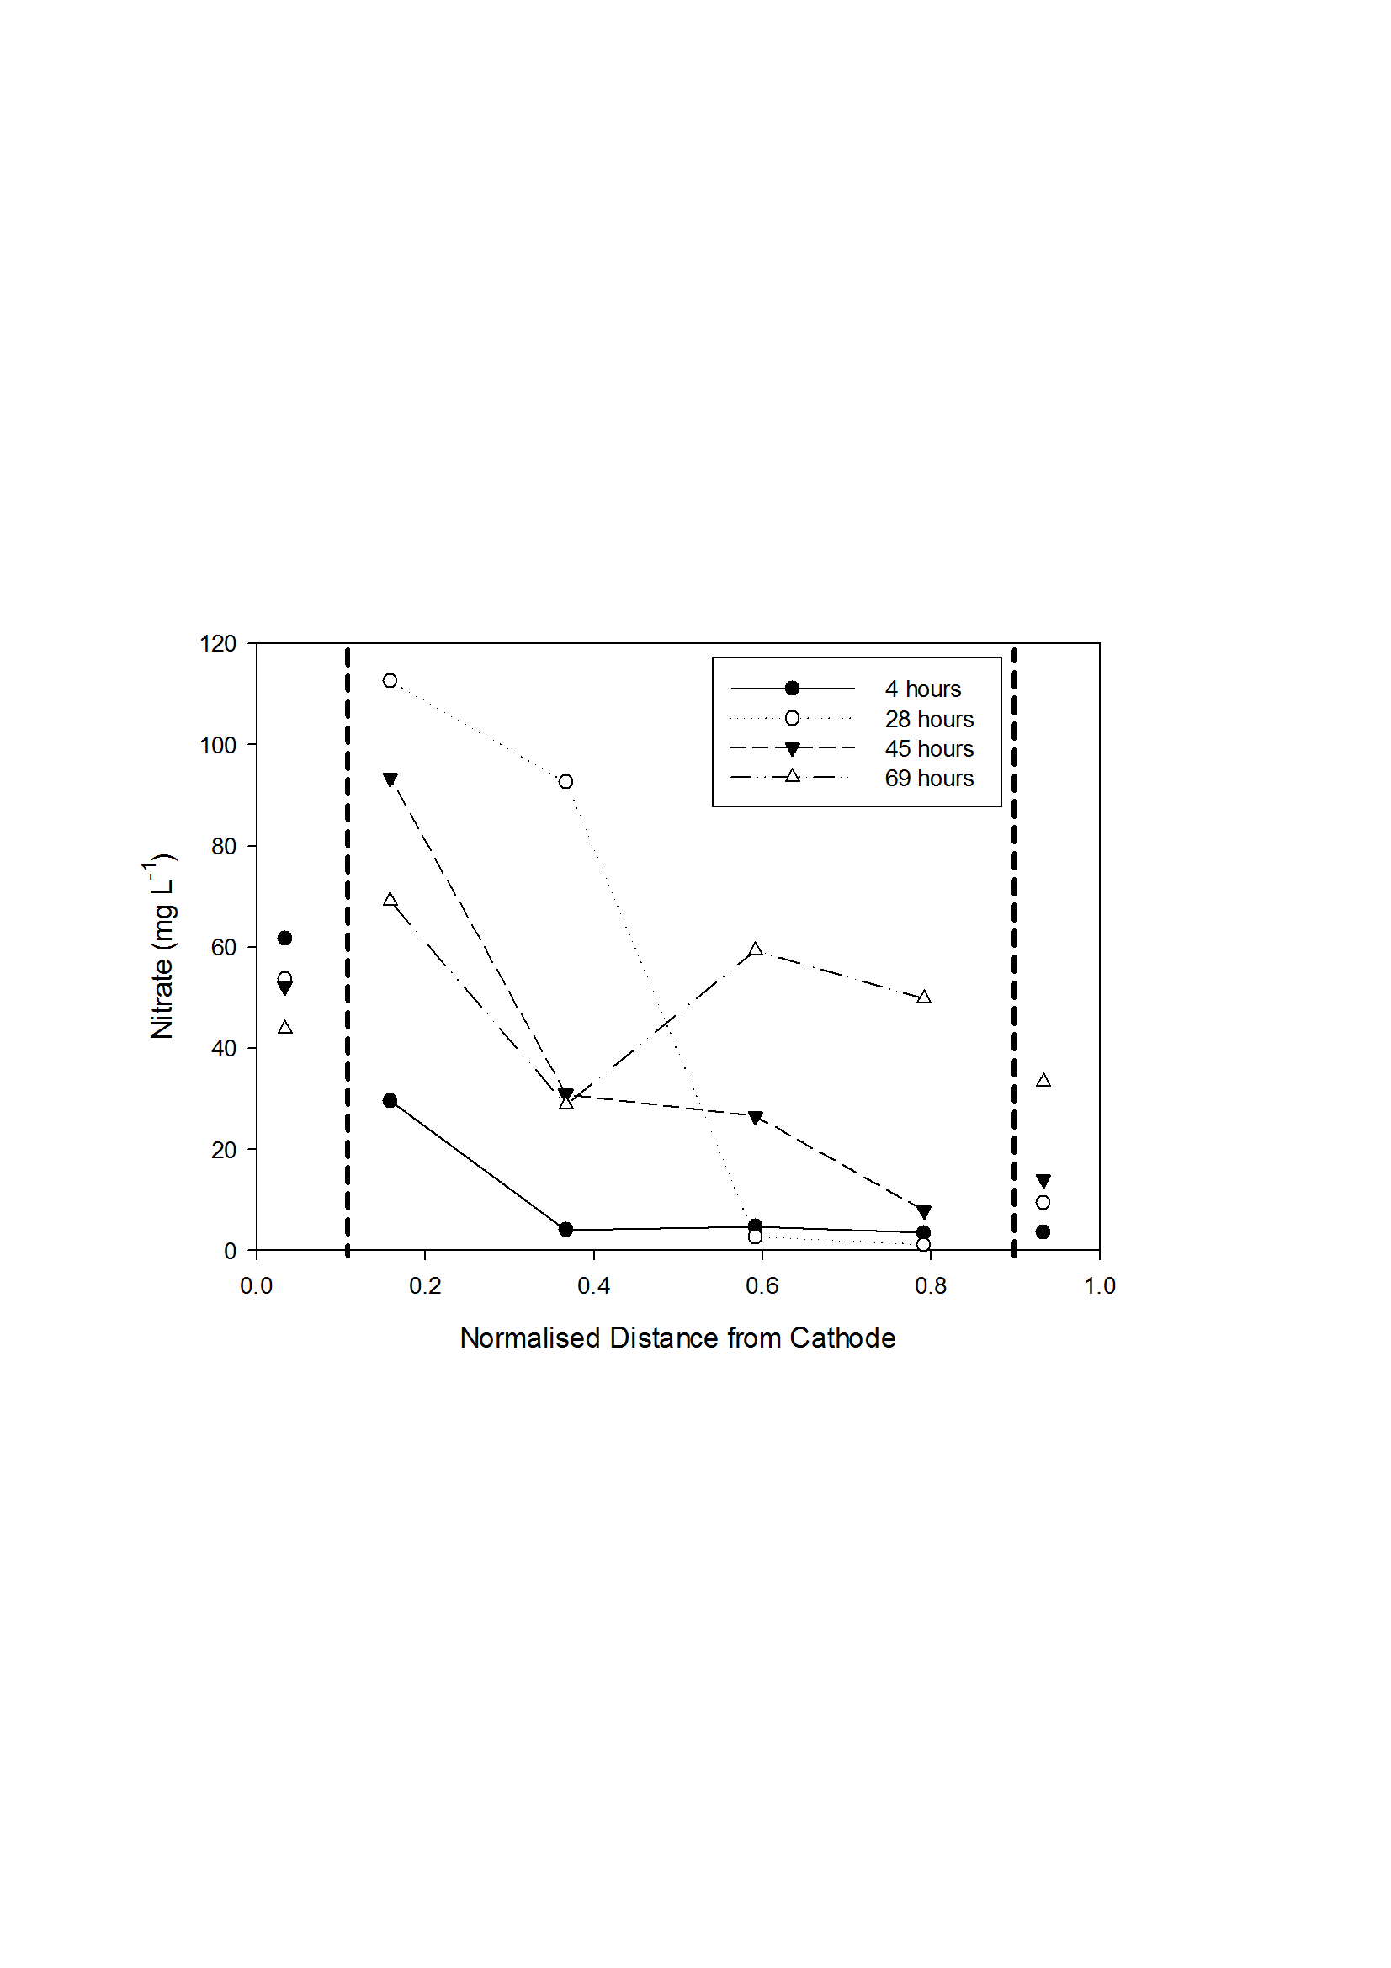
Figure 4. Above, calculated nitrate values; Below, observed values. The vertical dashed lines indicate the boundaries of the electrode chamber.
The calculated and observed values of nitrate migration are shown in Figure 4 for the system with EK applied only. Calculated values were determined by applying the initial observed values to equation 1 in a time step procedure. Both profiles show depletion of nitrate in the cathode chamber and movement from the cathode towards the anode, with the highest concentration located adjacent to the cathode. The transport rates vary, 0.62 and 1.21 cm hr⁻¹ for the calculated and observed values, respectively. Calculated values are representative of values reported in the literature, 0.7 cm hr⁻¹ at 1 V cm⁻¹ (Lohner et al., 2008a). Two factors may explain the difference between the data sets. Firstly, advection of nitrate into the sediment chamber due to pumping of fluid into the electrode chamber and passage through the divider separating them was confirmed by results from the control system. Secondly, a non-linear voltage gradient developed over time (data not shown) as a result of a charged amendment being migrated into the system. This increased the electrical conductivity of the fluid and this lowered the rate of electromigration. This is similar to profiles in other experiments (Lohner et al., 2008b) and is a potential explanation of the nitrate accumulation adjacent to the cathode.
Future Work and Conclusions
Using the theory and experimental methods outlined above the research programme will address the following points:
- Investigate the physical properties of low permeability zones within more permeable host media which influence the penetration of an amendment and distribution of contaminants such as clay/ sand content, porosity and electrical conductivity;
- Optimise the addition of amendments to enhance bioremediation in low permeability zones via increased voltage gradients and inlet concentrations;
- Assess in a two-dimensional system how the migration of amendments such as nitrate into a physically heterogeneous system that varies over a range of geometries and permeabilities can be stimulated by EK to enhance bioremediation of an orgnaic compound; and
- Interpret the experimental results using a computer model (developed by Wu et al., 2012a) to explore the scale-up issues for representative field scale scenarios
A summary of the experimental matrix supporting this research is presented in Table 1. The clay/ sand mix represents the material used to develop spatially variable permeability contrasts in the reactor. Clay has two functions in this respect : (1) reducing the hydraulic conductivity of the host media by restricting pore throat size and (2) supporting electroosmosis by the development of a zeta potential. The sand fraction will reduce the electroosmotic flux by lowering the porosity. Increasing the voltage gradient and the inlet nitrate concentration are the two main mechanisms to enhance amendment delivery and will be varied within the experiment setup. Contrasting a single well characterised microbial inoculum against a natural groundwater microbial community will provide information on how the community respond to EK and the nitrate amendment. The 2-D analysis in later studies will provide important data for validating the experimental observations using a numerical model, as well as representing a more dynamic system that captures the effects of physical heterogeneity on EK-enhanced migration in a realistic context.
Table 1. Summary of experimental matrix for the research.
Experiment Set | Experiment Details
1 | Influence of:  - clay/ sand ratio on nitrate migration  - voltage gradient on nitrate migration into low K zone  - different nitrate concentration on extent of penetration  - EK on the presence of dissolved toluene within a low K zone
2 | Influence of:  - clay: sand content on biodegradation  - voltage gradient and nitrate concentration on biodegradation  - biodegradation dynamics between a single inoculum and groundwater community
3 | Influence of  - 2-D physical heterogeneity on nitrate migration  - 2-D physical heterogeneity on biodegradation  Apply results of experiments for model validation and upscale

References
Acar, Y., & Alshawabkeh, A. (1993). Principles of electrokinetic remediation. Environmental science & technology, 27(13), 2638 – 2647.
Acar, Y. B., Gale, R. J., Alshawabkeh, A. N., Marks, R. E., Puppala, W., Brickad, M., & Parkere, R. (1995). Electrokinetic remediation : Basics and technology status. Journal of Hazardous Materials, 40, 117–137.
Biegert, T., Fuchs, G., & Heider, J. (1996). Evidence that anaerobic oxidation of toluene in the denitrifying bacterium Thauera aromatica is initiated by formation of benzylsuccinate from toluene and fumarate. European journal of biochemistry, 238(3), 661–8.
Cherepy, N. J., & Wildenschild, D. (2003). Electrolyte Management for Effective Long-Term Electro-Osmotic Transport in Low-Permeability Soils. Environmental Science & Technology, 37(13), 3024–3030.
CIRIA. (2002). Biological Methods fo Assessment and Remediation of Contaminated Land: Case Studies. (D. Barr, J. R. Finnamore, R. P. Bardos, J. M. Weeks, & C. P. Nathanail, Eds.) (pp. 79–109). London: CIRIA.
Eid, N., Elshorbagy, W., Larson, D., & Slack, D. (2000). Electro-migration of nitrate in sandy soil. Journal of hazardous materials, 79(1-2), 133–49.
Elektrowicz, M., & Boeva, V. (1996). Electrokinetic Supply Of Nutrients In Soil Bioremediation. Environmental Technology, 17, 1339–1349.
Freeze, R. A., & Cherry, J. A. (1979). Groundwater (1st ed., pp. 303–375). Uppersaddle River: Pearson Education.
Harbottle, M. J., Lear, G., Sills, G. C., & Thompson, I. P. (2009). Enhanced biodegradation of pentachlorophenol in unsaturated soil using reversed field electrokinetics. Journal of environmental management, 90(5), 1893–900.
Jørgensen, C., Flyvbjerg, J., Arvin, E., & Jensen, B. K. (1995). Stoichiometry and kinetics of microbial toluene degradation under denitrifying conditions. Biodegradation, 6(2), 147–56.
Lear, G., Harbottle, M. J., Van der Gast, C. J., Jackman, S. a., Knowles, C. J., Sills, G., & Thompson, I. P. (2004). The effect of electrokinetics on soil microbial communities. Soil Biology and Biochemistry, 36(11), 1751–1760.
Lee, G.-T., Ro, H., & Lee, S.-M. (2007). Effects of Triethy Phosphate and Nitrate on Electrokinetically Enhanced Biodegradation of Diesel in Low Permeability Soils. Environmental Technology, 28, 288–860.
Lohner, S. T., Daniel, K., & Tiehm, A. (2008). Electromigration of Microbial Electron Acceptors and Nutrients: (I) Transport in Synthetic Media. Journal of Environmental Science and Health Part A: Toxic/Hazardous Substances and Environmental Engineering, 43, 913–921.
Lohner, S. T., Katzoreck, D., & Tiehm, A. (2008). Electromigration of Microbial Electron Acceptors and Nutrients: (II) Transport in Groundwater. Journal of Environmental Science and Health Part A, 43, 922–925.
Luo, Q., Zhang, X., Wang, H., & Qian, Y. (2005). Mobilization of phenol and dichlorophenol in unsaturated soils by non-uniform electrokinetics. Chemosphere, 59(9), 1289–98.
Mao, X., Wang, J., Ciblak, A., Cox, E. E., Riis, C., Terkelsen, M., Gent, D. B., Alshawabkeh, A. N., (2012). Electrokinetic-enhanced bioaugmentation for remediation of chlorinated solvents contaminated clay. Journal of hazardous materials, 213-214, 311–7.
Niqui-Arroyo, J.-L., Bueno-Montes, M., Posada-Baquero, R., & Ortega-Calvo, J.-J. (2006). Electrokinetic enhancement of phenanthrene biodegradation in creosote-polluted clay soil. Environmental Pollution, 142(2), 326–32.
Pamukcu, S. (2009). Electrochemical Transport and transformations. Electrochemical Remediation Technologies for …, 29–63.
Rabbi, M. ., Clark, B., Gale, R. ., Ozsu-Acar, E., Pardue, J., & Jackson, A. (2000). In situ TCE bioremediation study using electrokinetic cometabolite injection. Waste Management, 20(4), 279–286.
Reynolds, D. a, Jones, E. H., Gillen, M., Yusoff, I., & Thomas, D. G. (2008). Electrokinetic migration of permanganate through low-permeability media. Ground water, 46(4), 629–37.
Saichek, R. E., & Reddy, K. R. (2005). Surfactant-enhanced electrokinetic remediation of polycyclic aromatic hydrocarbons in heterogeneous subsurface environments. Journal of Environmental Engineering and Science, 4(5), 327–339.
Semple, K. T., Doick, K. J., Jones, K. C., Burauel, P., Craven, A., & Harms, H. (2004). Defining Bioavailability and Bioaccessibility of Contaminated Soil and Sediment is Complicated. Environmental Science & Technology, 15(June), 228–231.
Sturman, P. J., Stewart, P. S., Cunningham, a. B., Bouwer, E. J., & Wolfram, J. H. (1995). Engineering scale-up of in situ bioremediation processes: a review. Journal of Contaminant Hydrology, 19(3), 171–203.
Thevanayagam, S., & Rishindran, T. (1998). Injection of nutrients and TEAs in clayey soils using electrokinetics. Journal of Geotechnical and Geoenvironmental Engineering, 124(4), 330–338.
Virkutyte, J., Sillanpää, M., & Latostenmaa, P. (2002). Electrokinetic soil remediation--critical overview. The Science of the total environment, 289(1-3), 97–121.
Wick, L. Y. (2009). Coupling Electrokinetics to the Bioremediation of Organic Contaminants: Principles and Fundamental Interactions. In K. R. Reddy & C. Cameselle (Eds.), Electrochemical Remediation Technologies for Polluted Soils, Sediments and Groundwater (pp. 369–387). New Jersey: John Wiley & Sons.
Wick, L. Y., Mattle, P. a, Wattiau, P., & Harms, H. (2004). Electrokinetic transport of PAH-degrading bacteria in model aquifers and soil. Environmental science & technology, 38(17), 4596–602.
Wu, M. Z., Reynolds, D. a, Fourie, A., Prommer, H., & Thomas, D. G. (2012a). Electrokinetic in situ oxidation remediation: Assessment of parameter sensitivities and the influence of aquifer heterogeneity on remediation efficiency. Journal of contaminant hydrology, 136-137, 72–85.
Wu, M. Z., Reynolds, D. a., Prommer, H., Fourie, A., & Thomas, D. G. (2012b). Numerical evaluation of voltage gradient constraints on electrokinetic injection of amendments. Advances in Water Resources, 38, 60–69.
Wu, X., Alshawabkeh, A. N., Gent, D. B., Larson, S. L., & Davis, J. L. (2007). Lactate Transport in Soil by DC Fields. Journal of Geotechnical and Geoenvironmental Engineering, 133(12), 1587–1596.

