Grinkle station, which was the most inconveniently placed of all stations on the line, suffered so greatly from the coming of regular bus services that, by 1932, the passenger bookings had fallen to as low as 228. The high point, as with all the other stations, had come in 1920 when 11,552 passengers had booked tickets at the station. The following graph for passengers booking at Grinkle in the years 1910-34 reflects the fortunes of all the stations (except perhaps Kettleness). By 1928 Grinkle’s station expenses (£512) exceeded that of the total income for the year (£508).

Table 9: Graph showing numbers of passengers booked at Grinkle station 1910-34.

The traffic receipts for both periods, then, enable the questions posed at the beginning of the chapter to be answered. Firstly, how far did the line contribute to rural mobility? The answer must be: considerably, up to c.1926, then less and less until, by 1934 its contribution was minimal. Secondly, can Irving’s two statements (‘the line was a financial disaster of some magnitude’ and ‘passenger traffic ceased to display the vitality characteristic of the 1880s and 1890s’) be justified by the history of the line between 1897 and 1934. Again, the answer – on the whole – must be no to both statements. Irving’s first statement dealt mainly with the construction costs of the line and its early income, but this income, as has been noted, improved considerably up until c.1926 and, too, the passenger figures indicate that the passenger traffic (again, up to c. 1926) was certainly displaying a ‘virility’. Should the line have been built at all? The answer here must be equivocal, for while, as will be shown in Chapter 4 (in which the criteria used for analysing the costs, profits, and losses of the line are discussed in detail), costs were high and the profits low (if non-existent by the late 1920s), it provided a most important social service to the inhabitants of the villages through which its passed, as well as providing (as the figures show) an important, indeed, the only, method of transporting freight. But perhaps most importantly, and this becomes very clear indeed after 1933, the line must be seen, not in isolation, but part of the wider network. It will be noted shortly that, while passenger bookings at the village stations fell massively, through trains from Middlesbrough to the coastal resorts of Whitby and Scarborough were (until the advent of popular motor car travel from the mid-late 1950s onwards) were extremely well patronised, at least in the summer. It was this factor that enabled the line to survive (at least after 1933) the catastrophic fall in passenger bookings. The line’s existence, certainly in its first fifty years of existence, was undeniably justified by its social function rather than any other element.

Ticket pricing and other economies
There is not a great deal of evidence to show that ticket pricing had any marked effect on the fortunes of the line. There are some timetables from the United company, dated July 17-September 17, 1938 which show fares from Scarborough to all major stops to Middlesbrough on the 65 service, fares from Middlesbrough to all major stops to Scarborough on the same service, and fares from Whitby to Saltburn and vice-versa on the 85 service, and fares from Whitby to Dormanstown and vice-versa on the 79 service. Previous timetables do not show ticket prices. There are a number of railway tickets, from the NER, LNER, and BR periods to and from stations along the line, and, finally, a number of excursion bills from the 1920s. For example, an excursion from Whitby (West Cliff) to Middlesbrough and Thornaby on 17 September, 1921 offered the price of 5/- return from Sandsend to Middlesbrough; on 3 May, 1924 a similar excursion, but this time as far as Darlington, would cost the excursionist from Sandsend to Middlesbrough 4/2 return, while a Boxing Day excursion in 1926 from Robin Hood’s Bay to Middlesbrough would only have cost the Sandsend excursionist 3/- for a return ticket. As far as prices between stations on the line were concerned, the NER (i.e. before 1923) and the LNER (1923-47) charged the following:

3rd class single | Before 1923 | 1923-47
Grinkle -Staithes | 3½d | -
Staithes-Hinderwell | 1½d | 6d (First class)
Loftus-West Cliff | 1/4½ | 2/9
Kettleness to West Cliff | 5d | 1/5 (to Whitby Town)
Sandsend to West Cliff | 1d (later 2d) | 5d
Hinderwell to Sandsend | 6d | -
Hinderwell to West Cliff | 1/3
Staithes to Kettleness | - | 11d
Kettleness to Sandsend | - | 9d (First class)

Table 10. Prices of tickets between stations on the Whitby-Loftus line (undated) in the N.E. and L.N.E.R. periods.

Unfortunately the tickets are not precisely dated, neither is there a wide selection, so it is impossible to make a firm comparison between rail and road prices. The relevant bus timetable prices are as follows:

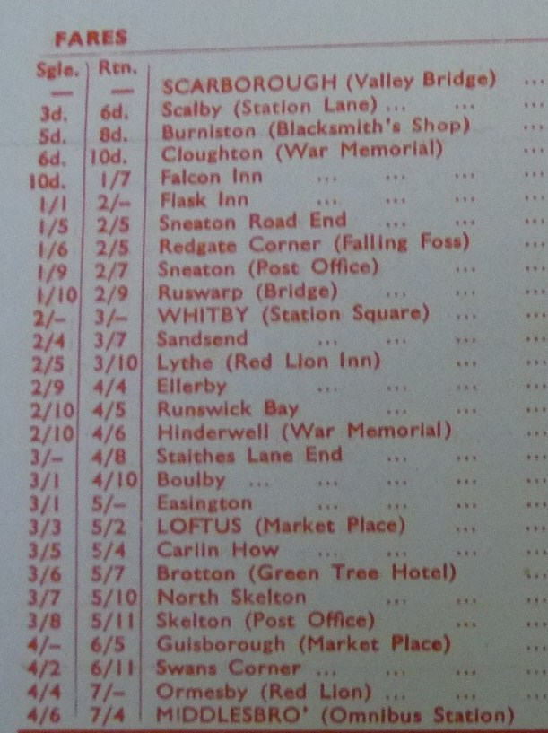
Table 11. Fares between Scarborough and Middlesbrough (65 service). United Omnibus Company. July – September 1938. (The Omnibus Society Library, Walsall).

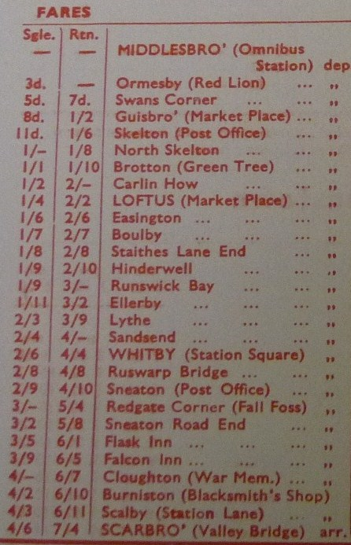
Table 12. Fares between Middlesbrough and Scarborough (65 service). United Omnibus Company. July – September 1938 (The Omnibus Society Library, Walsall).

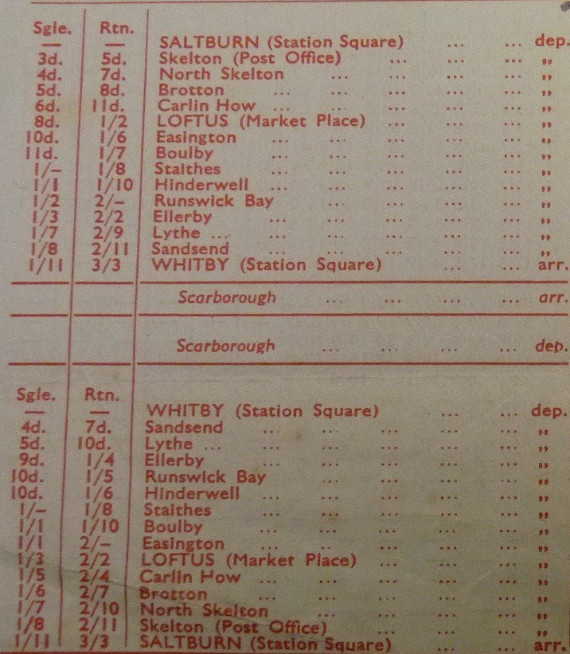
Table 13. Fares between Saltburn and Whitby and Whitby and Saltburn United Omnibus Company (85 service), July- September 1938 (The Omnibus Society Library, Walsall).

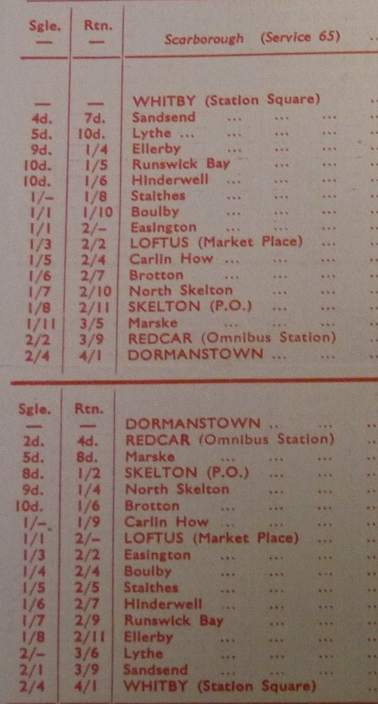
Table 14. Fares between Whitby and Dormanstown and Dormanstown and Whitby United Omnibus Company (79 service), July – September 1938 (The Omnibus Society Library, Walsall).

Aldcroft, writing of the inter-war years commented that ‘cheap fares were granted on all routes irrespective of the degree of competition and eventually nearly all passengers were travelling at reduced rates. The result was that the passenger mile fare on the railways was, on average, lower than that for road operation’. Unfortunately it is not, from the limited evidence for pricing available, possible to suggest that the Whitby-Loftus line’s prices were in line with Aldcroft’s overall assessment. If anything, the evidence seems to suggest that the prices were higher by rail.
However, the evidence shows that Aldcroft’s view that ‘there was a substantial reduction in the railway labour force from 735,870 in 1921 to 677,148 in 1928 and 588, 517 in 1939’ was, in the case of the Whitby-Loftus line, correct. The figures for the Whitby-Loftus line for station expenses (that is, salaries and wages) is as follows for the years 1921 and 1928 (no figures are available after 1929):

Station | 1921 | 1928
Loftus | 3371 | 2191
Grinkle | 817 | 512
Staithes | 991 | 593
Hinderwell | 1029 | 724
Kettleness | 628 | 438
Sandsend | 603 | 594
Whitby (West Cliff) | 2049 | 1098

Table 15. Station expenses (salaries and wages) for Whitby – Loftus line, 1921 and 1928.

Thus there is a saving over eight years on the line of £3148. Aldcroft continued ‘given the importance and rigidity of wage costs the reduction in manpower was probably the most important economy effected by the railways during this period’. However, given the overall financial performance of the line in these years, even this economy was too little.

The effects of changing the northern terminus of the line, in 1933, from Saltburn to Middlesbrough
Since the opening of the line in December 1883, the northern terminus of services had been Saltburn. Saltburn, apart from a few fishing cottages on the shore, did not exist before the 1860s; indeed, it is a railway town par excellence. However, the population has never been great. Thus the line, on its way to Scarborough, did not pass through any towns with a population greater than about three thousand (except Whitby). It was decided – no doubt because of the immense fall in passenger numbers – to change to northern terminus of the line to Middlesbrough whose population in 1933 was c.150, 000. That this change was successful, in terms of passenger numbers, may be deduced, not from numbers themselves, which are not available after 1937, but by a document issued by the North Eastern area of the L.N.E.R. The report began by stating that ‘the figures in respect of passengers conveyed in the summer of 1933 had exceeded all records up to that time’. The reader should be careful not to think that this statement referred to the Whitby-Loftus line; the traffic receipts for that year clearly contradict such a statement. It was the transference of the northern terminus to Middlesbrough which had caused such a growth. As such, the ‘Coast Line’ (at least in the summer season months) had been almost overwhelmed. The term ‘Coast Line’ had not appeared before and thus appears to be a marketing term. Again, the Whitby-Loftus section cannot be seen in isolation to the rest of the line to Middlesbrough and, indeed, it was (or so the report suggests) to enter into a period even busier than that of the early 1920s. This meant that the importance of the line was considerably increased; its value to urban mobility, that is, that of the conurbations of Tees-side, Darlington and West Hartlepool (from which the summer timetabled trains began), or at least urban/holiday mobility was much enhanced.
However, success brought problems in its wake. It cannot be denied that the change to Middlesbrough as the northern terminus was a spectacular success. In 1933, in the summer season between June and September 273,098 journeys were made and during the same period in 1934, 294,855 journeys were made. Of these, in 1933, 168,848 tickets were collected at intermediate stations (almost certainly the majority being at Whitby (West Cliff), while in 1934 during the season 178,054 tickets were collected at intermediate stations (again, with Whitby (West Cliff) being the most likely destination). Total receipts from the line for these summer months were equally as spectacular. Including holiday season tickets, total receipts for the June-September 1933 season were £12,112, and for the same period in 1934, £16,475. However, the operating improvement in 1934 was at some cost. In 1933 the line had been almost overwhelmed with traffic. Many trains ran late and there was a certain amount of chaos. It was the necessity to prevent further chaos in 1934, and, in doing so, to attract more people to the line, that the NE area report was made. That many improvements were authorised, at considerable expense, such as the construction of the new Platform 1a at Scarborough (a dead-ended platform solely for use by Coast Line trains) which made it possible to deal with the increased service in a much more satisfactory manner than before, indicates that the LNER considered that the line was worth such heavy investment and, indeed, right up to the end in 1958 summer traffic remained heavy, as will be shown in a later chapter. However, it must be emphasised that these improvements had very little effect, if any at all, upon the fortunes of the village stations on the Whitby-Loftus section of the line. This is consistent with the L. N. E. R’s policy, if it may be called as such, of giving priority to longer-distance traffic, for example, the closure of intermediate stations on the York-Scarborough line in 1930, thus speeding up the journey and allowing more trains to be run.
The improvements that the report suggested, and which were implemented, clearly were successful, in terms of the extra numbers of people attracted to the line and the improvements in punctuality. The report found that, in 1933, there was a serious problem with punctuality on the line. In July 1933, of the total of 356 trains on the line in that month, on average they ran 12.37 minutes late; in August the total of 331 trains ran on average 23.82 minutes late; in September 366 trains ran on average 7.68 minutes late. This meant that the main advantage that rail had over road, speed, was being eliminated. The report than made a number of suggestions to improve punctuality and the performance of the line generally. It was clear that the main problem was at Scarborough station, where the working of the Coast Line trains caused considerable problems to the efficient overall working at the station. The Coast Line trains had to make a reverse movement from the branch line into the station proper, thus often delaying other workings or causing even further delays to the service itself. The report proposed (and this was carried out before the 1934 season) that an additional terminal platform (1a) be made at Scarborough, close to the branch, and thus avoiding any crossing movements with other lines. The augmented service introduced in 1934 would have been impossible to operate without this improvement and, because it meant that the branch line was to all intents and purposes now self-contained, the improvement had a beneficial effect on station working generally. This alteration was so successful that the punctuality figures improved dramatically. That the improvement was on a major scale is also indicated by the vast number of extra trains over the line in 1934. The punctuality figures for all, trains terminating at Scarborough, Whitby, and Middlesbrough for July-September 1934 were as follows: July 1934, 608 trains were running on average 1.77 minutes late; August 1934, 571 trains running on average 3.48 minutes late, September 1934, 566 trains running on average 2.27 minutes late. Perhaps even more than the halcyon years of 1919-21, the years 1933-39 were the golden ones for the Coast Line in terms of numbers of passengers conveyed between the large Tees-side conurbation and the holiday resorts of Whitby and Scarborough. However, it must be emphasised that this prosperity did not affect the stations on the Whitby-Loftus section, whose decline is shown by the traffic returns of those years.
By 1934 the punctuality problems had been overcome, a vast augmentation of the timetable (in terms of the number of trains being run) had occurred, and the numbers of longer-distance passengers booking were very satisfactory indeed. This fits in with the wider picture nationally for these years, in that the longer distance trains were successful, while those slow trains which stopped at every station on a rural branch were losing passengers and income very quickly indeed. As has been noted, the United bus company put on huge numbers of buses on these holiday services, but it seems clear that the railway won this particular battle (once the 1933 upheavals had been sorted out) because of the advantages of speed and comfort. It is, though, unfortunate that it is not possible to make price comparisons. The rail timetables for the summer season of 1938 indicate how busy the line was, although it should be noted that these public timetables would not have included some relief trains. At the season’s height there were seventeen trains from Middlesbrough to Scarborough on weekdays and eleven trains on Sundays. In the opposite direction there were eighteen trains on weekdays and thirteen trains on Sundays. Leaving from Middlesbrough most trains departed between half past six and half past one, ten of which stopped at Hinderwell (a passing place) and three ran through non-stop. Returning from Scarborough, the majority of trains were in the evening, with ten trains stopping at Hinderwell between six and eleven o’clock. In addition there were three non-stop trains.
To revert for a moment to the example of Sandsend, which had been so deeply affected by the rise of the motor bus, at the height of the 1938 season 26 trains were stopping daily at Sandsend, with 18 on Sundays. The augmented Sunday service from 1934 was in line with the recommendations made by the NER report. However, this made little difference to the number of passengers booking there. In 1932 2264 passengers booked at the station, while in 1937 the number was 3325. As for tickets collected, in 1932 the number was 3504; this had risen to 5430 in 1937. Other recommendations which were taken up, and which were clearly successful, in that the main problem of late-running had been overcome, included withdrawing the 6.40 a.m. express parcels from Scarborough to Whitby, cancelling the 4.40 p.m. Whitby to Scarborough train, running a late train (11.15 p.m.) on two nights a week from Scarborough to Whitby and using the powerful A8 class 4-6-2 tank engines as much as possible. Even so, the loading of trains was not allowed to exceed five carriages.

Conclusion
How far, then, can the questions posed at the beginning of this chapter be answered, given the evidence available for the years 1897-1937? As far as the line’s contribution to rural mobility is concerned, it may be noted that although this began slowly when the line opened, passenger numbers grew more or less steadily until c.1920 when the stations along the line recorded their best ever figures for passenger bookings. Then came the catastrophic fall in passenger numbers, caused in the main by the incursion of regular omnibus services which ran far more conveniently than did the train. However, from 1933 the line contributed considerably to urban/leisure/discretionary mobility, once the northern terminus had changed to Middlesbrough, but takings from the stations along the line remained very depressed. Nevertheless the line had found a new raison d’être after 1933, as the exceptional passenger bookings indicate. The main problem, however, was that it was only during the relatively short summer season that such numbers (and so many trains) took to the line. From 1933, the success of the line in the summer months showed that the railway – at least for longer journeys – was still the major means of mass transport. It may be said then that up until the outbreak of war in September 1939 the line had, in varying ways, proved a considerable boon to rural (and later urban) mobility.

The Omnibus Society Library, Walsall. There are no reference numbers for these items.
Hoole, K., The Whitby, Redcar and Middlesbrough Union Railway (Nelson, 1981). The book is unpaginated.
Aldcroft, British Railways in Transition, p. 61.
Ibid, p. 78.
RAIL 398/293.
Aldcroft, British Railways in Transition, p. 78.
RAIL 390/1922. Report on the working of the Coast Line, Scarborough-Whitby-Middlesbrough. Summer 1934.
Ibid.
Ibid.
See also Butterfield, P., ‘Grouping, pooling, and competition. The passenger policy of the London and North Eastern Railway 1923-39’, JTH, III ser., 7, 1986, 2, pp. 21-45, at pp. 35-7. 35-7.
Ibid.
Traffic returns for the seven stations on the Whitby-Loftus line for the years 1935-7 may be found at RAIL 398/427.
RAIL 943/27.

