- The Drosophila prosaposin homologue
Aim: Investigate the phylogeny and expression pattern of the Drosophila prosaposin homologue as a measure of functional conservation with its human counterpart
- Confirm the identity of the Drosophila prosaposin homologue
- Assess its evolutionary relatedness to the human counterpart
- Investigate the expression pattern of the Drosophila prosaposin homologue
  - Introduction
Models of saposin deficiency are currently restricted to in vivo mouse systems and patient-derived cell lines. Although these approaches have provided solid grounding for understanding this group of sphingolipidoses (Chapter 1), each system has its disadvantages. The generation of mouse models can be very lengthy and expensive. In contrast, research using human disorder-derived cell lines can provide more rapid results but in an in vitro environment. Generation of a Drosophila saposin deficiency model would allow the benefits of using an in vivo system, with the additional advantages of the rapid life cycle, relative inexpensiveness of fly maintenance, and well-characterised and accessible nervous system.
This investigation involved the generation and characterisation of a Drosophila saposin deficiency model. To establish such a model, characterisation of the predicted Drosophila prosaposin homologue was required to ensure the correct locus had been identified. Following locus investigation, the expression pattern of the prosaposin homologue was determined.
  - Characterisation of the Drosophila Saposin-related locus
    - Confirmation of the Drosophila prosaposin homologue
The Drosophila Saposin-related (dSap-r) locus (CG12070) was previously identified as the prosaposin homologue (Pearce, 2004). A blastp search (NCBI, www.ncbi.nlm.nih.gov) was performed using the human prosaposin (hPSAP) protein sequence to probe the Drosophila protein database with the aim of confirming this result. Two Drosophila melanogaster isoforms were identified, which were products of alternative transcripts from the same gene: the dSap-r gene (dSap-r PA, blast E value 4e-36; dSap-rPB, blast E value 6e-28). The prosaposin gene product was also identified when the human protein database was searched using the Drosophila dSap-rPA sequence (blast E value 1e-34).
The dSap-r locus is located on the right arm of the third chromosome at cytogenetic band 100A7. As indicated above, there are 2 dSap-r isoforms, dSap-rPA (953 amino acids) and dSap-rPB (876 amino acids), which are the predicted products of the 2 putative transcripts dSap-rRA (3451 bp) and dSap-rRB (3349 bp). The dSap-rRB is an in-frame truncation of dSap-rRA (see Fig. 3.1). This information was generated based on expressed sequence tag (EST) data, which showed the presence of sequences from each of the transcripts illustrated in Figure 3.1 (www.flybase.org).

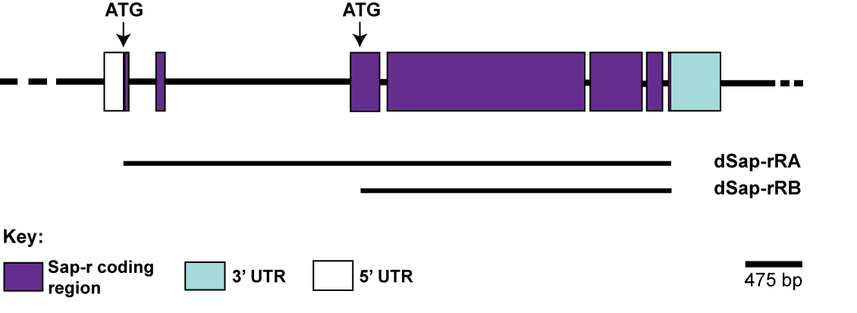
Fig. 3.1. The dSap-r gene locus. The Drosophila prosaposin homologue Saposin-related (dSap-r) consists of seven exons and is present on the right arm of the third chromosome (3R) at position 100A7. The dSap-r gene contains two potential transcript start sites (ATG), which result in the production of a transcript consisting of the entire coding sequence (dSap-rRA, 3451 bp) and an in-frame, truncated version (dSap-rRB, 3349 bp). The black lines representing dSap-rRA and dSap-rRB indicate the start and termination codons of each transcript. The 5’ untranslated region (UTR) is shown for the dSap-rRA transcript; the 3’ UTR is identical in both transcripts.

In addition to the two D. melanogaster isoforms, the Drosophila database blastp search also retrieved dSap-r homologues from the eleven other sequenced Drosophila genomes. These homologous sequences were aligned using ClustalX to reveal conserved regions of dSap-r (Fig. 3.2, see also sections 3.2.2 and 3.2.3).

D.melPA 1 MERAGLLAVLALCCAFGVFAAATP------LLGSSKCTWGPSYWCGNFS----------NSKECRATRHCIQ--TVWETQ
D.melPB 1 --------------------------------------------------------------------------------
D.simula 1 MERAGLLAVLALCCAFGAFAAATP------LLGSSKCTWGPSYWCGNFS----------NSKECRATRHCIQ--TVWETQ
D.sechel 1 MERAGLLAVLALCCAFGAFAAGTP------LLGSSKCTWGPSYWCGNFS----------NSKECRATRHCIQ--TVWETQ
D.yakuba 1 MERAGLLAVLALCCAFGVFAAATP------LLGSSKCTWGPSYWCGNFS----------NSKECRATRHCIQ--TVWETQ
D.erecta 1 MERAGLLAVLALCCAFGAFAAATP------LLGVSKCTWGPSYWCGNFS----------NSKECAATRHCIQ--TVWETQ
D.ananas 1 MQRMGLLAILALFCACGFVADATPVEGGGRLVGAKSCTWGPSYWCDNFS----------NSRECHATRHCIN--AVWTKQ
D.pseudo 1 MRRAGLLAILAV-CACGIASSSPVSGGAQQLVGASKCTWGPTYWCDNLS----------NSKECRATRHCIQ--TVWEKK
D.persim 1 MRRAGLLAILAV-CACGIASSSPVSGGAQQLVGASKCTWGPTYWCDNLSIFVFFVFYPLQQLEGMPGHPTLHPDRVGERK
D.willis 1 MIRAGLLAILAL-SVCGIIS-ATP-------LGSQKCTWGPSYWCDNLS----------NSKECRATRHCVQ--TVWVNR
D.mojave 1 MRNAGLLAILAV-FVFGVFVSSTPIAEQP-LLGATKCTWGPSYWCDNLS----------NSKECKATRHCIQ--TVWEKR
D.virili 1 MRNAGLLAILAV-FVCGVCVSSTPIAEQP-LLGASKCTWGPSYWCDNLS----------NAKDCRATRHCIQ--TVWEKR
D.grimsh 1 MRNAGLLAILAL-FVCAVGVSSTPVAEQVALLGSAKCTWGPSYWCENLS----------NSKDCRATRHCIQ--TVWEKR
*
*
*
*
*

D.melPA 63 KVPVDTDSICTICKDMVTQARDQLKSNQTEEELKEVFEGSCKLIPIKPIQKECIKVADDFLPELVEALASQMNPDQVCSV
D.melPB 1 ---------------MVTQARDQLKSNQTEEELKEVFEGSCKLIPIKPIQKECIKVADDFLPELVEALASQMNPDQVCSV
D.simula 63 KVPVDTDSICKICKDMVTQARDQLKSNETEEELKEVFEGSCKLIPIKPIQKECIKVADDFLPELVEALASQMNPDQVCSV
D.sechel 63 KVPVDTDSICKICKDMVTQARDQLKSNETEEELKEVFEGSCKLIPIKPIQKECIKVADDFLPELVEALASQMNPDQVCSV
D.yakuba 63 QVPVDTDSICKICKDMVTQARDQLKSNETEEELKEVFEGSCKLIPIKPIQKECIKVADDFLPELVEALASQMNPDQVCSV
D.erecta 63 NVPVDTDSICKICKDMVTQARDQLKSNETEEELKEVFEGSCKLIPIKPVQKECIKVADDFLPELVEALASQMNPDQVCSV
1
D.ananas 69 EVPVDTDSICKICKDMVTQARDQLKSNETEEELKEVFEGSCKLIPIKVITKECIKVADDFLPELVEALASQMNPDQVCSV
D.pseudo 68 VVPVDTDSICQICKDMVTQARDQLKSNETEEELKEVFEGSCKLIPIKPIQKECIKMADDFLPELVEALASQMNPDQVCSV
D.persim 80 VVPVDTDSICQICKDMVTQARDQLKSNETEEELKEVFEGSCKLIPIKPIQKECIKMADDFLPELVEALASQMNPDQVCSV
D.willis 60 EVPVDTGSICQICKDMVTQARDQLRSNETEEEIKEVFEGSCKLIPIKPVQKECIIVADNFIPELVEALSSEMNPDQVCSV
D.mojave 67 TVPVDTDSICQICKDMVTQARDQLRSNETEEEIKEVFEGSCKLIPIKLVQKECITLADNFIPELVEALSSQMNPDQVCSV
D.virili 67 VVPVDTDSICQICKDMVTQARDQLRSNETEEELKEVFEGSCKLIPVKLVQKECITLADNFIPELVEALSSQMNPDQVCSV
D.grimsh 68 IVPVDTDSICDICKKMVDEAREQLRSNQTEEELKEVLEGSCKLIPIKLIQKECITLADNFIPELVEALSSQMNPDQVCSV
1
*
*
*
D.melPA 143 AGLCNSARIDELYKNGIQAGLDG-TVQNEDDSSEE--------TELAMQPNQLSCGNCNLLSRLMHSKFAATDRDDMVET
D.melPB 66 AGLCNSARIDELYKNGIQAGLDG-TVQNEDDSSEE--------TELAMQPNQLSCGNCNLLSRLMHSKFAATDRDDMVET
D.simula 143 AGLCNSARIDEMFKNGIQAGLDG-TVQDEDDSSEE--------TELAMQPNQLSCGNCNLLSRLMHSKFAATDRDDMVET
D.sechel 143 AGLCNSARIDEMFKNGIQAGLDG-TVQDEDDSSEE--------TELAMQPNQLSCGNCNLLSRLMHSKFAATDRDDMVET
D.yakuba 143 AGLCNSARIDEMFRNGIQAGLDG-TAQEEDDSTEE--------TELVMQPNQLSCGNCNLLSRLMHSKFAATDRDDMVET
D.erecta 143 AGLCNSARIDEMLKNGFQAALDG-TVQDEDDSSEE--------TELAMQPNQLSCGNCNLLSRLMHSKFAATDRDDMVET
D.ananas 149 AGLCNSASIDEKLKKAYQDALEGKLAEDEEDSSEES-------TQVILKPNQLACGNCNQLSSLMHSKFAATDRDDMVEN
D.pseudo 148 AGLCNSASIDEKLKGAYQAALEG-KVQE-DSSEEE--------TSVILKPNQLSCGNCNLLSYMMHEKFEATNRDDMVEQ
D.persim 160 AGLCNSASIDEKLKGAYQAALEG-KVQEEDSSEEE--------TSVILKPNQLSCGNCNLLSYMMHEKFEATNRDDMVEQ
D.willis 140 AGLCNSAKIDELMKKSYQSVLDG--TLTDDDDVEEV-------TSVQLKPNLLSCGNCNLLSSMIHHKFETTNRDDMVEQ
D.mojave 147 AGLCNSARIDELLHNAYQAALDG-TLKEEEVVIDNN--DNKKEESKETGLTQLSCGNCNLLTRKMQSKFESTNRDDMVEQ
D.virili 147 AGLCNSARIDELMKQAYQGALDG-TLKEDEVVIKK---ESEQLEKKETGPTQLSCGNCNLLSRKMQSKFESTNRDNMVEQ
D.grimsh 148 AGLCNSARIDELRMHGFQATLNG-TLKEEDVDMESGVVAKKPEEKKEIDLKQLSCGNCNLLARLMQHKFASTNRDNMVEQ
*
*
*
*
*
*
2

D.melPA 214 MLHMCGSLSSFSDACANIVLTYFNDIYDHVSKHLTTDAVCHVSGVCASRYHQHEEEKQPQ--EALVALD-AGDDIPCELC
D.melPB 137 MLHMCGSLSSFSDACANIVLTYFNDIYDHVSKHLTTDAVCHVSGVCASRYHQHEEEKQPQ--EALVALD-AGDDIPCELC
D.simula 214 MLHMCGSLSSFSDACANIVLTYFNDIYDHVSKHLTTDAVCHVSGVCASKYHQHEEEKQPQ--EALVALD-AGDDIPCELC
D.sechel 214 MLHMCGSLSSFSDACANIVLTYFNDIYDHVSKHLTTDAVCHVSGVCASKYHQHEEEKQPQ--EALVALD-AGDDIPCELC
D.yakuba 214 MLHMCGSLSSFSDACANIVLTYFNDIYDHVSKHLTTDAVCHVSGVCASRYHQHEEDKQPQ--EALVALD-AGDDIPCELC
D.erecta 214 MLHMCRSLSSLSDACANIVLTYFNDIYDHVSKHLTTDAVCHVSGVCASRYHQHEEEKQPQ--EALVALD-AGDDIPCELC
D.ananas 222 LLHVCGYLSSFSDACANIVLTYFNDIYDHVSKHLSTDAVCHVSGVCASRYHQHEEEKQP---EALIALD-SGDDIPCELC
D.pseudo 218 LLHVCGSLSSFSDACANIVLSYFNEIYDHVRQHLNTDALCHVSGVCASRYHQHEEEKQAP--EALVALD-AGDDIPCALC
D.persim 231 LLHVCGSLSSFSDACANIVLSYFNEIYDHVRQHLNTDALCHVSGVCASRYHQHEEEKQAP--EALVALD-AGDDIPCALC
D.willis 211 LLHVCGSLSSFSDACANIVLTYFNDIYDHVKEHLSNKAVCHLSGVCAAKYHQHEDDEPEP--EPLVALD-AGDDIPCELC
D.mojave 224 LLHWCGTMSSFSDGCANLVLTYFNDIYENLQQHLQSDGLCHLSGVCAARYHQHEDDVKE--PEALTTLDGVGDDIPCALC
D.virili 223 LLHWCGTMSSFSDACANLVLTYFNDMYEHVQQHLQMDGLCHLSGVCAARYHQHEDDVKE--PEALTTLEGVGDDIPCALC
D.grimsh 227 LLHVCGTMSSFSDACASLVLTYFNDLYEHLEQHLQTNGLCHLSGVCAARYHQHEDDPKEEETEELATFDGVDDDIPCALC
3
*
*
*
*
D.melPA 291 EQLVKHLRDVLVANTTETEFKQVMEGFCKQSKGFKDECLSIVDQYYHVIYETLVSKLDANGACCMIGICQKNSASSMKD-
D.melPB 214 EQLVKHLRDVLVANTTETEFKQVMEGFCKQSKGFKDECLSIVDQYYHVIYETLVSKLDANGACCMIGICQKNSASSMKD-
D.simula 291 EQLVKHLRDVLVANTTETEFKQVMEAFCKQSKGFKDECLSIVDQYYHVIYETLVNKLDANGACCMIGICQKNSASSMKD-
D.sechel 291 EQLVKHLRDVLVANTTETEFKQVMEAFCKQSKGFKDECLSIVDQYYHVIYETLVNKLDANGACCMIGICQKNSASSMKD-
D.yakuba 291 EQLVKHLRDVLVANTTETEFKQVMDGFCKQSKGFKDECLSIVDQYYHVIYETLVNKLDANGACCMIGICQKNSASSIKD-
D.erecta 291 EQLVKHLRDVLVANTTETEFKQVMDGFCKQSKGFKDECLSIVDQYYHVIYETLVNKLDANGACCMIGICQKNSASSMKD-
D.ananas 298 EQLVKHLRDVLVANTTETEFKQVLEGFCKQSRGFKDECLGIVDQYYAVIYNTLVNKLDANGACSMIGICQK-GSSSMKD-
D.pseudo 295 EQLVKHLRDVLVANTTETEFKQVLEGFCKQSRGFKDECISIVDQYYDVIYNTLVNKLDANGACFLIGVCPKNAAGPHATP
D.persim 308 EQLVKHLRDVLVANTTETEFKQVLEGFCKQSRGFKDECISIVDQYYDVIYNTLVNKLDANGACFLIGVCPKNAAGPHATP
D.willis 288 EQLVKHLRDVLVANTTETEFKQVLEGFCKQSRGFKNECISIVDEYYHVIYSSLVNNLDANGACFLIGICPKNQKIFNDA-
D.mojave 302 EQLVKHLRDVLVANTTETEFKQVLEGFCKQSRGFKDECISIVDQYYHVIYSTLVNNLDANGTCFLIGVCPKGLDKTHDA-
D.virili 301 EQLVKHLRDVLVANTTETEFKQVLEGFCKQSRGFKDECISIVDQYYHVIYSTLVNNLDANGTCFLIGVCPKGLDLGYDA-
D.grimsh 307 EQLVKHLRDVLVANTTETEFKQVLEGFCKQSRGFKDECISIVDQYYHVIYSTLVNNLDANGTCFLIGVCPKGNSVIYDA-
*
*

D.melPA 369 -VPIMPLLPVIEPAQVKITIEKLEKHEKKQLGASEPKFSQQEILDMQLPIDHLMGAANPGALVEGGELCTLCEYMLHFIQ
D.melPB 292 -VPIMPLLPVIEPAQVKITIEKLEKHEKKQLGASEPKFSQQEILDMQLPIDHLMGAANPGALVEGGELCTLCEYMLHFIQ
D.simula 369 -IPIMPLLPVIEPAQVKITIEKLEKHEKKQLGASEPKFSQKEILDMQLPIDHLMGAANPGALVEGGELCTLCEYMLHFIQ
D.sechel 369 -IPIMPLLPVIEPAQVKITIEKLEKHDKKQLGASEPKFSQKEILDMQLPIDHLMGAANPGALVEGGELCTLCEYMLHFIQ
D.yakuba 369 -IPIMPLLPVIEPAQVQITIEKLEKHEKKQLGASEPKFSQQEILDMQLPIDHLMGAANPGALVEGGELCTLCEYMLHFIQ
D.erecta 369 -VPIMPLLPVVEPAQVKITIEKLEKHEKKQLGASEPKFSQQEILDMQLPIDHLMGAANPGALVEGGELCTLCEYMLHFIQ
D.ananas 375 -APIMPLLPVIEPAQVKVTIEKLEKHEKKQLGAGEPKFSQQEILDMQLPIDHLMGAANPQDLVEGGELCTICEYTLHFIQ
D.pseudo 375 VAPIMPLLPAIEPAQVQVTITKLQK-----LGAHEPKFTQDQLIGMQLPIDHLMGAANPSLLVEGGELCTICEYLLHFIQ
D.persim 388 VAPIMPLLPAIEPAQVQVTITKLQK-----LGAHEPKFTQDQLIGMQLPIDHLMGAANPSLLVEGGELCTICEYLLHFIQ
D.willis 366 -APIMPLLPVVEPAHVQVTIK--------KLGANEPKFTQDQILNMQLPIDHLMGAANPSQLVEGGELCTICEYLLHFIQ
D.mojave 380 --PIMPLLPAIAPAEVHVTIKK--------LGANEPKFSHQQIMDMQLPIDHLMGAANPGLLVQGGELCTICEYLLHFIQ
D.virili 379 --PIMPLLPAIAPAEVHVTIKK--------LGANEPKFSQKQIMEMQLPIDHLMGAANPGQLVKGGELCTICEYLLHFIQ
D.grimsh 385 --PIVPLVPVVAPAEVQISIKR--------LGANEPKFTQQQIMDMQLPFDSLMGAANRLQLVNEGSLCTVCEYLLHFIQ
4
*
*
*
*
D.melPA 449 ETLATPSTDDEIKHTVENICAKLPSGVAGQCRNFVEMYGDAVIALLVQGLNPRDVCPLMQMCPKNLPKKEDVEVFNPQPA
D.melPB 372 ETLATPSTDDEIKHTVENICAKLPSGVAGQCRNFVEMYGDAVIALLVQGLNPRDVCPLMQMCPKNLPKKEDVEVFNPQPA
D.simula 449 ETLATPSTDDEIKHTVENICAKLPSGVAGQCRNFVEMYGDAVIALLVQGLNPRDVCPLMQMCPKNLPKKDDVEVF-IQPA
D.sechel 449 ETLATPSTDDEIKHTVENICAKLPSGVAGQCRNFVEMYGDAVIALLVQGLNPRDVCPLMQMCPKNLPKKDDVEVF-IQPA
D.yakuba 449 ETLATPSTDDEIKHTVENICTKLPSGVAGQCRNFVEMYGDAVIALLVQGLNPRDVCPLMQMCPKNLPKKDDVEVFNPLPS
D.erecta 449 ETLATPSTDDEIKHTVENICTKLPSGVAGQCRNFVEMYGDAVIALLVQGLNPRDVCPLMQMCPKNLPKKDDVEVFNPLPF
D.ananas 455 ETLATPATDDEIKHAVESVCGKLPNGVAGQCRNFVEMYGDAVISLLIQGLNPRDMCPKMQLCPKNIEKKEDIEVFHPVPI
D.pseudo 450 ETLATPATDDEIKHTVENMCTKFPKGVAGQCRNFVEMYGDAVIALLVQGLNPREVCPKLQMCPHNVDNKEDIEVFHPVPV
D.persim 463 ETLATPATDDEIKHTVENMCTKFPKGVAGQCRNFVEMYGDAVIALLVQGLNPREVCPKLQMCPHNVDNKQDIEVFHPVPV
D.willis 438 ESLATPATDDQIKHTVENVCGKLPQGVAGQCRNFVEMYGDAVIALLIQGLNPRSVCPMMQMCPRNIEKAEDIEVFHPAPL
D.mojave 451 ETLATPATDDEIKHTVENICTKLPQGVAAQCRNFVEMYGDAVIALLIQGLNPRSVCPMMQMCPRNIENHDDIEVFNPSPV
D.virili 450 ETLATPATDDEIKRTVEGICTKLPQGVATQCRNFVEMYGDAVIALLIQGLNPRSVCPMMQMCPRNIEKQEDIEVFHPETV
D.grimsh 456 ETLATPATDDEIKHTVENICTKMPHGVAAQCRNFVEMYGDAVIALLIQGLNPRSVCPMMQMCPRNLELSEDIEVFQPETT
*
*
*
*

D.melPA 529 S------DEQDPPTCPLCLFAVEQAQMKIRDNKSKDNIKKVLNGLCSHLPNEIKEECVDFVNTYSNELIDMLITDFKPQE
D.melPB 452 S------DEQDPPTCPLCLFAVEQAQMKIRDNKSKDNIKKVLNGLCSHLPNEIKEECVDFVNTYSNELIDMLITDFKPQE
D.simula 528 S------DEQDHPTCPLCLFAVEQAQMKIRDNKSKDNIKKVLNGLCSHLPNEIKEECVDFVNTYSNELIDMLITDFKPQE
D.sechel 528 S------DEQDHPTCPLCLFAVEQAQMKIRDNKSKDNIKKVLNGLCSHLPNEIKEECVDFVNTYSNELIDMLITDFKPQE
D.yakuba 529 S------DEQDSPTCSLCLFAVEQAQMKIRDNKSKDNIKKVLNGLCSHLPKDLKDECVDFVNTYSNELVDMLITDFKPQE
D.erecta 529 S------DEQDSPTCSLCLFAVEQAQMKIRDNKSKDNIKKVLSGLCTHLPNELKDECVDFVNTYSNELVDMLITDFKPQE
D.ananas 535 T------DEQDKPTCPLCLFAVEQAQIKIRDNKSKDNIRKCLDGLCSHLPNKLKDECVDFVNTYSNELIDMLITDFKPQE
D.pseudo 530 TSG----DQQDQPTCPLCLFAVEQAQIKIRDNKSKDNIKKVLAGLCVHLPSKLRSECVDFVNTYSNELIDLLITDFKPQE
D.persim 543 TSG----DQQDQPTCPLCLFAVEQAQIKIRDNKSKDNIKKVLAGLCVHLPSKLRSECVDFVNTYSNELIDLLITDFKPQE
D.willis 518 PS-----DQQDQPTCPLCLFAVEQAQIKIRDNKSKENIKKVLDGLCSHLPTKLKSECVDFIDTYTNELIDMLITDFKPQE
D.mojave 531 S------DQQDKPTCPLCLFAVEQAQIKIRDNKSKDNIRKVLDGLCTHLPNKLRDECVDFVETYSNELIDMLITDFKPEE
D.virili 530 SS-----DQQDKPTCPLCLFAVEQAQIKIRDNKSKENIKKVLDGLCSHLPSKLRSECVDFVETYSNELIDMLITDFKPEE
D.grimsh 536 VHNSSPNDEQDKPTCPLCLFAVEQAQIKIRDNKSKDNIKRVLDDLCSHLPNKLRSECVDFVDTYSNELIDMLITDFKPEE
5
*
*
*
*
D.melPA 603 ICVQLKLCPKTTYALWDLRISLEDDVDGEDKSSS--EEISFNDIESLEELPPQLAFDPGFTAAPNCLICEELVKTLEKRM
D.melPB 526 ICVQLKLCPKTTYALWDLRISLEDDVDGEDKSSS--EEISFNDIESLEELPPQLAFDPGFTAAPNCLICEELVKTLEKRM
D.simula 602 ICVQLKLCPKTTNALSDLGISLEDDVDGEDKSSS--EEISFNGIESLEELPPQLAFDSGFTAAPNCLICEELVKTLEKRM
D.sechel 602 ICVQLKLCPKTTNALSDLGISLEDDVDGEDKSSS--EEISFNDIESLEELPPQLAFDSGFTAAPNCLICEELVKTLEKRM
D.yakuba 603 ICVQLKLCMKKTDALSDLAISLGDDVDGEDKSSS--EEISFNDIE----VRPQFAFDPEFSSAPNCLICEELVKTLEKRM
D.erecta 603 ICVQLKLCTKTTDALSDLAISLYDDVDGEDKSSS--EEISFNDIESLEELPPQLAYDPGFSAAPNCLICEELVKTLEKRM
D.ananas 609 ICVQLKLCPKSKDTLADLGISLEDD----DKSSS--EE-STNDIESLEELPLQFDFDEAFNAAPNCLICEELVKEVEKKM
D.pseudo 606 ICVQLKLCPKTKNYLDDMGISMEDD----ESSSS--EEMFFNEVASLEQLPIEVVFERDYNGAPNCLICEELVKTVEKKM
D.persim 619 ICVQLKLCPKTKNYLDDMGISMEDD----ESSSS--EELFFNEVASLEQLPIEVVFERDYNGAPNCLICEELVKTVEKKM
D.willis 593 ICVQLKLCPKSKNRLSDFGISLEEE----DKSSS--EEISFNEIGSSDEFPIEVSFKKDVSGAPNCLLCKELIKELEKKL
D.mojave 605 ICVQLKLCPKTKDYLDEMSISLIDSAETDKSSSSNSEELEANEIDSSKEMPVQIAFDKDFGVAPNCLLCEEVVKTVEKRI
D.virili 605 ICVQLKLCPKSKDYLDEMGISLLDSAENDKSDSS-SEDFAANEINSSDELPIQITFDKDFSLGPNCLICEEVVKTVEKKI
D.grimsh 616 ICVQLKLCPKTKNYLDDLGLSLSESSDENE------------IFGSNEELPIELSFDKDFSLSPNCLLCEEVVKQVEKRI
*
*
*
*
6

D.melPA 681 GKHPTRDSIKHILEESCDRMRKPMNTKCHKVIDKYGDKIADLLLKEMDPKLICTELGMCILA--DLDDLEVDEALKYDVI
D.melPB 604 GKHPTRDSIKHILEESCDRMRKPMNTKCHKVIDKYGDKIADLLLKEMDPKLICTELGMCILA--DLDDLEVDEALKYDVI
D.simula 680 GKHPTRDSIKHILEESCDRMRKPVNAKCHKVIDKYGDKIADLLLKEMDPKLICTELGMCVLA--DLYDLEVDEALKYDVI
D.sechel 680 GKHPTRDSIKHILEESCDRMRKPVNAKCHKVIDKYGDKIADLLLKEMDPKLICTELGMCILA--DLYDLEVDEALKYDVI
D.yakuba 677 GKHPTRDSIKQILEESCDRMRKPLNGKCHKVIDKYGDKIADLLLKEMDPKLICAELGMCVLA--DLDDLEVDEALKYDVI
D.erecta 681 GKHPTRDSIKHILEESCDRMRKPMNGKCHKVIDKYGDKIADLLLKEMDPKLICAELGMCVL-----DDLEVDEALKYVVV
D.ananas 682 GKHPTRDSIKQVLEQSCDKFKKPVAGKCHKIIDKYGDTIADLLLKEMNPKLICTELGLCLLAH-DLDDLEVDEALKYDVI
D.pseudo 680 GKHPTKDSIKQALEQSCDKLKKPVASKCHKLIDKFGDQIADLLLKEMDPKLICAELGLCLFS--ELDDLEIDEALKYDVI
D.persim 693 GKHPTKDSIKQALEQSCDKLKKPVASKCHKLIDKFGDQIADLLLKEMDPKLICAELGLCLFS--ELDDLEIDEALKYDVI
D.willis 667 GPKPNKADIEKELSQVCDKLKKAASHQCHKIVDKYGDKIADLLIAAEDPKYICLELGFCLLN--DEEDLEVDEALKYDVI
D.mojave 685 GKHTTKSEIKDALEHSCDKFKKPLATKCHKFIDKHGDQIADLLLREMEPKIICTEIGMCLGG--EQEDLEIDEALKYDVI
D.virili 684 GKHATKSDIKNALEHSCDKLKKPLANKCHVFIDKHGDQIADLLLKEMDPKLICLELGICLGG--EQEDLDIDEALKYDVI
D.grimsh 684 GKHATKAEIKDALAHSCDKLRKPLAHKCHMFIDKHGDQIADLFLKQMSPKLICAELGACIIGGGEQEDLDIDEALKYDVV
*
*
*
*
D.melPA 759 ALP--RQDNKLSSS-----IKEPPTCVLCEFIMTKLDADLKNKTEQDDIKRAIEAVCNRLPATVRKQCDTFVDGYASAVL
D.melPB 682 ALP--RQDNKLSSS-----IKEPPTCVLCEFIMTKLDADLKNKTEQDDIKRAIEAVCNRLPATVRKQCDTFVDGYASAVL
D.simula 758 ALP--HQDNKLSS------IKEPPTCVLCEFIMTKLDADLKNKTEQDDIKRAIEAVCNRLPATVRKQCDAFVDGYASAVL
D.sechel 758 ALP--HQDNKLSS------IKEPPTCVLCEFIMTKLDADLKNKTEQDDIKRAIEAVCNRLPATVRKQCDAFVDGYASAVL
D.yakuba 755 ALP--HQDNKLST------IRDPPSCALCEFIMTKLDSDLKNKTEQDAIKRAIESVCNHLPATVRKQCDTFVDGYASAVL
D.erecta 756 ALP--QQDNKLSS------IKEPPSCALCEFIMTKLDADLKNKTEQDAIKQAIEAVCKHLPATVRKQCDSFVDGYAAAVL
D.ananas 761 ALP--QQSDKLARLETSS-PKEPPTCVLCEFVMTKLENDLKNKTEQDDIKRAILAVCNKMPATIRKQCDSFVEGYATAVI
D.pseudo 758 ALP--HPADQLARLEESPKPKEPPTCVLCEFVMTKLEADLKNKTEQDDIKRAILAVCDHLPATVRKPCDTFVEGYAAAVI
D.persim 771 ALP--HPADQLARLEESPKPKEPPTCVLCEFVMTKLEADLKNKTEQDDIKRAILAVCDHLPATVRKPCDTFVEGYAAAVI
D.willis 745 ALP--HETS---------TIKDTPSCVLCEFVMTKVESELKNKSDQEEIKSVLLQICDHLPNTVRKQCDSFVNGYAAAVI
D.mojave 763 VMPKQQAD-KLARLES-AKVDEPPTCVLCEFIMTKLEADLRNQTEQDEIKKAIRAVCGRLPTTIRKQCDTFIDGYASAII
D.virili 762 VLPKRQDE-KLARLES-TKVDEPPTCVLCEFIMTKLETELQNKTEQDEIKRAIRVVCDRLPSTIRKQCDSFVDGYATAII
D.grimsh 764 VLANPQDDDKLARLESSSSVEEPPTCVLCEFVMTKLEADLQNKTEQDEIKKAIRNVCNHLPATIRKQCDTFVDSYATAII
*
*
*
*
*
*
7

D.melPA 832 KLLSDVPPKQVCQKLQLCFSVAVTDEVLECGVCHGVTQALLPFLREKKDNVSEVTALQMTSVGCENLPAKYYKICSEMIS
D.melPB 755 KLLSDVPPKQVCQKLQLCFSVAVTDEVLECGVCHGVTQALLPFLREKKDNVSEVTALQMTSVGCENLPAKYYKICSEMIS
D.simula 830 KLLSDVPPKQVCQKLQLCFSVAVTDEVVECGVCHGVTQALLPFLREKKDDESEVTALQMTSVGCENLPAKYYKICSEMIS
D.sechel 830 KLLSDVPPKQVCQKLQLCFSVAVTDEVVECGVCHGVTQALLPFLREKKEDESEVTALQMTSVGCENLPAKYYKICSEMIS
D.yakuba 827 KLLSDVPPKEVCQKLQLCFSVAVTDEVVECGVCHGVTQALLPFLQEKKDDETEVTALQMTSVGCENLPAKYYKICSEMIS
D.erecta 828 KLLSDVPPKEVCQKLQLCFSVAVTDEVVECGVCHGVTQALLPFLREKKDDDTEVTALQMTSVGCENLPAKYYKICSEMIS
D.ananas 838 DLLSKVPPKEVCQKLQLCFSMAVTDEVVECGVCHGATQVLLPFLREQKE---TVTTQQMTSVGCENLPAKYYKICSEMIS
D.pseudo 836 DLLSKVPPKEVCQKLQLCFSQVVTDEVIECGVCHGATQVLLPFLSARSKD-TDVTTVEMTSVACENLPAKYYSICSKMIS
D.persim 849 DLLSKVPPKEVCQKLQLCFSQVVTDEVIECGVCHGATQVLLPFLSARSKD-TDVTTVEMTSVACENLPAKYYSICSKMIS
D.willis 814 DLLSKVPPKEVCQKLMLCMNQAVTDEVIECGVCHGASQALLSHIRSQKDKNVELTTLDMTEVACGDLPAKYYSICSEMIS
D.mojave 841 SLLSKVPPKEVCQKLQLCFSQVVTDEVVECGVCHGVAQSLFPFFRAEKDH-DKFTIRDMISQACEDLPAKYYSICSRMIT
D.virili 840 SLLSKVPPKEVCQKLQLCFSQAVNDEVIECGVCHGVSQSLLPFFRSQKDY-DKLGVQDMISEACENLPAKYYNICSEMIS
D.grimsh 844 SLLSKVPPKEVCQKMQLCFSSVVSDEVIECGVCHGISQALLPFFRSQKQH-DQLTSQDMIGHACENLPAKYYNICSEMIS
8

*
*
D.melPA 912 IYGSSIKNLAKRPYIDQSHICAEIGKCFESEKSSLAFARISA------------------------------------
D.melPB 835 IYGSSIKNLAKRPYIDQSHICAEIGKCFESEKSSLAFARISA------------------------------------
D.simula 910 IYGNSIKNLAKRSYIDQSHICAEIGKCFDSEKSSLAFARISA------------------------------------
D.sechel 910 IYGNSIKNLAKRPYIDQSHICAEIGKCFDSEKSSLAFARISA------------------------------------
D.yakuba 907 IYGNSIKNLAKRPYIDQSHICAEIGKCFDSEKSSLAFARISA------------------------------------
D.erecta 908 IYGNSIKNLAKRPYVDQSHICAEIGKCFDSEKSSLAFARISA------------------------------------
D.ananas 915 IYGKSINNLASRPYVDQSHICAEIGKCFESEKSALAYARLTGKPETQAIIYIVY------------------------
D.pseudo 915 IYGNSFKHLSERPYVDQSHVCAEIGKCFDSEKSSLAFARISA------------------------------------
D.persim 928 IYGNSFKHLSERPYVDQSHVCAEIGKCFDSEKSSLAFARISADPVIRDNRIVMMCGVKEKEKEEGDTVPRFIYTYIFT
D.willis 894 IYGISIKHLADKPYMDQSHVCSEIGKCFDNEKSSLAFARITA------------------------------------
D.mojave 920 IYGYSIMHLSERPYVDPSHVCAEIGKCFDNEKSALAFAKISGIWEDLEEIY---------------------------
D.virili 919 IYGFSIMHLSERPYIDQSHVCSEIGKCFDSEKSALAFARISGV-----------------------------------
D.grimsh 923 IYGISIMHLAERPYIDQSHVCSEIGKCFDSEKSALAFARISA------------------------------------

Fig. 3.2. dSap-r homologues from Drosophila species show high conservation in the saposin regions. A multiple sequence alignment of the dSap-r homologues from all twelve sequenced Drosophila genomes was produced using ClustalX. Sequences were retrieved by performing a blastp search of all Drosophila species in the NCBI database. Blue highlights identical sequences; yellow highlights similar sequences (80% threshold setting); black lines demarcate the predicted saposin regions above; dashed black line indicates the predicted signal peptide; arrow marks position of dSap-rPB predicted start site; asterisks mark conserved cysteine residues in each saposin; black boxes mark conserved potential glycosylation sites; dashed black box marks non-conserved potential glycosylation sites. D.melPA; Drosophila (D.) melanogaster
Sap-rRA, D.melPB; D. melanogaster Sap-rPB, D.simula; D. simulans, D.sechel; D. sechellia, D.ananas, D. ananassae, D.pseudo;
D. pseudoobscura, D.persim; D. persimilis, D.willis; D. willistoni, D.mojave; D. mojavensis, D.virili; D. virilis, D.grimsh; D. grimshawi.

    - Are both dSap-r transcripts valid?
To investigate the validity of the dSap-r transcripts, the larger dSap-rPA sequence was used to search invertebrate protein databases for potential dSap-r homologues in closely related species. This approach allowed the conservation of these predicted start methionine residues to be determined. The retrieved dSap-r homologues were aligned using ClustalX (section 2.1.1). Figure 3.3 shows both start methionine residues are well conserved, with a 35 - 39% identity of residues upstream of the dSap-rPB start methionine. This is reinforced by the alignment in Figure 3.2 (46 – 59% identity). These data suggest that the dSap-rRA transcript is valid, but they do not disprove the validity of dSap-rRB. The start methionine for dSap-rPA is part of a stretch of well-conserved hydrophobic residues (Fig. 3.2) predicted using the SignalP 3.0 Server to be the signal peptide. The start methionine for dSap-rPB does not contain a predicted signal peptide and was therefore predicted by SignalP to be a non-secretory protein. Lysosomal proteins are targeted to their final destination via the secretory pathway; these proteins require a signal peptide for targeting to the ER, the entry point into the secretory pathway. Therefore, the predicted absence of a signal peptide in dSap-rPB may suggest that the dSap-rRB transcript is not valid.

*
*
A.aeg 1 MKNLLLALAGLLLVTTSTWASPVETGGRRLVGAKECTWGPTYWCSNLKNAKNCGAVTHCIQTVWEKQKYPVDNDEICNIC
A.gam 1 ----MLAIN----PVQSSPVKQTINGNKSLLGAKECTWGPSYWCSNIENAKTCAAVSHCIQTVWEKQHYPVDNDEICNIC
D.mel 1 MERAGLLAVLALCCA-----FGVFAAATPLLGSSKCTWGPSYWCGNFSNSKECRATRHCIQTVWETQKVPVDTDSICTIC
D.pse 1 MRRAGLLAILAVCACGIASSSPVSGGAQQLVGASKCTWGPTYWCDNLSNSKECRATRHCIQTVWEKKVVPVDTDSICQIC
D.wil 1 MIRAGLLAILALSVCG------IISATP--LGSQKCTWGPSYWCDNLSNSKECRATRHCVQTVWVNREVPVDTGSICQIC
D.gri 1 MRNAGLLAILALFVCAVGVSSTPVAEQVALLGSAKCTWGPSYWCENLSNSKDCRATRHCIQTVWEKRIVPVDTDSICDIC
A.mel 1 MNILIALCAILAVCKAGVVIQAEGPADLHLLGEQECTWGPSYWCENIKTASGCNATKHCIDKVWKHMKVPNDDDSVCTIC
T.cas 1 MKILILVSLVAFFAFTSGVFVPPRPGHKRLVDSKECTWGPSYWCQNLTAASDCRAVRHCIQTVWVHKQLPPDGSSICQTC
1

*
*
*
*

A.aeg 81 LDMVKQARDQLESNETQADLKAVFEGSCNLIPIKVVRKECKKMADDFIPELVEALASQMNPNVVCSVAGLCNNAAIDKML
A.gam 73 LDMVKQARDQLESNETQADLKAVFEGSCNLIPIKLVKKECRKLADDFIPELVEALASQMNPNAVCSVAGLCNNAAIDKLL
D.mel 76 KDMVTQARDQLKSNQTEEELKEVFEGSCKLIPIKPIQKECIKVADDFLPELVEALASQMNPDQVCSVAGLCNSARIDELY
D.pse 81 KDMVTQARDQLKSNETEEELKEVFEGSCKLIPIKPIQKECIKMADDFLPELVEALASQMNPDQVCSVAGLCNSASIDEKL
D.wil 73 KDMVTQARDQLRSNETEEEIKEVFEGSCKLIPIKPVQKECIIVADNFIPELVEALSSEMNPDQVCSVAGLCNSAKIDELM
D.gri 81 KKMVDEAREQLRSNQTEEELKEVLEGSCKLIPIKLIQKECITLADNFIPELVEALSSQMNPDQVCSVAGLCNSARIDELR
A.mel 81 KDMVQQAHDQLESNQTQEDIKNVFEGSCKLIHIKPIVKECITIVDQFIPELIETLASQMNPSIVCSVAGLCNSAHIDELI
T.cas 81 LDMVKQARDQLESNETQELIKEVFEGSCHLLHFKEIVKECDKIADQYIPELIDTLASEMNPQVVCSVAGLCNSEKVQKLI
*
*
*

A.aeg 161 EEMPAVKP-KDQDDVDESSSESEETRDE----------FSCEKCNKIAGLITNRFHATDRDQVLEGFLRFCGQMGSFSDG
A.gam 153 SEMIVLNPEQEVQGIEANEREPAVTGDT----------FNCDECHTISNLIQKRFRSTDRDSVLESILQICGKMSSYSDA
D.mel 156 KNGIQAGLDGTVQNEDDSSEETELAMQP--------NQLSCGNCNLLSRLMHSKFAATDRDDMVETMLHMCGSLSSFSDA
D.pse 161 KGAYQAALEGKVQ-EDSSEEETSVILKP--------NQLSCGNCNLLSYMMHEKFEATNRDDMVEQLLHVCGSLSSFSDA
D.wil 153 KKSYQSVLDGTLTDDDDVEEVTSVQLKP--------NLLSCGNCNLLSSMIHHKFETTNRDDMVEQLLHVCGSLSSFSDA
D.gri 161 MHGFQATLNGTLKEEDVDMESGVVAKKPEEKKEIDLKQLSCGNCNLLARLMQHKFASTNRDNMVEQLLHVCGTMSSFSDA
A.mel 161 VKYESSKPEIKELKSRSLEKDEVEPD-------------ECSKCFTVAAHMEHKLNNTPRDKILQQMLNLCAEFNSYSDA
T.cas 161 AEE-------KGLKPQNVG--------------------TCEGCQTVVGIMEEKFNKMSRDDVLQSFLQICGRTGSLSDG
2

*
*
*
*
*
A.aeg 230 CSSIALTYFNEIYEHMTKQFNAKNVCHMSGACASQYHQHEESQE---IEIRPMG--GNEQLVG---DDIPCKLCEQLVDH
A.gam 223 CSNIVLTYFGVMYEHLERNLKVEGVCHLSGVCAAQFHLHENNKRKDLIEARSMGDVGRLRVAG---DDVPCKLCEQLVDH
D.mel 228 CANIVLTYFNDIYDHVSKHLTTDAVCHVSGVCASRYHQHEEE-------KQPQEALVALD-AG---DDIPCELCEQLVKH
D.pse 232 CANIVLSYFNEIYDHVRQHLNTDALCHVSGVCASRYHQHEEE-------KQAPEALVALD-AG---DDIPCALCEQLVKH
D.wil 225 CANIVLTYFNDIYDHVKEHLSNKAVCHLSGVCAAKYHQHEDD-------EPEPEPLVALD-AG---DDIPCELCEQLVKH
D.gri 241 CASLVLTYFNDLYEHLEQHLQTNGLCHLSGVCAARYHQHEDDPK-----EEETEELATFDGVD---DDIPCALCEQLVKH
A.mel 228 CSATILTYFDTLYTHLQENFNAQNICHLSGQCSNKFHKHEDIDT--VIEIRPLSSVGMVDVN----DDLPCKLCEQLVGH
T.cas 214 CSNIVITYFNEIYNHLKDNFNPTDFCLMTGECSSKFHTHAN------VEITPMSHIGYVQVGGKQKDDLPCEFCEQLVTH
3

*
*
*
*

A.aeg 302 LRDLLIANTTELEFKQVLEGLCKQTKAFSQECLNIVDQYYEEIYSTLVHNLNSNSACFMIGVCPKGLNK---ALDGPIMP
A.gam 300 LRDVLIANTTELEFKEVLEGLCNQTKSFADECHSLVEQYYREIYETLVNNLNSNDACFIIGICPKEDGV---VSNGTVMP
D.mel 297 LRDVLVANTTETEFKQVMEGFCKQSKGFKDECLSIVDQYYHVIYETLVSKLDANGACCMIGICQKNSAS--SMKDVPIMP
D.pse 301 LRDVLVANTTETEFKQVLEGFCKQSRGFKDECISIVDQYYDVIYNTLVNKLDANGACFLIGVCPKNAAGPHATPVAPIMP
D.wil 294 LRDVLVANTTETEFKQVLEGFCKQSRGFKNECISIVDEYYHVIYSSLVNNLDANGACFLIGICPKNQKI--FNDAAPIMP
D.gri 313 LRDVLVANTTETEFKQVLEGFCKQSRGFKDECISIVDQYYHVIYSTLVNNLDANGTCFLIGVCPKGNSV---IYDAPIVP
A.mel 302 LKDLLVANTTETEFEEVLKGLCKQTNSFSTECIAIVDEYYPQIYEYLKKGLNCNIICKIMGICPTPGKT---VQNEPIWP
T.cas 288 LRDLLIANTTEHEFKRVLEGLCKQTKSFKAQCLSLVDEYYGAIYTFLVSELNANEVCVFAGICPR-NNT---QGVPPIMP
*
*

A.aeg 379 IVPVRVAIIHEQNAAKRMPP-KKLLGENEPKLSAVEIQQAQLPIDRLMGAPLSMNLVENG--KFCTLCEYFMHFVQEALS
A.gam 377 LLSVAVADRHERTEMYQRMN-RPLLGHNELILSASEVQQAQLPIDRIMSAPSGLNLIENG--KFCTLCEYFMHFVQEALS
D.mel 375 LLPVIEPAQVKITIEKLEKHEKKQLGASEPKFSQQEILDMQLPIDHLMGAANPGALVEGG--ELCTLCEYMLHFIQETLA
D.pse 381 LLPAIEPAQVQVTITKLQK-----LGAHEPKFTQDQLIGMQLPIDHLMGAANPSLLVEGG--ELCTICEYLLHFIQETLA
D.wil 372 LLPVVEPAHVQVTIK--------KLGANEPKFTQDQILNMQLPIDHLMGAANPSQLVEGG--ELCTICEYLLHFIQESLA
D.gri 390 LVPVVAPAEVQISIKR--------LGANEPKFTQQQIMDMQLPFDSLMGAANRLQLVNEG--SLCTVCEYLLHFIQETLA
A.mel 379 LVPRDAGEIGMRVFQNANE----NLKNDNEELNKSQAETMQLPIERLVPFPMLGESLGTQGKETCALCEYILHFIQEAIT
T.cas 364 LLPVETLEITPAPVIRVN-----IAKDGSSVKVMARPEEIQLPIERMMP-PHAQEMYNSQ---TCVFCEYFLHYLQQAIT
4

*
*
*
*
A.aeg 456 EPANEDEIKNVVGTTCEKLPKAIRGECHNFVDLYGDAVIALLIQSMDPREICPQLHMCP---AAQEDIEIFAPAQIDVTI
A.gam 454 EPANEDEIKKVIEVTCNRLPSSIRGECHNFVDVYGDAVIALLIQSINPRQICPTLKMCP---SASLDVEIFAPAPVEVSI
D.mel 453 TPSTDDEIKHTVENICAKLPSGVAGQCRNFVEMYGDAVIALLVQGLNPRDVCPLMQMCPKNLPKKEDVEVFNPQPAS---
D.pse 454 TPATDDEIKHTVENMCTKFPKGVAGQCRNFVEMYGDAVIALLVQGLNPREVCPKLQMCPHNVDNKEDIEVFHPVPVTSG-
D.wil 442 TPATDDQIKHTVENVCGKLPQGVAGQCRNFVEMYGDAVIALLIQGLNPRSVCPMMQMCPRNIEKAEDIEVFHPAPLPS--
D.gri 460 TPATDDEIKHTVENICTKMPHGVAAQCRNFVEMYGDAVIALLIQGLNPRSVCPMMQMCPRNLELSEDIEVFQPETTVHNS
A.mel 455 NPTTEEKVKTTLAKVCKKLPESISEQCTQFVDLYGDAIVAILAQEIDPSQVCSMLHLCPDEKLMKMWQSIPKKYMLEK--
T.cas 435 TPATEEEIKEVIDKACAKLPRSINTTCVEFVDTYEPALVAILAQEIDPSQVCPLIKACPSN-------TRDVEVFMQQ--
*
*
*
*
*

A.aeg 533 DANAGKDKPTCPLCLFAVTQLEETIKNDRTKENIKQALSKLCSHLSPKLKMECNDFVDTYSAELVEMLVSDFTPQEICVY
A.gam 531 TARGDKDKPTCPLCLFAVSQLEESVKTDRSKENIKSALNKLCTHLSPKLRLECNDFVDTYTAELVEMLASDFTPQEMCVF
D.mel 529 ---DEQDPPTCPLCLFAVEQAQMKIRDNKSKDNIKKVLNGLCSHLPNEIKEECVDFVNTYSNELIDMLITDFKPQEICVQ
D.pse 532 ---DQQDQPTCPLCLFAVEQAQIKIRDNKSKDNIKKVLAGLCVHLPSKLRSECVDFVNTYSNELIDLLITDFKPQEICVQ
D.wil 519 ---DQQDQPTCPLCLFAVEQAQIKIRDNKSKENIKKVLDGLCSHLPTKLKSECVDFIDTYTNELIDMLITDFKPQEICVQ
D.gri 540 SPNDEQDKPTCPLCLFAVEQAQIKIRDNKSKDNIKRVLDDLCSHLPNKLRSECVDFVDTYSNELIDMLITDFKPEEICVQ
A.mel 532 ----VQNKPSCPLCLLAVTQIYDVIKNNKTEANIEAQLDKLCIHLPHSLVDECTELVKGYSKELIELLLADLTPQEVCVY
T.cas 505 ----GSDGSKCPLCLFAVSKLEQMVKDKKTEQNIKAALNKLCDHLPNDIAAECNDFVNTYTDELVQLLIADLTPQEVCVY
5

*
*
*

A.aeg 613 LKLCVDQRPDLSLLNMEFDRDFRQQQR-------THYDIETNEIADNTVNGQITVDHQATVSSPECLVCEEMVKEVEKRV
A.gam 611 LKLCVDQRPDLSLLGMELDYEKRSSHQKSDILVSSSGDIETNEIPDITVNGEITIDHTLMSSSPECLVCQEMVKEVEKRV
D.mel 607 LKLCPKTTYALWDLRISLEDDVDGEDK------SSSEEISFNDIESLEELPPQLAFDPGFTAAPNCLICEELVKTLEKRM
D.pse 610 LKLCPKTKNYLDDMGISMEDDES----------SSSEEMFFNEVASLEQLPIEVVFERDYNGAPNCLICEELVKTVEKKM
D.wil 597 LKLCPKSKNRLSDFGISLEEEDK----------SSSEEISFNEIGSSDEFPIEVSFKKDVSGAPNCLLCKELIKELEKKL
D.gri 620 LKLCPKTKNYLDDLGLSLSESSD-------------ENEIF---GSNEELPIELSFDKDFSLSPNCLLCEEVVKQVEKRI
A.mel 609 IKLCDPTEHLGPRSEFITD---------------KDGEILTNEIPNDPIN---TEISDDLN-NVDCVVCEFAMHYIDKFL
T.cas 582 LKLCSDNK---PPTGFIG------------------GDTSTNMIADDTINGKNVKLAPVTD-NPRCVLCEFIMKEVQDEL
6
5

*
*
*
*
A.aeg 686 KNKKSKEQIKEALEHACDRLKK-YKTKCERYIDQHSDQIVDLLMKQLSPKEICHTLGFCIAK--EIDELEVDEALLDYVV
A.gam 691 QNKKSKEQIKQALEHACDRLRK-YKTKCEKYIDQHSDQIIDLVMKQLSPKEICNALGFCIP----AQEIIDDYGVIKFTK
D.mel 681 GKHPTRDSIKHILEESCDRMRKPMNTKCHKVIDKYGDKIADLLLKEMDPKLICTELGMCILA--DLDDLEVDEALKYDVI
D.pse 680 GKHPTKDSIKQALEQSCDKLKKPVASKCHKLIDKFGDQIADLLLKEMDPKLICAELGLCLFS--ELDDLEIDEALKYDVI
D.wil 667 GPKPNKADIEKELSQVCDKLKKAASHQCHKIVDKYGDKIADLLIAAEDPKYICLELGFCLLN--DEEDLEVDEALKYDVI
D.gri 684 GKHATKAEIKDALAHSCDKLRKPLAHKCHMFIDKHGDQIADLFLKQMSPKLICAELGACIIGGGEQEDLDIDEALKYDVV
A.mel 670 DNNKEKNKVENAVHSVCNHLPKTIHKRCNRFVNKYASSIIDIITKDVSPKQVCSFLGVCT--------------------
T.cas 640 KDNSTEEAIKKTVHNICNIMPKSISKECNDFVNEYADTIIQLLIEATVPSEICRMMHMCDNT------------------
*
*
*
*

A.aeg 763 EPGVMVEPPKELFSPVDVSAAQGQPPQCAMCEIVMVKLESELADKKTEEDIENAVRSVCSKLPNTVTKQCDHLIDQYGKF
A.gam 766 D--FLISSKR-----VDTGLEKNQPAQCAICEFVMVKLESELADNKTRTEIENAVRTVCDKMPGTITKQCDKLIDQYGEF
D.mel 759 ALP--RQDNKLS-------SSIKEPPTCVLCEFIMTKLDADLKNKTEQDDIKRAIEAVCNRLPATVRKQCDTFVDGYASA
D.pse 758 ALP--HPADQLAR--LEESPKPKEPPTCVLCEFVMTKLEADLKNKTEQDDIKRAILAVCDHLPATVRKPCDTFVEGYAAA
D.wil 745 ALP--HET-----------STIKDTPSCVLCEFVMTKVESELKNKSDQEEIKSVLLQICDHLPNTVRKQCDSFVNGYAAA
D.gri 764 VLANPQDDDKLAR--LESSSSVEEPPTCVLCEFVMTKLEADLQNKTEQDEIKKAIRNVCNHLPATIRKQCDTFVDSYATA
A.mel 729 -------------------KLIEEMKECTMCKTIISKIN----DRTIDDNIEKAISKVCQYLPSNMEHKCTILINSYGKS
T.cas 701 ----------------QIEQAKVEIFECAICESLVYAMEKILDNPKVDHSIDHVLEKACRALPHKEQTKCTEIIEKYGKT
7
5
*
*
*
*
*

A.aeg 843 IIKFLATLPPK-EICTRLALCEKQLAKMQESNLEIIECAVCQGAVKTVDDILGNKKIDY---DIVQDVEKICNTLPAKYY
A.gam 839 IIKFLQTLPPK-AICTQLDLCKEQL-------IEIVKCAVCHGAVKNLYELMAHDDIKG---HIMNHVNSVCNSLQGDYF
D.mel 830 VLKLLSDVPPK-QVCQKLQLCFSVAVT-----DEVLECGVCHGVTQALLPFLREKKDNVSEVTALQMTSVGCENLPAKYY
D.pse 834 VIDLLSKVPPK-EVCQKLQLCFSQVVT-----DEVIECGVCHGATQVLLPFLSARSKDT-DVTTVEMTSVACENLPAKYY
D.wil 812 VIDLLSKVPPK-EVCQKLMLCMNQAVT-----DEVIECGVCHGASQALLSHIRSQKDKNVELTTLDMTEVACGDLPAKYY
D.gri 842 IISLLSKVPPK-EVCQKMQLCFSSVVS-----DEVIECGVCHGISQALLPFFRSQKQHD-QLTSQDMIGHACENLPAKYY
A.mel 787 IINLIKRGEHIDKICSKMGICAPKDYS------------------AISLENLRIKRSYE------KNRIKHCTWGPVYWC
T.cas 766 IYNLVTHLADKGLVCKEIALCAARPAR------------------PSRPTLVGANR---------------CTWGPSFWC
8
5

*
*
*
A.aeg 919 GKCQKMVEVYGVSMVRQLQK-YVEKEQVCVNMGLCSNPTGYVKFEDEVAQVDHVEKEQAHLVGLDECTWGPAHWCATEEN
A.gam 908 TLCEKLFTMYGIDMMYQLKH-SIQKEYVCININMCSKST---------------------LLTLPEF--------ASDEH
D.mel 904 KICSEMISIYGSSIKNLAKRPYIDQSHICAEIGKCFESE----------------KSSLAFARISA--------------
D.pse 907 SICSKMISIYGNSFKHLSERPYVDQSHVCAEIGKCFDSE----------------KSSLAFARISA--------------
D.wil 886 SICSEMISIYGISIKHLADKPYMDQSHVCSEIGKCFDNE----------------KSSLAFARITA--------------
D.gri 915 NICSEMISIYGISIMHLAERPYIDQSHVCSEIGKCFDSE----------------KSALAFARISA--------------
A.mel 843 STNETAREC--KAVEHCKENVWKADFAPPKQITLSETEP-----------------------NV----------------
T.cas 813 ASDENAEKCGKAAKVHCQQKIWLAPSAPKV--------------------------------------------------

A.aeg 998 AQKCNASQFCAKKKLGKWQD
A.gam 957 --------------------
D.mel 953 --------------------
D.pse 956 --------------------
D.wil 935 --------------------
D.gri 964 --------------------
A.mel 881 --------------------
T.cas 842 --------------------

Fig. 3.3. dSap-r homologues from invertebrate species show conserved saposin domain features. A multiple sequence alignment of closely related invertebrate dSap-r homologues was produced using ClustalX. Sequences were retrieved by performing a blastp search of invertebrates in the NCBI database. Blue highlights identical sequences, yellow highlights similar sequences (80% threshold setting), black lines demarcate predicted saposin regions above, arrow marks dSap-rPB predicted start site; asterisks mark conserved cysteine residues in each saposin, black boxes mark conserved potential glycosylation sites, dashed black boxes mark
non-conserved potential glycosylation sites. A. aeg, Aedes aegypti; A.gam, Anopheles gambiae; D.mel, Drosophila melanogaster;
D.pse, D. pseudoobscura; D.wil, D. willistoni; D.gri, D. grimshawi; A.mel, Apis mellifera; T.cas, Tribolium castaneum.
    - Conserved features of the H. sapiens and
D. melanogaster saposins
The hPSAP sequence consists of 4 saposin domains, which consist of 6 conserved cysteine residues with the consensus sequence C(X)₂C(X)_{27/28}C(X)_{10/11}C(X)₂₃₋₂₅C(X)₅C(X). To determine whether dSap-r contained similar saposin-like domains, a series of bl2seq alignments were performed by aligning each of the hSaps against the full dSap-rPA sequence. The bl2seq alignments identified 8 putative D. melanogaster saposins (dSaps 1 - 8), which conformed to the highly conserved regions in Figures 3.2 and 3.3. These regions each contained 6 cysteine residues with the correct consensus sequence. Sequence homology in the inter-domain regions was low between the dSap-r and invertebrate saposins, suggesting a functional significance of the conserved domains. The presence of 8 dSaps was also presented by Hazkani-Covo et al. (2002), however the positioning of the dSaps was not outlined.
An additional feature of the hSaps is the presence of a conserved glycosylation site between the second and third cysteine residue (saposin A has a second glycosylation site located between the third and fourth cysteine) (Fig. 3.4). Alignment of the predicted dSaps with the hSaps allowed the identification of conserved potential glycosylation sites. The consensus N-glycosylation signal (NXS/T) was present in 5 of the 8 dSaps; these sites appeared between the second and third cysteine residues (Fig. 3.4).
*
*
*
*
*
*
dSap1 1 TDSICTICKDMVTQARDQLKSNQT-EEELKEV-FEGS-CKLIPIKPIQKECIKVADDFLPELVEALASQMN-PDQVCSVAGLCNSAR
dSap2 1 NQLSCGNCNLLSRLMHSKFAATD--RDDMVET-MLHM-CGSLS--SFSDACANIVLTYFNDIYDHVSKHLT-TDAVCHVSGVCASRY
dSap3 1 DDIPCELCEQLVKHLRDVLVANTT-ETEFKQV-MEGF-CKQSK--GFKDECLSIVDQYYHVIYETLVSKLD-ANGACCMIGICQKNS
dSap4 1 GGELCTLCEYMLHFIQETLATPST-DDEIKHT-VENI-CAKLP-SGVAGQCRNFVEMYGDAVIALLVQGLN-PRDVCPLMQMCPKNL
dSap5 1 DPPTCPLCLFAVEQAQMKIRDNKS-KDNIKKV-LNGL-CSHLP-NEIKEECVDFVNTYSNELIDMLITDFK-PQEICVQLKLCPKTT
dSap6 1 AAPNCLICEELVKTLEKRMGKHPT-RDSIKHI-LEES-CDRMR-KPMNTKCHKVIDKYGDKIADLLLKEMD-PKLICTELGMCILAD
dSap7 1 EPPTCVLCEFIMTKLDADLKNKTE-QDDIKRA-IEAV-CNRLP-ATVRKQCDTFVDGYASAVLKLLSD-VP-PKQVCQKLQLCFSVA
dSap8 1 EVLECGVCHGVTQALLPFLREKKDNVSEVTALQMTSVGCENLP-AKYYKICSEMISIYGSSIKNLAKRPYIDQSHICAEIGKCFESE
hSapA 1 -SLPCDICKDVVTAAGDMLKDNAT-EEEILVY-LEKT-CDWLPKPNMSASCKEIVDSYLPVILDIIKGEMSRPGEVCSALNLCESLQ
hSapB 1 -GDVCQDCIQMVTDIQTAVRTNSTFVQALVEH-VKEE-CDRLG-PGMADICKNYISQYSEIAIQMMMH-MQ-PKEICALVGFCDEV-
hSapC 1 SDVYCEVCEFLVKEVTKLIDNNKT-EKEILDA-FDKM-CSKLP-KSLSEECQEVVDTYGSSILSILLEEVS-PELVCSMLHLCSGT-
hSapD 1 DGGFCEVCKKLVGYLDRNLEKNST-KQEILAA-LEKG-CSFLP-DPYQKQCDQFVAEYEPVLIEILVEVMD-PSFVCLKIGACPSAH

Fig. 3.4. Alignment of the predicted D. melanogaster and H. sapiens saposins shows conservation of cysteine residues and glycosylation sites. The predicted D. melanogaster saposins were identified by bl2seq alignment of the individual H. sapiens saposins (hSapA – D) and the whole dSap-rPA sequence. The eight identified D. melanogaster saposins (dSap1 – 8) were aligned with hSapA – D using ClustalX. Blue highlights identical residues, yellow highlights similar residues (80% threshold setting), asterisks mark conserved cysteine residues, bold underlined residues highlight hSap glycosylation sites and potential dSap glycosylation sites. The underlined region of saposin C corresponds to the identified neurotrophic sequence (see Chapter 1).

    - How did the 8 dSaps arise during evolution?
8 putative saposins were identified in D. melanogaster; however, most vertebrates have 4 saposins and some invertebrates have 7 putative saposins (Fig. 3.3). Hazkani-Covo et al. (2002) suggested that the multiple saposin domains within the vertebrate prosaposins occurred through 2 duplication events from 1 initial saposin ancestor. The authors also suggested that saposin duplications within the nonvertebrate species
D. melanogaster, Bombyx mori, Caenorhabditis elegans, Dictyostelium discoideum and Naegleria fowleri occurred independently of each other and of vertebrate duplications. However, supporting data were not provided for nonvertebrate species. According to Hazkani-Covo et al. (2002), only the 5 nonvertebrate species outlined above were present in the entire nonredundant NCBI database. Since 2002, many more entries have been added for species containing prosaposin-like sequences.
In light of the additional prosaposin-like sequences in the NCBI database and to address the phylogeny of the nonvertebrate prosaposin homologues, saposin phylogeny was performed. The number of predicted saposins in a selection of these species was determined by alignment of each nonvertebrate sequence with dSap-rPA, and each vertebrate sequence with hPSAP. Putative saposins were only included if they contained 6 cysteine residues that aligned with the 6 conserved cysteines of all other vertebrate and nonvertebrate saposins. An alignment of 363 identified saposins from 58 different species was performed using ClustalX. This alignment was used to produce a phylogenetic tree using Bayesian inference using MrBayes software. A diagrammatical simplification of the phylogenetic relationships between the species used to generate the saposin tree is shown in Figure 3.5. Due to the large number of sequences used to generate the tree, those that were tightly grouped were collapsed and annotated accordingly to generate Figure 3.6. Expansions of certain regions of interest are shown in Figures 3.7 - 3.9 and the entire expanded tree is on the accompanying CD.
Figure 3.6 shows that the individual saposins from all 12 sequenced Drosophila species were grouped based on their location within the dSap-r protein, rather than by species, i.e. all of the dSaps at position 1 (dSap 1) were grouped together (Fig. 3.7). The dSaps also grouped well with the equivalent saposins from the other Arthropoda species, which were also generally grouped based on their positioning within the full-length protein (Fig. 3.6 & 3.7); this is supported by the high degree of sequence homology within the saposin domains in Figure 3.3 and suggests that most of the duplications within the Arthropoda species occurred before these species diverged.
In the Vertebrata species, a similar relationship was observed whereby the vertebrates grouped by saposin location within prosaposin (e.g. all vertebrate Sap A grouped together) rather than by species (Fig. 3.6). However, the grouping of the vertebrate saposin C was more dispersed across the non-vertebrate species. Saposin C from some vertebrate species grouped with some of the arthropod saposin 7 sequences (Fig. 3.8). Vertebrate saposin A is the only saposin to not closely group with any other non-vertebrate saposin.
The Trichoplax saposins provide an interesting potential evolutionary scenario. There are 4 T. adherens saposins: 1 groups with a saposin from each of the Trematoda species (S. mansoni Sap 2 and S. japonicum Sap 2), a saposin from the Nematoda (C. elegans Sap 2), and an Arthropoda saposin (P. humanus corporis Sap 1), and the other three T. adherens saposins group together, which may suggest that Trichoplax evolved from an ancestor with 2 saposins, 1 of which duplicated twice to form 2 additional saposins (Fig. 3.9). Because each of the two Trichoplax saposin groups include single saposins from different species of the Amoebozoan, Arthropoda, Nematoda and Trematoda, this may suggest a common ancestor that contained two saposins. The duplications in Trichoplax appear to have occurred after the divergence from the other Metazoans (Arthropoda, Nematoda, Trematoda, Vertebrata, and Cnidaria).
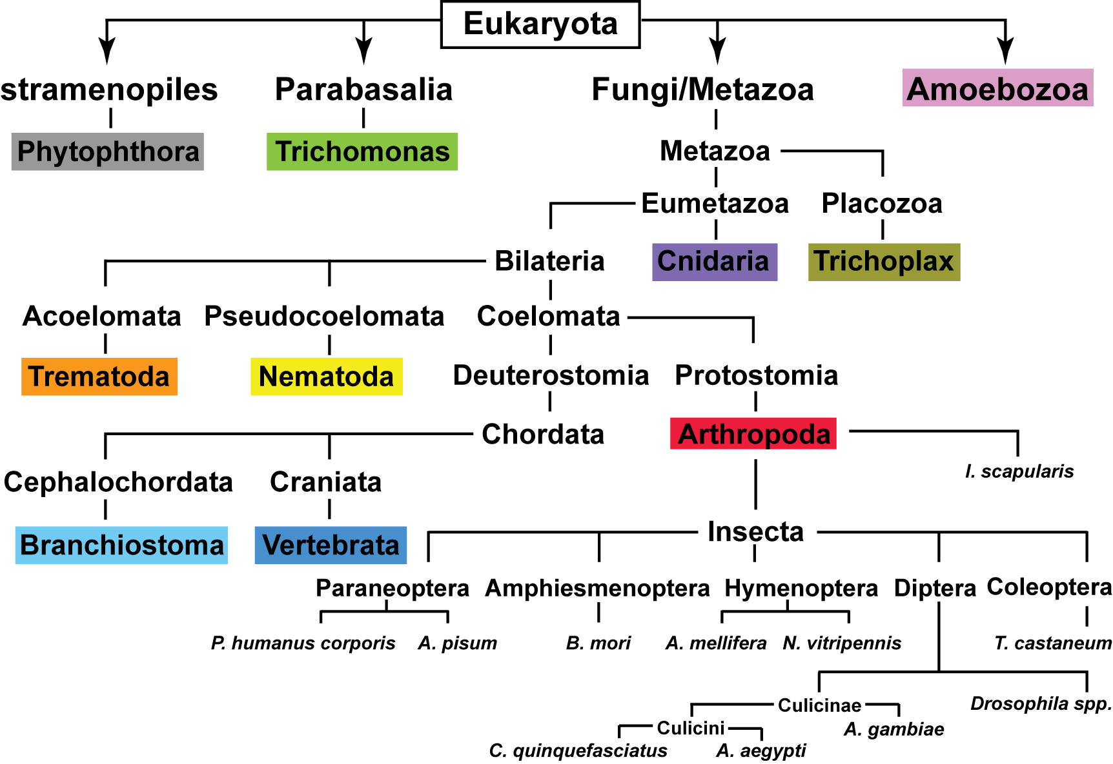 Fig. 3.5. Summary diagram of the phylogenetic lineages of the species used to assess saposin evolution (Figure legend overleaf)
Fig. 3.5. Summary diagram of the phylogenetic lineages of the species used to assess saposin evolution. This simplified representation of the phylogenetic lineages included in Figure 3.6 illustrates the divergence of each colour-coded grouping and shows the more recent divergence, and therefore closer relationship, of some of the Arthropoda species. For clarity, intermediate sub-groups have been excluded from the figure and branch points of divergence between species have been included. I. scapularis, Ixodes scapularis; P. humanus corporis, Pediculus humanus corporis; A. pisum, Acyrthosiphon pisum; B. mori, Bombyx mori; A. mellifera, Apis mellifera; N. vitripennis, Nasonia vitripennis; T. castaneum, Tribolium castaneum; C. quinquefasciatus, Culex quinquefasciatus; A. aegypti, Aedes aegypti; A. gambiae, Anopheles gambiae.
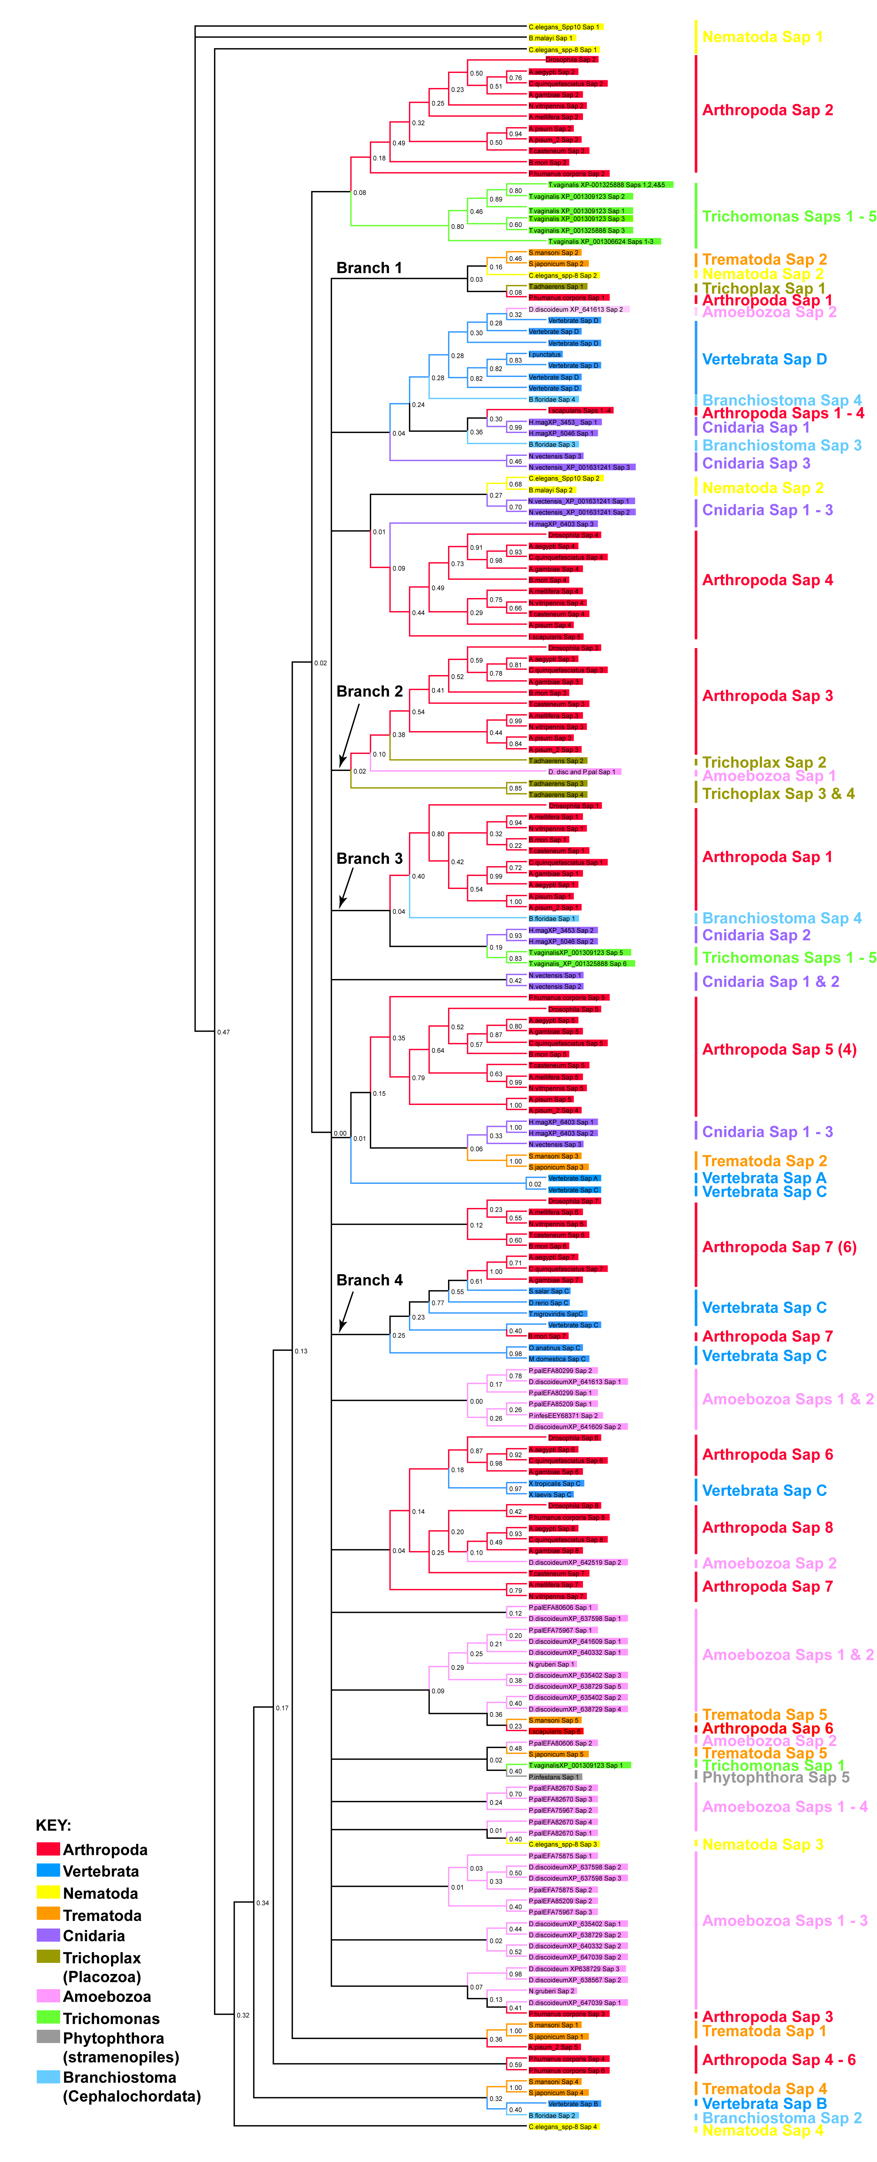 Fig. 3.6. Phylogeny of saposin homologues. (Figure legend overleaf)
Fig. 3.6. Phylogeny of saposin homologues. The 363 homologous saposin sequences from 58 different species were aligned using ClustalX and were inputted into MrBayes software to produce a phylogenetic tree (see section 2.1.3). Appropriate groupings were collapsed to allow presentation of the whole tree (expanded regions can be found in Figures 3.7 - 3.9; the whole tree can be found on the accompanying CD). Grouped species have been colour-coded according to Figure 3.5 to emphasise evolutionary conservation of sequences. For some of the Arthropoda species, the numbering in parentheses represents a minority saposin group that differs to the majority in that grouping. Bootstrap values are indicated at the branch nodes.
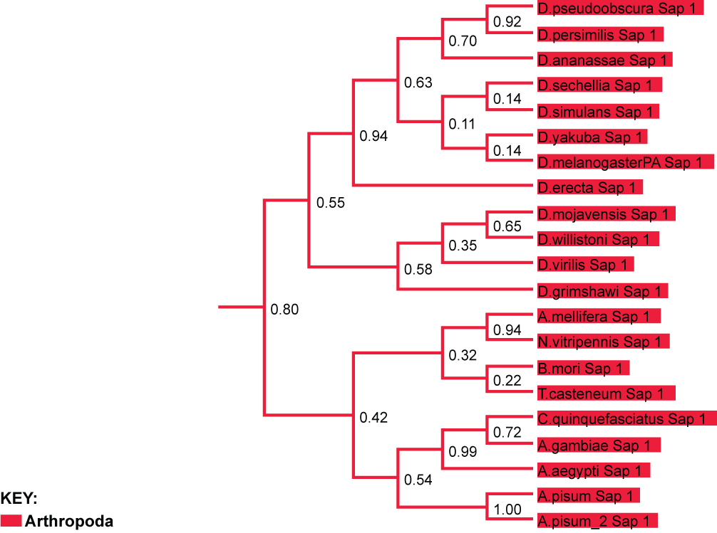
Fig. 3.7. A partial expansion of Branch 3 reveals the close grouping of all Drosophila Sap 1 sequences with the other equivalent Arthropoda Saps. Bootstrap values are indicated at the branch nodes: values over 0.5 indicate a highly significant grouping. See Appendix 1 for full species naming.
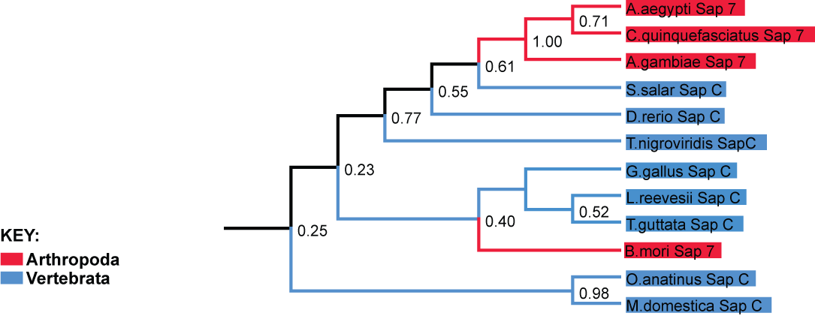
Fig. 3.8. Expansion of Branch 4 reveals the grouping of arthropod Sap 7 sequences with vertebrate Sap C. Bootstrap values are indicated at the branch nodes: values over 0.5 indicate a highly significant grouping. See Appendix 1 for full species naming.
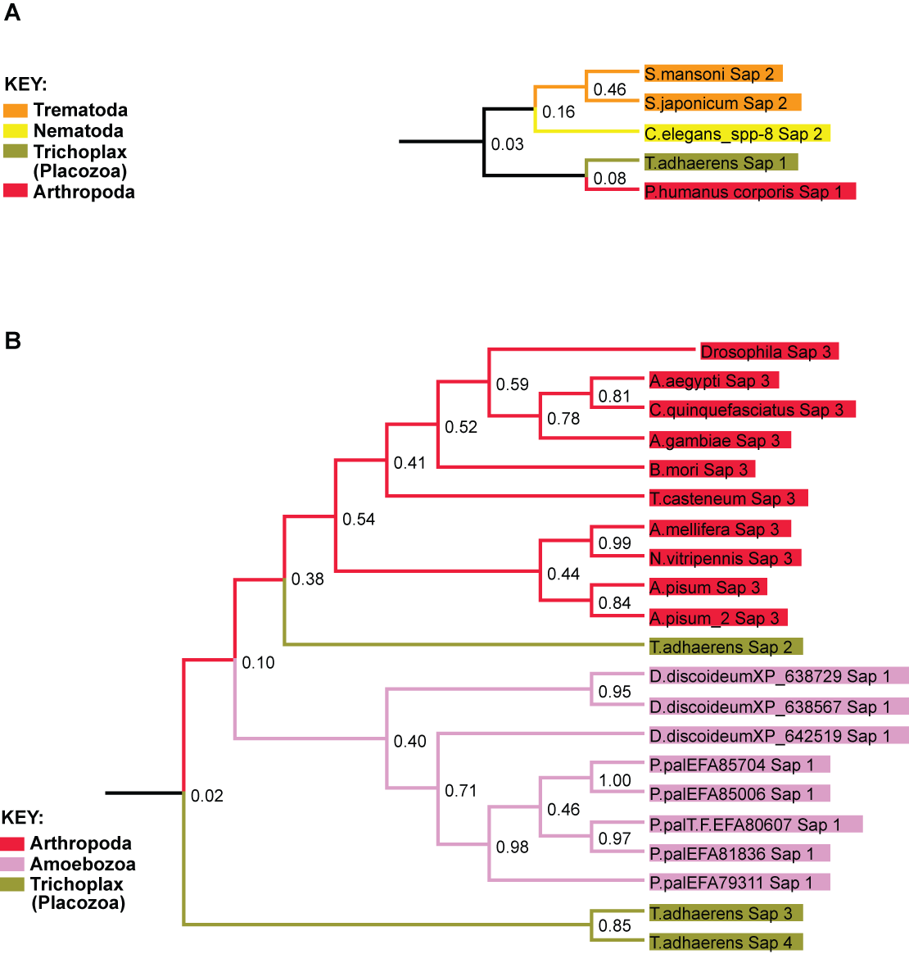
Fig. 3.9. Expansion of Branches 1 and 2: the common ancestor may have contained 2 saposin domains. The Trichoplax Saps are separated into 2 groupings (A & B), which may suggest a common ancestor with 2 saposin domains, one of which duplicated (B) to generate 2 additional saposins after Trichoplax diverged from the Metazoans (see Fig. 3.5). The presence of Amoebozoa, Trematoda, Nematoda and Arthropoda Saps in each of the Trichoplax groupings (A & B) supports this evolutionary hypothesis. Bootstrap values are indicated at the branch nodes: values over 0.5 indicate a highly significant grouping. See Appendix 1 for full species naming.
  - Where is dSap-r expressed?
    - The dSap-r^{NP7456} enhancer trap
To determine the expression pattern of dSap-r, the Gal4-UAS system was employed. This system, developed by Brand and Perrimon (1993), relies on the affinity of the yeast transcription factor Gal4 for the upstream activator sequence (UAS). Binding of this transcription factor to UAS leads to the expression of the downstream gene. Fly lines containing Gal4 constructs downstream of known promotor/enhancer sequences are produced by microinjection of the promotor-Gal4 construct into the embryo, leading to transformation of the germline progenitor cells. This leads to the generation of a stable Gal4 driver line. This method can also be used to create
UAS-reporter lines, by microinjection of constructs containing reporter genes downstream of multiple UAS sequences (see section 2.9). An alternative method for Gal4 line production involves the insertion or mobilisation of a
P-element transposon containing a Gal4 construct. Random insertion of this P-element within a gene locus creates an enhancer trap Gal4 line, whereby the upstream promotor/enhancer regions dictate the expression pattern of the Gal4. This form of enhancer trap was exploited to determine the expression pattern of dSap-r.
The dSap-r^{NP7456} line contains the P{GawB} P-element insertion, which encodes the mini-White (W⁺) and Gal4 constructs (Fig. 3.10). This fly line is an enhancer trap, which is a transposable element insertion downstream of an enhancer region that controls the expression pattern of the encoded reporter construct. In this case the reporter construct is Gal4, which is expressed in a dSap-r-specific manner due to the insertion of the P{GawB} P-element within the first intron of dSap-r. By crossing the dSap-r^{NP7456} line to a fluorescent reporter line containing either a UAS-membrane eGFP (mCD8eGFP) or nuclear eGFP (eIF4AIIIGFP) construct, the dSap-r expression pattern was determined.
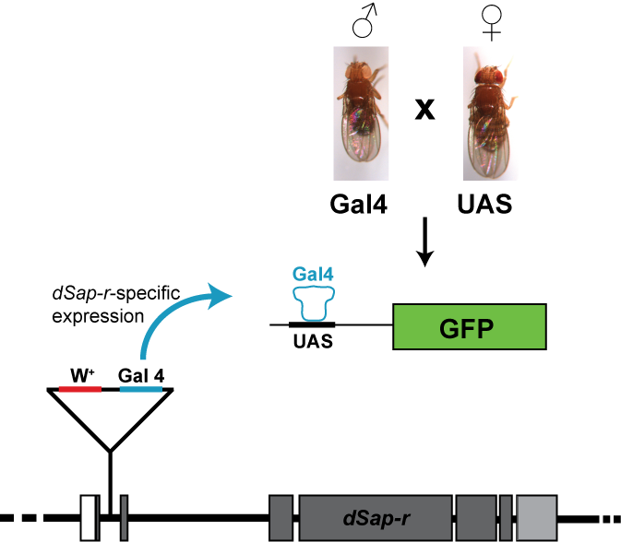
Fig. 3.10. The dSap-r^{NP7456} enhancer trap. The P{GawB}^{NP7456} transposon insertion lies in the intron between the first and second exons of dSap-r. This transposon encodes a White (W⁺) construct, which confers red eyes on the transformed flies, and a Gal4 construct. Due to the insertion of the transposon within the dSap-r gene, Gal4 expression is under the control of the upstream dSap-r promoter and enhancers. Gal4 is a yeast transcription factor that binds and activates transcription from genes containing upstream activator sequences (UAS). Mating the dSap-r^{NP7456} fly line with flies transformed with a UAS-reporter allows the location of dSap-r expression to be identified in the offspring. dSap-r-induced Gal4 expression results in binding to the UAS sequence upstream of the reporter construct, leading to the activation of reporter expression in cells that would normally express dSap-r. This approach was used for Figures 3.11 - 3.15 and Appendix 2.
      - dSap-r is expressed in the glial cells of the third instar CNS
dSap-r expression has been shown by in situ hybridisation to occur in glial cells and macrophages of the D. melanogaster embryo (Freeman et al., 2003). To confirm the glial expression of dSap-r, third instar larvae expressing mCD8eGFP under the control of the dSap-r enhancer trap Gal4 were dissected and immunolabelled using α-repo, an antibody specific to the glial nuclear marker repo (Fig. 3.11). The mCD8eGFP reporter revealed dSap-r expression in the glia, as indicated by membrane GFP surrounding glial nuclei (Fig. 3.11).
      - dSap-r is not expressed in the neurons of the third instar CNS
The same procedure was followed as above but using α-elav, an antibody specific to the neuronal RNA-binding protein elav (embryonic lethal abnormal visual system; Robinow and White, 1988; Robinow et al., 1988), to assess whether dSap-r expression was also present in neurons of the third instar CNS. Figure 3.12 shows that the mCD8eGFP dSap-r reporter does not localise to the same cells as the neuronal marker elav. Diffuse mCD8eGFP is shown to surround some neuronal nuclei, which can be seen more clearly in Figure 3.12 D – F. However, due to its diffuse nature this GFP may represent the glial membrane surrounding neuronal cell bodies, as is shown in the electron micrographs in Figure 5.7. To test this hypothesis, a nuclear GFP reporter (UAS-eIF4AIIIeGFP) was used to confirm whether dSap-r driven nuclear GFP localised to the same cells as the nuclear elav antibody. The nuclear GFP reporter localised to the same cells as the α-repo stained glia but not α-elav stained neurons (Appendix 2). Therefore, this confirms that dSap-r is expressed in glia but not in neurons.

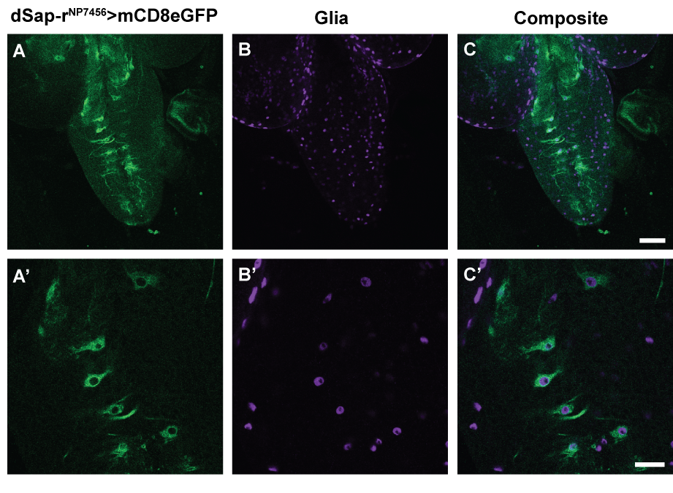
Fig. 3.11. dSap-r is expressed in the glia of the CNS in third instar larvae. Third instar larvae expressing mCD8eGFP under the control of dSap-r^{NP7456} Gal4 were dissected and stained with α-repo (glial nuclear marker). (A – C’) A confocal
z-section through the CNS at low (20x; A - C) and high (63x; A’ - C’) magnification. Scale bars: 50 μm (A – C), 20 μm (A’ – C’).
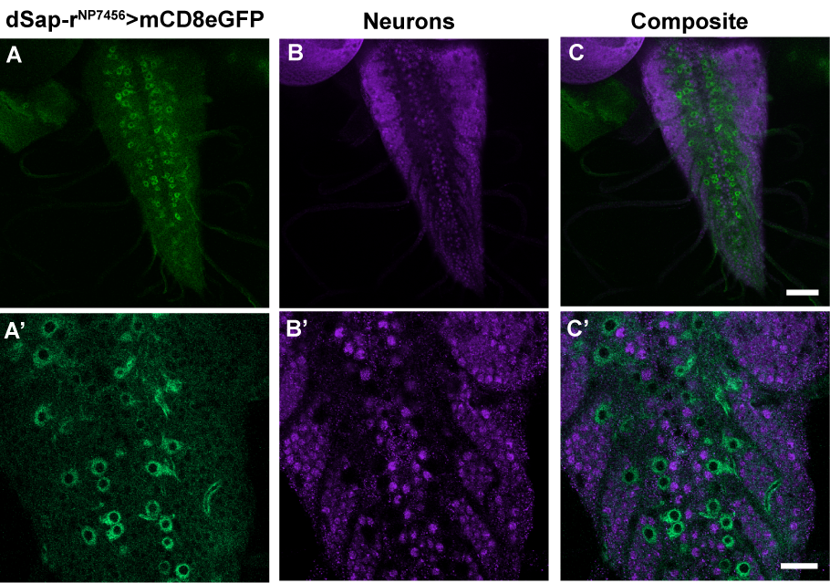

Fig. 3.12. dSap-r is not expressed in neurons of the CNS in third instar larvae. Third instar larvae expressing mCD8eGFP under the control of dSap-r^{NP7456} Gal4 were dissected and stained with α-elav (neuronal RNA binding protein). (A – C’) A confocal z-section through a third instar larval CNS at low (20x; A - C) and high (63x; A’ - C’) magnification. Scale bars: 50 μm (A – C), 20 μm (A’ – C’)

      - dSap-r expression in the adult
The dSap-r mutant phenotypes presented in Chapters 4 – 6 were found to occur in the mid- to late-adult stages. Therefore, the dSap-r^{NP7456} enhancer trap line was used to characterise dSap-r expression in the adult.
        - dSap-r is expressed in the adult digestive system
The whole digestive tract of the adult was dissected and imaged using a Zeiss stereomicroscope equipped with a mercury lamp. dSap-r^{NP7456} driven mCD8eGFP expression was localised to the midgut and Malpighian tubules (Fig. 3.13). The absence of fluorescence in the wild type control suggested this signal was not autofluorescence.
        - dSap-r is expressed in the spermatheca of the female reproductive system
Dissection of the female reproductive system revealed dSap-r^{NP7456} driven mCD8eGFP to be present in the spermatheca (Fig. 3.14). The spermatheca store sperm after mating and allow its release to fertilise a mature egg as it passes into the uterus (Pitnick et al., 1999). The dSap-r^{NP7456} driven mCD8eGFP reporter did not localise to any other regions of the female reproductive system, except faint expression surrounding or within the developing eggs of the ovaries. This may represent expression of maternal transcript or mCD8eGFP localisation to somatic cells surrounding the eggs (the follicle or border cells).
        - dSap-r is expressed in the testes and ejaculatory bulb of the male reproductive system
Due to the expression of dSap-r in the sperm-storage organs of the female reproductive system (the spermatheca), the male reproductive system was dissected to determine whether sperm-bearing organs of the male also express dSap-r. dSap-r^{NP7456} driven mCD8eGFP localised to the testes and the ejaculatory bulb of the male (Fig. 3.15), regions involved in sperm production and storage.
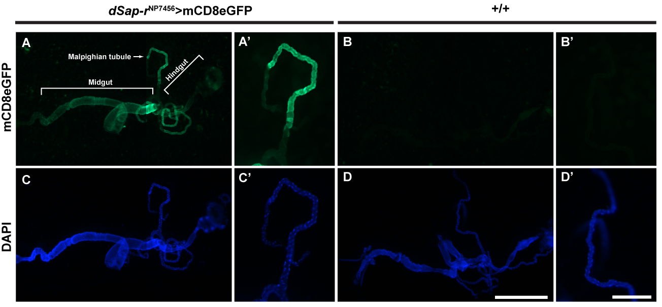

Fig. 3.13. dSap-r is expressed in the digestive system and Malpighian tubules. Adult flies expressing mCD8eGFP under the control of the dSap-r^{NP7456} Gal4 show expression within the midgut (A) and the Malpighian tubules (A and A’). (B and B’) Autofluorescence controls were performed using wild type flies (w⁻¹¹¹⁸; +/+). The digestive system and Malpighian tubules were stained with DAPI (C – D’). Scale bars: 1 mm (D) and 250 μm (D’). Images were taken at 40x (A – D) and 120x (A’ – D’) magnification.

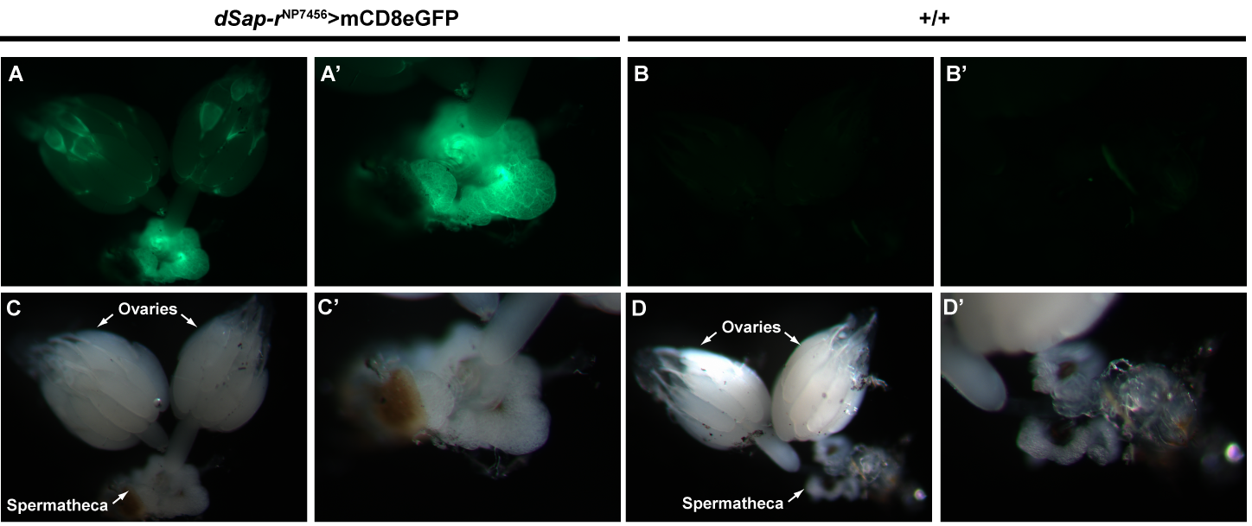

Fig. 3.14. dSap-r is expressed in the spermatheca of the female reproductive system. Female adult flies expressing mCD8eGFP under the control of dSap-r^{NP7456} were dissected and the reproductive system removed. (A – A’) Fluorescence was detected in the spermatheca and also within or surrounding the developing embryos. dSap-r^{NP7456}>mCD8eGFP; dSap-r^{NP7456} enhancer trap driving the mCD8eGFP reporter, +/+; wild type (w⁻⁻¹¹¹⁸). Wild type and reporter images were captured with the same exposure times using 65x (A – D) and 125x (A’ – D’) objectives. Scale bar: 500 μm (A - D); 250 μm (A’ - D’).

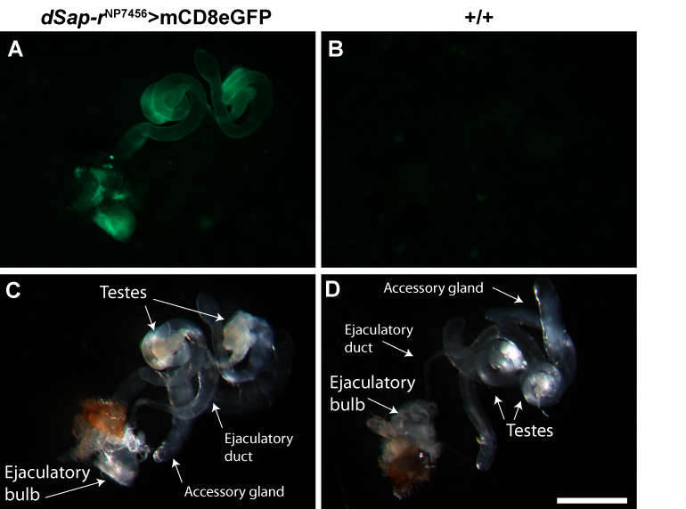

Fig. 3.15. dSap-r is expressed in the testes and ejaculatory bulb of the male reproductive system. Male adult flies expressing mCD8eGFP under the control of dSap-r^{NP7456} were dissected and the reproductive system removed. (A) Fluorescence was detected in the testes and ejaculatory bulb of flies expressing mCD8eGFP in a dSap-r expression pattern. (B) Fluorescence was not detected in wild type (w⁻¹¹¹⁸; +/+) controls. (C – D) Bright field images are shown of annotated male reproductive organs. Images were taken at 65x magnification. Scale bar:
500 μm.

    - Discussion
    - dSap-r is structurally related to hPSAP
The dSap-r locus was previously identified as the prosaposin homologue (Pearce, 2004). This was confirmed by conducting a blastp search of the Drosophila protein database at NCBI using the H. sapiens prosaposin sequence. Further support was provided by identification of common characteristics at the primary sequence level, such as the presence of the 6 conserved cysteine residues and potential glycosylation sites between the second and third conserved cysteine residues (Fig. 3.4).
The homologous dSap-r sequences were identified in the other 11 Drosophila species and in various invertebrates. These homologues also contained saposin-like domains, each containing 6 conserved cysteines that aligned with the D. melanogaster cysteines. Some of the invertebrate species (the mosquitos A. gambiae and A. aegypti) contained 8 saposin-like domains, akin to that of the Drosophila species. However, 2 of the invertebrate species only contained 7 saposin-like domains; these were the honey bee (A. mellifera) and red flour beetle (T. castaneum). Therefore, during the evolution of these closely related species, either a saposin domain was lost in the species containing 7 saposins or a further duplication event occurred after the divergence of the Drosophila and mosquito species from the bee and beetle lineages (see Fig. 3.5). To further evaluate the saposin duplication events during evolution, saposin phylogeny was investigated.
    - Phylogeny suggests that dSaps may be functionally related to the hSaps
A clear difference between the dSap-r and hPSAP sequences was their total length: 953 versus 527 amino acids, respectively. This translated to a difference in the number of individual Saps (8 versus 4, respectively). To determine the evolutionary relationship between the D. melanogaster dSap-r and H. sapiens prosaposin sequences, an alignment was required in order to produce a phylogenetic tree. Because of the difference in length and number of saposin domains, the full sequences did not align well. Therefore, each sequence, and those of other vertebrate and non-vertebrates, was separated into individual saposins. This allowed phylogeny to be assessed based on the similarities within the duplicated domains.
The saposin phylogenetic tree revealed that Metazoans, and likely all Eumetazoans, derived from an ancestor with 2 saposins. Hazkani-Covo et al. (2002) suggested that the 4 vertebrate saposins derived from 1 ancestral saposin, which underwent 2 rounds of duplications. Although Figure 3.6 suggests an ancestor with 2 saposins, this does not discard the possibility of a more ancestral species with only 1 saposin domain. Hazkani-Covo et al. were unable to determine the order of duplications in the vertebrate prosaposins. However, due to the larger number of saposin sequences and species coverage in Figure 3.6, some inclination of the most ancestral saposin in vertebrates was revealed. Due to the dispersed grouping of some vertebrate saposin C with some non-vertebrate saposins, this may suggest that in vertebrates, saposin C is most closely related to the ancestral saposin, which duplicated to generate saposin D followed by a final duplication of the two-domain sequence to generate saposins A-B-C-D in tandem. This is supported, in part, by the grouping of vertebrate saposins A and C in Figure 3.6 and the findings of Hazkani-Covo et al. that saposins B and D also grouped more closely than to any other saposins (Hazkani-Covo et al., 2002).
Some of the vertebrate saposin C sequences grouped with some arthropod saposin 7 sequences. This may suggest that saposin 7 is most closely related to the ancestral saposin and may also share a common function with saposin C. Although the Drosophila saposins did not closely group with vertebrate saposin C, the common lineage of the Drosophila species and the other arthropods (Fig. 3.5) would support a similarity in saposin function between these species.
    - dSap-r is expressed in the glia but not the neurons of the CNS
Previous work by Freeman et al. (2003) identified dSap-r as a Gcm (glial cells missing) responsive gene. Gcm is a transcription factor involved in determining glial cell fate on neuroblast cells (Hosoya et al., 1995); therefore, if dSap-r expression is responsive to Gcm, one would expect dSap-r expression in glial cells. This was confirmed by Freeman et al. (2003) and this investigation (Fig. 3.11 and Appendix 2). This investigation also showed that dSap-r is not expressed in neurons of the CNS (Fig. 3.12 and Appendix 2). In situ hybridization should be performed to confirm these results.
As is discussed in Chapter 1, mutations in prosaposin lead to severe, progressive neurodegenerative disorders. Therefore, it would be expected that prosaposin and dSap-r would be expressed in neurons. This is in fact the case for mammalian prosaposin, which has been shown to be highly expressed in certain neurons of the CNS and PNS, in particular the cerebellar Purkinje cells and neurons of the deep cerebellar nuclei, CA3 pyramidal neurons of the hippocampus, neurons of the lateral horn of the spinal cord, and the retinal ganglion cells (Sun et al., 1994; Van Den Berghe et al., 2004; Yoneshige et al., 2009). In contrast to dSap-r, prosaposin is only weakly expressed in glia (astrocytes and oligodendrocytes) (Sun et al., 1994). The discrepancy in the expression pattern of dSap-r and prosaposin may reflect a difference in the mechanism of control over sphingolipid metabolism in the CNS of Drosophila and mammals. In Drosophila, the glia may provide dSap-r or sphingolipid intermediates to the neurons; therefore, a deficiency of dSap-r would still be expected to result in a neurodegenerative phenotype, in addition to degeneration of the glia (see Chapter 5 and the discussion therein). Prosaposin is present in many secretory fluids, including the cerebrospinal fluid. Therefore, dSap-r may also be secreted (by the glia) and endocytosed by the neurons for targeting to the lysosomes.
    - dSap-r expression is localised to the digestive system and renal organs of the adult
Dissection of adult flies expressing a membrane GFP reporter in a dSap-r expression pattern revealed a high level of expression in the digestive system (midgut) and the Malpighian tubules, which are the Drosophila equivalent of the renal tubules (Fig. 3.13). In mammalian visceral organs, prosaposin is expressed ubiquitously at low levels but shows moderate to high expression levels in the lamina propria of the villi in the jejunum (middle region of the small intestine) and tubular epithelial cells in the kidney cortex, in addition to epithelial cells of the oesophagus, pancreatic duct and bile duct, and the hepatocytes of the liver (Sun et al., 1994). The localisation of dSap-r to the digestive and renal systems is therefore consistent with aspects of the prosaposin expression pattern in mammals.
In Drosophila, the uptake of water and solutes is important for osmoregulation of the haemolymph; this process is governed by the gut and the Malpighian tubules (Dow and Davies, 2001; Shanbhag and Tripathi, 2009). The Malpighian tubules extend from the hindgut, close to its boundary with the midgut. As mentioned above, they are the Drosophila equivalent of the renal tubules and are involved in transport of haemolymph constituents across the Malpighian tubules into the lumen prior to excretion (Dow and Davies, 2001). Fluid transport across the midgut and Malpighian tubule epithelia is though to be controlled by a proton motive force established by vacuolar-ATPases (Dow et al., 1994; Davies et al., 1996). Expression of dSap-r in the midgut and Malpighian tubules may suggest a role for dSap-r in osmoregulation. This will be discussed further in Chapter 6.
    - dSap-r is expressed in the male and female reproductive systems
Upon dissection of flies expressing membrane GFP in a dSap-r expression pattern it became apparent that dSap-r is highly expressed in the male and female reproductive systems. The localisation of the membrane GFP reporter revealed that dSap-r transcript is present in the sperm storing regions of the female reproductive system (the spermatheca) and the sperm production and storage regions of the male reproductive system (the testes and ejaculatory bulb).
The D. melanogaster testis is a tube of muscle and pigment cells that house 2 populations of stem cells, the male germline cells and the somatic support cells, which give rise to sperm and somatic cyst cells respectively. The somatic cyst cells support the germline stem cells and promote their differentiation into mature sperm (Kiger et al., 2000; Tran et al., 2000). Mammalian prosaposin (also known as sulfated glycoprotein-1 (SGP-1) is one of the major secretory proteins of the rat Sertoli cells (Collard et al., 1988). The Sertoli cells are the mammalian equivalent of the Drosophila somatic cyst cells. Therefore, dSap-r expression in regions of sperm production and storage is consistent with the presence of prosaposin in cells required for sperm development.
A role for prosaposin, in particular the region between the saposin A and B domains, has been identified in increasing fertility (see Chapter 1) (Hammerstedt, 1997). A synthetic peptide based on prosaposin was shown to increase the binding of human, boar and bull sperm to hen’s egg extract (Amann et al., 1999), which suggests a mechanism for its role in fertility. In addition, mice with double saposin C^{-/-}D^{-/-} deficiency were unable to reproduce (Sun et al., 2007) and morphological defects were identified in the male reproductive system of total PSAP^{-/-} deficient mice (Morales et al., 2000). This further supports a role for prosaposin (and
dSap-r) in sperm development and maintenance, and fertility. A dSap-r mutation may also reduce fertility in flies; this is yet to be confirmed.

