- Materials and methods
  - Bioinformatics
    - Prosaposin homologue search
A blastp search (NCBI; www.ncbi.nlm.nih.gov) was performed to identify the Drosophila melanogaster (D. melanogaster) prosaposin (PSAP) homologue. The entire human PSAP protein sequence (CAG33027) was used to search the D. melanogaster protein database. Standard blastp assumptions were applied. This technique was also used to search for PSAP homologues in different non-vertebrate and vertebrate species. Drosophila and other
non-vertebrate PSAP homologues were aligned using ClustalX to identify conserved regions. Default ClustalX settings were used.
    - Identification of putative saposins
To identify the putative saposins in the D. melanogaster PSAP homologue, each human saposin sequence (RCSB Protein Data Bank entries 2DOB, 1N69, 2GTG, 2RB3) was aligned against the full D. melanogaster sequence using the bl2seq tool (NCBI). Once the D. melanogaster saposin domains had been identified, the D. melanogaster PSAP homologue and H. sapiens PSAP were aligned against the identified homologues from other
non-vertebrate and vertebrate species to identify the putative saposin-related regions in these species. The H. sapiens and D. melanogaster saposins were aligned using default ClustalX settings.
    - Phylogenetic tree generation
The saposin-like proteins from vertebrate and non-vertebrate species were used to create a multiple sequence alignment using default settings in ClustalX (Version 1.83). A phylogenetic tree was generated using Bayesian inference with MrBayes software. Default settings were used except the number of generations, which was increased from 1,000,000 to 2,000,000 to deal with the slow convergence of the trees. The chains were sampled every 1000 generations and the burn-in was set to 1,000 to account for the slow convergence. The tree was run by P. Ashton (Technology facility, York University).
  - Drosophila techniques
    - Drosophila stocks
Drosophila stocks were purchased from the Bloomington stock centre (Indiana; http://flystocks.bio.indiana.edu/) and the Drosophila Genetic Resource Centre (Kyoto; http://www.dgrc.kit.ac.jp/). Additional stocks were kindly provided by colleagues and other laboratories or were generated as part of this investigation. A summary of the stocks used, their genotype, origin and a brief description can be found in Table 2.1. Stocks obtained from outside the York Drosophila laboratories were quarantined and transferred to fresh food on consecutive days for 3-4 days to ensure they were mite-free.
    - Drosophila media
Stocks were maintained on standard yeast-sucrose-agar medium (45.5 g/l yeast, 91.0 g/l sucrose, 13.7 g/l agar, 0.46g/l calcium chloride, 0.46g/l ferrous sulphate, 97.1 g/l potassium sodium tartrate, 6.1 g/l sodium chloride and 6.1 g/l manganese chloride). The above chemicals were from VWR BDH Prolabo (UK), except the agar (Oxoid, UK). Following autoclaving, the medium was left to cool in a 43°C water bath for approximately 1 hour before supplementing with the anti-fungal agents Bavistin (5.5 mg/l dissolved in 100% ethanol; BASF, Auckland, New Zealand) and Nipagin (0.7 mg/l dissolved in 100% ethanol; Sigma, UK). Plastic vials (B.T.P. Drewitt, UK) were filled with 9 ml of medium and sealed with cotton wool.
Stocks were stored at 25°C or 18°C, and were transferred to fresh fly medium every 2- and 4-weeks, respectively. At 25°C, the fly life cycle is completed in 10 – 11 days (from egg to adult), whereas at 18°C the life cycle is approximately doubled.
Experimental crosses, unless otherwise stated, were maintained on a richer maize-based medium (119.0 g/l maize meal; Alligator, 17.5 g/l yeast; VWR BDH Prolabo, 15.9 g/l agar; Oxoid, 103.2 g/l sucrose; VWR BDH Prolabo). After cooking the above reagents, 0.4 mg/l Nipagin (dissolved in 100% ethanol; Sigma) and 0.4% (v/v) propionic acid (Acros Organics, Geel, Belgium) were added. The final solution was poured into 1/3 pint glass bottles and sealed with sponge stoppers. Poured bottles were autoclaved for 20 minutes at 121°C. To enhance egg-laying, dried yeast pellets were added to the surface of the bottled maize medium before introducing the crosses. The richer maize medium was used to support larger numbers of F₁ generation flies when assays required large-scale fly collection. Experimental flies were maintained on maize-based medium until eclosion then adults were separated into single-sex vials containing standard yeast-sucrose-agar medium and aged at 29°C.
    - Drosophila anaesthetisation
To allow the identification of the sex and genotype of flies, flies were anaesthetised on a porous gas pad using carbon dioxide (CO₂). A constant CO₂ flow provided immediate and maintained anaesthetisation. CO₂ was the principal method of fly anaesthetisation used in this investigation. However, cold immobilisation was used to capture images of whole adult flies.
    - Drosophila crossing techniques
Crosses were established by adding males to their virgin female mates. Females less than 8 hours old should reject courtship (reviewed in Dickson, 2008) and, therefore, should be virgins. On this basis, virgin females were identified and collected by 2 methods. Firstly, flies less than 2 hours
post-eclosion (hatching) contain a meconium visible through the abdominal cuticle, as well as being lightly pigmented and bearing unexpanded wings. Females displaying any of these phenotypes were collected and kept for up to a week to confirm their virgin nature. The second means of virgin female identification and collection involved the removal of all adults from the vial or bottle followed by collection within 8 hours of eclosion. After confirming the
Stock Genotype Description Source

Wild Type
w-¹¹¹⁸ w-;+/+;+/+ Wild type (white-eyed) Simon Lab, Stanford
Canton-S +/+;+/+;+/+ Wild type (red-eyed) Bloomington Stock Centre
dSap-r Stocks
dSap-r^{PBac} w-;+/+;dSap-r^{PBac}/TM6b PBac Transposon Insertion Bloomington Stock Centre
dSap-r^{P{GawB}NP7456} w-;+/+;dSap-r^{NP7456} P-element insertion Kyoto Stock Centre
(includes Gal4 and White genes)
dSap-r^{C27} w-;+/+;dSap-r^{C27}/TM6b 2.5 kb deletion in dSap-r This Investigation
Df(3R)tll-e +/+;+/+;Df(3R)tll-e/TM6b 100A2-100C3 of 3R deleted Bloomington Stock Centre

Balancers
FM7h X/FM7h 1st Chromosome Balancer Bloomington Stock Centre
CyO/Sco w-;CyO/Sco 2nd Chromosome Balancer Bloomington Stock Centre
TM3/TM6b w-;+/+;TM3/TM6b 3rd Chromosome Balancer Bloomington Stock Centre
CyOGFP/If;MKRS/TM6b w-/+;CyOGFP/If;MKRS/TM6b 2nd and 3rd Chromosome Bloomington Stock Centre
Balancer
Table 2.1. Drosophila stocks used in this investigation
Stock Genotype Description Source

UAS- stocks
UAS-dSap-r UAS-dSap-r/FM7h 1st chromosome dSap-r insertion This Investigation
UAS-mCD8GFP w-;UAS-mCD8GFP/CyOGFP Membrane localised GFP Prokop Lab, Manchester
UAS-eIF4AIIIGFP w-;UAS-eIF4AIIIGFP; Nuclear GFP Prokop Lab, Manchester MKRS/TM6b

Gal4 stocks
Act5c-Gal4 w-;Actin5c-Gal4/CyOGFP Ubiquitous Gal4 Bloomington Stock Centre
Tub-Gal4 w-;Tubulin-Gal4/TM6b Ubiquitous Gal4 Bloomington Stock Centre
1407-Gal4 w-;1407-Gal4/CyO Neuronal Gal4 Prokop Lab, Manchester Gcm-Gal4 w-;Gcm-Gal4/SM6 Glial Gal4 Langraf Lab, Cambridge dSap-r^{P{GawB}NP7456} see previous entry dSap-r Gal4 Kyoto Stock Centre

Other Stocks
Δ2-3 transposase w⁻;CyO^{[Δ2-3PBac}}/Sco Contains active transposase Bloomington Stock Centre

Table 2.1. Drosophila stocks used in this investigation
virgin nature of the females, males and virgin females were combined in a fresh vial or bottle and stored at 25°C for up to 7 days. F₀ flies were removed after 7 days to prevent overcrowding. Following this period, the F₀ flies were either transferred to a fresh vial or bottle to allow collection of further F₁ flies or they were euthanised.
  - Generation of dSap-r mutations
    - P-element mobilisation
The dSap-r^{P{GawB}NP7456} fly stock (ID: 105467) was used to generate potential dSap-r null mutations by mobilisation of the P{GawB} P-element from the dSap-r locus. Figure 2.1 shows a schematic representation of this process and the required crossing scheme is shown in Figure 2.2. The
dSap-r^{P{GawB}NP7456} flies were crossed to flies containing an active transposase gene (PBac^{Δ2-3}). Offspring were collected containing both the dSap-r^{P{GawB}NP7456} P-element insertion and the active transposase gene (Fig. 2.2 A). These flies were identified based on the absence of the Irregular Facets (IF) and stubble (MKRS) markers. In the gametes of these flies, the active transposase can excise the P-element and remove flanking genomic DNA. The P{GawB} P-element contained a White (W⁺) gene, which resulted in red eye pigmentation in otherwise white-eyed (w⁻) flies. Flies with excised P-elements were identified based on the loss of the W⁺ gene, which resulted in an absence of eye pigmentation. The flies carrying these gametes were crossed to the third chromosome balancer stock TM3/TM6b in maize-meal bottles (Fig. 2.2 B). White-eyed TM3/TM6b balancer flies were used to avoid masking the loss of the W⁺ (red-eyed) phenotype. Each white-eyed fly represented a P-element mobilisation event and therefore individual
white-eyed flies were crossed to TM3/TM6b balancer flies (Fig. 2.2 C; single-mate crosses). The progeny from each cross were used to create stable stocks of each P-element mobilisation event (Fig. 2.2 D).

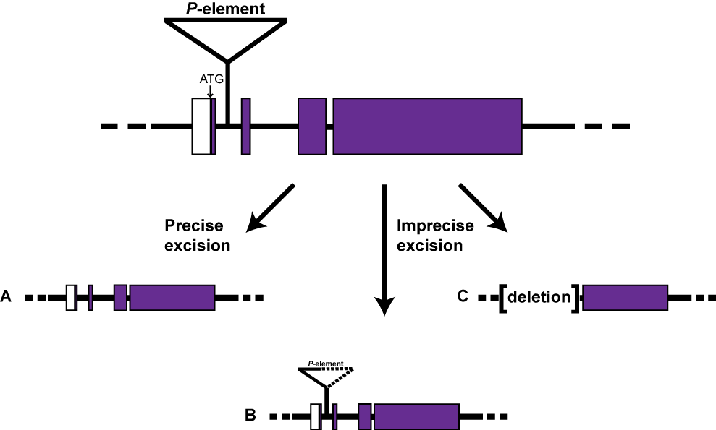

Fig. 2.1. Possible outcomes of the P-element mobilisation process.
A P-element insertion within or near a gene of interest can be mobilised to generate gene deletions. There are various possible P-element excision outcomes from this process: the P-element may be removed and the wild type homologous chromosome used to repair the double strand break generating a wild type allele (precise excision; A); the P-element sequence may be partially repaired (imprecise excision; B); or non-homologous end joining may occur after P-element excision has removed flanking DNA, generating a deletion (imprecise excision; C).
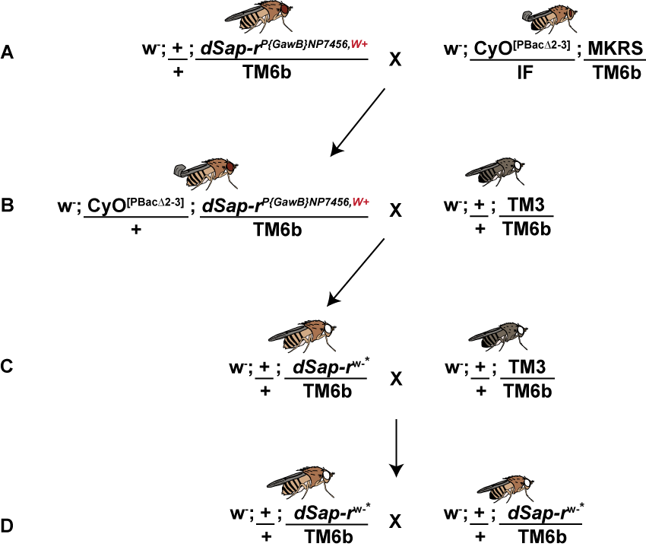

Fig. 2.2. P-element mobilisation from the dSap-r locus. To create a deletion in the dSap-r gene, the P{GawB}^{NP7456} element was mobilised using a constitutively active transposase gene (PBac∆2-3). To this end dSap-r^{P{GawB}NP7456,W+} flies were crossed to a stock containing the transposase gene (A), and F₁ flies containing both the P{GawB} element and the transposase gene were selected (B). In the germline of these F₁ flies, P-element mobilisation may have occurred. These offspring were crossed to a third-chromosome balancer stock to prevent recombination and loss of any potential dSap-r deletions in the progeny (B). Individual offspring, without the transposase and with white eyes, were selected and crossed to the
third-chromosome balancer stock (C; single-mate cross) to generate enough progeny to create stable stocks (D). Asterisks denote loss of W⁺ transgene (present on the P{GawB}^{NP7456} element).

    - Screening of potential dSap-r mutations by polymerase chain reaction (PCR)
Flies homozygous for potential dSap-r mutations were screened by PCR using multiple combinations of primer pairs (Table 2.2 and Fig. 2.3). The PCR process is described in section 2.5.3. Flies producing abnormal PCR products were further analysed by DNA sequencing.
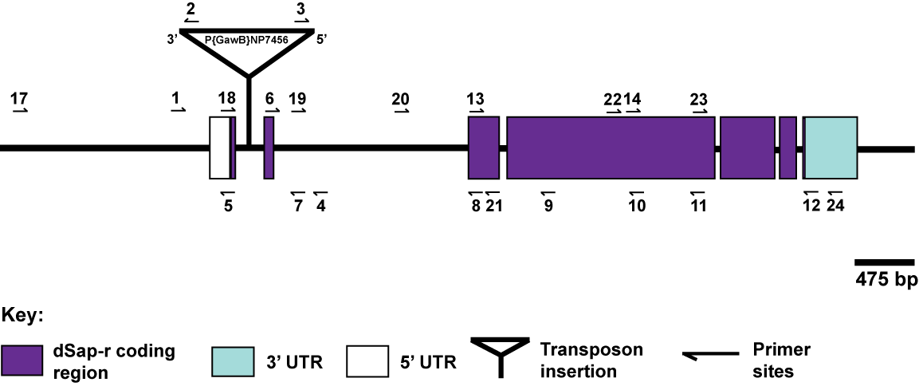
Fig. 2.3. Location of primer sites used to screen potential dSap-r mutations. The dSap-r locus is shown with the binding sites of the primers used. Various combinations of primer pairs were required to screen potential dSap-r mutations created by P-element mobilisation. All primer sites were within the dSap-r gene or enhancer region except primers 2 and 3, which were within the P{GawB}^{NP7456}
P-element. UTR, untranslated region. P-element transposon not to scale.
  - Characterisation of the dSap-r mutant phenotype
    - Longevity assay
Longevity assays were performed to assess the lifespan of various mutations and transgenes. Virgin females and males of the appropriate genotypes were crossed in maize-meal bottles and maintained at 25°C. The F₁ progeny were CO₂-anaesthetised and the desired genotypes collected as virgin females and males. These flies were separated into single-sex vials of 5 – 10 flies and aged at 29°C on standard fly food. Surviving flies were counted every
1 – 2 days and were transferred to fresh vials of standard fly food 2 - 3 times per week. Each vial represented an independent longevity assay (n ≥ 10).
    - Embedding of Drosophila adult heads for sectioning
      - Embedding of Drosophila adult heads in Spurr’s resin
Due to complications of inefficient resin infiltration, the original head embedding protocol was optimised. To increase accessibility of the embedding reagents to the brain, head dissections were performed as described in section 2.7.3.1. Briefly, flies were submerged in 30% ethanol followed by fixative (4% paraformaldehyde, 1% glutaraldehyde in 0.1 M sodium phosphate buffer, pH 7.4) and pinned through the abdomen. The proboscis and accessible air sacs were removed and the head dissected from the thorax and placed in glass vials containing the fixative. The glass vials were placed under vacuum pressure to remove air from the remaining air sacs and the cuticle surface. This was performed because fly heads often failed to sink in the various solutions, which resulted in inefficient submersion and infiltration problems. Heads were transferred to 500 μl fresh fixative in 1.5 ml ependorfs. Submersion of the heads was ensured by trapping them under a slim cigarette filter tip held in position by a shortened 0.2 ml PCR tube. Heads were incubated in fixative overnight at 4°C on a 360° rotator. Excess fixative was removed by 3 x 10 min washes in 0.1 M sodium phosphate buffer; all incubations and washes were performed in 1 ml of solution, unless otherwise stated. The tissue was incubated in 250 μl 1% osmium tetroxide (OsO₄) in 0.1 M sodium phosphate buffer for 1 hour, followed by washes in 0.1 M sodium phosphate buffer (3 x 10 min) then in distilled water (3 x 10 min). The tissue was then dehydrated by incubation in increasing concentrations of acetone (30%, 50%, 70%, 90% acetone, 20 min each) followed by 3 x 20 min incubations in 100% acetone (dehydrated over a molecular sieve). Fly heads were incubated in solutions of increasing concentrations of Spurr’s resin (Spurr, 1969; 5g vinylcyclohexene dioxide, 3g diglycidyl ether of polypropylene glycol, 13g nonenyl succinic anhydride,
0.25 ml 2-dimethylaminoethanol) diluted in acetone. Initially a 25% resin incubation was performed (25% resin: 75% acetone), followed by 50%, 75%, 90% and 3 x 100% resin (100% resin incubations were performed at a higher temperature (37°C) to reduce viscosity). Incubations were performed for 45 minutes with rotation. Heads were embedded in a layer of semi-polymerised resin in home-made moulds (Silastic J Kit, Dow, USA). The resin was previously added to the bottom of each well and semi-polymerised for 3.5 - 4 hours at 70°C. Heads were orientated with the dorsal face against one end of each well. Un-polymerised resin was added to fill the wells and was polymerised at 70°C for 24 hours. Polymerised resin blocks were left to cool before removing from the moulds.
      - Preparation and sectioning of resin blocks
Blocks were secured in a chuck and initially trimmed using a fine-bladed hacksaw and then more precisely using a razor blade, until the cuticle was exposed. A truncated pyramid-shaped resin mound was created surrounding the head to reduce the size of the cutting face. 1 μm sections were produced using custom-made glass knives attached to a microtome (Leica Ultracut UCT). Sections were transferred to a water droplet on a glass microscope slide and dried to the slide by heating on an 80°C hot plate. Sections were stained with 0.6% toluidine blue in 0.3% sodium carbonate on the hot plate for 5 – 10 seconds (longer exposure would lead to high background staining of the resin). Excess toluidine blue was removed by rinsing in distilled water, followed by drying on the hot plate. Sections were imaged using Zeiss AxioVision (Release 4.8.1, 2009) software and a Zeiss AxioCam HRm camera attached to a Zeiss Axiovert 200 microscope equipped with a HAL 100 halogen lamp. 10x, 20x and 63x (oil emersion) objectives were used.
      - Quantification of vacuoles
Vacuoles were counted manually for the antennal lobes and the visual system (eye, lamina, medulla, lobula and lobula plate) from 3 serial 1µm sections per fly head. Vacuoles from both sides of the fly head were quantified. The sections were matched for depth through the head. SPSS (Analysis of Variance) and Microsoft Excel (Student’s t-test) were used to assess statistical significance.
    - Transmission electron microscopy
Thin sections (60-70 nm) were produced from the same resin blocks used for light microscopy analysis. Both wild type (w⁻¹¹¹⁸/Canton-S; +/+) and
dSap-r^{C27}/Df(3R)tll-e blocks were sectioned for TEM analysis. Thin sections were treated with uranyl acetate in 50% ethanol for ten minutes, followed by submersion in distilled water to wash. Sections were stained with lead citrate for ten minutes in the presence of sodium hydroxide pellets, followed by washing in distilled water (staining was performed by M. Stark, Technology Facility, York). Images were captured using analySIS software on a TECNAI G² (Version 2.18) transmission electron microscope (120 kV).
    - Physiological and behavioural analyses
      - Electroretinograms (ERGs)
Flies were left to crawl up a trimmed 200 μl pipette tip and were forced to the end by blowing down the wider end. The fly was fixed with its head protruding from the tip using nail varnish. After placing the affixed fly in the ERG apparatus, glass electrodes were pulled and filled with Drosophila-Ringer solution (0.13 M NaCl, 4.7 mM KCl, 1.9 mM CaCl₂; Heisenberg, 1971). A recording electrode was positioned against one eye and the reference (earth) electrode placed against another region of the head
(e.g. the proboscis) using micromanipulators. The flies were dark-adapted for 5 min. ERGs were recorded in response to 5 x 2 sec green LED light pulses followed by 5 x 2 sec blue LED light pulses provided by a full colour LED lamp (KAF-5060PBESEEVGC, Kingbright, Taipei, Taiwan). The light pulses were emitted in 10 sec intervals. DASYLab software was used to record the ERGs and DASYView (Version 2.1.1) was used for analysis (DASYLab, customised software, C. Elliott, University of York). The 5 ERG responses were averaged for each fly and light condition, and statistical significance was assessed using SPSS software (Analysis of Variance).
An example ERG is shown in Figure 2.4. The photoreceptor (PR) response (1 in Fig. 2.4) was measured as the difference in potential between the start level and the bottom of the first decline in the trace (approximately 30% along the trace). The off-transient amplitude was inferred from the potential difference between the start and the minimum levels (2 in Fig. 2.4). The initial rate of recovery was measured as time taken to reach half way between the start and minimum levels (3 in Fig. 2.4).

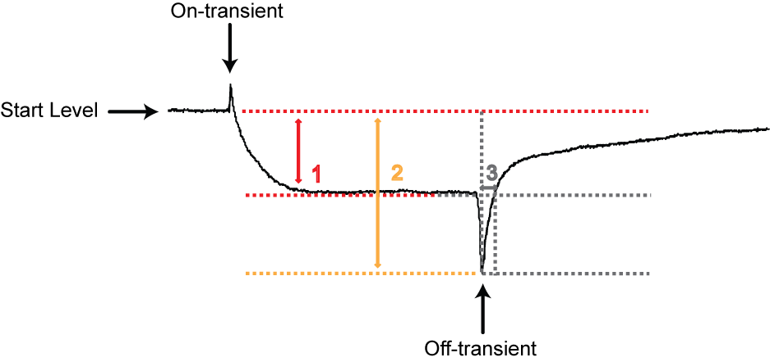
Fig. 2.4. The ERG components used to quantify neuronal dysfunction in the eye and optic lobes of dSap-r^{C27}/Df(3R)tll-e mutants. The ERG consists of 4 main elements: the photoreceptor response (1), the on-transient, the off-transient and the recovery phase (3). The photoreceptor response was determined as the difference between the starting potential and the potential a third of the distance along the recording. The on-transient was too small to be accurately distinguished above background noise; the extent of the amplitude of the off-transient can be inferred from the maximum potential (2), which measures the potential difference from the starting level to the minimum level (the peak of the off-transient). The initial phase of the recovery response was calculated as time taken to reach half the distance between the off-transient peak and the start level (3).
      - Climbing assay
Female flies were anaesthetised by CO₂ and then separated into cohorts of 5 flies per vial at least 24 hours prior to testing. Each cohort was transferred to a 100 ml glass measuring cylinder, which was placed under a light source. The flies were tapped to the bottom and the climbing response was recorded for 45 seconds using a webcam and VirtualDub software (Version 1.5.10, Avery Lee). The videos were analysed manually by viewing in QuickTime player (Apple). The climbing behaviour of each fly was quantified as percentage distance travelled, time taken to climb 50% of the measuring cylinder and maximum speed over 10% intervals of the measuring cylinder (Fig. 2.5). SPSS (Analysis of Variance) and Microsoft Excel (Student’s t-test) were used to assess statistical significance.

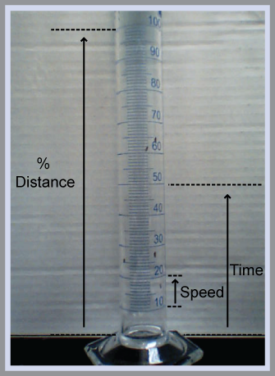
Fig. 2.5. Analysis methods for the climbing assays. Climbing behaviour was recorded at 5 frames per sec and was analysed manually by viewing in Quick time player. Climbing behaviours of each individual fly were scored by maximum distance travelled (as a percentage of the measuring cylinder), time taken to reach 50% of the measuring cylinder and speed across 10% intervals.
      - Jumping assay
The jump performance of female flies were tested using an ergometer apparatus (Elliott et al., 2007; Harvey et al., 2008; Fig. 2.6). Female flies were used due to their larger size, which increases the signal-to-noise ratio (Elliott et al., 2007). Flies were CO₂ anaesthetised, glued by the thorax to tungsten wire using Marabu glue (Marabu Fixo Gum, Tamm, Germany) and allowed to recover for 20 – 30 min. Affixed flies were attached to a micromanipulator and lowered onto the ergometer platform until the mesothoracic legs were positioned with the femur horizontal and the tibia vertical with respect to the platform. The platform was attached to an LED light pipe (RS Components Ltd., UK). Electrodes were inserted into the eyes and a 28 V stimulus applied for 1 ms to stimulate the Giant Fiber System (GFS) and promote an escape jump response. When the fly extended its legs during the jump response, the displacement of the light pipe was detected by the photodiode (RS Components Ltd., UK), amplified using four current-to-voltage convertors and transmitted to the PC for analysis using DASYView Version 2.1.1 (DASYLab, customised software, C. Elliott). Each fly was tested at least 4 times and the maximum jump response from each fly was pooled and averaged in Microsoft Excel to give an average peak beam displacement. SPSS software was used to assess statistical significance using the Analysis of Variance test. Flies were tested at 5 days, 15 days and 21-23 days old, with the exception of dSap-r^{C27}/Df(3R)tll-e mutants, which were tested at 18-20 days old due to their reduced longevity.
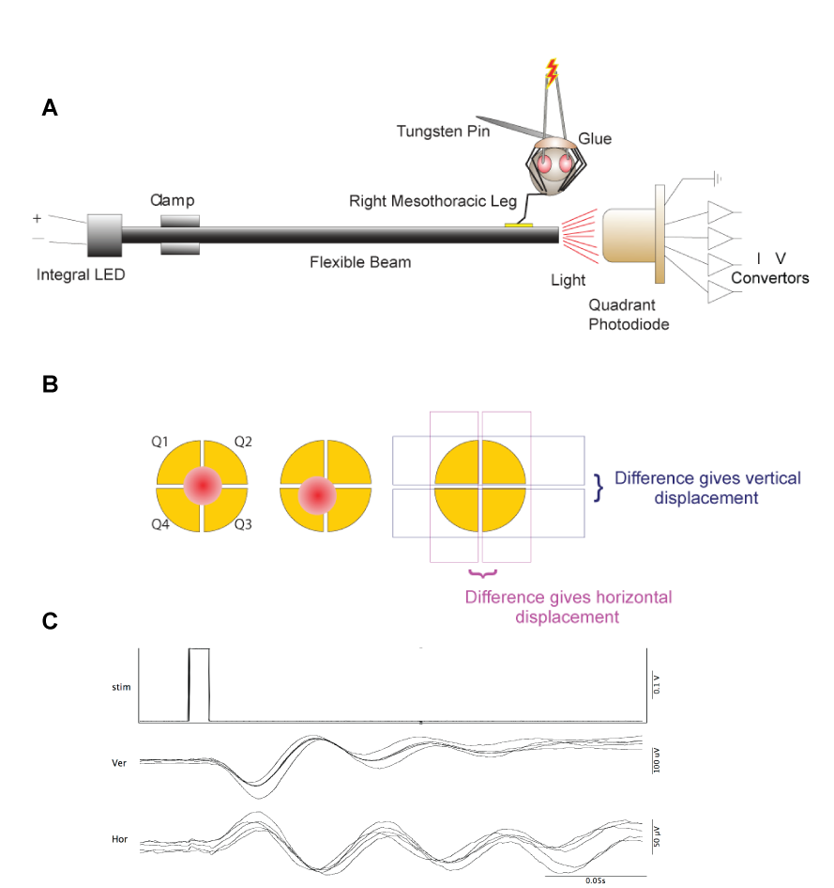
Fig. 2.6. The ergometer apparatus used to measure jump performance
(A) Female flies were affixed to a tungsten wire and lowered onto a platform on an LED light pipe. Sharpened tungsten electrodes were inserted into each eye and a 28 V stimulus applied for 1 ms to stimulate the giant fiber escape response. As the fly jumps, the light beam is displaced; this is detected by the photodiode and is transmitted to the PC via current-to-voltage convertors. (B) The displacement of the beam causes a shift in the illumination across the four segments of the photodiode. By measuring the difference in illumination between the top and bottom half of the photodiode, vertical beam displacement can be calculated. Similarly, measuring the difference between the left and right halves of the photodiode allows the calculation of the horizontal beam displacement. The peak vertical and horizontal beam displacements were combined to determine maximum jump performance. A and B were reproduced, with permission, from Harvey et al., 2008. (C) An example output from the ergometer is shown. Various jumps have been overlayed. Stim, electrical stimulus; Ver, vertical beam displacement; Hor, horizontal beam displacement.
  - Molecular biology
    - Genomic DNA extraction
Genomic DNA (gDNA) was extracted from 15 w⁻ and dSap-r^{{PGawB}NP7456} flies using the Puregene DNA purification kit (Gentra Systems Inc., QIAGEN, UK), as per the manufacturers instructions. Flies were homogenised in 300 μl ice-cold cell lysis solution and incubated at 65°C for 15 min. The lysate was treated with 4 mg/ml RNase A solution for 15 min at 37°C. After cooling to approximately 22°C (room temperature; RT), protein and particulates were removed by the addition of 100 μl protein precipitation solution and centrifugation at 13,000g for 3 min. The DNA-containing supernatant was treated with 300 μl isopropanol to precipitate the DNA, followed by centrifugation at 13,000g for 1 min. The DNA pellet was washed with 70% ethanol and rehydrated in 50 μl DNA hydrating solution for 1 h at 65°C. gDNA was stored in 5 μl aliquots at -20°C. 0.5 - 1 μl of gDNA was used in each PCR reaction.
    - DNA extraction from single flies
DNA from single flies was extracted by homogenising in 50 μl DNA extraction buffer (10 mM Tris-HCl pH 8.2, 25 mM NaCl, 1 mM EDTA), supplemented with fresh Proteinase K (200 μg/ml), and incubated at 37°C for 30 min. The Proteinase K was inactivated by a 10-min incubation at 85°C. The fly particulates were pelleted by centrifugation in a benchtop centrifuge at 13,000g for 3 min. 1 - 2 μl of the supernatant was used as a template in PCR.
    - Polymerase chain reaction (PCR)
PCR mastermix (Promega, UK; 25 U/ml Taq DNA polymerase, Taq Reaction Buffer, 200 μM of each dNTP, 1.5 mM MgCl₂) was used with 0.5 μM of each primer to amplify gDNA and single-fly DNA templates (see Table 2.2 for primer list). Primers were designed manually and the melting point temperatures were calculated using NetPrimer or Primer3 software and were
Primer Sequence Tm

dSap-r Primer 1 GAC AAC GTA TTC AAG TAC TC 56°C
dSap-r Primer 4 CAC TTG GCT GCG CAT TCA 56°C
dSap-r Primer 5 TCC ATT TTC CCG GTT TTA AC 56°C
dSap-r Primer 6 CGT ATT CGT GCT GTG CAC 56°C
dSap-r Primer 7 AAT ATG GGA TAT GAA GGC AG 56°C
dSap-r Primer 8 AGT AAC CAT GTC CTT GCA TA 56°C
dSap-r Primer 9 AAT AGG TGA GCA CAA TGT TG 56°C
dSap-r Primer 10 CTG AAT GAA ATG CAG CAT GT 56°C
dSap-r Primer 11 GTA CTT GTC GAT AAC CTT GT 56°C
dSap-r Primer 12 ACA TCA CAA CGC ATC ACT TA 56°C
dSap-r Primer 13 TAT GCA AGG ACA TGG TTA CT 56°C
dSap-r Primer 14 ACA TGC TGC ATT TCA TTC AG 56°C
dSap-r Primer 17 GGA AAT TTC ACT CTT GTG GA 56°C
dSap-r Primer 18 GTT AAA ACC GGG AAA ATG GA 56°C
dSap-r Primer 19 CTG CCT TCA TAT CCC ATA TT 56°C
dSap-r Primer 20 CTC TTC ATG TTA ATG GAA ATT AGC 56°C
dSap-r Primer 21 CAA CTC GGG CAG GAA GTC 56°C
dSap-r Primer 22 CGA AGT TCA GCC AGC AAG AG 59°C
dSap-r Primer 23 CAC CAG AGA CAG CAT CAA GC 56°C
dSap-r Primer 24 GCG TTT ATA AAT TCA GTT TCA TCA C 58°C

Table 2.2. Primer sequences and melting-point temperatures

Primer Sequence Tm

NP7456 Primer 2 TTC ACA CAG GAA ACA G 46°C
NP7456 Primer 3 CCT CTC AAC AAG CAA ACG 56°C
dSap RT-Forward GCA ACT GCA ACC TGC TTT CC 62°C
dSap RT-Reverse GCA TCG TTT CCA CCA TGT CA 60°C
rp49 Forward TCC TAC CAG CTT CAA GAT GAC 61°C
rp49 Reverse GTG TAT TCC GAC CAC GTT ACA 62°C
5’pUAST Forward CTG CAA CTA CTG AAA TCT GC 58°C

Table 2.2. Primer sequences and melting-point temperatures

synthesised by Eurogentec (UK). PCR reactions were performed in a 20 μl volume in a Techne TC512 PCR thermocycler (CamLab, UK). The annealing temperatures were calculated as 5°C lower than the lowest melting point temperature of the primer pairs. Elongation times were determined as 1 minute per 1kb of DNA to be amplified.
    - DNA agarose gel electrophoresis
Agarose gel electrophoresis was used to analyse DNA products from PCR or restriction enzyme digestions. Gels were made to 0.8% agarose for large products (> 1kb) or 1.3% agarose for small products (< 1kb) in TAE buffer (40 mM Tris acetate, 1 mM EDTA, pH 8.3). Either SYBR Safe (Invitrogen, UK; 10 μl/100 ml) or ethidium bromide (2 μl /100 ml) were added to the gel to allow visualisation of DNA products using a blue light or UV box, respectively. DNA was loaded with loading dye (Bromophenol Blue, 10% glycerol), and either a 1kb or 100bp DNA ladder (0.5 µg/lane) was used (NEB, Ipswich, MA; Promega, UK). Agarose gels were run at 90 volts for 30-45 min.
    - DNA fragment purification
      - Gel extraction
DNA products required for sequencing or cloning applications were excised from the agarose gel and processed using a QIAquick gel extraction kit (Qiagen, UK). Manufacturer’s instructions were followed. After determining the weight of each gel band, 3 volumes of Buffer QG were added to the agarose slice (100 mg gel is approximately equivalent to 100 μl). The gel was dissolved at 50°C for 10 min followed by the addition of 1 volume of isopropanol to the sample. The sample was added to a QIAquick spin column and centrifuged for 1 min at 13,000g to allow the DNA to bind to the affinity matrix. The column was washed with 500 μl Buffer QG (to remove excess agarose) followed by 750 μl Buffer PE to remove the salts, with centrifugation as above. After removing residual ethanol by centrifugation, the DNA was eluted with 30 μl distilled water. DNA concentration was determined using an ND-1000 spectrophotometer (NanoDrop; Thermo Scientific, DE, USA). See section 2.5.9 for template concentration and primer requirements for sequencing.
      - PCR purification
PCR products were purified using the QIAquick PCR Purification kit, as per manufacturer’s instructions. 5 volumes of Buffer PBI were added to the PCR product, which was applied to the QIAquick spin column, as above, and washed with 750 μl Buffer PE. After removing the residual ethanol from the PE buffer, DNA was eluted with 30 μl distilled water.
    - Restriction endonuclease digestion
Restriction endonucleases were used for inserting DNA into various plasmids (see section 2.9). Plasmid DNA was added to XhoI and EcoRI restriction endonucleases in NEB Buffer 4, and incubated for at least 1 h at 37°C. Restriction fragments were run on an agarose gel to assess restriction digest success. The required insert or plasmid products were excised and purified as described in section 2.5.5.1.
    - DNA ligation
DNA inserts and plasmids pre-treated with restriction endonucleases were ligated using T4 DNA ligase (Invitrogen, UK). The DNA concentration was measured using a NanoDrop to allow the quantification of insert and plasmid vector ratios (1:1 and 1:3 insert:vector ratio (ng)). The ligation reactions were left at RT for 1 h.
    - E. coli amplification of plasmid DNA
XL10 GOLD E. coli (Stratagene, CA, USA) transformation was used to amplify plasmids for transgenic fly generation (see section 2.9).
      - Production of competent E. coli
Chemically competent XL10 GOLD E. coli cells were generated by growing a 5 ml overnight culture in Luria broth (LB; 10 g/l tryptone, 10 g/l NaCl, 5 g/l yeast extract) at 37°C (without antibiotic selection) for approximately 16 h on a shaking platform. This culture was used to seed 200 ml sterile LB containing 20 mM MgSO₄ (filter sterilised). The cells were incubated on a shaking platform for 3 h at 37°C until the optical density at 600 nm (OD₆₀₀) was between 0.4 - 0.6. Cells were pelleted by centrifugation for 5 min at 5500g at 4°C. The supernatant was discarded and the pellet resuspended in 50 ml TFB1 buffer (30 mM KOAc, 10 mM CaCl₂, 50 mM MnCl₂, 100 mM RbCl, 15% glycerol, pH 5.8) at 4°C. The resuspension was pelleted by centrifugation (as before) followed by resuspension of the pellet in 5 ml TFB2 buffer (10 mM MOPS, 75 mM CaCl₂, 10 mM RbCl, 15% glycerol, pH 6.5) at 4°C. Resuspended cells were incubated on ice for 15 min and snap frozen in liquid nitrogen in 100 µl aliquots. The chemically competent XL10 Gold cells were stored at -80°C.
      - Heat-shock transformation of E. coli
100 µl chemically competent XL10 GOLD E. coli were incubated with approximately 1 µg plasmid DNA for 20 minutes on ice. Cells were heat shocked for 45 seconds at 42°C, followed by incubation for 20 minutes on ice. Cells were spread onto an LB-agar plate (LB and 20 g/l agar) containing the appropriate antibiotic (either ampicillin at 200 µg/ml, chloramphenicol at 12.5 µg/ml, or both). Plates were pre-warmed to 37°C and were returned to 37°C following cell plating for an overnight incubation.
      - Overnight E. coli culture production
Following overnight incubation of E. coli plates at 37°C, single colonies were picked with a sterile pipette tip and placed in a sterile universal tube containing 5 ml of LB and antibiotic. The culture was incubated overnight at 37°C on a shaking platform. Stocks of transformed E. coli were stored at
-80°C by adding overnight cultures to 50% sterile glycerol (v/v). These were used to seed fresh overnight cultures when required.
      - Harvesting of amplified plasmid: mini preps
2 ml of the overnight cultures were pelleted at 13000g for 2 minutes in a benchtop microcentrifuge. After removal of supernatant, the pellets were processed using the QIAprep Spin Miniprep Kit (QIAGEN, UK), according to the manufacturer’s instructions. This procedure is based on the alkaline lysis method and involves pellet resuspension in 250 µl Buffer P1, alkaline lysis by addition of 250 µl Buffer P2, followed by neutralisation with 350 µl Buffer N3. The lysate was cleared by centrifugation (13000g for 10 min) before addition of the supernatant to the QIAprep spin column. Following binding of plasmid DNA to the spin column membrane, various wash steps were performed
(500 µl Buffer PB then 750 µl Buffer PE, with centrifugation at 13000g for 1 min each). Residual wash buffer was removed by centrifugation (13000g for 1 min) and plasmid DNA eluted with 30 µl distilled water. Plasmid DNA was stored at -20°C.
      - Harvesting of amplified plasmid: midi preps
For higher yields and purity of plasmid DNA, a QIAGEN Plasmid Midi Kit was used. This procedure depends on the selective binding of plasmid DNA to an anion-exchange resin. The bacterial pellet (from 50 – 100 ml culture) was resuspended, lysed and neutralised as above (in 6 ml of Buffer P1, P2 and N3). Lysate clearance was performed by filtration through a QIAfilter cartridge into a pre-equilibrated HiSpeed Tip. After binding of the plasmid DNA to the anion-exchange resin, the resin was washed with 20 ml Buffer QC. Plasmid DNA was eluted using a high salt solution (5 ml Buffer QF). Plasmid DNA was concentrated and desalted by isopropanol precipitation (0.7 volumes of isopropanol) and filtered through a QIAprecipitator. The DNA was washed with 70% ethanol. After drying the membrane by pressing air through the QIAprecipitator, plasmid DNA was eluted by passing 1 ml Buffer TE (10 mM Tris, pH 8.0, 1 mM EDTA) through the QIAprecipitator. This step was repeated to increase the yield of eluted DNA. Plasmid DNA extracted in this way was used for microinjection of Drosophila embryos.
    - DNA sequencing
DNA sequencing was used to determine the exact deletion produced in the dSap-r^{C27} mutant, and to sequence the wild type dSap-r insert (see section 2.8.1). Purified PCR product and plasmid preparations were sequenced using either Geneservice (Cambridge, UK) or the Technology Facility (York, UK) sequencing services. 3 - 10 ng/µl were required for PCR products
(500 - 1000 bp) and 100-150 ng/µl for plasmid DNA sequencing. Primers were required at 3.2 µM. Sequencing results were analysed using Chromas (Version 1.45, Conor McCarthy, Australia) and NCBI bl2seq software.
    - Reverse transcription PCR (RT-PCR)
      - RNA extraction
RNA was extracted from Drosophila third instar larvae to allow the presence or absence of dSap-r transcript to be determined by RT-PCR. The QIAGEN RNeasy kit was used according to the manufacturer’s instructions. Larvae were pinned through the anterior end, the posterior end severed, and the fat bodies and guts removed. RNA was extracted by rupturing the larvae in lysis buffer (350 µl Buffer RLT containing 1% (v/v) β-mercaptoethanol) using a plastic pestle. The particulates were removed by centrifugation (13000g for 3 min). 1 volume 70% (v/v) ethanol was added to the supernatant and transferred to an RNeasy spin column. All centrifugation steps, unless otherwise stated, were at 8000g for 20 sec. After centrifugation, the spin column was washed with 700 µl Buffer RW1, followed by two washes in 500 µl Buffer RPE (the final centrifugation step was for 2 min). Residual Buffer RPE was removed by further centrifugation at 13000g for 1 min. The RNA was eluted with 30 µl RNase-free water, which was passed through the column twice to increase RNA yield.
      - DNase treatment of RNA extract
RNA extracted from third instar larvae was treated with DNase to remove contaminating DNA. 1 µl (1 U) of DNase (RQ1 RNase-free DNase, Promega, UK) was added per 1 µg of RNA, together with DNase buffer (40mM Tris,
pH 8.0, 10 mM MgSO₄, 1 mM CaCl₂). The reaction was incubated at 37°C for 30 min, and stopped by the addition of 1 µl STOP solution (2 mM EGTA,
pH 8.0; Promega, UK) and incubation at 65°C for 10 min.
      - RT-PCR
DNase-treated RNA was converted to cDNA by the reverse transcription reaction. Reverse transcriptase (4 U/20 µl reaction), RT buffer and 0.5 mM of each dNTP (Omniscript, QIAGEN, UK) were added to 1 µM Oligo-dT primers (Promega, UK), RNase inhibitor (10 U/20 µl reaction; Ribolock, Fermentas) and DNase-treated RNA, and were incubated at 37°C for 1 h. The cDNA was purified as described in section 2.5.5.2. The concentration of the purified cDNA was quantified using a NanoDrop to ensure the same amount of template was added to the subsequent PCR reactions. Primers for the ribosomal protein rp49 (Table 2.2) were used to detect any DNA contamination in the DNase-treated RNA samples and to show equal loading of template. PCR reactions were performed as described in section 2.5.3.
  - Western blotting
Western blotting was used to assess the levels of the lysosomal marker Arl-8 in Drosophila PSAP mutants. To allow equal loading of wild type and mutant protein samples, proteins were extracted in lysis buffer to allow protein quantification.
    - Protein extraction
      - Lysis buffer extraction
Proteins were extracted from 10 - 15 flies using lysis buffer (150 mM NaCl, 20 mM Tris-HCl, pH 8.0, 2 mM EDTA, 0.5% (v/v) NP-40, 1 complete mini protease inhibitor cocktail (Roche)). 10 µl lysis buffer was used per fly. The fly lysates were incubated on ice for at least 15 min followed by centrifugation at 13000g at 4°C for 10 min. The supernatant (soluble protein) was removed and stored at -20°C.
      - Quantification of protein concentration: Bradford assay
Protein concentration was quantified using a Bradford assay. Binding of protein to the Coomassie dye in the Bradford reagent leads to a colour shift from red/brown to blue. The absorbance of the reagent-protein complex can be measured at 595 nm. Protein samples (5 µl) were added to 250 µl Bradford reagent and the absorbance recorded. A bovine serum albumin (BSA) standard curve was produced by measuring the absorbance of known concentrations of BSA. The protein concentrations of the unknown samples were calculated from the BSA standard curve. Known amounts of protein sample were added to an equal volume of 2x sample buffer, samples were heated to 95°C for 10 - 15 min and loaded on an SDS-PAGE gel.
    - Sodium dodecyl sulphate polyacrylamide gel electrophoresis (SDS-PAGE)
Following heating to 95°C in sample buffer (100 mM Tris, pH 6.7, 15% (v/v) β-mercaptoethanol, 2% (w/v) SDS, 5% (v/v) glycerol, 0.002% (w/v) bromophenol blue), protein samples were separated on SDS-PAGE gels. The gels were composed of a 12.5% (v/v) acrylamide resolving gel and a 6% (v/v) acrylamide stacking gel. After loading of samples and a protein ladder (10 µl Pre-stained Benchmark Protein ladder, Invitrogen, UK), SDS-PAGE gels were run in running buffer (25 mM Tris, 192 mM Glycine, 0.1 % SDS) at 80 V for approximately 10 min (to narrow the running front) then increased
to 200 V. Proteins were visualised by incubation in Coomassie stain for
20 - 30 min, followed by frequent washes in destain solution.
    - Protein transfer and probing of nitrocellulose membrane
Following SDS-PAGE, gels and nitrocellulose membrane were soaked in transfer buffer (25 mM Tris-HCl, 192 mM glycine, 20% (v/v) methanol, 0.1% (w/v) SDS) for 10 min. Proteins were transferred to nitrocellulose membrane by applying 100 V for 1 h in a wet transfer system (BioRad, CA, USA). Successful transfer was assessed by reversible staining in 0.1% (w/v) Ponceau-S and 5% (v/v) acetic acid solution. Ponceau-S was removed by washes in PBS. The membranes were blocked using 5% (w/v) Marvel milk in TBS-T (Tris buffered saline (10 mM Tris, pH 7.4, 150 mM NaCl) supplemented with 0.1% (v/v) Tween-20) for 30-60 minutes followed by primary antibody incubation in 5% (w/v) Marvel milk in TBS-T for 1-2 h (or overnight at 4°C). Membranes were subsequently washed (3 x 5 min) in TBS-T. Secondary antibody (conjugated to HRP) was added in 5% (w/v) Marvel milk in TBS-T for 30 - 60 min. Excess secondary antibody was removed by washes (3 x 10 min) in TBS-T. All washes and incubations were performed on a rocking platform. Membranes were incubated in ECL reagent (GE Healthcare, UK) for 1 min. Film was placed on the blot for 10 sec (α-tubulin) and 20 sec (α-Arl-8). Exposed film was developed and fixed using an Xograph film developing machine. Antibody dilutions can be found in Table 2.3.

Antibody Host Species Source Dilution

α-Arl8 Rabbit polyclonal Smith lab, York 1:2000
α-β-tubulin (E. coli) Mouse monoclonal DSHB 1:100
α-Rabbit-HRP Goat Sigma 1:6000
α-Mouse-HRP Goat Sigma 1:10000

Table 2.3. Antibody dilutions used for western blotting

  - Fluorescence and light microscopy
    - Detecting the expression pattern of Gal4 lines
The expression pattern of the dSap-r^{NP7456}, 1407- and Gcm-Gal4 lines were detected by crossing these flies to flies containing a GFP reporter construct downstream of an upstream activator sequence (UAS). The tissue localisation of fluorescent protein was detected by dissection, fixation, immunostaining (Table 2.4) and visualisation on a confocal fluorescent microscope. The presence of fluorescence was determined at third instar and adult stages. Third instars and adults were dissected to visualise the brain, Malphigian tubules and reproductive system, where appropriate. Dissection protocols are outlined below.
    - Visualisation of fluorescence in third instar larvae
Third instar (wandering) larvae were placed on a Sylgard dish (Silicone elastromere kit, Dow Corning, MI, USA) in PBS and were pinned at both anterior and posterior ends with minuten pins (Austerilic Insect Pins 0.1 mm diameter, Fine Science Tools, Heidelberg, Germany). An incision was made at the posterior end using Spring scissors (Fine Science Tools, Heidelberg, Germany), which was expanded along the dorsal midline of the larva. The muscle walls were pinned out and the internal organs removed, leaving the CNS attached. The pinned larvae were fixed for at least 7 min using 3.7% formaldehyde in PBS, followed by washes (3 x 5 -10 min) in PBS-T (PBS supplemented with 0.1% (v/v) Triton X-100). Larvae were incubated in primary antibody diluted in PBS-T for 2 h at room temperature (or overnight at 4°C). After primary antibody incubations, larvae were washed
(3 x 5 - 10 min) in PBS-T, followed by secondary antibody incubation in
PBS-T for 2 h at RT. Excess secondary antibody was removed by washes
(3 x 5 - 10 min) in PBS-T. Air was removed from the trachea by incubation of the larvae in 70% (v/v) glycerol/PBS for 1 - 2 h (until the larvae had sunk to the bottom of the 1.5 ml tubes). The heads and tails of the larvae were discarded using a razor blade and the larvae mounted in Vectashield. A 22mm x 22mm coverslip was placed either side of the mounted larvae and a 50mm x 22mm coverslip placed on top to prevent flattening of the larval brain. Fluorescence was detected using a Zeiss LSM 510 meta Axiovert 200M laser scanning confocal microscope. The 20x and 63x (oil emersion) objectives were used. A 505 - 530 nm band pass filter was used to visualise the GFP and a long pass 560 nm to visualise the cyanine 3 (Cy3) conjugate.
    - Visualisation of fluorescence in adult flies
Adult flies were briefly dipped into 100% ethanol, to reduce surface tension, then placed dorsal side down and pinned through the head, thorax or abdomen (depending on which region of the fly was to be dissected). For fly brains, dissections were performed in fixative (4% (w/v) paraformaldehyde in PBS); all other dissections were performed in PBS.
      - Dissection of the adult fly brain
The legs and wings were first removed to reduce obstructions to the head. This was performed by apposing pairs of forceps against each other to break the tissue; this prevented pulling of the peripheral nervous system. Once these appendages had been removed, the proboscis was detached from the head by lifting the proboscis and severing the connections to the head. The silvery trachea and air sacs were excised and the eye and cuticle removed with a peeling action. At no point was the brain held within the forceps. The brain was severed from the cervical connective and placed in an ependorf containing fresh fixative (4% (w/v) paraformaldehyde in PBS). Adult brains remained in fixative for at least 20 min and were then washed in 0.3% PBS-T (PBS supplemented with 0.3% Triton X-100; 3 x 15 - 20 min) followed by primary antibody incubation overnight at RT in 0.3% PBS-T. The adult brains were washed (3 x 15 - 20 min) in PBS followed by secondary antibody incubation for 3 h at RT in 0.3% PBS-T. Washes were performed in PBS
(3 x 15 - 20 min) followed by an overnight wash. Adult brains were mounted in Vectashield with a 22 mm x 22 mm coverslip placed either side of the brains, as described above. Fluorescence was visualised using a Zeiss LSM 510 meta Axiovert 200M laser scanning confocal microscope; 10x and 63x objectives were used. Filters were used as described in section 2.7.2.
      - Dissection of the adult male and female reproductive systems
Flies were dipped in ethanol, placed dorsal side down (as above) and were pinned through the thorax. An incision was made from the side of the abdomen and the cuticle peeled back to reveal the inner organs. The gut, Malphigian tubules and fat bodies were removed and discarded, leaving the reproductive system behind. A discrete region of the remaining cuticle or digestive system was used to pin the reproductive system in place. Fluorescence was visualised using a Zeiss stereomicroscope equipped with an Axiocam MRc5 camera (utilising AxioVision (Release 4.8.1, 2009) software), a Neolumar S 1.5x FWD 30 mm lens and a HBO 100 mercury lamp.
      - Dissection of the adult Malphigian tubules
Since the Malphigian tubules are located both in the lower abdomen and the thorax, flies were pinned dorsal side down through the head. Dissections were performed as described for the reproductive system, however the gut and attached Malphigian tubules were left in place, and the reproductive system and fat bodies were removed. The Malphigian tubules (attached to the gut) were fixed, washed and stained in watchglasses. Malphigian tubules were mounted in Vectashield as described above, and visualised using a Zeiss stereomicroscope equipped with an Axiocam MRc5 camera (as above).
    - Visualisation of flies by light microscopy
Whole flies, dissected Malphigian tubules and reproductive systems were imaged using the Zeiss stereomicroscope (described above). Whole flies were cold immobilised (on ice) to aid image acquisition. Dissection of the Malphigian tubules and reproductive systems were performed as described above. Flies were imaged at 30x magnification (for whole flies), 40x and 120x magnification (for Malphigian tubules) and 63x, 65x and 125x for the reproductive systems.

Antibody/ Host Species Source Dilution

Stain
α-repo Mouse monoclonal DSHB 1:50
α-elav Mouse monoclonal DSHB 1:50
α-Arl8 Rabbit polyclonal Smith lab, York 1:500
α-Rabbit-FITC Goat Jackson Lab, USA 1:200
α-Mouse-Cy3 Goat Jackson Lab, USA 1:200
DAPI Sigma 1:10000

Table 2.4. Antibody and stain dilutions used for immunohistochemistry DSHB, Developmental Studies Hybridoma Bank
  - Generation of Drosophila transgenic stocks
    - Preparation of the dSap-r transgene
To allow expression of wild type dSap-r by the Gal4-UAS system (Brand and Perrimon, 1993), dSap-r-pUAST was microinjected into Drosophila embryos to generate transgenic stocks.
dSap-r-pUAST was produced by excision of the dSap-r cDNA insert from the chloramphenicol-resistant pOT2 vector (clone number GH08312, BDGP Gold collection). dSap-r-pOT2 plasmid was amplified by transformation and culture of E. coli, in the presence of 12.5 µg/ml chloramphenicol, and purification by the mini prep method (see section 2.5.8.4). The dSap-r cDNA insert was excised using XhoI and EcoRI restriction endonucleases. The 3447 bp product was purified by gel extraction and was ligated into the pUAST vector (see section 2.5.7), which had been treated with the EcoRI and XhoI restriction endonucleases. The ligation reaction was used to transform competent E. coli, which were spread on an LB-agar plate containing
200 µg/ml ampicillin and incubated at 37°C overnight. Single colonies were picked for amplification and plasmid purification by the mini prep method. After confirming the presence of the insert by restriction endonuclease assessment, 2 ml of the remaining overnight culture was used to seed a
200 ml culture. Centrifugation (5000g x 20 min) of this culture produced bacterial pellets that were processed to extract the plasmid using the QIAGEN Midi/Maxi kit (see section 2.5.8.5 for Midi prep method). Sequencing of the dSap-r-pUAST plasmid confirmed the sequence integrity of the dSap-r insert.
Approximately 6 µg dSap-r-pUAST was co-precipitated with 5 µg ∆2-3 transposase plasmid (Misra and Rio, 1990). 6 µg dSap-r-pUAST was also precipitated without ∆2-3 plasmid. These preparations were precipitated using 1/10th volume of 3 M NaOAc and 2 volumes of 100% ethanol followed by incubation at -20°C overnight. Precipitated DNA was pelleted by centrifugation at 13000g in a benchtop microcentrifuge for 30 min. Pellets were rinsed with 100 µl ice-cold 100% ethanol and left to air dry for 5 min. The pellets were resuspended in 5 µl Spradling buffer (5 mM KCl, 0.1 mM NaH₂PO4, pH 7.8; Rubin and Spradling, 1982). 0.5 µl of resuspended plasmid, not containing the ∆2-3, was run on an agarose gel to confirm the presence of DNA prior to microinjection.
    - Preparation of Drosophila embryos for microinjection
Large numbers of w⁻¹¹¹⁸ embryos were generated by placing w⁻¹¹¹⁸ adults in a cage with an apple-juice agar plate (40 g/l sucrose, 16 g/l agar, 20% (v/v) apple juice) in the bottom. Yeast paste was added to promote mating and egg laying. Flies were left to acclimatise to the cage for 48 h prior to eggs being required.
Eggs were collected within 1 h periods and a fresh agar plate added for the next round of egg collection. Eggs were harvested from the plate by wetting a paint brush, gently loosening the eggs and placing them onto a small piece of filter paper. The embryos were transferred to a piece of double-sided adhesive on a microscope slide and a second double-sided adhesive-lined microscope slide placed on top. Copper wires were placed between the microscope slides to prevent excess pressure being applied to the embryos. The microscope slides were parted to dechorionate the embryos.
Dechorinated embryos were carefully, but quickly, lined up with their posterior end overhanging a piece of non-toxic adhesive tape attached to a microscope slide. This procedure was carried out for no longer than 10 min to prevent drying of the dechorionated embryos. The lined up embryos were covered in oxygen-permeable, non-toxic Voltaleff oil to prevent dessication of the embryos.
    - Microinjection of Drosophila embryos
Microinjection was performed as described in Rubin and Spradling (1982) and Spradling and Rubin (1982). A glass needle was filled with 2 µl Spradling buffer containing the transgene and ∆2-3 transposase plasmid, and attached to the microinjection apparatus. The end of the needle was brought towards a pair of forceps to break the end to a sharp point. The slide containing the lined up embryos was placed on the microscope stage and the first embryo aligned with the needle. Embryos were microinjected with plasmid by piercing the posterior end and applying air pressure to the needle to eject plasmid. The posterior end contains the posterior pole cells, which are the progenitors of the gametes. Successful microinjection would result in plasmid uptake by the gamete progenitor cells. Following microinjection, the microscope slide containing the embryos was placed on an apple-juice agar plate in a box lined with wet tissue paper to create a humid environment.
    - Post-microinjection fly care
Embryos were checked for survival 48 h post injection. Any hatched first instar larvae were transferred to vials of standard fly food. This procedure was repeated daily. After 10 - 11 days, larvae that had developed to adulthood were collected and crossed to w⁻¹¹¹⁸ flies. If microinjection had been successful, the gametes of these flies would contain plasmid insertions. The pUAST plasmid contained a White gene, which would cause the fly’s eyes to be pigmented rather than white-eyed like the parent stock. Therefore, successful microinjection was screened based on eye colour in the offspring of this cross. Flies with pigmented eyes were collected and individually crossed to w⁻¹¹¹⁸ flies, as each fly represents a single plasmid insertion event. This amplified the numbers of flies with each plasmid insertion event to allow each insertion to be mapped to a chromosome (see below).
    - Determining the chromosome of plasmid insertion
To determine the chromosome identity for each insertion, flies with pigmented eyes were separately crossed to balancer chromosome stocks (Table 2.1). Balancer chromosomes prevent homologous recombination. When the transgene is present on the same chromosome number as the balancer, homologous recombination is prevented and the eye pigmentation (provided by the inserted White gene) would be maintained. If the insertion site is on a chromosome other than that of the balancer used, eye pigmentation will be lost during segregation of the chromosomes as a result of homologous recombination (Figure 2.7).
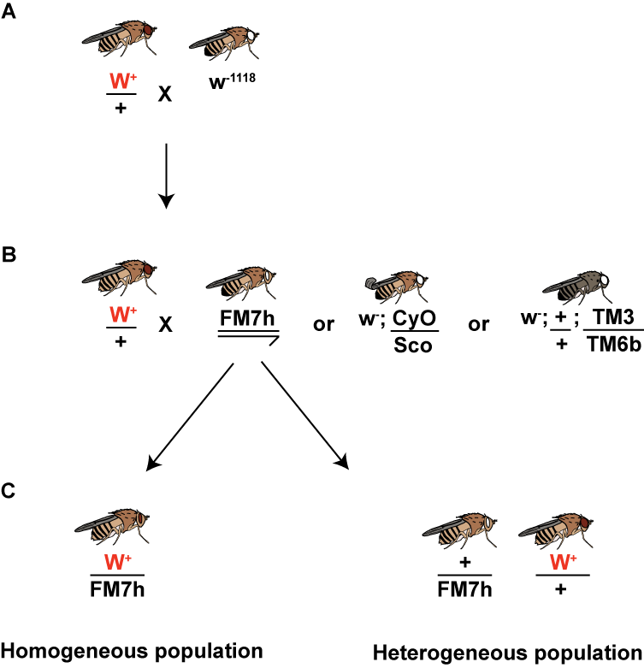

Fig. 2.7. Crossing scheme used to determine the chromosome identity of each transgene insertion. (A) Flies containing the transgene insertion (identified based on the presence of eye pigment) were crossed to a w⁻¹¹¹⁸ stock (white-eyed) to amplify the number of flies with each insertion. (B) The F₁ progeny with pigmented eyes were crossed to flies containing different chromosome balancers (FM7h; first-, CyO; second-, and TM3 & TM6b; third-chromosome balancers). (C) If the progeny were homogeneous (all flies with the balancer chromosome marker had pigmented eyes), the transgene was inserted on the same chromosome as the balancer used. If the progeny were heterogeneous (some flies had lost the eye pigmentation), the balancer had not prevented recombination of the transgene, therefore the insert was on a different chromosome to the balancer used. This is illustrated for the first chromosome balancer (FM7h) but the general principle also applies to the other balancers chromosomes.

