- Introduction
  - Rationale
Lysosomal storage disorders (LSDs) are a group of approximately 45 diseases characterised by the accumulation of undegraded material in the lysosomes, due to the dysfunction of some component of lysosomal function. The main causes of lysosomal dysfunction are mutations affecting the lysosomal hydrolases. Mutations affecting the group of lysosomal hydrolases required for sphingolipid degradation result in LSDs categorised as sphingolipidoses; this is the largest class of LSDs, comprising 16 different disorders (including each of the saposin deficiencies). Despite their collective prevalence of 1 in 16000 live births, the sphingolipidoses are sparsely represented by Drosophila models with only 2 models to date (Niemann Pick type C1 and C2).
The aim of this investigation was to generate and characterise a Drosophila model of the sphingolipidosis saposin deficiency. Saposins are activator proteins that promote the function of certain lysosomal hydrolases required for (glyco)sphingolipid degradation. In humans, there are 4 saposins encoded by the prosaposin gene. Mutations affecting each saposin leads to different neurodegenerative LSDs, as does the deficiency of prosaposin (a lack of all 4 saposins). Since 5 different LSDs are caused by mutations in this locus, a model generated by disrupting this locus would have the potential of advancing the understanding of up to 5 different LSDs. With this potential in mind, a Drosophila model of saposin deficiency was generated.

  - Lysosomal storage disorders
    - The lysosome: its function and implication in LSDs
The lysosome, as a membrane-bound acidic compartment containing various hydrolytic enzymes, was not discovered until the 1950s in the Belgian laboratory of Christian de Duve (de Duve, 1959). Its discovery was fundamental in the understanding of LSDs. The function of the lysosome is to degrade cellular and extracellular material targeted by various routes (Fig.1.1) to allow the recycling of unwanted or damaged material and provide intermediates for further metabolic reactions (Luzio et al., 2007). When this process becomes dysfunctional, lysosomal material accumulates and is stored in the lysosome: as in LSDs. Due to the involvement of lysosomes in many cellular degradative processes, their dysfunction has a vast impact on the function of the whole cell, the significance of which is only beginning to be understood.
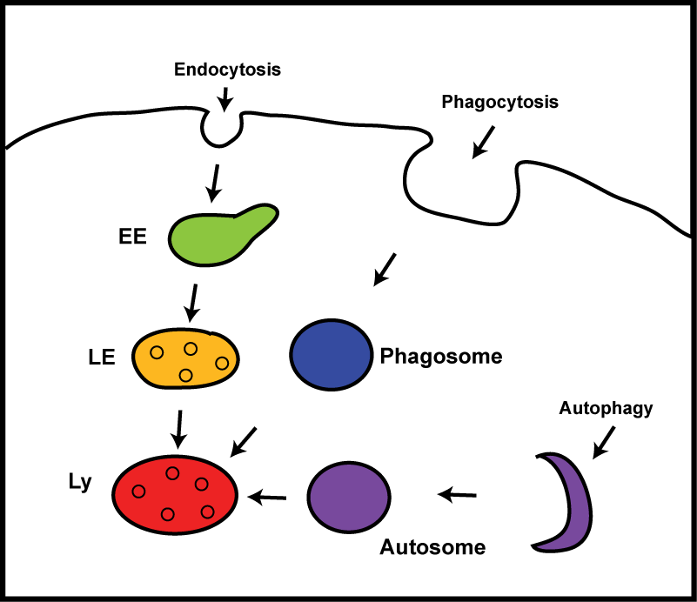

Fig. 1.1. Degradative routes to the lysosome. Various cellular degradative processes require the function of the lysosome (Ly). Extracellular material can traffic to the lysosome by the endocytic or phagocytic routes, whereas intracellular material is targeted via autophagy. The endocytic route to the lysosome occurs via intermediate organelles: the early endosomes (EE) and late endosomes (LE), which become increasingly acidic on route to the lysosome. Phagocytosis is required for the cellular engulfment of large materials, such as bacteria, for destruction by the lysosome. The autophagy pathway functions to remove intracellular material and organelles that are unwanted, toxic or damaged via targeting to the lysosome. Therefore, lysosome dysfunction would impact on each of these cellular pathways.

    - Clinical manifestations and causes of LSDs
There are approximately 45 LSDs, with a collective prevalence of 1 in 8000 live births (Meikle et al., 1999). The majority of LSDs are autosomal recessive, with the exception of Fabry and Hunter diseases (X-linked recessive). Usually LSD patients are compound heterozygotes, wherein each allele contains a different mutation (e.g. Tylki-Szymańska et al., 2007). This compound heterozygosity, in addition to other subtle genetic and epigenetic differences, can cause these disorders to be quite variable in their age of onset and severity, even between siblings with the same disorder (Wenger et al., 2001).
Despite this heterogeneity, some typical clinical manifestations can be described. Enlargement of the liver and/or spleen (hepato(spleno)megaly) is prevalent among many LSDs, particularly Gaucher disease type I where
90 - 96% of patients express these phenotypes (Mistry, 2006). Involvement of other visceral organs has also been reported in LSDs, such as the kidneys, lungs and heart, though these organs are spared in most cases. The milder forms of LSDs are often those with solely visceral organ involvement. More severe cases tend to be predominantly neuronopathic, with common manifestations including demyelination, general and localised seizures, sensorimotor deterioration and paralysis, retinal degeneration, and psychological disabilities (Jardim et al., 2010). Neuronopathic characteristics are particularly prevalent in the sphingolipidoses class of LSDs (section 1.2.3). This sensitivity of the nervous system suggests a particular requirement for sphingolipids in the nervous system. This is supported by the findings of Derry and Wolfe (1967), who discovered an enrichment of sphingolipids in neuronal tissue.
Although the onset of LSDs is variable, they are generally considered as childhood disorders: patients typically develop normally for the first 12 – 24 months followed by a period of deterioration and eventual lethality within the first decade of life (for review see Wraith, 2001). Mutations in the lysosomal hydrolases are the most common cause of LSDs; however, causative mutations have been identified in other lysosomal proteins (transmembrane proteins, soluble non-enzymatic activator proteins and protective proteins), and also in non-lysosomal proteins that negatively affect the synthesis, trafficking or function of lysosomal proteins (Fig. 1.2) (Jeyakumar et al., 2005).

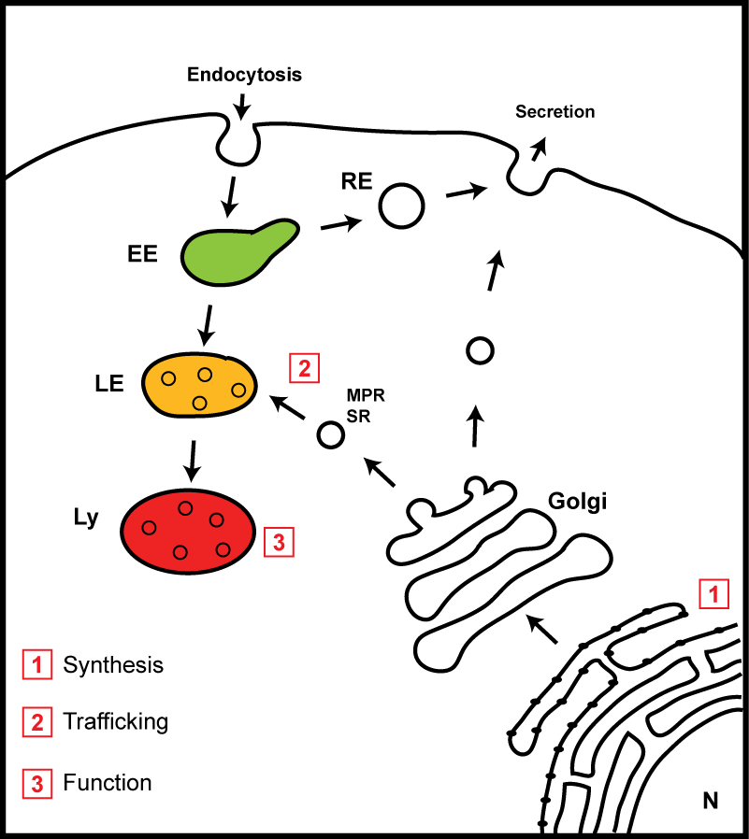
Fig. 1.2. Causes of lysosomal storage disorders. LSDs are caused by mutations that affect normal lysosomal function. These mutations can be present in the lysosomal hydrolases, lysosomal transmembrane proteins, soluble non-enzymatic proteins or protective proteins, or in non-lysosomal proteins that affect the synthesis, trafficking or function of lysosomal proteins. Lysosomal proteins are synthesised in the endoplasmic reticulum (ER) [1] and are trafficked to the late endosome (LE) and lysosome (Ly) via the Golgi apparatus [2]. An alternative route that can be taken by some lysosomal proteins (e.g. prosaposin) involves secretion in vesicles budding from the Golgi, and uptake by endocytosis. Endocytosed cargo can be either directed to the lysosomes via the early endosome (EE) and LE, or can be redirected to the plasma membrane via the recycling endosomes (RE).

    - The sphingolipidoses
The sphingolipidoses comprise 16 disorders, which accumulate varying combinations of sphingolipid species. Collectively, these disorders occur in approximately 1 in 16,000 live births and are the most common cause of childhood neurodegenerative disease (Meikle et al. 1999; reviewed in Ginzburg et al., 2004).
      - Sphingolipid biosynthesis and degradation
        - Sphingolipid biosynthesis
Sphingolipids are primarily found at the plasma membrane. Sphingomyelin, for example, constitutes approximately 16% of plasma membrane lipids, compared to 8% in the Golgi and 3% in the endoplasmic reticulum (ER), (van Meer, 1998). The de novo synthesis of sphingolipids begins in the ER by the condensation of L-serine and palmitoyl-CoA, catalysed by the heterodimeric serine-palmitoyl-CoA transferase (SPT); this results in
3-ketodihydrosphingosine formation. A reduction reaction leads to the formation of the sphingoid base dihydrosphingosine, which is converted to dihydroceramide by N-acylation followed by desaturation to ceramide (Fig. 1.3) (for review see Chen et al., 2010). Ceramide can be either degraded into sphingosine or transported to the Golgi by an ATP-dependent or –independent pathway (Fukasawa et al., 1999; Funato and Riezman, 2001). The conversion of ceramide to sphingomyelin, which occurs in the Golgi, preferentially utilises the ATP-dependent pathway; this has been shown to require the ceramide transfer protein (CERT) (Hanada et al., 2003). Modification of ceramide to form sphingomyelin is catalysed by the Golgi-localised sphingomyelin synthase (Allan and Obradors, 1999).
The simple glycosphingolipids are formed by the addition of glucose or galactose to the primary hydroxyl group of ceramide by glucosyl- or galactosyltransferase (Chen et al., 2010). The subcellular localisation of simple glycosphingolipid formation is controversial, with some evidence suggesting localisation in the ER, Golgi and also mitochondria-associated membranes (MAM) (Sprong et al., 1998; Allan and Obradors, 1999; Ardail et al., 2003). Further glycosylation to form the more complex glycosphingolipids, such as the gangliosides, occurs in the Golgi. Mature sphingolipids are transported to the plasma membrane, where 90% of sphingomyelin resides (Lange et al., 1989).
Sphingolipid biosynthesis is very similar in Drosophila, though the biochemical nature of the sphingolipids is different. The length of the sphingoid base hydrocarbon chain is shorter in dipteran species: tetradecasphingenine (C14) and hexadecasphingenine (C16) are predominantly used in contrast to octadecasphingenine (C18) in mammals, whilst sphingolipid acyl chain length is also shorter in diptera (Dennis et al., 1985). The formation of ceramide in Drosophila occurs in the ER, as described for mammals, and is transported to the Golgi by the Drosophila CERT (dCERT) (Rao et al., 2007). Although sphingomyelin is not synthesised in Drosophila, the structural analogue ceramide phosphoethanolamine is formed following ceramide transfer to the Golgi, as described for mammalian sphingomyelin. As in mammals, glycosphingolipids are also produced in Drosophila by the subsequent addition of monosaccharides by the appropriate glycosyltransferase; however, Drosophila do not contain the machinery to transport sialic acid into the Golgi and therefore the complex sialic acid-containing glycosphingolipids (the gangliosides) are not produced (Aumiller and Jarvis, 2002) (see Fig. 1.4).

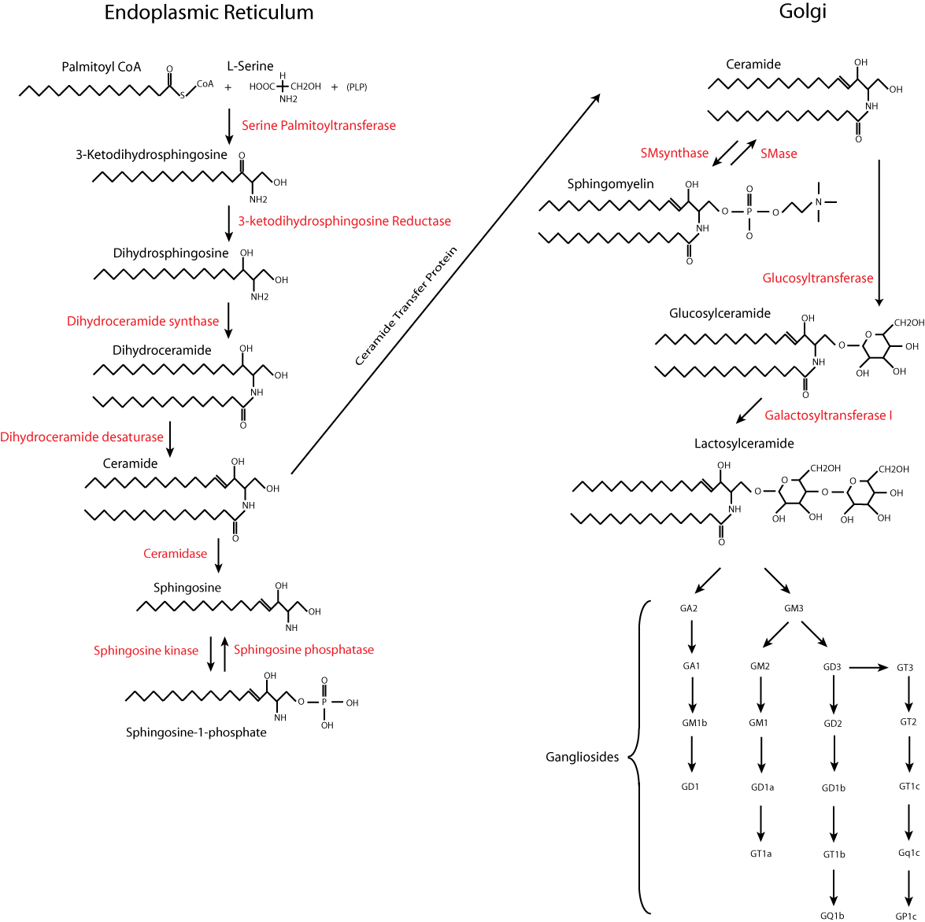
Fig. 1.3. The mammalian de novo glycosphingolipid synthesis pathway. Sphingolipids are synthesised in the ER by a condensation reaction between serine and palmitoyl-CoA. Following a series of reduction, acylation and desaturation steps, ceramide is formed. Ceramide can be transported to the Golgi by the ceramide transfer protein (CERT) to allow the addition of various hexose residues by glycosyltransferases to generate glycosphingolipids. Complexity is increased by the addition of one or multiple sialic acid residues to create the gangliosides. Image reproduced with permission (Oswald, 2010)

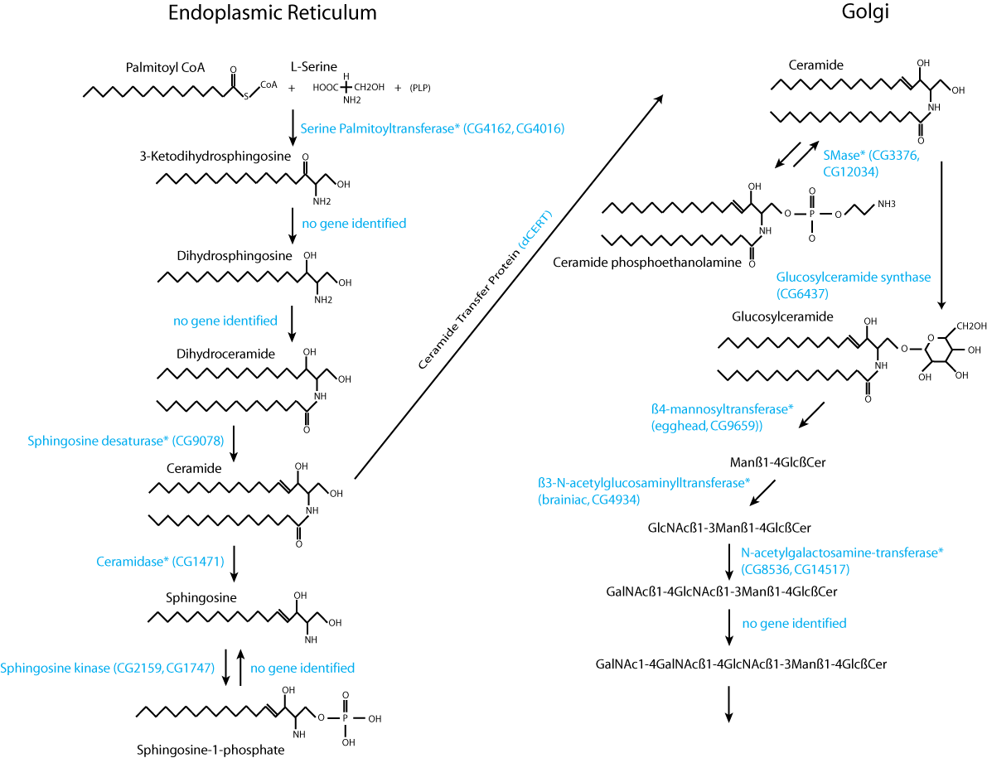
Fig. 1.4. The Drosophila de novo glycosphingolipid synthesis pathway. The synthesis of ceramide in Drosophila occurs in the ER, as in mammals. Ceramide is transferred to the Golgi via Drosophila ceramide transfer protein (dCERT) where it can be converted into the sphingomyelin analogue ceramide phosphoethanolamine or glycosphingolipids before transfer to the plasma membrane. The identified Drosophila homologues for the sphingolipid synthesis enzymes are shown in blue with the gene ID number in parentheses. Asterisks refer to the homologues with proven function, whereas the remaining homologues were identified based on sequence similarity to the mammalian protein. Image reproduced with permission (Oswald, 2010).
        - Sphingolipid degradation
The sphingolipidoses are caused by mutations that disrupt (glyco)sphingolipid degradation. The degradative process is performed in the lysosomes by certain lysosomal hydrolases, which sequentially remove the terminal sugar residues from the non-reducing end (Fig. 1.5) (Sandhoff, 1974). (Glyco)sphingolipids are targeted to the lysosomes from the plasma membrane by endocytosis. These (glyco)sphingolipids are localised to intralysosomal membranes, whereas the hydrolases that degrade them are soluble in the lysosomal lumen. For efficient (glyco)sphingolipid degradation, the sphingolipid hydrolases must directly interact with their membane-localised substrate, or commandeer an activator protein. Activator proteins can either extract the glycosphingolipid or increase the accessibility of the membrane substrate for the hydrolase (see section 1.3.4.1.2). This overcomes the steric hindrance imposed by the close proximity of the terminal hexose residue to the membrane in sphingolipids with short oligosaccharide head groups (Wilkening et al., 1998; Wilkening et al., 2000). These activator proteins are known as sphingolipid activator proteins, saposins or Saps. There are 5 sphingolipid activator proteins in humans, expressed by 2 genes: the human GM₂ activator protein (GM₂AP) is expressed by the GM2A gene on chromosome 5 (Heng et al., 1993), whereas the other 4 are expressed by the human prosaposin gene (PSAP) on chromosome 10 (Fürst et al., 1988; Morimoto et al., 1988; O’Brien et al., 1988; Morimoto et al., 1989; Nakano et al., 1989). As the name suggests, GM₂AP is involved in promoting the degradation of GM₂ gangliosides through β-N-acetylgalactosaminidase (hexosaminidase A); deficiency of this activator protein leads to the AB-variant of GM₂ gangliosidosis (reviewed in Mahuran, 1998). The prosaposin gene encodes saposins A, B, C and D (Sap A – D), each promoting the function of a different lysosomal hydrolase involved in (glyco)sphingolipid degradation (see below) (Berent and Radin, 1981; Vogel et al., 1987; Azuma et al., 1994; Yamada et al., 2004). LSDs have been identified for complete prosaposin deficiency, where all 4 saposins were absent (Harzer et al., 1989; Hulkova et al., 2001), and for individual saposin deficiencies, which result in a variant form of the LSD caused by mutation of its cognate hydrolase (Christamanou et al., 1986; Christamanou et al., 1989; Schnabel et al., 1991; Rafi et al., 1990; Kretz et al., 1990; Rafi et al., 1993; Pàmpols et al., 1999; Regis et al., 1999; Wrobe et al., 2000; Amsallem et al., 2005; Spiegel et al., 2005; Tylki-Szymańska et al., 2007; Deconinck et al., 2008).
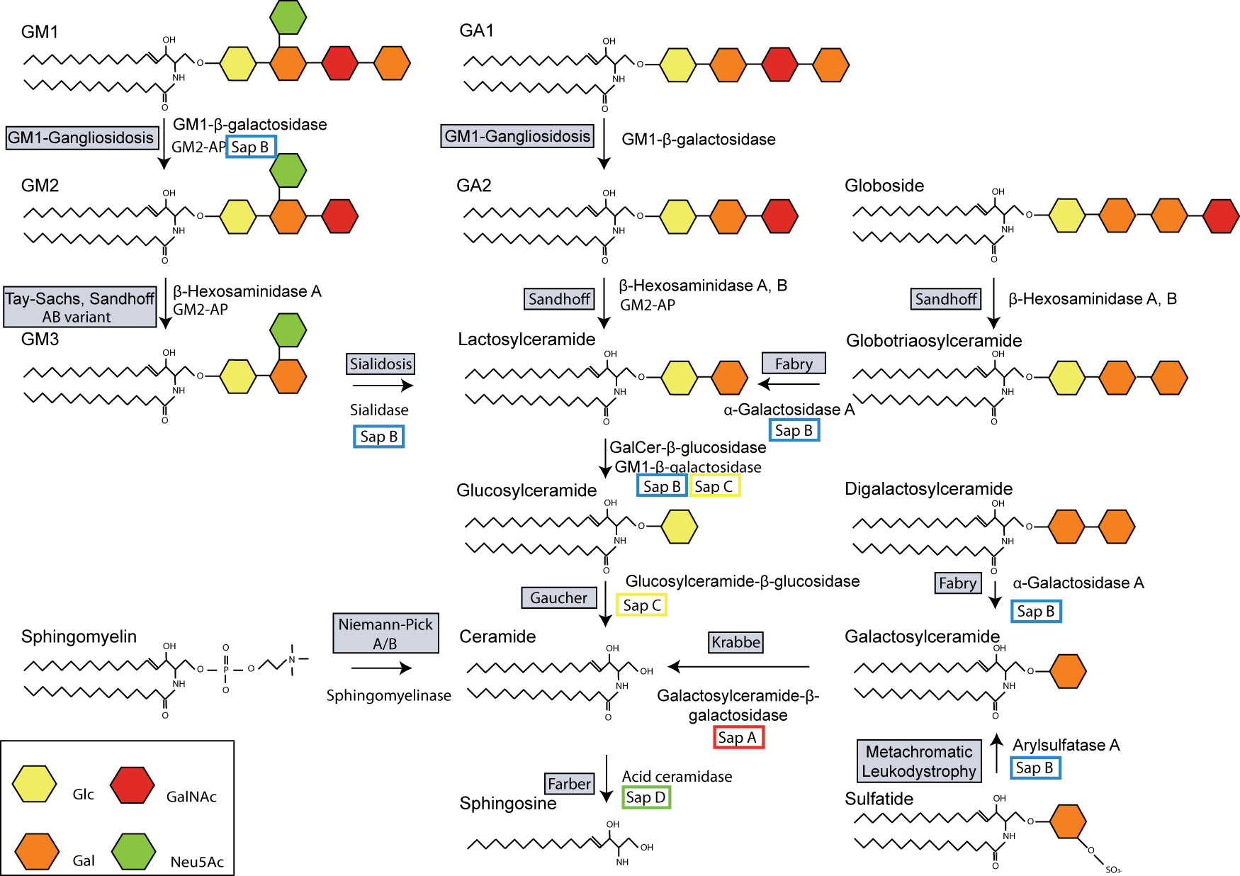
Fig. 1.5. The glycosphingolipid degradation pathway: disruption of either the sphingolipid hydrolases or their cognate sphingolipid activator proteins leads to distinct LSDs. Glycosphingolipids are composed of a ceramide backbone with various lengths of monosaccharides attached. Glycosphingolipids are degraded in the lysosome by the sequential removal of the terminal monosaccharide by sphingolipid hydrolases. The degradation of glycosphingolipids with short polysaccharide chains requires the action of sphingolipid activator proteins (GM₂AP and Sap A - D). Deficiency of either the sphingolipid hydrolase or the activator protein leads to an LSD (grey boxes). Only part of the glycosphingolipid degradation pathway is shown. Glc, glucose; Gal, galactose; GalNAc, N-acetylgalactosamine; Neu5Ac, N-acetylneuraminic acid.
      - Sphingolipids and the Sphingolipidoses
For each saposin deficiency there is a particular associated disease. Saposin A, B and C deficiencies produce variant forms of Krabbe disease, metachromatic leukodystrophy (MLD) and Gaucher disease, respectively. Saposin D deficiency is an exception, having never been reported, though its effect on acid ceramidase function would likely result in a variant of Farber disease.
        - Krabbe disease
Krabbe disease (globoid cell leukodystrophy) was first identified by Knud Haraldsen Krabbe in 1916 (Krabbe, 1916) and is classified among the leukodystrophies (as is MLD). This disease is caused by the deficiency of galactosylceramidase activity due to mutations within the GALC gene, of which 60 have been identified (Wenger et al., 2000). As is the case with many LSDs, the onset and progression of Krabbe disease is variable (Crome et al., 1973; Noronha et al., 2000; Harzer et al., 2002). However, in approximately 90% of cases symptoms arise in the first few months, followed by a rapid deterioration and death within the first two years post natal (Wenger et al., 2001). Hagberg et al. (1963) described the progression of Krabbe disease in three stages. The patient usually presents with hyperirritability, hypersensitivity to auditory, visual and tactile sensations, vomiting, fever, and stiffness of the limbs (stage I). This is rapidly followed by a period of motor and mental deterioration, seizures and vision loss due to optic nerve atrophy (stage II). The final stage is characterised by a complete loss of contact with their surroundings, generalised seizures and blindness. These disorders impact on the central and peripheral nervous systems (CNS and PNS) where they cause the almost complete destruction of myelin-producing CNS oligodendrocytes and PNS Schwann cells, resulting in severe demyelination (Hagberg et al., 1963; reviewed in Suzuki, 2003).
These myelin-producing cells are the primary site for the synthesis of galactosylceramide, the main substrate of galactosylceramidase. In a disorder where galactosylceramidase is deficient, one would expect an accumulation of its substrate (galactosylceramide). However the rapid degeneration of myelin-producing cells counters this, and the abnormal accumulation of this primary substrate is not observed (Eto et al., 1970). Nonetheless, galactosylceramide can be released as a product of myelin turnover. This free galactosylceramide cannot be degraded and has been linked to the infiltration of macrophages, which phagocytose the undegraded material and take on the characteristic “globoid cell” phenotype (Austin and Lehfeldt, 1965).
Another hallmark of this disease is the accumulation of the cytotoxic metabolite psychosine (galactosylsphingosine) (Svennerholm et al., 1980). Correlation between the level of psychosine accumulation and the severity of the disease indicated a probable cause for the rapid and severe degeneration of oligodendrocytes (“psychosine hypothesis”) (Miyatake and Suzuki, 1972; Suzuki, 2003). Reducing psychosine levels has, therefore, been a focus for therapeutic intervention; though successful reduction of psychosine levels by BMT in the twitcher mouse model had variable effects (Yeager et al., 1984; Ichioka et al., 1987; Hoogerbrugge et al., 1988a; Hoogerbrugge et al., 1988b).
        - Metachromatic leukodystrophy
MLD is caused by the deficiency of arylsulfatase A activity (ARSA), the lysosomal enzyme responsible for degrading sulfated glycosphingolipids (sulfatides); and a resulting accumulation of sulfatides (Norton and Poduslo, 1982). More than 100 disease-causing mutations have been identified in ARSA (Biffi et al., 2008). This disorder is metabolically very similar to Krabbe disease; both galactosylceramide and sulfatides constitute 20% of the myelin sheath lipid (dry weight) (DeVries and Norton, 1974). Accordingly, MLD is also primarily a disorder of the CNS and PNS, though sulfatide storage also occurs in visceral organs, such as the kidneys, gall bladder, liver, testes and rectal tissue (Wolfe and Pietra, 1964).
MLD can present as a late infantile, early juvenile, late juvenile or adult form. The majority of MLD cases are late infantile, presenting with deterioration of motor skills and language, followed by lower limb spasticity and speech impediment (Mahmood et al., 2009). Most MLD cases show a reduction in their motor and sensory nerve conduction velocities. As is the case with Krabbe disease and many neuronopathic LSDs, vision loss occurs due to optic nerve atrophy. Death normally ensues within 1-4 years of disease onset (Gieselmann, 2003).
        - Gaucher disease
Gaucher disease, the most prevalent sphingolipidosis, was the first LSD to be described (Gaucher, 1882), though its identity as a lysosomal disorder was not determined until de Duve’s discovery of the lysosome (de Duve, 1959). Gaucher disease patients show a marked variability in disease onset and severity, and have therefore been classified into three types. The type I Gaucher diseases are the most prevalent forms of the disorder and show a particularly high frequency amongst the Ashkenazi Jewish population (Beutler et al., 1993). Type I Gaucher patients show a high degree of variability, but are never neuronopathic. The type II and type III disorders are neuronopathic, with type II showing earlier onset and greater severity (Horowitz and Zimran, 1994). The majority of Gaucher causing mutations are within glucosylceramidase, leading to the accumulation of glucosylceramide (Fig. 1.5).
As Gaucher disease is the most common LSD, with a prevalence of 1 in 57,000 live births (Meikle et al., 1999), extensive research efforts have been channeled into understanding this group of disorders. In addition to glucosylceramide, Gaucher patients also accumulate its lyso-derivative (glucosylsphingosine) (Nilsson and Svennerholm, 1982). As discussed above, lyso-sphingolipids (such as psychosine) are thought to be toxic and are a likely cause of the neuropathology seen in many LSDs.
An additional hypothesis has been proposed implicating dysregulation of calcium homeostasis in Gaucher disease. Glucosylceramide, which accumulates in much greater quantities than glucosylsphingosine, has been shown to stimulate the agonist-induced calcium release from ER stores via the ryanodine receptor (RyaR) (Lloyd-Evans et al., 2003a). Microsomes from Gaucher Type II patients confirmed these results and also showed an enhanced calcium-induced calcium release (CICR) from internal stores (Pelled et al., 2005). Consequently, an elevated level of cytosolic calcium has been proposed as a factor that may sensitise neurons to excitotoxicity, as was shown in response to glutamate in a neuronal model of Gaucher disease (Schwarz et al., 1995).
        - Farber disease
Farber disease was first described by Dr. Sidney Farber in 1952 and was later identified as a deficiency of the lysosomal enzyme acid ceramidase (Farber, 1952; Sugita et al., 1972). Acid ceramidase catabolises ceramide in the lysosomes, producing sphingosine and fatty acid; therefore, in Farber disease, ceramide accumulates (Levade et al., 1995). This disorder is characterised by the development of painful subcutaneous skin nodules, a hoarse cry, and usually progressive neurodegeneration, the severity of which depends upon the degree of residual enzyme activity (Levade et al., 1995). Some patients also develop respiratory problems and die of pneumonia. However, in most cases, death ensues within the first few years post natal due to neurodegeneration (Ehlert et al., 2007).

These four sphingolipidoses are all caused by the deficiency of the relevant lysosomal hydrolase required to catabolise (glyco)sphingolipids with very short head groups. As discussed in section 1.2.3.1.2, saposins are also required to aid degradation of these (glyco)sphingolipids. The following section will introduce the structure and function of the four saposins encoded by the prosaposin gene.
  - Sphingolipid activator proteins: saposins A – D
    - Prosaposin synthesis and trafficking
As discussed in section 1.2.3.1.2, saposins A, B, C and D are encoded by the prosaposin gene. Prosaposin is synthesised in the ER, where its correct folding requires the quality control protein UDP-glucose:glycoprotein glucosyltransferase 1 (UGT1, also known as UGGT), which promotes interaction with the ER-associated, lectin-like chaperones calreticulin and calnexin (Pearse et al., 2010). Prosaposin is a major substrate of UGT1 (Pearse et al., 2010), which suggests its correct folding requires multiple rounds of chaperone-assisted folding; this may be a result of its multidomain structure and high percentage of hydrophobic residues. Binding of chaperones also recruits the oxidoreductase ERp57, which can aid the formation of disulfide bonds (Oliver et al., 1997). Each saposin domain contains three disulfide bonds (see section 1.3.3); therefore, prosaposin contains at least 12 disulfide bonds, which would further complicate its correct folding. In mouse embryonic fibroblasts (MEFs), deletion of ugt1 causes incorrect formation of the disulfide bonds in prosaposin, confirming the requirement for chaperones in prosaposin disulfide bond formation (Pearse et al., 2010).
Following successful folding, prosaposin advances through the secretory pathway into the Golgi apparatus, where it is further glycosylated. There are two glycosylation sites on the saposin A domain and one on each of the other saposin domains (Morimoto et al., 1989; O’Brien and Kishimoto, 1991). Therefore, prosaposin has a total of five oligosaccharide chains. The composition of the glycans on each domain is not homogeneous (Yamashita et al., 1990; Ito et al., 1993). The reason for the different glycosylation of each saposin domain is not known, but may be due to sequence variation around the glycosylation sites in each domain (Ito et al., 1993).
Following trafficking through the Golgi apparatus, prosaposin can either be secreted or targeted to the LE/lysosome. Targeting of most soluble lysosomal proteins requires the mannose-6-phosphate receptor (MPR), which binds the GGA (Golgi-localising, γ-adaptin ear homology domain, ARF-binding proteins) monomeric adapter proteins (Lobel et al., 1989; Nielsen et al., 2001; Puertollano et al., 2001; Zhu et al., 2001). However, prosaposin has been shown to traffic to the LE/lysosomes in fibroblasts from I-cell patients (Rijnboutt et al., 1991). I-cell patients lack phosphotransferase, the enzyme required for the addition of mannose-6-phosphate (M6P) tags to soluble lysosomal proteins (Reitman et al., 1981). This suggests that prosaposin can traffic to the LE/lysosome by an MPR-independent pathway. Lefrancois et al. (2003) showed that the sorting receptor necessary for prosaposin delivery to the LE/lysosome is the sortilin receptor (SR); they showed by co-immunoprecipitation assays that the luminal domain of SR can bind prosaposin. The SR, like the MPR, contains an acidic cluster-dileucine motif for interaction with monomeric adaptor proteins such as GGA (Nielsen et al., 2001). Previous observations have shown the saposin D domain and C-terminus of prosaposin to be required for targeting to the lysosomes (Zhao and Morales, 2000). In addition, the presence of sphingomyelin in the inner leaflet of the Golgi membrane is required for prosaposin targeting to the lysosomes (Lefrancois et al., 2002). From these observations, Lefrancois et al. suggest that the saposin D domain interacts with sphingomyelin, which localises prosaposin in close proximity to the SR for interaction through its
C-terminus (Lefrancois et al., 2002; Lefrancois et al., 2003).
Indirect trafficking of prosaposin from the trans Golgi network (TGN) to the lysosomes can occur through secretion and endocytic reuptake (Hiesberger et al., 1998). However, this route of trafficking to the lysosomes is thought to be minor and may represent recapturing of lysosomal proteins that have failed to traffic by the direct route (Lefrancois et al., 2003).
Prosaposin is thought to have an additional role independent of the individual saposins. O’Brien et al. (1994) proposed that prosaposin can act as a neurotrophic factor to promote cell survival (section 1.3.4.3), a theory supported by the abundance of prosaposin in the brain and cerebrospinal fluid (O’Brien et al., 1988). As suggested by Hiesberger et al. (1998), efficient reuptake of prosaposin would be necessary for control over neurotrophic signalling imposed by prosaposin, a role suggested to be provided by the low density lipoprotein receptor-related protein (LRP) (Hiesberger et al., 1998).
    - Processing in the endosome: the formation of four saposins
The processing of prosaposin is primarily carried out by the lysosomal aspartyl protease cathepsin D (Hiraiwa et al., 1997b). Proteolytic cleavage by cathepsin D initially produces a mixture of trisaposins consisting of saposins A, B & C and saposins B, C & D (48kDa) (Hiraiwa et al., 1993a; Leonova et al., 1996; Hiraiwa et al., 1997b). Further proteolysis leads to the formation of two disaposins consisting of saposins A & B and C & D (35kDa and 29kDa, respectively). The disaposins can then be processed by cathepsin D into smaller fragments containing single saposins with additional intersaposin sequence (14.5 - 17.5 kDa). Cathepsin D is only able to fully process saposin A to produce a mature protein (Hiraiwa et al., 1997b). Mature saposins B, C & D require additional proteases to complete their proteolysis (8 - 11kDa). Having found that gangliosides can complex with prosaposin (Hiraiwa et al., 1992), Hiraiwa et al. (1997b) investigated whether this interaction affected processing and discovered that 250 pmoles of ganglioside was sufficient to completely inhibit the processing of prosaposin. This powerful interaction suggests the existence of a mechanism that maintains prosaposin levels for roles independent of saposin production.
    - The “saposin fold”
Each saposin consists of 4 highly conserved amphipathic α-helices (α-1 - α-4) arranged as 2 α-helical pairs held together by disulfide bonds (Fig. 1.6 A & B) (Ahn et al., 2003; Ahn et al., 2006; Rossmann et al., 2008). There are 3 disulfide bonds in each saposin, formed between the first and last, second and fifth, and third and fourth cysteine residues (α-1 and α-4 are paired by 2 disulfide bonds and α-2 and α-3 by 1 disulfide bond). These disulfides are critical for saposin function and mutations that disrupt their formation result in saposin deficiency (Holtschmidt et al., 1991; Schnabel et al., 1991; Rafi et al., 1993; Amsallem et al., 2005). The saposin-like protein (SAPLIP) superfamily is a group of small proteins that share 4- or 5-amphipathic α-helices joined by 3 disulfide bonds. This superfamily also includes larger proteins with a saposin-like fold, such as the lysosomal hydrolase acid sphingomyelinase (Ponting, 1994).
The arrangement of residues within the α-helices results in a hydrophilic external surface and an inner hydrophobic pocket, which is thought to house the hydrophobic acyl chains of the sphingolipids prior to degradation (see Fig. 1.6 B) (Ahn et al., 2003; Ahn et al., 2006). The charged, hydrophilic surface residues are not conserved across the 4 saposins, and this is thought to explain their different modes of interaction with the intralysosomal vesicle membranes (see section 1.3.4.1.2).
Crystallography revealed that saposins A, B and D form homodimers, whereas saposin C forms homodimers and homotrimers. The oligomerisation of saposins A and C is pH- and detergent-dependent: dimerisation only occurs at acidic pH in the presence of detergent (Ahn et al., 2006), whereas saposin B is always present as a homodimer (Ahn et al., 2003). Saposin D is present in a monomer-dimer equilibrium in both neutral (pH 7) and acidic (pH 4.8) conditions (Rossmann et al., 2008).

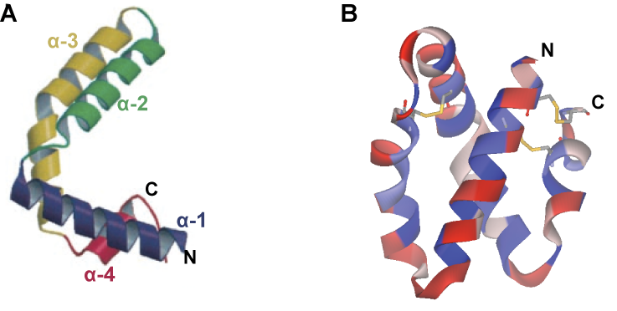

Fig. 1.6. Crystal structure of the saposins. (A) The saposins consist of 4
α-helices (α-1 - α-4) forming a V-shaped structure. From Ahn et al., 2003. (B) The V-shaped structure is supported by 3 disulfide bonds, which are formed between the helices of each arm. Each α-helix is amphipathic, with the hydrophilic residues on the outer surface (red) and the hydrophobic on the inner surface (blue). Produced using DS Visualizer using the RCSB file 2GTG.

    - Prosaposin: the multifunctional protein
Prosaposin is thought to have multiple roles: as a precursor to the saposins, which function in (glyco)sphingolipid hydrolysis and lipid transfer, as a neurotrophic and myelinotrophic factor, and as a fertility factor. These roles centre on their ability to bind and rearrange lipids.
      - Saposins function in (glyco)sphingolipid degradation
        - The hydrolase specificity of the 4 saposins
As mentioned in section 1.2.3.1.2, each saposin promotes the function of a different sphingolipid hydrolase (see also Fig. 1.5). Saposins A, C and D are generally more restricted in their targets, predominantly promoting the function of galactosylceramidase, glucosylceramidase and ceramidase, respectively (Berent and Radin, 1981; Azuma et al., 1994; Yamada et al., 2004). In contrast, saposin B is thought to have a more general detergent function promoting the degradation of more than one species of sphingolipid. It primarily promotes the degradation of sulfatides, globotriaosylceramide and GM₁ ganglioside, which are hydrolysed by arylsulfatase A, α-galactosidase, and β-galactosidase, respectively (Vogel et al., 1987).
Saposins A, C and D have more restricted targets due to the required interaction with their cognate hydrolase for their function (see section 1.3.4.1.2). The interaction of saposin C with glucosylceramidase requires residues 6 - 27 and 45 - 60 of the saposin (Weiler et al., 1995). The residues of saposins A and D required for hydrolase interaction have not been identified.
Saposin B can promote the hydrolysis of many sphingolipids, but does not interact directly with its cognate hydrolases. In normal individuals, 3 alternate transcripts can be produced from the saposin B region of prosaposin (Rafi et al., 1990; Zhang et al., 1990; Holtschmidt et al., 1991). These alternate splice sites produce prosaposin transcripts with either no, 6- or 9- bases from exon 8, producing three alternate forms of mature saposin B. Exon 8 encodes the residues Gln-Asp-Gln; the presence of which has been shown to abolish saposin B binding to GM₁ ganglioside and enhance binding to sulfatide and sphingomyelin (4-fold and 2-fold, respectively) (Holtschmidt et al., 1991). The expression pattern of the various transcripts is tissue specific; in the liver and lymphoblasts, there was an almost exclusive presence of the version without exon 8, whereas in the brain and skin fibroblasts the majority of transcripts contained the 9-base insertion (Holtschmidt et al., 1991). The presence of the 6-base insertion was minimal or not detectable in all examined tissues. Therefore, tissue-specific expression of the three alternate transcripts is likely to reflect the sphingolipid hydrolysis demands of each tissue. These alternate forms of saposin B may also have implications on their proposed lipid transfer functions (see section 1.3.4.2).

        - Modes of saposin function
Each saposin is thought to function by one of two modes: as a “solubiliser“ or a “liftase” (Fig.1.7). The solubiliser model suggests that saposins interact with the intralysosomal membranes and extract the appropriate (glyco)sphingolipid, which they present to their cognate hydrolase as a soluble protein-lipid complex; saposin B is thought to act in this manner. The liftase model proposes that saposins interact with the intralysosomal membranes, act as a docking site for their partner hydrolase, and increase the accessibility of the (glyco)sphingolipids by perturbing the lipid bilayer; saposin C is thought to act in this way.
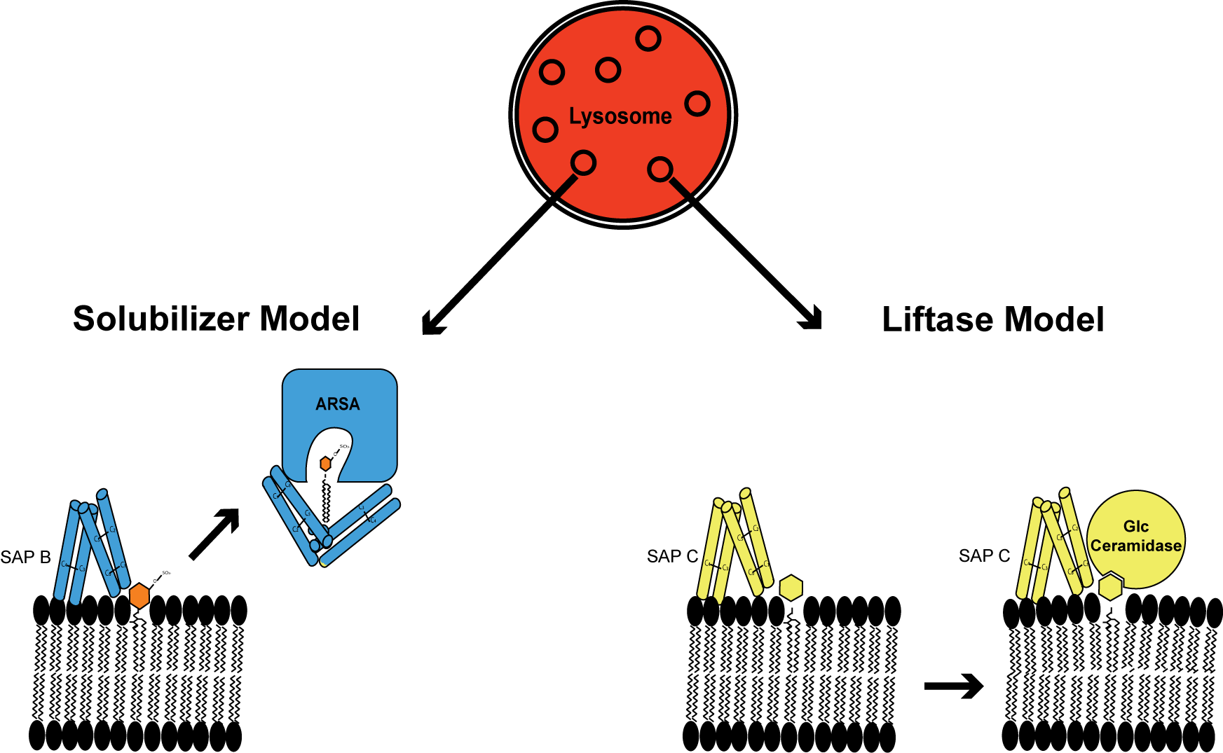

Fig. 1.7. Modes of saposin function. Saposins promote the function of soluble lysosomal hydrolases, which degrade (glyco)sphingolipids on the luminal face of intralysosomal vesicles. Saposins act by one of two modes: the solubiliser or liftase modes. Acting in the solubiliser mode, saposins interact with the intralysosomal vesicles where they extract the (glyco)sphingolipid and present it to the hydrolase as a soluble saposin-lipid complex. Saposin B acts as a solubiliser. Saposins A, C and D are thought to act as liftases, whereby the saposin acts as a docking site for the hydrolase and also increases the accessibility of the (glyco)sphingolipid for the hydrolase. ARSA, Arylsulfatase A; GlcCeramidase, Glucosylceramidase.
Atomic force microscopy (AFM) confirmed the lipid perturbation caused by saposins and indicated that saposin B had the greatest effect on reducing the thickness of the lipid bilayer (Alattia et al., 2006); this supports the assigned solubiliser role of saposin B. Evidence to support the role of saposin C as a liftase was provided by Alattia et al. (2007). By fluorescently labelling saposin C and glucosylceramidase (GCase), and using the fluorogenic substrate analogue DFUG (6,8-difluoro-4-heptadecylumbelliferyl β-D-glucopyranoside), FRET analysis revealed an interaction between saposin C and GCase, and between GCase and DFUG (Alattia et al., 2007) (a previous interaction was shown between fluorescently labeled saposin C and DPPE (1,2-dipalmitoyl-sn-glycero-3-phosphoethanolamine) (Alattia et al., 2006)). This indicated a direct interaction between saposin C and GCase at the lipid bilayer.
Interestingly, although the target species for hydrolysis are sphingolipids, their presence in the membrane is not required for saposin interaction; instead, anionic phospholipids are required (Tatti et al., 1999). Consistent with this, positively charged amino acid patches are present on all 4 saposins, though their positioning is not conserved (Ahn et al., 2006; Rossmann et al., 2008). Intralysosomal membrane vesicles are rich in the anionic phospholipid lysobisphosphatidic acid (LBPA, also known as bis(monoacylglycero)phosphate (BMP)) (Wherrett and Huterer, 1972). The positively charged patches on the saposins are thought to aid the initial interaction with the LBPA-rich membranes, followed by a rolling of the protein to allow correct orientation for interaction of the hydrophobic surfaces of their helices with the hydrophobic acyl chains within the membrane (Rossmann et al., 2008). The saposins have been shown by crystallography to have two possible conformations: closed and open. The open configuration is promoted by lipid/detergent binding (Hawkins et al., 2005); therefore, binding to the lipid membrane may alter saposin conformation and allow further interactions through the hydrophobic residues, which constitute over 50% of the saposin residues.
In addition to the presence of anionic phospholipids, saposins also require an acidic environment for membrane interaction and, in most cases, for dimerisation (Vaccaro et al., 1995; Ahn et al., 2006). The acidic conditions and presence of LBPA-rich vesicles in the lysosomes provide an optimum environment for saposin-induced hydrolase activity.
      - Saposins as lipid transfer proteins: roles in immunology
As discussed above, saposins interact with membrane lipids and aid their extraction for hydrolysis. Evidence for a role in lipid transfer was provided by in vitro assays that measured the saposin-induced transfer of sphingolipids and phospholipids from donor to acceptor liposomes or large unilamellar vesicles (LUVs); prosaposin was also shown to transfer gangliosides (Vogel et al., 1991; Hiraiwa et al., 1992; Locatelli-Hoops et al., 2006). This function is pH-dependent, with transfer only occurring in acidic conditions (below pH 5.0).
Late endosomes and lysosomes are involved in the presentation of antigens on major histocompatibility complex (MHC) proteins (reviewed in Salio et al., 2010). The CD1 molecules are an MHC-like class of antigen-presenting proteins that present lipid antigens from pathogens that have been targeted to the lysosomes. There are 5 CD1 isoforms in humans (CD1a - e), which present a wide spectrum of lipids, generally derived from mycobacteria (Salio et al., 2010). Because of the hydrophobic nature of these lipid antigens, lipid transfer proteins are required to extract and present the lipids to the CD1 molecules. All 4 saposins have been shown to operate in this role, though the authors suggest saposin B as the dominant facilitator of CD1d loading (Yuan et al., 2007). The Niemann Pick type C2 protein can also load CD1d molecules (Schrantz et al., 2007). A role for saposin C in loading mycobacterial lipids onto CD1b has been identified by Winau et al. (2004); this function was not shown by the other saposins and suggests that some specificity exists in the lipid transfer functions of the saposins. Therefore a role appears to exist for saposins in the development and execution of the immune response.
      - Prosaposin: a neurotrophic and myelinotrophic factor
Due to the high levels of prosaposin in various secretory fluids, roles have been investigated that are independent of its function as a saposin precursor. Prosaposin has been identified in cerebrospinal fluid, milk (human, chimpanzee, rhesus monkey, cow, goat and rat), pancreatic fluid, bile and seminal fluid (Sylvester et al., 1989; Hineno et al., 1991; Kondoh et al., 1991; Hiraiwa et al., 1993a; Patton et al., 1997), though individual saposins have not been identified in these fluids (Hineno et al., 1991; Patton et al., 1997).
As mentioned in section 1.3.2, prosaposin can complex with gangliosides, which was shown to inhibit prosaposin processing by cathepsin D (Hiraiwa et al., 1997b). Because gangliosides can stimulate neurite growth (Skaper et al., 1985), O’Brien et al. (1994) investigated a possible role of prosaposin in promoting neurite extension. The authors revealed a potent stimulatory effect of both prosaposin and saposin C on neurite growth in murine (NS20Y) and human (SK-N-MC) neuroblastoma cells (O’Brien et al., 1994).
The neurotrophic region of prosaposin has been identified as the N-terminus of saposin C; the C-terminus showed no neurotrophic activity (the GCase activating region of saposin C is localised to the C-terminus (Weiler et al., 1995)) (O’Brien et al., 1995). 12 residues within this region are the minimum requirement for neurotrophic activity (see Fig. 3.4); a synthetic peptide of this 12-mer sequence (prosaptide) has been developed into various analogs (retro-inverso prosaptides) that can cross the blood brain barrier where they function as bioactive neurotrophic factors (O’Brien et al., 1995; Taylor et al., 2000). These peptides have also been successful in preventing apoptosis of cerebellar granule neurons and Schwann cells, in promoting sciatic nerve regeneration, and improving diabetic neuropathy (Kotani et al., 1996; Calcutt et al., 1999; Tsuboi et al., 1998; Campana et al., 1999).
O’Brien et al. (1995) determined that the addition of ganglioside GM₁ rearranged the conformation of saposin C (O’Brien et al., 1995). Neuronal membranes are enriched in gangliosides (Derry and Wolfe, 1967); therefore, prosaposin may interact with neuronal membrane gangliosides, inducing a conformational change required for receptor binding and signal transduction initiation to promote neuronal survival and growth. Saposin C has been shown to bind to putative receptors on NS20Y cells (O’Brien et al., 1994). Investigations into the identity of the putative prosaposin receptor have revealed co-purification of saposin C and a 55kDa protein. This interaction was inhibited by pre-incubation with pertussis toxin, which prevents interactions with G protein-coupled receptors (GPCRs) (Hiraiwa et al., 1997a). Confirmation of the association of a G protein with the putative prosaposin receptor was provided by western blot analysis using an antibody raised against human G_{oα} (Hiraiwa et al., 1997a). The prosaposin analog prosaptide D5 has been shown to inhibit calcium uptake by rat brain synaptosomes, an effect that was significantly inhibited by pertussis toxin (Yan et al., 2000). This suggests that prosaposin binds a GPCR, leading to the blocking of calcium influx.
Defects in calcium homeostasis have been implicated in various LSDs, including Niemann-Pick type C (Lloyd-Evans et al., 2008). NPC is characterised by the accumulation of cholesterol in the lysosomes, however, sphingolipids have also been shown to accumulate; in fact, sphingosine was shown to be the causative agent in the calcium homeostasis defect in NPC1 cells (Lloyd-Evans et al., 2008). Sphingosine caused a decrease in lysosomal calcium concentration, leading to the late endosome/lysosomal fusion defect characteristic of NPC cells. Interestingly, in PC12 cells prosaposin has been shown to cause a 450-fold increase in sphingosine kinase activity within 5 minutes of 10 nM prosaposin treatment (Misasi et al., 2001). In addition, prosaposin RNAi has been shown to enhance the cholesterol storage in NPC1 RNAi-treated cells (Bartz et al., 2009). The effect of prosaposin RNAi on cholesterol storage may reflect its ability to induce sphingosine kinase activity; in its absence, sphingosine levels would increase and enhance the NPC phenotype (cholesterols storage). In all, this evidence may suggest an interesting and complex interaction between prosaposin-induced G-protein signaling and sphingolipid storage, independent of the role of saposins in sphingolipid metabolism.
Prosaposin also functions as a myelinotrophic factor. Prosaposin, saposin C and prosaptides caused an increase in sulfatide levels (a major component of the myelin sheath) in Schwann cells and oligodendrocytes, an effect that was not matched by saposin A, B or D treatment (Hiraiwa et al., 1997c). Further evidence of a role for prosaposin in myelination is the observed increase in prosaposin mRNA levels concomitant with remyelination after rat sciatic nerve crush (Gillen et al., 1995).
Although these data show a potent neurotrophic and myelinotrophic effect, a complex relationship is likely to exist between the roles of the prosaposin precursor and the saposins. This is supported by the presence of demyelination in both prosaposin deficient and single saposin deficient patients, as prosaposin is still synthesised and trafficked normally in patients within single saposin deficiencies (Harzer et al., 1989; Henseler et al., 1996; Regis et al., 1999; Wrobe et al., 2000; Hulkova et al., 2001; Spiegel et al., 2005; Deconinck et al., 2008).
      - Prosaposin: a fertility factor
Prosaposin has been identified in seminal fluid and the rat prosaposin orthologue (sulphated glycoprotein-1 (SGP-1)) is one of the major secreted proteins of Sertoli cells; it has been shown to bind the tails of late differentiating spermatids and spermatozoa (Sylvester et al., 1984; Sylvester et al., 1989; Morales et al., 1996; Morales et al., 1998). Hammerstedt (1997) found that a specific region of prosaposin, which was named Universal Primary Sperm-Egg Binding Protein (UPSEBP), enhanced binding of sperm to avian perivitelline membrane. Pre-treating various sperm samples with FertPlus®, a synthetic peptide based on UPSEBP, increased sperm binding in a microwell sperm-binding assay (Amann et al., 1999).
The multiple functions of prosaposin and its saposin derivatives suggest that a spectrum of symptoms are likely to occur as a result of total and single saposin deficiencies. These disease phenotypes are discussed below.
    - The saposin deficiencies: 5 disorders from the same locus
      - Prosaposin deficiency: a severe infantile sphingolipidosis
4 cases of prosaposin deficiency have been reported (Harzer et al., 1989; Hulkova et al., 2001). The first 2 cases were identified in the same family and, due to the limited knowledge of the number of prosaposin-derived saposins, were initially characterised as atypical, severe forms of Gaucher disease (Harzer et al., 1989). The molecular identity of the mutation was later revealed as a single nucleotide substitution in the initiation codon (ATG>TTG) causing a complete absence of prosaposin (Schnabel et al., 1992). The 2 other cases were identified by Hulkova et al. (2001) and were caused by a frameshift mutation in the saposin B domain (c.803delG), which resulted in a premature stop codon 27 bases downstream.
Prosaposin deficiency results in a severe neurological disorder that, unlike many LSDs, is apparent at birth (Harzer et al., 1989). Hepatosplenomegaly, generalised seizures and signs of motor impairment were present at birth (Elleder et al., 1984; Harzer et al., 1989; Hulkova et al., 2001). Sonograms and CT scans revealed atrophy of the cortex, cerebellum and brain stem. Patients died within 4 months, with some reports of respiratory and circulatory failure (Elleder et al., 1984; Harzer et al., 1989; Hulkova et al., 2001).
Histological and biochemical analyses revealed an accumulation of a broad spectrum of sphingolipids in all 4 cases of prosaposin deficiency, including galactosylceramide, galactosylceramide sulfate, glucosylceramide and ceramide (Elleder et al., 1984; Harzer et al., 1989; Paton et al., 1992; Hulkova et al., 2001). In addition gangliosides GM₁, GM₂ and GM₃, globotriaosylceramide, and lactosylceramide were also show to accumulate; this can be attributed to the ability of saposin B to act as a general detergent and aid the degradation of multiple sphingolipids (Li and Li, 1976; Vogel et al., 1987).
Sphingolipid storage occurred in most tissues, including the brain (both in neurons and glia), liver, spleen, kidneys, pancreas and the vascular endothelium (Elleder et al., 1984; Hulkova et al., 2001), and ultrastructurally it appeared as membranous vesicular and lamellar structures, Gaucher-like tubules (in macrophages), and electron-dense inclusions (Harzer et al., 1989; Hulkova et al., 2001).
A striking pathological consequence of prosaposin deficiency was the severe loss of cortical neurons, in addition to a massive cortical infiltration of fibrilliary astrocytes and lipid storing phagocytes (Hulkova et al., 2001). The basal ganglia showed a similar but less severe neuronal loss and neurons appeared “ballooned with storage”. There was also a severe depletion of myelin and, where it remained, the number of layers were reduced (Hulkova et al., 2001); this is likely a result of saposin A and B deficiency (see sections 1.3.5.2 and 1.3.5.3) but could also be exacerbated by the absence of the myelinotrophic function of prosaposin (section 1.3.4.3).
      - Saposin A deficiency: a variant form of Krabbe disease
Only one case of saposin A deficiency has been reported, which described a pathology similar to Krabbe disease (Spiegel et al., 2005). This individual had a deletion of the codon encoding the conserved valine residue at position 11 in saposin A. Whether this mutation leads to a complete absence of saposin A or a disruption of function was not investigated, however, activity of galactosylceramidase from saposin A deficient leukocytes was almost completely abolished, even in the presence of detergent (Spiegal et al., 2005). This suggests that saposin A is also required to protect, stabilise or alter the conformation of galactosylceramide, explaining the close similarity to Krabbe disease pathology. Saposin A deficiency had no effect on any other lysosomal enzymes assayed (Arylsulfatase A, β-Galactosidase, β-Hexosaminidase A and Palmitoyl protein thioesterase) (Spiegal et al., 2005).
Unlike prosaposin deficiency, the effects of saposin A deficiency were not apparent at birth. The infant developed normally for 3.5 months followed by deterioration in previously acquired skills. At 6 months old, the patient was in an almost vegetative and unresponsive state with only minimal spontaneous movements. An MRI scan revealed signs of brain atrophy and dysmyelination. The infant died at 8 months old of respiratory failure (Spiegal et al., 2005).
      - Saposin B deficiency: a variant form of MLD
Saposin B deficiency has been reported in 9 cases as a result of 6 independent mutations. The most prevalent cause of saposin B disruption is the removal of its glycosylation site by mutation of either the asparagine residue at position 215 or the threonine residue 217 (numbering refers to the position within prosaposin) (Rafi et al., 1990; Kretz et al., 1990; Regis et al., 1999; Wrobe et al., 2000; Deconinck et al., 2008). The absence of the glycosylation site was shown to affect the folding of saposin B (Hiraiwa et al., 1993b). In most cases of saposin B glycosylation site mutations, mature saposin B was undetectable (Inui et al., 1983; Henseler et al., 1996). This would suggest that the aberrant folding of unglycosylated saposin B may reduce its resistance to degradation. However, a report of another glycosylation defect in the saposin B domain, which caused the asparagine 215 to be replaced by histidine, revealed that the unglycosylated mature saposin B was detected even after a 72-hour chase experiment (Wrobe et al., 2000). Regardless of this discrepancy, all cases of saposin B gylcosylation defects have resulted in a reduced turn over of sulfatide, digalactosylceramide and globotriaosylceramide.
Splice site mutations are another reported cause of saposin B deficiency (Zhang et al., 1990; Henseler et al., 1996). In normal individuals, three alternate transcripts can be produced from the saposin B encoding region (section 1.3.4.1.1). Therefore, it is not surprising that this region, highly enriched in potential splice sites, is also the site of a large aberrant insertion in a saposin B deficient individual. This case was caused by a mutation in the intron preceding exon 8, which created a cryptic splice acceptor producing a 33-base exon 8 rather than the normal 6- or 9-base version (Zhang et al., 1990; Holtschmidt et al., 1991). This insertion was shown to cause an absence of saposin B, possibly due to an increased hydrophobicity and instability of the mature protein, which caused a reduced ability to degrade radiolabelled sulfatide (Hahn et al., 1982; Inui and Wenger, 1984; Zhang et al., 1990).
An additional saposin B splice site mutation was reported by Henseler et al. (1996). The causative mutation was found to occur in intron e: a single base substitution (G>T) that abolished the splice acceptor site. This led to two different transcripts with either a 21-base deletion (Δ21) or a 144-base deletion (Δ144). The Δ21 transcript was caused by the activation of a cryptic splice site within exon 6, which led to the deletion of the first 21 bases of exon 6. In the Δ144 transcript, the exon 6 cryptic splice site was not activated leading to the complete loss of exon 6 (the normal splice acceptor in intron f prior to exon 7 was used). Both transcripts lead to the absence of active saposin B, but for different reasons. The Δ21 deletion removed one of the highly conserved cysteine residues of saposin B, among other residues. The mutation of a conserved cysteine alone, is sufficient to perturb saposin function (Holtschmidt et al., 1991). As is the case with other cysteine mutations in the saposins, the remaining saposins are unaffected due to the absence of an effect on prosaposin trafficking. In contrast, the Δ144-encoded prosaposin is retained in the ER resulting in an absence of all mature saposins (Henseler et al., 1996). Since the trafficking of Δ21-derived prosaposin is unaffected, this prevents the complete absence of all saposins resulting in saposin B deficiency rather than total prosaposin deficiency.
Saposin B deficiency can also be caused by the mutation of a conserved cysteine residue. Section 1.3.3 described the arrangement of the 3 disulfide bonds in the highly conserved “saposin fold”. The deletion of just 1 of the 6 conserved cysteine residues is sufficient to disrupt saposin function, as was demonstrated by the case described by Holtschmidt et al. (1991). In this individual the cysteine residue at position 241 was mutated to serine, abolishing the third disulfide bond of saposin B.
The disease progression is very similar across the 9 cases of saposin B deficiency, with most cases showing a late-infantile variant of MLD (Henseler et al., 1996; Regis et al., 1999; Wrobe et al., 2000; Deconinck et al., 2008). This disorder is very similar, but generally less severe than saposin A deficiency, with patients not presenting until the second year of life. Patients presented with a regression of walking abilities, usually followed by a period of rapid motor and cognitive deterioration and blindness. Brain MRI revealed lesions in the cerebellar white matter and nerve conduction velocities were slow, suggestive of demyelination (Henseler et al., 1996; Regis et al., 1999; Wrobe et al., 2000; Deconinck et al., 2008). Sulfatides, dihexosylceramide sulfates and globotriaosylceramides were increased in the urine and in vitro activity of arylsulfatase A was normal (Henseler et al., 1996; Regis et al., 1999; Wrobe et al., 2000; Deconinck et al., 2008).
Ultrastructurally, a common characteristic of saposin B deficiency is the presence of dense metachromatic material in the macrophages (Henseler et al., 1996; Regis et al., 1999; Wrobe et al., 2000; Deconinck et al., 2008). Heterogeneous deposits were also present in both neuronal and
non-neuronal cells, including Schwann cells, macrophages, fibroblasts and endothelial cells, which were present as multivesicular and multilamellar bodies and electron-dense inclusions referred to as “tuffstone deposits” (Regis et al., 1999; Deconinck et al., 2008).
The presence of severe demyelination in both saposin A and B deficiencies suggests a requirement in maintenance or formation of the myelin sheath. The enhanced severity of prosaposin deficiency may suggest compensation occurs in the single saposin deficiencies. Mouse models are beginning to address the compensatory roles of saposins (section 1.3.5.5.6).
      - Saposin C deficiency: a variant form of Gaucher disease
5 cases of saposin C deficiency have been reported to date. In 3 cases the patients showed clear signs of neuronopathic type III Gaucher disease, whilst the remaining 2 individuals (from the same family) developed the non-neuronopathic type I form (Christamanou et al., 1986; Christamanou et al., 1989; Schnabel et al., 1991; Rafi et al., 1993; Pàmpols et al., 1999; Amsallem et al., 2005; Tylki-Szymańska et al., 2007).
The 3 neuronopathic cases resulted from point mutations affecting a conserved cysteine residue in saposin C (C315S, C382G and C382F) (Schnabel et al., 1991; Rafi et al., 1993; Amsallem et al., 2005). The less severe non-neuronopathic mutation involved a substitution of a leucine residue by proline (L349P). This residue is located outside the glucosylceramidase binding site but within the activation site; therefore the mutated saposin C may retain its ability to bind its cognate enzyme and allow a low level of enzyme activation, contributing to a less severe pathology (Tylki-Szymańska et al., 2007).
One patient with neuronopathic saposin C deficiency (C382F) presented at 4 years old with an increase in glucosylceramide in the spleen; she died aged 14 years (Schnabel et al., 1991). The second case of saposin C deficiency (C382G) presented at 8 years old with epileptic fits (Pàmpols et al., 1999). Within 2 years the patient’s symptoms had progressed to generalised seizures, an enlarged spleen and liver, and Gaucher cells in the bone marrow (Gaucher cells have a characteristic morphology of an eccentric nucleus and enlarged cytoplasm containing granular or striated material) (Pàmpols et al., 1999). The patient’s motor and intellectual abilities deteriorated, and development of bilateral bronchopneumonia resulted in death at 15.5 years old (Pàmpols et al., 1999). The third case of neuronopathic saposin C deficiency (C315S) presented aged 7 years with an enlarged spleen, mild leucopenia and Gaucher cells in the bone marrow (Amsallem et al., 2005). By age 11 years she had developed epileptic fits. This patient was treated with Miglustat, an imino sugar analogue of D-glucose that inhibits glucosylceramide synthase, as a form of substrate reduction therapy (SRT) (Amsallem et al., 2005). Miglustat treatment was successful in reducing the frequency of epileptic fits and slowed the progression of the disorder. The last report of this individual recorded that she was still alive at 20 years old (Tylki-Szymańska et al., 2007).
The 2 cases of non-neuronopathic saposin C deficiency were siblings. The sister was 7 years younger and showed a similar disease progression as her brother. The brother presented at 2 years old with mild hepatosplenomegaly, anaemia, thrombocytopaenia and Gaucher cells in the bone marrow. His physical development was normal until the fourth decade of life when he showed severe hypersplenism, which progressed to hepatosplenomegaly, moderate bone pain and osteopaenia (Tylki-Szymańska et al., 2007).
In all cases of saposin C deficiency an accumulation of glucosylceramide was reported, with an absence of glucosylceramidase defects.
No cases of single saposin D deficiency have been reported; however one mutation in the saposin D domain (Q430X) was identified in the other allele of prosaposin in the second case of saposin C deficiency described above (Diaz-Font et al., 2005). This patient inherited the C382G allele from his father (Pàmpols et al., 1999). Since the mother’s prosaposin mRNA levels were half the normal amount, it was assumed that this allele resulted in nonsense-mediated decay (Rafi et al., 1993). This allele has now been identified as a C>T transition leading to a stop codon within the saposin D domain (Diaz-Font et al., 2005). Because of the absence of prosaposin production from this allele, the saposin C mutation within the other allele causes the Gaucher phenotype.
      - Mouse models of the saposin deficiencies
To enhance the understanding of the roles of prosaposin and its derived saposins, various mouse models of complete and single saposin deficiencies have been developed. The single saposin deficiency models were generated using the Cre/loxP technique. Embryonic stem cells were transformed with a transforming vector containing the mutated saposin transgene and a selectable marker flanked by loxP sites. Following successful transformation and microinjection of the saposin mutant stem cells, the selectable marker was removed by crossing the transformed mice to a mouse line expressing cre recombinase. The cre recombinase recognises the loxP sites causing the excision of the selectable marker. The background strain for each saposin mouse model was C57BL/6J/129SvEv. The parent strains have a normal lifespan of approximately 22-23 months (Storer, 1966).
        - Complete prosaposin deficiency
The generation of prosaposin deficiency in the mouse produced disease pathology very similar to that in the human: a rapidly progressive neurological disorder characterised by seizures and motor deterioration (Fujita et al., 1996). Some PSAP^{-/-} mice died within the first 2 days, whereas the remaining developed normally for the first 18-20 days followed by a rapid deterioration and death by 35 days post natal (Fujita et al., 1996). Ultrastructurally, signs of neuronal storage were present at day 1, which rapidly progressed to include most regions of the central nervous system (both white and grey matter), peripheral nervous system (including the enteric nervous system), retinal ganglion cells, macrophages of the liver and spleen, hepatocytes, renal tubular epithelia and proximal tubular cells, cardiac myocytes, and skin fibroblasts (Fujita et al., 1996; Oya et al., 1998). The storage material was very heterogeneous with clusters of multivesicular and lamellar structures, electron-dense inclusions, which often included lipid droplets, and granular material.
As was the case with the human prosaposin deficiencies, the PSAP^{-/-} mice showed a paucity of myelin in both the central and peripheral nervous systems, and therefore the myelin constituents galactosylceramide and sulfatide did not accumulate in the brain (Fujita et al., 1996). These glycosphingolipids were shown to accumulate in visceral organs (liver and kidneys) along with other sphingolipids that depend on saposin function for their hydrolysis (glucosylceramide, ceramide, globotriaosylceramide) and also some monosialic acid gangliosides (GM₁, GM₂ and GM₃) (Fujita et al., 1996). The striking feature of this disorder, both in human patients and the mouse model, was the vast accumulation of lactosylceramide; this dihexosylceramide was present at 50 times the level in controls and is thought to be due to the absence of both saposin B and C (Fujita et al., 1996). Both of these saposins are able to promote the enzymes that hydrolyse this sphingolipid (galactosylceramide-β-glucosidase and
GM₁-β-galactosidase); therefore, in the absence of one saposin, the function of the other can compensate but in the absence of both lactosylceramide accumulates (Zschoche et al., 1994; Fujita et al., 1996).
The activities of certain lysosomal hydrolases were also shown to be reduced as a result of prosaposin deficiency. The activity of glucosylceramidase was reduced by 75%, galactosylceramidase by 50% and acid sphingomyelinase by 40% (Fujita et al., 1996). These assays were performed in the presence of detergents, which would substitute for the absence of saposins if their sole function was in lipid extraction. This supports the liftase model, which involves physical interaction of saposins with their cognate hydrolase to increase activity. Interestingly, the activity of arylsulfatase A, which requires saposin B for sulfatide hydrolysis, was not reduced in this assay; this is consistent with saposin B acting in line with the solubiliser model.
As discussed in section 1.3.4.4, prosaposin has been implicated as a fertility factor (Hammerstedt, 1997). Consistent with this discovery, PSAP^{-/-} male mice showed a reduction in the size of the testes, epididymides, seminal vesicles and prostrates, in addition to reduced spermiogenesis (Morales et al., 2000). The reduced development of the male reproductive system has been linked to an inactivation of the MAPK signalling pathway (Morales et al., 2000).
        - Saposin A deficiency: Krabbe-like phenotype
To determine the effect of saposin A deficiency, as no single saposin A deficient patients had been reported at the time, Matsuda et al. used the Cre/loxP technique to generate a saposin A^{-/-} mouse model (Matsuda et al., 2001). They chose to introduce a C106F mutation to abolish the first disulfide bond in the saposin A domain, as cysteine mutations were shown to affect the appropriate saposin function in the saposin B and C deficient patients, whilst leaving the remaining saposins functional (e.g. Holtschmidt et al., 1991).
The saposin A^{-/-} mice developed normally until 2.5 months when slight hind leg paralysis and “sluggish” behaviour was observed (Matsuda et al., 2001). After 3 months, seizures, dysfunction of the large intestine and bladder (ileus and neurogenic bladder), and feeding problems became apparent and death ensued by 5 months.
The main features observed in the saposin A^{-/-} mice were progressive demyelination and infiltration of macrophages; this was apparent in the white matter of the brain stem fibers, cerebellum and spinal cord within 1 month, prior to any overt clinical signs of neuronal pathology. Demyelination and macrophage infiltration became more widespread by 4.5 months and was particularly severe in the PNS (Matsuda et al., 2001).
In saposin A^{-/-} mice, galactosylceramide accumulated in the brain, but not to the degree observed in the kidney; this likely reflects the massive demyelination occurring in the brain (galactosylceramide is a major constituent of myelin) (Matsuda et al., 2001). As was evident in the prosaposin deficient mice, the activity of galactosylceramide was 50% of normal, even when assayed in the presence of detergent. This again suggests that some saposins are not solely required as sphingolipid extractors, but are required to physically interact with, and may also protect, their cognate hydrolase.
        - Saposin B deficiency: MLD-like phenotype
Saposin B^{-/-} mice were also generated by the Cre/loxP system. The first conserved cysteine of the saposin B domain was mutated to a phenylalanine residue to disrupt the first disulfide bond (Sun et al., 2008). This mutation caused an absence of mature saposin B without affecting the other 3 saposins.
As in humans, the saposin B^{-/-} mice showed a later onset and a more slowly progressing disorder than the saposin A^{-/-} mice. The saposin B^{-/-} mice developed normally until 12 months when they showed an unbalanced gait, agitation and head tremors (Sun et al., 2008). By 15 months, the saposin B^{-/-} mice showed a progressive deterioration in their balance and motor coordination and died at 23 months.
Using alcian blue staining, various regions of the brain (brain stem, cortex, cerebellum, thalamus and spinal cord) and kidney tubules were shown to store sulfated material (Sun et al., 2008). Thin layer chromatography confirmed an accumulation of sulfated sphingolipids (sulfatides) in the brain, kidney and lung. Lactosylceramide and globotriaosylceramide were also increased in the liver and kidney, respectively.
The striking feature of this mouse model was the absence of an effect on myelination, even though sulfatides were shown to accumulate in many brain regions, primarily in the oligodendrocytes. Because the ratio of non-hydroxy fatty acid (NFA) to hydroxy fatty acid (HFA) galactosylceramide affects myelin stability, the authors suggest that the ratio of NFA:HFA sulfatides may be normal though their overall levels were increased (Fewou et al., 2005; Sun et al., 2008).
As has been shown with the other prosaposin and saposin models, the storage appeared very heterogeneous at the ultrastructural level. Membranous vesicular and lamellar material, and electron dense granular inclusions were reported in the kidney tubules, neurons of the brain stem and spinal cord, and the oligodendrocytes and Schwann cells (Sun et al., 2008).
As was the case in the saposin A^{-/-} mice, the proinflammatory response was activated as evidenced by the presence of infiltrating macrophages in various regions of the CNS, PNS and kidneys, in addition to activated astrocytes in the CNS and PNS (Sun et al., 2008).
Although not all features of the human saposin B disorders were reflected in this mouse model (notably the absence of demyelination), this model has confirmed the role of saposin B in the hydrolysis of lactosylceramide and globotriaosylceramide in vivo and shows many similar characteristics of MLD, including an accumulation of sulfatide and a decline in motor abilities.
        - Saposin C deficiency: Gaucher-like phenotype
The Cre/loxP technique was used to create a mouse model of saposin C deficiency. The fifth conserved cysteine was targeted and substituted with a proline residue to abolish the second disulfide bond of saposin C (Sun et al., 2010a).
The saposin C^{-/-} mice developed normally until 10 - 21 months post natal, when they showed signs of motor disabilities (uncoordinated movements, hind limb weakness and abnormal leg reflexes) (Sun et al., 2010a). The neurological symptoms of the saposin C^{-/-} mice developed slowly and as a result the mice survived 24 months.
The striking feature of the saposin C^{-/-} mice was the progressive loss of Purkinje cells in the cerebellum (Sun et al., 2010a). Purkinje cell loss was evident at 2 months, well before overt clinical signs of pathology were observed. This degeneration progressed from lobule III towards lobule X; by 24 months, Purkinje cells were no longer detectable in lobules III to VIII. Also in the cerebellum, granule cell atrophy was demonstrated to occur prior to Purkinje cell loss (Sun et al., 2010a). Activated astroglia and microglia were increased in these areas of the cerebellum, in addition to their presence in the spinal cord, brain stem, hindbrain and thalamic regions. Although vast degeneration of the Purkinje cells was apparent, no inclusions were detected. Heterogeneous inclusions were present in other areas of the cerebellum, the spinal cord, brain stem, midbrain, cortex, hippocampus and sciatic nerve. Degeneration of the myelin layers of the sciatic nerve was also observed (Sun et al., 2010a). Electron dense membranous inclusions were present in the axons and neuronal processes, which, combined with the severe degeneration in the cerebellum, is likely responsible for the motor disturbances observed in these mice (Sun et al., 2010a).
Glucosylceramide and glucosylsphingosine were both shown to accumulate in the spinal cord, lactosylceramide accumulated in the cerebellum, and lactosylsphingosine levels were increased in both the spinal cord and cerebellum (Sun et al., 2010a). No glycosphingolipid accumulation was evident in any other regions of the brain. No visceral organ involvement was observed in the saposin C^{-/-} mice.
The activity of the cognate hydrolase of saposin C (glucosylceramidase) was reduced by 50% in the liver, lung, spleen and brain. In addition, the protein levels of glucosylceramidase were also reduced to 67% of wild type (Sun et al., 2010a), supporting the role of certain saposins in protecting their cognate hydrolase from degradation; this was also shown by the mouse model described in section 1.3.5.5.7.
        - Saposin D deficiency: Selective renal and cerebellar degeneration
Because of the absence of saposin D deficient patients, a mouse model was generated using the Cre/loxP technology. The fifth conserved cysteine residue was mutated to serine to abolish the second disulfide bond (Matsuda et al., 2004).
Saposin D^{-/-} mice developed normally until 4 months, when they showed motor coordination impairment followed by ataxia at 6 months post natal. Motor deterioration progressed to almost complete paralysis followed by mortality at 15 months (Matsuda et al., 2004).
The saposin D^{-/-} model was expected to show signs of Farber disease, due to the proposed function for saposin D in promoting acid ceramidase function (Azuma et al., 1994). However, many of the classic signs of Farber disease were not observed (skin nodules, joint pathology and hepatosplenomegaly) (Matsuda et al., 2004). The saposin D^{-/-} mice did, however, show a slight accumulation of ceramide species, mainly HFA-ceramide, in the kidney and the brain (especially the cerebellum) (Matsuda et al., 2004).
The two main features of the saposin D^{-/-} mice were degeneration of renal tubules leading to hydronephrosis, and the loss of Purkinje cells in the cerebellum. The renal degeneration was consistent with their progressive polyuria (excessive production/passage of urine) and polydipsia (excessive thirst), which was responsible for the severe dehydration in some saposin D^{-/-} mice (Matsuda et al., 2004). The Purkinje cell degeneration was first observed at 4 months, consistent with the observation of motor impairment at this age, and developed to an almost complete absence of Purkinje cells by 15 months. This degeneration in the cerebellum was extremely selective as the surrounding GABA neurons and Bergmann glia were spared (Matsuda et al., 2004).
Although the saposin D^{-/-} mouse model lacked many hallmarks of Farber disease, its role as an acid ceramidase activator was confirmed. This discrepancy may be a result of compensatory roles of other saposins, as is discussed in section 1.3.5.5.6.
        - Saposin C and D double knock-out
Because the pathology of the prosaposin deficient mouse model did not simply equate to the sum of the individual saposin deficiencies, a double saposin knock-out was produced (saposin C^{-/-}D^{-/-}). This mouse model identified various examples of compensatory actions between the saposins and revealed some complexities in the effect of disrupting glycosphingolipid metabolism (Sun et al., 2007).
The saposin C^{-/-}D^{-/-} mouse model was created by the Cre/loxP technique, introducing a mutation at the fifth cysteine of both the saposin C and D domains of prosaposin (Sun et al., 2007). Both saposin C and D were shown to be absent in this model, whereas saposin A and B remained, though at lower levels (Sun et al., 2007).
Compared to the individual saposin C and D deficiencies, the double mutants showed a more rapidly progressive disorder with first clinical symptoms appearing at 4 weeks old, with death ensuing by 8 weeks of age (56 days) (Sun et al., 2007). However, these mutants survived twice as long as the total prosaposin deficiency model, which had a lifespan of 30 days (Fujita et al., 1996). The vast difference in survival of the single and double mutants suggests that some aspects of saposin C and D function can be performed by each other, leading to a much more severe pathology when both are deficient. For example, saposin D has been shown to aid the degradation of ceramide, as shown by its accumulation in saposin D^{-/-} mouse models (Matsuda et al., 2004). The majority of the accumulating ceramide was found to be HFA-ceramide, whereas in the double mutants an additional accumulation of NFA-ceramide occurred in the brain, kidneys and liver (Matsuda et al., 2004; Sun et al., 2007). This suggests that saposin C is able to promote the degradation of NFA-ceramide; however, in the saposin C single mutant, NFA-ceramide does not accumulate suggesting that saposin D can also promote NFA-ceramide degradation (Sun et al., 2010a). Therefore, a synergistic role for saposins C and D in ceramide degradation was revealed by the double mutant and suggests that saposin functions may be more complex than were originally expected.
The striking pathology of the single saposin C and D mouse models was a dramatic degeneration of the cerebellar Purkinje cells (Matsuda et al., 2004; Sun et al., 2010a). However, in the double saposin C^{-/-}D^{-/-} mice, only partial loss of Purkinje cells was observed in cerebellar folia III at 7 weeks old (Sun et al., 2007). This contrasts with the phenotype described above, whereby the phenotype is less severe in the double saposin knock out compared to single saposin deficiency. A similar example is provided by the normal morphology of the kidneys of the double saposin C^{-/-}D^{-/-} mutants, which is in marked contrast to the phenotype of the kidneys in the saposin D^{-/-} mice (Matsuda et al., 2004; Sun et al., 2007). It seems a balance of sphingolipid levels is required for cell viability, which may have been disrupted in the single saposin deficiencies leading to cerebellar Purkinje cell and renal tubule degeneration, whereas in the double mutant the correct sphingolipid ratio may have been maintained though at a higher level (see also section 1.3.5.5.3).
A feature of prosaposin deficiency was the vast accumulation of lactosylceramide (Fujita et al., 1996). In contrast, lactosylceramide levels were much less increased in age matched double saposin C^{-/-}D^{-/-} mutants (Sun et al., 2007). As saposins B and C have been implicated in promoting lactosylceramide hydrolysis, this suggests that saposin B can, to some degree, compensate for the absence of saposin C in the double
saposin C^{-/-}D^{-/-} mutants.
As was mentioned in section 1.3.4.4, prosaposin is one of the major secretory proteins of the rat Sertoli cells and has been implicated in promoting fertility (Sylvester et al., 1989; Hammerstedt, 1997). In the
saposin C^{-/-}D^{-/-} mice, the majority of prosaposin was retained in the ER and there was no detectable prosaposin secretion from saposin C^{-/-}D^{-/-} fibroblasts (Sun et al., 2007). According to Sun et al. (2007), the saposin C^{-/-}D^{-/-} mice did not reproduce, which may reflect a defect in spermatogenesis and fertilisation caused by the absence of secreted prosaposin.
Although the majority of prosaposin was retained in the ER, a significant amount was successfully targeted to the lysosome and processed to produce mature saposins A and B. For this reason, galactosylceramide and sulfatides, targets of saposin A and B functions, did not accumulate in the saposin C^{-/-}D^{-/-} mutants; this is likely responsible for the extended lifespan of these mutants compared to the total prosaposin deficient mice (Fujita et al., 1996; Sun et al., 2007).
        - Saposin C deficiency in a glucosylceramidase mutant background
To address the effect of introducing saposin C deficiency into a mutant background of its cognate enzyme glucosylceramidase, the saposin C^{-/-} mice were crossed to the V394L glucosylceramidase mutant mice (Sun et al., 2010b). Onset of neurological symptoms occurred at 30 days post natal and death ensued by 48 days in the V394L;saposin C double mutants. The V394L mutation alone did not cause a CNS phenotype (Xu et al., 2003); however, addition of the saposin C mutation led to CNS pathology, due to a further reduction in glucosylceramidase activity and protein levels to a level that was presumably below a threshold required for normal CNS function and maintenance (Sun et al., 2010b).
In the V394L;saposin C double mutants, axonal degeneration was apparent in the brain stem, spinal cord and white matter of the cerebellum of 46 day old mutant mice, whereas at an equivalent age CNS involvement was not observed in the single saposin C^{-/-} mice and the glucosylceramidase models (Xu et al., 2003; Sun et al., 2010a; Sun et al., 2010b). The visceral organs were morphologically normal in this double mutant, despite a similar accumulation of glucosylceramide and glucosylsphingosine in the viscera compared to the CNS (Sun et al., 2010b). This suggests a greater resistance of the visceral organs to the accumulation of these sphingolipids.
Mammalian systems have proved to be fundamental in the elucidation of the physiological function and interplay between the saposins. Much of this knowledge has been provided by recent mouse models, which have exemplified the advances that can be gained from disease model systems. Due to the complexity of these disorders, there is a need for a simple model organism to dissect out the molecular mechanisms underlying their pathology. The Drosophila model organism provides a powerful genetic system with a neuronal architecture not too dissimilar from its mammalian counterpart. In addition, more than 60% of disease-causing genes in humans have an identified Drosophila homologue (Rubin et al., 2000). These qualities have drawn Drosophila research to the forefront of human disease modeling and have provided a number of significant contributions to the understanding of neurodegeneration.
  - The Drosophila model organism
    - The Drosophila genetic “toolbox”
One of the strengths of the Drosophila model system is its genetic tractability. The sequencing of the Drosophila genome (Adams et al., 2000) provided researchers with endless possibilities for genetic manipulation and has led to the expansion of the genetic tools available for Drosophila research.
The Drosophila genome contains approximately 13,600 genes (Adams et al., 2000), which are contained on four chromosomes (the first (X or Y) sex chromosomes, and the second, third and fourth autosomal chromosomes). Prior to the sequencing of the Drosophila genome, disease modeling utilised a forward genetics approach. This involved the random generation of mutations, using chemical means (EMS: ethyl methanesulphonate) and transposable element “hopping”, followed by screening based on a phenotype of interest e.g. a sensorimotor disability revealed by climbing assays (for review see St Johnston, 2002). Since the publication of the Drosophila genome, various reverse genetics techniques have been developed, whereby mutations are generated in known genes to determine the phenotypic effect and, therefore, function of that gene product (for review see Adams and Sekelsky, 2002).
      - Mobilisation of transposable elements to generate mutations in known genes: reverse genetics
Various P-element transposons have been generated and used to transform flies, with the initial aim of disrupting the gene in which they insert. These
P-elements usually contain a transformation marker, such as the rosy or mini-White constructs, which exert an external phenotype on transformed flies to allow their identification (in this instance eye pigmentation); a transposase recognition sequence at the 5’ and 3’ ends; and usually an antibiotic resistance gene.
The inserted P-element can be mobilised to generate null mutants by creating deletions in the nearby gene. This is achieved by crossing
P-element-containing flies to flies engineered to express active transposase in the germline (Adams and Sekelsky, 2002). The transposase recognises the transposase binding sites (Kaufman et al., 1989) and excises the
P-element resulting in a double strand break (DSB). If the repair of this DSB is inaccurate it can result in the deletion of gene sequence flanking the original P-element insertion site (section 2.3.1). This method is relatively simple and successful for generating potential null mutants, and has been used during this investigation (see Chapter 4).
Following the generation of the mutation, homologous recombination could lead to the loss of the mutation during chromosomal segregation. Balancer chromosomes have been developed in Drosophila to combat this problem (section 1.4.1.3).
      - P-element insertions as gene expression reporters: the Gal4-UAS system
P-elements can also be engineered to include the Gal4 construct, which encodes a Saccharomyces cerevisiae transcription factor that binds to an upstream activator sequence (UAS) to induce transcription of the downstream gene. If a P-element containing a Gal4 construct is inserted within your gene of interest (Gene X; Fig. 1.8), Gal4 would be expressed wherever Gene X was expressed. By crossing these flies to flies containing a UAS-reporter, the expression pattern of your gene of interest can be revealed. This technique has been used at various stages of this investigation (Chapters 3 and 4).
The Gal4-UAS system can also be used to drive the expression of a desired gene by transforming flies with a UAS-(gene of interest) construct (Brand and Perrimon, 1993). By crossing this fly line to flies expressing Gal4 under the control of a tissue-specific promoter, this allows your gene of interest to be ectopically expressed based on the expression pattern of the Gal4 line that you chose. A vast range of Gal4 transgenic lines exists in Drosophila stock centers allowing the induced expression of your UAS-(gene of interest) in virtually any tissue/developmental stage. This technique can be used to rescue a mutant phenotype by inducing the expression of a wild type copy of the gene in the mutant fly line. This was performed in Chapters 4 and 5.

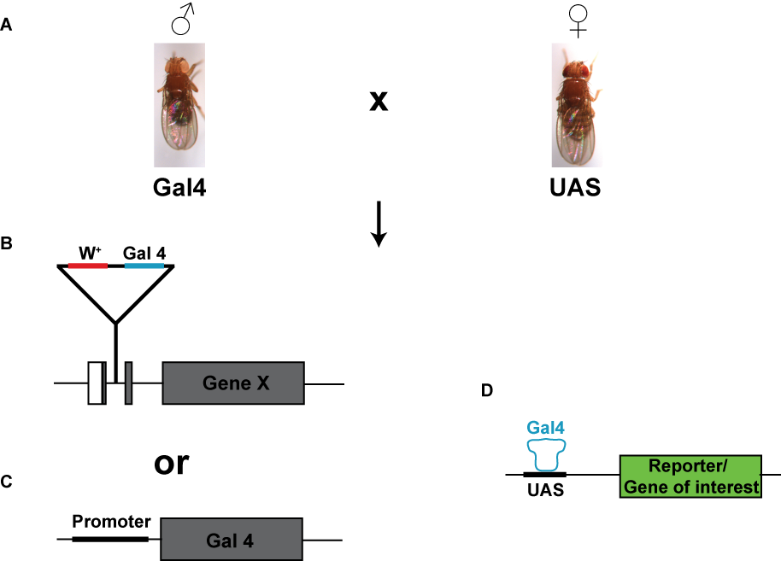

Fig. 1.8. The Gal4-UAS system. (A) Flies from a line containing a Gal4 insertion within a gene (Gene X; B) or downstream of an engineered tissue-specific promoter (C) are crossed to flies from a line containing a construct for a reporter (e.g. GFP) or a gene of interest downstream of a UAS sequence (D). In the offspring of the cross, Gal4 binds to the UAS sequence driving the expression of the downstream reporter/gene of interest. In this way, expression of your reporter/gene of interest can be controlled by the spatial or temporal expression pattern of your chosen Gal4 construct.

      - The balancer chromosome
Balancer chromosomes contain an array of inverted genes across varying degrees of their length, which prevents the correct alignment and homologous recombination that would normally occur in the gametes. These chromosomes also contain dominant mutations that produce external phenotypes that mark the presence of the balancer chromosome. This allows the researcher to follow the mutation, which is not on the balancer chromosome, during chromosomal segregation in the offspring (see Fig. 1.9).

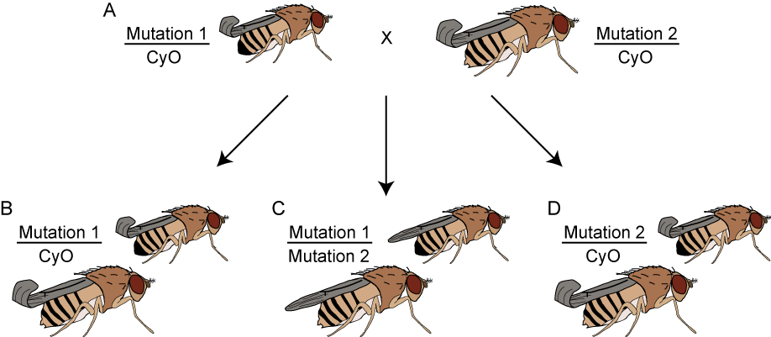

Fig. 1.9. Balancer chromosome markers: their use in following mutations during chromosomal segregation. In this example, the cross in (A) would be set up to obtain flies with the genotype of (C). The parent flies in (A) contain a mutation (either “Mutation 1” or “Mutation 2”) on one copy of the second chromosome and the other copy of the second chromosome is the CyO balancer chromosome. The CyO balancer chromosome has a dominant mutation (marker), which gives the adults curly wings. In the offspring of this cross, chromosomal segregation produces some flies with the same genotype as each of the parents: these flies have curly wings due to presence of the CyO balancer chromosome (B & D). The remaining offspring contain each of the mutations (one on each copy of chromosome 2): these flies do not contain the balancer chromosome and therefore have wild type (straight) wings (C). Using the phenotype of the flies (based on the presence or absence of the balancer chromosome marker(s)), the correct genotype of the fly can be determined to allow the researcher to correctly select the flies with the desired mutation(s).
In addition to the genetic tractability of the Drosophila model system, the relative ease of nervous system accessibility and the similarities of many features of the Drosophila and mammalian nervous systems, further enhance its suitability as a model of human neurodegenerative disease. The anatomical features of the Drosophila nervous system are discussed below.
    - Modelling neurodegenerative disorders in Drosophila
      - The Drosophila life cycle
From embryo to adult, the Drosophila life cycle completes in approximately 10 - 11 days at 25°C (at lower temperatures the life cycle is extended and at higher temperatures it is shortened) (Fig. 1.10). Following egg laying, the embryonic stage lasts approximately 1 day and is followed by hatching of the first instar larva. First instar larvae remain on the surface of the food and moult after 2 days to form second instar larvae. For the duration of this stage second instars are found within the food and, after an additional moulting phase, re-emerge from the food as third instar (wandering) larvae. Third instars emerge 5 - 6 days after egg laying (AEL), and shortly after they form the pre-puparium. The pupal stage lasts for 3 - 4 days, during which the adult organs and appendages develop from the imaginal discs that are laid down during embryogenesis.

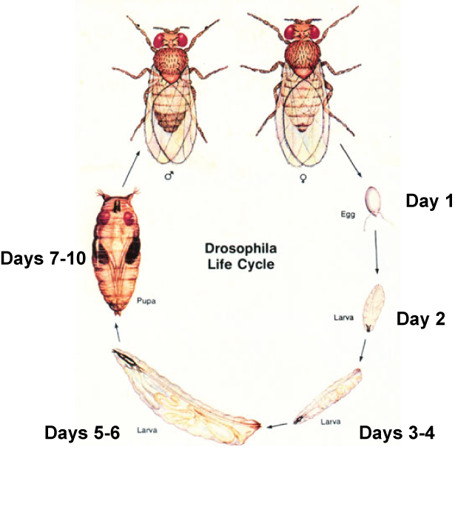

Fig. 1.10. The Drosophila life cycle. After egg laying (AEL), the embryo stage lasts approximately 1 day before the first instar larva hatches. This stage is followed by the second instar stage, which appears approximately 3 days AEL. The second instar larvae are found within the food and re-emerge approximately 5 - 6 days AEL. The third instar larva crawls up the side of the vial and forms the puparium. Metamorphosis occurs for approximately 3 days followed by adult hatching. Image from www.seop.yale.edu/supplementary/supp_drosophila.html.

      - The adult Drosophila nervous system
The CNS of all developmental stages in Drosophila is arranged with the neuronal cell bodies on the outside (the cortex) surrounding the inner centers known as neuropiles. These neuropiles are devoid of neuronal cell bodies and consist of neuronal projections (axons and dendrites) and glial cells (reviewed in Prokop and Meinertzhagen, 2006). The morphology of the adult CNS is dramatically different from that of the embryonic and larval stages (Fig. 1.11; Nichols; 2006). Following metamorphosis, the ventral nerve cord (the thoracic and abdominal ganglia of the larva) remodels to form the suboesophageal ganglion and the fused thoracic and abdominal ganglia (Fig. 1.11; Nichols, 2006). The suboesophageal ganglion receives neuronal signals from, and transmits them to, the mouthparts (Shanbag and Singh, 1992). The brain (cephalic ganglia) of the larva is transformed into three bilaterally fused ganglia in the adult: the protocerebrum, deutocerebrum and the tritocerebrum, which form the supraoesophageal ganglion (Fig. 1.12). The supraoesophageal ganglion consists of many neuropiles surrounded by their appropriate cortex. Architecturally, the most pronounced neuropiles are those of the central complex (ellipsoid body, noduli, superior arch, fan-shaped body and protocerebral bridge), the antennal lobes, the mushroom bodies, and the optic lobe neuropiles (lamina, inner and outer medulla, lobula and lobula plate) (Fig. 1.12).
The regions of the brain that are central to this investigation are the antennal lobes, which are the first-order neuropiles of the olfactory system, and the optic lobes, which together with the compound eye are involved in colour and motion vision (Rister et al., 2007; Yamaguchi et al., 2010; Imai et al., 2010). The structure and function of these neuropiles will be discussed in sections 1.4.2.2.1 and 1.4.2.2.2. The glia of the adult CNS have only been well characterised in the antennal lobes and optic lobes and will thus be covered in these sections.

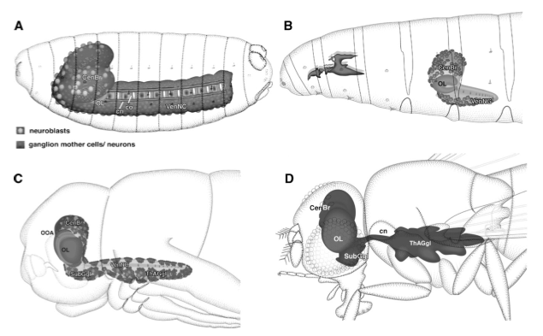
Fig. 1.11. Developmental stages of the Drosophila CNS. A diagrammatical representation of the CNS in the late stage 17 embryo (A), the third instar larva (B), the pupa (C) and the adult (D). CenBr, central brain; cn, central commissures OL, optic lobes; SubGgl, suboesophogeal ganglia; ThAGgl, thoracic ganglia; VenNC, ventral nerve cord (from Nichols, 2006).

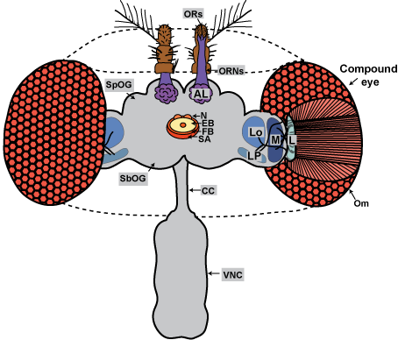

Fig. 1.12. Organisation of the adult Drosophila CNS. The adult CNS consists of the supraoesophageal ganglion (SpOG), the suboesophageal ganglion (SbOG) and the fused thoracic and abdominal ganglia (ventral nerve cord; VNC). The SbOG and VNC are joined by the cervical connective (CC). Architecturally, the predominant neuropiles of the SpOG are the antennal lobes (AL), the optic lobe neuropiles (lamina, L; medulla, M; lobula, Lo; lobula plate, LP), and the central complex neuropiles (noduli, N; ellipsoid body, EB; fan-shaped body, FB; superior arch, SA). During olfaction, the olfactory receptors (ORs) in the third segment of the antennae detect odor and send electrical impulses to the AL via the olfactory receptor neurons (ORNs). Phototransduction begins with the reception of light by the rhodopsin present in each ommatidium (Om) of the compound eye. This triggers a signaling cascade resulting in the opening of TRP calcium channels and depolarisation of the photoreceptors. The photoreceptors innervate the lamina or medulla, which send projections to the lobula and lobula plate.

        - The structure and function of the antennal lobes
The antennal lobe (AL), the Drosophila equivalent of the mammalian olfactory bulb, consists of approximately 40 individual neuropile units known as glomeruli (Laissue et al., 1999). The glomeruli are innervated by the olfactory receptor neurons (ORNs) of the antennae (Fig. 1.12) and maxillary palp (sensory organ of the proboscis). There are approximately 1300 ORNs within each antenna and 120 ORNs in each maxillary palp, each of which expresses a specific group of olfactory receptors (ORs) (Shanbhag et al., 2000; Hallem and Carlson, 2004; Fishilevich and Vosshall, 2005). ORNs that express the same set of ORs innervate the same glomerulus of the AL (Vosshall et al., 2000). ORNs synapse onto AL projection neurons (PNs) that innervate higher brain centres: namely the mushroom body and the lateral horn. The dendrites of individual PNs generally innervate only one AL glomerulus and can receive input from approximately 25 ORNs, all of which express the same set of ORs (Stocker et al., 1990; Vosshall et al., 2000). ALs also contain local interneurons, which unlike the PNs innervate many, if not all, AL glomeruli (Stocker et al., 1990).
Upon binding of an odorant to the OR, an ionotropic and metabotropic pathway is activated. This allows a very rapid and amplified transmission to the underlying AL and subsequently the mushroom body to elicit a higher order (often behavioural) response (Nakagawa and Vosshall, 2009).
There are approximately 80 glial cells in the ALs, which are categorised as either cortex glia or neuropile glia (ensheathing glia and astrocyte-like glia). Both the cortex and neuropile glia form the sheath around the neuropile, separating it from the cell bodies in the cortex (Pereanu et al., 2005; Oland et al., 2008). The astrocyte-like glia also project into the neuropile (Doherty et al., 2009). In addition to their role in forming the neuropile/cortex sheath, the cortex glia surround the neuronal cell bodies that form the AL cortex separating the AL from adjacent neuropiles and oesophagus (Doherty et al., 2009).
At least two populations of glia have also been identified in the antennae: the coeloconic independent glia (ensheathe individual groups of ORNs) and the glia of the atonal-dependent coeloconic lineage (form an outer sheath surrounding the groups of ORNs) (Sen et al., 2005). Like the cortex glia of the AL, the latter population of antennal glia also ensheathe the cell bodies of the antennal sense organs (Sen et al., 2005).
        - The structure and function of the optic lobes
In addition to the olfactory system, a major component of the fly’s sensory nervous system is the compound eye and underlying optic lobes. Together these components function in phototransduction, a process that depends upon extremely rapid activation and termination of the light response to maintain visual sensitivity.
The compound eye consists of approximately 750 repeating units known as ommatidia, each containing 8 photoreceptor cells (R1 - 8), a lens, lens-secreting cone cells, and accessory cells (Ready, 1989). R1 - 6 are responsible for motion vision, whereas R7 and R8 are required for colour vision (Yamaguchi et al., 2008; Morante and Desplan, 2008). The region of each photoreceptor cell that is specialised for light capture and phototransduction is confined to the microvillar structure: the rhabdomere. Each rhabdomere is concentrated with the molecular components required for phototransduction, allowing rapid transmission of the signal to the underlying neuropiles of the optic lobe.
The first-order neuropile of the optic lobe is the lamina. The lamina contains synaptic terminals from the axons of R1 - 6, whereas R7 and R8 axons pass through the lamina and terminate in different layers of the medulla (Morante and Desplan, 2004); this difference in R1 - 6 and R7/R8 synapse localisation is likely to reflect their differing roles in motion and colour vision. Each R1 - 6 terminal forms approximately 50 tetrad synapses with lamina monopolar cells L1 and L2, and also with either L3 monopolar cells or amacrine cells (Prokop and Meinertzhagen, 2006). The monopolar cells form synapses with each of the R1 - 6 of an ommatidium to allow these cells to pool the transmissions from each photoreceptor of a specific visual field.
As mentioned above, the axons of photoreceptor cells R7 and R8 terminate in the medulla rather than the lamina. There are 10 layers in the medulla (M1 - 10); R7 axons terminate in M6 and R8 in M3 (Morante and Desplan, 2004). The lamina monopolar cells that synapse with R1 - 6 axons (L1, L2 and L3) also project into the medulla and terminate in layers M1/M5, M2 and M3, respectively (Fischbach and Dittrich, 1989); therefore, the medulla may be involved in integrating synaptic information from both motion and colour vision. Within the medulla, various neurons have been identified that group into two broad types: the medulla local neurons and projection neurons (Fischbach and Dittrich, 1989; Morante and Desplan, 2008). These neurons synapse with the photoreceptor axons and also connect with neurons within the underlying lobula and lobula plate, and the overlying lamina (Fischbach and Dittrich, 1989; Morante and Desplan, 2008).
Phototransduction is induced by the light activated conversion of rhodopsin to metarhodopsin. This is common to both vertebrates and invertebrates; however, the retinal chromophore, and some aspects of the phototransduction mechanism are different between vertebrates and invertebrates. In vertebrates the chromophore 2-dehydro-retinal is required, compared to 3-hydroxy-retinal in Drosophila (reviewed in Hardie and Raghu, 2001). In both cases, the retinal chromophore is converted from the 11-cis to the all-trans configuration, which leads to a conformational change of rhodopsin to metarhodopsin. In vertebrates, this conversion leads to the activation of a G-protein (transducin) response that activates phosphodiesterase (PDE), which hydrolyses 3’,5’-cyclic guanosine monophosphate (cGMP) and results in the closing of cGMP-gated channels and hyperpolarisation (Hardie and Raghu, 2001). In Drosophila, the conversion of rhodopsin to metarhodopsin activates a distinct G-protein (G_{q}), which activates a phospholipase C isoform (PLCβ4: norpA) leading to the opening of transient receptor potential (TRP) and TRP-like (TRPL) channels and depolarisation (Bloomquist et al., 1988; Scott et al., 1995; Niemeyer et al., 1996). Depolarisation of the PR cell results in the release of histamine and the activation of chloride channels of the post-synaptic cells in the lamina and medulla. This phototransduction cascade can be measured in the form of an electroretinogram (ERG) and is a method used during this investigation (Chapter 6).
In addition to the 80,000 neurons present in the optic lobe neuropiles, various types of glial cells have been identified. In the lamina, there are two types of surface glia (fenestrated and pseudocartridge glia), two types of cortex glia (the distal and proximal satellite glia), and two types of neuropile glia (the epithelial and marginal glia) (reviewed in Edwards and Meinertzhagen, 2010). Their functions include the formation of a blood brain barrier (BBB) (pseudocartridge glia), endocytotic clearance of excess neurotransmitters, such as histamine and glutamate (fenestrated and epithelial glia), and ensheathing of neuronal cell bodies and axon projections (distal and proximal satellite glia, and marginal glia). Similar glial types are also associated with the medulla, lobula and lobula plate, including optic chiasm glia, cortex glia (satellite glia) and neuropile glia (Edwards and Meinertzhagen, 2010). An intimate relationship appears to exist between glia and photoreceptor cells in the regulation of phototransduction and therefore the shaping of the ERG.
    - The success of using Drosophila to model neurodegenerative disorders
The Drosophila model organism provides a relatively simple and inexpensive system (compared to mammals) with a suitably complex nervous system (compared to Caenorhabditis elegans) and a sophisticated array of behaviours with which to model a neurodegenerative disorder. For these reasons, and the identification of a genetic component to many human neurodegenerative disorders, Drosophila has emerged as the model organism of choice for modeling many neurodegenerative disorders. In the past 10 years, Drosophila models of AD (Gotz et al., 2004), PD (Whitworth et al., 2006), Trinucleotide Repeat Expansion Disorders (TREDs) (Marsh et al., 2000), and LSDs (e.g. Venkatachalam et al., 2008; Tuxworth et al., 2009) have provided great insight into some of the molecular mechanisms, and therefore therapeutic targets, implicated in these disorders. Many of these mechanisms converge upon similar pathways that are being revealed as common to various neurodegenerative disorders, such as oxidative stress, calcium homeostasis and regulation of the autophagic/lysosomal systems.
This investigation involved the generation of the first Drosophila model of saposin deficiency, providing the potential for understanding not only prosaposin deficiency and the related saposin deficiencies, but also other LSDs and neurodegenerative disorders.
  - Aims
The main aim of this investigation was to generate and characterise a Drosophila model of saposin deficiency to advance the understanding of the molecular mechanisms underlying this group of disorders. To achieve this, various contributing aims had to be accomplished. These are outlined below.
1) Investigate the phylogeny and expression pattern of the Drosophila prosaposin homologue as a measure of functional conservation with its human counterpart. (Chapter 3)
2) Generate a loss-of-function Drosophila model of saposin deficiency. (Chapter 4)
3) Determine whether the Drosophila saposin deficiency mutants provide a suitable model of the neurodegenerative aspects of saposin deficiency. (Chapter 5)
4) Assess whether the Drosophila saposin deficient mutants display the physiological pathology relevant to these disorders. (Chapter 6)

mol % of phospholipids

