Appendix 5
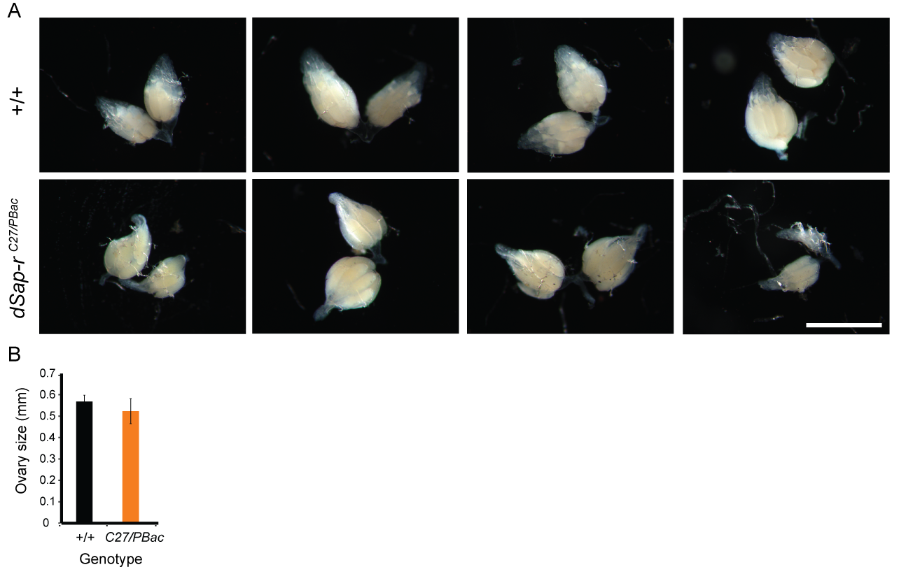
Ovary size is not responsible for the swollen abdomen phenotype in dSap-r mutant females. (A) Wild type (w⁻¹¹¹⁸/Canton-S; +/+) and dSap-r^{C27/PBac} mutants were aged to 20 days at 29°C in the same vial. Ovaries were dissected in PBS and imaged using a stereomicroscope with 30x magnification. Scale bar: 1 mm. Dissections were performed by A. Middleton, University of York. (B) Ovary diameter was measured using ImageJ. A two-tailed Student’s t-test was used to assess significance between wild type and dSap-r^{C27/PBac} mutant ovary size.

