Appendix 4
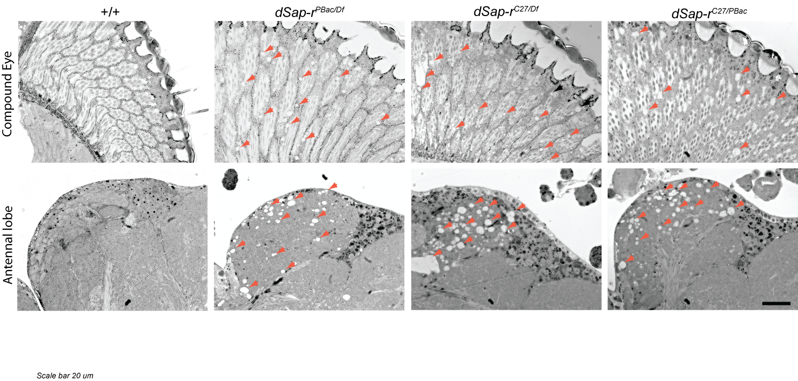Vacuolarisation of the compound eye and antennal lobes in dSap-r mutants. Higher magnification images of the vacuoles in the compound eye (upper row) and antennal lobes (lower row) in dSap-r mutants in contrast to wild type (w⁻¹¹¹⁸/Canton-S; +/+). Vacuoles are indicated by red arrowheads. Images were taken with a 63x objective on a Zeiss AxioVert 200 microscope. Scale bar: 20 μm.

