Appendix 3
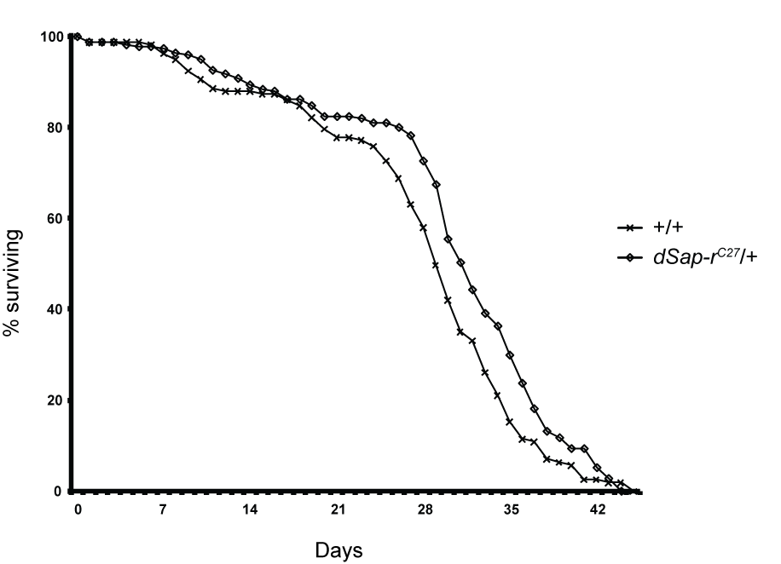
Wild type longevity observed in dSap-r^{C27}/+ heterozygotes. The longevity of dSap-r^{C27}/+ heterozygous flies and wild type (w⁻¹¹¹⁸/Canton-S; +/+) control flies were assessed. The longevity assay was performed at 29°C and surviving flies were counted and transferred to fresh food every 2 days (± 1 day). Longevity was plotted as the percentage of Day 0 flies surviving for each genotype. n > 100 for each genotype.

