- Discussion and future investigations
The main results and conclusions from this investigation are outlined below:
- The dSap-r locus consists of 8 putative saposin domains, each containing 6 conserved cysteines that aligned with the human counterparts. Putative glycosylation sequences were also identified between the second and third conserved cysteines of some of the dSaps. This may reflect a functional conservation between the dSaps and hSaps.
- The dSap-r transcript was expressed in glia but not neurons, in addition to the digestive system, Malpighian (renal) tubules, and the male and female reproductive systems.
- Mutations that disrupted the dSap-r locus caused a reduction in longevity.
- The dSap-r mutations caused progressive neurodegeneration, with sensory regions of the brain (antennal lobes, compound eyes and optic lobes) being particularly sensitive.
- At the ultrastructural level, dSap-r mutants showed heterogeneous storage in the form of electron-dense and electron-lucent material, and an abundance of MLBs and MVBs: highly reminiscent of LSDs.
- All dSap-r mutants showed an age-dependent decline in motor output (jump performance and/or climbing speed).
- The dSap-r mutants showed an age-dependent deterioration in phototransduction (ERGs).
- All dSap-r allelic combinations showed an abdominal swelling phenotype, which may relate to the abnormal Malpighian tubule morphology.

- Conclusion: dSap-r mutants show a specific sensitivity of sensory systems to neurodegeneration, which correlates with a decline in sensorimotor behaviour. Due to the abdominal swelling and Malpighian tubule morphological defect in dSap-r mutants, osmoregulation may be perturbed. Therefore, this suggests a requirement for either efficient regulation of sphingolipid metabolism or lysosomal function in sensory neuron function and osmoregulation.
The generation of a Drosophila model of saposin deficiency has provided the potential to apply powerful genetic tools to the understanding of this group of disorders. Although various mouse models of the saposin deficiencies have provided a solid characterisation of the pathological effects of these mutations, the causative molecular mechanisms are far from understood. The dSap-r model is poised for the rapid elucidation of the molecular mechanisms implicated in this disease, as is discussed below.
  - How can the dSap-r model be used to elucidate the pathological mechanisms involved in the saposin deficiencies?
Many possible pathogenic mechanisms could be proposed that could be attributable to stored sphingolipid. Based on the results of this investigation and the current literature, three potential mechanisms present themselves. These will be discussed in turn.
    - Calcium homeostasis dysregulation
As was discussed in Chapter 6, calcium homeostasis has been implicated in the pathology of many of the sphingolipidoses. Therefore, to determine if dSap-r-induced neurodegeneration is caused by a calcium homeostasis defect, the effect of reducing or enhancing the cytosolic calcium levels can be assessed. With this aim, a wild type transgene of the calcium exchanger (CalX; see Fig. 6.10) can be expressed in the photoreceptor cells of dSap-r mutants (using the GMR-Gal4) to enhance the extrusion of calcium and reduce cytosolic calcium levels. If increased resting calcium levels are causing neurodegeneration in dSap-r mutants, overexpression of CalX should ameliorate the degeneration of the photoreceptor cells and restore the ERG photoreceptor potential. Conversely, a calx mutant line can be crossed into the dSap-r mutant background, which should act to reduce calcium extrusion, worsen the photoreceptor cell degeneration, and exacerbate the photoreceptor ERG phenotype.
Although wild type CalX expression would prevent mitochondrial calcium overload in dSap-r mutants, if ER calcium store depletion is the cause of the increased cytosolic calcium this would not restore ER calcium levels. ER calcium depletion can itself lead to the induction of apoptosis, which would lead to neurodegeneration (Ginzburg et al., 2004). Therefore, if this contributes to the pathological mechanism in dSap-r mutants, ER calcium levels would also need to be restored to prevent neurodegeneration. This could be provided by the overexpression of the ER calcium influx channel SERCA in a dSap-r mutant background.
    - Oxidative stress
Mitochondrial calcium overload can occur as a result of calcium release from the ER, leading to apoptosis due to oxidative stress and caspase activation (Ginzburg et al., 2004). Therefore, overexpression of the antioxidant enzymes superoxide dismutase SOD1 and catalase (using the Gal4-UAS system) would alleviate some of the oxidative stress that may be responsible for the dSap-r phenotype. This can be tested first by longevity
assays followed by an assessment of their preventative effects on neurodegeneration and physiology.
    - Macroautophagy
Macroautophagy (hereafter referred to as autophagy) is a process by which the cell can engulf and degrade cellular material and organelles that are unwanted or damaged (reviewed in Cherra et al., 2010). Autophagy has been shown to enhance survival and reduce neurodegeneration, which can be related to its ability to clear damaged mitochondria (mitophagy) that would otherwise lead to oxidative stress and apoptosis. If the progressive neurodegeneration in dSap-r mutants is caused by increased cytosolic calcium levels, this would likely cause loss of mitochondrial membrane integrity and the release of cytotoxic ROS, leading to the induction of apoptosis. If this pathological mechanism is occurring in the dSap-r mutants, upregulation of autophagy should reduce neurodegeneration and enhance longevity. This can be induced by overexpression of autophagy genes (Atg 1 or Atg 5) using the Gal4-UAS system or by feeding the flies rapamycin, which inhibits TOR (an inhibitor of autophagy).
The three mechanisms proposed can be pathologically interdependent; however, using the fly system we can assess their relative contribution to disease progression.
These pathological mechanisms are not only common to LSDs, but appear to contribute towards many neurodegenerative disorders, including Alzheimer’s disease (AD), Amyotrophic lateral sclerosis (ALS), and Huntington’s disease (HD) (Lindholm et al., 2006). For brevity, the involvement of these mechanisms in the above disorders is summarised by Figure 7.1.
  - Can the dSap-r model contribute to the understanding of other LSDs?
As has been discussed in Chapters 4 - 6, many characteristics of the Drosophila NPC1 model closely resemble the dSap-r phenotype. This potentially implicates a common molecular mechanism in both disorders. As was mentioned in Chapter 1, a functional interaction has been identified between NPC1 and PSAP: PSAP RNAi enhanced the cholesterol storage in cells treated with NPC1 RNAi (Bartz et al., 2009). Therefore, a functional interaction may also occur between Drosophila NPC1 and
dSap-r. Due to the generation of the dSap-r model, this interaction can now be tested in vivo. To investigate this, the dnpc1 line can be crossed into the dSap-r mutant background to determine whether this exacerbates the dSap-r phenotype. As a result of this investigation, both UAS-dSap-r and UAS-PSAP transgenic Drosophila lines are available; therefore, their expression can be induced in dnpc1 mutants to assess any rescuing effect. This would establish whether a functional interaction also occurs between the Drosophila orthologues and therefore whether the dSap-r model has the potential to contribute to the understanding of NPC.
The saposins may also be implicated in other LSD pathologies. The saposins, particularly saposins A and D, accumulate in Sandhoff, Tay-Sachs, Gaucher, fucosidosis and infantile NCL (Morimoto et al., 1990; O’Brien and Kishimoto, 1991; Tyynela et al., 1993). This may be caused by the ability of the saposins to bind many lipid species (as discussed in section 1.3.4.2) and therefore accumulate as protein/lipid complexes. The availability of an infantile NCL Drosophila model (Hickey et al., 2006) allows the pathological contribution of the saposins to be assessed using the dSap-r mutant.
  - The use of the dSap-r model to investigate potential therapeutic routes
Since LSDs are characterised by the accumulation of undegraded material in the lysosomes, therapeutic routes have angled towards reducing the degradative burden on the lysosome either by replacing the defective lysosomal enzyme (enzyme replacement therapy: ERT) or by reducing the synthesis of the substrate (substrate reductive therapy) (Jeyakumar et al., 2005). The generation of the dSap-r model allows these therapeutic strategies to be tested genetically. For example, fly lines are available with mutations in the subunits of the first enzyme of sphingolipid synthesis (SPT1 and SPT2/lace). The introduction of lace mutations has previously been shown to reverse the effects of sphingosine-1-phosphate lyase deficiency in Drosophila (Herr et al., 2003). Therefore, the effect of genetically reducing sphingolipid synthesis in the dSap-r mutants can be assessed in a similar way to establish whether this route would be advantageous for treating the saposin deficiencies.
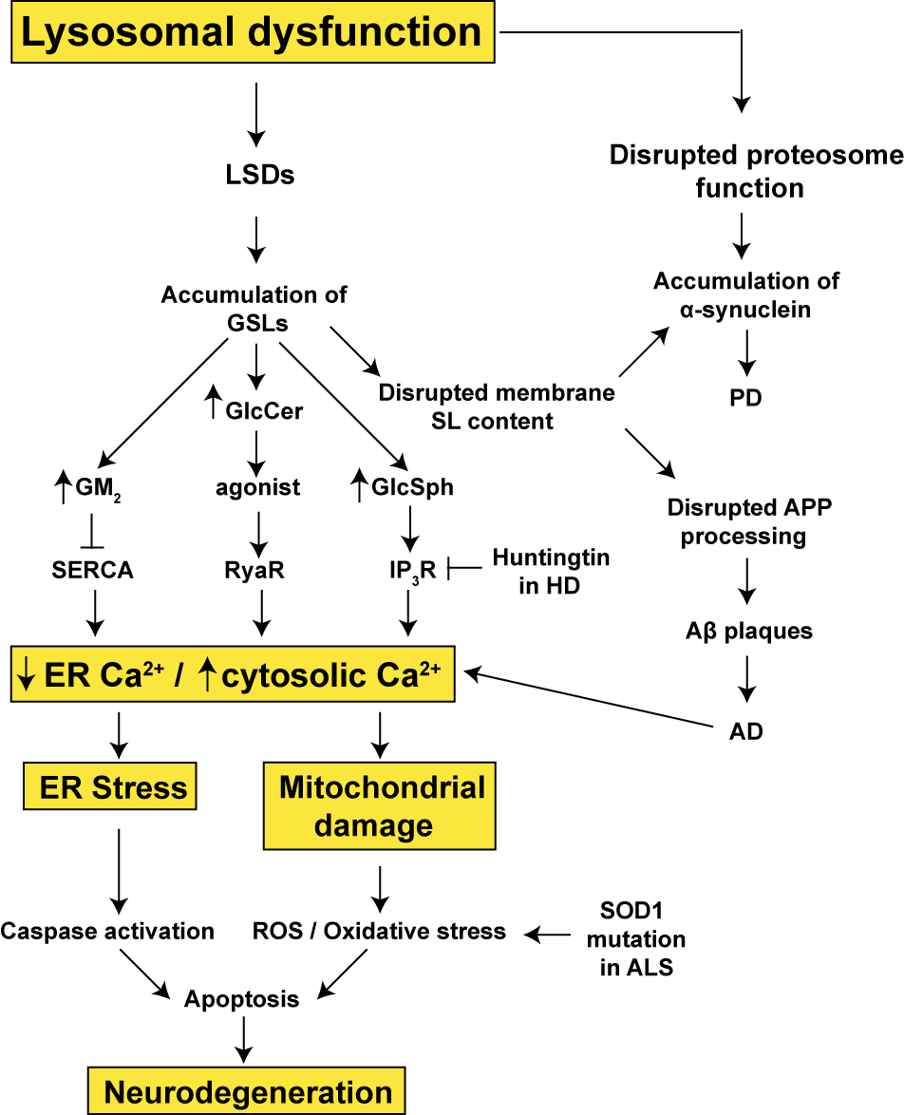
Fig. 7.1. Common pathological cascades implicated in various neurodegenerative disorders. Although LSDs primarily affect lysosomal function, due to their role in cellular degradation via autophagy this can lead to dysfunction of other organelles, primarily the ER and mitochondria. In the case of the sphingolipidoses, the failure of glycosphingolipid degradation can affect ER function due to their effect on ER calcium channels, which can lead to an ER calcium depletion and/or cytosolic calcium increase. An increase in cytosolic calcium can cause mitochondrial calcium overload, which disrupts mitochondrial membrane integrity and causes the release of ROS and proapoptotic factors. ER calcium depletion can affect the protein folding capabilities of the ER, leading to protein misfolding/unfolding, activation of ER associated degradation (via the proteosome) and eventually caspase activation and apoptosis. Due to lysosomal dysfunction, cellular demand on the ubiquitin-proteosome system is increased, which can lead to the aggregation of cytotoxic proteins (e.g. α-synuclein) leading to neurodegeneration. These LSD-induced cellular cascades are also common to other neurodegenerative disorders. Therefore, elucidation of the pathological cascade involved in the dSap-r mutants may also contribute to the understanding of many neurodegenerative disorders. See text for abbreviations.
  - Investigation synopsis
This investigation has lead to the production of the first Drosophila model of saposin deficiency. This model reproduces many of the classic hallmarks of saposin deficiency and other LSDs, such as a severely reduced longevity, progressive neurodegeneration marked by an abundance of heterogeneous storage material, and physiological decline. Some of the multifunctional aspects of PSAP may also be reflected in the dSap-r model; expression of dSap-r was localised to the male and female reproductive systems, which may suggest a conserved role for dSap-r in fertility, as is the case with PSAP. The dSap-r mutation may also cause renal failure, mirroring the kidney pathology of the saposin D^{-/-} mouse model. As such, the dSap-r model not only recapitulates the neurodegenerative aspects of saposin deficiency but also the visceral organ involvement, suggesting that this model may provide a substantial tool for understanding many features of saposin deficiency, other LSDs and neurodegenerative disorders, as well as more broadly related visceral organ dysfunctions.

