- Physiological decline in dSap-r mutants

Aim: Assess whether the Drosophila saposin deficient mutants display the physiological pathology relevant to these disorders
- Investigate whether the dSap-r mutants show a progressive sensorimotor decline
- Assess the degree to which this reflects a sensory rather than motor defect
- Determine whether dSap-r mutants show a progressive deterioration in synaptic transmission
- Investigate whether the dSap-r mutants show other aspects of physiological deterioration relevant to the saposin disorders
  - Introduction
During the longevity assays it was observed that the dSap-r mutants became progressively languid with less inclination to climb. This suggested that
dSap-r mutation caused either muscle degeneration or deterioration in neural function. Chapter 5 revealed a selective degeneration of sensory regions of the dSap-r mutant brains. Therefore, the reduced mobility observed in dSap-r flies may be due to a reduced sensory input: a lack of response to sensory cues. To test this hypothesis, various sensorimotor assays were used.
A common measure of Drosophila motor ability involves the recording of climbing ability. As discussed below, climbing requires a complex integration of multiple sensory inputs to coordinate a motor output. Therefore, if dSap-r mutants show a reduced level of activity due to a deterioration of sensory perception or motor output, this defect should be detected by the climbing assay.
To assess the degree to which this motor deficit is due to sensory degeneration, a jumping assay (Elliott et al., 2007) can be used to measure motor output negating the requirement for sensory input. Reduced jump performance would suggest either a muscle defect or degeneration of function of the motor neurons required for jumping.
To further determine whether neuronal function is disrupted in dSap-r mutants, ERGs were recorded from the fly eye. This provided a measure of synaptic transmission between the photoreceptor neurons in the retina and the neurons of the underlying brain, regions that were shown to be degenerate in dSap-r mutants (Chapter 5).
In addition to motor deterioration, other aspects of physiological decline were investigated in the dSap-r mutants, including a potential osmoregulatory defect.
  - dSap-r mutants show sensorimotor decline
    - An age-dependent decrease in climbing ability is observed in dSap-r mutants
A classic method of measuring motor ability in Drosophila relies on their innate negative geotropism; flies that are tapped to the bottom of a vessel will immediately right themselves and run upwards (against gravity). Climbing can also be induced by placing a light source above the vessel, which stimulates their positive phototropism response. Motor ability can be scored in many ways, e.g. the time taken for 50% of the flies to climb a certain distance. These measurements can be recorded at the time of testing, however this approach relies heavily on human judgement and capability of tracking many flies simultaneously. Therefore, to allow for more accurate and informative measurements of motor output, climbing assays can be recorded allowing the observer to analyse each fly individually in a variety of ways.
Due to the complex combination of sensory perception (negative geotropism and positive phototropism) and motor output required for climbing, this assay measures the impact of both sensory and motor deterioration. A region closely apposing the antennal lobes, the antennal mechanosensory and motor centre (AMMC), receives innervation from the mechanosensory bristles of the antennae responsible for sensing gravity (Kamikouchi et al., 2009). Therefore, if the dSap-r antennal lobe degeneration originates in the antennae, the AMMC function may also be affected. Furthermore, a degenerating visual system would also impact on climbing behaviour due to the strong positive phototropism. Therefore, this method was well suited to functionally test the impact of the neurodegeneration observed in dSap-r mutants at the level of general neurological decline, but may hint strongly at peripheral nervous system dysfunction. Because neurodegeneration was shown to be progressive (Fig. 5.4), dSap-r climbing ability was tested when flies were 5 days old and 22 days old, and was compared to the appropriate wild type and heterozygous controls.
As described in section 2.4.5, climbing ability was analysed as the time taken to climb 50% of the measuring cylinder, maximum distance climbed, and speed over 10% intervals. The results from these tests are shown in Figure 6.1 A, B and C, respectively. The results from statistical analyses are only shown for the 22-day old data, to not overcomplicate the graphs.
      - The dSap-r^{PBac}/Df mutants show an age-dependent decline in speed and distance climbed
At 5 days old, the dSap-r^{PBac}/Df mutants showed no significant difference to the controls in their climbing ability in any of the methods of analysis used (white bars in Fig. 6.1 A, B and C). After aging the same flies to 22 days old (± 1 day), a significant decrease in the distance climbed was observed for the dSap-r^{PBac}/Df flies compared to the equivalent controls (dSap-r^{PBac}/+ and Df(3R)tll-e/+; * p<0.05, Analysis of Variance). The reduction in the distance climbed by dSap-r^{PBac}/Df flies is reflected in the deterioration in climbing speed seen in these mutants compared to controls (*** p≤0.001, Analysis of Variance). Although the dSap-r^{PBac}/Df mutants showed an age-dependent reduction in speed and distance climbed, the time taken to climb 50% of the measuring cylinder was not significantly different from the controls (n.s. p≥0.05, Analysis of variance). This may seem like a contradiction to the results in Figure 6.1 B and C, however this appears to reflect a limitation of the method of analysis rather than a discrepancy in the climbing ability of dSap-r^{PBac}/Df flies (see section 6.4.1.1 for further discussion).
      - The dSap-r^{C27}/Df mutants show a progressive decline in speed and distance climbed
In contrast to the dSap-r^{PBac}/Df mutants, the 5-day old dSap-r^{C27}/Df mutants displayed a reduction in climbing ability compared to the controls and other dSap-r mutants. The 5-day old dSap-r^{C27}/Df mutants showed an increase in time taken to climb 50% of the measuring cylinder (Fig. 6.1 A; *** p≤0.001, Analysis of Variance), a reduction in distance climbed (Fig. 6.1 B;
*** p≤0.001, Analysis of Variance), and a reduction in climbing speed
(Fig. 6.1 C; *** p≤0.001, Analysis of Variance) compared to all controls. After aging these flies to 18 – 20 days old, a further decline was seen in the maximum distance climbed and the speed of climbing (Fig. 6.1 B and C). This deterioration in climbing ability was significantly different compared to the appropriate 22-day old controls (dSap-r^{C27}/+ and Df(3R)tll-e/+;
*** p≤0.001, Analysis of Variance). However, as shown for the dSap-r^{PBac}/Df mutants, the 18 – 20 day old dSap-r^{C27}/Df mutants did not show a significant difference in time taken to climb 50% of the measuring cylinder compared to their dSap-r^{C27}/+ heterozygous controls (Fig. 6.1 A; n.s. p≥0.05, Analysis of Variance). This may reflect a limited sensitivity of the analysis method or a possible dominant-negative effect of the dSap-r^{C27} allele (see section 6.2.2).
      - The dSap-r^{C27/PBac} allelic combination causes a reduced climbing speed
As was shown for the dSap-r^{PBac}/Df mutants, at 5 days old the dSap-r^{C27/PBac} mutants did not show a significant difference in time take to climb 50% of the measuring cylinder (Fig. 6.1 A; n.s. p≥0.05, Analysis of Variance) or distance climbed (Fig. 6.1 B; n.s. p≥0.05, Analysis of Variance) compared to controls and the dSap-r^{PBac}/Df mutants. However, the dSap-r^{C27/PBac} mutants had a significantly quicker climbing speed than most controls and mutants (Fig. 6.1 C; *** p≤0.001, Analysis of Variance). This may be due to the dSap-r^{PBac} allele, as the dSap-r^{PBac}/+ heterozygotes also showed a significant increase in climbing speed at this age-point (*** p≤0.001, Analysis of Variance). After aging the flies to 22 days old, the dSap-r^{C27/PBac} mutants showed a decline in climbing speed compared to the dSap-r^{C27}/+ control (Fig. 6.1 C; ** p<0.005, Analysis of Variance), which also showed a decreased climbing speed
(*** p≤0.001, Analysis of Variance). As was shown for the other dSap-r mutants, the dSap-r^{C27/PBac} flies did not exhibit a significant difference in the time taken to climb 50% of the measuring cylinder (Fig. 6.1 A; n.s. p≥0.05, Analysis of Variance). Additionally, the dSap-r^{C27/PBac} mutants did not shown a significant decrease in the distance climbed compared to the appropriate control (dSap-r^{C27}/+) (Fig. 6.1 B; n.s. p≥0.05, Analysis of Variance), unlike the other dSap-r mutants.

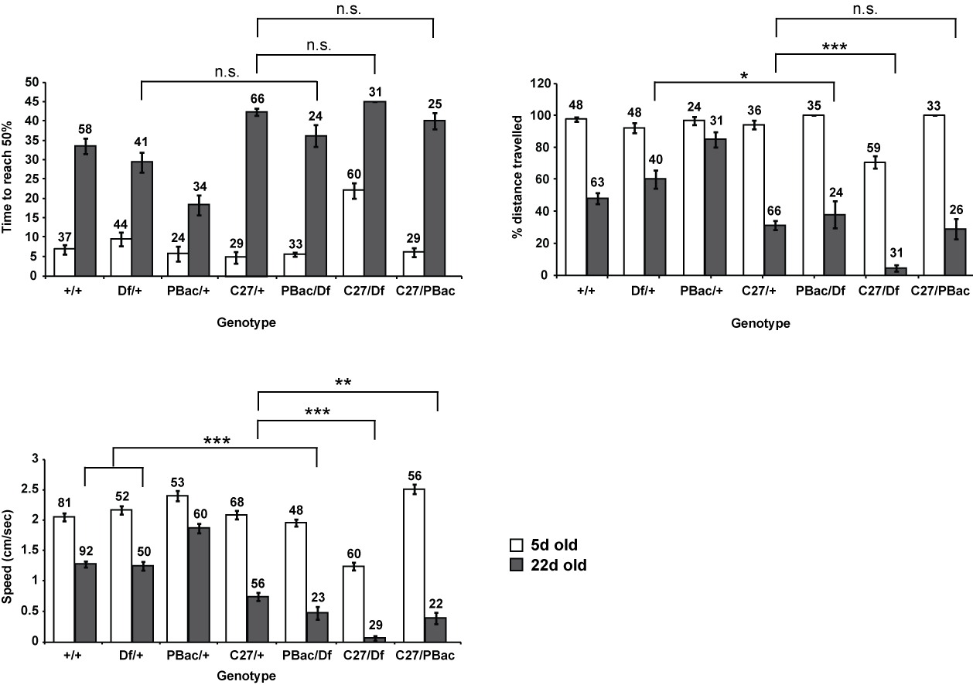 Fig. 6.1. dSap-r mutants show an age-dependent deterioration in climbing ability. (Figure legend overleaf)
A
B
C

Fig. 6.1. dSap-r mutants show an age-dependent deterioration in climbing ability. 5-day old (white bars) and 22-day old flies (grey bars) were subjected to climbing assays by tapping the flies to the bottom of a 100 ml glass measuring cylinder and recording their climbing response for 45 seconds. The data were analysed by quantifying the time taken for the flies to reach half way up a measuring cylinder (A), the maximum distance climbed by each fly (B), and the climbing speed of each fly over 10% intervals of the measuring cylinder (C). Wild type (+/+), dSap-r heterozygous controls (Df(3R)tll-e/+, Df/+; dSap-r^{PBac}/+, PBac/+ and dSap-r^{C27}/+, C27/+), and dSap-r mutants (dSap-r^{PBac}/Df(3R)tll-e, PBac/Df; dSap-r^{C27}/Df(3R)tll-e, C27/Df and dSap-r^{C27/PBac}, C27/PBac) were screened in this way. The number of flies included in the quantification is indicated above each bar. Error bars: ± sem.
*** p≤0.001; ** p<0.005; * p<0.05; n.s., no significant difference p≥0.05, Analysis of Variance.

    - Jumping ability deteriorates with age in some dSap-r allelic combinations

    - The deterioration in climbing speed in all dSap-r mutants could reflect a deterioration of sensory input required to respond to the geotropic and phototropic stimuli, or a degeneration of motor output. Therefore, to bypass the requirement of sensory input for motor output, a jumping assay was used. This technique works by activating the giant fiber pathway, responsible for the escape behaviour, by electrical stimulation applied through electrodes in the eyes). As with the climbing assays, flies were tested at 5 days old and 22 days old to test the progressive nature of motor deterioration. To assess the rate in progression of motor decline, 15-day old flies were also tested: a point when 70 – 90% of dSap-r mutants were still alive (see Fig. 4.5). The results of the jumping assays are represented in two different forms in Figure 6.2 to allow statistical significances to be highlighted (Fig. 6.2 A), whilst displaying the progressive nature of the motor decline in the clearest manner (Fig. 6.2 B).
At 5 days old (white bars in Fig. 6.2 A), there was no significant difference between the controls and mutants (n.s., p≥0.05, Analysis of Variance), except the dSap-r^{C27}/Df flies (* p<0.05, Analysis of Variance). By 15 days old (light grey bars in Fig. 6.2 A), there were no significant differences between the 5-day and 15-day data points within each genotype (n.s. p≥0.05, Student’s t-test), suggesting that the progressive nature of the motor decline was not yet apparent. By 22 days (dark grey bars in Fig. 6.2 A), jump performance in the dSap-r^{PBac}/Df mutants had significantly deteriorated compared to the appropriate controls (* p<0.05, Analysis of Variance). Although jump performance in the 18 – 20 day old dSap-r^{C27}/Df flies was significantly reduced compared to most of the controls (*** p≤0.001, Analysis of Variance), there was no significant difference between the dSap-r^{C27}/Df mutants and the dSap-r^{C27}/+ heterozygotes (n.s. p≥0.05, Student’s t-test). This reaffirms the potential dominant-negative nature of this allele. There was no significant difference between the jump performance of the controls and the dSap-r^{C27/PBac} mutants.

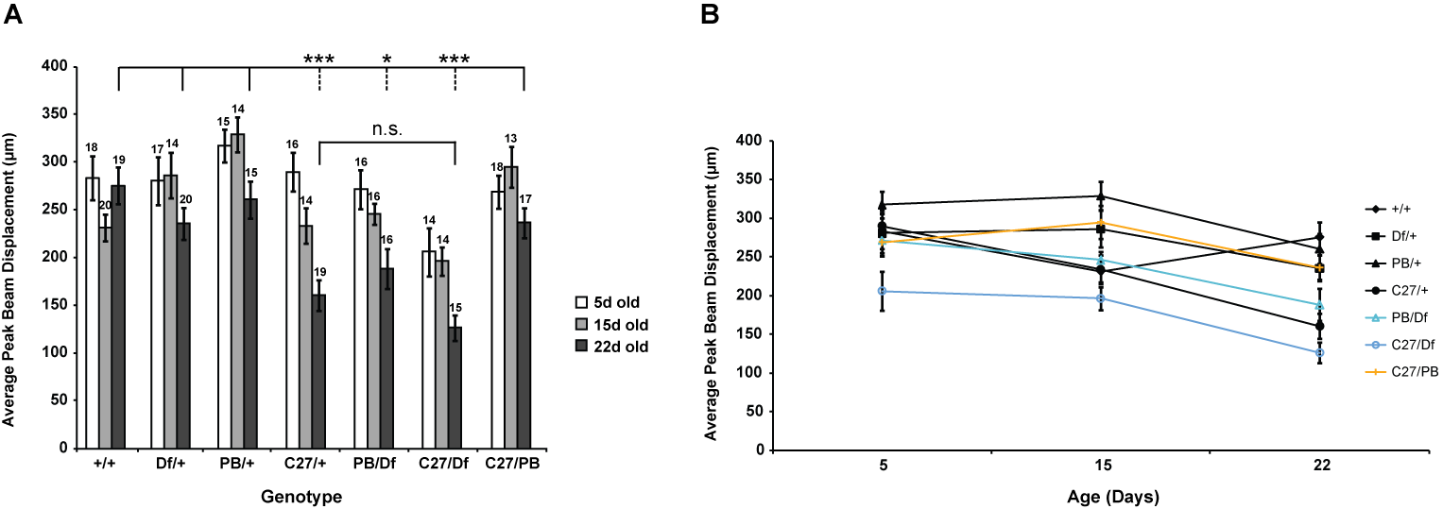
Fig. 6.2. Jump performance of dSap-r^{PBac}/Df and dSap-r^{C27}/Df flies deteriorates with age. 5-day, 15-day and 22-day old female flies were assayed for their jumping ability using an ergometer. Example traces are shown in Figure 2.6. Quantification of jump performance was obtained using DASYView software, which provided the average peak beam displacement (μm). The data are presented as a bar graph (A) to show the n values above the bars, and a line graph (B) displaying the degree of decline in dSap-r jump performance. Error bars represent s.e.m.
*** p≤0.001; * p<0.05; n.s., no significant difference p≥0.05; Analysis of Variance. Results of statistical analyses are shown for the 22-day data. The asterisks above dashed lines show significance compared to the genotypes of non-dashed lines.
    - dSap-r mutants show an age-dependent deterioration in synaptic transmission
The climbing and jumping assays, although informative, do not discriminate between a muscular and synaptic defect. Therefore, to determine whether dSap-r mutants showed an age-dependent deterioration in synaptic transmission, ERGs were recorded.
ERGs measure the extracellular potential generated by the summed neuronal activity in the eye and underlying optic lobe in response to a pulse of light (Heisenberg et al., 1971). ERGs were recorded by placing a glass capillary electrode, containing Drosophila Ringer solution, against one fly eye and a reference electrode against another region of the fly (e.g. the proboscis). The potential difference between the electrodes was measured in response to the light pulse. Although the recordings are a summation of synaptic activity, individual components of the traces reflect output of certain components of the visual system (see Fig. 2.4). Therefore, valuable information can be gained as to the integrity of synaptic transmission between these different regions during phototransduction. As was shown in Figures 5.3 and 5.4, dSap-r mutants showed an age-dependent deterioration of the compound eye and underlying optic lobe. This was confirmed by electron microscopy in dSap-r^{C27}/Df mutants, which revealed abundant storage of both electron-dense and electron-lucent material (Fig. 5.6). A common characteristic of saposin deficiency, and LSDs generally, is retinal degeneration, which can lead to blindness. This technique was therefore used to determine whether the retinal degeneration observed in dSap-r mutants translated to a defect in synaptic transmission, and if so, to dissect out where in the phototransduction cascade this degeneration was occurring.
ERGs were recorded from 5- and 22-day old flies (18 – 20 day old
dSap-r^{C27}/Df flies were used due their reduced longevity). The dSap-r^{C27/PBac} mutant ERGs were not tested because the degree of pigmentation of the eye affects the ERG due to absorbance of light by the pigment (Stark, 1973) (dSap-r^{C27/PBac} females had yellow eyes compared to red eyes in all the other genotypes tested). Because the R1 – R6 photoreceptors are maximally responsive to blue light (Harris et al., 1976), and the R8 photoreceptors to both blue and green light (Salcedo et al., 1999), both blue and green light pulses were used. Figure 6.3 shows a representative ERG trace from each genotype at each age-point. The start level of each trace has been aligned to aid comparison between genotypes. At 5 days old, there were no differences in the traces for the controls or mutants (left and right of the dividing line, respectively). However, at 22 days old the dSap-r^{PBac}/Df and dSap-r^{C27}/Df flies showed deterioration in their response to the light pulses. Each component of the ERG trace was quantified separately for each condition using DASYView software (Fig. 6.4).
At 5 days old, as the example traces show, there were no significant differences between the genotypes across all light conditions and ERG components analysed (Fig. 6.4 A –H), except between the photoreceptor responses of the dSap-r^{PBac}/+ and dSap-r^{PBac}/Df flies (** p<0.005 in response to green light and *** p≤0.001 in response to blue light; Student’s t-test).
In the older flies (green and blue bars in Fig. 6.4) the controls, in both light conditions, showed no significant differences in the photoreceptor component of their ERGs (the first drop in potential; see Fig. 2.4). In contrast, both
dSap-r mutants showed a significant deterioration in the photoreceptor potential in response to the green light pulse (dSap-r^{PBac}/Df, * p<0.05, Analysis of Variance; dSap-r^{C27}/Df, *** p≤0.001, Analysis of Variance); however, only the dSap-r^{C27}/Df mutants showed this deterioration in response to blue light (*** p≤0.001, Analysis of Variance).
A similar deterioration was observed when analysing the difference in the maximum potential; this reflects the size of the off-transients, which are a measure of synaptic activity in the underlying brain. Both dSap-r mutants showed a decline in their maximum potential in response to green light (dSap-r^{PBac}/Df, *** p≤0.001, Analysis of Variance; dSap-r^{C27}/Df, *** p≤0.001, Analysis of Variance). However, as in Figure 6.4 D, the dSap-r^{C27}/Df response was more severely degenerate in response to blue light compared to the dSap-r^{PBac}/Df mutants (Fig. 6.4 E; dSap-r^{PBac}/Df, *, p<0.05, Analysis of Variance; dSap-r^{C27}/Df, ***, p≤0.001, Analysis of Variance). Unlike in Figure 6.4 A, D and E, the dSap-r^{C27}/+ heterozygotes also showed a slight decline in maximum potential in response to green light (Fig. 6.4 B); this may suggest a slight decline in synaptic transmission in the optic lobe as the dSap-r^{C27}/+ photoreceptor potential was shown to not be affected (see Fig. 6.4 A).
The final ERG component measured was the initial stage of recovery after the termination of the light pulse (“lights off”). This is a biphasic recovery and reflects feedback from the optic lobe and within the photoreceptors themselves (Scott and Zuker, 1997). At 5 days old, there were no significant differences between the controls and dSap-r mutants in either light condition. At 22 days old, the dSap-r mutants showed a dramatic increase in the time taken during the initial recovery phase (Fig. 6.4 C and F) after termination of both the green and blue light (*** p≤0.001, Analysis of Variance).

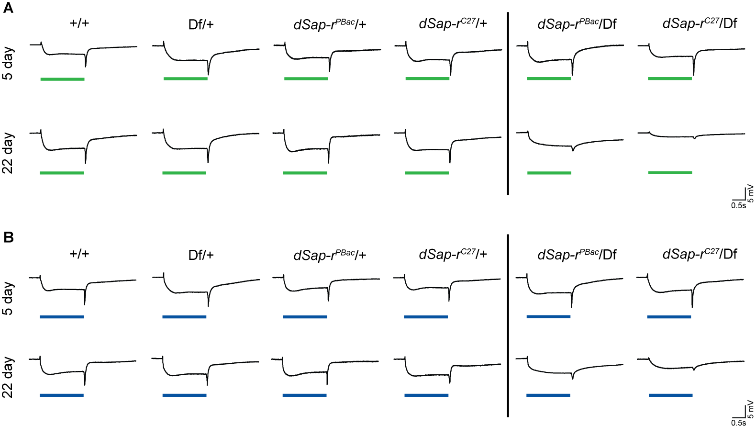 Fig. 6.3. dSap-r mutants show an age-dependent deterioration of their ERGs (Figure legend overleaf)
Fig. 6.3. dSap-r mutants show an age-dependent deterioration of their ERGs. Representative ERG traces are shown from wild type (+/+), dSap-r heterozygotes (Df(3R)tll-e/+, Df/+; dSap-r^{PBac}/+ and dSap-r^{C27}/+), and dSap-r mutants (dSap-r^{PBac}/Df and dSap-r^{C27}/Df) in response to two-second green (A) and blue (B) light pulses. The duration of the light pulse is represented by the green and blue lines under the ERG traces. Flies were tested at 5 days and 22 days old (± 1 day) (dSap-r^{C27}/Df flies were tested at 18 – 20 days old due to their reduced longevity). Flies were dark-adapted for 5 minutes. 5 green light pulses were administered at 10-second intervals; this was repeated with blue light. Scale bars for time (sec) and potential (mV) are shown.

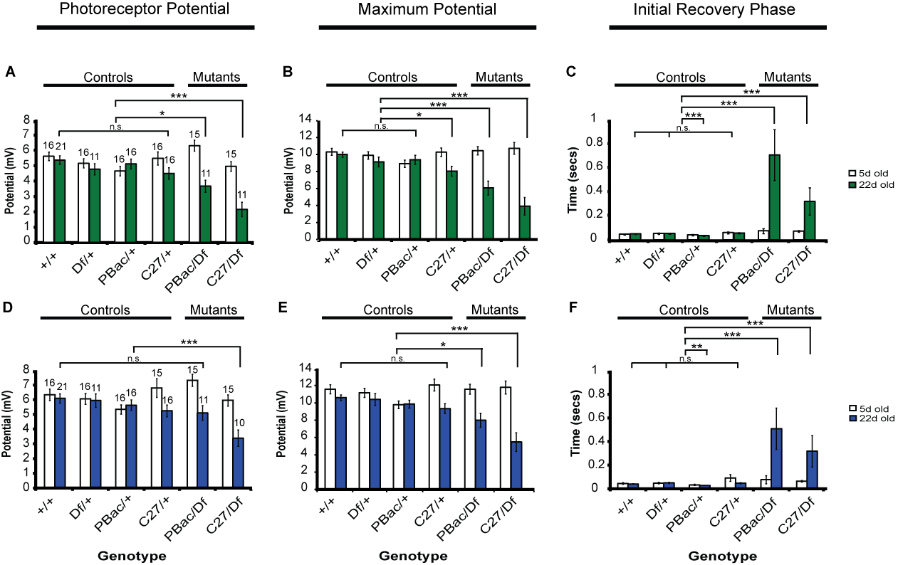 Fig. 6.4. Quantification of the progressive deterioration in dSap-r mutant ERGs (Figure legend overleaf)
Fig. 6.4. Quantification of the progressive deterioration in dSap-r mutant ERGs. ERGs from flies subjected to 2-second green (A – C) and blue (D – F) light pulses were quantified using DASYView software. The photoreceptor potential
(A & D), the maximum potential (B & E) and the initial stage of the biphasic recovery (C & F) were calculated as described in Fig. 2.4. Flies were screened at 5 days old (white bars) and 22 days old (± 1 day; green and blue bars). *** p≤0.001;
** p<0.005; * p<0.05; n.s., no significant difference p≥0.05; Analysis of Variance.
n values shown in A also apply to B & C; n values in D apply to E & F. Error bars represent s.e.m.

  - dSap-r mutants show a potential defect in osmoregulation
The results in Chapters 4 and 5 revealed a reduction in dSap-r mutant longevity, which appeared concomitant with progressive neurodegeneration. However, expression of dSap-r in the neurons of dSap-r mutants only provided partial rescue of neurodegeneration, yet a complete rescue of most dSap-r mutant longevities. This suggests that neurodegeneration might not have been solely responsible for the premature mortality observed. To investigate this hypothesis, further aspects of dSap-r physiology were assessed.
    - The dSap-r mutants show a progressive abdominal swelling phenotype
In ageing flies, a severe swelling of the abdomen of dSap-r mutants was observed. This was first noticed in the females due to their naturally larger size (Fig. 6.5). The size of the abdomen in females is normally influenced by the size of the ovaries; however the ovaries were not significantly different in size to wild type (see Appendix 5). On closer analysis, it was observed that the males also became swollen with age (Fig. 6.6). The penetrance of this phenotype is not 100%; therefore, the number of flies showing a swollen abdomen were quantified (Fig. 6.7). The age of onset of swelling was recorded for each fly and the data were expressed as a percentage of flies alive at that age-point. Figure 6.7 shows that the age of onset peaked between 13 – 16 days for the females, and most swelling appearing between 15 – 17 days for the males. Some wild type flies also showed this phenotype, though the degree of swelling was rarely comparable and this occurred usually at an age when most of the dSap-r mutants had already died. Dissection of these flies revealed that the dSap-r mutants contained a larger than normal volume of haemolymph: the Drosophila equivalent of blood. Therefore, a defect in osmoregulation was investigated.
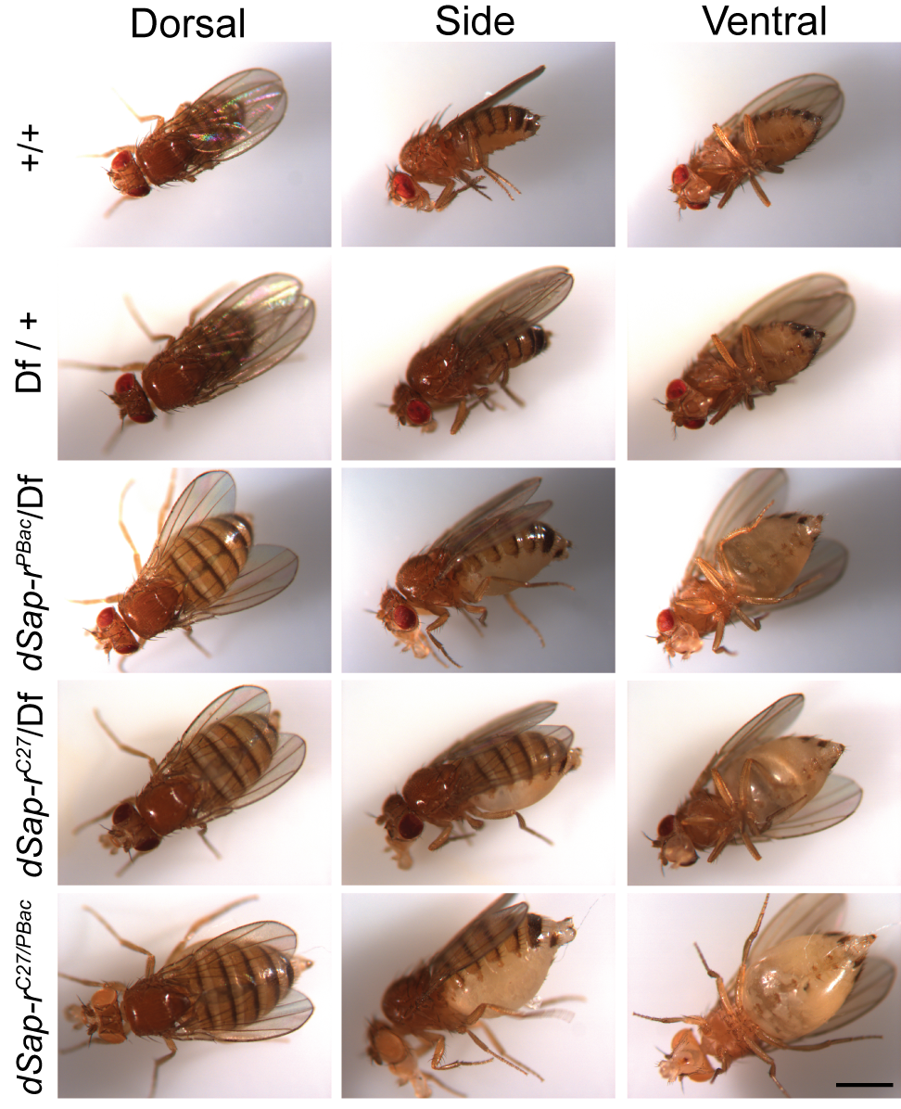
Fig. 6.5. dSap-r females show a severe swelling of the abdomen. Dorsal, side and ventral views are shown for wild type (+/+), Df(3R)tll-e/+ heterozygous control (Df/+), dSap-r^{PBac}/Df(3R)tll-e (dSap-r^{PBac}/Df), dSap-r^{C27}/Df(3R)tll-e (dSap-r^{C27}/Df), and dSap-r^{C27/PBac} females. Flies were aged at 29°C for 20 – 21 days. Images were captured using a Zeiss stereomicroscope at 30x magnification. Scale bar: 1 mm.

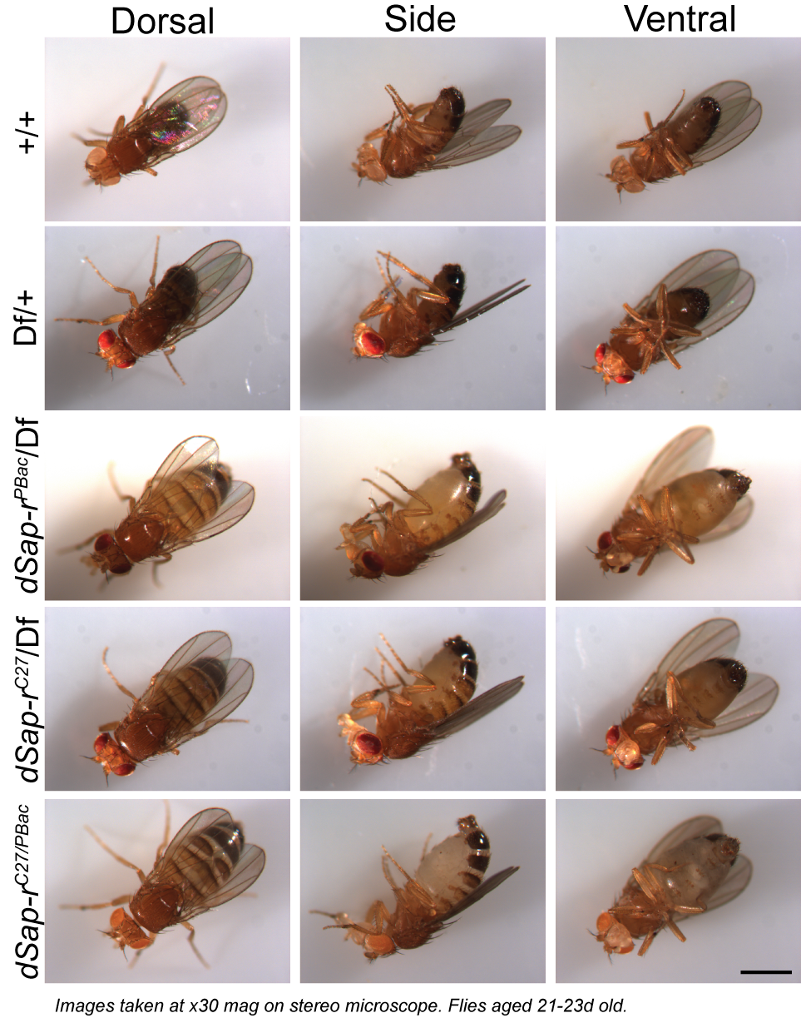
Fig. 6.6. dSap-r males show a severe swelling of the abdomen. Dorsal, side and ventral views are shown for wild type (+/+), Df(3R)tll-e/+ heterozygous control (Df/+), dSap-r^{PBac}/Df(3R)tll-e (dSap-r^{PBac}/Df), dSap-r^{C27}/Df(3R)tll-e (dSap-r^{C27}/Df), and
dSap-r^{C27/PBac} males. Flies were aged at 29°C for 21 – 23 days. Images were captured using a Zeiss stereomicroscope at 30x magnification. Scale bar: 1 mm.

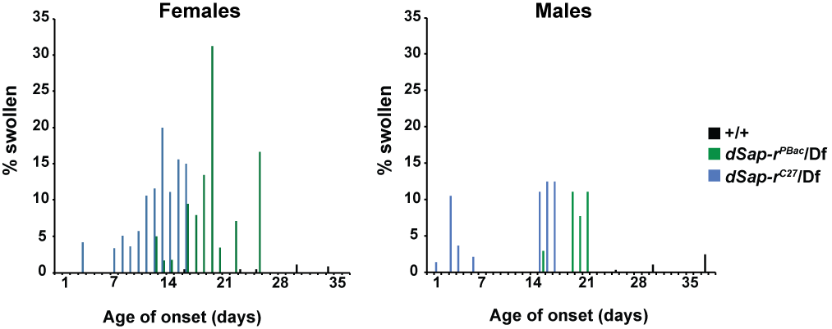
A
B
Fig. 6.7. Both female and male dSap-r mutants become swollen with age. Virgin females (A) and males (B) were aged at 29°C and the age of onset of abdomen swelling was recorded for wild type (+/+), dSap-r^{PBac}/Df(3R)tll-e
(dSap-r^{PBac}/Df), and dSap-r^{C27}/Df(3R)tll-e (dSap-r^{C27}/Df) flies and expressed as a percentage of flies alive at that age-point.

    - dSap-r mutation causes malformation of Malpighian tubules: the Drosophila renal tubules
Due to the increased volume of haemolymph in the swollen dSap-r mutants, an osmoregulation defect was investigated. The haemolymph composition is controlled by the Malpighian tubules and the nephrocytes, which together perform the role of the mammalian kidney tubules and glomeruli, respectively (Weavers et al., 2009; Denholm and Skaer, 2009). Dissection of dSap-r^{C27}/Df adult Malpighian tubules revealed a morphological difference to wild type (Fig. 6.8). Wild type Malpighian tubules were long, slender and yellow. However, dSap-r mutant Malpighian tubules were short, wider and unpigmented. They also contained white accumulations within the Malpighian tubule lumen. This morphological difference was present in 5-day old dSap-r mutants and did not appear to worsen with age (compare Fig. 6.8 D & H).
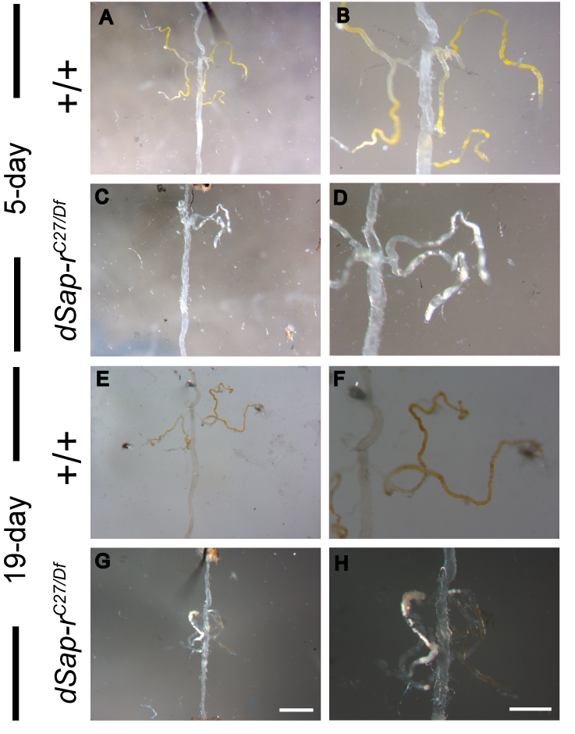
Fig. 6.8. Malpighian tubules in dSap-r^{C27}/Df mutants are morphologically distinct from wild type. 5-day and 19-day old wild type (+/+) and
dSap-r^{C27}/Df(3R)tll-e (dSap-r^{C27/Df}) females were dissected to reveal the Malpighian tubules (attached to the digestive system). The Malpighian tubules were imaged using a Zeiss stereomicroscope at 20x (A, C, E & G) and 50x (B, D, F & H) magnification. Scale bars: 1 mm (G) and 0.5 mm (H).

    - The dSap-r swollen abdomen phenotype is rescued by neuronal expression of dSap-r
Whilst assessing the effect of neuronal dSap-r expression on the longevity of dSap-r mutants, it was observed that the swollen abdomen phenotype was also rescued (Fig. 6.9). As in Figure 6.7, the age of onset of abdomen swelling was recorded and the total number expressed as a percentage of flies alive at that age. A small percentage of the rescued dSap-r^{PBac}/Df and dSap-r^{C27}/Df females developed swollen abdomens but at a much later age-point compared to the dSap-r mutants: a point when most dSap-r mutants had died. Occasionally transgene control females also showed a swollen abdomen phenotype, but not to the degree of the dSap-r mutants. This suggests that this phenotype may have neuronal involvement (see discussion in section 6.4.2).

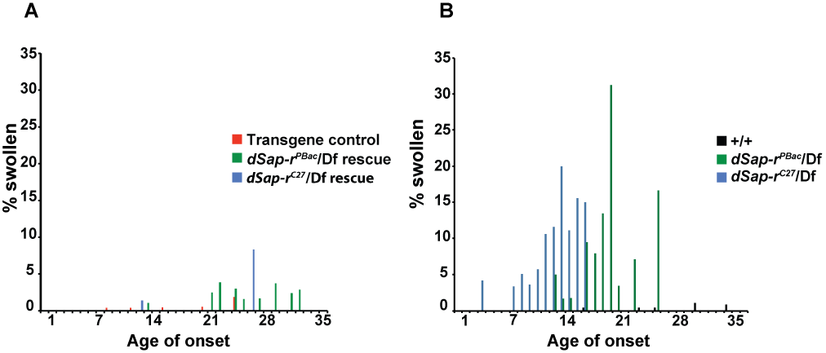
A

Fig. 6.9. Neuronal expression of dSap-r rescues the dSap-r swollen abdomen phenotype. (A) Virgin females were aged at 29°C and the age of onset of abdomen swelling was recorded for the transgene control (UAS-dSap-r;1407), and the
dSap-r^{PBac}/Df(3R)tll-e and dSap-r^{C27}/Df(3R)tll-e mutants expressing dSap-r in the neurons (UAS-dSap-r;1407;dSap-r^{PBac}/Df and UAS-dSap-r;1407;dSap-r^{C27}/Df). The comparable data from Figure 6.7 is shown in (B). The number of swollen flies was expressed as a percentage of flies alive at that age.
  - Discussion
    - Sensorimotor decline in dSap-r mutants
Due to the selective degeneration of the sensory brain regions and the reduced mobility observed in the dSap-r flies, various assays were used to test the sensory and motor responses of dSap-r mutants.
      - dSap-r mutants show a decline in climbing ability with age
All dSap-r mutants showed an age-dependent decline in climbing ability by at least one of the methods of analysis used. Both the dSap-r^{PBac}/Df and
dSap-r^{C27}/Df flies showed a reduction in their speed and distance climbed (Fig. 6.1 B and C). The dSap-r^{C27/PBac} flies also showed a decline in climbing speed (Fig. 6.1 C), but not a concomitant reduction in distance climbed.
The methods used to analyse this data set were not always sensitive enough to dissect out the difference between the controls and mutants. This was the case for the distance climbed and time taken to climb 50% of the measuring cylinder. In the dSap-r^{C27/PBac} mutants, a clear decrease in climbing speed was revealed, yet the distance climbed was comparable to the appropriate controls; this may be due to the length of the video capture time. As the flies were recorded for 45 seconds, slower moving flies could eventually climb a similar distance to controls. This was the reason for also analysing time taken to reach half way; by measuring this parameter, the difference in overall climbing speed would be revealed. However, the 22-day old flies showed a higher propensity to stop and groom, compared to the continuous climbing response of young 5-day old flies. This created aberrant results as some flies would stop and groom before reaching the 50% mark, leading to a maximum score of 45 seconds being assigned. Therefore, this method of analysis also had caveats. By analysing climbing speed over short intervals, this negated the problem of flies stopping and grooming. In Figure 6.1, the error bars are smaller and more consistent across the data set when analysing climbing speed (compare Fig. 6.1 C to A and B); this reflects the more accurate and robust data obtained by this method of analysis. By this method, all dSap-r mutants showed an age-dependent deterioration in climbing ability compared to controls.
      - dSap-r mutants show an age-dependent reduction in their jump performance
To determine whether the decline in climbing ability was due to a sensory or motor deficit, the jump response of the dSap-r mutants was investigated. The giant fiber system is normally activated during escape behaviour and is therefore responsive to light changes and motion, reflective of an object or predator moving towards the fly. By placing electrodes into the fly’s eyes, the giant fiber can be electrically activated, bypassing the requirement for sensory input. Using this approach, both the dSap-r^{PBac}/Df and dSap-r^{C27}/Df flies showed a significant age-dependent decline in jump performance compared to most of the controls (Fig. 6.2). The dSap-r^{C27/PBac} flies did not show a reduction in jumping ability that was significantly different from the controls. Because the dSap-r^{C27/PBac} mutants did show a decline in climbing speed, this may suggest that sensory input is reduced but not motor output in this mutant allelic combination. Therefore, in this mutant the decline in climbing speed was due to a lack or reduction of the correct sensory cues to promote climbing, rather than a motor defect per se. This is consistent with the degeneration of the sensory brain regions in this mutant. Because the dSap-r^{PBac}/Df and dSap-r^{C27}/Df mutants showed a decline in jump performance, these mutant combinations may also cause degeneration of either the motor neurons required for jumping (the giant fiber and tergotrochanteral motor neurons) or the jump muscle (tergotrochanteral muscle) itself. Because the ergometer is not sensitive enough to distinguish between a synaptic and a muscular defect, synaptic transmission was assessed by recording ERGs.
      - Synaptic transmission deteriorates in an age-dependent manner in dSap-r mutants
Synaptic transmission between the photoreceptor neurons and the underlying brain was shown to deteriorate in dSap-r mutants (Fig. 6.3 and 6.4). This was shown to be a progressive deterioration as ERGs from 5-day old flies were normal for both dSap-r^{PBac}/Df and dSap-r^{C27}/Df mutants; this is in contrast to other physiological assays, which detected an early decline in dSap-r^{C27}/Df climbing and jumping (Fig. 6.1 and 6.2). This is, however, consistent with the lack of degeneration of the retina and underlying brain in this mutant at this early age (Fig. 5.4). Because neurodegeneration was already seen in the antennal lobe region of this mutant at 5 days old, this may explain the reduced climbing seen at this age (due to reduced perception of gravity). However, this would not impact on the jump performance as sensory inputs are bypassed by electrical stimulation to the brain, yet jumping ability was affected. Therefore, this may imply that muscle degeneration does occur in dSap-r mutants, and precedes some aspects of neurodegeneration. However, degeneration of the thoracic ganglia were not characterised during this investigation. These ganglia are innervated by the neurons of the giant fiber system; therefore the possibility of neurodegeneration occurring in these ganglia at this young age cannot be dismissed.
As the dSap-r flies aged, a marked deterioration of their ERG traces was seen. This was in clear contrast to the minimal changes in aged control flies (Fig. 6.3 and 6.4). Figure 6.4 A and B confirmed a deterioration of the photoreceptor potential, which normally causes a sharp drop in potential difference between the measuring and reference electrodes in response to a light pulse. This is consistent with the degeneration shown in the retina by electron microscopy in dSap-r^{C27}/Df mutants and reveals that synaptic transmission to the underlying lamina and medulla is disrupted in both mutants. The initial spikes at “lights on” and “lights off“ (the on- and off-transients) reflect synaptic signalling in the optic lobes (Coombe, 1986). The on-transients were too small to be accurately distinguished from noise in the traces. An indication of the amplitude of the off-transients can be provided by the maximum potential (representative of the photoreceptor response and the off-transient). In response to green light, the 22-day old dSap-r^{C27}/+, dSap-r^{PBac}/Df and 19-day old dSap-r^{C27}/Df flies displayed a reduction in the maximum potential. The reduction in dSap-r^{C27}/+ maximum potential, but not photoreceptor potential (compare Fig. 6.4 A to B), suggests a slight decline in the off-transient or an increase in adaptation during the maintained potential in these flies. In response to blue light, only the 22-day old dSap-r^{PBac}/Df and 19-day old dSap-r^{C27}/Df mutants displayed a reduction in maximum potential (Fig. 6.4 F). A reduction in the off-transients in dSap-r mutants suggests degeneration of the optic lobes, supported by the increased vacuolarisation of the optic lobes in dSap-r mutants (Fig. 5.3 and 5.4).
Following “lights off”, the ERG normally shows a biphasic recovery back to the base line (start level in Fig. 2.4). At 22 days old, the dSap-r^{PBac}/Df and dSap-r^{C27}/Df mutants showed a reduction in rate of the initial phase of recovery after both green and blue light pulses (Fig. 6.4 C and F). Since the initial recovery phase is quantified as time taken to recover to half way between the off-transient and the peak of the photoreceptor potential (see Fig. 2.4), the amplitude of these components will affect the recovery time regardless of the speed of recovery. Therefore, because the dSap-r mutants showed a distinctly slower recovery, as well as having a smaller potential to recover from, this reflects a very severe deterioration of this feedback mechanism.
The recovery phase of the ERG was thought to reflect mechanisms intrinsic to the photoreceptors. However, Rajaram et al. (2005) discovered that this recovery period relies on both histaminergic and cholinergic transmission. When either histaminergic or cholinergic signalling was disrupted, by genetic or pharmacological means, the recovery after “lights off” was delayed (Rajaram et al., 2005). Because neurotransmitters of the cholinergic system are produced in the brain but not in the fly eye, they concluded that the termination of the ERG must also require synaptic transmission from the brain. This provides further evidence that synaptic signalling from the brain is disrupted in the dSap-r mutants.
In summary, the ERGs revealed a decline in photoreceptor response and off-transients, and a delay in recovery after lights off in both dSap-r mutants. This translates to a disruption of synaptic transmission between the photoreceptors and underlying brain, and may provide an explanation for some aspects of the sensorimotor deterioration observed in the climbing assays.
      - Sensorimotor decline is evident in other Drosophila LSD models
Motor defects have also been reported in other Drosophila models of LSDs (Phillips et al., 2008; Venkatachalam et al., 2008). For the NPC model, reduced locomotive activity and coordination were revealed by scoring activity levels based on descriptive criteria (Phillips et al., 2008). Activity levels were assessed in the trpml mutants (mucolipidosis type IV model) by climbing assays and tabulation of the number of times individual flies crossed an infrared beam during 24 hours (Venkatachalam et al., 2008). In both of these LSD models, neurodegeneration was shown to occur in the retina and underlying optic lobe, in addition to central brain regions. Reduced motor activity in these flies may reflect sensory deficits, as may be the case in the dSap-r mutants, however a more widespread degeneration was observed for these LSD models. Venkatachalam et al. (2008) found that defects in synaptic transmission (in third instar trpml larvae) preceded signs of neurodegeneration (21 day old adults), therefore reduced synaptic transmission rather than neuronal degeneration per se may be responsible for these early signs of motor deficiency. Although motor deficits were observed in 5-day old dSap-r^{C27}/Df mutants, prior to major signs of neurodegeneration, synaptic transmission was not shown to be affected by ERGs at this stage. Despite this, one cannot disregard the possibility that synaptic transmission may be disrupted elsewhere (e.g. at the neuromuscular junction or the antennal lobe), resulting in the motor deficits shown.
Synaptic transmission was also investigated in the NPC Drosophila model (dnpc1a) using ERG recordings (Phillips et al., 2008). These mutants showed an age-dependent decline in ERG amplitude (photoreceptor potential), and on- and off-transients. This finding was not surprising due to the retinal and optic lobe degeneration in both the dnpc1a and dSap-r mutants. The rate of biphasic recovery was not quantified for the dnpc1a mutants, however their representative traces looked similar to their equivalent control. This may suggest that synaptic transmission from the brain back to the retina is not disrupted in dnpc1a mutants, unlike in dSap-r mutants. An NCL-like LSD model, the benchwarmer mutant (allelic to spinster), showed a similar loss of on- and off-transients to the dnpc1a and dSap-r mutants (Dermaut et al., 2005). Due to the greater severity of the benchwarmer mutants, flies with eyes mosaic for the benchwarmer mutations were generated to allow ERG analysis at 1-day and 40 days old. A similar age-dependent deterioration was observed as seen for the dnpc1a and dSap-r mutants (Dermaut et al., 2005). In addition to the reduced photoreceptor potential and on- and off-transients, the benchwarmer mosaic eyes showed a delayed recovery (repolarisation) after ‘lights off’, as was evident in the dSap-r mutants.
Clear parallels are seen between the dSap-r phenotypes and other LSD Drosophila models, both at the light and electron microscopy level (discussed in Chapter 5), and at the physiological level. However, the very distinct localisation of degeneration to the antennal lobe regions of the dSap-r brain is not mirrored by these similar Drosophila models and therefore warrants further investigation. It would be interesting to measure the synaptic transmission between the antennal nerve and the antennal lobe in 1-day and 5-day old dSap-r^{C27}/Df flies, to determine whether synaptic transmission defects precede the neurodegeneration observed in the 5 day old flies.
      - Mouse models of saposin deficiency show signs of sensorimotor decline
A common pathophysiological feature of the mouse models of saposin deficiency is progressive ataxia (lack of control of movements) particularly in the hind legs, often leading to paralysis. This characteristic was reported in all saposin deficient mouse models, including single, double and total saposin deficiencies (Fujita et al., 1996; Oya et al., 1998; Matsuda et al., 2001; Matsuda et al., 2004; Sun et al., 2007; Sun et al., 2008; Sun et al., 2010a; Sun et al., 2010b). Some of the saposin deficiency models also showed clear signs of cerebellar dysfunction, in the form of demyelination, inclusions, and complete or partial loss of Purkinje cells. The cerebellum is an important center of the brain that receives sensory input and controls motor output. Degeneration of the Purkinje neurons is a common feature of LSD pathology and has been suggested to be the likely cause of the motor coordination defects observed in the saposin deficient mouse models (Matsuda et al., 2004). In Drosophila, the central complex and mushroom bodies have been implicated in motor control and coordination (Poeck et al., 2008; Serway et al., 2009). The mushroom bodies, composed of a series of neuropiles connected by Kenyon cells, are classically known for their role in learning and memory in flies (e.g. Connolly et al., 1996; reviewed in Heisenberg, 2003). The mushroom bodies receive input from many sensory regions, including the antennal lobes and to some extent the optic lobes, and therefore provide an integrative centre for sensory information (Strausfeld and Li, 1999). The organisation of the intrinsic mushroom body neuronal projections and the intersecting extrinsic neuron dendrites has been likened to the Purkinje cell and parallel fiber network of the cerebellum (Li and Strausfeld, 1997). The degeneration of both the antennal lobes and visual system (compound eyes and optic lobes) may impact on the normal function of the mushroom bodies, causing a deterioration of motor control. The morphology and function of the mushroom bodies has not been directly assessed during this investigation, and therefore requires further investigation.
    - Does dSap-r mutation cause renal failure?
During aging of dSap-r mutants it was observed that they developed a progressive swelling of the abdomen, usually from 12 days onwards
(Fig. 6.5 - 6.7). Dissection of these individuals revealed an increase in haemolymph volume (Drosophila blood) and a morphological defect in the Malpighian tubules. The Malpighian tubules, the Drosophila equivalent of the liver and kidney, play a key role in osmoregulation (reviewed in Dow and Davies, 2001); consequently, this may suggest a dysregulation of osmoregulation in dSap-r mutants.
Renal degeneration has been reported in the saposin D knock-out mouse models, which may be responsible for the polyuria (passage of large volumes of urine) and polydipsia (excessive thirst), which caused the mice to die of dehydration (Matsuda et al., 2004). Inclusions and storage of sphingolipids in the kidneys are also common features of single, double and total saposin deficiencies in mouse models (Fujita et al., 1996; Oya et al., 1998; Matsuda et al., 2001; Matsuda et al., 2004; Sun et al., 2007; Sun et al., 2008), and also in human patients (Hulkova et al., 2001; Deconink et al., 2008).
The Malpighian tubules are produced during embryogenesis as two pairs of epithelial tubules, the anterior pair and the posterior pair, which bud off from the hindgut (Dow and Davies, 2001). The Malpighian tubules consist of two main cell types: the principal cells and the stellate cells (a small subset, thought to be neurosecretory, are also present) (Sözen et al., 1997). Since the morphology of the dSap-r Malpighian tubules did not worsen with age, this defect may occur earlier in development as Malpighian tubule formation is normally completed by the end of embryogenesis (Jung et al., 2005). As part of the elongation phase of Malpighian tubule formation, stellate cells from the mesenchymal mesoderm incorporate into the tubule (Denholm et al., 2003). Due to the decreased length of the dSap-r Malpighian tubules, the defect may occur at the elongation step. To assess whether the stellate cells have integrated into the tubules, DAPI staining could be used to count the number of cells in the Malpighian tubules. Malpighian tubules normally consist of approximately 484 principal cells and 110 stellate cells (Denholm et al., 2003). Alternatively, to specifically determine whether stellate cells are present in the dSap-r mutant Malpighian tubules, stellate cell-specific Gal4 drivers could be used to drive a fluorescent reporter in dSap-r mutants.
The principal cells and stellate cells have been shown to be responsible for the osmoregulatory role of Malpighian tubules (O’Donnell et al., 1998; Linton and O’Donnell, 1999). They control the osmolarity of the haemolymph by regulating secretion across the Malpighian tubules (Fig. 6.10. E). The major ionic components that are regulated by the Malpighian tubules are the potassium ions. In Drosophila, potassium ions are transported from the haemolymph across the Malpighian tubule cells and into the lumen, from which they are excreted. Transport of these ions depends on a proton-motive force (due to the higher potassium ion concentration in the Malpighian tubule lumen compared to the haemolymph; Wessing and Zierold, 1993), which is set up by a Vacuolar-ATPase in the apical membrane of the principal cells. This drives a potassium ion/proton exchanger in the apical membrane allowing transport of potassium ions into the lumen (Maddrell and O’Donnell, 1992). Chloride ion transport subsequently occurs due to the proton gradient created by the V-ATPase. Disruption of this proton-motive force could result in decreased or abolished fluid secretion followed by an increase in haemolymph volume, which may become harmful as toxins and metabolites are not cleared from the haemolymph.
Fluid secretion is hormonally controlled by diuretic peptides, such as leukokinin and cardioacceleratory protein CAP_{2b}. Drosophila leukokinin causes a rise in calcium levels in stellate cells, which stimulates chloride channel conductance promoting fluid secretion (O’Donnell et al., 1998). CAP_{2b} promotes fluid secretion by activating the cyclic GMP/Nitric Oxide (cGMP/NO) pathway in principal cells (Davies et al., 1995). CAP_{2b} is thought to bind its putative receptor and promote cytosolic calcium increase, stimulating the activity of the Drosophila Nitric Oxide Synthase (dNOS). This results in NO synthesis and cGMP production via soluble guanylate cyclase activity. cGMP stimulates Protein Kinase G, which leads to activation of the V-ATPase and production of the proton-gradient that powers the luminal secretion of potassium ions through the potassium/proton exchanger (Dow et al., 1994; Davies et al., 1997; Rosay et al., 1997). Expression of dSap-r in neurons, using the 1407-Gal4 driver, rescued the abdomen swelling in
dSap-r mutants. Therefore, in dSap-r mutants, abdominal swelling may be caused by a lack of neuropeptide that would ordinarily stimulate secretion across the Malpighian tubules. The expression of 1407-Gal4 in the Malpighian tubules has not been determined; therefore, it is unknown whether this rescue is due to Malpighian tubule expression or the rescue of neurons that produce these modulatory neuropeptides. Further work is required to determine the exact mode of this rescue in order to reveal the pathological mechanism behind this phenotype.

Fluid secretion is thought to be further controlled and maintained by feedback from cGMP production. This second messenger enhances fluid secretion by increasing calcium levels, resulting in NO-dependent synthesis of further cGMP (MacPherson et al., 2001). Increase in calcium levels may be triggered by the activation of cyclic nucleotide-gated channels (CNGs). These allow calcium influx and are expressed in Drosophila Malphigian tubules (MacPherson et al., 2001). Calcium influx is necessary for the CAP_{2b}-stimulated increase in calcium levels that are required for enhanced fluid secretion (Rosay et al., 1997) (see Fig. 6.10 for summary diagram). CNG channels in both the mammalian olfactory system, and rod and cone photoreceptors have been shown to be lipid raft associated (Brady et al., 2004; Ding et al., 2008). Disruption of the lipid raft components cholesterol and sphingolipids, using methyl-β-cyclodextrin and myriosin, inhibits these channels (Brady et al., 2004; Ding et al., 2008). The photoreceptor CNGA3 channel subunit was also mislocalised as a result of sphingolipid depletion (Ding et al., 2008). This suggests that disruption of lipid raft composition, by sphingolipid or cholesterol depletion, results in mislocalisation and reduced activity of CNG channels. Verapamil, an L-type calcium channel blocker, inhibits the novel vertebrate CNG-like channel KCNA10 (Lang et al., 2000). Verapamil also reduces the increase in calcium levels and fluid secretion normally induced by CAP_{2b} and cGMP in Drosophila principal cells (MacPherson et al., 2001). Therefore, if dSap-r principal cell membranes are depleted in sphingolipids, CNG channels may be mislocalised, abolishing the calcium influx required to stimulate NO/cGMP signalling and fluid secretion.
Interestingly, CNG channels have also been identified in Drosophila eyes, antennae and a CNG-like protein has been discovered in the brain (Baumann et al., 1994; Miyazu et al., 2000). This suggests a conserved role for cGMP-induced calcium entry in Drosophila vision, olfaction and transepithelial fluid secretion. dSap-r mutants display a specific sensitivity to neurodegeneration in the antennal lobes (olfaction) and the compound eyes and optic lobes (visual system), in addition to displaying a proposed osmoregulatory defect. Therefore, an aspect of calcium signalling may be disrupted in dSap-r mutants (see Fig. 6.10).
Calcium homeostasis has recently been revealed as a common defect in various LSDs (Ginzburg et al., 2004; Jeyakumar et al., 2005; Lloyd-Evans et al., 2008). In the primary sphingolipidoses (Gauchers, Sandhoff disease and GM₁-gangliosidosis) defects in calcium homeostasis by the ER have been reported. In Gaucher disease, increased levels of glucosylceramide increase agonist-induced calcium release via the Ryanodine receptor (RyaR), resulting in increased cytosolic calcium. Glucosylsphingosine, which also accumulates in Gauchers, also increases cytosolic calcium by stimulating release from the ER by an agonist-independent mechanism (Lloyd-Evans et al., 2003a; Lloyd-Evans et al., 2003b). Cytosolic calcium levels have also been shown to be increased in mouse models of Sandhoff and Niemann Pick type A due to the reduced activity of the ER calcium uptake receptor SERCA (sarco/endoplasmic reticulum Ca²⁺-ATPase); this was shown to be caused by increased GM₂ levels (Pelled et al., 2003). Calcium homeostasis was also disrupted in NPC1 cells (Lloyd-Evans et al., 2008). Although ER and mitochondrial calcium release were shown to be normal in NPC1 cells, lysosomal calcium was revealed as approximately 65% lower than in wild type cells. The authors identified that sphingosine was the first species to accumulate in NPC1 cells and it was this sphingosine that was responsible for the calcium homeostasis defect. Calcium release from the lysosome is required for late endosome and lysosome fusion (Pryor et al., 2000); therefore the abnormal calcium levels in the lysosome are the likely cause of the observed failure of this fusion event in NPC1 mutant cells (Lloyd-Evans et al., 2008). Increasing the cytosolic calcium levels in NPC1 cells, by SERCA inhibition, was shown to reduce NPC pathology both in NPC1 cells and mouse models (Lloyd-Evans et al., 2008).
Purkinje neurons of the cerebellum appear to be particularly sensitive to degeneration in many LSDs, as exemplified by the mouse models of single and double saposin C and D deficiency, and the related Niemann Pick Type A, B and C disorders (Sarna et al., 2001; Sarna et al., 2003; Matsuda et al., 2004; Sun et al., 2007; Sun et al., 2010a). It has been suggested that, due to the high expression of the IP₃R (inositol 1,4,5-trisphosphate receptor) in these cells, Purkinje cells are particularly sensitive to IP₃R-mediated calcium induced calcium release (CICR) leading to apoptosis (Ginzburg et al., 2004). Purkinje cells are also enriched in the RyaR1 isoform (Mori et al., 2000), which may render them oversensitive to modulation by accumulation of glucosylceramide in these disorders. Whether olfactory sensory neurons, photoreceptor neurons and Malpighian tubules express high levels of RyaR and/or IP₃R requires further investigation, though these receptors are involved in the processes of olfaction, phototransduction and osmoregulation and could, therefore, be implicated in the proposed calcium homeostasis defect in dSap-r mutants (Fig. 6.10 for summary diagram).
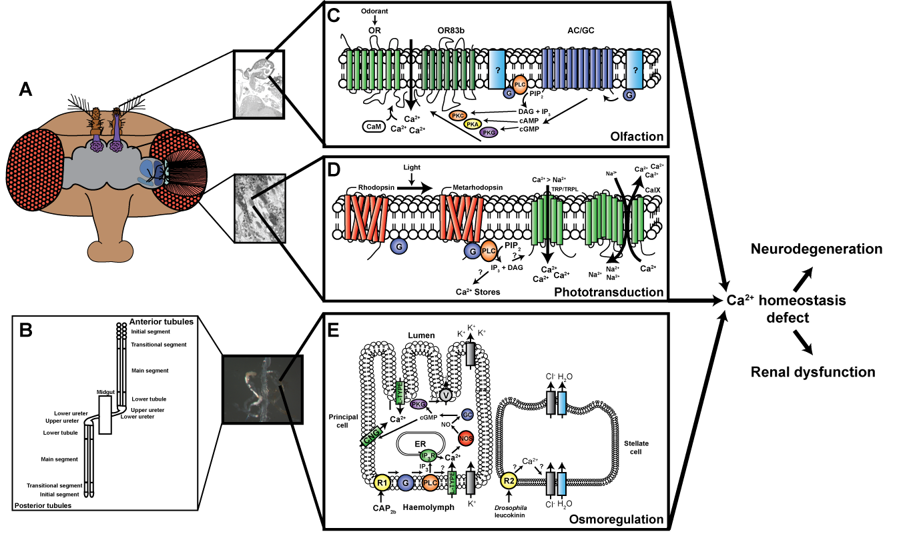 Fig. 6.10. Calcium homeostasis defects may cause dSap-r pathology (Figure legend overleaf)
Fig. 6.10. Calcium homeostasis defects may cause dSap-r pathology. (A & B) Diagram

of the Drosophila head (A) showing the olfactory and visual systems, and Malpighian tubules (B) showing its segmental organisation (the main segments are the primary secretory regions). (C - E) Signalling pathways involved in olfaction (C), phototransduction (D) and osmoregulation (E). All three processes involve a
G-protein-coupled (G) response linked to phospholipase C (PLC) activation and increased calcium (Ca²⁺) levels. Disrupting Ca²⁺ homeostasis, possibly by altering Ca²⁺ channel localisation/activity due to sphingolipid metabolism defects, may cause neurodegeneration and proposed renal dysfunction in dSap-r mutants. In (C), an odorant binds the olfactory receptor (OR) causing Ca²⁺ influx through the proposed channel formed by OR/OR83b. This Ca²⁺ increase is maintained by activation of a G-protein-coupled response that causes stimulation of adenylate- or guanylate cyclase (AC/GC) increasing cyclic nucleotide levels (cAMP/cGMP) and further stimulation of the OR/OR83b channel, possibly by phosphorylation by protein kinase A, C or G (PKA/PKC/PKG). Ca²⁺ binding to calmodulin (CaM) may also increase Ca²⁺ influx through the OR/OR83b channel. In (D), light stimulates the rhodopsin to metarhodopsin conversion and activation of a G-protein-coupled response that activates PLC resulting in the formation of inositol 1,4,5-trisphosphate (IP₃) and diacylglycerol (DAG). DAG is thought to activate the transient receptor potential (TRP) and TRP-like (TRP-L) Ca²⁺ channels leading to Ca²⁺ influx, and IP₃ may activate Ca²⁺ stores leading to a further Ca²⁺ increase. Ca²⁺ can be removed from the system by a Ca²⁺ exchanger (CalX). In (E), secretion across Malpighian tubules is stimulated by neuropeptides, e.g. cardioacceleratory protein 2b (CAP_{2b}) and leucokinin. CAP_{2b} stimulates its putative receptor (R1) and activates a G-protein-coupled response leading to activation of PLC and L-type Ca²⁺ channel opening. Production of IP₃ by PLC can also cause Ca²⁺ influx by activating Ca²⁺ stores via the IP₃ receptor (IP₃R). The increased cytosolic Ca²⁺ leads to activation of NOS causing NO production, which activates a soluble GC leading to cGMP production. cGMP may activate cyclic nucleotide-gated channels (CNG), which allow further Ca²⁺ influx. cGMP also activates PKG, eventually leading to activation of the Vacuolar ATP-ase (V) that produces the proton motive force to drive secretion. Drosophila leucokinin activates its putative receptor (R2) leading to Ca²⁺ increase and chloride channel stimulation. This results in influx of chloride ions (Cl⁻) down the ionic gradient set up by potassium ion (K⁺) secretion and the proton motive force.

