- Generation and characterisation of dSap-r mutants
Aim: Generate a loss-of-function Drosophila model of saposin deficiency
- Generate and screen potential dSap-r deletion mutants and determine dSap-r transcript levels
- Determine whether the dSap-r mutants show a reduced longevity, characteristic of LSDs
  - Introduction
A common characteristic of LSDs is a reduction in lifespan. Prosaposin deficiency (a complete absence of Saposins A – D) causes a severely shortened lifespan: patients die within the first 16 weeks of life (Harzer et al., 1989; Bradová et al., 1993; Hulkova et al., 2001). Deficiency of the individual saposins leads to four different LSDs, each with a variable age of disease onset and mortality (see Chapter 1). At the start of this investigation, published data were only available for mouse models of PSAP^{-/-}, saposin A^{-/-} and saposin D^{-/-} (Fujita et al., 1996; Matsuda et al., 2001; Matsuda et al., 2004). More recently, further mouse models have been developed for saposin B^{-/-}, saposin C^{-/-}, double saposin C^{-/-}D^{-/-}, and saposin C^{-/-} in a glucosylceramidase mutant background (the saposin C cognate enzyme) (Sun et al., 2007; Sun et al., 2008; Sun et al., 2010a; Sun et al., 2010b). The recent mouse models have highlighted the complexity of these disorders: the phenotype of total saposin deficiency (PSAP^{-/-}) is not simply a summation of phenotypes from the single saposin deficiencies (Sun et al., 2007). The longevities of these models do, however, approximately equate to the number of functional saposins present. For example, PSAP^{-/-} mice died within 30 days (Fujita et al., 1996), combined saposin C and D deficiency caused a comparatively enhanced longevity of 56 days (Sun et al., 2007), and individual saposin deficiencies resulted in premature death at 17 – 24 months (Matsuda et al., 2001; Matsuda et al., 2004; Sun et al., 2008; Sun et al., 2010a). To improve the understanding of these complex disorders, Drosophila Saposin-related (dSap-r) mutants were generated and initially screened for reduced longevity.
  - Generation and screening of potential dSap-r mutants: identification of the dSap-r^{C27} mutation
To generate dSap-r mutants, the P{GawB}^{NP7456} fly line was used. This line contained a P-element transposon insertion within the dSap-r gene. This
P-element was originally developed to generate many enhancer trap lines by mobilising the P-element and selecting lines where the P-element had reinserted near or within a gene enhancer region (Brand and Perrimon, 1993). This allowed the expression pattern of nearby genes to be revealed using the Gal4-UAS system, as shown in Chapter 3. In addition to its enhancer trapping potential, this P-element can be used to generate deletions using imprecise excision of the transposon resulting in a deletion of the proximal gene. This property was utilised to generate potential dSap-r mutants.
P-element mobilisation was induced by crossing the dSap-r^{NP7456} line with flies carrying an alternate transposon containing an active P-element transposase, which cannot itself be mobilised. In the offspring containing both the transposase and dSap-r^{NP7456}, the dSap-r^{NP7456} P-element can be mobilised by the transposase. This process often results in precise excisions of the P-element, leaving the host gene intact. However, occasionally excisions can be imprecise, leading to fragments of P-element remaining or flanking host DNA being removed (see Fig. 2.1). The latter may lead to gene deletions, creating dSap-r mutations.
After generating a stable stock of each potential dSap-r mutation, homozygous flies from each line were screened for dSap-r deletions by single-fly PCR. Each line was screened against various primer pairs (Fig. 4.1) until a PCR product was produced. This PCR product was sequenced to determine the exact location and size of the dSap-r deletion. Figure 4.2 shows 2 example gels with products of PCR reactions using a primer pair either side of the P-element insertion site (1 & 4) and a pair within the
P-element and the dSap-r gene (3 & 4) (see Fig. 4.1 for primer locations). These example gels illustrate the possible outcomes from a P-element mobilisation screen. A precise excision results in the P-element being removed leaving the dSap-r gene intact; this allows PCR amplification using dSap-r primers 1 & 4 but not primers 3 & 4, which require the presence of the 5’ end of the P-element to generate a PCR product. This is exemplified by lanes marked by a + symbol in Figure 4.2. An imprecise excision can result in partial P-element mobilisation where fragments of the P-element remain, or complete P-element mobilisation where flanking regions of the dSap-r gene are also removed. Partial imprecise P-element mobilisation is shown in Figure 4.2 by the lanes marked by a ‡ symbol. The remaining P-element sequence allows PCR amplification with primers 3 & 4. However, depending on the size of the remaining P-element fragment, either a larger product is produced with primers 1 & 4 or no product is produced, due to the P-element fragment being too large. Complete imprecise P-element mobilisation with dSap-r removal is highlighted by the lanes marked with a * symbol (Fig. 4.2). These examples are negative for both sets of primer pairs as the P-element and one or both dSap-r primer sites (1 & 4) have been removed. 125 potential dSap-r mutants were screened in this way.

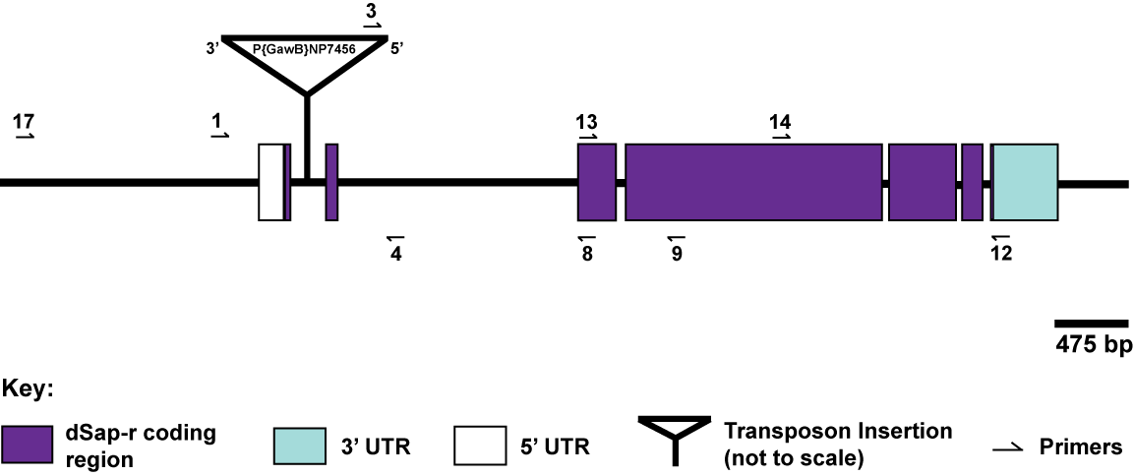
Fig. 4.1. Location of the primer sites used to screen the dSap-r^{C27} mutation. The dSap-r locus is shown with the locations of the primer sites used during the PCR screening of the dSap-r^{C27} mutation. Primer pairs 1 & 4 and 3 & 4 were initially used to identify potential dSap-r mutants, as dSap-r deletions should not allow amplification of PCR product with these primers. Primer pairs 12 & 14 and 13 & 9 determined whether 3’ dSap-r sequence was present and primer pairs 17 & 4 and 17 & 8 allowed the mapping of the dSap-r^{C27} deletion. The primer lengths are not to scale (see Table 2.2 for primer details).

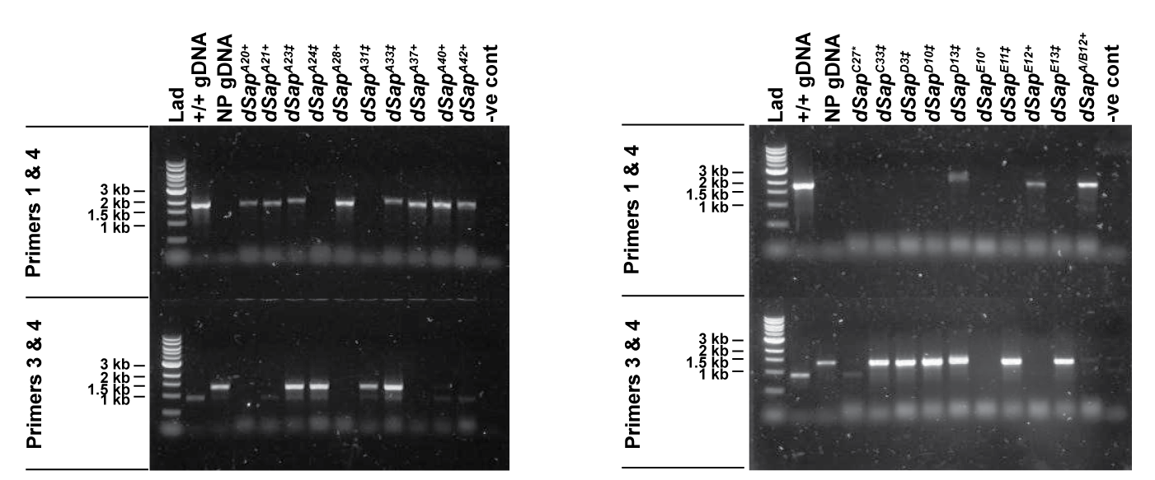
A
B
Fig. 4.2. Single-fly PCR screening identified potential dSap-r mutant lines (Figure legend overleaf)

Fig. 4.2. Single-fly PCR screening identified potential dSap-r mutant lines.
(A & B) Primer pairs 1 & 4 and 3 & 4 were used to identify precise and imprecise
P-element excisions from the dSap-r locus. Precise excisions (lanes marked by +) were identified by the presence of PCR product when using primers 1 & 4, but an absence of product when using primers 3 & 4 (see Fig. 4.1 for primer locations). Imprecise excisions that resulted in P-element fragments remaining in dSap-r (lanes marked by ‡) were revealed by the presence of PCR product when using primers 3 & 4. The size of the remaining P-element fragment dictated whether a PCR product was synthesised when using primers 1 & 4: if the P-element fragment was too large no PCR product was present, otherwise a larger than wild type PCR product was synthesised. dSap-r deletions were identified by the absence of PCR product when using both primer pairs (lanes marked by *). Wild type (w⁻¹¹¹⁸; +/+) and dSap-r^{NP7456} (NP) genomic DNA (gDNA) were used as controls: a PCR product should be produced when using +/+ gDNA with primers 1 & 4 (1.9 kb) and NP gDNA with primers 3 & 4 (1.3 kb). The band present when using +/+ gDNA with primers 3 & 4 is non-specific. This non-specific band is also present when using dSap-r^{C27} template with primer 3 & 4. Lad, ladder; -ve cont, negative control.

The dSap-r^{C27} allele was identified as a potential dSap-r deletion due to the absence of PCR product using primer pairs 1 & 4 and 3 & 4. This fly line was further screened using various primer pairs to identify the deleted region. The presence of PCR product when using primer pairs covering the 3’ end of the gene (12 & 14 and 13 & 9) suggested dSap-r was intact between these primer sites (Fig. 4.3 A). The absence of PCR product when using primers
1 & 4 (Fig. 4.2) implied that one or both of primer sites 1 & 4 had been deleted. Therefore, primer 17, upstream of primer 1, was used together with primers 4 and 8. Both primer pairs resulted in the synthesis of PCR product >2 kb smaller than wild type (Fig. 4.3 B). These PCR products were purified by gel extraction and used to sequence the dSap-r^{C27} deletion. Sequencing revealed a 2.5 kb deletion in dSap-r^{C27}, which removed 1.35 kb upstream and 1.179 kb downstream of the original P-element insertion site (Fig. 4.4). Therefore, the first potential start site but not the second had been deleted in the dSap-r^{C27} line.
In addition to the generated dSap-r^{C27} allele, the parent allele (dSap-r^{NP7456}) and another transposon insertion (dSap-r^{PBac}) were available from the Bloomington stock centre (Fig. 4.4). These alleles were used for initial longevity screening (Fig. 4.5).

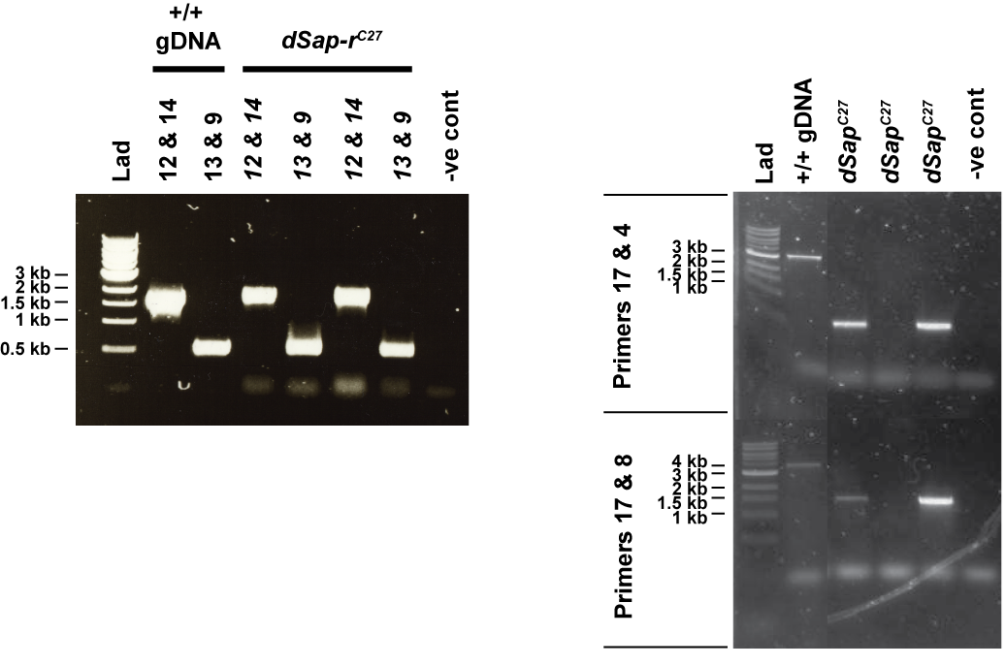
B
A
Fig. 4.3. The dSap-r^{C27} allele has a >2 kb deletion. (A) PCR products of wild type size were synthesised from dSap-r^{C27} template using primers 12 & 14 (1.7 kb) and 13 & 9 (560 bp), suggesting that 3’ dSap-r sequence was intact in this fly line.
(B) PCR products >2 kb smaller than wild type were synthesised when using primers 17 & 4 (wild type; 3.2 kb, dSap-r^{C27}; < 1kb) and 17 & 8 (wild type; 3.9 kb, dSap-r^{C27}; 1.5 kb). All lanes in (B) are from the same gel, which has been cropped to remove unnecessary lanes. Lad, ladder; +/+ gDNA, wild type genomic DNA; -ve cont, negative control.

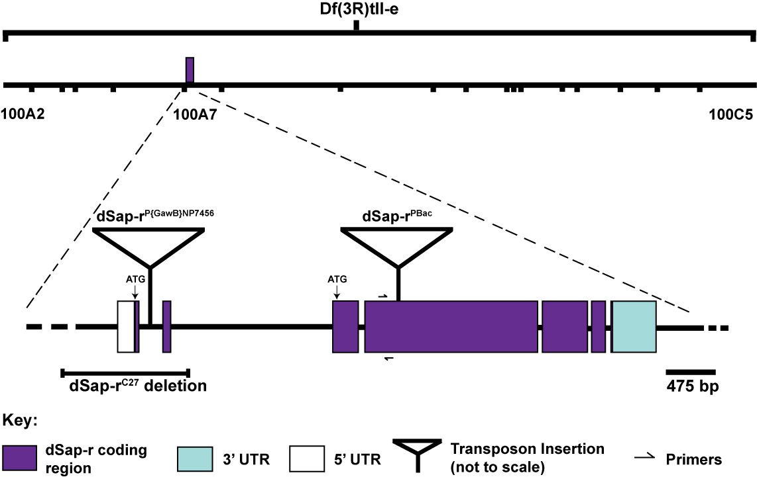
Fig. 4.4. The dSap-r alleles. The dSap-r^{NP7456} allele consists of a P{GawB}
P-element transposon insertion (11.279 kb) within the first intron of dSap-r. The dSap-r^{PBac} allele consists of a piggyBac transposon (5.971 kb) inserted into the largest dSap-r exon. The dSap-r^{C27} 2.5 kb deletion removed the first predicted start site (ATG) of dSap-r. The deletion in the deficiency line Df(3R)tll-e spans cytogenetic bands 100A2 – 100C5, which includes the dSap-r gene. UTR, untranslated region. The localisations of the dSap-r RT-PCR primers are indicated.
  - Reduced longevity in dSap-r mutants.
To determine whether dSap-r mutants displayed an LSD-like phenotype, a longevity assay was performed. In preliminary experiments, homozygous wild type (w⁻¹¹¹⁸) flies were shown to have a reduced longevity, which was a result of inbreeding; therefore, the w⁻¹¹¹⁸ flies were out-crossed to another wild type line (Canton-S) to prevent inbreeding effects. All heterozygous controls were also out-crossed to Canton-S. All dSap-r alleles were crossed to the Df(3R)tll-e line. The deletion in the Df(3R)tll-e deficiency included the dSap-r locus and was, therefore, null for dSap-r (among other genes)
(Fig. 4.4). Therefore, by crossing the various dSap-r lines to the Df(3R)tll-e flies, the only copy of dSap-r present in the offspring was the dSap-r mutant allele. Therefore, the effect of the dSap-r allele was revealed without using homozygous dSap-r flies, and thereby avoiding inbreeding effects. The longevity of the dSap-r^{C27}/dSap-r^{PBac} transheterozygotes (hereafter referred to as dSap-r^{C27/PBac}) was also assessed.
Figure 4.5 indicates that all the dSap-r alleles caused a reduction in longevity. The time point when 50% of the flies were alive was used to compare the longevity of the dSap-r mutants and controls. The 50% survival point for the wild type and heterozygous controls was between 37 - 42 days. In comparison, the dSap-r^{PBac}/Df(3R)tll-e, dSap-r^{C27}/Df(3R)tll-e and
dSap-r^{C27/PBac} flies showed the most severe phenotype (50% surviving at 20 - 24 days), with the dSap-r^{NP7456}/Df(3R)tll-e flies displaying an intermediate phenotype indicative of a hypomorphic mutation (50% surviving at 28 days). Unfortunately, the dSap-r^{C27}/+ heterozygotes were not tested during this longevity assay, therefore their longevity was tested separately along with a wild type control. The dSap-r^{C27}/+ heterozygotes displayed a normal longevity when compared to the wild type control (Appendix 3).

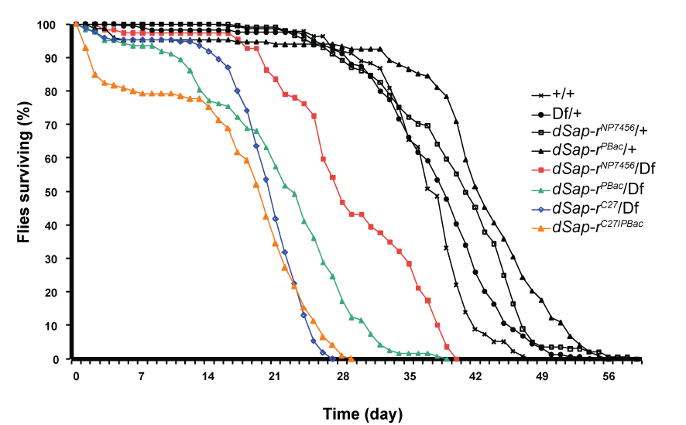

Fig. 4.5. Reduced longevity was observed in all dSap-r mutants compared to wild type and heterozygous controls. The effect on longevity of dSap-r mutants was assessed together with wild type and heterozygous controls. The dSap-r mutant alleles were crossed to the Df(3R)tll-e deficiency line (dSap-r^{NP7456}/Df,
dSap-r^{PBac}/Df and dSap-r^{C27}/Df) and the dSap-r^{C27} line crossed to dSap-r^{PBac} flies to generate the dSap-r^{C27/PBac} allelic combination. The wild type control consisted of wild type w⁻¹¹¹⁸ flies out-crossed to the Canton-S wild type line (+/+), and the dSap-r heterozygous controls consisted of each dSap-r line or Df(3R)tll-e out-crossed to Canton-S (dSap-r^{NP7456}/+, dSap-r^{PBac}/+ and Df/+). The longevity assay was performed at 29°C and surviving flies were counted and transferred to fresh food every 2 days (± 1 day). Longevity was plotted as the percentage of Day 0 flies surviving for each genotype. n > 100 for each genotype (n represents the number of flies at day 0).

  - Reduced dSap-r transcript levels in dSap-r^{C27} mutants
Because the dSap-r^{PBac} and dSap-r^{C27} alleles caused the most severe longevity phenotype, RT-PCR was performed to assess their dSap-r transcript levels. RNA was extracted from wild type, dSap-r^{PBac}/Df(3R)tll-e and dSap-r^{C27}/Df(3R)tll-e third instar larvae, and DNase-treated to remove gDNA. To determine whether the DNase treatment had been successful, DNase-treated RNA from each genotype was added to a PCR reaction using ribosomal protein 49 (rp49) control primers (Fig. 4.6 A). After confirming that the DNase-treated RNA was free from gDNA contaminants, the RNA was converted to complementary DNA (cDNA) using reverse transcriptase. Successful production of cDNA from RNA was assessed using PCR with rp49 primers (Fig. 4.6 B). To ensure that equal template was added from each sample, PCR reactions were conducted for 25, 30 and 35 cycles using rp49 primers (Fig. 4.6 C). The rp49 product was amplified equally across the different samples, confirming that equal template had been used. The same amount of template was used to assess dSap-r transcript levels in the wild type and dSap-r mutants (Fig. 4.6 D). The dSap-r transcript levels were almost completely absent in the dSap-r^{C27} mutants whereas the dSap-r^{PBac} mutants were similar to wild type. The RT-PCR was performed using flies of the same genotype as were used for the longevity assay (Fig. 4.5). Although this allowed comparisons to be made between transcript levels and dSap-r mutant phenotype, the slight reduction in transcript levels in the dSap-r^{PBac} may solely reflect the absence of one dSap-r allele (due to the Df(3R)tll-e deletion) compared to the two copies in the wild type flies. The degree of reduction in dSap-r transcript levels in the dSap-r^{C27} mutants does not equate to half the levels in wild type; therefore the reduction seen in this mutant suggests a real deficiency of dSap-r transcript.
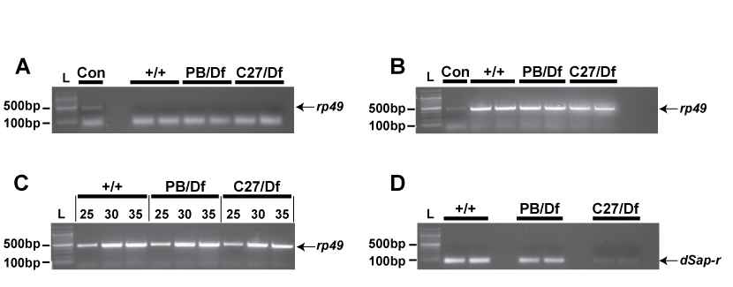

Fig. 4.6. Reduced dSap-r transcript levels in the dSap-r^{C27} mutants
(A) DNase-treated RNA extracted from wild type (w⁻¹¹¹⁸/Canton-S; +/+),
dSap-r^{PBac}/Df(3R)tll-e (PB/Df) and dSap-r^{C27}/Df(3R)tll-e (C27/Df) third instar larvae were screened for genomic DNA contamination by performing PCR with ribosomal protein 49 (rp49) control primers. (B) The success of cDNA synthesis from the RNA in A was determined by conducting a PCR reaction using rp49 primers. (C) To assess whether equal template had been used for each genotype, PCR reactions were performed as in B but for 25, 30 and 35 cycles. Separate PCR reactions were prepared for each cycle length. (D) The same amount of cDNA used for B and C was added to PCR reactions with dSap-r primers to detect dSap-r levels in the wild type and dSap-r mutant lines. All PCR reactions using rp49 and dSap-r primers were performed with an annealing temperature of 50°C and 55°C, respectively, and an elongation time of 1 minute. PCR reactions in A and B were performed for 25 cycles, and for 35 cycles in (D). dSap-r primers were designed to anneal downstream of the dSap-r^{C27} deletion, but upstream of the dSap-r^{PBac} insertion.
L, ladder; Con, positive control (w⁻¹¹¹⁸/Canton-S; +/+ cDNA from a previous RNA extraction).
  - Can the dSap-r mutant longevity be rescued by driving expression of wild type dSap-r?
A wild type UAS-dSap-r transgenic line was generated by microinjecting a pUAST transgene containing dSap-r into Drosophila w⁻¹¹¹⁸ embryos. The pUAST plasmid contains UAS sequences upstream of the multiple cloning site, which allowed dSap-r expression to be under the control of the Gal4-UAS system once integrated into the Drosophila genome. The expression of dSap-r was driven by the ubiquitous Gal4 lines Act5c-Gal4 and Tub-Gal4, the neuronal Gal4 line 1407-Gal4, and the glial Gal4 line Gcm-Gal4. Their effect on dSap-r mutant longevity was assessed.
    - Ubiquitous expression of dSap-r caused pre-adult lethality.
dSap-r expression was driven using the actin promoter Gal4 (Act5c-Gal4), which causes high, ubiquitous expression. No adults emerged of the correct genotype to drive dSap-r ubiquitously in either a wild type or dSap-r mutant background. This was repeated using a different ubiquitous Gal4 to assess whether this lethality was due to a positional effect of the Act5c-Gal4 insertion. The tubulin promoter Gal4 (Tub-Gal4) was used to drive dSap-r expression ubiquitously in a wild type background. Again, no adults hatched of the correct genotype to cause dSap-r overexpression. This suggested that high, ubiquitous dSap-r expression caused lethality in both wild type and dSap-r mutant backgrounds.

    - Neuronal expression of dSap-r rescued dSap-r mutant longevity.
Neurodegeneration is a common characteristic of many LSDs, particularly the sphingolipidoses such as saposin deficiency (Jardim et al., 2010). Therefore, to determine whether the reduced longevity observed in dSap-r mutants can be attributed, in part, to a neuronal deficiency of dSap-r, the neuronal 1407-Gal4 was used to drive dSap-r expression. Its effect on
dSap-r mutant longevity is shown in Figure 4.7. In addition to a wild type control (w⁻¹¹¹⁸/Canton-S; +/+), a transgene control was required. This control assessed the effect on longevity of each transgene insertion (UAS-dSap-r and 1407-Gal4), as well as the effect of driving dSap-r in neurons of otherwise wild type flies. The longevities of the dSap-r mutants were also recorded to allow direct comparison between mutant and rescued mutant longevities. The longevity assays in Figure 4.7 A and C were carried out independently of the assay in B, therefore slightly different 50% survival point values were obtained. In all longevity assays, the transgene control displayed a reduced longevity compared to wild type (50% surviving 29 – 31 days compared to 35 – 38 days, respectively). Because the rescued mutants also contained these transgenes, their longevities could not be expected to surpass that of the transgene control. The 1407-Gal4-induced expression of dSap-r in the dSap-r^{PBac}/Df and dSap-r^{C27/PBac} mutants caused their mutant longevities (50% surviving 18 days and 16 days, respectively) to be rescued to that of the transgene control (50% surviving 29 days and 30 days, respectively); therefore neuronal expression completely rescued the longevity of these dSap-r mutants. 1407-Gal4-induced dSap-r expression also significantly rescued the mutant longevity of the dSap-r^{C27}/Df mutants (50% surviving 20 days compared to the mutant longevity of 6 days). However, this longevity did not rescue to that of the transgene control; therefore, neuronal expression of dSap-r provided a partial rescue of the dSap-r^{C27}/Df mutant longevity.

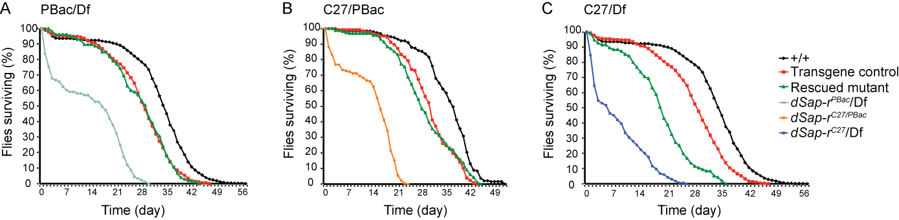
Fig. 4.7. Neuronal expression of wild type dSap-r rescued dSap-r mutant longevity. dSap-r was expressed in neurons using the
1407-Gal4 to drive a wild type dSap-r transgene. dSap-r was expressed in dSap-r^{PBac}/Df (A), dSap-r^{C27/PBac} (B), and dSap-r^{C27}/Df (C) mutant backgrounds. Various genetic controls were also included: a wild type control (w⁻¹¹¹⁸/Canton-s; +/+), the appropriate dSap-r mutant controls (dSap-r^{PBac}/Df, dSap-r^{C27/PBac} and dSap-r^{C27}/Df), and a transgene control (UAS-dSap-r/+;1407-Gal4/+). n > 90 for each genotype (n represents the number of flies at day 0).
    - Glial expression of dSap-r was not sufficient to rescue dSap-r mutant longevity.
The expression pattern of dSap-r was shown to be in the glia of Drosophila (Fig. 3.11). Therefore, a dSap-r transgene was expressed in the glia of
dSap-r^{C27/PBac} mutants and its effect on longevity was assessed (Fig. 4.8). The glial driver glial cells missing (Gcm)-Gal4 was used. Gcm is a transcription factor that determines whether a neuroblast differentiates into a glial or neuronal cell, and is therefore expressed in glia (Hosoya et al., 1995; Jones et al., 1995). As was described in section 4.5.2, wild type
(w⁻¹¹¹⁸/Canton-s; +/+), transgene (UAS-dSap-r/+; Gcm-Gal4/+), and
dSap-r^{C27/PBac} controls were required. Figure 4.8 shows a 50% survival point of 37 days for wild type, 30 days for the transgene control, 16 days for the dSap-r^{C27/PBac} mutant, and 15 days for the dSap-r^{C27/PBac} mutant expressing dSap-r in the glia. Therefore, Gcm-induced dSap-r expression did not restore the lifespan of the dSap-r^{C27/PBac} mutants.
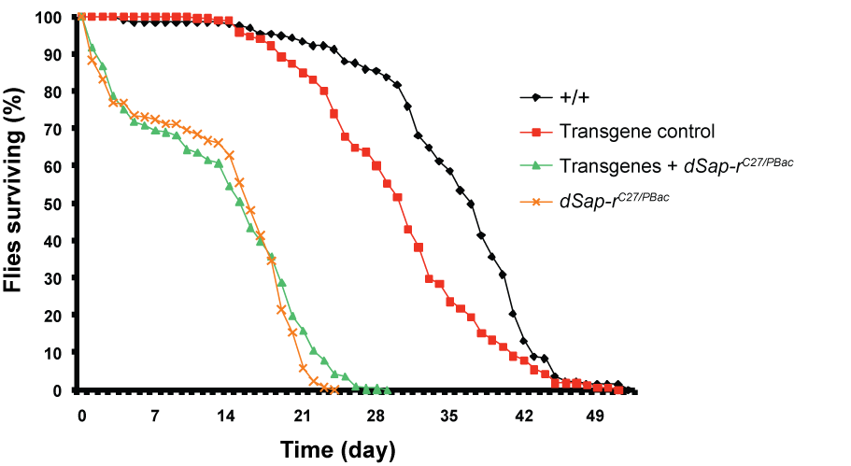
Fig. 4.8. Gcm-Gal4 expression of dSap-r was not sufficient to rescue
dSap-r^{C27/PBac} mutant longevity. dSap-r expression was driven in the glia of
dSap-r^{C27/PBac} mutants using the Gcm-Gal4. Various genetic controls were also included: a wild type control (w⁻¹¹¹⁸/Canton-s; +/+), the dSap-r^{C27/PBac} mutant control, and a transgene control (UAS-dSap-r/+;Gcm /+). n > 100 for each genotype (n represents the number of flies at day 0).
    - Expression patterns of the 1407- and Gcm-Gal4 drivers
The expression of the 1407- and Gcm-Gal4 drivers was investigated to determine whether the inability of the Gcm-Gal4 to rescue dSap-r^{C27/PBac} longevity was a result of an inappropriate expression pattern.
      - The neuronal 1407-Gal4 is expressed in neurons of the adult CNS.
The expression pattern of the neuronal 1407-Gal4 was visualised using the Gal4-UAS system to drive the nuclear GFP reporter UAS-eIF4AIIIGFP. To determine whether 1407-Gal4 was expressed in neurons of the adult, the adult CNS was stained with an antibody against the neuronal RNA binding protein elav. Figure 4.9 A - C shows confocal projection images through an adult brain. 1407-Gal4 expression was detected in the adult brain
(Fig. 4.9 A), and showed some colocalisation with the neuronal marker elav (Fig. 4.9 A’ - C’). However, the 1407-Gal4 did not express in all neurons marked by elav and is therefore not a pan-neuronal driver.

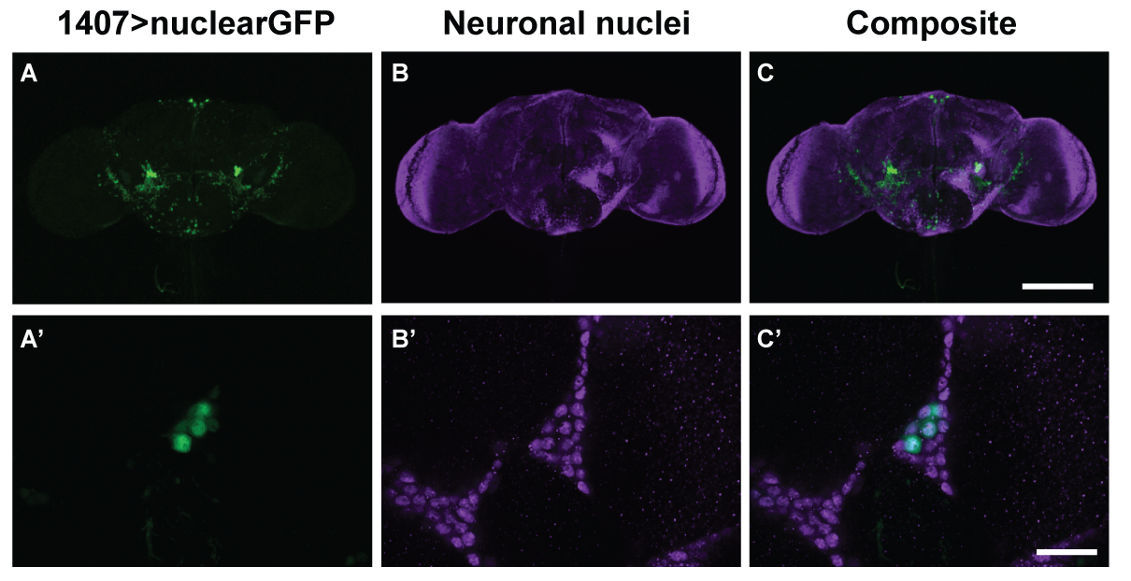
Fig. 4.9. The neuronal 1407-Gal4 induced expression in the adult CNS.
(A - C) Confocal projection images showing the expression pattern of the 1407-Gal4 using the UAS-eIF4AIIIGFP reporter. (A’ - C’) Higher magnification single plane confocal images of 1407-Gal4-induced expression in neurons. The brains were stained with an antibody against the neuronal RNA binding protein elav, which marks the neurons of the brain. Scale bars: (C) 100 µm (applies to A - C); (C’) 20 µm (applies to A’ - C’).
      - The Gcm-Gal4 does not drive expression in the glia of the adult.
Gcm-Gal4-driven UAS-dSap-r was unable to rescue the dSap-r^{C27/PBac} mutant longevity (Fig. 4.8). This may suggest that glial expression of dSap-r was insufficient to rescue dSap-r^{C27/PBac} longevity. However, the expression of Gcm-Gal4 may terminate early in development and would therefore not be available to drive dSap-r in the adult. To determine whether Gcm-Gal4 was capable of inducing expression in the glia of the adult, these transgenic flies were crossed to the UAS-eIF4AIIIGFP nuclear GFP line. This allowed the visualisation of the Gcm-Gal4 expression pattern. The CNS of adults were dissected and stained using an antibody against the glial nuclear marker repo. Figure 4.10 A - C shows confocal projection images through an adult brain. The Gcm-Gal4 induced expression of the nuclear GFP reporter did not colocalise with the glial nuclear antibody (Fig. 4.10 A’ - C’), and was therefore not an appropriate Gal4 to drive UAS-dSap-r in adult glia.
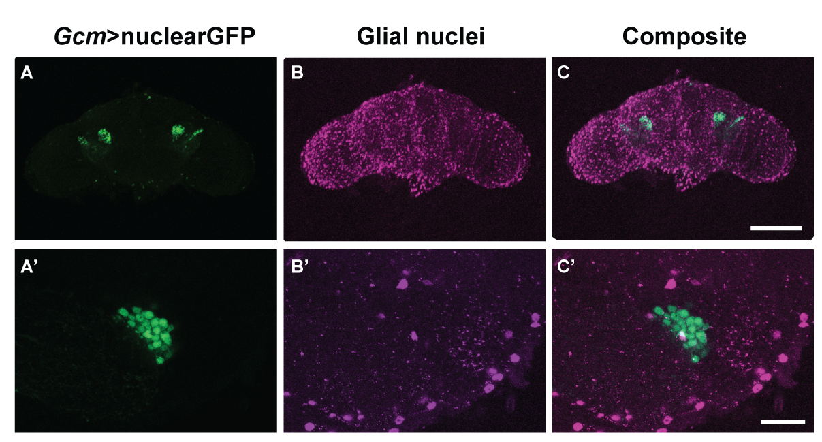
Fig. 4.10. The Gcm-Gal4 did not drive expression in the glial cells of the adult CNS. The UAS-eIF4AIIIGFP line was used to report the expression pattern of
Gcm-Gal4 in the adult brain. The adult brains were stained with antibody against the glial nuclear marker repo. Confocal projection images (A - C) and single plane images (A’ - C’) are shown. Scale bars: (C) 100 μm (applies to A – C); (C’) 20 μm (applies to A’ - C’).

  - Discussion.
    - Reduced longevity in dSap-r mutants
Potential dSap-r mutants were generated by mobilising the P{GawB}
P-element from the dSap-r^{NP7456} locus. Following PCR screening, the
dSap-r^{C27} allele was identified: a 2.5 kb deletion flanking the original
P-element insertion site. This deletion removed the first predicted transcript start site, but left the second intact. Therefore, the severity of this mutation may provide information as to whether functional dSap-r can be expressed from the second predicted start site.
One of the defining characteristics of most LSDs is premature mortality. Therefore, this attribute was investigated in the dSap-r mutants. All dSap-r mutant combinations caused a reduction in longevity compared to the controls. The dSap-r^{C27} allele caused a more severely reduced longevity compared to the parent dSap-r^{NP7456} allele, which suggests that the dSap-r^{C27} deletion has further reduced dSap-r levels or function. The dSap-r^{NP7456} allele led to an intermediate longevity suggestive of a hypomorphic mutation.
To assess the dSap-r transcript levels in both the dSap-r^{PBac} and dSap-r^{C27} lines, RT-PCR was performed. dSap-r levels were shown to be slightly reduced in the dSap-r^{PBac}/Df mutant and severely reduced in the dSap-r^{C27}/Df mutant. However, the wild type control (w⁻¹¹¹⁸/Canton-S) contained two functional copies of dSap-r compared to only one copy being present in the dSap-r mutants. Therefore, the slight reduction seen in the dSap-r^{PBac}/Df mutant may reflect the presence of only 1 copy of dSap-r rather than a reduction in transcript production due to the PBac transposon insertion. The degree to which dSap-r transcript levels were reduced in the dSap-r^{C27}/Df mutants is unlikely to be solely due to the presence of only 1 copy of dSap-r; therefore, this mutant appears to represents a genuine dSap-r knock-down mutation (RT-PCR using the Df(3R)tll-e/+ heterozygote would confirm the level of dSap-r transcript produced from a single copy of the gene). These RT-PCR results are representative of the transcript levels produced in the dSap-r mutant combinations used for longevity assays and further characterisations (Chapters 5 and 6) and are therefore relevant in this context. Quantitative PCR (qPCR) would be required to accurately determine dSap-r transcript levels.
The similarity in the severity of longevity phenotype between the
dSap-r^{PBac}/Df(3R)tll-e and dSap-r^{C27}/Df(3R)tll-e mutants did not reflect the difference in dSap-r transcript levels determined by RT-PCR. Therefore, these data suggest that the dSap-r^{PBac} transcript, although present at almost wild type levels, may be non-functional. The primers used during RT-PCR amplified a region of dSap-r upstream of the PBac insertion site, but downstream of the dSap-r^{C27} deletion and the second predicted start site (see Fig. 4.4). Therefore, the effect of the PBac insertion may not be reflected in these results. To address whether the insertion leads to premature termination of the dSap-r^{PBac} transcript, RT-PCR primers should be designed downstream of the PBac insertion site.
If non-functional protein is expressed in this mutant line, the protein may fold incorrectly and trigger the ER unfolded protein response (UPR). An additional copy of the dSap-r^{PBac} mutation would be likely to worsen this effect. Although the longevity of the dSap-r^{PBac} homozygotes was not assessed, the fly stock showed a preference for the heterozygous state (dSap-r^{PBac}/TM6b) and no, or very few, homozygotes survived post second instar. This may be due to a second-site mutation, or could reflect additional ER stress caused by the extra non-functional dSap-r protein. Whether the ER UPR is triggered in dSap-r^{PBac} mutants could be assessed using an XBP1-GFP transgenic line. XBP1 is a transcription factor that activates expression of UPR proteins, such as molecular chaperones. XBP1 transcription is induced by the ER stress-activated transcription factor ATF6. XBP1 mRNA undergoes unconventional splicing by Ire1α to produce a frame shift in the spliced mRNA leading to the synthesis of XBP1 transcription factor (Yoshida et al., 2001). The XBP1-GFP transgenic line only expresses the GFP form of XBP1 when the frame shift occurs as a result of unconventional splicing, and therefore acts as a reporter of ER stress. A similar construct was used by Back et al. (2006) to confirm the molecular mechanism and localisation of XBP1 mRNA processing.
The dSap-r^{C27/PBac} transheterozygotes also showed a reduced longevity equivalent to that of the dSap-r^{PBac}/Df and dSap-r^{C27}/Df mutations. This alone would suggest that both of these dSap-r mutations were of a similar severity as the longevities were equivalent when either 1 or 2 copies of the dSap-r mutant alleles were present. However, the mutant longevities in Figure 4.7 and physiological characterisation in Chapter 6 suggest the dSap-r^{C27} allele is more severe.
      - Comparisons to other Drosophila LSD models
Drosophila saposin deficiency can be compared to models of other LSDs, such as NPC, Mucolipidosis Type IV and the neuronal ceroid lipofuscinoses (NCLs). The closest Drosophila LSD models to saposin deficiency, in terms of the stored material, are the NPC models. NPC is caused by mutations in the NPC-1 and NPC-2 genes, which encode proteins thought to be involved in cholesterol sensing and homeostasis (Carstea et al., 1997; Loftus et al., 1997; Naureckiene et al., 2000). NPC is characterised by the accumulation of cholesterol and also sphingolipids. The dSap-r mutants showed a 41 – 49% reduction in longevity compared to wild type. Drosophila npc1a (dnpc1a) mutants showed first instar lethality due to a requirement for cholesterol, and therefore dnpc1a, in molting hormone synthesis. These mutants were rescued to the adult stage by either supplementing their diet with excess precursors of the molting hormone ecdysone (during larval stages), or by driving the wild type dnpc1a in the ring gland, the site of ecdysone synthesis (Huang et al., 2005; Fluegel et al., 2006; Phillips et al., 2008). This rescue allowed the adult longevity of these mutants to be assessed; a 55% reduction in their longevity was seen compared to wild type (Phillips et al., 2008). A Drosophila model of NPC has also been produced by mutating a Drosophila NPC-2 gene (dnpc2a). The percentage reduction in 50% survival point could not be calculated for these mutants because the published wild type data was incomplete. However, the data did show a 50% survival point of 36 days for these mutants; at this time point, more than 90% of wild type flies were alive (Huang et al., 2007). The Mucolipidosis Type IV Drosophila model, caused by mutations in the TRPML Transient Receptor Potential channel, showed a reduction in numbers of adults hatching (<25%); therefore, these mutants displayed a greater lethality than the other Drosophila LSD models (Venkatachalam et al., 2008). The neuronal ceroid lipofuscinoses (NCLs) are a group of LSDs characterised by accumulation of the autofluorescent material lipofuscin (reviewed in Kohlschütter and Schulz, 2009). There are three Drosophila NCL models: infantile NCL (Hickey et al., 2006), Cathepsin D deficiency (Myllykangas et al., 2005) and spinster, an NCL-like LSD (Nakano et al., 2001; Sweeney and Davis, 2002; Dermaut et al., 2005). A reduced longevity was seen in both the infantile NCL and spinster flies: a
37 – 42% and 78 – 89% reduction, respectively. All the Drosophila LSD models mentioned so far displayed a reduction in longevity; the
Cathepsin D-deficient model was the exception, showing no signs of reduced longevity. However, these mutants did show storage of autofluorescent material and neurodegeneration: both signs of NCL disorders (Myllykangas et al., 2005). One other novel LSD model exists for which the locus has not yet been identified. This mutant, eggroll, showed a 47% reduction in longevity (Min and Benzer, 1997). Most of the Drosophila LSD models displayed a 40 – 55% reduction in longevity; the saposin deficiency model presented here showed a comparable reduction in longevity (41 - 49% reduction).
    - The dSap-r mutant longevity can be rescued by neuronal dSap-r expression.
To show that reduced longevity observed in dSap-r mutants was specific to the dSap-r mutation, wild type dSap-r was expressed ubiquitously, in neurons, and in the glia. Ubiquitous expression in both a wild type and a dSap-r mutant background caused 100% pre-adult lethality. This was not a result of the Gal4 transgene insertion, as the same effect was produced using a different ubiquitous Gal4. In addition, this was not due to the
UAS-dSap-r transgene insertion, as expression driven by other Gal4 lines (1407-Gal4 and Gcm-Gal4) did not have this same effect. Therefore, the lethality was likely caused by ubiquitous overexpression of dSap-r. The human saposins are activator proteins, not enzymes, and would therefore have to be the limiting factor in order for an increase in their expression to affect sphingolipid degradation. Each saposin is thought to activate enzymes involved in different stages of the sphingolipid degradation pathway (see Figure 1.5), however they all contribute towards the final production of ceramide and sphingosine-1-phosphate. These two molecules have been implicated in apoptosis and cell survival (reviewed in Bartke and Hannun, 2009). A fine balance is required in the levels of these molecules to ensure inappropriate cell death or proliferation is prevented. Overexpression
of dSap-r may result in a misbalance of ceramide and
sphingosine-1-phosphate, leading to premature mortality.
Overexpression of dSap-r in neurons and glia did not cause pre-adult mortality. Therefore, the effect on longevity of expressing dSap-r in each of these cell types was assessed. In wild type flies, dSap-r is expressed in glia, but not neurons (Fig. 3.11 and 3.12). However, neuronal expression of
dSap-r substantially rescued the longevity of all dSap-r mutants (Fig. 4.7). When driving dSap-r expression with the neuronal 1407-Gal4, this would not induce dSap-r expression in the glia. This may suggest that the glia normally provide the neurons with dSap-r, or the sphingolipids themselves. This could represent a regulatory mechanism to control sphingolipid levels in neurons. Expressing dSap-r in the neurons would allow the neurons to synthesise their own sphingolipids via the salvage pathway (from degradation of glycosphingolipids in the lysosome).
Although dSap-r expression has been shown in the glia (Fig. 3.11; Freeman et al., 2003), expression of dSap-r with the glial driver Gcm-Gal4 did not rescue dSap-r^{C27/PBac} longevity (Fig. 4.8). In this scenario, the glia would be wild type for dSap-r, whereas the neurons would be dSap-r-deficient.
Gcm-Gal4-driven nuclear GFP did not colocalise with the glial nuclear marker in the adult brain (Fig. 4.10). This absence of Gcm-Gal4 expression in the glia may explain the inability of this driver to rescue dSap-r^{C27/PBac} longevity. To determine whether glial expression of dSap-r is sufficient to rescue dSap-r longevity, a different glial-Gal4 would be required. Repo-Gal4 would be an appropriate glial Gal4, as repo is expressed in the adult (see α-repo staining in Fig. 4.10).
The NPC-1 Drosophila model also showed a rescue of mutant longevity when expressing wild type dnpc1a in neurons (Phillips et al., 2008). As was found during dSap-r rescue assays (Fig. 4.7), their transgene control also showed a reduction in longevity (Phillips et al., 2008). The rescue caused by neuronal dnpc1a expression produced a longevity equivalent to the transgene control, as was shown for dSap-r^{PBac}/Df and dSap-r^{C27/PBac} rescues. Rescue of the dnpc1a longevity was partially provided by glial expression of dnpc1a using the repo-Gal4 driver (Phillips et al., 2008). The normal expression pattern of dnpc1a has been shown to be quite ubiquitous, including expression in the brain (Huang et al., 2005). However, it was not shown whether dnpc1a expression normally localises to neurons or glia.

The percentage reduction in all longevities were calculated from the 50% survival point of the mutants compared to wild type.

