Insights into enzyme-catalysed phosphoryl transfer from studies of MAP kinases

Thesis submitted for the Degree of Doctor of Philisophy

Thomas Lake, MChem
Department of Molecular Biology & Biotechnology, University of Sheffield

September 2014

Abstract
Phosphoryl transfer is one of the most common biological reactions, and enzymes catalysing this are capable of producing huge rate enhancements that has led to great interest in their catalytic mechanism. This thesis focuses on p38α and MEK6, protein kinases belonging to one of the MAP kinase signalling pathways in eukaryotic cells, in which MEK6 activates p38α by dual phosphorylation of tyrosine and threonine in its activation loop. Protein phosphatases which dephosphorylate the same residues play a role in regulating these pathways.

Chapter 3 demonstrates and investigates a novel phosphatase activity of MEK6 towards p38α. This phosphatase activity is found to be dependent on activation loop phosphorylation, is metal cation dependent and requires the general base aspartate. Together these results indicate that the kinase and phosphatase activities utilise the same active site. Whilst this dual kinase/phosphatase activity is unexpected, similarities in the mechanism of protein kinases and PPP/PPM phosphatases suggest that the active site is naturally equipped to catalyse both reactions.
Chapter 4 concerns studies on other protein kinases, either serine/threonine specific or dual specificity, to try to determine how widely phosphatase activity is preserved amongst members of the kinome. The results of these studies suggest that phosphatase activity is a specific feature of the MAP2K’s which are archetypal dual specificity kinases.
Chapter 5 focuses on unexpected kinase activity, firstly investigating the ability of MEK6 and other protein kinases to transfer the β-phosphate of ADP (rather than ATP γ-phosphate) to substrate. The findings show that these kinases can use ADP as a phosphoryl donor, which may be functionally significant in conditions of limited ATP supply. In addition this chapter describes the unexpected formation of a transition-state analog complex between MEK6 and p38α lacking both activation sites, implying a nonspecific kinase activity of MEK6.

Acknowledgments
I want to thank colleagues in the NMR group for their company and help during my PhD. In particular thanks to Matt Cliff and Jin Yi. I also want to thank my family and close friends for their support and encouragement during my PhD.

List of Figures and Tables Figure 1.1 Reaction profile for catalysed vs non-catalysed reaction Figure 1.2 Half-times of biologically important reactions in solution Figure 1.3 Representation of associative, dissociative and concerted phosphoryl transfer mechanisms Figure 1.4 Net charge vs radius from the central metal ion in transition-state analogs of various phosphoryl transfer enzymes Figure 1.5 Schematic representation of the structure of a protein kinase in its active form Figure 1.6 Representation of key interactions in a protein kinase active site Figure 1.7 Catalytic mechanism of the PPP phosphatase family with the metal coordination shown Figure 1.8 Catalytic mechanism of PTP phosphatase family including dual specificity phosphatases Figure 1.9 Catalytic mechanism of aspartate-based phosphatases Figure 1.10 Metal fluoride TSA’s mimicking both phosphoryl transfer steps of PSP Figure 1.11 Vanadate-based TSA’s mimicking both phosphoryl transfer steps of PTP1B Figure 1.12 MAP kinase pathways and their activation and downstream targets Figure 1.13 Schematic representation of p38α MAP kinase pathway Figure 1.14 Crystal structure of dually phosphorylated p38α Figure 1.15 Structure of p38α in its non-phosphorylated vs dually phosphorylation forms showing close-up of the activation loop region Figure 1.16 Aligned sequences of human p38α and human MEK6 Figure 1.17 Crystal structure of nucleotide-bound non-phosphorylated MEK6 Figure 1.18 Crystal structure of inactive p38α complexed to MEK3-derived peptide showing close-up of the docking groove Figure 3.1 Reaction catalysed by kinases vs reaction catalysed by PPP/PPM phosphatases Figure 3.2 Phostag gel for wild-type MEK6 before and after λ-phosphatase treatment Figure 3.3 Phostag gel for non-activated vs activated wild-type MEK6 Figure 3.4 Native PAGE showing phosphorylation and subsequent reversion to non-phosphorylated form of wild-type p38α in the presence of MEK6dd
Figure 3.5 Native PAGE time course of MEK6dd-catalysed dephosphorylation of activated p38DA Figure 3.6 Schematic representation of possible p38α dephosphorylation pathways Figure 3.7 Native PAGE time courses for MEK6dd-catalysed dephosphorylation of p38α T180A and Y182F variants Figure 3.8 Native PAGE time courses for p38DA a) in the absence of Mg²⁺, b) for MEK6dd D179N variant Figure 3.9 Native PAGE time courses for p38DA dephosphorylation by a) non-activated MEK6wt, b) activated MEK6wt Figure 3.10 Native PAGE time courses for MEK6dd-catalysed p38DA dephosphorylation with added nucleotide Figure 3.11 Schematic representation of possible modes of phosphatase inhibitition by nucleotide Figure 3.12 Representation of the phosphoryl transfer transition-states catalysed by protein kinase vs PPP/PPM family phosphatase Figure 4.1 Phostag gel for wild-type GST-MEK4 before and after λ-phosphatase treatment Figure 4.2 Phostag gel for non-activated vs activated wild-type GST-MEK4 Figure 4.3 Aligned sequences of human MEK4 with human MEK6 Figure 4.4 Crystal structure of nucleotide-bound non-phosphorylated MEK4 Figure 4.5 Native PAGE time courses for p38DA dephosphorylation by a) non-activated GST-MEK4wt, b) activated GST-MEK4wt Figure 4.6 Native PAGE time course for p38α in the absence of other kinases Figure 4.7 Aligned sequences of mouse cAPK catalytic subunit with human MEK6 Figure 4.8 Crystal structure of cAPK catalytic subunit bound to Mn²⁺-ATP and inhibitor peptide Figure 4.9 ³¹P NMR time course to test for phosphatase activity of cAPK catalytic subunit towards kemptide Figure 4.10 Crystal structure of human DYRK1a bound to ATP-competitive inhibitor and substrate peptide Figure 4.11 ³¹P NMR time course to test for phosphatase activity of DYRK1a towards DYRKtide Figure 5.1 Representation of ATP-dependent kinase activity and hypothesized ADP-dependent kinase activity Figure 5.2 Alternative mechanisms for MAPK dual phosphorylation Figure 5.3 Native PAGE time course for p38DA phosphorylation by MEK6dd and ADP Figure 5.4 Native PAGE time courses for ADP-dependent p38DA phosphorylation with varying ADP concentrations Figure 5.5 Native PAGE time courses for ATP-dependent p38DA phosphorylation with varying ATP concentrations Figure 5.6 ³¹P NMR showing the result of mixing 1eq MEK6dd + 1eq p38DA + 2eq ATP Figure 5.7 ³¹P NMR and native PAGE showing the result of mixing 1eq MEK6dd + 1eq p38DA + 1 or 2eq ATP, with reaction quenched by urea Figure 5.8 Native PAGE timecourse for p38DA phosphorylation by activated MEK4wt and ADP Figure 5.9 ³¹P NMR time course for ADP-dependent phosphorylaton of kemptide by cAPK Figure 5.10 ³¹P NMR time course for ADP-dependent phosphorylaton of DYRKtide by DYRK1a
Figure 5.11 Linked assay absorption vs time after addition of varying MEK6dd concentrations to ATP
Figure 5.12 Linked assay absorption vs time after addition of MEK6dd to ATP and varying p38DA concentrations
Figure 5.13 Linked assay absorption vs time after addition of MEK6dd to ATP and varying p38DATAYF concentrations
Figure 5.14 Native PAGE time course testing for phosphorylation of p38DATAYF by MEK6dd
Figure 5.15 Homology model (based on cAPK) of MEK6 active site in an AlF₄⁻ TSA complex
Figure 5.16 ¹⁹F NMR spectra of a) MEK6dd-p38DA–ADP–AlF₄⁻ TSA complex; b) MEK6dd-p38DATAYF-ADP-AlF₄⁻ TSA complex
Figure 5.17 Schematic representation of the ‘kinase-phosphatase’ activity of MEK6 towards the p38α activation sites, and hypothesized kinase-phosphatase activity towards alternative substrate hydroxyls

Table 3.1 Calculated rate constants for MEK6-catalysed p38α dephosphorylation Table 3.2 Calculated rate constants for MEK6-catalysed p38α dephosphorylation with added nucleotide Table 4.1 Calculated rate constants for MEK4-catalysed p38α dephosphorylation
Table 5.1 ¹⁹F chemical shifts for various MEK6-p38α –AlF₄⁻ TSA complexes

List of Abbreviations
ADP Adenosine diphosphate
AMPPCP Adenosine-5-(β,γ-methylene) diphosphate AMPPNP Adenosine-5-(β,γ-imido) diphosphate AMP Adenosine monophosphate ATP Adenosine triphosphate APS Ammonium persulfate cAPK cyclic-AMP dependent protein kinase DTT Dithiothreitol DYRK Dual-specificity tyrosine-regulated kinase EDTA Ethylenediaminetetraacetic acid GST Glutathione-S-transferase HEPES 4-(2-hydroxyethyl)-1-piperazineethanesulfonic acid IPTG Isopropyl-β-D-thiogalactopyroniside MAPK Mitogen-activated-protein kinase MAP2K Mitogen-activated-protein kinase kinase MEK6dd MEK6 S207D T211D MKP MAPK phosphatase NAD(H) Nicotinamide adenine dinucleotide (hydride) NMR Nuclear magnetic resonance OD Optical density PCR Polymerase chain reaction P_{i} Inorganic phosphate p38DA p38α D168A p38DATAYF p38α D168A T180A Y182F (SDS-)PAGE (Sodium dodecyl sulfate) polyacrylamide gel electrophoresis TSA Transition-state analog

CONTENTS
Chapter 1 Introduction 1
1.1 Theory of enzyme catalysis 1
1.2 Phosphoryl transfer 2
1.2.1 Mechanism of phosphoryl transfer 3
1.2.2 Uncatalysed hydrolysis of phosphate monoesters 4
1.2.3 Enzyme-catalysed reactions of phosphomonoesters 4
1.3 Protein kinases 6
1.3.1 Protein kinase structure 7
1.3.2 Substrate specificity of protein kinases 8
1.3.3 Role of metal ions in catalysis 9
1.3.4 Role of catalytic aspartate in catalysis 10
1.3.5 Activation of protein kinases 10
1.4 Protein phosphatases 11
1.4.1 Metal-dependent (PPP/PPM) phosphatases 11
1.4.2 Cysteine-based phosphatases 12
1.4.3 Aspartate-based phosphatases 14
1.5 Transition-state analogs of phosphoryl transfer enzymes 14
1.5.1 Metal fluoride TSA’s 15
1.5.2 Vanadate-based TSA’s 17
1.6 MAP kinase pathways 19
1.6.1 Advantage of a three-component signalling pathway 20
1.6.2 MAPK dual phosphorylation mechanism 21
1.6.3 Signal regulation by phosphatases 21
1.6.4 MAPK docking interactions 22
1.6.5 p38α pathway 23
1.7 Thesis Aims 29
Chapter 2 Materials and Methods 30
2.1 Reagents 30
2.2 Production of competent cells 30
2.3 Site-directed mutagenesis 31
2.3.1 Primer design 31
2.3.2 PCR 31
2.3.3 Agarose gel electrophoresis 32
2.3.4 Plasmid purification 32
2.4 Protein expression and purification 33
2.4.1 Transformation 33
2.4.2 Culture medium 33
2.4.3 p38α specific protocol 33
2.4.4 MEK6 specific protocol 34
2.4.5 MEK4 specific protocol 35
2.4.6 cAPK specific protocol 35
2.4.7 DYRK1a specific protocol 36
2.5 Gel electrophoresis 36
2.5.1 SDS-PAGE 36
2.5.2 Phostag gel 37
2.5.3 Native PAGE 37
2.6 NMR 38
2.6.1 ³¹P NMR 38
2.6.2 ¹⁹F NMR 38
2.7 Linked assay for measuring ADP production 38
2.8 General methods 39
2.8.1 Measurement of protein concentration 39
2.8.2 Buffer exchange 39
Chapter 3 Phosphatase activity of MEK6 40
3.1 Background 40
3.2 Specific methods 41
3.2.1 Wild-type p38α activation 41
3.2.2 p38α dephosphorylation timecourses 42
3.2.3 Analysis of native PAGE 42
3.2.4 Wild-type MEK6 activation 43
3.3 Phosphatase activity of MEK6 45
3.3.1 MEK6-dependent dual dephosphorylation of p38α 45
3.3.2 Activity is unaffected by p38α D168A mutation 47
3.3.3 Modelling of dephosphorylation kinetics 47
3.3.4 MEK6 dephosphorylates Tyr182 faster than Thr180 49
3.3.5 Requirement of catalytic Mg²⁺ and catalytic base Asp179 51
3.3.6 Activation dependence of phosphatase activity 53
3.3.7 Effect of nucleotide on MEK6 phosphatase activity 55
3.4 Discussion 58
3.4.1 Mechanism of phosphatase activity 59
3.4.2 Comparing to previous reports of dual activity kinases/phosphatases 60
3.4.3 Biological significance of phosphatase activity 61
3.4.4 Significance for MAPK activation protocols 62
Chapter 4 Potential phosphatase activity of other kinases 63
4.1 Background 63
4.2 Specific methods 63
4.2.1 Wild-type MEK4 activation 63
4.2.2 Native PAGE vs ³¹P NMR for phosphorylation timecourses 65
4.2.3 Peptide substrates 65
4.3 MEK4 background and comparison with MEK6 65
4.3.1 MEK4 possesses phosphatase activity towards p38α 67
4.4 p38α comparison with MEK6 70
4.5 cAPK background and comparison with MEK6 70
4.5.1 cAPK has no apparent phosphatase activity 73
4.6 Identification of an alternative dual specificity kinase 74
4.6.1 DYRK1a background and comparison with MEK6 75
4.6.2 DYRK1a has slow phosphatase activity compared to MEK6 77
4.7 Discussion 79
Chapter 5 Alternative kinase activities of MEK6 81
5.1 Background 81
5.2 MEK6 can phosphorylate p38α using ADP 82
5.2.1 Concentration dependence of ADP-dependent kinase activity 83
5.2.2 Relative ADP-dependent and ATP-dependent kinase rates 85
5.2.3 MEK6 uses two ATP molecules to dually phosphorylate p38α 87
5.3 ADP-dependent kinase activity in other protein kinases 90
5.3.1 MEK4 can phosphorylate using ADP 90
5.3.2 cAPK can phosphorylate using ADP 90
5.3.3 DYRK1a can phosphorylate using ADP 91
5.3.4 Comparison of ADP-dependent kinase activities 92
5.4 Discussion and biological significance 93
5.4.1 Mechanism of p38α activation by MEK6 93
5.4.2 Significance of ADP-dependent kinase activity 94
5.5 Nonspecific kinase activity of MEK6 95
5.5.1 MEK6 has an ATPase activity 95
5.5.2 Enhancement of ATP turnover rate by substrate 96
5.5.3 TSA complexes between active MEK6 and inactive p38α 98
5.5.4 Discussion 101
Chapter 6 Perspective and Future work 103
6.1 Overall conclusions 103
6.2 Biological significance of phosphatase activity 104
6.3 Future work 106
References 115

Introduction

Theory of enzyme catalysis

The rates of uncatalysed chemical reactions are generally slow and vary widely, but in biological systems enzyme-catalysed reactions occur at much enhanced rates that fall within a relatively narrow range. Understanding how enzymes achieve such rate enhancements is a fundamental goal of life science. Enzyme catalysis can most accurately be explained by transition state theory[1], in which the transition state is defined as the highest energy point along the reaction pathway. This theory is based on a combination of thermodynamic, kinetics and statistical mechanical treatments. In simple terms, enzymes achieve catalysis by preferential stabilization of the transition-state relative to the ground-state resulting in a lowering of activation energy (illustrated in Figure 1.1). This can be achieved either by stabilization of the transition-state or destabilization of the ground-state, whilst the equilibrium between reactants and products is unaffected by enzyme catalysis. A number of interrelated factors can contribute to preferential stabilization of the transition-state, these include electrostatic effects, entropic effects, orbital steering and steric strain; however electrostatic effects are thought to be the primary factor driving catalysis[2]. Furthermore in some cases the actual mechanism of the enzyme-catalysed reaction is different from the uncatalysed reaction.

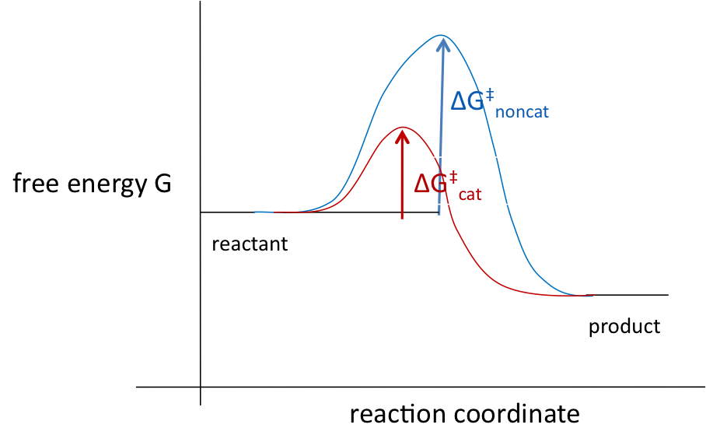
Figure 1.1: Reaction profile for catalysed vs non-catalysed reaction

Phosphoryl transfer

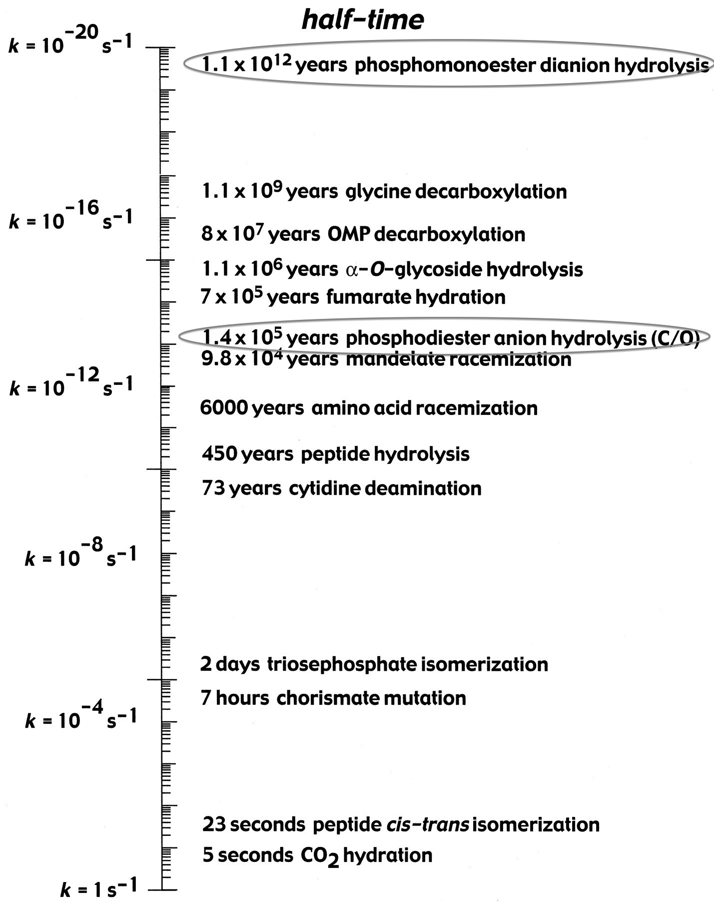
Phosphate groups and their esters are ubiquitous in biology, with monoesters and diesters naturally occurring, and living organisms have evolved to utilise them for a wide range of purposes. Phosphorylation of proteins is an important regulatory mechanism for many signalling processes, many high-energy compounds such as ATP contain phosphate groups, and phosphate diesters form the building blocks of nucleic acids. Hydrolysis of phosphate esters is intrinsically very slow, as shown in Figure 1.2, and monoesters are the most stable. However many phosphorylation or dephosphorylation reactions in biology necessarily occur on very short timescales. As such, enzymes that catalyse these reactions are found to produce massive rate enhancements even compared to other enzyme-catalysed reactions. For example the catalysed hydrolysis of certain phosphate monoesters is found to occur at a rate in the order of 10²¹-fold higher than the uncatalysed reaction[3]. Such efficient catalysis has led to great interest into the mechanism of enzyme-catalysed phosphoryl transfer, in particular the nature of the active site.
Figure 1.2: Diagram showing half-times of biologically important reactions in water in the absence of catalyst at 25°C (taken from ref [3]).

Mechanism of phosphoryl transfer

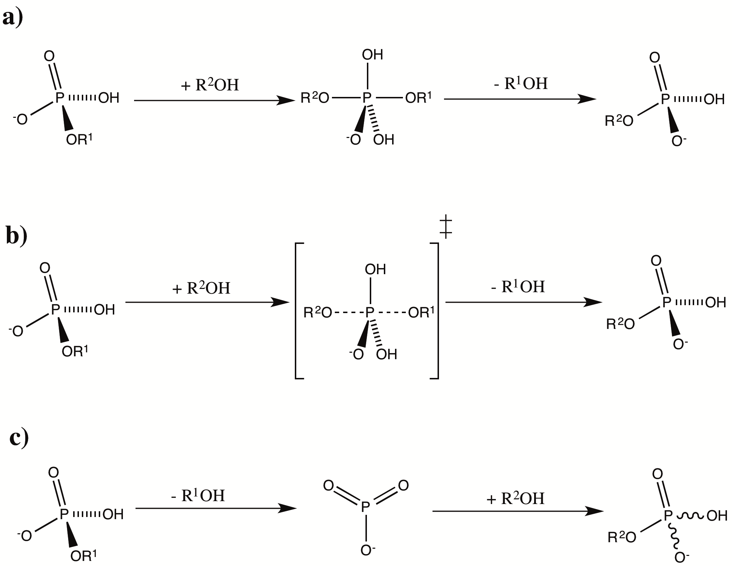
Phosphoryl transfer occurs via in-line attack at phosphorus by a nucleophile and loss of a leaving group, proceeding through a species containing a trigonal planar PO₃ moiety[4, 5]. The mechanism can fall anywhere between two extremes which are fully associative and fully dissociative. In the associative mechanism, the reaction proceeds in two steps via a phosphorane intermediate in which the P atom is bonded to both the incoming and leaving groups. In the dissociative mechanism a metaphosphate anion is initially formed, which subsequently forms a bond with the incoming nucleophile in the rate-determining step. In the concerted mechanism, bond formation to the incoming group and bond fission with the leaving group occur simultaneously and as a result there is no intermediate. The associative and concerted mechanisms result in retention of stereochemistry around P whereas a fully dissociative mechanism results in loss of stereochemistry, as shown in Figure 1.3.

Figure 1.3: Representation of a) fully associative, b) concerted and c) fully dissociative mechanisms of phosphoryl transfer.

Uncatalysed hydrolysis of phosphate monoesters

Phosphate monoesters under normal physiological conditions exist in either the monoanionic or dianionic form depending on pH, with the neutral form only favoured under highly acidic conditions. They are extremely stable towards spontaneous hydrolysis, and kinetic studies have focused on aryl monoesters since the hydrolysis of alkyl monoesters is normally too slow for accurate measurement.
The hydrolysis rates of phosphomonoester dianions have a large dependence on the leaving group pKa, compared to phosphomonoester monoanions which have a weaker dependence[6]. This is given by Bronsted β_{lg} values (the slope of log k_{hyd} plotted vs leaving group pKa) of -1.23 for the dianions compared to -0.27 for monoanions. From using different primary alcohols as solvents, the rate dependence on nucleophile pK_{a} (given by β_{nuc} value) was found to be small and positive[7]. In addition a large positive kinetic isotope effect for the bridging oxygen, ¹⁸k_{bridge}>1, is observed in the case of p-nitrophenyl phosphate dianion, and a smaller positive kinetic isotope effect for the p-nitrophenyl phosphate monoanion[8]. Hydrolysis rates of both monoanionic and dianionic esters have near-zero entropies of activation implying a concerted mechanism. In addition, when the phosphoryl group is made chiral by isotopic labelling of the nonbridging oxygens, phosphoryl transfer is found to result in inversion of stereochemistry[9]. Overall the data for both monoanionic and dianionic esters are indicative of a concerted process with a ‘loose’ transition state, in which there is significant bond-cleavage to the leaving-group but little bond-formation with the incoming nucleophile. For monoanionic esters the smaller β_{lg} value indicates that there is significant proton transfer to the leaving group in the transition state[5, 10].

Enzyme-catalysed reactions of phosphomonoesters

There are several groups of enzymes catalyzing reactions of phosphomonoesters. Kinases catalyse transfer of ATP γ-phosphate to an acceptor group; phosphatases catalyse transfer of a phosphate group from substrate to water; ATPases catalyse transfer of ATP γ-phosphate to water; and mutases catalyse the overall transfer of phosphate from one position to another within the same molecule in a multistep process.
Precise details of how enzymes catalyse phosphoryl transfer reactions are not well understood; however structural studies, in particular of complexes mimicking the transition-state, have contributed towards our understanding. A common feature is positively charged groups in the active site, in the form of metal cations and amino acid side-chains, which stabilise the negatively charged phosphates of ATP[5]. However this effect would only preferentially stabilize the transition-state relative to ground-state in the case of an associative mechanism, whereas for a dissociative mechanism the transition-state would be relatively destabilized. This suggests that enzyme-catalysed phosphoryl transfer is more associative than observed in solution.

Charge balance hypothesis

The charge balance hypothesis states that for enzyme-catalysed phosphoryl transfer, balancing of positively and negatively charge groups in the active site is essential for transition-state stabilization and therefore drives catalysis. In order to retain net-zero local charge, any increase in negative charge must be compensated for by an identical increase in positive charge. Perhaps the best experimental support for the charge balance hypothesis comes from human phosphoglycerate kinase (PGK)[11]. ¹⁹F NMR combined with high-resolution crystal structures show that wild-type PGK forms both PGK-3PG-MgF₃⁻-ADP and PGK-3PG-AlF₄⁻-ADP complexes. In contrast the K219A mutant (loss of one positive charge) forms a PGK-3PG-AlF₃-ADP complex (loss of one negative charge), in which aluminium retains its octahedral coordination by replacing fluoride with water as the fourth ligand. The loss of negative charge of the metal fluoride moiety for the K219A mutant is shown by average ¹⁹F shifts moving downfield.
To determine the generality of charge balance, structures of various phosphoryl transfer enzyme TSA complexes from the PDB have been examined. These include small molecule kinases (HsPGK, NDP kinase, UMP-CMP kinase) and four G-proteins. Pauling charges were assigned to each of the atoms and summed within a sphere of defined radius centred at the transferring P or metal ion mimic, and this value was plotted as a function of radial distance. As shown in Figure 1.4, up to 15A radius the net charge remains within 0±3 thus providing support for the charge balance hypothesis.

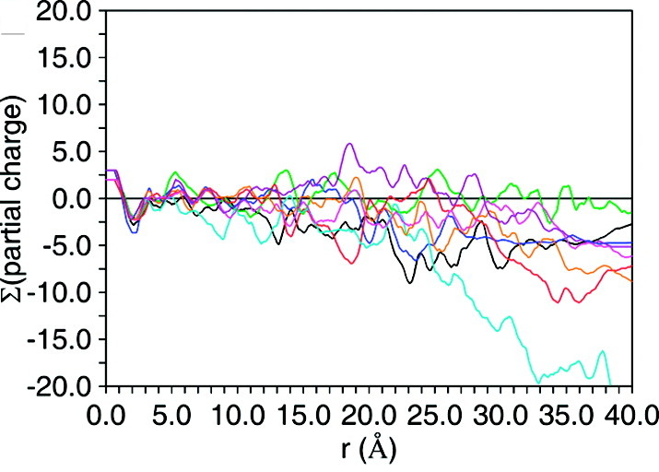
Figure 1.4: Net charge shown as a function of radius from the central metal ion in transition-state analogs of various phosphoryl transfer enzymes. Black - HsPGK; green – NDP kinase; blue – UMP/CMP kinase; red – HRas:GAP; magenta – CDC42:GAP; orange – Rho:GAP; purple – G protein α-subunit; cyan – nitrogenase.

Protein kinases

Protein kinases catalyse the transfer of ATP γ-phosphate to an acceptor group (normally a serine, threonine or tyrosine hydroxyl) of a target protein. They are a superfamily of phosphoryl transfer enzymes[12] comprising 518 genes of the human genome[13] (1.7% of all human genes). Protein kinases regulate a wide range of cellular processes and therefore their misregulation can lead to a range of diseases.

Protein kinase structure

The first protein kinase for which a three-dimensional structure was determined was cAMP-dependent protein kinase (cAPK) catalytic subunit[14]. This enzyme has become a structural paradigm for protein kinases, due to extensive studies on its structure, dynamics and mechanism. The catalytic domain of protein kinases has significant sequence and structural conservation. It comprises two subdomains, the N-terminal lobe and the larger C-terminal lobe, which are connected by a flexible hinge region[15]. The N-terminal lobe is composed mainly of β-sheet elements but also possesses a key helix termed the αC helix, whilst the C-terminal lobe possesses mainly α-helical secondary structure. A conserved catalytic aspartate (catalytic base) is located within a partially conserved HRD motif that forms the essential part of the catalytic loop. The activation loop, a disordered loop region in the C-terminal lobe, contains one or more residues that are phosphorylated in the active kinase and is crucial for controlling the activation state[16]. In the active kinase conformation, ATP binds at the cleft formed between the two lobes and lies in close proximity to a conserved glycine-rich loop (GXGXXG), whose backbone amides coordinate to the ATP phosphate groups. At the N-terminus of the activation loop is a conserved catalytic DFG motif. The aspartate of the DFG motif coordinates to catalytic Mg²⁺ ion(s) in the active conformation. A conserved lysine residue (also essential for catalysis) coordinates to the ATP α and β-phosphates and to a glutamate in the αC-helix.

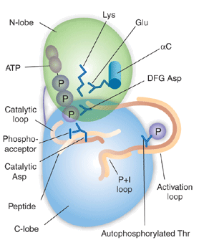
Figure 1.5: Schematic representation of the structure of a protein kinase in its active form, illustrating the relative positions of key residues, loops and substrates (taken from [17]). Based on cAPK catalytic subunit structure.

Substrate specificity of protein kinases

In eukaryotes, protein kinases fall into three subgroups according to residue specificity. One major subgroup phosphorylates serine and threonine side-chains, and the second major subgroup phosphorylates tyrosine side-chains. A third group (dual specificity) can phosphorylate serine, threonine and tyrosine side-chains. Known dual specificity kinases are relatively few in number, and do not constitute a distinct class from the serine/threonine kinases based on primary sequence, therefore they can only be identified from their biochemistry. Aside from the division of protein kinases into these broad groups, they are generally specific for particular residues, and this specificity is largely governed by the peptide sequence of the substrate immediately flanking the phosphorylation site. For example, cAPK phosphorylates serine or threonine with positively charged residues in the P-2 and P-3 positions and a small hydrophobic residue in the P+1 position[18]; whilst MAPK’s selectively phosphorylate a serine or threonine where proline is in the P+1 position[19].

Role of metal ions in catalysis

Protein kinases require divalent cations for activity, normally Mg²⁺ due to its high concentration in the cell cytosol, which are known to coordinate to ATP and are likely to position the groups for catalysis. Existing crystal structures of protein kinases in complex with ATP or an analog (including cAPK, CDK2, ERK2, PhK catalytic subunit, Src kinase and InRK) all show two Mg²⁺ ions in the active site, and kinetic studies have shown that they can bind two metal ions[20]. However kinases are still found to possess activity in the presence of stoichiometric Mg²⁺ with respect to ATP, and the effect of the second Mg²⁺ on activity varies. Furthermore the two ions bind to the enzyme with greatly different affinities (dissociation constants of 10μM and 2mM), and so at physiological metal concentrations the second site is only partially occupied. In the crystal structures, one Mg coordinates to β and γ non-bridging oxygens of ATP and to the DFG aspartate, while the other Mg coordinates to α and γ non-bridging oxygens and the β,γ -bridging oxygen of ATP (Figure 1.6).
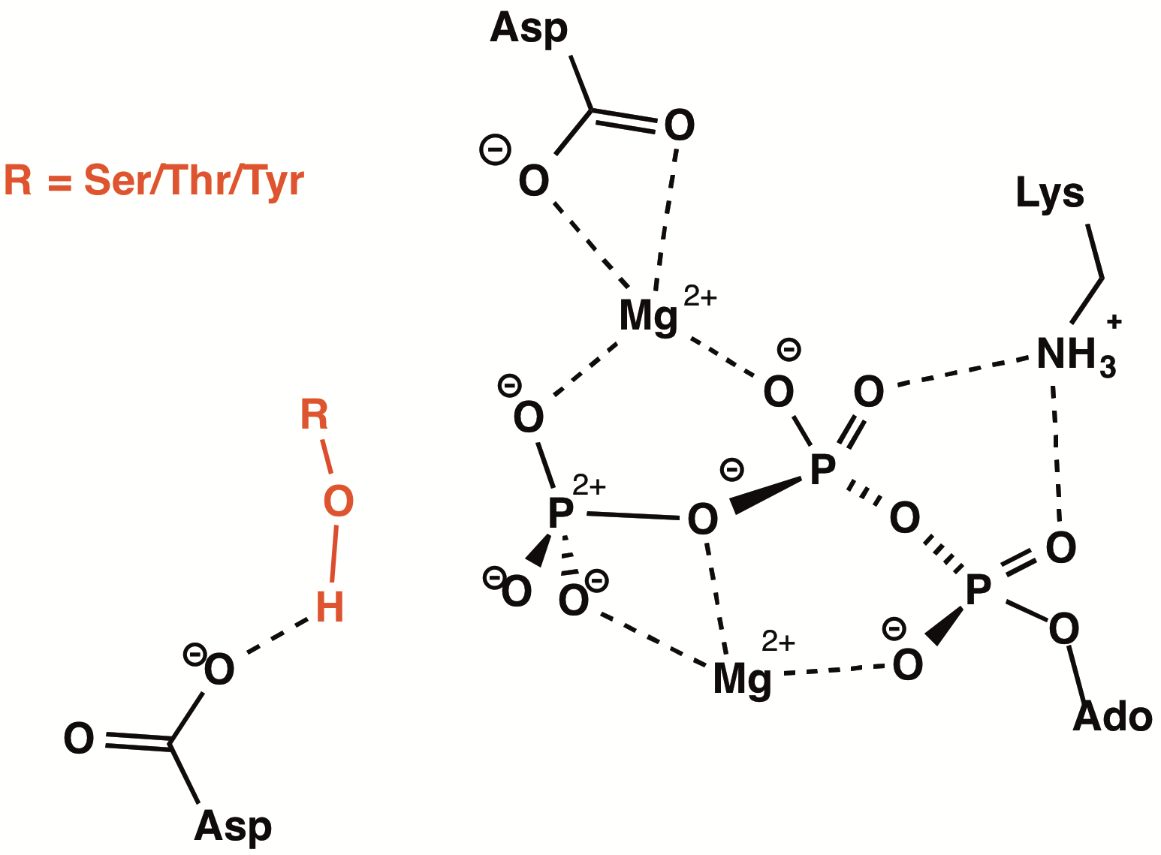

Figure 1.6: Representation of substrate, ATP and Mg²⁺ binding in a protein kinase active site, with interactions of key catalytic residues.

Role of catalytic aspartate in catalysis

Protein kinases possess a conserved aspartate in the catalytic loop, whose essential role in catalysis has been established by mutational studies[20]. In crystal structures of kinase-substrate complexes, the γ-oxygen of this aspartate is within hydrogen bonding distance of the substrate hydroxyl. This implies that it performs a general base function in catalysis, enhancing the nucleophilicity of the substrate by deprotonation. Hydrogen-bonding of the substrate hydroxyl to this aspartate may also help to position it- for in-line attack.

Activation of protein kinases

In order for many cellular processes to function effectively there must be a mechanism for spatial and temporal regulation that can switch ‘on’ and ‘off’ protein kinases. One of the most common regulatory mechanisms is through phosphorylation (and dephosphorylation) of particular residues in the activation loop[21]. Phosphorylation at the activation loop causes the kinase to switch to its catalytically active conformation, and current evidence for the structural mechanism is largely based on crystal structures of active versus inactive protein kinases. Furthermore it is well established that the DFG motif switches conformation between the active and inactive states (‘in’ vs ‘out’ position). The number, nature and position of phosphorylation sites in the activation loop is variable; for example cAPK has a single threonine[22] whilst the MAP kinases have a threonine and tyrosine (TXY motif), MAP2Ks have two serine/threonine residues, and insulin receptor kinase has three tyrosines[23]. However in general, one phosphorylation site occupies a central position in the activation loop, and in the active state this phosphate forms an ion pair with the arginine of the HRD motif. To support this, sequence comparison reveals that all protein kinases that are regulated by activation loop phosphorylation possess a conserved arginine residue immediately preceding the catalytic base; whereas many kinases that are not regulated by phosphorylation do not possess this arginine. This interaction is likely to promote reorientation of the DFG motif to the catalytically active ‘in’ position. The phosphoaminoacid also commonly interacts with basic residues in the N-lobe αC-helix; this causes a rotation of the two lobes towards each other, so that the active kinase adopts a more closed conformation relative to the inactive form.

Protein phosphatases

Protein phosphatases catalyse the removal by hydrolysis of a phosphate group from a protein side-chain to form inorganic phosphate. They employ either a 1 or 2-step mechanism and not all are metal dependent. Protein phosphatases can be tyrosine specific, serine/threonine specific or dual specificity, and fall into three main groups according to catalytic mechanism.

Metal-dependent (PPP/PPM) phosphatases

Serine/threonine specific phosphatases are predominantly made up of the PPP and PPM families. The PPP family includes PP1, PP2A, PP2B, PP4 and PP5, and the PPM family includes PP2C and pyruvate dehydrogenase[24]. These all go through a single step mechanism of direct nucleophilic attack by hydroxide on the substrate phosphoryl group, where the hydroxide ion is stabilized by coordination to two catalytic metal ions (Figure 1.7). Whilst all PPP/PPM phosphatases are metal dependent, the identities of the metal ions vary between family members. For example PP1 (a prototype PPP family member) has Mn²⁺ and Fe²⁺ in its active site[25], PP2B has Fe³⁺ and Zn²⁺ in its active site and PPM family members are Mn²⁺ or Mg²⁺ dependent. The metal ions are coordinated by three histidines, two aspartates and an asparigine and these residues are conserved across the PPP family. Another conserved histidine residue is thought to act as general acid by protonating the serine or threonine leaving group.
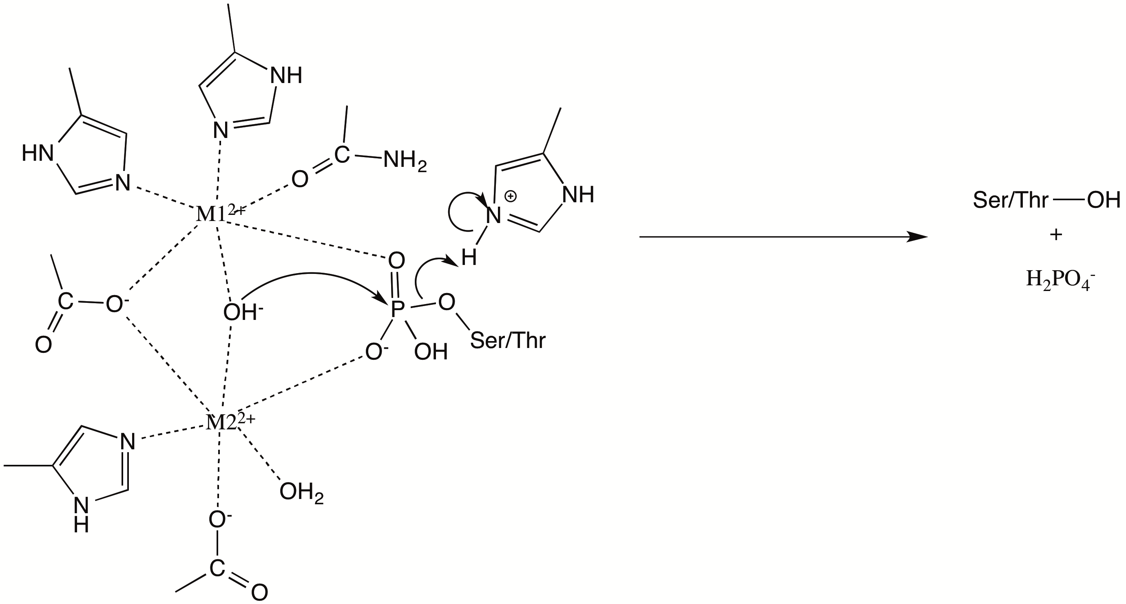
Figure 1.7: Catalytic mechanism of the PPP phosphatase family with the metal coordination shown.

Each PPP holoenzyme consists of a catalytic subunit associated with a regulatory subunit. The catalytic subunit adopts a conserved fold consisting of a β-sandwich wedged between two α-helical domains, with the active site located at the three-way joint. The number of catalytic subunits encoded in the human genome is small (approximately 30) considering the number of serine/threonine kinases. However each of these may associate with a large number of possible regulatory subunits. Interaction with the regulatory subunit is likely to confer substrate specificity on the phosphatase and/or target it to specific subcellular compartments.

Cysteine-based phosphatases

The protein tyrosine phosphatase (PTP) family, which also includes dual specificity phosphatases, uses a cysteine-based mechanism[26]. They are characterized by a conserved HCXXGXXR(S/T) catalytic motif that is termed the P-loop. The mechanism is a two-step process involving initial nucleophilic attack by the catalytic cysteine on the phosphorylated substrate to generate a cysteinyl-phosphate intermediate, and subsequent attack by water to release inorganic phosphate and regenerate the active enzyme (Figure 1.8). The conserved arginine in the catalytic motif coordinates to two phosphoryl group oxygens and is essential for both substrate binding and catalysis. The conserved histidine contributes to a low pKa value of the catalytic cysteine (through a network of hydrogen-bond interactions), enabling it to act as a nucleophile in the first step. A conserved aspartate residue (located 30-40 residues away from the catalytic motif) is also essential for catalysis. This serves as a general acid (protonates substrate leaving group) in the first step, and is likely to act as general base (deprotonating the incoming water molecule) in the second step. The mechanism is independent of metal cations.

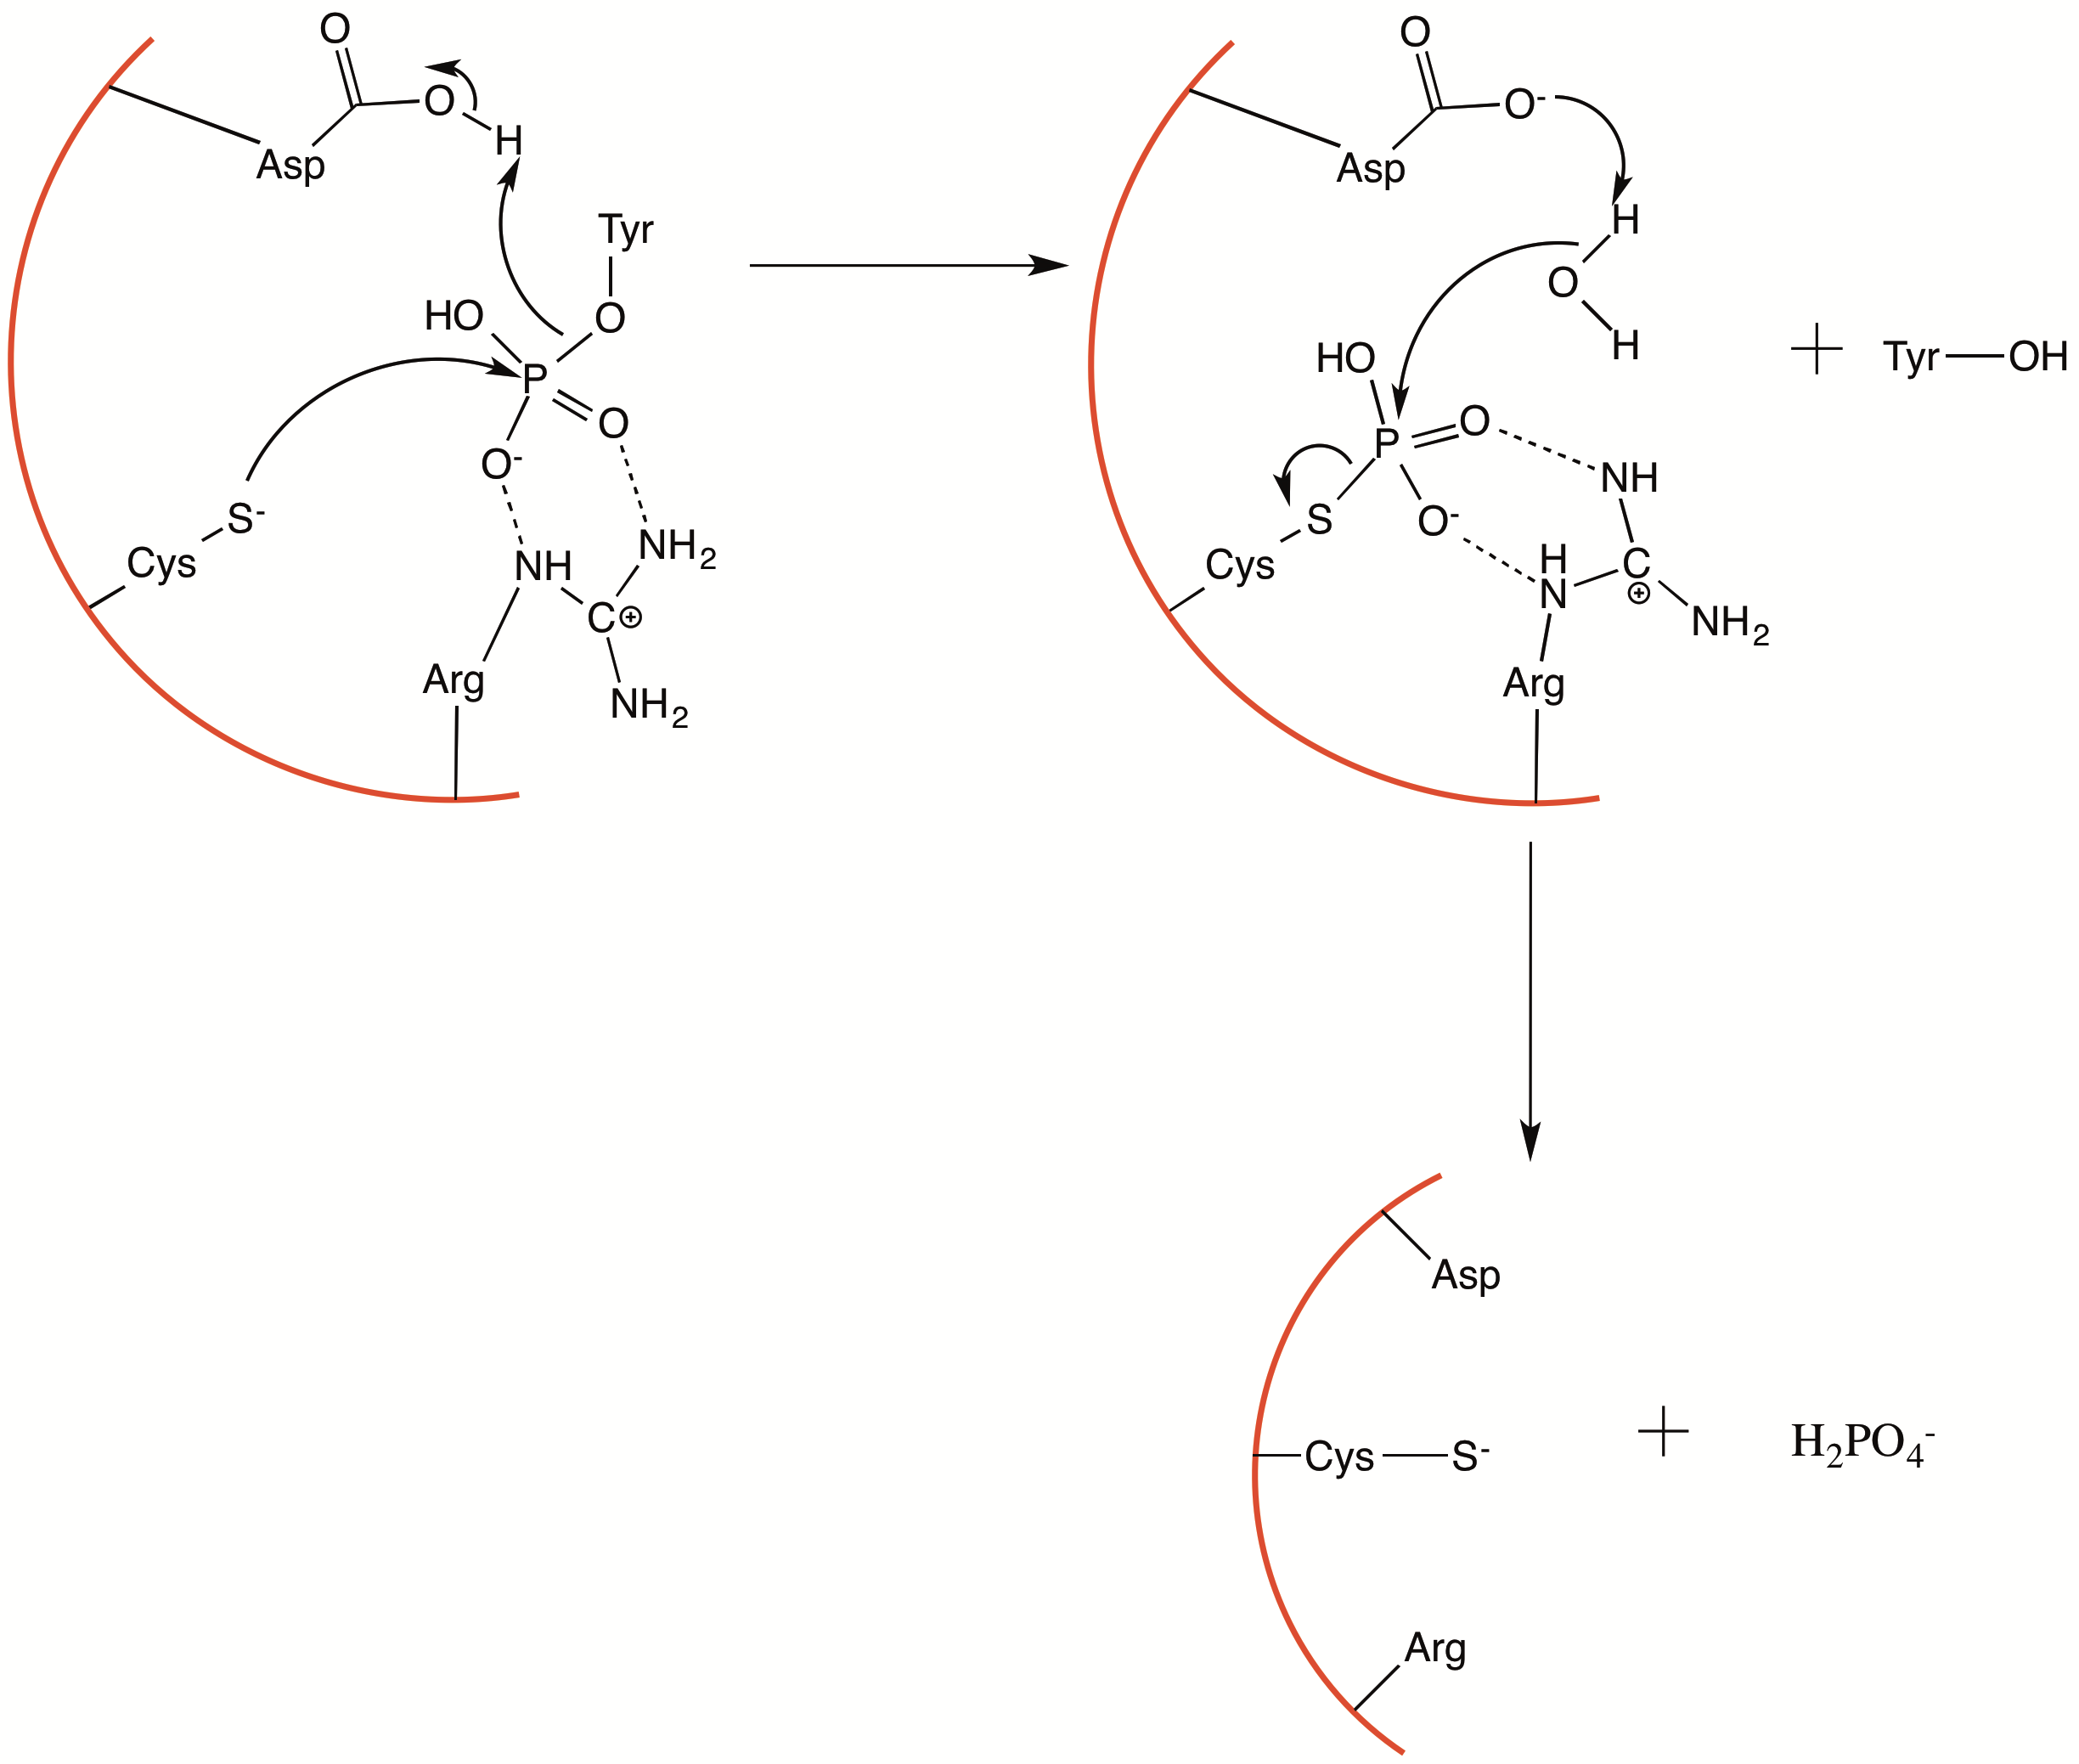

Figure 1.8: Catalytic mechanism of PTP family including dual specificity phosphatases

Dual specificity phosphatases are found to possess shallower active site clefts than the tyrosine specific phosphatases[27]. This implies that specificity for tyrosine may be derived from a deeper active site cleft being unable to accommodate shorter phosphoserine or phosphothreonine residues.

Aspartate-based phosphatases

A third group of phosphatases go through a mechanism that utilizes a nucleophilic aspartate. These comprise members of the HAD superfamily of phosphoryl transfer enzymes[28]. They catalyse the reaction by a two-step mechanism, involving formation of an aspartyl-phosphate intermediate then subsequent attack by water to form inorganic phosphate and regenerate the active enzyme (Figure 1.9). They are characterized by a DXDX(T/V) catalytic motif. The first aspartate in this motif acts as the nucleophile, and the second aspartate is likely to function as both general acid and general base. A catalytic Mg²⁺ ion coordinates to both aspartates.

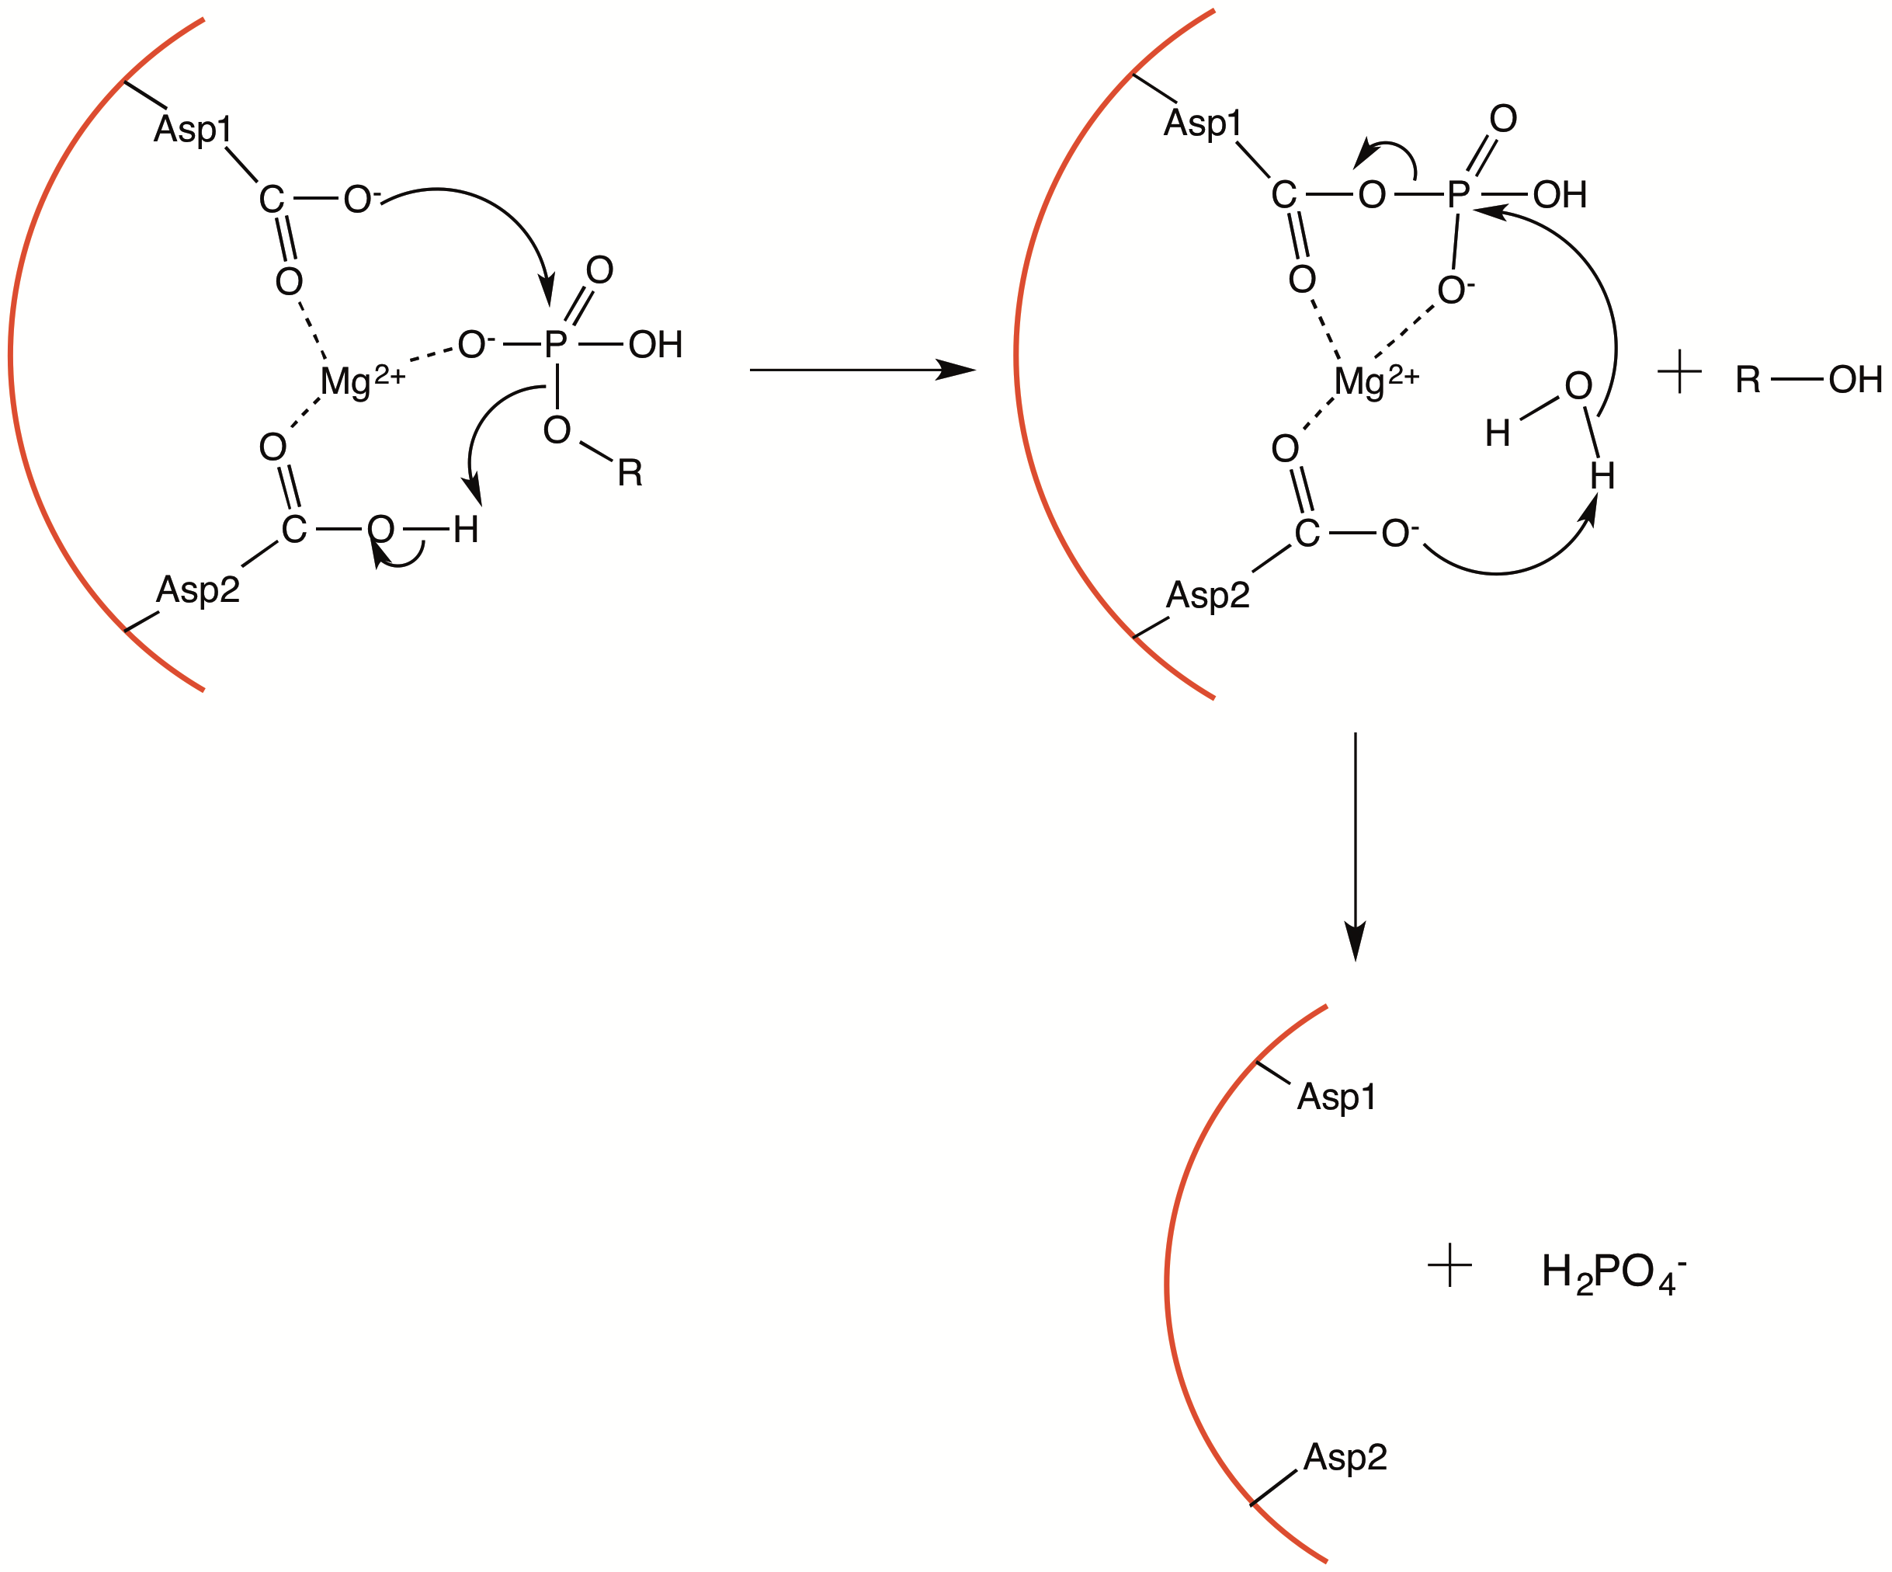

Figure 1.9: Catalytic mechanism of aspartate-based phosphatases

Transition-state analogs of phosphoryl transfer enzymes

In order to understand the mechanism of enzyme-catalysed phosphoryl transfer, the nature of the transition-state must be known. Transition-states are by definition high in energy and therefore they cannot be isolated and studied directly. However so-called transition-state analogs (TSA’s) have become a useful tool for indirectly studying the structure of the transition state. A TSA is a structural mimic of the enzyme-substrate complex in the proposed transition-state, that is chemically unreactive. For the phosphoryl transfer reaction, the scissile phosphate group (PO₃⁻) in the transition-state adopts a trigonal bipyramidal conformation with axial coordination by the incoming and leaving oxygen atoms. A corresponding transition state analog would replace this scissile phosphate with a non-reactive group that mimics its charge or geometry and preferably both.

Metal fluoride TSA’s

It has been established that phosphoryl transfer enzymes can form TSA complexes in which the scissile phosphate group is substituted by a metal fluoride moiety, and there are currently over 80 high-resolution structures of metal fluoride containing TSA complexes. These are generally assigned as either AlF₄⁻ or MgF₃⁻, suggesting that the anionic charge of the PO₃⁻ must be preserved in a transition state mimic. MgF₃⁻ but not AlF₄⁻ also preserves the trigonal planar geometry of the PO₃⁻ moiety. However the preference for AlF₄⁻ over AlF₃ species suggests that preservation of anionic charge is prioritized over geometry in a TSA.
The x-ray crystal structure of cAMP-dependent protein kinase (cAPK) catalytic domain in complex with ADP, a metal fluoride and a 20-residue serine-containing substrate peptide (SP20)[29] represents the first case of a protein kinase TSA complex being characterized. As both magnesium and aluminium species were present in the crystallization buffer there was originally some ambiguity as to the identity of the metal fluoride species. Originally assigned as an AlF₃ moiety axially coordinated by oxygens of the ADP β-phosphate and the P-site serine, however closer inspection of the metal-oxygen bond lengths indicate that it is in fact predominantly a MgF₃⁻ moiety. In solution cAPK-ADP-SP20 can similarly form a TSA complex of either AlF₄⁻ or MgF₃⁻[30], the preference for which depends on pH: as pH increase above neutrality then AlF₄⁻ species is progressively displaced by MgF₃⁻ due to precipitation of aluminium hydroxide species. An example of particular relevance here is the determination of a TSA complex in solution between MEK6, ADP, AlF₄⁻ and substrate kinase p38α[31] (no MgF₃⁻ TSA complex was observed). This also represents the only known TSA complex of a dual specificity protein kinase to date. Another example is for cyclin-dependent-kinase (CDK)2-cyclin A (CDK2 is a serine/threonine protein kinase regulated by binding to cyclin subunit), in which a MgF₃⁻ TSA complex with ADP and substrate peptide has been determined by crystallography[32].
Similar behaviour has been observed for other phosphoryl transfer enzymes, notably β-phosphoglucomutase (PGM) and phosphoglycerate kinase (PGK). In each of these cases both AlF₄⁻ and MgF₃⁻ TSA complexes have been shown to form in solution by ¹⁹F NMR, although the AlF₄⁻ complex is the dominant species at equal Mg and Al concentrations and neutral pH, and there is no evidence for an AlF₃⁰-containing TSA complex.
So far studies of metal fluoride TSA’s of phosphatases have been more limited, the most notable example being phosphoserine phosphatase (PSP). PSP is an aspartate-based phosphatase, and as well as representing a good model for other family members, it is physiologically crucial as the rate-limiting enzyme in serine biosynthesis. For example D-serine (synthesized directly from L-serine) is a co-agonist of the NMDA receptor in the mammalian brain[33], and PSP is a likely regulator of steady-state D-serine levels. The reaction pathway of PSP has been characterized in detail through crystallographic ‘snapshots’ of the various stages. The TSA structure used to mimic the transition-state[34] of both catalytic steps (Figure 1.10) was assigned as a PSP-AlF₃ complex, however it is more likely to be PSP-MgF₃⁻ since this retains the charge of the phosphate. The phosphoaspartate intermediate is difficult to study directly because of its lability and so was mimicked by a PSP-BeF₃⁻ complex. The TSA complex has significantly shorter metal-oxygen bond lengths compared to the reaction starting-point, implying that phosphoryl transfer in one or both steps is associative.

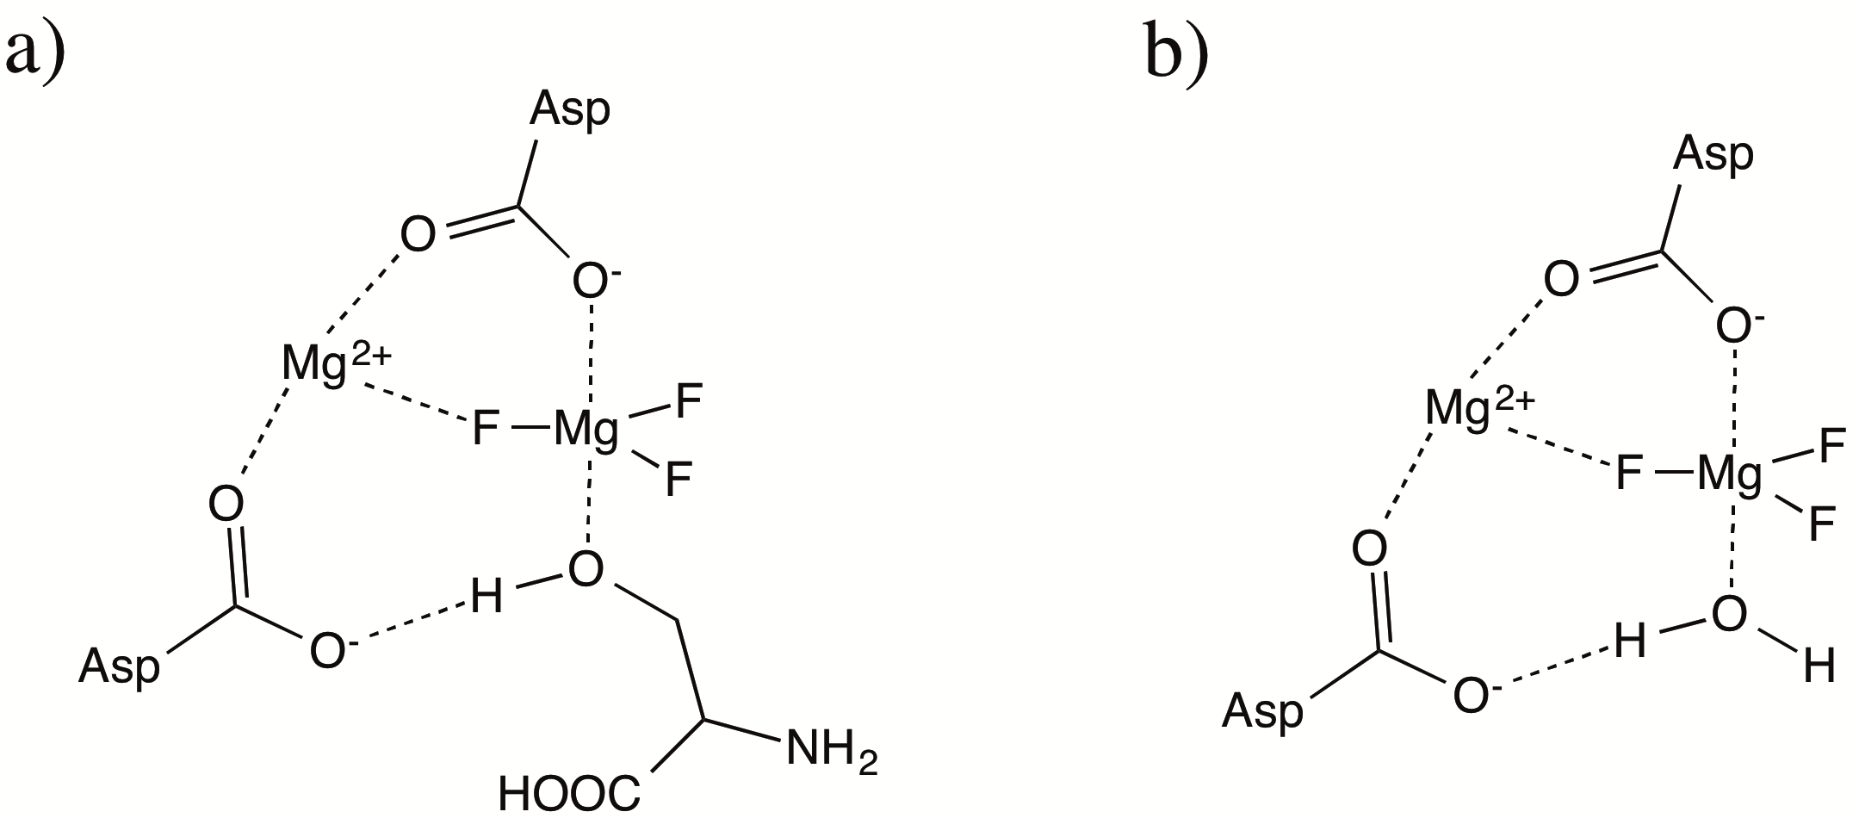

Figure 1.10: Metal fluoride TSA’s mimicking a) first phosphoryl transfer step (formation of aspartyl-phosphate intermediate), b) second phosphoryl step (hydrolysis by water) for PSP. Only the crystal structure of b) was determined, serine was modeled into the active site for a).[34]

Another example is Fcp1, also an aspartate-based phosphatase, which dephosphorylates particular serine residues in RNA polymerase II C-terminal domain (CTD). During the transcription cycle the CTD undergoes a series of serine phosphorylation and dephosphorylation events, and so Fcp1 plays a role in regulating transcription. Structures of Fcp1-BeF₃⁻-Mg²⁺ complex (mimicking the phosphoaspartate intermediate) and of Fcp1-AlF₄⁻-Mg²⁺ complex (mimicking the transition-state of the hydrolysis step) were characterized[35]. Comparison between the geometries of the two structures suggests an associative-like mechanism for the hydrolysis step.

Vanadate-based TSA’s

Vanadates are potentially a good alternative to metal fluorides for studying the transition-state of various phosphoryl transfer enzymes. The vanadate moiety (VO₃⁻) can covalently bond to two apical ligands in an approximately trigonal bipyramidal geometry, and so conserves both the charge and geometry of the transition-state. The main disadvantage of using vanadate compared to metal fluorides is that it is not simple to probe by NMR.
In the PDB there are many crystal structures of vanadate-bound phosphatases, several of which are reported as TSA’s. A vanadate TSA complex for hydrolysis of the phosphoseryl intermediate in the alkaline phosphatase reaction has been determined[36], as has one for hydrolysis of the phosphohistidine intermediate in the rat acid phosphatase reaction[37]. In terms of protein phosphatases, TSA complex crystal structures have been reported for both catalytic steps of the cysteine-based phosphatase PTP1B[38]. In the first TSA, vanadium is axially coordinated by the sulfur atom of the catalytic cysteine and tyrosine hydroxyl of a substrate peptide (DADEYL). In the second TSA (obtained from lowering the peptide to vanadate concentration ratio) vanadium is axially coordinated to a water molecule instead of tyrosine (Figure 1.11). These structures show, in addition to interactions with the catalytic arginine and aspartate side-chains, that the nonbridging vanadate oxygens form hydrogen-bonds to backbone amide groups of the P-loop. Also the second TSA shows an interaction between the incoming water oxygen and a glutamine side-chain, which is rotated relative to its position in the first TSA, confirming that this glutamine residue is required for positioning of the water nucleophile in the second catalytic step.

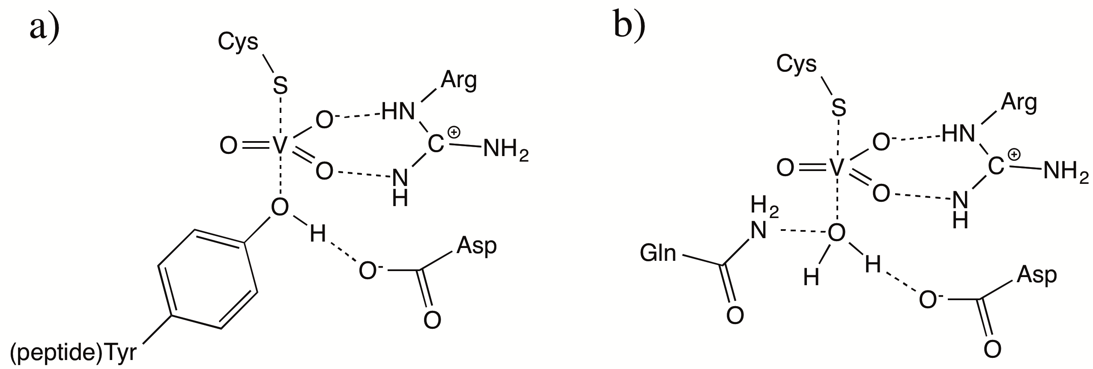

Figure 1.11: Vanadate-based TSA’s mimicking a) first phosphoryl transfer step (formation of cysteinyl-phosphate intermediate), b) second phosphoryl transfer step (hydrolysis by water) for the phosphatase PTP1B.

The extent to which vanadate mimics the true transition-state in PTP1B has been questioned on the basis that the V-O bond order indicates an associative transition-state, rather than a dissociative-like transition-state predicted for phosphoryl transfer[39].

MAP kinase pathways

The related MAP kinases and their upstream activators are ubiquitous components of signal transduction in eukaryotic cells[40, 41]. They regulate a range of downstream processes in the cytoplasm, nucleus, cytoskeleton or membrane, and are activated upstream by one or more of a range of extracellular stimuli, such as cytokines, hormones and growth factors. These stimuli mediate activation of the pathway via a transmembrane receptor, such as receptor tyrosine kinase or G-protein coupled receptor[41]. The multiple MAP kinase pathways present in cells are illustrated in Figure 1.12.

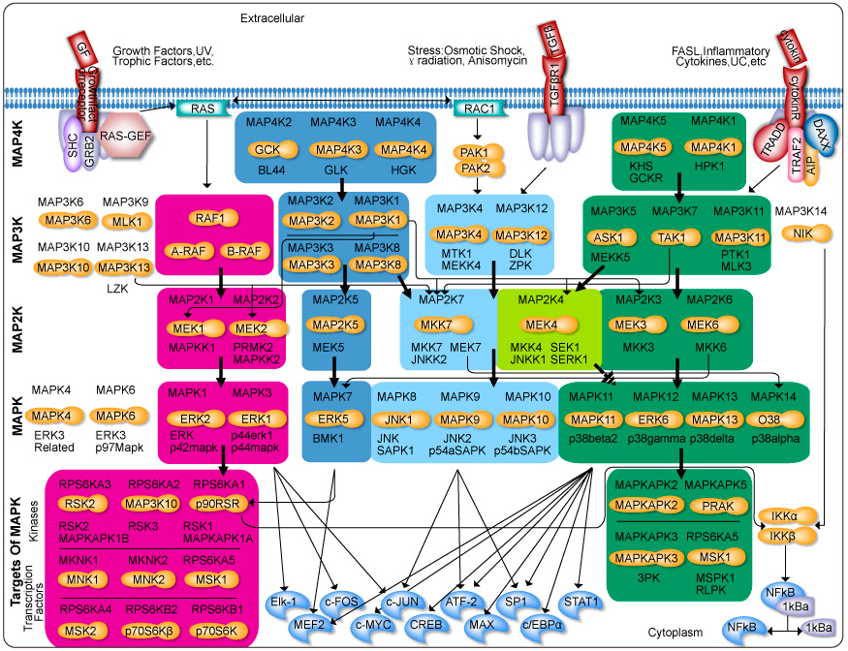
Figure 1.12: MAPK pathways and their activation and downstream targets (taken from www.genecopoeia.com)

Each pathway mediates distinct signalling events and is activated by different sets of stimuli. It consists of a core series of three kinases[42], which activate sequentially by phosphorylation when the pathway is switched on. The core series of three kinases has conserved features. The most downstream of these (MAPK) is activated by dual phosphorylation in a TXY motif. The dual specificity MAPK-activating kinase (MAP2K) is itself activated by phosphorylation at two serine or threonine residues. For MEK3 and MEK6, double mutation of these residues to aspartate or glutamate (mimicking the negative charge) is found to result in a constitutively active kinase[43]. The MAP2K-activating kinase (MAP3K) is a serine/threonine kinase that generally activates by autophosphorylation upon binding to an upstream regulatory protein, or phosphorylation by a further upstream kinase. The activated MAPK can either phosphorylate a further downstream kinase or can translocate to the nucleus for phosphorylation of a transcription factor.
The three main MAPK groups are the ERK, JNK and p38 isoforms, and each of these are activated by distinct sets of upstream kinases. The kinases are generally freely diffusing in the cell cytoplasm, however it is normally desirable to have high signalling specificity in order to avoid unintended ‘cross-talk’ between different pathways. The marked specificity of MAP2K’s for particular MAPK’s is thought to be the primary factor responsible for the selective activation of downstream targets, and this is due to interaction between allosteric docking regions described in Section 1.6.4. Scaffolding proteins may also play a role in ensuring specificity. Nevertheless there is thought to be a small degree of cross-talk between the different pathways, as shown in Figure 1.12, which may in some cases serve an intended physiological function.

Advantage of a three-component signalling pathway

Reasons why organisms have evolved to use a three-kinase cascade for signalling, rather than one or two kinases, are not immediately apparent. In the past signal amplification was put forward a possible reason, however there is a lack of evidence to support this hypothesis. A more plausible reason is that such a three-level cascade is capable of converting a graded input into a switch-like response. This is likely to be physiologically beneficial for the regulation of downstream cellular processes (eg. mitogenesis) that must switch between discrete ‘on’ and ‘off’ states. This theory is supported by stimulus-response relationships that are predicted from the rate equations, given a wide range of cytosolic concentrations and K_{M} values for each of the enzymes and reactions in the cascade[44, 45]. Whereas the predicted MAP3K activity follows a hyperbolic profile typical of an enzyme following Michaelis-Menten kinetics, MAP2K activity follows a sigmoidal profile and MAPK activity follows a sigmoidal profile that is steeper than the MAP2K. Therefore the response curve becomes increasingly ‘switch-like’ as the cascade is descended.

MAPK dual phosphorylation mechanism

At least two possible mechanisms of dual phosphorylation can be envisaged. In a ‘distributive’ mechanism, the singly phosphorylated MAPK is released before rebinding to another MAP2K enzyme; whereas in a ‘processive’ mechanism the MAP2K phosphorylates a MAPK molecule on both sites in a single binding event. It has been shown from in vitro studies that MEK1 dually phosphorylates ERK2 by the distributive mechanism[46, 47], because the concentration of ERK-1P is found to exceed the amount of MEK1, and the rate of ERK-1P to ERK-2P conversion increases with MEK1 concentration. This is also believed to be the case for the other MAP kinases including MEK6 phosphorylating p38α. A distributive mechanism of dual phosphorylation is also found to contribute to the switch-like response curve of MAPK activity[44, 45]; whereas a processive mechanism would result in the more typical hyperbolic response.

Signal regulation by phosphatases

In order for MAP kinase pathways to function effectively in cells so that they induce the desired physiological response at the appropriate time, both the magnitude and duration of the MAPK activation must be controlled. This requires a mechanism for negative regulation, which is achieved by the action of phosphatases. Phosphatases can in principle act at any step in the cascade, and it is likely that the overall MAPK activation level is controlled by a number of different phosphatases present in the cell cytosol. However the major source of regulation is through dephosphorylation of the MAPK by a subfamily of phosphatases specifically targeting MAPK’s (MAPK phosphatases, MKP’s). MKP’s are dual specificity as they dephosphorylate both tyrosine and threonine residues of the MAPK, although only threonine dephosphorylation is required for full MAPK inactivation[48]. In cells the expression of MKP’s is not constant but induced by the activity of particular MAPK’s, which may either be the MKP substrate or from a different pathway[49]. This shows that MKP’s play a key role in dynamic regulation of MAPK activity through negative feedback processes.
MKP’s utilize a cysteine-based mechanism that is analogous to that of protein tyrosine phosphatases[26, 27]. A number of MKP’s have been identified and characterized[50-53], and they fall into distinct groups according to substrate specificity. For example MKP3 is specific for ERK2[54] whereas MKP5 and MKP7 can dephosphorylate JNK and p38 isoforms but not ERK[51, 52]. Their substrate specificity is largely due to binding of their N-terminal docking motif with the docking groove of the corresponding MAPK. Furthermore MKP3 is found to have enhanced catalytic activity upon binding to ERK2, as shown by an increased hydrolysis rate of p-nitrophenyl phosphate[55, 56], although catalytic activation upon binding does not seem to be a general feature of all MKP’s.

MAPK docking interactions

For the MAPK’s and their upstream activators, allosteric interactions between complementary docking motifs on the two kinases, and not local sequence, is the primary factor that determines enzyme-substrate binding affinity. MAP2K’s possess a linear N-terminal docking motif of 15 to 20 residues, containing a consensus sequence (R/K-(X)₂₋₆-φ_{Α}−X-φ_{Β})[57]. This motif is also found in other MAPK-interacting proteins (substrates and inactivating phosphatases). The docking motif interacts with an allosteric docking groove on its cognate MAPK. The nature of the docking groove and docking motif varies between MAPK groups, and therefore docking interactions are a key factor that help to ensure signalling specificity. The docking groove of the MAPK consists of a common docking (CD) domain[58] and an additional docking groove that recognizes the φ_{Α}Xφ_{B} hydrophobic motif. The CD domain comprises several acidic residues that interact with basic residues of the complementary docking motif.

p38α pathway

Core components of the p38α pathway are shown in Figure 1.13. p38 pathways play an essential role in regulating many cellular processes including inflammation, cell differentiation, cell growth and apoptosis. p38α kinase substrates include MAPK activated protein kinase (MAPKAP) 2/3 and p38-regulated/activated kinase (PRAK), both of which can in turn activate heat-shock protein (Hsp) 25/27. Transcription factors activated by p38α include ATF2 and MEF2A.

Figure 1.13: Schematic representation of p38α MAP kinase pathway

The primary means of p38α activation is dual phosphorylation by an upstream MAP2K, either MEK6 or MEK3 in vivo[43] although MEK4 can also phosphorylate p38α in vitro[59]. However two alternative activation mechanisms have been identified. The first is p38α autophosphorylation induced by interaction with the Tak1-binding protein (TAB1)[60]. The second that occurs only in T-cells is phosphorylation of p38α Y323 residue by the TCR-proximal tyrosine kinase Zap70, which induces its autophosphorylation[61].

Structure and activation of p38α MAP kinase

p38α adopts a structure that is largely preserved amongst all MAPK members despite them mediating distinct functions in vivo. Their distinguishing features are a docking groove, located on the opposite face to its active site, which mediates interactions with an upstream kinase or phosphatase. They also possess an additional feature in the C-terminal lobe termed the MAPK insert, which is a region of two α-helices connected by a short loop. In p38 this has particular significance because it forms a hydrophobic binding site for lipidic molecules[62], and there is evidence that lipid binding to p38 may regulate its activity. There are numerous crystal structures of various MAP kinases, in either non-phosphorylated or dually phosphorylated forms, including both forms of p38α.

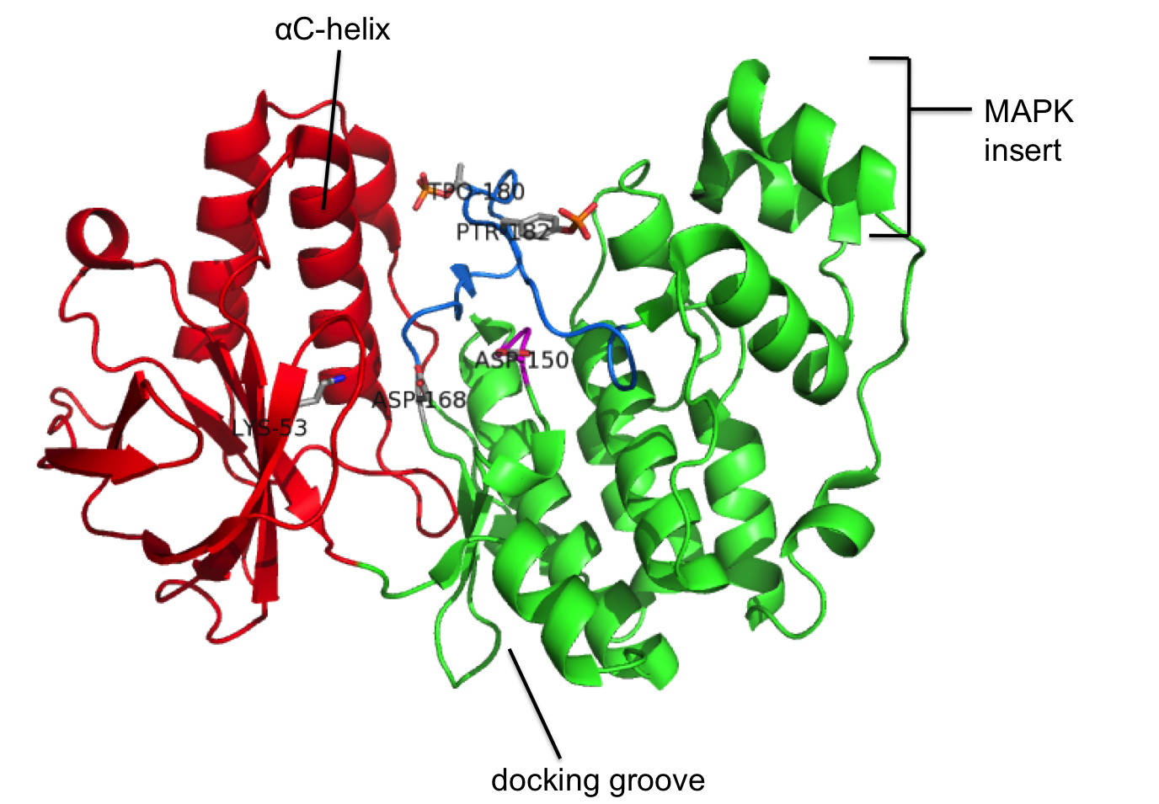
Figure 1.14: Crystal structure of dually phosphorylated p38α (PDB: 3PY3). N-terminal domain shown in red, C-terminal domain in green, activation loop in blue, catalytic loop in magenta. Catalytic lysine (K53), general base aspartate (D150) and DFG aspartate (D168) are labelled.

Comparing between phosphorylated and non-phosphorylated p38α shows that in the active form[63], the phosphates of Thr180 and Tyr182 interact with a number of basic residues. The phosphothreonine coordinates to Lys66, Arg67 and Arg70 in the αC-helix, Arg149 adjacent to the catalytic base, and Arg173 in the activation loop; the phosphotyrosine forms an interaction with His228 (Figure 1.15). As a result of these interactions the two lobes are rotated towards each other by 5 degrees in the active form[63].

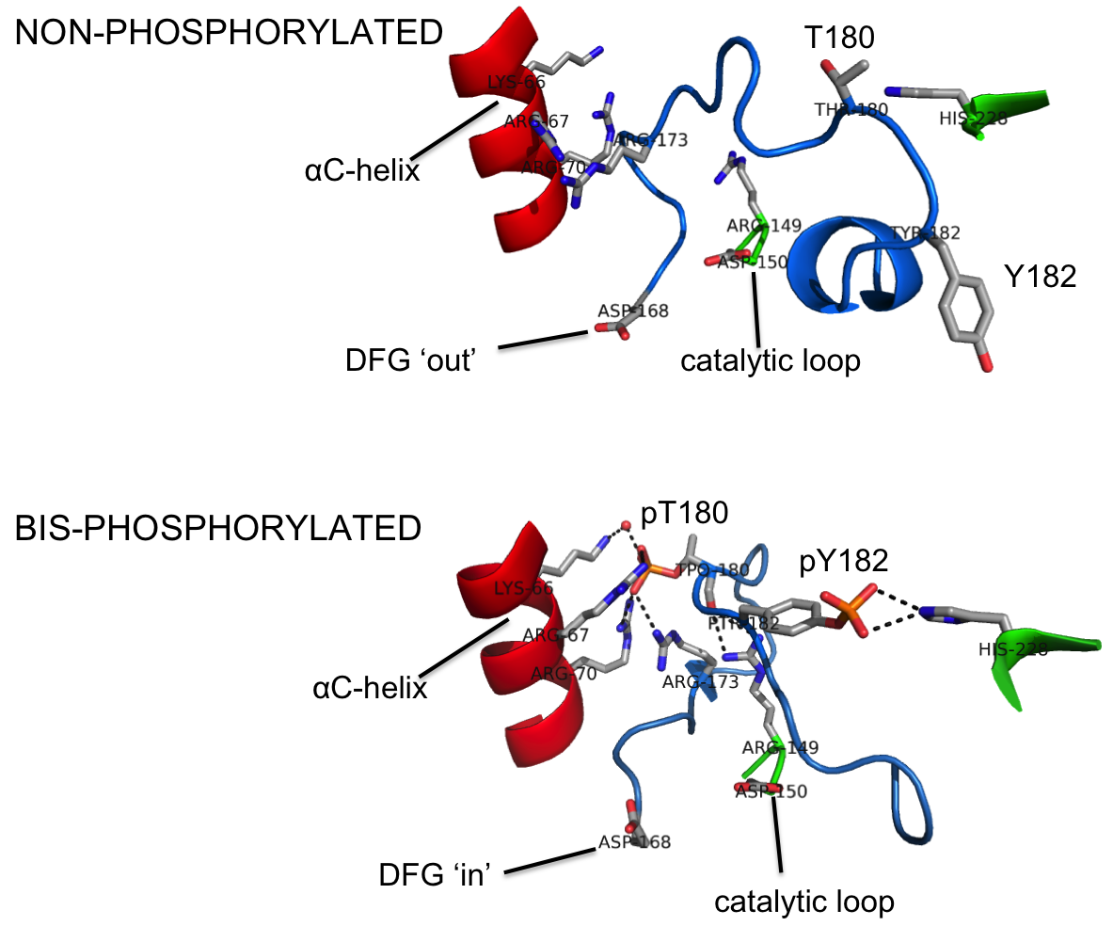

Figure 1.15: Close-up of the activation loop region of p38α in its inactive form (PDB: 1P38) and active form (PDB: 3PY3). Activation loop is shown in blue, and rotation of the DFG aspartate between the ‘in’ and ‘out’ conformations is illustrated.

Structure and activation of MEK6

The aligned sequences of MEK6 with p38α (Figure 1.16) shows that they have do not have significant sequence homology (27%).
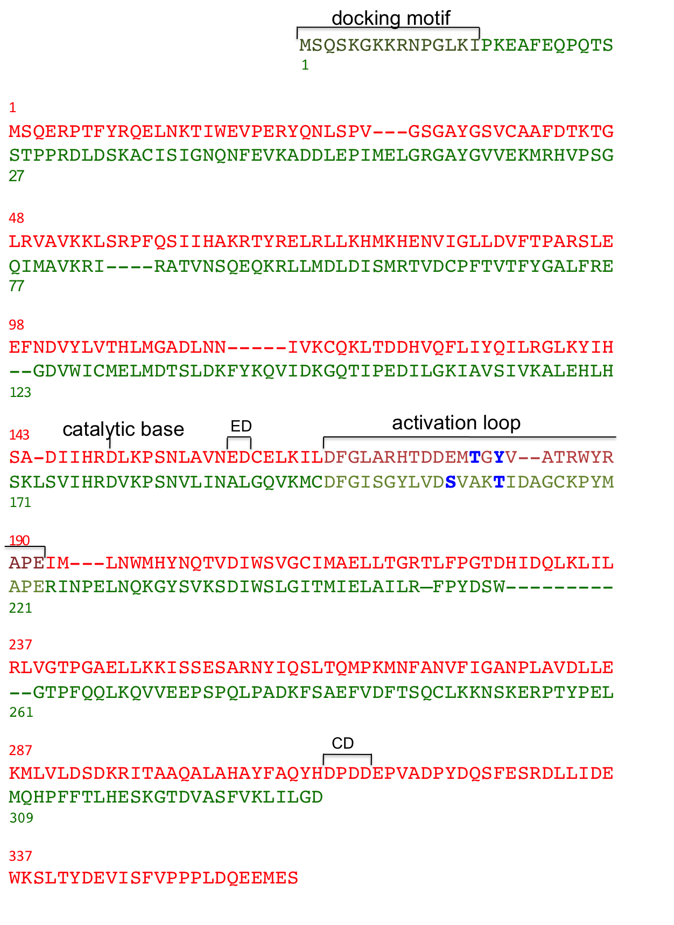
Figure 1.16: Aligned sequences of human p38α (red) and human MEK6 (green). Activation loop regions, catalytic base, docking motif of MEK6 and docking sites of p38α (CD domain – residues 313, 315, 316, ED motif – residues 160, 161) are indicated. Activation sites shown in blue.

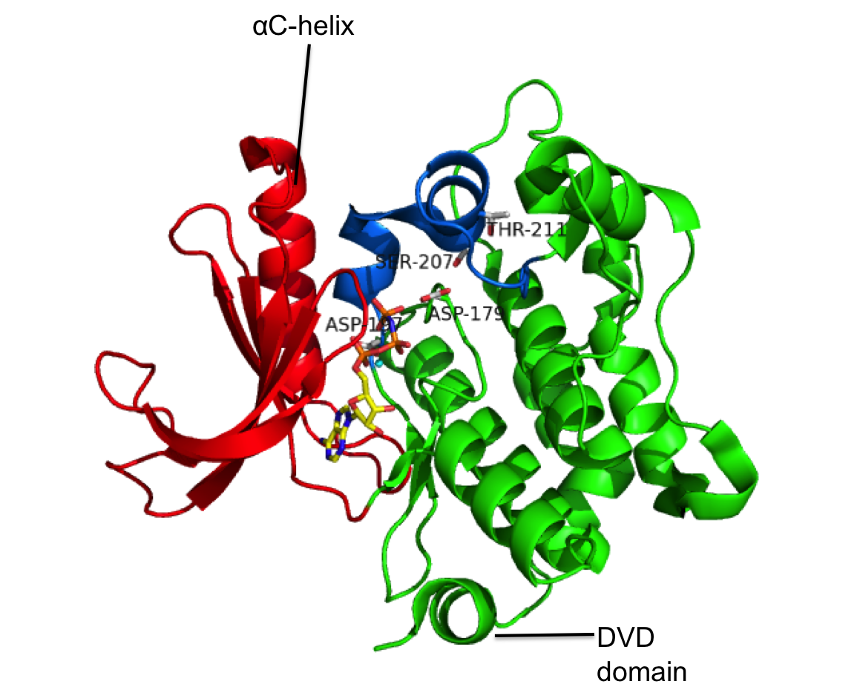
In common with other MAP2K’s, MEK6 possesses a linear N-terminal docking motif for binding to the MAPK docking groove, and a C-terminal docking site for binding to the upstream MAP3K, termed the DVD domain[64]. Due to a lack of structural data for active MAP2K’s, less is known about their activation mechanism compared to MAPK’s, however structures of inactive forms indicate that they may adopt autoinhibited states. A crystal structure of full-length non-phosphorylated MEK6 complexed to AMPPNP[65] shows the γ-phosphate is concealed from bulk solvent by two short α-helices in the activation loop (spanning residues 200-213), and therefore may be inaccessible to nucleophiles (Figure 1.17). On the basis of this, it was proposed that dual phosphorylation causes the activation loop to become disordered and opens up the active site for substrate access. In addition, a crystal structure of N-terminal truncated MEK6 in apo form, with phosphomimetic mutations S207D and T211D shows a partially disordered activation loop (unresolved from residues 208 to 216)[66]. However this structure reveals a homodimer whereby the N-terminal lobe of one subunit forms contacts with the N-terminal lobe of the other subunit. This dimer structure appears to stabilize a catalytically inactive conformation despite the phosphomimetic mutations. The activation loop and DFG motif seem to adopt a kinase-inactive configuration that prevents ion pair interaction between the catalytic Lys82 and an αC-helix aspartate. This indicates that deletion of the N-terminal docking motif prevents MEK6 from adopting its active conformation, or may indicate that ATP binding plays a role in activation.

Figure 1.17: Crystal structure of non-phosphorylated MEK6 bound to AMPPNP and Mg²⁺(PDB: 3VN9). N-terminal domain shown in red, C-terminal domain in green, activation loop in blue, catalytic loop in magenta, AMPPNP in yellow, Mg²⁺ in cyan. Disordered N-terminal docking motif is unresolved. General base aspartate (D179), DFG aspartate (D197) and phosphorylation sites are labelled.

Structures of non-phosphorylated MEK1 and MEK4[67, 68] suggest that this autoinhibition mechanism of MEK6 may not be preserved among other MAP2K’s.

Docking interactions of p38α

Crystal structures of activated and non-activated p38α in complex with a MEK3 docking peptide have been determined[69, 70]. These conformations are highly similar and distinct from the apo forms of active and inactive p38α, thus revealing that p38α adopts a ‘third’ conformation when bound to docking peptide. The residues Ile116 and Gln120 interacts with the LRI motif of the peptide, and a glutamate-aspartate motif (Glu160, Asp161) is also found to be required for binding (Figure 1.18)[71]. Associated with these interactions is a change in the orientation of helix D (residues 113-119) upon binding. The CD domain of p38α is formed by acidic residues Asp313, Asp315 and Asp316, but CD domain interactions are not apparent in these structures, probably because the complementary basic residues of the docking peptide are not structurally resolved. Peptide binding also induces disorder in the p38α activation loop, in both phosphoryated and non-phosphorylated forms, although how this long-range conformational change is brought about has not been established.

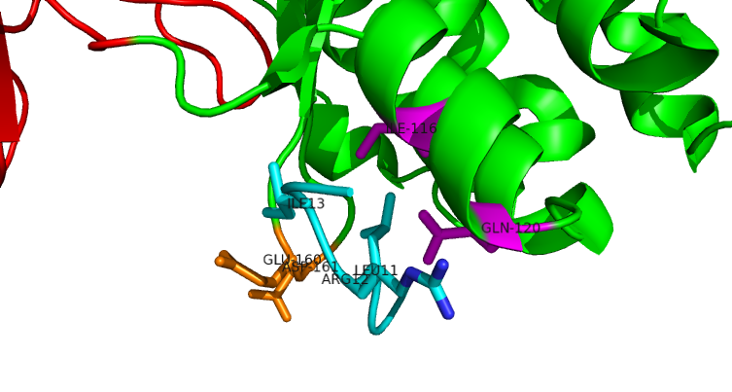
Figure 1.18: Crystal structure of inactive p38α complexed to an 18-mer MEK3b-derived peptide (SKGKSKRKKDLRISCNSK), showing a close-up of the docking groove. Only residues 8-15 of peptide are visible in stucture (PDB: 1LEZ). Docking peptide shown in cyan, ED motif in orange and residues I116/Q120 in magenta.

Thesis Aims

This thesis is based primarily on studies of MEK6 and p38α kinases, and aims to investigate the following hypotheses:

- Protein phosphorylation in signalling is highly reversible, and generally requires separate kinases and phosphatases for adding and removing the phosphate group. Phosphatases essentially catalyse the reverse kinase reaction but with water replacing ADP β-phosphate as the nucleophile, so it may be thought that the catalytic site is similar in both cases. Despite this protein phosphatases have very little sequence or structural homology with protein kinases. Based on an unexpected finding, the ability of MEK6 to dephosphorylate substrate and the nature of the catalytic site in this activity is investigated. Leading from this, the ability of other protein kinases to act as phosphatase is investigated.

- ATP is the normal phosphoryl donor for protein kinases, but in conditions of limited ATP availibility it may be beneficial to utilize ADP as phosphoryl donor. Furthermore if ADP can be used as a phosphoryl donor then this may present an alternative mechanism of MAPK dual phosphorylation. The ability of MEK6 and other protein kinases to phosphorylate using ADP is studied, and it is hoped to gain insight into how the enzyme active site can accommodate this.

Materials and Methods

Reagents

All standard chemicals were bought from Sigma, Melford Laboratory Supplies or VWR unless otherwise specified. Deionised water was provided by Sartorium Ariumn 611 VF ultrapure filtration system.

Production of competent cells

A single bacterial colony of the desired E. coli strain was innnoculated into 5-10 ml LB with the selective antibiotic, and incubated for 12 to 18 hours at 37°C with 230 rpm shaking. 0.4 ml of this culture was inoculated into 75 ml fresh LB with the selective antibiotic and incubated at 37°C with 230 rpm shaking. When OD(600nm)=0.3 the culture flask was placed on ice for 15 minutes. The suspension was centrifuged at 4000 rpm for 20 minutes at 4°C, and the supernatant removed. The cell pellet was resuspended in 25 ml RF1 buffer and placed on ice for 15 minutes. The suspension was centrifuged at 4000 rpm for 20 minutes at 4°C and supernatant removed. The cell pellet was resuspended in 6.25 ml RF2 buffer then placed on ice for another 15 minutes. The resultant solution was stored in aliquots at -80°C.
RF1:
160mM KCl, 50mM MnCl₂.4H₂O, 30mM K⁺(CH₃COO⁻), 10mM CaCl₂.2H₂O, 15% glycerol b/volume, pH adjusted to 5.8 by addition of acetic acid
RF2:
10mM MOPS, 20mM KCl, 75mM CaCl₂.2H₂O, 15% glycerol b/volume, pH adjusted to 6.8 by addition of NaOH
RF1 and RF2 buffers were filter sterilized and stored at 4°C.

Site-directed mutagenesis

Primer design

Oligonucleotides were purchased pre-purified from Eurofins in lyophilized form, then resuspended in TE buffer (10mM Tris-HCl pH 8, 1mM EDTA) to 1000ng/μl stock solution. Sequences given are 5’ to 3’ direction. Primers were designed to have complementary sequences, a minimum G/C content of 40% and no self-annealing properties.

MEK6 wild-type reversion:
1. GGCTACTTGGTGGACTCTGTTGCTAAAACAATTGATGCAGGTTGC
2. GCAACCTGCATCAATTGTTTTAGCAACAGAGTCCACCAAGTAGCC
MEK6_D179N:
1. TGTCATTCACAGAAACGTCAAGCCTTC
2. GAAGGCTTGACGTTTCTGTGAATGACA
p38_T180A:
1. CACACAGATGATGAAATGGCTGGCTACGTGGCCAC
2. GTGGCCACGTAGCCAGCCATTTCATCATCTGTGTG
p38_Y182F:
1. GATGATGAAATGACAGGCTTTGTGGCCACTAGGTGG
2. CCACCTAGTGGCCACAAAGCCTGTCATTTCATCATC
p38_T180A-Y182F:
1. gatgaaatggcaggcttcgtggcgactaggtgg
2. ccacctagtcgccacgaagcctgccatttcatc

PCR

PCR was carried out using reagents and protocol from the Stratagene Quikchange Mutagenesis kit. For each reaction, added 5μl (10X reaction buffer), 125ng primer 1 and 125ng primer 2 (from stock diluted to 100ng/μl), 10-50ng of the template plasmid, 1μl dNTP mix, diluted up to 50μl with ddH₂O and finally added 1μl PfuUltra DNA polymerase. Multiple reactions were set up with varying plasmid concentration. Ran in a thermal cycling machine (Techne Progene) using the following cycle:
Segment | No. of cycles | temperature /°C | Time
1 | 1 | 95 | 30 seconds
2 | 16 (single amino acid mutation)  18 (two mutations) | 95 | 30 seconds
2 | 16 (single amino acid mutation)  18 (two mutations) | 55 | 1 minute
2 | 16 (single amino acid mutation)  18 (two mutations) | 68 | 7 minutes

After cooling to room temperature, added Dpn1 restriction enzyme (1μl) to each sample and incubated at 37°C for 1 hour.

Agarose gel electrophoresis

Used to verify length of DNA fragments following PCR. Gel was formed by dissolving agarose (1% w/v) in TAE buffer (40mM Tris, 1.1% v/v acetic acid, 1mM EDTA, final pH 7.8) by heating, before adding GelRed nucleic acid gel stain and allowing to solidify. Samples were added to 6× loading buffer (0.25% w/v bromophenol blue, 0.25% w/v, 40% w/v sucrose) and run alongside a DNA ladder in TAE running buffer at 100V. Bands were subsequently visualized under a UV lamp.

Plasmid purification

Transformed 1μl of PCR product into XL1 Blue competent E. coli cells (50μl) using protocol described in 2.4.1. 275μl was plated onto LB-agar with Amp+Tet antibiotics. Single colony was inoculated into LB+Amp+Tet medium and incubated at 37°C for 12-16 hours, then centrifuged and the cell pellet retained. Qiagen QIAPREP Miniprep kit was used to isolate the plasmid in ddH₂O, which was sent for sequencing (Core Genomic Facility, Sheffield university) to verify the mutation. Plasmid concentration was calculated from its absorbance at 260nm (absorption coefficient is 0.02 (μg/ml)⁻¹cm⁻¹).

Protein expression and purification

Transformation

A 200μl aliquot of competent cells was thawed on ice, and 1μl of plasmid encoding the desired protein was added. The mixture was left on ice for 30 minutes, subjected to 42°C heat-shock for 45 seconds then placed for ice for 90 seconds. 350μl LB was added, the mixture was incubated at 37°C for 1 hour then varying volumes of the mixture were plated onto agar containing the selective antibiotics. Plates were incubated overnight at 37°C, and single colonies were inoculated into LB medium containing the selective antibiotics and incubated with shaking overnight at 37°C for a starter culture.

Culture medium

LB medium (per litre):
10 g Tryptone, 10 g NaCl, 5 g yeast extract
pH adjusted to 7.5 by addition of NaOH. Medium was sterilized by autoclaving.

Antibiotics (see specific protocol for which antibiotics were added):
Ampicillin (Amp)– Stored in ddH₂O at -20ºC. Added to 50μg/ml.
Chloramphenicol (Chl)– Stored in EtOH at -20ºC. Added to 34μg/ml.
Tetracycline (Tet)– Stored in MeOH at -20ºC. Added to 15μg/ml.
Kanamycin (Kan)– Stored in ddH₂O at -20 ºC. Added to 50μg/ml.

p38α specific protocol

Human p38α (wild-type or mutant, N-terminal His-tagged) encoded in pET15b vector was expressed in Rosetta pLysS E. coli cells grown in LB medium, with Amp+Chl antibiotics. After incubation at 37ºC with 240 rpm shaking, expression was induced by addition of 0.5 mM IPTG when OD(600nm)=0.8. Following induction, the culture was incubated for 16 h at 25ºC, then cells were harvested by centrifugation. The cell pellet was resuspended in lysis buffer (50mM HEPES pH 8.0, 200 mM NaCl, 2 mM β-mercaptoethanol, 20 mM imidazole) supplemented with 0.2 mM phenylmethylsulfonyl fluoride and EDTA-free protease inhibitor tablet. The cell suspension was sonicated and the resulting lysate was centrifuged (18krpm for 40 minutes at 4ºC). The resulting supernatant was filtered through a 0.2 μm membrane and loaded onto a Ni-NTA column (5ml Histrap FF, GE Healthcare) pre-equilibrated with lysis buffer. His-tagged p38α was eluted by applying a gradient of 20 mM to 300 mM imidazole over 100 ml, at 3ml/min flow rate. Fractions containing p38α were combined and exchanged into a buffer containing 25 mM HEPES pH 7.6, 50 mM NaCl, 2 mM DTT. The His-tag was cleaved by incubation with thrombin (2U/mg protein) at 4ºC for 20 h. The sample was further purified though a Q-sepharose column (Sigma) whereby the protein was eluted by applying a gradient of 50 mM to 600 mM NaCl over 150 ml at 2.5ml/min flow rate. Fractions containing p38α were combined and buffer exchanged to 50 mM HEPES pH 7.6, 150 mM NaCl, 2 mM DTT, 2 mM sodium azide. A final protein yield of 15 mg per litre growth culture was typically obtained.

MEK6 specific protocol

Human MEK6 (dd mutant or wild-type, N-terminal His-tagged) encoded in pET15b vector was expressed in Rosetta pLysS E. coli cells grown in LB medium, with Amp+Chl antibiotics. After incubation at 37ºC with 240 rpm shaking, expression was induced by addition of 0.5 mM IPTG when OD(600nm)=0.8. Following induction, the culture was incubated for 16 h at 25ºC, then cells were harvested by centrifugation. The cell pellet was resuspended in lysis buffer (50mM HEPES pH 8.0, 200 mM NaCl, 2 mM β-mercaptoethanol, 20 mM imidazole) supplemented with 0.2 mM phenylmethylsulfonyl fluoride and EDTA-free protease inhibitor tablet. The cell suspension was sonicated and the resulting lysate was centrifuged (18krpm for 40 minutes at 4ºC). The resulting supernatant was filtered through a 0.2 μm membrane and loaded onto a Ni-NTA column (5ml Histrap FF, GE Healthcare) pre-equilibrated with lysis buffer. His-tagged MEK6 was eluted by applying a gradient of 20 mM to 300 mM imidazole over 100 ml, at 3ml/min flow rate. Fractions containing MEK6 were combined and exchanged into a buffer containing 50 mM HEPES pH 7.5, 300 mM NaCl, 2 mM DTT. The sample was further purified using gel filtration chromatography (Superdex S75, 300ml), eluting at a flow rate of 1.5ml/min. Fractions containing MEK6 were combined, exchanged to standard buffer, concentrated and the protein stored at -20ºC. A final protein yield of 8 mg per litre growth culture was typically obtained.

MEK4 specific protocol

pGEX vector encoding human MEK4wt (N-terminal GST-tagged) was received from P. Eyers. There is no current evidence that the dd mutant is active despite analogy with MEK6. GST-MEK4 was expressed in Rosetta pLysS E. coli cells grown in LB medium, with Amp+Chl antibiotics. Due to lack of existing protocol for GST-MEK4 expression, test expressions were carried out at varying temperature (37, 25, 18 °C), induction times or IPTG concentration (0.1, 0.5, 1 mM). Most GST-MEK4 was found to be in the insoluble cell pellet, so conditions that maximized soluble protein yield were determined. Of the conditions tested, highest yield was obtained when expression was induced by addition of 0.1mM IPTG when OD(600nm)=0.6, and following induction the culture was incubated for 18 h at 25 ºC before harvesting cells by centrifugation. The cell pellet was resuspended in buffer (50mM Tris-HCl pH 7.6, 100mM NaCl, 2mM DTT) supplemented with 0.2 mM PMSF and EDTA-free protease inhibitor tablet, sonicated, and the resulting lysate was centrifuged (18krpm for 40 minutes at 4ºC) and supernatant filtered. GST-MEK4 was purified through a glutathione-agarose column using a 0 to 5mM glutathione gradient for elution. The protein was further purified through a gel filtration column (Superdex S75, 300ml) in 50mM HEPES pH 7.4, 300mM NaCl, 2mM DTT running buffer. Final purified protein was stored in standard buffer at -20ºC.

cAPK specific protocol

Mouse cAPK catalytic subunit (His-tagged) encoded in pACYCDuet-1 vector was expressed in BL21 Gold E. coli cells grown in LB medium with Chl antibiotic. Expression was induced by addition of 1mM IPTG when OD(600nm)=0.6, and following induction the culture was incubated for 6 h at 18ºC before harvesting cells by centrifugation. The cell pellet was resuspended in buffer (50mM HEPES pH 7.4, 300mM NaCl, 15mM imidazole) supplemented with 0.2 mM PMSF and EDTA-free protease inhibitor tablet, sonicated and the resulting lysate centrifuged and the supernatant filtered. His-tagged cAPK was purified through a Ni-NTA column (5ml) using the same protocol as for p38α, and further purified by gel filtration (G75 column, 100ml) in buffer 50mM HEPES pH 7.4, 300mM NaCl, 5mM DTT. Final purified protein was stored in standard buffer at -20ºC.

DYRK1a specific protocol

Human DYRK1a (residues 127-485, His-tagged) encoded in pNIC28-Bsa4 vector was expressed in Rosetta pLysS E. coli cells grown in LB medium, with Kan+Chl antibiotics. Expression was induced by addition of 0.5mM IPTG at OD(600nm)=0.6, and following induction the culture was incubated for 4 h at 18 ºC before harvesting cells by centrifugation. Cells were resuspended in buffer (50mM HEPES pH 7.4, 500mM NaCl, 5mM β-mercaptoethanol, 20mM imidazole) supplemented with 0.2 mM PMSF and EDTA-free protease inhibitor tablet, sonicated and the resulting lysate centrifuged and the supernatant filtered. His-tagged DYRK1a was purified through a Ni-NTA column (5ml) using a 20mM to 250mM imidazole gradient for elution. The protein was further purified through a gel filtration column (Superdex 75, 300ml) in buffer 25mM HEPES pH 7.5, 500mM NaCl, 5mM DTT. Final purified protein was stored in standard reaction buffer at -20ºC.

Gel electrophoresis

SDS-PAGE

16% resolving gel (per 10ml):
2.5ml of 4×lower buffer (1.5M Tris-HCl pH 8.8, 4% w/v SDS), 4ml of 40% acrylamide/bisacrylamide, 100μl of 10% APS, 10μl of TEMED
4.5% stacking gel (per 10ml):
2.5ml of 4×upper buffer (0.5M Tris-HCl pH 6.8, 4% w/v SDS), 1.125ml of 40% bisacrylamide, 110μl of 10% APS, 11μl of TEMED
2 × loading buffer: 100mM Tris-HCl pH 6.8, 4% w/v SDS, 200mM DTT, 0.2% w/v bromophenol blue, 20% v/v glycerol
1 × running buffer: 25mM Tris, 250mM glycine, 0.1% w/v SDS, final pH 8.3

Samples were added to loading buffer and boiled at 80ºC for a few minutes to denature the protein. Samples were run alongside a prestained marker. Gels were run at 180 V for an appropriate length of time, then stained (10% glacial acetic acid, 45% methanol, 45% water, 2.5g/l Coomassie Brilliant Blue R-250) for 1 hour, then destained (10% glacial acetic acid, 45% methanol, 45% water) for 1-2 days.

Phostag gel

Used to resolve between phosphorylation states. Same protocol as SDS-PAGE but resolving gel supplemented with 50μM PhostagTM (Wako Pure Chemical Industries Ltd) and 100μM MnCl₂, and gel was run at 30mA constant current.

Native PAGE

7% resolving gel (per 10ml):
2.5ml of 4×lower buffer (1.5M Tris-HCl pH 9.1, 4.5M urea), 1.8ml of 40% acrylamide/bisacrylamide, 100μl of 10% APS, 10μl of TEMED
4% stacking gel (per 10ml):
2.5ml of 4×upper buffer (0.5M Tris-HCl pH 9.1, 4.5M urea), 1.125ml of 40% acrylamide/bisacrylamide, 110μl of 10% APS, 11μl of TEMED
4 × Loading buffer: 200mM Tris-HCl pH 6.8, 400mM DTT, 0.4% w/v bromophenol blue, 40% v/v glycerol
1 × running buffer: 25mM Tris, 180mM glycine, final pH 9.1

Gels were run at 25mA constant current, then stained and destained as for SDS-PAGE.

NMR
Samples were made up in standard buffer (see individual sections) and added to standard 5mm glass NMR tube, with 10% D₂O added or in a capillary tube for lock signal. Spectra were acquired at 298K and processed using Topspin.

³¹P NMR
Acquired on Bruker 500 MHz spectrometer with a 5mm multinuclear probe tuned to ³¹P (202.4MHz). zgig pulse program was used. Tuning and shimming were done manually, pulse length (p1) set at 10μs, recycle time (d1) was set at 1s.

¹⁹F NMR
Acquired on Bruker 500 MHz spectrometer with 5mm QXI probe with z-field gradients, tuned to ¹⁹F (470.4MHz). Automatic tuning and shimming were applied, pulse length (p1) was calibrated for each sample, recycle time (d1) was set at 1s. zg pulse program was used for acquiring a spectrum without presaturation. For free fluoride presaturation, zgps pulse program was used. Presaturation parameters were p18=10000μs, l6=100, sp6=120dB, spoffs6 set at the offset frequency (in Hz) of free fluoride. Presaturation was a series of low-power sinc-shaped pulses over a time (p18*l6) of 1 second.

Linked assay for measuring ADP production

This method couples formation of free ADP to NADH oxidation by the following scheme, resulting in an absorbance drop at 340nm.
ADP + phosphoenolpyruvate --- ATP + pyruvate
pyruvate + NADH --- lactate + NAD⁺

Reactions were carried out in 1ml total volume in 1cm plastic cuvettes. Assay mix is standard reaction buffer (50mM HEPES pH7.6, 150mM NaCl, 2mM DTT, 2mM azide) supplemented with 10mM MgCl₂, 0.1mM NADH and 0.6mM phosphoenolpyruvate. 20μl of pyruvate kinase/lactate dehydrogenase mix (Sigma product ref. P0294, 600 units/ml PK + 900 units/ml LDH) was added prior to addition of ATP. After addition of all the components, sample was mixed and immediately placed in Cary 60 UV-Vis spectrophotometer. Absorbance at 340nm was monitored over time at 1 second intervals. Absorption coefficient of NADH is 6220M⁻¹cm⁻¹, therefore a 0.1AU drop equates to 16μM ADP formation.

General methods

Measurement of protein concentration

The absorbance of buffer in a quartz cuvette was recorded as the baseline. A small volume of protein sample was added to the cuvette and the absorbance was recorded. From the absorbance peak at 280nm the protein concentration was calculated using the extinction coefficients given below (calculated using ExPASy ProtParam tool).

Protein | ε/M⁻¹cm⁻¹
p38α (and D168A and T180A variants) | 49850
p38α Y182F | 48360
His-MEK6 (dd and wt) | 28420
GST-MEK4wt | 85720
His-cAPK catalytic subunit | 53860
His-DYRK1a | 51800

Buffer exchange

Buffer exchange and protein concentration was done using Vivaspin 20 centrifugal concentrator (GE Healthcare), 10kDa cutoff membrane.

Phosphatase activity of MEK6

Background

Protein kinases in eukaryotic cells possess catalytic machinery that is set up to catalyse the transfer of ATP γ-phosphate to a target serine, threonine or tyrosine hydroxyl group. The reaction catalysed by phosphatases is essentially the reverse of the kinase reaction but with water replacing ADP as the nucleophile.

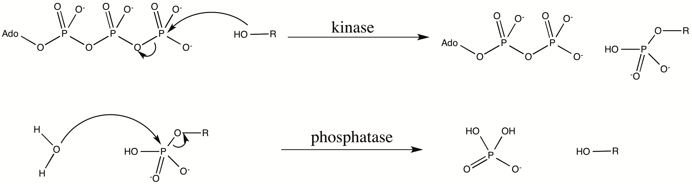

Figure 3.1: Reaction catalysed by kinases vs reaction catalysed by PPP/PPM phosphatases (metal cations omitted).

Kinases have a conserved catalytic domain that includes an aspartate residue that provides general base catalysis by deprotonation of the substrate hydroxyl; two catalytic Mg²⁺ ions that balance the negative charge of the adenine nucleotide phosphates and also help to position the γ-phosphate for in-line attack by the substrate hydroxyl; a conserved lysine that provides charge balance to the negatively charged phosphates; and another conserved aspartate in a DFG motif that coordinates to the Mg²⁺ ions.
Unlike protein kinases, protein phosphatases fall into subgroups that employ different catalytic mechanisms and are structurally distinct. The PPP and PPM families (serine/threonine specific) go through a single step involving direct nucleophilic attack by a water molecule on the substrate phosphoryl group, which is activated by two divalent metal ions; and a conserved histidine residue acts as general acid (protonates the serine or threonine leaving group). In contrast the cysteine-based phosphatases (tyrosine specific and dual specificity) form a cysteinyl-phosphate intermediate in a two-step mechanism and are not metal dependent. These possess a conserved aspartate that serves as a general acid (protonates substrate leaving group) in the first step, and is likely to act as general base (deprotonating the incoming water molecule) in the second step.
Protein kinases do not generally have sequence homology with the PPP/PPM phosphatases and have markedly different tertiary structure, but it is easy to see how their catalytic machinery is equipped to carry out similar catalytic functions.
In MAP kinase pathways, the MAPK is activated by dual phosphorylation on a TXY motif, and this is most commonly mediated by a particular upstream MAP2K, a dual specificity kinase. Dual phosphorylation of the MAPK is required for its full activity. The same sites are targets for a particular phosphatase, a member of the dual specificity MAPK phosphatase (MKP) family. MKP’s inactivate MAPK’s by dephosphorylation and therefore are a source of down-regulation of the pathway. The balance between MAP2K activity and MKP activity controls the magnitude and duration of MAPK activation, which in turn determines whether a cell response is initiated and can determine the nature of the cell response. In vivo, it is desirable to be able to switch readily between the ‘on’ and ‘off’ states of the pathway in response to varying environmental stimuli. Therefore the intrinsic activities of the MAP2K and the opposing MKP must not be substantially different, otherwise the MAPK would be permanently active or inactive.
In this chapter, a novel phosphatase activity of MEK6 towards its substrate p38α in vitro is demonstrated and investigated. Whether this is likely to be a unique activity or shared by other family members or protein kinases in general, is investigated in the subsequent chapter.

Specific methods

Wild-type p38α activation

Wild-type p38α and the D168A, T180A and Y182 mutants were phosphorylated using the same protocol. p38α (50μM) was incubated with constitutively active MEK6dd (0.5μM) and ATP (5mM) in reaction buffer (50 mM HEPES pH 7.6, 150 mM NaCl, 2 mM DTT, 2 mM sodium azide, 10mM MgCl₂) at room temperature for 2 hours. The His-tagged MEK6dd was then removed by spinning down with Ni-NTA resin beads and extracting the supernatant. Subsequently nucleotide was removed by selective buffer exchange (dilution factor of 2000) using a Vivaspin 20, 10kDa cutoff membrane (GE Healthcare).

p38α dephosphorylation timecourses

Sample was incubated at room temperature, at 60μM protein concentrations in standard buffer (50mM HEPES pH7.6, 150mM NaCl, 2mM DTT, 2mM azide) plus 10mM MgCl₂. At each time-point, 2.5 μl of reaction mixture was quenched in loading buffer supplemented with 3.2M urea final concentration. Native PAGE was run as described in Section 2.5.3.

Analysis of native PAGE
It has previously been verified by mass spectrometry that the two bands running at higher mobility in native PAGE correspond to p38 phosphorylated at one or two residues in its activation loop (E. Pellegrini, unpublished work).
The gel was scanned and intensities of each p38α band were determined by densitometric analysis, using ImageJ software. The image was cropped to remove edges of the gel, then applied ‘Invert’ command so that blue regions appear brighter, then applied ‘Subtract background’ command to apply a baseline correction (setting ‘rolling ball radius’ parameter equal to lane width). The lane width was set manually for each gel (equal lane widths within a gel). The Analyze--> Gels function was used to measure the vertical position of the intensity maximum and the distance between maxima of different phosphorylation states (band separation). The band separation was kept constant for all subsequent lanes within the gel and the 0P-1P band separation was set equal to the 1P-2P separation. The band intensity was calculated from the integrated intensity of a rectangular selection, with width equal to the lane width, vertical position centred at the intensity maximum and height equal to 0.8 times the band separation. Whilst the vertical position of the rectangular selection was generally kept constant between lanes within a gel, in cases where the dye front did not run as a straight line the shape and position of the selection box had to be manually altered whilst keeping the same area and band separation. The band intensity for each species was divided by the sum of the three bands (sum of two bands for T180A and Y182F variants), to give the fractional band intensity.
The main source of error in the fractional band intensities reported is likely to be overlap between 0P, 1P and 2P bands, due to imperfect resolution. For an estimate of this error, the band intensities for fully non-phosphorylated p38α were measured (after background subtraction), and whilst this should ideally give 100% intensity in 0P band, band overlap results in around 86% in 0P band and 14% in 1P band. From trial and error it was established that loading 2.5μl of 60μM sample (corresponding to around 6μg p38α) per gel lane gives adequate resolution, whereas loading significantly more protein than this results in larger area bands and therefore more overlap. On the other hand loading less protein than this would result in less intense bands and therefore lower signal to background ratio. After applying the background subtraction in ImageJ, the background intensity is typically around 2% of the p38 band intensity so errors arising from this (eg. due to incomplete destaining) are unlikely to be significant.

Wild-type MEK6 activation

MEK6 gives a smeared band on native PAGE, therefore its phosphorylation was determined by running on PhostagTM-supplemented gel (see protocol Section 2.5). In order to determine the phosphorylation state of wild-type MEK6 purified from E. coli, it was incubated with lambda protein phosphatase (a Mn²⁺ dependent protein phosphatase originating from bacteriophage lambda, active towards serine, threonine and tyrosine residues – Sigma cat no P9614). No shift of the band (Figure 3.2) indicates that it is non-phosphorylated after expression.
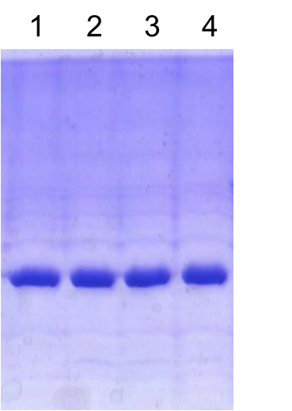
Wild-type MEK6 (20μM) was activated by incubating with GST-ASK1 (bought from Sigma, 0.02μM, 0.001eq) and ATP (3mM, 150eq) in reaction buffer at room temperature for 5 hours. Subsequently nucleotide and Mg²⁺ were removed by selective buffer exchange (dilution factor of 2000) using a Vivaspin 20 (10kDa cutoff membrane). The result of activation is shown in Figure 3.3. Phosphorylation is incomplete and points taken at longer incubation times show no further phosphorylation occurring.

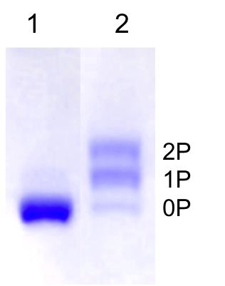
Figure 3.2: PhostagTM gel for purified wild-type MEK6 (lane 1), and after λ-phosphatase treatment using protocol described above (lane 2 – 15 mins, lane 3 – 30 mins, lane 4 – 45 mins)

Figure 3.3: PhostagTM gel showing phosphorylation of non-activated wild-type MEK6 (lane1) vs MEK6 activated using protocol described above (lane 2).

Phosphatase activity of MEK6

MEK6-dependent dual dephosphorylation of p38α

Incubation of active MEK6 with p38α and ATP results in the p38 band shifting downwards (higher mobility) on a native PAGE, due to an increase in its negative charge as a result of its phosphorylation. Running on a native PAGE after longer time periods shows a reversion to the non-phosphorylated band, as shown in Figure 3.4. This indicates that p38α is being subsequently dephosphorylated.

Figure 3.4: Native PAGE showing reversion of p38α to its non-phosphorylated form (60μM MEK6dd incubated with non-activated 60μM p38α wt and 60μM ATP in standard buffer, lanes correspond to quenching the reaction in urea after given time, zero time-point being when ATP was added to MEK6dd-p38α mixture). ‘na’ and ‘act’ correspond to purified p38α (no treatment) and p38α activated using protocol described in Section 3.2.1, respectively. Initial phosphorylation results in mostly singly phosphorylated species due to addition of 1 equivalent ATP.

If pre-activated p38α (with nucleotide removed) is incubated with active MEK6 then the same reversion to its non-phosphorylated form is observed (Figure 3.5).

Figure 3.5: Top - Native PAGE showing MEK6-catalysed dephosphorylation of activated p38α (60μM MEK6dd incubated with 60μM p38DA in standard buffer). Lane 1 is pre-activated p38DA (zero time-point), lanes 2-14 are successive time-points at times given by x-values on graph. Bottom – Circles are fraction of each phosphorylated species (blue: zero-phosphorylated; red: singly phosphorylated; green: doubly phosphorylated), calculated as described in Section 3.2.3, plotted vs time. Lines are the fraction of each phosphorylated species fitted to this data as described in Section 3.3.3.

A control timecourse, in which phosphorylated p38α is incubated in the absence of MEK6 (removed from the sample following activation), does not show any observable dephosphorylation of p38α after 24 hours. This shows that MEK6 (or a contaminating enzyme co-purified with MEK6) is responsible for the observed activity.

Activity is unaffected by p38α D168A mutation

The same dephosphorylation of p38α is observed whether it is the wild-type form or a D168A variant. The D168A mutant (p38DA) is inactive as a kinase[72] due to loss of the Mg²⁺ coordinating aspartate. Dephosphorylation is unaffected by this mutation, showing that p38α is not responsible for phosphatase activity towards itself, or if it is then this aspartate has no catalytic role in phosphatase activity. In addition, p38DA was used instead of the wild-type for all subsequent experiments (apart from T180A and Y182F mutants). Use of the inactive p38α variant in later experiments is beneficial since it eliminates any ambiguity as to which kinase is responsible for the observed activity.

Modelling of dephosphorylation kinetics

Dephosphorylation of dually phosphorylated species comprises four possible reactions (Figure 3.6), each of which is defined by a K_{M} and a k_{cat} value.

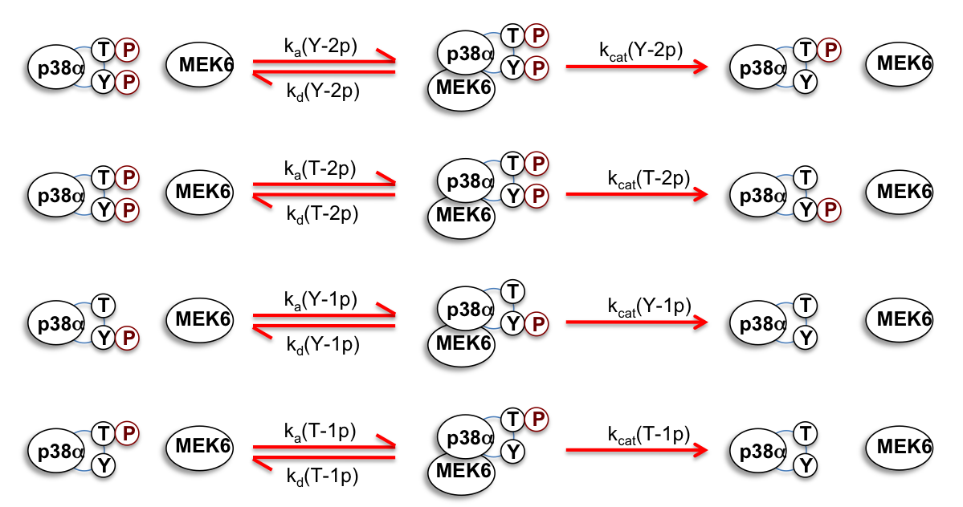
Figure 3.6: Schematic representation of the four possible p38α dephosphorylation reactions.

A numerical model was set up to simulate this reaction scheme (Python script written by M.Cliff), with the aim of determining kinetic parameters for each of these reactions that best fit the data. Fitted data were generated that correspond to minimum chi squared value with given variable parameters, as described below.
Initially the four k_{a}’s were set as equal fixed parameters, as were the four k_{d}’s, for reasons of simplicity. k_{d}/k_{a} (dissociation constant) was fixed at the p38α concentration (60μM). The four k_{cat} values were set as variables. However fitting with this model was not able to derive four well-defined k_{cat} values; this is due to covariance between k_{cat}(Y-2P) and k_{cat}(T-2P), and similarly between k_{cat}(Y-1P) and k_{cat}(T-1P).
Therefore the model was simplified to include only two k_{cat} variables by assuming that k_{cat} for tyrosine dephosphorylation is independent of the threonine phosphorylation state (k_{cat}(Y-2P) = k_{cat}(Y-1P)), and k_{cat} for threonine dephosphorylation is independent of the tyrosine phosphorylation state (k_{cat}(T-2P) = k_{cat}(T-1P)). This assumption can be considered reasonable because MEK6 as a kinase can phosphorylate Tyr182 and Thr180 independently (previous studies showing T180A, T180E, Y182F, Y182E mutants are all singly phosphorylated). Fitting with this model yielded two reasonably well-defined rate constants, with errors that are reported here due to covariance.
Fitting of the timecourse in Figure 3.5 to this model gives rate constants of 1.1 ± 0.1 × 10⁻⁴ s⁻¹ and 7.9 ± 0.9 × 10⁻⁵ s⁻¹. From this time course alone is not possible to assign the rate constants to tyrosine and threonine dephosphorylation, this required studying the T180A and Y182F mutants.

Limitations due to unknown K_{M} values
In order to derive both K_{M} and k_{cat} values would require taking a set of time courses at multiple p38α concentrations. Since only data for a single substrate concentration is available, only relative k_{cat} values given fixed values of k_{d} and k_{a} could be derived. Practical considerations of running a native PAGE mean that it is not possible to lower the substrate concentration by more than 5-10 fold whilst achieving the same total intensity of p38α bands per lane; this is because this would require loading a correspondingly larger volume of reaction sample onto the gel. Additionally, this would require lowering the enzyme (MEK6) concentration resulting in the dephosphorylation occuring more slowly. Monitoring the dephosphorylation over a much longer time period is likely to increase potential sources of error due to protein precipitation.
All of the k_{cat} values reported in this chapter are for k_{d}/k_{a} fixed at 60μM, and so can be directly compared to each other. The effect of fixing k_{d}/k_{a} at other values was also investigated when fitting to the experimental data in Figure 3.5. It was found that reducing k_{d}/k_{a} to sub-micromolar concentration for all four reactions does not noticeably affect the quality of the fit. Increasing k_{d}/k_{a} for all four reactions significantly above 60μM results in the fit becoming progressively worse. However an alternative model with two k_{d}/k_{a} values was tested, in which k_{d}/k_{a} for three of the four reactions are increased above 60μM, whilst k_{d}/k_{a} for the fourth reaction (loss of one of the singly phosphorylated species) is fixed at 60μM. Fitting with this model gives increased k_{cat} values and gives a fit consistent with the data.

MEK6 dephosphorylates Tyr182 faster than Thr180

The relative rates of Thr180 and Tyr182 dephosphorylation were determined by examining the behaviour of the p38α mutants Y182F and T180A. These mutants are known to be singly phosphorylated by MEK6 at T180 and Y182 respectively. Addition of active MEK6 to pre-activated p38α T180A or Y182F results in singly phosphorylated species being converted to non-phosphorylated species, as shown in Figure 3.7.
Figure 3.7: a) Native PAGE and corresponding graph showing dephosphorylation of p38TA variant (60μM) following addition of MEK6dd (60μM). Bands correspond to phosphotyrosine (lower) and non-phosphorylated (upper). Lane 1 is pre-activated p38TA (zero time-point), lanes 2-13 are successive time-points at times given by x values on graph. b) Native PAGE and corresponding graph showing dephosphorylation of p38YF variant (60μM) following addition of MEK6dd (60μM). Lane 1 is pre-activated p38YF (zero time-point), lanes 2-13 are successive time-points at times given by x values on graph. Bands correspond to phosphothreonine (lower) and non-phosphorylated (upper). Lane 1 is pre-activated p38TA (zero time-point), lanes 2-13 are successive time-points at times given by x values on graph. Fractions of each species were calculated as described in Section 3.2.3, fitting as described in Section 3.3.3.

Best-fit k_{cat} parameters for the dephosphorylation were 1.2±0.07 × 10⁻³ s⁻¹ and 1.5±0.09 × 10⁻⁴ s⁻¹ for p38α T180A and p38α Y182F variants, respectively.
Therefore MEK6 has an approximately 8-fold preference for dephosphorylation of Tyr182 over Thr180, and the singly phosphorylated intermediate in Figure 3.5 is therefore dominated by phosphothreonine. The preference for tyrosine dephosphorylation is in line with the relative leaving group pK_{a}’s of the two residues; however the difference in rate is substantially less than the difference in pK_{a} values would predict. MEK6 therefore catalyses phosphothreonine dephosphorylation more efficiently than phosphotyrosine.
These k_{cat} values for Tyr182 and Thr180 dephosphorylation were compared to those obtained from dually phosphorylated p38DA. k_{cat}(Y) for the T180A mutant was 11-fold higher than calculated from dually phosphorylated species, and k_{cat}(T) for the Y182F mutant was 1.9-fold higher than calculated from dually phosphorylated species. This discrepancy suggests that K_{M} values for each of the four possible reactions are not equal, as was approximated. The dephosphorylation rate of tyrosine may also be affected by the state of the neighbouring threonine (and/or vice versa), which could be verified by studies on the T180E and Y182E mutants. Alternatively the loss of hydroxyl group in Y182F and T180A mutations may affect p38α as a substrate.

Requirement of catalytic Mg²⁺ and catalytic base Asp179

In order to establish whether the activity is Mg²⁺ dependent, a time course was run with no Mg²⁺ added to the activated p38α sample and in the presence of EDTA. No measurable dephosphorylation occurred during the time period or after 48 hours (Figure 3.8a), showing that phosphatase activity requires catalytic Mg²⁺. Similarly to establish whether the phosphatase activity requires the catalytic aspartate (Asp179) that in MEK6 kinase activity acts as the general base, a time course was run using the D179N variant of MEK6dd. Here there was also no measurable dephosphorylation during the time period or after 48 hours (Figure 3.8b), showing that Asp179 plays a key catalytic role in phosphatase activity. ¹H NMR was used to confirm that the D179N mutant folds correctly to the native structure of MEK6.

Figure 3.8: a) Native PAGE and corresponding graph showing no observable p38DA (60μM) dephosphorylation after addition of MEK6dd (60μM), with no added Mg²⁺ and 10mM EDTA added prior to MEK6dd addition. Lane 1 is non-activated p38DA, lane 2 is activated p38DA, lanes 3-10 are successive time points at times given by x values on graph. b) Native PAGE and corresponding graph showing no observable p38DA (60μM) dephosphorylation after addition of MEK6dd D179N variant (60μM). Lane 1 is non-activated p38DA, lane 2 is activated p38DA, lanes 3-10 are successive time points at times given by x values on graph. Fractions of each species were calculated as described in Section 3.2.3.

Activation dependence of phosphatase activity

Tmecourses described above were carried out using the constitutively active MEK6dd with phosphomimetic aspartate groups substituting Ser207 and Thr211. Use of this variant instead of the wild-type form removes the need for pre-activation of MEK6, which may result in a non-homogenous sample and would require subsequent removal of nucleotide. However in order to elucidate the activation dependence of MEK6 phosphatase activity the wild-type form was used. Non-phosphorylated wild-type MEK6 purified from E. coli is found to have substantially diminished phosphatase activity towards p38α, relative to the dd mutant (Figure 3.9a). Activation of wild-type MEK6 using the upstream kinase ASK1, following the protocol described in Section 3.2.3, enhances its phosphatase activity by around 56-fold for phosphotyrosine and around 140-fold for phosphothreonine (Figure 3.9b).

Figure 3.9: a) Native PAGE and corresponding graphs showing dephosphorylation of activated p38DA (60μM) by non-activated MEK6wt (60μM). Lane 1 is non-activated p38DA, 2 is activated species, 3-14 are successive time points at times given by x values on graph. Upper graph corresponds to same data as lower graph but over a longer time period.
b) Native PAGE and corresponding graph showing dephosphorylation of activated p38DA (60μM) by activated MEK6wt (60μM). Lane 1 is activated p38DA, 2-14 are successive time points at times given by x values on graph. In a) and b), fractions of each phosphorylated species were calculated as described in Section 3.2.3 and fitting was carried out as described in Section 3.3.3.

These results show that phosphatase activity of MEK6 is, like its kinase activity, dependent on its activation. Activation dependence supports the hypothesis that MEK6 uses the same active site for its kinase and phosphatase activities. The calculated rates are summarized in Table 3.1.

 | k_{cat} (Y) /s⁻¹ | k_{cat} (T) /s⁻¹
Non-activated MEK6wt | 9.5 ± 0.3 × 10⁻⁶ | 7.7 ± 2.2 × 10⁻⁷
Activated MEK6wt | 5.3 ± 0.1 × 10⁻⁴ | 1.1 ± 0.02 × 10⁻⁴
MEK6dd | 1.1 ± 0.1 × 10⁻⁴ | 7.9 ± 0.9 × 10⁻⁵
MEK6dd – p38T180A | 1.2 ± 0.07 × 10⁻³
MEK6dd – p38Y182F |  | 1.5 ± 0.09 × 10⁻⁴

Table 3.1: Calculated rate constants for p38α dephosphorylation.

Effect of nucleotide on MEK6 phosphatase activity

p38α is dephosphorylated by MEK6 in the absence of nucleotide, showing that the activity is a nucleotide independent process. Therefore water is assumed to act as the nucleophile in the phosphatase reaction. However it is possible that nucleotide may activate or inhibit the reaction, so the effect of addition of AMP or AMPPCP (a non-hydrolysable ATP analog) was investigated. These nucleotides were selected as they cannot donate their phosphoryl group and therefore do not cause any competing phosphorylation.

Figure 3.10: Native PAGE and corresponding graphs showing the effect of nucleotide on rate of p38DA (60μM) dephosphorylation by MEK6dd (60μM). a) 5mM AMP added at the start (lane 1 is non-activated p38DA, lane 2 is activated p38DA, 3-15 are successive time points); b) 120μM AMP added at the start (lane 1 is activated p38DA, 2-14 are successive time points); c) 5mM AMPPCP added at the start (lane 1 is activated p38DA, 2-15 are successive time points). Fractions of each phosphorylated species were calculated as described in Section 3.2.3 and fitting was carried out as described in Section 3.3.3.

When MEK6dd and excess AMP were added to activated p38α (Figure 3.10a), there is a modest reduction in the dephosphorylation rate (around 3-fold slower for phosphotyrosine and 18-fold slower for phosphothreonine) compared to the control without added nucleotide. When MEK6dd and excess AMPPCP were added to activated p38α, there is a larger reduction in the dephosphorylation rate compared to AMP (Figure 3.10c). These results (calculated rate constants shown in Table 3.2) indicate that nucleotide has an inhibitory effect on phosphatase activity. In order to try to elucidate the concentration dependence, time courses were repeated at lower AMP concentrations. No inhibition of phosphatase activity relative to no added nucleotide was observed at AMP concentration below 600μM.

 | k_{cat} (Y) /s⁻¹ | k_{cat} (T) /s⁻¹
No nucleotide | 1.1 ± 0.1 × 10⁻⁴ | 7.9 ± 0.9 × 10⁻⁵
+ 5mM AMP | 3.8 ± 0.1 × 10⁻⁵ | 4.3± 0.6 × 10⁻⁶
+ 5mM AMPPCP | 1.6 ± 0.1 × 10⁻⁵

Table 3.2: Effect of nucleotide on calculated rate constants for p38DA dephosphorylation

In order to determine which residue is dephosphorylated faster in the presence of AMP, time courses were repeated with the p38α T180A and Y182F mutants. The T180A mutant was dephosphorylated faster, thus AMP does not selectively inhibit dephosphorylation of the tyrosine.
The mode of inhibition by nucleotide has not been determined. Nucleotide binding may compete with water for binding to the MEK6 active site. Alternatively it may partially inhibit phosphatase activity in a noncompetitive manner, by inducing a conformational change of MEK6 (Figure 3.11). In the latter case then even at saturating nucleotide concentrations, phosphatase activity may still occur.

Figure 3.11: Two alternative modes of phosphatase activity inhibition by AMP (or AMPPCP). a) Reaction in the absence of nucleotide; b) competitive inhibition, in which AMP binding prevents hydrolysis by water; c) partial inhibition, in which AMP binding reduces the activity.

Discussion

These findings demonstrate a novel phosphatase activity of MEK6. The phosphatase reaction is not simply a reverse of the kinase reaction because water and not ADP β-phosphate is the nucleophile. The fact that mutation of the catalytic base Asp179 eliminates the activity confirms that MEK6, and not a contaminating enzyme copurified from E. coli, is responsible for the activity. The estimated rate of the fast dephosphorylation step here is 1.1 × 10⁻⁴ s⁻¹. In contrast, kinetic studies (using native PAGE) of the phosphorylation of p38DA by MEK6dd with excess ATP gave an estimated rate of 0.3 s⁻¹ for the initial phosphorylation step (described in Section 5.2.2). Comparing these rates, the phosphatase activity of MEK6 is slower than its kinase activity by around 3000-fold.

Mechanism of phosphatase activity

The requirement for Asp179 and the activation dependence of phosphatase activity indicates that MEK6 uses the same catalytic site for its kinase and phosphatase activities. The requirement for catalytic Mg²⁺ ions and the fact that there is no evidence for a catalytic cysteine residue both point to a mechanism that is analogous to that of PPP and PPM phosphatase families. The similarities between transition states for protein kinase and PPP/PPM phosphatase catalysed reactions are illustrated in Figure 3.12. This involves initial direct nucleophilic attack by water on the p38α phosphotyrosine or phosphothreonine, activated by catalytic Mg²⁺ ions. MEK6 is likely to utilise two metal ions for its phosphatase activity although the stoichiometry of Mg²⁺ binding is not known. The catalytic residue Asp179, which acts as general base in kinase activity of MEK6, presumably acts as a general acid in its phosphatase activity, thus performing the role of the conserved histidine in PPP/PPM phosphatases. This mechanism is in contrast to the two-step mechanism utilized by known MKP’s, which involves initial nucleophilic attack by a cysteine residue to form a cysteinyl-phosphate intermediate and does not require catalytic metal ions.

Figure 3.12: Representation of the putative transition states for phosphoryl transfer catalysed by a) a protein kinase; b) a PPP/PPM family phosphatase.

Comparing to previous reports of dual activity kinases/phosphatases

The discovery of phosphatase activity in MEK6 is novel, as it is the first example of which we are aware, of a eukaryotic protein kinase demonstrated to have dual kinase and phosphatase activities.
Previously a dual kinase and phosphorylase activity has been reported for bacterial HPr kinase. This normally transfers phosphate from ATP to serine 46 in phosphocarrier HPr protein, but was also found to dephosphorylate HPr-pSer, as shown by product analysis on native PAGE[73]. This was originally assumed to be due to hydrolysis by water (phosphatase activity). However subsequent studies found that dephosphorylation is inorganic-phosphate-dependent and pyrophosphate is formed in the reaction, implying that free phosphate acts as the nucleophile in the reverse reaction (phosphorylase activity)[74]. In addition, the relative kinase and phosphorylase activities are sensitive to ATP or fructose bis-phosphate (FBP) concentration. In these in vitro assays, for E. faecalis HPr kinase nonphosphorylated HPr only predominates at low initial ATP concentration, whilst for B. subtilis HPr kinase, nonphosphorylated product only predominates at low FBP concentration but is unaffected by increased ATP concentration. HPr is a cytoplasmic component of the PEP-dependent phosphotransferase system, used by bacteria for sugar uptake, which accepts a phosphoryl group on a histidine. Serine phosphorylation of HPr is known to play a regulatory role by inhibiting histidine phosphorylation and therefore sugar uptake. Therefore it is likely that the dual activity of HPr kinase plays an important functional role in adjusting carbon catabolism in response to changes in the availability of carbon sources.
There is also a previous report of reversible aspartate phosphorylation in the EnvZ-OmpR phosphorelay in E. coli, which is an example of the two-component signalling modules found in prokaryotes. In these signalling modules[75], activation by an extracellular stimulus causes dimerisation of a transmembrane histidine kinase (EnvZ), resulting in trans-autophosphorylation at histidine, and this phosphate is subsequently transferred to an aspartate residue of the cognate response regulator (OmpR). The EnvZ cytoplasmic domain was also found to deplete phosphorylated OmpR to produce inorganic phosphate[76]. However this phosphatase activity is not particularly surprising considering that aspartyl phosphates are intrinsically more labile than serine, threonine or tyrosine phosphates; and in any case, the aspartyl-phosphate in these systems is generally short-lived even in the absence of the upstream kinase. This EnvZ phosphatase activity is Mg²⁺ dependent and requires the autophosphorylation site histidine[77], but does not require the ATP binding domain, although the full-length cytoplasmic domain displays enhanced activity. Phosphatase activity of EnvZ could play a necessary role in regulating intracellular phosphorylated OmpR levels in E. coli and is thought to be modulated in response to the extracellular stimulus.
A similar example of such activity is reported in the RegB-RegA relay system studied in R. Sphaeroides, which acts as a global redox switch to regulate aerobic versus anerobic growth. Here phosphate is normally transferred from the histidine kinase (RegB) to an aspartate of the response regulator (RegA). From analyzing the loss of phosphorylated RegA versus time with varying RegB concentrations, RegB was also found to catalyse the dephosphorylation of RegA, thus indicating that it can act as a phosphatase[78]. Although the nucleophile in this reaction was not explicitly identified, it is likely to be water since the reverse transfer of phosphate to the RegB histidine is known to be highly unfavourable.

Biological significance of phosphatase activity

MEK6 phosphatase activity is unlikely to be prevalent under normal physiological conditions, mainly because it requires low ATP concentration otherwise kinase activity dominates. In the cytosol of eukaryotic cells, ATP is present in low millimolar concentrations and is maintained at a steady level by adjusting the rate of ATP production to meet changes in energy demand. The phosphatase activity could however play a functional role in vivo as a ‘backup’ means of inactivating p38α in reduced ATP levels. Such a scenario may arise in hypoxia[79-81], in which a reduced oxygen supply limits ATP synthesis by oxidative phosphorylation.
Another consideration is that there are a multitude of other phosphatases in the cell cytosol, and cells can express separate MAPK-specific phosphatases (of which MKP5, MKP7 and MKP8 were found to selectively dephosphorylate p38α[48, 52, 53]). For an example of the intrinsic rates of these enzymes, MKP5 has been found to dephosphorylate p38α with a k_{cat} of 0.5 s⁻¹ in vitro, substantially faster than the 1.1×10⁻⁴ s⁻¹ calculated for MEK6. This slow timescale makes it seem unlikely that MEK6 phosphatase activity could be physiologically important, however cells must be able to express separate phosphatases when required in order to downregulate the signalling pathway. If the normal downregulation system fails, then it is conceivable that MEK6, which is already present in the cytosol, can function as a backup phosphatase in order to switch off the p38 pathway.
Alternatively this dual kinase-phosphatase activity may simply be an evolutionary relic that represents the primordial activity of kinases. Since kinases are believed to have evolved earlier than phosphatases, they are likely to have developed a means to reverse phosphorylation of substrates.
In addition, while phosphatase activity measured here is for the activation sites Thr180 and Tyr182, MEK6 may also possess a phosphatase activity towards alternative hydroxyl groups that is faster. These could be MEK6 autophosphorylation sites or alternative p38α hydroxyl groups. Evidence that MEK6 could have a kinase-phosphatase activity towards alternative substrate residues is described in Chapter 5.

Significance for MAPK activation protocols

Existing protocols for in vitro MAPK activation require adding a large excess of ATP in order to achieve near complete phosphorylation[43, 59, 82]. This has not been explained, but suggests that the MAP2K’s are wasteful in expending ATP on other reactions. This discovery of phosphatase activity may partly explain why the activation of MAPK’s in vitro is so inefficient with respect to ATP.

Potential phosphatase activity of other kinases

Background

The previous chapter showed that MEK6 has dual kinase and phosphatase activity. In order to determine how general phosphatase activity is among protein kinases, it was necessary to carry out further investigation.

Specific methods

Wild-type MEK4 activation

Purified wild-type GST-MEK4 was run on a Phostag gel to check its phosphorylation. Incubation with lambda-phosphatase results in no shift of the GST-MEK4 band, indicating that it is non-phosphorylated after expression (Figure 4.1).
GST-MEK4 (25μM) was incubated with GST-MEKK1 (bought from Sigma, 0.12μM, 0.005eq) and ATP (20mM, 800eq) in reaction buffer (with 30mM MgCl₂) at room temperature for 3 hours. Subsequently nucleotide and Mg²⁺ were removed by selective buffer exchange (dilution factor of 10000) using a Vivaspin 20 (10kDa cutoff membrane). Figure 4.2 shows partial phosphorylation and points taken at longer incubation times show no further phosphorylation occurring.

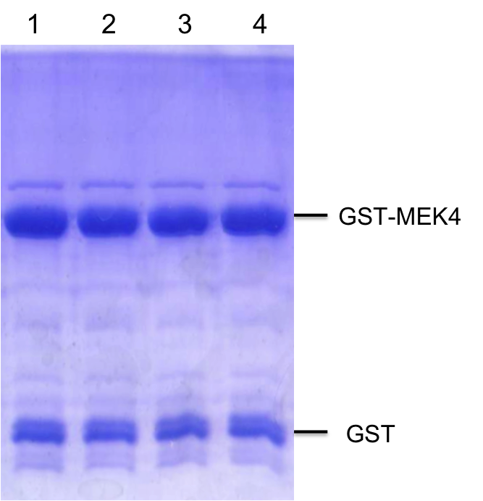
Figure 4.1: PhostagTM gel for purified wild-type GST-MEK4 (lane 1), and after λ-phosphatase treatment using protocol described above (lane 2 – 15 mins, lane 3 – 30 mins, lane 4 – 45 mins)

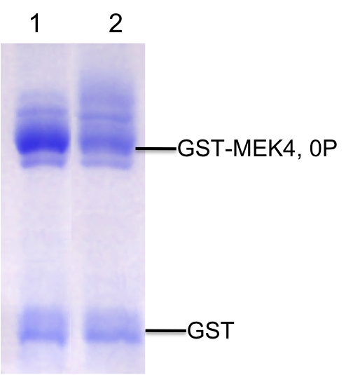
Figure 4.2: PhostagTM gel showing phosphorylation of non-activated wild-type MEK4 (lane1) vs MEK4 activated using protocol described above (lane 2). Whilst individual bands corresponding to each phosphorylation state could not be assigned, the loss of intensity of non-phosphorylated species on the gel was interpreted as showing that partial activation is achieved.

Native PAGE vs ³¹P NMR for phosphorylation timecourses

For the MEK6 and MEK4 time courses, native PAGE was used to follow substrate phosphorylation state because it enables points to be taken at short time intervals, and does not require a large amount of protein. In these experiments ³¹P NMR cannot follow p38α dephosphorylation over time, because the time taken to obtain a scan of sufficiently high signal to observe phosphoprotein peaks is of the order of a few hours for 60μM concentration, similar to the timescale of dephosphorylation. However for the cAPK and DYRK1a time courses which have peptide substrates, ³¹P NMR was used to follow phosphorylation over time. This is because these peptides are too small to be resolved on standard native PAGE, and in any case phosphopeptide peaks were observed in ³¹P NMR.

Peptide substrates

Kemptide (LRRASLG) – bought from RBI cat no. K-114
DYRKtide (RRRFRPASPLRGPPK) - bought from SignalChem cat no. D96-58

MEK4 background and comparison with MEK6

MEK4 is an upstream activator of the c-Jun NH2-terminal kinases (JNK1 and JNK2)[83], and can also dually phosphorylate p38 isoforms in vitro[59]. It is phosphorylated on S257 and T261 by the upstream kinase MEKK1. It has significant sequence homology with MEK6 (58%, Figure 4.3). Activity of the double aspartate or glutamate mutant has not been determined.

Figure 4.3: Aligned sequences of human MEK4 (black) with human MEK6 (green). Conserved residues highlighted in yellow. Activation loop residues shown in blue, docking motif in brown.

Only non-phosphorylated structures of MEK4 have been determined, as a binary complex with the ATP analog AMPPNP, and a ternary complex with AMPPNP and p38α-derived peptide containing the TGY motif[67]. The MEK4-AMPPNP structure shows a disordered activation loop (Figure 4.4), in contrast to MEK6 in which the activation loop forms two α-helices that conceal the γ-phosphate from bulk solvent. For the ternary complex, surprisingly the p38α peptide is bound allosterically at the N-terminal lobe of MEK4, and the activation loop forms a long α-helix that blocks substrate access to the γ-phosphate. This implies that allosteric substrate binding at the N-terminal docking motif may be responsible for autoinhibition of MEK4 in the non-phosphorylated state.

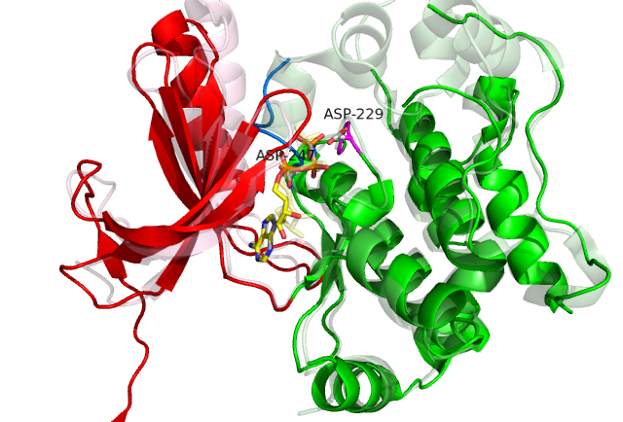

Figure 4.4: Crystal structure of non-phosphorylated MEK4 bound to AMPPNP and Mg²⁺(PDB: 3ALN). N-terminal lobe shown in red, C-terminal lobe in green, start of activation loop in blue, AMPPNP in yellow. General base aspartate (D229) and DFG aspartate (D247) are labeled. Structure is superimposed on npMEK6-AMPPNP shown in pale (PDB: 3VN9).

MEK4 possesses phosphatase activity towards p38α

Investigation was carried out to investigate whether MEK4 has a phosphatase activity, using p38α as substrate and following the same protocol as for MEK6. The time courses for both activated and non-activated GST-MEK4 are shown in Figure 4.5.
Figure 4.5: a) Native PAGE and corresponding graph showing dephosphorylation of activated p38DA (60μM) by non-activated GST-MEK4wt (60μM). Lane 1 is activated p38DA, 2-14 are successive time points at times given by x values on graph, lane 15 is non-activated p38DA. b) Native PAGE and corresponding graph showing dephosphorylation of activated p38DA (60μM) by activated GST-MEK4wt (60μM). Lanes 1-14 are successive time points at times given by x values on graph, lane 15 is activated p38DA. Fractions of each phosphorylated species were calculated as described in Section 3.2.3, lines correspond to fitting as described in Section 3.3.3.

Non-phosphorylated wild-type MEK4 dephosphorylates p38α at rates given in
Table 4.1 (assuming that the preference for Tyr182 over Thr180 is the same as
for MEK6). Phosphatase activity of the activated wild-type was also tested. This dephosphorylates p38α at enhanced rates compared to the non-activated form, as shown in Table 4.1. For activated MEK4 (Figure 4.5b), the model does
not give a particularly good fit to the data, in particular it cannot account for the
initial faster loss of dually phosphorylated species within the first couple of time
points. A possible reason for this result is that MEK4 becomes dephosphorylated
during the time course (possibly due to an auto-phosphatase activity, though
this activity is not currently known). Incorporating this activity into the model
would require introducing k_{cat} and K_{M} values for this reaction as additional
parameters.

 | k_{cat} (Y) /s⁻¹ | k_{cat} (T) /s⁻¹
Non-activated GST-MEK4wt | 7.7 ± 1.9 × 10⁻⁶
Activated GST-MEK4wt | 6.3 ± 0.7 × 10⁻⁵ | 1.5 ± 0.3 × 10⁻⁵

Table 4.1: Calculated rate constants for p38 dephosphorylation for activated and non-activated forms of MEK4.

These results show that MEK4 can similarly act as a phosphatase, and this activity is regulated by its own activation. The rate constants for non-activated MEK4 are close to those of non-activated MEK6. The observed rate constants for activated MEK4 are lower than for activated wild-type MEK6; however this may be due to inefficient phosphorylation of MEK4 by its upstream kinase. Therefore the results overall suggest that MEK6 and MEK4 are similarly efficient phosphatases towards p38α. Nevertheless, the phosphatase activity of MEK4 towards JNK1 or JNK2 was not tested and these may represent better phosphatase substrates.

p38α comparison with MEK6

Serine/threonine specific kinase p38α has been described previously. There is previous evidence of it being able to autophosphorylate at Thr180 and Tyr182[60], although no autophosphorylation was observed in these native PAGE assays. Therefore the possibility of activated p38α dephosphorylating itself (autophosphatase activity) was tested. Wild-type p38α was activated by MEK6dd using the previously described protocol. After removal of MEK6dd and nucleotide it was incubated with MgCl₂ added. No dephosphorylation was observed during the time course period (Figure 4.6) or after a few days.

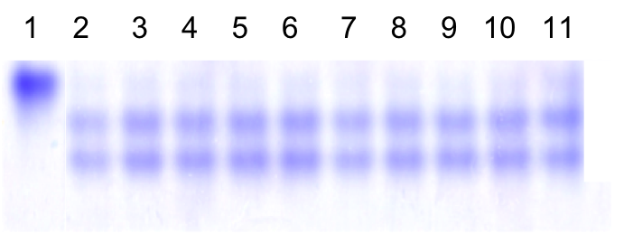
Figure 4.6: Native PAGE showing the result of incubating activated wild-type p38α at room temperature in the absence of any other kinases. Sample was in standard buffer. Lane 1 is non-phosphorylated species, lane 2 is activated species, lanes 3-11 are points taken every hour after addition of 10mM MgCl₂.

p38α does not show any autophosphatase activity, but whether it can act as a phosphatase towards an exogenous substrate remains to be determined.

cAPK background and comparison with MEK6

cAPK is an archetypal serine/threonine specific kinase and one of the best studied members. Its activity in cells is regulated by cytosolic cyclic AMP (cAMP) concentration. The inactive form of cAPK is tetrameric consisting of two regulatory subunits that are each bound to a catalytic subunit. cAMP binding to the regulatory subunits causes activation of the kinase by release of the catalytic subunits. cAPK can act on a range of protein substrates. Its specificity is determined by local sequence around the phosphorylation site, requiring the consensus sequence RRXS/TZ, where X is any residue and Z is a hydrophobic residue. This is in contrast to the MAP2K’s whose substrate specificity is primarily governed by allosteric binding.
cAPK catalytic subunit has 27% sequency homology with MEK6 (Figure 4.7), and has been structurally characterized in various forms. It is phosphorylated at Thr197 in its activation loop, which is a result of autophosphosphorylation when overexpressed in E. coli. The T197A mutation results in substantial loss of activity, showing that this phosphorylation is critical to its function[22]; however the phosphothreonine is generally found to be highly stable towards hydrolysis by phosphatases in vitro, indicating that phosphatases do not play a key role in regulating the activity. The crystal structure of a ternary complex between cAPK, MnATP and inhibitor peptide[84] shows the cleft between the lobes accomodating ATP and part of the peptide (Figure 4.8). Phospho-Thr197 is stabilised by interactions with Arg165 preceding the catalytic base (conserved in MEK6, MEK4 and p38α), Lys189 in the activation loop, and His87 in the αC-helix of the N-terminal lobe. This corresponds to the ‘closed’ conformation, whereas crystal structures of the apoenzyme and a binary complex of cAPK with modified inhibitor peptide reveal an ‘open’ conformation[85]. In this conformation, interaction between phospho-Thr197 and His87 is lost and the N-terminal lobe is rotated away from the C-terminal lobe.

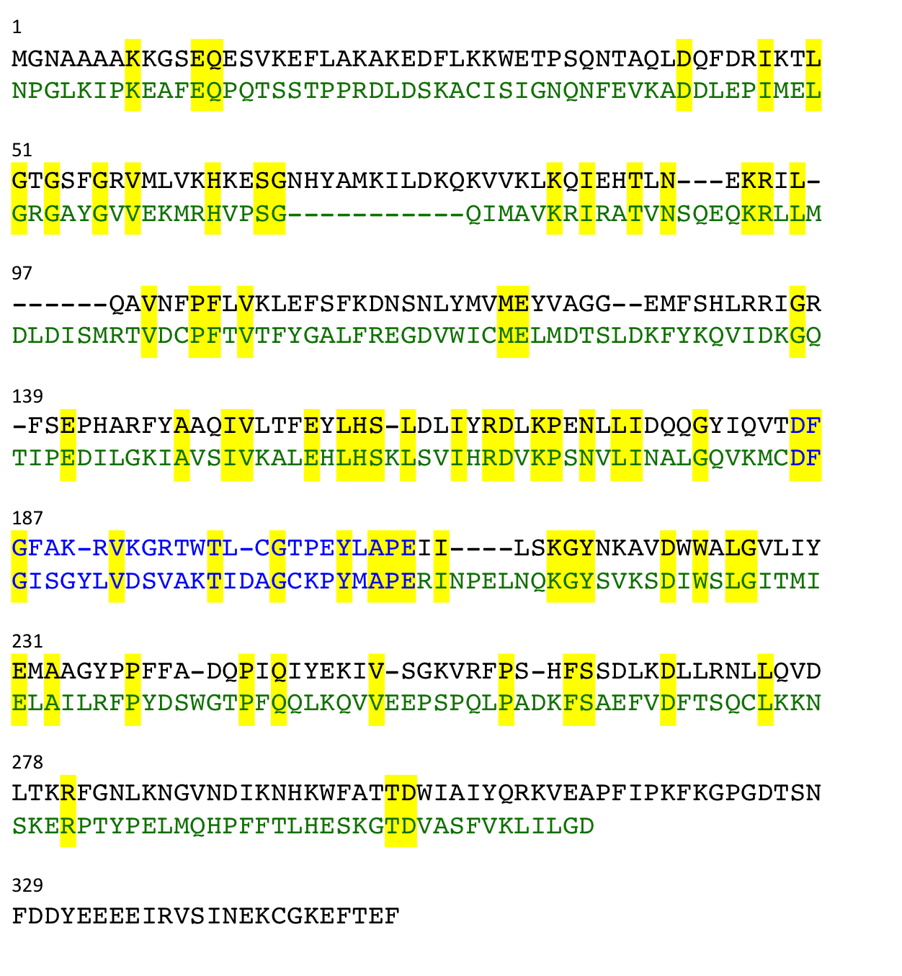
Figure 4.7: Aligned sequences of mouse cAPK catalytic subunit (black) with human MEK6 (green). Conserved residues highlighted in yellow, activation loop residues shown in blue.
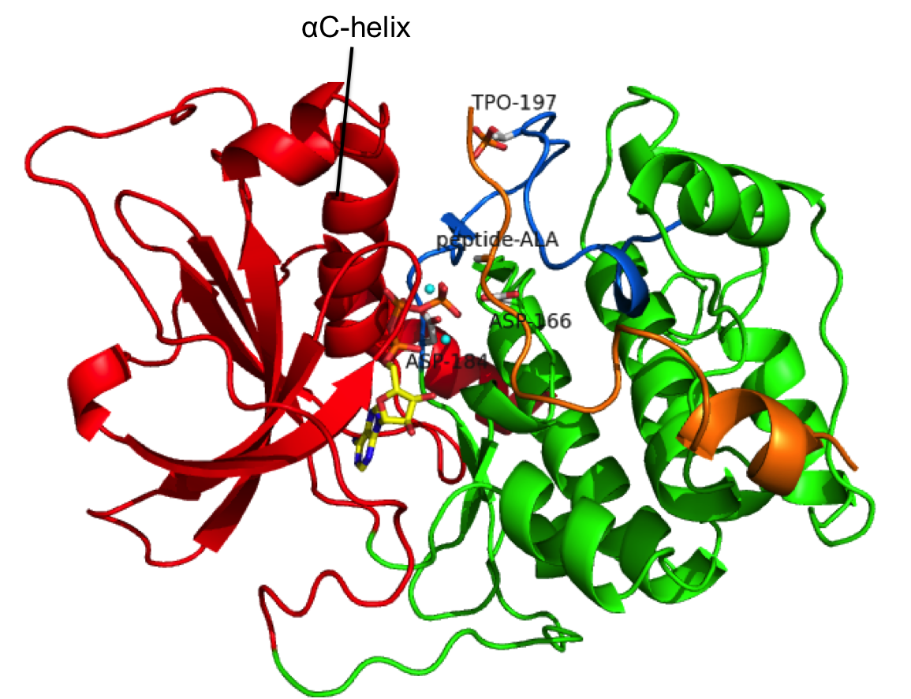
Figure 4.8: Crystal structure of cAPK catalytic subunit bound to Mn²⁺-ATP and inhibitor peptide (TTYADFIASGRTGRRNAIHD). PDB ID: 1ATP. N-terminal lobe shown in red, C-terminal lobe in green, start of activation loop in blue, ATP in yellow, peptide in orange, Mn²⁺ ions in cyan. General base aspartate (D166), DFG aspartate (D184) and P-site alanine are labeled.

cAPK has no apparent phosphatase activity

cAPK catalytic subunit was added to kemptide (consensus serine-containing peptide) and ATP. The extent of substrate phosphorylation was monitored over time by ³¹P NMR (Figure 4.9).

Figure 4.9: Series of ³¹P NMR spectra (10k scans each) to test for phosphatase activity of cAPK catalytic subunit. Follows addition of 85μM cAPK to 300μM kemptide and 300μM ATP. Sample was in standard buffer (50mM HEPES pH 7.6, 150mM NaCl, 2mM DTT) with 10mM MgCl₂. Zero time-point is when ATP was added to the mixture, and times given are the midpoint of acquisition. Unlabelled peaks in the region +4 to +7 ppm correspond to phosphorylated serine and threonine hydroxyls of cAPK after purification from E. coli. Shown in lower panel is phosphoserine peak intensity vs time

The data in Figure 4.9 do not indicate that kemptide is being dephosphorylated, or if it is then at a rate that is unobservable over the time period recorded.
Surprisingly Figure 4.9 shows a loss of ADP so that none is observed from 6.5 hours onwards. There is also an increase in the inorganic phosphate (P_{i}) peak until it levels off after 14.8 hours. The AMP peak also increases in the first few spectra although it is more difficult to distinguish because it lies in the vicinity of phospho-cAPK peaks. This indicates that cAPK can hydrolyse ADP to form AMP and phosphate (ie. it has an ADPase activity).

Identification of an alternative dual specificity kinase

Of the experiments described so far, the dual specificity MAP2K’s were found to possess phosphatase activity whereas the serine/threonine kinases were not. Therefore it was hypothesized that phosphatase activity may be a feature of dual specificity kinases. These must accommodate both phenolic and alkyl hydroxyl groups, and therefore the specificity of their active site may necessarily be compromised, so that they are predisposed to delivering more efficient phosphatase activity.
An alternative dual specificity kinase that is not a member of the MAP2K family was identified, in order to determine whether phosphatase activity is preserved in this case. MAP2K’s are considered archetypal dual specificity kinases, because they phosphorylate tyrosine and threonine residues within a single substrate motif (TXY), and phosphorylation of both residues is required for the conformational changes that bring about activation. Other than MAP2K’s, a number of putative dual specificity kinases and kinase subfamilies have been identified based on their ability to phosphorylate serine, threonine and tyrosine in vitro. These include dual-specificity tyrosine–regulated (DYRK) subfamily[86], CDC2-like kinase (CLK) subfamily[87], glycogen synthase kinase 3 (GSK3)[88], monopolar spindle 1 (MPS1) kinase[89] and casein kinase 2 (CK2). However the extent or functional relevance of tyrosine kinase activity for these is questionable. The DYRK members, CLK members and GSK3 can autophosphorylate on serine, threonine or tyrosine hydroxyls, including a conserved tyrosine in the activation loop, but are thought to normally function as serine/threonine specific kinases. Similarly, MPS1 phosphorylates threonine residues of its normal substrates but was also found to autophosphorylate on tyrosine[89], whilst CK2 can phosphorylate a large number of substrates, including some tyrosine residues (such as Tyr184 of nucleolar immunophilin Fpr3 for CK2)[90] although tyrosine kinase activity is normally found to be weaker.
Of these kinases, DYRK1a has been well studied and structurally characterised, and does not require activation, therefore this was identified as a candidate for testing phosphatase activity.

DYRK1a background and comparison with MEK6

DYRK1a is a prototype member of the DYRK subfamily, which includes five human kinases (DYRK1a, 1b, 2, 3 and 4). It is known to have serine/threonine kinase activity towards substrates, and can autophosphorylate weakly at a number of tyrosine residues as well as serine and threonine in vitro.[91] DYRK1a has 26% sequence homology with MEK6 but 30% sequence homology with p38α, indicating that it is more homologous to the MAPK’s.
The activation loop is characterized by a YXY³²¹ motif, and when expressed in either E. coli or eukaryotic cells it is found to be phosphorylated at the second tyrosine of this motif. This phosphorylation is thought to be an intramolecular autophosphorylation process mediated by the nascent kinase passing through a transitory intermediate form[92], occuring in a ‘one-off’ event during folding. Recent studies have revealed that tyrosine-phosphatase-treated DYRK1a does not lose any autophosphorylation activity, or activity towards exogenous substrates D3 and dynamin, compared to the untreated control[93]. Therefore activation loop phosphorylation is apparently not required for enzymatic activity, unlike for MAPK’s and MAP2K’s. Furthermore the DYRK1a Y321F mutant possesses much reduced activity, whereas QQ and HH double mutants (Y319 and Y321 mutated) retain considerable activity, indicating that polar side-chains in these positions are sufficient for the kinase to be active[93].
There is structural data of DYRK members in complex with various inhibitors. Human DYRK1a has been determined in complex with an ATP-competitive inhibitor, both in the presence and the absence of a threonine-containing substrate peptide[91]. The structure (shown in Figure 4.10) reveals an active kinase conformation, in which phospho-Tyr321 is stabilized by coordination to Arg325 and Arg328 in the activation loop, and Tyr319 forms a hydrogen-bond with Gln199 in the αC-helix[91]. However there is a cysteine residue immediately preceding the catalytic base instead of arginine that is conserved in the other kinases. The substrate peptide binds at the canonical active site and does not induce any major conformational changes. Additional structural features are a conserved DYRK homology (DH) box N-terminal to the catalytic domain and a region corresponding to the MAPK insert.

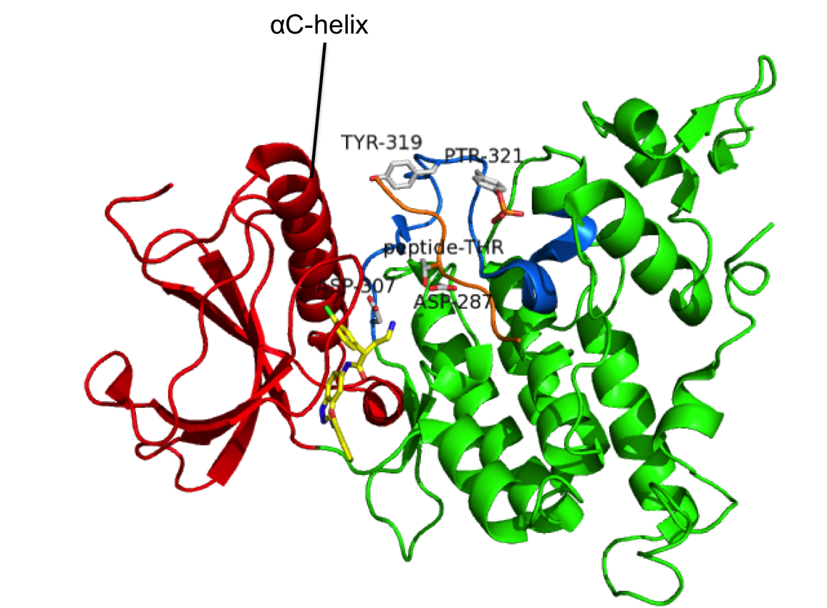
Figure 4.10: Crystal structure of human DYRK1a (residues 127-485) in complex with ATP-competitive inhibitor (DJM2005) and substrate peptide (RARPTPALRE). PDB ID: 2WO6. N-terminal lobe is shown in red, C-terminal lobe in green, activation loop in blue, substrate peptide in orange, inhibitor in yellow. Activation loop tyrosines (Y319 and pY321), general base aspartate (D287) and DFG aspartate (D307) are labeled.

DYRK1a has slow phosphatase activity compared to MEK6

DYRK1a was added to the consensus serine-containing substrate peptide DYRKtide and ATP. The extent of phosphorylation was monitored over time by ³¹P NMR (Figure 4.11).

Figure 4.11: Series of ³¹P NMR spectra (10k scans each) to test for phosphatase activity of DYRK1a. Follows addition of 90μM DYRK1a to 540μM DYRKtide and 540μM ATP. Sample was in standard buffer (50mM HEPES pH 7.6, 150mM NaCl, 2mM DTT) with 10mM MgCl₂. Zero time-point is when ATP was added to the mixture, and times given are the midpoint of acquisition. Shown in lower panel is phosphoserine peak intensity vs time.
The data in Figure 4.11 indicate a very slow rate of DYRKtide-pSer dephosphorylation. In addition there is no observable dephosphorylation of the DYRK1a phosphotyrosine residue, presumably Tyr321 that is autophosphorylated, over time. These data, when compared to that of p38α dephosphorylation by active MEK6, thus indicate that DYRK1a is a relatively inefficient phosphatase for either serine or tyrosine residues. Furthermore, the possibility that such a slow phosphatase activity may be due to a contaminating enzyme purified from E. coli cannot be discounted; testing of an inactive DYRK1a mutant for phosphatase activity would establish whether this is the case.
In order to determine if the lack of dephosphorylation is due to inhibition by AMP that is present in the sample, the experiment was repeated with different relative concentrations of the components so that there is less than 1 equivalent AMP relative to DYRK1a. In this case there was again insignificant dephosphorylation of the serine.
The spectra also show a loss of ADP, and increase in inorganic phosphate (P_{i}) and AMP. The P_{i} and AMP peaks increase during the whole time course even though no ADP is observed from 14.8 hours onwards. This indicates that DYRK1a can hydrolyse ADP to form AMP and phosphate, and so has an ADPase activity similarly to what is observed for cAPK.

Discussion

Both MEK4 and MEK6 have phosphatase activity towards p38α, a known kinase substrate in vitro. However cAPK (serine/threonine specific) does not have any observable phosphatase activity towards a peptide substrate and p38α (serine/threonine specific) does not have any observable autophosphatase activity. DYRK1a has a very weak phosphatase activity compared to the active forms of MEK6 and MEK4. These results indicate that phosphatase activity is a specific feature of the MAP2K’s, which are well established dual specificity kinases. In contrast the dual specific nature of DYRK1a is questionable, as tyrosine phosphorylation on exogenous substrates has not been identified. The active site nature of dual specificity kinases, which must accommodate both phenolic and alkyl groups, may predispose it to being a more effective phosphatase.
It remains to be determined whether tyrosine-specific kinases also possess phosphatase activity towards their substrates.

Alternative kinase activities of MEK6

Background

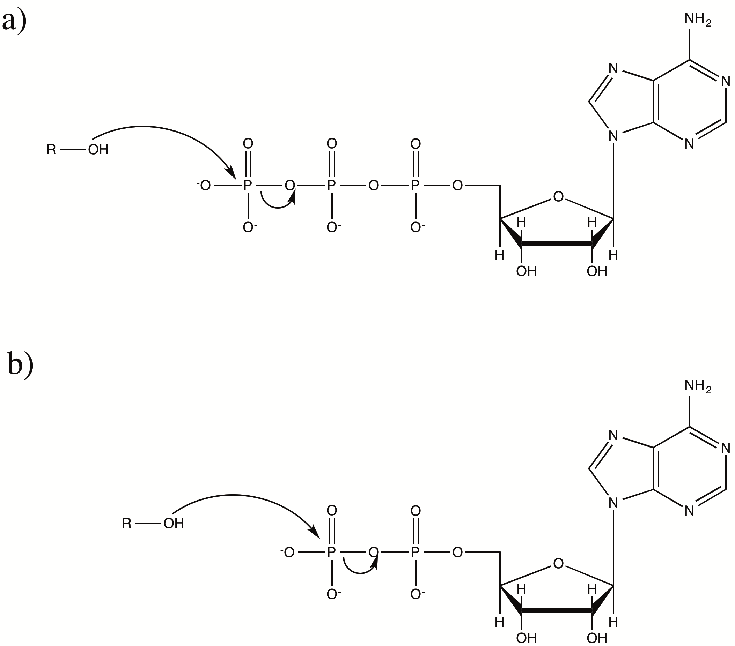
In nature, kinases almost always use a nucleoside triphosphate (normally ATP) as the phosphoryl donor. This is not surprising since ATP is the cellular energy currency and is abundant in cell cytoplasm. However in principle, kinases could use nucleoside diphosphate (ADP) as a phosphoryl donor since this is similarly unstable towards hydrolysis, the significant difference being the loss of one negative charge. The ability of protein kinases to use ADP as a phosphoryl donor and structural factors that influence their nucleotide specificity are largely unknown.

Figure 5.1: Representation of a) ATP-dependent kinase activity; b) hypothesized ADP-dependent kinase activity. Role of Mg²⁺ ions is not shown.

Furthermore if protein kinases can use ADP as a phosphoryl donor, then an alternative means for MAPK dual phosphorylation by MAP2K’s can be considered. In the canonical mechanism, MAP2K singly phosphorylates MAPK using ATP, releases ADP and binds to a second ATP molecule, which it uses to phosphorylate another MAPK molecule on either site. An alternative mechanism is proposed in which MAP2K dually phosphorylates MAPK using a single ATP molecule: after the first phosphorylation, ADP remains bound and is used to phosphorylate on the second site, and subsequently AMP is released. Both of these mechanisms permit dissociation and rebinding of the singly phosphorylated MAPK species according to the distributive model.

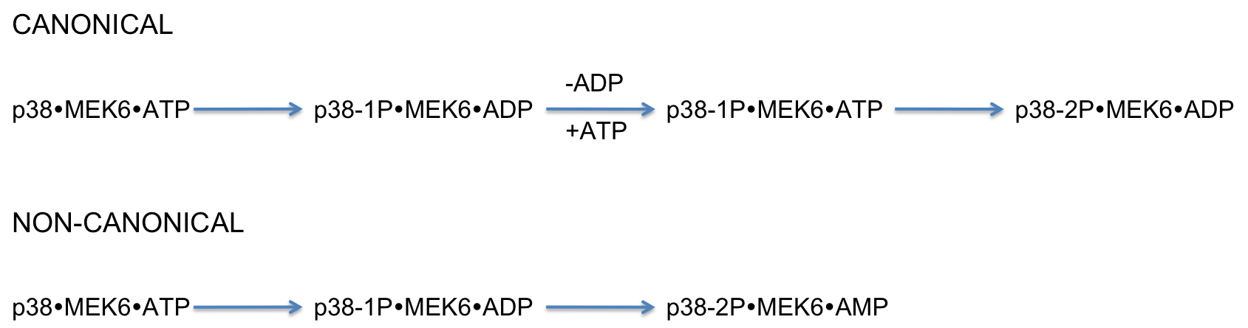

Figure 5.2: Alternative mechanisms for MAPK dual phosphorylation

MEK6 can phosphorylate p38α using ADP

The initial observation that MEK6 can use ADP as a phosphoryl donor was a result of attempts to produce a TSA complex between MEK6dd, wild-type p38α, ADP and a metal fluoride for crystallization (E. Pellegrini, PhD thesis). Running the mixture on native PAGE showed two p38α bands corresponding to a mixture of singly and doubly phosphorylated species, whereas expressed p38α is non-phosphorylated, thus indicating that ADP can phosphorylate on either Thr180 or Tyr182 residues. The possibility of this being a result of ADP conversion into ATP by contaminating adenylate kinase was eliminated, as addition of the adenylate kinase inhibitor Ap₅A does not inhibit phosphorylation.
Here the phosphorylation of p38DA by MEK6dd and ADP was verified by running a time course on native PAGE (Figure 5.3). Incomplete phosphorylation is observed, followed by some dephosphorylation due to a competing MEK6 phosphatase activity. ADP-dependent phosphorylation is also significantly slower compared to ATP.

Figure 5.3: Native PAGE timecourse for 60μM MEK6dd + 60μM p38DA + 5mM ADP. Sample was in standard buffer (50mM HEPES pH7.6, 150mM NaCl, 2mM DTT) with 10mM MgCl₂ added.

Concentration dependence of ADP-dependent kinase activity

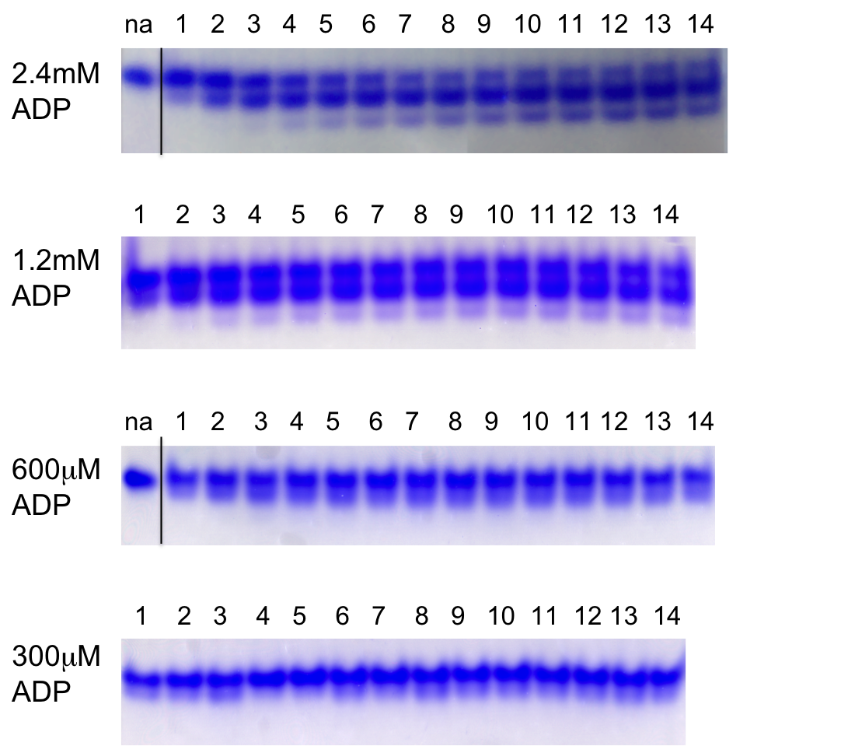
Time courses were run on native PAGE at a range of ADP concentrations (Figure 5.4), in order to try to determine k_{cat} and K_{M} values for the kinase activity.

Figure 5.4: Native PAGE gels and corresponding time course graphs for ADP-dependent phosphorylation of p38α (30μM p38DA + 6μM MEK6dd + varying ADP). Sample was in standard buffer (50mM HEPES pH7.6, 150mM NaCl, 2mM DTT) with 10mM MgCl₂ added. Lanes 1-14 are 5μl aliquots quenched at 5-minute intervals (0 to 70 minutes, ADP addition defined as zero time-point).

The extent of phosphorylation is incomplete and increases with ADP concentration. This is thought to be a result of competing MEK6 phosphatase activity, and makes determination of the kinetic parameters difficult. From the initial rate of 0P loss for 2.4mM ADP, an approximate k_{cat} value of 0.002 s⁻¹ was calculated. This assumes that ADP is saturating at this concentration.

Relative ADP-dependent and ATP-dependent kinase rates

In order to compare to the observed ADP-dependent kinase activity, time courses were similarly run at a range of ATP concentrations (Figure 5.5).
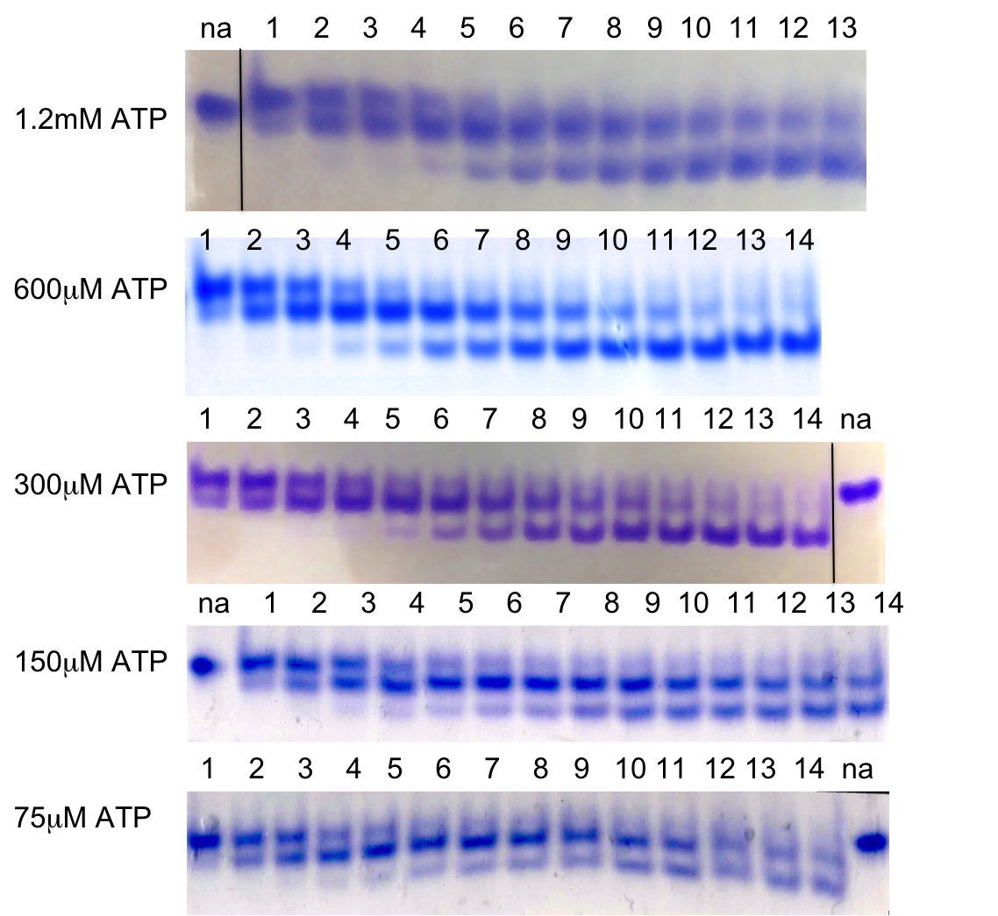
Figure 5.5: Native PAGE gels and corresponding time course graphs for ATP-dependent phosphorylation of p38α (30μM p38DA + 0.6μM MEK6dd + varying ATP). Sample was in standard buffer (50mM HEPES pH7.6, 150mM NaCl, 2mM DTT) with 10mM MgCl₂ added. Lanes 1-14 are 5μl aliquots quenched at 20-second intervals (0 to 280 seconds, ATP addition defined as zero time-point).

k_{cat} was calculated as 0.3 s⁻¹, from the initial rate of 0P loss for 600μM ATP. This is close to a previously reported k_{cat} of 0.24 s⁻¹ for kinase activity of the double glutamate MEK6 mutant[94]. K_{M} could not be accurately determined, however increasing ATP concentration from 75μM to 1.2mM does not noticeably increase the rate of 0P loss, implying that K_{M} for ATP-dependent phosphorylation is significantly less than 75μM.

MEK6 uses two ATP molecules to dually phosphorylate p38α

The observed phosphorylation of p38α by ADP shows that MEK6 can transfer both the γ-phosphate and β-phosphate of ATP to substrate hydroxyl groups. This gives rise to the possibility of MEK6 using a single ATP molecule for dual phosphorylation (non-canonical mechanism, Figure 5.2).
In order to determine which mechanism occurs in vitro, the components (MEK6dd, non-phosphorylated p38DA and ATP with Mg²⁺) were mixed under single-turnover conditions and the products determined. However a major complicating factor here is that MEK6 can also act as a phosphatase, and therefore p38α is expected to be non-phosphorylated by the reaction end-point, whichever phosphorylation mechanism is correct. However due to the differing timescales of MEK6 kinase and phosphatase activities, this problem was partially resolved by quenching the reaction by after a suitable time period, during which ATP-dependent kinase activity goes to completion and phosphatase activity is insignificant.
³¹P NMR recorded after mixing the components shows AMP (+4.7ppm) and inorganic phosphate (+3.4ppm) as the products (Figure 5.6). No p38DA phospho-Thr180 or phospho-Tyr182 is apparent in the ³¹P NMR (which appear at shifts of +4.5ppm and +0.5ppm respectively, known from taking a spectrum of the activated species). Native PAGE of the same sample after removing from the magnet confirms that p38DA is non-phosphorylated. Minor peaks in the spectrum (at +5.2, +4.9 and +4.1 ppm) do not apparently change over time, and as the ³¹P NMR of MEK6dd with no added nucleotide gives the same peaks (Figure 5.7c), these are likely to correspond to MEK6dd side-chain hydroxyls autophosphorylated during expression in E. coli (residues are unassigned).

Figure 5.6: ³¹P NMR showing the result of mixing MEK6dd (235μM)+ p38DA (235μM) + 2 eq ATP (470μM) in standard buffer + 10mM MgCl₂, without quenching (times given are the midpoint of acquisition, zero time-point is ATP addition).

³¹P NMR recorded of a similar sample quenched by addition of urea after a short time period shows ADP and phospho-Thr180 and phospho-Tyr182 of p38DA, as well as a smaller amount of inorganic phosphate (Figure 5.7b).

Figure 5.7: Left: ³¹P NMR showing the result of mixing a) MEK6dd (250μM)+ p38DA (250μM) + ATP (250μM); b) MEK6dd (250μM)+ p38DA (250μM)+ ATP (500μM). In a) and b), reaction was in standard buffer + 10mM MgCl₂ and quenched by addition of urea (3.2M final concentration) after 2 minutes. c) ³¹P NMR of untreated MEK6dd purified from E. coli in standard buffer. d) ³¹P NMR of p38DA activated using standard protocol with nucleotide and MEK6dd removed. Peak labels: T is p38DA Thr180, Y is p38DA Tyr182, P_{i} is inorganic phosphate, αP is ADP α-phosphate, βP is ADP β-phosphate. In a) and b), unlabelled peaks at +5.7, +5.0 and +0.9 ppm correspond to MEK6 side-chain hydroxyls phosphorylated during expression as shown by spectrum c). Right: native PAGE run of samples a) and b) after quenching in urea, in order to establish p38DA phosphorylation state. 1μl of sample loaded onto gel.

In order to verify which peaks in Figure 5.7 are phosphoprotein, the sample was passed through a Vivaspin membrane (10kDa cutoff) and ³¹P NMR taken of the flow-through, and the resulting spectrum showed only the peaks labelled as ADP, ATP and P_{i}. Since Figure 5.7b shows dually phosphorylated p38DA but no AMP formed, this confirms that MEK6 uses two ATP molecules for dual phosphorylation of p38DA in vitro. This is consistent with ATP-dependent kinase activity being more efficient than ADP-dependent kinase activity.

ADP-dependent kinase activity in other protein kinases

In order to determine the generality of ADP-dependent kinase activity, it was tested for the other protein kinases MEK4, cAPK and DYRK1a.

MEK4 can phosphorylate using ADP

The phosphorylation of p38DA by activated wild-type MEK4 (see activation protocol in Section 4.2.1) and ADP was followed on native PAGE (Figure 5.8).

Figure 5.8: Native PAGE timecourse showing that MEK4 can use ADP to phosphorylate its substrate (60μM p38DA+ 60μM MEK4 activated wild-type + 6mM ADP in standard reaction buffer + 10mM MgCl₂)

These results show that activated MEK4wt can similarly use ADP to phosphorylate p38α. The phosphorylation does go to completion, which was not observed for MEK6dd.

cAPK can phosphorylate using ADP

cAPK phosphorylation of kemptide (consensus serine-containing peptide) using ADP was followed by ³¹P NMR (Figure 5.9).

Figure 5.9: Series of ³¹P spectra (4k scans each) after mixing cAPK (5μM), kemptide (200μM) and ADP (5mM) in standard reaction buffer + 10mM MgCl₂.

These results show that cAPK can similarly use ADP to phosphorylate substrate. From the increase in peptide-pSer peak intensity, the turnover rate for phosphorylation is calculated as approximately 0.001 s⁻¹.

DYRK1a can phosphorylate using ADP

DYRK1a phosphorylation of DYRKtide (consensus serine-containing peptide) using ADP was followed by ³¹P NMR (Figure 5.10).

Figure 5.10: Series of ³¹P spectra (2k scans each) after mixing DYRK1a (10μM), DYRKtide (200μM) and ADP (5mM) in standard reaction buffer + 10mM MgCl₂.

These results show that DYRK1a can similarly use ADP to phosphorylate substrate. From the increase in peptide-pSer peak intensity, the turnover rate for phosphorylation is calculated as approximately 0.001 s⁻¹.

Comparison of ADP-dependent kinase activities

Both MEK6dd and activated wild-type MEK4 can use ADP to phosphorylate p38α, and their rates are not substantially different (Figure 5.3 vs Figure 5.8). It is not known why complete phosphorylation is observed with MEK4 but not with MEK6dd. The activities of cAPK catalytic subunit and DYRK1a are also similar and comparable to that of MEK6dd. The ADP concentration (5mM) is assumed to be saturating in each of these experiments, so these data indicate that k_{cat} values for ADP-dependent kinase activity are not substantially different between each of the four kinases. This is slightly surprising considering that the ATP-dependent kinase rates for these kinases are substantially different (k_{cat} = 0.3 s⁻¹ for MEK6dd, k_{cat} = 20 s⁻¹ for cAPK[95], k_{cat} = 0.2 s⁻¹ for DYRK1a[96]).

Discussion and biological significance

Mechanism of p38α activation by MEK6
Mixing p38DA, one equivalent MEK6dd and one equivalent ATP in results in equal or similar levels of Thr180 and Tyr182 phosphorylation (shown in Figure 5.7, ³¹P NMR does not show a difference in the relative integrals for p38-pT and p38-pY in b) vs a)). This means that there is a roughly equal amount of phospho--Tyr182 and phospho-Thr180 singly phosphorylated p38DA species. This is somewhat surprising considering results of previous studies, which showed that activated wild-type MEK6 phosphorylates predominantly on tyrosine in the initial step[97], and similarly from earlier studies of a constitutively active MEK1 with ERK2 substrate[46]. These studies found that whilst tyrosine phosphorylation generally occurs first because it is faster (a higher k_{cat} value), a strictly ordered mechanism is not required because some phosphothreonine species is formed. Given this, it would be expected that in this experiment the singly phosphorylated p38DA species would be predominantly phosphotyrosine. The reason for the apparent lack of preference for tyrosine phosphorylation is currently not clear. A possible explanation may be that the double aspartate mutant of MEK6, unlike the activated wild-type form, has roughly equal k_{cat} values for Thr180 and Tyr182 phosphorylation; however the finding that MEK6dd preferentially forms a TSA complex with Tyr182 over Thr180[31] indicates otherwise.

This activity shows that MEK6 can in principle carry out two phosphorylations using a single ATP molecule, leading to the proposed ‘single ATP’ mechanism for dual phosphorylation of MAPK’s by MAP2K’s. However it is found that under single turnover conditions in vitro, MEK6 uses two ATP molecules to dually phosphorylate p38α. Nevertheless, it is possible that in conditions in which nucleotide exchange is restricted, the single ATP mechanism is more favoured. This may be favoured by a ‘processive’ MAPK phosphorylation in which the MAPK remains bound for both phosphorylation steps. In vivo, scaffold proteins in the cell cytosol may stabilise the MAP2K-MAPK complex, or molecular crowding which restricts diffusion of proteins may promote ‘quasi-processive’ phosphorylation. To support this hypothesis, it has been found that addition of 15% PEG as a crowding agent in vitro shifts the phosphorylation kinetics of ERK by MEK to more processive behaviour[98].

Significance of ADP-dependent kinase activity

All of the protein kinases tested can phosphorylate their substrate using ADP as an alternative phosphoryl donor to ATP, suggesting that this activity may be a more general feature of protein kinases. The physiological relevance of this activity has not yet been determined. The greatest advantage of using ADP as a phosphoryl donor is likely to be in conditions where ATP supply is reduced and so energy saving is crucial, most notably in the case of hypoxia.
However there are surprisingly few reports of ADP-dependent kinases in existing literature. Some glucokinases and phosphofructokinases in archaea are known that phosphorylate specifically using ADP, and an equivalent eukaryotic glucokinase was identified and characterized as being ADP-dependent[99]. Whether this kinase plays a significant metabolic role in vivo has not been shown, and depends on its relative activity to ATP-dependent glucokinases also present in cells. In these ADP-dependent kinases, kinetic studies found that ATP can compete with ADP for the active site without being hydrolysed[100].
The structural basis for the ADP preference of these kinases is not clear. According to charge balance considerations, it would require one less positive charge in the active site compared to normal ATP-dependent kinases. In the crystal structure of an archaeal ADP-dependent glucokinase bound to ADP[101], the binding site for the terminal and adjacent phosphate moieties is conserved with ATP-dependent kinases, and the β and α -phosphates occupy equivalent positions to the γ and β-phosphate of ATP.

Nonspecific kinase activity of MEK6

MEK6 has an ATPase activity

Initially it was attempted to follow ATP-dependent phosphorylation of inactive p38DA by MEK6dd using the linked assay method that measures ADP production. However when p38DA was omitted from the sample, a drop in absorbance was still observed and the slope of this was found to be MEK6 concentration dependent (Figure 5.11). Therefore MEK6dd can turn over ATP in the absence of normal substrate, and since ³¹P NMR shows formation of inorganic phosphate this was shown to be effective ATPase activity.

Figure 5.11: Absorption from linked assay vs time after addition of MEK6dd (varying concentrations) to 5mM ATP. Sample in standard buffer with 10mM MgCl₂ added (protocol in Section 2.7).

Since ATP is constantly regenerated from ADP in this assay, ATPase activity would be expected to be constant over time, resulting in a linear absorbance drop until NADH is depleted. However a lag period is observed at the start, implying that an activation process is occurring in the early period of the assay. This may well be dissociation of inactive MEK6dd dimer to an active monomeric form. This suggestion is supported by the previously reported crystal structure of (N-terminal truncated) MEK6dd, in which it forms a dimer in an apparently inactive conformation, and by the finding that analytical gel filtration shows a shift of the equilibrium towards monomer in the presence of ATP[66].
From fitting of the linear region for 1.5μM MEK6dd (red), k_{cat} for ATPase activity was calculated as approximately 0.05 s⁻¹ (assuming that ATP is saturating). k_{cat} values calculated from plots for the other concentrations are in fairly good agreement with this.

Enhancement of ATP turnover rate by substrate

The effect of p38α addition on ATPase activity of MEK6dd was investigated. In order to observe only MEK6-related activity, catalytically inactive p38DA was used (after first verifying that p38DA with ATP does not give rise to an observable absorbance drop over the experiment timescale). Addition of p38DA results in an initial sharp absorbance drop, attributed to phosphorylation of Thr180 and Tyr182 producing 2 equivalents ADP, followed by a linear drop presumably due to an ATPase activity (Figure 5.12). The ATP turnover rate in the linear region (approximately 0.04 s⁻¹) is not substantially different in the three graphs in Figure 5.12, indicating that the ATPase rate is unaffected whether MEK6 is bound to p38DA or not. This result is surprising, because it might be expected that p38α binding to the MEK6 active site would inhibit its ATPase activity.

Figure 5.12: Absorption from linked assay vs time after addition of 1μM MEK6dd to 5mM ATP and varying p38DA concentrations. Sample in standard buffer with 10mM MgCl₂ added (protocol in Section 2.7).

In order to remove activity associated with p38α dual phosphorylation, a triply mutated D168A T180A Y182F p38α mutant lacking both phosphorylation sites (p38DATAYF) was expressed and purified from E. coli. The effect of this protein on ATP turnover rate of MEK6 was similarly tested. It was found that addition of p38DATAYF enhances the turnover rate, as shown in Figure 5.13. From the linear region of the absorbance drop, turnover rates were estimated as 0.04 s⁻¹ without p38, 0.06 s⁻¹ for 1μM p38DATAYF, 0.07 s⁻¹ for 5μM p38DATAYF and 0.08 s⁻¹ for 10μM p38DATAYF.

Figure 5.13: Absorption from linked assay vs time after addition of 1μM MEK6dd to 5mM ATP and varying p38DATAYF concentrations. Sample in standard buffer with 10mM MgCl₂ added (protocol in Section 2.7).

p38DATAYF was run on native PAGE to determine if it is phosphorylated by MEK6dd, and only a very slow and incomplete phosphorylation was observed (Figure 5.14). This phosphorylation would be insignificant over the experiment timescale in Figure 5.13.

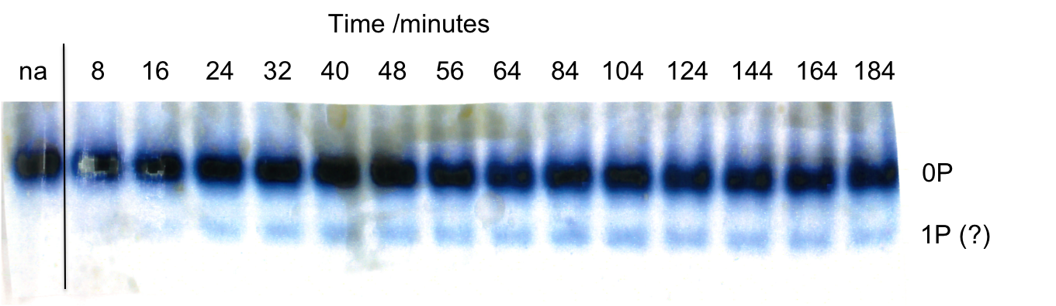
Figure 5.14: Native PAGE timecourse for 60μM MEK6dd + 60μM p38DATAYF + 5mM ATP. Zero time-point is addition of ATP, lane labeled ‘na’ is sample prior to addition of ATP. Sample was in standard buffer (50mM HEPES pH7.6, 150mM NaCl, 2mM DTT plus 10mM MgCl₂).

TSA complexes between active MEK6 and inactive p38α

It has previously been found that active MEK6dd forms a TSA complex with wild-type p38α in the presence of ADP, Mg²⁺, Al³⁺ and F⁻[31], and the presence of four protein-associated peaks in the ¹⁹F spectrum are indicative of an AlF₄⁻ moiety. Studies on the singly mutated p38α forms (T180A, Y182F) showed that a TSA complex can be formed with either Thr180 or Tyr182 acceptor residues, but that the TSA with the tyrosine is favoured. A homology model of this TSA complex based on the crystal structure of a cAPK-ADP -AlF_{x}-SP20 complex (PDB: 1L3R) was constructed (M. Cliff, described in [31]). In this model the AlF₄⁻ moiety is coordinated by the side-chain nitrogen of Lys181, side-chain nitrogen of Asn184 and the two catalytic Mg²⁺ ions, and Asp179 hydrogen bonds to the substrate hydroxyl group (Figure 5.15).
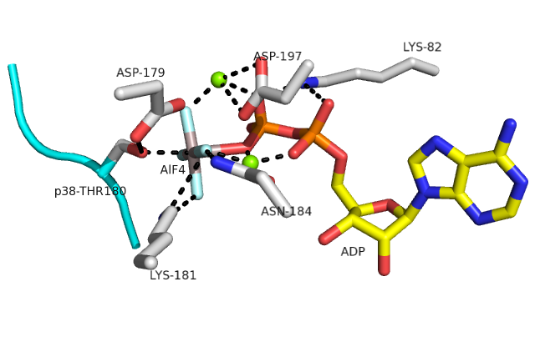Figure 5.15: Homology model of the MEK6 active site in an AlF₄⁻ TSA complex mimicking phosphorylation of the substrate threonine (based on PDB coordinates: 1L3R). Substrate peptide shown in cyan, ADP in yellow, Mg²⁺ ions in green.

Here, ¹⁹F NMR was used to show that a similar TSA complex is formed with the catalytically inactive p38DA mutant. Initially a standard ¹⁹F spectrum was run of the sample containing all necessary components (MEK6dd, p38DA, ADP, Mg²⁺, Al³⁺, F⁻). This showed two major peaks (at -119ppm and -155ppm, assigned as free fluoride and free AlFx species respectively), and three minor peaks in the region -140 to -170 ppm, assigned as protein-bound AlF₄⁻ species. In order to remove the free AlFx peak which is likely to be obscuring the additional protein-bound resonance, presaturation to free fluoride was applied. Assuming that free fluoride exchanges with free AlFx much more rapidly than with protein-bound AlFx, presaturation over an appropriate time period should selectively remove fluoride and free AlFx from the spectrum. Running ¹⁹F spectrum with this presaturation does indeed reveal four peaks indicative of an AlF₄⁻ TSA complex.
In addition an analogous experiment was carried out using the p38DATAYF triple mutant, in which both canonical phosphorylation sites are mutated. It was expected not to observe any protein-bound resonances in the ¹⁹F spectrum of this sample due to the loss of the two substrate hydroxyls. However surprisingly, four peaks indicative of an AlF₄⁻ TSA complex were observed, at chemical shifts slightly different than for with p38DA. These results are shown in Figure 5.16.

Figure 5.16: ¹⁹F NMR with F⁻ presaturation of a) MEK6dd - p38DA– ADP – AlF₄⁻ TSA complex; b) MEK6dd-p38DATAYF-ADP-AlF₄⁻ TSA complex. Each sample consists of 200μM MEK6dd, 200μM p38, 5mM ADP, 10mM NH₄F, 200μM AlCl₃, 10mM MgCl₂ in buffer 50mM HEPES pH 6.8, 150mM NaCl, 2mM DTT, 2mM azide. Presaturation of F⁻ (details given in Section 2.6.2) causes almost complete suppression of the free AlF_{x} peak (-155 ppm), whilst a residual F⁻ peak is observed.

 | δ /ppm
 | F_{A} | F_{B} | F_{C} | F_{D}
MEK6-p38DA-ADP-AlF₄⁻ | -142 | -148 | -154 | -167
MEK6-p38DATAYF-ADP-AlF₄⁻ | -143 | -150 | -155 | -165
MEK6-p38wt-ADP-AlF₄⁻ | -142 | -148 | -154 | -167
MEK6-p38TA-ADP-AlF₄⁻ | -142 | -148 | -154 | -167
MEK6-p38YF-ADP-AlF₄⁻ | -143 | -149 | -155 | -164

Table 5.1: ¹⁹F chemical shifts for the different MEK6-p38α TSA complexes. Ones in red are previously reported.

These results show that the TSA complexes with p38DA and p38DATAYF both have a lifetime of greater than 1 second, because presaturation of free fluoride over this time period does not result in suppression of the TSA resonances.
Assuming that the MEK6-p38DA complex in (a) is equivalent to the MEK6-p38wt TSA complex, F_{C} and F_{D} correspond to the two Mg²⁺ coordinated fluorides, and F_{A} and F_{B} correspond to those coordinated only by hydrogen bonds. This is based on the greater upfield shifts and lower deuterium solvent-induced isotope shifts of F_{C} and F_{D} for the MEK6-p38wt TSA complex[31]. For the MEK6-p38DATAYF complex (b), F_{A}, F_{B} and F_{C} are shifted upfield and F_{D} is shifted downfield, relative to the DA mutant (a). In addition all four peaks are slightly broader for the DATAYF mutant compared to DA. Chemical shift differences reflect the nature of the substrate hydroxyl, which in the case of p38DA is the phenolic group of Tyr182. ¹⁹F shifts for the p38DATAYF complex are indistinguishable from those of the Y182F mutant, assigned as an AlF₄⁻ TSA complex with the Thr180 hydroxyl. If this assignment is correct then this suggests that MEK6 can form a TSA complex with an alternative serine or threonine hydroxyl of p38α.

Discussion

The ATPase activity described here is not unique but has been demonstrated among several other protein kinases, including the related MEK1[102] as well as p38α. For phospho-MEK1, using a similar assay to monitor ADP production as the one used here, k_{cat} for its ATPase activity in the absence of ERK was calculated as 0.81 s⁻¹, greater than the 0.05 s⁻¹ calculated for MEK6dd. However the presence of the substrate ERK was found to inhibit ADP production, implying that kinase activity is slower and competes against uncoupled ATPase activity. This is in contrast to MEK6dd, whereby binding to p38α enhances the rate of ADP production.
The enhancement of ATP turnover rate, combined with formation of a TSA complex for MEK6dd with p38DATAYF, suggests that MEK6 may phosphorylate p38α at alternative sites. This would be surprising, since activation using the standard protocol with excess ATP produces dual phosphorylation, and previously no other p38α phosphorylation sites targeted by MEK6 other than Thr180 and Tyr182 have been identified. Ηοwever native PAGE (Figure 5.14) indicates that p38DATAYF can be weakly phosphorylated at another residue. This non-specific phosphorylation site has yet to be identified, however it could be identified by peptide mass fingerprinting. This would involve treating p38DATAYF with active MEK6 and ATP, isolating the phosphorylated p38 product, treating with trypsin and analysing the peptide fragments by mass spectrometry.
However a possible ‘kinase-phosphatase’ activity can be considered, in which MEK6 reverses the phosphorylation of non-targeted residues (Figure 5.17). In this model MEK6 can phosphorylate p38α at alternative residues, but the non-targeted residues (ie. those that are not Thr180 or Tyr182) are subsequently dephosphorylated at a fast relative rate. The specificity of MEK6, like other MAP2K’s, is primarily determined by allosteric binding rather than local sequence in the p38α activation loop. Therefore it is conceivable that MEK6 could phosphorylate other p38α side-chain hydroxyls that are in the activation loop or located in close proximity in the active site. Furthermore, this phosphatase activity would have great functional significance if the ‘incorrect’ phosphorylation of MAPK’s by their activators may lead to unintended consequences in the signalling pathway.

Figure 5.17: Schematic representation of the ‘kinase-phosphatase’ activity of MEK6 towards the p38α activation sites (a), and hypothesized kinase-phosphatase activity towards alternative substrate hydoxyls (b). X=Ser, Thr or Tyr.

Perspective and Future work

Overall conclusions

The p38 MAP kinase pathway is involved in a number of important biological processes and therefore has attracted interest as a therapeutic target. As an upstream activator of p38α, MEK6 is a key component in this pathway. Understanding the nature of these kinases’ active sites will help to us understand the basis for their specificity and aid in the design of specific inhibitors for the pathway.
In this thesis, it is shown how MEK6 has additional activities apart from its normal kinase activity. From native PAGE showing a reversion of p38α to its non-phosphorylated form over time, combined with the results of ³¹P NMR, it is shown to have a novel phosphatase activity. This activity is possessed by both the dd mutant and activated wild-type MEK6, and is much reduced in the non-activated wild-type form. The phosphatase activity is substantially slower than the kinase activity, although absolute k_{cat} values for p38α Thr180 and Tyr182 dephosphorylation could not be determined because K_{M} values were not independently determined by experiment. Given a K_{M} value of 60μM for all four dephosphorylation reactions, estimated k_{cat} values for phosphatase activity (1.1 ± 0.1 × 10⁻⁴ and 7.9 ± 0.9 × 10⁻⁵ s⁻¹ for Tyr182 and Thr180 respectively) are slower than the kinase activity (k_{cat} = 0.3 s⁻¹ for initial phosphorylation) by between three and four orders of magnitude. However the dephosphorylation results may be consistent with higher k_{cat} values than given here, in which case the difference between the rate constants would be less. This is because K_{M} values for one or more of the reactions may be higher than 60μM. In other words, a weak binding between MEK6dd and the phosphorylated p38α species, rather than slow turnover rate, may at least partially account for the slow activity observed.
Phosphatase activity was observed for the MAP2K family members MEK6 and MEK4, but not observed in cAPK (serine/threonine specific) and only observed at a much slower rate in DYRK1a (which has a serine/threonine kinase activity and can autophosphorylate on tyrosine). This suggests that phosphatase activity is a specific feature of the MAP2K’s, which are the archetypal dual specificity kinases. However future work to investigate whether tyrosine specific kinases also have a phosphatase activity is necessary to obtain a more complete picture. A possible candidate to be tested for this is Src kinase, which is tyrosine-specific and known to phosphorylate a large number of substrates including peptides.

Also in this thesis, the ability of protein kinases to utilise ADP as a phosphoryl donor is demonstrated. MEK6dd phosphorylates p38α at a turnover rate of around 2×10⁻³ s⁻¹ using ADP, slower than the ATP-dependent kinase activity by around two orders of magnitude. This activity was preserved amongst other kinases tested (activated MEK4, cAPK and DYRK1a) and is substantially slower than ATP-dependent phosphorylation in each case. The catalysis of ADP phosphoryl group transfer has not been much reported in literature, except for the cases of some glucokinases and fructokinaes in archaea that are ADP-dependent. Nevertheless this is potentially a very important reaction in biology. It represents a means by which kinases may operate in reduced energy circumstances (limited ATP supply) such as hypoxia. It also means that protein kinases can use both the γ and β phosphates of a single ATP molecule to phosphorylate.
In addition, MEK6dd was shown to possess a nonspecific activity, turning over ATP in the absence of substrate. This this is likely to be an ATPase activity. However the formation of an aluminium fluoride TSA complex with p38α mutant lacking both phosphorylation sites suggests that MEK6 may be able to phosphorylate at substrate hydroxyl groups other than Thr180 and Tyr182.

Biological significance of phosphatase activity
Whether this observed phosphatase activity of protein kinases confers any evolutionary advantage is not known. In previous reports of dual activity kinase/phosphatases occurring in bacteria (Section 3.4.2), it was suggested that the phosphatase activity may serve a beneficial function in regulating phospho-substrate levels, even though it was found to be significantly slower than the kinase activity. In the case of MEK6 or MEK4, its phosphatase activity is unlikely to be prevalent under normal physiological conditions, due to millimolar ATP present in eukaryotic cells favouring the kinase reaction.
However phosphatase activity is wasteful in terms of ATP (and therefore energy) expenditure, therefore evolution would have been expected to remove this activity, unless it does perform a beneficial function. The activity could potentially function as a ‘backup’ means of switching off the MAP kinase pathway. This would only occur in limited ATP supply due to circumstances such as hypoxia, and where the corresponding MAP kinase phosphatase is not being expressed in the cell.
In addition to the observed dephosphorylation of Thr180 and Tyr182 of p38α, it is hypothesized that the phosphatase activity could serve a ‘proof-reading’ function in vivo. In this case it would rapidly reverse undesirable phosphorylation events, which if left umodified would have adverse effects on the signalling pathway. This possibility is supported by the fact that MEK6 can likely phosphorylate p38α on alternative hydroxyls yet nonspeficic phosphorylation is not generally observed. If true then this would have huge implications for our understanding of how MAP kinase pathways are regulated.

An alternative explanation for the phosphatase activity is that for some kinases, it is an unavoidable side reaction. Whilst it does not serve a specific function, it has not been removed by evolution because doing so would also compromise its integrity as a kinase. In support of this argument, known phosphatases are generally not regulated by their own phosphorylation, whereas the majority of kinases are regulated by activation loop phosphorylation. This implies that as long as kinases are regulated, there is no advantage for organisms to tightly regulate the activity of corresponding phosphatases, and so there is no significant evolutionary advantage in removing unnecessary phosphatase activity. The suggestion that phosphatase activity is a specific feature of dual specificity kinases can be rationalised on the basis that the specificity of the active site must necessarily be compromised so that it can readily accommodate both both alkyl hydroxyl and phenolic groups. This inherent loss of specificity of the active site may result in phosphatase activity as an unavoidable side reaction.
In order to learn more about potential biological implications of phosphatase activity, further experiments are necessary which mimic in vivo conditions.

Future work
This work has demonstrated both phosphatase activity and ADP-dependent kinase activity, with an estimation of kinetic rates. In order to determine absolute K_{M} and k_{cat} values for the phosphatase activity, it is necessary to establish its substrate concentration dependence. This would require measuring dephosphorylation rates at several p38α concentrations below and above the K_{M} value.
Apart from demonstrating that phosphatase activity requires the catalytic base (D179), and that it is Mg²⁺ dependent, what is lacking currently is an understanding of the structural basis for the activity. The ideal way to study this would be to form a TSA complex mimicking the phosphatase reaction. This would comprise active MEK6 bound to p38α and a metal fluoride mimicking the transferring phosphoryl group, with water as the second ligand. It would be generated by mixing MEK6, p38DA, MgCl₂, AlCl₃ and NH₄F in solution. However from ¹⁹F NMR studies of the kinase TSA complex, control experiments have not shown any formation of a TSA complex in the absence of ADP, and there is no evidence that such a TSA is stable.
A structural characterisation of the MEK6dd-p38DA-ADP-AlF₄⁻ TSA and the MEK6dd-p38DATAYF-ADP-AlF₄⁻ TSA (shown by ¹⁹F NMR as described in Section 5.5.3) would provide valuable information as to how the loss of both activation sites affects the mode of p38 binding. If p38 binds in the same manner in the two complexes then this would lend support to the hypothesis that MEK6 can reversibly phosphorylate alternative p38α hydroxyls.
Detailed structural studies are necessary to further investigate the basis of why some protein kinases have phosphatase activity but others don’t. Whilst structural data on MAPK’s is abundant, there is a lack of structural data for active MEK6 or other active MAP2K’s, whether in apo-form or substrate-bound, as existing crystal structures mostly represent non-phosphorylated forms. This is holding back our knowledge of the MAP2K active site, which may aid in understanding how it can act as a phosphatase. In addition, it is difficult to study this system in solution by NMR methods due to the large molecular weight (approximately 79kDa) of the MEK6-p38α complex. Given these difficulties of studying MAP2K-MAPK systems, it would be advantageous if another protein kinase is identified that has phosphatase activity and is more amenable towards characterization either by x-ray crystallography or NMR.

Further investigation is also required to establish the identity of the alternative p38α phosphorylation site, which was weakly phosphorylated by MEK6. In addition it remains to be investigated whether this nonspecific phosphorylation has a regulatory effect on the activity of p38α. There are no previous reports of nonspecific p38α phosphorylation by MEK6, therefore this would be a novel finding if it is a functionally significant phosphorylation. The only previous example is phosphorylation of Tyr323 by the tyrosine kinase Zap70, which induces its autophosphorylation on Thr180 and Tyr182.

Another aspect that could be further investigated is the cause of the MEK6 lag phase in linked assay experiments measuring ATP turnover. Here, when MEK6 was added to ATP there was an initial lag in the ATP turnover rate before it reaches normal activity. It is thought that this phenomenom is a result of dimer dissociation, and that MEK6dd is only active in its monomeric form, agreeing with previous studies showing the existence of a MEK6 dimer[66]. In this case these results imply that MEK6dd exists largely as a dimer in the absence of nucleotide. Future work could be carried out to investigate the stability of the MAP2K dimeric forms, and the role of dimerisation in regulating their activity. It may also be possible that a phosphorylation event plays a role in dimer formation or dissociation, but has yet to be found out.

References

1. Laidler, K.J. and King, M.C., The development of transition-state theory. Journal of Physical Chemistry, 1983. 87(15): p. 2657-2664.
2. Warshel, A., Sharma, P.K., Kato, M., Xiang, Y., Liu, H.B., and Olsson, M.H.M., Electrostatic basis for enzyme catalysis. Chemical Reviews, 2006. 106(8): p. 3210-3235.
3. Lad, C., Williams, N.H., and Wolfenden, R., The rate of hydrolysis of phosphomonoester dianions and the exceptional catalytic proficiencies of protein and inositol phosphatases. Proceedings of the National Academy of Sciences of the United States of America, 2003. 100(10): p. 5607-5610.
4. Dennis, E.A. and Westheim.F.H, Geometry of transition state in hydrolysis of phosphate esters. Journal of the American Chemical Society, 1966. 88(14): p. 3432-3433.
5. Cleland, W.W. and Hengge, A.C., Enzymatic mechanisms of phosphate and sulfate transfer. Chemical Reviews, 2006. 106(8): p. 3252-3278.
6. Kirby, A.J. and Varvogli.A.G., Reactivity of phosphate esters . Monoester hydrolysis. Journal of the American Chemical Society, 1967. 89(2): p. 415-423.
7. Herschlag, D. and Jencks, W.P., Phosphoryl transfer to anionic oxygen nucleophiles - Nature of the transition-state and electrostatic repulsion. Journal of the American Chemical Society, 1989. 111(19): p. 7587-7596.
8. Hengge, A.C., Edens, W.A., and Elsing, H., Transition-state structures for phosphoryl transfer reactions of p-nitrophenyl phosphate. Journal of the American Chemical Society, 1994. 116(12): p. 5045-5049.
9. Buchwald, S.L., Friedman, J.M., and Knowles, J.R., Stereochemistry of nucleophilic displacement on 2 phosphoric monoesters and a phosphoguanidine - the role of meta-phosphate. Journal of the American Chemical Society, 1984. 106(17): p. 4911-4916.
10. Westheimer, F., Why nature chose phosphates. Science, 1987. 235(4793): p. 1173-1178.
11. Cliff, M.J., Bowler, M.W., Varga, A., Marston, J.P., Szabo, J., Hounslow, A.M., Baxter, N.J., Blackburn, G.M., Vas, M., and Waltho, J.P., Transition State Analogue Structures of Human Phosphoglycerate Kinase Establish the Importance of Charge Balance in Catalysis. Journal of the American Chemical Society, 2010. 132(18): p. 6507-6516.
12. Hanks, S.K. and Hunter, T., Protein Kinases .6. The eukaryotic protein kinase superfamily - Kinase (catalytic) domain-structure and classification. Faseb Journal, 1995. 9(8): p. 576-596.
13. Manning, G., Whyte, D.B., Martinez, R., Hunter, T., and Sudarsanam, S., The protein kinase complement of the human genome. Science, 2002. 298(5600): p. 1912-1934.
14. Knighton, D.R., Zheng, J.H., Teneyck, L.F., Ashford, V.A., Xuong, N.H., Taylor, S.S., and Sowadski, J.M., Crystal structure of the catalytic subunit of cyclic adenosine-monophosphate dependent protein kinase. Science, 1991. 253(5018): p. 407-414.
15. Huse, M. and Kuriyan, J., The conformational plasticity of protein kinases. Cell, 2002. 109(3): p. 275-282.
16. Taylor, S.S. and Radzioandzelm, E., 3 protein kinase structures define a common motif. Structure, 1994. 2(5): p. 345-355.
17. Hinnebusch, A.G., eIF2 alpha kinases provide a new solution to the puzzle of substrate specificity. Nature Structural & Molecular Biology, 2005. 12(10): p. 835-838.
18. Gibbs, C.S. and Zoller, M.J., Identification of electrostatic interactions that determine the phosphorylation site specificity of the cAMP-dependent protein kinase. Biochemistry, 1991. 30(22): p. 5329-5334.
19. Songyang, Z., Lu, K.P., Kwon, Y.T., Tsai, L.H., Filhol, O., Cochet, C., Brickey, D.A., Soderling, T.R., Bartleson, C., Graves, D.J., DeMaggio, A.J., Hoekstra, M.F., Blenis, J., Hunter, T., and Cantley, L.C., A structural basis for substrate specificities of protein Ser/Thr kinases: Primary sequence preference of casein kinases I and II, NIMA, phosphorylase kinase, calmodulin-dependent kinase II, CDK5, and Erk1. Molecular and Cellular Biology, 1996. 16(11): p. 6486-6493.
20. Adams, J.A., Kinetic and catalytic mechanisms of protein kinases. Chemical Reviews, 2001. 101(8): p. 2271-2290.
21. Johnson, L.N., Noble, M.E.M., and Owen, D.J., Active and Inactive Protein Kinases: Structural Basis for Regulation. Cell, 1996. 85(2): p. 149-158.
22. Steinberg, R.A., Cauthron, R.D., Symcox, M.M., and Shuntoh, H., Autoactivation of catalytic (C-alpha) subunit of cyclic AMP-dependent protein kinase by phosphorylation of threonine-197. Molecular and Cellular Biology, 1993. 13(4): p. 2332-2341.
23. Hubbard, S.R., Crystal structure of the activated insulin receptor tyrosine kinase in complex with peptide substrate and ATP analog. Embo Journal, 1997. 16(18): p. 5572-5581.
24. Shi, Y.G., Serine/Threonine Phosphatases: Mechanism through Structure. Cell, 2009. 139(3): p. 468-484.
25. Egloff, M.P., Cohen, P.T.W., Reinemer, P., and Barford, D., Crystal structure of the catalytic subunit of human protein phosphatase-1 and its complex with tungstate. Journal of Molecular Biology, 1995. 254(5): p. 942-959.
26. Denu, J.M. and Dixon, J.E., Protein tyrosine phosphatases: mechanisms of catalysis and regulation. Current Opinion in Chemical Biology, 1998. 2(5): p. 633-641.
27. Camps, M., Nichols, A., and Arkinstall, S., Dual specificity phosphatases: a gene family for control of MAP kinase function. Faseb Journal, 2000. 14(1): p. 6-16.
28. Burroughs, A.M., Allen, K.N., Dunaway-Mariano, D., and Aravind, L., Evolutionary genomics of the HAD superfamily: Understanding the structural adaptations and catalytic diversity in a superfamily of phosphoesterases and allied enzymes. Journal of Molecular Biology, 2006. 361(5): p. 1003-1034.
29. Madhusudan, Akamine, P., Xuong, N.H., and Taylor, S.S., Crystal structure of a transition state mimic of the catalytic subunit of cAMP-dependent protein kinase. Nature Structural Biology, 2002. 9(4): p. 273-277.
30. Jin, Y., Cliff, M.J., Baxter, N.J., Dannatt, H.R.W., Hounslow, A.M., Bowler, M.W., Blackburn, G.M., and Waltho, J.P., Charge-Balanced Metal Fluoride Complexes for Protein Kinase A with Adenosine Diphosphate and Substrate Peptide SP20. Angewandte Chemie-International Edition, 2012. 51(49): p. 12242-12245.
31. Liu, X.X., Marston, J.P., Baxter, N.J., Hounslow, A.M., Zhao, Y.F., Blackburn, G.M., Cliff, M.J., and Waltho, J.P., Prioritization of Charge over Geometry in Transition State Analogues of a Dual Specificity Protein Kinase. Journal of the American Chemical Society, 2011. 133(11): p. 3989-3994.
32. Bao, Z.Q., Jacobsen, D.M., and Young, M.A., Briefly Bound to Activate: Transient Binding of a Second Catalytic Magnesium Activates the Structure and Dynamics of CDK2 Kinase for Catalysis. Structure, 2011. 19(5): p. 675-690.
33. Matsui, T., Sekiguchi, M., Hashimoto, A., Tomita, U., Nishikawa, T., and Wada, K., Functional comparison of D-serine and glycine in rodents - The effect on cloned NMDA receptors and the extracellular concentration. Journal of Neurochemistry, 1995. 65(1): p. 454-458.
34. Wang, W.R., Cho, H.S., Kim, R., Jancarik, J., Yokota, H., Nguyen, H.H., Grigoriev, I.V., Wemmer, D.E., and Kim, S.H., Structural characterization of the reaction pathway in phosphoserine phosphatase: Crystallographic "snapshots" of intermediate states. Journal of Molecular Biology, 2002. 319(2): p. 421-431.
35. Ghosh, A., Shuman, S., and Lima, C.D., The Structure of Fcp1, an Essential RNA Polymerase II CTD Phosphatase. Molecular Cell, 2008. 32(4): p. 478-490.
36. Holtz, K.M., Stec, B., and Kantrowitz, E.R., A model of the transition state in the alkaline phosphatase reaction. Journal of Biological Chemistry, 1999. 274(13): p. 8351-8354.
37. Lindqvist, Y., Schneider, G., and Vihko, P., Crystal structures of rat acid phosphatase complexed with the transition-state analogs vanadate and molybdate - Implications for the reaction mechanism. European Journal of Biochemistry, 1994. 221(1): p. 139-142.
38. Brandao, T.A.S., Hengge, A.C., and Johnson, S.J., Insights into the Reaction of Protein-tyrosine Phosphatase 1B: Crystal structures for transition state analogs of both catalytic steps. Journal of Biological Chemistry, 2010. 285(21): p. 15874-15883.
39. Deng, H., Callender, R., Huang, Z.H., and Zhang, Z.Y., The PTPase-vanadate complex a true transition state analogue? Biochemistry, 2002. 41(18): p. 5865-5872.
40. Kyriakis, J.M. and Avruch, J., Mammalian mitogen-activated protein kinase signal transduction pathways activated by stress and inflammation. Physiological Reviews, 2001. 81(2): p. 807-869.
41. Cobb, M.H. and Goldsmith, E.J., How MAP Kinases Are Regulated. Journal of Biological Chemistry, 1995. 270(25): p. 14843-14846.
42. Widmann, C., Gibson, S., Jarpe, M.B., and Johnson, G.L., Mitogen-activated protein kinase: Conservation of a three-kinase module from yeast to human. Physiological Reviews, 1999. 79(1): p. 143-180.
43. Raingeaud, J., Whitmarsh, A.J., Barrett, T., Derijard, B., and Davis, R.J., MKK3- and MKK6-regulated gene expression is mediated by the p38 mitogen-activated protein kinase signal transduction pathway. Molecular and Cellular Biology, 1996. 16(3): p. 1247-1255.
44. Ferrell, J.E. and Machleder, E.M., The biochemical basis of an all-or-none cell fate switch in Xenopus oocytes. Science, 1998. 280(5365): p. 895-898.
45. Huang, C.Y.F. and Ferrell, J.E., Ultrasensitivity in the mitogen-activated protein kinase cascade. Proceedings of the National Academy of Sciences of the United States of America, 1996. 93(19): p. 10078-10083.
46. Ferrell, J.E. and Bhatt, R.R., Mechanistic studies of the dual phosphorylation of mitogen-activated protein kinase. Journal of Biological Chemistry, 1997. 272(30): p. 19008-19016.
47. Burack, W.R. and Sturgill, T.W., The activating dual phosphorylation of MAPK by MEK is nonprocessive. Biochemistry, 1997. 36(20): p. 5929-5933.
48. Zhang, Y.Y., Mei, Z.Q., Wu, J.W., and Wang, Z.X., Enzymatic activity and substrate specificity of mitogen-activated protein kinase p38 alpha in different phosphorylation states. Journal of Biological Chemistry, 2008. 283(39): p. 26591-26601.
49. Caunt, C.J. and Keyse, S.M., Dual-specificity MAP kinase phosphatases (MKPs): Shaping the outcome of MAP kinase signalling. Febs Journal, 2013. 280(2): p. 489-504.
50. Chu, Y.F., Solski, P.A., KhosraviFar, R., Der, C.J., and Kelly, K., The mitogen-activated protein kinase phosphatases PAC1, MKP-1, and MKP-2 have unique substrate specificities and reduced activity in vivo toward the ERK2 sevenmaker mutation. Journal of Biological Chemistry, 1996. 271(11): p. 6497-6501.
51. Tanoue, T., Moriguchi, T., and Nishida, E., Molecular cloning and characterization of a novel dual specificity phosphatase, MKP-5. Journal of Biological Chemistry, 1999. 274(28): p. 19949-19956.
52. Tanoue, T., Yamamoto, T., Maeda, R., and Nishida, E., A novel MAPK phosphatase MKP-7 acts preferentially on JNK/SAPK and p38 alpha and beta MAPKs. Journal of Biological Chemistry, 2001. 276(28): p. 26629-26639.
53. Vasudevan, S.A., Skoko, J., Wang, K., Burlingame, S.M., Patel, P.N., Lazo, J.S., Nuchtern, J.G., and Yang, J.H., MKP-8, a novel MAPK phosphatase that inhibits p38 kinase. Biochemical and Biophysical Research Communications, 2005. 330(2): p. 511-518.
54. Muda, M., Theodosiou, A., Gillieron, C., Smith, A., Chabert, C., Camps, M., Boschert, U., Rodrigues, N., Davies, K., Ashworth, A., and Arkinstall, S., The mitogen-activated protein kinase phosphatase-3 N-terminal noncatalytic region is responsible for tight substrate binding and enzymatic specificity. Journal of Biological Chemistry, 1998. 273(15): p. 9323-9329.
55. Stewart, A.E., Dowd, S., Keyse, S.M., and McDonald, N.Q., Crystal structure of the MAPK phosphatase Pyst1 catalytic domain and implications for regulated activation. Nature Structural Biology, 1999. 6(2): p. 174-181.
56. Camps, M., Nichols, A., Gillieron, C., Antonsson, B., Muda, M., Chabert, C., Boschert, U., and Arkinstall, S., Catalytic activation of the phosphatase MKP-3 by ERK2 mitogen-activated protein kinase. Science, 1998. 280(5367): p. 1262-5.
57. Sharrocks, A.D., Yang, S.H., and Galanis, A., Docking domains and substrate-specificity determination for MAP kinases. Trends in Biochemical Sciences, 2000. 25(9): p. 448-453.
58. Tanoue, T., Adachi, M., Moriguchi, T., and Nishida, E., A conserved docking motif in MAP kinases common to substrates, activators and regulators. Nature Cell Biology, 2000. 2(2): p. 110-116.
59. Derijard, B., Raingeaud, J., Barrett, T., Wu, I., Han, J., Ulevitch, R., and Davis, R., Independent human MAP-kinase signal transduction pathways defined by MEK and MKK isoforms. Science, 1995. 267(5198): p. 682-685.
60. Ge, B.X., Gram, H., Di Padova, F., Huang, B., New, L., Ulevitch, R.J., Luo, Y., and Han, J.H., MAPKK-independent activation of p38 alpha mediated by TAB1-dependent autophosphorylation of p38 alpha. Science, 2002. 295(5558): p. 1291-1294.
61. Salvador, J.M., Mittelstadt, P.R., Guszczynski, T., Copeland, T.D., Yamaguchi, H., Appella, E., Fornace, A.J., and Ashwell, J.D., Alternative p38 activation pathway mediated by T cell receptor-proximal tyrosine kinases. Nature Immunology, 2005. 6(4): p. 390-395.
62. Diskin, R., Engelberg, D., and Livnah, O., A novel lipid binding site formed by the MAP kinase insert in p38 alpha. Journal of Molecular Biology, 2008. 375(1): p. 70-79.
63. Zhang, Y.Y., Wu, J.W., and Wang, Z.X., Mitogen-activated Protein Kinase (MAPK) Phosphatase 3-mediated Cross-talk between MAPKs ERK2 and p38 alpha. Journal of Biological Chemistry, 2011. 286(18).
64. Takekawa, M., Tatebayashi, K., and Saito, H., Conserved docking site is essential for activation of mammalian MAP kinase kinases by specific MAP kinase kinase kinases. Molecular Cell, 2005. 18(3): p. 295-306.
65. Matsumoto, T., Kinoshita, T., Matsuzaka, H., Nakai, R., Kirii, Y., Yokota, K., and Tada, T., Crystal structure of non-phosphorylated MAP2K6 in a putative auto-inhibition state. Journal of Biochemistry, 2012. 151(5): p. 541-549.
66. Min, X.S., Akella, R., He, H.X., Humphreys, J.M., Tsutakawa, S.E., Lee, S.J., Tainer, J.A., Cobb, M.H., and Goldsmith, E.J., The Structure of the MAP2K MEK6 Reveals an Autoinhibitory Dimer. Structure, 2009. 17(1): p. 96-104.
67. Matsumoto, T., Kinoshita, T., Kirii, Y., Yokota, K., Hamada, K., and Tada, T., Crystal structures of MKK4 kinase domain reveal that substrate peptide binds to an allosteric site and induces an auto-inhibition state. Biochemical and Biophysical Research Communications, 2010. 400(3): p. 369-373.
68. Fischmann, T.O., Smith, C.K., Mayhood, T.W., Myers, J.E., Jr., Reichert, P., Mannarino, A., Carr, D., Zhu, H., Wong, J., Yang, R.-S., Le, H.V., and Madison, V.S., Crystal Structures of MEK1 Binary and Ternary Complexes with Nucleotides and Inhibitors. Biochemistry, 2009. 48(12): p. 2661-2674.
69. Chang, C.I., Xu, B.E., Akella, R., Cobb, M.H., and Goldsmith, E.J., Crystal structures of MAP kinase p38 complexed to the docking sites on its nuclear substrate MEF2A and activator MKK3b. Molecular Cell, 2002. 9(6): p. 1241-1249.
70. Akella, R., Min, X.S., Wu, Q.O., Gardner, K.H., and Goldsmith, E.J., The Third Conformation of p38 alpha MAP Kinase Observed in Phosphorylated p38 alpha and in Solution. Structure, 2010. 18(12): p. 1571-1578.
71. Tanoue, T., Maeda, R., Adachi, M., and Nishida, E., Identification of a docking groove on ERK and p38 MAP kinases that regulates the specificity of docking interactions. Embo Journal, 2001. 20(3): p. 466-479.
72. Kumar, S., McLaughlin, M.M., McDonnell, P.C., Lee, J.C., Livi, G.P., and Young, R.R., Human mitogen-activated protein kinase CSBP1, but not CSBP2, complements a Hog1 deletion in yeast. Journal of Biological Chemistry, 1995. 270(49): p. 29043-29046.
73. Kravanja, M., Engelmann, R., Dossonnet, V., Bluggel, M., Meyer, H.E., Frank, R., Galinier, A., Deutscher, J., Schnell, N., and Hengstenberg, G., The hprK gene of Enterococcus faecalis encodes a novel bifunctional enzyme: the HPr kinase/phosphatase. Molecular Microbiology, 1999. 31(1): p. 59-66.
74. Mijakovic, I., Poncet, S., Galinier, A., Monedero, V., Fieulaine, S., Janin, J., Nessler, S., Marquez, J.A., Scheffzek, K., Hasenbein, S., Hengstenberg, W., and Deutscher, J., Pyrophosphate-producing protein dephosphorylation by HPr kinase/phosphorylase: A relic of early life? Proceedings of the National Academy of Sciences of the United States of America, 2002. 99(21): p. 13442-13447.
75. Egger, L.A., Park, H., and Inouye, M., Signal transduction via the histidyl-aspartyl phosphorelay. Genes to Cells, 1997. 2(3): p. 167-184.
76. Tokishita, S., Yamada, H., Aiba, H., and Mizuno, T., Transmembrane signal transduction and osmoregulation in Escherichia-coli .2. The osmotic sensor, EnvZ, located in the isolated cytoplasmic membrane displays its phosphorylation and dephosphorylation abilities as to the activator protein, OmpR. Journal of Biochemistry, 1990. 108(3): p. 488-493.
77. Zhu, Y., Qin, L., Yoshida, T., and Inouye, M., Phosphatase activity of histidine kinase EnvZ without kinase catalytic domain. Proceedings of the National Academy of Sciences of the United States of America, 2000. 97(14): p. 7808-7813.
78. Potter, C.A., Ward, A., Laguri, C., Williamson, M.P., Henderson, P.J.F., and Phillips-Jones, M.K., Expression, purification and characterisation of full-length histidine protein kinase RegB from Rhodobacter sphaeroides. Journal of Molecular Biology, 2002. 320(2): p. 201-213.
79. Ridge, J.W., Hypoxia and energy charge of cerebral adenylate pool. Biochemical Journal, 1972. 127(2): p. 351-355.
80. Yoshino, M., Yamamoto, C., Murakami, K., Katsumata, Y., and Mori, S., Stabilization of the adenylate energy-charge in erythrocytes of rats and humans at high-altitude hypoxia. Comparative Biochemistry and Physiology a-Physiology, 1992. 101(1): p. 65-68.
81. Arthur, P.G., Hogan, M.C., Bebout, D.E., Wagner, P.D., and Hochachka, P.W., Modeling the effects of hypoxia on ATP turnover in exercising muscle. Journal of Applied Physiology, 1992. 73(2): p. 737-742.
82. Raingeaud, J., Gupta, S., Rogers, J.S., Dickens, M., Han, J.H., Ulevitch, R.J., and Davis, R.J., Pro-inflammatory cytokines and environmental stress cause p38 mitogen-activated protein kinase activation by dual phosphorylation on tyrosine and threonine. Journal of Biological Chemistry, 1995. 270(13): p. 7420-7426.
83. Lin, A.N., Minden, A., Martinetto, H., Claret, F.X., Langecarter, C., Mercurio, F., Johnson, G.L., and Karin, M., Identification of a dual-specificity kinase that activates the Jun kinases and p38-Mpk2. Science, 1995. 268(5208): p. 286-290.
84. Zheng, J.H., Trafny, E.A., Knighton, D.R., Xuong, N.H., Taylor, S.S., Teneyck, L.F., and Sowadski, J.M., 2.2 Å refined crystal structure of the catalytic subunit of cAMP-dependent protein kinase complexed with MnATP and a peptide inhibitor. Acta Crystallographica Section D-Biological Crystallography, 1993. 49: p. 362-365.
85. Zheng, J.H., Knighton, D.R., Xuong, N.H., Taylor, S.S., Sowadski, J.M., and Teneyck, L.F., Crystal structures of the myristylated catalytic subunit of cAMP-dependent protein kinase reveal open and closed conformations. Protein Science, 1993. 2(10): p. 1559-1573.
86. Kentrup, H., Becker, W., Heukelbach, J., Wilmes, A., Schurmann, A., Huppertz, C., Kainulainen, H., and Joost, H.G., Dyrk, a dual specificity protein kinase with unique structural features whose activity is dependent on tyrosine residues between subdomains VII and VIII. Journal of Biological Chemistry, 1996. 271(7): p. 3488-3495.
87. Colwill, K., Pawson, T., Andrews, B., Prasad, J., Manley, J.L., Bell, J.C., and Duncan, P.I., The Clk/Sty protein kinase phosphorylates SR splicing factors and regulates their intranuclear distribution. Embo Journal, 1996. 15(2): p. 265-275.
88. Lochhead, P.A., Kinstrie, R., Sibbet, G., Rawjee, T., Morrice, N., and Cleghon, V., A chaperone-dependent GSK3 beta transitional intermediate mediates activation-loop autophosphorylation. Molecular Cell, 2006. 24(4): p. 627-633.
89. Lauze, E., Stoelcker, B., Luca, F.C., Weiss, E., Schutz, A.R., and Winey, M., Yeast spindle pole body duplication gene MPS1 encodes an essential dual-specificity protein kinase. Embo Journal, 1995. 14(8): p. 1655-1663.
90. Wilson, L.K., Dhillon, N., Thorner, J., and Martin, G.S., Casein kinase II catalyzes tyrosine phosphorylation of the yeast nucleolar immunophilin Fpr3. Journal of Biological Chemistry, 1997. 272(20): p. 12961-12967.
91. Soundararajan, M., Roos, A.K., Savitsky, P., Filippakopoulos, P., Kettenbach, A.N., Olsen, J.V., Gerber, S.A., Eswaran, J., Knapp, S., and Elkins, J.M., Structures of Down Syndrome Kinases, DYRKs, Reveal Mechanisms of Kinase Activation and Substrate Recognition. Structure, 2013. 21(6): p. 986-996.
92. Lochhead, P.A., Sibbet, G., Morrice, N., and Cleghon, V., Activation-loop autophosphorylation is mediated by a novel transitional intermediate form of DYRKs. Cell, 2005. 121(6): p. 925-936.
93. Adayev, T., Chen-Hwang, M.C., Murakami, N., Lee, E., Bolton, D.C., and Hwang, Y.W., Dual-specificity tyrosine phosphorylation-regulated kinase 1A does not require tyrosine phosphorylation for activity in vitro. Biochemistry, 2007. 46(25): p. 7614-7624.
94. Zheng, L.S., Zhang, Y.Y., Wu, J.W., Wu, Z.G., Zhang, Z.Y., and Wang, Z.X., A continuous spectrophotometric assay for mitogen-activated protein kinase kinases. Analytical Biochemistry, 2012. 421(1): p. 191-197.
95. Cox, S. and Taylor, S.S., Kinetic analysis of cAMP-dependent protein kinase: Mutations at histidine 87 affect peptide binding and pH dependence. Biochemistry, 1995. 34(49): p. 16203-16209.
96. Himpel, S., Tegge, W., Frank, R., Leder, S., Joost, H.G., and Becker, W., Specificity determinants of substrate recognition by the protein kinase DYRK1A. Journal of Biological Chemistry, 2000. 275(4): p. 2431-2438.
97. Humphreys, J.M., Piala, A.T., Akella, R., He, H.X., and Goldsmith, E.J., Precisely Ordered Phosphorylation Reactions in the p38 Mitogen-activated Protein (MAP) Kinase Cascade. Journal of Biological Chemistry, 2013. 288(32): p. 23322-23330.
98. Aokia, K., Yamada, M., Kunida, K., Yasuda, S., and Matsuda, M., Processive phosphorylation of ERK MAP kinase in mammalian cells. Proceedings of the National Academy of Sciences of the United States of America, 2011. 108(31): p. 12675-12680.
99. Ronimus, R.S. and Morgan, H.W., Cloning and biochemical characterization of a novel mouse ADP-dependent glucokinase. Biochemical and Biophysical Research Communications, 2004. 315(3): p. 652-658.
100. Tuininga, J.E., Verhees, C.H., van der Oost, J., Kengen, S.W.M., Stams, A.J.M., and de Vos, W.M., Molecular and biochemical characterization of the ADP-dependent phosphofructokinase from the hyperthermophilic archaeon Pyrococcus furiosus. Journal of Biological Chemistry, 1999. 274(30): p. 21023-21028.
101. Ito, S., Fushinobu, S., Yoshioka, I., Koga, S., Matsuzawa, H., and Wakagi, T., Structural basis for the ADP-specificity of a novel glucokinase from a hyperthermophilic archaeon. Structure, 2001. 9(3): p. 205-214.
102. Rominger, C.M., Schaber, M.D., Yang, J., Gontarek, R.R., Weaver, K.L., Broderick, T., Carter, L., Copeland, R.A., and May, E.W., An intrinsic ATPase activity of phospho-MEK-1 uncoupled from downstream ERK phosphorylation. Archives of Biochemistry and Biophysics, 2007. 464(1): p. 130-137.

