

Torque-Speed Characteristics of Induction Machine and Hybrid Permanent Magnet Assisted Synchronous Reluctance Machine for Electric Vehicle Application

Yang Guan

A thesis submitted for the degree of Doctor of Philosophy
Department of Electronic and Electrical Engineering
The University of Sheffield
Mapping Building, Sheffield, S1 3JD, UK

December 2014

Abstract
This thesis describes an investigation into two types of electrical machines for EV/HEV applications, i.e. induction machine (IM) and permanent magnet assisted synchronous reluctance machine (PMA-SynRM). Both are low-cost due to no or less usage of NdFeB permanent magnet (PM), compared with interior PM (IPM) machines.
IM is investigated with particular reference to its maximum torque/power-speed characteristic. Firstly, an analytical method based on dq-axis reference frame to obtain the maximum torque/power-speed characteristic is developed and validated by experiments. Then, the influences of some design parameters on the flux-weakening performance are investigated, such as the ratio of leakage to mutual inductance, stator and rotor resistances, and iron saturation, etc. In addition, the influences of some physical parameters on the torque/power-speed characteristic are investigated, including split ratio, number of stator/rotor slots per pole per phase, length of airgap, number of pole pairs and stator/rotor slot area, etc. Finally, the difference in maximum torque/power-speed characteristics between motor and generator modes is described, and how the design parameters influence the difference is investigated.
For PMA-SynRM, a novel hybrid-PM assisted SynRM is proposed, which utilizes both ferrite and NdFeB PMs. The design process is presented and the electromagnetic performance and material cost are analyzed and discussed. The analyzed electromagnetic performances include electromagnetic torque, flux density, back electromotive force (EMF), torque/power-speed characteristic, power factor, torque ripple, cogging torque and demagnetization, etc.
Finally, the electromagnetic performances and material costs of IM and hybrid-PM assisted SynRM are compared with those of IPM, respectively, including torque capability per Ampere, torque/power-speed characteristic, power factor, torque ripple and efficiency map, etc.

Acknowledgements
Great thanks are due to my supervisor, Prof. Zi-Qiang Zhu, for his strong and continued support, advices and encouragements, which have been invaluable in the completion of this thesis. Thanks are also due to all members of the Electrical Machines and Drives Group at the University of Sheffield, particularly Mr Ibrahim Afinowi for his many helpful and productive discussions.
I would like also to thank Valeo France for the financial support and prototyping, particularly Dr. Philippe Farah and Dr. Jean-Claude Mipo for their very helpful supervision and advices, and Mr Yong Zhu for his strong support in testing.
Finally, I warmly thank my parents for their love and encouragement.

Content

Abstract II
Acknowledgements III
Nomenclature X
1 General Introduction 1
1.1 Introduction 1
1.2 Basic Theory of IM and SynRM 5
1.3 Classification of Inverter-driven IM Topologies 10
1.4 Strategies for IM Flux-Weakening Performance Improvement 12
1.5 Classification of SynRM Topologies 15
1.6 Design of SynRM 17
1.6.1 To Improve L_{d}/L_{q} and (L_{d}-L_{q}) 17
1.6.2 To Minimize Torque Ripple 19
1.7 PMA- SynRM 22
1.8 Scope and Contributions of Research 24
1.8.1 Scope of Research 24
1.8.2 Contributions of Research 26
2 Analytical Calculation of Torque-Speed Characteristic of Induction Machines for Electric Vehicle Application 28
2.1 Introduction 28
2.2 Calculation Strategy 29
2.3 Calculation of Resistance and Inductance 30
2.3.1 Resistance 30
2.3.2 Mutual Inductance 31
2.3.3 Slot Leakage Inductance 34
2.3.4 Harmonic Leakage Inductance 35
2.3.5 End Leakage Inductance 36
2.3.6 Slot Skewing Leakage Inductance 37
2.4 Calculation of Losses 37
2.4.1 Copper Loss 37
2.4.2 Iron Loss 37
2.5 Experiment Verification 38
2.6 Conclusion 46
3 Influence of Machine Design Parameters on Torque-speed Characteristic of Induction Machine for Electric Vehicle Application 47
3.1 Introduction 47
3.2 Influence of Mutual and Leakage Inductances on Flux-weakening Performance 48
3.2.1 Basic Equations of IM in Per-unit Model 48
3.2.2 Influence of Mutual and Leakage Inductance 49
3.2.3 Discussions 52
3.3 Influence of Iron Saturation, Stator and Rotor Resistances on Flux-Weakening Performance 53
3.3.1 Iron Saturation 53
3.3.2 Stator Resistance 58
3.3.3 Rotor Resistance 61
3.4 Influence of Physical Parameters on Torque-Speed Characteristic 64
3.4.1 Initial Design 64
3.4.2 Influence of Physical Parameters 65
3.5 Conclusions 82
4 Difference in Maximum Torque-speed Characteristics of Induction Machine between Motor and Generator Operation Modes 84
4.1 Introduction 84
4.2 Maximum Torque-speed Characteristics in Motor and Generator Modes 84
4.3 Influence of Stator and Rotor Resistances 87
4.3.1 Stator Resistance 87
4.3.2 Rotor Resistance 90
4.4 Influence of Other Parameters 94
4.4.1 Variable Inductance 94
4.4.2 Iron Loss 97
4.5 Experiment Verification 101
4.6 Conclusions 105
5 Design and Electromagnetic Performance of Hybrid Permanent Magnet Assisted Synchronous Reluctance Machine 106
5.1 Introduction 106
5.2 Design of SynRM 107
5.2.1 Minimization of Rotor Optimization Parameter Number 107
5.2.2 Number of Barriers 110
5.3 Design of PMA-SynRM 112
5.4 Design of Hybrid PM-assisted SynRM 114
5.5 Design Specifications 116
5.6 Electromagnetic Performance and Cost 119
5.6.1 Flux Field Distribution 119
5.6.2 Electromagnetic Torque 121
5.6.3 Back EMF 124
5.6.4 Torque-speed Characteristic 125
5.6.5 Power Factor 127
5.6.6 Torque Ripple and Cogging Torque 128
5.6.7 Demagnetization 129
5.6.8 Cost 131
5.7 Conclusion 132
6 Comparison of Electromagnetic Performance and Cost between Different Types of Electrical Machines for Electric Vehicle Application 133
6.1 Introduction 133
6.2 Comparison between IM and IPM 134
6.2.1 Design of IM 134
6.2.2 Comparison of Performance and Cost 141
6.3 Comparison between SynRM, Ferrite-Assisted SynRM, NdFeB-Assisted SynRM, Hybrid PM-Assisted SynRM and IPM 151
6.3.1 Design of SynRM 151
6.3.2 Design of Ferrite-Assisted SynRM 154
6.3.3 Design of NdFeB-Assisted SynRM 155
6.3.4 Design of Hybrid PM-Assisted SynRM 157
6.3.5 Design Specification 161
6.3.6 Comparison of Performance and Cost 165
6.4 Comparison between IM and hybrid PM-Assisted SynRM 179
6.4.1 Design Specifications 179
6.4.2 Comparison of Performance and Cost 182
6.5 Conclusion 188
7 General Conclusions 190
7.1 IM for EV/HEV Applications 190
7.1.1 Analytical Calculation of Torque-Speed Characteristic 190
7.1.2 Influence of Design Parameters on Torque-Speed Characteristic 190
7.1.3 Difference of Torque-Speed Characteristic between Motor and Generator Modes 192
7.2 Hybrid PM-Assisted SynRM for EV/HEV Applications 193
7.2.1 Design of Hybrid PM-Assisted SynRM 193
7.2.2 Electromagnetic Performance and Cost 193
7.3 Comparison between Different Types of Electrical Machines 194
7.4 Future Work 196
Reference 197
Appendix A Basic Equations of IM and SynRM in Dq-Axis Reference Frame 210
Appendix B Lamination and Permanent Magnet Specifications 212
Appendix C Per-unit System 216
Appendix D Reluctance Torque and Permanent Magnet Torque Calculation Using Frozen Permeability 217
Appendix E Torque-Speed Characteristic Calculation Equations Accounting for Cross-Coupling for PMA-SynRM and IPM [QI09] 219
Appendix F Mechanical Loss of Prius 2010 Interior Permanent Magnet Electrical Machine 220
Appendix G FEA Evaluation of Iron Loss and PM Loss 222
Appendix H Specifications of Valeo IM 223
Appendix I Comparison of Electromagnetic Performance and Cost between Induction Machine and Hybrid Permanent Magnet Assisted Synchronous Reluctance Machine with Valeo Size 225
I.1 Design Specifications 225
I.2 Comparison of Performance and Cost 227
I.2.1 Torque Capability per Ampere 227
I.2.2 Torque/Power-Speed Characteristic 227
I.2.3 Power Factor 229
I.2.4 Torque Ripple 230
I.2.5 Efficiency Map 231
I.2.6 Cost 232
I.3 Conclusion 233
Publications 234

Nomenclature
a₁ | Number of parallel branches of winding | m²
A_{B} | Area of one rotor bar of IM | m²
A_{c1}, A_{c2} | Areas of stator and rotor yoke of flux path per pole | m²
A_{g} | Area of airgap per pole | m²
A_{R} | Area of rotor end ring of IM | m²
A_{t1}, A_{t2} | Areas of stator and rotor teeth of flux path per pole | m²
A_{wir} | Cross-section area per wire copper | m²
b₀₁, b₁₁ | Stator slot opening and slot width (Fig. 2.1) | m
b₀₂, b₁₂, b₂₂ | Rotor slot opening and slot width (Fig. 2.1) | m
B_{c1}, B_{c2} | Maximum flux densities in stator and rotor yokes | T
B_{g} | Maximum flux density in airgap | T
b_{sk} | Maximum distance that the rotor bar has been skewed | m
B_{t1}, B_{t2} | Maximum flux densities in stator and rotor tooth | T
b_{t1}, b_{t2} | Stator and rotor tooth widths | m
C₁, C₂ | Empirical coefficients for stator and rotor yoke magnetomotive force (MMF) calculation
cos(φ) | Power factor
D_{i} | Stator inner diameter | m
D_{R} | Rotor end ring diameter | m
E_{g} | RMS of airgap electromotive force (EMF) of per phase IM | V
E_{r} | RMS of rotor EMF per phase of IM | V
E_{s} | RMS of stator EMF per phase of IM | V
f_{s} | Stator current frequency | Hz
F_{c1}, F_{c2} | MMF of stator and rotor yoke | At
F_{g} | MMF of airgap | At
F_{m} | Exciting MMF | At
F_{t1}, F_{t2} | MMF of stator and rotor tooth | At
g | Airgap length | m
G_{Fej}, G_{Fej2} | Stator and rotor total tooth weights | kg
G_{Fet}, G_{Fet2} | Stator and rotor yoke weights | kg
h₀₁, h₁₁, h₂₁ | Stator slot heights (Fig. 2.1) | m
h₀₂, h₁₂, h₂₂ | Rotor slot heights (Fig. 2.1) | m
h_{b1}, h_{b2}, h_{b3}  h_{b1}', h_{b2}', h_{b3}' | Thicknesses of layers of barriers of SynRM (Fig. 5.2) | m
h_{bar} | Average thickness of barriers in SynRM | m
H_{c1}, H_{c2} | Maximum magnetic fields in stator and rotor yokes | A/m
H_{g} | Maximum magnetic field in airgap | A/m
h_{i1}, h_{i2}, h_{i3}  h_{i1}', h_{i2}', h_{i3}', h_{i4}' | Thicknesses of layers of irons of SynRM (Fig. 5.2) | m
h_{iron} | Average thickness of iron layers in SynRM | m
h_{s}, h_{r} | Stator and rotor slot total heights | m
H_{t1}, H_{t2} | Maximum magnetic fields in stator and rotor teeth | A/m
$h_{t1}^{'}$, $h_{t2}^{'}$ | Magnetic path lengths in stator and rotor teeth | m
$$\vec{i}$$ | Stator current vectors in dq frame | A
i_{a} | Stator phase current amplitude | A
I_{base} | Base value of current | A
i_{d}, i_{q} | Stator d- and q-axis currents | A
i_{lim} | Limit of stator phase current amplitude | A
I_{m} | RMS of exciting current | A
i_{p} | Scaled stator phase current amplitude | A
I_{r} , I_{s} | RMS values of rotor and stator phase current | A
i_{r} | Rotor current amplitude | A
J | Stator current density | A/m²
k₂ | Order of rotor MMF harmonic
K_{B} | Rotor bar skin-effect coefficient
$$K_{c_sr}$$ | Average Carter coefficient
K_{dp1} | Stator winding factor
k_{j} | Correction coefficient for yoke iron loss calculation
K_{L1}, K_{L2} | Coefficients for stator and rotor slot leakage inductance coefficients calculation
k_{pac} | Packing factor
K_{s} | Ratio of maximum flux density to average flux density in airgap
K_{s_coil} | End winding shape empirical coefficient used for winding end length calculation
k_{t} | Tooth iron loss correction coefficient
K_{t1}, K_{t2} | Saturation coefficients used for magnetic circuit calculation
K_{U1}, K_{U2} | Coefficients for stator and rotor slot leakage inductance coefficients calculation
L | Stack length | m
L_{B} | Rotor bar length | m
L_{base} | Base value of inductance | H
$l_{c1}^{'}$, $l_{c2}^{'}$ | Magnetic path lengths in stator and rotor yokes | m
L_{d}, L_{q} | D- and q-axis inductances of IPM | H
L_{d1}, L_{d2} | Stator and rotor harmonic leakage inductances | H
L_{e1}, L_{e2} | Stator and rotor end leakage inductances | H
L_{end} | Length of coil end part | m
L_{half_turn} | Average length of half coil | m
L_{line} | Length of straight part of coil | m
L_{m}, L_{s}, L_{r} | Mutual, stator and rotor inductances of IM | H
L_{mp}, L_{sp}, L_{rp} | Scaled mutual, stator and rotor inductances
L_{md}, L_{mq} | magnetizing components d- and q-axis inductances | H
L_{s1}, L_{s2} | Stator and rotor slot leakage inductances | H
L_{sk} | Slot skewing leakage inductance | H
L_{t} | L_{s}-L_{m}²/L_{r} | H
$L_{σ}$, $L_{σs}$, $L_{σr}$ | Total, stator and rotor leakage inductances | H
$$L_{σp}$$ | Scaled total leakage inductance
m₁ | Number of phases
N₁ | Number of parallel wires per turn per coil
n, n_{s} | Mechanical speeds of rotor and field in the airgap | rpm
p | Number of pole pairs
P_{Cu1}, P_{Cu2} | Stator and rotor copper losses | W
P_{Cu1_M,} P_{Cu1_G} | Stator copper losses in motor and generator modes | W
P_{Cu2_M,} P_{Cu2_G} | Rotor copper losses in motor and generator modes | W
P_{em} | Electromagnetic power | W
P_{em_M}, P_{em_G} | Electromagnetic power in motor and generator modes | W
P_{Fe1}, P_{Fe2} | Stator and rotor iron losses | W
P_{Fej}, P_{Fej2} | Stator and rotor yoke iron losses | W
p_{Fej}, p_{Fej2} | Stator and rotor yoke iron loss coefficients | W/kg
P_{Fet}, P_{Fet2} | Stator and rotor tooth iron losses | W
p_{Fet}, p_{Fet2} | Stator and rotor tooth iron loss coefficients | W/kg
P_{fw} | Frictional loss | W
P_{out} | Output power | W
P_{out_M}, P_{out_G} | Output power in motor and generator modes | W
Q₁, Q₂ | Numbers of stator and rotor slots
q₁, q₂ | Numbers of stator and rotor slots per pole per phase
Q_{p} | Number of slots per pole
r₂₁ | Stator slot bottom radius (Fig. 2.1) | m
R_{B} | Rotor bar resistance transformed to stator side | Ω
R_{base} | Base value of resistance | Ω
R_{m} | Iron loss resistance of IM | Ω
R_{r} | Rotor phase resistance transformed to stator side | Ω
R_{Ring} | Rotor end ring resistance transformed to stator side | Ω
R_{s}, R_{r} | Stator and rotor phase resistances | Ω
R_{sp}, R_{rp} | Scaled stator and rotor resistances
s | Slip ratio
S_{slot} | Area per stator slot | m²
t₁, t₂ | Stator and rotor slot pitches in terms of distance | m
T_{barrier}, T_{ferrite}, T_{NdFeB} | Torque components contributed by barriers, ferrite and NdFeB | Nm
T_{base} | Base value of torque | Nm
T_{em} | Electromagnetic torque | Nm
T_{emp} | Scaled electromagnetic torque | Nm
T_{PM_ferrite}, T_{PM_NdFeB} | PM torque components contributed by ferrite and NdFeB | Nm
T_{rel} | Reluctance torque | Nm
T_{shaft} | Shaft torque | Nm
T_{shaft_M}, T_{shaft_G} | Shaft torque in motor and generator modes | Nm
$\vec{u}$, $\vec{u'}$ | Stator voltage vector in dq frame | V
u_{a} | Stator phase voltage amplitude | V
U_{base} | Base value of voltage | V
u_{d}, u_{q} | Stator d- and q-axis voltages | V
U_{dc} | DC link voltage | V
u_{dp}, u_{qp} | Scaled stator d- and q-axis voltages
u_{lim} | Stator phase voltage amplitude limit | V
u_{rd}, u_{rq} | Rotor and rotor d- and q-axis voltages | V
U_{s}, $\vec{U_{s}}$ | RMS value and vector of stator phase voltage | V
v | Order of stator MMF harmonic
W_{φ} | Number of series turns per phase
X_{m} | Exciting reactance of IM | Ω
X_{σs}, X_{σs} | Stator and rotor leakage reactances | Ω
Y | Coil pitch in terms of slot number
Z_{ϕ1} | Number of series conductors per phase of winding
ΣS, ΣR | Coefficient used for stator and rotor harmonic leakage inductances calculation
𝜓_{a} | RMS of stator phase flux linkage | Wb
$$ψ_{base}$$ | Base value of flux linkage | Wb
𝜓_{d} , 𝜓_{q} | Stator d- and q-axis flux linkages | Wb
$$ψ_{PM}$$ | PM flux linkage | Wb
$${\dot{ψ}}_{r_abc}$$ | Phasor of rotor flux linkage in abc frame | Wb
𝜓_{r} | Rotor flux linkage in dq frame | Wb
𝜓_{rd}, 𝜓_{rq} | Rotor d- and q-axis flux linkages | Wb
β | Coil short pitch ratio
η | Efficiency
η_{M}, η_{G} | Efficiencies in motor and generator modes
θ | Current angle | deg
$λ_{L1}$, $λ_{L2}$ | Coefficients for stator and rotor slot leakage inductance coefficients calculation
$λ_{s1}$, $λ_{s2}$ | Stator and rotor slot leakage inductance coefficients
$λ_{U1}$, $λ_{U2}$ | Stator and rotor slot opening leakage inductance coefficients
$$μ_{0}$$ | Vacuum permeability | H/m
ρ_{B}, ρ_{R} | Rotor bar and ring resistivity | Ω·m
ρ_{Cu} | Copper resistivity | Ω·m
σ | 1+X_{σs}/X_{m}
τ_{y} | Coil pitch in terms of circumferential distance | m
ω | Stator electrical angular speed | rad/s
ω_{p} | Scaled stator electrical angular speed | rad/s
ω_{rate} | Rated stator electrical angular speed | rad/s
ω_{s} | Slip electrical angular speed | rad/s
ω_{sp} | Scaled slip electrical angular speed | rad/s
φ_{g} | Flux per pole | Wb

General Introduction

Introduction
Vehicles with internal combustion engines (ICE) have existed for over 100 years. With global economic and population growth nowadays, the demand for personal vehicles has increased. Consequently, more and more fossil fuel is needed to satisfy the increasing number of vehicles. Another problem related with the increasing number of vehicles is CO₂ emission, which contributes to the green-house effect. Based on the two concerns above, new types of vehicles consuming less oil and exhausting less CO₂ have been developed, e.g.
- Hybrid electric vehicle (HEV)
- Battery-powered electric vehicle (EV)
- Fuel cell electric vehicle (FCV)
The electric traction system, which includes an electricity source, a controller and a couple of electrical machines, is the key to solve the two problems above. Pure EVs completely utilize the electricity discharged from the battery as power to drive the vehicle. Thus, they are oil-free. If the power of battery comes from clean energy, the pure EVs emit no CO₂. The disadvantages of EVs are high cost of battery, short driving range, long charging time and reduced passenger and cargo space [CHA07]. FCVs also utilize electricity power. However, the power comes from fuel cells consuming hydrogen. They are also oil-free and the by-product is water. Popularity of FCVs is limited by high cost of fuel cells, storage of hydrogen, production and transportation of hydrogen, and life cycle of the fuel cells [CHA07]. HEVs utilize electrical machines to adjust the torque and speed of ICE to make it always operate in a fuel-efficiency status, and consequently, reduce the CO₂ emission. When the vehicle-required energy is larger than the output energy of ICE, the electrical machine will assist ICE to drive the vehicle. When the vehicle-required energy is smaller than the output energy of ICE, the electrical machine will store the excess energy into the battery, or drive the vehicle by itself with ICE shutting down. The electrical machine can also recover the kinetic energy during the braking or coasting of the vehicle and store it into the battery. EV/HEVs have become more and more popular due to their technological maturity and acceptable price, and also due to the increasing attention to energy conservation and global warming.
The electrical machines are key components in the traction systems used for EV/HEV applications. The following requirements of traction electrical machines should be satisfied [ZHU07]:
- High torque at low speed region for starting and hill climbing, and high power in high speed region for cruising;
- High torque and power density due to the compact space;
- Wide constant power region, usually 3-4 times the base speed;
- High efficiency over wide speed and torque region;
- High reliability and robustness;
- Acceptable cost;
- Low torque ripple;
- Low acoustic noise to supply a comfortable driving environment.
Induction machine (IM) and permanent magnet (PM) electrical machine are two types of electrical machines used most widely in the EV/HEV market, as listed in Table 1.1 [REF13] [ZU09] [HAS08] [ONL09] [ONL11ab] [ONL11b] [ONL11c] [ONL14a] [ONL14b] [ONL14c]. The topologies of IM and PM machine are shown in Fig. 1.1.
Usually, a PM machine has better performance than an IM in terms of torque, power density, power factor, and constant power region. However, the price of PM machine is higher than IM due to the high cost of NdFeB PM, which fluctuated violently in recent years and peaked in 2011 [XUE11]. It strongly affects the popularity of PM machines in EV/HEV market. PM-assisted synchronous reluctance machines (PMA-SynRM) have developed rapidly recently, which mainly utilizes the rotor saliency instead of PM flux linkage for torque production. Usually, the PM quantity in a PMA-SynRM is smaller than that in a PM machine. The topologies of SynRM and PMA-SynRM are also shown in Fig. 1.1. In fact, PMA-SynRM and interior PM machine share the same principle. The PMA-SynRM in this thesis refers to this kind of interior PM machines, with reluctance torque more predominant and PM torque added, which is usually realized by utilizing multi-layer barriers.
In this thesis, two types of electrical machines with no or less PM quantity are investigated and analyzed for EV/HEV application:
- IM;
- PMA-SynRM.
Table 1.1 Summary of EV/HEVs using IM and PM machines
 | Company | Vehicle
IM | GM (USA) | Chevrolet Silverado
IM | Ford (USA) | Ford Think City
IM | Teslar (USA) | ROADSTER
IM | Renault (France) | Kangoo VAN Z.E.
IM | Daimler(Germany) | Mercedes-Benz ML450
IM | BMW (Germany) | BMW X6
PM machine | GM (USA) | Chevrolet Spark EV  Chevrolet Volt
PM machine | Nissan (Japan) | Nissan Leaf
PM machine | Toyota （Japan） | Toyota Camry  Toyota Prius  Lexus
PM machine | Honda (Japan) | Honda Insight  Honda Civic  Honda Accord
PM machine | Peugeot (France) | Peugeot 3008 Hybrid4

IM
SynRM
PMA-SynRM
PM machine
Fig. 1.1 Topologies of IM, SynRM, PMA-SynRM and PM synchronous machine.

Basic Theory of IM and SynRM
The basic equations of IM and SynRM based on dq-axis reference frame are listed in Appendix A. The d-axis is aligned with the rotor field. It can be seen that the formats of basic equations of IM are the same as those of SynRM, if L_{t} and L_{s} are substituted by L_{q} and L_{d} [BIA98]. Thus, IM and SynRM share the same phenomena, in terms of how the resistance and inductance affect the voltage, flux-linkage, electromagnetic torque/power, etc. The basic theory and descriptions of behaviors of performance parameters of SynRM are presented in [STA93] [MAT94] [SOO94] [MOG10].
A. Torque per Ampere
The electromagnetic torque in dq-axis frame is (3.4), which shows that (L_{d}-L_{q}) is the key parameter determining the torque capability per Ampere. The maximum torque per Ampere increases with the stator current amplitude, as shown in Fig. 1.2. Without iron saturation, the optimal current angle for maximum torque per Ampere is 45º, and this angle increases with stator current amplitude due to increased iron saturation level.
$T_{em}=\frac{m_{1}}{2}p(L_{d}-L_{q})i_{d}i_{q}$
(1.1)
Fig. 1.2 Variations of torque with stator current angle for different current amplitudes, these curves are for illustration, not calculated.

B. Torque per Wb
The electromagnetic torque with constant flux is (1.2). The maximum possible output torque is (1.3). The maximum torque per Wb increases with the stator flux linkage amplitude, as shown in Fig. 1.3. The optimal current angle for maximum torque per Wb decreases with the stator flux linkage amplitude. It is because as the iron is more saturated, ε usually decreases, further the optimal current angle for maximum torque per Wb, equalling to tan⁻¹(ε), decreases.
$T_{em}=\frac{m_{1}}{2}\frac{p}{2}(\frac{1}{L_{q}}-\frac{1}{L_{d}}){(\frac{E_{s}}{ω})}^{2}\sin{(2\tan^{-1}\left(\frac{\tan{θ}}{ε}\right))}$
(1.2)
$T_{em}=\frac{\frac{m_{1}}{2}\frac{p}{2}(1-\frac{L_{q}}{L_{d}}){(\frac{E_{s}}{ω})}^{2}}{L_{q}}$ with $\tan{θ}=ε$
(1.3)
$ε=\frac{L_{d}}{L_{q}}$
(1.4)
where θ is the current angle, i.e. the current angle between stator current vector and d-axis, E_{s} is the rms of stator electromagnetic force (EMF), 𝜓_{a} is the rms of stator flux linkage.

Fig. 1.3 Variations of torque with stator current angle for different stator flux linkage amplitudes, these curves are for illustration, not calculated.
C. Power Factor
The power factor cosφ is (1.5), where the stator resistance is neglected. This simplification is valid only when the stator resistance is much smaller than ωL_{q}. If $\tan{θ}=\sqrt{ε}$, the power factor reaches the maximum value (1.6), which shows that the maximum power factor depends on ε, the larger the better. The behavior of power factor is shown in Fig. 1.4. As the stator current amplitude increases, ε decreases due to more saturated iron, and then cosφ decreases. The current angle for maximum power factor decreases with the stator current amplitude, due to decreased ε and (1.6).
$cosφ=(ε-1)\sqrt{\frac{sin⁡(2θ)}{2(\tan{θ}+ε^{2}\cot{θ})}}$
(1.5)
Maximum power factor:
$cosφ=\frac{ε-1}{ε+1}$ with $\tan{θ}=\sqrt{ε}$
(1.6)

Fig. 1.4 Variations of power factor with current angle for different stator current amplitudes, these curves are for illustration, not calculated.

D. Circle Diagram and Constant Power Region
The circle diagram is well-known to graphically show the current vector behaviors under different control strategies, as shown in Fig. 1.5. The current vector trajectory for maximum torque-speed control is shown as the solid line, and the corresponding maximum power-speed curve is shown in Fig. 1.6. The whole speed region can be divided into three modes:
- Mode I: i_{a}=i_{lim}, u_{a}<u_{lim}
- Mode II: i_{a}=i_{lim}, u_{a}=u_{lim}
- Mode III: i_{a}<i_{lim}, u_{a}=u_{lim}
where i_{a} and u_{a} are the stator phase current and voltage amplitude, i_{lim} and u_{lim} are the limits of stator phase current and voltage amplitudes. The dividing speeds between modes I and II, modes II and III are named as base speed and critical speed.
When IM or SynRM operates in mode I, i.e. constant torque region, the current vector is that of point B, and the current angle θ≥45º. When IM or SynRM operates in mode II, the current vector will move along the current limit circle from point B to P, until the constant torque curve is tangential to the voltage ellipse. When IM or SynRM operates in mode III, the current vector will move along the line PO. The ideal power with power factor unity and no loss is shown as the dash line in Fig. 1.6. The reason for the decline of ideal power in mode III is attributed to the decrease of stator current amplitude.
The constant power region increases with ε, as shown in Fig. 1.7. The optimum flux-weakening performance can be achieved with an infinite ε.
Fig. 1.5 Circle diagram
Fig. 1.6 Power-speed characteristic
Fig. 1.7 Normalized power-speed characteristics with different L_{d}/L_{q} values, [SOO94]

Classification of Inverter-driven IM Topologies
IM has a history of almost 130 years, and the first IM was developed by Nikola Tesla in 1888. The earlier IMs were all developed for line-fed applications. Since the early 1990s, more attention has been given to the inverter-driven IM design, although the development of solid-state inverters and control algorithms has started much earlier [DAU91]. Because the specific design for high self-starting torque is no longer required for inverter-driven IM, the double-cage or deep slot rotor structure is not needed [ZHA00]. IM is favorable due to its low cost, simple and rugged construction, high reliability and mature manufacturing and control technology. Despite of the wide variety of electrical machines, IM still represents the largest market share by far [ALM14].
A. Squirrel-Cage Rotor and Wound Rotor
The squirrel-cage IM is used extensively in market due to its advantages of simple rotor construction and maintenance-free, because no slip ring is used. For wound rotor IM, the inverter can be connected to the rotor winding, while the stator winding is still connected to grid. The advantages of inverter-driven wound rotor IM are as follows:
- Low inverter capacity. The inverter size is not related to the full power, but depends on the slip power. For wind turbine, an inverter size of around 25% of the generator total power is usually adopted [BOG13].
- Adjustable power factor in the stator side. The magnetizing current can be supplied from the rotor side and adjustable, and consequently, the stator side can absorb or produce reactive power.
The disadvantages of inverter-driven wound rotor IM are:
- Complicated rotor structure and maintenance problem, due to the existence of slip ring and brush.
- Low temperature-withstanding capability for the rotor due to the existence of insulation in the rotor;
- Limited speed range, because the slip ratio cannot be too large to limit the inverter capacity.
The wound rotor IM is quite favorable in wind turbine market, which does not require a wide speed range. Up to 70% of the installed wind turbines incorporated wound rotor IM [GOR14].
B. Integral-Slot Distributed Winding and Fractional-Slot Concentrated Winding
The integral-slot distributed winding is the most extensively adopted winding topology for IM, due to better electromagnetic performance over those with concentrated winding. However, the fractional-slot concentrated winding topology has some fantastic advantages, which are shown as follows:
- Short end winding, both axially and circumferentially, because coil span is short and there is no or mild overlapping between coils;
- High filling factor, about 60% [STA05], and it can be further improved to up to 85% by using compressed coils with segmented stator [REF10];
- Stator modularity to simplify manufacturing;
- Higher efficiency due to the higher filling factor and short end winding;
- Increased slot thermal conductivity due to the higher filling factor.
In spite of the advantages above, the research on fractional-slot concentrated winding for IM is still not popular due to the following drawbacks [REF08]:
- Lower torque capability per Wb due to the high harmonic leakage inductance;
- Higher torque ripple;
- Higher rotor bar loss;
- Higher vibration and acoustic noise.
The rotating three-phase IM with fractional-slot concentrated winding was firstly studied by El-Refaie et al. [REF08]. The electromagnetic performance of fractional-slot concentrated winding IM is compared with that of traditional distributed winding IM in [REF08] [GUN14]. Alberti and Bianchi [ALB12] [ALB13] proposed some multi-layer winding topologies to reduce the torque ripple and rotor bar loss for fractional-slot IM.

Strategies for IM Flux-Weakening Performance Improvement
The flux-weakening of IM can be easily realized [VAS90]. However, good flux-weakening performance, in terms of constant power region, is difficult to be achieved. Since the IM is driven by an inverter, the maximum imposed voltage is limited by the DC link voltage. For IM with fixed stator voltage amplitude, the maximum torque is inversely proportional to the square of speed, as shown in (1.3) and Fig. 1.8. However, the required torque is usually inversely proportional to the speed. Thus, there is always a limited operation region to satisfy the required torque.
Fig. 1.8 Torque-speed curves of IM with fixed voltage amplitude and different frequencies [ZHU07].
This flux-weakening performance can be improved by increasing the maximum torque per Wb. It can be realized by decreasing the leakage inductance, through the following strategies [HAR95], [ZHA00], [SON05], [JUR12]:
- Adopting flat slot shape to reduce the slot leakage inductance;
- Increasing stator and rotor slot opening to reduce the slot leakage inductance;
- Increasing airgap length to reduce the harmonic leakage inductance;
- Adopting un-skewed slot to eliminate the skew leakage;
- Adopting a larger number of rotor slots to reduce the rotor harmonic leakage inductance.
As can be seen from (1.3), the pole number is another degree of freedom to change the maximum possible output torque of IM, and the flux-weakening performance of IM can be improved by the pole changing strategy. It can be realized by changing the current direction of one set of coils mechanically or electronically, as shown in Fig. 1.9. Usually, IM with a lower number of poles has larger output torque in high speed region. Thus, the pole number can be changed from a larger value to a smaller value when IM operates in high speed region, as shown in Fig. 1.10. Miller et al. [MIL98a] built a 12-pole/4-pole IM, and the pole-changing is realized mechanically by winding connection switching devices, such as a magnetic contactor or solid-state switches. Usually, the mechanically pole-changing strategy increases the equipment space and results in deterioration of certain performance of electrical machines [OSA97]. The concept of electronic pole changing between two pole numbers was initially suggested by Eichhofer et al. [EIH76]. The pole-changing is realized by utilizing power electronics. In this way, the mechanical switching is no longer required and the intermittent torque at the pole changing point is eliminated, and thus, the smooth torque transmission is possible. Osama et al. [OSA97] and Jiang et al. [JIA02] [JIA03] proposed and analyzed a 4-pole/2-pole electronic pole-changing IM for EV/HEV applications. Mizuno et al. [MIZ96a] [MIZ96b] [MOR97] proposed a six phase 8-pole/4-pole electronic pole-changing IM. A 3-phase 12-pole/9-phase 4-pole IM for EV/HEV applications was built and analyzed by Miller et al. [MIL01] [WEL03], Sun et al. [SUN10] and Gautam and Ojo [GAU12]. In theory, all speed ratios in a two speed electrical machine can be achieved through pole-phase modulation, as long as the number of slots is correctly selected and the winding is properly arranged [MIL01]. However, more inverter legs have to be used sometimes.
Kim et al. [KIM04] presented a dual-inverter topology to increase the constant power region of IM. Different from traditional dual-inverter, there is merely a capacitor bank connected in the DC-link of secondary inverter, instead of a power source, in order to compensate the reactive power due to the stator and rotor leakage flux. Thus, there seems no leakage inductance in IM, which is seen from the first inverter. Finally, the constant power region can be achieved up to 10:1. Although there is no additional power source, it still involves complicated inverter topology and the requirement for the capacity of the first inverter is not reduced.
(a) 4-pole (b) 2-pole
Fig. 1.9 Principle of pole-changing

Fig. 1.10 Torque-speed characteristic of a six-phase pole-changing IM [MOR97].

Classification of SynRM Topologies
A. Rotor Topologies
Synchronous reluctance machine (SynRM) operates by utilizing the anisotropy of rotor. From the view of anisotropy value, SynRM rotor topologies can be classified into the following three categories, as shown in Fig. 1.11:
- Salient-pole rotor
- Multiple-segment rotor
- Axially laminated rotor
The salient-pole rotor has the most simple and rigid structure suitable for high speed application. However, it is not favourable due to the lower anisotropy value, compared with the other two types of rotor structures. It is because although the inter-pole cut-out can decrease the q-axis inductance, it reduces the pole arc as well, producing an unwanted reduction in d-axis inductance [KOS23]. The axially laminated SynRM has the largest anisotropy value, which makes it theoretically appealing. However, the following drawbacks make it unfavourable [VAG00]: 1) It is not suitable for mass manufacturing, because the rotor lamination cannot be punched as a whole; 2) It is not practical for rotor skewing to reduce torque ripple; 3) It has high iron loss, particularly eddy current loss, due to the axial lamination (two or three times that of multiple-segment rotor) [SOO02]. The multiple-segment rotor SynRM was firstly proposed by J. K. Kostko in 1923 [KOS23]. Although its saliency ratio is not as high as that of axially laminated SynRM, the multiple-segment rotor SynRM is the most popular one due to its easy manufacturing and comparable anisotropy to axially laminated rotor [VAG00].
The SynRM mentioned in the following content in the thesis will only be referred to that with multiple-segment rotor.
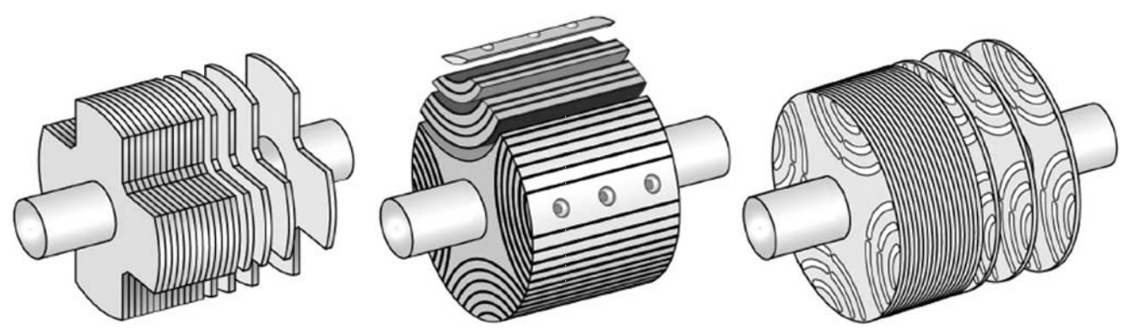
(a) Salient-pole | (b) Axially laminated | (c) Multi-segment
Fig. 1.11 Rotor structures of SynRMs [KOL10]
B. Winding Topologies
The winding topologies can be classified into two categories:
- Distributed winding
- Concentrated winding
Most of SynRMs in literature adopt distributed winding. SynRMs and PMA-SynRMs with fractional-slot concentrated winding are studied in [HON97] [JEI09] [SPA13] [SPA14] [CHE13] and [GAM14]. The main disadvantages of concentrated winding SynRMs are as follows:
- Lower torque capability per Ampere. The reasons for SynRMs with a lower number of poles and a higher number of poles are different, and should be explained respectively. For SynRMs with a lower number of poles, the low torque capability is due to the limited number of applicable slot-pole combinations, which cannot supply a winding factor as high as that of distributed winding. For SynRMs with a higher number of poles. The low torque capability is caused by the increase of pole number, which will be explained in section 1.6.1, although the winding factor can be improved by appropriately choosing slot-pole combination.
- Decreased torque capability per Wb and power factor due to the increase of stator harmonic leakage inductance, caused by large quantity of MMF space harmonics. The stator harmonic leakage inductance increases L_{d} and L_{q} simultaneously. As a result, the saliency ratio (L_{d}/L_{q}) decreases.
- Increased torque ripple.
- Increased iron loss.

Design of SynRM
The design of physical parameters of SynRM to improve L_{d}/L_{q} and (L_{d}-L_{q}) and to minimize torque ripple are two most concerned topics, which will be summarized in this section.

To Improve L_{d}/L_{q} and (L_{d}-L_{q})
The influences of some critical physical parameters on (L_{d}-L_{q}) or L_{d}/L_{q} have been studied by Lawrenson and Gupta [LAW67], Fong and Htsui [FON70], Staton et al. [STA93], Matsuo and Lipo [MAT94] and Vagati et al. [VAG92] [VAG96]. The ideal rotor for SynRM is one which is infinitely permeable along d-axis flux path and completely impermeable along q-axis flux path. In practice, the q-axis permeance is not possible to be zero, and the d-axis permeance is not possible to be infinite due to the existence of airgap and iron saturation. L_{q} mainly depends on the total barrier thickness, and L_{d} mainly depends on the airgap length and iron saturation level. The design guidelines for some critical physical parameters are summarized as follows:
A. Number of Barriers
It is desirable to make the number of barriers as large as possible to obtain an ideal “distributed anisotropy structure”, which favors to reduce L_{q}, further to increase L_{d}/L_{q}, such as axially laminated SynRM [VAG92]. However, in real case the increase of (L_{d}-L_{q}) is not obvious, when the number of barriers ≥2 [HON98] [WAN13]. Usually, 2- or 3-layer SynRM is favorable in most literature.
B. h_{bar}/(h_{bar}+h_{iron})
h_{bar} and h_{iron} are the average thickness of barriers and irons respectively. When h_{bar}/(h_{bar}+h_{iron}) increases, the total barrier thickness increases and the d-axis flux path is narrowed and more saturated. Consequently, L_{q} and L_{d} are both decreased. There exist optimal h_{bar}/(h_{bar}+h_{iron}) for L_{d}/L_{q} and (L_{d}-L_{q}) respectively.
C. Pole Pair Number
If the rotor diameter and h_{bar}/(h_{bar}+h_{iron}) are fixed, the total barrier thickness per pole decreases, as the pole pair number p increases, at least along the circumferential direction. Consequently, L_{q} increases and L_{d} changes little, since the airgap length and iron saturation level are not changed. Thus, L_{d}/L_{q} and (L_{d}-L_{q}) both decrease with p [VAG92] [VAG96]. However, the change of rotor geometry with p is complicated in real case. The optimal rotor diameter usually increases with p due to the decrease of flux per pole in the stator yoke, and it favors to increase the barrier thickness. Sometimes, the performance of SynRM with higher pole number may be better than that with a smaller pole number [PRI12], especially when the pole pair number is not large, such as 1, 2 and 3 pole pairs.
D. Airgap Length
The airgap length decreases L_{d} a lot, while influences L_{q} a little, because the airgap length is quite small compared with total barrier width. Thus, L_{d}/L_{q} and (L_{d}-L_{q}) both decrease with the increase of airgap length.
E. Bridge and Rib
Bridges or ribs are usually utilized to make the SynRM rotor mechanically rugged. However, their existence decreases L_{q}, by allowing q-axis flux to flow through them [VAG92]. The bridge shape and dimensions also affect L_{d} value, because the existence of bridges is equivalent to the decrease of Carter Coefficient of airgap length. Consequently, it is not always that L_{d}/L_{q} and (L_{d}-L_{q}) decrease with bridge dimension. It has been shown that properly notched bridges favor to improve the torque density and flux-weakening performance [HON98].
F. Other Parameters
The influences of physical parameters of SynRM on L_{d} and L_{q} discussed above are mainly for the magnetizing components. In fact, L_{d} and L_{q} are (1.7) and (1.8).
$L_{d}=L_{md}+L_{σs}$ (1.7)
$L_{q}=L_{mq}+L_{σs}$ (1.8)
where L_{md} and L_{mq} are the d- and q-axis purely magnetizing components, L_{σs} is the stator leakage inductance. L_{σs} tends to make L_{d}/L_{q} decrease, while does not affect (L_{d}-L_{q}). L_{σs} consists of stator slot, harmonic and end leakage inductances. The major physical parameters that influence the stator slot, harmonic and end leakage inductances are slot opening, winding configuration and end winding length. Thus, small slot opening, winding configuration producing a large quantity of MMF space harmonics and long end winding all tend to decrease L_{d}/L_{q}.
In real case, the rotor geometry of SynRM is complicated, due to the multi-layers of barriers and irons. There exist a lot of physical parameters that can influence the d- and q-axis flux path permeability, and consequently L_{d}/L_{q} and (L_{d}-L_{q}). Usually, some multi-parameter optimization methods have to be utilized, such as genetic algorithm (GA) [DUF00] [CUP12] [CUP13] [PEL13] [KWA03], particle swarm optimization (PSO) [ALO11] [ARK09], sequential unconstrained minimization technique (SUMT) [MUN08] [PAR95], response surface methodology (PSM) [PAR06], feed-forward artificial neural networks (NN) [MIL98b], finite-element shooting-Newton method [LI01] and coupled finite element (FE) & Preisach [LEE07] [LEE10] etc.

To Minimize Torque Ripple
The torque ripple of SynRM is usually large and sometimes unacceptable for some applications [FRA95]. The torque ripple of SynRM is caused by the interaction between the spatial harmonics of MMF and rotor anisotropy [FRA95]. The torque ripple can also be attributed to the discontinuity reluctance change between the rotor and stator [SAN04]. The rotor geometry designed to minimize the torque ripple can be classified into two categories:
- Symmetric rotor
- Asymmetric rotor
The strategy for symmetric rotor to minimize torque ripple is to cancel some orders of torque ripple harmonics by geometry configuration of rotor barriers [VAG98] [TSU01] [HUD06] [MOG12] [SAN04] [OBA14] [OOI13] [FER13]. Vagati et al. [VAG98] studied the influence of rotor barrier pitch on the torque ripple and recommended n_{r}=n_{s}±4, where n_{r} and n_{s} are the separation point number for rotor and stator respectively. The analysis in [VAG98] is based on the condition that the flux barrier tips are distributed uniformly along the airgap. In other words, all the rotor barrier tip pitches are the same. However, the torque ripple of SynRM is extremely sensitive to barrier tip positions [DEG14], and the tip positions should be designed carefully to effectively minimize the torque ripple.
The strategy of adopting asymmetric rotor for torque ripple reduction is to compensate some orders of torque ripple harmonics. Different from the term ‘cancel’, the torque ripple amplitude of a given order is not reduced for a fraction of rotor. However, their sum is zero for the whole rotor [BIA09]. The major asymmetric rotor structures to compensate torque ripples are as follows:
- Asymmetric in one pole section: the barrier configuration for each pole is asymmetric. However, the barrier configurations for all the poles are the same, such as the asymmetric rotor structure developed by Lange et al. [LAN14], as shown in Fig. 1.12;
- Asymmetric between poles: the barrier configuration for each pole is symmetric, while asymmetric between different poles, such as “Machaon” rotor developed by Bianchi et al. [BIA08] [BIA09] [ALO11], as shown in Fig. 1.13, and asymmetric flux barrier rotor developed by Sanada et al. [SAN04].
- Asymmetric in axial direction: the barrier configuration for each lamination is symmetric, while asymmetric in the axial direction, such as skewed rotor [FRA95] [BOM02] and “Romeo and Juliet” (R and J) rotor [BIA08] [BIA09], in which type I and type II laminations, as shown in Fig. 1.14, are packed to form two stacks respectively. Then, one stack is skewed with respect to the other.
Due to the SynRM rotor geometric complication, multi-parameter optimization methods are sometimes utilized to reduce the torque ripple, together with maximization of L_{d}/L_{q} or (L_{d}-L_{q}), i.e. multi-objective and multi-parameter optimization [CUP12] [CUP13] [PEL13] [PAR06] [ALO11].
Fig. 1.12 Lamination of asymmetric rotor with flux barrier configuration asymmetric for each pole, θ₁'≠ θ₁, θ₂'≠ θ₂ [LAN14].
Fig. 1.13 Lamination of asymmetric rotor with flux barrier configuration asymmetric between poles, θ₁'≠ θ₁, θ₂'≠ θ₂ [BIA09].

(a) Type I
(b) Type II
Fig. 1.14 Laminations of asymmetric rotor with asymmetric stack, θ₁'≠ θ₁, θ₂'≠ θ₂, each lamination is symmetric and they are packed together to form an asymmetric stack [BIA09]

PMA- SynRM
The performance of SynRM can be improved by adding some quantity of PM into the barriers, either NdFeB or ferrite, which favours to saturate the bridges and ribs to further enhance the saliency ratio, and provide some PM torque as well. Consequently, the torque per Ampere, power factor and constant power region are all improved. This type of machine is named as PMA-SynRM.
The influence of parameters on the flux-weakening performance of PMA-SynRM can be seen from IPM parameter plane proposed by Soong and Miller [SOO94], as shown in Fig. 1.15. There exists an optimal design line to realize the optimal flux-weakening performance, which consists of an infinite constant power region and unity normalized high speed output power. In fact, the optimal flux-weakening performance can be realized by satisfying (1.9) [SCH90]. For ferrite-assisted SynRM or NdFeB-assisted SynRM, which mainly utilizes saliency ratio instead of PM flux linkage for the purpose of cost-saving, the flux-weakening performance always increases with PM quantity.
$ψ_{PM}=L_{d}i_{lim}$ (1.9)
where 𝜓_{PM} is the PM flux linkage.
The influences of PM quantity and position on the performance of PMA-SynRM have been investigated by Khan et al. [KHA10], Vartanian et al. [VAR13a] [VAR13b], Morimoto et al. [MOR97] [MOR01] [MUR01] [TOK09] and Obata et al. [OBA13] [OBA14]. Although the electromagnetic performances are improved, some design problems are also brought in. The first problem is PM minimization for cost-saving. There are mainly two kinds of PMs used in PMA-SynRM, i.e NdFeB and ferrite. PM minimization is a key design consideration for NdFeB-assisted SynRM due to the high cost of NdFeB, which has been studied by Carraro et al. [CAR13] and Guglielmi et al. [GUG13]. Although the magnetic energy product of ferrite PM is lower than that of NdFeB, ferrite-assisted SynRM is much popular nowadays due to the low cost of ferrite [VAG12] [HON97] [HON98] [ZHA98a] [ZHA98b] [GUG04] [GUG13] [OBA12] [YUN12] [OOI13] [OBA14] [CAI14], and the PM minimization is not a consideration. The second problem is the PM demagnetization, some strategies to prevent the irreversible demagnetization have been proposed by Tokuda et al. [TOK09] and Vagati et al. [VAG14]. Usually, ferrite is more vulnerable to demagnetization due to the lower magnetic energy product, especially at a lower temperature, because the knee point at B-H curve becomes lower as the temperature decreases, which is opposite to the situation of NdFeB PM. The third design problem for PMA-SynRM is the uncontrolled generator (UCG) voltage caused by PM [JAH99]. Thus, the PM optimization should also consider the tradeoff between constant power region and uncontrolled generator operation [PEL11]. In addition, the total loss for some operation points in flux-weakening region of PMA-SynRM may be increased, although the efficiency in constant torque region is improved. The PM optimization should be carried out to achieve the maximum efficiency over the specific driving cycle [BAR10] [BAR12] [CAR14] [LAZ14] [CHE12].
Fig. 1.15 Normalised power-speed characteristics, the dashed power-speed curves are the ideal ones, with unity power factor and no loss [SOO94].

Scope and Contributions of Research

Scope of Research
The research reported in this thesis is mainly concerned with the following two topics:
- IM
- PMA-SynRM
for EV/HEV application.
For IM, the maximum torque/power-speed characteristic is investigated. For PMA-SynRM, a new type of hybrid PM-assisted SynRM is proposed, which utilizes both ferrite and NdFeB PMs, in order to reduce the material cost without sacrificing the electromagnetic performance.

The contents of subsequent chapters are summarized as follows:
Chapter 2
This chapter illustrates the process of obtaining torque/power-speed characteristic of IM and the related algorithms in detail, together with the loss and efficiency map computation. The analytical analysis of torque/power-speed character of IM is based on a dq-axis reference frame, instead of single-phase equivalent circuit which is used extensively in literature. Finally, the analytically calculated torque/power-speed characteristics of a 12kW IM are compared with finite element analyses (FEA) and experiment results.
Chapter 3
This chapter focuses on the influence of motor design parameters on the torque/power-speed characteristic of IM, assuming ideal maximum torque control is realized. The torque/power-speed characteristic is calculated by analytical method, presented in Chapter 2. A per-unit IM model is used and the influence of mutual and leakage inductances is investigated. The inductance ratio between the leakage and mutual inductances is introduced, which is a key parameter determining the flux-weakening performance. Also the effects of other practical parameters are investigated, such as stator and rotor resistance and iron saturation. Following the fore-mentioned investigation, the influences of some physical parameters on the torque/power-speed characteristic of IM are investigated, such as the ratio of tooth width to slot pitch, stator inner diameter, airgap length, slot area, number of stator/rotor slots per pole per phase, number of pole pairs, etc.
Chapter 4
This chapter mainly focuses on investigating the difference of maximum torque-speed characteristics and power factor of IM between motor and generator modes. Firstly, the reason for the difference is explained. Then, the influence of some design parameters, such as stator resistance, rotor resistance, iron saturation and iron loss etc., on the difference is investigated using analytical method presented in Chapter 2.
Chapter 5
A hybrid PM-assisted SynRM is proposed in this chapter, which utilizes both ferrite and NdFeB PMs, in order to reduce the material cost without sacrificing the electromagnetic performance. FEA is adopted for the optimization in order to consider the iron saturation more accurately. Firstly, the design process is presented and a hybrid PM-assisted SynRM is designed. Then, SynRM, ferrite-assisted and NdFeB-assisted SynRMs are designed for comparison to highlight the features of hybrid PM-assisted SynRM. Finally, the electromagnetic performance of hybrid PM-assisted SynRM is investigated and discussed.
Chapter 6
This chapter quantitatively compares six different types of electrical machines, including IM, SynRM, ferrite-assisted, NdFeB-assisted and hybrid PM-assisted SynRMs and IPM, mainly in terms of electromagnetic performance and material cost. For IPM, Toyota Prius 2010 IPM is adopted directly for comparison, thus, there is no need of optimization. For a fair comparison, the other electrical machines are designed with the same stator outer diameter and stack length, and with the same current and voltage ratings as Prius 2010 IPM. Firstly, IM is optimized and compared with IPM. Then, SynRM, ferrite-assisted, NdFeB-assisted and hybrid PM-assisted SynRMs are optimized and compared with IPM. Finally, the comparison results between IM and hybrid PM-assisted SynRM are provided and discussed.
Chapter 7
This chapter contains the general conclusions of this thesis as well as the potential future work.

Contributions of Research
The contributions of this thesis are summarized as follows:
- The analytical modeling and analysis of torque/power-speed characteristic of IM, based on a dq-axis reference frame.
- Investigation of influence of design parameters on flux-weakening performance of IM, such as the inductance ratio between the leakage and mutual inductances, stator and rotor resistance, and iron saturation etc.
- Investigation of influence of physical parameters on torque/power-speed characteristic of IM, such as the ratio of tooth width to slot pitch, stator inner diameter, airgap length, slot area, number of stator/rotor slots per pole per phase, number of pole pairs, etc.
- Investigation of difference of maximum torque-speed characteristics and power factor of IM between motor and generator modes.
- Development of a novel hybrid PM-assisted SynRM.
- Comparative study of IM, SynRM, ferrite-assisted, NdFeB-assisted and hybrid PM-assisted SynRMs and IPM.

Analytical Calculation of Torque-Speed Characteristic of Induction Machines for Electric Vehicle Application

Introduction
The calculation methods of electromagnetic performance of IMs are presented extensively in literature, which can be classified into three categories:
- Single-phase lumped equivalent circuit;
- Finite-element analysis (FEA);
- Magnetic equivalent circuit (MEC).
The analytical method based on the classic single-phase lumped equivalent was proposed earliest and used extensively nowadays, because of its fast calculation speed and acceptable accuracy [VEI95] [LIW60] [BOG11]. FEA was introduced into electrical engineering in 1960s and is used by electrical machine designers for its excellent accuracy [WIN65] [WIL86] [BIA99]. However, FEA usually takes quite a long time, particularly for variable frequency operation and efficiency map computation, coupled analysis and system optimization etc. MEC provides a compromise between analytical method and FEA, in terms of calculation speed and accuracy [SUD07] [AMR09] [AMR10].
The foregoing calculation methods have been utilized extensively in literature for line-fed applications, in which usually only a few operation points need to be analysed, such as rated operation, starting and pull out operation points, etc. However, for many variable-speed applications, such as EVs/HEVs, the torque/power-speed characteristic is an important design criterion. It means that the calculation should be carried out for many operation points covering the whole speed range. Thus, the total amount of calculation work is much larger than that for line-fed applications. In this case, the analytical method is a good choice, especially at the design stage, in terms of calculation speed. Usually, the analysis is still based on the single-phase lumped equivalent circuit [ZHA95] [HAR95] [SCH00] [WIL07] [DOR08] [MIL99]. MEC may also be a good choice for calculation of IMs for EV application, in terms of calculation speed and accuracy [MCC01]. For FEA, the transient FEA using transient analysis is not suitable for machine design, because it takes quite a long time. Alberti et al. [ALB09] [ALB11] proposed a FEA using magnetostatic analysis especially for variable-speed IM analysis, which was also used by Pellegrino [PEL12].
The aim of this chapter is to illustrate the process of obtaining torque/power-speed characteristic of IM and the related algorithms in detail, together with the efficiency map computation. In addition, the analytical analysis of torque/power-speed characteristic of IM is based on a dq-axis reference frame, instead of single-phase equivalent circuit. In this way, the relationship between d- and q-axis currents and IM’s parameters and performances can be obtained, which is appreciated by control engineers. The dq-axis reference frame has been utilized in literature for IM analysis, such as [ALB09], etc. Finally, the analytically calculated torque/power-speed characteristics of a 12kW IM are verified by experiments.

Calculation Strategy
The mathematical model in a dq-axis reference frame, in which the d-axis is aligned with the rotor field, is presented in Appendix A. For an IM fed by an inverter, the following current and voltage limitations should be satisfied:
$\sqrt{i_{d}^{2}+i_{q}^{2}}≤i_{lim}; \sqrt{u_{d}^{2}+u_{q}^{2}}≤u_{lim}$
(2.1)
where i_{lim} and u_{lim} are the maximum phase current and voltage amplitude limits. For a specific stator frequency, all the possible torque values can be obtained by scanning all i_{d} and i_{q} combinations with the limitations of (2.1), with the condition that all the resistances and inductances are known. Then the maximum possible torque is chosen from them by comparison. This step can be repeated for different frequencies to obtain the maximum torque/power-speed characteristic.
For a specific operation point (with specific torque and frequency) within the maximum torque/power-speed characteristic, there exist different possible combinations of i_{d} and i_{q}. If all the losses for those combinations are known, the corresponding efficiencies can be obtained, (2.2). Then the maximum efficiency is chosen from them as the desired one for the specific point. This step can be repeated for all the operation points to obtain the efficiency map. Similar to the maximum torque/power-speed characteristic calculation, the calculation of efficiency map should also be conducted with the limitations of (2.1).
$η=\frac{P_{em}-P_{Fe1}-P_{Fe2}-P_{Cu2}-P_{fw}}{P_{em}+P_{Cu1}}$
(2.2)
where $P_{Fe1}$ and $P_{Fe2}$ are the stator and rotor iron losses, $P_{fw}$ is the frictional loss, $P_{Cu1}$ and $P_{Cu2}$ are the stator and rotor copper losses.

Calculation of Resistance and Inductance
The stator inductance L_{s} consists of mutual inductance L_{m}, stator slot leakage inductance L_{s1}, stator harmonic leakage inductance L_{d1} and stator end leakage inductance L_{e1}, as shown in (2.3). The rotor leakage inductance L_{r} consists of mutual inductance L_{m}, rotor slot leakage inductance L_{s2}, rotor harmonic leakage inductance L_{d2}, rotor end leakage inductance L_{e2} and slot skewing leakage inductance L_{sk}, as shown in (2.4).
$L_{s}=L_{m}+L_{s1}+L_{d1}+L_{e1}$
(2.3)
$L_{r}=L_{m}+L_{s2}+L_{d2}+L_{e2}+L_{sk}$
(2.4)
The calculations of all the resistances and inductances are presented as follows:

Resistance
1) Stator Resistance:
The stator resistance $R_{s}$ is
$R_{s}=ρ_{Cu}\frac{L_{half_turn}Z_{φ1}}{a_{1}A_{wir}N_{1}}$
(2.5)
where $ρ_{Cu}$ is the copper resistivity, $L_{half_turn}$ is the average length of half turn, $Z_{φ1}$is number of series conductors per phase, $a_{1}$ is the number of parallel branches, $A_{wir}$ is area per wire, $N_{1}$ is the number of parallel wires in one conductor.
The average length of half turn is
$L_{half_turn}=L_{line}+L_{end}$
(2.6)
where $L_{line}$ and $L_{end}$ are the lengths of coil straight part and end part respectively.
(a) | (b)
Fig. 2.1. Stator and rotor slot shape. (a) Stator slot. (b) Rotor slot.
For the slot shape in Fig. 2.1 and single layer winding, the coil end length can be calculated by (2.7a), where $τ_{y}$ is the coil pitch in terms of circumferential length, $β$ is the short pitch ratio, K_{s_coil} is the end winding shape empirical coefficient, related with the number of pole pairs, [CHE90], Y is the coil pitch in terms of slot number, Q_{p} is the slot number per pole.
$L_{end}=K_{s_coil}τ_{y}=K_{s_coil}\frac{π[D_{i1}+2\left(h_{01}+h_{11}\right)+h_{21}+r_{21}]β}{2p}$
(2.7a)
$β=\frac{Y}{Q_{p}}$
(2.7b)
2) Rotor Resistance:
The rotor resistance$R_{r}$, after transformed to stator side, is [CHE90]
$R_{r}=R_{B}+R_{Ring}$

$=\frac{m_{1}{\left(Z_{φ1}K_{dp1}\right)}^{2}}{Q_{2}}(\frac{ρ_{B}K_{B}L_{B}}{A_{B}}+\frac{D_{R}ρ_{R}Q_{2}}{2πp^{2}A_{R}})$
(2.8)
where $R_{B}$ and $R_{Ring}$ are the rotor bar and end ring resistances transformed to stator side, $m_{1}$ is the number of phases, K_{dp1} is the stator winding factor, Q₂ is the number of rotor slots, $ρ_{B}$ and $ρ_{R}$ are the rotor bar and end ring resistivity, $L_{B}$ is the rotor bar length, $D_{R}$ is the rotor end ring diameter, $A_{B}$ and $A_{R}$ are the areas of one rotor bar and end ring respectively, $K_{B}$ is the skin-effect coefficient, which is assumed to be one in this chapter.

Mutual Inductance
In fact, the value of mutual inductance is a function of d- and q-axis currents, i.e. L_{m}(i_{d}, i_{q}), because the value is affected significantly by the saturation in the iron. In order to calculate the torque/power-speed characteristics of IM correctly, the mutual inductances corresponding to different i_{d} and i_{q} should be calculated at the beginning. The strategy of obtaining L_{m}(i_{d}, i_{q}) is as follows: Firstly, the corresponding exciting current I_{m} is calculated using the given i_{d} and i_{q}; Then the corresponding mutual inductance can be obtained through an iteration process, as shown in Fig. 2.3, to consider the iron saturation.
The meanings of parameters shown in Fig. 2.3 are as follows: I_{m} is the exciting current; F_{m} is the exciting magnetic motive force (MMF); F_{g}, F_{t1}, F_{t2}, F_{c1} and F_{c2} are the MMF in airgap, stator tooth, rotor tooth, stator yoke and rotor yoke respectively; K_{t2} is the saturation coefficient; B_{g}, B_{t1}, B_{t2}, B_{c1} and B_{c2} are the maximum flux densities in airgap, stator tooth, rotor tooth, stator yoke and rotor yoke respectively; H_{g}, H_{t1}, H_{t2}, H_{c1} and H_{c2} are the magnetic densities corresponding to B_{g}, B_{t1}, B_{t2}, B_{c1} and B_{c2}; $h_{t1}^{'}$, $h_{t2}^{'}$, $l_{c1}^{'}$ and $l_{c2}^{'}$ are the magnetic path lengths in stator tooth, rotor tooth, stator yoke and rotor yoke; C₁ and C₂ are the empirical coefficients to correct the yoke flux path length, considering the non-uniformity of flux density distribution in yokes [CHE90]; $μ_{0}$ is the vacuum permeability; g is the airgap length; $K_{c_sr}$ is the average Carter coefficient [CAR26]; φ₀ is the flux per pole; K_{s} is the ratio between airgap maximum and average flux densities, related with the saturation level in stator and rotor teeth, which can be found in [CHE90]; A_{g}, A_{t1}, A_{t2}, A_{c1} and A_{c2} are the areas of airgap, stator tooth, rotor tooth, stator yoke and rotor yoke per pole respectively.
How to express I_{m} in terms of i_{d} and i_{q} is described as follows.
After constant amplitude dq frame transformation, the rotor phase flux linkage amplitude ($\sqrt{2}\left|{\dot{Ψ}}_{r_abc}\right|$) in abc frame equals rotor flux linkage ($Ψ_{r}$) in dq frame, i.e.
$\sqrt{2}\left|{\dot{ψ}}_{r_abc}\right|=ψ_{r}$
(2.9)
According to IM single-phase equivalent circuit, Fig. 2.2, the ${\dot{ψ}}_{r_abc}$ can be expressed with I_{m} (2.10). The rotor flux linkage $ψ_{r}$ can also be expressed using i_{d}, i_{q}, through (A.7) and (A.6). Finally, according to (A.7), (A.6), (2.9) and (2.10), the relationship between i_{d}, i_{q} and I_{m} is obtained as (2.11).
${\dot{Ψ}}_{r_abc}=\frac{\dot{E_{r}}}{ω}=\frac{1}{ω}({\dot{E}}_{g}-{\dot{E}}_{σr})$

$=\frac{1}{ω}({\dot{I}}_{m}∙j{ωL}_{m}-\frac{{\dot{I}}_{m}∙j{ωL}_{m}}{{R_{r}}/s+j{ωL}_{σr}}j{ωL}_{σr})$
(2.10)
$I_{m}=\frac{i_{d} }{\sqrt{2}}\sqrt{1+{(\frac{L_{σr}i_{q}}{L_{r}i_{d}})}^{2}}$
(2.11)
where $L_{σr}$is the total rotor leakage inductance.
Fig. 2.2. IM single-phase equivalent circuit

Given I_{m} and K_{t20}
F_{m}
F_{g}
B_{g}
φ₀
B_{t1}, B_{t2}, B_{c1}, B_{c2}

F_{t1}, F_{t2}, F_{c1}, F_{c2}

K_{t1}, K_{t2}
Over
K_{t20}=K_{t2}
$Ψ$_{m}
L_{m}

$K_{t20}$ is the initial value of K_{t2}
$F_{m}=\frac{I_{m}m_{1}Z_{φ1}K_{dp1}}{4.44p}$
$F_{g}=\frac{F_{m}}{K_{t20}}$
$B_{g}=\frac{{μ_{0}F}_{g}}{K_{c_sr}g}$
$φ_{0}=\frac{B_{g}A_{g}}{K_{s}}$
$B_{t1}=\frac{K_{s}φ_{0}}{A_{t1}}$; $B_{t2}=\frac{K_{s}φ_{0}}{A_{t2}}$;
$B_{c1}=\frac{φ_{0}}{0.5A_{c1}}$;$B_{c2}=\frac{φ_{0}}{0.5A_{c2}}$
$F_{t1}=H_{t1}h_{t1}^{'}$;$F_{t2}=H_{t2}h_{t2}^{'}$
$F_{c1}=C_{1}H_{c1}l_{c1}^{'}$;$F_{c2}=C_{2}H_{c2}l_{c2}^{'}$
$K_{t1}=\frac{F_{g}+F_{t1}+F_{t2}}{F_{g}}$
$K_{t2}=\frac{F_{g}+F_{t1}+F_{t2}+F_{c1}+F_{c2}}{F_{g}}$
$Ψ_{m}=\frac{2.22Z_{φ1}K_{dp1}φ_{0}}{2π}$
$L_{m}=\frac{Ψ_{m}}{I_{m}}$
Fig. 2.3. Flow chart of mutual inductance calculation.

Slot Leakage Inductance
The slot leakage inductance corresponds to the flux linkage crossing the stator or rotor slot, not through the airgap.
1) Stator slot leakage inductance
The stator slot leakage inductance, $L_{s1}$, is
$L_{s1}=\frac{{μ_{0}∙m}_{1}∙L∙Z_{φ1}^{2}}{Q_{1}}λ_{s1}$
(2.12a)
$λ_{s1}=K_{U1}λ_{U1}+K_{L1}λ_{L1}$
(2.12b)
$K_{U1}=\frac{3β+1}{4},K_{L1}=\frac{9β+7}{16},$ when $\frac{2}{3}≤β≤1$

$K_{U1}=\frac{6β-1}{4},K_{L1}=\frac{18β+1}{16},$ when $\frac{1}{3}≤β≤\frac{2}{3}$

$K_{U1}=\frac{3β}{4},K_{L1}=\frac{9β+4}{16},$ when $0≤β≤\frac{1}{3}$
(2.12c)
$λ_{U1}=\frac{h_{01}}{b_{01}}+\frac{2h_{11}}{b_{01}+b_{11}}$
(2.12d)
$λ_{L1}=\frac{(\frac{h_{21}}{2∙r_{21}})∙(K_{r1}+K_{r2})}{[{\frac{π}{8}/(\frac{h_{21}}{2∙r_{21}})+\frac{1}{2}(1+\frac{b_{11}}{2∙r_{21}})]}^{2}}$
(2.12e)
$K_{r1}=\frac{1}{3}-\frac{1}{4}\left(1-\frac{b_{11}}{2∙r_{21}}\right)[\frac{1}{4}+\frac{1}{3\left(1-\frac{b_{11}}{2∙r_{21}}\right)}$

$+\frac{1}{2{\left(1-\frac{b_{11}}{2∙r_{21}}\right)}^{2}}+\frac{1}{{\left(1-\frac{b_{11}}{2∙r_{21}}\right)}^{3}}+\frac{log⁡(\frac{b_{11}}{2∙r_{21}})}{{\left(1-\frac{b_{11}}{2∙r_{21}}\right)}^{4}}]$
(2.12f)
$K_{r2}=\frac{2π^{2}-9π}{1536{(\frac{h_{21}}{2∙r_{21}})}^{2}}+\frac{π}{16(\frac{h_{21}}{2∙r_{21}})}-\frac{π}{8(1-\frac{b_{11}}{2∙r_{21}})(\frac{h_{21}}{2∙r_{21}})}$

$-[\frac{π^{2}}{64\left(1-\frac{b_{11}}{2∙r_{21}}\right){\left(\frac{h_{21}}{2∙r_{21}}\right)}^{2}}+\frac{π∙\log\left(\frac{b_{11}}{2∙r_{21}}\right)}{8{\left(1-\frac{b_{11}}{2∙r_{21}}\right)}^{2}\left(\frac{h_{21}}{2∙r_{21}}\right)}]∙log⁡(\frac{b_{11}}{2∙r_{21}})$
(2.12g)

where $Q_{1}$ is the number of stator slots, $λ_{s1}$ is the stator slot leakage inductance coefficient, consisting of slot opening part ($K_{U1}λ_{U1}$) and coil part ($K_{L1}λ_{L1}$), as shown in (2.12b), $K_{U1}$ and $K_{L1}$ are coefficients related with short pitch ratio $β$, (2.12c), [CHE90]. For slot shape in Fig. 2.1(a), $λ_{U1}$ and $λ_{L1}$ can be calculated from (2.12d)-(2.12g), [TAN97].

2) Rotor slot leakage inductance
The rotor slot leakage inductance, $L_{s2}$, is
$L_{s2}=\frac{{μ_{0}∙m}_{1}∙L∙{(Z_{φ1}K_{dp1})}^{2}}{Q_{2}}λ_{s2}$
(2.13a)
$λ_{s2}=λ_{U2}+λ_{L2}$
(2.12b)
$λ_{U2}=\frac{h_{02}}{b_{02}}$
(2.13c)
$λ_{L2}=\frac{2∙h_{12}}{b_{02}+b_{12}}+\frac{4∙\frac{h_{22}}{b_{22}}∙K_{r1R}}{{(1+\frac{b_{12}}{b_{22}})}^{2}}$
(2.13d)
$K_{r1R}=\frac{1}{3}-\frac{1}{4}\left(1-\frac{b_{12}}{b_{22}}\right)[\frac{1}{4}+\frac{1}{3\left(1-\frac{b_{12}}{b_{22}}\right)}$

$+\frac{1}{2{\left(1-\frac{b_{12}}{b_{22}}\right)}^{2}}+\frac{1}{{\left(1-\frac{b_{12}}{b_{22}}\right)}^{3}}+\frac{log⁡(\frac{b_{12}}{b_{22}})}{{\left(1-\frac{b_{12}}{b_{22}}\right)}^{4}}]$
(2.13e)
where $λ_{s2}$ is the rotor slot leakage inductance coefficient, consisting of slot opening component $λ_{U2}$ and coil component $λ_{L2}$, (2.13c), the corresponding calculation methods for slot shape in Fig. 2.1(b) are shown in (2.13c) and (2.13d) respectively [CHE90] [TAN97].

Harmonic Leakage Inductance
The harmonic leakage inductance corresponds to the flux linkage produced by stator harmonic MMFs, which mainly include phase belt harmonics and tooth harmonics. Although these fluxes produced by MMF harmonics cross the air gap, they do not produce helpful torque, and only decrease the fundamental electromotive force (EMF). Thus the influence of MMF harmonics on the performance of IM can be considered in the form of leakage inductance [CHE90]. It is possible that some orders of harmonics produce positive torque, such as sub-harmonics in fractional slot IM, etc., which are out of the consideration in this these.
1) Stator harmonic leakage inductance
The stator harmonic leakage inductance, L_{d1}, is
$L_{d1}=\frac{{μ_{0}∙m}_{1}∙τ∙L∙Z_{φ1}^{2}}{2π^{2}{∙K}_{c_sr}∙g∙p∙K_{t1}}\sum{S}$
(2.14a)
$\sum{S}=\sum{{(\frac{K_{dpv}}{v})}^{2}}$
(2.14b)
where$τ$is the pole pitch length in the airgap, K_{t1} is the saturation coefficient, which has been calculated in Fig. 2.3, $\sum{S}$ is the coefficient reflecting the overall magnitude of stator MMF harmonics, K_{dpv} is the winding factor of v_{th} stator MMF harmonic. $\sum{S}$ has a relationship with the number of slots per pole per phase and short pitch ratio $β$.
2) Rotor harmonic leakage inductance
The rotor harmonic leakage inductance, L_{d2}, is
$L_{d2}=\frac{{μ_{0}∙m}_{1}∙τ∙L∙{\left(Z_{φ1}K_{dp1}\right)}^{2}}{2π^{2}{∙K}_{c_sr}∙g∙p∙K_{t1}}\sum{R}$
(2.15a)
$\sum{R}=\sum{{(\frac{1}{k_{2}\frac{Q_{2}}{p}±1})}^{2}}$
(2.15b)
where $\sum{R}$ is the coefficient reflecting the magnitude of rotor MMF harmonics, k₂ is the order of rotor MMF harmonic.

End Leakage Inductance
It is difficult to calculate the winding end leakage inductance, because the geometry of end winding is complex and the flux is easily influenced by nearby metal. Thus, the calculation of end winding leakage inductance always involves some empirical coefficients which are obtained by experiment.
1) Stator end leakage inductance
The stator end winding leakage inductances for single-layer concentric, single-layer cross, single-layer chain windings are (2.16a) respectively [CHE90].
$L_{e1}=\frac{0.67μ_{0}∙(L_{end}-0.64τ_{y})∙Z_{φ1}^{2}}{2p}$
(2.16a)
$L_{e1}=\frac{0.47μ_{0}∙(L_{end}-0.64τ_{y})∙Z_{φ1}^{2}}{2p}$
(2.16b)
$L_{e1}=\frac{0.2μ_{0}∙L_{end}∙Z_{φ1}^{2}}{2p}$
(2.16c)
where L_{end} has already been calculated in equation (2.7).
2) Rotor end leakage inductance
The calculation of rotor end leakage inductance is (2.17), proposed by Alger [ALG28].
$L_{e2}=\frac{0.757μ_{0}∙{\left(Z_{φ1}K_{dp1}\right)}^{2}}{2p}(\frac{L_{B}-L}{1.13}+\frac{D_{R}}{2p})$
(2.17)
where L_{B} is the length of rotor bar, D_{R} is the diameter of rotor end ring.

Slot Skewing Leakage Inductance
Usually, either the stator coils or rotor bars are skewed to decrease the vibration and acoustic noise. When either the stator slots/coils or rotor bars are skewed, the induced EMF in rotor squirrel by the same stator MMF will decrease. Similarly, the induced EMF in the stator winding by the same rotor MMF will also decrease. That means that there exist leakage flux linkages in both the stator and rotor sides and the mutual inductance between the stator and rotor sides is also undermined. This phenomenon can be expressed by adding a rotor slot skewing leakage inductance, L_{sk}, in the rotor side, and the mutual inductance, L_{m}, is kept unchanged [CHE90].
$L_{sk}=0.5{(\frac{b_{sk}}{b_{t2}})}^{2}∙L_{d2}$
(2.18)
where b_{sk} is the length that the rotor bar has been skewed, b_{t2} is the rotor tooth pitch, 0.5 is an empirical coefficient considering the non-uniformity of leakage magnetic field distribution along the axial direction.

Calculation of Losses
Copper losses and iron losses are calculated analytically in this section.

Copper Loss
The stator and rotor copper losses, $P_{Cu1}$ and $P_{Cu2}$, are
$P_{Cu1}=\frac{m_{1}}{2}(i_{d}^{2}+i_{q}^{2})R_{s}$
(2.19)
$i_{r}=-\frac{L_{m}}{L_{r}}i_{q}; P_{Cu2}=\frac{m_{1}}{2}i_{r}^{2}R_{r}$
(2.20)
where $i_{r}$ is the rotor current [ALB11].

Iron Loss
The stator and rotor iron losses, $P_{Fe1}$ and $P_{Fe2}$, are
$P_{Fe1}= P_{Fet}+P_{Fej}$
(2.21a)
$P_{Fet}= k_{t}∙p_{Fet}∙G_{Fet}$
(2.21b)
$P_{Fej}= k_{j}∙p_{Fej}∙G_{Fej}$
(2.21b)
$P_{Fe2}= P_{Fet2}+P_{Fej2}$
(2.22a)
$P_{Fet2}= k_{t}∙p_{Fet2}∙G_{Fet2}$
(2.22b)
$P_{Fet2}= k_{j}∙p_{Fej2}∙G_{Fej2}$
(2.22b)
where $P_{Fet}$ and $P_{Fej}$ are stator tooth and yoke iron losses; $k_{t}$ and $k_{j}$ are tooth and yoke iron loss correction coefficients, which consider the non-uniformity distribution of flux density in tooth or yoke, non-sinusoidal variation of flux density with time, etc. [CHE90]; $p_{Fet}$ and $p_{Fej}$ are iron loss coefficients in stator tooth and yoke, in terms of watt per kilogram, which can be obtained by looking up iron loss table using flux densities B_{t} and B_{c} in Fig. 2.3 and corresponding frequencies; $G_{Fet}$ and $G_{Fej}$ are stator total tooth and yoke weights; $P_{Fet2}$ and $P_{Fej2}$ are rotor tooth and yoke iron losses; $p_{Fet2}$ and $p_{Fej2}$ are iron loss coefficients in rotor tooth and yoke, in terms of watt per kilogram; $G_{Fet2}$ and $G_{Fej2}$ are rotor total tooth and yoke weights.

Experiment Verification
In this section, the analytically calculated no-load characteristic and torque/power-speed characteristic of a 12kW IM are compared with measured results for verification. The specifications of the tested IM are shown in Appendix G. The stator and rotor winding temperatures are both set to be 120ºC during the calculation. During the process of testing, the stator and rotor winding temperatures are not beyond 120ºC. The test rig is shown in Fig. 2.4.
For no-load test, the speed is fixed to 1000rpm. Different stator current amplitudes are imposed and the current angle is fixed to zero, i.e. only i_{d} is imposed. The calculated and measured no-load characteristics are shown in Fig. 2.5.
For torque-speed test, the procedure of measuring the maximum possible output torque for a specific speed with the limitation of u_{a}≤u_{lim} and i_{a}≤i_{lim} is as follows. Different combinations of stator current amplitude and current angle are imposed on the stator of IM, with the condition that i_{a}≤i_{lim}. The voltage can be limited automatically by the DC link in the inverter. Consequently different torque values can be obtained, from which the maximum value is chosen to be the maximum possible output torque. The foregoing procedure can be repeated for different speeds to obtain the maximum torque-speed characteristic of IM. The comparison between calculated and measured torque-speed characteristics of IM with different u_{lim} and i_{lim} are shown in Fig. 2.6. It should be mentioned that u_{lim} is different in motor and generator modes. It is due to the large cable resistance between the inverter and tested IM, which influences the phase voltage value imposed on the winding, although DC link voltage is fixed to 48V. The influence of cable is obvious for a low-voltage large-current IM.
The current waveforms corresponding to the maximum output torque (300Arm, 3000rpm) are shown in Fig. 2.7. The power factor and efficiency along those torque-speed characteristics are shown in Fig. 2.8-Fig. 2.11. The analytically predicted torque-speed characteristic, power factor and efficiency agree well with the measured results.

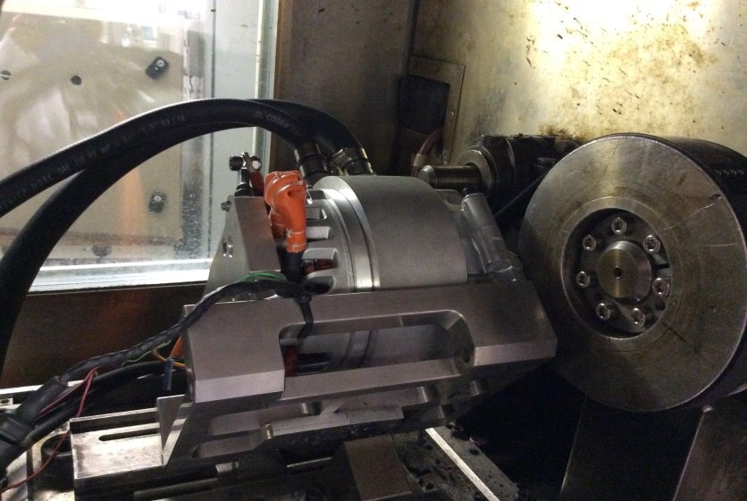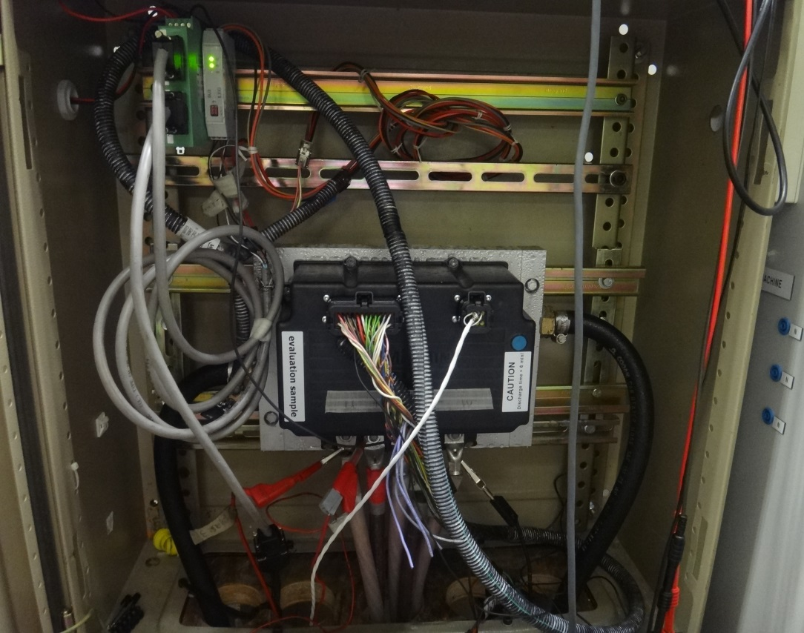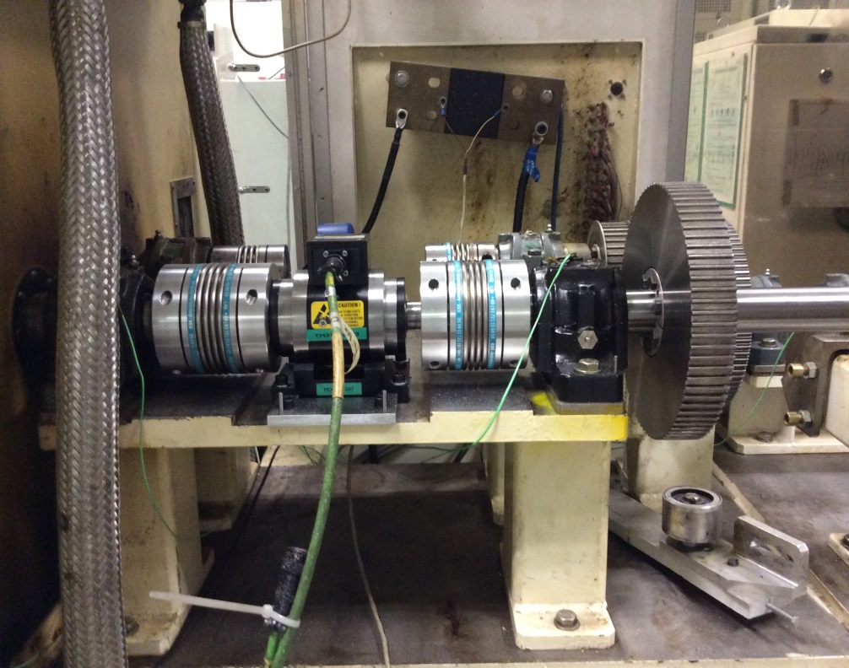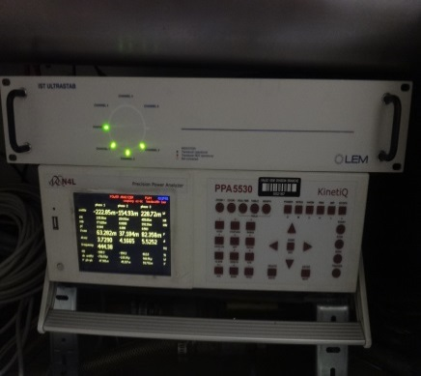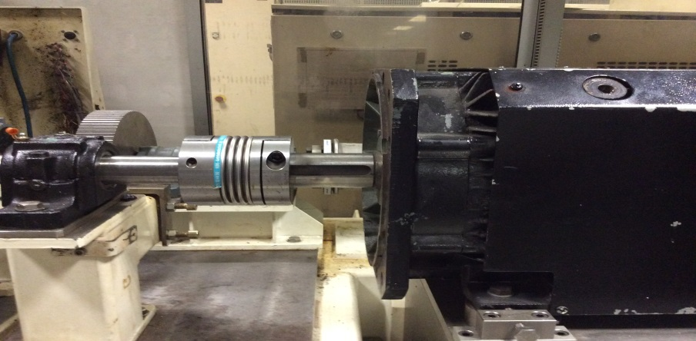
Inverter
Tested IM
Dynamometer machine
Shaft joint
Power analyser
Torque & speed sensor
Belt transmission
Fig. 2.4. Test rig.

Fig. 2.5. Variations of phase voltage amplitude with phase current amplitude, i_{q}=0, speed=1000rpm.
(a)
(b)
Fig. 2.6. Torque-speed characteristics of IM in motor and generator modes with different i_{lim}. (a) Motor, u_{lim}≈21V. (b) Generator, u_{lim}≈27V.
(a)
(b)
Fig. 2.7. Current waveforms corresponding to maximum torque of IM in motor and generator modes, 300Arms, 3000rpm. (a) Motor. (b) Generator.

(a) | (b)
(c) | (d)
(e)
Fig. 2.8. Power factors along torque-speed characteristics of IM in motor mode for different i_{lim}, u_{lim}=21V. (a) 141A. (b) 282A. (c) 424A. (d) 565A. (e) 707A.

(a) | (b)
(c) | (d)
(e)
Fig. 2.9. Power factors along torque-speed characteristics of IM in generator mode for different i_{lim}, u_{lim}=27V. (a) 141A. (b) 282A. (c) 424A. (d) 565A. (e) 707A.

(a) | (b)
(c) | (d)
(e)
Fig. 2.10. Efficiencies along torque-speed characteristics of IM in motor mode for different i_{lim}, u_{lim}=21V. (a) 141A. (b) 282A. (c) 424A. (d) 565A. (e) 707A.

(a) | (b)
(c) | (d)
(e)
Fig. 2.11. Efficiencies along torque-speed characteristics of IM in generator mode for different i_{lim}, u_{lim}=27V. (a) 141A. (b) 282A. (c) 424A. (d) 565A. (e) 707A.

Conclusion
In this chapter, a detailed process and related algorithms of calculating maximum torque/power-speed characteristic and efficiency map of IM, using analytical method, are presented. The analytical analysis of torque/power-speed character of IM is based on a dq-axis reference frame, which can provide the relationship between d- and q-axis currents and IM’s parameters and performances. The validity of this analytical method is verified by experiments.

Influence of Machine Design Parameters on Torque-speed Characteristic of Induction Machine for Electric Vehicle Application

Introduction
The traditional analysis of influence of design parameters on flux-weakening performance of IM is usually based on the pull-out torque (3.1), without considering stator and rotor resistances [CHE90]. It originates from the analysis method for line-fed IM. It can be seen that there exist multiple parameters affecting the pull-out torque, such as the number of pole pairs p, stator phase voltage U_{s} and total leakage inductance L_{σ}, etc.
$T_{em}≈\frac{m_{1}pU_{s}^{2}}{8π^{2}{f_{s}}^{2}L_{σ}}$
(3.1)
This chapter aims to analyse the flux-weakening performance based on constant power region. By utilizing per-unit model, the number of decisive parameters can be reduced to one. The methodology developed and presented here is directly applicable to EV/HEVs. The torque/power-speed characteristic is calculated by a per-unit mathematical model based on a dq-axis reference frame. Firstly, the influence of mutual and leakage inductances is investigated, and the inductance ratio between the leakage to mutual inductances is introduced, which is a key parameter determining the flux-weakening performance. Also the effects of other practical parameters are investigated, such as stator and rotor resistance and iron saturation. After that, the influence of some physical parameters are investigated, such as the ratio of tooth width to slot pitch, stator inner diameter, airgap length, the ratio of total slot area to lamination area, the number of stator/rotor slots per pole per phase and the pole pair number, etc. The optimal parameter design values for maximum torque in low speed region and constant power region are usually different. The relationship between them is established, and the reasonable design values to achieve an optimal torque/power-speed characteristic should be between them. Based on a specific IM, reasonable physical parameter design ranges are given.

Influence of Mutual and Leakage Inductances on Flux-weakening Performance
To simplify the analysis of influence of mutual and leakage inductances on flux-weakening performance, some assumptions are firstly adopted:
- There is no saturation in the iron.
- The stator and rotor resistances are neglected.
- Stator leakage inductance is equal to rotor leakage inductance in order to reduce the number of analysis variables.
It should be mentioned that IMs do not work if the rotor resistance is zero, because the flux through rotor is always zero, i.e. the rotor will not be magnetized, according to Kirchhoff’s law (d𝜓/dt=0). In this section, the rotor resistance is set to be quite small (1×10⁻⁶Ω) to make IM still works, but the influence of rotor resistance can be neglected. The influence of iron saturation as well as stator and rotor resistances will be investigated later in section 3.3.

Basic Equations of IM in Per-unit Model
In this chapter, the torque-speed characteristic is calculated by analytical method based on a dq-axis reference frame, in which the d-axis is aligned with the rotor field, [VAS90], [ALB11]. The basic equations of IM under dq-axis reference frame are listed in Appendix A. In addition, a per-unit model is used in order to remove some variables in the equations of IM, such as the phase voltage and current [SCH90], [SOO94], [HAR70], [MIL89], [ADN91]. The definition of base values and basic scaled equations are shown in Appendix C.
With the assumptions at the beginning of this section, the scaled equations of IM in dq-axis reference frame can be simplified as (3.2)-(3.4).
$u_{dp}=-ω_{p}(L_{mp}+L_{σp}-\frac{L_{mp}^{2}}{L_{mp}+L_{σp}})i_{p}\sin{θ}$
(3.2)
$u_{qp}=ω_{p}(L_{mp}+L_{σp})i_{p}\cos{θ}$
(3.3)
$T_{emp}=\frac{L_{mp}^{2}}{L_{mp}+L_{σp}}i_{p}^{2}\cos{θ}\sin{θ}$; $ω_{sp}=0$
(3.4)
Because the rated angular speed will be scaled to unity (D.3), (3.5) will be established, since $i_{p}=1 and θ={45}^{°}$ at rated speed for maximum output torque when saturation is neglected [ALB11]. In this way, when one of the mutual and leakage inductances is investigated, the other one will be fixed. Thus, the torque-speed characteristic after scaled depends only on one parameter. In this chapter, the ratio between the total leakage inductance and mutual inductance is selected as the key parameter which determines the flux weakening performance of IM.
${\left[\frac{1}{\sqrt{2}}(L_{mp}+L_{σp})\right]}^{2}+{\left[\frac{1}{\sqrt{2}}(L_{mp}+L_{σp}-\frac{L_{mp}^{2}}{L_{mp}+L_{σp}})\right]}^{2}=1$
(3.5)
For IM fed by an inverter, the following current and voltage limitations should be satisfied:
$i_{p}≤1;\sqrt{u_{dp}^{2}+u_{qp}^{2}}≤1$
(3.6)
The torque-speed characteristic can be obtained by scanning all i_{dp} and i_{qp} combinations, with the limitations of (3.6), to find out the maximum possible electromagnetic torque at each operating speed.

Influence of Mutual and Leakage Inductance
The variations of the scaled torque- and power-speed characteristics with L_{σ}/L_{m} are shown in Fig. 3.1(a) and (b). L_{σ} is the total leakage inductance of stator and rotor. The dashed line is the ideal output torque or power of machine, assuming it has a unity power factor and 100% efficiency. It shows that the flux-weakening performance increases with the decrease of L_{σ}/L_{m} ratio. The influences of L_{σ}/L_{m} ratio on constant power region, power factor, inverter utilization and infinite speed will be further investigated in this section. A classic power-speed characteristic of IM has been shown in Fig. 1.7. The operation region, with output power larger than that at rated speed, is defined as constant power region, which is usually represented by the ratio of critical speed to rated speed.
The variation of scaled maximum constant power speed with the ratio of L_{σ} /L_{m} is plotted in Fig. 3.1(c). The scaled maximum constant power speed is the constant power region, since the rated speed has been scaled to unity. If the ratio is zero, IM can obtain infinite constant power region. While in real situation, the leakage inductance always exists and cannot be zero. Thus, in designing an IM demanding a wide constant power region, the topology with smaller ratio between leakage and mutual inductances and the design methods for minimizing this ratio should be chosen.
The power factor variation along the torque-speed characteristic for different L_{σ}/L_{m} is shown in Fig. 3.1(d). IM has the same power factor over the whole speed region excluding the constant power region. The power factor increases as L_{σ}/L_{m} decreases and it is comparatively higher in the constant power region. With zero L_{σ}/L_{m} ratio, the power factor can reach approximately 0.7 in the constant torque region and 1.0 in the flux-weakening region.
The inverter utilization is defined as the ratio of actual output power to ideal output power [SOO94]. In constant power region, the input voltage and current of inverter have reached the maximum values. Thus, the inverter utilization equals the power factor when the copper loss and iron loss are not considered. Thus, it can be concluded that the maximum possible inverter utilization is approximately 0.7 at rated speed and 1.0 in the constant power region. This conclusion is different from what is obtained in PM machine, in which the maximum inverter utilization at base speed can reach 1.0. However, if PM machine is designed with the ‘optimal’ flux-weakening performance, the utilization is also 0.7 at base speed and 1.0 in flux-weakening region [SOO94]. It means that, if the maximum output power of an inverter is 20kW, the maximum output power of the IM at rated speed can only reach at most 14kW, with nearly zero leakage inductance.
IMs can always have infinite speed, which is also different from the case of PM machine. Only when the PM flux linkage is not larger than the product of d-axis inductance and maximum phase current peak, can PM machines reach infinite speed [SOO94].
(a)
(b)
(c)
(d)
Fig. 3.1 Influence of ratios of leakage to mutual inductances on IM’s flux-weakening performance. (a) Scaled torque-speed characteristic. (b) Scaled power-speed characteristic. (c) Scaled constant power speed. (d) Power factor along the torque-speed characteristic.

Discussions
The advantages and application of parameter L_{σ}/L_{m} of IM are discussed in this section. It is a parameter determining the flux-weakening performance, which is an important design criterion of IM for EV application. In normal case, L_{σ} and L_{m} are modelled together to get the flux-weakening performance of IM with given u_{lim} and i_{lim}. By using L_{σ}/L_{m} instead of L_{σ} and L_{m}, the number of design parameters is decreased and there is no need to know u_{lim} and i_{lim}. It can provide a simple design guideline for electrical machine designer working on IM for EV application.
In fact, the Blondel coefficient σ, (3.7), can also be investigated instead of L_{σ}/L_{m}, which can simplify the basic equations of IM in the dq-axis reference frame and provide an alternative to simplify the calculation process. However, the physical significance of ratio of leakage inductance to mutual inductance (L_{σ}/L_{m}) is clearer than the Blondel coefficient σ. Thus, the ratio of leakage inductance to mutual inductance is still preferable here. In addition, similar conclusion can be obtained by using σ instead of (L_{σ}/L_{m}), because (L_{σ}/L_{m}) is quite close to σ, (3.8), since $L_{σs} and L_{σr}$ are usually much smaller than L_{m}.
$σ=\frac{\left(L_{s}-\frac{L_{m}^{2}}{L_{r}}\right)}{L_{s}}$
(3.7)
$σ=\frac{\left(L_{σs}+L_{σr}\right)L_{m}+L_{σs}L_{σr}}{L_{m}^{2}+\left(L_{σs}+L_{σr}\right)L_{m}+L_{σs}L_{σr}}≈\frac{L_{σs}+L_{σr}}{L_{m}}$
(3.8)

Influence of Iron Saturation, Stator and Rotor Resistances on Flux-Weakening Performance
The conclusions obtained in section 3.2 are based on some assumptions, which would more or less affect the real IM performances. This section investigates how IM’s flux-weakening performance is influenced by the practical factors, such as iron saturation, stator and rotor resistances.

Iron Saturation
The calculation carried out in section 3.2 is based on the condition that there is no saturation in the iron, i.e. the magnetic circuit is linear and all the inductances are constant values. While in fact, the iron saturation cannot be neglected, in order to make the calculation more accurate. The influence caused by iron saturation can be perceived by current dependent inductances. The more precise electromagnetic torque equation can be expressed as (3.9). The calculation of torque-speed characteristic considering iron saturation has been presented in Chapter 2.
$T_{em}=\frac{3}{2}p\frac{L_{m}^{2}\left(i_{d},i_{q}\right)}{L_{r}\left(i_{d},i_{q}\right)}i_{d}i_{q}$

$=\frac{3}{4}p\frac{L_{m}^{2}\left(i,θ\right)}{L_{r}\left(i,θ\right)}i^{2}\sin{2θ}$
(3.9)
The IM in Appendix G is utilized to check the influence of iron saturation. The current dependent mutual and leakage inductances are shown in Fig. 3.2. The inductances are mainly affected by the d-axis current. The mutual and leakage inductances are both increased, as the d-axis current decreases. The torque-speed characteristic is obtained, as the dashed line in Fig. 3.3(a). The iron saturation only influences the constant torque region by decreasing the maximum output torque and increasing the rated speed, while leaving the torque-speed curve in flux-weakening region overlapping with part of the torque-speed curve of IM without considering saturation. The change of torque-speed characteristic in constant torque region is caused by the decrease of inductances and increase of current angle, which can be seen from Fig. 3.3(b) and (c) and equation (3.9). Because the iron is not saturated in flux-weakening region, the torque-speed characteristic in this region is not changed.
The influences of iron saturation on torque-speed characteristic of IM are listed in Table 3.1. The constant power region is reduced (from 6.6:1 to 2.1:1) when iron saturation is considered, because the rated speed is increased (from 1140rpm to 3550rpm) while the critical speed is still the same (7600rpm). The inverter utilization at rated speed is increased from 0.65 to 0.75. IM still has infinite speed. It should be mentioned that it is a highly saturated electrical machine, with flux density in the stator yoke ~2T. It is because in the process of stator manufacturing, a kind of existing rectangular coils are utilized directly to shorten the prototyping cycle. The existing coils have higher height and smaller width than optimal ones, which should have made the flux density distribution in the stator teeth and yoke more reasonable. The slim stator slots contribute to the quite thinner stator yoke.
(a)
(b)
Fig. 3.2 Influences of d- and q-axis currents on mutual and total leakage inductances. (a) Mutual inductance. (b) Leakage inductance.
(a)
(b)
(c)
(d)
Fig. 3.3 Performances and parameters of IMs with/without saturation, u_{lim}=26V, i_{lim}=707A. (a) Torque- and power-speed characteristics. (b) Phase current amplitude and angle along the torque-speed characteristics (c) Mutual, stator and rotor inductances along the torque-speed characteristics (d) Power factors along the torque-speed characteristics

Table 3.1 Influence of iron saturation on IM’s torque-speed characteristic
 | No saturation | Saturation
Max. torque | 149Nm | 55Nm
Rated speed | 1140rpm | 3550rpm
Constant power region ratio | 6.6:1 | 2.1:1
Inverter utilization at rated speed | 0.65 | 0.75
Max. speed | $$∞$$ | $$∞$$

The influence of iron saturation on the power factor along the torque-speed characteristic is shown in Fig. 3.3(d). When the iron saturation is considered, the power factor in constant torque region is actually larger, increasing from 0.65 to 0.75, while the power factor in the flux-weakening region is the same as that without considering saturation. The reason for the increase of power factor in constant torque region can be explained from the vector diagram and the power factor angle equation. According to the vector diagram of IM, as shown in Fig. 3.4, and equations (A.1)-(A.4), the power factor angle can be expressed by (3.10). Without considering the stator resistance, the power factor angle can be further simplified to (3.11). $\tan^{-1}{\frac{\left(L_{s}-L_{m}^{2}/L_{r}\right)i_{q}}{L_{s}i_{d}}}$ is the angle between voltage vector and q-axis, and $(\tan^{-1}{\frac{i_{d}}{i_{q}}})$ is the angle between current vector and q-axis. Their sum is the power factor angle. When the iron saturation is considered, the current angle will increase since in this case i_{d} decreases and i_{q} increases [ALB11]. Consequently, $(\tan^{-1}{\frac{i_{d}}{i_{q}}})$ decreases and $\tan^{-1}{\frac{\left(L_{s}-L_{m}^{2}/L_{r}\right)i_{q}}{L_{s}i_{d}}}$ increases. However, their sum still decreases, because $(\tan^{-1}{\frac{i_{d}}{i_{q}}})$ changes more than $\tan^{-1}{\frac{\left(L_{s}-L_{m}^{2}/L_{r}\right)i_{q}}{L_{s}i_{d}}}$ since $(L_{s}-{L_{m}^{2}}/{L_{r}})$/L_{s} is relatively smaller. Thus, it can be concluded that if the iron is more saturated in constant torque region, the power factor will be larger. While in flux-weakening region, because the current vector and inductances are not changed, Fig. 3.3(b) and (c), the power factor in this region is still the same.
$φ=\tan^{-1}{\frac{ω\left(L_{s}-\frac{L_{m}^{2}}{L_{r}}\right)i_{q}-R_{s}i_{d}}{ωL_{s}i_{d}+R_{s}i_{q}}+\tan^{-1}{\frac{i_{d}}{i_{q}}}}$
(3.10)
$φ≈\tan^{-1}{\frac{\left(L_{s}-\frac{L_{m}^{2}}{L_{r}}\right)i_{q}}{L_{s}i_{d}}+\tan^{-1}{\frac{i_{d}}{i_{q}}}}$
(3.11)
Fig. 3.4 Vector diagram of IM ($\vec{u} and \vec{i}$are the voltage and current vectors when the current dependent inductances are not considered, $\vec{u'}$ and $\vec{i^{'}}$ are the corresponding vectors when the current dependent inductances are considered, φ is power factor angle, θ is the current angle).

Stator Resistance
The influence of stator resistance on the torque-speed performance of IM is investigated by including different stator resistance values into the calculation. The torque- and power-speed characteristics of IMs with different stator resistances are shown in Fig. 3.5(a). The variations of phase current amplitude and angle along the maximum torque-speed characteristic are shown in Fig. 3.5(b). The influences of stator resistance on the maximum output torque, rated speed, constant power region and the inverter utilization at rated speed are listed in Table II. When the stator resistance is considered, the maximum output torque and constant power regions will not be affected, while the rated speed will be decreased. IM still has infinite speed.
The influence of winding resistance on power factor and efficiency is plotted in Fig. 3.5 (c) and (d). As the stator resistance increases, the power factor along the torque-speed characteristic becomes higher, which can easily be explained according to (3.10). Although the power factor increases, the inverter utilization at rated speed still becomes lower, as shown in Table 3.2, because more active power is consumed as stator copper loss. In addition, increasing the stator resistance decreases the efficiency, Fig. 3.5(d), due to the increase of stator copper loss.
It should be mentioned that the stator resistance seems quite small in this section, because the calculated IM is a low voltage and high current one. The actual stator and rotor resistances (180ºC) are 0.0036Ω and 0.0015Ω for an IM designed under such voltage and current ratings, as shown in Appendix G.
(a)
(b)
(c)
(d)
Fig. 3.5 Performances and parameters of IMs with different stator resistances, u_{lim}=26V, i_{lim}=707A, L_{σ} =0.011mH, L_{m}=0.135mH, R_{r}=1×10⁻⁶Ω. (a) Torque- and power-speed characteristics. (b) Phase current amplitudes and angles along the torque-speed characteristics (c) Power factors along the torque-speed characteristics (d) Efficiencies along the torque-speed characteristics

Table 3.2 Influence of stator resistance on IM’s torque-speed characteristic
Stator resistance | 0Ω | 0.005Ω | 0.01Ω
Max. torque | 149Nm | 149Nm | 149Nm
Rated speed | 1140rpm | 1035rpm | 920rpm
Constant power region | 6.6:1 | 6.6:1 | 6.6:1
Inverter utilization at rated speed | 0.65 | 0.59 | 0.52
Max. speed | $$∞$$ | $$∞$$ | $$∞$$

Rotor Resistance
Different values of rotor resistances are considered in the performance calculation of IM. The voltage and current ratings and inductance parameters are the same as those in the previous section. The influences of rotor resistances on the maximum output torque, rated speed, constant power region and the inverter utilization at rated speed are listed in Table 3.3. When the rotor resistance is considered, the maximum output torque will not change, while the rated speed, constant power region and inverter utilization at rated speed will all be decreased. IM still has infinite speed.
Table 3.3 Influence of rotor resistance on IM’s torque-speed characteristic
Rotor resistance | 1×10⁻⁶Ω | 0.005Ω | 0.01Ω
Max. torque | 149Nm | 149Nm | 149Nm
Rated speed | 1140rpm | 1030rpm | 920rpm
Constant power region | 6.6:1 | 5.9:1 | 5.1:1
Inverter utilization at rated speed | 0.65 | 0.59 | 0.52
Max. speed | $$∞$$ | $$∞$$ | $$∞$$

The torque- and power-speed characteristics of IMs with different rotor resistances are shown in Fig. 3.6(a). The variations of phase current amplitude and angle along the maximum torque-speed characteristic are shown in Fig. 3.6(b). The influence of rotor resistance on the power factor and efficiency is plotted in Fig. 3.6(c) and (d). Rotor resistance will not influence the power factor along the maximum torque-speed characteristic, because the power factor is independent of the rotor resistance, as can be seen from (3.10). Comparing the influence of rotor resistance with stator resistance, they have the same effect on the maximum torque, rated speed and inverter utilization at rated speed. The stator resistance can increase the power factor, while the rotor resistance cannot. The stator resistance will not influence the constant power region, while the rotor resistance will decrease the constant power region.
(a)
(b)
(c)
(d)
Fig. 3.6 Performances and parameters of IMs with different rotor resistances, u_{lim}=26V, i_{lim}=707A, L_{σ} =0.011mH, L_{m}=0.135mH, R_{s}=0. (a) Torque- and power-speed characteristics. (b) Phase current amplitudes and angles along the torque-speed characteristic. (c) Power factors along the torque-speed characteristics. (d) Efficiencies along the torque-speed characteristics

Influence of Physical Parameters on Torque-Speed Characteristic
The influences of inductances, resistances and iron saturation on flux-weakening performance of IM have been investigated in section 3.2 and 3.3, and it shows that the flux-weakening performance mainly depends on the ratio of total leakage to mutual inductance L_{σ}/L_{m}. It is well known that the maximum torque in low speed region depends on the mutual inductance L_{m}, with the maximum stator current limited by inverter. In this section, the influences of some physical parameters on the maximum torque-speed characteristic are investigated, such as the ratio of tooth width to slot pitch, stator inner diameter, airgap length, slot area, number of stator/rotor slots per pole per phase, number of pole pairs, etc. The maximum torque in low speed region and constant power region are analysed, which are two key design targets of IMs for EV/HEV applications. The definition of constant power region has been clarified in section 3.2.2. The analytical calculation method presented in Chapter 2 is utilized for torque-speed characteristic calculation.

Initial Design
In order to investigate the influence of physical parameters, an IM is initially designed. The cross section is shown in Fig. 3.7 and the main parameters are listed in Table 3.4. The split ratio is defined as the ratio of stator inner diameter to stator outer diameter (D_{i}/D₁). The stator and rotor slot combination is referred to a commercialized IM product.
Fig. 3.7 Cross section of initially designed IM
Table 3.4 Major parameters of initially designed IM
Stator outside diameter D₁ (mm) | 144
Stack axial length L (mm) | 110
Number of pole pairs p | 3
Number of stator slot number Q₁ | 54
Number of rotor slot number Q₂ | 44
Split ratio | 0.68
Airgap length g (mm) | 0.4
Area per stator slot (mm²) | 30.89
Area per rotor slot (mm²) | 24.71
Ratio of stator tooth width to slot pitch (b_{t1}/t₁) | 0.59
Ratio of rotor tooth width to slot pitch (b_{t2}/t₂) | 0.59
Packing factor | 0.4
Stator copper loss P_{Cu1} at 180ºC (kW) | 2.96
Squirrel cage material | Copper

Influence of Physical Parameters

Dimension Parameters
The investigated dimension parameters include:
- b_{t1}/t₁ or b_{t2}/t₂;
- Split ratio;
- Airgap length g;
- The ratio of stator and rotor total slot area to lamination area.
b_{t1}/t₁ is always set to be equal to b_{t2}/t₂ during the process of dimension variation, to make the total stator and rotor tooth width per pole similar. It is reasonable because the main flux flowing through stator and rotor per pole are similar. For each IM with a different split ratio, the ratio of tooth width to slot pitch is re-optimized to obtain the maximum possible torque in low speed region, and the other parameters listed in Table 3.4 are not changed. For each IM with a different p, the split ratio and b_{t1}/t₁ are globally optimized to obtain the maximum torque in low speed region, and Q₁ and Q₂ are changed to keep q₁ and q₂ (q₁=3 and q₂=22/9) unchanged. For each IM with a different ratio of total slot area to lamination area, the split ratio and b_{t1}/t₁ are globally optimized to obtain the maximum torque, and the stator and rotor slot areas are changed proportionally (the ratio of area per stator slot to rotor slot is 1:0.8).
The maximum torque and constant power region for different b_{t1}/t₁, split ratio, g and slot areas are shown in Fig. 3.8. There exist optimal dimensions for the maximum torque in low speed region and constant power region respectively, which are represented by A_{opt_T} and A_{opt_P} and listed in Table 3.5. A_{opt_T} and A_{opt_P} are usually different, and the reasonable design values to achieve an optimal torque/power-speed characteristic should be between them. There exists a general rule for the relationship between A_{opt_T} and A_{opt_P} , which is stated as follows:
- A_{opt_T} < A_{opt_P}, if L_{σ} decreases with dimension, such as split ratio and g, etc.;
- A_{opt_T} > A_{opt_P}, if L_{σ} increases with dimension, such as b_{t1}/t₁ and slot area.
The maximum torque and constant power region depend mainly on L_{m} and L_{σ}/L_{m} respectively, which are shown in Fig. 3.9. If L_{σ} does not change with dimension, i.e., L_{σ} is constant, the dimension for the smallest L_{σ}/L_{m} will be the same as that for the largest L_{m}. If L_{σ} decreases with the increase of dimension, the optimal dimension for the smallest L_{σ}/L_{m} will be larger than that for the largest L_{m}. On the other hand, the optimal dimension for the smallest L_{σ}/L_{m} will be smaller than that for the largest L_{m}. How the dimensions influence L_{σ} are as follows:
- As b_{t1}/t₁ and b_{t2}/t₂ increase, L_{s1} and L_{s2} increase, Fig. 3.11 (a), because the slot becomes narrower. Consequently, L_{σ} increases, Fig. 3.10 (a).
- The slot becomes shallower as split ratio increases. Thus, L_{s1} and L_{s2} decrease, Fig. 3.11 (b). Consequently, L_{σ} decreaes, Fig. 3.10 (b).
- L_{d1} and L_{d2} decrease with the increase of airgap length. Consequently, L_{σ} decreases, Fig. 3.10 (c).
- As the slot area increases, the number of series turns per phase $Z_{φ1}$ has to be increased to keep P_{Cu1} unchanged, as seen from (3.12). Thus, all the leakage inductance components increase, Fig. 3.11 (d). Consequently, L_{σ} increases, Fig. 3.10 (d).
$P_{Cu1}=\frac{m_{1}^{2}}{2}i_{a}^{2}ρ_{Cu}\frac{L_{half_turn}Z_{φ1}^{2}}{Q_{1}S_{slot}k_{pac}}$
- (3.12)

Table 3.5 Optimal dimension values for the maximum torque in low speed region and constant power region
 | Optimal value  for maximum torque  (A_{opt_T}) | Optimal value  for constant power region  (A_{opt_P})
Ratio of tooth width to slot pitch | 0.59 | 0.47
Split ratio | 0.68 | 0.74
Airgap length (mm) | 0 | 0.6
Ratio of slot to lamination area | 0.32 | 0

(a)
(b)
(c)
(d)
Fig. 3.8. Variations of maximum torque in low speed region and constant power region with dimensions. The dimension parameters include: (a) Ratio of tooth width to slot pitch. (b) Split ratio. (c) Airgap length. (d) Ratio of stator and rotor total slot area to lamination area.
(a)
(b)
(c)
(d)
Fig. 3.9. Variations of mutual inductance and ratio of leakage to mutual inductances with dimensions. The dimension parameters include: (a) Ratio of tooth width to slot pitch. (b) Split ratio. (c) Airgap length. (d) Ratio of stator and rotor total slot area to lamination area.
(a)
(b)
(c)
(d)
Fig. 3.10. Variations of total leakage inductance with dimensions. The dimension parameters include: (a) Ratio of tooth width to slot pitch. (b) Split ratio. (c) Airgap length. (d) Ratio of stator and rotor total slot area to lamination area.
(a)
(b)
(c)
(d)
Fig. 3.11. Variations of all leakage inductance components with dimensions. L_{s1} and L_{s2} are the stator and rotor slot leakage inductances, L_{d1} and L_{d2} are the stator and rotor harmonic leakage inductances, L_{e1} and L_{e2} are the stator and rotor end leakage inductances. The dimension parameters include: (a) Ratio of tooth width to slot pitch. (b) Split ratio. (c) Airgap length. (d) Ratio of stator and rotor total slot area to lamination area

Other Physical Parameters
The influences of the following physical parameters are also investigated:
- Number of stator slots per pole per phase q₁;
- Number of rotor slots per pole per phase q₂;
- Number of pole pairs p;
The maximum torque and constant power region for different q₁, q₂ and p are shown in Fig. 3.12. As can be seen from Fig. 3.12 (a) and (b), q₁ and q₂ have little influence on the maximum torque, because they affect L_{m} little, as shown in Fig. 3.13 (a) and (b). However, the constant power region increases with q₁ and q₂, because the total leakage inductances decrease with the increase of q₁ and q₂, and further L_{σ}/L_{s} decreases, Fig. 3.14 (a) and (b). It is caused by the decreased stator and rotor harmonic leakage inductances, L_{d1} and L_{d2}, respectively, as shown in Fig. 3.15 (a) and (b). It is due to the more sinusoidal MMF space waveform. In addition, the improvement of constant power region is not obvious if q₁ or q₂>3.
Usually, L_{m} is inversely proportional to p², assuming D_{i} does not change, as can be seen from (3.13). The stator and rotor harmonic and end leakage inductances (L_{d1} and L_{d2}, L_{e1} and L_{e2}) are inversely proportional to p², as shown in Fig. 3.15 (c), (2.14a), (2.15a), (2.16) and (2.17). The slot leakage inductances are almost independent of p. Thus, the decrease of L_{σ} with p is not as fast as L_{m}, Fig. 3.14 (c). Consequently, L_{σ}/L_{m} increases with p, Fig. 3.13 (c). In real case, the stator yoke thickness decreases as p increases, because the flux per pole is reduced. Consequently, D_{i} increases, which favours to increase L_{m} and reduce L_{σ}/L_{m}. The influence of p on L_{m} is complicated, which is especially obvious when p is small. In the specific case in this chapter, the optimal p for the maximum torque and constant power region are both 3. It should be mentioned that when p is changed, the maximum torque is proportional to pL_{m} instead of L_{m}. Thus, the variation of pL_{m} is shown in Fig. 3.13 (c), instead of L_{m}.
$L_{m}=μ_{0}\frac{{m_{1}(W_{φ}K_{dp1})}^{2}}{{πp}^{2}}L\frac{D_{i}}{K_{c_sr}∙g}$
(3.13)
(a)
(b)
(c)
Fig. 3.12. Variations of maximum torque in low speed region and constant power region with physical parameters. The physical parameters include: (a) Number of stator slots per pole per phase. (b) Number of rotor slots per pole per phase. (c) Number of pole pairs.
(a)
(b)
(c)
Fig. 3.13. Variations of mutual inductance and ratio of leakage to mutual inductance with physical parameters. The physical parameters include: (a) Number of stator slots per pole per phase. (b) Number of rotor slots per pole per phase. (c) Number of pole pairs.
(a)
(b)
(c)
Fig. 3.14. Variations of leakage inductance with physical parameters. The physical parameters include: (a) Number of stator slots per pole per phase. (b) Number of rotor slots per pole per phase. (c) Number of pole pairs.
(a)
(b)
(c)
Fig. 3.15. Variations of all leakage inductances with physical parameters. L_{s1} and L_{s2} are the stator and rotor slot leakage inductances, L_{d1} and L_{d2} are the stator and rotor harmonic leakage inductances, L_{e1} and L_{e2} are the stator and rotor end leakage inductances. The physical parameters include: (a) Number of stator slots per pole per phase. (b) Number of rotor slots per pole per phase. (c) Number of pole pairs.

Conclusions
The flux-weakening performance of IM is mainly affected by the mutual and leakage inductances. The ratio of total leakage inductance to mutual inductance is introduced as a key design parameter which determines the flux-weakening performance of IM. With zero inductance ratio, IM can achieve infinite constant power region and maximum utilization of the inverter at base speed, approximately 0.7, while the power factor reaches the maximum value, 0.7 in constant torque region and 1.0 in constant power region. IM can always output infinite speed. In addition, the influences of some practical factors, including iron saturation, stator and rotor resistances, on the foregoing mentioned conclusions are examined.
There exist optimal dimensional values for the maximum torque in low speed region and constant power region respectively (represented by A_{opt_T} and A_{opt_P}). For split ratio and airgap, A_{opt_T} < A_{opt_P}; For the ratio of tooth width to slot pitch and slot area, A_{opt_T} > A_{opt_P}. The reasonable design values to achieve an optimal torque/power-speed characteristic should be between them. It is desirable to design an IM with q₁ or q₂≥3 to achieve an optimal torque-speed characteristic. In the specific case in this chapter, 3 is the optimal number of pole pairs for both the maximum torque and constant power region.

Difference in Maximum Torque-speed Characteristics of Induction Machine between Motor and Generator Operation Modes

Introduction
Torque/power-speed characteristic of IM has been studied extensively in literature. However, most of the papers mainly focus on IM in motor operation mode, and not much attention is paid to the generator operation mode. Usually, electrical machines for EV/HEV applications need to work in both motor and generator modes. In fact, the maximum torque/power-speed characteristics of IM in motor and generator modes are sometimes quite different, which can be seen from the calculation or test results in some literature [FRI09]. This chapter mainly focuses on investigating the difference of maximum torque-speed characteristics of IM between motor and generator modes. The investigated parameters include stator and rotor resistances, and the analysed performances include the maximum torque- and output power-speed curves, power factor and efficiency. In addition, the influences of some practical parameters are investigated, such as variable inductances and iron loss, etc.

Maximum Torque-speed Characteristics in Motor and Generator Modes
The circle diagram and corresponding torque-speed characteristics of IM in motor and generator modes are shown in Fig. 4.1, which typically divides the torque-speed characteristics into three modes by rated and critical operating points B (or B') and P (or P'). The current trajectories of IM in motor and generator modes are symmetrical about d-axis. IM in generator mode has better torque-speed characteristic than in motor mode, because for the same current vector, i.e. electromagnetic torque, the corresponding frequency of voltage limit ellipse in generator mode is larger than that in motor mode. IM in motor and generator modes has identical electromagnetic torque value in constant torque region, because the d- and q-axis current amplitudes are the same. It should be mentioned that the torque/power value in generator mode is usually minus. However, it is transformed to positive value in this chapter to make the difference between motor and generator modes clearer.
The frequency difference of the voltage limit ellipse of IM in motor and generator modes, for the same d- and q-axis current values, can be explained from the voltage vector diagram. Two voltage vector diagrams for points B(or $B^{'})$ and P(or $P^{'})$ are shown in Fig. 4.2. The voltage equations of IM in dq-axis reference frame are listed in (A.3) and (A.4) in Appendix A. $\vec{U}(M)$ and $\vec{I}(M)$ are the stator voltage and current vectors in motor mode, $\vec{U}(G)$ and $\vec{I}(G)$ are the stator voltage and current vectors in generator mode, φ and φ' are power factor angles in motor and generator modes. It can be seen that with the same d- and q-axis current values and stator frequency, the stator voltage amplitude of IM in generator mode is always smaller than that in motor mode, while the power factor in generator mode is always lower than that in motor mode, which are both caused by the opposite directions of q-axis currents. That is also the reason why for the same electromagnetic torque, the frequency of voltage limit ellipse in generator mode is larger than that in motor mode. It also can be seen that the magnitude of voltage difference has a close relationship with stator resistance value.

(a) | (b)
Fig. 4.1. Circle diagram of IM in motor (Solid blue line) and generator (Solid red line) modes. The solid line in (a) is the current trajectory under maximum torque control. The curves in (b) are the corresponding torque-speed characteristics

(a)
(b)
Fig. 4.2. Voltage vector diagrams of IM in motor (Blue) and generator (Red) modes. (a) Vector diagram with current vectors at B and B’ with frequency ω_{B}. (b) Vector diagram with current vectors at P and P’ with frequency ω_{P}.

Influence of Stator and Rotor Resistances
The calculation method in Chapter 2 is utilized to calculate the torque/power-speed characteristics. In this section, the influences of stator and rotor resistances R_{s} and R_{r} on the difference in the maximum torque/power-speed characteristics between motor and generator modes are investigated. It is assumed that the iron saturation level does not change along the whole speed region, i.e. L_{s} and L_{t} are constant, and the iron loss is zero, to simplify the analysis. The influence of variable inductances and iron loss will be investigated in section 4.4.

Stator Resistance
The electromagnetic torque/power-speed characteristics of IM with different R_{s} are shown in Fig. 4.3 (a) and (b). The rotor resistance is set to be quite small (1×10⁻⁶Ω) to exclude the influence of R_{r}. The electromagnetic torque in flux-weakening region decreases with R_{s} in motor mode, while increases with R_{s} in generator mode. Consequently, the difference between them increases. It is due to the opposite directions of q-axis currents, which has been explained in last section. Although the difference of electromagnetic power between motor and generator modes in flux-weakening region increases with R_{s}, the difference of output power does not change obviously, as shown in Fig. 4.3 (c). The output power in motor and generator modes can be expressed by (4.1) and (4.2) respectively. The output power difference between generator and motor modes is (4.3). Although $(P_{em_G}-P_{em_M})$ in flux-weakening region increases with R_{s}, the stator copper loss P_{Cu1} also increases, and consequently the difference of output power does not change obviously.
$P_{out_M}=P_{em}-P_{Cu2}$
(4.1)
$P_{out_G}=P_{em}-P_{Cu1}$
(4.2)
$P_{out_G}-P_{out_M}=P_{em_G}-P_{em_M}+P_{Cu2_M}-P_{Cu1_G}$
(4.3)
where $P_{out_M}$ and $P_{out_G}$ are the output power in motor and generator modes respectively, $P_{em_M}$ and $P_{em_G}$ are the electromagnetic power in motor and generator modes respectively, $P_{Cu2_M}$ is the rotor copper loss in motor mode, $P_{Cu1_G}$ is the stator copper loss in generator mode.
The power factors and efficiency at rated operation point of IM in motor and generator modes for different R_{s} are shown in Fig. 4.4. The power factor increases with R_{s} in motor mode, while decreases with R_{s} in generator mode. Consequently, the difference between them increases with R_{s}. It is also due to the opposite direction of q-axis current, as explained in section 4.2.
For the efficiency calculation, the iron loss is not included. The efficiency decreases with R_{s} in both motor and generator modes, due to the increased P_{Cu1}. R_{s} value does not influence the difference of efficiency between motor and generator modes.
(a)
(b)
(c)
Fig. 4.3. Torque- and power-speed characteristics of IM with different R_{s}, R_{r}=1×10⁻⁶Ω, L_{s}=0.0712mL, L_{t}=0.0107mL, θ₀=63.2º, u_{lim}=26V, i_{lim}=707A. (a) Torque-speed. (b) Electromagnetic power-speed. (c) Output power-speed.

(a)
(b)
Fig. 4.4 Variation of power factor and efficiency at rated operation point of IM with different R_{s}, R_{r}=1×10⁻⁶Ω, L_{s}=0.0712mL, L_{t}=0.0107mL, θ₀=63.2º, u_{lim}=26V, i_{lim}=707A. (a) Power factor. (b) Efficiency.

Rotor Resistance
The electromagnetic torque- and power-speed characteristics of IM with different R_{r} are shown in Fig. 4.5 (a) and (b). The electromagnetic torque in flux-weakening region decreases with R_{r} in motor mode due to the positive slip ratio, but increases with R_{s} in generator mode due to the negative slip ratio, as shown in Fig. 4.5 (d). The opposite slip ratios are caused by opposite directions of q-axis currents, (A.6). Consequently as R_{r} increases, the difference between them increases.
The difference of output power in flux-weakening region between motor and generator modes also increases with R_{r}, as shown in Fig. 4.5 (c). It is due to the increased$(P_{em_G}-P_{em_M})$, as well as the increased P_{Cu2}, according to (4.3).
The power factors and efficiency at rated operation point of IM in motor and generator modes for different R_{r} are shown in Fig. 4.6. The rotor resistance R_{r} does not influence the power factor value. It can be explained from the voltage vector diagram in Fig. 4.2, which shows that the power factor is independent on R_{r}.
As R_{r} increases, the efficiency of IM in both motor and generator modes decreases, due to the increased P_{Cu2}. However, the decrease of efficiency for motor mode is faster than that in generator mode. The efficiency for rated operation points in motor and generator modes, $η_{M}$ and $η_{G}$ are (4.4) and (4.5) respectively, which show that P_{Cu2} affects the efficiency in motor mode more than that in generator mode. Consequently, the efficiency difference between motor and generator modes increases with P_{Cu2}.
$η_{M}=\frac{P_{em}-P_{Cu2}}{P_{em}+P_{Cu1}}=1-\frac{P_{Cu1}+P_{Cu2}}{P_{em}+P_{Cu1}}$
(4.4)
$η_{G}=\frac{P_{em}-P_{Cu1}}{P_{em}+P_{Cu2}}=1-\frac{P_{Cu1}+P_{Cu2}}{P_{em}+P_{Cu2}}$
(4.5)
(a)
(b)
(c)
(d)
Fig. 4.5 Torque-, power- and slip ratio-speed characteristics of IM with different R_{r}, R_{s}=0.004Ω, L_{s}=0.0712mL, L_{t}=0.0107mL, θ₀=63.2º, u_{lim}=26V, i_{lim}=707A. (a) Torque-speed. (b) Electromagnetic power-speed. (c) Output power-speed. (d) Slip ratio-speed.

(a)
(b)
Fig. 4.6 Variation of power factor and efficiency at rated operation point of IM with different R_{r}, R_{s}=0.004Ω, L_{s}=0.0712mL, L_{t}=0.0107mL, θ₀=63.2º, u_{lim}=26V, i_{lim}=707A. (a) Power factor. (b) Efficiency.

Influence of Other Parameters
The influences of some practical parameters are neglected in the foregoing investigation in order to simplify the analysis, such as variable inductance and iron loss. The IM in Appendix G is utilized to check the influence of variable inductance and iron loss on the torque/power-speed characteristic in this section.

Variable Inductance
The iron saturation level may be different for different operation points along the torque-speed curve of IM, in other words, the inductances are varying along the torque-speed curve, as shown in Fig. 4.7. The inductance in flux-weakening region is larger than that in constant power region, due to the less saturated iron because of flux-weakening. The electromagnetic torque/power-speed characteristics of IM with constant and variable inductances are shown in Fig. 4.8 (a) and (b). The electromagnetic torque/power in flux-weakening region of IM with variable inductances is larger than that of IM with constant inductances in both motor and generator modes. The improvement of flux-weakening performance of IM can also be explained from the circle diagram, Fig. 4.1. For the same current vector and stator frequency in flux-weakening region, L_{s} of IM with variable inductances is much smaller than that with constant inductances, Fig. 4.7. Consequently, the stator voltage amplitude of IM with variable inductances is smaller, as can be seen from (4.6) with R_{s} neglected. In other words, for the same current vector in flux-weakening region, the corresponding voltage limit ellipse frequency of IM with variable inductances is larger.
$\sqrt{u_{d}^{2}+u_{q}^{2}}=ω\sqrt{L_{t}^{2}i_{q}^{2}+L_{s}^{2}i_{d}^{2}}$
(4.6)
Although the electromagnetic torque/power-speed characteristics in both motor and generator modes are improved, the difference between them does not change obviously. It is the same case for output power-speed characteristics, as shown in Fig. 4.8 (c).
When the variable inductances are considered, the power factor at rated operation point is improved both in motor and generator modes, due to the smaller L_{t}/L_{s}. As the IM works in the flux-weakening region, the iron becomes less saturated, consequently, L_{m} increases and L_{t}/L_{s} decreases. The variable inductances have little effect on the efficiency. In summary, the variable inductances do not influence the difference in maximum torque/power-speed characteristics between motor and generator modes obviously.
Fig. 4.7. Inductance values along the torque-speed characteristics of IM with constant and variable inductances in motor mode, u_{lim}=26V, i_{lim}= 707A.

(a)
(b)
(c)
Fig. 4.8. Torque- and power-speed characteristics of IM with constant and variable inductances, u_{lim}=26V, i_{lim}=707A. (a) Torque-speed. (b) Electromagnetic power-speed. (c) Output power-speed.

Table 4.1 Power factor and efficiency at rated operation points of IM with constant and variable inductances
 |  | Constant inductance | Variable inductance
Motor | cosφ | 0.772 | 0.791
Motor | η | 83.5% | 83.9%
Generator | cosφ | 0.678 | 0.705
Generator | η | 84.2% | 84.8%

Iron Loss
The main energy flows of IM in motor and generator modes are shown in Fig. 4.9. The shaft torque of IM in motor and generator modes is (4.7) and (4.8) respectively. The output powers in motor and generator modes are given by (4.9) and (4.10) respectively. As can be seen from (4.7) and (4.8), the torque in motor and generator modes decreases and increases respectively, when iron loss is considered. Consequently the difference in torque-speed characteristics between the motor and generator modes increases. As can be seen from (4.9) and (4.10), the iron loss decreases the output power in motor mode, while does not influence the output power in generator mode. Consequently the difference in output power-speed characteristics between motor and generator modes also increases with iron loss.
(a)
(b)
Fig. 4.9. Energy flows of IM in motor and generator modes. (a) Motor. (b) Generator. P_{in} is the input power, P_{out} is the output power, P_{Fe} is the iron loss.

$T_{shaft_M}=T_{em}-T_{Fe}$
(4.7)
$T_{shaft_G}=T_{em}+T_{Fe}$
(4.8)
$P_{out_M}=P_{em}-P_{Fe}-P_{Cu2}$
(4.9)
$P_{out_G}=P_{em}-P_{Cu1}$
(4.10)

where $T_{shaft_M}$ and $T_{shaft_G}$ is the shaft torque in motor and generator modes respectively.
The iron losses along the torque-speed curve of IM in motor and generator modes are shown in Fig. 4.10. The torque-speed characteristics of IM with and without considering iron loss are shown in Fig. 4.11 (a). The iron loss influences the torque in constant torque region more obviously than in flux-weakening region, due to the not large iron loss and higher speed in flux-weakening region, compared with those in low speed region. The iron loss decreases the output power-speed characteristic of IM in motor mode slightly, as shown in Fig. 4.11 (b), because the iron loss is much smaller than the electromagnetic power.
The iron loss does not influence the power factors in both motor and generator modes, but decreases the efficiency, as listed in Table 4.2.
Fig. 4.10. Iron losses along the torque-speed curves, u_{lim}=8.65V, i_{lim}= 141A.

(a)
(b)
Fig. 4.11 Torque- and output power-speed characteristics of IM with and without considering iron loss, u_{lim}=8.65V, i_{lim}= 141A. (a) Torque-speed. (b) Output power-speed.

Table 4.2 Power factor and efficiency at rated operation points of IM with and without considering iron loss
 |  | Without iron loss | With iron loss
Motor | cosφ | 0.694 | 0.694
Motor | η | 89.9% | 87.8%
Generator | cosφ | 0.629 | 0.629
Generator | η | 89.9% | 87.9%

Experiment Verification
In this section, the differences in maximum torque/power-speed characteristics between the motor and generator modes are verified by experiment. The tested IM and the test rig are the same as those shown in section 2.5.
The IM and inverter are connected by cables. The cable resistance per phase (0.006Ω at 20ºC) is even larger than the winding phase resistance (0.003Ω at 120ºC). Consequently, the voltages imposed on the winding of IM in the motor and generator modes are different, as shown in section 2.5, although the limit of inverter output voltage is the same. In order to make a fair comparison between motor and generator modes, the cable is seen as part of the stator winding. Then the winding terminal voltages of IM in motor and generator modes will be the same.
The output power ($P_{out_M}^{'}$ and $P_{out_G}^{'}$), apparent powers ($S_{inv_M}^{'}$ and $S_{inv_G}^{'}$), power factors (${\cos{φ}}_{M}^{'}$and ${\cos{φ}}_{G}^{'}$) and efficiencies ($η_{M}^{'}$ and $η_{G}^{'}$) of IM in the motor and generator modes with cable included are obtained by (4.11)-(4.18).
$P_{out_M}^{'}=P_{out_M}$
(4.11)
$P_{out_G}^{'}=P_{out_G}-P_{cable}$
(4.12)
$S_{inv_M}^{'}=\frac{P_{in_M}}{{\cos{φ}}_{M}}+P_{cable}$
(4.13)
$S_{inv_G}^{'}=\frac{P_{out_G}}{{\cos{φ}}_{G}}-P_{cable}$
(4.14)
${\cos{φ}}_{M}^{'}=\frac{P_{in_M}+P_{cable}}{S_{inv_M}^{'}}$
(4.15)
${\cos{φ}}_{G}^{'}=\frac{P_{out_G}-P_{cable}}{S_{inv_G}^{'}}$
(4.16)
$η_{M}^{'}=\frac{P_{out_M}}{P_{in_M}+P_{cable}}$
(4.17)
$η_{G}^{'}=\frac{P_{out_G}-P_{cable}}{P_{in_G}}$
(4.18)
where P_{cable} is the power loss in cables, P_{in_M} and P_{in_G} are the input power in motor and generator modes without cable included, cosφ_{M} and cosφ_{G} are the power factors in motor and generator modes without cable included. P_{in_M}, P_{in_G}, cosφ_{M} and cosφ_{G} are all measured values.
$P_{out_M}^{'}$, $P_{out_G}^{'}$, ${\cos{φ}}_{M}^{'}$, ${\cos{φ}}_{G}^{'}$, $η_{M}^{'}$ and $η_{G}^{'}$ are approximately considered as the measured results.
Then the analytically calculated and measured torque- and output power-speed characteristics, power factors and efficiencies are shown in Fig. 4.12 - Fig. 4.15. The analytically calculated and measured results agree well.
During the test, the IM shaft and torque sensor are connected by the belt transmission device and shaft joint. The shaft torque is obtained by dividing the measured torque by belt ratio, assuming there is no slip power loss in the belt transmission device. With the slip power loss considered, the real shaft torque of IM in motor and generator modes are (4.19) and (4.20), i.e. the real shaft torque should be higher in the motor mode and lower in the generator mode. That is the reason why the measured maximum torque in low speed region of IM in the motor mode is lower than that in generator mode, as shown in Fig. 4.12. The slip power loss in the belt transmission device has a relationship with load and is difficult to separate from the total loss. Thus, it is not considered in the test.
$T_{shaft_M}^{'}=T_{shaft_M}-T_{mec_belt}$
(4.19)
$T_{shaft_G}^{'}=T_{shaft_G}+T_{mec_belt}$
(4.20)
where T_{mec_belt} is the torque corresponding to slip power loss in the belt transmission device.
Although the shaft torque in the generator mode in low speed region is close to that in motor mode, the output power is much lower, because the stator and rotor copper losses, and iron loss are subtracted from the shaft power to obtain the output power in generator mode.
Fig. 4.12 Torque-speed characteristics, i_{lim}=424A, u_{lim}=24V.
Fig. 4.13 Output power-speed characteristics, i_{lim}=424A, u_{lim}=24V.
Fig. 4.14 Power factors along torque-speed characteristics, i_{lim}=424A, u_{lim}=24V.
Fig. 4.15 Efficiencies along torque-speed characteristics, i_{lim}=424A, u_{lim}=24V.

Conclusions
The torque/power-speed characteristic of IM in generator mode is always better than that in motor mode, but the power factor in generator mode is lower than that in motor mode The differences are caused by the opposite directions of q-axis currents. The difference in torque-speed characteristic is mainly influenced by both stator and rotor resistances, but the difference in output power-speed characteristic is mainly influenced by rotor resistance. The magnitude of differences increases with the corresponding resistance value. In addition, iron loss contributes to their difference in torque- and output power-speed characteristics, but not as obvious as resistances.

Design and Electromagnetic Performance of Hybrid Permanent Magnet Assisted Synchronous Reluctance Machine

Introduction
SynRM is not a type of traction machine as widely used as IM and IPM for EV/HEV application. The operation of SynRM relies on reluctance torque which depends on saliency ratio. Usually, its torque density is much lower than that of IPM, which utilizes both reluctance and permanent magnet (PM) torque. The electromagnetic performance of SynRM, in terms of torque and power density, power factor and flux-weakening performance, can be enhanced by adding low-cost ferrite PM with low magnetic energy product or a small quantity of NdFeB PM, i.e. PMA-SynRM, which still makes its price preferable to the conventional IPM [ALB10] [ARM08] [BAR12] [BIA09] [GUG04] [GUG13] [MOR01] [NIA07] [OOI13] [PEL09] [PEL11]. In addition, the no load voltage is not so high when over-speeding due to weaker PM-excited magnetic field, and consequently, the requirement of fault voltage protection may be eliminated [BOL14].
The price of NdFeB PM is high and fluctuates violently in recent years, which strongly influences the popularity of electrical machines with NdFeB. NdFeB-assisted SynRM tries to reduce the NdFeB quantity by maximizing reluctance torque, however, the NdFeB usage quantity is still not satisfying. The ferrite-assisted SynRM is favourable from the view of material cost, while the electromagnetic performance is usually not as good as the IPM employing NdFeB magnets. Taking FB12H and N36Z as examples, the maximum magnetic energy product of ferrite is ~15% of NdFeB at 20ºC, as shown in Fig. B.1 and Fig. B.2. However, the material cost is less than 10% of NdFeB (ferrite=~8£/kg, NdFeB=~100£/kg in 2013 UK market). Thus, it favors to further reduce the material cost of electrical machine if some quantity of NdFeB can be substituted by ferrite. Some of hybrid types of PMs have been proposed to reduce to electrical machine material cost [JHA12] [YU13]. However, the topology is different from what is proposed in this chapter.
A hybrid PM-assisted SynRM is proposed in this chapter, as shown in Fig. 5.1, which utilizes both ferrite and NdFeB PMs, in order to reduce the material cost without sacrificing the electromagnetic performance. Finite element analysis (FEA) is adopted for the optimization in order to consider the iron saturation more accurately. Firstly, the design process is presented and a hybrid PM-assisted SynRM is designed. In order to present the features of hybrid PM-assisted SynRM, a SynRM, ferrite-assisted and NdFeB-assisted SynRMs are also designed. Then the electromagnetic performance is investigated and discussed.
Fig. 5.1 Rotor of hybrid PM-assisted SynRM.

Design of SynRM

Minimization of Rotor Optimization Parameter Number
There exist a large number of design parameters in the rotor of multi-layer SynRM, which complicates the optimization process. The design parameters can be reduced by imposing some reasonable conditions, which will not obviously influence the electromagnetic performance, in terms of maximum output torque capability. The reasonable conditions are discussed in this section. Genetic algorithm (GA) is adopted for optimization, since it is suitable for multi-variable optimization [BIA12] [PEL13] [CUP13]. Firstly, a parameterized model is built by FEA software Maxwell. Then GA is adopted for optimization of maximum output torque.
Different conditions investigated in this section are as follows and a three-layer SynRM rotor is shown in Fig. 5.2 to illustrate the conditions:
- Condition I: the iron widths along tangential and radial directions are equal respectively, i.e. h_{i2}= h_{i3} and h_{i2}'= h_{i3}'= 2h_{i4}'
- Condition II: the barrier widths along tangential and radial directions are equal respectively, i.e. h_{b1}=h_{b2}= h_{b3} and h_{b1}'= h_{b2}'= h_{b3}'
- Condition III: all irons have uniform width, i.e. h_{i2}= h_{i2}' , h_{i3}= h_{i3}'
- Condition IV: all barriers have uniform width, i.e. h_{b1}= h_{b1}', h_{b2} =h_{b2}', h_{b3}= h_{b3}'
Fig. 5.2 Cross section of SynRM rotor with four barriers and all dimensional variables.
The stator of a 6-pole IM in Appendix H is used without changes. The rotor is optimized with different combinations of the above conditions to maximize the possible electromagnetic torque, and the imposed stator current amplitude is 707A. The optimized geometries of SynRM with different conditions are shown in Fig. 5.3. The corresponding maximum possible electromagnetic torque is shown in Fig. 5.4. It can be seen that the condition IV is not reasonable which significantly weakens the output torque capability. Thus, the conditions I, II and III are reasonable for the optimization of SynRM rotor, which significantly reduce the number of rotor optimization parameters to four, i.e. h_{b1}, h_{b1}', h_{i1}' and h_{i1}. Further, minimum h_{i1} can be adopted directly during the optimization process, which will not influence the output torque capability, according to the research by Pellegrino [PEL13]. Finally, the number of rotor design parameters of SynRM is reduced to three h_{b1}, h_{b1}', h_{i1}'.

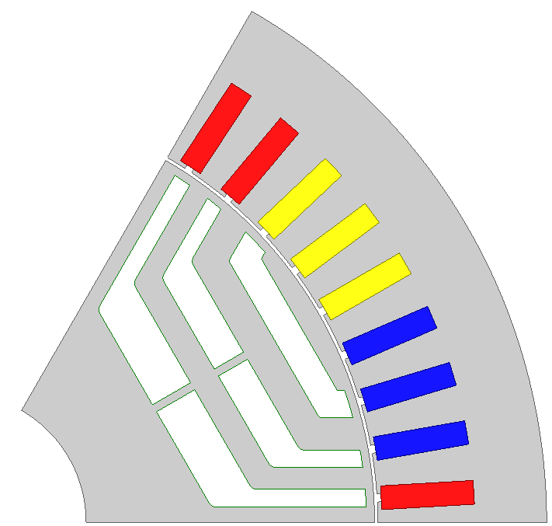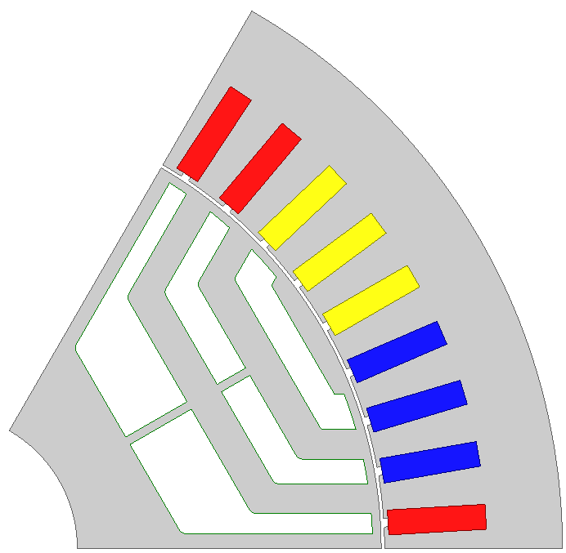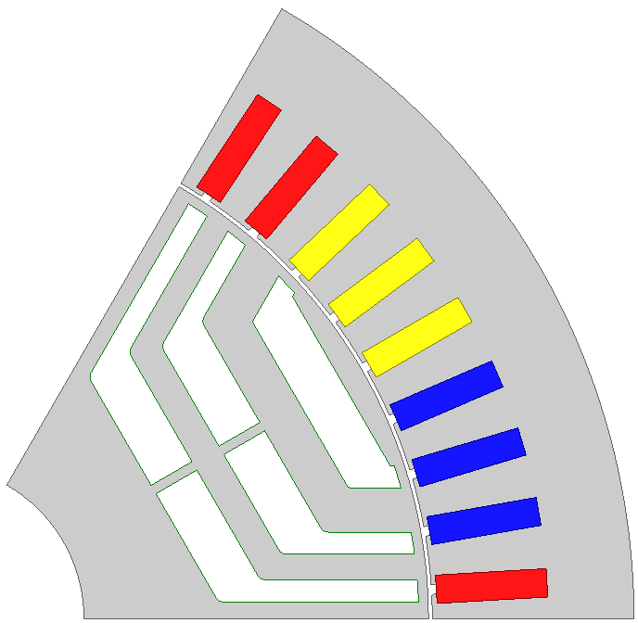
(a) (b) (c)
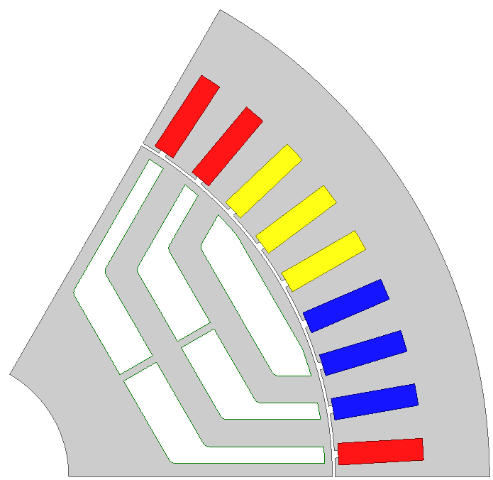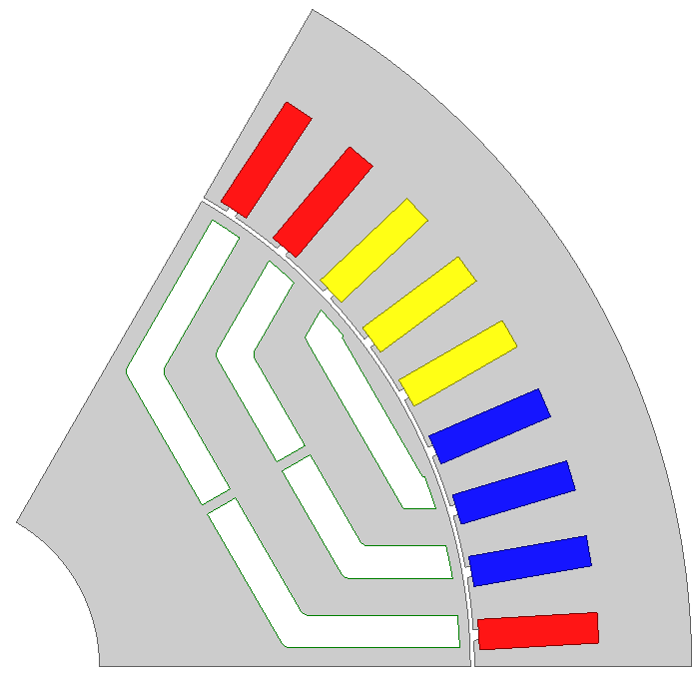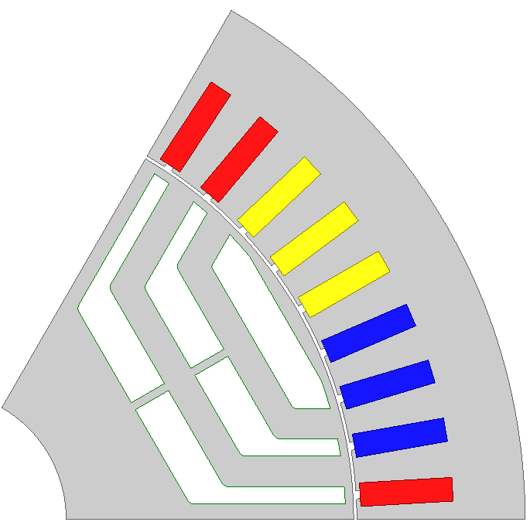
(d) (e) (f)
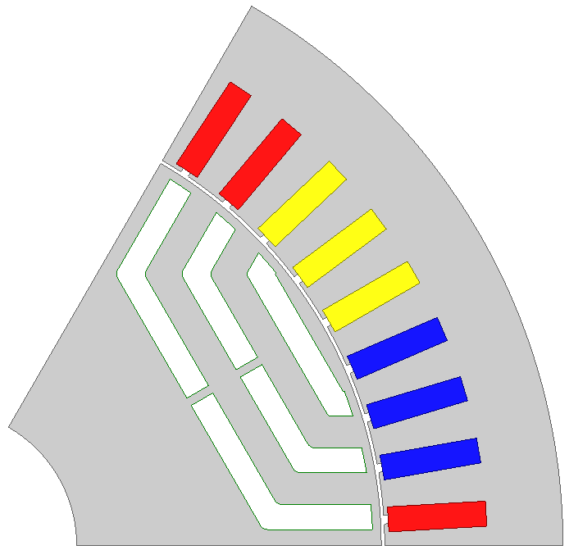
(g)
Fig. 5.3 Optimized geometries of SynRMs with different imposed conditions (a) Without Conditions. (b) Condition I. (c) Condition II. (d) Conditions I+II. (e) Conditions I+II+IV. (f) Conditions I+II+III. (g) Conditions I+II+III+IV.
Fig. 5.4 Maximum output torque of SynRMs with different imposed conditions.

Number of Barriers
The number of rotor barriers of SynRM has an influence on the output torque capability and torque ripple. Reasonable conditions, as illustrated in section 5.2.1, are imposed on the optimization process, and GA is adopted for each SynRM with a different number of barrier layers to maximize the possible output torque. The cross sections of optimized SynRMs with different number of layers are shown in Fig. 5.5. The maximum possible output torque and torque ripples are shown in Fig. 5.6 and Fig. 5.7. The maximum output torque increases with the number of layers, however, the influence is not obvious if the number of layer is larger than two. Finally, two is determined as the number of layers, because it has much smaller torque ripple than three-layer SynRM, and less mechanically complicated than four-layer SynRM.

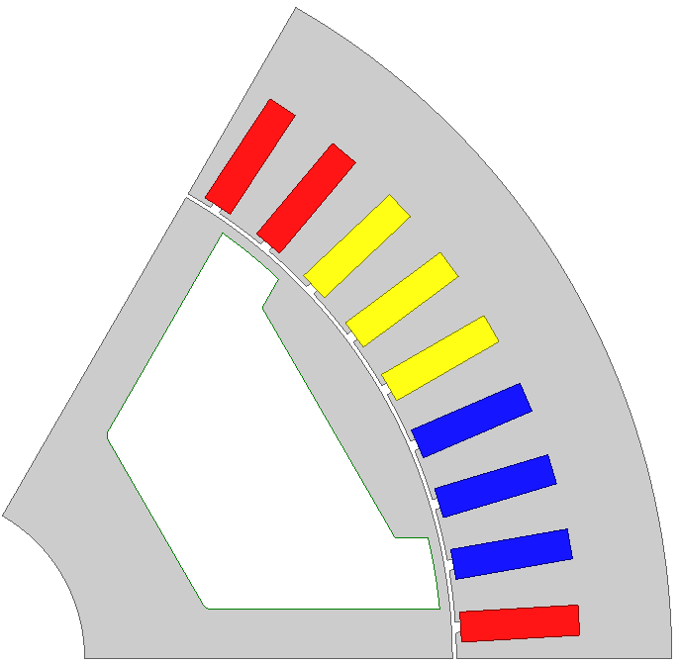 | 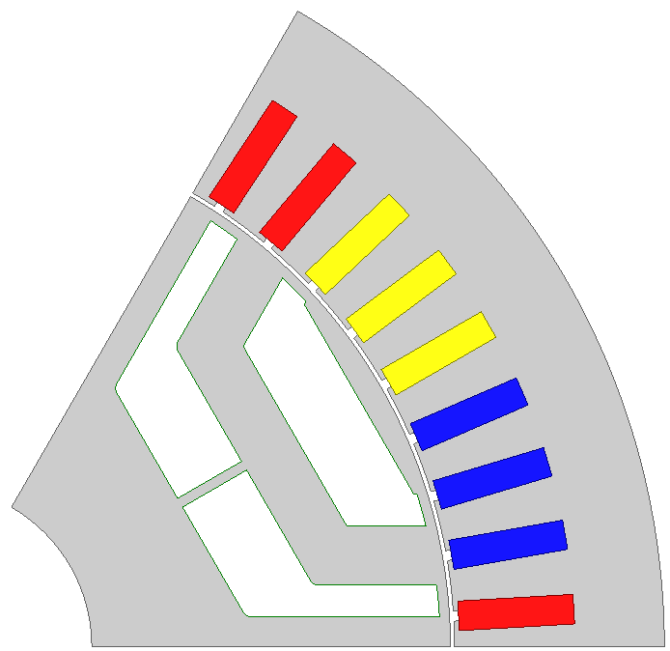
(a) | (b)
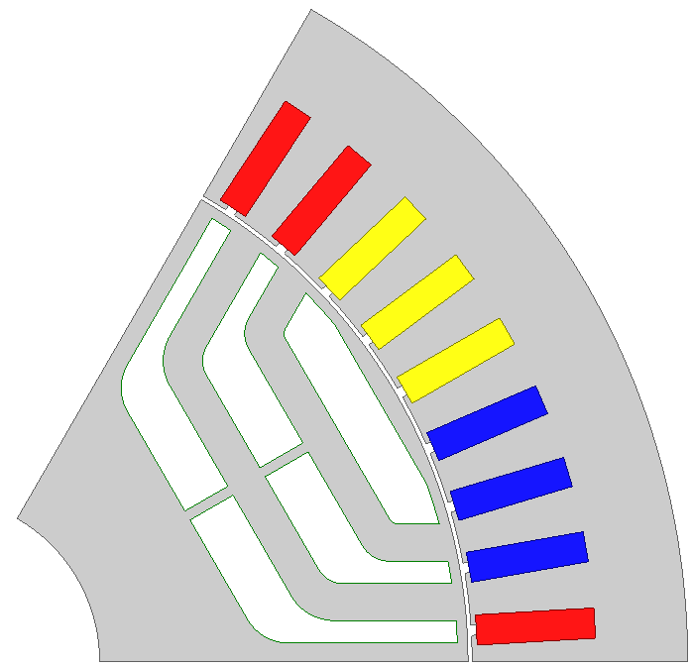 | 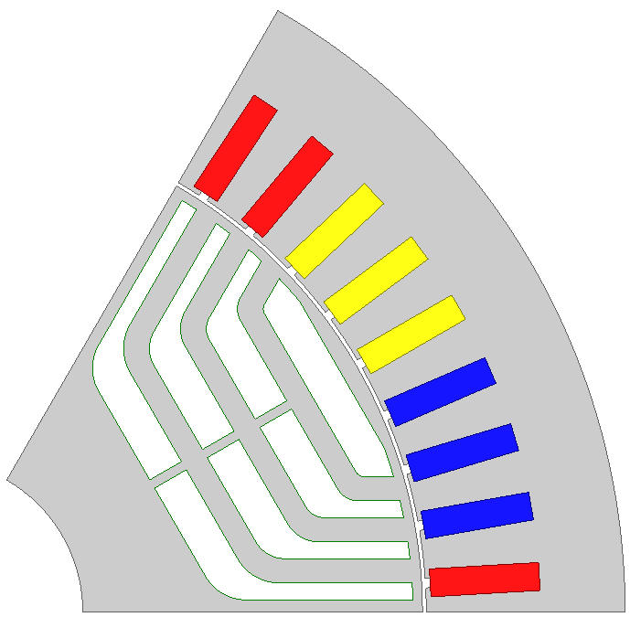
(c) | (d)
Fig. 5.5 Cross sections of optimized SynRMs. (a) Single-layer. (b) Two-layer. (c) Three-layer. (d) Four-layer.
Fig. 5.6 Torque ripple waveforms corresponding to maximum output torque of SynRMs with different numbers of barriers.
Fig. 5.7 Maximum output torque and corresponding peak-to-peak torque ripple values of SynRMs with different numbers of barriers.

Design of PMA-SynRM
The electromagnetic torque of PMA-SynRM consists of reluctance and PM torque. Since the reluctance torque of optimized SynRM has already been maximized, the design of PMA-SynRM can be carried out by inserting PMs into the barriers. It is reasonable from the view of saving PM, since it favours to reduce the PM quantity by utilizing the reluctance torque maximally. In fact, the iron saturation can be different after inserting PM. Consequently, the real reluctance torque of PMA-SynRM can be different from that of SynRM. It will be checked in section 5.6.2 by using frozen permeability. The influence of PM on reluctance torque of PMA-SynRM is neglected in order to simplify the optimization process without using frozen permeability. Ferrite-assisted SynRM and NdFeB-assisted SynRM are two major types of PMA-SynRMs. Ferrite FB12H and NdFeB N36Z are adopted, of which BH characteristics are shown in Fig. B.1 and Fig. B.2. A ferrite-assisted SynRM are usually designed by filling low-cost ferrite PM fully into the barriers of SynRM. The narrower parts of barriers are not filled with ferrite, as shown in Fig. 5.8(a), because thinner ferrite is easily subject to demagnetization due to the low magnetic energy product, especially for electrical machine under high electric load. For a NdFeB-assisted SynRM, because NdFeB PM is not easy to be demagnetized due to the high magnetic energy product, thinner NdFeB PM is usually favourable to improve the utilization of PM [GUG13], and further to reduce the material cost, as shown in Fig. 5.8(b). The variation of maximum possible output torque with NdFeB quantity is shown in Fig. 5.9, which shows that the maximum torque of NdFeB-assisted SynRM increases almost linearly with PM quantity. For electrical machines with NdFeB PMs for EV/HEV applications, it is always desirable that the electromagnetic performance can be satisfied with a less quantity of NdFeB, due to high cost of NdFeB. Finally, the NdFeB is determined to be 0.38kg in order to satisfy the maximum torque requirement, which is 55Nm in this chapter.
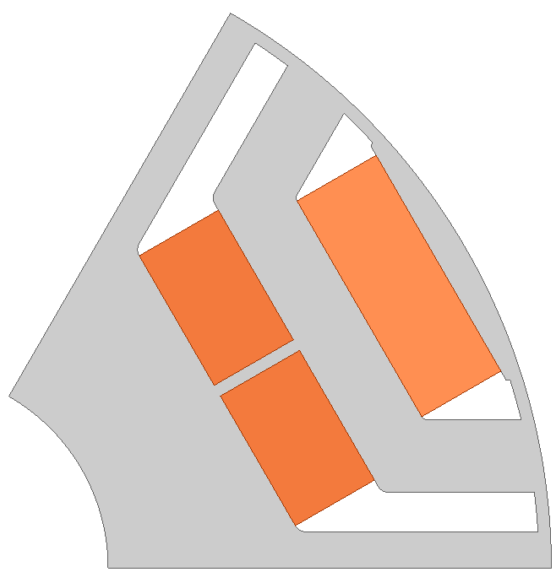 | 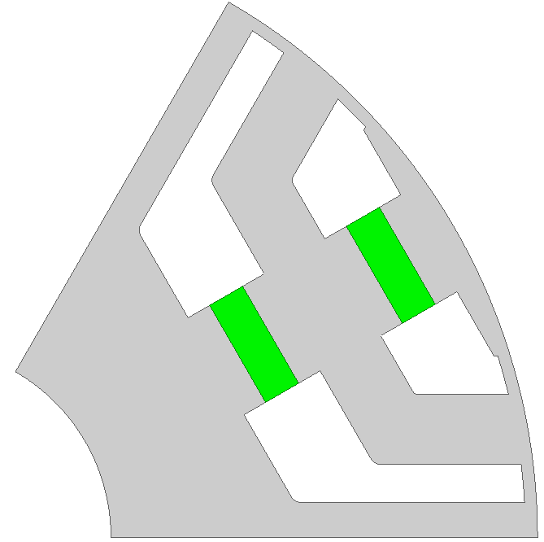
(a) | (b)
Fig. 5.8 Cross sections of PMA- SynRM rotors. (a) Ferrite-assisted SynRM. (b) NdFeB-assisted SynRM.
Fig. 5.9 Variation of maximum possible output torque of NdFeB-assisted SynRM with NdFeB PM quantity.

Design of Hybrid PM-assisted SynRM
The design of hybrid PM-assisted SynRM is conducted by filling both ferrite and NdFeB PMs into the barriers of SynRM. Because the barriers of SynRM are usually thicker in the middle and thinner in the ends, the ferrite is located in the middle of barriers, which is beneficial to demagnetization performance, and NdFeB PMs are located at the ends of barriers, which helps to improve the PM utilization, as shown in Fig. 5.1.
The maximum possible output torque of hybrid PM-assisted SynRMs with different ferrite and NdFeB quantities is shown in Fig. 5.10, which shows that the maximum torque increases approximately linearly with ferrite or NdFeB quantity. The PM costs are shown in Fig. 5.11. It can be seen from Fig. 5.10 and Fig. 5.11 (a) that the NdFeB PM affects the torque more than material cost. Since NdFeB quotation fluctuates violently sometimes, the PM costs for different NdFeB quotation are also calculated, as shown in Fig. 5.11. The reasonable quantities of ferrite and NdFeB PMs depend on the relationship of ferrite and NdFeB quotations, from the view of saving material cost:
- It is reasonable to use the maximum possible quantity of ferrite instead of NdFeB, if the ratio of NdFeB quotation to ferrite is > 28:8;
- It is reasonable to use the maximum possible quantity of NdFeB instead of ferrite, if the ratio of NdFeB quotation to ferrite is < 28:8. In fact in this case, the hybrid PM-assisted SynRM becomes NdFeB-assisted SynRM.
Finally, the ferrite and NdFeB quantities of hybrid PM-assisted SynRM are determined to be 0.69kg and 0.19kg respectively to satisfy the design targets.
Fig. 5.10 The maximum possible electromagnetic torque of hybrid PM-assisted SynRM with different ferrite and NdFeB PM quantities.
(a) | (b)
(c) | (d)
Fig. 5.11 PM costs of hybrid PM-assisted SynRMs with different ferrite and NdFeB PM quotations. (a) Ferrite=8£/kg, NdFeB=100£/kg, in 2013 UK market. (b) Ferrite=8£/kg, NdFeB=50£/kg. (c) Ferrite=8£/kg, NdFeB=28£/kg. (d) Ferrite=8£/kg, NdFeB=10£/kg.

Design Specifications
The cross sections of finally optimized SynRM, ferrite-assisted, NdFeB-assisted and hybrid PM-assisted SynRMs are shown in Fig. 5.12. The dimensions and design parameters are listed in Table 5.1. It should be mentioned that the rectangular shape of coils contribute to the high packing factor 0.64. This kind of coils is usually formed before inserting into stator. The bridge thickness is fixed 1mm to simplify the optimization. Usually, the bridge thickness should be mechanically checked.
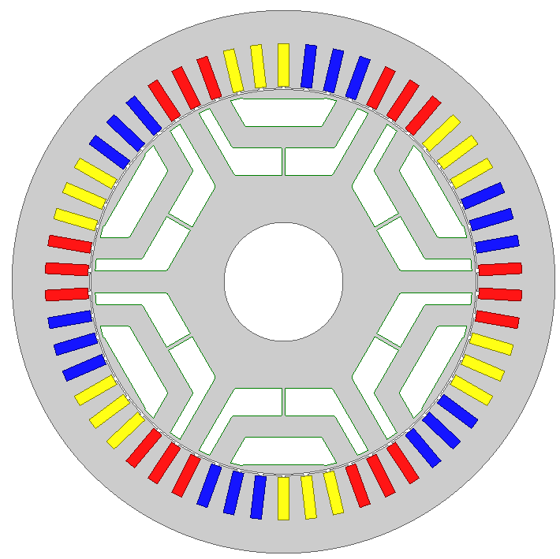
(a)
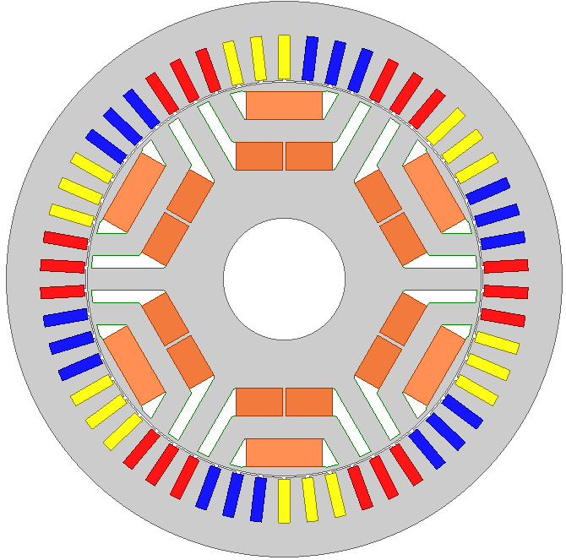
(b)
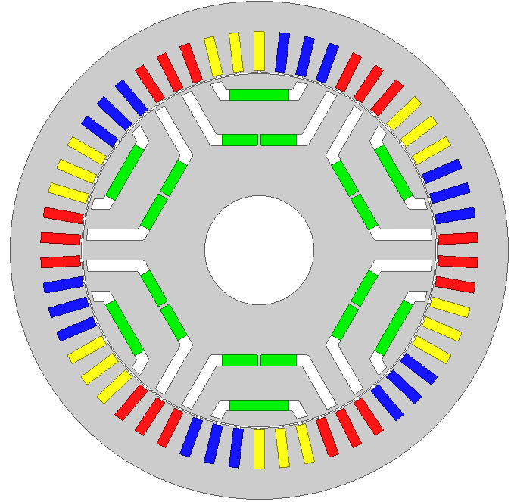
(c)
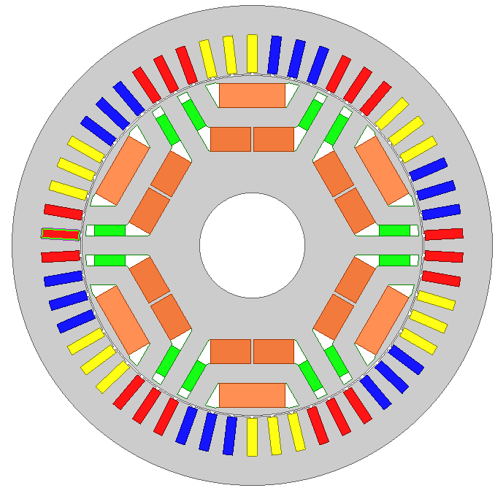
(d)
Fig. 5.12 Cross sections. (a) SynRM. (b) Ferrite-assisted SynRM. (c) NdFeB-assisted SynRM. (d) Hybrid PM-assisted SynRM.

Table 5.1 Dimensions and design parameters
 | Hybrid PM-assisted SynRM | NdFeB-assisted SynRM | Ferrite-assisted SynRM | SynRM
Limit of phase current amplitude (A) | 707
Limit of phase voltage amplitude (V) | 26
Number of poles | 6
Stator outer diameter (mm) | 146
Stator inner diameter (mm) | 104.2
Stack length (mm) | 70
Number of stator slots | 54
Stator slot height (mm) | 11.99
Slot opening width (mm) | 1
Slot opening height (mm) | 0.5
Stator slot width (mm) | 2.94
Airgap length (mm) | 0.4
Number of barriers | 2
Width of each barrier along circumferential direction (mm) | 3.18
Width of each barrier along radial direction (mm) | 7.36
Width of each iron layer (mm) | 5.85
Ferrite dimensions (mm) | 20×7.36  12×7.36 | - | 20×7.36  12×7.36 | -
NdFeB dimensions (mm) | 9.36×3.18 | 10.5×3.18  17×3.18 | - | -
Bridge thickness (mm) | 1.0
Rib thickness (mm) | 1.0
Wire dimension (mm) | 2.24×5
Number of turns per coil | 1
Number of coils per slot | 2
Number of parallel branches | 2
Number of series turns per phase | 9
Packing factor | 0.64
Stator phase resistance at 21℃ (Ω) | 0.0022
Steel grade | M270-35A
Type of magnet (NdFeB/ferrite) | N36Z  FB12H | N36Z | FB12H | -

Electromagnetic Performance and Cost
The following electromagnetic performances are calculated with the conditions that the winding temperature=180ºC and PM temperature=150 ºC.

Flux Field Distribution
The no load flux field distributions of hybrid PM-assisted, NdFeB-assisted and ferrite-assisted SynRMs are shown in Fig. 5.13. PMs provide the flux through the stator, in addition to saturating the iron bridge. The iron bridges in hybrid PM-assisted SynRM are mainly saturated by flux of NdFeB PMs. The airgap flux density waveforms are shown in Fig. 5.14. The maximum flux density of ferrite-assisted SynRM is much lower than those of hybrid PM-assisted and NdFeB-assisted SynRMs due to the low magnetic energy product of ferrite.
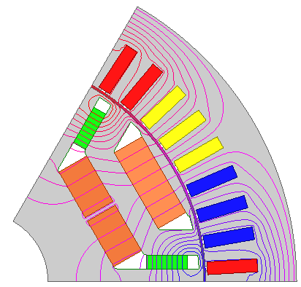 | 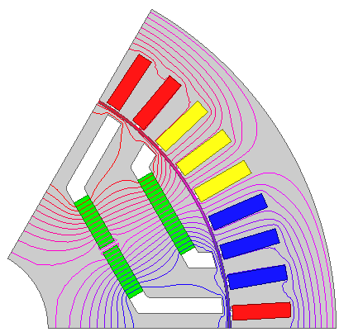
(a) | (b)
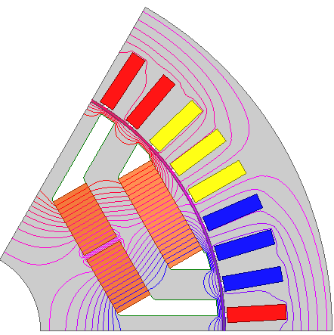
(c)
Fig. 5.13 No load flux distributions of hybrid PM-assisted, NdFeB-assisted and ferrite-assisted SynRMs.
Fig. 5.14 No load airgap flux density waveforms of hybrid PM-assisted, NdFeB-assisted and ferrite-assisted SynRMs.

Electromagnetic Torque
A. Comparison between Hybrid PM-Assisted SynRM, NdFeB-Assisted SynRM, Ferrite-Assisted SynRM and SynRM
The variations of electromagnetic torque with current angle of hybrid PM-assisted, NdFeB-assisted and ferrite-assisted SynRMs, and SynRM are shown in Fig. 5.15. The torque of hybrid PM-assisted and NdFeB-assisted SynRMs are close to each other, and both are larger than that of ferrite-assisted SynRM and SynRM. The torque of SynRM is the lowest, because no PM is used.
Fig. 5.15 Variations of torque with current angle.

B. Electromagnetic Torque of Hybrid PM-Assisted SynRM
The electromagnetic torque includes reluctance torque and PM torque. For hybrid PM-assisted SynRM, the PM torque can be further divided into ferrite- and NdFeB-contributed torque, as shown in (5.1). Frozen permeability method, which is described in detail in Appendix D, is utilized to calculate the reluctance and PM torque components correctly. The reluctance torque, ferrite- and NdFeB-contributed PM torque is shown in Fig. 5.16. It shows that most of the electromagnetic torque of hybrid PM-assisted SynRM comes from reluctance torque (82.3% at current angle=62º), and the values of ferrite- and NdFeB-contributed PM torque is similar (both account for 8.8% at current angle=62º).
$T_{em}=T_{rel}+T_{PM_ferrite}+T_{PM_NdFeB}$
(5.1)
It should be mentioned that the ferrite- or NdFeB-contributed PM torque does not represent all the contribution of PM, since the PM saturates the iron bridge as well, which favors to improve the reluctance torque. The contribution to iron bridge saturation can be seen from Fig. 5.13. The PM-contributed synchronous reluctance torque is shown in Fig. 5.17. The contribution of PM to reluctance torque is comparable to PM torque. The method of calculating PM-contributed synchronous reluctance torque is as follows: Firstly, the torque for different current angles for a pure SynRM (without PMs) is calculated, without using frozen permeability method, as the solid columns in Fig. 5.17; Then, the PM-contributed reluctance torque is obtained by subtracting this torque from the reluctance torque obtained in Fig. 5.16.
The reason for the reluctance torque corresponding to current angle zero is as follows. There exists saliency in the stator by using frozen permeability [CHU13]. The axis corresponding to the smallest reluctance of stator always rotates with some angle in advance of rotor. The torque is produced by the interaction between stator and rotor modulated fields.
Fig. 5.16. Reluctance torque, ferrite- and NdFeB-contributed PM torque of hybrid PM-assisted SynRM.
Fig. 5.17. Reluctance torque of hybrid PM-assisted SynRM.

Back EMF
The no load phase and line back EMF of hybrid PM-assisted, NdFeB-assisted and ferrite-assisted SynRMs are shown in Fig. 5.18. The amplitude of back EMF of hybrid PM-assisted SynRM is comparable to that of NdFeB-assisted SynRM.
(a)
(b)
Fig. 5.18 No load back EMF. (a) Phase back EMF. (b) Line back EMF.

Torque-speed Characteristic
The proposed methodology in [QI09] is utilized for torque/power-speed characteristic calculation which can accurately consider the magnetic cross coupling. The basic calculation equations are listed in Appendix E. The maximum torque- and power-speed characteristics of SynRM, ferrite-assisted, NdFeB-assisted and hybrid PM-assisted SynRMs are shown in Fig. 5.19. The torque- and power-speed characteristics of SynRM are much poorer than those of other machines with PMs, especially in flux-weakening region. The torque- and power-speed characteristics of NdFeB-assisted and hybrid PM-assisted SynRM are both better than those of ferrite-assisted SynRM. With the same maximum torque in constant torque region, the flux-weakening performance of hybrid PM-assisted SynRM is better than that of NdFeB-assisted SynRM. The constant power region of PM electrical machine depends on the relationship between PM flux linkage ψ_{PM} and the product of d-axis inductance and maximum stator current L_{d}·i_{lim}, which are shown in Fig. 5.20. L_{d} of hybrid PM-assisted SynRM is smaller than that of NdFeB-assisted SynRM, because the middle of barriers is thicker than that of NdFeB-assisted SynRM, which reduces the d-axis flux path reluctance. Consequently, the smaller L_{d} makes the difference between ψ_{PM} and L_{d}·i_{max} of hybrid PM-assisted SynRM smaller than that of NdFeB-assisted SynRM, and further makes the constant power region wider. It should be mentioned that L_{d}·i_{max} is larger than ψ_{PM} in this case, otherwise, the constant power region of hybrid PM-assisted SynRM may be smaller.
(a)
(b)
Fig. 5.19 Torque- and power-speed characteristics. (a) Torque-speed. (b) Power-speed.
Fig. 5.20 PM flux linkages and the products of d-axis inductance and maximum stator current along the maximum torque-speed curves.

Power Factor
The power factors along the maximum torque-speed characteristics of SynRM, ferrite-assisted, NdFeB-assisted and hybrid PM-assisted SynRMs are shown in Fig. 5.21. The power factors of SynRM are much lower than those of other electrical machines with PMs. The power factors of NdFeB-assisted and hybrid PM-assisted SynRMs are close, both are larger than that of ferrite-assisted SynRM, because the PM flux linkage of NdFeB-assisted and hybrid PM-assisted SynRMs are larger than that of ferrite-assisted SynRM, as can be seen from Fig. 5.18.
Fig. 5.21 Power factor along the maximum torque-speed curve.

Torque Ripple and Cogging Torque
The torque ripples corresponding to maximum output torque and cogging torque of SynRM, ferrite-assisted, NdFeB-assisted and hybrid PM-assisted SynRMs are shown in Fig. 5.22 and Fig. 5.23. The torque ripple of hybrid PM-assisted SynRM is not larger than those of other electrical machines, and the cogging torque is not larger than that of NdFeB-assisted SynRM.
Fig. 5.22 Torque ripples corresponding to maximum electromagnetic torque.
Fig. 5.23 Cogging torque.

Demagnetization
A higher magnetic energy product and a higher knee point in the BH curve of PM are beneficial to the demagnetization performance. For NdFeB PM, both the magnetic energy product and knee point decrease as the temperature increases, as shown in Fig. B.2. Thus, the most serious demagnetization happens at a higher temperature. For ferrite PM, the magnetic energy product decreases as the temperature increases, whilst the knee point increases with temperature, Fig. B.1. Thus, the worst demagnetization situation may appear at a high or low temperature. The maximum possible stator current 707A is imposed on the minus d-axis direction, and the lowest and highest temperatures are set to be -40ºC and 150ºC respectively.
- Demagnetization of Ferrite
The flux densities in ferrite of hybrid PM-assisted and ferrite-assisted SynRM at -40ºC and 150ºC are shown in Fig. 5.24. The knee points of BH curves of ferrite FB12H at -40ºC and 150ºC are 0.12T and -0.05T respectively. The lowest flux density is higher than the corresponding knee point. Even if the flux density in some part of ferrite is close to the knee point, the area of this part is quite small. Thus, the ferrite is safe from the irreversible demagnetization.
In addition, the demagnetization of ferrite in the second layer of hybrid PM-assisted SynRM is more serious than that of ferrite-assisted SynRM, comparing Fig. 5.24 (a) and (b), or (c) and (d). The more serious demagnetization of ferrite in hybrid PM-assisted SynRM is due to the influence of NdFeB PMs, which cause more demagnetization flux through the second layer of barrier, as shown in Fig. 5.25.

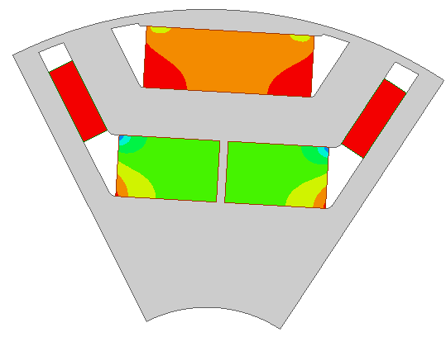  (a) | 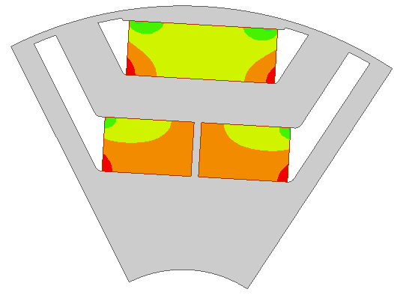  (b) | 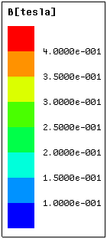
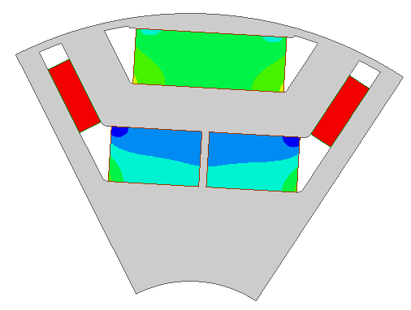  (c) | 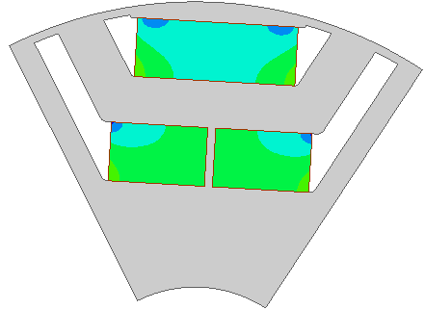  (d)
Fig. 5.24. Flux densities in PMs, i_{d}=-707A, i_{q}=0. (a) Hybrid PM-assisted SynRM, -40ºC. (b) Ferrite-assisted SynRM, -40ºC. (c) Hybrid PM-assisted SynRM, 150ºC. (d) Ferrite-assisted SynRM, 150ºC.
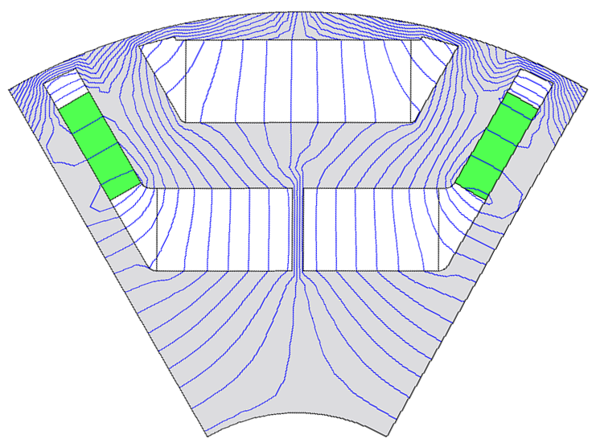 | 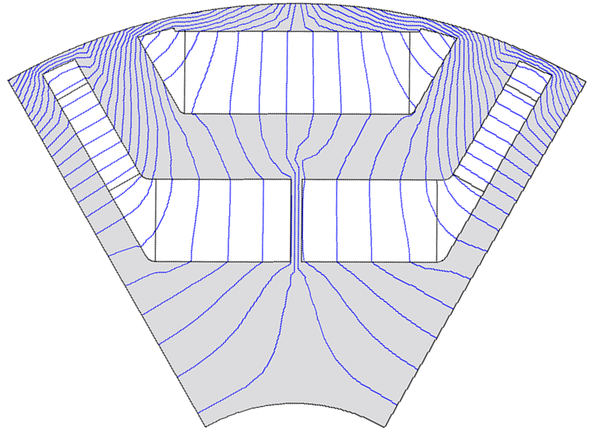
(a) | (b)
Fig. 5.25 Flux field distributions in the rotors of hybrid PM-assisted and ferrite-assisted SynRMs, i_{d}=-707A, i_{q}=0, both are without ferrite, the permeability in the iron is frozen to that corresponding to Fig. 5.24 I and (d) respectively. (a) Hybrid PM-assisted SynRM. (b) Ferrite-assisted SynRM.

B. Demagnetization of NdFeB
The flux densities in NdFeB of hybrid PM-assisted and NdFeB-assisted SynRM at 150ºC are shown in Fig. 5.26. The knee points of BH curve of NdFeB N36Z at 150ºC is lower than zero. Thus, NdFeB is quite far from irreversible demagnetization. In addition, the demagnetization of NdFeB in hybrid PM-assisted SynRM is more serious than that in NdFeB-assisted SynRM. It is because the middle of barriers in hybrid PM-assisted SynRM is thicker, which tends to make more demagnetization flux through the narrower ends.
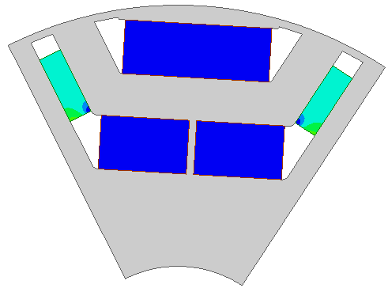  (a) | 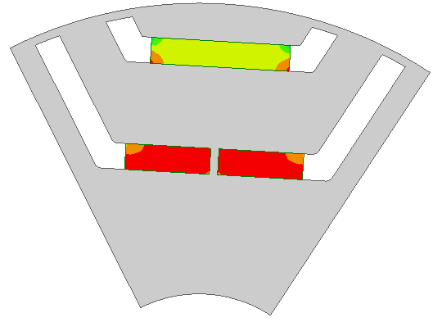  (b) | 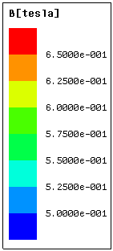
Fig. 5.26. Flux densities in PM, i_{d}=-707A, i_{q}=0. (a) Hybrid PM-assisted SynRM, 150ºC. (b) NdFeB-assisted SynRM, 150ºC.

Cost
The quotation is based on the market price in 2013 in UK:
- Cost of copper: 7£/kg;
- Cost of iron lamination: 2£/kg;
- Cost of NdFeB PM: 100£/kg;
- Cost of ferrite PM: 8£/kg;
The weight and material costs of hybrid PM-assisted, NdFeB-assisted and ferrite-assisted SynRMs are listed in Table 5.2. Hybrid PM-assisted SynRM uses half of NdFeB PM of NdFeB-assisted SynRM, and the total material cost is ~20% less. The material costs of ferrite-assisted SynRM and SynRM are ~50% and ~60% less than that of NdFeB-assisted SynRM respectively.

Table 5.2 Material weights and costs
 | Hybrid PM-assisted SynRM | NdFeB-assisted SynRM | Ferrite-assisted SynRM | SynRM
Copper mass (kg) | 1.61 | 1.61 | 1.61 | 1.61
Iron mass (kg) | 6.06 | 6.06 | 6.06 | 6.06
NdFeB mass (kg) | 0.187 | 0.38 | - | -
Ferrite mass (kg) | 0.69 | - | 0.69 | -
Total mass (kg) | 8.56 | 8.05 | 8.36 | 7.67
Copper cost (£) | 11.2 | 11.2 | 11.2 | 11.2
Iron (£) | 12.1 | 12.1 | 12.1 | 12.1
NdFeB (£) | 18.7 | 38.0 | - | -
Ferrite (£) | 5.57 | - | 5.57 | -
Total (£) | 47.7 | 61.4 | 29.0 | 23.3

Conclusion
A new type of hybrid PM-assisted SynRM, which utilizes both ferrite and NdFeB PMs, is proposed in this chapter. Portion of NdFeB in NdFeB-assisted SynRM is substituted by ferrite without sacrificing the output torque capability. In the proposed design in this chapter, half of NdFeB is replaced by four times weight of ferrite, and hybrid PM-assisted SynRM can achieve competitive electromagnetic performance, in terms of torque capability, torque/power-speed characteristic, power factor, torque ripple and cogging torque. The total material cost of hybrid PM-assisted SynRM is ~20% less than NdFeB-assisted SynRM. Although it has complicated rotor structure, it is a good candidate for no-or-less PM electrical machine for EV application.

Comparison of Electromagnetic Performance and Cost between Different Types of Electrical Machines for Electric Vehicle Application

Introduction
IPM and IM are two types of machines used most widely in EV/HEV propulsion systems. Many comparisons have been done between them for EV/HEV applications [PEL12] [HAS08] [BUC08] [DOR12] [SOO94]. IPM is nalysede due to its high torque and power density and high efficiency, because of the usage of NdFeB PM. In addition, wide constant power region can be achieved [SOO94]. However, the high price of NdFeB PM strongly influences the popularity of IPM [XUE11]. The uncontrolled generator voltage is another issue for IPM, which may cause the fault of inverter [JAH99].
IM is favourable because of its simplicity, robustness and mature manufacturing technology and control method. Further, IM is cheaper than PM machine, which makes it popular in the EV/HEV market. However, because the magnetic field of IM is established by the magnetizing component of stator current, the power factor is not as high as IPM, which leads to lower power density and high power rating of the inverter. Further, the constant power region of IM is not as wide as IPM, although usually up to 4:1 constant power region can be realized [HUM69] [BOG92]. The overall efficiency of IM is usually lower than IPM, except in the high speed region, which is due to no need of large stator current to counteract PM magnetic field.
As mentioned in Chapter 6, SynRM is not a type of traction machine used as widely as IM and IPM in EV/HEV market. The material cost of SynRM is the lowest. However, it has complicated rotor structure and poorer performance, in terms of torque density, power factor, constant power region and efficiency, compared with IPM. These electromagnetic performances can be enhanced by adding ferrite PM or a small quantity of NdFeB PM, i.e. PMA-SynRM. In addition, the no load voltage is lower than IPM, which may eliminate the requirement for fault voltage protection. Torque ripple is a design factor which should be considered seriously for SynRM or PMA-SynRM. There are extensive researches in literature for torque ripple improvement, and it can be reduced to quite a low level by appropriate design. SynRM and PMA-SynRM have gained more and more attention in EV/HEV market recently due to the above features [OBA14] [MAL01] [CAZ14].
This chapter aims to quantitatively compare different types of electrical machines, including IM, SynRM, ferrite-assisted, NdFeB-assisted and hybrid PM-assisted SynRMs and IPM, mainly in terms of electromagnetic performance and material cost. For IPM, Toyota Prius 2010 IPM is adopted directly for comparison, thus, there is no need of optimization. The specifications of Prius 2010 IPM are in [OLS11]. For a fair comparison, other electrical machines are designed with the same stator outer diameter and stack length as Prius 2010 IPM, as well as the same voltage and current ratings. Firstly, IM is optimized and compared with IPM. Then, SynRM, ferrite-assisted, NdFeB-assisted and hybrid PM-assisted SynRMs are optimized and compared with IPM. Finally, the comparison results between IM and hybrid PM-assisted SynRM are provided and discussed.

Comparison between IM and IPM

Design of IM
The calculation of IM is carried out using analytical method developed in Chapter 2. The optimization of maximum torque-speed characteristic with the same copper loss and driven by the same inverter as Prius 2010 IPM is determined as the design target, since it is an important design criterion for traction electrical machine for EV/HEV applications. It is more likely that the maximum output torque in constant torque region and the flux-weakening performance cannot be maximized at the same time. Thus, the optimal torque-speed characteristic of IM has to be determined by a compromise. The maximization of output torque in constant torque region is chosen as the major optimization target in this chapter, and meanwhile the flux-weakening performance should not be decreased so obviously.
- Determination of Major Design Parameters
Some of the major design parameters of IM are determined as follows: (1) Stator outer diameter and stack length are 264mm and 50.5mm respectively (same as Prius 2010); (2) The pole number is 8 (same as Prius 2010); (3) The stator and rotor slot number combination Q₁/Q₂ is 48/44; (4) The airgap length g is 0.73mm (same as Prius 2010); (5) The stator copper loss P_{Cu1} is kept about the same as Prius 2010; (6) The rotor squirrel cage material is copper, and the rotor copper loss is fixed around 1.9kW at 150℃; (7) Packing factor k_{pac} is 0.465 (same as Prius 2010). The other dimension parameters to be optimized are stator inner diameter D_{i}, stator and rotor tooth width b_{t1} and b_{t2}, stator and rotor slot height h_{s} and h_{r}, as shown in Fig. 6.1. In addition, the number of stator series turns per phase W_{φ} needs to be determined.
Fig. 6.1 Cross section and parameters to be optimized of IM.
B. Number of Series Turns, Stator Inner Diameter and Slot Dimension
In fact, the slot area can be fixed, if P_{Cu1}, W_{φ}, k_{pac} and the stator current I_{s}, which is decided by the inverter, are determined. The stator total copper loss is (6.1) and the area per stator slot is given by (6.3).
$Q_{1}J^{2}\left(S_{slot}k_{pac}\right)ρ_{Cu}L_{half_turn}=P_{Cu1}$
(6.1)
$J=\frac{m_{1}·I_{s}∙2W_{φ}}{Q_{1}S_{slot}k_{pac}}$
(6.2)
$S_{slot}=\frac{m_{1}^{2}I_{s}^{2}ρ_{Cu}∙{(2W_{φ})}^{2}L_{half_turn}}{{P_{Cu1}Q}_{1}k_{pac}}$
(6.3)
where J is the stator current density, ρ_{Cu} is the copper resistivity, L_{half_turn} is the half turn length of stator coil, m₁ is the phase number.
The stator slot height can be easily obtained with the stator slot area and slot width. It is the same case for rotor slot. It means that the optimization parameter number can be reduced by two. Further, it is assumed that the flux flowing through stator and rotor per pole are the same. Thus, it is reasonable to make b_{t1}/t₁ equals b_{t2}/t₂ to make the total stator and rotor tooth width per pole similar. Here, t₁ and t₂ are the stator and rotor slot pitch. Finally, the parameters to be optimized are W_{φ}, D_{i} and b_{t1}/t₁.
W_{φ}, D_{i} and b_{t1}/t₁ are optimized simultaneously and the optimal combination of D_{i} and b_{t1}/t₁ for each number of series turns is determined by comparing the calculated maximum electromagnetic torque, which is shown in Table 6.1. The number of series turns per phase, which is a key parameter affecting flux-weakening performance besides torque density with limited phase current and voltage, can be determined by comparing the torque/power-speed characteristics. The torque- and power-speed characteristics of Ims with different number of series turns per phase are shown in Fig. 6.2. It can be seen that, the flux-weakening performance of Ims enhances as the number of series turns decreases, although the maximum output torque may decrease. Finally, 72-turn is determined as the “optimal” number of series turns per phase, because the maximum output torque of 72-turn IM can satisfy the requirement of Prius 2010, as can be seen in the following section.
Table 6.1 Maximum electromagnetic torque variation with different D_{i} and b_{t1}/t₁ combinations for different number of series turns per phase
W_{φ} | b_{t1}/t₁ | D_{i} (mm)
W_{φ} | b_{t1}/t₁ | 185 | 190 | 195
88 | 0.3 | 218.09 | 193.27 | 150.08
88 | 0.32 | 228.27 | 208.60 | 170.02
88 | 0.34 | 234.24 | 220.02 | 187.62
88 | 0.36 | 238.25 | 228.00 | 203.33
88 | 0.38 | 240.72 | 236.57 | 216.32
88 | 0.4 | 241.98 | 241.22 | 225.96
88 | 0.42 | 241.67 | 244.07 | 232.34
88 | 0.44 | 240.44 | 245.22 | 239.80
88 | 0.46 | 237.06 | 245.70 | 242.64
88 | 0.48 | 234.02 | 241.02 | 240.57
88 | 0.5 | 229.19 | 236.93 | 239.11
80 | b_{t1}/t₁ | D_{i} (mm)
80 | b_{t1}/t₁ | 185 | 190 | 195
80 | 0.3 | 233.57 | 223.25 | 198.05
80 | 0.32 | 234.12 | 229.81 | 210.18
80 | 0.34 | 235.68 | 234.45 | 220.93
80 | 0.36 | 235.93 | 239.84 | 228.68
80 | 0.38 | 235.30 | 241.66 | 233.67
80 | 0.4 | 234.25 | 242.23 | 237.89
80 | 0.42 | 233.51 | 240.39 | 239.94
80 | 0.44 | 230.98 | 238.27 | 239.94
80 | 0.46 | 226.86 | 234.81 | 238.34
80 | 0.48 | 221.83 | 230.01 | 235.25
80 | 0.5 | 216.15 | 224.31 | 230.58
72 | b_{t1}/t₁ | D_{i} (mm)
72 | b_{t1}/t₁ | 190 | 195 | 200
72 | 0.3 | 188.01 | 218.16 | 193.50
72 | 0.32 | 200.53 | 224.79 | 203.23
72 | 0.34 | 211.76 | 228.88 | 211.38
72 | 0.36 | 220.09 | 232.28 | 220.65
72 | 0.38 | 225.22 | 233.95 | 226.45
72 | 0.4 | 228.72 | 233.79 | 228.94
72 | 0.42 | 230.90 | 232.00 | 229.70
72 | 0.44 | 231.81 | 229.00 | 228.96
72 | 0.46 | 231.73 | 225.13 | 227.06
72 | 0.48 | 232.45 | 219.14 | 223.94
72 | 0.5 | 230.76 | 213.93 | 218.34
64 | b_{t1}/t₁ | D_{i} (mm)
64 | b_{t1}/t₁ | 190 | 195 | 200
64 | 0.2 | 201.97 | 182.65 | 157.56
64 | 0.22 | 209.33 | 192.73 | 169.84
64 | 0.24 | 214.09 | 201.07 | 180.55
64 | 0.26 | 216.99 | 207.70 | 189.81
64 | 0.28 | 218.49 | 213.64 | 197.78
64 | 0.3 | 218.96 | 217.27 | 204.49
64 | 0.32 | 218.70 | 220.84 | 210.60
64 | 0.34 | 219.63 | 222.06 | 216.13
64 | 0.36 | 216.92 | 221.74 | 218.90
64 | 0.38 | 214.57 | 218.81 | 219.60
64 | 0.4 | 211.32 | 216.56 | 218.82
56 | b_{t1}/t₁ | D_{i} (mm)
56 | b_{t1}/t₁ | 190 | 195 | 200
56 | 0.2 | 194.72 | 186.28 | 171.05
56 | 0.22 | 197.42 | 191.40 | 178.59
56 | 0.24 | 198.99 | 195.07 | 184.72
56 | 0.26 | 199.82 | 197.50 | 189.84
56 | 0.28 | 199.71 | 200.86 | 194.78
56 | 0.3 | 200.77 | 203.09 | 198.61
56 | 0.32 | 199.73 | 203.42 | 200.99
56 | 0.34 | 197.83 | 202.29 | 201.97
56 | 0.36 | 195.22 | 200.51 | 201.78
56 | 0.38 | 192.23 | 198.00 | 200.34
56 | 0.4 | 188.79 | 194.80 | 198.25
48 | b_{t1}/t₁ | D_{i} (mm)
48 | b_{t1}/t₁ | 190 | 195 | 200
48 | 0.2 | 167.59 | 163.48 | 154.60
48 | 0.22 | 168.51 | 166.24 | 159.26
48 | 0.24 | 169.40 | 168.22 | 163.08
48 | 0.26 | 169.41 | 170.77 | 166.70
48 | 0.28 | 170.56 | 172.24 | 169.45
48 | 0.3 | 170.13 | 173.05 | 171.23
48 | 0.32 | 168.84 | 172.76 | 172.17
48 | 0.34 | 166.81 | 171.56 | 172.27
48 | 0.36 | 164.52 | 169.54 | 171.81
48 | 0.38 | 161.73 | 167.14 | 170.50
48 | 0.4 | 158.85 | 164.02 | 168.56

(a)
(b)
Fig. 6.2 Torque- and power-speed characteristics of Ims with different numbers of series turns per phase. (a) Torque-speed. (b) Power-speed.
C. Design Specification
The cross sections of optimized IM and Prius 2010 IPM are shown in Fig. 6.3. The design specifications are listed in Table 6.2. During the calculation, the temperature of stator winding, rotor squirrel cage and PM is set to be 150℃.
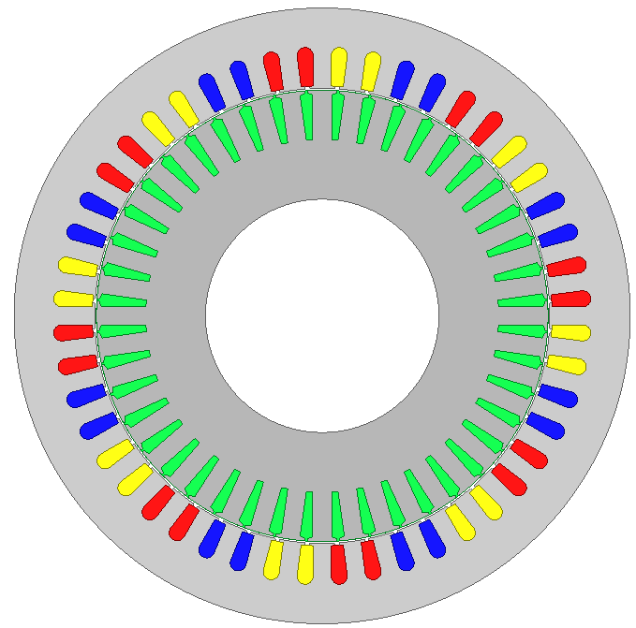
(a)
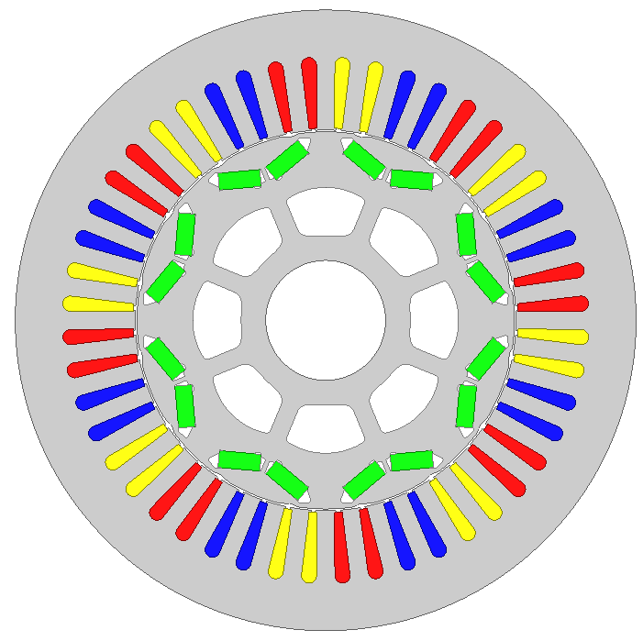
(b)
Fig. 6.3 Cross sections of IM and Prius 2010 IPM.
Table 6.2 Design specifications of Prius 2010 IPM and IM
 | Prius 2010 | IM
Limit of phase voltage amplitude (V) | 650×2/π×85% | 650×2/π×85%
Limit of phase current amplitude (A) | 225 | 225
Stator outer diameter D₁ (mm) | 264 | 264
Stator inner diameter D_{i} (mm) | 161.9 | 195
Stack length (mm) | 50.5 | 50.5
Number of stator slots | 48 | 48
Stator slot height h_{s} (mm) | 30.9 | 17.79
Stator slot opening width b₀₁ (mm) | 1.88 | 1.88
Stator tooth width b_{t1} (mm) | 7.55 | 7.74
Airgap length (mm) | 0.73 | 0.73
Magnet dimensions (mm) | 49.3×17.88×7.16 | -
Number of rotor slots | - | 44
Rotor slot height h_{r} (mm) | - | 20.22
Rotor slot opening b₀₂ (mm) | - | 1
Rotor tooth width b_{t2} (mm) | - | 8.2
Number of coils per slot | 1 | 1
Number of turns per coil | 11 | 9
Number of parallel branches | 1 | 1
Number of series turns per phase | 88 | 72
Packing factor | 0.465 | 0.465
Squirrel cage material | - | Copper/  aluminium
Stator phase resistance at 21℃ (Ω) | 0.077 | 0.077
Iron grade | W270-35A | W270-35A
Type of magnet | N36Z | -

Comparison of Performance and Cost
The following electromagnetic performances are calculated with the conditions that the stator winding, squirrel cage and PM temperature is set to be150 ºC.

Torque Capability
The maximum electromagnetic torque capabilities for different stator current amplitudes of IM and Prius 2010 IPM are shown in Fig. 6.4. It can be seen that the torque capability of IM increases faster with electric load than IPM, the torque capability of IPM is much better than IM under low electric load operations, while as the electric load increases, the torque capability of IM may be better than IPM. The reason for that is explained as follows:
The electromagnetic torque of IPM includes both PM and reluctance torque. PM torque depends on 𝜓_{PM} and is proportional to the stator current; Reluctance torque depends on (L_{q}-L_{d}) and is proportional to the square of stator current, (A.5). The electromagnetic torque of IM depends only on L_{m}²/L_{r} and is proportional to the square of stator current, (6.4). Under low electric load, the effect of PM in IPM is predominant, i.e. PM torque is predominant. Thus, the output torque of IPM is larger than IM. Under high electric load, the torque components proportional to the square of stator current become predominant. In addition, L_{m}²/L_{r} of IM is larger than (L_{q}-L_{d}) of IPM, Fig. 6.5. Thus, the torque of IM may be larger than that of IPM.
In order to validate FEA, the FEA result of IPM is compared with test result, which can be found in [OLS11], and the analytically calculated result of IM is compared with FEA result.
$T_{em}=\frac{3}{2}p\frac{L_{m}^{2}}{L_{r}}i_{d}i_{q}$
(A.5)
$T_{em}=\frac{3}{2}p[ψ_{PM}i_{q}-\left(L_{d}-L_{q}\right)i_{d}i_{q}]$
(6.4)
The method of obtaining maximum electromagnetic torque of IM using FEA for specific current amplitude is as follows. Three-phase current source with fixed amplitude and frequency is imposed on the stator side. Then, transient FEA is carried out for different slip ratios to obtain different torque values. The maximum electromagnetic torque can be obtained from them by comparison.
Fig. 6.4 Variation of maximum electromagnetic torque with current amplitude.
Fig. 6.5 Variations of inductance corresponding to maximum electromagnetic torque with current amplitudes

Torque/Power-Speed Characteristic
The proposed methodology in [QI09] is utilized for torque/power-speed characteristic calculation of IPM. The maximum and rated torque- and power-speed characteristics of IM and Prius 2010 IPM are shown in Fig. 6.6. It is assumed that the maximum converter current is 225A and the rated converter current is half of the maximum value. For the maximum torque/power-speed characteristic, although the torque in constant torque region of IM is competitive to IPM, the flux-weakening performance is always poorer, because the constant power region of IM is always narrower than IPM. For the rated torque/power-speed characteristic, the performance of IM is poorer than that of IPM in both constant torque region (~18% lower) and flux weakening region. In addition, Ims with copper and aluminium squirrel cage materials are compared and they have similar torque- and power-speed characteristics.
(a)
(b)
(c)
(d)
Fig. 6.6 Torque- and power-speed characteristics. (a) Torque-speed, maximum converter current. (a) Power-speed, maximum converter current. (c) Torque-speed, rated converter current. (d) Power-speed, rated converter current.

Power Factor
The power factors of IM and Prius 2010 IPM along torque-speed characteristics for maximum and rated converter current are shown in Fig. 6.7. The power factor of IM is competitive and even larger than IPM under high electric load in low speed region. The reason is explained as follows. The power factor of IM increases as the ratio of leakage to mutual inductance L_{σ}/L_{m} decreases, according to the investigation in section 3.2.2; the power factor of IPM increases with the decrease of ratio of q-axis to d-axis inductance L_{q}/L_{d}, if the effect of PM is quite small [SOO94]. Under high electric load, the PM effect is less predominant. Consequently, the power factor of IM may be better than that IPM, because L_{σ}/L_{m} is much smaller than L_{q}/L_{d}, as shown in Fig. 6.8. Under low electric load, the PM effect is increased, and thus, the power factor of IPM is improved.
(a)
(b)
Fig. 6.7 Power factor along the torque-speed characteristics. (a) Maximum converter current. (b) Rated converter current.
Fig. 6.8 Ratio of leakage to mutual inductances of IM and ratio of q-axis to d-axis inductances of IPM along the torque-speed characteristics for maximum converter current.

Torque Ripple
The torque ripples of maximum output torque of IM and Prius 2010 IPM for different stator current amplitudes are shown in Fig. 6.9. The comparison of peak to peak torque ripple of IM and IPM is shown in Fig. 6.10. It can be seen that the torque ripple of IM is larger than IPM, under high electric load. Under low electric load, the torque ripple of IM becomes lower than IPM. It is mainly because that as the electric load of IPM deceases, the torque ripple produced by PM becomes more and more prominent. In addition, the frequency of torque ripple of IM is higher than IPM.
(a)
(b)
Fig. 6.9 Torque ripples for different current amplitude. (a) IM. (b) Prius 2010 IPM.
Fig. 6.10 Peak to peak torque ripples for different stator current amplitudes.

Efficiency Map
The loss calculation method of IM has been introduced in Chapter 2. The mechanical loss of IM is referenced to Prius 2010 IPM, as shown in Appendix F. The calculated efficiency maps of Ims with copper and aluminium squirrel cages and tested efficiency map of Prius 2010 IPM are shown in Fig. 6.11. The overall efficiency of IM is lower than IPM. The maximum efficiency of IM with copper squirrel cage is 2~3% lower than that of IPM. The maximum efficiency of aluminium squirrel cage IM is further 1% lower than IM with copper squirrel cage.
(a)
(b)
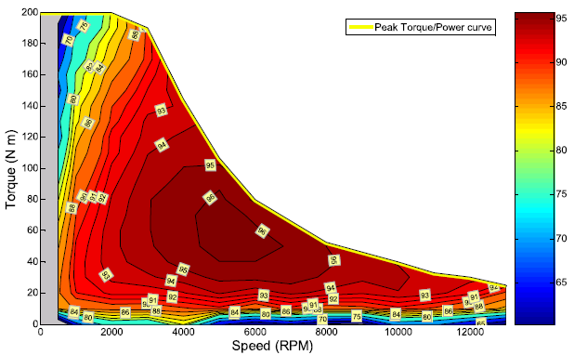
(c)
Fig. 6.11 Efficiency maps. (a) IM, Cu-cage. (b) IM, Al-cage. (c) Prius 2010 IPM [OLS11].

Cost
The material costs of IM and Prius 2010 IPM are compared in this section. The quotation is based on the market price in 2013 in UK, as listed in section 5.6.8. The weight and material cost of IM and Prius 2010 IPM are listed in Table 6.3. The total weight of IM and IPM is similar, because the IM is designed with the same stator outer diameter and stack length as Prius 2010 IPM. However, the cost of IM is much lower than IPM, almost half of IPM’s price. The price of IPM is much susceptible to the fluctuation of NdFeB PM quotation.
Table 6.3 Material costs of IM and Prius 2010 IPM
 | IM | Prius 2010
Stator copper mass (kg) | 3.36 | 4.93
Iron mass (kg) | 15.0 | 15.04
Rotor copper/PM mass (kg) | 3.92 | 0.775
Total mass (kg) | 22.2 | 20.75
Stator copper (£) | 23.5 | 34.51
Iron (£) | 29.9 | 30.08
Rotor copper/PM (£) | 27.5 | 77.56
Total (£) | 80.9 | 142.1

Comparison between SynRM, Ferrite-Assisted SynRM, NdFeB-Assisted SynRM, Hybrid PM-Assisted SynRM and IPM
Some of the major design parameters are determined as follows: (1) Stator outer diameter and stack length is 264mm and 50.5mm respectively (same as Prius 2010); (2) The pole number is 8 (same as Prius 2010); (3) The stator slot number Q₁ is 48 (same as Prius 2010); (4) The airgap length g is 0.73mm (same as Prius 2010); (5) The stator copper loss P_{Cu1} is fixed around 1.9kW at 150℃, about the same as Prius 2010; (6) Packing factor k_{pac} is 0.465 (same as Prius 2010). The design principle and strategy of SynRM and PMA-SynRM have been presented in Chapter 5. FEA is adopted for calculation. The design target is to maximize the maximum torque-speed characteristic with the same copper loss and the same inverter current and voltage rating as Prius 2010 IPM, the same as that in section 6.2.

Design of SynRM
- Number of Barriers
The number of barriers of SynRM is determined firstly in this section. With the stator the same as Prius 2010 IPM, SynRM rotors with 1-, 2-, 3- and 4-layers of barriers are optimized. The optimization method is the same as that in section 5.2. The cross sections of optimized SynRMs are shown in Fig. 6.12, and the corresponding maximum torque and torque ripples are shown in Fig. 6.13. Finally, three is determined as the number of layers, because the maximum electromagnetic torque does not increase obviously if the number of layers is larger than two and the three-layer SynRM has the smallest torque ripple.
It should be mentioned that the optimal number of barriers in this section (3-layers) is not the same as that in section 5.2.2 (2-layers), from the view of torque ripple. The torque ripple has a close relationship with the combination of stator slot number and rotor barrier number [VAG98]. The number of stator slots per pole per phase q₁ in section 5.2.2 and this section are 3 and 2 respectively. For torque ripple, it seems that:
- If q₁=3, 2-layer is better than 1-layer, 4-layer is better than 3-layer;
- If q₁=2, 1-layer is better than 2-layer, 3-layer is better than 4-layer.

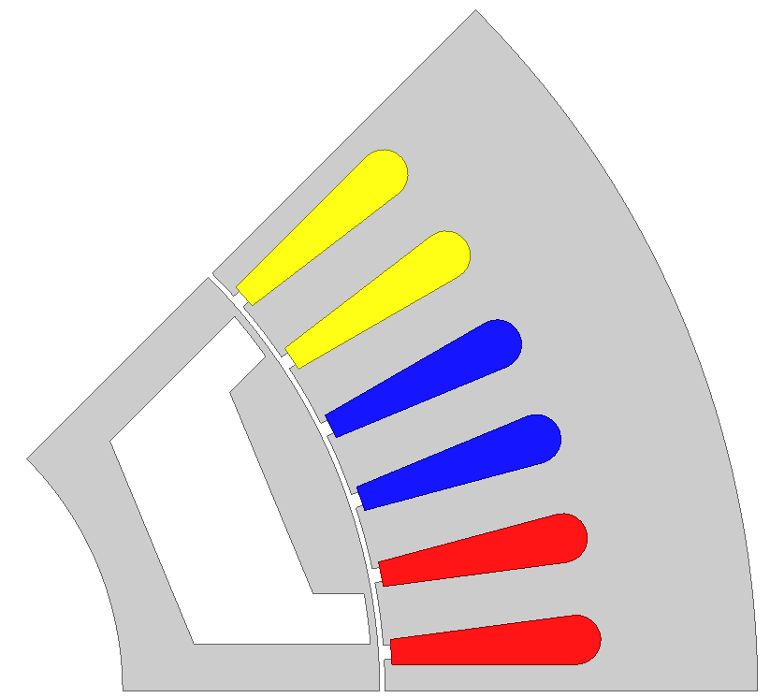 | 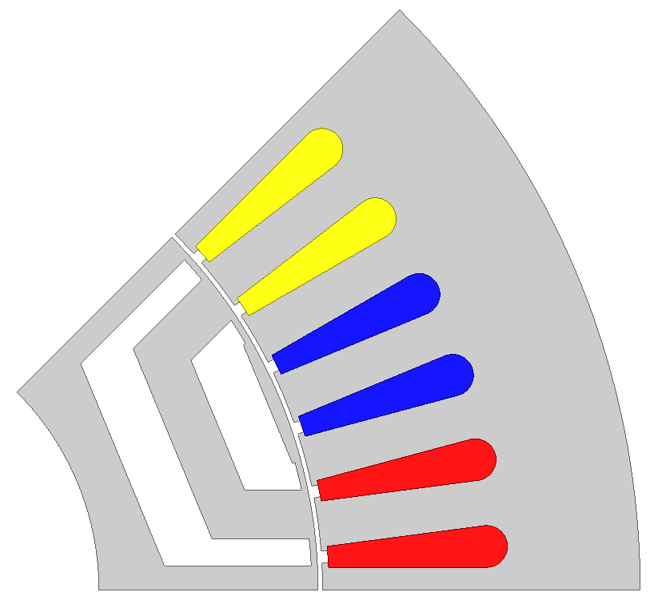
(a) | (b)
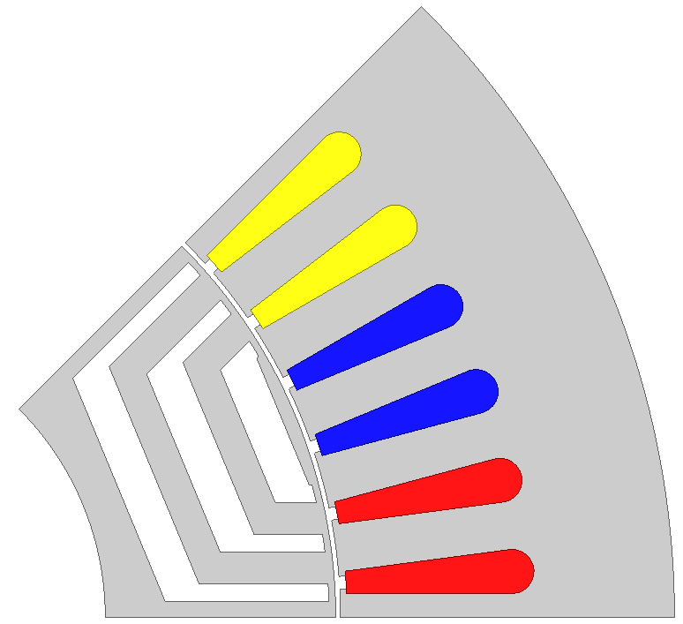 | 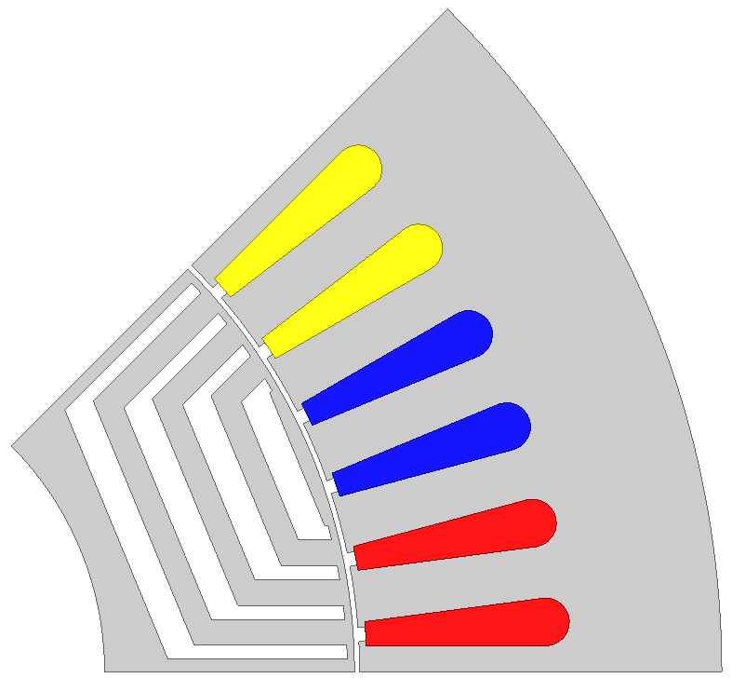
(c) | (d)
Fig. 6.12 Cross sections of optimized SynRMs. (a) Single-layer. (b) Two-layer. (c) Three-layer. (d) Four-layer.
Fig. 6.13 Maximum output torque and corresponding peak-to-peak torque ripples of SynRMs with different numbers of layers.
B. Number of Turns
Then the widths of barrier layer h_{b1}’ and h_{b1}, width of iron layer h_{i1}’, stator inner diameter D_{i} and tooth width b_{t1} are optimized for 3-layer SynRM with different number of series turns per phase W_{φ} using GA. The torque- and power-speed characteristics of SynRMs with different number of layers of barriers are shown in Fig. 6.14, which shows that the torque in constant torque region increases with the turn number, while the flux weakening performance decreases with the turn number. Finally, 72 is determined as the number of turns of SynRM, since the torque will not increase obviously as the turn number continues to increase.
(a)
(b)
Fig. 6.14 Torque- and power-speed characteristics of SynRMs with different numbers of series turns per phase. (a) Torque-speed. (b) Power-speed.

Design of Ferrite-Assisted SynRM
The design of ferrite-assisted SynRM is conducted based on optimized SynRM by inserting ferrite PM into the barriers. The torque- and power-speed characteristics of ferrite-assisted SynRMs with different number of turns are shown in Fig. 6.15. Finally, the number of series turns per phase is determined as 80, because its maximum output torque in constant torque region is almost the largest.
(a)
(b)
Fig. 6.15 Torque- and power-speed characteristics of ferrite-assisted SynRMs with different numbers of series turns per phase. (a) Torque-speed. (b) Power-speed.

Design of NdFeB-Assisted SynRM
- PM Thickness
The thickness of NdFeB PM in NdFeB-assisted SynRM should be designed carefully, in order to improve the utilization rate of PM and avoid demagnetization as well. Usually, the most proper thickness of NdFeB designed from the view of PM utilization is easily subject to demagnetization [GUG13]. Thus, the thickness of NdFeB can be just determined from the view of demagnetization. The maximum stator current 225A is imposed on minus d-axis direction and the temperature is set to be 150ºC to check the demagnetization of NdFeB PMs. In order to fairly compare with Prius 2010 IPM, the demagnetization situation of NdFeB PMs in NdFeB-assisted SynRM should be close to Prius 2010 IPM, whose demagnetization situation is shown in Fig. 6.16. There is a small area of PM with flux density lower than 0.3T, which is as the criterion of determining PM thickness. The demagnetization situations of PMs in NdFeB-assisted SynRM with different number of series turns and thickness of PM are shown in Table 6.4. The demagnetization performance of PMs becomes better as the number of series turns decreases and as the thickness of PM increases. Finally, the thickness of PM in NdFeB-assisted SynRMs with 72, 80 and 88 turns is determined to be 2.0, 2.4 and 3.0mm respectively.
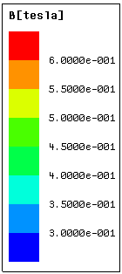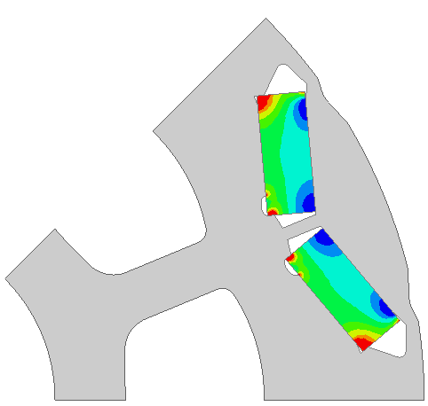
Fig. 6.16 Flux density of PM in Prius 2010 IPM, i_{d}=-225A, i_{q}=0, temperature=150ºC

Table 6.4 Flux densities of PMs in NdFeB-assisted SynRM, i_{d}=-225A, i_{q}=0, temperature=150ºC
PM thickness | Number of series turns per phase
PM thickness | 72-turn | 80-turn | 88-turn
2.0mm | 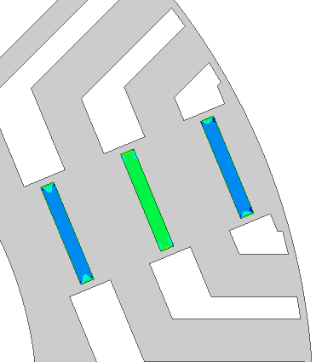 | 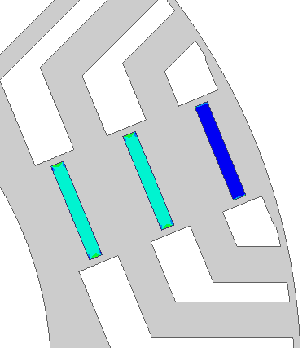 | 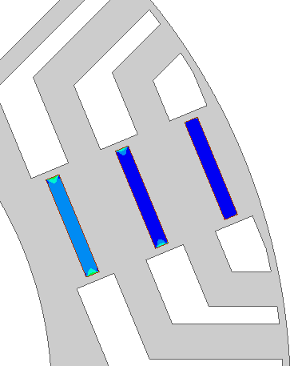
2.4mm | 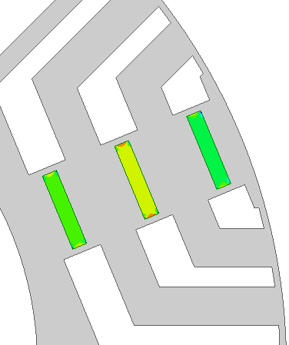 | 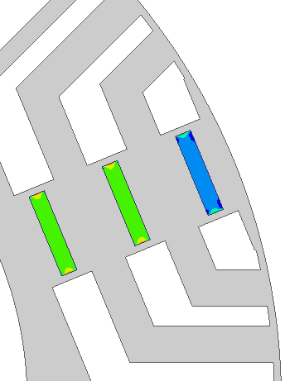 | 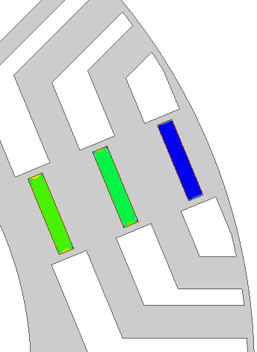
2.8mm | 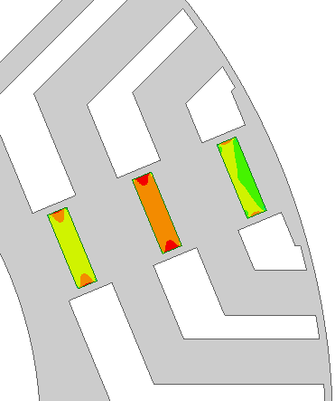 | 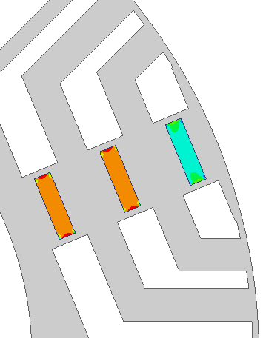 | 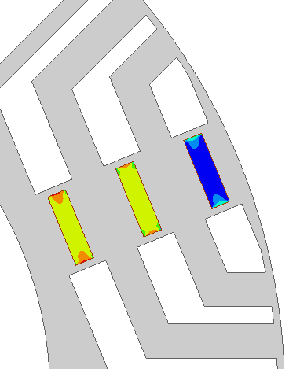
3.0mm | 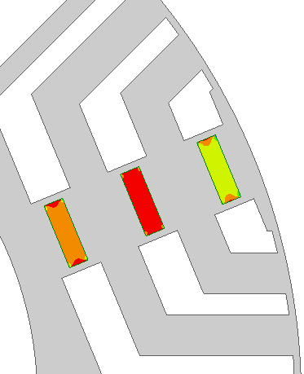 | 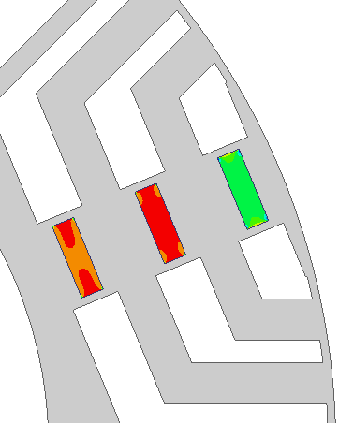 | 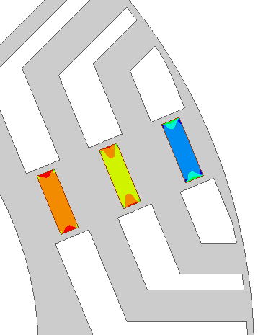

B. Number of Turns
The torque-speed characteristics of NdFeB-assisted SynRMs with different quantity of PM and number of series turns per phase are shown in Fig. 6.17. It can be seen that the torque-speed characteristic of NeFeB-assisted SynRM enhances with the increase of PM quantity. Finally, the number of series turns and PM quantity is determined to be 80 and 0.54kg respectively, because the target torque-speed characteristic can be achieved by the least quantity of NdFeB PM.
Fig. 6.17 Torque-speed characteristics of NdFeB-assisted SynRM with different PM quantities and numbers of series turns per phase. Solid lines are for NdFeB-assisted SynRMs and dashed lines are for Prius 2010 IPM.

Design of Hybrid PM-Assisted SynRM
- Number of Turns and PM Quantity
Ferrite PM is filled fully into the wider parts of barriers (radial parts) and NdFeB PM is inserted into the narrower parts (circumferential parts). The torque-speed characteristics of hybrid PM-assisted SynRMs with different number of turns and NdFeB PM quantities are shown in Fig. 6.18. The torque or power-speed characteristic improves with NdFeB quantity. Finally, the number of series turns per phase and NdFeB PM quantity are determined to be 80 and 0.24kg respectively, since it has the smallest quantity of NdFeB and the torque-speed characteristic is not poorer than that of Prius 2010 IPM.
Fig. 6.18 Torque- and power-speed characteristics of hybrid PM-assisted SynRMs with different numbers of series turns per phase and NdFeB PM quantities. The solid lines are for hybrid PM-assisted SynRMs. The dashed lines are for Prius 2010 IPM.
C. Location of NdFeB PMs
There are three layers of barriers in the rotor of SynRM, and the NdFeB PM can be located in different positions in the barriers. The influence of location of NdFeB PM on the electromagnetic performance, in terms of maximum output torque, torque ripple and iron loss, is investigated in this section. Three hybrid PM-assisted SynRMs with different arrangements of NdFeB PM are investigated, as shown in Fig. 6.19. Design A, B and C have all, two-thirds and one-third of NdFeB in barrier 3 respectively. The total quantity of NdFeB PM is fixed to be 0.24kg. The variations of electromagnetic torque with current angle are shown in Fig. 6.20, which shows that the location of NdFeB has little influence on torque capability if the total quantity of PM is fixed.
The torque ripples corresponding to maximum output torque of hybrid PM-assisted SynRMs with different NdFeB location and stator current amplitude are shown in Fig. 6.21. The influence of distribution of NdFeB PM on torque ripple and iron loss is shown in Fig. 6.22. It can be seen that the torque ripple is quite sensitive to the NdFeB PM locations. Locating less NdFeB in layer 2 favours to reduce the torque ripple (10~20% in layer 2 is the best in this case). There also exists an optimal location of NdFeB in terms of reducing no load iron loss (40~50% of total NdFeB in layer 2 is the best in this case). Finally, the ratio of NdFeB PM quantity in layer 2 to total is determined to be 0.12, since torque ripple is major design consideration for PMA-SynRM and no load iron loss is small.
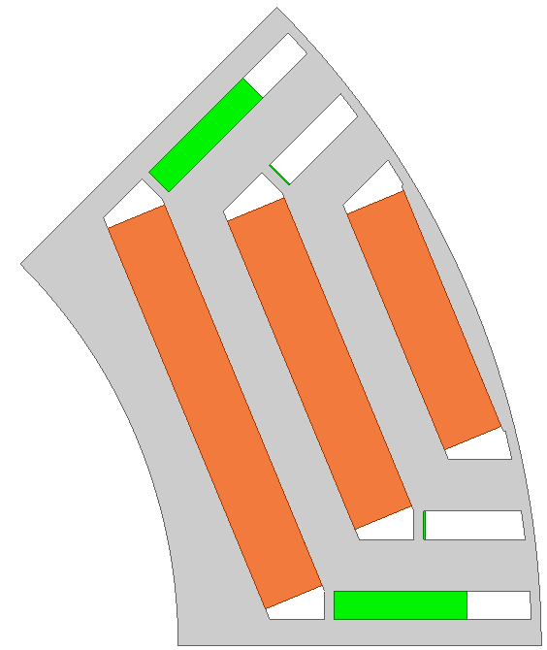 | 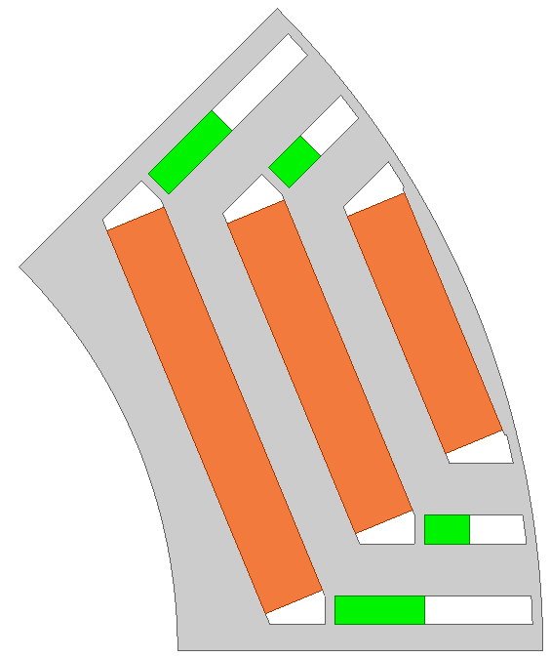 | 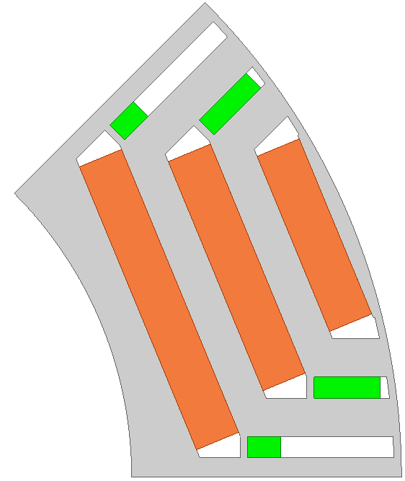
(a) | (b) | I
Fig. 6.19 Cross sections of hybrid PM-assisted SynRM rotors with different arrangements of NdFeB PMs. (a) Design A: all NdFeB is in layer 3. (b) Design B: 2/3 of NdFeB is in layer 3. (c) Design C: 1/3 of NdFeB is in layer 3.
Fig. 6.20 Variations of electromagnetic torque with current angle of hybrid PM-assisted SynRMs with different stator current amplitudes.
Fig. 6.21 Torque ripples corresponding to maximum electromagnetic torque of hybrid PM-assisted SynRMs with different stator current amplitudes.
Fig. 6.22 Variations of peak to peak torque ripple and no-load iron loss with the NdFeB PM quantity in layer 2, the total NdFeB mass is 0.24kg.

Design Specification
The cross sections of optimized SynRM, ferrite-assisted, NdFeB-assisted and hybrid PM-assisted SynRMs and Prius 2010 IPM are shown in Fig. 6.23, and the corresponding design specifications are listed in Table 6.2. It should be mentioned that there is only a bit of NdFeB PMs in layer 2 of hybrid PM-assisted SynRM, which is to optimize the torque ripple, as can be seen from section 6.3.4 C. However, it may be better to put all the NdFeB PMs in layer 3 to ease the manufacturing.
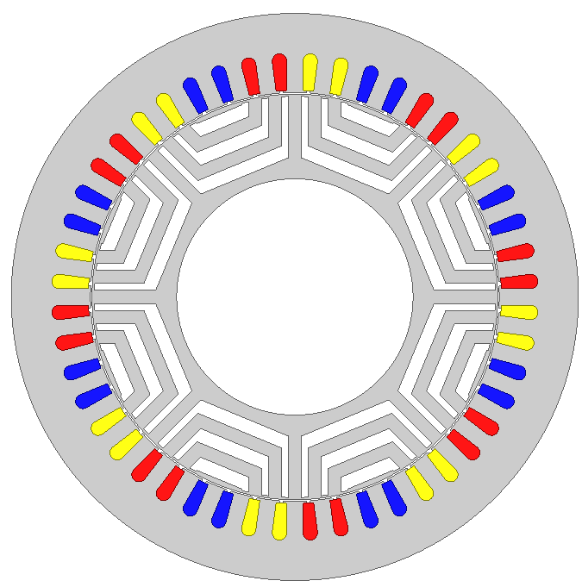
(a)
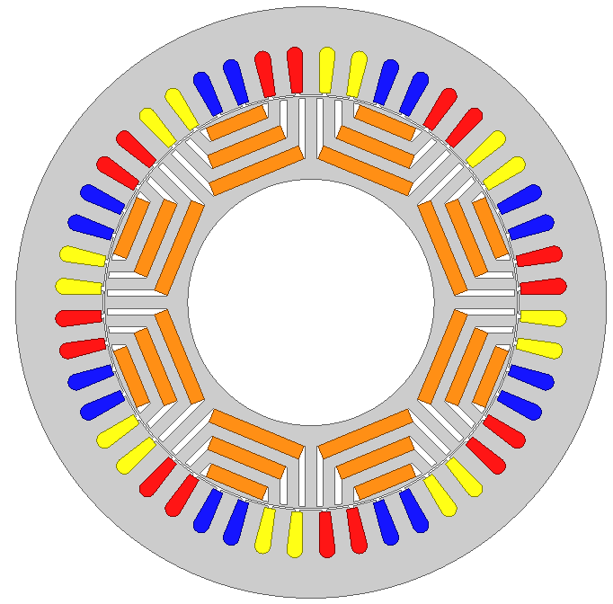
(b)
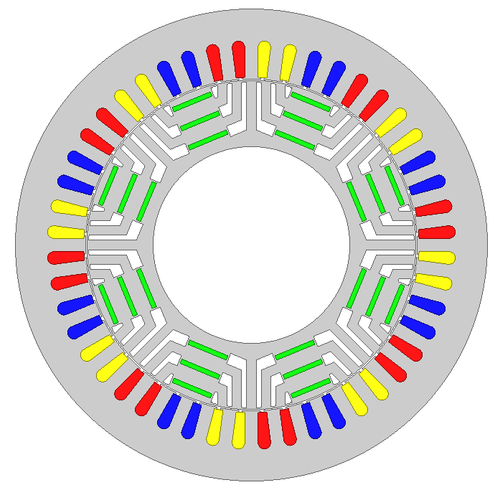
(c)
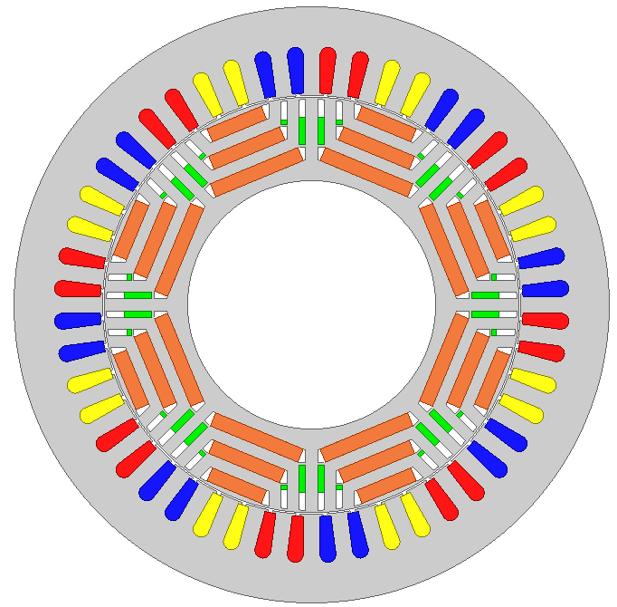
(d)
(e)
Fig. 6.23 Cross sections of optimized electrical machines. (a) SynRM. (b) Ferrite-assisted SynRM. (c) NdFeB-assisted SynRM. (d) Hybrid PM-assisted SynRM. (e) Prius 2010 IPM.
Table 6.5 Design specifications of SynRM, PMA-SynRM and Prius 2010 IPM
 | SynRM | Ferrite-assisted SynRM | NdFeB-assisted SynRM | Hybrid PM-assisted SynRM | Prius 2010 IPM
u_{lim} (V) | 650×2/π×85%
i_{lim} (A) | 225
D₁ (mm) | 264
D_{i} (mm) | 190.2 | 185.5 | 185.5 | 185.5 | 161.9
L (mm) | 50.5
Q₁ | 48
h_{s} (mm) | 18.2 | 21.4 | 21.4 | 21.4 | 30.9
b₀₁ (mm) | 1.88
b_{t1} (mm) | 7.67 | 7.39 | 7.39 | 7.39 | 7.55
g (mm) | 0.73
Number of barriers | 3 | 3 | 3 | 3 | 1
h_{b1}’ (mm) | 3.24 | 2.90 | 2.90 | 2.90 | -
h_{b1} (mm) | 6.31 | 6.26 | 6.26 | 6.26 | -
h_{i2} (mm) | 6.04 | 5.27 | 5.27 | 5.27 | -
Ferrite dimensions (mm) | - | 26×6.26  34×6.26  42×6.26 | - | 26×6.26  34×6.26  42×6.26 | -
NdFeB dimensions (mm) |  |  | 23×2.6 | 2.05×2.9  11.6×2.9 | 17.88×7.16
Bridge dimension (mm) | 3.24×1 | 2.9×1 | 2.9×1 | 2.9×1 | ~4.3×2.1
Rib dimension (mm) | - | - | 2.6×1 | 2.9×1 | ~5.3×1.8
Number of turns per coil | 9 | 10 | 10 | 10 | 11
a₁ | 1 | 1 | 1 | 1 | 1
W_{φ} | 72 | 80 | 80 | 80 | 88
Packing factor | 0.465
R_{s} at 21℃ (Ω) | 0.077 | 0.077 | 0.077 | 0.077 | 0.077
Iron grade | M270-35A
Type of magnet | - | FB12H | N36Z | FB12H  N36Z | N36Z

Comparison of Performance and Cost
The following electromagnetic performances are calculated with the conditions that the winding and PM temperature is set to be150 ºC.

Torque Capability
The variation of maximum output torque with stator current is shown in Fig. 6.24.
- Comparison between SynRM and Electrical Machines with PMs
The maximum output torque capability of SynRM is much lower than those of PMA-SynRMs and IPM, because SynRM utilizes only reluctance torque.
B. Comparison between PMA-SynRM and IPM
The increase of maximum output torque capability of PMA-SynRMs with current is faster than that of IPM. The reason can be explained as follows: The electromagnetic torque of PM machines includes both PM and reluctance torque. The PM torque is proportional to the stator current, while the reluctance torque is proportional to the square of stator current, (6.4). Because the reluctance torque of PMA-SynRM accounts for a larger part of total torque than IPM, the electromagnetic torque of PMA-SynRM increases faster than IPM. Thus, although the torque capability of PMA-SynRM is lower than IPM under low electric load, it is close to and even higher than IPM under high electric load.
Fig. 6.24 Variations of maximum output torque with stator current amplitude

Torque/Power-Speed Characteristic
The maximum and rated torque- and power-speed characteristics are shown in Fig. 6.25. It is assumed that the maximum converter current is 225A and the rated converter current is half of the maximum value. The flux-weakening performances of SynRM, PMA-SynRM and IPM depend on the saliency ratio and PM effect.
- Comparison between SynRM and Other Electrical Machines with PMs
The torque-speed characteristic of SynRM is poorer than PMA-SynRM and IPM in both constant torque (~25% lower) and flux-weakening regions, because no PM is adopted.
B. Comparison between Ferrite-assisted SynRM and Other Electrical Machines with PMs
The torque in constant torque region of ferrite-assisted SynRM is a bit lower than other machines. However, the flux-weakening performance decreases faster than other machines. It is because that the PM flux linkage of ferrite-assisted SynRM is much smaller than those of other machines due to the low magnetic energy product of ferrite.
C. Comparison between NdFeB-Assisted SynRM, Hybrid PM-Assisted SynRM and IPM
For flux-weakening performance, hybrid PM-assisted SynRM > NdFeB-assisted SynRM > IPM, with the torque in constant torque region similar. It is because for the d-axis inductance, hybrid PM-assisted SynRM < NdFeB-assisted SynRM < IPM, which has been explained in section 5.6.4.
(a)
(b)
(c)
(d)
Fig. 6.25 Torque- and power-speed characteristics (a) Torque-speed, maximum converter current. (b) Power-speed, maximum converter current. (c) Torque-speed, rated converter current. (d) Power-speed, rated converter current.

Power Factor
The power factor of SynRM, PMA-SynRM and IPM depends on both the PM contribution and saliency ratio [SOO94]. Usually, more PM amount and higher saliency ratio contributes to higher power factor. The effect of PM is more obvious under low electric load, while the effect of saliency ratio is more obvious under high electric load, because PM and reluctance torque components are proportional to stator current and square of stator current, respectively. As a result, PM effect is more decisive under low electric load and reluctance effect is more decisive under high electric load. The power factor along torque-speed characteristic for maximum converter current and rated converter current is shown in Fig. 6.26.
- Comparison between SynRM and Other Electrical Machines with PMs
The power factor of SynRM is the lowest because no PM is utilized. The power factor of SynRM at rated operation point is similar to that IPM under high electric load in this case. It is because the PM effect is not so large and the reluctance effect of IPM is smaller than that of SynRM. As the electric load decreases, the effect of PM becomes more obvious, and thus, the power factor of IPM is larger than that of SynRM Fig. 6.26 (b).
B. Comparison among Electrical Machines with PMs
For power factors of electrical machines in low speed region under high electric load, hybrid PM-assisted SynRM > ferrite-assisted SynRM > NdFeB-assisted SynRM > IPM. It is because for the saliency ratio, hybrid PM-assisted SynRM > ferrite-assisted SynRM > NdFeB-assisted SynRM > IPM, and the PM effect under high electric load is small. The power factors at rated operation points of NdFeB-assisted SynRM and IPM increase more compared with those of ferrite-assisted and hybrid PM-assisted SynRMs, as electric load decreases. It is because the PM effect increases as electric load decreases, and NdFeB-assisted SynRM and IPM have lager PM flux linkage, as shown in section 6.3.6.5. Consequently, hybrid PM-assisted SynRM > NdFeB-assisted SynRM > ferrite-assisted SynRM > IPM, and the difference between IPM and other machines is not as large as that under high electric load.
(a)
(b)
Fig. 6.26 Power factors along the torque-speed characteristics (a) Maximum converter current. (b) Rated converter current.

Torque Ripple
The torque ripples of SynRM, ferrite-assisted, NdFeB-assisted, hybrid PM-assisted SynRMs and IPM are shown in Fig. 6.27 and Fig. 6.28.
- Comparison between SynRM and electrical machines with PMs
The torque ripple of SynRM is much more serious than PMA-SynRM or IPM under high electric load, whilst it is the lowest under low electric load.
B. Comparison between ferrite-assisted SynRM, NdFeB-assisted SynRM and IPM
They have similar torque ripples for different current amplitudes.
C. Comparison between hybrid PM-assisted SynRM and other electrical machines with PMs
The torque ripple of hybrid PM-assisted SynRM is higher than those of other machines under low electric load, but lower under high electric load.
Overall, the torque ripples of ferrite-assisted, NdFeB-assisted and hybrid PM-assisted SynRMs are competitive to IPM.
(a)
(b)
(c)
(d)
(e)
Fig. 6.27 Torque ripples for different current amplitudes. (a) SynRM. (b) Ferrite-assisted SynRM. (c) NdFeB-assisted SynRM. (d) Hybrid PM-assisted SynRM. I Prius 2010 IPM.
Fig. 6.28 Peak to peak torque ripples of SynRM, ferrite-assisted SynRM, NdFeB-assisted SynRM and Prius 2010 IPM for different stator current amplitudes.

Back EMF
When a PM electrical machine works in high speed region, the amplitude of line back EMF may significantly exceed the dc-link source voltage U_{dc}, which could lead to a fault in the inverter. Usually a low magnet flux is favourable in order to design a PM machine with wide speed region [JAH99] [PEL11]. The line back EMF waveforms of ferrite-assisted, NdFeB-assisted and hybrid PM-assisted SynRMs are shown in Fig. 6.29. The variations of fundamental line back EMF amplitude with speed are shown in Fig. 6.30, which shows that ferrite-assisted SynRM has the largest threshold speed (23.7krpm) due to the much lower magnetic energy product of ferrite, and the threshold speed of NdFeB-assisted (12.6krpm) and hybrid PM-assisted (10.3krpm) SynRMs is also larger than IPM (8.6krpm), because less PM effect is utilized than IPM.
Fig. 6.29 Line back EMF waveforms, 1000rpm.
Fig. 6.30 Variations of fundamental line back EMF amplitude of ferrite-assisted, NdFeB-assisted, hybrid PM-assisted SynRMs and Prius 2010 IPM with speed.

Efficiency Map
The efficiency maps of SynRM, ferrite-assisted, NdFeB-assisted, hybrid PM-assisted SynRMs and Prius 2010 IPM are calculated and compared in this section. The iron and PM losses are calculated using FEA, as shown in Appendix G. The mechanical loss is referenced to Prius 2010 IPM, as shown in Appendix F. For each specific operation point, the maximum possible efficiency is searched, and the final efficiency maps are shown in Fig. 6.31. The maximum efficiency of SynRM is much lower than IPM, ~2% lower than IPM, due to low torque capability. The maximum efficiency of ferrite-assisted SynRM is a little lower than IPM, less than 1%. The efficiency maps of NdFeB-assisted and hybrid PM-assisted SynRMs are close to IPM. The tested efficiency map of Prius 2010 IPM [OLS11] is shown in Fig. 6.31 (f) to verify the validity of calculation method of efficiency map. Although the calculated maximum efficiency of Prius 2010 IPM is less than the tested 96%, it is reasonable because the copper temperature is fixed to be 150℃ in the calculation, which may cause larger calculated copper loss than that in real case.
(a)
(b)
(c)
(d)
(e)
(f)
Fig. 6.31 Efficiency maps. (a) SynRM. (b) Ferrite-assisted SynRM. (c) NdFeB-assisted SynRM. (d) Hybrid PM-assisted SynRM. (e) Prius 2010, calculated. (f) Prius 2010, tested [OLS11].

Cost
The quotations are referred to section 5.6.8. The weight and material costs of SynRM, ferrite-assisted, NdFeB-assisted, hybrid PM-assisted SynRMs and Prius 2010 IPM are listed in Table 6.6. NdFeB-assisted and hybrid PM-assisted SynRMs use 30% and 70% less NdFeB PM than IPM respectively. The material cost of SynRM is the cheapest, ~1/3 of IPM. ferrite-assisted, hybrid PM-assisted and NdFeB-assisted SynRMs are 55%, 40% and 25% cheaper than IPM respectively. SynRM, ferrite-assisted and hybrid PM-assisted SynRMs have great advantage over IPM in terms of material cost.

Table 6.6 Material weight and costs
 | SynRM | Ferrite-assisted SynRM | NdFeB-assisted SynRM | Hybrid PM-assisted SynRM | Prius 2010 IPM
Copper mass (kg) | 3.32 | 4.1 | 4.1 | 4.1 | 4.93
Iron mass (kg) | 12.8 | 12.4 | 12.4 | 12.4 | 15.04
NdFeB mass (kg) | 0 | 0 | 0.545 | 0.24 | 0.77
Ferrite mass (kg) | 0 | 1.31 | 0 | 1.31
Total mass (kg) | 16.1 | 17.9 | 17.1 | 18.1 | 20.75
Copper cost (£) | 23.2 | 28.7 | 28.7 | 28.7 | 34.51
Iron (£) | 25.7 | 24.9 | 24.9 | 24.9 | 30.08
NdFeB (£) | 0 | 0 | 54.5 | 24 | 77.5
Ferrite (£) | 0 | 10.5 | 0 | 10.5
Total (£) | 48.9 | 64.2 | 108 | 88.2 | 142

Comparison between IM and hybrid PM-Assisted SynRM

Design Specifications
The optimization processes of IM and hybrid PM-assisted SynRM with Prius size have been presented in section 6.2.1 and 6.3.4. The cross sections and corresponding design specifications are shown again in Fig. 6.32 and Table 6.7.
(a)
(b)
Fig. 6.32 Cross sections of optimized electrical machines. (a) IM. (b) Hybrid PM-assisted SynRM.

Table 6.7 Design specifications of IM and hybrid PM-assisted SynRM
 | IM | Hybrid PM-assisted SynRM
u_{lim} (V) | 650×2/π×85%
i_{lim} (A) | 225
D₁ (mm) | 264
D_{i} (mm) | 195 | 185.5
L (mm) | 50.5
Q₁ | 48
Q₂ | 44 | -
h_{s} (mm) | 17.79 | 21.4
b₀₁ (mm) | 1.88
b_{t1} (mm) | 7.74 | 7.39
h_{r} (mm) | 20.22 | -
b₀₂ (mm) | 1 | -
b_{t2} (mm) | 8.2 | -
g (mm) | 0.73
Number of barriers | - | 3
h_{b1}’ (mm) | - | 2.90
h_{b1} (mm) | - | 6.26
h_{i2} (mm) | - | 5.27
Ferrite dimensions (mm) | - | 26×6.26, 34×6.26,  42×6.26
NdFeB dimensions (mm) | - | 2.05×2.9, 11.6×2.9
Bridge dimension (mm) | - | 2.9×1
Rib dimension (mm) | - | 2.9×1
Number of turns per coil | 9 | 10
a₁ | 1 | 1
W_{φ} | 72 | 80
Packing factor | 0.465
R_{s} at 21℃ (Ω) | 0.077 | 0.077
Iron grade | M270-35A
Type of magnet | - | FB12H/N36Z

Comparison of Performance and Cost
The following electromagnetic performances are calculated with the conditions that the winding and PM temperature is set to be150 ºC.

Torque Capability
The maximum electromagnetic torque capability for different stator current amplitude of IM and hybrid PM-assisted SynRM is shown in Fig. 6.33. It can be seen that the torque capability of IM increases faster with electric load than hybrid PM-assisted SynRM, the torque capability of hybrid PM-assisted SynRM is better than IM under low electric load operations, while as the electric load increases, the torque capability of IM may be better. The reason is the same as that for torque capability difference between IM and IPM in section 6.2.2.1.
Fig. 6.33 Variations of maximum electromagnetic torque with current amplitude.

Torque/Power-Speed Characteristic
The maximum and rated torque- and power-speed characteristics of IM and hybrid PM-assisted SynRM are shown in Fig. 6.34. The maximum torque/power-speed characteristic of IM is not as good as hybrid PM-assisted SynRM overall. Although the maximum output torque of IM is competitive to hybrid PM-assisted SynRM, the flux-weakening performance is poorer, because the narrower constant power region of IM. The rated torque/power-speed characteristic of IM is poorer than that of hybrid PM-assisted SynRM in both constant torque region (~12% lower) and flux-weakening region.
(a)
(b)
Fig. 6.34 Torque- and power-speed characteristics. (a) Maximum converter current. (b) Rated converter current.

Power Factor
The power factors of IM and hybrid PM-assisted SynRM along torque-speed characteristics for maximum and rated converter current are shown in Fig. 6.35. The power factor of IM is competitive to hybrid PM-assisted SynRM under high electric load in low speed region, but lower under low electric load. The reason is the same as that for power factor difference between IM and IPM in section 6.2.2.3.
(a)
(b)
Fig. 6.35 Power factors along the torque-speed characteristics. (a) Maximum converter current. (b) Rated converter current.

Torque Ripple
The torque ripples of maximum output torque of IM and hybrid PM-assisted SynRM for different stator current amplitudes are shown in Fig. 6.36. The comparison result of peak to peak torque ripple is shown in Fig. 6.37. It can be seen that the torque ripple of IM is larger than hybrid PM-assisted SynRM, when the electric load is high. As the electric load deceases, the torque ripple of IM becomes much lower. The reason is the same as that of torque ripple difference between IM and IPM in section 0.
(a)
(b)
Fig. 6.36 Torque ripples for different current amplitude. (a) IM. (b) Hybrid PM-assisted SynRM.
Fig. 6.37 Peak to peak torque ripples for different stator current amplitude.

Efficiency Map
The calculated efficiency maps of IM and hybrid PM-assisted SynRM are shown in Fig. 6.38. The overall efficiency of IM is lower than hybrid PM-assisted SynRM. The maximum efficiency of IM with copper squirrel cage is ~2% lower than hybrid PM-assisted SynRM, due to the low torque capability under low electric load and also rotor copper loss.
(a)
(b)
Fig. 6.38 Efficiency maps. (a) IM. (b) Hybrid PM-assisted SynRM.

Cost
The material costs of IM and hybrid PM-assisted SynRM are compared in this section. The weight and material cost of IM and hybrid PM-assisted SynRM are listed in Table 6.8. The cost of IM is only a little lower, ~9%, than hybrid PM-assisted SynRM. Thus, hybrid PM-assisted SynRM is a type of machine competitive to IM, in terms of material cost.
Table 6.8 Material costs of IM and Prius 2010 IPM
 | IM | Hybrid PM-assisted SynRM
Stator copper mass (kg) | 3.36 | 4.1
Iron mass (kg) | 15.0 | 12.4
Rotor copper/PM mass (kg) | 3.92 | 0.24 (NdFeB)  1.31 (Ferrite)
Total mass (kg) | 22.2 | 18.1
Stator copper (£) | 23.5 | 28.7
Iron (£) | 29.9 | 24.9
Rotor copper/PM (£) | 27.5 | 24 (NdFeB)  10.5 (Ferrite)
Total (£) | 80.9 | 88.2

Conclusion
- Comparison between IM and IPM
The electromagnetic performance of IM is competitive and even better than IPM under high electric load, in terms of torque capability and power factor, but lower under low electric load. The flux-weakening performance of IM is always poorer than IPM. The torque ripple of IM is comparable to IPM under high electric load and much lower than IPM under low electric load. The overall efficiency of IM is lower than IPM, and the maximum efficiency of IM is approximately 2~3% lower than IPM. The material cost of IM is almost half of IPM.
B. Comparison between SynRM and IPM
The electromagnetic performance of SynRM is much poorer than that of IPM, in terms of torque capability, torque-speed characteristic, power factor and efficiency. The torque ripple is lower than IPM under low electric load, but higher under high electric load.
C. Comparison between Ferrite-Assisted SynRM and IPM
Ferrite-assisted SynRM is competitive and even better than IPM especially under high electric load, in terms of torque capability, torque-speed characteristic and power factor. The torque ripple of ferrite-assisted SynRM is competitive to IPM. In addition, ferrite-assisted SynRM has great advantage over IPM in view of threshold speed (23.7krpm vs. 8.6krpm) and material cost (55% lower).
D. Comparison between NdFeB-Assisted, Hybrid PM-Assisted SynRMs and IPM
The performances of NdFeB-assisted, hybrid PM-assisted SynRMs can be close and even better than IPM in terms of torque capability, torque-speed characteristic, power factor, torque ripple and efficiency.
E. Comparison between IM and Hybrid PM-Assisted SynRM
The electromagnetic performance of IM is competitive to hybrid PM-assisted SynRM under high electric load, in terms of torque capability and power factor, but lower under low electric load. The flux-weakening performance of IM is always poorer than hybrid PM-assisted SynRM. The torque ripple of IM is lower than hybrid PM-assisted SynRM, especially under low electric load. The overall efficiency of IM is lower than hybrid PM-assisted SynRM, and the maximum efficiency of IM is approximately 2~3% lower than hybrid PM-assisted.
The material costs of SynRM, ferrite-assisted SynRM, IM, hybrid PM-assisted SynRM and NdFeB-assisted SynRM are ~65%, ~55%, ~43%, ~40% and ~25% lower than IPM respectively. In addition, the electrical machines with high PM flux linkage tend to have better performances under low electric load, in terms of torque capability per Ampere, flux-weakening performance and power factor, especially torque capability and power factor. Electrical machines with high saliency ratio tend to have better performances under high electric load.

General Conclusions
IM and IPM are two types of electrical machines used most widely in the EV/HEV market. PM-assisted synchronous reluctance machines (PMA-SynRM) have developed rapidly recently, due to their comparatively low cost compared with IPM. In this thesis, two types of electrical machines with no or less PM quantity are investigated and nalysed for EV/HEV application, with particular reference to the maximum torque/power-speed characteristic.
- IM;
- PMA-SynRM.
Finally, the electromagnetic performance and material costs of different types of electrical machines are compared. The investigated electrical machines include IM, SynRM, ferrite-assisted SynRM, NdFeB-assisted SynRM and IPM.

IM for EV/HEV Applications

Analytical Calculation of Torque-Speed Characteristic
The analytical method for electromagnetic performance calculation of electrical machine is appreciated for its fast speed and feasible accuracy. The developed analytical model is based on a dq-axis reference frame, instead of the traditional single-phase equivalent circuit. In this way, the relationship between d- and q-axis currents and IM’s parameters and performances can be obtained, which is appreciated by control engineers. The analytically calculated electromagnetic performances of a 12kW IM are verified by experiments. It can predict:
- The maximum torque/power-speed characteristic;
- Power factors along the torque-speed characteristic;
- Efficiency map.

Influence of Design Parameters on Torque-Speed Characteristic
Based on the analytical calculation method, the influences of design parameters on the torque-speed characteristic are investigated. Firstly, the parameters, i.e. mutual and leakage inductances, stator and rotor resistances, and iron saturation, are studied, with particular reference to the influence on flux-weakening performance. In general, it can be concluded that:
- The ratio of total leakage inductance to mutual inductance is a key design parameter which determines the flux-weakening performance of IM. IM can always output infinite speed. With ideal zero inductance ratio, IM can achieve infinite constant power region and maximum utilization of the inverter at base speed, approximately 0.7, while the power factor reaches the maximum value, 0.7 in constant torque region and 1.0 in constant power region
- When iron saturation is considered, the constant power region is reduced due to the increase of the rated speed. The maximum torque in constant torque region is reduced as well. The power factor and inverter utilization at rated speed are increased.
- When the stator resistance is considered, the maximum output torque and constant power regions will not be affected, while the rated speed will be decreased. As the stator resistance increases, the power factor along the torque-speed characteristic becomes higher, and the inverter utilization at rated speed still becomes lower.
- When the rotor resistance is considered, the maximum output torque will not change, while the rated speed, constant power region, inverter utilization at rated speed and efficiency will all be decreased. Rotor resistance will not influence the power factor along the maximum torque-speed characteristic.
After the investigation above, the influences of some physical parameters are investigated, such as the ratio of tooth width to slot pitch, split ratio, airgap length, slot area, the number of stator/rotor slots per pole per phase (q₁ or q₂) and pole pair number p:
- For the ratio of tooth width to slot pitch, split ratio, airgap length and slot area, there exist optimal values for the maximum torque in low speed region and constant power region respectively, which are represented by A_{opt_T} and A_{opt_P}. The two values are usually different, and the reasonable design values to achieve an optimal torque/power-speed characteristic should be between them. There exists a general rule for the relationship between A_{opt_T} and A_{opt_P} . 1) A_{opt_T} < A_{opt_P}, if L_{σ} decreases with dimensions, such as split ratio and g, etc.; 2) A_{opt_T} < A_{opt_P}, if L_{σ} decreases with dimensions, such as split ratio and g, etc.
- q₁ or q₂ has little influences on the maximum torque. However, the constant power region increases with either of them. In addition, the improvement of constant power region is not obvious if q₁ or q₂ >3. It is desirable to design an IM with q₁ or q₂≥3.
- The maximum torque and constant power region decrease with the increase of p, when p is large (>3 in the specific case in the thesis). However, it is difficult to find a general rule for the influence of p when it is quite small, because its influence on the geometry is very complicated. In the specific case in section 3.4, the optimal p for the maximum torque and constant power region are both 3.

Difference of Torque-Speed Characteristic between Motor and Generator Modes
Usually, electrical machines for EV/HEV applications need to work in both motor and generator modes. The maximum torque/power-speed characteristics of IM in motor and generator modes are sometimes quite different. This section mainly focuses on investigating their difference. The investigated parameters include stator and rotor resistances (R_{s} and R_{r}), and iron loss; the analysed performances include the maximum torque- and output power-speed curves, power factor and efficiency.
- The difference of torque-speed characteristics between motor and generator modes increases with R_{s}. It is due to the opposite direction of q-axis current. The difference of output power-speed characteristics does not change obviously with R_{s}. The difference of power factor increases with R_{s}, which is also due to the opposite direction of q-axis current. R_{s} value does not influence the difference of efficiency between motor and generator modes.
- The difference of torque-speed characteristics between motor and generator modes increases with R_{r}, due to positive slip ratio in motor mode and negative slip ratio in generator mode. The opposite slip ratios are also caused by the opposite direction of q-axis current. The difference of output power-speed characteristics in flux-weakening region between motor and generator modes also increases with R_{r}. R_{r} does not cause the power factor difference. The efficiency difference between motor and generator modes increases with R_{r}.
- The difference in torque-speed characteristics between motor and generator modes increases with iron loss, more obvious in constant torque region. The iron loss does not influence the power factors in both motor and generator modes, but decreases the efficiency.

Hybrid PM-Assisted SynRM for EV/HEV Applications
A hybrid PM-assisted SynRM is proposed, which utilizes both ferrite and NdFeB PMs, in order to reduce the material cost without sacrificing the electromagnetic performance. The idea behind hybrid PM-assisted SynRM is as follows: Take FB12H and N36Z as examples, the maximum magnetic energy product of ferrite is ~15% of NdFeB at 20ºC. However, the material cost is less than 10% of NdFeB. Thus, it favours to reduce the material cost of electrical machine if some quantity of NdFeB can be substituted by ferrite.

Design of Hybrid PM-Assisted SynRM
- Location of PMs
The design of hybrid PM-assisted SynRM is conducted by filling both ferrite and NdFeB PMs into the barriers of SynRM. Because the barriers of SynRM are usually thicker in the middle and thinner in the ends, the ferrite is located in the middle of barriers, which is beneficial to demagnetization performance, and NdFeB PMs are located at the ends of barriers, which helps to improve the PM utilization.
B. Reasonable Quantities of Ferrite and NdFeB PMs
The reasonable quantities of ferrite and NdFeB PMs depend on the relationship of ferrite and NdFeB quotations, from the view of saving material cost. In the specific case in this thesis, it can be concluded as follows:
- It is reasonable to use the maximum possible quantity of ferrite instead of NdFeB, if the ratio of NdFeB quotation to ferrite > 28:8;
- It is reasonable to use the maximum possible quantity of NdFeB instead of ferrite, if the ratio of NdFeB quotation to ferrite < 28:8. In fact in this case, the hybrid PM-assisted SynRM becomes NdFeB-assisted SynRM.

Electromagnetic Performance and Cost
The electromagnetic performances and cost of hybrid PM-assisted SynRM are compared with ferrite- and NdFeB-assisted SynRMs.
- Most of the electromagnetic torque of hybrid PM-assisted SynRM comes from reluctance torque (82.3% of maximum possible torque), and the values of ferrite- and NdFeB-contributed PM torque is similar (both account for 8.8% of the maximum possible torque). Ferrite and NdFeB PMs contribute to the reluctance torque by saturating the iron bridges, as well as PM torque. In the specific case, PMs contribute to 18% of the maximum torque.
- The amplitude of back EMF of hybrid PM-assisted SynRM is comparable to that of NdFeB-assisted SynRM.
- With the same maximum torque in constant torque region, the flux-weakening performance of hybrid PM-assisted SynRM is usually better than that of NdFeB-assisted SynRM.
- The power factors of NdFeB-assisted and hybrid PM-assisted SynRMs are close, both are larger than that of ferrite-assisted SynRM.
- The torque ripple of hybrid PM-assisted SynRM is not larger than ferrite- and NdFeB-assisted SynRMs.
- For demagnetization of ferrite, the ferrite of hybrid PM-assisted SynRM is safe from the irreversible demagnetization. In addition, the demagnetization of ferrite in the second layer of hybrid PM-assisted SynRM is more serious than that of ferrite-assisted SynRM, due to the influence of NdFeB PMs. For demagnetization of NdFeB, it is far from irreversible demagnetization. In addition, the demagnetization of NdFeB in hybrid PM-assisted SynRM is a little more serious than that in NdFeB-assisted SynRM.
- Hybrid PM-assisted SynRM uses half of NdFeB PM of NdFeB-assisted SynRM, and the total material cost is ~20% less.

Comparison between Different Types of Electrical Machines
The comparison is carried out with the conditions that all electrical machines have the same stator outer diameter, stack length and inverter current and voltage rating. The major electromagnetic performances and material costs of SynRM, IM, ferrite-assisted, NdFeB-assisted and hybrid PM-assisted SynRMs, and IPM are summarised and listed in
Table 7.1.
- Comparison between SynRM and IPM
The electromagnetic performances of SynRM are much poorer than those of IPM under high and low electric loads, in terms of torque capability, torque-speed characteristic, power factor and efficiency. The torque ripple is lower than IPM under low electric load, but higher under high electric load. The maximum efficiency in the efficiency map is ~2% lower than that of IPM. The material cost is ~65%, lower than IPM.
B. Comparison between IM and IPM
The electromagnetic performances of IM are competitive and even better than IPM under high electric load, in terms of torque capability and power factor, but lower under low electric load. The flux-weakening performance of IM is always poorer than IPM. The torque ripple of IM is comparable to IPM under high electric load, but lower than IPM under low electric load. The overall efficiency of IM is lower than IPM, and the maximum efficiency of copper squirrel cage IM is approximately 2% lower than IPM. The material cost of IM is almost half of IPM.
C. Comparison between Ferrite-Assisted SynRM and IPM
The performances of ferrite-assisted SynRM are competitive to IPM, especially under high electric load, in terms of torque capability, torque-speed characteristic and power factor. The torque ripple of ferrite-assisted SynRM is similar to IPM. In addition, ferrite-assisted SynRM has great advantage over IPM in view of threshold speed (23.7krpm vs. 8.6krpm) and material cost (55% lower). The maximum efficiency is 0.5% lower than IPM. The material cost is ~55% lower than IPM.
D. Comparison between NdFeB-Assisted, Hybrid PM-Assisted SynRMs and IPM
The performances of NdFeB-Assisted, hybrid PM-assisted SynRMs are competitive to IPM in terms of torque capability, torque ripple and efficiency, especially under high electric load. The power factors and flux-weakening performances are better than those of IPM. The maximum efficiencies of hybrid PM-assisted SynRM and NdFeB-assisted SynRM are close to IPM. The material costs are ~40% and ~25% lower than IPM respectively.

Table 7.1 Electromagnetic performances and costs of electrical machines under high and low electric loads, the stator currents i_{a} corresponding to high and low electric loads are 225A and 112A respectively.
 | SynRM | IM | Ferrite-assisted SynRM | Hybrid PM –assisted SynRM | NdFeB-assisted SynRM | IPM
Max torque (Nm), i_{a}=225A | 175 | 233 | 220 | 228 | 227 | 227
Max torque (Nm), i_{a}=112A | 82 | 101 | 111 | 114 | 120 | 121
Constant power region, i_{a}=225A | 1.25:1 | 1.27:1 | 1.41:1 | 1.55:1 | 1.34:1 | 1.17:1
Constant power region, i_{a}=112A | 1.72:1 | 2.04:1 | 2.61:1 | 3.47:1 | 2.91:1 | 2.34:1
Power factor, i_{a}=225A | 0.6 | 0.71 | 0.69 | 0.71 | 0.68 | 0.62
Power factor, i_{a}=112A | 0.62 | 0.72 | 0.74 | 0.79 | 0.77 | 0.73
Torque ripple (Nm), i_{a}=225A | 37 | 36 | 25 | 15 | 27 | 26
Torque ripple (Nm), i_{a}=112A | 9 | 12 | 15 | 14 | 13 | 14
Max efficiency (%) | 94 | 94 | 95.4 | 95.8 | 95.8 | 96
Cost (£) | 48.9 | 80.9 | 64.2 | 88.2 | 108 | 142.1

Future Work
Following the research work in this thesis, the proposed future research includes:
- Prototyping and testing of hybrid PM-assisted SynRM, which are being carried out by the sponsoring company.
- Multi-phase IM for EV/HEV applications.
- Fractional-slot IM for EV/HEV applications.
- Multi-phase hybrid PM-assisted SynRM for EV/HEV applications.
- Fractional-slot hybrid PM-assisted SynRM for EV/HEV applications.
It should be noted that multi-phase and fractional-slot IM and hybrid PM-assisted SynRM are being investigated by other PhD students in the Electrical Machines and Drives Research Group.

Reference
[ADN91] | A. K. Adnanes and T. M. Undeland, “Optimum torque performance in PMSM drives above rated speed,” Proc. IEEE Ind. Appl. Soc. Annu. Meeting, Oct. 1991, pp. 169–175.
[ALB08] | L. Alberti, N. Bianchi, and S. Bolognani, “A very rapid prediction of im performance combining analytical and finite-element analysis,” IEEE Trans. Ind. Appl., vol. 44, no.5, pp. 1505-1512, Sept./Oct. 2008.
[ALB09] | L. Alberti, N. Bianchi, and S. Bolognani, “A finite-element procedure to compute variable speed induction machine performance,” IEEE Energy Conversion Congr. And Exposition, Sept. 2009, pp. 20-24.
[ALB10] | L. Alberti, M. Barcaro, M.D. Pré, A. Faggion, L. Sgarbossa, N. Bianchi, and S. Bolognani, “IPM Machine Drive Design and Tests for an Integrated Starter-Alternator Application,” IEEE Trans. Ind. Appl., vol. 46, no3, pp. 993-1001, May/Jun. 2010.
[ALB11] | L. Alberti, N. Bianchi, and S. Bolognani, “Variable-speed induction machine performance computed using finite-element,” IEEE Trans. Ind. Appl, vol. 47, no. 2, pp. 789-797, Sept. 2009.
[ALB12] | L. Alberti and N. Bianchi, “Design and tests on a fractional-slot induction machine,” IEEE Energy Conversion Congr. And Expo., 2012, pp. 166-172.
[ALB13] | L. Alberti and N. Bianchi, “Theory and design of fractional-slot induction multilayer windings,” IEEE. Trans. Ind. Appl., vol. 49, no. 2, pp. 841-849, Jan./Feb. 2013.
[ALG28] | P. L. Alger, “The calculation of the armature reactance of synchronous machines,” A.I.E.E. Trans., vol. 47, no. 2, pp. 493-512, Apr. 1928
[ALM14] | A. T. D. Almeida, F. J. T. E. Ferreira and D. A. Quintino, “Technical and economical considerations on super high-efficiency three-phase motors,” IEEE Trans. Ind. Appl., vol.50, no.2, pp.1274-1285, Mar./Apr. 2014
[ALO11] | P. Alotto, M. Barcaro, N. Bianchi, and M. Guarnieri, “Optimization of Interior PM Motors With Machaon Rotor Flux Barriers,” IEEE Trans. Magn., vol. 47, no. 5, pp. 958-961, May 2011.
[AMR09] | M. Amrhein, P. T. Krein, “3-D magnetic equivalent circuit framework for modelling electromechanical devices,” IEEE Trans. Energy Convers., vol. 24, no. 2, pp. 397-405, Jun. 2009.
[AMR10] | M. Amrhein, P. T. Krein, “Induction machine odelling approach based on 3-D magnetic equivalent circuit framework,” IEEE Trans. Energy Convers., vol. 25, no. 2, pp. 339-347, Jun. 2010.
[ARK09] | A. A. Arkadan, M. N. ElBsat, and M. A. Mneimneh, “Particle swarm design optimization of ALA rotor SynRM for traction applications,” IEEE Trans. Magn., vol. 45, no. 3, pp. 956-959, Mar. 2009.
[ARM08] | E. Armando, P. Guglielmi, M. Pastorelli, and G. Pellegrino, “Performance of IPM-PMASR motors with ferrite injection for home appliance washing machine,” IEEE Industry Applications Society Annu. Meeting, Oct. 2008, pp. 1-6.
[BAR10] | M. Barcaro, N. Bianchi, and F. Magnussen, “Design considerations to maximize performance of an IPM motor for a wide flux-weakening region,” IEEE Int. Conf. Electrical Machines, 2010, pp. 1-7.
[BAR12] | M. Barcaro, N. Bianchi, and F. Magnussen, “Permanent-magnet optimization in permanent-magnet-assisted synchronous reluctance motor for a wide constant-power speed range,” IEEE Trans. Ind. Electron., vol. 59, no. 6, pp. 2495-2502, Jun. 2012.
[BIA00] | N. Bianchi and S. Bolognani, “Reducing torque ripple in PM synchronous motors by pole-shifting,” in Proc. Int. Conf. Electrical Machines, Helsinki, Finland, Aug. 2000, pp. 1222–1226.
[BIA08] | N. Bianchi, S. Bolognani, D. Bon and M. D. Pre, “Torque Harmonic Compensation in a Synchronous Reluctance Motor,” IEEE Trans. Energy Convers., vol. 23, no. 2, pp. 466-473, Jun. 2008.
[BIA09] | N. Bianchi, S. Bolognani, D. Bon and M. D. Pre, “Rotor flux-barrier design for torque ripple reduction in synchronous reluctance and PM-assisted synchronous reluctance motors,” IEEE Trans. Ind. Appl., vol. 45, no. 3, pp. 921-928, May/Jun. 2009.
[BIA12] | N. Bianchi, D. Durello and E. Fornasiero, “Multi-objective optimization of a PM Assisted Synchronous Reluctance Machine, including torque and sensorless detection capability,” 6th IET Int. Conf. Power Electronics, Machines and Drives, Mar. 2012, pp. 1-6.
[BIA97a] | N. Bianchi and S. Bolognani, “Parameters and volt-ampere ratings of a field-oriented induction motor drive for flux-weakening applications,” in Proc. Int. Conf. Electrical Machines and Drives, 1997, pp. 46-50.
[BIA97b] | N. Bianchi and S. Bolognani, “Design procedure of a vector controlled induction motor for flux-weakening operations,” Conf. Rec. 32nd IEEE IAS Annu. Meeting, New Orleans, LA, 1997, pp. 104–111.
[BIA98] | N. Bianchi and S. Bolognani, “Unified approach to the analysis and design of an ac motor drive for flux-weakening operations,” in Rec. 33rd IEEE IAS Annu. Meeting Industry Applications Conf., 1998, pp. 95–102.
[BIA99] | N. Bianchi, S. Bolognani, and G. Comelato, “Finite element analysis of three-phase induction motors comparison of two different approaches,” IEEE Trans. Energy Convers., vol. 14, no.4, pp. 1523-1528, Dec. 1999.
[BOG11] | A. Boglietti, A. Cavagnino, and M. Lazzari, “Computational algorithms for induction-motor equivalent circuit parameter determination—part I: resistances and leakage reactances,” IEEE Trans. Ind. Electron., vol. 58, no. 9, pp. 3723–3733, Sep. 2011.
[BOG13] | A. Boglietti, A. Cavagnino, M. Popescu, and D. Staton, “Thermal model and analysis of wound-rotor induction machine,” IEEE Trans. Ind. Appl., vol. 49, no. 5, pp. 2078-2085, Sept./Oct. 2013
[BOG92] | A. Boglietti, P. Ferraris, M. Lazzari, and F. Profumo, “A new design criteria for spindles inductance motors controlled by field-oriented technique,” Proc. Int. Conf. Electrical machines, pp. 356-360, 1992.
[BOL01] | I. Boldea, S. A. Nasar, The Induction Machine Handbook, 1st ed. FL:CRC press, 2001.
[BOL14] | I. Boldea, L. Tutelea, L. Parsa and D. Dorrell, “Automotive electric propulsion systems with reduced or no permanent magnets: an overview,” IEEE Trans. Ind. Electron., vol. 61, no. 10, pp. 5696-5711, Oct. 2014.
[BOM02] | X. B. Bomela and M. J. Kamper, “Effect of stator chording and rotor skewing on performance of reluctance synchronous machine,” IEEE Trans. Ind. Appl., vol. 38, no. 1, pp. 91-100, Jun./Feb. 2002.
[BUC08] | D. Bucherl, R. Nuscheler, W. Meyer, and H. G. Herzog, “Comparison of electrical machine types in hybrid drive trains: Induction machine vs. permanent magnet synchronous machine,” Proc. 18th Int. Conf. Electrical Machines, Sept. 2008, pp. 1-6.
[CAI14] | H. Cai, B. Guan and L. Y. Xu, “Low cost ferrite PM assisted synchronous reluctance machine for electric vehicles,” IEEE Trans. Ind. Electron., vol. 61, no. 10, pp. 5741-5748, Oct. 2014.
[CAR13] | E. Carraro, M. Degano, and N. Bianchi, “Permanent magnet volume minimization in permanent magnet assisted synchronous reluctance motors,” 8th Int. Conf. and Exhibition on Ecological Vehicles and Renewable Energies, 2013, pp. 1-4.
[CAR14] | E. Carraro, M. Morandin, and N. Bianchi, “Optimization of a traction PMASR motor according to a given driving cycle,” IEEE Transportation Electrification Conf. and Expo., 2014, pp. 1-6.
[CAR26] | F. W. Carter, “The magnetic field of the dynamo-electric machine,” J. IEE, vol. 64, no. 359, pp. 1115-1138, Nov. 1926.
[CHA02] | C. C. Chan, “The state of the art of electric and hybrid vehicles,” Proc. IEEE, vol. 90, no. 2, pp. 247–275, Feb. 2002.
[CHA07] | C. C. Chan, “The state of the art of electric, hybrid, and fuel cell vehicles,” Proc. IEEE, vol. 95, no. 4, pp. 704-718, Apr. 2007.
[CHE12] | L. Chen, J. Wang, P. Lombard, P. Lazari, and V. Leconte, “Design optimisation of permanent magnet assisted synchronous reluctance machines for electric vehicle applications,” Int. Conf. Electrical Machines, 2012, pp. 2647-2653.
[CHE13] | X. Chen, J. B. Wang, P. Lazari, and L. Chen, “Permanent Magnet Assisted Synchronous Reluctance Machine with fractional-slot winding configurations,” IEEE Int. Electric Machines & Drives Conf., 2013, pp. 374-381.
[CHE90] | S. K. Chen, Electrical Machine Design, Beijing: MI press, 1990.
[CHE92] | S. Chen and S. N. Yen, “Optimal efficiency analysis of induction motors fed by variable-voltage and variable frequency source,” IEEE Trans. Energy Convers., vol. 7, pp. 537–543, Sept. 1992.
[CHU13] | W. Q. Chu and Z. Q. Zhu, “Average torque separation in permanent magnet synchronous machines using frozen permeability,” IEEE Trans. Magn., vol. 49, no. 3, pp. 1202-1210, Mar. 2013.
[CUP12] | F. Cupertino, G. M. Pellegrino, E. Armando, and C. Gerada, “A SyR and IPM machine design methodology assisted by optimization algorithms,” IEEE Energy Conversion Congr. And Expo., 2012, pp. 3686-3691.
[CUP13] | F. Cupertino, G. Pellegrino and C. Gerada, “Design of synchronous reluctance machines with multi-objective optimization algorithms,” IEEE Energy Conversion Congr. And Expo., Sep. 2013, pp. 1858-1865.
[DAU91] | R. H. Daugherty and C. U. Wennerstrom, “Need for industry standards for AC induction motors intended for use with adjustable-frequency controllers,” IEEE Trans. Ind. Appl., vol. 27, pp. 1175-1185, Nov./Dec. 1991.
[DEG14] | M. Degano, N. Bianchi, and E. Fornasiero, “Sensitivity analysis of torque ripple reduction of synchronous reluctance and interior PM motors,” IEEE Trans. Ind. Appl., accepted, 2014.
[DOR08] | D. G. Dorrell, “Combined thermal and electromagnetic analysis of permanent-magnet and induction machines to aid calculation,” IEEE Trans. Ind. Electron. Vol. 55, no. 10, pp. 3566-3574, Oct. 2008.
[DOR12] | D. G. Dorrell, A. M. Knight, L. Evans, and M. Popescu, “Analysis and design techniques applied to hybrid vehicle drive machines-assessment of alternative IPM and induction motor topologies,” IEEE Trans. Ind. Electron. Vol. 59, no. 10, pp. 3690-3699, Oct. 2012.
[DUF00] | S. Dufour, G. Vinsard, and B. Laporte, “Generating rotor geometries by using a genetic method,” IEEE Trans. Magn., vol. 36, no. 4, pp. 1039-1042, Jul. 2000
[EHA97] | M. Ehsani, K. M. Rahman, and H. Toliyat, “Propulsion system design of electric and hybrid vehicles,” IEEE Trans. Ind. Electron., vol. 44, no. 1, pp. 19–27, Feb. 1997.
[FER13] | M. Ferrari, N. Bianchi, A. Doria, and E. Fornasiero, “Design of synchronous reluctance motor for hybrid electric vehicles,” IEEE Int. Electric Machines & Drives Conf., 2013, pp. 1058-1065.
[FON70] | W. Fong and J. S. C. Htsui, “New type of reluctance motor,” Proc. Inst. Elect. Eng., vol. 117, no. 3, pp. 545–551, 1970.
[FRA95] | A. Fratta, G. P. Toglia, A. Vagati, and F. Villata, “Ripple evaluation of high-performance synchronous reluctance machines,” IEEE Trans. Ind. Appl., vol. 1, no. 4, pp. 14-22, Jul./Aug. 1995.
[FRI09] | G. Friedrich and A. Girardin, “Integrated starter generator,” IEEE Ind. Appl. Mag., vol. 1, no. 4, pp. 26-34, Jul./Aug. 2009
[GAM14] | M. Gamba, G. Pellegrino, A. Vagati, “A new PM-assisted Synchronous Reluctance machine with a nonconventional fractional slot per pole combination,” 2014 Int. Conf. Optimization of Electrical and Electronic Equipment, 2014, pp. 268-275.
[GAU12] | A. Gautam and J. O. Ojo, “Variable speed multiphase induction machine using pole phase modulation principle,” IEEE 2012 38th Industrial Electronics Society Annu. Conf., 2012, pp. 3659-3665.
[GOR14] | H. Gorginpour, H. Oraee, and E. Abdi, “Calculation of core and stray load losses in brushless doubly fed induction generators,” IEEE Trans. Ind. Electron., vol. 61, no. 7, pp. 3167-3177, Jul. 2014.
[GUG04] | P. Guglielmi, N. G. Giraudo, G. Pellegrino, and A. Vagati, “P.M. assisted synchronous reluctance drive for minimal hybrid application,” in Rec. IEEE 39th LAS Annu. Meeting Industry Applications Conf., Oct. 2004, pp. 299-306.
[GUG13] | P. Guglielmi, B. Boazzo, E. Armando, G. Pellegrino and A. Vagati, “Permanent-magnet minimization in PM-Assisted Synchronous reluctance motors for wide speed range,” IEEE Trans. Ind. Appl., vol. 49, no. 1, pp. 31-41, Jan./Feb. 2013.
[GUN14] | T. Gundogdu, G. Komurgoz, and B. Mantar, “Implementation of fractional slot concentrated windings to induction machines,” IEEE Int. Conf. Power Electronics, Machines and Drives, 2014, pp. 1-6.
[HAN07] | S. H. Han, T. M. Jahns, and W. L. Soong, “Torque ripple reduction in interior permanent magnet synchronous machines using the principle of mutual harmonics exclusion,” in Rec. IEEE 42nd LAS Annu. Meeting Industry Applications Conf., Sept. 2007, pp.558-565.
[HAN10] | S. H. Han, T. M. Jahns, W. L. Soong, M. K. Guven, and M. S. Illindala, “Torque ripple reduction in interior permanent magnet synchronous machines using stators with odd number of slots per pole pair,” IEEE Trans. Energy Convers., vol. 25, no. 1, pp. 118–127, Mar. 2010.
[HAR70] | M. R. Harris, P. J. Lawrenson, and J. M. Stephenson, Per-unit systems Cambridge University Press, 1970.
[HAR95] | A. Harson, P. H. Mellor, and D. Howe, “Design considerations for induction machines for electric vehicle drives,” Proc. IEE Int. Conf. Electrical Machines and Drives, Sept. 11–13, 1995, pp. 16–20.
[HAS08] | N. Hashemnia and B. Asaei, “Comparative study of using different electric motors in the electric vehicles,” Proc. 18th Int. Conf. Electrical Machines, Sept. 2008, pp. 1-5.
[HIC76] | H. Eichhofer, V. V. Sastry, and H. Weh, “Wechselrichtergespeiste asynchronmachinen mit elektronischer polumschaltung,” ETZ, vol. 28, no. 5, pp. 116-118, 1976.
[HON97] | Y. Honda, T. Nakamura, T. Higaki, and Y. Takeda “Motor design considerations and test results of an interior permanent magnet synchronous motor for electric vehicles,” Rec. IEEE 32nd Industry Applications Society Annu. Meeting, 1997, pp. 75-82.
[HON98] | Y. Honda, T. Higaki, S. Morimoto, and Y. Takeda, “Rotor design optimisation of a multi-layer interior permanent-magnet synchronous motor,” IEE Proc. Electr. Power Appl., vol. 145, no. 2, Mar. 1998.
[HU03] | J. Hu, J. Zou, and W. Liang, "Finite element calculation of the saturation DQ-axes inductance for a direct drive PM synchronous motor considering cross-magnetization," 5th Int. Conf. Power Electronics and Drive Systems, 2003, pp. 677-681.
[HUD06] | P. Hudak, V. Hrabovcová, and P. Rafajdus, “Geometrical dimension influence of multi-barrier rotor on reluctance synchronous motor performances,” Int. Symp. On Power Electronics, Electrical Drives, Automation and Motion, 2006, pp. 346-351.
[HUM69] | A. J. Humphrey, “Constant horsepower operation of induction motors,” IEEE Trans. Ind. And General Applicat., Sept. 1969, pp. 552-557.
[JAH96] | T. M. Jahns and W. L. Soong, “Pulsating torque minimization techniques for permanent magnet ac motor drives-a review,” IEEE Trans. Ind. Electron., vol. 43, no. 2, pp. 321-330, Apr. 1996.
[JAH99] | T. M. Jahns and V. Caliskan, “Uncontrolled generator operation of interior PM synchronous machines following high-speed inverter shutdown,” IEEE Trans. Ind. Appl., vol. 35, no. 6, pp. 1347-1357, Nov./Dec. 1999
[JEI09] | B. Jeihoon, M. M. Rahimian, H. A. Toliyat, “Optimal design and comparison of stator winding configurations in permanent magnet assisted synchronous reluctance generator,” IEEE Int. 2009 Electric Machines and Drives Conf., 2009, pp. 732-737.
[JHA12] | A. K. Jha, “Optimization of line start permanent magnet synchronous motor for magnet cost reduction,” M.S. thesis, Dept. Elect. Eng., Roy. Inst. of Technology, Stockholm, Sweden, 2012.
[JIA02] | S. Z. Jiang, K. T. Chau, and C. C. Chan, “Performance analysis of a new dual-inverter pole-changing induction motor drive for electric vehicles,” IEEE Elect. Mach. Power Syst., vol. 30, no. 1, pp. 11–29, Jan. 2002.
[JIA03] | S. Z. Jiang, K. T. Chau, C. C. Chan, “Spectral analysis of a new six-phase pole-changing induction motor drive for electric vehicles,” IEEE Trans. Ind. Electron., vol. 50, no. 1, pp. 123-131, Feb. 2003.
[JUR12] | S. Jurkovic, J. C. Morgante, K. M. Rahman, P. J. Savagian, “Electric machine design and selection for General Motors e-assist light electrification technology,” Energy Conversion Congr. And Expo., 2012, Sept. 2012, pp. 906-913.
[KEL03] | J.W. Kelly, E.G.Strangas, J.M. Miller, “Control of a continuously operated pole changing induction machine”, Proc. Of Electric Machines and Drives Conf., 2003, pp. 211-217.
[KHA10] | K. Kashif, L. Mats, and W. Oskar, “Design aspects on magnet placement in permanent-magnet assisted synchronous reluctance machines,” 5th IET Int. Conf. Power Electronics, machines and Drives, 2010, pp. 1-5.
[KIM04] | J. Kim, J. Jung, and K. Nam, “Dual-inverter control strategy for high-speed operation of EV induction motors,” IEEE Trans. Ind. Electron., vol. 51, no. 2, pp. 312–320, Apr. 2004.
[KOS23] | J. K. Kostko, “Polyphase reaction synchronous motors,” J. Amer. Inst. Elect. Eng., vol. 42, pp. 1162–1168, Nov. 1923.
[KRA02] | P. C. Krause, O. Wasynczuk and S. D. Sudhoff, Analysis of electric machinery and drive systems, 2nd ed. Wiley-IEEE press, 2002, ch. 4.
[KWA03] | S. Y. Kwak, J. K. Kim, and H. K. Jung, “Inductance and torque characteristic analysis of multi-layer buried magnet synchronous machine,” IEEE Int. Conf. Electrical Machines and Systems, 2003, pp. 104-107.
[KWA05] | S. Y. Kwak, J. K. Kim, and H. K. Jung, "Characteristic analysis of multilayer-buried magnet synchronous motor using fixed permeability method," IEEE Trans. Energy Convers., vol. 20, pp. 549-555, 2005.
[KWA10] | J. Kwack, S. Min, and J. P. Hong, “Optimal stator design of interior permanent magnet motor to reduce torque ripple using the level set method,” IEEE Trans. Magn., vol. 46, no. 6, pp. 2108–2111, Jun. 2010.
[LAN14] | T. Lange, B. Kerdsup, C. Weiss, and R. W. D. Doncker, “Torque ripple reduction in Reluctance Synchronous Machines using an asymmetric rotor structure,” IET 7th Power Electronics, Machines and Drives Conf., 2014, pp. 1-5.
[LAZ14] | P. Lazari, J. Wang, L. Chen, and X. Chen, “Design optimisation and performance evaluation of a rare-earth-free permanent magnet assisted synchronous reluctance machine for electric vehicle traction,” 7th IET Int. Conf. Power Electronics, Machines and Drives, 2014, pp. 1-6.
[LAW67] | P. J. Lawrenson and S. K. Gupta, “Developments in the performance and theory of segmental-rotor reluctance motors,” Proc. Inst. Elect. Eng., vol. 111, no. 8, pp. 1435–1445, 1964.
[LEE07] | M. K. Lee and J. H. Lee, “Characteristics analysis of anisotropy rotor SynRM using a coupled FEM & Preisach Model,” IEEE Int. Electric Machines & Drives Conf., 2007, pp. 916-920.
[LEE10] | J. H. Lee, S. C. Lee, and T. H. Lee, “Loss analysis and efficiency evaluations of synchronous reluctance motor using coupled finite element method & Preisach modelling,” IEEE Electrical Machines and Systems Conf., 2010, pp. 1447-1450.
[LEV00] | E. Levi and V. A. Levi, "Impact of dynamic cross-saturation on accuracy of saturated synchronous machine models," IEEE Trans. Energy Convers., vol. 15, pp. 224-230, 2000.
[LI01] | S. Li and H. Hofmann, “Numerically efficient steady-state finite element analysis of magnetically saturated electromechanical devices using a shooting-Newton/GMRES approach,” IEEE Int. Electric Machines and Drives Conf., 2001, pp. 275-279.
[LIW60] | M. Liwschitz-Garik and C. C. Whipple, Electric Machinery, Vol. II, A-C Machines. New York: Van Nostrand, 1960.
[MAL01] | J. Malan, M. J. Kamper, “Performance of a hybrid electric vehicle using reluctance synchronous machine technology,” IEEE Trans. Ind. Appl., vol. 37, no. 5, pp. 1319-1324, Sep./Oct. 2001.
[MAR92] | T. C. Martin and J. Wetzler, “The electric motor and its applications,” 3rd ed. New York: The W. J. Johnston Company, 1892.
[MAT94] | T. Matsuo and T. A. Lipo, “Rotor design optimization of synchronous reluctance machine,” IEEE Trans. Energy Convers. Vol. 9, no. 2, pp. 359-365, Jun. 1994.
[MAX10] | Maxwell Online Help, Ansys Co., 2010.
[MCC01] | P. J. McCleer, J. M. Miller, A. R. Gale, M. W. Degner, and F. Leonardi, “Nonlinear model and momentary performance capability of a cage rotor induction machine used as an automotive combined starter-alternator,” IEEE Trans. Ind. Appl. Vol. 37, no. 3, pp. 840-846, May/Jun. 2001.
[MIL01] | J. M. Miller, V. Stefanovic, V. Ostovic, and J. Kelly, “Design considerations for an automotive integrated starter-generator with pole-phase modulation,” Conf. Rec. IEEE 2001 Industry Applications Society Annu. Meeting, 2001, pp. 2366-2373.
[MIL89] | T. J. E. Miller, Brushless permanent magnet and reluctance motor drives, Oxford University Press, 1989.
[MIL98a] | J. M. Miller, A. R. Gale, P. McCleer, F. Leonardi, and J. Lang, “Starter-alternator for hybrid electric vehicle: Comparison of induction and variable reluctance machines and drives,” Proc. IEEE 1998 33rd IEEE Industrial Applications Soc. Annu. Meeting, 1998, pp. 513–523.
[MIL98b] | D. Miljavec, “Set-up an expert system for reluctance motor design,” 9th Mediterranean Electrotechnical Conf., 1998, pp. 1237-1240.
[MIL99] | T. J. E. Miller, M. McGilp, and A. Wearing, “Motor design optimization using SPEED CAD software,” in IEE Seminar Practical Electromagnetic Design Synthesis, Feb. 1999, pp. 2/1-2/5.
[MIZ96a] | T. Mizuno, K. Tsuboi, I. Hirotsuka, S. Suzuki, I. Matsuda, and T. Kobayashi, “Basic principle and maximum torque characteristics of a six-phase pole change induction motor for electric vehicles,” T.IEE Japan, vol. 116-D, no. 3, pp. 256-264, Mar. 1996.
[MIZ96b] | T. Mizuno, K. Tsuboi, I. Hirotsuka, S. Suzuki, T. Ashikaga, and I. Matsuda, “Transient performance analysis of a six-phase pole change induction motor for electric vehicles,” T.IEE Japan, vol. 116-D, no. 11, pp. 1116-1125, Nov. 1996.
[MOG10] | R. R. Moghaddam, F. Magnussen, and C. Sadarangani, “Theoretical and Experimental Reevaluation of Synchronous Reluctance Machine,” IEEE Trans. Ind. Electron., vol. 57, no. 1, pp. 6-13, Jan. 2010.
[MOG12] | R. R. Moghaddam, F. Magnussen, and C. Sadarangani, “Novel rotor design optimization of Synchronous Reluctance Machine for low torque ripple,” IEEE Int. Conf. Electrical Machines, 2012, pp. 720-724.
[MOR01] | S. Morimoto, M. Sanada, and Y. Takeda, “Performance of PM-assisted synchronous reluctance motor for high-efficiency and wide constant-power operation,” IEEE Trans. Ind. Appl., vol. 37, no. 5, pp. 1234-1240, Sept./Oct. 2001.
[MOR97] | M. Mori, T. Mizuno, T. Ashikaga, and I. Matsuda, “A control method of an inverter-fed six-phase pole change induction motor for electric vehicles,” Proc. Int. Power Conversion Conf., Nagaoka, Japan, 1997, pp. 25–32.
[MUN08] | S. J. Mun, Y. H. Cho, and J. H. Lee, “Optimum design of synchronous reluctance motors based on torque/volume using finite-element method and sequential unconstrained minimization technique,” IEEE Trans. Magn., vol. 44, no. 11, pp. 4143-4136, Nov. 2008.
[MUR01] | H. Murakami, Y. Honda, Y. Sadanaga, Y. Ikkai, S. Morimoto, and Y. Takeda, “Optimum design of highly efficient magnet assisted reluctance motor,” Rec. IEEE 36th Industry Applications Conf. Annu. Meeting, 2001, pp. 2296-2301.
[NIA07] | P. Niazi, H. A. Toliyat, D. H. Cheong, and J. C. Kim, “A low-cost and efficient permanent-magnet-assisted synchronous reluctance motor drive,” IEEE Trans. Ind. Appl., vol. 43, no. 2, pp. 542–550, Mar./Apr. 2007.
[OBA12] | M. Obata, M. Shigeo, M. Sanada, and Y. Inoue, “Characteristic of PMASynRM with ferrite magnets for EV/HEV applications,” 15th Int. Conf. Electrical Machines and Systems, 2012, pp. 1-6.
[OBA13] | M. Obata, M. Shigeo, M. Sanada, and Y. Inoue, “High-performance PMASynRM with ferrite magnet for EV/HEV applications,” 15th European Conf. Power Electronics and Applications, 2013, pp. 1-9.
[OBA14] | M. Obata, S. Morimoto, M. Sanada and Y. Inoue, “performance of PMASynRM with ferrite magnets for EV/HEV applications considering productivity,” IEEE Trans. Ind. Appl., vol. 50, no. 4, pp. 2427-2435, Jul./Aug. 2014.
[OLS05] | M. Olszewski, “Evaluation of 2004 Toyota Prius hybrid electric drive system,” Oak Ridge Nat. Lab., U.S. Dept. Energy, 2005.
[OLS08] | M. Olszewski, “Evaluation of the 2007 Toyota Camry hybrid synergy drive system,” Oak Ridge Nat. Lab., U.S. Dept. Energy, 2008.
[OLS11] | M. Olszewski, “Evaluation of the 2010 Toyota Prius hybrid synergy drive system,” Oak Ridge Nat. Lab., U.S. Dept. Energy, 2011.
[ONL09] | [Online]. (2009, Apr. 9). 2010 ML450 Hybrid Debuts. Available: http://www.germancarforum.com/community/threads/2010-ml450-hybrid-debuts.29005/
[ONL11a] | [Online]. Available: http://www.bosch-presse.de/presseforum/details.htm ?txtID=5285&locale=en
[ONL11b] | [Online]. (2011, Oct. 31). GM shows 85kW Spark EV Electric Motor. Available: http://electriccarsreport.com/2011/10/gm-shows-85-kw-spark-ev-electric-motor/
[ONL11c] | [Online]. (2011, Feb. 23). 2011 Nissan Leaf vehicle overview. Available : http://c.ymcdn.com/sites/www.electricauto.org/resource/resmgr/media/nissan_leaf_sae_2_11.pdf
[ONL14a] | [Online]. Available: http://en.wikipedia.org/wiki/Think_City.
[ONL14b] | [Online]. Available: http://www.teslamotors.com/roadster/technology/motor.
[ONL14c] | [Online]. Available : http://en.wikipedia.org/wiki/Chevrolet_Volt.
[OOI13] | S. Ooi, S. Morimoto, M. Sanada, and Y. Inoue, “Performance evaluation of a high-power-density PMASynRM with ferrite magnets,” IEEE Trans. Ind. Appl., vol. 49, no. 3, pp. 1308-1315, May./Jun. 2013.
[OSA97] | M. Osama and T. A. Lipo, “Modeling and analysis of a wide-speed-range induction motor drive based on electronic pole changing,” IEEE Trans. Ind. Appl., vol. 33, no. 5, pp. 1177-1184, Sept./Oct. 1997.
[PAR06] | J. M. Park, S. I, Kim, J. P. Hong, and J. H. Lee, “Rotor design on torque ripple reduction for a synchronous reluctance motor with concentrated winding using response surface methodology,” IEEE Trans. Magn., vol. 42, no. 10, pp. 3479-3481, Oct. 2006.
[PAR95] | F. Parasiliti and M. Villani, “Optimisation analysis of synchronous reluctance motor design,” IEEE 7th Int. Electrical Machines and Drives Conf., 1995, pp. 276-280.
[PEL09] | G. Pellegrino, P. Guglielmi, A. Vagati, and F. Villata, “Core loss and torque ripple in IPM machines: dedicated odelling and design trade off,” IEEE Energy Conv. Congr. And Expo., Sept. 2009, pp. 1911-1918.
[PEL11] | G. Pellegrino, A. Vagati, and P. Guglielmi, “Design tradeoffs between constant power speed range, uncontrolled generator operation, and rated current of IPM motor drives,” IEEE Trans. Ind. Appl., vol. 47, no. 5, pp. 1995–2003, Sept./Oct. 2011.
[PEL12] | G. Pellegrino, A. Vagati, B. Boazzo, and P. Guglielmi, “Comparison of Induction and PM Synchronous Motor Drives for EV Application Including Design Examples,” IEEE Trans. Ind. Appl. Vol. 48, no. 6, pp.2322-2332, Nov./Dec. 2012.
[PEL13] | G. Pellegrino, F. Cupertino and C. Gerada, “Barriers shapes and minimum set of rotor parameters in the automated design of Synchronous Reluctance machines,” IEEE Int. Electric Machines & Drives Conf., May 2013, pp. 1204-1210.
[REF08] | A. M. El-Refaie and M. R. Shah, “Comparison of Induction Machine Performance with Distributed and Fractional-Slot Concentrated Windings,” IEEE Industry Application Society Annu. Meeting, 2008, pp. 1-8.
[REF10] | A. M. El-Refaie, “Fractional-slot concentrated-windings synchronous permanent magnet machines: opportunities and challenges,” IEEE Trans. Ind. Electron., vol. 57, no. 1, pp. 107-121, Jan. 2010.
[REF13] | A. M. El-Refaie, “Motors/generators for traction/propulsion applications: A review,” IEEE Veh. Technol. Mag., vol. 8, no. 1, pp. 90-99, Mar. 2013.
[PRI12] | D. Prieto, B. Daguse, P. Dessante, P. Vidal, and J. Vannier, “Effect of magnets on average torque and power factor of Synchronous Reluctance Motors,” Int. Conf. Electrical Machines, 2012, pp. 213-219
[QI09] | G. Qi, J. T. Chen, Z. Q. Zhu, D. Howe, L. B. Zhou, and C. L. Gu, “Influence of skew and cross-coupling on d- and q-axis inductances and flux-weakening performance of PM brushless AC machine,” IEEE Trans Magn., vol. 45, no. 5, pp. 2854-2859, May 2009.
[SAN04] | M. Sanada, K. Hiramoto, S. Morimoto, and Y. Takeda, “Torque ripple improvement for synchronous reluctance motor using an asymmetric flux barrier arrangement,” IEEE Trans. Ind. Appl., vol. 40, no. 4, pp. 1076–1082, Jul./Aug. 2004.
[SCH00] | R. D. Schultz, “Performance model of an automotive starter-generator,” Rec. IEEE Conf. Industry Applications,2000, pp.324-329.
[SCH90] | R. Schiﬂer and T. Lipo, “Power capability of salient pole permanent magnet synchronous motors in variable speed drive applications,” IEEE Trans. Ind. Appl., vol. 26, no. 1, pp. 115–123, Jan./Feb. 1990.
[SER88] | A. M. El-Serafi, A. S. Abdallah, M. K. El-Sherbiny, and E. H. Badawy, "Experimental study of the saturation and the cross-magnetizing phenomenon in saturated synchronous machines," IEEE Trans. Energy Convers., vol. 3, pp. 815-823, 1988.
[SON05] | L. W. Song, Y. Dai, S. M. Cui, and S. K. Cheng, “Constant-power operation performance improvement of the induction machine drives for hybrid electric vehicle applications,” Proc. 8th Int. Conf. Electrical Machines and Systems, Sept. 2005, pp. 818-821.
[SOO02] | W. L. Soong and N. Ertugrul, “Field-weakening performance of interior permanent-magnet motors,” IEEE Trans. Ind. Appl. vol. 38, no. 5, pp. 1251-1258, Sept./Oct. 2002.
[SOO94] | W. L. Soong and T. J. E. Miller, “Field-weakening performance of brushless synchronous ac motor drives,” Proc. Inst. Elect. Eng.—Elect. Power Appl., vol. 141, no. 6, pp. 331–340, Nov. 1994.
[SPA13] | C. M. Spargo, B. C. Mecrow, and J. D.Widmer, “Application of fractional slot concentrated windings to synchronous reluctance machines,” IEEE Int. Electric Machines & Drives Conf., 2013, pp. 618-625.
[SPA14] | C. M. Spargo, B. C. Mecrow, and J. D.Widmer, and C. Morton, “Application of fractional slot-concentrated windings to synchronous reluctance motors,” IEEE. Trans. Ind. Appl., accepted, 2014
[STA05] | S. Staton, A. Boglietti, and A. Cavagnino, “Solving the more difficult aspects of electric motor thermal analysis in small and medium size industrial motors,” IEEE Trans. Energy Convers., vol. 20, no. 3, pp. 620-628, Sept. 2005.
[STA93] | D. A. Staton, T. J. E. Miller, and S. E. Wood, “Maximising the saliency ratio of the synchronous reluctance motor,” IEEE Trans. Ind. Appl. vol. 140, no. 4, Jul. 1993.
[SUD07] | S. D. Sudhoff, B. T. Kuhn, K. A. Corzine, and B. T. Branecky, “Magnetic equivalent circuit odelling of induction motors,” IEEE Trans. Energy Convers., vol. 22, no. 2, pp. 259-270, Jun. 2007
[SUN10] | D. Sun, B. M. Ge, and D. Q. Bi, “Winding design for pole-phase modulation of induction machines,” IEEE 2010 Energy Conversion Congr. and Expo., Sept. 2010, pp. 278-283.
[TAN09] | J. K. Tangudu, T. M. Jahns, A. M. El-Refaie, and Z. Q. Zhu, “Segregation of torque components in fractional-slot concentrated-winding interior PM machines using frozen permeability,” IEEE Energy Conversion Congr. and Expo., 2009, pp. 3814-3821.
[TAN97] | R. Y. Tang, Modern Permanent Magnet Machines – Theory and Design, 1st ed., Beijing: IM press, 1997.
[TOK09] | T. Tokuda, M. Sanada, and S. Morimoto, “Influence of rotor structure on performance of permanent magnet assisted synchronous reluctance motor,” IEEE Int. Conf. Electrical Machines and Systems, 2009, pp. 1-6.
[TSU01] | J. Tsuchiya, K. Mishima, and G. Kimura, “A study on torque ripple reduction of synchronous reluctance motor,” Proc. IEEE Int. Conf. Power Electronics and Drive Systems, 2001, pp. 452-455.
[VAG00] | A. Vagati, A. Canova, M. Chiampi, M. Pastorelli, and M. Repetto, “Design refinement of synchronous reluctance motors through finite-element analysis,” IEEE Trans. Ind. Appl. vol. 36, no. 4, pp. 1094-1102, Jul./Aug. 2000.
[VAG12] | A. Vagati, B. Boazzo, P. Guglielmi, and G. Pellegrino, “Ferrite assisted synchronous reluctance machines: a general approach,” IEEE Int. Conf. Electrical Machines, 2012, pp. 1315-1321.
[VAG14] | A. Vagati, B. Boazzo, P. Guglielmi, and G. Pellegrino, “Design of Ferrite-Assisted Synchronous Reluctance Machines Robust Toward Demagnetization,” IEEE Trans. Ind. Appl., vol. 50, no. 3, pp. 1768-1779, May/Jun. 2009.
[VAG92] | A. Vagati, G. Franceschini, I. Marongiu, and G. P. Troglia, “Design criteria of high performance synchronous reluctance motors,” Rec. IEEE 1992 Industry Applications Society Annu. Meeting, 1992, pp. 66-73
[VAG96] | A. Vagati, A. Fratta, G. Franceschini, and P. Rosso, “AC motors for high-performance drives: a design-based comparison,” IEEE Trans. Ind. Appl., pp. 1211-1219, Sept./Oct. 1996.
[VAG98] | A. Vagati, M. Pastorelli, G. Franceschini, and S. C. Petrache, “Design of low-torque-ripple synchronous reluctance motors,” IEEE Trans. Ind. Appl., vol. 34, no. 4, pp. 758–765, Jul./Aug. 1998.
[VAR13a] | R. Vartanian, Y. Deshpande, and H. A. Toliyat, “Performance analysis of a ferrite based fractional horsepower permanent magnet assisted SynRM for fan and pump applications,” IEEE Int. Electric Machines & Drives Conf., 2013, pp. 1405-1410.
[VAR13b] | R. Vartanian, Y. Deshpande, and H. A. Toliyat, “Performance analysis of a rare earth magnet based NEMA frame permanent magnet assisted synchronous reluctance machine with different magnet type and quantity,” IEEE Int. Electric Machines & Drives Conf., 2013, pp. 476-483.
[VAS90] | P. Vas, Vector Control of AC Machines. Oxford: Clarendon, 1990.
[VEI95] | C. Veinott, Theory and Design of Small Induction Motors. New York: McGraw-Hill, 1959.
[WAL05] | J. A. Walker, D. G. Dorrell, and C. Cossar, "Flux-linkage calculation in permanent- magnet motors using the frozen permeabilities method," IEEE Trans. Magnetics, vol. 41, pp. 3946-3948, 2005.
[WAN13] | K. Wang, Z. Q. Zhu, G. Ombach, M. Koch, S. Zhang, and J. Xu, “Optimal slot/pole and flux-barrier layer number combinations for synchronous reluctance machines,” 8th Int. Conf. and Exhibition on Ecological Vehicles and Renewable Energies, 2013, pp. 1-8.
[WIL07] | S. S.Williamson, A. Emadi, K. Rajashekara, “Comprehensive efficiency odelling of electric traction motor drives for hybrid electric vehicle propulsion applications,” IEEE Trans. Veh. Technol., vol. 54, no. 4, pp. 1561-1572, Jul. 2007.
[WIL86] | S. Williamson, A. Smith, M. Begg, and J. Smith, “General techniques for the analysis of induction machines using finite elements,” in Proc. Int. Conf. Evol. Modern Aspect Induction Motors, Turin, Italy, Jul. 8–11, 1986, pp. 389–395.
[WIN65] | A.M. Winslow, Magnetic field calculation in an irregular triangular mesh, UCRL 7784-T, Rev. 1, Lawrence Radiation Laboratory, Livermore, CA, 1965.
[XU09] | W. Xu, J. G. Zhu, Y. G. Guo, S. H. Wang, Y. Wang, and Z. H, Shi, “Survey on electrical machines in electrical vehicles,” Int. Conf. Applied Superconductivity and Electromagnetic Devices, Sept. 2009, pp. 167-170.
[XUE11] | P. Xue and J. Lin, “Discussion on the rare earth resources and its development potential of Inner Mongolia of China,” in Proc. 2011 Int. Conf. Materials for Renewable Energy & Environment, May 20–22, 2011, vol. 1, pp. 9–12.
[YU13] | M. H. Yu, “Analysis of hybrid permanent magnet assisted synchronous reluctance motor for compressor,” Int. Conf. Electrical Machines and Systems, Oct. 2013, pp. 1256-1259.
[YUN12] | Y. H. Jeong, K. Kim, Y. J. Kim, B. S. Park, and S. Y. Jung, “Design characteristics of PMa-SynRM and performance comparison with IPMSM based on numerical analysis,” IEEE Int. Conf. Electrical Machines, 2012, pp. 164-170.
[ZER06] | M. Zeraoulia, M. E. H. Benbouzid, and. Diallo, “Electric motor drive selection issues for HEV propulsion systems: A comparative study,” IEEE Trans. Veh. Technol., vol. 55, no. 6, pp. 1756-1764, Nov. 2006.
[ZHA00] | Z. M. Zhao, S. Meng, C. C. Chan, and E. W. C. Lo, “A novel induction machine design suitable for inverter-driven variable speed systems,” IEEE Trans. Energy Convers., vol. 15, no. 4, pp. 413–420, Dec. 2000.
[ZHA95] | Z.M. Zhang, L. Y. Xu, A. El-Antably, “Strategies and a computer aided package for design and analysis of induction machines for inverter-driven variable speed systems,” in Conf. Rec. IEEE LAS Annu. Meeting, Oct. 1995, pp. 523-529.
[ZHA98a] | Z. M. Zhao and A. E. Antably, “Advanced computer-aided design and analysis for synchronous reluctance-permanent magnet machines,” Tsinghua Science and Technology, vol. 3, no. 3, pp. 1143-1148, Sept. 1998.
[ZHA98b] | Z. M. Zhao and A. E. Antably, “Optimization of added permanent magnet amount in synchronous reluctance machines for high performance,” Tsinghua Science and Technology, vol. 3, no. 3, pp. 1137-1142, Sept. 1998.
[ZHU07] | Z. Q. Zhu and D. Howe, “Electrical machines and drives for electric, hybrid, and fuel cell vehicles,” Proc. IEEE, vol. 95, no. 4, pp. 746–765, Apr. 2007.

Basic Equations of IM and SynRM in Dq-Axis Reference Frame
A. Basic Equations of IM [VAS90], [BIA97b]
In the dq-axis reference frame, in which the d-axis is aligned with the rotor field, the stator d- and q-axis flux linkages are (A.1) and (A.2). The stator d- and q-axis voltages are (A.3) and (A.4). The electromagnetic torque is (A.5), and the slip electrical angular speed and slip ratio s are (A.6).
$ψ_{d}=L_{s}i_{d}$
(A.1)
$ψ_{q}=\left(L_{s}-\frac{L_{m}^{2}}{L_{r}}\right)i_{q}=L_{t}i_{q}$
(A.2)
$u_{d}=R_{s}i_{d}-ωψ_{q}$
(A.3)
$u_{q}=R_{s}i_{q}+ωψ_{d}$
(A.4)
$T_{em}=\frac{3}{2}p\frac{L_{m}^{2}}{L_{r}}i_{d}i_{q}$
(A.5)
$ω_{s}=\frac{R_{r}i_{q}}{L_{r}i_{d}}$; $s=\frac{R_{r}i_{q}}{ωL_{r}i_{d}}$
(A.6)
where L_{s} and L_{r} are the stator and rotor inductances, L_{m} is the mutual inductance between the stator and rotor, i_{d} and i_{q} are the stator d- and q-axis currents, R_{s} is the stator resistance, ω is the stator electrical angular frequency, m₁ is the number of phases, p is the number of pole pairs.
The rotor d- and q-axis flux linkages are (A.7) and (A.8). The rotor d- and q-axis voltages are (A.9).
$ψ_{rd}=L_{m}i_{d}$
(A.7)
$ψ_{rq}=0$
(A.8)
$u_{rd}=u_{rq}=0$
(A.9)

B. Basic Equations of SynRM
$ψ_{d}=L_{d}i_{d}$
(A.10)
$ψ_{q}=L_{q}i_{q}$
(A.11)
$u_{d}=R_{s}i_{d}-ωψ_{q}$
(A.12)
$u_{q}=R_{s}i_{q}+ωψ_{d}$
(A.13)
$T_{em}=\frac{3}{2}p(L_{d}-L_{q})i_{d}i_{q}$
(A.14)
where L_{d} and L_{q} are the d- and q-axis inductances.

Lamination and Permanent Magnet Specifications
The BH and loss speciation of lamination M330-35A is listed and shown in Table B.1 and Table B.2.
The BH and loss speciation of lamination M270-35A is listed and shown in Table B.3and and Table B.4.
The specification of FB12H is shown in Fig. B.1.
The specification of N36Z is shown in Fig. B.2.
Table B.1 BH curve of lamination M330-35A
H (A/m) | B (T) | H (A/m) | B (T) | H (A/m) | B (T)
10 | 0.016 | 100 | 0.922 | 1500 | 1.528
15 | 0.029 | 125 | 1.054 | 2000 | 1.555
20 | 0.045 | 150 | 1.139 | 2500 | 1.580
25 | 0.068 | 175 | 1.202 | 5000 | 1.666
30 | 0.101 | 200 | 1.250 | 7500 | 1.730
40 | 0.200 | 250 | 1.309 | 10000 | 1.777
50 | 0.340 | 350 | 1.374
60 | 0.509 | 500 | 1.421
70 | 0.653 | 750 | 1.463
80 | 0.765 | 1000 | 1.491
90 | 0.855 | 1250 | 1.511

Table B.2 Loss characteristic of lamination M330-35A
B ( T ) | W/kg 50Hz | W/kg 100Hz | W/kg 200Hz | W/kg 400Hz | W/kg 700Hz | B (T) | W/kg 1000Hz | W/kg 1200Hz
0.10 | 0.022 | 0.049 | 0.115 | 0.304 | 0.70 | 0.02 | 0.006 | 0.089
0.15 | 0.049 | 0.110 | 0.260 | 0.67 | 1.53 | 0.05 | 0.037 | 0.341
0.20 | 0.084 | 0.188 | 0.447 | 1.16 | 2.62 | 0.1 | 1.083 | 1.538
0.25 | 0.125 | 0.282 | 0.67 | 1.74 | 3.95 | 0.15 | 2.478 | 3.250
0.30 | 0.171 | 0.387 | 0.93 | 2.39 | 5.4 | 0.2 | 4.193 | 5.621
0.35 | 0.221 | 0.50 | 1.21 | 3.14 | 7.2 | 0.25 | 6.352 | 8.362
0.40 | 0.276 | 0.63 | 1.53 | 3.98 | 9.1 | 0.3 | 8.963 | 11.474
0.50 | 0.397 | 0.92 | 2.24 | 5.9 | 13.4 | 0.35 | 11.602 | 15.034
0.60 | 0.53 | 1.24 | 3.06 | 8.1 | 18.7 | 0.4 | 14.765 | 18.839
0.70 | 0.68 | 1.60 | 3.99 | 10.7 | 24.9 | 0.5 | 21.854 | 29.294
0.80 | 0.85 | 2.00 | 5.0 | 13.7 | 32.2 | 0.6 | 30.187 | 40.032
0.90 | 1.03 | 2.44 | 6.2 | 17.0 | 41 | 0.7 | 40.795 | 55.102
1.00 | 1.23 | 2.93 | 7.5 | 20.8 | 50 | 0.8 | 53.749
1.10 | 1.46 | 3.47 | 8.9 | 25.0 | 61 | 0.9 | 68.647
1.20 | 1.71 | 4.09 | 10.5 | 29.7 | 73 | 1 | 86.284
1.30 | 2.01 | 4.8 | 12.3 | 35 | 91
1.40 | 2.40 | 5.7 | 14.6 | 41 | 115
1.50 | 2.87 | 6.9 | 17.6 | 50 | 131
1.60 | 3.37 | 8.0 | 20.9 | 60
1.70 | 3.75 | 8.9 | 24.8 | 73
1.75 | 3.91 | 9.7
1.80 | 4.19

Table B.3 BH curve of lamination M270-35A
H (A/m) | B (T) | H (A/m) | B (T) | H (A/m) | B (T)
0 | 0 | 0.125 | 1.015 | 2 | 1.535
0.01 | 0.018 | 0.15 | 1.108 | 2.5 | 1.560
0.02 | 0.048 | 0.175 | 1.172 | 5 | 1.654
0.03 | 0.097 | 0.2 | 1.218 | 7.5 | 1.720
0.04 | 0.175 | 0.25 | 1.279 | 10 | 1.769
0.05 | 0.292 | 0.35 | 1.346
0.06 | 0.436 | 0.5 | 1.394
0.07 | 0.573 | 0.75 | 1.439
0.08 | 0.690 | 1 | 1.466
0.09 | 0.788 | 1.25 | 1.489
0.1 | 0.870 | 1.5 | 1.505

Table B.4 Loss characteristic of lamination M270-35A
B (T) | W/kg 50Hz | W/kg 100Hz | W/kg 200Hz | W/kg 400Hz | W/kg 700Hz | B (T) | W/kg 1000Hz | B (T) | W/kg 1200Hz
0.10 | 0.018 | 0.041 | 0.098 | 0.256 | 0.59 | 0.10 | 0.886 | 0.02 | 0.094
0.15 | 0.043 | 0.095 | 0.227 | 0.58 | 1.31 | 0.15 | 1.764 | 0.05 | 0.352
0.20 | 0.075 | 0.167 | 0.398 | 1.01 | 2.27 | 0.20 | 3.763 | 0.1 | 1.326
0.25 | 0.113 | 0.253 | 0.60 | 1.53 | 3.44 | 0.25 | 5.867 | 0.15 | 3.082
0.30 | 0.157 | 0.350 | 0.84 | 2.13 | 4.74 | 0.30 | 8.079 | 0.2 | 5.073
0.35 | 0.204 | 0.46 | 1.10 | 2.80 | 6.26 | 0.35 | 10.733 | 0.25 | 7.692
0.40 | 0.256 | 0.58 | 1.39 | 3.56 | 7.96 | 0.40 | 13.213 | 0.3 | 10.591
0.50 | 0.370 | 0.84 | 2.04 | 5.26 | 11.7 | 0.50 | 21.271 | 0.35 | 14.089
0.60 | 0.50 | 1.13 | 2.78 | 7.17 | 16.2 | 0.60 | 27.908 | 0.4 | 17.359
0.70 | 0.64 | 1.46 | 3.62 | 9.41 | 21.5 | 0.70 | 36.751 | 0.5 | 26.902
0.80 | 0.79 | 1.82 | 4.52 | 11.9 | 27.6 | 0.80 | 48.094 | 0.6 | 37.094
0.90 | 0.96 | 2.22 | 5.53 | 14.8 | 34.6 | 0.90 | 60.143 | 0.7 | 49.153
1.00 | 1.14 | 2.65 | 6.66 | 18.0 | 42.8 | 1.00 | 75.708 | 0.8 | 66.369
1.10 | 1.35 | 3.13 | 7.89 | 21.7 | 52.1 | 1.10 | 92.695 | 0.9 | 85.012
1.20 | 1.58 | 3.68 | 9.30 | 25.8 | 62.9 | 1.20 | 114.869 | 1 | 105.062
1.30 | 1.86 | 4.3 | 10.9 | 30.5 | 79.5 | 1.30 | 138.441 | 1.1 | 126.653
1.40 | 2.19 | 5.1 | 12.9 | 36.4 | 103 | 1.40 | 176.609
1.50 | 2.57 | 6.0 | 15.5 | 43.6 | 134
1.60 | 2.94 | 7.0 | 18.5 | 53.0
1.70 | 3.29 | 8.0 | 22.2 | 65.6
1.75 | 3.50 | 8.7
1.80 | 3.71
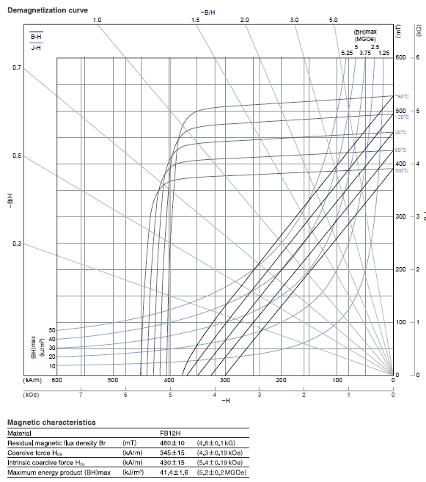
Fig. B.1 Specification of FB12H (by TDK).
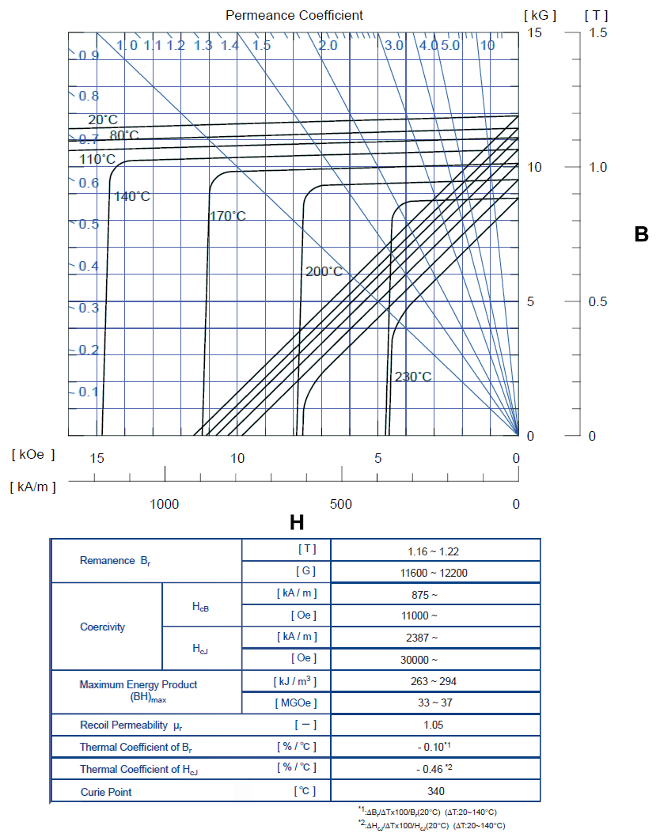
Fig. B.2 Specification of N36Z (by Shine-Etsu)

Per-unit System
In per-unit model of IM, the maximum phase voltage and current peak values are chosen as the base voltage and current ($U_{base}$and $I_{base}$) as shown in (C.1).
$U_{base}=u_{lim}$; $I_{base}=i_{lim}=\sqrt{i_{d}^{2}+i_{q}^{2}}$
(C.1)
where u_{lim} and i_{lim} are the limits of phase voltage and current amplitudes, i_{d} and i_{q} are d- and q-axis currents. The remaining base values, which include flux linkage ($Ψ_{base}$), resistance ($R_{base}$), inductance ($L_{base}$), angular speed ($ω_{base})$, rotor speed ($n_{base}$), torque ($T_{base}$) and power (P_{base}), are shown in (C.2) - (C.4).
$Ψ_{base}=\frac{U_{base}}{ω_{base}}$; $R_{base}=\frac{U_{base}}{I_{base}}$; $L_{base}=\frac{Ψ_{base}}{I_{base}}$
(C.2)
$ω_{base}=ω_{rated}$; $n_{base}=\frac{60∙ω_{base}}{2π∙p}$
(C.3)
$T_{base}=\frac{3pU_{base}I_{base}}{2ω_{base}}$; $P_{base}=\frac{T_{base}ω_{base}}{p}$
(C.4)
where ω_{rated} is the rated angular speed, p is the number of pole pairs. With the base values listed above, the basic equations of IM under per-unit system can be expressed as follows:
$u_{dp}=R_{sp}i_{p}\cos{θ}-ω_{p}(L_{sp}-\frac{L_{mp}^{2}}{L_{rp}})i_{p}\sin{θ}$
(C.5)
$u_{qp}=R_{sp}i_{p}\sin{θ}+ω_{p}L_{sp}i_{p}\cos{θ}$
(C.6)
$T_{emp}=\frac{L_{mp}^{2}}{L_{rp}}i_{p}^{2}\cos{θ}\sin{θ}$; $ω_{sp}=\frac{R_{rp}\sin{θ}}{L_{rp}\cos{θ}}$
(C.7)
where u_{dp} and u_{qp} are the scaled d- and q-axis voltage, i_{p} is the scaled phase current amplitude, θ is the current angle, ω_{p} and ω_{sp} are the scaled stator and slip angular speed, R_{sp} and R_{rp} are the scaled stator and rotor resistances, L_{sp}, L_{rp} and L_{mp} are the scaled stator, rotor and mutual inductances, T_{emp} is the scaled electromagnetic torque.

Reluctance Torque and Permanent Magnet Torque Calculation Using Frozen Permeability
The purpose of employing the frozen permeability (FP) technique is to allow the superposition theory applicable for torque components analysis, such as PM torque and reluctance torque etc., with fully accounting for the magnetic saturation [WAL05] [TAN09]. It has been illustrated and utilised to segregate the PM and reluctance torque components in [KWA05] [HU03] [SER88] [LEV00]. The segregation of reluctance torque in IPM is taken for illustration. The BH curve of lamination is shown in Fig. D.1. When IPM works at an operation point, the iron permeability is μ_{WP}. Then the PM is removed from the model, to segregate the reluctance torque. With only the excitation of phase currents, the iron permeability becomes μ_{PC}, which is different from μ_{WP}. Thus, the calculated reluctance torque is different from the real reluctance torque component of working point, due to the difference of iron saturation level. However, if the iron permeability is frozen to μ_{WP}, the obtained reluctance toque will be correct.
Fig. D.1 BH curve of lamination, WP, PM and PC refer to the working point, PMs and phase currents excitations.
The separation of reluctance torque, ferrite-contributed and NdFeB-contributed PM torque for an operation point of hybrid PM-assisted SynRM is as follows.
- Firstly, the machine (model I) is analysed nonlinearly in the FEA tool (JMAG). Consequently, the total electromagnetic torque T_{em} is obtained. The permeability of each element is saved.
- Second step: all PMs are removed from the model, and the saved permeability is imposed in the new model (model II). Then, the reluctance torque component T_{rel} is obtained.
- Third step: The ferrite PMs are restored to model II, which are still with the saved permeability in model I. Then the ferrite-contributed PM torque T_{PM_ferrite} can be obtained by subtracting T_{rel} from the newly obtained torque.
- Fourth step: the NdFeB-contributed PM torque is obtained by subtracting T_{rel} and T_{PM_ferrite} from T_{em}.

Torque-Speed Characteristic Calculation Equations Accounting for Cross-Coupling for PMA-SynRM and IPM [QI09]
The electromagnetic torque accounting for the influence of cross-coupling is given by
$T_{em}=\frac{3}{2}p[ψ_{d}\left(i_{d},i_{q}\right)i_{q}-ψ_{q}\left(i_{d},i_{q}\right)i_{d}]$

$=\frac{3}{2}p[ψ_{d}\left(i_{d}=0,i_{q}\right)i_{q}+\frac{ψ_{d}\left(i_{d},i_{q}\right)-ψ_{d}\left(i_{d}=0,i_{q}\right)}{i_{d}}i_{d}i_{q}-\frac{ψ_{d}\left(i_{d},i_{q}\right)}{i_{q}}i_{d}i_{q}]$

$=\frac{3}{2}p[ψ_{PM}\left(i_{q}\right)i_{q}+(L_{d}\left(i_{d},i_{q}\right)-L_{q}\left(i_{d},i_{q}\right))i_{d}i_{q}]$
(E.1)
where
$ψ_{PM}\left(i_{q}\right)=ψ_{d}\left(i_{d}=0,i_{q}\right)$
(E.2)
$L_{d}\left(i_{d},i_{q}\right)=\frac{ψ_{d}\left(i_{d},i_{q}\right)-ψ_{PM}\left(i_{q}\right)}{i_{d}}$
(E.3)
$L_{q}\left(i_{d},i_{q}\right)=\frac{ψ_{q}\left(i_{d},i_{q}\right)}{i_{q}}$
(E.4)
where , p is the number of pole pairs, 𝜓_{d} and 𝜓_{q} are the d- and q-axis flux linkages, i_{d} and i_{q} are the stator d- and q-axis currents, 𝜓_{PM} is PM flux linkage, L_{d} and L_{q} are the d- and q-axis inductances.
The phase voltage amplitude u_{a} is
$u_{a}=\sqrt{{(ωL_{q}\left(i_{d},i_{q}\right)i_{q}-Ri_{d})}^{2}+{(ωψ_{PM}\left(i_{q}\right)+ωL_{d}\left(i_{d}, i_{q}\right)i_{d}+Ri_{q})}^{2}}$

$=\sqrt{{(ωψ_{q}\left(i_{d},i_{q}\right)-Ri_{d})}^{2}+{(ωψ_{d}\left(i_{d},i_{q}\right)+Ri_{q})}^{2}}$
(E.5)
where ω is electrical angular speed.

Mechanical Loss of Prius 2010 Interior Permanent Magnet Electrical Machine
The mechanical loss P_{fw} is approximately expressed by (F.1)
$P_{fw}=k_{fw1}f_{s}+k_{fw1}f_{s}^{2}$
(F.1)
where k_{fw1} and k_{fw2} are mechanical loss coefficients, f_{s} is the corresponding stator frequency.
The estimation of mechanical loss is based on the test data of Prius 2004 IPM in [OLS05], since there is no loss data for Prius 2010 IPM according to the author’s knowledge. The rotor diameters of the two machines are the same. By fitting the loss data of Prius 2004 IPM into (F.1), k_{fw1}=0.03035 and k_{fw2}=7.56×10⁻⁶. Further, the mechanical loss of Prius 2010 IPM is expressed as (F.2), since the stack length of Prius 2010 is shorter than Prius 2004 (50.8mm vs. 84mm).
$P_{fw}=\left(0.4553n+7.56×{10}^{-6}n^{2}\right)×\frac{50.8}{84}$

$=0.3035n+4.54×{10}^{-6}n^{2}$
(F.2)

Table F.1 Mechanical loss of Prius 2004
Speed (rpm) | Frequency (Hz) | Mechanical loss (W)
494 | 32.93 | 19.8
1000 | 66.66 | 31.6
1506 | 100.4 | 60.2
1991 | 132.7 | 109
2501 | 166.7 | 135.9
3007 | 200.4 | 161.7
3501 | 233.4 | 205.3
3999 | 266.6 | 242.1
4505 | 300.3 | 297.4
4999 | 333.2 | 323.9
5492 | 366.1 | 404.9
6006 | 400.4 | 472.8

Fig. F.1 The tested and fitting mechanical loss of Prius 2004 IPM.

FEA Evaluation of Iron Loss and PM Loss
A. Iron Loss
Iron loss P_{Fe} is calculated by (G.1).
$P_{Fe}=k_{h}f_{s}B_{pk}^{2}+k_{c}{(f_{s}B_{pk})}^{2}+k_{e}{(f_{s}B_{pk})}^{1.5}$
(G.1)
where k_{h}, k_{c} and k_{e} are hysteresis loss, eddy current loss and excessive loss coefficients, B_{pk} is the amplitude of flux density, f_{s} is the frequency. These coefficients are obtained by fitting the manufacturer loss data into (G.1) [MAX10]. The loss date has been shown in Appendix B. The commercial FEA software Maxwell is used for flux density calculation.
For SynRM, PMA-SynRM and IPM, a set of simulations are carried out in a (i_{d}, i_{q}) plane, covering all the possible operating current vectors, at a specific speed. Then repeat this step for different speed to cover the whole operation speed region.
B. PM Loss
The eddy-current loss of PM is calculated by FEA according to the electrical conductivity of material. Calculation of PM losses is also conducted throughout all the (i_{d}, i_{q}) and speed operation regions.

Specifications of Valeo IM
The specifications of laminations of Valeo IM are shows in Fig. H.1, and the other parameters are listed in Table H.1.
.
Fig. H.1 Specifications of stator and rotor laminations

Table H.1 Design specifications
Stack length (mm) | 70
Number of pole pairs | 3
Number of stator slots | 54
Number of rotor slots | 44
Wire dimension (mm×mm) | 5×2.24
Number of coils per slot | 2
Number of turns per coil | 1
Number of parallel branches | 2
Number of series turns per phase | 9
Packing factor | 0.64
Stator resistance at 21ºC (Ω) | 0.0022
Stator resistance at 21ºC (Ω) | 0.00091
End ring area (mm²) | 170
Iron grade | M270-35A

Comparison of Electromagnetic Performance and Cost between Induction Machine and Hybrid Permanent Magnet Assisted Synchronous Reluctance Machine with Valeo Size

I.1 Design Specifications
The optimization processes of hybrid PM-assisted SynRM has been presented in Chapter 5. The cross sections and design specifications of IM and hybrid PM-assisted SynRM with Valeo size are shown again in Fig. I.1 and Table I.1. They have identical stator.
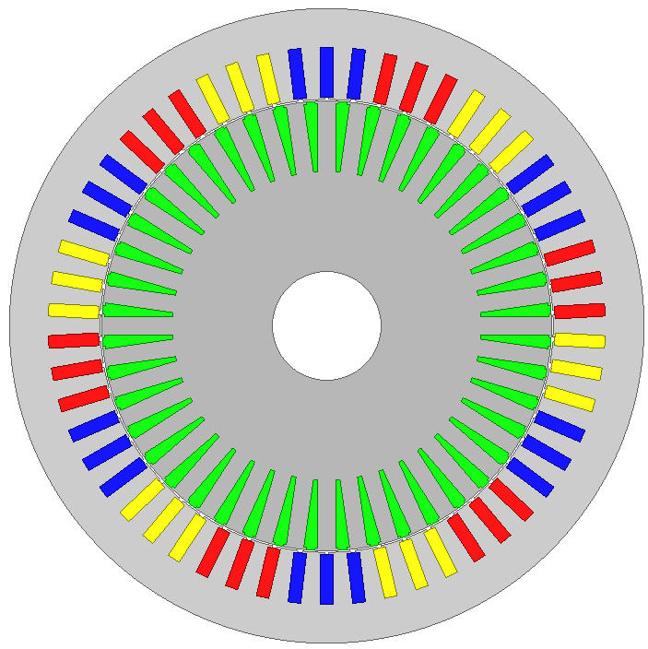
(a)
(b)
Fig. I.1 Cross sections of optimized electrical machines. (a) IM. (b) Hybrid PM-assisted SynRM.
Table I.1 Design specification of IM and hybrid PM-assisted SynRM
 | IM | Hybrid PM-assisted SynRM
D₁ (mm) | 146
D_{i} (mm) | 104.2
L (mm) | 70
Q₁ | 54
Q₂ | 44 | -
h_{s} (mm) | 13.46
b₀₁ (mm) | 1
b_{s1} (mm) | 2.94
h_{r} (mm) | 16.31 | -
b₀₂ (mm) | 2 | -
b_{t2} (mm) | 4.03 | -
g (mm) | 0.4
Number of barriers | - | 2
h_{b1}' (mm) | - | 3.18
h_{b1} (mm) | - | 7.36
h_{i2} (mm) | - | 5.85
Ferrite dimensions (mm) | - | 20×7.36  12×7.36
NdFeB dimensions (mm) | - | 9.4×3.18
Bridge dimension (mm) | - | 3.18×1
Rib dimension (mm) | - | 7.36×1
Number of coils per slot | 2
Number of turns per coil | 1
a₁ | 2
W_{φ} | 9
Packing factor | 0.64
R_{s} at 21℃ (Ω) | 0.0022 | 0.0022
Type of iron | M270-35A
Type of magnet | - | FB12H/N36Z

I.2 Comparison of Performance and Cost

I.2.1 Torque Capability per Ampere
The maximum electromagnetic torque capability for different stator current amplitude of IM and hybrid PM-assisted SynRM is shown in Fig. I.2. Same conclusion can be obtained as that in section 6.4.2.
Fig. I.2 Variation of maximum electromagnetic torque with current amplitude.

I.2.2 Torque/Power-Speed Characteristic
The maximum and rated torque- and power-speed characteristics of IM and hybrid PM-assisted SynRM are shown in Fig. I.3. Same conclusion can be obtained as that in section 6.4.2.2. The torque in constant torque region of IM is ~5% and ~17% lower than hybrid PM-assisted SynRM for maximum and rated torque-speed characteristics respectively.
(a)
(b)
Fig. I.3 Torque- and power-speed characteristics. (a) Maximum converter current. (b) Rated converter current.

I.2.3 Power Factor
The power factors of IM and hybrid PM-assisted SynRM along torque-speed characteristics for maximum and rated converter currents are shown in Fig. I.4. Same conclusion can be obtained as that in section 6.4.2.3.
(a)
(b)
Fig. I.4 Power factor along the torque-speed characteristics. (a) Maximum converter current. (b) Rated converter current.

I.2.4 Torque Ripple
The torque ripple of maximum output torque of IM and hybrid PM-assisted SynRM for different stator current amplitude is shown in Fig. I.5. The comparison result of peak to peak torque ripple is shown in Fig. I.6. The torque ripple of IM is much lower than hybrid PM-assisted SynRM, no matter for high or low electric load. The result is not exactly the same as that in section 6.4.2.4, in which IM may has larger torque ripple than hybrid PM-assisted SynRM for high electric load.
(a)
(b)
Fig. I.5 Torque ripples for different current amplitude. (a) IM. (b) Hybrid PM-assisted SynRM.
Fig. I.6 Peak to peak torque ripples for different stator current amplitude.

I.2.5 Efficiency Map
The calculated efficiency maps of IM and hybrid PM-assisted SynRM are shown in Fig. I.7. Same conclusion can be obtained as that in section 6.4.2.5. The maximum efficiency of IM with copper squirrel cage is about 2~3% lower than hybrid PM-assisted SynRM.
(a)
(b)
Fig. I.7 Efficiency maps. (a) IM. (b) Hybrid PM-assisted SynRM.

I.2.6 Cost
The material costs of IM and hybrid PM-assisted SynRM are compared in this section. The weight and material cost of IM and hybrid PM-assisted SynRM are listed in Table I.2. The cost of IM is ~12% lower than hybrid PM-assisted SynRM.
Table I.2 Material costs of IM and Prius 2010 IPM
 | IM | Hybrid PM-assisted SynRM
Stator copper mass (kg) | 1.61 | 1.61
Iron mass (kg) | 6.95 | 6.06
Rotor copper/PM mass (kg) | 1.71 | 0.188 (NdFeB)  0.697 (Ferrite)
Total mass (kg) | 10.28 | 8.57
Stator copper (£) | 11.3 | 11.3
Iron (£) | 13.9 | 12.1
Rotor copper/PM (£) | 11.9 | 18.8 (NdFeB)  5.57 (Ferrite)
Total (£) | 37.2 | 47.8

I.3 Conclusion
Similar conclusions can be drawn as those in Chapter 5. The electromagnetic performance of IM is competitive to hybrid PM-assisted SynRM under high electric load, in terms of torque capability, torque-speed characteristic in constant torque region and power factor, but poorer under low electric load. The maximum output torque of IM for rated current is around 18% lower than that of hybrid PM-assisted SynRM. The flux-weakening performance of IM is always poorer than hybrid PM-assisted SynRM. The torque ripple of IM is much lower than hybrid PM-assisted SynRM. The overall efficiency of IM is lower than hybrid PM-assisted SynRM, and the maximum efficiency of IM is approximately 2~3% lower than that of hybrid PM-assisted. The material cost of IM is ~20% lower than that of hybrid PM-assisted SynRM.

Publications
Journal papers published or in press:
[J1] | Y. Guan, Z. Q. Zhu, I. Afinowi, and J.C. Mipo, “Influence of Machine Design Parameters on Flux-weakening Performance of Induction Machine for Electrical Vehicle Application,” IET Electric Syst. Trans., 2014, in press.

Conference papers:
[C1] | Y. Guan, Z. Q. Zhu, I.A.A Afinowi, J. C. Mipo, and P. Farah, “Calculation of Torque-Speed Characteristic of Induction Machine for Electrical Vehicle Application Using Analytical Method,” 2014 XXIth Int. Conf. on Electrical Machines, Berlin, Germany.
[C2] | Y. Guan, Z. Q. Zhu, I.A.A Afinowi, J. C. Mipo, and P. Farah, “Difference in Maximum Torque-Speed Characteristics of Induction Machine between Motor and Generator Operation Modes for Electric Vehicle Application,” 2014 XXIth Int. Conf. on Electrical Machines, Berlin, Germany.
[C3] | Y. Guan, Z. Q. Zhu, I.A.A Afinowi, J. C. Mipo, and P. Farah, “Comparison between Induction Machine and Interior Permanent Magnet Machine for Electric Vehicle Application,” 2013 Int. Conf. on Electrical Machines and Systems, Hangzhou, China.
[C4] | Y. Guan, Z. Q. Zhu, I.A.A Afinowi, J. C. Mipo, and P. Farah, “Design of Synchronous Reluctance and Permanent Magnet Synchronous Reluctance Machines for Electric Vehicle Application,” 2013 Int. Conf. on Electrical Machines and Systems, Hangzhou, China.

