Gestures as a measure of preschool children’s event recall

Laura Elizabeth Robertson

Thesis submitted in partial fulfilment of the requirements
for the degree of Doctor of Philosophy

Psychology Department
April, 2014

Abstract
Children’s memory for an event is typically measured verbally and behaviourally. Although preschool children can converse fluently, they report less information verbally about their recall than would be expected from their language capabilities (Simcock & Hayne, 2002). People frequently produce gestures when they speak and gestures have been found to convey information, provide an insight into the speaker’s knowledge, and support the learning of mathematical strategies (Goldin-Meadow, 2003). The aim of this thesis was to develop methodologies for the use of preschooler’s own gestures as an additional measure of their recall. Across three experimental studies the semantic content of gestures was measured and the effect of gesture production on recall was manipulated. Children aged 3-5 years observed a series of actions demonstrated on a novel toy (study 1 N = 112, study 2 N = 70, study 3 N = 48). Verbal and gesture recall was obtained using open questions, and cued with a photograph of the stimuli, followed by behavioural imitation with a physical prop. Children’s gestures were found to convey meaningful information about the event, including additional spatial, motion and size/shape information expressed uniquely in gesture. Using a visual cue combined with increasing the communication demands increased verbal and gesture recall. Encouraging gesturing and motor experience with the props during encoding did not affect gesture production or recall. Taken together these results indicate that gestures reflect the child’s recall, supplemented their verbal expression of their recall, and may have been intentionally used to communicate some information, but evidence was not found for gestures supporting memory directly.

Acknowledgments
I greatly appreciate the support of my supervisors Dr Jane Herbert and Dr Danielle Matthews. Particularly for the drafts Jane proof read and advised me on whilst she was on maternity leave, many thanks for this extra effort and support.
The research study for chapter 3 was a re-analysis of data collected by Vicky Hayman and myself (working as a research assistant for Dr Jane Herbert) for a study designed by Dr Jane Herbert and Vicky Hayman. The majority of the data (n = 84) and method formed Vicky Hayman’s masters dissertation.
Thanks to the undergraduate students who coded data for reliability purposes; Genevieve Buckley, Mei Lin Law and Charles Fu Chan Lau. Mei Lin Law also assisted with the data collection during chapter 4, experiment 2, and this data and method were included within her undergraduate thesis. Laura Espin collected data using the methods in chapter 4 for her undergraduate dissertation and this data was used to pilot the use of the photo cue to elicit gesturing. These two undergraduate dissertations include similar descriptions of methods used in chapter 4 and used the coding criteria I developed during this thesis.
This PhD was funded through an Economic Social Research Council scholarship of full time fees plus an annual maintenance stipend and research support grant. This was awarded in October 2009 for a 1 year MSc Psychological Research + 3 year PhD.
Thanks also have to go to my husband and daughter for their persistent reminders that there is more to life than work, which has helped me to keep this thesis in perspective.

Declaration
Publications and Conference Attendances
International Society for Gesture Research 1st Summer School, 19th-24th July 2010.
1-week summer school attending lectures and workshops on gestures. Poster presentation entitled “Can Gestures help Infant Memory?” European University Viadrina Frankfurt (Oder), Germany. Refers to data collected for my masters work.
Society for Research in Child Development biennial conference, New Orleans, 2012
Poster presentation entitled “3-year-olds use gestures during recall which express spatial locations, actions and motions”, which was written by Laura Robertson but presented by Dr Jane Herbert. Refers to the study from chapter 3 of this thesis.
The White Rose Social Science Summer Conference, 28th August 2013
Poster presentation entitled “Does motor experience effect gesture production in 3-year-olds?” which refers to the study from chapter 5 of this thesis.
Joint Annual Conference of the British Psychological Society Developmental and Cognitive Sections, Reading University, September 4th-6th 2013.
Poster presentation entitled “Can gestures increase 3-year-olds recall?” which refers to chapter 4 of this thesis.

Table of Contents Page
List of Tables 10
List of Figures 12
Chapter 1: Theoretical perspectives of gestures and memory 13
Communication 14
Gestures reflecting and shaping thoughts 17
Working Memory 23
Language Production 28
Embodied Cognition: memory and gestures 36
Conclusion 45
Chapter 2: The role of children’s own gestures in reflecting and supporting their 47
memory retrieval
Method 52
Selection Criteria 52
Results and Discussion 55
Do children’s own gestures directly support their memory? 60
Do children’s gestures reflect information that provides an insight into their memories? 67
The present thesis 82
Interim Statement 86
Chapter 3: Gestures as an additional measure of preschool children’s event recall 87
Method 93
Participants 93
Measures 94
Procedure and Apparatus 94
Coding 98
Reliability 103
Results 104
Discussion 109
Chapter 4: Eliciting gesture production in 3-year-olds to increase recall 114
Experiment 1 114
Method 120
Participants 120
Measures 121
Materials and Procedure 121
Coding 123
Reliability 124
Results 125
Does gesture manipulation condition affect recall? 128
Collapsed across condition: Does gesturing relate to recall? 129
Discussion 131
Experiment 2 133
Method 139
Participants 139
Measures 140
Procedure 140
Coding 141
Reliability 145
Results 146
Did a change of experimenter affect free recall? 150
Did the use of a photo cue affect recall? 152
Information conveyed 155
Discussion 158
General Discussion 160
Chapter 5: Manipulating physical action during 3-year-olds’ encoding of an event 168
Method 174
Participants 174
Stimuli 175
Measures 178
Procedure 178
Coding 180
Reliability 182
Results 183
Discussion 190
Chapter 6: Discussion and conclusion 194
Can gestures be used as an additional measure of preschooler’s event recall? 197
How can 3-year-olds’ gestures be manipulated to increase gesture production? 201
What is the function of children’s gestures during their memory recall? 201
Limitations 203
Implications for future research 205
References 210
Appendix A: Social and demographic questionnaire given to parents 225
Appendix B: British Sign Language signs used in chapter 4 228
Appendix C: Additional analyses for Chapter 4 experiment 1 229
Appendix D: Additional descriptive statistics for Chapter 4, Experiment 1 230
Appendix E: Additional descriptive statistics from chapter 5 232

List of Tables Page
Table 2.1 Overview of the research studies that assessed children’s gestures 57
during memory retrieval.
Table 2.2 An overview of the coding of semantic information in the studies 69
that compared the information conveyed verbally and in gestures.
Table 3.1 Example of the coding of target items to calculate verbal and gesture 102
recall in Study 1.
Table 3.2. The number of times an item from each category was recalled in each 105
modality for all of the participants in Study 1.
Table 4.1. The frequencies of the number of steps recalled per condition in words 127
and gestures for Study 2, experiment 1.
Table 4.2. Examples of the coding of participant’s responses during questioning 144
using the photo cue, in Study 2, Experiment 2.
Table 4.3. Points scored per gesture for all representational gestures produced 147
based upon the semantic content expressed, for free recall only, in Study 2,
Experiment 2.
Table 4.4. The different types of information produced in verbal recall and 156
gesture recall collapsed across all five conditions, in Study 2, Experiment 2.
Table 5.1. Total information recalled in Study 3, displayed by type of information 188
and modality (individual items counted once per child per modality).
Table 5.2. Points scored per gesture for all representational gestures produced 189
based upon the semantic content expressed (includes repetitions of gestures).
Table 7.1 Spearman’s Rho analyses for Chapter 4, experiment 1. 229
Table 7.2 Descriptive statistics for gestures, Chapter 4, Experiment 1. 230

Table 7.3. Appendix E: Additional descriptive statistics from chapter 5. 232

List of Figures Page

Figure 3.1. Still image from the Animated video demonstration (a). 96
The wooden box stimuli presented to the children for behavioural recall (b).
Figure 3.2. The scores given for the semantic information conveyed in gesture, 106
In Study 1 with examples.
Figure 4.1 Mean amount of recall produced in Study 2, Experiment 2, for the 151
un-cued recall in the Absent condition compared with the collapsed conditions
from Study 2, Experiment 1 (error bars display 95% confidence intervals).
Figure 4.2 Mean amount of recall produced in Study 2, Experiment 2, for the total 154
amount of different items recalled in each modality in the photo-cued conditions
compared with the collapsed conditions from Study 2, Experiment 1 (error bars
display 95% confidence intervals).
Figure 4.3 The whole representational gestures produced during photo cued 157
recall in both conditions for experiment 2.
Figure 5.1. Sequence of four photographs shown during encoding in Study 3 in 177
the observe condition, for the rattle task (a) and for the slide task (b). Photographic
cues shown to each child during cued recall questioning (c).

Chapter 1
Theoretical perspectives of gestures and memory
In this chapter the psychological theories that relate to the role of gestures in communication and cognition are reviewed in order to identify future directions for research into the role of gestures in children’s memory retrieval. It has been argued that gestures form part of the system of speech, and therefore just like speech gestures can convey to an observer the thoughts, memories and thinking processes that are in the speakers mind (Goldin-Meadow, 2000; Goldin-Meadow, 2003; McNeill, 1992; McNeill 2005). Although there is a debate in the literature about whether gestures are produced primarily to communicate with a listener or primarily to support the speakers’ cognition (e.g., Hostetter, 2011; Rauscher, Krauss & Chen, 1996) this issue is less important for this thesis than obtaining information from the gestures about the speaker’s memory and determining whether the speaker’s gesture production is affecting their memory retrieval. Within this thesis I consider whether just as observing physical and verbal behaviour is used to obtain information about memory, observing gesture behaviour during recall may provide additional recalled information, an insight into memory systems, and could also affect recall itself if gestures serve a function for the speaker.
In accordance with a large body of literature, based upon McNeill’s criteria and terminology (1992; 2005), the term gesture is being used here to mean the hand motions that are produced spontaneously, fluently and automatically, usually during speech production. Gestures have a definite start and end point, and are distinct from movements made to adjust a persons’ self (e.g., touching your hair) or to manipulate an object. They vary in form and do not follow a formal code like sign languages do. This thesis focuses on gestures that convey meaning, which are termed by McNeill (1992) as representational gestures; iconic, metaphoric, and deictic. Iconic gestures provide a visual and often active and spatial impression of the concept being conveyed (e.g., moving the hands in a large arc to describe the path of a thrown ball). Metaphoric gestures look like iconic gestures but are a metaphor in comparison to the speech (e.g., reaching up as if grasping an object when talking about an idea). Deictic gestures are gestures that reference something physically present such as pointing, reaching and holding an object up for show. Deictic gestures do have a relatively fixed and consistent form and so they require more of an understanding of the context or they need to be accompanied by speech in order for an observer to comprehend the message that is being conveyed. McNeill (1992) also identifies a type of deictic gesture he terms ‘absent deictics’ which are deictic gestures that are not produced at a physically present item but are produced in the air at a shared mental referent (e.g., giving directions to someone by pointing in the air to space that has been verbally defined as representing particular locations). For the purposes of this thesis, which focuses on analysing gestures for a concrete event these gesture types have been grouped together as representational gestures because they all express meaning and individual gestures can overlap between these categories (McNeill, 2005). The theories and supporting evidence that focus on representational gestures have been reviewed for the explanations and predictions about the role of the speaker’s own gestures during tasks that are relevant to memory retrieval.

Communication
Although recall is not always measured verbally there is usually still a social-communicative element to the retrieval task, instructions or settings that mean that it is important to know whether communication demands affect gesture production. This thesis considers whether gestures could be used as an additional measure of preschooler’s recall, based upon research that gestures can be used to obtain information about a speaker’s reasoning (for reviews see: Goldin-Meadow, 2003; Goldin-Meadow, Alibali & Church, 1993). In order to use gestures to obtain recalled information the speaker’s gestures would need to be communicating information that could be reliably recognised and interpreted by observers even if the speaker was not aware of their gesture production or did not intend their gestures to communicate. However if the speaker was using gestures to intentionally communicate their recall then the communicative demands of the recall session could influence gestures they produced.
The theory that gestures form a part of communication has been proposed by people throughout human history based upon anecdotal observations of the co-ordinated production of gestures during conversational speech (Kendon, 1997). Kendon states that when gesturing speakers “render in visible form part of what is meant by the utterance” (p112). This implies that whether intentional or not gestures can communicate ideas to the observer. Kendon argues that like speech, gestures may be communicative and serve a function for the speaker, so the two functions do not have to be mutually exclusive. Other researchers have also emphasised the importance of gestures to researchers who are interpreting speech in order to understand the speaker’s cognition and for obtaining the whole picture that the speaker is trying to convey (e.g., Alibali, Bassok, Solomon, Syc, & Goldin-Meadow, 1999; Goldin-Meadow, 2000; McNeill, 1992). This indicates that to ignore gestures when measuring recall verbally is to lose a part of the information the speaker is communicating-whether that communication is intentional or not.
A recent comprehensive meta-analysis investigated in what circumstances and situations gestures communicate information to a listener (Hostetter, 2011). The reviewed studies (N = 38) experimentally manipulated gesture production so that the participants received speech without gesture in one condition and speech in combination with gesture in a separate condition. Their comprehension, memory or learning of the information was tested and compared between conditions. In all of the studies a separate person produced the gestures to the participant who was the listener observing the gestures. Hostetter’s review identifies that on average gestures did significantly improve the listener’s comprehension of the message, although this was not the case for all of the studies. Gestures were more likely to be communicative when they were about motor and spatial topics than abstract concepts but it could not be determined from the data descriptions whether this was due to the topic or due to different types or frequencies of gestures being produced when the topic differed. Gestures that conveyed additional information that was relevant to the task, and not conveyed in speech, were more communicative than gestures that conveyed the same information as speech (or non-task relevant additional information). Children benefitted significantly more than adults from seeing speech accompanied by gestures than just speech, although it could not be identified why. In particular having a lower verbal proficiency did not appear to be the reason children benefitted although Hostetter suggests that this could be due to task variations and that gestures may support people with a lower verbal proficiency when the message is more complex. This review also did not find that the benefits to comprehension were due to an improvement in the speaker’s word retrieval and speech fluency, so seemed to be independent of any benefits that gestures were having for the speaker. In sum Hostetter’s review demonstrates that gestures can communicate in a range of circumstances and that this is beneficial to the listener. This is important for the interpretation of gestures that are produced during memory retrieval and for considering variables that may inadvertently affect communicative demands when using gestures as part of the measures of memory retrieval.
The evidence that gestures can be communicative provokes several questions. Do speakers intentionally form gestures to communicate or are the communicative benefits of gestures coincidental? If they are coincidental is this because gestures are being produced to support the speaker’s cognition and happen to sometimes also express meaning or because gestures occur reflexively as part of thinking about or remembering information without having a specific function for speaker or listener? The evidence that gestures have a communicative function does not mean that they do not also serve a function for the speaker (Hostetter, 2011). The studies in the following sections focus on the function of the speaker’s gestures for their own cognition.

Gestures reflecting and shaping thoughts
Grouped within this section are theories that gestures have their source in the underlying cognitive processes that the gesturer themselves is not consciously aware of and so gestures can reflect this information without being intentionally communicative. It has been argued by Goldin-Meadow and colleagues that gestures can convey implicit knowledge that the speaker knows but does not yet fully understand and so cannot consciously express it (Goldin-Meadow, et al., 1993). Implicit knowledge has been defined as knowledge that the speaker can demonstrate knowing by acting upon it, but cannot consciously describe or explain, in contrast to explicit knowledge being facts that the speaker can state (Dienes & Perner, 1999). Dienes and Perner suggest that knowledge expressed in gestures is implicit because it is expressed unconsciously, without the speaker seemingly consciously aware of that knowledge. Goldin-Meadow and Alibali (1999) state that although the knowledge expressed through gestures is implicit, gestures can express explicit information and gestures may also help implicit knowledge to become explicit. Thus gestures can be a way of observing a speaker’s knowledge and thoughts that they themselves may not know they know.
A number of studies have shown that gestures can convey information about the speaker’s knowledge about problem solving strategies prior to them being able to express the strategies in speech (for reviews see Goldin-Meadow, 2003; Goldin-Meadow, et al., 1993). The first study to demonstrate this tested young children on Piaget’s conservation of matter problems (Church & Goldin-Meadow, 1986). In this study children asked to explain their answers, and the gestures they produced whilst speaking were examined. Children who primarily expressed different information in their gestures to their speech expressed more advanced understanding in their gestures than in their speech, such as giving the incorrect answer to the problem but expressing the correct strategy for solving it in gesture. Children whose gestures expressed the same information as their speech were at either end of the spectrum, either both of their responses were correct or both were incorrect. This indicates that gestures provide an insight into thoughts when people are in the transition of acquiring new understanding and are at the point of having grasped some aspects of this implicitly but cannot yet explain it verbally. Observing gestures allows for a distinction to be made within a group of children who give the wrong answer, between those that do not understand at all, and those that are in the process of understanding (Church & Goldin-Meadow, 1986).
Consistent with Vygotsky’s developmental theory (1934/2012) information conveyed in gestures about children’s knowledge state may be the cue that allows parents and teachers to tailor their assistance more appropriately allowing them to support learning. Vygotsky proposed that what children are capable of learning needs to take into account what they are capable of achieving with the support of an adult to extend their learning. This means that if a child is trying to solve a problem and the concept is too difficult then they will not be able to solve it even with assistance, but if they have almost grasped it then just a small amount of support could enable the child to solve the problem for themselves and so extend their learning and development. The point when a child is almost able to understand or solve a problem but needs some extra support to fully understand it has been termed the ‘zone of proximal development’ (Vygotsky, 1934/2012). Goldin-Meadow proposes that when a child gives an incorrect answer to a problem but conveys the correct strategy for solving the problem in gesture this indicates that their knowledge is in a transitional state that represents Vygotsky’s zone of proximal development (Goldin-Meadow et al., 1993). Goldin-Meadow suggests that it is through gestures that parents and teachers are alerted to a child being in this zone. If this is the case then gestures play a vital role in children’s learning and memory development when supported by an observant and responsive adult (Goldin-Meadow et al., 1993).
Whether gesturing can reveal information about children’s knowledge that predicts whether they will learn from additional training has been examined experimentally (Broaders, Cook, Mitchell & Goldin-Meadow, 2007). In this study, school aged children were asked to solve mathematical equations and explain the strategy they used. The children were then allocated into one of three conditions that manipulated the children’s gesturing during their explanations of the strategies they used; told to gesture, told not to gesture, and no gesture instructions. The children then solved and explained more of the equations. The manipulation did not affect the children’s verbal explanations, however the children who were told to gesture generated significantly more strategies for finding the answer than the other conditions, and they expressed these strategies uniquely in gestures. Additionally when, in a second experiment, the children were given training in how to solve the problems the children who had been told to gesture subsequently solved significantly more of the problems than those told not to gesture. Specifically it was just the children who were told to gesture and came up with new strategies that then benefitted from the teaching instructions. The authors conclude that this is evidence that gestures help the expression of implicit knowledge that in turn helps children to benefit from tuition (Broaders et al, 2007). This supports Goldin-Meadow et al.’s (1993) argument that gestures also play a role in learning using Vygotsky’s proximal development theory. It also indicates that the information that is reflected in gesture can be unique compared to speech and it is therefore an important aspect to observe for gaining an insight into the speaker’s knowledge.
Building on this research that gestures reflect the speaker’s knowledge, it has also been demonstrated that gestures can support the learning of new knowledge. In Cook, Mitchell and Goldin-Meadow (2008), school aged children were asked to solve mathematical equations and then explain how they solved them. The children were then asked to copy an experimenter solving equations, either just in speech, just in gesture or using speech and gestures. All of the children were then taught how to solve the equations using one strategy and the teacher used speech and gestures to explain. Then they were asked to solve and explain more equations, with the teacher instructing them to either use speech only, gestures only or speech and gestures (depending on experimental condition) to explain their solutions after each one. Finally, children solved and explained more equations on their own. Four weeks later the children were given the same type of equations by their classroom teacher and were asked to solve them and explain their answers. Although all of the groups improved equally immediately after training only the two conditions that included gesture training maintained this learning four weeks later. This demonstrates that gestures do not just reflect knowledge, but can also support the learning of new knowledge.
Although adults are not in the same kinds of learner-teacher relationships that children experience one possibility is that adults may develop their understanding and learning in social contexts with other adults, and so gestures continue to indirectly support cognition throughout the lifespan. Alibali, Bassok, Solomon, Syc, and Goldin-Meadow (1999) investigated whether adults, when they were describing how they would solve mathematical word problems, would produce gestures that conveyed the way they conceptualised the problems. The problems either involved changes that were continuous, or discrete, or a combination of both. The participants solved the problems and then had to describe the problem to another participant and explain how the problem could be solved. It was found that gesture and speech were equally able to portray the participants’ conceptualisation of the problem, discrete or continuous, when looked at separately. When a participant’s gestures and speech conflicted they were more likely to actually solve the problem using the method conveyed in gesture. Alibali et al. (1999) propose that this supports the theory that gestures reflect a person’s underlying mental representations and that considering gesture as well as speech provides additional information about cognition that would not be found by just analysing speech alone. The fact that this information reflected in gesture was not always articulated in speech provides support for the theory that gestures reflect implicit information about cognition that is not accessible to the speaker verbally, but can be observed and be particularly useful to researchers to gain a deeper insight into the underlying cognitive process than even the speaker themselves is aware of.
Additionally it has also been tested whether the gestures adults’ produce during their recall of a task shapes their learning of the task. In Beilock and Goldin-Meadow (2010), adults participated in the ‘Tower of Hanoi’ task which involves a stack of discs arranged largest to smallest where each one is a proportional increase or decrease in size and weight so that the smallest disc is also the lightest. The participants were asked to move the discs using 3 pegs and not to put a larger disc on top of a smaller disc. They were then asked to verbally describe how they completed the task, and their gesturing was also recorded. In the second part of the experiment, the participants were asked to solve the task again but this time half of the group were given the same discs as before whilst the other half had a new set of discs with the weight to disc size reversed. When the participants described the event, the authors report that disc weight was reflected in gesture but was not mentioned in speech. In the first part of the experiment some participants indicated that they could move the smallest disc with one hand, suggesting they had formed a mental representation of the disc weights. These participants performed worse on the second part of the experiment if they were in the condition where the weights were reversed, even though weight was not relevant to the task. This effect was only found when participants were asked to verbally describe, and therefore gestured, about their experience, after completing the first task. Consistent with Cook et al. (2008) research, this suggests that gestures not only reflect learning but also play a role in the forming of new mental representations. Beilock & Goldin-Meadow (2010) propose that this evidence supports the embodied cognition paradigm, since it that the participant’s actions, produced by gesturing, shaped their mental representation of the event.
Overall these studies indicate that gestures can provide information to a listener that the speaker themselves is not consciously aware of and does not refer to in speech. This can supplement the information conveyed in the verbal message and also provide an insight into the speaker’s knowledge. In the next sections theories are discussed that relate to gestures supporting cognition on-line as speech or working memory is being used.

Working Memory
Working memory can be described as the information that is recalled and temporarily held in the current thought processes in order to be used for a cognitive task (Cowan & Alloway, 2009). Cowan and Alloway emphasise that working memory is different to other cognitive processes because it is limited in the amount of information it can hold and the length of time it can hold it for. Information that is brought to the working memory will rapidly be forgotten, in a process termed decay, unless it is repeated or there is some form of reminder (Cowan & Alloway, 2009). There appears to be limited space in working memory and it has been predicted that an adult can hold only 7 items in working memory, although these items can be information that is grouped together into 7 ‘chunks’ (Miller, 1956; cited in Cowan & Alloway, 2009). Working memory has also been suggested to have limited energy, leading to a limited attention span and forgetting occurring once this attention span has run out (Cowan & Alloway, 2009).
Goldin-Meadow (2000) proposes that gestures may directly support cognition using the model of working memory proposed by Baddeley and Hitch (1974; cited in Goldin-Meadow, 2000). This model involves a central processor, the ‘central executive’ which is where the information is held and manipulated, and is assisted by a ‘visio-spatial scratchpad’ and a ‘phonological loop’ which temporarily hold recently seen or heard information (Baddeley & Hitch, 1974 cited in Goldin-Meadow, 2000). Goldin-Meadow proposes that because gestures are visio-spatial they may transfer information to the visio-spatial scratchpad, therefore freeing up processing for the central executive to use to solve the problem more effectively. It is also proposed that because gestures are not restricted to conveying information according to a linguistic code they may support the learning of new ideas by providing a medium that can express space, motion and action far easier than words can, particularly for new concepts that are not yet tangible enough to fit into being expressed in speech (Goldin-Meadow, 2000). Wesp, Hesse, Kneutman, & Wheaton (2001) also suggest that gestures are part of holding visio-spatial information for working memory. However their theory is built on Rauscher, Krauss & Chen’s (1996) theory that gestures assist with lexical access, rather than with general cognition. In contrast to Rauscher et al. they state that rather than gestures assisting with the cross modal priming of words, gestures hold the mental image of the word being searched for in the memory and this is how they assist with word retrieval.
To investigate whether gestures support working memory, Wesp et al. (2001) asked adult speakers to view and describe a painting. The gestures the adults produced when describing the image were compared depending on whether the painting was still in view or hidden during the describing phase. Within these conditions for half of the participants the observer closed or averted their eyes while the participant was speaking, and for the other half they maintained normal eye contact. A significant reduction was observed in gesturing when the participants could see the picture in comparison to when they had to describe the picture from memory. Eye contact between the listener and the speaker had no effect on speaker’s recall or gesture production which suggests that the gestures were being produced to support memory rather than interpersonal communication. The authors therefore argue that gestures are formed as part of a pre-linguistic representation of the spatial image held in working memory (Image Maintenance Hypothesis). That is, gestures directly support cognition by maintaining this imagery in working memory.
Building on this evidence that gestures support the holding of visio-spatial information in working memory Wagner, Nusbaum and Goldin-Meadow (2004) aimed to investigate whether gestures can also support working memory for verbal information. In a series of trials adult’s had to solve a maths problem, memorise an item, explain to the experimenter how they solved the maths problem, and then recall the item. Half of the participants were in the verbal working memory condition and the items they had to remember were three consonant pairs whilst the other half of the group was in the visio-spatial condition and had to remember a pattern of four dots arranged within a grid. Gesturing was compared within participants by allowing spontaneous hand movements on some of the trials (20) and asking participants to keep their hands still on the table on other trials (10). It was found that participants recalled significantly more items, both verbal and visio-spatial, when they had gestured during their explanation than when they had not, and whether they had been told to gesture or had gestured spontaneously did not affect this.
Wagner et al. (2004) argue that because gesturing did not interfere with recall for either verbal or visio-spatial recall, and in fact supported this recall, it indicates that gestures are not reflections of underlying spatial representations, and that they may instead be propositional representations. Propositional representations are abstract symbols like words rather than imagery or visio-spatial representations of spoken concepts (Wagner et al. 2004). To investigate the possibility that gestures are propositional, Wagner et al. went on to investigate the gesture-speech matches and mismatches produced. They argue that matches should support cognitive load because the same message is being reinforced in two modalities, whereas mismatches should increase cognitive load because two different messages are being expressed. They found that the participants recalled significantly more items when their gestures and speech matched than when they were mismatched. Wagner et al. conclude that gestures do play a supportive role to working memory, and that this is the case for verbal as well as visio-spatial memory. They argue that their evidence does not support theories that gestures result from underlying visio-spatial representations as this evidence indicates that this is not always the case. However they also point out that in their study the maths problem being described was present on the screen and not visio-spatial in format, whereas gestures may become more visio-spatial if the item being described needed reproducing in space in order to refer to it, and was a visio-spatial task. Overall this study lends support to the theory that gestures support working memory, but the authors conclude that this is through demands relating to the statements meaning rather than visio-spatial dimensions.
Further evidence that gestures play role in working memory has accumulated from studies investigating the function of gestures during counting and numerical tasks (e.g., Alibali & DiRusso, 1999; Carlson, Avraamides, Cary & Strasberg, 2007; Crollen, Mahe, Collignon & Seron, 2011; Marstaller & Burianová, 2013). When children are learning to count they point at the objects they are counting (Alibali & DeRusso, 1999). The same study also found that children count more accurately when they point at, or touch, the objects they are counting than if their gesturing is restricted. This was the case regardless of whether the child or a puppet counted, indicating that gestures help children to remember what they have counted and what is left to count. However this study also showed that the children’s matching of number words to items was more accurate when they counted than when a puppet counted, indicating that gesturing also supports the child to co-ordinate words and items. Alibali and DiRusso’s evidence indicates that gestures are supporting children’s working memory and the authors suggest this is achieved through gestures providing a physical, visual, place holder for the information, freeing up cognitive load on working memory.
This evidence for gestures supporting working memory was supported in a series of experiments by Carlson et al. (2007) in which adults use of gesture was manipulated. However when these adults were restricted from gesturing they nodded their heads, which suggests that the mechanism for gestures supporting counting does not rely on gestures providing an external visual support. Whether gestures are specifically a visual strategy to support working memory was tested by comparing the performance of blind and sighted children on a battery of arithmetic, verbal and working memory tests (Crollen et al., 2011). Although the blind children did gesture they produced significantly fewer gestures than the sighted children. Blind and sighted children performed equally well on the counting tests although the blind children’s performance was reduced during tasks where their verbal working memory was disrupted by asking them to repeat non-words. This supports the theory that gestures are a strategy that provides a visual support to working memory but that in the absence of visual development other strategies (such as auditory working memory) can be used to support counting (Crollen et al, 2011). Evidence also indicates that gestures specifically support the working memory of individuals with a low working memory capacity (Marstaller & Burianová, 2013). These studies indicate that not only are gestures supportive of the speaker’s working memory they also provide evidence for how the body is used to develop arithmetic and working memory strategies that support the embodied cognition paradigm and is consistent with the gestures as simulated actions framework (Hostetter & Alibali, 2008; Marstaller & Burianová, 2013).
In conclusion these studies indicate that gestures do support working memory during verbal, visio-spatial and numerical tasks. The evidence indicates that gesturing is a strategy to support working memory that is particularly utilised when working memory capacity is taxed. Gestures appear to reduce working memory load during counting tasks specifically by providing a visual marker or visual externalisation of information. All of these studies involved a verbal element, such as counting out loud or verbally recalling or explaining information. The following section focuses on the theories that gestures specifically serve a function for the speaker’s speech and language production.
Language Production
This section considers theories have been grouped based upon the hypothesis that the primary function of gesture production is to assist the gesturer with their speech production. This includes the theories that have been termed: lexical retrieval hypothesis (Rauscher, et al., 1996) and the semantic specificity hypothesis (Pine, Gurney & Fletcher, 2010). Also discussed are the interface hypothesis (Kita and Özyürek, 2003) and the information packaging hypothesis (Kita, 2000) which emphasise the source rather than the function of the gestures but also focus on the speaker’s own gestures playing an important role in speech production.
Gestures are primarily produced when we speak which leads to the theory that gestures are being produced in order to assist with the production of speech, termed the lexical retrieval hypothesis (Rauscher, et al., 1996). In this theory it is hypothesised that gestures are part of the memory of a concept and could provide an extra way to reach a word in our memory, particularly when the word is infrequently used making it harder to recall quickly whilst speaking (Frick-Horbury & Guttentag, 1998; Krauss, 1998; Rauscher et al.). Krauss argues that because a concept is stored in different formats in memory when a word is being retrieved it simultaneously activates the other formats it is stored in. When a speaker is temporarily unable to retrieve a word phonologically a gesture will be produced that also activates the phonological stored version helping the speaker to produce the word (Krauss, 1998).
The main prediction of the lexical retrieval hypothesis is that if gestures support lexical retrieval then restricting participants’ ability to gesture will decrease their verbal fluency. This prediction was tested by Rauscher et al. (1996) who asked adults to watch cartoon video clips and then verbally recall the clip. Gesturing was manipulated within participants by allowing hand movements on half of the trials and restricting hand movements on the other half. Speakers gestured three times more often when they used spatial words than when they did not, and speech was slower when gestures were restricted, but only when the content was spatial. When participants were prevented from gesturing, their speech for spatial words contained more disruptions and pauses in the middle of sentences, which the authors’ propose is associated with word finding difficulties (Rauscher et al. 1996). This evidence supports the lexical retrieval hypothesis because restricting gesturing did have a significant negative impact on speech production. Rauscher et al. do consider the possibility that restricting normal behaviour interfered with cognitive processing but this does not account for why only spatial speech was impeded.
Although Rauscher et al.’s (1996) study does indicate that gestures play a role in speech production, the lexical retrieval hypothesis does not explain why only spatial words were affected. Additionally a similar experiment by Frick-Horbury and Guttentag (1998), that also compared word retrieval when gesturing was allowed or restricted, did not find evidence that directly supported this theory. In that study, more words were retrieved when the hands were unrestricted compared to when they were restricted but this was not related to gesture production. And although more gestures were produced when the adults were struggling to retrieve a word, this was not related to actually retrieving the word. This finding is more consistent with theories that gesture were reflecting the underlying motor representation of the word without serving a direct function for word retrieval. Alternatively gesturing could have been serving a communicative function to alert the speaker that they were trying to retrieve a word rather than that they had finished speaking. How this relates to better overall word retrieval in the unrestricted condition is, however, not clear from Frick-Horbury and Guttentag’s study. The evidence indicates that the role gestures have during speech production may be more complex than just supporting speech at a surface level of word retrieval during access difficulties.
The basis of the lexical retrieval hypothesis is that gestures may support speech production because either modality can be used to retrieve a word from memory. Yap, So, Yap, Tan and Teoh (2010) aimed to test this to see whether presenting adults with an iconic gesture would also retrieve a semantically related word. Adults watched a sequence of an iconic gesture video clip, followed by a word that was either semantically related, unrelated, or a non-word. The participants had to respond by pressing a key after the word was shown to indicate whether it was a real word or a non-word. Participants responded faster to related words than unrelated words. The authors conclude that this demonstrates that iconic gestures prime semantically related words and that this is the case for the different lexical tasks of speed as well as accuracy. This study indicates that gestures and words may stem from the same underlying content so that a gesture can be used to retrieve a word from memory as predicted by the lexical retrieval hypothesis.
An interesting finding during the testing of the lexical retrieval hypothesis was that restricting gesture production impaired speech production specifically for spatial words (Rauscher et al, 1996). An explanation for this has been proposed in the semantic specificity hypothesis (Pine, et al, 2010) which states that different types of gestures serve different purposes, some being communicative and some being for the speaker’s cognitive benefit. According to the semantic specificity hypothesis, iconic gestures are intrinsically connected to the underlying meaning of the concept, they are more likely to be produced for the speaker rather than for the listener, and are more likely to be produced when the underlying meaning is a spatial or motor concept.
The semantic specificity hypothesis was tested against the hypothesis that gestures are primarily for communication by Pine et al. (2010). In this study adults were given pictures of objects that had either been rated as high or low for being easily manipulated. The speaker had to describe to the listener what was in the picture without naming the item. To manipulate communicative demands for half of the trials there was a screen blocking the speaker and listeners view of each other. If gesturing was communicative then gesturing was predicted to decrease when the screen was up. If gesturing was being produced to support the speaker’s cognition for spatial-motor concepts then gesturing was predicted to increase when the picture was an object that could be manipulated, without being affected by communicative demands. Iconic gestures were significantly more likely to be produced when the picture showed an object that could be manipulated than when it did not, regardless of visibility, although other gesture types were reduced when the speaker could not see the listener. These findings provides support for the semantic specificity hypothesis and indicates that although some gestures play a role in communication, iconic gestures that convey spatial and motor concepts are related to the speaker’s cognition and not for communication. The authors state that this study also provides evidence for other theories that gestures support lexical access such as the lexical retrieval hypothesis (Rauscher, et al, 1996) and the gestural feedback model (Morsella & Krauss, 2004). This study does not distinguish between the different theories of gestures providing lexical access, but it does provide the additional information that gestures are also related to whether an object can be manipulated as well as spatial words which were identified by Rauscher et al. (1996). This evidence also supports the gestures as simulated action framework (Hostetter & Alibali, 2008). The gestures as simulated action framework predicts that gestures are more likely to be produced with action words because they will have a lower threshold due to have a richer mental representation. This would explain why gestures were produced with motor words, irrespective of whether someone was observing them.
The mechanism and function for representational gestures playing a role in speech production has been proposed in the information Packaging Hypothesis (Kita, 2000). This theory aims to explain why and how representational gestures appear to be related to the underlying semantic content and are specifically related to spatial and action words. The main premise of the information packaging hypothesis is that stored mental concepts contain complex and detailed spatial and motor information that has to be organized into packages in order to translate them into speech; producing representational gestures supports this process. Kita states that there are two types of thinking; he terms these spatio-motoric and analytic. Spatio-motoric thinking organizes information based upon physical and perceptual actions generated through the body performing actions. Analytic thinking is abstract information that has been separated from physical experience and is stored hierarchically. Kita argues that gestures enable the spatio-motoric information to be divided up and translated into speech. Therefore the information packaging hypothesis predicts that more gestures will be produced when the underlying spatio-motoric concepts are complex and difficult to translate into speech, and the rate of gesturing will not vary if the difficulty of translating the lexical concept into a word is kept constant even if the difficulty of retrieving the word is varied.
The lexical retrieval hypothesis and information packaging hypothesis have been compared by testing children’s gestures during their explanations and descriptions of their logical reasoning In Alibali, Kita and Young (2000), 5-year-old children were asked to observe tasks based upon Piaget’s conservation tasks. They were then asked to either explain their judgments of why the amounts were the same or different, or they were asked to describe how they looked different. It was hypothesized that both questions would result in the same level of difficulty in word finding and speaking because the spatial words used were the same so if the Lexical Retrieval Hypothesis was correct then the participants should use comparable amounts and types of gestures in both tasks. However because children typically do not solve this task until they are 7-years-old, explaining why they think the amounts are the same or different ought to be cognitively more difficult than simply describing the differences. Therefore in accordance with the information packaging hypothesis, children should use more gestures when they have to explain their judgment, and more of the concepts should be produced only in gesture and not in speech. This is predicted because the children would think things through using the gestures before deciding on the explanation they would say. As predicted by the information packaging hypothesis, more children produced gestures in the explaining condition, and more of the gestures expressed concepts that were not in speech. The authors state that although gestures may play a role in word finding this evidence suggests that gestures also play a role in thinking. This perspective argues that gestures may directly support cognition, but primarily cognition used to produce spatial language and reason about spatial concepts.
Hostetter, Kita and Alibali (2007) then aimed to test whether it was representational gestures specifically, as the information packaging hypothesis predicts, that increased when items containing spatial information were harder to conceptualise. Adults took part in a series of trials where they saw dot patterns that could be conceptualized in multiple ways (difficult to conceptualise), and similar dot patterns with lines drawn through them to create shapes (easier to conceptualise). The patterns did not differ in linguistic difficulty or memory demands and spatial and shape words were primed before the task to minimize word retrieval difficulties. The adults saw the patterns on a computer screen and then had to remember and describe them into an audio recorder which they were told another participant would use to draw the dot patterns. The participants generated more low frequency words in the dots with shapes condition, but in contrast to the lexical retrieval hypothesis they did not produce more gestures in this condition. More representational gestures were produced in the dots only condition, providing support for the information packaging hypothesis. Hostetter et al. state that this evidence also supports the hypothesis that more gestures are produced when the task is difficult and that gestures are supporting cognitive load, specifically that representational gestures support the conceptualization of spatial information.
One question that arises from Alibali, et al. (2000) is whether the stored concepts are dependent on or independent of language. Kita and Özyürek (2003) aimed to investigate this question cross linguistically in order to better identify if there are gestures that are consistent to a concept regardless of language or whether gestures vary depending on language and regardless of a unifying concept. Three different theories were compared. The lexical retrieval hypothesis (Rauscher et al., 1996; Krauss, 1998), the theory that gestures arise from images stored in long term memory independently of language (DeRuiter 2000; Krauss, Chen & Chawla 1996 cited in Kita & Özyürek, 2003) and a new theory termed the interface hypothesis (Kita and Özyürek, 2003). The interface hypothesis is a blend between the two extremes which argues that gestures arise from a spatial-motoric representation that is formed to interact between spatial thinking and speech and therefore gestures contain non-linguistic information but they also prepare information to be compatible with language production (Kita & Özyürek, 2003).
In order to test these theories, Kita and Özyürek (2003) examined the gestures of native adult speakers of Japanese, Turkish and English, languages which express spatial motoric information in different ways. The participants were asked to watch cartoon clips and to remember and then re-tell the story in exact detail to a second person. Differences in gestures were found depending on how the concepts were verbally described in each language. For example, when the clip was of a cat swinging with an arcing path, in languages where there is not a specific word for swinging the participants only conveyed that the cat had moved in gesture. In contrast, in languages where there is a word for swing, the participants produced an arcing path gesture matching the action.
The findings above support the Lexical Retrieval and Interface Hypothesis, but not the theory that gestures are produced independently from language. However this could be interpreted that language can shape the way one experiences the world and so the gestures relating to motion and spatial information could still be coming from a source embodied in experience but modified by that individuals linguistic constraints on that experience when they recall it. Kita and Özyürek (2003) also found that all speakers indicated in gesture that the cat moved on a right to left trajectory, which was information that they did not convey in speech. All of the speakers also conveyed in gesture that the movement was on the vertical plane, which they did not convey in speech. The authors propose that this provides evidence for the interface hypothesis rather than lexical retrieval because additional spatial information is being conveyed that is not part of the words produced. This study seems to indicate that language can work both ways with gesture; so that as gesture may support language to be produced the individuals language may also shape the way gestures are produced. It also appears to suggest that while some of the gestures expressed universal concepts across the languages examined, indicating that the gestures were formed pre-linguistically, other gestures were influenced by the way concepts are expressed in the languages used.

Embodied Cognition: memory and gestures
These theories involving embodied cognition focus primarily on the source of gestures from the point our minds interact with the world and internally process experiences, prior to translating that information into speech. In this category I have included the gestural feedback model and the gestures as simulated actions framework. If the source of gestures is embodied physical experiences then this would have a bearing on how gestures convey information during the recall and also on the context and experiences during encoding that could affect gesture production during recall.
In the gestural feedback model (Morsella & Krauss, 2004) it is argued that gestures activate the underlying sensory and kinaesthetic representation to word meanings and this supports the activation of the phonological representation. As long as the gesture is produced this continues in a feedback loop allowing a concept to be held in working memory until the word is found. This theory was developed from the lexical retrieval hypothesis after the evidence found that gestures specifically supported the retrieval of spatial words. The gestural feedback model was also proposed in response to the evidence collected by Wesp et al. (2001) that gestures support working memory, and their theory that gestures support word retrieval by holding a concept in working memory whilst the word is retrieved. Morsella and Krauss (2004) agree with Wesp et al. that gestures are used when visio-spatial working memory is being used and so this suggests that gestures assist in the recall of this type of memory. However they disagree that this is the main function of gestures, because Wesp et al. still found that people gesture when describing an object that is still present (even though it was significantly reduced compared to the object not being present) which does not require working memory.
The gestural feedback model was tested by Morsella and Krauss (2004) in comparison to the theory proposed by Wesp et al. (2001) that gestures support word retrieval indirectly by holding the concept in working memory while the word is searched for. In Morsella and Krauss participants were either allowed to gesture or restricted from gesturing. Half of the participants had to describe pictures when they were in front of them, whilst the other half viewed the pictures and then described them from memory. The pictures were presented on a computer screen and included easily describable objects and abstract line drawings. To limit gestures being produced for communicative purposes participants spoke their descriptions into a tape recorder. Significantly more gestures were produced when the picture was absent than when it was present and when the picture was of an abstract line drawing than when it was of a concrete object. These findings are consistent with Wesp’s et al.’s evidence that gestures play a role in supporting working memory. However high rates of gesturing were found when the pictures were present and so Morsella and Krauss argue that this supports the theory that gestures are supporting word retrieval in accordance with the gestural feedback model. Furthermore, there was more gesturing for the abstract line drawings, which were harder to find an appropriate word for, than for the easily nameable pictures. Finally, restricting gesturing was found to decrease the rate of speech in both present and absent conditions. If gestures were supporting working memory then speech should only have been affected in the absent condition, so this also indicates that the gestures were supporting speech production and working memory.
Further evidence for the gestural feedback model, in particular the hypothesis that gestures stem from embodied actions that are linked to the memory of a word, was provided by Morsella and Krauss (2005) who measured muscular activity in adults arms during the retrieval of different types of word. In this study a definition of a word come up on a computer screen and the participant had 60 seconds to produce the word that was being described. Low frequency words were used to increase the trial length and elicit muscular activity if gesturing was related to word production. It was found that concrete words were more likely to elicit muscle activity than abstract words. A high muscular activity was most highly correlated with concrete words that had been rated as easy to draw, manipulate and spatial concepts. These findings support the gestural feedback model and provides evidence that gesturing is related to embodied actions.
Many of the above studies (e.g., Kita & Ozyurek 2003; Morsella & Krauss, 2005; Rausher, et al., 1996; Wesp et al., 2001) have found that gestures particularly tend to represent spatial information. Miller and Franz (2005) conducted a study to specifically investigate the relationship between gestures and the spatial cognition underlying speech. Using adults who gestured on a pre-test, the participants were then asked to verbally describe five scenarios to an experimenter. The scenarios were designed to include varying amounts of spatial cognition and memory and included describing the house they had lived in as a child, the house they lived in now, the house they imagined themselves living in, in 15-20 years time, their current lounge, and their typical daily routine. Significantly more gestures were produced in the lounge description task in comparison to the other tasks and significantly fewer gestures were produced in the daily routine description task compared to the other tasks. The majority (75%) of the representational gestures produced were concrete iconic gestures. More concrete representational gestures were produced in the lounge description task than in the other tasks. More spatial language was produced in the lounge and house description tasks than in the daily routine tasks. These findings indicate that there is a positive relationship between tasks with increasing demands on spatial cognition and increased gesture production. Although all of the theories indicate that gestures have a relationship with spatial language, this study’s finding that gesturing increased with increased demands on spatial cognition particularly supports theories such as the information packaging hypothesis (Kita, 2000) and the gestures as simulated actions framework (Hostetter & Alibali, 2008). This is because these theories predict that increased spatial concepts in the original memory of the event will then either require more gesture support to translate this into words (according to the information packaging hypothesis), or increase the re-enactment of the events spatial activity in gesture (according to the gestures as simulated action framework).
According to the perspective of embodied cognition, cognition does not operate according to an abstract symbolic system nor is it a computational system of networks; cognition occurs through the activation of mental imagery that is created from stored perceptual and kinaesthetic experiences of the physical world (Gibbs, 2006). The term mental imagery used in embodiment does not just mean visual imagery but the entire stored experience (Gibbs, 2006). This includes the physical sensations of movement, touch, texture, pressure, balance, taste, smell etc., and the personal way the individual felt during the time and how it related to their other stored mental imagery, etc., so that the whole event as the person’s mind experienced it, is stored in the mind, and can then be activated re-experienced by simulating the perceptions and actions. According to Gibbs, this forms the basis for knowledge, learning and thinking about the world.
There is evidence from a study by Glenburg and Kaschak (2002) supporting the theory of embodied cognition for language and gesture. This study was conducted to investigate whether producing physical actions could affect the comprehension of a sentence. Participants were presented with sentences that involved a transfer of an object towards or away from the subject. The participant had to move a button either further away from themselves to indicate that the sentence made sense or move the button closer towards themselves to indicate that it did not make sense (direction counterbalanced across condition). It was found that the participants could comprehend the sentences better when they had to make an action that was compatible with the sense of the sentence than if it contradicted the action. The authors propose that these results indicate that physical actions underlie the linguistic concepts of actions and this is explained by the theory of embodied cognition. The actions used in this study were similar to representational gestures so these findings suggests that gesture production may also be specifically explained by the embodied cognition theory.
According to the embodied cognition paradigm memory does not involve an experience being separated and encoded as an abstract piece of information which is then stored separately, retrieved and decoded, but remembering something involves the reactivation of the stored mental representation (Gibbs, 2006). Glenburg (1997) states that the memory system is not a tool that we use to intentionally store and recall information but it is for the benefit of the individuals’ ability to perceive and act within the world. Memory is necessary to deal with a world that includes obvious perceptual things and also non-obvious concepts that have to be remembered. For example Glenburg (1997, p4) discusses how “turn left to go home” involves the spatial direction of the left turn that can be physically experienced, but also the concept of home that has to be remembered. Memories are then updated based on new experiences. This perspective argues that when information is recalled the whole experience and all of its associated mental imagery is re-experienced at the same time.
If memory is embodied then producing gestures of motor actions during the encoding of an event could be predicted to have an effect on the later recall of the event. Cook, Yip and Goldin-Meadow (2010) conducted a series of studies with adults to investigate whether gestures produced at encoding have an effect on the recall of that event. Adults were shown animations of actions which they were asked to verbally recall immediately and after a delay. Gesturing producing during immediate verbal recall was classed as gesturing during encoding whilst gesturing during verbal recall after a delay was classed as recall. When the participants were able to gesture spontaneously, they gestured when describing about half of the animations (47%) during encoding and they recalled more items verbally, and spoke more. A second study confirmed that when adults were instructed to gesture during encoding they recalled more items verbally in comparison to when they were restricted from gesturing during encoding. Taken together these findings indicate that gesturing during the encoding of an event then improves recall for the events. The authors argue that these findings support the embodied theory of memory stated by Glenburg (1997) that memory supports motor actions and so gesturing the motor actions supports the encoding and retrieval of the memory more than the visual encoding. Cook et al. further propose that gestures improve the storage of information in memory, which supplements previous studies that have found that gesture production improves the retrieval of information.
How gestures may arise from embodied cognition has been set out in the gestures as simulated action framework (Hostetter & Alibali, 2008). It is stated that as speakers talk they retrieve the mental imagery from the original experience and the actions and visio-spatial information is simulated through gestures. A range of predictions are specified about when gestures are likely to be produced. When the original experience involves the motor system, rather than just the perceptual system, a gesture representing the action is likely to occur. Perceptual imagery that is associated with imagery can result in gesturing whereas perceptual imagery that is not, such as a smell, would not trigger a gesture. Recalling an event from the active perspective of the character is going to simulate motor imagery and be more likely to produce gestures than someone who describes it from their passive viewpoint as an observer. Gestures are more likely to be produced when the words being produced relate to physical objects, whether these are actually physical or used in a metaphoric sense (for example, phrases like “put aside some time” and “let’s share our ideas” which imply that the abstract concepts of time and ideas are physical objects that can be manipulated). It is proposed by Hostetter and Alibali that gestures are primarily produced during speech production because, due to the fast motor and cognitive co-ordination required for speech production, it is necessary for pre-motor simulations to be used, which in turn increase the activation of simulated actions. Thus, an increased need to communicate will result in increased gesturing. Hostetter and Alibali therefore argue that each person is capable of inhibiting their gestures, this is the gesture threshold, and varies based upon every individual’s neurology, experiences, and the context they are speaking in. The gestures as simulated actions framework states that increasing the gesture threshold so that gestures are not produced uses up cognitive resources so that a person will be less able to do other cognitive tasks. It is predicted based upon the gestures as simulated actions framework that gestures will reflect memories because they are simulations of the stored mental representations. It is also predicted that encouraging gesture production, and therefore the lowering of the gesture threshold, may free up cognitive resources, improving memory recall. Additionally it is predicted that tasks that involve physical action in the encoding or require mental activity, such as mentally rotating a shape, during retrieval will result in more gestures being produced than tasks that involve static visual imagery and passive recall (Hostetter & Alibali, 2008).
The main prediction from the gestures as simulated actions framework is that motor activity, in comparison to visual imagery, during the encoding of an event will result in more gestures produced during recall because gestures are acting out the embodied motor experience. To test this prediction Hostetter and Alibali (2008) had adults view geometric patterns of dots connected by lines on a computer and then asked them to verbally recall the patterns without the pattern in view. On half of the trials the participants could manipulate wooden versions of the patterns after viewing them on the screen. There was a significant increase in gesturing when the participants described the patterns they had physically manipulated in comparison to when they described the patterns they had just viewed, in support of the gestures as simulated actions framework.
However it is possible that more gestures were produced after motor activity in the study by Hostetter and Alibali (2008) not because they were re-enacting the actions but because the information to recall was more complex, as there was more physical and perceptual detail involved in the memory, and so gestures were produced to support this increase in cognitive demands. This interpretation was tested by Sassenberg and Van-Der Meer (2010) who asked adult speakers to describe routes and spatial locations to a listener from the perspective of walking on it, rather than as if they were looking at it. Difficulty was manipulated by having speakers describe new routes and repeat parts of the route. This procedure aimed to test whether speakers were more likely to produce gestures when describing a new step (indicating the gestures were supporting speech when it was more difficult) or whether gestures were more likely to be used when the step was repeated (indicating that gestures were produced with an activation of the stored mental representation which the gestures as simulated actions framework predicts would be stronger if it had been reinforced through repetition). It was found that gestures are more likely to be produced when the speaker was repeating a step, not when a new step is being described, and this was independent of whether the listener had asked for the step to be repeated because they had not understood it or whether it was a junction. This finding indicates that gestures are being produced when the speaker has a stronger activation for the concept, rather than when speech is difficult, which provides further support for the gestures as simulated actions framework.
The above study demonstrates that gestures are produced when spatial information is verbally described. However there is also evidence to suggest that gestures are also produced in and serve a function for non-verbal spatial processing. In Chu and Kita (2011) adult’s gesture production was observed when they had to mentally rotate a shape to determine whether it was the same as another shape. There were no verbal or social-communicative demands to the task as the participant was alone in a room and unaware their behaviour was being recorded. Despite the absence of social and communicative demands, participants still produced gestures, and they gestured significantly more on complex shapes than simpler shapes. In a second experiment using the same task gesture production was manipulated in three ways: told to gesture, told to sit on their hands to prevent gesturing, and spontaneous gesturing. Significantly more gestures were produced when participants were told to gesture than when gesturing was spontaneous. The told to gesture group also correctly mentally rotated more shapes than the other two groups, without a significant difference between the spontaneous gesturing and restricted gesturing groups. Again participants also gestured more when the mental rotation was more challenging. Overall, gesturing decreased over trials, whilst accuracy increased, supporting the authors prediction that gestures had been supporting thought when it was difficult and that as the task became more familiar this was not necessary. These findings support the hypothesis that gesturing can directly support cognition, specifically that gesturing can support mental spatial visualisation, and that the source of gestures stems from embodied cognition.
Conclusion
In summary, the theories about the function of gestures fit into three broad categories; gestures serve a direct function for the gesturer’s speech, gestures serve a direct function for the gesturer’s cognition and gestures are primarily to communicate with a listener so they convey thoughts and memories but do not necessarily have a specific function for the speaker. These functions are not mutually exclusive, and the evidence suggests that gestures may serve a broad supportive role for the speaker’s cognition, particularly for tasks that involve both speech and working memory. Whilst the way gestures support cognition (by re-producing actions and spatial information) also means that information is communicated to listeners (which may or may not be intentionally communicated) depending on the context. All of the theories and evidence, particularly from the last decade, indicate that the source of gestures is physical action consistent with the embodied cognition paradigm. The theories reviewed in this chapter were primarily developed from studies that tested adult participants, with the exception of the studies by Goldin-Meadow and colleagues who tested school-aged children (8-to-11-year-olds). Since everyone produces gestures these theories apply to children as well as adults but the source and function of gestures may change during early development, particularly at the start of fluent language and gesture production. The focus of this thesis is on the use of gestures to obtain an insight into preschool children’s memories, as well as identifying whether there is a function of preschooler’s gesture production during recall. Just as observing physical and verbal behaviour is used to obtain information about children’s memory, the aim of this thesis is to test the use of observing gesture behaviour to obtain recalled information. In chapter 2 the evidence is reviewed from studies that specifically examined children’s own gestures during their memory retrieval and the implications of this evidence for the source and function of gestures is discussed.

Chapter 2
The role of children’s own gestures in reflecting and
supporting their memory retrieval
The theories discussed in chapter 1 provide broad predictions that gestures do serve a function for the speaker’s cognition and are also part of communication. Goldin-Meadow (2000) theorized that gestures can provide “an additional window to the mind of the developing child” (p231). In this chapter the focus is specifically on children’s memory to identify whether the representational gestures children produce during retrieval provide a reliable insight into their recall and memory system. Given that much of the evidence for the main theories has been developed through studies with adults it is also important to consider whether gestures serve the same function for children’s memory recall as they do for adults. This chapter is a review of research that has examined the relationship between the gestures children produce and their memory retrieval.
In the adult literature, memory research focuses on the theory of the episodic memory system (Tulving, 2002). Tulving defines the episodic memory system as a specific neural system of explicit memory, which is a component of semantic memory (knowledge of facts, such as knowing what currency is used in Japan). Episodic memory gives us the ability to re-experience a previous event as if one is back in that moment, but with the self awareness that they are not, for example, remembering the time when you learnt about world currency at school. Tulving specifies that in order to demonstrate a memory is episodic then the “what, where and when” (p3, 2002) of the event must be demonstrated. Tulving argues that the episodic memory system is a late emerging system, not yet developed fully in children under 4-years-old.
In order to test the validity of this age boundary for event recall, Hayne and Imuta (2011) designed a hide-and-seek task to measure episodic memory in 3- and 4-year-olds. The task involved the experimenter and child first hiding three toys in different rooms of the child’s house. Five minutes later verbal and behavioural recall was tested. In the verbal recall task, episodic memory was assessed by asking the name of the toy (what), the specific room that toy was hidden in (where) and the order each toy was hidden in (when). In the behavioural recall task, the child was asked to find the three toys in the order they were hidden in. It was found that verbally the 4-year-olds reported significantly more than the 3-year-olds. Behaviourally 3- and 4-year-olds performed similarly except 3-year-olds were significantly less able to demonstrate the correct temporal order, supporting Tulving’s account (2002) that the episodic memory system is still developing in children under 4-years-old. Hayne and Imuta’s study (2011) demonstrates that it is specifically the ‘when’ aspect of episodic memory that is still developing in 3-year-olds. However it is important to note that it is only apparent that 3-year-olds can remember the ‘what’ and ‘where’ aspects of the event when their recall is measured behaviourally; attending only to their verbal recall would underestimate their event recall.
The findings from Hayne and Imuta (2011) supports earlier research that tested preschool children’s verbal and behavioural event recall (Simcock & Hayne, 2002; Simcock & Hayne, 2003). In these two studies 2-to-4-year-old children were shown a sequence of events on a box that appeared to shrink a toy, and then asked, after varying delay lengths, to recall the event verbally and then behaviourally by showing the experimenter how to use the box to shrink a toy. It was found that all of the children reported significantly less information verbally than behaviourally, and much less than the potential number of event related items that could have been reported. Children who were tested after a long delay, 6-months to 1-year (Simcock & Hayne, 2002) only used words in their recall that they knew at the original time of encoding even though they now knew relevant vocabulary. Even children who were tested after 24-hours reported significantly less information verbally than behaviourally, with 3-year-olds reporting significantly less than 4-year-olds and less than would be expected from their language proficiency and their knowledge of even specific vocabulary. Simcock and Hayne (2003) propose that this may indicate that whilst children’s ability to remember and recall information does not change based upon whether they have verbal language or not. Before children have fully verbal language their memories may be stored non-verbally so that they can be accessed behaviourally but are not easily translated into speech.
Although the findings from these studies might be taken to suggest that children under 4 should only have their recall measured behaviourally in order to avoid underestimating their recall, this is not always practical or possible, such as when a child has witnessed or been a victim of a crime. Hershkowitz, Lamb, Orbach, Katz, and Horowitz (2012) examined the police interviews for 299 alleged victims of abuse to determine whether there are age related differences in 3– to 6- year-old children’s ability to report an event in a real-life context. The children were all interviewed following a specific child interview protocol which involved the explanation of the rules, a rapport building phase, open ended questions about the event once the child has made an allegation, prompts that follow up information the child has given, followed by specific questions once open ended prompts have been exhausted. Although all of the children provided some relevant information, there was a significant increase with age in how much information was reported and how often the child answered the question with a relevant response. This is the first study to examine the witness statements of children as young as 3-years-old as they have been considered too young and are often not interviewed by the police even if they are the only witness (Hershkowitz, 2012). This study demonstrates the importance for practical contexts of assessing what 3-year-olds can report verbally, and identifies that they can provide some information even though it is significantly less than the information older children can provide.
Taken together, these studies (e.g., Hayne & Imuta, 2011; Hershkowitz, et al., 2012; Simcock & Hayne, 2002; Simcock & Hayne, 2003) demonstrate that for memory research the age range across 3-years-old is important as their episodic memory system and their ability to describe their recall verbally are both still developing. In general, young children’s memory for events has been studied by setting up behavioural tasks and observing how the child respond to the stimuli based on their previous experiences (reviewed in Courage & Howe, 2004). These include behavioural measures such observing recall through visual attention to novel and familiar stimuli, operant conditioning, and behavioural imitation of bodily actions or actions with objects (see Courage & Howe, 2004). These methods have provided evidence that infants and young children can encode, store, and retrieve information and that their ability to recall more information, longer sequences in temporal order and retain it over a longer interval all increase with age (Courage & Howe, 2004). By the time children are 3-years-old they are capable of verbal recall, but attending only to their verbal recall may underestimate their memory for past events. Coding only behavioural recall is not always possible and can result in more subtle details being unreported as well as prompting occurring from seeing the behavioural props (Salmon, 2001). Therefore 3-year-olds are at an important point in development for examining their ability to recall specific events, and for developing measures of recall that do not underestimate or prompt their actual recall of the event. This thesis examines whether gestures could offer an additional insight into 3-year-old’s event recall.
Like adults, when children speak they also gesture (Goldin-Meadow, 2000; Goldin-Meadow, 2003; McNeill, 1992). Therefore it is possible that children’s gestures could be used as an additional measure of their recall. The observation of children’s gestures when they are explaining their problem solving logic can provide an additional insight into children’s knowledge and learning (eg., Alibali, et al., 1999; Goldin-Meadow, 2000; Kelly, Singer, Hicks & Goldin-Meadow, 2002; McNeill, 2005). Gestures and speech are linked from a very early point in development, when infants first start to produce speech-like sounds they also produce arm movements that co-ordinate with the rhythm of their babbling (Iverson & Fagan, 2004; Iverson & Thelan, 1999). These movements could be a precursor to the development of canonical babbling (Iverson & Fagan, 2004; Masataka, 2001). Slightly before infants produce their first words, between 9-to-14-months-old, they begin to produce their first gestures, such as reaching, pointing and showing an object (Fenson, Dale, Reznick, Bates, Thal, & Pethick, 1994; Franco & Butterworth, 1996; Leung & Rheingold, 1981). By 16-to-18-months infants have typically begun producing gestures such as waving, and putting a hand on the ear to indicate a phone (Accredolo & Goodwyn, 1988; Crais, Douglas & Campbell, 2004). Between 15-to-24-months infants begin to combine words and gestures to form 2-concept phrases, for example “pointing at the dog’s bowl and saying dog” (Iverson & Goldin-Meadow, 2005; McEachern & Haynes, 2004). By 3-to-4-years-old children’s speech is more fluent and is accompanied by a large number of spontaneous adult-like gestures which continue to be produced with speech throughout childhood and adulthood (for overviews see McNeill, 1992; Goldin-Meadow, 2003; McNeill, 2005). This indicates that by the time children are able to respond to verbal questioning about their recall, they are also likely to be producing gestures whilst speaking about their memories.
The gestures children produce during recall may serve a function that affects their memory or their communication of their memories, and these gestures could also convey additional information about their recall. The aim of this review is to address two main questions. Do children’s gestures during retrieval directly support their recall of an event? Do children produce gestures during memory retrieval that convey more information about their memories than verbal recall alone? The research that has addressed the function and reflected content of children’s gestures will be examined in two sections and then the conclusions and further research questions this generates will be discussed in the final section.
Method
Selection Criteria
Research studies that examined gestures from a psychological perspective and involved human children (under 13-years-old) as participants were considered in this review. Although gestures have been widely researched in diverse areas such as linguistics, anthropology, and animal behaviour, these areas are beyond the scope of this thesis. It is also important to mention that what is described as a gesture varies in the literature and this review included only research that examined hand movements that met the definition of a gesture given by McNeill (1992; 2005; described in Chapter 1). This resulted in the exclusion of papers that observed only; oral gestures, facial expressions, pantomime without speech, sign language studies, imitated bodily actions and actions with objects.
Given that this review focuses on gestures produced in a spontaneous form by the child, studies that involved only gestures produced by an adult instructor, or an adult teaching the child to imitate or produce gestures with a specific form, were excluded. This led to the exclusion of studies where an adult produces gestures with speech; to test word learning and comprehension (e.g., Capone & McGregor, 2005; Capone 2007; McGregor, Rohlfing, Bean, Marschner, 2009), to teach new knowledge (e.g., Church, Kelly & Lynch, 2000; Ping & Goldin-Meadow, 2008; Singer & Goldin-Meadow, 2005) and in baby signing studies (e.g., Goodwyn, & Acredolo,1993; Goodwyn, Acredolo & Brown, 2000; Góngora & Farkas, 2009). Although these studies provide evidence for the role another person’s gestures have on a child’s memory, the role of the gestures the child generates for themselves is not examined.
The other factor that determined inclusion in this review was the focus on memory retrieval. Due to the diverse range of tasks and topics used to elicit and analyse gestures, it was necessary to limit this review only to those studies that involved children producing gestures when they were retrieving a memory or compared children’s scores on a gesture measure with their recall on a memory task. This included studies where the children gestured whilst accessing their memory, such as in working memory tasks and studies where the children are asked to remember and recall an event or information they have previously encoded. The included studies measured the children’s memory as a specific measure in the task and compared this to the child’s gesture production. Therefore, studies that examined gestures during recall for linguistic analysis only, for social interaction features, or communication, were not included if there was not also a focus on and analysis of the children’s memory. This led to the exclusion of studies of naturalistic mother-infant interaction without a measure of memory retrieval (e.g., Alcock & Krawczyk, 2009; Ozcaliskan, & Goldin-Meadow, 2005; Rowe & Goldin-Meadow, 2009) and studies where children are asked to recall a cartoon but their gestures are analysed for linguistic features without memory being specifically measured (e.g., McNeill, 2005). Studies were also excluded because the task was not focused on memory retrieval; for example, theory of mind (Carlson, Wong, Lemke & Cosser, 2005), explanations of balance beams (Pine, Lufkin & Messer, 2004), the role of finger-counting and pointing gestures during counting (such as Alibali & DiRusso, 1999; Crollen, et al., 2011; Graham, 1999), and the large body of research investigating children’s gestures during their explanations of problem solving strategies in relation to mathematical and logical reasoning tasks (for reviews see: Alibali & Goldin-Meadow, 1993; Goldin-Meadow, 2000; Goldin-Meadow, 2009; Goldin-Meadow & Alibali, 1999; Goldin-Meadow & Alibali, 2013). These studies provide valuable information for the function of gestures in children’s cognition in the areas tested but could not be used as evidence for the function of gestures during memory retrieval specifically.
Studies that focused on lexical retrieval were included in this review because the aim of this thesis is to examine children’s gestures when they are verbally recalling an event. Therefore it is important to consider the evidence for whether children’s gestures that are produced when they are speaking are supporting their word retrieval or their underlying memory for the event. Additionally lexical retrieval studies are included because they examine children’s own spontaneous gesture production when they are recalling information, which is the focus of this review.
Papers were obtained from searching the online database Web of Science using the key words gesture and child* combined with memory, recall, retrieval and cognition and limited to the subject area of psychology. The reference sections of included papers were also examined for any additional papers. Search results were initially screened from the title, then abstract, followed by a reading of the paper.

Results and Discussion
There were 17 included studies that analysed the relationship between children’s gesture production and their performance on a memory task (overview in Table 1.1). Although in five of the studies the children were instructed to gesture the gestures they produced were still spontaneous in form. Similarly in three of the studies the experimenter modeled and demonstrated what was meant by gesturing but this was done to encourage the children to produce spontaneous gestures, not so that the children would copy any specific forms of gesture. Wesson and Salmon (2001) called their gesture condition pantomime and referred to gestures only in terms of pantomimes and re-enactment. Although pantomime was excluded from the definition of gesture for this review, this study was included because the gestures were produced with speech and so were not taking on the whole communicative burden (McNeill, 2005). The studies that were testing gestures and memory directly for the function of gestures were experimental and usually had two or more gesture manipulation conditions, whilst the studies that examined the reflected information in children’s gestures typically examined just spontaneously elicited or instructed gesturing. The participant’s ages were grouped as infant (under 2-years-old), preschool (between 2- and 5-years-old) and school age (5-to-12-years-old), based upon the majority of the participants. The first section of the following review examines the direct relationship between gestures and memory (direct). The studies are examined primarily based upon the methods that were used to manipulate gesturing and the tasks used to measure memory. These studies were primarily experimental. In the second section of the following review the studies are examined by the task used to elicit gesturing in order to compare the coding of gestures for semantic information, the comparison between gestures and speech about the same memory and the reliability of the gestured information for an obtaining an insight into the speaker’s memory (reflect). These studies were primarily observational although several of the experimental studies that manipulated gesture production also examined the semantic content of the gestures. In the final section of the following review there is a discussion of future research that is needed to support the evidence obtained from this review.

Table 2.1. Overview of the research studies that assessed children’s gestures during memory retrieval.
Reference | Age |  | Memory | Gesturing | Design | Direct or Reflect
Wesson & Salmon (2001) | 5-9 years |  | Autobiographical event recall | Instructed and modeled | Experimental, cross sectional, between participants. | Direct
Sekine (2009). | 4--6-years |  | Autobiographical; route recall. | Spontaneous | Longitudinal, observational. | Reflect
Iverson & Goldin-Meadow (1997). | 11-12-years |  | Autobiographical-route recall and event recall | Spontaneous | Cross-sectional, observational | Reflect
Heiman, Stridd, Smith, Tjus, Ulvund & Meltzoff (2006). | 6-15-months |  | Event Recall; Deferred Imitation. | Spontaneous | Longitudinal, experimental memory task and observational for gestures. | Direct
Tamis-LeMonda, Song, Leavell, Kahana-Kalman & Yoshikawa (2012). | 14-24-months |  | Imitation | Spontaneous | Longitudinal, observational. | Direct
Shafto, Conway, Houston (2011). | 8-14-months |  | Visual Sequence Recall | Spontaneous | Longitudinal, gestures parent report and experimental memory task. | Direct
Pine, Bird and Kirk (2007). | 6-8-years |  | Word Retrieval; low frequency words. | Spontaneous vs. restricted (mittens) | Cross-sectional, experimental within-participants. | Direct
Stefanini, Bello, Caselli, Iverson, & Volterra (2009). | 2-7-years |  | Word Retrieval; high frequency words. | Spontaneous | Cross-sectional; observational. | Reflect
Pettenati, Stefanini, & Volterra (2010). | 2-3-years |  | Word retrieval; high frequency words. | Spontaneous | Cross-sectional; observational. | Reflect
Pettenati, Sekine, Congestrì & Volterra (2012). | 2-3-years |  | Word retrieval; high frequency words. | Spontaneous | Cross-sectional; observational. | Reflect
Delgado, Gómez, & Sarriá (2011). | 2-4, 4-6-years |  | Working Memory | Spontaneous vs. restricted (computer keys) | Study 1: cross sectional, observational. Study 2: cross sectional, experimental within participants. | Both
Goldin-Meadow, Nusbaum, Kelly, & Wagner (2001). | 9-10-years |  | Working Memory | Spontaneous vs. restricted (verbally) | Cross sectional, experimental; within participants. | Direct
Ping & Goldin-Meadow (2010). | 8-years |  | Working Memory | Told to vs. restricted (verbally) | Cross sectional, experimental, within participants. | Both
Stevanoni & Salmon (2005). | 6-7-years |  | Event recall | Spontaneous vs. restricted (hands in pockets), vs. modeled vs. told to + modeled. | Cross-sectional, experimental; between participants. | Both
Goksun, Hirch-Pasek, Golinkoff & Michnick (2010). | 2-5-years |  | Event recall | Spontaneous | Cross-sectional, observational, | Reflect
Cameron & Xu, (2011). | 4-5-years |  | Event recall | Modeled and Told to vs. restricted (hold a bar) | Cross-sectional, experimental, between participants. | Direct
Sauter, Uttal, Schaal Alman, & Goldin-Meadow, (2012) . | 8-10-years |  | Event recall | Spontaneous-study 1 and told to- study 3. | Cross-sectional, observational. | Both

Do children’s own gestures directly support their memory?
It is important to identify whether gestures serve a function for children’s memory retrieval because this could be an uncontrolled variable that is affecting the amount of verbal and behavioural recall children produce when their memory is tested. If gestures do support memory then methods to increase gesture production could be a way to increase the amount of recall children can provide. This would be beneficial for memory research purposes and for practical contexts such as forensic witness statements and in education. The effect of children’s gesturing behavior during a memory task on their memory retrieval has been investigated in 7 studies (Cameron & Xu, 2011; Delgado, et al., 2011; Goldin-Meadow, et al., 2001; Pine, et al., 2007; Ping & Goldin-Meadow, 2010; Sauter, et al., 2012; Stevanoni & Salmon, 2005; Wesson & Salmon, 2001). Three studies examined the relationship between gestures and memory measured in separate tasks (Heiman, et al., 2006; Shafto, et al., 2011; Tamis-LeMonda, et al., 2012). These 10 studies are compared by gesture manipulation methodology to identify whether there is evidence to suggest that gestures are directly supporting children’s memory recall.
Spontaneous gesturing has been compared with restricted gesturing using a variety of tasks; solving and explaining mathematical equations whilst holding a list of words in working memory (Goldin-Meadow, et al., 2001), naming pictures of unfamiliar words (Pine, et al., 2007), and identifying whether the top row of pictures is the same as the bottom row of pictures (Delgado et al., 2011). These three studies all used multiple trials and a counterbalanced within participants design, enabling individual differences in gesture rates to be controlled. In comparison to restricted gesturing all three studies found a higher mean rate of verbal recall when the children gestured spontaneously, although this was not the case for all individuals. This indicates that allowing children to freely gesture during tasks that involve word retrieval and working memory leads to better recall than if hand movements are restricted.
Difficulties arise in measuring gesturing as a spontaneous, quasi-experimental variable because some participants do not produce gestures, and also because gesturing behavior is not controlled in comparison to restricted gesturing which is controlled. Delgado et al. (2011) found that only the children who gestured when they were able to performed significantly worse when they could not gesture. This indicates that gesturing may be a strategy to support memory that is not used by all children (Delgado et al. 2011). Delgado et al. suggest that gesturing during a non-communicative task may be like self-directed speech that is beneficial to younger children, or during a difficult task, but becomes internalized so that it is not necessary for older children to physically gesture (or to gesture on an easier task) because it can be done mentally. This is supported by their finding that it was younger children, who also had a mean lower score for the memory task, who were more likely to gesture and perform worse when gesturing was restricted. Pine et al. (2007) found a small effect size between the conditions so although gesturing played a role in word retrieval a large number of words were recalled without gesturing being required. Children also did not always gesture when they struggled to retrieve a word, whether they solved it or not. This suggests that whilst a function of gesturing is word retrieval, this may not be used intentionally by children, or like in Delgado et al.’s study, it may be a mnemonic strategy that some children use but others do not. Although gesturing improved recall for all of the children in Goldin-Meadow et al.’s study (2001), in contrast to the individual differences seen in the other two studies, they had selected only participants who gestured spontaneously on a pre-test (26 out of 40) so may have only tested children who used gesturing as a cognitive strategy. Because the comparison condition to restricted gesturing was only quasi-experimental it cannot be determined from these three studies whether gesturing is beneficial to all children but not all children spontaneously use it, or whether gesturing only supports memory for some children due to certain individual differences.
Instructing children to gesture was compared to spontaneous gesturing in two studies that examined children’s event recall; for autobiographical emotional events (Wesson & Salmon, 2001) and to provide directions around a novel laboratory arrangement (Sauter et al., 2012). In Wesson and Salmon verbal recall was measured across three conditions; no instructions about gesture, drawing what happened, and instructed plus modeled gesturing. Verbal recall was significantly higher when children received instructions to gesture, and when they drew the event, compared to when their verbal recall was accompanied with only their spontaneous gesturing. This indicates that instructing children to gesture results in more verbal recall than when children gesture spontaneously, although telling children to draw also increases recall to the same degree. In contrast, in Sauter et al. (2012), instructing the children to gesture did not increase their verbal recall. However, children who did not express spatial relations between items verbally expressed them in gesture only when they were instructed to produce gestures. The children were also asked to arrange cards to demonstrate the correct layout and spatial relations between the toys behaviourally and all performed at a ceiling level. This indicates that instructing children to gesture increases children’s verbal communication for the task rather than their underlying recall of the event. Taken together, the findings from these two studies indicate that instructing children to gesture increases the amount they can recall more than just allowing children to gesture spontaneously.
Although this evidence does indicate that instructing children to gesture is beneficial for increasing children’s recall, these two studies suggest that this may not be due to a unique function of gestures, and that gesturing during recall may be part of communicating memory not because gestures are supporting memory. Wesson and Salmon’s (2001) study may indicate that simply asking children to do something else related to the memory they are recalling as well as verbally describing it assists with verbal recall. The authors discuss that gesturing and drawing both could relieve experimenter effects by giving the child something else to focus on during recall. Alternatively, since drawing and gesturing both involve physically using the hands to generate a visual image that represents mental imagery, both methods may be providing the same supportive function to working memory load, allowing for more items to be recalled verbally (Goldin-Meadow, 2001; Ping & Goldin-Meadow, 2010). A limitation to interpreting Wesson and Salmon’s study is that it is not reported whether children gestured spontaneously in the drawing condition. Other research has reported that children spontaneously gestured towards visible items such as pictures when speaking (e.g., Cameron & Xu, 2011; Stefanini et al., 2009) so it is possible that the children in the drawing condition also gestured towards their drawing when they verbally recalled their event and possible that the benefits to recall found in the drawing condition were also due to gesturing. Sauter et al. (2012) state that in their study instructing the children to gesture may have provided the children with the cue that they should communicate any information they do not have the words for using their hands. Thus, although the findings from Wesson and Salmon (2001) and Sauter et al. (2012) indicate that instructing children to gesture increases their communication of their recall to an uninformed listener, these studies do not provide evidence that instructing children to gesture benefits their own memory.
To determine whether gesturing served a function for the speaker’s memory as well as for their expression of that memory, three studies comparing restricted gesturing with instructing the children to gesture (Cameron & Xu, 2011; Ping & Goldin-Meadow, 2010; Stevanoni & Salmon, 2005). Three different tasks were used; a dual task of asking children to remember two words whilst they were explaining their reasoning for how they solved Piagetian conservation problems followed by verbally recalling the words (Ping & Goldin-Meadow, 2010), recalling an interactive event after a 2-week delay (Stevanoni & Salmon, 2005), and immediately recalling a story (Cameron & Xu, 2011). In all three studies significantly more information was recalled verbally when the children were instructed to gesture than when gesturing was restricted. Stevanoni and Salmon also tested a spontaneous gesturing condition and a condition where the experimenter modeled gesturing but did not instruct the children to gesture. In Stevanoni and Salmon spontaneous gesturing rates were low so there was not a significant difference between verbal recall in the restricted, modeled or spontaneous gesturing conditions. Stevanoni and Salmon also found that, in the instructed condition, the children conveyed information uniquely in gesture that led to more information about the task being recalled in total when gestures were included as a measure of memory. Overall the evidence in these three studies indicates that when gesturing is manipulated children verbally recall more information, in a communicative context, when they are instructed to gesture than when gesturing is spontaneous or restricted.
Whether the objects that were part of the encoded event were visible during recall was examined as an additional variable in two of the studies to determine whether this affected gesture production and recall (Cameron & Xu, 2011; Ping & Goldin-Meadow, 2010). In two separate studies Cameron and Xu (2011) examined children’s recall without any props and children’s recall when instructed to point at a map with pictures of locations on it. Instructing children to gesture increased verbal recall, whether or not an object was visible, although all of the children complied with the instruction to gesture when the map was visible, whereas only 8 out of 14 children gestured when there was not a visible object. This indicates that although having visible objects does not affect verbal recall, it can be a method of increasing the number of children who produce gestures. Ping and Goldin-Meadow compared children’s gestures when explaining their reasoning when the objects from the task were either present or absent within the same study. The authors theorized that gestures may support working memory by providing a reference to real physical objects, and so lessening the load that is held in memory. If the objects were absent, gestures would not be able to reference the real objects so may not have the same benefit to working memory. Ping and Goldin-Meadow did not find a significant difference for recall when the objects were present or absent, both conditions led to the production of gestures and significantly higher verbal recall of the 2 words than when gesturing was restricted. As predicted they did find that when objects were present the children primarily used pointing gestures and when the objects were absent the children primarily used iconic gestures. The authors suggest this means that gestures not only relieve cognitive load by referencing physically present objects, but they can also make absent objects present by creating them using an iconic gesture, which then serves the same function to relieve cognitive load.
To examine whether gesturing and memory is related early on in development three studies measured gestures and memory separately using three different memory tasks; imitation of bodily actions (Tamis-LeMonda, et al., 2012), deferred imitation of actions with objects and visual recognition memory (Heimann, et al., 2006), and visual recognition memory for visio-spatial sequences (Shafto, et al., 2011). All three studies measured gesture production using parent-report language questionnaires. Tamis-LeMonda et al. also measured infant gesture production during social-communication with the infant’s mothers, whilst Heimann et al. measured infant gesture production during a structured social-communcation routine with the experimenter. All three studies found positive correlations between gestures and memory. Heimann et al. and Shafto et al. found this was independent of vocabulary comprehension. Heimann et al. found that performance on the deferred imitation task at 9-months-old, was the strongest predictor of gesture production at 14-months, and visual recognition memory at 6-months was also positively correlated with gesture production at 14-months. Shafto et al. found that infants who learned the visual recognition sequences at 8-months had significantly higher gesture comprehension at 14-months than infants who did not learn the sequences at 8-months, but was not correlated with vocabulary comprehension or production (gesture production was not reported). Due to the memory task being part of a battery of cognitive and linguistic tasks for Tamis-Lemonda et al.’s study it was not possible to separate memory scores from language production and comprehension scores, although all were positively correlated with gesture production. Although these studies indicate that there is a relationship between memory and gestures early in development, testing gestures and memory separately mean that the effect of gesturing whilst retrieving a memory cannot be examined from these studies and causal effects cannot be determined.
In conclusion, the evidence indicates that producing gestures does increase children’s verbal memory retrieval, although gesturing may be a strategy that not all children use or is only utilized in certain contexts, such as when the memory is difficult to describe. Instructing children to gesture increases the number of children who produce gestures and, therefore, leads to higher amounts of information being recalled verbally and also to information being uniquely expressed in gestures, in tasks where the communication demands are high. The evidence indicates that this may be because instructing children to gesture provides a non-verbal option for communication, rather than because gesturing is supporting the retrieval of more information from memory. There is not enough evidence to identify whether gesturing serves a function for memory if there is not a verbal element to the task. The only study that manipulated gesturing during a non-verbal, non-communicative task (Delgado et al., 2011) found that the children who benefitted from gesturing also produced self-directed speech whilst gesturing so this may also have been due to gestures supporting verbal aspects of recall. Further research is needed that uses behavioural measures of recall so that what the child can remember can be separated from what they are capable of communicating about their memories. The next section focuses on studies that measured the semantic information conveyed in children’s gestures.

Do children’s gestures reflect information that provides an insight into their memories?
To address this question studies were compared that included analyses of the semantic content conveyed in the children’s representational gestures. There were six studies that did not manipulate gesturing (Goksun, et al., 2010; Iverson & Goldin-Meadow, 1997; Sekine, 2009; Pettenati, et al., 2010; Pettenati, et al., 2012; Stefanini, et al., 2009). There were also two of the studies that manipulated gesturing that also analysed the semantic content reflected in children’s gestures so this aspect of those studies will also be discussed here (Sauter, et al., 2012; Stevanoni & Salmon, 2005). Since the way information is conveyed in gesture may differ depending on the type of information that has been encoded the studies have been grouped by the three main tasks used; retrieving a word, recalling an event and giving directions.
In contrast to many of the studies described in the first section, when coding for semantic content only gestures that were relevant to the task and conveyed the specific information being examined were coded. Gestures are coded in a similar way to speech which whilst speech can be coded for total words or total proportion of the interview spent speaking coding for meaningful recall usually involves only coding each different response once and only coding speech that conveys target information rather than all speech. An overview of the coding of each study is given in Table 1.2, which demonstrates that although each study was measuring gestures for different tasks, the methods used for coding gestures and speech for meaning were comparable. These studies also compared how correct or similar to the target response the speech was and whether gestures provided less, the same or additional correct information to information conveyed in speech. This will be examined in this section to address whether children produce gestures that can reliably be used to provide information about the recalled information they are describing.
Table 2.2. An overview of the coding of semantic information in the studies that compared the information conveyed verbally and in gestures.
Study | Speech-information | Gestures-information | Gestures-physical aspects
Iverson & Goldin-Meadow (1997)  -narrative task | Number of events conveyed out of 20 (1 point for any aspect of the event) | Number of events conveyed out of 20 (1 point for any aspect of the event) | -hand shape (ASL*)  -trajectory; path and motion
Iverson & Goldin-Meadow (1997)  -directions task | Number of steps on the route (mostly out of 5), 1 point for any part of the step. | Number of steps on the route (mostly out of 5), 1 point for any part of the step. | -hand shape (ASL*)  -trajectory; path and motion.
Stevanoni & Salmon (2005) | 1 point for each core action and object from the task, and descriptive details. | The core actions and objects, including points for correctly conveying size, shape and directions. | -hand shape  -motion; trajectory shape, space and spatial direction.
Stefanini et al. (2009) | Best response; correct, incorrect or no response for naming each picture. | Actions and size/shape perceptual details of the objects for representational gestures, with deictic gestures coded separately. | -hand shape  -motion,  -could include holding or touching the picture  -had to be directed towards the picture or experimenter.
Sekine (2009) | -landmarks  -motion verbs  -left/right turns and number of turns | Direction; whether gestures matched or were a mismatch for the real direction, or both types were produced (mixed).  --left/right and number of turns | -Direction of gesture,  -Gesture space in relation to body  -‘Gesture units’-arm movements until return to original resting point, can include multiple gestures.
Pettenati, et al. (2010) | Not coded | -actions related to the picture (can include an object)  -size/shape of object in the picture | -only representational gestures (not deictic)  -used ASL* criteria  -motion; type and direction  -hands; shape, number, laterality, symmetry, arm length, picture contact.
Goksun et al. (2010) | Event specific:  -causal verbs, agents, instruments, location and directions. | Event specific:  Pointing or representational gestures that convey the same referents as speech.  -reinforces speech, is supplementary to speech or conveyed in gesture only. | -Hand shape  -Motion, direction
Pettenati et al. (2012) | Correct, incorrect or no response per picture. | -actions in pictures  -size/shape of objects in the pictures.  The completeness of the gesture information in conveying the picture; partial or complete reproduction or an indirectly or peripherally related action or object is conveyed. | -gesture accompanied with or without speech.  -how synchronous the gestures and speech were.  -hand shape  -motion direction and trajectory in relation to picture.
Sauter et al. (2012) | Overall Layout; none, basic, partial, full.  Relative Locations: 0-6 points per animal. | Overall Layout; none, basic, partial, full.  Relative Locations: 0-6 points per animal.  -did the gesture information lead to a higher score when combined with speech. | -spatial information conveyed through hand shape, movement, bimodal hand placements and gesture space.
*Note: ASL = American Sign Language, based upon the letters and main hand shapes used when signing.

The gestures that young children produce spontaneously towards pictures of high frequency words were examined in Stefanini, et al. (2009) to compare the form and semantic content of gestures multiple children produce towards the same referents. Each child was shown 42 pictures, one at a time, of a word that is known to young children, and they were asked to name it verbally, with spontaneous gesturing also being measured. Pointing gestures towards the pictures were the most frequently produced gestures. There were also a large number (87%) of iconic gestures produced which primarily conveyed actions, compared to 13% of the gestures conveying size/shape without an action. About half (47%) of the representational gestures that conveyed actions were produced towards pictures that did not display actions. This indicates that pictures are a method of obtaining gestures from young children and that these gestures may be based upon the child’s mental representation of associated actions, rather than being a direct reproduction of what they can see or the word they are saying. Stefanini et al. also found that the form and semantic content of the gestures produced by different children was similar towards the same referent. This demonstrates that when children are gesturing about a specific referent the gestures are not as idiosyncratic as has been described in studies where the child chooses what to talk and gesture about (e.g., Wesson & Salmon, 2001).
The similarities across representational gestures produced by different participants towards the same referents were examined in more detail using the same methodology by Pettenati, et al. (2010). In this study, a large number of representational gestures were generated (269) and the majority of the children produced representational gestures (63 out of 87) supporting the previous finding (Stefanini et al., 2009) that preschool children do spontaneously produce representational gestures when naming familiar objects in a picture. This indicates that children do not just produce gestures when they are naming pictures of low frequency words they are struggling to retrieve, as demonstrated by Pine, et al. (2007), but that children also gesture when a word is familiar and easy to name. This suggests that gestures do not just act as an additional path to word retrieval as a substitute for verbal retrieval, but that gestures are part of the concepts underlying the word, as theorized by the information packaging hypothesis (Kita, 2000) and the gestures as simulated actions framework (Hostetter & Alibali, 2008).
Evidence to support these theories that the gestures stem from the underlying conceptual representation of the words was obtained when Pettenati et al. (2010) went on to further examined 10 of the pictures, half pictures of actions and half pictures of objects, in specific detail. Almost all of the gestures were produced with speech (97%) and represented an action (98%). Gestures produced by different children were produced in a similar location in space for the same referent. These similarities indicate that there is a conventional way that representational gestures are produced by young children which could indicate that there is an innate mechanism or systematic way that humans convey information using gestures.
It is also possible that children produce similar gestures to one another when speaking about the same referent because they share a language and culture, rather than because of an innate mechanism. This was tested in Pettenati et al. (2012) by comparing children in two different cultures which the authors identified as having a high cultural norm for gesture production, Italian, and a low cultural norm for gesture production, Japanese. Consistent with the previous two studies (Stefanini et al., 2009; Pettenati et al., 2010) both groups of children produced predominantly representational gestures of actions with significantly fewer size/shape gestures. In this study Pettenati et al. (2012) coded the level of similarity the gesture had to the picture with four levels: a complete reproduction that is the same as the picture; a partial reproduction where an aspect of the picture is produced but not in the same way it is pictured; a peripheral reproduction where something that is related to the picture but not in the picture such as producing the action you do with an object; and an indirect reproduction where a semantically related item is produced not the item pictured (p155). Children were found to produce gestures that conveyed all levels of reproduction. Japanese children produced more complete reproductions. However, when the partial and complete conditions were collapsed together, there was not a significant difference between the gestures produced in each language group. Pettenati et al. argue that this supports the theory that there is a universal mechanism that is related to mental imagery generated through physical experience that leads to common features expressed in gestures about the same referents, rather than language or cultural norms dictating similar gesture forms.
An important finding from the study by Pettenati et al. (2012) was that the majority of the gestures produced did not convey the same information that was in the picture but instead conveyed information that was semantically related to the pictured item. Both groups of children produced primarily peripheral gestures out of all of the gestures produced (52% Italian, 39% Japanese). This indicates that gestures may not be as reliable to interpret when the referent is not known. These three studies (Pettenati et al., 2010; Pettenati et al., 2012; Stefanini et al., 2009) all demonstrate that young children do produce representational gestures that provide an insight into their memory for words. However the finding that the children primarily convey actions in gesture, even when an action is not pictured, and the actions are often related to, but not the same as, the one pictured presents a limitation to interpreting children’s gestures when the referent is unknown to the interviewer. More research is needed to investigate whether gestures become more or less conventional and similar between participants depending on the context. This finding could be due to the generic and static nature of the pictures, which may have been more likely to elicit a stereotypical action associated with the picture in gesture. The studies on event recall can clarify whether this effect is also found when the children are recalling an event which involves specific and novel actions and objects.
Children’s gesture production during event recall was investigated in three studies (Goksun, et al., 2010; Iverson & Goldin-Meadow, 1997; Stevanoni & Salmon, 2005). The event recall task in Iverson and Goldin-Meadow’s (1997) study involved children exploring a prop of a town and then hearing an audio recording about the town. The children were then asked to re-tell the story to a new experimenter. Children primarily recalled the story verbally with a low mean rate of gesturing and all of the information conveyed in gesture was also conveyed in speech, so gestures did not supplement recall. This indicates that in some contexts gestures may not be a supplementary measure to recall. In Stevanoni and Salmon’s (2005) study, children participated in an interactive series of activities involving ‘visiting a pirate’. Similar to Iverson and Goldin-Meadow, low levels of gesture production were obtained when the children spontaneously recalled the event. However when the children were told to use their hands when speaking and had examples of gesturing modeled they produced significantly more gestures. This manipulation also resulted in more verbal and gesture recall, with gestures conveying actions and objects that were additional to speech with size, shape, and spatial location information conveyed uniquely in gesture. This indicates that it may be necessary to instruct children to gesture during event recall before they convey information in gesture that is supplementary to speech. In the study by Goksun et al. a causal sequence of events involving pushing a ring or ball across a pool of water was demonstrated and the children were then asked to recall what happened. Goksun et al. found that more children produced more gestures that were redundant with speech rather than supplementary, although spatial location and direction gestures were supplementary to speech. Taken together, these three studies indicate that children do produce gestures during event recall that convey information that is the same as their verbal recall and also details such as locations, directions, sizes and shapes that are additional to the information described in speech. However, it is not clear from the descriptions whether this information is specifically related to the event, so that gestures could be used to identify the event details if the interviewer is unaware of them, or whether the actions were more stereotypical and generated from the objects rather than being direct recall. Spatial information was identified as being expressed uniquely in gesture in two of the studies (Stevanoni & Salmon, 2005; Goksun et al., 2011) and appeared to be correctly related to the specific event. This may indicate that spatial information may be more reliably a direct reproduction of the spatial information in the event because it is taking on the whole communicative burden.
The spatial information children convey in gestures when they give directions has been examined in the context of recalling routes to locations in their daily life (Iverson & Goldin-Meadow, 1997; Sekine, 2009) and the route and layout of a novel laboratory route (Sauter et al., 2012). Iverson and Goldin-Meadow asked children to describe how to get to familiar locations in their school. To compare whether visual experience affected the gesture production of sighted children, their performance was compared to the gesture production of children who were blind. Half of the sighted children were blindfolded as a control for whether gesturing was affected by being unable to see the listener or due to a lack of life-long visual experience of gestures. No significant difference was found between the two groups for the proportion of the routes verbally described. For sighted children, the proportion of gestures to speech produced did not differ whether they had been blindfolded or not. Overall, sighted children conveyed additional information in their gestures to their speech, such as indicating specific paths, and conveying left or right. They also described their routes as a single whole path, and indicating this also in gesture. In comparison, the children who were blind produced significantly fewer gestures overall. They also described the routes in a series of small steps between landmarks. Iverson and Goldin-Meadow propose that it is not visual status but these differences in speech, and the underlying mental representation, that led to the differences to gesture production. The authors hypothesize that gestures are reflecting differences in the children’s memory representation of the path. This evidence indicates that children’s gestures can provide an insight into their mental representation for a route and also can reveal additional spatial information about the route that is only indicated in gesture.
Similarly Sekine (2009) also found that the gestures children produce when recalling a route differed based upon their mental representation of the route. Sekine interviewed preschool children longitudinally once a year for three years and asked them to describe their route home from nursery. Children produced more gestures as they got older, but also more speech, so that the proportion of gestures to speech decreased. In particular, turns were initially expressed primarily in speech and gestures, but later were expressed in just speech or just gestures. As the children got older their gestures changed from being specific to their present physical environment and more abstract. The author explains this in terms of a cognitive change from 4-year-olds thinking of the route physically based in the actual environment, whereas by 6-years-old they are explaining the route based upon having a map-like mental image of the route. This change from a literal to an abstract representation of the route was only observable through the children’s gestures and could not be identified from the children’s verbal descriptions. This supports Goldin-Meadow’s (2000) theory that a valuable reason to attend to children’s gestures is to obtain information about cognition that cannot be obtained through another means. Sekine’s study demonstrates that this can be applied to the observation of children’s mental imagery for a route. As children get older there is evidence of a change in their gesture production from producing spatial relations linked to the physical landscape to gestures that represent their mental map of the spatial relations and routes. Although both types of gestures clearly convey the correct spatial information, it is not clear which would be more useful for communicating the information to an uninformed listener. Sekine discusses that it is likely to be more adaptive to be able to describe your route home in an abstract way that does not depend on the landscape around you. For an informed observer this evidence indicates that, in contrast to action gestures, spatial gestures are more likely to convey specific information that does relate to the specific example and can supplement verbal recall.
In contrast to Iverson and Goldin-Meadow (1997) and Sekine’s (2009) findings, Sauter et al. (2012) found that it was not a change in children’s mental representation of a route that gestures revealed but children’s ability to communicate that mental representation. Through using a behavioural task to measure recall for the route it was demonstrated that at all ages (8-, 9-, 10-years and adults), the participants could recall the layout and spatial arrangement of the room in the same way. However, there were differences in the use of gestures across age. Whilst 10-year-olds and adults used speech and gestures that conveyed this memory, 9-year-olds conveyed some spatial information only in gesture, whilst 8-year-olds did not convey spatial information at all, and only conveyed this in gesture (not in speech) when they were told to use their hands whilst recalling. Since 8-year-olds are unlikely to have a full vocabulary to express spatial relations, it is possible that this reflects the task getting easier with age and with increased vocabulary and knowledge of spatial terms, rather than any specific age changes in gesture production. This indicates that gestures are not supporting the children’s memory for the route they are supporting the children’s ability to communicate their memories.
In all of the studies (Iverson & Goldin-Meadow, 1997; Sauter et al., 2012; Sekine, 2009) the communication demands for the child were high because they were told the person they were speaking to did not know the route. This means these gestures may not generalize to scenarios where children are asked to recall a route in a situation with low communication demands. However, Sauter et al. has important implications for obtaining information about recall from children because it reveals that children can remember spatial information but not be able to express it in words or gestures. Instructing children to gesture is a method that can allow this information to be obtained. This study also demonstrates the importance of having a behavioural measure for comparison with the knowledge the children convey verbally and in gesture, to test whether it is memory or communication difficulties that are limiting recall.
An important aspect that reviewing the literature has revealed is that children often convey information in gesture that is not exactly the same as the referent or event they are recalling but is an abstracted aspect of the action or spatial information. McNeill (2005) identified that children often gesture one aspect, such as the action, separately to the object and path of movement that they saw. McNeill termed this the “decomposition effect” (pp 184-194) which he describes as when children from 3-years to 12-years-old frequently separate the manner and path of actions when they reproduce them in gestures but combine them before and after this age range. It is theorized by McNeill that what is occurring is a linguistic separation that may be related to development as children become aware that manner and path can be separated and combined independently. This is not necessarily related to any decomposition in their memory of the specific event, but this can also not be ruled out from the current evidence. Actions in particular appear to be generated even when an action has not been shown (Pettenati et al., 2010; 2012). An explanation for this is that gestures are re-enacting physical experiences that typically occur with the objects that are being seen, as predicted by the gestures as simulated actions framework (Hostetter & Alibali, 2008; Pettenati et al., 2010). This suggests that when the child recalls a specific word or event their memories for other similar events and associations that are related to those items are generated in gesture. All of these explanations would mean that gestures are often generated that do not literally reproduce what children have seen but provide an insight into the way the memories have been encoded and stored, and an insight into the memories the child associates with features of the encoded memory. This has practical implications for applying information recalled in gesture to a context where the interviewer is trying to ascertain the true details of an event, such as in a forensic context.

In summary it has been identified from the studies reviewed that allowing or instructing children to gesture results in them reporting more information verbally about their memories than when gesturing is restricted. This suggests that gesturing is supporting the verbal reporting and communication of memories, but there is not enough evidence in the reviewed studies to conclude whether gesturing also supports the retrieval of the memory itself. The studies reviewed covered an age range from 9-months-old to 12-years-old and there was evidence for gestures supporting recall at all of these ages, although within each study the amount of gesturing that occurred as a function of age varied depending on particular task features. The general pattern was that within each task, younger children produced more gestures than older children (e.g., Delgado et al., 2011; Sekine, 2009; Stefanini et al., 2009) a finding which does not appear to be due to age- related changes in gesturing but instead due to gesturing increasing when the task was difficult, harder to verbally describe, or more spatially complex. Whilst gestures tended to convey spatial information they did not only support the verbal description of spatial information; in general gestures supplemented the verbal recall of non-spatial features with spatial details. The reviewed studies included a range of different encoding experiences, from the observation of a staged event (eg. Stevanoni & Salmon, 2005), the recall of a story (eg. Cameron & Xu, 2011; Iverson & Goldin-Meadow, 1997) autobiographical recall (eg. Sekine, 2011; Wesson & Salmon, 2004) to working memory tasks (eg. Delgado et al., 2011) and naming pictures (eg. Pettenati et al., 2010). This range of encoding types provided evidence that gestures are not related to one type of encoding; gesturing occurred spontaneously during the recall of all of these types of encoding events and also supported verbal recall in all of these scenarios. The similarity between them was that they all involved a verbal element to the recall, suggesting that it may be the method of recall rather than the method of encoding that is more likely to affect gesture production. These studies all indicate that the close relationship between gestures and speech needs to be taken into account when studying gestures and memory, even when the focus of the research is on using speech as a measure of recall rather than to assess language or communication.
In conclusion, children’s gestures convey information about their memories that is a comparable measure to their verbal recall and can also be used to obtain additional information about their recall. However the studies that describe how similar the children’s gestures are to the actual referents (Pettenati et al., 2010; Pettenati et al., 2012; Stefanini et al., 2009; Stevanoni & Salmon, 2005) indicate that children’s gestures do not always represent the actual memory specifically but convey information that is associated to the memory. This suggests that gestures can be used to obtain an insight into memory systems and cognitive processing, and the information that has been recalled, but only when the original memory is known. The evidence from studies where children provide directions (Iverson & Goldin-Meadow, 1997; Sauter et al., 2012; Sekine, 2009) indicates that children may be more likely to express spatial information correctly, but there is no evidence for whether this would be the case when spatial information is part of an event but not highlighted as the main information the child needs to communicate as it is when giving directions. More research needs to be conducted to identify how and when children separate information in their gestures and whether preschool children, who express less information verbally, can be encouraged to produce more information non-verbally in gestures that can be reliably used to provide an additional measure of their recall.

The present thesis
In the subsequent series of studies I aim to examine some of the issues raised in this review in relation to whether gestures directly support children’s recall of an event, and whether gestures can be used as an additional measure of recall. The gesture production of 3-year-olds during their recall of a novel event will be examined. McNeill (2005) identified 3-years-old as the earliest age when adult-like gestures begin to be produced with fluent speech and also when the decomposition of gestures is first observed. This is also an age when children have developed sufficient language ability to verbally describe an event but it remains difficult to elicit this recall verbally (Hayne & Imuta, 2011; Hershkowitz et al., 2012; Simcock & Hayne, 2002; Simcock & Hayne, 2003).
Variables that have not yet been experimentally manipulated with child participants that are predicted to affect gesture production and memory based upon this review will be examined. These include varying: task difficulty, physical interaction with the stimuli, use of a visual cue, delay length and the communication demands of recalling to a person who is aware or unaware of the original event. The question of whether 3-year-old’s gestures can reliably convey recalled information will be tested by examining the semantic information conveyed and degree of decomposition of the different aspects of meaning. Instructing children 3-year-olds to gesture could also work as a method of increasing verbal recall without prompting or leading the information that is conveyed. If this is related to embodied cognition and consistent with the gestures as simulated actions framework then it is predicted that the gestures are more likely to be actions and spatial information that is consistent with the original imagery (Hostetter & Alibali, 2008). This framework would also predict that the more physical interaction the child had with the stimuli the more gestures would be produced. In this review 14 of the studies used tasks with a static image, observation of actions or visual task, whilst 5 of the studies used tasks where the child physically interacted with the stimuli. However children’s gesture production after encoding observing an event or image compared to participating in producing motor actions has not been directly compared within one study in order to test the predictions of gestures as simulated actions framework.
Measuring behavioural recall is the primary method of obtaining recall from infants and young children, but few studies in this review compared scores on behavioural tests to gesture production. Out of all of the studies reviewed only Sauter et al. (2012) included a direct measure of behavioural recall comparable to gesture recall. The three studies testing infants only used behavioural measures of recall, while the remainder only used verbal measures of recall. Sauter et al. found that their behavioural measure was at a ceiling level, so it confirmed that whilst the 8-year-old children could recall the spatial relations between the items they saw in the event they could not express this information verbally and only did so in gesture when instructed to. Without this behavioural measure it could be concluded that being told to gesture supports their memory for the spatial relations because once they were told to gesture it appeared that they could now recall them. However the behavioural measure clarifies that they could always remember the spatial relations they just did not know they were required to communicate them, or did not know how to do so without the language to describe them. In contrast Stevanoni and Salmon (2005) and Cameron and Xu (2011) who conducted the only studies that manipulated gesture production during event recall, conclude that gesturing supported children’s recall for the event because children verbally conveyed more when they were encouraged to gesture than when they were prevented from gesturing. However without a behavioural measure of event recall it is possible that gesturing did not directly support the children’s recall for the event but instead supported their communication or speech about the event. Children’s gestures during event recall may be directly supporting their memory for the event by freeing up cognitive resources, as suggested by the research using working memory tasks (eg., Delgado et al., 2011; Ping & Goldin-Meadow, 2010). Alternatively children may be able to remember the event but not communicate all of the information and gestures support communication of the memories, as suggested by Sauter et al. This has not yet been tested with preschool children during event recall tasks.
Overall the original questions have been refined from this review: Do children’s gestures during retrieval only support their communication of their memories, or do gestures also support their retrieval of the event? This will be tested by comparing the effect of gestures on children’s behavioural recall as well as their verbal recall. To what degree are 3-year-olds’ gestures during their verbal event recall specific to the exact event demonstrated? This will be tested by coding the semantic information conveyed in children’s gestures for specific comparison to the actual event. With also the additional research question; how can 3-year-olds’ gestures be manipulated to increase gesture production? This is with the aim of testing whether increasing gesture production rates will increase the amount of information that can be obtained from preschoolers about their event recall.
In conclusion this review found evidence that instructing children to gesture during verbal recall increases the amount of information children communicate, including additional information that is uniquely expressed in gesture. The semantic content of children’s gestures allows information to be obtained about memory when the referents are known to the researcher but there is evidence to suggest that these gestures could not be reliably used as a measure of memory if the referents are unknown. The semantic content of information 3-year-olds produce when recalling an event will be examined in detail to identify how reliable and specific to the event being recalled children’s gestures are and to what degree decomposition occurs. The following research will address the need for a behavioural measure of recall to identify whether gestures are supporting communication about memory or also memory retrieval itself. This research will also extend current research by testing a younger age group, 3-year-olds, in order to examine the effect of manipulating their gesture production during event recall and the semantic information reflected about their recall for an event.

Interim Statement
The data analysis for study 1 and study 2 experiment 1 began in September 2010, and had been planned when the thesis proposal was written in 2009. There was an 8-month break due to the author being on maternity leave before the studies were written up. During this time two studies were published (Cameron & Xu, 2011; Delgado et al., 2011) that tested preschool children’s gestures in the context of memory retrieval, the areas which our study had also been designed to address. They identified that preschool children do produce gestures spontaneously even under experimental conditions when questioned about an event, and that producing gestures when using working memory (Delgado et al., 2011) and when re-telling a story (Cameron & Xu, 2011) can increase the children’s performance on these tasks. Although study 1 in this thesis uses the new context of event recall, includes a measure of behavioural recall, and focuses on the task specific meaningful recall conveyed in gesture, the main fact that we investigated gestures and cognition in preschool children is the same as the other studies. These two publications, and other papers which were published during or after 2010 (including Goksun, et al., 2010; Pettenati, et al., 2010; Pettenati, et al., 2012; and Sauter, et al., 2012) have also reported important findings which are similar to those we discovered in study 1. These studies were not included in the report of study 1 which had already been conducted and written up as a thesis chapter by this time. However they have been discussed in the literature review in Chapter 2 and the subsequent studies in this thesis due to their importance in shaping the progress of this thesis once study 1 was completed.

Chapter 3
Gestures as an additional measure of preschool children’s event recall
The difficulty of obtaining verbal memory reports from young children has been well-documented (Courage & Howe, 2004; Salmon 2001), and has resulted in the wide use of nonverbal behavioural measures for assessing early recall abilities (for review see Courage & Howe, 2004). Even in the preschool years, when children have more developed language abilities, their verbal recall abilities lag behind what would be expected in comparison to their language ability and behavioural recall for an event. For example, in Simcock and Hayne (2002), preschool children who participated in a unique event demonstrated high levels of photograph recognition for the objects, and behavioural re-enactment for the target actions when tested after a 6 month or a 1 year delay. However, their verbal recall for the event was low and constrained by their vocabulary at the time of the original event. Even when tested after a delay of only 24-hours, 2-to-4 year olds recalled significantly less verbally about this event than they could convey behaviourally (Simcock & Hayne, 2003). Although verbal recall increased with age in these studies by Simcock and Hayne, at the oldest ages children still verbally reported less than half of the information they could have recalled. Thus although children could recall the event they failed to express this recall verbally, supporting the theory that preschool children rely mainly on nonverbal representations in memory (Simcock & Hayne, 2003).
Although behavioural measures are effective ways to obtain recall, one limitation is that the responses must be given in a categorical way so the qualitative aspects of the child’s recall, such as whether they could recall the spatial details of the objects before seeing them again, cannot be measured. The physical props required for behavioural recall can also prompt memory, leading to difficulty separating spontaneous production from recall. This can also increase incorrect responses if the child plays imaginatively with the props rather than just imitating (Salmon, 2001). It is also important to note that behavioural recall is not possible for all events, particularly in real life contexts such as where children need to give a verbal eye witness testimony. However, the difficulty of obtaining verbal information from young children in the context of formal forensic interviews with children who have disclosed abuse has been highlighted recently by Hershkowitz, et al. (2012). In this study, 3- to 4-year-olds were able to respond verbally to a large number of questions and responded well to specific and closed questions. However they produced few new details, and made fewer appropriate verbal responses to open questions than older children did. Only by 5-to-6-years-old could children reliably give an on-topic verbal response to open questions, and even then they did not respond appropriately to approximately a third of the questions they were asked (Hershkowitz et al., 2012). This indicates the importance of researching other reliable measures of recall in order to obtain a full and accurate picture of preschoolers’ memory.
Gesture production is a non-verbal measure of recall that may bridge the gap between verbal and behavioural measures. It has been proposed that gestures reflect thoughts and can be used to gain insight into the gesturers’ cognition (Goldin-Meadow, 2000, 2009; McNeill, 1992, 2005). Gestures have been theorized to convey implicit knowledge that can indicate transitions in knowledge during the time a child is learning a new concept but does not yet fully understand the concept and cannot express it verbally (Goldin-Meadow, et al., 1993). This is supported by evidence that children between 5-to-10-years-old in a range of studies using tasks of conservation of matter and mathematical equations often produce correct problem solving strategies in gesture when they only give incorrect verbal responses (reviewed in Goldin-Meadow, et al., 1993). This theory leads to the prediction that researchers could use children’s gestures to obtain more information about an event they have witnessed than the child can express verbally, as it is likely that there is information that the child can recall but does not understand well enough or does not have the vocabulary to be able to express it explicitly.
The evidence supporting this theory has been gathered with school age children (for reviews, see Goldin-Meadow, 2003; Goldin-Meadow et al., 1993). There is also evidence that preschool children’s gestures can be used by adults to gain insight into their cognition. In Carlson, et al. (2005), 3-to-4-year-old children, who are in the process of acquiring false belief understanding, performed better on false belief tasks when they were taught to use gesture labels rather than verbal labels. This indicates that when preschooler’s are in the process of grasping a new concept they may be able to convey this better using gesture than speech.
The gestures 2-year-olds produced when learning the names of novel objects can also provide an insight into the learning process. In Capone (2007), children were taught the names and functions of novel objects, either using gesture or verbal labels, and this knowledge was then tested after one and three learning sessions. It was found that toddler’s produced pointing and representational gestures that conveyed the functions of the objects. Furthermore, they often conveyed different information in speech and gestures, and this changed between the two tests with children who had received instruction in gestures and speech changing from producing mismatching information (where either the speech or gesture information was incorrect) to more matching information (both items correct) from the first test session to the final test session. These findings indicate that the process of acquiring new words can be revealed by observing gesture production, even though there was not a significant difference in speech production across these test sessions. Although these studies (Carlson et al., 2005; Capone, 2007) included teaching the children to use specific gestures as part of the encoding of the new information, they still demonstrate that children’s production of learnt and spontaneous gestures can provide an insight into their knowledge.
As well as analyzing whether speech and gestures differ during children’s acquisition of new knowledge, the form and content of preschooler’s gestures when naming familiar pictures has been examined, as discussed in detail in chapter 2 (Stefanini, et al., 2009). This study indicates that preschool children do frequently produce representational gestures spontaneously when naming pictures. The children gestured even though the experimenter and child could both see the picture, which the authors argue indicates that they were gesturing to support their own speech or memory rather than because they intended the gesture to be communicative (Stefanini et al., 2009). It was also identified in both studies that the gestures produced towards the same referents had a similar and consistent in form between children, indicating that there is some degree of formal, recognisable code even between spontaneous representational gestures. These findings suggest that preschool children’s gestures can be reliably identified and that asking children to produce gestures about the same referent could be a method of accurately and reliably coding gestures for meaning. This research also indicates that preschool children produce representational gestures frequently, even when the information being described is familiar, high frequency words in the child’s vocabulary, rather than only when the information is still being acquired and understood. It is also demonstrated that additional information can be obtained from preschooler’s gestures even when they are retrieving familiar concepts.
Children’s gestures in the context of memory recall have been examined from school aged children; 5-to-8-year-olds (Wesson & Salmon, 2001) and 6-to-7-year-olds (Stevanoni & Salmon, 2005) but not preschoolers. Taken together the evidence from these two studies indicates that children who gesture during their recall of an event produce more event specific verbal recall. Stevanoni and Salmon’s (2005) evidence from the experimental manipulation of the children’s gestures during recall suggests that gestures may be directly supporting the children’s speech, communication or memory about the event and that gestures can be used as a reliable additional measure of 6-to-7-year-old children’s event recall.
The purpose of the present study is to build on these findings to examine the reflected content of 3-to-4-year-old children’s gestures during their verbal recall of an event. Our aim was to answer the following questions:
- Do preschool children naturally produce gestures that contain relevant information about their recall of an event?
- Do task-relevant gestures correlate with verbal and behavioural measures of recall?
- Does the information conveyed in gesture supplement the information conveyed verbally and behaviourally?
To address these questions, we conducted a re-analysis of a video dataset from a previous study that investigated preschool children’s recall of a novel event. (Hayman, Herbert, & Watson, 2007; I collected some of the data for this study whilst working as a research assistant for Dr Herbert. For my PhD I developed the gesture coding system and coded and re-analysed the videos for gestures. This study was not part of my masters which was on a separate topic focused on communicative gestures and the effect of adult sign-gestures on infant’s memory). The original dataset included 140 children aged 3-to-4-years-old who individually watched a video of a novel event in which a woman demonstrated a sequence of novel actions with a box that appeared to change the colour of a ball. Verbal and behavioural recall of the target actions was measured only. The original study was investigating the factors that affected children’s recall of a televised event. This involved a manipulation of the type of video shown (empty narration, full narration and animated narration) and the length of delay between watching the video and the recall phase (Immediate, 1-week, 2-week). This was in order to test whether the type of video children watch has an effect on their recall for that video, and whether video type affects the length of retention interval that event can be recalled for (Hayman, Herbert & Watson, 2007).
The performance of children who had watched the demonstration video was compared to children in a condition who had not seen the demonstration video. This was termed the baseline condition because it was a measure of the spontaneous responses the children produced with the stimuli. A baseline condition was used for comparison to the other conditions in order to take into account whether any of the actions shown on in the demonstration may have been spontaneously elicited by the stimuli rather than recalled from the demonstration. Behavioural recall was high, with a mean of 5.22 (SD1.6) out of 7 actions re-enacted, and although it was significantly higher than the baseline condition for the immediate conditions, there was not a significant difference between the control and experimental conditions after a 1 and 2-week delay, and there was no effect of video type. Verbal recall levels were low with a mean of 2.04 words produced (SD = 2.5). Verbal recall was significantly affected by both delay length and video type. The mean recall for the empty video after an immediate and 1-week delay was significantly lower than the animated condition immediately and after a 1-week delay. This was consistent with the findings by Simcock and Hayne (2002, 2003) that preschool children’s verbal recall is lower than their behavioural re-enactment. Higher levels of verbal recall were also found when the video contained full narration rather than when empty narration was used.
In the present study, the videos of the children’s test sessions were re-examined for evidence of gesture recall. Gestures were coded during the verbal recall phase when the children were asked open-ended questions to elicit unprompted speech.

Gestures are predicted to express additional meaningful information about the event in accordance with the theory that gestures can reflect thoughts and convey additional information to speech (Goldin-Meadow, et al., 1993; Hostetter & Alibali, 2008).

Method
Participants
Videos from 112 children (61 girls, 51 boys, M_{age} = 46.5 months, range 37-58 months) were re-coded from an original sample of 126 children who watched the video demonstration (Hayman, Herbert & Watson, 2007). The remaining 14 children from the original sample were excluded from the current analysis due to the child not being sufficiently visible during verbal recall to allow for their gestures to be coded.
Children were recruited from nine nurseries in Sheffield city centre and came from a range of socio-economic backgrounds. English was the main language used by staff in all the nurseries, and was used at nursery by all the children in the study. Children’s ethnicity and home language(s) were taken from nursery records as reported by their parents. There were nine different home languages, with the three largest categories being English 70%, Arabic 6%, and Somali 4%, and 7% being bilingual with English as one of their home languages. The children were identified as being from 17 different ethnicities, with the largest categories being: White British 56%, Black Caribbean and White 6%, Black African and White 4%, Pakistani 4%, and Somali 4%.

Measures
The British Picture Vocabulary Scale: Second edition (BPVS II; Dunn, Dunn, Whetton & Burley, 1997) was used to measure vocabulary comprehension. These scores were re-analysed in the current study to test for a correlation with gesture production. The scores were translated into a standardised score and resulted in a range from 80 to 129 (M = 103, SD = 12). A mean of 100 is the age appropriate score for that child’s age, so this provides us with a range within two standard deviations either side of the average for the children’s age. Participants who scored more than two standard deviations below the average were excluded from the original study (n = 16). These scores indicate that all of the children were likely to have been able to comprehend the language used in the video and questioning.

Procedure and Apparatus
In the original study, children were tested individually in a quiet room in the nursery. The session began with the BPVS-II being administered, which took approximately 15 minutes. The child was then asked to watch the demonstration video on the nursery television with the experimenter. The experimenter did not comment during the video, except to say “Look” encouragingly and point at the television if the child stopped attending. The video showed a woman demonstrating a series of 7 action steps with a decorated wooden box (40cm wide x 60cm high x 40cm deep; see Figure 1.1) that appeared to change the colour of a ball. The box had been constructed specifically for these studies and was activated by pushing down a raised red button (3cm) on the top of the box (STEP 1). A blue plastic ball (4cm) was then inserted into a hole (5cm) at the top of the box (STEP 2) and disappeared from sight. A yellow spherical sun (6cm), made of felt and padding, attached to the front of the box was removed (STEP 3) and then inserted into the hole at the top of the box (STEP 4). Then the handle on the left side panel of the box was turned to produce a siren sound (STEP 5). This turning action was also intended to create the illusion of mixing up the yellow and blue colours inside the box. A switch on the bottom left of the front panel was then pulled across (STEP 6), illuminating a line of red LED lights and unlocking a drawer (13cm wide) at the bottom right of the front panel. The drawer could then be opened (STEP 7) to reveal a green plastic ball (4cm).

- 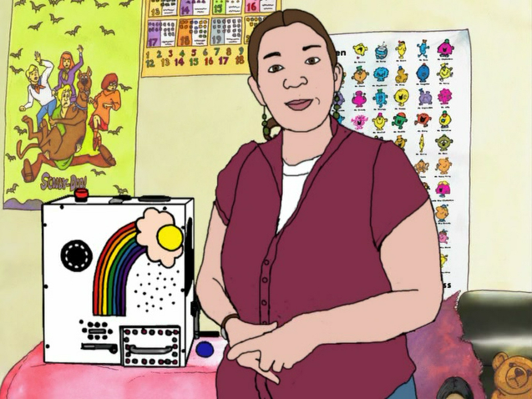 b. 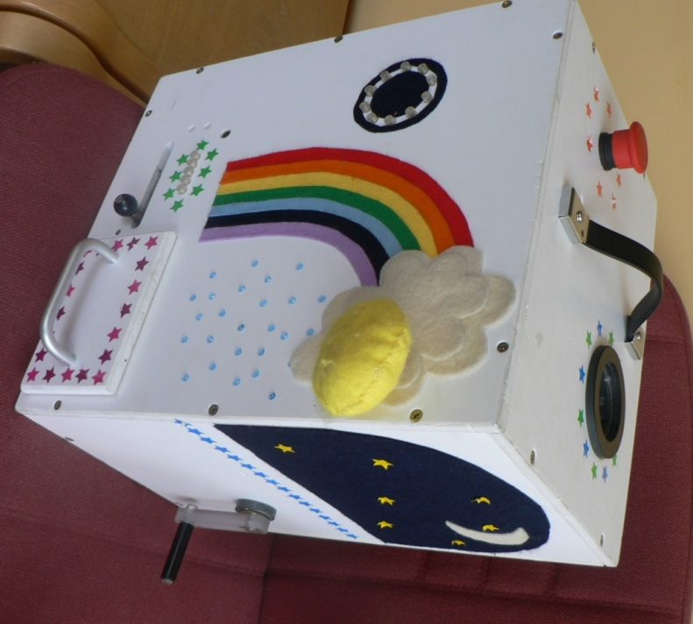

Figure 3.1. Still image from the Animated video demonstration in Study 1 (a.). The wooden box stimuli presented to the children for behavioural recall (b).
Three different versions of the DVD were created for the original study; Empty, Full, and Animated. All videos showed the same person demonstrating the target actions with the box placed on a table in a room with children’s posters in the background. However, three videos differed in the style of narration that was used during the demonstration and the visual effects on the video. The Empty and Full conditions were matched recordings which contained either empty non-specific language cues (e.g., “I wonder what happens if I do this”) or full language cues which labelled and described the event and actions (e.g., “Press the big red button at the top of the box”). An Animated version was then created from the Full version (see figure 1.1). To do this, individual still frames (12 per second) were made into a simplified, cartoon style image with brighter, more enhanced, colours in Photoshop. Each child just viewed one version on the video, depending on group assignment.
The verbal recall phase was conducted either immediately after watching the video, or after a delay of 1 or 2 weeks, depending on group assignment. The verbal recall phase consisted of open questions including: “Can you tell me what happened in the video?” and “there was a lady in the video, what did she do?” During this phase, the experimenter reinforced the child’s responses by repeating back what the child said and gave general praise for all responses. The experimenter did not produce any gestures while questioning the children. The children’s verbal recall was coded for gestures from the video tapes. The verbal recall phase continued until the child did not report any further information. Immediately after the verbal recall phase, each child participated in a behavioural recall phase. The experimenter revealed the colour changing box from the video that had been hidden under a cover in the corner of the room. She then gave the child the blue ball and said “show me what you saw on the video”. The child had 2 minutes from the time they began interacting with the box in which to reproduce the actions. The entire session was videotaped for later analysis.
Coding
All speech and hand movements were transcribed from the video, with multiple passes made to obtain accurate speech and gesture descriptions (McNeill, 2005). Gestures and speech were coded in parallel for recalled information to only count concepts that were relevant to the recalled event and once for the first time they were recalled. This coding method is consistent with previous memory research studies testing children’s verbal recall (e.g., Simcock & Hayne, 2002; Simcock & Hayne 2003; Wesson & Salmon, 2001). Verbal recall. Once the entire verbal recall session was transcribed, individual target words were identified. To calculate the variable of Verbal Recall, target words received a point for the first time they were produced. Because the intention was to use verbal and gesture responses in order to measure what the children could recall about the series of target actions they were shown, only information relevant to completing these actions were coded (for an example, see Table 2.1).
Only target words that were produced during on-topic speech were coded. So, for example, if the child said “She put a ball in the box” the words ‘put’ and ‘ball’ would receive a point, but if the child said “I put a ball in my garden” no words would be scored. Target words were those that referred to the actions, paths of motion, objects, size/shapes of objects, colours of the button, balls and sun, and spatial location on the box that the action occurred at. Speech and gestures that referred to decorative features, such as the lights and rainbow, experimenter or background were not coded as target information because these features were included as distracter items for behavioural recall and we wanted to code the three measures of recall in an equivalent way.
Gestures. The same gestures were coded in three variables in order to be more comparable with the general gesture literature whilst also allowing for our specific focus on meaningful information conveyed in gesture that could be compared with meaningful information conveyed verbally and behaviourally. These three variables were:

Total Gesture Count: A total count of every gesture produced, including beat gestures and repetitions of the same gesture or same meaning. Beat gestures were movements that accompanied the rhythm of speech rather than conveying meaning directly and included the child clapping their hands together during or at the end of speaking (McNeill, 1992, 2005).

Representational Gestures: This included just the gestures within Total Count Gestures that were representational and conveyed meaningful recall about the action steps. Each gesture was coded once per meaning, so repetitions of the same gesture or meaning were not coded again. 1 point was given for each gesture that conveyed different information about the 7 target actions steps (as described for verbal and behavioural recall). Because gestures are global movements, they often convey multiple concepts, so whole gestures are more comparable with a sentence than with individual words (McNeill, 2005).

Gesture Recall: Because one whole representational gesture could convey from 1 to 6 different items of information relating to each target step, the variable of gesture recall was the term used to describe the individual concepts that were conveyed (example in table 2.1). This is a similar coding method to the one used in Stevanoni and Salmon (2005). The variable of gesture recall is the one that is most directly comparable with verbal recall and behavioural recall and therefore most relevant for the present study.

In the initial transcription from the video, hand motions were described including hand shape, movement, location in space and any relation to speech (McNeill, 1992). A hand motion was coded as a representational gesture when the hands moved from a resting place, produced an action, and then paused (McNeill, 1992). For example; “moves hand away from body and up to head height, holds fingers as if holding an object with a pincer grip. Moves hand in a short downwards motion twice when he says “put in box” then drops hand to rest on the table”.
Movements to adjust the self, such as scratching the head or fidgeting with clothing, were not coded as a gesture (McNeill, 1992). The specific part of the video with the gesture was watched repeatedly until the transcriber was sure the gesture was accurately transcribed. The video was also watched several times to identify, firstly, whether hand movements were gestures, secondly whether the gestures were relevant and thirdly to identify the individual concepts that were conveyed as part of the gesture.
Once a movement was coded as a relevant gesture, the individual concepts it conveyed were identified based upon the child’s hand shape, the location in the air they were produced, and the way the hands were moved. The speech produced whilst the gesture was being performed was used to gauge whether the movement was a relevant gesture and clarify what it represented. For example, gestures indicating the actions of putting the ball in and putting the sun in were distinguished based upon what the child was saying whilst gesturing.
Gestures that did not convey any target information were not coded even if they occurred during relevant speech. Conversely, gestures that did appear to convey target information were not coded if they occurred during irrelevant speech. For example, the gesture of a holding a small ball in their hand would not be coded if it was accompanied by the speech “I have a blue ball at home”. This was consistent with the way verbal recall was coded. The aim of this was to obtain an accurate and reliable measure of recall and not include off topic information that 3-year-olds tend to produce. This is similar to the way preschool children’s gestures have been coded in other studies investigating memory (Stevanoni & Salmon, 2005).
The only gestures that were not scored at all were ones produced during irrelevant speech. For example during recall one child said “on holiday I got crabs in a bucket” and produced a grabbing gesture like claws with both hands. Emblems including head nod and shakes, shoulder shrugs and repeating the demonstrator’s wave goodbye were not scored. The colour of the object was only relevant for steps that included specific individual colours: the red button, blue ball, yellow sun, and green ball.

Behavioural Recall. The coding of behavioural recall from the previous study was used in this analysis. The scoring was similar to that used for verbal recall and gesture production. One point was given for the re-enactment of each of the 7 target actions; pressing the button, putting the blue ball in, taking the sun off, putting it in, turning the handle, sliding the switch and opening the drawer. The item was still coded if the child attempted the action out of order and had been unable to complete the action. For example, trying to open the drawer before they had unlocked it.

Table 3.1. Example of the coding of target items used to calculate verbal and gesture recall in Study 1.
 | Verbal Recall | Gesture Recall
Action | Put in | Hand moves as if putting something in. Can be in any direction and using any hand shape.
Path of Motion | Down | Hand is moved in a short downwards motion
Object | Ball | Hand shape indicates an object of any size/shape is being manipulated. For example by forming a pincer grip between the thumb and forefinger or making a fist; any shape that is not a pointing finger
Size/Shape | Small/Circle or similar descriptor | The hand shape forms as if shaping or directly holding a ball. For example forming a cupped shape with the hand or by pressing the index finger to the thumb to form a circle.
Spatial Location on the box | On the top/ up or similar | Raises hand up in the air to indicate the top, or indicates a box shape with their hands before then indicating the top of it.
Colour | Blue | Uses a gesture to refer to colour, for example pointing towards their blue eyes when saying blue.

Reliability
Inter-rater reliability was established for the current study by randomly selecting 24 videos of the children who produced at least one item of verbal recall and a second coder transcribed the words and gestures from the videos (approximately 40% of the participants who produced verbal recall; 20% of the total sample). The number of behavioural actions identified by both coders was 98%, and for target words was 97.2%. Gestures were first calculated for the number of representational gestures identified at the same part of the verbal description and given the same overall meaning. For example, the child says “open the drawer” and as they say this they reach their hand out, grip the air and pull their hand back towards themselves as if opening the drawer. If both coders identified a gesture at this point and gave the meaning as opening the drawer then this was coded as agreed upon by the two coders. The percentage agreement for representational gestures was 88% (30 out of 34 gestures). The specific breakdown of the concepts each gesture conveyed was then calculated. Because each gesture was coded as conveying up to six concepts (action, path, object, size/shape, spatial location, and colour) then one gesture being disagreed upon could lead to a large difference between the reliability scores, therefore the percentage agreement for gesture concepts was lower at 76% (65 out of 85 concepts). When there was a disagreement in the coding both coders discussed the coding criteria and then independently re-coded that video. The first coder’s scoring was used for the analyses. In order to determine the reliability between the scores given by each rater, Spearman’s rho correlations were conducted. For verbal recall r = .982, p < .001, for representational gesture recall r = .973, p < .001, and for gesture recall r = .959, p < .001. Thus, there was high inter-rater reliability for the overall score given per participant for each measure.

Results
Out of 112 children, 110 behaviourally recalled at least one target item (98%). There were 58 (54%) who verbally recalled at least one target item, and in total 234 target words were produced (M = 2.09 words, SD = 2.7). There were 31 children who produced gestures containing target information (28%). Those 31 children produced 64 representational gestures conveying recall (M = 0.57 representational gestures, SD = 1.1) which expressed 151 target concepts (M = 1.35 gesture recall, SD=2.9). The number and type of the concepts expressed in each modality was then grouped into seven categories relating to the target information being coded for (displayed in table 2.2). There were 129 gestures produced altogether, coded in the total gesture count variable, which includes repetitions of gestures, beat gestures and interpersonal gestures such as holding the hands up when saying “I don’t know” and tapping the head or mouth whilst thinking. Seventy eight of these conveyed recall and Figure 1.1 provides the details on how the concepts coded for gesture recall were conveyed as part of each representational gesture, with visual examples of how the gesture was produced and the typical accompanying speech.

Table 3.2. The number of times an item from each category was recalled in each modality for all of the participants in Study 1.
Concept category | Verbal | Gesture
Object | 85 | 33
Colour | 45 | 1
Size/Shape | 1 | 12
Spatial Location | 1 | 20
Path | 2 | 32
Action | 75 | 46
Changes Colour | 25 | 6

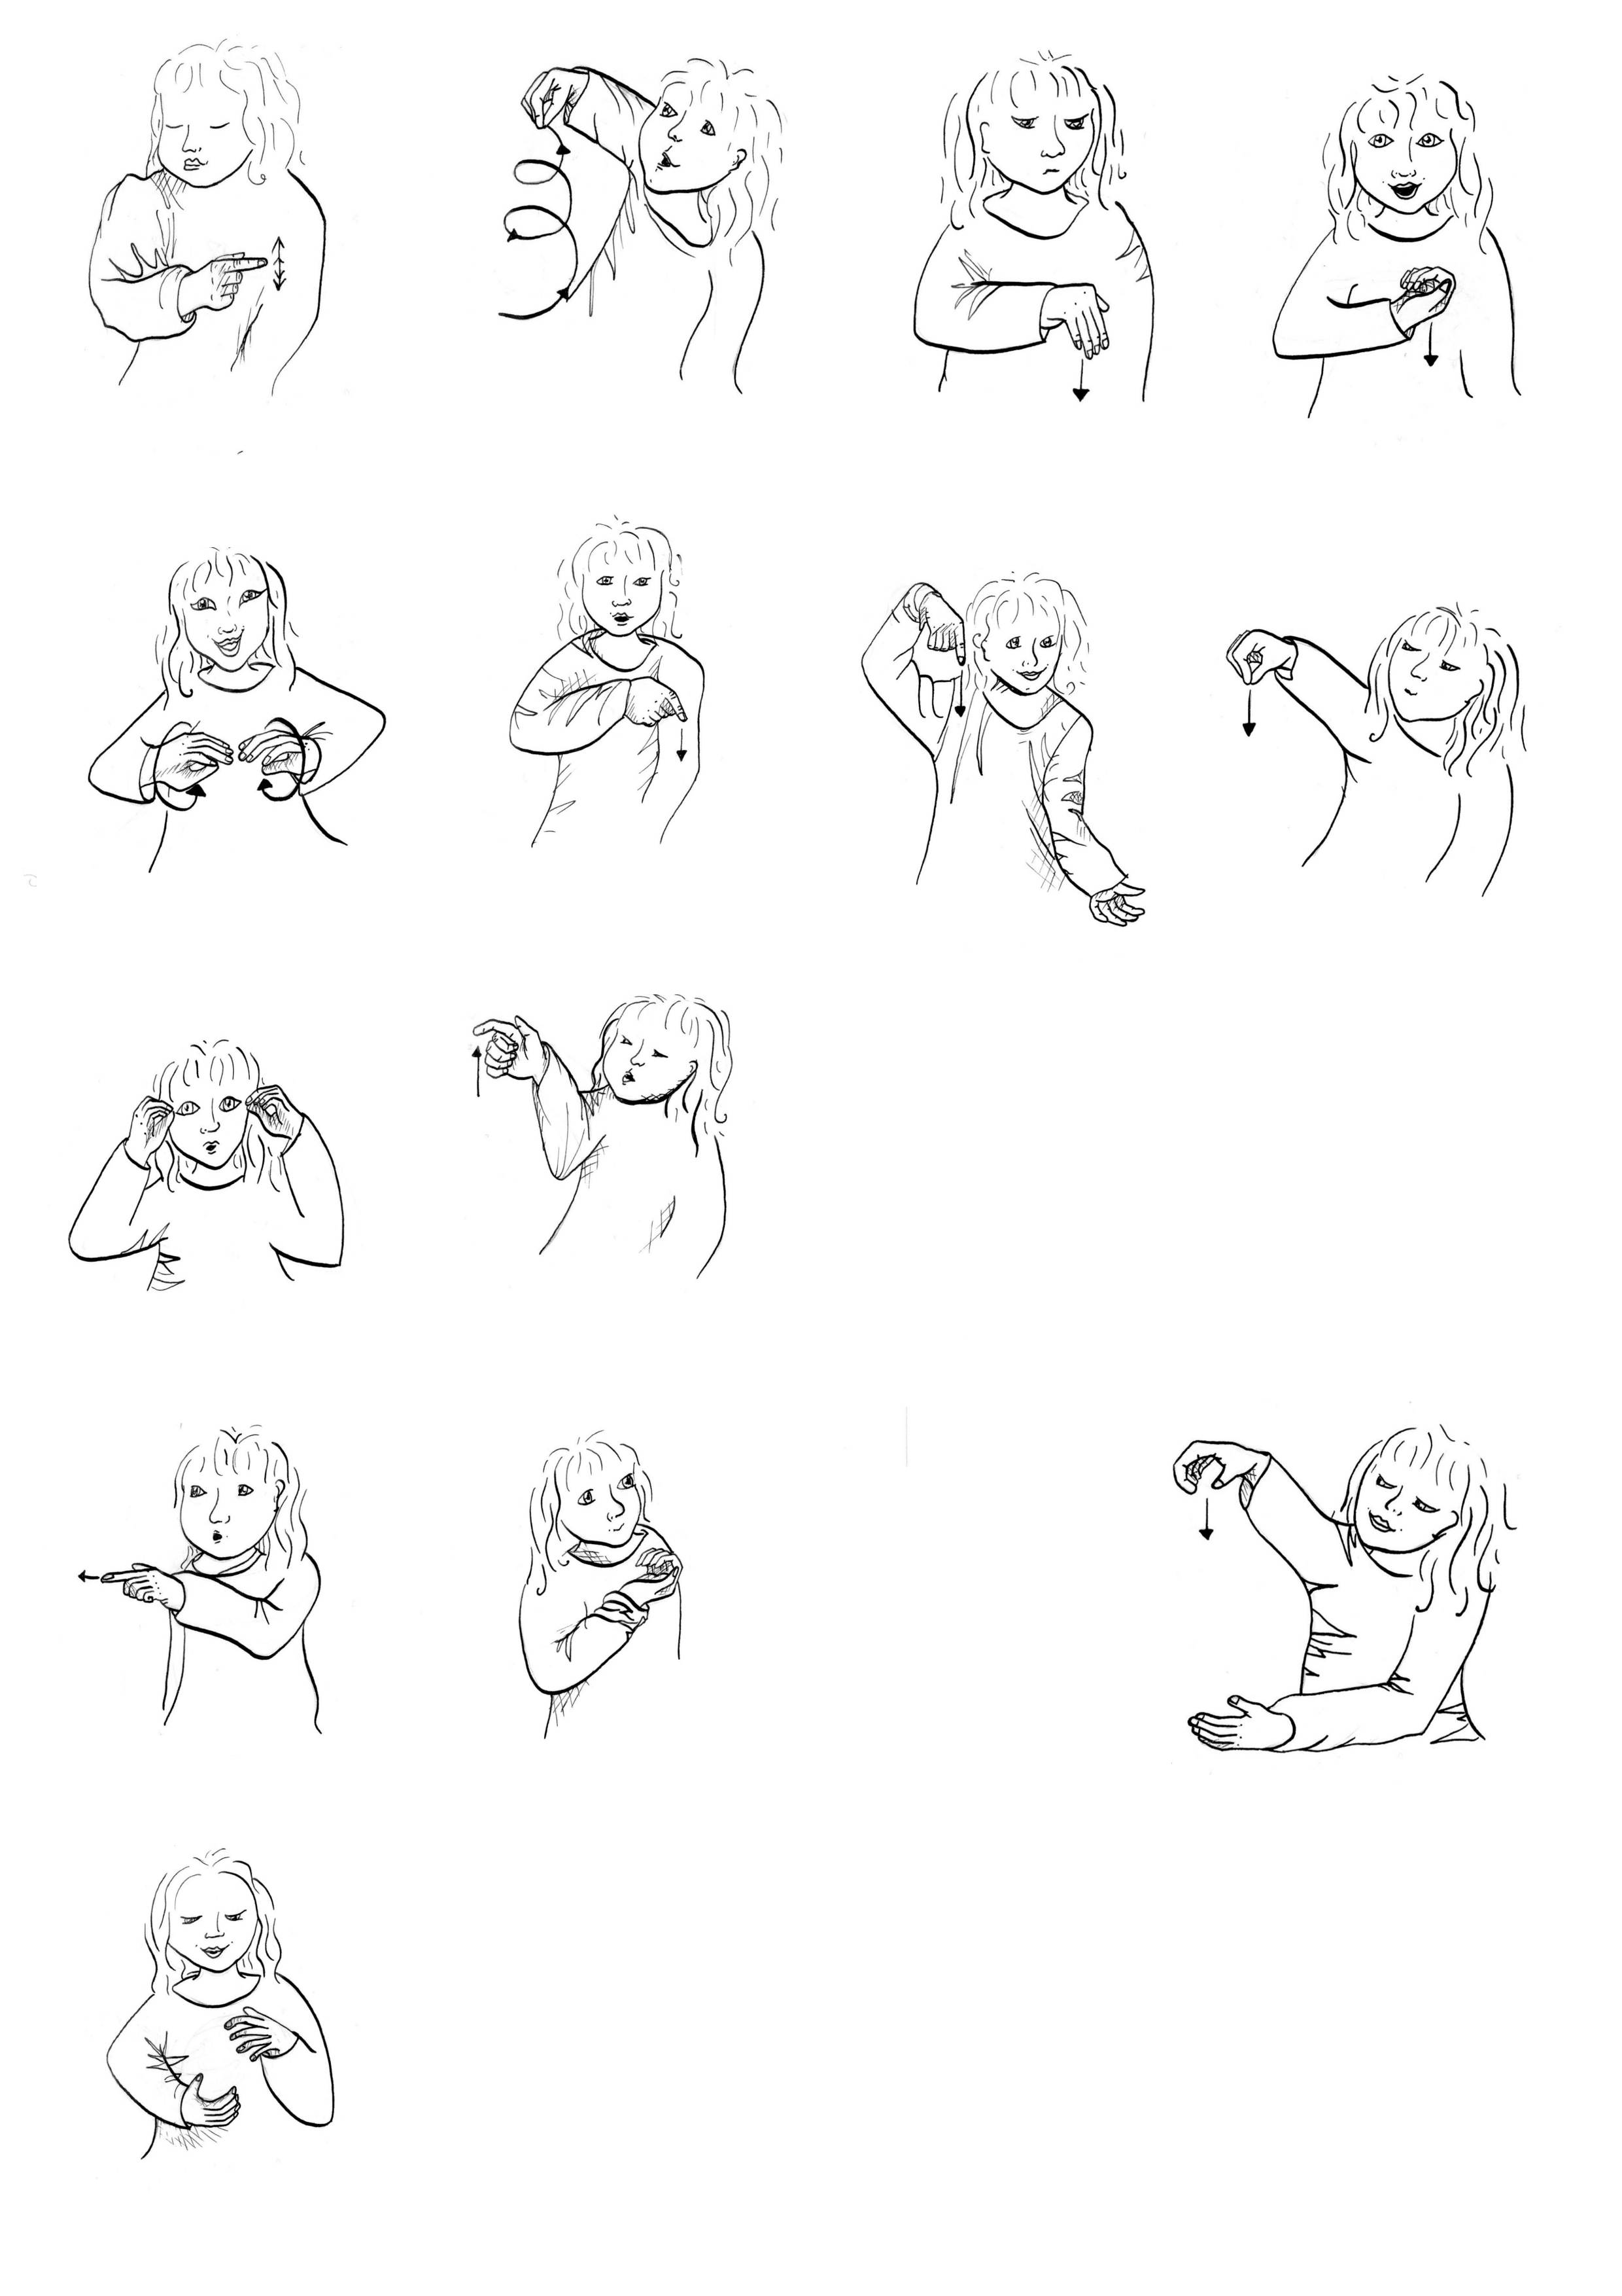
Action, Path, Object “put in” n = 6
Note: n = the number of times each gesture (given that point score) occurred in the data, including repetitions.
Figure 3.2. The scores given for the semantic information conveyed in gesture in study 1 with examples.
Points 1 2 3 4
Object, Size “ball”
n = 10
Spatial “sun” n = 2
Colour “green” n = 1
Object “ball” n = 1
Action, Path, Spatial “put in”
n = 15
Action “put in”
n = 11
Points
5
Action, Path, Object, Spatial “put in” n = 2
Action, Path “put in” n = 9
Change
n = 7
Action, Spatial
“put in” n = 1
Action, Spatial, Path, Object, Size
“put ball in”
n = 5
Action, Path, Object, Size “put in” n = 3
Action, Object “turn handle” n = 5
In the original study (Hayman, Herbert, & Watson, 2007), video type and delay length were manipulated in nine experimental conditions. As these variables were not under investigation in the present study they were analysed to rule out any effect on gesture production so that the conditions could be collapsed. In the present analysis these variables were analysed for the current subset of 112 participants to determine whether they may have had an effect on gesture production. The data was not normally distributed, as indicated by histograms and Kolmogorov-Smirnov tests of normality, so non-parametric Kruskal-Wallis tests were conducted. For behavioural imitation (total Mdn = 6, Range = 7), no significant differences were found for any of the conditions, χ² (56, N = 112) = 60.6, p = .508. For verbal recall, there was not a significant effect of delay length (immediate n = 35, Mdn = 2, Range = 12, 1-week n = 37, Mdn = 0, Range = 10, 2-weeks n = 40, Mdn = 0.5, Range = 8) χ² (22, N = 112) = 22.6, p = .634. There was a significant effect of video type on the number of words recalled (empty n = 37, Mdn = 0, range = 6; full n = 33, Mdn = 2, Range = 8; animated n = 42, Mdn = 3, Range = 12), χ² (22, 112) = 36.7, p < .05. Games-Howell post-hoc tests indicated that the full and animated conditions had significantly higher verbal recall in comparison to the empty condition, but were not significantly different to each other.
The data was then examined for gesture recall. Gesture recall was also not-normally distributed due to a high number of 0 values across all conditions, so non-parametric Kruskal-Wallis tests were used. There was not a significant effect of delay length on gesture recall (immediate Mdn = 0, Range = 10, 1 week Mdn = 0, Range = 16, 2 weeks Mdn = 0, Range = 13) χ² (22, N = 112) = 25.1, p = .723. There was not a significant effect of video type on gesture recall (empty Mdn = 0, Range = 8, full Mdn = 0, Range = 10, animated Mdn = 0, Range = 16), χ² (22, N = 122) = 19.4, p = .096, although there was a trend for gesture production to increase with narration and animation.
Gesture recall was then examined collapsed across condition. There were 31 participants who scored at least 1 for gesture recall, and 81 participants who did not. For behavioural imitation significantly more actions were imitated by the gesturers (Mdn = 6, Range = 5) than the non-gesturers (Mdn = 5, Range = 7), χ² (7, N = 112) = 12.2, p = .002. For verbal recall there was a significantly higher score for the gesturers (Mdn = 5, Range = 12) in comparison to the non-gesturers (Mdn = 0, Range = 10), χ² (11, N = 112) = 50.1, p < .001.
Next the relationship between the dependent variables was analysed in order to identify any significant correlations. The variables of age, BPVS-II test score, number of correct behavioural actions imitated (behavioural), verbal recall (verbal), the number of representational gestures and gesture recall and gender were analysed. All variables, apart from age, were significantly non-normally distributed on a Kolmogorov-Smirnov test of normality so non-parametric correlations were computed using Spearman’s rho coefficients. Behavioural recall was significantly positively correlated with gesture recall, r_{s} = .327, p < .001, and verbal recall, r_{s} = .287, p < .001. Verbal recall was significantly positively correlated with gesture recall, r_{s} = .626, p < .001. BPVS-II test score and age were not significantly correlated with any of the variables. This indicates that all three measures of recall were significantly positively correlated with each other to a small to medium level.

Discussion
Consistent with our hypothesis, we found that an observer can obtain information about an event preschool children have observed reflected in their gestures. The information contained in gesture includes spatial information that children do not or cannot report verbally. However, under a third (28%) of children spontaneously produced at least one gesture that contained task relevant recall information. During verbal recall about half (52%) of the children produced at least one item of target information. This is consistent with previous research that also found that whilst preschool children can behaviourally recall an event, their verbal recall is low (Simcock & Hayne, 2003).
Since some aspects of the event were reported verbally this suggests some aspects of the memory are accessible verbally to preschool children, spatial information may be knowledge that is particularly difficult for preschool children to access verbally. This is consistent with the theory that memory is primarily non-verbal for preschool children. Spatial information is likely to be implicit knowledge the children know from their real world visio-spatial experiences but may be information that they do not yet have the vocabulary, or explicit conceptual knowledge to describe. The finding that this information was expressed only in gestures is consistent with this and predicted by the theory that gestures can express implicit knowledge (Alibali et al., 1993). This recall could only have been identified by observing gesture content rather than behavioural re-enactment because the subtlety of this information could not be separated from what is prompted by the physical presence of the stimuli during behavioural re-enactment. We have not found that observing gesture production could be used as a method of obtaining non-verbal recall in the absence of verbal recall. However, when verbal recall can be elicited then further unique information about preschool children’s recall can be obtained including a measure of gestures.
The gestures produced in this study were primarily representational gestures produced during fluent, descriptive speech production. These gestures primarily conveyed motor actions and spatial information that represented the steps of the task. This finding is consistent with the work of Stefanini et al. (2009), and Pettenati et al. (2010) who reported that preschool children produce representational gestures which convey actions, paths of movement and objects, when they are naming pictures. Our findings also show that preschool children can produce these types of representational gesture when describing a video they observed a single time, up to 2 weeks previously. This is consistent with the findings that older children, 6-to-7-year-olds, also produce these types of representational gestures when recalling an event they saw 2-weeks previously (Stevanoni & Salmon, 2005).
The findings that the children produced representational gestures that seemed to be physically re-enacting the events actions, and spatial information from the event as if there was an invisible box in front of the children, is consistent with the theories of the gestures as simulated actions framework (GSA) and that gestures can convey implicit information (Alibali & Goldin-Meadow, 1993; Hostetter & Alibali, 2008). Whilst we did not find that children produced any information in gesture that conflicted with their speech, the spatial information they conveyed was uniquely conveyed in gesture. The theory that gestures can convey implicit information would predict that the information conveyed in gesture but not speech is information that the children cannot fully articulate yet but are on the verge of understanding.
A limitation of this study is that the data was taken from a study where the effect of narration in the demonstration was manipulated. It is possible that this manipulation had an effect on gesture production, even though this effect was not statistically significant. The fully narrated animated condition elicited significantly higher levels of verbal recall than the empty conditions. Although there was not a significant effect of video type on gesture, gesture production did follow the same trend as verbal recall, with more children gesturing and more gestures produced in the animated condition than the empty condition. Typically tests using deferred imitation do not use narration during the demonstration, when obtaining behavioural imitation (for review see Meltzoff, 1995). However the addition of verbal cues during a behavioural demonstration has been found to increase behavioural imitation rates in infants (Hayne & Herbert, 2004). The present findings suggest that using full and detailed narration in the demonstration could be a relevant factor in increasing verbal and gesture recall for preschool children and would be worth further investigation.
In this study, verbal, gesture, and behavioural measures of recall were all found to be positively correlated. This could indicate that gestures were supporting the children’s memory for the event, since children who did not gesture recalled significantly less verbally and behaviourally. However, because so few children gestured it could also just indicate that the children who could recall the event, and were willing to talk about it, were therefore the ones that expressed details about the event in all three modalities. In order to limit the effect that the more children spoke the more they gestured(i.e. that gestures were just an artifact of increased speech), each relevant piece of information was only coded once per modality. That is, we coded only the first time information was produced in speech and also the first time it was produced in gesture.

Although previous research has identified that gesturing can support speech production and verbal recall (Rauscher et al., 1996; Stevanoni & Salmon, 2005; Wesp et al., 2001) this has not been examined with a measure of behavioural recall included. Therefore the next steps for this research is to examine this causally by manipulating gesture production and measure the effect of this on verbal and behavioural recall. Finding a method of increasing verbal and gesture production by preschool children so that the majority of the children produce gestures that convey recall is also required.
The relationship between speech, gesture and behavioural re-enactment found in this study was one of being three different viewpoints of the same event. That is, the same general information was conveyed in all three measures but different aspects of each item were conveyed in each modality. Verbal recall, gesture recall and behavioural recall were not highly correlated, suggesting that although there is an overlap between each modality there each one provides individually valuable information. Because the amount of information produced during behavioural recall was high then any actions they conveyed verbally and in gesture were the same as those they had conveyed behaviourally. For example a typical response was the child recalling six actions behaviourally, verbally recalling one of those actions and producing a gesture of this same one action but supplementing this with the spatial location and path of motion involved in the action. This example demonstrates that if only gross aspects of a memory are being coded then coding all three modalities may be redundant but if a full picture of the entire event being remembered is required then having all three measures of recall will provide more information.
In summary, Goldin-Meadow (2000, 2009) has stated that gestures should be observed by researchers in order to obtain an insight into the child’s mental processes. We have applied this to preschool gestures during event recall and found that gestures can be obtained that convey important information that preschool have recalled from the event but not conveyed in another modality. Further investigation is needed to identify what influences the rates of gesture production, particularly to identify whether the amount of narration in the demonstration influences gesture production. Our findings demonstrate that the observation of the content of preschool children’s gestures as a measure of recall would allow for a more complete recording of what they can recall, in addition to using verbal and behavioural measures of recall.

Chapter 4
Eliciting gesture production in 3-year-olds to increase recall
Experiment 1
Manipulating gesture production is an important method of establishing the causal effects of gestures (Cook, et al., 2007; Goldin-Meadow, 2009; Rauscher, et al., 1996). Without a gesture manipulation children cannot be randomly assigned to condition, so it cannot be determined whether producing gestures supports memory or whether children with better memories also happen to gesture more without this being a causal effect. Ideally the gesture manipulation would involve all participants gesturing in one condition, compared with none of the participants gesturing in a comparison condition. In reality though gesturing is a difficult behavior to manipulate because it is produced automatically with little conscious thought (Goldin-Meadow, 2003; McNeill, 1992). Many variables have been theorized to affect whether gestures are produced. These variables include, the amount of action involved in the original encoding event, visual-spatial properties of the memory, how socially acceptable the speaker deems gesturing in that context, the lexical demands, the mental processing and working memory demands of the task, and the communication demands of the context (Hostetter & Alibali, 2008; Kita, 2000; Rauscher et al., 1996. This means that even adults do not fully comply with instructions to produce, or not produce, gestures when they are speaking, and that it may be particularly challenging to manipulate gesture production in young children (e.g., Cook, Yip & Goldin-Meaodw, 2010). This chapter focuses on methods of manipulating children’s gesture production in order to measure the effect of gesturing on memory and identify methods that could lead to higher levels of recall.
A range of methods have been used to increase children’s gesturing rates in order to compare a high rate of gesturing with spontaneous gesturing or no gesturing. With school aged children (8- to 12-year-olds), just verbally instructing children to use their hands when they speak results in increased gesturing (Broaders, Cook, Mitchell & Goldin-Meadow, 2007; Goldin-Meadow, et al. 2001; Ping & Goldin-Meadow, 2010). This method has identified that producing gestures results in children being able to hold a larger amount in working memory than when they are told not to gesture (Goldin-Meadow et al., 2001; Broaders et al., 2007; Ping & Goldin-Meadow, 2010). Combining the instruction to gesture with the modelling of gestures, thereby providing examples of gesturing, is also an effective way to increase the gesture production in 5- to -9-year-olds (Cameron & Xu, 2011; Cook & Goldin-Meadow, 2006; Stevanoni & Salmon, 2005; Wesson & Salmon, 2001). Although only Stevanoni and Salmon (2005) directly compared whether providing examples of gestures increased recall more than just instructing children to gesture verbally, the other studies compared instructed and modelled gesturing with restricted gesturing (Cameron & Xu, 2011; Cook & Goldin-Meadow, 2006) or did not measure gestures in the other condition (Wesson & Salmon, 2001). This comparison (Stevanoni & Salmon, 2005) identified that it was the instruction to gesture combined with modelled gestures that specifically increased gesturing and not just modelling gesturing without an instruction telling the child to gesture. With preschool children (2-to-4-year-olds) instructing them to produce a specific gesture (pointing at objects) has been found to result in more accurate counting than not pointing (Alibali & DiRusso, 1999; Graham, 1999). Taken together these findings indicate that telling children to gesture and modelling gesturing is likely to increase gesture rates above spontaneous rates and lead to increased verbal recall compared to the amount of verbal recall that could be obtained when gesturing is spontaneous or restricted.
Methods to decrease or prevent gesture production have varied depending on the participants’ age. With school-age children, simply instructing the participants not to move their hands when speaking has been a successful way to prevent gesturing by most participants (e.g., Goldin-Meadow, et al., 2001; Ping & Goldin-Meadow, 2010) whilst studies conducted with children under 7-years-old have often needed to use a method of physically restricting the children’s hands in order to prevent gesturing. Methods of restricting gesturing in young children have included asking children to; keep their hands in an apron pocket (Stevanoni & Salmon, 2005), to hold onto a bar (Cameron & Xu, 2011), to wear mittens that are attached to the table (Pine et al., 2004) and hold down computer keys that pause the task upon release (Delgado et al., 2011). All these methods were found to be effective at restricting gesture production and led to a significantly lower performance on the tasks of verbal event recall, working memory, word retrieval and counting. These findings indicate that gestures were supporting the speaker’s speech and memory during these tasks, since restricting gesturing impaired speech and memory performance on each task.
However a criticism of artificially restricting gesture production is that this involves altering the participant’s normal behavior so any impairment to speech and memory could simply be due to the discomfort or strangeness of having normal movement restricted, not because gesturing specifically is restricted. This concern has been addressed in several studies by having a control condition where gesturing is spontaneous and comparing the performance of children who do not gesture spontaneously with children whose gesturing has been restricted. Using a control condition has revealed no significant difference for verbal recall (Stevanoni & Salmon, 2005) or the holding of words in working memory (Ping & Goldin-Meadow, 2010) between children who do not gesture spontaneously when they are able to and children who are prevented from gesturing. In a study with adults, Rauscher et al. (1996) restricted gesturing by attaching wires to the participant’s hands and telling them not to move so an electrical conductance reading could be taken, whilst asking them to watch and then verbally recall cartoon clips. In comparison to allowing spontaneous gesturing, preventing gesturing impaired performance only for the retrieval of spatial words, not for all words. The authors argue that if the restriction of normal behavior was affecting the speaker’s speech and memory then all responses should have been affected. However, as only the production of spatial words was affected by restricting behavior, gestures appeared to support the production of spatial words. Taken together, this evidence suggests that artificially restricting gesturing does not produce any effects that are different to the speaker spontaneously not producing gestures. Thus, restricting gesture production appears to be a valid method that allows for gesturing behavior to be randomly assigned to participants in order to test for the causal effects of gesturing.
Encouraging gesture production may increase recall because, according to the gestures as simulated action framework (Hostetter & Alibali, 2008), producing gestures depends on the level of an activation threshold, with a high activation threshold leading to a reduced amount of gestures being produced whilst speaking, and vice versa. The level of the threshold is proposed by Hostetter and Alibali (2008) to fluctuate and to be affected by environmental factors such as the social environment and how appropriate the speaker deems it to gesture, as well as factors relating to the underlying stored concepts, such as how much action and perceptual information was stored from the event. It may be that encouraging gesture production through the modeling of gestures and asking the speaker to gesture lowers the gesture activation threshold allowing more gestures to be produced and more additional information about the memory (such as spatial locations and specific motions) to be produced. Conversely, the gestures as simulated action framework predicts that not producing gestures, either naturally or by being prevented from gesturing, would involve using cognitive resources to increase the activation threshold which would then be predicted to reduce the amount of information that could be recalled.
The aim of the present study is to manipulate children’s gesture production during recall with the aim of increasing the number of participants who gesture and the amount of gesture recall produced above the low spontaneous levels identified in Chapter 3. By comparing the performance of children in a manipulation to increase gesturing with children whose gesture production is restricted at recall, we aim to determine whether producing gestures during recall is supporting children’s recall about the event. Gestures will also be measured for semantic content recalled and differences in gesture recall will be examined between conditions.
Three-year-olds will be tested in this study because this age has been identified as the starting point for the production of fluent speech and gestures (McNeill, 2005) and it is also an age when it is difficult to elicit verbal event recall (e.g., Simcock & Hayne, 2003). Encouraging increased rates of gesturing is therefore being examined as a method of obtaining more recall from young children. Previous research by Cameron and Xu (2011) has manipulated preschoolers’ gesture production by telling 4-to-5-year-olds’ a story that included the experimenter producing gestures and then either restricted gesturing or encouraged gesturing when the children verbally re-told the story. The present research aims to extend this research in three main ways: testing a younger age group, having a spontaneous gesturing condition as a comparison group to determine whether encouraging gesturing increases gesture rates above spontaneous levels, and by coding the semantic content in children’s gestures to identify whether instructions to gesture increase the type as well as the amount of information conveyed through gestures. Additionally Cameron and Xu measured the effect of gesturing on verbal recall only, whereas in the present study, behavioural recall will also be measured and compared with verbal and gesture recall to determine whether gesturing has an effect on the memory for the event overall or specifically on the speech or communication of that recall.
To address these issues, children saw a video demonstration of the colour changing box used in chapter 3 and then gesturing behaviour was manipulated during verbal recall. The same task was used because it followed a similar design as previous event recall tasks used in memory research (e.g., Simcock & Hayne, 2002; Simcock & Hayne, 2003) and was successful in engaging preschoolers’ attention. Furthermore, the finding from chapter 3 of this thesis that some spontaneous gesture production occurred when preschoolers participated in this task indicated that there was room for improvement for encouraging increased gesture production. Participants were randomly assigned to one of three conditions: control, encouraged and discouraged. In the control condition, no instructions about gesturing were given and children were free to gesture spontaneously. In the discouraged condition, children were instructed to keep their hands still and asked to place their hands on hand prints on the table. In the encouraged condition, the experimenter modelled a series of British Sign Language signs during the language test, and the children are asked to “use your hands when you are talking to show me what you saw” at the start of recall.
It is hypothesized that if gestures are supporting the speaker’s speech or memory then producing gestures will result in higher verbal and behavioural recall in comparison to not producing gestures. It is therefore predicted that the highest amount of recall will be in the encouraged gesture condition, and the lowest amount of recall will be in the discouraged gesture condition.
Method
Participants
The final sample consisted of 42 children (21 girls and 21 boys, M_{age} = 36.5, range = 35-38 months). Children were randomly assigned to each condition with the constraint of an equal gender ratio per condition (n = 7 males and 7 females). An additional 9 children were tested but excluded from the final analysis: piloting the procedure (n = 6) and did not cooperate with all of the tasks (n = 3).
Participants were recruited from a database of families that has been maintained through visiting parents at the local maternity unit and through parents signing up online or by returning a research leaflet. Parents identified their child’s ethnicity on a demographic form; 90% were identified as White British, 8% were identified as dual ethnicity (not specified) and 2% preferred not to disclose. The main caregiver’s highest level of education was: 31% postgraduate, 16% degree, 14% BTEC, NVQ or A-levels, 4% GCSE, and 4% without educational qualifications. All of the children spoke English. Two of the children were bilingual (English/Persian and English/French). All of the children attended child care or playgroup on a weekly basis. Forty three percent of the children had been taught some baby sign language and one child had a family member who used British Sign Language to communicate, but none of the children were reported to regularly use sign language in their daily life. The majority of children (45%) were the 1st born child, 37% were the 2nd born, 12% were 3rd born and 2% were the 4th born. Twenty nine percent of the children did not have siblings, 51% had 1 sibling, 16% had 2 siblings and 2% had 3 siblings.
This study received ethics approval, as part of a series of studies, from the departmental ethics committee in February 2011.
Measures
The BPVS II (Dunn et al., 1997) was used to measure vocabulary comprehension. The scores were translated into standardised scores which resulted in a range from 90 to 132 (M = 113). This is an age equivalent range of 32-months to 62-months (M = 42 months) (Dunn et al., 1997). The lower end of the range is approximate to the actual age of the participants and indicates that our sample ranged from average to highly above average for vocabulary comprehension. Based upon these scores it is unlikely that any of the participants did not comprehend the verbal information in the study or did not produce verbal recall due to lack of language capability. None of the parents reported any concerns with their child’s language development.
Materials and Procedure
All children were tested individually in the same testing room in the psychology department, with their parent present throughout the session. Informed written consent was obtained from the parent on behalf of the child. The child assented verbally and the study was stopped if he or she refused to participate at any stage either verbally or behaviourally. Before the testing session began the experimenter played with the child and some toys for 5-15 minutes to build rapport while the parent completed a demographic questionnaire and a questionnaire on the child’s development and social experiences (see appendix A). The child, parent and experimenter then moved to the nearby testing room and sat on child-sized chairs at a low table, with the child in the middle and their parent and the experimenter on either side. All children first completed a jigsaw puzzle with the experimenter as a warm-up activity in the testing room.
The session then began with the experimenter administering the BPVS-II, which took approximately 15 minutes depending on the child’s ability. In the control and discouraged conditions the BPVS-II was conducted by following the standard manual protocol. In the encouraged condition for the first set of twelve words of the BPVS-II, after each picture had been indicated by the child, the experimenter demonstrated a British Sign Language sign that represented the correct word and then invited the child to copy this sign too. The signs were obtained from a book for parents to introduce British Sign Language to preschool children (Smith & Teasdale, 2005). For example, after the experimenter had presented the child with the four pictures and asked them to point to bus and the child had made their selection, as per the standard BPVS-II procedure, the experimenter then said “I know an action for bus” and produced the sign for bus by moving both hands as if turning a steering wheel (for sign list and descriptions see appendix B). The signs were iconic in form and intended to be similar to representational gestures. After the first set of words was presented along with the signs, the rest of the sets were conducted according to the standard procedure.
Once the BPVS-II was completed the child was asked to watch a 5 minute video demonstrating a colour changing trick (described in Chapter 3). In the discouraged condition the child was asked to place their hands on handprints on the table. This was done at the start of the video with the aim of familiarizing the children with having their hands on the prints before the verbal recall phase. The child was reminded to replace their hands on the handprints if they moved them during the video or verbal recall phase. This was not enforced if they declined and the child was not interrupted if they removed their hands while they were speaking. Half of the children removed their hands from the prints at some point briefly during the recall phase, with two of these children taking their hands off the prints for the duration of recall but holding them clasped together. At the start of the verbal recall phase the experimenter asked the children in the discouraged condition to keep their hands on the hands prints while they were talking. The children in the encouraged condition were asked to use their hands while they were talking, “like we did before” and the experimenter pointed to the child and waved their hands. No mention of what to do with their hands was made to the children in the control condition. The experimenter did not gesture and made minimal movements while asking the open questions during the verbal recall phase. The video demonstration, verbal recall, and behavioural recall phases were identical to the procedure used in chapter 3, with the exceptions described above for the discouraged and encouraged conditions. The recall session occurred immediately after the child had watched the video demonstration.
Coding
The data was coded for verbal and gesture recall during open questions, and then coded for behavioural recall, using the same criteria described in Chapter 3 (based on coding criteria used in McNeill, 2005; Pettenati et al., 2010; Stevanoni & Salmon, 2005; Wesson & Salmon, 2001).
All verbal and gesture production produced from the time the experimenter began asking the child open questions to the time when the child indicated they could not recall any more information was transcribed. As in chapter 3, gestures, words and actions that related to the 7 target steps of the procedure plus the final action of the ball changing colour were coded. The facets of each step (the objects, size/shape of objects, colour of objects, actions, paths of motion in the action, and the spatial location on the box that the action is produced at) were the items coded in a parallel way in words and gestures.
As described in Chapter 3 the gesture codes were:

Total Gesture Count: A total count of every gesture produced, including beat gestures and repetitions of the same gesture or same meaning.

Representational Gestures: A count of gestures included within Total Count Gestures that were representational and conveyed meaningful recall about the action steps. Each gesture was coded once per meaning, so repetitions of the same gesture or meaning were not coded again.

Gesture Recall: A count of the individual aspects of each step that were conveyed in each representational gesture. The variable of gesture recall is the one that is most directly comparable with the way words are coded for verbal recall and therefore most relevant for the present study.

In order to compare behavioral recall directly with verbal and gesture recall the number of target steps out of 7 that were recalled in words and gestures were calculated. One point was given for each different sentence or gesture that conveyed the main action in each target step. So for example “put ball in” would receive a point for conveying the step but “blue ball” would not.

Reliability
A third of the data was coded independently by two raters (the first author and the assistant in experiment 2) for the purposes of reliability. As part of the training process the 2nd coder made multiple passes through the data, with disagreements being discussed and each coder independently re-coding any sections of disagreement. Inter-rater reliability was calculated at the end of the coding process using spearman’s rho correlations. The inter-rater reliability for verbal recall was rs = .983, p < .001. The inter-rater reliability for behavioural recall was rs = .99, p < .001. The inter-rater reliability for representational gestures was rs = .98, p < .001. The inter-rater reliability for gesture recall was rs = .99, p < .001. This indicates a high rate of agreement for all measures of recall.

Results
Preliminary analyses for the variables of gender, language test score, key words produced, key words understood, number of siblings and baby signing experience did not correlate significantly with the main variables of verbal recall, behavioural recall or gesture recall, so they were not considered further in the analysis (see Appendix C, Table 7.1). The data was analysed to compare for differences in gesture production, gesture recall, verbal recall and behavioural recall between the conditions. Out of the 42 participants, 41 (98%) behaviourally recalled items, 25 (60%) produced verbal recall and 10 (24%) produced gesture recall. The total gesture count was low (M = 0.62, range 0-5) irrespective of condition. In the control condition 4 out of 14 children produced at least one representational gesture, in the discouraged condition 1 out of 14, and in the encouraged condition 5 out of 14. In the discouraged condition four children produced one gesture each but only one of these gestures conveyed target information and so was included in the analyses. The other gestures were an “I don’t know” emblem, tapping the chin, and a pointing gesture produced during irrelevant speech (“she put the pink ball in”). The verbal recall (M = 2.6, SD = 3.04, range 0-11) and gesture recall (M = 2.22, SD = 0.88, range 0-10) for the sample was also low compared to the possible amount that could have been recalled (maximum 40 items). Behavioral recall was high across conditions (M = 5 steps out of 7). For direct comparison to behavioural recall the number of the target steps recalled in words and gestures were calculated, collapsed across condition. For verbal recall only 18 children described at least one target step in speech (M = 1 step out of 7). For gesture recall only 9 children recalled at least one target step (M = 0 steps out of 7). For the gesturers all except one child’s gesture conveyed the same step(s) that they then re-enacted behaviourally. Similarly in speech all except one child (the same child) recalled
Table 4.1. The frequencies of the number of steps recalled per condition in words and gestures for Study 2, experiment 1.
 | Verbal |  |  | Gestures
Steps | Discouraged | Encouraged | Control | Discouraged | Encouraged | Control
0 | 9 | 6 | 9 | 14 | 9 | 11
1 | 2 | 2 | 3 | 0 | 1 | 1
2 | 2 | 5 | 1 | 0 | 2 | 1
3 | 0 | 0 | 1 | 0 | 0 | 1
4 | 0 | 1 | 0 | 0 | 1 | 0
5 | 1 | 0 | 0 | 0 | 0 | 0
6 | 0 | 0 | 0 | 0 | 0 | 0
7 | 0 | 0 | 0 | 0 | 0 | 0

the same steps in speech that they then re-enacted in gesture, with two additional children conveying steps that they did not re-enact as well as steps that they did.
Due to the large number of 0 scores kolmorogov-smirnov tests indicated that the data was significantly non-normally distributed at p < .05 for each condition for the dependent variables of verbal recall, gesture recall-concepts and gesture recall-representational gestures. Behavioural recall was significantly non-normally distributed due to a near ceiling effect. All measures also did not meet the assumption of homogeneity of variance for parametric univariate or multivariate analysis, as indicated by Levene’s test p < .001 and Box’s test of multivariate covariance p < .001. Due to low numbers of children producing gestures most of the scores for children who gestured were indicated as being outliers on frequency box plots. Since this was the phenomena being investigated these outliers were included. The child who did not produce any behavioural recall was indicated as an outlier. This score was accommodated to 2 which was the next lowest score within the range. Non parametric tests were used for the analyses of statistical significance.
Does gesture manipulation condition affect recall?
To identify whether manipulating gesture production significantly affected recall four independent samples Kruskal-Wallis tests were conducted in SPSS to compare the effect of gesture manipulation (control, encouraged, discouraged) on the median amount of recall for the dependent variables of behavioural recall, verbal recall and gesture recall (full descriptive statistics for gestures in Appendix D, Table 7.2). The variable of total gesture count was also included to identify whether overall gesture production was affected by the manipulation as predicted. For gesture recall there was not a significant effect of condition; control (Mdn = 0.00, range = 9), encouraged (Mdn = 0.00, range = 10), discouraged (Mdn = 0.00, range = 1), χ² (12, N = 42) = 10.81, p = .166. For total gesture count there was not a significant effect of condition; control (Mdn = 0.00, range = 3), encouraged (Mdn = 0.00, range = 5), discouraged (Mdn = 0.00, range = 1), χ² (8, N = 42) = 7.63, p = .356. For verbal recall there was not a significant effect of condition; control (Mdn = 2.00, range = 7), encouraged (Mdn = 2.00, range = 11), discouraged (Mdn = 0.50, range = 11), χ² (16, N = 42) = 19.22, p = .502. Finally, for behavioural recall the effect of condition was also non significant; control (Mdn = 6, range 5), encouraged (Mdn = 5.5, range 5), discouraged (Mdn = 6, range = 5), χ² (10, N = 42) = 10.0, p = .763.
Collapsed across condition: Does gesturing relate to recall?
As the previous analyses reveal that our gesture manipulations per condition were not successful, the data was then analysed for the participants that did and did not gesture, collapsed across condition. Previous research (e.g., Ping & Goldin-Meadow, 2010) has found that participants’ performance on a task was the same whether they spontaneously gestured after being told not to, or gestured because they were told to and vice versa for not gesturing. Therefore the participant’s were collapsed across condition and divided into two groups by whether they gestured at least once, or did not gesture.
To identify whether there was a relationship between spontaneous gesture recall and the other measures of recall the categorical variable of whether the participant did or did not produce at least one gesture that contained relevant information was created. Due to there being fewer gesturers than non-gesturers this led to uneven groups of 32 non-gesturers to 10 gesturers. Two independent samples Mann-Whitney-U tests were conducted to compare the verbal and behavioural recall scores for the gesturers versus the non-gesturers. Significantly more target items were reported during verbal recall by the children who gestured (Mdn = 4.0, range 11) than those who did not (Mdn = 0.5, range 11), χ² (8, N = 42) = 9.98, p = .026 but for behavioural recall there was not a significant difference between the gesturers (Mdn = 6, range = 5) and the non-gesturers (Mdn = 6.5, range = 5), χ² (5, N = 42) = 6.63, p = .122.
The total number of different concepts conveyed in words and gestures were calculated by adding up the different items each child conveyed verbally and then adding any additional new items conveyed in gestures to that score (so there was no redundancy or repetition of items). When the total different concepts conveyed in words and gestures were calculated the gesturers conveyed more information overall than the non-gesturers with a mean of 6.40 different target items of information in comparison to the mean of 2.06. This additional information primarily related to the same information being conveyed in speech but supplemented it. For example, the step of putting the ball in, but they may say “put ball” and gesture the spatial location and path of motion of putting the ball into the box.
To identify the effect size of the relationship between verbal recall and gesture recall they were correlated using Kendall’s Tau. This test was used due to the variables being non-normally distributed and there being a large number of 0 values. There was a significantly positive correlation τ = .3, p < .05 between verbal recall and gesture recall. This indicates that there was a small positive correlation between recalling information about the event verbally and recalling information about the event in gesture.

Discussion
Gesture production was low in all conditions, with just under a quarter (24%) of preschool children producingone gesture or more conveying target information when responding to open questions about their recall for an event. Verbal recall levels were also low. This is consistent with verbal and gesture recall from preschool children for verbal recall and spontaneous gesturing using this task (Chapter 3) and young children’s verbal and gestural recall in previous studies (Goksun et al., 2010; Simcock & Hayne, 2002; 2003; Stevanoni & Salmon, 2005). This indicates that encouraging and modelling gesture production is not sufficient to increase 3-year-olds gesture rates during free recall.
Gesture production levels may have been low because the children could not verbally recall the event. There was a significant positive correlation between words and gestures, and it is established in the literature that gestures primarily occur with speech (Goldin-Meadow, 2003; McNeill, 1992). This indicates that verbal and gesture recall of a single observed event prompted only by open questions may be too difficult for 3-year-olds. This explanation would be consistent with the findings of Simcock and Hayne (2002; 2003) in which 2-to-4-year-olds’ verbal recall contained significantly less target information than their behavioural recall, and supports the theory that preschool children’s memory is primarily non-verbal. Our findings indicate that because of the intrinsic link between gestures and speech it may not be possible to access additional information about preschool children’s recall non-verbally through their gestures if they do not also produce at least some speech. Our manipulations were not successful at increasing or decreasing gesture production compared to that produced in the control condition. Therefore any causal effects of gesture production on verbal and behavioural recall could not be identified.
It is possible that gesture rates were low because of limitations of the method. In Study 1 (Chapter 3) spontaneous levels of verbal and gesture recall were low. It is possible that this specific task does not elicit high rates of gesture production even when gesturing is instructed and modeled. This is likely since 3-year-olds have been found to have high levels of gesture production in other studies using different tasks, for example when asked to name pictures of actions (Pettenati et al., 2009). Another reason gesturing may have been low was because gesturing was not prompted if the children did not gesture as instructed at the start of their recall. The children were prompted to gesture at the start of recalling, and since the verbal recall session lasted for approximately 2 minutes the decision was made not to prompt gesturing in order to keep the recall session as similar as possible across conditions. Due to the difficulty of eliciting a verbal response from 3-year-olds the decision not to prompt gesturing was also made to avoid disrupting the child’s speech once they had begun to respond to the questions.
Many studies that have manipulated gesture production have not been able to encourage or prevent gestures in all children (Cameron & Xu, 2011; Broaders et al., 2007; Goldin-Meadow et al., 2001; Stevanoni & Salmon, 2005). Cameron and Xu (2011) used a design that included the experimenter modeling gestures all the way through a story but found that only 8 out of 15 (53%) 4-to-5-year-olds produced any gestures when they were asked to re-tell the story. Delgado et al. (2010) reported that on their computer task only 38% of the 2-to-4-year-old children gestured at least once when they were able to and they only gestured on a mean of 2.93 trials out of a possible 8. Although we were able to successfully discourage the children from gesturing, we were not able to compare this with a group of children who produced gestures. This indicates that even though it may be possible to physically prevent preschool children from gesturing, getting them all to produce gestures in the comparison condition is particularly difficult. Given that our main aim is to increase gesture rates in order to increase the benefits of using gestures as an additional measure of recall, Experiment 2 seeks to examine whether indirect methods to increase gesture production may be a more successful way to elicit gesturing in preschoolers.
The main focus for Experiment 2 is on finding a method of increasing gesture production in 3-year-olds. If gesture production can be increased above spontaneous levels then this method can be used in subsequent research in order to test the causal effects of gesture production on memory.

Experiment 2
Due to the low levels of verbal recall produced by preschool children, researchers have used a wide range of props in an attempt to increase recall, including toys, dolls, drawing and photographs (for review see Salmon, 2001). Props can be beneficial to young children’s verbal recall because they can be used to demonstrate what happened without the child having to fully rely on their verbal skills (Salmon, 2001). Providing props can also allow the child to focus on the objects rather than the experimenter during their recall which can reduce the social pressure of being interviewed (Salmon, 2001).
Visual props such as photographs have frequently been used to elicit further event recall from preschool children (Aschermann, Dannenberg & Schulz, 1998; Simcock & Hayne 2002; Simcock & Hayne, 2003). In these studies photographs of the stimuli were shown amongst photographs of distracter objects and the child was asked to point to the item they could recall from the event. This photograph recognition procedure led to more information being obtained than the amount that was obtained without a prop. This suggests that using a photograph can be a useful way to obtain information from preschool children that they are not able to verbally articulate. It also demonstrates that preschool children can be instructed to use pointing gestures to discriminate between items they can and cannot recall.
Another type of visual prop is the use of an image that supports the child to remember and talk about the task, rather than using photographs to test the child’s recognition of the stimuli and actions. Ling and Blades (2001) tested the use of a colour chart to support children’s recall of colours that were part of an encoding event. In this study, the children were shown grey versions of objects they had played with the day before during games with an experimenter. Half of the children were given a colour chart during recall that included the correct colours of the objects as well as other colours, whilst the other half recalled without a prop. The children who were given the prop could indicate a colour by pointing to the chart or by verbally describing the colours. Children who were given the colour chart recalled significantly more colours than children who did not. Although the results did not distinguish whether the increase in recall for children in the prop condition was from information expressed in words or pointing gestures, the findings indicate that 4-to-5-year-olds can use a general visual cue to convey more recall about colours than they could convey without a cue. This evidence suggests that more recall could be obtained from preschool children by asking them to point at visual cues in comparison to free verbal recall alone.
Visual images have also been used in order to causally manipulate gesture production. In Cameron and Xu (2011), a map identifying ten key locations was pointed to and described by the experimenter when telling the children a story. Half of the children were asked to point to the locations on the map when recalling them and the experimenter also pointed to the pictures. All of the children gestured when asked to in this condition. In a no-gesture condition children were asked to hold onto a bar during recall meaning that they could not gesture although they could see the map. Children who were able to gesture during recall verbally reported more locations and details from the story. Thus it is the use of gestures that appears to be supporting preschool children’s verbal recall when they are asked to point at visual cues during recall. Pointing may have served a similar function to pointing during working memory tasks, reducing cognitive load by helping children to keep track of what they have said and the locations they need to talk about, and matching words to locations (Alibali & DiRusso, 1999; Cameron & Xu, 2011; Delgado et al., 2012).
In addition to photographs being used to elicit pointing gestures, photographs have also been used to elicit iconic gestures from preschool children. Asking preschool children to name pictures has been found to elicit iconic gestures that represent actions associated with the image (Pettenati, et al., 2010; Pettenati, et al., 2012; Stefanini, et al., 2009). These studies were testing word retrieval rather than event recall, but their findings indicate that if children are not given instructions to point at a picture they may also spontaneously produce iconic gestures that convey additional information to that which is visible in the image.
There is also the possibility that the use of a photograph as a cue during a recall task may decrease the production of representational gestures. Adults have been found to produce more gestures when they are describing a painting from memory than when the painting is still visible (Morsella & Krauss, 2004; Wesp et al., 2001). Wesp et al. (2001) have argued that gestures are supporting spatial working memory to increase working memory capacity whilst speech is being produced. Morsella and Krauss (2004) found that adults also produce more gestures when the visual image they are recalling is more spatially complex and hard to describe verbally such as an abstract pattern. If gestures are providing a visual support to memory then it is likely that when a photograph is serving that function then gesturing will not be needed. However both studies also found that even though significantly fewer gestures were produced when a visual image was visible a high number of gestures were still produced. Morsella and Krauss argued that this indicates that gestures also serve a function for word retrieval. In a study with school age children (9- to 10-year-olds) who observed an event and were then asked to describe it, gesture production was not effected by whether the objects they were describing were physically present or not (Ping & Goldin-Meadow, 2010). The only difference found between the conditions in that study was that when the objects were visible the children produced more pointing gestures to directly reference the objects whereas when the objects were absent they produced more iconic gestures that recreated the form of the objects. This indicates that having a visual cue present at recall may still elicit gesture production in adults and older children, although it remains to be tested how a visual prompt will effect preschool children’s gesture production during recall.
Communication demands are also an important variable for gesture production. The focus of the present study is on the cognitive demands of recalling an event, with the aim of eliciting words and gestures that are related to that memory. However due to the use of questions to obtain verbal and gesture recall it also inadvertently requires communication between the child and experimenter, which could be having an effect on gesture production. Gestures do play a role in children’s communication (for review, see Hostetter, 2011) and it is possible that children’s gesture production was limited in Experiment 1 because the child knew that the experimenter had just watched the video too and therefore there was no communicative need for the child to explain what they had seen.
Communicative demands have been found to affect adult’s gesture production. Adults produce more gestures when they are speaking to someone face-to-face than when they cannot see a listener (Alibali, Heath & Myers, 2001) which indicates that the presence of listener is an important part of determining how much people gesture. Altering the communication demands of the information being conveyed has also been found to influence adult’s gesture production (Kelly, Byrne, & Holler, 2011). In this study, adults were asked to give a talk to camera about wilderness survival and the communication demands of the situation were manipulated by telling half the participants that the people who will watch the video were taking an orienteering activity (low need to communicate) or preparing for a mountain camping trip (high need to communicate). Significantly more gestures were produced when the need to communicate was high than when it was low, indicating that the speaker’s perception of the listener’s need to know the information affects gesture production rates. It remains to be determined whether increasing the need to communicate their recall increases children’s gesture production.
The aim for Experiment 2 was to test the effect of manipulating the communication demands and of using a photograph to cue recall, on 3-year-old’s gesture production. Delgado et al. (2011) found that some 2-to-4-year-olds produce pointing gestures to aid their working memory when there is no-one in the room to communicate with which suggests that the 3-year-olds in our study may also produce gestures to support their memory rather than to directly communicate. However our task design is quite different to Delgado et al. as we use an interview which is a directly communicative context. Our task follows a similar design to Stevanoni and Salmon (2005) and in their study a different person interviewed the children to the one they had met during the demonstration. Our method is also similar to Goksun et al. (2010) as they asked preschool children to verbally describe an event that the children had just witnessed to the experimenter who had been present for the event. Goksun et al. highlight that in future research that a change of experimenter could increase gesture production because the child needs to provide the perceptual cues to the new person and an easier way to do this than speech is to gesture. A direct comparison between having the same experimenter present for the demonstration and test and having a change of experimenter has not yet been conducted in research examining preschool children’s gesture production during recall. Two new conditions were conducted in Experiment 2 to compare with the conditions in Experiment 1. The absent + photo condition tested the effect of communication demands by having a change of experimenter between watching the video event and the recall phase. In addition, a photograph was used to cue recall after a period of free recall. This condition was compared to the control + photo condition in which the experimenter remained the same but the photograph was still present to cue recall, without a period of free recall. A period of free recall was not included in the control + photo condition prior to the photo being presented because this had already been conducted as the control condition in Experiment 1.
If gestures are being produced to communicate with the experimenter then an increase in gesture production is predicted in the absent + photo condition in comparison to un-cued recall in the conditions used in experiment 1 and the control + photo condition. If communication demands are not influencing gesture production then no significant differences would be expected between these conditions. The use of a photograph is predicted to increase verbal recall. If gestures are being produced to support cognitive load when the task is difficult then fewer gestures will be produced when a photo cue is used. If gestures are reflecting a stronger mental image of the event, or supporting speech production, then more gestures will be produced when a photo cue is used. Gestures will be analysed for the content of the information conveyed and compared to the information conveyed in verbal recall.

Method
Participants
A total of 28 additional children (15 girls, 13 boys, M_{age} 36.4 months, range 35-38 months) were included in Experiment 2. There were 14 participants in each condition. Children were randomly assigned to condition based upon participation order. The data for the absent + photo condition was collected before data collection for the present + photo condition. Three additional children were tested to pilot a baseline of the photograph. A further 5 children participated but their data were excluded from the analysis due to: experimenter error (n = 1) and refusal to complete the tasks (n = 4). The data from the control, encouraged and discouraged conditions from Experiment 1 was collapsed into one condition since there was not a significant difference between the conditions. This collapsed condition was reanalyzed and compared with these two new conditions to give a total of 70 participants’ data used for Experiment 2.
Parents of children in these two additional conditions reported their children’s ethnicity as; White British 88%, White European 6%, Asian British 3%, and dual ethnicity (not specified) 3%. Home language was reported as English for all of the children, with two children reported as bilingual (English/German and English/Polish). All of the children attended childcare or playgroup on a weekly basis. Twenty eight percent of the children had been taught ‘baby signs’, but none of them had any family members or friends who used sign language to communicate and they did not use sign language routinely at home. The majority of children (58%) were 1st born, 33% were 2nd born, 3% were 3rd born and 3% were 4th born out of their siblings. There were 28% of children with no siblings, 61% had 1 sibling, 5% had 2 siblings and 3% had 3 siblings. The highest level of educational qualification reported by the primary caregiver was: 47% postgraduate, 19% degree, 11% diploma, 11% NVQ, 5% GCSE and 3% A-levels.

Measures
The New Reynell Developmental Language Scales: Production Scales (NRDLS; Edwards, Letts & Sinka 2011) were used to measure the children’s expressive language capabilities. Due to the need to limit the length of the test session to maintain the children’s attention and interest, the comprehension part of this test was not administered. It is stated in the NRDLS manual that it can be assumed that in typically developing children if production is at an age appropriate level then comprehension will also be (Edwards, et al.). Six included participants did not complete the NRDLS because they did not follow the instructions, either by not speaking or not cooperating. These participants were included in the study because they cooperated in all other aspects of the study, and their parents did not have any concerns about their language development. Overall, the group had a mean standardised score of 97, with a range from 84 to 116. This is an age equivalent mean language production level of approximately 35-months, with a range of 32-months to 40-months (Edwards et al.). This is consistent with the age appropriate level for the age range tested.

Procedure
The procedure and materials from Experiment 1 were used, with the following variations detailed below. In the absent + photo condition, two experimenters greeted the family, spent time playing in the waiting room to build rapport with the child, and both entered the testing room initially. Experimenter 1 conducted the NRDLS and then said she had to leave the room but would be back shortly, and that in the meantime experimenter 2 had a video to show them, then left the room. Experimenter 2 then started the video clip showing the animated demonstration of the box. At the end of the video, experimenter 2 left the room and experimenter 1 returned. Experimenter 1 then asked the child the open questions about the video, following the same procedure as experiment 1. This experimenter then placed an A4 photograph of the magic box down on the table in front of the child and asked the same open questions used in the open recall section, with the addition of the question “How does the box work?” The procedure then continued as described in Experiment 1.

In the present + photo condition the procedure was the same as the control condition in Experiment 1 except that at recall there was no period of free recall questions. The photograph was produced immediately and then the same procedure as the absent + photo condition was followed. Prior to the language test in the present + photo condition the participants completed a similar format recall task for a different study (the rattle task from chapter 5) for approximately 5-minutes.

Coding
The data was coded using the same criteria described in experiment 1, and Chapter 3, based upon previous coding schemes for children’s verbal, behavioural and gesture recall (eg.; Pettenati et al., 2010; McNeill, 2005; Simcock & Hayne, 2002; Simcock & Hayne, 2003; Stevanoni & Salmon, 2005Wesson & Salmon, 2001).
Photo Cue: Verbal and gesture data were initially transcribed and analysed separately for open recall and photo cued recall for the absent + photo condition (only photo cued recall was collected during the present + photo condition).
Absent un-cued. The additional variable of absent un-cued was derived from the same data as the absent + photo condition by totalling the number of target items reported just during un-cued recall. The variable of absent + photo total was then calculated by adding any additional target information conveyed in words or gestures to the absent un-cued score but not including repetition of information. This was done in order to identify whether the photo cue increased recall beyond un-cued recall and did not just lead to a large score just because the participants repeated the same information when questioned again. The exception to this was the variable of total gesture count since it is a total of all of the gestures produced including repetitions.
The photo cue was coded to the same criteria as free un-cued recall except that words that only labelled the items and gestures that also just referred to what the child could see in the picture without reference to the target actions or demonstrators behaviour were not coded.
This was based upon responses obtained from a pilot baseline (3 children) with the photograph using the same open questions used during photo cued recall. In the baseline pilot each child was shown the photo cue without having seen the stimuli or demonstration, in order to determine what they would report spontaneously. During piloting the only responses the children made was to point at items on the box and say “that” or label what they could see (eg. “button”, “handle”). The pilot children reported more of the non-target decorations such as the rainbow and the moon. They did not report any of the target actions in words or gestures.
To account for the increase in pointing gestures when the photo cue was present, a set coding criteria for pointing gestures was used (examples from actual data given in table 3.1). Pointing gestures were coded depending on the context of the verbal information. To be consistent with un-cued recall, pointing gestures were not coded as conveying an object; pointing at an object was either not coded (if there was no accompanying speech or just labelling) or coded as conveying the spatial location of the action involved with the object (if the speech included the action, eg. “you press the button”-points at the button). This was in order to minimise coding any information that was just pointing without demonstrating recall, and to keep the coding of objects consistent with the un-cued recall, which required a hand shape other than a pointing gesture (e.g., a cupped hand or pincer grip indicating an object was being manipulated). Items that were incorrect (had not been demonstrated) as indicated in either words or gesture were not given a score.

Table 4.2. Examples of the coding of participant’s responses during questioning using the photo cue, in Study 2 experiment 2.
Transcribed recall | Verbal Recall Score | Gesture Recall Score
“you press that button there”-points at the button. | 2; press (action) and button (object). | 1; location of button at the top (spatial location).  -1 representational gesture-deictic
“press the button”-holds hand in a wide pincer grip above the button as wide as the button. | 2; press (action) and button (object) | 2; button (object) and width (size/shape).  -1 representational gesture-iconic
“red button” points at the button. | 0; labelling not recall. | 0; labelling not recall.
“She pressed that button” palm open and facing down is moved down twice in quick succession in the air above the button. | 2; press (action), button (object) | 3; press (action), downwards (path), at the top of the box (spatial location).  -1 representational gesture-iconic
“You press that button”-points at the handle used to carry the box. | 0; incorrect. | 0; incorrect.

Reliability
Half of the videos were coded by two raters (the first author and an undergraduate research assistant) independently to determine reliability. Inter-rater reliability was calculated using Spearman’s Rho correlations. For verbal recall, agreement was rs = .98, p < .001. For behavioural recall, agreement was rs = .88, p < .001. For representational gesture recall, agreement was rs = .96, p < .001. For gesture recall, agreement was rs = .91, p < .001. This indicates a high degree of reliability for each measure of recall.

Results
The amount of recall the children reported was analysed for responses during free recall to identify whether communication demands affected recall, and then responses during photo cued recall were compared. In the absent + photo condition, all 14 children recalled at least one piece of information in gesture, verbally, and behaviourally. In the present + photo condition, 11 out of 14 recalled at least one item verbally, 9 out 14 children recalled at least one item in gesture, and 13 out of 14 recalled at least one item behaviourally. In order to compare whether having the experimenter absent for the demonstration affected un-cued recall the condition of absent un-cued was created from absent + photo and analysed separately (see table 3.2 for a comparison of gestures produced in free recall). For the whole sample, there was a mean of 3.07 steps recalled in words (SD = 1.8), a mean of 2.61 steps recalled in gestures (SD = 1.9), and a mean of 5.25 steps recalled behaviourally (SD = 1.5). Due to the lack of significant correlation between the experimental variables of behavioural, verbal, and gesture recall and the demographic variables of gender, baby signing experience, number of siblings, and language test score in experiment 1 only language score test was compared with the experimental variables in experiment 2. This was in order to identify whether children’s language proficiency as measured by the NRDLS had an effect on their recall of the event. Spearman’s Rho bivariate correlations were used to identify that there was not a significant effect of language test score on verbal, gesture or behavioural recall, at the p < .05 level.

Table 4.3. Points scored per gesture for all representational gestures produced based upon the semantic content expressed, for free recall only, in Study 2 experiment 2.

 | Control  (exp. 1) | Encouraged  (exp. 1) | Absent-uncued  (exp. 2)
Coding Score
1 | Action n =1  Change n = 1 | Action n = 2  Change n = 1 | Action n = 1  Change n = 2
2 | Action, Path n = 4 | Action, Path n = 5 | Action, Path n = 3  Object, Size n = 1
3 |  | Action, Path, Object n = 2  Action, Path, Spatial n = 1 | Action, Path, Object n = 2  Action, Path, Spatial n = 3  Object, Size, Spa n = 1
4 | Action, Path, Spatial, Object n = 1  Action, Path, Object, Size n = 1 |  | Action, Path, Spatial, Object n = 2  Action, Path, Object, Size n = 1
5 |  | Action, Path, Object, Size, Spatial n = 1
n = the number of times this type of gesture appeared in the data, including repetitions. See figure 1.1 for visual examples of these gesture types.

The data were significantly non-normally distributed, so non-parametric statistical analyses were conducted (verbal recall skewness = .558, SE = .287, kurtosis = - .663, SE = .566. Gesture recall: skewness = 1.403, SE = .287, kurtosis = .885, SE = .566. Total gesture count: skewness = 1.915, SE = .287, kurtosis = 3.925, SE = .566. Behavioural: skewness = -.963, SE .287, kurtosis = .884, SE = .566). One outlier was identified in the absent + photo condition with a score for gesture recall of 23 concepts, which is more than 3 standard deviations higher than the mean (M = 8.07, SD = 5.4) for the absent + photo condition. In order to retain this participants’ data for the other measures of recall for which they were not outliers, this score was accommodated by changing it to the next highest score, 12 (Field, 2006).

Did a change of experimenter affect free recall?
In order to identify whether a change of experimenter resulted in an increase in the amount recalled during free recall the un-cued recall of the absent condition was compared to the recall in the collapsed conditions from Experiment 1 using three independent samples Mann-Whitney U tests. Verbal recall was not significantly different across the conditions: collapsed experiment 1 conditions (Mdn = 2.0, range = 11), absent-uncued (Mdn = 3.0, range = 10) χ² (27, N = 56) = 29.57, p = .116. Behavioural recall was also not significantly affected by condition: collapsed experiment 1 conditions (Mdn = 6.0, range = 5), absent-uncued (Mdn = 5.0, range = 3) χ² (15, N = 56) = 14.53, p = .727. However, there was a significant effect of condition on gesture recall: collapsed experiment 1 conditions (Mdn = 0.0, range = 15), absent-uncued (Mdn = 2.5, range = 10) χ² (24, N = 56) = 28.10, p = .011.
This result indicated that having a different experimenter ask the children free recall questions from the one present during the video demonstration increased the amount of information children recall in gesture. However verbal and behavioural recall were not affected by a change of experimenter (means displayed in Figure 4.1).
Did the use of a photo cue affect recall?
To identify whether the use of a photo cue affected recall, three independent samples Kruskal-Wallis tests were conducted to compare between the collapsed experiment 1 conditions, absent + photo and present + photo conditions for the variables of gesture recall, verbal recall and behavioural recall. Verbal recall was significantly different across conditions: control (Mdn = 2.0, range = 7), encouraged (Mdn = 2, range = 11), discouraged (Mdn = 0.5, range = 11), absent + photo (Mdn = 7, range = 10), control + photo (Mdn = 7.5, range = 13), χ² (48, N = 70) = 64.61, p = .001. Gesture recall was also significantly different between the conditions: control (Mdn = 0.00, range = 9), encouraged (Mdn = 0.00,
Figure 4.1 Mean amount of recall produced in Study 2, Experiment 2, for the un-cued recall in the Absent condition compared with the collapsed conditions from Study 2, Experiment 1 (error bars display 95% confidence intervals).
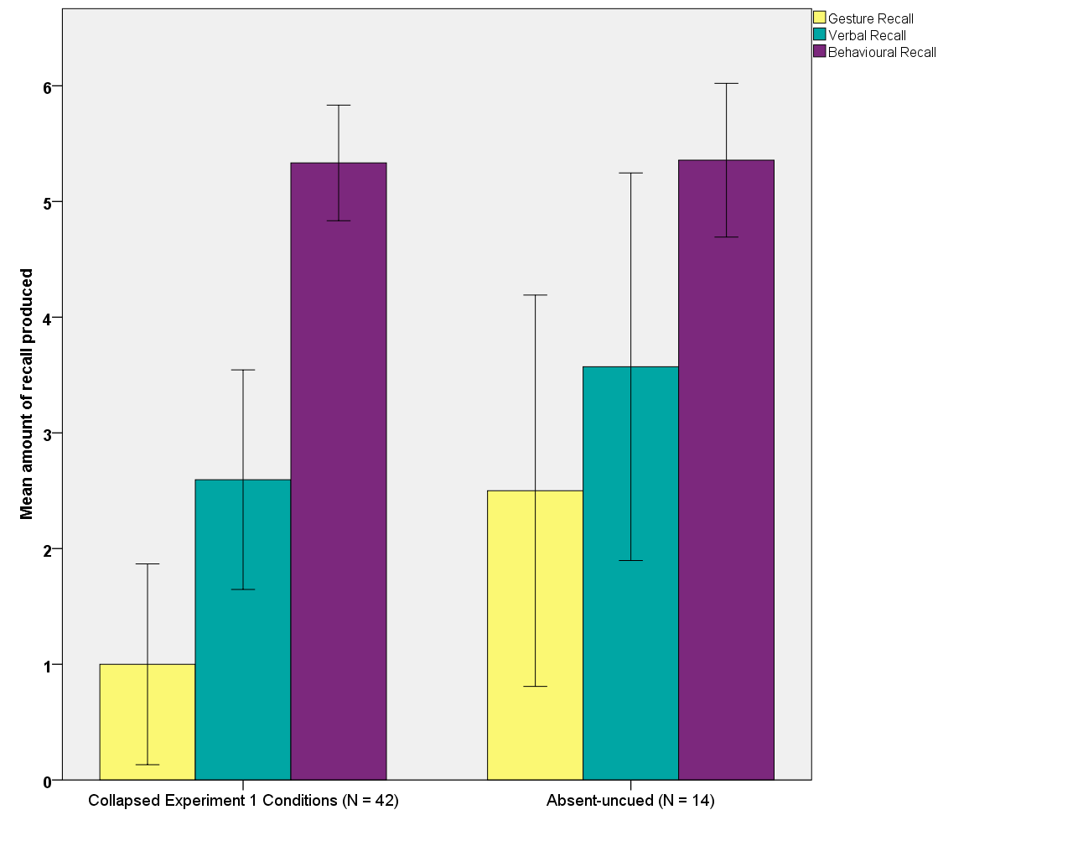
*
*
* = significantly different p < .05

range = 10), discouraged (Mdn = 0.00, range = 1), absent + photo (Mdn = 8, range 11), control + photo (Mdn = 3, range 18), χ² (60, N = 70) = 79.67, p < .001. In contrast, behavioural recall was not significantly different between the conditions, with all conditions performing at a high level on this measure: control (Mdn = 6, range 5), encouraged (Mdn = 5.5, range 5), discouraged (Mdn = 6, range = 5), absent + photo (Mdn = 5, range = 3), control + photo (Mdn = 5, range = 7), χ² (24, N = 70) = 23.32, p = .948.
Follow up comparisons for the variables of gesture recall and verbal recall were conducted using Games-Howell tests to identify which conditions were significantly different to each other. There was not a significant different between the absent + photo condition and the present + photo condition for any of the measures but both photo cued conditions had significantly higher verbal and gesture recall than the collapsed conditions from experiment 1, in which a photo cue was not used (absent + photo, p < .001, present + photo, p < .05). These findings indicate that the use of a photo cue elicited more verbal and gesture recall than just using free recall questions, regardless of whether the experimenter was present or absent for the demonstration.

Figure 4.2 Mean amount of recall produced in Study 2, Experiment 2, for the total amount of different items recalled in each modality in the photo-cued conditions compared with the collapsed conditions from Study 2, Experiment 1 (error bars display 95% confidence intervals).
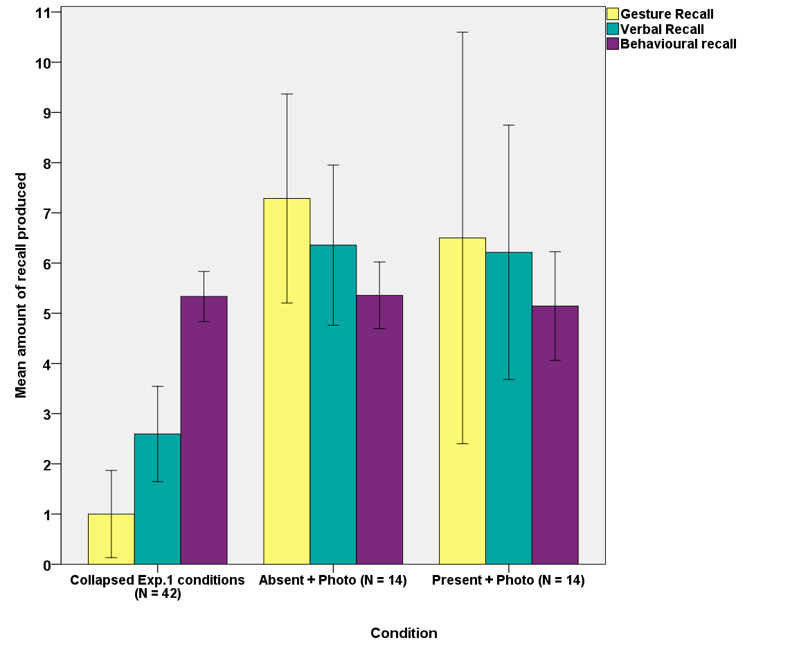

Information conveyed
The target concepts conveyed in words and gestures were grouped into the categories displayed in table 4.4. The main finding was that whilst most items were conveyed in both words and gestures, colours were only conveyed in speech and sizes/shapes and spatial locations were only conveyed in gestures. The vast majority of gestures conveying sizes/shapes and spatial locations (except for two of the size/shape gestures) were produced only during photo cued recall. During un-cued recall there were: 90 % iconic gestures (n = 40), 9 % beat gestures (n = 4) and no deictic gestures. Figure 4.3 displays the representational gestures produced, including repetitions, as a function of the semantic information conveyed in each gesture. Although a lot of pointing gestures were produced (41%) when the photo cue was used, it can been seen from figure 4.3 that a lot of iconic gestures were also still produced (54%). Many gestures conveyed only part of the information from each step, with information such as spatial location, action and path frequently being decomposed. Table 4.4 indicates that a large number of objects were conveyed in gesture. Figure 4.3 clarifies that this was due to the hand shape the child produced when gesturing an action, rather than gestures that convey specific objects separately to actions being produced (these did occur but much less frequently than a hand shape indicating an object was being manipulated whilst an actions is being produced). This is consistent with the findings of previous research involving eliciting representational gestures from 3-year-olds from picture cards (Stefanini et al., 2009; Pettenati et al., 2010; Pettenati et al., 2012). These studies only coded an object gesture if it was produced separately to the action, and so also found that children primarily conveyed actions in gestures rather than specific objects with size/shape information.
Table 4.4. The different types of information produced in verbal recall and gesture recall collapsed across all five conditions, in Study 2 experiment 2.
Type | Verbal | Gesture
Actions  Path  Objects  Size/Shape  Spatial location  Colours  Changed | 111  12  87  0  0  47  23 | 62  45  43  18  62  0  5

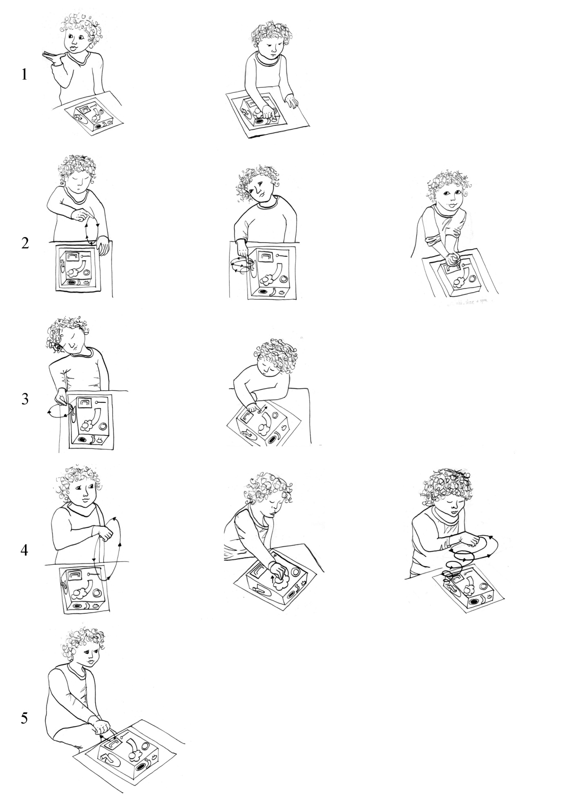Note: n = the number of times each type of gesture occurred in the data, including repetitions.
Figure 4.3. The whole representational gestures produced during photo cued recall in both conditions for experiment 2.
Action, Path, Spatial, Object
n = 5
“Take it off”
Action, Path, Spatial, Object, Size
n = 8
“Open the drawer”
Action, Spatial, Object, Size
n = 4
“Turn handle”
Action, Path, Object, Size
n = 1
“Turn handle”
Spatial
n = 38
“Press this here”
Action, Path, Spatial
n = 12
“Unlock it”
Action, Object, Spatial
n = 4
“Turn handle”
Object, Size
n = 5
“Ball”
Action , Spatial
n = 3
“Turn handle”
Action , Path
n = 3
“Turn handle”
Object
n = 4
“Ball”
Points
1

2

3

4

5
Discussion
The combination of a change of experimenter and a photo cue resulted in the highest amount of recall. This indicates that gesture production increased when there was an increased need to communicate the information and when a photo cue supported the child to recall more information verbally and in gesture. The finding that behavioural recall was not affected by the manipulations suggests that it was communicating their recall, rather than recalling the information, that 3-year-olds found difficult.
These findings indicate that a visual cue is an important method of eliciting more event recall from 3-year-olds. The children spontaneously produced representational gestures that conveyed information recalled from the event. They also produced pointing and representational gestures that conveyed size/shapes and spatial locations which they did not convey verbally. A photo cue may assist with recall for a number of reasons, including because it allows the children to touch the image when they are gesturing. Alibali and DiRusso (1999) found that when preschoolers counted tokens, their ability to count was significantly higher when they touched the tokens than when they pointed at them from a distance. The authors argue that by touching the image, because this is closer than pointing from a distance, it acts as a stronger mnemonic to ‘tag’ the location of the item to allow the child to use their memory resources to also remember the counting word and keep track of what they have already counted. In the present study the photo cue may have performed a similar mnemonic function by providing the option for children to touch the image to “act as a place holder” (p53, Alibali & DiRusso, 1999) for the object whilst they recalled the information and words related to the actions demonstrated with the object. Additionally it has been suggested by Pettenati et al. (2010) that the use of a photo cue may have created a common ground and reference point for the child to communicate with the experimenter. Furthermore, the photo cue may have relieved the social pressure to respond by giving the child something to look at and focus on (Wesson & Salmon, 2001).
There were several limitations to the design of this experiment. Although the encouraged and discouraged conditions could also have been ran with the photo cue due to time constraints the control condition was chosen to provide a suitable comparison for the absent experimenter manipulation which used the control condition’s format. Time constraints also meant that baseline conditions for photograph were not conducted, and so the coding criteria was adapted to exclude data that may have been labelling rather than recall. It is possible that this could have underestimated children’s recall, or that the children may have guessed potential actions resulting in recall possibly being overestimated. Since the focus of this study was on comparing between the conditions, the baseline conditions were not a priority. Establishing the baseline level of description 3-year-olds would use when shown the photograph without having seen the encoding event is the next step for this research in order to establish the use of a photograph as a method of eliciting gestures. A pilot baseline condition was conducted with 3 children but a full baseline condition would allow for statistical comparisons to be drawn.

General Discussion
Two main questions were addressed in this study. First, can 3-year-olds’ gesture production be manipulated to identify the causal effects of gesture production on recall? Second, what methods can be used to increase gesture production? Across the first three conditions, gesture production during verbal recall was manipulated. In the final two conditions, a change of experimenter and the use of a photograph to cue recall were compared with the data from Experiment 1. The significant increase in gesture recall when a visual cue was present and a naïve experimenter conducted the test session demonstrated that it was possible to manipulate gesture production in 3-year-olds and provides the opportunity to use gestures as an additional measure of recall for the majority of the children.
Given that the change of experimenter and the photo cue resulted in a disproportionate increase in gesture recall compared to verbal recall, it is unlikely that the increase in gesture production was simply a result of more speech being produced. Our findings do not support the theories that gestures are supporting verbal production (Kita, 2000; Rauscher et al., 1996) because there was an increase in verbal recall in both photo cue conditions but only an increase in gesture recall in comparison to the control condition when there was also a change of experimenter. The children in the present study used the combination of visual cue and gestures to indicate specific spatial locations that they only referred to imprecisely in speech (eg., “You press that one there”). This is consistent with previous research that has shown that preschool children can use gestures to clarify the difference between homonyms when re-telling a story (Kidd & Holler, 2009), and use gestures in combination with objects to specify referents for terms such as “that” (So, Demir & Goldin-Meadow, 2010). The findings in the present study demonstrate that one of the ways that a visual cue can benefit preschool children’s recall is by providing them with a reference point to indicate information using gestures. In this context, gestures appear to be directly communicative and are being produced in order to bridge the gap between a concept the child understands but does not yet have the language to communicate verbally. However, our finding that gestures are still produced when the experimenter saw the demonstration could indicate that some, although not all, of the gestures were produced primarily to communicate. This is consistent with previous research showing that some gestures increase when there is a listener visible, whilst others are still produced when the listener is not visible indicating they are produced for the speaker (Alibali, et al., 2001). This suggests that 3-year-olds produce gestures depending on the communication demands of a context but that gestures are also used as a mnemonic aid when they are talking about their recall.
This study reveals that the use of a photograph, combined with an increased need to communicate the information, is a successful method for eliciting more verbal and gestural recall from 3-year-olds. These findings extend previous research that has involved using visual cues for children to point at to indicate recognition of specific items (Cameron & Xu, 2011; Ling & Blades, 2000; Simcock & Hayne, 2002, Simcock & Hayne, 2003). This research has also extended previous research that has elicited iconic gestures using generic pictures during a word retrieval task (Pettenati et al., 2010; Pettenati et al., 2012; Stefanini et al., 2009). The present research has combined these two contexts to demonstrate that a photograph of specific stimuli from an encoding event can be used to elicit spontaneous iconic and deictic gestures that convey important information about children’s event recall.
If the function of gesturing was to provide visual-spatial support for working memory, to reduce cognitive load, then a photograph would serve the same function as gestures, reducing the need for gesturing (Wesp et al. 2001). Our results do not appear to support this hypothesis, and are not directly consistent with the research that adults produce fewer gestures when describing an image they can see in comparison to when the image is hidden (Wesp et al., 2001). This finding suggests that 3-year-olds may gesture for different reasons to adults, or it could be the context of using a visual cue to ask participants to describe their event recall to a listener that led to different types of gestures being produced. Gestures that describe spatial topics are more likely to be deictic gestures and also more likely to be communicative gestures (Hostetter, 2011). This may mean that it was children’s additional deictic gestures produced towards the photo cue that were the gestures particularly affected by communication demands. In our study the children were not asked to describe the image they were shown but to recall a series of actions that were not visible in the photograph but had been produced with the objects that were visible. Therefore it is possible that gesturing could still have been produced to support their memory of the actions. However our finding that behavioural recall did not correlate with verbal or gesture recall seems to suggest that gesture production was not supporting memory for the overall task, but was associated with their verbal report of the task.
Our results indicate that gestures were used to communicate and gesturing was positively correlated with a better, rather than worse, verbal recall for the event. The increase in gesture production when a visual cue is used could indicate that the visual cue strengthened the children’s mental representation for the event, consistent with the gestures as simulated actions hypothesis (Hostetter & Alibali, 2008). It is possible that the increased overall gesture production in the absent + photo condition was due to two different effects; an increased demand to communicate resulting in the increase in communicative gestures that conveyed deictic referents and the visual cue creating a stronger mental representation led to more reflected content being conveyed in iconic gestures.
It is possible that the change in language measure across the two experiments in this chapter may, to some extent, have limited our ability to compare children’s verbal abilities across the five conditions. In Experiment 1 we used the BPVS-II (Dunn et al., 1997), while in Experiment 2 we used the NRDLS (Edwards et al., 2011). This change of language measure was because the BPVS-II requires children to point at pictures to indicate the correct word. This raised the concern that because the language test was conducted before the memory test (due to the difficulty of maintaining the children’s attention once they have completed the test, and to build rapport between the child and experimenter in the testing room) it may train the children to only point at the photograph used for the recall phase. If the child just points at everything on the photo, this could increase the amount of incorrect items reported as well as reducing the production of spontaneous representational gestures. The NRDLS production scale requires only verbal responses from the child and, therefore, was not expected to have an effect on subsequent gesture production. Although the NRDLS is a measure of language production and the BPVS-II is a measure of language comprehension, the manuals state that language comprehension and production should be at a similar level in typically developing children and are comparable measures of language ability (Edwards, et al., 2011). Therefore, the use of two different language measures should have little impact on our ability to compare across the two studies.
In Experiment 2, the present + photo condition did not have a period of free recall before the photo cued recall, unlike the absent + photo condition. It is possible that the lower scores in the present + photo condition were due to the children not being scored for labelling objects and colours visible on the box in the photograph when they would have received points for these if they said them during free recall. However the finding that recall increased in the free recall part of the absent condition too suggests that the increase was due to communication demands rather than repetition of questioning. The children also would have been scored for recalling these objects during photo cued recall so they still had the opportunity to obtain these points. In the present + photo condition, the children also completed a short memory task (the rattle task in chapter 5 of this thesis) prior to completing the task for this experiment, however as this was an unrelated task it is unlikely to have affected recall.
There is the possibility that 3-year-olds may not have understood that the experimenter leaving the room meant they did not know what was on the video. Three-year-olds are still too young to have fully acquired a theory of mind, an understanding that other people have different knowledge and thoughts to their own (e.g., Carlson et al., 2005). This could mean that they still assumed that the experimenter had seen the same video content that the child had watched, and so did not need this information communicating to them. It is also possible that the child may have been (correctly) suspicious that the experimenter had seen the video at another time since the experimenter who left the room was the same experimenter who ran the study and conducted the initial language test with the child. A stronger effect of communication demands may be obtained by using a 2nd experimenter who does not meet the children until they question them about their recall. Or to have an assistant who is blind to the full content of the video ask the questions to make the questions asked about the content more authentic. In the present study although having the child report their recall to a stranger was considered, the importance of the interviewer building rapport with the 3-year-olds meant that an experimenter who had already met and interacted with the children was used. Sauter et al., (2012) has the child’s parents sit in a separate room to the event, and then the child provides directions to their parent who the child knows has not seen the room and the parent genuinely is asking questions because they do not know the information. However Sauter et al., tested 8-year-old participant’s who would be more comfortable with being separated from their parent for part of a study than 3-year-olds would be, this would need to be taken into consideration for the design of any future research building upon this. Since we did obtain a significant effect of communication demands for both free and photo cued this is not likely to have had a large effect on the results.
Important next steps for this research would be to further consider the type of visual cue used during to elicit recall. Specifically, the visual cue needs to support memory whilst still allowing children’s recall to be clearly identifiable as opposed to just a description of the visual cue itself. Salmon (2001) suggests that a photograph may function to create a context for the children to interact with the experimenter in, which could lead them to talk and gesture more. It is possible that the photograph itself did not cue recall in our study, but that having a visual focus for the child relieved the social pressure of the interview from the child and encouraged them to talk and gesture more (for a similar argument see Wesson & Salmon, 2000). This is a possibility since the children’s behavioural recall was higher than their verbal and gesture recall, suggesting that the children could recall more than they were able to say. A way to investigate this in future research would be to use a photograph that is related to the event but is not a specific cue for the objects being recalled. For our event a picture of the demonstrator from the video, perhaps with the box under a cover as if she is about to begin the demonstration, would be an appropriate cue since it shows a part of the event but does not include any of the target information we were coding for. This type of cue would allow us to identify whether it was the content of a visual cue, or just having a joint attention and reference point that increased recall.
Another focus for future research would be to run the encouraged condition with a change of experimenter and a visual cue and contrast this with prevented gesturing in order to manipulate gesture production for causal analysis. This needs to be conducted because for spontaneous gesture production, the number of gestures produced and amount of information conveyed was still low in comparison to behavioural recall and the total amount of items that could have been recalled, even when a change of experimenter and visual cue was used. This is consistent with the findings of previous research that used a change of experimenter and found that young children’s spontaneous levels of gesturing were still very low (Stevanoni & Salmon, 2005). Directly comparing instructed and modelled gesturing with prevented gesturing was conducted with 6-to-7-year-olds by Stevanoni and Salmon the next step on from this is to test these conditions with 3-year-olds plus the addition of a photo cue, and subsequent comparison with behavioural recall. This would allow for the causal effects of gesturing to be examined to identify whether gestures were supporting the communication of the memory or also supporting the overall recall of the memory.
In conclusion, whilst we were not able to directly encourage 3-year-olds to increase their natural rates of gesture production we have found that changing the interview method can lead to indirectly increasing preschoolers’ gesture production during recall. Gestures increased when there was an increased need to communicate with the experimenter in combination with a visual cue being presented during recall. Gestures were strongly positively correlated with verbally recalling more about the event, but not correlated with behaviourally recalling the event. This finding suggests that gestures were not supporting the children’s memory but were part of the communicative expression of their recall and reflected their memory during verbal recall. The children were able to use gestures with the visual cue to convey spatial locations that they did not express verbally. Observing 3-year-olds’ gestures towards the visual cue allowed more information to be obtained about their event recall than could be obtained from their verbal recall and gesturing without a visual cue. This study is a methodological starting point to using visual cues to elicit increased gesture production in order to obtain more overall information about young children’s memory for events.

Chapter 5
Manipulating physical action during 3-year-olds’ encoding of an event
According to the embodied cognition paradigm cognition is not purely in the mind, but is formed and shaped by our body’s interaction with our physical environment and the mental imagery this generates (Glenberg, 1997; Hostetter & Alibali, 2008; Iverson & Thelen, 1999). Motor experience is argued to be the source of gesture production (Hostetter & Alibali, 2008; Iverson & Thelen, 1999; Morsella & Krauss, 2004). The mechanism for this is set out in the gestures as simulated actions (GSA) framework where it is predicted that experiences containing physical action, or involve mental activity, will result in more gesturing compared to experiences that involved passively observing visual stimuli (Hostetter & Alibali, 2008). Adults have been shown to produce more gestures during verbal recall when they have produced motor actions during encoding than when they have only viewed static visual patterns (Hostetter & Alibali, 2010). The form of the gesture is also influenced by motor experience, with adult’s producing two-handed gestures when recalling lifting a heavy item, compared to a one-handed gesture for a light item (Beilock & Goldin-Meadow, 2010). This indicates that the form and frequency of gesture production is affected by the motor activity involved in the original encoding of an event, at least in adults.
In this chapter the theory that motor actions during encoding shape gesture production during recall is tested in the context of young children’s event recall. Although the evidence suggests that motor experience affects gesture production for adults, who are fluent speakers and have had many years of gesture and motor experience, this has not been tested with preschool children who have just began to produce speech and gestures fluently.
It has been argued that initially children’s gestures and speech are not co-ordinated into a joint system, and that it is not until the pre-school years that gestures and speech share one system (Goldin-Meadow, 2003; McNeill, 2005). Since it is not until children are 3-to-4-years-old that they produce a large amount of adult-like gestures with fluent speech, it is possible that at 3-years-old children’s gestures are affected by different factors than adult’s gestures (McNeill, 2005). It has been found that children obtain more communicative benefit from another person’s gestures than adults do, and that producing gestures is an important part of children’s early word development (Hostetter, 2011; Iverson & Goldin-Meadow, 2005; Ozcaliskan & Goldin-Meadow, 2005). It is possible that 3-year-old’s gestures are more affected by the communicative and speech demands during recall than by the amount of physical action involved during encoding. Alternatively Iverson and Thelen (1999) have theorised that by 18-months-old infants are producing synchronous speech and gestures, even though this is during one-to-two word utterances, and so already have developed a single speech and motor system. From this it can be predicted that by 3-years-old children’s gestures will be affected by motor activity in the same way as adult’s gestures. Applying the predictions set out in the GSA framework to preschool children’s gestures will allow the effect of physical action on gesture production to be tested at the start of fluent gesture production.
The concept that our body’s interaction with our environment determines how we think and learn has been an important part of developmental theories throughout history. A recent review has highlighted how Piaget’s theory that children learn through their own sensori-motor experiences is particularly relevant to gesture research and embodied cognition (Kontra, Goldin-Meadow & Beilock, 2012). It is argued that the actions produced by gestures can also shape cognition in an embodied way similar to how physical actions with objects can shape cognition (Kontra, et al., 2012). Boncoddo, Dixen and Kelley (2010) obtained evidence for this by examining the role preschool children’s gestures play when they are learning a new concept. The authors trained children in how gears worked by playing with a physical toy that demonstrated gears turning in the same direction. During the task children played a computer game that involved working out which direction the gears would turn when the first gear was turned. Children spontaneously used gestures to trace the way the gears should move in order to work out which direction the final gear would turn. The children who produced more gestures that traced movements were significantly faster at working out that turning a gear in one direction could result in the final gear turning in the alternate direction. Although this does not prove a causal relationship, this evidence is consistent with the theory that the production of actions through gestures supported the embodiment of the new concept and led to a higher level of understanding (Boncoddo et al., 2010; Kontra et al., 2012). This study also demonstrates that after physically experiencing novel actions, children produce gestures that convey these actions, indicating that the actions are embodied into the child’s representation of the event and that gestures can be used to reveal this information.
Manipulating physical actions during encoding for the effect this has on behavioural imitation has been investigated with infants (Bauer, Wenner, Dropik, & Wewerka, 2000; Hayne, Barr & Herbert, 2003; Meltzoff, 1995). These studies used imitation tasks which involved infant’s being shown a short (1-to-4) series of actions with objects and then being given the objects to see if they imitate the actions that they observed, demonstrating that they can recall them. Although these actions are not the same as gestures, if motor activity during encoding affects how a memory is stored then increased behavioural imitation would be predicted when a child has physically manipulated items during encoding in contrast to just observing someone else produce the actions. However there was not a difference in infant’s behavioural imitation for the number of actions recalled for short and long-term event recall (Bauer, Wenner, Dropik, & Wewerka, 2000; Meltzoff, 1995). The explanation given by Meltzoff (1995) for this is that when infants are presented with the stimuli again after the initial encoding demonstration they are using their declarative memory to actively re-construct the original memory from the adult’s demonstration not their own actions. However it has been found that physically producing actions with the stimuli during encoding does increase infants’ ability to generalise their memory to a different stimulus, and access the memory after a longer delay when given a reminder (Hayne et al., 2003). This suggests that physical interaction does have an effect on infant memory that is not measurable when just observing the number of actions recalled. This may indicate that when a similar imitation task is used with preschool children, whose verbal and gesture recall can also be measured, more subtle affects on memory of having interacted with the stimuli may be apparent than can be observed by measuring the number of actions behaviourally recalled.
Preschool children’s verbal recall has also been examined to identify whether motor activity during encoding affects their recall of a story. In Davis and Hathaway (1986), the amount of motor experience children had with props related to a story was manipulated, after the child heard the story read once through. Significantly more information was recalled from the story when either the children or the experimenter had acted out the events of the story with props, in comparison to only having heard the story read once. However if children had heard the story read twice and observed the static props, their amount of verbal recall was not significantly different than the two conditions that involved motor activity, although their performance was not significantly higher than children who had heard the story read only once. This suggests that although motor experience did increase preschoolers’ verbal recall, this was not a large effect. The authors discuss that physical actions may support some children’s recall but not others, so individual differences may have been the cause of the small effect. Because only verbal recall was measured in this study, it is not known whether motor experience affected the children’s gesture production during recall. An increase in gesture production after motor experience, but not an effect on verbal recall, is predicted by the GSA framework (Hostetter & Alibali, 2008).
Preschool children’s physical interaction during encoding has also been manipulated in the context of children’s learning about balance beams. In Zacharia, Loizou, and Papaevripidou (2012), children were either taught to use balance beams with physical items that they could hold and feel the weight of, or they were taught using a virtual computer environment where they received feedback about the weights but did not physically interact with anything. Within each condition, half the children already understood how balance beams worked whilst the other half did not. Children who did not understand how a balance beam worked before training only showed learning when they physically manipulated the objects during training. However children who did understand how a balance beam worked before training showed increased understanding of how a balance beam worked in both conditions. This suggests that in the context of learning about balancing, having physically interacted with the objects during learning is important when children are first grasping the contexts, but that physical interaction is then not a necessary part of developing this understanding further (Zacharias et al., 2012). These studies indicate that there are individual differences in how physical motor activity affects preschool children’s recall.
Whether different amounts of motor experience during encoding will affect preschool children’s rates of gesture production remains to be investigated. In particular the effect of motor experience versus observing actions with novel stimuli may affect recall differently in the context of recalling an event, compared to learning about concepts such as weight and balance which are hard to understand without physical experience. The present study aims to test the theory of embodied cognition and specifically the GSA framework with 3-year-olds to identify whether gesture production is effected by the amount of motor activity the children have had with the same stimuli. If gestures stem from embodied actions from the original memory, then increased gesture production is predicted when the children have had the chance to physically produce the actions themselves compared to when they have simply observed the actions being produced by the experimenter.
The aim of the present study is to extend the work by Hostetter and Alibali (2008; 2010) to test the predictions set out in the GSA framework, that physical action is the source of gestures, with 3-year-old children. We hypothesise that producing motor actions by physically manipulating the stimuli during encoding (interactive condition) will result in an increase in gesture production during verbal recall of the event, in comparison to just observing someone else physically manipulate the stimuli during encoding (observe condition). This will be tested in two between participant conditions with gesture recall, all gestures, verbal recall and behavioural recall being taken as measures of event recall.
There is also evidence that gestures can be produced to support speech, either through supporting word finding, or the translation of imagery into speech (Kita, 2000; Krauss, 1998; Rauscher, et al., 1996). In order to control for any affect of word retrieval on gesture production the children hear a narrated script during the demonstration so they will have heard the main target words. The tasks and narration are the same whether the participants are in the difficulty of describing the tasks is identical in both conditions, so if gestures are being produced to support speech there should not be a difference between the conditions.
There are also two alternative hypotheses based upon the literature. If the children are recalling only the actions they were shown and not recalling their own actions, as suggested by the imitation studies with infants, then whether the participants physically interacted with the stimuli during encoding or just observed the actions would not be expected to affect gestures during recall (Bauer et al, 2000; Meltzoff, 1995). In this case verbal recall and behavioural recall would also not be predicted to differ by condition. Alternatively if gestures are produced to support memory when recalling is difficult, and if not having the opportunity to manipulate the stimuli makes it harder to recall the event, then more gestures would be predicted to be produced in the observe condition than in the interactive condition (Goldin-Meadow, 2009; Morsella & Krauss, 2004; Wesp, et al., 2001).

Method
Participants
The final sample consisted of 48 children aged from 35-to-38-months (6 participants in the control condition also took part in chapter 4, experiment 2). Fourteen participants were randomly assigned to the interactive and observe conditions (6 female, 8 male per condition). A control condition which used a standard demonstration of the stimuli without the experimental manipulation was conducted to identify if there was an effect of manipulation whether this was higher, lower or the same as the standard imitation demonstration. Due to time constraints for completing data collection, the initial control condition (N = 14) only involved the children participating in the slide task. To supplement this data, 4 of these children also completed the control version of the slide task and an additional 6 children only completed the slide task. Due to the limits of this preliminary data this meant that the control condition was only used in analyses when the two scores for each task were analysed separately, creating a slide control condition (N = 14) and a rattle control condition (N = 10) for comparison. Fourteen additional participants were tested but their data was excluded from analysis due to; piloting the stimuli (n = 8), refused to participate (n = 2), unwell (n = 1), expressive language disorder (n = 1), experimenter error (n = 2).
The main caregiver completed and returned a demographic questionnaire, 92% were returned. Children’s ethnicity was reported as; White British 95%, Black and White British 2% and Pakistani and White British 2%. All of the children attended child care or playgroup on a weekly basis. Forty eight percent of the children had been taught some amount of baby signing through classes or at home, when they were under 1-year-old. One child had a relative who used British Sign Language however none of the children used sign language on a regular basis or lived with someone who did. All of the children spoke English and one child was bilingual English/Urdu. Twenty five percent of children did not have siblings, 56% of children had 1 sibling, 14% had 2 siblings and 7% had 3 siblings. Forty eight percent of children were the 1st born child, 45% were the 2nd born, 7% were the 3rd born and 5% were the 4th born. The main caregiver’s highest level of education was reported as: 27% postgraduate, 48% degree, 14% NVQ, 11% Diploma, and 5% GCSE.
This study received departmental ethics approval as part of a series of studies.
Stimuli
The stimuli used for this study were specifically constructed for imitation studies within our lab, and are based upon stimuli used in other imitation studies (e.g., Bauer, Hertsgaard, & Wewerka, 1995; Hayne, Barr & Herbert, 2003; Hayne & Herbert, 2000). Although the stimuli have primarily been used with children under 2.5 years, it was our intention to reduce the task demands and verbal demands on 3 year olds to maximise the opportunity for verbal and gesture production during recall.
Slides: The slide stimuli consisted of two plastic slides (45cm high x 15cm wide) that were identical in form but had been painted in different designs (a snow scene and a garden scene, see figure 3.1). Two halves of a wooden polar bear (approx. 6cm high x 9 cm wide) could be attached together with Velcro. The feet of the bear also had Velcro attached so that it could be secured onto a rectangle of wood (3cm x 10cm) which had 4 small wheels underneath. This “bear on wheels” could then be pushed down the snow slide. Two halves of a brown wooden camel (approx. 9cm high x 9cm high) could also be attached together and placed with Velcro onto a rectangle of wood (3cm x 10cm) that had 4 small wheels underneath. This “camel on wheels” could then be pushed down the garden slide.
Rattle: The rattle stimuli consisted of a small clear plastic pot (12cm high x 6cm wide) which had a white screw on lid with a 5cm hole cut into it. The hole was covered with a rubber seal which a 3cm green wooden ball could be pushed through. Velcro was used to attach the lid of the pot to a 10 cm round white plastic lid attached to a 15cm long green wooden handle.
Photographs: Ten laminated photographs were used, see Figure 3.1. One set of four photographs (each approximately 8cm x 12cm) displayed the four actions required to put the bear down the snow slide. A second set of four photographs (each approximately 8cm x 12cm) displayed the four actions required to make the rattle. One A4 photograph displayed the rattle stimuli and one A4 photograph displayed the garden slide and camel stimuli.

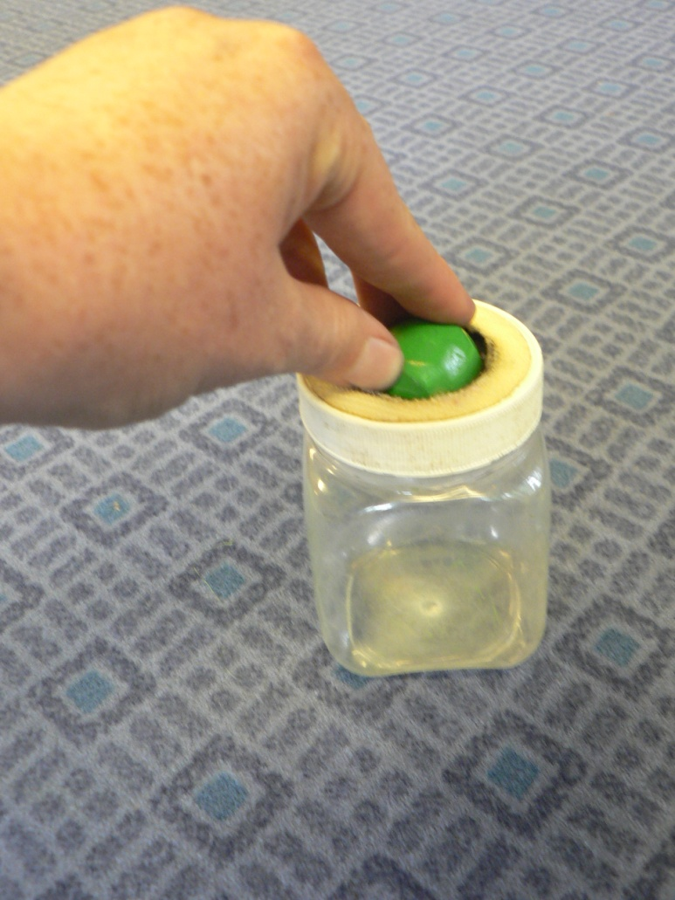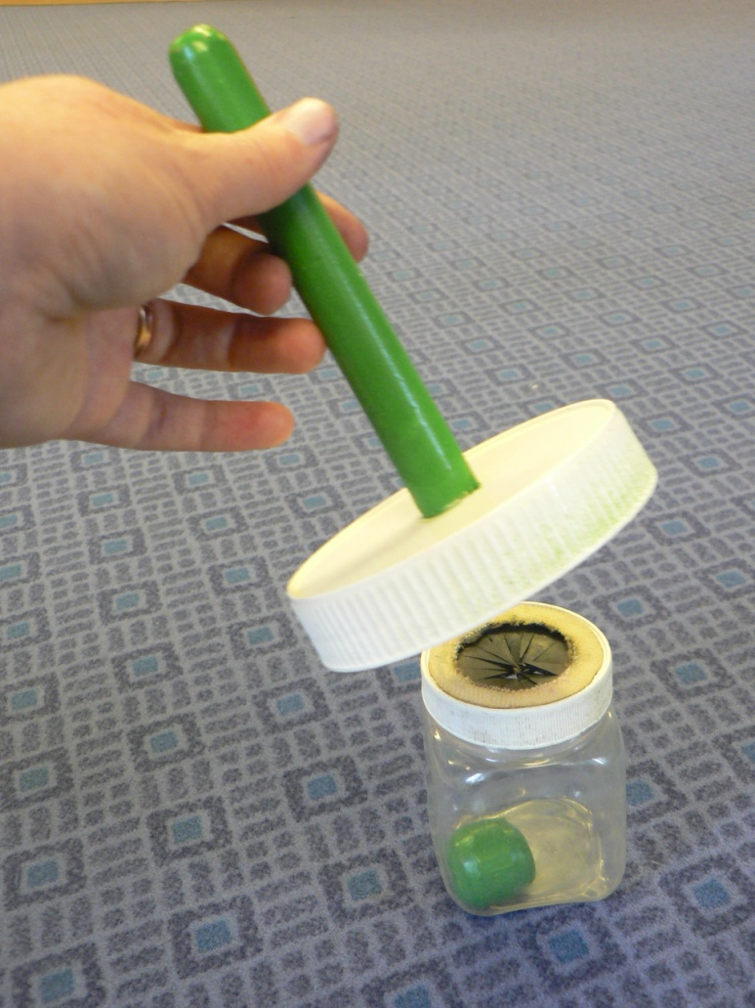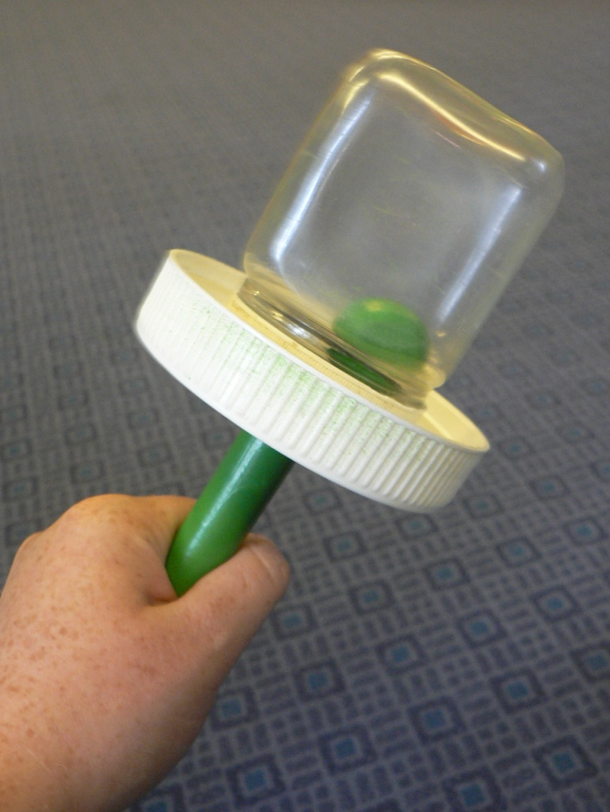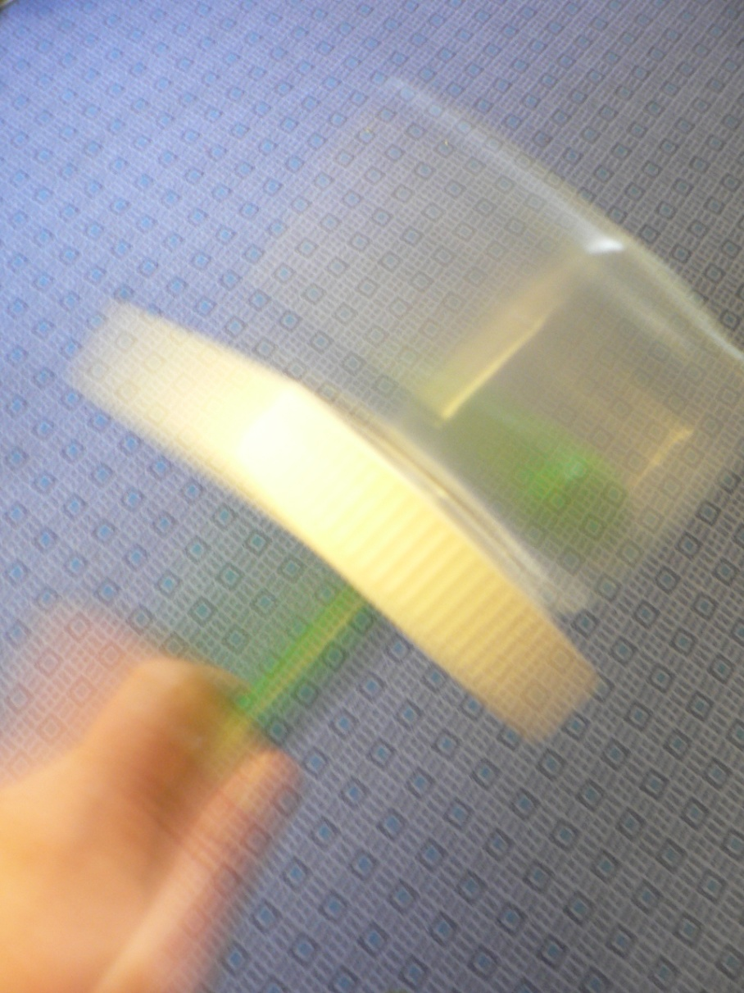

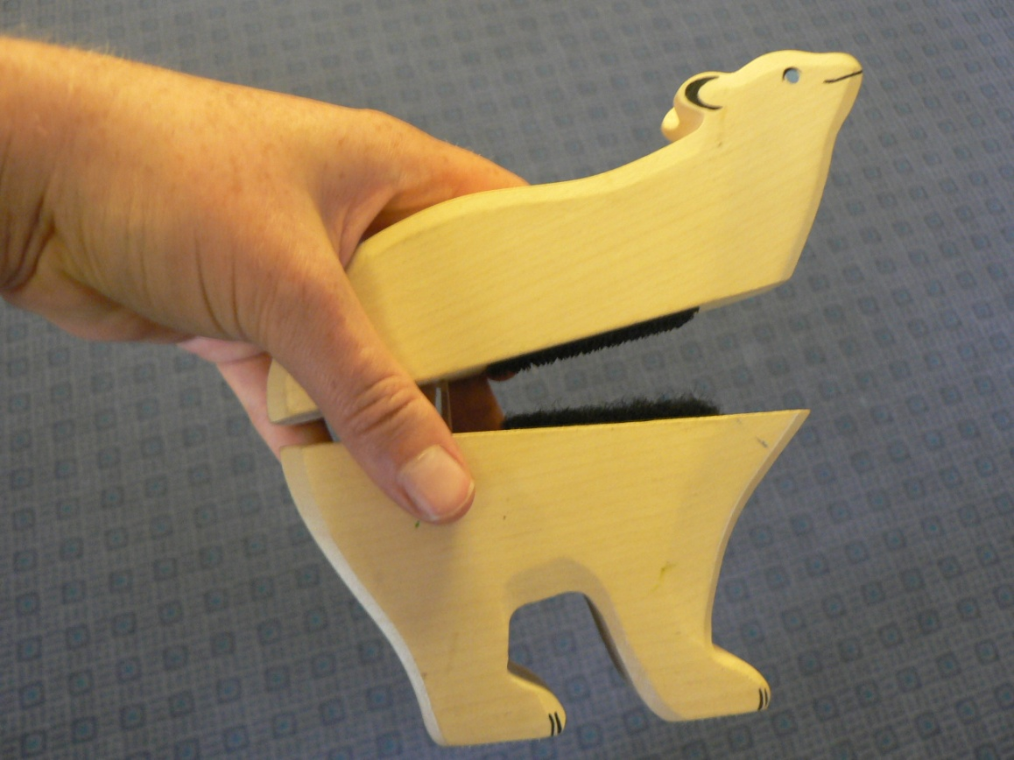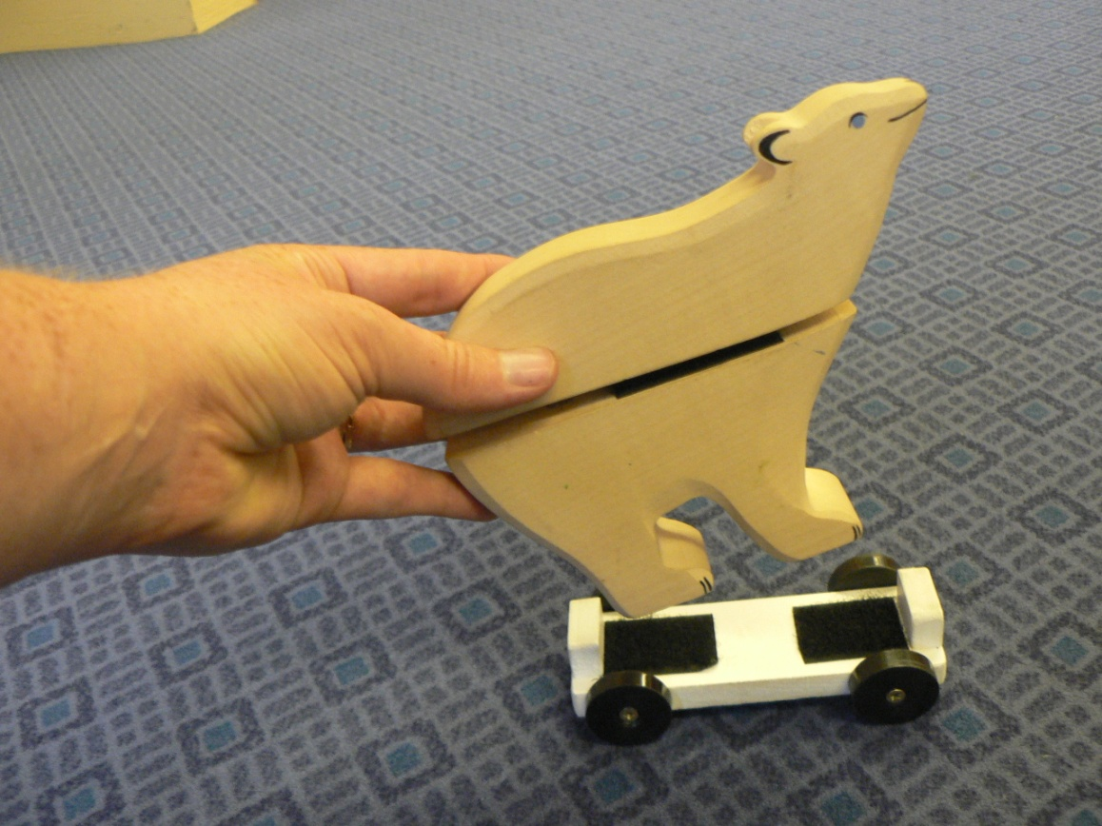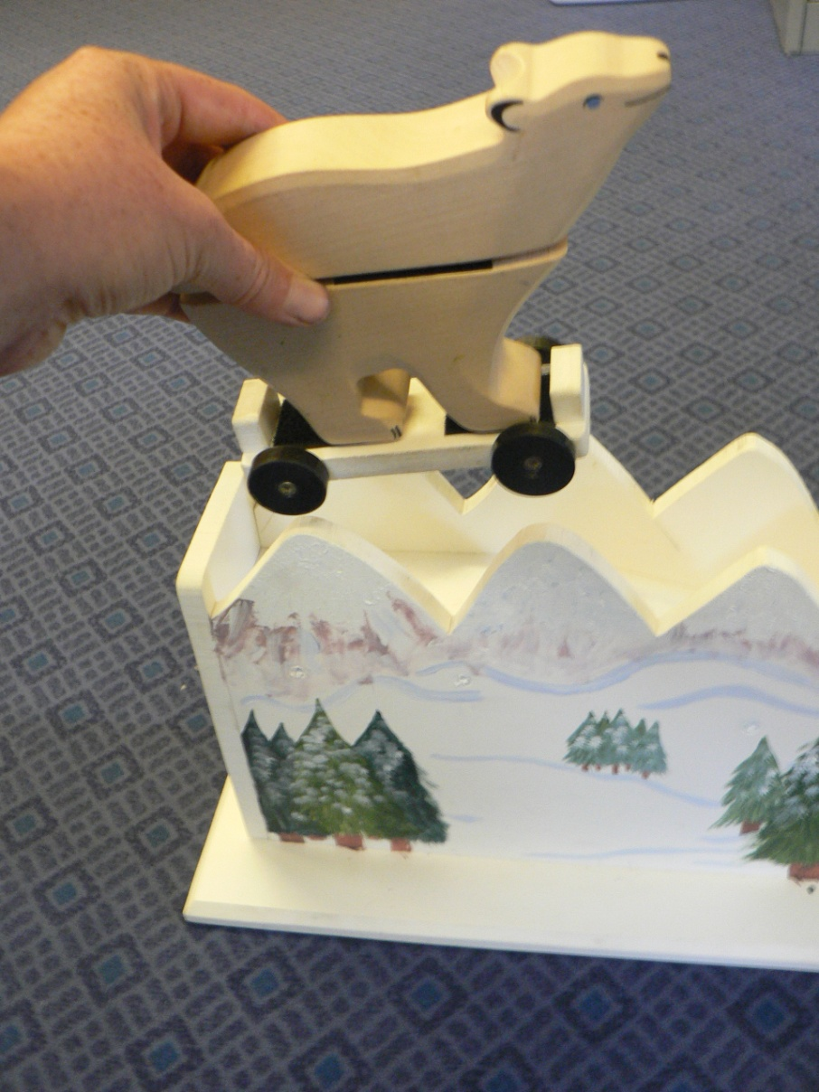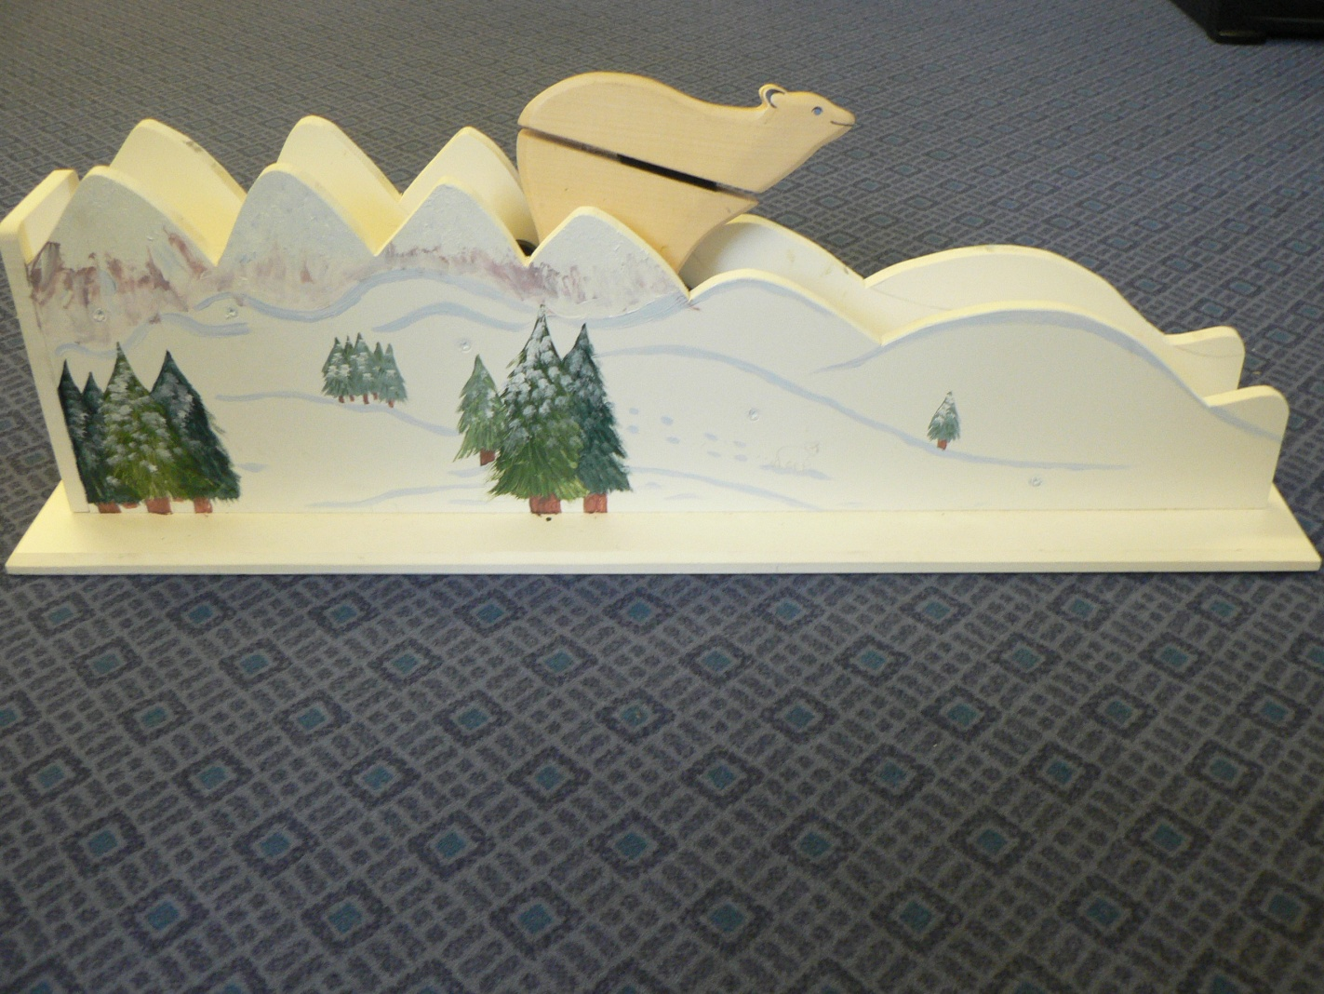
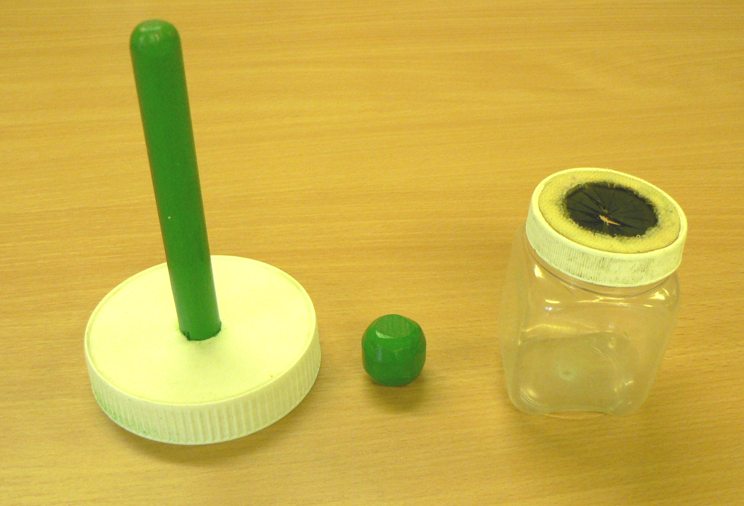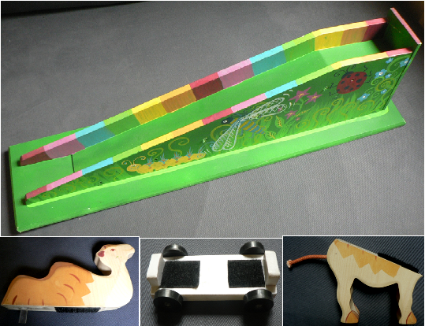
Figure 5.1. Sequence of four photographs shown during encoding in Study 3 in the observe condition, for the rattle task (a) and for the slide task (b). Photographic cues shown to each child during cued recall questioning (c).

c.
b.
a.

Measures
The BPVS-II (Dunn et al., 1997) was used order to determine the language level of the children. Only the first three sets of words were used in order to avoid losing the attention of the children before the main study. The previous research (in Chapter 3 and Chapter 4, experiment 1) had found no significant correlation between BPVS-II score and recall so we simply wanted to confirm the children did not have a comprehension level of more than two standard deviations below the norm for their age. All included children had a BPVS-II that was at least equivalent to their age or above so their performance was unlikely to be affected by low language level. None of the included children’s parents had any concerns about their child’s language abilities.

Procedure
The parent filled in a consent form and a demographic questionnaire while the experimenter played with the child in the waiting room to build rapport (5-10 minutes). The experiment took place in the test room with the child and parent seated in front of a child sized table with the experimenter adjacent to them. The first three sets of the BPVS-II were then administered.
The experiment then followed the following procedure for each task:
1. The experimenter demonstrated the correct sequence of actions to the child.
2. Depending on group assignment, the child either watched the same demonstration again (control), was given a photograph of each step to look at after the experimenter demonstrated each step (observe) or was given the stimuli and shown how to physically complete each step themselves (interactive).
3. The stimuli were then removed from sight and the child was asked to verbally recall the sequence of actions.
4. The child was given the physical objects with which to behaviourally recall the sequence of actions.
The slide task was demonstrated first at a separate table using the snow scene slide and the two halves of the bear and the wheels. Simple narration was used throughout to describe the main objects and actions as the experimenter produced them. In step 1 the two bear halves were held up and the Velcro was attached together to make a whole bear. In step 2 the bear was attached to the Velcro on the wheels. In step 3 the bear was lifted to the top of the slide. In step 4 the bear was pushed down the slide.
The second demonstration of the slide differed as a function of condition. In the control condition, the second demonstration was a repetition of the original demonstration. In the interactive condition, the experimenter demonstrated each step again but the child was given the stimuli after each step and was asked to complete the step in the same way as the demonstration. In the observe condition, the child was given a photograph of the step being completed (Figure 3.1) and asked them to look at the picture after each step during the second demonstration. This was to control for the extra time, narration and attention from the experimenter the children in the interactive condition received. Narration was kept as similar as possible across conditions, for example, in the interactive condition “here is the bear, now you put it together” while in the observe condition the narration was “look, here is a photo of the bear being put together”.
After the sequence of actions had been demonstrated twice the stimuli were removed from sight. Then child was then asked open questions about their recall of the event, for example “what did I just show you?”. When the child failed to provide any new information in their recall they were shown the A4 photograph of the garden slide scene with the camel (Figure 3.1). The change of stimuli from snow slide to garden slide was tested with the aim of eliciting an increased verbal and gesture response from the child by having new items and a new context to apply their recall to.
After the child indicated they could not recall any more information, the garden slide, camel halves, and wheels were placed on the table in front of them and the child had one minute to behaviourally reproduce the target actions. The stimuli were then removed out of sight and the experimenter demonstrated the rattle task. The experimenter laid out the rattle stimuli with the pot, ball and lid in a row on the table. Simple narration was again used whilst demonstrating each step. In step 1 the ball was pushed into the pot. In step 2 the lid was attached to the pot with Velcro. In step 3 the pot was held by the handle, turned upside down and raised up in front of the experimenter. In step 4 the rattle was raised up to the experimenter’s head height and shook to make a loud rattling noise. The second demonstration of the rattle differed by condition in the same way as is described above for the slide task (i.e., control, observe, interactive). The recall phase was also the same as described above, although there was no change of stimuli context for the rattle task at recall.
No mention of gesture production was made during the experimental session. The entire session was video recorded so that measures of verbal, behavioural and gesture recall could be coded and checked for reliability.

Coding
Coding was conducted in the same way as chapter 3 and chapter 4 of this thesis with the following variations. There were four target steps for each task. Within each step there were up to five pieces of target information that could be conveyed; the action (e.g., put), the object (e.g., ball), size/shape of object (e.g., small), the path of motion involved in the action (e.g., downwards), and the spatial location the action occurred at (e.g., the top of the pot). In some steps only three or four target items were coded due to the nature of the stimuli and actions. For example when the bear halves are put together the spatial location of pushing the pieces together horizontally could not be distinguished from the path of motion. The variables of verbal recall and gesture recall were coded in a parallel way. The variable of all gestures includes repetitions of gestures and beat gestures. All variables exclude responses containing; irrelevant speech to the task (e.g., “there’s mickey mouse” points at the poster), incorrect speech and gestures (e.g., “you painted batman” painting gesture), refer to the task they saw prior to the one they have been asked to recall, and involved just labelling the visible items in the photograph (points at the button and says “a button” is not coded compared to points at the button and says “she pressed that button” which was coded).
There were several differences to the coding of these tasks to the coding of the magic box task. Due to the simpler tasks used here for verbal recall the words “in” and “on” used appropriately were sufficient to receive a point for conveying the spatial locations of the actions because there were not multiple options of location they could be referring to. In contract to the magic box coding, in the slide and rattle task coding pointing at an object in the photograph could indicate an object or a spatial location depending on the accompanying speech. For example: “put the ball (points at the ball) in the pot (points at the top of the pot)” the first gesture conveys the object and the second gesture conveys the spatial location and would have been coded accordingly.

Reliability
The first author coded all of the data. An undergraduate student who was unaware of the hypothesis of the experiment and blind to condition assignment independently coded 16 videos to determine inter-rater reliability (every 3rd video was selected, 38% of the data). When disagreements were identified both coders discussed how to apply the coding criteria and then re-coded that video independently and then coding was compared. The first coders’ scoring was used for the analyses. Bivariate spearman’s rho correlations were conducted to compare the scoring between raters. For the number of representational gestures that conveyed the same meaning agreement was rs = .831, p < .001. For gesture recall agreement was rs = .836, p < .001. For verbal recall agreement was rs = .843, p < .001. This high positive correlation between the scores indicates the coding method was reliable.
Results
Out of the 48 children tested overall 39 (81%) recalled target information. There were 37 children who produced at least one target word and at least one target gesture on one or both of the tasks, 1 child who only produced gesture recall on both tasks and 1 child who only produced verbal recall on both tasks. All of the children behaviourally recalled the tasks. There were large individual differences in the amount of task related speech produced per child. In the interactive condition there was a range of 0-49 words (M = 27.1) and in the observe condition there was a range of 0-82 words produced (M = 24.3).
The scores for behavioural re-enactment were not normally distributed due to a ceiling effect therefore the behavioural re-enactment scores were not included in the statistical analyses. Outliers, for the measures of verbal recall, gesture recall and all gestures, were identified using frequency plots as being more than 3 standard deviations from the mean, and they were accommodated to the next highest score within range in to maintain the distribution of the scores (Field, 2009).
Rates of gesture recall and verbal recall during open questions were low (interactive condition: verbal recall M = 2.5, SD = 3.67, CIs = 0.30-3.27, and gesture recall M = 3.0, SD = 5.89, CIs = -0.4- 6.40; observe condition; verbal recall M = 2.5, SD = 3.67, CIs = 0.38- 4.62; gesture recall M = 2.14, SD = 4.56, CIs -0.49- 4.56) with the mode score for all variables being 0. The difference between free and cued recall was not the focus of this study so the data were collapsed for the following statistical analyses.
In order to investigate whether gesture production was affected by condition the children’s scores for the slide and rattle task scores were first analysed separately per task for the three conditions. For the slide task the data did not meet the assumptions of homogeneity for univariate tests and multivariate tests for all variables therefore non-parametric tests were conducted (Levene’s test gesture recall p = .008, Box’s test p = .061, Bartletts test of sphericity p < .0001). Three independent samples Kruskall-Wallis tests were conducted. These analyses revealed that the amount of recall children recalled in gestures (control Mdn = 3.5, Range = 15, interactive Mdn = 4.5, Range = 8, Observe Mdn = 3, Range = 6), was not significantly different between the conditions χ² (18, N = 42) = 17.62, p = .701. The analyses also revealed that the variable all gestures (control Mdn = 3, Range = 13, interactive Mdn = 5, Range = 11, Observe Mdn = 4, Range = 11) was not significantly different between the conditions χ² (20, N = 42) = 25.2, p = .727. And that the amount of recall children produced verbally (control Mdn = 4, Range = 11, interactive Mdn = 2, Range = 7, Observe Mdn = 4, Range = 8) was not significantly different between the conditions χ² (22, N = 42) = 18.6, p = .402. This indicates that for the slide task there was not an effect of condition on recall.
The verbal and gesture recall from the rattle task also did not meet the assumptions of homogeneity (Levene’s test for verbal recall p = .004, Bartletts test of sphericity p < .0001 so nonparametric analyses were used. Three independent samples Kruskall-Wallis tests were conducted. Due to fewer participants completing the rattle task in the control condition there were unequal participant numbers (control n = 10, interactive n = 14, observe n = 14). The amount of recall conveyed in gestures (control Mdn = 4.5, Range = 14, interactive, Mdn = 3.5, Range = 10, observe Mdn = 3.5, Range = 10) was not significantly different between the conditions χ² (16, N = 38) = 21.6, p = .503. The number of gestures produced for the variable all gestures (control Mdn = 3.5, Range = 8, interactive Mdn = 3.5, Range = 8, observe, Mdn = 2.5, Range = 9) were not significantly different between the conditions χ² (18, N = 38) = 19.1, p = .740. And the amount of recall produced verbally (control Mdn = 4.5, Range = 8, interactive = 5.5, Range = 6, observe = 2.5, Range = 7) was also not significantly different between the conditions χ² (16, N = 38) = 18.7, p = .196. This indicates that for the rattle task there was also not a significant effect on recall.

The following analyses compare the scores for the interactive and observe conditions, collapsed across task. Since no task specific differences were identified the scores for the two tasks were combined because analysing the separate tasks was not the aim of this study and so the order of task presentation had not been counterbalanced. The control condition was not included in this analysis because the majority of the children (16 out of 20) only took part in one of the tasks. The total scores, for free and photo cued recall, produced in the interactive and observe conditions for both tasks were added together and were compared for the three dependent variables of all gestures, gesture recall and verbal recall. The variables were normally distributed but did not meet the assumption of homogeneity of variance for all variables (Levenes test for verbal recall p = .01, Box’s test p = .01 and Bartlett’s test of sphericity p < .0001) so non-parametric tests were conducted. Three independent samples Kruskall-Wallis tests were conducted. The results demonstrated that the amount of recall conveyed in gesture did not differ significantly between the conditions (interactive Mdn = 7, Range = 18, observe Mdn = 5.5, Range = 11) χ² (11, N = 28) = 12.1, p = .159. The number of gestures produced for the variable all gestures (interactive Mdn = 8.5, Range = 19, observe Mdn = 6.5, Range = 17) did not differ significantly by condition, χ² (12, N = 28) = 6.7, p = .61. And the amount of information recalled verbally (interactive Mdn = 7.5, Range = 8, observe Mdn = 6.5, Range = 15) did not differ significantly between the conditions, χ² (11, N = 28) = 12.2, p = .563. These analyses indicate that although there was a slight trend for lower recall scores and less speech and gesture production in the observe condition compared to the interactive condition, there was not a significant difference between the conditions.
The semantic information conveyed in words and gestures is displayed in tables 5.1 and 5.2. As can be seen in table 5.1 similar amounts of information are conveyed in speech and gestures for each category of information. Although there was a trend for more spatial and path of motion gestures to be produced in the interactive condition (M = 3.74, SD = 2.7, CI 2.15-5.27) in compared to the observe condition (M = 2.14, SD = 2.03, CI 0.97- 3.32) an independent samples Mann-Whitney-U analysis indicated that this was not a significant difference, p = .077.
In table 5.2 the way this information was conveyed in representational gestures is displayed. As shown in the table, a large number of gestures only conveyed one piece of information, particularly towards the photo cue, although there is a similar range of information conveyed in gestures in both conditions. There was a trend for slightly more representational gestures to be produced in the interactive condition (M = 7.5, SD = 4.9, CI 4.7-10.2, Mdn = 7.5, Range 0-20) in comparison to the observe condition (M = 6.36, SD = 5.6, CI 3.12-9.6, Mdn 6.5, Range 0-20). Hostetter and Alibali (2010) found that it was specifically representational gestures that increased when motor activity was part of encoding. Only a few beat gestures were produced in our study (N = 21) however since the variable of all gestures includes beat gestures, whilst gesture recall is a measure of the number of individual pieces of semantic information conveyed, regardless of the number of gestures, an additional analysis on representational gestures was conducted. In order to examine this the total number of representational gestures produced for both tasks and combined from free and cued recall, including repetitions of the same gestures, were compared by condition. A Mann-Whitney-U analysis indicated that there was not a significant difference between the conditions for the number of representational gestures produced, p = .511. This indicates that although there seemed to be a trend for higher representational gestures in the interactive condition compared to the observe condition this may be due to chance variations. An unexpected effect of gender was identified during preliminary analyses which indicated a higher gesture production by the female participants in the interactive condition compared to the observe condition, and compared to the male participants in both conditions (see Table 7.3 appendix E). Due to the low numbers of each gender in each condition and the large individual differences this trend could not be analysed further or interpreted.
Table 5.1. Total information recalled in Study 3, displayed by type of information and modality (individual items counted once per child per modality).
 | Interactive |  | Observe
 | Verbal | Gesture | Verbal | Gesture
Actions | 40 | 32 | 43 | 27
Spatial and Paths of Motion | 36 | 51 | 37 | 30
Objects and Size/Shape | 34 | 46 | 19 | 33

Table 5.2. Points scored per gesture for all representational gestures produced in Study 3 based upon the semantic content expressed (includes repetitions of gestures).
 | Interactive | Observe
Score
Free
1 | Action n = 6 | Action n = 5
2 | Action, Path n = 2 | Action, Object n = 5  Object, Size n = 1
3 | Action, Path, Object n = 4 | Action, Path, Object n = 3
4 | Action, Path, Object, Spatial n = 7  Action, Path, Object, Size n = 1 | Action, Path, Object, Spatial n = 2
5 | Action, Path, Object, Size, Spatial n = 2 | Action, Path, Object, Size, Spatial n = 1
Photo
1 | Action n = 1  Object n = 36  Spatial n = 22 | Action n = 4  Object n = 32  Spatial n = 21
2 | Action, Object n = 2  Action, Path n = 3  Object, Size n = 2 | Action, Object n = 1  Action, Path n = 1  Action, Spatial n = 3
3 | Action, Path, Spatial n = 8 | Action, Path, Spatial n = 7  Action, Path, Object n = 3
4 | Action, Path, Spatial, Object n = 8 | Action, Path, Spatial, Object n = 1
5 | Action, Path, Object, Size, Spatial n = 0 | Action, Path, Object, Size, Spatial n = 0
Note: for visual examples of the gesture forms see figure 1.1 (free recall) and figure 2.3 (photo cued recall).

Discussion
This study aimed to investigate whether increased motor activity during the encoding of an event would result in increased gesture production during children’s verbal recall of the event, in accordance with the gestures as simulated actions framework (Hostetter & Alibali, 2008). These results did not support this prediction; physical interaction with the stimuli during encoding, in comparison to watching someone else interacting with the stimuli, did not affect children’s gesture production. However these findings do not contradict the predictions of the gestures as simulated actions framework either. These results are consistent with research with infants and preschoolers that manipulated physical interaction during encoding of actions and did not find this affected subsequent behavioural or verbal recall (Bauer et al., 2000; Davis & Hathaway 1986; Meltzoff, 1995). The possible explanations for these results and the implications for future research will be discussed below.
This was the first study to test the effect of manipulating motor activity during a memory task on 3-year-olds’ gesture production. This study only tested a small difference in motor activity, observing physical actions versus observing and also producing physical actions. This is a small difference in contrast to the large difference in motor activity between observing static abstract visual patterns versus producing physical actions that was compared by Hostetter and Alibali (2010). The contrast in the present study was chosen for two reasons. Firstly because this is a manipulation that is used in behavioural memory tasks with young children (eg. Bauer et al., 2000; Meltzoff, 1995) and so would allow us to continue to use an imitation task design and compare gesture production with verbal and behavioural measures of recall. Secondly the method has ecological validity because children are frequently in situations where they are either able to physically participate in an activity or they are only able to watch someone else carry out an activity, but they are expected to learn from this, such as when they are in school (Zacharia et al., 2012). The findings of the present study indicated that children can still recall information when they have only seen someone else produce the actions and not been able to produce the actions themselves. However for the purposes of testing the theory of the GSA framework, because observing motor activity is predicted to elicit mental representations in a similar way to producing motor activity our manipulation may not have created enough of a difference in motor experience in order to differentially effect gesture production (Hostetter & Aliabli, 2008). The non-significant trend for higher representational gesture production in the interactive condition supports the suggestion that physical interaction had a small affect but the contrast between observed action and experienced action was not strong enough to lead to a significant difference in gesture production between the conditions.
In the GSA framework it is also predicted that the gestures that are produced will take on the form and qualities from the original experienced actions, for example if an object requires two hands to lift it then a two handed gesture should be produced during recall (Beilock & Goldin-Meadow, 2010; Hostetter & Alibali, 2008). Although the gestures the children produced in our study did semantically convey the actions from the event it was not always the case that their gestures represented the precise form of the hand movement required for the action demonstrated. For example it was common for the children to gesture with a closed pincer grip over the photo cue as if picking up the handle even though the actual action required a full closed fist hand shape to grip the handle. The most frequent hand shape used was a pointing index finger to convey actions such as the bear going down the slide which was abstracted from the actual way the child or demonstrator held and then pushed the bear down the slide. Although there were more gestures produced in the interactive condition that conveyed more completed aspects of each step (received 4-5 points) it was not possible to analyse this from the data generated using this task. This study indicates that whilst some gestures conveyed the form and qualities of the original action a large number of gesture produced only conveyed incomplete, abstracted aspects from the original action.
The alternative explanation for the results found in the present study is that physical interaction does not play a main role in children’s gesture production for this type of event recall. It is possible that variables that were kept consistent between the conditions such as communication demands, memory recall demands, and word retrieval may have more of an effect on gesture production than motor experience. The study by Hostetter and Alibali (2010) found that even though adults produce significantly more gestures when describing patterns they had physically interacted with, they still produced gestures when they spoke about visual patterns that did not involve action. The findings in the present study are consistent with this and suggest that other factors, such as producing gestures to support speech or cognition is an important function of gestures and leads to gestures being produced even when the encoding event does not contain action.
The present study was limited by the large individual differences in gesture and speech production rates by the children. Subsequent research would benefit from being conducted using a within-participants design so that changes in gesture production can be determined without individual differences in gesture and speech rates per condition affecting the results. A within participant design has been found to be an effective method of reducing individual differences in gesture production for studies that have used multiple trials, such as those that have tested working memory or mathematical learning (e.g., Alibali & DiRusso, 1999; Delgado et al., 2011; Ping & Goldin-Meadow, 2010). In contrast to this studies that have tested gesture production in the context of event recall have used a between participant design (e.g., Cameron & Xu, 2011; Stevanoni & Salmon, 2005; Wesson & Salmon, 2001). This suggests that future research could attempt to combine the two methods to test a within participant design using the method of multiple trials used for working memory tasks but using several event recall tasks, counterbalanced, as a method of reducing the effect of individual variations on gesture production at recall.
An additional limitation was that baseline speech and gestures towards the photographs used in this study had not been conducted. If they had been conducted a comparison could be made between information the children report spontaneously upon seeing the photographs and information that is related to their memory of the events. Baseline responses were not collected for the photographs because the focus of this study was on whether there was a difference in recall and gesture production based upon motor activity during encoding. If some responses were spontaneously elicited from the photographs this would not be expected to differ by condition. Free recall elicited through open questioning was also measures and analysed and although the children recalled less information during open questioning the trends did not change when photo cued recall was also analysed. The lack of baseline data was also factored into the coding of the study (in the same way as in chapter 4, experiment 2) so that if the children just pointed at or labelled the stimuli that was visible without describing details of the event that were not visible then this was not coded to avoid coding information that was not recall. This suggests that any information that was spontaneously elicited from the photographs was not likely to have had a large effect on the results.
Another limitation was that although a preliminary analysis indicated there was an interaction between condition and gender (see appendix C) there were not a sufficient number of males and females in each condition to allow for further analysis or interpretation of this finding. An effect of gender on memory or gesture production has not been indicated in the majority of studies and there is not a theoretical prediction for a gender difference, so the present study had not been designed to analyse for an effect of gender. However studies that have used parent-report questionnaires (MacArthur Communicative Development Index) of young children’s communicative speech and gesture development have found a small but consistent effect of gender, with girls being slightly ahead of boys in their speech and gesture production (Eriksson et al., 2012; Fensen et al., 1994). This suggests that the present findings may be due to the communicative element to the task and that including sufficient participants to enable analyses by gender could be important for future research to establish whether the trend observed in the present study is of statistical significance.
The next step for this research is to test a larger contrast of activity between the conditions so that the observe condition involves the children looking at static visual stimuli in contrast to the same interactive condition to attempt to more directly replicate Hostetter and Alibali’s study (2010) with 3-year-olds. This would tell us whether the findings of the present study were due to age differences, which could suggest a developmental change in the source or use of gestures, or whether the present findings were due to the methodological differences. This study aimed to be a starting point for testing the embodied cognition paradigm in the context of preschool children’s gestures during event recall.
In the present study, although children in the observe condition produced gestures that represented novel actions with novel stimuli, the type of motor actions they observed were familiar ones that they are likely to have produced before and already have a mental representation that includes physical actions (e.g., pushing a toy down a slide). This may have made it more likely that observing the actions could simulate mental representations sufficiently that producing the actions did not provide any extra benefit. Future research could test this by using more novel stimuli and including aspects such as weight or texture that can only be fully experienced through physical interaction.
Another important variable to investigate in future research is whether there is an interaction between the communication demands of the task, and the age of the participants, on the effect of motor activity on gesture production. It has been found that children obtain more communicative benefit from gestures than adult’s do (Hostetter, 2011). It is stated in the GSA framework that communication demands are a predictor of gesture production (Hostetter & Alibali, 2008). Therefore communication demands which were equal in the two conditions in the present study may have been having a stronger affect on gesture production than physical practice. This would also be consistent with the results from experiment 2, chapter 4 of this thesis, which found that it was manipulating communication demands by having the child report their recall to a new person that led to the most gesture production. The task used in the present study was more communicative and involved face-to-face communication with the experimenter when gesturing, in comparison to the virtually non-communicative setting of speaking into an audio recorder used by Hostetter and Alibali (2010). This suggests that it could be the different communicative demands of the tasks rather than age of the participant’s that led to the differences between the present study and Hostetter and Alibali’s study, with physical interaction affecting gesture production when the communication demands are limited but communication overriding this when the demand to communicate is high. This could be tested by manipulating communication demands and action levels within the same study, for example by comparing observing and participating in motor activity during encoding with half of the participants in each condition recalling the event to someone who was not present for the event but will have to re-enact the actions based on the child’s description (high communication demands) versus re-telling the event to the experimenter who already knows the actions (low communication demands). The gesture production of adult’s and children could be compared using a parallel task, for example Hostetter and Alibali’s (2010) geometric visual patterns and wooden peg puzzles could be adapted to be suitable for young children. This design would allow future research to test for developmental changes of the effect of motor activity during encoding on gesture production during recall without task or methodological differences being an extraneous variable.
In conclusion physically producing actions during encoding did not significantly increase 3-year-olds gesture production or affect their event recall, in comparison to observing an experimenter produce the actions. This indicates that observing actions and producing actions have a comparable effect on gesture production. Factors such as communication and verbal recall demands may have had a larger effect on gesture production than motor experience. Further research that controls for the limitations of large individual rates of speech and gestures, compares a visual event with an action event and directly compares preschooler’s gesture production with adult’s gesture production is needed to identify whether these findings are due to methodological differences or developmental changes in gesture production.

Chapter 6: Discussion and conclusion

In this thesis I examined whether gestures could be used as an additional measure of preschool children’s event recall. Methods were chosen that are traditionally used to obtain children’s verbal and behavioural recall in order to examine what additional information gestures may provide. Methods for manipulating gesture production were tested with the aim of eliciting more recall from 3-year-olds. The 3-year-old age group was specifically chosen because this has been stated as the starting point for ‘adult-like’ fluent speech and gesture production (McNeill, 2005). During the planning of this research series (2009) 3-year-olds’ gesture production had not been examined in the context of event recall. In the interim a few studies have also looked specifically at these issues (Cameron & Xu, 2011; Goksun et al., 2010) although they have not included a measure of behavioural recall. The inclusion of a measure of behavioural recall is an important method for establishing whether gesture production affected just verbal and communicative aspects of recall, or also was related to children’s overall memory of the event. In this concluding summary the questions raised at the start of this research series will be addressed regarding the type of event specific meaningful information preschooler’s recall in gesture, the function of gestures in relation to memory recall and methods for eliciting and manipulating gestures from preschool children. The limitations of this research and the implications for methodology and practical contexts such as witness testimony will also be discussed.

Can gestures be used as an additional measure of preschooler’s event recall?
The main finding was that during free recall elicited by open questions 3-year-olds did spontaneously produce representational gestures during verbal recall. Their gestures were semantically related to their speech about the event and conveyed key items of information that demonstrated their recall of the event. This included information such as paths of motion, size/shapes and spatial locations that were not conveyed in speech. This indicates that gestures are an important part of preschool children’s verbal recall. Gestures and speech were positively correlated even when only the event specific semantic information was coded. This is consistent with Goldin-Meadow’s theory (2003) that gestures are not just waving the hands about when speaking but form part of the communication and are involved in the cognitive processing of the underlying thoughts and memories. Conveying the same meaning in speech and gestures is consistent with the theory that gestures and speech stem from a single system working together to express meaning (Goldin-Meadow, 2009; Iverson & Thelan, 1999; McNeill, 2005). The present research series demonstrates that even at the start of fluent speech and gesture production 3-year-old’s gestures can be recognised and coded for semantic recall and gestures work together with verbal recall to convey memories to a listener.
A main aim of this research series was to investigate whether gestures could be used to overcome the lack of information preschooler’s express verbally when recalling an event (Hayne & Imuta, 2011; Hershkowitz, et al., 2012; Simcock & Hayne, 2002; Simcock & Hayne, 2003). If children did not speak or recall anything about the event verbally, then apart from one or two exceptions, they also did not convey anything about their recall in gesture. So this could suggest that gestures are not useful for obtaining information that children can remember but not say. However children who tried to express their recall, for example by saying “the lady did that thing” which is recall about the event but conveys nothing that would be coded as verbal recall, they often completed the sentence with a gesture that conveyed target information. This indicates that although in the context of memory recall gesture may not be a modality that could be used instead of speech to access the thoughts of children who do not say anything related to the event they are asked to recall, paying attention to gestures is a method of obtaining further information from children who do talk about their memories.
Spatial information was identified in the present research as being uniquely conveyed in gestures during recall. This is consistent with previous research with school-aged children and adults that has identified that spatial information in particular is likely to be conveyed in gesture (e.g., Alibali, Kita & Young, 2001; Chu & Kita, 2012; Goldin-Meadow, et al., 2001; Iverson & Goldin-Meadow, 1997; Rauscher, et al., 1996; Sauter et al., 2012). Previous research with 3-year-olds has identified that they can convey spatial information in gesture when asked to give directions from their nursery to their home (Sekine, 2009). The present research has extended this to event recall where children are not specifically asked to provide spatial information. This demonstrates that 3-year-old’s gestures can be used to obtain spatial information that the children have recalled from an event but do not express verbally.
Decomposition of information in gestures (McNeill, 2005) is an important issue for memory research because the emphasis is on obtaining recall that is a precise, accurate and reliable representation of the encoding event. In chapter 2 previous research was discussed that indicated that young children do portray information in gestures that is decomposed (McNeill, 2005; Pettenati et al., 2010; Pettenati et al., 2012; Stefanini et al., 2009) but this had not been examined from the context of children’s memory for a specific event. In the present research 3-year-olds did produce more information in gestures that was an abstract or partial representation of the actions rather than complete reproductions of actions and objects. The way that children conveyed meaning in words and gestures meant that sometimes information that was separated in gesture was complemented by the information conveyed in speech. For example saying “she put the ball in” with a pointing hand shape that indicates only the action of putting the ball but not the object, with the object being conveyed in speech. Children also decomposed action and path which meant they produced gestures of actions that were never demonstrated, such as saying “she turned the handle” but producing a wide spiraling turning gesture on the horizontal plane, as opposed to the small circular turning motion on the vertical plane that they saw demonstrated. This indicates that even when children are asked to recall one specific novel event they separate information in their gestures so that the majority of the gestures produced were not a literal reproduction of the actions they observed during encoding.
It is important to note that due to the generic and symbolic nature of words it could also be said that information is being decomposed in speech since it was very rare for children to verbally report anything specific about the sizes and shapes of objects, spatial locations or paths of motion. Vygotsky (1934/2012) describes words as generic categories which have been decontextualised in order to simplify the meaning and communicate effectively. In accordance with theories such as the information packaging hypothesis (Kita, 2000) gestures may be part of the process of turning context specific memories into generic words that are separated from their original context. McNeill (2005) states that the separation of action and path in gesture may be to fit in with the abstract and separated nature of speech, as young children develop from seeing events as a representational to realising that the concepts can be split up into separate, abstract segments. This suggests that gestures are also part of the end product of speech rather than being pantomime-like reproductions of the original memory.
The present research has demonstrated that the observation of children’s gestures provides more information about the storage and retrieval of the memory and the translation of that memory into speech, than is clear from just attending to the words the children say. This is an application of Goldin-Meadow’s theory that gestures can provide “a window on the mind” (p1, chapter 1, 2003). In the present research gestures provided the insight that although children may seem to be verbally recalling specific details that they in fact have recalled them in a much more abstracted way that could be identified from their speech. Whether this is a separation in the encoding, storage or retrieval of memory or a linguistic effect that is part of communicating the information has yet to been identified, but the present research indicates that gestures could be the method of finding this out.

How can 3-year-olds’ gestures be manipulated to increase gesture production?
In chapter 4, in order to increase rates of gesture production, so that gesture production could be manipulated experimentally, four main methods were tested; encouraging and modelling gestures, increasing the communication demands, using a photograph as a visual cue, and motor interaction with the stimuli during encoding. Of these only the use of a photo cue combined with increasing the communication demands led to a significant increase in gesture recall in comparison to spontaneous gesture rates. This suggests that it is difficult to directly manipulate 3-year-olds’ gesture behaviour, and that of increasing gesture production that apply to older children cannot be assumed to increase preschool children’s gesture production.
The present research extended the methodology of using a photograph to cue recall, to using a photograph to also elicit representational gestures that conveyed event recall. In chapter 4 it was demonstrated that 3-year-olds can do more than point at items that they recognise they can also point at places where actions (that are not visible in the picture) occurred during the event and also produce iconic gestures that convey meaningful event recall and supplements their verbal recall. The present findings were consistent with Pettenati et al.’s (2010) explanation that the use of a picture can elicit gestures from preschoolers by creating a ‘common ground’ between the child and the interviewer. We also found that the photograph was used by the children as a shared reference point with the interviewer that they referred to in speech and then supplemented their speech with gestures (e.g., says “She did that” and produces a gesture above the photograph as if putting an object into the hole). The present research indicates that the use of a photograph, in combination with a need to communicate the information, is an important method of eliciting additional gestures and speech that convey event recall.

What is the function of children’s gestures during their memory recall?
The use of a behavioural measure of recall in the present research provided a control for recall that just comparing verbal and gesture recall would have not revealed. The behavioural measures clarified that the children could recall the spatial locations where actions occurred, so it indicated that gestures were being used by the children to convey information that they were not able to communicate verbally, rather than that gestures were supporting their memory retrieval for this information. This is consistent with research conducted with older children who also compared a behavioural measure with gesture information (Sauter et al., 2012). One aim for this thesis was to test whether gestures served a direct function for children’s memory retrieval. However the evidence has indicated that children’s gestures serve a function for their communication of their memories.

Limitations
The usefulness of gestures as a measure of recall was limited by the finding that during free recall the majority of children did not gesture. The children who did gesture were the ones who recalled more about the event in all three modalities. This suggests that gestures may only supplement measured recall for the children who could already recall and articulate the event, and is not method of obtaining further recall from the majority of children. This finding differs from previous research with preschooler’s where it was the children who got a lower score for a working memory task (Delgado et al., 2012), or who had a lower counting ability (Alibali, 1999) who were more likely to gesture. However these studies used working memory tasks that elicited only pointing gestures, whereas during free recall the children primarily produced iconic gestures. It is possible that these task and gesture differences account for this. This indicates the importance of testing the function of gestures in different contexts and the current research has extended this evidence base to include preschooler’s recall of an event.
The interview context used to elicit gestures in the present research has a high social communicative demand due to the aim of applying the study of gestures to a typical interview context used in memory research. Research testing the function of gestures for adult’s memory and cognition has used designs that minimise the likelihood that gestures were being produced as part of social communication, such as asking adult’s to speak into a tape recorder (eg. Hostetter & Alibali, 2010) or solve problems with no-one else present in the room (eg., Chu & Kita, 2012). Without anyone to communicate with the production of gestures in these contexts indicates that gestures are serving a function for the speaker.
Methodological adaptions for testing young children meant that it was difficult to design studies with such low communication demands. Just one study has designed a method without social communicative demands to test preschool children’s gestures in a similar way to the studies with adults (Delgado et al., 2011). Since there is just one study which has used this method this highlights the difficulty of designing a study like this for preschool children. One risk is that the children will not gesture or speak. Delgado and colleagues found that only 57% of the children produced at least one gesture in at least one of four trials. These are low rates of gesturing and all of the gestures produced were pointing gestures rather than iconic gestures. Due to the low levels of spontaneous gesture production during recall in our studies and the focus of the present research on using the semantic information, particularly conveyed in iconic gestures, as a measure of recall the risk of no gestures or responses being produced at all if the communication demands were any lower meant that this type of methodology was not able to be tested within the time constraints of the thesis.
In order to balance the communication demands with the memory demands, the need to communicate the information to the experimenter was kept as low as possible within an interview context by having the children recall to the same person who watched or demonstrated the task. The condition in which communication demands were increased by having the interviewer leave the room during the demonstration was used as a comparison to identify whether gestures were primarily being produced to communicate with the experimenter. However it is acknowledged that the limitations of this method mean that the findings of the present research may only apply to the function of children’s gestures when produced in a communicative context in direct conversation with another person.
A further limitation of the interview method used in the present research was that experimenter demands may have limited children’s response rates. Some children reacted with shyness when they were questioned about their recall (e.g., by hiding their face or going to their parent) and this may explain why some of the children did not speak at all. The present research aimed to overcome this by testing methods such as; running the study in the laboratory so the parent could be present, giving the children stickers and praise, using an easier task to behaviourally recall, using the photograph to cue recall, spending more time building rapport before the study, and having the child recall to someone who had not watched the demonstration. Since an interview context is a typical setting in practice and in research for children to report their recall the present research also developed methods for eliciting responses, particularly gesture responses, from preschoolers in this context.

Implications for future research
The main implication for future research that the present thesis indicates is that in situations, in research and practice, where young children’s speech production is measured for meaningful content then gestures should also be measured and the meaning expressed in gestures should be taken into account when interpreting the meaning being expressed in speech. Specifically for research investigating children’s memory the present research is consistent with the theories that gestures communicate information and that ignoring children’s gestures could result in their memory being underestimated (Goldin-Meadow, 2000; Kendon, 1997; McNeill, 2005). The next steps for this research would therefore require the development of systematic measures of identifying and coding children’s gestures to improve the reliability and allow more direct comparison of the meaningful information conveyed in children’s gestures between studies and across age ranges.
The finding that it was spatial information that was uniquely conveyed in gesture warrants further investigation. The present research does not identify whether 3-year-olds are able to communicate spatial information if asked directly, or whether this is implicit knowledge that could only be accessed by observing gestures (Alibali & Goldin-Meadow, 1993). It is also possible that spatial information was not a salient part of our event. This needs to be tested with adult participants, and also by asking the 3-year-olds direct questions after free recall, to determine whether they could verbally provide this information if directly asked. It is also possible that direct questioning could elicit more gestures if the children are only able to convey this information in gesture and so respond by producing a gesture when specifically asked. Some aspects that the children conveyed in gesture would be difficult to describe in words, for example the specific vertical turning motion of the handle. Further research into this uniquely expressed information conveyed in gestures would help to develop the use of gestures as an additional measure of children’s recall, particularly for information that may not be accessible verbally or for information that is difficult to put into words.
The decomposition of information was frequently encountered in the present data and so further investigation of this finding is an important future direction for research into young children’s gestures. Decomposition could be examined further by using a task with completely novel items and actions, for example by using similar stimuli to Capone (2007) which were kitchen apparatus that toddlers would not have encountered before. If when the actions are completely novel the children produce gestures that are literal re-enactments of the gestures this would indicate support for the theory that the source of gestures is embodied physical actions (Hostetter & Alibali, 2008). However if children still separate the information then this suggests that linguistic and cognitive processing after an event is encoded plays a role in the formation of gesture production (Kita, 2001; McNeill, 2005).
McNeill (2005) describes decomposition in gestures as more advanced linguistically because it indicates that children have learnt that aspects such as action and path can be separated. What requires more research is whether this is also more advanced in the context of memory. Decomposition could indicate more forgetting, so the children are relying on a more generic aspect because they cannot recall the specific details. Or it could indicate that the children have learnt the underlying information, the gist of the situation, and assimilated it into their general knowledge. This suggests that another line for future research would be conducting a similar event recall task and comparing children’s responses at a range of ages. This could be combined with introducing delays and distracter tasks versus increasing practice and learning opportunities to identify whether forgetting or learning leads to increased decomposition.
This research has practical implications for the use of children’s gestures in forensic contexts such as witness testimony. Children are susceptible to leading questions and verbal prompts during interviewing and this has led to specific interview protocols being developed for interviewing child witnesses (recently reviewed in Hershkowitz, et al., 2012). Recent research has identified that the gestures that the interviewer and witnesses produce during interviews can also influence the process and can lead to misleading information being communicated and inaccurately reported (Broaders & Goldin-Meadow, 2010; Gurney, Pine & Wiseman, 2013). This previous research has identified that when an interviewer conveys incorrect or leading information only in gesture during questioning 9-to-10-year-old children (Broaders & Goldin-Meadow, 2010) and adults (Gurney, Pine & Wiseman, 2013) incorporate this misleading information into their verbal account of their memory. In the present research series we identified that children produce gestures that reflect the semantic content of the event they witnessed so it could be predicted that children’s gestures could also be used to provide an insight into their recall in a forensic context. However the findings that children frequently separated aspects of the event that they conveyed in gesture such as conveying a generic action rather than the specific path of motion demonstrated, indicates that gestures may not be a reliable source of event recall when the event is unknown to the interviewer.
Importantly though this data indicates that children’s gestures also need to be recorded and taken into account during forensic questioning because it could be possible for inaccurate or separated information that children convey in gesture could also mislead the interviewer unintentionally and without the interviewer being fully aware or able to account for where this information came from (Broaders et al., 2010; Gurney et al., 2013). It is important to note that not all of the children’s gestures were decomposed and most gestures still conveyed accurate information about the event they saw when their meaning was considered in conjunction with speech. Forensic interviews often involve children recalling information that can has an emotional and sometimes traumatic content (Herschkowitz et al., 2012). This may affect gesture production and the interpretation of gestures and so future research would need to specifically investigate these variables before any findings from the present research series could be applied to a forensic context.
In conclusion this research has demonstrated that gestures can be used as an additional measure of preschooler’s recall to supplement verbal and behavioural measures of recall and provide an insight into their memory for an event. Future research is needed to develop the use of gestures as a measure of recall to test reliability and validity to other memory contexts. Preliminary testing indicates a photograph to cue recall, combined with a need to communicate the information, is a method of eliciting increased gesture recall from preschoolers and warrants further research. The main function of gesture production identified was to support and reflect speech and communication about memory, but evidence was not found for gestures directly supporting memory retrieval. This research has also expanded knowledge about the decomposition of information in gestures to demonstrate that 3-year-olds frequently separate information such as actions, objects, path and spatial locations so that their gestures cannot be reliably used as a literal representation of the actions they are shown if the original encoded event is unknown. This has important implications for contexts such as forensic witness statements, but also indicates that future research studying the way children decompose information in gesture may provide a valuable insight into the way young children store, think about and communicate their memories.

References
Acredolo, L., & Goodwyn, S. (1988). Symbolic gesturing in normal infants. Child Development, 59(2), 450-466.
Alcock, K.J., & Krawczyk, K. (2010). Individual differences in language development: relationship with motor skills at 21 months. Developmental Science, 13 (5), 677-691, doi: 10.1111/j.1467-7687.2009.00924.x
Alibali, M.W., Bassok, M., Solomon, K.O., Syc, S.E., & Goldin-Meadow, S. (1999). Illuminating mental representations through speech and gesture. Psychological Science, 10(4), 327-333, doi: doi: 10.1111/1467-9280.00163
Alibali, M., & DiRusso, A. (1999). The function of gesture in learning to count: more than keeping track. Cognitive Development, 14(1), 37-56, doi: 10.1016/S0885-2014(99)80017-3
Alibali, M., S., Kita, S., & Young, A.J. (2000). Gesture and the process of speech production: We think, therefore we gesture. Language and cognitive processes, 15(6), 593-613, doi: 10.1080/016909600750040571.
Alibali, M.W., Heath, D.C., & Myers, H.J. (2001). Effects of visibility between speaker and listener on gesture production: Some gestures are meant to be seen. Journal of Memory and Language, 44, 169-188, doi: 10.1006/jmla.2000.2752.
Alibali, M.W., & Goldin-Meadow, S. (1993). Gesture-speech mismatch and mechanisms of learning: What the hands reveal about a child’s state of mind. Cognitive Psychology, 25, 468-523, doi: 10.1006/cogp.1993.1012
Aschermann, E., Dannenberg, U., Schulz, A.P. (1998). Photographs as retrieval cues for children. Applied Cognitive Psychology, 12 (1), 55-66, doi: 10.1002/(SICI)1099- 0720(199802)12:1<55::AID-ACP490>3.0.CO;2-E
Bauer, P.J., Wenner, J.A., Dropik, P.L., Wewerka, S.S. (2000). Parameters of remembering and forgetting in the transition from infancy to early childhood. Monographs of the Society for Research in Child Development, 65(4), i-vi, 1-204.
Beilock, S.L., & Goldin-Meadow, S. (2010). Gesture changes thought by grounding it in action. Psychological Science, 21(11), 1605-1610, doi: 10.1177/0956797610385353
Boncoddo, R., Dixon, J.A., & Kelley, E. (2010). The emergence of a novel representation from action: evidence from preschoolers. Developmental Science, 13(2), 370-377, doi: 10.1111/j.1467-7687.2009.00905.x
Broaders, S.C., Cook, S.W., Mitchell, Z., & Goldin-Meadow, S. (2007). Making children gesture brings out implicit knowledge and leads to learning. Journal of Experimental Psychology-General 136(4), 539-550, doi: 10.1037/0096-3445.136.4.539.
Cameron, H., & Xu, X. (2011). Representational gesture, pointing gesture, and memory recall of preschool children. Journal of Nonverbal Behavior, 35 (2), 155-171, doi: 10.1007/s10919-010-0101-2
Capone, N.C., & McGregor, K.K. (2005). The effect of semantic representation on toddlers’ word retrieval. Journal of Speech Language and Hearing Research, 48(6), 1468-1480 doi: 10.1044/1092-4388(2005/102)
Capone, N.C. (2007). Tapping toddlers’ evolving semantic representation via gesture. Journal of Speech, Language and Hearing Research, 50, 732-745, doi: 1092-4388/07/5003-0732
Carlson, R.A., Avraamides, M.N., Cary, M., & Strasberg, S. (2007). What do the hands externalize in simple arithmetic? Journal of Experimental Psychology, 4, 747-756, doi: 10.1037/0278-7393.33.4.747
Carlson, S.M., Wong, A., Lemke, M., & Cosser, C. (2005). Gestures as a window on children’s beginning understanding of false belief. Child Development, 76 (1), 73-86, doi: 10.1111/j.1467-8624.2005.00830.x
Church, R.B., & Goldin-Meadow, S. (1986). The mismatch between gesture and speech as an index of transitional knowledge. Cognition, 23, 43-71, doi: 10.1016/0010-0277(86)90053-3
Church, R.B., Kelly, S.D., & Lynch, K. (2000). Immediate memory for mismatched speech and representational gesture across development. Journal of Nonverbal Behavior, 24 (2), 151-174, doi: 10.1023/A:1006610013873
Chu, M. & S. Kita (2011). The nature of gestures' beneficial role in spatial problem solving. Journal of Experimental Psychology: General 140 (1), 102-116, doi: 10.1037/a0021790

Cook, S.W., & Goldin-Meadow, S. (2006). The role of gesture in learning: Do children use their hands to change their minds? Journal of Cognition and Development, 7(2), 211-232.
Cook, S.W., Mitchell, Z., & Goldin-Meadow, S. (2008). Gesturing makes learning last. Cognition, 106, 1047-1058.
Cook, S.W., Yip, T.K.Y., & Goldin-Meadow, S. (2010). Gesturing makes memories that last. Journal of Memory and Language, 63, 465-475, doi: 10.1016/j.jml.2010.07.002
Courage, M.L., & Howe, M.L. (2004). Advances in early memory development research: Insights about the dark side of the moon. Developmental Review, 24, 6-32, doi: 10.1016/j.dr.2003.09.005
Cowan, N., & Alloway, T. (2009). Development of working memory in childhood. In M.L. Courage & N. Cowan (Eds.). The development of memory in infancy and childhood (pp.303-342). East Sussex, UK: Psychology Press.
Crais, E., Douglas, D.D., & Campbell, C.C. (2004). The intersection of the development of gestures and intentionality. Journal of Speech, Hearing and Language Research, 47, 678-694.
Crollen, V., Mahe, R., Collignon, O., & Seron, X. (2011). The role of vision in the development of finger-number interactions: Finger-counting and finger-montring in blind children. Journal of Experimental Child Psychology, 109, 525-539, doi:10.1016/j.jecp.2011.03.011
Davis, A.J., & Hathaway, B.K. (1986). The effects of visual, verbal, and motor elaborations on preschool children’s recall and comprehension of prose. Reading Psychololgy, 7 (4), 231-248, doi: 10.1080/0270271860070402
Delgado, B., Gómez, J.C., & Sarriá, E. (2011). Pointing gestures as a cognitive tool in young children: Experimental evidence. Journal of Experimental Child Psychology, 110, 299-312, doi:10.1016/j.jecp.2011.04.010
DeRuiter, J.P. (2000). The production of gesture and speech. In D.McNeill (Ed.), Language and gesture (pp. 284–311). Cambridge: Cambridge University Press.
Dienes, Z., & Perner, J. (1999). A theory of implicit and explicit knowledge. Behavioral and Brain Sciences, 22, 735-808.
Dunn L. M., Dunn L. M., Whetton, C., Burley, J & NFER-Nelson. (1997). The British Picture Vocabulary Scale: Second Edition. National Foundation for Educational Research-Nelson, UK.
Edwards, S., Letts, C., & Sinka, I. (2011). The New Reynell Developmental Language Scales (4th Edition). GL Assessment Limited.
Eriksson, M., Marschik, P.B., Tulviste, T., Almgren, M., Miguel, P.P., Wehberg, S., Marjanovi-Umek, L., Gayraud, F., Kovacevic, M., & Gallego, C. (2012). Differences between girls and boys in emerging language skills: Evidence from 10 language communities. British Journal of Developmental Psychology, 30, 326-343, doi: 10.1111/j.2044-835X.2011.02042.x
Fenson, L., Dale, P.S., Reznick, J.S., Bates, E., Thal, D.J., & Pethick, S.J. (1994). Variability in early communicative development. Monographs of the Society for Research in Child Development, 242,59,(5), doi: 10.2307/1166093
Field, A. (2009). Discovering statistics using SPSS (3rd Ed.) Sage Publications: London.
Franco, F., & Butterworth, G. (1996). Pointing and social awareness: Declaring and requesting in the second year. Journal of Child Language, 23, 307-336, doi: 10.1017/S0305000900008813
Frick-Horbury, D., & Guttentag, R.E. (1998). The effects of restricting hand gesture production on lexical retrieval and free recall. The American Journal of Pyschology, 111 (1), 43-62, http://www.jstor.org/stable/1423536
Gibbs, R.W. Jr., (2006). Embodiment and cognitive science. Cambridge University Press; New York.
Glenberg, A.M. (1997). What memory is for: Creating meaning in the service of action. Behavioural and Brain Sciences, 20, 1-55, doi: 10.1017/S0140525X97470012
Glenberg, A.M., & Kaschak, M.P. (2002). Grounding language in action. Psychonomic Bulletin & Review, 9(3), 558-565
Goodwyn, S.W., Acredolo, L.P., & Brown, C.A. (2000). Impact of symbolic gesturing on early language development. Journal of Nonverbal Behavior, 24 (2), 81-103, doi: 10.1023/A:1006653828895
Goksun, T., Hirsh-Pasek, K., & Golinkoff, R.M. (2010). How do preschoolers express cause in gesture and speech? Cognitive Development, 25, 56-68, doi: 10.1016/j.cogdev.2009.11.001
Goldin-Meadow, S. (2000). Beyond words: The importance of gesture to researchers and learners. Child Development, 71(1), 231-239, doi: 10.1111/1467-8624.00138
Goldin-Meadow, S. (2003). Hearing gesture: How our hands help us think. Cambridge, MA: Harvard University Press.
Goldin-Meadow, S. (2009). How gesture promotes learning throughout childhood. Child Development Perspectives 3(2): 106-111, doi: 10.1111/j.1750-8606.2009.00088.x
Goldin-Meadow, S., & Alibali, M.W. (1999). Does the hand reflect implicit knowledge? Yes and no. Behavioral and Brain Sciences, 22, 766–767. doi: 10.1017/S0140525X99352183
Goldin-Meadow, S., & Alibali, M.W. (2013). Gesture's role in speaking, learning, and creating language. Annual Review of Psychology, 64, 257-283, doi:10.1146/annurev-psych-113011-143802
Goldin-Meadow, S., Alibali, M.W., & Church, R.B. (1993). Transitions in concept acquisition: Using the hand to read the mind. Psychological Review, 100(2), 279-297, doi: 10.1037/0033-295X.100.2.279
Goldin-Meadow, S., Nusbaum, H., Kelly, S.D., & Wagner, S. (2001). Explaining math: Gesturing lightens the load. Psychological Science, 12(6), 516-522, doi: 10.1111/1467-9280.00395
Goodwyn, S.W., & Acredolo, L.P. (1993). Symbolic gesture versus word: Is there a modality advantage for onset of symbol use? Child Development, 64 (3), 688-701, doi: 10.2307/1131211
Góngora, X., & Farkas, C. (2009). Infant sign language program effects on synchronic mother – infant interactions. Infant Behavior and Development, 216-225,doi:10.1016/j.infbeh.2008.12.011
Graham, T.A. (1999). The role of gesture in children’s learning to count. Journal of Experimental Child Psychology, 74, 333-355.
Gurney, D.J., Pine, K.J., & Wiseman, R. (2013). The gestural misinformation effect: Skewing eye witness testimony through gesture. American Journal of Psychology, 126(3), 301-314, retrieved from: http://researchprofiles.herts.ac.uk/portal/en/publications/the-gestural-misinformation-effect%28dbbf687b-d26c-4b1c-b357-7faf948b3f74%29.html
Hayman, V., Herbert, J.S., & Watson, L. (2007) Does animation improve children’s learning from television? Conference poster; British Psychological Society, Developmental Conference, Plymouth, UK. University of Sheffield, UK
Hayne, H., Barr, R., & Herbert, J. (2003). The effect of prior practice on memory reactivation and generalization. Child Development, 74(6), 1615-1627, doi:10.1046/j.1467-8624.2003.00627.x
Hayne, H., & Imuta, K. (2011). Episodic memory in 3- and 4-year-old children. Developmental Psychobiology, 53(3), 317-322, doi:10.1002/dev.20527
Heiman, M., Strid, K., Smith, L., Tjus, T., Ulvund, S.E., & Meltzoff, A.N. (2006). Exploring the relation between memory, gestural communication, and the emergence of language in infancy: A longitudinal study. Infant and Child Development, 15, 233-249, doi: 10.1002/icd.462
Herbert, J.S. (2008). Unpublished raw data. University of Sheffield, UK.
Hershkowitz, I., Lamb, M.E., Orbach, Y., Katz, C & Horowitz, D. (2012). The development of communicative and narrative skills among preschoolers: Lessons from forensic interviews about child abuse. Child Development, 83 (2), 611-622, doi: 10.1111/j.1467-8624.2011.01704.x
Hostetter, A. B. (2011). When do gestures communicate? A meta-analysis. Psychological Bulletin. 137(2): 297-315, doi: 10.1037/a0022128
Hostetter, A. B., & Alibali, M.W. (2008). Visible embodiment: Gestures as simulated action. Psychonomic Bulletin & Review, 15(3),495-514, doi: 10.3758/PBR.15.3.495
Hostetter, A. B., & Alibali, M.W. (2010). Language, gesture, action! A test of the Gesture as Simulated Action framework. Journal of Memory and Language, 63(2), 245-257, doi: 10.1016/j.jml.2010.04.003
Iverson, J.M., & Fagan, M.K. (2004). Infant vocal–motor coordination: precursor to the gesture–speech system? Child Development, 75 (4), 1053-1066, doi: 10.1111/j.1467-8624.2004.00725.x
Iverson, J.M., & Goldin-Meadow, S. (1997). What’s communication got to do with it? Gesture in children blind from birth. Developmental Psychology, 33 (3), 453-467, doi: 10.1037/0012-1649.33.3.453
Iverson, J.M., & Goldin-Meadow (2005). Gesture paves the way for language development. Psychological Science, 16, 367-371, doi: 10.1111/j.0956-7976.2005.01542.x
Iverson, J.M., & Thelen, E. (1999). Hand, mouth and brain: the dynamic emergence of speech and gesture. Journal of Consciousness Studies, (6, 11-12), 19-40.
Kelly, S., Byrne, K., & Holler, J. (2011). Raising the ante of communication: Evidence for enhanced gesture use in high stakes situations. Information, 2, 579-593, doi:10.3390/info2040579
Kelly, S. D., Singer, M., Hicks, J., & Goldin-Meadow, S. (2002). A helping hand in assessing children’s knowledge: Instructing adults to attend to gesture. Cognition & Instruction, 20,1–26, doi: 10.1207/S1532690XCI2001_1
Kendon, A. (1997). Gesture. Annual Review of Anthropology, 26, 109-128.
Kidd, E., & Holler, J. (2009). Children's use of gesture to resolve lexical ambiguity. Developmental Science, 12(6), 903-913, doi: 10.1111/j.1467-7687.2009.00830.x
Kita, S.O.A. (2000). How representational gestures help speaking. In D.McNeill (Ed.), Language and gesture (pp. 162–185). Cambridge: Cambridge University press.
Kita, S., & Özyürek, A. (2003). What does cross-linguistic variation in semantic coordination of speech and gesture reveal?: Evidence for an interface representation of spatial thinking and speaking. Journal of Memory and Language, 48(1), 16-32, doi: 10.1016/S0749-596X(02)00505-3
Kontra, C., Goldin-Meadow-S., Beilock, S.L. (2012). Embodied learning across the life span. Topics in Cognitive Science, 4, 731-739, doi: 10.1111/j.1756-8765.2012.01221.x
Krauss, R.M. (1998). Why do we gesture when we speak? Current Directions in Psychological Science, 7, 54-60, doi: 10.1111/1467-8721.ep13175642
Leung, E.H.L., & Rheingold, H.L. (1981). Development of pointing as a social gesture. Developmental Psychology, 17 (2), 215-220.
Ling, J., & Blades, M. (2000). The effect of a nonverbal aid on preschoolers’ recall for color. Journal of Genetic Psychology, 161 (3), 314-324, doi: 10.1080/00221320009596714
Marstaller, L., & Burianová, H. (2013). Individual differences in the gesture effect on working memory. Psychonomic Bulletin & Review, 20(3), 496-500, doi: 10.3758/s13423-012-0365-0
Masataka, N. (2001). Why early linguistic milestones are delayed in children with Williams syndrome: late onset of hand banging as a possible rate-limiting constraint on the emergence of canonical babbling. Developmental Science, 4(2), 158-164
McEachern, D., & Haynes, W.O. (2004). Gesture-speech combinations as a transition to multiword utterances. American Journal of Speech-Language Pathology, 13(3), 227-235, doi: 10.1044/1058-0360(2004/024)
McGregor, K.K., Rohlfing, K.J., Bean, A., Marschner, E. (2009). Gesture as a support for word learning: The case of under. Journal of Child Language, 36, 807-828, doi: 10.1017/S0305000908009173
McNeill, D. (1992). Hand and mind: What gestures reveal about thought. The University of Chicago Press, Chicago.
McNeill, D. (2005). Gesture and thought. The University of Chicago Press, Chicago.
Meltzoff, A.N. (1995). What infant memory tells us about infantile amnesia: Long-term recall and deferred imitation. Journal of Experimental Child Psychology, 59(3), 497-515.
Miller, K., & Franz, E.A. (2005). Bimanual gestures: Expressions of spatial representations that accompany speech processes. Laterality, 10(3), 243-265, doi: 10.1080/13576500442000067
Morsella, E., & Krauss, R. M. (2004). The role of gestures in spatial working memory and speech. American Journal of Psychology, 34, 411–424.
Morsella, E., & Krauss, R.M. (2005). Muscular activity in the arm during lexical retrieval: Implications for gesture-speech theories. Journal of Psycholinguistic Research, 34(4), doi: 10.1007/s10936-005-6141-9
Ozcaliskan, S., & Goldin-Meadow, S. (2005). Do parents lead their children by the hand? Journal of Child Language, 32, 481-505, doi: 10.1017/S0305000905007002
Pettenati, P., Sekine, K., Congestri, E., & Volterra, V. (2012). A comparative study on representational gestures in Italian and Japanese children. Journal of Nonverbal Behavior, 36, 149-164, doi: 10.1007/s10919-011-0127-0.
Pettenati, P., Stefanini, S., & Volterra, V. (2010). Motoric characteristics of representational gestures produced by young children in a naming task. Journal of Child Language. 37(4), 887-911, doi:10.1017/S0305000909990092
Pine, K., Bird, H., Kirk, E. (2007). The effects of prohibiting gestures on children’s lexical retrieval ability. Developmental Science 10(6), 747-754, doi: 10.1111/j.1467-7687.2007.00610.x.
Pine, K. J., Gurney, D.J., & Fletcher, B. (2010). The semantic specificity hypothesis: When gestures do not depend upon the presence of a listener. Journal of Nonverbal Behavior, 34(3), 169-178, doi: 10.1007/s10919-010-0089-7.
Pine, K.J., Lufkin, N., & Messer, D. (2004). More gestures than answers: Children learning about balance. Developmental Psychology, 40(6), 1059-1067, doi: 10.1037/0012-1649.40.6.1059
Ping, R.M., & Goldin-Meadow, S. (2008). Hands in the air: Using ungrounded iconic gestures to teach children conservation of quantity. Developmental Psychology, 44 (5), 1277-1287, doi: 10.1037/0012-1649.44.5.1277.
Ping, R.M, & Goldin-Meadow, S. (2010). Gesturing saves cognitive resources when talking about nonpresent objects. Cognitive Science, 34, 602-619, doi: 10.1111/j.1551-6709.2010.01102.x
Rauscher, F. H., Krauss, R.M., Chen, Y. (1996). Gesture, speech, and lexical access: The role of lexical movements in speech production. Psychological Science 7(4), 226-231 DOI: 10.1111/j.1467-9280.1996.tb00364.x.
Rowe, M.L., & Goldin-Meadow, S. (2009). Early gesture selectively predicts later language learning. Developmental Science, 12 (1), 182-187, doi: 10.1111/j.1467-7687.2008.00764.x
Salmon, K. (2001). Remembering and reporting by children: The influence of cues and props. Clinical Psychology Review, 21(2), 267-300, doi: /10.1016/S0272-7358(99)00048-3
Sassenberg, U. & Van Der Meer, E. (2010). Do we really gesture more when it is more difficult? Cognitive Science, 34(4), 643-664, doi: 10.1111/j.1551-6709.2010.01101.x
Sauter, M., Uttal, D.H., Alman, A.S., Goldin-Meadow, S., & Levine, S.C. (2012). Learning what children know about space from looking at their hands: The added value of gesture in spatial communication. Journal of Experimental Child Psychology, 111, 587-606, doi: 10.1016/j.jecp.2011.11.009.
Sekine, K. (2009). Changes in frame of reference use across the preschool years: A longitudinal study of the gestures and speech produced during route descriptions. Language and Cognitive Processes, 24(2), 218-238, doi: 10.1080/01690960801941327
Shafto, C.L., Conway, C.M., Field, S.L., & Houston, D.M. (2012). Visual sequence learning in infancy: Domain-general and domain-specific associations with language. Infancy, 17(3), 247-271, doi: 10.1111/j.1532-7078.2011.00085.x
Simcock, G. & Hayne, H. (2002). Breaking the barrier? Children fail to translate their preverbal memories into language. Psychological Science 13(3), 225-231, doi: 10.1111/1467-9280.00442
Simcock, G., & Hayne, H. (2003). Age-related changes in verbal and nonverbal memory during early childhood. Developmental Psychology, 39(5), 805-814, doi: 10.1037/0012-1649.39.5.805
Singer, M.A., & Goldin-Meadow, S. (2005). Children learn when their teacher’s gestures and speech differ. Psychological Science, 16(2), 85-89, doi:10.1111/j.0956-7976.2005.00786.x
Smith, C., & Teasdale, S. (2005). Let’s sign: Early years BSL building blocks child and carer guide. . Stockton-on-Tees, UK: Co-Sign Communications.
So, W. C., Demir, O.E., & Goldin-Meadow, S. (2010). When speech is ambiguous, gesture steps in: Sensitivity to discourse-pragmatic principles in early childhood. Applied Psycholinguistics 31(1): 209-224, doi:10.1017/S0142716409990221.
Stefanini, S., Bello, A., Caselli, M.C., Iverson, J.M., & Volterra, V. (2009). Co-speech gestures in a naming task: Developmental data. Language and Cognitive Processes, 24(2), 168-189, doi: 10.1080/01690960802187755
Stevanoni, E. & Salmon, K. (2005). Giving memory a hand: Instructing children to gesture enhances their event recall. Journal of Nonverbal Behavior 29(4): 217-233, doi: 10.1007/s10919-005-7721-y
Tamis-LeMonda, C.S., Song, L., Leavell, A.S., Kahana-Kalman, R., & Yoshikawa, H. (2012). Ethnic differences in mother-infant language and gestural communications are associated with specific skills in infants. Developmental Science, 15(3), 384-397, doi: 10.1111/j.1467-7687.2012.01136
Tulving, E. (2002). Episodic memory: From mind to brain. Annual Review of Psychology, 53, 1-25.
Vygotsky, L.S (2012). Thought and Language (E. Hanfman, & G. Vakar, Trans). Cambridge, MA: MIT Press (Original published in 1934).
Wagner, S.M., Nusbaum, H., & Goldin-Meadow, S. (2004). Probing the mental representation of gesture: Is handwaving spatial? Journal of Memory and Language, 50, 395-407, doi: 10.1016/j.jml.2004.01.002
Wesp, R., Hesse, J., Kneutmann, D., & Wheaton, K. (2001). Gestures maintain spatial imagery. The American Journal of Psychology, 114(4), 591-600, doi: 10.2307/1423612
Wesson, M., & Salmon, K. (2001). Drawing and showing: Helping children to report emotionally laden events. Applied Cognitive Psychology, 15(3), 301-319, doi: 10.1002/acp.706
Yap, D., So, W., Yap, J.M., Tan, Y., & Teoh, R.S. (2010). Iconic gestures prime words. Cognitive Science, 35, 171-183, doi:10.1111/j.1551-6709.2010.01141.x
Zacharia, Z.C., Loizou, E., & Papaevripidou. (2012). Is physicality an important aspect of learning through science experimentation among kindergarten students? Early Childhood Research Quarterly, 27, 447-457, doi:10.1016/j.ecresq.2012.02.004

Appendix A: Social and demographic questionnaire given to parents
Parent/Caregiver Questionnaire
Demographic Questions
Your responses will be used to look at the trends across groups of children rather than your child individually, and no identifying will be published. This information will be kept confidential and stored securely and will not be passed on to anybody outside of the Sheffield Cognitive Development Group. Please leave out any questions you do not wish to answer.
Your Name: Today’s Date:
Child’s Name: Child’s Date of Birth:
Please tick whether you have completed/are currently studying any of the following:
GCSE’s A-levels Degree Postgraduate Study NVQ’s City & Guild Other please specify:

Please tick your average total yearly income for your family:
Under £10000 £30001-£40000 over £60000
£10000-£20000 £40001-£50000 prefer not to say
£20001-£30000 £50001-£60000
Please select the categories that you identify as the ethnicity of your child:
Asian British
Asian-Indian
Asian-Pakistani
Asian- other background*
Black British
Black Caribbean
Black African
Black-other background*
Chinese British
Chinese
Mixed/Dual Ethnicity*
White British
White-other background*
Other Ethnic group*
Prefer not to answer
* = please provide additional details: __________________________________________________________
Social and Language Questions:
1. Does your child go to nursery/childminder or other childcare? Yes No
If yes, how many days/hours a week do they go? __________________________________
2. How many hours a week do they attend social groups/events/classes? (eg. Playgroup) ________________________________________________________________________________
3. Has your child ever been taught any sign language, such as ‘baby signs’? If yes please give details:

________________________________________________________________________________
6. Does anyone your child spends time with regularly use sign language as their main form of communication?
Yes No
8. What is your child’s most familiar and fluent language? ________________________________
9. Does your child understand and speak more than one language? Yes No
If yes, which languages: ______________________________________________________________
10. If any, how many brothers and/or sisters does this child have? _____
11. Are their siblings younger or older____________
12. Has your child needed speech therapy or had any difficulty with their language and communication?
________________________________________________________________________________
13. Does your child have any disabilities or additional needs? Yes No if yes, please give details:

________________________________________________________________________________
Thank you for taking the time to answer these questions. Your answers will be stored and used confidentially and only averages taken from the group of participants who take part in the study will be used and reported.

Appendix B: British Sign Language signs used in chapter 4

The signs are from Smith and Teasdale (2005). The words are from the first set in the BPVS-II (Dunn, Dunn, Whetton & Burley, 1997).
Baby: fold arms and move from side to side to represent cradling a baby.
Cat: both hands form a spread shape moved across the face to represent whiskers.
Bus: hands held up in two fists as if turning a steering wheel.
Tractor: as bus, but a larger movement.
Cow: fists held on head and curved upwards to represent horns.
Reading: flat palms held together then opened to represent a book.
Jumping: two fingers are moved up and down on the back of the other hand as if jumping.
Gate: both arms and held up in front horizontally and then one is moved outwards to represent a gate being opened.
Hand: the hand is held up in a waving gesture.
Drum: Hands in a fist shape move up and down to represent tapping drumsticks.
Drinking: Hand as if holding a glass is lifted to the mouth to represent drinking.
Running: two closed fists are moved up and down at the side of the body to represent running.

Appendix C: Table 7.1 Spearman’s Rho analyses for Chapter 4 experiment 1
 |  | BPVS | Key words understood | Key words produced | Gender | Siblings | Baby Signing | Verbal Recall | Gesture Recall | Behavioural Recall
BPVS | R | 1.000 | .304 | .327* | .181 | -.311* | -.095 | .249 | .218 | -.103
 | Sig. (2-tailed) |  | .050 | .035 | .251 | .045 | .548 | .112 | .166 | .517
 | N | 42 | 42 | 42 | 42 | 42 | 42 | 42 | 42 | 42
Key words understood | R | .304 | 1.000 | .618** | .176 | -.118 | .194 | -.001 | .005 | .167
 | Sig. (2-tailed) | .050 |  | .000 | .265 | .457 | .218 | .995 | .974 | .290
 | N | 42 | 42 | 42 | 42 | 42 | 42 | 42 | 42 | 42
Key words produced | R | .327* | .618** | 1.000 | .162 | -.199 | .134 | -.182 | -.021 | -.182
 | Sig. (2-tailed) | .035 | .000 |  | .306 | .207 | .399 | .248 | .894 | .248
 | N | 42 | 42 | 42 | 42 | 42 | 42 | 42 | 42 | 42
Gender | R | .181 | .176 | .162 | 1.000 | .203 | -.096 | .128 | -.020 | .252
 | Sig. (2-tailed) | .251 | .265 | .306 |  | .198 | .544 | .418 | .898 | .107
 | N | 42 | 42 | 42 | 42 | 42 | 42 | 42 | 42 | 42
Siblings | R | -.311* | -.118 | -.199 | .203 | 1.000 | .032 | .121 | .158 | .162
 | Sig. (2-tailed) | .045 | .457 | .207 | .198 |  | .840 | .447 | .317 | .305
 | N | 42 | 42 | 42 | 42 | 42 | 42 | 42 | 42 | 42
baby signing | R | -.095 | .194 | .134 | -.096 | .032 | 1.000 | -.239 | -.205 | .047
 | Sig. (2-tailed) | .548 | .218 | .399 | .544 | .840 |  | .127 | .192 | .768
 | N | 42 | 42 | 42 | 42 | 42 | 42 | 42 | 42 | 42
Verbal Recall | R | .249 | -.001 | -.182 | .128 | .121 | -.239 | 1.000 | .402** | .229
 | Sig. (2-tailed) | .112 | .995 | .248 | .418 | .447 | .127 |  | .008 | .144
 | N | 42 | 42 | 42 | 42 | 42 | 42 | 42 | 42 | 42
Gesture Recall | R | .218 | .005 | -.021 | -.020 | .158 | -.205 | .402** | 1.000 | .244
 | Sig. (2-tailed) | .166 | .974 | .894 | .898 | .317 | .192 | .008 |  | .119
 | N | 42 | 42 | 42 | 42 | 42 | 42 | 42 | 42 | 42
Behavioural Recall | R | -.103 | .167 | -.182 | .252 | .162 | .047 | .229 | .244 | 1.000
 | Sig. (2-tailed) | .517 | .290 | .248 | .107 | .305 | .768 | .144 | .119
 | N | 42 | 42 | 42 | 42 | 42 | 42 | 42 | 42 | 42
* Correlation is significant at the .05 level |  |  |  | ** Correlation is significant at the .001 level
R = Correlation coefficient for Spearman's Rho
Appendix D: Additional descriptive statistics for gestures, Chapter 4, Experiment 1
Table 7.2. Full descriptive statistics for the gesture variables in Experiment 1, Chapter 4
 | Representational Gestures | Control | Mean |  | .57
 |  |  | 95% Confidence Interval for Mean | Lower Bound | -.02
 |  |  |  | Upper Bound | 1.16
 |  |  | 5% Trimmed Mean |  | .47
 |  |  | Median |  | 0.00
 |  |  | Variance |  | 1.033
 |  |  | Std. Deviation |  | 1.016
 |  | Discouraged | Mean |  | .07
 |  |  | 95% Confidence Interval for Mean | Lower Bound | -.08
 |  |  |  | Upper Bound | .23
 |  |  | 5% Trimmed Mean |  | .02
 |  |  | Median |  | 0.00
 |  |  | Variance |  | .071
 |  |  | Std. Deviation |  | .267
 |  | Encouraged | Mean |  | .64
 |  |  | 95% Confidence Interval for Mean | Lower Bound | -.02
 |  |  |  | Upper Bound | 1.31
 |  |  | 5% Trimmed Mean |  | .49
 |  |  | Median |  | 0.00
 |  |  | Variance |  | 1.324
 |  |  | Std. Deviation |  | 1.151
 | Gesture Recall | Control | Mean |  | 1.14
 |  |  | 95% Confidence Interval for Mean | Lower Bound | -.09
 |  |  |  | Upper Bound | 2.38
 |  |  | 5% Trimmed Mean |  | .88
 |  |  | Median |  | 0.00
 |  |  | Variance |  | 4.593
 |  |  | Std. Deviation |  | 2.143
 |  | Discouraged | Mean |  | .07
 |  |  | 95% Confidence Interval for Mean | Lower Bound | -.08
 |  |  |  | Upper Bound | .23
 |  |  | 5% Trimmed Mean |  | .02
 |  |  | Median |  | 0.00
 |  |  | Variance |  | .071
 |  |  | Std. Deviation |  | .267
 |  | Encouraged | Mean |  | 1.21
 |  |  | 95% Confidence Interval for Mean | Lower Bound | -.34
 |  |  |  | Upper Bound | 2.77
 |  |  | 5% Trimmed Mean |  | .79
 |  |  | Median |  | 0.00
 |  |  | Variance |  | 7.258
 |  |  | Std. Deviation |  | 2.694
 | Total Gesture Count | Control | Mean |  | .71
 |  |  | 95% Confidence Interval for Mean | Lower Bound | -.05
 |  |  |  | Upper Bound | 1.48
 |  |  | 5% Trimmed Mean |  | .57
 |  |  | Median |  | 0.00
 |  |  | Variance |  | 1.758
 |  |  | Std. Deviation |  | 1.326
 |  | Discouraged | Mean |  | .14
 |  |  | 95% Confidence Interval for Mean | Lower Bound | -.07
 |  |  |  | Upper Bound | .35
 |  |  | 5% Trimmed Mean |  | .10
 |  |  | Median |  | 0.00
 |  |  | Variance |  | .132
 |  |  | Std. Deviation |  | .363
 |  | Encouraged | Mean |  | 1.00
 |  |  | 95% Confidence Interval for Mean | Lower Bound | .01
 |  |  |  | Upper Bound | 1.99
 |  |  | 5% Trimmed Mean |  | .83
 |  |  | Median |  | 0.00
 |  |  | Variance |  | 2.923
 |  |  | Std. Deviation |  | 1.710

Appendix E: Additional descriptive statistics from chapter 5

Table 7.3. Gesture production for the slide and rattle task, as a function of condition and gender.
 | Interactive condition |  |  | Observe Condition
 | Mean | SD | CI (95%) | Mean | SD | CI (95%)
Female (N = 12)
Gesture Recall | 12.50 | 5.75 | (6.46, 18.54) | 5.17 | 3.76 | (1.22, 9.12)
All Gestures | 10.83 | 5.35 | (5.22, 16.44) | 6.50 | 5.79 | (0.43, 12.57)
Male (N = 18)
Gesture Recall | 5.88 | 3.14 | (3.25, 8.50) | 6.25 | 3.15 | (3.62, 8.89)
All Gestures | 6.75 | 5.29 | (2.33, 11.17) | 8.00 | 4.47 | (4.26, 11.74)
Note: SD = Standard Deviation, CI = Confidence Interval (Lower bound, upper bound).

