Isolation and characterization of mesoporous cellulose from citrus and mango waste
Ankita Bagaria
Supervisor: Prof. James H Clark and Dr. Avtar S Matharu
MSc by Research
University of York
Green Chemistry Centre of Excellence
Department of Chemistry
March 2014

ABSTRACT
This thesis reports the isolation and characterization of mesoporous cellulose-derived from citrus and mango wastes. Cellulosic matter was isolated successfully using hydrothermal microwave processing technology over a range of temperatures from 140 – 200 ºC in good to moderate yield (approx. 5 % by weight and dependent on variety).
Optimum cellulosic yield for orange peel was 12.5% at140ºC.The effect of pre-processing of orange peel, i.e., removal of pectin either by enzymes or microwave radiation, prior to microwave-assisted cellulose extraction was investigated. Thus the effect of extraction temperature and the effect of method of extraction on quality of cellulose were investigated. The cellulose produced from enzymatic + microwave method was comparatively of better quality than microwave + microwave even at lower temperatures. ATR-IR revealed that the cellulosic matter produced was in good agreement with the commercial microcrystalline cellulose. Porosimetry data showed that the cellulose obtained had surface area (BET) of 178.5 m² g⁻¹, pore volume of 0.40 cm³ g⁻¹ and average pore diameter in the range 91.6 Å, indicating a very high propensity of mesoporous character with limited microporosity.C¹³ solid state NMR and XRD data revealed that at 180 ºC the cellulose had a higher degree of crystallinity and that the amorphous regions depolymerised to give sugars.
Extraction of mesoporous cellulose from mango peel waste from different originsunder the optimized conditions was also investigated; it was found that microwave hydrothermal treatment at 180 ºC provided the isolation of mesoporous cellulose from the peel waste. It was also observed that cellulose extracted from Alphonso peel (India) had higher porosity (124 m² g⁻¹) and pore volume (0.38 cm³ g⁻¹) compared to cellulose extracted from Honey peel (Pakistan).
Both citrus and mango wastes both contain inherently structured cellulosic matter. Structuring may be provided by a combination of pectinaceous matter and hemicelluloses which when removed affordcrystalline mesoporous cellulose.

Table of Contents

List of Figures 6
List of Tables………………………………………………………………………………….9
ABSTRACT 2
ACKNOWLEDGEMENTS 10
DECLARATION OF ORIGINALITY 11
1. INTRODUCTION 12
1.1 Citrus Wastes 12
1.2 Orange peel 13
1.2.1. Pectin 13
1.2.2. Essential oils (D-limonene) 15
1.2.2.1. D-Limonene 15
1.2.3. Cellulose 16
1.2.3.1. Cellulose morphology 17
1.2.4. Potential molecules of interest in orange waste 20
1.3 Other Citrus Wastes 21
1.4 Mango peel waste 21
1.5 The Biorefinery concept and Project Aims 22
2. EXPERIMENTAL 23
2.1 Raw materials and reagents 24
2.2 Analytical Methods and Equipment Used 24
2.2.1 Infra- Red Spectroscopy (ATR-IR) 24
2.2.2 ¹³ C Solid state NMR 25
2.2.3 Thermogravimetricanalysis(TGA) 25
2.2.4 Powder X-ray diffraction(XRD) 25
2.2.5 N₂ adsorption porosimetry 25
2.2.6 Scanning electron microscopy (SEM) 25
2.2.7 Electron-spray ionization- Mass spectrometry (ESI-MS) 26
2.2.8 Proton/deuterium exchange by ATR-FTIR 26
2.2.9 Freeze Dryi 26
2.2.10 Microwave Processing 26
2.2.11 Centrifugation 27
2.3 Experimental Methods 27
2.3.1 Microwave-assisted extraction and purification of cellulose from fresh orange peel – general method 27
2.3.1.1 Variation of extraction temperature 27
2.3.2Step-wise extraction of valuable products from fresh orange peel – generic methodology 27
2.3.2.1 Microwave steam distillation of D-limonene 28
2.3.2.2. Soxhlet extraction of flavonoids 28
2.3.2.3 Pectin extraction 29
2.3.3 Cellulose extraction from orange peel residues (OP3) 29
2.3.4 Extraction and purification of cellulose from citrus peels 30
2.3.5 Step-wise treatment of mango peels obtained from different countries 30
2.3.5.1 Microwave assisted pectin extraction from mango peel 31
2.3.5.2 Isolation of cellulose from the pre-treatedmango peel 31
3. MESOPOROUS CELLULOSE FROM FRESH VIRGIN ORANGE PEEL 32
3.1 Background 32
3.2 Results and Discussion 34
3.2.1 Effect of extraction temperature on “cellulosic matter” yield 34
3.2.2 ATR-IR Spectral Analysis 34
3.2.3 Thermogravimetric analysis 38
3.2.4 Nitrogen adsorption porosimetry 39
3.3 Conclusions 41
4. AN ORANGE PEEL BIOREFINERY: SEQUENTIAL EXTRACTION OF VALUABLE CHEMICALS LEADING TO MESOPOROUS CELLULOSE 42
4.1 Concept of a waste orange peel biorefinery 42
4.2 Characterization and comparison of cellulose derived from: i. enzymatic + microwave, and; ii. microwave + microwave removal of pectinaceous materials 42
4.2.1 ATR-IR spectral characterization 43
4.2.1.1 Enzymatic + microwave treatment 43
4.2.1.2 Microwave + Microwave treatment 46
4.2.2 Nitrogen adsorption porosimetry 48
4.2.2.1 Enzymatic treatment of orange peel prior to microwave 50
4.2.2.2 Enzymatic + microwave treatment 50
4.2.2.3 Microwave + microwave treatment 52
4.2.3 Solid state C13 NMR (CP-MAS) 54
4.2.3.1 Enzymatic treatment prior to microwave 56
4.2.3.2 Enzymatic + microwave treated orange peel (at 140 and 180 ºC) 58
4.2.3.3 Microwave treated orange peel at 140 and 180 ºC 59
4.2.4 SEM Analysis 61
4.2.4.1 Comparison of SEM images of cellulosic matter derived from enzymatic + microwave and microwave + microwave treatment at 140 ºC and 180 ºC 62
4.2.5 Thermogravimetric analysis 64
4.2.5.1 Enzymatic + microwave at 140 ºC and 180 ºC 64
4.2.5.2 Microwave + microwave at 140 ºC and 180 ºC 66
4.2.6 X-Ray Diffraction (XRD) 67
4.3 Conclusions 70
5. MESOPOROUS CELLULOSE FROM GRAPEFRUIT, LEMON AND LIME CITRUS WASTES – PRELIMINARY INVESTIGATION 71
5.1 Preamble 71
5.2 Results and Discussion 71
5.2.1 ATR-IR Spectroscopic analysis 71
5.2.2 Nitrogen Adsorption Porosimetry 74
5.2.3 Relative amorphous cellulose content 74
5.3 Conclusions 75
6. MESOPOROUS CELLULOSE FROM MANGO PEEL OF DIFFERENT ORIGIN 76
6.1 Background 76
6.2. Results and Discussion 77
6.2.1 ATR-IR Spectroscopy 77
6.2.2 Thermogravimetric Analysis 79
6.2.3 Nitrogen adsorption porosimetry 80
6.3 Conclusions 79
7. REFERENCES 81

List of Figures

Figure 1.The primary structure of pectin shown by homogalacturon………………………..13
Figure 2. Schematic representation of the structure of pectin. 14
Figure 3. Chemical structure of D-limonene 16
Figure 4. Outermost covering of a pant cell. 16
Figure 5. Schematic representation of cellulose structure 17
Figure 6. Microfibril structure of cellulose showing its amorphous and cellulose regions 18
Figure7. Chemical structure of hesperidin 20
Figure 8.Biorefinery concept for waste orange peel 23
Figure 9. Process of MW-assisted hydrothermal extraction of cellulose from orange peel…………………………………………………………………………………………...33
Figure 10. Effect of extraction temperature on the yield of “cellulosic matter” 34
Figure 11.ATR-IR of dried orange peel with commercial cellulose and pectin as reference 35
Figure 12. Effect of extraction temperature on cellulose with reference to commercial cellulose 37
Figure 13. TGA trace for virgin orange peel 38
Figure 14. TGA trace for AB 140 oC 39
Figure 15. TGA trace for AB 180 oC 39
Figure 16. ATR-FTIR spectrum of dried orange peel versus peel residue after microwave extraction of pectin ; and enzymatic extraction of pectin 43
Figure 17. ATR-IR spectrum of samples produced through enzymatic+microwave method at different temperatures 44
Figure 18. ATR-IR spectrum of samples produced through microwave+microwave method at different temperatures 46
Figure 19. ATR-IR spectra of cellulose samples produces from microwave+microwave treatment at different temperatures in the range of 1200 – 850cm⁻¹ 47
Figure 20. ATR-IR spectra of cellulose samples from microwave+ microwave method at different temperatures in the 1700-800cm⁻¹ region 47
Figure 21. Adsorption and desorption isotherm of exp 18 140C 49
Figure 22. Adsorption and desorption isotherm for exp 17 140C 49
Figure 23. Surface area and pore volume with respect to temperature of cellulosic matter following enzyme +microwave treatment 51
Figure 24. BJH pore distribution cellulosic matter from exp 18 140C 52
Figure 25. Surface area and pore volume with respect to temperature of cellulosic matter following microwave + microwave treatment 53
Figure 26. BJH pore distribution of cellulosic matter from exp 17 140C 54
Figure 27. Solid State C13 NMR of microcrystalline cellulose 56
Figure 28. Solid State C13 NMR of cellulosic matter obtained by enzymatic treatment of orange peel prior to microwave 57
Figure 29. Solid State C13 NMR of exp 18 140C (top) and exp 18 180C (bottom) 58
Figure 30. Solid State C13 NMR of exp 17 140C (top) and exp 17 180C (bottom) 60
Figure 31.SEM images of dried orange peel albedo at 500 µm (A), 100 µm (B) and 10 µm resolution……………………………………………………………………………………..61
Figure 32.Comparison of SEM images of samples prepared by enzymatic+microwaveandmicrowave+microwave method at 140ºC………………………..62
Figure 33.Comparison of SEM images of samples prepared by enzymatic + microwave and microwave + microwave method at 180 ºC………………………………………………….63
Figure 34. TG curve for enzymatically treated orange peel residue 64
Figure 35. TGcurve for exp 18 140C 65
Figure 36. TG curve for exp 18 180C 66
Figure 37. TGA curve for exp 17 140C 66
Figure 38. TG curve for exp 17 180C 67
Figure 39.XRD curve for exp 16 (enzymatically treated) 68
Figure 40.XRD curve for Exp 18 180C (enzyme + microwave) 68
Figure41. XRD curve for Exp 17 180C (microwave + microwave) 69
Figure 42.ATR-IR spectra of cellulosic matter derived from different citrus peels at 180 ºCcompared with the commercial cellulose 72
Figure 43.ATR-IR spectra of virgin grapefruit peel in comparison with AB grapefruit_180 ºC.71………………………………………………………………………………………….72
Figure 44.ATR-IR spectrum of virgin lemon peel in comparison with AB Lemon_180 ºC 73
Figure 45. ATR-IR spectra of cellulose obtained from microwave treatment of de-pectinated Alphonso and Honey peel residues 77
Figure 46. De-pectinated honey peel residue versus cellulose obtained from hydrothermal treatment of de-pectinated peel residue at 180oC 78
Figure 47.De-pectinated Alphonso peel residue versus cellulose obtained from hydrothermal treatment of de-pectinated peel residue at 180ºC 78
Figure 48.TGA curve of AB Alphonso 180C 79
Figure 49.TGA curve of AB Honey 180C 79

List of Tables

Table 1. Characteristic FTIR peaks for orange peel components……………………………35
Table 2. Characteristic absorption bands for AB180 ºC with similarity to cellulose………..37
Table 3. Textural properties of mesoporous cellulose from orange peel with different extraction temperatures………………………………………………………………………40
Table 4. Porosity data for cellulosic samples obtained from enzymatic + microwave treatment ………………………………………………………………………………………………..50
Table 5. Porosity data for cellulosic samples obtained from microwave + microwave treatment……………………………………………………………………………………...52
Table 6. Summary of CPMAS NMR signals of cellulose extracted by different methodologies based on the prior removal of pectin…………………………………………………………55
Table 7. Crystallinity index and average crystallite size of mesoporous cellulose samples…69
Table 8.Porosity data for mesoporous cellulose from different citrus peels…………………74
Table 9. Porosity data of cellulose samples obtained from microwave treatment of de-pectinated Alphonso mango peel and Honey peel...…………………………………………80

ACKNOWLEDGEMENTS
I would like to thank my supervisor and mentors Professor James Clark and Dr. Avtar S Matharu for giving me the opportunity to work on the OPEC project and their support throughout my project.
In addition my extended gratitude goes to Dr. Avtar S Matharu for his help, moral support and guidance throughout my Masters.
I would sincerely like to thank Dr.Vitaly Budarin and Dr.Mario De bruyn for their constant assistance and help with the laboratory work and data analysis
My sincere appreciation goes to Dr. Duncan Macquarrie,Dr. Thomas Farmer, Mr Paul Elliot, Ms Lucie Pfaltzgraff and Ms Aleksandra Borisova for their kindness, suggestion of ideas and technical assistance.
I would like to thank MsCovandonga Lucas, MrKai Schute, MrTianzong Li, and Dr Peter Shuttleworth for their contribution and help in my project.
Many Thanks to everyone in the Green Chemistry Centre of Excellence for the wonderful one year I have had in the United Kingdom
Last but not the least I would like to thank my wonderful family for the financial and psychological support they provided me with.

DECLARATION OF ORIGINALITY
This is to certify that the results and observation stated in this dissertation is entirely my own work and not of any other person, unless explicitly acknowledged (including citation of published and unpublished sources). This work has never been submitted previously in any form to the University of York or to any other institution for assessment or for any other purpose.

1. INTRODUCTION
The start of the 21st century is gripped by several, inter-linked, global economic and environmental crises that unless mitigated represent an unsustainable future. Crude oil (and fossil fuel) continues to be our cornerstone for energy and feedstock chemicals but for how long?As emerging economic countries become more successful, coupled with increasing industrialisation and urbanisation, future oil production will be unable to meet the anticipated energy and feedstock chemical demand. Utilisation of biomass, at best non-food competitive and where it is produced en masse as a waste or low value resource, represents an outstanding opportunity for our next generation feedstock for the chemical industry. According to Pike Research, green chemistry represents a potential market opportunity of $100bn by 2020 from its current value of $2.98bn and the use of green chemistry(waste as a resource, bio-based or renewable materials) is expected to save the chemical industry $65.5bn by 2020.Food supply chain wastes (FSCW) represent a unique opportunity for bio-based chemicals and materials especially since 1.3 billion metric tons is wasted every year.
1.1 Citrus Wastes
Till recently citrus waste was typically discarded to landfill which is extremely harmful to the balance of an ecosystem because it is predominantly organic in nature, sugar rich and acidic thus is able to perturb chemical- and biological-oxygen demand and, total organic carbon. Microbial fermentation of citrus wastes releases greenhouse gases such as carbon dioxide (CO₂) and methane (CH₄). Moreover its use as cattle feed is not profitable owing to the high water content of the peel (80%) which has to be dried before being sold as cattle feed and the drying process is extremely energy and cost intensive, adding to the problems is its low protein content. Thus these food wastes pose extreme environmental, economic and social issues so addressing the problem of global wastage whilst producing industrially valuable yet ‘natural’ products via a greener route is an exciting challenge.
Utilisation of citrus wastes (oranges, tangerines, mandarins, grapefruits and, lemon and limes)is an interesting area for investigation because the large volumes grown and concentration of significant wastes particularly at orange juicing plants. Citrus fruit production for 2013-4 is forecast at a staggering 90 million metric tons, with orange production alone at a staggering 51.8 million metric tons.
1.2 Orange peel
Orange juice production usually yields up to 50% by weight juice. Based on globalorange juice production for 2013/14 the forecast is at 2 million metric tons, thus generating approximately 2 million metric tons of orange juice manufacturing wastes (peel, pith, juice sacs and membranous material). This is a significant resource worth exploiting other than for low-grade animal feed, composting or anaerobic digestion.
Orange peel mainly contains water (ca. 80%) and with the residual dry matter (ca. 20%) comprising sugars, waxes, lipids, proteins, lignin, cellulose, hemicellulose, essential oils, pectin and polymethoxyflavonoids, all of which are valued resources for bio-based industry.The composition of orange peel is dependent on species, climate (temperature, humidity), soil, infection and pests, planting methods and harvesting time which can affectyield of pectin, cellulose, hemicellulose and lignin. Therefore it warrants a brief overview of some of the compounds in waste orange peel.

1.2.1. Pectin
Orange peel contains about 20-30% of extractable pectin, which is a structural hetero-polysaccharide rich in D-galacturonic acid (GalA) moieties linked together by α(1-4) glycosidiclinkages giving rise to homogalacturan which is known as the primary structure of pectin (Figure 1).

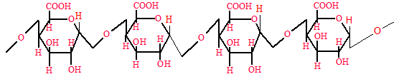
Figure 1. Theprimary structure of pectin shown by homogalacturon.
The carboxyl groups at position C6 within GalA may be in the form of their methyl esters giving to pectin types with differing degrees of esterification (DE). Amides can also be formed by reaction of the C6 carboxyl group with ammonia. O-Acetylation of the hydroxyl groups at C2 and C3 in the presence of ethanoic acid is also possible. GalA is found in nature in either water soluble form or in the insoluble form intertwined with cellulose and hemicellulose. Substituted galacturones are indicated by the presence of saccharide residues like L-rhamnose, L-arabinose, D-galactose, L-aceric acid, D-glucose, D-xylose, and D-apioseattatched to the backbone of the D-galacturonic acid residues (Figure 2).
Pectin is generally used in food as gelling agent, thickener, emulsifier, and stabilizer. Pectin is used to stabilize acidic protein drinks and improves the pulp stability in juice based drinks and acts as a fat substitute in baked goods.
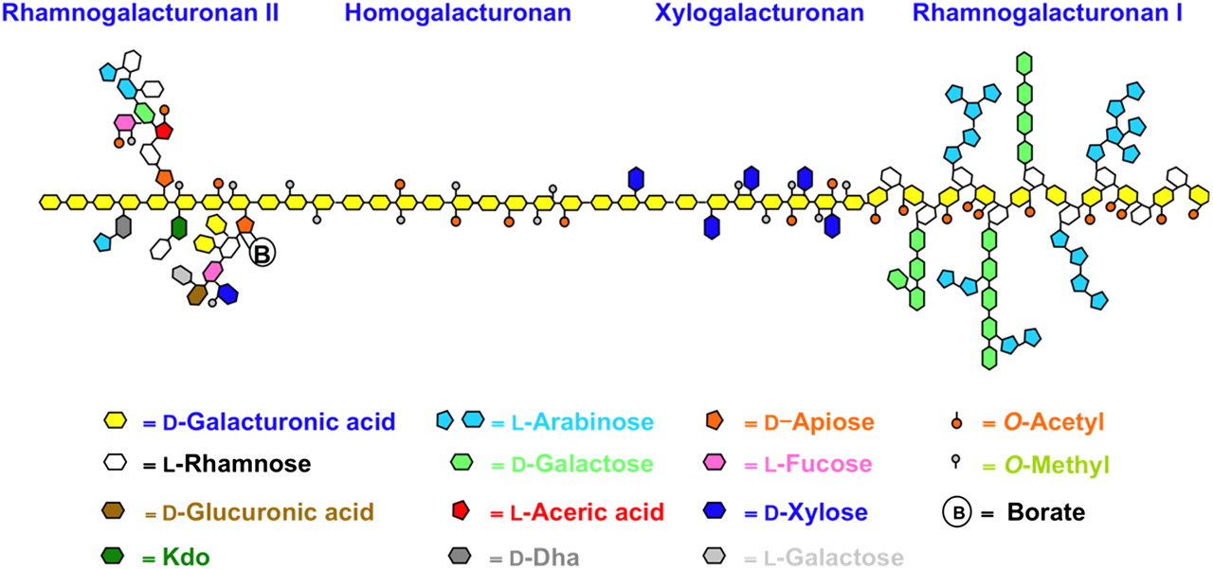
Figure 2. Schematic representation of the structure of pectin.
Pectin is also used in pharmaceutical industry for drug delivery. It has been used to control cholesterol levels in blood, for the prevention of colon cancer and prostate cancer and against diabetes and gastro esophageal reflux disease (GERD). It also prevents poisoning by removing heavy metals such as lead and mercury from gastrointestinal tract and respiratory organs by chelation. Pectin increases the volume and viscosity of stool and is used against constipation and diarrhea. It is also used for stabilizing water and oil emulsions, as biodegradable pectin films, metal chelating agents, foams and plasticizers. Recently pectin has been used to produce a mesoporous carbonaceous material through thermal and acidic gelation of native pectin.
Industrially, pectin is extracted from citrus peel by acidic hydrolytic methods at elevated temperatures (up to 100ºC). The resulting pectin-containing extract is then treated with ethanolto release free pectin as a precipitate, which is isolated washed and dried. This process is energy intensive, uses corrosive acids and generates significant quantities of acidic waste thus not very green. Enzymatic extraction has also been used for the isolation of pectin from citrus peel using different enzymes such as endo-polygalacturonase, lyase, and protease. However, this process is not yet industrially viable due to the complexity involved with enzymes. Recently, Clark etal.¹⁴ reported a method for the isolation of pectin using low-temperature (120ºC) microwave-assisted extraction. This process is much greener than conventional (thermal acidic hydrolysis) process because it does not require additional mineral or organic acid so does not generate acidic wastes and is effective within 10 minutes unlike several hours of heating at approximately 100ºC.
1.2.2. Essential oils (D-limonene)
Orange peel contains about 1% by wet weight of essential oil, which is basically concentrated volatile hydrophobic liquid present in the oil glands located in the outer rind of the fruit peel. Orange oil comprises more than 90% monoterpenes (mainly D-limonene), small amount of alcohols, usually 0.5-1% aldehydes, ketones, free acids, and about 2.4% esters. Commercially, essential oils are extracted by cold pressing and steam distillation. Recently, microwave assisted steam distillation has gained popularity for the production of essential oil. The main applications of orange oil include flavours and fragrances for cosmetic, food and home and personal care industries.,
1.2.2.1. D-Limonene
D-Limonene is a cyclic monoterpene (Figure 3) with an annual production between 50,000- 70,000 tonnes.The L-isomer can be obtained by the hydration of turpentine followed by distillation of eucalyptus oil. Bio-derived D-Limonene is gaining considerable interest as a bio-based replacement solvent in many industrial processes and as an excellent starting material for industrially relevant fine chemicals, flavour compounds and resins.
Figure 3 .Chemical structure of D-limonene
1.2.3. Cellulose
Cellulose is the most abundant renewable polymer with about 10¹¹ -10¹² tons per annum synthesized naturally in pure form but a huge amount of it is present in combination with lignin, hemicellulose or pectin (as protopectin) (Figure 4).Orange peel contains about 13% cellulose.
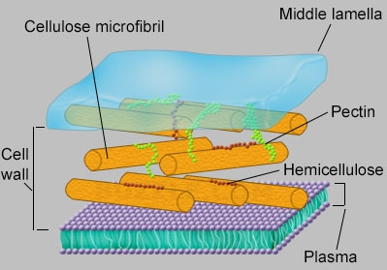
Figure 4. Outermost covering of a plant cell.
Cellulose is a linear insoluble polymer of β-(1-4)-D-glucopyranose units in ⁴C₁ conformation (Figure 5). The complete equatorial conformation of β-linked glucopyranose residues stabilizes the chair structure.
Figure 5. Schematic representation of cellulose structure
Cellulose in contrast to starch is oriented with -CH₂OH groups alternating above and below the plane of the cellulose molecule thus giving long, unbranched chains. The absence of side chains allows cellulose molecules to lie close together and form stiff a rod like conformation. The multiple hydroxyl groups on the glucose moiety from one chain forms hydrogen bonds with oxygen atoms on the same or on a neighboring chain, holding the chains firmly together side-by-side and thus forming microfibrils with high tensile strength which is responsible for the strength in cell walls, where cellulose micro fibrils are meshed into a polysaccharide matrix (Figure 4).
1.2.3.1. Cellulose morphology
A fundamentalcellulose fibril is considered to be the smallest morphological unit with size variation of 3-20nm. The basic structure of native cellulose comprises aggregated particles with extensive pores which are capable of holding relatively large quantity of water by capillary action. The cellulose structure experiences crystal formation due to intra-molecular (O3-HO5' and O6H-O2') and intra-strand (O6-HO3') hydrogen bonds holding the network horizontally. Weak C6-HO2' hydrogen bonds also have some impact on thestability of the crystal network.
Several crystalline structures of cellulose have been known depending on the location of hydrogen bonds between the cellulose ribbons. For example, cellulose I (which is, natural cellulose) contains parallel strands with no inter-sheet hydrogen bonding. This metastable state consists of two coexisting phases in different proportions:cellulose I_{α} (triclinic) which is found in algae, and; cellulose I_{β} (monoclinic) which is the major form in higher plants.The metastable cellulose I_{α} converts to cellulose I_{β} on annealing. Cellulose I gives the thermodynamically more stable monoclinic Cellulose II structure when recrystallized using base/CS₂. Cellulose II has an antiparallel arrangement of the threads and contains both intra- and inter- sheet hydrogen-bonding.Cellulose III is formed from cellulose mercerized in ammonia and has a structure similar to cellulose II but the chains are parallel, as in cellulose I_{α} and cellulose I_{β}.
The tendency of cellulose to form crystals utilizing extensive hydrophobic connections in addition to inter- and intra-molecular hydrogen bonding makes it completely insoluble in normal aqueous solutions (although it is soluble in more exotic solvents such as aqueous N-methylmorpholine-N-oxide,CdO/ethylene-diamine(cadoxen),LiCl/N,N'-dimethylacetamide or near supercritical water. The order of molecules in a cellulose fiber is uneven throughout the whole structure, and hence there exists regions within the structure, that have varying amounts of order. Experimental analysis proves that cellulose is a two-phase model, thus dividing the supramolecular structure into two regions: low ordered (amorphous) and highly ordered (crystalline) regions excluding the medium ordered parts (Figure 6).

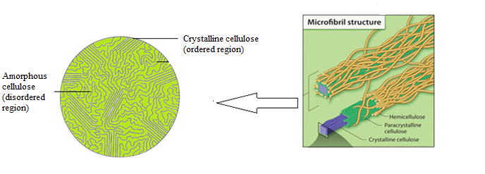
Figure 6. Microfibril structure of cellulose showing its amorphous and cellulose regions

There have been several reports on the extraction of cellulose from orange peel.Bicuet al. reported the production of decent quality pure cellulose with a good degree of crystallinity, whiteness and water retention capacity making it very useful for the generation of microcrystalline cellulose, and as filler for paper. The acidic hydrolysis of α-cellulose obtained from orange peel for the isolation of microcrystalline cellulose proved by Ejikemeprovides a very good base for future work on the isolation of crystalline cellulose from orange peel.Recently Tsukamoto et al.reported the production of nano-cellulose post hydrolysis of orange peel wastes followed by sonification and defibrillation of the residue. However, a major concern in cellulose extraction and production is the generation of vast quantities of chemical waste such as HCl, acetic acid, NaOH²², organic solvents (trichloromethane, hexane)²⁰,oxidizing agents (hydrogen peroxide and sodium hypochlorite)^{21,}and sodium salts of sulfurous acid,²⁰which are a huge environmental concern. So recently Clark et al. reported a greener alternative for the extraction of cellulose from waste citrus peel. Hydrothermal microwave treatment of the peel at low temperatures makes the extraction of cellulose a single step process as opposed to the long, tedious multistep processes used conventionally.
Citrus peel specially the pith possesses a rather novel type of cellulose, i.e., the cellulose is already structured with inherent porosity. Porous materials are broadly classified into three classes according to IUPAC: microporous, pore size (< 2 nm); mesoporous, pore size (2–50 nm), and; macroporous, pore size (>50 nm). Mesoporous materials have a large surface area over a smaller volume and hence make them suitable for a variety of application like catalysis, chemical sensors and molecular separation.
Chemicals such as dyes and pigments are used in variety of industries including textile manufacture, leather tanning, paper production, food technology and cosmetics manufacture. A tremendous amount of these dyes are released into the water streams during the dyeing process. Many of these dyes are toxic, even carcinogenic, and persistent in the environment and non-biodegradable. The impact of releasing such waste streams into water poses a serious threat to the environment. Many dyes are resistant to aerobic digestion, stable to light, heat, water and oxidation, making their treatment very difficult. The conventional technologies such as chemical precipitation, oxidation/reduction, ion exchange, and electrolysis or membrane filtration have to be replaced by greener methods as biosorption because they are expensive and require a large number of micropores results in large amounts of material needed to improve extraction rates of extraction. Polysaccharides, like cellulose, are relatively inexpensive, have low density, the ability to undergo structural and chemical modification, non-toxic, biodegradable, possess polyfunctionality and are abundant. The development of polysaccharide-derived mesoporous materials with large pore volumes and surface areas may open new doors to naturally-derived biobased adsorbents. Thus the hydrothermal extraction of mesoporous cellulose from waste orange peel will be a further break through. The surface chemistry and porosity of these materials can be controlled through varying the temperature, conditions of preparation and the solvents used for the solvent exchange process.
1.2.4. Potential molecules of interest in orange waste
The peel of sweet oranges contains about 4.5% polymethoxyflavones and flavonoids. These polyphenolic compounds have been of major interest in the biological sector due to the broad range of health benefits they have including anticancer, anti-inflammatory, anti-atherogenic properties.The main flavonoid present in citrus peel is hesperidin (Figure 7). It is usually extracted from orange peel using petroleum ether and acids like acetic acid or hydrochloric acid generating massive quantities of acid waste.,
Figure7. Chemical structure of hesperidin
Orange peel also contains about 5-6% hemicellulose which is a source of D-glucose-xylose, D-mannose, D-galactose, L-rhamnose and L-arabinose. Orange peel is rich in fermentable sugars like glucose, sucrose and fructose thus a potential source of bio-ethanol (from the fermentation of the reducing sugars) or hydroxymethyl furfural (HMF) by the acidic hydrolysis of the biomass itself.,,
1.3 Other Citrus Wastes
Similar to orange peel, peels of grapefruit, lemon and lime peel are valuable bioresources. Over the years there has been quite some work on the extraction of pectin,, flavonoids,,and carbohydratesfrom these citrus peels. But the methods being used pose a serious environmental hazard due to the usage of harmful chemicals. Moreover there has not been any reported research about the isolation of cellulose from these peels. As proved earlier with orange peel which contains structured cellulose that can be isolated by microwave-hydrothermal treatment. Thus we also need to focus on the extraction of cellulose from the other citrus peels and study its properties. It will also be an interesting observation to compare the quality and property of the cellulose extracted from different types of peel belonging to the same family of fruits.
1.4 Mango peel waste
Mango is one of the most important fruits in tropical areas. India is the largest producer of mango (national fruit of India). In India alone about 15.2 million metric tons of mango was produced in 2011. Other major mango producing countries are China, Indonesia, Thailand, Pakistan and Brazil.⁴¹ Alphonso mango cultivated in India is considered the king of mangoes and is an important export product.Besides the use of mango as an edible fresh fruit, processed mango as juices, jams, jellies,amchur powder and dried fruits have become very popular. This produces a large amount of waste including the kernel and seeds, and similar to citrus peels, their disposal is a huge problem. Mangoes are a rich source of dietary fibre (cellulose,hemicellulose, lignin and pectin), polyphenols, carotenoids, vitamins and volatiles. In the last couple of years there has been a lot of work on the extraction of pectin^{,,47} isolation of mixture of enzymes from the peel and the extraction of polyphenols and carotenoids.,But the work on the extraction of cellulose from mango peel is scarce. The complete exploitation of this bioresource is very important from the economic and environmental point of view. Hence, microwave-assisted hydrothermal extraction of cellulose from citrus peel can also be applied to mangoes.

Mangoes cultivated in different countries experience, different climatic conditions, different harvesting conditions,different ripening stage. All these factors not only affect the color and thickness and texture of the peel but also affect the yield and quality of polysaccharides present in the peel.So if peels from different origins are treated under the sample extraction conditions, it will be interesting to see the difference in the quality and properties of the polysaccharides.
1.5 The Biorefinery concept and Project Aims
The potentially valuable chemicals present in citrus wastes which is a great source of raw materials for a wide range of industries areunderutilized when used just for either energy generation or animal feed. Moreover these conventional methods leadto escalating prices of the raw material, high transportation costs,increasing environmental concerns, low resource efficiency and extremely low profit margin. This is where the concept of a biorefinery comes in as a greener and economically profitable alternative. Hence, reusing the waste as raw material for manufacturing marketable goods fulfills the principles of green chemistry and thus helps take a step forward toward our goal or circular economy based on zero waste. Clark et al.²³ have patented a biorefinery-based concept on microwave activation of waste orange peel. This involves microwave assisted low temperature hydrothermal treatment of waste orange peel to yield D-limonene, pectin and mesoporous cellulose without the use of acids or any pre-treatment. Thus the key for complete waste valorization is making use of all the valuable components in the waste while processing it in a way to also fulfill the principles of green chemistry. A detailed flowchart as shown in Figure 8 summarizes the biorefinery concept for waste orange peels.
Thus, the aims of the project are:
- to develop extraction methods for mesoporous cellulose from waste orange peel;
- to develop an understandingof the mechanism of production so as to optimize extraction methodology for the attainment of good quality mesoporous crystalline cellulose;
- to investigate the effect of experimental method on the degree of crystallinity and the textural properties of cellulose;
- to develop extraction methods for mesoporous cellulose from other waste citrus peels;
- to develop extraction methods for mesoporous cellulose from mango of different varieties and to investigate any relationship between cellulose type and varietal type.

D-Limonene and water
Oligomers and products and decomposition of pectin
Mesoporous cellulose
Pectin
Poly-methoxy flavanoids and sugars
Soxhlet extraction ; 3L acetone ; 1.08 KWH
Work -up
Work- up
Orange peel residue ; OP 3 (a)
Pectinase treatment at room temperature
Orange Peel residue ; OP 3(B)
Steam distilled and soxhlet extracted orange peel residue ; OP 2
MW hydrothermal treatment ; 120 C ; 1.4g: 70 ml ; 10 minutes
Steam distilled orange peel residue (dry) ; OP 1
Fresh Orange Peel (wet)
MW assisted steam distillation 800-1200W ; 0.95 KWH

Work- up

Work up
Mw Hydrothermal treatment ; 140- 180 C ; 1g: 20 ml ; 10 minutes
MW hydrothermal treatment ; 140 - 180C ; 1g: 20ml ; 10 minutes

Work - Up
Work up
Mesoporous cellulose
Mesoporous Cellulose

Figure 8. Biorefinery concept for waste orange peel.
EXPERIMENTAL
2.1 Raw materials and reagents
Extraction experiments were carried out using frozen orange peels which were obtained from a London-based juicer (Sundance, New Covent Garden Market).The peels were defrosted, stored in the laboratory fridge at 5ºC and milled into small pieces (<5mm) using a food processor before use. The water content (84%) was determined by the weight loss after drying the peel (5g) overnight in the oven at 120ºC.
Cellulose extraction from citrus peels was carried out using peels obtained from "Costcutters" (local university supermarket). The citrus peels used for extraction were grapefruit, lemon and lime. The peels were stored in the laboratory fridge and milled into small pieces prior to extraction(< 5mm) using a knife.
Cellulose extraction from mango peels were performed using mango imported from different countries, e.g.,Alphonso mango from India, Honey variety from Pakistan. The peels were stored in the laboratory fridge and the milled into small pieces (<5mm) before pectin extraction followed by cellulose extraction.
For comparison and analysis purposes, microcrystalline cellulose was purchased from Sigma Aldrich Chemical Company and was used as received , commercial citrus pectin with degree of esterification of 75-80% was obtained from MP biomedicals, Germany.
The pectinase enzyme used was obtained from Young’s u-Brew,Bilston, England.
Solvents and reagents used in work up procedures, i.e. ethanol and acetone, were obtained from Fischer Chemicals.
2.2 Analytical Methods and Equipment Used
2.2.1 Infra- Red Spectroscopy (ATR-IR)
Attenuated total reflectance infrared spectroscopy (ATR-IR) measurements were performed on aBruker Vertex 70 instrument. Commercial microcrystalline cellulose was used as a reference for the cellulose samples. Spectra were taken from 4000 cm⁻¹ to 600 cm⁻¹ at 64 scans, with a spectral resolution of 2 cm⁻¹, with blank window for background.

2.2.2 ¹³ C Solid state NMR
Solid state NMR (CP-MAS) was performed externally by the EPSRC National Solid-State NMR service based at the University of Durham. ¹³C NMR analysis was carried out on a Varian VNMRS 400 spectrometer with cross-polarization and a magic angle spinning probe with a rotor size of 6mm.A 1 ms contact time was used.
2.2.3 Thermogravimetricanalysis(TGA)
Thermogravimetric analysis was performed on NETZSCH STA 409. A small amount of sample was accurately weighed into a TGA cup and heated under the nitrogen flow of 50ml/min to avoid oxidation of the sample. The programmed temperature was started at room temperature and then increased up to 700ºC at a rate of 10K/min.
2.2.4 Powder X-ray diffraction(XRD)
Powder X-ray diffraction (XRD) studies were performed on a Bruker–AXS B8 Advance diffractometer with a kristalloflex 760 X-ray generator which produced monochromatic K-alpha radiation from a copper source. A finely ground powder of the sample under investigation was placed and leveled within a small round hole beveled out of an aluminum sample holder.Scans were taken with a rate of 2º/min across the range θ = 2-60 with a 40 K voltage and 40mA current.
2.2.5 N₂ adsorption porosimetry
Nitrogen adsorption/desorption analyses were carried out at 77 K using a MicromeritricsTristar volumetric adsorption analyzer. Before analysis finely ground samples (~ 100 mg) were degassed at 50ºC for 4 h under nitrogen flow. Specific surface area (m² g⁻¹) were calculated using the Brunauer, Emmett and Teller(BET) method and the total pore volume (cm³ g⁻¹) was determined from the amount of nitrogen adsorbed at p/pº .All pore size distribution curves were determined from the desorption branch using the Barrett, Joyner and Halenda (BJH) method.

2.2.6 Scanning electron microscopy (SEM)
SEM images were carried out with the assistance of Dr Meg Stark, Department of Biology, University of York. SEM images were recorded using a JEOL JSM-6490LV scanning electron microscope.
2.2.7 Electron-spray ionization- Mass spectrometry (ESI-MS)
ESI-MS measurements were carried out by Dr Karl Heaton. The experiments were performed on a Bruker microTOF mass spectrometer coupled to an Agilent 1200 series liquid chromatograph system with a 90 position autosampler and a single wavelength detector. The spectrometer typically has a mass range of 3000 - 10,000 FWHM. The samples were all water based.
2.2.8 Proton/deuterium exchange by ATR-FTIR
The cellulose samples (1g) were washed with deuterium oxide (10g), followed by freeze drying. The freeze dried samples were then analyzed by ATR-FTIR. The accessible hydrogen bonds within the cellulose sample was measured by the ratio between the areas associated with the O-H and O-D bands in the respective 3400cm⁻¹ and 2900cm⁻¹ regions.
2.2.9 Freeze Drying
AVirTis SP Scientific Sentry 2.0 freeze- drier was used to dry the aqueous ethanol and water extracts following microwave treatment.
2.2.10 Microwave Processing
Two different microwave systems were used, either:
- Milestone Rotosynth microwave reactor equipped with a ultra-high vacuum system so as to isolate D-limonene, and/or;
- ACEM MARS 6 with One TouchTM Technology microwave for the extraction of cellulose from citrus peel. The experiments were carried out in the EasyPrepTMPlus Teflon 100ml closed vessels. The vessels were fitted with a fibre optic probe for accurate temperature measurement.

2.2.11 Centrifugation
Liquid-solid separation was performed for the work up of pectin using a HeraeusMegafuge40R centrifuge set at 3600 rpm for 10 minutes at room temperature (acceleration and deceleration set at 9 and 6 RCF, respectively).

2.3 Experimental Methods
2.3.1 Microwave-assisted extraction and purification of cellulose from fresh orange peel – general method.
Milled orange peel (3g) and de-ionized water (60 ml) were added to a microwave vessel (80 ml) and subjected to microwave heating for 10 minutes (high stirring, closed system, 20 minutes ramping time,600W). Thereafter, the cooled reaction mixture was filtered, the solid residue was isolated and set aside, whilst the filtrate was solvent exchanged with ethanol (3 x 60 ml)with high stirringat room temperature. The ensuing solid was filtered, washed with acetone (3 x 60 ml) and dried invacuo to afford an off-white solid.
2.3.1.1 Variation of extraction temperature
The generic method described above in section 2.3.1 was applied different temperatures: 140 ºC,150 ºC,160 ºC,170 ºC,180 ºC, 190 ºC and 200 ºC(6 microwave vessels were prepared per run, each vessel containing 3g peel:60ml water). The samples were labeled as AB 140C, AB 150C, AB 160C, AB 170C, AB 180C, AB 190C, AB 200C, respectively.
2.3.2 Step-wise extraction of valuable products from fresh orange peel – generic methodology
The process commenced with themicrowave-assisted steam distillation of fresh (wet) orange peel to release D-limonene and water. The orange peel residue was then subjected to continuous hot solvent extraction (Soxhlet) with acetone which removed flavonoids and sugars. The pectin extraction was carried out by two different methods:
- enzymatic hydrolysis (pectinase), and;
- microwave-assisted hydrothermal treatment at 120ºCof the steam distilled and soxhlet extracted orange peel residue.

The final extraction of mesoporous cellulose was carried out by three different methods:
- Microwave hydrothermal treatment of the enzymatically hydrolysed peel at a range of different temperatures ( 140-180 ºC);
- Work up ( solvent exchange by ethanol and acetone) of the enzymatically treated OP residue;
- Microwave assisted hydrothermal treatment (140 ºC - 180 ºC)of the orange peel residue that has been treated earlier in the microwave at 120ºC for pectin extraction.
2.3.2.1 Microwave steam distillation of D-limonene
The steam distillation was carried out in a Milestone RotoSYNTH microwave reactor connected to a Vigreux column, which was attached to a cooler (-2 °C) and a second water condenser. The distillate was collected in two two-necked round bottomed flasks attached to the two condensers, respectively. Fresh, wet orange peel (ca. 7.2 kg in total, i.e. 9 microwave runs of 800 g each) was irradiated at 1200W for 6 minutes and thereafter the power was decreased to 800W for 19 minutes to avoid pyrolysis of the peel. The system was operated under vacuum (562 mbar) to facilitate the extraction of essential oil and water from the peel. The total energy consumed by the system including the chiller, vacuum pump and the microwave was 0.95 Kwh per run. The essential oil was isolated from the aqueous phase using a separating funnel to give crude D-limonene (4.5 g, 0.18 %), as a clear, colorless oil. The orange peel residue after steam distillation was saved and labeled as OP1 for further experimentation.
2.3.2.2. Soxhlet extraction of flavonoids
Dry, essential oil-free peel (OP1, ca 1382 g, for three runs of 450 g each as described in section 2.3.2.1) was subjected to continuous hot acetone extraction (Soxhlet, 3 L) for four continuous cycles. Thereafter, acetone was evaporated in vacuo to give a light brown solid which was dissolved in water, filtered and the resultant filtrate was freeze-dried and labeled as F1. The water-insoluble residue was dissolved in ethanol to give an ethanol soluble fraction (F2) and again some insoluble matter (F3). The orange peel residue after Soxhlet extraction was saved and labeled as OP2 for further experimentation.

2.3.2.3 Pectin extraction
Method 1: Enzymatic extraction of pectin using pectinase: Commercial pectinase (4 g) was mixed with de-ionized water (600 ml) and added to essential oil- and flavonoid-free orange peel residue, i.e.,OP2 (50 g) (as described in section 2.3.2.2.). The resultant slurry was stirred for 48 h at room temperature and then subjected to centrifugation (3600rpm, 10min). The pellet was isolated, washed with water (4 x 300 ml)and labelled as OP3 (a). The supernatant consisted of residual pectinase and products of decomposition of pectin including oligomers.
Method 2:Microwave-assisted hydrothermal extraction of pectin: OP2 (1.4g) and de-ionized water (70 ml) was added in a microwave vessel (80 ml, 6 vessels per run) and subjected to microwave heating for 10 minutes at 120ºC (high stirring, closed system, 20 minutes ramping time, 600W). Post microwave extraction the sample was filtered and the solid residue was collected and labelled as OP3 (b) whilst the filtrate was treated with an excess of ethanol to effect pectin precipitation. The ensuing precipitated pectin was collected by centrifugation (3600 rpm, 10 min),washed twice with double the volume of acetone and finally with hot ethanol (1.2L) to remove sugars. The purified pectin was consequently dried in a rotary evaporator to remove any residual ethanol.

2.3.3 Cellulose extraction from orange peel residues (OP3)
Cellulose was extracted and/or processed in three different ways:
Method 1: The pectinase extracted orange peel residue (wet), i.e.,OP3(a) (62g) was solvent exchanged with an excess of ethanol ( 3x 300ml), filtered, washed thrice with double the volume of acetone and dried in a vacuum rotary evaporator with high rotation to afford “cellulose” labeled as Exp16.
Method 2 (microwave): The de-pectinated orange peel residue, i.e.,OP3(b) from method 2 (as described in section 2.3.2.3) [wet] (3g per vessel; total 18g per one temperature run) and de-ionized water (60 ml) was mixed in a Teflon vessel and subjected to microwave irradiation in a Mars 6 CEM microwave for 10 minutes, (high stirring, closed system, 20 minutes ramping time, 600W). Microwave irradiation was performed at different temperatures, i.e., 140ºC, 150ºC, 160ºC, 170ºC and 180ºC. Post microwave radiation, the sample was solvent exchanged with an excess of ethanol (3x 200ml), filtered, washed with twice the volume of acetone and dried in vacuo. The resultant “cellulose” samples were labeled as exp17 140C, exp17 150C, exp17 160C, exp17 170C, exp17 180C obtained from microwave extraction temperatures 140 ºC, 150 ºC, 160 ºC, 170 ºC, 180 ºC, respectively.
Method 3 (microwave):The enzymatically treated orange peel residue i.e., OP3(a) from method 1 of section 2.3.2.3 (3gpeel :60 ml de-ionized water per vessel; 18g peel per run) was mixed in a Teflon vessel and subjected to microwave heating in mars 6 CEM microwave for 10 minutes ( high stirring, closed system, 20 minutes ramping time, 600W). Microwave irradiation was performed at different temperatures, i.e., 140ºC, 150ºC, 160ºC, 170ºC and 180ºC. Post microwave radiation, the sample was solvent exchanged with an excess of ethanol (3x 200ml), filtered, washed with twice the volume of acetone and dried in vacuo. The resultant “cellulose” samples were labeled as exp18 140C, exp18 150C, exp18 160C, exp18 170C, exp18 180C obtained from microwave extraction temperatures 140 ºC, 150 ºC, 160 ºC, 170 ºC, 180 ºC, respectively.
2.3.4 Extraction and purification of cellulose from citrus peels
Milled peel (ca. 3 g: either grapefruit, lemon or lime) was placed in a Teflon vessel containing de-ionized water (60 ml; each run had 6 vessels) and subjected to microwave irradiation at 180 ºC for 10 minutes (20 minutes ramping, 600 W, high stirring). The solid material post microwave treatment was solvent exchanged with an excess of ethanol (3x 200 ml), filtered, washed with acetone (3x 200 ml) and dried in vacuo to afford the desired “cellulosic” material as a dark brown-greyish fibrous material labeled as either AB grapefruit or AB lemon or AB lime based on the nature of the starting citrus peel.
2.3.5 Step-wise treatment of mango peels obtained from different countries
The mango peels were first hydrothermally treated in the microwave for the extraction of pectin. This extraction was performed by Ms Covadonga Lucas and post the microwave extraction the solid material provided by her was further processed for the isolation of cellulose.

2.3.5.1 Microwave assisted pectin extraction from mango peel
The pectin extraction was performed in the microwave (MARS 6 CEM, 600 W, high stirring) at 140 ºC for 10 minutes with peel to water ratio being 1:10. The solid material obtained after microwave treatment was provided and further processed for extraction of cellulose.

2.3.5.2 Isolation of cellulose from the pre-treated mango peel
The different mango peels( 3 g per vessel; 18 g per run) were subjected to microwave heating at a temperature of 180 ºC for 10minutes with peel to water ratio being 1:20 (high stirring, 600 W). Post the microwave extraction the solid residue was collected and washed with ethanol (3x 200 ml)for the removal of water and sugars from the peel. Subsequently the peel was washed with acetone (3x 200 ml) and dried in vacuo to afford mango “cellulosic” matter labeled as AB Alphonso, AB honey based on their country of origin or type, i.e., Alphonso (India), Honey (Pakistan), respectively.

3. MESOPOROUS CELLULOSE FROM FRESH VIRGIN ORANGE PEEL
3.1 Background
Baluet al.²³ recently reported that microwave-assisted hydrothermal extraction of orange peels in the temperature range 180 ºC – 200 ºC furnished D-limonene, pectin and a cellulosic-like material. Characterisation of the latter by FTIR, porosity and SEM revealed that non-porous parent orange peel was converted to a macroporous cellulosic-like material with a low surface area when heated at 180 ºC but at 200 ºC, mesoporous cellulose was obtained. Fan et al. have shown that commercial microcrystalline cellulose when hydrothermally treated in the microwave starts depolymerising above 200 ºC. Considering these observations the aim of this chapter was to optimize the extraction conditions in order to increase the textural properties of the mesoporous cellulose produced and also to investigate the effect of the extraction temperature on the quality of cellulose produced.

The defrosted orange peel was reduced in size by using a food processor. The ratio of orange peel: water in the microwave vessel was taken as 1:20 as opposed to 2:1 reported by Balu et al.²³ The higher amount of water results in increased pressure in the microwave vessel which results in greater vaporization, enhanced cell expansion and hence more efficient extraction of pectin and essential oil in the surrounding media. The orange peel was microwaved in the temperature range of 140 ºC - 200 ºC.

The CHN analysis of the virgin peel was performed to determine the different constituents of the orange peel and the values were found to be 40.30% C; 6.16% H; 0.71%N. The dried peel was also analysed by ATR-IR and TGA and nitrogen adsorption porosimetry. The analytical data was compared with commercial microcrystalline cellulose, hemicellulose and pectin taken as standard references. It was observed that the maximum carbon content was present in cellulose and it was extremely important for the extraction of cellulose from orange peel to valorise the biomass to its full potential.

A detailed process flow-sheet of the procedure is summarized in Figure 9 and full experimental details are given in Chapter 2, section 2.4.

;;;;;;;;
Defrosted orange peel (size reduced in food processor)

Microwave hydrothermal treatment, 10 min, 140ºC- 180ºC (∆10ºC)
Acetone (x ml)
Ethanol (x ml)
Acetone (x ml)

vacuum drying
Ethanol (x ml)

Acetone wash x 3
filtration
Ethanol wash x 3
Filtration
H₂O (360ml) [for one temperature]

H₂0 (360ml)

Pectin in aqueous solution

Mesoporous cellulose

Figure 9. Process of MW-assisted hydrothermal extraction of cellulose from orange peel

3.2 Results and Discussion
3.2.1 Effect of extraction temperature on “cellulosic matter” yield
Microwave experiments were carried out at 140, 150, 160, 170, 180, 190 and 200 ºC, respectively for 10 minutes with an orange peel: water ratio of 1:20. The yield (%) of “cellulose matter” with respect to temperature is plotted in Figure 10, which shows unusual behaviour. “Cellulose matter” yield is maximum (12.5%) at 140 ºC most likely due to the fact the material still contains pectin, cellulose and hemicellulose. Thereafter, increasing temperature decreases yield of “cellulosic matter” until second maxima (8.3%) is reached at 170 ºC and then keeps on decreasing on further increase of temperature. The reason for the second maxima is still unknown.

Figure 10. Effect of extraction temperature on the yield of “cellulosic matter”
3.2.2 ATR-IR Spectral Analysis
For comparative purposes the ATR-IR spectrum of dried orange peel, pectin and cellulose was determined as shown in Figure 11. Orange peel contains three major polysaccharide components viz: pectin, hemicellulose and cellulose. It contains petite amounts of lignin (<2%) the main ir absorption bands are summarized in Table 1.
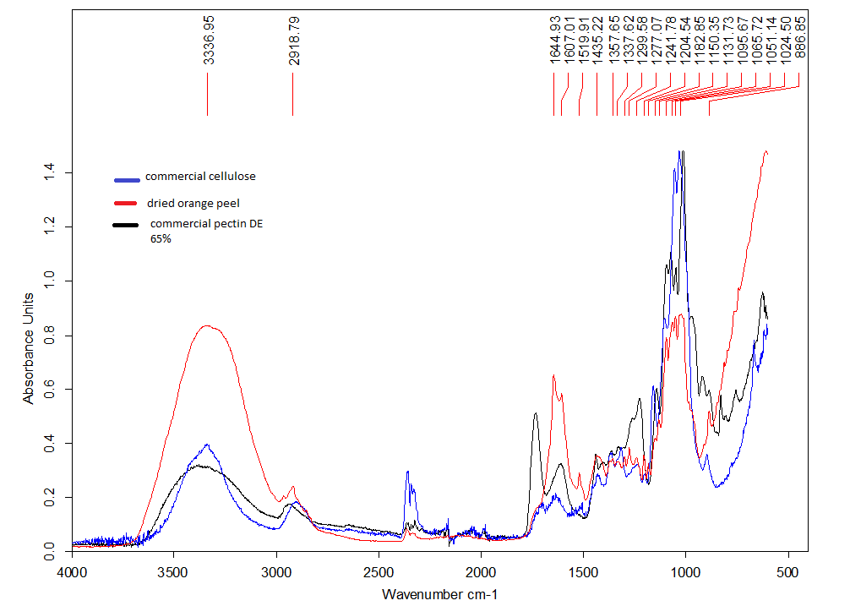
Figure 11. ATR-IR of dried orange peel with commercial cellulose and pectin as reference
Absorption band (cm⁻¹) | Inference
1700-1740 (-COOCH₃/-COOH),  1431-1439 (-CH₃ bending)  1606 | Pectin
1425-1423 (C-H deformation in lignin)  1328(syringyl ring plus guaiacyl ring)  1515-1511(C=C) stretch of aromatic ring in lignin | Lignin
1715-1765 (C=O stretch in hemicellulose is more than the other biomass components)  1428 (C-H, O-H bending)  1745(acetyl and uronic ester groups) | Hemicellulose
898 (C-O-C glycosidic linkage) | Amorphous regions of cellulose
1430 (-CH₂ bending vibration) | Crystalline regions of cellulose
Table 1. Characteristic FTIR peaks for orange peel components. ,,,,
ATR-IR analysis of the “cellulosic matter” with respect commercial cellulose showed that the material became more cellulose-like with increasing temperature as shown in Figure 12. The detailed analysis of the ATR-IR spectrum of AB180 ºC is listed in Table 2 which reveals very good correlation with commercial cellulose. However, above 180 ºC the spectra of the samples differed from commercial reference cellulose. The depolymerisation of cellulose could be observed, i.e., the breaking of the hydrogen bonds, reduction of the crystallinity, decomposition of the skeletal structure, and increase in the number of O-H bonds. Above 180ºC significant changes were observed in the cellulose spectra ; an increase in the intensity of the bands at 1335, 1320 cm⁻¹ are related to the increase in the number of O-H bonds. The increase in intensity of the bands at 1158 and 1033 cm⁻¹ is due to the C-OH, C-O-C and C-C bonds becoming more apparent. The appearance of a peak at 1698 cm⁻¹ is may be due to the occurrence of aldehydic groups., Significant darkening of the material was also noticed with increasing temperature.
Comparing ATR-IR spectrum of pectin in Figure 11 with those spectra shown in Figure 12 it can very clearly be seen that the intensity of the pectin peaks at 1350-1450 cm⁻¹ (esterified -CH₃ bending vibration), 1700-1740 cm⁻¹ (-COOCH₃/-COOH), 1100-1200cm⁻¹ (ether R-O-R stretching vibration and cyclic C-C ring structure of polygalacturonic acid) decreased with the increase in temperature, even at 180 ºC there was still some residual pectin. Also the intensity of peaks of hemicellulose at 1715-1765 cm⁻¹ (C=O stretching) also decreased with increasing temperature. The signature absorptions of cellulose at 1140-926 cm⁻¹ relating to the C-C,C-OH,C-H ring and side group vibrations shows a distinct change in the temperature range 140 ºC - 160 ºC, after which it remains the same (with different intensities though). The slight shoulder at 1035 cm⁻¹ at 140 ºC is shifted to a strong sharp peak at 1033 cm⁻¹ at higher temperatures.
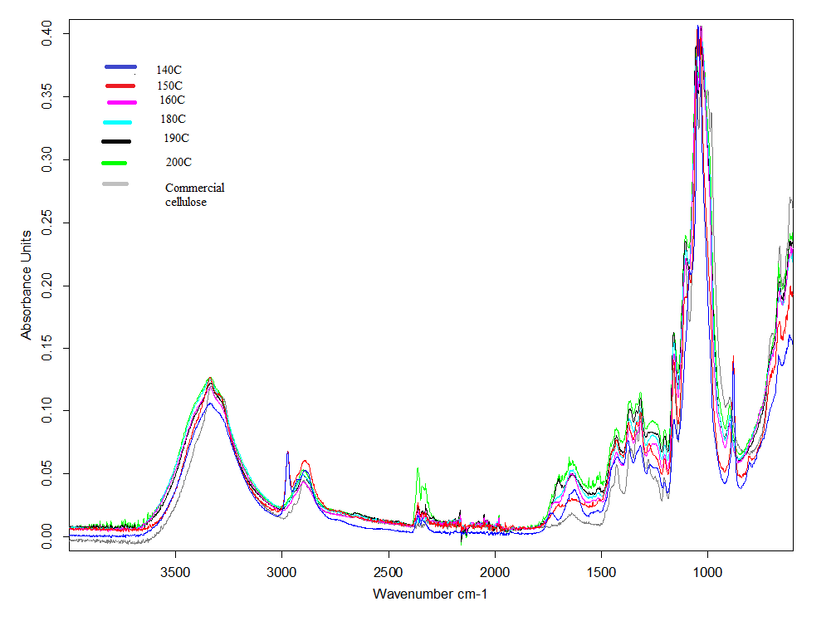
Figure 12. Effect of extraction temperature on cellulose with reference to commercial cellulose
Absorption band (cm⁻¹) | Assignment
3600-3000 | O-H group stretching
2896 | C-H stretching in cellulose skeleton
1700-1740 | -C=O stretch
1685-1585 | Absorbed moisture
1343-1493 | H-C-H, O-C-H in-plane bending
1315 | CH₂ rocking vibration at C6 carbon
1215-1290 | Out of plane bending vibration of C-O-H at C6
1204 | Symmetrical stretching vibration from C-O-C
1162 | Asymmetric stretching vibrations from C-O-C
1140-926 | C-C,C-OH,C-H ring and side group vibrations
1104 | C-O-C (1-4) glycosidic linkages
899 | C-O-C,CC-O, C-C-H deformation and stretching vibrations
Table 2. Characteristic absorption bands for AB180 ºC with similarity to cellulose
temperature of 160 ºC. Moreover, the band at 1087 cm⁻¹ (140 ºC) is also shifted to 1104 cm⁻¹ at 160 ºC which is attributed to the absorption by the 1-4 glycosidic linkages.
Another interesting observation is that there is a strong C=O stretch of a methyl ester at 140 ºC, possibly due to highly esterified pectin. But the intensity of this band decreases with increasing temperature probably due to decarboxylation. The decarboxylation of pectin is caused due to the acidic nature of the orange peel combined with the increase in temperature of the microwave.
3.2.3 Thermogravimetric analysis
The TGA of orange peel is shown in Figure 13, which basically shows four decomposition intervals: i. elimination of water at <170 ºC; ii. breakdown of pectin at 200-260 ºC; iii. breakdown of hemicellulose from 260-315 ºC, and; iv. decomposition of cellulose at 315-370 ºC and volatization of lignin at temperatures higher than 400 ºC.,
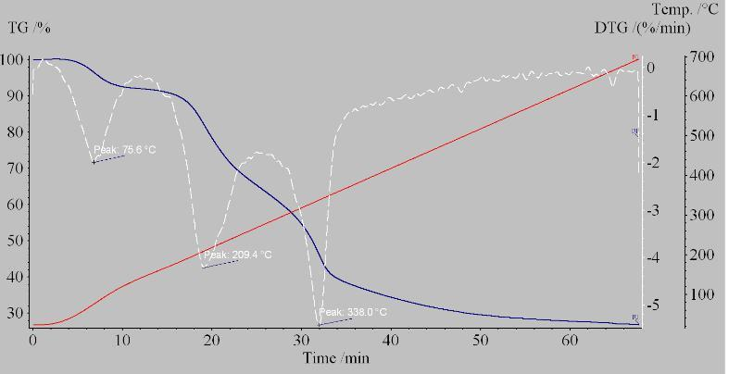
Figure 13 TGA trace for virgin orange peel
TGA traces for samples microwaved at 140 ºC (AB 140 ºC) and 180 ºC (AB 180 ºC) are shown in Figure 14 and Figure 15, respectively which when compared to virgin orange peel (Figure 13) show that the former (AB 140 ºC) contains still contains some amount of pectin corroborating the ir spectral analysis of the said material described earlier. The transition at approximately 260 ºC relates to the volatization of pectin and probably small amounts of hemicellulose. Moreover when the temperature is increased to 180 ºC only one main decomposition peak is observed at 359.2 ºC which is associated with the volatization of cellulose.
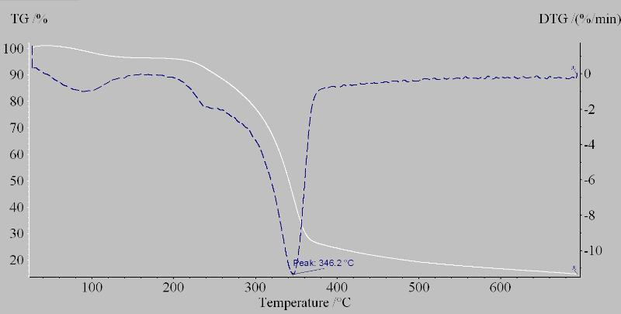
Figure 14. TGA trace for AB 140 ºC
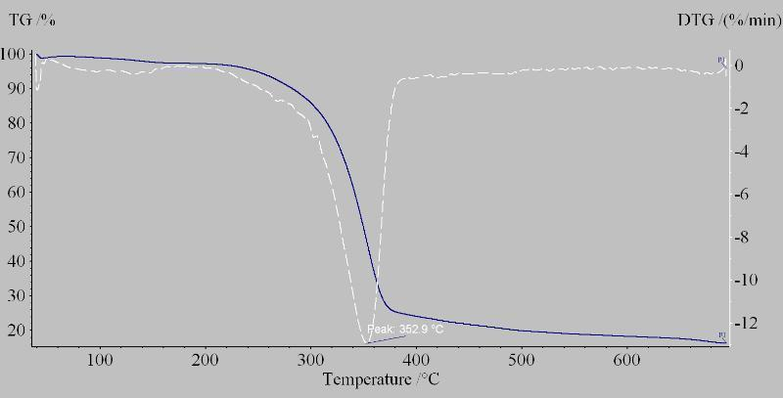
Figure 15. TGA trace for AB 180 ºC
Also, according to the TG data it can be inferred that the samples are very thermally stable and do not decompose before 300 ºC, which is an added benefit for applications like environmental remediation.
3.2.4 Nitrogen adsorption porosimetry
The effect of the extraction temperature on the textural properties of the “cellulosic materials” (Surface area (S_{BET}), Pore volume (V_{BJH}), Pore diameter (D_{BJH})) is shown in Table 3.
Sample | S_{BET}(m² g⁻¹) | V_{BJH} (cm³ g⁻¹⁾ | D_{BJH}(Å)
AB 140 ºC | 107 | 0.19 | 66.4
AB 150 ºC | 172 | 0.48 | 106.8
AB 160 ºC | 171 | 0.40 | 85.8
AB 170 ºC | 162 | 0.38 | 92.8
AB 180 ºC | 121 | 0.31 | 94.3
AB 190 ºC | 101 | 0.26 | 96.3
AB 200 ºC | 44 | 0.13 | 98.4
Table 3. Textural properties of mesoporous cellulose from orange peel with different extraction temperatures.
According to the porosity data the textural property of the sample indicates that the samples are mesoporous, with negligible microporosity ( which possibly reflects the relatively low degassing temperatures to be used i.e. 50 ºC ) and possess a high surface area (AB 150 ºC, 172.4 m² g⁻¹). Thus the materials have potential use as adsorbents. The porosity comes from the structured cellulose present in orange peel and is increased by the removal of the other structural non-porous components due to the hydrothermal treatment. Also, it is possible that the microwave irradiation opens up the linear cellulose structure giving rise to porous solid. But also the porosity decreased significantly, from 100.5 m² g⁻¹ to 44.3 m² g⁻¹, as the temperature was raised from 180 ºC to 200 ºC, respectively. This is probably due to the fact that the acidic conditions of orange peel and microwave irradiation leads to the thermal decomposition and depolymerisation of cellulose to give acetic acid, formic acid or even hydroxymethylfurfural (HMF). The pore volume also significantly drops due to treatment at 180 ºC to 200 ºC.

3.3 Conclusions
Cellulose and “cellulosic matter” was successfully extracted from orange peel by microwave hydrothermal treatment. The extraction temperature influenced the quality of product obtained. At lower temperatures the samples contained a significant quantity of the other structural components - hemicellulose and pectin, which was confirmed by the FTIR, TG data and the unusually high yield (%). As the temperature was increased (up to 180 ºC) the analytical data for the “cellulosic matter” came in close agreement with commercial cellulose. Thereafter, heating to 200 ºC initiated cellulose decomposition due to the acidic nature of orange peel. This not only results in loss of the porosity but also the yield drops and the sample becomes dark black which might be a result of premature partial carbonization of the sample at 200 ºC.
From the porosity data it can be confirmed that the cellulose obtained is mesoporous. Thus the extraction of mesoporous cellulose from orange peel without any pre-treatment or the addition of any acid has a procedural advantage over the production of mesoporous materials derived from starch, i.e., Starbon™. The latter uses expanded starch which is doped with a catalytic amount of organic acids (e.g. p-toluene sulfonic acid) which albeit in low concentration, does produce some acidic wastes. Starbon™ also has an advantage over the templating method which requires energy intensive high temperature programming for carbonisation along with the usage of highly corrosive chemicals like caustic soda and hydrofluoric acid. Moreover the resulting materials have a significant percentage of micropores, which can be a disadvantage for a lot of industrial applications .,,. Whereas mesoporous cellulose obtained from a renewable resource using clean technology typically contains mesopores. This quality along with its thermal stability makes it very suitable for applications like catalysis, environmental remediation, chromatography, formation of optical devices and nanotubes.
Hence, in conclusion a process has been developed which separates cellulose from the other structural components in the cell walls of orange peel without the need for additional acid or pre-treatment. This work clearly demonstrates the excellent potential possessed by the microwave to be used as a clean technology for the valorisation of biomass.

4. AN ORANGE PEEL BIOREFINERY: SEQUENTIAL EXTRACTION OF VALUABLE CHEMICALS LEADING TO MESOPOROUS CELLULOSE
4.1 Concept of a waste orange peel biorefinery
Orange peel waste is well known to contain D-limonene, flavonoids and pectin which have been isolated by many methods but the residual cellulosic matter is often discarded. Within the concept of an orange peel biorefinery based on maximizing value of all resources the residual cellulosic matter has importance because it represents the largest source of carbon. Chapter three already demonstrates the production of mesoporous cellulose from orange peel but has been performed without optimization in the concept of a biorefinery. Thus, in this chapter the aim is to investigate optimized production of mesoporous cellulosic matter via sequential extraction of valuable chemicals in the order: i. D-limonene; ii. flavonoids, iii. isolation of sugars and pectin (enzymatic, enzymatic plus microwave and, microwave plus microwave). Steps i and ii have been undertaken by researchers in the Green Chemistry Centre of Excellence to afford good quality limonene (based on scent profile verified externally) and the flavonoid, hesperidin, in reasonable yield so it will not be discussed here. A detailed account of the properties of the resultant cellulosic matter are discussed as this will ascertain which key variable or processing step has the biggest influence on mesoporosity.
4.2. Characterization and comparison of cellulose derived from: i. enzymatic + microwave, and; ii. microwave + microwave removal of pectinaceous materials
Acidic hydrolysis is one of the most common methods used commercially for the removal of pectic polysaccharides. However, since hemicellulose and pectin have similar chemical structures, the simultaneous hydrolysis of hemicellulose and the solubilisation of pectin occur under most given conditions. Thus, enzymatic hydrolysis is a more selective way to remove pectin from essential oil-free residual orange peel. One of the major advantages of pectin extraction through enzymatic treatment is that it is performed at room temperature without the addition of any acid/buffer or need for any pre-treatment. This does not alter the basic cellulosic structure as present in the orange peel and hence provides a better understanding of whether the structured cellulose is already present in the peel or if it is a direct result of microwave treatment.
Pectinase was used to release pectinaceous matter from essential-oil free residual orange peel. Commercially the most widely used pectic enzyme is polygalacturonase. The principal function of this pectinase is the degradation of polygalacturonan (pectin) by the hydrolysis of the glycosidic bonds linking the galacturonic acid residues. Thus the enzyme solubilizes the pectin and breaks it down thus releasing the embedded cellulose fibrils and hence making its extraction easier. Although there has been a lot of work on the removal of pectin using pectinase for industrial purposes, to the best of our knowledge, this is the first time ever it has been used as a method for the isolation of cellulose from citrus peel.
Both methods (i. enzymatic + microwave, and; ii. microwave + microwave) were compared on the basis of pectin and hemicellulose removal, porosity and quality of cellulose obtained.
4.2.1 ATR-IR spectral characterization
4.2.1.1 Enzymatic + microwave treatment
The ATR-IR spectrum of dried orange peel albedo, enzymatically treated peel (OP3 a) and residue post microwave-assisted extraction of pectin (OP3 b) is shown in Figure 16.
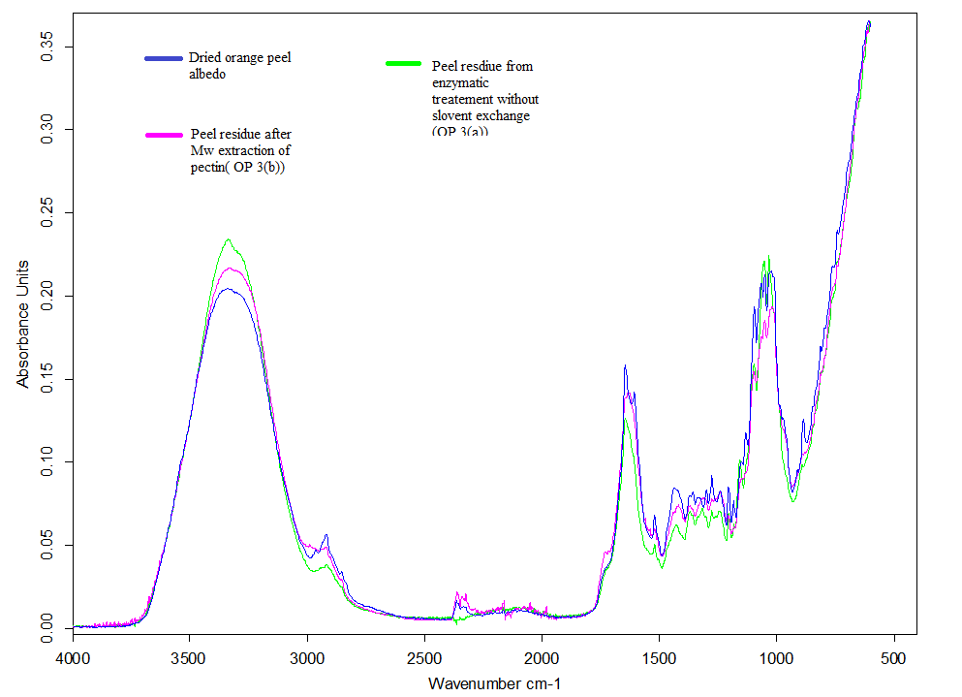
Figure 16. ATR-FTIR spectrum of dried orange peel versus peel residue after microwave extraction of pectin ; and enzymatic extraction of pectin

With respect to Table 1 (Chapter 3, section 3.2.2) ,the characteristic absorption bands for pectin usually at 1606 and 1431 cm⁻¹ are significantly reduced after both types of pectin removal treatment, with enzymatic treatment (OP 3a) appearing to have a greater effect.
The ATR-IR spectra of the resultant cellulosic matter post microwave irradiation at various temperatures (140 – 180 ºC) of enzymatically treated peel are shown in Figure 17.
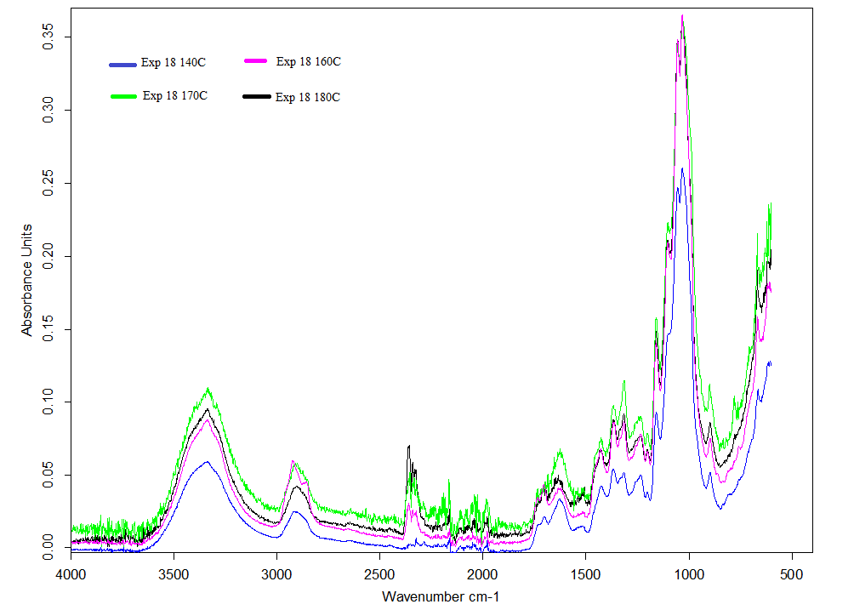
Figure 17. ATR-IR spectrum of samples produced through enzymatic + microwave method at different temperatures

No significant spectral change was observed as a result of increasing temperature sequentially from 140 – 180 ºC at 10 ºC intervals. Although not shown, these spectra correlate well with that of crystalline cellulose. The 3600-3000 cm⁻¹ broad yet strong band corresponds to the O-H stretching vibration. The broadness of the band is due to extensive inter- and intra- molecular hydrogen bonding between the adjacent cellulose chains. However, on increasing temperature from 140 to 170 ºC, this band becomes more intense and less broad possibly due to the depolymerisation of the amorphous regions of the cellulose leading to porous regions and availability of free O-H groups. The small weak band at 2896 cm⁻¹ was due to the C-H stretching vibration of the cellulose skeleton. The double band at 2360 cm⁻¹ is due to the presence of CO₂ which is apparently increasing with temperature due to increase in pressure in the microwave vessel. The very small band at 1700-1724 cm⁻¹ attributable to the C=O stretching vibration of an ester (–COOCH₃) and/or carboxylic acid group (–COOH) usually associated with pectin confirms that most of the pectin has been removed. The region 1343-1493 cm⁻¹ is assigned to the HCH and OCH in-plane bending vibration, and the band at 1315 cm⁻¹ is due to the CH₂ rocking vibration at C6. The broad region at 1215-1290 cm⁻¹ is caused by out of plane bending vibrations from C-OH at C6. Moreover the band at 1162 cm⁻¹ is due to C-O-C asymmetric vibrations. The region from 1140-926 cm⁻¹ is attributed to the C-C, C-OH , C-H ring and side group vibrations. The band at 1104 cm⁻¹ is caused by the absorption of the C-O-C glycosidic linkages which are one of the characteristic peaks of cellulose. The band at 899cm⁻¹ is allocated to the C-OC, CC-O and CCH deformation and stretching vibrations.^{,53,,} Thus, in particular at 150 ºC hemi-cellulosic matter is also completely removed and thus the principal component in the sample after this temperature is crystalline cellulose.
Fan et al.⁴⁹ recently reported that microcrystalline commercial cellulose when hydrothermally treated in a microwave, the amorphous regions depolymerise at temperatures below 190ºC whereas the crystalline regions remain unaffected till 200 ºC. Moreover as orange peel is slightly acidic (ca. pH = 4.8) due to the presence of citric acid in the peel it is possible that the amorphous cellulose depolymerisation takes place at a lower temperature. This is further evidenced on inspection of the absorption band at 898 cm⁻¹which is assigned to the C-O-C stretching of glycosidic linkages is referred to as the amorphous absorption band. The intensity of this band decreases with increasing temperature. Moreover the absorption band at 1430 cm⁻¹ assigned to symmetric CH₂ bending vibration is known as the crystallinity band, an increase in its intensity indicates increase in crystallinity of the sample. It is worth noting that at lower temperatures the samples have a band at 1424 cm⁻¹ which above 160 ºC, shifts to 1430 cm⁻¹. This proves that with increase in temperature the amorphous cellulose is removed and the crystallinity of the samples becomes more apparent especially at 180 ºC.

4.2.1.2 Microwave + Microwave treatment
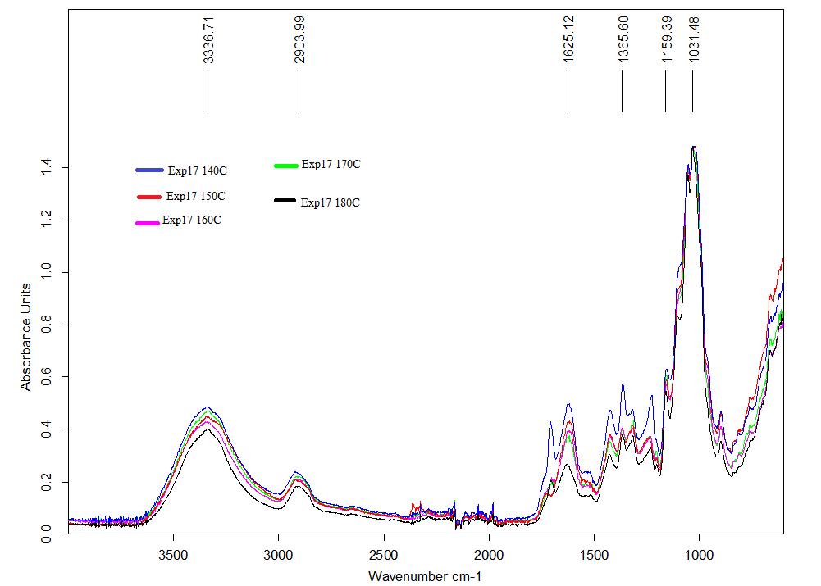
Figure 18. ATR-IR spectrum of samples produced through microwave + microwave method at different temperatures
From theATR-IR spectra shown in Figure 18 it is clearly evident that temperature has a considerable effect on the samples compared with enzymatic + microwave treatment (Figure 17). The intensities of all the bands on average decrease repeatedly with an increase in temperature. Moreover with increase in temperature the residual cellulosic matter becomes more cellulose-like. The intensity of the characteristic pectin absorption bands at 1740 cm⁻¹, 1430-1439 cm⁻¹are reduced significantly proving that increase in microwave extraction temperature is directly related to better removal of pectin from the peel residue. Also the intensity of the absorption bands relating to hemicellulose decrease with the increase in temperature. Moreover the absorption band at 1033-1015 cm⁻¹ assigned to the C-C, C-OH,C-H ring and side group vibration is very broad and blunt at lower temperatures (up to 160 ºC). Then with increase in temperature the peak becomes strong, sharp and defined at 1033 cm⁻¹ resembling the band of the reference cellulose sample (see Figure 19).
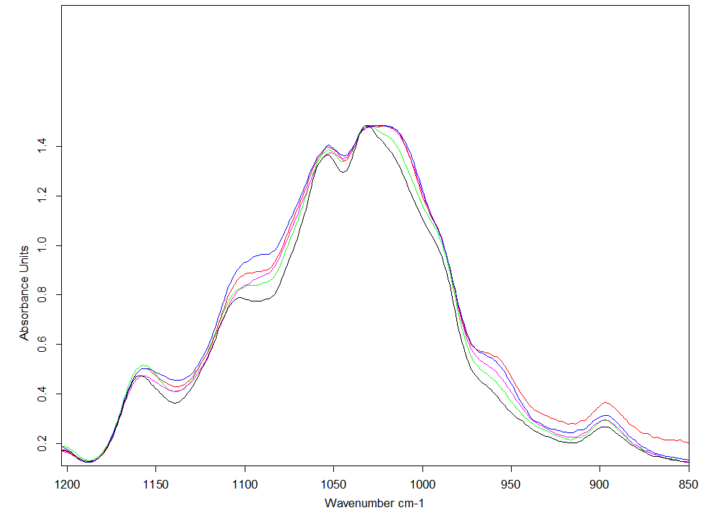
Figure 19. ATR-IR spectra of cellulose samples produced from microwave+microwave treatment at different temperatures in the range of 1200 – 850 cm⁻¹
Also as mentioned earlier the intensity of the amorphous absorption band decreased and the intensity of the crystalline absorption band shifted to 1430 cm⁻¹ from 1425 cm⁻¹ also confirming the depolymerisation of the amorphous cellulose (Figure 20).
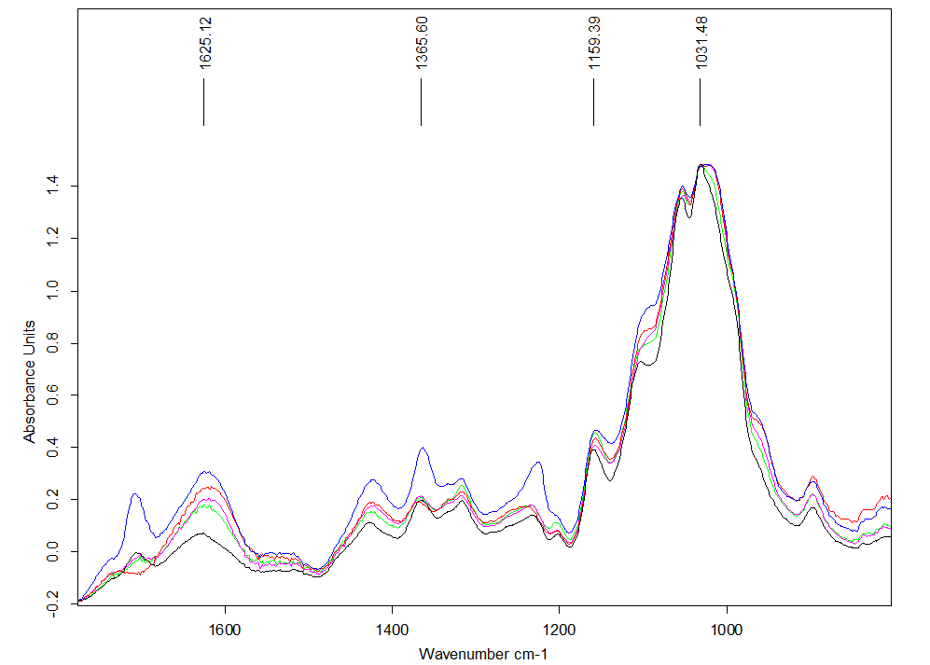
Figure 20. ATR-IR spectra of cellulose samples from microwave+ microwave method at different temperatures in the 1700-800 cm⁻¹ region.
Thus, the main components in all the samples is cellulose with minor traces of other components at lower temperatures which are removed at higher temperatures in the case of microwave + microwave treatment. But in the case of enzymatic + microwave treatment the cellulose appears to be much better based on a qualitative analysis of IR spectral bands.
4.2.2 Nitrogen adsorption porosimetry
According to IUPAC the type IV isotherm is characteristic for mesoporous adsorbent materials. This is the isotherm observed for the cellulose samples obtained from both methods. Initially, at lower pressures, an adsorbate monolayer is formed on the pore surface, followed by a multilayer formation. The point A in Figure 21and Figure 22 is usually taken in order to indicate the stage at which the monolayer coverage is complete. However, the theory of monolayer adsorption works only on a perfect planar surface and a real surface possesses some degree of roughness ,, due to which the absorption does not progress homogeneously.
Based on the porosity data and the shape of the isotherm the mesoporous cellulose is thought to have a pore network with an undefined or disordered structure.

A
Figure 21. Adsorption and desorption isotherm of exp 18 140C
A
Figure 22. Adsorption and desorption isotherm for exp 17 140C

4.2.2.1 Enzymatic treatment of orange peel prior to microwave
The porosity data for enzymatically-treated orange peel (BET surface area, 97.8 m²g⁻¹; BJH pore volume, 72.33 cm³g⁻¹; BJH pore volume, 0.17 Å) clearly shows that removal of pectin introduces porosity since the virgin peel showed zero porosity. The cellulose structure opens to afford a mesoporous network albeit with a low pore volume. This proves that mesoporosity is inherently present in nanostructured form in the peel but the pores are blocked. The reason for low pore volume may be either the result of blockage of pores by the products of decomposition of pectin or the inability of pectinase to completely remove hemi-cellulosic matter.
4.2.2.2 Enzymatic + microwave treatment
The porosity parameters of the samples (surface area(S_{BET}), pore diameter (D_{BJH}) and pore volume (V_{BJH}) obtained from enzymatic + microwave treatment are given in Table 4 along with its respective yields (%). The surface area and pore volume for each temperature are also represented graphically in Figure 23.
Sample Id | S_{BET}(m²g⁻¹) | V_{BJH}(cm³g⁻¹) | D_{BJH}(Å) | Yield(%)
Exp 18 140C | 161 | 0.36 | 88.8 | 1.8
Exp 18 150C | 144 | 0.34 | 93.2 | 2.4
Exp 18 160C | 158 | 0.37 | 92.1 | 2.4
Exp 18 170C | 155 | 0.34 | 87.9 | 2.1
Exp 18 180C | 179 | 0.40 | 91.6 | 2.4
Table 4. Porosity data for cellulosic samples obtained from enzymatic + microwave treatment.

Figure 23. Surface area and pore volume with respect to temperature of cellulosic matter following enzyme +microwave treatment
Although the variation of porosity data with respect to temperature (Figure 23) shows minima at 150 ºC with respect to surface area, this may be probably due to experimental error; but its pore volume is in accordance with the other samples. Hence it can generally be concluded that the and pore volume marginally increases with increasing temperature confirming removal of pectinaceous material and possible depolymerisation of amorphous cellulose. It was observed that the porosity of the samples were more or less constant which shows that at temperature 140 ºC the removal of hemicellulose took place which increased the porosity to a great extent as compared to the enzymatically treated peel residue. Further increase in temperature only led to improved removal of pectin, hemicellulose and the products of decomposition of pectin by the enzymatic treatment. Also it is very clear that at 180 ºC the pore volume reaches its maxima, which is due to depolymerisation of the amorphous regions of cellulose.
BJH pore distribution curve for the cellulosic matter derived from exp18 140C is shown in Figure 24. The distribution of pore size shows that the sample even at a low temperature is predominantly mesoporous with a sufficiently high pore volume of 0.36 cm³g⁻¹
Figure 24. BJH pore distribution cellulosic matter from exp 18 140C

4.2.2.3 Microwave + microwave treatment
The porosity of the samples (surface area (S_{BET}), pore diameter (D_{BJH}), pore volume (V_{BJH}) obtained from microwave + microwave method is given in Table 5 with its respective yield (%). The surface area and pore volume for each temperature are also shown graphically in Figure 25.
Sample ID | S_{BET}(m²g⁻¹) | V_{BJH}(cm³g⁻¹) | D_{BJH}(Å) | Yield(%)
Exp 17 140C | 193 | 0.35 | 70.9 | 4.9
EXP 17 150C | 156 | 0.34 | 80.3 | 2.5
EXP 17 160C | 196 | 0.39 | 79.5 | 4.3
EXP 17 170C | 148 | 0.31 | 77.4 | 3.2
EXP 17 180C | 148 | 0.35 | 92.7 | 3.4
Table 5. Porosity data for cellulosic samples obtained from Microwave + microwave treatment

Figure 25. Surface area and pore volume with respect to temperature of cellulosic matter following microwave + microwave treatment
From Figures 24 and 25, we can see that at lower temperatures the surface area of the cellulosic samples of the microwave + microwave is higher than those of enzymatic + microwave, experiencing a bizarre minimum at 150 ºC. However, after 160 ºC the porosity drops and at higher temperatures the porous characteristics of cellulose samples from enzymatic + microwave is higher.
According to the FTIR spectrum, the sample at 180 ºC is comparatively more in agreement with cellulose as compared to the other temperatures. At 180 ºC we obtain a cellulose sample with higher porosity in the case of enzymatic + microwave.
BJH pore distribution curve for the cellulosic matter derived from exp11 140C is shown in Figure 26.
Figure 26. BJH pore distribution of cellulosic matter from exp 17 140C
Similarly (as shown in Figure 24 earlier), the pore distribution of cellulosic matter generated at 140 ºC is predominantly mesoporous in character with limited microporosity. Thus, within the concept of a biorefinery this material has added value as a potential adsorbent or catalyst once functionalised.

4.2.3 Solid state ¹³C NMR (CP-MAS)
An overview interpretation of the CP-MAS NMR spectra used to ascertain the C-H framework of the cellulosic matter derived from three types of treatments is summarised in Table 6 together with a more detailed discussion as follows.

Material | T (°C) | C=O region | CO-O-CH₃ region | Remarks | Overall remarks
Commercial orange pectin | RT | ester: ~171 ppm  acid: ~175 ppm | ~53 ppm |  | Data Ms Lucie Pfaltzgraff
Enzymatic treatment | RT | 172.8 ppm (very broad)  168.4 ppm (defined shoulder)  164.3 ppm (defined standalone peak) | ~54 ppm | The enzymatic treatment has not removed all the pectin
Enzymatic + microwave | 140 | 173.8 ppm (very broad)  Hint for a shoulder ~ 168 ppm but unclear | weak and ill-defined peaks | the impression exists that there are no methyl ester groups but there are clearly some residual carbonyl groups | Enzymatic + microwave treatment seems to give cleaner materials at 140 °C compared to only microwave treatment at 140 °C  Treatment at 180 °C, irrespective the exact method, gives cleaner materials in which more pectin has been removed  Note that the ¹³C solid state NMR spectra of all these materials are taken non-quantitative making that the CO-O-CH₃ should be bigger than the CO-O-CH₃ peak.
Enzymatic + microwave | 180 | 173.8 ppm (broad but smaller compared to 140 °C)  168.3 ppm (distinct peak) | absent (or at maximum a shoulder)
Microwave treatment | 140 | 173.6 ppm (broad peak)  168.4 ppm (more defined) | broad peak at ~54 ppm | microwave treatment at 140 C still leaves some methyl esters.
Microwave treatment | 180 | 172.7 ppm (broad peak)  168.3 ppm (more defined peak) | Absent | microwave treatment at 180 C seems to have eliminated all methyl esters. Yet some carbonyl groups are remaining.
Table 6. Summary of CPMAS NMR signals of cellulose extracted by different methodologies based on the prior removal of pectin
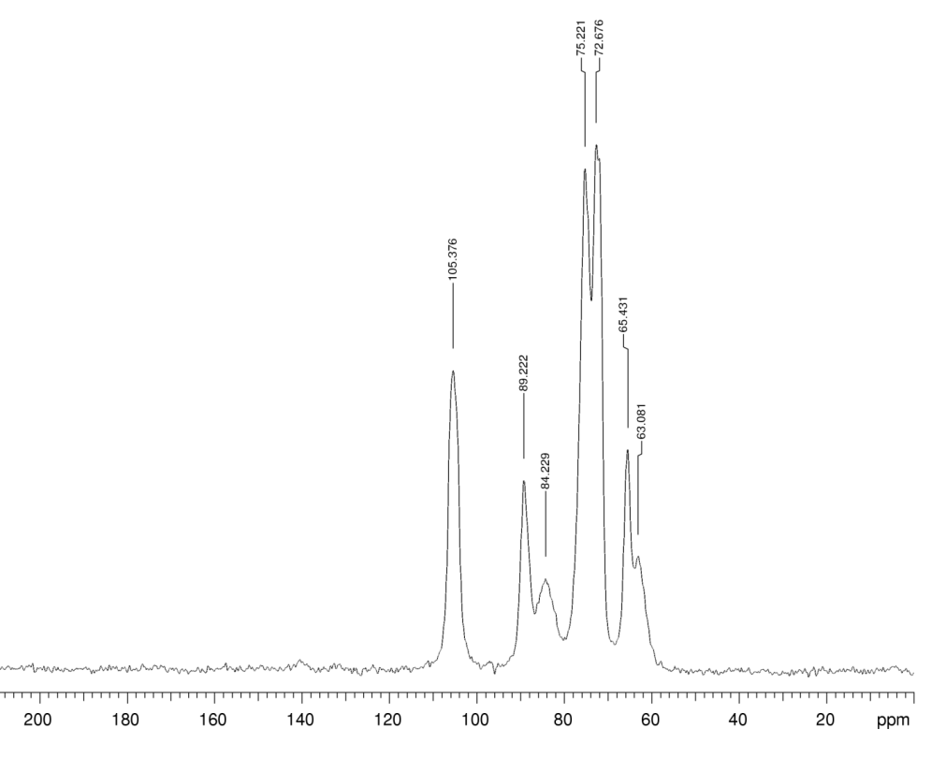
Figure 27. Solid State C13 NMR of microcrystalline cellulose

The degree of crystallinity of cellulose can be determined by CP-MAS NMR (Figure 27). The signals at 84/89 ppm and 63/65 ppm help us to determine the degree of crystallinity in a sample. The signals at 89 and 84 ppm are from the C4 carbon and specifically the former (89 ppm) is characteristic of crystalline cellulose whilst the latter (84 ppm) is synonymous with amorphous material. The signals at 65/63 are from the C6 carbon, crystalline/amorphous, respectively. The relative intensities within each pair vary from sample to sample, thus so does the crystallinity assuming that cross polarisation is the same for each sample.
4.2.3.1 Enzymatic treatment prior to microwave
The CP-MAS NMR spectrum of the enzyme-treated peel prior to microwave treatment is shown in Figure 28. For cross-referencing purposes, the CP-MAS NMR spectrum of commercial pectin (not shown) has the following signals at approximately 175-170, 110-90, 85-60 and 50-58 ppm and in particular the Me group of the ester occurs at approximately 55 ppm.

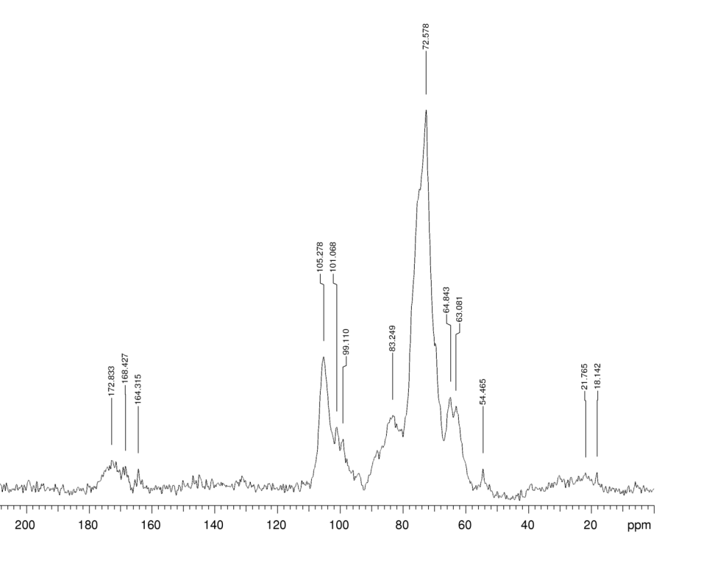
Figure 28. Solid State ¹³C NMR of cellulosic matter obtained by enzymatic treatment of orange peel prior to microwave
The solid state ¹³C NMR reveals three separate signals at 172.8 (very broad), 168.4 and 164.3 ppm. Tentatively the signal at 172.8ppm can be assigned to ester functions while it is presently unclear what the signals at 168.4 and 164.3 ppm correspond to. Presence of the signal at 54 ppm shows that there are methyl esters still present in this material as commercial pectin with a high degree of esterification shows a similar signal at approx. 55 ppm.
According to the relative intensities of the amorphous/crystalline peaks, the amorphous peak at approximately 84 ppm is relatively more pronounced, and in comparison with the reference sample Figure 27, which clearly signifies that the enzymatically treated orange peel residue has significant amount of amorphous regions as the enzymatic treatment does not affect the crystallinity of the sample.

4.2.3.2 Enzymatic + microwave treated orange peel (at 140 and 180 ºC)
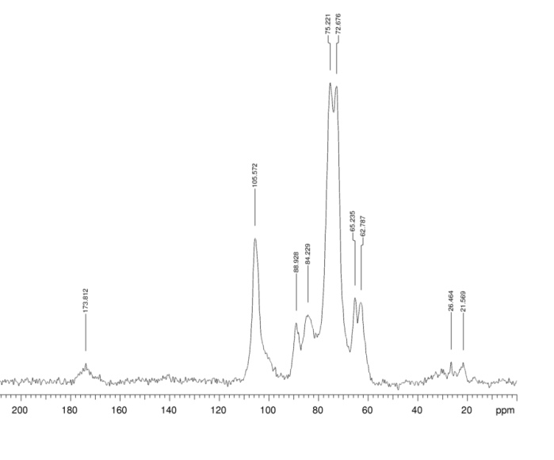
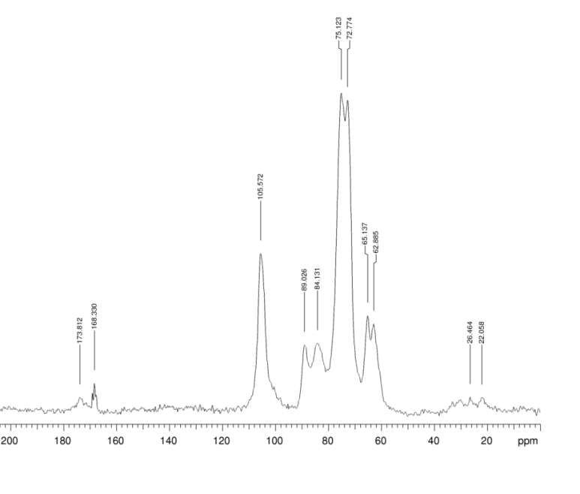
Figure 29. Solid State ¹³C NMR of exp 18 140C (top) and exp 18 180C (bottom)
At 140 °C (Figure 29, top) there appears to be only one very broad signal centred around 173.8 ppm, which is likely related to C=O of esters. There is a minor shoulder around the 168 ppm but no defined signal as that observed in the enzymatically treated orange peel (Figure 28). At 180 °C (Figure 29, bottom) it seems as though the peak at 173.8 ppm shrinks (relatively to the cellulose peaks) and clearly defined signal at 168.3 ppm appears. Signals corresponding to methyl esters (approx. 55 ppm) are virtually non-existent in both 140 and 180 ºC samples.
In comparison with the enzymatically treated peel, the enzymatic + microwave treated peel at 140ºC observes an increase in the intensity of the peak at 89 ppm relating to the C4 carbon ( crystalline region of the cellulose). When the extraction temperature is increased to 180 ºC, due to the removal of some amorphous regions of the cellulose structure, signals corresponding to crystalline regions are becoming more apparent.
4.2.3.3 Microwave treated orange peel at 140 and 180 ºC
The CPMAS NMR spectra of microwave treated peel at 140 °C (exp 17 140C) and 180 ºC are shown in Figure 30. Microwave irradiation at 140 ºC shows that the CP-MAS NMR (Figure 30 top) of the cellulosic matter has two signals in the C=O region: one very broad signal centred around 173.6 ppm and a second more defined signal around 168.4 ppm. The cellulosic material at 140 ºC still contains pectinaceous matter as evidenced by the methyl signals of a methyl ester as approx. 57 ppm. Compared with respect to the enzymatic + microwave treated sample at 140ºC (see Figure 29), the amorphous regions are more pronounced based on the ratio of the signal at 84/89 ppm.
The CPMAS NMR of the cellulosic sample at 180 °C (Figure 30, bottom) shows the signal at 173.6 ppm shrinks relatively to the one at 168.3 ppm. But, unlike at 140 ºC this material does not have any methyl esters due to the absence of signals at 55 ppm. The crystalline regions are again much more pronounced at higher temperatures considering the intensities of the ratio of 84/89 and 63/65. However, the relative degree of crystallinity is more in the enzymatic + microwave sample at 180 ºC, probably because of less free water in the sample due to high temperature microwave treatment.

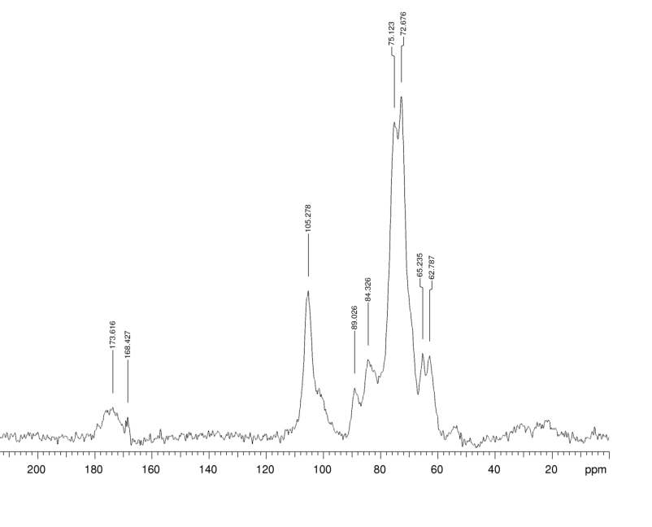
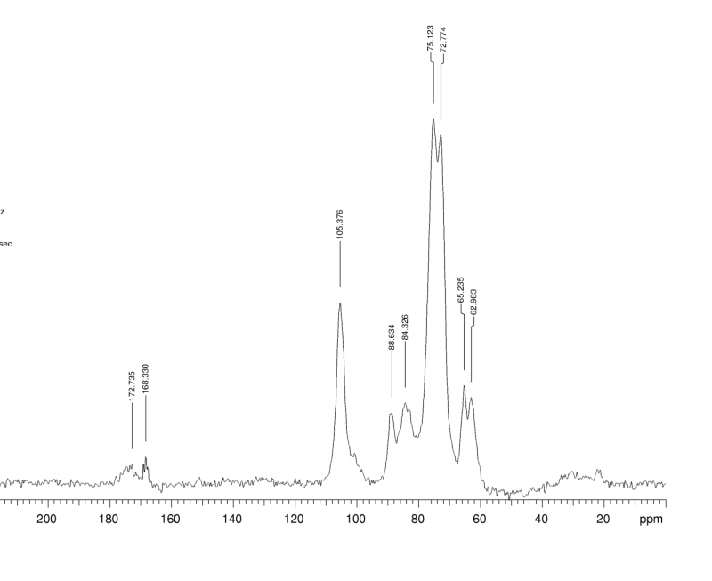
Figure 30. Solid State ¹³C NMR of exp 17 140C (top) and exp 17 180C (bottom)

4.2.4 SEM Analysis
Scanning electron microscopy (SEM) was applied to the samples in order to elucidate formation of mesoporous cellulose from orange peel from a morphological point of view. The SEM image of orange peel albedo is shown in Figure 31, which serves as the reference point with respect to subsequent enzymatic and microwave treatments of peel to afford cellulosic matter.
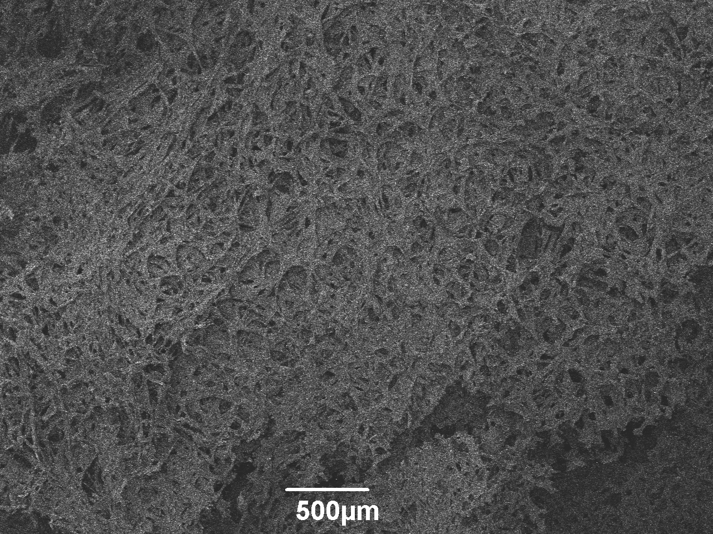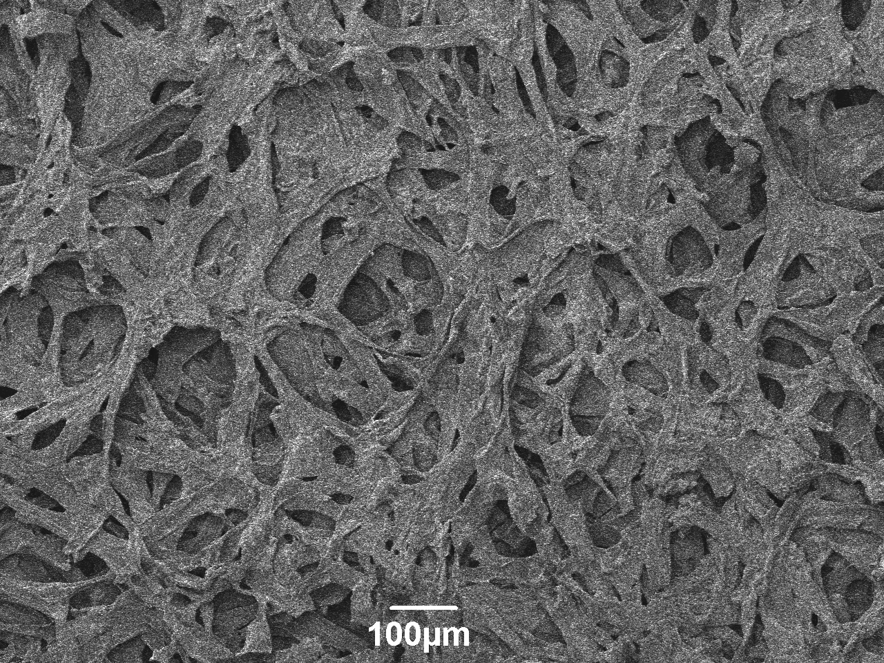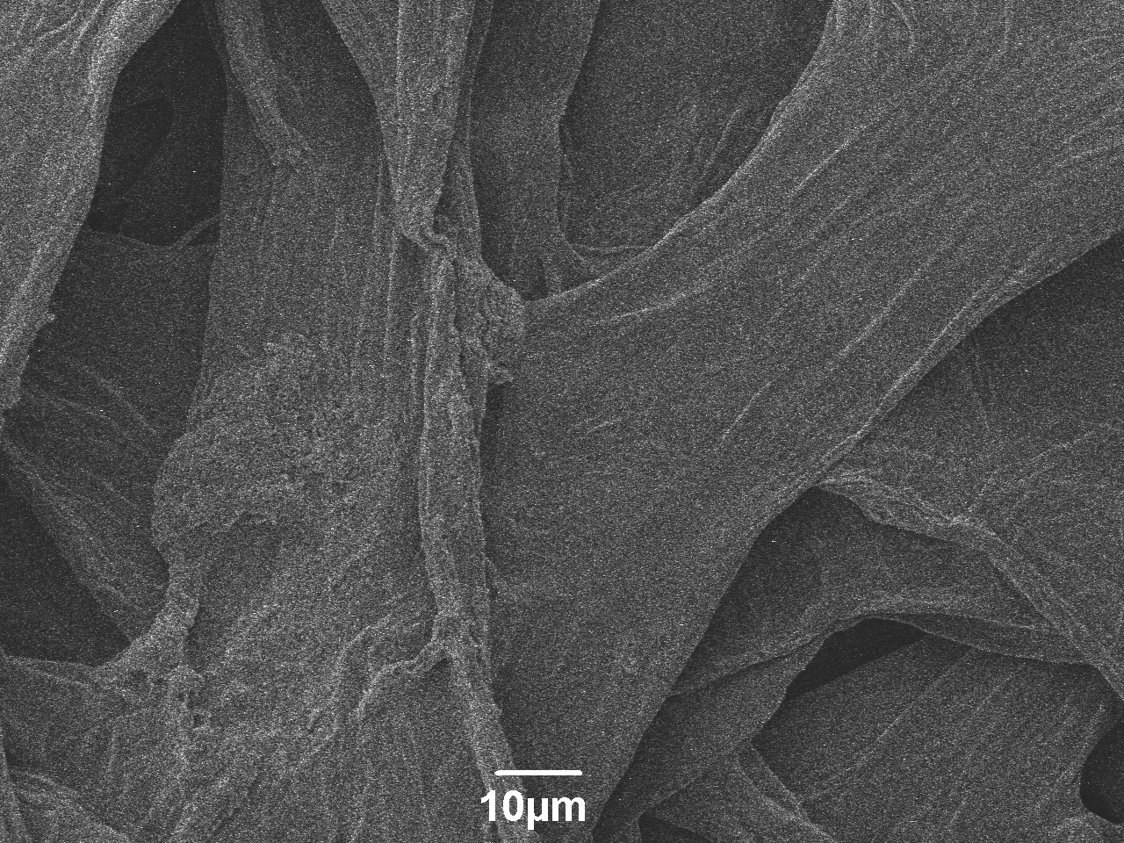Figure 31. SEM images of dried orange peel albedo at 500 µm (A), 100 µm (B) and 10 µm resolution
A
B
C
4.2.4.1 Comparison of SEM images of cellulosic matter derived from enzymatic + microwave and microwave + microwave treatment at 140 ºC and 180 ºC
The SEM images of cellulosic matter derived from enzymatic + microwave and microwave + microwave treatment at 140 ºC (Figure 32)and 180 ºC (Figure 33) compared to that of orange peel albedo (Figure 31) provide evidence of structuring akin to a mesoporous carbon network with a polydisperse pore size distribution. The pores are randomly distributed for orange peel albedo, it possesses a very compact and dense structure, and is quite different from the morphology of the resulting cellulose samples post the treatment methods.

Figure 32. Comparison of SEM images of samples prepared by enzymatic + microwave and microwave + microwave method at 140 ºC

The development of a hierarchal pore structure during both the methods could also be a consequence of the microwave irradiation. But as the enzymatic treated sample also seems to be very porous and fibrous this proves that the orange peel already has inherent structure that when unlocked gives rise to porous cellulose. The cellulose sample is fibrous with cavities and random orientation of the fibres. Moreover there was no even division of fibre within the polymer matrix and the surfaces were coarse indicating the presence of disordered cellulose region.

Figure 33. Comparison of SEM images of samples prepared by enzymatic + microwave and microwave + microwave method at 180 ºC
At 140 ºC (Figure 32) , the microwave+ microwave sample still has some compact and dense regions, whereas the enzymatic + microwave at the same temperature is already comparatively more fibrous and expanded. Moreover at 180 ºC (see Figure 33) both samples have the same physical microscopic appearance. Also some ends of the strands of the fibres of the samples at 180 ºC are unattached and loose underlining the fact that some bonds have been ruptured which may be either due to the removal of the amorphous regions in the cellulose and its subsequent depolymerisation or due to the withering of the pecto-cellulosic bonds.
4.2.5 Thermogravimetric analysis
In the previous chapter we had observed that orange peel contains three major structural components, namely: pectin; hemicellulose; cellulose, and; ca.<2% lignin. TGA studies were undertaken on cellulosic matter derived from enzymatic + microwave and microwave + microwave treatment of orange peel as shown in Figures 35 and 36, respectively.
4.2.5.1 Enzymatic + microwave at 140 ºC and 180 ºC
For reference purposes the TGA of enzymatically-treated orange peel prior to microwave radiation is shown in Figure 34. Three main regions of volatility occur: i. elimination of moisture upto 127 ºC; ii. elimination of pectin at 254 ºC followed by depolymerization and chain breaking of hemicellulose till 315 ºC, and; iii. decomposition of cellulose as the major endothermic process was observed at 348.6 ºC. The residual mass at 700 ºC was about 15.6 %.

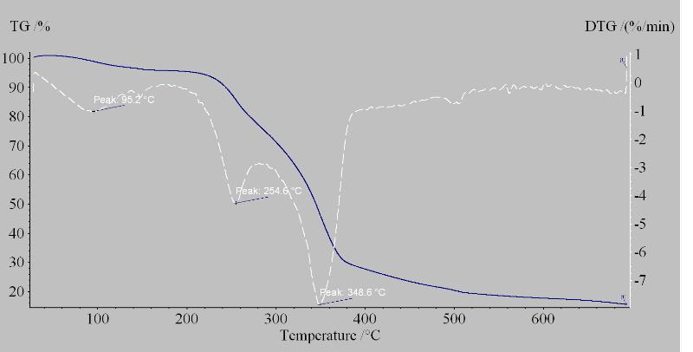
Figure 34. TG curve for enzymatically treated orange peel residue

The TG curve for samples treated at 140ºC is displayed in Figure 35
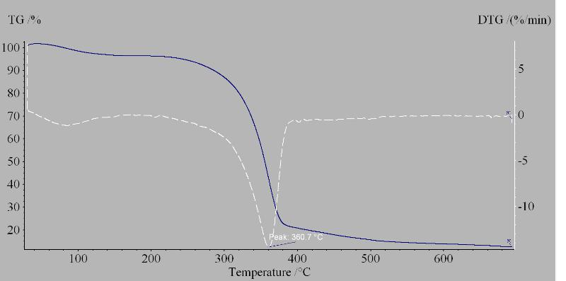
Figure 35. TG curve for exp 18 140C
As there is no defined pectin peak observed at 140 ºC, thus we can say that after the pectinase treatment there are negligible amounts of pectin remaining. After the decomposition of pectin, the elimination of hemicellulose takes place till 315 ºC, although the mass loss is again insignificant. There was a distinct endothermic peak of decomposition of cellulose at 360.7 ºC, with about 59.3 % mass. At the end of the measurement at 700 ºC, the residual mass percentage was found to be about 12.7 %.
The TG curve for samples treated at 180 ºC is shown in Figure 36 which reveals decomposition starting at approximately 302 ºC associated with a major endothermic process peaking at 366 ºC which is characteristic of cellulose breakdown. This sample contains approximately 60 % cellulose with about 15 % residual matter at 700 ºC.
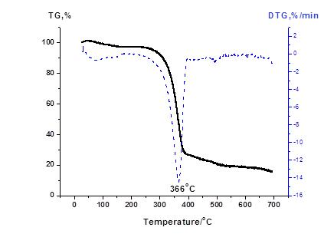
Figure36. TG curve for exp 18 180C
4.2.5.2 Microwave + microwave at 140 ºC and 180 ºC
TG curve at 140ºC is shown in Figure 37 which highlights considerable amount of volatile matter at 61.4 ºC which was attributed to residual acetone in the sample. Also, a significant decomposition peak at about 253 ºC for loss of pectin is observed. Greatest loss of mass was observed at 357ºCcharacteristic of cellulose decomposition.
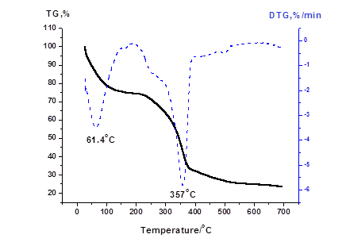
Figure 37. TGA curve for exp 17 140C
The thermogravimetric curve (Figure 38) of the sample microwaved at 180 ºC showed only one main endothermic peak at 366.5 ºC thus indicating that the material was pectin-free. Also there was no significant mass loss in the interval 260-315 ºC indicating the absence of hemicellulose. Cellulosic matter was calculated at approximately 54 % and after complete volatization of cellulose the sample afforded a residual mass of 16 % at 700 ºC.
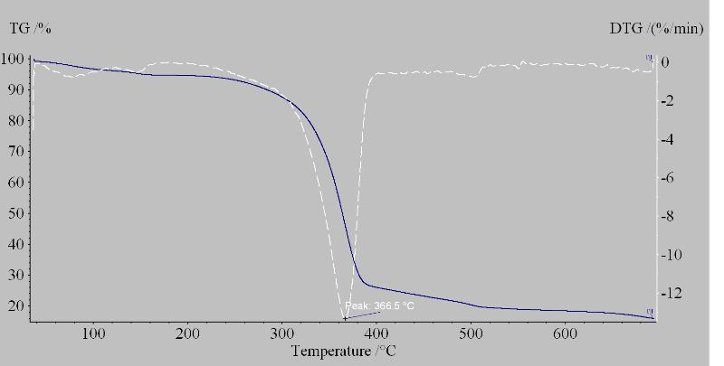
Figure 38. TG curve for exp 17 180C
4.2.6 X-Ray Diffraction (XRD)
XRD analysis was performed to get a qualitative evaluation of the amount of crystalline cellulose present in the samples prepared by the three different methods, namely: enzymatic; enzymatic plus microwave, and microwave plus microwave. The crystallinity index (CI) was calculated by peak de-convolution (curve-fitting method). Usually the method of preparation of the samples can influence the diffraction peak intensities, thereby influencing the CI. The average crystallite size (D_{p}) was calculated using Scherrer equation.
For the calculation of the CI it is usually assumed that the peak broadening is solely due to the crystalline disorder (amorphous region), but there are other factors which influence the peak broadening. The crystallite size is also calculated by measuring the peak broadness. Moreover there are other intrinsic factors which contribute to the width of the diffraction peak, some of these include inhomogeneous strain, and crystal lattice imperfection among others. Also in general cellulose peaks are usually broad and not quite well resolved, with a bit of overlapping of peaks. Thus a lot of care needs to be taken so as to avoid ambiguity.
The XRD curves for enzymatically-treated peel, enzyme + microwave and, microwave + microwave are shown in Figures 39, 40 and 41, respectively and values for their crystallinity index (CI) and crystallite size are listed in Table 7.
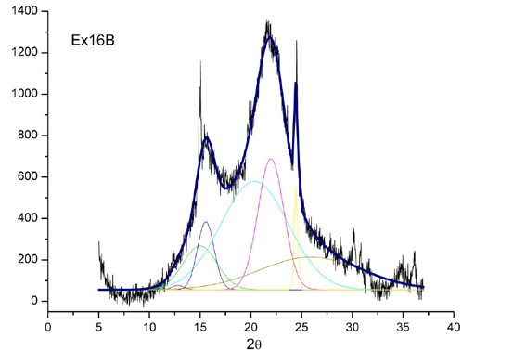
Figure 39. XRD curve for exp 16 (enzymatically treated)
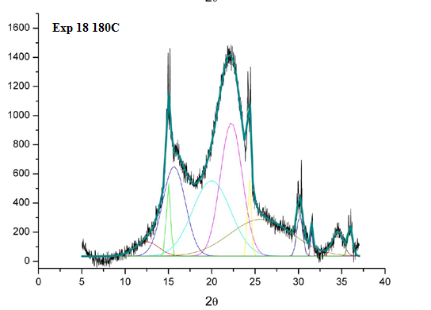

Figure 40. XRD curve for Exp 18 180C (enzyme + microwave)

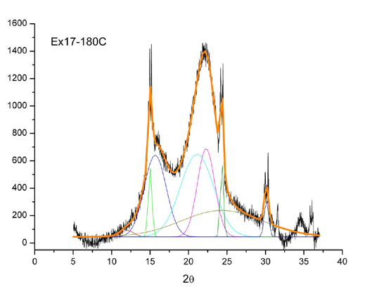
Figure41. XRD curve for Exp 17 180C (microwave + microwave)

SAMPLE ID | CI % | D_{p}(nm)
Exp 16 | 60 | 4.2
Exp 17 180C | 65 | 4.7
Exp 17 180C | 67 | 4.3

Table7. Crystallinity index and average crystallite size of mesoporous cellulose samples
The above XRD spectra for all the three samples are in complete accordance with the spectral data given in the literature for cellulose. Thus all three samples mainly contain crystalline cellulose. Also, from the above tabulated data we can infer that the enzymatic + microwave treated sample at 180 ºC has the maximum crystallinity index relative to the enzymatically treated sample and the microwave + microwave treated sample at 180 ºC. This is in complete agreement with the ¹³ C solid state NMR data reported earlier and is associated with the depolymerization of the amorphous cellulose at 180 ºC.

4.3 Conclusions
The introduction of the enzymatic method for removal of pectin prior to extraction of cellulose by microwave not only helps us obtain cellulose in its native form, i.e., without subjecting the peel to harsh pre-treatments, but we are also able to attain a much more clearer and better quality material as compared to the removal of pectin from the microwave method.
According to the FTIR, ¹³C solid state NMR and TGA data it is very clear that we are able to obtain good quality cellulose which is in accordance with the commercial cellulose even at lower temperatures in the enzymatic + microwave treatment. Whereas in the microwave + microwave treatment we achieve good quality cellulose only at higher temperatures. Moreover the crystallinity in the enzymatic + microwave sample at 180 ºC is more pronounced than its counterpart for microwave + microwave. The SEM analysis and textural properties confirm the fabrication of mesoporous cellulose with disordered pores and a fibrous texture.
The attainment of a mesoporous solid directly after the enzymatic removal of pectin without any microwave extraction of cellulose proves that the cellulose present in the orange peel is already structured with a potential for porosity, and the impact of the microwave insures better removal of the other polysaccharides present in the peel leading to mesoporosity.
Thus it can be concluded that our aim of development of a biorefinery for the complete valorisation of this biomass has been achieved. Besides the production of a novel kind of crystalline mesoporous cellulose from a renewable resource, we are able to obtain several product streams including essential oil (not discussed here), polymethoxyflavanoids (not discussed here), pectin and sugars in a step-wise low temperature hydrothermal treatment.

5. MESOPOROUS CELLULOSE FROM GRAPEFRUIT, LEMON AND LIME CITRUS WASTES – PRELIMINARY INVESTIGATION
5.1 Preamble
Similar to oranges, the production of other citrus fruits is also growing rapidly by the year due to the ever flourishing juicing industries. Thus, citrus wastes other than orange are also increasing exponentially. As mentioned earlier the main use of citrus waste is as cattle feed, which not only leads to wastage of the valuable chemical components present in the peel but also it is not economically viable due to the expensive drying and pelletizing process.
There has been a lot of research on the valorisation of orange peel has highlighted in previous chapters; the extraction of chemicals (pectin, D-limonene, mesoporous cellulose and bio flavonoids) and the development of a biorefinery for its complete utilisation. But there has not been much work on the exploitation of the other citrus varieties, namely: grapefruit; lime, and; lemon. Only recently these citrus peels are being used for the extraction of pectin via acidic hydrolysis, and the production of (bio)ethanol by hydrolysis with cellulases.,,, According to the literature grapefruit peels contains about 27 % of pectin.
Based on the results described in Chapters 3 and 4, optimized conditions were used for the extraction of mesoporous cellulose from virgin citrus peels: grapefruit; lemon, and ;lime without any pre-treatment or addition of any mineral acid in order to further understand the variation in textural properties and degree of crystallinity with respect to processing conditions. Within the context of biorefinery it is important that it can operate with different feedstocks depending regardless of security of supply, i.e., if orange peel becomes limited then biorefinery can switch to different citrus waste without compromising productivity.
5.2 Results and Discussion
The yields of cellulosic matter post microwave treatment at 180 ºC were: grapefruit peel, 5.1% (dark-grey brown); lemon peel, 5.1% (dark grey), and; lime peel, 4.9% (grey).
5.2.1 ATR-IR Spectroscopic analysis
Figure 42 shows the ATR-IR spectra of the cellulosic matter derived from microwave hydrothermal treatment at 180 ºC of lime-, lemon-, and grapefruit-peel compared with that of cellulosic matter from orange peel under the same extraction conditions to draw a parallel amongst the different fruits belonging to the same family. From the IR spectra shown in Figure 42 no significant difference in the spectra was observed thus the process was feedstock independent and based on Table 2 (Chapter 3, section 3.2.2), the absorption bands of the samples were in complete accordance with the reference absorption bands found for micro-crystalline cellulose.

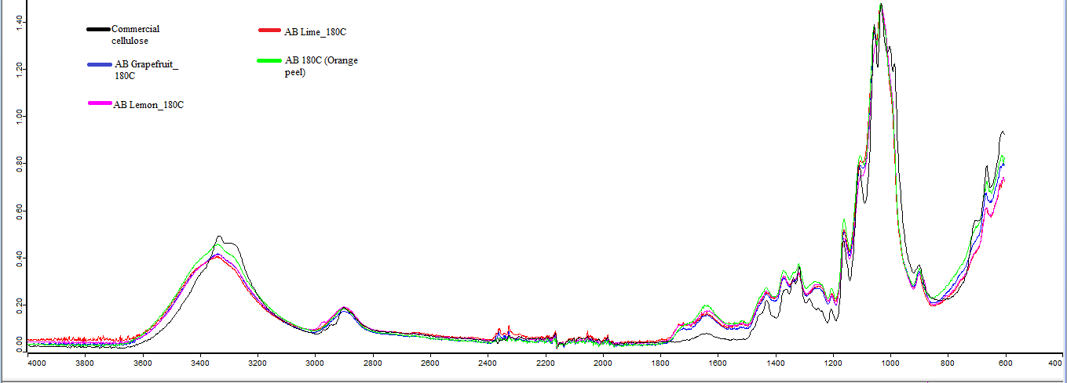
Figure 42. ATR-IR spectra of cellulosic matter derived from different citrus peels at 180 ºC compared with the commercial cellulose
For further clarity and to show that pectin has been removed very efficiently (significant decrease in absorption bands between 1700 – 1630 cm⁻¹), the ATR-IR spectra of grapefruit and lemon peel are shown in Figures 43 and 44 respectively together with the IR of their corresponding cellulosic matter derived at 180 ºC.
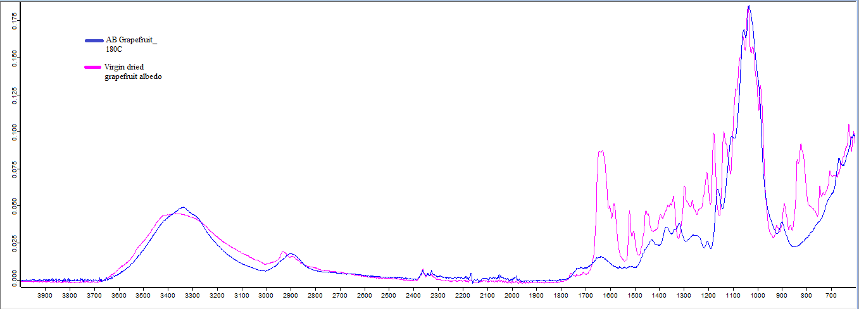
Figure 43. ATR-IR spectra of virgin grapefruit peel compared with AB grapefruit_180 ºC
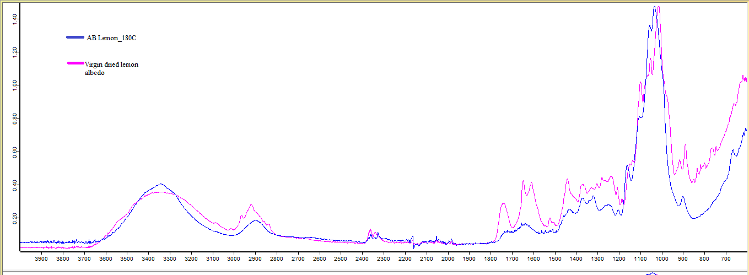
Figure 44. ATR-IR spectrum of virgin lemon peel compared with AB Lemon_180 ºC

With reference to the spectral interpretation given in Table 1 (Chapter 3, section 3.2.2),dried virgin peels contain a significant quantity of hemicellulose, pectin and also lignin. But when subjected to hydrothermal microwave treatment at 180 ºC, the other components seemed to have been extracted and the main component present in the samples was cellulose.
When the intensity of the peaks of the grapefruit peel and lemon peel was compared, it was found that grapefruit peel contained higher quantities of lignin, as the intensity of the peaks characteristic to lignin, i.e., the absorption bands at 1514, 1600 and 1450 cm⁻¹ relative to the aromatic skeletal vibrations, was higher in the case of virgin grapefruit peel.
In the case of lemon peel, the C=O associated with acetyl and uronic ester groups of hemicellulose usually absorb at 1745 cm⁻¹. It also shows a very strong band at 1092 cm⁻¹ which also is related to the vibration of the hemicellulosic fraction. Grapefruit peel on the other hand experiences a peak at 1034 cm⁻¹ which is indicative of the glucan band, suggesting the presence of glucomannan.^{, 53,}
Lemon exhibit bands at 1015, 1100 and 1620 cm⁻¹ which is characteristic of pectin. Thus showing the presence of significant quantities of pectin the peel, whereas grapefruit exhibit absorption bands at 1017, 1039, 1055 cm⁻¹, also related to the absorption of pectin.^{,67}

5.2.2 Nitrogen Adsorption Porosimetry
Porosity data (Surface area (S_{BET}), Pore volume (V_{BJH}), Pore diameter (D_{BJH})) of the cellulosic matter obtained from different citrus peel, i.e. grapefruit peel, lime peel and lemon peel is shown in Table 8.
D_{BJH}(Å) | V_{BJH} (cm³ g⁻¹) | S_{BET}( m² g⁻¹) | Sample ID
88.2 | 0.32 | 130.1 | AB grapefruit_180 oC
78.9 | 0.28 | 127.5 | AB lemon_180 oC
83.7 | 0.26 | 113.2 | AB lime_180 oC

Table 8. Porosity data formesoporous cellulose from different citrus peels
The porosity data confirms good mesoporosity with limited microporosity within the cellulosic matter derived from the different peels. However, the pore volume and surface area was not as high as that obtained from orange peel. The reason for this might be the difference in the quality of peel, seasonal variation and stage of maturation within growing cycle and place of origin. Thus while comparison all these factors need to be taken into consideration it can be clearly seen that grapefruit has a high relative surface area and pore volume under the same extraction conditions. Nevertheless, there is a strong probability that all the three citrus peels have already structured forms of cellulose as in the case of orange peel.
5.2.3 Relative amorphous cellulose content
To understand the amount of amorphous cellulose regions present in the sample, a proton/ deuterium exchange experiment was performed using ATR-IR spectroscopy to measure the accessible hydrogen bonds in the sample. However, it must be stressed that this is not the exact degree of amorphous character but rather a relative idea of the non-bonded O-H bonds present in the sample. When the proton/deuterium exchange was performed, the ratio of areas under the O-D bonds with respect to the O-H bonds signified the amount of accessible hydrogen bonds.
Cellulosic matter from grapefruit had about 21% accessible O-H bonds whereas the cellulose extracted from lime peel had about 17% of the accessible O-H bonds. Interestingly, cellulose from lemon peel was found to contain 27% of these bonds. As the amorphous regions of cellulose are those regions which have accessible O-H bonds, the percentage of this maybe related to the degree of amorphousness. Thus we can say that the degree of amorphousness varies with the type of biomass unlike the porous characteristics.
5.3 Conclusions
A variety of citrus wastes can be exploited to yield mesoporous cellulose. However, the porosity varies possibly due to the quality of peel and/or degree of ripeness. The extracted cellulose samples need to be further studied and analysed by TGA, ¹³C NMR, SEM analysis so as to get a better overview of the samples, and understand the effect of the texture of the peel on the quality of cellulose produced.

6. MESOPOROUS CELLULOSE FROM MANGO PEEL OF DIFFERENT ORIGIN
6.1 Background
Mango peel is one of the most important and highly exported fruit in the tropical and sub-tropical regions. A large percentage of the produced mangoes is consumed fresh, however it is also increasingly being used in food processing operations for the production of jams, jellies, juices, concentrates and dried fruits, ⁴³ which leads to considerable amount of waste such as pulp, peel, kernel and seed.

The kernel is rich in fatty acids, mainly oleic and stearic acid, which can be fractionated to give olein and stearin which are important industrial chemicals. The extraction of the fatty acids is usually performed with petroleum ether and chloroform, The peel contains pectin, hemicellulose and cellulose. The industrial extraction of pectin is performed under acidic conditions followed by alcohol precipitation producing massive amounts of acid waste,⁴³ whilst phenolics are removed by solvent extraction under reflux conditions.

To the best of our knowledge there have not been any reports on the extraction of mesoporous cellulose from mango peel. Moreover, as established in the earlier chapters we can obtain mesoporous cellulose by hydrothermal treatment of citrus peels in the microwave at optimised conditions of 180 ºC and peel:water ratio of 1:20. Since it is well-known that the cultivation conditions affects the quality of the mango produced and hence the quality and yield of its cell wall components thus, to get a better understanding of this variable, mango peels from three different countries were used for the experiment, namely: i. Alphonso (India), and; ii. Honey (Pakistan). Hence the main aim of this chapter was to valorise waste mango peels by extraction of cellulose under already optimised conditions while comparing the effect of the country of origin of the mango on the quality of cellulose extracted.

Prior to the microwave-assisted cellulose extraction, the virgin mango peels were subjected to pectin extraction in the microwave at 140 ºC for 10 minutes with peel:water ratio of 1:10. Pectin was extracted from the aqueous solution by ethanol precipitation followed by purification with hot ethanol and acetone. Pectin with a high degree of esterification (75-80%) depending upon the cultivar and with optimum yields was obtained. The extraction and characterisation of the pectin was performed by Ms Covadonga Lucas. The solid residue obtained post the microwave extraction was collected and further processed for extraction of cellulose.

6.2. Results and Discussion
The yield of cellulosic material obtained from Alphonso mango peel was 10.6% (dark-brown pellets) and from Honey was 6.3% (dark-grey light particulate solid).
6.2.1 ATR-IR Spectroscopy
Figure 45 shows the ATR-IR spectra of the cellulosic matter obtained from the microwave hydrothermal treatment of de-pectinated Alphonso and Honey mango peel residues. For reference purposes the extracted cellulosic materials are compared with commercial microcrystalline cellulose purchased from Sigma Aldrich Company, used as received.

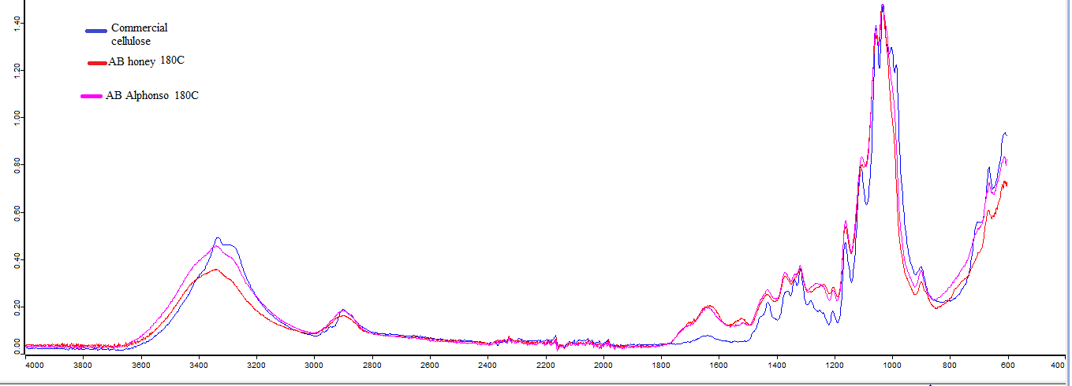
Figure 45. ATR-IR spectra of cellulose obtained from microwave treatment of de-pectinated Alphonso and Honey peel residues

From the spectra shown in Figure 45 both cellulosic materials (AB Honey 180C and AB Alphonso 180C) show similar absorption bands with respect to commercial cellulose. Thus under microwave conditions we are able to isolate cellulose from mango peel residues.
For further clarity Figure 46 and Figure 47 portray IR spectra of peel residue after microwave extraction of pectin and the cellulosic matter obtained after microwave hydrothermal treatment of the de-pecinated peel for Honey and Alphonso varieties, respectively.

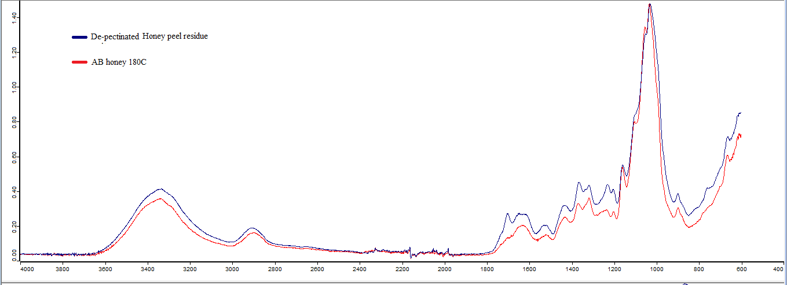
Figure 46. De-pectinated honey peel residue versus cellulose obtained from hydrothermal treatment of de-pectinated peel residue at 180ºC

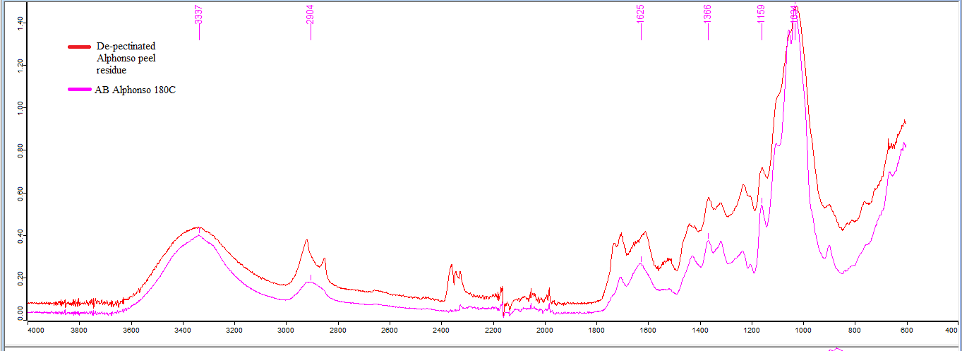
Figure 47. De-pectinated Alphonso peel residue versus cellulose obtained from hydrothermal treatment of de-pectinated peel residue at 180ºC
From Figure 46 and Figure 47 reveal that even in the de-pectinated peel there is considerable amount of residual pectin as evidenced by the absorption bands 1431- 1439 cm⁻¹(see chapter 3, Table 1, section 3.2.2). Also, de-pectinated Alphonso peel contains hemicelluloses evidenced by the small band at 1715- 1720 cm⁻¹. It can be seen that after treatment in the microwave at 180 ºC the pectin and hemicellulosic components seem to have been extracted in both the peels and the remaining residue is mainly cellulose.

6.2.2 Thermogravimetric Analysis
Figure 48 and Figure 49 depict the decomposition of the cellulosic matterobtained from Alphonso and Honeyin the presence of nitrogen gas, respectively.
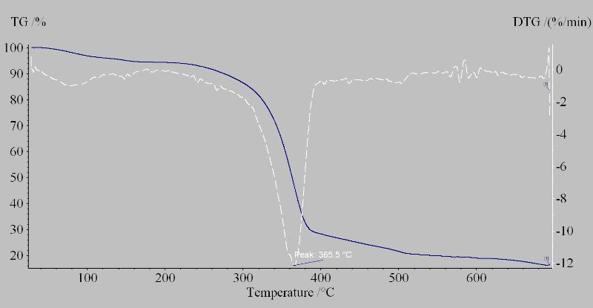
Figure 48. TGA curve of AB Alphonso 180C

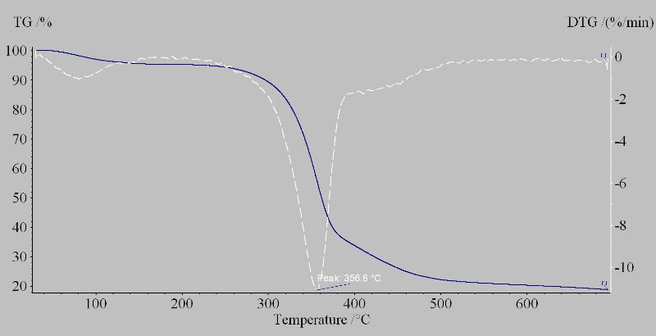
Figure 49. TGA curve of AB Honey 180C
Apart from initial loss of residual water and/or solvent, the TGA data reveals only one major endothermic process between 350 ºC - 370 ºC which is characteristic of cellulose decomposition. Thus the TGA data confirms the IR data signifying that when the de-pectinated peel residue of both the mango peels are hydrothermally treated in the microwave at 180 ºC, cellulosic matter in high yield is obtained.
6.2.3 Nitrogen adsorption porosimetry
The porosity data (Surface area (S_{BET}), Pore volume (V_{BJH}), Pore diameter (D_{BJH})) for cellulosic matter derived from Honey and Alphonso mangoes, respectively is given in Table 9.
D_{BJH}(Å) | V_{BJH} (cm³ g⁻¹) | S_{BET}(m² g⁻¹) | Sample ID
109.3 | 0.38 | 124.0 | AB Honey_180 oC
95.8 | 0.22 | 88.8 | AB Alphonso_180 oC

Table 9. Porosity data of cellulose samples obtained from microwave treatment of de-pectinated Alphonso mango peel and Honey peel
From Table 9 it can be seen that as expected there is quite a difference between the textural properties of the cellulose obtained from Alphonso and that obtained from Honey. This is due to the difference in origin, this may also be related to the difference in the ripening stage as when the fruit ripens more than required its quality deteriorates. The average pore diameter is in the mesoporous region, hence the mesoporosity can be claimed. Moreover there was limited microporosity observed for the samples.

6.3 Conclusions
Thus from the above results and analysis it can be concluded that mango peel contains a significant amount of cellulose, and hence its complete valorisation is very important. Thus using microwave processing, mesoporous cellulose at low temperatures without the addition of any acid/ buffer can be isolated. The ‘quality’ of the cellulose is still to be determined via NMR, XRD and SEM to get a better understanding of structure and morphology.
7. REFERENCES

P.T. Anastas and J.C. Warner, Theory and Practice; Oxford University Press, New York, 1998.
Bio-based Chemicals, Renewable Feedstocks, Green Polymers, Less-toxic Alternative Chemical Formulations, and the Foundations of a Sustainable Chemical Industry; 2Q 2011, © 2011 Pike Research LLC, Boulder, CO 80302 USA.
FAO food statistics Global food losses and food waste – extent, causes and prevention, FAO, 2011.
United States Department of Agriculture Foreign Agricultural Service.“Citrus: World Markets and Trade”, January 2014.
F. Schierbaum," Polysaccharides and Polyamides in the Food industry Properties, Production, and Patents" edited by Steinbüchel and S.K. Rhee, Starch/Stärke, 57, p 453.doi: 10.1002/star.200590051#.
C.D. May, Carbohydrate Polymers, 1990, 12, p.79-99.
J. Harholt, A. Suttangkakul, H.V.Scheller, Plant Physiology, 2010, 153, p. 384-395.
P. Sriamornsak; Silpakorn University International Journal; 2003, 3, 206-228.
N.R. Khule, N.B. Mahale, D.S. Shelar, M. M. Rokade, S.R. Chaudhari, Scholars Research Library, Der Pharmacia Lettre, 2012, 4, p.558-564.
B. Min, J.Lim, K. Lee, S.H. Lee, S. Lee, Bioresource Technology,2011, 102, p. 3855-3860.
W. Q. Hull, C.W. Lindsay, W.E. Baier, Ind. Eng. Chem. 1953, 45, p. 876-890.
S. Raeissi, C.J. Peters, Journal of Supercritical Fluids, 2005, 33, p. 201-208.
A. F. Thomas and Y. Bessiere, Natural Product Reports, 1989, 6, p. 291-309.
L.A. Pfaltzgraﬀ, M. De bruyn, E.C. Cooper, V. Budarin and J. H. Clark, Green Chem, 2013, 15, p. 307.
Tilottama Chatterjee, http://www.buzzle.com/articles/organelles-and-their-functions.html,Last accessed "19/06/2013".
J.A. Kaduk, T.N. Blanton, Powder Diffraction, 2013, 28,p. 194-199.
M. Chaplin, http://www.lsbu.ac.uk/water/hycel.html, last accessed "15/01/2014".
I. Bicu,F.Mustata,Carbohydrate Polymers, 2013, 98, p. 341-348.
P.M Ejikeme, Cellulose,2008, 15, p. 141-147.
J. Tsukamoto, N. Durán, L. Tasic, J. Braz. Chem. Soc.,2013, 24, p. 1537-1543.
21 I. Bicu, F.Mustata, Bioresource Technology, 2011, 102, p.10013-10019.
F. Yasar,H.Togrul,N.Arslan, Journal of Food Engineering, 2007, 81, p. 187-199.
A.M. Balu, V. Budarin, P.S. Shuttleworth, L. Pfaltzgraff, K. Waldron, R. Luque, J.H. Clark, ChemSusChem, 2012, 5, p. 1694-1697.
A. Bhatnagar, A.K. Jain, J. Colloid Interface Sci, 2005, 281,p. 49–55.
M. Dogan, Y. Ozdemir and M. Alkan, Dyes Pigm, 2007,75, p. 701–713.
V. Goloband A. Ojstrsek, Dyes Pigm, 2005,64, p. 57–61.
Z. Xuan, Y. Tang, X. Li, Y. Liu, F. Luo, Biochemical Engineering Journal, 2006, 31,p. 160-164.
B.K. Singh, N.S. Rawat, J. Chem. Technol. Biotechnol, 1994,61,p. 307–317.
H.L. Parker , A.J. Hunt , V. Budarin , P.S. Shuttleworth , K.L. Miller, J.H. Clark, RSC Adv, 2012, 2, p. 8992-8997.
S. Li, C.Y. Lo, C.T. Ho,, J Agric Food Chem., 2006 , 54, p.4176-85.
A. Di Mauro, B. Fallico, A. Passerini, P. Rapisarda, E. Maccarone, J. Agric. Food Chem., 1999, 47, p.4391-4397.
P. Sharma, P. Pandey, R. Gupta, S. Roshan, A. Garg, A. Shulka, A.Pasi, Indo American Journal Of Pharmaceutical Research, 2013, 3, p.3892-3897.
A.A. Rosatella, S.P. Simeonov, R.F. Frade , C.A. Afonso, Green Chem., 2011, 13,p. 754-793.
K. Grohmann, E.A. Baldwin, B.S.Buslig, Applied Biochemistry and Biotechnology, 1994, 45, p. 315-327.
G. Santi, S. Crognale, M. Moresi, M. Petruccioli, A. D’Annibale, Environmental Engineering and Management Journal, 2012, 11, S55.
G.O. Aspinall , J.W.T. Craig, J.L. Whyte, Carbohydrate Research, 1968, 7, p. 442–452.
R.A. Padival,S.Ranganna, S.P. Manjrekar, International Journal of Food Science & Technology, 1979, 14,p. 333–342.
Y-C.Wang, Y-C.Chuang, H-W. Hsu, Food Chemistry, 2008, 106, p. 277–284.
T. Wu, Y. Guan, J. Ye, Food Chemistry, 2007, 100, p. 1573–1579.
Y. Miyake, K. Yamamoto, Y. Morimitsu, T.Osawa, J. Agric. Food Chem., 1997, 45, p. 4619–4623.
V. Ting, E.J. Deszyck, Journal of Food Science,1961, 26, p. 146–152.
J. Allen, New York Times, 2013.
N. Berardini, M. Knödler, A. Schieber, Innovative Food Science & Emerging Technologies, 2005,6, p. 442–452.
O.P. Beerh,B. Raghuramaiah, G.V Krishnamurthy, Journal of Food Science and Technology, 1976, 13, p .96-97.
S. Couri, S. da Costa Terzi, G.A.S. Pinto, S.P. Freitas, A.C.A. da Costa, Process Biochemistry, 2000, 36, p. 255–261.
C.M. Ajila, S.G. Bhat, U.J.S. Prasada Rao, Food Chemistry, 2007,102, p. 1006–1011.
C.M. Ajila, K.A. Naidu, S.G. Bhat, U.J.S. Prasada Rao, Food Chemistry, 2007, 105, p. 982–988.
K. Mahattanatawee , J.A. Manthey , G.Luzio , S.T. Talcott, K. Goodner, E.A. Baldwin, J. Agric. Food Chem, 2006, 54, p. 7355–7363.
J. Fan, M. De bruyn, V.L. Budarin, M.J. Gronnow, S.Breeden, D.J Macquarrie, J.H. Clark, P.S. Shuttleworth, Journal of the American Chemical Society, 2013, 135, p. 12728-12731.
M. E.Lucchesi, F. Chemat, J. Smadja ,J. Chromatogr. A, 2004, 1043, p. 323 –327.
H. Yang, R. Yan, H. Chen, D.H. Lee, C. Zheng, Fuel, 2007,86, p. 1781-1788.
M.Kac̆uráková, P. Capek, V.Sasinková, N.Wellner, A .Ebringerová, Carbohydrate Polymers, 2000, 43, p. 195-203.
J.M. Fang, R.C. Sun, J. Tomkinson, Cellulose, 2000, 7, p. 87–107.
G. Zhou, G. Taylor, A.Polle,Plant Methods, 2011, 7:9, p. 1-10.
L.M. Kline, D.G. Hayes, A.R. Womac, N. Labbe, Bioresources, 2010, 5, p. 1366-1383.
Y. Sun, L. Lin, H. Deng, J. Li, B. He, R. Sun, P. Ouyang, Bioresources, 2008, 3, p.297-315.
K. Kavkler, A. Demsar, Tekstilec, 2012, 55, p. 19–31.
L. Gašparovič, Z. Koreňová, L. Jelemenský, Chemical Papers, 2010, 64, p. 174-181.
G. Varhegyi , M.J. Antal Jr., T. Szekely, P. Szabo, Energy Fuels, 1989, 3, p. 329–335.
V. Budarin, J.H. Clark, R. Luque, R. White, Material Matters, 2009, 4, p. 19.
R. Ryoo, S.H. Joo,S.Jui, J. Phys. Chem. B, 1999, 103,p. 7743.
C.F. Poole, The Essence of Chromatography, 2003, Elsevier, New York, p. 404.
A. Sayari, Chem.Mater., 1996, 8, p. 1840-1852.
S.H. Joo, S.J. Choi, I. Oh, J.Kwak,Z. Liu, O.Terasaki, R. Ryoo, Nature, 2001, 412, p. 169-171.
P. Garside, P. Wyeth, Studies in Conservation,2003, 48,p. 269-275.
M. Fan, D. Dai, B. Huang, Fourier Transform - Materials Analysis, 2012, S.Salih (Ed.), ISBN: 978-953-51-0594-7, InTech, DOI: 10.5772/3548.
X-C.Yu, D-L. Sun, Asian Journal of Chemistry, 2013, 25, p. 5333-5336.
F. Ciolacu, V.I. Popa, Cellulose Chem. Technol, 2011, 45,p. 13-21.
K.Sing, D. Everett, R. Haul, L. Moscov, R. Pierotti, J. Roquerol, T. Siemieniewska, Pure Appl. Chem.,1985, 57,p. 603-619.
R.Valiullin, P.Kortunov,J.Karger, V.Timoshenko, J.Phys.Chem.B , 2005,109,p. 5746.
S.Naumov, A.Khokhlov, R.Valiullin, J.Karger, P.A. Monson, Phys. Rev. E, 2008,78,p. 060601.
J.Puibasset, J. Phys. Chem., 2008, 129, p. 194706.
C.J. Garvey, I.H. Parker, G.P.Simon, Macromol Chem Phys, 2005, 206,p. 1568-1575.
A.K. Singh (ed.), "Advanced X-ray Techniques in Research And Industries",2005, IosPr Inc.
R.H. Newman,Holzforschung, 2004, 58,p.91-96.
S. Park, J.O. Baker, M.E. Himmel, P.A. Parilla, D.K. Johnson, Biotechnology for Biofuels, 2010, 3, p. 1-10.
V.O. Aina, M.M. Barau, O.A. Mamman, A. Zakari, H. Haruna, M.S. Hauwa Umar, Y. Abba, British Journal of Pharmacology and Toxicology,2012, 3,p. 259-262.
A.H. Rouse, A.H. Crandall, P.G., Journal of Food Science,1978, 43,p. 72–73.
M.R. Wilkins, W.W. Widmer, K. Grohmann, R.G. Cameron, Bioresource Technol., 2007, 98, p. 1596-601.
M. Boluda-Aguilar, A. López-Gómez, Industrial Crops and Products, 2012, 41, p.188–197.
D. Stewart, W. Widmer, K. Grohmann, M. Wilkins, 2006, US 20060177916 A1.
M.C. Edwards, J. Doran-Peterson, Applied MicrobiolBiotechnol, 2012, 95,p. 565–575.
S.N. Sun, T.Q. Yuan, M.F. Li, X.F. Cao, F. Xu, Q. Y. Liu, Cellulose Chem. Technol.,2012, 46,p. 165-176.
R. Bodirlau, C.A. Teaca, Rom. Journ. Phys.,2009, 54, p. 93–104.
M. Kacurakova, P. Capek, V.Sasinkova, N.Wellner, A. Ebringerova, Carbohydrate Polymers, 2000, 43, p. 195-203.
D.R. Muchiri, S.M. Mahungu, S.N. Gituaja., J. Am. Oil Chem. Soc., 2012, 89, p. 1567-1575.
J.M. Nzikou, A. Kimbonguila,L. Matos,B. Loumouamou, N.P.G. Pambou-Tobi,C.B. Ndangui, A.A. Abena,Th. Silou,J. Scher, S. Desobry, Res. J. Environm. Earth Sc.,2010, 2,p. 31-35.
J.C. Barreto, M.T.S. Trevisan, W.E. Hull, G. Erben, E.S. de Brito, B. Pfundstein, G. Würtele, B. Spiegelhalder, R.W. Owen., J. Agric. Food Chem., 2005, 56, p. 5599-5610.

