Biological Evaluation of Drug delivery Systems for Anti-prion Compounds

By Lei Luo


The University of Sheffield
Faculty of Science
Department of Chemistry

Thesis submitted to the University of Sheffield for the Degree of Doctor in Philosophy.
Acknowledgements

After four years, I finally finished the last chapter of my thesis, I would like to firstly thank Dr. Beining Chen for giving me the opportunity to work in her group and this thesis would not have been possible without her patient and help. It has been a pleasure to work in the group. I would like to thank all members of the Chen group for tolerating me in the laboratory: Kai Guo, Jennifer Louth,Mark Thompson, Peng Hua, Saadah A Alssadeq, James Newby, Ed Rab, Christoph Muller, Fiona Sorrell, Matthew Jackson, Matthew Sellwood and Ashlie Butler. Special thanks to Yifei Kong from Dr. Dejian Zhou’s research group for technical supports for preparing drug-quantum dot conjugates. Thanks also go to Dr. Xiaohe Tian, Dr. Linge Wang, Dr. Denis Cecchin and Lijuan Guan in Professor Giuseppe Battaglia research group for their warm help in their lab, especially the great help on laser confocal by Dr.Xiaohe Tian.

I would like to thank all my friends for their support during my time in Sheffield, without your friendship the life would be so boring and special thanks to the football teammates for great pleasure, Xiaohe Tian, Derong Kong, Xi Wang, Xiaofeng Li, Yuan Tian, Qiaohao Peng. Also, thanks go to Ziqi Zhang, Yaxin Liu, Sen du, Jie He, Pengcheng Yang and Jing Yu, for the great friendship and I was privileged to be able to spend lots of weekends playing football with you together.

I cannot find words to express my gratitude to my parents Yonghuang Luo and Yuemei Luo. Your unselfish support and love have always been the power for me to go on when I was low. Of course, I owe my deepest gratitude to my wife Lijie He, spending the beautiful three and half years with me in UK and more than 6 months alone in China coping with tough pregnancy. Precious memories will always stay in our hearts and I would like to present this thesis as a present for our little angel to be born in the New Year.

At last, I would like to use this space to memorise my grandfather Yuxun Luo and my aunt Yongqing Zhu. They passed away during the last four years and I could not even attend their funerals. May they rest in peace.

List of Abbreviation

BSE Bovine Spongiform Encephalopathy
TSEs Transmissible Spongiform Encephalopathies
vCJD Variant Creuzfeld–Jakob Disease
PrP^{C} Cellular Prion Protein
GPI Glycosyl phosphatidyl inositol
PrP^{Sc} Scrapie form of Prion Protein
ScNB Crapie-infected mouse neuroblastoma
PAMAM Polyamidoamine
PS Pentosan Polysulfate
CR Congo Red
AAV Adeno-associated vector
CNS Central Nervous System
BBB Blood Brain Barrier
BCSFB Blood Cerebrospinal Fluid Barrier
P/P Peptide and Protein
DDS Drug Delivery System
IGF Insulin-like Growth Factors
LDLr Low-density Lipoprotein receptor
RES Reticuloendothelial System
PEG Polyethylene glycol
PBCA Polybutylcyanoarcylate
SLN Solid Lipid Nanoparticles
CMC Critical Micelle Concentration
CPP Critical Packing Parameter
P-gp P-glycoprotein
HBP Hyperbranched Polymers
IF Immunofluoresence
TEM Transmission Electron Microscopy
DLS Dynamic Light Scattering
CLSM Confocal Laser Scanning Microscopy
HPLC High-performance Liquid Chromatography
SMB Scrapie-infected Mouse Brain cells
ScN2a Scrapie-infected Neuroblastoma cells
ScGT1 Scrapie Chandler strain infected immortalized murine hypothalamic neuronal cells
DMSO Dimethyl Sulfoxide
BSA Bovine Serum Albumin
PK Proteinase K
PMSF Phenylmethyl-Sulfonyl Fluoride
EDTA Ethylenediaminetetraacetic acid
GPC Gel Permeation Chromatography
NMR Nuclear Magnetic Resonance
SAR Structure-Activity Relationship
NBCS New Born Calf Serum
FBS Foetal Bovine Serum
HBSS Hanks Balanced Salt Solution
CWD Cattle and Chronic Wasting Disease
GSS Gerstmann–Sträussler–Scheinker syndrome
FFI Familial Fatal Insomnia
TBS Tris-Buffered Saline
PBS Phosphate buffer saline
Rt Retention time
AR Aspect Ratio
MinFeret Minimal Feret
MaxFeret Maximum Feret
ETP Empty Tubular Polymersomes
DTP Drug loaded Tubular Polymersomes
DSP Drug loaded Spherical Polymersomes
ESP Empty Spherical Polymersomes
APC Anti-prion Compound
QDs Quantum Dots
BLP Biotinylated Lipid Particles
ER Endoplasmic Reticulum
TA Thioctic acid
TCEP Tris(2-carboxyethyl)phosphine
TOPO Trioctylphosphine Oxide
DHLA Dihydrolipoic Acid

List of Figures
PartⅠ

Figure 1. The comparison of the normal cow brain (left picture) to the BSE infected cow brain (right picture)
Figure 2. The structure of PrP^{C} and PrP^{Sc}
Figure 3. The model of PrP^{Sc} formation and 5 potential ways to discover antiprion drugs
Figure 4. Scrapie-infected cells show co-localization of PrP and ferritin. ScN2a and SMB cells cultured in the absence or presence of 0.1 mM FAC were immunostained with 8H4-anti-mouse-FITC followed by anti-ferritin–anti-rabbit-TRITC. Untreated ScN2a cells show minimal PrP reactivity and reaction for ferritin in the cytosol (panels 1–3). Following exposure to FAC, both PrP and ferritin form intracellular aggregates that colocalize for the most part (panels 4–6, arrowheads). Untreated SMB cells show intracellular aggregates of PrP and reaction to ferritin in the cytosol (panels 7–9). However, exposure to FAC increases the reactivity between PrP and ferritin significantly, and PrP and ferritin form intracellular aggregates that co-localize in vesicular structures (panels 10–12, arrowheads).
Figure 5. Immunofluorescence staining of PrPSc oligomers/multimers with PRIOC mAbs. PRIOC extensively stained large aggregates in ScN2a cells. (A). Staining with PRIOC1 did not display the PrPSc oligomer-specific stain. (B). PRIOC2, (C) PRIOC3 and (D) PRIOC4 displayed distinct and unusual staining (yellow arrows) in ScN2a cells (green) as opposed to an anti-monomer antibody that displayed the typical diffuse ring-shaped stain of the cell membrane (red). Following permeabilization, ScN2a cells displayed a similar stain for aggregates using (E). PRIOC2 and (F). PRIOC2. Florescence microscopy was performed and images from each source [FITC (450–490 nm), Texas red (510–560 nm) and DAPI (330–380 nm)] were collected. Scale bar = 25 mm.
Figure 6. Transport mechanisms at the BBB
Figure 7. A representation of the steric organization of a liposome (left) and a micelle (right)
Figure 8. Schematic structures of (a) dendrimers, and (b) HBP.
Figure 9 The structure of the polymersomes
Figure. 10 TEM pictures of samples with a different soft to hard phase ratio
contrasted by (a) preferential staining with RuO4 and, (b) Pt-shadowing
technique.

PartⅡ

Figure 11. Structures of ε-PL
Figure 12. An example of MTT plate ready for reading
Figure 13. An example of dot blot result
Figure 14. EC₅₀ results fo Curcumin by 3 times of repeating and the viablity results under the concentrations
Figure 15. MTT results of H₂0, DMSO and PBS in series dilutions
Figure 16. Example of BSA standard curve for protein determination
Figure 17. Viability results in the screening of benzofuran derivatives
Figure 18. The anti-prion effect of six benzofuran derivatives
Figure 19. Figure 9. Correlations of the anti-prion effect, aggregation inhibition, radical quenching, tPSA and AlogP
Figure 20. Viability results in the screening of ε-PL
Figure 21. The anti-prion effect of ε-PL

Part Ⅲ
Chapter 1
Figure 22. The chemical structure of a) 3001126 and b) 3001326
Figure 23. The synthesis of the hyperbranched polymer
Figure 24. The UV-visible absorbance of 3001126 in water
Figure 25. The UV-visible absorbance of 3001126 in methanol
Figure 26. The UV-visible spectrums of 3001126 in 5 concentrations
Figure 27. The calibration curve of 3001126
Figure 28. The UV-visible spectrums of HBP in 5 concentrations
Figure 29. The calibration curve of HBP
Figure 30. The UV chromatograms of 3001126, HBP and 3001126 loaded HBP
Figure 31. The viability results of 3001126 loaded HBP and 3001126 in DMSO
Figure 32. The EC₅₀ curve of the HBP encapsulated 3001126
Figure 33. The viability results of 3001126 in DMSO (30nM and 2μM) and 3001126 (2μM) loaded in HBP in 5-day dosing assay
Figure 34. The comparison of the anti-prion activity curves of 3001126 in DMSO (30nM and 2μM) and 3001126 (2μM) loaded in HBP in 5-day dosing assay
Figure 35. The viability assay for the HBP in 3 concentrations

Chapter 2
Figure 36. The optimised HPLC mobile phase gradients
Figure 37. Mechanisms of tube destabilizing
Figure 38. TEM results of the sample stirred for 1, 2 and 3 weeks
Figure 39. TEM results of drug loaded and empty polymersomes after sonication for 0, 0.5 and 1 hour.
Figure 40. TEM results of a) DTP, b) ETP, c) DSP and d) ESP.
Figure 41. The DLS size distribution of ESP and DSP samples
Figure 42. The HPLC calibration curves of (a)3001126 and (b) PMPC₂₅–PDPA₇₀
Figure 43. a) EC₅₀ results of DTP, DSP, 3001126, ETP and ESP; b) Anti-prion activity of DTP, DSP, 3001126, ETP and ESP with higher concentration.
Figure 44. The MTT results of ETP, DTP, ESP, DSP and 3001126
Figure 45. Z stack 3D images: a, b, c, d and e are the cells treated with DSP; f, g, h, i and j are the cells treated with DTP. a and f are stained by DAPI (Ex405, Em420-450), b and g are stained by Syto9 (Ex488, Em500-550), c and h are stained by DSP and DTP (Ex561, Em575-600), d and i are stained by Cell-Mask (Ex647, Em650-700), e and j are the overlays. Scale bar represent 10μm.
Figure 46. a) Co-localization between DTP and cell mask, b) Co-localization between DSP and cell mask. Scale bar represent 10μm.

Chapter 3
Figure 47. Synthesis diagram of QDs-APC
Figure 48. Structures-activity comparison of 3001326 (APC) and its relative structures
Figure 49. The anti-prion activity of the APC, QDs-APC and QDs blank
Figure 50. The viability results of QDs-APC, APC and QDs blank
Figure 51. LD₅₀ of QDs-APC, APC and QDs blank

Figure 52. Cell live images of QDs blank and QDs-APC treated cells taking by CLSM. a and f are DIC, b and g are stained by Syto9 (Ex488, Em500-550), c and h are stained by PI (Ex561, Em575-600), d and i are stained by QDs-APC and QDs blank (Ex450, Em590-620), e and j are the merges, and the scale bar represents 50μm.
Figure 53. Live cell image of QDs-APC in high resolution. Scale bar represent 10μm.
Figure 54. 3D image of live cell uptake of QDs-APC. Scale bar represent 20μm.
Figure 55. Optimization of primary antibody concentration
Figure 56. IF images of cells treated with QDs blank and QDs-APC. a and e are DAPI (Ex561, Em575-600), b and f were firstly stained by Goat anti-PrP antibody then followed with Donkey Anti-Goat IgG (Ex488, Em500-550), c and g are stained by QDs blank and QDs-APC (Ex450, Em590-620) , d and h are the merges, and the scale bar represents 10μm.
Figure 57. a is co-localization between PrP and QDs-APC; b is the scatter plot Pearson's Correlation Coefficient (r); c is the 3D volume viewer. The scale bar represents 10μm.
Figure 58. 3D IF image of QDs-APC treated cells. Scale bar represent 10μm.
Figure 59. Cells treated with QDs-APC and dye by DAPI (Ex561, Em575-600), ER tracker (Ex504, Em510-520), QDs-APC (Ex450, Em590-620), the scale bar represents 10μm.
Figure 60. Co-localization between QDs-APC and lysosomes tracker. a) DAPI (Ex561, Em575-600), b) lysosomes tracker (Ex488, Em500-550), c) QDs-APC (Ex450, Em590-620), d) merge, e) 3D volume viewer from select region, f) co-localization between QDs-APC and lysosomes tracker from select region, g) scatter plot Pearson's Correlation Coefficient

List of tables
Part Ⅰ
Table 1. The structure and screening results of different classes of previously founded compounds
Table 2. CNS targeting immunoliposomes DDS
Table 3. The parameters in the compounds’ selection
Table 4. The top ranked active anti-prion compounds

Part Ⅱ
Table 5. Structures of the benzofuran derivatives
Table 6. An example of a dilution sequence
Table 7. Protein determination data during the ZINC compounds screening assays
Table 8. Toxic compounds in the initial screening
Table 9. Active compounds in the initial screening
Table 10. The compounds for EC₅₀ assay
Table 11. The EC₅₀ results of the selected compounds
Table 12. Protein determination data during the benzofuran derivatives screening assays
Table 13. Protein determination data during the ε-PL screening assays

Part Ⅲ
Chapter 2
Table 14. The optimization of MeOH ratio in HPLC mobile phase gradients
Table 15. Comparison of the length of tubular-polymersome samples

Part Ⅳ
Table 16. Comparison the solubility, toxicity and traceable in vitro of DMSO, HBP, DTP, DSP and QDs
Table 17. The anti-prion effect of 3001126 and 3001326 in both DMSO and DDS

List of schemes
Part Ⅰ
Scheme 1. Biological evaluating system based on SMB cell line
Scheme 2. Evaluating DDS via the biological system

Part Ⅲ
Chapter 1
Scheme 3. Synthesis of indole-3-glyoxylamides

Chapter 2
Scheme 4. Synthesis of labelled and non-labelled diblock polymer and the assembly of drug carrying spherical and tubular polymersomes and the release of the encapsulated drug upon pH changes.

Chapter 3
Scheme 5. Synthesis process of 3001326 (APC)

Table of Contents

Part Ⅰ Introduction and Literature Survey 1
Part Ⅰ Chapter 1 Introduction 2
1. Prion diseases and anti-prion drug discovery 2
1.1 Background 2
1.2 Current known anti-prion compounds 11
2. Drug delivery systems for the anti-prion compounds 15
2.1 The blood brain barrier 16
2.2 BBB transport vectors 20
2.3 Nano-drug delivery systems 23
2.3.1 Liposomes 24
2.3.2 Nanoparticles 27
2.3.2.1 Polymeric nanoparticles 28
2.3.2.2 Solid lipid nanoparticles (SLN) 28
2.3.3 Micelles 29
2.3.4 Dendrimers and hyperbranched polymers 32
2.3.4.1 Dendrimers 32
2.3.4.2 Hyperbranched Polymers (HBP) 33
2.3.5 Polymersomes 34
3. Brief review of the instruments and techniques used in the project 37
3.1 Immunofluoresence (IF) 37
3.2 Transmission electron microscopy (TEM) 37
3.3 Dynamic light scattering (DLS) 38
3.4 Confocal laser scanning microscopy (CLSM) 39
3.5 High-performance liquid chromatography (HPLC) 39
Part Ⅰ Chapter 2 Previous work 40
1. Compounds selection by virtual high throughput screening 40
2. Biological Screening of Computational Hits 41
2.1 SMB cell line screening 41
2.2 Active hits 42
Part Ⅰ Chapter 3 Aims of the project 43
1. Aims 43
2. Project design 43
2.1 Problems with current anti-prion compounds 43
2.2 Current status of DDS for prion research 43
2.3 Justifications for needing a DDS for anti-prion leads 44
3. Project Plan 44
Part Ⅰ Chapter 4 Thesis layout 47
Part Ⅱ General Screening and Optimization of Biological Evaluation Systems for DDS 49
1. Introduction 50
2. Materials and methods 54
2.1 Materials 54
2.2 Methods 55
2.2.1 Initial screening 55
2.2.1.1 Sub-culture of SMB cell lines 55
2.2.1.2 Dosing the cells 57
2.2.1.3 Viability assay (MTT assay) 59
2.2.1.4 Cell lysis 61
2.2.1.5 Protein determination 61
2.2.1.6 Dot blot analysis 62
2.2.2 EC₅₀ assay 65
3. Results and discussion 66
3.1 Optimizing the biological evaluation system 66
3.1.1 Seeding number of SMB cells 66
3.1.2 Concentrations of positive control 67
3.1.3 Concentrations of negative control 69
3.2 Screening the ZINC compounds 70
3.2.1 Protein determination 70
3.2.2 Viability assay 72
3.2.3 Initial screening of anti-prion activity 73
3.2.4 EC₅₀ screening 74
3.3 Screening benzofuran derivatives 76
3.3.1 Protein determination 76
3.3.2 Viability assay 77
3.3.3 EC₅₀ screening 78
3.4 Screening ε-PL 80
3.4.1 Protein determination 80
3.4.2 Viability assay 81
3.4.3 EC₅₀ screening 83
4. Conclusions 83
Part Ⅲ Drug Delivery Systems for Anti-prion Compounds 85
Part Ⅲ Chapter 1 Hyperbranched Polymers as Delivery Systems for Hydrophobic Anti-prion Compounds 89
1. Introduction 89
2 Materials and methods 91
2. 1 Materials and instrumentation 91
2.1.1 Materials 91
2.1.2 Synthesis of the anti-prion compound 92
2.1.3 Instrumentation 93
2.2 Solubility assay 93
2.2.1 The UV absorbance of 3001126 in water and in methanol 93
2.2.2 Calibration curve for both 3001126 and the HBP 94
2.2.3 Preparation of the aqueous solution of HBP loaded with compound 94
2.3 Cell line analysis 95
2.3.1 Cell culture 95
2.3.2 Dosing plan for anti-prion activity of 3001126 loaded HBP 95
2.3.3 Five-day time course 96
2.3.4 Viability assay (MTT assay) 97
2.3.5 Cell lysis 97
2.3.6 Protein determination 97
2.3.7 Dot blot analysis 97
3 Results and discussion 98
3.1 The UV absorbance of 3001126 in water 98
3.2 The calibration curve of both 3001126 and HBP 99
3.2.1 3001126’s calibration curve in methanol 99
3.2.2 The HBP’s calibration curve in methanol 100
3.2.3 UV-visible absorbance of the HBP encapsulated 3001126 in aqueous solution 102
3.3 Cell line analysis 103
3.3.1 MTT results and EC₅₀ analysis 103
3.3.2 5-day time course 105
3.3.3 The MTT results of different molecular weight HBPs 107
4. Conclusions 107
Part Ⅲ Chapter 2 pH Sensitive Biocompatible Polymersomes as Delivery Systems for Hydrophobic Anti-prion Compounds 109
1. Introduction 109
2. Materials and Methods 112
2.1 Materials and instrumentation 112
2.1.1 Synthesis of PMPC-PDPA 114
2.2.2 Synthesis of the anti-prion compound 115
2.2 Experimental methods 115
2.2.1 Preparation of the two shapes of drug loaded polymersomes 115
2.2.2 HPLC conditions 116
2.2.3 Dynamic light scattering (DLS) 117
2.2.4 Transmission electron microscope (TEM) sample preparation 117
2.2.5 Cell line assays 118
2.2.5.1 Cell culture 118
2.2.5.2 Dosing cells 118
2.2.5.3 Viability assay (MTT assay) 119
2.2.5.4 Cell lysis 119
2.2.5.5 Protein determination 119
2.2.5.6 Dot blot analysis 120
2.2.6 Cell live image 120
3. Results and discussion 121
3.1 Optimisations 121
3.1.1 HPLC conditions 121
3.1.2 Sample sonication 123
3.2 Sample characterization 126
3.3 Samples quantitative by HPLC 128
3.4 Cell line assays 130
3.4.1 Anti-prion activity and cell viability assays 130
3.4.2 Cellular uptake and localization 133
4. Conclusions 135
Part Ⅲ Chapter 3 Quantum Dots as Delivery Systems for Hydrophobic Anti-prion Compounds 137
1 Introduction 137
2 Materials and methods 141
2. 1 Materials and instrumentation 141
2.2 Synthesis of APC 142
2.3 Synthesis of QDs-APC conjugates 143
2.3.1 Synthesis of DHLA-PEG₆₀₀-NH₂ 143
2.3.2 Synthesis of DHLA-PEG₆₀₀-NH₂-capped QDs via surface ligand exchange 144
2.3.3 Synthesis of maleimide-activated QDs 144
2.3.4 Coupling of maleimide-activated QDs and thiolated anti-prion compound 145
2.4 Cell line analysis 146
2.4.1 Cell culture 146
2.4.2 Dosing plan for anti-prion activity of APC, QDs-APC and QDs 146
2.4.3 Viability assay (MTT assay) 147
2.4.4 Cell lysis 147
2.4.5 Protein determination 147
2.4.6 Dot blot analysis 147
2.5 Cell image 148
2.5.1 Cell live image 148
2.5.2 Immunofluorescence (IF) 148
3 Results and discussion 150
3.1 EC₅₀ analysis 152
3.2 LD₅₀ of QDs-APC and QDs 153
3.3 Cell live image 154
3.3.1 Cellular uptake and distribution of QDs-APC and QDs blank 154
3.3.2 Immunofluorescence (IF) 160
3.3.3 Cell images with organelle tracker 165
4 Conclusions 167
Part Ⅳ General Discussion and Conclusions 169
References: 177

PartⅠ Introduction and Literature Survey

PartⅠChapter 1 Introduction

The intentions of this introduction are to introduce background of prion disease, to discover the possible therapy mechanism of anti-prion compounds and to review current known anti-prion compounds. Potential drug delivery systems especially ones targeting the blood brain barrier will then be discussed, followed by a brief review of the instruments and techniques used for this research project.

- Prion diseases and anti-prion drug discovery

1.1 Background
Bovine Spongiform Encephalopathy (BSE or mad cow disease), a form Transmissible Spongiform Encephalopathies (TSEs) had a major outbreak in cattle in the UK in 1986.¹ TSEs are also called prion diseases because they are all related to prion proteins. BSE and other form of TSEs belong to a family of fatal neurodegenerative diseases which lead to spongiform degeneration, and the formation of large vacuoles in brain cortex and cerebellum was observed anatomically in infected animals. (Figure 1) In addition to BSE, TSEs include scrapie in sheep and goats, chronic waste disease in elk and deer and variant Creuzfeld–Jakob disease (vCJD) in humans etc.² They can be transmitted through transplantations, contaminated biological products from cadavers, blood transfusion, contaminated surgical instruments and from ingesting beef products derived from infected cattle.

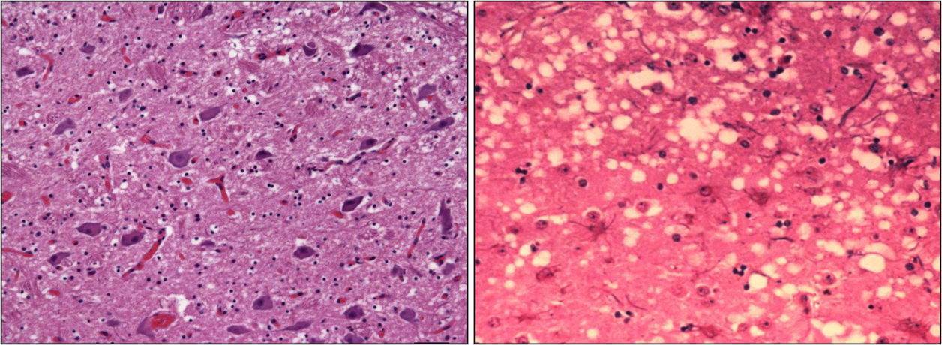
Figure 1. The comparison of the normal cow brain (left picture) to the BSE infected cow brain (right picture)³

The diseases are believed to be caused by the conformational change of the cellular prion proteins (PrP^{C}), which are sialoglycoproteins existing in different type of cells, especially in neurons, but their physiological functions are not yet completely known. They are anchored to the external surface of cells via a glycosyl phosphatidylinositol (GPI) moiety. The structure comparison of a PrP^{C} molecule and a PrP^{Sc} molecule is shown in Figure 2.³
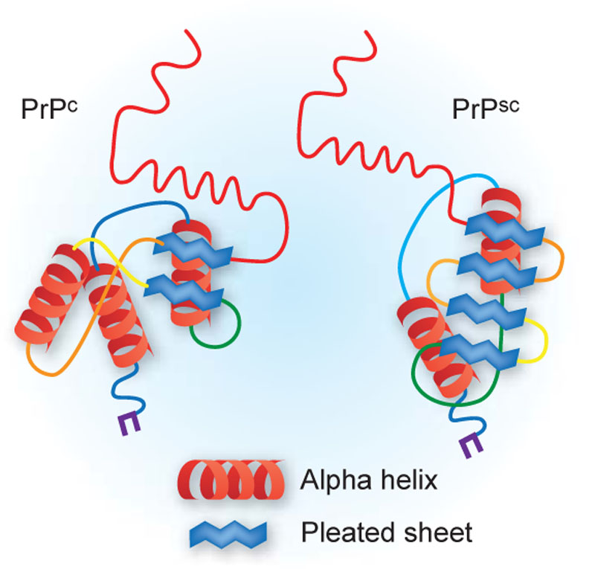
Figure 2. The structure of PrP^{C} and PrP^{Sc 4}

The PrP^{C} structure contains 3 α-helices and 2 β-sheets that are located close to the C-terminus, while the N-terminus peptide is highly unstructured. It can be easily digested by proteases, however in the case of TSEs the PrP^{C} is converted into the protease resistant isoform or the scrapie form, PrP^{Sc}, which has less α-helical content, but much more β-sheet structure. Moreover, the increase in β-sheets results in an aggregation of the scrapie protein, PrP^{Sc}, which then creates a spongy brain in the infected animal.
The conversion process from PrP^{C} to PrP^{Sc} is illustrated in Figure 3. There are 5 possible strategies which could possibly be used to develop therapeutics against PrP^{Sc} formation from the mechanisms.

Firstly, PrP^{C} is synthesised in the cell and then it is transported to the extracellular side of the cell membrane where it is attached to the cell membrane via a GPI anchor. Hence, inhibiting the synthesis of PrP^{C} can reduce the turnover rate from PrP^{C} to PrP^{Sc} from initial stage. (Figure 3, Stage 1) Lack of PrP^{C} can cut off the supply of PrP^{C} as a starting material for PrP^{Sc} synthesis. This strategy was demonstrated in mice studies by inoculating mouse prion protein to PrP^{C} devoid mouse without inducing prion symptoms for at least 13 months.⁵

Secondly, another strategy is preventing the interaction between PrP^{C} and PrP* to form complexes. (Figure 3 Stage 2) The synthesized PrP^{C} can undergo a normal life cycle and be degraded within a few hours after being synthesised or after random conformational change to intermediate PrP (PrP*). Therefore it is possible to stabilise the normal conformation of PrP^{C}. Detergent-resistant membrane domains was reported that could bind to PrP^{C} and lock its conformation, and thus prevent its further conversion.⁶

Thirdly, PrP* may also interact with protein X, a molecular chaperone (Figure 3, Stage 5), resulting in a partial conformational change of PrP^{C} to PrP* which could potentially advance the binding of the exogenous infectious particles of PrP^{Sc} (Figure 3, Stage 4). Interrupting the association between PrP^{Sc} and PrP^{C} directly is regarded as a potential route, but it was reported that the PrP^{Sc} binding site on the surface of the PrP^{C} (90-231) NMR structure spans a rather large area, and the high affinity between the two proteins proposed by biochemical data are causing difficulties to disrupt them by binding with small molecules.⁷

Fourthly, another method to avoid forming PrP^{Sc} is to prevent the association of PrP^{C} to protein X. The binding sites of protein X on PrP^{C} are mapped to a small area. A few residues on the binding sites Q168, Q172, T215 and Q219 are shown to be involved in the binding. The substitution of the residues 167, 171, or 218 preventing PrP^{Sc} formation were reported based on the scrapie-infected mouse neuroblastoma cells assay.⁸

At last, the binding of both PrP^{Sc} and protein X facilitates the complete conformation changing from PrP^{C} to PrP^{Sc} and subsequent aggregation into amyloidal fibrils. The formed aggregates can also be degraded via normal metabolic pathways in order to be eliminated (Figure 3, Stage 3). Weakening the protease resistance of PrP^{Sc} is a strategy to make it easier for clearance,⁹ and binding compounds with PrP^{Sc} can prevent it acting as template for replication. An amyloid-binding dye, Congo red, was capable of overstablilizing the PrP^{Sc} conformation in rodents. However, this only works when it is administrated at the start of the infection.¹⁰ In an early report, the β-sheet of PrP^{Sc} was stabilized by intermolecular interactions and further propagation of PrP^{Sc} was prevented.¹¹ The existing anti-prion drugs were generally discovered by using 5 strategies above, and a diverse set of small molecules are reported to be active in a variety of assay systems.

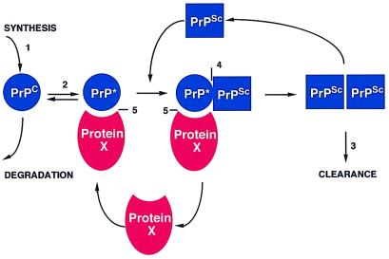
Figure 3. The model of PrP^{Sc} formation and 5 potential ways to discover antiprion drugs¹²
It is important to understand the intracellular locations of PrP^{C}, PrP^{Sc} and their conversion in cell organelles so that drug targets can be identified and their mode-of-actions can be established. There are a few papers studying the cellular locations of PrP^{C} or PrP^{Sc}, and sites where PrP^{C} is converted to PrP^{Sc}. PrP^{C} is mostly reported being located on the cell membrane and anchored by GPI. In different cell lines it was also observed in late endosomes (N2a)¹³, lysosomes (N2a)¹⁴, Golgi and early endosomes (SN56)¹⁵. In another hand, however, the intracellular localization of PrP^{Sc} is difficult to locate due to the lack of a specific antibody. Recently research has shown that PrP^{Sc} was accumulated intracellularly along the endocytic pathway, and the prion conversion was believed to happen in the endosomal recycling compartment.¹⁶ PrP^{Sc} was also observed in lysosomes (N2a)¹⁷ and late endosomal compartments (GT1-7 and N2a)¹³. PrP^{Sc} oligomers were shown in the cells as high signal light spots. (Figure 4 and Figure 5)
Figure 4. Scrapie-infected cells show co-localization of PrP and ferritin. ScN2a and SMB cells cultured in the absence or presence of 0.1 mM FAC were immunostained with 8H4-anti-mouse-FITC followed by anti-ferritin–anti-rabbit-TRITC. Untreated ScN2a cells show minimal PrP reactivity and reaction for ferritin in the cytosol (panels 1–3). Following exposure to FAC, both PrP and ferritin form intracellular aggregates that colocalize for the most part (panels 4–6, arrowheads). Untreated SMB cells show intracellular aggregates of PrP and reaction to ferritin in the cytosol (panels 7–9). However, exposure to FAC increases the reactivity between PrP and ferritin significantly, and PrP and ferritin form intracellular aggregates that co-localize in vesicular structures (panels 10–12, arrowheads).¹⁸

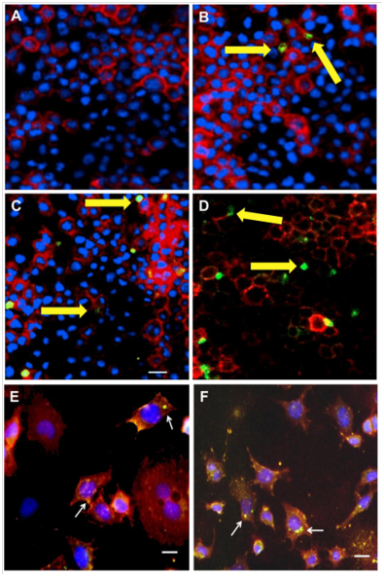
Figure 5. Immunofluorescence staining of PrPSc oligomers/multimers with PRIOC mAbs. PRIOC extensively stained large aggregates in ScN2a cells. (A). Staining with PRIOC1 did not display the PrPSc oligomer-specific stain. (B). PRIOC2, (C) PRIOC3 and (D) PRIOC4 displayed distinct and unusual staining (yellow arrows) in ScN2a cells (green) as opposed to an anti-monomer antibody that displayed the typical diffuse ring-shaped stain of the cell membrane (red). Following permeabilization, ScN2a cells displayed a similar stain for aggregates using (E). PRIOC2 and (F). PRIOC2. Florescence microscopy was performed and images from each source [FITC (450–490 nm), Texas red (510–560 nm) and DAPI (330–380 nm)] were collected. Scale bar = 25 mm.¹⁹

1.2 Current known anti-prion compounds
There are a number of compounds from different families which were reported with anti-prion ability. They are tricyclic derivatives, cyclic tetrapyrrole compounds, branched polyamines, polyanions, antibiotics, azo dyes, monoclonal antibodies, cysteine protease inhibitors and structure based inhibitors. The tricyclic derivatives of quinacrine, acridine, chlorpromazine, phenothiazine, promethazine, promazine and acepromazine were reported as active antiprion leads with EC₅₀s between 0.3 and 3μM based on the screening results of an ScN2a cell line assay.²⁰ Quinacrine and chlorpromazine (Table 1) were used individually as anti-malarial and anti-psychotic drugs for a few years and they were able to penetrate the blood brain barrier (BBB).

The anti-prion activity of cyclic tetrapyrrole compounds²¹ (Table 1) and its sulfonation, metals and oligomerization products²² were reported and compared in a few scrapie infected cell lines. The most active tetrapyrrole was reported had IC₅₀ of 0.5 to 1μM in scrapie-infected mouse neuroblastoma (ScNB) cells.²¹ The activity of tetrapyrrole sulfonation, metals and oligomerization products was relative to the type of metal bound at the center of the molecule.²² A group of branched polyamines exhibited prion inhibition ability. One of the most potent branched polyamines was polyamidoamine, (PAMAM) (Table 1) which had an EC₅₀ of 9nM on ScN2a cells.²³
Some of the polyanions are anti-prion compounds represented by pentosan polysulfate (PS) (Table 1) which was shown to eliminate PrP^{Sc} in ScN2a cells²⁴ and was screened in MDB^{CWD2} cells (a transformed cell line stained with chronic wasting disease) with an EC₅₀ of 3nM.²⁵

Some of the antibiotics such as tetracycline derivatives and anthracyclines are are also reported to have anti-prion properties. Tetracyclic compounds (Table 1) were reported as being able to disable PrP^{Sc} aggregation and its proteinase K resistance by binding with both PrP^{Sc} and PrP peptides.²⁶

Azo dye is a class of synthetic organic dye within the azo group (-N=N-). Congo red (CR) (Table 1) is a di-azo dye which had an half maximal effective concentration (EC₅₀) of 1μM in SMB cells,²⁷ but it is very hard to pass through BBB.

Antigen-binding fragment D18, a monoclonal antibody, was able to inhibit prion propagation at 6 nM in ScN2a cells. It is raised against 132-156 epitopes of recPrP (29-231).²⁸

Cysteine protease inhibitors are another class of anti-prion candidates. The most potent compound of this class is E-64d (Table 1) which had an EC₅₀ of 0.5μM in ScN2a cells.²⁹
Cp-60, 2-amino-6-[(2-aminophenyl)thiol]-4-(2-furyl) pyridine-3,5-dicarbonitrile, which is a structure based inhibitor was discovered by computational docking and the ScN2a cell line screening. The EC₅₀ of Cp-60 was 18 μM, however it showed slight cytotoxicity on ScN2a cells.⁷ Analogues of Cp-60 compounds from the library of the pyridine dicarbonitriles were shown to have the EC₅₀ of 50nM on the SMB cells.³⁰ The structures, classifications and EC₅₀ of some of the compounds are displayed in the table below.

Table 1. The structure and screening results of different classes of previously founded compounds
Catalogue | Name | Structure | EC₅₀ (μM)
Tricyclic derivatives | Quinacrine²⁰ |  | ~0.3
Tricyclic derivatives | Chlorpromazine²⁰ |  | 2
Branched polyamines | Polyamidoamine³¹ |  | 0.009
Polyanions | Pentosan polysulfate^{25, 32} |  | 0.003
Antibiotics | Tetracyclic compound^{26a} |  | N/A
Azo dye | Congo red²⁷ |  | 1
Cysteine protease inhibitors | E-64d²⁹ |  | 0.5
 | Cp-60⁷ |  | 18

It is very interesting to note that a few anti-prion antibodies also showed anti-prion effect. Monoclonal antibody ICSM 18 was able to specifically bind to PrP^{C}, and ICSM 35 could bind to both PrP^{C} and PrP^{Sc} on epithelial Rov cells which are derived from rabbit kidney (RK13) epithelial cells by transfection of a Tet-regulatable ovine PrP gene. ICSM 35 was shown to have better anti-prion efficiency than ICSM 18.³³ Other monoclonal antibodies have also shown inhibition of prion replication and a delay in the development of prion disease in murine, which survived for more than 300 days after being treated.³⁴ Recombinant adeno-associated vector type 2 viral vector platform was applied successfully to express PrP^{c}-specific single-chain fragment variable antibodies within mice infected with CNS and it delayed the onset of prion pathogenesis.³⁵ Recombinant adeno-associated vector (AAV) type 2 viral vector was able to express PrP^{C}-specific single-chain fragment variable antibodies within the CNS in vivo.³⁵ AVV serotype 2 carried with the D18scFv gene also reduced the prion levels in cultured infected cells in vitro.³⁶

Drug delivery systems for the anti-prion compounds
The anti-prion compounds are needed to reach the central nervous system (CNS) in order to exhibit therapeutic effects. However, targeted delivery of drugs into the central nervous system remains the greatest challenge in drug delivery field. The main difficulty is the physiological barriers between the brain and blood circulation in animals (or the human body). They are likely to enable the lipophilic molecule to pass through the barrier, therefore the drugs for CNS diseases were mostly designed to be lipophilic. However, in theory a vehicle can be used to deliver drugs to the microvascular region in the brain and to be accumulated in a specific position. As a result, improving a drug’s solubility without changing the polarity which is required to pass blood brain barrier (BBB) is one of the main priorities in drug delivery research, and it is not trivial. The intravenous injection and oral administration are two commonly used routes of administrating CNS drugs. The intracerebral injection of a viral vector carrying a therapeutic substance may cause brain inflammation, and therefore it is a less preferred route of administration. ³⁷ However, the administration of a drug into CNS via non-intracerebral routes needs to go through blood circulation and pass through the BBB.

2.1 The blood brain barrier
There were two main physiological barriers in the human CNS: the BBB, an extracellular space formed between cerebral microvessels made of endothelial cells with tight junctions, and the blood cerebrospinal fluid barrier (BCSFB), which consists of epidermal cells tightly joined together. The BBB is located between the blood circulating and the brain³⁸, where the tightly closed junctions between cells prevent solute (hydrophilic) exchange between blood and the brain, while the BCSFB prevents potentially harmful substances from passing from the blood to the cerebrospinal fluid.³⁹ The relative surface area of the BBB is 1000 times larger than BCSFB, so the administration of a CNS drug largely depends on its BBB penetration ability.^{39b}

There are six pathways allowing the BBB to exchange substances under normal physiological conditions as shown in Figure 6.⁴⁰ Pathways A and B are the passive transports named paracellular and transcellular lipophilic pathways. Pathway A is the channel for water-soluble compounds, while the transport of lipid-soluble substances relies on Pathway B. Active transports across BBB are demonstrated by pathways C and D using carriers in the brain endothelia cells. Nutrients such as glucose, amino acids, nucleosides, monocarboxylates and small peptides were passed in by carriers in the C pathway while pathway D was responsible for the intake of proteins by receptors. Positive charged protein molecules (such as albumin), which means the proteins with a basic isoelectric point (a molecule has no electric charge at a certain pH), are able to penetrate the BBB by interacting electrostatically with the negatively charged region of the plasma membrane. (Pathway E) The mechanism of pathway E is known as adsorptive endocytosis and works without specific membrane receptors participating, unlike pathway D. However, most of the substances were rejected and pumped out by the Efflux system (pathway F) without reaching the active site in the brian.
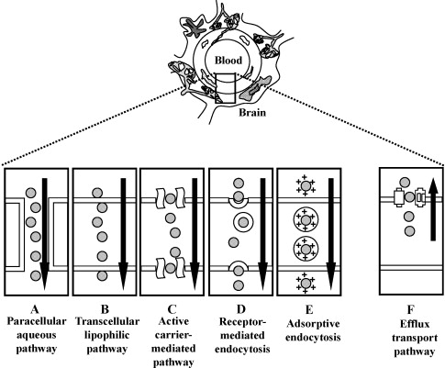
Figure 6. Transport mechanisms at the BBB⁴⁰

Based on the BBB transport mechanisms, relevant strategies were used to conquer the barrier. (i) Pharmacology-based strategies, such as manipulating the physicochemical characteristics of peptide and protein (P/P) drugs and/or using colloidal drug carriers (liposomes, nanoparticles and nanogels). Drugs with lipophilic surface character are easier to pass through the BBB, therefore hydrophilic drugs could be encapsulated by a hydrophobic mask in order to cross the BBB.⁴⁰ (ii) Physiology-based approaches, i.e. utilizing various endogenous carriers. It is known that the carriers and receptors in the brain endothelia cells are capable of carrying certain drugs across the BBB by utilizing facilitated diffusion or a “Trojan horse” mechanism, and drugs are then released in the brain cells. (iii) The chemistry-based strategies which are able to disrupt and transiently open BBB to increase the permeability of the BBB. Osmotic opening agents (e.g. hyperosmolar mannitol), vasoactive agents (e.g. bradykinin and analogues, histamine, serotonin), detergents (e.g. sodium dodecyl sulfate), free fatty acids (e.g. oleic acid), alkylating agents (e.g. etoposide, 5-flurouracil, cisplatin) and solvents (e.g. ethanol, dimethylsulfoxide) can potentially be used to increase the permeability of BBB, however many of these agents are toxic and therefore not practically useful.^{39b}

Recently it was shown that P/P drugs can cross BBB and be used as promising treatments for the CNS diseases. Many of the drugs fail to penetrate the BBB because they are metabolised by enzymes in the liver before they reach the molecular target or because they are pumped out of the BBB via efflux systems, so they may not reach the molecular targets due to their inability to pass through the BBB. Moreover, the plasma protein binding rate is another significant factor affecting the drug’s BBB permeability. They could tightly bind to the plasma protein and be metabolised in the peripheral circulation⁴⁰, therefore it is essential that cell specific drugs can not only pass through the BBB but also survive the efflux and the metabolic systems. Generally speaking, lipophilic drugs that form less than 8-10 hydrogen bonds with water⁴¹ and have an MW of less than 400 (500³⁷) are essential physiochemical properties required to enable them to pass through the BBB.

2.2 BBB transport vectors
The BBB transport vectors are used to assist a drug delivery system (DDS) or (P/P) drugs when they are unable to penetrate the BBB by themselves. Generally speaking, the cellular uptake of the vectors coupled DDS or (P/P) drugs can be either receptor or adsorptive mediated endocytosis.⁴²

The receptor mediated endocytosis involves 4 steps. Firstly, the specific membrane receptor was bound with the vectors (ligand).⁴³ The conformation of the receptor protein is altered via a modification which turns the receptor ligand complex into pits.⁴⁴ Those pits become coated pits once they are binding with clathrin protein. Secondly, the coated pits form complete vesicles and then endocytosis takes place. The vesicles lose the coated clathrin; and endosomes are formed. Endosomes may fuse with an uncoupling vesicle (compartment of uncoupling of receptor and ligand), which leads to acidic dissociation of the receptor ligand complex. The free receptors are recycled to the cell membrane.⁴⁵ Thirdly, the rest of the ligand containing vesicle may combine with a primary lysosome in order to form a secondary lysosome which leads to the degradation of the ligand. Alternatively, the endosome towards the trans-Golgi sacs intracellularly result in lysosomal degradation.⁴⁶ The exocytosis is the final step.

The mechanism of adsorptive mediated endocytosis is similar to the receptor mediated endocytosis. The difference is that there are no specific membrane receptors participating in the adsorptive mediated endocytosis.⁴⁷

The specific receptors on brain capillary endothelia cells have been identified and they are used as vectors including insulin, insulin-like growth factors (IGF), and transferrin et al..⁴² These vectors are developed for BBB targeting functions.

Insulin was demonstarted to be able to bind to the cerebral microvessels and penetrate the BBB both in vitro and in vivo.⁴⁸ However, its short serum half-life and causing hypoglycemia are limited its ability to act as a vector. IGF-Ⅰ and IGF-Ⅱ can avoid the hypoglycemia side effect by using very low concentration as vectors. Due to the same disadvantage of a short serum half-life, an optimized IGF having low affinity with the serum binding protein and retained affinity with insulin receptors is expected to be synthesized for BBB targeting.⁴⁹ It was reported that IGF-Ⅰ was able to cross the BBB via a saturable transport system both in vivo and in situ.⁵⁰
OX26, a mouse monoclonal antibody raised against the rat transferrin receptor, was used to locate transferrin receptors into the brain microvascular endothelia cells.⁵¹ Human serum albumin nanoparticles were covalently coupled with OX26 or R17217 (a monoclonal antibody against transferrin receptor) which could transport the bounded loperamide across BBB.⁵²

A low-density lipoprotein receptor (LDLr) present on the surface of brain capillary endothelial cells attracted some attentions because of their specific capabilities in BBB transporting. It is able to combine with apolipoprotein and form an LDLr-apolipoprotein complex. Then the complex can cross the BBB and apolipoprotein is released into the brain.⁵³ There are two kinds of apolipoprotein, Apo B and Apo E. Angiopep-2, a synthetic ligand of LDLr, is wildly used as a vector to cross the BBB.⁵⁴

Moreover, mimicking or neutralizing a CNS toxin or virus is regarded as another strategy of finding BBB targeting vectors. The tetanus toxin C fragment, which is a non-toxic fragment of tetanus toxin, was conjugated with nanoparticles for CNS targeting.⁵⁵ A short peptide derived from the rabies virus glycoprotein was able to deliver small interfering RNA to the brain in a safe and noninvasive manner (intravenous injection).⁵⁶ Cross-reacting material 197, a non-toxic mutant of diphtheria toxin, could deliver drugs across the BBB in vitro by inducing a signal to affect endocytosis in endothelial cells.⁵⁷

2.3 Nano-drug delivery systems
In order to enhance the hydrophilic character of a drug to cross the BBB, nanomaterials have been regarded as potential vehicles to deliver drugs into the brain. Nanomaterials have the unique ability of masking the drugs’ molecular character via the formation of lipid vesicles. They play an important role in central nervous system DDS. In General, the nano-carrier systems have some advantages over the free drugs, better chance to pass through the cell-membranes and other bio-barriers, an ability to prolong the period of encapsulated drug in the blood stream, and targeting certain tissues/cells by conjugation with specific ligands.⁵⁸

Targeting the drug to specific organs is considered as a solution to lower the drug’s volume of distribution, and therefore minimize the side effects of the drug. Nano-carriers could be conjugated with specific ligands and antibodies in order to achieve cell/organ specific targeting.

Liposomes, nanoparticles, polymeric nanoparticles, solid nanoparticles, micelles, dendrimers, hyperbranched polymers and polymersomes are considered as potential DDS for BBB targeting tools and they will be discussed as below.

2.3.1 Liposomes
A classic liposome is a vesicle with a hydrophilic core and a bilayer shell. It consists of biocompatible and biodegradable lipids. Cholesterol is an important component used to stabilize the liposome systems.⁵⁹ The preparation process involves dissolving lipids in an organic solvent followed by the evaporation of the solvent to dryness in order to allow the formation of the lipid film. Finally, the liposomes are obtained by dispersing them in a hydrophilic medium, and they are then added to an aqueous solution to allow the liposomes to disperse within it.⁶⁰ For different encapsulation missions, different formulations with a different ratio of lipid compositions were applied. In 1994, Fresta’s group used a liposome system to encapsulate citicoline, which is a therapeutic agent for brain injury. The high polarity of citicoline prevented it from penetrating the BBB. The liposome delivery systems help the drug cross the BBB, and therefore improved efficacy was observed in rats. The system was composited by 1, 2-dipalmitoyl-sn-glycero-phosphocholine, dipalmitoyl-DL-α-phosphatidyl- L-serine and cholesterol at a ratio of 7: 4: 7 respectively.⁶¹ Further examples were demonstrated by phenytoin, an anti-epileptic drug which was entrapped in liposomes and showed high affinities and efficacy for the amygdaloid epileptogenic condition after being administrated in comparatively large dosages. L-α-phosphatidylcholine, cholesterol and stearylamine were applied at a ratio of 7: 2: 1 to form the liposome.⁶²

Tissue (brain) uptake and the possibility of successful drug delivery of liposomes are mainly depended on the particle size, surface charge, lipid materials and the amount of cholesterol.⁴⁰ The particle size is one of the most important parameters to affect the penetration of a delivery system through the BBB. The diameters of liposomes varying from 20nm to 100nm were reported as being able to pass through the BBB. Some suggested that the diameter of liposomes should not larger than 80~100nm⁴⁰, while others believed that 80nm⁵⁹ is the optimal for the endocytosis (Figure 6 B and D) otherwise they could be trapped by the reticuloendothelial system (RES), e.g. the liver, the spleen and the bone marrow etc. Polyethylene glycol (PEG) was largely applied as a ‘Trojan’ tool to conjugate to the surface of liposomes which are able to weaken the intake of the RES and prolong the circulation time.^{39b}

Furthermore, the specific targeting effect can be achieved by conjugating a liposome with specific monoclonal antibodies or ligands which are covalently bound with the PEG ended chain. One of the advantages of this is that the system targets external receptor epitopes instead of competing with the binding sites of the drug target.⁴⁰ More than one kind of ligand can be conjugated to this system in order to achieve specific targeting effects.⁵⁹ Therefore a system modified with CNS specific antibodies could assist the anti-prion compounds across the BBB.
Ines Sauer found that the penetration ability of the PEG coated liposomes had been enhanced by covalently associating them with apolipoprotein E, which had a high affinity binding with LDLr. The compositions of the liposomes include1-palmitoyl-2-snglycero-phosphocholine,1,2-dipalmitoyl-sn-glycero-3- phosphoethanolamine-N-[methoxy(poly(ethyleneglycol)-2000)], 1,2-stearoyl- sn-glycero-3-phosphoethanolamine-N-[maleimide(poly(ethylene glycol)-2000)], ammonium salt and cholesterol.⁶³

Other PEGylated immunoliposomes were applied as a nerve growth factor carrier system. RMP-7, a ligand to specific receptors on the brain microvascular endothelial cells was conjugated with liposomes in order to help the system across the BBB. The result showed that the system also enhances the bioavailability of nerve growth factors. 1,2-Dioleoyl-sn-glycero-3-phospho ethanol amine-n-[poly(ethylenegly-col)]-hydroxysuccinamide(DSPE-PEG-NHS) and DSPE-PEG-RMP-7 are the lipid components. The particle size was less than 100nm and the encapsulation rate of the drug was 34%.⁶⁴ Some immunoliposomes targeting DDS in CNS are listed in table 2. Research on immunoliposomes demonstrated that these DDS are capable of assisting the drugs across the BBB and improving the bioavailability of the drug.⁶⁵

Table 2. CNS targeting immunoliposomes DDS
Drugs | Lipids | Ligands | Ref
Global gene | PEG-LP | MAb | ⁶⁶
Doxorubicin | PEG-LP | ----- | ⁶⁷
Horseradish peroxidase | PEG-LP | Transferrin | ⁶⁸

2.3.2 Nanoparticles
Depending on the materials used the nanoparticles can be divided into polymeric and solid lipid nanoparticles, and both of them have been proven to assist with drugs penetrating into CNS. The particle size could be controlled at a comparatively small nano-scale (<100nm) in order to allow them to cross the tight endothelia junctions. Just like the CNS targeting immunoliposomes, conjugating PEG at the surface can be applied to avoid the RES trap, and the specific ligands were associated to ensure the carrier system reaches the specific organ.^{39b}

2.3.2.1 Polymeric nanoparticles
For the purpose of transporting drugs across the BBB, polybutylcyanoarcylate (PBCA) was used as the material of polymeric nanoparticles. This BBB penetration is commonly assisted with tight junction opening modulators.⁶⁹ Alyautdin group used PBCA nanoparticles to transport loperamide through the BBB in mice by intravenous injection. This DDS using PBCA nanoparticles was coated with polysorbate 80, and this system produced a longer lasting drug effect than its parent one.⁷⁰ This system was also used to deliver another drug, dalargin, which was administrated only by intracerebral injection. An improved CNS activity was achieved by adding polysorbate 80 to the PBCA nanoparticles suspension with particle size at approximately 250nm.⁷¹ Some other natural products such as polysaccharides were also used as recipients to CNS DDS.⁷²

2.3.2.2 Solid lipid nanoparticles (SLN)
SLN are defined as ‘dispersions of solid lipids stabilised by emulsifier or an emulsifier/co-emulsifier complex in water’^{39b}. Different grades of poloxamers, polysorbates, lecithin and bile salts were used as emulsifiers. There were some experiments demonstrating that the SLN is able to assist CNS drugs crossing the BBB. Camptothecin was trapped in SLN (soybean lecithin) which was coated with poloxamer 188. The SLN assisted the drug to maintain a high concentration and a long action time in the brain after oral administration. The average particle size was 196.8nm with a Zeta potential of –69.3 mV.⁷³ The zeta potential is the overall charge a particle acquires in a particular medium, which is determined by the electrophoretic mobility of nanoparticles in a U type tube. It can be used to predict the binding process and internalization process of the nanoparticles after uptake by cells.⁷⁴ This DDS provides a new possibility of developing a more compliant administration route than the intravenous injection. When a drug delivered by an SLN with different degrees of PEG modification was compared with its free form, the brain intake and sustained release are increased in proportion to the amount of PEG used, but the drug’s distribution to the liver and heart decreased.⁷⁵

2.3.3 Micelles
A typical micelle is formed by the self-assembly of small molecule amphiphiles which exceed the critical micelle concentration (CMC) in an aqueous solution. The shape of the micelles are decided by a packing parameter (p) which is calculated using the equation⁷⁶ below:
p = v/a_{o}l_{c}
is the volume of a hydrophobic tail, l_{c} is the length of the hydrophobic tail, and a₀ is the contact area of the head group. Spherical micelles are formed When p<1/3; cylindrical micelles are favoured when 1/3 < p < 1/2; when 1/2 < p < 1, flexible lamellae or vesicles (also known as polymersomes); when p = 1, planar lamellae are observed. If p > 1, inverted structures can be obtained.⁷⁶⁻⁷⁷
Formation of amphiphilic diblock polymers into different morphologies is dependent on enthalpy contribution of interfacial energy and the entropy contribution of chain stretching.⁷⁶ Various morphologies including spherical micelles, cylindrical micelles, bicontinuous structures, lamellae and vesicles, have been observed in bulk and in aqueous solutions. For the spherical micelles in an aqueous solution the hydrophilic groups are on the surface of the micelles and the lipophilic tails are inside the core. These types of micelles are the single layer vesicles which are different from the bilayer liposomes. (Figure 7) The lipophilic compounds can be encapsulated into the core of the sphere for delivery.
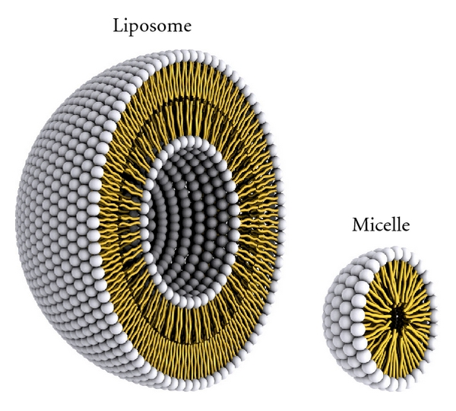
Figure 7. A representation of the steric organization of a liposome (left) and a micelle (right)⁷⁸

The materials of such micelles should be non-toxic (also biocompatible), biodegradable, have high loading capacity for the drug, and be stable, sustained and have controlled release. Block copolymers were largely used in such delivery systems.^{58, 79} Moreover, the size of micelles are normally 10-100nm, which is advanced for CNS delivery.⁸⁰

The polymeric surfactant poly(oxyethylene)-poly(oxypropylene) block copolymer (pluronic) forms micelles were used to deliver haloperidol, a typical antipsychotic drug. Its brain penetration ability was increased by conjugating the micelles with an insulin vector (α₂-glycoprotein), resulting in an average particle size of 12-36 nm. The results indicated that the DDS could increase the drug’s CNS effect after crossing the BBB. Pluronic was regarded as nontoxic and non-immunogenic block copolymers which can self-assemble into micelles.⁸¹ They were delivered FITC into brain with a size range between 12-36nm and surface conjugated with anti-α₂-GP antibody as vector.⁸¹ They were also reported as inhibitors of the drug efflux transporter such as P-glycoprotein (P-gp) in the blood–brain barrier which made them more promise as tools for BBB targeting.⁸² Recently, a PEG-polyamino acid block copolymer, polyplex nanomicelle with an average size of 50nm was reported to administer mRNA into the CNS in rats and resolved the instability and immunogenicity of mRNA in vivo.⁸³

2.3.4 Dendrimers and hyperbranched polymers

2.3.4.1 Dendrimers
Dendrimers consist of repeating units which are conjugated into a defined and ordered branching structure in a range between 1 to 10 nm. The spaces between the branches could provide ‘pockets’ for the drug. ⁸⁴ They were found to be capable of assisting drugs penetrating the BBB.

Different formulations of CNS targeting dendrimers based on gene carrier systems were compared by R Q Huang’s group.⁸⁵ The PEGylated polyamidoamine dendrimer conjugated with transferrin as a vector for DNA loading performed the best after i.v. injection in mice. The gene express in the brain was enhanced by this DDS. The DNA transfection efficiency was quantitatively analyzed by fluorescent microscopy and luciferase activity determination.⁸⁵ Recently, PEGylated polyamidoamine dendrimer’s BBB penetrating ability was further proven in animal experiments by associating it with fluorescein-doped magnetic silica nanoparticles. The results, which were observed in a cellular and subcellular level by confocal laser scanning microscopy and transmission electron microscopy (TEM) respectively, provided direct evidence that PEGylated PAMAM conjugated fluorescein-doped magnetic silica nanoparticles could penetrate the BBB and reach the brain parenchyma.⁸⁶

2.3.4.2 Hyperbranched Polymers (HBP)
HBP is a randomly branched polymer which is less symmetrical than the structure of dendrimer but more cost-effective in the synthetic progress.⁸⁷ Compared to the dendrimers, a HBP contains more end-groups which are able to conjugate with ligands for the specific targeting applications. (Figure 8) Also, the synthesis of the HBP is easier than the dendrimers. Fewer steps are needed in the HBP’s synthesis and purification process. ⁸⁸ HBPs were also reported as nano-drug carriers.
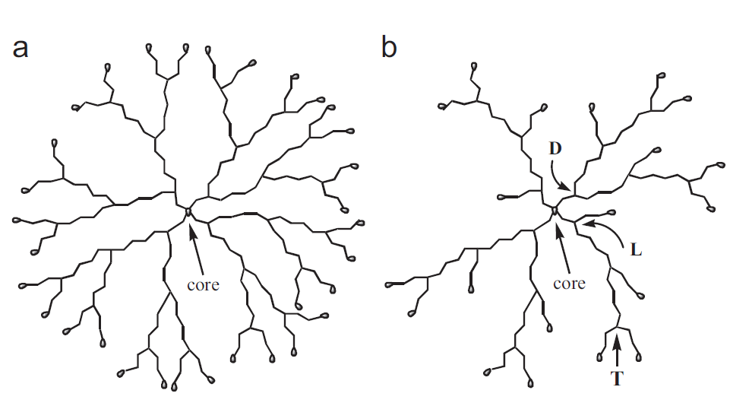
Figure 8. Schematic structures of (a) dendrimers, and (b) HBP.⁸⁹

The Perstrop Polyol which is the hyperbranched polyester with –OH groups was applied to encapsulate ibuprofen. However, when comparing the drug loading the dendrimer PAMAM-G4-NH₂ was capable of catching approximately 3 times more ibuprofen than HBP. The lack of a strong interaction between the hyperbranched polymers’ function groups –OH and the drugs was believed to lead to less encapsulation.⁹⁰ It was also reported that the hyperbranched aliphatic polyester Boltorn H40 with surface modification (with folic acid) was used as the delivery system of 5-fluorouracil and paclitaxel. The inhibition of the tumor cells was increased by using this drug delivery system. ⁹¹ Unfortunately, not many CNS targeting applications using HBP were reported.

2.3.5 Polymersomes
The polymersomes are bilayer-based vesicles made from synthetic polymer instead of lipids. ⁹² The specific amphiphilic block polymers can self-assemble into the nano-scale bilayer vesicles—polymersomes (Figure 9) in an aqueous solution. The core and shell of the polymersomes are hydrophilic and hydrophobic respectively. Therefore, the polymersomes are able to encapsulate both the hydrophilic and hydrophobic compounds. The synthetic nature of polymersomes allows them to possess more controllable properties (by adjusting the mass ratio of the compositions) towards permeability.⁹³ The pH responsive polymersomes are one of the examples that can specifically release at the targeting sites in order to minimize the side effects. They were designed by inducing pH sensitive functional groups into the block polymer. ⁹⁴ Also, the entirely ‘PEG-based’ polymersomes showed a two-fold longer circulation time than the PEG modified liposomes after being injected into rats. ⁹⁵ This means that the structure of polymersomes in a solution is more physically stable than that of the liposomes, therefore those unique properties make the polymersomes a potential delivery system for drugs and genes.
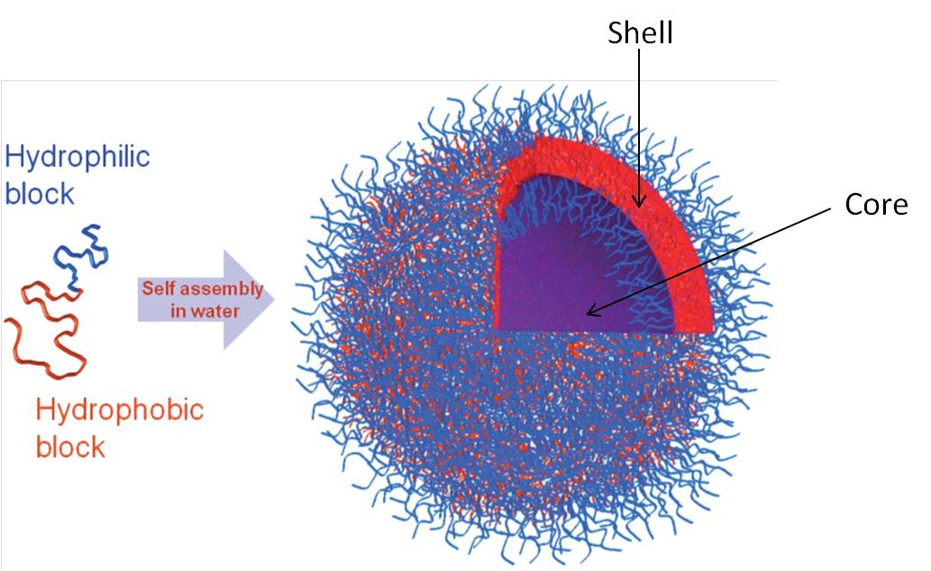
Figure 9 The structure of the polymersomes ⁹³

The pH responsible polymersomes were reported as an efficient delivery vector for DNA by Hannah Lomas et al. in 2007.⁹⁶ Poly(2- methacryloyloxy)ethylphosphorylcholine)-co-poly(2-(diisopropylamino)ethyl methacrylate) (PMPC₂₅–PDPA₇₀) was applied to form the polymersomes. The PDPA block contains the pH response functional groups, which allowed the polymersomes maintaining in vesicle from in the physiological pH and disassociated in intracellular pH. The viability assay proved that the PMPC₂₅–PDPA₇₀ had no cytotoxicity to the human dermal fibroblasts cells. The size of the DNA encapsulated polymersomes was from 200 to 400nm. The application of polymersomes in CNS drug delivery was also reported. The poly(ethyleneglycol)-poly(ε-caprolactone) (PEG-PCL) polymersomes conjugated with mouse-anti-rat monoclonal antibody OX26 were able to deliver NC-1900, a model peptide, into rats’ brains. The average diameter of them was around 100nm.⁹⁷

In summary, more than one of the nano-scale vesicles such as liposomes, polymersomes, nanoparticles, micelles, hyperbranched polymer and dendrimers are potentially suitable as the delivery tool for delivering compounds through BBB. The particle size is one of the most significant parameters to ensure the drug crossing the BBB. Also, the surface of these potential vehicles can mask them as ‘Trojans’ to survive from immune system and specifically target organ in vivo by decorating the specific antibody. The biodegradable and biocompatible materials are preferred for their similarity to the in-vivo environment. Also, apolipoprotein E and transferrin could be potential specific vectors if targeting the brain endothelial cells is required. The targeting effect is also expected to enhance the drug’s bioavailability. The prolonged effect of the drug’s life is usually achieved by PEGylating the end of the lipid.

3. Brief review of the instruments and techniques used in the project

3.1 Immunofluoresence (IF)
Immunofluorescence (IF) which uses fluorescent-labelled secondary antibodies to detect primary antibodies which can specifically binding with their antigen and therefore visualize the distribution of specific biomolecule.⁹⁸ IF is applied to locate the intracellular PrP^{C} or PrP^{Sc}.¹⁸⁻¹⁹ Figure 4 and Figure 5 are the examples of PrP^{Sc} IF staining. Cells for IF assay were fixed with formaldehyde (or ethanol) and block them with blocking buffer which normally consist of Triton X-100 and serum in 1X PBS. Then, incubate the specimen with primary and followed with secondary antibodies. At last, the specimen is immersed in 1X PBS and observed under laser confocal microscope.

3.2 Transmission electron microscopy (TEM)
TEM is applied to observe the nano-scale polymer morphologies in high resolution. It can be used to measure the diameter of the polymer microspheres assisted by software. Sample preparation is normally required due to the absorption of the electrons, which is dependent on the thickness of the material on the copper grid and which was pre-coated with carbon under vacuum. Different staining techniques are acquired when varying samples.⁹⁹ The examples of TEM pictures are shown in Figure 10 below.

Figure. 10 TEM pictures of samples with a different soft to hard phase ratio contrasted by (a) preferential staining with RuO4 and, (b) Pt-shadowing technique.¹⁰⁰

3.3 Dynamic light scattering (DLS)
DLS is typically applied to measure the diameters of particles, emulsions or molecules in a solution based on the theory of Brownian motion.¹⁰¹ It can statistically measure the size distribution of spherical polymers. The DLS results are often compared with the measurement on TEM images and DLS often have slightly larger value than TEM which might be induced by high polydispersity index (large particle size variation).

3.4 Confocal laser scanning microscopy (CLSM)
CLSM is applied here for the live cell image with depth selectivity which allows the generating of 3D images.¹⁰² The intracellular locations of various cell organelles are able to be localized by CLSM by marking them with different commercially available cell organelle trackers.¹⁰³ IF fluorescence was also captured by CLSM.¹⁰⁴

3.5 High-performance liquid chromatography (HPLC)
This is normal liquid chromatography with high pressure which is significantly improved efficiency of the system. The basic mechanism of it is to separate different components by the difference of polarities leading to different retention time. The optimising of retention time of certain compounds is mainly dependent on the stationary and mobile phase. Good separation can be achieved by optimizing column, mobile phase composition (gradients), temperature and flow rate. HPLC is a robust technique and it is widely used in many areas for quality control. Here, it is applied to quantitatively measure both anti-prion compounds and materials of delivery system with UV-vis absorption.

PartⅠChapter 2 Previous work
Previous work in Chen group leading to the selection of the model compound in this project will be briefly discussed to give some background of current project. This was achieved by the joint effect of the group over several years of research.

1 Compounds selection by virtual high throughput screening
A library containing 1,300,000 virtual compounds compiled from public databases was virtually docked into the specific binding pocket on PrP^{C105}, their ability in fitting into the binding pocket was ranked according to their binding energy using docking programme, GLOD. The top 300 of these potentially active compounds were selected using criteria listed in Table 3 for further biological screening.

Table 3. The parameters in the compounds’ selection
Parameters | requirement
Solubility | Lipophilic, cLogP 2.5~6.0
GOLD score | >60
Availability | Suppliers

The lipophilicity of the compounds is relevant to their solubility, permeability of blood brain barrier, receptor binding, metabolism rate and plasma protein binding. A logP in the range of 2-5 was used to select compounds with potentials of good permeability across the cell membranes, even BBB. The GOLD score above 60 means that the binding affinities between compounds and chosen PrP^{C} pockets are satisfied, and compounds with a score lower than 60 are ‘filtered’ before the next screening step. Also, the availability of compounds was also considered for purchasing.

2 Biological Screening of Computational Hits

2.1 SMB cell line screening
The SMB cells are the persistent scrapie-infected cells cloned from infected mouse brain cells of non-neuronal origin. The infected cells can constantly produce PrP^{Sc}. The prion protein can be quantified by dot-blot assay before and after being dosed with the candidate compounds. The viability assay can also be applied for evaluating the toxicity of certain compounds to the SMB cells by MTT assays. The protocol of the dot-blot assay on the SMB cell line screening was optimized based on an assay developed by Rudyk.²⁷ Compounds from different libraries were screened in the same method. The structure activity relationship was determined from the data obtained in this assay.

2.2 Active hits
The screening outcome of most active anti-prion compounds from existing libraries in our lab with EC₅₀ lower than 10 nM from cell line screening are listed in the table below (Table 4).¹⁰⁶ The anti-prion EC₅₀ is acquired from the dot-blot assay results.

Table 4. The top ranked active anti-prion compounds
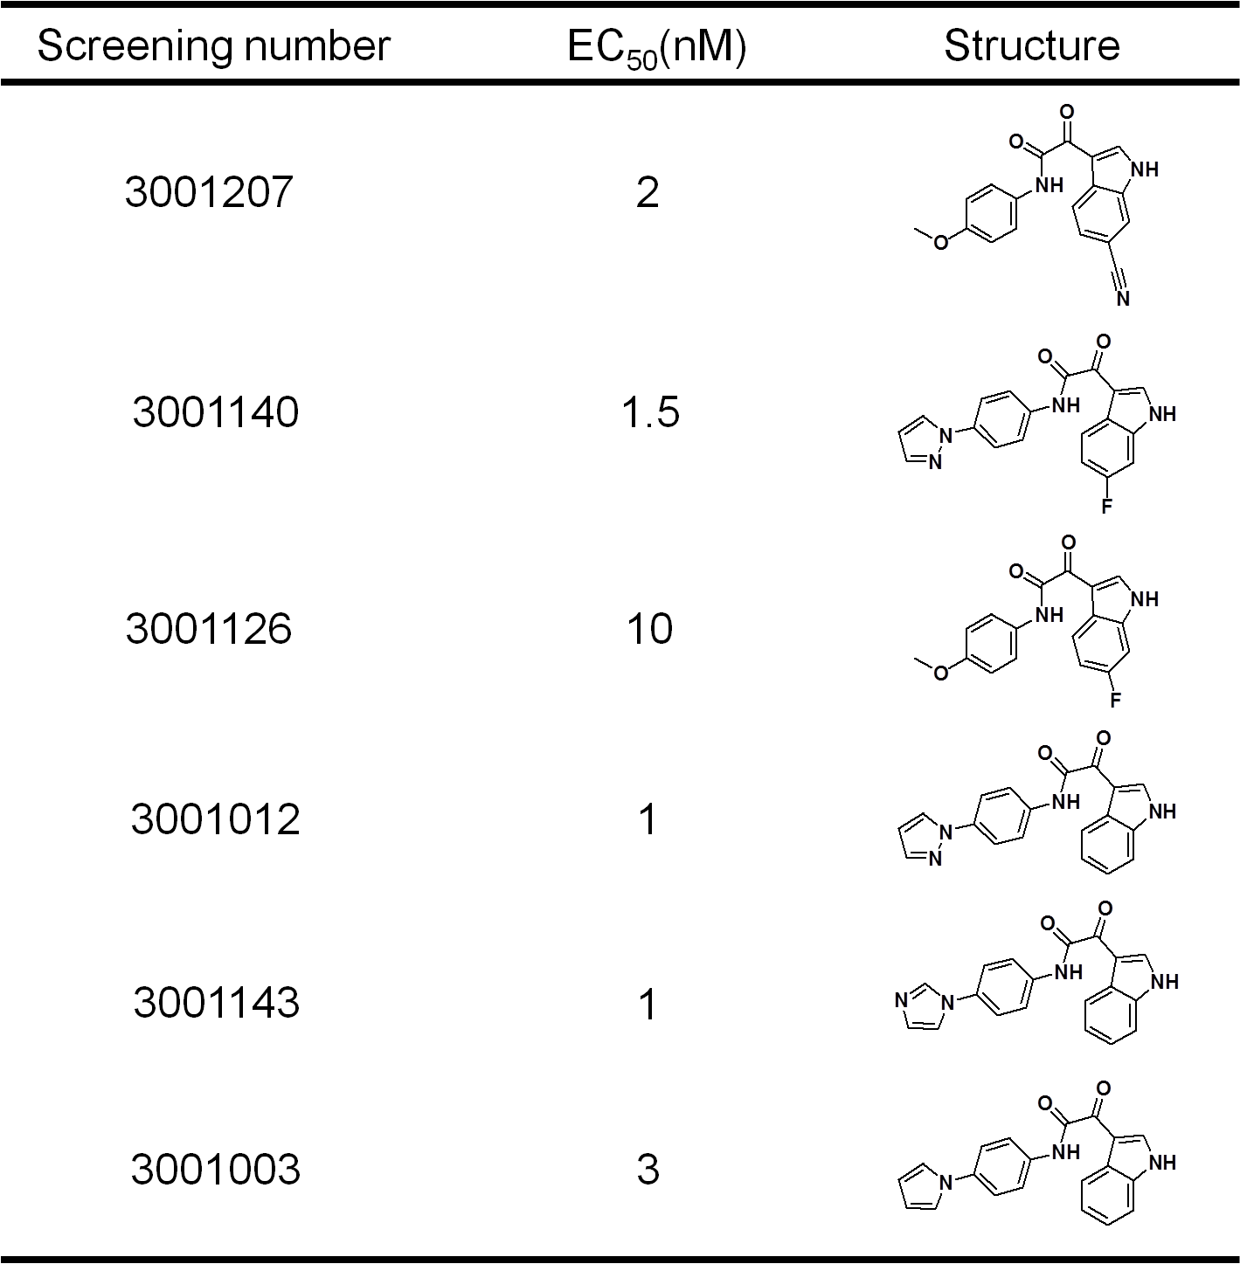

PartⅠChapter 3 Aims of the project

1 Aims
The aim of this research is to adapt and optimize a cell based biological evaluating system for DDS by screening the anti-prion effect and the cytotoxicity of three libraries of compounds (ZINC library, benzofuran derivatives and ε-PL) to complement the existing work in the group. Then, three DDS (Hyperbranched polymer, polymersomes and quantum dots) are used to increase the solubility of the hydrophobic anti-prion leads. The cytotoxicity and anti-prion effect of DDS can be evaluated by the system. Also, the DDS with fluorescence function should allow them to be traced intracellularly which could help understanding their possible mode-of-action.

2 Project design

2.1 Problems with current anti-prion compounds
- Low solubility
- Unable to reach the disease focus
- Non-fluorescence (Unable to track in vitro and in vivo)

2.2 Current status of DDS for prion research
- Lacking small molecule delivery techniques in general
- CNS targeting is still a challenge

2.3 Justifications for needing a DDS for anti-prion leads
- Improving solubility and bioavailability
- Tracking the compounds intracellularly by conjugating with fluorescence group
- Protect drugs before reach the target
- Targeting delivery by decorating with vectors

3 Project Plan
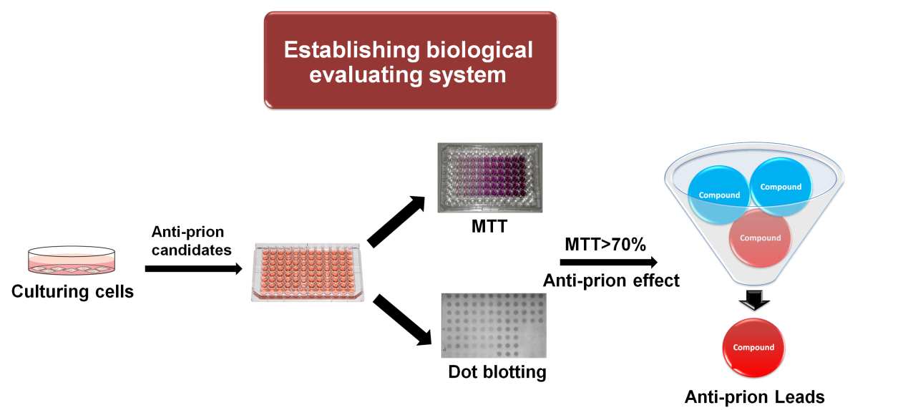
Scheme 1. Biological evaluating system based on SMB cell line

A biological evaluating system based on the SMB cell line was adapted and optimized based on the group members’ previous work. A brief evaluating process is started from culturing SMB cells and split them in 96-well plate. Then, treat the cells with anti-prion compounds in serial dilutions. The MTT and dot blotting assays are applied after 5 days incubation and anti-prion leads are picked up under certain parameters (MTT>70% and anti-prion effect in nano-molar scale). This system was applied to screen the anti-prion effect and the cytotoxicity of three libraries of compounds, ZINC library, benzofuran derivatives and ε-PL.

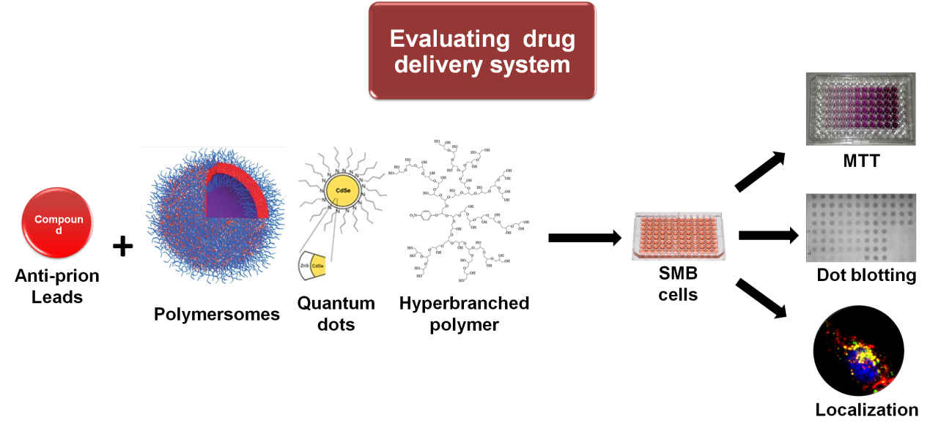
Scheme 2. Evaluating DDS via the biological system

Polymersomes, hyperbranched polymer and quantum dots were applied as DDS for anti-prion compounds, and they were evaluated in vitro individually. The drug loaded DDS are dosed on the cells in serial dilutions and comparing with DDS material without loading drug and free drug in DMSO in corresponding concentrations. Then, the MTT and dot blotting assays were applied to evaluate their biocompatibility and anti-prion effect. Also, the intracellular localization of the fluorescence traceable DDS is observed under confocal microscope. All three DDSs were chosen to improve the poor water solubility of those compounds. Furthermore, we will try to locate the intracellular location of those non-fluorescence compounds by modifications on the DDS, and this would help us to understand the mechanism of them, and lastly it can help the anti-prion compounds to reach the disease focus located in the CNS.

PartⅠChapter 4 Thesis layout

This thesis consists of four parts.
Part 1 Introduction and literature survey
Research background about prion disease, drug delivery systems and previous works are introduced. Aims and objectives were demonstrated.

Part 2 General screening and optimization of the biological evaluating system
A cell based biological evaluating system is adapted and optimized for evaluating anti-prion effect and toxicity of samples to SMB cells. ZINC library, benzofuran derivatives and ε-PL were practiced on this system.

Part 3 Drug delivery systems for anti-prion compounds
Three drug delivery systems, hyperbranched polymer, polymersomes and quantum dots (QDs), were loaded with anti-prion compounds and their anti-prion effect and cytotoxicity were evaluated by the optimized cell based evaluation system. The intracellular uptake of both polymersomes and QDs were observed under laser confocal microscope. Furthermore, the QDs’ mode-of-action was researched on cells.

Part 4 General discussion and conclusions
Comparing the anti-prion activity and cytotoxicity of three DDS; the problems of anti-prion compounds (poor solubility; traceability; unable to reach CNS) partially solved by the DDS were discussed. Also, conclusions of the whole thesis were drawn in this part.

Part Ⅱ General Screening and Optimization of Biological Evaluation Systems for DDS

- Introduction
In order to discover therapeutic leads from thousands of potential anti-prion candidates both in vitro and in vivo models have been used in recent research.¹⁰⁷ The in vivo model can be established by using animals such as sheep, cattle, deer and rodents infected with prion disease.¹⁰⁸ The comparatively cheap and fast in vivo models are the ones with mice and hamsters infected with an appropriate amount of rodent adapted TSE scrapie strains.¹⁰⁹ The in vivo model is an excellent tool to acquire distribution and metabolism data from a real biological environment rather than by prediction. Indeed, there are a few compounds showing their therapeutic benefits from in vivo.¹¹⁰ Amphotericin B, MS8209 and filipin belong to polyene antibiotics showed some benefits as anti-prion agents in rodents, but are toxic prohibiting their further use in humans.¹¹¹ Quinacrine, quinine, biquinoline and chlorpromazine belong to tricyclic derivatives and have been applied on human trials, but showed little effects in prolonging lives of CJD patients.^{20, 112} Flupirtine was also reported on human trials without much success.¹¹³

However, the time and costs have been key barriers to use in vivo models in the initial screening. They are normally used to evaluate the compounds selected and confirmed by in vitro models.

In vitro models are cheaper and results are generated quicker than the in vivo assays. Cell based assays were commonly used as an in vitro high throughput models for screening anti-prion compounds. The cell lines in multi-well plate can be cultured by using the prion infected cells, typically scrapie-infected mouse brain cells (SMB), scrapie-infected neuroblastoma cells (ScN2a), or scrapie Chandler strain infected immortalized murine hypothalamic neuronal cells (ScGT1) which are all capable of continuously producing PrP^{Sc}.¹¹⁴

In cell line screening, dot blot assays were applied as a high-throughput method to quantitative the amount of PrP^{Sc}. It can be used to quantitatively analyze a large number of protein samples. For example, Taraboulos et al. used dot blotting to measure the accumulation of PrP^{Sc} in the infected hamster brain cell line¹¹⁵, Kocisko et al. screened a library of 2000 drugs and nature products as anti-prion candidates on ScN₂a cells based on the 96-well dot blotting assay¹¹⁶, and in our group, dot blotting was applied to discover novel anti-prion candidates from synthesized libraries by testing on both SMB and ScN2a cell lines.¹¹⁷ One of the compounds from indole-3-glyoxylamides even showed its activity about 1nM from the dot blotting results.¹⁰⁶
Dot blotting assay has been used throughout this PhD project. To complement the existing work in the group, this part of the thesis documents the optimization of SMB cell line assay, testing it as an anti-prion screening system for screening three families of chemicals. They are compounds from the ZINC library, benzofuran derivatives and ε-PL. This cell line will also be used for assessing the biological activities of the DDS designed in Part III.

ZINC library contains compounds specifically selected for an antibiotic lead discovery project. It would be interesting to see if any of the compounds would exhibit anti-prion activities in the evaluating system I adapted. The hypothesis is that these compounds should be weak or non-inhibitors in the SMB cell line assay because they were purchased for a different drug discovery project aimed at the discovery of new antibiotics. Anti-prion compounds and antibiotics should in theory act via a totally different mode of action, i.e. via different drug targets.

Free radicals are atoms, molecules or ions which have unpaired valence electrons or open electron shell. They may attack and damage lipids, proteins, and DNA and relative to aging.¹¹⁸ Cell hypoxia is the main cause of free radicals and oxidative stress. The brain tissue is especially sensitive to oxidative damage because of its high content of readily oxidised fatty acids, high use of oxygen, and low levels of antioxidants.

There is reports about free radical quenchers (also called anti-oxidants) slowing the prion disease progression.¹¹⁹ The activity of anti-oxidant is related to copper binding of PrP^{C}.¹²⁰ Increasing evidence showed that free radical–induced oxidative damage may play a role in the pathogenesis of both Alzheimer’s and prion diseases.¹²¹ However, there is no report about anti-oxidants benzofuran exhibiting anti-prion effect.

Benzofurans were shown some correlations between their free radical quenching ability and their ability to inhibit Aβ-aggregation in the previous research from University of Lancaster. Here, a novel family of benzofuran derivatives was applied to screen through this evaluation system. The correlations between anti-prion effect, free radical quenching and inhibiting Aβ-aggregation ability of 6 benzofurans (Table 5) were analyzed.

Table 5. Structures of the benzofuran derivatives
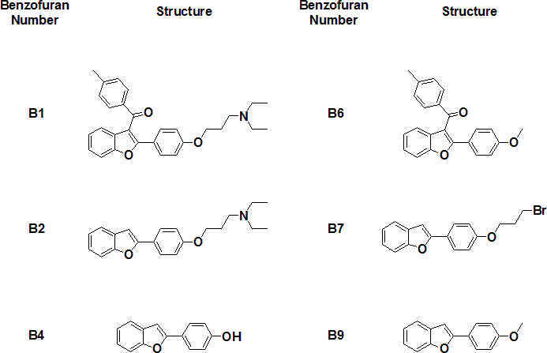

ε-Poly lysine (ε-PL) with a molecule weight of 5000 was kindly provided by Dr. Hong Xu (Nanjing University of Technology, China). (Figure 11) This poly amino acid was produced by a strain of Kitasatospora which was isolated from soil.¹²² It is a board spectrum antibiotics¹²³ and it has been applied as food preservatives¹²⁴. Synthesized poly-L-lysine was showed its anti-prion activity in the cell-free (protein misfolding cyclic amplification), cell culture (ScN2a cells), and mouse models.¹²⁵ Anti-prion effect of bacterial produced ε-PL has not reported yet, therefore this compound was evaluated.

Figure 11. Structures of ε-PL

2. Materials and methods

2.1 Materials
The compounds from the ZINC database were purchased commercially from various companies. Benzofuran derivatives for screening were kindly provided by Dr. Lance Twyman. ε-PL was kindly provided by Dr. Hong Xu (Nanjing University of Technology, China).

SMB cells were obtained from the TSE centre at the Institute of Animal Health. The medium for the cell culture was Phenol-red Medium 199 (Invitrogen). 10% New Born Calf Serum (NBCS, Invitrogen), 5% Foetal Bovine Serum (FBS, Invitrogen) and 1% Penicillin-Streptomycin Solution (Sigma) were added into the medium before use. Trypsin-Ethylenediaminetetraacetic acid (EDTA) solution was purchased from SIGMA. Hanks Balanced Salt Solution (HBSS, Invitrogen) was used as the compound dilution solution. The SMB cells were cultured and passaged in tissue-culture treated petri dishes (BD Falcon through SLS). The sterile 96 well plates (BD Falcon through SLS) were used for the cell culture and dosing. Chemical reagents for the viability assay and the protein determination were all obtained from Sigma, which includes 3-(4,5-dimethylthiazol-2-yl)-2,5-diphenyltetrazolium bromide (MTT), dimethyl sulfoxide (DMSO), isopropanol, Bradford reagent, and bovine serum albumin (BSA). The plate reader was from BioTek instruments. The reagents for the dot blot assays include proteinase K (PK, Sigma), phenylmethyl-sulfonyl fluoride (PMSF, Sigma), Tris-Buffered Saline (TBS, Sigma), Guanadine Thiocyanate (Acros), skim milk powder (Fluka), 6H4 primary antibody (Prionics through celtic foods) and the mouse antibody IgG and chemiluminescent solutions (GE Healthcare). The haemcytometer was bought from Fisher Scientific. The 96 well manifold (minifold, GE) was used for the dot blot assay.

2.2 Methods

2.2.1 Initial screening

2.2.1.1 Sub-culture of SMB cell lines
The SMB cells were cultured in tissue-culture treated petri dishes which were placed in an incubator under the conditions of 37˚C, 5% CO₂ and 95% humidity. Phenol-red Medium 199 supplemented with 10% NBCS, 5% FBS and 1% Penicillin-Streptomycin Solution was used as the cell culture medium.

The SMB cells were sub-cultured every 7 days. To sub-culture the cells, the medium was discarded and 5ml of trypsin-EDTA solution (prepared from 2.5ml stock trypsin-EDTA in 22.5ml HBSS) was added into each dish and incubated for 5 minutes at 37˚C to digest cadherin, a Ca²⁺ protein which is expressed on the surface of cells, plays a significant role in cell-cell junction formation¹²⁶ and cell-matrix adhesion¹²⁷. EDTA chelates Ca²⁺ ions in the solution, to enhance the activity of trypsin used for digestion. Cells can be seen detaching from the dish bottom under an optical microscope. 5ml medium containing inhibitors for trypsin including Mg²⁺ ,Ca²⁺ and proteins in the NBCS was then added to each dish to stop the digestion.¹²⁸ The cells were collected by placing 25 ml of suspension into two 50 ml centrifuge tubes followed by centrifugation at 1000g for 5 minutes. The supernatant was removed and a 10ml medium was added into each tube to re-suspend the cells. The hemocytometer was used for cell counting. 5x10⁵ cells were seeded on each new tissue-culture dish and fresh medium was added in order to make the total volume of 10ml. The sterile 96 well plates were seeded with 0.8x10⁴ cells in 100µl medium per well. Duplicates or triplicates of wells were dosed with a compound from the library for further activity and viability assays respectively. These plates were incubated for 24 hours before dosing with compounds, which allows the cells to attach. The medium in the tissue-culture dishes was changed after 4 days in order to ensure that there was sufficient nutrition for the cell growth.

2.2.1.2 Dosing the cells
- Screening the ZINC compounds
The cells on 96 well plates were ready for dosing with compounds after seeding for 24 hours. There were 145 commercially available compounds purchased for this screening which are selected for the antibiotic project. Stock solutions of all compounds were uniformly prepared at a concentration of 10mM in DMSO. The stock solution was diluted using DMSO and followed by medium to the required concentration. The final DMSO composition was required to be no more than 0.5% by volume to avoid any cytotoxicity and solvent effect.

Each compound was dosed at three concentrations, 1µM, 10 µM and 20 µM, in triplicate in the initial screen. DMSO (0.5% v/v) treated cells were set as negative controls and cells treated by a known anti-prion compound curcumin at 10μM were set as positive controls respectively. To dilute a stock solution to require concentration, a dilution sequence is applied, an example of a dilution sequence was shown in the Table 6. Stock solution (A) is normally prepared in a concentration of 10mM. Firstly, certain volume of A is diluted by DMSO solution (B) in corresponding volume. Then, 6μL of the diluted solution is transferred to 54μL of HBSS solution (C) which allows the DMSO concentration in the cell culture medium after dosing below 0.5% (v/v). At last, 5μL of the well mixed C is dosed to destination well on muti-well plates and achieve the required compound concentration in cell culture medium.

Table 6. An example of a dilution sequence
Solutions | A | B | C | Multi-well plate
Sample | Stock solution (μL) | DMSO (μL) | HBSS (μL) | Required concentration (μM)
Compound | 2 | 98 | 54 | 1
Compound | 4 | 16 | 54 | 10
Compound | 8 | 12 | 54 | 20

- Screening the benzofuran derivatives
The cells on 96 well plates were ready for dosing with compounds after seeding for 24 hours. There were 6 compounds kindly provided by Dr. Lance Twyman for this screening which are selected as molecular probes for studiying and inhibiting free radical production, Ab-aggregation assay and scrapie-infected cell based screening. Stock solutions of all compounds were uniformly prepared at a concentration of 10mM in DMSO. The stock solution was diluted using DMSO and followed by medium to the required concentration. The final DMSO composition was required to be no more than 0.5% by volume to avoid any cytotoxicity and solvent effect.

Each compound was dosed at eight concentrations, 0.1, 0.5, 1.0, 2.5, 5.0, 7.5, 10, 20µM, in triplicate in the initial screening. DMSO (0.5% v/v) treated cells were set as negative controls and cells treated by a known anti-prion compound curcumin at 10μM were set as positive controls respectively.Concentration range for EC₅₀ assays were adjusted to avoid toxic concentration and eight concentrations in triplicate were applied.

- Screening the ε-PL
The cells on 96 well plates were ready for dosing with compounds after seeding for 24 hours. ε-PL was kindly provided by Dr. Hong Xu for this screening. Stock solutions of ε-PL was prepared at a concentration of 10mM in H₂O. The stock solution was diluted using sterilized water and followed by medium to the required concentration.

ε-PL was dosed in sixteen concentrations, 0.05, 0.1, 0.3, 0.8, 1.0, 3.0, 5.0 ,8.0, 10, 30, 60, 100, 200, 300, 500, 600µM, in triplicate in the initial screening. 5μL H₂O treated cells were set as negative controls and cells treated by a known anti-prion compound curcumin at 10μM were set as positive controls. Concentration ranges for EC₅₀ assays were adjusted to avoid toxic concentration and each concentration was in triplicate.

2.2.1.3 Viability assay (MTT assay)
The viability assay was set to evaluate the cytotoxicity of the compounds dosed on the cells by the mechanism of reducing the yellow MTT into water insoluble purple formazan by enzyme in the living cells’ mitochondria. A duplicate plate dosed with the same compounds was used in the viability assay. After dosing the cells for 5 days, a 10µl MTT solution (5mg/ml) was added into each well. After two hours’ incubation the entire medium was removed and 30µl of acidic isopropanol was then added to each well. The living cells were able to produce a purple color while the dead cell can’t. The absorbance was measured on an UV-vis plate reader at a wavelength of 570nm with background subtraction at 690nm which could minimize the interfere of the debris during reading.¹²⁹ The steps above followed the protocol from Sigma¹³⁰. An example of a MTT assay plate is shown in Figure 12.
Each experiment was done by duplicate and the mean value was applied in data analysis. Viability assay in both negative and positive control optimization was done by triplicate and the standard deviation (error bar) was applied in data analysis.
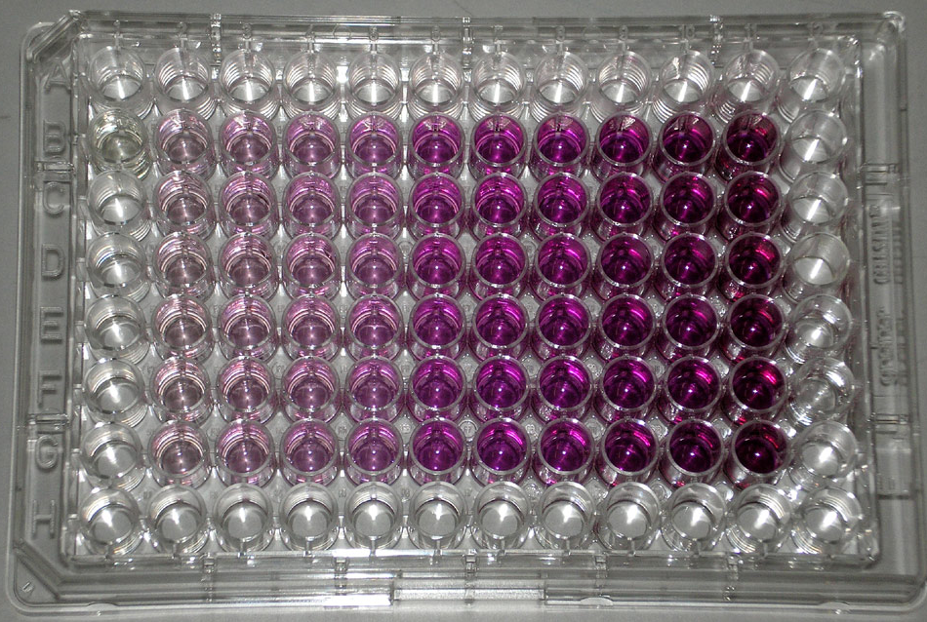
Figure 12. An example of MTT plate ready for reading

2.2.1.4 Cell lysis
Preparation of lysis buffer: 500ml of lysis buffer (pH 7.4) is composed of 10nM Tris HCl, 100nM sodium chloride, 0.5% v/v Nonidet P20 (detergent), 0.5% w/v Sodium deoxycholate and 10nM EDTA.

The cells in 96 well plates were lysed after 5 days’ incubation with controls and with compounds at various concentrations to release PrP^{Sc} for the quantitative analysis. The medium in each well was removed first in the lysing process, and 50µl of lysis buffer (pH 7.4) was added to each well. After shaking for a few minutes 25µl benzonase (0.2µl/ml) was added into each well to break down any cell debris.

2.2.1.5 Protein determination
Bradford assay was used to determine the protein concentration in the cell lysate.

Standard curve: the protein concentration was calculated by using a BSA standard curve which was created by adding 5µl of BSA standards at 7 concentrations from 0 to 1.0 mg/ml in a 96 well plate in triplicate (The concentration at 0 mg/ml was using the lysis buffer.). 250µl Bradford reagent was mixed with BSA standards in each well, then the plate was shaken on the platform shaker (100 rpm) and read by the plate reader at 570nm with a reference wavelength of 405nm (Single mode).

5µl of the cell lyaste from each well was transferred into corresponding wells in a new 96 well plate. 250µl Bradford reagent was added into each well in the new plate, and a blue color was produced after 5 minutes shaking on a platform shaker (100 rpm). The absorbance was measured at 570nm with a reference wavelength of 405nm as an internal control by a plate reader.

The protein concentration was required to calculate the volume of the cell lysate that needs to be used in the dot blot analysis described below. Based on the previous work in our group 30-40 µg protein from each well was normally required after Bradford assay to be loaded on each dot of the nitrocellulose membrane to generate reasonable strong signals without overloading the membrane.¹⁰⁶

2.2.1.6 Dot blot analysis
Dot bolt analysis was applied for determining the concentration of PrP^{Sc}. Because both PrP^{C} and PrP^{Sc} are present in the cell lysate, it is essential that the proteinase K (PK) digestion is performed to remove the PK sensitive PrP^{C}, but PK resistant PrP^{Sc} was collected for the dot blot analysis.

A nitrocellulose membrane and two filter papers were cut in the same size by using a template for analysing one 96 well plate. The membranes and papers were soaked in distilled water for saturation (around 5 minutes). A 96 well manifold was used to hold the membranes and papers, and was connected to a vacuum pump. Two filter papers were put under the nitrocellulose membrane before clamping the manifold. The vacuum pump was connected to the manifold with 350mm Hg pressure. The required volume of the cell lysate, which was calculated by the protein determination data from 96 well plate, was transferred to the corresponding well on the manifold. (Care must be taken while pipetting to avoid generating any air bubble.) To make sure all the liquid in the well running through the membrane, one minute vacuum was applied after added all the cell lysate. Then, the membrane was drying for 1 hour. All parts of the manifold were washed with 10% ethanol in water after being used.
A series of washes and treatments were applied after the membranes being dried. Firstly, the lysates were incubated with 30ml of proteinase K (150µg/ml, TBS dilution) (PK) for 60 minutes at 37˚C. All the proteins except PrP^{Sc} were digested in this step. The PK activity was stopped with 1mM PMSF for 10 minutes. The TBS-T solution (TBS-T solution was made up in distilled water with 100 ml 10 x TBS stock, 10 ml 1:10 Tween solution and a total volume of 1000 ml.) was used to wash each of the membrane for three times (5 minutes for each wash) to get rid of the excessive PK. This TBS washing process was applied between each following immersion step to prevent the excessive solution being contaminated in the next step. A 1.8 M guanadine thiocyanate solution was used to immerse membranes for 10 minutes. It unfolds the protein to expose the specific epitopes for the antibodies binding in the next step. The membranes were immersed with 5% fat free milk solution for 60 minutes to block all the sites on the membrane except the dots. Then, 60 minutes’ immersion in 0.2 µg/ml 8H4 anti-prion antibody was applied to bind to the specific site on PrP^{Sc}. Then, the membrane was immersed in the mouse IgG antibody solution (1:4000 dilution) for 60 minutes. The IgG was tagged with a chemiluminescent tag. The membrane was then immersed in 6ml of the enhanced chemiluminescence (ECL) detection solution for 5 minutes to active the tags. ECL is a sensitive detection method and it was applied to quantitative the protein quantity by comparing the light emission. ECL generates chemiluminescence via a highly exergonic reaction to produce an electronically excited state and then emit light to a lower level state. The chemiluminescent signal was transported to the hyperfilms and they were developed and fixed as photo washing in dark room. Then, the washed films were analysed by the Lab WorksTM software. The darkness of each spot on the membrane was read by the software and converted to %PrP^{Sc} by comparing with negative controls. A typical example of dot blot results is shown in Figure 13.
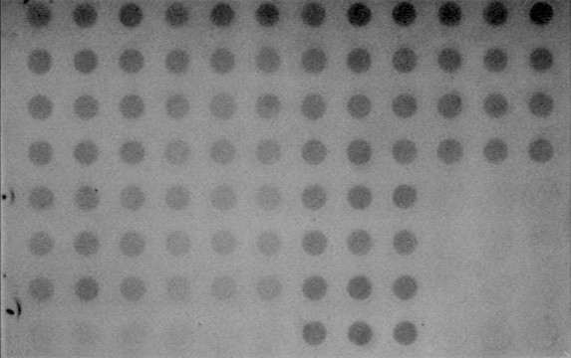
Figure 13. An example of dot blot result
Each experiment was done by triplicate and the standard deviation (error bar) was applied in data analysis.

2.2.2 EC₅₀ assay
EC₅₀ assay was applied to confirm the anti-prion efficacy of the compounds by dot blotting but more dosing concentrations. Each compound was dosed at eight different concentrations: 0.1µM, 0.5µM, 1µM, 2.5µM, 5µM, 7.5µM, 10µM and 20µM in triplicate. The results were analysed by dot blot assay. (The protocol is referred to Section 2.2.1.6) The intensities of dot blot results were transferred to a excel file and the dose-activity curve was plotted and EC₅₀ was calculated by a software, Graphpad Prism. To manage those data with this software, first thing to do is transforming the concentrations into log form. Then, the a curve can be fitted those data by using equation ‘log(agonist) vs. Response-- Variable slope (four parameters)’. The EC₅₀ result can be automatically generated during the fitting process. Also, the viability assay and protein determination method are referred to the protocol in Section 2.2.1.3 and 2.2.1.5.

Each experiment was done by triplicate and the standard deviation (error bar) was applied in data analysis. Viability assay in both negative and positive control optimization was done by triplicate and the standard deviation (error bar) was applied in data analysis.

3. Results and discussion
The results include four parts: optimizing the biological evaluating system, using this system to screen the ZINC library, benzofuran derivatives and ε-PL.

3.1 Optimizing the biological evaluation system

3.1.1 Seeding number of SMB cells
In the previous protocol 10000 of the SMB cells per well were seeded on the 96-well plate. However, minor over confluence (Normally the cell density should be 80-95% in exponential phase after 5 days’ growth) was observed after 5 days’ incubation. Therefore, 10000, 9000, 8000, 7000, 6000, and 5000 cells per well were seeded on a 96-well plate and each experiment was repeated 8 times. 8000 cells per well was chosen as the optimimal initial seeding density. Using this seeding density, an average protein concentration of 55.78µg/well via the Bradford assay was measured, which is adequate for a further dot blot assay.

3.1.2 Concentrations of positive control
10μM of curcumin was used as a positive control in the dot blot assay in the previous protocol. In this project, the dot blot assay was applied to determine the EC₅₀ of curcumin and also to confirm whether 10μM of it can eliminate more than 90% PrP^{Sc} by comparing it with negative control (0.5% DMSO). Also, the viability of cells should be above 70 percent by comparing them with negative control (0.5% DMSO). EC₅₀ of curcumin anti-prion activity was reported as 0.95±0.07µM on the SMB cell line.¹¹⁷
The determination of curcumin EC₅₀ was set up by diluting its DMSO stock solution and dosing from 0.05 to 12.5µM in 3 parallel assays (triplicates in each assay). Although there were different lots of curcumin and different passages of cells, average EC₅₀ of curcumin from 3 assays was 0.87±0.12µM, which was similar to the EC₅₀ in the report mentioned above. Furthermore, 10µM of curcumin was able to suppress the PrP^{Sc} to 10% by comparing it with negative control. (Figure 14, top) The viability results were higher than 90% in all eight concentrations, (Figure 14, bottom) therefore in order to fulfill the requirement as a positive control and also for ‘safekeeping’ reasons (decrease the PrP^{Sc} to 10%), 10μM was kept and confirmed as the concentration of positive control.

Figure 14. EC₅₀ results of curcumin by 3 times of repeating and the viability results under the same concentrations (the error bars indicate standard deviation of mean)

3.1.3 Concentrations of negative control
Figure 15. MTT results of H₂0, DMSO and PBS in series dilutions (the error bars indicate standard deviation of mean)

DMSO is a colourless organic solvent for both polar and nonpolar compounds and is applied here to solubilise the hydrophobic anti-prion compounds in the culture medium. However, it is toxic to the cells¹³¹ and increases permeability in the cell membrane in high concentrations,¹³² therefore the DMSO concentration in the culture medium should be restricted.

0.5% (v/v) DMSO was used as a negative control and the maximum concentration of DMSO residual in the cell culture medium. In order to verify the reliability of this concentration, DMSO was compared with H₂0 and PBS in eight volume ratios from 0.10% to 10%. (Figure 15) MTT results showed that cell viability was significantly decreased from 0.50% to 3%, while the cell viability of both H₂0 and PBS in corresponding concentrations was above 90%. Cell viability was above 80% at 0.5% DMSO, therefore the concentration was kept as a negative control to the SMB cell line and the DMSO mediated cell treatment is safe below it.

3.2 Screening the ZINC compounds

3.2.1 Protein determination
The final loading concentration on the dot-blot membrane should be between 30µg/mL and 40µg/mL to produce best assay results. The protein determination was determined based on the standard protocol of Bradford assays. The standard curve was built by 7 BSA standards with concentrations from 0 to 1.0mg/ml in triplicate. The absorbance from each well was read after adding Bradford reagent for 5 minutes, and the average absorbance of each concentration was calculated. The value from concentration 0 was subtracted from all of the other 6 values, which forced the trend line to be more likely to cross the intersection of coordinates as a standard linear curve with a R² greater than 0.99. (Figure 16) An equation which was generated based on the trend-line is used to calculate the protein concentration from each well. Table 7 shows the average concentrations of protein in lysate from 17 Bradford assays. The average protein concentration was calculated to be 54µg/well and 65µL of lysate from each well (from 75µL in each well) and was loaded onto the dot blotting membrane.
Figure 16. Example of BSA standard curve for protein determination (the error bars indicate standard deviation of mean)

Table 7. Protein determination data during the ZINC compounds screening assays
Date | Average protein concentration (µg/well)
2010.02.11 | 65.32±6.77
2010.02.18 | 60.11±4.22
2010.02.24 | 57.89±7.78
2010.03.25 | 54.21±8.13
2010.04.01 | 55.33±10.52
2010.04.21 | 57.68±6.09
2010.06.15 | 51.07±6.92
2010.06.23 | 51.45±4.85
2010.10.10 | 49.71±7.80
2010.10.14 | 54.77±5.08
2010.10.23 | 44.11±9.33
2010.10.29 | 50.90±6.92
2010.11.19 | 53.60±7.87
2010.11.21 | 54.23±6.21

3.2.2 Viability assay
The viability results were acquired by comparing them to the blank well of the cells treated with 0.5% DMSO in the initial screening. The survival rates lower than 70% were deemed as having a toxic effect. The details of compounds and their lowest concentration showing toxicity are shown in Table 8.

Table 8. Toxic compounds in the initial screening
42 compounds showed a toxic effect to the SMB cells according to the MTT assay. All 42 listed compounds were shown to be toxic at 20 µM, 21 of them were shown to be toxic at 10 µM, and 6 of them were toxic at 1 µM. It is important that the anti-prion compound should not cause too much toxic effect during the therapy process, therefore the most toxic compounds (compounds toxic at 1µM) were excluded from further screening.

3.2.3 Initial screening of anti-prion activity
The results in the dot blot assay lower than 70% of the negative control (diluted DMSO) were regarded as active. 30 compounds were found to be active at minimal concentrations and are shown in Table 9.
Table 9. Active compounds in the initial screening

30 compounds exhibited anti-prion activity at 20 µM. 6 of them were active at 10 µM, and 2 of them were the top-active compounds during this screening and were active at 1 µM. (6100139 and 6100152 were active at 1 µM.)

3.2.4 EC₅₀ screening
Based on the viability and activity results in the initial screening the comparatively active compounds with non-toxic (or low toxic) effects were selected for further confirmation of their anti-prion EC₅₀ by dot blotting assay (Table 10).
Table 10. The compounds for EC₅₀ assay
The EC₅₀ results of the selected compounds were repeated 3 times, and each time was dosed in triplicate. The results were acquired by dot blotting and calculated by using Graphpad, as shown in Table 11 below.

Table 11. The EC₅₀ results of the selected compounds
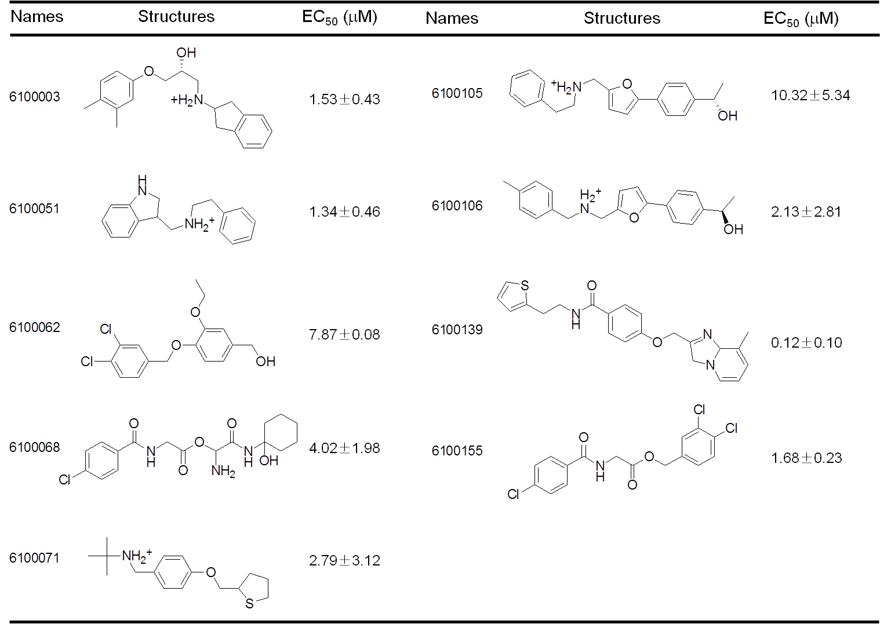

The EC₅₀ screening results of most of the selected compounds were not as active (>1µM) as the anti-prion effect of previous indole library (active in nanomolar scale). 6100139 was the most active compound (EC₅₀=0.12±0.10µM) in this screening. It is composed of an imidazo pyridine moiety which is a fused 6- and 5- membered aromatic ring system similar to the ones in the active indole family. Also, another comparatively active (EC₅₀=1.53±0.43µM) compound 6100003 has an indene group which is a fused 6-, 5- membered aromatic and aliphatic ring system which has no nitrogen substitution on the five-membered ring by comparing it with indole. Furthermore, the anti-prion activity of 6100106 is approximately 4 times more potent than 6100105. The methyl group on the phenyl of 6100106 is the only difference when compared with 6100105’s structure.

3.3 Screening benzofuran derivatives

3.3.1 Protein determination
The average concentrations of protein in lysate from four Bradford assays were shown in Table 12. The average protein concentration was calculated to be 53 µg/well and 65 µL of lysate from each well (from 75 µL in each well) and was loaded onto the dot blotting membrane.

Table 12. Protein determination data during the benzofuran derivatives screening assays
Date | Average protein concentration (µg/well)
2012.05.18 | 48.02±9.51
2012.05.25 | 55.67±9.32
2012.09.16 | 51.21±7.58
2012.09.21 | 58.32±7.90

3.3.2 Viability assay
The viability results were acquired by comparing the read from each well to the blank well of the cells treated with 0.5% DMSO. The survival rates lower than 70% were deemed as having a toxic effect. The mean value from duplicate results was used to build the figure below.
Figure 17. Viability results in the screening of benzofuran derivatives
B9 and B6 showed no significant toxic effect to the SMB cells according to the MTT assay and all eight concentrations of each sample were higher than 70% by comparing to the negative control. B1, B2, B4 and B7 were the toxic concentration of each compound, cell growth being affected, which can possibly cause the reduction of the PrP^{Sc} production.

3.3.3 EC₅₀ screening

Figure 18. The anti-prion effect of six benzofuran derivatives

The EC₅₀s of benzofuran derivatives were acquired from six individual curves via dot blot assay. B2 and B1 were the top two scores having EC₅₀ at 0.75 and 0.48μM, respectively. B9 and B6 were shown to be less toxic in MTT assays, however, their anti-prion effect were comparatively weaker which were 6.76 and 10.69μM individually. The EC₅₀ of B7 and B4 were 1.23 and 3.13μM individually. (Figure 18) According to the structure activity relationship (SAR), the carbon chain between aryloxy group and tertiary amine group enhanced the anti-prion effect and the tertiary amine group could possibly further increase the effect as it is in the known anti-prion compound, quinacrine. Methylphenyl carbonyl group fused on benzofuran group was hardly affected the anti-prion effect.
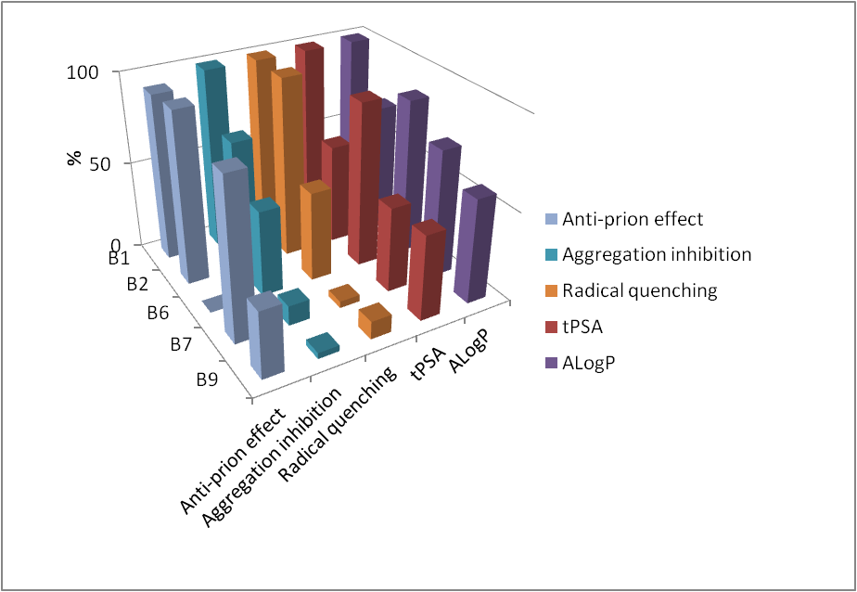Figure 19. Correlations of the anti-prion effect, aggregation inhibition, radical quenching, tPSA and AlogP

Figure 9 was built by using compound names (B1, B2, B6, B7 and B9) as x-axis; five parameters, anti-prion effect, aggregation inhibition, radical quenching, tPSA (Topological Polar Surface Area), and AlogP (Computer predict value for the lipophilicity of a molecule) were using as y-axis; percentage of corresponding controls was using as z-axis.

In the previous collaborating with Lancaster University, five compounds B1, B2 B6, B7 and B9 were showed similar efficiency trend in Aß aggregation inhibition and radical quenching. (Figure 19) The anti-prion effect in Figure 19 was built by using the highest EC₅₀ of B6 as 100% (normalized point) which represented the weakest anti-prion effect and then using 100% to minus each value which allows the results having comparability with the other four parameters (the higher column shows in Figure 19, the stronger effect it has). B1, B2 and B9 were shown a similar trend in all three assays. However, the aggregation inhibition and radical quenching results of B7 were both weak, but the anti-prion effect of it was comparatively high which was less than 2μM. ALogP and tPSA of all five compounds had similar trend between each other, however, they had no significant correlation with the other three parameters.

3.4 Screening ε-PL

3.4.1 Protein determination
The average concentrations of protein in lysate from three Bradford assays were shown in Table 13. The average protein concentration was calculated to be 46µg/well and 75 µL of lysate from each well (from 75 µL in each well) and was loaded onto the dot blotting membrane.

Table 13. Protein determination data during the ε-PL screening assays

Date | Average protein concentration (µg/well)
2011.05.10 | 40.71±9.91
2011.11.21 | 45.67±8.02
2011.12.02 | 53.31±7.18

3.4.2 Viability assay
The viability results were acquired by comparing the read from each well to the blank well of the cells treated with negative controls. The survival rates lower than 70% were deemed as having a toxic effect. The mean value from duplicate results was used to build the figures below.

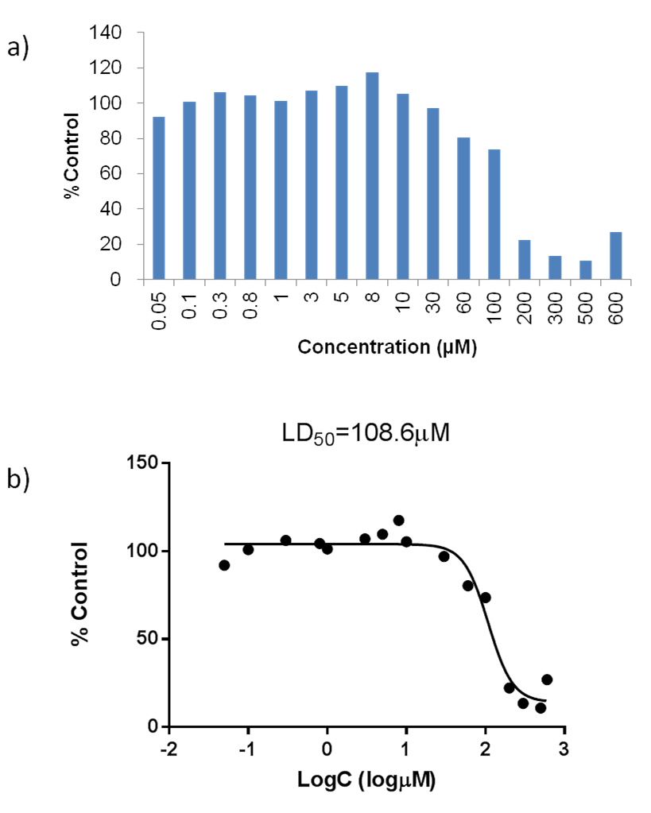
Figure 20. a) Viability results in the screening of ε-PL, b) LD₅₀ of ε-PL
ε-PL showed extremely toxic effect (lower than 30%) to the SMB cells above 200μM. (Figure 20a) In the following EC₅₀ assay the toxic concentrations were excluded from the experiments. The LD₅₀ of the ε-PL was 108.6μM. (Figure 20b)

3.4.3 EC₅₀ screening
Figure 21. The anti-prion effect of ε-PL (the error bars indicate standard deviation of mean)

The EC₅₀ of ε-PL was 0.474 μM. (Figure 21) and its LD₅₀ was around 229 times higher than its EC₅₀ which indicated the therapy window of ε-PL.

4. Conclusions
A biological evaluating system based on an SMB cell line was adapted and optimized. Three catalogues of compounds were applied to screen through this system, and they are compounds from the ZINC library, six benzofuran derivatives and ε-PL.

Most of the compounds from the ZINC library did not exhibit strong anti-prion activities when compared with the previously designed anti-prion libraries in our group. A few compounds found in the previously study were able to eliminate the PrP^{Sc} in the nanomolar scale.¹⁰⁶ The comparatively active compounds from the ZINC library have similar function groups to those in the indole family.
All six benzofuran derivatives showed anti-prion activities in micromolar scale and the carbon chain between aryloxy group and tertiary amine group and the tertiary amine group could possibly enhanced the anti-prion effect. Four of them were toxic effect to the SMB cells. Aggregation inhibition and radical quenching of five compounds had similar trend and the anti-prion effect of the three compounds, B1, B2 and B9 were shown a similar trend by comparing the two parameters. AlogP and tPSA had no significant correlation with the other three parameters.

The EC₅₀ value of ε-PL was 0.474μM and it is 299 times smaller than the value of its LD₅₀. It will be interesting to see the effects of ε-PL of different molecular weighs upon the anti-prion activities.

Part Ⅲ Drug Delivery Systems for Anti-prion Compounds

Introduction
The anti-prion compounds from the indole library were discovered in the previous cell line screening of a chemical library collection in our group. The EC₅₀s of many compounds were measured at nano-molar scales on the SMB cell line.¹⁰⁶

However, there are three main obstacles associated with this family of compounds to exhibit clinical therapy effects. Firstly, the active compounds from the indole library are insoluble under physiological conditions due to the relative high LogP values. DMSO was therefore chosen as their solvent for in vitro tests. However, DMSO could not only be adding cytotoxic risks, but also cause difficulties to interpret the in vivo results of compounds themselves. A coordination effect cannot be excluded. Furthermore, as the solubility of DMSO in both polar and non-polar compounds, it could also increase the permeability in cell membranes in high concentration which could affect the cell line screening results.¹³² Secondly, the compounds do not contain fluorophore, therefore are not fluorescent. It is difficult to track down where the drug located in cells which add difficulties in the mode-of-action studies. Thirdly, they need to reach the disease focus located in the central nervous system (CNS). These compounds were computationally designed and filtered via their solubility (cLogP 2.5~6.0) and GOLD score (>60) before synthesis. It is yet to confirm whether these compounds can diffuse across membrane, especially BBB, to reach the drug targets. The lipophilic property also makes them hard to be prepared into commonly used dosage forms, for example, oral tablets due to their low bioavailability caused by the gastrointestinal tract and liver; and an oil injection which is normally applied on the muscle instead of CNS.
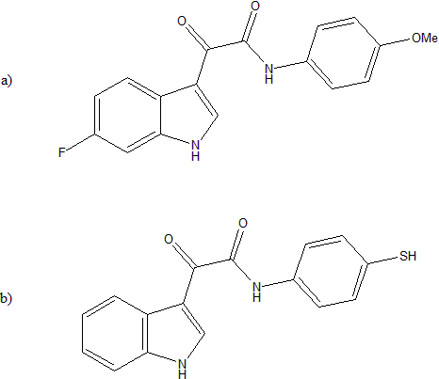
Figure 22. The chemical structure of a) 3001126 and b) 3001326

3 different DDSs (hyperbranched polymer, polymersomes and quantum dots) were chosen and evaluated using two model compounds in this project in order to overcome some aspects of the aforementioned problems associated with this family of compounds. 3001126 (Figure 22a), 2-(6-fluoro-1H-indol-3yl)-N- (4-methoxy-phenyl)-2-oxo -acetamide, as one of the top-10 compound (EC₅₀ =10nM) from indole library was loaded onto hyperbranched polymers in order to overcome the solubility problem with this family of compounds. This model compound was also loaded onto specifically designed pH responsive fluorescent labelled polymersomes to ensure that the drug is delivered into cells and compare the shape effect of polymersome DDS on their anti-prion activities.

Another anti-prion model compound 3001326, 2-(1H-indol-3-yl)-N-(4-mercapto -phenyl)-2-oxo-acetamide (Figure 22b), was designed and synthesized by chemists in our group based on the parent structure, 6-substituted indole-3-glyoxylamides, and the thiol group on the phenyl group was used to couple with the quantum dots (QDs) modified with maleimide group via covalent bonds. QD have many unique advantages including natural fluorescent, high loading capacities and stable. They can be used as an imaging tool for real-time tracking the location of the drug action.

The loading efficiency of covalent and non-covalent bonding of drug to DDSs and their effects upon anti-prion activities are compared. The evaluation of each DDS is detailed in the following chapters.

PartⅢChapter 1 Hyperbranched Polymers as Delivery Systems for Hydrophobic Anti-prion Compounds

1. Introduction
A hyperbranched polymer (HBP) was used as a carrier for this compound to increase the water solubility of the anti-prion compound 3001126. It was hoping that 3001126 (Figure 22) can be load onto the hydrophobic pocket/part of HBP. It was also hoped that the surface of the HBP can be modified with CNS ligand at a later stage if needed so that the compound can be specifically delivered to the brain in vivo. The cell line assay discussed in Part II was used to evaluate this delivery system.

HBP is a randomly branched polymer which is less symmetrical than the structure of dendrimer but its synthesis is more cost-effective.⁸⁷ It has been used as a DDS for controlled drug release in vitro and in vivo. Amphiphilic hyperbranched core−shell polymers decorated with folate moieties were achieved for tumor cell targeting.⁹¹ HBP conjugated with FITC-ibuprofen molecules was able to be taken up by lung epithelial cells and deliver into the cell cytosol.¹³³ Chlorambucil-loaded phospholipid analogous hyperbranched polymers were applied to investigate a breast cancer cell line in vitro and its IC₅₀ was 5μg/mL.¹³⁴ An in vivo model was practiced on mouse recently. Hyperbranched polymers conjugated with peptide-aptamer were able to specifically target tumor cells.¹³⁵

The HBP used here was synthesized by Dr. Suriani Shamsudin and the anionic-polymerisation technique, with ρ-nitrophenol as the core and glycidol as the monomer, (Figure 23) was applied. The molecular weights of HBP were produced by varying the core to monomer ratio, and its molecular weight and structure were confirmed by gel permeation chromatography (GPC) and nuclear magnetic resonance (NMR), individually. It is highly hydrophilic due to the large number of hydroxyl group on its surface. It is believed that it can potentially act as a delivery system carrying hydrophobic compounds by the internal hydrophobic environment.
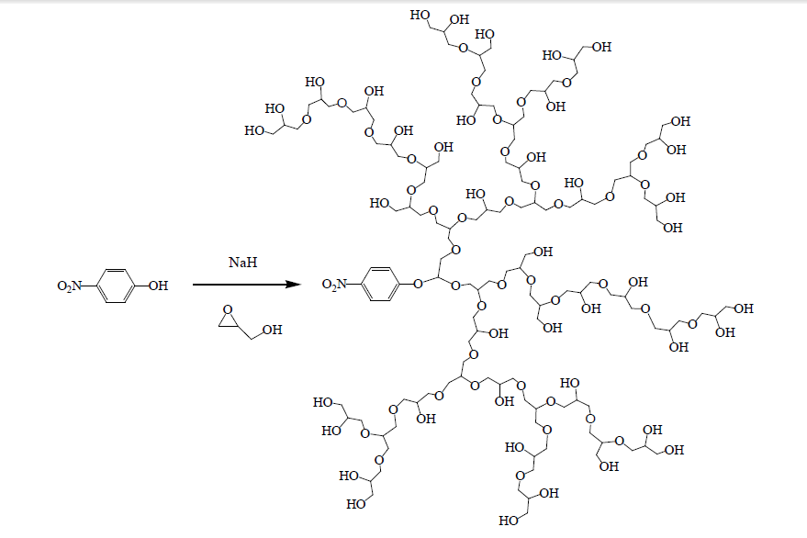
Figure 23. The synthesis of the hyperbranched polymer

2 Materials and methods

2. 1 Materials and instrumentation

2.1.1 Materials
HBP used in this research was kindly provided by Dr. Suriani Shamsudin. SMB cells were obtained from the TSE centre at the Institute of Animal Health. The medium for the cell culture was Phenol-red Medium 199 (Invitrogen). 10% New Born Calf Serum (NBCS, Invitrogen), 5% Foetal Bovine Serum (FBS, Invitrogen) and 1% Penicillin-Streptomycin Solution (Sigma) were added into the medium before use. Trypsin-EDTA solution was purchased from Sigma-Aldrich. Hanks Balanced Salt Solution (HBSS, Invitrogen) was used as the compound dilution solution. The SMB cells were cultured and passaged in tissue-culture treated petri dishes (BD Falcon SLS). The sterile 96 well plates (BD Falcon SLS) were purchased for the cell culturing and dosing. Chemical reagents for the viability assay and the protein determination were all obtained from Sigma-Aldrich, which include 3-(4,5-dimethylthiazol-2-yl)-2,5-diphenyl tetrazolium bromide (MTT), dimethyl sulfoxide (DMSO), acidic isopropanol, Bradford reagent, and bovine serum albumin (BSA). The reagents for the dot blot assays include proteinase K (PK, Sigma), phenylmethyl-sulfonyl fluoride (PMSF, Sigma), Tris-Buffered Saline (TBS, Sigma), Guanidine Thiocyanate (Acros), skim milk powder (Fluka), 6H4 primary antibody (Prionics) and the mouse antibody IgG and chemiluminescent solutions (GE Healthcare). The haemcytometer was bought from Fisher Scientific. The 96 well manifold (minifold, GE) was used for dot blot assay.

2.1.2 Synthesis of the anti-prion compound
The anti-prion compound 3001126 was synthesized by Dr. Mark Thompson. A brief description for the synthesis is documented here to illustrate a complete process of the development. The model indole glyoxylamide anti-prion compound selected for this delivery study is 3001126. This compound has an EC₅₀ of about 10nM in the cell line assay and without observing cellular toxic effect through MTT assay even dosing at 10μM. This compound was synthesised using a two-step on pot procedure as previously reported.¹¹⁷ Firstly, 6-fluoroindole was dissolved in dry THF, oxalyl chloride was added and the mixture stirred at room temp. After 1 h, appropriate amount of N,N-diisopropyl-ethylamine was introduced to the reaction, followed by 4-methoxyl benzylamine. The mixture was stirred at room temperature for 18 h. The solvent was evaporated, then the residue resuspended in a mixture of ethyl acetate and brine and stirred vigorously for 30 min. After passing through a liquid–liquid extraction column, ensuring washing through of the column with additional ethyl acetate, a second extraction was carried out with sat. NH₄Cl (10 mL) in the same manner. Product solutions were then evaporated to dryness giving the crude indole-3-glyoxylamides, which were purified by two sequential recrystallizations, from ethyl acetate–hexane and then by 2-propanol–water, afforded final products of good purity.¹¹⁷
Scheme 3. Synthesis of indole-3-glyoxylamides

2.1.3 Instrumentation
The rotary evaporator was used to dry the solvent for dissolving polymer and anti-prion compound. The UV-visible spectrometry (Specord S600) was applied to determine the absorbance of hyperbranched polymer and 3001126.

2.2 Solubility assay

2.2.1 The UV absorbance of 3001126 in water and in methanol
A calculated quantity of anti-prion compound 3001126 was mixed with water and methanol separately by using a vortex mixing for 30 seconds. The solutions were filtered and the maximum absorption wavelength (λ_{max}) was scanned from 200 to 700nm by applying the UV-Visible spectrometry. Background for water and methanol controls was subtracted for each corresponding 3001126 solution in the measurement.

2.2.2 Calibration curve for both 3001126 and the HBP
The 3001126’s calibration curve was obtained by using UV absorbance at various concentrations. Methanol was used as a solvent and 3001126 was diluted into five different concentrations of standards, 0.002, 0.004, 0.006, 0.008 and 0.01mg/ml. The absorbance of each standard was determined in triplicate by using UV-Visible spectrometry, and methanol was used as a control for background subtraction.

The HBP with molecular weight 12700 Da was diluted into 5 concentrations of standards ranging from 0.2 to 1mg/ml in methanol. The absorbance of each standard was determined in triplicate by using UV-Visible spectrometry, and methanol was used as a control for background subtraction. The calibration curves for 3001126 and HBP were built by using concentrations against the average of the maximum absorbance. Two formulas generated from calibration curves could be used for calculating the concentrations of 3001126 and HBP in the 3001126 loaded HBP solution, individually.

2.2.3 Preparation of the aqueous solution of HBP loaded with compound
3001126 and the HBP (MW 12500) were dissolved into methanol individually before being mixed together in a round bottom flask. The solvent was then removed thoroughly by using the rotary evaporator and a film was left on the wall of the flask. 1ml of sterilized water was added to dissolve the film. The sample solution was filtered to remove compound 3001126 which was not taken up by HBP, therefore precipitated out from water. The absorbance of compound 3001126 in the sample solution was determined by the UV-visible spectrometry scanning from 200 to 700nm, and the concentration was calculated via the formula from the calibration curve.

2.3 Cell line analysis

2.3.1 Cell culture
The scrapie-infected mouse brain (SMB) cells were cultured for cell line assays and the culture followed the same protocol as detailed in Part ⅡSection 2.2.1.1.

2.3.2 Dosing plan for anti-prion activity of 3001126 loaded HBP
The SMB cells in 96 well plates were ready for dosing after seeding for 24 hours. The concentration of 3001126 encapsulated in HBP was quantified by UV-visible spectrometry. It was diluted into eight different concentrations from 0.0001 to 10μM and then dosed on the SMB cells. The stock solution of pure compound 3001126 was prepared at a concentration of 10mM in DMSO. It was then diluted using DMSO and followed by PBS to 8 concentrations from 0.0001 to 10μM. The final DMSO composition was required no more than 0.5% by volume. The pure compound with various concentrations was used to dose cell in parallel to the HBP loaded with the compound. Based on the drug/polymer ratio, the calculated equal quantity of the pure HBP polymer corresponding to the same quantity of HBP used for encapsulating the compound was diluted accordingly and tested on the cell line. .

Each concentration was dosed for three times for both viability and dot blotting assays. Two negative and a positive controls used are DMSO (0.5% v/v), PBS (5% v/v) and curcumin (10μM) respectively.

2.3.3 Five-day time course
The SMB cells in 96-well plates had a growth cycle time of 7 days. The cells were settled down to the bottom on the 1st day. HBP encapsulated 3001126 (2μM) and 3001126 in DMSO (30nM and 2μM) as well as pure empty HBP were dosed in one batch per day from the 2nd to 6th day in the different wells on the same plate and all the wells were lysed in the 7th day to ensure cells in every well have the same growth time length. Both 2μM of 3001126 in HBP and 30nM of 3001126 in DMSO are approximately three times higher than their EC₅₀ value individually and they were chosen to ensure eliminate PrP^{Sc} more than 80% in 5 days. After all treated cells harvested on day 7, the cell line assays (MTT and dot blot assays) were applied by following the previous protocol. The relationship between the reduction in PrP^{Sc} production and the duration of treatment can be established and presented by a graph.

Each experiment was done by triplicate and the standard deviation (error bar) was applied in data analysis.

2.3.4 Viability assay (MTT assay)
The viability assay was set for evaluate the cytotoxicity of the compounds and the protocol is referred to Part Ⅱ Section 2.2.1.3.

Each experiment was done by duplicate and the mean value was applied in data analysis.

2.3.5 Cell lysis
The cells in 96 well plates were lysed after 5 days’ incubation to release PrP^{Sc} for the quantitative analysis and the protocol is referred to Part Ⅱ Section 2.2.1.4.

2.3.6 Protein determination
Bradford reagent was used to determine the protein concentration in the cell lysate and the protocal is referred to Part Ⅱ Section 2.2.1.5.

2.3.7 Dot blot analysis
Dot bolt analysis was applied for determining the concentration of PrP^{Sc} and the culture protocal is referred to Part Ⅱ Section 2.2.1.6.

Each experiment was done by triplicate and the standard deviation (error bar) was applied in data analysis.

3 Results and discussion

3.1 The UV absorbance of 3001126 in water
The anti-prion compound 3001126 is poorly water soluble. The UV absorbance of the aqueous solution of 3001126 was measured after filtration by 0.22μm filter membrane (Figure 24). It is hard to observe the characteristic peak of 3001126 in the UV-visible spectrum. Conversely, characteristic peaks at 220nm and 328nm could be found its spectrum in a methanol solution. (Figure 25)

Figure 24. The UV-visible absorbance of 3001126 in water

Figure 25. The UV-visible absorbance of 3001126 in methanol

3.2 The calibration curve of both 3001126 and HBP

3.2.1 3001126’s calibration curve in methanol
Five concentrations of 3001126 in methanol, 0.002, 0.004, 0.006, 0.008, 0.01mg/ml, were prepared. The UV absorbance of each standard was determined and five UV-visible spectrums were overlaid and are shown in Figure 26. The two characteristic peaks are displayed at 220nm and 328nm correspondingly. 328 nm was chosen as the detection wavelength for constructing a calibration curve for the compound 3001126. The equation, y = 59.97x - 0.009 was acquired by using 3001126’s concentrations against the corresponding absorbance at 328 nm. (Figure 27) The linearity of the calibration curve was satisfied (R²=0.9975).

Figure 26. The UV-visible spectrums of 3001126 in 5 concentrations

Figure 27. The calibration curve of 3001126 (the error bars indicate standard deviation of mean)

3.2.2 The HBP’s calibration curve in methanol
Five concentrations of HBP’s methanol solution, 0.2, 0.4, 0.6, 0.8 and 1mg/ml, were prepared. The UV absorbance of each standard was determined and five UV-visible spectra were shown in the graph (Figure 28) 306.5nm was chosen as the characteristic peak of the HBP. The linearity of the calibration curve was satisfied (R²=0.987). The equation, y = 0.838x + 0.033, was built by using the HBP’s concentrations against the corresponding absorbance. (Figure 29)

Figure 28. The UV-visible spectrums of HBP in 5 concentrations

Figure 29. The calibration curve of HBP (the error bars indicate standard deviation of mean)

3.2.3 UV-visible absorbance of the HBP encapsulated 3001126 in aqueous solution
Based on the comparison of three UV-visible spectra of 3001126 in methanol, HBP in methanol and aqueous solution of 3001126 loaded HBP, (Figure 30) the shoulder peak on the spectrum of 3001126 loaded HBP at 328nm was believed to be evidence of the successful loading of 3001126. It was therefore chosen as the 3001126’s characteristic absorption peak for further calculation. The sample solution was diluted with water in order to ensure that the UV-visible absorbance was lower than 1, and 3001126’s the original concentration was calculated as 1X10⁻⁴ M by using the equation in Figure 27 and therefore the loading capacity was calculated as 0.33%.

Figure 30. The UV chromatograms of 3001126, HBP and 3001126 loaded HBP

3.3 Cell line analysis

3.3.1 MTT results and EC₅₀ analysis
Figure 31. The viability results of 3001126 loaded HBP and 3001126 in DMSO

Figure 32. The EC₅₀ curve of the HBP encapsulated 3001126 (the error bars indicate standard deviation of mean)

Both 301126 DMSO stock solution and HBP loaded with the compound were tested on SMB cells at 8 different concentrations from 0.0001 to 10μM. Their toxicity by MTT assay and anti-prion effects by dot blotting assay were measured and presented in Figure 31 and 32. The mean value from duplicate results was used to build the Figure 31. Of all concentrations tested, parent compound 3001126, the HBP loaded with encapsulated drug and blank HBP all displayed a viability of greater than 80%, showing any toxicity effect to the tested cells (Figure 31).

The anti-prion EC₅₀ of HBP encapsulated 3001126 and 3001126 in DMSO were 0.658 and 0.0097μM, respectively. (Figure 32) An equal quantity of HBP alone showed no significant anti-prion effect to the cells. The anti-prion effect of HBP encapsulated 3001126 was approximately 65 times weaker than the 3001126’s DMSO solution after a five-day treatment course. It is possible that a part of the drug was still trapped in the HBP after the five-day incubation, and this might be the reason why EC₅₀ decreases after the compound being loaded into HBP. The key advantage is that the hydrophobic 3001126 easily dissolve in the aqueous phase DMSO as solvent is no longer required.

3.3.2 Five-day time course
Figure 33. The viability results of 3001126 in DMSO (30nM and 2μM) and 3001126 (2μM) loaded in HBP in 5-day dosing assay

Figure 34. The comparison of the anti-prion activity curves of 3001126 in DMSO (30nM and 2μM) and 3001126 (2μM) loaded in HBP in 5-day dosing assay (the error bars indicate standard deviation of mean)

Three concentrations of sample solutions (30nM and 2μM of 3001126 in DMSO and 2μM 3001126 in HBP) were applied to the five-day time course assay. Dot blot and MTT assays were applied for analyzing anti-prion effect and cell viability of the samples individually. The mean value from duplicate results was used to build the Figure 33. Both 2μM of 3001126 in HBP and 30nM of 3001126 in DMSO are approximately three times higher than their EC₅₀ value individually, which reduced the PrP^{Sc} level to less than 20% after 5 days’ incubation. 2μM of 3001126 in DMSO was set up as the parallel concentration of the drug in DMSO. The PrP^{Sc} levels of three sample solutions decreased as the incubation time was increased from days 1 to 5 and the DMSO dissolved drug at both 2μM and 30nM could eliminate more PrP^{Sc} than the drug loaded in HBP, especially in the incubation period from days 1 to 3. (Figure 34) Cell viabilities of all three samples were higher than 80%. (Figure 33) Most of the PrP^{Sc} was cleared after being incubated for 4 to 5 days for all three samples. The drug in HBP took a longer time period to eliminate 80% PrP^{Sc} compared to the same concentration of 3001126 in DMSO. This could be caused by a sustained releasing effect of HBP after the drug is encapsulated.

3.3.3 The MTT results of different molecular weight HBPs

Figure 35. The viability assay for the HBP in 3 concentrations

This is an independent assay aiming to evaluate the cytotoxicity of HBP with three molecular weights. Three HBP samples with different molecular weights (4000, 12700, 50000) were diluted into 3 concentrations individually, and the cell viability was determined via MTT assays. The mean value from duplicate results was used to build the figure 35. None of them showed cytotoxicity (<70%) to the SMB cells. (Figure 35)

4. Conclusions
Firstly, the hyperbranched polymer was able to carry the anti-prion compound 3001126 into aqueous phase. Secondly, the anti-prion activity of 3001126 loaded in HBP was 0.658μM, which was 65 times weaker than 3001126 in DMSO. Thirdly, the complex did not show toxicity to the SMB cells after a maximum 5 days’ incubation. Fourthly, the five-day time course assay results showed that 3001126 in DMSO could eliminate more PrP^{Sc} than the drug loaded in HBP from days 1 to 3 that could indicate that the HBP has sustained release effect. However, this DDS was not further investigated due to the fact that it showed much weakened anti-prion effect and it doesn’t contain fluorophore that can be tracked during the course of delivery.

PartⅢChapter 2 pH Sensitive Biocompatible Polymersomes as Delivery Systems for Hydrophobic Anti-prion Compounds

1. Introduction
Polymersomes are supra-macromolecular structures formed by the self-assembly of synthetic amphiphilic block co-polymers in aqueous environments in a similar fashion to the formation of lipid membrane bilayers.¹³⁶ The concept of polymersomes was introduced by Discher et al more than two decades ago when polymersomes were successfully made from diblock co-polymers.¹³⁷ Much progress has been made to improve their circulation time in blood stream¹³⁸ and colloidal stability⁹⁴. Polymersomes have found many applications as carriers for both hydrophobic and hydrophilic molecules such as anti-cancer drugs¹³⁹, DNA used in gene therapy^{96, 140}, for proteins including hemologlobin¹⁴¹ and therapeutic antibodies¹⁴², and contrast agents for in vivo imaging etc.¹⁴³ However, its application as delivery system for small molecule anti-prion compound has not been reported before.

pH sensitive and biocompatible polymersomes were designed and synthesised as carriers for our potent hydrophobic anti-prion compound based on the fact that it has been used for delivering anti-cancer and antibiotics with a good DMPK properties.¹⁴⁴ The polymersomes were synthesised from diblock copolymers, poly(2-(methacryloyloxy)ethylphosphorylcholine)₂₅-co-poly-(2-(di isopropylamino)ethylmethacrylate)₇₀ (PMPC₂₅–PDPA₇₀) 4 and poly (rhodamine(Rho)-2-(methacryloyloxy) ethylphosphorylcholine)₃₀-co-poly-(2-(di isopropylamino) ethylmethacrylate)₆₀ ((Rho)-PMPC₃₀–PDPA₆₀) 5 at a ratio of 9:1 (Scheme 4). Rhodamine-labelled copolymer was used so that the uptake of the polymersomes can be tracked using a fluorescent microscope. Each diblock copolymer was synthesised from its corresponding monomers, i.e. PMPC₂₅-PDPA₇₀ was synthesised from 2-(methacryloyloxy)ethylphosphoryl choline (PMPC) 1 and 2-(diisopropylamino)ethylmethacrylate (PDPA) 3; and (Rho)-PMPC₃₀–PDPA₆₀ was synthesised from (Rho)- 2-(methacryloyloxy)ethylphosphoryl choline 2 and 2-(diisopropylamino)ethylmethacrylate 3. In each case, the co-polymer was synthesised by an Atom Transfer radical polymerization (ATRP) procedure as previous reported.¹⁴⁵

Scheme 4. Synthesis of labelled and non-labelled diblock polymer and the assembly of drug carrying spherical and tubular polymersomes and the release of the encapsulated drug upon pH changes.

The pK_{a} of the tertiary amine in PDPA is about 6.4.¹⁴⁶ This means that at pH7.4, the ratio of neutral and protonated amine is 10:1, but this figure drops down to 0.4:1 at pH 6, a drop of 25 fold. This change in protonation state of the amine has profound effects upon the stability of the polymersomes. Therefore, it is expected that after drug carrying polymersomes enter into the cell or organelles where pH is dropped from physiological pH of 7.4 to slightly acidic pH of 6, 25 times more side chain amines will be protonated which destabilise the polymersomes and result in the disassembly of the polymersomes into diblock polymers 7 and 8, at the same time 3001126 (compound 6) is released.

Two different shapes of the polymersomes, spherical and tubular polymersomes were discovered and separated during the preparation of the polymersomes and their encapsulation loading and effects of shapes upon the anti-prion effects were tested and compared. Also, the intracellular localization of both shapes of polymersomes were observed and compared.

2. Materials and Methods

2.1 Materials and instrumentation
SMB cells were obtained from the TSE centre at the Institute of Animal Health. The medium for the cell culture was Phenol-red Medium 199 (Invitrogen). 10% New Born Calf Serum (NBCS, Invitrogen), 5% Foetal Bovine Serum (FBS, Invitrogen) and 1% Penicillin-Streptomycin Solution (Sigma) were added into the medium before use. Trypsin-EDTA solution was purchased from Sigma-Aldrich. Hanks Balanced Salt Solution (HBSS, Invitrogen) was used as the compound dilution solution. The SMB cells were cultured and passaged in tissue-culture treated petri dishes (BD Falcon SLS). The sterile 96 well plates (BD Falcon SLS) were for the cell culture and dosing. Chemical reagents for the viability assay and the protein determination were all obtained from Sigma-Aldrich, which include 3-(4,5-dimethylthiazol-2-yl)-2,5-diphenyl tetrazolium bromide (MTT), dimethyl sulfoxide (DMSO), acidic isopropanol, Bradford reagent, and bovine serum albumin (BSA). The reagents for the dot blot assays include proteinase K (PK, Sigma), phenylmethyl-sulfonyl fluoride (PMSF, Sigma), tris-buffered saline (TBS, Sigma), guanadine thiocyanate (Acros), skim milk powder (Fluka), 6H4 primary antibody (Prionics) and the mouse antibody IgG and chemiluminescent solutions (GE Healthcare). The haemcytometer was bought from Fisher Scientific. The 96 well manifold (minifold, GE) was used for dot blot assay. Phosphate buffer saline (PBS) tablets from Oxoid Ltd., and Sepharose 4B from Sigma-Aldrich. HPLC was applied to quantify the polymer and the compound. Syto9, cell-mask deep red and DAPI were purchased from Invitrogen. Sterile PBS was from OXOID tablets.

IKA multiplate stirrer was applied in the polymersomes’ preparation process. The DLS for vesicles‘ size measuring was from Malvern. TEM images was taken by using FEI Tecnai instrument operating at 80 kV equipped with a Gatan 1 k CCD Camera. The UV-vis plate reader was from BioTek instruments. Cellular uptaking images were taken under Zeiss LSM 510 META upright confocal-laser scanning microscope with 40×and 100× water-dipping lenses. Image data were acquired and processed by using Zeiss LSM Image Browser, Zeiss LSM Image Expert and ImageJ.

2.1.1 Synthesis of PMPC-PDPA
The polymer synthesis work was accomplished by Dr. Jeppe Madsen. A brief description for the synthesis is documented here to illustrate a complete process of the development. PMPC₂₅-PDPA₇₀ co-polymer 4 was synthesised by dissolving ME-Br initiator and bpy in methanol and solution deoxygenated using N₂ for 30 min, then injected into a septum sealed flask containing CuBr and MPC 1. The [MPC]:[ME-Br]:[CuBr]:[bpy] relative molar ratio was 25:1:1:2. The polymerization was conducted under a nitrogen atmosphere at 20°C. After 65 min, a mixture of 2 molar equivalent deoxygenated DPA 3 in methanol was injected into the flask. The reaction was continued for 48 hours before diluted with appropriate volume of isopropanol and then passed through a silica column to remove the spent Cu catalyst. After removal of the solvent, the solid was dissolved in chloroform containing methanol (3:1) and dialyzed for 3 days against this solvent mixture with daily changes of the solvent to remove residual bpy ligand. After evaporation of solvent, the solid was dispersed in water, freeze-dried in a vacuum oven at 80°C for 48 h.

The same procedure was applied for the synthesis of Rho-PMPC₃₀-PDPA₆₀ 5 where rhodamine 6G-based initiator (Rho initiator) was used instead of ME-Br initiator and relative molar ratio of [MPC]: [Rho]:[CuBr]:[bpy] was maintained at 30:1:1:2. The final reaction mixture was diluted with methanol first, then chloroform before passing through a silica column to remove Cu catalyst.

2.1.2 Synthesis of the anti-prion compound
The anti-prion compound 3001126 was synthesized by Dr. Mark Thompson and the brief synthesis steps are referred to Part Ⅲ Chapter 1 Section 2.3.2.

2.2 Experimental methods

2.2.1 Preparation of the two shapes of drug loaded polymersomes
The drug carrying polymersomes were prepared using PMPC₂₅-PDPA₇₀ containing 5% (v/v) Rho-PMPC₃₀-PDPA₆₀. (Scheme 4) Briefly, the diblock copolymers 4 and 5 and 3001126 were dissolved in a 2:1 mixture of chloroform:methanol in a glass vial. A drug carrying copolymer film was formed by evaporating the solvent overnight in a vacuum oven at 50° C. The film was then rehydrated using 2 ml pH 2 PBS (100 mM). Once the film dissolved the pH was increased to 7.4.

This solution was stirred at room temperature for 1 week to form spherical and filo shaped polymersomes. The suspension was centrifuged at 10,000 rpm and the filo-shaped polymersome was isolated as a pellet. The supernatant was then further centrifuged at 15,000 rpm and the spherical shaped polymersomes were isolated as a pellet.

2.2.2 HPLC conditions
Chromatographic separations were carried out on an Shimadzu prominence UFLCXR chromatographic system (Shimadzu Scientific Instruments, UK) using a Jupiter 5μ C18 300A column (1.0 I.D. × 150 mm in length; particle size, 3.5 μm) The gradient elution program was as follows: The 80% mobile phase A (0.05% TFA in H2O) was maintained for 5 min, then mobile phase B (0.05% TFA in MeOH) was increased from 20 to 95% in 5 min and maintain for 5 min, the mobile phase B was dropped back to 20% in 1 min and maintain for 5 min with a flow rate of 0.5 mL min⁻¹. Sample for HPLC was freeze dried overnight and then redissolved with MeOH the volume of which was the same as the volume before freeze dry. 1μl of the sample after pretreatment was automatically sampled into HPLC and 3 times were applied for each sample.

HPLC standard calibration curve: 3001126 was prepared into a 1mg/ml MeOH solution and six different volumes of solutions were injected and the mass of injected samples are 0.1, 0.2, 0.4, 0.6, 0.8 to 1μg in triplicate. The reason of choosing this mass range was that the maximum drug concentration in the polymeric solution was 1mg/ml and the mass for 1μl injection was 1μg. Accrodingly, the standard curve of PMPC₂₅-PDPA₇₀ was built from 50 to 300μg.

2.2.3 Dynamic light scattering (DLS)
The DLS is used to measure the size distribution of the spherical polymersomes samples. The polymersome samples were separated by sepharose column, the fractions were collected and diluted 10 times using PBS (filtered by 0.2 membrane filter). The sample was then transferred into a DLS cuvette and the average size of polymersomes was determined by DLS. A Zetaseizer Nano ZS (Malvern Instruments) with a 633 nm HeNe laser was used. Samples were scanned for 10 s at an angle of 173º and averaged over 13 runs. This was repeated three times and then averaged. Particle size and polydispersity were estimated using the CONTIN multiple-pass method.

2.2.4 Transmission electron microscope (TEM) sample preparation
Polymersomes solution was diluted 20 times with PBS which was filtered by 0.2μm filter. Then around 20 μl of the sample was transferred onto the glow-discharged copper grids (carbon coated). The grids were dried with filter paper after 1 minute, and then immersed into the phosphotungstic acid (PTA) staining solution (7.5mg/ml at pH 7.0) for 5 seconds. The copper grids were dried under vacuum and they are ready to be analysed by TEM. TEM images were taken by using FEI Tecnai instrument operating at 80 kV equipped with a Gatan 1 k CCD Camera.

Morphology of polymersomes (both tubular and spherical samples) were imaged by TEM and measured by ImageJ which was applied to quantitative the diameter of spherical size by the steps: chose 30 samples -- draw straight line as their diamters -- Analyze – Measure – Calculate the average length. The lengths and cross-sections of the tubular samples were analysed by aspect ratio (AR), maximum feret (MaxFeret) and minimal feret (MinFeret) with ImageJ and the steps were Set measurement – Tick Feret diameter – Choose the TEM picture – Image – Adjust – Threshold – Analysis – Analysis – Particles – Calculate the average AR, MaxFeret and MinFeret.

2.2.5 Cell line assays

2.2.5.1 Cell culture
The scrapie-infected mouse brain (SMB) cells were cultured for cell line assays and the culture protocal is referred to PartⅡ Section 2.2.1.1.

2.2.5.2 Dosing cells
The cells on 96 well plates were ready for dosing with compounds after seeding 24 hours. The stock solution of anti-prion compound was prepared at a concentration of 10mM in DMSO. The stock solution was diluted using DMSO and followed by PBS to 16 concentrations from 0.1nM to 10000nM. The final DMSO composition was required no more than 0.5% by volume. Otherwise, the DMSO would cause cytotoxicity effect. DTP and DSP were diluted by PBS to the same 3001126 concentrations. Based on the drug/polymer ratio, same polymer concentrations of corresponding DTP and DSP concentration were calculated and prepared by diluting ETP and ESP samples. Each concentration was dosed for three times for both viability and dot blotting assays. Two negative and a positive controls were set as DMSO (0.5% v/v) PBS (5% v/v) and curcumin (10 μM) respectively. PBS (5% v/v) buffer was used as the negative control and the levels of PrP^{Sc} from those wells were defined as 100% and the levels of PrP^{Sc} in other treated SMB cells were normalised against this control.

2.2.5.3 Viability assay (MTT assay)
The viability assay was set for evaluate the cytotoxicity of the compounds and the protocal is referred to Part Ⅱ Section 2.2.1.3.

Each experiment was done by triplicate and the standard deviation (error bar) was applied in data analysis.

2.2.5.4 Cell lysis
The cells in 96 well plates were lysed after 5 days’ incubation to release PrP^{Sc} for the quantitative analysis and the protocal is referred to Part Ⅱ Section 2.2.1.4.

2.2.5.5 Protein determination
Bradford reagent was used to determine the protein concentration in the cell lysate and the protocal is referred to Part Ⅱ Section 2.2.1.5.

2.2.5.6 Dot blot analysis
Dot bolt analysis was applied for determining the concentration of PrP^{Sc} and the culture protocal is referred to Part Ⅱ Section 2.2.1.6.

Each experiment was done by triplicate and the standard deviation (error bar) was applied in data analysis.

2.2.6 Cell live image
Cells were cultured in a 96-well plate after five-hour treatment by 500nM polymerconcentration equivalent of DSP and DTP individually. The cellular dyes (DAPI, Syto9 and Cell Mask) were added to cells for 10 mintues followed by washing with PBS. PBS treated cells were used as the negative control. The incubation chamber was used to take live images and it was connected with ZEISS Temp-control and CO₂ controller. The excitation wavelength for DAPI, Syto9, Rho-polymersomes and Cell Mask were 405/488/561/647 respectively.

3. Results and discussion

3.1 Optimisations

3.1.1 HPLC conditions
The gradients of the mobile phase of HPLC were initially setup by members of Prof. Giuseppe Battaglia’s group to measure drug and polymer concentration for different projects as follows: The 95% mobile phase A (0.05% TFA in H₂O) and 5% mobile phase B (0.05% TFA in MeOH) were maintained for 5 min, then the mobile phase B (0.05% TFA in MeOH) was gradually increased from 5 to 95% in 5 min while mobile phase B was gradually decreasd from 95% to 5% and the same gradient was maintained for 5 min, the mobile phase B was then dropped back to 5% in 1 min and maintained for 5 min with a flow rate of 0.5 mL min⁻¹.

Due to the poor water solubility of 3001126, higher ratio of initial organic phase was required. During the optimization process, 0%, 5%, 20%, 40% and 60% of the MeOH% in the time of 0-5 and 16-20 min were applied individually in each assay. Two samples were used in this assay. One was the polymersomes encapsulated with 3001126, and the other one was the DMSO solution of 3001126 (0.336 mg/ml). Both of them were sampled with an injection volume of 20µl without pretreatment.

Table 14. The optimization of MeOH ratio in HPLC mobile phase gradients
MeOH% | Rt of Polymer | Rt of 3001126  mins
MeOH% | mins | Rt of 3001126  mins
60 | 5.19 | 5.10
40 | 6.32 | 8.23
20 | 7.02 | 9.81
5 | 8.18 | 10.5
0 | 8.75 | 10.6

The peaks of both 3001126 and PMPC₂₅-PDPA₇₀ were observed under the detection wavelength of 220nm in different starting methanol content. The higher the ratio of MeOH occupied in the mobile phase, the shorter the 3001126 peak’s retention time (Rt) in the HPLC spectrum. (Table 14) However, the peaks could only be separated when 20% or less of MeOH was used as starting concentration at the beginning and the end of the concentration gradients. Therefore, 20% of MeOH was chosen as a starting gradient for time and cost efficiency. The optimized HPLC mobile phase gradients were shown in Figure 36 below.

Figure 36. The optimised HPLC mobile phase gradients

3.1.2 Sample sonication
As discussed in more details in a different report¹⁴⁷, polymersomes formation during film hydration occurs via the sequential dissolution of lyotropic microscopic aggregates that will subsequently break into tubular vesicular structures (also polymersomes). The formation of tubular vesicle is the result of spinodal decomposition between the copolymer and the water with the consequent formation of finger instabilities at the interface between the two phases. Similar morphological transitions were observed in poly(ethylene oxide)–copoly(butylene oxide) copolymer. The polymer film was slowly swollen in aqueous environments to form tubes, which were then converted into more kinetic stable unilamellar or multilamellar vesicles by budding and clewing via the pearl instability mechanism.¹⁴⁷ (Figure 37) Here, although at a nanometre scale, the tubular polymersomes can be slowly converted into spherical polymersomes if the rehydration of the diblock polymer film was carried out in three weeks instead of one week showing that spherical polymersomes are generally thermodynamically more stable.^{76, 93, 148}(Figure 38)

Figure 37. Mechanisms of tube destabilizing¹⁴⁸

In the film rehydration process, worm-like filo-polymersomes was able to be converted to spherical polymersomes in 3 weeks. (Figure 38) Long worms in week 1 were become shorter in week 2 and large number of vesicles could be observed in week 4. However, the forming period cost as long as three weeks.
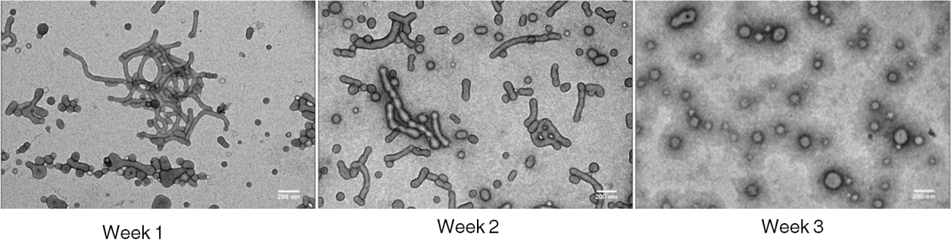Figure 38. TEM results of the samples collected on week1, 2 and 3

In order to form more vesicles in one week, sonication was explored to speed up the shape conversion. Three time points of sonication, 0, 0.5 and 1 hour, was set to acquire samples from same vial stirred for one week. Both polymersomes loading with 3001126 and empty polymersomes after being stirred for one week were used in this experiment. Samples acquired from different time points were examined under TEM. (Figure 39)
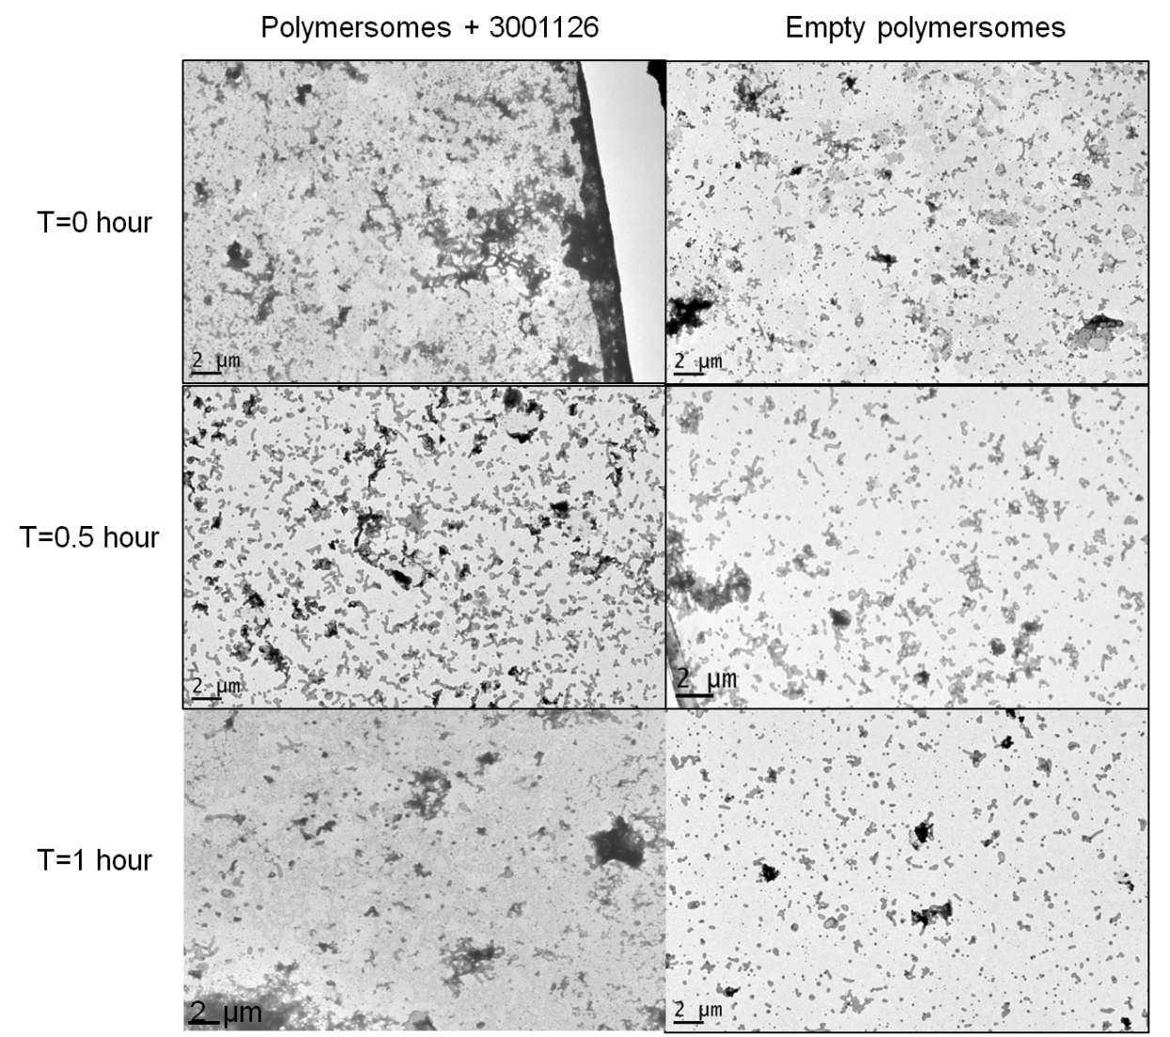
Figure 39. TEM results of drug loaded and empty polymersomes after sonication for 0, 0.5 and 1 hour.

It was observed in both samples that more spherical polymersomes was formed after one hour sonication. Therefore, it was chosen to be the optimized condition for accelerating formation of vesicle polymersomes. Two shapes of the polymersomes were separated and compared in the following assays.

3.2 Sample characterization
The transmission electron microscope (TEM) images (Figure 40), showed the efficient separation of spherical polymersomes (Figure 40c and 40d) from tubular-polymersomes (Figure 40a and 40b) after the centrifugation. The lengths and cross-sections of the tubular samples were analysed by the parameters of aspect ratio (AR) and minimal feret (MinFeret) and maximum feret (MaxFeret) (Table 15). The aspect ratio (AR) was obtained by deviding the MaxFret by MinFeret. The AR for empty tubular-polymersomes (ETP) is 7.60; is larger than the value (7.04) of the drug loaded tubular-polymersomes (DTP). The average diameter of the drug loaded spherical polymersomes (DSP) (Figure 40c) and empty spherical polymersomes (ESP) (Figure 40d) were 113.63 ± 10.86 nm and 120.44±14.79nm, displaying a similar trend as the tubular shaped polymersomes. 166.43±3.09nm and 148.13±1.52nm respectively determined by DLS. (Figure 41) Comparing with DLS results, the measurement from TEM showed smaller values for both DSP and ESP respectively.

Table 15. Comparison of the length of tubular-polymersome samples
 | MinFeret (nm) | MaxFeret (nm) | AR
DTP | 62.3±8.8 | 438.3±111.6 | 7.04
ETP | 64.0±11.7 | 486.7±96.3 | 7.60

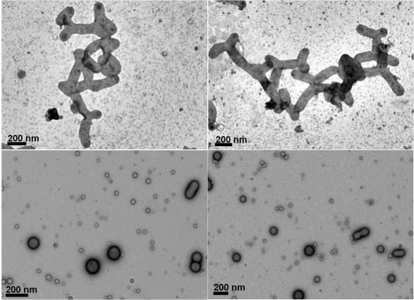
a)
d)
c)
b)
Figure 40. TEM results of a) DTP, b) ETP, c) DSP and d) ESP.

Figure 41. The DLS size distribution of ESP and DSP samples

3.3 Samples quantitative by HPLC
The amount of 3001126 encapsulated in the polymersomes were determined quantitatively by RP-HPLC coupled with a diode array detector. 3001126 was dissolved into MeOH and six mass of injected samples are from 0.1 to 1μg in triplicate. Accrodingly, the standards of PMPC₂₅-PDPA₇₀ were composed of six injecting mass of PMPC₂₅-PDPA₇₀ in MeOH from 50 to 300μg in triplicate. The calibration curves were bulit by mass (μg) aginst average peak areas (mAU) and the curves for 3001126 and PMPC₂₅-PDPA₇₀ were shown in figure 42a and 42b individually. The equations generated accroding to the curves were applied for further concentraion calculation.
a)
b)
Figure 42. The HPLC calibration curves of (a)3001126 and (b) PMPC₂₅–PDPA₇₀ (the error bars indicate standard deviation of mean)

The concentrations of 3001126 in DTP and DSP were 1.170 mM and 0.574mM respectively. The corresponding encapsulation efficiency of 3001126 for DTP and DSP were 35.7% and 20.5%. The DTP had a better drug loading efficiency which is probably due to the larger hydrophobic region than the one in DSP.

3.4 Cell line assays

3.4.1 Anti-prion activity and cell viability assays
a)

b)

Figure 43. a) EC₅₀ results of DTP, DSP, 3001126, ETP and ESP; b) Anti-prion activity of DTP, DSP, 3001126, ETP and ESP with higher concentration (the error bars indicate standard deviation of mean)

The dot blot results are shown in Figure 43a. The EC₅₀ of 3001126, DTP and DSP were 8.07nM, 11.04nM and 46.56nM respectively. The anti-prion effect of DTP was only slightly higher than the 3001126 on its own, which was dosed by diluting a DMSO stock solution using PBS, hence a minor cooperative effect from DMSO cannot be fully excluded. The polymersomes as drug carriers here has a huge advantage because it completely eliminates the need of DMSO as a co-solvent to increase the solubility of 3001126 in cellular assay. This overcomes the solubility issues embedded in this family of anti-prion compounds and enables the development of a new formulation for active drug. It also implied that drug target(s) for 3001126 may reside in cytoplasm as polymersomes carry the drug across the membrane via endocytosis and if the mode of action of the compound is by the interacting with cell surface membrane receptors much higher EC₅₀ would be expected from the drug encapsulated polymersomes.

It is very interesting to note that the anti-prion activity of DSP was almost 5 times weaker than DTP despite of the encapsulation rate only differs by 1.5 fold. This may indicate that the tubular-shape polymersomes are more effective in transporting and releasing the anti-prion compound into the intracellular compartment. In the control group, ETP and ESP did not show anti-prion activities when compared to the negative control. Neither ETP nor ESP showed any cytotoxicity in the tested cell model by MTT assay. (Figure 44) The mean value from duplicate results was used to build the figure below.

Figure 44. The MTT results of ETP, DTP, ESP, DSP and 3001126

When samples prepared in same batch, but higher concentrations (from 100 nM to 10,000 nM) were dosed on the SMB cells, decreased in anti-prion activities with an increasing in the drug concentration were observed for both DTP and DSP (Figure 43b). However, 3001126 on its own did not show this biphasic effect. ETP and ESP were not active at higher concentrations either. (Figure 43b) This phenomenon can be speculated that at a high concentration the drug may aggregate and cluster together within the polymersomes preventing them being effectively released into cytosol to exert its activities.

3.4.2 Cellular uptake and localization
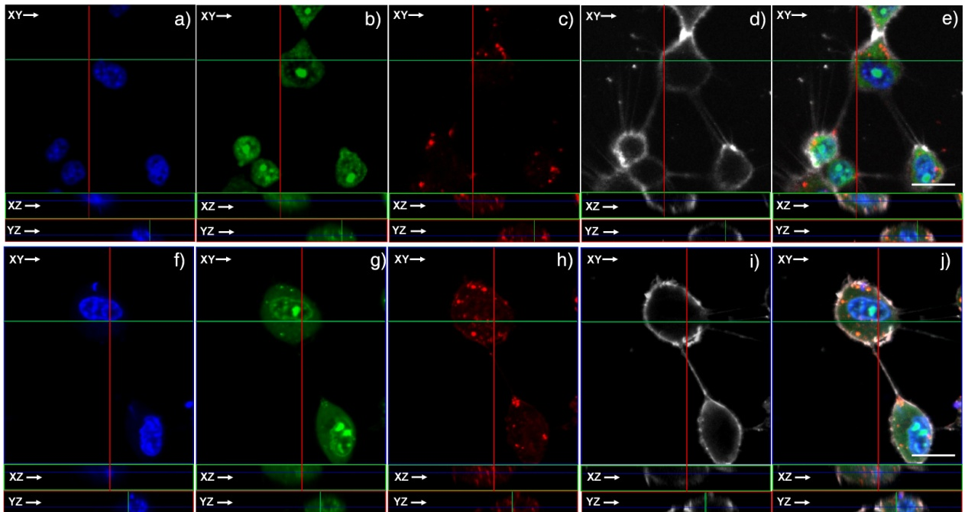
Figure 45. Z stack 3D images: a, b, c, d and e are the cells treated with DSP; f, g, h, i and j are the cells treated with DTP. a and f are stained by DAPI (Ex405, Em420-450), b and g are stained by Syto9 (Ex488, Em500-550), c and h are stained by DSP and DTP (Ex561, Em575-600), d and i are stained by Cell-Mask (Ex647, Em650-700), e and j are the overlays. Scale bar represent 10μm.

Both shapes of the drug loaded polymersomes 3001126 were uptake well by cells despite a huge drop in reducing PrP^{Sc} production level by DSP when compared to the native 3001126. The presence of Rho–PMPC₂₅–PDPA₇₀ as part of the polymersomes composition, allows following the cellular uptake using the confocal-laser scanning microscope.

To analyse the cellular localisation of both polymersomes shapes the DSP and DTP were incubated for 5 hours with SMB cells. The cells were then washed with PBS and stained with DAPI (staining nucleus) (Figure 45a and 45f), Syto9 (staining DNA/RNA of live cells) (Figure 45b and 45g) and Cell-Mask (staining live cell plasma membrane) (Figure 45d and 45i). Live cell images were taken in PBS solution. Based on the previous research, it was known that the spherical polymersomes were internalised by the cells via endocytic pathway.¹⁴⁹ The results showed that both polymersomes were taken up by the cells successfully and disassembled within cellular endosomes (c.a. pH 6.2) (shown in Figure 45c and 45h).

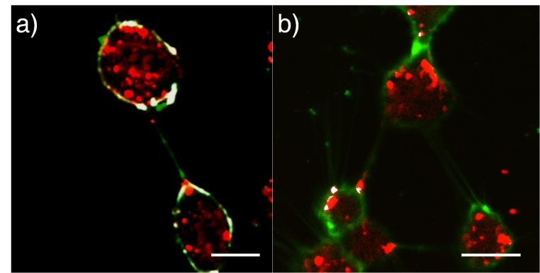
Figure 46. a) Co-localization between DTP and cell mask, b) Co-localization between DSP and cell mask. Scale bar represent 10μm.

In a previous report¹⁴², it was observed that while the shape of the polymersomes does not affect the binding of PMPC to its receptors, the shape has a strong effect on the internalisation kinetics. The intrinsic anisotropic nature of tube, indeed, forces a frustrated endocytosis and while the particle are internalised, their full sorting within the endocytic organelles is considerably slower than their spherical counterparts. This translates in much longer residence times of the tubular polymersomes on the cellular membrane compared to the spherical ones as we recently reported for both human neutrophils and oral carcinoma cells¹⁴². Recently, it was also reported that the surface interaction of rod-like particles with the cellular membrane can enhance internalization rate.¹⁴⁹ The membrane invagination can be much bigger than expected for sphere with this conformation. The improved uptake of those tubular-polymersomes is evocative of the internalisation of rod-like bacteria by non-phagocytic cells.¹⁵⁰

Herein we show that shape depended anti-prion effect is also observable in SMB cells. It was observed that there were more DTPs than the DSPs on the surface of the membrane co-focal analysis of the co-localization of polymersomes (DTP and DSP) and cell mask. (Figure 46) The results suggested that the tubular polymersomes have a larger overlapping region with membrane, hence facilitate the uptake by diffusion and more effective release of the compound. The difference in cellular uptake between DTP and DSP might affect their anti-prion effects.

4. Conclusions
In conclusions, biocompatible pH sensitive polymersomes with two different shapes, tubular and spherical, have been used as carriers for the hydrophobic anti-prion compound. They are non-toxic to the cells and overcome the solubility problems of the drug. The tubular-polymersomes exhibit better anti-prion activities and cellular uptake on SMB cells than the spherical ones. This shows for the first time that different shapes of the polymersomes can produce very different delivery outcome as drug carriers and tubular-polymersomes showed better distribution on cell membrane than spherical polymersomes. This will have significant impacts on further developing this type of polymersome as CNS specific drug carriers, especially for anit-prion drugs.

PartⅢChapter 3 Quantum Dots as Delivery Systems for Hydrophobic Anti-prion Compounds

1 Introduction
Quantum dots (QDs) are small nanoparticles composed of a few hundred to a few thousands of atoms and their sizes are normally below 100nm. They are colloidally stable due to the surface conjugation of hydrophilic polymeric groups outside the core/shell structure.¹⁵¹ QDs are known for their unique, size-dependent, highly stable and bright fluorescence in biological applications. These fluorescence nanoparticles could be used as fluorescence tags for immunoassays, cellular labeling and tissue imaging, and they can be excited and produce fluorescent emissions in a wide range of wavelengths from the visible to near infrared by using different preparations. These are superb properties over organic dyes that normally have narrow excitation and broad emission spectra. However, the use of QDs probes is limited by their in vitro or in vivo toxicities which are originally from their core structure containing Cd, Te, Pb and As ions. Overcoated with metal like ZnS or a biocompatible hydrophilic polymer like polyethylene glycol (PEG) was regarded as a solution for this issue.¹⁵²

QDs were widely used in cell labeling and specific targeting. QDs can be taken up by cells via endocytosis, and the distribution of dihydrolipoic acid (DHLA) capped QDs were co-localized as an endosome cell marker.¹⁵³ QDs for cell labeling were conjugated with antibodies (clone 4E3) specific to the extracellular epitope of P-glycoprotein. Cell growth and differentiation were not affected with the QD labeling, and the cell differentiation over a long period could be tracked.¹⁵³ Another example of targeting delivery was achieved by Valeria Sigot and colleagues. Biotinylated lipid particles (BLP) were applied to encapsulate red-emitting QD_{655,} and the surface of BLP was decorated with green-emitting QD₅₂₅ which was conjugated with epidermal growth factor ligand. Intracellular fluorescence of both QD₆₅₅ and QD₅₂₅ was observed in the perinuclear area. Contrary to this, BLP without conjugating ligands were hardly observed fluorescence inside the cells.¹⁵⁴
Scheme 5. Synthesis process of 3001326 (APC)

The novel anti-prion compound, 3001326 (APC), 2-(1H-indol-3-yl)- N-(4-mercapto-phenyl)-2-oxo-acetamide, was synthesized based on the parent structure of 6-substituted indole-3-glyoxylamides which were shown excellent anti-prion activity and the EC₅₀ of top rank compounds is in nanomolar scale. It is a highly lipophilic compound with a molecule weight of 264.35.

Here, DHLA-PEG₆₀₀-NH₂-capped CdSe/ZnS core/shell QDs were activated with maleimide which was applied to conjugate with the thiol group on APC via thiol-maleimide nucleophilic reaction. (Figure 47) This drug delivery system (DDS) is selected to conquer the problems of indole library (poor solubility and unable to track in vitro). Most of the QDs surface is ending with NH₂ hence the whole system could bring the hydrophobic APC into an aqueous phase. Furthermore, the self-fluorescent QDs can be used as an efficient intracellular fluorescence marker so that the uptake of the compound could be tracked. The studies of this DDS are mostly based on the biological evaluating system mentioned previously.
Figure 47. Synthesis diagram of QDs-APC
The indole derivative (3001326) was designed and synthesized by Mr. Matthew Sellwood and Miss. Nomagugu Mbelesi from our group. The modified QD was designed and synthesized by Mr.Yifei Kong from University of Leeds. The anti-prion effect and cell toxicity of the drug loaded QDs was evaluated by the biological evaluation system and into its mode-of-action is also investigated in this project by cell images under confocal-laser scanning microscope (CLSM).

2 Materials and methods

2. 1 Materials and instrumentation
SMB cells were obtained from the TSE centre at the Institute of Animal Health. The medium for the cell culture was Phenol-red Medium 199 (Invitrogen). 10% New Born Calf Serum (NBCS, Invitrogen), 5% Foetal Bovine Serum (FBS, Invitrogen) and 1% Penicillin-Streptomycin Solution (Sigma) were added into the medium before use. Trypsin-EDTA solution was purchased from Sigma-Aldrich. Hanks Balanced Salt Solution (HBSS, Invitrogen) was used as the compound dilution solution. The SMB cells were cultured and passaged in tissue-culture treated petri dishes (BD Falcon SLS). The sterile 96 well plates (BD Falcon SLS) were for the cell culture and dosing. Chemical reagents for the viability assay and the protein determination were all obtained from Sigma-Aldrich, which include 3-(4,5-dimethylthiazol-2-yl)-2,5
-diphenyltetrazolium bromide (MTT), dimethyl sulfoxide (DMSO), acidic isopropanol, Bradford reagent, and bovine serum albumin (BSA). The reagents for the dot blot assays include proteinase K (PK, Sigma), phenylmethyl-sulfonyl fluoride (PMSF, Sigma), Tris-Buffered Saline (TBS, Sigma), Guanadine Thiocyanate (Acros), skim milk powder (Fluka), 6H4 primary antibody (Prionics through celtic foods) and the mouse antibody IgG and chemiluminescent solutions (GE Healthcare). The haemcytometer was bought from Fisher Scientific. The 96 well manifold (minifold, GE) was used for dot blot assay. Primary and secondary antibodies for IF were purchased from Abcam. Syto9, PI, DAPI and lysosomes traker dyes were bought from life technologiesTM.

Cellular fluorescence images were taken under Zeiss LSM 510 META upright CLSM with 40×and 100× water-dipping lenses. Image data were acquired and processed by using Zeiss LSM Image Browser, Zeiss LSM Image Expert and ImageJ.

2.2 Synthesis of APC

The synthesis of APC was accomplished by Mr. Matthew Sellwood and Miss. Nomagugu Mbelesi from our group. A brief description for the synthesis is documented here to illustrate a complete process of the development.
A mixture of CuI, N-(4-iodo-phenyl)-2-(1H-indol-3-yl)-2-oxo-acetamide, sulfur powder and K₂CO₃ was refluxed in dry DMF at 90ºC for 24 hours. The solution was then cooled to allow for NaBH₄ to be added, and then stirred at 40ºC for 5 hours. 3M HCl was then added and the solution was stirred for an hour. The solution was then separated in the aqueous layer after an addition of 20% NaOH. Ethanol was then added and the aqueous layer was acidified to pH 2 using HCl. Ethyl acetate was then added and the organic layer was extracted and washed with water and brine separately. The organic layer was dried with magnesium sulfate and the solvent was removed under reduced pressure to give a yellow solid.

2.3 Synthesis of QDs-APC conjugates
This synthesis work was collarbrately accomplished by Mr. Yifei Kong from University of Leeds. A brief description for the synthesis is documented here to illustrate a complete process of the development.

2.3.1 Synthesis of DHLA-PEG₆₀₀-NH₂
135μL 0.4M thioctic acid (TA)-PEG₆₀₀-NH₂ and 17mg tris(2-carboxyethyl)phosphine (TCEP) were dissolved in 200μL deionized water and stirred at room temperature till the solution became colorless. The reduced TA-PEG₆₀₀-NH₂ (aka DHLA-PEG₆₀₀-NH₂) was extracted 4✕400uL chloroform. Thereafter, the extractions were combined and evaporated in a vacuum distillation apparatus to remove the chloroform.

2.3.2 Synthesis of DHLA-PEG₆₀₀-NH₂-capped QDs via surface ligand exchange
Trioctylphosphine oxide (TOPO) capped CdSe/ZnS QDs (λ_{em}=607nm) and DHLA-PEG₆₀₀-NH₂ were dissolved in 1mL chloroform with final molar ratio of QD: ligand=1: 2000, followed by the addition of 540μL 0.1M NaOH (dissolved in EtOH). After heating at 60°C for 2hrs under N₂ protection, DHLA-PEG₆₀₀-NH₂-capped CdSe/ZnS QDs were purified via selective precipitation by adding 3~4mL n-hexane. The precipitated DHLA-PEG₆₀₀-NH₂-capped QDs were washed 3✕phosphate buffer (PB, pH=7.4) whereby AmiconTM centrifugal concentrators (13,000 MWCO) were used to separate unbound ligands from the beads.

2.3.3 Synthesis of maleimide-activated QDs
The molar concentration of the above DHLA-PEG₆₀₀-NH₂-capped QDs in PB buffer (pH=7.4) was determined as ca. 17μM by measuring their absorbance at 590nm (extinction coefficient 260,000 M⁻¹cm⁻¹). 5mg succinimidyl- [(N-maleimidopropionamido)-octaethy-leneglycol] ester (SM(PEG)₁₂, 288 molar equivalent to QDs) was then added and reacted under rigorous stirring for 2hrs at RT. Afterwards, O-Methyl-O′-[2-(succinylamino)-ethyl]polyethylene glycol N-succinimidyl ester (NHS-PEG₇₅₀-OMe) was introduced with the molar ratio of NHS-PEG₇₅₀-OMe to QDs as 200: 1 to block non-reacted amine groups on the surface of QDs. The products were washed 3✕ phosphate buffer (PB, pH=7.4) by ultrafiltration to get rid of unbound SM(PEG)₁₂ and NHS-PEG₇₅₀-OMe.

2.3.4 Coupling of maleimide-activated QDs and thiolated anti-prion compound
The maleimide-activated CdSe/ZnS QDs were equally divided into two subunits to make 5nmol QDs in 500μL PB buffer (pH=7.4) for each, among which one unit would be used as a blank control. Subsequently, thiolated anti-prion compounds were added to the rest unit with molar ratios of QDs to anti-prion compound as 1: 100 and it was leaved at RT for 2 hrs during maleimides would effectively react with thiol groups in a Michael addition type reaction to form a covalent bond between the QDs and anti-prion compound. After the reaction, 2-mercaptiethanol (100 equivalents to QDs) was introduced to block the non-reacted maleimides on the surface of the QDs. The QD-anti-prion conjugates were washed 3✕phosphate buffer (PB, pH=7.4) before the final determination of their concentrations (NB the extinction coefficient of anti-prion compound was measured as 1391 M⁻¹ cm⁻¹ at 378nm).

2.4 Cell line analysis

2.4.1 Cell culture
The scrapie-infected mouse brain (SMB) cells were cultured for cell line assays and the culture protocal is referred to Part Ⅱ Section 2.2.1.1.

2.4.2 Dosing plan for anti-prion activity of APC, QDs-APC and QDs
The SMB cells on 96 well plates were ready for dosing after seeding 24 hours. QDs-APC was diluted into eight different concentrations from 0.1 to 4μM and then dosed on the SMB cells. APC stock solution was prepared at a concentration of 10mM in DMSO. The stock solution was diluted using DMSO and followed by PBS to 8 same concentrations from 0.1 to 4μM as QDs-APC. The final DMSO composition was required no more than 0.5% by volume. Based on the drug/QDs ratio, same QDs concentrations of corresponding QDs-APC concentrations were calculated and prepared by diluting QDs solution.

Each concentration was dosed in triplicate for both viability and dot blotting assays. Two negative and a positive controls were set as DMSO (0.5% v/v) PBS (5% v/v) and curcumin (10μM) respectively.

2.4.3 Viability assay (MTT assay)
The viability assay was set for evaluating the cytotoxicity of the compounds and the protocal is referred to Part Ⅱ Section 2.2.1.3.

Median lethal dose (LD₅₀) was calculated via the MTT results. It could be used for evaluating the cytotoxic concentration of sample to cells. Certain value could be calculated via a curve which is plotted by using logarithm of sample concentrations against MTT results.

Each experiment was done by triplicate and the standard deviation (error bar) was applied in data analysis.

2.4.4 Cell lysis
The cells in 96 well plates were lysed after 5 days’ incubation to release PrP^{Sc} for the quantitative analysis and the protocal is referred to Part Ⅱ Section 2.2.1.4.

2.4.5 Protein determination
Bradford reagent was used to determine the protein concentration in the cell lysate and the protocal is referred to Part Ⅱ Section.

2.4.6 Dot blot analysis
Dot bolt analysis was applied for determining the concentration of PrP^{Sc} and the culture protocal is referred to Part Ⅱ Section 2.2.1.6.

Each experiment was done by triplicate and the standard deviation (error bar) was applied in data analysis.

2.5 Cell image
All cellular fluorescence images were taken using a Zeiss LSM 510 META upright confocal-laser scanning microscope with 40× and 100× water-dipping lenses. Image data were acquired and processed using a Zeiss LSM Image Browser, Zeiss LSM Image Expert and ImageJ.

2.5.1 Cell live image
Cells were cultured in a 96-well plate after two-hour treatment by 100nM equivalent of QDs-APC and QDs-blank individually. The cellular dyes (ER-Tracker, Syto9 and PI) were added to cells for 10 mintues followed by washing with PBS. Lysosomes-GFP was transfected overnight, then the excessive dyes were washed with PBS. PBS treated cells were used as the negative control. The incubation chamber was used to take live images and it was connected with ZEISS Temp-control and CO₂ controller. The excitation wavelength for QDs, Syto9, Lysosomes-GFP, ER-Tracker and PI were 458/488/488/504/561 respectively.

2.5.2 Immunofluorescence (IF)
Cells were cultured in a 96-well plate and 100nM of QDs-APC and QDs-blank were individually dosed on the cells in different wells for 1 hour. The wells were washed by PBS and then fixed with 4% formaldehyde in PBS for 15min in room temperature. A blocking buffer (1XPBS/5% FBS/0.3% Triton TM X-100) for 60min. Primary antibody (Goat polyclonal to Prion protein) was diluted in an antibody dilution buffer (1XPBS/1% FBS/0.3% Triton TM X-100) and incubated for 2 hours at room temperature. The cells were washed in PBS 3 times, each time for 5min. Incubated cells in a fluorochrome-conjugated secondary antibody (Donkey Anti-Goat IgG) were diluted in an antibody dilution buffer for 2 hrs at room temperature in the dark. The cells were washed in PBS 3 times, each time for 5min, then the cells were ready for taking the fluorescence image.

3 Results and discussion

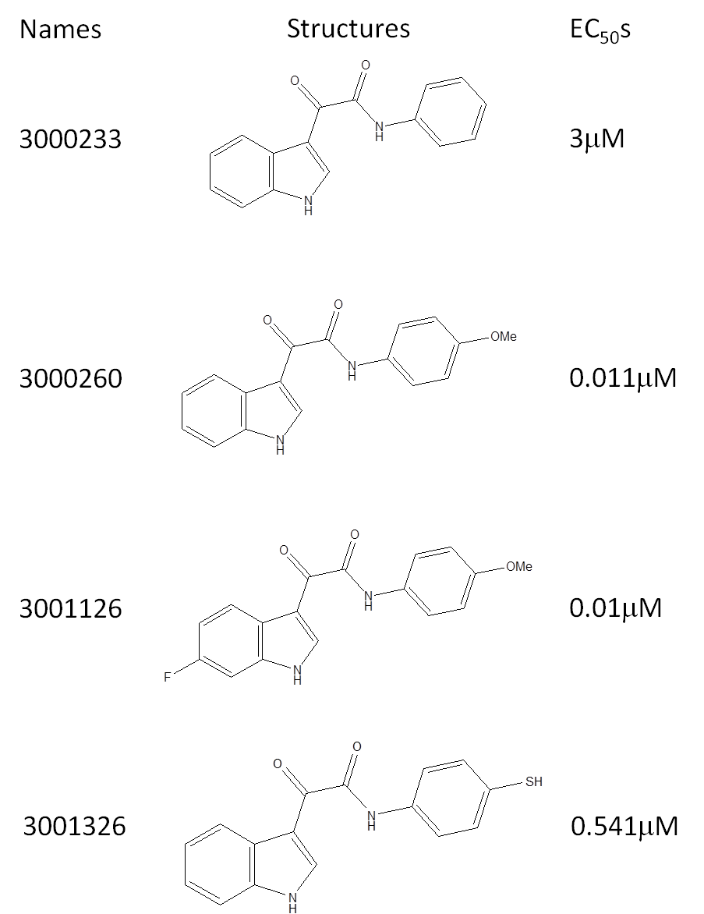
Figure 48. Structures-activity comparison of 3001326 (APC) and its relative structures

APC belonged to the indole family was specifically designed with a thiol group for reacting with the maleimide ending on the QDs surface. This system is intended to load APC via chemical conjugation and it is intracellularly traceable based on the QDs fluorescence. The anti-prion effect of APC was approximately 5.5 times stronger than its parent structure 3000233. Two compounds, 300260 and 3001126, have similar structures and their anti-prion effects were even better. (Figure 48) The fluoro group on the indole did not significantly affect the anti-prion effect when compared with 3001126 with 3000260. The methoxy group on phenyl could significantly enhance the anti-prion effect.

The drug-QDs coupling efficiency is still not fully accomplished because of the APC has poor solubility in aqueous solution. Also APC has poor UV-vis absorbance and low concentration in sample solution. Further quantitative assay is going to solve the obstacle. Therefore, we use the coupling yield of 50% as loading efficiency in the following dosing and calculation.

3.1 EC₅₀ analysis
Figure 49. The anti-prion activity of the APC, QDs-APC and QDs blank (the error bars indicate standard deviation of mean)

Figure 50. The viability results of QDs-APC, APC and QDs blank (the error bars indicate standard deviation of mean)

The anti-prion EC₅₀ of APC and QDs-APC were 0.541 and 0.438μM individually according to the concentration of APC. (Figure 49) QDs blank with corresponding concentrations showed no significant anti-prion effect to the cells. The anti-prion effect of APC’s DMSO stock solution was approximately 1.24 fold weaker than the QDs-APC after five-day incubation on the SMB cells. APC was dragged into water after conjugating with QDs and therefore it was dosed in buffer solution instead of using organic solvent DMSO. There were no significant toxic effects being shown in any dosing concentrations from 0.01 to 0.8µM of QDs-APC, APC and QDs blank, and the MTT results were higher than 70% when compared to the negative control (PBS). (Figure 50)

3.2 LD₅₀ of QDs-APC and QDs
Figure 51. LD₅₀ of QDs-APC, APC and QDs blank (the error bars indicate standard deviation of mean)

Three samples were dosed from 1µM to 100µM according to the APC’s concentration. According to the MTT results, both QDs blank and QDs-APC were toxic to the SMB cells at high concentrations, and their LD₅₀ were 10.21µM and 14.50µM individually from corresponding curves in Figure 51. APC in DMSO solution did not affect the cell surviving when compared to the 0.5% DMSO in PBS as the control used in the MTT assay. The QD-APC was shown to have higher survival data than QDs without APC conjugation. The LD₅₀ of QDs-APC was more than 33 times higher than its EC_{50,} which was the therapeutic window of this DDS. Therefore, this DDS should be noticed about its cytotoxicity when its applied on the cell based evaluating system.

  - Cell live image
    - Cellular uptake and distribution of QDs-APC and QDs blank
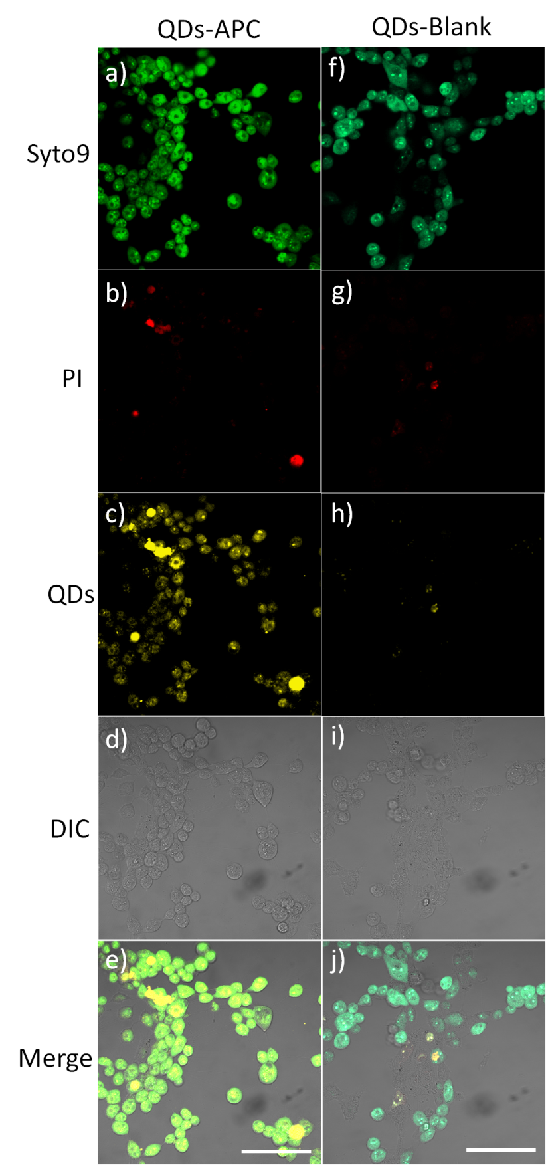
Figure 52. Cell live images of QDs blank and QDs-APC treated cells taking by CLSM. a and f are DIC, b and g are stained by Syto9 (Ex488, Em500-550), c and h are stained by PI (Ex561, Em575-600), d and i are stained by QDs-APC and QDs blank (Ex450, Em590-620), e and j are the merges, and the scale bar represents 50μm.

Cell live images were taken under CLSM and two dyes, Syto9 and PI, were applied to indicate the live and dead cells individually. DIC channel was set to observe the cell morphology. It was surprising that the cellular uptake between the QDs-APC (Figure 52c) and QDs blank (Figure 52H) were significantly different after two hours of incubation. The QDs without APC conjugation (QD blank) were not uptaken up at all by SMB cells during this time period, while QDs-APC showed a good cell uptake. The cell dye PI could dye the dead cells, and this indicated that both the QDs-APC (Figure 52b) and QDs blank (Figure 52g) were able to accumulate in the dead cells and displayed a strong signal due to the increased membrane permeability. Most of the cells in the image were alive and this was proved by syto9 (Figure 6a and 6f). The DIC (Figure 52d and 52i) showed the cell morphology were normal after treated by each sample and Figure 52e and 52j were the merges.
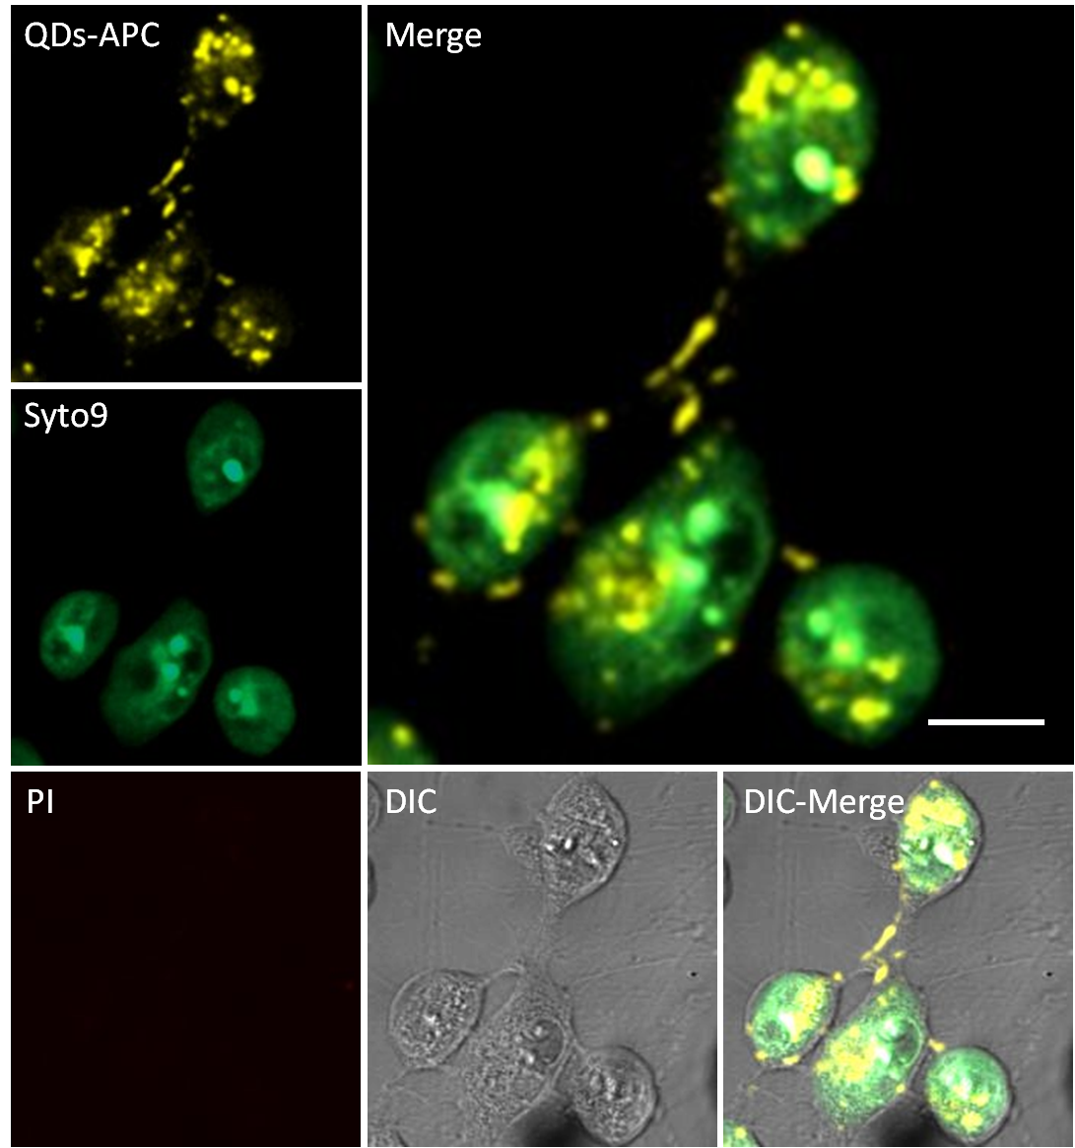
Figure 53. Live cell image of QDs-APC in high resolution. Scale bar represent 10μm.

The cellular uptake of QDs-APC was observed under laser confocal in higher resolution (X63). (Figure 53) The PI and syto9 channels showed that there were no dead cells in this region and DIC channel showed that the cells’ morphology was integrated. Most of the QDs fluorescence was observed in the intracellular region via QDs channel and a minor amount could be found on the cell membrane region (Figure 53 Merge channel). High signal spots were observed intracellularly in the channel of QDs-APC. This could be further observed in the 3D stack cell image. (Figure 54) Those spots were supposed to be formed by an aggregation mechanism, which could possibly be explained from two aspects. Firstly, it might be induced by binding with PrP (for example, PrP^{Sc}), and the intracellular distribution of QDs-APC is very similar to the distribution of PrP^{Sc} oligomers.^{16, 18-19} Another explanation is that this system, QDs-APC, was uptaken by cells via endocytosis and they aggregate in certain cell organelles (endosomes¹⁵⁵ and lysosomes¹⁵⁶). These two hypotheses will be investigated in the next section by using immunofluorescence and live cell images with cell organelle trackers.
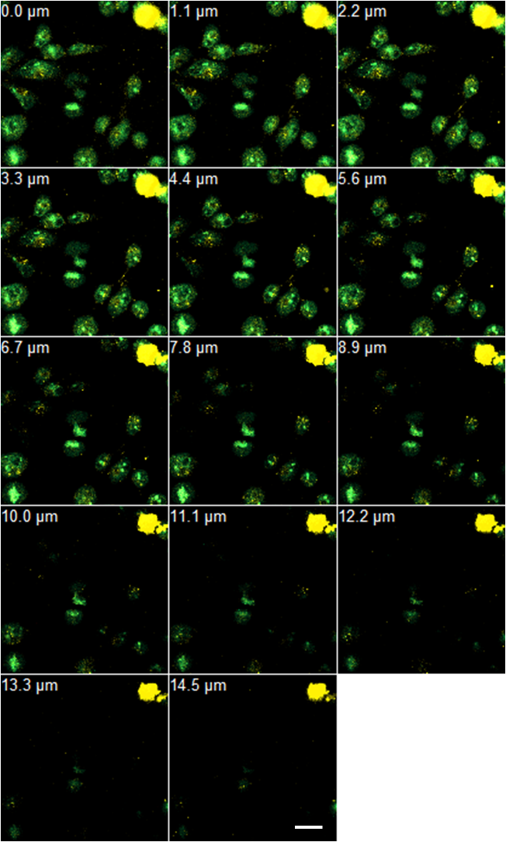
Figure 54. 3D image of live cell uptake of QDs-APC. Scale bar represent 20μm.

3.3.2 Immunofluorescence (IF)
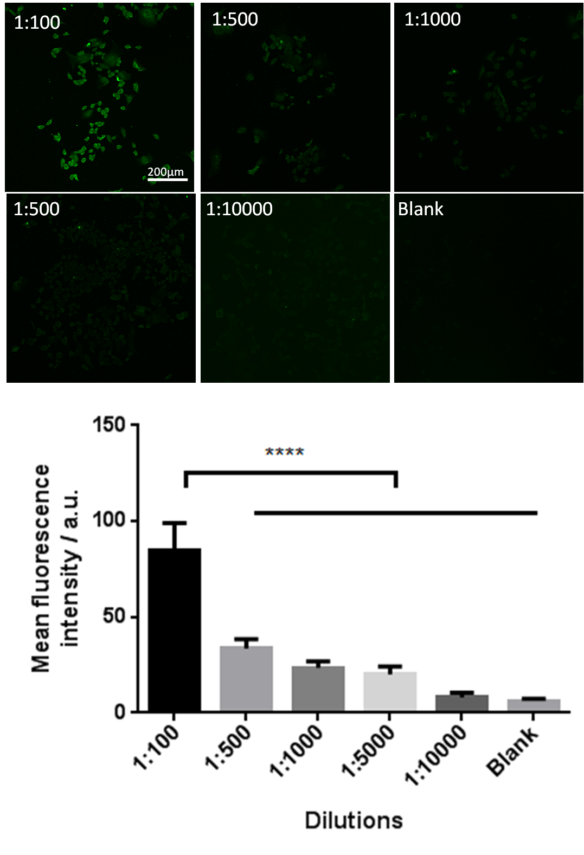
Figure 55. Optimization of primary antibody concentration (the error bars indicate standard deviation of mean)

To investigate what is the suitable concentration of the PrP antibody to be used in the assay, each of the 5 different dilutions of the antibody from 1:100 to 1:10000 were incubated with the SMB cells followed by treatment with a secondary antibody as instructed by the manufacture. The strongest signal was acquired from 1:100 dilution. (Figure 55) The mean fluorescence intensity of 1:100 was significantly higher than the other 4 concentrations, therefore 1:100 was chosen for further IF assay.

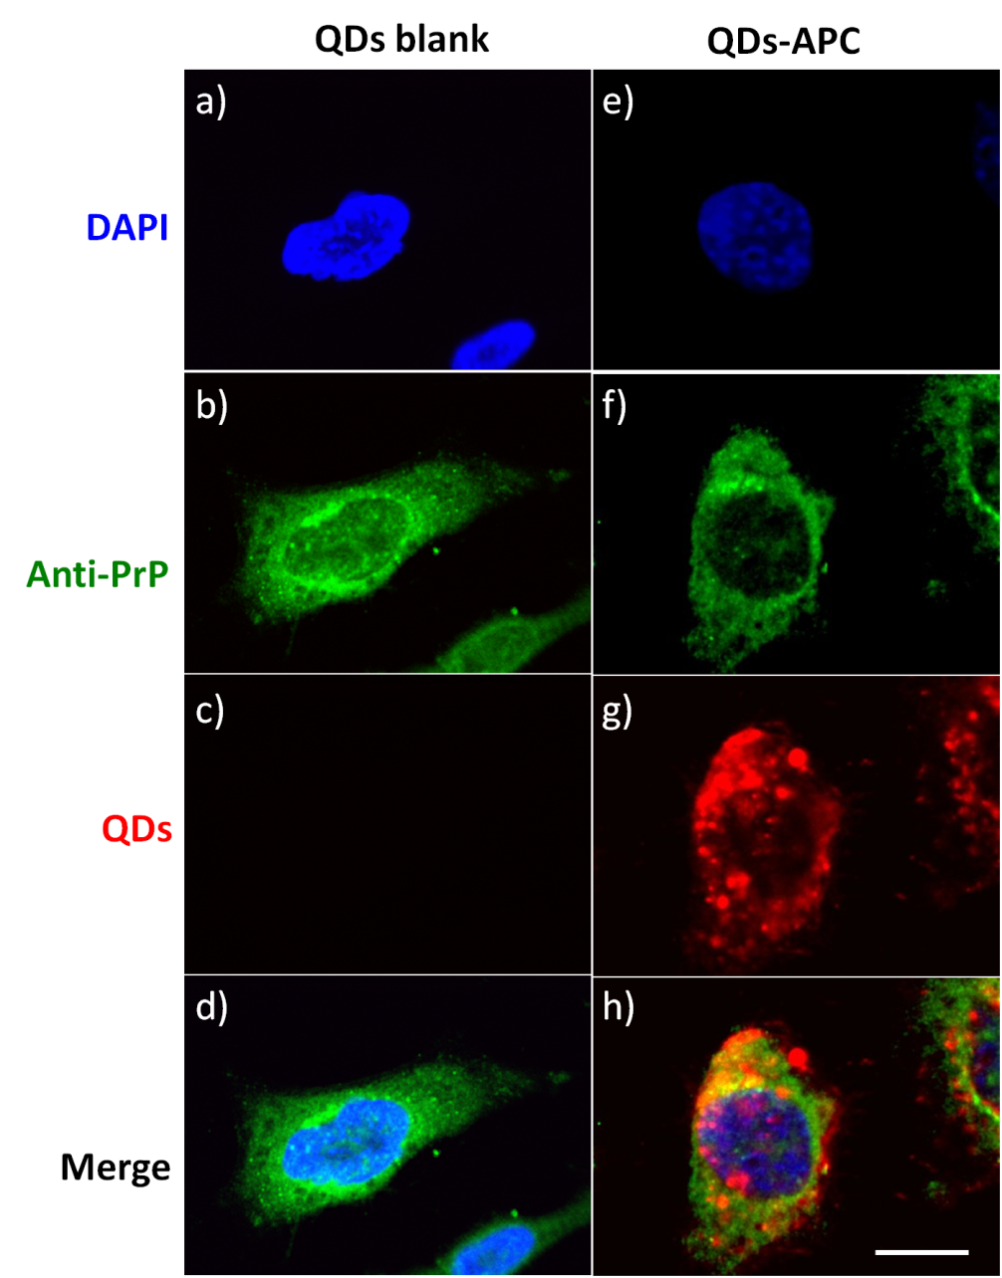
Figure 56. IF images of cells treated with QDs blank and QDs-APC. a and e are DAPI (Ex561, Em575-600), b and f were firstly stained by Goat anti-PrP antibody then followed with Donkey Anti-Goat IgG (Ex488, Em500-550), c and g are stained by QDs blank and QDs-APC (Ex450, Em590-620) , d and h are the merges, and the scale bar represents 10μm.

The cellular uptake of QDs without compound could hardly observed in the SMB cells, which was further proved by QDs channel in Figure 56c. Due to the lack of commercially available PrP^{Sc} specific antibody the PrP antibody which is non-specifically binding with both PrP^{C} and PrP^{Sc} (Figure 56b and 56f) stained both the membrane and intracellular area (Figure 56b and 56f) of the cells except the nucleus region (Figure 56a and 56e). In the merge channel of QDs-APC (Figure 56h), a few regions between QDs (Red) and antibody (Green) were overlapped and this was further analyzed via CLSM 3D scanning.

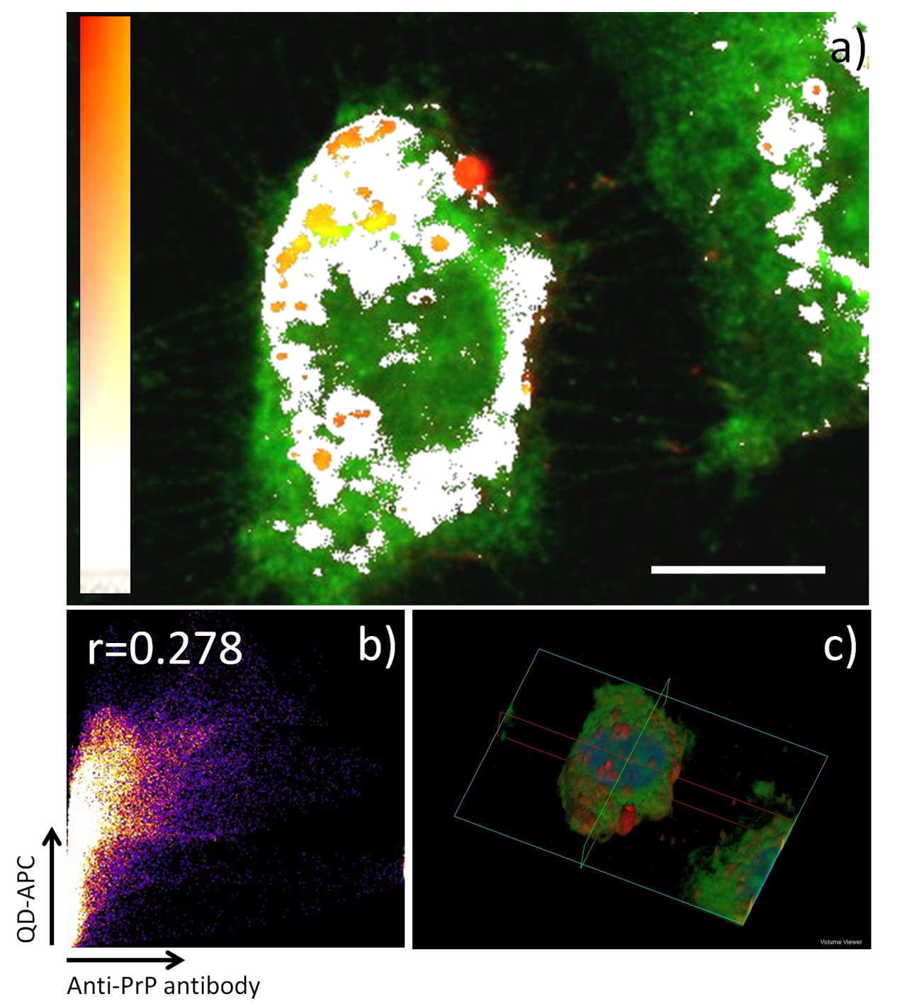
Figure 57. a is co-localization between PrP and QDs-APC; b is the scatter plot Pearson's Correlation Coefficient (r); c is the 3D volume viewer. The scale bar represents 10μm.

Co-localization between QDs-APC and PrP was shown in Figure 57a, and the most overlapping region (in orange) was around the nuclear membrane. The Pearson's correlation coefficient (r) was 0.278. (Figure 57b) r value is between -1 and +1 and the trend is co-localization when r is between 0 and +1. Furthermore, the 3D volume viewer (Figure 57c) could clearly distinguish the intracellular distribution of QDs-APC from the merger. Three dimensional images with 6.90μm and 0.63μm intervals were further proved that PrP was free in the cell nucleus. (Supporting information Figure 58)

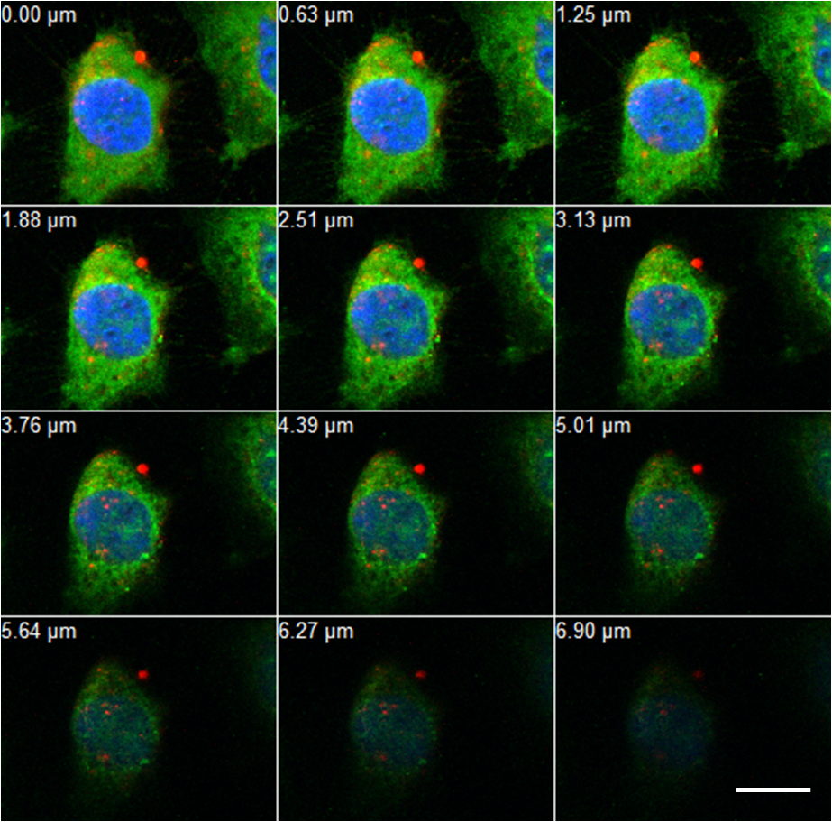
Figure 58. 3D IF image of QDs-APC treated cells. Scale bar represent 10μm.

3.3.3 Cell images with organelle tracker
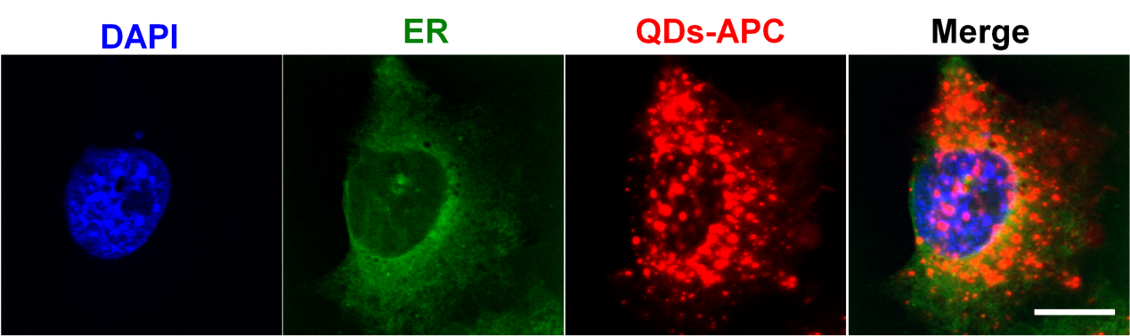
Figure 59. Cells treated with QDs-APC and dye by DAPI (Ex561, Em575-600), ER tracker (Ex504, Em510-520), QDs-APC (Ex450, Em590-620), the scale bar represents 10μm.

Endoplasmic reticulum (ER) and lysosomes trackers without excitation overlapping were applied in order to investigate the cell organelle localization of QDs. ER is classified into two types, rough ER and smooth ER. Rough ER is interested in this research due to its protein synthesis function.¹⁵⁷

PrP^{C} and PrP^{Sc} were possibly produced from ER, however, the ER tracker is non-specific and the distribution is quite different from QDs-APC. (Figure 59) QDs-APC was distributed intracellularly as high signal dots which was different from the ‘smooth’ distribution of ER tracker. It was also showed that ER did not exist in the cell nucleus.

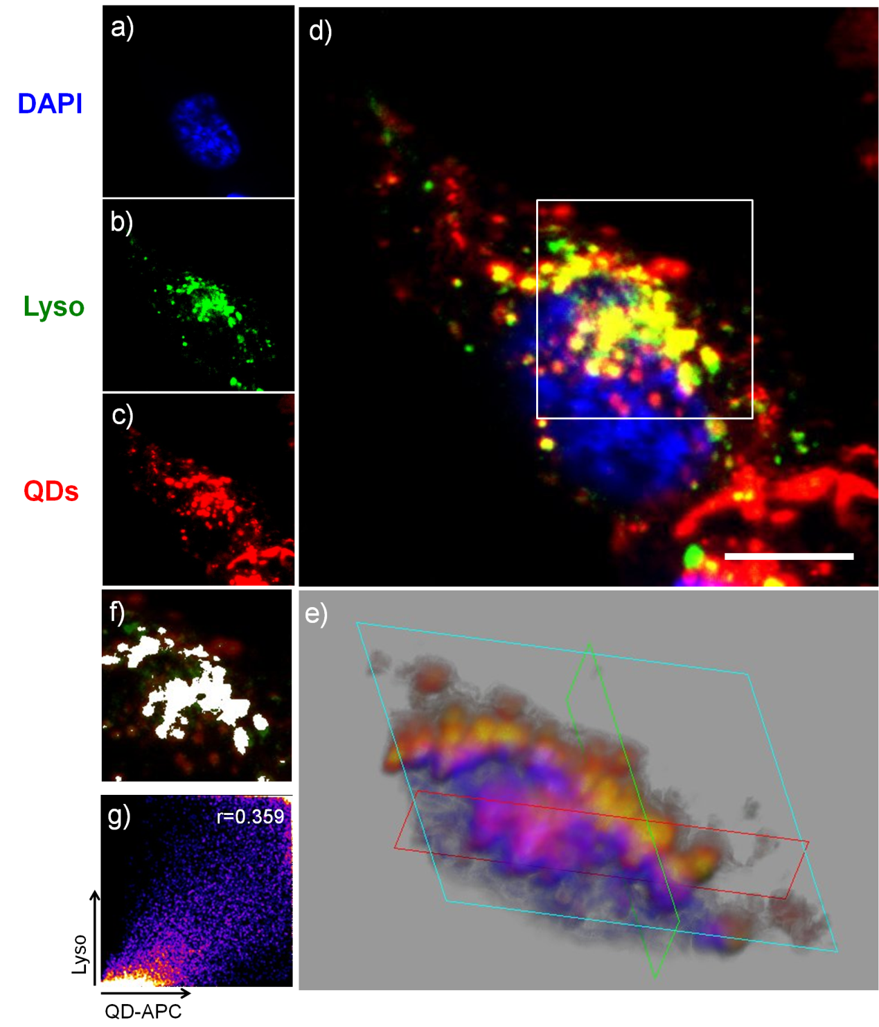
Figure 60. Co-localization between QDs-APC and lysosomes tracker. a) DAPI (Ex561, Em575-600), b) lysosomes tracker (Ex488, Em500-550), c) QDs-APC (Ex450, Em590-620), d) merge, e) 3D volume viewer from select region, f) co-localization between QDs-APC and lysosomes tracker from select region, g) scatter plot Pearson's Correlation Coefficient

Lysosomes contain acid hydrolase enzymes which break down waste materials. It was reported to be highly relative to the pathogenesis of prion disease, and the scrapie form of PrP was suspected to be accumulated and degraded in this organelle.¹⁵⁸ Cell co-localization between DAPI (Figure 60a), lysosomes tracker (Figure 60b) and QDs-APC (Figure 60c) was shown in a yellow color. (Figure 60d) The strong signal region was selected, and the lysosomes tracker and QDs-APC were analyzed via a 3D volume viewer (Figure 60e), co-localization analysis (Figure 60f) and scatter plot Pearson's Correlation Coefficient (r) (Figure 60g). r value was 0.359, which indicated that the trend between lysosomes and QDs-APC is co-localization. Therefore, QDs-APC was very likely distributed in the cell lysosomes where the PrP^{Sc} oligomer accumulated.

- Conclusions
Firstly, APC was successfully conjugated with surface modified CdSe/ZnS core/shell QDs via thiol-maleimide reaction and dragged the hydrophobic compound into aqueous phase. There is no need of using DMSO as a cosolvent when dosing the cells. Secondly, its anti-prion effect (EC₅₀=0.438μM) was slightly increased 1.24 fold by comparing to the free APC. Thirdly, this system could be applied on a cell model avoiding its cytotoxicity due to the fact that the LD₅₀ of QDs-APC was more than 33 times higher than its EC₅₀. Fourthly, the cell fluorescence images showed that the QDs-APC was able to cross the plasma membrane of the SMB cells via endocytosis and co-localized with a lysosomes tracker, which possibly indicates that this DDS could intracellularly binding with PrP^{Sc} oligomers in lysosomes. Furthermore, the QDs without conjugating with APC was hardly uptake by live SMB cells and in the contrary, QDs-APC could uptake by the cells and showed strong signal under CLSM. The CNS targeting vector can be decorated for QDs DDS to enhance their abilities to penetrate BBB in the future work.

Part Ⅳ General Discussion and Conclusions

A biological evaluating system based on SMB cell line was adapted and optimized for measuring the PrP^{Sc} elimination and cytotoxicity effect of small molecule anti-prion compounds quantitatively using MTT assay and dot-blotting .

Compounds from ZINC library, benzofuran derivatives and ε-PL were screened using the optimized assays. Most of the compounds from ZINC database which were selected for an antibiotic lead discovery project did not exhibit strong anti-prion activities. The ones that were active have similar function groups as what are presented in the indole family of potent anti-prion compounds previously discovered in the group. All six benzofuran derivatives showed anti-prion activities at micromolar scale and the carbon chain between aryloxy group and tertiary amine group resembles the side chain in a known anti-prion compound, quinacrine, could be responsible for the anti-prion effect of this class of compounds. However, four of them showed considerable toxicity to the SMB cells prohibiting of further investigation of these compounds. ε-PL biopolymer showed anti-prion effect below 1μM while it was toxic to the cells at more than 100μΜ showing some potential and should be further studied.
The anti-prion compounds (APCs) from the indole library were discovered in the previous cell line screening of a chemical library collection in our group. The EC₅₀s of many compounds were measured at nano-molar scales on the SMB cell line.¹⁰⁶ However, there are three main obstacles associated with this family of compounds to exhibit clinical therapy effects: poor solubility; difficult to track in vitro and in vivo; unable to reach the disease focused location in CNS. Three drug delivery systems (DDS), hyperbranched polymer (HBP), polymersomes and quantum dots (QDs) loaded with APCs from indole library were evaluated so that some solutions for the above problem can be found.

3001126 as one of the top-10 compound (EC₅₀ =10nM) from indole library was loaded onto HBP in order to overcome the solubility problem with this family of compounds. This model compound was also loaded onto specifically designed pH responsive fluorescent labelled polymersomes to ensure that the drug is delivered into cells and the shape effects (include tubular DTP and spherical DSP) of polymersome DDS on their anti-prion activities were compared. Both DDSs successfully overcome the solubility problem in the cellular model, but the drug loading capacities vary considerably. The corresponding encapsulation efficiency of 3001126 for DTP, DSP and HBP were 35.7%, 20.5% and 0.33%. The tubular polymersomes showed the highest loading of 3001126. Of these two systems, polymersomes are more preferred to the HBP because the latter has very low loading capacity and lacks of fluorophore reporter that can enable its use as a molecular imaging tool for tacking the destination of the molecule in the cellular system.

Another APC 3001326 was derived from 6-substituted indole-3-glyoxylamides as its parent structure and the thiol group on 4’-position of the phenyl group was used to couple with the QDs modified with maleimide group via covalent bonds. The QDs DDS has unique advantages of being natural fluorescent and can be used as both drug carrier as well as an imaging tool for cell based analysis.

Several aspects of the physiochemical properties brought by using the three DDSs were summarized and compared as follows.

- Solubility
Both APCs were highly hydrophobic, and their solubility in aqueous phase has been significantly improved via the corresponding DDS. When tested in cell models they no longer need DMSO as a co-solvent. (Table 16) APCs can loaded onto DDS via different mechanisms. Both HBP and polymersomes encapsulate compound 3001126. The assembly of these two DDSs depends on the hydrophobic interactions between the drug and the polymer core when solutions of the polymer and the drug were mixed, solvent evaporated followed by rehydration of the film formed driven by solvation process, the hydrophobic compounds are ‘trapped’ in the hydrophobic polymer core. HBP encapsulates compound 3001126 into a hydrophobic pocket and the hydrophilic corona carries the drug with it when dissolving in water, hence the solubility of the compound is improved.

Similarly, the polymersomes encapsulate 3001126 into a hydrophobic bilayer of spherical polymersomes (DSP) and the hydrophobic inner layer of tubular filo-polymersomes (DTP). Those bilayer structures were formed by self-assemble of the diblock polymer PMPC-PDPA in aqueous solution and the hydrophobic block PDPA is able to assemble together in neutral pH (pH 7.4).

QDs were coupled with APC via covalent bonding and the water solubility of the whole system is improved due to the modification of the QD surface with hydrophilic functional groups.

- Toxicity
The toxicities of all three DDSs were evaluated by MTT assays and results that are lower than 70% against negative controls were regarded as toxic. HBP, DTP and DSP did not exhibit toxicity at concentrations up to uM during the experiments. (Table 16) However, both QDs conjugated with and without APC were toxic to the cells at a concentration above 10μM. Furthermore, DMSO showed some toxicity above 0.5% (v/v) and all the DDS were dosed onto the cells without needing DMSO as a co-solvent.

- Traceability
HBP contains no chromophore while the other two DDSs have fluorescent properties, therefore were traceable under confocal laser scanning microscope (CLSM) and their location in cells could possibly be visualised. Polymersomes (DTP and DSP) were composed of 5% (v/v) Rho-PMPC₃₀-PDPA₆₀ which is a fluorescent material. Polymersomes conjugated with rhodamine were tracked in the cell organelles (endosomes and (or) lysosomes) and plasma membrane. However, the non-fluorescent APC is hard to detect by laser confocal microscope(LCM) after the polymersomes were disassociated in the intracellular acidic enviroment.

QDs are fluorescent biosensor which was conjugated with APC via covalent binds formed between maleimide and thiol group. They are able to display the intracellular localization of both QDs and APC. This DDS was found to be co-colocalized with lysosomes which are supposed to be the organelles where PrP^{Sc} is processed and degradated. (Table 16)

Table 16. Comparison the solubility, toxicity and traceable in vitro of DMSO, HBP, DTP, DSP and QDs
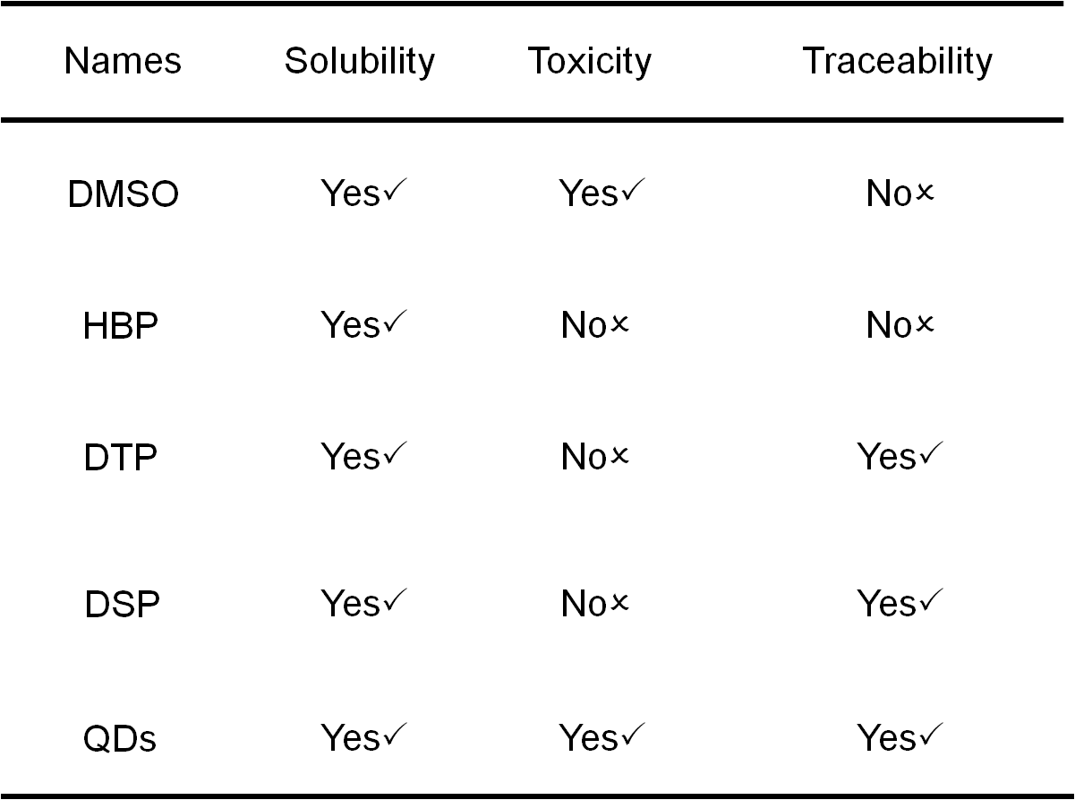
- Anti-prion effect
Table 17. The anti-prion effect of 3001126 and 3001326 in both DMSO and DDS
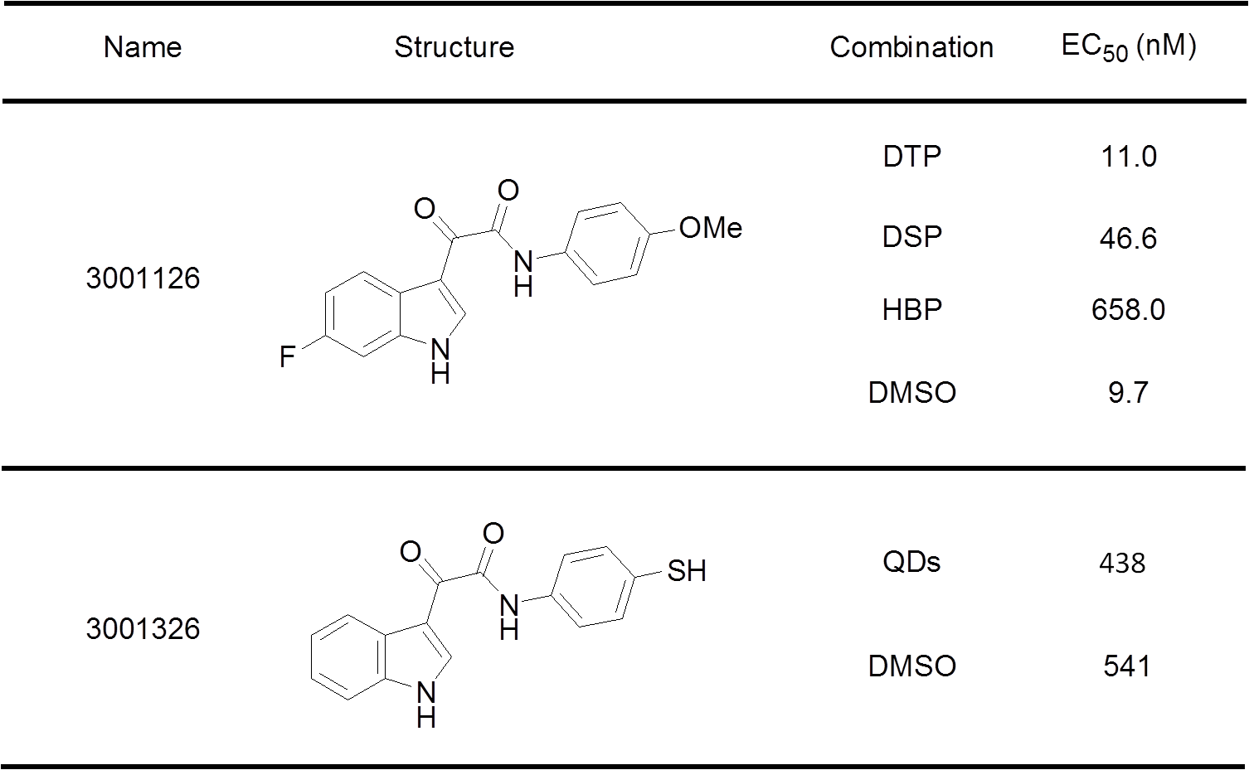
In DMSO, 3001126 has an EC₅₀ of 9.7nM and 3001326 showed an EC₅₀ of 541nM. DTP showed the highest anti-prion effect with an EC₅₀ of 11.0nM by comparing with 3001126 in DSP and HBP. The EC₅₀ of HBP was increased more than 65 times than the EC₅₀ of its DMSO solution. The anti-prion effect of 3001326’s DMSO stock solution was approximately 1.24 fold weaker than the QDs conjugated APC. Additionally, the LD₅₀ of QDs conjugated APC was more than 33 times higher than its EC_{50,} which was indicated the therapy window of this DDS. (Table 17) Moreover, the all three DDS had different mechanisms of loading anti-prion compound. The cellular uptake pathways, intracellular location and drug release of those DDS are hardly the same which could strongly affect the anti-prion effect of them.

In conclusion, three DDS assisted the hydrophobic compounds increasing their solubility in aqueous solution and exhibited anti-prion activity after loading with APC. I would preferred to use polymersomes as the primary choice as potential DDS for future CNS delivery. The synthesized block co-polymer is modifiable and this could induce more function to polymersomes, such as far red fluorescence group and BBB vectors. Also, it displayed decent biocompatibility on cells through the research above which might be non-toxic in the animal test. Moreover, the size of polymersomes could be cut by temperature and external energy (extrusion or sonication) and smaller size is more promising to pass through BBB.
- Future work
The work so far on HBP showed low loading efficiency (0.33%) to the anti-prion compound. To improve this, an increasing amount of HBP could be used in the encapsulation process to increase the polymer-drug molar ratio which could lead to more drug molecules being encapsulated. The loading capacity of HBP can also be improved if different molecular weight HBP is tested. With an increase in molecular weight, a larger hydrophobic region/pocket might be formed to trap more drug molecules into them. Also, different encapsulation methods can be attempted.

The hydrophobic chain of polymersomes could self-assemble into micelles (30-60nm) in aqueous solution. Micelle is a single layer spherical object and has hydrophobic core. Micelle is believed to have larger hydrophobic volume than polymersomes by using same amount of materials. Therefore, micelles are supposed to load more hydrophobic compound than polymersomes. Moreover, the smaller diameter is assisted the DDS penetrate BBB.

Cytotoxicity is restricted the application of QDs which are toxic to the cells even coated with biocompatible materials. Self fluorescence nanoparticles or nanoclusters with decent biocompatibility should be attempted in the future work. Also, compounds with stronger anti-prion effect but keeping conjugatable function group can be developed.
CNS targeted delivery of these compounds are not investigated due to the time constrain. If the three DDSs were modified with BBB specific vectors they could potentially become useful delivery systems to enable these potent anti-prion compounds to be used for curing the prion disease in the central nervous system in the future.

References:

1. Schudel, A. A.; Carrillo, B. J.; Weber, E. L.; Viera, J. B.; Gimeno, E. J.; van Gelderen, C.; Ulloa, E.; Nader, A.; Cané, B. G.; Kimberlin, R. H., Risk assessment and surveillance for bovine spongiform encephalopathy (BSE) in Argentina. Preventive Veterinary Medicine 1996, 25 (3-4), 271-284.
2. Touil, F.; Pratt, S.; Mutter, R.; Chen, B., Screening a library of potential prion therapeutics against cellular prion proteins and insights into their mode of biological activities by surface plasmon resonance. Journal of Pharmaceutical and Biomedical Analysis 2006, 40 (4), 822-832.
3. May, O. Prion Proteins: Unfolding Infectious Potential. http://www.caymanchem.com/app/template/Article.vm/article/2117.
4. Wilson, D. A.; Nixon, R. A., Sniffing out a function for prion proteins. Nat Neurosci 2009, 12 (1), 7-8.
5. Büeler, H.; Aguzzi, A.; Sailer, A.; Greiner, R. A.; Autenried, P.; Aguet, M.; Weissmann, C., Mice devoid of PrP are resistant to scrapie. Cell 1993, 73 (7), 1339-1347.
6. Sarnataro, D.; Campana, V.; Paladino, S.; Stornaiuolo, M.; Nitsch, L.; Zurzolo, C., PrP(C) association with lipid rafts in the early secretory pathway stabilizes its cellular conformation. Molecular biology of the cell 2004, 15 (9), 4031-42.
7. Perrier, V.; Wallace, A. C.; Kaneko, K.; Safar, J.; Prusiner, S. B.; Cohen, F. E., Mimicking dominant negative inhibition of prion replication through structure-based drug design. Proceedings of the National Academy of Sciences of the United States of America 2000, 97 (11), 6073-6078.
8. Kaneko, K.; Zulianello, L.; Scott, M.; Cooper, C. M.; Wallace, A. C.; James, T. L.; Cohen, F. E.; Prusiner, S. B., Evidence for protein X binding to a discontinuous epitope on the cellular prion protein during scrapie prion propagation. Proc Natl Acad Sci U S A 1997, 94 (19), 10069-74.
9. Soto, C.; Kascsak, R. J.; Saborío, G. P.; Aucouturier, P.; Wisniewski, T.; Prelli, F.; Kascsak, R.; Mendez, E.; Harris, D. A.; Ironside, J.; Tagliavini, F.; Carp, R. I.; Frangione, B., Reversion of prion protein conformational changes by synthetic b-sheet breaker peptides. The Lancet 2000, 355 (9199), 192-197.
10. Caspi, S.; Halimi, M.; Yanai, A.; Sasson, S. B.; Taraboulos, A.; Gabizon, R., The Anti-prion Activity of Congo Red. Journal of Biological Chemistry 1998, 273 (6), 3484-3489.
11. Fink, A. L., Protein aggregation: folding aggregates, inclusion bodies and amyloid. Folding & design 1998, 3 (1), R9-23.
12. Véronique Perrier, A. C. W., Kiyotoshi Kaneko, Jiri Safar, Stanley B. Prusiner, and Fred E. Cohen, Mimicking dominant negative inhibition of prion replication through structure-based drug design. Proc Natl Acad Sci 2000, 97 ((11): ), 6073-6078.
13. Pimpinelli, F.; Lehmann, S.; Maridonneau-Parini, I., The scrapie prion protein is present in flotillin-1-positive vesicles in central- but not peripheral-derived neuronal cell lines. European Journal of Neuroscience 2005, 21 (8), 2063-2072.
14. Sunyach, C.; Jen, A.; Deng, J.; Fitzgerald, K. T.; Frobert, Y.; Grassi, J.; McCaffrey, M. W.; Morris, R., The mechanism of internalization of glycosylphosphatidylinositol-anchored prion protein. The EMBO journal 2003, 22 (14), 3591-3601.
15. Magalhães, A. C.; Silva, J. A.; Lee, K. S.; Martins, V. R.; Prado, V. F.; Ferguson, S. S. G.; Gomez, M. V.; Brentani, R. R.; Prado, M. A. M., Endocytic Intermediates Involved with the Intracellular Trafficking of a Fluorescent Cellular Prion Protein. Journal of Biological Chemistry 2002, 277 (36), 33311-33318.
16. Marijanovic, Z.; Caputo, A.; Campana, V.; Zurzolo, C., Identification of an Intracellular Site of Prion Conversion. PLoS Pathog 2009, 5 (5), e1000426.
17. Caughey, B.; Raymond, G. J.; Ernst, D.; Race, R. E., N-terminal truncation of the scrapie-associated form of PrP by lysosomal protease(s): implications regarding the site of conversion of PrP to the protease-resistant state. Journal of Virology 1991, 65 (12), 6597-6603.
18. Singh, A.; Isaac, A. O.; Luo, X.; Mohan, M. L.; Cohen, M. L.; Chen, F.; Kong, Q.; Bartz, J.; Singh, N., Abnormal Brain Iron Homeostasis in Human and Animal Prion Disorders. PLoS Pathog 2009, 5 (3), e1000336.
19. Tayebi, M.; Jones, D. R.; Taylor, W. A.; Stileman, B. F.; Chapman, C.; Zhao, D.; David, M., PrPSc-Specific Antibodies with the Ability to Immunodetect Prion Oligomers. PLoS ONE 2011, 6 (5), e19998.
20. Korth, C.; May, B. C. H.; Cohen, F. E.; Prusiner, S. B., Acridine and phenothiazine derivatives as pharmacotherapeutics for prion disease. Proceedings of the National Academy of Sciences 2001, 98 (17), 9836-9841.
21. Caughey, W. S.; Raymond, L. D.; Horiuchi, M.; Caughey, B., Inhibition of protease-resistant prion protein formation by porphyrins and phthalocyanines. Proc Natl Acad Sci U S A 1998, 95 (21), 12117-22.
22. Caughey, W. S.; Priola, S. A.; Kocisko, D. A.; Raymond, L. D.; Ward, A.; Caughey, B., Cyclic tetrapyrrole sulfonation, metals, and oligomerization in antiprion activity. Antimicrobial agents and chemotherapy 2007, 51 (11), 3887-94.
23. Supattapone, S.; Wille, H.; Uyechi, L.; Safar, J.; Tremblay, P.; Szoka, F. C.; Cohen, F. E.; Prusiner, S. B.; Scott, M. R., Branched Polyamines Cure Prion-Infected Neuroblastoma Cells. Journal of Virology 2001, 75 (7), 3453-3461.
24. Caughey, B.; Raymond, G. J., Sulfated polyanion inhibition of scrapie-associated PrP accumulation in cultured cells. J Virol 1993, 67 (2), 643-50.
25. Raymond, G. J.; Olsen, E. A.; Lee, K. S.; Raymond, L. D.; Bryant, P. K.; Baron, G. S.; Caughey, W. S.; Kocisko, D. A.; McHolland, L. E.; Favara, C.; Langeveld, J. P. M.; van Zijderveld, F. G.; Mayer, R. T.; Miller, M. W.; Williams, E. S.; Caughey, B., Inhibition of Protease-Resistant Prion Protein Formation in a Transformed Deer Cell Line Infected with Chronic Wasting Disease. Journal of Virology 2006, 80 (2), 596-604.
26. (a) Tagliavini, F.; Forloni, G.; Colombo, L.; Rossi, G.; Girola, L.; Canciani, B.; Angeretti, N.; Giampaolo, L.; Peressini, E.; Awan, T.; De Gioia, L.; Ragg, E.; Bugiani, O.; Salmona, M., Tetracycline affects abnormal properties of synthetic PrP peptides and PrP(Sc) in vitro. Journal of molecular biology 2000, 300 (5), 1309-22; (b) Forloni, G.; Iussich, S.; Awan, T.; Colombo, L.; Angeretti, N.; Girola, L.; Bertani, I.; Poli, G.; Caramelli, M.; Grazia Bruzzone, M.; Farina, L.; Limido, L.; Rossi, G.; Giaccone, G.; Ironside, J. W.; Bugiani, O.; Salmona, M.; Tagliavini, F., Tetracyclines affect prion infectivity. Proceedings of the National Academy of Sciences 2002, 99 (16), 10849-10854.
27. Rudyk, H.; Vasiljevic, S.; Hennion, R. M.; Birkett, C. R.; Hope, J.; Gilbert, I. H., Screening Congo Red and its analogues for their ability to prevent the formation of PrP-res in scrapie-infected cells. J Gen Virol 2000, 81 (4), 1155-1164.
28. Peretz, D.; Williamson, R. A.; Kaneko, K.; Vergara, J.; Leclerc, E.; Schmitt-Ulms, G.; Mehlhorn, I. R.; Legname, G.; Wormald, M. R.; Rudd, P. M.; Dwek, R. A.; Burton, D. R.; Prusiner, S. B., Antibodies inhibit prion propagation and clear cell cultures of prion infectivity. Nature 2001, 412 (6848), 739-43.
29. Doh-ura, K.; Iwaki, T.; Caughey, B., Lysosomotropic Agents and Cysteine Protease Inhibitors Inhibit Scrapie-Associated Prion Protein Accumulation. Journal of Virology 2000, 74 (10), 4894-4897.
30. Guo, K.; Mutter, R.; Heal, W.; Reddy, T. R. K.; Cope, H.; Pratt, S.; Thompson, M. J.; Chen, B., Synthesis and evaluation of a focused library of pyridine dicarbonitriles against prion disease. European Journal of Medicinal Chemistry 2008, 43 (1), 93-106.
31. Newkome, G. R.; Shreiner, C. D., Poly(amidoamine), polypropylenimine, and related dendrimers and dendrons possessing different 1 --> 2 branching motifs: An overview of the divergent procedures. Polymer 2008, 49 (1), 1-173.
32. Caughey, B.; Raymond, G. J., Sulfated polyanion inhibition of scrapie-associated PrP accumulation in cultured cells. J. Virol. 1993, 67 (2), 643-650.
33. Beringue, V.; Vilette, D.; Mallinson, G.; Archer, F.; Kaisar, M.; Tayebi, M.; Jackson, G. S.; Clarke, A. R.; Laude, H.; Collinge, J.; Hawke, S., PrPSc Binding Antibodies Are Potent Inhibitors of Prion Replication in Cell Lines. Journal of Biological Chemistry 2004, 279 (38), 39671-39676.
34. White, A. R.; Enever, P.; Tayebi, M.; Mushens, R.; Linehan, J.; Brandner, S.; Anstee, D.; Collinge, J.; Hawke, S., Monoclonal antibodies inhibit prion replication and delay the development of prion disease. Nature 2003, 422 (6927), 80-83.
35. Wuertzer, C. A.; Sullivan, M. A.; Qiu, X.; Federoff, H. J., CNS Delivery of Vectored Prion-specific Single-chain Antibodies Delays Disease Onset. Mol Ther 2008, 16 (3), 481-486.
36. Campana, V.; Zentilin, L.; Mirabile, I.; Kranjc, A.; Casanova, P.; Giacca, M.; Prusiner, S. B.; Legname, G.; Zurzolo, C., Development of antibody fragments for immunotherapy of prion diseases. Biochem J 2009, 418 (3), 507-515.
37. Lawrence, R. N., William Pardridge discusses the lack of BBB research. Drug Discovery Today 2002, 7 (4), 223-226.
38. Walker, I.; Coleman, M. D., The blood-brain barrier: In vitro methods and toxicological applications. Toxicology in Vitro 1995, 9 (2), 191-204.
39. (a) Bradbury, M. W. B., Chapter 20: An approach to study of transport of trace metals at the blood-brain barrier. In Progress in Brain Research, Armin Ermisch, R. L.; Hans-Joachim, R., Eds. Elsevier: 1992; Vol. Volume 91, pp 133-138; (b) Tiwari, S. B., A review of nanocarrier-based CNS delivery systems. Current drug delivery 2006, 3, 219-232.
40. Brasnjevic, I.; Steinbusch, H. W. M.; Schmitz, C.; Martinez-Martinez, P., Delivery of peptide and protein drugs over the blood-brain barrier. Progress in Neurobiology 2009, 87 (4), 212-251.
41. Pardridge, W. M., The Blood-Brain Barrier: Bottleneck in Brain Drug Development. NeuroRX 2005, 2 (1), 3-14.
42. Bickel, U.; Yoshikawa, T.; Pardridge, W. M., Delivery of peptides and proteins through the blood–brain barrier. Advanced Drug Delivery Reviews 2001, 46 (1–3), 247-279.
43. Grasso, P.; Dattatreyamurty, B.; Dias, J. A.; Reichert, L. E., Jr., Transglutaminase activity in bovine calf testicular membranes: evidence for a possible role in the interaction of follicle-stimulating hormone with its receptor. Endocrinology 1987, 121 (2), 459-65.
44. Gex-Fabry, M.; DeLisi, C., Receptor-mediated endocytosis: a model and its implications for experimental analysis. The American journal of physiology 1984, 247 (5 Pt 2), R768-79.
45. (a) Solenski, N. J.; Williams, S. K., Insulin binding and vesicular ingestion in capillary endothelium. Journal of cellular physiology 1985, 124 (1), 87-95; (b) Clarke, B. L.; Weigel, P. H., Recycling of the asialoglycoprotein receptor in isolated rat hepatocytes. ATP depletion blocks receptor recycling but not a single round of endocytosis. The Journal of biological chemistry 1985, 260 (1), 128-33.
46. Willingham, M. C.; Hanover, J. A.; Dickson, R. B.; Pastan, I., Morphologic characterization of the pathway of transferrin endocytosis and recycling in human KB cells. Proc Natl Acad Sci U S A 1984, 81 (1), 175-9.
47. Gonatas, N. K.; Stieber, A.; Hickey, W. F.; Herbert, S. H.; Gonatas, J. O., Endosomes and Golgi vesicles in adsorptive and fluid phase endocytosis. J Cell Biol 1984, 99 (4 Pt 1), 1379-90.
48. Pardridge, W. M.; Eisenberg, J.; Yang, J., Human Blood—Brain Barrier Insulin Receptor. Journal of Neurochemistry 1985, 44 (6), 1771-1778.
49. Cascieri, M. A.; Saperstein, R.; Hayes, N. S.; Green, B. G.; Chicchi, G. G.; Applebaum, J.; Bayne, M. L., Serum half-life and biological activity of mutants of human insulin-like growth factor I which do not bind to serum binding proteins. Endocrinology 1988, 123 (1), 373-81.
50. (a) Pan, W.; Kastin, A. J., Interactions of IGF-1 with the blood-brain barrier in vivo and in situ. Neuroendocrinology 2000, 72 (3), 171-178; (b) Nishijima, T.; Piriz, J.; Duflot, S.; Fernandez, A. M.; Gaitan, G.; Gomez-Pinedo, U.; Verdugo, J. M. G.; Leroy, F.; Soya, H.; Nuñez, A.; Torres-Aleman, I., Neuronal Activity Drives Localized Blood-Brain-Barrier Transport of Serum Insulin-like Growth Factor-I into the CNS. Neuron 2010, 67 (5), 834-846.
51. Jefferies, W. A.; Brandon, M. R.; Hunt, S. V.; Williams, A. F.; Gatter, K. C.; Mason, D. Y., Transferrin receptor on endothelium of brain capillaries. Nature 1984, 312 (5990), 162-163.
52. Ulbrich, K.; Hekmatara, T.; Herbert, E.; Kreuter, J., Transferrin- and transferrin-receptor-antibody-modified nanoparticles enable drug delivery across the blood-brain barrier (BBB). European Journal of Pharmaceutics and Biopharmaceutics 2009, 71 (2), 251-256.
53. Spencer, B. J.; Verma, I. M., Targeted delivery of proteins across the blood–brain barrier. Proceedings of the National Academy of Sciences 2007, 104 (18), 7594-7599.
54. (a) Shao, K.; Huang, R.; Li, J.; Han, L.; Ye, L.; Lou, J.; Jiang, C., Angiopep-2 modified PE-PEG based polymeric micelles for amphotericin B delivery targeted to the brain. Journal of Controlled Release 2010, 147 (1), 118-126; (b) Demeule, M.; Régina, A.; Ché, C.; Poirier, J.; Nguyen, T.; Gabathuler, R.; Castaigne, J.-P.; Béliveau, R., Identification and Design of Peptides as a New Drug Delivery System for the Brain. Journal of Pharmacology and Experimental Therapeutics 2008, 324 (3), 1064-1072; (c) Shao, K.; Huang, R.; Li, J.; Han, L.; Ye, L.; Lou, J.; Jiang, C., Angiopep-2 modified PE-PEG based polymeric micelles for amphotericin B delivery targeted to the brain. Journal of controlled release : official journal of the Controlled Release Society 2010, 147 (1), 118-126.
55. Townsend, S. A.; Evrony, G. D.; Gu, F. X.; Schulz, M. P.; Brown Jr, R. H.; Langer, R., Tetanus toxin C fragment-conjugated nanoparticles for targeted drug delivery to neurons. Biomaterials 2007, 28 (34), 5176-5184.
56. Kumar, P.; Wu, H.; McBride, J. L.; Jung, K.-E.; Hee Kim, M.; Davidson, B. L.; Kyung Lee, S.; Shankar, P.; Manjunath, N., Transvascular delivery of small interfering RNA to the central nervous system. Nature 2007, 448 (7149), 39-43.
57. Wang, P.; Xue, Y.; Shang, X.; Liu, Y., Diphtheria Toxin Mutant CRM197-Mediated Transcytosis across Blood–Brain Barrier In Vitro. Cellular and Molecular Neurobiology 2010, 30 (5), 717-725.
58. Mozafari, M. R., Micro and nano systems in biomedicine and drug delivery. In Nanomaterials and nanosystems for biomedical applications, 2007 ed.; Springer: 2007; pp 1-3, 19.
59. Schnyder, A.; Huwyler, J., Drug Transport to Brain with Targeted Liposomes. NeuroRX 2005, 2 (1), 99-107.
60. Béduneau, A.; Saulnier, P.; Benoit, J.-P., Active targeting of brain tumors using nanocarriers. Biomaterials 2007, 28 (33), 4947-4967.
61. Fresta, M.; Puglisi, G.; Di Giacomo, C.; Russo, A., Liposomes as in-vivo carriers for citicoline: effects on rat cerebral post-ischaemic reperfusion. J Pharm Pharmacol 1994, 46 (12), 974-81.
62. Mori, N.; Kurokouchi, A.; Osonoe, K.; Saitoh, H.; Ariga, K.; Suzuki, K.; Iwata, Y., Liposome-entrapped phenytoin locally suppresses amygdaloid epileptogenic focus created by db-cAMP/EDTA in rats. Brain Research 1995, 703 (1-2), 184-190.
63. Sauer, I.; Dunay, I. R.; Weisgraber, K.; Bienert, M.; Dathe, M., An Apolipoprotein E-Derived Peptide Mediates Uptake of Sterically Stabilized Liposomes into Brain Capillary Endothelial Cells†. Biochemistry 2005, 44 (6), 2021-2029.
64. Xie, Y.; Ye, L.; Zhang, X.; Cui, W.; Lou, J.; Nagai, T.; Hou, X., Transport of nerve growth factor encapsulated into liposomes across the blood-brain barrier: In vitro and in vivo studies. Journal of Controlled Release 2005, 105 (1-2), 106-119.
65. Huwyler, J.; Wu, D. F.; Pardridge, W. M., Brain drug delivery of small molecules using immunoliposomes. Proceedings of the National Academy of Sciences of the United States of America 1996, 93 (24), 14164-14169.
66. Zhang, Y.; Schlachetzki, F.; Pardridge, W. M., Global Non-Viral Gene Transfer to the Primate Brain Following Intravenous Administration. Mol Ther 2003, 7 (1), 11-18.
67. Siegal, T.; Horowitz, A.; Gabizon, A., Doxorubicin encapsulated in sterically stabilized liposomes for the treatment of a brain tumor model: biodistribution and therapeutic efficacy. Journal of Neurosurgery 1995, 83 (6), 1029-1037.
68. Visser, C. C.; Stevanovic, S.; Voorwinden, L. H.; Bloois, L. v.; Gaillard, P. J.; Danhof, M.; Crommelin, D. J. A.; Boer, A. G. d., Targeting liposomes with protein drugs to the blood-brain barrier in vitro. European Journal of Pharmaceutical Sciences 2005, 25 (2-3), 299-305.
69. Singh, R.; Lillard Jr, J. W., Nanoparticle-based targeted drug delivery. Experimental and Molecular Pathology 2009, 86 (3), 215-223.
70. Alyautdin, R. N.; Petrov, V. E.; Langer, K.; Berthold, A.; Kharkevich, D. A.; Kreuter, J., Delivery of Loperamide Across the Blood-Brain Barrier with Polysorbate 80-Coated Polybutylcyanoacrylate Nanoparticles. Pharmaceutical Research 1997, 14 (3), 325-328.
71. Ramge, P.; Kreuter, J.; Lemmer, B., Circadian Phase-Dependent Antinociceptive Reaction in Mice Determined by the Hot-Plate test and the Tail-Flick Test After Intravenous Injection of Dalargin-Loaded Nanoparticles. Chronobiology International: The Journal of Biological and Medical Rhythm Research 1999, 16 (6), 767 - 777.
72. Fenart, L.; Casanova, A.; Dehouck, B.; Duhem, C.; Slupek, S.; Cecchelli, R.; Betbeder, D., Evaluation of effect of charge and lipid coating on ability of 60-nm nanoparticles to cross an in vitro model of the blood-brain barrier. J Pharmacol Exp Ther 1999, 291 (3), 1017-22.
73. Yang, S.; Zhu, J.; Lu, Y.; Liang, B.; Yang, C., Body Distribution of Camptothecin Solid Lipid Nanoparticles After Oral Administration. Pharmaceutical Research 1999, 16 (5), 751-757.
74. Zhang, Y.; Yang, M.; Portney, N. G.; Cui, D.; Budak, G.; Ozbay, E.; Ozkan, M.; Ozkan, C. S., Zeta potential: a surface electrical characteristic to probe the interaction of nanoparticles with normal and cancer human breast epithelial cells. Biomedical microdevices 2008, 10 (2), 321-8.
75. Zara, G. P.; Cavalli, R.; Bargoni, A.; Fundarò, A.; Vighetto, D.; Gasco, M. R., Intravenous Administration to Rabbits of Non-stealth and Stealth Doxorubicin-loaded Solid Lipid Nanoparticles at Increasing Concentrations of Stealth Agent: Pharmacokinetics and Distribution of Doxorubicin in Brain and Other Tissues. Journal of Drug Targeting 2002, 10 (4), 327 - 335.
76. Mai, Y.; Eisenberg, A., Self-assembly of block copolymers. Chemical Society Reviews 2012, 41 (18), 5969-5985.
77. Blanazs, A.; Armes, S. P.; Ryan, A. J., Self-Assembled Block Copolymer Aggregates: From Micelles to Vesicles and their Biological Applications. Macromolecular Rapid Communications 2009, 30 (4-5), 267-277.
78. Bitounis, D.; Fanciullino, R.; Iliadis, A.; Ciccolini, J., Optimizing Druggability through Liposomal Formulations: New Approaches to an Old Concept. ISRN pharmaceutics 2012, 2012, 738432.
79. Kwon, G. S., Block copolymer micelles as drug delivery systems. Advanced Drug Delivery Reviews 2002, 54 (2), 167-167.
80. Laquintana, V.; Trapani, A.; Denora, N.; Wang, F.; Gallo, J. M.; Trapani, G., New strategies to deliver anticancer drugs to brain tumors. Expert opinion on drug delivery 2009, 6 (10), 1017-32.
81. Kabanov, A. V.; Batrakova, E. V.; Melik-Nubarov, N. S.; Fedoseev, N. A.; Dorodnich, T. Y.; Alakhov, V. Y.; Chekhonin, V. P.; Nazarova, I. R.; Kabanov, V. A., A new class of drug carriers: micelles of poly(oxyethylene)-poly(oxypropylene) block copolymers as microcontainers for drug targeting from blood in brain. Journal of Controlled Release 1992, 22 (2), 141-157.
82. Kabanov, A. V.; Batrakova, E. V.; Miller, D. W., Pluronic® block copolymers as modulators of drug efflux transporter activity in the blood–brain barrier. Advanced Drug Delivery Reviews 2003, 55 (1), 151-164.
83. Uchida, S.; Itaka, K.; Uchida, H.; Hayakawa, K.; Ogata, T.; Ishii, T.; Fukushima, S.; Osada, K.; Kataoka, K., <italic>In Vivo</italic> Messenger RNA Introduction into the Central Nervous System Using Polyplex Nanomicelle. PLoS ONE 2013, 8 (2), e56220.
84. Wong, H. L.; Chattopadhyay, N.; Wu, X. Y.; Bendayan, R., Nanotechnology applications for improved delivery of antiretroviral drugs to the brain. Advanced Drug Delivery Reviews 2010, 62 (4-5), 503-517.
85. Huang, R.-Q.; Qu, Y.-H.; Ke, W.-L.; Zhu, J.-H.; Pei, Y.-Y.; Jiang, C., Efficient gene delivery targeted to the brain using a transferrin-conjugated polyethyleneglycol-modified polyamidoamine dendrimer. FASEB J. 2007, 21 (4), 1117-1125.
86. Ku, S.; Yan, F.; Wang, Y.; Sun, Y.; Yang, N.; Ye, L., The blood-brain barrier penetration and distribution of PEGylated fluorescein-doped magnetic silica nanoparticles in rat brain. Biochemical and Biophysical Research Communications 2010, 394 (4), 871-876.
87. Irfan, M.; Seiler, M., Encapsulation Using Hyperbranched Polymers: From Research and Technologies to Emerging Applications. Industrial & Engineering Chemistry Research 2010, 49 (3), 1169-1196.
88. Wang, T.; Li, M.; Gao, H.; Wu, Y., Nanoparticle carriers based on copolymers of poly([epsilon]-caprolactone) and hyperbranched polymers for drug delivery. Journal of Colloid and Interface Science 2011, 353 (1), 107-115.
89. Chattopadhyay, D. K.; Raju, K. V. S. N., Structural engineering of polyurethane coatings for high performance applications. Progress in Polymer Science 2007, 32 (3), 352-418.
90. Kolhe, P.; Misra, E.; Kannan, R. M.; Kannan, S.; Lieh-Lai, M., Drug complexation, in vitro release and cellular entry of dendrimers and hyperbranched polymers. International Journal of Pharmaceutics 2003, 259 (1-2), 143-160.
91. Chen, S.; Zhang, X.-Z.; Cheng, S.-X.; Zhuo, R.-X.; Gu, Z.-W., Functionalized Amphiphilic Hyperbranched Polymers for Targeted Drug Delivery. Biomacromolecules 2008, 9 (10), 2578-2585.
92. Lomas, H.; Massignani, M.; Abdullah, K. A.; Canton, I.; Lo Presti, C.; MacNeil, S.; Du, J.; Blanazs, A.; Madsen, J.; Armes, S. P.; Lewis, A. L.; Battaglia, G., Non-cytotoxic polymer vesicles for rapid and efficient intracellular delivery. Faraday Discussions 2008, 139, 143-159.
93. LoPresti, C.; Lomas, H.; Massignani, M.; Smart, T.; Battaglia, G., Polymersomes: nature inspired nanometer sized compartments. Journal of Materials Chemistry 2009, 19 (22), 3576-3590.
94. Battaglia, G.; Ryan, A. J., Bilayers and Interdigitation in Block Copolymer Vesicles. Journal of the American Chemical Society 2005, 127 (24), 8757-8764.
95. Photos, P. J.; Bacakova, L.; Discher, B.; Bates, F. S.; Discher, D. E., Polymer vesicles in vivo: correlations with PEG molecular weight. Journal of Controlled Release 2003, 90 (3), 323-334.
96. Lomas, H.; Canton, I.; MacNeil, S.; Du, J.; Armes, S. P.; Ryan, A. J.; Lewis, A. L.; Battaglia, G., Biomimetic pH Sensitive Polymersomes for Efficient DNA Encapsulation and Delivery. Advanced Materials 2007, 19 (23), 4238-4243.
97. Pang, Z.; Lu, W.; Gao, H.; Hu, K.; Chen, J.; Zhang, C.; Gao, X.; Jiang, X.; Zhu, C., Preparation and brain delivery property of biodegradable polymersomes conjugated with OX26. Journal of Controlled Release 2008, 128 (2), 120-127.
98. Odell, I. D.; Cook, D., Immunofluorescence Techniques. J Invest Dermatol 2013, 133 (1), e4.
99. Ramli, R. A.; Laftah, W. A.; Hashim, S., Core-shell polymers: a review. RSC Advances 2013, 3 (36), 15543-15565.
100. Kirsch, S.; Landfester, K.; Shaffer, O.; El-Aasser, M. S., Particle morphology of carboxylated poly-(n-butyl acrylate)/poly(methyl methacrylate) composite latex particles investigated by TEM and NMR. Acta Polymerica 1999, 50 (10), 347-362.
101. Malvern, Dynamic Light Scattering DLS for particle size characterization of proteins, polymers and colloidal dispersions. 2013.
102. Schermelleh, L.; Carlton, P. M.; Haase, S.; Shao, L.; Winoto, L.; Kner, P.; Burke, B.; Cardoso, M. C.; Agard, D. A.; Gustafsson, M. G. L.; Leonhardt, H.; Sedat, J. W., Subdiffraction Multicolor Imaging of the Nuclear Periphery with 3D Structured Illumination Microscopy. Science 2008, 320 (5881), 1332-1336.
103. Ali, S. M.; Olivo, M., Bio-distribution and subcellular localization of Hypericin and its role in PDT induced apoptosis in cancer cells. International journal of oncology 2002, 21 (3), 531-40.
104. Kwok, T.; Backert, S.; Schwarz, H.; Berger, J.; Meyer, T. F., Specific Entry of Helicobacter pylori into Cultured Gastric Epithelial Cells via a Zipper-Like Mechanism. Infection and Immunity 2002, 70 (4), 2108-2120.
105. Judd, K., Generating a Lead Series for the Treatment of Prion Disease. 4th year research project report , The Univeristy of Sheffield.
106. Thompson, M. J.; Louth, J. C.; Ferrara, S.; Jackson, M. P.; Sorrell, F. J.; Cochrane, E. J.; Gever, J.; Baxendale, S.; Silber, B. M.; Roehl, H. H.; Chen, B., Discovery of 6-substituted indole-3-glyoxylamides as lead antiprion agents with enhanced cell line activity, improved microsomal stability and low toxicity. Eur J Med Chem 2011, 46 (9), 4125-32.
107. Nunziante, M.; Gilch, S.; Schätzl, H. M., Prion Diseases: From Molecular Biology to Intervention Strategies. ChemBioChem 2003, 4 (12), 1268-1284.
108. (a) Race, R.; Oldstone, M.; Chesebro, B., Entry versus Blockade of Brain Infection following Oral or Intraperitoneal Scrapie Administration: Role of Prion Protein Expression in Peripheral Nerves and Spleen. Journal of Virology 2000, 74 (2), 828-833; (b) Fischer, M.; Rulicke, T.; Raeber, A.; Sailer, A.; Moser, M.; Oesch, B.; Brandner, S.; Aguzzi, A.; Weissmann, C., Prion protein (PrP) with amino-proximal deletions restoring susceptibility of PrP knockout mice to scrapie. The EMBO journal 1996, 15 (6), 1255-64.
109. (a) Barret, A.; Tagliavini, F.; Forloni, G.; Bate, C.; Salmona, M.; Colombo, L.; De Luigi, A.; Limido, L.; Suardi, S.; Rossi, G.; Auvre, F.; Adjou, K. T.; Sales, N.; Williams, A.; Lasmezas, C.; Deslys, J. P., Evaluation of quinacrine treatment for prion diseases. J Virol 2003, 77 (15), 8462-9; (b) Akhtar, S.; Grizenkova, J.; Wenborn, A.; Hummerich, H.; Fernandez de Marco, M.; Brandner, S.; Collinge, J.; Lloyd, S. E., Sod1 Deficiency Reduces Incubation Time in Mouse Models of Prion Disease. PLoS ONE 2013, 8 (1), e54454; (c) Leidel, F.; Eiden, M.; Geissen, M.; Kretzschmar, H. A.; Giese, A.; Hirschberger, T.; Tavan, P.; Schatzl, H. M.; Groschup, M. H., Diphenylpyrazole-derived compounds increase survival time of mice after prion infection. Antimicrobial agents and chemotherapy 2011, 55 (10), 4774-81.
110. Cashman, N. R.; Caughey, B., Prion diseases--close to effective therapy? Nature reviews. Drug discovery 2004, 3 (10), 874-84.
111. (a) Pocchiari, M.; Schmittinger, S.; Masullo, C., Amphotericin B Delays the Incubation Period of Scrapie in Intracerebrally Inoculated Hamsters. Journal of General Virology 1987, 68 (1), 219-223; (b) Dormont, D., Approaches to prophylaxis and therapy: An investigation into prion disease diversity. British Medical Bulletin 2003, 66 (1), 281-292; (c) Marella, M.; Lehmann, S.; Grassi, J.; Chabry, J., Filipin Prevents Pathological Prion Protein Accumulation by Reducing Endocytosis and Inducing Cellular PrP Release. Journal of Biological Chemistry 2002, 277 (28), 25457-25464.
112. (a) Murakami-Kubo, I.; Doh-ura, K.; Ishikawa, K.; Kawatake , S.; Sasaki, K.; Kira, J.-i.; Ohta, S.; Iwaki, T., Quinoline Derivatives Are Therapeutic Candidates for Transmissible Spongiform Encephalopathies. Journal of Virology 2004, 78 (3), 1281-1288; (b) Barret, A.; Tagliavini, F.; Forloni, G.; Bate, C.; Salmona, M.; Colombo, L.; De Luigi, A.; Limido, L.; Suardi, S.; Rossi, G.; Auvré, F.; Adjou, K. T.; Salès, N.; Williams, A.; Lasmézas, C.; Deslys, J. P., Evaluation of Quinacrine Treatment for Prion Diseases. Journal of Virology 2003, 77 (15), 8462-8469.
113. Otto, M.; Cepek, L.; Ratzka, P.; Doehlinger, S.; Boekhoff, I.; Wiltfang, J.; Irle, E.; Pergande, G.; Ellers-Lenz, B.; Windl, O.; Kretzschmar, H. A.; Poser, S.; Prange, H., Efficacy of flupirtine on cognitive function in patients with CJD: A double-blind study. Neurology 2004, 62 (5), 714-8.
114. Bate, C.; Salmona, M.; Diomede, L.; Williams, A., Squalestatin Cures Prion-infected Neurons and Protects Against Prion Neurotoxicity. J. Biol. Chem. 2004, 279 (15), 14983-14990.
115. Taraboulos, A.; Serban, D.; Prusiner, S. B., Scrapie prion proteins accumulate in the cytoplasm of persistently infected cultured cells. J Cell Biol 1990, 110 (6), 2117-32.
116. Kocisko, D. A.; Baron, G. S.; Rubenstein, R.; Chen, J.; Kuizon, S.; Caughey, B., New inhibitors of scrapie-associated prion protein formation in a library of 2000 drugs and natural products. J Virol 2003, 77 (19), 10288-94.
117. Thompson, M. J.; Borsenberger, V.; Louth, J. C.; Judd, K. E.; Chen, B., Design, synthesis, and structure-activity relationship of indole-3-glyoxylamide libraries possessing highly potent activity in a cell line model of prion disease. J Med Chem 2009, 52 (23), 7503-11.
118. Lobo, V.; Patil, A.; Phatak, A.; Chandra, N., Free radicals, antioxidants and functional foods: Impact on human health. Pharmacognosy reviews 2010, 4 (8), 118-26.
119. Webb, S.; Lekishvili, T.; Loeschner, C.; Sellarajah, S.; Prelli, F.; Wisniewski, T.; Gilbert, I. H.; Brown, D. R., Mechanistic Insights into the Cure of Prion Disease by Novel Antiprion Compounds. Journal of Virology 2007, 81 (19), 10729-10741.
120. Brown, D. R.; Clive, C.; Haswell, S. J., Antioxidant activity related to copper binding of native prion protein. Journal of Neurochemistry 2001, 76 (1), 69-76.
121. Castellani, R. J.; Perry, G.; Smith, M. A., Prion disease and Alzheimer's disease: pathogenic overlap. Acta neurobiologiae experimentalis 2004, 64 (1), 11-7.
122. Ouyang, J.; Xu, H.; Li, S.; Zhu, H.; Chen, W.; Zhou, J.; Wu, Q.; Xu, L.; Ouyang, P., Production of ϵ-poly-L-lysine by newly isolated Kitasatospora sp. PL6-3. Biotechnology Journal 2006, 1 (12), 1459-1463.
123. Hamano, Y., Occurrence, biosynthesis, biodegradation, and industrial and medical applications of a naturally occurring epsilon-poly-L-lysine. Bioscience, biotechnology, and biochemistry 2011, 75 (7), 1226-33.
124. El-Sersy, N. A.; Abdelwahab, A. E.; Abouelkhiir, S. S.; Abou-Zeid, D.-M.; Sabry, S. A., Antibacterial and Anticancer activity of ε -poly-L-lysine (ε -PL) produced by a marine Bacillus subtilis sp. Journal of Basic Microbiology 2012, 52 (5), 513-522.
125. Ryou, C.; Titlow, W. B.; Mays, C. E.; Bae, Y.; Kim, S., The suppression of prion propagation using poly-l-lysine by targeting plasminogen that stimulates prion protein conversion. Biomaterials 2011, 32 (11), 3141-3149.
126. Kim, S. A.; Tai, C.-Y.; Mok, L.-P.; Mosser, E. A.; Schuman, E. M., Calcium-dependent dynamics of cadherin interactions at cell–cell junctions. Proceedings of the National Academy of Sciences 2011, 108 (24), 9857-9862.
127. Mertz, A. F.; Che, Y.; Banerjee, S.; Goldstein, J. M.; Rosowski, K. A.; Revilla, S. F.; Niessen, C. M.; Marchetti, M. C.; Dufresne, E. R.; Horsley, V., Cadherin-based intercellular adhesions organize epithelial cell–matrix traction forces. Proceedings of the National Academy of Sciences 2012.
128. Ameye, D.; Voorspoels, J.; Foreman, P.; Tsai, J.; Richardson, P.; Geresh, S.; Remon, J. P., Trypsin inhibition, calcium and zinc ion binding of starch-g-poly(acrylic acid) copolymers and starch/poly(acrylic acid) mixtures for peroral peptide drug delivery. J Control Release 2001, 75 (3), 357-64.
129. Chapdelaine, J. M. MTT reduction - a tetrazolium-based colorimetric assay for cell survival and proliferation. http://mdc.custhelp.com/app/answers/detail/a_id/19245/~/mtt-reduction---a-tetrazolium-based-colorimetric-assay-for-cell-survival-and (accessed 2013-10-10).
130. MTT protocol from Sigma.
131. Qi, W.; Ding, D.; Salvi, R. J., Cytotoxic effects of dimethyl sulphoxide (DMSO) on cochlear organotypic cultures. Hearing Research 2008, 236 (1–2), 52-60.
132. Da Violante, G.; Zerrouk, N.; Richard, I.; Provot, G.; Chaumeil, J. C.; Arnaud, P., Evaluation of the cytotoxicity effect of dimethyl sulfoxide (DMSO) on Caco2/TC7 colon tumor cell cultures. Biological & pharmaceutical bulletin 2002, 25 (12), 1600-3.
133. Kolhe, P.; Khandare, J.; Pillai, O.; Kannan, S.; Lieh-Lai, M.; Kannan, R., Hyperbranched polymer-drug conjugates with high drug payload for enhanced cellular delivery. Pharm Res 2004, 21 (12), 2185-95.
134. Liu, J.; Pang, Y.; Huang, W.; Zhu, X.; Zhou, Y.; Yan, D., Self-Assembly of phospholipid-analogous hyperbranched polymers nanomicelles for drug delivery. Biomaterials 2010, 31 (6), 1334-1341.
135. Coles, D. J.; Rolfe, B. E.; Boase, N. R. B.; Veedu, R. N.; Thurecht, K. J., Aptamer-targeted hyperbranched polymers: towards greater specificity for tumours in vivo. Chemical Communications 2013, 49 (37), 3836-3838.
136. Bangham, A. D., A correlation between surface charge and coagulant action of phospholipids. Nature 1961, 192, 1197-8.
137. Discher, B. M.; Won, Y. Y.; Ege, D. S.; Lee, J. C.; Bates, F. S.; Discher, D. E.; Hammer, D. A., Polymersomes: tough vesicles made from diblock copolymers. Science 1999, 284 (5417), 1143-6.
138. Photos, P. J.; Bacakova, L.; Discher, B.; Bates, F. S.; Discher, D. E., Polymer vesicles in vivo: correlations with PEG molecular weight. J Control Release 2003, 90 (3), 323-34.
139. (a) Pegoraro, C.; Cecchin, D.; Gracia, L. S.; Warren, N.; Madsen, J.; Armes, S. P.; Lewis, A.; MacNeil, S.; Battaglia, G., Enhanced drug delivery to melanoma cells using PMPC-PDPA polymersomes. Cancer Letters (0); (b) Discher, D. E.; Ortiz, V.; Srinivas, G.; Klein, M. L.; Kim, Y.; Christian, D.; Cai, S.; Photos, P.; Ahmed, F., Emerging applications of polymersomes in delivery: From molecular dynamics to shrinkage of tumors. Progress in Polymer Science 2007, 32 (8–9), 838-857; (c) Mane, S. R.; Rao N, V.; Chaterjee, K.; Dinda, H.; Nag, S.; Kishore, A.; Das Sarma, J.; Shunmugam, R., Amphiphilic Homopolymer Vesicles as Unique Nano-Carriers for Cancer Therapy. Macromolecules 2012, 45 (19), 8037-8042; (d) Wang, G.; de Kruijff, R.; Stuart, M. C. A.; Mendes, E.; Wolterbeek, H. T.; Denkova, A. G., Polymersomes as radionuclide carriers loaded via active ion transport through the hydrophobic bilayer. Soft Matter 2013, 9 (3), 727-734.
140. (a) Lasic, D. D., Recent developments in medical applications of liposomes: sterically stabilized liposomes in cancer therapy and gene delivery in vivo. Journal of Controlled Release 1997, 48 (2–3), 203-222; (b) Lomas, H.; Johnston, A. P.; Such, G. K.; Zhu, Z.; Liang, K.; van Koeverden, M. P.; Alongkornchotikul, S.; Caruso, F., Polymersome-loaded capsules for controlled release of DNA. Small 2011, 7 (14), 2109-19.
141. (a) Wang, L.; Chierico, L.; Little, D.; Patikarnmonthon, N.; Yang, Z.; Azzouz, M.; Madsen, J.; Armes, S. P.; Battaglia, G., Encapsulation of Biomacromolecules within Polymersomes by Electroporation. Angewandte Chemie International Edition 2012, 51 (44), 11122-11125; (b) Arifin, D. R.; Palmer, A. F., Polymersome Encapsulated Hemoglobin: A Novel Type of Oxygen Carrier. Biomacromolecules 2005, 6 (4), 2172-2181; (c) Rameez, S.; Alosta, H.; Palmer, A. F., Biocompatible and biodegradable polymersome encapsulated hemoglobin: a potential oxygen carrier. Bioconjug Chem 2008, 19 (5), 1025-32; (d) Chen, K.; Merkel, T. J.; Pandya, A.; Napier, M. E.; Luft, J. C.; Daniel, W.; Sheiko, S.; DeSimone, J. M., Low Modulus Biomimetic Microgel Particles with High Loading of Hemoglobin. Biomacromolecules 2012, 13 (9), 2748-2759.
142. Canton, I.; Massignani, M.; Patikarnmonthon, N.; Chierico, L.; Robertson, J.; Renshaw, S. A.; Warren, N. J.; Madsen, J. P.; Armes, S. P.; Lewis, A. L.; Battaglia, G., Fully synthetic polymer vesicles for intracellular delivery of antibodies in live cells. FASEB J 2013, 27 (1), 98-108.
143. (a) Ghoroghchian, P. P.; Frail, P. R.; Susumu, K.; Blessington, D.; Brannan, A. K.; Bates, F. S.; Chance, B.; Hammer, D. A.; Therien, M. J., Near-infrared-emissive polymersomes: Self-assembled soft matter for in vivo optical imaging. Proceedings of the National Academy of Sciences of the United States of America 2005, 102 (8), 2922-2927; (b) Li, Z.; Wu, L.; Hu, P.; Han, S.; Zhang, T.; Fan, H.; Jin, W.; Jin, Q.; Mu, Y., Soft nanomaterial-based targeting polymersomes for near-infrared fluorescence multispectral in vivo imaging. Nanoscale 2012, 4 (22), 7097-105.
144. (a) Jeong, I. K.; Gao, G. H.; Li, Y.; Kang, S. W.; Lee, D. S., A Biodegradable Polymersome with pH-Tuning On-Off Membrane Based on Poly(β-amino ester) for Drug Delivery. Macromolecular Bioscience 2013, 13 (7), 946-953; (b) Pegoraro, C.; Cecchin, D.; Gracia, L. S.; Warren, N.; Madsen, J.; Armes, S. P.; Lewis, A.; MacNeil, S.; Battaglia, G., Enhanced drug delivery to melanoma cells using PMPC-PDPA polymersomes. Cancer Letters 2013, 334 (2), 328-337; (c) Gaitzsch, J.; Canton, I.; Appelhans, D.; Battaglia, G.; Voit, B., Cellular Interactions with Photo-Cross-Linked and pH-Sensitive Polymersomes: Biocompatibility and Uptake Studies. Biomacromolecules 2012, 13 (12), 4188-4195.
145. (a) Du, J.; Tang, Y.; Lewis, A. L.; Armes, S. P., pH-Sensitive Vesicles Based on a Biocompatible Zwitterionic Diblock Copolymer. Journal of the American Chemical Society 2005, 127 (51), 17982-17983; (b) Madsen, J., PhD thesis, University of Sheffield. PhD thesis, University of Sheffield 2009.
146. Pearson, R. T.; Warren, N. J.; Lewis, A. L.; Armes, S. P.; Battaglia, G., Effect of pH and Temperature on PMPC–PDPA Copolymer Self-Assembly. Macromolecules 2013, 46 (4), 1400-1407.
147. J. Robertson, G. Y., M. M. Avila-Olias. L. Chierico, S. Renshaw, O. Bandman, J. Madsen, S. Armes, G. Battaglia pH sensitive tubular polymersomes: formation and applications in cellular delivery submitted 2013.
148. Battaglia, G.; Ryan, A. J., Neuron-Like Tubular Membranes Made of Diblock Copolymer Amphiphiles. Angewandte Chemie International Edition 2006, 45 (13), 2052-2056.
149. Gratton, S. E. A.; Ropp, P. A.; Pohlhaus, P. D.; Luft, J. C.; Madden, V. J.; Napier, M. E.; DeSimone, J. M., The effect of particle design on cellular internalization pathways. Proceedings of the National Academy of Sciences 2008, 105 (33), 11613-11618.
150. Massignani, M.; LoPresti, C.; Blanazs, A.; Madsen, J.; Armes, S. P.; Lewis, A. L.; Battaglia, G., Controlling Cellular Uptake by Surface Chemistry, Size, and Surface Topology at the Nanoscale. Small 2009, 5 (21), 2424-2432.
151. Zhang, A.; Liu, N.; Cao, Y.; Shi, R.; Wang, J.; Zhu, Y.; Yang, P., Photoluminescence Stability of Colloidal CdTe Quantum Dots in Various Buffer Solutions. J Clust Sci 2013, 24 (2), 427-437.
152. Mattoussi, H.; Palui, G.; Na, H. B., Luminescent quantum dots as platforms for probing in vitro and in vivo biological processes. Advanced Drug Delivery Reviews 2012, 64 (2), 138-166.
153. Jaiswal, J. K.; Mattoussi, H.; Mauro, J. M.; Simon, S. M., Long-term multiple color imaging of live cells using quantum dot bioconjugates. Nat Biotech 2003, 21 (1), 47-51.
154. Sigot, V.; Arndt-Jovin, D. J.; Jovin, T. M., Targeted Cellular Delivery of Quantum Dots Loaded on and in Biotinylated Liposomes. Bioconjugate Chemistry 2010, 21 (8), 1465-1472.
155. Hanaki, K.-i.; Momo, A.; Oku, T.; Komoto, A.; Maenosono, S.; Yamaguchi, Y.; Yamamoto, K., Semiconductor quantum dot/albumin complex is a long-life and highly photostable endosome marker. Biochemical and Biophysical Research Communications 2003, 302 (3), 496-501.
156. Corazzari, I.; Gilardino, A.; Dalmazzo, S.; Fubini, B.; Lovisolo, D., Localization of CdSe/ZnS quantum dots in the lysosomal acidic compartment of cultured neurons and its impact on viability: Potential role of ion release. Toxicology in Vitro 2013, 27 (2), 752-759.
157. Pfeffer, S. R.; Rothman, J. E., Biosynthetic Protein Transport and Sorting by the Endoplasmic Reticulum and Golgi. Annual Review of Biochemistry 1987, 56 (1), 829-852.
158. (a) Laszlo, L.; Lowe, J.; Self, T.; Kenward, N.; Landon, M.; McBride, T.; Farquhar, C.; McConnell, I.; Brown, J.; Hope, J.; et al., Lysosomes as key organelles in the pathogenesis of prion encephalopathies. The Journal of pathology 1992, 166 (4), 333-41; (b) Sassa, Y.; Yamasaki, T.; Horiuchi, M.; Inoshima, Y.; Ishiguro, N., The effects of lysosomal and proteasomal inhibitors on abnormal forms of prion protein degradation in murine macrophages. Microbiology and immunology 2010, 54 (12), 763-8; (c) Jeffrey, M.; McGovern, G.; Goodsir, C. M.; L Brown, K.; Bruce, M. E., Sites of prion protein accumulation in scrapie-infected mouse spleen revealed by immuno-electron microscopy. The Journal of pathology 2000, 191 (3), 323-332.

