Sound Reinforcement
A practical based study into the technical requirements and aesthetic qualities required to produce a live music performance

Bethany P A Wilson

Submitted in partial requirement for a MMus degree

Department of Music
The University of Sheffield

February 2014

This portfolio is an investigation into sound reinforcement and the different aspects that are required in producing a successful quality of sound at a live event. The project combines the knowledge I have gained from book research with the practical field research I have conducted. The project firstly details the sound quality of the venues I have worked at during these events. It then consists of diary entries with a detailed explanation of what I did at each event. These entries describe the equipment that was used, the acoustic qualities of the venues, the signal paths of each venues, the steps taken to produce the sound and the creative input I had as an engineer in producing a good quality sound. All this work leads to an experience at a larger outdoor event where the different requirements between small and large events is investigated. There is then an investigation into PA placement and how this impacts the sound. Within the conclusion, the issues that occurred during these events are discussed including the debate of analogue equipment compared with digital equipment, PA placement and the importance of people management during an event and how this can impact on the quality of the live event. By combining these different segments of the study, I hope to have achieved a thorough understanding of all the technical elements in play at a live event and emphasise the important part sound engineers play in the creative production of sound.

I would like to thank the following people who have helped me throughout my masters, without whom this research would not have been achievable.

To Adrian Moore for his time and guidance in the completion of this portfolio.

To Dr Adam Stansbie and Professor John Storey for taking the time to mark my writing.

To the Payne family for their generous financial support and the Julian Payne Award committee for giving me the opportunity to undertake this research.

To everyone at TSC for giving me the opportunity to work some amazing live music events.

To Bill Keown and the rest of his team for allowing me to help out at Black Magic Audio.

To my friends and family for all their support.

Notes

All photos were taken by myself unless stated otherwise.

Attached to this portfolio is an additional CD. Tracks one to four are recordings made by myself of a CD being played through the PA at The University of Sheffield. Track five provides the original track. Factory of Faith by The Red Hot Chili Peppers played through the PA as a reference. Full details of the tracks can be found in the discography.

Contents

- Introduction ……………………………………………………………………………………………………………………………p. 6
- Literature Review ……………………………………………………………………………………………………………………p. 8
- Venue profiles ………………………………………………………………………………………………………………………p. 10
- Diary entries ………………………………………………………………………………………………………………………...p. 19
- PA placement ……………………………………………………………………………………………………………………….p. 78
- Conclusion …………………………………………………………………………………………………………………….………p. 82
- Bibliography ………………………………………………………………………………………………………………………….p. 85
- Discography ………………………………………………………………………………………………………………………….p. 86

- Introduction

This project is a detailed exploration into the different elements within sound reinforcement, with the intention of highlighting the importance of the sound engineer and the creative role she plays within a live event. It is a combination of both book and field research, which hopes to explore these elements in depth. The purpose of this submission is to understand the role of the sound engineer rather than focus on the technical elements in order to understand the role of a sound engineer as an artistic and integral one. This research hopes to describe the process the sound engineer goes through when producing live sound in order to highlight the input they have into a live performance and therefore emphasise their importance within the live industry. The objectives of this portfolio are;

- To understand how the sound engineer uses their knowledge of the venue, equipment and music when working within sound reinforcement. It will also research how a sound engineer works within the constraints of these factors to achieve their musical intentions as best as they can.
- To research whether the sound engineer plays an integral creative role during a live event, using their musical listening skills in order to boost or reduce certain frequencies and/or instruments in order to enhance or alter the style of a performance.
- To research the importance of communication within sound reinforcement and how the sound engineer combines both their own sound preferences with the preferences of the musicians. It will also investigate what compromises a sound engineer has to make as this study believes the sound engineer’s main priority is to achieve the style required from the musician as it is their performance and this may contrast with their own opinion.

This piece of work hopes to explore these objectives using field research, detailing my own experiences within the industry. It will look at the entire process of producing sound from pre-event preparation to the live performance itself. Objective one will be studied when discussing the venue profiles, focussing on how some technical elements affect the creative output. These limitations will also be addressed within the diary entries themselves. It will attempt to highlight and explain any issues that repeatedly occur during events, how the problems can be solved and most importantly how it impacts a sound engineer’s ability to reinforce sound.

In order to explore objective two, this project details within diary entries the work I have done as a sound engineer, the different roles I have undertaken and the creative decisions I made in order to produce certain styles of sound. An understanding that there is not one standard of sound considered ‘good’ or the ‘ultimate’ will be highlighted because the role of the sound engineer is to be flexible and understand that different styles are suitable for different occasions as well as knowing how to achieve this.

In order to explore objective three, within each diary entry I will discuss the preparations made prior to the event, ranging from listening to recordings of their music, watching performances available online to communicating with the musicians in order to understand the type of sound they wanted to be achieved. How communication with musicians and promoters differs within venues will also be studied in order to highlight the difficulties encountered when working with popular acts.

Finally, the hope of this project is to understand the issues that need to be taken into account when live events are on a larger scale or taken out of an indoor environment. By looking at the requirements of larger events I hope to be able to develop the knowledge I have gained from sound engineering and apply it within a different setting. This study will also detail the creative input the sound engineer has when changing the sound through the use of effects, such as EQ. It will also consider how the role of the sound engineer is changing with the increasing use of electronic instruments.

- Literature review

There are several comprehensive text books focussing on the technical elements of sound reinforcement including Davis and Jones (1990) and Stark (2004) as well as smaller works by White (2003a, 2003b). Davis and Jones (1990) and Stark’s (2004) work follows a similar pattern and more or less addresses the same topics. They both begin by describing the basic physics of sound and go into more detailed explanations of different systems and technology including explanations of how the technology functions and how they are operated. Within this research there is a preference to use Davis and Jones (1990) over Stark (2004) because I believe that the concepts are clearly explained and the diagrams easier to read for a scholar not from an engineering background, whereas Stark’s (2004) writing is quite technical and can become very scientific in parts. For example Davis and Jones (1990) have very clear, simple and easy to understand polar pattern diagrams (p. 50) compared with Stark’s (2004) more complicated diagrams, somewhat lacking clarity (p. 83).

Despite both text books providing a great insight into the technical details required for sound engineers, neither of the writers allow much space for the discussion on the role of the sound engineer, or the aspects outside of using the technology. At times the authors address the creative role of the engineer such as, ‘[f]or compression of vocal and other instrumental sounds, more moderate attack and release times are usually most appropriate. Good judgement needs to be exercised here as well’ (Stark, 2004, p. 128) and ‘[u]ltimately, if the experience is listening, then listening should be the preferred, first-hand means to evaluate the sound’ (Davis and Jones, 1990, p. 105). Although these emphasise the importance of the sound engineer and the musical decisions they make, it is clear that these rather vague sentences about the creative input of a sound engineer do not deal with the issue in depth, nor express the importance of creativity within sound engineering.

White (2003a, 2003b) does not have the space to be as comprehensive as the other authors, but his work still has a tendency to focus on the technical elements, including descriptions of how to use different equipment rather than a discussion on the role of the sound engineer. One example of this is White’s (2003a) description of compression ratio (p. 72). Therefore, the intention of this piece of research is to build upon the work of these authors by using their technical knowledge in order to produce live performance sound successfully. However, it will develop the understanding of sound reinforcement by detailing what is involved outside of the technical elements. This includes discussion on the elements which impact creative decisions made by the sound engineer, whether that be the quality of the equipment or the acoustics of the room, as well as looking at the preparation the sound engineer does prior to the event and how they go about the collaborative elements.

- Venue Profiles

The following profiles include information about the acoustic qualities, the equipment available and the set-up of equipment, including the signal path at each venue. The primary concern at most of these venues is to limit reflections and refractions by increasing absorption. This is because within both popular and rock music, clarity within sound is desirable so they can be manipulated by electronic processes and amplification. In this instance, many of the musicians perform in venues which are not primarily designed as performance spaces, or which have not had the budget to be acoustically designed to a great standard.

The reflection, refraction and absorption of sound is an essential part of sound reinforcement. When sound waves hit an obstacle, part of the sound is reflected back towards the source and part of it is absorbed into the obstacle. The amount that is reflected depends on the material of the surface, for example harder surfaces such as bare brick will reflect a high percentage of the sound, whereas materials such as heavy drapes will absorb a high percentage of the sound, minimising reflections. When sound hits smaller objects such as a pillar, it bends around it. This is also known as refraction (Davis and Jones, 1990, p. 55). Therefore the shape, size and material of a room has a huge impact on the sound that reaches the audience’s ears. When a room has very reflective surfaces, such as The Octagon, resonances can occur. When a frequency is reflected off one surface to another, then reflected back and the wave length fits the distance between the two surfaces exactly, the frequency will resonate as the successively reflected waves reinforce themselves (Davis and Jones, 1990, p.56). This causes some frequencies to be at a greater amplitude than others, thus negatively affecting the sound. When a sound engineer works multiple times in a venue it becomes easier to locate these resonances and use EQ to minimise the effect. Reverberation is essentially the decay of a sound wave, as it is continuously reflected off the surface of a room, allowing the listener to hear the sound even after it has stopped (Davis and Jones, 1990, p. 57). Again, the amount of reverberation depends on the shape, size and material of the room. Reverberant rooms can produce a nice effect, giving a piece of music warmth, body and fullness. However, a sound engineer cannot alter the reverberations of the room during an event, therefore they need to consider whether the venue is suitable for the genre of music that is being performed. Having more reflective surfaces can also increase resonances, which can have a negative impact on the sound. For venues that have not been acoustically designed, it is arguably a good idea to dampen reflections as much as possible which helps achieve a clear and clean sound, which can then be electronically altered afterwards (by putting it through a reverb unit). Although this method may be less natural sounding, the sound engineer does have full control over the music as well as minimising potential problems. This information is integral to research before starting a live gig, so the engineer knows what is available, what the limitations of the venue are and to ensure they have an idea of what problems may occur at each event. Although this section discusses more of the technical elements of sound reinforcement - which is not the primary focus of this piece of research – it is important to understand the preparation which is undertaken by the sound engineer prior to the live performance and how this can impact the creative decisions they make.

Venue one: The Leadmill
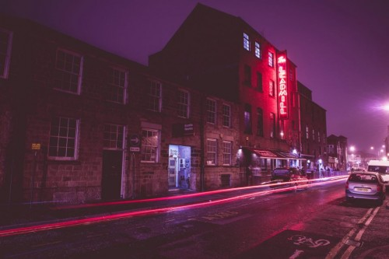
Figure 1: The Leadmill (Georgiou, 2013).

Location: Leadmill Road, Sheffield

Capacity: 800

Equipment:
PA: EV (some boxes with different drivers in)
Wedges: unknown, similar to Roadstar MR15s but lighter and smaller
Drum monitor: combo EV sub and custom top
FOH desk: Soundcraft Series 5
Monitor desk: SM12

Acoustic qualities:

The room itself has reflective bare walls, enclosing a large empty space; there are no pillars or room dividing walls. During live nights The Leadmill usually attracts a large crowd which helps absorb the reflective sound and thus vastly improves the sound quality. The width of the performance area fills the main width of the room, so the majority of the audience are directly in front of the stage reducing the need for in-fills to cover dead spots around the room. Although this is largely the case, ideally there would be an infill in the centre front of stage compensating for the dead spot created at the front of the PA system. The walls surrounding the stage are also very reflective. However, they have been improved by thick heavy drapes hanging on each side. The more absorbent a material, the less reflective sound is, which makes it easier in live sound reinforcement to control the sound and reduce feedback. For example drape is significantly more absorbent than bare wall, which is why they are often used to improve the sound quality of live venues and studios. (Davis and Jones, 1990, p. 55). With the use of drapes that minimise reverberation and resonances as much as possible, processors such as reverb units can be used to electronically create any warmth and body that the sound requires. Thus, the sound engineer can have relative creative freedom with minimised problem frequencies in order to produce the desired sound.

Signal Path:
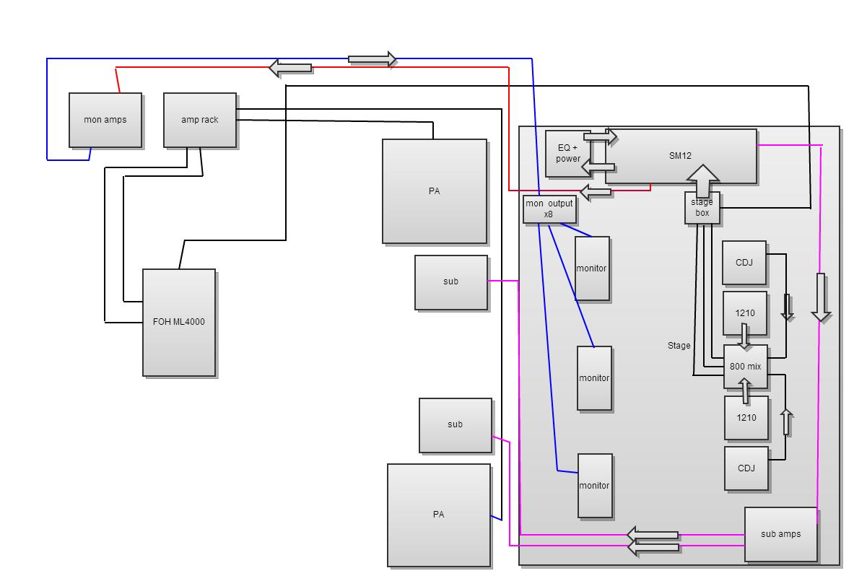
Figure 2: Signal Path of The Leadmill

The amp racks are stored in a separate room which makes it difficult to monitor during an event. This requires someone other than the sound engineer (who needs to be on the sound desk all night) to ensure sure the PA is not clipping. This necessitates constant communication throughout the night to ensure none of the equipment is damaged. The Leadmill is a medium sized venue. Therefore, I would argue that signal degradation from long cables is not much of an issue as the Front of House desk is not a great distance away from the stage. Everything is permanently installed, meaning all the cables are run over the ceiling and break out on stage which does mean if any damage occurred during the event it would be almost impossible to fix. However, this is unlikely to happen if a successful sound check has taken place, especially due to the fact that all cables are out of the way of both the audience and the musicians.

Venue two: The Octagon, The University of Sheffield’s Student Union

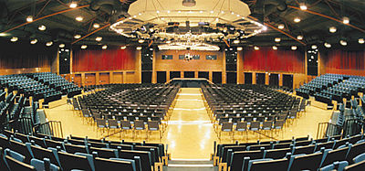
Figure 3: The Octagon Centre, (withUS, W.Y.)

Location: Western Bank, Sheffield

Capacity: 1600

Equipment:
PA system: Nexo Alpha
Amps: Custom Alpha rack (able to power 6x M3, 6x B1 and 4x S2 - 2xS2 on separate chain), Crown amps and Camco amps (Monitors)
Fills: 2x Betamax
Cables: XLR, 32amp, 16amp, NL4 and NL8
DJ Equipment: 2x CDJ 2000 1x DJM 800 1x SM58

Acoustic qualities:

The Octagon Centre is primarily a conference centre however due to the temporary closure of the Fusion and Foundry (the original venues for club nights at The University of Sheffield’s Student Union) it has been adapted as a club night venue. During conferences the upholstered seats help minimise resonances and reflections because they provide none reflective surfaces that absorb the sound. However, during club nights when there is no seating and with its unique shape seen in figure four, it is clear that sound will reflect off the walls at many different angles creating different level of volumes as well as dead spots throughout the venue. The reflective material of the walls and ceiling also increase the reflection of sound. There are curtains hung up in the upper half of the walls which helps to absorb some of the sound and during club nights drapes are hung from the ceiling which also improves the sound. This can aid the sound engineer when working at this venue, however it is often the case that the sound engineer has to use her ‘musical ear’ to work out where dead spots occur and use in-fills to improve the sound as well as reduce frequencies that resonate within the hall.

The other problem that The Octagon Centre presents is its capacity. Capacity is calculated by looking at floor space, fire exits and facilities such as toilets to ensure the venue is a safe environment for everyone in it (dcms, 2008). The Octagon Centre has a large floor space which is useful during conferences because the space is required for the temporary seating areas. However when the seats are removed, due to a limited amount of toilets and fire exits the capacity is relatively low in comparison to the floor space. Therefore, it rarely feels full even when it is at capacity and often the Student’s Union will not sell enough tickets to reach capacity. This means that there are less people to absorb the sound. Towards the back of the venue where it will remain relatively empty, the sound quality deteriorates. However this is not always a negative thing. Although it is frustrating during popular nights that the room cannot feel full, often the regular nights do not sell out. Therefore, because the sound quality deteriorates at the back of the hall it encourages the attendees to gather nearer the centre of the venue making them feel like they are part of a busier club night.
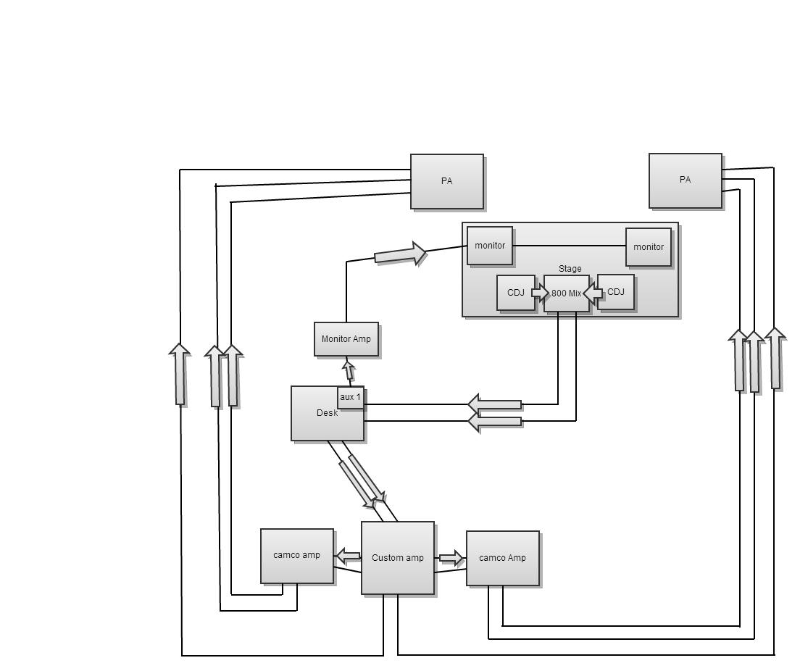

Signal Path:

Figure 4: Signal Path of The Octagon

All the equipment is in the one room which means amps can be easily monitored during the night. Long cables are run at mid-way height of the walls on installed hooks, and the PA is set-up at every event. This can cause technical issues with wrongly connected cables or broken cabs from moving the PA around however it is the only possibility at this venue.

Venue three: Bungalows and Bears
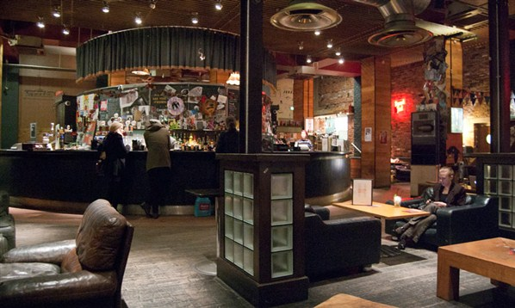
Figure 5: Bungalows and Bears (Leigh, 2011)

Location: Division Street, Sheffield

Capacity: 400

Equipment:
Desk: Yamaha LS9 Sound Desk
PA: Funktion-One Resolution
Monitors: varied

Acoustic qualities:
Unlike The Leadmill, Bungalows and Bears is primarily an eatery and bar not a live venue. This means that not a lot of consideration has been given to the acoustic quality of the venue. The walls are bare brick which has already been shown to have a low absorbency, causing sound to become greatly reverberated, leading to a lack of clarity in the music. The room is also a difficult shape. There are pillars in the middle of the audience area. The stage is very small in width which means the PA on either side of the stage covers only a narrow area of the venue. The seating areas towards the back of the bar do not have good sound coverage at all. However, this is in some ways desirable for the customers who are there to eat and socialise rather than watch the band. Live nights at Bungalows and Bears do not always attract a large crowd so as a sound engineer you cannot rely on a large audience to absorb a lot of the sound. However on occasion when there is a large crowd, the audience will receive different standards of sound depending on where they are standing because of the problems listed above.

Signal Path:
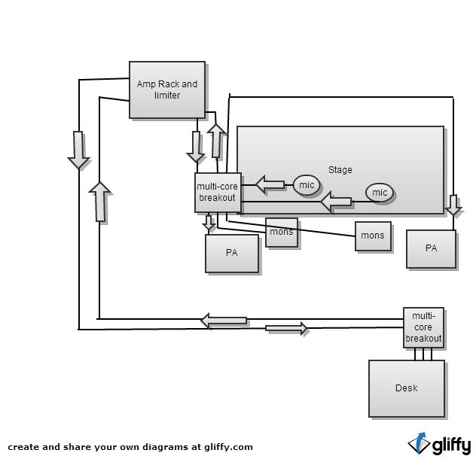
Figure 6: Signal Path of Bungalows and Bears

The sound desk is quite close to the stage so little degradation happens due to cable length. However the break-out box is on stage, and due to the small size of the stage, damage to cables can occur during the event. The amps are in a separate room, which only the manager has access to, making it very difficult to monitor the amps during the event. Inevitably, this causes the PA to be damaged on a regular basis.

- Diary Entries

The following diary entries explain in detail the process a sound engineer goes through by looking at a number of different events that range in venue, musical style and size, as well as looking at the differences between the role of a front of house engineer and a monitor engineer. It details the entire process, including the preparation done before the event to the performance itself. As well as discussing the communication between all the people involved within the performance. It also discusses the limitations and factors that impacts sound reinforcement and the creative decisions the sound engineer makes. Each entry will include a conclusion which explores the objectives listed in the introduction in order to investigate what the role of the sound engineer is outside of the technical elements.

Date: 23/10/2012

Event: Submotion Orchestra at TTC (The Tuesday Club)

Venue: The Leadmill

Position: Monitor Engineer

Photos: None

Floor plan:

Figure 7: Floor Plan of Submotion Orchestra

Microphones:
Kick (in) SM91
Kick (out) B52
Snare (top) e904
Snare (bottom) e904 (using the same mics on top and bottom helps with phase issues)
Snare 2: e904
Hat: C451
Overhead (L+R): 414
Drum Trigger 1: DI
Drum Trigger 2: DI
Conga: SM57
Bongo: SM57
Percussion Overhead: C451
Bass 1 - sub - DI
Bass 2 - mid - DI
Prophet 8 (L+R) - DI
Moog - DI
Laptop (L+R) - DI
Trumpet - 421
Backing Vox - SM58
Main Vox - Beta SM58

Band spec: Submotion Orchestra consists of seven members. Instruments included drums, percussion, bass, vocals, keyboards, trumpet and laptop.

Write-up:

Constructing the event
All the equipment that would be needed for the event was placed onto the stage before the band arrived, such as the mixing desk, EQ unit and DJ equipment. Once the band had arrived and set-up their instruments, the microphones listed above were placed in their correct positions. Choosing where to place a microphone is important to get right as it is essential that they are out of the way of the musician but able to capture the instrument. It is also key to use their directional patterns to minimise picking up sources of sound from different instruments on the stage (Stark, 2004, p.82). Microphone placement can also impact the sound itself. For example, if you point the kick drum microphone directly in front of the beater you will get a shorter, more defined beat in which you can hear the beater hitting the skin, whereas if you placed it inside the kick drum it would sound more ‘boomy’. Therefore the engineer can manipulate the sound of the instrument by placing the microphone correctly, reducing the need to EQ afterwards. This can be beneficial because overusing EQ can increase the chance of feedback and make the instrument sound unnatural. It also means less work for the sound engineer during sound check which can save time.

The drapes at each side of The Leadmill stage and the banners at the back reduced sound reverberation helping to minimise feedback. Three pairs of monitor wedges were used at the front of stage for keys, vocals and trumpet/laptop. The bass and percussion had single wedges and the drummer had specific drum monitors. The monitors were positioned directly behind the microphones, which were in cardioid configuration as the back of these microphones provides the least amount of pick-up thus reducing the risk of feedback from the monitor (White, 2003b, p. 142). Despite the attempts to minimise feedback, such as ringing out the monitors before the band arrived, with the large number of musicians, microphones and monitor wedges on stage, feedback was a concern. Ringing out the monitors is a technique where one person stands in front of a monitor wedge with a microphone, talking, shouting and/or singing whilst moving closer or further away from the wedge. As they do this, the sound engineer tries to eliminate any frequencies that are feeding back. This method is the most common way of reducing the risk of feedback. However, this method relies on an experienced sound engineer with good listening skills to complete the task proficiently.

Challenges
The equipment available only provided eight auxiliary sends, so some musicians had to share monitor wedges. The vocalist brought her own in-ear monitors which helped reduce feedback as the level of her own voice could be boosted in these rather than on her monitor wedge which reduces the risk of feedback. There were also side-fills available, which were used to put in extra vocals however these did not have a great sound quality and they also increased the likelihood of feedback occurring. During the performance, these were turned down and I would be reluctant to use them again. I tried to avoid boosting frequencies as this can often cause feedback.

Achieving the sound
Submotion Orchestra are a popular band – they are especially well known at The Tuesday Club because they regularly perform there. They also brought their own front of house engineer. Arguably, there was not the open communication as there would have been if I was sound engineering at a smaller venue, as the idea of ‘celebrity’ does create some barriers. For example, before and after the performance the band were in a separate room from the crew, resulting in little interaction between the crew and the band. As the monitor engineer, my focus was not on creating the overall sound for the audience but ensuring that each musician had the mix they needed in their monitor. My role involved talking with each musician in order to understand what they needed in their mix. The band were amiable and clearly experienced musicians because each one knew what they wanted in their mix, as well as understanding there are some limitations in what the monitor wedges can produce before feeding back.

It is also integral that the monitor engineer has a good relationship with the front of house engineer as the sound check happens together. For example, when the front of house engineer works on the kick drum channel, the monitor engineer also needs to process the kick drum to ensure it is working, as well as performing any processing on the channel that is required. Therefore, if there is a problem with an instrument on stage, which is the responsibility of the monitor engineer, it will also cause problems for the front of house engineer. During the sound check their front of house engineer was quite meticulous and spent a lot of time perfecting the sound which gave me plenty of time to work on the monitors. The Tuesday Club is a weekly drum and bass night usually held at the Student’s Union, but due to refurbishment has been temporarily moved to The Leadmill. The crowd expect a high level of volume as well as an emphasised bass sound, to enhance the ‘dance’ experience and create an atmosphere in which everyone wants to get involved in.

Processing
On the drum monitors, around 100hz was boosted because the drummer wanted a ‘punchy’ drum sound, meaning a sound in which the hit of the beater against the drum is more prominent and clear, as well as a sound with a short decay emphasising a clear and clean beat that can pierce through the rest of the instruments in a mix, especially the bass guitar which resides around the same frequency range. A slight boost at 3K allowed for more attack. The drummer wanted a high-end sound for more clarity against the other instruments, especially the bass which was loud on stage as well as residing around the same frequencies as the kick drum. 3k on the snare was boosted for more attack. Most of the other instruments went through a DI box, reducing feedback, allowing a clear signal to be captured and also being used as a ground earth. Mid-low frequencies were taken out of the vocals to stop them sounding muddy.

Conclusion
Although the sound of the main PA was not my responsibility, I was the engineer closest to the musicians and therefore it was my responsibility to remain calm and confident and help the musicians feel at ease before and during their set. This shows the integral role the sound engineer plays, because if they fail in creating this comfortable atmosphere it could in turn affect how the musician performs. In order to do this, I had to show strong communicative skills and converse with each musicians to ensure they had the right mix in their monitors and that they were happy with what they received. Finally, the most important role of a monitor engineer is to reduce feedback on stage so I had to work with the equipment I had in order to achieve this. I was limited in my auxiliary sends but generally I had high quality equipment which meant I could be free with my creative decisions. The vocalist’s in-ear monitors also helped to reduce feedback. I also used my knowledge of microphone placement to reduce feedback.

Date: 30/10/2012

Event: Gentleman’s Dub Club at TTC

Venue: The Leadmill

Position: Monitor Engineer

Photos: None

Microphones:

Kick (out) - B52
Kick (in) - SM91
Snare (top) - SM57
Snare (bottom) - SM 57
Snare 2 - SM 57
Hat - C451
Rack - e904
Floor - e904
Overhead (L+R) - 414
Bongo - SM57
Percussion Overhead - C451
Laptop (L+R) DI
Sub - Juno G (L+R) - DI
Keys - Juno G (L+R) - DI
Keys - Laptop (L+R)
Guitar - SM57
Trumpet - SM57
Sax - 421
Backing Vox (L+R) - SM57
Main Vox - Beta SM58

Band Spec: Gentleman’s Dub Club consists of eight members. Instruments included drums, percussion, bass, guitar, vox, keyboards, sax and trumpet

Write-up:

Constructing the event
Similarly to the Submotion Orchestra performance, all the equipment that would be needed for event was put onto the stage and set-up prior to the band arriving. This included the microphones that would be used (already decided and listed in accordance with Gentlemen’s Dub Club technical specifications) placed on their stands and put in relatively the right position, ready to be tweaked when the musicians had their instruments set-up. The time allowed for sound checking was limited. Gentleman’s Dub Club’s touring front of house engineer worked quickly which also meant time management was important when it came to EQing and setting monitor levels.

Challenges
Most of the instruments were electronic and captured through DI boxes which saved space on stage as well as reducing feedback. Not all of the channels from the multi-core to the breakout box worked so the desk had to be re-patched. The drummer had forgotten his tom stand which meant a make-shift one had to be erected. This caused the sound quality of the tom to deteriorate to the point where it could not be improved by any processing equipment on the desk. This emphasises the importance of making sure the sound being captured is as close to the desired sound as possible and not just relying on processing to create it (White, 2003a, p.52). The least amount of processing used the better, as processors can break or cause the instrument to sound unnatural. As stated in the previous diary entry, heavy drapes are hung on either side of The Leadmill stage to minimise reflections. Banners are hung from the back wall which also absorbs some sound, although not as efficiently as drape. This helps with feedback issues on stage. However feedback was a major concern because of the limited space on stage, the large amount of microphones and listening wedges as well as the band moving around a lot during their performance.

Achieving the sound
Similarly to Submotion Orchestra, Gentleman’s Dub Club are a relatively popular band and are also regular performers at The Tuesday Club, so the idea of celebrity can again cause a slight barrier to communication. My role was to operate the monitors, not the front of house sound so it was not necessary for me to study previous recordings. Gentlemen’s Dub Club were also confident and experienced performers and understood how to communicate what they wanted in each monitor wedge effectively, so I was able to give them the instruments and levels they wanted. The front of house engineer worked quickly and effectively, which meant I also had to work quickly creating some pressure on stage. There were some issues with patching which had to be communicated to the front of house engineer and inevitably caused delays, however the front of house engineer and musicians were quite relaxed and friendly which created a positive atmosphere. With the event being held at The Tuesday Club, the bass had to be distinct and run at a high volume to encourage a club night atmosphere.

Processing
A light EQ, slightly boosting 100hz was applied to the kick drum for more bass. 300hz was boosted on the snare for more snap at the request of the drummer. However, boosting frequencies should always be minimized as it increases the possibility of feedback. It is also more natural sounding if frequencies are cut rather than boosted (White, 2003a, p.44). Boosting should therefore be limited during sound reinforcement. As with the previous group, with only eight auxiliary sends some of the musicians had to share monitor wedges. Feedback was minimised by ringing out the monitors before the band arrived, however this technique can only reduce the risk of feedback and not completely eradicate it. The danger of ringing out the monitors is that frequencies can be cut that also make the monitors sound good and then musicians complain that their voice sounds strange. The monitor mixes were kept relatively quiet because I could hear some feedback during the performance. However the band did not ask for any alteration in their levels during the performance so it can be assumed that they could all hear themselves and the other instruments comfortably.

Conclusion
As with the previous event, my role was not to produce the overall sound with the PA but produce the mixes in the monitors. This meant I had to communicate with each member of the band to understand what instruments they needed to hear in their wedges and whether the levels were loud enough. It was therefore my role to appear calm and reassuring so the musicians felt confident to produce a great performance. Technically, my role as a monitor engineer was to minimise feedback so it would not impede the performance. Therefore, placing the microphones in the correct positions in relation to the monitor wedges was key, as well as ensuring the lowest amount of pick up on the microphone facing the wedge was used. It also meant utilising the sound dampening facilities present at The Leadmilll. Again, the equipment did not restrict my creative decisions too much, except for the limit of eight auxiliary sends available on the desk. This is because The Leadmill and the Student’s Union invests in good quality equipment which is well maintained and looked after.

Date: 07/01/2012

Event: SSE Audio Group PA demonstration (Nexo, L-acoustic and JBL)

Position: Attendee

Photos:

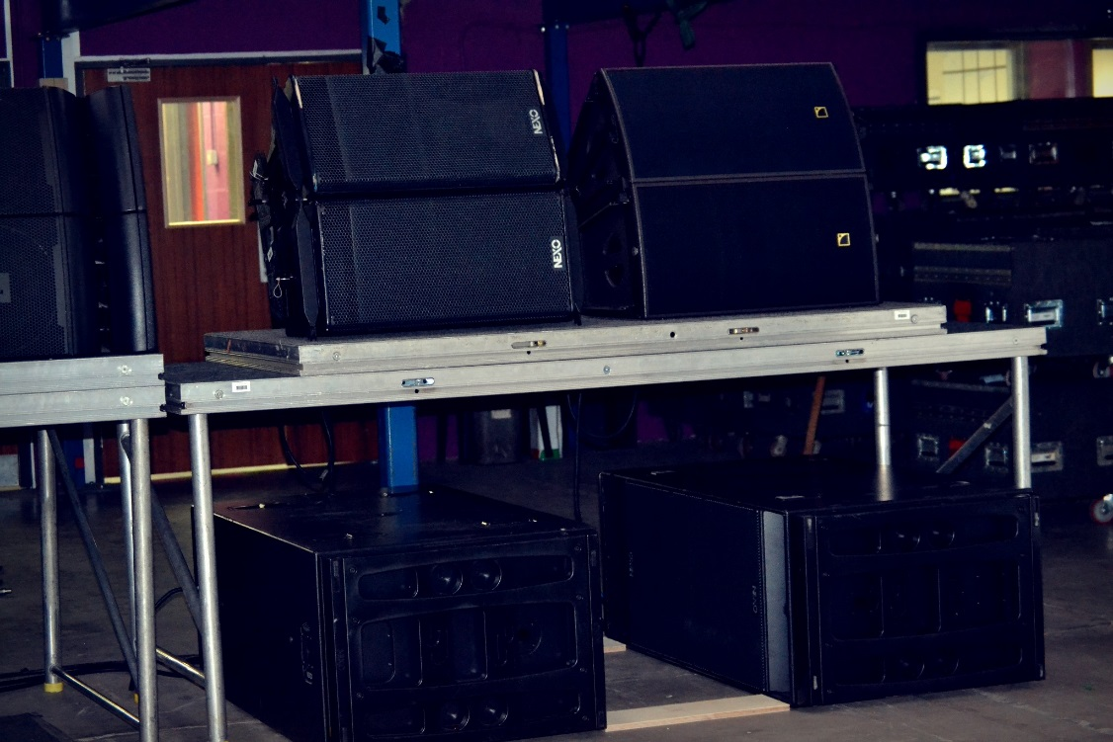
Figure 8: (clockwise from left) Nexo geo12, L-acoustic arcs wifo and Nexo rs18s
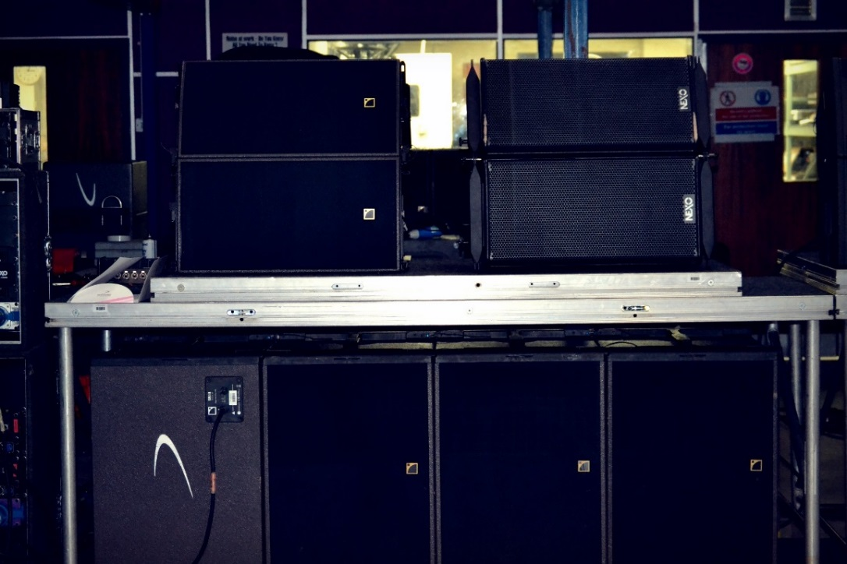

Figure 9: (clockwise from left) L-acoustic arcs aifo, Nexo geo12 and L'acoustic sb18s

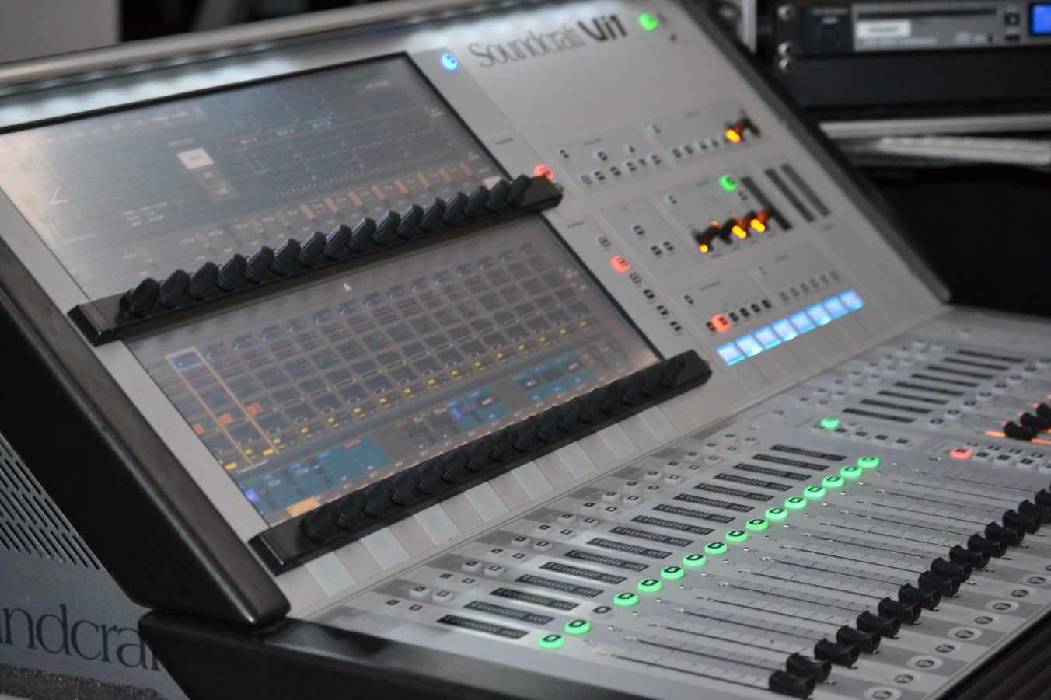
Figure 10: Soundcraft Vi1 digital desk
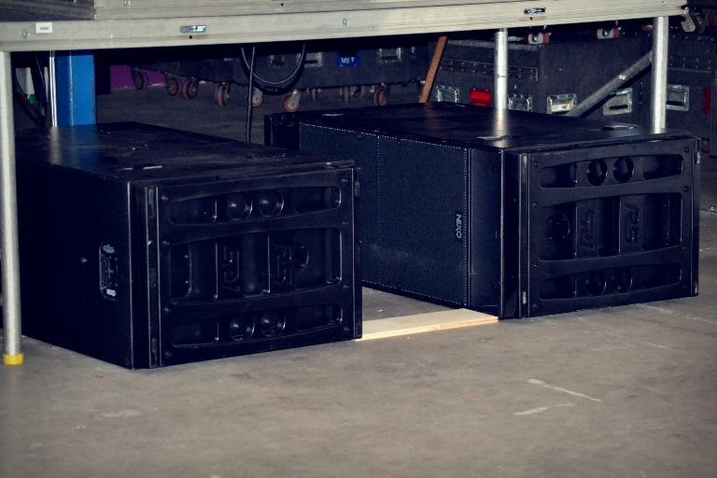

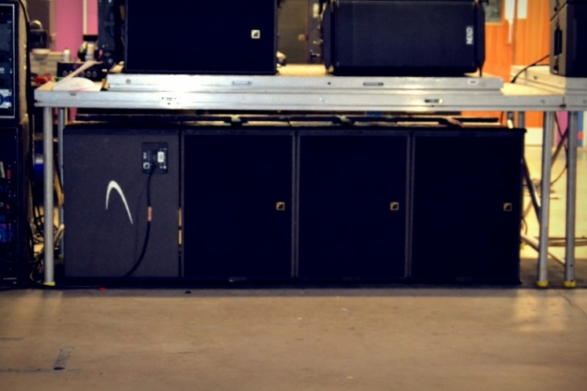

Figure 11: Nexo rs18s in the cardioid configuration

Figure 12: L-acoustic sb18s in the cardioid configuration
Write-up:

I visited SSE Audio Group to listen to two different PA systems which were being considered for part of a new install in the Sheffield University Union after the current refurbishment was completed. The main issues that were being discussed included:
1) Full coverage to eliminate dead spots on the dance floor
2) Reducing noise spillage out onto the street (after receiving numerous noise complaints last year resulting in the closure of the smaller room)
3) Trying to decide on equipment even though the complete architecture specification had not been given (such as stage size) and keeps on changing throughout the process.

During the tour of the facility we met a front of house sound engineer and a monitor engineer who had recently worked with UB40. They were programming a digital desk for the new Paloma Faith tour. I briefly spoke to them about the differences between audio and digital desks and which one they believed to be better. They thought that everyone should initially learn on analogue desks because it was easier to get the fundamentals of sound engineering and that they had often seen young people working who had no idea how to operate an analogue desk. They said it was much easier to work on a digital desk if you had the knowledge of an analogue one. They also said that analogue desks were ideal for festivals or within any environment where you had a very short time to mix because all the functions are clear, in front of you and that all analogue desks, no matter what make they are, operate in very similar ways, so it is easier to move from one desk to another. This is less applicable to digital desks which are much more difficult and require time to learn how each desk works. However, digital is ideal for touring. Most of the programming is done before the tour and then it is a matter of developing and tweaking the settings during the tour. However the monitor engineer did say that digital desks were making things far more complicated, as musicians have more of a choice and that the amount of different sounds and different levels the musicians wanted on each individual song was becoming unnecessarily complex.

Prior to the meeting, SSE Audio Group sent diagrams to the staff at the Student’s Union showing how they proposed to give full coverage of the Foundry (the main club room). They presented two options. The first and most desirable was to add a fourth stack of Nexo onto the main PA which would cover the sides of the venue better. This was also the most expensive option. This was the original plan, however due to shutters being installed at the front of the stage the architects said there would not be enough room, so another option needed to be presented in the meeting. However, just before the meeting with SSE Audio, we had been informed that there would be enough room to add the extra stack. The second option was to install fills using either the Nexo geos12 or the L-acoustic arcs wifo installed at each side of the stage with JBL VRXs positioned as delays at the back of the room, therefore giving coverage to the whole venue. This option was cheaper, however the main problem was that more sub would also be required. Last year, the sound engineers for Tuesday Club had started to put an extra sub pointing down stage left however this was not practical, very time consuming and aesthetically poor not to mention the risk the equipment took from being damaged by club night attendees since it was left unguarded on the dance floor. The only way of adding more sub without having an extra PA stack would be to put some under the stage in the centre but the TSC manager believed that most of this space would be used for storage. Therefore, even though the second option was cheaper, the first option was simpler and more appropriate.

The L-acoustic and Nexo products we were listening to were also being installed in room two and room three at the Student’s Union. One of the main problems with these rooms was that it was used as a food outlet during the day, so the subs would have to be installed underneath the seating in room two and both sets of subs were too large for this. They could be stacked horizontally or vertically (horizontally was more desirable for sound purposes) so it was decided that this issue would have to be discussed and negotiated with the architects. The subs were also too large to fit under the relatively small stage in room three. The main issue with room three was that it will be used for both club nights and live nights. Therefore SSE Audio Group came up with an idea to put the PA on a runner system so in ‘club mode’ the hi, mid, low part of the stack were at the back of the room. For live nights, they could simply be rolled forward to the front of stage. The subs would also be put on wheels so they could be rolled from the front to the back underneath the stage. Although the managers liked this idea, they did not believe it would be possible to get the architects to install a runner system and the stage was not large enough to fit the subs underneath. In terms of PA it was decided that the crew would be able to manually move the speaker system as they had been building a full PA stack in the Octagon all year. The subs were more difficult and it was left to be debated with the architects.

The most impressive demonstration was their solution of eliminating the sound issues in rooms two and three where noise was spilling out into the residential area. The subs were put in hyper-cardioid and then placed with one or two (depending on the brand) 180 degrees away from the others. This creates wave cancellation so very little sub is thrown backwards, producing more directional and therefore more controllable subs. The effect was impressive. The back of Nexo rs18s shown in figure twelve were almost inaudible. These have two front drivers and two back drivers within each sub. The L-acoustic sb18s were also impressive but the effect was not as exact as the Nexo. As seen in figure thirteen, only one sub of the L-acoustic brand was reversed which caused wave cancellation but not as effectively as having two subs facing backwards. However, it did mean there were three, not two subs pointed forward which gave a better sound quality than the Nexo on the dance floor.

After the sound demonstration it was generally agreed that L-acoustic was the better system. Although the Nexo did have more punch, which is ideal for a venue that is focussed on rock music, the L-acoustic had a warmth that is perfect for club and pop music. The L-acoustic complimented a wider variety of genres of music rather than the Nexo. Both the Nexo and the L-acoustic have a similar frequency range, with Nexo’s 50hz-20khz and L-acoustic slightly smaller 55hz-20khz (these lower frequencies perhaps explain why the Nexo has more punch that the L-acoustic), however the difference which seems to make the L-acoustic stand out is the way in which L-acoustic has shaped their speakers. Instead of the traditional trapezoidal shape that Nexo has, the constant curvature and spherical wavefront HF driver means that they do not interfere as badly with each other minimizing comb filtering effects (L-acoustic, W.Y.b). The other problem Nexo has is that the trapezoidal shape of their cabs do not correlate with their dispersion, unlike the arcs (Nexo, W.Y.). The L-acoustics also have a higher SPL at 135db compared to Nexo’s 103db which explains why the L-acoustic were much brighter and louder (Nexo, W.Y.; L-acoustic, W.Y.a).

Date: 19/01/2013

Event: Pop Tarts

Venue: Octagon Centre, Sheffield Student’s Union

Position: Sound Tech

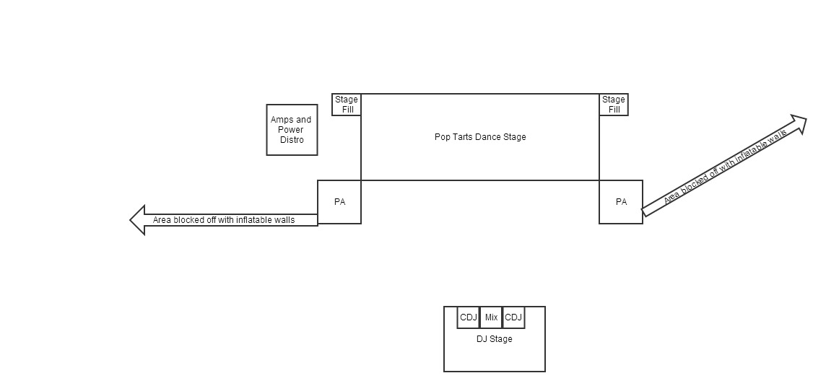Floor Plan:

Figure 13: Pop Tarts Floor Plan

Photos:
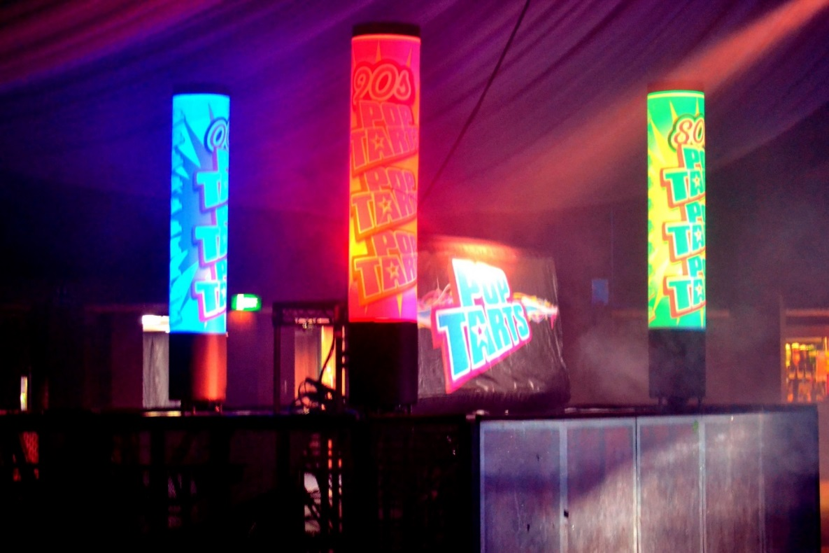
Figure 14: DJ stage facing main dance stage and PA
Figure 15: Dance stage with PA stacks either side, centre truss above and inflatable projection screen at rear

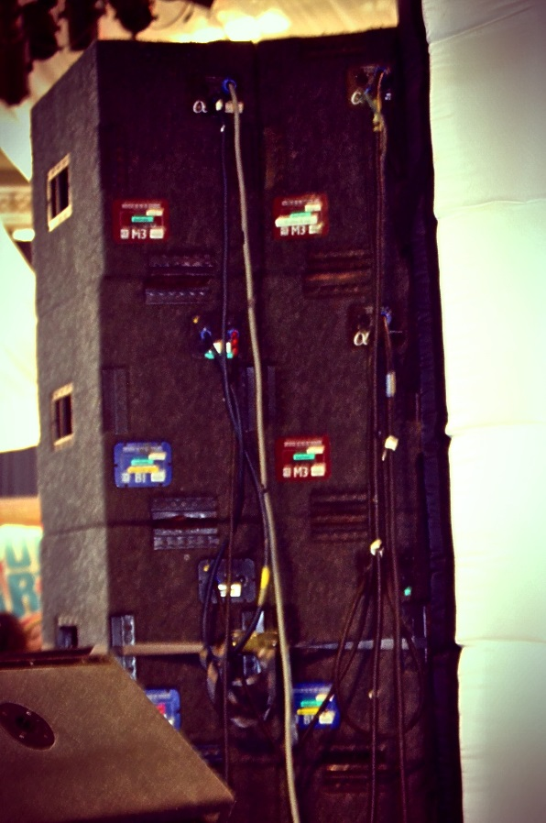

Figure 16: PA chains

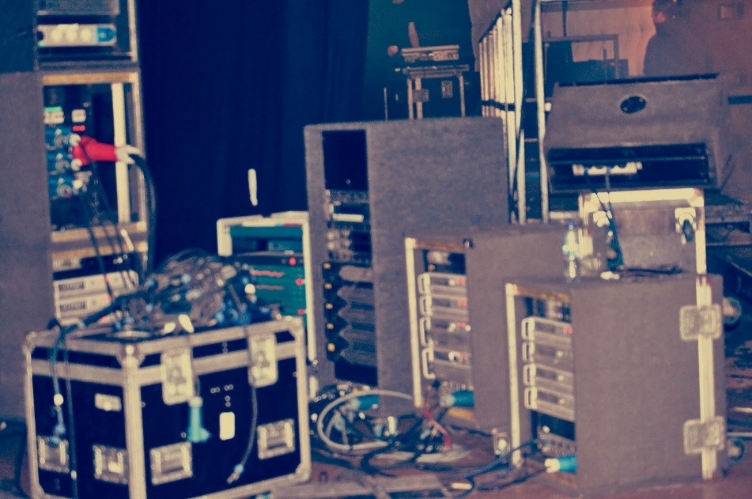

Figure 17: Amps and power distribution

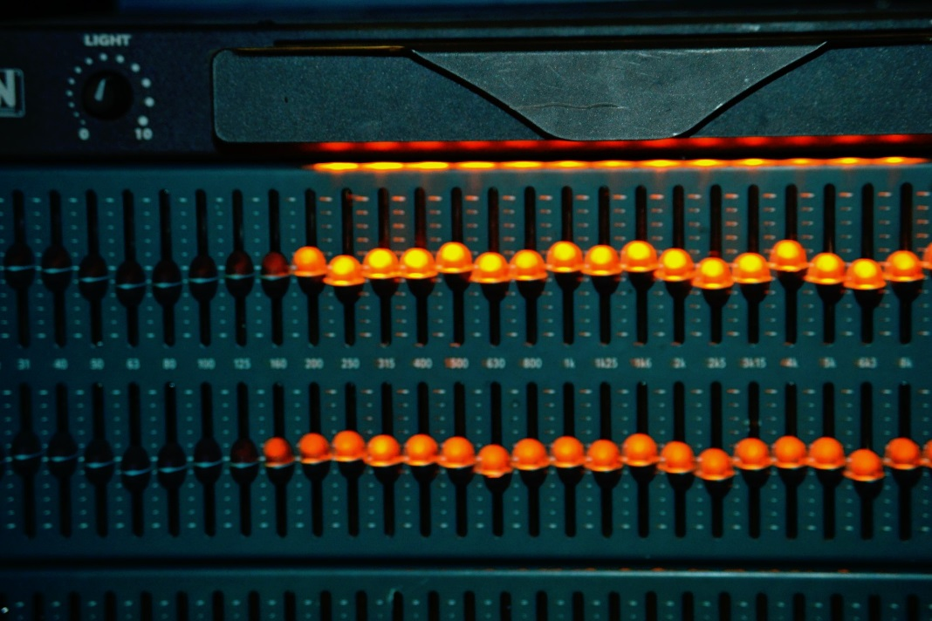

Figure 18: Room EQ

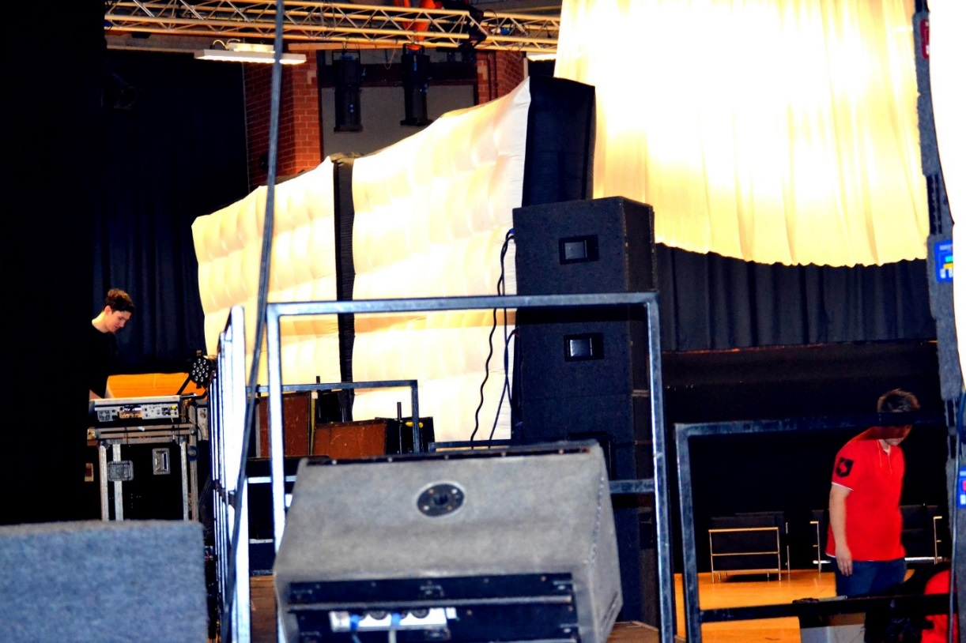

Figure 19: Inflatable walls used to shorten room

Write-up:

Constructing the event
In the day time the Octagon Centre operates as a conference venue which means club events such as Pop Tarts have to be built from scratch (stage, PA and lighting rig). Working at Pop Tarts requires long, physically demanding shifts to transform the hall. After the event everything needs to be taken down to ensure it is suitable to be a conference centre again by seven the next morning. The hall was reduced in size by half because turn-out was expected to be low. This was achieved by hanging a drape from the centre truss, creating the illusion of a wall. This also helps to reduce resonances which are common in the large hall because of its size and oddly shaped walls. By using steel deck and inflatable walls the room was divided in two. The DJ stage was positioned by the front doors, facing the inflatable walls and the dance stage. The PA was positioned at each side of the dance stage pointing at the DJ which meant the DJ did not require monitor wedges. Instead, we used the Betamax monitor wedges as in-fills to cover the dance stage (positioned behind and between the PA) to cover the dead spot that occurs in the front centre of the dance floor.

Challenges
The PA stack was significantly reduced; using only two subs, three M3s and three B1s. This reduced coverage was an effective way in which to draw the crowd into the centre of the hall so it would feel busier, rather than having the crowd dispersed throughout the venue. Due to the small stacks there were not too many cabs running on one chain; one B1 and one M3 on a chain and one B1, one M3 and one S2 on a chain. This meant that the amps could be run fairly hard without danger of them going into protect mode and possibly damaging the PA. An amplifiers role is to increase the power of an audio signal. Ohms law becomes an essential equation in audio physics when trying to determine how much power a loudspeaker can take before it becomes damaged. Ohms law is;
I (Current) = V (voltage in volts) ÷ R (resistance in ohms).
This can be algebraically changed to calculate any of the elements in this equation;
R = V ÷ I
V = I * R (Davis and Jones, 1990, p. 194).
When connecting speakers in parallel to the same amplifier, the voltage does not change. If we have an amplifier that gives out 10 volts, with a speaker of 8 Ω it will draw 1.25 amps. When adding another speaker the amps being drawn will double to 2.5 amps, and three speakers will draw 3.75 amps and so on. When there are too many speakers drawing too much current from the amplifiers, the amplifiers start to smoke and can become permanently damaged.

As these speakers draw more amps, the impedance of the circuit decreases. When three speakers are added, 10 V ÷ 3.75 A = 2.67Ω. As more speakers are added the impedance of the circuit decreases. Generally the minimum load impedance can be found on the amplifier, and the impedance value must be total or greater than this otherwise the equipment may be damaged (Preston, 2011). In terms of The Octagon PA system and amplifiers, each side of the custom rack can power three M3s, three B1s and two B2s per side, with separate outputs for Sub (Gardner et al, 2011, p. 48). The less that is run on each side of the amp ramp, the better the performance from the amplifiers. This is why it is better practice in smaller sized venues to run a smaller PA system.

Achieving the sound
Pop Tarts is a weekly club night at the Student’s Union, which usually plays the same style of music. In the main room it tends to be nineties pop music as well as modern day chart music, whilst the smaller room plays pop music from the sixties and eighties. These are generally poorer quality recordings burnt to CD rather than the mastered recordings used in the main room. The volume needs to be continuously loud and the bass still needs to be prominent as it is a dance event, however this can be significantly less that The Tuesday Club as pop songs have more of a focus on the melody. The vocals and guitar lines need to be clearly coherent as these are often the focus of the music and students enjoy singing along during the event. The same DJs are used each week, so the crew know what each DJ requires and communication between the DJ and crew is open and friendly. This is further emphasised because it is a Student’s Union in which most of the DJs work for the University in some capacity and the crew mainly comprise of students. Thus, there is a very welcoming atmosphere between all involved in the event.

Processing
In terms of EQ I cut a lot of the bass (60hz-100hz) because the PA had a heavy sub sound due to the smaller stacks. I also cut at 6k3 and 12k6 as these tend to be harsh frequencies that resonate badly in the Octagon.

Conclusion
It is the sound engineer’s job to understand the style of music and use their musical skills to ensure that the processing used is to enhance the sound. In this instance, knowing the night plays pop music helps the sound engineer know what frequencies need to be more prominent. When the sound engineer achieves this they can enhance the club night feel to a venue creating a more enjoyable experience for the attendees of the event, thus showing the integral part a sound engineer plays at a club night. The complexities of PA placement also show some of the technical challenges a sound engineer has to work with in order to produce different sound effects. In this instance using the PA’s throw can improve the evening by ensuring the crowd collect together making them feel part of a busier event, even if a limited amount of tickets have been sold. They must work the PA without damaging it, using the amps that are available in the best possible way. They therefore must achieve something musical using their technical abilities. Regular nights also offer the opportunity to form strong relationships with the DJs as well as the rest of the crew, which can help nights run smoother. Knowing the kind of requests a DJ may ask for and understanding what they expect the room to sound like prior to them even turning up can help save time and stress.

Date: 25/01/2013

Event: Space

Venue: Octagon Centre, University of Sheffield Student’s Union

Position: Sound engineer

Photos:
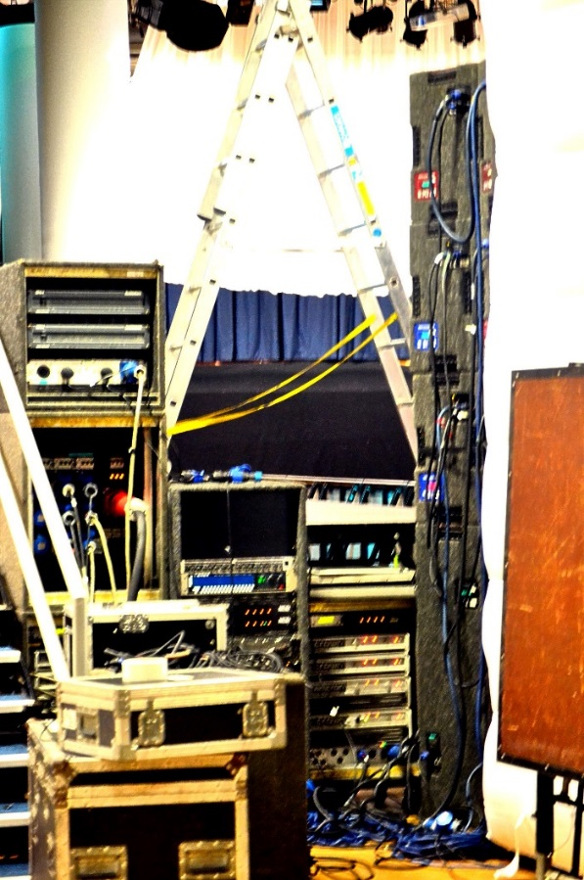

Figure 20: Amps and power behind the left PA stack

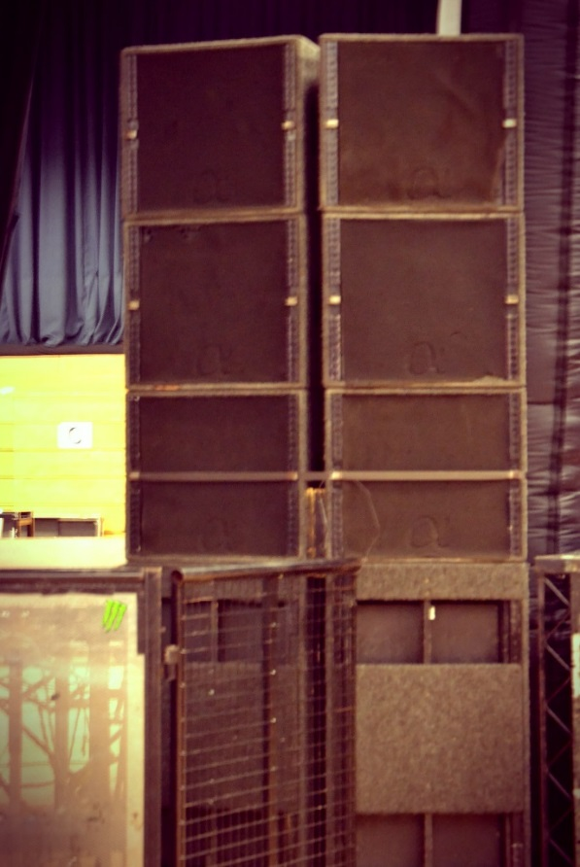

Figure 21: Right PA Stack
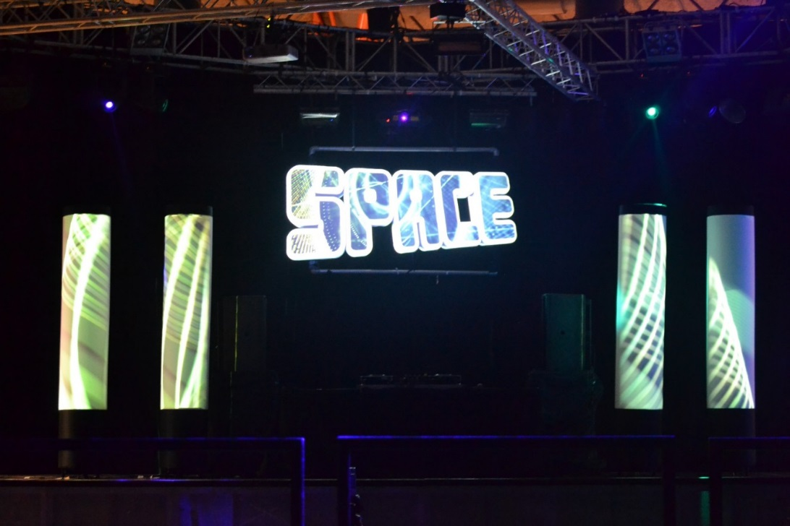

Figure 22: Space stage

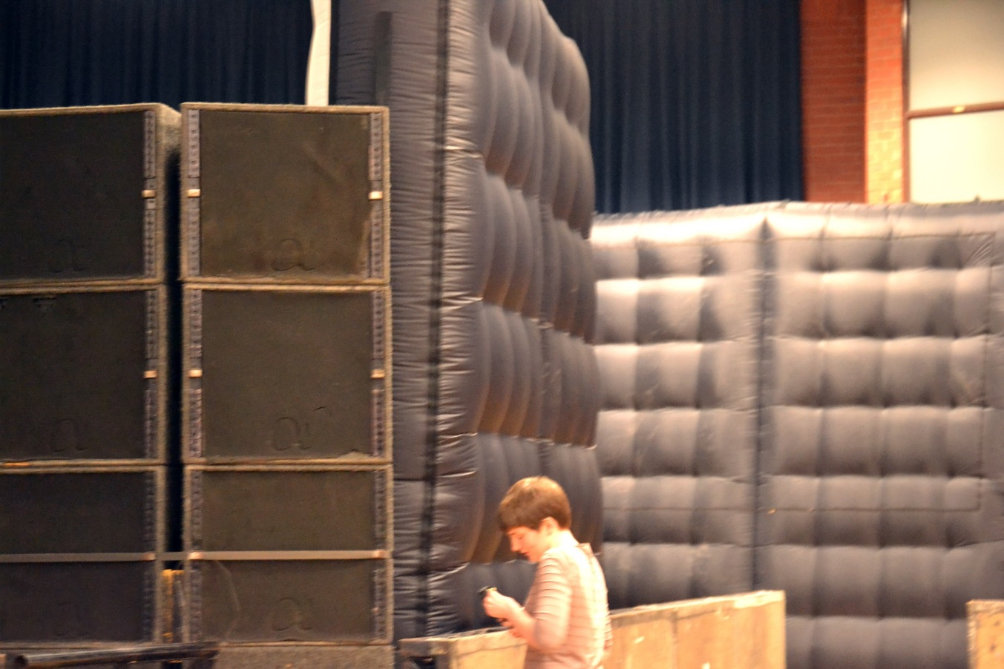
Figure 23: Space inflatable walls
Write-up:
Constructing the event
The same reduced PA stacks (three M3s, three B1s and two S2s on each side) that had been erected the previous week at Pop Tarts were used because the room was yet again reduced in size due to an expected low turnout. The only difference was that I ensured the stacks were given a wider dispersion to cover more of the room. Again, a huge drape was hung at the back of the centre truss which was good for absorbing a lot of the sound reflections. The octagon is not acoustically an ideal venue for sound events as the eight bare walls cause sound to greatly reverberate, creating distracting echoes and causing an uneven distribution of sound due to resonances. The main stage was positioned between the two PA stacks. The fills were not required during this event because the dead spots in front of the PA were minimal, helped by the better dispersion by the PA. The DJ had two Betamax listening wedges in mono.

The custom Alpha amp rack used at the Student’s Union is of a much better quality than the Crown amps, so the large chain of one S2, two B1s and two M3s was loaded onto the Alpha, as well as the other S2 on the individual sub channels also found on the Alpha. The remaining B1s and M3s were connected to the Crown amps. In practice, it is always better to have the same quality amps, with the same number of cabs running on them to get a consistent signal level and sound quality across the whole of the PA system. However, this is not always the reality in terms of what equipment is available. The better amps were used on the inside cabs on the PA stack as these were the speakers pointing directly to the majority of the crowd.

Challenges
The first DJ sent a hot signal, a sound engineering phrase which means sending a high signal level which can cause distortion, forcing the amps to go into protect and if not altered can cause permanent damage to the PA. The custom Alpha amps were struggling with the amount of bass signal being sent. First of all, the bass was cut slightly in the EQ to try and resolve this problem. However the amps were still going into protect so the only other alternative was to turn the PA volume down about 3db. Whenever turning the whole PA volume down during an event it is best to do it gradually during a quiet part of a song to make it less audibly noticed by the audience.

Achieving the sound
Space, similarly to Pop Tarts is a weekly club night at the Student’s Union which primarily plays modern day chart music, both pop, electric and hip hop among other popular genres. Therefore there is a prominent bass feel, more so that Pop Tarts because of the emphasis on dance music however less than The Tuesday Club which plays drum and bass, dubstep and grime. Some of the DJs work at the University however they also use outside DJs. Taking this into account, there is still open communication and it is expected that throughout the evening the crew will go and ask the DJ if everything is ok and whether they need anything. Sound levels need to be quite high to create a club night environment.

Processing
Similarly to Pop Tarts I cut some of the bass (60hz-100hz) because the PA had a heavy sub sound due to the smaller stacks, however not as much as the previous week since it was important to keep a club night feel to the event. I also cut at 6k3 and 12k6 because they cause resonances in The Octagon.

Conclusion
Again, in this instance the sound engineer has to be able to achieve the musical preferences of the event. For Space, this means ensuring the bass is powerful to encourage dancing whilst not drowning out the melody lines, which is still essential within chart music. I achieved this by cutting out some bass from the PA which was bass heavy because of the reduced stacks, and by pointing the M3s which were at the top of the stack down towards the audience so they would still be able to hear the higher frequencies clearly. Again, this shows that the sound engineer is integral to creating the overall feel of the night, doing so through their knowledge of the equipment. Although the amps do cause some limitations for the sound that can be achieved, it is still possible to create an even sound over all the amps by loading more cabs onto the better amps. I would also argue that having the ability to build a PA from scratch, although being more time consuming as well as sometimes causing technical issues gives the engineer more creativity in what they can achieve. By adjusting the splay, size and the angles of the PA, different effects can be achieved. This method was utilised at Space in order to make the room feel busier than it was. Having a friendly relationship with the DJs at Space and knowing what type of music they play helps the sound engineer have a good idea of what they should be achieving prior to the event which helps the event run smoother.

Date: 05/02/2013

Event: Joy Orbison at The Tuesday Club (TTC)

Venue: The Leadmill

Position: Sound engineer

Photos:

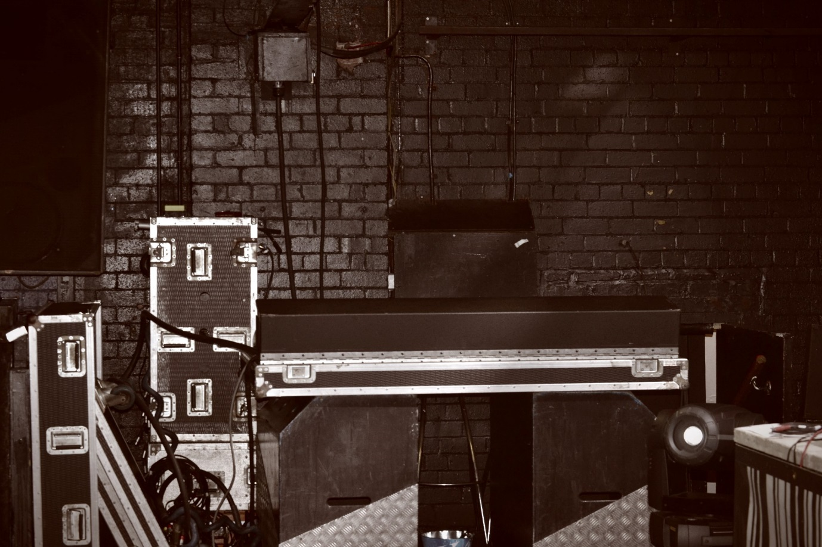
Figure 20:The Leadmill monitor desk

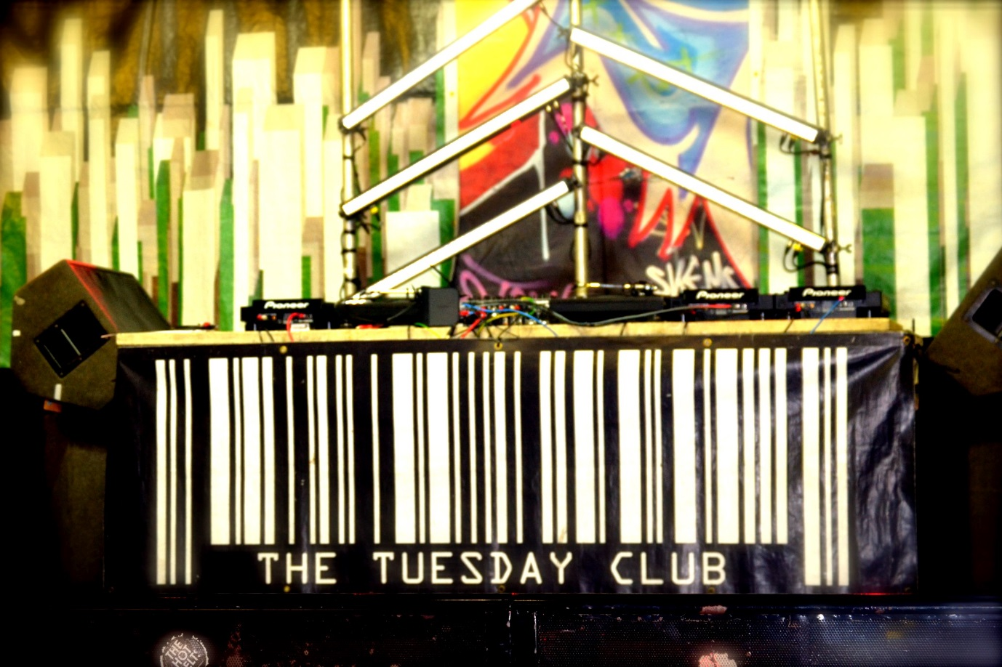
Figure 21: The Tuesday Club DJ desk
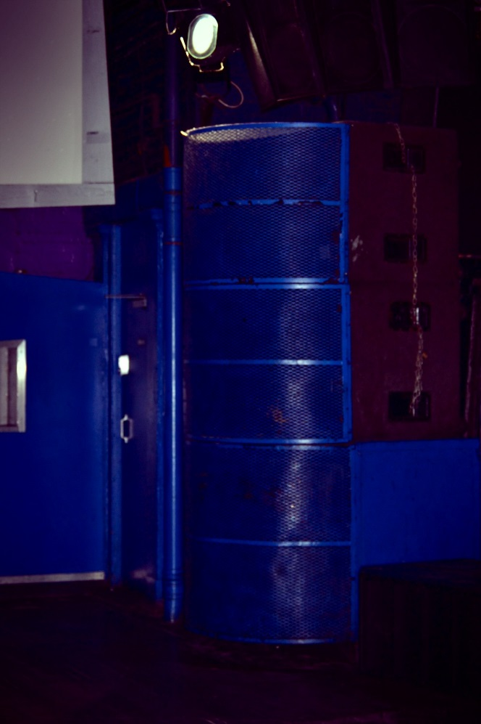
Figure 22: Left PA stack

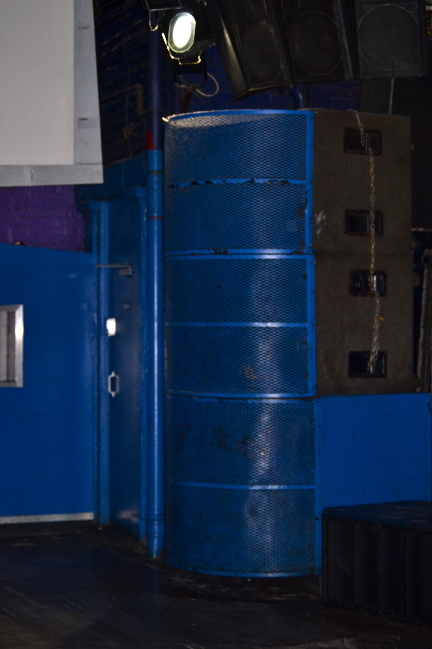

Write-up:

Constructing the event
This event was at The Leadmill so there was no staging to build and the in-house engineers had already set up the sound desk. On arrival the two sound engineers were taking some level readings. There had been some noise complaints and the in-house engineers were required to monitor sound levels during the night to ensure the limit was not exceeded. The setup continued as normal and with only several DJs playing I was only required to set-up the decks and sound check the room.

Challenges
Just before the event opened there was a meeting with the sound engineers, The Leadmill House Manager and The Tuesday Club Manager in which The Leadmill House Manager expressed the importance of not exceeding the sound limit. If exceeded, the consequence would be a substantial fine. Noise complaints have become an issue in all of the venues within these diary entries. One had to close down part of their venue, significantly reducing the amount of people that could attend the events. The law states that noise pollution is a problem when it becomes a statutory nuisance, defined as ‘noise emitted from premises so as to be prejudicial to health or a nuisance’ (Chartered Institute of Environmental Health, 2013). It is the duty of every local authority to inspect premises on occasion to check if there is any statuary nuisance and to take any steps needed to prevent it happening. Noise is obviously a serious problem which can disrupt people’s lives if they live near music venues. However, clubs are suffering greatly from trying to maintain the ever stricter noise levels enforced on them by the environmental office. This is why it is so important that companies such as SSE Audio Group research new ways to combat noise pollution, for example the cardiod figuration of the subs discussed in a previous diary entry. In the future, I believe that clubs will have to spend a great deal of time and money trying to come up with ways of sound proofing their venues as the risks of getting noise complaints is becoming a greater issue with nights being closed down and up to £20,000 fine being issued.

I made the decision to set-up the sound desk side of stage in order to save floor space. I made this decision because there were only DJs playing, which meant I would not be doing any live mixing so it was not necessary to be facing the stage. However, the in-house engineers were monitoring the sound levels from the back of the dance floor, facing the front of the stage. Due to the distance between us, we had to communicate through a coms set (a set of headphones with a microphone attached) which was challenging to use during the event because of high noise levels. If I have had previous knowledge of the sound limits before setting the desk up, I would have set-up the desk front of stage in order to have direct contact with the in-house engineers. The first act went well and the system was run at 0db. However when the main act arrived on stage, the sound limit was exceeded several times. The main issue was that the stereo out faders had no peak lights and the SM12 only shows the level pre-fade which meant only the level being sent by the DJ could be monitored. The DJ sent a high signal level, so the in-house engineers kept sending messages to turn the volume down. However, I was unable to clearly hear the main PA over the DJ monitors which were pointing directly at me, and eventually the main PA was turned down too much. After the DJ complained, I then turned the level back up to 0db. However, then The Leadmill House Manager came on stage and insisted it was turned down because the sound limit levels were being exceeded. After this intense period, communication between me and the sound engineer was much more thorough and they kept me updated consistently with the noise levels. The DJs were not pleased however this issue had to be dealt with by The Tuesday Club Manager as it was his responsibility to manage the acts. To keep within the noise limits I had to run the night at below 0db with no subs as whenever I attempted to turn the subs up I was told to turn it down, so overall the sound quality was poor.

Achieving the sound
The Tuesday Club often have big name DJs play and it is not uncommon to have little to no communication with the DJs. They arrive with a high expectation of sound quality which is usually delivered (although on this occasion unforeseen problems compromised the event). There is an expectation of a very high level of volume and prominent bass in the sound. On this occasion the DJ was quite hostile towards me because of the sound problems. Although there were errors I do not believe it is ever useful to cause conflict with anyone involved in the event, as everyone should have an understanding that things can go wrong and problems can be solved quicker if all parties remain calm. However this is not always the case. I believe the sound engineer’s role is to reassure the musician and continuously communicate with them if a problem does occur so they understand what is going on. This is important because their frustration might stem from not understand the sound problems that are happening. This is what I attempted to do during this event when there were significant problems with the sound.

Conclusion
Although club night attendees often have a high expectation of sound, especially concerning the level the music is played at, the sound engineer has to work within the constraints of the noise limits. During this event I should have had a better understanding of these limits, perhaps monitoring it myself in order to avoid the problems I came across. It also requires good communication skills between the promoter and the engineer in order to discuss these limits which was not achieved during this event. However there are ways in which engineers can improve the sound without breaking these limits. If the PA in The Leadmill was adjustable, it could be directed more towards the centre of the dance floor thus creating an area where those who wanted a louder sound could gather. We could also utilise the methods learnt at SSE audio and create directional subs which would minimise spill outside of the venue. The sound engineer becomes integral in exploring these possibilities and using acoustic techniques to ensure the venue is as sound proofed as possible. This event also shows that sound engineers are always working within limits to achieve the sound they want, in this case that meant lowering the volume of the PA.

Date: 19/02/2013

Event: Toddla T at TTC

Venue: The Leadmill

Position: Monitor Engineer

Photos:
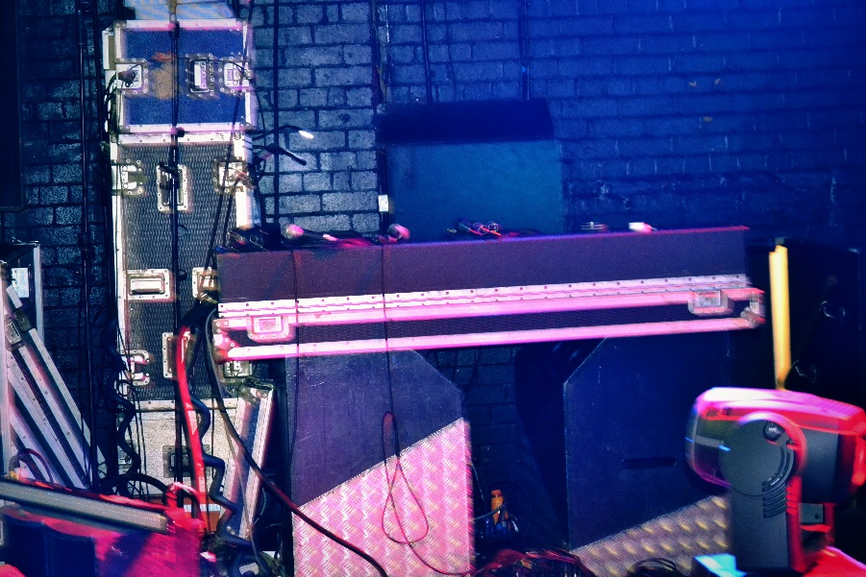
Figure 23: Monitor Desk
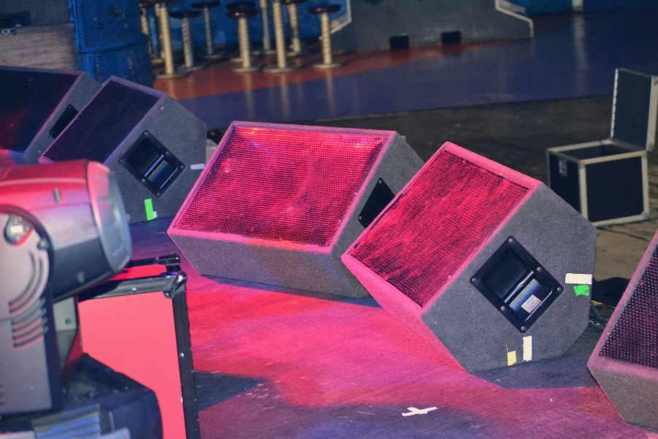
Figure 24: Vocal centre monitors

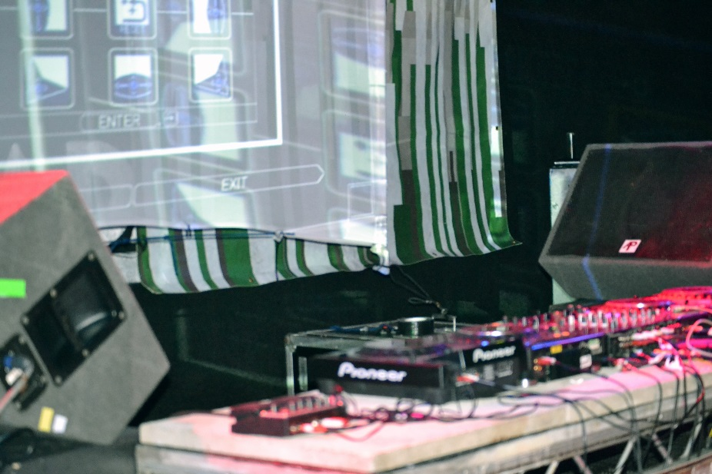
Figure 25: DJ monitors, DJ set-up

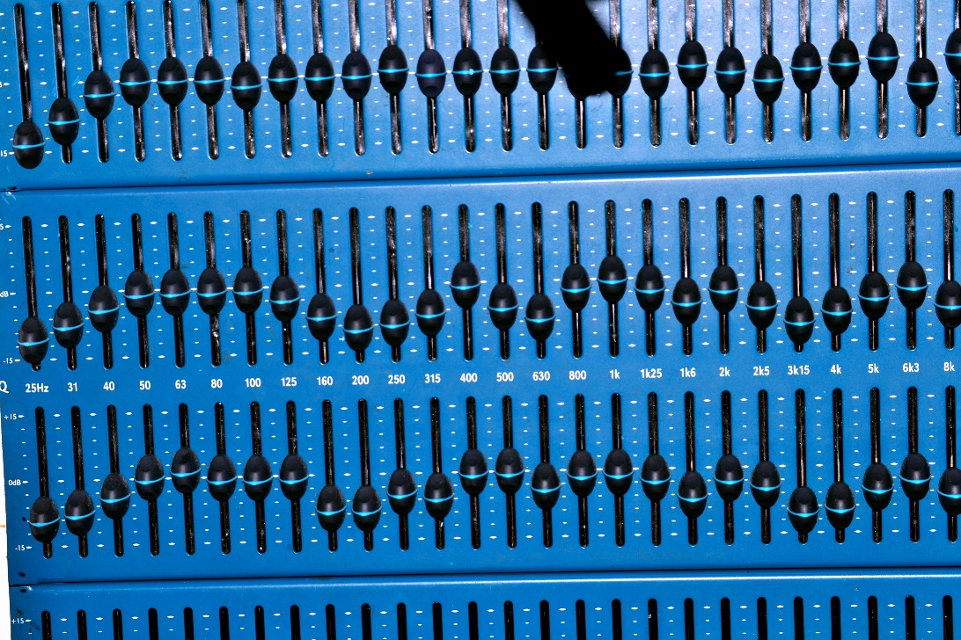

Figure 26: EQ for monitor wedges

Microphones:

3x Radio Mics
1 x SM58

Band Spec: DJ + Vocal mic, 2xMCs and 1xVocalist

Write-up:

Constructing the event
The venue set-up required a monitor engineer at side of stage and a separate front of house engineer. To begin with, the monitors were positioned and plugged into the monitor output box which was connected to the desk. The DJ equipment was then setup and enough stage power was provided for the entire band. The band had asked for four pairs of monitor wedges, one for the DJ and three pairs for each vocalist. It is common just to have the DJ monitors in mono however they were put in stereo for a better sound quality. Three radio microphones were used which required the set-up of a signal box, and then the XLR was taken from the signal box and inserted straight into the desk. Radio microphones have the advantages of freedom as the singers can move around without the risk of pulling or tripping on cables. The performers from this event did a lot of jumping around on stage, as well as going crowd surfing, so it was important they had nothing constraining their movement. However radio microphones also produce some technical problems. To begin with, a lot of the controls are on the microphone itself. During the show, the signal from the radio microphones were clipping badly, but the internal microphone pad could only be accessed on the microphone. Between songs the performers came off stage, which is when I had to quickly put the pad in. There are also other problems with using a radio microphone including, 'calculate transmission loss between transmitter and receiver through use of an isotropic antenna’, ‘difficulty in designing antennas that are small but efficient in the VHF low-band area' as well as '[i]nterference from other radio services is the major problem' (Davis and Jones, 1990, p. 141). This means that signal can be interfered with during the performance of which the sound engineer has no control over. During this performance however there was no interference, but there were problems with distorted signal into the desk.

Challenges
I used a lot of EQ on the monitors because of the nature of the event. Usually, the method to reduce feedback on vocals is to use cardioid configured microphones and place the monitor wedge directly behind because this is where the microphone has a minimum sensitive pick-up. However, the vocalists were moving around during the set, meaning the positions of the monitor wedges would be insignificant. The low frequencies were cut to make the wedges sound clearer. The monitors were also rung out before the sound check began to try and eliminate the worst offending frequencies. The two male MCs had loud vocals and did not require much of their own voice turned up in their monitor wedges because they felt they could hear themselves well enough through the main PA. The female singer had quite a high level of herself in the centre wedges because this was her primary position on stage. I then added a small amount of her voice in the side wedges for when she moved around. The DJ had control of his own monitors, which he ran extremely loud so it was not necessary to put any through the front monitors. No vocals were put through the DJ monitors.

During the performance, sound engineering was challenging because all vocalists were moving around and coming on and off stage for different songs. The DJ also sent his signal at +15db which meant it was mostly in the red and therefore clipping, so I had to turn the faders down quite a bit. Footage of the event can be found at livesandlevels (2013). This video shows the style of the performance, highlighting the type of challenges that occurred during Toddla T’s set. When performers move around like this it is likely to cause feedback. During the performance it was a case of 'riding the faders' - a sound engineering term meaning that you have to manually turn the faders up and down, depending on who is singing and what they are doing. The female singer’s monitor had feedback during her performance because when she stopped singing she would point the microphone out to the crowd to encourage them to sing, however by doing this she was also pointing the microphone directly to the monitor wedges which caused feedback. The faders therefore had to be turned down when she stopped singing. Although not ideal, this method worked resulting in very little feedback during the event. All the performers seemed pleased with the performance.

Achieving the sound
Toddla T was a very popular act to be booked during the event and I had no contact with him. I did speak to the MCs and singer that were performing with him as I had to discuss their monitor mixes, what instruments they wanted to hear and whether they sounded ok during the sound check. However, it was quite difficult communicating with the performers as they would report any problems with their monitors to their front of house engineer rather than me directly. This meant I either had to try and over hear what was being said or the front of house engineer would tell me to change something. This made the sound check more challenging than usual as I would normally communicate directly with the performers. When the DJ was sending high signal to the desk I also felt like I had no authority to ask him to turn it down, something I would normally do at Pop Tarts or Space, where the crew have friendly relationships with the DJ. This highlights the importance of this research. By showing the significance of the sound engineer and the creative role they play, musicians can understand their role and feel more comfortable communicating with them.

Conclusion
It can often be challenging for a sound engineer when there is not the freedom to communicate with the musicians because of a celebrity status. When the DJ sends a high level of signal to the desk, which clearly deteriorates the quality of the sound and the DJ cannot be spoken to, this requires the engineer to continuously turn down the level and accept the degradation of the quality of the sound. This proves the importance of having an open environment in order to communicate with people otherwise the sound quality can be affected. It is also the sound engineer’s role to work with different musicians as well as different styles of performance. In this instance, I adapted to musicians moving around the stage and constantly changed the monitor settings in order to deal with this movement. Having access to expensive equipment such as good quality radio microphones also helps. In the smaller venues where radio microphones are not available, a musician’s movement around the stage could cause feedback issues. Again this event highlights the integral job of a sound engineer, because without a sound engineer being flexible and able to deal with movement, the musician would be unable to perform however they wanted without the sound being compromised.

Date: 04.04.2013

Event: JAWS, Tropic of Youth and Playlounge Live

Venue: Bungalows and Bears

Position: Sound engineer (FOH and monitors)

Photos:
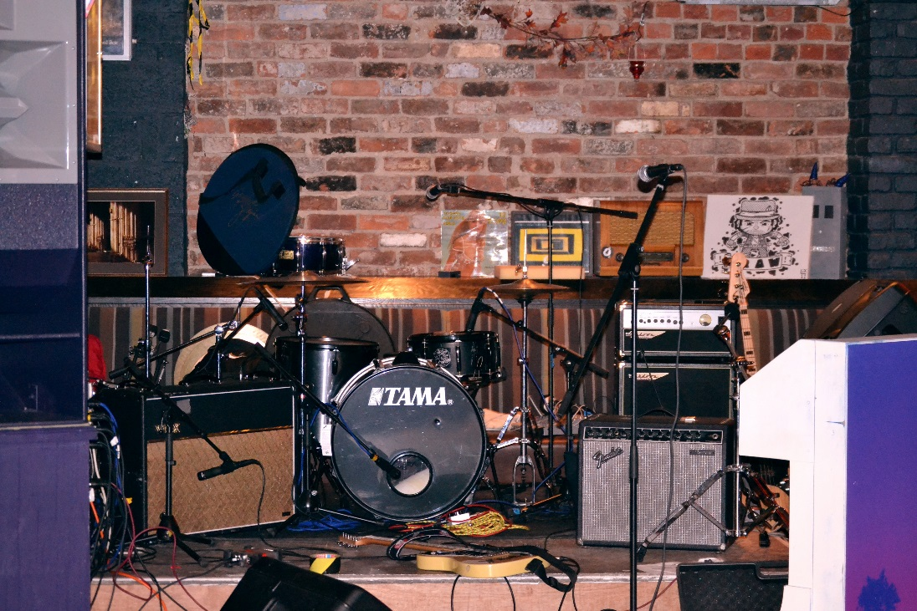
Figure 27: View of main stage

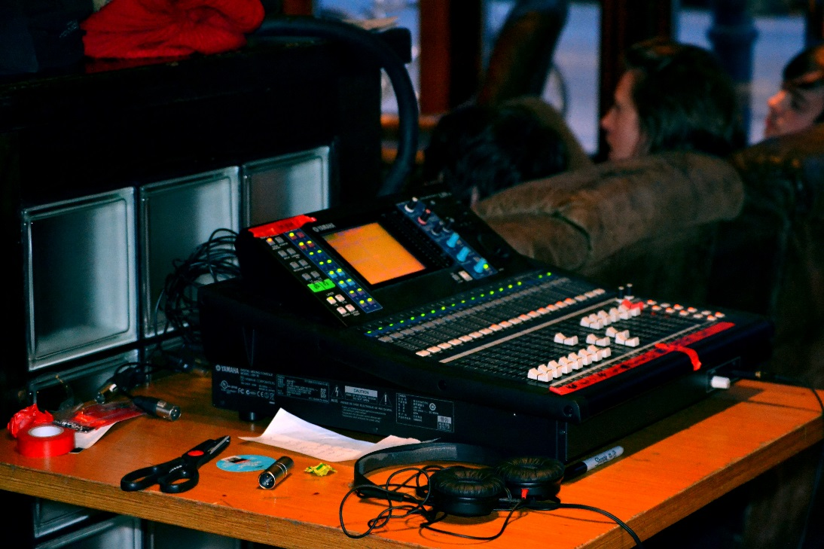
Figure 28: Sound desk Yamaha LS9

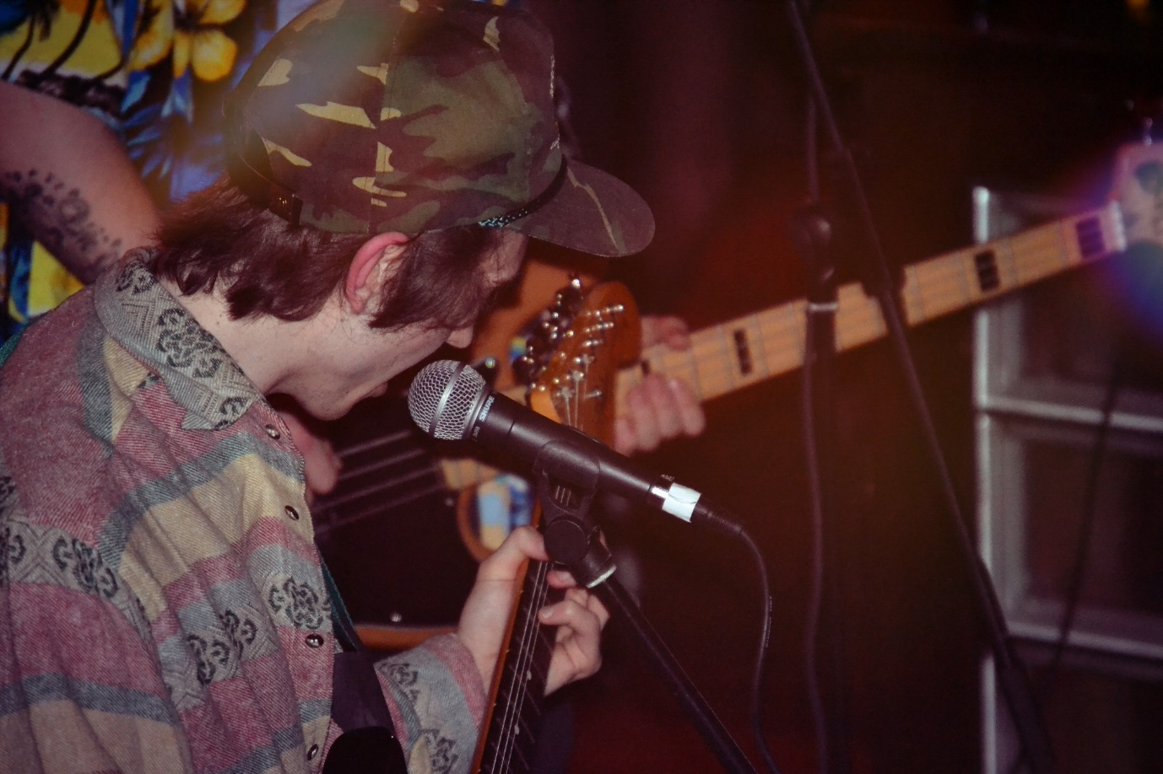
Figure 29: Lead singer of JAWS

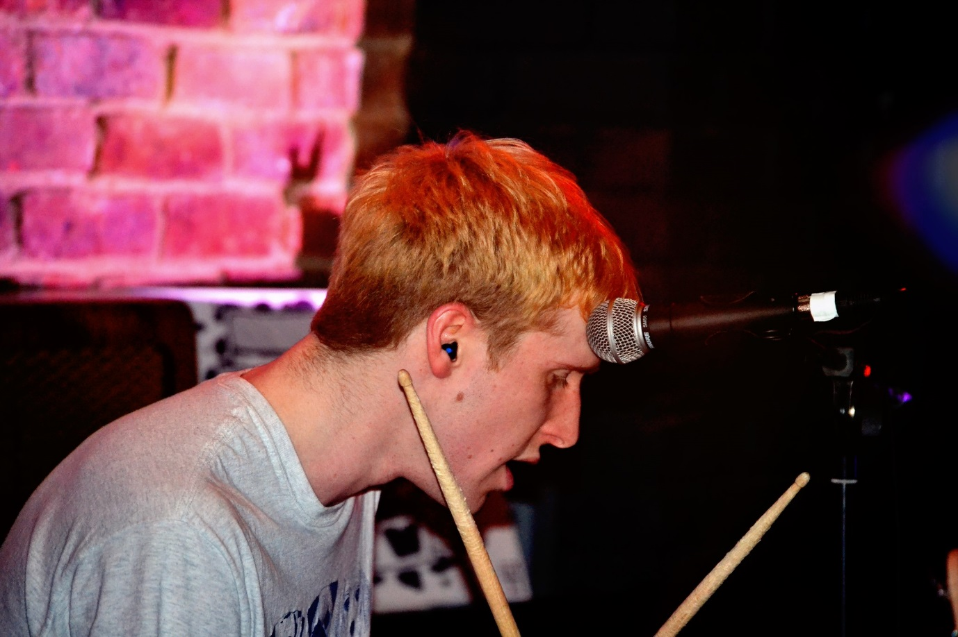
Figure 30: Drummer/vocalist of Playlounge

Microphones:
SM58 - vocals
SM57 – other instruments
e604 – snare and tom
DI – guitar and bass

Band Spec:
JAWS consists of four members. Instruments included vox, guitars, bass, drums and laptop.
Tropic of Youth consists of four members. Instruments included vox, guitars, keys, bass and drums.
Playlounge consists of two members. Instruments include guitar, drums and vox.

Write-up:

Constructing the event and the challenges presented
Doing front of house and monitors at the same time in a small venue, with no other crew whilst using a digital desk was an exciting new experience that challenged my abilities. Before the band arrived the microphones were set-up, the multicore was plugged into the desk and three individual files were saved for each band to ensure time was used effectively during the sound check. There were some space issues when the band arrived because the stage was so small, as can be seen in figure one. The vocalist was on the floor in front of the stage, with the monitors just in front of the main PA to stop feedback. There was a very limited number and make of microphone. Therefore a SM57 had to be substituted as a bass drum microphone, which was not ideal. Due to the fact it is such a small venue, the drums were overpowering the mix. Therefore microphones were only used on the kick drum, snare, tom and floor tom in order to emphasise them. When sound checking there were some difficulties with the laptop which resulted from a wrongly patched desk which was quickly rectified. The bass was captured using a DI box. The bass player did not use his bass amp, so I made sure there was plenty of bass in his monitor wedge. There were too few microphones to use one on every instrument, therefore both guitar amps were also captured through the use of a DI box which would also help with feedback. An SM57 was used on the lead guitarist’s amp. Unfortunately, problems such as dead channels on the multi-core and broken XLR took up a lot of time during the sound check, but these problems are common in small venues that use multiple sound engineers, have cheap, low quality equipment and have staff who do not always take great care of the equipment.

The sound check for the other two bands went relatively quicker as they were sharing their amps and drum kit, so it was just a case of tweaking the settings. The keyboards from the second band were captured in mono through DI boxes. The first band Playlounge had some difficulties with their equipment. The guitarist used two amps, plugged into different parts of his effects pedals to create his guitar sound. However the amps were resonating badly off of each other creating an audible hum. To solve this, a microphone was used on one amp and the other one was captured using a DI box. Only the DI signal was fed through his monitors to stop feedback and reduce the hum. One of the monitor wedges also had to be moved from front of stage to side of stage for the drummer because he was also the lead vocalist.

During the event there was some amp hum that had not occurred during the sound check – possibly caused by the first band changing the amp settings or the musicians turning them up on stage. To reduce this, all the amplified guitars were removed from the monitor wedges because they could already hear their amps on stage.

Achieving the sound
In this instance, I was the front of house and monitor engineer, which meant I had the responsibility of creating the sound that the band and the audience were expecting. Prior to the event, I contacted the promoter to find out as much information as possible. This information included the names of the band, how many people in each group, the style of music (as the performances in Bungalows and Bears stylistically vary) and the type of instruments they used. After getting this information I would then research them online to get a general idea of their music. Ideally I looked for video recordings of live performances due to the fact that bands sometimes want a different atmosphere from their music recordings to their live performances. This would also help me understand the physical attributes of their performance, giving me prior knowledge on whether they moved around on stage or anything else that could impact how I achieved the sound. In the case of the headliner JAWS, I found a video of one of their songs on Youtube (JAWSJAWSJAWSSS, 2012). Although it is not a recording of a live performance, it did inform me of the band’s music which is very melodic and mellow as well as giving me an insight into their style of playing. During the video the players do not move much. Their image is very ‘indie’ which suggested that the performance would be relatively static in order to appear cool and calm. Also, because of the tranquil style of music, I did not expect the band to be jumping around or crowd surfing. The focus on the melody and lyrics in the recording suggested that they would want the higher frequencies to be prominent during their live performance, rather than a prominent bass sound. Since JAWS was the headliner, their sound specifications mattered the most. If I did not have access to a digital desk, I would ensure that the desk was primarily programmed for JAWS’ performance. The other two bands would have to adjust to that sound, because with analogue desks only one set of faders can be used per event. However, at this event I had access to a digital desk which meant I could save different settings for different bands. I could not find many recordings of Tropic of Youth prior to the performance, but assumed because they were touring with JAWS they would adopt a similar style, which turned out to be more or less correct. I found a recorded performance of Playlounge on Youtube (Andunemir, 2013). This video showed that Playlounge were ‘grungier’ than the other two bands which would mean a slightly heavier, bass prominent sound would be suitable. The video also showed that the musicians do not move around too much on stage which would reduce feedback issues.

Although it was useful to have an understanding of the type of music I was mixing prior to the event, it was also key to communicate with the musicians to ensure I had achieved the type of sound they expected during sound check. I discussed the sound with the musicians in order to learn things such as what they thought the most important instrument was. They also described the type of snare sound they wanted which seemed to be something very important to them. The only slight disagreement we had was my preference of having vocals high in the mix. However, Tropic of Youth wanted their guitar quite loud which somewhat drowned out the vocals. Although I disagreed with them, I turned the guitars up because they explained that the guitars were an integral part of their aesthetic. However, I perhaps did not turn it up as much as they would have wanted because the engineer should still use their expertise in making decisions such as these and in my opinion the audience generally want to hear the lyrics.

Conclusion
Sound reinforcement is not just about using the technical equipment correctly but also using the engineer’s creative and musical skills to enhance a performance. In order to do this, the sound engineer must combine music research, their own preferences and opinion as well as the musician’s expectations in order to conduct sound reinforcement. Although the sound engineer is the expert and should use their own knowledge to make informed decisions about sound, it is my opinion that the musician’s preferences come first and that the engineer’s role is to successfully produce the style of sound the musicians want. This can be achieved by both listening and watching recordings of the band, as well as communicating and questioning them at the event. This is much easier to achieve within small scale venues as the sound engineer and the crew both share the same space before and after the gig (there is no green room where the band is segregated from everyone else) and the musicians are happy to communicate with the engineer. However, small venues can also produce problems within sound reinforcement. It is usually the case that the equipment is of a poorer quality, although this venue is lucky enough to have the use of a digital desk. I had a limited amount of microphones to use and some of the microphones were not suitable for the instrument I used them on. This is in contrast to The Leadmill where I had a large number and diverse range of microphones. Although this impacts the quality of the sound produced, there is a general understanding among the audience as well as the musicians, that the sound quality will not be as professional as it would be in larger venues. It is still the integral role of the engineer to use their skills in order to produce clearly heard instruments that are separated within the mix. This can be achieved through the use of EQ, compression and pan. It is also their goal to ensure the instruments sound as closely as possible to the original source, so that the audience cannot hear how amplification can change the sound of an instrument and that there is little to no feedback.

Date: 16/04/2013

Event: Battle of the Bands Competition

Venue: The Raynor Lounge, Sheffield University Student’s Union

Position: Sound engineer – FOH and Monitors

Photos:
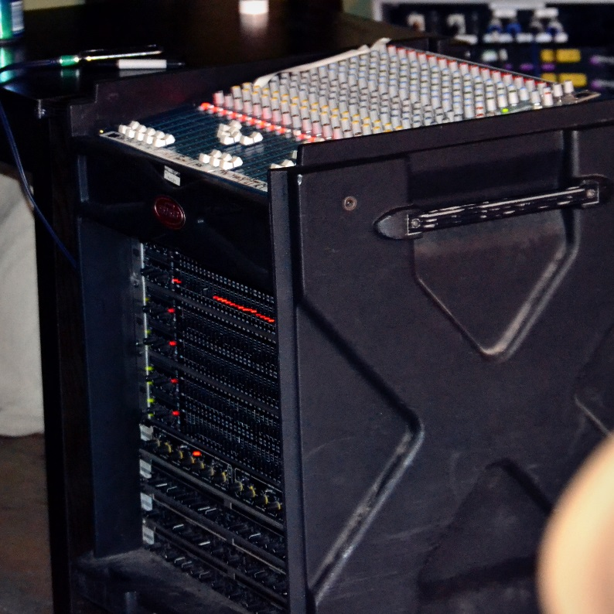
Figure 31: Allen and Heath Mix Wizard
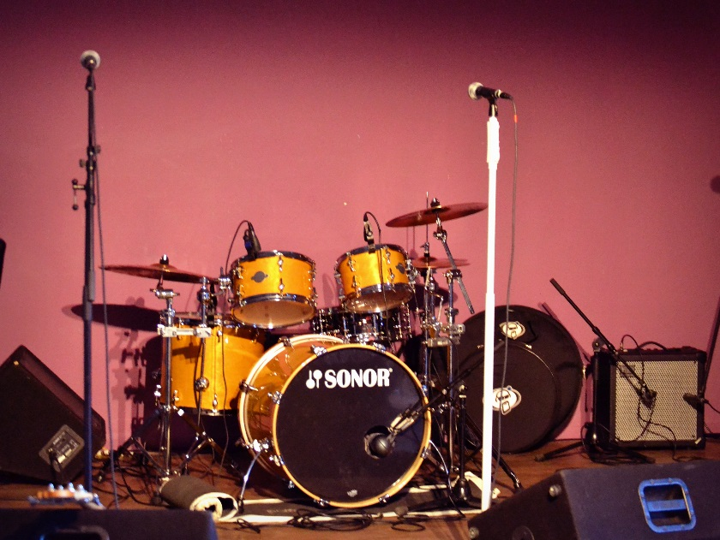
Figure 32: Drum kit and vocal mics

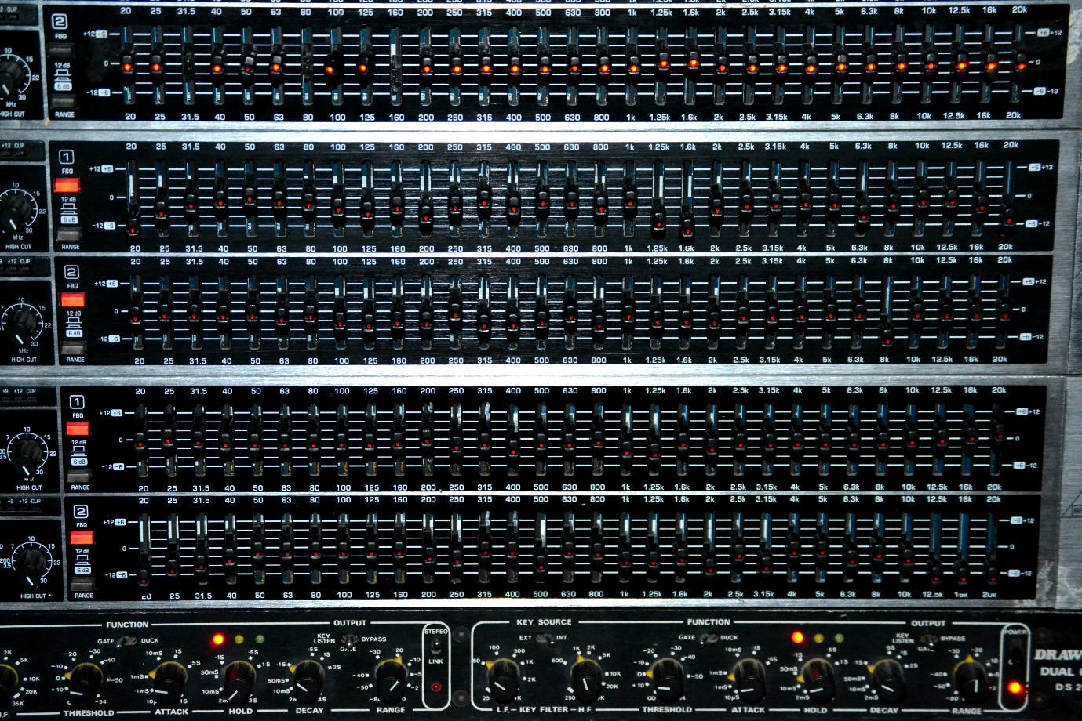
Figure 33: EQ over the monitor wedges

Equipment:
PA - Marth audio London
PA Amp - Black Line PA Rack
Desk - Allen and Heath Mix Wizard
Monitor Amp - Crest Audio LA 1201
Monitor Wedges - Yamaha AX159

Microphone:
Vocals – SM58
Guitar – DI

Band spec:
Acoustic guitar and vocals

Write up:
Constructing the event
The battle of the bands competition consisted of five competing bands with a different engineer mixing each one. I was mixing a soloist who played an acoustic guitar. Before the bands arrived, the crew setup the equipment and rang out the monitors.

Challenges
The Raynour Lounge does not have very good acoustic qualities. It has very reflective surfaces with low walls and one side of the venue is entirely made up of glass windows, therefore it is very reverberant with some harsh resonating frequencies. The equipment is also very cheap and low quality with broken channels and faulty in-built compressors and gates. There was no time to sound check. Each engineer had twenty minutes between the bands playing to line check and get a rough estimate of the monitors. This meant that the sound quality in general was quite poor. The previous engineers struggled with some microphones but with only the twenty minute set to fix the problems, the musicians had generally finished before there was any time to improve the sound. For my act, I had an SM58 vocal microphone placed directly in front of the monitor wedge to minimise feedback. The acoustic guitar was plugged in using signal directly from the guitar’s pick-up. ‘Crash mixing’, a sound engineering term used to describe mixing from scratch with no sound check is an important skill for sound engineers to learn as it becomes key during music events such as festivals where there is relatively little time between sets with rarely an opportunity to sound check. However with the poor standard of equipment provided at this event and no previous knowledge of the band, the sound was not of an acceptable standard.

Achieving the sound
For this event, we had no prior knowledge of what bands were performing and we knew there would be varied genres of music performed. The aesthetic decisions had to be made quickly after having a brief discussion with the musicians prior to the show. My act was a solo guitar player, who informed me he played folk music. I could then assume that the sound required a clean guitar and vocal, with a little bit of reverb to add warmth.

Processing
I placed a high pass filter up to about 100hz on each instrument to try and minimise the low-end rumble that occurred during the performance. The guitar was also feeding back quite a bit so I minimised the gain and pushed the fader up as far as I could. The voice was also very ‘boomy’, meaning the lower frequencies were very prominent in the voice, despite me cutting out a lot around the 200hz due to the PA system not having a flat frequency response. There was also a crackling noise coming from the guitar channel which was caused by a broken compression channel. In terms of EQ, 200hz on both channels were cut. A little compression was used on the guitar but had to be turned off during the performance due to a technical fault.

Conclusion
The equipment was of a low quality which seriously degraded the sound. This caused huge constraints for myself and the other engineers, limiting what we could achieve. This event also emphasised the importance of communication between musicians and engineers in order to understand the desired sound of the musicians. At this event, the only way this could be achieved was by conducting a brief discussion prior to the event in order to understand the genre of the music and how the music usually sounded at performances because I had no knowledge of what artist I would be mixing and I did not have the opportunity to sound check.

Date: 23/05/2013

Event: Ghosting Season and The Slow Revolt

Venue: Bungalows and Bears, Sheffield

Position: Sound engineer, FOH and monitors

Photos:

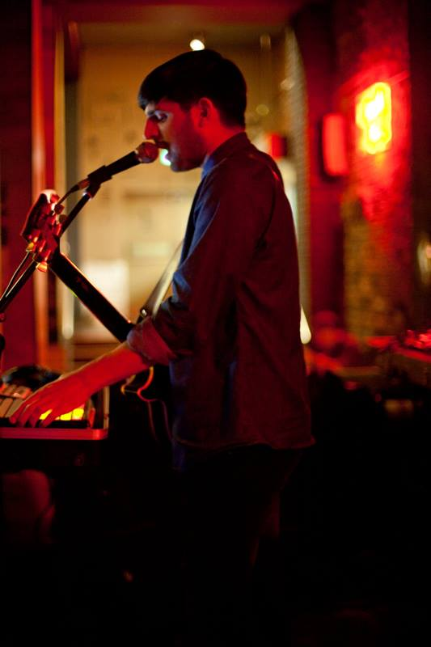
Figure 34: The Slow Revolt, (McGregor, 2013)

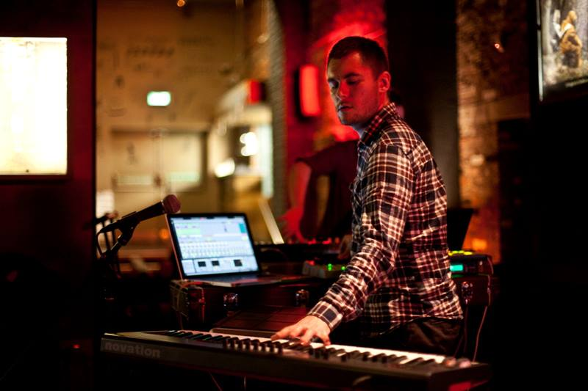
Figure 35: Ghosting Season, (McGregor, 2013)

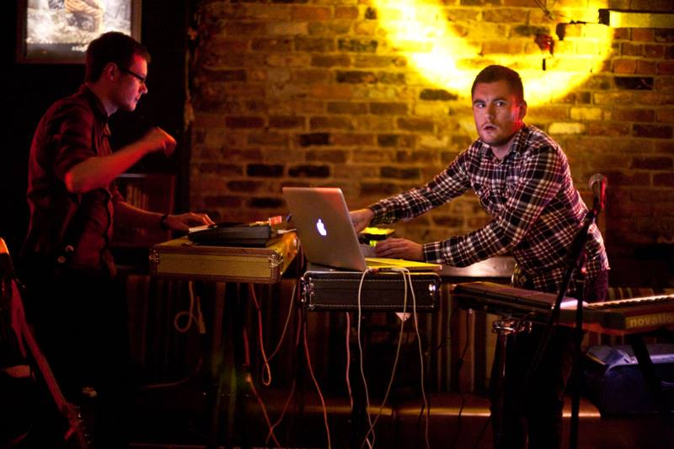
Figure 36: Ghosting Season, (McGregor, 2013)

Mic:
2x DI (left and right)

Band Spec:
The Slow Revolt: vocals, guitar and laptop
Ghosting Season: 2x guitars, vocals, drum machine and laptops

Write-up:

Constructing the event
This event differed significantly from other events. Both bands were using laptops, guitars and vocals. However, the band themselves controlled and processed these instruments on their laptops, only sending one left-right output which was captured using a DI box.

Challenges
Other than the EQ over the main PA, I had very little control over the sound. My role was listening to the sound they were outputting during the sound check and communicating with them how I thought they needed to alter it on their laptops. Events such as these show the importance of sound engineers having good communication skills which are needed to talk through problems with the musicians. Due to the bare brick walls, the high hats were audibly reflecting causing a distance echo which was quite distracting for both the musicians and the audience. There was not much that could improve this, other than cutting around 4khz where sibilance of the hi-hat occurs (thus making is less prominent in the mic) and waiting for the audience to arrive and absorb some of the sound. The only difficulty with the performance was during the set the vocals were too prominent in the mix. However, this could not be communicated to the act. The only thing I could do to improve it was cutting around 200hz to reduce it slightly within the mix.

Achieving the sound
The promoter had informed me that both the performances were by acts who used mainly electronic instruments so I had a vague understanding of what would be involved. I also researched the headliner Ghosting Season in order to grasp what style of music they would play. From their performance at Dale Street, I learnt that they use electronic instruments alongside an electric guitar played with a bow. They have a largely reverberant sound that fills the entire sound spectrum, aided by lush string sounds with some prominent melody lines (Umbro, 2012). Although I could hear a strong beat, the bass did not need to be as prominent as the music played at The Tuesday Club. However, I did ensure it was clearly heard. The crack of the snare appeared to be the most important beat of the drum line as it was the most prominent instrument in their recorded mix. It would also need to be quite loud to pierce through the melodic sounds, so the audience could become immersed in the performance. Also, from watching the video I could see that two of the most prominent visual features by the musicians was when one played their guitar with a bow and the other played the drum pad flamboyantly. Therefore I believed it was essential to draw these out of the mix in order to emphasise them both musically and visually. Other than the opening act who brought and set-up their own, there was no microphone requirements. Therefore it was not relevant whether the musicians moved around on stage because feedback was never going to be an issue.

Conclusion
Electronic instruments provide both benefits and challenges for engineers. The benefits mainly consist of the reduced probability of feedback as well as the little amount of equipment that is required for an event. However, there is a lack of creative control over the sound which can only be altered during the sound check by communication with the musicians. In relation to the objectives detailed in the introduction, this perhaps diminishes the importance of the sound engineer within sound reinforcement. If more musicians are using these types of instruments and having more control over their own sound, arguably there is little need for a creative engineer. However, although elements of this may be true, I was still required to control the EQ over the PA. It is also integral that the sound engineer uses their knowledge of PA placement and acoustic qualities of a room in order to achieve the best quality sound that is possible within the venue. Therefore I would still argue the role of the sound engineer is integral within a live performance event.

Date: 12-13/07/2013

Event: Proms at Pontefact Castle

Venue: Pontefract Castle

Position: Sound Engineering Assistant

Photos:
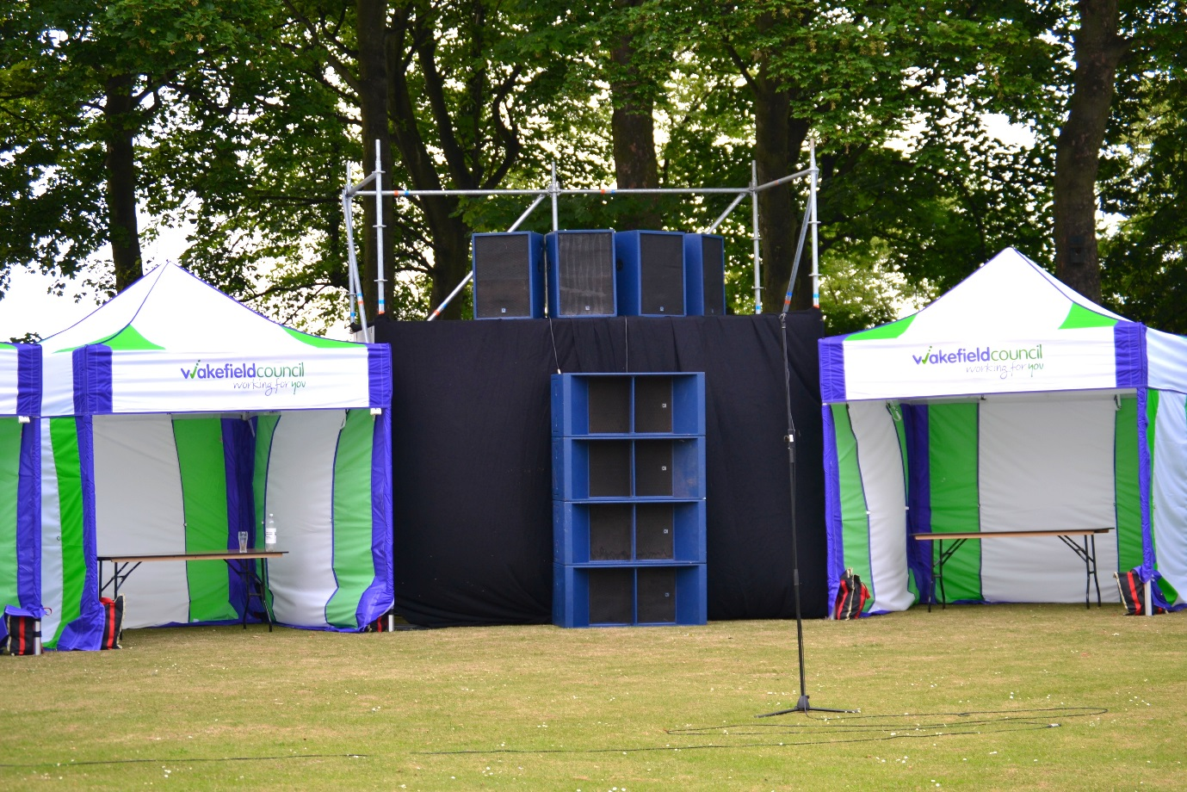
Figure 37: PA

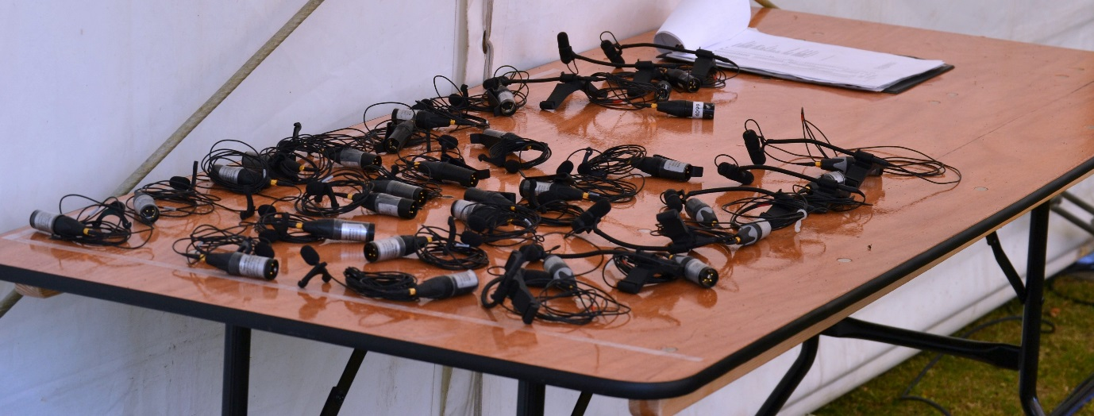
Figure 38: Microphones

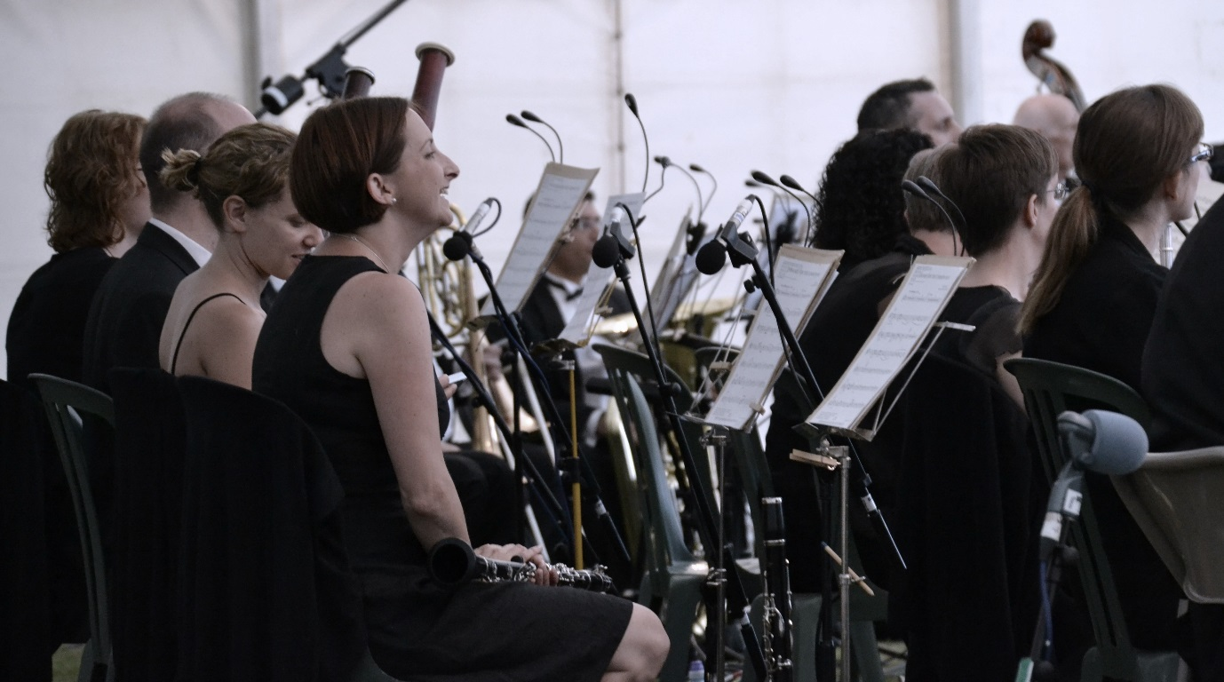
Figure 39: Clarinet and Bassoon microphones

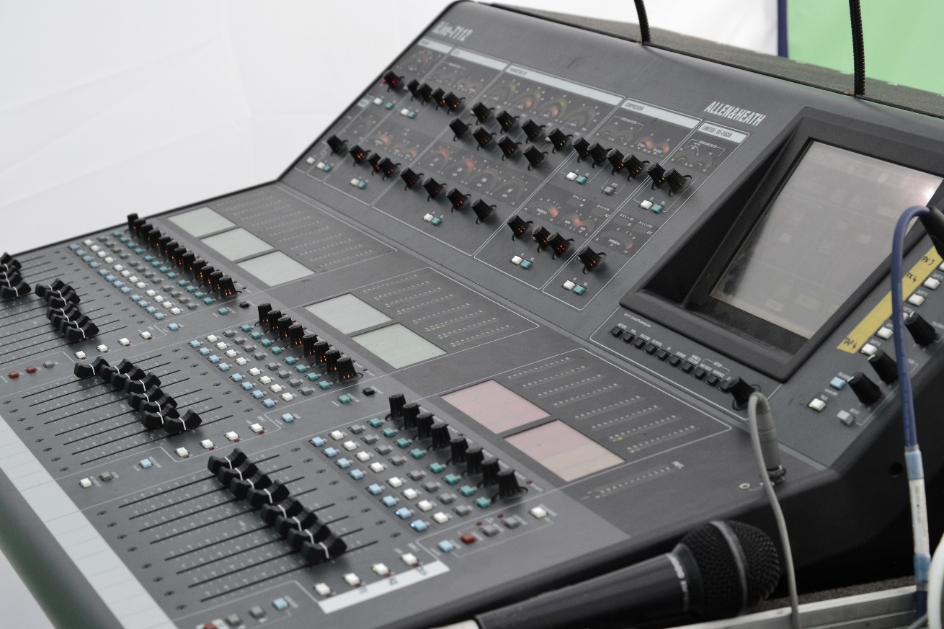
Figure 40: Allen&Heath digital sound desk

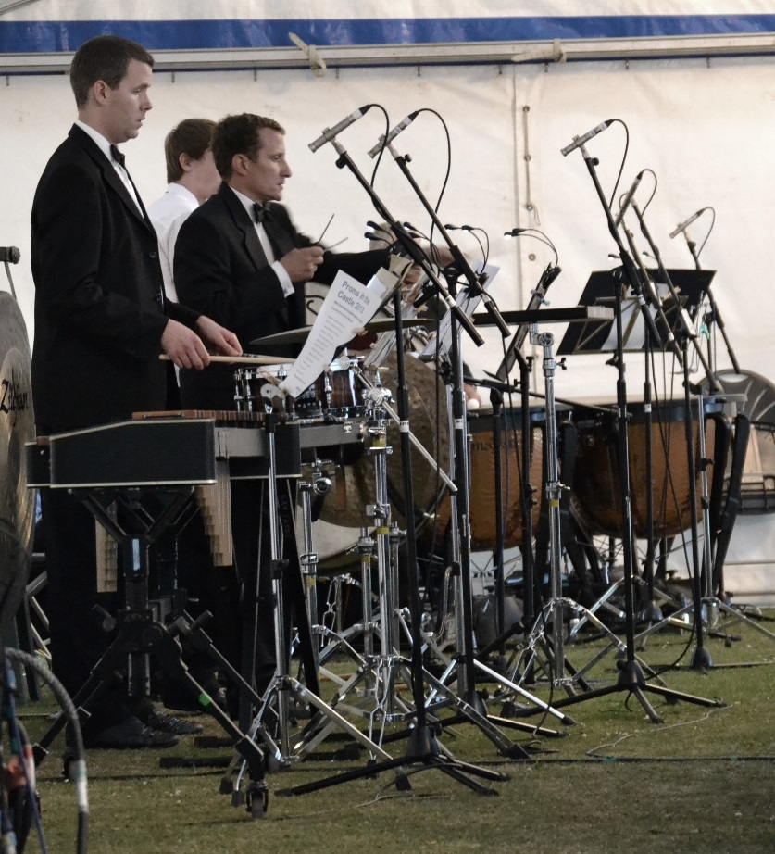
Figure 41: Percussion microphones

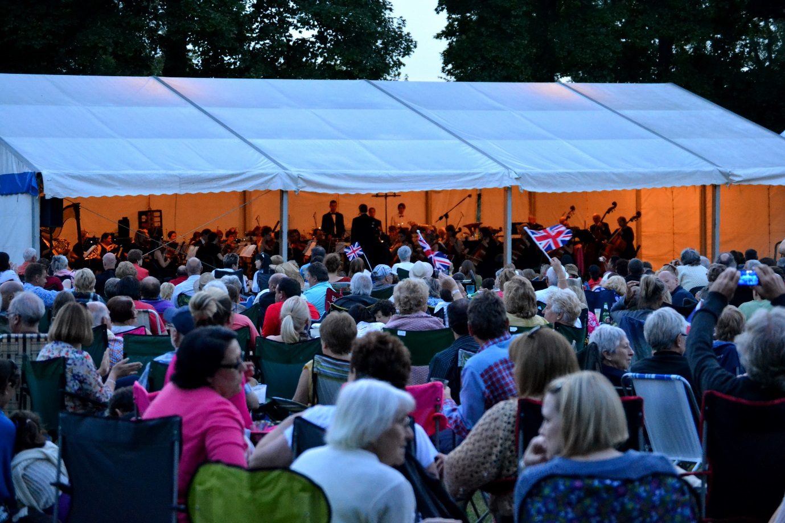
Figure 42: Audience and stage
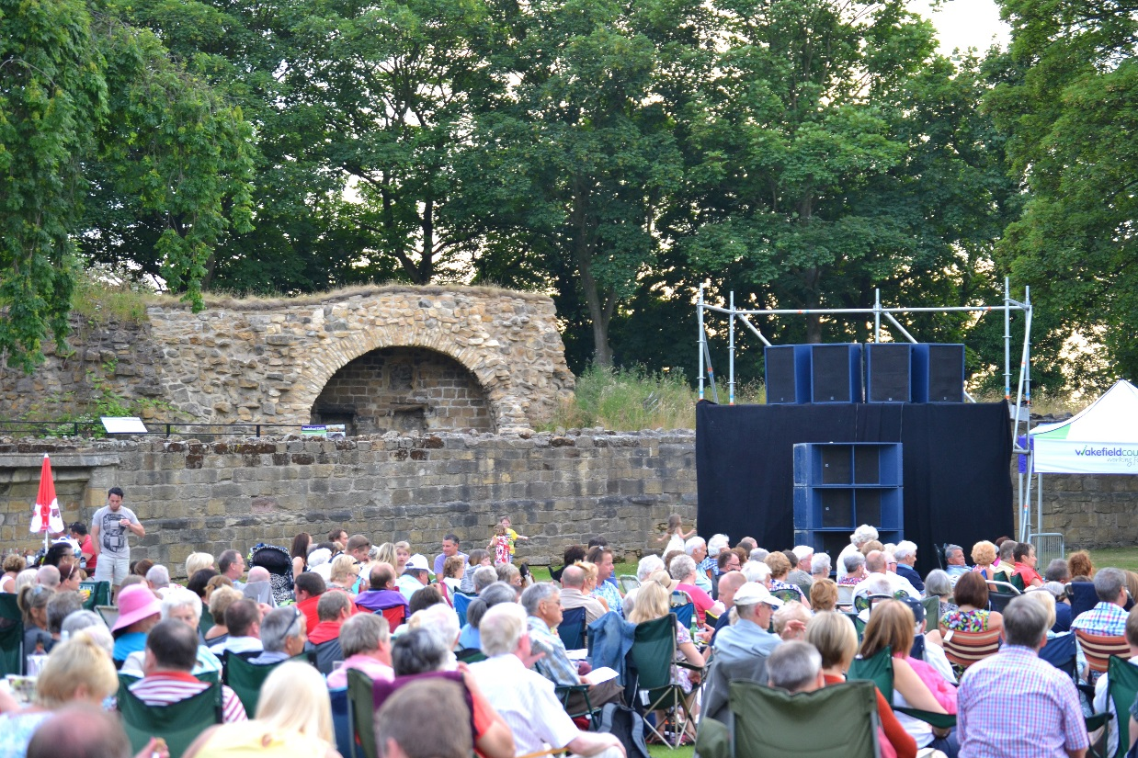
Figure 43: PA 2

MULTI | REMOTE | INSTRUMENT | MIC | STAND | +48v
1 | RED 1 | 1st Violin 1 | DPA 4060 | N/A | Y
2 | RED 2 | 1st Violin 2 | DPA 4060 | N/A | Y
3 | RED 3 | 1st Violin 3 | DPA 4060 | N/A | Y
4 | RED 4 | 1st Violin 4 | DPA 4060 | N/A | Y
5 | RED 5 | 1st Violin 5 | DPA 4060 | N/A | Y
6 | RED 6 | 1st Violin 6 | DPA 4060 | N/A | Y
7 | RED 7 | 1st Violin 7 | DPA 4060 | N/A | Y
8 | RED 8 | 1st Violin 8 | DPA 4060 | N/A | Y
9 | RED 9 | 2nd Violin 1 | DPA 4060 | N/A | Y
10 | RED 10 | 2nd Violin 2 | DPA 4060 | N/A | Y
11 | RED 11 | 2nd Violin 3 | DPA 4060 | N/A | Y
12 | RED 12 | 2nd Violin 4 | DPA 4060 | N/A | Y
13 | RED 13 | 2nd Violin 5 | DPA 4060 | N/A | Y
14 | RED 14 | 2nd Violin 6 | DPA 4060 | N/A | Y
15 |  | 2nd Violin 7 |  | N/A | Y
16 |  | 2nd Violin 8 |  | N/A | Y
17 | YEL 1 | Viola 1 | DPA 4060 | N/A | Y
18 | YEL 2 | Viola 2 | DPA 4060 | N/A | Y
19 | YEL 3 | Viola 3 | DPA 4060 | N/A | Y
20 | YEL 4 | Viola 4 | DPA 4060 | N/A | Y
21 | YEL 5 | Viola 5 | DPA 4060
22 | YEL 6 | Viola 6 | DPA 4060
23 | YEL 7 | Cello 1 | DPA 4099C | N/A | Y
24 | YEL 8 | Cello 2 | DPA 4099C | N/A | Y
25 | YEL 9 | Cello 3 | DPA 4099C | N/A | Y
26 | YEL 10 | Cello 4 | DPA 4099C | N/A | Y
27 | YEL 11 | Cello 5 | DPA 4099C | N/A | Y
28 | YEL 12 | Cello 6 | DPA 4099C | N/A | Y
29 | YEL 13 | Cello 7 | NT5 | SHORT
30 | YEL 14 | Cello 8 | NT5 | SHORT
31 | YEL 15 | Double Bass 1 | DPA 4099DB | N/A | Y
32 | YEL 16 | Double Bass 2 | DPA 4099DB | N/A | Y
33 | BLUE 1 | Double Bass 3 | DPA 4099DB | N/A | Y
34 | GRN 1 | Flute 1 | Octava 012 | TALL | Y
35 | GRN 2 | Flute 2 | Octava 012 | TALL | Y
36 | BLUE 2 | Oboe 1 | Octava 012 | SHORT | Y
37 | BLUE 3 | Oboe 2 | Octava 012 | SHORT | Y
38 | GRN 3 | Clarinet 1 | Octava 012 | SHORT | Y
39 | GRN 4 | Clarinet 2 | Octava 012 | SHORT | Y
40 | BLUE 4 | Bassoon 1 | Octava 012 | SHORT | Y
41 | BLUE 5 | Bassoon 2 | Octava 012 | SHORT | Y
42 | GRN 5 | French Horn 1 | Beta56 | SHORT | N
43 | GRN 6 | French Horn 2 | Beta56 | SHORT | N
44 | GRN 7 | French Horn 3 | Beta56 | SHORT | N
45 | GRN 8 | French Horn 4 | Beta57a | SHORT | N
46 | BLUE 6 | Trumpet 1 | M201 | SHORT | N
47 | BLUE 7 | Trumpet 2 | M201 | SHORT | N
48 | BLUE 8 | Trumpet 3 | M201 | SHORT | N
49 | BLUE 9 | Trombone 1 | MD441 | SHORT | N
50 | BLUE 10 | Trombone 2 | MD441 | SHORT | N
51 | BLUE 11 | Trombone 3 | D12 | SHORT | N
52 | BLUE 12 | Tuba | D12 | TALL | N
53 | GRN 9 | Harp 1 | BMA AT4041 | SHORT | Y
54 | ORANGE 1 | Timp 1 | Octava 012 | TALL | Y
55 | ORANGE 2 | Timp 2 | Octava 012 | TALL | Y
56 | ORANGE 3 | Perc 1 | Octava 012 | TALL | Y
57 | ORANGE 4 | Perc 2 | Octava 012 | TALL | Y
58 | ORANGE 5 | Perc 3 | Octava 012 | TALL | Y
59 | ORANGE 6 | Perc 4 | Octava 012 | TALL | Y
60 | RED 15 | REF MIC 1 | AKG C414 | TALL
61 | RED 16 | REF MIC 2 | AKG C414 | TALL
62 |  |  |  |  | N
63 |  | RADIO MIC 1 | HH B58A | TALL | N
64 |  | RADIO MIC 2 | HH B58A | TALL | N
65
66 |  | SHOUT TO HOUSE | SWITCH
67 |  | SHOUT TO STAGE | SWITCH
Figure 44: Table of instruments, microphones and breakout boxes
Microphones:
DPA 4060
DPA 4099C
DPA 4099DB
Octava 012
Beta56
Beta 57a
M201
MD441
D12
BMA AT4041
AKG C414
HH B58A (Radio Mic)

Band Spec:
Symphony Orchestra
Violins 1st (x6), Violins 2nd (x6), Violas (x6), Cello (x6), Double Bass (x3), Flute (x2), Oboe (x2), Clarinet (x2), Bassoon (x2), French Horn (x4), Trumpet (x 3), Trombone (x3), Tuba (x1), Harp (x1), Timp (x2) and Perc (x4). Plus microphone for conductor to talk in between music.

Write-up:

Constructing the event
This event provided an opportunity to see how sound engineering works at larger performances and within an outdoor environment. We were required to arrive the day before the event to set-up the equipment. This required tight logistic skills, organising loading and unloading of the van. It also meant that since the event was a long distance away from the sound equipment store, it was essential to have everything that was needed on hand during the event. When we arrived we organised all the XLR, break-out boxes and microphones (already on their stands) and ensured they were labelled up and ready for use. As can be seen in figure forty-five, the production side of The Proms at Pontefract was done before the event which made it much easier for us to sort everything out on the day. A hired in company were erecting the scaffolding structure to place the PA on, so work was halted until they arrived.

One of the most important features of an outdoor event was to ensure the equipment was protected from weather damage. Luckily, the weekend provided two sunny days despite the forecast predicting rain and thunder. Overnight the amps and PA were protected with tarpaulin sheets and rubber matting was used to protect the cabling running from the marque to the front of house tent.

The PA was set up on the scaffold towers, with the high-mid speakers on the top platform and the subs stacked four high on the floor (see figure thirty-eight). The high-mid speakers were then tilted slightly so they were facing down towards the audience and splayed so they dispersed the width of the audience area. There was concern over the throw of the PA. To reach the back of the audience, the PA had to be run fairly loud, however that meant the people at the front of the crowd would experience uncomfortable high volumes. The team had to spread themselves across the audience area and agree on a compromise so everyone was able to audibly hear the music without creating uncomfortable audio levels for the front of the audience. There were also issues with the PA crossover causing the PA to sound ‘muddy’ because of a peak in the lower frequency cross-over. The sound engineer used a program called ‘Live-Capture Pro’ to analyse the crossover patterns, smoothing out any sharp peaks in certain frequencies he felt were impeding the sound quality. With this program you can also control the time delays between the PA ensuring the timing of the system as a whole (even with the subs placed in front of the PA) are coherent. The program uses a test microphone to analyses all these factors. By connecting the amp to the computer, the program can change the settings of the active crossover to ensure the PA is performing at its optimum ability in any setting (wavecapture.com, W.Y.).

Another difference between smaller and larger events is the use of ethernet cable instead of the traditional multicore used with analogue equipment. This is one feature that emphasises the benefits of digital over analogue. With an analogue desk the only option is to run a multicore connector, often aided by a pyle connector to connect microphones to the desk. As well as being large and heavy, pyle connectors can be easily damaged and are expensive to replace. This also requires the engineer to plug in a multitude of XLR cables into the back of the desk which correlate with a breakout box in which the microphones are plugged into. Again, this is time consuming and equipment can be easily damaged. When being used over a long distance, there can also be significant deterioration in the signal quality. With a digital desk, there is the option of using an ethernet cable instead of the multicore. Other more expensive cables can also be used such as fibre optics in order to maximise desk efficiency. Using an ethernet cable is more reliable than using a multi-core because it allows a much better quality of signal to run to the desk. They are also lighter and easier to run over long distances. During The Proms at Pontefract Castle, we ran two ethernet cables so if one became damaged it could be easily swapped over to the other one. This would not be possible if you were running a multi-core. Since ethernet can only be used with a digital desk, this mean digital desks provide flexibility and opportunity to problem solve some of the more difficult tasks that engineers face at larger events such as running long, heavy cables and signal degradation. All of the engineers agreed on the day that digital desks were more preferable for engineering because of benefits such as these.

Challenges
The venue caused some acoustic problems. The venue is surrounded by bare brick castle ruins (see figure forty-four) and as stated in previous diary entries, bare brick is very reflective. This caused an audible echo throughout the venue which impeded the sound quality. There is not much that can be done in venues such as these which adds to the challenge presented by outdoor venues. However, by locating some of the frequencies that were reflecting more than others and cutting them on the EQ, directing the speakers inwards so they were not pointing directly towards the brick and with the help of a full audience absorbing a lot of the sound we managed to reduce the reflections so they were not too distracting.

Achieving the sound
With it being a classical orchestra, it was already known that all the segments of the instruments needed to be clear and concise. It would not matter as much if it was in a reverberant setting as orchestras often play in large halls that are designed to be reverberant to give the music more body, making it sound somewhat more impressive. This helps the orchestra to sound fuller and provide a greater experience for the audience.

Conclusion
When doing outdoor events, using the best quality equipment that is available is integral otherwise producing a clear sound may be unachievable no matter how talented the engineer is. The sound engineer has to combine all the skills discussed within the previous diary entries. These skills include placing the PA correctly to ensure all the audience can hear the music clearly, using technology such as wave capture in order to ensure the delay and timings are correct so the sound is not distorted, communicating with musicians, talking each musicians through the microphones and always asking permission before placing a microphone on their instrument as they are incredibly expensive and often treasured by the player as well as using their musical skills in order to produce a sound that allows each section to be heard and sound natural. Essentially, the audience should not really acknowledge they are listening to the instruments through electronic amplification but that they are hearing the source of the sound. Therefore the role of the sound engineer is integral to ensure that the audience are enjoying the performance as much as possible.

- PA placement

PA placement is a vital part of creating successful sound reinforcement as it is essential that the entire audience can hear the performance and that the sound is consistent throughout the audience area. PA placement can also affect the balance of higher and lower frequencies therefore altering the quality of the sound significantly. A lot of the events described within the previous sections have highlighted the importance of speaker placement, from SSE Audio to how they go about designing installs for outdoor events such as Proms at Pontefract Castle. The following section is an investigation into how the sound quality is effected by PA placement.

For this experiment, a pair of microphones (neumanns) were used to capture the PA playing the same track at different points in the room. This was done in the octagon centre. The strange shape of the octagon centre means we can predict that at different points, coverage would be significantly different because of the reflections and therefore cancellation effects would occur. No EQ was placed over the PA system.

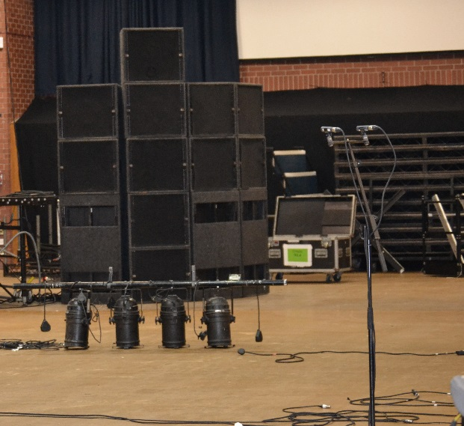
Figure 45: Position one: Microphones placed between the PA stacks, further distance
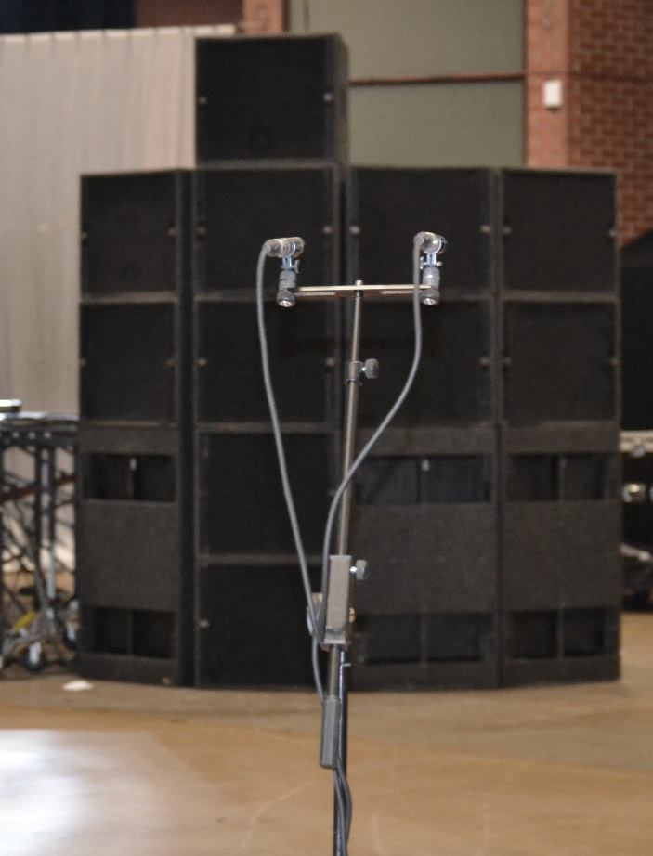
Figure 46: Position two: Microphones placed in front of PA right stack, closer distance

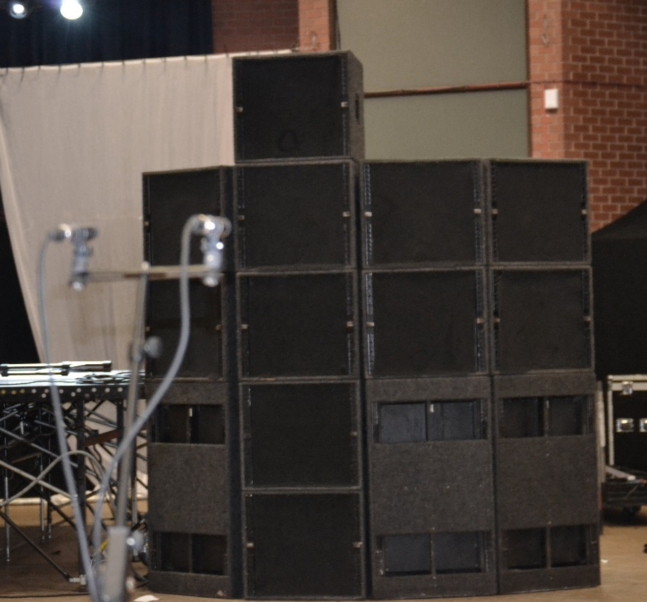
Figure 47: Position three: Microphones placed in front of PA right stack, further distance

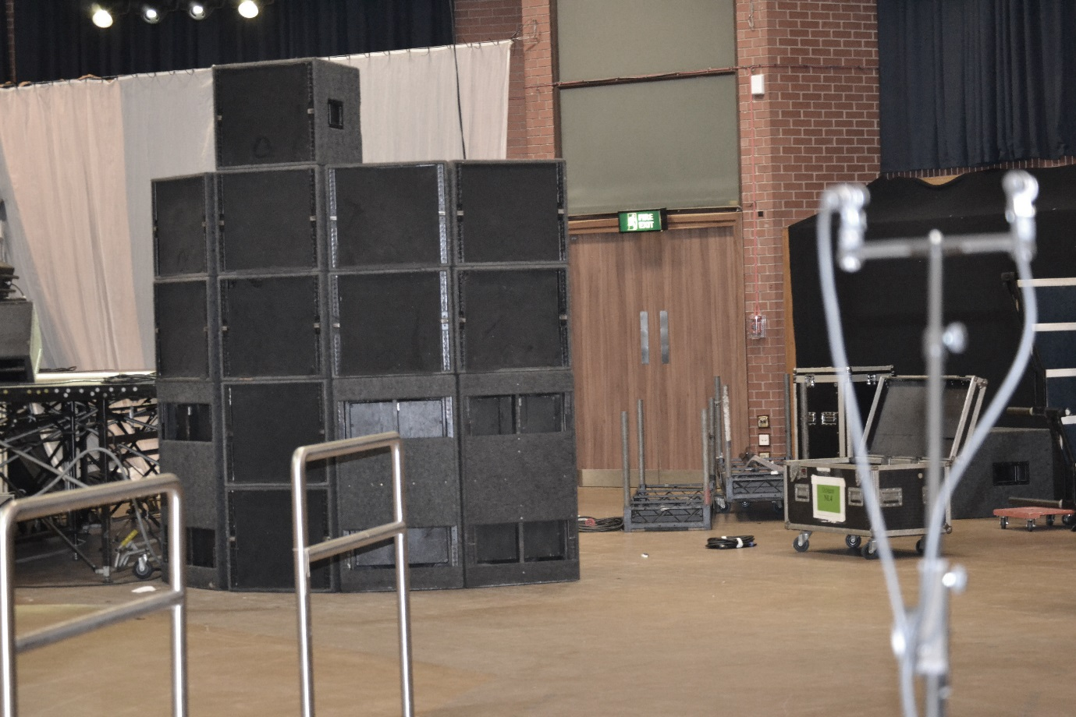
Figure 48: Position four: Microphones to the right of PA stack

On the additional CD, tracks one to four are sound snippets from these different microphone positions in the same order. Track one is very bass heavy and therefore the low-mid sounds quite muddy and un-defined. The snare is not as defined as it is in track three. The sound is also quite reverberant however this is present in all the positions because it was recorded in an empty room. The sound is quite bass heavy because the microphone is placed between the PA stacks and is receiving bass from both PA stacks. Because of the PA configuration there is only one sub on the inside half of the stack and two low frequency drivers which may suggest why the microphone is picking up more bass than the microphone in position four which is facing the two sub drivers, (the microphones do not have the capacity to pick up a lot of sub frequency, as well as there being little sub in the track) two B1s and two M3s.

Position two, placed in front of the PA at a close distance, has more defined high frequencies however the bass lacks clarity. This is because it is placed directly in front of the column of three B1s so the microphone is receiving a lot of bass frequency causing an imbalance between high and low frequencies. However the extra M3 placed on top of the stack is helping the higher frequencies to be more pronounced.

With position three, the microphone is placed in front of the PA system towards the back of the room. The sound is much brighter here as it is more in line with the top throw of the PA and the bass frequencies are not as prominent. Being further back also means you begin to hear the sound of the PA as a whole rather than it sounding sectional.

Position four is to the right of the right PA stack, so it is only capturing the right side of one stack. There is more separation between the high and low frequencies because there is not much sub on the track which means the two subs on the right side of the PA are not working too hard. This leaves two M3s and two B1s facing the microphone creating a more balanced sound. Due to only having two B1s facing the microphone the sound is less muddy. However, being on the edge of the room closer to the walls means the sound is very reverberant.

This exercise shows how the sound of the PA changes throughout the venue highlighting the importance of PA placement. Although it is almost impossible to get a perfect coverage (and sometimes a limited coverage is beneficial), it is important sound engineers take PA placement into consideration and think carefully about the structure of the PA. Fills can be used to cover areas within a venue where the PA is unable to throw the entire length of the room. This can result in a more consistent level of sound throughout the venue. However this can cause timing issues so programs such as ‘Live Capture’ need to be used to ensure the PA is synchronised. Dispersion of the PA needs to be considered to ensure the entire audience area is being covered, and setting out the cabs so there is a balance of low and high frequencies is essential. Other factors also need to be taken into consideration such as where the bar or seating area is because these areas usually require a quieter level. Therefore the PA should be facing away from this area. After this, EQ can be used to smooth out any other frequency issues ensuring the PA is being used to its optimum level.

- Conclusion

This study has explored both the technical and practical elements within sound engineering that have a significant impact on the aesthetic qualities of live sound in order to emphasise the creative role a sound engineer has within the live industry. This research has explored all three objectives listed in the introduction, including the elements that confine the aspects of sound reinforcement a sound engineer can achieve, the creative role of the sound engineer and the importance of communication when sound engineering in order to understand the practical elements of sound reinforcement.

One element that was constantly debated throughout my time researching sound reinforcement was whether digital or analogue desks enabled the sound engineer to create the sound she wishes to create during live performance. Although some engineers still refuse to work with digital desks because they do not have the warm, high sound quality of analogue desks, however, the problems that occur during sound engineering that can be solved by using digital desks cannot be disputed. Arguably, it is more important to have a reliable system, a means of saving different pages for different bands and the equipment to reduce feedback or any other issues such as broken pyle connectors than it is to achieve the warmth of analogue. Even without the quality of analogue, as digital desks are continuously developed, they are producing a sound quality that is competitive with analogue desks. Therefore, this research would argue that using digital desks does not impede sound quality but instead reduces the limitations of analogue providing more freedom for the sound engineer to be creative. With the ability to store multiple files, for multiple bands during an event, the sound engineer can guarantee the best possible sound for each band without compromising between the bands by using a digital, rather than an analogue desk. It also improves sound quality at large events as there is less signal degradation when using ethernet cable.

PA placement is also integral to get right when producing a high quality sound at live events. The different sound qualities an audience hears depending on where they stand is highlighted in the recordings undertaken in section four. Programs such as ‘Live Capture’ are making it increasingly easy to produce a PA with a flat frequency response. However, sound engineers still have to rely on their listening skills in order to come up with sound level compromises and use EQ to ensure the PA coverage ensures the same level of sound reaches everyone in the audience. It is also effective to use PA in order to draw people to the centre of the dance floor if turn out is expected to be low in order to make the event feel busier. Although in some events, electronic instruments may be diminishing the need for creative sound engineers, as the musicians mix all their own instruments, sound engineers are still required because their knowledge of PA placement can significantly improve the sound of an event and still create a creative an integral role for a sound engineer within sound reinforcement.

Another factor that became a prominent issue during this research was learning the importance of communication and people management to ensure all parties are content before and during the event. A sound engineer’s job is not just to produce the style of sound required from the musician, audience and venue but also to help the musicians feel relaxed and welcome, as well as allowing them to have confidence in you as a sound engineer so they are able to play to the best of their abilities. During the events described above, I made it a priority to introduce myself to all the musicians, listen to their opinions on what the band should sound like and make them feel confident I knew how to achieve this. Sometimes this meant making changes to the sound that I did not necessarily agree with. However, by ensuring the musicians felt positive about the event as a whole, they generally performed better and were also more likely to return to the venue to partake in another event.

Minimising feedback has been a central aim in all the events I was involved in. There are several methods that can help these issues, including ringing out the monitors, using the right configuration of microphone in the right position in relation to the monitor wedges, ensuring the venue is suitable for live events and using good quality equipment that will supress feedback. If enough preparation is done before the event then feedback should not be too much of an issue. However problems can still occur, so listening practice is essential so you can identity frequencies and quickly cut them out using EQ.

During these events I have developed my own style of sound engineering which I believe gives the best sound quality at an event. This also gives evidence that the role of a sound engineer is a creative one, as we use our own musical skills in order to produce a sound that is desirable and suitable to both the musicians and the audience. One thing which many sound engineers do in present day is try to make the mix as loud as possible, especially at club nights since they believe this makes the sound better. However, a quiet mix can be better since it is less distorted, does not cause anyone physical pain and generally makes the performance more comfortable for the audience. When the PA and amps are being pushed too much they can distort and become damaged therefore a quieter mix can actually produce a better quality of sound. As stated before, a more prominent vocal draws attention to the lead singer who is often the centre of the stage. Therefore the other instruments can fit comfortably around them in the mix and thus the sound reflects what the audience is looking at. During this research it has also been discovered that often cutting the bass is useful during club nights because DJs tend to boost the bass frequencies on their mixers which often leads to distorted sound and/or damaged equipment. When using EQ, wherever possible the sound engineer should cut instead of boost frequencies because it sounds more natural.

I believe this portfolio has addressed all three objectives through the use of practical work and book research. It has listed numerous factors that limit and confine a sound engineer and what they can produce. It has discussed how a sound engineer makes creative decisions and therefore has a huge impact on the event as a whole. It has also highlighted the importance of communication during an event in order to achieve a sound that is agreeable to all parties and enhances the musical performance as a whole.

- Bibliography

Andunemir. (2013). Playlounge - Fan Fiction (Live @ Catch, London, 30.01.13) [online]. <http://www.youtube.com/watch?v=1Xou2i4Cx-E> [accessed 19/12/13].

Chartered Institute of Environmental Health. (2013) Statutory Nuisance [online]. <http://www.cieh.org/policy/environmental-protection/statutory-nuisance.html> [accessed 01/09/2013].

Davis, Gary and Jones, Ralph. (1990) Sound Reinforcement Handbook (2nd ed). Milwaukee: Hal Leonard Corporation.

dcms. (2008) Guide of Safety at Sport’s Grounds [online]. <http://www.safetyatsportsgrounds.org.uk/sites/default/files/publications/green-guide.pdf> [accessed 04/06/2013].

Gardner, Ian et al. (2011) Technical Services Committee Manual 2012. Unpublished.

Georgiou, Elouisa. (2013) Sheffield venue The Leadmill looking to open venues abroad [online]. <http://www.thelineofbestfit.com/news/latest-news/sheffield-venue-the-leadmill-looking-to-open-venues-abroad-120601> [accessed 03/06/2013].

JAWSJAWSJAWSSS. (2012). Jaws – Stay In [online]. <http://www.youtube.com/watch?v=1Xou2i4Cx-E> [accessed 19/12/13].

L-acoustic. (W.Y.a) Arcs Wide [online]. <http://www.l-acoustics.com/admin/product_files/ARCSWIDE_SP_EN_2.0.pdf> [accessed 17/04/2013].

L-acoustics. (W.Y.b) Products, Arcs Wide [online]. <http://www.l-acoustics.com/products-arcs-wide-117.html> [accessed 17/04/2013].

Leigh, William. (2011) 10 Best Underground UK Bars [online]. <http://him.uk.msn.com/time-off/10-best-underground-uk-bars?page=3#image=3> [accessed 04/06/2013].

Livesandlevels. (2013) Toddla T Sound Harlem Shake [online]. <http://www.youtube.com/watch?v=btS0521NgNg> [accessed 28/08/2013].

McGregor, Alex. (2013) Photos [online]. <https://www.facebook.com/bungsandbears/photos_stream?ref=ts> [accessed 01/08/2013].

Nexo. (W.Y.) GEO S1210 [online]. <http://nexo-sa.com/attachments/products/14/nexo_geo-s1210_datasheet.pdf> [accessed 17/04/2013].

Preston, Neil. (2011) Meditations on Speaker Impedance [online]. <http://www.prestonelectronics.com/audio/Impedance.htm> [accessed 18/06/2013].

Stark, Scott Hunter. (2004). Live Sound Reinforcement: A Comprehensive Guide to P.A. and Music Reinforcement Systems and Technology. Australia: Course Technology, Cengage Learning.

Umbro. (2012). Ghosting Season Tailored at Dale Street [online]. <http://www.youtube.com/watch?v=bEjkn57enV4> [accessed 19/12/13].

White, Paul. (2003a) Basic Effects and Processors. London: SMT.

White, Paul. (2003b) Basic Live Sound. London: SMT.

withUS. (W.Y.) Octagon Centre [online]. <http://withus.com/conferencewithus/venues/octagon-centre/> [accessed 04/06/2013].

Wavecapture.com. (W.Y.) Live-Capture Pro [online]. <http://www.wavecapture.com/> [accessed 18/06/2013].

- Discography

Red Hot Chili Peppers. (2011) Factory of Faith. Red Hot Chili Peppers. MP3. Warner Bros.

