University of Leeds
Studies on materials and techniques to enhance clinical outcomes for non-vital immature permanent incisors.
Submitted in accordance with the requirements of the degree of Doctor of Philosophy by

2013 THE UNIVERSITY OF LEEDS WAGEH ALI TWATI
This copy has been supplied on the understanding that it is copyright material and that no quotation from the thesis may be published without proper acknowledgement.

Abstract of the studies in this Thesis
In this thesis three studies are presented all aimed at enhancing outcomes for the endodontic management of non-vital immature permanent incisors.
Study 1.
Aim: To study the effect of non-setting calcium hydroxide (NSCH) and mineral trioxide aggregate (MTA) on mechanical properties of dentine.
Methodology: Approval was obtained from the Tissue bank of the Leeds Dental Institute for the use of human teeth for this study. Twenty-seven human premolar teeth were sectioned to give a total of 54 dentine slabs. Nine slabs used in each group for each of the two time periods: 3 months and 8 months. A thin layer of NSCH or MTA was applied to the slabs, whilst the control group had no application of a medicament. The total period of the study was eight months. Dentine fracture resistance was measured using nano-indentation and by impact test, after which the slabs were Map Scanned for softening after 3 months and then at 8 months.
Results: Impact test showed a significant reduction in the fracture resistance of dentine (p<0.001) after 3 and 8 months of application of MTA and NSCH compared with the control group. MTA application had the worst effect on dentine followed by NSCH and control. Also the map scan showed softer areas in the MTA group than the other groups.
Conclusion: There was a significant time dependant reduction in the hardness of dentine with NSCH and MTA application.
Study 2
The aim: This study was undertaken to evaluate the most effective intra canal medicament against five bacteria commonly implicated in causation of endodontic infections.
Methodology: Five bacteria, namely, Actinomyces odontolyticus (NCTC 9335) Porphyromonas gingivalis (W50), Fusobacterium nucleatum (ACTC 10953), Escherichia coli (NCTC 11954) and Enterococcus faecalis (NCTC 755) were selected for this study. The test materials used to evaluate their effect against the chosen bacteria were calcium hydroxide (CH), mineral trioxide aggregate (MTA) and the recently advocated antibiotics (Minocycline, Metronidazole and Ciprofloxicillin), individually and as a Triple mixture. E. coli and E. faecalis were grown in Brain Heart Infusion (BHI) broth under an atmosphere of 10% CO₂ + air and incubated at 37ºC. P gingivalis, F. nucleatum and A. odontolytics were grown in BHI broth supplementd with haemin and menadione at a final concentration of 5 µg/ml and 1 µg/µl respectively, all three bacteria were incubated at 37ºC under anaerobic conditions (80% N₂, 10% H₂ and 10% CO₂) in a Mark III anaerobic Work station (Don Whitley Scientific, Shipley, UK). The antimicrobial activity of test materials were determined in agar diffusion assays. Broth cultures of all five bacteria were adjusted in sterile BHI or BHI supplemented with haemin and menadione to an optical density at 540 nm corresponding to 1 x 10⁶ colony forming units (CFU) per ml. Aliquots (100 µl) of bacterial suspensions were inoculated onto the surfaces of Columbia blood agar plates (pre-reduced for anaerobic bacteria). Wells of 3 mm diameter were cut in each plate using a sterile cork borer and test materials applied using a syringe. Zones of inhibition of bacterial growth were measured using a caliper gauge and the mean of three measurements of each zone was calculated, each experiment was carried out on three different occasions.
Results: CH, MTA and Metronidazole were not effective against E. faecalis; whereas Ciprofloxacin and Minocycline showed large inhibition zones with all five types of bacteria used in the present study. When all three antibiotics were used as a mixture, they were found to be effective against all five types of bacteria.
Conclusions: In the present study the application of triple antibiotic (TriBioDent) was effective against the five common types of bacteria that cause endodontic lesions.

Study 3
Aim: To evaluate the toxicity of antibiotics used for regenerative antibiotic technique, both individually and in combination on pulp cell survival.
Methodology:
Human dental pulp cells obtained from three different donors from the tissue bank were grown until sub-confluence. These were then incubated for 24 hours with culture media supplemented with different antibiotics (50 mg/ml each) in five groups including: 1- Metronidazole, 2- Ciprofloxacin and 3- Minocycline, 4- Metronidazole + Ciprofloxacin and 5- Metronidazole + Ciprofloxacin + Minocycline. Cells grown in culture medium without any antibiotics were used as a control. The experiments were repeated three times and the cell viability was measured using three methods: Lactate Dehydrogenase (LDH) assay, Trypan blue cell counting and flow cytometery.
Results:
The three methods used to measure the effect of individual or mixed antibiotics on cell viability showed consistent results. Ciprofloxicillin showed a high cytotoxic when compared to the control group that was significantly different (p<0.00). However a combination of two antibiotics, i.e, Metronidazole and Ciprofloxicillin showed a slightly higher cell survival as compared with a combination of all three antibiotics as currently used for the regenerative endodontic technique.
Conclusion:
In the present study the application of antibiotics used in the regenerative endodontic technique (double or triple antibiotics) was considered to have no significant effect on the survival of pulp cells. There was no difference between using two or three antibiotics in combination.

ACKNOWLEDGEMENTS
It would not have been possible to write this PhD thesis without the help and support of the kind people around me, to only some of whom it is possible to give particular mention here. Above all, I would like to thank my wife Dr Fatma Aoun for her personal support and great patience at all times. My Parents, Mr & Mrs Twati and Mr & Mrs Aoun who they have given me their unequivocal support.
This thesis would not have been possible without the help, support and patience of my principal supervisor, Prof. Monty Duggal who spent time in reviewing and suggestion correct changes for my project. Special thanks to Prof. KJ Toumba for his support and encouragement throughout PhD. Also I would like to thank Prof. D.J Wood for his advice and suggestion.

I would like to acknowledge Dr Tomasz Liskiewicz for his support and training in the use of nano-indentation technique. Thanks also to Dr Rimondia S Percival for training and support and value advice in microbiology. Special thanks to Dr Thuy Do for her helping and support in the final stages of the thesis. I would also like to thank Dr. El-Mostafa Raif for his indispensable advice, training, support and developing my work in stem cells. Special thanks to Dr Matthew Tomlinson and Shabnum Rashid. Also I would like to acknowledge our statistician Dr Theresa Munyombwe for her hard work in helping in designing my study, sample size, calculation and interpretation.

I would like to acknowledge Dr Steve Brooks for his advice through some of the project.

I would also like to express my gratitude to my colleagues in Paediatric dentistry, Marina Malinowski and Hani Nazzal for their friendship and support

I would like to acknowledge the Libyan Government for financial support without which my studies would not have been possible.

Table of contents
1. Abstract of the studies in this Thesis II
2. ACKNOWLEDGEMENTS VII
1. Chapter 1 1
1.1 INTRODUCTION 1
1.2 Literature Review 4
1.3 A Systematic Review of the Evidence. 5
1.3.1 INTRODUCTION 5
1.3.2 OBJECTIVES OF THE REVIEW 8
1.4 METHODOLOGY. 9
1.4.1 Search strategy for identification of studies. 9
1.4.2 Electronic Search strategy. 9
1.4.3 Subject search strategy for MEDLINE via OVID. 9
1.4.4 Subject search strategy for MEDLINE via OVID. 10
1.4.5 Databases searched 11
1.4.6 Hand search strategy 12
1.4.7 The key journals that have been identified were as follows: 13
1.4.8 Personal contacts 14
1.4.9 Study selection process 14
1.4.10 Criteria for considering studies 15
1.4.11 Types of studies 16
1.4.12 Assessment of methodological quality of selected trials 18
1.4.13 Definition of success and failure criteria: 20
1.4.14 Data collection 20
1.4.15 RESULTS AND DISCUSSION 22
1.4.16 Recommended best practice based on the clinical experience of the guideline development group (SIGN). 33
1.4.17 Reinforcement of the coronal portion after endodontic management 35
1.4.18 Biological Methods. The Regenerative/Revitalisation Endodontic Technique 37
1.4.19 The technique is based on the following prerequisites: 38
1.4.20 Harnessing the Potential of Stem Cells in the Apical Area 38
1.4.21 Achieving disinfection of the root canal 39
1.4.22 Providing a Scaffold and Signal for stem cells to differentiate 39
1.4.23 Clinical Technique 40
1.4.24 Review of Current Evidence 41
1.4.25 Recommended best practice based on the clinical experience of the guideline development group (SIGN). 42
1.5 Conclusions and Summary 44
2. Chapter 2 46
An evaluation of the effects of non-setting calcium hydroxide and mineral trioxide aggregate (MTA) on human dentine. 46
2.1 Literature review 47
2.1.1 The dental pulp in trauma 47
2.1.2 Root development 49
2.1.3 What are the classifications of immature teeth? 50
2.1.4 Apexogenesis 50
2.1.5 Goals of apexogenesis (Webber, 1984): 51
2.1.6 Apexification 51
2.2 Materials used to form apical barrier. 54
2.2.1 A number of materials have been proposed over the years including: 54
2.2.2 Calcium Hydroxide (CH) In Endodontic Therapy 55
2.2.3 Mineral Trioxide Aggregate (MTA) 61
2.2.4 Dentine as a tissue 72
2.2.5 Nano-indentation 74
2.2.6 Summary of literature review justifying aims of this study 76
2.3 AIMS of the study 76
2.4 Methodology: 77
2.4.1 Test materials used in the study 77
2.4.2 Sample size calculation 77
2.4.3 Inclusion Criteria for Teeth 78
2.4.4 Preparation of Specimens 79
2.4.5 Study design 79
2.4.6 Application of Non setting calcium hydroxide NSCH 80
2.4.7 Application of Mineral trioxide aggregate MTA 81
2.4.8 Storage of the experimental and the control slabs 81
2.5 Method of Assessment 82
2.5.1 Measurement of Hardness of Dentine using Nanoindentation 82
2.5.2 Preparing and embedding slabs for nanoindentation 83
2.5.3 Nano-mapping scan 86
2.5.4 Nano-impact testing 87
2.5.5 Calculation of Young’s Modulus of Elasticity 89
2.6 Statistical analysis 90
2.7 Results 91
2.7.1 Distribution of the data- Test of normality 91
2.7.2 Hardness of dentine and Young’s Modulus of Elasticity after three months of application of NSCH and MTA 93
2.7.3 Hardness of dentine and Young’s Modulus of Elasticity after eight months of application of NSCH and MTA 98
2.7.4 Nano mapping scan 103
2.7.5 Nano-impact testing 108
2.8 Discussion 111
2.8.1 Sample selection and storage 111
2.8.2 Discussing the effect of each test group on dentine and compared to the literature: 112
2.8.3 Sample preparation to be tested under nanoindentation: 116
2.8.4 Dentine Hardness and Modulus of Elasticity 118
2.9 Clinical implications 121
3. Chapter 3 122
3.1 Introduction 123
3.2 Bacteria 125
3.3 Dentinal tubules 129
3.4 Antibacterial properties of intra-canal medicaments 130
3.4.1 Non-setting calcium hydroxide (NSCH). (UltraCal XS, Ultradent, USA) 130
3.4.2 Mineral trioxide aggregate (MTA), (ProRoot® white, Tulsa Dental Specialties, USA) 131
3.5 Brief history of using antibiotics 133
3.5.1 The antibiotic paste was formulated by Winter (1966) as: 133
3.5.2 Triple antibiotic paste in root canal therapy 134
3.6 Methodology used for studies on bacterial susceptibility to antibacterial agents 137
3.6.1 Agar diffusion 137
3.6.2 Turbidity by Spectrophotometer (Optical Density) 138
3.7 Summary of literature review 139
3.8 Aims: 139
3.8.1 Primary Aim: 139
3.8.2 Secondary Aim 139
3.9 Materials and methods 140
3.10 Test materials 140
3.11 Bacteria and living media 141
3.11.1 Anaerobic bacteria. 141
3.11.2 Aerobic bacteria. 142
3.12 Culture media 142
3.12.1 Columbia Blood Agar (CBA) 142
3.12.2 General information about Columbia Blood Agar (CBA) 142
3.12.3 Composition of Columbia blood agar (CBA): 143
3.12.4 Brain Heart Infusion (BHI) 143
3.13 Preparation of mineral trioxide aggregate MTA 144
3.14 Preparation of NSCH has been described in chapter 2 144
3.15 Preparation of antibiotics: 144
3.16 Preparation of inoculums (Bacteria growth) 145
3.16.1 Growth of Anaerobic bacteria 145
3.16.2 Growth preparation 145
3.17 Description of the streaking technique for pure isolation of a bacterial strain 146
3.18 Gram stain for checking the purity of the bacterial culture (summarised in Figure ‎3.4) 148
3.19 Standardised growth curves for bacteria: 150
3.19.2 Ten fold (Hoover and Newbrun, 1977) 150
3.19.3 Two fold 151
3.19.4 Summary of agar diffusion assay procedures 154
3.19.5 Preparation of test plates 155
3.19.6 Inhibition zone 155
3.19.7 Statistical analysis 156
3.20 Results 157
3.20.1 Standard growth curves. 157
3.1 Statistical Analysis of the data 163
3.1.1 Comparison of antibacterial effectiveness of the test materials and antibiotics 164
3.2 Discussion 181
3.2.1 Bacterial selection 181
3.2.2 Calcium hydroxide for root canal disinfection 182
3.2.3 Mineral trioxide aggregates MTA 186
3.2.4 Antibiotics 189
4. Chapter 4 191
4.1 Literature review: 192
4.1.1 Background of revascularization/regenerative endodontic technique. 192
4.1.2 Pulp regenerative treatment 193
4.1.3 Stem cells 193
4.1.4 Revascularization theory Shah et al., (2008) 199
4.1.5 Medicaments that have been used for irrigation and disinfection of the root canals 201
4.1.6 Success of regenerative endodontic technique. (Hargreaves et al., 2008) 202
4.1.7 Pulp revascularization or pulp regeneration? 202
4.1.8 Advantages and disadvantages of regenerative endodontic techniques by Shah et al., (2008) 203
4.2 Methods of cell viability assessment 204
4.2.1 Lactate Dehydrogenase (LDH) Assay 204
4.2.2 Flow cytometery 206
4.3 Summary of literature review 210
4.1 Aim of this study 210
4.2 Materials and methods 211
4.2.1 General material and equipment needed for this experiment. 211
4.2.2 Conditions for cell culture and storage. 211
4.2.3 Cytotoxicity test: 212
4.2.4 Demonstration of cytotoxicity measurement point 213
4.2.5 Antibiotics preparation: 215
4.2.6 The tested pulp cells: 215
4.2.7 How cells were prepared for this study 217
4.2.8 Cytotoxicity was tested by using three different methods of assessment: 220
4.2.9 Trypan blue exclusion method Procedure 220
4.2.10 Lactate dehydrogenase (LDH) assay 225
4.2.11 Flow cytometry 229
4.3 Results 232
4.4 Cytotoxicity testing 232
4.4.1 Percentages of cell viability were calculated and grouped according to the criteria of Dalh et al (2006) as follows: 232
4.4.2 Cell counting using Trypan Blue: 233
4.4.3 Lactate dehydrogenase (LDH) assay 235
4.4.4 FLOW CYTOMITRY 237
4.5 Discussion 240
4.5.1 Human dental pulp cells source 241
4.5.2 Investigation methods: 243
4.5.3 The cells survivability after antibiotics application 247
4.6 Conclusion 251
4.7 CLINICAL IMPLICATION 252
5. References 253

List of Figures
Figure 1.1 Successes of calcium hydroxide apexification in three studies 26
Figure 2.1 A view of the sectioned tooth root for both control and expermintal groups 80
Figure 2.2 Nanoindentor used to test the Hardness of dentine 82
Figure 2.3 Metal die constructed to hold the dentine samples for assessment by nanoindention 84
Figure 2.4 Showing the composite block containing the dentine slab cut in the middle. 85
Figure 2.5 Showing test area and the arrow indicates the site of nanoindentation measurement 85
Figure 2.6 Illustration of the NanoTest system showing the configuration for impact testing. 88
Figure 2.7 Whisker box plot showing that the data for hardness of dentine is not normally distributed. 91
Figure 2.8 Whisker box plot showing that the data for hardness of dentine is not normally distributed. 92
Figure 2.9 Whisker box plot represents the effect of NSCH and MTA on dentine slabs hardness after three months compared to control group. 94
Figure 2.10 Whisker box plot represents the effect of NSCH and MTA on dentine slabs Modulus of elasticity after three months compared to control slabs. 96
Figure 2.11 Whisker box plot represents the effect of NSCH and MTA on dentine slabs hardness after eight months compared to control group. 99
Figure 2.12 Whisker box plot represents the effect of NSCH and MTA on dentine slabs Modulus of elasticity after eight months compared to control slabs. 101
Figure 2.13 Colour scale to illustrate the hardness and modulus of elasticity. 103
Figure 2.14 Showing dentine surface hardness of the control group. It can be seen that the dominant colours ranged between green and red indicating high hardness. 104
Figure 2.15 Showing dentine surface hardness of NSCH. It can be seen that the dominant colours ranged between green and blue indicating soft or low hardness. 104
Figure 2.16 Showing dentine surface hardness after 8 months of MTA application. It can be seen that the dominant colour is blue indicating low hardness. 105
Figure 2.17 Showing dentine surface modulus of elasticity for the control group. It can be seen that the colour ranged between green and red meaning high modulus of elasticity. 106
Figure 2.18 Showing dentine surface modulus of elasticity for the NSCH. It can be seen that that the dominant colour is blue meaning low modulus of elasticity. 106
Figure 2.19 Showing dentine surface modulus of elasticity for the MTA. It can be seen that that the dominant colour is blue indicating low modulus of elasticity. 107
Figure 2.20 The rapid Nano-impact test showing the resistance to multiple impacts of the indenter force of 15 mN for control group for up to 300 seconds. 109
Figure 2.21 The rapid Nano-impact test showing the resistance to multiple impacts of the indenter force of 15 mN for NSCH group. This shows a decrease in resistance time to 200 seconds. 109
Figure 2.22 The rapid Nano-impact test showing the resistance to multiple impacts with a indenter force of 15 mN for MTA group. This shows the least time resistance compared to the other groups with a resistance 110 seconds. 110
Figure 2.23 This image illustrates how the smear layer affects the nano-indentation measurement 116
Figure 2.24 This image illustrates how the surface roughness affects the nano-indentation measurement 117
Figure 3.1 A time line showing early classic studies that gave evidence for micro-organisms in the aetiology of periapical disease (Siqueira and Rocas, 2011). 124
Figure 3.2 Bacterial species found in primary infections 126
Figure 3.3 illustrating the streaking techniques of bacteria. 147
Figure 3.4 A diagram to illustrate the gram stain process 149
Figure 3.5 This diagram illustrates how spectrophotometer worked to count the bacteria. 153
Figure 3.6 This diagram shows the bacterial sensitivity to antibiotics by measure ring the inhibition zone at three different points using a digital calliper gauge. 156
Figure 3.7 Standard growth curve for E coli (NCTC 755) OD₄₅₀ against number of colony forming units (CFU/ml) 158
Figure 3.8 Standard growth curve for E faecalis (NCTC 755) OD₄₅₀ against number of colony forming units (CFU/ml) 159
Figure 3.9 Standard growth curve for P. gingivalis (W50) OD₄₅₀ against number of colony forming units (CFU/ml) 160
Figure 3.10 Standard growth curve for F. nucleatum (ACTC 10953) OD450 against number of colony forming units (CFU/ml) 161
Figure 3.11 Standard growth curve for A. odontolyticus (NCTC 9335) OD₄₅₀ against number of colony forming units (CFU/ml) 162
Figure 3.12 Bar chat plotted with standard residual means which confirmed that the data was normally distributed 163
Figure 3.13 Shows a comparison of inhibition zone for all test material and antibiotics against E coli 165
Figure 3.14 Comparison of inhibition zone for all test material and antibiotics against E. faecalis 168
Figure 3.15 Comparison of inhibition zone for all test material and antibiotics against P.gingivalis 171
Figure 3.16 Comparison of inhibition zone for all test material and antibiotics against F. nucleatum 174
Figure 3.17 Comparison of inhibition zone for all test material and antibiotics against A. odontolyticus 177
Figure 3.18 Inhibition zone of selected bacteria with MTA and NSCH application 179
Figure 3.19 Inhibition zone of selected bacteria with Mino, Cip, and Met individually or in combination 180
Figure 4.1 Schematic diagram of a flow cytometer, showing focusing of the fluid sheath, laser, optics. 209
Figure 4.2 Illustrate the point that can be identified for cytotoxicity, one point or two can be measured at the same time (Xenometrix cytotoxicity Screening Test BioAntares website) 213
Figure 4.3 Illustrate the application of cells in suspension to haemcytometr count 223
Figure 4.4 illustrate the Appearance of haemocytometer grid under the microscope. 223
Figure 4.5 Count the cells within the large square and those crossing the edge on two out of the four sides. 224
Figure 4.6 Illustrate the summary of above image of Haemocytometer, arrangement and dimensions. 224
Figure 4.7 Shows Lactate dehydrogenase (LDH) used to clarify the effect of the antibiotics used individually or in combination on pulp stem cells after 24 of application 228
Figure 4.8 Shows MRX Microplate Reader used to measure the pulp stem cells cytotoxicity 228
Figure 4.9 Shows a Flow cytometry used to test pulp cells cytotoxicity after antibiotics application. 230
Figure 4.10 Shows the percentage of survival pulp cells after 24 hours incubated with antibiotics 234
Figure 4.11 Live cell count, dead cells and percentage of pulp cell survival s after 24 hours incubation with antibiotics 236
Figure 4.12 Showed the percentage of survival pulp cells after 24 hours incubated with antibiotics assessed by flow cytomitry. 239

List of Tables
Table ‎1.1 Characteristics of controlled clinical studies for calcium hydroxide [Ca(OH)₂] apexification 23
Table ‎1.2 Summary of validity assessment criteria applied to reviewed clinical trials for calcium hydroxide apexification 24
Table ‎1.3 Grading system for evidence based guidelines used by SIGN. 27
Table ‎1.5 Characteristics of clinical studies evaluating the use of MTA to facilitate obturation of root canals. 34
Table ‎1.6 Characteristics of clinical studies evaluating the use of Regenerative Endodontic Technique (RET). 43
Table ‎2.1 Test for normality using Shpiro-Wilk test of normality for hardness dentine 91
Table ‎2.2 Test for normality using Shapiro-Wilk test of normality for modulus of elasticity of dentine. 92
Table ‎2.3 Hardness of dentine slabs as evaluated with nanoindentation after three months of application of NSCH and MTA compared with control slabs. 94
Table ‎2.4 Statistical analysis of the harndness data after three months for the experimental and control groups using non-parametric Mann-Whitney and Wilcoxon tests. 95
Table ‎2.5 Modulus of elasticity of dentine slabs as evaluated with nanoindentation after three months of application of NSCH and MTA compared with control slabs. 96
Table ‎2.6 Statistical analysis of the modulus of elasticity data after 3 months for the experimental and control groups using nonparametric Mann-Whitney and Wilcoxon tests 97
Table ‎2.7 Hardness of dentine slabs as evaluated with nano-indentation after eight months of application of NSCH and MTA compared with control slabs. 99
Table ‎2.8 Statistical analysis of the harndness data after eight months for the experimental and control groups using non-parametric Mann-Whitney and Wilcoxon tests 100
Table ‎2.9 Modulus of elasticity of dentine slabs as evaluated with nano-indentation after eight months of application of NSCH and MTA compared with control slabs. 101
Table ‎2.10 Statistical analysis of the modulus of elasticity data after eight months for the experimental and control groups using non-parametric Mann-Whitney and Wilcoxon tests. 102
Table ‎3.1 Showings the anaerobic bacteria used in this study and the code. 141
Table ‎3.2 Showings the aerobic bacteria used in this study and the code. 142
Table ‎3.3 Showing the composition of Columbia blood agar (CBA) 143
Table ‎3.4 Shows E coli (EC) (NCTC 11954) measured by OD₄₅₀ against (CFU/ml). 158
Table ‎3.5 Shows E faecalis (NCTC 755) measured by OD₄₅₀ against (CFU/ml). 159
Table ‎3.6 Shows P. gingivalis (W50) measured by OD₄₅₀ against (CFU/ml). 160
Table ‎3.7 F. nucleatum (ACTC 10953) measured by OD₄₅₀ against (CFU/ml). 161
Table ‎3.8 Shows A. odontolyticus (NCTC 9335) measured by OD₄₅₀ against (CFU/ml). 162
Table ‎3.9 Shapiro-Wilk showing the test for normality for all bacteria which was inconclusive with regards to normality of the data. 163
Table ‎3.10 Shows results for the inhibition zone (mm) for E. coli with all the test materials. 164
Table ‎3.11 Comparison of antibacterial effectiveness of different materials, NSCH, MTA, Minocycline, Ciprofloxacin and Metronidazole on E. coli.(I) Treatment 166
Table ‎3.12 Shows results for the inhibition zone (mm) for E. faecalis with all the test materials. 167
Table ‎3.13 Comparison of antibacterial effectiveness of different material NSCH, MTA, Minocycline, Ciprofloxacin and Metronidazole, on E faecalis. 169
Table ‎3.14 Results for the inhibition zone (mm) for P.gingivalis with all the test materials. 170
Table ‎3.15 Comparison of antibacterial effectiveness of different material NSCH, MTA, Minocycline, Ciprofloxacin and Metronidazole, on P. gingivalis. 172
Table ‎3.16 Results for the inhibition zone (mm) for F.nucleatum with all the test materials. 173
Table ‎3.17 Comparison of antibacterial effectiveness of different material NSCH, MTA, Minocycline, Ciprofloxacin and Metronidazole, on F. nucleatu. 175
Table ‎3.18 Results for the inhibition zone (mm) for A. odontolyticus with all the test materials. 176
Table ‎3.19 Comparison of antibacterial effectiveness of different material NSCH, MTA, Minocycline, Ciprofloxacin and Metronidazole, on A odontolyticus bacteria. 178
Table ‎4.1 This table Shows the a live cells count and death cells also the percentage of survival pulp cells after 24 hours incubated with antibiotics 234
Table ‎4.2 Percentage of pulp cells death after 24 hours incubation with antibiotics. 235
Table ‎4.3 Shows live, apoptosis necrotic death pulp cells after 24 hours incubated with antibiotics. 238
Table ‎4.4 Summary of cell survival after incubation for 24 houres with antibiotics. 239

Chapter 1

INTRODUCTION
Dental trauma is common in young children often leading to pulp death. The dental health survey in England and Wales (Chadwick and Pendry, 2004) found that 11% of 12 year olds and 13% of 15 years olds had accidental damage to their permanent teeth. Children up to 6 years of age had as much as 18% of all injuries (Andreasen et al., 2007). Most injuries occur in the age range of 7 to 10 years and over 16% of these affect the anterior permanent teeth (Andreasen et al., 2007).
The high permeability of dentine in children plays an important role in the ingress of bacteria from the oral environment to the pulp, leading to pulpal necrosis. Given that the root development of young permanent teeth is usually incomplete.
Clinicians face a big challenge in the endodontic management of these teeth. Thin dentine walls are liable to fracture under physiological forces and a wide open apex makes obturation difficult. Treatment requires complete elimination of bacteria, necrotic pulp, tissue debris, remaining inflamed pulp and the use of a suitable material to induce or create apical barrier formation. The use of calcium hydroxide was introduced as early as 1920, (Hermann, 1920). It has been suggested very early on that this material mixed with camphorated parachlorophenol (CMCP) would induce a calcified barrier across the apex (Kaiser, 1964). This material became popular when it was observed that calcium hydroxide also reduced bacterial contamination of the root canals (Frank, 1966).
One of the disadvantages of using calcium hydroxide for formation of a hard tissue barrier to facilitate obturation is the length of time it takes to obtain this barrier. The mean time of barrier detection has been reported as nine months (Kinirons et al., 2001, Dominguez-Reyes et al., 2005) However, it has been pointed out that long term placement of calcium hydroxide in root canals might lead to a weakening of the dentine structure due to degradation of proteins (Andreasen et al., 2002). This would make the dentine more brittle and susceptible to fracture. High incidences of root fractures have been reported for immature permanent incisors that have been managed endodontically, particularly with calcium hydroxide (Cvek, 1992; Al-Jundi, 2004;). In a more recent study (Rosenberg et al., 2007), have shown a significant reduction in the mean tensile fracture strength (MTFS) of dentine with prolonged use of calcium hydroxide. Twati et al., (2009) showed that non-setting calcium hydroxide (NSCH) has a negative effect on hardness and modulus of elasticity after six months.
Many materials have been suggested, as an alternative to NSCH. Mineral Trioxide Aggregate (MTA) has come to be the most popular. MTA has a similar chemical composition as ordinary Portland cement; which is 65% calcium hydroxide with a mixture of oxides. The choice of this material is based on its compatibility to human apical tissues (Sousa et al., 2004), lower toxicity and reduced number of clinical visits for treatment completion. Although MTA has been used for more than 25 years there are no long term data from randomised clinical trials that show its efficacy. Also MTA has almost the same alkalinity as NSCH (Duarte et al., 2003). Therefore it was considered important to study and compare the effects of NSCH and MTA on the structural integrity of human dentine. Although, MTA remains the treatment of choice for many non-vital immature incisors, the quest for more biological treatments is ongoing.
One such biological treatment proposed has been regenerative endodontic therapy. Reports of possible revascularisation of non-vital immature teeth dates back to 1961 (Ostby, 1961). There are many case reports in the last decade (Iwaya et al., 2001; Banchs et al., 2004; Chueh and Huang, 2006; George et al., 2008). Some clinical pilot studies are also available (Shah et al., 2008), which indicate a high success rate with better prognosis. However, many questions related to this proposed method remain unresolved. One of the mainstays of the regenerative technique is that it requires the use of intra-canal antibiotics in various mixtures that have been proposed. However, the effect of these mixtures on commonly encountered intra-canal microbes has never been shown convincingly. Also, some of the constituent antibiotics, in particular minocycline, causes discolouration of the tooth crown (Kim et al., 2010). Therefore it was considered prudent to study this aspect and to see what combination of antibiotics provided the best antimicrobial efficacy while reducing the effect on the colour of the crown. As the regenerative technique requires viable stem cells located within the apical region it was also considered important to investigate the effect that these antibiotics may have on the viability of some cell lines.

Literature Review
Traumatic dental injuries to the permanent dentition are common in children. Literature has demonstrated that the evidence of trauma to the permanent dentition, especially the permanent incisors varies in different countries (Bastone et al,. 2000). The frequency of all types of dental trauma in high school children ranged between 6% in an Australian study (Burton et al., 1985) to 34% In a UK study (Hamilton et al., 1997). Another Swedish study (Forsberg and Tedestam, 1990) concluded the prevalence of traumatised teeth in children aged 7-15 years was 30%, while a Swiss study (Kaba and Marechauxr, 1989) revealed a prevalence of trauma to permanent teeth in children aged 6-18 years to be 11%. The more recent study stated that the incidence of dental injuries in children ranged between1–3% (Andreasen et al., 2007). Also 20% of children had trauma in the permanent dentition (Andersson et al., 2013).
Management of dental injuries is an evolving science. Some traditional treatment options have stood the test of time and are still valid to this day. As new science and new materials evolve, this will prove, disprove or facilitate approaches to the management of these injuries. In some forms of trauma, the dental pulp was injured or insulted by physical or chemical materials which could lead in many cases to loss of vitality. Pulp necrosis in permanent immature teeth implies the interruption of the root formation and apical closure. If this happens then it is necessary to implement one of the several treatments that are available such as apexification with calcium hydroxide, use of MTA or the newer treatment modality of regenerative endodontic therapy.
For the purposes of this review of the literature it was felt that rather than carry out a traditional review, much of which has been repeatedly carried out over the years by several authors, it would be prudent to undertake a systematic review of the literature. This was carried out for the three techniques, namely, apexification with calcium hydroxide, use of MTA and the regenerative endodontic technique. The methods proposed by the Scottish Intercollegiate Guideline Network (SIGN), in 2009 were used for the systematic review. However, there are some aspects of the literature that are required to be reviewed for the work presented here that fall outside the scope of a systematic review. Therefore, such literature is reviewed at the start of each relevant chapter.
Interventions for the Endodontic Management of Non-vital Traumatised Immature Anterior Teeth in Children and Adolescents - Calcium Hydroxide Apexification, Use of MTA and Regenerative Endodontic Technique.

A Systematic Review of the Evidence.

INTRODUCTION
Dental trauma is common in young children and is the most frequent cause of pulp necrosis in immature permanent incisors. The 2003 Children's Dental Health Survey in England and Wales (Chadwick and Pendry 2004) found 11% of 12 year olds and 13% of 15 year olds had sustained accidental damage to their permanent teeth. At all ages the majority of injuries remained untreated. The highest levels of treatment were at age 15 years, when only 27% of damaged incisors had had any treatment provided.
In immature teeth where there is death of the pulp, clinicians face a challenge. Because there is no further root development, the root has thin dentine walls liable to fracture under physiological forces and a wide, open apex which is time consuming and technically difficult to treat. The treatment first requires the elimination of bacterial infection from the root canal and the prevention of re-infection of this space. Disinfection of the root canal space is straight forward for most cases; however, there is no natural apical constriction or stop against which a suitable root filling material can be placed to prevent re-infection of this space. Traditionally the treatment has been aimed at producing a barrier, against which a root canal filling material can be placed thereby preventing the extrusion of material into the surrounding tissues. This has usually and most commonly been achieved with prolonged dressing of the root canal with calcium hydroxide to achieve “apexification”. Although this technique has been reliable and has consistently allowed clinicians to successfully achieve root canal obturation, there have been recent concerns about the long term use of calcium hydroxide in root canals. It is thought that calcium hydroxide might, through the desiccation of dentinal proteins, make dentine more brittle and more predisposed to root fractures. Indeed, an increased prevalence of root fractures has been reported for teeth that have been treated with this technique (Cvek, 1992).
In the last decade the introduction of mineral trioxide aggregate (MTA) has meant that a plug can be created immediately by dentists, which allows immediate obturation of the root canal (Pradhan, 2006). However, it remains expensive and there are few long term studies on its success. Also there are some indications that MTA might also have a weakening effect on the dentine (Twati et al., 2011).
Recently there has been a paradigm shift in the proposed treatment for such teeth. Techniques have been put forward which might harness the stem cells at the apical area of immature incisors, thereby allowing the root canal to be repopulated with vital tissue, which might then allow the continued deposition of hard tissue, even further root development (Banchs and Trope, 2004). This technique is widely referred to as regenerative endodontic technique (RET).
This systematic review attempts to establish where the effects of interventions for treating traumatised immature permanent front teeth using these techniques; apical plug techniques are consistent and where they may vary significantly. This was performed by evaluating the evidence from research in this field using explicit, systematic methods to limit bias (systematic errors) and reduce chance effects, hoping to provide more reliable results upon which conclusions can be drawn and decisions can be made. In drawing conclusions and making recommendations the authors are very mindful of the fact that there are a very few RCT’s in these areas which stand up to rigorous scrutiny that is normally applied to such studies.

OBJECTIVES OF THE REVIEW
To evaluate the relative effectiveness of the following interventions for treating traumatised non-vital immature permanent front teeth:
(a) Apexification techniques;
(b) Apical plug technique using MTA;
(c) Regenerative endodontic technique
To evaluate any immediate and/or long-term side effects and limitations for the materials and techniques used.

METHODOLOGY.

Search strategy for identification of studies.
A comprehensive search was developed for ensuring that as many studies as possible were identified through a structured electronic search, hand search, and personal contacts.

Electronic Search strategy.
A search for relevant studies began with OVID electronic bibliographic databases using a structured search strategy that was developed by the Trials Search Co-ordinator of the UK Cochrane Oral Health Group to determine an article’s relevance to this review based on the title and abstract.

Subject search strategy for MEDLINE via OVID.
The subject search used a combination of controlled vocabulary and free text terms. There was no restriction on the language of publication.
An example of the search strategy for apexification procedure is given below.

Subject search strategy for MEDLINE via OVID.
1. exp Tooth Injuries/
2. Tooth, Nonvital/
3. (tooth adj3 rupture$).mp. [mp=title, original title, abstract, name of substance word, subject heading word]
4. (teeth adj3 rupture$).mp. [mp=title, original title, abstract, name of substance word, subject heading word]
5. (tooth adj4 nonvital).mp. [mp=title, original title, abstract, name of substance word, subject heading word]
6. (teeth adj4 nonvital).mp. [mp=title, original title, abstract, name of substance word, subject heading word]
7. (tooth adj4 nonvital).mp. [mp=title, original title, abstract, name of substance word, subject heading word]
8. (teeth adj4 nonvital).mp. [mp=title, original title, abstract, name of substance word, subject heading word]
9. (tooth adj4 dead).mp. [mp=title, original title, abstract, name of substance word, subject heading word]
10. (teeth adj4 dead).mp. [mp=title, original title, abstract, name of substance word, subject heading word]
11. ((tooth or teeth) and trauma$).mp. [mp=title, original title, abstract, name of substance word, subject heading word]
12. ((tooth or teeth) and injur$).mp. [mp=title, original title, abstract, name of substance word, subject heading word]
13. (tooth adj4 damag$).mp. [mp=title, original title, abstract, name of substance word, subject heading word]
14. ((teeth adj4 damag$) or (open adj apex) or (open adj apices)).mp. [mp=title, original title, abstract, name of substance word, subject heading word]
15. or/1-14
16. Incisor/
17. incisor$.mp. [mp=title, original title, abstract, name of substance word, subject heading word]
18. (anterior$ adj4 tooth).mp. [mp=title, original title, abstract, name of substance word, subject heading word]
19. (anterior adj4 teeth).mp. [mp=title, original title, abstract, name of substance word, subject heading word]
20. (front adj3 teeth).mp. [mp=title, original title, abstract, name of substance word, subject heading word]
21. (front adj3 tooth).mp. [mp=title, original title, abstract, name of substance word, subject heading word]
22. or/16-21
23. apexification.mp. [mp=title, original title, abstract, name of substance word, subject heading word]
24. (apical$ adj3 barrier$).mp. [mp=title, original title, abstract, name of substance word, subject heading word]
25. (apex adj3 barrier$).mp. [mp=title, original title, abstract, name of substance word, subject heading word]
26. (root$ adj3 strengthen$).mp. [mp=title, original title, abstract, name of substance word, subject heading word]
27. root-strengthen$.mp. [mp=title, original title, abstract, name of substance word, subject heading word]
28. or/23-27
29. 15 and 22 and 28

Databases searched
The following databases were searched via OVID gateway:
- ACP Journal Club (ACP)  - Cochrane Central Register of Controlled Trials (CENTRAL)  - Cochrane Database of Systematic Reviews (CDSR)  - Cochrane Oral Health Group Trials Register  - Database of Abstracts of Reviews of Effects (DARE)  - EMBASE databases ; the Excerpta Medica Database (EMBASE), EMBASE Drugs and Pharmacology (EMDP), and EMBASE Psychiatry (EMPS)  - Index to Scientific and Technical Proceedings | - National Library of Medicine - Toxnet (http://toxnet.nlm.nih.gov).  - Ovid MEDLINE(R) (1966 to date)  - Ovid MEDLINE(R) (daily update)  - Ovid MEDLINE(R) in-process, other non-indexed citations  - Science Citation Index Expanded  - Social Science Citation Index  - System for Information on Grey Literature in Europe

Hand search strategy
Hand searching involved a manual page-by-page examination of the entire contents of a journal issue to identify all eligible reports of trials, whether they appear in articles, abstracts, news columns, editorials, letters or other text. Hand searching health care journals is a necessary adjunct to searching electronic databases for at least two reasons: 1) not all trial reports are included on electronic bibliographic databases, and 2) even when they are included, they may not be indexed with terms that allow them to be easily identified as trials.
Hopewell, (2002) has found that a combination of hand searching and electronic searching is necessary for full identification of relevant reports published in journals that are indexed in MEDLINE, especially for articles published before 1991 when the NLM system for indexing trial reports was not as well developed as it is today and for those articles that are in parts of journals (such as supplements and correspondence) which are not indexed in MEDLINE.
Key journals that have been searched as part of the Cochrane journal hand searching programme were consulted. There are almost 2200 journals which have been, or are being, searched within the Cochrane collaboration, and are included in a Master List of hand searched journals. "Stand-alone" conference proceedings being searched are also included in this list. The Master List of Journals & Conference Proceedings was checked for all relevant reports of randomised controlled trials and associated material through the Cochrane Central Register of Controlled Trials (CENTRAL).

The key journals that have been identified were as follows:
- A.S.D.C. Journal of Dentistry for Children  - Acta Odontologica Scandinavia  - American Journal of Dentistry  - Australian Endododontic Journal  - British Dental Journal  - Dental Traumatology  - European Journal of Paediatric Dentistry  - International Dental Journal  - International Endodontic Journal  - International Journal of Paediatric Dentistry  - Journal of Clinical Dentistry  Journal of Clinical Paediatric Dentistry  - Journal of Dental Research | - Journal of Dentistry  - Journal of Dentistry for Children  - Journal of Endodontics  - Journal of Paediatric Dentistry  - Journal of the American Dental Association  - Journal of the British Dental Association  - Journal of the British Endodontic Society  - Oral Surgery, Oral Medicine, Oral Pathology, Oral Radiology, and Endodontics  - Paediatric Dentistry  - Proceedings of the British Paedodontic Society  - Quintessence International  - Scandinavian Journal of Dental research  - The Review of Dentistry for Children

Additional hand searching was performed for the volumes and issues of the identified key journals that are still being searched and not yet completed. The University of Leeds Health Science Library databases and journals were searched to:
- Identify the key articles as well as using citation databases to search for any paper that cited a seminal article.
- Identify authors or institutions working in this particular topic area and to search for papers originating from these sources.
- Check all the references at the end of relevant articles or manually search through printed indexes, bibliographies or issues of relevant journals.

Personal contacts
Personal communication via e-mail correspondence was initiated with the author(s) of the identified relevant studies in an attempt to identify ongoing, unpublished or unlisted studies that may be eligible for inclusion in this review.
A list of these relevant articles along with the inclusion criteria for the review was sent to the first author of reports for included studies, asking if they know of any additional studies (published or unpublished) that might be relevant. The same correspondence was sent to other experts and others with an interest in the area.
The manufacturers of dental materials were contacted to obtain information on relevant published or unpublished studies that may have involved the materials that they manufacture. Companies were also asked for reference lists that contain studies on dental materials that are used in inducing a calcific barrier and root strengthening procedures.

Study selection process
All reports identified electronically by the search strategy were scanned on the basis of the title, keywords and abstract to exclude reports that were non-relevant to the review question as well as case reports, in vitro, animal studies, and retrospective studies.
Pilot testing of the electronically identified trials appearing to meet the inclusion criteria was independently performed by two reviewers using a sample of articles to ensure that the appraisal criteria could be applied consistently. Six papers that spanned a range of study designs were used as a sample for this.
Full text articles were obtained from the University of Leeds Health Science Library if the title or the abstract did not provide enough information about the study to make a decision or there was no abstract available.

Criteria for considering studies
The authors should make it clear that the numbers of randomised controlled trials (RCT) in this field were very few indeed. We have tried to list other types of studies as well, but are conscious of the fact that most studies are of such poor quality that only very limited information can be derived from these. However, when a controlled clinical trial was identified, the Cochrane methodology assessment for quality of randomised controlled trials (Higgins and Green, 2005) was used in this systematic review of interventions for non-vital immature teeth. The following describes the criteria that were used for considering studies into this review.

Types of studies
- Randomised controlled trials that assess the effectiveness of one or more methods of inducing an apical barrier in traumatised non-vital immature permanent front teeth (since 1966 up to date, which were performed on human subjects) with at least 12 months follow-up period.

Types of participants
- All patients presenting with non-vital immature open apex permanent anterior front teeth as a result of any type of trauma in all age ranges requiring root canal treatment due to any signs or symptoms related to these teeth. The diagnosis of pulp status in traumatised teeth can be difficult. This has been demonstrated in laser Doppler studies, where the pulp has been shown to be healthy but the tooth has not responded to traditional sensibility tests (Gazelius 1988). The diagnosis of non-vital immature teeth should depend on trauma history (including previous episodes of trauma) as well as one or more clinical signs and symptoms (abscess formation, sinus tracts), sensibility testing or radiographic evidence of arrested root development or pulp necrosis.
- All patients presenting for root canal obturation following any of the procedures used for inducing an apical barrier in traumatised non-vital immature permanent front teeth.

Types of interventions
All techniques for inducing an apical barrier in traumatised non-vital immature permanent front teeth, including apexification and apical plug formation compared to control groups, use of MTA, the use of RET or where there was no attempt to induce an apical barrier and a conventional root canal obturation was performed.

Types of outcome measures
- The main outcome measures concerning the patient and parents were the long-term success (aesthetics and function) and freedom from symptoms (pain and discomfort).
- For comparison of different methods of inducing an apical barrier, apexification was compared to apical plug techniques and both techniques were compared to no treatment (conventional root canal obturation or no treatment at all), the primary outcome measure was the proportion of teeth that were symptom-free for at least 12 months after treatment. The secondary outcome measure was the total duration of treatment time to achieve an apical barrier.

The evaluation of apical barrier formation may be difficult as there is no objective method to do so and it is based on subjective methods of clinical tactile examination using paper points to 'feel' an apical barrier at the root end as well as radiographic examination with its known limitations as a two dimensional view of a three dimensional object. The Royal College of Surgeons Clinical Guidelines (1999) describe the use of paper points to clinically evaluate apical barrier formation and states that when the apex is reached the paper point will either impact against a solid barrier or press onto soft granulation tissue. If a barrier is present the paper point can be tapped against the barrier and the patient will not feel it. The paper point end will remain dry. If the barrier is not yet formed the paper point will press against soft spongy granulation tissue and this will be felt by the patient. The end of the paper point will be wet with tissue fluid or blood.

Assessment of methodological quality of selected trials
The methodological quality of included RCT’s studies was assessed using the criteria described in the Cochrane Handbook for Systematic Reviews of Interventions
The quality assessment of the included trials was performed independently and in duplicate by two reviewers without blinding the name of authors, institutions and journals. The grading for the recommendations in evidence considering all usable studies was conducted according to the SIGN guidelines.
Additional testing of assessment criteria for included studies using a second pilot sample of articles was carried out to ensure that the appraisal criteria could be applied consistently. Six papers that spanned a range of low to high risk bias were used as a sample for this. Studies' validity was judged on the basis of:

Method of allocation concealment:
- Unmet: no randomisation or no concealment for the randomisation process.
- Unclear: when papers did not report such information.
- Met: when the assignment of patients to treatments was randomised and the randomisation schedule was kept concealed to the researcher recruiting participants.

The definition of exclusion and inclusion criteria:
Unmet: not defined.
- Unclear: poorly defined.
- Met: well defined.

Control and treatment groups’ comparability:
- Unmet: large potential for confounding or not discussed.
- Confounding small: mentioned but not adjusted for.
- Un-confounded: good comparability of groups or confounding adjusted for.

Protection against performance bias (blindness of the study):
- Unmet: no blindness.
- Unclear: when papers do not report such information.
- Partially met: when only one group (patients or researchers) was kept blind.

Met: when patients and researchers assessing outcome measures were kept blind. Follow-up of participants:
- Inadequate: when less than 80% of patients who entered the trial were included in the final analysis.
- Unclear: when papers did not report such information.
- Adequate: when at least 80% of patients who entered the trial were included in the final analysis.

Definition of success and failure criteria:
- Unmet: not defined.
- Unclear: poorly defined.
- Met: well defined.

Intention-to-treat (ITT) analysis - were the outcomes of the people who withdrew described by study group and included in the analysis?
- Unmet: not mentioned.
- Partially met: states numbers and reasons for withdrawal by study group but analysis unmodified.
- Met: primary analysis based on all recruited cases.

The global validity of the study was assessed using three categories:
- Low risk of bias: all of the criteria met.
- Moderate risk of bias: one or more criteria partially met.
- High risk of bias: one or more criteria unmet.

Data collection
Data about the included studies were recorded on an abstraction form and entered into RevMan (2003) software for further analysis. For each included trial the following data were recorded:
- The year of publication and country of origin
- Sample size, age of participants and drop outs/withdrawals
- Study participants and outcomes
- Detailed description of interventions, techniques and materials used
- Signs and symptoms before intervention and after treatment
- Duration of studies
- Information on adverse events or effects as well as cost implications.
The data abstraction form was developed and was tested for consistency. This form was designed to collect the above mentioned information for each evaluated study.

RESULTS AND DISCUSSION

Apexification
Completed searches from all sources identified 200 reports on apexification. Following scanning of the titles and abstracts of these reports; 33 electronically identified reports were non-relevant to the review topic and were rejected leaving 167 reports of different study designs to be assessed. The abstracts and full text were obtained whenever there was a doubt that the article could not be definitely rejected. Only six studies were suitable to be assessed as clinical trials. The analysis of these six studies is presented in this section and other studies are summarised in Appendix 1.
The data from the six clinical trials which were assessed in detail are presented in Table ‎1.1 and the global validity of the studies presented in Table ‎1.2

Table ‎1.1 Characteristics of controlled clinical studies for calcium hydroxide [Ca(OH)₂] apexification
Author | Level of evidence | n (Teeth) | Dropouts | Age | Length of follow-up | Intervention | Outcomes
Roberts & Brilliant, 1975 | 1- | Exp= 8  Cont=8 | 1 | Reported for each patient | No follow-up after obturation | Ca(OH)_{2 &}Tricalcium phosphate | High success but number too small to reach conclusion
Mackie et al., 1994 | 2 | Exp= 19  Cont=19 | 3 | 6-10 years  11 & older | No follow-up after apical closure | Two Ca(OH)₂ pastes | 100% success
Coveillo & Brilliant, 1979 | 1- | Exp= 42  Cont=59 | 14 | Not defined | 9 months | Ca(oH)₂+Tricalciumphosphate & Ca(OH)₂ Apexification | 82%withCa(OH)₂₊Tricalciumphosphate & 63.5 with Ca(OH)₂ Apexification
Yates, 1988 | 1- | Exp= 22  Cont=26 | Not reported | Mean 10.3y  9.5 years | 1 – 7 years | Ca(OH)₂ Apexification | 100% success with 9 months better formation
Merglova, 2001 | 1- | Exp= 103  Cont=193 | Not reported | 6-15 years | 1 – 4 years | Ca(OH)₂ Apexification | 94.2% success
Reyes et al., 2005 | 1- | Exp= 26  Cont=13 | 1 | 6-9 years | No follow-up after obturation | Ca(OH)₂ Apexification | 100% success

Table ‎1.2 Summary of validity assessment criteria applied to reviewed clinical trials for calcium hydroxide apexification
Quality assessment | Met most of criteria |  | Met some criteria
Quality assessment | Roberts & Brilliant 1975 | Mackie et al. 1994 | Coviello & Brilliant 1979 | Yates 1988 | Merglova 2001 | Reyes et al. 2005
Randomisation & allocation concealment | unmet: Inadequate randomisation & no concealment | partially met: adequate randomisation & No concealment | unmet: Inadequate randomisation & no concealment | unmet | unmet | unmet
Exclusion & inclusion criteria | unclear | unclear | unclear | met | unclear | unclear
Control & treatment groups comparability | confounding small | good comparability & confounding adjusted for | unmet: large potential for confounding | unmet: large potential for confounding | unmet | unmet
Protection against performance bias (blindness of the study) | partially met | unclear: not reported | partially met | unmet: no blinding | blinding not possible | unmet: no blinding
Follow-up of participants | met: more than 80% are included in analysis | met: more than 80% are included in analysis | met: more than 80% are included in analysis | unclear: not reported | unmet | unclear: not reported
Success & failure criteria | unclear | unclear | unclear | met | unclear | met
Intention to treat (ITT) | partially met: withdrawals stated, analysis unmodified | partially met: withdrawals stated, analysis unmodified | partially met: withdrawals stated, analysis unmodified | unmet: not mentioned | partially met: withdrawals stated, analysis unmodified | unmet: not mentioned
The global validity of the study | High risk of bias: one unmet criteria | Moderate risk of bias: one or more partially met | High risk of bias: two unmet criteria | High risk of bias: four unmet criteria | High risk of bias: three unmet criteria | High risk of bias: four unmet criteria

Out of these six studies three studies (Roberts & Brilliant 1975, Coviello & Brilliant., 1979 and Mackie et al., 1994) met most of the review's methodological quality assessment criteria.
The results reported by Roberts & Brilliant., (1975) showed 87.5% (7 out of 8 teeth) had a successful apical barrier formed using calcium hydroxide powder compared to 75% (6 out of 8 teeth) treated with tricalcium phosphate. Small numbers of participants in both groups did not allow any difference between materials to be identified. One dropout was reported (calcium hydroxide group). Intention to treat (ITT) analysis was carried out this would have reduced the success rate to 75% in this group.
Coviello & Brilliant., (1979) reported a success in apical barrier formation of 82.9% (29 teeth out of 35) in the apical plug group which had one failure, seven dropouts and five questionable teeth. The calculated ITT = 69% success. In the apexification group there were nine failures, seven dropouts and 10 questionable teeth with a success of 63.5%. The calculated ITT = 55.9% success. There was no reported significant difference between treatment groups or materials used employing Chi-square tests at 0.05 probabilities. The relative effectiveness of the single appointment technique using both materials compared to the multi-appointment technique using the same materials cannot be evaluated based on the data presented in this study; the difference in providing treatment to both groups may explain the large number of failures seen in the multi-appointment group which denotes a high risk of performance bias. The same can be applied to the number of visits needed to complete the treatment in this group. Small numbers of positive controls in both groups would not allow for observing any difference between both materials using either technique.
Mackie et al., (1994) compared two calcium hydroxide paste preparations. The success for both brands was 100% based on available patients at the time of final analysis (33 children with 38 teeth out of 36 children with 41 teeth). Dropouts (1 patient with 1 tooth) and excluded cases (2 patients with 2 teeth) were not included in the final analysis. ITT analysis if performed would change the total success to 92.7% which was still a favourable percentage of success. It should be noted that both comparison groups were calcium hydroxide preparations and the results should be interpreted on the basis of comparing Reogan Rapid® to Hypo-cal® and not to be applied as a general success rate for calcium hydroxide material in multi-visit apexification.
The overall success rates reported in these studies is summarised in Figure ‎1.1
Figure ‎1.1 Successes of calcium hydroxide apexification in three studies

Calcium hydroxide apexification has been used over many decades as the treatment of choice for non-vital immature incisors where it has been essential to obtain a root end barrier in order to facilitate the placement of a root filling. However, it can be seen from the review that evidence for this technique cannot be obtained from well conducted randomised controlled trials or even good quality clinical studies, which are not RCT’s.
Therefore the level of recommendation for calcium hydroxide apexification is = C/D
Levels of evidence
1++ | High quality meta-analyses, systematic reviews of RCTs, or RCTs with a very low risk of bias
1+ | Well conducted meta-analyses, systematic reviews of RCTs, or RCTs with a low risk of bias
1- | Meta-analyses, systematic reviews or RCTs, or RCTs with a high risk of bias
2++ | High quality systematic reviews, case-control, cohort or high quality studies with a very low risk of confounding, bias, and a high probability that the relationship is causal
2+ | Well conducted case-control or cohort studies with a low risk of confounding, bias,or chance and a moderate probability that the relationship is causal
2 | Case-control or cohort studies with a high risk of confounding, bias, or chance and a significant risk that the relationship is not causal
3 | Non-analytic studies, eig case reports, case series
4 | Expert opinion
Table ‎1.3 Grading system for evidence based guidelines used by SIGN.
Levels of recommendation
A | Very strong evidence
B | Medium
C | Low
D | Very Low, expert opinion

Detrimental effects of prolonged dressing of root canal with calcium hydroxide
It has been suggested that due to its highly alkaline pH, calcium hydroxide can cause desiccation of dentinal proteins thereby leading to the weakening of the tooth structure and predisposing these teeth to fractures.
Prolonged dressing of the immature tooth with non-setting calcium hydroxide has been shown to result in a reduction in the fracture strength of dentine. A retrospective study of luxated non-vital maxillary incisors treated with calcium
Cvek M. Prognosis of luxated treated with calcium hydroxide and filled with gutta percha. A retrospective clinical study. Endodontics and Dental traumatology. 1992; 8:45-55.
Level of evidence = C
In the last decade there have been a number of laboratory studies that have also shown a significant reduction of resistance to fracture of teeth following prolonged use of calcium hydroxide.
Andreasen JO, Farik B, Munksgaard EC. Long-term calcium hydroxide as a root canal dressing may increase risk of root fracture. Dental Traumatology. 2002; 18: 134-137.
Level of evidence = B
Rosenberg B, Murray PE, Namerow K. The effect of calcium hydroxide root filling on dentine fracture strength. Dental Traumatology. 2007; 23:26-29.
Doyon GE, Dumsha TD, von Fraunhofer A. Fracture resistance of human root dentine exposed to intra-canal calcium hydroxide. Journal of Endodontics. 2005: 895-897.
Twati W A, Wood DJ Liskiweicz TW, Willmott NS, Duggal MS. An evaluation of non-setting calcium hydroxide on human dentine: a pilot study. European Archives of Paediatric Dentistry. 2009 :10(2):104-109
Level of evidence = D

Recommended best practice based on the clinical experience of the guideline development group.
In view of these findings clinicians should consider discarding the traditional approach of using prolonged dressing of root canals with calcium hydroxide to achieve apexification and consider alternative methods of managing these teeth.

USE OF MINERAL TRIOXIDE AGGREGATE (MTA)
Mineral trioxide aggregate (MTA) first received Food and Drug Administration (FDA) approval in 1998. It was introduced to function as the apical barrier, reducing the time needed for completion of treatment and for restoration of the tooth. The treatment with MTA can be completed in one or two visits.
MTA is a powder that consists of fine hydrophilic particles that set in the presence of moisture. Hydration of the powder results in a colloidal gel with a pH of 12.5 that solidifies to a hard structure.

MTA is available as grey or white. The major components of MTA are tricalcium silicate, dicalcium silicate, tricalcium aluminate, calcium sulphate dehydrate and bismuth oxide.

Properties of MTA
- reduces number of visits for the patients
- Good biocompatibility
- Prevents microleakage
- Induction of odontoblasts, cementoblasts and hard tissue barrier
- Capacity to set in a moist environment
- Radiopacity that is slightly greater than dentine
- Low solubility
- setting time of 3-4 hours
- pH of 12.5 after setting which is said to impart antimicrobial properties
- Compressive strength after setting is 70 Mpa
- Ability to create an apical stop that allows the tooth to be filled immediately
- Potential for fracture of thin roots is reduced as a bonded core can be placed immediately within the root canal.
MTA can be used to physically create a barrier at the root end thereby allowing root canal obturation to be carried out in the same or the next visit. The following procedure is currently recommended:
- Clean Root canal system and dress with calcium hydroxide paste for at least 1 week.
- Mix MTA immediately before its use
Powder: sterile water (3:1)
- Carry mix in a small amalgam carrier
- Lightly condense the MTA with plugger or back end of paper points.
- Create 3-4 mm apical plug and check radiographically
- Place a moist cotton pellet and wait for 20-30 minutes or until next visit
- Obturate the root canal using thermoplasticised gutta percha or another obturation technique.
- The coronal portion of the tooth is restored and reinforced to prevent fractures
In reviewing the evidence for MTA use it became very clear that the current available evidence did not meet the strict criteria set out by Cochrane collaboration. Most studies were in the form of case reports, case control/cohort or retrospective evaluations of cases (Table ‎1.4). However in our opinion these substantial numbers of studies supporting the use of MTA should not be overlooked. Conducting a prospective randomised control trial on treatment outcome comparing calcium hydroxide with MTA for managing non-vital immature permanent incisor teeth with an appropriate follow-up period is not only difficult but also expensive to undertake.

Recommended best practice based on the clinical experience of the guideline development group (SIGN).
In view of these findings clinicians should consider using MTA routinely as a method for creating an apical barrier to allow root canal obturation to be carried out
The level of recommendation for MTA = C
Table ‎1.4 Characteristics of clinical studies evaluating the use of MTA to facilitate obturation of root canal.
Calcium hydroxide in the root canal found that the frequency of cervical fracture was higher in these teeth.
Al-Jundi SH. Type of treatment, prognosis and estimation of time spent to manage dental trauma in late presentation cases at a dental teaching hospital: a longitudinal and retrospective study. Dental Traumatology. 2004; 20:1-5.
Cvek M. Prognosis of luxated treated with calcium hydroxide and filled with gutta percha. A retrospective clinical study. Endodontics and Dental traumatology. 1992; 8:45-55.
Level of evidence = C
In the last decade there have been a number of laboratory studies that have also shown a significant reduction of resistance to fracture of teeth following prolonged use of calcium hydroxide.
Andreasen JO, Farik B, Munksgaard EC. Long-term calcium hydroxide as a root canal dressing may increase risk of root fracture. Dental Traumatology. 2002; 18: 134-137.
Level of evidence = B
Rosenberg B, Murray PE, Namerow K. The effect of calcium hydroxide root filling on dentine fracture strength. Dental Traumatology. 2007; 23:26-29.
Doyon GE, Dumsha TD, von Fraunhofer A. Fracture resistance of human root dentine exposed to intra-canal calcium hydroxide. Journal of Endodontics. 2005: 895-897.
Twati W A, Wood DJ Liskiweicz TW, Willmott NS, Duggal MS. An evaluation of non-setting calcium hydroxide on human dentine: a pilot study. European Archives of Paediatric Dentistry. 2009:10(2):104-109.
Level of evidence = D

Recommended best practice based on the clinical experience of the guideline development group (SIGN).
In view of these findings clinicians should consider using MTA routinely as a method for creating an apical barrier to allow root canal obturation to be carried out
The level of recommendation for MTA = C

Table ‎1.4 Characteristics of clinical studies evaluating the use of MTA to facilitate obturation of root canals.
Author | Level of evidence | n (Teeth) | Dropout | Age (years) | Length of follow-up | Intervention | Outcomes
Pradhan et al 2006 | 2 | Exp= 10  Cont=10 | Not reported | 8 – 15 | No follow-up after obturation | Ca(OH)₂ & MTA Apexification | 100% success
Sarris et al 2008 | 3 | 17 teeth | Not reported | Mean age 11.7 | mean follow-up=12.53 mth | GMTA Apexification | Clinically 94.1% success  Radiographically 76.5%
Simon et al 2007 | 2 | 57 teeth  11GMTA  46WMTA | Not reported | Mean age 18 | Every 6 mth for 2 years & yearly thereafter/4yrs | WMTA & GMTA Apexification | 81% success with minimum one year follow-up
Witherspoon et al 2008 | 2 | 144 teeth  92 I Visit  52 II visit | Not reported | Mean age 18.6 | The mean recall =19.4 months | MTA Apexification | 93.5% success with 1 visit & 90.5%succcess 2 visit
Pace et al 2007 | 3 | 11 teeth | Not reported | 11 – 32 | 1 – 2 yrs | Ca(OH)₂ / MTA Apexification | 10 out of 11=  90.9% success
El meligy & Avery 2006 | 2 | 30 teeth | Not reported | 6-12 | follow-up after obturation for one year | Ca(OH)₂ & MTA Apexification | 100% MTA success  87% Ca(OH)₂ success
Lindeboom et al 2005 | 1- | 100 teeth | Not reported | 17 – 64 | follow-up after obturation for one year | MTA & IRM Apexification | MTA scored 92% success after one year  BUT surgically managed
Holden et al 2008 | 2 | 20 teeth | Not reported | 7 – 23 | follow-up after obturation  1yr – 3.8yrs | 5.25 - 6% NaOCl + Ca(OH)₂ +(MTA | 85% success

Disadvantages of MTA
Two potential problems have been reported with the use of MTA.
- Discolouration of the crown (Adamidou et al, 2010) leading to poor aesthetics in the long term.
Level of evidence = D
- Contributes to increased brittleness of dentine and decrease in the fracture resistance of the tooth (Twati et al, 2011, unpublished work).
Level of evidence = D

Reinforcement of the coronal portion after endodontic management
It is important to reinforce the coronal protion at the time of final restoration in order to increase the fracture resistance of endodontically managed immature teeth. There is a high frequency of coronal fractures reported for such teeth.
Cvek M. Prognosis of luxated treated with calcium hydroxide and filled with gutta percha. A retrospective clinical study. Endodontics and Dental traumatology. 1992; 8:45-55.
Level of evidence = C
There is some evidence that fibre posts might be superior to other forms of restorations.
Bateman G, Ricketts D.N.J, Saunders W.P. Fibre-based post systems: a review. British Dental Journal. 2003; 195: 43-48.
Al Ansari A. Which type of post and core system should be used? Evidence based Dentistry. 2007; 8:5-6.
Level of Evidence= A

Coronal seal
It is important to create a leak-proof coronal seal in order to prevent reinfection of the root canal with microorganisms as there is some evidence that coronal leakage contributes to the failure of endodontic treatment.
Quality guidelines for the endodontic treatment: consensus report of the European Society of Endodontology 2006. International Endodontic Journal. 2006; 39: 921-930.
Level of Evidence= D

Biological Methods The Regenerative/Revitalisation Endodontic Technique
In the last few years there seems to have been a paradigm shift in the way it is proposed to manage teeth with incomplete root development which have become non-vital as a result of trauma. The new way of thinking seems to have been prompted by the limitations of the use of calcium hydroxide or MTA. Both these methods allow root canal obturation to be performed through generating a physical barrier against which the root filling can be condensed. However, neither of these methods contributes to any qualitative or quantitative improvement in root dimensions. In fact evidence reviewed above suggests that both methods can have a detrimental effect on dentine and might make the root more prone to fracture, in particular the prolonged use of calcium hydroxide. If any further dentine or cementum is to be achieved to provide a qualitative improvement of root structure, then vital tissue has to be generated, as only cellular activity can result in any such tissue being deposited. Recently there has been an attempt to re-establish the blood supply in those teeth which have already become non-vital and the technique is commonly known as the regenerative or revitalisation endodontic therapy or technique (RET).
The rationale is to repopulate the root canal space with vital tissue, and this technique aims to promote continued root development and/or thickening of the dentinal walls, thereby improving the long term prognosis of the tooth.

The technique is based on the following prerequisites:
- Presence of stems cells
- Complete disinfection of the root canal
- Provision of a scaffold within the root canal
- Provision of a signal to the stem cells in order they can differentiate

Harnessing the Potential of Stem Cells in the Apical Area
Recently it has been shown that stem cells exist in the apical area of incomplete roots in children and adolescents (Sonayama et al., 2008). The entity in which these cells exist has been called as stem cells of the apical papilla (SCAP). Sonoyama and co-workers demonstrated that isolated SCAP grown in cultures had the ability to undergo dentinogenic differentiation when stimulated with dexamethasone supplemented with L-ascorbate-2 phosphate and inorganic phosphate. SCAP cells have also been shown to be capable of differentiating into functional dentinogenic cells in vivo, using implantation techniques in animal experimental models (Sonoyama et al., 2006). In summary the stem cells in SCAP have been shown to be similar to dental pulp progenitor cells and therefore, if their potential can be harnessed they could be induced to differentiate into dental pulp cells.
Following this understanding a technique has been proposed which could harness the potential of the SCAP cells leading to repopulation of the root canal space with vital tissue. This has been referred to as revascularisation, but we feel that this is not the right terminology as revascularisation usually refers to re-establishment of the blood supply once it has been severed, such as that happens in some replanted teeth when the conditions for this to occur are favourable. What we hope to achieve when we harness the potential of the SCAP cells is to achieve regeneration of vital tissue in the root canals, long after the tooth had become non-vital. Therefore, the correct term that should be used is regeneration, and the technique should be called the regenerative endodontic technique (RET).

Achieving disinfection of the root canal
Various combinations of topical antibiotics have been proposed for use in the disinfection of root canals. One of the most well documented antibiotic combinations found to be effective against intra-canal bacterial in infected root canals is the triple antibiotic paste, which consists of ciprofloxacin, metronidazole and minocycline.

Providing a Scaffold and Signal for stem cells to differentiate
There are an increasing number of commercial scaffolds available for tissue engineering in the medical field but these are too expensive for us in dental practice. A biological scaffold is required within the root canal which would serve two purposes. Firstly it would provide a matrix into which the cells from SCAP could differentiate. Secondly it should acts as a scaffold rich in growth and differentiation factors that are essential to aid in the in growth of viable tissue into the pulpal space. Currently a blood clot is considered as a favourable scaffold for this technique.

Clinical Technique
There are currently no standardised protocols for regenerative endodontic therapy (RET) in the treatment of non-vital immature teeth with wide open apices. Minor modifications to the procedures have been made by various groups who have carried out clinical case studies. The outline of the technique proposed in general is as follows:
- All procedures are carried out under administration of local anaesthetic and rubber dam isolation.
- Pulpal extirpation and copious chemical irrigation of root canals with a mild disinfectant such as 0.5% sodium hypochlorite is performed.
- Minimal or no filing to the root canal is performed to prevent further weakening of the existing dentinal walls.
- The tooth is then dried and the root canal filled with the triple antibiotic paste. Caution should be exercised during the placement of antibiotic pastes to ensure that its application is below the cervical margins in order to prevent discolouration of the crown due to staining properties of minocycline.
- The tooth is sealed temporarily and a review is scheduled in 10-15 days. It is essential that disinfection of the root canal is carried out until there is no evidence of purulent discharge, sinus tract or infection, and a repeat of the disinfection process should be performed if the root canal is still not infection free.
- At the next appointment, the canals are re-irrigated with sodium hypochlorite. A sterile 23-gauge needle or a long endodontic instrument such as a file or a finger spreader is pushed 2 mm beyond the working length past the confines of the root canal into the periapical tissues to intentionally induce bleeding into the root canal. The bleeding is allowed to fill the root canal.
- When frank bleeding is evident at the cervical portion of the root canal, a cotton pellet is then inserted 3–4mm into the canal below the cervical margins and held there for about 7-10 mins to allow formation of a blood clot in the apical 2/3rds of the canal. This blood clot acts as a scaffold rich in growth and differentiation factors that are essential to aid in the ingrowth of viable tissue into the pulpal space and in wound healing processes.
- The access is sealed with materials such as MTA or Glass ionomer cements to prevent coronal leakage, extending about 4 mm into the coronal portion of the root canal
- Periapical radiographs are then taken as a baseline record. This is essential for comparison with future 6-monthly radiographs to ascertain continued root development and thus success of the treatment.

Review of Current Evidence
There are only few studies in the literature that have reported the outcomes for RET, and most of these are of insufficient quality, therefore it is not possible to provide a strong basis for this technique from evidence. There are no RCT’s and other studies are mainly reports of case series. The original idea as proposed by Banchs and Trope (2004) was followed up by many clinicians but no randomised controlled trials have emerged although some are being conducted at the moment. Another factor making these studies unusable for the purposes of a systematic review is that most do not use a standardised treatment protocol and use a variation of the original idea as promoted by Martin Trope’s group.
We present an analysis of the studies that we feel are relevant in Table ‎1.5

Recommended best practice based on the clinical experience of the guideline development group (SIGN).
At present there is insufficient evidence available for this technique to be recommended to be used routinely by clinicians for the management of non-vital immature teeth in children
However, we suggest that clinicians should give due consideration to the use of this method especially in cases where the root development is very immature and even the use of MTA is unlikely to improve the prognosis of the tooth.
The level of recommendation for RET= D

Table ‎1.5 Characteristics of clinical studies evaluating the use of Regenerative Endodontic Technique (RET).
Author | Level of evidence | n (Teeth) | Dropouts | Age (Years) | Length of follow-up | Intervention | Outcomes  success
Shah et al 2008 | 2 | 14 teeth | Not reported | 9 – 18 | follow-up 6mth – 3.5y | 3% H2O2 +2.5% NaOCl +Formocresol + GIC | Radiographically 93%  PA healing 78%  Root length 71%  Dentine thickness 51%
Chueh et al 2009 | 3 | 23 teeth | 2 | 6.8 – 14.2 | follow-up 3.6y | 2.5% NaOCl + Ca(OH)₂ +(MTA or amalgam or GP) | PA healing 100%  Root length 91%
Ding et al 2009 | 3 | 12 teeth | 3 | 8 – 11 | follow-up 1.3y | 5.25% NaOCl + triple antibiotics +MTA | 6 pt completed the treatment But no follow-up for 6.
Jung et al 2008 | 3 | 9 teeth | – | 9 – 14 | follow-up 1 – 5y | 2.5– 5.25% NaOCl + triple antibiotics +MTA | 100 % success asymptomatic +Continued root length & Dentine wall thickness
Bose et al 2009 | 3 | 54 teeth | – | – | Not reported | NaOCl + Ca(OH)₂, triple antibiotics & Formocresol | Ret success 89% increase in root length and thickness
Chueh & Huang 2006 | 3 | 4 teeth | – | 9 – 10 | follow-up 7mth – 5y | 2.5% NaOCl /Ca(OH)₂ + amalgam/GIC | 100% success of RET with Complete calcification of apical 1/3 of the root
Reynolds et al 2008 | 3 | 2 | – | 11 | follow-up 18mth | 6% NaOCl+ CHX + triple antibiotics +MTA | 100% success with slight cervical discoloration
Petrino et al 2010 | 3 | 6 | – | 6 – 13 | follow-up 6mth – 1y | 5.25%NaOCl+ .12%CHX + triple antibiotics +MTA | 100% success increased root length & 50% increase in dentine wall +some discoloration

Conclusions and Summary
Recommendations of best practice based on the clinical experience of the guideline development group (SIGN) for the management of non-vital anterior teeth with incomplete root development.
- There seems to be sufficient evidence to make a recommendation that the prolonged use of calcium hydroxide in root canals of non-vital immature teeth should be avoided. Therefore the prolonged use of calcium hydroxide for the traditional apexification technique is no longer advocated as the treatment of choice for such teeth.

- For non-vital anterior teeth with incomplete root development, and/or a wide open apex it is recommended to use calcium hydroxide for a short period of time to achieve disinfection. This should be followed by the application of MTA to create a barrier, obturation of root canal space with gutta percha and finally the creation of a good coronal seal to prevent re-infection of the root canal space.

This should be the treatment of choice based on the current systematic review.
- Clinicians should consider using the regenerative/revitalisation endodontic technique in cases where the root development is very incomplete with insufficient amount of dentine, and where it is considered that the tooth has a hopeless prognosis even with application of MTA. In these cases it would be advantageous to gain some deposition of hard tissues through a regenerative approach. However, this is based on weak evidence although many trials are underway.

Chapter 2

An evaluation of the effects of non-setting calcium hydroxide and mineral trioxide aggregate (MTA) on human dentine.

Literature review

The dental pulp in trauma
The changes seen soon after pulp injury are oedema and disorganisation of the odontoblasts layer as well as nuclear pkynosis (shrinkage) of pulp cells. Perivascular haemorrhage can be demonstrated within a few hours. However, in most cases, a complete arrest of pulpal circulation occurs, which leads to ischaemia, breakdown of vessel walls, escape of erythrocytes and the eventual conversion of haemoglobin to red granular debris, which permeates the pulp tissue and gives it a red colour. The events of pulpal healing after luxation injury are unknown, but it might be expected that a gradual revascularisation and re-innervation of the pulp occurs if the size of the apical foramen is adequate to permit vascular in-growth and that intervening infection of the ischaemic pulp does not occur. The injury usually interferes with normal dentine formation. This is related to a number of factors, among which the stage of root formation and the type of luxation injury seem to be decisive. In teeth with incomplete root development, a distinct incremental line usually indicates arrest of normal tubular dentine at the time of injury. After a certain period, apposition of hard tissue is resumed, but without the normal tubular structure. This tissue often contains cell inclusions, which maintain their tubular connections with dentine formed before the injury, as well as vascular inclusions. This junction between old and new is weak, explaining the separation, which may occur during extractions.
This hard tissue formation may continue to the point of total obliteration of the pulp canal. Although the calcified cellular tissue, which is formed in response to the injury, may resemble bone and cementum, it lacks the cellular organisation characteristics of these tissues. The rate of hard tissue formation is accelerated after injury, resulting in large amounts of newly formed hard tissue, especially in the coronal portion. In the case of luxation of young permanent teeth bone can be deposited within the pulp after trauma and is usually connected to the root canal walls by a collagenous fibre arrangement imitating a PDL. This form of healing has been found to be related to damage to Hertwig’s epithelial root sheath (HERS). Such damage can occur from either incomplete repositioning, whereby HERS becomes ischaemic, or by forceful repositioning, whereby all or parts of HERS are crushed. In mature teeth, the disturbance to the odontoblasts layer can be more severe, with resorption sometimes preceding deposition of new hard tissue. The time required for re‐establishing vascularisation after injury is longer in a tooth with complete root formation. Temporary resorption of bone surrounding the root apex and of dentine within the apical foramen of extruded and laterally luxated mature incisors has been shown (transient apical breakdown). Mineralisation of these resorptive processes could be associated with normalisation of coronal discolouration and/or restoration of pulpal sensibility (Andreasen, 1985). Transient apical breakdown appears to be related to moderate injuries such as extrusion and lateral luxation. It is rare after slight injury such as concussion and subluxation and totally absent after severe injury such as intrusive luxation (Andreasen, 1985).
According to Mackie et al., 1998 endodontic treatment is usually indicated when one or more of the following features are present: the clinical assessment of necrotic pulp by signs and symptoms, such as the presence of acute or chronic pain, tenderness to percussion, increased mobility, discolouration of the crown, or the presence of a draining sinus tract and tooth not responding to electrical pulp test.
External inflammatory resorption indicates that the pulp is necrotic and infected, and in need of urgent treatment. Apical changing after luxation injuries may indicate that revasculariation of the pulp is occurring, or that it has happened.

Root development
Normally the root growth begins after the crown formation. At this stage when enamel and dentine formation has reached the cementoenamel junction the inner and outer enamel epithelia fuse to form a bilayered epithelial sheath termed Hertwig’s epithelial root sheath (HERS). This HERS regulates the root development time, shapes the future root, and induces mesenchymal cell differentiation into odontoblasts and cementoblasts. Odontoblasts will form the first layer of dentine. HERS begins to disintegrate and lose its continuity and close relationship to the root surface. Its remnants persist as an epithelial network of strands or tubules near the external surface of the root (Zeichner-David et al., 2003). The epithelial diaphragm surrounds the apical opening to the pulp and eventually becomes the apical foramen. An open apex of immature teeth will continue growing until apical closure occurs approximately 3 years after eruption to form a mature root (Bhasker, 1991).

What are the classifications of immature teeth?
The most common classification that is used for the shape of open apices is that described by Dominguez-Reyes and co-workers (2005).
1. Convergent walls
2. Parallel apical walls
3. Divergent root canals
The completion of root development and closure of the apex occurs up to three years after the eruption of the permanent tooth. For teeth with incomplete root development that have suffered pulpal injury, two treatment approaches are usually considered; apexogenesis or apexification [Rafter, 2005].

Apexogenesis
Apexogenesis involves removal of the inflamed pulp and the placement of calcium hydroxide on the remaining healthy pulp tissue. Traditionally this has implied removal of the coronal portion of the pulp. A number of investigators have demonstrated that, following mechanical exposures of the pulp that were left untreated for up to 168 hours, inflammation was limited to the coronal 2-3 mm of the pulp (Cvek et al., 1982). This has led to the so-called Cvek pulpotomy or shallow pulpotomy in which only the most superficial pulp is removed.

Goals of apexogenesis (Webber, 1984):
The aim is to:
- Sustain a viable Hertwig's sheath, thus allowing continued development of root length for a more favourable crown-to-root ratio.
- Maintaining pulp vitality, thus allowing the remaining odontoblasts to lay down dentine, producing a thicker root and decreasing the chance of root fracture.
- Promoting root end closure and decreasing the chance of root fracture.
- Promoting root end closure, thus creating a natural apical constriction for root canal filling.
- Generating a dentinal bridge is not essential for the success of the procedure, but it does suggest that the pulp has maintained vitality.

Apexification
When immature teeth suffer from pulp necrosis, the development of the tooth root ceases which leaves the apical area widely open with fragile dentinal walls. Apexification is the best treatment option. Usually the treated tooth undergoes root irrigation and disinfection (Rafter, 2005). The canal is then filled with calcium hydroxide paste for the purpose of further disinfection and induction of an apical calcific barrier. Calcium hydroxide is antimicrobial because of its release of hydroxyl ions and high pH causing damage to the bacterial cellular components. Calcium hydroxide chemically alters Lipopolysaccharide (LPS) which affects its various biological properties (Nelson-Filho et al., 2002, Jiang et al., 2003). Filling the root canal with calcium hydroxide helped to form the apical calcific barrier.

Aims of Endodontic Therapy
The aims of root canal treatment are summarised as (Schilder, 1974; Saunders and Saunders, 1997, El Meligy, 2006):
1. Infection control.
2. Shaping the root canal to ease and facilitate the placement of root filling.
3. Removing the remnants of pulp tissue and infected material.
4. Disinfection of root canal space in order to minimise bacteria and their toxic products to an acceptable biological level.
5. Obturation of the root canal by suitable materials.
6. Conservation of root structure as much as possible.

Challenges in the treatment of non-vital immature teeth
- The apices of the root canals are frequently divergent, are oval in shape, narrower mesio-distally than bucco-palatally and the apices immature making debridement and obturation difficult.
- The dentine walls are thin and liable to fracture under physiological forces.
- Widening of the coronal segment to make the diameter greater than that of the apical portion can significantly weaken the root and increase the risk of fracture.
- The disadvantages of surgical intervention include the difficulty of obtaining the necessary apical seal in the young pulpless tooth with its thin, fragile, irregular walls at the root apex.
- The wide foramen results in a large volume of filling material and a compromised seal.
- Apicectomy further reduces the root length resulting in a very unfavourable crown:root ratio.

Materials used to form apical barrier.

A number of materials have been proposed over the years including:
- Calcium hydroxide paste which was introduced by Kaiser (1964).
- Calcium hydroxide powder which was mixed with CMCP (camphorated monochlorophenol), metacresyl acetate, cresenol, saline, Ringer’s solution, distilled water or anaesthetic solution (Michanowicz and Michanowicz, 1967; Pitts et al., 1984; Weisenseel et al., 1987; Schumacher and Rutledge, 1993;).
- Tricalcium phosphate (Harbert, 1996).
- Collagen calcium phosphate (Nevins et al., 1978).
- Osteogenic protein (Shabahang et al., 1999).
- Bone growth factor (Tittle et al., 1996).
- Mineral trioxide aggregate (Bal et al., 1993; Lee et al., 2003).
- Oxidised cellulose (Surgicel®) use has been also reported (Dimashkieh, 1975).
- Proplast, apoly-tetrafluor-ethylene and carbon felt-like porous material was experimentally used (Eleazer et al., 1984).
- Decalcified allogenic bone matrix (Narang and Wells., 1973).
- Barium hydroxide (Narang and Wells., 1973).
- True bovine bone ceramics (Yoshida, 1998) and dentine chips as plugs.
- Antibacterials such as camphorated monochlorophenol (Weine, 2004) or metronidazole (Nyarasdy et al., 1987) were used as intra-canal medications to stimulate apexfication.

Calcium Hydroxide (CH) In Endodontic Therapy
Calcium hydroxide (CH) has been advocated for a long time as the best material used in root canal treatment. It is considered to possess many of the properties of an ideal root canal dressing, acting as a physical barrier, preventing root canal re-infection and interrupting the nutrient supply to the remaining bacteria. However, its mechanisms of cell damage are still not well known. The best accepted explanation is that the high pH hydroxyl group is the most important property for calcium hydroxide. The release of hydroxyl ions in an aqueous environment causes damage to the bacterial cytoplasmic membrane and disrupts both protein denaturation and the DNA of bacterial cells. The antimicrobial action of calcium hydroxide is also related to its capacity to react with carbon dioxide in the root canal and thus some carbon dioxide dependent bacteria do not survive in this environment. Calcium hydroxide serves as an effective agent in removing tissue debris remaining in the root canal wall.
The reasons behind using calcium hydroxide as a root-filling material are to maintain a healthy environment by stimulating the apical root tissues in order to promote healing and for its antimicrobial effects (Desai and Chandler, 2009). The exact mechanisms are unknown, but the following theories have been proposed:
1. Calcium hydroxide has an antibacterial activity which is dependent on the availability of free hydroxyl ions (Cvek, 1974; Bystrom et al., 1985). It has a high pH (hydroxyl group) that encourages repair and active calcification. There is an initial degenerative response in the immediate vicinity followed rapidly by a mineralisation and ossification response (Manhart, 1982).
2. The alkaline pH of calcium hydroxide neutralises lactic acid from osteoclasts and prevents dissolution of mineralised components of teeth. This pH also activates alkaline phosphatase that plays an important role in hard tissue formation (Stock, 1985).
3. Calcium hydroxide is less toxic to tissue in the root canal as it has protein denaturing properties.
4. Calcium hydroxide activates the calcium-dependent adenosine triphosphatase reaction associated with hard tissue formation (Torneck et al., 1983; Stock, 1985).
5. Calcium hydroxide diffuses through dentinal tubules and may communicate with the periodontal ligament space to arrest external root resorption and accelerate healing (Tronstad et al., 1981; Manhart, 1982).

Use of calcium hydroxide for apexification
Apexification is defined as the process of establishing a condition within the root canal and periapical tissues after pulp death that allows a calcified barrier to form across the open apex of an immature root (Pitt Ford, 2002). This calcified barrier is formed as osteocementum or other bone-like tissue (Grossman, 1988).
Studies reporting the success and clinical outcomes with calcium hydroxide have already been systematically reviewed in the previous chapter. The literature review here will concentrate on the effect of calcium hydroxide on the structural integrity of the teeth through its effect on the dentine.

Root Fractures Following Apexification
One of the long-term failures that have been reported in the literature are root fractures of teeth after apical barrier formation and obturation. This has been attributed to the prolonged use of calcium hydroxide as an apexification agent (Cvek, 1992; Andreasen et al., 2002; Al-Jundi, 2004; Andreasen et al., 2006). The hypothesis was that long-term exposure to calcium hydroxide may weaken the dentine, thus making the roots more susceptible to fracture.
In a retrospective study of 885 luxated non-vital immature incisor teeth, treated with calcium hydroxide and followed-up for four years (Cvek, 1992) it was observed that the main root fractures were at the cervical region in 77% of immature teeth compared to 2% in mature teeth. These results indicated that the thin dentine walls in immature incisors could be one of the reasons. This view was supported by finding a significant relationship between fracture and defects after inflammatory resorption of the root had arrested.
Al-Jundi, (2004) performed an analysis of the outcomes of their previously reported retrospective study (Al-Jundi, 2002) regarding complications due to the late presentation of dental trauma. Examination of dental records and radiographs of 195 children with 287 teeth aged from 15 months to 14 years old were performed then a clinical and radiographic follow-up was scheduled at 3, 6, 12, 24 and 36 months. Among the outcomes assessed in this study were root fractures as a long-term complication following apexification. It was reported in 83 patients who had apexification treatment, 32% had root fractures, 85% of these which had occurred spontaneously. The technique of apexification and type of restorations provided were among some key information that was not reported in the study.
Andreasen et al., (2002) in an in vitro study on sheep’s immature teeth concluded that a marked decrease in fracture strength occurred with increasing storage time (in saline) for teeth treated with calcium hydroxide dressing. It was also concluded that the fracture strength of calcium hydroxide-filled immature teeth was halved in about a year due to the root filling and this might explain the frequently reported fractures observed with long term use of calcium hydroxide or mineral trioxide aggregate.
Rosenberg et al., (2007) in an in vitro study on human teeth concluded that the intra-canal calcium hydroxide weakened the dentine strength by 43.9% after 84 days of application. In this study all teeth were embedded in plaster blocks that were carved to end at the cervical margins of teeth and tested for fracture strength using a testing machine. One of the problems in interpretation of the results was related to a real-life situation, i.e. human teeth are functioning in the oral environment and lying within a unique system of highly specialised periodontium. The behaviour of these teeth under the experimental conditions when stored in saline for prolonged periods of time and then subjected to mechanical forces while embedded in plaster may be totally different from teeth that are subjected to physiological forces, and surrounded by the periodontium. Other forces may play a more important role in the increased fracture susceptibility (if present) in these teeth e.g. thin week dentine walls of immature teeth.
Kawamoto et al., (2008) concluded in an in vitro study that exposure to calcium hydroxide over 90 days increased the elastic modulus of dentine, making the effected tooth more prone to fracture. The same finding was found in Twati et al., 2009 that the dentine was weakening by 50% after eight months of calcium hydride application. A more recent study stated that the prolonged contact of calcium silicate–based mineral had an adverse effect on the integrity of dentine collagen matrix that led to root fracture (Leiendecker, et al., 2012).
A causal relation between the prolonged uses of calcium hydroxide in immature teeth and the observed root fracture following completed apexification and root canal obturation cannot be established based on the available reports in the literature.
A decision regarding the effect of any medicament placed into the root canal should take into account all the possible known confounding factors that may affect root fracture of teeth. It is possible to control or adjust for confounders that are known and measured such as type of final restoration, root reinforcement attempts, further tooth weakening by preparation for post-retained restorations, root size of coronal access cavity and the amount of remaining coronal tooth structure etc. On the other hand, it is not possible to adjust for those factors that are not known to be confounders or that cannot be measured.

Shortcomings of calcium hydroxide apexification:
- Long time-span of the entire treatment.
- Multiple visits with heavy demands on patients and carers and inevitable clinical costs (Rafter, 2005)
- Increased risk of tooth fracture using calcium hydroxide as a long-term root canal dressing (Andreasen et al., 2002, Twati et al., 2009).
These downsides led to the use of mineral trioxide aggregate (MTA) to fill the apical end without the need for calcific barrier formation.
In comparison to calcium hydroxide, use of MTA for apexification may shorten the treatment period with Apexification (Banchs and Trope, 2004; Jung et al., 2008).
MTA offers a very good sealing ability (Al-Khatani et al., 2005), high pH, antimicrobial properties (Torabinejad et al., 1995; Estrela et al., 2000), excellent setting ability uninhibited by blood or water (Torabinejad et al., 1995), low cytotoxicity, biocompatibility (Saidon et al., 2003) and also an effect on the induction of odontoblasts and of a hard barrier (Apaydin et al., 2004).

Mineral Trioxide Aggregate (MTA)
MTA was first described in the dental literature for repair of lateral root perforations (Lee et al., 1993) and numerous studies have been published regarding various aspects of the uses of this material. MTA is a powder that consists of fine hydrophilic particles which set in the presence of moisture. Hydration of the powder results in a colloidal gel with a pH of 12.5 that solidifies to a hard structure (Duarte, 2003; Lee et al., 2003).
MTA is prepared by mixing three parts powder with one part aqueous solution or according to the manufacturer’s recommendations. The characteristics of the aggregate depend on the size of the particles, powder to water ratio, temperature, presence of water and entrapped air (Torabinejad et al., 1995). The setting time for the cement is about four hours.

Physical and chemical properties of MTA
MTA is a powder that consists of fine hydrophilic particles that sets in the presence of moisture. Hydration of the powder results in a colloidal gel that solidifies to a hard structure in less than four hours (Lee et al., 1993). The characteristics of the aggregate depend on the size of the particles, powder to water ratio, temperature, presence of water and entrapped air (Torabinejad et al., 1993). Since MTA was first introduced as a root-end filling material, most of the studies have compared its physical and chemical properties with other commonly used materials for root-end surgical procedures. Torabinejad and co-workers (1995a) conducted a study in which they determined the chemical composition of MTA, the pH of the setting cement and the radio-opacity of the material. Examination of the MTA showed specific phases throughout the material that were divided into calcium oxide which appeared as discrete crystals and calcium phosphate which presented as an amorphous structure with no apparent crystal growth but a granular appearance. The pH changes with time from pH 10.2 at the start then rose to 12.5 after three hours.
MTA is currently available as two forms grey (GMTA) and white (WMTA). (Kratchman, 2004). The WMTA has been introduced as an aesthetic improvement of the original material for placement in anterior teeth. The chemical composition of grey and white MTA have shown that both materials are similar to Portland cement, but with bismuth oxide. Portland cement itself is a mixture of dicalcium silicate, tricalcium silicate, tricalcium aluminate, gypsum, and tetracalcium aluminoferrite (Dammaschke et al., 2005; Sarkar et al., 2005). The amount of gypsum in MTA is approximately half the amount in Portland cements. The importance of gypsum was to determine the setting time. Modifying the gypsum content in the MTA mix can result in a significant reduction of setting time (Camilleri et al., 2005).
White MTA is widely used in dentistry rather than grey MTA because studies have shown that grey MTA might cause tooth discolouration. The main difference between white and grey MTA in chemical composition were absence of iron in white MTA (Asgary et al., 2006). Other stated differences include alumino-ferrite content which imparts the grey colouration (Camilleri et al., 2005). Asgary et al., (2005) reported that white MTA contained significantly less amounts of oxides of iron, aluminium, and magnesium than grey MTA.
The major components of white MTA are tricalcium silicate, tricalcium aluminum, calcium phosphate and bismuth oxide added to make the material radio-opaque for dental use (Roberts et al., 2008).
White MTA is primarily composed of tricalcium silicate and bismuth oxide (Camilleri et al., 2005). As bismuth oxide dissolves in an acidic environment, it has been suggested that placing MTA in an acidic environment such as inflammatory tissues might result in the release of bismuth oxide (Camilleri, 2007). This might decrease MTA’s biocompatibility because bismuth oxide does not encourage cell proliferation in cell culture (Camilleri et al., 2004).

Setting and hardening:
MTA is prepared by mixing its powder with sterile water in a 3:1 powder-to-liquid ratio (Torabinejad et al., 1993). Reynaud et al., (2007) stated that the mean setting time of MTA was two hours and forty-five minutes, which is longer than amalgam, Super EBA, and intermediate restorative material (IRM) (Torabinejad et al., 1995). GMTA exhibits significantly higher initial and final setting times than WMTA (Islam et al., 2006). The longer setting time of WMTA in comparison with portland cement (PC) and is attributed to the lower levels of sulphur and tricalcium aluminate in WMTA (Dammaschke et al., 2005).
MTA is prepared by mixing three parts powder with one part aqueous solution, by weight, to obtain a putty consistency. Because of its hydrophilic nature, the presence of moisture in the surrounding tissue acts as an activator of a chemical reaction in this material. This is considered to be a major advantage of MTA and does not pose a problem with its use in moist environments (Lee et al., 1993; Sluyk et al., 1998). An in vitro study of the setting properties of MTA showed that although the material originally sets in less than 3 hours (Torabinejad et al.,1995a), the chemical reaction continued beyond the initial 24 hour setting period. This fact was considered to be the reason for the increased resistance in displacement from the dentinal walls with time. The same authors recommended the placement of a moist cotton pellet over the MTA for 72 hours to encourage setting (Sluyk et al., 1998).
Although the increased setting time of MTA in comparison with other restorative materials can delay permanent treatment, it is generally acknowledged that the quicker a material sets the more it shrinks (Torabinejad et al., 1995a). Therefore, it is considered that increased setting time of MTA plays a role in dimensional stability of the material, which can be seen in studies demonstrating significantly less dye and bacterial leakage than other materials tested for root-end filling (Torabinejad et al., 1993; Torabinejad et al., 1994; Torabinejad et al., 1995a).
We understand that the reason for the extended setting time of MTA is presence of gypsum (Camilleri et al., 2005). Torabinejad et al., (1995a) compared three commonly used root-ends filling materials to MTA. Amalgam, Super-EBA and IRM were examined forsetting time, compressive strength and solubility compare to MTA. This study showed that the main molecules present in MTA were calcium and phosphorous ions. Amalgam had the shortest setting time (4 min) and MTA the longest (2 h 45 min). It has also been stated that the setting times are 2 h and 55 min for grey MTA and 2 h and 20 min for white MTA (Islam et al., 2006).

Compressive strength
When considering the creation of an apical barrier against which a root filling will be condensed a significant amount of pressure is applied during the condensation of the root filling material. In the same above mentioned study by Torabinejad et al., (1995a) the compressive strength of amalgam was the highest amongst the three materials used after 21 days and MTA was lowest after 24 h. MTA showed an increase in compressive strength over the period of time.
MTA is composed of tricalcium and dicalcium silicate with bismuth oxide. The compressive strength and push-out strength of MTA reached its peak several days after mixingas the dicalcium silicate hydration rate is slower than that of tricalcium silicate (Dammaschke et al., 2005).
Islam et al.,(2006) reported greater compressive strength for the grey form of ProRoot MTA in comparison to the white form at 3 days and 28 days in a similar in vitro study. Solubility is another factor in assessing the suitability of potential substances to be used as restorative materials in dentistry. If a material is to be used in direct contact with the periapical tissues where moisture may be present, lack of solubility is considered an ideal characteristic. In the same study of Torabinejad et al., (1995a) MTA showed no signs of solubility in water as did amalgam and super-EBA.
Santos et al. (2005) reported that calcium and hydroxyl ions may be released from MTA Angelus during storage in moist conditions for periods up to 360 h.

Mineral trioxide aggregate (MTA) pH
Torabinejad et al. (1995) stated that the pH value of mixing MTA is 10.2. This value rises to 12.5 at three hours. Other studies reported a significantly higher pH value 60 minutes after mixing (Chng et al., 2005; Islam et al., 2006). MTA kept its high pH value throughout the course of a long-term study, due to constant release of calcium from MTA and the formation of calcium hydroxide (Fridland and Rosado, 2005). Comparing pH values at different periods of time, both White MTA and GMTA there were no statistical differences between the two materials 30 minutes following mixing. However 60 minutes, after mixing GMTA had a significantly lower pH value than WMTA (Islam et al., 2006). Available data show that mixing MTA with water results in the formation of CH and a high pH environment.

Retention characteristics and marginal adaptation of MTA
When a restorative material is placed in contact with dental tissue it is usually in an attempt to replace lost or poorly developed structure of the tooth or to seal a cavity. The type of contact this material forms with the dental tissue is important, as this will affect its sealing ability and retention characteristics. There are a few in vitro studies evaluating marginal adaptation and retention characteristics of MTA when used for different applications.
Torabinejad et al.(1995g) investigated and compared the marginal adaptation of MTA and three other commonly used root-end filling materials (amalgam, super-EAB and IRM) in 88 extracted human teeth. The distance between the test materials and surrounding dentine was measured at better adaptation to the other test materials, presenting only a few small gaps in longitudinal sections. An in vitro study however cannot reproduce clinical conditions, where the placement of the materials and therefore marginal adaptation would be expected to be as shown in this study.
In another report by Sluyk and co-workers (1998) they evaluated the effect of time and moisture on retention and re-adaptation characteristics of MTA when it was used for the repair of furcation perforations. MTA was placed in perforation sites produced on 32 extracted human molars after the creation of a model to simulate clinical conditions. An Instron force probe was used to apply force on the set material after 24 and 72 hours. MTA displayed significantly more resistance to displacement at 72 hours than 24 hours. When displacement did occur at 24 hours, the material demonstrated the ability to re-establish resistance to dislodgment from the dentinal walls, although not to the original level. This was according to the authors possibly a result of a continued chemical reaction within the material, while the presence of moisture during application appeared to be advantageous in aiding adaptation of MTA to the walls of the perforation. Again, clinical conditions may have had a different effect in the retention of the material, since when used for perforation repair, it is usually placed against bone, and therefore resistance to dislodgment would be expected to be different.
In the previous studies marginal adaptation and retention of MTA was used as a root-end filling and as a perforation repair material with great success. The clinical situation is slightly different. In this case, MTA is not condensed against a hard tissue or material and direct visualisation of the site during application of the material is difficult without the use of adjunctive means such as magnification lenses. In vitro models to simulate the structure of an immature tooth and the delivery technique are recommended by the manufacturer and several authors (Torabinejad and chiivian, 1999; Shabahang and Torabinejad, 2000; Schmitt et al., 2001; Giuliani et al., 2002). In a more recent study it was observed that use of calcium hydroxide treatment improved the marginal adaptation of the MTA apical plug (Bidar et al., 2007).
Extracted human premolars have been used to produce a model of immature teeth with open apices and divergent apical areas. An apical barrier of MTA was created either 1 mm or 4 mm thick. Resistance to displacement with and without prior application of calcium hydroxide medication was compared. The results showed that a 4 mm plug of MTA demonstrated statically significant greater of force regardless of calcium hydroxide use (Hachmeister et al., 2002).

Antimicrobial effect of MTA
MTA demonstrated antimicrobial activity against E. faecalis, Micrococcus luteus, Staphylococcus aureus, S. epidermidis, Pseudomonas aeruginosa, and Candida albicans but not against Escherichia coli (Sipert et al., 2005).
High alkalinity tolerance of E. faecalis gives it the ability to survive conventional root canal therapy (Yoshimine et al. 2007). Fresh and set MTA have powerful elimination of E. faecalis from root canals and even more powerful when it is mixed with dentine powder (Zhang et al., 2009).

Mineral trioxide aggregate (MTA) as an apexification material
As previously described, one of the most recent developments in endodontics involving teeth with immature root development is the creation of an artificial barrier which can be achieved when the material of choice is placed in direct contact with the peri-radicular tissues. Mineral Trioxide Aggregate (MTA) has been proposed by a number of authors for this use as it has been shown to demonstrate impressive properties which make it almost an ideal material for use against bone.
Torabinejad and co-workers (1995) in an animal study found that after a period of 2-5 weeks 23% of specimens had formed cementum. However after a 10-18 weeks of MTA application as a root end material 80% of the experimental group showed a cementum deposition. On the other hand the root end cavities filled with amalgam showed no cementum deposition.
Shabahang et al., (1999) compared the efficacy of osteogenic protein-1 and MTA with that of calcium hydroxide in the formation of hard tissue in immature roots of dogs. They experimentally induced pulp necrosis and periapical pathology in the premolars of four Beagle does by exposing the root canals to the oral environment. These teeth were later instrumented and chemically prepared and after their random allocation to three different groups one of the three materials was placed appically. The access cavity was sealed with MTA in all teeth. After performing a histolgical assessment, it was shown that after only 12 days, MTA produced an apical hard tissue formation with significantly greater consistency than calcium hydroxide or osteogenic protein-1.
In another report (Tittle et al., 1996) bone growth factors and MTA were compared to calcium hydroxide for their ability to stimulate apical closure or produce an effective apical barrier in dog's immature teeth. They showed that MTA produced the best healing of the periapical tissues both histologically and radiographically. Based on the findings of these investigators and a number of other studies evaluating the various properties of the material, several authors have suggested the use of MTA as an apexification material.
Felippe et al., (2006) compared MTA verses CH as a root end material on dogs. Their results showed no significant differences in the formation of bone or hard tissue barrier. In addition, they reported that MTA application without CH pre-treatment showed tissue barrier deposition compared to the other groups which had CH before MTA application. Furthermore, extrusion in MTA groups that were pre-treated with CH was higher than the other MTA only treated groups.
In these studies MTA was evaluated mostly as a root-end filling material or for the repair of root perforations using either in vivo animal models or in vitro laboratory conditions.
Several studies have confirmed successful clinical outcomes including healing of existing periapical lesions in the majority of immature teeth that were treated with an MTA apical plug (Holden et al., 2008; Moore et al., 2011).

Shortcomings ofMTA apexification:
- A discolouration potential.
- Presence of toxic elements in the material composition.
- Difficult handling characteristics.
- Long setting time.
- High material cost.
- An absence of a known solvent for this material, and the difficulty of its removal after curing.

Dentine as a tissue
Dentine is an elastic, yellow-white mineralised living connective tissue that forms the bulky hard tissue portion of the tooth, Crown dentine is located under the enamel tissue which prevents exposure of dentine to the oral environment, whereas the root dentine is covered by cementum.
Dentine begins to forms during the bell stage, the outer cells of the dental papilla become odontoblasts, and these cells differentiate from mesenchymal cells. As the odontoblasts elongate and become columnar they will form a matrix of collagen fibres called predentine. The collagen matrix will increase and calcifies to become dentine. The dental papilla at that time becomes dental pulp surrounded by dentine. Dentinogenesis has two phases. First collagen matrix formation followed by deposition of calcium phosphate (hydroxyapatite crystal) in the matrix.
Dentine structure and molecular chemistry may vary greatly between different species and the basis of dentine formation is different in mature and fully developed human teeth. The formation of dentine is a highly regulated and controlled sequence of events in which several constituents of both cellular and extracellular nature play a role. A complex compound of type I collagen fibres and a carbonate-rich apatite mineral phase (Ca₁₀(PO₄)₆(OH)₂) gives a quality of rigidity and strength to the dentine matrix. In addition, inter-tubular dentine determines the elasticity of the dental matrix (Kinney et al., 1996).

Collagen
Collagen type I forms about 90% of all collagen presented in dentine structures and the remaining collagen is of type IV, V, and VI. Type I collagen is typically found in connective tissues like cartilage or tendons and provides the primary structure for bone. Collagen molecules are triple helical amino acid chains with a diameter of 1-3 nm and a length of 60-300 nm. In dentine, the collagen fibrils typically form into cylinders of 83-100 nm in diameter and 0.3-10 mm in length (Habelitz et al., 2002). The length of the collagen fibrils is almost impossible to determine due to their 3-dimensional nature. As a direct result, some studies of fibril length failed to find both ends of the fibril (Birk et al., 1997).

Dentine hardness
The hardness value of normal dentine is estimated to be between 40-75 Giga Pascal (Gpa) is (Vickers hardness) (Patterson, 1963). This hardness increases from the root canal lumen toward the cemento-dentinal junction, whereas the values in the apical third are lower than in the middle and cervical section of the root (Patterson, 1963).
However, the root dentine hardness was almost constant at the entrance of the root canal and was about 88.78 Gpa increasing to about 94.68 Gpa at the (apex by Vickers hardness). Pashley et al., (1985) reported that there was an inverse correlation between dentine microhardness and dentine tubule density.

Nano-indentation
Nano-indentation has been used widely in dentistry during the last decade, especially for testing the hardness of calcified tissues such as enamel, dentine and cement. Nano-indentation can test thin specimens of less than 50 nm in thickness. Conventional micro-indentation systems primarily use Vickers or Knoop indenters. Tests are performed using a specific load, and hardness values are calculated based on the dimension of the imprint generated by an indenter on the contact surface of the specimen as a function of the force applied. The hardness value is presented as a Vickers or Knoop hardness number, which is the ratio of the load applied to the indenter, P (in kilograms) to the unrecovered projected area, A (in millimeters squared). Most current nano-indentation instruments function as load and displacement sensing systems in which information is derived from the penetration of indenter on loading and also from the elastic recovery of the specimen during unloading.
Indentation into specimens normally proceeds continuously or in incremental steps with a gradually increasing force load until a preset maximum force is reached, and then it is unloaded in a similar manner or in a multiple load/partial-unload cycle where the indenters progress in several incremental steps and partially unload at each step. Often, an additional hold period at the maximum load is incorporated to allow for creep relaxation before unloading, enabling a more reliable estimate of the elastic modulus from the unloading slope. Indentations can be performed using a pyramid pointed indenter or a spherical indenter. A diamond-pointed tipped indenter with an equilateral triangular base Berkovich indenter is the most common indenter used. The indentation is normally carried out in a continuous load/unload cycle. Hardness is determined as a function of penetration depth in the sample.

Advantages of nano-indentation
- It can test the hardness in thin or thick samples.
- Unique pendulum design for superior vibrational stability.
- Precise repositioning technique allows investigation of small particles.
- Simple to use with user-friendly software for rapid training and fully automated data analysis.
- Integration with an atomic force microscope if required.
- Fully automated scheduling system allows overnight operation to ensure maximum productivity up to 100 nano-indentation.
- Environmental control for excellent data reproducibility even at ultra-load.

Summary of literature review justifying aims of this study
It is clear from the systematic review and the review of the literature that the management of non-vital immature teeth still pose a significant clinical challenge and the long term prognosis is questionable with the current techniques involving the use of NSCH and MTA. In particular NSCH seems to have a negative influence on the structure of dentine through long term use, although the evidence for this is not definitive. There is a lack of data on the long term effect that MTA might have on the structural integrity of the dentine. Therefore the aims of this study were as follows.

AIMS of the study
The primary aim of this study was to evaluate the effect of non-hard setting calcium hydroxide (NSCH) and mineral trioxide aggregate (MTA) on the hardness and elasticity of human dentine.
The secondary aims of this study were:
- To study the effects of NSCH and MTA on the fracture resistance of dentine that has been subjected to application by NSCH and MTA compared to a control without application.
- To carry out a mechanical characterisation of tooth samples.

Methodology:

Test materials used in the study
The materials used in this study were:
- Non-setting calcium hydroxide (UltraCal XS, Ultradent, USA)
This material was in the form of an aqueous paste at pH 12.5, containing 35% concentration of calcium hydroxide. The reason this particular product of calcium hydroxide was used was because it was the only one on the market that flows easily through the NaviTip making it easier for its uniform application in our experimental situation.
2. Mineral Trioxide Aggregate (ProRoot® white, Tuslsa Dental Specialties, USA). The pH of this material was 12.5 and the setting time was between 1-2 hours. (Manufacturer’s instruction sheet).

Sample size calculation
In this study we looked at previous data which helped us calculate the sample size for our study (Angker and Swain, 2006; Twati et al., 2009).
We used the following formula to calculate the sample size:
N = 2 x (standard deviation) 2 x (magic number) +1
(Difference in means)
Data from our previous study (Twati et al ., 2009) showed that the SD = 5.19 and the difference in mean =13.21.
Using these data the minimum numbers of slabs per group were found to be 5. However after consulting our LDI statistician the sample size was raised to 9 slabs for each group

Sample collection
Ethical approval was obtained from the LDI tissue bank (Tissue bank application No: 131008/WT/15) for collecting extracted human teeth.
Twenty-seven single rooted extracted permanent human teeth were collected from the One Day Unit (ODU) and Sedation Clinics at the Leeds Dental Institute. The teeth had been extracted due to periodontal or orthodontic reasons with clinically intact crowns and roots.
Immediately after collection the teeth were cleaned with distilled water. All debris and soft tissue remnants on the root surface were removed with a scaler, after which the teeth were immersed in thymol for storage until their use in the study. Patients were consented and informed that the teeth would be used for training or research purposes.

Inclusion Criteria for Teeth
The teeth were inspected to exclude those with defective, carious or cracked roots and crowns. Inclusion criteria for teeth were as follows:
- Non-defective roots or crowns (intact teeth)
- Crack-free roots and crowns.
- Long, single rooted teeth such as canines or premolar teeth.
- Non-curved or non-hypercemented roots
- Orthodontic extraction.

Preparation of Specimens
Initially the crowns of the teeth were separated from the roots with a Precision Diamond Wire Saw. (Well, Made in USA). Each root was then sectioned longitudinally into two sections (Error! Not a valid bookmark self-reference.). In total 54 dentine slabs were prepared from the 27 teeth. The slabs were divided into experimental groups where calcium hydroxide or MTA were applied to the surface dentine, and the control groups where no medicament was used, but slabs were otherwise treated in the same way as the experimental ones.

Study design
Fifty-four dentine slabs were allocated as following:
- Nine teeth for the NSCH group for assessment at 3 months and nine for assessment after 8 months.
- Nine for the MTA group for assessment at 3 months and nine for assessment after 8 months.
- Finally the last nine teeth were for the control group for assessment at 3 months and 9 for assessment after 8 months.
.
An example of the prepared tooth ready for experiment is shown in (Error! Not a valid bookmark self-reference.). Nine slabs from each group tested after 3 months and the other nine after 8 months after application of test materials.

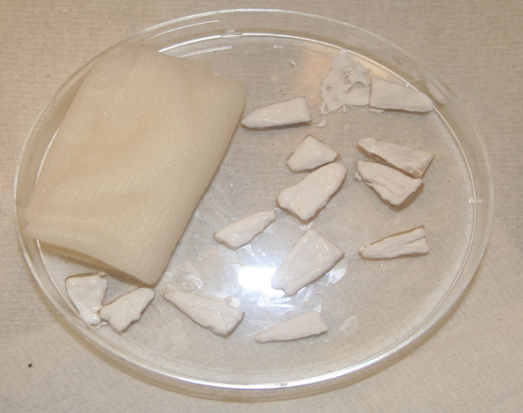
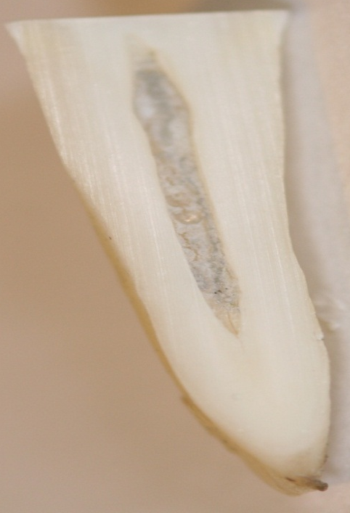
Gauze soaked with saline
Figure ‎0.1 A view of the sectioned tooth root for both control and expermintal groups

Experimental group

Application of Non setting calcium hydroxide NSCH
The length of each slab was marked on the long flexible plastic applicator tip of the NSCH delivery system. The calcium hydroxide paste was applied slowly and continuously from the apical to the most coronal part of the root canal using a slight up-and-down movement. This was continued until the paste was seen covering the whole surface of the slabs.

Application of Mineral trioxide aggregate MTA
A pack of MTA was opened, which contained one gram of MTA and manipulated with water that comes in the packet. The dough was applied using the same method as described in (section ‎2.4.4 page, 82). The last nine slabs which were used as controls were retained with no application of any material.

Storage of the experimental and the control slabs

All dentine samples were stored in a humid environment in a Petri dish to maintain the hydration of dentine, in order to replicate normal oral conditions and to prevent the slabs from drying.
Nine specimens were placed in each Petri-dish. Samples were covered with gauze soaked with saline following which the petri dish was covered. All Petri dishes were kept in an incubator at a temperature at 37°C (Townson and Mercer LTD, USA). A thermometer was used continuously to make sure that the temperature was maintained at 37°C.
Saline-soaked gauzes were changed every week throughout the period of the study to prevent dehydration. This also was done to ensure that no microbial growth was possible on the surfaces of the slabs
.

Method of Assessment

Measurement of Hardness of Dentine using Nanoindentation
A Nano-indenter (Micro Material Ltd, Wrexham, UK) located in the Mechanical Engineering Laboratory of University of Leeds was used (Figure ‎0.2).
Before the slabs could be used for assessment by nano-indentation they were prepared to be clean, flat and smooth. The slabs were left in a water bath for 30 minutes to remove any debris and remnants of calcium hydroxide. They were then made smooth and flat using fine sandpaper (3M, USA).
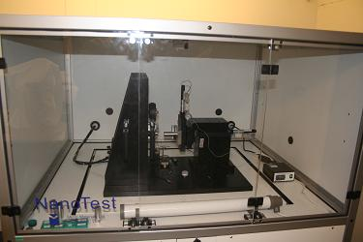
Figure ‎0.2 Nanoindentor used to test the Hardness of dentine

Preparing and embedding slabs for nanoindentation
The nano-indenter is usually used to assess larger slabs and materials than was the case in our study. For slabs of the dimensions that we used in our study, we were required to develop a system that would hold the slabs securely in the nanoi-ndenter for the tests to be carried out. For this purpose we developed a metal die as shown in (Figure ‎0.3). This die was fabricated from iron in the workshop of Leeds Dental Institute according to our instructions. The rectangular well in the middle of the metal die was filled with a light cured composite resin into which the dentine slabs were set before light curing. A ruler was used with gentle pressure to ensure flatness of the slab before curing. After curing the composite the embedded slab was gently removed from the die with pressure applied through the small hole located in the middle of the well. Using a Diamond cutting wire the dentine slab was sectioned in the middle as shown in (Figure ‎0.4).

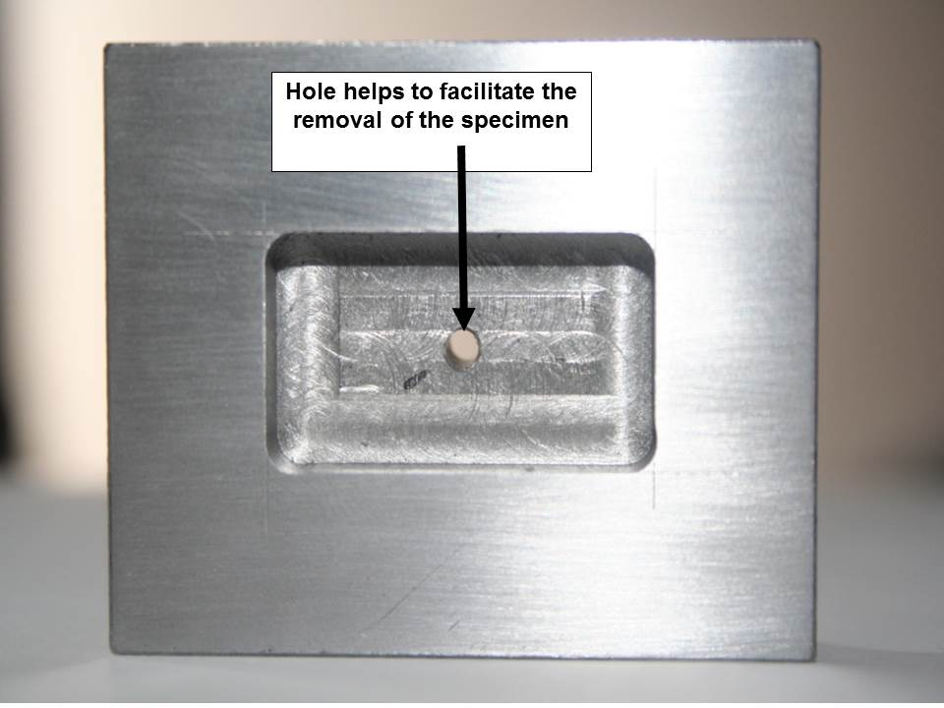
Figure ‎0.3 Metal die constructed to hold the dentine samples for assessment by nanoindention

The nano-indentation readings were taken from the side rather than the surface of the dentine (Figure ‎0.5). This was done in order to avoid measuring the exposed surface which was found to contain the smear layer on SEM examination performed when the investigator was familiarising himself with the technique. The samples were smoothed with a fine grade sand paper, from both sides then it was left in an ultrasound bath to clean the experimental side from the debris.
Hole helps to facilitate the removal of the specimen

Hole helps to facilitate the removal of the specimen

Figure ‎0.4 Showing the composite block containing the dentine slab cut in the middle.
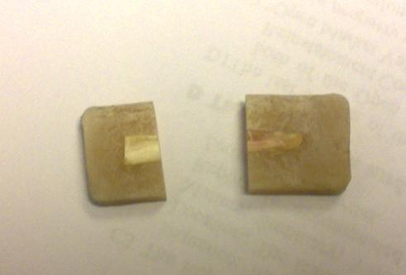

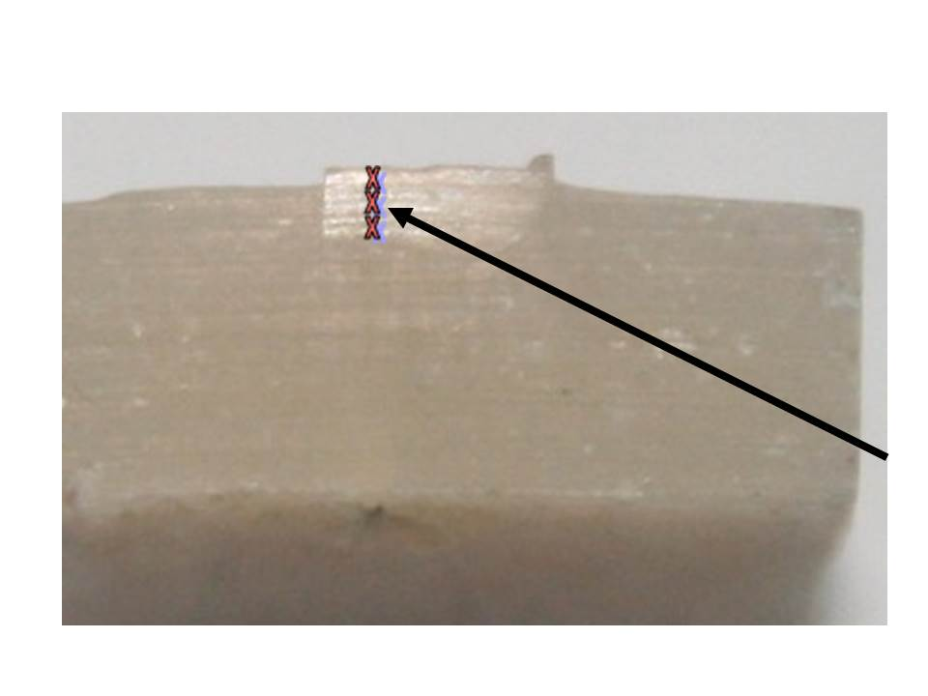
Figure ‎0.5 Showing test area and the arrow indicates the site of nanoindentation measurement
The test area

Nano-mapping scan
This method was described by (Oliver and Pharr, 1992; Fischer-cripps, 2002) NanoTest platform (MicroMaterials Ltd.) was used in this study to perform mechanical characterisation of tooth samples. The primary application of the platform is nano-indentation experiments but with additional modules it can be adapted to scratch friction and impact tests.
A typical outcome of the nano-indentation testing is an indentation load depth hysteresis curve. The indenter load applied to the contact area with a specimen surface, produces an indent/impression which consists of a permanent or temporary elastic deformity. Recovery of the elastic deformity occurs when unloading is started. Determination of the elastic recovery by analysing the initial part of the unloading data according to a model for the elastic contact problem leads to a solution for calculation of the elastic modulus E and hardness H of the test area. The nano-indentation apparatus used in this study was a Nano-indenter (MTS Systems Corporation). In this study, all testing was programmed in such a way that the loading started when the indenter came into contact with the test surface and the load maintained for 60 seconds at the pre-specified maximum value before unloading. Progressive multistep indentation testing with five loading–unloading cycles at different depths was applied at each test point.
On each individual sample at least 5 indentations were taken to obtain average values of hardness and elastic modulus. A Berkovich diamond indenter was used and the experiments were run with the following loading conditions: max load 20mN, loading rate 0.5mN/s, and 60s of dwell time at the maximum load. All indentations were taken in a close proximity to the tooth root, which was achieved by adjusting the measurement position using a coupled light microscope. Hardness and elastic modulus maps were obtained with the same loading conditions by running experiments with 10x10 indentations matrix.

Nano-impact testing
NanoTest platform (MicroMaterials Ltd) was used in this study to perform mechanical characterisation of tooth samples. The primary application of the platform is nano-indentation experiment but with additional modules it can be adapted to scratch friction and impact tests (Figure ‎0.6). On each individual sample at least 5 indentations were taken to obtain average values of hardness and elastic modulus. Berkovich diamond indenter was used and the experiments were run with the following loading conditions: max load 20mN, loading rate 0,5mN/s, 60s of dwell time at the maximum load. All indentations were taken in a close proximity to the tooth root, which was achieved by adjusting the measurement position using coupled light microscope. Hardness and elastic modulus maps were obtained with the same loading conditions by running experiments with 10x10 indentations matrix.
For impact tests, samples were mounted on the impact stub, which incorporates a piezo stack to oscillate the sample while in contact with the indenter. A cube corner-type indenter was used for impact experiments with the following test conditions: 1, 5 and 15mN normal load, 300s test duration, 80Hz oscillation frequency, each test was repeated 5 times. Sample oscillation was applied in alternating 3s on and 3s off periods.
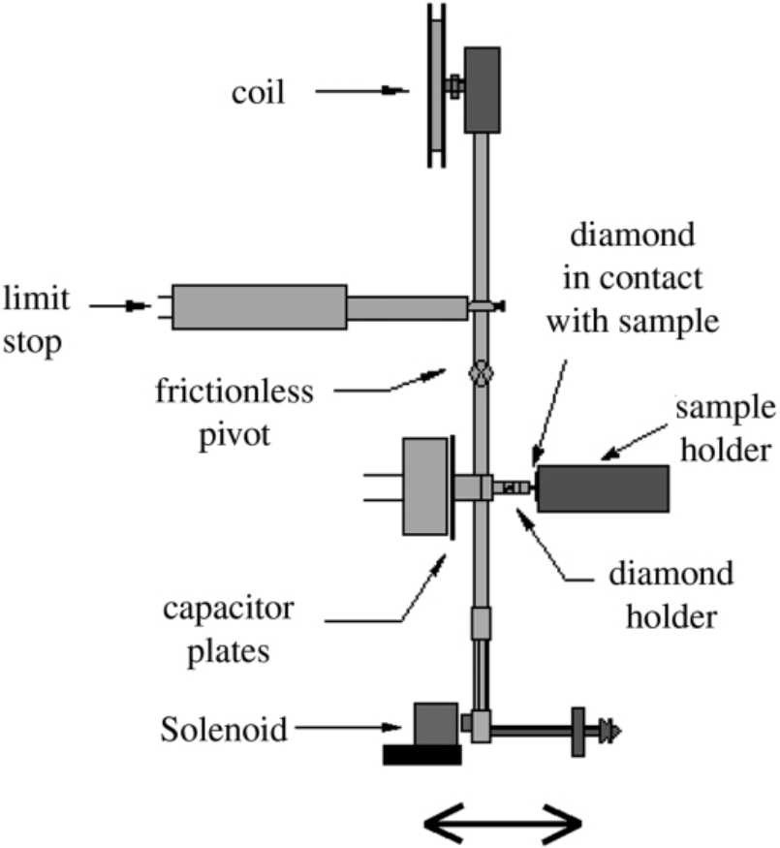
Figure ‎0.6 Illustration of the NanoTest system showing the configuration for impact testing.

Calculation of Young’s Modulus of Elasticity
The value obtained from nano-indentation was used in a formula described by Oliver and Pharr (1992), to calculate the Young’s Modulus of Elasticity from the following equation:
Em=
E* is the value obtained from nano-indentation.
Em this is the modulus of elasticity.
Ei this is a constant value=0.07.
Vi this is a constant value=1141.
Vm this value was obtained from the literature=0.03

Statistical analysis
The normality of the data was checked using the Shapiro Wilk test. Further analysis was carried out using non-parametric Kruskal-Wallis tests, using SSPS (version 20) to calculate the median and confidence intervals. A p value of (p≤0.5) was accepted as significant.

Results

Distribution of the data- Test of normality

Hardness
A significant difference between groups was observed using the Shapiro-Wilk test which means that the data was not normally distributed. This is shown in Table ‎0.1and in Figure ‎0.7.
Table ‎0.1 Test for normality using Shpiro-Wilk test of normality for hardness dentine
Tests of Normality
 | time | Kolmogorov-Smirnovª |  |  | Shapiro-Wilk
 | time | Statistic | df | Sig. | Statistic | df | Sig.
hardness | 3 Months | .129 | 27 | .200* | .925 | 27 | .052
hardness | 8 Months | .311 | 27 | .000 | .776 | 27 | .000
*. This is a lower bound of the true significance.
a. Lilliefors Significance Correction
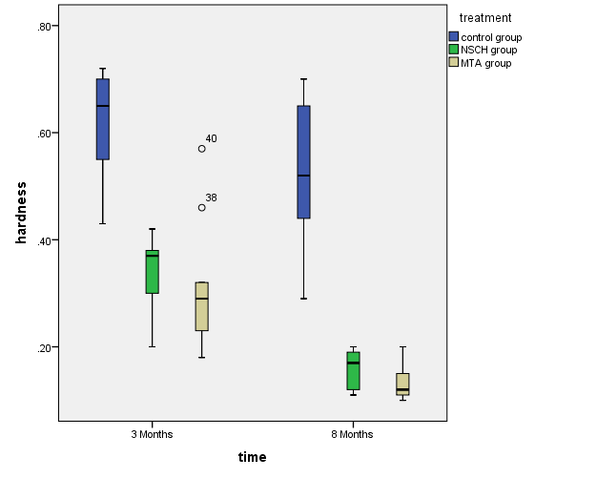
Figure ‎0.7 Whisker box plot showing that the data for hardness of dentine is not normally distributed.

Modulus of elasticity
It can be seen from that the data for the modulus of elasticity was not normally distributed.
Table ‎0.2 and Figure ‎0.8 that the data for the modulus of elasticity was not normally distributed.
Table ‎0.2 Test for normality using Shapiro-Wilk test of normality for modulus of elasticity of dentine.
Tests of Normality
 | time | Kolmogorov-Smirnovª |  |  | Shapiro-Wilk
 | time | Statistic | df | Sig. | Statistic | df | Sig.
MOD | 3 Months | .083 | 27 | .200* | .986 | 27 | .967
MOD | 8 Months | .150 | 27 | .125 | .904 | 27 | .016
MOD Modulus of elasticity
*. This is a lower bound of the true significance.
a. Lilliefors Significance Correction
Figure ‎0.8 Whisker box plot showing that the data for hardness of dentine is not normally distributed.
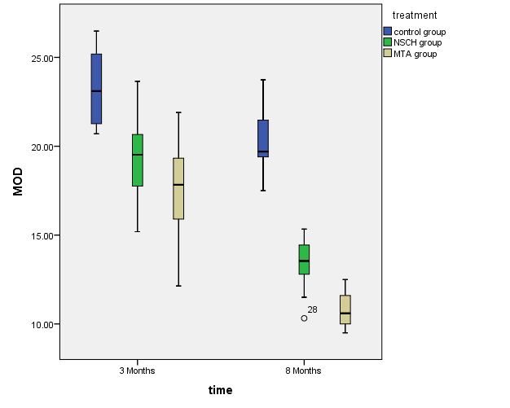
(MOD)= Modulus of elasticity

Hardness of dentine and Young’s Modulus of Elasticity after three months of application of NSCH and MTA

Hardness
The results are presented inTable ‎0.3 and Figure ‎0.9. The highest mean hardness was 0.61 Giga Pascal (GPa), for control slabs followed by NSCH (0.34 GPa) with the lowest value for MTA group (0.31 GPa). There was a significant difference in the hardness of dentine of both the experimental groups compared with the control group after three months of calcium hydroxide and mineral trioxide aggregate application (p<0.01).
It can also been seen that although the mean hardness values for the MTA group were lower than that of NSCH, the results did not reach statistical significance.

Table ‎0.3 Hardness of dentine slabs as evaluated with nanoindentation after three months of application of NSCH and MTA compared with control slabs.
SLAB | Control (Gpa) | NSCH (Gpa) | MTA (Gpa)
1 | 0.65 | 0.38 | 0.18
2 | 0.59 | 0.2 | 0.46
3 | 0.7 | 0.42 | 0.24
4 | 0.68 | 0.31 | 0.57
5 | 0.71 | 0.28 | 0.3
6 | 0.55 | 0.37 | 0.29
7 | 0.72 | 0.38 | 0.32
8 | 0.43 | 0.3 | 0.21
9 | 0.5 | 0.39 | 0.23
Mean | 0.6144 | 0.3367 | 0.3111
Median | 0.65 | 0.37 | 0.29
SD | 0.1061 | 0.0071 | 0.0354
(Gpa) is Giga Pascal.
Figure ‎0.9 Whisker box plot represents the effect of NSCH and MTA on dentine slabs hardness after three months compared to control group.

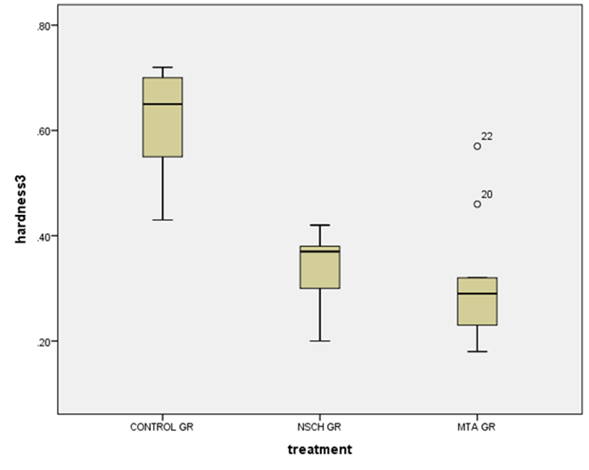

Table ‎0.4 Statistical analysis of the harndness data after three months for the experimental and control groups using non-parametric Mann-Whitney and Wilcoxon tests.
Three months
Treatment | N | Mean Rank | Sum of Ranks | Stat -test | Hardness
control gr | 9 | 14.00 | 126.00 | Mann-Whitney U | 0.000
NSCH gr | 9 | 5.00 | 45.00 | Wilcoxon W | 45.000
Total | 18 |  |  | . Sig | 0.000
control gr | 9 | 13.56 | 122.00 | Mann-Whitney U | 4.000
MTA gr | 9 | 5.44 | 49.00 | Wilcoxon W | 49.000
Total | 18 |  |  | Sig | 0.001
NSCH gr | 9 | 10.72 | 96.50 | Mann-Whitney U | 29.500
MTA gr | 9 | 8.28 | 74.50 | Wilcoxon W | 74.500
Total | 18 |  |  | . Sig | 0.331

Modulus of elasticity
The results are presented in. Table ‎0.5 and
Figure ‎0.10. The mean modulus of elasticity of control slabs was 22.56 GPa compared with 18.73 GPa in for NSCH and 17.53 for the MTA group.
The difference in the mean of modulus of elasticity between both the experimental groups and control group was statistically significant (p<0.01). However there was no significant difference between the NSCH and the MTA group.

Table ‎0.5 Modulus of elasticity of dentine slabs as evaluated with nanoindentation after three months of application of NSCH and MTA compared with control slabs.
SLAB | Control (Gpa) | NSCH (Gpa) | MTA (Gpa)
1 | 24.55 | 16.64 | 12.14
2 | 21.19 | 18.11 | 21.9
3 | 20.7 | 22.72 | 15.65
4 | 25.86 | 20.66 | 20.4
5 | 26.48 | 15.19 | 16.56
6 | 21.27 | 19.52 | 15.9
7 | 23.1 | 17.76 | 19.33
8 | 25.19 | 20.1 | 18.1
9 | 22.16 | 23.65 | 17.83
Mean | 23.39 | 19.37 | 17.53
Median | 23.1 | 19.52 | 17.83
SD | 1.69 | 4.96 | 4.02
(Gpa) is Giga Pascal.

Figure ‎0.10 Whisker box plot represents the effect of NSCH and MTA on dentine slabs Modulus of elasticity after three months compared to control slabs.
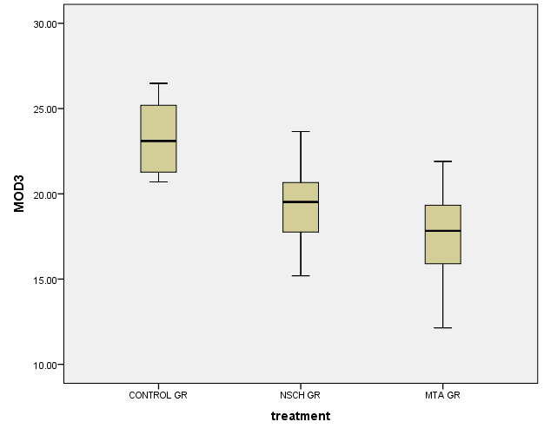

(MOD) Modulus of elasticity

Table ‎0.6 Statistical analysis of the modulus of elasticity data after 3 months for the experimental and control groups using nonparametric Mann-Whitney and Wilcoxon tests
Three Months
Treatment | N | Mean Rank | Sum of Ranks | Stat -test | MOD
control gr | 9 | 9 | 13.00 | Mann-Whitney U | 9.000
NSCH gr | 9 | 9 | 6.00 | Wilcoxon W | 54.000
Total | 18 |  |  | . Sig | 0.005
control gr | 9 | 13.67 | 123.00 | Mann-Whitney U | 3.000
MTA gr | 9 | 5.33 | 48.00 | Wilcoxon W | 48.000
Total | 18 |  |  | Sig | 0.001
NSCH gr | 9 | 11.11 | 100.00 | Mann-Whitney U | 26.000
MTA gr | 9 | 7.89 | 71.00 | Wilcoxon W | 71.000
Total | 18 |  |  | . Sig | 0.222

Hardness of dentine and Young’s Modulus of Elasticity after eight months of application of NSCH and MTA

Hardness after eight months of NSCH and MTA application
The results are presented in. Table ‎0.7 and
Figure ‎0.11. The highest mean hardness was 0.53 GPa for control slabs followed by the mean hardness value of the NSCH which was 0.16 GPa, and the lowest value was 0.13 for MTA slabs. There was a significant difference in the hardness of dentine of the experimental groups and the control group after eight months of calcium hydroxide and mineral trioxide aggregate application (p<0.00).
The results showed a statistical significant difference between both experimental groups compared with the control group. Although the mean value for the hardness of the MTA group was lower than for the NSCH group, this was not statistically significant.

Table ‎0.7 Hardness of dentine slabs as evaluated with nano-indentation after eight months of application of NSCH and MTA compared with control slabs.
Slab | Control(Gpa) | NSCH(Gpa) | MTA(Gpa)
1 | 0.7 | 0.2 | 0.15
2 | 0.5 | 0.11 | 0.16
3 | 0.65 | 0.12 | 0.11
4 | 0.61 | 0.19 | 0.2
5 | 0.29 | 0.12 | 0.12
6 | 0.37 | 0.17 | 0.1
7 | 0.52 | 0.17 | 0.14
8 | 0.67 | 0.2 | 0.12
9 | 0.44 | 0.17 | 0.11
Mean | 0.53 | 0.16 | 0.13
Median | 0.57 | 0.17 | 0.13
SD | 0.18 | 0.02 | 0.03
(Gpa)= is Giga Pascal.

Figure ‎0.11 Whisker box plot represents the effect of NSCH and MTA on dentine slabs hardness after eight months compared to control group.
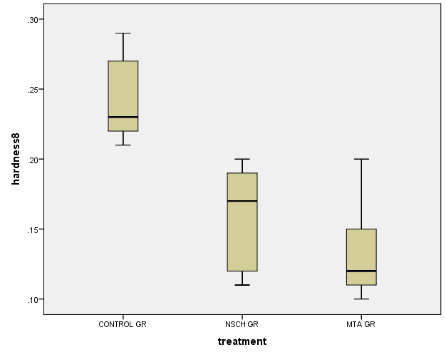

Table ‎0.8 Statistical analysis of the harndness data after eight months for the experimental and control groups using non-parametric Mann-Whitney and Wilcoxon tests
Eight Months
Treatment | N | Mean Rank | Sum of Ranks | Stat -test | Hardness
control gr | 9 | 14.00 | 126.00 | Mann-Whitney U | 0.000
NSCH gr | 9 | 5.00 | 45.00 | Wilcoxon W | 45.000
Total | 18 |  |  | . Sig | 0.000
control gr | 9 | 13.56 | 122.00 | Mann-Whitney U | 4.000
MTA gr | 9 | 5.44 | 49.00 | Wilcoxon W | 49.000
Total | 18 |  |  | Sig | 0.001
NSCH gr | 9 | 11.56 | 104.00 | Mann-Whitney U | 22.000
MTA gr | 9 | 7.44 | 67.00 | Wilcoxon W | 67.000
Total | 18 |  |  | . Sig | 0.098

Modulus of elasticity after eight months of NSCH and MTA application
The results are presented in. Table ‎0.9 and Figure ‎0.12. The mean modulus of elasticity of control slabs was 20.3 GPa compared with 13.27 GPa in NSCH and 10.81 for the MTA group. The difference in the mean of modulus of elasticity between both the experimental groups and control group was statistically significant. (p<0.01). However there was no significant difference between the NSCH and the MTA groups.

Table ‎0.9 Modulus of elasticity of dentine slabs as evaluated with nano-indentation after eight months of application of NSCH and MTA compared with control slabs.
Slab | Control (Gpa) | NSCH(Gpa) | MTA(Gpa)
1 | 19.56 | 10.32 | 10
2 | 21.66 | 14.44 | 9.5
3 | 19.7 | 14.73 | 11.3
4 | 21.47 | 15.34 | 9.55
5 | 23.74 | 11.5 | 10.6
6 | 20.77 | 12.8 | 12.5
7 | 19.4 | 13.55 | 10.33
8 | 18.88 | 13.85 | 11.6
9 | 17.5 | 12.9 | 11.9
Mean | 20.298 | 13.27 | 10.81
Median | 20.24 | 13.7 | 10.47
SD | 1.4566 | 1.82 | 1.34
Gpa) is Giga Pascal.

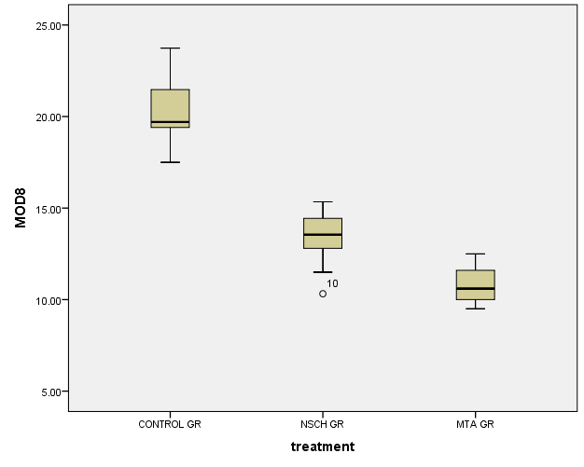
Figure ‎0.12 Whisker box plot represents the effect of NSCH and MTA on dentine slabs Modulus of elasticity after eight months compared to control slabs.

Table ‎0.10 Statistical analysis of the modulus of elasticity data after eight months for the experimental and control groups using non-parametric Mann-Whitney and Wilcoxon tests.
Eight Months
Treatment | N | Mean Rank | Sum of Ranks | Stat -test | MOD
control gr | 9 | 9 | 13.00 | Mann-Whitney U | 9.000
NSCH gr | 9 | 9 | 6.00 | Wilcoxon W | 54.000
Total | 18 |  |  | . Sig | 0.004
control gr | 9 | 13.67 | 100.00 | Mann-Whitney U | 3.000
MTA gr | 9 | 5.33 | 48.00 | Wilcoxon W | 48.000
Total | 18 |  |  | Sig | 0.001
NSCH gr | 9 | 11.11 | 104.00 | Mann-Whitney U | 22.000
MTA gr | 9 | 7.89 | 67.00 | Wilcoxon W | 67.000
Total | 18 |  |  | . Sig | 0.113

Nano mapping scan
Results are presented for the map scan illustrating the mechanical properties throughout the dentine slabs for all groups. This was performed after 8 months of application of the test materials.
A nano-software that is built into the nano-indentor assessment method was used to interpolate between the individual values of hardness and modulus of elasticity thereby creating a continuous map.
Hardness values were presented in map scan indicated by different colours, and every colour represents a value of hardness or modulus of elasticity throughout the dentine slab surface. It is clear that the control group showed the highest hardness Figure ‎0.14 and modulus of elasticity (Figure ‎0.17), followed by NSCH (Figure ‎0.15) and (Figure ‎0.18), with the MTA group showing the least hardness and modulus of elasticity on scanning (Figure ‎0.16) and (Figure ‎0.19).
Figure ‎0.13 Illustrate the colour scale for hardness and modulus which would help the reader to understand the map scan figures that are presented below.
Figure ‎0.13 Colour scale to illustrate the hardness and modulus of elasticity.
High hardness & modulus of elasticity
Low hardness & modulus of elasticity

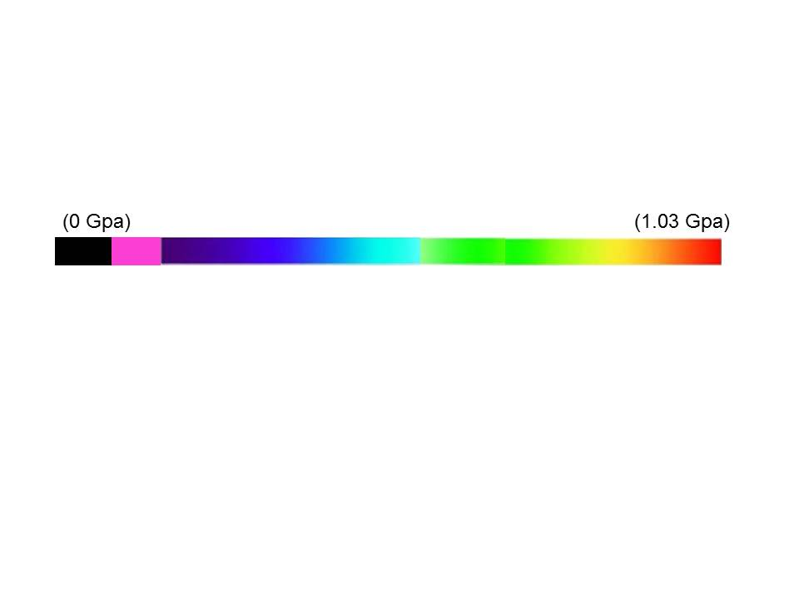

Map scans illustrating Hardness after eight months

Figure ‎0.14 Showing dentine surface hardness of the control group. It can be seen that the dominant colours ranged between green and red indicating high hardness.
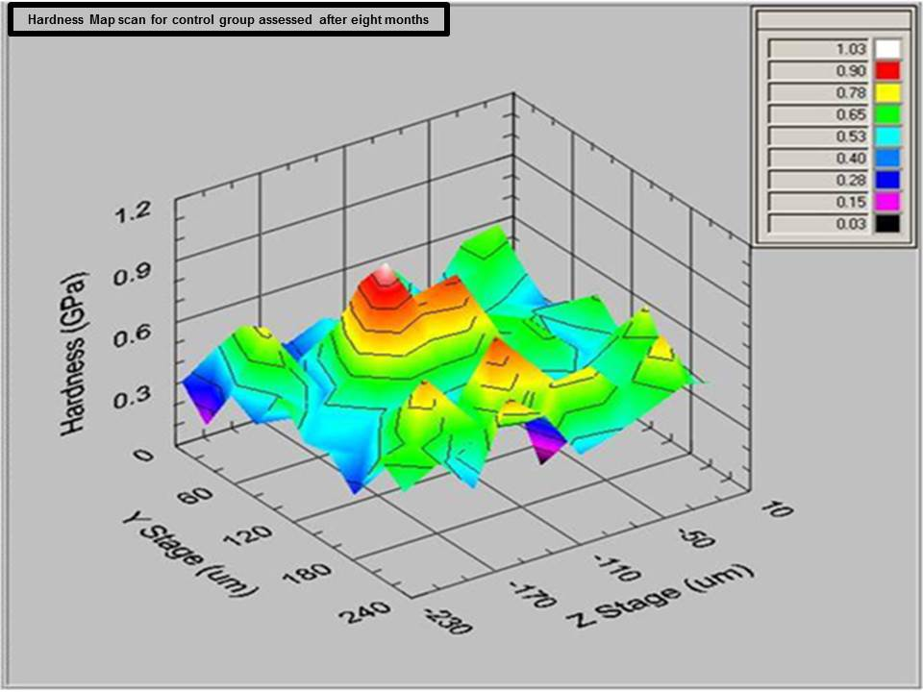

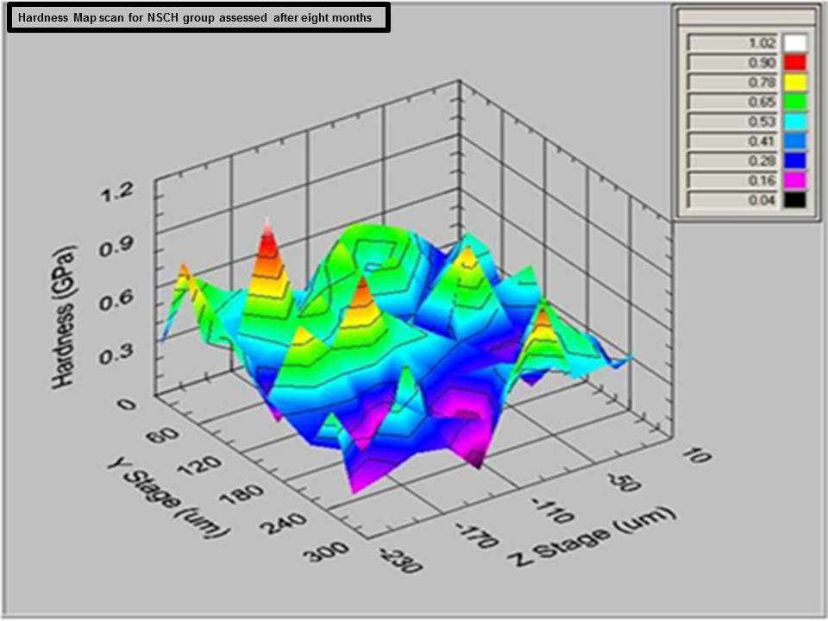
Figure ‎0.15 Showing dentine surface hardness of NSCH. It can be seen that the dominant colours ranged between green and blue indicating soft or low hardness.

Figure ‎0.16 Showing dentine surface hardness after 8 months of MTA application. It can be seen that the dominant colour is blue indicating low hardness.
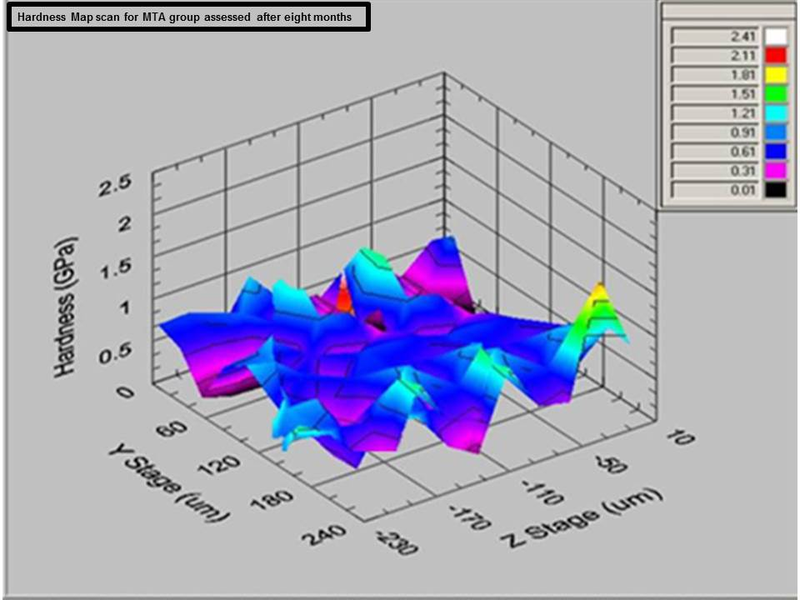

Map scans illustrating modulus of elasticity after eight months
Figure ‎0.17 Showing dentine surface modulus of elasticity for the control group. It can be seen that the colour ranged between green and red meaning high modulus of elasticity.
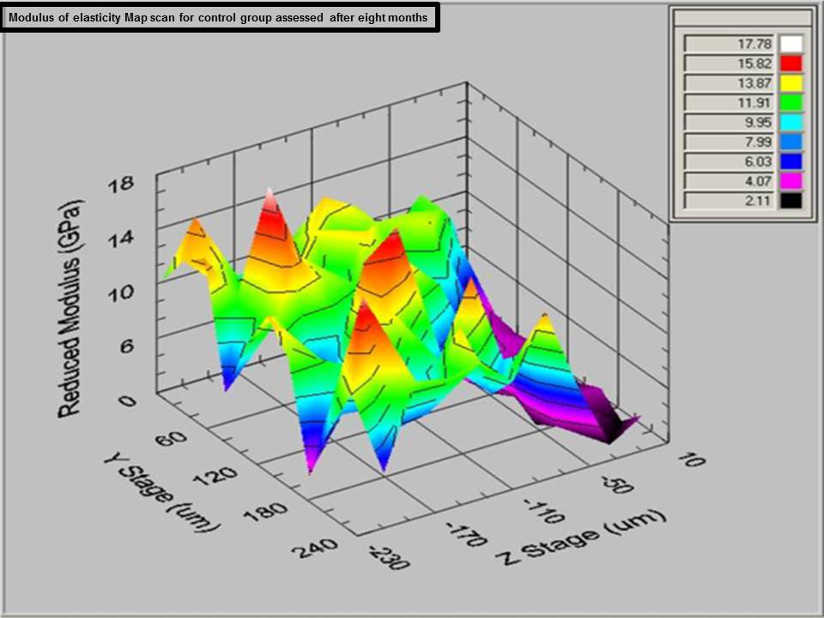

Figure ‎0.18 Showing dentine surface modulus of elasticity for the NSCH. It can be seen that that the dominant colour is blue meaning low modulus of elasticity.
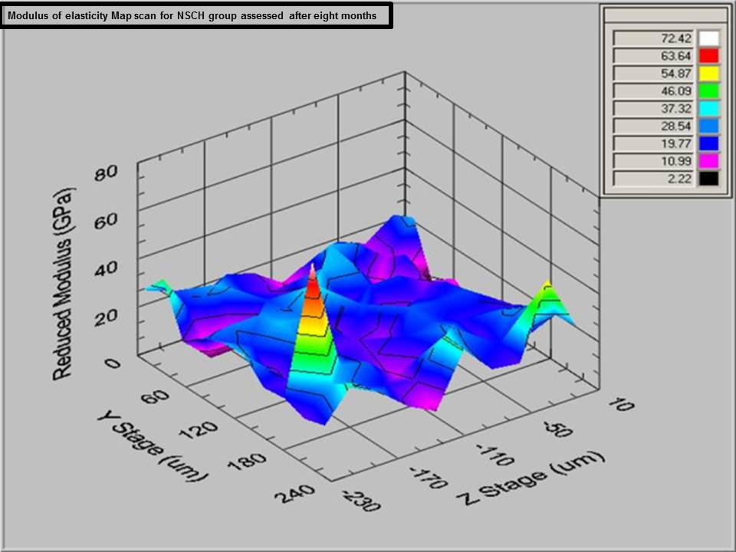

Figure ‎0.19 Showing dentine surface modulus of elasticity for the MTA. It can be seen that that the dominant colour is blue indicating low modulus of elasticity.

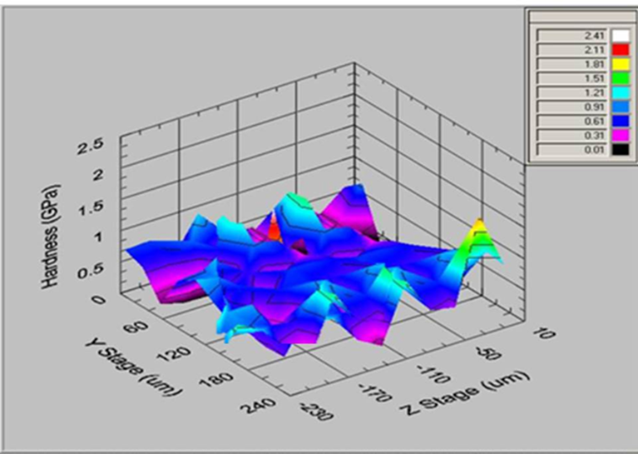

Nano-impact testing
The impact test recorded the evolution of impact induced damage with time (i.e. deformation, fatigue wear and fracture) on repetitive impact of a test probe. The position of the surface was recorded with sub-nanometer precision when the probe was on the surface.
The initial application of the 1mN load and 5 mN (micro newton) showed no result which means that no deformity or fractures and no changes were observed in all samples which were the same as the control group. However with a load of 15 mN there was a clear behaviour difference between the samples group, which reflected that there were changes in mechanical properties of dentine after applications of NSCH and MTA. This change affected the strength of the dentine samples. The sample treated with no material (control group) showed a 1450 nm depth after 300 seconds. Figure ‎0.20. In, this experiment the dentine samples which were treated with NSCH for eight months showed indenter depth of 1800 after 200 seconds Figure ‎0.21 and the other samples treated with MTA, showed the least resistance to impact by 1900 nm depth after only 110 seconds. This behaviour might be related to lower hardness indicating that the experimental samples are more brittle and prone to fractures.

Figure ‎0.20 The rapid Nano-impact test showing the resistance to multiple impacts of the indenter force of 15 mN for control group for up to 300 seconds.
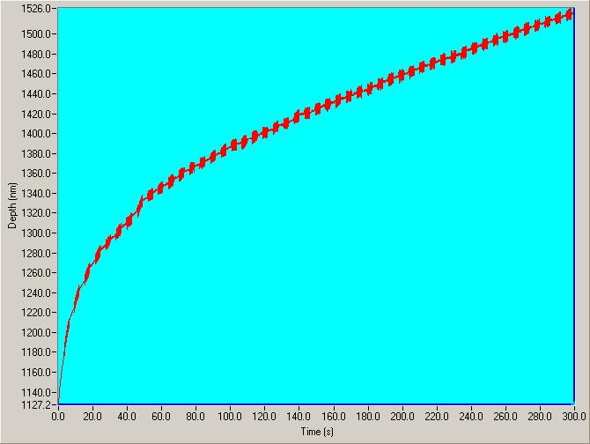

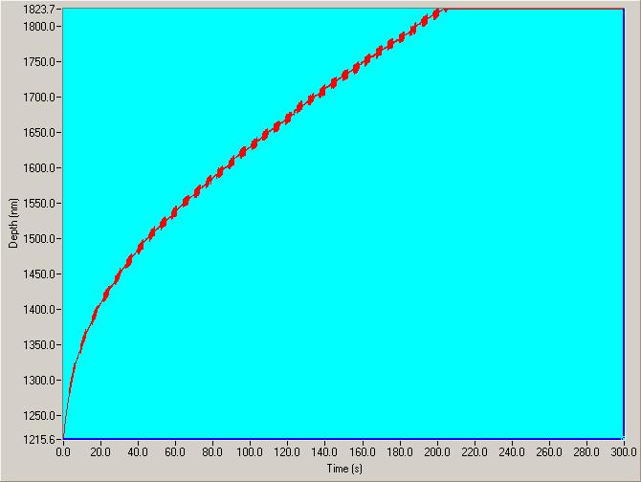
Figure ‎0.21 The rapid Nano-impact test showing the resistance to multiple impacts of the indenter force of 15 mN for NSCH group. This shows a decrease in resistance time to 200 seconds.

Figure ‎0.22 The rapid Nano-impact test showing the resistance to multiple impacts with a indenter force of 15 mN for MTA group. This shows the least time resistance compared to the other groups with a resistance 110 seconds.

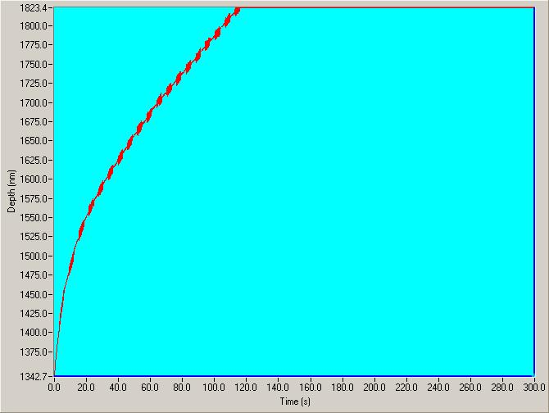

Discussion

Sample selection and storage
The teeth used in our study were collected from the One Day Unit or sedation clinic at Leeds Dental Institute. Ethical approval was obtained from the Leeds Dental Institute Tissue Bank. The teeth had been extracted for orthodontic reasons. This was the only source of teeth that was available to the investigator. We presumed that all patients had been exposed to a similar level of fluoride and accepted that this might not have been the case. Fluoride does have an effect on the hardness of dentine and its mineralisation (Vieira et al., 2005). However, by randomly distributing our slabs to the experimental and control groups we felt that any influence that this might have had on our results would be minimised.
Goodies et al., (1993) compared the storage effect on dentine permeability and bond strength of 70% ethanol, 10% formalin, distilled water, distilled water with thymol and phosphate buffered with saline with thymol. Distilled water was reported to be the best choice to clean the teeth, since it had no effect on dentine. Thymol was also advocated as the solution of choice due to its minimal effect on the properties of dentine, and most researchers use thymol as a storage medium for teeth that are used for hard tissue research which has been used in this study.

Sample size calculation
Sample size plays an important role in research for the following reasons:
1- If the sample size is too small, a real difference between the treatments could be missed.
2- It is unethical to recruit patients if the study could not have detected a useful effect.

Discussing the effect of each test group on dentine and compared to the literature:

Non setting calcium hydroxide NSCH group:
Our results seem to be quite indicative of the detrimental effect of NSCH on the fracture resistance of dentine. A recent study (Rosenberg et al., 2007) has also shown a significant decrease in the mean tensile fracture strength (MTFS) of dentine after the application of CH for 84 days.
A previous study (Yoldas et al., 2004) showed a statistically significant decrease in hardness of dentine as soon as 7 days after the application of CH. From our study design we could not ascertain this. It would have been interesting to carry out the hardness measurements at more regular intervals to exactly pin point the time at which the changes start to become clinically relevant.
It is possible that NSCH causes a change in matrix content, denatures proteins, effects the pH or changes the mechanical and chemical properties of root dentine walls (Andreasen et al., 2002; White et al., 2002; Doyon et al., 2005; Andreasen et al., et al., 2006; Rosenberg et al., 2007). Andreasen et al., (2002) in their study on sheep teeth concluded that it was indeed the high pH of CH which caused proteolysis and weakened the dentine by up to 50% which might lead to root fracture. White et al., (2002) reported a 32% decrease in dentine strength after use of calcium hydroxide. Yoldas et al., (2004) reported that the use of calcium hydroxide combinations for intra-canal dressing softened the dentine.
Though these previous studies have addressed this area some have flaws with their methodology. In a previous study (Doyon et al., 2005) the teeth were stored at room temperature of 22C°, which is not reflective of body temperature and humidity. It has also been shown that a dry environment has an effect on the hardness of dentine (Balooch et al., 1998). Therefore in our study we kept the slabs moist and stored them at a temperature of 37ºC.
Previous studies have used sodium hypochlorite as an irrigation solution before the application of calcium hydroxide (Rosenberg et al., 2007). Sodium hypochlorite has been proven by many studies to have a negative effect on dentine hardness (Sim et al., 2001; White et al., 2002). However, it was felt that for immature teeth a very weak hypochlorite solution could be used as an irrigant as this was unlikely to have any detrimental effect on dentine. We decided not to incorporate this into this study design.
In this study we did not investigate the effect of CH on the proteins in dentine but it can be safely assumed that a reduced hardness and modulus of elasticity could be a result of denaturation of proteins within the dentine matrix. Certainly SEM images from a previous study (Twati et al., 2009) showed widespread distribution of CH inside the dentinal tubules throughout the dentine.

Mineral Trioxide Aggregate MTA
MTA has led to successful resolution of the periapical lesion, but neither method (NSCH & MTA) can lead to further dentine development and thus leaves the tooth in a weakened state.
Consequently, MTA materials have largely replaced calcium hydroxide as endodontic repair materials. It has been demonstrated that MTA stimulates reparative dentine formation, with thick dentinal bridging, minimal inflammation, and nominal hyperaemia (Chacko and Kurikose, 2006). MTA is a calcium silicate–based material with chemical similarities to ordinary Portland cement. It has been modified with reduced heavy metal content, increased radio-opacity, better particle distribution and size, lower solubility, and reduced setting expansion to meet the demands of a biomaterial (Darvell and Wu, 2011). MTA is classified as a hydraulic cement that sets and is stable under water. As the components are similar to those of Portland cement, it may be assumed that MTA sets through a hydration reaction that involves dissolution of calcium silicate granules to produce calcium hydroxide and calcium silicate hydrates, which form the matrix that holds anhydrated granules and contains water-filled microspaces where the calcium hydroxide distributes (Atmeh et al., 2012). The release of calcium hydroxide provides the high alkalinity and is believed to be responsible for its ability to induce hard tissue formation when used as a pulp-capping material and encourage the periapical tissue to continue root development. Relatively poor strength properties of MTA have been reported (Islam et al., 2006) and an earlier study that suggested that prolonged contact of root dentine with calcium hydroxide or MTA resulted in similarly severe reductions (32% versus 33%) in dentine fracture resistance (White et al., 2002). In this study we found that MTA weakened the tooth by 48% after eight months of application. Several modifications to the original composition have been made (Oliveira et al., 2010). More recent in vitro investigations showed that MTA-filled root canals had significantly greater fracture strength than calcium hydroxide-filled root canals but no different than unfilled roots after saline storage for 100 days (Andreasen et al., 2006). Similar results were reported for MTA and a modified MTA (DiaRoot; DiaDent Group International, Burnaby, BC, Canada) with respect to calcium hydroxide-filled roots (Tuna et al., 2011). There appears to be some consensus that MTA does not weaken the dentine to the same extent as calcium hydroxide, although some negative effect on dentine strength has been demonstrated (Sawyer et al., 2012) after 2–3 months of contact. The ability for MTA to reinforce weakened teeth is still open to some debate. One investigator found that the fracture strength of MTA was greater than gutta-percha filled and non-filled canals after 48 hours (Bortoluzzi et al., 2007). Another investigator showed that the reinforcing effect could not be detected until after one year of storage when compared with the unfilled control (Hatibovi et al., 2008). Yet another investigator found that after thermocycling MTA did not improve the fracture resistance of weakened roots when compared with an unfilled control (Schmoldt et al., 2011). It would appear from the current data that the strengthening effect of MTA cement alone as a root fortification material is minimal at best but may not negatively impact on dentine properties to the same extent as calcium hydroxide.

Sample preparation to be tested under nanoindentation:

Smear Layer
In the case of sample preparation, the surface polishing of a sample directly affects the depth of the smear layer created (Li et al., 2011). The smear layer is roughly one third to one-half the size of the particle size used for polishing Figure ‎0.23 . If the indentation load is not large enough to penetrate the smear layer, the measured elastic modulus could reflect the value of the smear layer, or the underlying substrate or some combination thereof thus giving a false value of the sample in question.

Figure ‎0.23 This image illustrates how the smear layer affects the nano-indentation measurement
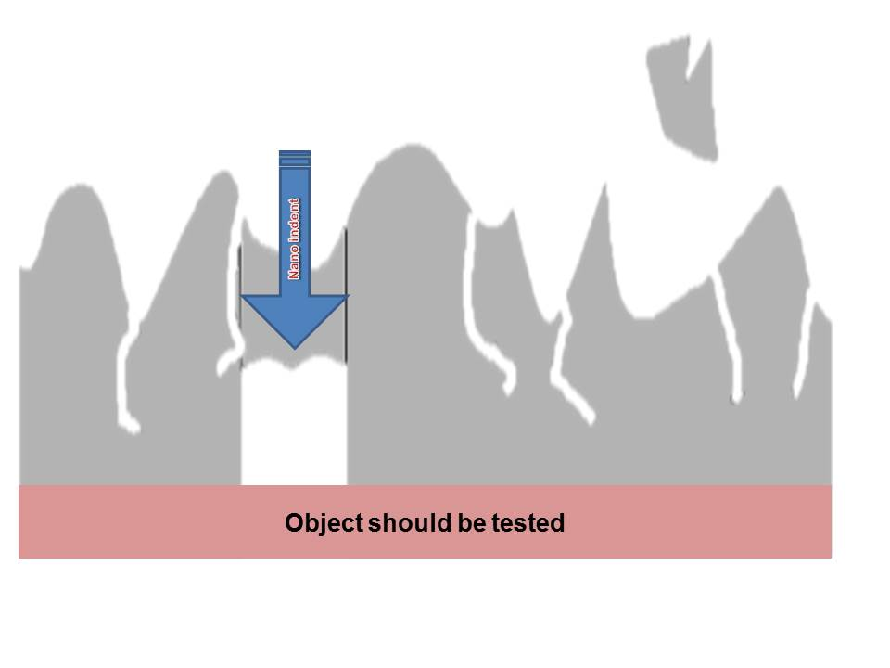
Object to be tested
Nano indent

Surface roughness
The surface roughness creates error because the nano-indenter tip may encounter peaks on the sample surface and prevent the tip from contacting the surface (Figure ‎0.24). Generally, this is overcome by decreasing the surface roughness by polishing the surface or by increasing the force of indentation so that the peaks cannot support the load of the indenter to give a false surface engagement. When using the nano-indenter to create a topographic map, however the forces used are very small which implies that unless the sample is highly polished, the image created will be of the smear layer and not of the sample.

Figure ‎0.24 This image illustrates how the surface roughness affects the nano-indentation measurement
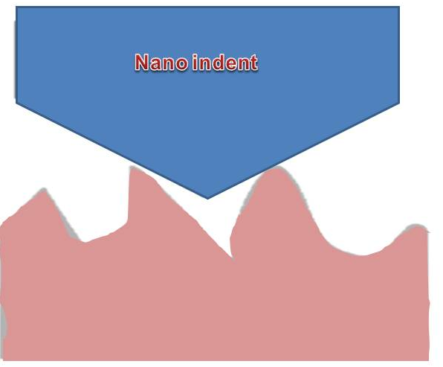

Dentine Hardness and Modulus of Elasticity
Nano-indentation seems to have been used in many recent studies on the mechanical properties of calcified hard tissue (Angker and Swain, 2006). This sensitive method allows the researcher a better way to measure the mechanical properties, hardness and Young’s modulus for dentine (Chng et al., 2002).
The nano-indentation technique is a non-destructive, simple procedure compared with others and sample preparation is less time consuming. It does require the surface to be measured to be flat and smooth (Angker and Swain, 2006). In this study because the samples were semi-spherical we embedded the samples in composite resin to enable us to have a flat top surface, to facilitate measurement. The Dental Institute technology laboratory constructed a metal die for this purpose which though never used before was ideal to hold small samples for nano-indentation measurement. A small hole placed in the bottom of the die enabled us to remove the composite block holding the dentine slab without any damage to the surface that was to be measured. Also, we did not use the “top” surface for hardness measurement and preferred to use the surface on one side after cutting through the composite block. The reason for this was that on SEM examination, (Twati et al., 2009), it was found that the exposed top surface was covered by a smear layer which was about 10–15 microns which could have affected the results. The “side” surface had a smear layer but was less than 5 microns thick and was acceptable for measurement. Also, the storage medium could have an influenced the dentine properties and hardness (Habelitz et al., 2000). Samples in this study were kept in a humid environment by putting soaked gauze of saline in every Petri dish which was changed every week. All Petri dishes containing the samples were kept in an incubator at 37°C to replicate oral temperature. Balooch et al. (1998) stated that non-hydrated dentine had a higher hardness and elasticity compared to hydrated dentine. Therefore by creating a humid environment in this model we ensured dentine hydration which would allow some extrapolation of the results to clinical situations (Angker and Swain., 2006). The choice of the type of indenter is also important. Angker and Swain (2006) have shown that a 5-20µm spherical indenter is more reliable for the investigation of the enamel and dentine elasticity. This was also used in this study.
Map scan of mechanical properties shows significant decrease in hardness and modules of elasticity, on dentine slabs after treatment with both NSCH and MTA, which was time dependant. However MTA exhibited the worst softening after eight months of application on dentine. The impact test in this study shows that the samples treated with MTA could not withstand a 15 mN load against time which implies sample softening which could be due to high pH. One possible reason for this is that the pH of MTA is maintained at an alkaline level for a much longer period compared with NSCH (Parirokh and Torabinejad, 2010).
It is clear from the results of nano-indentation that the hardness of dentine was significantly lower in both groups where NSCH and MTA were applied as compared with the controls after eight months. A reduction of roughly 39% in NSCH and 48% in MTA was observed compared to control group mean. This difference was even more significant when the results were compared after eight months. After eight months the hardness values for the experimental groups were significantly less than the control group. Modulus of elasticity of the experimental groups was also similarly less than that of the controls with more negative effect with the MTA group. A decreased hardness and a reduced modulus of elasticity would signify a compromised dentine fracture resistance. One of the reasons that MTA had a more negative effect on dentine was because NSCH stops releasing calcium ions after one month. (Duarte et al., 2009). However,MTA reached it’s peak of releasing calcium ions after 48 hours and maintained releasing calcium hydroxide ions even after one month (Massi et al., 2011). Also comparing pH values at different periods of time, White MTA (WMTA) exhibited significantly higher pH values than Grey MTA (GMTA) and Portland Cement (PC) immediately after mixing (Islam et al., 2006). However, 30 minutes after mixing, no statistical difference could be found among the materials. At 60 minutes, GMTA had a significantly lower pH value than WMTA and PC (Islam et al., 2006). Available data show that mixing MTA with water results in the formation of CH and a high pH environment (Parirokh and Torabinejad., 2010).

Clinical implications
There was a significant time dependent reduction in the hardness and Young’s Modulus of dentine with NSCH and MTA application.
We suggest that application of NSCH or MTA makes the dentine softer and less stiff.
Weak dentine would not be able to withstand masticatory forces, making teeth more prone to fracture.

Chapter 3

The effect of root canal medicaments and antibiotics used in endodontics on the common pathogens found in root canals of non-vital teeth

Introduction
Extensive carious lesions involving the pulp or any pulpal damage in the form of tooth surface loss, trauma and other iatrogenic factors may compromise the pulp. As long as the pulp is vital, balance between the host immune system and bacterial invasion is maintained. However, severe bacterial infection causes pulp necrosis, tissue destruction and the defence system becomes overwhelmed (Siqueira and Rôças, 2009).
Inflammatory and pathologic changes in the periapical tissues, the cementum, periodontal ligament and the alveolar bone are referred to as apical periodontitis or periapical or peri-radicular disease (Siqueira & Rocas,2011). The prevalence of periapical disease increases with age and is estimated to be between 33-62% (Lin and Huang., 2011). In order to formulate an effective treatment plan it is crucial to understand the aetiology and pathogenesis of the disease. Although Miller was the first to identify bacteria in an infected root canal, it was not until 1965 when a strong causal link between micro-organisms and periapical disease was established (Kakehashi et.al., 1965; Hoover and Newbrun, 1977) (Figure ‎3.1).
Figure ‎3.1 A time line showing early classic studies that gave evidence for micro-organisms in the aetiology of periapical disease (Siqueira and Rocas, 2011).
1890 | 1900 | 1950 | 1960 | 1970 | 1980 | 1990
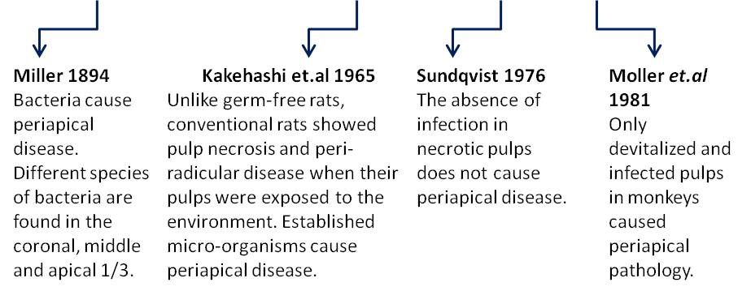
The micro-organisms implicated in endodontic diseases are often likened to a group of invaders seeking different routes of entry into the root canal system (Lin and Huang, 2011). Once they get past the host defences, they launch their virulence potential and overcome harsh conditions like low oxygen potential and nutrition deficiency. The outcome of the struggle/war is influenced by the following factors:
- Pathogenicity or virulence potential of the invading micro-organism.
- Host resistance factors, host immunity.
- Duration of the infection
The host defence system responds to the bacterial presence by causing inflammation of the tissues. However, if the severity of microbial assault increases, the blood supply to the tissue ceases and the pulp becomes necrotic. This environment is conducive for microbial proliferation which results in further tissue destruction.
Bacterial endotoxins and other metabolic waste products are formed which move through the root canal into the periapical tissues. These are toxic to the tissues and result in periapical disease with pathologic destruction of the surrounding structures (Lin and Huang, 2011).

Bacteria
Bacteria play the major role in the aetiology of periapical lesion formation (Sundqvist, 1992), resulting in bone resorption which is an active process carried out by osteoclasts. Bacteria can gain access to the dental pulp through the crown or root surfaces in association with processes such as caries, periodontal disease, or trauma.
It has been revealed that in chronic periapical infections micro-organisms co-exist like an organised community with each species having its hierarchical importance and function. The biofilm not only augments microbial pathogenicity but also provides protection from external factors like host defence systems, other micro-organisms, antimicrobials and environmental stress (Siqueira and Rocas, 2011)
It has been suggested that genetic exchange of information also takes place across the species. Synergistic or additive relationships occur due to these bacterial interactions which determine the virulence of the microbial community (Nair, 2004). In contrast, bacteria in acute apical infections are no longer part of the biofilm and exist in a planktonic phase. Though they are more toxic in this form they make relatively easy targets for antimicrobial therapy during treatment (Siqueira and Rocas, 2011).
It is the virulence of individual bacterial species that determines the pathogenic potential of the biofilm once it gains entry into the tooth. Strict anaerobes accounted for 64.9% of all species isolated, and gram-negative microorganisms accounted for 55.4%. Microbial genera most frequently isolated were Prevotella, Fusobacterium, Peptostreptococcus, Streptococcus, Enterococcus, Clostridium, and Porphyromonas (Ferreira et al., 2006).
The most common bacterial species found in untreated primary infections are shown in Figure ‎3.2 (Siqueira and Rôças, 2009)
Figure ‎3.2 Bacterial species found in primary infections
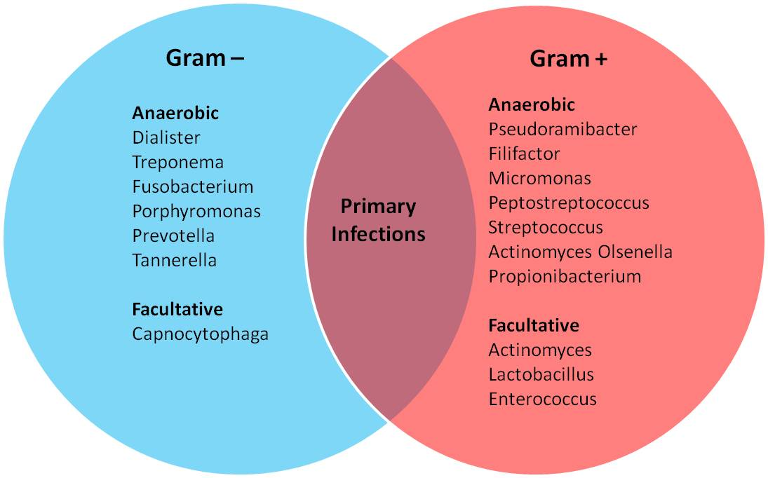

Microbial influence on the development of periapical diseases
Apical periodontitis is an inflammation and destruction of periradicular tissues caused by aetiological agents of endodontic origin. Periapical disease development is a complex process between pathogens and bodily defence mechanisms. Progression of any disease may combine or rely completely on pathogen virulence factors or debilitated bodily immunity. Under normal conditions, dental pulp and dentine are completely sterile and protected from external environment by an overlying enamel and cementum.
In conventional laboratory rats, oral microorganisms have been shown to enter the pulp cavity and cause pulpal inflammation and necrosis (Kakehashi et al., 1965). Subsequently, peri-radicular inflammation emerged that needed 1 to 42 days after exposure of coronal pulp. The classic study of (Kakehashi et al., 1965) showed that peri-radicular inflammation developed in conventional laboratory rats but not in germ-free rats with surgically exposed pulps.
On the other hand, uninfected devitalised pulp could not stimulate any inflammatory response (Lin et al., 2006).
Despite the large number of bacterial species colonising oral cavity, only few species can survive inside the root canal, either with live or necrotic pulp tissue. The endodontic environment provides a selective habitat for establishment of a mixed with predominant strict anaerobic flora.
Microorganisms can reach the dental pulp mainly by breaching the hard tissue wall, due to caries, clinical procedures or trauma induced fractures and cracks (Lin et al., 2006). These routes have been considered as the most frequent portals of pulp infection where the bacteria can survive the host defences (Ørstavik and Ford, 2008). However, microbes have also been isolated from necrotic pulps and clinically intact crowns (Nair, 2006). These microbes may reach the pulp through severed periodontal blood vessels of periodontal pockets (Nair, 2006).
The root canal flora of teeth with intact crowns, but having necrotic pulps and diseased periapical tissues are dominated by obligate anaerobes (Tani-Ishii, 1994). Consequently, the types of pathogens that colonise the pulp and periapical area reflect the clinical signs and symptoms.

Dentinal tubules
The sterile pulp-dentine complex (PDC) is protected by the enamel and cementum. However, an infringement of these layers exposes the dentinal tubules to several predominant bacterial species in the oral cavity. Due to their tubular structure and permeable nature, bacteria from caries and periodontal disease can easily penetrate the tubules. Bacteria present in carious lesions have been deemed responsible for the aetiology of pulpitis (Haapasalo et al., 2003). Conditions like tooth surface loss and trauma can expose the dentinal tubules to the oral microbiota. Iatrogenic factors like microleakage from poor restorative margins and aggressive root planning also result in dentinal exposure. In addition, bacterial assault may occur from the radicular dentine (Love and Jenkinson, 2002). Despite this microbial invasion can be allayed by the outward flow of the dentinal fluid. Odontoblasts have special ‘Toll-like Receptors’ (TLRs) that can ‘sense’ cariogenic bacteria and induce the production of chemokines for pulpal protection (Farges et al., 2009). The presence of a smear layer also blocks the dentinal tubules and prevents or delays bacterial ingress. The laying down of sclerotic and tertiary dentine is seen as a protective response to external stress. Regardless of the obstacles constructed by the host defence mechanism, certain bacterial species like E. faecalis have been known to get past the barriers and into the dentinal tubules (Haapasalo et al., 2003). Moreover, the defensive mechanism of the dentinal tubules is limited if the pulp is non-vital. In non-vital and necrotic teeth, dentine permeability increases which results in increased bacterial invasion (Nagaoka et al., 1995).

Antibacterial properties of intra-canal medicaments

Non-setting calcium hydroxide (NSCH). (UltraCal XS, Ultradent, USA)
The antibacterial effect of calcium hydroxide is based on high pH and its ability to release hydroxyl ions (Cvek, 1974; Bystrom et al., 1985). Killing of bacteria by calcium hydroxide will therefore depend on the availability of hydroxyl ions in solution. Studies have showed that hydroxyl ions diffuse through root dentine. The pH of calcium hydroxide paste has been shown to be as high as 12.5 when used as an intra-canal medicament (Bystrom et al., 1985).
Tronstad et al., (1981) reported a pH greater than 12.2 for four weeks after calcium hydroxide application. However, the pH values were decreased in the more distant areas from the root canal where pH values ranged from 7.4 to 9.6 (Nerwich et al., 1993). The pH of the inner dentine reached a plateau of approximately 9.5 after two weeks. In the outer dentine, although the pH began rising earlier, the maximum pH level was low, reaching just under pH 9 at two weeks. The pH of inner cervical dentine peaked at 10.8 after 24 hours and the outer cervical dentine reached over 9 at two weeks.
Bacteria vary in their pH tolerance, which ranges between pH 6-9. (Padan et al., 1981). Some strains of Escherichia coli, Proteus vulgaris, Enterobacter aerogenes and Pseudomonas aeruginosa can survive at pH 8-9. (Atlas, 1997). These bacterial species have been occasionally isolated from infected root canals, usually causing secondary infections (Tronstad, 1992; Siren et al., 1997). Certain bacteria, such as some enterococci, tolerate very high pH values, varying from 9 to 11. Fungi generally also exhibit a wide pH range, growing within a range of 5-9 pH (Atlas, 1997). Strains of Prevotella intermedia, Fusobacterium nucleatum and Porphyromonas gingivalis may show stable growth in alkaline pH values (approximately 8.0-8.3) (Marsh et al., 1993).

Mineral trioxide aggregate (MTA), (ProRoot® white, Tulsa Dental Specialties, USA)
The antibacterial effect of MTA is conflicting. Investigations reported that MTA has limited antimicrobial effects against some microorganisms (Torabinejad et al., 1995; Estrela et al., 2000; Yasuda et al., 2008). An investigation (Torabinejad et al., 1995) on facultative and strict anaerobic bacteria showed that MTA had an antibacterial effect on some facultative anaerobic bacteria and no effect on any species of strict anaerobes. In another antimicrobial study, MTA exhibited diffusion in agar without inhibition of microbial growth (Estrela et al., 2000). The antifungal effect of MTA might be due to its high pH or to substances that are released from MTA into the media.
A recent investigation reported that both white MTA and grey MTA had similar antibacterial properties (Asgary and Kamrani, 2008). It has been shown that GMTA (Al-Nazhan and Al-Judai, 2003; Mohammadi et al., 2006; Tanomaru-Filho et al., 2007) and WMTA (Mohammadi et al., 2006) have an antifungal effect. Al-Nazhan and Al-Judai (2003) reported that freshly mixed and 24-hour set grey MTA have an antifungal effect on C. albicans. However, other researchers showed that GMTA had limited or no antifungal effect (Estrela et al., 2000; Yasuda et al., 2008). On the other hand the study by Al-Hezaimi et al. (2005) comparing the effect of MTA and PC on C. albicans, S. aureus, and Escherichia coli showed no antimicrobial effect for either of the tested materials.

The antimicrobial effect of MTA on bacterial dentine
There are many reports about the inhibitory effect on bacterial dentine by calcium hydroxide, sodium hypochlorite, and calcium hydroxide (Portenier et al., 2001; Reynaud et al., 2007). However, a recent investigation reported dentine enhanced MTA’s bacterial killing activity (Zhang et al., 2009). It has been reported that the source of MTA might affect the antibacterial activity of the material (Al-Hezaimi et al., 2009).
The antibacterial and antifungal effect of MTA depends on several factors:
Reducing the powder-to-liquid ratio might adversely affect the antibacterial and antifungal properties of MTA. Other factors include the various tested species of microorganisms, the source of the preparing material (Torabinejad et al., 1995; Estrela et al., 2000; Stowe et al., 2004; Holt et al., 2007, Zhang et al., 2009), as well as the concentration and the type of MTA used in these studies (Al-Hezaimi et al., 2005; Al-Hezaimi et al., 2006; Al-Hezaimi et al., 2009).

Brief history of using antibiotics
Although the discovery of antibiotics was in 1926, they have not been used routinely in clinics till the early forties. After the Second World War where many soldiers lost their lives due to bacterial infection rather than the wound itself this magic material helped to save many human lives (Abbott, 2000). In dentistry antibiotics were applied systematically for trauma patients and for root canal treatments. The first time antibiotics were applied topically were in 1951 by Grossman as poly-antibiotic pastes which were known as PBSC (formulated from penicillin, bacitracin, streptomycin and caprylate sodium) and the idea behind this mixture was for Penicillin targeting the gram positive bacteria, streptomycin against gram negative bacteria, bacitracin for organisms that were resistant to penicillin and finally caprylate sodium for antifungal infections. These formulas were updated to be PBSN by Weine (2003) who substituted caprylate sodium with Nystatin.

The antibiotic paste was formulated by Winter (1966) as:
Neomycin sulphate 2.0gr
Polymyxin B sulphate 100mg.
Bacitracin 500mg.
Nystatin 500,000 units.
John et al. (1969) compared the revascularisation to calcium hydroxide in an animal study. Nine immature teeth were treated by fresh serial blood clot revascularisation and eight teeth received calcium hydroxide paste. This paste was inserted by using 18 gauge needles to carry the material to the apex. They used six teeth for the control group. The results showed that in the calcium hydroxide group three teeth had no calcified barrier and one tooth had external resorption. In the second group only four teeth showed partial bridging. This study concluded that the use of calcium hydroxide gave more favourable healing.
Johnson and Burich (1979) in an animal study of five dog teeth, stated that the success rate of revascularisation was 100% and it could be considered as one of the endodontic treatment options to treat immature teeth.

Triple antibiotic paste in root canal therapy
The infection of the root canal system is believed to be a polymicrobial infection, consisting of both aerobic and anaerobic bacteria. This complexity of the root canal infection makes it unlikely that any single antibiotic would work effectively to sterilise the tooth canal; an antibiotic mixture would be needed to address the diversity of the microbiota encountered. The combination that appears to be most promising consists of metronidazole, ciprofloxacin, and minocycline (William et al., 2005). This formula of the triple-antibiotics regimen was first tested by Sato et al., (1996).
The majority of bacteria in the infected root canal dentine are obligate anaerobes. Therefore, metronidazole was selected as the first choice among antibacterial drugs since metronidazole exhibit a broad spectrum of activity against protozoa and anaerobic bacteria. However, it was not efficient to kill all types of bacteria, even at a high concentration, indicating the necessity for combination of other drugs. Propylene glycol can be used as a vehicle for the delivery of this paste (Pinky et al., 2011). Minocycline is a semi-synthetic derivative of tetracycline with a similar spectrum of activity. Ciprofloxacin, a synthetic fluoroquinolone, has a bactericidal mode of action (William et al., 2005). Recently Ordinola-Zapata et al., 2013 reported that the tri-antibiotic paste was most effective at killing bacteria in the biofilms on the intra-orally infected dentine model in comparison with 2% chlorhexidine gel and calcium hydroxide paste.

Minocycline.
It is part of the tetracycline group, and has been used in treating dental disease. Minocycline is nominated to be one of the important combinations of three antibiotics to treat necrotic immature teeth. They have the ability to concentrate in the periodontal tissues and inhibit the growth of A. actinomycetemcomitans (Sebastian et al., 1982) In addition; they exhibit anti-collagenase effects which can inhibit tissue destruction and aid in bone regeneration. Mechanical removal of calculus and plaque from the root surfaces may not eliminate the bacteria from periodontal tissues. Systemic intake can eliminate bacteria and has been shown to arrest bone loss and suppress microbial levels in conjunction with scaling and root planning (Gordon et al., 1981); the only one disadvantage of minocycline is that it could cause tooth discolouration (Kim et al., 2010).

Metronidazole.
Metronidazole exhibits a broad spectrum of activity against protozoa and anaerobic bacteria. Roche and Yoshimori (1997) investigated the activity of metronidazole against clinical isolates from odontogenic abscesses in vitro. Their outcomes showed that metronidazole had a good antimicrobial activity against anaerobes isolated from odontogenic abscesses but had no activity against aerobes.
A study evaluated the antibacterial activity of metronidazole-chlorhexidine solution on chronic apical lesions (Wang et al., 2003). They found that there was a significant inhibition of bacterial growth and the antimicrobial effectiveness of metronidazole-chlorhexidine was 97.6%. Also it has been successfully effective against bacteria when used in combination with Ciprofloxacin (Rams et al., 1992).

Ciprofloxacin.
Ciprofloxacin is active against gram-negative rods, including all facultative and some anaerobic putative periodontal pathogens. Since it demonstrates minimal effect on Streptococcus species, which are associated with periodontal health, its administration may facilitate the establishment of microflora associated with periodontal health. At present, ciprofloxacin is the only antibiotic in periodontal therapy to which all strains of A. actinomycetemcomitans are susceptible. It has also been used in combination with metronidazole (Rams et al., 1992).

Methodology used for studies on bacterial susceptibility to antibacterial agents

Agar diffusion
The primary aim of antimicrobial susceptibility tests is to guide the clinician making appropriate decision in choice of therapy. This method was used widely in the in vitro study to evaluate the antimicrobial efficacy of treatment agents for the most common bacteria which had been isolated from root or periapical lesions.
The agar diffusion idea refers to the movement of molecules through the agar matrix under controlled conditions; the degree of the molecule's movement can be related to the concentration of the molecule. This phenomenon forms the basis of the agar diffusion assay that is used to determine the susceptibility or resistance of a bacterial strain to an antibacterial agent.
The agar diffusion assay proceeds firstly by spreading a bacterial suspension onto the surface of the agar. Then, antibiotics or other test materials are applied to a number of wells in the plate. Following a time period to allow for growth of the bacteria, the agar is then examined. If bacterial growth is right up to the antibiotic or other test material this indicates bacterial resistance to the antibiotic or the test material. If there is a clearing around the sample then the bacteria have been adversely affected. The size of the inhibition zone can be measured and related to standards, in order to determine whether the bacterial strain is sensitive to the antibiotic or the test material.
In relation to antibiotics this technique can also be performed by placing disks of an absorbent material that have been soaked with the antibiotic of interest directly onto the agar surface. The antibiotic will subsequently diffuse out of the disk into the agar. This version of agar diffusion is known as the Kirby-Bauer disk-diffusion assay.

Turbidity by Spectrophotometer (Optical Density)
The turbidity of a liquid medium increases as bacteria multiply and can be measured using a spectrophotometer. The amount of light reaching the detector is inversely proportional to the number of bacteria under standardised conditions. The absorbency of the sample (optical density) is dependent on the number of cells, their size and shape, and is used to plot bacterial growth. If absorbency readings are matched with a direct count of the same culture, its protein content or dry mass, the correlation can be used in a future estimate of bacterial numbers or biomass based directly on turbidity measurements.
The difference between the reference and a sample is that the concentration of the assayable substance in the reference solution is zero. The reference tube transmits as much light as is possible with the assay solution used. A sample tube with any concentration of the assayable substance absorbs more light than the reference, transmitting less light to the photometer. In order to obtain the best readability and accuracy, the scale is set to read zero absorbance (100% transmission) with the reference in place. If water blank is used as a reference, the assay solution alone absorbs so much light relative to distilled water that the usable scale is compressed, and the accuracy is very poor.

Summary of literature review
There is little evidence on the antimicrobial efficacy of many intra-canal medicaments. In particular the antibiotics that are used for Regenerative Endodontic Technique (RET) have not been assessed exhaustively for their efficacy against the predominant pathogens that inhabit root canals.

Aims:

Primary Aim:
- To compare the antimicrobial effect of Non-Setting Calcium Hydroxide, Mineral Trioxide Aggregate (MTA) and Tribiodent, a mixture of Minocycline, Ciprofloxacin, and Metronidazole.

Secondary Aim
To evaluate the efficacy of individual antibiotics and various antibiotic combinations in particular with exclusion of minocycline.

Materials and methods

Test materials
Three groups of test materials were used in this study:
1. Non-setting calcium hydroxide (UltraCal XS, Ultradent, USA). This material is an aqueous paste at pH 12.5, containing 35 % concentration of calcium hydroxide.
2. White mineral trioxide aggregate (ProRoot® MTA White, Tulsa Dental Specialties, USA), composed of tricalcium silicate, dicalcium silicate, tricalcium aluminate, tetracalcium aluminoferrite, calcium sulphate and bismuth oxide. This material is alkaline (pH 12.5) with a setting time of 1-2 hours. (Manufacturer’s instruction sheet).
3. The final group comprised of three antibiotics used individually and in various combinations with one another:
- Metronidazole 50%. 50mg/ml.
- Ciprofloxacin 50%. 50mg/ml.
- Minocycline 50%. 50mg/ml.
- Metronidazole + Ciprofloxacin 50%. 50mg/ml.
- Metronidazole + Ciprofloxacin + Minocycline 50%. 50mg/ml.
The drugs were packaged and supplied by the pharmacy unit, at Royal Victoria Infirmary. Newcastle, UK.

Bacteria and living media

Anaerobic bacteria.
The species that were used in the study were:
Table ‎3.1 Showings the anaerobic bacteria used in this study and the code.

Bacterium |  | Type
A | Porphyromonas gingivalis | (W50)
B | Actinomyces odontolyticus | (NCTC 9335)
C | Fusobacterium nucleatum | (ACTC 10953)

All anaerobic bacteria were incubated at 37ºC under anaerobic conditions (80% N₂, 10% H₂ and 10% CO₂) in an anaerobic workstation (Mark III, Don Whitley Scientific, Shipley, UK).

Aerobic bacteria.
Table ‎3.2 Showings the aerobic bacteria used in this study and the code.
 | Bacterium | Type
A | Enterococcus faecalis | (NCTC 755)
B | Escherichia coli | (NCTC 11954)
All aerobic bacteria were incubated at 37ºC under an atmosphere of 10% CO₂ + air.

Culture media

Columbia Blood Agar (CBA)
Columbia Blood Agar (CBA) was prepared at Leeds dental institute by a laboratory technician, and was used for the isolation and cultivation of a wide variety of fastidious microorganisms.

General information about Columbia Blood Agar (CBA)
Columbia blood agar base media are typically supplemented with 5-10% sheep, rabbit, or horse blood for use in isolating, cultivating and determining haemolytic reactions of fastidious pathogenic microorganisms. Without enrichment, Columbia Blood Agar Base is used as a general purpose media.

Composition of Columbia blood agar (CBA):
Table ‎3.3 Showing the composition of Columbia blood agar (CBA)
Ingredients | Grams/Litre
Special nutrient substrate | 23.0
Starch | 1.0
Sodium chloride | 5.0
Agar | 15.0

Store prepared media below 8°C, protected from direct light. Prepared media should not be used if there are signs of contamination or deterioration (shrinking, cracking, evaporation or discolouration). Store dehydrated powder, in a dry place, in tightly-sealed containers at 2-25°C.

Brain Heart Infusion (BHI)
Brain Heart Infusion (BHI) is a general-purpose liquid medium used in the cultivation of fastidious and nonfastidious microorganisms, including aerobic and anaerobic bacteria, from a variety of clinical and nonclinical materials. However for culturing anaerobic bacteria Haemin and menadione were added to Brain Heart Infusion at a final concentration of 5 µg/ml and 1 µg/µl respectively (BHI + H + M).

Preparation of mineral trioxide aggregate MTA
A pack containing one gram of powder of MTA was mixed with sterile water as per the manufacturer’s instructions in a ratio of 3:1. This mix was loaded in a syringe with a large gauge (19 mm) to facilitate insertion of this material into the culture plate.

Preparation of NSCH has been described in chapter 2

Preparation of antibiotics:
The antibiotics for this experiment were used individually and also used in mixtures as described below:
- Metronidazole 50%. 50mg/ml.
- Ciprofloxacin 50%. 50mg/ml.
- Minocycline 50%. 50mg/ml.
- Metronidazole + Ciprofloxacin 50%. 50mg/ml.
- Metronidazole + Ciprofloxacin + Minocycline 50%. 50mg/ml.

Preparation of inoculums (Bacteria growth)
Bacterial strains were stored at -80°C in 30% (v/v) sterile glycerol. During the experimental period all cultures were maintained on plates of Columbia Blood Agar (CBA) (Oxoid, Basingstoke, Uk) comprising of Columbia agar base plus 5% (v/v) sterile horse blood.

Growth of Anaerobic bacteria
Two days prior to the start of experiments, a loopfull of each culture was suspended in 10ml sterile pre-reduced Brain Heart Infusion (BHI) broth containing 5 mg ml⁻¹ haemin and incubated again overnight at 37°C in an anaerobic cabinet under 80% N₂, 10% H₂ 10% CO₂.
NB for bacteria requiring Haemin 1 ml of haemin stock solution (1mg/ml⁻¹ was added to BHI (7.5 mg BHI powder in 200ml de-ionised water).
Media were pre-reduced by placing them in the anaerobic cabinet overnight prior to use.

Growth preparation
The respective test bacteria were grown in BHI broth. For the strict anaerobic bacteria broths were pre-reduced for 24 hours before inoculation. Test samples were produced by picking colonies of bacteria from the CBA plates with a sterile wire loop and inoculating a 10ml BHI broth (+/- haemin as required). This suspension was then incubated overnight at 37ºC under anaerobic conditions. Growth of bacteria was viable after overnight incubation as the suspension was added to fresh 10ml of BHI broth (+/- haemin as required) and incubated overnight at 37ºC under anaerobic conditions to produce a test suspension

Description of the streaking technique for pure isolation of a bacterial strain
- For aerobic bacteria, an inoculating loop was sterilised by placing it at an angle over a flame. For anaerobic bacteria, disposable loops were used which do not require flaming.
- A colony of the experimental bacterium was picked and a loop used to transfer the bacteria to a new agar plate after the lid was lifted just enough to insert the loop.
- The loop containing bacteria was streaked at the top end of the agar plate moving in a zig-zag horizontal pattern until 1/3 of the plate was covered.
The plate was rotated 60 degrees and the bacteria spread from the first streak into a second area using the edge of the agar away from the bacteria in the plate that was streaked. The plate was rotated another 60 degrees and the bacteria spread into a new area in the same pattern. The plate was lidded and incubated over night at 37°C. (Figure ‎3.3)
- The anaerobic bacteria took between 6 –7 days to grow after which the purity of the bacterial growth was checked to eliminate the possibility of contamination by other bacterial species. The technique to check purity is described below.

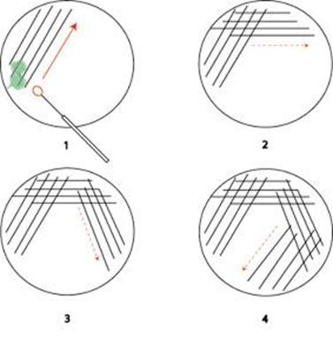
Figure ‎3.3 illustrating the streaking techniques of bacteria.

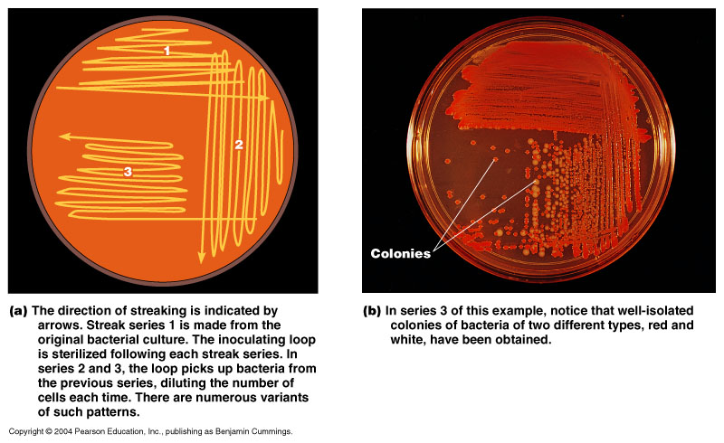

Gram stain for checking the purity of the bacterial culture (summarised in Figure ‎3.4)
Gram staining is a method of differentiating bacterial species into two large groups (Gram-positive and Gram-negative). This can be achieved by observing the chemical and physical properties of their cell walls by detecting peptidoglycan, which is present in a thick layer in Gram positive bacteria.
- A glass slide with a bacterial smear was placed on a staining rack.
- The slide was stained with crystal violet for 1-2 min. The stain was then poured off with running tap water.
- The slide was flooded with Gram’s iodine for 1-2 min.
- The iodine was poured off with running tap water. The slide was decolourised by washing the slide briefly with ethanol (2-3 seconds) which was washed off under running water.
- Safranin counterstain was added for 2 min and then washed with water.
- Excess water was blot dried with a paper towel

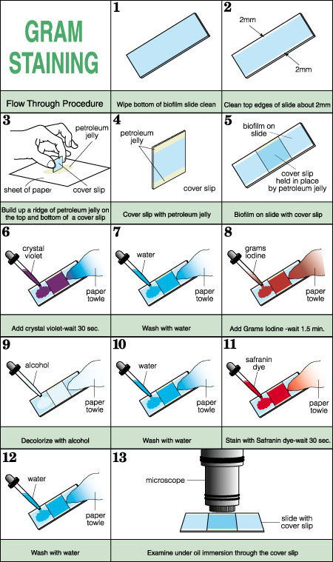
Figure ‎3.4 A diagram to illustrate the gram stain process

Standardised growth curves for bacteria:
In order to ensure reproducibility, it was necessary to generate a standard growth curve for each type of bacteria included in this study.

Bacteria Viable count.
Viable plate count is one of the most common methods of determining bacterial numbers.
The viable count was performed by two methods.

Ten fold (Hoover and Newbrun, 1977)
This method was used to count the live bacteria. One ml of liquid bacteria was grown in BHI and incubated for 24 h, diluted into 9 ml buffer (RTF) and mixed thoroughly to form in total 10 ml solution. A portion of this first diluted solution was then diluted further. This process was repeated until a concentration series was obtained as follows: 10⁷,10⁶,10⁵,10⁴,10³,10²,10¹. One ml of the inoculum was then transferred from each dilution into duplicated CBA plates. Following an incubation period of 48 hours a Stuart automatic colony counter (Stuart, BioCote, Staffordshire,UK) was used to count the colony forming units (CFU) on each agar plate. The plates that contained between 30-300 bacteria were the only counted plates. This is in accordance with conventional microbiological methodology. The number of colonies was then used to estimate the number of CFU ml⁻¹ of the original inoculums. This was calculated by using the following formula: (CFU in dilution) x dilution factor x 10 = CFU ml⁻¹ original inoculum. These results were tabulated against the respective OD₅₄₀ and a standard growth curve was generated.

Two fold
Aerobic bacteria were grown for 24 h in BHI solution and anaerobic bacteria in BHI + H +M respectively. One ml of bacteria was added to one ml of sterile media and the process continued seven times to give a sequence of dilution as follows: 1:1, 1:2, 1:8, 1:16, 1:32, 1:64, and 1:128.
One ml from each tube was then transferred to the cuvette to measure the optical density by Spectrometer (UNICAM 5625 Spectrometer UV/Visible range, Northants, UK).

Optical density Spectrometer
The spectrophotometer was used to pass a light of a wavelength of 540 nm (optical density OD₅₄₀) through the bacteria suspension. (Figure ‎3.5).
Turbidity (Optical Density): The following procedure was carried out in a bio-safety cabinet using sterile pipette tips to avoid contamination of sterile media stock and also to protect the live cultures from contamination.

Sample preparation:
- 1 mL of prepared bacteria was pipetted into a disposable polystyrene cuvette. The cuvette was labelled on the frosted portion at the top, without touching the lower part of the cuvette as it might interfere with the reading.
- All samples were prepared.
- Spectrophotometer must have been warm for at least 15 min. prior to use. A wavelength of 540 nm.
- Sample medium was used for calibration with blank un-inoculated broth which was (BHI+H+M or BHI); the machine was re-recalibrated if necessary before checking the next sample.
- The sample was inserted into the holder. The cover was closed and optical density recorded for each cuvette.

Calculation of the CFU ml⁻¹
This was carried out on the day of the experiment for the pure cultures of bacteria (Gram stains broth before adjusting the optical density). The optical density was measured at a wavelength of (OD₅₄₀), this related to the number of cells in the suspension, as represented in Figure ‎3.5 below. The suspension was adjusted with sterile BHI broth plus haemin to an OD₅₄₀ that corresponded to 1×10⁻⁶ colony forming units (CFU)/ ml) from a graph that was generated by plotting viable counts and optical density readings.
The number of colonies was then used to estimate the number of CFUml⁻¹ of the original inoculums. This was calculated using the following formula:
(CFU in dilution) x dilution factor x 10 = CFU ml⁻¹ original inoculum.
These results were tabulated against the respective OD₅₄₀ and standard growth curves were generated.

Figure ‎3.5 This diagram illustrates how spectrophotometer worked to count the bacteria.

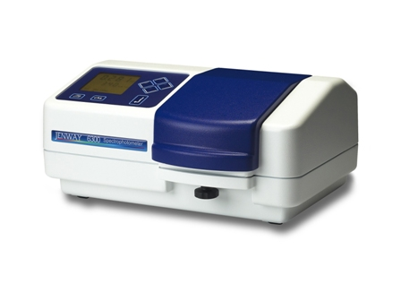
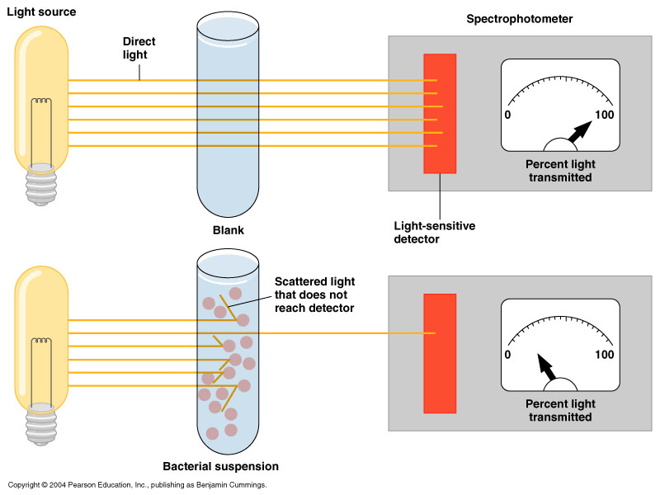

NB The dilution series experiments and viable counts were repeated three times to ensure operator reproducibility.

Summary of agar diffusion assay procedures
The respective test bacteria were grown in BHI broth. For the strict anaerobic bacteria broths were pre-reduced for 24 hours before inoculation. Test samples were produced by lifting colonies of bacteria from the CBA plates with a sterile wire loop and inoculating a 10ml BHI broth (+/-haemin as required). This suspension was then incubated overnight at 37ºC under anaerobic conditions. Growth of bacteria was visible after overnight incubation as the suspension presented with a cloudy appearance. One ml of this suspension was added to a fresh 10ml of BHI broth (+/-haemin as required) and incubated overnight at 37ºC under anaerobic conditions to produce a test suspension. The surfaces of pre-reduced CBA plates were inoculated with 1ml aliquots of bacterial suspension (of the OD adjusted suspension) and spread evenly with sterile plastic spreaders. A three mm diameter was made in each CBA plates using a sterile cork borer into which the test materials were inserted.
The agar diffusion method was used to evaluate the antibacterial effectiveness of the various materials such as NSCH, MTA, and different mixtures of antibiotics. CBA plates were inoculated with the test bacteria and the inhibition zone for each test material was assessed on three separate occasions.

Preparation of test plates
Plating of test plates were carried out in the anaerobic cabinet at 37ºC for oxygen sensitive bacteria and on the bench for the oxygen tolerant bacteria.
The CBA plates were inoculated using a Gilson pipette with 100 µl aliquots of the adjusted suspension of the respective bacteria. Plates for anaerobic bacteria were pre-reduced for 24 hours prior to inoculation. A sterile plastic spreader was used to distribute the 1 ml aliquots evenly over the surface of each CBA plate.
One or two wells of 5mm were cut into each plate using a sterile cork borer. The cork borer was sterilised between plates by immersing in ethanol and was dried by being passed through the flame of Bunsen burner. The relevant admixes of MTA etc were then selected and placed directly into the prepared wells. All plates were then incubated in the anaerobic cabinet at 37ºC for 48 hrs. Each experiment was carried out on three different occasions for each type of bacteria.

Inhibition zone
Following incubation, the antibacterial effectiveness of the test material samples was analysed by measuring the clear zone around each test sample where the growth of bacteria had been inhibited. These zones of inhibition were measured at three different points using a digital calliper gauge as shown in Figure ‎3.6 (Draper tool Ltd, Chandler’s ford, Hampshire,UK). The mean of the three separate measurements were calculated and recorded.

Figure ‎3.6 This diagram shows the bacterial sensitivity to antibiotics by measure ring the inhibition zone at three different points using a digital calliper gauge.
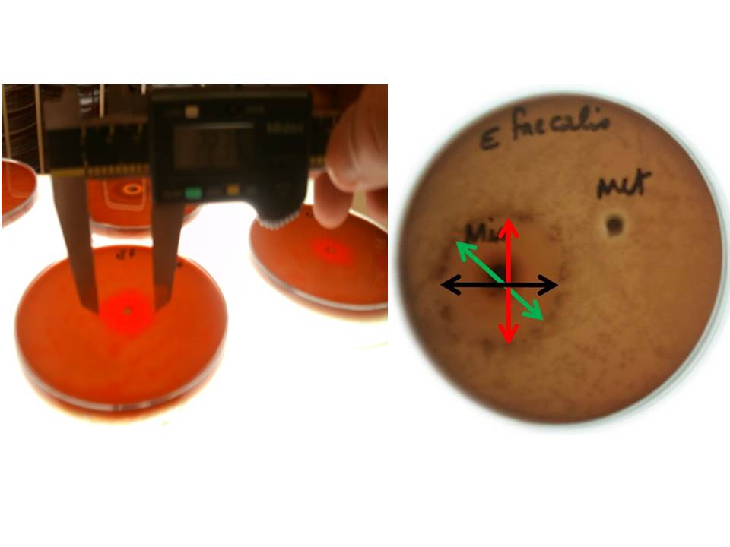

Statistical analysis
Statistical analysis was undertaken on statistical package of social sciences version 20 (SPSS 20). The distributions of the inhibition zone were determined by first checking the normality by Shapiro-Wilk. As the data was found to be normally distributed further analysis was performed using ANOVA.

Results

Standard growth curves.
Standard growth curves for each bacterium were produced for bacterial strains used in this study as outlined in section 3.19. The optical density and viable count for each were calculated. These results enabled a standard growth curve to be produced by plotting the optical density (OD₅₄₀) against the respective number of colony forming units (CFU ml⁻¹). Seven standard growth curves were produced. The production of these growth curves enabled the researcher to inoculate each plate of the bacterium used
.

Escherichia coli. ( E. Coli) (NCTC 11954).
E coli the respective serial dilution, CFU and the associated optical OD₅₄₀ are shown in Table ‎3.4 and the standard growth curve for this bacterium is shown in Figure ‎3.7.
Table ‎3.4 Shows E coli (EC) (NCTC 11954) measured by OD₄₅₀ against (CFU/ml).
Dilution | CFU ml⁻¹ | OD₅₄₀
1:2 | 2.80E+08 | 1.404
1:4 | 1.40E+08 | 0.814
1:8 | 6.90E+07 | 0.41
1:16 | 3.40E+07 | 0.211
1.32 | 1.70E+07 | 0.108
1.64 | 8.60E+06 | 0.055

The method used to calculate the growth behaviour of E. coli (NCTC 11954) measured by OD₄₅₀ against (CFU/ml) has been given in section 3.19.3.3. The standard growth curve for E coli is shown in Figure ‎3.7.
Figure ‎3.7 Standard growth curve for E coli (NCTC 755) OD₄₅₀ against number of colony forming units (CFU/ml)

Colony forming units (CFU)
Optical density at a wavelength ⁽OD₄₅₀₎

Enterococcus faecalis. (E. faecalis) (NCTC 755)
The respective serial dilution, CFU and the associated optical OD₅₄₀ are shown in Table ‎3.5 and the standard growth curve for this bacterium is shown in Figure ‎3.8.
Table ‎3.5 Shows E faecalis (NCTC 755) measured by OD₄₅₀ against (CFU/ml).
Dilution | CFU ml⁻¹ | OD₅₄₀
1:2 | 2.40E+08 | 1.302
1:4 | 1.20E+08 | 0.764
1:8 | 6.00E+07 | 0.393
1:16 | 3.00E+07 | 0.2
1.32 | 1.50E+07 | 0.093
1.64 | 7.50E+06 | 0.054

Figure ‎3.8 Standard growth curve for E faecalis (NCTC 755) OD₄₅₀ against number of colony forming units (CFU/ml)

Colony forming units (CFU)
Optical density at a wavelength ⁽OD₄₅₀₎

Porphyromonas gingivalis (P. gingivalis) (W50)
The respective serial dilution, CFU and the associated optical OD₅₄₀ are shown in Table ‎3.6 and the standard growth curve for this bacterium is shown in Figure ‎3.9.
Table ‎3.6 Shows P. gingivalis (W50) measured by OD₄₅₀ against (CFU/ml).
Dilution | CFU ml₋₁ | PG OD₅₄₀
1:2 | 4.50E+08 | 0.925
1:4 | 2.20E+08 | 0.448
1:8 | 1.10E+08 | 0.23
1:16 | 5.60E+07 | 0.121
1.32 | 2.80E+07 | 0.062
1.64 | 1.40E+07 | 0.029
1.28 | 7.00E+06 | 0.007

Figure ‎3.9 Standard growth curve for P. gingivalis (W50) OD₄₅₀ against number of colony forming units (CFU/ml)

Colony forming units (CFU)
Optical density at a wavelength ⁽OD₄₅₀₎

Fusobacterium nucleatum (F. nucleatum) (ACTC 10953)
The respective serial dilution, CFU and the associated optical OD₅₄₀ are shown in Table ‎3.7 and the standard growth curve for this bacterium is shown in Figure ‎3.10.
Table ‎3.7 F. nucleatum (ACTC 10953) measured by OD₄₅₀ against (CFU/ml).
Dilution | CFU ml-1 | FN OD₅₄₀
1:2 | 2.20E+08 | 0.983
1:4 | 1.10E+08 | 0.478
1:8 | 5.40E+07 | 0.264
1:16 | 2.70E+07 | 0.132
1.32 | 1.30E+07 | 0.078
1.64 | 6.70E+06 | 0.028
1.28 | 3.40E+06 | 0.015

Figure ‎3.10 Standard growth curve for F. nucleatum (ACTC 10953) OD450 against number of colony forming units (CFU/ml)

Colony forming units (CFU)
Optical density at a wavelength ⁽OD₄₅₀₎

Actinomyces odontolyticus (A odontolyticus) (NCTC 9335)
The respective serial dilution, CFU and the associated optical OD540 are shown in Table ‎3.8 and the standard growth curve for this bacterium is shown in Figure ‎3.11 for A odontolyticus.
Table ‎3.8 Shows A. odontolyticus (NCTC 9335) measured by OD₄₅₀ against (CFU/ml).
Dilution | CFU ml₋₁ | AO OD₅₄₀
1:2 | 1.60E+05 | 0.758
1:4 | 8.00E+04 | 0.398
1:8 | 4.00E+04 | 0.194
1:16 | 2.00E+04 | 0.095
1.32 | 1.00E+04 | 0.048
1.64 | 5.00E+03 | 0.011

Figure ‎3.11 Standard growth curve for A. odontolyticus (NCTC 9335) OD₄₅₀ against number of colony forming units (CFU/ml)

Colony forming units (CFU)
Optical density at a wavelength ⁽OD₄₅₀₎

Statistical Analysis of the data
The test for normality

Shapiro –Wilk test could not confirm the distribution of our data set (Table ‎3.9) Therefore, a graph was plotted using standard residual means which confirmed that the data was indeed normally distributed (Figure ‎3.12).
Table ‎3.9 Shapiro-Wilk showing the test for normality for all bacteria which was inconclusive with regards to normality of the data.

Tests of Normality
 | Bacteria | Kolmogorov-Smirnovª |  |  | Shapiro-Wilk
 | Bacteria | Statistic | df | Sig. | Statistic | df | Sig.
Mean | E coli | .160 | 21 | .171 | .902 | 21 | .039
Mean | E faecalis | .292 | 21 | .000 | .773 | 21 | .000
Mean | A odontolyticus | .134 | 21 | .200* | .927 | 21 | .122
Mean | P gingivalis | .197 | 21 | .033 | .919 | 21 | .083
Mean | F nucleatum | .247 | 21 | .002 | .736 | 21 | .000
*. This is a lower bound of the true significance.

Figure ‎3.12 Bar chat plotted with standard residual means which confirmed that the data was normally distributed
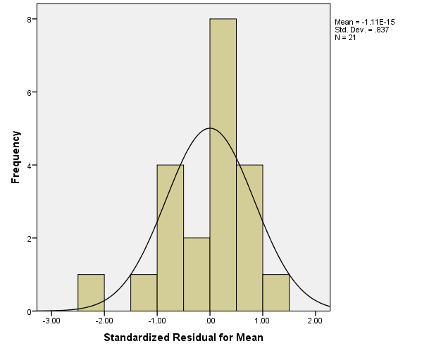

Comparison of antibacterial effectiveness of the test materials and antibiotics

Results for the inhibition zone (mm) for E. coli with all the test materials.
The values for mean zone of inhibition (mm) are shown in Table ‎3.10 and Figure ‎3.13. It can be seen that the mean inhibition zone was the least for MTA (24.17 mm+3.28) and the highest for Minocycline (35.54 mm+2.87).
Table ‎3.10 Shows results for the inhibition zone (mm) for E. coli with all the test materials.
Test materials | Mean Zone of inhibition (MM) against E Coli NCTC (11954) | SD
NSCH | 27.58 mm | 2.25
MTA | 24.17 mm | 3.28
Minocycline (Mino) | 35.54 mm | 2.87
Ciprofloxacin (Cip) | 27.05 mm | 2.28
Metronidazol (Met) | 22.1 mm | 1.30
(Cip + Met) | 32.65 mm | 4.64
(Mino+ Cip + Met) | 34.46 mm | 2.09

Figure ‎3.13 Shows a comparison of inhibition zone for all test material and antibiotics against E coli

Statistical analysis of the data is presented in Table ‎3.11 It can be seen that Minocycline has the best effect against E. coli, also the combination of Cip+Met are significantly more effective as compared with other materials, except when all three antibiotics were used together (Mino+Cip+Met). There was no significant difference between Cip+Met and Mino+ Cip + Met.

I) Treatment | (J) Treatment | Mean Difference (I-J) | Sig. | 95% Confidence Interval
 |  |  |  | Lower Bound | Upper Bound
NSCH | MTA | 3.40* | .014 | .7116 | 6.0951
NSCH | Mino | -7.96* | .000 | -10.6551 | -5.2716
NSCH | Cip | .68 | .615 | -2.0118 | 3.3718
NSCH | Met | 5.52* | .000 | 2.8282 | 8.2118
NSCH | Cip+Met | -5.07* | .000 | -7.7640 | -2.3805
NSCH | Cip+Met+Mino | -6.88* | .000 | -9.5762 | -4.1927
MTA | NSCH | -3.40* | .014 | -6.0951 | -.7116
MTA | Mino | -11.37* | .000 | -14.0584 | -8.6749
MTA | Cip | -2.73* | .047 | -5.4151 | -.0316
MTA | Met | 2.12 | .121 | -.5751 | 4.8084
MTA | Cip+Met | -8.48* | .000 | -11.1673 | -5.7838
MTA | Cip+Met+Mino | -10.29* | .000 | -12.9795 | -7.5960
Mino | NSCH | 7.96* | .000 | 5.2716 | 10.6551
Mino | MTA | 11.37* | .000 | 8.6749 | 14.0584
Mino | Cip | 8.64* | .000 | 5.9516 | 11.3351
Mino | Met | 13.48* | .000 | 10.7916 | 16.1751
Mino | Cip+Met | 2.89* | .036 | .1993 | 5.5829
Mino | Cip+Met+Mino | 1.08 | .425 | -1.6129 | 3.7707
Cip | NSCH | -.68 | .615 | -3.3718 | 2.0118
Cip | MTA | 2.72* | .047 | .0316 | 5.4151
Cip | Mino | -8.64* | .000 | -11.3351 | -5.9516
Cip | Met | 4.84* | .001 | 2.1482 | 7.5318
Cip | Cip+Met | -5.75* | .000 | -8.4440 | -3.0605
Cip | Cip+Met+Mino | -7.56* | .000 | -10.2562 | -4.8727
Met | NSCH | -5.52* | .000 | -8.2118 | -2.8282
Met | MTA | -2.12 | .121 | -4.8084 | .5751
Met | Mino | -13.49* | .000 | -16.1751 | -10.7916
Met | Cip | -4.84* | .001 | -7.5318 | -2.1482
Met | Cip+Met | -10.59* | .000 | -13.2840 | -7.9005
Met | Cip+Met+Mino | -12.40* | .000 | -15.0962 | -9.7127
Cip+Met | NSCH | 5.07* | .000 | 2.3805 | 7.7640
Cip+Met | MTA | 8.48* | .000 | 5.7838 | 11.1673
Cip+Met | Mino | -2.89* | .036 | -5.5829 | -.1993
Cip+Met | Cip | 5.75* | .000 | 3.0605 | 8.4440
Cip+Met | Met | 10.59* | .000 | 7.9005 | 13.2840
Cip+Met | Cip+Met+Mino | -1.81 | .183 | -4.5040 | .8795
Cip+Met+Mino | NSCH | 6.88* | .000 | 4.1927 | 9.5762
Cip+Met+Mino | MTA | 10.29* | .000 | 7.5960 | 12.9795
Cip+Met+Mino | Mino | -1.08 | .425 | -3.7707 | 1.6129
Cip+Met+Mino | Cip | 7.56* | .000 | 4.8727 | 10.2562
Cip+Met+Mino | Met | 12.40* | .000 | 9.7127 | 15.0962
Cip+Met+Mino | Cip+Met | 1.81 | .183 | -.8795 | 4.5040
Table ‎3.11 Comparison of antibacterial effectiveness of different materials, NSCH, MTA, Minocycline, Ciprofloxacin and Metronidazole on E. coli.(
*. The mean difference is significant at the 0.05 level.

E. faecalis (NCTC 755)
The values for mean zone of inhibition (mm) are shown in
Table ‎3.12 and
Figure ‎3.14. It can be seen that NSCH, MTA and metronidazole had no effect on E.faecalis. The combination Mino+Cip + Met had the highest values for the inhibition zone.

Table ‎3.12 Shows results for the inhibition zone (mm) for E. faecalis with all the test materials.
Test materials | Mean Zone of inhibition (MM) against E.faecalis(NCTC 755) | SD
NSCH | No | .00000
MTA | No | .00000
Minocycline (Mino) | 27.42 mm | 3.79
Ciprofloxacin (Cip) | 24.21 mm | 1.82
Metronidazole (Met) | No | .00000
(Cip + Met) | 22.68 mm | 2.01
(Mino+ Cip + Met) | 31.68 mm | 1.78

Figure ‎3.14 Comparison of inhibition zone for all test material and antibiotics against E. faecalis

The statistical analysis is presented in Table ‎3.13. It can be seen that the combination of the three antibiotics (Mino+cip+met) were significantly more effective against E faecalis as compared to other materials and antibiotics individually and in combination.

Table ‎3.13 Comparison of antibacterial effectiveness of different material NSCH, MTA, Minocycline, Ciprofloxacin and Metronidazole, on E faecalis.
(I) Treatment | (J) Treatment | Mean Difference (I-J) | Sig. | 95% Confidence Interval
 |  |  |  | Lower Bound | Upper Bound
NSCH | MTA | .00000 | 1.000 | -1.7797 | 1.7797
NSCH | Mino | -27.42444* | .000 | -29.2041 | -25.6448
NSCH | Cip | -23.09889* | .000 | -24.8786 | -21.3192
NSCH | Met | .00000 | 1.000 | -1.7797 | 1.7797
NSCH | Cip+Met | -22.67556* | .000 | -24.4552 | -20.8959
NSCH | Cip+Met+Mino | -31.67667* | .000 | -33.4563 | -29.8970
MTA | NSCH | .00000 | 1.000 | -1.7797 | 1.7797
MTA | Mino | -27.42444* | .000 | -29.2041 | -25.6448
MTA | Cip | -23.09889* | .000 | -24.8786 | -21.3192
MTA | Met | .00000 | 1.000 | -1.7797 | 1.7797
MTA | Cip+Met | -22.67556* | .000 | -24.4552 | -20.8959
MTA | Cip+Met+Mino | -31.67667* | .000 | -33.4563 | -29.8970
Mino | NSCH | 27.42444* | .000 | 25.6448 | 29.2041
Mino | MTA | 27.42444* | .000 | 25.6448 | 29.2041
Mino | Cip | 4.32556* | .000 | 2.5459 | 6.1052
Mino | Met | 27.42444* | .000 | 25.6448 | 29.2041
Mino | Cip+Met | 4.74889* | .000 | 2.9692 | 6.5286
Mino | Cip+Met+Mino | -4.25222* | .000 | -6.0319 | -2.4726
Cip | NSCH | 23.09889* | .000 | 21.3192 | 24.8786
Cip | MTA | 23.09889* | .000 | 21.3192 | 24.8786
Cip | Mino | -4.32556* | .000 | -6.1052 | -2.5459
Cip | Met | 23.09889* | .000 | 21.3192 | 24.8786
Cip | Cip+Met | .42333 | .636 | -1.3563 | 2.2030
Cip | Cip+Met+Mino | -8.57778* | .000 | -10.3574 | -6.7981
Met | NSCH | .00000 | 1.000 | -1.7797 | 1.7797
Met | MTA | .00000 | 1.000 | -1.7797 | 1.7797
Met | Mino | -27.42444* | .000 | -29.2041 | -25.6448
Met | Cip | -23.09889* | .000 | -24.8786 | -21.3192
Met | Cip+Met | -22.67556* | .000 | -24.4552 | -20.8959
Met | Cip+Met+Mino | -31.67667* | .000 | -33.4563 | -29.8970
Cip+Met | NSCH | 22.67556* | .000 | 20.8959 | 24.4552
Cip+Met | MTA | 22.67556* | .000 | 20.8959 | 24.4552
Cip+Met | Mino | -4.74889* | .000 | -6.5286 | -2.9692
Cip+Met | Cip | -.42333 | .636 | -2.2030 | 1.3563
Cip+Met | Met | 22.67556* | .000 | 20.8959 | 24.4552
Cip+Met | Cip+Met+Mino | -9.00111* | .000 | -10.7808 | -7.2214
Cip+Met+Mino | NSCH | 31.67667* | .000 | 29.8970 | 33.4563
Cip+Met+Mino | MTA | 31.67667* | .000 | 29.8970 | 33.4563
Cip+Met+Mino | Mino | 4.25222* | .000 | 2.4726 | 6.0319
Cip+Met+Mino | Cip | 8.57778* | .000 | 6.7981 | 10.3574
Cip+Met+Mino | Met | 31.67667* | .000 | 29.8970 | 33.4563
Cip+Met+Mino | Cip+Met | 9.00111* | .000 | 7.2214 | 10.7808

*. The mean difference is significant at the 0.05 level.

P.gingivalis (W50)
The values for mean zone of inhibition (mm) are shown in Table ‎3.14 and
Figure ‎3.15. It can be seen that all test materials were effective with the largest inhibition zone observed with ciprofloxicillin and the least with metronidazole.

Table ‎3.14 Results for the inhibition zone (mm) for P.gingivalis with all the test materials.

Test materials | Mean Zone of inhibition (MM) against P.gingivalis (W50) | SD
NSCH | 23 mm | 1.32
MTA | 30.04 mm | 4.40
Minocycline (Mino) | 33.67 mm | 3.58
Ciprofloxacin (Cip) | 35.05 mm | 1.92
Metronidazole (Met) | 21.21 mm | 2.95
(Cip + Met) | 32.12 mm | .85
(Mino+ Cip + Met) | 33.49 mm | 3.39

Figure ‎3.15 Comparison of inhibition zone for all test material and antibiotics against P.gingivalis

The statistical analysis is presented in Table ‎3.15. It can be clearly seen that although all materials were effective in inhibiting P.gingivalis, a combination of the three antibiotics (Mino+Cip+Met) was significantly more effective compared with other materials or antibiotics individually and in combination.

Table ‎3.15 Comparison of antibacterial effectiveness of different material NSCH, MTA, Minocycline, Ciprofloxacin and Metronidazole, on P. gingivalis.
(I) Treatment | (J) Treatment | Mean Difference (I-J) | Sig. | 95% Confidence Interval
 |  |  |  | Lower Bound | Upper Bound
NSCH | MTA | -7.15444* | .000 | -9.8842 | -4.4247
NSCH | Mino | -10.78444* | .000 | -13.5142 | -8.0547
NSCH | Cip | -12.16556* | .000 | -14.8953 | -9.4358
NSCH | Met | 1.67778 | .223 | -1.0519 | 4.4075
NSCH | Cip+Met | -9.23000* | .000 | -11.9597 | -6.5003
NSCH | Cip+Met+Mino | -10.60444* | .000 | -13.3342 | -7.8747
MTA | NSCH | 7.15444* | .000 | 4.4247 | 9.8842
MTA | Mino | -3.63000* | .010 | -6.3597 | -.9003
MTA | Cip | -5.01111* | .001 | -7.7408 | -2.2814
MTA | Met | 8.83222* | .000 | 6.1025 | 11.5619
MTA | Cip+Met | -2.07556 | .133 | -4.8053 | .6542
MTA | Cip+Met+Mino | -3.45000* | .014 | -6.1797 | -.7203
Mino | NSCH | 10.78444* | .000 | 8.0547 | 13.5142
Mino | MTA | 3.63000* | .010 | .9003 | 6.3597
Mino | Cip | -1.38111 | .315 | -4.1108 | 1.3486
Mino | Met | 12.46222* | .000 | 9.7325 | 15.1919
Mino | Cip+Met | 1.55444 | .259 | -1.1753 | 4.2842
Mino | Cip+Met+Mino | .18000 | .895 | -2.5497 | 2.9097
Cip | NSCH | 12.16556* | .000 | 9.4358 | 14.8953
Cip | MTA | 5.01111* | .001 | 2.2814 | 7.7408
Cip | Mino | 1.38111 | .315 | -1.3486 | 4.1108
Cip | Met | 13.84333* | .000 | 11.1136 | 16.5730
Cip | Cip+Met | 2.93556* | .036 | .2058 | 5.6653
Cip | Cip+Met+Mino | 1.56111 | .257 | -1.1686 | 4.2908
Met | NSCH | -1.67778 | .223 | -4.4075 | 1.0519
Met | MTA | -8.83222* | .000 | -11.5619 | -6.1025
Met | Mino | -12.46222* | .000 | -15.1919 | -9.7325
Met | Cip | -13.84333* | .000 | -16.5730 | -11.1136
Met | Cip+Met | -10.90778* | .000 | -13.6375 | -8.1781
Met | Cip+Met+Mino | -12.28222* | .000 | -15.0119 | -9.5525
Cip+Met | NSCH | 9.23000* | .000 | 6.5003 | 11.9597
Cip+Met | MTA | 2.07556 | .133 | -.6542 | 4.8053
Cip+Met | Mino | -1.55444 | .259 | -4.2842 | 1.1753
Cip+Met | Cip | -2.93556* | .036 | -5.6653 | -.2058
Cip+Met | Met | 10.90778* | .000 | 8.1781 | 13.6375
Cip+Met | Cip+Met+Mino | -1.37444 | .317 | -4.1042 | 1.3553
Cip+Met+Mino | NSCH | 10.60444* | .000 | 7.8747 | 13.3342
Cip+Met+Mino | MTA | 3.45000* | .014 | .7203 | 6.1797
Cip+Met+Mino | Mino | -.18000 | .895 | -2.9097 | 2.5497
Cip+Met+Mino | Cip | -1.56111 | .257 | -4.2908 | 1.1686
Cip+Met+Mino | Met | 12.28222* | .000 | 9.5525 | 15.0119
Cip+Met+Mino | Cip+Met | 1.37444 | .317 | -1.3553 | 4.1042

*. The mean difference is significant at the 0.05 level.

F. nucleatum (ACTC 10953)
The values for mean zone of inhibition (mm) are shown in Table ‎3.16 and
Figure ‎3.16. It can be seen that (NSCH) had no effect against F.nucleatum and the largest inhibition zone was 43.42 mm (1.82) for Minocycline.

Table ‎3.16 Results for the inhibition zone (mm) for F.nucleatum with all the test materials.

Test materials | Mean Zone of inhibition (MM) against P.gingivalis (W50) | SD
NSCH | No | .00
MTA | 25.55 mm | 3.58
Minocycline (Mino) | 43.42 mm | 1.82
Ciprofloxacin (Cip) | 43.02 mm | 2.70
Metronidazole (Met) | 34.44 mm | 2.66
(Cip + Met) | 40.23 mm | 1.35
(Mino+ Cip + Met) | 41.03 mm | 1.59

Figure ‎3.16 Comparison of inhibition zone for all test material and antibiotics against F. nucleatum

The statistical analysis is presented in Table ‎3.17. It can be seen that the NSCH was the least effective compared with all other groups. Also Cip+Met were significantly more effective compared to all other materials except to a combination of the three antibiotics (Cip+Met+Mino) from which no significant difference was observed.

Table ‎3.17 Comparison of antibacterial effectiveness of different material NSCH, MTA, Minocycline, Ciprofloxacin and Metronidazole, on F. nucleatu.
(I) Treatment | (J) Treatment | Mean Difference (I-J) | Sig. | 95% Confidence Interval
 |  |  |  | Lower Bound | Upper Bound
NSCH | MTA | -25.54778* | .000 | -27.6549 | -23.4407
NSCH | Mino | -43.45000* | .000 | -45.5571 | -41.3429
NSCH | Cip | -43.02444* | .000 | -45.1315 | -40.9173
NSCH | Met | -34.43889* | .000 | -36.5460 | -32.3318
NSCH | Cip+Met | -40.22778* | .000 | -42.3349 | -38.1207
NSCH | Cip+Met+Mino | -41.12667* | .000 | -43.2338 | -39.0196
MTA | NSCH | 25.54778* | .000 | 23.4407 | 27.6549
MTA | Mino | -17.90222* | .000 | -20.0093 | -15.7951
MTA | Cip | -17.47667* | .000 | -19.5838 | -15.3696
MTA | Met | -8.89111* | .000 | -10.9982 | -6.7840
MTA | Cip+Met | -14.68000* | .000 | -16.7871 | -12.5729
MTA | Cip+Met+Mino | -15.57889* | .000 | -17.6860 | -13.4718
Mino | NSCH | 43.45000* | .000 | 41.3429 | 45.5571
Mino | MTA | 17.90222* | .000 | 15.7951 | 20.0093
Mino | Cip | .42556 | .687 | -1.6815 | 2.5327
Mino | Met | 9.01111* | .000 | 6.9040 | 11.1182
Mino | Cip+Met | 3.22222* | .003 | 1.1151 | 5.3293
Mino | Cip+Met+Mino | 2.32333* | .031 | .2162 | 4.4304
Cip | NSCH | 43.02444* | .000 | 40.9173 | 45.1315
Cip | MTA | 17.47667* | .000 | 15.3696 | 19.5838
Cip | Mino | -.42556 | .687 | -2.5327 | 1.6815
Cip | Met | 8.58556* | .000 | 6.4785 | 10.6927
Cip | Cip+Met | 2.79667* | .010 | .6896 | 4.9038
Cip | Cip+Met+Mino | 1.89778 | .077 | -.2093 | 4.0049
Met | NSCH | 34.43889* | .000 | 32.3318 | 36.5460
Met | MTA | 8.89111* | .000 | 6.7840 | 10.9982
Met | Mino | -9.01111* | .000 | -11.1182 | -6.9040
Met | Cip | -8.58556* | .000 | -10.6927 | -6.4785
Met | Cip+Met | -5.78889* | .000 | -7.8960 | -3.6818
Met | Cip+Met+Mino | -6.68778* | .000 | -8.7949 | -4.5807
Cip+Met | NSCH | 40.22778* | .000 | 38.1207 | 42.3349
Cip+Met | MTA | 14.68000* | .000 | 12.5729 | 16.7871
Cip+Met | Mino | -3.22222* | .003 | -5.3293 | -1.1151
Cip+Met | Cip | -2.79667* | .010 | -4.9038 | -.6896
Cip+Met | Met | 5.78889* | .000 | 3.6818 | 7.8960
Cip+Met | Cip+Met+Mino | -.89889 | .396 | -3.0060 | 1.2082
Cip+Met+Mino | NSCH | 41.12667* | .000 | 39.0196 | 43.2338
Cip+Met+Mino | MTA | 15.57889* | .000 | 13.4718 | 17.6860
Cip+Met+Mino | Mino | -2.32333* | .031 | -4.4304 | -.2162
Cip+Met+Mino | Cip | -1.89778 | .077 | -4.0049 | .2093
Cip+Met+Mino | Met | 6.68778* | .000 | 4.5807 | 8.7949
Cip+Met+Mino | Cip+Met | .89889 | .396 | -1.2082 | 3.0060

*. The mean difference is significant at the 0.05 level.

A. odontolyticus (NCTC 9335)
The values for mean zone of inhibition (mm) are shown in Table ‎3.18 and
Figure ‎3.17 It can be seen that all test materials were effective ranged with the mean zone of inhibition ranging 8.79 mm+4.64 for NSCH to 39.94 mm +2.82 for Mino+Cip+Met.

Table ‎3.18 Results for the inhibition zone (mm) for A. odontolyticus with all the test materials.
Test materials | Mean Zone of inhibition (MM) against P.gingivalis (W50) | SD
NSCH | 8.79 mm | 4.64
MTA | 28.63 mm | 3.75
Minocycline (Mino) | 27.48 mm | 4.74
Ciprofloxacin (Cip) | 27.64 mm | 2.04
Metronidazol (Met) | 20.75 mm | 1.66
(Cip + Met) | 38.50 mm | 1.83
(Mino+ Cip + Met) | 39.94 mm | 2.82

Figure ‎3.17 Comparison of inhibition zone for all test material and antibiotics against A. odontolyticus

The statistical analysis is presented in Table ‎3.19 It can be seen that the NSCH) was least effective against A. odontolyticus compared with all other groups. (P value =0.000). Also a combination of the two antibiotics (Cip+Met) and the three antibiotics (Cip+Met+Mino) were equally effective with no statistical difference observed between them. Also, both these were significantly more effective compared with all other groups.

Table ‎3.19 Comparison of antibacterial effectiveness of different material NSCH, MTA, Minocycline, Ciprofloxacin and Metronidazole, on A odontolyticus bacteria.
(I) Treatment | (J) Treatment | Mean Difference (I-J) | Sig. | 95% Confidence Interval
 |  |  |  | Lower Bound | Upper Bound
NSCH | MTA | -22.77778* | .000 | -25.8960 | -19.6596
NSCH | Mino | -21.62667* | .000 | -24.7449 | -18.5085
NSCH | Cip | -21.78444* | .000 | -24.9026 | -18.6663
NSCH | Met | -14.89222* | .000 | -18.0104 | -11.7740
NSCH | Cip+Met | -32.63778* | .000 | -35.7560 | -29.5196
NSCH | Cip+Met+Mino | -34.09111* | .000 | -37.2093 | -30.9729
MTA | NSCH | 22.77778* | .000 | 19.6596 | 25.8960
MTA | Mino | 1.15111 | .463 | -1.9671 | 4.2693
MTA | Cip | .99333 | .526 | -2.1249 | 4.1115
MTA | Met | 7.88556* | .000 | 4.7674 | 11.0037
MTA | Cip+Met | -9.86000* | .000 | -12.9782 | -6.7418
MTA | Cip+Met+Mino | -11.31333* | .000 | -14.4315 | -8.1951
Mino | NSCH | 21.62667* | .000 | 18.5085 | 24.7449
Mino | MTA | -1.15111 | .463 | -4.2693 | 1.9671
Mino | Cip | -.15778 | .920 | -3.2760 | 2.9604
Mino | Met | 6.73444* | .000 | 3.6163 | 9.8526
Mino | Cip+Met | -11.01111* | .000 | -14.1293 | -7.8929
Mino | Cip+Met+Mino | -12.46444* | .000 | -15.5826 | -9.3463
Cip | NSCH | 21.78444* | .000 | 18.6663 | 24.9026
Cip | MTA | -.99333 | .526 | -4.1115 | 2.1249
Cip | Mino | .15778 | .920 | -2.9604 | 3.2760
Cip | Met | 6.89222* | .000 | 3.7740 | 10.0104
Cip | Cip+Met | -10.85333* | .000 | -13.9715 | -7.7351
Cip | Cip+Met+Mino | -12.30667* | .000 | -15.4249 | -9.1885
Met | NSCH | 14.89222* | .000 | 11.7740 | 18.0104
Met | MTA | -7.88556* | .000 | -11.0037 | -4.7674
Met | Mino | -6.73444* | .000 | -9.8526 | -3.6163
Met | Cip | -6.89222* | .000 | -10.0104 | -3.7740
Met | Cip+Met | -17.74556* | .000 | -20.8637 | -14.6274
Met | Cip+Met+Mino | -19.19889* | .000 | -22.3171 | -16.0807
Cip+Met | NSCH | 32.63778* | .000 | 29.5196 | 35.7560
Cip+Met | MTA | 9.86000* | .000 | 6.7418 | 12.9782
Cip+Met | Mino | 11.01111* | .000 | 7.8929 | 14.1293
Cip+Met | Cip | 10.85333* | .000 | 7.7351 | 13.9715
Cip+Met | Met | 17.74556* | .000 | 14.6274 | 20.8637
Cip+Met | Cip+Met+Mino | -1.45333 | .354 | -4.5715 | 1.6649
Cip+Met+Mino | NSCH | 34.09111* | .000 | 30.9729 | 37.2093
Cip+Met+Mino | MTA | 11.31333* | .000 | 8.1951 | 14.4315
Cip+Met+Mino | Mino | 12.46444* | .000 | 9.3463 | 15.5826
Cip+Met+Mino | Cip | 12.30667* | .000 | 9.1885 | 15.4249
Cip+Met+Mino | Met | 19.19889* | .000 | 16.0807 | 22.3171
Cip+Met+Mino | Cip+Met | 1.45333 | .354 | -1.6649 | 4.5715

*. The mean difference is significant at the 0.05 level

Figure ‎3.18 and Figure ‎3.19 demonstrate visually the inhibition zones for each bacteria and for all the groups used in our study.

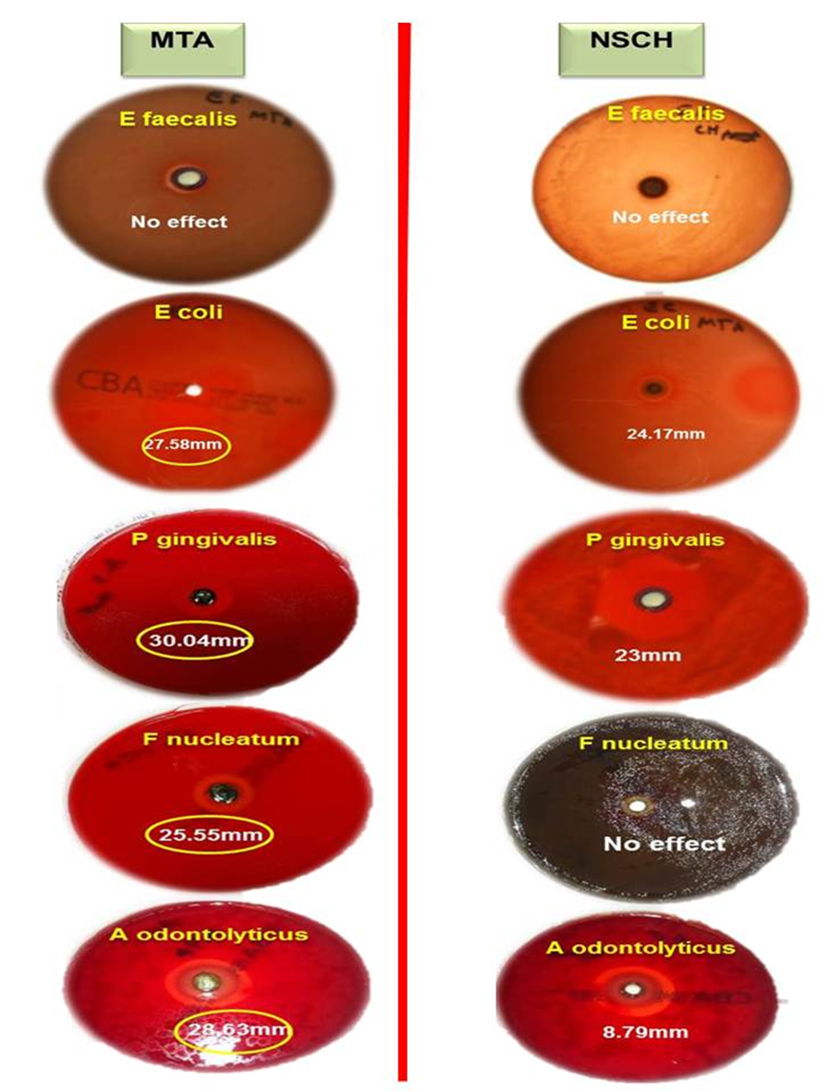
Figure ‎3.18 Inhibition zone of selected bacteria with MTA and NSCH application
Figure ‎3.19 Inhibition zone of selected bacteria with Mino, Cip, and Met individually or in combination

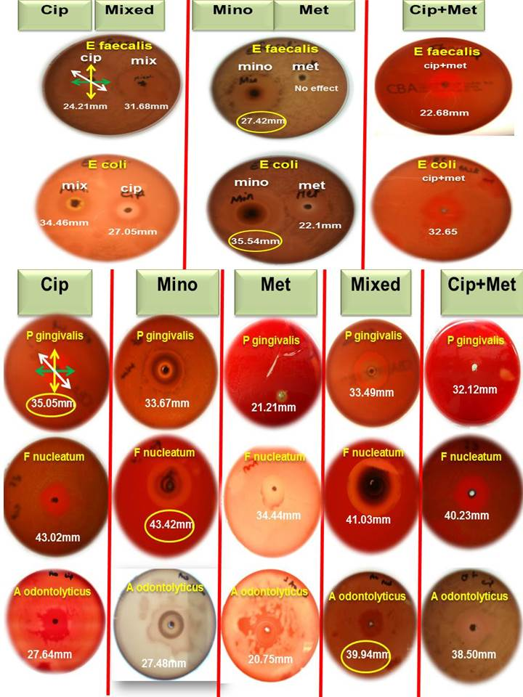

Discussion
Extensive carious lesions involving the pulp or any pulpal damage in the form of tooth surface loss, trauma and other iatrogenic factors may also compromise the pulp. As long as the pulp is vital, balance between the host immune system and bacterial invasion is maintained. However, severe bacterial attack causes pulp necrosis, tissue destruction and the defence system to come to a standstill (Siqueira and Rôças, 2009).

Bacterial selection
The oral microbiota consists of more than 500 species of micro-organisms but only limited amounts have been identified in the infected canal (Figdor et al., 2007). Due to their advantages, superior molecular techniques are employed for bacterial species identification. In this study it was very difficult to choose between the bacteria. There was wide range of primary infection caused by bacteria, secondary, aerobic and anaerobic bacteria. After a consultation from our restorative department and microbiology, in this study we used the bacteria that were frequently isolated in primary infections and one of the most responsible bacteria for secondary infections.
One of the bacteria used in this study was E. coli. It is very rare for E. coli to be present in the root canal, however it is one of the most important bacteria presented in periapical lesions as this specific bacterium is responsible for discontinuing blood connection in the tooth apical area and destroying the tissue around the tooth thereby causing the lesion.

Calcium hydroxide for root canal disinfection
In the last decade calcium hydroxide used to be the gold standard for treating immature root canals especially for disinfection, as it has the ability to kill and neutralise a wide range of bacteria and aid dissolution of remnant root tissues It also maintains a healthy environment for successful root canal obturation. Calcium hydroxide acts effectively as an intra-canal dressing, via diffusing hydroxyl ions and dissolves the pulpal tissue remnants (Cvek , 1974; Bystrom et al., 1985). The alkaline pH of calcium hydroxide neutralises lactic acid from osteoclasts and prevents dissolution of mineralised components of teeth. This pH also activates alkaline phosphatase that plays an important role in hard tissue formation (Stock, 1985).
The application of calcium hydroxide on dentine walls could affect the penetration of sealers into the dentinal tubules (Calt and Serper, 1999; Kim and Kim, 2001). This might cause a problem for the disinfectant material to reach the target bacteria present in the dentinal tubules. If these bacteria are left untreated they could form an important reservoir for infection or reinfection during or after endodontic treatment (Oguntebi, 1994).
Recently many studies confirmed that a long term application of calcium hydroxide had protein denaturing properties affecting the mechanical properties and weakening the tooth which might increase the risk of tooth fracture (Andreasen et al., 2002; Twati et al., 2009). This was also discussed in chapter 2.

Comparing the finding of this study to previous work on selected bacteria with calcium hydroxide
Several substances have been recommended for intra-canal medication. Most recommendations are based on empiricism. In an analysis of the literature, (Law and Messer, 2004), suggested that the ideal intra-canal medicament had not been found. However, calcium hydroxide has been an established antimicrobial medicament in dentistry for over 40 years (Spangburg and Haapasalo, 2002), and researchers have reported it may be the best inter-appointment medicament available to reduce residual microbial flora (Law and Messer, 2004).
Calcium hydroxide is widely used due to its ability to dissolve the remaining tissue, antimicrobial and antifungal activity, treatment of perforations, and detoxification of lipopolysaccharides (Spangburg and Haapasalo, 2002; Siqueira et al., 2003; Law and Messer, 2004).
A study stated that calcium hydroxide was as good as antibiotics when compared to metronidazole and had an inhibitory effect on all strains of bacteria if chlorhexidine was added (Jose et al., 1997). However a higher percentage of calcium hydroxide led to greater efficacy on bacteria (Gautam et al., 2011).
Looking at the market today, there are many products of calcium hydroxide which have different pH’s and that may affect the ability of calcium hydroxide to inhibit growing bacteria. An in vitro study concluded that calcium hydroxide (Apexit) was unsuccessful in elimination of Candida albicans and Staphylococcus aureus because of insufficient elevation of pH (Kaplan et al., 1999).
In this study we used Ultracal which is one of most sophisticated formulae of non-setting calcium hydroxide, with a high pH of up to pH 12.5 according to the manufacturer (see chapter 2). Also this product of calcium hydroxide uses a NaviTip making it easier for its uniform application in our experimental situation. Also it is the material used in our daily clinic at Leeds Dental Institute.
Several studies have studied the antimicrobial effects of calcium hydroxide–containing sealers and their duration of activity using different bacterial species and different test methods. The methods used to show short- and long-term antibacterial activity of sealers with the agar diffusion inhibitory test (ADT) (Estrela et al., 2000), and this is what this study had used to assess the effect of calcium hydroxide on bacteria. There has been debate in the literature regarding the use of the ADT as a method to determine the short-term antibacterial activity of calcium hydroxide sealers. The method relies on the solubility and physical properties of the antimicrobial component of the sealer. This works well for water-soluble materials (Mickel et al., 2003), and calcium hydroxide has low water solubility and diffusibility.
However this is still the most popular method used in the laboratory for assessing the effects on bacteria.
According to the results of this study the best effect of calcium hydroxide was on E. coli by inhibition zone of 24.17 mm, followed by 24 mm on P. gingivalis. This finding was supported by (Abdulkader et al., 1996) who stated that calcium hydroxide was an effective antibacterial material to inhibit growth of bacteria. On the other hand this study stated a limited effect of calcium hydroxide on A. odontolyticus or no effect at all on bacteria such as F. nucleatum and E. faecalis. These findings are supported by several studies (Al-Khatib et al., 1990; Estrela et al., 2000; Leonardo et al., 2000; Mickel et al., 2003).
Overall according to the findings in this study calcium hydroxide was the worst antibacterial material among all the other study groups.
This result could be due to an inadequate rise in pH in dentinal tubules for effective results (Ørstavik, 1988). The limited antibacterial activity of calcium hydroxide sealer might be attributed to a lack of sufficient pH elevation, limited solubility, and diffusibility in ADT plates (Heling and Chandler, 1996).

Mineral trioxide aggregates MTA
In an antimicrobial study on MTA and PC against Staphylococcus aureus, Enterococcus faecalis, Pseudomonas aeruginosa, Bacillus subtilis, Candida albicans, a fungus, and a mixture of these bacterial and fungal species, both materials exhibited diffusion in agar without inhibition of microbial growth (Estrela et al., 2000).
Another investigation reported antimicrobial activity of GMTA, WPC, and OPC on Micrococcus luteus, S. aureus, E. coli, P. aeruginosa, C. albicans, and Enterococcus faecalis (Tanomaru-Filho et al., 2007). Al-Hezaimi et al., (2005) evaluated the antifungal effect of WMTA on C. albicans and revealed that the concentration of MTA was a significant factor in the antifungal effect of this material.
Plates containing a WMTA concentration of less than 25 mg/mL showed no antifungal effect. In contrast, plates containing a concentration of 25 mg/mL showed antifungal activity at 1 and 24 hours, whereas a concentration of 50 mg/ mL of WMTA was effective against C. albicans during the whole study time. Another investigation compared the antifungal effect of GMTA and WMTA in different concentrations on C. albicans (Al-Hezaimi et al., 2006). Results confirmed a previous study by the same authors for WMTA (Al-Hezaimi et al., 2005). However, GMTA in concentrations lower than 25 mg/mL was significantly more effective against C. albicans than WMTA (Al-Hezaimi et al., 2006). The results for WMTA and GMTA in concentrations of 25 mg/mL and 50 mg/mL were similar.
Same as calcium hydroxide when we have high concentration or high pH we will have more efficiency as different types of bacteria have different resistances. Comparing the antibacterial effects of different concentrations of GMTA and WMTA against E. faecalis and S. sanguis showed that the former material required lower concentrations to produce the same antibacterial effects against each of the bacteria tested (Al-Hezaimi et al., 2006). Comparing both species of bacteria, E. faecalis required a higher MTA concentration for growth inhibition. However, conflicting results from antibacterial and antifungal investigations on MTA might be attributed to the various tested species of the microorganisms, the source of the preparing material (Torabinejad et al., 1995; Estrela et al., 2000; Stowe et al., 2004; Holt et al., 2007; Zhang et al., 2009), as well as the concentration and the type of MTA used in these studies (Al-Hezaimi et al., 2005; Al-Hezaimi et al., 2006; Al-Hezaimi et al., 2009). The literature shows that MTA had an antibacterial and antifungal effect. Lowering the powder-to-liquid ratio might adversely affect the antibacterial and antifungal properties of MTA.

Antibacterial Properties of MTA
Some investigations replaced distilled water with other liquids to mix with MTA powder. In this study we found that MTA had an effective anti-microbial effect against all types of primary infection bacteria, but was not effective against the secondary cause of infection (E. faecalis).
An investigation evaluated the antibacterial and antifungal activities of mixtures of WMTA with 0.12% CHX and sterile water against Actinomyces odontolyticus, Fusobacterium nucleatum, Streptococcus sanguis, E. faecalis, E. coli, S. aureus, P. aeruginosa, and C. albicans (Stowe et al., 2004).
Regardless of the type of mixing agent, all WMTA samples inhibit microbial growth.
Another study mixed 2% CHX with MTA powders and reported a significant increase in the antibacterial effect of WMTA and GMTA against E. faecalis (Holt et al., 2007). WMTA can cause cell apoptosis (Hernandez et al., 2005).
These studies support the results of this experiment, however disagreed on the effect of E faecalis. This study found that MTA had a superior effect to NSCH but less effect than all other antibiotics. In addition this study observed that WMTA turned a grey colour after it had been incubated in an anaerobic cabinet. This fact explains the clinical tooth discolouration seen after treatment with WMTA a few years later.
The WMTA alone does not change colour when incubated in an aerobic cabinet. The explanation for this phenomenon could be because MTA is a liquid absorbing material (hydrophilic). According to the literature (Parirokh and Torabinejad, 2010) the difference between WMTA and GMTA are ferric ions, so we presume that the WMTA absorbs the ferric ions from the ABC plates. This reaction happened only in an aerobic environment.

Antibiotics
Bacteria located inside dentinal tubules are protected from the effects of host defence cells and molecules, systemically administered antibiotics, and chemo-mechanical preparation. Therefore, treatment strategies that are directed toward the elimination of tubule infection are necessary and must include medicaments that penetrate dentinal tubules and kill bacteria. As discussed above NSCH and MTA do not comply with our endodontic aim of treatment. The necessity of new treatment is needed especially now with a new treatment of immature teeth with the regenerative endodontic technique. The uses of antibiotics in the root canal are not new but they had stopped because of antibiotic toxicity. However, now we understand antibiotic action better and also know that the tooth has a small closed blood circle which will reduce any risk of adverse reaction of the drugs. The other reason for stopping the use of antibiotics was that single antibiotic use was not effective but now there is better knowledge of microflora and the causes of periapical lesions. The other concept is that some believe we should not use any chemical irritant to disinfect the root canal.
Poly-antibiotics were introduced by Winter (1966) and shown to have very good results.
This study used individual antibiotics (single) and a combination that was mentioned in the literature by (Hoshino et al., 1996). This study concluded that all antibiotics were very effective against all types of primary infections bacteria used in this study except for metronidazole which had no effect on E. faecalis. This effect of antibiotics varied between bacteria but that was not statistically significant. Also this study found that Ciprofloxacin and minocycline in combination had an inhibitory effect on all bacteria used in this study although there was no effect of metronidazole on E faecalis when used individually. The mixture of antibiotics showed superior effects compared to when they were used individually, but this was not statistically significant.
The reasons for trying to use two antibiotics were that minocycline is known to cause tooth discolouration. Moreover, the dentine bonding agent reduced the intensity of the discolouration but did not prevent it. Conclusions: The possible aesthetic problems with tooth colour should be considered when using minocycline as a canal medication (Kim et al., 2010).

Chapter 4

The effect of antibiotics used for regenerative endodontics on cell survival

Literature review:

Background of revascularization/regenerative endodontic technique.
The novel concept of revascularisation although not actually a new concept, was conceived when Ostby (1961) considered the importance of using blood clot in bone healing (Lorin-Epstein, 1927; Weinmann and Sicher, 1955; Ackerman, 1959).
Ostby (1961) decided to study how the periodontal tissue would react if the entire pulp was removed from the main canal and the apical part subsequently allowed to be filled with blood. The investigation was carried out in animals and followed by human experiments.
Eight teeth were extracted from three healthy dogs, aged 8-8.5 years, under anaesthesia. The Apices were cut off, pulps were removed and no medicaments were used inside the canal. The tooth was then re-implanted and observed for a period of 42, 51, 60, 70 and 1019 days. The teeth were extracted and examined. There was fibrous connective tissue in the root canals that meant that there had been a degree of revascularisation. Over an observation period of three and half years there were no clinical symptoms.
Rule and Winter (1966), in their retrospective clinical and radiological study reviewing immature teeth over the a 10 year period, showed that it seemed likely that continued root growth was dependent on the biological integrity of the epithelial root sheath of Hertwig. This must depend to a variable extent on the intensity of the initial infection, whilst repair may be attributed to dystrophic calcification within tissue of mesenchymal origin in the apical region. This review recommended avoidance of any solution or paste contain protoplasmic poisons, and also not to use any mechanical irrigation but to use only sterile water. The authors suggested that the body’s immune system and polyantibiotics could be enough to disinfect the canal from bacteria.

Pulp regenerative treatment
The rationale for this technique is that if a sterile tissue matrix is provided in which new cells can grow, pulp vitality can be re-established to allow repair and regeneration of tissues. This means a continuation of development of the immature tooth and an increase in dentine thickness.
The term apical papilla has been proposed (Sonoyama et al., 2008). There is an area rich in pluripotent and multipotent cells lying between apical papilla and pulp. Importantly, stem cells were located in both dental pulp and the apical papilla but with different characteristics (Sonoyama et al., 2008). The apical location enables the stem cells to survive during the pulp necrosis process.

Stem cells
Stem cells have the capability to proliferate and renew themselves. Human dental stem cells were isolated from dental pulp tissue of extracted third molars. These cells have the ability to differentiate into odontoblast-like cells and form dentine and pulp-like complex when they were re-implanted in mice (Gronthos et al., 2000). Subsequently, a variety of dental Mesenchymal stem cells MSCs have been isolated including stem cells from human exfoliated primary teeth (Miura et al., 2003).
The term of “stem cell” is a controversial term that is very difficult to define, especially with the growing numbers of cluster differentiation surface antigens that are claimed to be characteristic for the “stemness” of stem cells (Caplan, 1991; Gronthos et al., 2003; Gronthos et al., 2007). However, there are certain biological criteria that could be taken together to define stem cells.
Stem cells are known for their unique ability to renovate (Caplan, 1991). They are also pluripotent or multipotent and form cell colonies (Caplan, 1991).
Stem cells can give rise to different progenitors of all body tissues (Castro-Malaspina et al., 1981; Caplan, 1991; Ying et al., 2002; Collas and Hakelien, 2003). They remain relatively quiescent in vivo but are activated in cases of disease and injury to repair and regenerate the damaged tissues (Castro-Malaspina et al., 1981; Caplan, 1991; Ying et al., 2002; Collas and Hakelien, 2003; Bernardo et al., 2007a). Stem cells are usually recognised as being of two main types: embryonic and adult or post-natal stem cells (Breitbart et al., Bernardo et al., 2007a, Castro-Malaspina et al., Henningson et al., 2003).

Human dental pulp stem cells (HDPSCs)
Human dental pulp is a connective tissue that occupies the centre of all teeth. Along with its surrounding dentine, dental pulp is considered as a complex, with the dental pulp itself considered to be an organ. Pulp tissue comprises of condensed connective tissue that contains a mixed population of cells embedded in a fibrous vascular stroma (de Oliveira et al., 2010). Dental pulp cells are a mixture of fibroblasts, lymphocytes, macrophages, dendritic cells, nerve cells, pericytes, endothelial cells and undifferentiated mesenchymal cells (de Oliveira et al., 2010). This heterogonous cell population originates mainly from the neural crest and first branchial arch mesoderm and later on from the dental follicle. The cells derived from these can retain a mitotic potential even in the adult tissue (Erickson and Reedy, 1998; Tecles et al., 2005). The dental pulp stem cells are believed to have the capacity to differentiate into odontoblast progenitor cells which can further differentiate to odontoblasts later on (Jontell, 1987; Fitzgerald, 1990).
Odontoblasts are cells that surround the pulp cavity and their long cytoplasmic processes run through the dentine in dentinal tubules. Odontoblasts are responsible for secretion of primary dentine during tooth development, secondary dentine after complete tooth formation and tertiary or osteodentine in response to irritation (Murray et al., 2000).
Odontoblasts themselves are post-mitotic and cannot repair/regenerate damaged dentine. Instead new odontoblasts derived from HDPSCs migrate to the damaged dentine surface. These new odontoblasts form tertiary dentine that seals and protects the pulp against injury (Murray et al., 2001; Murray et al., 2000; Batouli et al., 2003). These capabilities along with the accessibility of the tissue for cell harvesting and its potential for banking in the case of the primary dentition have prompted further investigation of HDPSCs for regenerative purposes.

Isolation and characterization of stem cell populations in the human dental pulp
Human dental pulp stem cells (HDPSCs) were initially isolated from the dental pulp tissues of extracted wisdom teeth and premolars (Huang et al., 2006b). Further investigations indicated that wisdom teeth were the preferred source for HDPSCs, possibly related to the fact that being the last teeth to develop, their cells retain maximum pluripotency and proliferative potential (Couble et al., 2000). Another multipotent highly proliferative dental pulp population was isolated from pulps of exfoliated primary teeth (SHED). They were found to have a more primitive character compared to HDPSCs and to retain more embryonic features (Miura et al., 2003).

Multipotential differentiation of adult HDPSCs
When HDPSCs were cultured under a range of inductive conditions and a number of differentiation pathways were identified as evidenced by the expression of differentiation-specific markers (Zhang et al., 2006a). Adipogenic differentiation occurred after treating HDPSCs with culture media supplemented with dexamethasone, isobutyl methyl xanthin, insulin and indomethacin as evidenced by PPR expression (Gronthos et al., 2002; Zhang et al., 2006a). After neurogenic culture in the presence of fibroblast growth factor, neurogenic growth factors, DMSO, or epidermal growth factors, HDPSCs expressed nesting and glial fibrillary protein (Zhang et al., 2006a). However, the early morphological change of the cells in response to DMSO was unreliable, because it was associated with toxicity rather than differentiation (Jackson et al., 2007). Human dental pulp stem cells also showed myogenic differentiation in response to the addition of human serum, hydrocortisone and dexamethasone, expressing MyoD-1 and MHC (Huang et al., 2006a). Furthermore, HDPSCs have been cultured in 3D pellets with dexamethasone, ascorbic acid, phosphate and insulin transferring selenium (ITS) supplement (which consists of bovine insulin, transferrin, selenous acid and further additives including L-glutamine and TGF-beta1) and showed enhanced expression of aggrecan and collagen type II indicative of chondrogenic differentiation (Jackson et al., 2007).

Capability of HDPSCs to regenerate mineralised tissues (dentine)
Many studies have studied the potential of HDPSCs to differentiate into odontoblasts and regenerate dentine based on the fact that this is one of the innate capabilities of HDPSCs in vivo, since HDPSCs basically act as a reservoir to regenerate and replace degenerated or destroyed odontoblasts due to trauma or caries. The study of HDPSCs added an immense amount of information about the dentinogenesis process in vivo, in addition to proposing various scenarios for dentine tissue engineering and regeneration (Tecles et al., 2005; Sloan and Smith, 2007; Sloan and Waddington, 2009). The use of dexamethasone, ascorbic acid TGF-β, BMPs, ultrasound mediated gene therapy and the use of biomimetic materials were all possible scenarios used to induce HDPSCs to form dentine in vitro and form a dentine-pulp complex in vivo (Gronthos et al., 2000; Gronthos et al., 2002; Batouli et al., 2003; Nakashima et al., 2003; Nakashima et al., 2004; Shi et al., 2005; Trope, 2008).
In addition and again under osteo-inductive culture conditions, dentine extracts and dentine matrix protein-1 have been used to promote HDPSC odontogenic differentiation. Dentine sialophosphoprotein (DSPP) is thought to be a specific marker of odontogenic differentiation. DSPP is expressed in abundance by HDPSCs and in trace amounts by other osteogenic cells (Gronthos et al., 2000; Batouli et al., 2003). The DSPP gene encodes for a single gene product that then gives rise via extracellular processing to two major proteins secreted by the odontoblasts: dentine sialoprotein (DSP) and dentine phosphoprotein (DPP) and a third recently discovered fragment of protein called dentine glycoprotein (Yamakoshi et al., 2003, 2005, 2006, 2008). When HDPSCs were mixed with hydroxyl apatite ceramic powder and transplanted subcutaneously in immunocompromised mice, they formed a dentine- pulp complex (Gronthos et al., 2000).

Type of dental stem cells that have been isolated from human tissue.
To date, four types of human dental stem cells have been isolated and characterised:
(i) Dental pulp stem cells (DPSCs) (Gronthos et al., 2000).
(ii) Stem cells from exfoliated primary teeth (SHED) (Miura et al., 2003).
(iii) Stem cells from apical papilla (SCAP) (Sonoyama et al., 2006 and 2008).
(iv) Periodontal ligament stem cells (PDLSCs) (Soe et al., 2004).

Revascularization theory Shah et al., (2008)
Various theories have been proposed to explain the process of regeneration/revascularisation:
Theory 1
It is possible that a few vital pulp cells remain at the apical end of the root canal (Banchs et al., 2004). These cells might proliferate and differentiate into odontoblasts under the organising influence of cells of Hertwig’s epithelial root sheath, which are quite resistant to destruction, even in the presence of inflammation (Sonoyama et al., 2008). The newly formed odontoblasts can lay down atubular dentine at the apical end, causing apexogenesis (elongation of root), as well as on lateral aspects of dentinal walls of the root canal, reinforcing and strengthening the root.
Theory 2
Another possible mechanism of continued root development could be due to multipotent dental pulp stem cells, which are present in permanent teeth. (Gronthos et al., 2002). These and might be present in abundance in immature teeth. These cells from the apical end might be seeded onto the existing dentinal walls and might differentiate into odontoblasts and deposit tertiary or atubular dentine.
Theory 3
The third possible mechanism could be attributed to the presence of stem cells in the periodontal ligament (Soe et al., 2004) which can proliferate, grow into the apical end and within the root canal, and deposit hard tissue both at the apical end and on the lateral root walls. The evidence in support of this hypothesis is presented by documentation of cementum and Sharpey’s fibres in the newly formed tissues.
Theory 4
The fourth possible mechanism of root development could be attributed to stem cells from the apical papilla or the bone marrow. Instrumentation beyond the confines of the root canal to induce bleeding can also transplant mesenchymal stem cells from the bone into the canal lumen. These cells have extensive proliferating capacity. Transplantation studies have shown that human stem cells from bone marrow can form bone or dentine in vivo (Gronthos et al., 1997).
Theory 5:
The fifth possible mechanism could be that the blood clot itself, being a rich source of growth factors, could play an important role in regeneration. These include platelet-derived growth factor, vascular endothelial growth factor (VEGF), platelet-derived epithelial growth factor, and tissue growth factor and could stimulate differentiation, growth, and maturation of fibroblasts, odontoblasts, cementoblasts, etc from the immature, undifferentiated mesenchymal cells in the newly formed tissue matrix. Expression of VEGF in immature and mature permanent teeth has been documented by Wang et al., (2007).

Medicaments that have been used for irrigation and disinfection of the root canals
In a study by Shah et al., (2008) the root canal systems were irrigated with 3% hydrogen peroxide + 2.5% sodium hypochlorite following which formocresol was used for intracanal disinfection.
In the publications of Chueh and Huang (2006) and Chueh et al., (2009) irrigation had been carried out with 2.5% sodium hypochlorite following which calcium hydroxide was used as an antibacterial agent in the root canal. Also, Cotti et al., (2008) used calcium hydroxide but a different concentration (5.25%) of sodium hypochlorite. On the other hand it has been reported that in some cases where calcium hydroxide had been used in the canals, calcifications that appeared to impede the continued thickening of the dentinal walls of these immature teeth could be observed (Chueh and Huang, 2006). In addition, other investigators (Banches and Trope, 2004) have suggested that the use of calcium hydroxide might kill any remaining pulpal cells, including stem or progenitor cells known to be present in dental pulp tissue (Liu et al., 2006), or possibly disrupt the apical papilla and its resident stem cells (Sonoyama et al., 2006 and 2008), which is critical for continued root development.
In other case reports (Banches and Trope, 2004) irrigation of the canal was carried out with 5.25% NaOCl and 10 ml of Peridex following which a mixture of ciprofloxacin, metronidazole, and minocycline paste as described by Hoshino et al. (1996) was used in the canal.
This triple antibiotic mixture has high efficacy. In a recent study on dogs, the intra-canal delivery of a 20-mg/mL solution of these three antibiotics via a Lentulo spiral resulted in a greater than 99% reduction in mean colony-forming units (CFU) levels, with approximately 75% of the root canal systems having no cultivable microorganisms present (Windley et al., 2005).

Success of regenerative endodontic technique. (Hargreaves et al., 2008)
1. Revascularisation occurs most predictably in teeth with immature open apices (Kling et al., 1986; Andreasen et al., 1995).
2. Sodium hypochlorite irrigation and instrumentation is not sufficient to reliably create the conditions for revascularisation of the infected necrotic tooth.
3. Placement of calcium hydroxide in root canal prevents revascularisation coronal to the location of the calcium hydroxide (Schroder et al., 1971).
4. The use of triple antibiotic paste, developed by Hoshino et al., (1996) is effective disinfection for the infected necrotic tooth, setting the conditions for subsequent revascularisation (Windley et al., 2005).

Pulp revascularization or pulp regeneration?
The goal from an endodontic perspective is to regenerate a pulp-dentine complex that restores functional properties of this tissue, fosters continued root development for immature teeth, and prevents or resolves apical periodontitis. Thus, using the term revascularisation for regenerative endodontic procedures has been questioned.
Revascularisation is not a formal medical or scientific term used to describe a physiological condition associated with this type of healing or repair after non-traditional treatment. The re-establishment of vascularity in the pulp space after this treatment procedure is a natural physiological process of healing and repair. There were no artificial blood vessels or implant blood vessel grafts in the canal. However, this treatment was aimed to create a favourable environment for cells at the apical area to migrate along the blood clot into the pulp space. What occurs after the non-traditional treatment is basically a healing and repair process in the host. In this situation, generation of tissues, such as cementum, periodontal ligament, bone, and dentine, or regeneration of pulp may occur rather than just the generation of vasculature in the canal space. Healing and repair implies replacement of injured or damaged tissue by parenchymal tissue (regeneration) or by connective tissue. So pulp regeneration rather than pulp revascularisation describes the process more accurately (George et al., 2008).

Advantages and disadvantages of regenerative endodontic techniques by Shah et al., (2008)

Advantages of regenerative endodontic technique
The following have been described as the advantages that this technique offers over other methods:
- Shorter treatment time compared to calcium hydroxide.
- Can be completed in fewer visits.
- Better quality and prognosis for the tooth by reinforcement of dentinal wall.
- Very cost-effective .
- Obturation not required.
- Achieves continued root development and strengthening due to reinforcement of lateral dentinal walls

Disadvantages
- No clinical studies so far – only isolated case reports and small case series reported in the literature. Results from long-term clinical studies are not yet available.
- May get root canal obliteration with its complications
- Where post & core are the final restorative treatment plan, revascularization is not correct treatment option because vital tissue in apical 2/3 of canal cannot be violated for post placement

Methods of cell viability assessment

Lactate Dehydrogenase (LDH) Assay
Cell Death Quantification: Lactate Dehydrogenase
Cell death is quantified via the determination of lactate dehydrogenase (LDH), which is released into the surrounding fluid/medium upon cell death. LDH is an enzyme that can act on lactate and NAD+, creating pyruvate and NADH. NADH can then react with a tetrazolium salt, creating a formazan product that can be quantified by absorbance measurement at the appropriate wavelength. Absorbance is therefore directly proportional to the quantity of cell death. 50 μL of medium used during culture was combined with 50 μL of substrate mix (containing lactate and tetrazolium salt) from CytoTox 96®. Non-radioactive cytotoxicity assay (Promega, G1780) within a well of a 96-well plate, incubated for 30 mins at room temperature and protected from light. Reaction within the solution was halted by adding 50 μL of stop solution (Promega, G1780) to the well. Absorbance was read at 490 nm by a microplate reader (Dynex Technologies, MRX Microplate Reader).

Flow cytometery
Flow cytometry: (Vermes et al., 2000)
It is a single wavelength of light beam (laser), using biophysical technology employed in cell counting, sorting, biomarker detection and protein engineering, which works by suspending cells in a stream of fluid and passing them by an electronic detection apparatus. It has the ability for multiparametric analysis of the physical and/or chemical characteristics of up to thousands of particles per second.

Principle:
A single wavelength light beam is directed hydro-dynamically onto stream of liquid. Many detectors are designed at the point where the a stream passes through the light beam: single cell with the light beam (Forward Scatter or FSC), some perpendicular to it (Side Scatter or SSC) and fluorescence detectors. Principles of light scattering, light excitation, and emission of fluorochrome molecules to produce specific multi-parameter data from particles and cells in different size range of 0.5um to 40um diameter. Chemicals fluorescent found attached to the particle may be excited into radiating light at a longer wavelength than the light source. This combination of scattered and fluorescent light is picked up by the detectors, and, by analyzing fluctuations in brightness at each detector. That aid to derive various types of information about the physical and chemical structure of each individual particle. FSC correlates with the cell volume and SSC depends on the inner complexity of the particle (i.e., shape of the nucleus, the amount and type of cytoplasmic granules or the membrane roughness). Because the light scattered off of the internal components of the cell. Flow cytometers have the ability to analyze several thousand particles every second.

A flow cytometer has five main components:
A flow cell liquid stream: which carries, aligns and helps cells to pass in single file through the light beam for detection.
A measuring system: Commonly used are measurement of impedance (or conductivity) and optical systems - lamps (mercury, xenon); high-power water-cooled lasers (argon, krypton, dye laser); low-power air-cooled lasers.
A detector and analogue-to-digital conversion (ADC) system - which generates FSC and SSC as well as fluorescence signals from light into electrical signals that can be processed by a computer and amplification system - linear or logarithmic computer for analysis of the signals.
Acquisition is a process of collecting data from samples. It ismediated by a computer and physically connected to the flow cytometer. The software used to handle the digital interface with the cytometer has a capability for adjusting parameters. A Schematic diagram of a flow cytometer, showing focusing of the fluid sheath, laser, optics is shown in. Figure ‎4.1. and includes photomultiplier tubes (PMTs), analogue-to-digital converter, and an analysis workstation. Modern instruments usually have multiple lasers and fluorescence detectors. The current record for a commercial instrument is four lasers and 18 fluorescence detectors. Increasing the number of lasers and detectors allows for multiple antibody labeling, and can more precisely identify a target population by their phenotypic markers.

Applications:
Flow cytometry has a broad application in number of areas including medicine, molecular biology, pathology, immunology, plant and marine biology.
1- Used in health disorders, clinical practice and clinical trials. (Especially in transplantation, hematology, tumor immunology and chemotherapy, prenatal diagnosis, genetics and sperm sorting for sex preselection).
2- Applications in basic research, (in protein engineering, quantity & type of cells)
3- Used in conjunction with yeast display and bacterial display to identify cell surface-displayed protein variants with desired properties.
4- A common variation is to physically sort particles based on their properties, so as to purify populations of interest.
5- Cells counting (live, apoptosis and death cells)
6- A lot of other applications
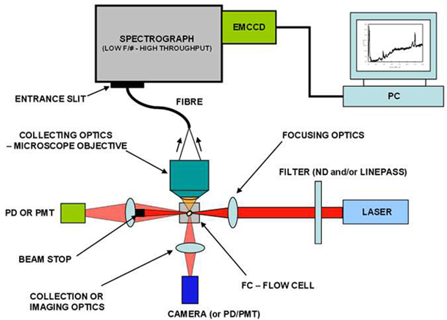
Figure ‎4.1 Schematic diagram of a flow cytometer, showing focusing of the fluid sheath, laser, optics.

Summary of literature review
Triple antibiotics have been reported to be effective against bacterial flora of human root canal dentine, dental plaque, and necrotic pulp. The majority of the available weak evidence supports the use of triple antibiotics for root canal disinfection to facilitate regenerative endodontic treatments of necrotic immature permanent teeth. Many areas of regenerative endodontic treatments remain unclear with poor quality evidence available in the literature. One such area of poor understanding is cellular response, such as cell proliferation or cell survivability after the application of the mixtures of antibiotics. These cells are ultimately responsible for the future of the regenerative process and it was considered prudent to study the affect these antibiotics might have on the survival of these cells.

Aim of this study
To evaluate the toxicity of antibiotics used for regenerative antibiotic technique, both individually and in combination, on pulp cell survival.

Materials and methods

General material and equipment needed for this experiment.
Cell culture hood / incubator / water bath / centrifuge /refrigerator / haemocytometer / microscope/ cell cultured media (Alpha minimum essential medium (MEM)) / pipette.
. Trypsin/ Phosphate buffered saline (abbreviated PBS) (sigma – Aldrich. USA) / foetal bovine serum (FBS) (Biosera, East Sussex, UK).

Conditions for cell culture and storage.
Cell media: Transfer 9 ml of Minimum Essential Medium (MEM) Alpha Medium (Gibco. UK) + 1 ml (10%) foetal bovine serum (FBS) + 0.1 ml (1%) L-Glutamine.
Cell culture hood: The laminar flow hood provides an aseptic work area and environment necessary for cell culture experiments.
Incubator:
Cell culture incubator is designed to maintain a constant temperature and high humidity for the growth of tissue culture cells under a CO₂ atmosphere. For these experiments the incubator was set at a temperature of 37ºC and CO₂ level of 5%, and the relative humidity was maintained between 95% and 98%.

Cytotoxicity test:
Cytotoxicity is the quality of being toxic to cells. Cytotoxicity is a test to measure the fates of pulp cells after been exposed to antibiotics in treating necrotic immature teeth with regenerative endodontic techniques.
Cells undergoing necrosis could be identified by losing membrane integrity and rapid death as a result of cell lysis. The cells can stop growing actively and dividing (a decrease in cell viability), or the cells can activate a genetic program of controlled cell death (apoptosis).
Cell necrosis: Cells exhibit rapid swelling, lose membrane integrity, shut down metabolism and release their contents into the environment. Cells that undergo rapid necrosis in vitro do not have sufficient time or energy to activate apoptotic machinery and will not express apoptotic markers.

Apoptosis:
Apoptosis is characterised by well-defined cytological and molecular events including a change in the refractive index of the cell, cytoplasmic shrinkage, nuclear condensation and cleavage of DNA into regularly sized fragments.
Cells in culture that are undergoing apoptosis eventually undergo secondary necrosis. They will shut down metabolism, lose membrane integrity and lyse.

Demonstration of cytotoxicity measurement point
The following image showing the point that can be identified for cytotoxicity, one point or two can be measured at the same time (Figure ‎4.2)
Membrane integrity (LDHe)
Metabolic activity (GLU)
Respiratory chain activity (XTT/MTT)
Total protein synthesis (SRB)
DNA content and (CVDE) and
Lysosomal activity (PAC, NR)
Figure ‎4.2 Illustrate the point that can be identified for cytotoxicity, one point or two can be measured at the same time (Xenometrix cytotoxicity Screening Test BioAntares website)

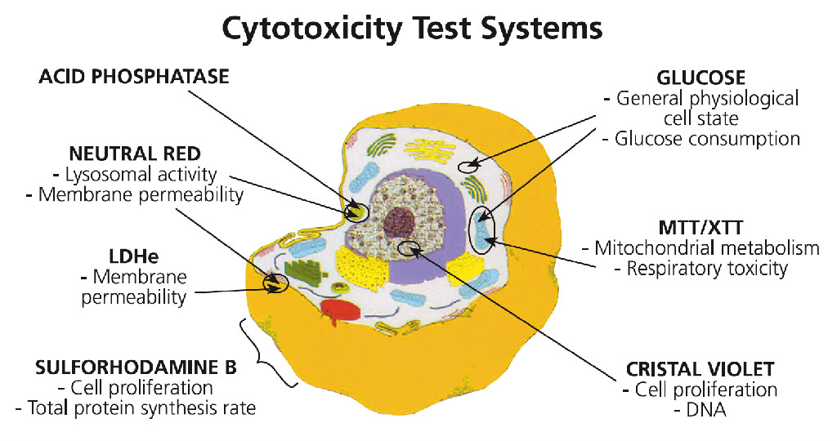

Single endpoint cytotoxicity measurement as
- CVDE (Crystal Violet Dye Elution)
- GLU (Glucose)
- LDH (Extracellular Lactate dehydrogenase)
- MTT (Diphenyltetrazol ium Bromide)
- NR (Neutral Red)
- PAC (Acid Phosphatase)
- 5RB (Sulforhodamine B)
- XTT (Tetrazolium Hydroxide)

Multiple endpoint cytotoxicity measurement as
- LDH-G LU-XTT-SRB
- LDH-GLU-XTT-PAC
- XTT-SRB-CVDE
- LDH-XTT-NR
- NR-SRBNR.CVDE

Antibiotics preparation:
The antibiotic formulae were obtained after a pilot trial in the laboratory. A concentration of 15% gave no effect, 50% had the best effect and 100% was fatal. As a result three antibiotics concentrations were chosen in this present in vitro study.
From the previous experiment the following antibiotics and concentration was used:
- Metronidazole 50%. 50mg/ml.
- Ciprofloxacin 50%. 50mg/ml.
- Minocycline 50%. 50mg/ml.
- Metronidazole + Ciprofloxacin 50%. 50mg/ml.
- Metronidazole + Ciprofloxacin + Minocycline 50%. 50mg/ml.

The tested pulp cells:
The dental pulp cells are coded in our laboratory for data protection. The donor’s references in this experiment:
- Sample 070311
- Sample 190311
- Sample 150811

Cells were obtained
Cells were obtained from the tissue bank at Leeds Dental Institute, from three donors. According to our protocol at Leeds University all donors had signed a consent form. All dental pulp samples used were collected from wisdom teeth (third permanent molars). The external tooth surfaces were cleaned and washed twice with sterile 1 x PBS. The attached gingival tissues were detached from the tooth surface using a sterile scalpel to avoid contamination of dental pulp cultures. The external tooth surfaces were then extensively cleaned again using 1 x PBS. This procedure resulted in low levels of contamination (<8 % of all teeth used). The teeth were then cracked openusing a decontaminated vice or a sterile wire cutter. Pulp tissue was extracted from the pulp chamber of the teeth and immersed in sterile Petri dishes containing 1 x PBS to prepare for collagenase digestion of the cells in the laboratory.

Dental pulp cell extraction and isolation
Healthy human impacted third molars were collected from anonymous consenting adults (18-38 years of age) at the Leeds Dental Institute under approved ethical guidelines. Tooth surfaces were cleaned with 70% (v/v) ethanol soaked tissue paper and any attached tissue was removed with a sterile scalpel blade. Teeth were fractured to allow exposure of the dental pulp, which was gently removed from the tooth fragments with sterile forceps. Following extraction pulps were mechanically disrupted with a scalpel blade and digested in a solution of 3 mg/mL collagenase type I (Sigma-Aldrich, Poole, UK) and 4 mg/mL dispase (Roche, Mannheim, Germany) for 30 minutes at 37°C with gentle agitation on a MACSmix tube rotator (Miltenyi Biotec, Bergisch Gladbach, Germany). The resulting suspension was passed through a 70 µm filter (BD Biosciences, San Jose, CA) and centrifuged at 200 x g for 5 minutes before re-suspension of the cell pellet in alpha modification of Eagle’s medium (α-MEM) (Life Technologies, Paisley, UK) supplemented with 15% FCS (Biosera, Ringmer, UK), 2 mM L-glutamine (Sigma-Aldrich) and 100 units/mL penicillin / 100 µg/mL streptomycin (Sigma-Aldrich). Re-suspended cells were incubated in T25 flasks (Corning, Amsterdam, Netherlands) at 37°C in 5% CO₂ in air at a ratio of one digested pulp per flask for 10-14 days.

How cells were prepared for this study

Passaging and counting cells
All procedures were processed under aseptic conditions in the cell culture hood. Cells were cultured in 75 cm² tissue culture flasks and maintained between 90% and 95% confluence in a humidified 37ºC, 10% CO2 incubator for 24 hrs. When cells reached sub-confluence as judged using light microscopy, the cell layer was washed twice with 1 x PBS and then detached from the culture vessels using 0.25 mm trypsin/ EDTA (ethylenediaminetetra acetic acid) for 3-5 min at 37ºC. The reaction was then stopped using media containing 10 % FCS. The cell suspension was transferred to a centrifuge tube and centrifuged at 200 g for 5 min. The supernatant was carefully aspirated and the pellet re-suspended in medium. The cell number was counted using a haemocytometer.

Trypsinisation of adherent cells:
Trypsinisation is the process of cell dissociation using Trypsin / EDTA. Trypsin, a proteolytic (protein degrading) enzyme which breaks down proteins, to dissociate adherent cells from the vessel in which they are being cultured. EDTA allows trypsin to work more efficiently by engaging certain metal ions that may inhibit its activity. Trypsinisation is often used to passage cells to a new vessel. When the trypsinisation process is complete the cells will be in suspension and appear rounded. When the adherent cells are completely dissociated, media with 10% serum is added to deactivate trypsin.

Protocol for Trypsinisation of adherent cells:
All solutions and equipment that come in contact with the cells were sterile and experiment was carried out in a laminar flow hood.
- Remove and discard the spent cell culture media from the culture vessel.
- Wash cells using a balanced salt solution without calcium and magnesium (approximately 2 mL per 10 cm² culture surface area). Gently add wash solution to the side of the vessel opposite the attached cell layer to avoid disturbing the cell layer, and rock the vessel back and forth several times.
Note: The wash step removes any traces of serum, calcium, and magnesium that would inhibit the action of the dissociation reagent.
- Remove and discard the wash solution from the culture vessel
- Add the pre-warmed trypsin / EDTA to the side of the flask; use enough reagent to cover the cell layer (approximately 1 mL per 10 cm²). Gently rock the container to get complete coverage of the cell layer.
- Incubate the culture vessel at 37ºC for approximately 2 minutes. Note that the actual incubation time varies with the cell line used.
- Observe the cells under the microscope for detachment. If cells are less than 90% detached, increase the incubation time a few more minutes, checking for dissociation every 30 seconds. You may also tap the vessel to expedite cell detachment.
- When ≥ 90% of the cells have detached, tilt the vessel for a minimal length of time to allow the cells to drain. Add the equivalent of 2 volumes (twice the volume used for the dissociation reagent) of pre-warmed complete growth medium. Disperse the medium by pipetting over the cell layer surface several times.
- Transfer the cells to a 50-mL conical tube and centrifuge at 200 × g for 5 to 10 minutes.
- Re-suspend the cell pellet in a minimal volume of pre-warmed complete growth medium and remove a sample for counting.
- Determine the total number of cells and percent viability using a haemacytometer, cell counter and Trypan Blue exclusion. Then add growth media to the cells to achieve the desired cell concentration.
- Dilute cell suspensions to the seeding density recommended for the cell line and pipette the appropriate volume into new cell culture vessels, and return the cells to the incubator.

Seeding the cells for the test
Human dental pulp stem cells HDPSCs were seeded in 24 well plates at 5 x 10⁵ cells/ well and incubated for 48 hours.

Cytotoxicity was tested by using three different methods of assessment:
  - Trypan blue exclusion method
  - Lactate dehydrogenase (LDH) assay
  - Flow cytometry

Trypan blue exclusion method Procedure

Cytotoxicity measured by Trypan Blue method:
Trypan Blue is one of several stains recommended for use in dye exclusion procedures for viable cell counting. This method is based on the principle that live (viable) cells do not take up certain dyes, whereas dead (non-viable) cells do.

Protocol for Viable Cell Counting using Trypan Blue
1. Prepare a cell suspension in a balanced salt solution.
2. Transfer 0.5 ml of 0.4% Trypan Blue solution (w/v) to a test tube. Add 0.5 ml of the cell suspension (dilution factor =2) and mix thoroughly. Allow to stand for 5 to 15 minutes.
Note: If cells are exposed to Trypan Blue for extended periods of time, viable cells, as well as non-viable cells, may begin to take up dye.
3. With the cover-slip in place, use a pipette to transfer a small amount of Trypan Blue-cell suspension mixture to both chambers of the haemacytometer. Carefully touch the edge of the cover-slip with the pipette tip and allow each chamber to fill by capillary action. Do not overfill or underfill the chambers.
4. Starting with chamber 1 of the haemacytometer, count all the cells in the 1 mm centre square and four 1 mm corner squares (see Diagram I). Non-viable cells will stain blue. Keep a separate count of viable and non-viable cells.
Note: Count cells on top and left touching middle line of the perimeter of each square. Do not count cells touching the middle line at bottom and right sides (see Diagram II).
5. Repeat this procedure for chamber 2.
Note: If greater than 10% of the cells appear clustered, repeat entire procedure making sure the cells are dispersed by vigorous pipetting in the original cell suspension as well as the Trypan Blue-cell suspension mixture. If less than 200 or greater than 500 cells (i.e. 20–50 cells/square) are observed in the 10 squares, repeat the procedure adjusting to an appropriate dilution factor.
3. Withdraw a second sample and repeat count procedure to ensure accuracy.
To calculate the cell concentration per ml we used the following formula:
Average number of cells in one large square x dilution factor* x 10⁴
*dilution factor is usually 2 (1:1 dilution with trypan blue), but one may need to further dilute (or concentrate) cell suspensions.
10⁴ = conversion factor to convert 10⁻⁴ml to 1ml (refer to Figure ‎4.4 to view a diagram of the arrangement and dimensions)
Calculation of Cell Viability:
No. of Viable Cells
X 100 = % of viable cells
Total Cells Counted (viable

Haemocytometer
Pipette trypan blue/cell mix (approximately 10µl) at the edge of the cover-slip and allow to run under the cover slip Figure ‎4.3 Focussing the haemocytometer grid to be visualised under the microscope, refer to Figure ‎4.4 for layout of grid. The counting cells within the large square and those crossing the edge on two out of the four sides.Figure ‎4.5. The viable (live) and dead cells were counted in one or more large corner squares and the cell count recorded.

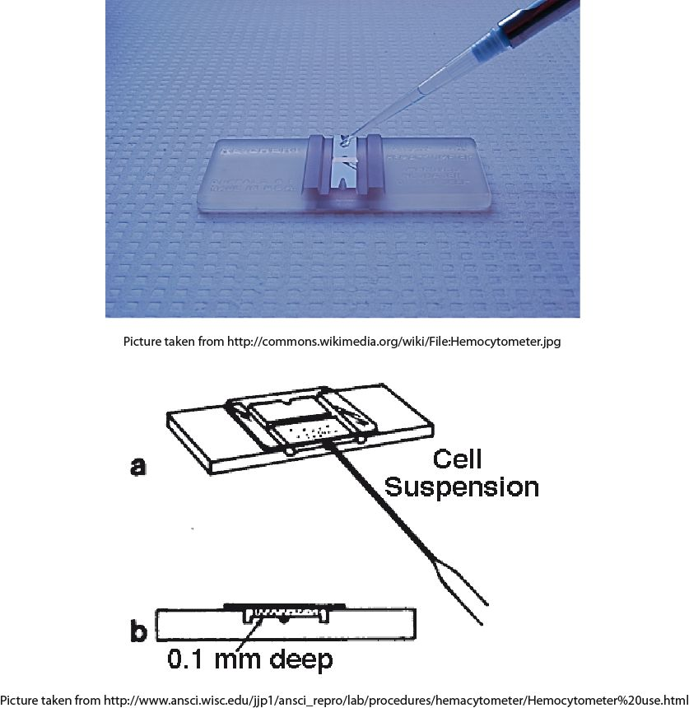
Figure ‎4.3 Illustrate the application of cells in suspension to haemcytometr count

Figure ‎4.4 illustrate the Appearance of haemocytometer grid under the microscope.
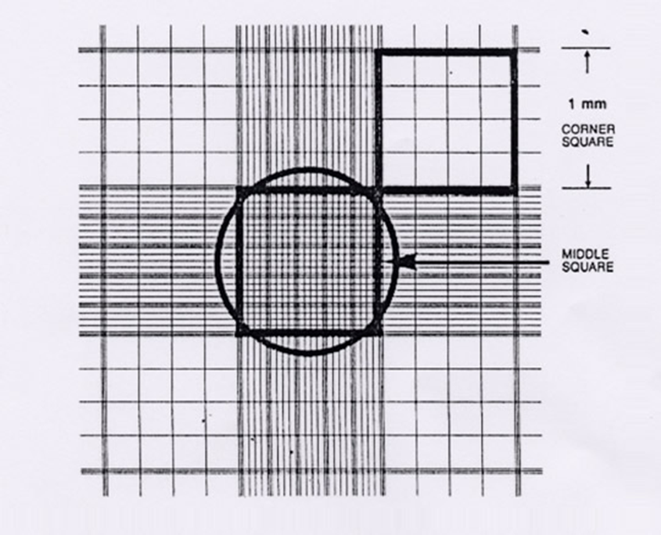

Figure ‎4.5 Count the cells within the large square and those crossing the edge on two out of the four sides.

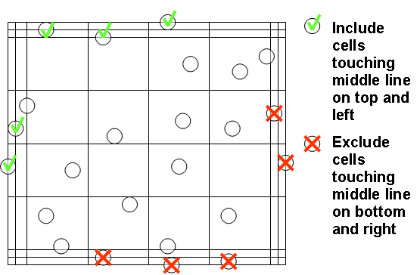

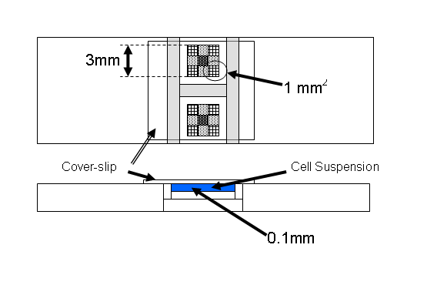
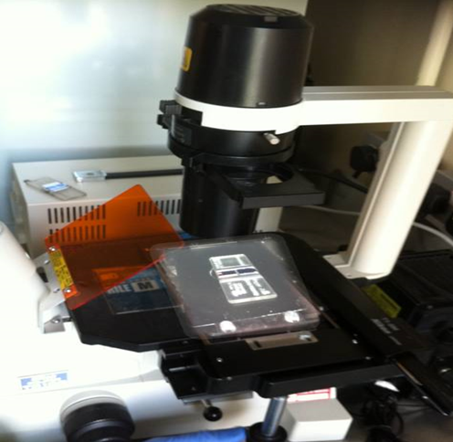
Figure ‎4.6 Illustrate the summary of above image of Haemocytometer, arrangement and dimensions.

Lactate dehydrogenase (LDH) assay
LDH assays can be performed by assessing LDH released into the media as a marker of dead cells or after performing lysis LDH is a marker of remaining live cells.

Introduction
Lactate dehydrogenase (LDH) Figure ‎4.7, which is a soluble cytosolic enzyme present in most eukaryotic cells, is release into culture media upon cell death due to damage of the plasma membrane. The increase of LDH activity in culture supernatant is proportional to the number of lysed cells. LDH cytotoxicity assay measures the activity using a reaction cocktail containing lactate, NAD+, diaphorase and (iodonitrotetrazolium (INT)). LDH catalyses the reduction of NAD+ to NADH in the presence of L-lactate, while the formation of NADH can be measured in a coupled reaction in which the tetrazolium salt INT (yellow) is reduced to a red formazan (red) product. The amount of the highly coloured and soluble formazan (red) can be measured at 490 nm spectrophotometrically.

Cell culture setup
1. Cells (10⁴ cells) were seeded in a 96-well culture plate in 200 μl of culture medium (see cell preparation section 4.2.7.1 page 218) and incubated at 37°C in humidified atmosphere of 5% CO² for 24 hours. For each test sample prepared as mentioned above section 4.2.7.1 page 218 by 50 μg/ml antibiotics were added and incubated for another 24 hours. Besides test samples, three positive controls (cultures in medium with 1% Triton X-100) and three negative controls (cultures in medium) were included.

Preparation of LDH standard
1. Add 2 μl of LDH stock to 498 μl of PBS to make a 500 μl solution of 1000 mU/ml LDH.
2. Obtain 8 test tubes, add 450 μl of culture medium into each tube and label them #1 through #8.as following (Met, Cip, Mino, Cip +Met,Cip +Mino+Met, Cont +ve cont and _ve cont)
3. Add 450 μl of the 1000 mU/ml LDH solution into tube #1 and mix well to get the 500 mU/ml LDH standard.
4. Transfer 450 μl of the 500 mU/ml LDH standard from tube #1 to tube #2 and mix well to get the 250 mU/ml LDH standard.
5. Repeat step 4 for tubes #3-7 to serially dilute the LDH standards. Do not add any LDH to tube #8, which serves as the blank.
6. Obtain a 96-well test plate; prepare 3 replicates (A, B, C) of each LDH standard by aliquoting 150 μl/well of each LDH standard into triplicate wells of the 96-well test plate.

Preparation of test samples and +/-controls
1. Centrifuge the 96-well culture plate at 400 g for 5 min and transfer 150 μl of supernatant from each well (test, positive and negative control wells) to the corresponding well of the 96-well test plate.

Measurements
To make 60 μl of working reaction mixture for each well of 96-well plate, add 2 μl of sodium lactate, 2 μl of INT and 20 μl of substrate mix to 36 μl of PBS.
2. Add 60 μl of working reaction mixture into each well of the 96-well test plate containing LDH standard, test samples, or controls. Incubate for 30 minutes at room temperature in dark.
3. Stop the reaction with 20 μl of sodium oxymate solution per well of 96-well plate.
4. Read the absorbance at 490 nm with an MRX Microplate Reader (Figure ‎4.8)
Calculation
The measurements were calculated using the following formula

$$\% Cytoxicity =\frac{Experimental LDH release (OD490)}{Maximum LDH release (OD490)}$$

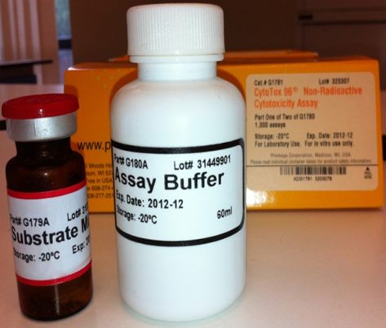
Figure ‎4.7 Shows Lactate dehydrogenase (LDH) used to clarify the effect of the antibiotics used individually or in combination on pulp stem cells after 24 of application

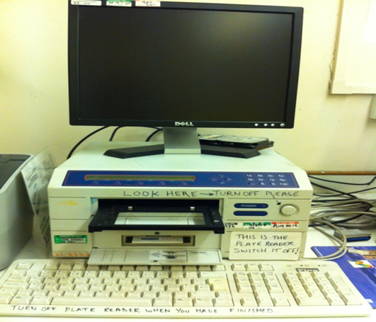
Figure ‎4.8 Shows MRX Microplate Reader used to measure the pulp stem cells cytotoxicity

Flow cytometry
Dental pulp cells at a concentration of 1 x 10⁶ cells / mL were either incubated in a water bath at 60°C for 30 minutes to induce cell death or UV irradiated for 30 minutes to induce apoptosis. Following this treatment cells heated to 60°C were stained with 1 µg / mL propidium iodide (PI) (Miltenyi Biotec GmbH, Bergisch Gladbach, Germany) in PBS (10 µL of PI solution to 1 mL of cell suspension). UV irradiated cells were washed with PBS and resuspended in 1 mL of Annexin V Binding Buffer (BioLegend, San Diego, CA), of which 100 µL was transferred to a fresh microtube before the addition of 5 µL Alexa Fluor® 647 conjugated Annexin V (BioLegend, San Diego, CA). In addition 100 µL of UV irradiated cell suspension was dual labelled with both Annexin V and PI. Samples were incubated in the dark at room temperature for 15 minutes prior to washing and resuspension in PBS or Annexin V Binding Buffer. These samples, in addition to an unlabelled negative control, were analysed using a BD Biosciences LSRFortessa flow cytometer and BD CellQuest Pro Software (BD Biosciences, San Jose, CA). Unlabelled, single labelled and dual labelled samples were used to set acquisition parameters to reduce the acquiring of autofluorescent signals and any potential channel crossover.

Antibiotic treated samples were removed from tissue culture plastic using 0.25% trypsin 0.02% EDTA (Sigma-Aldrich, Poole, UK). Samples were centrifuged at 200 x g for 5 minutes, washed with PBS, centrifuged again at 200 x g for 5 minutes and resuspended in 1 mL Annexin V Binding Buffer to which 10 µL of PI was added. 100 µL of cell suspension was transferred to a fresh microtube to which 5 µL of Alexa Fluor® 647 conjugated Annexin V was added. Samples were incubated in the dark at room temperature for 15 minutes before the addition of 400 µL of Annexin V Binding Buffer. Samples were then centrifuged at 300 x g for 5 minutes before resuspension in 500 µL of Annexin V Binding Buffer prior to analysis. Samples were gated based on forward scatter and side scatter to exclude cellular debris from the analysis and were analysed for expression of PI and Alexa Fluor® 647. (Figure ‎4.9)
Figure ‎4.9 Shows a Flow cytometry used to test pulp cells cytotoxicity after antibiotics application.
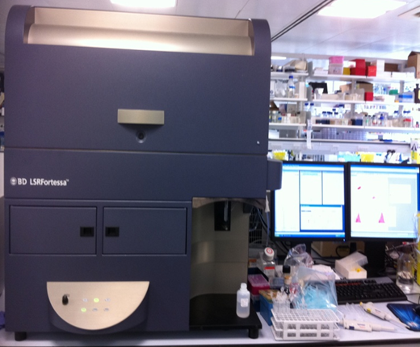
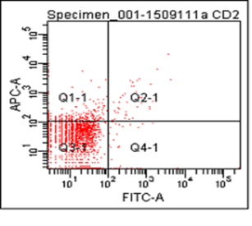

Statistics
Statistical analysis was undertaken on statistical package of social sciences version 20 (SPSS 20). The distributions of pulp death of cells were determined by first checking the normality of the data using the Shapiro-Wilk test. As the data was found to be normally distributed further analysis was performed using ANOVA for the trypan blue test and LDH. However, the data was not normally distributed for the flow cytometry tested group, so non-parametric Kruskal-Wallis tests were used.

Results

Cytotoxicity testing
Cytotoxicity was investigated using 3 methods:
  - Cell counting using Trypan Blue:
  - LDH
  - Flow cytometry

Percentages of cell viability were calculated and grouped according to the criteria of Dalh et al (2006) as follows:

1. <30% cell viability = severe cytotoxicity
2. 30%–60% cell viability = moderate cytotoxicity
3. 60%–90% cell viability = slight cytotoxicity
4. >90% cell viability = noncytotoxicity

Cell counting using Trypan Blue:
The number of live and dead cells for each test and control groups were counted and the averages were calculated using the following methods:

Counting:
Cell counting = number of cells*10000*2* (number of cells per millimetre)
For exam if number of cells are 3
3*10000*2= 60000 cell/ml
The total number = number of cells per millilitre X total Volume (ml)

Cells %= death cells
Death cells + alive cells X 100 =

The Table ‎4.1and Figure ‎4.10 show that the viability rate of pulp cells for the control group was high (93.5%) but was lower than metronidazole which was 94.9%. Ciprofloxacin had the worse effect on cell survivability which was statistically significant compared to the control group (p=0.00), followed by minocycline (79.0%) although this difference was not significant. The combination of two or three antibiotics had almost the same effect, with slightly higher cell viability in Met+Cip group but this was not statistically significant.

Table ‎4.1 This table Shows the a live cells count and death cells also the percentage of survival pulp cells after 24 hours incubated with antibiotics
 | cell counts |  |  | survival cells
samples | L | D | Av live % | SD
control | 251200 | 18000 | 93.458 | 1.91199
Met | 132000 | 5866.7 | 94.87 | 1.84279
Cip | 91733 | 45867 | 73.689 | 5.54886
Mino | 63467 | 18193 | 79.003 | 2.9422
2Ab | 166400 | 21333 | 86.195 | 2.0748
3Ab | 150286 | 21867 | 84.278 | 2.34194

L Live cells
D Death cells
Met Metronidazole
Cip Ciprofloxicillin
Mino Minocycline

Figure ‎4.10 Shows the percentage of survival pulp cells after 24 hours incubated with antibiotics

Lactate dehydrogenase (LDH) assay
The data showed in Table ‎4.2 and Figure ‎4.11 represent the percentage of dead cells after incubation with antibiotics for 24 hours and assessed by LDH enzyme test.
Table ‎4.2 shows that minocycline and ciprofloxacin are highly cytotoxic to human dental pulp stem cells (60%). Also this test shows that a combination of Cip+Met had the lowest cytotoxicity (40%), even better than the control group. The triple antibiotics (Mion+ Cip+Met) had the same effect as the control group (45%).
Table ‎4.2 Percentage of pulp cells death after 24 hours incubation with antibiotics.
Samples | Cytotoxicity% | SD | Average
Contol | 46.42857 | 0.082103 | 0.744667
Met | 48.70536 | 0.108342 | 0.773333
Cip | 59.86607 | 0.511746 | 0.954667
Mino | 60.17411 | 0.330641 | 0.959267
2Ab | 40.17857 | 0.228863 | 0.660667
3Ab | 45.80357 | 0.121212 | 0.742667

Figure ‎4.11 Live cell count, dead cells and percentage of pulp cell survival after 24 hours incubation with antibiotics

FLOW CYTOMITRY
Table ‎4.3 and Figure ‎4.12 represent the percentage of pre-apoptotic, apoptotic, necrotic and live cells following incubation with antibiotics for 24 hours as assessed by flow cytometry.Table was added to show the meaning of all Q that presented in the .In Table ‎4.3 it can be seen that Q1 represents necrotic cells. Q2 represents apoptosis which is the process of programmed cell death that may occur due to biochemical cell characteristic changes that lead to cell death. Q3 represents live cells, and Q4 represents the pre-apoptotic cells, which are defined as cells involved in the early stages of apoptosis. In Table ‎4.4 the most interesting Column is Q3 as the aim of this study was to look at pulp cell viability and it can clearly be seen that the cell survival of the control group is 86%, the triple antibiotics group (Mio+Cip+Met) is 85.3%, the combination of (Cip+Met) is 83.2%, which is almost the same as for minocycline at 83.5%. For the individual application of Metronidazole it was 65 % and the highest negative effect on cell survival was observed in the ciprofloxicillin added group. This data is summarised in Table ‎4.4 and Figure ‎4.12 and more result interpreting for Q1, Q2 and Q3 in discussion.

Table ‎4.3 Shows live, apoptosis necrotic death pulp cells after 24 hours incubated with antibiotics.

Sample | Q1 | SE | Q2 | SE | Q3 | SE | Q4 | SE
Control | 0.8 | 0.064 | 3.3 | 1.12 | 87.133 | 3.76 | 8.8 | 2.83
Control | 0.7 |  | 7.4 |  | 81.1 |  | 10.8
Control | 0.7 |  | 3 |  | 89.95 |  | 6.5
Met | 0.7 | 0.187 | 3.3 | 0.75 | 85.97 | 5.03 | 10.1 | 4.46
Met | 0.6 |  | 4.5 |  | 74.733 |  | 20.2
Met | 1.7 |  | 7.2 |  | 83.6 |  | 23.7
Cip | 0.8 | 0.111 | 2.7 | 0.74 | 87.5 | 6.98 | 9 | 6.37
Cip | 0.5 |  | 4.4 |  | 70.63 |  | 24.5
Cip | 0.8 |  | 2.8 |  | 75.43 |  | 21
Mino | 0.9 | 0.056 | 5.4 | 0.83 | 79.77 | 3.25 | 13.9 | 2.50
Mino | 0.9 |  | 4.6 |  | 84.57 |  | 9.9
Mino | 0.6 |  | 2.5 |  | 87.83 |  | 9.1
MET+CIP | 0.7 | 0.132 | 3 | 0.42 | 84.37 | 1.84 | 12 | 1.84
MET+CIP | 0.9 |  | 2.8 |  | 84.23 |  | 12.1
MET+CIP | 0.8 |  | 3.8 |  | 83.37 |  | 12
MET+CIP+MINO | 0.8 | 0.063 | 4.1 | 0.69 | 83.2 | 1.77 | 11.9 | 1.33
MET+CIP+MINO | 0.7 |  | 2.9 |  | 86.37 |  | 10
MET+CIP+MINO | 0.7 |  | 2.8 |  | 87.9 |  | 8.7

Table ‎4.4 Summary of cell survival after incubation for 24 houres with antibiotics.
Groups | % Survival pulp cells | SE
Control | 86% | 3.76
Metronidazol | 64.50% | 3.2
Ciprofloxacin | 55.40% | 4.6
Minocycline | 72.80% | 3.25
MET+CIP | 82.20% | 1.84
MET+CIP+MINO | 85.30% | 1.77

Figure ‎4.12 Showed the percentage survival of pulp cells after 24 hours incubated with antibiotics assessed by flow cytomitry.

Discussion
Irreversible damage to immature permanent teeth as a result of noxious infection or local trauma before normal physiological closure of the apical structure represents a real clinical challenge. In trauma or infection, root canal development is interrupted and natural apical closure does not take place, this presents further difficulties for performing conventional endodontic treatment successfully.
In this situation, the standard therapeutic approach has been to consider the use of synthetic biocompatible materials, such as calcium hydroxide (Rafter, 2005) and substituted recently by mineral trioxide aggregate (MTA) (Shabahang and Torabinejad, 2000) to induce apical closure by forming a hard tissue barrier across the root apex. None of these biomaterials however are suitable for resolving clinical dilemmas. One of the major risks facing immature teeth with interrupted root development is weakened fracture resistance of the dentine walls (Twati et al., 2009) and this finding was supported by the results in chapter 2.
Recently, a biologically based treatment called regenerative endodontic treatment was introduced (Hargreaves and Law, 2011). This approach is based on the presence of stem cells in the apical papilla that are resistant to infection and necrosis (Huang et al., 2008). In this treatment, the ideal goal is to prepare an appropriate environment inside the root canal space (i.e. absence of bacteria and necrotic pulp tissue, presence of a scaffold and a tight coronal seal) that promotes repopulation of these stem cells, regeneration of pulp tissue, and continuation of root development (Hargreaves et al., 2008).
The treatment procedure begins with chemical disinfection by irrigation of the root canal space with sodium hypochlorite (Thibodeau and Trope, 2007), followed by antibiotic medicaments like triple antibiotic mixture (metronidazole, ciprofloxacin, and minocycline) (Banches and Trope, 2004).
A recent study by Trevino et al., 2011, showed that NaOCl (a commonly used irrigant) at different concentrations had the potential to affect stem cell survival. This highlights the need to evaluate the effects of each chemical material used for regenerative endodontic treatment, such as the effect of antibiotic mixtures on cell survival.

Human dental pulp cells source
Dental pulp plays an important role in tooth homeostasis (Pashley et al., 2006). Various types of cells can be found inside the pulp (e.g. odontoblasts, fibroblasts, stem cells, immune cells, and endothelial cells). The apical papilla tissues played an important role during root formation. This tissue has a high collateral circulation and consists of various cells types (e.g. fibroblasts, immune cells, endothelial cells, and stem cells). These cells play a part in tooth development and pulpal infection control including the self-repairing process (Chuensombat et al., 2013).
The pulp cells in this study were obtained from wisdom teeth which are the preferred source for HDPSCs, possibly related to the fact that being the last teeth to develop, their cells retain maximum pluripotency and proliferative potential (Couble et al., 2000).
Complete elimination of necrotic pulp that might weaken the bacteria as it will lose the main nutrient reservoir inside the canal which helps in root canal disinfection. However a study recommended not extirpating the root canal pulp, as it could have some live stem cells which increase the chance of achieving regenerative processes (Chueh and Huang, 2006). This could be achieved using minimum instrumentation in the root canal to reduce the chance of odontoblast injury.

Investigation methods:
In general toxicity tests, aimed mainly at detection of the biological activity of test substances, can be carried out on many cell types. A number of parameters have been introduced for testing cytotoxicity endpoints, including vital staining, cytosolic enzyme release, cell growth and alterations in the cell membrane metabolism or integrity.
In this study we have used cell membrane integrity, lysosomal and accumulation techniques for this investigation. This was considered important as we did not want to change the endpoint of assessment, so we could minimise the other factors from affecting the result. As the change in the parameters of cell assessment for example from mitochondria to cell membrane assessment could be criticised, as in this case, the same endpoints were not assessed and it would have become difficult to compare the results of all tests to each other.

Trypan blue
This is another cytotoxicity measurement based on cell membrane functions, by measuring the cell viability using vital dyes such as trypan blue which enters dead cells only or neutral red that is actively taken up by living cells. This method is commonly used in biomaterial testing.
Counting of dead and vital cells in comparison with the control provides an index of lethality of the test compound on pulp stem cells (Holden et at., 1973).
Trypan blue is a very simple test in which the trypan blue dye passes through the dead cells membrane. Hence, dead cells are shown as a distinctive blue colour under the microscope. However in live cells the trypan stain cannot be absorbed. This investigation gives us very basic information about whether the pulp cells survive after incubation with antibiotics for 24 hours or not. The accuracy of this test was one of the major issues, as it depends on visual assessment and many cells could be missed during counting. Although the chemical assays have unpredicatble outcomes, they remain the gold standard for in vitro cytotoxicity tests and for detecting changes of cell membrane integrity. We used this test as an indicator for cell survivability. Interestingly the result that was obtained from this test was compatible with other results. In this study cell survival was higher than what was observed in other tests. The percentage of live cells for the control groups was 94%, and curiously metronidazole (95%) had even more viable cells than that found in the control group, Cip+Met was 86%, Mino+ Cip+Met 84% and even Ciprofloxicillin and minocycline were considered to be moderately cytotoxic (Dalh et al., 2006). This finding was also supported by another recent study (Chuensombat et al., 2013). Due to a deficiency of literature in this area of research it is not possible to compare these findings to other published research. For this reason it was also decided to conduct further analysis and to use a cell membrane based test (Lactate dehydrogenase LDH assay).

Lactate dehydrogenase LDH assay
Lactate dehydrogenase LDH activity test is more sophisticated than for trypan blue and has a long history as a preferred marker for cell death with in vitro cell models (Xia et al., 2008). Simply, the LDH is a stable cytoplasmic enzyme stored in viable cells. An increase in LDH leakage indicates that the stability of cell membranes is damaged, possibly due to oxidative injury (Yildiz et al., 1999). The activity of LDH is indirectly measured by an enzymatically-coupled reagent that is chemically comprised of lactate, NAD+, diaphorase and an appropriate redox dye such as a tetrazolium compound or resazurin.
In this method of investigation it can be seen that the cytotoxicity was very high even in the control group as almost half of the cells were dead. Interestingly, in this study it was observed that poly antibiotics whether Cip+Met (40%) or Mino+ Cip+Met (45%) were less toxic than if applied individually.
LDH assay detection is a robust and cost-effective means of assessing cytotoxicity, but is susceptible to background signals from serum sources of LDH found in supplemented growth media. Further LDH can be affected by several culture parameters including intracellular oxygen tension (Issa et al., 2004), and the exogenous sources of supplemented growth media of the LDH can greatly elevate the background values and negatively impact on the cells (Andrew et al., 2009).This could explain the high mortality in cells compared to other tests. It might well be that after the application of antibiotics the cell media environment could be affected which therefore makes the test more sensitive. So the necessity to find even more tests to confirm the results of the present study were needed and flow cytometry was considered.

FLOW CYTOMRY
Flow cytometry with complementary techniques such as optical microscopy, confocal fluorescence, scanning or transmission fully covers all the biochemical and morphological aspects that need to be taken into account with cytotoxicity in biological science.
These multicolour advanced techniques have the ability to reveal more information about each individual cell in less time, with even a small amount of sample. This technique allows analysis of cell behaviour after application of antibiotics to the cells and it showed the necrotic cells in Q1. The necrotic cells mean that the cell death occurred in response to adverse conditions in the cell’s environment whereas apoptosis in Q2 meant that the affected cell actively participated in the cell death process. It can be seen in , (page 261) that in Q1 all cells were already dead from a biological accident not due to antibiotic application. However in Q2 (apoptosis) it started to be observed that some changes started to occur due to application of antibiotics that could lead to some alterations in the cell components leading to cell death. It can also been seen from Table ‎4.3 that the highest negative cell modification occurred for the Ciprofloxacin and minocycline group. This was significantly significant (p=0.00), and the lowest cell changes were seen for the combined antibiotic (Cip+Met) group and (Mino+Cip+Met) group. The viable cells in Q3 were explained in the results. In Q4 these are the cells that are affected by the antibiotics and could become apoptotic and die. Minocycline and Ciprofloxacin negatively affected pulp cells and the antibiotic mixture was less toxic to the cells.

The cells survivability after antibiotics application
Triple antibiotics have been reported to be effective against bacterial flora of human root canal dentine, dental plaque, and necrotic pulp (Banches and Trope, 2004). The vast majority of evidence is based on in vivo and clinical studies (Banches and Trope, 2004; Akgun et al., 2009) support the use of triple antibiotics for root canal disinfection. In chapter three we have proven the efficiency of the antibiotics against the main types of bacteria. Moreover, the presence of a small local amount of antibiotics may need to be considered as a natural biodegradable for proteins scaffolds such as collagen I or fibronectin (Peter et al., 2007). On the other hand one of the drawbacks for regenerative endodontic treatment (Nosrat et al., 2012) is tooth discolouration after triple antibiotics used for root canal disinfection due to use of minocycline (Kim et al., 2010). This finding led to a change in some of the RET treatment protocols. A combination of metronidazole and ciprofloxacin were used without minocycline. Radiographic assessment after 30 months showed complete apical closure and thickening of the canal wall. This indicated the revascularisation potential of young permanent tooth pulp stem cells (Mittal and Jain, 2013). In successful cases, pulpal regeneration has been shown to occur in experimental animal studies and in humans (Miller et al., 2012). In contrast, when an inflammatory reaction persists for a long time, a bone-like tissue occupies the pulp chamber in the replanted teeth (Rungvechvuttivittaya et al., 1998; Takamori et al., 2008).

Although calcium hydroxide is the gold standard root canal disinfection material, it is not recommended to be used for teeth that are going to be treated with regenerative endodontic techniques. Banches and Trope (2004) have suggested that the use of calcium hydroxide might be lethal to the remaining pulpal stem cells, which affect future regenerative treatment (Liu et al., 2006), or possibly disrupt the apical papilla cell reproduction (Banches and Trope, 2004). This is ultimately critical for stem cell survival and thus discontinued root development.

Compare our study to the literature
This study looked at the effect of individual and combinations of antibiotics used to treat necrotic immature teeth. The cytotoxicity of these drugs was assessed by three methods to evaluate cell viability.
This study used three different tests to confirm the validity of the results, as this is a new area of research and there is no clear evidence for the best test to be used. Interestingly all the results obtained from the three different methods were consistent.
Metronidazole, is commonly used for necrotic dental pulp disinfection (Siqueria and de-Uzeda, 1997), because it is highly effective against anaerobic bacteria and has no effect on live cells (Chuensombat et al., 2013.). Although we did not agree with the effectiveness of metronidazole on bacteria, which is discussed in chapter 3, we do agree that metronidazole is slightly cytotoxic to cell survival. According to Dalh et al., (2006) the toxicity scale of metronidazole ranged between 60-90% and most of the time was equal or slightly higher when compared to thecontrol group.
Minocycline has the ability to increase the rate of dental pulp revascularisation compared with doxycycline or saline solution (Ritter et al., 2004). Ciprofloxacin significantly reduces inflammatory reactions in pulp tissue of monkeys mechanically exposed and contaminated (Cannon et al., 2008). In this study it was found that incubating the pulp stem cells with ciprofloxicillin individually showed a statistically significant reduction of viable cells in all three methods used in this investigation. However it was considered to be moderately cytotoxic according to Dalh et al., 2006.
Minocycline had a significant negative effect on cell viability but this finding was not confirmed when minocycline was assessed by flow cytometry. The cytotoxicity was not statistically significant and we considered minocycline to be moderately cytotoxic according to a known cytotoxicity scale (Dalh et al., 2006). The same finding was reported by Suzuki et al. (2006).
The mixture of ciprofloxacin, metronidazole, and minocycline may be sufficiently effective in preventing penetration of bacteria in the root canal, and may result in a sterile environment that favours pulpal regeneration (Chuensombat et al., 2013). The healing pattern seems to depend on variations in the concentrations of antibiotics present in the mixture. Further studies demonstrated the importance of maintaining dental pulp stem/progenitor cells for the generation of odontoblast-like cells during the healing process following tooth replantation, regenerative treatment and transplantation (Ishikawa et al., 2010; Mutoh et al., 2011). In addition, several studies showed that high concentrations of antibiotics have a detrimental effect on the survival of stem cells of the apical papilla (Ruparel et al., 2012; Chuensombat et al., 2013). Hence, higher concentrations of antibiotics are consequently detrimental to the production of odontoblast-like cells. The mixture of three antibiotics had greater cytotoxicity than applications of single drugs at high concentrations, and when used at low concentrations this mixture gave the most favourable environment for pulp cell survival and significantly reduced the number of bacteria (Chuensombat et al., 2013). Interestingly, a recent study showed that a mixture of antibiotics at reduced concentrations can lead to an increase of tertiary dentine and bone-like tissue in regenerative teeth. This phenomenon may be related to an increase in the anti-bacterial effectiveness (Quispe-Salcedo et al., 2013).
The above mentioned supports the views of this research group and preliminary work to find out the correct drug concentrations to be used before proceeding with this experiment. The concentration of the drug in Quispe-Salcedo et al. (2013) study was 50mg/ml, which was the same drug strength that was used for all the antibiotic groups used in our study. The investigations conducted in chapter 3 showed the effectiveness of the antibiotic concentrations against the common organisms present in root canals of non- vital teeth.
In chapter 3 it was also observed that the antibiotic mixtures, whether two or three combinations, had the greatest inhibition of bacterial growth. Also in this study it can be seen that the outcome for antibiotics as a two antibiotic mixture (Cip+Met) or three antibiotic mixture (Mino+Cip+Met) had the best outcome on human dental pulp stem cell survival.
However, when some antibiotics were used individually (Minocycline, Ciprofloxacin ) these were found to have a had a detrimental effect on pulp survival.

Conclusion
In the present study the application of antibiotics in combination had no significant effect on the survival of pulp cells. There was no difference between using two or three antibiotic mixtures. However, Ciprofloxacin in all results alone seemed to affect pulp cell survival although this was not seen when it was used in combination.

CLINICAL IMPLICATION
Ciprofloxicillin alone seemed to significantly affect cell survival. However in combinations, antibiotics that are commonly used for regenerative endodontic treatments seem to have no adverse effect on the survival of pulp cells.

References
ABBOTT, P. 2000. Selective and intelligent use of antibiotics in endodontics. Aust Endod J, 26, 30-39.
ABDULKADER, A., GUDUID, R. & SAUNDERS, E. 1996. The antimicrobial activity of endodontic sealers to anaerobic bacteria. Int Endod J 29, 280–3.
ADAMIDOU, V. 2010. In vitro investigation of teeth discolouration with different endodontic medications. MDentSci, University of Leeds.
AKGUN, O., ALTUN, C. & GUVEN, G. 2009. Use of triple antibiotic pastes disinfectant for a traumatized immature tooth with aperiapical lesion: a case report. Oral Surg Oral MedOralPatholOralRadiolEndod, 108, e62–5.
AL ANSARI, A. 2007. Which type of post and core system should be used? Evidence based Dentistry., 8, 5-6.
AL-HEZAIMI, K., AL-HAMDAN, K., NAGHSHBANDI, J., OGLESBY, S., J., S. & ROTSTEIN, I. 2005. Effect of white-colored mineral trioxide aggregate in different concentrations on Candida albicans in vitro. J Endod 31, 684–6.
AL-HEZAIMI, K., AL-SHALAN, T., NAGHSHBANDI, J., OGLESBY, S., SIMON, J. & ROTSTEIN, I. 2006. Antibacterial effect of two mineral trioxide aggregate (MTA) preparations against Enterococcus faecalis and Streptococcus sanguis in vitro. . J Endod 32, 1053-6.
AL-HEZAIMI, K., AL-SHALAN, T., NAGHSHBANDI, J., SIMON, J. & ROTSTEIN, I. 2009. MTA preparations from different origins may vary in their antimicrobial activity. Oral Surg Oral Med Oral Pathol Oral Radiol Endod 107, e85–8.
AL-HEZAIMI, K., NAGHSHBANDI, J., OGLESBY, S., SIMON, J. & ROTSTEIN, I. 2006. Comparison of antifungal activity of white-colored and gray-colored mineral trioxide aggregate (MTA) at similar concentrations against Candida albicans. . J Endod 32, 365–7.
AL-JUNDI, S. 2002. Dental emergencies presenting to dental teaching hospital due to complications from traumatic dental injures. Dental Traumatology, 18 181-185.
AL-JUNDI, S. 2004. Type of treatment, prognosis and estimation of time spent to manage dental trauma in late presentation cases at a dental teaching hospital: a longitudinal and retrospective study. Dental Traumatology 20, 1-5.
AL-KHATANI, A., SHOSTAD, S., SCHIFFERLE, R. & BHAMBHANI, S. 2005. In-vitro evaluation of microleakage of an orthograde apical plug of mineral trioxide aggregate in permanent teeth with simulated immature apices. . J Endod 31, 117-119
AL-KHATIB, Z., BAUM, R. & MORSE, D. 1990. The antimicrobial effect of various endodontic sealers. Oral Surg Oral Med Oral Pathol Oral Radiol Endod, 70, 784–90.
AL-NAZHAN, S. & AL-JUDAI, A. 2003. Evaluation of antifungal activity of mineral trioxide aggregate. J Endod, 29, 826–7.
ANDERSSON, L. 2013. Epidemiology of Traumatic Dental Injuries. J Endod, 39, S2–S5.
ANDREASEN, F. & ANDREASEN, J. 1985. Diagnosis Of luxation injuries: The importance of standardised clinical, radiographic and photographic techniques in clinical investigations. Endod Dent Traumatol 1, 160-169.
ANDREASEN, J. 1985. Challenges in clinical dental traumatology. Endod Dent Traumatol, 1, 45-55.
ANDREASEN, J., ANDREASEN, F. & ANDERSSON, L. 2009. Textbook and Color Atlas of Traumatic Injuries to the Teeth, Blackwell Munksgaard.
ANDREASEN, J., ANDREASEN, F. & ANDREASEN, L. 2007. Textbook and color atlas of traumatic injuries to the teeth, Blackwell Munksgaard, Oxford.
ANDREASEN, J., BAKLAND, L., MATRAS, R. & ANDREASEN, F. 2006. traumatic intrusion of permanent teeth part 1. An epidemiological study of 216 intruded permanent teeth. Dental Traumatology, 22, 83-89.
ANDREASEN, J., FARIK, B. & MUNKSGAARD, E. 2002. Long-term calcium hydroxide as root canal dressing may increase risk of root fracture. Dental Traumatology, 18, 134-7.a
ANDREASEN, J., JACOBSEN, H. & ANDREASEN, F. 1995. Replantation of 400 avulsed permanent incisors: 2-factors related to pulpal healing. Endod Dent Traumatol 11, 59-68.
ANDREASEN, J., MUNKSGAARD, E. & BAKLAND, L. 2006. Comparison of fracture resistance in root canals of immature sheep teeth after filling with calcium hydroxide or MTA. Dent Traumatol 22, 154–6.
ANGKER, L., NOCKOLDS, C., SWAIN, M. & KILPATRICK, M. 2004. Correlating the mechanical properties to the mineral content of carious dentineâ€”a comparative study using an ultra-micro indentation system (UMIS) and SEM-BSE signals. Archives of oral biology, 49, 369-378.
ANGKER, L. & SWAIN, M. 2006. Nanoindentation: Aplication to dental hard tissue investigations. J Material Research, 21, 1893-1905.
APAYDIN, E., SHABAHANG, S. & TORABINEJAD, M. 2004. Hard tissue healing after application of fresh or set MTA as root-end-filling material. J Endod 30, 21-24.
ASGARY, S. & KAMRANI, F. 2008. Antibacterial effects of five different root canal sealing materials. J Oral Sci 50, 469–74.
ASGARY, S., PARIROKH, M., EGBBAL, M. & BRINK, F. 2005. Chemical differences between white and gray mineral trioxide aggregate. J Endod, 31, 101-103.
ASGARY, S., PARIROKH, M., EGHBAL, M., STOWE, S. & BRINK, F. 2006. A qualitative X-ray analysis of white and grey mineral trioxide aggregate using compositional imaging. Journal of Materials Science. Materials in Medicine., 17, 187-91.
ATLAS, R. 1997. Principles of Microbiology, Dubuque, IA: WCB Publishers.
ATMEH, A., CHONG, E. & RICHARD, G. 2012. Dentin-cement interfacial interaction: calcium silicates and polyalkenoates. J Dent Res 91, 454–9.
BAL, C., PADDA, B. & BALA, R. 1993. Evaluation of apical seal with renew (calcium hydroxide) and synthograft (tricalcium phosphate) in teeth with open apices Indian Journal of dental Research, 4, 7-12.
BALL, J. 1964. Apical root in non-vital immature permanent incisor. British Dental Journal.
BALOOCH, M., WU-MAGIDI, I. & BALAZS, A. 1998. Viscoelastic properties of demineralized human dentine measured in water with atomic force microscope (AFM) based indentation. J Biomed Material Res, 40, 539-543.
BANCHS, F. & TROPE, M. 2004. Revascularization of Immature Permanent Teeth With Apical Periodontitis: New Treatment Protocol. Journal of Endodontics 30, 196-200.
BANCHS, F. & TROPE, M. 2004. Revascularization of immature permanent teeth with apical periodontitis: new treatment protocol? J Endod 30, 196 -200.
BASTONE, E., FREER, T. & MCNAMARA, J. 2000. Epidemiology of dental trauma: A review of the literature. . Australian Dental Journal 45, 2-9.
BATEMAN, G., RICKETTS, D. & SAUNDERS, W. 2003. Fibre-based post systems: a review. British Dental Journal, 195, 43-48.
BATOULI, S., MIURA, M., BRAHIM, J., TSUTSUI, T., FISHER, L., GRONTHOS, S., ROBEY, P. & SHI, S. 2003. Comparison of stem-cell-mediated osteogenesis and dentinogenesis. J Dent Res, 82, 976-81.
BERNARDO, M., EMONS, J., KARPERIEN, M., NAUTA, A. J., WILLEMZE, R., ROELOFS, H., ROMEO, S., MARCHINI, A., RAPPOLD, G. A., VUKICEVIC, S., LOCATELLI, F. & FIBBE, W. 2007a. Human mesenchymal stem cells derived from bone marrow display a better chondrogenic differentiation compared with other sources. Connect Tissue Res, 48, 132-40.
BHASKER, S. 1991. Orban's oral histology and embryology, St. Louis: Mosby.
BIDAR, M., DISFANI, R., GHARAGOZLOO, S., KHOYNEZHAD, S. & ROUHANI, A. 2010. Medication with Calcium Hydroxide Improved Marginal Adaptation of Mineral Trioxide Aggregate Apical Barrier J Endod 36, 1679–1682.
BIDAR, M., MORADI, S., JAFARZADEH, H. & BIDAD, S. 2007. Comparative SEM study of the marginal adaptation of white and grey MTA and Portland cement. . Aust Endod J, 33, 2–6.
BIRK, D., ZYCBAND, E. & WOODRUFF, S. 1997. Collagen fibrillogenesis in situ: Fibril segments become long fibrils as the developing tendon matures. Developmental Dynamics, 208, 291–298.
BORTOLUZZI, E., SOUZA, E. & REIS, J. 2007. Fracture strength of bovine incisors after intra-radicular treatment with MTA in an experimental immature tooth model. Int Endod J 40, 684–91.
BOSE, R., NUMMIKOSKI, P. & HARGREAVES, K. 2009. A retrospective evaluation of radiographic outcomes in immature teeth with necrotic root canal systems treated with regenerative endodontic procedures. Journal of Endodontics, 35, 1343-9.
BURTON, J., PRYKE, L., ROB, M. & LAWSON, J. 1985. Traumatized anterior teeth amongst high school students in northern Sydney. Aust Dent J 30, 346-348.
BYSTROM, A., CLAESSON, R. & SUNDQVIST, G. 1985. The antimicrobial effect of camphorated paramonochlorophenol, camphorated phenol and calcium hydroxide in treatment of infected root canals. Endod Dent Traumatol 1, 170–5.
CALT, S. & SERPER, A. 1999. Dentinal tubule penetration of root canal sealers after root canal dressing with calcium hydroxide. J Endod 25, 431–3.
CAMILLERI, J. 2007. Hydration mechanisms of mineral trioxide aggregate. Int Endod J 40, 462–70.
CAMILLERI, J., MONTESIN, F., BRADY, K., SWEENEY, R., CURTIS, R. & FORD, T. 2005. The constitution of mineral trioxide aggregate. Dent Mater 21, 297–303.
CAMILLERI, J., MONTESIN, F., BRADY, K., SWEENEY, R., CURTIS, R. & PITT FORD, T. 2005. The constitution of mineral trioxide aggregate. Dental Materials, 21, 297-303.
CAMILLERI, J., MONTESIN, F., DI SILVIO, L. & PITT FORD, T. 2005. The chemical constitution and biocompatibility of accelerated Portland cement for endodontic use. Int Endod J, 38 834-842.
CAMILLERI, J., MONTESIN, F., PAPAIOANNOU, S., MCDONALD, F. & PITT FORD, T. 2004. Biocompatibility of two commercial forms of mineral trioxide aggregate. Int Endod J 37, 699–704.
CANNON, M., CERNIGLIARO, J., VIEIRA, A., PERCINOTO, C. & JURADO, R. 2008. Effectsofantibacterial agents on dental pulps of monkeys mechanically exposed and contaminated. Clin PediatrDent, 33, 21–8.
CAPLAN, A. 1991. Mesenchymal stem cells. J Orthop Res, 9, 641-50.
CASTRO-MALASPINA, H., RABELLINO, E., YEN, A., NACHMAN, R. & MOORE, M. 1981. Human megakaryocyte stimulation of proliferation of bone marrow fibroblasts. Blood, 57, 781-7.
CHACKO, V. & KURIKOSE, S. 2006. Human pulpal response to mineral trioxide aggregate (MTA): a histologic study. J Clin
Pediatr Dent, 30, 203–9.
CHADWICK, B. & PENDRY, L. 2004. Children’s Dental Health in the United Kingdom Non Carious Dental Condition. National Statistics.
CHNG, H., ISLAM, I., YAP, A., TONG, Y. & KOH, E. 2005. Properties of a new root-end filling material. J Endod 31, 665–8.
CHNG, H., PALAMARA, J. & MESSER, H. 2002. Effect of hydrogen peroxide and sodium perborate on biomechanical properties of human dentine. J Endodont, 28, 62-67.
CHUEH, L., HO, Y., KUO, T., LA.I, W., CHEN, Y. & CHIANG, C. 2009. Regenerative Endodontic Treatment for Necrotic Immature Permanent Teeth. JOE., 35, 160-164.
CHUEH, L. & HUANG, G. 2006. Immature Teeth with Periradicular Periodontitis or Abscess Undergoing Apexogenesis: A Paradigm Shift. Journal of Endodontics 32, 1205-13.
CHUENSOMBAT, S., KHEMALEELAKUL, S., CHATTIPAKORN, S. & SRISUWAN, T. 2013. Cytotoxic Effects and Antibacterial Efficacy of a 3-Antibiotic Combination: An In Vitro Study. J Endod 39, 813–819.
COLLAS, P. & HAKELIEN, A. 2003. Teaching cells new tricks. Trends Biotechnol, 21, 354-61.
COTTI, E., MEREU, M. & LUSSO, D. 2008. Regenerative treatment of an immature, traumatized tooth with apical periodontitis: report of a case. J Endod, 34, 611–616.
COUBLE, M., FARGES, J., BLEICHER, F., PERRAT-MABILLON, B., BOUDEULLE, M. & MAGLOIRE, H. 2000. Odontoblast differentiation of human dental pulp cells in explant cultures. Calcif Tissue Int,, 66, 129-38.
COVIELLO, J. & BRILLIANT, J. 1979. A preliminary clinical study on the use of tricalcium phosphate as an apical barrier. Journal of Endodontics 5, 6-13.
CVEK, M. 1974. Treatment of non-vital permanent incisors with calcium hydroxide. Odont Revy 25, 239.
CVEK, M. 1992. Prognosis of luxated non-vital maxillary incisors treated with calcium hydroxide and filled with gutta-percha. A retrospective clinical study. Endodontics & Dental Traumatology, 8, 45-55.
CVEK, M., P E , CLEATON-JONES, P., AUSTIN, J. & ANDREASEN, J. 1982. Pulp reaction to exposure after experimental crown fractures of grinding in adult monkeys. J Endod, 9, 391-7.
Dahl JE, Frangou-Polyzois MJ, Polyzois GL (2006) In vitro biocompatibility of denture relining materials. Gerodontology 23, 17–22.
DAMMASCHKE, T., ZUCHNER, H. & SCHAFER, E. 2005. Chemical and physical surface and bulk material characterization of white ProRoot MTA and two Portland cements. Dent Mater, 21.
DARVELL, B. & WU, R. 2011. MTA: an hydraulic silicate cement—review update and setting reaction. Dent Mater, 27, 407–22.
DENTISTRY., A. A. O. P. 2004. Guideline on pulp therapy for primary and young permanent teeth. . J Clin Pediatr Dent, 26, 115-119.
DESAI, S. & CHANDLER, N. 2009. Calcium Hydroxide–Based Root Canal Sealers: A Review. Journal of Endodontics, 35, 475-480.
DIMASHKIEH M. 1975. A method of using silver amalgam in routine endodontic, and its use in open apices. British Dental Journal, 138, 298-300.
DING, R., CHEUNG, G., CHEN, J., YIN, X., WANG, Q. & ZHANG, C. 2009. Pulp revascularization of immature teeth with apical periodontitis: a clinical study. Journal of Endodontics, 35, 745-9.
DOMINGUEZ-REYES, D., MUN˜OZ, T. & MARTı, A. 2005. Study of calcium hydroxide apexification in 26 young permanent incisors Dental Dental Traumatology, 21, 141-145.
DOYON, G., DUMSHA, T. & VON FRAUNHOFER, A. 2005. Fracture resistance of human root dentine exposed to intracanal calcium hydroxide. Journal of Endodontics, 895-897.
DUARTE, M., DEMARCHI, C., YAMASHITA, J., KUGA, M. & FRAGA, S. 2003. A pH and calcium ion release of 2 root-end filling materials. Oral Surg Oral Med Oral Pathol Oral Radiol Endod, 95, 345-7.
DUARTE, M., YAMASHITA, J., KUGA, M. & FRAGA, S. 2003. pH and calcium ion release of 2 root-end filling materials. Oral Surgery Oral Medicine Oral Pathology Oral Radiology and Endodontics, 95, 345-7.
EL MELIGY, O. 2006. Comparison of apexofication with mineral trioxide Aggregate and calcium hydroxide. Paediatric Dentistry., 28, 248-252.
ELEAZER, P., MCDONALD, T., SINAI, I., FANTASIA, J., MICHELICH, R. & YAGIELA, J. 1984. Proplast as an apical barrier in root canal therapy. Journal of Endodontics, 10, 487-90.
ENDODONTOLOGY., E. S. O. 2006. Quality guidelines for endodontic treatment: consensus report of the European Society of Endodontology. International Endodontic Journal, 39, 921-930.
ENGLAND., R. C. O. S. O. 1999. Paediatric Dentistry Clinical Guidelines. [Online]. www.rcseng.ac.uk
ESTRELA, C., BAMMANN, L., ESTRELA, C., SILVA, R. & PE´CORA, J. 2000. Antimicrobial and chemical study of MTA, Portland cement, calcium hydroxide paste, Sealapex and Dycal. Braz Dent J 11, 3–9.
FARGES, J., KELLER, J., CARROUEL, F., DURAND, S., ROMEAS, A., BLEICHER, F., LEBECQUE, S. & STAQUET, M. 2009. Odontoblasts in the dental pulp immune response. J Exp Zool B Mol Dev Evol., 312B, 425-36.
FELIPPE, W., FELIPPE, M. & ROCHA, M. 2006. The effect of mineral trioxide aggregate on the apexification and periapical healing of teeth with incomplete root formation. Int Endod J, 39, 2–9.
FERREIRA, F., CAMPOS RABANG, H., PINHEIRO, E., GADÊ-NETO, C., ZAIA, A., FERRAZ, C., DE SOUZA-FILHO, F. & GOMES, B. 2006. Root canal microbiota of dogs’ teeth with periapical lesions induced by two different methods. Oral Surg Oral Med Oral Pathol Oral Radiol Endod, 102, 564-70.
FISCHER-CRIPPS, A. 2002. Nanoindentation, mechanical engineering series, Springer-Verlag New York.
FITZGERALD, M., CHIEGO, D. & HEYS, D. 1990. autoradiographic analysis of odontoblasts replacement following pulp exposure in primate teeth. Arch Oral Biol, 35, 707-715.
FORSBERG, C. & TEDESTAM, G. 1990. Traumatic injuries to teeth in Swe d i s h children living in an urban area. Swed Dent J 14, 115-122

FRANK A. 1966. Therapy for the divergent pulpless tooth by continued apical formation. Journal of American Dental Association, 72, 87-93.
FRIDLAND, M. & ROSADO, R. 2005. MTA solubility: a long term study. J Endod, 376–9.
GAUTAM, S., RAJKUMAR, B., LANDGE, S., DUBEY, S., NEHETE, P. & BORUAH, L. 2011. Antimicrobial efficacy of metapex (calcium hydroxide with iodoform formulation) at different concentrations against selected microorganisms--an in vitro study. Nepal Med Coll J., 13, 297-300.
GAZELLES, B., OLGART, L. & EDWALL, B. 1988. Restored vitality in luxated teeth assessed by laser Doppler flowmeter. Endodontics & Dental Traumatology 4, 265-8.
GEORGE T, HUANG, J., WATARU SONOYAMA, YI LIU, HE LIU, SONGLIN WANG, A. & SHI., S. 2013. The Hidden Treasure in Apical Papilla: The Potential Rolein Pulp/Dentin Regeneration and BioRoot Engineering J Endod 39, 319–326.
GIULIANI, V., BACCETI, T., PACE, R. & PAGAVINO, G. 2002. The use of MTA in teeth with necrotic pulps and open apices. Dental Traumatology, 18.
GOODIS, H., MARSHALL, G., WHITE, J., GEE, L., HORNBERGER, B. & MARSHALL, S. 1993. Storage effects on dentin permeability and shear bond strengths. Dent Mater, 9, 79-84.
GORDON, J., WALKER, C. & MURPHY, J. 1981. Concentration of tetracycline in human gingival fluid after single doses. J Clin Periodontol, 8, 117.
GRONTHOS, S., BRAHIM, J. & LI, W. 2002. Stem cell properties of human dental pulp stem cells. J Dent Res, 81.
GRONTHOS, S., BRAHIM, J., ROBEY, P. & SHI, S. 2000. Postnatal human dental pulp stem cells (DPSCs) in vitro and in vivo. Proc Natl Acad Sci U S A 97, 13625-30.
GRONTHOS, S., BRAHIM, J., ROBEY, P. & SHI, S. 2003. Perivascular Niche of Postnatal Mesenchymal Stem Cells in Human Bone Marrow and Dental Pulp. 18, 696–704.
GROSSMAN, L. 1988. Endodontic practice Lea & Febiger, Philadelphia
HAAPASALO, M., UDNÆS, T. & ENDAL, U. 2003. Persistent, recurrent, and acquired infection of the root canal system post-treatment. Endodontic Topics, 6, 29-56.
HABELITZ, S., MARSHALL, G., BALOOCH, M. & MARSHALL, S. 2002. Nanoindentation and storage of teeth. Journal of Biomechanics, 35, 995-998.
HACHMEISTER, D., SCHINDLER, W., WALKER, W. & THOMAS, D. 2002. The sealing ability and retention characteristics of mineral trioxide aggregate in a model of apexification. J Endod 28, 386–90.
HAMILTON, F., HILL, F. & HOLLOWAY, P. 1997. An investigation of dento-alveolar trauma and its treatment in an adolescent population. Part 1: The prevalence and incidence of injuries and the extent and adequacy of treatment received. Br Dent J 182, 91-95.
HARBERT, H. 1996. One- step apexification without calcium hydroxide. J Endodon, 22, 690-2.
HARGREAVES, K., GEISLER, T., HENRY, M. & WANG, Y. 2008. Regeneration Potential of the Young Permanent Tooth: What Does the Future Hold? JOE, 34, S51-S56.
HARGREAVES, K. & LAW, A. 2011. Regenerative endodontics. In: Hargreaves K, Cohen S, eds. Pathways of the pulp, St Louis: Mosby Elsevier.
HATIBOVIC-KOFMAN, S., RAIMUNDO, L., ZHENG, L. & CHONG, L. 2008. Fracture resistance and histological findings of immature teeth treated with mineral trioxide aggregate. Dent Traumatol, 24, 272–6.
HELING, I. & CHANDLER, N. 1996. The antimicrobial effect within dentinal tubules of four root
canal sealers. J Endod, 22, 257–9.
HENNINGSON, C., STANISLAUS, M. & GEWIRTZ, A. 2003. Embryonic and adult stem cell therapy. J Allergy Clin Immunol, 111, S745-53.
HERMANN, B. 1920. Calcium hydroxide Als Mittel Zum Behandein Und Fullen Von Zahnwurzlkanalen. Dissertation.Wurzburg, Med.Diss, 29.
HERMANN, B. 1920. Calcium hydroxide Als Mittel Zum Behandein Und Fullen Von Zahnwurzlkanalen. Dissertation.Wurzburg, Med.Diss29
HERMANN, B. 1920. Calcium hydroxide Als Mittel Zum Behandein Und Fullen Von Zahnwurzlkanalen. Dissertation.Wurzburg, . Med.Diss, 29.
HERNANDEZ, E., BOTERO, T., MANTELLINI, M. & MCDONALD, N. 2005. . Effect of ProRoot MTA mixed with chlorhexidine on apoptosis and cell cycle of fibroblasts and macrophages in vitro. . Int Endod J 38, 137–43.
.HIGGINS, J. & GREEN, S. 2005. Cochrane Handbook for Systematic Reviews ofInterventions [Online]. http://www.cochrane.org/resources/handbook/hbook.htm
HOLDEN, D., SCHWARTZ, S., KIRKPATRICK, T. & SCHINDLER, W. 2008. Clinical outcomes of artificial root-end barriers with mineral trioxide aggregate in teeth with immature apices. Journal of Endodontics, 34, 812–7.
HOLT, D., WATTS, J., BEESON, T., KIRKPATRICK, T. & RUTLEDGE, R. 2007. The anti-microbial effect against enterococcus faecalis and the compressive strength of two types of mineral trioxide aggregate mixed with sterile water or 2% chlorhexidine liquid. J Endod 33, 844-7.
HOOVER, C. & NEWBRUN, E. 1977. Survival of Bacteria from Human Dental Plaque Under Various Transport Conditions. J. CLIN. MICROBIOL, 6.
HOPEWELL, S., CLARKE, M., LUSHER, A., LEFEBVRE, C. & WESTBY, M. 2002. A comparison of hand searching versus MEDLINE searching to identify reports of randomized controlled trials. Statistics in Medicine, 21, 1625-34.
HOSHINO, E., KURIHARA-ANDO, N. & SATO, I. 1996. In-vitro antibacterial susceptibility of bacteria taken from infected root dentine to a mixture of ciprofloxacin, metronidazole and minocycline. Int Endod J, 29, 125-30.
HUANG, G., SONOYAMA, W., CHEN, J. & PARK, S. 2006b. In vitro characterization of human dental pulp cells: various isolation methods and culturing environments. Cell Tissue Res, 324, 225-36.
HUANG, G., SONOYAMA, W. & LIU, Y. 2008. The hidden treasure in apical papilla: the potentialrole in pulp/dentin regeneration and bioroot engineering. J Endod, 34, 645–51.
ISHIKAWA, Y., IDA-YONEMOCHI, H., SUZUKI, H., NAKAKURA, O., HSHIMA, K., JUNGH, S., HONDA, M., ISHII, Y., WATANABE, N. & OHSHIMA, H. 2010. Mapping of BrdU label-retaining dental pulp cells ingrown teeth and the regenerative capacity after injuries. Histo chem Cell Biol, 134, 227–41.
ISLAM, I., CHANG, H. & YAP, A. 2006. X-ray diffraction analysis of mineral trioxide aggregate and Portland cement. Int Endod J, 39, 220-225.
ISLAM, I., YAP, A., TONG, Y. & KOH, E. 2005. Properties of a new root-end filling material. J Endod 31, 665–8.
IWAYA, S., IKAWA, M. & KUBOTA, M. 2001. Revascularization of an immature permanent tooth with apical periodontitis and sinus tract. Dental Traumatology, 17, 185–187.
J., A. 2003. Traumatic dental injuries: a manual., Oxford: Blackwell Munksgaard.
JACKSON, L., JONES, D., SCOTTING, P. & SOTTILE, V. 2007. Adult mesenchymal stem cells: differentiation potential and therapeutic applications. J Postgrad Med, 53, 121-7.
JIANG, J., ZUO, J., CHEN, S. & HOLLIDAY, L. 2003. Calcium hydroxide reduces lipopolysaccharide-stimulated osteoclast formation. Oral Surg Oral Med Oral Pathol Oral Radiol Endod., 95, 348–354.
JONTELL, M., GUNRAJ, M. & BERGENHOLTZ, G. 1987. immunocompetent cells in the normal dental pulp. j.Dent Res, 66, 1149-1153.
JUNG, I., LEE, S. & HARGREAVES, K. 2008. Biologically Based Treatment of Immature Permanent Teeth with Pulpal Necrosis: A Case Series. Journal of Endodontics, 34, 876-87.
KABA, A. & MARECHAUX, S. 1989. A fourteen-year follow-up study of traumatic injuries to the permanent dentition. J Dent Child 56, 417-425.
KAISER, H. 1964. Magment of wide open canals with calcium hydroxide. Presentaion at the American Association of Endodontics. Washinton,DC.
KAISER, H. 1964. Mangment of wide open canals with calcium hydroxide. In presentation at American Association of Endodontics. Washington, DC.
KAKEHASHI, S., STANLEY, H. & FITZGERALD, R. 1965. The effects of surgical exposures of dental pulps in germ-free and conventional laboratory rats. Oral Surg Oral Med Oral Pathol, 20, 340-49.
KAPLAN, A., PICCA, M., GONZALEZ, M., MACCHI, R. & MOLGATINI, S. 1999. Antimicrobial effect of six endodontic sealers: an in vitro evaluation. Endod Dent Traumatol 15, 42–5.
KAWAMOTO, R., KUROKAWA, H., TAKUBO, C., SHIMAMURA, Y., YOSHIDA, T. & M., M. 2008. Change in elastic modulus of bovine dentine with exposure to a calcium hydroxide paste. Journal of Dentistry, 36, 959-64.
KIM, J., KIM, Y., SHIN, S., PARK, J. & JUNG, I. 2010. Tooth Discoloration of Immature Permanent Incisor Associated with Triple Antibiotic Therapy: A Case Report Journal of Endodontics, 36, 1086-1091.
KIM, M., KIM, B. & YOON, S. 2001. Effect on the healing of periapical perforations in dogs of the addition of growth factors to calcium hydroxide. J Endod, 27, 734–737.
KINIRONS, M., SRINIVASAN, V., WELBURY, R. & FINUCANE, D. 2001. A study in two centres of variations in the time of apical barrier detection and barrier position in nonvital immature permanent incisors International Journal of Paediatric Dentistry, 11, 447-451.
KINNEY JH, BALOASH M, MARSHALL GW & WIEHS GS. 1996. Hardness and Young’s modulus of human pertubular dentine. Arch Oral Biol,, 41, 9-13.
KLING M, CVEK M & I., M. 1986. Rate and predictability of pulp revascularization in therapeutically reimplanted permanent incisors. Endod Dent Traumatol, 2, 83-9.
KRATCHMAN, S. 2004. Perforation repair and one-step apexification procedures. Dent Clin North Am, 48, 291–307.
LAW, A. & MESSER, H. 2004. An evidence-based analysis of the antibacterial effectiveness of intracanal medicaments. J Endod, 30, 689–694.
LEE, R., BARRETT, E. & KENNY, D. 2003. Clinical outcomes for permanent incisor luxations in pediatric population.II. Extrusion. Dental Traumatology, 19, 274-279.
LEE, S., MONSEF, M. & TORABINEJAD, M. 1993. Sealing ability of a mineral trioxide aggregate for repair of lateral root perforation. Journal of Endodontics, 19, 541-544.
LEIENDECKER, A., QI, Y., SAWYER, A., NIU, L., AGEE, K., LOUSHINE, R., WELLER, R., PASHLEY, D. & TRAY, F. 2012. Effects of Calcium Silicate–based Materials on Collagen Matrix Integrity of Mineralized Dentin. J DentinEndod, 38, 829–833.
LEONARDO, M., DASLIVA, L. & FIHLO, M. 2000. In vitro evaluation of antimicrobial activity of sealers and pastes used in endodontics. J Endod 26, 391–4.
LI, Y., ZHENG, N., LI, H., HOU, J., LEI, X., CHEN, X., YUAN, Z., WANG, J., LIN, Z., LIU, G. & SHAN, X. 2011. Morphology and distribution of subsurface damage in optical fused silica parts: Bound-abrasive grinding. Applied Surface Science, 257, 2066-2073.
LIN, L. & HUANG, G. 2011. Pathobiology of the Periapex, Mosby Elsevier.
LINDEBOOM, J., FRENKEN, J., KROON, F. & VAN DEN AKKER, H. 2005. A comparative prospective randomized clinical study of MTA and IRM as root-end filling materials in single-rooted teeth in endodontic surgery. Oral Surgery, Oral Medicine, Oral Pathology, Oral Radiology, and Endodontics, 100, 495-500.
LIU, H., GRONTHOS, S. & SHI, S. 2006. Dental pulp stem cells. Methods Enzymol, 419, 99 -113.
LOVE, R. & JENKINSON, H. 2002. Invasion of Dentinal Tubules by Oral Bacteria. Oral Biology & Medicine, 13, 171-83.
MACKIE, I. 1998. UK National Clinical guidelines in Paediatric Dentistry: Management and root canal treatment of non-vital immature permanent incisor teeth. International Journal of Paediatric Dentistry, 8, 289-293.
MACKIE, I., HILL, F. & WORTHINGTON, H. 1994. Comparison of two calcium hydroxide pastes used for endodontic treatment of non-vital immature incisor teeth. Endodontics & Dental Traumatology, 10, 88-90.
MANHART, M. 1982. The calcium hydroxide method of endodontic sealing. Oral Surg Oral Med Oral Pathol 54, 219–24.
MARSH, P., MCKEE, A. & MCDERMID, A. 1993. Biology of the Species Porphyromonas Gingivalis. , Boca Raton, FL: CRC Press.
MASSI, S., TANOMARU-FILHO, M., FERREIRA SILVA, G., HUNGARO DUARTE, M., GRIZZO, L., MARÍLIA, A., RABELO BUZALAF, J. & GUERREIRO-TANOMARU, M. 2011. pH, Calcium Ion Release, and Setting Time of an Experimental Mineral Trioxide Aggregate–based Root Canal Sealer. Journal of Endodontics, 37, 844-846.
MERGLOVA, V. 2001. The treatment of non-vital permanent teeth by filling of root canals with Calcium Hydroxide. European Journal of Pediatric Dentistry, 1, 38-44.
MICHANOWICZ, J. & MICHANOWICZ, A. 1967. A conservative approach and procedure to fill an incompletely formed root using calcium hydroxide as an adjunct. Journal of Dentistry for Children, 34, 42-47.
MICKEL, A., NGUYEN, T. & CHOGLE, S. 2003. Antimicrobial activity of endodontic sealers on Enterococcus faecalis. J Endod 29, 257–8.
MILLER, E., LEE, J., TAWIL, P., TEIXEIRA, F. & VANN, J. 2012. Emerging the rapies for the management of traumatized immature permanent incisors. Pediatr Dent, 34, 66–9.
MITTAL, N. & JAIN, J. 2013. Antibiotics as an intracanal medicament in endodontics: A review. Indian Journal of Dentistry., 29e 34.
MIURA, M., GRONTHOS, S. & ZHAO, M. 2003. Stem cells from human exfoliated deciduous teeth. Proc Natl Acad Sci U S A, 100, 5807-12.
MOHAMMADI, Z., MODARESI, J. & YAZDIZADEH, M. 2006. Evaluation of the antifungal effects of mineral trioxide aggregate materials. Aust Endod J 32, 120–2.
MOORE, A., HOWLEY, M. & O’CONNELL, A. 2011. Treatment of open apex teeth using two types of white mineral trioxide aggregate after initial dressing with calcium hydroxide in children. Dent Traumatol, 27, 166-73.
MURRAY, P., GARCIA-GODOY, F. & HARGREAVES, K. 2007. Regenerative Endodontics: A Review of Current Status and a Call for Action. J Endod 33, 377–390.
MUTOH, N., NAKATOMI, M., IDA-YONEMOCHI, H., NAKAGAWA, E., TANI-ISHII, N. & OHSHIMA, H. 2011. Responses of BrdU label-retaining dental pulp cells to allogenic tooth. Histochem Cell Biol, 136, 649–61.
NAGAOKA, S., MIYAZAKI, Y., LIU H, J., IWAMOTO, Y., KITANO, M. & KAWAGOE, M. 1995. Bacterial invasion into dentinal tubules of human vital and nonvital teeth. Journal of Endodontics, 21, 70-73.
NAGAOKA, S., MIYAZAKI, Y., LWAMOTO, Y., KITANO, M. & KAWAGOE, M. 1995. Bacterial invasion into dentinal tubules of human vital and non vital teeth. Journal of Endodontics., 21, 70-74.
NAIR, P. 2004. Pathogenesis Of Apical Periodontitis And The causes Of Endodontic failures. Oral Biology & Medicine, 15, 348-381.
NAIR, P. 2006. On the causes of persistent apical periodontitis; a review. Int Endodont J, 39, 249-281.
NAKASHIMA, M., IOHARA, K., ISHIKAWA, M., ITO, M., TOMOKIYO, A., TANAKA, T. & AKAMINE, A. 2004. Stimulation of reparative dentin formation by ex vivo gene therapy using dental pulp stem cells electrotransfected with growth/differentiation factor 11. Hum Gene Ther, 15, 1045-53.
NAKASHIMA, M., TACHIBANA, K., IOHARA, K., ITO, M., ISHIKAWA, M. & AKAMINE, A. 2003. Induction of reparative dentin formation by ultrasound-mediated gene delivery of growth/differentiation factor 11. . Hum Gene Ther, 14, 591-7.
NARANG, R. & WELLS, H. 1973. Experimental osteogenesis in periapical area with decalcified bone matrix. Oral Surgery, Oral Medicine and Oral Pathology,, 35, 136-143.
NELSON-FILHO, P., LEONARDO, M., SILVA, L. & ASSED, S. 2002. Radiographic evaluation of the effect of endotoxin (LPS) plus calcium hydroxide on apical and periapical tissues of dogs. J Endod., 28, 694-6.
NERWICH, A., FIGDOR, D. & MESSER, H. 1993. pH changes in root dentine over a 4-week period following root canal dressing with calcium hydroxide. Journal of Endodontics, 19, 302-6.
NEVINS, A., FINKELSTIEN, F., LAPORATA, R. & BORDEN, B. 1978. Induction of hard tissue into pulpless open-apex using collagen-calcium phosphate gel. Journal of endodontics, 4, 76 -81.
NOSRAT, A., HOMAYOUNFAR, N. & OLOOMI, K. 2012. Drawbacks and Unfavorable Outcomes of Regenerative Endodontic Treatments of Necrotic Immature Teeth: A Literature Review and Report of a Case. J Endod 38, 1428–1434.
NYARASDY, I., FERENCZI, I., BANOCZY, J. & HERCZEGH, B. 1987. Experience with the use of the metronidazole-containing paste (Grinazole)in root canal therapy of gangrenous teeth. Fogorvosi Szemle, 80, 149-52.
OGUNTEBI, B. 1994. Dentine tubule infection and endodontic therapy implications. International Endodontic Journal, 27, 218–22.
OLIVEIRA, I., PANDOLFELLI, V. & JACOBOVITZ, M. 2010. Chemical, physical and mechanical properties of a novel calcium aluminate endodontic cement. Int Endod J 43, 1069–76.
OLIVER, W. & PHARR, G. 1992. An improved technique for determining hardness and elastic modulus using load and displacement sensing indentation experiments. J Mater Res, 7, 1564–79.
ØRSTAVIK, D. 1988. Antibacterial properties of endodontic materials. Int Endod J, 21, 161–9.
ØRSTAVIK, D. & FORD, T. P. 2008. Essential endodontology: prevention and treatment of apical periodontitis, Blackwell Munksgaard.
OSTBY, B. 1961. The role of the blood cloth in endodontic therapy. Acta Odontologica Scandinavica, 19, 324-353.
O''STBY, B. 1961. The role of the blood clot in endodontic therapy. acta odontologica scandinavia, 19, 323-353.
PACE, R., GIULIANI, V., PINI, PRATO, L., BACCETTI, T. & PAGAVINO, G. 2007. Apical plug technique using mineral trioxide aggregate: results from a case series. International Endodontic Journal, 40, 478–84.
PADAN, E., ZILBERSTEIN, D. & SCHULDINER, S. 1981. pH homeostasis in bacteria, Biochim. Biophys. Acta odontologica scandinavia, 650, 151– 166.
PARIROKH, M. & TORABINEJAD, M. 2010. Mineral Trioxide Aggregate: A Comprehensive Literature Review—Part I: Chemical, Physical, and Antibacterial Properties Review Article. Journal of Endodontics,, 36, 16-27.
PASHLEY, D., LIEWEHR, F., COHEN, S. & HARGREAVES, K. 2006. Structure and functions of the dentin-pulp complex. Pathways of the Pulp St Louis, MO: Mosby.
PASHLEY, D., OKABA, A. & PARHAM, P. 1985. The relation between micro-hardness and tubule dentistry. Endodontic Dental Traumatology, 1, 176-185.
PATTERSON, S. 1963. In vivoand in vitro studies of sodium salts of the ethylenediamine tetra-acetate on human dentine and its endodontic implication. Oral Surg Oral Med Oral Pathol, 16, 83-103.
PEREZ, F., FRANCHI, M. & PELI, J. 2001. Effect of calcium hydroxide form and placement on root dentine pH. Int Endodo J, 34, 417-423.
PETRINO, J., BODA, K., SHAMBARGER, S., BOWLES, W. & MCCLANAHAN, S. 2010. Challenges in Regenerative Endodontics: A Case Series. Journal of Endodontics. , 36, 536-541.
PINKY, C., SHASHIBHUSHAN, K. & SUBBAEDDY, V. 2011. Endodontic treatment of necrosed primary teeth using two different combinations of antibacterial drugs. J Indian Soc Pedod Prev Dent, 29, 121–7.
PITT FORD, T., TORABINEJAD, M., MCKENDRY, D., HONG, C. & S., K. 2002. Use of mineral trioxide aggregate for repair of furcal perforations. Oral Surgery, Oral Medicine, Oral Pathology, Oral Radiology and Endodontology, 79, 756-763.
PITTS, D., JONES, J. & OSSWALD, R. 1984. A histological comparison of calcium hydroxide plugs and dentine plugs used for the control of gutta-percha root canal filling material. Journal of Endodontics, 10, 283-93.
PORTENIER, I., HAAPASALO, H., RYE, A., WALTIMO, T., ØRSTAVIK, D. & HAAPASALO, M. 2001. Inactivation of root canal medicaments by dentine, hydroxyapatite and bovine serum albumin. . Int Endod J 34, 184–8.
PRADHAN, D., CHAWLA, H., K., G. & GOYAL, A. 2006. Comparative evaluation of endodontic management of teeth with unformed apices with mineral trioxide aggregate and calcium hydroxide. Journal of Dentistry for Children, 73, 79–85.
QUISPE-SALCEDO, A., IDA-YONEMOCHI, H. & OHSHIMA, H. 2013. Use of a triple antibiotic solution affects the healing process of intentionally delayed replanted teeth in mice. Journal of Oral Biosciences, 55, 91–100.
RAFTER, M. 2005. Apexification: a review Dental Traumatology 21, 1-8.
RAMS, T., FEIK, D. & SLOTS, J. 1992. Ciproflacin/metronidazole treatment of recurrent adult periodontitis. J Dent Rest 71, 319.
RAVN, J. 1981. Follow-up study of permanent incisors with enamel fractures as a result of an acute trauma. . Scand J Dent Res 89, 213-217.
REVIEW MANAGER (REVMAN) [COMPUTER PROGRAM]. VERSION 4.2 FOR WINDOWS. COPENHAGEN: THE NORDIC COCHRANE CENTRE, T. C. C. 2003.
REYNAUD A, GEIJERSSTAM A & R, C. 2007. Comparative analysis of virulence determinants and mass spectral profiles of Finnish and Lithuanian endodontic Enterococcus faecalis isolates. Oral Microbiol Immunol 22, 87–94.
REYNOLDS, K., JOHNSON, J. & COHENCA, N. 2009. Pulp revascularization of necrotic bilateral bicuspids using a modified novel technique to eliminate potential coronal discolouration: a case report. International Endodontic Journal, 42, 84-92.
RITTER, A., RITTER, A., MURRAH, V., SIGURDSSON, A. & TROPE, M. 2004. Pulp revascularization of re-planted immature dog teeth after treatment with minocycline and doxycy- cline as-sessed by laser Doppler flowmetry, radiography, and histology. Dent Traumatology, 20, 75–84.
ROBERTS, H., TOTH, J., BERZINS, D. & CHARLTON, D. 2008. Mineral trioxide aggregate material use in endodontic treatment: a review of the literature. Dent Mater 24, 149-164.
ROBERTS, S. & BRILLIANT, J. 1975. Tricalcium phosphate as an adjunct to apical closure in pulpless permanent teeth. . Journal of Endodontics, 1, 263-9.
ROCHE, Y. & YOSHIMORI, R. 1997. In vitro activity of spiramycin and metronidazole alone or in combination against clinical isolates from odontogenic abscesses. J Antimicrob Chemother, 40, 353e377.
ROSENBERG, B., MURRAY, P. & NAMEROW, K. 2007. The effect of calcium hydroxide root filling on dentin fracture strength. Dental Traumatology, 23, 26-29.
RULE, D. & WINTER, G. 1966. Root growth and apical repair subsequent to pulpal necrosis in children. British Dental Journal, 120, 586-90.
RUNGVECHVUTTIVITTAYA, S., OKIJI, T. & SUDA, H. 1998. Responses of macrophage-associated antigen expressing cells in the dental pulp of rat molars to experimental tooth replantation. Arch Oral Biol, 43, 701–10.
RUPAREL, N., TEIXEIRA, F., FERRAZ, C. & DIOGENES, A. 2012. Directeffectofintracanal medicaments onsurvivalofstemcellsoftheapicalpapilla. JEndod, 38, 1372–5.
SAIDON, J., HE, J., ZHU, Q. & SAFAVI, K. 2003. Cell and tissue reactions to mineral trioxide aggregate and Portland cement. Oral Surg Oral Med Oral Pathol Oral Radiol Endod, 95, 483-489

SANTOS, A., MORAES, J., ARAUHO, E., YUKIMITY, K. & FILHO, V. 2005. Physico-chemical properties of MTA and a novel experimental cement. Int Endod J, 38, 443-447.
SARKAR, N., CAIDEDO, R., TIRWIK, P., MOISEYEVA, R. & KAWASHIMA, I. 2005. Physicochemical basis of the biologic properties of mineral trioxide aggregate. J Endod, 21, 731-738.
SARRIS, S., TAHMASSEBI, J., DUGGAL, M. & CROSS, I. 2008. A clinical evaluation of mineral trioxide aggregate for root-end closure of non-vital immature permanent incisors in children: a pilot study. Dental Traumatology, 24, 79–85.
SATO, I., ANDO-KURIHARA, N., KOTA, K., IWAKU, M. & HOSHINO, E. 1996. Sterilization of infected root-canal dentine by topical application of a mixture of ciprofloxacin, metronidazole and minocycline in situ. Int Endod J, 29, 118-24.
SAUNDERS, W. & SAUNDERS, E. 1997. Preparation of root canal system. In: Harty’s endodontics in clinical practice, Oxford, UK: Wright.
SAWYER, A., NIKONOV, S., PANCIO, A. & NIU, A. 2012. Effects of calcium silicate-based materials on the flexural properties of dentin. Journal of Endodontics, 38, 680-683.
SCHILDER, H. 1974. Cleaning and shaping the root canal. Dental Clinics of North America, 18, 269-296.
SCHMITT, D., SCHMITT, L., LEE, J. & BOGEN, G. 2001. Multifaceted use of proroot mta root canal repair material. pedeatric dentestry, 23, 326-330.
SCHMOLDT, S., KIRKPATRICK, T., RUTLEDGE, R. & YACCINO, J. 2011. Reinforcement of simulated immature roots restored with composite resin, mineral trioxide aggregate, guttapercha, or a fiber post after thermocycling. J Endod 37, 1390–3.
SCHRODER, U. & GRANATH, L. 1971. Early reaction of intact human teeth to calcium hydroxide following experimental pulpotomy and its significance to the development of hard tissue barrier. Odontol Revy, 22, 379 -95.
SCHUMACHER, J. & RUTLEDGE, R. 1993. An alternative to apexification. Journal of Endodontics, 19, 529-531.
SEO, B., MIURA, M. & GRONTHOS, S. 2004. Investigation of multipotent postnatal stem cells from human periodontal ligament. Lancet, 364, 149 -55.
SHABAHANG, S. & TORABINEJAD, M. 2000. Treatment of teeth with open apices using mineral trioxide aggregate. Pract Periodontics Aesthet Dent, 12, 315–20.
SHABAHANG, S., TORABINEJAD, M., BOYNE, P., ABEDI, H. & MCMILLAN, P. 1999. Comparative study of root-end induction using osteogenic-1: calcium hydroxide, and mineral trioxide aggregate in dogs. Journal of Endodontics, 25, 1-5.
SHAH, N., LOGANI, A., BHASKAR, U. & AGGARWAL, V. 2008. Efficacy of Revascularization to Induce Apexification/Apexogensis in Infected, Nonvital,Immature Teeth: A Pilot Clinical Study. Journal of Endodontics, 34, 919–925.
SHEPPARD, P. & BURICH, R. 1980. Effects of Extra-oral Exposure and Multiple Avulsions on Revascularization of Reimplanted Teeth in Dogs. J Dent Res, 59, 140.
SIMON, S., RILLIARD, F., BERDAL, A. & MACHTOU, P. 2007. The use of mineral trioxide aggregate in one-visit apexification treatment: a prospective study. International Endodontic Journal, 40, 186 –97.
SIPERT, C., HUSSNE, R., NISHIYAMA, C. & TORRES, S. 2005. In vitro antimicrobial activity of Fill Canal, Sealapex, mineral trioxide aggregate, Portland cement and EndoRez. Int Endod J 38, 539-43.
SIQUEIRA, J. & ROCAS, I. 2011. Microbiology and treatment of Endodontic infections Mosby Elsevier.
SIQUEIRA, J. & RÔÇAS, I. 2009. Endodontic Microbiology. In: Walton RE, Torabinejad M, editors. Endodontics: Principles and Practice, Saunders/Elsevier.
SIQUEIRA, J., ROCAS, I., LOPES, H., MAGALHAES, F. & DE UZEDA, M. 2003. Elimination of Candida albicans infection of the radicular dentin by intracanal medications. J Endod, 29, 501–504.
SIQUERIA, J. & DEUZEDA, M. 1997. Intracanal medicaments: evaluation of the antibacterial ef-fects of chlorhexidine, metronidazole, and calcium hydroxide asso ciated withthreevehicles. JEndod, 23, 167–9.
SIREN, E., HAAPASALO, M., RANTA, K., SALMI, P. & KEROSUO, E. 1997. Microbiological findings and clinical treatment procedures in endodontic cases selected for microbiological investigation. International Endodontic Journal, 30, 91-95.
SLOAN, A. & SMITH, A. 2007. Stem cells and the dental pulp: potential roles in dentine regeneration and repair. Oral Dis, 13, 151-7.
SLOAN, A. & WADDINGTON, R. 2009. Dental pulp stem cells: what, where, how? Int J Paediatr Dent, 19, 61-70.
SLUYK, S., MOON, P. & HARTWEEL, G. 1998. Evaluation of sealing properties and retention charcteristic of mineral trioxide aggregate when used as a furcation perforation repair material. Journal of Endodontics, 24, 768-771.
SONOYAMA, W., LIU, Y. & FANG, D. 2006. Mesenchymal stem cell-mediated functional tooth regeneration in swine. PLoS ONE 1, e79.
SONOYAMA, W., LIU, Y., YAMAZA, T., TUAN, R., WANG, S., SHI, S. & HUANG, G. 2008. Characterization of the Apical Papilla and Its Residing Stem Cells from Human Immature Permanent Teeth:A Pilot Study. Journal of Endodontics 34, 166-171.
SOUSA, C., VERSIANI, M., BIFFI, J., OLIVEIRA, R. & PASCON, E. 2004. A comparative histological evaluation of the biocompatibility of materials used in apical surgery. International Endodontic Journal, 37, 738-748.
SPANGBURG, L. & HAAPASALO, M. 2002. Rationale and efficacy of root canal medicaments and root filling materials with emphasis ontreatment outcome. Endodontic Topics, 2, 35–58.
STOCK, C. 1985. Calcium hydroxide: root resorption and perio-endo lesions. Br Dent J 158, 325–34.
STOCK, C. 1985. Calcium hydroxide: root resorption and perio-endo lesions. Br Dent J, 158, 325–334.
STOCKWELL, A. 1988. Incidence of dental trauma in the We s t e rn Australian School Dental Service Community Dent Oral Epidemiol 16, 294-298.
STOWE, T., SEDGLEY, C., STOWE, B. & FENNO, J. 2004. The effects of chlorhexidine gluconate (0.12%) on the antimicrobial properties of tooth-colored ProRoot mineral trioxide aggregate. . J Endod 30, 429–31.
SUNDQVIST, G. 1992. Ecology of the root canal flora. Journal of Endodontics 18, 427-30.
SVINGEN, P., LOEGERING, D., RODRIGUEZ, J., MENG XW, MESNER, P., HOLBECK, S., MONKS, A., KRAJEWSKI, S., SCUDIERO, D., SAUSVILLE, E., REED, J., LAZEBNIK, Y. & KAUFMANN, S. 2004. Components of the cell death machine and drug sensitivity of the National Cancer Institute Cell Line Panel. Clin Cancer Rev, 10, 6807-20.
TANI-ISHII, N., WANG, C., TANNER, A. & STASHENKO, P. 1994. Changes in root canal microbiota during the development of rat periapical lesions. Oral Microbiology and Immunology, 9, 129-135.
TANOMARU-FILHO, M., TANOMARU, J., BARROS, D., WATANABE, E. & ITO, I. 2007. In vitro antimicrobial activity of endodontic sealers, MTA-based cements and Portland cement. J Oral Sci 49, 41–5.
TECLES, O., LAURENT, P., ZYGOURITSAS, S., BURGER, A., CAMPS, J., DEJOU, J. & ABOUT, I. 2005. Activation of human dental pulp progenitor/stem cells in response to odontoblast injury. Arch Oral Biol, 50, 103-8.
THIBODEAU, B. & TROPE, M. 2007. Pulp revascularization of a necrotic infected immature per-manent tooth: case report and review of the literature. Pediatr Dent 29, 47–50.
TITTLE, K., FARLEY, J., LINKHARD, T. & TORABINEJAD, M. 1996. Apical clouser induction using bone growth factors and trioxide aggregate. Journal of Endodontics, 22, 198.
TORABINEJAD, M. & CHIVIAN, N. 1999. Clinical application of mineral trioxide aggregate. . journal of endodontics., 25, 197-205.
TORABINEJAD, M., HANG, C., MCDONALD, F. & PITT-FORD, T. 1995a. physical and chemical properties of anew root-end filling material. journal of endodontics, 21, 349-353.
TORABINEJAD, M., HIGA, R., MCKENDRY, D. & PITT FORD, T. 2004
Dye leakage of four root end filling materials:effects of blood contamination. journal of endodontics. , 20, 159-163.
TORABINEJAD, M., HIGA, R., MCKENDRY, D. & PITT-FORD, T. 1994. Dye leakage of four root end filling materials:effects of blood contamination. Journal of Endodontics, 20, 159-163.
TORABINEJAD, M., HONG, C., PITT FORD, T. & KETTERING, J. 1995. Antibacterial effects of some root end filling materials. J Endod 21, 403–6.
TORABINEJAD, M., SMITH, P., KETTERING, J. & PITT-FORD, T. 1995g. Comparative investigation of marginal adaptation of mineral trioxide aggregate and other commonly used root-end filling materials. Journal of Endodontics.
TORABINEJAD, M., TORABINEJAD, M., WASTON, T. & PITT-FORD, T. 1993. Sealing ability of mineral trioxide aggregate when used as a root end filling material. journal of endodontics, 19, 591-595.
TORABINEJAD, M. & WALTON, R. 2008. Endodontics: principles and practice, St. Louis Saunders-Elsevier.
TORABINEJAD, M., WATSON, T. & PITT FORD, T. 1993. Sealing ability of a mineral trioxide aggregate when used as a root end filling material. J Endod 21, 349–53.
TORNECK, C. 1982. Effects of trauma to the developing permanent dentition. Dent Clin N Am, 26, 481-504.
TORNECK, C., MOE, H. & HOWLEY, T. 1983. The effect of calcium hydroxide on porcine pulp fibroblasts in vitro. J Endod, 9, 131–6.
TREVINO, E., PATWARDHAN, A. & HENRY, M. 2011. Effect of irrigants on the survival of human stem cells of the apical papilla in a platelet-rich plasma scaffold in human root tips. . J Endod 37, 1109–15.
TRONSTAD, L. 1992. Recent development in endodontic research. Scandinavian Journal of Dental Research, 100, 52-9.
TRONSTAD, L., ANDREASON, J. & HASSELGREN, G. 1981. pH changes in dental tissues after root canal filling with calcium hydroxide. J Endod 7, 17–21.
TROPE, M. 2006. Treatment of immature teeth with non-vital pulps and apical periodontitis. Endodod Topics, 14, 51-9.
TROPE, M. 2008. Regenerative potential of dental pulp. J Endod, 34, S13-7.
TSUKAMOTO-TANAKA, H., , I., M., TAKAGI, R. & HARADA, H. 2008. Histochemical and immunohistochemical study of hard tissue formation in dental pulp during the healing process inr at molars after tooth replantation. Cell Tissue Res, 325, 219–29.
TUNA, E., DINC¸OL, M., GENC¸AY, K. & AKT€OREN, O. 2011. Fracture resistance of immature teeth filled with BioAggregate, mineral trioxide aggregate and calcium hydroxide. . Dent Traumatol, 27, 174–8.
TWATI, W., WOOD, D., LISKIWEICZ, T., WILLMOTT, N. & DUGGAL, M. 2009. An evaluation of non setting calcium hydroxide on human dentine: a pilot study. European Archives of Paediatric Dentistry 10, 104-109.
VERMES, I., HAANEN, C. & REUTELINGSPERGER, C. 2000. Flow cytometry of apoptotic cell death. Journal of immunological, 243, 167–190.
VIEIRA, A., HANCOCK, R., DUMITRIU, M., SCHWARTZ, M., LIMEBACK, H. & GRYNPAS, M. 2005. How Does Fluoride Affect Dentin Microhardness and Mineralization? Journal of Dental Research, 84, 951.
WANG, Q., LIN, X., LIN, Z., LIU, G. & SHAN, X. 2007. Expression of vascular endothelial growth factor in dental pulp of immature and mature permanent teeth in human. Shanghai Kou Qiang Yi Zue, 16, 285-9.
WANG, Z., WANG, D., ZHANG, L. & KONG, L. 2003. The observation of the effect of metronidazole-chlorhexidine solution on treatment of periapical periodontitis. Shanghai Kou Qiang Yi Xue, 12, 244e246.
WEINE, F. 2004. Endodontic Therapy, Mosby.
WEINSTEIN, L. 1975. Antimicrobial agents: Tetracyclines and Chloramphenicol., New York: Macmillan.
WEISENSEEL, J., HICKS, M. & PELLEN, G. 1987. Calcium hydroxide as an apical barrier. Journal of endodontics, 13, 1-5.
WHITE, J., LACEFIELD, W., CHAVERS, L. & ELEAZER, P. 2002. The effect of three commonly used endodontic materials on the strength and hardness of root dentin. J Endod 28, 828–30.
WINDLEY, W., TEIXEIRA, F., LEVIN, L., SIGURDSSON, A. & TROPE, M. 2005. Disinfection of immature teeth with a triple antibiotic paste. J Endod, 31, 439-43.
YASUDA, Y., KAMAGUCHI, A. & SAITO, T. 2008. In vitro evaluation of the antimicrobial activity of a new resin-based endodontic sealer against endodontic pathogens. J Oral Sci 50, 309–13.
YATES, J. 1988. Barrier formation time in non vital teeth with open apices. International Endodontic Journal, 21, 313-319.
YING, Q., NICHOLS, J., EVANS, E. & SMITH, A. 2002. Changing potency by spontaneous fusion. Nature, 416, 545-8.
YOLDAŞ, O., DOĞAN, C. & SEYDAOĞLU, G. 2004. The effect of two different calcium hydroxide combinations on root dentine microhardness. Int Endod J., 37, 828-31.
YOSHIDA, T., ITOH, T., SAITOH, T. & SEKINE, I. 1998. Histopathological study of the use free dried allogenic dentine powder and true bone ceramic as apical barrier materials. Journal of endodontics, 24, 581-586.
YOSHIMINE, Y., ONO, M. & AKAMINE, A. 2007. In vitro comparison of the biocompatibility of mineral trioxide aggregate, 4META/MMA-TBB resin, and intermediate restorative material as root-end-filling materials. J Endod, 33, 1066 -9.
ZHANG, H., PAPPEN, F. & HAAPASALO, M. 2009. Dentin enhances the antibacterial effect of mineral trioxide aggregate and bioaggregate. J Endod 35, 221–4.
ZMENER, O., PAMEIJER, C. & BANEGAS, G. 2007. An in vitro study of the pH of three calcium hydroxide dressing materials. Dental Traumatol, 23, 21-25.

