THE MICROBIOLOGY AND BIOGEOCHEMISTRY OF DESERT SOILS NOTABLY IN RELATION TO MICROBIAL PHOSPHATE SOLUBULIZATION
By

Sami Abdulaziz Alyahya

MSc., King Saud University, Riyadh, Kingdom of Saudi Arabia

MPhil, University of Sheffield, England



Thesis submitted in partial fulfillment for the requirements of the Degree of Doctor of Philosophy
Department of Molecular Biology and Biotechnology
The University of Sheffield, England
November 2013

بسم الله الرحمن الرحيم

Dedication
To my beloved parents, my wonderful wife ‘Sarah’ and my sweet
Daughters ‘Lina and Lama and my son Abdulaziz
To my brothers and sisters.

ACKNOWLEDGMENTS
First of all, I would like to express my gratitude to Almighty Allah, who blessed me with countless huge blessings which enabled me to complete this Thesis.
I extend my thanks and appreciation to my supervisor Professor Dr. Milton Wainwright for his support, helpful advice guidance, encouragement, assisted me during study and complete the Thesis.
I would also like to special thank to Dr D. J. Gilmour for his advice, throughout my project, I am grateful to Professor Mike Williamson for his help in doing NMR and results analysis. And I would like to thank Mr. Chris Hill for his cooperation in transmission and scanning electronic microscope images, and also friend Dr. Mohammed Almalki for his help when I came in the U.K.and encouragement, I am also grateful to all laboratory members ( Dr. Salah Mansur, Dr. Khalid Al'Abri ,Dr Sulaiman Alnaimat , Dr Reda Amasha, Dr. Salah Jaber, Dr. Khalid al Quthami, Dr. Soultan Alsharari, Mr. Waleed Alwaneen and Mamdouh Bukhari and Aref Alamari. Also, I am grateful to my beloved parents, brothers and sisters for their encouragement. And to my wonderful wife Sarah who is help, encouraged and supported me during the period of my study.
Finally, I would like to thank to the King Abdulaziz City for Science and Technology
(KACST) for me a full scholarship which allowed me to study on this PhD course at the University of Sheffield.

Summary
The aim of the work reported in this Thesis was to investigate the role of a range of microorganisms in the functioning of the desert environment, particularly in relation to the biogeochemical cycles. A study was made of the microbial activity of phosphate soils in comparison with that found in a fertile, temperate grassland soil. The microbial transformations studied included phosphate solubilization, the oxidation of elemental sulphur to sulphate, nitrification and the hydrolysis of urea by microbes and were collectively used to study the biogeochemical activity of soils. Bacterial and fungal population densities in the soils, temperate grassland, and phosphate mine spoil desert-vegetated soil samples were investigated. In all cases the highest activity of the individual components of the mineral cycles was not surprisingly, found in the temperate grassland (control soil). The highest activities in the desert soils were associated with vegetation cover, i.e. the establishment of a rhizosphere. A variety of bacteria and fungi were isolated from phosphate mine spoil desert-vegetated soil and desert non-vegetated soil samples were identified using molecular identification techniques based on DNA extraction, PCR amplification and determination of the sequences 16SrRNA and 18SrRNA genes. The isolates were: bacteria- Paracoccus sp., Rhizobium sp, Bacillus megaterium, Cupriavidus necator, Bacillus simplex and Bacillus foraminis and fungi Cochliobolus lunatus, Penicillium daleae, Mucor sp. and Aspergilus oryzae.
The following desert soil fungi, solubilized insoluble phosphate: Cochliobolus lumans, Penicillium daleae and Mucor Sp. Using NMR it was shown that soluble phosphate was released into the medium and also taken up by the fungi and fixed as metal phosphates.

Contents:
Chapter 1 1
1- Introduction 2
1-1 The role of microorganisms in the environment 2
1-2-1.The role of phosphorus and microbes in the environment 2
1-2-2 Microbial solubilization of inorganic phosphorus 6
1-2-3 Mineralization and immobilization of phosphorus 6
1-2-4 Ability of microbes to solubilize insoluble phosphates 8
1-3-1 Sulphur cycle 10
1-3-2 Sulphur mineralization 10
1-3-3 Sulphur oxidation 11
1-3-4 Role of fungi in the S-Cycle 12
1-3-5 Factors affecting the oxidation of sulphur in soil 12
1-4-1Nitrogen cycle 13
1-4-2 Nitrogen fixation 14
1-4-3 Ammonification 15
1-4-4 Assimilation 15
1-4-5 Nitrification 15
1-4-6 Denitrification 16
1-5 Urea hydrolysis 16
1-6-1 Molecular biology techniques 17
1-6-2 Deoxyribonucleic Acid (DNA) 17
1-6-3 Polymerase chain reaction (PCR) 19
1-8 Aims of the Project 22
Chapter 2 23
Studies on microbial activity in a phosphate mine and desert-vegetated and non- vegetated soils of Jordan…………………………………………………………….….24
2-1. Introduction 24
2-2 Materials and Methods 26
2-2-1 Sample collection 26
2-2-3 Measurement of soil pH 27
2-2-4 Determination of soil microbial numbers (CFU) 27
2-2- 5 Determination of phosphate solubilisation 27
2-2-6-Determining the oxidation of sulphur in soils 28
2-2-7 Determination of the hydrolysis of urea to ammonium in the soils 29
2-2-8 Determination of the oxidation of ammonium to nitrate in Soils 30
2-2-9 Determination of soil phosphate solubilization when mixed P with S 31
2-3-1 Counts of colony forming units (C.F.U.) 32
2-3-2 Phosphate solubilization 34
2-3-3 Sulphur oxidation 39
2-3-4 Oxidation of ammonium to nitrate 44
2-3-5 Hydrolysis of urea to ammonium 49
2-3-6 Determination of phosphate solubilization in soils amended with P with S 54
2-3-7 Conclusion 61
Chapter 3 63
Analysis of population diversity in the phosphate spoil, desert-vegetated soil and desert non-vegetated soil using 16SrRNA and 18SrRNA gene sequencing 64
3-1 Introduction 64
3-2 Materials and Methods 65
3-2-1 16SrRNA sequencing 65
3-2-2 Procedures (Key prep- Bacterial DNA Extraction) 65
3-2-3 the Polymerase Chain Reaction (PCR) 66
3-2-3-1Reaction mixer of PCR product 67
3-2-3-2 Quantity Types 67
3-2-3-3 PCR cycle 67
3-2-4-1Microscopy 69
3-2-5 The identification of fungi using 18S rRNA 69
3-2-5-1 Procedures (Norgen- Fungal Genomic DNA Isolation Kit) 69
3-2-5-2The Polymerase Chain Reaction (PCR) 70
3-2-6. Agarose gel electrophoresis 72
3-2-7. Phylogenetic analysis 72
3-3. Result and discussion 74
3-3-1. Total bacteria count 74
3-3-2. Phylogenetic identification of unknown microorganisms 76
3-3-3 Phylogenetic identification of unknown microorganisms 78
3-3-4 Discussion 81
Chapter 4 82
Microbial solubilization of inorganic phosphates 83
4-1. Introduction 83
4-2. Materials and methods 85
4-2-1. fungal solubilization of inorganic phosphorus 85
4.2.2. Siderophore detection 85
4-2-3. Ability of fungi to solubilize insoluble phosphates 86
4-2-4 Solubilization of insoluble phosphate by bacteria 86
4-2-5. Effect of fumed silica on the in vitro solubilization of calcium phosphate by fungi 87
4-2-6-1. Nuclear magnetic resonance (NMR) spectroscopy apparatus 88
4-2-6-2. Sample preparation for NMR analysis 88
4-2-6-3. Products formed during growth of Cochliobolus lunatus, Penicillium daleae and Mucor Sp. cultures 89
4-2-6-4. Determination of inorganic phosphate in the intracellular and extracellular samples 90
4-3. Results and Discussion 91
4-3-1.Ability of fungi to solubilize insoluble phosphate in solid medium 91
4-3-2. Ability of fungi to solubilize insoluble phosphate in liquid medium 93
4-3-3. Study of siderophore producing fungi using the O –CAS detection method 99
4-3-4 Bacterial solubilization of inorganic phosphate 100
4-3-5 Solubilization of insoluble phosphate by bacteria 102
4-3-6 Effect of fumed silica on the solubilization of calcium phosphate by fungi 104
4-3-7 -1. Use of NMR to determination the products of inorganic phosphate in the extracellular samples 110
4-3-7-2. Determination of intracellular phosphate accumulation by the fungi 112
Chapter 5 119
Attempts to detect Mycoplasma in desert soil and a range of Environmental samples using the EZ- PCR test 120
5-1. Introduction 120
5-2. Material and method 121
5-2-1. Detection of Mycoplasma 121
5-2-2. EZ-PCR Mycoplasma test kit 121
5-2-3. PCR amplification 121
5-2-4. Analysis of amplified products by gel electrophoresis 123
5-3. Results and Discussion 124
Conclusion 126
Chapter 6 127
General Discussion 128
REFERENCES 136
APPENDIX: A 159

Figures contents:
Figure 1. 1. The Structure of bases in DNA . 18
Figure 1.2 .The Polymerase Chain Reaction (PCR) cycle. . 21
Figure 2- 1 .The soils used 26
Figure 2. 2 .Counting of colony forming units 33
Figure 2. 3 . Phosphate solubilization in phosphate spoil 35
Figure 2. 4 . Phosphate solubilization in desert non-vegetated soil. 36
Figure 2. 5 . Phosphate solubilization in desert-vegetated soil 37
Figure 2. 6 . Phosphate solubilization in all soils 38
Figure 2. 7 . Sulphur oxidation in desert-vegetated soil 40
Figure 2. 8 . Sulphur oxidation in Phosphate spoil ………… .………………………..41
Figure 2. 9 . Sulphur oxidation in desert non-vegetated soil 42
Figure 2. 10 .Sulphur oxidation in all soil. 43
Figure 2. 11 .Ammonia oxidization to nitrate in desert-vegetated soil : 45
Figure 2. 12 .Ammonia oxidization to nitrate in desert non-vegetated soil 46
Figure 2. 13 . Ammonia oxidization to nitrate in Phosphate spoi, 47
Figure 2.14 . Ammonia oxidization to nitrate in all soil 48
Figure 2. 15 . Urea hydrolyis to ammonium in desert-vegetated soil 50
Figure 2. 16 . Urea hydrolyis to ammonium in desert non-vegetatedsoil 51
Figure 2. 17 .Urea hydrolyis to ammonium in phosphate spoil 52
Figure 2. 18 . Urea hydrolyis to ammonium in all soils 53
Figure 2. 19 . Determination of phosphate solubilization when mixed P with S. in Phosphate spoil. 54
Figure 2. 20. pH of phosphate spoil 56
Figure 2. 21 The Determination of phosphate solubilization when mixed P with S in desert-vegetated soil 57
Figure 2. 22 .pH in desert-vegetated soil 58
Figure 2. 23 . Determination of phosphate solubilization when mixed P with S. in desert non-vegetated soil 59
Figure 2. 24. pH in desert non-vegetated soil 60
Figure 3. 1 . Finch TV software…………..……………………………………….…73
Figure 3. 2. Total bacteria count in soils 75
Figure 3. 3 .Successful extraction of DNA of unknown bacteria 77
Figure 3. 4 Successful amplification of 16SrRNA of unknown bacteria 77
Figure 3- 5 The Successful amplification of 18SrRNA of unknown fungi 79
Figure 4- 1 (A) Explanatory scheme of NMR apparatus….……………………………88
Figure 4- 2 91
Figure 4. 3. Solubilization of inorganic phosphate by fungi 92
Figure 4.4.Ability of C.lunatus to solubilize insoluble phosphate 94
Figure 4. 5. Ability of fungi to Solubilise insoluble phosphate 95
Figure 4. 6 .Ability of Mucor Sp.to solubilize insoluble phosphate. 96
Figure 4. 7 .Ability of all fungi to solubilize insoluble phosphate 97
Figure 4. 8. Medium pH at 7, 14, 21 and 28 days 98
Figure 4. 9 .Siderophore producing fungi determined using the O–CAS detection . 99
Figure 4.10 .Bacteria solubilizing insoluble inorganic phosphate 100
Figure 4. 11 .Size of solubilization zones produced by bacteria. 101
Figure 4- 12 .Solubilization of insoluble phosphate by bacteria 103
Figure 4.17. Effect of fumed silica on the solubilization of calcium phosphate by fungi 105
Figure 4. 18. Biomass following addition of fumed silica during the solubilization of calcium phosphate by C. lunatus.. 106
Figure 4.19. Effect of fumed silica on the solubilization of calcium phosphate by P.daleae.. 107
Figure 4. 20. Biomass in the presence of fumed silica fumed during the solubilization of calcium phosphate by P.daleae . 108
Figure 4. 21.pH 109
Figure 4. 22 . NMR ³¹ P spectra from the mediua after 21 days in different media. 111
Figure 4. 23.³¹P spectra in intracellular through 21 days in different media 114

Tables
Table 1- 1 .The oxidation states of nitrogen. 13
Table 3- 1.Summary of 16S rRNA sequence analyses of bacteria….. ……….………78
Table 3- 4 .Summary of 18S rRNA sequence analyses of oligotrophic fungi cultured from Phosphate soils, desert-vegetated soil and desert non-vegetated soil 80
Table 4- 1. Extracellular concentration of inorganic phosphate (mM)………… ..…..111
Table 4- 2 Intracellular concentration of inorganic phosphate (mM) …………………115
Table 5- 1. Reaction mixture in a PCR tube for amplification Mycoplasma DNA…...122
Table 5- 2 .PCR amplification procedure for Mycoplasma sp. 123
Table 5- 3. The occurrence or absence of Mycoplasma in different environmental samples……………………………………………………………………..………..124

Chapter 1

1- Introduction

1-1 The role of microorganisms in the environment
Microorganisms, notably prokaryotes, play a fundamental role in the environment largely based on their ability to recycle the essential elements that support life. The Earth has limited amounts of the major plant nutrients in forms that can be utilized by living systems. These elements are generally first modified by microbes enabling them to be assimilated into living matter. The total biomass of microbial cells in the biosphere, their metabolic variability and their stability are based on the ability of microbes to play crucial roles in the transformations and recycling of essential elements. Microorganisms live everywhere, in air, soil, rock, and water and are found in all of earth’s habitats, from the poles to the deep sea where they colonize a very wide variety of different substrates and adapt to a wide range of environmental conditions (Ruisi et al., 2007; Anjana et al., 2007).

1-2-1.The role of phosphorus and microbes in the environment
Phosphorus is an essential element for all living systems, and is a limiting nutrient source in both microbial nutrition and the production of most crop plants (Goldstein, 1994) .The concentration of soluble P in soil is generally very low, normally at levels of 1 ppm H₂PO₄ (Schachtman et al., 1988) and after N, phosphate is the major commonly limiting macronutrient for plant growth (Katznelson et al., 1962); (Agnihotri, 1970). Many filamentous fungi and bacteria release phosphate from insoluble phosphates in vitro and are thought to play a role in this process in soils; the potential role of soil yeasts in this process has however, been largely overlooked, although Katznelson et al. (1962) isolated a species of Candida from soil, which was shown to be capable of phosphate solubilization.
Thien and Myers (1992) have shown that immobilisation and mineralisation are the most significant processes in the phosphorus cycle. Phosphate solubilizing soil microorganisms include species of Bacillus, Pseudomonas, Flavobacterium, Mycobacterium, Fusarium, Penicillium and Aspergillus .Phosphorus solubilization in soil varies according to pH, with neutral or alkaline soils showing the greatest solubilization,other influential factors include soil moisture and temperature.
Richardson (1994) pointed out that the total amount of phosphate in a soil may be high, but much of it is unavailable for plant uptake due to precipitation of the element, such that plant roots are incapable of absorbing this form of phosphorus from the soil.
Russell (1973) and Hedley et al. (1982) have shown that the phosphorus contained within microbial biomass can constitute a significant component of total soil phosphorus, and that plants utilize phosphorus in a soluble inorganic form. Marschner et al. (2006) also showed that the growth of plants and phosphate uptake were positively correlated with microbial activity and Kutiel and Shaviv (1989) have also shown that available phosphorus increases when soils are burned.
Phosphorus is found in soils largely in its oxidized state as orthophosphate, mostly as complexes with Ca, Fe, Al, and silicate minerals (Paul and Clark, 1996). Phosphorus is needed by life forms because of its central role in many important biomolecules, notably DNA (deoxyribonucleic acid), phospholipids, and ATP (adenosine triphosphate) (Russell, 1973), (Al-Turk, 1990), (Hyland et al., 2005). Phosphorus is just behind nitrogen as an inorganic nutrient required by plants and microorganisms; it is especially important in the accumulation and release of energy during cell metabolism. The element is not surprisingly, an essential nutrient in crop production. Although bound-P is abundant in many soils, it is essentially unavailable to plants. Because the availability of phosphorus to plants is restricted by various factors, it is necessary to study those microorganisms which can solubilize phosphate in soil and as a result, promote P uptake by plants (Marschner et al., 2006). The phosphorus content of soils varies considerably, depending on the makeup of the parent material, amount of weathering, and the extent of P leaching (Dey, 1988).
Soils formed from acidic, igneous rocks are usually low in P, while those derived from basic rocks contain moderate to high amounts. Non-weathered, arid, calcareous soils often have high P contents due to the lack of leaching and the presence of large amounts of P as apatite (Barber, 1984). Most of the P in soils occurs as inorganic forms, with the exception of peat (Histosols), where essentially all of the P occurs as organic forms. Soil phosphate is most conveniently divided into insoluble and readily soluble forms; the former, which is not directly available to plants or microorganisms, usually makes up about 95 – 99% of the total soil phosphate (Hayman, 1975). The insoluble inorganic phosphate content of soils is mostly attached to three elements, iron and aluminium in acid soils and calcium in slightly acid to alkaline soils (Sharpley et al., 1984). Most of the inorganic phosphate in the earth’s crust is present as apatite (rock phosphate), mainly insoluble calcium fluorapatite, 3Ca₃ (PO₄)₂, CaF₂. In soil, this weathers to produce a variety of secondary minerals such as hydroxy–apatite, 3Ca₃ (PO₄)₂, Ca (OH) ₂. The large quantity of insoluble iron and aluminium compounds in soil includes hydrated phosphates, FePO₄.2H₂O, variscite, and AlPO₄ 2H₂O. In acid soils, phosphate is precipitated on the iron and aluminium oxides surfaces, or by free aluminium ions or those attached to silicate crystals like kaolinite and montmorillonite (Hayman, 1975).
Next to nitrogen, P is the most abundant nutrient found in the microbial biomass, making up around 2% of the dry weight. Partly for this reason, P is the second most common nutrient in soil organic matter (Agnihotri, 1970). Microorganisms are involved in the following transformations within the phosphorus cycle:
1 – Solubilization of inorganic insoluble P compounds.
2 – Mineralization of organic compounds to form inorganic P.
3 – Immobilization of inorganic P into cell components.
4 – Very limited oxidation and reduction of inorganic P compounds (Alexander, 1977).
Native P in soils is derived from soil apatite–forming parent materials. Apatite is a complex compound of tricalcium phosphate with the empirical formula 3[Ca₃ (PO₄)₂].CaX₂, where X can be Cl⁻, F⁻, OH⁻, or CO₃²⁻. The most common minerals are the chloro-, fluor-, hydroxyl-, and carbonate–apatites. These minerals are very insoluble in water, and the P they contain is not readily available to plants. During long periods of weathering, the P of apatite is liberated and then (1) absorbed by plants and recycled. (2) incorporated into the organic matter of soils and sediments, and (3) re-deposited as sparingly soluble mineral forms, such as Ca, Fe, and Al phosphates and P of Fe and Al oxides (Rajan et al., 1996, Rengel and Marschner, 2005, Janzen et al. ,1995).
Most of the phosphorus in mineral soils exists in the organic form, mostly precipitated as the aluminium or iron salt in acid soils and as the calcium salt in high pH soils. Phosphorus uptake by plants is always more rapid in natural, non–sterilized soil than in sterilized soil, which shows the importance of microorganisms in phosphorus cycling and P nutrition (Alexander, 1977).

1-2-2 Microbial solubilization of inorganic phosphorus
Phosphorus in the soil is divided into two types: soluble forms and insoluble forms. Insoluble phosphorus is unavailable to plants and microorganisms.
Many microorganisms can solubilize insoluble inorganic P compounds; a number of fungi, for example, have a marked ability to solubilize insoluble phosphates (Hattori, 1973, Paul and Clark, 1996), including species of Aspergillus, Fusarium, Penicillium and Sclerotium (Alexander, 1977, Al-Turk, 1990). Bacteria, including some species of Actinomycetes also solubilize phosphate. Certain bacteria can also release hydrogen sulphide, which reacts with ferric phosphate to produce ferrous sulphide and soluble phosphate (Hattori, 1973).

1-2-3 Mineralization and immobilization of phosphorus
Phosphorus mineralisation is the microbial conversion of organic phosphate to dihydrogen (H₂PO₄⁻) or monohydrogen (HPO₄⁻²) phosphate ion. Plant available phosphate is usually in the form of orthophosphates (Hyland et al., 2005).
H₃PO₄H⁺+H₂PO⁻₄
H₂PO⁻₄ H⁺ + HPO²⁻₄
HPO₄⁻² H⁺ + PO³⁻₄
Sharpley (2000) points out that the process of P- mineralisation is achieved by soil enzymes( mostly phosphatase and phytases) which hydrolyze carbon, and oxygen, and phosphorous as (C-O-P) ester bonds present in soil organic material.
Microorganisms produce these enzymes in soil, with the result that soil microorganisms play an important role in the P-cycling in the environment (Dinkelaker and Marschner, 1992; He, 1998). A wide range of fungi (e.g. Aspergillus and Penicillium Spp.) and bacteria (e.g. Actinomycetes, Pseudomonas, and Bacillus Spp) produce the enzymes involved in organic P-mineralization (Richardson and Simpson, 2011). Phosphorus availability is mediated through mineralization and immobilization via the organic fraction and the solubilization and precipitation of organic phosphate. When plants, animals and microbial remains are returned to the soil, they are decomposed by soil microorganisms and the P in these organic residues needs to be liberated if it is to become available to plants and microorganisms.
The turnover of P through mineralization–immobilization follows somewhat the same pattern as for N in that both processes occur simultaneously. As a result, the maintenance of soluble phosphate in the soil solution depends on the magnitude of the two opposing processes (Goldstein, 1994).

Organic P mineralization P _{i} (e.g., H₂PO₄⁻ , HPO₄²⁻ )
immobilization
Phosphorus mineralization is an enzymatic process, involving phosphatases, which catalyze a variety of reactions capable of releasing phosphate from organic phosphorus compounds into the soil solution; phosphatases are released by microbes extracellularly into the soil solution. Several factors affect the mineralization of organic phosphate, including temperature (the optimum being between 18°C to 40°C), soil pH (the optimum occurring at soil pH 6.5), moisture, aeration, type of crop cultivated, the presence of growing plants, and the addition of fertilizer phosphate (Hyland et al., 2005; Mahfouz, 2005). Phosphorus is an important element for microbial growth, and the absorption of phosphorus into microbial protoplasm leads to the accumulation of non-utilizable forms of the element and thereby making it unavailable to plants (Stewart and Tiessen, 1987,Vance et al., 2003, Richardson et al., 2009). Microorganisms are essential for the cycling of soil phosphorus, the localised improvement of microbial activity in the rhizosphere having important implications for the phosphorus nutrition of plants (Sharpley, 2000; Richardson and Simpson, 2011;Yong, et al., 2007).

1-2-4 Ability of microbes to solubilize insoluble phosphates
The concentration of soluble soil phosphate is generally very low (1 ppm H₂PO₄) (Goldstein, 1994). Barber (1995) pointed out that the total phosphorus content of arable soils varies from 0.02–0.5% with an average of 0.05% in both organic and inorganic components. A wide range of microorganisms plays a significant role in dissolving insoluble inorganic phosphates in the soil and converting them into plant-available forms. (Subba, 1982; Rodriguez and Fraga, 1999; Chen et al., 2006) .Numerous heterotrophs solubilize phosphate from a variety of sources. Phosphate is assimilated by these microbes, which coincidently solubilize large amounts of insoluble inorganic P, thereby making it available to other organisms. Various chemolithotrophic microbes
(e.g. Nitrosomonas and Thiobacillus ) also mobilise inorganic P by the production of nitric and sulphuric acids, respectively (Tiessen and Stewart, 1985).
Parks et al. (1990) showed that microbes can solubilize insoluble phosphate as a means of removing phosphate contaminants from iron ore, an ability attributed to organic acids (Kucey et al., 1987; Molla et al., 1984; Nahas et al, 1990; Agnihotri et al.1970; Kpomblekou and Tabatabai, 1994). The mechanisms of solubilization of insoluble phosphate are related mostly with the acidification of the medium and organic acid production (Banik and Dey, 1982; Goldstein, 1986; Cunningham and Kuiack, 1992; Goldstein, 1995; Gyaneshwar et al., 1998; Kim et al., 1997, 1998; Deubel et al., 2000). Fungi also produce phosphatase enzymes in order to mineralise organic-P (Pandey et al., 2008; Vassileva et al., 2010). It is generally accepted that mineral phosphate solubilization results from the synthesis of organic acids by soil microorganisms which results in the acidification of media (FNCA. 2006). (Shuang et al., 2007) showed that Aspergillus niger produces gluconic acid, oxalic acid; while Penicillium Spp. produce malic acid , gluconic acid and oxalic acids (Chin et al.,2006). Malial et al. (2004) also showed that A. niger, A. flavus and P. canescens produce citric acid, and other workers have included in this list , gluconic, oxalic and succinic acids (Puente et al., 2004; Rodriguez et al., 2006).
Studies on phosphate solubilization involve isolating microorganisms from the soil and then studying their solubilization ability in vitro. Phosphate–solubilizing bacteria have been used as biofertiliser for temperate grassland . In the former Soviet Union for, example, a commercial biofertiliser under the name “phosphobacterin” has been prepared using Bacillus megaterium var. phophaticum; it is was widely used in Soviet East European countries and India (Smith et al.,1962). Phosphate solubilizing microorganisms (fungi and bacteria) include species of Pseudomonas, Mycobacterium, Microococcus, Bacillus, Flavobacterium, Penicillium, Sclerotium, Fusarium and Aspergillus (Alexander, 1977). Up to 85% of the microbes in some soils have the ability to solubilize phosphates, although the ability is often lost on sub-culturing. The rhizosphere often exhibits a particularly high proportion of such organisms; Swaby and Sperber (1959), for example found that 20 – 40% of the bacteria, actinomycetes and fungi isolated from the rhizospheres of many plants can dissolve hydroxyapatite, compared to 10–15% from non–rhizosphere soil.

1-3-1 Sulphur cycle
Sulphur is a fundamental component in the growth of all living things. (Raina et al.,2009,Coleman, 1966) and deficiencies of the element occur in soils worldwide (Bixby and Beaton, 1970); the majority of the soil sulphur occurring in the organic soil fraction which must be converted to inorganic sulphates before it is available for plant use, a small amount of non- biological S-oxidation also occurs in soils. Brown (1982) pointed out that most of the soil sulphate is produced from inorganic forms by microbiological oxidation. Sulphur conversions in soil which together form the sulphur cycle (Brown, 1982; Sievert et al., 2007). The S-cycle can be summarized as the mineralization of organic sulphur to inorganic sulphate, the oxidation of reduced, inorganic forms to sulphate, the anaerobic reduction of sulphate to sulphides, and immobilisation of sulphate as organic sulphur (Waksman, 1927).

1-3-2 Sulphur mineralization
Sulphur mineralization is the transformation of organic sulphur into inorganic forms by biological or chemical processes. Sulphur is taken up by plant roots largely as the sulphate ion, although several amino acids can also be assimilated, and atmospheric sulphur dioxide may also supply the element. Within plant tissues, sulphate is reduced to the sulphydryl ion (-SH) form (Alexander, 1977), and the mineralisation of organic sulphur to sulphate is often the major source of sulphate, especially in forest ecosystems. Sulphur mineralisation is the result of both biological and biochemical mechanisms, the latter involving the mineralisation of carbon-bonded sulphur (e.g. amino acids) in response to microbial energy demand and to the mineralisation of ester sulphates by extracellular or periplasmic microbial sulphatases (Grayston and Wainwright, 1987), Maier et al., 2009; Johnson et al., 1982 ; Tabatabai, 1985; Grayston, 1987;Haque and Walmsley, 1972; David et al.,1993). Finally, Maynard et al. (1985) have shown that sulphur availability to plants in western Canadian soils is dependent on the release of this element from soil organic matter and their incubation studies have shown that the net mineralization of soil sulphur is affected by additions of organic matter and plant growth.

1-3-3 Sulphur oxidation
Inorganic sulphur compounds, which are converted biologically, represent different the oxidation of reduced sulphur in soil is a microbial process which often involves heterotrophy, including both bacteria and fungi. Because sulphur oxidation is biological, it is greatly influenced by factors which affect microbial activity, including soil temperature, water potential, and aeration (Wainwright, 1978; Dennis and Friesen, 1996; Germida and Janzen, 1993).
Dennis and Friesen (1996) showed that when phosphate is mixed with sulphur increased plant growth occurred, while Chapman (1997) showed that the oxidation of some commercially available powdered elemental S samples was affected by temperature. Ramesh et al. (1999) pointed out the increasing occurrence of sulphur deficiencies in soils around the world leading to the need to apply powdered or liquid S-fertilizers.

1-3-4 Role of fungi in the S-Cycle
The mineralisation and oxidation of the organic sulphur compounds to sulphate often involve the activity of fungi (Wainwright, 1984,Wainwright and Killham 1980); the soil fungus Fusarium solani for example oxidizes S° to S₂O₃²⁻ , S₄O₆^{2-,} and SO₄²⁻ . Wainwright (1984a) pointed out that fungi oxidize sulphur to sulphate with the formation of tetrathionate and thiosulphate and that these products may protect fungi from the toxic effects of heavy metals when grown in vitro (Wainwright et al., 1997).

1-3-5 Factors affecting the oxidation of sulphur in soil
The following factors influence S-oxidation in soils (Janzen et al., 1982).
1 - Moisture and aeration: The optimum soil moisture content for S- oxidation is near field capacity, with the exception of T. denitrificans and some photosynthetic bacteria, oxygen is required.
2 -Temperature: the optimum temperature for S-oxidation is between 27 to 40ºC, although some thermophilic S-oxidizers can mediate the process at 55º C (Wainwright, 1984).
3- pH: the microbial oxidation of sulphur can occur between pH 2 and 9; oxidation generally increases with increasing pH, although the process is not critically limited by this soil property. The addition of lime to acidic soils usually increases the rate of sulphur oxidation (Wainwright, 1984).
4 – S-oxidation is strongly influenced by the size and composition of the soil microbial community.

1-4-1Nitrogen cycle
Nitrogen is one of the major building blocks needed by living organisms and is the most important plant nutrient in soil.
Table 1- 1 The oxidation states of nitrogen (Reproduced and updated from Bengtson, 2010).
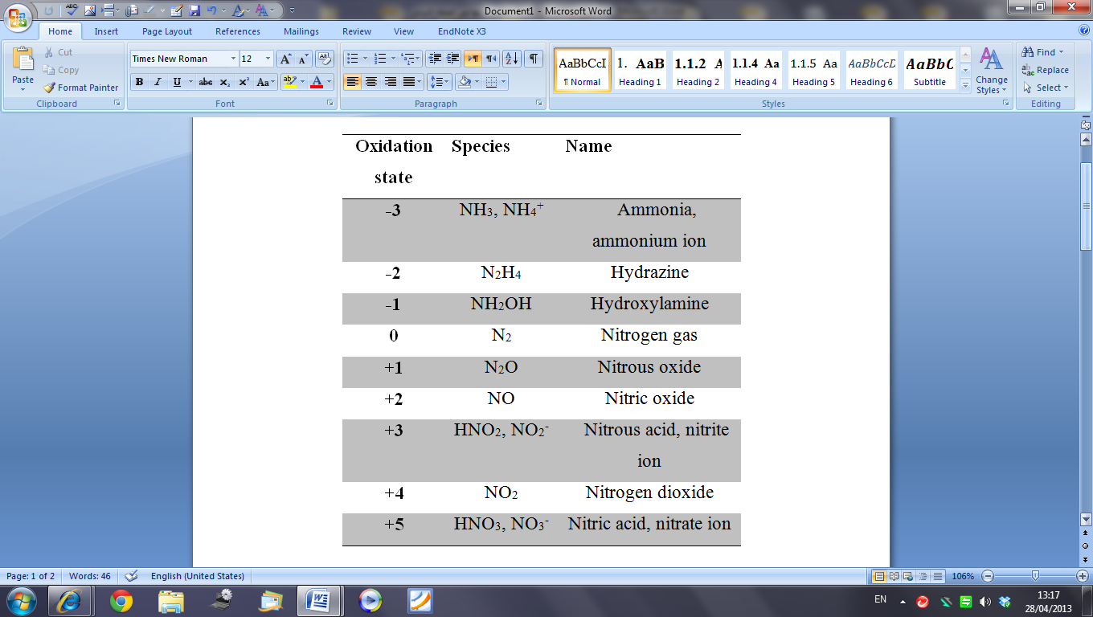
The nitrogen cycle represents one of the most important nutrient cycles found in terrestrial ecosystems. The cycle starts with the element nitrogen in the air, which can be fixed by certain microorganisms, living in soil or in root nodules, in the process of nitrogen fixation (Francis et al., 2007). In this process, dinitrogen is reduced to ammonia (NH₃), a process achieved by specific bacteria. Ammonium can be oxidized to nitrate by nitrifying bacteria in the soil. Ammonium and nitrate assimilation also occurs, the process being termed “nitrogen uptake” (i.e. assimilation) in which microorganisms make use of ammonia to produce organic nitrogen compounds; put simply, the mineralization of nitrogen is the means by which organic nitrogen is converted into inorganic nitrogen ions. During nitrification, ammonium (NH₄⁺) is oxidized to nitrite (NO₂⁻) and then to nitrate (NO₃⁻). Denitrification then reduces nitrate and nitrite (NO₂⁻), to nitrous oxide (N₂O), and to a nitrogen gas which is released into the atmosphere (Harrison, 2003; Pidwirny, 2006).

1-4-2 Nitrogen fixation
The fixation of nitrogen is the process whereby dinitrogen gas (N₂) is reduced to ammonium, an important process since it is the only way by which nitrogen gas from the atmosphere is fixed into ammonia (NH₃) and made available to plants and microorganisms. (Park, 2010)
Bacteria, such as Cyanobacterium, Clostridium (anaerobic) and Nostoc, Anabaena (aerobic), Azotobacter, Beijerinckia, Acetobacer and Pseudomonas (aerobic), Rhodospirillum, Klebsiella and Bacillus (facultative anaerobic), as well as actinomycetes, like Frankia are all capable of fixing dinitrogen. Fungi do not participate in this process, so nitrogen fixation is limited to bacteria (Soomro, 2000; Maier et al., 2009). Species of Rhizobium are the most important bacteria involved in the fixation of dinitrogen (Harrison, 2003).

1-4-3 Ammonification
Ammonification is an important phase in the nitrogen cycle and involves a diverse group of microorganisms which live in soil and water, and which degrade organic nitrogen in the form of proteins and amino acids (present in dead plant and animal matter and faeces), releasing ammonia (NH₃) into soil which is then absorbed by plants (Hart et al., 1994).

1-4-4 Assimilation
Plants take up nitrogen via their roots in the process of N-assimilation. Many microbes can grow by assimilating inorganic nitrogen along with organic carbon: this is known as nitrogen immobilization and many fungi and Gram-negative bacteria utilize nitrate as well as ammonia; amino acids are also readily used by some microorganisms (Fateh, 2005; Haque and Walmsley, 1972) the amount of nitrogen mineralized is significantly correlated with total nitrogen present in soil.

1-4-5 Nitrification
Nitrification is the microbial conversion of ammonium (NH₄) to nitrate. Malhi and Mcgill (1982) showed that the process is sensitive to high temperatures, with the rate of nitrification increasing with a rise in temperature from 4 to 20°C, although no nitrate is generally formed at 40°C and above. Nitrification proceeds in two steps: The first reaction occurs when ammonia or ammonium (NH₄⁺) ions are oxidized to nitrite (NO₂⁻), mainly by the activities of chemoautotrophic nitrifying bacteria (Nitrosomonas):
NH₄⁺ + 1.5O₂ → NO₂⁻ + 2H+ + H₂O ΔG = -267.5 kJ.mol⁻¹
In the second reaction, nitrite (NO₂⁻) is oxidized to (NO₃⁻), by Nitrobacter species, which are chemoautotrophic, Gram-negative bacteria.
NO₂⁻ + 0.5O₂ → NO₃⁻ ΔG = -86.96 kJ.mol⁻¹
The range of pH over which bacterial nitrification occurs is between 6.6 – 8.0, with nitrification becoming slower at a pH below 6.0, and wholly inhibited at pH less 4.5 (Philips et al., 2002). Heterotrophic bacteria and fungi may also participate in nitrification, a process termed heterotrophic nitrification and which is generally only important in organic –rich forest soils of low pH (Falih, 1995).

1-4-6 Denitrification
Denitrification is the conversion of nitrates (NO₃⁻) to nitrogen gas (N₂₎ by microorganisms (Payne, 1981). Denitrification occurs in anaerobic soils and is mediated mainly by heterotrophic bacteria. The process of denitrification involves the reduction of nitrate (NO₃⁻) to dinitrogen (N₂) or nitrous oxide (N₂O) gas, which are then lost from the soil. Many factors affect denitrification in the environment, including soil pH (optimal between 7.0 to 8.5) and the availability of carbon sources. Denitrification occurs between 5ºC and 30ºC, and the rate of the process increases with increasing temperature (Payne, 1981).

1-5 Urea hydrolysis
Urea is one of the most important fertilizers used in temperate grassland. It is highly soluble in water and has a high nitrogen content which exceeds that of ammonium, nitrate and ammonium sulphate (Ferguson et al., 1984). Ureases are extracellular enzymes secreted by soil microbes, plants and animals. As shown in the equation below, urea is converted to carbon dioxide and ammonia by urease activity in soil (Maier et al., 2009). Many bacteria are capable of hydrolysing urea, notably species of Bacillus, Pseudomonas, Micrococcus, Achromobacter, Clostridium and Coryneform bacteriua and actinomycetes, as well as a wide variety of fungi.

(NH₂)₂-C =O + H₂O 2NH₃ + CO₂

1-6-1 Molecular biology techniques
Molecular biology techniques are useful analytical techniques for evaluating the microorganism population structure and function, for both the cultivated and non cultivated organisms. These methods can be applied to both pure and mixed cultures. DNA analysis has been applied at different resolution levels for whole communities, fungal, bacterial and yeast isolates and clones of specific genes (Hill et al.,2000) after it has detected informative DNA sequences such as the 16S rRNA gene , providing
a universal system for the identification and classification of organisms. It is also able to detected , identify microorganisms independent of their cultivability and to determine the variety and spatial association of complex microbial communities (Amann et al., 1995; Kirk et al., 2004 and Rogers, 2008). Martin et al., (2000) showed that molecular methods have a higher specificity and sensitivity traditional visual and microscopic analytical methods .Amann et al. (1997) described the molecular methods used to identify microorganisms from environmental samples.

1-6-2 Deoxyribonucleic Acid (DNA)
DNA is essential for all known forms of cellular life. DNA is deoxyribonucleic acid and contains four chemical bases (pyrimidine) cytosine (C), thymine (T) and purine guanine (G), adenine (A). DNA bases pair up with each other, A with T and C with G, to form units called base pairs. Each base is also attached to a sugar molecule and a phosphate molecule. Together, a base, sugar, and phosphate are called a nucleotide. Nucleotides are organized in two long strands that form a spiral called a double helix. The structure of the double helix is somewhat like a ladder, with the base pairs forming the ladder’s rungs and the sugar and phosphate molecules forming the vertical sidepieces of ladder. (Pary, 2008; Baker et al., 2006).
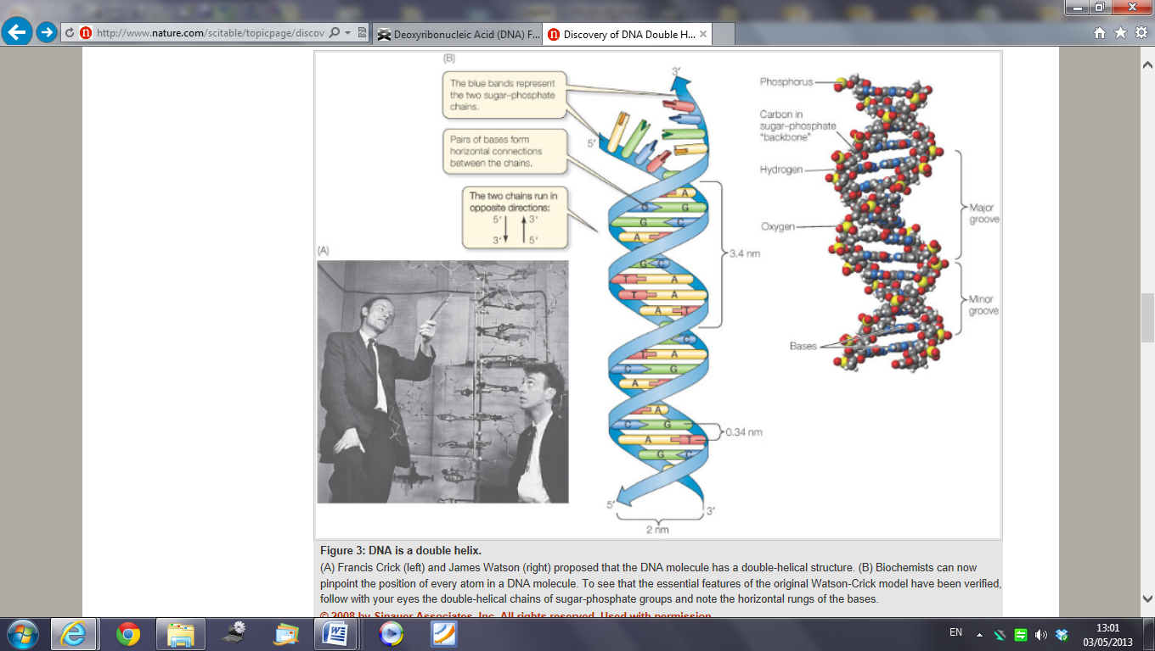
Figure 1. 1 The Structure of Bases in DNA (Reproduced and updated from Pray, 2008).
The DNA extraction method removes inhibitory resources; (Sambrook et al 1989). The configuration of the fungal cell wall is extremely complex compared to bacterial cell walls and mammalian cell membranes. Mammalian cell membranes consist of a lipid bilayer and transmembrane proteins and are moderately easy to break down when treated with proteolytic enzymes, for example, proteinase K (Ebeling et al., 1974). Fungi have strong cell walls which are resistant to standard DNA extraction procedures for yeast and bacteria.(Vanburik et al. ,1998). The cell walls of fungi consist of (1–3)- ß -d-glucan (1,6) ß -glucans, thick layers of chitin, peptides and lipids. A tough surface layer of melanin can also be present that is very resistant to enzymatically hydrolysis with UV light, and chemical breakdown. Chen et al. ( 2002) suggested the use of enzymatic methods in the process of extracting the cell wall in fungi such as the through the use of zymolyase, lyticase and proteinase K. Physical methods used to extract the cell wall of fungi include sonication , freezing in liquid nitrogen and grinding with a mortar and pestle, glass bead milling, and microwaving (Bir et al., 1995, Dean et al., 2004; Gang and Weber, 1995; Haugland et al., 2002; Jin et al., 2004; Loffler et al., 1997; Maaroufi et al., 2004; Millar et al., 2000; Williams et al., 2001) and finally, chemical approaches to the disruption of the cell walls of fungi (Chen et al., 2002, Ross, 1995). It should be pointed out that no single process can be effectively used to break down the cell wall of all fungal species (Manian et al. 2001).

1-6-3 Polymerase chain reaction (PCR)
Today PCR is a widespread technique, and often essential used in the laboratories of medical and biological research for diverse applications (Kubista et al., 2006). PCR has revolutionized molecular biology through the ability to make hundreds of millions of copies of a specific sequence of DNA in a matter of only a few hours (Johan, 2012). The polymerase chain reaction (PCR) is a process to amplify copies of a piece of DNA sequence to a huge number of copies (Lexa et al., 2001, Fenollar et al., 2006, Yeung et al., 2009). PCR has a number of benefits over traditional methods; it is sensitive, specific, quick and simple when compared to conventional techniques.
The Polymerase Chain Reaction consists of three steps: denaturation, annealing and extension. Hadidi and Candresse (2003); Maier et al.(2009) have shown that DNA is first denatured and then the double strand is separated so that single stranded DNA exists. This is done by heating the DNA to 94ºC for a few seconds. Then in the second step, the temperature is reduced to around 50 to 70°C for 30 seconds to 1 minute, to allow the primer to bind to the single stranded template DNA and this step is called annealing, the final step being an extension in the extension step, the temperature is raised to the optimum of extension (72-74 °C), the enzyme Taq polymerase binds to the double-stranded regions synthesized by primer and adds nucleotide dNTPs to extend another strand, Also, Taq adds bases to the 3ˋend of both primers ,extending the DNA sequence in the 5̍ˋ to 3ˋ directions . The process is then followed by cycling during the temperatures repeatedly again (35 to 40 times). Each cycle which results in a new DNA duplex, each strand performing as a possible template for one or other primer (Robert, 1988).
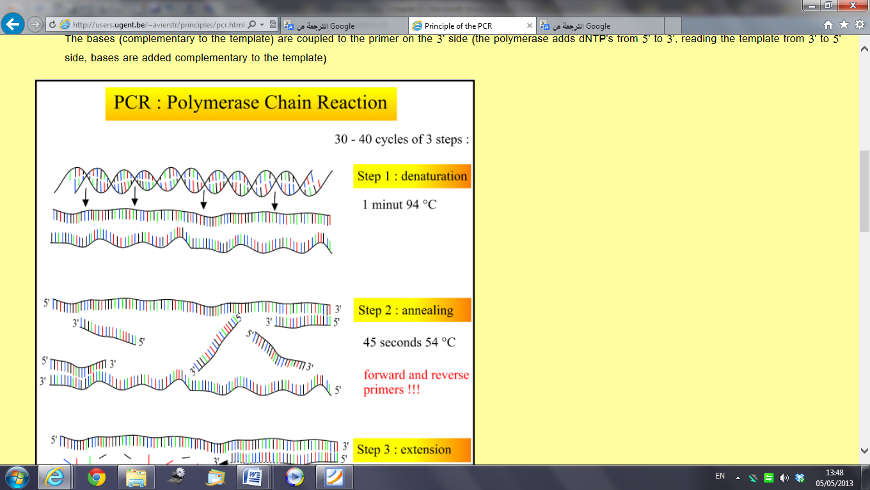
Figure 1.2 The polymerase chain reaction (PCR) cycle. (Reproduced and updated from Andy, 1999). Used with permission.

PCR techniques 16SrRNA has been generally used to study prokaryote variety and allows identification and prediction of phylogenetic relationships 18Sr RNA and (ITS) internally transcribed spacer regions have been extensively used to study fungal classes, though the available databases are not as thorough as for prokaryotes (Prosser, 2002). Genomic DNA was extracted from the sample and purified in the laboratory. DNA (16Sr RNA) target is amplified using universal or specific primers; the resultant products are separated according to need (Kirk et al., 2004).

1-8 Aims of the Project
Diverse soil samples were collected from Jordan deserts, namely, a phosphate mine spoil, a desert-vegetated soil, and a desert non-vegetated soil. The microbiology and biogeochemistry of these samples were studied in order to determine their microbial activity and the results were compared with microbial activity in a fertile temperate grassland soil. Bacterial and fungal population densities in the desert surface soils and fertile soils were determined, and five microbial parameters were selected for study, namely phosphate solubilization, phosphate solubilization when mixed with elemental sulphur, the oxidation of sulphur to sulphate, nitrification, and lastly urea hydrolysis.
A secondary aim was to isolate and identify microorganisms present in these desert soils using molecular identification techniques including both 16S rRNA and 18S rRNA gene sequencing approaches. Classical microbiology and molecular techniques were thereby employed to identify bacteria and fungi isolated from these soils. A third aim was to use NMR to study phosphate solubilization by fungi.
The final aim of the study was to determine if the soils contain Mycoplasma using PCR to detect culturable- independent Mycoplasma DNA in these environmental soil samples.

Chapter 2

Studies on microbial activity in a phosphate mine and desert-vegetated and non-vegetated soils of Jordan

2-1. Introduction
Microbes play the major role in the cycling of elements in the environment, including the element phosphorus (Atlas and Bartha, 1997). The aim of the studies reported in this Chapter was to determine the biochemistry and microbiology of a variety of both vegetated and non-vegetated desert soils sampled from Jordan and compares these to microbial activity in a fertile temperate grassland soil. Fungal and bacterial populations in these soils were also determined; microbial populations were evaluated by plate counting. This procedure can produce useful information about on the numbers of bacteria and is also easy and quick. Plate counts however, favour highly sporulating fungi, and bacteria which grow quickly on the nutrient medium selected; factors influencing the accuracy of this method include incubation temperature, light and pH, and most notably medium-type, all of which can influence the picture given of the microbial community (Kirk et al, 2004). Four microbial processes were selected for study, namely:
1) Phosphate solubilization, 2) the oxidation of sulphur to sulphate, 3) nitrification and 4) urea hydrolysis. The following soil types were studied:
A) Phosphate mine spoil from Russeifa, 15 km north of Amman, Jordan.
B) Desert-vegetated and non-vegetated soils, Wadi Rum, Jordan.
C) An temperate grassland soil was used from the UK.
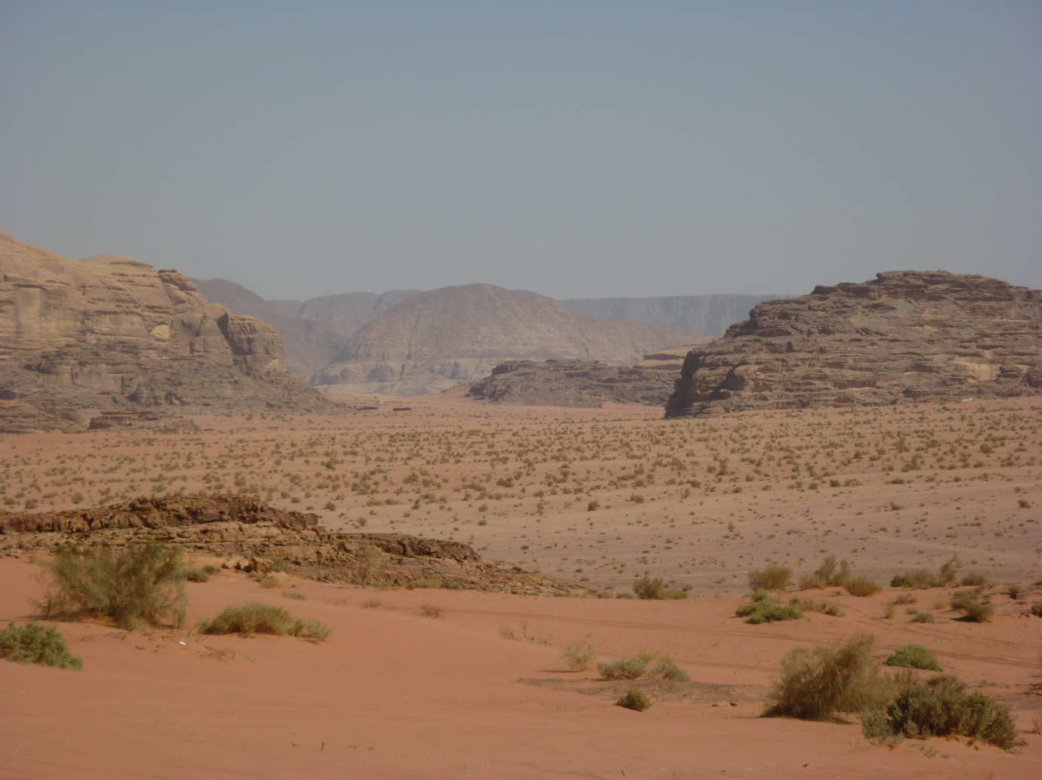
Figure 2. 1 A. Desert soils showing vegetation cover, Wadi Rum, Jordan.
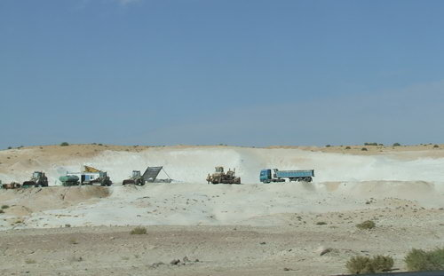
Figure 2. B. Phosphate Mine spoil, Russeifa, 15 km north of Amman, Jordan.

2-2 Materials and Methods

2-2-1 Sample collection
Samples were collected from a phosphate mine spoil in Jordan and a desert soil in Wadi Rum, Jordan (collected by my supervisor, using standard sampling methods); the temperate grassland soil was obtained from the Weston Park in Sheffield region (53°22'55.43"N, 1°29'22.00"W).
1
2
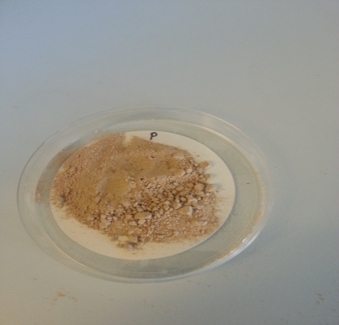
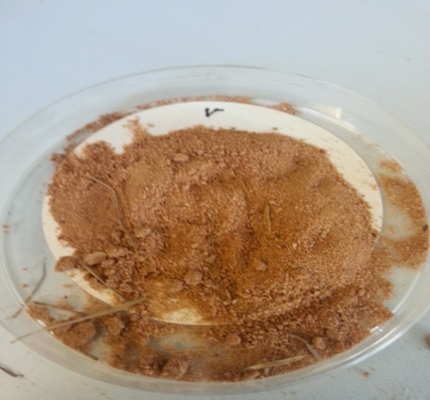

3
4
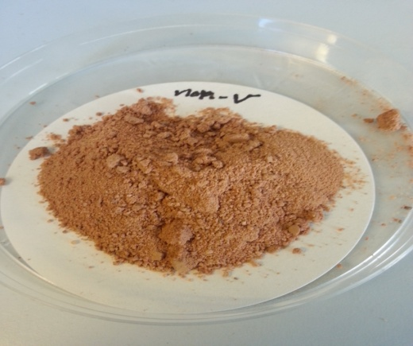
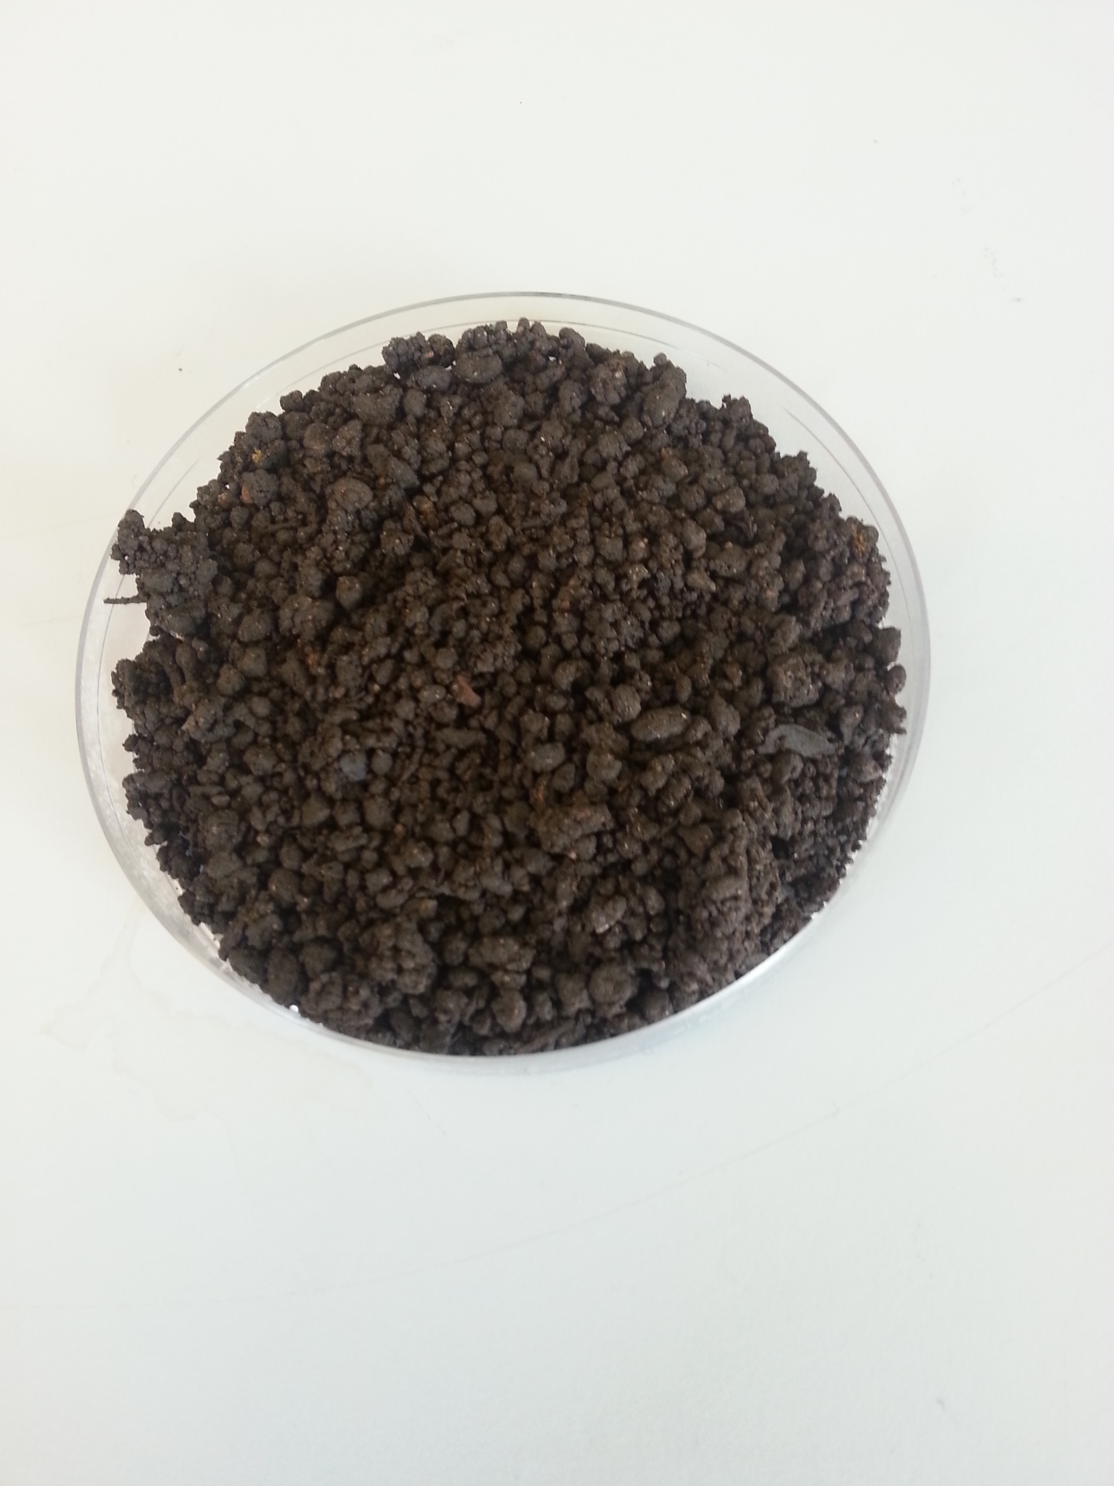

Figure 2. 2 The soils used: 1) phosphate mine soil 2) desert-vegetated soil; 3) desert non- vegetated soil; 4) Temperate grassland soil.

2-2-3 Measurement of soil pH
Soil pH was determined using a pH meter fitted with a glass electrode (3310, Jenway Ltd, UK) on a soil: distilled water sample (1:1, 10 g soil in 10 ml D.W., shaken for 30 minutes).

2-2-4 Determination of soil microbial numbers (CFU)
Soil samples (10g) were added to 90ml of sterile Ringers solution (1/4 strength) and shaken for 15min on a shaker (250 rpm) then diluted serially with the same solution. Aliquots (0.1ml) were then spread on the surface of Plate Count Agar which was prepared by suspending 17.5g of a mixture containing (tryptone 5.0g, yeast extract 2.5g, glucose 1.0 g, agar 9.0g and dH₂O 1L) and the pH was adjusted to pH 7.2. The medium was autoclaved; 3 plates were used for each sample. The plates were then incubated at 25°C ± 5°C for 1-3 days and the bacterial colonies were counted (Meintanis et al., 2006).
2-2- 5 Determination of phosphate solubilisation
Samples of soils (Jordan mine spoil, desert-vegetated, desert non-vegetated and UK temperate grassland ) soil were used; 100g were placed in polythene bags; 1g of calcium phosphate was added and mixed thoroughly. A control was set up without calcium phosphate. All the soil samples were set up in triplicate and incubated at 25ºC for 7, 14, 21, and 28 days. After incubation, 10g of soil was placed into screw capped glass bottle containing 100 ml of 0.5 N NaHCO₃ and all the bottles were shaken for 30 minutes at 70 rpm on shaker; the contents were then filtered through Whatman No.1 filter paper. Phosphorus ions were determined as described by Fatih (1995) as follows: Filtrate (3 ml) was mixed with 7 ml of working solution then the mixture incubated at 37ºC for 1 hour. The blue color was measured at 820 nm using a spectrophotometer and the amount of PO₄-P was determined by reference to a calibration curve (0 –100 µg PO₄-P ml⁻¹) prepared from a standard solution of Na₂HPO₄ (see Appendix).
Reagents
1- Stock Solution
Ascorbic acid (10g) acid was dissolved in100ml of distilled water. 0.42g of Ammonium molybdate was dissolved in 100ml of 1N H₂SO₄ (28ml of H₂SO₄ in 1 liter distilled water).
Ascorbic acid (10%) was mixed with 6 volumes of ammonium molybdate (0.42%).

2-2-6-Determining the oxidation of sulphur in soils
This experiment was done to determine sulphur oxidation by using samples of soil (Jordan phosphate mine spoil, desert-vegetated, desert non- vegetated and the Sheffield temperate grassland soil) all of which were amended with elemental sulphur. Elemental sulphur (1g) was added to 50g of each soil, and the amended soils were incubated in polythene bags. Distilled water (20ml) was then added and the bags were closed to allow a small hole to allow for gas exchange. The bags were set up in triplicate and incubated for 28 days at 25°C. At zero time and at 7 day intervals, samples were extracted. 1g of the soil samples was shaken for 15min with 20ml of water and then the samples were filtered through Whatman No.1 filter paper. The optical density was then measured at 470 nm. Barium chloride (1g) and gum acacia (1ml) were then added to form a white suspension, with turbidity measured at 470nm.The sulphate concentration was determined by reference to a standard curve (0-100μg sulphate ml) prepared from a standard solution of Na₂SO₄.

2-2-7 Determination of the hydrolysis of urea to ammonium in the soils
An experiment was performed to study hydrolysis of ammonium following urea addition, as follows. Ammonium was extracted from the soil using KCl (150 g KCL / 1000 water) in the ratio: (0.5g) soil: (10ml) KCl. The soil was shaken for 30min then filtered through filter paper Whatman No.1. Filtrate (1ml) was then added to (0.5ml) of EDTA (6% w/v), (3.5ml) of distilled water, (2.5ml) of phenolate reagent and (1.5ml) of sodium hypochlorite solution (10%v/v). The reaction mixture was mixed thoroughly and incubated at 25°C for 20 minutes in the dark. The volume was made up to 50 ml and mixed and the concentration of the indophenol-blue ammonium complex was measured at 630 nm (Wainwright and Pugh, 1973), the concentration of ammonium was then determined by reference to a standard curve (10-100μg NH₄-N ml) prepared from a standard solution of ammonium sulphate. Samples of soil (Jordan spoil, vegetated and non-vegetated and Sheffield soil temperate grassland) were amended with urea (0.5g to 5gof soil). These amended soils were incubated in polythene bags; (10ml) of water was finally added to each bag which was closed to allow a small hole to allow for gas exchange. Triplicates were set up in and incubated for 28 days at 25°C and untreated samples were used as control. At zero time and at 7 day intervals, samples were extracted.
Ammonium reagents
Ethylenediaminetetraacetic acid (EDTA)
60 g of EDTA was dissolved in 900 ml of distilled water then diluted to 1 litre.

Phenol solution:
62.5 g of phenol was dissolved in ethanol (25 ml) and acetone (18.5ml) added to make up to 100 ml. The phenol solution was stored in the dark at 4°C.
Phenolate reagent
Phenol solution (20 ml) was mixed with 20 ml hydroxide sodium (27% NaOH w/v) and diluted to 100 ml.

2-2-8 Determination of the Oxidation of Ammonium to Nitrate in Soils
Samples of soils were tested for the ability to nitrify ammonia to nitrate. The following soils were used: Jordan mine spoil, desert non-vegetated, and desert-vegetated, and Sheffield soil temperate grassland, all of which were amended with NH₄SO₄ (5ml of NH₄ SO₄ was added to 25g of soil). The amended soils were then incubated in polythene bags then the bags were closed with a small hole to allow for gas exchange. The bags were set up in triplicate and incubated for 7, 14, 21 and 28 days at 25°C. At zero time and at 7 day intervals, samples were extracted and untreated samples were used as control. 1g of each sample was shaken for 15minute with (20ml) of distilled water then the samples were filtered through a Whatman No.1 filter paper. Nitrate was determined by using the method of Sims and Jackson (1971). Chromotropic acid (7ml) was mixed with 3ml of filtrate then incubated at 40°C in water bath for 45 minutes; the yellow colour formed was measured at 410 nm and the concentration of nitrate was determined by reference to a standard curve of nitrate concentrations.

Chromotropic acid
1- Stock solution
Chromotropic acid (C₁₀H₆O₈S₂Na₂, 1.84 g) was dissolved in 1 litre of sulphuric acid H₂SO₄ .The solution was stored at 4°C for several months.
2- Working solution
Stock solution (100 ml) was added to 10 ml of concentrated HCL to 1 litre of concentrated H₂SO₄. The solution was stored at 4° C.

2-2-9 Determination of soil phosphate solubilization when mixed P with S
Samples of the following soils were used: Jordan Mine Spoil, desert-vegetated and desert non-vegetated soil was used;100g were placed in polythene bags; 1g of calcium phosphate with 1 g sulphur was added and mixed thoroughly and into second a bag was placed 1 g calcium phosphate. A control was set up without calcium phosphate (Dennis and Friesen, 1996). All the soil samples were set up in triplicate and incubated at 25ºC for 7, 14, 21, and 28 days. After incubation, 10g of soil was placed into a screw capped glass bottles containing 100 ml of 0.5 N NaHCO₃ and all the bottles were shaken for 30 minutes at 70 rpm on shaker; the contents were then filtered through a Whatman No.1 filter paper. Phosphate was determined as described by Falih (1995) as follows: Filtrate (3 ml) was mixed with 7 ml of working solution then the mixture incubated at 37ºC for 1 hour. The blue colour was measured at 820 nm using a spectrophotometer and the concentration of PO4-P was determined by reference to a calibration curve (0 –8 µg PO₄-P ml⁻¹).

Statistics
All observations are presented as means ± SE (standard error). The data were analyzed by SigmaPlot© (Version11.0) and P < 0.05 was considered as significant.
Paired two or three sample t-tests were performed to check whether means were significantly different.

2-3. Results and discussion
The pH of the soils was as follows: desert soil vegetated, pH 7.8; desert soil non vegetated, pH 7.7; phosphate mine spoil, pH 8.5; and the temperate grassland soil was pH 7.6. The optimum soil pH for phosphate solubilization was pH 6.5 and for sulphur oxidation in the range between pH (2- 9) and the optimum pH range between 6.6 to 8.0 for nitrification (USDA, 1996) ;( Maier et al., 2009).

2-3-1 Counts of colony forming units (C.F.U.)
Fig.2.3 shows the total bacterial counts found in the soil samples which progressively decreased during the period of incubation. The highest bacterial count was found in the temperate grassland soil. As expected, the bacterial count of the desert non-vegetated soil was the lowest during the incubation period, with higher numbers being found in the soils associated with plant cover. The C.F.U. count of the temperate grassland soil was six times higher than the desert non-vegetated soil, five times larger than the phosphate soil and four times higher than the desert-vegetated soil. The decline in bacterial numbers (in all samples) over time was probably the result of soil drying, as the original moisture content was not maintained.

Figure 2. 3. Bacterial counts (CFUs) in soils: Temperate grassland soil, desert vegetated, desert non-vegetated, phosphate mine spoil.
*
*
*
*

Means of triplicates ($±)$ standard error (SE). *significant difference from value,
P < 0.05.

2-3-2 Phosphate solubilization
Figs (2.4), (2.5), (2.6) and (2.7) show phosphate solubilization during the length of the incubation period. Fig 2.4 shows the result for the Jordan phosphate mine spoil and control. At week 2, there was increased phosphate solubilization, followed by a gradual fall off at weeks 3 and 4 in both treatment and control. Fig 2.5 shows the results for the desert non-vegetated soil when compared with the control. It can be clearly seen that there was increased phosphate solubilization at week 2 followed by decreases at weeks 3 and 4. Fig 2.6 shows that microbial phosphate solubilization in the desert-vegetated soil was highest at week two, after which it fell slightly in both the treatment and control. (Fig.2.7). Not surprisingly, the temperate grassland soil produced the largest amount of phosphate solubilization with phosphate solubilization being higher in the vegetated compared to non-vegetated soils. The results can be explained by the fact that increased microbial activity in the rhizosphere of the vegetated soil leads to enhanced microbial activity which aids the release of phosphate. Again the decline in phosphate solubilization over time in all samples was probably due to soil drying. It is noteworthy that the desert mine spoil was not the most active of the desert soils studied despite having originated from a phosphate-rich source and therefore might be expected to contain larger numbers of phosphate solubilizing microorganisms.

Figure 2. 4. Phosphate solubilization in the phosphate mine spoil.
*
*
Phosphate spoil, control, no added phosphate. Means of triplicates ($±)$ standard error (SE).*significant difference from control value, P < 0.05.

Figure 2. 5 Phosphate solubilization in desert non-vegetated soil.
*
*
*
Desert non-vegetated soil, Control. No added phosphate.
Means of triplicates ($±)$ standard error (SE). *significant difference from control value, P < 0.05.

Figure 2. 6. Phosphate solubilization in the desert- vegetated soil;
*
*
*
Desert- vegetated soil, control, Control no added phosphate
Means of triplicates ($±)$ standard error (SE). *significant difference from control value, P < 0.05.

*
*
*

Figure.2. 7 Phosphate solubilization in all soils: Desert-vegetated, Desert non-vegetated, phosphate mine spoil , temperate grassland soil.

Means of triplicates ($±)$ standard error (SE). *significant difference from control value, P < 0.05.

2-3-3 Sulphur oxidation
Microbial sulphur oxidation to sulphate occurred in all soils (Fig2.8, 2.9, 2.10 and 2.11). Fig.2.8 shows the oxidation of sulphur in the desert vegetated soil and control increased slightly at 1 and 2 weeks of the incubation period. The process in the desert- vegetation soil increased gradually and was highest at week 4. Fig. 2.9 shows sulphur oxidation in the phosphate mine spoil increased slightly during weeks 1 and 2 and rose gradually in week 3 and 4, while control values increased steadily over the 28 day incubation period. Fig. 2.10 shows S-oxidation in the desert non-vegetated soil and control. There was a sharp increase in sulphate production after week 1 in the former, while values in the control increased steadily throughout the 28 day incubation period.
Fig 2.11 shows that the highest rates of S-oxidation were found in the temperate grassland soil over the entire 28day incubation period, rising steadily over the four week and peaking at around 300 µg. The phosphate mine spoil was the second most active in relation to this process with vegetated soils showing slightly higher activity than the non- vegetated soil.

*
*
*
*
Figure 2. 8 Sulphur oxidation in the desert-vegetated soil: Desert-vegetated soil, Control, no added sulphur. Means of triplicates ($±)$ standard error (SE). *significant difference from control value, P < 0.05.

*
*
*
Figure 2. 9. Sulphur oxidation in phosphate mine spoil: phosphate mine spoil,. Control,Control no added sulphur.Means of triplicates ($±)$ standard error (SE), *significant difference from control value, P < 0.05.

*
*
*
Figure 2. 10. Sulphur oxidation in the desert non-vegetated soil: Desert non-vegetated soil, Control, Control no added sulphur.
Means of triplicates ($±)$ standard error (SE). *significant difference from control value, P < 0.05.

*

*

*

Figure 2.11 Sulphur oxidation in all soils. Temperate grassland soil, phosphate mine spoil, Desert non-vegetated soil, , Desert-vegetated soil
Means of triplicates ($±)$ standard error (SE). *significant difference from control value, P < 0.05.

2-3-4 Oxidation of ammonium to nitrate
The results show that ammonium was oxidized to nitrate in all soil types. Figs 2.12, 2.13, 2.14 and 2.15 show that ammonium was oxidized to nitrate over the four week incubation period. Fig 2.12 shows that in the desert-vegetated soil control soil; the highest nitrate production occurred at week 4. Figure 2.13 displays desert non-vegetated soil treatment and control. The maximum nitrification occurred at week 2 in treated soils. Figure 2.14 shows the oxidation of ammonia to nitrate in the phosphate-mine spoil and control soils. The highest nitrification occurred at week 2 after which a reduction occurred at weeks 3 and 4. Figure 2.15 shows a comparison in nitrification between the temperate grassland soil, desert-vegetated soil, desert non-vegetated and phosphate soil. The oxidation of ammonia increased in the temperate grassland soil at week 1. The highest nitrification was at week 3 after that there was a sharp decrease at 28 days. On the other hand, the highest nitrification in desert-vegetated soil occurred at week 4, increased nitrification occurred in desert non-vegetated at week 2 , while there was no change in the concentration found in phosphate soil during the whole period of incubation. The results show that the temperate grassland soils exhibited highest rates of nitrate production followed by the desert-vegetated and desert non-vegetated soil followed by the phosphate mine spoil, showing that the oxidation of ammonium to nitrate is associated with vegetation cover and related microbial activity.

*

*

Figure 2.12. Ammonium oxidation to nitrate in the desert-vegetated soil : desert-vegetated soil, Control, Control no added ammonium.
Means of triplicates ($±)$ standard error (SE), *significant difference from control value, P < 0.05.

*
*
*
Figure 2.13. Ammonium oxidation to nitrate in the desert non-vegetated soil: desert non-vegetated, Control. Control no added ammonium.
Means of triplicates ($±)$ standard error (SE), *significant difference from control value, P < 0.05.

*
*
*
Figure 2.14.Ammonium oxidation to nitrate in the phosphate mine spoil phosphate mine spoil, control. Control no added ammonium.
Means of triplicates ($±)$ standard error (SE), *significant difference from control value, P < 0.05.

Figure 2. 15 . Ammonium oxidation to nitrate in all soils:
*
*
*
*
Temperate grassland soil,Desert-vegetated soil, Desert non-vegetated soil, phosphate mine spoil.
Means of triplicates ($±)$ standard error (SE), *significant difference from control value, P < 0.05.

2-3-5 Hydrolysis of urea to ammonium
The ability of the microorganisms to hydrolysis urea to ammonium is shown in (Figs. 2.16, 2.17, 2.18 and 2.19). Fig 2.16 shows ammonium production from the hydrolysis of urea in the desert-vegetated and control soils. The amounts of ammonium produced significantly increased after 14 days, with the highest ammonium production occurring at week 4 while there was only a slight increase in ammonium production in the control sample (with no added substrate) (with no added substrate). Figure 2.17 shows that the rate of ammonium production in desert non- vegetated and control soil, showing that the highest hydrolysis occurred at week 4. Fig 2.18 shows that the amount of ammonium produced in the phosphate mine spoil and control soil (with no added substrate). The hydrolysis of urea in phosphate soil increased gradually at 2, 3 and 4 weeks of the incubation period. Figure 2-19 provides a comparison of the process in all soils, showing clearly that ammonium production in the temperate grassland soil increased to 7 day and the highest urea hydrolysis to ammonium occurred in 14 days reaching a peak of
169 µg /g after which it then decreased sharply at week 4. The highest hydrolysis of urea in the desert-vegetated soil occurred at week 4. The phosphate mine spoil and the desert non-vegetated soil where ammonium production in the samples saw slight increases over 28 days. The expected outcome was found, namely that the temperate grassland soil exhibited a higher rate of ammonium production than the desert-vegetated soil next and desert non-vegetated soil, followed by the phosphate mine spoil.

*
*
*
Figure 2. 16. Urea hydrolyis to ammonium in the desert-vegetated soil: Desert-vegetated soil,control. Control no added urea.
Means of triplicates ($±)$ standard error (SE). *significant difference from control value, P < 0.05.

*
*
Figure 2.17. Urea hydrolyis to ammonium in the desert non-vegetated soil Desert non-vegetated, control. Control no added urea.
Means of triplicates ($±)$ standard error (SE), *significant difference from control value, P < 0.05.

*
*
Figure 2.18 .Urea hydrolyis to ammonium in the phosphate mine spoil.
Phosphate mine spoil, control. Control no added urea.
Means of triplicates ($±)$ standard error (SE), *significant difference from control value, P < 0.05.

*
*
*
Figure 2. 19.Urea hydrolyis to ammonium in all soils Temperate grassland soil,Desert-vegetated soil, Desert non-vegetated soil Phosphate mine spoil.
Means of triplicates ($±)$ standard error (SE), *significant difference from control value, P < 0.05.

2-3-6 Determination of phosphate solubilization in soils amended with P with S
The results show that the addition of sulphur (S) together with insoluble phosphate in all soils led to an increase in phosphate solubilization compared to when phosphate alone was added. Figures 2.20, 2.22 and 2.24 show that phosphate solubilization rose when 1 g of sulphur was added, an effect which lasted the length of the incubation period. Figure 2.20 shows phosphate solubilization in the phosphate-rich soil increased after 14 days reaching a peak of 117 µg/ g . Also, phosphate soil (without sulphur) increased at week 2 and then decreased at week 3. Only slight increases occurred in the phosphate soil control (without sulphur and calcium phosphate).Soil pH decreased in the phosphate mine spoil (S + P) but in phosphate with (P), increased at 14 days. Fig 2.22 also shows the phosphate solubilization in desert-vegetated soil when mixed (S+ P), desert-vegetated soil with (P) (treatment) and control desert-vegetated soil without (S and P) over the three week incubation period. It is clear that the highest phosphate solubilization in the desert-vegetated soil with (S+ P) occurred at week 2, followed by the desert-vegetated soil with (P) and by the desert-vegetated soil control; pH showed a gradual decrease at week 1 and 2 in desert-vegetated soil with ( S+ P ). Fig 2-24 displays the phosphate solubilization in desert non-vegetated soil when mixed (S+ P), desert-vegetated soil with (P) (treatment) and control desert non-vegetated soil without (S and P) over the 21 day incubation period. The highest phosphate concentration was in desert non-vegetated soil when mixed (S+ P) at week 2 to allowed by desert non-vegetated soil with (P), followed by the desert non-vegetated soil control. The expected outcome was found, namely that the desert-vegetated soil when mixed (S+P) showed a higher phosphate concentration, the desert-vegetated soil next and phosphate soil, followed by the desert non-vegetated soil. Dennis and Friesen (1996) found that when sulphur is added to soil, insoluble phosphate increases the mobility of dissolved phosphate and thus increases in the concentration of dissolved phosphate.

Figure 2. 20 Phosphate solubilization in spoil amended with P and with S- phosphate-rich spoil. Phosphate spoil with P+S, Phosphate spoil with P, Phosphate spoil control.
Means of triplicates ($±)$ standard error (SE), *significant difference from control value, P < 0.05.

Figure 2.21 the pH of the phosphate spoil Phosphate spoil with P+S Phosphate spoil with P, Phosphate spoil control.

Figure 2.22. Phosphate solubilization in soil amended with P and S- desert-vegetated soil : Desert-vegetated soil with P+S, desert-vegetated soil with P , desert-vegetated soil control.
*

Means of triplicates ($±)$ standard error (SE),*significant difference from control value, P < 0.05,
Figure 2.23. The pH of the desert-vegetated soil desert-vegetated soil with P+S, desert-vegetated soil with P, desert-vegetated soil control.

*
*
*
Figure 2. 24 Phosphate solubilization in soils amended with P and S- desert non-vegetated soil: Desert non-vegetated soil with P+S, Desert non-vegetated soil with P, Desert-vegetated soil control.
Means of triplicates ($±)$ standard error (SE). *significant difference from control value, P < 0.05.

Figure 2. 25. The pH of the desert non-vegetated soil: Desert non-vegetated soil with P +S, Desert non-vegetated soil with P, Desert non-vegetated soil control .

2-3-7 Conclusion
The conclusions obtained from the results shown in this Chapter are as follows: bacterial counts were obtained in the order: temperate grassland soil > desert-vegetated soil > phosphate mine spoil > desert non- vegetated soil. This finding is what would be expected in relation to the relative organic matter contents of the four soils, which is likely to occur in the same order as the bacterial counts. The decrease in numbers over the incubation period is assumed to be due to soil drying as the soil moisture content was not maintained constant over the incubation period.
The major conclusions from the study of the four microbial processes are: the highest level of microbial activity was found in temperate grassland soil and the lowest microbial activity was found in desert non-vegetated soil. Ureases are produced by soil microbes and soils with low organic matter will possess low urease activity; microbial activity in desert non-vegetated soils was seen to be lower than in desert-vegetated soils and increases in regions associated with plant cover. The same trend was found in nitrification, urea hydrolysis and phosphate solubilization. Microbial activity was found in the order: temperate grassland soil > desert-vegetated soil > phosphate mine spoil > desert non-vegetated soil. On the other hand, the highest level of the oxidation of elemental sulphur to sulphate was found in the order: temperate grassland soil ˃ phosphate mine spoil > desert-vegetated soils > desert non-vegetated soils When sulphur was added (S) with insoluble phosphate in all soils (phosphate soil, desert-vegetated soil and non-vegetated soil) .The phosphate concentration increased compared to the amount of phosphate alone and control. Dennis and Friesen (1996) found when sulphur is added to soils containing insoluble phosphate the mobility of dissolved phosphate is increased and this increases the concentration of dissolved phosphate.

Chapter 3

Analysis of population diversity in the phosphate spoil, desert-vegetated soil and desert non-vegetated soil using 16SrRNA and 18SrRNA gene sequencing

3-1 Introduction
Hill et al. (2000) have shown that less than 0.1% of the total microbial population of most natural microbial habitats is selected by standard media-based isolation methods. This is because bacteria and fungi are highly selective in relation to growth and other requirements, with the result that an extremely wide variety of media would have to be used to isolate even a small proportion of the total population present. Despite the above, microbiologists continue to use direct isolation methods as a useful tool to determine the presence of microbes in soils and other environments, even if they recognize that the ones isolated may not represent the dominant species, both in terms of numbers or metabolic activity. Once the organism has been isolated from the environment, it needs to be identified. Traditional methods, based on colony morphology and the growth on, and reaction to, various media are still used, but increasingly less so because of the development of molecular methods based on 16 SrDNA for (bacteria) and 18SrDNA (for fungi) techniques. Such methods are generally perceived as being relatively easy to perform, simple to interpret and accurate, so much so that they are often used with little thought, leading to miss-identification of the organism studied; the reliability of the data bases on which molecular microbial identification is based is also increasingly being shown to be questionable. Nevertheless, these techniques can be usually successfully employed, as is the case here, to identify bacteria and fungi isolated, using traditional methods, from soils (Amann et al., 1997; Scow et al., 2001; Hill et al., 2000).
Techniques based on 16SrRNA analysis have been generally used to identify and predict phylogenetic relationships in bacteria. While 18SrRNA analyses have been extensively used to identify fungi, the available databases are not as extensive as those available for prokaryotes (Prosser, 2002; Kirk et al., 2004).
The aim of the work reported here was to use the above named methods to identify the bacteria and fungi which had been isolated from the soils studied. Considerable attention was given to the methods which could be employed to disrupt fungal biomass in order to achieve the best preparations for molecular analysis (see Appendix).

3-2 Materials and Methods
3-2-1 16SrRNA sequencing
Genomic DNA was extracted from four strains and then a PCR protocol was used with the suitable primers to produce large quantities of the 16SrRNA gene. Genomic DNA was isolated by using (Key prep- Bacterial DNA Extraction) the following procedures. The DNA was run on Agarose gel (1%) to check for purity.

3-2-2 Procedures (Key prep- Bacterial DNA Extraction)
1- Centrifugation: Pure bacterial culture (3ml) grown overnight in N.B. medium was collected by centrifugation at 6,000×g for 2 minutes. The supernatant was then decanted.
2- Re-suspension of pellet: The pellet was re-suspended by adding 100 μl Buffer R1and
mixing it by pipetting it up and down.
3- Lysozyme treatment: Lysozyme (10 μl, 50 mg/ml) was added to the suspension for Gram negative bacteria; for Gram-positive bacteria 20μl of lysozyme was used. The suspensions were mixed completely and incubated at 37°C for 20 minutes.
4- Centrifugation: the sample was centrifuged at 1000×g for 3 minutes then the supernatant was discarded.
5- Protein denaturation: 180μl of Buffer R2 and 20 μl of Proteinase K were added to the pellet, mixed completely and then incubated in a shaking water bath 65°C for 20 minutes.
6- Homogenization: Buffer BG (410 μl) was added to the sample and mixed thoroughly, and then incubated at 65 °C for 10 minutes.
7- Addition of Ethanol: Absolute ethanol (200 μl) was added into the samples and mixed.
8- Loading to column: the sample was transferred into a column and then centrifuged at
10,000×g for 1 minute and the supernatant was discarded.
9- Column washing: Wash buffer (750 μl) was gently washed through the column and centrifuged at 10,000×g for 1 minute and the flow through discarded. The column was centrifuged at 10,000×g for 1 minute to removed residual ethanol.
10- DNA elution: a clean microcentrifuge tube was used to collect DNA by adding 100 μl of preheated elution buffer directly into the column membrane and standing for 2 minutes at room temperature and then centrifuging at 10,000×g for 1 minute to elute DNA. DNA was stored at -20°C.

3-2-3 the Polymerase Chain Reaction (PCR)
The Polymerase Chain Reaction was used during this work for amplifying specific
16SrRNA genes PCR was prepared as follows:

3-2-3-1Reaction mixer of PCR product

3-2-3-2 Quantity Types
Distilled water 38μl, 5.0 μl 10x buffer, 2.5 μl 50mM Mgcl₂, 0.5 μl of Forward Primer ( 16S rRNA unv. 10pp mol.L⁻¹) (Weisburg et al., 1991) 0.5 μl of Reverse Primer (16S rRNA unv. 10 pp mol.L⁻¹) (Weisburg et al., 1991), 1.0 μl dNTPs, 2.0 μl Genomic DNA and 0.5 μl Bioline Taq. PCR was running on the following cycle (Named 16s Standard)

3-2-3-3 PCR cycle
Initial denature 94°C for 3 min to separate the double strand of DNA to single strand RNA.Denature 94°C for 1 min. Annealing 60°C for 1 min to allow primers to match DNA fragments. Elongation 72°C for 5 min .Final elongation 75°C for 5 min by using Tg polymerase. Hold at 4° C.
Forward primer:
5' CCG AAT TCG TCG ACA ACA GAG GAT CCT GGC TCA G 3' (34) (Weisburg et al., 1991).
Reverse primer:
5' CCCGGGATC CAA GCT TAC GGC TAC CTT GTT ACG ACT T 3' (37) (Weisburg et al., 1991).
PCR product (10 μl) was mixed with 2 μl of Blue/Orange 6x loading dye and run on a 1% agarose gel. In addition, 6 μl of 1 Kb Hyper ladder was loaded in the gel to confirm the correct size product.
3-2-4 In order to compare the efficiency of fungal wall lyses protocols that use physical, chemical and enzymatic disruption methods on three fungi were employed as follows:
- Lyticase digestion
Fungi were digested in 300 µl of a buffer containing 400 U lyticase in a sorbitol based buffer containing 0.1M sorbitol, 100mM Tris–HCl, 100 mM EDTA and 14 mM Hmercaptoethanol, pH 8.0 and digested overnight at 30 ⁰C.
- Proteinase K digestion
Fungi were digested in 300 µl of a buffer containing 1 mg/ml proteinase K. (10 mM Tris–HCl, 1 mM EDTA, pH 7.5), 0.5% SDS and incubated overnight at 60 ⁰C.
3 - Acid treatment
To the fungi, 300 µl of concentrated HCl was added to each sample and incubated overnight at room temperature.
4- Alkali treatment
A 300 µl volume of 5M sodium hydroxide (NaOH) was added to each fungal sample and incubated overnight at room temperature.
5 - Sonication
Fungal samples were sonicated for 90 s at 150 Hz using a Labsonic U sonicator in 300 µl of TE buffer.

6 - Liquid nitrogen breakage
After freezing and grinding with a mortar and pestle, the fungal Samples were frozen in liquid nitrogen and ground to a fine powder for 1min in 300 µl of TE.

3-2-4-1Microscopy
The samples were examined under a light microscope at 20X and the scanning electron microscope in order to determine mycelium-breakage efficiency.

3-2-5 .The identification of fungi using 18S rRNA
Genomic DNA was extracted from four strains and then a PCR protocol was used with the suitable primers to produce large quantities of the 18SrRNA gene. Genomic DNA was isolated by using (Norgen- Fungi Genomic DNA Isolation Kit) the following procedures. The DNA was run on Agarose gel (1%) to check for purity.

3-2-5-1 Procedures (Norgen- Fungal Genomic DNA Isolation Kit)
- Centrifugation: Pure fungal culture (500µg) grown for 3 days in Czapek Dox liquid and P.D.L medium were collected by centrifugation at 14,000×g for 1 minute to pellet the cells. The supernatant was then decanted carefully.
- - Re-suspension of pellet: The pellet was re-suspended by the addition 500 µl of lysis solution and the cells were re-suspended by gentle vortexing (optional RNase treatment). 10 KUnits of RNase was added to the suspension and mixed completely.
- Homogenization: The samples were transferred into a bead tube and vortexed straight for 5 minutes on a flat bed vortex pad with tape. Then the samples were incubated at 65°C for 10 minutes.
- Centrifugation: The samples were transferred into a DNase-free microcentrifuge tube and centrifuged at 14,000 Xg for 2 minutes and then supernatant transferred to a new microcentrifuge tube.
- Addition of ethanol: Absolute ethanol (200 μl) was added to the samples and mixed carefully.
- Loading to column: the sample was transferred into a column and then centrifuged at 10,000×g for 1 minute and the supernatant discarded.
- Column washing: Wash buffer (750 μl) was gently washed through the column and centrifuged at 10,000×g for 1 minute and flow through discarded. The column was centrifuged at 10,000×g for 1 minute again to removed residual ethanol.
- DNA elution: a clean microcentrifuge tube was used to collect DNA by adding 100 μl of preheated Elution Buffer directly into the column membrane and standing for 2 minutes at room temperature and then centrifuged at 10,000×g for 1 minute to elute DNA; DNA was stored at -20°C.

3-2-5-2The Polymerase Chain Reaction (PCR)
The Polymerase Chain Reaction was used during this work for amplifying specific 18SrRNA genes .PCR was prepared as follows:
1-Reaction mixer of PCR product
2-Quantity types
Distilled water (28μl), 5.0 μl 10x buffer, 2.5 μl, 50mM MgCl₂ ,4 μl Forward Primer 4 μl Reverse Primer, 1.0 μl dNTPs ,5μl Genomic DNA and 0.5 μl Bioline Taq.
PCR was run on the following cycle.
3-PCR cycles
Initial denature 98°C for 3 min to separate the double strand of DNA to single strand RNA.Denature 94°C for 1 min. Anneal 58°C for 1 min to allow primers to match DNA fragments. Elongation 72°C for 5 min. Final elongation 75°C for 5 min by using Tg polymerase.Hold at 4° C.
Primer Forward. : Nu-SSU-0817 (TTAGCATGGAATAATRRAATAGGA(24)
( Borneman and Hartin, 2000).
Primer Forward: ITS1 (TCCGTAGGTGAACCTGCGG) (Simon et al., 1993).
Primer Reverse: Nu-SSU-1196-39. TCTGGACCTGGTGAGTTTCC(20). (Borneman and Hartin, 2000).
ITS4: ( TCCTCCGCTTATTGATATGC) (Simon et al., 1993)
4-DNA quantification
There are several methods for investigative DNA quantification. Quantification by using a spectrophotometer is one appropriate method (Haque et al., 2003). 98.0 µl of elution buffer (EB) was added to 2.0 µl of the genomic DNA sample, mixed and filled in special UV cuvettes (UVcuvette, Eppendorf) and the optical density OD was measured at 260nm using a spectrophotometer (Unicam, Hexios). The amount of DNA was calculated by following this equation:
100÷ 2 = 50 dilution
OD₂₆₀ × 50 dilution factor = amount of DNA µg/ml.

3-2-6. Agarose gel electrophoresis
Agarose (1%) was used to achieve DNA fragments. The gels were prepared as follows: 0.4g of molecular biology grade agarose was dissolved in 0.8μl of 50x TAE buffer and 40ml distilled water by heating in a microwave on a medium high power for approximately 3 minutes and then 2.5 μl ethidium bromide was added to visualize the DNA before setting the solution in a gel tray and then the gel was poured in the gel rack. The comb was inserted at one side of the gel and left at room temperature. The gel was immersed in TAE buffer 1x and samples (10 μl) mixed with 2 μl loading dye were added to wells. To determine the size of fragments, 6 μl of Hyper Ladder was used. The samples were then electrophoresed for 40 minutes at 80V. The DNA was visualized on the gel and a digital image taken using UVitec ‘‘Uvidoc”attached to a digital camera.

3-2-7. Phylogenetic analysis

The phylogenetic determinations of 18S rRNA genes sequences were compared using the Basic Local Alignment Search Tool (BLAST) available from the website of the National Centre for Biotechnology Information (NCBI) (http://www.ncbi.nlm.nih.gov) (Altschul et al., 1997). BLAST is very affirmative for comparing query sequences with the larger numbers of sequence held online at NCBI (Macrae, 2001).
The incomplete sequences, generated in this experiment, were assembled and the errors of consensus sequences were corrected manually by using Finch TV software. In Finch TV software the unknown nucleotides represented as N, and it could be either A, or T, or G, or C, according to the different colours which appear (Mishra et al., 2010).

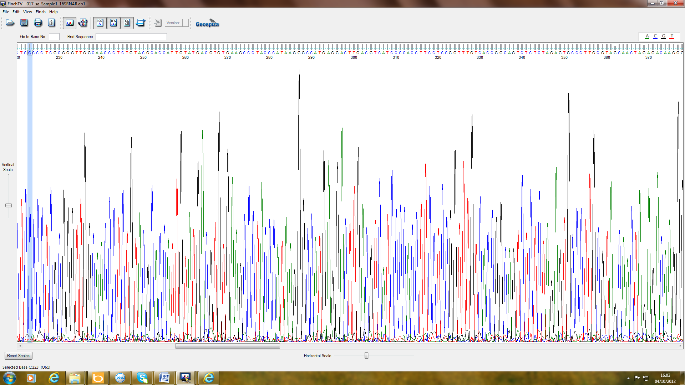

Figure 3. 1 . Finch TV software.

3-3. Result and discussion

3-3-1. Total bacteria count
The total bacterial count of soil samples from Jordan is shown in Fig 3.2. It can be clearly seen that the numbers of colony forming units in the desert-vegetated soil was higher than that for the phosphate soil and the desert non-vegetated soil. Furthermore, the highest bacterial count found in the desert-vegetated soil was three fold higher than that for the desert non-vegetated soil and twice the numbers were observed for the phosphate spoil.

Figure 3.2.Total bacterial count in the soils desert non-vegetated Phosphate mine spoil and desert-vegetated.
Phosphate mine spoil, desert-vegetated and desert non-vegetated.

3-3-2. Phylogenetic identification of unknown microorganisms
In this study, 23 bacterial strains isolated from diverse desert soils were considered. Total genomic DNA was successfully extracted from 6 isolates by using the Key prep- Bacterial DNA Extraction Kit. Fig 3.3 shows an instance of a high quality molecular weight of genomic DNA. Hyperladder 1 has been used in these studies to determine the size of DNA molecules. Fig.3.3 shows the successful amplification of 16SrRNA of unknown bacteria.

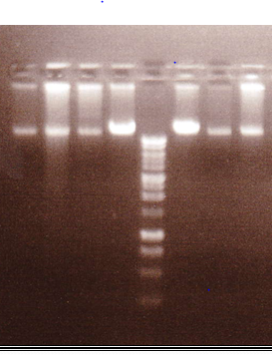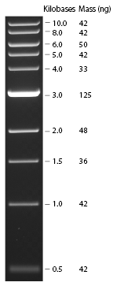
Figure 3.3 .Successful extraction of DNA of an unknown bacterium.

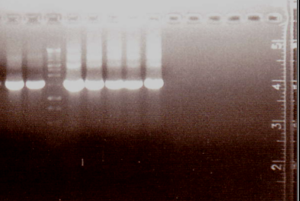
1500 bp pp b
Figure 3.4. Successful amplification of 16SrRNA of unknown bacterium.

Table 3.1. Summary of 16S rRNA sequence analyses of bacteria cultured from the phosphate spoils, desert-vegetated soil and desert non-vegetated soil.
Samples | Closest matches Identification | Sequence Identity | NBCl (Accession number)
1-Desert-vegetated soil | Paracoccus sp. | 100 % | JQ259698.1
2-Desert-vegetated soil | Bacillus megaterium | 100% | JQ897397.1
3-Desert-vegetated soil | Rhizobium sp. | 100% | HE800134.1
4-Phosphate spoil | Cupriavidus necator | 99.0 % | JQ655461.1
5-Phosphate spoil | Bacillus simplex | 100 % | KC503989.1
6-Desert Non-vegetated soil | Bacillus foraminis | 99.0% | KC250259.1

3-3-3 Phylogenetic identification of unknown microorganisms
18S rRNA sequences resulted from the diverse fungal isolates were determined. The sequences data were used to produce a phylogenetic tree providing the basis for efficient phylogenetic investigation of each genus. Fig 3.5 shows the successful amplification of 18SrRNA of an unknown fungus. In addition, Table 3.2 shows 18S rRNA analyses. Representing the closest matches of all strains cultured from desert soils, desert-vegetated soil, desert non-vegetated soil and phosphate spoil. Phylogenetic analysis of JQ72 by using the BLASTN algorithm at NCB1 indicated 99% identity to Cochliobolus lunatus .(NCBL accession number JQ724488.1).
4
2
3
1
L
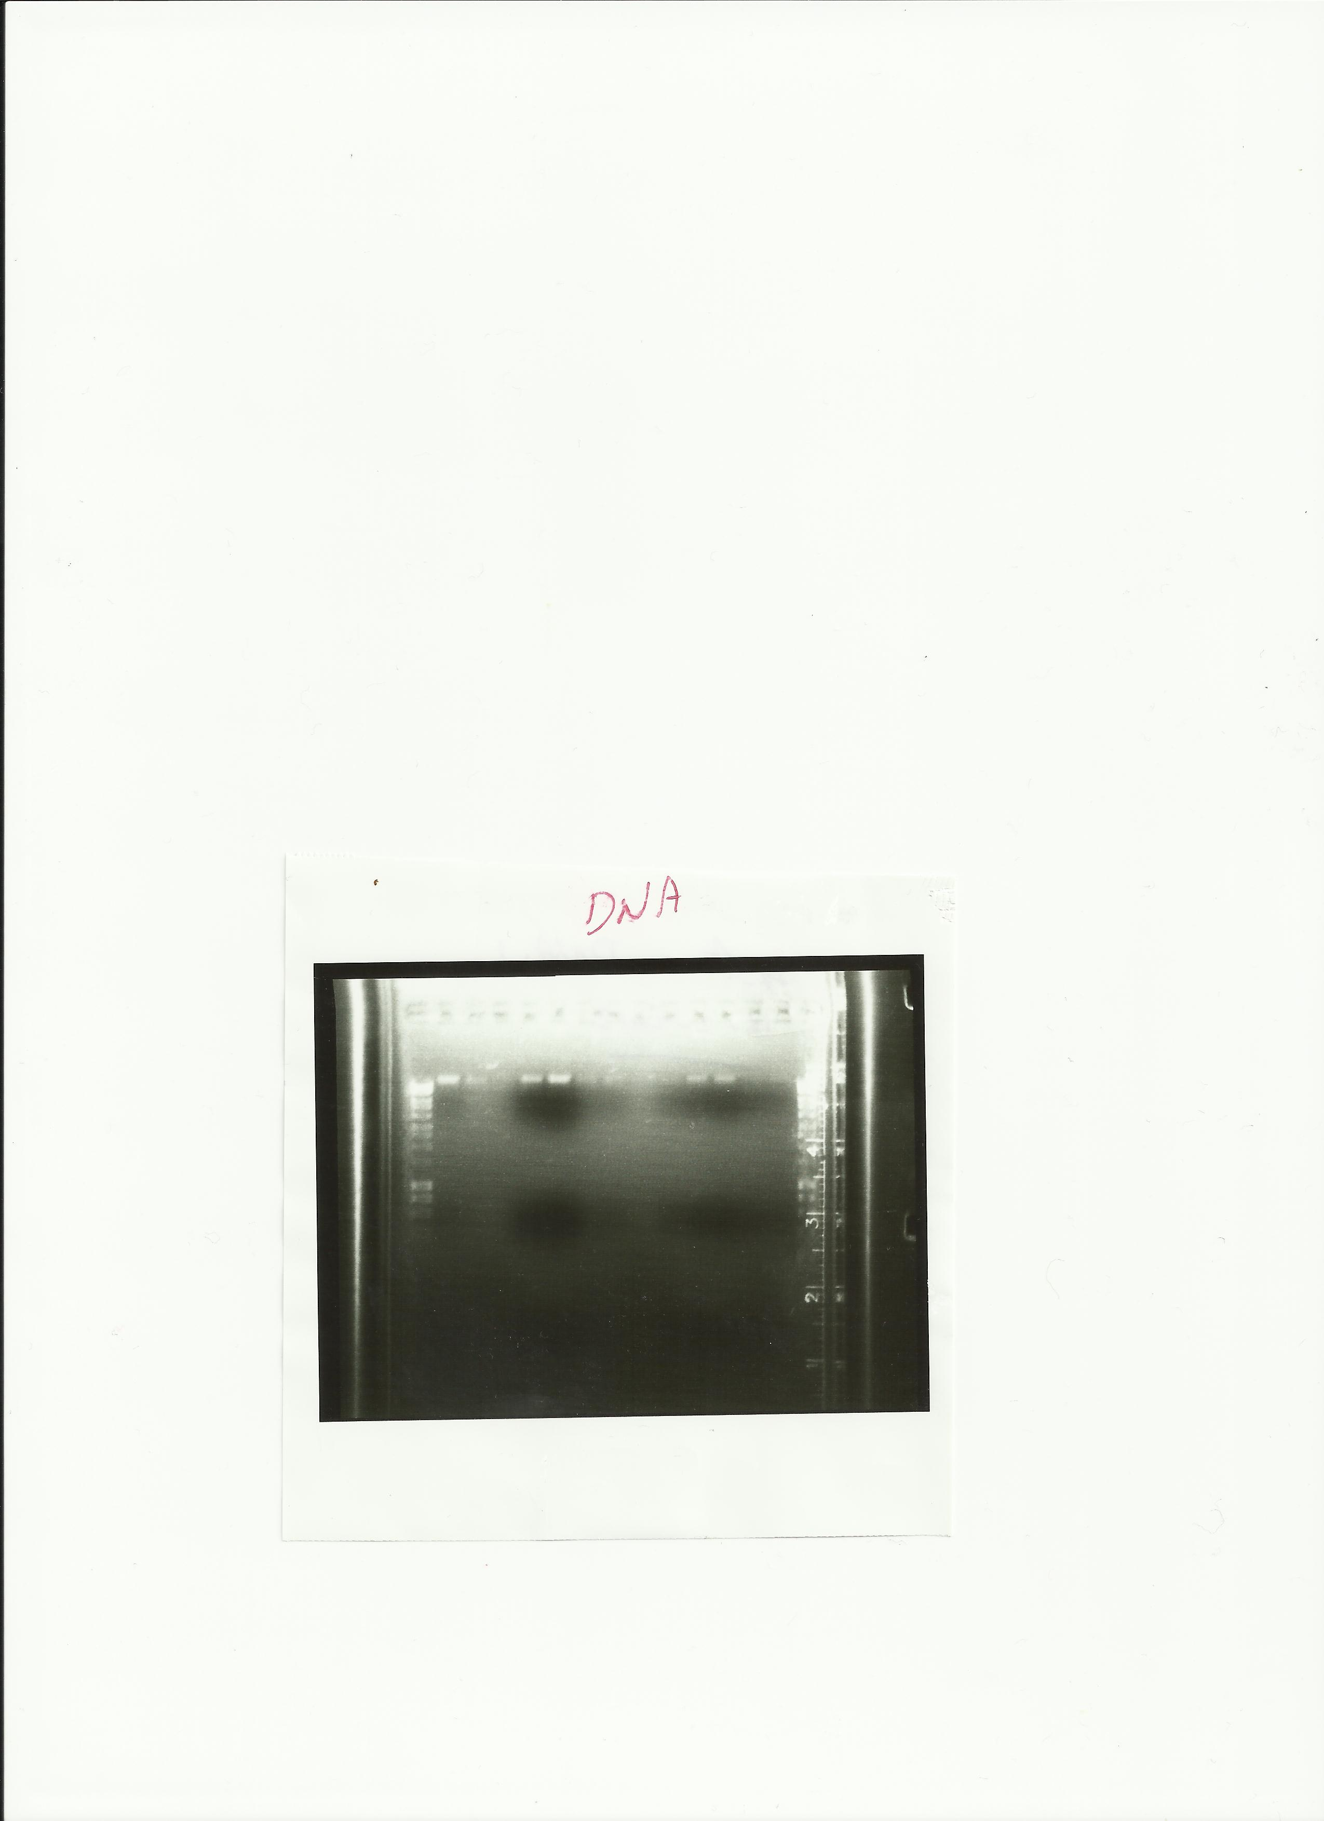
Figure 3.5 The successful amplification of 18SrRNA of an unknown fungus.

Table 3. 2 Summary of 18S rRNA sequence analyses of oligotrophic fungi cultured from phosphate spoils, desert-vegetated soil and desert non-vegetated soil.
Samples | Closest matches Identification | Sequence Identity | NBCl (Accession number)
1- Desert-vegetated soil | Cochliobolus lunatus | 99.0 % | JQ724488.1
2-Desert-vegetated soil | Penicillium daleae | 90.0 % | Aj850133.1
3-Phosphate spoil | Mucor sp | 92% | Jx160050.1
4-Desert Non vegetated soil | Aspergillus oryzae | 85 % | Fj654482.1

3-3-4 Discussion

The major aim of this Chapter was to isolate and identify microorganisms (bacteria and fungi) in Jordan phosphate mine spoil, desert-vegetated soil and desert non-vegetated soil. Six bacteria (Paracoccus sp., Rhizobium sp, Bacillus megaterium, Cupriavidus necator, Bacillus simplex and Bacillus foraminis) were isolated as pure cultures and identified by 16S rRNA gene sequencing. Table 3-2 shows 18S rRNA sequence results from diverse fungal strains. The sequence data were used to produce a phylogenetic tree providing the basis for efficient phylogenetic investigation of each genus. Fungi contain a strong cell wall and in order to obtain the DNA, it is necessary to break down the cell wall. The highest disruption of cell walls was achieved by mortar and pestle grinding and then liquid treatment, followed by sonication (see Appendix). The following fungi were isolated and identified using 18SrRNA: Cochliobolus lunatus, Penicillium daleae, Mucor sp. and Aspergilus oryzae. The results show the usefulness of both these molecular techniques for the identification of environmental isolates. The isolates however, are common soil bacteria and fungi and show no particular, unique, association with the soil samples used here ( i.e. they are not specific to desert soils or to phosphate mine spoils), but can be found in other soils types.

Chapter 4

Microbial solubilization of inorganic phosphates

4-1. Introduction
Phosphate is the most commonly limiting macronutrient for plant growth after nitrogen (Katznelson et al., 1962; Agnihotri, 1970). A large number of filamentous fungi and bacteria can release phosphate from insoluble phosphate compounds in vitro and are thought to play a role in this process in the environment, most notably in soils; soil yeasts also have the potential to play a role in this process although Katznelson et al. (1962) isolated a species of Candida from soil which they showed was able to solubilize phosphate. Phosphate solubilization by microorganisms is usually thought to be due to the release of organic acids such as citric acid.
Many microorganisms can solubilize insoluble phosphates, including fungi (Hattori, 1973; Paul and Clark, 1996). P-solubilizing fungi include species of Aspergillus, Fusarium, Penicillium and Sclerotium (Alexander, 1977). The above named fungi solubilize calcium phosphate, apatite or similar insoluble phosphates and release soluble P into the medium (Al-Turk, 1990) as do most species of bacteria, including actinomycetes. Insoluble P solubilization is mediated by organic acids which transfer insoluble phosphates into dibasic and monobasic phosphates. Certain species of bacteria and fungi can also produce hydrogen sulphide, which reacts with ferric phosphate to produce ferrous sulphide and soluble phosphate (Hattori, 1973). Inorganic P compounds are solubilized by the reaction of organic and inorganic acids which are secreted by fungi and bacteria in hydroxyl and carboxyl groups of acids which chelate cations (Ca, Al and Fe) and reduce soil pH (Kpomblekou and Tabatabai, 1994). Microorganisms achieve this solubilization in the main by the production of acids notably lactic, oxalic, acetic, tartatic, citric, succinic, ketogluconic, gluconic,and glycolic (Banik and Dey, 1982; Goldstein,1986; Cunningham and Kuiack, 1992; Goldstein, 1995; Gyaneshwar et al., 1998; Kim et al., 1997; 1998; Deubel et al., 2000).
Silicates can also mobilize phosphate and increase dissolved insoluble phosphate in soils, a fact which has long been used in temperate grassland (Hingston et al. 1967; Obihara and Russell 1972; Ma and Takahashi, 1991).
The aim of the work reported in this Chapter was to study the solubilization of inorganic phosphates by bacteria and fungi and to employ NMR to determine the solubilization initiators involved.

4-2. Materials and methods

4-2-1. fungal solubilization of inorganic phosphorus
An experiment was performed to study how fungi solubilize insoluble phosphates. Fungi isolated from the phosphate-rich spoil, desert-vegetated soil and desert non-vegetated soil were used. The fungi were isolated using Pikovskaya agar medium of the following composition :0.5 g (NH₄) 2SO₄, 0.5 g MgSO₄.7H₂O, 0.3 g of sodium chloride, 0.3 g KCl, 0.03g FeSO₄.7H₂O, 0.02 g MnSO₄.H₂O, 10.0 g Ca₃(PO₄) ₂ and glucose 10.0 g and 15.0 g agar supplemented with 0.003% w/v Rose Bengal. The plates were incubated at 28° ±2 ⁰C for 3-6 days. Colonies were removed which showed clear evidence of the ability to solubilize tricalcium phosphate by the production of a clearing zone.

4.2.2. Siderophore detection
An experiment was performed to study if fungi are able to produce siderophores on a solid medium. CAS medium was prepared according to Schwyn and Neilands (1987). The medium for use as an overlay consisted per L of: Piperazine-1, 4-bis (2-ethanesulfonic acid) (PIPES) 30.24 g, hexadecyltrimethyl ammonium bromide (HDTMA) 72.9 mg, Chrome azurol S (CAS) 60.5 mg, , and 1mM FeCl₃6H₂O in 10 mM HCl 10 mL. Agarose (0.9% w/v). The plates were inoculated with a single disc (11 mm) of Cochliobolus lunatus, Penicillium daleae, Mucor Sp. or. In order to test for siderophore production after a maximum period of 15 min, a change in colour will be observed in the medium, produced by the producer microorganism, from blue to purple (as described in the traditional CAS assay for siderophores of the catechol type) or from blue to orange (as reported for microorganisms that produce hydroxamates). Assay specificity was evaluated by repeating the above mentioned protocol with standard media (thus, lacking induction of siderophore production). All these experiments were replicated at least three times, using three replicates on each occasion.

4-2-3. Ability of fungi to solubilize insoluble phosphates
This experiment was conducted to study the ability of fungi to solubilize insoluble phosphates on Pikovskaya liquid medium (PVK) (Pikoskaya,1948).This medium consisted of: 0.5 g (NH₄) 2SO₄, 0.5 g MgSO₄.7H₂O, 0.3 g of sodium chloride, 0.3 g KCl, 0.03g FeSO₄.7H₂O, 0.02 g MnSO₄.H₂O, 10.0 g Ca₃(PO₄)₂ and glucose 10.0 g , 5g Yeast extract. The medium was distributed in flasks (50 ml in 100 ml flasks) and sterilized by autoclaving at 120 °C for 20 minutes. After cooling, the flasks were inoculated with a single disc (11 mm) cut from the leading edge of a 7 day old culture of Cochliobolus lunatus, Penicillium daleae or Mucor Sp. All flasks were set up in triplicate and incubated at 25˚C on a reciprocal shaker (125 rev min⁻¹) for 28 days. Phosphorus was determined as described by Hesse (1971); pH of the medium was also determined as was biomass production and mycelial dry weight.

4-2-4 Solubilization of insoluble phosphate by bacteria
An experiment was done to study the ability of bacteria to solubilize insoluble phosphate. Bacteria were isolated from the soils (phosphate mine spoil, desert-vegetated soil and desert non-vegetated soil). Cupriavidus necator, Bacillus megaterium and Rhizobium sp were isolated and stored at 4 ° C in a refrigerator. They were then grown on Pikovskaya agar incubated at 28° C for 3-6 days. Colonies derived from the soils were also determined which showed evidence of the ability to solubilize tricalcium phosphate by producing clearing zones after 2, 4 days and 6 days.

4-2-5. Effect of fumed silica on the in vitro solubilization of calcium phosphate by fungi
This experiment was performed in order to study the effect of fumed silica on the solubilization of calcium phosphate by fungi when growing in Pikoskaya liquid medium (PVK) (Pikoskaya,1948). The medium was distributed in flasks (50 ml in 100 ml flasks), and a range of concentrations of fumed silica (0.5 and 1 g) was added directly to the medium and sterilized by autoclaving at 120 °C for 20 minutes. After cooling, the flasks were inoculated with one disc (11 mm) from the edge of a 7 day old culture of Cochliobolus lunatus and Penicillium daleae. All flasks were set up in triplicate and incubated at 25 ˚C on a reciprocal shaker (125 rev min⁻¹) for 28 days. Phosphate was determined (Hesse, 1971) and the pH of the medium was also determined as was biomass production as mycelial dry weight.
4-2-6. Use of NMR to study phosphate solubilization by fungi
The aim of the study was to use NMR to study phosphate solubilization by fungi .The organisms studied were isolated from soil and identified using 18SrRNA analysis as Cochliobolus lunatus, Penicillium daleae and Mucor Sp. These fungi were grown on either Pikovskaya medium containing calcium phosphate medium or potato dextrose liquid medium without calcium phosphate.

4-2-6-1. Nuclear magnetic resonance (NMR) spectroscopy apparatus
During NMR analysis use a magnetic field is cooled by helium and liquid nitrogen. Radio waves are passed in the sample and release the response radio waves which are analyzed and then respond electronically to produce an NMR spectrum (Fein et al., 2002).
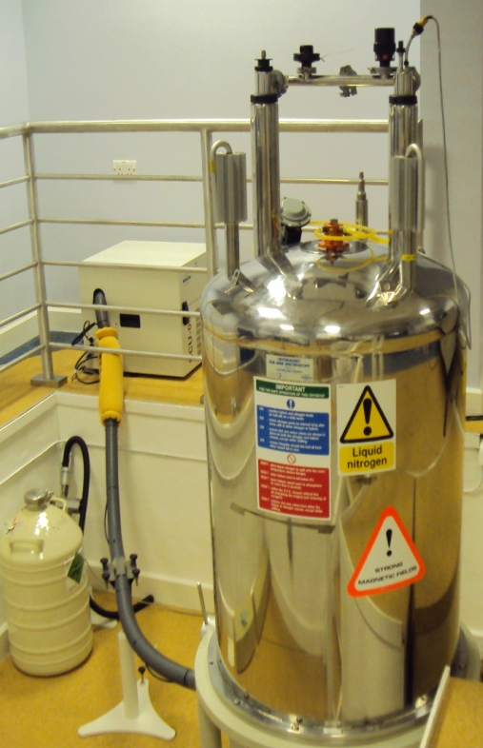
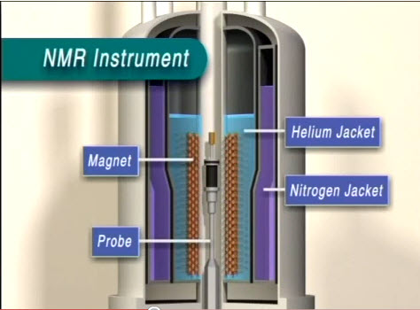
- (A) ( B )
Figure 4- 1. (A) Explanatory scheme of NMR apparatus (Reproduced and updated from Fenn et al., 2002) used with permission. (B) The NMR apparatus used in this experiment.

4-2-6-2. Sample preparation for NMR analysis
Samples (5ml) of a liquid culture of Cochliobolus lunatus, Penicillium daleae and Mucor sp. were transferred into (15 ml) tubes, centrifuged at 5000 ×g for 10 minutes and the supernatant discarded carefully. The resulting pellets were kept in a-80°C freezer until analysed. The pellets were thawed by re-suspending them in 1ml of MilliQ water and vortexed for 1 minute at room temperature, and then sonicated (3× 20 seconds) using a Soniprep 15, SANYO at 15 amplitude microns. The samples were then centrifuged at 5000 ×g for 10 minutes, and the resultant supernatant layers were transferred into microcentrifuge tubes and then transferred to -80°C for 2 hours. The samples were then freeze dried using (Heto Power Dry PL9000) at -91.4°C condenser and 0.36 KPa pressure for 2 days. The final sample preparation step before NMR analysis was the addition of ¹H to 2D ¹H-¹H HSQC and 2D C-H C-HSQC. NMR spectra were obtained by re-dissolving the dried sample cells in 500 µl of D₂O in a microcentrifuge tube, followed by the addition of 5µl of trimethly siylpropionate (TSP) to the NMR tube; the dissolved samples were then analysed using NMR (Frings et al., 1993).

4-2-6-3. Products formed during growth of Cochliobolus lunatus, Penicillium daleae and Mucor Sp. cultures
The effect of growth on different media (Pikovskaya with calcium phosphate medium) and (Potato Dextrose Liquid without calcium phosphate) on the growth of Cochliobolus lunatus, Penicillium daleae and Mucor Sp. was determined. The fungi were incubated for 21 days at 25°C. At 7 day intervals, pH was measured , and being were transferred into (15 ml) tubes, centrifuged at 5000 ×g for 10 minutes and the supernatant was throw away carefully. The resulting pellets were kept in -80°C freezer until analyzed.

4-2-6-4. Determination of inorganic phosphate in the intracellular and extracellular samples
An experiment was performed to determent inorganic phosphate in the extracellular samples after cultivation of the fungi (Cochliobolus lunatus, Penicillium daleae and Mucor sp.). Fungi were inoculated into the media and incubated for 21 days at 25°C. At 7 day periods, fungi were transferred into (15 ml) tubes, centrifuged at 5000 ×g for 10 minutes and the supernatant was kept in a-80°C freezer until analysed.

4-3. Results and Discussion

4-3-1.Ability of fungi to solubilize insoluble phosphate in solid medium
Fig 4.2 shows clearing zones of phosphate solubilization produced by the fungi. A clear zone was formed around the colonies after 6 days of incubation on solidified PV K. medium supplemented with calcium phosphate, showing phosphate-solubilizing ability of the fungal isolates. Penicillium daleae produced the largest zone followed by Cochliobolus lunatus after the six day incubation period.
Figure 4-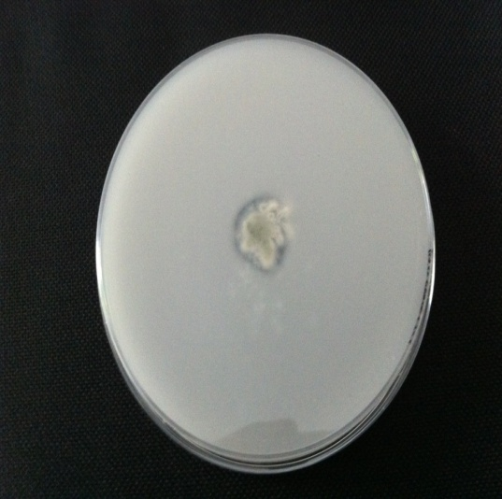 fungi
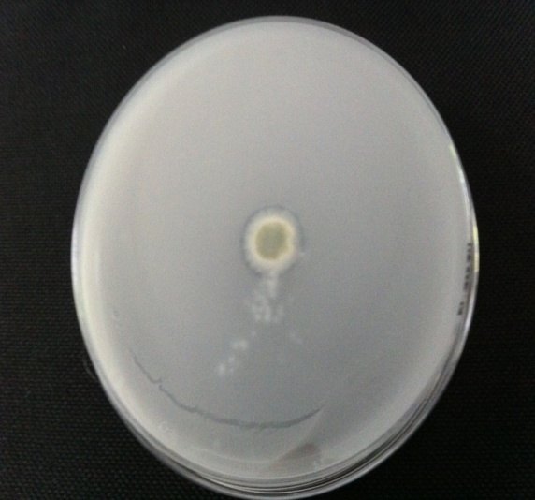

B
A

D
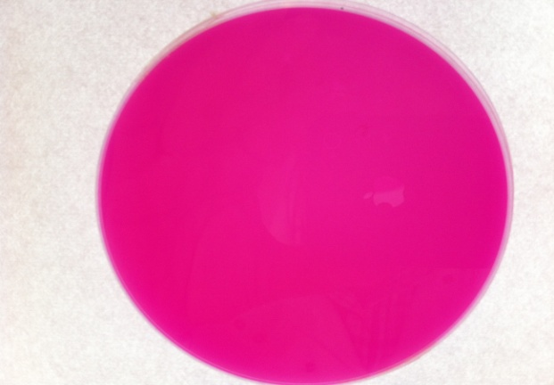
C
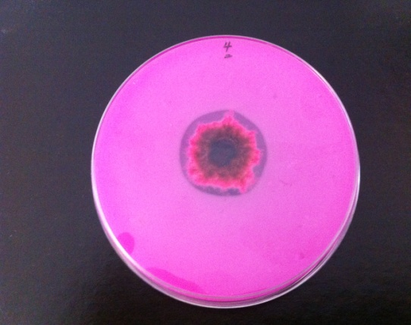
Figure ‎0-1

Figure 4- 2
Figure 4. 2 .Solubilization of inorganic phosphate by fungi (A) Mucor sp.(B) Penicillium daleae (C) Cochliobolus lunatus (D) non-inoculated control.

$$*$$
esert vegetated
$$*$$
eans of triplicates ($±)$ standard error (SE).
*significant difference from control value, P < 0.05.

Figure 4. 3. Solubilization of inorganic phosphate by fungi
Cochliobolus lunatus, Penicillium daleae,Mucor Sp.;
NB control showed no zone of inhibition.

4-3-2. Ability of fungi to solubilize insoluble phosphate in liquid medium
After confirming that fungi can solubilize phosphates on solid medium, the ability of fungi to solubilize phosphates in liquid medium was next studied. Phosphate solubilization coincided with a drop in the pH of the medium by Penicillium daleae (lowest pH at week 2). Fig 4. 4 shows the ability of Cochliobolus lunatus to solubilize insoluble phosphate (treatment) and control (without fungus). The highest phosphate solubilization was seen at week 1. After 7 day, there was then a gradual decrease at weeks 3 and 4 in treatment. Fig 4. 5 shows the ability of Penicillium daleae to solubilize insoluble phosphate. The results show that the Penicillium daleae solubilized insoluble phosphate at day 7 and continued increasing to the 14 day sampling after which solubilization by this fungus sharply decreased at weeks3and 4. Fig 4.6 shows the ability of the Mucor sp. to solubilize insoluble phosphate. It can be clearly seen that there was a significant increase in phosphate throughout the incubation period, reaching a peak after 21days. Fig 4.7 shows a comparison of all of the fungi in relation to phosphate solubilization. It shows clearly that phosphate solubilization was in the order: Cochliobolus lunatus, Penicillium daleae and Mucor sp with highest rates being found in C. lunatus at week 1, while at week 2, P. daleae showed the highest rates of solubilization.
Phosphate solubilizing microorganisms are reported to solubilize insoluble phosphates by the production of inorganic or organic acids with a resultant decrease in medium pH (Hattori, 1973; Alexander, 1977; Paul and Clark, 1996). Cochliobolus lunatus biomass was increased to solulbilise insoluble phosphate which peaked at 0.44 g on week four.

*
*
Figure 4.4.Ability of C.lunatus to solubilize insoluble phosphate.
C.lunatus ,control.
Means of triplicates ($±)$ standard error (SE).*significant difference from control value, P < 0.05.

*
*
Figure 4. 5. Ability of P. daleae to solubilise insoluble phosphate.
Penicillium daleae , control.
Means of triplicates ($±)$ standard error (SE).*significant difference from control value, P < 0.05.

*
*
Figure 4. 6. Ability of Mucor Sp.to solubilize insoluble phosphate.
Mucor Sp.,control.
Means of triplicates ($±)$ standard error (SE).*significant difference from control value, P < 0.05.

*
*
*
Figure 4. 7. Ability of all fungi to solubilize insoluble phosphate.
Cochliobolus lunatus, Penicillium daleae, Mucor SP.
control.
Means of triplicates ($±)$ standard error (SE).*Significant difference from control value, P < 0.05.

pH after 28 days

Figure 4. 8 .Medium pH after 7, 14, 21 and 28 days

4-3-3. Study of siderophore producing fungi using the O –CAS detection method
This experiment was aimed at determining if siderophore production is involved in microbial phosphate solubilization. Fig 4.9 A, B and C show catechol production by the fungi using the O –CAS detection method. Fig 4. 9 A shows that Cochliobolus lunatus is a catechol producer, which changed the medium from blue to purple. Fig 4.9 B shows that Mucor sp also changed the colour of the medium from blue to purple, indicating catechol production. The observations that these fungi produce catechol is in agreement with the findings of Pérez et al. (2007).
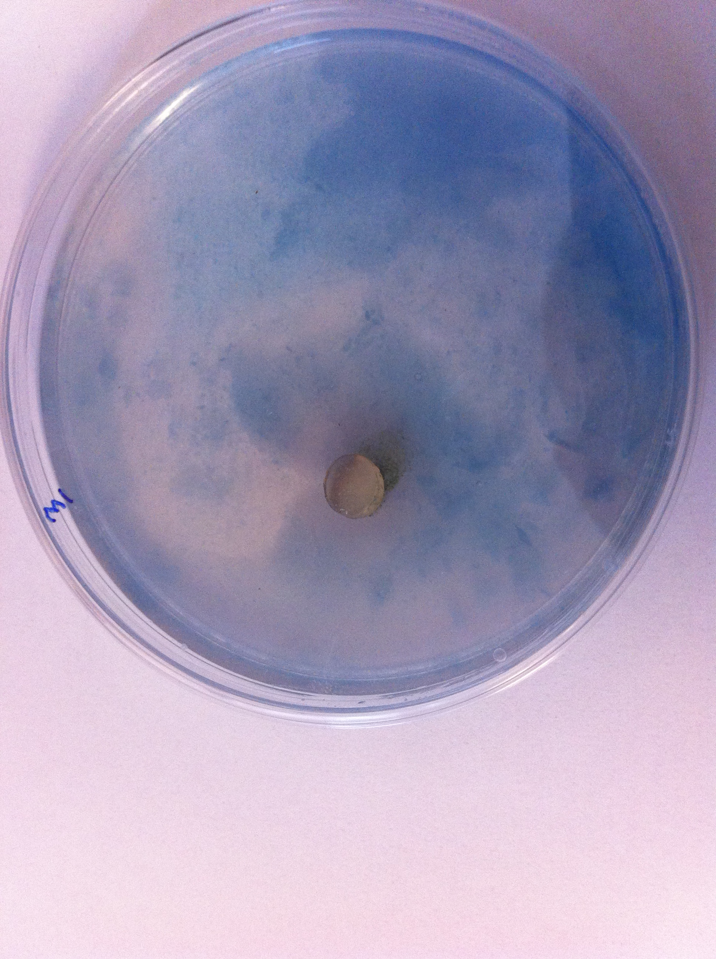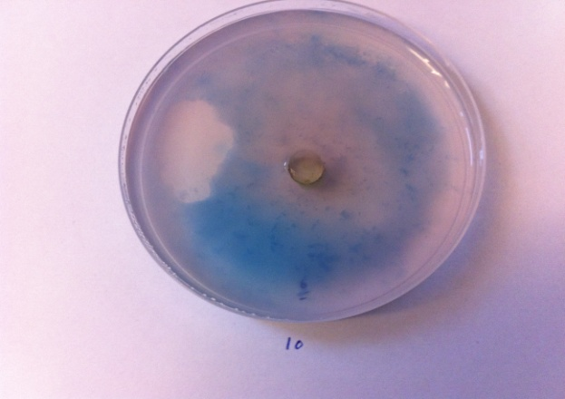
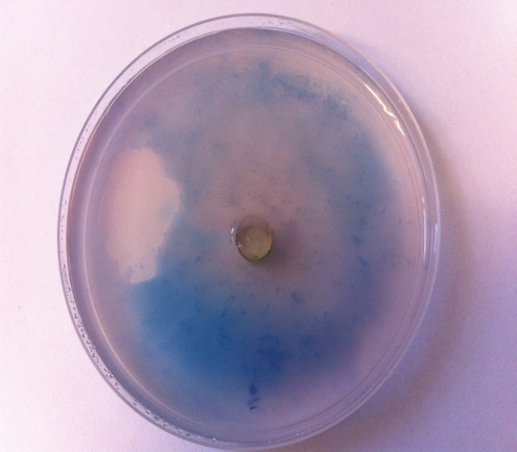
B
A

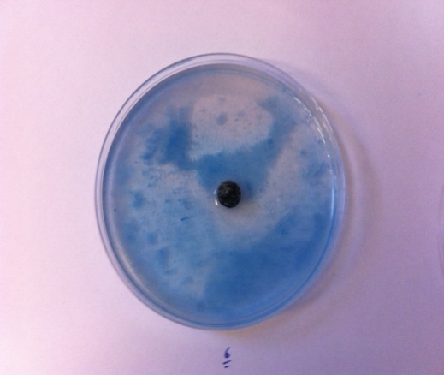
C

Figure 4. 9. Siderophore producing fungi determined using the O –CAS detection method (A) Cochliobolus lunatus, (B ) Mucor sp., ( C ). Penicillium daleae did not change the colour and is therefore not a catechol producer.

4-3-4 Bacterial solubilization of inorganic phosphate
Fig 4.10 shows that the bacteria produced a zone of clearing after 3 days incubation on solidified PV K medium supplemented with calcium phosphate, indicating phosphate solubilizing ability. Rhizobium Sp. was the most active solubilizer, followed by Bacillus megaterium, Cupriavidus necator was the only fungus tested which did not solubilize the insoluble phosphate compound used here.
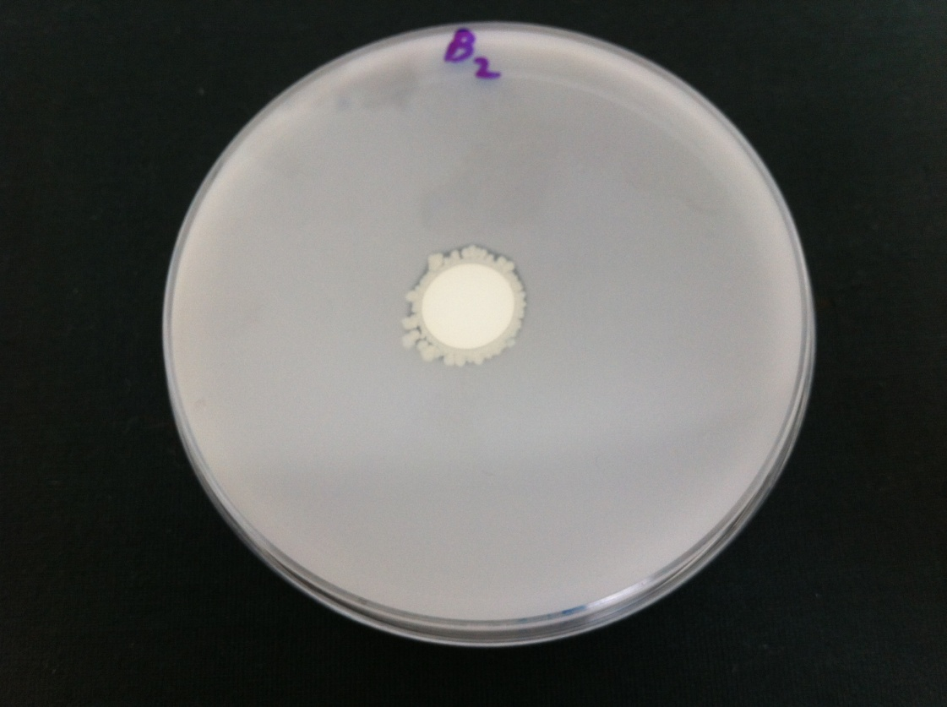
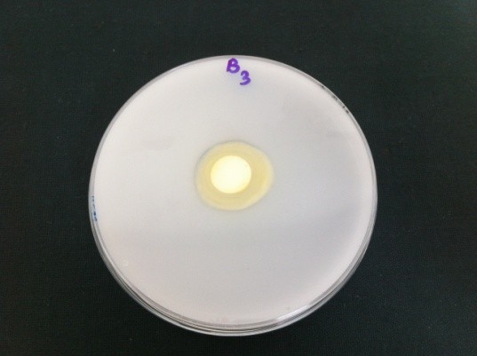
A
B

C
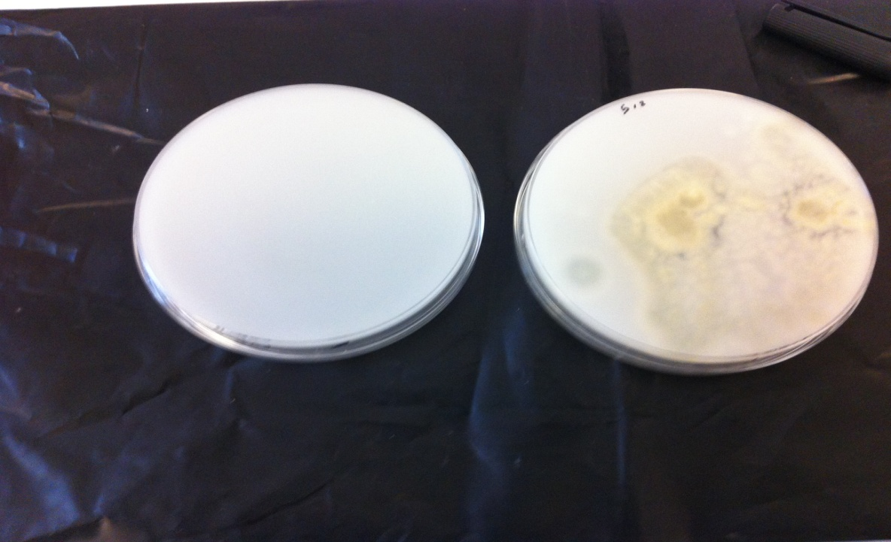

Figure 4.10. Bacteria capable of solubilizing insoluble inorganic phosphate( A) .Bacillus megaterium (B) Rhizobium Sp.( C) control.

*

Figure 4. 11. Size of solubilization zones produced by bacteria.
Cupriavidus necator, Bacillus megaterium Rhizobium Sp.
Means of triplicates ($±)$ standard error (SE).*significant difference from control value, P < 0.05.

4-3-5 Solubilization of insoluble phosphate by bacteria
Fig 4.12. Shows the solubilization of insoluble phosphate by bacteria in liquid culture over a three week incubation period. It shows that Bacillus megaterium and Rhizobium Sp. solubilized phosphate sharply after 7 days and at week 2, followed by a leveling off in solubilization at week 3. Bacillus megaterium was the most active phosphate solubilizer at week 2. Only a small difference was seen in the phosphate solubilizing abilities of the other three bacteria over the 21 day incubation period.

*
*
*
Figure 4- 12 Solubilization of insoluble phosphate by Cupriavidus necator, Bacillus megaterium , Rhizobium Sp.control.
Means of triplicates ($±)$ standard error (SE).*significant difference from control value, P < 0.05.

4-3-6 Effect of fumed silica on the solubilization of calcium phosphate by fungi
Figs 4.13 and 4.15 show the effect of fumed silica on the solubilization of calcium phosphate by fungi (Cochliobolus lunatus and Penicillium daleae) growing in vitro at Si additions of 0.5 g and 1g. It can be clearly seen that in media in which C. lunatus was growing, an increase was observed in the amount of soluble P in the medium, (i.e., at concentrations from 0.5 g to 1 g). Fig 4. 14 show Increases in biomass occurred in all cases when C. lunatus was grown with calcium phosphate as compared to control.
Fig. 4.15 shows the effect of fumed silica on the solubilization of calcium phosphate by P. daleae at Si concentrations of 0.5 g and 1g. Fig 4.17 shows the pH after 28 days. The pH decreased in the Cochliobolus lunatus culture (i.e., at concentrations from 0.5 g to 1 g) at week 3 and 4, but increased in the case of P. daleae pH (i.e., at concentrations from 0.5 g to 1 g) at week 4. Fig 4-16 shows the amount of soluble P and biomass in the medium (i.e., at concentrations from 0.5 g to 1g) were seen to increase.
*
*
Figure 4.13.The effect of fumed silica on the solubilization of calcium phosphate by C.lunatus control, C.lunatus with silica 0.5 g and C.lunatus with silica 1 g. Means of triplicates ($±)$ standard error (SE). *significant difference from control value, P < 0.05.

Figure 4. 14 .Biomass following addition of fumed silica during the solubilization of calcium phosphate by C. lunatus control, C. lunatus with silica 0.5 g and C. lunatus with silica 1 g.
*
*
Means of triplicates ($±)$ standard error (SE). *significant difference from control value, P < 0.05.

.
*
Figure 4.15.The effect of fumed silica on the solubilization of calcium phosphate by P. daleae. control , P. daleae with silica 0.5g and P.daleae with silica 0.5g
Means of triplicates ($±)$ standard error (SE). *significant difference from control value, P < 0.05.

Figure 4. 16 .Biomass in the presence of fumed silica fumed during the solubilization of calcium phosphate by P.daleae , control , P. daleae with silica 0.5g and P.daleae with silica 0.5g.
*
*
Means of triplicates ($±)$ standard error (SE). *significant difference from control value, P < 0.05.

C
D

Figure ‎0-1 4-22 show pH in (A) 7 days, (B) 14 days, (C) 21 days and (D) 28 days.

Figure 4. 17. pH after (A) 7 days, (B) 14 days, (C) 21 days and (D) 28 days.

4-3-7 -1. Use of NMR to determination the products of inorganic phosphate in the extracellular samples
³¹P spectra were run in order to look at the concentration of phosphorus in the extracellular (supernatant) samples. For all these samples a standard was added, (i.e. the two signals seen at 5.8 and 5.2 ppm). The standard was set up in separate tubes and the results are given in Fig 4.18 and Table 4.1, showing phosphate solubilization in extracellular samples through a three week incubation period. Fig 4. 18 show NMR ³¹ P spectra in the extracellular medium over 21 days in different media. It can be clearly seen that in Table 4.1 the highest phosphate solubilization occurred at week 3 in all fungi; with Penicillium daleae being the most active solubilizer, producing 4.9 mM phosphate; the next most active solubilizer was C. lunatus , followed by the Mucor sp. A common cause of broadening in NMR is the presence of metal ions in solution. In order to confirm this, EDTA was added to Mucor sp. and as a result, the broad signal sharpened up to give a standard width signal. In other words, metals are present in the extracellular medium which bind to phosphate ions and broaden the NMR signal. The intensity of the peak in sample 10 Mucor sp can be compared to the standard, and gives a concentration of phosphate in the medium of about 3 mM. It is therefore concluded that there is soluble inorganic phosphate in the extracellular medium and that in sample (Mucor sp.) it is about 3 mM. EDTA was then added to all samples and ³¹P spectra run again on three occasions. It appears therefore that Cochliobolus lunatus and Mucor sp. have already reached steady state in relation to the concentration of extracellular phosphate by day 7. The broadness of the signals in the absence of EDTA confirms that there is a paramagnetic metal ion present complexed to the phosphate, most likely Cu or Fe.

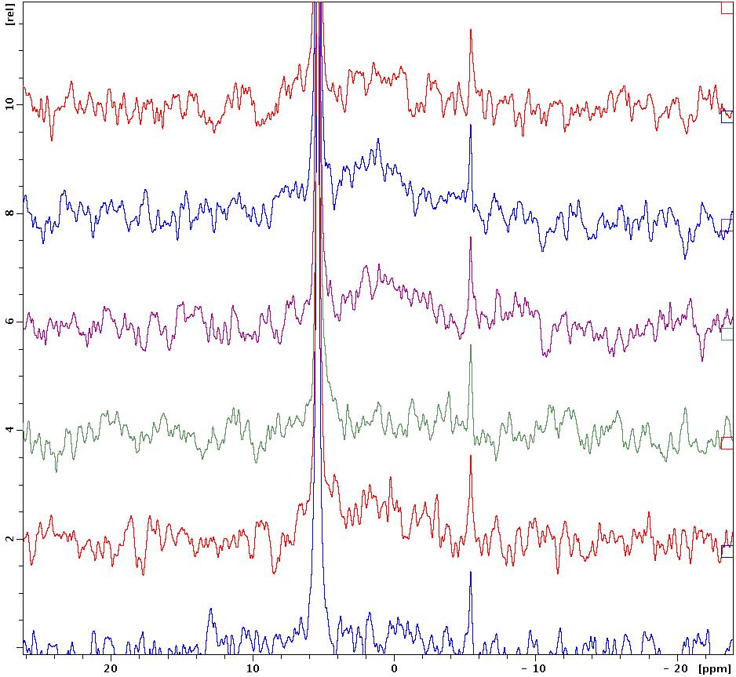
Figure 4. 18 .NMR ³¹ P spectra from the medium after 21 days in different media.

Table 4- 1 Extracellular concentration of inorganic phosphate (mM).
 | 7 days | 14 days | 21 days
Cochliobolus lunatus | 4.2 | 4.0 | 4.9
Penicillium daleae | 0 | 4.9 | 7.5
Mucor Sp. | 3.8 | 2.9 | 3.5

4-3-7-2. Determination of intracellular phosphate accumulation by the fungi
Fig 4.19 shows ³¹P spectra in intracellular material after 21 days for the different fungi when grown in the two media. It can be clearly seen from Table 4.2 that the amount of phosphate solubilization increased over the incubation period when the fungi were grown in calcium phosphate Pikovskaya, with all fungi reaching a peak at week three. Intracellular phosphate, like extracellular phosphate was highest in P.dahliae followed by Mucor sp and C.lunatus. As expected, there was little intracellular phosphate inside the fungi grown in potato dextrose liquid medium (except that is for a trace amount in the case of the Mucor Sp.). These results show that fungi solubilize insoluble phosphate and also accumulate it internally. These were the only samples of interest. Samples from the controls (fungi grown in potato dextrose liquid medium) had a sharp peak at 1.3 ppm. This corresponds to inorganic phosphate (roughly pH 4-5 judging by the position). Samples from the Treatment (i.e. grown in insoluble phosphate) have broad humps. It is assumed that the broadness is again caused by metal ions, thereby suggesting that the Treatment samples contained considerable amounts of soluble intracellular phosphate, but bound to metal ions; while the controls have less phosphate, but also less metal ions. EDTA was next added to all samples and the measurements were repeated. The results are shown below:
- Even in the absence of insoluble phosphate in the medium, the fungi built up a marked intracellular concentration of inorganic phosphate over time
- When there was phosphate in the medium, the fungi were able to extract it. The results for both C. lunatus and Mucor sp. show that the concentration was highest at 7 days and the decreased. Presumably a proportion of the phosphate liberated was used to make intracellular compounds, and the concentration of free inorganic phosphate thereby decreased with time, as more of it was required as cell numbers increased.
- The difference in signal on adding EDTA confirmed the assumption that the samples had a significantly higher concentration of metal ions intracellularly.
None of the samples contained intracellular 2-keto gluconate. All three fungi produced steady state levels of soluble inorganic phosphate in the medium by day 7, roughly 4 mM. All three fungi also produced soluble inorganic phosphate inside the cells. The amount decreased from day 7 to day 21, presumably because of incorporation of phosphate the cells of C. lunatus and Mucor sp produced marked concentrations (∼ 1 mM) of inorganic phosphate inside the cell, even in control medium. For all three fungi, the extraction of phosphate seems to have been associated with accumulation of metal ions, possibly Cu or Fe.

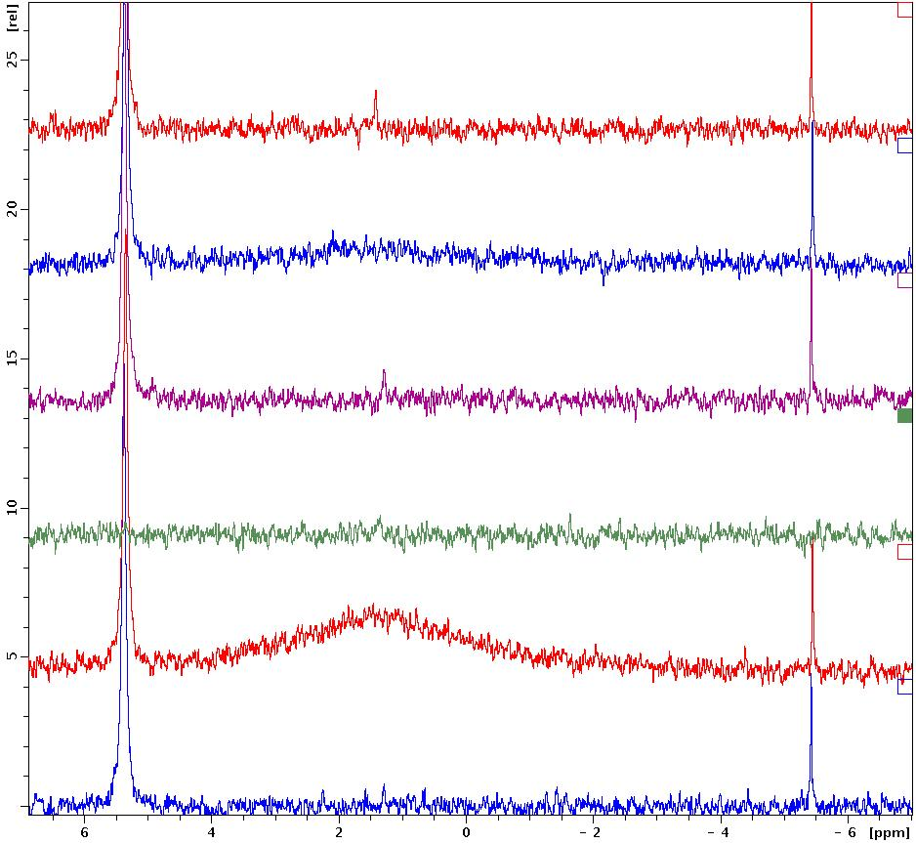
Figure 4. 19. ³¹P spectra in intracellular material after 21 days in different media.

Table 4.2 Intracellular concentration of inorganic phosphate (mM).
Fungi | Medium | 7 Days | 14 Days | 21 Days
Cochliobolus lunatus | P.D.L | 0 | 0 | 0
Cochliobolus lunatus | Pikovskaya | 1.6 | 1.2 | 0.6
Penicillium daleae | P.D.L | 0 | 0 | 1.5
Penicillium daleae | Pikovskaya | 7.2 | 10.03 | 21.9
Mucor Sp. | P.D.L | 0 | 0.4 | 0.6
Mucor Sp. | Pikovskaya | 10.9 | 3.7 | 2.3

A number of reports have detailed the ability of bacteria to solubilize insoluble inorganic phosphate compounds, notably tricalcium phosphate, dicalcium phosphate, hydroxyapatite, and rock phosphate (Altomare et al, 1999; Baijpai et al., 1971; Goldstein, 1986; Nahes et al.1996; Nannipieri et al. 2011; Venkateswarlu et al. 1984; Wu et al. 2009; Yandaw et al., 2011). Bacterial are generally involved in this process. The bacteria which are capable of solubilizing phosphates include species of Pseudomonas, Bacillus, Rhizobium, Burkholderia, Achromobacter, Agrobacterium, Microccocus, Aereobacter, Flavobacterium and Erwinia (Hilda and Frega, 1999). Considerable populations of phosphate-solubilizing bacteria occur in soil, most notably in the rhizosphere, including both aerobic and anaerobic species, with the latter, not surprisingly dominating submerged soils (Goldstein, 1986). Phosphate solubilizers can be detected by their ability to produce clearing zones around colonies in media which have been amended with insoluble mineral phosphates (notably calcium phosphate or hydroxyapatite) (Katznelson et al., 1962; Bardiya and Gaur, 1974).
As the sole P source, an approach which can be visually improved by the use of a medium containing bromophenol blue as a pH indicator, which indicates the ongoing acidification of the medium by phosphate solubilizers, (i.e. a yellow-coloured halo surrounds colonies in response to both the pH drop and the release of organic acids resulting from phosphate solubilization) (Gupta et al., 1994).
Species of Rhizobium, Pseudomonas and Bacillus species are among the most active solubilizers of inorganic P, while tricalcium phosphate and hydroxyapatite are more readily degradable than is rock phosphate ((Illmer and Schinner,1995).
Mechanisms of phosphate solubilization
The main mechanism of mineral phosphate solubilization appears to be related to the production of organic acids by bacteria and fungi which bring about the acidification of the microbial cell and the surrounding soil (Bajpai and Rao, 1971). Gluconic acid is the most important agent of mineral phosphate solubilization and is the principal organic acid produced by phosphate solubilizing strains of Pseudomonas, Erwinia erbicola, Pseudomonas cepacia and Burkholderia cepacia (Illmer and Schinner,1995). Another important organic acid produced by phosphate-solubilizing bacteria is 2-ketogluconic acid, which is produced by Rhizobium leguminosarum, Rhizobium meliloti, Bacillus firmu, and other unidentified soil bacteria. However, this organic acid was not detected in the studies reported here when NMR was employed. Strains of Bacillus liqueniformis and Bacillus amyloliquefaciens also produce lactic, isovaleric, sobutyric, and acetic acids and other organic acids produced by phosphate solubilizers include: glycolic, oxalic, malonic, and succinic acids (Bajpai and Rao, 1971).
The studies reported here show that fungi can solubilize phosphates on solid and in liquid media. A comparison of the fungal isolates in relation to phosphate solubilization shows clearly that phosphate solubilization was in the order: Cochliobolus lunatus, Penicillium daleae and Mucor sp, with highest rates being found in C. lunatus at week 1, while at week 2, P. daleae showed the highest rates of solubilization. These results confirm that a wide variety of fungi can solubilize insoluble phosphates and that the ability is not restricted to a single genus or species. In fact, it seems that nearly all fungi show this ability to varying degrees (Cunnigham and Kuiack, 1992).
The fact that Cochliobolus lunatus was shown here to produce catechol during phosphate solubilization is of considerable interest because production of this compound has previously been linked with P-solubilization (Ilmer and Schinner, 1995).
A strain of Rhizobium was found in the present studies, described in this Thesis, followed by Bacillus megaterium, facts which show that, as was seen to be the case with fungi, phosphate solubilization is widely spread across bacterial genera. The fact that Rhizobium has been shown here to be a phosphate solubilizer is of obvious importance in relation to the phosphate nutrition of crop plants, notably legumes (Hilda and Fraga, 1999; Gyaneshwar et al., 2002).
NMR analysis appears not have been previously used to study phosphate solubilization by microbes. The use of this technique showed that intracellular 2-ketogluconate was not a major product associated here with phosphate solubilization by fungi. All three fungi produced steady state levels of soluble inorganic phosphate in the medium by day seven (roughly 4 mM). All three also produced soluble inorganic phosphate inside the cells. For all three fungi, the extraction of phosphate seemed to be associated with accumulation of metal ions, possibly Cu or Fe. The results show that fungi solubilize insoluble phosphate and also accumulate it internally. When there is phosphate in the medium, the fungi are able to extract it. The results for both C. lunatus and Mucor sp. show that the concentration was highest at 7 days and then decreased. Presumably a proportion of the phosphate liberated is used to make intracellular compounds, and the concentration of free inorganic phosphate thereby decreases with time, as more of it is required as cell numbers increase. Finally, the results presented here show that the addition of silicon to the medium increased the rate of phosphate solubilization.

Chapter 5

Attempts to detect Mycoplasma in desert soil and a range of Environmental samples using the EZ- PCR test

5-1. Introduction
Mycoplasma were first recognized by Frank in 1899, the name consists of two parts in Greek (mykes) which mean fungus and plasma , plasma like structure (Freshney, 2010). Frank thought Mycoplasma was a type of fungus; however Mycoplasma are now regarded as unique organisms and are one of the smallest organisms that live freely on the Earth. They do not have a cell wall and because they have a flexible membrane, they can take on diverse forms, so it is not easy to identify them even under a high powered electron microscope. Mycoplasma are prokaryotic with a cell size between 0.15-0.3μm. They have been found in animals, insects, plants, humans, soil and sewage (Greenwood et al., 2002). Mycoplasma is resistant to most frequently used antibiotics, for example penicillin, cycloserine and other antibiotics which have an effect on cell wall growth (Tadesse and Alem, 2006). Mycoplasma are grown in culture supernatants and cell membranes (Hay et. al., 1989; McGarrity et al., 1985) and Mycoplasma are a troublesome problem as they readily contaminate cell cultures (Nikfarjam and Farzaneh, 2012).
The aim of the study described in this Chapter, was to determine if Mycoplasma sp can be isolated from various desert soils, and the other environmental samples using the EZ-PCR Mycoplasma Test.

5-2. Material and method
The following samples were tested: A) phosphate spoil, b) desert-vegetated soil, C) desert non-vegetated soil, D) temperate grassland soil and E) soil from the Ponderosa park in Sheffield.( 53°23'18.45"N)( 1°28'58.61"W).

5-2-1. Detection of Mycoplasma
All the samples were tested using an EZ-PCR Mycoplasma Test Kit (Geneflowltd, Cat No.20-70-20)

5-2-2. EZ-PCR Mycoplasma test kit
Each soil sample (1g) was shaken in 10 ml ddH₂O for 15 min at 250 rpm and then 1.0 ml was then transferred to a 1.5 ml microcentrifuge tube and was centrifuged at 10000 ×g for 1min. The supernatant was then transferred to a new tube and centrifuged at 13000×g for 10 min to pellet the Mycoplasma. In order to estimate the Mycoplasma, the supernatant was carefully discarded and the pellet was re-suspended in 50µl of buffer solution, and mixed thoroughly using a vortex mixer. Finally, the test sample was heated at 95°C for 3 minutes, and stored at -20°C for later use.

5-2-3. PCR amplification
The reaction mixtures of the test samples were prepared (on ice in a PCR tube). One negative control and one positive were also prepared (see Table 5.1) the tubes were next placed in a thermal cycler and the Mycoplasma program was run. When the PCR amplification was finished 4µl of (5× loading day) were added to each tube. For positive control, the size of the PCR product was (270bp) and the PCR was checked, whereas in the negative control tube, the DNA template was substituted with sterile MilliQ water.
Table 5. 1. Reaction mixture in a PCR tube for amplification of Mycoplasma DNA.
Component | Quantity
Sterile Milli-Q water | 35.0-39.0µl
Reaction Mix | 10.0 µl
Test sample  Positive and  Negative control | 5.0 µl

The thermal cycling order for PCR amplification of Mycoplasma was used as follows: initial denaturing at 94°C for 30 sec, followed by 35 cycles of DNA denaturation at 94°C for 30 sec, then the primer annealing step at 60°C for 120 sec, elongation at 72°C for 60 sec, final denaturation at 94°C for 30 sec, primer annealing at 60°C for 120 sec., and final elongation at 72°C for 5 min. The thermal cycling conditions used for the amplification of Mycoplasma are shown in Table 5.2.

Table 5.2. PCR amplification procedure for Mycoplasma sp.
Steps | Temperature and time | Number of cycles
Initial denaturating | 94°C for 30 sec | 1
Denaturating | 94°C for 30 sec | 35
Annealing | 60°C for 120 sec | 35
Elongation | 72°C for 1 sec | 35
Final denaturating | 94°C for 30 sec | 1
Final annealing | 60°C for 120 sec | 1
Final elongation | 75°C for 5 min | 1
∞ | 4°C

5-2-4. Analysis of amplified products by gel electrophoresis
The PCR product (10 μl) was mixed with 2 μl of Blue 6x loading dye and run on a 2% agarose gel. In addition, 6 μl of 1 Kb Hyper ladder loading in the gel to confirm the correct sized of product. The PCR test sample (10µl) positive and negative controls were then placed in 2% agarose gel wells and (2µl) of 6× loading dye was placed in wells. The gel was immersed in TAE buffer 1× with 2.5µl ethidium bromide. 6 µl of Hyper Ladder 200 bp (Bioline, UK) was used in this experiment. Finally, the samples were subjected to electrophoresis for 40 minutes at 80V. The amplified products were finally visualized on the gel and digital images were taken using “UVitec” attached to a digital camera.

5-3. Results and Discussion
Table 5.3. The occurrence or absence of Mycoplasma in different environmental samples.
Samples | Results
Phosphate spoil | Negative
Desert vegetated soil | Negative
Desert non-vegetated soil | Negative
temperate grassland soil | Negative
Ponderosa park | Positive

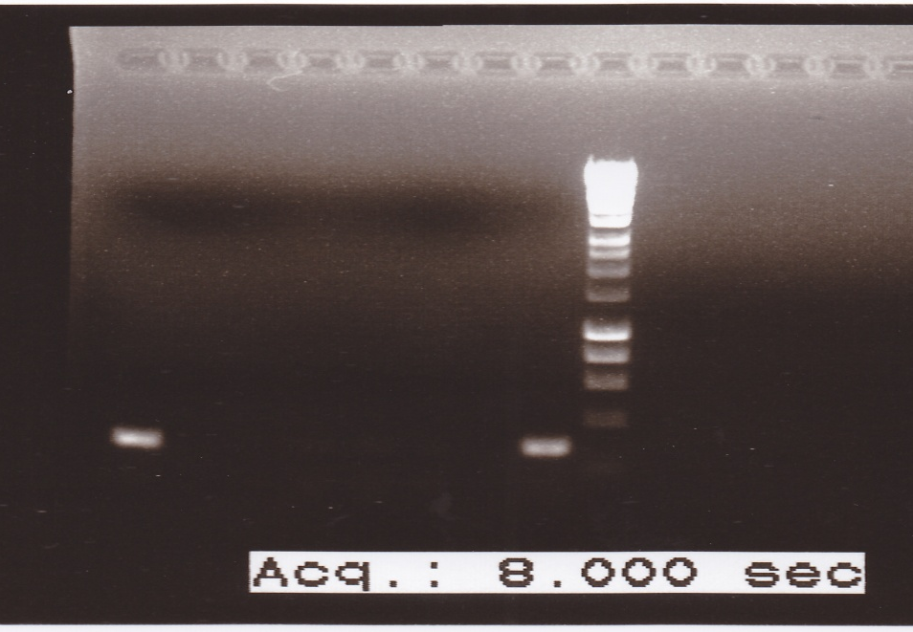
270 bp
1 2 3 4 5 6 7 L

Figure 5. 1 EZ-PCR detecting Mycoplasma analyzed using electrophoresis in 2% agarose gel .L: 1bp hyper ladder, No. 1 Pandarose Park, No. 2 phosphate spoil, No3 desert-vegetated soil, and No.4 desert non-vegetated soil and No.5 temperate grassland soil, No.6 negative control and No. 7 Positive control.

It is assumed that the presence of Mycoplasma in the Ponderosa Park sample was due to a high level of faecel pollution from animals and birds and notably dogs. (Amasha, 2012). Shown the presence of these organisms has been shown on Moss (Polytrichum commune), from the Sheffield area and a garden soil collected from the gardens of the Royal Hallamshire Hospital in Sheffield. Al-Abri (2011) also found Mycoplasma in samples of hailstones which fell on Sheffield, a result that might suggest the possibility of intercontinental upper atmospheric transfer of the potential pathogens. Finally, Shammari (2010) isolated Mycoplama from the Nile River which were assumed to be associated with human and animal feaces. The lack of Mycoplasma in the arid soils studied here is perhaps to be expected, although it is possible that they might be present in the more benign conditions of the rhizosphere.

Conclusion
The aim of the work reported in this Chapter was to detect Mycoplasma in phosphate spoil, desert-vegetated soil, desert-vegetated soil and a range of environmental samples.
This study involved environmental samples being tested for the presence of Mycoplasma by means of an EZ-PCR Mycoplasma Test Kit (Geneflow Limited, Cat No.20-700-20). Mycoplasma sp. was isolated from park soil, but it was not found from any of the desert soils, phosphate spoil, desert-vegetated soil, desert-vegetated soil and temperate grassland soils.

Chapter 6

General Discussion
Relatively few studies have been made on the microbiology and biogeochemistry of desert soils (Bull and Asenjo, 2013) and phosphate-rich spoils. The former lack of interest is largely related to the fact that desert soils are infertile in their natural state and are therefore of little primary interest to temperate grassland and soil scientists. When desert soils are used for temperate grassland they are generally merely used as a structural base for crops which are highly fertilized with nitrogen, phosphorous and other crop-plant nutrients. In this approach, desert soils merely act as sand cultures. The results of this study show that the desert soils used here are by no means sterile and respond in the expected way to the addition of ammonium, urea, elemental sulphur and insoluble phosphates. These desert soils therefore contain a microbial population which can respond to the addition of potential fertilizers and release plant-available nutrients. Not surprisingly, the rate of production of these plant available ions does not compare with that released from a fertile UK temperate grassland soil, but they do respond in a way which indicates that they do have a diverse and active microbial population. This was further emphasized here by the fact that bacteria and fungi were isolated from these desert soils (and identified using molecular methods).The organisms isolated were however, in no way unusual or exceptional, and it cannot be concluded from these studies that a specific desert microbial microflora exists.
The results show that a definite and expected rhizosphere effect was seen in the Waddi Rum samples, where higher bacterial numbers and enhanced biogeochemical activity were found in the root region of the Arabian Boxthorn (Lycium shawii) bush. In fact, desert soils have an important and intrinsic use for the study of the rhizosphere in that plants often grow here in an isolated manner in these environments allowing for rhizophere microbial populations and activity to be readily differentiated from the bulk soil activity without interference from other plants, either of the same or different species. As a result, desert soils, like the ones studied here should provide perfect sites for rhizophere studies. It was noted, when samples were taken, that the root region of the Arabian Boxthorn contained often isolated bands of organic matter which represent the breakdown of leaf litter. Such bands will of course act as the source of microorganisms in the bulk rhizophere samples which were studied here. Water availability is an obvious limiting factor for microbial activity in these, and all other desert soils, and again it was noticeable (although not measured) that soils of the rhizosphere of the Arabian Boxthorn (Lycium shawii) bush was more moist than the bulk desert soils. All of the normally accepted factors which produce the rhizopshere effect due to higher water holding capacity and root-released nutrients will operate in these desert rhizosphere soils (Walker et al., 2012).
Phosphate solubilizing bacteria and fungi were isolated and studied here. There was no evidence that the phosphate mining spoil was particularly active in phosphate solubilization, or that it contained elevated populations of phosphate solubilizers. Some of the phosphate-solubilizing isolates were shown to produce catechol, a siderophore compound associated with phosphate solubilizaton. NMR was used to good effect to show that 2-ketogluconic acid, one of the generally accepted mediators of phosphate solubilzation was not produced in flasks in which microbial phosphate solubilization was occurring. The use of this technique also showed that phosphate, when taken up by microbes, is rapidly converted to intracellular metal phosphates. Whether this binding is tight enough to immobilize phosphate permanently is not known, but it is likely that, if it is, then phosphate will be released from such intracellular metal-phosphates to be available for cellular metabolism.
An attempt was made to isolate Mycoplasma from the desert soils used here; no Mycoplasma was isolated. An isolate was however, obtained from a local park (Ponderosa Park, near the University) which was used as a control. We assume that Mycoplasma from this source originates from animal feces from pets, such as cats and dogs. It is not surprising therefore that Mycoplasma was not isolated from the desert soils, although camels and wild animal faeces could have acted as a source similar to the suggested source from pets visiting the Ponderosa Park in the UK.

1) Numbers of colony forming units in the desert-vegetated soil were higher than that for the phosphate spoil and the desert non-vegetated soil. Furthermore, the highest bacterial count found in the desert-vegetated soil was three fold higher than that for the desert non-vegetated soil and twice the numbers observed for the phosphate spoil. Bacterial counts were obtained in the order: temperate grassland soil > desert-vegetated soil > phosphate mine spoil > desert non- vegetated soil. The decrease in numbers over the incubation period is assumed to be due to soil drying as the soil moisture content was not maintained constant over the incubation period.
2) The highest level of microbial activity was found in temperate grassland soil and the lowest microbial activity was found in desert non-vegetated soil. The same trends were found in nitrification, urea hydrolysis and phosphate solubilization. Microbial activity was found in the following order: temperate grassland soil > desert-vegetated soil > phosphate mine spoil > desert non-vegetated soil. On the other hand, the highest level of the oxidation of elemental sulphur to sulphate was found in the order: temperate grassland soil ˃ phosphate mine spoil > desert-vegetated soils > desert non-vegetated soils When sulphur was added (S) with insoluble phosphate in all soils (phosphate spoil, desert-vegetated soil and non-vegetated soil.

3) Six bacteria (Paracoccus Sp., Rhizobium sp, Bacillus megaterium, Cupriavidus necator, Bacillus simplex and Bacillus foraminis were isolated as pure cultures and identified by 16S rRNA gene sequencing. The following fungi were isolated and identified using 18SrRNA: Cochliobolus lunatus, Penicillium daleae, Mucor sp. and Aspergilus oryzae. The results show the usefulness of both these molecular techniques for the identification of environmental isolates. The isolates however, are common soil bacteria and fungi and show no particular, unique, association with the soil samples used here (i.e. they are not specific to desert soils or to phosphate mine spoils, but can be found in other soils types).
4) After confirming that fungi can solubilize phosphates on solid medium, the phosphate solublizing ability of fungi in liquid medium was next studied. Phosphate solubilization coincided with a drop in the pH of the medium by Penicillium daleae (lowest pH at week 2 and Cochliobolus lunatus and to solubilization of insoluble phosphate (treatment) compared to control (without fungus). The highest phosphate solubilization was seen at week 1. After 7 days, there was then a gradual decrease which was continued at weeks 3 and 4. Penicillium daleae solubilized insoluble phosphate at day 7 and this continued to increase to the 14 day sampling after which solubilization by this fungus sharply decreased at weeks 3and 4. There was a significant increase in phosphate concentration throughout the incubation period, reaching a peak after 21days. A comparison of all of the fungi in relation to phosphate solubilization shows clearly that phosphate solubiliazation was in the order: Cochliobolus lunatus > Penicillium daleae and Mucor sp with highest rates being found in C. lunatus at week 1,while at week 2, P. daleae showed the highest rates of solubilization.
5) Cochliobolus lunatus was shown to produce catechol, which changed the medium from blue to purple. Mucor sp also changed the colour of the medium from blue to purple, indicating catechol production. Incubation on solidified PV K medium supplemented with calcium phosphate indicated phosphate solubilizing ability. Rhizobium Sp. was the most active solubilizer, followed by Bacillus megaterium. Cupriavidus necator was the only fungus tested which did not achieve solubilization. In liquid culture, Bacillus megaterium and Rhizobium Sp. solubilized phosphate sharply after 7 day and at week 2, followed by a leveling off in solubilization at week 3. Bacillus megaterium was the most active phosphate solubilizer at week 2. Only a small difference was seen in the phosphate solubilizing abilities of the other three bacteria over the 21 day incubation period.
6) NMR analysis showed that none of the group media contained intracellular 2-ketogluconate. All three fungi produced steady state levels of soluble inorganic phosphate in the medium by day 7, roughly 4 mM. All three also produced soluble inorganic phosphate inside the cells. The amount decreased from day 7 to day 21, presumably because of incorporation of phosphate into cells. C. lunatus and Mucor sp produced marked concentrations (∼ 1 mM) of inorganic phosphate inside the cell even in the control medium. For all three fungi, the extraction of phosphate appears to be associated with accumulation of metal ions, possibly Cu or Fe.
7) The amount of phosphate solubilization increased over the incubation period when the fungi were grown in calcium phosphate amended Pikovskaya medium; all fungi reached a peak in solubiliation at week three. Intracellular phosphate, like extracellular phosphate, was highest in P. daliae followed by Mucor Sp and C.lunatus. As expected, there was little intracellular phosphate inside the fungi grown in potato dextrose liquid medium (except for a trace amount in the case of the Mucor Sp.). These results show that fungi solubilize insoluble phosphate and also accumulate it internally. Samples from the controls (fungi grown in potato dextrose liquid medium) have a sharp peak at 1.3 ppm. This corresponds to inorganic phosphate (roughly pH 4-5 judging by the position). Samples from the treatment (i.e. when grown in insoluble phosphate) exhibit broad humps. We assume that the broadness is again caused by metal ions, thereby suggesting that the treatment samples contained considerable amounts of soluble intracellular phosphate, but bound to metal ions; while the controls had less phosphate, but also less metal ions. EDTA was next added to all samples and the measurements were repeated even in the absence of insoluble phosphate in the medium. The fungi built up a marked intracellular concentration of inorganic phosphate over time.
- When there is phosphate in the medium, the fungi are able to extract it. The results for both C. lunatus and Mucor sp. show that the concentration was highest at 7 days and the decreased. Presumably, a proportion of the phosphate liberated is used to make intracellular compounds, and the concentration of free inorganic phosphate thereby decreased with time, as more of it was required as cell numbers increased.
- The difference in signal on adding EDTA confirms the assumption that the samples had a significantly higher concentration of metal ions intracellularly.
8) The effect of fumed silica on the solubilization of calcium phosphate by fungi was investigated. It can be clearly seen that in media in which C. lunatus was growing, an increase was observed in the amount of soluble P in the medium,( i.e. at concentrations from 0.5 g to 1g) . Increases in biomass occurred in all cases when C. lunatus was grown with calcium phosphate as compared to control. The quantity of soluble P and biomass in the medium, (i.e. at concentrations from 0.5 g to 1g) were increased. It is clear that silica increased the degree of phosphate solublization by this fungus.
9) An attempt was made to isolate Mycoplasma from the phosphate spoil, desert-vegetated soil, desert-vegetated soil and a range of environmental samples. Environmental samples were tested for the presence of Mycoplasma by means of an EZ-PCR Mycoplasma Test Kit (Geneflow Limited, Cat No.20-700-20). Mycoplasma sp. was isolated from a Sheffield park soil, but not from any of the desert soils, phosphate spoils, desert-vegetated soil, desert-vegetated soil and temperate grassland soils.

Future Studies
The thesis reported here provide a broad-brush approach to the subject of the microbiology and biogeochemistry of desert soils which aimed to cover as many areas of the topic as possible within the time constraints and in so doing, to gain experience of as many analytical approaches as possible( i.e. the colorimetric analysis of ions, NMR, molecular techniques for the identification of bacteria and fungi, and finally the isolation of Mycoplasma) .As a result, every aspect of the work, reported here, could be revisited and studied in more detail. For example the rhizophere of a variety of plants could be studied, as could the soils of a number of different desert locations. The work could also be done in situ over a year, in order to determine seasonal influences. We were of course limited in this work by the fact that only relatively small amounts of soil samples were available for study. In this respect, it would be desirable to conduct this work do the work at a laboratory close to a variety of desert locations, in fact ideally to set up a specific desert laboratory. Similarly, it would be useful to study desert sites which have received fertilizer treatment and irrigation in relation to the growth of crop plants.

REFERENCES

Agnihotri, V. P. (1970). Solubilization of insoluble phosphates by some soil fungi isolated from nursery seedbeds. Can. J. Microbiol. 16, 877-880.

Alexander, M. (1978). Introduction to Soil Microbiology, New York, Academic Press.

Alexander, M. (1965). Nitrification. Soil Nitrogen American Society of Agronomy, Madison, Wisconsin 10, 307-343.

Al Abri, K. (2011). Use of Molecular Approaches to Study the Occurrence of Extremophiles and Extremodures in Non-Extreme Environments. PhD Thesis. University of Sheffield, UK.

Alshammari, F. (2010). Application of Molecular Identification and other Modern Approaches to the Study of Ultrasmall Bacteria. PhD Thesis. University of Sheffield, UK.

Almalki, M. (2012). Molecular Identification and Characterisation of Acid Tolerant Microorganisms Isolated from Rivelin and Limb Valleys. PhD Thesis. University of Sheffield, UK.

Altomare, C., Noevell, W.A., Björkman, T. and Harman, G.E. (1999). Solubilization of phosphates and micronutrients by the plant growth promoting and biocontrol fungus Trichoderma harzianum. Appl. Environ. Microbiol. 65, 2926-2933.

Amann, R., Glockner, F. O. and Neef, A. (1997) .Modern methods in subsurface microbiology in situ identification of microorganisms with nucleic acid probes. FEMS. Microbiol. Rev., 20, 191-200.

Amasha, R. (2012).Studies on the Environmental Microbiology and Biogeochemistry of Desert Surface Soils. PhD Thesis. University of Sheffield, UK.

Asea, P.,Kucey, M. N. and. Stewart, J.( 1988). Inorganic phosphate solubilization by two Penicillium species in solution culture and soil. Soil Biol. Biochem. 20,459-464.

Avid, M. B., Schinder, S. C. , Metchell, M. J. and Strick, J. E. (1983). Importance of organic and inorganic sulphur to mineralization process in a forest soil. Soil Biol. Biochem. 15, 671-677.

Al-Turk, I. (1990). In Vitro Studies on Streptomyces in Relation to their Role in Mineral Cycling in Soil. PhD Thesis. University of Sheffield, UK.

Barber, S.A. (1995) .Soil Nutrient Bioavailability. Wiley, New York.

Bardiya, MC. and Gaur, AC. (1974). Isolation and screening of microorganisms dissolving low grade rock phosphate. Microbiol. 386, 9 –19.

Baker, S., Nicklin, J., Khan, N. and Killington, R. (2006). Microbiology.Taylor and Francis Group.

Banerjee, MR. and Germida, JJ .(1997) .Phosphate solubilizing rhizobacteria enhance the growth and yield but not the phosphorus uptake of canola. Biol. Fert. Soil, 24,358–364.

Bajpai, P.D. and Sundra Rao, W.V.B. (1971). Phosphate solubilizing bacteria

extracellular production of organic acids by selected bacteria

solubilizing insoluble phosphate. Soil Sc.Pl. Nutr. 17, 44-45.

Banik, S. and Day, B.K. (1982). Available phosphate content of an alluvial soil as influenced by inoculation of some isolated phosphate solubilizing microorganisms. Pl. Soil, 69, 353-364.

Bettina, K. and Erhard, B. (1998).Uptake and synthesis of compatible solutes as microbial stress responses to high-osmolality environments. Microblol . 170, 319–30.

Bermejo, J.M., Domiguez, J.B., Goni, F.M. and Uruburu, F. (1981). Influence of carbon and nitrogen sources on the transition from yeast-like cells to chlamydospores in Aureobasidium pullulans. Anton van Leeuwenhoek. 47, 107-119.

Bengtson, H. (2010). Easy to understand diagram of the nitrogen cycle. Environ. Engin. 1-2.

Bir, N., Paliwal, A., Muralidhar, K., Reddy, P. and Sarma, P.U. (1995). A rapid method for the isolation of genomic DNA from Aspergillus fumigatus. Prep. Biochem. 25, 171– 181.

Bixby, D.W. and Beaton, J.D.(1970). Sulphur Containing Fertilizer, Properties and Application. Sulphur Inst . Washington D.C. Tech.Bull.117, 1-27.

Brown, K. A. (1982). Sulphur in the environment: a review. Environmental Pollut. Series B, . 3, 47-80.

Bull, A.T. and Asenjo, J.A. (2013). Microbiology of hyper-arid environments: recent insights from the Atacama Desert, Chile. 103, 1173-1179.

Carl. J.R, Roger E.(1996). Nutrient Management for Commercial Fruit and Vegetable Crops in Minnesota, Department of Soil, Water, and Climate. Minnesota Extension Service, University of Minnesota.

Casey, Michael W. and Michael, P. (2001). Fluorescent microsphere-based readout technology for multiplexed human single nucleotide polymorphism Analy.Bacteriol. Ident. 17, 305-316.

Chapman S. J. (1997). Powdered elemental sulphur: oxidation rate, temperature dependence and modelling Nutrient Cycling in Agroecosystems 47, 19-28.

Chen, Y., Rekha, P., Arun, A., Shen, F., Lai, W. A. and Young, C. (2006). Phosphate solubilizing bacteria from subtropical soil and their tricalcium phosphate solubilizing abilities. Appl, .Soil Ecol. 34,33-41.

Chen, S.C., Halliday, C.L. and Meyer, W. (2002). A review of nucleic acid-based diagnostic tests for systemic mycoses with an emphasis on polymerase chain reaction based assays. Med. Mycol. 40, 333–357.

Chen J., May-Sung Li, J. ,David, T., Quan, N., Heidi ,M., Colton, Warren, M. Cunningham , J.E. and Kuiack, C. (1992). Production of citric and oxalic acids and solubilization of calcium phosphates by Penicillium bilajii. Appl. Environ. Microbiol. 5. 1451-1458.

Coleman, R. (1966). The important of sulphur as a plant nutrient in world crop production. Soil Sci. 101,230-239.

Cunningham, J.E. and Kuiack, C. (1992). Production of citric and oxalic acids and solubilization of calcium phosphates by Penicillium bilaii. Appl. Environ. Microbiol., 58, 1451-1458.

Dean, T.R., Betancourt, D., Menetrez, M.Y.(2004). A rapid DNA extraction method for PCR identification of fungal indoor air contaminants. J. Microbiol. Meth. 56, 431–434.

Deubel, A., Gransee, A. and Merbach, W. (2000). Transformation of organic rhizodeposits by rhizoplane bacteria and its Influence on the availability of tertiary calcium phospate, Plant Nutr. Soil Sci. 4, 387-392.

Dennis, K. and Friesen (1996). Influence of co-granulated nutrients and granule size on plant responses to elemental sulphur in compound fertilizers. Nutr .Cycl. Agroec.46, 81-90.

Dey, KB. (1988).Phosphate solubilizing organisms in improving fertility status. , Naya Prokash.2, 237–48.

Dinkelaker, B. and Marschner, H. (1992). In vivo demonstration of acid phosphatase activity in the rhizosphere of soil-grown plants. Pl. Soil .144, 199-205.

Ebeling, W., Hennrich, N., Klockow, M., Metz, H., Orth, H.D. and Lang, H. (1974). Proteinase K from Tritirachium album Limber. Eur. J. Biochem. 47, 91– 97.

Ellis, B. A and Kummerow , J.(1988). N2(C2H2-C2H4) fixation in two species of Ceanothus seedlings in second year postfire chaparral. Pl. Soil .109, 207-213.

Fateh. ( 2005). Mineral Transformation in vitro by Phytopathogenic Fungi. Thesis Sheffield University.

Ferguson, R., Koelliker, D. and J.K. Basel, W. (1983). Ammonia volatilization from surface-applied urea: Effect of hydrogen ion buffering capacity. Soil Sci. Soc. Amer. Proc. 48, 578 -588.

Fenollar, F., Roux, V., Setin, A., Drancourt, M. and Raoult, D. (2006) .Analysis of 525 Samples to determine the usefulness of PCR amplification and sequencing of the 16S rRNA gene for diagnosis of bone and joint infections. Clin.Microbiol. 44, 1018.

Forum for Nuclear Cooperation in Asia (FNCA. 2006). FNCA Biofertilizer Project Group. Biofertilizer Manual.

Fraga, R. (1999). Phosphate solubilizing bacteria and their role in plant

growth promotion. Biotechnol. Adv. 17,319-339.

Freshney, I.R. (2010) .Culture of animal cells: a manual of basic tech- 37. nique and specialized applications.6, 57-70.

Galinski E.A. and Truper, H.G. (1994) .Microbial behaviour in salt stressed ecosystems. Microbiol . 15, 95–108.

Gang, D.R. and Weber, D.J. (1995). Preparation of genomic DNA for RAPD analysis from thick-walled dormant teliospores of Tilletia species. Biotechniques. 19, 96–97.

Germida, J. J. and Janzen., H. H. (1993). Factors affecting the oxidation of elemental sulphur in soils. Fert. Res. 35, 101-114.

Golstein, A.H. (1986). Bacterial phosphate solubilization. Historical perspective and future prospects. Amer. J. Altern. Agric. 1, 57-65.

Goldstein, A.H. (1994) .Involvement of the quinoprotein glucose dehydrogenase in the solubilization of exogenous phosphates by gram-negative bacteria. In: Torriani-Gorini A, Yagil E, Silver, S, editors. Phosphate in Microorganisms: Cellular and Molecular Biology. Washington, DC: ASM Press, pp. 197–203.

Golstein, A.H. (1986). Bacterial phosphate solubilization. Historical perspective and future prospects. Amer. J. Altern. Agric. 1, 57-65.

Grayston, S. J. (1987). Sulphur Oxidation and Nitrification by Fungi in vitro and in Soils. Ph.D Thesis, University of Sheffield.

Gupta, R., Singal R., Sankar ,A., Chander, RM. and Kumar RS .(1994). A modified plate assay for screening phosphatesolubilizing microorganisms. Appl Microbio. 255,40 -60.

Gyaneshwar, P., Pareka, L.J., Archana, G., Podle, P.S., Collins,M.D., Huston, R.A. and Naresh, K.G. (1999). Involvement of a phosphate starvation inducible glucose dehydrogenase in soil phosphate solubilization by Enterobacter asburiae. FEMS Microbiol. Lett. 2, 223-229.

Gyaneshwar, P., Kumar, N.J., Pareka, L.J. and Podle, P.S. (2002). Role of soil microorganisms in improving P nutrition of plants. Pl. Soil 245, 83-93.

Hadidi, A. and Candresse, T. (2003). Polymerase chain reaction. Viroids: 115-122.

Halder, AK., Mishra, AK., Bhattacharyya ,P. and Chakrabartty, P.K. (1990). Solubilization of rock phosphate by Rhizobium and Bradyrhizobium. Microbiol. 36, 81–92.

Haque , I. and Walmsley , D. (1972) . Incubation studies on mineralization of organic sulphur and organic nitrogen. Pl. Soil .37, 255-264.

Harrison, J. (2003).The Nitrogen Cycle of Microbes and Men. Visionlearning,

EAS- . 2,2-4.

Hattori, T. (1973). Physiological basis of microbial life in the soil. In: Microbial Life in Soil (Douglas Maclaren, Ed.) Marcel Dekker, New York. 105- 151.

Hattori, R., and Hattori, T. (1980). Sensitivity to salts and organic compounds of soil bacteria isolated on diluted mediaChange inorganic and organic phosphorus fractions induced by cultivation practices and by laboratory incubation. Soil Sci. Soc. Amer. J. 46, 970-975.

Haugland, R.A., Brinkman, N. and Vesper, S.J. (2002). Evaluation of rapid DNA extraction methods for the quantitative detection of fungi using real-time PCR analysis. Microbiol. Meth.,50, 319– 323.

Hay R.J., Macy M. and Chen T.R. (1989). Mycoplasma infection of culture cells. Nature 339,487-488.

Hayman, D. S. (1975) Phosphorus cycling by soil micro-organisms

and plant roots. In Soil Microbiology. Pp. 67–91.

He, X. (1998). Mineralization and bioavailability of phosphorus bound to Soil Organic Matter by Enzymes from Lupinus albus.PhD Thesis University of Wisconsin, Madison.

Hedley, M. J., Stewart, J. W. B and Chauha, B. S. (1982) . Changes in inorganic and organic soil phosphorus fractions induced by cultivation practices and by laboratory incubations. Soil Sci. Soc. Amer. Proc. 46, 970-976.

Hilda, R. and Fraga, R. (1999). Phosphate solubilizing bacteria and their role in plant growth promotion. Biotechnol. Adv., 17,319-339.

Hingston, F. J., Atkinson, R. J., Posner, A. M., and Quirk , J. P. (1967) Specific adsorption of anions. Nature, Lond. 215, 1459-61.

Hill, G., Mitkowski, N., Aldrich-Wolfe, L., Emele, L., Jurkonie, D., Ficke, A., Maldonado-Ramirez, S., Lynch, S. and Nelson, E. (2000). Methods for assessing the composition and diversity of soil microbial communities. App.Soil Ecol. .15, 25-36.

Hilda, R. and Fraga, R. (1999). Phosphate solubilizing bacteria and their role in plant growth promotion. Biotechnol. Adv., 17,319-339.

Hyland, C., Ketterings, Q., Dewing, D., Stockin, K., Czymmek, K., Albrecht, G.and L, G., (2005). Phosphorus basics- The phosphorus cycle. Agronomy Fact Sheet Series 12, 1-2.

Ilkka T. Miettinen, Terttu V.Pertti J. (1997).Phosphorus and Bacterial Growth in Drinking Water. Environment Microbiology, National Public Health Institute, 70701 Kuopio, Finland.

Illmer, P. and Schinner, F. (1995). Solubilization of inorganic calcium phosphate solubilization mechanisms. Soil Biol.Biochem. 27, 257-263.

Janzen, H.H., Mortensen, P., Anderson, F., Rasmussen, E. and Janzen, A. (1995). Phosphorus cycling in a coastal marine sediment, Aarus Bay, Denmark. Limnol. Oceanogr. 40, 908-917.

Jin, J., Lee, Y.K., Wickes, B.L. (2004). Simple chemical extraction method for DNA isolation from Aspergillus fumigatus and other Aspergillus species. Clin. Microbiol. 42, 4293– 4296.

Johnson, S. and Loeppert, R.(2006) Role of organic acids in phosphate mobilization from iron oxide. Soil Sci. Soc. Amer. J. 70,222–234.

Johan and M.,Butler ( 2012 ). PCR Amplification Capabilities and Cautions.

New York, Elsevier. 69-97.

Katznelson H., Peterson, E. and Rouatt, J .W. (1962). Phosphate dissolving micro-organisms on seed and in the root zone of plants. J.Bot. 40, 1181-1186.

Kirk ,J. L., Beaudette ,L. A, Hart ,M., Moutoglis,P., Klironomos, J.N, Lee, H. and Trevors, J.T. (2004). Methods of studying soil microbial diversity. Microbiol Meth. 58, 169- 188.

Kim, K. D. and McDonald, G.A. (1998). Effect of phosphate solubilizing bacteria and vesicular-arbuscular mycorrhizae on tomato growth and soil microbial activity. Biol. Fert. Soils. 2, 79-87.

Kim, K.Y., Jordan, D. and McDonald, D. (1997) .Solubilization of hydroxyapatite by Enterobacter Agglomerans and cloned Escherichia coli in culture medium. Biol. Fert. Soils. 4, 347-352.

Kuenzi, M. T., and A. Fiechter. (1972). Regulation of carbohydrate composition of under growth. Mikrobiol. 84,254-265.

Kucey, R. M. N. (1987). Increased phosphorus uptake by wheat and field beans inoculated with a phosphorus-solubilizing Penicillium bilaji strain and with vesicular arbuscular mycorrhizal fungi. Appl. Environ. Microbiol. 53, 2699-2703.

Kutiel, P. and Shaviv, A. (1989).Effect of simulated forest fire on the availability of N and P in Mediterranean soils. Pl. Soil 120, 57- 63.

Lexa, M. , Horak, J. and Brzobhaty, B. (2001) .Virtual PCR. Bioinformatics. 17, 192-193.

Lillie, S. H. and J. R. Pringle. ( 1980). Reserve carbohydrate metabolism in Saccharomyces cerevisiae: responses to nutrient limitation. J. Bacteriol. 143, 1384-1394.

Lin, S. K. and Reysenbach, A. L. (2003). Biodiversity of microbial life: foundation of Earth's Biosphere. Mol. 8, 223-225.

Loffler, J., Hebart, H., Schumacher, U., Reitze, H and Einsele, H. (1997). Comparison of different methods for extraction of DNA of fungal pathogens from cultures and blood. Clin. Microbiol.35, 3311– 3312.

Ma, J. F. and Takahashi, E. (1991). Effect of silicate on phosphate availability for rice in a P-deficient soil. Pl. Soil. 133, 151-155.

Maaroufi, Y., Ahariz, N., Husson, M. and Crokaert, F. (2004). Comparison of different methods of isolation of DNA of commonly encountered Candida species and its quantitation by using a real-time PCR-based assay. Clin. Microbiol. 42, 3159– 3163

MacIntire, W., Gray, F. and Shaw, W. (1921). The non biological oxidation of elemental sulphur in quartz media. Soil Sci. 14, 135-147.

Madigan, M.T., Mantinko , J. M. and Parker J. (2003). Microbial evolution and systematic. In Brocked Biology of Microorganisms. 6, 147 New Jersey: Prentice Hall International Editions.

Maier, R. M., Pepper, I. L. and Gerba, C. P. (2009). Environmental Microbiology. New York, Academic Press.

Malhi, S. S. and McGill, W. B. (1982). Nitrification in three Alberta soils: effect of temperature, moisture and separate concentration. Soil Biol. Biochem. 14, 393 – 399.

Manian, S., Sreenivasaprasad, S. and Mills, P.R. (2001). DNA extraction

method for PCR in mycorrhizal fungi. Lett. Appl. Microbiol. 33,307– 310.

Martins ,L., Huber, R., Huber ,H., Stetter, K . , Da Costa, M. and Santos, H. (1997) .Organic solutes in hyperthermophilic Archaea. Environ Microbiol. 63,896–902.

Martin, R. R., James D. and Levesque, C. A. (2000). Impacts of molecular diagnostic technologies on plant disease management. Ann. Rev. Phytopathol. 38, 207-239.

Marschner, Solaiman Z. and Rengel Z. (2006).Rhizosphere properties of Phocaea genotypes under P-limiting conditions. Pl. Soil. 283, 11–24.

Maynard, D. G., Stewart, J. W. B and Bettany, J. R. (1985). The effects of plant on soil sulphur transformations. Soil Biol. Biochem. 17, 127-134.

McGarrity, G.J. and Kotani ,H.(1985) .Cell culture mycoplasma. Cellular and.6 353-390.

Mirocha, C.J. and Devay, J.E. (1971). Growth of fungi on an inorganic medium

17, 1373-1378.

Molla, M. A. Z. and Chowdhury, A. A.( 1984). Microbial mineralization of organic phosphate in soil. Pl. Soil .78, 393-399.

Nahas, E. (1996). Factors determining rock phosphate solubilization by micro organisms. World J.Microbiol.Biotechnol. 12, 567-572.

Nahas, E., Banzatto ,D. A. and. Assis ,L. C. (1990). Fluorapatite solubilization by Aspergillus niger in vinasse medium. Soil Biol. Biochem. 22,1097-1101.

Nannipieri ,P., Johnson, R. L. and. Paul, E. A. (1978). Criteria for measurement of microbial growth and activity in soil. Soil Biol. Biochem. 10, 223 - 229.

Nannipieri, P., Giagnoni, L., Landi, L. and Renella, G. (2011 )Role of phosphatase enzymes in soil. Soil Biology. 26,215-241.

Obihara, E. C. H. (1969). Interactions Between Soluble Silica and Phosphate in soils. Ph. D. Thesis, Unív. Reading.

Oneill' J. G. and Willktion ,J. F. (1977). Oxidation of ammonia by methane-oxidizing bacteria and the effects of ammonia on methane oxidation. J.Gen. Microbiol. 100, 407-412.

Parks, E. J., G. J., Olson, F. E., Brinckman and Baldi F. (1990). Characterization by high performance liquid chromatography (HPLC) of the solubilization of phosphorus in iron ore by a fungus. J. Ind. Microbiol. 5,183-190.

Park, S. (2010). Sulphur-Utilizing Autotrophic Denitrification Process For the Treatment of Nitrate-Rich Water. Worcester Polytechnic Institute, Project Report.

Pandey, A., Das, N., Kumar, B., Rinu, K. and Trivedi, P.( 2008). Phosphate solubilization by Penicillium spp. isolated from soil samples of Indian Himalayan region. Microbiol. Biotechnol. 24, 97-102.

Paul, E. A. and Clark, D. P. (1996). Soil Microbiology and Biochemistry. California, Academic Press.

Payne, W. J.(1981). Denitrification. New York, John Wiley.

Pérez-Miranda, S., Cabirol ,N., George-Téllez, R., Zamudio-Rivera ,LS . and Fernández FJ.(2007). O-CAS, a fast and universal method for siderophore detection. Microbiological, Method.70, 127-131.

Philips, S., Wyffels, S., Sprengers, R. and Verstraete, W. (2002). Oxygen-limited autotrophic nitrification/denitrification by ammonia oxidisers enables upward motion towards more favourable conditions. Appl. Microbiol. Biotechnol. .59,557-566.

Pidwirny, M. (2004). The Nitrogen Cycle. Fundamentals of Physical Geography, physical geography. net/fundamentals/9s. html (July 2004).

Pikovskaya ,R. (1948). Mobilization of phosphorus in soil in connection

with vital activity of some microbial sp. Microbi .17, 362– 373.

Prosser ,J. I. (2002). Molecular and functional diversity in soil microorganisms. Pl. Soil .244, 9-17.

Puente, ME., Bashan, Y., Li, CY. and Lebsky, VK. (2004) .Microbial populations and activities in the rhizoplane of rock-weathering desert plants. Root colonization and weathering of igneous rocks. Pl. Biol. 6,629 – 642.

Raina ,M., Ian ,L. and Charles, P. (2009). Environmental Microbiology .Academic press, Elsevier. 2,310-311.

Rajan ,S, Watkinson, JH. and Sinclair ,AG .(1996) .Phosphate rocks for direct application to soils. Adv. Agron. 77, 57–159.

Ramesh, C. Jaggi,I. and Milkha, S. (1999).Temperature effects on soil organic sulphur mineralization and elemental sulphur oxidation in subtropical soils of varying pH.54, 175–182.

Rengel, Z. and Marschner, P. (2005).Nutrient availability and management in the rhizosphere: exploiting genotypic differences. New Phytol. 168,305–312.

Richardson, A.E. (1994). Soil microorganism and phosphorus availability. In: eds. Pankhurst, CE. Doube, B.M., Gupta, V.V.S.R. and Grace, P.R.,: Soil Biota- Management in Sustainability.

Robert, J. Steeffan,T .,Ronaldm,A. and Atasdna,S.(1988). Amplification to enhance detection of genetically. Environ. Microbiol. 9, 2185-2191.

Rodriguez, H. and Fraga, R. (1999). Phosphate solubilizing bacteria and their role in plant growth promotion. Biotechnol. Adv. 17,.319-339.

Ross, I.K. (1995). Non-grinding method of DNA isolation from human pathogenic filamentous fungi using xanthogenates. Biotechniques 18, 828– 830.

Ruisi, S., Barreca, D., Selbmann, L., Zucconi, L. and Onofri, S. (2007). Fungi in antarctica. Rev. Environ. Sci. Biotechnol.6, 127–141.

Salih, H.M., Yahya A.Y., Abdul-Rahem, A.M. and Munam,B.H.(1989). Availability of phosphorus in a calcareus soil treated with rock phosphate or superphosphate as affected by phosphate dissolving fungi. Pl. Soil. 120,181–5.

Sambrook,J., Fritsche,.F. and Maniatis, T. (1989). Molecular cloning: A laboratory manual. Cold Spring Harbor .

Sharpley, A. (2000). Phosphorus availability. Handbook of Soil Science. CRC Press. Boca Raton Flg, 18-38.

Sievert, S. M., Kiene, R. P. and Schultz-Vogt, H. N. (2007). The sulphur cycle. Oceanography . 20,117–123.

Sims, J.R., and Jackson, G.D. (1971). Rapid analysis of soil nitrite with chromotrophic acid. Soil Sci. Soc. Am. Proc. 35, 603-606.

Soomro, F. (2000). Effect of Silicon Compounds on Microbial Transformtion in Soil. PhD Thesis. University of Sheffield, UK.

Simon L, Bousquet, J., Levesque ,RC. and Lalonde, M. (1993).Origin and diversification of endomycorrhizal fungi and coincidence with vascular land plants. Nature.363, 67-69.

Smith ,J.H., Allison, F.E. and Soulides, D.A. (1962). Phosphobacteria as a soil inoculant. Agricult. 1, 63–70.

Strauss,S.L.,Day, T.A. and Garcia–Pichel, F.(2012). Nitrogen cycling in desert biological soil crusts across biogeographic regions in the Southwestern united States. Biogeochemistry. 108,171-182.

Tabtabatia, M.A. (1977). Effect of trace elements on urease activity in soils. Soil. Sci. Am. Proc. 9, 9 -13.

Tabatabai, M. A. and Olson, R. (1985). Effect of acid rain on soils. Environ. Sci. Technol. 15, 65-110.

Tadesse, A. and Alem, M. (2006). Medical Bacteriology. University of Gondar.

Thien, S. and Myers, R. (1992). Determination of bioavailable phosphorus in soil. Soil Sci Soc. Amer.Proc. 56, 814-814.

Tribe, H.T. and Mabadeje, S.A. (1972). Growth of moulds on media prepared without organic nutrients. Trans. Brt.Mycol. Soc. 58, 127-137.

Vanburik, J.A., Schreckhise, R.W., Whtte, T.C., Bowdenr, R.A. and Myerson, D. (1998). Extraction techniques for isolation of DNA from filamentous fungi. Med. Mycol. 36, 299.

Van Den Burg, B. (2003). Extremophiles as a source for novel enzymes. Curr. Op Microbiol. 6, 213-218.

Vassileva, M., Serrano, M., Bravo, V., Jurado, E., Nikolaeva, I., Martos, V. and Vassilev, N. (2010). Multifunctional properties of phosphate-solubilizing microorganisms grown on agro-industrial wastes in fermentation and soil conditions. Appl. Microbiol. Biotechnol. 85, 1287-1299.

Venkateswarlu, B., Rao, A.V. and Raina, P. (1984). Evaluation of phosphorous

solubilization by microorganisms isolated from arid soils. J. Indian Soc Soil Sci. 32, 273-277.

Ventosa ,A., Nieto, J. and Oren, A. (1998). Biology of moderately halophilic aerobic bacteria. Microbiol Mol. Biol. 62,504–544.

Venkateswarlu, B., Rao, A.V. and Raina, P. (1984). Evaluation of phosphorus

solubilization by microorganisms isolated from arid soils. J. Indian

Soc Soil Sci. 32, 273-277.

Wahid, O., Moustafa, A. and Moustafa, A. (1996). Fungal population in the atmosphere of Ismailia City. Aerobiologia.12, 249-255.

Wainwright, M. (1984). Sulphur oxidation in soils. Adv. Agron. 37, 349-396.

Wainwright, M. and Killham, K. (1980). Sulphur oxidation by Fusarium solani. Soil Biol. Biochem. 12, 555-558.

Wainwright, M., Al-Wajeeh, K. and Grayston, S. (1997). Effect of silicic acid and other silicon compounds on fungal growth in oligotrophic and nutrient-rich media. Mycological Research .101, 933-938.

Wainwright, M. and Pugh, G. (1973). The effect of three fungicides on nitrification and ammonification in soil. Soil Biol. Biochem. 5, 577-584.

Walker,T.S., Bais, H.P., Grotewold, E. and Vivanco, J.M.(2012). Root exudation

phospobacteria isolates from eutrophic aquatic ecosystems.

Microbiology 78, 769-775.

Waksman,S., Williams , W. and Baltimore, A.( 1927). Principles of Soil Microbiology.

Williams, R.H., Ward, E. and McCartney, H.A. (2001). Methods for integrated air sampling and DNA analysis for detection of airborne fungal spores. Appl. Environ. 67, 2453– 2459.

Wu, G., Liu, J. and Ye, Z. (2009). Characterization of phospobacteria isolates from eutrophic aquatic ecosystems. Microbiology 78, 769-775.

Yadav, B.K. and Tarafdar, J.C. (2011). Penicillium purpurogenum, Unique P mobilizers in arid agro-ecosystems. Arid Land Res. Manag. 25, 87-99.

Yeung, S. N., Butler, A. and Mackenzie, P. J. (2009). Applications of the polymerase. Chain reaction in clinical ophthalmology. Can. J ophthalmology.44, 23-30.

Yong, B.L. and Pil, J. K. (2007). Reduction of phposphate adsorption by ion competition with silicate in soil. Environ. Agri. 26, 286-293.

APPENDIX: A

Fungal cell wall disruption methods:
In this study three morphologically diverse fungal species, Cochliobolus lunatus, Penicillium daleae and Mucor Sp. were studied in relation to techniques for the chemical, physical and enzymatic disruption of their cell walls for use in the determination of 18SrRNA analysis. Fig 7. 1 shows A) treatment with lyticase B) proteinase K . C) HCL (conc. D) 5 M NaOH . E) by sonication . F) break down using mortar and pestle (after liquid Nitrogen treatment). Fig 7.2 a. shows the degradation of cells when treated with lyticase enzyme. Penicillium daleae exhibited the highest degree of cell lyseis, followed by Cochliobolus lunatus, and Mucor sp. Fig 7-2 b. shows the a affect of the enzyme Proteinase K on the degree of cell lyses. Mucor sp. cell wall was less effected than Penicillium daleae and Cochliobolus lunatus. Fig 7.2 C and D shows the effect of chemicals ( HCL and NaoH) on fungal cell wall lysis. HCL treatment was more efficient than NaOH treatment (incubated overnight at room temperature as a means to decrease possible DNA damage). Fig 7. 2(E and F) shows the effects of physical disruption methods using sonication and mortar and pestle grinding (with liquid nitrogen). The highest disruption cell wall was achieved with mortar and pestle grinding (with liquid nitrogen), followed by sonication. Clearly the best method for fungal wall disruption was the use of mortar and pestle grinding (plus liquid nitrogen).

Table 7.1 the figure shows examined the samples under a magnifying power of the microscope at 20X.
Treatment | Cochliobolus lunatus | Penicillium daleae | Mucor Sp.
Control | 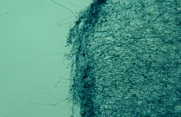 | 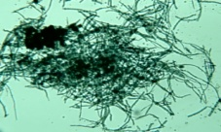 | 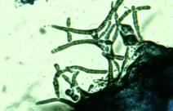
Lyticase | 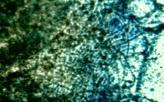 | 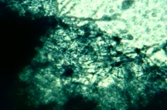 | 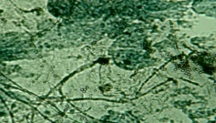
Proteinase K | 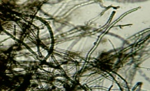 | 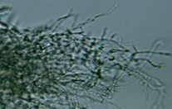 | 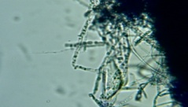
HCl | 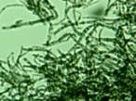 |  | 
NaoH | 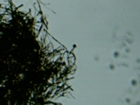 | 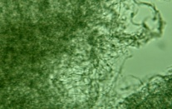 | 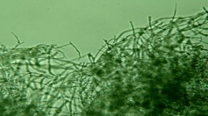
Sonication | 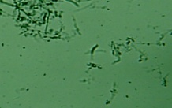 | 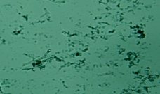 | 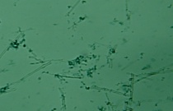
Mortar and pestle | 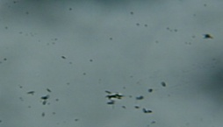 | 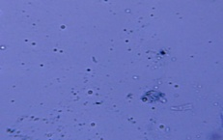 | 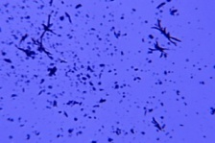

Table 7.2 .The efficiency of fungal cell lysis assessed using physical, chemical or enzymatic cell wall disruption methods for three morphologically different fungal species.
Treatment | Cochliobolus lunatus | Penicillium daleae | Mucor Sp.
Lyticase | 0-10 | 75 -90 | 75-90
Proteinase K | 25-50 | 25- 50 | 10-25
Con. HCL | 25-50 | 75 -90 | 25-50
5 M NaoH | 0-10 | 0-10 | 0-10
Sonication | 75-90 | 75 -90 | 75-90
Mortar and pestle | 90-100 | 90 -100 | 90-100

B
A

C
D

F
E

Figure 3- 4 A) Treatment By Lyticase B) By Proteinase K. C) By HCL CON. D) By Figure 7.1 5 M NaOH. E) By sonication . F) By Mortar and pestle (liquid Nitrogen).

7.2 External morphology of Cochliobolus lunatus and Mucor sp. observed by scanning electron microscopy (SEM) when treated by lyticase.
B
A

D
C

Figure 7.2 Scanning electron micrograph shows the morphology of the of C. lunatus (A) is control and (C) is treatment and Mucor sp (B) is control and (D) is treatment.
Note the cell wall did not damage.

7.3 . Internal morphology of of C. lunatus and Mucor sp. observed by transmission electron microscopy (TEM). when treated by lyticase.
E
F
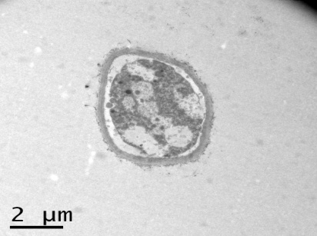
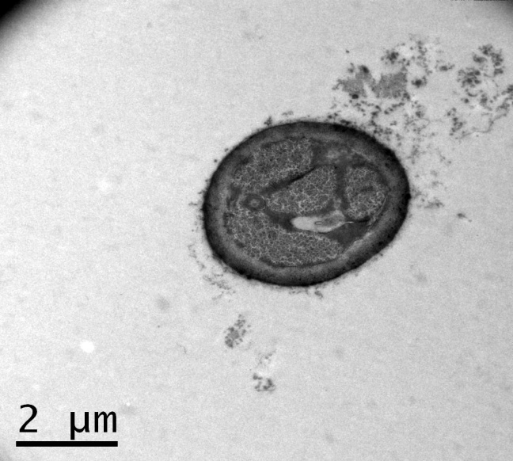

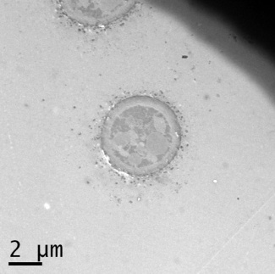
G
H
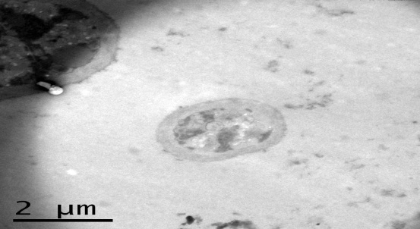

C.W

Figure 5.3 Transmission electron micrograph shows the morphology of C. lunatus (E) is control and (G) is treatment and Mucor sp (F) is control and (H) is treatment. Note C. lunatus cell wall (C.W) damage.

7.3. External morphology of Cochliobolus lunatus and Mucor sp. observed by scanning electron microscopy (SEM) when treated by Proteinase K .
B
A

D
C

Figure 7.4 . Scanning electron micrograph shows the morphology of the of C. lunatus (A) is control and (C) is treatment and Mucor sp (B) is control and (D) is treatment.
Note the cell wall did not damage.

7.4. Internal morphology of C. lunatus and Mucor sp. observed by transmission electron microscopy (TEM). When treated by Proteinase K.
F
E

H
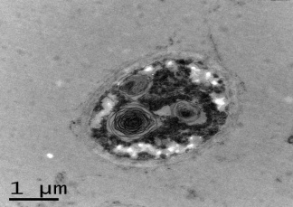
G
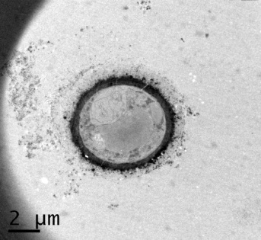

CM

Figure 7.5 Transmission electron micrograph shows the morphology of C. lunatus (E) is control and (G) is treatment and Mucor sp (F) is control and (H) is treatment.
Note Mucor sp. cytoplasmic membrane (CM) damage.

7.5 . External morphology of Cochliobolus lunatus and Mucor sp. observed by scanning electron microscopy (SEM) When treated by HCL.
B
A

D
C

Figure 7.6. Scanning electron micrograph shows the morphology of the of C. lunatus (A) is control and (C) is treatment and Mucor sp (B) is control and (D) is treatment.
Note the cell wall did not damage.

7.6 Internal morphology of of C. lunatus and Mucor sp. observed by transmission electron microscopy (TEM). When treated by acid
F
E

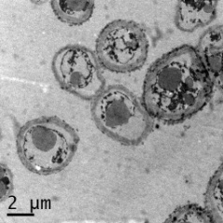
G
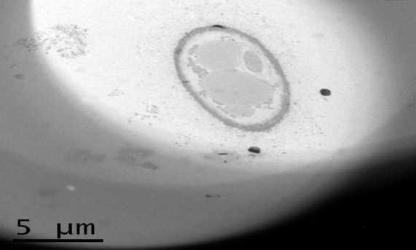
H

Figure 7.8. Transmission electron micrograph shows the morphology of C. lunatus (E) is control and (G) is treatment and Mucor sp (F) is control and (H) is treatment
Note the cell wall did not damage , but cytoplasm in Mucor sp (H) was scattered .

7.7. External morphology of Cochliobolus lunatus and Mucor sp. observed by scanning electron microscopy (SEM) .When treated by NaOH.
B
A

D
C
HY

Figure 7.9. Scanning electron micrograph shows the morphology of C. lunatus (A) is control and (C) is treatment and Mucor sp (B) is control and (D) is treatment.
Note the Hypha (C) in C. lunatus damaged.

7.8. Internal morphology of of C. lunatus and Mucor sp. observed by transmission electron microscopy (TEM). When treated by NaOH.
E
F

G
H
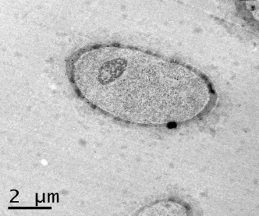
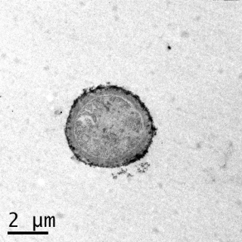

Figure 7.9.Transmission electron micrograph shows the morphology of C. lunatus (E) is control and (G) is treatment and Mucor sp (F) is control and (H) is treatment .

7.10. External morphology of Cochliobolus lunatus and Mucor sp. observed by scanning electron microscopy (SEM) When treated by sonication.
A
B

C
D

Figure 7.10 Scanning electron micrographshows the morphology of the of C. lunatus (A) is control and (C) is treatment and Mucor sp (B) is control and (D) is treatment.
Note the Hypha (C) in C. lunatus and Mucor sp. is damaged.

7.11. Internal morphology of of C. lunatus and Mucor sp. observed by transmission electron microscopy (TEM). When treated by sonication .
F
E

G
H
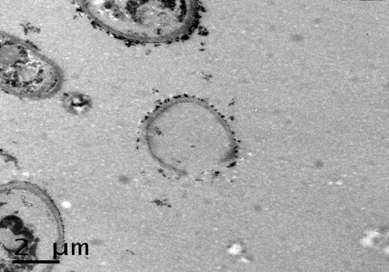
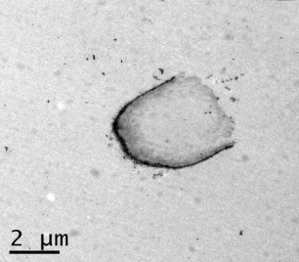
C.W
C.W

Figure 7.11 Transmission electron micrograph shows the morphology of C. lunatus (E) is control and (G) is treatment and Mucor sp (F) is control and (H) is treatment
Note the cell wall ( C.W) C. lunatus and Mucor sp. is damaged.

7.12 .External morphology of Cochliobolus lunatus and Mucor sp. observed by scanning electron microscopy (SEM). When treated by grinding and liquid nitrogen.
B
A

D
C

Figure 7.12 Scanning electron micrograph shows the morphology of C. lunatus (A) is control and (C) is treatment and Mucor sp (B) is control and (D) is treatment.
Note the hypha (C) in C. lunatus and Mucor sp.

7.13. Internal morphology of C. lunatus and Mucor sp. observed by transmission electron microscopy (TEM). When treated with liquid nitrogen.
E
F

G
H
C.W
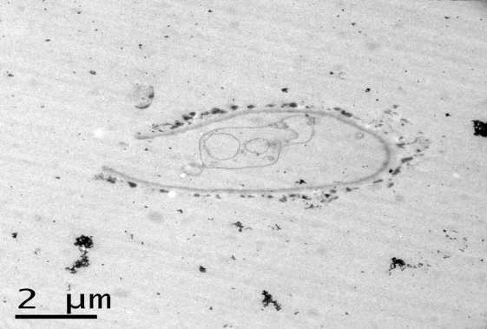
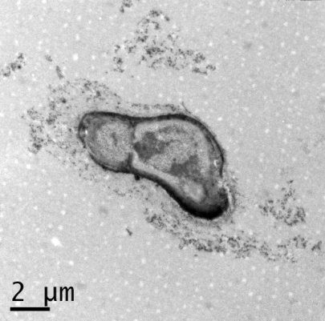

Figure 7.13 Transmission electron micrograph shows the morphology of C. lunatus (E) control and (G) treatment and Mucor sp (F) control and (H) treatment.
Note the cell wall ( C.W) in C. lunatus and Mucor sp. is damaged.
Appendix: B

Preparation of standard curves:
- Standard curve for Phosphate

In order to produce a calibration curve for phosphate –P, 1.48 g of sodium hydrogen phosphate (Na₂HPO₄) was dissolved in 1 L dH₂O to obtain 1000µg PO₄-Pml⁻¹. Then the solution was diluted 10 times (10 ml of sodium hydrogen phosphate solution with 90 ml of dH₂O) equivalent to 100µ g / PO₄-P ml⁻¹. This solution was finally diluted with dH₂O to produce 0,5,10,25,50,75 and 100 µg PO₄-Pml⁻¹. All solutions were analysed to determine the phosphate-P ions by using the colorimetric analysis of phosphate -P (Ajaj, 2005).

(2) Standard curve for sulphate-S
To produce a calibration curve for sulphate –S, 1.47 g of sodium sulphate (NaSO₄) was dissolved in 1 L dH₂O to obtain 1000µg SO₄²⁻-Sml⁻¹. Then the solution was diluted 10 times (10 ml of sodium sulphate solution with 90 ml of dH₂O) equivalent to 100µ g / SO₄⁻²-S ml⁻¹. This solution was diluted with dH₂O to produce 0,5,10,25,50,75 and 100 µg SO₄²⁻-Sml⁻¹. All solutions were analysed to determine the sulphate-S ions by using the turbidimetric analysis of sulphate-S (Hesse, 1971).

Standard curve for nitrate
To produce a calibration curve for nitrate, 1.37 g of sodium nitrate (NaNO₃) was dissolved in 1 L dH₂O to obtain 1000µg NO₃⁻-N ml⁻¹. Then the solution was diluted 10 times (10 ml sodium nitrate solution with 90 ml of dH₂O) equivalent 100µg / NO₃⁻-N ml⁻¹ This solution was diluted with dH₂O to produce solution 0,10,25,50,75, and 100 µg NO₃⁻-Nml⁻¹. All solution were analysed to determine the nitrate ions by using chromotropic acid method (Sims and Jackson, 1971).

(4) Standard curve for ammonium
To produce a calibration curve for ammonium ions, 3.66 g of (NH₄)₂SO₄ ammonium sulphate was dissolved in 1 L dH₂O to obtain 1000µg NH₄⁺-Nml⁻¹. Then the solution was diluted 10 times (10 ml ammonium sulphate solution with 90 ml of dH₂O) equivalent 100µ g NH₄⁺-Nml^{-1 .}This solution was diluted with dH₂O to produce solution 0,10,25,and 50 µg NH₄⁺-Nml⁻¹. All solutions were analysed to determine the ammonium ions by using indophenol blue method (Wainwright and Pugh, 1973).

Appendix (C)
Permission image



Primer ITS.
Oligonucleotide synthesis primer 18sr RNA ( ITS).
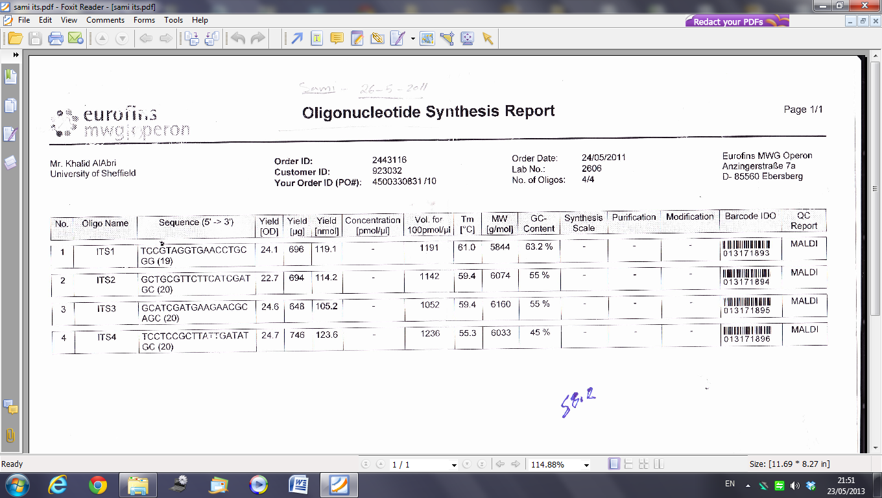

The identification of fungi.
1-Aspergillus oryzae strain SV/09-08 18S ribosomal RNA.
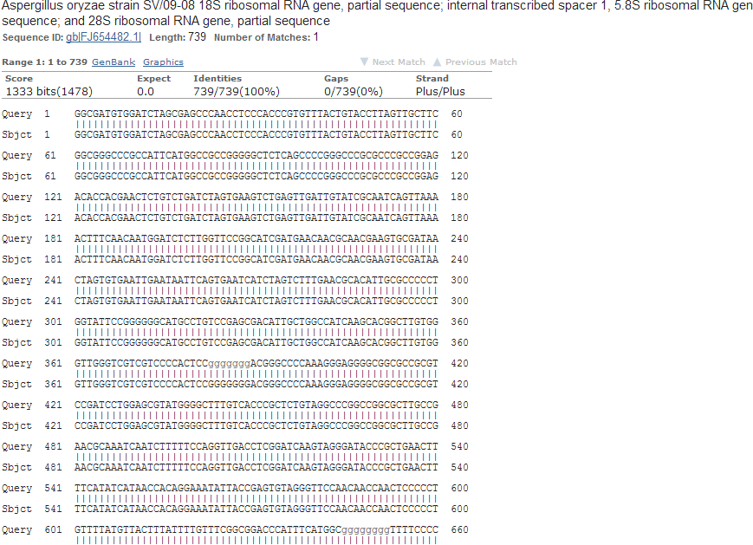

Distance tree of result of Aspergillus oryzae
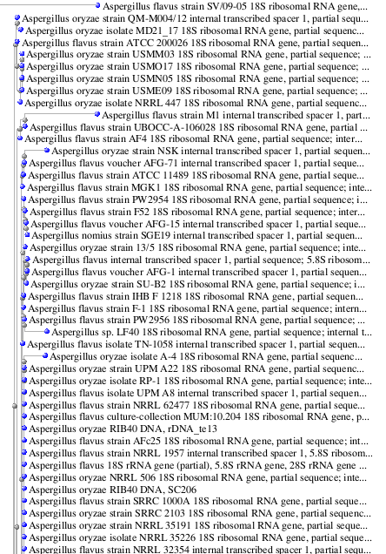

2-Cochliobolus lunatus
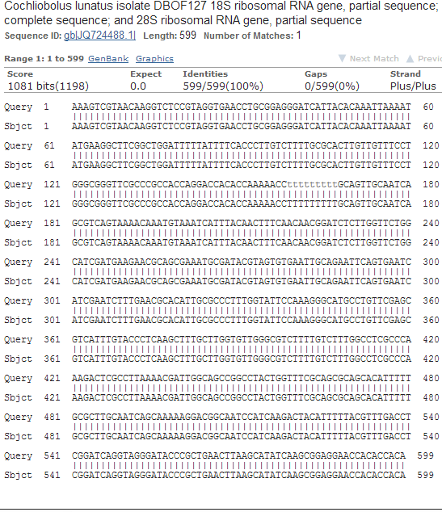

Distance tree of result of Cochliobolus lunatus

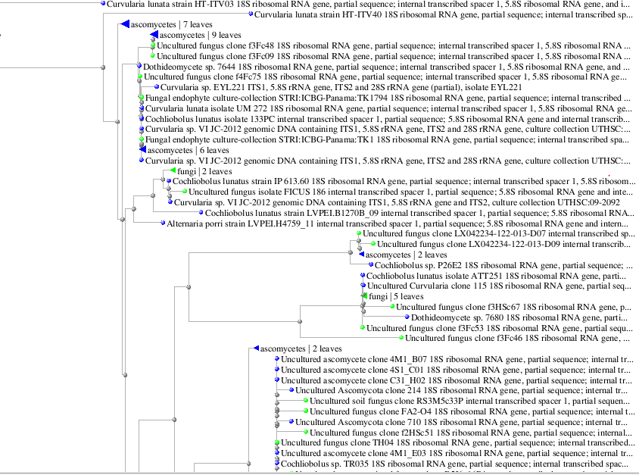

3--Penicillium daleae
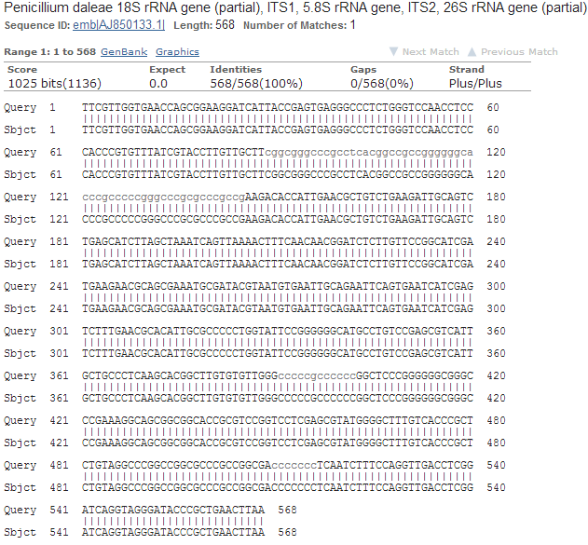

Distance tree of result of Penicillium daleae
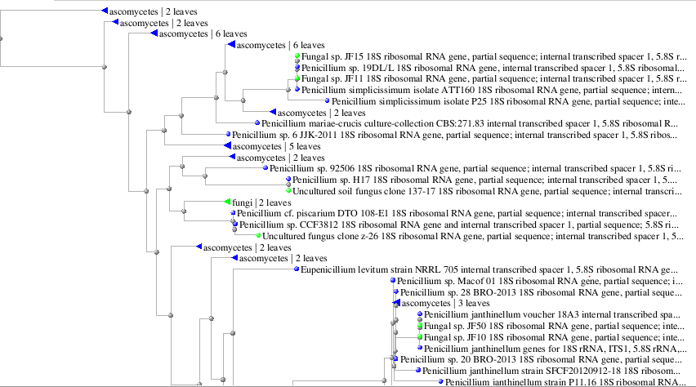

- Mucor sp. NFL5 18S ribosomal RNA gene.
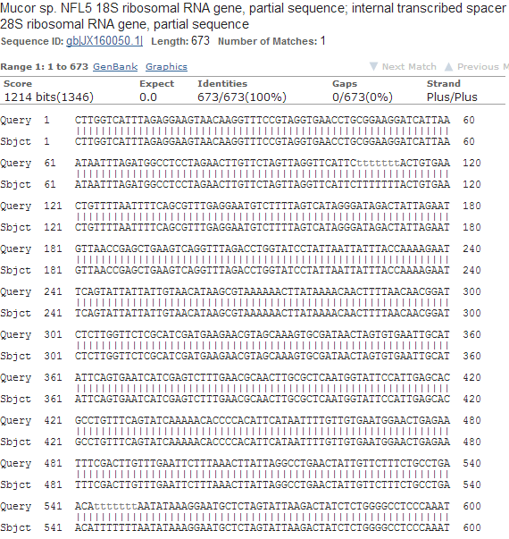

Distance tree of result of Mucor sp.
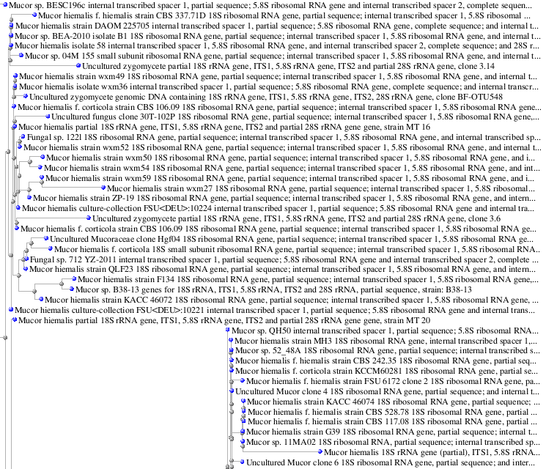

The identification of bacteria using 16S rRNA :
1-Cupriavidus necator strain ss1-6-6 16S ribosomal
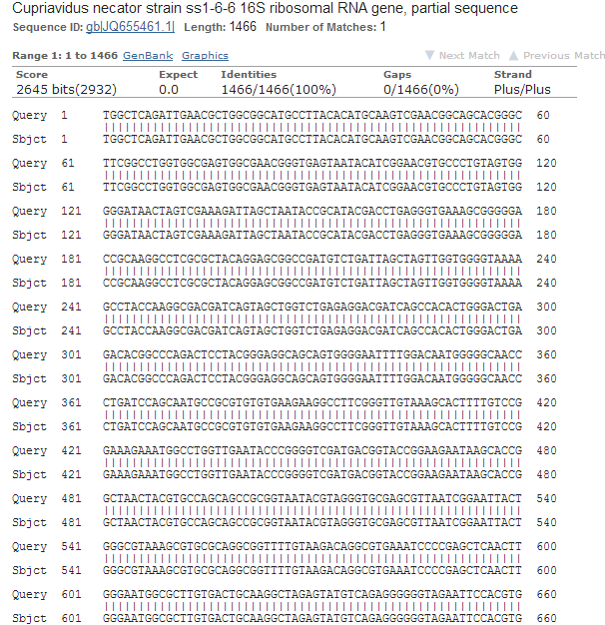

Distance tree of result of Cupriavidus necator
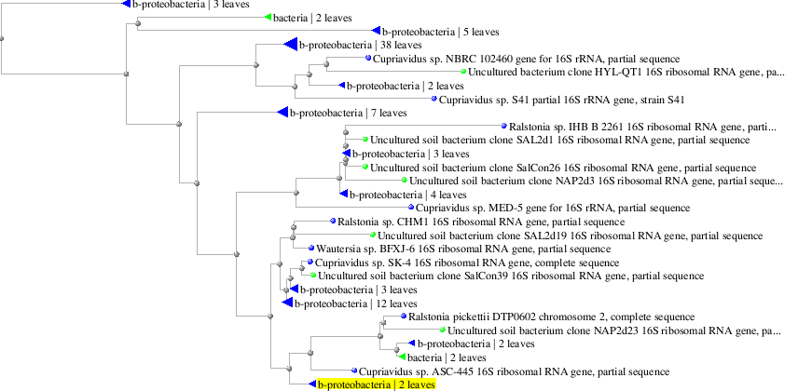

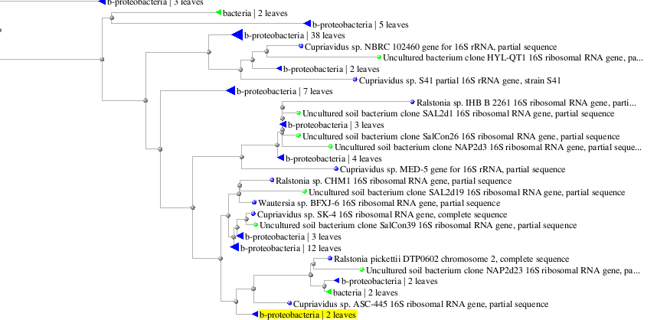 Top of Form

- Finch TV software
Top of Form
Top of Form
Top of Form
Top of Form
Top of Form
Top of Form
Top of Form
Top of Form

2-Top of Form
Bottom of Form
Top of Form
Bacillus megaterium
JQ897397.1 | 16S ribosomal RNA gene, partial sequence | 719 | 719 | 100% | 0.0 | 100%
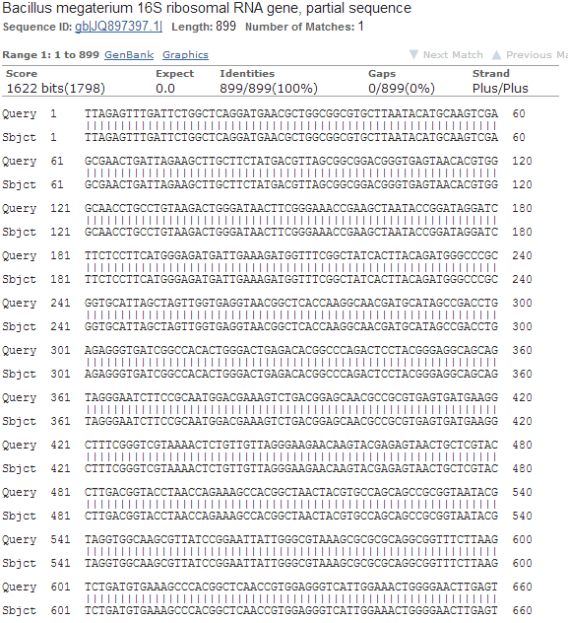

Distance tree of result of Bacillus megaterium

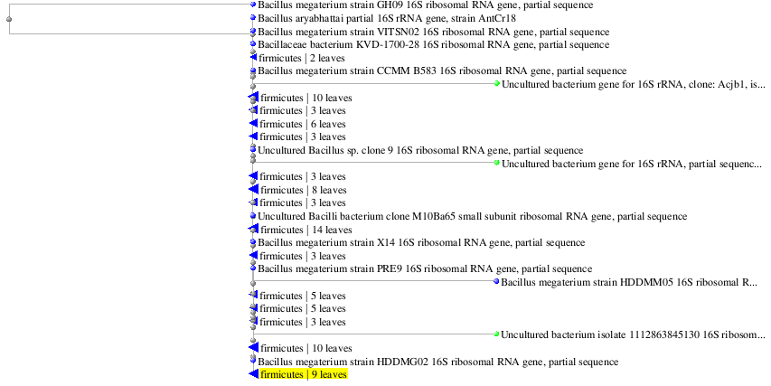

- Rhizobium sp.
WL12 partial 16S rRNA gene, isolate WL12 | 398 | 398 | 100% | 1e-107 | 100%
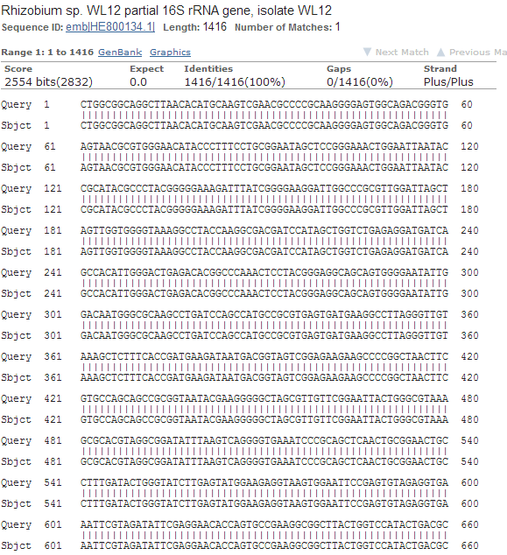

- Distance tree of result of Rhizobium sp.

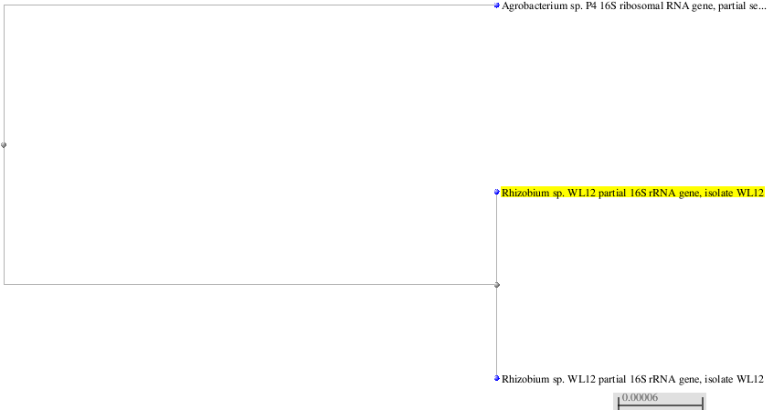

Statistics
All observations are presented as means ± SE (standard error). The data were analyzed by SigmaPlot© (Version11.0) and P < 0.05 was considered as significant.
Paired two or three samples t-test was performed to check whether means were significantly different.

- Tricalcium phosphate
Data source: Data 4 in Tribasic calcium phosphate

Group Name N Missing Mean Std Dev SEM
Row 1 3 0 130.171 2.278 1.315
Row 2 3 0 53.740 7.215 4.166

Difference 76.431

t = 17.496 with 4 degrees of freedom. (P = <0.001)

95 percent confidence interval for difference of means: 64.302 to 88.559

The difference in the mean values of the two groups is greater than would be expected by chance; there is a statistically significant difference between the input groups (P = <0.001).

Power of performed test with alpha = 0.050: 1.000

- Solublizition of phosphate

Penicillium sp.

Data source: Data 5 in total accunt B in jourdn

Group Name N Missing Mean Std Dev SEM
Row 1 3 0 2933.333 152.753 88.192
Row 2 3 0 200.000 57.735 33.333

Difference 2733.333

t = 28.991 with 4 degrees of freedom. (P = <0.001)

95 percent confidence interval for difference of means: 2471.568 to 2995.099

The difference in the mean values of the two groups is greater than would be expected by chance; there is a statistically significant difference between the input groups (P = <0.001).

Power of performed test with alpha = 0.050: 1.000

- Solublizaition of phosphate

Cochlioblus sp.

Group Name N Missing Mean Std Dev SEM
Row 1 3 0 2933.333 152.753 88.192
Row 2 3 0 200.000 57.735 33.333

Difference 2733.333

t = 28.991 with 4 degrees of freedom. (P = <0.001)

95 percent confidence interval for difference of means: 2471.568 to 2995.099

The difference in the mean values of the two groups is greater than would be expected by chance; there is a statistically significant difference between the input groups (P = <0.001).

Power of performed test with alpha = 0.050: 1.000

3-
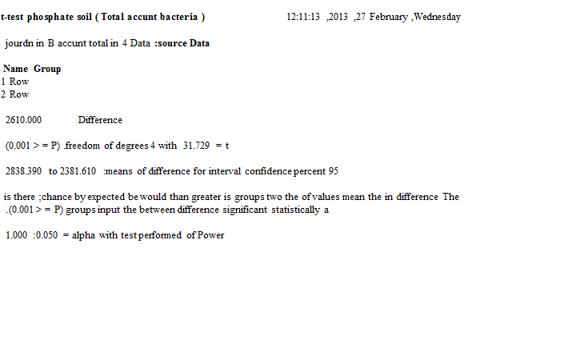

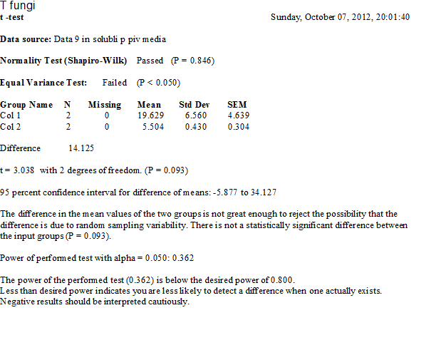

4 - : t test temperate grassland in silica 4 -12 -2012

Group Name N Missing Mean Std Dev SEM
Row 1 3 0 18.792 2.448 1.413
Row 2 3 0 44.581 5.245 3.028

Difference -25.788

t = -7.717 with 4 degrees of freedom. (P = 0.002)

95 percent confidence interval for difference of means: -35.067 to -16.510

The difference in the mean values of the two groups is greater than would be expected by chance; there is a statistically significant difference between the input groups (P = 0.002).

Power of performed test with alpha = 0.050: 1.000

t-test

5-Data source: Data 3 in SULPHATE V+ NCON SOIL 1 JORD

Group Name N Missing Mean Std Dev SEM
Row 1 3 0 15.137 3.444 1.988
Row 2 3 0 2.104 3.644 2.104

Difference 13.034

t = 4.503 with 4 degrees of freedom. (P = 0.011)

95 percent confidence interval for difference of means: 4.997 to 21.070

The difference in the mean values of the two groups is greater than would be expected by chance; there is a statistically significant difference between the input groups (P = 0.011).

Power of performed test with alpha = 0.050: 0.905

6-Data source: Data 3 in SULPHATE + NonV CON.

Group Name N Missing Mean Std Dev SEM
Row 1 3 0 37.659 2.712 1.566
Row 2 3 0 5.765 0.788 0.455

Difference 31.894

t = 19.562 with 4 degrees of freedom. (P = <0.001)

95 percent confidence interval for difference of means: 27.367 to 36.421

The difference in the mean values of the two groups is greater than would be expected by chance; there is a statistically significant difference between the input groups (P = <0.001).

Power of performed test with alpha = 0.050: 1.000

t-test

7-Data source: Data 3 in SULPHATE =CONTROL and phosphate soil

Group Name N Missing Mean Std Dev SEM
Row 1 3 0 94.136 5.379 3.106
Row 2 3 0 4.934 0.736 0.425

Difference 89.202

t = 28.457 with 4 degrees of freedom. (P = <0.001)

95 percent confidence interval for difference of means: 80.499 to 97.905

The difference in the mean values of the two groups is greater than would be expected by chance; there is a statistically significant difference between the input groups (P = <0.001).

Power of performed test with alpha = 0.050: 1.000

-test
8-Data source: Data 3 in urea =+ phosphate soil

Group Name N Missing Mean Std Dev SEM
Row 1 3 0 6.047 0.725 0.419
Row 2 3 0 4.357 0.543 0.313

Difference 1.690

t = 3.232 with 4 degrees of freedom. (P = 0.032)

95 percent confidence interval for difference of means: 0.238 to 3.142

The difference in the mean values of the two groups is greater than would be expected by chance; there is a statistically significant difference between the input groups (P = 0.032).

Power of performed test with alpha = 0.050: 0.641

9-Data source: Data 4 in urea in vegetated siol

Group Name N Missing Mean Std Dev SEM
Row 1 3 0 13.923 12.636 7.295
Row 2 3 0 4.182 6.727 3.884

Difference 9.742

t = 1.179 with 4 degrees of freedom. (P = 0.304)

95 percent confidence interval for difference of means: -13.205 to 32.688

The difference in the mean values of the two groups is not great enough to reject the possibility that the difference is due to random sampling variability. There is not a statistically significant difference between the input groups (P = 0.304).

Power of performed test with alpha = 0.050: 0.077

The power of the performed test (0.077) is below the desired power of 0.800.
Less than desired power indicates you are less likely to detect a difference when one actually exists. Negative results should be interpreted cautiously.

10-Data source: Data 3 in Urea in non-vegetated SOIL 2

Group Name N Missing Mean Std Dev SEM
Row 1 3 0 8.058 1.219 0.704
Row 2 3 0 5.138 1.125 0.650

Difference 2.920

t = 3.049 with 4 degrees of freedom. (P = 0.038)

95 percent confidence interval for difference of means: 0.261 to 5.580

The difference in the mean values of the two groups is greater than would be expected by chance; there is a statistically significant difference between the input groups (P = 0.038).

Power of performed test with alpha = 0.050: 0.587

Electron Microscope

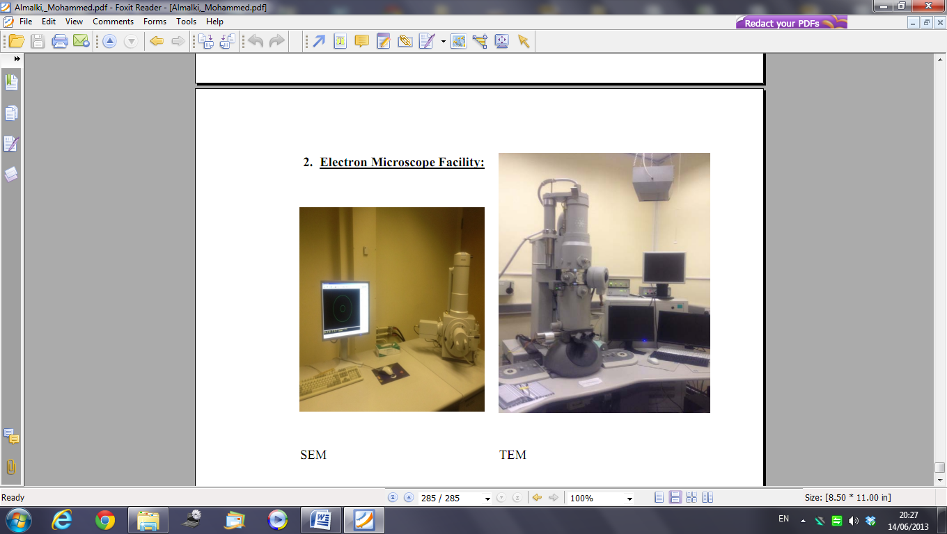
Images of the SEM TEM
used in these studies.

Image of NMR used in these studies

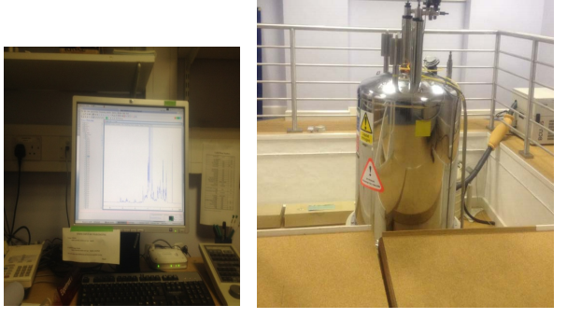
Bottom of Form
Bottom of Form
Bottom of Form
Bottom of Form
Bottom of Form
Bottom of Form
Bottom of Form
Bottom of Form
Bottom of Form
Bottom of Form

