Contents
- Introduction ………………………………………………………………………………………………………(5)
  - History of III-Nitride research …………..………………………………………………………….(5)
  - Background of semiconductors and group III-nitrides ………………………………….(7)
    - Direct and indirect band gap semiconductors ………………………………….(7)
    - Advantages of solid state lighting …………………………………………………….(8)
    - III-nitrides ………………………………………………………………………………….…….(9)
    - Substrates for the growth of GaN ………………………………………………….(10)
  - Research Objectives ………………………………………………………………………..………(11)
  - Thesis organization ……………………………………………………………………………..…….(13)
References …………………………………….………………………………………………………………..(14)

- Metal-organic Chemical vapour ………………………………………………….…………………..(16)
  - Main structure ……………………………………………………..…………………………………..(16)
    - Carrier gas lines …………………………………………..…………………………………(16)
    - Lower-carrier gas line/MO source bubbler …………..………………………..(18)
    - Upper carrier gas line/NH₃ ……………………………………..……………………..(20)
    - Close coupled showerhead (CCS) reactor ………………..…………………….(21)
  - Growth mechanism ………………………………………………………………..…………………(22)
    - Reactor flowing pattern ……………………………………………….………………..(22)
    - Chemical reaction ………………………………………………………………………….(23)
  - Operation and maintenance ……………………………………………..………………………(24)
    - Epitor controlling system …………………………………..………………………….(24)
    - Epitor growth recipe ………………………………………………………………………(25)
    - Temperature calibration …………………………………………….………………….(25)
  - Typical growth conditions of III-nitrides …………………………………….………………(26)
    - Conventional 2-step growth method ………………………………….………….(26)
    - In-situ laser monitoring system ……………………………………………………..(26)
    - Growth conditions for typical c-plane GaN ………………………….…………(28)
    - Growth conditions for typical Al_{x}Ga_{1-x}N/Al_{y}Ga_{1-y} MQW structure ….…..(28)
    - Growth conditions for typical InGaN/GaN MQW structure ……………(29)
References ………………………………………………………………………………………………..(30)

- Material characterisation and optical measurements …………………………….……….(31)
  - X-ray diffraction ………………………………………………………………………………………..(31)
    - Basic theory …………………………………………………………………………………..(31)
    - Wurtzite GaN crystal structure and planes …………………………………….(33)
    - Identification of parameters in XRD measurement ………………………..(35)
    - XRD measurements ……………………………………………………………………….(36)
  - Scanning electron microscopy (SEM) ……………………………………………………..…(40)
  - Atomic force microscopy (AFM) ………………………………………………………………..(41)
  - Photoluminescence (PL) measurement …..…………………………………………………(42)
    - Spontaneous emission: background ……………………………………………..(42)
    - Experimental setup ……………………………………………………………………….(44)
    - Temperature dependent PL …………………………………………………………..(46)
    - Power dependent PL ……………………………………………………………………..(46)
Reference ………………………………………………………………………………………(47)

- High temperature AlN buffer and stimulated emission of Al_{0.05}Ga_{0.95}N/Al_{0.16}Ga_{0.84} based MQW structure ……………………………………………………………………………………………….(48)
  - High temperature AlN buffer technology …….……………………………………………(49)
    - Initial state - nitridation and AlN nucleation layer ….……………………..(49)
    - Multiple Porous/flat high temperature AlN buffer layers ………………(52)
  - Background of stimulated emission ………………………………………………….……….(56)
  - Optical pumping measurement on Al_{0.05}Ga_{0.95}N/Al_{0.16}Ga_{0.84} MQWs …………………….(57)
    - Sample preparation ……………………………………….………………………………(57)
    - Experimental procedure ………………………………………………………………..(59)
    - Results and discussion …………………………………………………………………..(59)
  - Conclusions ……………………………………………….……………………………………………..(62)
Reference ……………………………………………………………………………………………………….(63)

- Study of optical gain in Al_{0.05}Ga_{0.95}N/Al_{0.16}Ga_{0.84} multiple quantum well (MQW) structures
  - Sample preparation ………………………………………………………..…………………………(64)
  - Amplified spontaneous emission (ASE) measurement ……………..……………….(65)
    - Theory and Methodology …………………………….………………………………..(65)
    - ASE spectra and gain spectra ………………………………..……………………….(66)
  - Reciprocal space mapping (RSM) measurements ………………………..…………….(68)
    - Methodology ………………………………………………………………………….……..(68)
    - Results ……………….………………………………………………………………………….(69)
  - Influence of strain on optical gain in Al_{0.05}Ga_{0.95}N/Al_{0.16}Ga_{0.84} MQW ……………………(70)
  - Influence of cavity orientation on optical gain for c-plane Al_{0.05}Ga_{0.95}N/Al_{0.16}Ga_{0.84} MQW ………………………………………………………………………………………………..………(71)
  - Conclusions ……………………………………………………………………………………….……..(72)
Reference ……………………………………………………………………………………………………….(73)

- Overgrowth of non-polar a-plane GaN ……………………………………………………………(74)
  - Introduction ……………………………………………………………………………………………..(74)
  - Methodology ……………………………………………………………………………………………(75)
    - Growth of non-polar a-plane template ………………………………………..(75)
    - Nano-rod template fabrication …………………………………………………….(76)
  - Overgrown non-polar GaN ………………………………………………..……………………..(77)
    - Growth methodology …………………………………….………………………………(77)
    - Structural properties ……………………………………………………………………..(78)
    - Optical properties …………………………………………………….…………………..(80)
  - Mechanisms of defect reduction due to the overgrowth ………………..………..(81)
  - InGaN/GaN MQWs grown on the overgrown a-plane GaN ……………..…………(85)
  - Conclusions ……………………………………………………………………………………………….(87)
Reference……………………………………………………………………………………………………….(87)

- Optical investigation of In_{x}Ga_{1-x}N/In_{y}Ga_{1-y}N MQW nanorods ……………………………………(89)
  - Introduction ……………………………………………………………………………………..………(89)
  - Sample preparation …………………………………………………………………………………..(90)
  - Strain relaxation in InGaN/GaN MQW nanorods ……………………………………..(91)
    - Methodology ………………………………………..………………………………………(91)
    - Results and discussion ……………………………………………………………………(91)
  - Optical properties of InGaN/GaN MQW nanorods …………….………………………(93)
  - Conclusions ……………………………………………………………………………………………….(98)
Reference ………………………………………………………………………………………………..……..(99)

- Conclusions ……………………………………………………………………….……………………….…(101)
Acknowledgement ………………………………………………………………………………………………..…(104)

Chapter 1
Introduction

Compound semiconductor Gallium Nitride (GaN) shows tremendous potential as optoelectronic devices. Over the last two decades, researchers all around the world have put great effort in studying GaN and its alloys. Incredible breakthroughs have been made in this area since the first report of GaN-based blue laser diode (LD) by Nakamura in 1998 .[1] Now the spectral range of GaN-based optoelectronic devices is spread out from pure green 500-530nm LEDs and LDs [2-5] to deep ultra-violet (DUV) 210nm light-emitting diodes (LEDs). [6] The investment on Nitrides is increasing rapidly year by year, as well as the number of institutes and researchers over the world.
This chapter will start with the history of Nitride research. Afterwards, the background of Group III-Nitrides semiconductors will be introduced, explaining the reason why the material is so attractive in terms of physical properties. The advantages and disadvantages of III-Nitrides as optoelectronics will be compared with other semiconductors subsequently. Finally, the research objectives and structure of this thesis will be outlined.

1.1 History of III-Nitride research
As early as in the 1930s, GaN was synthesized by Juza and Hahn. They passed ammonia (NH₃) over liquid gallium (Ga) at elevated temperature, achieving GaN in powder form. Their purpose was to study the crystal structure and calculate the lattice constants of GaN. [7] In the next few decades, people paid little attention to GaN due to lack of native GaN substrate so that no epitaxial growth was attempted.
It is not until 1968 that the growth of GaN started a new era. H. Maruska first grew GaN by hydride vapour phase epitaxy (HVPE) using sapphire as a substrate. At that time, group III element was transported as the monochloride, such as gallium chloride (GaCl), and ammonia (NH₃) was used as the source of group V element. As Maruska reviewed early German papers of GaN in the 1930s and 1940s, he chose the growth temperature of GaN to be less than 600°C in vacuum to prevent decomposition. [8] However, he found that in NH₃ environment, GaN had an impressive growth rate rather than decomposition, so he raised the growth temperature to 850°C and obtained single crystalline GaN film. [9] Better film quality was obtained when the growth temperature was raised to 950 °C.
At that time, undoped GaN had a high electron concentration which means that undoped GaN was also naturally n-doped. The most acceptable reason after a lot of discussions over years is that the n-type dopant comes from the nitrogen vacancy. In order to realize p-n junction by GaN material, it needs to find out the p-type dopant element next. It was also Maruska who found that Magnesium (Mg) is a suitable p-type dopant for GaN, and grew the first Mg-doped GaN LED by HVPE with an emitting wavelength at 430 nm in 1972. [10] His research results laid the basis of modern GaN-based LED.
In the late 1970s and 1980s, GaN was challenged in obtaining high crystal quality to meet the requirement of device fabrication and in finding conducting p-type GaN films. In 1989, I Akasaki discovered conducting p-type GaN films by performing low-energy electron beam irradiation on Mg-doped GaN during cathodoluminescence (CL) measurement in a scanning electron microscopy (SEM). The p-type Mg-doped GaN was approved by a Hall Effect measurement. It is believed that in Mg doped GaN, Mg:H bounds form which passivates the acceptor and prevents the material from being p-type conducting. [22] The energy of electron beam breaks the bound leaving Mg as a shallow acceptor. A photoluminescence (PL) measurement also indicated that the luminescence efficiency of Mg doped GaN had been improved by two orders of magnitude due to the low-energy electron beam irradiation. [11] Akasaki’s work was an important breakthrough that made it possible to realize high efficient GaN-based LEDs. In 1992, S Nakamura discovered a more simple method to obtain p-type GaN, that is, by annealing Mg-doped GaN in N₂ ambient at 750°C. [12]
Before the late 1980s, there is no well-developed growth technology for GaN to obtain good surface morphology. At that time, an AlN nucleation layer was grown between sapphire substrate and GaN at 1050°C typically. In 1986, H Amano reported that the surface morphology of GaN film was greatly enhanced by growing GaN on a thin low temperature AlN nucleation layer on sapphire substrate by metal organic chemical vapor deposition (MOCVD). [13] An optically flat and crack-free surface was obtained with the method. However, large lattice mismatch between low temperature AlN and the overlying GaN causes defect generation. In 1991, S Nakamura extended the concept to low temperature (450-600°C) GaN nucleation layer. [14] This was a great improvement compared to AlN nucleation layer, as low temperature GaN layer could prevent defect generation due to the large lattice mismatch between AlN and GaN.
The achievements obtained by Amano, Akasaki and Nakamura led to the possibility for the practical applications of III-nitrides as optoelectronics. Researchers gained new interest and understanding on the material, and new III-nitride theory and system were built up. In 1991, M. Khan firstly reported 2D electron gas formation in an AlGaN/GaN heterojunction grown by MOCVD on sapphire substrate. [15] Nakamura developed first high brightness blue LED in 1993 [16]. The multiple quantum well (MQW) structure of the blue LED is based on InGaN compound, which is prepared by two-flow MOCVD method. [17] This LED has output power 1500 μW at 20 mA forward bias current, and the external quantum efficiency (EQE) is 2.7 %. The turn on voltage of the device is as low as 3.6 V at 20 mA. In 1997, he demonstrated the first room temperature continuous-wave (cw) blue laser diode (LD) with a long life time. [1] The threshold current density was 7 kA/cm², and an output power of 5 mW was obtained at a current 120 mA. The life time of the LD is estimated to be 24 – 40 min.

1.2 Background of semiconductors and Group III-nitrides
Semiconductors are defined by their unique conductive behaviour, namely the band structure. Under normal conditions, electrons stay in the state of valence band, where the electrons are not energized to move freely. In this state, the semiconductor has high resistivity. However, in some specific conditions, electrons can be energized and excited into the conduction band, which results in a free electron in the conduction band and a hole in the valence band. The important physical property here is the band gap, which defines how ‘difficult’ an electron can be energized.

1.2.1 Direct and indirect band gap semiconductors
Generally, there are two types of semiconductors, the direct band gap and indirect band gap semiconductors. The definition of a direct band gap of semiconductors is that free electrons in the conduction band and the holes in the valence band have the same momentum as shown in figure 1.1.
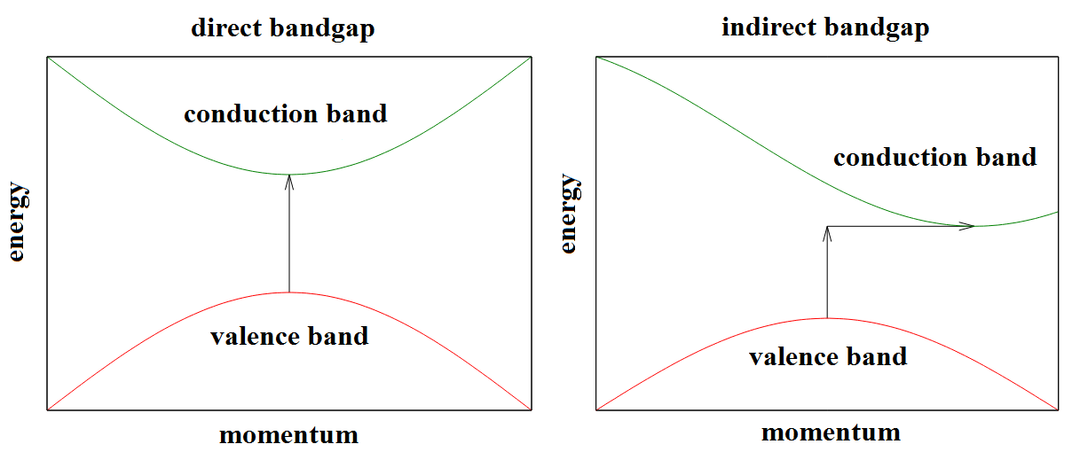
Figure 1.1 direct band gap and indirect band gap

The major difference between the two types of semiconductors with different band gap structure is that the recombination of electrons and holes in a direct band gap emits a photon. The recombination in an indirect band gap highly likely emits a phonon due to the change of momentum of electrons in the recombination process. Therefore, an important application of a direct band gap semiconductor has been developed in the field of optical electronics: by fabricating light emitting diodes (LEDs), which could be the next generation of lighting source.

1.2.2 Advantages of solid state lighting
Compared to the traditional incandescent and fluorescent lighting, solid state lighting has several advantages. First of all, the ideal energy transformation efficiency is very high. As discussed previously, a photon would emit by the recombination in a direct band gap semiconductor. Under the condition of perfect crystal of semiconductor, no phonons would emit which means no extra energy waste on heat generation compared to traditional incandescent lighting. Secondly, the lifetime of an LED is very long, which is expected to be around 25000 to 100000 working hours, much longer than both incandescent and fluorescent lighting. Finally, the wavelength of the emission from an LED can be selected by the energy band of the material. It can be calculated by formula 1.1:
$E=\frac{hc}{λ}$ (1.1)
where E is the band gap of semiconductor, h is the Planck’s constant (6.63×10⁻³⁴ J/s), c is the velocity of light (3×10⁸ m/s) and λ is the wavelength. By selecting the proper material, the whole visible spectra can be obtained with the solid state lighting as well as the white LED.

1.2.3 III-nitrides
Group III-V compounds are found to be suitable semiconductors for solid state lighting. Figure 1.2 shows the typical semiconductor materials for the fabrication of LEDs at room temperature. Group III-arsenics and group III-phosphorics LED and laser diode (LD) system have been well established. Molecular beam epitaxy is the most common method for the growth of GaAs and InP. They are both direct band gap semiconductor, which makes them perfect material for optoelectronic devices. However, as shown in figure 1.2, the band gaps of III-arsenics and III-phosphorics are quite small, although they are defined as wide band gap semiconductors. Their narrow band gap seriously limits the emission wavelength to be longer than red/infra-red region, which makes it far away from the realisation of solid state lighting.
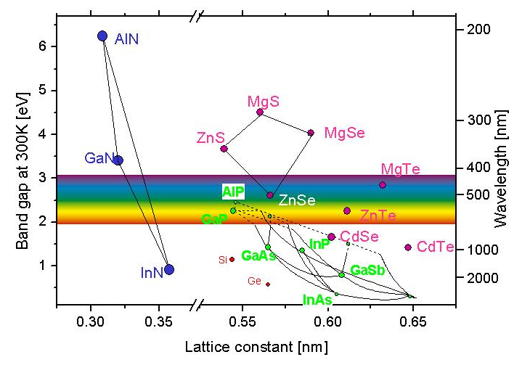
Figure 1.2 Band gap, emission wavelength and lattice constant of semiconductors at room temperature [18]

In the last two decades, III-Nitrides based semiconductors have attached significant attention as a promising material for developing light-emitting diodes (LEDs) and laser diodes. III-nitrides all have direct band gap, which makes them suitable materials for optoelectronics. III-Nitrides and their ternary alloys, Al_{x}Ga_{1-x}N and In_{x}Ga_{1-x}N, which have direct band gap between ~0.7 eV (InN) to 6.2 eV (AlN), covers the whole visible range along with ultraviolet and infrared as shown in figure 1.2. Since Nakamura reported the first GaN-based long-lived light emitting diode (LED) and blue laser diode (LD), GaN has attracted more and more attention and investment in the world wide range.

1.2.4 Substrates for the growth of GaN
III-nitrides are non-natural materials. So far, mass production of free-standing GaN substrate is still unavailable. Therefore, foreign substrates are still widely used for the growth of III-nitrides. A number of most common foreign substrates will be introduced: sapphire, silicon carbide (SiC) and Si. In addition, free-standing GaN substrate will be briefly discussed to compare to the foreign substrates.
Sapphire substrate
Traditionally, sapphire is the most commonly used substrate for GaN heteroepitaxy. Sapphire is an interesting choice because it is semi-insulating, it can withstand the required high growth temperatures, and it is relatively cheap (£25~50 for a 2 inch wafer). In addition, it is capable to produce larger sapphire substrates. By cutting sapphire substrates into different crystalline orientations, non-polar and semi-polar GaN can be grown. These properties make sapphire a valid substrate for scientific investigation and to be a potential substrate for mass production. However, its very low thermal conductivity (0.47 W/cmK at 300 K), large lattice mismatch (13% for c-plane sapphire) and large thermal expansion coefficient (TEC) mismatch (34%) with the GaN epilayers makes it a challenging choice for the high quality GaN epitaxy growth.
SiC substrate
6H-SiC has a wurtzite crystal structure and the basel-plane lattice constant (a = 3.073 Å) which is fairly close to that of GaN (a = 3.189 Å), giving the lattice mismatch reduced to 3.4 %. It also has a high thermal conductivity (3.7-4.5 W/cm×K at 300K). These properties makes SiC considered to be one of the most promising foreign substrate. However, the high price (~£500 for a 2-inch wafer) and low productivity limits the value of SiC substrate in establishing a mass production system.
Si substrate
Si is the cheapest substrates among the three most commonly used foreign substrates of GaN (~£10 for a 2-inch wafer). Beneficial from the highly-developed Si-based semiconductor industry, large size of Si wafers are available (12-inch). This makes Si attractive substrates in recent years as they can easily meet the requirement of mass production. However, Si has a cubic crystal structure, and the lattice mismatch is as large as 17 %, which makes it a great challenge for the growth of high quality GaN. In addition, the large thermal expansion coefficient (2.6×10⁻⁶ °C⁻¹) of Si causes serious cracking issue on the overlying GaN.
Free-standing GaN substrate
Homoepitaxial growth has major advantages compared to heteroepitaxial growth. GaN crystal with superior quality can be produced with massively reduced dislocation density compared to that grown on sapphire or SiC substrate. [19][20] Secondly, device fabrication is simplified as the substrate can be n-doped. Free-of-strain GaN can be obtained, which could effectively minimize the quantum efficiency reduction caused by the piezoelectric field. It is always expected that free-standing GaN substrate could be applied in the mass production of GaN. However, up to now, free-standing GaN substrate only appears in the area of scientific research of a few groups. The reasons are the extremely high price and the small size of free-standing GaN substrate.

1.3 Research objectives
Several technological difficulties need to be overcome for maximizing commercialization of GaN-based optoelectronics. Basically, there are two main directions forward: 1, to utilize the whole visible spectra; 2, to improve the optical efficiency. Currently, due to the difficulty of the growth of high In composition InGaN, the optical efficiency for long wavelength ( >500nm) decreases significantly. Figure 1.3 shows the external quantum efficiencies of LEDs in the recent years where the ‘green gap’ can be observed. [21]
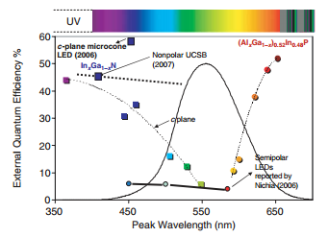
Figure 1.3 External quantum efficiency of the LEDs in the recent years [21]
On the other hand, AlGaN-based UV LEDs or LDs have applications in biological detection, biological imaging and disease analysis, so it is also important to push the emission wavelength of nitride devices toward deep UV. However, due to the tensile strain of high Al content AlGaN grown on GaN buffer layer, serious cracking issue occurred, which makes it difficult for the fabrication of deep UV emitters. Therefore, a new buffer technology is required for the growth AlGaN based multiple quantum wells (MQWs).
In terms of improving the optical efficiency, there are two directions to go. Firstly, the crystalline quality of buffer needs to be improved. The internal quantum efficiency (IQE) can be improved by simply reducing the non-radiative recombination rate which takes place between an electron and a defect. Secondly, by introducing non-polar and semi-polar GaN, the quantum confined stark effect (QCSE) can be minimized. Therefore, non-polar and semi-polar GaN are gaining more attraction than c-plane GaN.
In this work, three main subjects will be discussed. For c-plane GaN, a multiple high temperature AlN buffer on sapphire substrate is introduced to improve crystalline quality. The multiple AlN buffer consists of sereral pairs of porous/flat AlN layers grown under different conditions which can effectively reduce the dislocation density. Based on this buffer technology, high quality AlGaN MQWs are achieved and stimulated emission at 340 nm is observed. The material characteristics and optical properties will be studied in detail to understand the emission mechanism of the stimulated emission.
The second subject is to grow non-polar GaN on sapphire substrates. High quality non-polar GaN cannot be grown using traditional planar growth method applied to c-plane GaN. Therefore, we developed the growth technique to overgrow GaN on a non-polar nanorod template prepared by self-organized Ni nanomask. The dislocation blocking mechanism is studied by XRD and transmission electron microscopy (TEM). The optical properties of InGaN/GaN MQW grown on the overgrown GaN are studied, which is used to make comparison with the one grown on c-plane GaN.
The final subject is to improve the optical performance of InGaN/GaN MQWs by developing new device fabrication techniques. We fabricated InGaN/GaN MQWs into nanorod structure, and found the IQE of the MQWs is massively improved. By performing X-ray reciprocal spacing mapping (RSM) measurements and photoluminescence (PL) measurements, the relations between the strain induced QCSE and the optical properties are well understood.
1.4 Thesis organization
Chapter 2 and 3 introduce the experimental facilities and scientific methodologies used in this work. Chapter 2 describes the machine structure and growth mechanism of metal-organic chemical vapor deposition (MOCVD), as known as metal-organic vapor phase epitaxy (MOVPE). Typical growth recipes for III-nitrides are given as examples in this chapter as well. Chapter 3 explains the methodologies applied in this research related to material characterization and optical performance, including X-ray diffraction measurement (XRD), scanning electron microscopy (SEM), atomic force microscopy (AFM) and PL, etc.
Chapter 4 deals with the design and the growth of AlN buffer at high temperature and stimulated emission obtained from Al_{0.05}Ga_{0.95}N/Al_{0.16}Ga_{0.84}N MQWs based on such buffer. Firstly, this chapter talks about the optimization for the growth conditions of “multiple AlN buffer”. Stable Al- / Ga- polarity has been obtained and the crystalline quality has been improved by the high temperature AlN buffer. Two sets of Al_{0.05}Ga_{0.95}N/Al_{0.16}Ga_{0.84}N MQWs are grown based on two growth technologies, the “multiple AlN buffer” and “GaN interlayer”, respectively. Stimulated emission was observed with optical pumping measurements from both the samples grown by these technologies.
In chapter 5, studies of the optical properties of the Al_{0.05}Ga_{0.95}N/Al_{0.16}Ga_{0.84}N MQWs grown based on the two high temperature AlN buffer technologies where stimulated emission has been obtained are described. Amplified spontaneous emission (ASE) measurement is introduced to study the optical gain. The ASE measurements are taken along the anisotropic orientation, the a- and m- orientation. The gain spectra of the stimulated emission are plotted for the two samples and comparison has been made. In order to understand the emission mechanism, X-ray reciprocal space mapping (RSM) measurements are performed on the two samples. The in-plane lattice constants are calculated for both samples by drawing the reciprocal space maps and the strain relaxation in the two MQW structures has been compared. The emission mechanism is discussed with the data obtained.
Chapter 6 talks about the growth of non-polar GaN. A brief description about the growth of non-polar templates will be given firstly, followed by the fabrication procedure of the nanorod template. High quality non-polar GaN is next grown on the nanorod template and the high crystalline quality is demonstrated by X-ray rocking curve measurements. The growth mechanism will be discussed based on TEM and SEM images. The improved IQE of the InGaN/GaN MQWs grown on the non-polar overgrown GaN also confirms the improved crystal quality.
Chapter 7 compares the optical properties of as-grown and nanorod InGaN/GaN MQWs with emission in blue and green spectral region. It is found that the IQEs of the nanorod InGaN/GaN MQWs are significantly enhanced. The relations between the strain and the optical properties of the QWs are studied by X-ray RSM measurements and the PL measurements.
Chapter 8 gives the conclusions of all the work involved in this research thesis.

References
- S. Nakamura, M. Senoh, S. Nagahama, N. Iwasa, T. Yamada, To. Matsushita, Y. Sugimoto, and H. Kiyoku, Appl. Phys. Lett. 70, 868 (1997)
- Anurag Tyagi, Robert M. Farrell, Kathryn M. Kelchner, Chia-Yen Huang, Po Shan Hsu, Daniel A. Haeger, Matthew T. Hardy, Casey Holder, Kenji Fujito, Daniel A. Cohen, Hiroaki Ohta, James S. Speck, Steven P. DenBaars and Shuji Nakamura, Appl. Phys. Express 3, 011002 (2009)
- Miyoshi Takashi, Masui Shingo, Okada Takeshi, Yanamoto Tomoya, Kozaki Tokuya, Nagahama Shin-ichi and Mukai Takashi, Appl. Phys. Express 6, 062201 (2009)
- Avramescu Adrian, Lermer Teresa, Müller Jens, Eichler Christoph, Bruederl Georg, Sabathil Matthias, Lutgen Stephan andStrauss Uwe, Appl. Phys. Express 3, 061003 (2010)
- YoheiEnya, Yusuke Yoshizumi, Takashi Kyono, Katsushi Akita, Masaki Ueno, Masahiro Adachi, Takamichi Sumitomo, Shinji Tokuyama, Takatoshi Ikegami, Koji Katayama and Takao Nakamura, Appl. Phys. Express 2, 082101 (2009)
- Yoshitaka Taniyasu, Makoto Kasu and Toshiki Makimoto, Nature 411, 325 (2006)
- R. Juza and H. Hahn, Zeitschrift für anorganische und allgemeine Chemie 239, 282–287 (1938)
- M. R. Lorenz and B. B. Binkowski, J. Electrochem. Soc. 109, 24 (1962)
- H. P. Maruska and J. J. Tietjen, Appl. Phys. Lett. 15, 327–329, (1969)
- H. P. Maruska, W.C. Rhines, D.A. Stevenson, Mat. Res. Bull. 7, 777 (1972)
- H. Amano, M. Kito, K. Hiramatsu, and I. Akasaki, Jpn. J. Appl. Phys. 28, 2112 (1989)
- S. Nakamura, T. Mukai, M. Senoh, and N. Iwasa, Jpn. J. Appl. Phys. 31, 139 (1992)
- H. Amano, N. Sawaki, I. Akasaki, and Y. Toyoda, Appl. Phys. Lett. 48, 355 (1986)
- S. Nakamura, Jpn. J. Appl. Phys. 30, 1620 (1991)
- M. Khan, J. van Hoven, J. Kuznia, and D. Olson, Appl. Phys. Lett. 58, 2408 (1991)
- S. Nakamura, M. Senoh, and T. Mukai, Jpn. J. Appl. Phys. 32, 8, (1993)
- S. Nakamura, Y. Harada, and M. Senoh, Appl. Phys. Lett. 58, 2021 (1991)
- University of Ulm, “Lecture Notes in Optoelectronics, Scholz F.,” http://www-opto.e-technik.uni-ulm.de/lehre/cs/ (Accessed 16/09/2013)
- M. Mayer, A. Pelzmann, M. Kamp, K. J. Ebeling, H. Teisseyre, G. Nowak, M. Leszczynski, I. Grzegory, S.Porowsky, and G. Karczewski, Jpn. J. Appl. Phys. 36, 1634 (1997)
- F. A. Ponce, D. P. Bour, W. Götz, N. M. Johnson, H. I. Helava, I. Grzegory, J. Jun, and S. Porowsky, Appl. Phys. Lett. 68, 917 (1996)
- S. Nakamura, MRS Bulletin 34, 101 (2011)
- N. Vellas, C. Gaquière, A. Minko, V. Hoël, J. C. D. Jaeger, Y. Cordier, and F. Semond, IEEE Microwave and Wireless Components Letters, 13, 99, (2003)

Chapter 2
Metal-organic Chemical Vapour Deposition

In the last two decades, Metal-organic chemical vapour deposition (MOCVD), also known as metal-organic vapour phase epitaxy (MOVPE) has become standard method for the growth of III-Nitride materials. Low running cost, simple operation and suitability for mass production are the advantages of MOCVD. My work is majorly in the area of growth of GaN by MOCVD. In this chapter, the major components and flow chart of MOCVD will be firstly introduced. The growth mechanism in the reactor will also be explained. Finally, the operation and maintenance procedure will be discussed. The appearance of the MOCVD in our group is shown in figure 2.1.
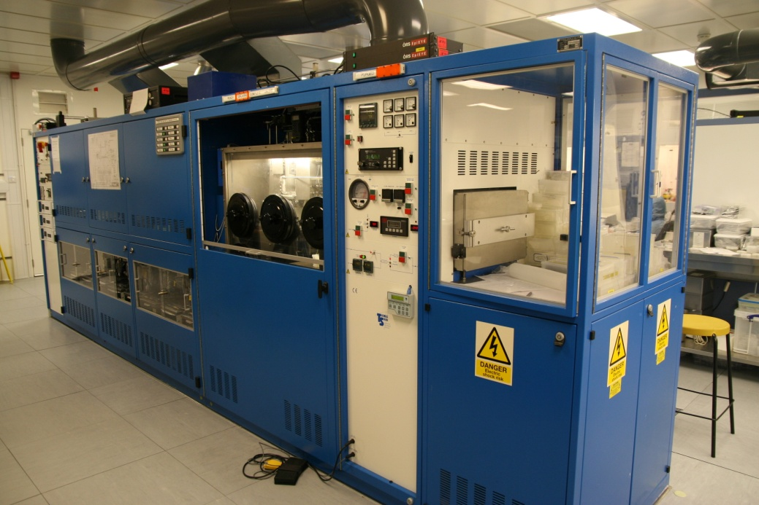
Figure 2.1 Appearance of MOCVD

2.1 Main structure
2.1.1 Carrier gas lines
MOCVD is a chemical vapor deposition method to produce crystalline structure. Differed from molecular beam epitaxy (MBE), the crystal growth is by chemical reaction rather than physical deposition, therefore the reaction would take place in gas phase at suitable pressure. The schematic diagram of the flow chart of MOCVD is shown in Figure 2.2.
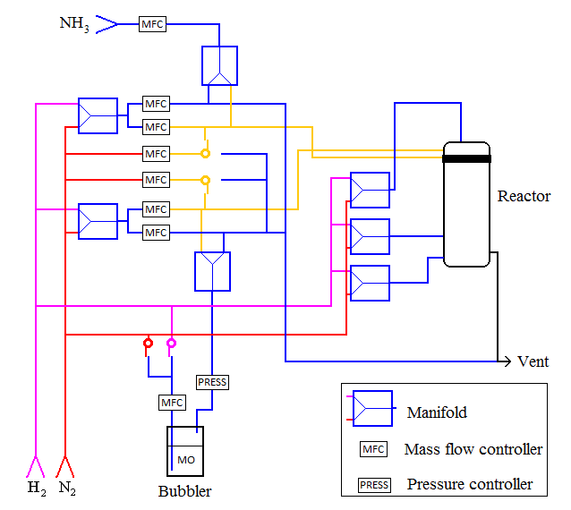
Figure 2.2 Schematic diagram of the flow chat of MOCVD

Figure 2.2 shows only the most important units of MOCVD. Solid lines stand for gas lines and different colours are used to highlight different carrier gases or destinations of the gas lines. The red line and the magenta line stand for N₂ and H₂ carrier gas, respectively. The two main carrier gas lines (yellow) carry MO source or NH₃ as precursors for the growth into the reactor where the upper carrier gas carries MO source and the lower carrier gas carries NH₃. Before the carrier gas carries any reactants, it must pass through a manifold. Manifolds are the units to switch on and off gas valves and to select the path of the gas flow. For standard growth of GaN or AlN, H₂ carrier gas is chosen. H₂ is purified by a palladium membrane H₂ purifier before flowing into the reactor. Figure 2.3 shows how the H₂ purifier works.
This unit makes use of the smallest atomic number of hydrogen, which forms H₂ molecule, the smallest gas particle in the world. By heating a thin palladium by up to 300°C, the monatomic H₂ is able to pass through crystal lattice of palladium while any other particles cannot. N₂ carrier gas is not as purified as H₂, but InGaN has a much faster decomposition rate than growth rate in H₂ environment at the growth temperature. Therefore, N₂ is chosen to be the carrier gas for the growth of InGaN.
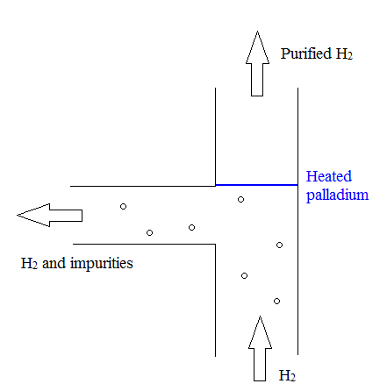
Figure 2.3 Palladium membrane H₂ purifier

Mass flow controllers work to control the flow rate in the gas line. Pressure controllers are used to change the setting pressure in the bubbler. Metal-organic (MO) source and NH₃ are the precursors for group III and V elements, respectively. Both reactants require H₂/N₂ carrier gas to carry them into the reactor, therefore two carrier gas lines are installed for the reactor, the upper carrier gas line and the lower carrier gas line. They are named after the import position at the showerhead. In other words, the upper carrier gas line goes through the upper showerhead plate and the lower carrier gas line goes through the lower showerhead plate. For each carrier gas line, a manifold is installed to switch the carrier gas between H₂ and N₂. Except for that, sometimes there is a complementary requirement of N₂ into H₂ carrier gas, therefore an additional alternative switch of N₂ supply for the carrier gas is installed as well.

2.1.2 Lower-carrier gas line/MO source bubbler
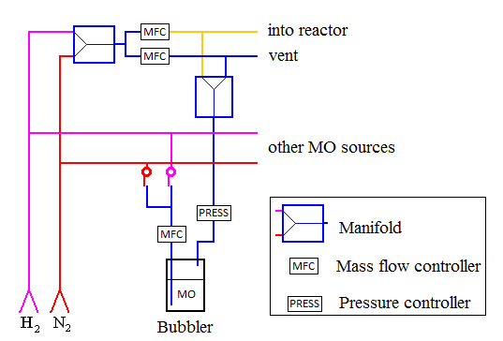
Figure 2.4 Schematic diagram of MO source bubbler

The Bubbler is the container of the MO sources. The schematic diagram of bubbler is shown in figure 2.4. For our growth of III-nitrides, there are 4 types of MO precursors, Trimethylgallium (TMGa), Trimethylalluminium (TMAl), and Trimethylindium (TMIn) and bis-cyclopentadienylmagnesium (Cp₂Mg). The molecular formulas of the precursors are listed in table 2.1.
TMGa | Trimethylgallium | Ga(CH₃)₃
TMAl | Trimethylalluminium | (Al(CH)₃)₃)₂
TMIn | Trimethylindium | In(CH₃)₃
Cp₂Mg | Bis-cyclopentadienylmagnesium | Mg(C₅H₅)₂
Table 2.1 Name and molecular formulas of the III-nitride precursors

TMGa, TMAl and Cp₂Mg are liquid while TMIn is solid at room temperature. For liquid MO source, the input tube is inserted to the bottom of the bubbler and the output tube is at the top of the bubbler (above liquid level of the bubbler when it is full). During the growth, carrier gas flows into the MO source and blows bubbles which contain MO molecules into the output of the bubbler. Meanwhile, the output tube of the bubbler is warmed up by thermal tape in order to secure the vapor status of the MO source. The flow rate of the MO source is controlled by the mass flow controller (MFC) at the input in the unit of standard cubic centimeter per minute (sccm). In order to calculate the V/III ratio for the growth of III nitrides, molar flow rate needs to be calculated. The molar flow rate of the MO source is determined by the bubbler pressure, temperature and is directly proportional to the MFC flow rate. The vapor partial pressure of MO source depends on the bubbler temperature, which can be expressed as following:
$P_{partial}={10}^{(a-\frac{b}{T})} torr$$P_{Partial}={10}^{(a-\frac{b}{T})} torr (1)$$P_{Partial}={10}^{(a-\frac{b}{T})} torr$ (2.1)
where a and b are constants for each MO source listing in Table 2.2.

Compound | P at 298K (torr) | A | B
TMAl | 14.2 | 10.48 | 2780
TEAl | 0.041 | 10.78 | 3625
TMGa | 238 | 8.50 | 1825
TEGa | 4.79 | 9.19 | 2530
TMIn | 1.75 | 9.74 | 2830
TEIn | 0.31 | 8.94 | 2815
Cp₂Mg | 0.05 | 10.56 | 3556
Table 2.2 vapor partial pressure constants of common MO precursors

According to ideal gas law, PV= nRT where P is the partial pressure of the bubbler, V is the volume, n is the number of moles, T is the temperature and R is the ideal gas constant 8.316 J/(mol*K). Hence the molar flow rate of the MO source can be calculated:
$∂n\left(MO\right)=\frac{P_{partial\left(MO\right)}}{RT}×∂V\left(MO\right)$ (2.2)
and
$∂V\left(MO\right)=\frac{P_{atm}}{P_{total}}×∂V(total)$ (2.3)
where $∂n(MO)$ and $∂V(MO)$ are the flow rate in mole and volume of MO precursors, P_{atm} and P_{total} are the atmospheric and bubbler pressure, respectively. For example, typical bubbler temperature for TMGa source is 0°C, so the partial pressure can be calculated using formula (1) P_{partial} = 67.9 torr. Knowing that the bubbler pressure is set at 1300 torr, by applying formula (2) and (3), the molar flow rate of TMGa can be calculated:
$∂n=2.33×{10}^{-3}\frac{mmol/min}{sccm}×∂V$$∂n=2.33×{10}^{-3}\frac{mmol}{min×sccm}×∂V$ (2.4)
The calculation of mol flow rate of MO precursors is widely used in the calculation of V/III ratio for the growth of III-nitrides by MOCVD.

2.1.3 Upper carrier gas line/NH₃
NH₃ is stored in a standard gas cylinder. Before NH₃ can be flown into the reactor as group V precursor, it must be purified by the NH₃ purifier. The mole flow rate of NH₃ can be simply calculated as:
$∂n= \frac{∂V}{V_{m}}$ (2.5)
where V_{m} is the molar volume 22.4L/mol at standard temperature and pressure.

2.1.4 Close coupled showerhead (CCS) reactor
A water-cooled showerhead design is the core of CCS reactor. The showerhead and the growing surface are very close but have uniform distance. Though the showerhead, group III V reactants are delivered into the reactor chamber separately and mixed shortly before they reach the growing surface due to the short distance between the showerhead and the growing surface. Due to the rotation of the growing surface, the reactant atoms diffuse radially resulting in good uniformity of the growth thickness. [1][2]
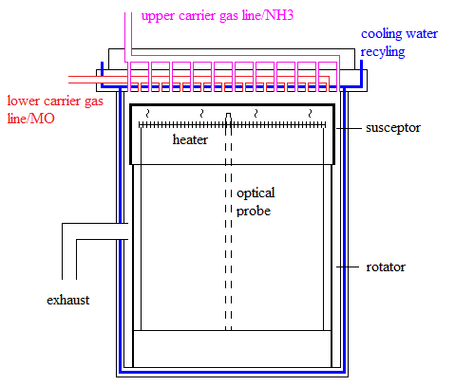
Figure 2.5 Schematic structure of a close-coupled showerhead reactor

A schematic diagram of a close coupled showerhead reactor is shown in figure 2.5. There are many channels to pass the group III/V precursors in both upper and lower showerheads. The channels are distributed uniformly on the showerhead. As shown in figure 2.5, both NH₃ and MO precursor, which pass through upper and lower showerhead respectively, go into the reactor chamber directly. The design of double showerhead is to avoid mixing NH₃ and group III precursor in the showerhead where the space is so small that resultant GaN may block the showerhead. It is also important to avoid early reaction happening in the space between the showerhead and the substrate, therefore low temperature is required to slow down the reaction. In order to realize this purpose, cooling water is recycled in the showerhead and sidewall of the reactor chamber. When the substrate is heated up to 1100°C, the temperature at the shower head is only around 200°C. Besides, cooling water could also reduce the temperature of the reactor chamber which provides a safe environment for the laboratory.
Wafers are placed on the susceptor during the growth. A susceptor is made of graphite due to the high thermal conductivity of the material. However, the reaction between graphite and NH₃ at high temperature needs to be avoided. Therefore, a thin SiC film is deposited on the susceptor which is physically and chemically stable under high temperature and NH₃/H₂ environment. The susceptor stands on a quartz-made glass well on the wafer rotator unit. Heater element is placed under the susceptor inside the glass well and is fixed in the reactor. An optical probe is installed below the susceptor as well. The function of this optical probe is to monitor the temperature of the susceptor. An exhaust line is also installed at the side of the reactor. In addition, H₂/N₂ purge lines, including optical purge, reactor purge and heater purge, are installed. Purge gas is used to keep blowing the core parts in the reactor during the growth at high temperature to keep them clean and protect them.

2.2 Growth mechanism
2.2.1 Reactor flowing pattern
For our 3-wafer LP-MOCVD reactor, the reactant vapor enters the reactor chamber vertically from the showerhead at the top. The gas flow turns 90° to the horizontal direction after hitting the susceptor, then the gas flows radially outward. Figure 2.6 shows the simulated flowing pattern of GaAs, which is similar to GaN in the MOCVD reactor with 1000 rpm rotation speed and 900 K surface temperature. [3] Finally, the exhaust gas flows out from a total number of 2 exhaust lines. [4]
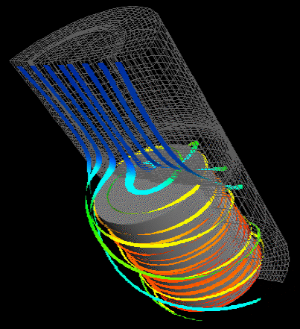
Figure 2.6 Simulated flowing patterns in a vertical reactor chamber of GaAs [3]

A number of processes are happening during the MOVPE deposition at the sample surface and above it. The majority of the reaction in the chamber can be described as following: Firstly, group III and V precursors decompose at high temperature into group III and V atoms. The substrate absorbs group III elements and the high temperature of the substrate provides the energy for the elements to migrate on the substrate. The group III elements then absorb N atoms to form the III-V chemical bonds. During the growth process, the decomposition process is also taking place due to high temperature and H₂ environment, but with a much lower rate compared to the absorption rate.

2.2.2 Chemical reaction
The basic thermodynamics of the GaN growth in MOCVD can be expressed by the following chemical equation:
${\left({CH}_{3}\right)}_{3}Ga+{NH}_{3}=GaN+3({CH}_{4})$ (2.6)
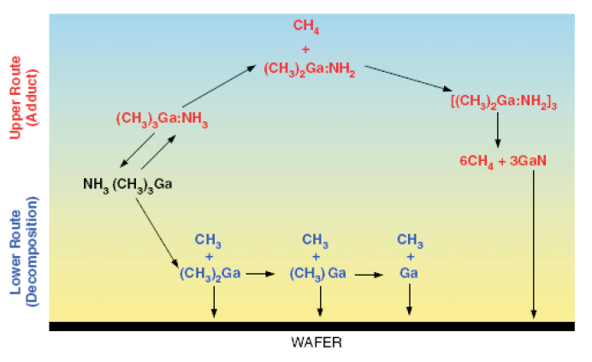
Figure 2.7 GaN chemical reactions in MOCVD growth process [5]

Figure 2.7 shows the GaN chemical reaction pathway in the CCS reactor chamber. At high temperature, TMGa and NH₃ decompose into Ga and N atoms. Ga atoms would migrate on the surface of the substrate, which abstract N atoms to form Ga-N chemical bonds. However, the reaction must take place only on the surface of the substrate, therefore two conditions need to be satisfied: 1, group III/V precursors shall not be mixed in the showerhead; 2, the temperature at the showerhead must be very low. As discussed in section 2.1.4, the reactor chamber is designed to satisfy the two conditions: the double showerhead can avoid the early contact of the III/V precursors, and the cooling water system can guarantee that the reaction will not take place in the showerhead.

2.3 Operation and maintenance
2.3.1 Epitor controlling system
The control for the growth by MOCVD is through the Epitor controlling system, which is a massive controlling system by controlling all the manifolds, mass flow controllers, pressure controllers, heater temperature, heater power distribution, and wafer rotating, etc. in one control panel. There are mainly two interfaces, including a growth interface and a manual interface. The growth interface only deals with several important parameters that are changed during the growth. Generally, there are four major areas need to be controlled in the growth interface.
The first area is the reactor chamber, including the heater temperature, zone settings, growth pressure and the wafer rotating speed. The wafer rotating speed is normally set at 100 rpm and the growth pressure is controlled by the reactor system pump. The heater temperature is set by the program, and thermal couple gives a feedback temperature to the system, and the computer pre-set PID feedback would set the power distribution to control the heater power.
The second area is the purges of the reactor, including optical purge, reactor purge and heater purge. Purges are used to blow the sensitive parts in the reactor during the growth to avoid damage caused by any contamination contact. The purges use H₂ gas normally. Sometimes optical purge and reactor purge use N₂ gas depending on the material that is growing, for example, InGaN. Since the heater is under the susceptor and isolated from the showerhead, the purge for heater is kept to be H₂.
The third area is the 2 main carrier gas lines, including the upper carrier gas line, lower carrier gas line and vent lines. All the lines can be switched between N₂ and H₂, and they are set to flow into the reactor automatically. Under standby condition, the flow rates of the carrier gas lines are low, normally between 500 sccm to 1000 sccm to keep purging the gas line and the reactor chambers. The fourth area commands the V/III precursors. The flow rate of the precursors are controlled by MFCs while the manifolds control the on/off status and which gas line (reactor/vent) the precursors flow to.

2.3.2 Epitor growth recipe
The growth condition in MOCVD is controlled by a pre-set recipe by Epitor recipe system. One recipe is made of 2 factors, the steps and the actions, and the time and actions are defined by all the parameters changed in each step. All the variables of the units mentioned in section 2.3.1 can be written in the recipe, including the switching between H₂/N₂ main carrier gas lines, flow rate of MFCs, manifolds status, setting temperature, zone settings, etc.

2.3.3 Temperature calibration
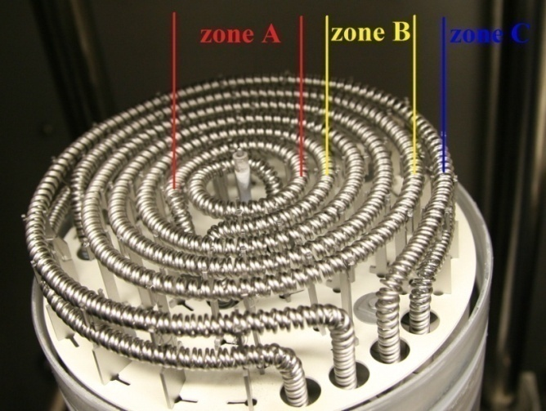
Figure 2.8 3-zone induction heater

For our reactor, a 3-zone induction heating system is introduced. As shown in figure 2.8, from inner coils to outer coils, the heater can be divided into zone A, B and C. The three zones are parallelly connected electrically, and each zone has their individual power transformer and power distribution controller. Zone C is designed as a double coil to gain extra power, as the most heating is contributed by zone C. The percentage of power distribution can be controlled by the zone settings.
The growth of GaN by MOCVD is extremely sensitive to the growth temperature, therefore it is important to supply high uniformity heating across the susceptor. Temperature calibration is a routine maintenance job for the growth by MOCVD. With the increase of number of growth, the deposition of nitride powders on the susceptor becomes so thick that would heavily influence the reproducibility of the growth. At that time the susceptor needs to be changed, and temperature calibration needs to be done, because the temperature uniformity is so sensitive to any minor change in the reactor. To do that, three calibrated optical probes are installed above the susceptor, regarding to the three zones of the susceptor. By setting a series of setting temperature and zone settings of the heater and reading the real temperature transmitted by the three optical probes to an external thermal couple, high uniformity of the temperature across the susceptor can be obtained. The temperature calibration needs to be done in both H₂ and N₂ ambient.

2.4 Typical growth conditions of III-nitrides
2.4.1 Conventional 2-step growth method
As mentioned in section 1.1, Amano introduced a thin AlN nucleation layer and atomically flat GaN surface was obtained. He used atmospheric pressure in horizontal reactor for the growth of such samples. Firstly, a 50nm thick AlN layer was deposited on (0001) sapphire substrate at 600°C. An undoped GaN layer was grown on the AlN layer at 1030°C. The thin AlN layer was grown in a 3D model due to low temperature. The overlying GaN layer laterally grew on these 3D islands, and finally coalesced with smooth surface. [6]

2.4.2 In-situ laser monitoring during growth
During the growth, an in-situ monitoring system is required to monitor the growth process. Three different lasers at 405nm, 635nm and 950nm were shined on to the surface of the wafers vertically, and the reflected laser is detected. According to the Bragg’s Law
(2.7)
the intensity of the reflected laser is oscillating according to the thickness of the epitaxial film, where the maximal intensity will be obtained with the constructive interference while the minimal intensity will be obtained with the destructive interference. The in-situ lasing monitoring system has two functions. The first function is to monitor the in-situ status of the sample during growth. For example, figure 2.9 (a) shows a typical reflectivity of GaN grown on high temperature AlN layer. The curve was drawn by the reflection of 635nm red laser. The x-axis represents the time axis in second during and y-axis is the percentage of the red laser reflected by the sample surface. The magnitude of the reflectivity stands for both AlN and GaN layers are generally quite stable. In this case, it can be judged that the GaN has a stable Ga-face. Figure 2.9 (b) shows a reflectivity of GaN grown on high temperature AlN layer as well. However, the reflectivity of both GaN and AlN layers rapidly falls as the layer grows. A drop in the reflection of the laser represents a roughened surface because scattering occurs in many directions for a rougher surface. This roughening is due to the N-polarity of the growth.
The second function of the in-situ monitoring system is that the growth rate of GaN layer can be calculated. According to Bragg’s Law (2.7), constructive interference occurs when a certain thickness of material is grown. Using GaN layer as an experience, incident in-situ laser beam is perpendicular to the surface of the sample, therefore the minimal period of constructive interference at
$d=\frac{}{2n}$ (2.8)
where n (=2.39907) is the refractive index of GaN layer and λ is the wavelength of the in-situ laser. The thickness for one period of oscillation of the reflectivity by 635nm can be calculated 132 nm per period. By counting the time for each period of oscillation, the growth rate of GaN layer can be calculated.
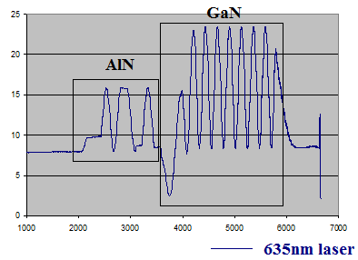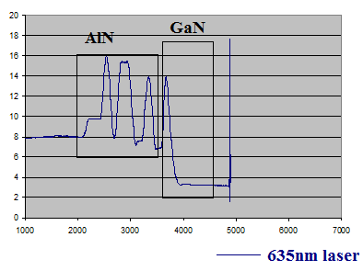
Figure 2.9 GaN layer grown on high temperature AlN buffer layer with (a) a constant reflectivity and (b) a fast degrading reflectivity
2.4.3 Growth conditions for typical c-plane GaN
In our group, GaN is grown based on high temperature AlN buffer. The AlN layer is grown under a pressure 65 torr. Prior to the growth, the sapphire substrate is annealed in H₂ ambient at 1200°C for 5 mins. Subsequently, TMAl is flown into the reactor without NH₃ supplied for 9 sec with a flow rate of 0.5496 mmol/min at 1200°C. The function of TMAl pre-flow is to secure the Al-polarity of the sample. The AlN layer is then grown at 1200°C with a V/III ratio of 9.74. Normally, the growth temperature of AlN is set to be the highest growth temperature allowed by the heater. This is due to the crystal quality of AlN improves with the increase of growth temperature. The total thickness of the AlN layer is 500nm. Subsequently, GaN layer is grown on the AlN layer at 1130°C and 175torr, which are the typical growth conditions of GaN. The V/III ratio is 1300 and the TMGa flow rate is 0.2007 mmol/min. Under such conditions, the growth rate of GaN is around 5.8 Å/sec.

2.4.4 Growth conditions for typical Al_{x}Ga_{1-x}N/Al_{y}Ga_{1-y}N MQW structure
The growth temperature of the AlGaN layer is between that of the AlN and GaN layers. Unlike the thick AlN or GaN buffer layers, the thickness of QW or barrier is less than 20nm, which makes it impossible to calculate accurate thickness and growth rate by in-situ laser monitoring system. The Al_{x}Ga_{1-x}N/Al_{y}Ga_{1-y}N MQW structure is grown in H₂ ambient. An example of the growth condition of Al_{x}Ga_{1-x}N/Al_{y}Ga_{1-y}N MQW is given as shown in table 2.3.
Number of Repeation | Time (sec) | Temperature (°C) | Pressure (torr) | TMAl  flow rate  (sccm) | TMGa flow rate  (sccm)
 | 20 | 1165 | 75 | 35 | 40
10 | 10 | 1165 | 75 | 15 | 20
 | 20 | 1165 | 75 | 35 | 40
Table 2.3 Growth conditions of Al_{x}Ga_{1-x}N/Al_{y}Ga_{1-y}N MQW

The Al composition is normally controlled by changing the TMGa/TMAl flow rate during the growth of MQW structure. The thickness of the QW/barrier and the ternary alloy composition are normally estimated by X-ray measurements or PL measurements for any MQW structures.
2.4.5 Growth conditions for typical InGaN/GaN MQW structure
Same as Al_{x}Ga_{1-x}N/Al_{y}Ga_{1-y}N MQW structure, the thickness of InGaN/GaN MQW structure cannot be calculated by in-situ laser monitoring system. However, InGaN can only be grown in N₂ ambient. The growth temperature for InGaN is very low, and the In composition is also very sensitive to the growth temperature. Therefore, the In composition is normally controlled by changing the growth temperature of the QW. An example of growth condition of InGaN/GaN MQW structure is shown in table 2.4.
Number of Repeation | Time (sec) | Temperature (°C) | Pressure (torr) | TMIn  flow rate  (sccm) | TMGa  flow rate  (sccm)
 | 100 | 825 | 250 | - | 10
10 | 20 | 825 | 250 | 200 | 10
 | 100 | 825 | 250 |  | 10
Table 2.4 Growth conditions InGaN/GaN MQW structure

As shown in table 2.4, the growth temperature of InGaN QW is only around 800°C which is much lower than GaN layer, leading to worse crystal quality of the GaN barrier. To minimize this effect, a modified growth condition is used for the growth of InGaN/GaN MQW structure as shown in table 2.5.
Number of Repeation | Time (sec) | Temperature (°C) | Pressure (torr) | TMIn  flow rate  (sccm) | TMGa  flow rate  (sccm)
 | 100 | 880 | 250 | - | 10
10 | 20 | 825 | 250 | 200 | 10
 | 20(*) | 825 | 250 |  | 10
 | 110 | 880 | 250 |  | 10
Table 2.5 Modified growth condition of InGaN/GaN MQW structure

As shown in table 2.5, the growth temperature of GaN barrier is higher than the InGaN QW which can effectively improve the crystal quality of GaN barrier layer. The * marked 20 sec low temperature GaN barrier is grown right after the growth of InGaN QW in order to protect the InGaN layer from decomposition due to increased temperature. Normally the PL intensity from such InGaN/GaN MQW structure is enhanced compared to standard MQW structure.

References
- C. Martina, M. Dauelsberga,, H. Protzmanna, A.R. Boydb, E.J. Thrushb, M. Heukena, R.A. Talalaevc, E.V. Yakovlevd and A.V. Kondratyev, J. Cryst. Growth 303, 318 (2007)
- E.J. Thrush, A.R. Boyd, in: Z.C. Feng (Ed.), “III-Nitride Semiconductor Materials”, (Imperial College Press, London) pp. 73–116 (2006)
- Sandia National laboratories, http://www.cs.sandia.gov/CRF/MPSalsa/ (Accessed 01/09/2013)
- P. Gibart, Rep. Prog. Phys. 67, 667 (2004)
- R. Parikh and R. Adomaitis, J. Cryst. Growth 286, 259 (2006)
- K. Hiramatsu, S. Itoh, H. Amano, I. Akasaki, N. Kuwano, T. Shiraishi and K. Oki, J. Cryst. Growth 115, 628 (1991)

Chapter 3

Material characterization and optical measurements

In this chapter, various scientific methods are introduced to study structural and optical properties of III-nitrides. Scanning electron microscopy (SEM), and atomic force microscopy (AFM) measurements are performed to study the surface morphology of III-nitrides, while X-ray diffraction measurement is to study the crystalline structure. To study the optical properties, photoluminescence (PL) measurement is the standard method. In advance, stimulated emission measurement by using optical pumping setup will be emphasized in this chapter.

3.1 X-ray diffraction
3.1.1 Background
X-rays are electromagnetic waves which have wavelengths within the range 0.01 to 10 nm. X-ray is generated by high speed electrons bombarding on a metal where the electrons are generated from hot cathode and accelerated in a high voltage vacuum tube. [1] In the field of crystallography, copper (Cu) is the common metal used and the x-ray generated from which has an emitting wavelength 0.154 nm.
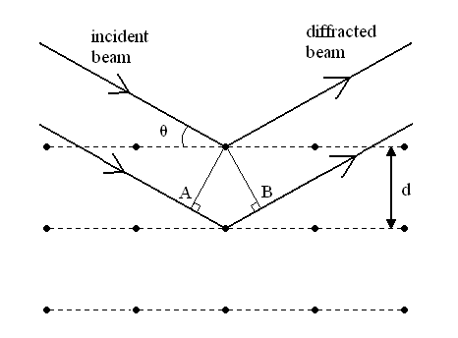
Figure 3.1 the crystalline structure acts as a 3D grating in x-ray diffraction

X-ray diffraction (XRD) is widely used since the wavelengths of x-rays are close to crystal lattice constants. When an x-ray beam is incident on a crystalline structure, the lattice acts as a 3D grating as shown in Figure 3.1.
Considering that an incident x-ray beam is reflected by 2 parallel lattice layers in the crystal, maximal intensity of diffracted beam can be obtained when constructive interference occurs. In figure 3.1, the path x-ray traveling between AB (2dsinθ) must be equivalent to integral multiple of the wavelength of the x-ray beam (nλ) so that the constructive interference would occur. This is known as the Bragg’s Law which can be described as the following equation:
(3.1)
Each set of diffraction plane would produce a diffraction spot inversely related to the distance between crystal planes. The diffraction spots form a 3D reciprocal lattice in a reciprocal space, compared to the real space associated with the crystal lattice. [2] The reciprocal space of GaN is shown as an example in figure 3.2. The reciprocal space converts a 3D crystal space into a 2D map expressing the relationship between crystal planes and lattice constants.
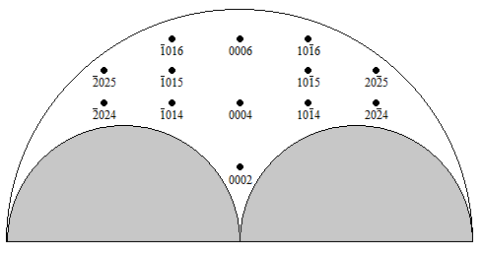
Figure 3.2 the reciprocal space of GaN crystal

The outer limit of the reciprocal space is determined by the wavelength of the x-ray and the angle ω (defined in figure 3.7). Regions in the grey area cannot be detected because either the incident or the diffracted x-ray beam is blocked by the sample. For each reciprocal lattice point (RLP), the location on the vertical axis is associated with the out-of-plane lattice constant while the location on the horizontal axis is associated with the in-plane lattice constant. Therefore, the x-ray measurement can be used to measure the crystal layer structure and ternary alloy composition by locating the RLP.

3.1.2 Wurtzite GaN crystal structure and planes
III-nitrides have two forms of crystal structures, wurtzite and zinc-blende. The formation of different crystal structures of III-nitrides depends on the substrate and growth condition. The crystal structures of wurtzite and zinc-blende GaN are shown in figure 3.3.
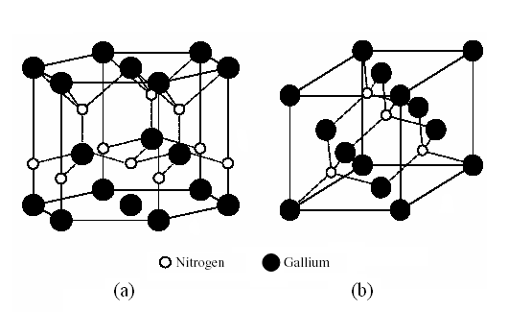
Figure 3.3 (a) wurtzite GaN and (b) zinc blende GaN

The wurtzite GaN has a hexagonal crystal structure. Miller index defines that two lattice constants are needed to define a hexagonal lattice as shown in figure 3.4. The in-plane lattice constant a is defined as the distance between the two atoms at the side of hexagonal plane and the out-of-plane lattice constant c is defined as the distance between the two same atoms perpendicular to the hexagonal plane. Miller index can be used to define both crystal orientation and the crystal plane in a lattice. An example of bracketing conversions used in XRD is shown in table 3.1
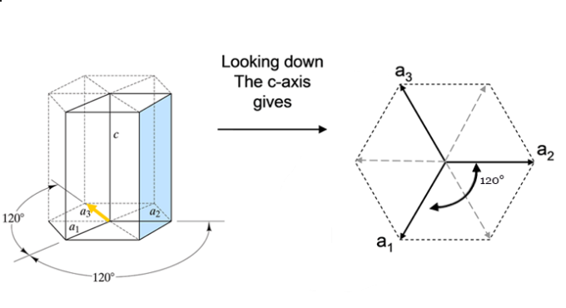
Figure 3.4 in-plane lattice constant (a) and out-of-plane lattice constant (c) in a hexagonal lattice

Three-index notation | Four-index notation | Meaning
(002)  (102) | (0002)  (10-12) | Plane
[002]  [102] | [0002]  [10-12] | Direction
Table 3.1 Bracketing conversions to differ crystal planes and directions in XRD

For a hexagonal lattice, any plane or direction can be defined by either three-index or four-index notations. For a four-index notation, the first three digits are the reciprocal of three vectors in the hexagonal plane a₁, a₂ and a₃, while the 4th digit is the reciprocal of the vector c. For convenience, 4 crystal planes are named after c-, a-, and m-planes in GaN crystal as shown in figure 3.5.
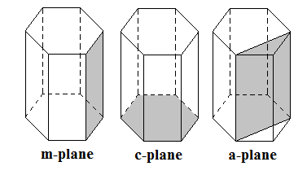
Figure 3.5 crystal planes in a hexagonal lattice

The miller index of c-, a-, m- and r-plane in a hexagonal lattice are listed in table 3.2.
 | Four-index notation | Three-index notation
c-plane | (0001) | (001)
a-plane | (11-20) | (110)
m-plane | (10-10) | (100)
r-plane | (11-22), (10-15), (20-21) etc. | (112), (105), (201) etc.
Table 3.2 Miller index of c-, a, m- and r-plane

Here, c-, a- and m-planes have one equivalent plane in the hexagonal lattice, while many r-planes can be found, since any crystal plane that is neither 0° nor 90° to the c-plane can be defined as an r-plane.

    - Identification of parameters in XRD measurement
Since the exit of the x-ray from the generating vacuum tube is a simple hole, the direction and the wavelength are not selected for the x-ray beam, which has no high resolution for XRD measurement. Therefore, x-ray beam is firstly selected by a double crystal monochromator. Figure 3.6 shows the schematic structure of the double crystal monochromator.
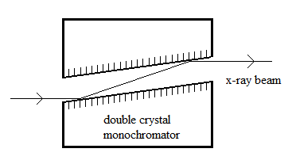
Figure 3.6 double crystal monochromator for the x-ray beam

In the monochromator, there is a very thin channel for the selection of the x-ray. After alignment, the crystal acts as a 3D grating which filters the direction and the wavelength of the x-ray beam for high resolution measurement.
Figure 3.7 shows a photo and the top view of experimental setup of our Bede D1 x-ray diffractometer, which means the sample stage is perpendicular to the paper plane.
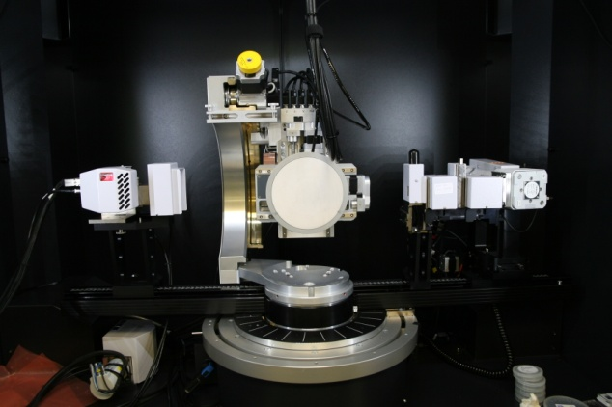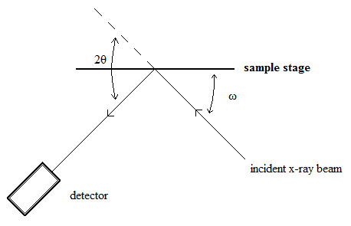
Figure 3.7 a photo and top view of basic setup of x-ray diffractometer setup

Experimentally, the x-ray generation vacuum tube is fixed, and the sample stage and the detector can be moved freely. The angle between the incident x-ray beam and the sample stage is called ω and the angle between the incident and reflected beam is called 2θ.
Except for the ω and 2θ angle, there are several definitions of angles for the sample stage as shown in figure 3.8.
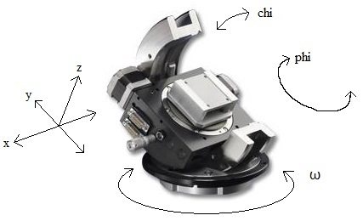
Figure 3.8 definition of angles of the sample stage in X-ray diffractometer

X, y and z are the 3D movement axes of the sample stage, where y is the vertical axis, and x (left and right) and z (forward and backward) are the horizontal axes. Chi is the rotation of the sample stage using x-axis as the rotating shaft. Phi is the rotation of the sample stage using z-axis as the rotating shaft.

    - XRD measurements
Rocking curve measurement (ω scan)
Theoretically, at only one specific angle diffracted emission peak from a perfect crystal by XRD measurement. However, the diffraction peak would be broadened due to several reasons. The most key reason is that the defects in the crystal, leading to the tilted angle of the Bragg’s angle. Therefore, the standard rocking curve measurement is introduced to estimate the defect density. During the scan, the detector remains stationary and the sample stage is rotating around the ω axis. Based on the Bragg’s Law, the incident angle ω can be calculated:
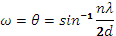 $ω=θ=\sin^{-1}{\frac{nλ}{2d}}$ (3.2)
A Gaussian curve would be obtained by the measurement and the full-width at half maximum (FWHM) of the curve can be used to estimate the defect densities.
Burgers vector is applied to represent the magnitude and the direction of different types of dislocations. [2] As shown in figure 3.9, assuming in a crystal structure without dislocation, one can draw a rectangular as a unit cell. If any dislocation is found in the crystal, there would be an additional vector from the rectangular unit cell. This vector is the Burgers vector of the dislocation. When the Burgers vector is parallel to the rectangle plane, the dislocation is edge dislocation (top right of figure 3.9). When the Burgers vector is perpendicular to the rectangle plane, the dislocation is screw dislocation (bottom right of figure 3.9).
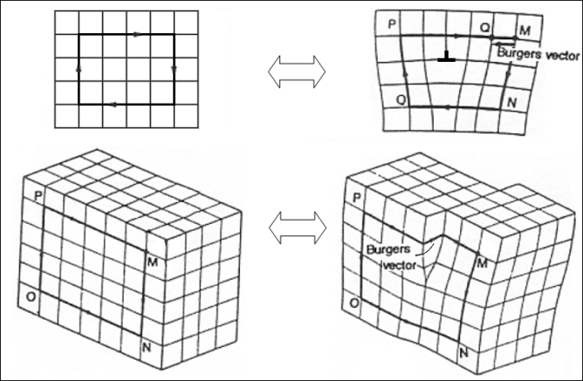
Figure 3.9 Burgers vector of dislocations: edge dislocation and screw dislocation [7]
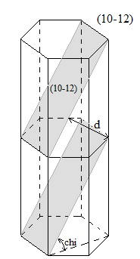
Figure 3.10 Schematic alignment parameters for measuring x-ray rocking curve of (10-12) GaN

For c-plane GaN, the major defect types are screw dislocations, edge dislocations and mixed dislocations. The direction of the Burgers vector of screw dislocation is along the c-axis. In other words, screw dislocations would cause the c-plane tilt, which can be easily detected by the on-axis (reflected surface is the sample surface which is c-plane) rocking-curve measurement. On the other hand, the direction of the Burgers vector of edge dislocation is perpendicular to the c-axis, which has no effect on the c-plane. Therefore, the on-axis rocking curve measurement cannot detect edge dislocations. For the detection of edge dislocations, the off-axis rocking curve measurement is required. (10-12) is a typical orientation for the off-axis rocking curve measurement for c-plane GaN. In order to find the (10-12) plane, chi and phi angles need to be tilted and aligned. As shown in figure 3.10, the chi angle between the (10-12) plane and the c-plane, and the distance between the two parallel (10-12) planes can be calculated by Pythagorean Theorem. Hence, the Bragg’s angle can be calculated for (10-12) GaN. The chi angle and the Bragg’s angle are 43.1894° and 24.0489°, respectively. After setting the chi, ω and 2θ, only 6 equivalent (10-12) planes exists in GaN lattice, therefore the angle of phi needs to be aligned to find the diffraction surface.
Figure 3.11 Typical x-ray rocking curves of GaN measured along (a) (0002) direction and (b) (10-12) direction

Figure 3.11 (a) and (b) show typical x-ray rocking curves of GaN measured along symmetrical (0002) direction and asymmetrical (10-12) direction, respectively. The x-axes are the tilted ω angle and the y-axes are the intensity of the reflected x-ray beam. The full width at half maximum (FWHM) of the rocking curves are used to compare and estimate the dislocation densities.

2θ-ω measurement
For a 2θ-ω measurement, the scan is taken by rotating the sample stage by ω and the detector by 2θ with a ratio of 1:2. Different from a rocking curve measurement, a 2θ-ω measurement cannot be used to study the crystal quality. However, it can estimate the layer thickness, ternary alloy composition or the structure of super-lattice. For example, a typical structure is prepared with 1 μm c-plane GaN grown on 500 nm c-plane AlN. The c-plane of both GaN and AlN layers are parallel, but the out-of-plane lattice constant c is different. By rotating the ω and 2θ at a ratio of 1:2 in the same direction, both diffraction peaks of (0002) GaN and (0002) AlN can be detected. Furthermore, if the scan range is large enough, diffraction peaks of (0004) GaN and AlN and (0004) sapphire diffraction peaks can be detected as well.
In the reciprocal space, a 2θ-ω measurement can be treated as a 1D measurement for locating the RLP contributed by the diffraction planes parallel to each other. For c-plane GaN and its ternary alloy sample, the in-plane 2θ-ω measurement can target layers with different out-of-plane lattice constants, hence identifying the layer thickness or alloy composition. This measurement is very important in the study of MQW structure.
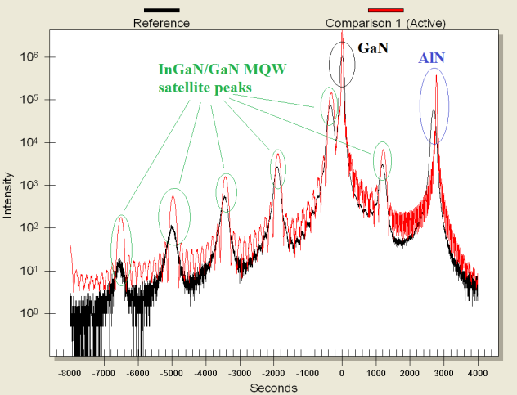
Figure 3.12 2θ-ω curves of typical InGaN/GaN MQW structure grown on AlN/GaN buffer layer

Figure 3.12 shows 2θ-ω curves of typical InGaN/GaN MQW structure grown on AlN/GaN buffer layer. The black curve is an experimental result while the red curve is the simulation curve based on the experimental curve. In the 2θ-ω curves, the diffracted peaks contribute to GaN and AlN layers are strong due to the large thickness of the buffer layer. The periodical diffracted peaks are the satellite peaks from the InGaN/GaN MQW structure, where the peak with the maximum intensity is the zeroth order satellite peak. The location of the zeroth order satellite peak is related to the indium composition and the strain. The spacing between each satellite peak is related to both indium composition and the QW/barrier thickness. The simulated result is shown in table 3.3.
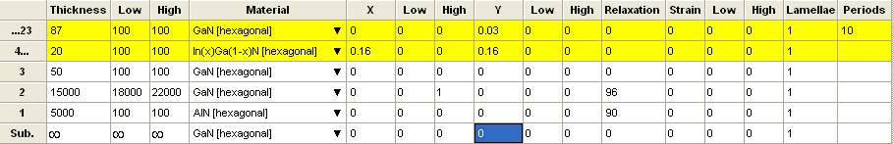
Table 3.3 Simulated result of the experimental 2θ-ω curve in figure 3.12

The QW thickness is 2nm and the barrier thickness is 8.7nm. The indium composition of the InGaN layer is 16%. Although some other factor is unable to be concerned in the simulation such as in-plane strain, it is a relative simple and accurate way to estimate the structure of MQW structure.

Reciprocal space mapping (RSM) measurement
An RSM measurement is an upgraded 2θ-ω measurement from 1D to 2D in a reciprocal space. The scan is taken by a series of 2θ-ω measurements with the ω off-set angle tilting as the second axis. By tilting the ω off-set angle, the measurement is capable to detect diffraction planes non parallel with each other, and measure the in-plane lattice constants of different layers in the crystal. In this work, strain value in the MQW is quantized by the RSM measurement. Detailed measurement procedure will be discussed along the experimental results lately.

  - Scanning electron microscopy (SEM)
SEM is a type of electron microscopy that can produce images of a sample by scanning focused electron beam on the sample and measuring signals that contain information about the surface morphology by the detector. A photo and a schematic diagram of an SEM is shown in figure 3.13.
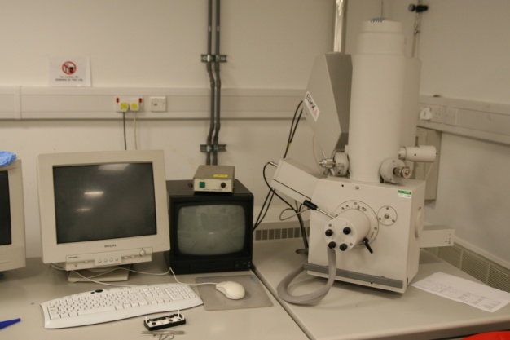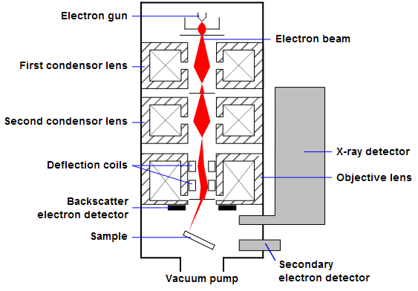
Figure 3.13 photo and schematic diagram of an SEM [8]

The major components in an SEM chamber are electron column, scanning system, detector and vacuum system. The electron column is made of an electron gun and two or more condenser lenses in series operating in high vacuum. During the operation, the electron gun generates free electrons to 1-40 keV energy levels. The condenser lenses can focus the electrons into a small, focused spot on the sample, with the smallest diameter of the spot size less than 10 nm. The typical resolution of an SEM is in the range of 1 nm to 1 μm. The deflection coil is to help focus the electron beam into a fine probe, in which case it could scan across the surface of the sample. The scanning electron beam is also called primary electron. Electrons in the form of electromagnetic radiation emit with the bombardment of the electron beam and the sample atom, which are called secondary electrons. The secondary electrons are collected by a detector and the signal is amplified and displayed.
In this work, surface and cross sectional SEM images are taken on non-polar overgrowth samples. This facility is important for the understanding of the growth mechanism in terms of lateral growth rate along anisotropic orientation and polarity of the sample.

  - Atomic force microscopy (AFM)
AFM is a very high-resolution type of scanning probe microscopy, with demonstrated resolution on the order of fractions of a nanometer. By moving a tip across the surface of a sample and reflecting laser from the tip, the surface morphology can be drawn as shown in figure 3.14.
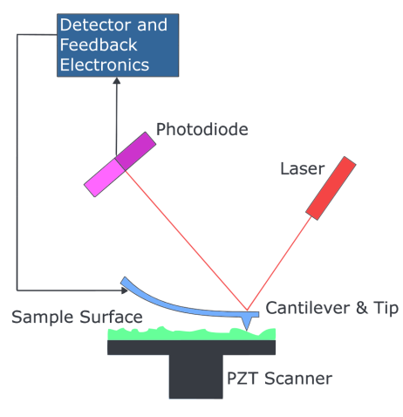
Figure 3.14 Schematic of AFM [9]

There are several types of AFM tips available:
Contact mode: The tip must contact the surface of the sample. When the tip scans across the sample surface, it deforms with the surface roughness in different extent. Additionally, there are a tiny laser spot on the tip, the reflected laser phase will vary with the deformation of the tip. Then, the surface morphology of the surface can be recorded.
The mechanism of the tip deformation is the atomic repulsive force between the tip and the atoms of sample. This force is in the range of 10⁻⁶ to 10⁻⁹ N, however, due to the touching between tip and surface, it is easy to cause some damage of the sample even it is easier to obtain higher resolution.
Tapping mode: The tip is oscillating up and down at about the frequency of its resonance. When the tip scan across the sample surface, the Van der waals interaction verify the amplitude of the tip’s oscillation. The amplitude will be smaller when the tip gets closer to the surface. Thus, the AFM image can be produced by imaging the interaction force between the tip and the sample.

3.4 Photoluminescence (PL) measurement
3.4.1 Background
PL is the type of luminescence that is photo excited. PL phenomenon appears in semiconductor in the following procedure: the energy band absorbs a photon with energy larger than the energy band, and excites an electron in the valence band into the conduction band leaving a hole in the valence band. As the generated free electron in the conduction band is not stable, it would recombine with the hole in the valence band, leading to a particle release in some energy form. For a direct band gap semiconductor, this particle has a high chance to be a photon, and the energy level of this photon is equivalent to that of the band bap of the semiconductor. The mechanism of the PL procedure is shown in figure 3.15.
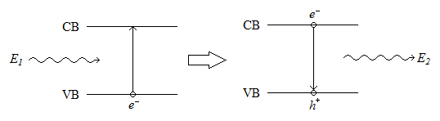
Figure 3.15 the mechanism of PL

When an electron absorbs energy and is excited from a lower to a higher energy level, it will not stay there for long, but decay to a lower energy level. When a photon emits during the recombination of a free electron and hole, it is called radiative recombination. If this photon emitting process is not influenced by other factors such as external applied energy field, this is called a spontaneous emission.
In order to improve the quantum efficiency in semiconductor, special design is required to confine the recombination to take place in a small region. The structures of quantum well (QW), quantum wire and quantum dot are introduced which represent 1D, 2D and 3D confinement structure of the energy band, respectively. For a typical InGaN/GaN single quantum well (SQW) structure, a thin film of InGaN layer around 1~2 nm is sandwitched by 2 thin film of GaN layer. The InGaN layer with the smaller band gap is called the well and the GaN layers with the larger band gap are called the barrier. Figure 3.16 shows the band structure of an InGaN/GaN SQW.
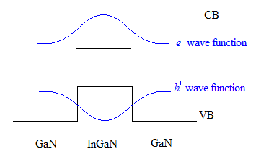
Figure 3.16 Band structure of InGaN/GaN SQW

The band gap of the InGaN quantum well region is narrower than the GaN barrier region. When the electrons in the valence band are excited into the conduction band, the electrons and holes are confined in the well region. Under ideal circumstance, the wave functions of the electrons and holes show their peaks at the centre of the QW. In this situation, the radiative recombination rate is much higher than in a bulk III-nitride film, hence enhancing the internal quantum efficiency.
In reality, it is difficult to obtain high optical performance of SQW structures of III-nitrides. The reason is that the large lattice mismatch between the well and barrier for QW grown along c-direction induces strain, and the piezoelectric constant of GaN is very large, which lead to the generation of piezoelectric field. [3-6] This external electric field applied across the quantum well causes the energy band bending as shown in figure 3.17.
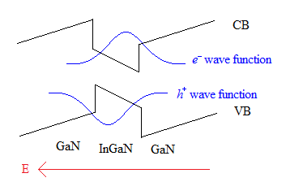
Figure 3.17 band structure of QW with piezoelectric field

The energy band bending causes the maximum of valence band higher and minimum of the conduction band lower, which means narrower energy band. This causes the red-shift of the emission wavelength of the LEDs. Another effect is that electron and hole wave functions shift, and they no longer have the same momentum, leading to decreased radiative recombination rate. This causes the reduction of the quantum efficiency of LEDs. This phenomenon is called quantum confined stark effect (QCSE), which is one of the main factors that reduce the IQE of the QW. The reduction in the IQE is extremely serious in a SQW, as the thin layer of QW has no space to release any strain. Therefore, practically, a multiple quantum well (MQW) structure is designed for III-nitride emitters.

3.4.2 Experimental setup
Basically, a PL measurement set-up is made of 4 parts: the laser source, the path of the ray, the monochromator and the detector. Figure 3.18 shows a typical setup of PL measurement.
Normally, laser is used as the excitation light source for the PL measurement due to its high power and synchronized phase angle. After adjusting the laser path by some mirrors, the laser is finally focused by a focus lens before exciting the sample. This is to reduce the size of the laser spot and further improve the excitation power density. Figure 3.18 shows a surface emitting PL set up, as the emission collected is from the surface of the sample. As the direction of spontaneous emission is random, two focus lenses are placed in front of the monochromator to focus the emitted light.
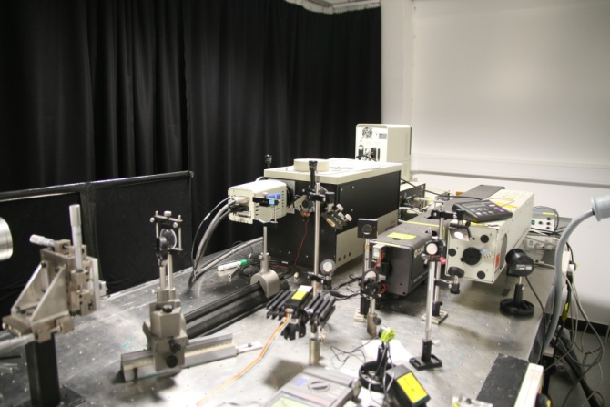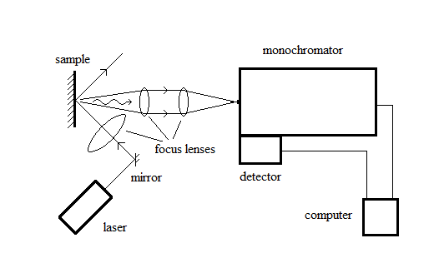
Figure 3.18 typical PL measurement setup

The monochromator is a device that produces monochromatic light. The mechanism is that by diffracting light with either a prism of a diffraction grating, light of different colors will be separated spatially. By applying several controllable mirrors, a monochromator can select a specific wavelength from an incident light and output a monochromatic light. The schematic of a monochromator is shown in figure 3.19.
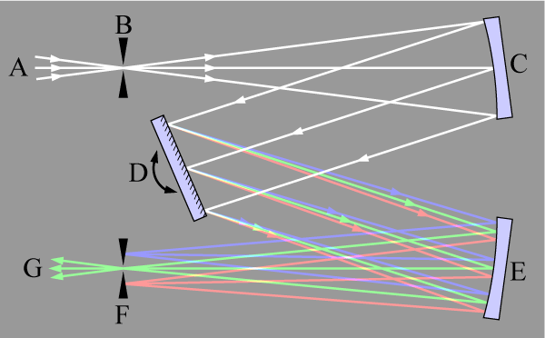
Figure 3.19 schematic of monochromator where A is the incident illumination source, B is the entrance slit, C and E are mirrors, D diffraction grating, F is the exit slit and G is the monochromatic light

Finally, the monochromatic light will be received by the detector. By drawing the intensity as a function of wavelength, the emission spectrum of the input light at the monochromator can be drawn. By building updating facilities, different types of PL measurement can be performed to study the optical properties of our III-nitride samples in different angles.

3.4.3 Temperature dependent PL
Temperature dependent PL measurement is one of most important types of PL measurements for investigation of the optical properties of III-nitrides. Instead of a standard room temperature sample stage, the sample is loaded into a cryostat which is capable to cool the surface temperature of the sample to 10 K. The measurement is taken by collecting the PL spectra of a sample at temperature varying from 10 K to 300 K. Normally, recombination of free electrons and holes in semiconductor emits either photons (radiative recombination) or phonons (non-radiative recombination). At 0 K, any thermal vibration of electrons is eliminated, therefore the recombination process of the PL theoretically emits photons only, which means the internal quantum efficiency (IQE) is 100 %. By working out the ratio of the integrated intensity of the PL spectra at 10 K and room temperature, the IQE can be estimated.

3.4.4 Power dependent PL
As mentioned earlier, QCSE in III-nitride quantum well structure seriously affects the IQE. The major reason is that the strain induces energy band bending, which causes the wave function of the conduction band and valence not having the same momentum. There are two ways to reduce the QCSE. The first way is to grow nitride QW along non-polar or semi-polar orientation, because the piezoelectric constant is zero or smaller than along c-direction. This makes the generated piezoelectric field weaker. The second way is to increase the excitation power, as the high excitation power could neutralize the energy band bending effect from the QCSE. Typical behavior can be observed that the emission wavelength blue shifts with the increase of the excitation power. This is so called “screening effect”.
Power dependent PL measurement is performed by collecting the PL spectra of a sample at different incident laser power density. Since the lasers we used for this measurement have constant output power, an adjustable filter is employed on the light path to change the laser power. By adjusting the input laser power, the excitation power of the sample is changed, and the wavelength could shift with increasing the power. Hence PL spectra can be compared and the QCSE can be studied.

References
- B. D. Cullity and S. R, Stock Elements of X-Ray Diffraction 3rd ed. (Englewood Cliffs, NJ: Prentice-Hall) (2001)
- M. A. Moram and M. E. Vickers Rep. Prog. Phys. 72, 036502 (2009)
- N. Grandjean, B. Damilano, S. Dalmasso, M. Leroux, M. Lauugt and J. Massies, J. Appl. Phys. 86, 3714 (1999)
- S. H. Park and S. L. Chung, Appl. Phys. Lett. 72, 3103 (1998)
- M. Leroux, N. Grandjean, M. Laugt, J. Massies, B. Gil, P. Lefebvre and P. Bigenwald, Phys. Rev. B 58, R13371 (1998)
- K. B. D. Cullity and S. R, Stock Elements of X-Ray Diffraction 3rd ed. (Englewood Cliffs, NJ: Prentice-Hall) (2001)
- Wikipedia, http://en.wikipedia.org/wiki/Burgers_vector (accessed 02/09/2013)
- Wikipedia, http://en.wikipedia.org/wiki/Scanning_electron_microscope (accessed 02/09/2013)
- Wikipedia, http://en.wikipedia.org/wiki/Atomic_force_microscope (accessed 03/09/2013)

Chapter 4
High temperature AlN buffer and stimulated emission of Al_{0.05}Ga_{0.95}N/Al_{0.16}Ga_{0.84}N based MQW structure

In comparison with blue optical devices, the development of UV optical devices is far from satisfactory due to their reliance on AlGaN buffer system, since AlGaN material has emission wavelength between 200nm to 365nm with different Al composition. The AlGaN buffer grown on a classic GaN buffer suffers from a tensile strain, as the in-plane lattice constant of AlN is smaller than GaN as shown in table 4.1, leading to a serious cracking issue. This problem becomes more severe when pushing toward deep UV due to the increase of Al composition.

 | In-plane lattice constant (Ǻ) | Out-of plane lattice constant (Ǻ) | Band gap (eV)
AlN | 3.112 | 4.982 | 6.2
GaN | 3.189 | 5.185 | 3.4
InN | 3.533 | 5.693 | ~0.7
Table 4.1 Lattice constants and band gap of III-Nitrides

Previously, epitaxial lateral overgrowth (ELOG) technology has been developed as a successful technique in reducing the dislocation density in GaN, leading to fabrication of InGaN-based long-lived blue LDs. [1] Recently, an electrically injected LD at 336 nm has been reported by Yoshida et al. by applying the ELOG in growth of UV LDs, [2],[3] the shortest wavelength LD so far. However, the ELOG approach has severe limits, as it is still a GaN-based buffer technique while higher Al composition is required for further moving toward shorter wavelength. [4-6] SiC substrate can achieve AlGaN layer with a better crystal quality, [7],[8] but it is extremely expensive. First stimulated emission at room temperature on III-nitrides is from a single GaN. [9]
Therefore, it is extremely important to develop new buffer technology. As well known, GaN buffer layer grown on AlN buffer would not lead to a cracking issue as the overlying GaN suffers from compressive strain. In the past few years, our group has developed a high temperature AlN buffer technology, which improves the crystal quality of the overlying GaN significantly as compared to conventional 2-step growth technique of GaN.

4.1 High temperature AlN buffer technology
High temperature AlN buffer is introduced to be grown on 2-inch c-plane sapphire substrate by low-pressure MOCVD. Trimethylgallium (TMGa), Trimethyl-aluminium (TMAl), and ammonia (NH₃) are used as the precursors for Ga, Al and N, respectively and H₂ is used as the carrier gas. Several groups of samples are grown with different growth conditions to make comparison. Standard X-ray diffraction rocking curve measurements are performed to study the crystal quality of the AlN buffer layer. The polarity of the sample is determined by hot liquid KOH etching as N-polarity AlN/GaN can react with hot liquid KOH strongly. After the hot liquid KOH etching, all N-polarity AlN/GaN material is be removed.

4.1.1 Initial state - nitridation and AlN nucleation layer
The major challenge for the growth of III-Nitrides is to find reproducible growth conditions to obtain stable Al- or Ga-polarity. Figure 4.1 shows the Ga- and N-polarity of GaN. If the chemical bonds terminates with Ga atom on the surface, GaN has Ga-polarity and vice-versa. In terms of physical properties, GaN with a Ga-polarity has a very mirror-like and hard surface while GaN with an N-polarity has a very rough and soft surface. In terms of chemical properties, GaN with a Ga-polarity is very chemically stable while N-polarity can be easily etched by various of chemical solutions which are very commonly used in the device fabrication process. On the other hand, N-polarity normally results in worse crystal quality than Ga-polarity.
Sample A, sample B and sample C are grown as first group of samples. The sapphire substrates are annealed in H₂ at 1220°C for 5 mins. These three samples are grown using standard TMAl pre-flow technique. The growth pressure is 65 torr and 175 torr for AlN and GaN, respectively. The TMAl pre-flow time is 20 sec, 21 sec, 22 sec, respectively for sample A, B and C. The TMAl flow rate is 4.0 μmol/min. Afterwards, 600 nm AlN buffer is grown at 1230 °C with a V/III ratio 129. Finally, 1 μm GaN layer is grown on the AlN buffer at 1130 °C with a V/III ratio 1300. The X-ray rocking curves of the AlN layers along (002) orientation is shown in figure 4.2. The polarity and the full-width at half maximum (FWHM) of X-ray rocking curves along both (0002) and (10-12) directions of GaN and AlN layers of the samples are shown in Table 4.2.
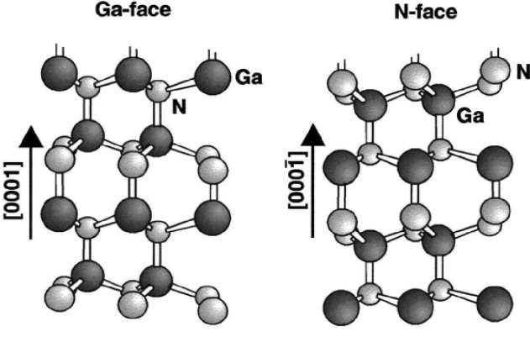
Figure 4.1 Ga-polarity and N-polarity of GaN

The result shows that sample A is N-polarity, indicating that too low TMAl pre-flow time would cause N-polarity of the sample. By increasing the TMAl pre-flow time for only 1 sec with rest of the growth conditions unchanged, sample B turns into Al-/Ga- polarity. Therefore, one can conclude that short time of TMAl pre-flow time results in N-polarity. The overall on-axis and off-axis X-ray rocking curve FHWM of AlN and GaN of sample B have been reduced compared to sample A, indicating a reduction in screw and edge dislocation densities for sample B. When the TMAl pre-flow time is further increased to 22 sec, sample C still remains Al-/Ga-polarity. However, the full-width at half maximum (FWHM) of overall on-axis and off-axis X-ray rocking curve for AlN and GaN has increased compared to sample B. This result shows that if the TMAl pre-flow time is too long, the crystal quality of AlN and GaN becomes worse.
One of the major disadvantages of this TMAl pre-flow technique is that the growth window is too narrow. From the first group of samples, one can find that 1 sec change in the growth time, which is the minimal change time for the reactor, could result in major difference in polarity or crystal quality. As a commercialised Aixtron reactor might have unstable growth conditions, this method is not suitable to satisfy for both growth of high quality and reproducibility of III-Nitrides.

Figure 4.2 X-ray rocking curves of the AlN layers along (002) orientation of sample A, B and C
Sample | polarity | (002) AlN FWHM (°) | (002) GaN FWHM (°) | (102) AlN FWHM (°) | (102) GaN FWHM (°)
A | N | 0.170 | 0.112 | 0.264 | 0.157
B | Al/Ga | 0.161 | 0.096 | 0.284 | 0.135
C | Al/Ga | 0.172 | 0.099 | 0.354 | 0.144
Table 4.2 Polarity and X-ray rocking curve FWHM of sample A, B and C

In order to broaden the growth window of high temperature AlN buffer, we developed a thin AlN nucleation layer for the initial deposition of AlN buffer. Sample D, E, F are grown with standard high temperature H₂ thermal annealing for surface treatment. The growth pressures of AlN and GaN are 65 torr and 175 torr, respectively. Afterwards, 1 sec of TMAl pre-flow is supplied at 4.0 μmol/min, followed by a 20 nm-thick AlN nucleation layer with a V/III ratio of 260. The growth temperatures for the TMAl pre-flow and the nucleation layer for sample D, E and F are 1130°C, 1100°C and 1080°C, respectively. Subsequently, 600 nm HT AlN buffer layer at 1230°C is grown with a V/III ratio 129~258. Finally, 1 μm GaN layer is grown on the AlN buffer at 1130°C with a V/III ratio 1300. The polarity and the FWHM of X-ray rocking curves of the samples are shown in Table 4.3.
Sample | polarity | (002) AlN FWHM (°) | (002) GaN FWHM (°) | (102) GaN FWHM (°)
D | N | 0.173 | 0.088 | 0.127
E | Al/Ga | 0.158 | 0.081 | 0.122
F | Al/Ga | 0.168 | 0.086 | 0.123
Table 4.3 Polarity and X-ray rocking curve FWHM of sample D, E and F

As shown in table 4.3, by reducing the nucleation layer growth temperature from 1130 °C to 1100 °C, the polarity turns into Al-/Ga-face from N-face. Therefore, one can conclude that high AlN nucleation growth temperature results in N-polarity. The overall on-axis and off-axis X-ray rocking curve FHWMs of AlN and GaN of sample E have reduced compared to sample D, indicating a reduction in screw dislocations and edge dislocations for sample E by reducing the nucleation layer growth temperature from 1130 °C to 1100 °C. When the nucleation layer growth temperature is further reduced to 1080 °C, sample F still remains Al-/Ga-polarity. However, the overall on-axis and off-axis X-ray rocking curve FWHMs of AlN and GaN have increased compared to sample E. This result shows that lower nucleation layer temperature results in deterioration of the crystal quality.
As compared to the standard TMAl pre-flow technique controlling the polarity and crystal quality of AlN/GaN by 1 sec difference in the pre-flow time, one can control the polarity and crystal quality of AlN/GaN by ~20 °C difference in the growth temperature. This gives a much more flexible growth window. On the other hand, TMAl pre-flow time could be massively reduced by the introduction of AlN nucleation layer, where long time of TMAl pre-flow degrades the crystal quality of AlN/GaN.

4.1.2 Multiple Porous/flat high temperature AlN buffer layers
In order to further improve the crystal quality of AlN buffer, multiple porous/flat high temperature AlN buffer layers are introduced. A typical porous AlN layer has a twice higher V/III ratio and 30-50 °C lower growth temperature compared to standard flat high temperature AlN layer. The surface morphology of the porous AlN is scanned by AFM, and the image is shown in Figure 4.3 [10].
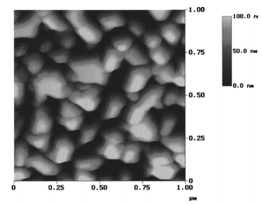
Figure 4.3 AFM image of the surface morphology of porous AlN layer [10]

Basically, for the growth of III-nitrides by MOCVD, group III elements firstly migrate on the substrate surface, which abstract nitrogen atoms to form the compound. Therefore, one can find that group III elements need higher energy to move freely on the substrate surface so that an atomic flat surface can be formed. Porous AlN layer is grown under the condition of higher NH₃ flow rate which suppress the potential energy for the migration of the group III elements. In addition, the lower growth temperature of the porous layer also reduces the migration energy of the group III elements. Under such condition, an atomic flat surface is unable to be formed. Instead, AlN film with porous surface morphology is formed as shown in Figure 4.3.
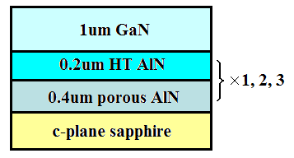
Figure 4.4 Schematic structure of sample G, H and I with 1, 2, 3 times of repetitions of porous/flat AlN layers

Three samples are grown with 1, 2, 3 times of repetitions of porous/flat AlN buffer layer, namely sample G, H and I, respectively. Figure 4.4 shows the schematic structures of sample G, H and I. For each repetition of porous/flat AlN layer, 0.4 μm of porous AlN is grown at 1170°C with a V/III ratio of 258, followed by the deposition of 0.2 μm of flat AlN layer at 1230°C with a V/III ratio of 129. Subsequently, 1 μm standard GaN is grown on the AlN buffer. In order to make comparison, sample J is also prepared with GaN grown using conventional 2-step growth method.
It is worth to highlight X-ray rocking curve measurements along the asymmetrical (10-12) orientation of AlN as shown in figure 4.5. For standard single layer high temperature AlN buffer, the FWHM of X-ray rocking curve along (10-12) orientation is as high as 1267 arcsec. With the introduction of porous layer and increase of the number of repetitions of porous/flat AlN layer pairs, the FWHM of X-ray rocking curve along (10-12) orientation is reduced to 576 arcsec, meaning that the overall dislocation density has been reduced by the multiple porous/flat AlN buffer significantly. The dislocation density can be estimated formula
[4.1]
where b is the length of the Burgers vector, β is the rocking curve FWHM and D_{B} is the dislocation density.
Figure 4.5 X-ray rocking curve of sample G, H, I and reference sample J along (10-12) orientation

The estimated dislocation density of sample G, H, I and J in the AlN layer based on the X-ray results are 9.4*10⁸, 7.1*10⁸, 3.2*10⁸ and 2.0*10¹⁰ cm⁻², respectively. Figure 4.6 shows the Transmission electron microscopy (TEM) cross sectional image of the porous/flat AlN layers. As shown in figure 4.6 (a) [10], a large number of dislocations form due to the large lattice-mismatch between AlN and sapphire substrate and penetrate through the porous AlN layer. However, there is a massive reduction in the dislocation density at the boundary between the porous AlN and flat AlN layer.

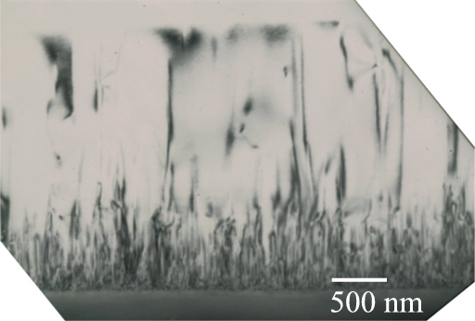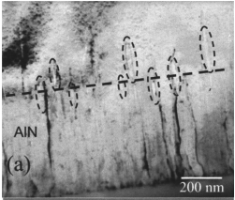
Porous AlN layer
Flat AlN layer
(b)
(a)
Sapphire substrate
Flat AlN layer
Porous AlN layer
Figure 4.6 Cross sectional TEM image of (a) the porous/flat AlN layers (b) the boundary between porous and flat AlN

Figure 4.6 (b) shows the cross sectional TEM image of the porous AlN and the automatic flat AlN layers. [10] The dash line in the center marks the boundary between the two layers. A high density of bubbles of nanometer size can be observed around the boundary of the two films. These bubbles are formed during the coalescence of the porous AlN layer. This is very similar to the air bridges observed in ELOG growth of GaN [12]. The strain caused by the large lattice mismatch can be released in the bubbles and the dislocation cannot penetrate through these bubbles as well. This is the mechanism for the reduction of dislocation density by porous/flat AlN layer.
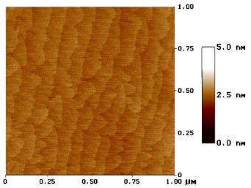
Figure 4.7 surface morphology of the multiple AlN buffer by AFM [17]

Figure 4.7 shows the AFM image of multiple AlN buffer. Clear atomic steps can be observed, indicating smooth surface morphology of the AlN buffer. Figure 4.8 (a) shows the typical AFM image of the GaN grown using conventional 2-step growth method. Dark spots which represent the terminations of screw dislocations can be observed. Figure 4.8 (b) shows the AFM image of the GaN layer grown on high temperature AlN buffer, where no dark spots have been spotted. [16]
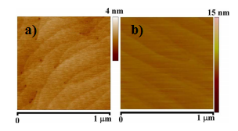
Figure 4.8 typical AFM images of (a) GaN grown using two-step method and (b) GaN grown on high temperature AlN buffer

4.2 Background of stimulated emission
Stimulated emission emits photons with same wavelength and same phase. Therefore, the emission spectrum of a stimulated emission has a very narrow linewidth and is strongly polarized. The emission mechanism of stimulated emission is shown in Figure 4.9.
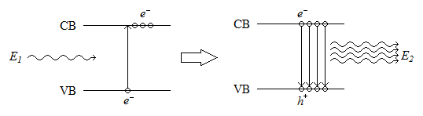
Figure 4.9 mechanism of stimulated emission

In order to realize stimulated emission, one condition is to obtain “population inversion”, which means more electrons in the conduction band than in the valence band. This status is not natural, since there are rare free electrons in the conduction band under normal condition, normally high excitation power is applied to the semiconductor to obtain population inversion. Under such condition, when an electron recombines with a hole, it would also affect other electrons in the conduction band and make them recombining with holes at the same time. These emitted photons have the same frequency and phase, and this process is called optical gain. Secondly, the device should form a cavity, where the emitting photons can reflect in the gain region so that the optical gain could be repeatedly enhanced. Eventually these photons charge out of the facet and form the stimulated emission.

4.3 Optical pumping measurement on Al_{0.05}Ga_{0.95}N/Al_{0.16}Ga_{0.84}N MQWs
In the last section, we have obtained high quality AlN buffer by multiple porous/flat high temperature AlN buffer layers. Al_{0.05}Ga_{0.95}N/Al_{0.16}Ga_{0.84}N MQWs used in this section are grown based on such AlN buffer technique. Two sets of samples are prepared to perform the power-dependent optical pumping measurements to study the optical properties of the MQWs. The first set of sample is grown on a high temperature AlN buffer layer using “GaN interlayer” technique [13][14] and the second set of sample is grown on a high temperature AlN buffer layer using “multiple porous/flat AlN layers” technique. Stimulated emission has been obtained from both sets of samples and the gain spectra has been plotted to study the emission mechanism.

    - Sample preparation
All the MQWs are designed and grown by our low-pressure MOCVD system. All the samples are grown under a pressure between 65 to 100 torr. The schematic structures of the samples are shown in Figure 4.10.
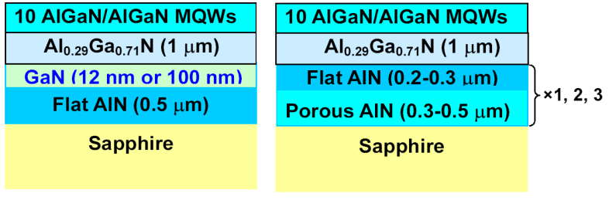
Figure 4.10 schematic structures of the first and the second set of samples

For the first set of samples, a single layer 0.5 μm AlN is grown on c-plane sapphire at 1200°C after thermal annealing in H₂ for 10 mins. [15] Afterwards, a 100 nm GaN interlayer is grown on the AlN buffer at 1130°C, followed by 1 μm AlGaN layer. Finally, 10 periods of Al_{0.05}Ga_{0.95}N/Al_{0.16}Ga_{0.84} MQW structure are grown on the AlGaN layer. Another identical MQW structure is grown with 12 nm thick GaN interlayer. The two samples are named sample A and B with 100 nm and 12 nm GaN interlayer, respectively. For the second set of samples, three samples are grown. 0.3-0.5 μm of porous AlN is grown at 1170°C with a V/III ratio of 258 is grown on sapphire substrate after thermal annealing in H₂, followed by the deposition of 0.2-0.3 μm of flat AlN layer at 1230 °C with a V/III ratio of 129. This growth process has been repeated for 1, 2 and 3 times respectively, marking them as sample C, D and E, respectively. Finally, identical AlGaN layer and MQW structure are grown on both the first set of samples and the second set of samples. X-ray 2θ-ω measurements were performed on the samples and simulations were carried out to estimate the Al composition in each layer and the QW/barrier thickness. Figure 4.11 shows the experimental and simulated 2θ-ω curves of sample A where the black curve is the experimental result and the red curve is the simulated result. The simulated curve is plotted by “RADS Mercury” software based on the estimated layer thickness and composition as shown in table 4.4. The results show that the thickness and Al composition of QW/barrier is 3nm/10nm and 5%/16%, respectively. The Al composition of the AlGaN buffer layer is 29%.
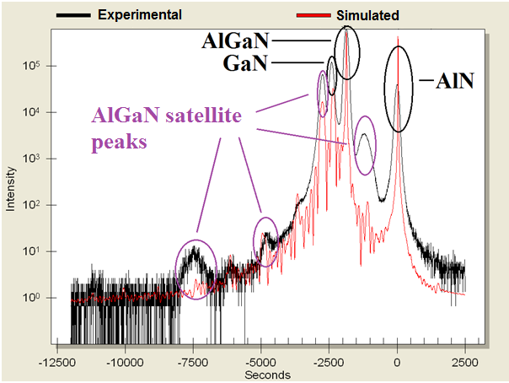
Figure 4.11 2θ-ω curve of sample A
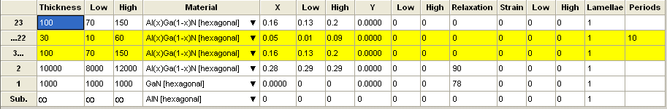
Table 4.4 simulated layer thickness and ternary alloy compositions make up of sample A

4.3.2 Experimental procedure
Figure 4.12 shows the experimental setup for the power-dependent optical pumping measurements. The stimulated emission measurements are performed in an edge emission geometry excited by a diode pumped pulsed neodymium doped yttrium aluminium garnet (Nd:YAG) laser (266 nm) with a pulse repetition rate of 850 Hz and a pulse width of 9 ns. Two cylindrical lenses are placed in front of the sample to focus the laser beam into a 1 mm by 0.2 mm stripe. For the power dependent optical pumping measurement, the pumping power can be changed by a manual control of the laser. The power density can be varied from 100 kW/cm² to 1100 kW/cm². All the samples are cleaved along (11-20) orientation of sapphire in order to obtain the best cleavage which is extremely important for obtaining stimulated emission by edge geometry. A charge-coupled detector (CCD) is used for the collection of the emission spectra, and polarization measurements are performed by placing a polarizer at the entrance of the monochromator.
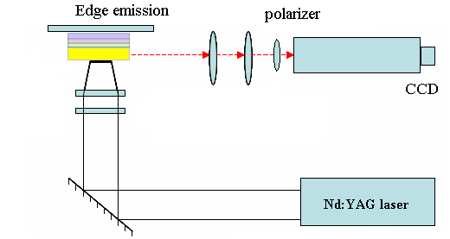
Figure 4.12 Experimental setup of the optical pumping measurement

4.3.3 Results and discussion
Stimulated emission from Al_{0.05}Ga_{0.95}N/Al_{0.16}Ga_{0.84} MQW grown using “GaN interlayer” technique
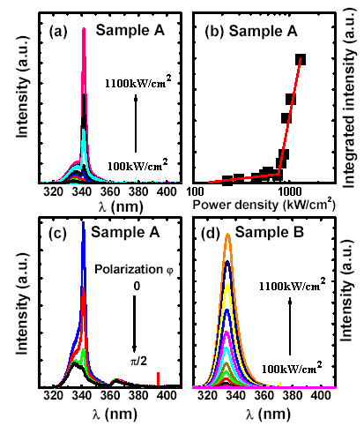
Figure 4.13 (a) Power dependent optical pumping spectra of sample A, (b) integrated intensity as a function of power density of sample A, (c) polarisation measurement of sample A and (d) power dependent optical pumping spectra of sample B

Figure 4.13 (a) shows the power dependent optical pumping spectra of sample A. At low excitation power, there is only a broad emission peak at 336 nm which is a spontaneous emission. When the excitation power is increased up to 700kW/cm², another emission peak appears at 340 nm. When the excitation power is further increased, the second emission peak at 340 nm becomes strong and narrow. This is the typical behaviour of the stimulated emission. Figure 4.13 (b) shows the integrated intensity as a function of power density. From the image, a threshold power density at ~700kW/cm² can be obtained. The polarization measurement is performed at an excitation power of 1000kW/cm² as a function of polarization angle. This measurement provides strong evidence to confirm the stimulated emission as shown in figure 4.13 (c), where the sharp emission peak behaves a strong transverse electric (TE) mode polarization. [16] In comparison, as shown in figure 4.13 (d), there is no stimulated emission by photo-exciting sample B under the same excitation power as sample A. The comparison between sample A and B confirms that the thickness of GaN interlayer plays an important role in blocking the dislocation density. With the increase of GaN interlayer thickness, more dislocations can be blocked from the underlying AlN, which leads to the observation of stimulated emission of the AlGaN-based MQWs structure grown on it. However, the thickness of GaN interlayer cannot be further improved, otherwise the AlGaN layer grown on it would suffer from cracking issue as it is grown on GaN buffer layer.

Stimulated emission from Al_{0.05}Ga_{0.95}N/Al_{0.16}Ga_{0.84} MQW grown using “multiple AlN buffer” technique
Power dependent optical pumping measurements have been also performed on the second set of samples. However, stimulated emission can only be observed from sample E as shown in Figure 4.14 (a) by increasing the optical pumping power density from 100 kW/cm² to 1100 kw/cm², while only spontaneous emission is observed from sample C and D. Typically, at low excitation power, there is only a broad spontaneous emission peak at 336 nm and when the excitation power density is increased by up to 600 kW/cm², a second peak at lower energy side appears. When the excitation power is further increased, the emission peak at lower energy side becomes stronger and narrower, indicating typical stimulated emission behaviour. Figure 4.14 (b) shows the integrated intensity as a function of the power density where a threshold power density at ~600kW/cm² can be obtained. As discussed in section 4.1, the dislocation density of the AlN buffer layer in sample E has been reduced significantly by the multiple porous/flat AlN buffer layer. Therefore, it can be concluded that the improvement in the crystal quality of AlN buffer layer is the key reason for the observation of stimulated emission from sample E.
Figure 4.14 (a) power-dependent optical pumping spectra of sample E and (b) integrated intensity as a function of power density

4.4 Conclusions
In conclusion, high temperature AlN buffer layer is used as the standard growth technique of III-nitrides in our group. By introducing AlN nucleation layer, stable Al polarity can be obtained for c-plane AlN/GaN buffer. During the work, the growth condition of the AlN is optimized to improve the crystal quality. By introducing multiple porous AlN buffer, the dislocation density in the AlN is massively reduced. Al_{0.05}Ga_{0.95}N/Al_{0.16}Ga_{0.84} MQWs are grown based on such “multiple AlN buffer” technique and the earlier work in our group the “GaN interlayer” technique, and stimulated emission is obtained by optical pumping measurements.

References
- S. Nakamura, M. Senoh, S. Nagahama, N. Iwasa, T. Yamada, To. Matsushita, Y. Sugimoto, and H. Kiyoku, Appl. Phys. Lett. 70, 868 (1997)
- H. Yoshida, Y. Yamashita, M. Kuwabara, and H. Kan, Appl. Phys. Lett. 93, 241106 (2008)
- H. Yoshida, Y. Yamashita, M. Kuwabara, and H. Kan, Nat. Photonics 2, 551(2008)
- J. H. Edgar, “Properties of Group III Nitrides”(INSPEC, London, 1994), p. 74.
- T. M. Katona, P. Cantu, S. Keller, Y. Wu, J. S. Speck, and S. P. DenBaars, Appl. Phys. Lett. 84, 5025(2004)
- Z. Chen, R. S. Qhalid Fareed, M. Gaevski, V. Adivarahan, J. W. Yang, A. Khan, J. Mei, and F. A. Ponce, Appl. Phys. Lett. 89, 081905 (2006)
- T. Takano, Y. Ohtaki, Y. Narita, and H. Kawanishi, Jpn. J. Appl. Phys., Part 2 43, L1258 (2004)
- T. Takano, Y. Narita, A. Horiuchi, and H. Kawanishi, Appl. Phys. Lett. 84, 3567 (2004)
- H. Amano, T. Asahi, and I. Akasaki, Jpn. J. Appl. Phys., Part 2 29, L205 (1990)
- T. Wang, J. Bai, P. J. Parbrook and A. G. Cullis, Appl. Phys. Lett. 87, 151906 (2005)
- M. A. Moram and M. E. Vickers, Rep. Prog. Phys. 72, 036502 (2009)
- R. S. Qhalid Fareed, V. Adivarahan, C. Q. Chen, S. Rai, E. Kuokstis, J. W. Yang, M. A. Khan, J. Caissie, and R. J. Molnar, Appl. Phys. Lett. 84, 696(2004)
- T. Wang, K. B. Lee, J. Bai, P. J. Parbrook, R. J. Airey, Q. Wang, G. Hill, F. Ranalli and A. G. Cullis, Appl. Phys. Lett. 89, 081126 (2006)
- T. Wang, K. B. Lee, J. Bai, P. J. Parbrook, R. J. Airey, Q. Wang, G. Hill, F. Ranalli, and A. G. Cullis, Appl. Phys. Lett. 89, 081126 (2006)
- J. Bai, T. Wang, P. J. Parbrook, I. M. Ross, and A. G. Cullis, J. Cryst. Growth 289, 63 (2006)
- S. C. Davies, D. J. Mowbray, Q. Wang, F. Ranalli and T. Wang, Appl. Phys. Lett. 95, 101909 (2009)

Chapter 5
Study of optical gain in Al_{0.05}Ga_{0.95}N/Al_{0.16}Ga_{0.84} multiple quantum well (MQW) structures

In this chapter, optical properties and mechanisms of stimulated emission in Al_{0.05}Ga_{0.95}N/Al_{0.16}Ga_{0.84} multiple quantum well (MQW) structures are further studied. Two samples are prepared with different AlN buffer growth techniques, the “GaN interlayer” technique and the “multiple AlN buffer” technique, respectively. For both samples, stimulated emissions have been obtained as described in chapter 4. The theory and experimental methodology of the amplified spontaneous emission (ASE) will be elaborated in the first section, where the optical gain can be calculated. Furthermore, the reciprocal space mapping (RSM) measurements are performed in order to study the influence of strain on the optical gain. At last, influence of cavity orientation on the optical gain is discussed.

5.1 Sample preparation
Two samples, Sample A and Sample B with the same structures as those shown in figure 4.10 are used in this experiment. The AlN buffer of sample A is grown using “GaN interlayer” technique while that of sample B is grown by “multiple AlN buffer” technique. The sapphire substrates are annealed in H₂ at high temperature for 5 mins. Sample A and sample B were grown using standard TMAl pre-flow technique, which means TMAl source is supplied to the reactor earlier than NH₃. The growth pressures for both samples are 65 torr and 175 torr for AlN and GaN, respectively. Afterwards, TMAl pre-flow is supplied at 4.0 μmol/min. For sample A, the TMAl pre-flow time is 20 sec, followed by a 600 nm AlN buffer layer at 1230°C with a V/III ratio 129. For Sample B, the TMAl pre-flow time is 1 sec, followed by a 20nm-thick AlN nucleation layer grown at 1100°C with a V/III ratio of 260. Subsequently, 600 nm HT AlN buffer layer at 1230°C is grown for Sample B with a V/III ratio 129~258. Finally, for both samples, 1 μm GaN layer is grown on the AlN buffer at 1130°C with a V/III ratio 1300. The MQW of the two samples are 10 periods of 10 nm Al_{0.16}Ga_{0.84}N / 3 nm Al_{0.05}Ga_{0.95}N. The X-ray 2θ-ω measurements were performed on the samples and simulations were carried out to estimate the Al composition in each layer and the QW/barrier thickness as shown in table 4.4.

5.2 ASE measurement
5.2.1 Background and Methodology
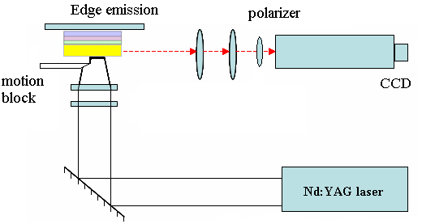
Figure 5.1 experimental setup of ASE

The purpose of the ASE measurement is to further study the mechanism of stimulated emission, which is also known as the optical gain measurement. For stimulated emission, there would be energy gain in the excited region in the cavity and energy loss in the excited region and in the non-excited region. The energy loss is mainly due to the defect density in the crystal. Both energy gain and loss are proportional to e^{(L*gain)} and e^{loss}, respectively, and the gain is directly proportional to the length of the excited region. When the net gain e^{(L*gain-loss)} is larger than 1, the emission is amplified which could lead to stimulated emission. The experimental setup is shown in Figure 5.1. [1]
In comparison with the optical pumping measurement setup, an additional motion block is placed in front of the sample. The motion block is controlled by a motorized transition stage with an accuracy of 1 μm. The measurement is used to calculate the optical gain, which is related to the length of the excited region, namely, the length of the laser stripe as the following relationship [2]:
(5.1)
where I(L) is the integrated intensity of the spectra, L is the laser beam stripe length, g is the optical gain and A is a constant that relates to the ASE. By changing the length of the laser beam stripe, two equations of equation 5.1 can be obtained and g and A can be calculated.
ASE spectra of sample A and sample B are measured by performing stripe-length dependent optical pumping measurement. After recalibrating the optical pumping system, the threshold power densities of both samples are reduced to ~250 kW/cm². The excitation region is a laser spot with 1 mm×0.2 mm on the surfaces of the samples. All the stripe-length dependent optical pumping measurements are carried out at room temperature under a same peak excitation power density of 402 kW/cm². The excitation stripe length is kept between 0.3 mm and 0.9 mm to avoid the edge part of the laser stripe. In order to obtain accurate net modal gain, a simple method is employed to test the homogeneity of the laser beam. The accuracy of the motorized transition stage is 1 μm which is much smaller than the length of the stripe (in millimetre scale). The homogeneity of the laser beam has been confirmed through a linear increase in the intensity of the spontaneous emission below threshold with increasing stripe length, as shown in all the ASE spectra in figure 5.2 later.

5.2.2 ASE spectra and gain spectra
Figure 5.2 a) and 5.2 b) show the ASE spectra of sample A and sample B, respectively, obtained with the laser beam stripe parallel to the (1-100) m-axis. For both samples, when the stripe length is shorter than 0.6 mm, there is only a spontaneous peak at 3.72 eV. When the length of the laser beam is increased by up to 0.6 mm, another peak appears at 3.65 eV of low energy side. In addition, the emission intensity of the peak at 3.65 eV increases much faster than the peak at 3.72 eV when the excitation length is further increased, which indicates a clear stimulated emission.
Figure 5.2 c) and d) show the ASE spectra of sample A and B respectively obtained with the laser beam stripe parallel to the a-axis. The spectra indicate similar behaviour with those measured along m-axis. The results have been repeated by performing the measurements on many different pieces of samples cleaved from the same wafer, showing an excellent reproducibility. The net modal gain can be calculated by equation 5.1. As the stimulated emission only appears when the stripe length is larger than 0.6 mm, the optical gain is calculated when the excitation stripe length is larger than 0.6 mm. The optical gain spectra can be plotted by a series of data fitting.
Figure 5.2 ASE spectra of a) sample A and b) sample B, both measured along m-axis; c) sample A and d) sample B, both measured along a-axis

Figure 5.3 a) shows the gain spectra measured along m- and a- axis of sample A, where the peak net modal gains of are around 100 cm⁻¹ at 3.64 eV and 70 cm⁻¹ at 3.66 eV with beam stripe parallel to m-axis and a-axis, respectively. Figure 5.3 b) shows the gain spectra measured along m- and a-axis of sample B, where the peak net modal gains are both at 3.65 eV with values of 71 cm⁻¹ and 57 cm⁻¹ for beam stripe parallel to m-axis and a-axis, respectively. This means that the peak net modal gains along the a-axis are lower than those along the m-axis for both samples. Furthermore, the peak net modal gains of sample A along both a-axis and m-axis are higher than those of sample B.
Figure 5.3 Gain spectra of a) sample A and b) sample B measured along both m- and a-axis, respectively

5.3 RSM measurements
5.3.1 Methodology
As mentioned earlier in Chapter 3, the 2θ-ω measurement is associated with the distance between the diffraction planes while rocking curve measurement (ω scan) is associated with the angle between diffraction planes. A RSM measurement is an upgraded 2θ-ω measurement from 1D to 2D in a reciprocal space. The scan is taken by a series of 2θ-ω measurements with the ω off-set angle tilting as the second axis. By tilting the ω off-set angle, the measurement is capable of detecting diffraction planes that are non parallel with each other, and of measuring the in-plane lattice constants of different layers in the crystal.
Typically, (10-15) plane is used as the diffraction plane for the RSM measurement for III-nitrides. For sample A and B, the AlGaN buffer layers are used as the reference points for the alignment of the measurements as they are the thickest layers in the samples. A group of 2θ-ω measurements are performed with the off-set angles ω tilted for both samples and the reciprocal space maps are drawn in figure 5.4.
5.3.2 Results
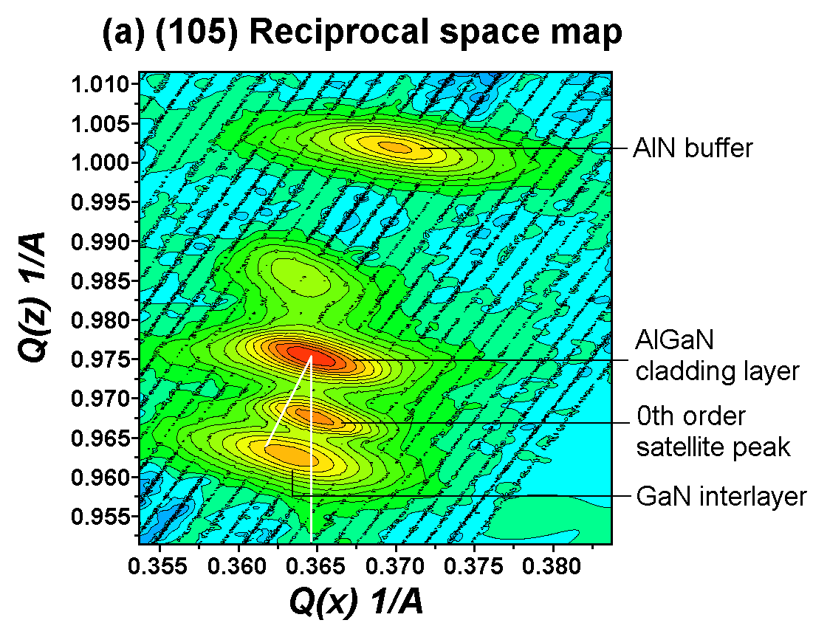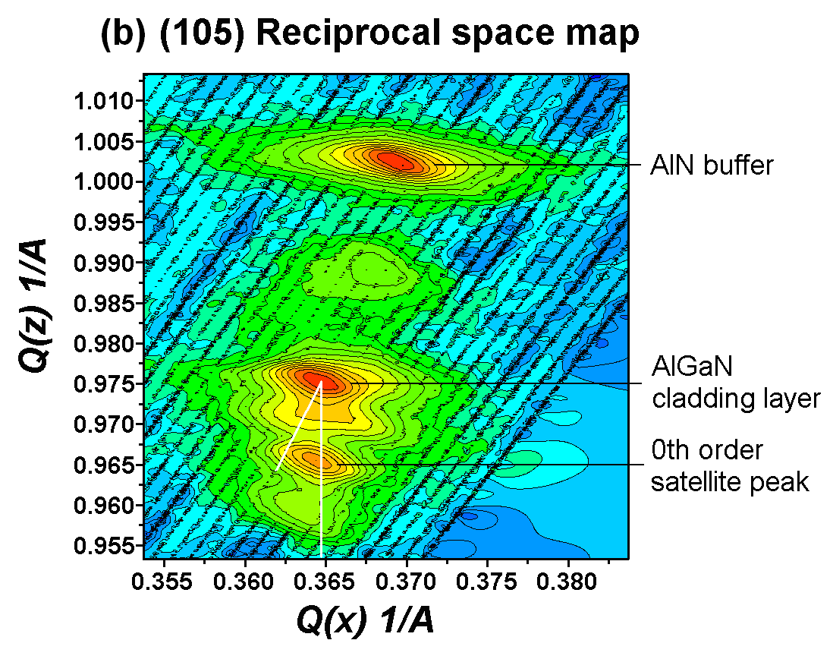
Figure 5.4 RSM along (10-15) orientation of a) sample A and b) sample B

Asymmetric RSM measurements along (10-15) direction are performed to investigate the strain relaxation. Figure 5.4 a) and 5.4 b) show the RSM of sample A and sample B, respectively. Each reciprocal lattice point (RLP) shown in the RSM is contributed to each material layer in the sample.[3] For any RLP measured along (h,k,l) axis, the coordinates of the RLP on the x-axis q_{x} can be used to work out the in-plane lattice constant of the relative material by using formula:
(5.2)
while the coordinate of the RLP on the y-axis q_{z} can be used to work out the out-of-plane lattice constant by formula
(5.3)
For sample A, the RLPs from top to bottom are contributed to AlN buffer layer, AlGaN capping layer, zeroth order satellite peak of the QW and the GaN interlayer, respectively. For sample B, all the RLPs can be found at similar positions with sample A except the one which is contributed to GaN interlayer. It is worthwhile to point out that only the zeroth order satellite peak can be obtained for the MQW structures in this measurement for both samples as the reflections regarding to other satellite peaks are too weak to be detected. As the thickness of the AlGaN capping layer is 1 μm, the AlGaN capping layer is assumed to be fully relaxed. Therefore, the RLP of the AlGaN layer is used as a reference substrate layer. From the RLP of AlGaN cladding layer, we can draw a fully strained line which is perpendicular to the x-axis, and a fully relaxed line which links the RLP of AlGaN cladding layer and ideal GaN RLP. As the overlying QW structures in both samples have lower Al content compared to the AlGaN cladding layer, they are under compressive strain and the RLP contributing to the zeroth order satellite peak of the QW should be between the fully strained and fully relaxed lines. For sample A, the RLP of the zeroth order satellite peak of the MQW structure is on the fully strained line, which indicates a fully strained QW structure. For sample B, there is a slight shift of the RLP contributing to zeroth order satellite peak on x-axis with respect to the AlGaN layer, which indicates partial relaxation of the MQW. Using the coordinates of the RLPs, the real lattice constant of the QW can be obtained, where the in-plane lattice constant for sample A and B are 0.3167 nm and 0.3172 nm, respectively. The compressive strain can be calculated by
(5.4)
where a₀ and a are the lattice constants of AlGaN layer and the QW, respectively. [4] Hence, the compressive strains of the sample A and B are 0.0069 and 0.0054, respectively.

5.4 Influence of strain on optical gain in Al_{0.05}Ga_{0.95}N/Al_{0.16}Ga_{0.84} MQW
According to the well known expression for the net gain coefficient [5],
(5.5)
where λ is the wavelength of the photons, f_{c}(E₂)-f_{v}(E₁) is the Fermi inversion, τ_{r} is the radiative recombination lifetime and ρ(v) is the optical joint density-of-states, which is determined by the valance subband structure. The radiative recombination lifetime is determined by the crystal quality of the QW and we assume τ_{r} for the two samples are same. The Fermi inversion represents the level of population inversion which is also same for the two samples under same excitation power. Therefore the densities of states determine the value of optical gain for the two samples. In wurtzite III-nitrides, conduction band to heavy-hole valence subband transition (C-HH) and conduction band to light-hole subband transition (C-LH) have strong TE polarization while conduction band to split-hole subband transition (C-CH) has a dominant TM polarization. [6] In the GaN QW, the valance subbands from top to bottom are HH, LH and CH respectively in the zone centre. As stated in the earlier part of the section, we have already reported transverse electric (TE) polarization from both samples which indicates that the AlGaN QW with low Al content has similar optical properties as the GaN QW. [7] As the stimulated emissions have strong TE polarization, C-HH and C-LH transitions have most contributions to the stimulated emission. However, the valence subbands are strongly coupled with each other in III-nitrides. Therefore, in the GaN QW or low Al content AlGaN QW, C-CH transitions will easily take place which may not contribute to stimulated emission. According to theoretical calculations, compressive strain separates HH and LH, therefore increase of compressive strain is expected to lead to the increase of optical gain. [8],[9] This might be the reason that the optical gain of sample A is higher than sample B, as the compressive strain in the QW of sample A is larger than sample B as discussed above. It is also found that the net modal gain value measured along m-axis is higher than a-axis. Point defect density can be simply excluded as a factor which gives different optical gain between sample A and B, as it is well-known that the point defects in III-nitride such as Ga or N vacancy are normally determined by III/V ratio or doping level. Both samples are nominally undoped, and their MQW structures are grown under identical conditions including III/V ratio.

5.5 Influence of cavity orientation on optical gain for c-plane Al_{0.05}Ga_{0.95}N/Al_{0.16}Ga_{0.84} MQW
It has also been found that the net modal gain measured along the m-axis is always higher than that along the a-axis. Basically, the optical properties of III-nitrides grown on c-plane sapphire are isotropic around c-axis, [10] i.e., growth direction. Therefore, the optical gains of III-nitrides along the m-axis and a-axis have to be identical in theory. Furthermore, the RSM and standard 2θ-ω measurements have been carried out on the samples at different angles rotated along c-axis, and the same results have been obtained, meaning the strain is isotropic.
It is well-known that the c-axis of c-plane GaN is still parallel to that of the c-plane sapphire, but there is a 30° in-plane rotation around c-axis between them. [11] Therefore, the m-axis of the GaN or AlN is parallel to the a-axis (i.e., (11-20)) of c-plane sapphire. If the cleavage is carried out along the a-axis of sapphire, it will be easiest for cutting “sapphire” as the number of the chemical bonds of c-plane sapphire along the a-axis is less than that along any other direction. As sapphire substrate (≥330 μm) is generally much thicker than epitaxial III-nitride layers, this is why the a-axis of c-plane sapphire is normally chosen as the cleavage orientation of III-nitride samples on c-plane sapphires.
Based on the same reasons, the best cleavage direction for III-nitride such as GaN or AlN is also along the a-axis of GaN or AlN, which is actually perpendicular to the a-axis of sapphire. Therefore, if the cavity facets are formed along the a-axis of GaN or AlN (meaning that the laser beam excited on the sample should be along the m-axis), the cavity facets with better quality can be obtained, leading to a higher measured optical gain. This is why the measured net modal gain value measured along the m-axis is higher than that along the a-axis. This is extremely important for design and fabricating III-nitride based laser diodes, which can lead to a lower threshold for lasing.

5.6 Conclusions
ASE spectra have been measured on the Al_{0.05}Ga_{0.95}N/Al_{0.16}Ga_{0.84} MQWs grown using two kinds of high temperature AlN buffer technologies. The gain spectra of the two samples have also been obtained. The results show that the net modal gain value of sample A is higher than sample B. The RSM measurements, indicates a fully strained MQW structure in sample A and a partially strain-relaxed MQW structure in sample B, which is attributed to the difference in net modal gain value of the two samples. The gain spectra along the m- and a-axis have also been obtained, showing a higher net modal gain along the m-axis than that along the a-axis due to the 30° in-plane rotation between III-nitride and the c-plane sapphire.

References
- Y. P. Gong, K. Xing and T. Wang, Appl. Phys. Lett., 99, 171912 (2011)
- K. L. Shaklee, R. E. Nahory, and R. F. Leheny, J. Lumin., 7, 284 (1973)
- S. Pereira, M. R. Correia, E. Pereira, K. P. O’Donnell, E. Alves, A. D. Sequeira, N. Franco, I. M. Watson, and C. J. Deatcher, Appl. Phys. Lett., 80, 3913 (2002)
- S. L. Chuang and C. S. Chang, Semicond. Sci. Technol., 12, 252 (1997)
- S. Nakamura and S. F. Chichibu, “Introduction to Nitride Semiconductor Blue Lasers and Light Emitting Diodes”, (CRC, Boca Raton, 2000), p. 249.
- H. Kawanishi, M. Senuma, and T. Nukui, Appl. Phys. Lett., 89, 041126 (2006)
- Q. Wang, Y. P. Gong, J. F. Zhang, J. Bai, F. Ranalli, and T. Wang, Appl. Phys. Lett., 95, 161904 (2009)
- S. L. Chuang,IEEE J. Quantum Electron, 32, 1791 (1996).
- S. H. Park and S. L. Chuang, Appl. Phys. Lett., 72, 287 (1998)
- M. Sukuzi and T. Uenoyama, Jpn. J. Appl. Phys., 35, 1420 (1996).
- W. A. Melton and J. I. Pankove, J. Cryst. Growth, 178, 168 (1997)

Chapter 6
Overgrowth of non-polar a-plane GaN

6.1 Introduction
III-nitride based optoelectronics have progressed impressively in last two decades, leading to commercialization of InGaN/GaN multiple quantum well (MQW) based blue light emitting diodes (LEDs) and violet/blue laser diodes (LDs). However, further improvement in optical performance is still necessary in order to meet the requirements for replacement of conventional lighting source. One of the fundamental limits results from internal electrical fields and so-called quantum-confined Stark effect (QCSE) in InGaN/GaN multiple quantum wells (MQWs). It is well-known that the QCSE results in a reduced overlap of wave functions between electron and hole in InGaN/GaN MQW structure as an emitting region, thus reducing the internal quantum efficiency of InGaN/GaN MQWs. This is an unavoidable problem for the III-Nitrides grown on widely used c-plane sapphire substrates. One of the most promising approaches for counteracting the negative effects of the QCSE is growth along non-polar or semi-polar orientation. [1] III-nitride optoelectronics grown along non-polar or semi-polar orientations are expected to lead to significant improvement in internal quantum efficiency (IQE) because they can eliminate or significantly reduce the piezoelectric and spontaneous polarization induced electric fields. Moreover, non-polar or semi-polar emitters can emit polarized light, and thus play an important role in making liquid-crystal displays.
Up to date the non-polar or semi-polar III-nitride emitters with high performance have to be grown on extremely expensive GaN substrates. [2][3] High non-uniformity in the substrates also makes them less attractive for mass production. Therefore, it is desirable to obtain non-polar or semi-polar GaN with high crystal quality on sapphire substrates.
Conventional epitaxial lateral overgrowth (ELOG) and the techniques evolved from ELOG [4-10] have been employed to improve crystal quality of either non-polar or semi-polar GaN on sapphire. The ELOG techniques are based on selective overgrowth, and thus require an ex-situ surface-coating with a dielectric mask, which is then patterned into stripes on a micro-meter scale using a standard photolithography. [4-10] The dislocations in the region under the mask stripes are effectively blocked. However, due to the limits of the photolithography, both the mask-stripe and the wing widths cannot be further reduced down to a nanometer scale, potentially causing a non-uniformity issue. Furthermore, an atomically flat surface cannot be obtained till the overgrown layer has to be 10 - 20 μm thick. These drawbacks make these techniques less impressive. Very recently a simple ELOG using self-organised nano-masks has been proposed for growth of non-polar GaN (i.e., a-plane GaN) and some good results have been achieved. [11] However, further improvement is still required in order to compete with the conventional ELOG approaches in terms of enhancement in crystal quality.
In this chapter, a simple but effective overgrowth approach based on self-organised nickel nano-masks was reported, leading to massive improvement in crystal quality of a-plane GaN on sapphire. This is a single-step process, but can reduce dislocation density twice. An InGaN/GaN multiple quantum well (MQW) structure has been grown on such a-plane GaN simply under the condition typically for c-plane InGaN/GaN MQWs, showing excellent optical properties, demonstrated by an enhancement with a factor of 7 in internal quantum efficiency (IQE), compared with a similar c-plane InGaN/GaN MQWs. Mechanisms of defect reduction due to the overgrowth is also discussed.

6.2 Methodology
6.2.1 Growth of a-plane non-polar template
The a-plane GaN template used is a standard GaN layer grown on r-plane sapphire substrate using our high temperature AlN buffer technique by low-pressure MOCVD. The sapphire is annealed in H₂ ambient for 5 min, followed by nitridation for 200 sec with NH₃ flow rate 4.46×10⁻² mol/min. The nitridation for the substrate is necessary for avoiding the formation of facet pits on the surface of overlying layers. The growth temperature of AlN is 1200°C and the growth pressure is 65 torr. The AlN film is grown using pulse mode supply of NH₃, as the growth of AlN on r-plane sapphire requires Al rich environment. The gas feeding sequence is shown in Figure 6.1.
The TMAl is supplied continuously and the NH₃ is supplied simultaneously with 5 sec feeding time and 3 sec interval time within a period. The flow rate of TMAl supply is 1.449×10⁻³ mmol/min and that of NH3 at the feeding time is 5.35 mmol/min. The total thickness of the AlN film is 450 nm. Afterwards, a 200 nm thin GaN film is grown under the pressure of 225 torr and V/III ratio of 1473 at 1120 °C. This high pressure GaN film works to improve the crystal quality of the GaN layer. However, if this layer is too thick, facet pits would generate on the surface of GaN. Finally, GaN film with a total thickness of 2.4 μm is grown under the pressure of 75 torr and a V/III ratio of 815 at 1120 °C.
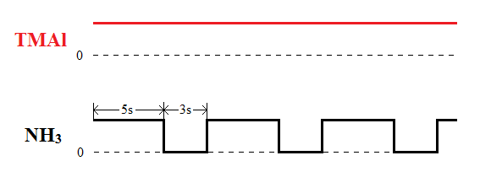
Figure 6.1 gas feeding sequence of AlN film for non-polar AlN/GaN template

6.2.2 Nano-rod template fabrication
For the subsequent overgrowth, a nanorod template needs to be fabricated on the above a-GaN wafer using the self-organised nano-masks. Figure 6.2 illustrates a fabrication procedure schematically. Initially, a SiO₂ thin film with 200 nm is deposited on the a-plane GaN template, followed by growth of a 10 nm nickel film. Subsequently the sample is annealed under flowing N₂ at temperature 850°C for 1 min so that the thin nickel layer can be developed into self-organised nickel islands with ~200 nm in diameter on the SiO₂ surface. The self-organised nickel islands then serve as a mask to etch the underlying SiO₂ film into SiO₂ nanorods on the GaN surface by reactive ion etching (RIE). The SiO₂ nanorods are used as a second mask, and the GaN layer is dry-etched to form GaN nanorods using inductively coupled plasma (ICP).
Figure 6.3 a) show a typical scanning microscopy (SEM) image of our a-plane GaN nanorods, indicating ~200 nm in diameter and 1.0×10⁹ cm⁻² in density. The nanorod length is around 1.5μm. The nano-rods have been examined across 2” inch wafer, showing an excellent uniformity. It is worth highlighting that the SiO₂ has to be simply remained on the top of the GaN nanorod.

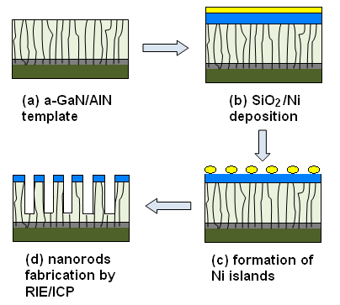
Figure 6.2 Schematic diagram of nanorod fabrication procedure

6.3 Overgrown non-polar GaN
6.3.1 Growth methodology
The a-plane GaN template with the nanorod structure is then put back into MOCVD for overgrowth. As shown in figure 6.3, the overgrowth starts from the sidewall of the GaN nanorods where the GaN is exposed, as the SiO₂ nano-masks on the top of the nanorods stop the GaN growth on their top. When the growing face reaches above the height of the SiO₂ nano-masks, the GaN regrowth extends laterally over the SiO₂ nano-masks, and eventually coalesces to form an atomically flat surface. In theory, all the dislocations originating from the nanorods are effectively blocked, which is fundamentally different from the other reports also based on a nano-mask approach where there is not any SiO₂ nano-mask left on the top of the nanorod. [11] In addition, we have found that the SiO₂ on the top of the nanorod plays an important role in the overgrowth, which is currently under investigation. Due to the advantage of utilising the nano-masks, a quick coalescence (less than 1 μm) can be obtained, confirmed by an in-situ optical monitoring system.
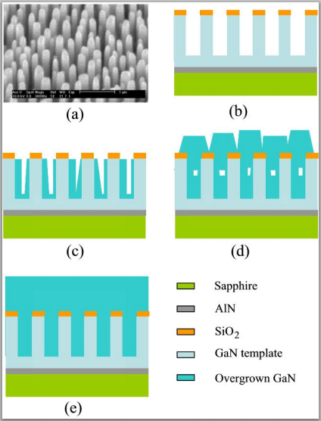
Figure 6.3 (a) SEM image of GaN nanorods; (b)-(e) Schematic of overgrowth on a nanorod GaN template

6.3.2 Structural properties
Figure 6.4 a) shows the surface morphology of our overgrown a-plane GaN, taken using optical microscopy. It is clear that the smooth surface has been obtained within 4-5 μm, which is less than the typical thickness obtained by any other conventional ELOG methods.
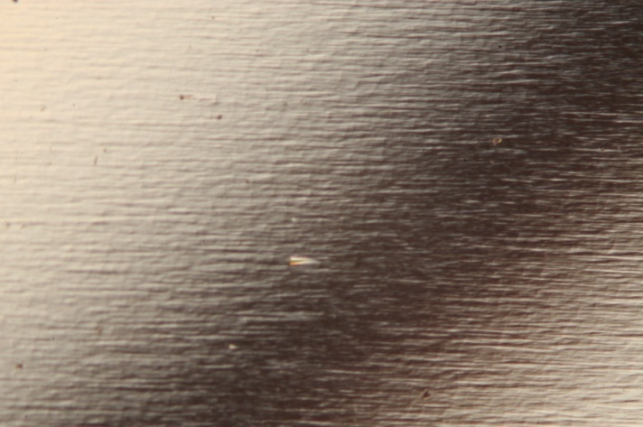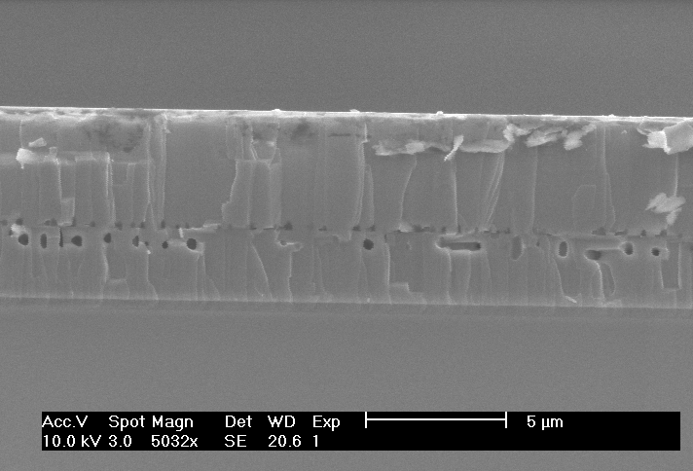
b)
a)
Figure 6.4 a) Surface morphology of the overgrown a-plane GaN by optical microscopy. b) Cross-sectionall SEM image of our overgrown a-plane GaN

Figure 6.4 (b) shows a typical cross-sectional SEM image of the fully coalesced a-plane GaN film, where two kinds of voids with different sizes have been clearly observed. All the small ones are at the same depth, which is around 2.6 μm above the AlN buffer, i.e., the thickness of the a-plane GaN template. Obviously, the small voids are on the top of the SiO₂ nano-masks, and are formed when the overgrowth extends laterally over the SiO₂ nano-masks to form coalescence. The large voids are ~1.3 μm below the small voids, and the depth is close to the length of our nanorods. Having examined the large voids carefully, one can find that those voids locate at the regions between two neighbouring small voids. It means that the large 5 voids are at the regions, which are originally the gaps between nanorods. Therefore, the formation of the large voids is due to the quick lateral growth from the sidewall of the GaN nanorods at the initial stage. We have found that the two kinds of voids are always observed in the overgrown a-plane GaN with greatly improved crystal quality. If either of the two kinds of voids disappears, the improvement in crystal quality becomes weak.
The Bede D1 XRD is employed to evaluate the crystal quality of the overgrown a-plane GaN, which is compared with the a-plane GaN template. Due to anisotropic nature of a-plane GaN, the evaluation of a-plane GaN is performed typically through measuring XRD rocking curves along symmetrical (11-20) direction as a function of azimuth angles. The azimuth angle is defined as zero when the projection of the incident beam is parallel to the c-direction of the epilayer. Figure 6.5 illustrates the full width at half maximum (FWHM) of the XRD rocking curves along (11-20) direction as a function of azimuth angles. The FWHM of the XRD rocking curves for the template is between 731 to 1202 arcsec, the typical values for a standard a-plane GaN grown on sapphire. In a remarkable contrast, the FWHM for our overgrown a-plane GaN is between 360 and 443 arcsec, very close to the best report [6] in which the conventional ELOG is used and thus the layer is around 20 μm (Our overgrown layer is 4-5 μm). This demonstrates an excellent crystal quality of our a-plane GaN, which is also close to the crystal quality of current c-plane GaN on sapphire for growth of ultra-high brightness blue LED. The XRD rocking curve measurements have also been performed along asymmetrical (11-22) and (10-11) directions to provide further evidence as shown in figure 6.6. The FWHM of the XRD rock curves along (11-22) and (10-11) directions are 392 and 726 arcsec for our overgrown a-plane GaN, respectively, which are significantly reduced from 623 and 1534 arcsec for the template.
Figure 6.5 FWHM of the XRD rocking curve of overgrown a-plane GaN layer and a-plane GaN template along symmetrical (11-20) direction as a function of azimuth angle
Figure 6.6 Asymmetrical X-ray rocking curves of overgrown and standard non-polar GaN along (a) (11-22) orientation and (b) (10-10) orientation

Based on the XRD data, the dislocation density has been estimated to 2.2×10⁸ cm⁻² for our overgrown a-plane GaN, substantially reduced from typical 9×10⁹ cm⁻² for the template. As discussed earlier, the overgrowth approach is expected to lead to an elimination of all the dislocations in theory, and thus the dislocation density is expected to lower than 10⁸ cm⁻². The mechanism of dislocation reduction will be explained in section 6.5.

6.3.3 Optical properties
PL measurements have been performed on the over-grown a-plane GaN and the a-plane GaN template at both room temperature (RT) and low temperature (LT) of 10 K . For the a-plane GaN template, the near band-edge emission (NBE) cannot be observed at both LT and RT, which is normal for any standard a-plane GaN grown on r-plane sapphire. Figure 6.7 shows the PL spectra of our overgrown a-plane GaN at RT and LT in a log scale. The PL spectrum at 10 K shows the NBE peak at 3.499 eV. In addition, the peaks at 3.426 eV, 3.302 eV, 3.232 eV and 3.121 eV have also been observed. The emission peak at 3.426 eV is usually related to stacking fault which is often observed in c-plane GaN [8]. The emission peak at 3.302 eV is likely to be due to donor-acceptor emission [9, 10]. Other peaks are under further investigation. The PL spectrum at RT indicates that the NBE shifts to 3.438 eV and that the emission related to the stacking faults shifts to 3.390 eV.
Figure 6.7 Room temperature and low temperature PL spectra of the overgrown a-plane GaN sample

6.4 Mechanisms of defect reduction due to the overgrowth
In order to gain insight into the origin of the significant improvement in crystal quality, both overgrown non-polar and semi-polar GaN films were structurally characterized by using a Phillips EM 430 transmission electron microscopy (TEM). All the TEM images in this section are taken by Dr Jie Bai.
Threading dislocations (TDs) in GaN have been proved to be nonradiative recombination centres, leading to severe degradation in optical efficiency. One of the major planar defects in either non-polar or semipolar GaN is basal plane stacking faults (BSFs). Recent studies suggest that the BSFs generate an emission at 3.42 eV, which merely act as shallow electron traps rather than non-radiative recombination centres. [16][17] Despite this, the partial dislocations which are bounded to the SFs have to be reduced in order to further improve optical performance of either non-polar or semi-polar GaN-based optoelectronics. Figure 6.8(a) and 6.8(b) show the typical cross-sectional TEM images of our overgrown non-polar GaN, taken under two-beam conditions. Figure 6.8(a) was taken with g=11-20 close to the [0001] zone-axis, where the edge a TDs, the mixed a+c TDs, and the Shockley partial dislocations can be observed. Figure 6.8(b) was taken with g=0002 close to the [1-100] zone-axis, where the screw c TDs, the mixed a+c TDs, and the Frank partial dislocations can be observed. Even if the original GaN template exists in form of nanorods at the bottom part with the overgrown GaN in the nanorod gaps, it can be still seen clearly that the dislocation density in the upper part (i.e., the overgrown GaN) is significantly reduced in comparison with the lower part, which is the original nanorod template. According to plan-view TEM observation, the dislocation density in the regrown non-polar GaN is in the middle of 10⁸ cm⁻². As the overgrowth proceeds, the lateral growth extends quickly from the sidewalls of the nanorods. Due to the nanorod gap depth of ∼1.5 μm, the coalescence takes place quickly, leaving a lot of voids remained after the overgrowth, which can be observed clearly in Figure 6.8 (a) and 6.8(b). Figure 6.3 (b)-(e) displays a schematic drawing, demonstrating how the voids are formed during the lateral overgrowth.
Figure 6.8 Cross-sectional TEM images of non-polar GaN overgrown on a nanorod template, (a) taken around [0001] zone-axis with g=11-20; (b) taken around [1-100] zone-axis with g=0002; (c) Scanning TEM image around [0001] zone-axis. (d) TEM image around [1-100] zone-axis with g=0002 (thank Dr Jie Bai for taking the images)
As observed in Figure 6.8(a), the original dislocation lines in the nanorod template move towards free surfaces with the overgrowth. Theoretically, when they are close to free surfaces, the image force induced by image dislocations acts on the inner dislocations and attracts them towards the growth surface. This causes the dislocations to bend. Figure 6.8(c) is a scanning TEM image, taken at (0001) zone-axis around a void. It can be clearly seen that a lot of threading dislocations redirect to propagate towards the void from the original growth direction. Because the dislocation density in the non-polar template is very high (∼10¹⁰ cm⁻²), there is a high probability that the bended dislocations encounter each other after their deviation from the original growth direction. As shown in Figure 6.8(c), these dislocations have been observed to meet each other and then annihilate finally through fusion or forming dislocation loops. Nevertheless, the dislocations in the non-polar GaN can change their line direction only within basal planes, but never deflect out of basal planes. [8][19] It is also confirmed by our observation that the dislocation bending is observed only in the (0001)-axis cross-sectional view (figure 6.8 (a) and figure 6.8 (c)) but never in the (1-100)-axis cross-sectional view (figure 6.8 (b) and figure 6.8 (d)). Figure 6.8 (d) shows a magnified TEM image including three nanorods taken around [1-100] zone axis, where there is no dislocation bending observed. Moreover, a high density of dislocations is observed in the nanorods, while there is nearly no dislocation observed in the overgrown area among and above the nanorods. Therefore, there are two main pathways for reduction of the dislocation density in this case: enhanced dislocation annihilation due to the line bending in the basal planes; and termination of the dislocations at the free surfaces locally introduced by the voids. Additionally, the SiO₂ (marked by white arrows) was remained deliberately on the top of the nanorods for the overgrowth, which is different from other reports also using the self-organized Ni nano-mask technique in which SiO₂ was removed prior to growth. [18] The remained SiO₂ plays an important role in both blocking the dislocations and enhancing the lateral growth from nanorod sidewalls.
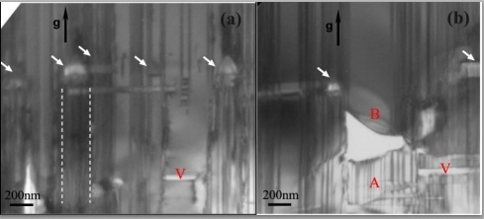
Figure 6.9 TEM images of non-polar GaN, taken close to [1-210] zone-axis with g=10-10 to show BSFs (thank Dr Jie Bai for taking the images)

It has been reported [17] that the windows of stripes grown from (0001)-oriented stripes in ELOG has a lower dislocation density than from other direction-oriented stripes. It indicates that the growth from (0001)-oriented stripes is more favourable with the TD redirection in basal planes and thus a reduction in dislocation density; while the (1-100)-oriented stripes has a characteristic of ±(0001) growth, which is not favourable with the TD redirection. However, the advantage of the (1-100)-oriented stripes is to effectively block BSFs, because the original BSFs lying in basal planes could be impeded through the overgrowth only when the lateral growth precedes normal to the basal planes. Though the evidence concerning the effect of BSFs on the optical properties of non-polar GaN is inconclusive, a reduction in the BSF density is still expected. In order to bring the BSFs in the non-polar GaN into contrast, it is necessary to tilt the specimen by ∼30° from [1-100] zone-axis towards [2-1-10] or [1-210] zone-axis during a TEM observation. Figure 6.9 are the TEM images taken under g=1010 diffraction condition, where the BSFs in form of straight lines perpendicular to the surface can be seen clearly. The BSF density in the overgrown region has been decreased by a factor of 5 to ∼1×10⁵ cm⁻¹ from ∼5×10⁵ cm⁻¹ inside the nanorods. Since the (0001) Ga–face growth is much faster than the (000-1) N-face growth, the coalescence front between nanorods tends to be close to the N-face side of the nanorod and thus the BSFs are confined within narrow N-face regions. Therefore, there is nearly no BSFs observed in the nanorod gaps as shown in figure 6.9, especially in the right side of the nanorods which is the Ga-face side. However, occasionally, the overgrowth started from the bottom parts among the nanorods. As shown in figure 6.9 (b), the BSFs in the original GaN layer propagated with the growth, leading to a high density of BSFs in the region labeled as A. As a contrast, there is nearly no SFs in the region labeled as B. A large void has been observed between region A and region B (partially removed due to specimen thinning), indicating that the GaN in region B is not grown from the underlying GaN in region A, but from the sidewalls of the nanorods. The BSFs are thus blocked out of region B and the area above it. Therefore, in our case, the overgrowth on nanorods, which starts all around the sidewalls, takes advantage of not only the in-basal-plane growth to reduce the dislocation density, but also the priority (0001) growth to block the BSFs.
One can notice that a type of voids (marked with red V) has been observed in the overgrown non-polar GaN, where the c-direction is perpendicular to the growth direction. As shown in Figure 6.8, they emerge in the gap area of nanorods and lying along the c-direction. It indicates that when the +c growing wing advances and then meet with another growing wing, the growth front is actually truncated with {11-2n} planes. The vertical sidewalls of nanorods could trigger the lateral growth perpendicular to the sidewalls in the non-polar GaN. Due to that the lateral growth in the nanorod gaps is along ±(0001) direction in the non-polar GaN, it is favourable with the non-polar GaN in blocking BSFs.

6.5 InGaN/GaN MQWs grown on the overgrown a-plane GaN
In order to demonstrate high crystal quality of our overgrown a-plane GaN , an InGaN/GaN MQW structure has been grown on the overgrown a-plane GaN layer under the conditions for c-plane InGaN/GaN, which may not be optimised for a-plane InGaN/GaN MQWs. This is a 10 period InGaN/GaN MQW structure with 2.5 nm InGaN quantum well and 10 nm GaN barrier. For comparison, a similar InGaN/GaN MQW structure was grown on a standard c-plane GaN layer.
Figure 6.10 Internal quantum efficiency for (0002) c-plane and (11-20) a-plane InGaN/GaN quantum well at different temperatures ranging from 10K to 300K

Estimation of IQE can be made through performing temperature-dependent PL measurements assuming that the IQE is 100% at low temperature (in this case 10K), a standard and widely used method. By increasing the temperature to room temperature, the ratio between the integrated intensity of the PL spectra of 300K and 10K is the estimated IQE. This method cannot give an accurate IQE, but it can provide an accurate comparison of IQE as long as the samples are measured under identical conditions. Figure 6.10 illustrates the normalized integrated intensity as a function of temperature in an Arrhenius plot in a temperature range from 10 to 300 K. A 375 nm diode laser with a low excitation power is used, and thus the influence of QCSE on IQE can be seen clearly. The InGaN/GaN MQWs on the overgrown a-plane GaN show an enhancement with a factor of 7 in IQE, compared with the InGaN/GaN on the c-plane GaN. This demonstrates the advantage of non-polar InGaN/GaN MQWs.
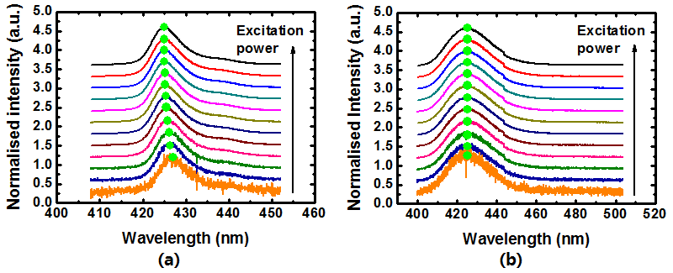
Figure 6.11 (a) Excitation power dependent PL of c-plane InGaN/GaN quantum well; (b) Excitation power dependent PL of the non-polar a-plane InGaN/GaN quantum well
Excitation-power dependent PL measurements have also been performed in order to confirm that the a-plane InGaN/GaN MQWs doesn’t suffer from QCSE. Figure 6.11 (a) and (b) shows the excitation-power dependent PL of the InGaN/GaN MQWs on the overgrown a-plane GaN and the c-plane GaN, respectively. Both are measured at 10 K. There is not any clear shift in emission energy for the a-plane InGaN/GaN MQWs with increasing the excitation power, while an obvious blue-shift has been observed for the InGaN/GaN MQWs on the c-plane GaN, a finger-print for existence of QCSE. It confirms that the a-plane InGaN/GaN MQWs are free of QCSE.

6.6 Conclusions
A simple but effective overgrowth approach using self-organised nanomasks has been developed, leading to a massive improvement in crystal quality of a-plane GaN on sapphire. XRD rocking curve measurements along symmetrical and asymmetrical directions show a significant reduction in FWHM. RT PL measurements show a strong near band-emission, further confirming enhanced optical properties. The InGaN/GaN MQWs grown on the high quality a-plane GaN layer shows excellent optical properties, demonstrating an enhancement with a factor of 7 in IQE, compared with compared with the identical MQWs grown on the c-plane GaN on sapphire. The excitation-power dependent PL measurements have confirmed that the a-plane MQWs are free of QCSE.
The overgrowth on a nanorod template takes advantages of the omnidirectional growth around sidewalls of the nanorods, which not only significantly reduce dislocations due to the line bending in basal planes, but also effectively block BSFs through priority (0001) growth. The growth technology is proved to be a potentially cost-effective technology to achieve a high quality non-polar and semi-polar GaN exhibiting not only a quick coalescence but also a low defect density with an uniform distribution across a 2" wafer.

References
- F. Bernardini, V. Fiorentini and D. Vanderbilt, Phys. Rev. B 56, R10024 (1997)
- P. Waltereit, O. Brandt, A. Trampert, H. T. Grahn, J. Menniger, M. Ramsteiner, M. Reiche and K. H. Ploog, Nature (London) 406, 865 (2000)
- T. Takeuchi, H. Amano and I. Akasaki, Jpn. J. Appl. Phys. 39, 413 (2000)
- Y. Yoshizumi, M. Adachi, Y. Enya, T. Kyono, S. Tokuyama, T. Sumitomo, K. Akita, T. Ikegami, M. Ueno, K. Katayama, and T. Nakamura, Appl. Phys. Express 2, 092101 (2009)
- H. Zhong, A. Tyagi, N. N. Fellows, R. B. Chung, M. Saito, K. Fujito, J. S. Speck, S. P. DenBarrs and S. Nakamura, Electron. Lett. 43, 825 (2007)
- K. Linthicum, T. Gehrke, D. Thomson, E. Carlson, P. Rajagopal, T. Smith, D. Batchelor and R. Davis, Appl. Phys. Lett. 75, 196 (1999)
- I. Kidoguchi, A. Ishibashi, G. Sugahara and Y. Ban, Appl. Phys. Lett. 76, 3768 (2000)
- B. Imer, F. Wu, S. P. DenBaars and J. S. Speck, Appl. Phys. Lett. 88, 061908 (2006)
- X. Ni, Ü. Özgür, A. A. Baski, H. Morkoç, L. Zhou, D. J. Smith and C. A. Tran, Appl. Phys. Lett. 90, 182109 (2007)
- D. Iida, M. Iwaya, S. Kamiyama, H. Amano, I. Akasaki, J. Cryst. Growth 311, 2887 (2009)
- N. Kriouche, M. Leroux, P. Vennéguès, M. Nemoz, G. Nataf, and P. de Mierry, Nanoscale Res. Lett. 5, 1878 (2010)
- C. F. Johnston, M. J. Kappers, and C. J. Humphreys, J. Appl. Phys. 105, 073102 (2009)
- Q. Sun, B. H. Kong, C. D. Yerino, T. Ko, B. Leung, H. K. Cho, and J. Han, J. Appl. Phys. 106, 123519 (2009)
- K. Xing, Y. Gong, J. Bai and T. Wang, Appl. Phys. Lett. 99, 181907 (2011)
- T. Wang, J. Bai, P. J. Parbrook and A. G. Cullis, Appl. Phys. Lett. 87, 151906 (2005)
- P. P. Paskov, R. Schifano, B. Monemar, T. Paskova, S. Figge, and D. Hommel, J. Appl. Phys. 98, 093519 (2005)
- B. A. Haskell, T. J. Baker, M. B. Mclaurin, F. Wu, P. T. Fini, S. P. Denbaars, J. S. Speck, Appl. Phys. Lett. 86, 111917 (2005)
- S. C. Ling, C. L. Chao, J. R. Chen, P. C. Liu, T. S. Ko, T. C. Lu, H. C. Kuo, S. C. Wang, S.J. Cheng and J. D. Tsay, J. Cryst. Growth 312, 1316 (2010)
- M. Imura, A. Honshio, K. nakano, M. Tsuda, M. Iwaya, S. Kamiyama, H. Amano, and I. Akasaki, Jpn. J. Appl. Phys. Part 1 44, 7418 (2005)
Chapter 7
Optical investigation of InGaN/GaN MQW nanorods

7.1 Introduction
III-nitride based optoelectronics have progressed impressively in last two decades, leading to commercialization of InGaN/GaN multiple quantum well (MQW) based blue light emitting diodes (LEDs) and violet/blue laser diodes (LDs). However, further improvement in optical performance of blue LEDs is still necessary to meet the requirements for fabrication of high efficient white LEDs by means of the widely used “blue LED + yellow phosphor” approach. Moreover, a fundamental limit due to self-built internal electrical fields in InGaN/GaN MQWs causes a significant reduction in optical efficiency when the LEDs is moving toward longer wavelength such as green spectral region [1], leading to so-called “green gap”. The internal electrical fields are mainly due to large lattice-mismatch between InGaN and GaN, which becomes even worse for high indium content for long emission wavelength [2-4]. One of the most promising approaches to eliminate or minimize the internal electric fields is growth of InGaN/GaN MQWs on non-polar or semi-polar substrates [5-7]. Very recently, III-nitride growth on non-polar or semi-polar planes has achieved major breakthroughs for green emitters. However, these non-polar or semi-polar III-nitride devices are exclusively grown on extremely expensive GaN substrates [8]. Unfortunately, non-polar or semi-polar GaN substrates are very small and extremely expensive. In addition, highly non-uniform also makes them unsuitable for mass production.
Fabrication into InGaN/GaN–based optical devices in a reduced size is another promising approach in order to further improve InGaN/GaN based optical devices, such as fabrication of InGaN-based LEDs into nanorod arrays. Fabrication of III-nitride based nano LED arrays have been reported by using electron beam lithography (EBL) or nano-imprint lithography and subsequent dry etching technique [9,10]. Recently, a so-called self-organised nano-mask approach has been developed, providing a simple method for fabrication of III-nitride based nanorod LED arrays [11,12]. These reports have demonstrated that the nanorod configuration can lead to significant improvement in quantum efficiency. The enhanced performance has been claimed to be mainly due to the occurrence of strain relaxation in InGaN/GaN MQWs in the nanorod array form [9,12], which causes a reduction in internal electrical fields mentioned above. However, so far, there have been no direct and quantitative evidences to prove such strain relaxation. Moreover, there is almost absence of research on a systematic study of optical properties of InGaN/GaN based nanorod array structures with different indium compositions. These issues need to be addressed in order to further improve optical performance of III-nitride based nano LED arrays, in particular, green emitters, which is our purpose for the study in the report.

7.2 Sample preparation
Two five-period InGaN/GaN MQW epiwafers with different indium composition (in blue and green spectral regions, respectively) were grown on (0001) sapphire substrates by using a low pressure metalorganic chemical vapour deposition (MOCVD). The structures are fairly standard as shown in figure 7.1(a), i.e., 5 periods InGaN well: 2nm /GaN barrier: 10 nm MQWs on a 1 μm GaN buffer layer.
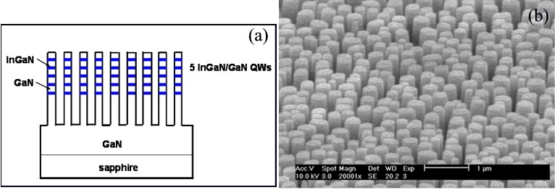
Figure 7.1(a) Schematic of InGaN/GaN QW nanorods; (b) Typical bird’s-eye-view SEM image of GaN nanorod arrays

Subsequently, the two wafers were fabricated into nanorod array structures using the self-organised nickel mask approach as mentioned in Chapter 5 established by our group recently: a SiO₂ film with a thickness of approximate 200 nm is deposited on the surface of any standard III-nitride epiwafer using plasma-enhanced chemical vapor deposition (PECVD), followed by a 10 nm nickel layer deposited by a thermal evaporator. Subsequently the epiwafer is annealed at 800 °C for 1 min under a flowing N₂ ambient, allowing the thin nickel layer to self-organise into nickel islands on a hundreds-of-nanometer scale. Such self-organised nickel islands are used to form SiO₂ nanorod arrays using a standard reactive ion etching (RIE) process. Finally, the SiO₂ nanorod arrays as a second mask are employed to fabricate into the epiwafer into III-nitride nanorod arrays using inductively coupled plasma (ICP). Figure 7.1 (b) is a typical scanning electron microscope (SEM) image of our GaN nanorod arrays, showing a cylindrical shape with straight and smooth sidewalls. The diameter and the density of the GaN nanorod are estimated to be about 200 nm and 1×10⁹ /cm², respectively.
Based on calibration samples, the indium concentration of the InGaN/GaN MQWs in the two epiwafers are estimated 22% and 32% by using a Bede D1 X-ray diffractometer (XRD), denoted as epiwafer A and epiwafer B, respectively. For simplicity, the nanorod array structures fabricated from epiwafer A and epiwafer B are labelled as nanorod A and nanorod B, respectively. In order to avoid the introduction of surface state due to the air-exposed surface, a special surface treatment is normally performed just prior to any optical measurement if the sample stays in the air for a long time [13].

7.3 Strain relaxation in InGaN/GaN MQW nanorods
7.3.1 Methodology
RSM measurements were performed on epiwafer A, B and nanorod A, B, respectively. Detailed experimental method was described in chapter 5. The range of the 2θ-ω measurement and the ω off-set angle are as large as covering all the RLPs including the satellite peaks of the InGaN/GaN MQW and GaN buffer layer.

7.3.2 Results and discussion
Figure 7.2 (a) and (b) show the (10-15) RSM of epiwafer B and nanorod B, respectively, as representatives. The coordinate of each reciprocal lattice point (RLP) on Q (x) and Q (z) axis represents its in-plane and out-of-plane lattice constants for each individual layer, respectively. For a wurtzite structure, the relationship between lattice constants and RLP can be expressed using the following formula [14]:
, (7.1)
where a and c are the in-plane and out-of-plane lattice constants; q_{x} and q_{z} are the coordinates of the RLPs on Q (x) and Q (z) axis, respectively; h, k, l are miller indices.
As shown in Figure 7.2(a), for Epiwafer B, the RLPs from top to bottom correspond to the GaN buffer layer, 0th order and 1st order satellite peaks of the InGaN/GaN MQWs, respectively [14,15]. It should be noticed that the centre of 0th and 1st order satellite peaks from the MQWs have the identical Q (x) coordinate to that of the GaN buffer layer (q_{x} = 0.3621 Ǻ⁻¹), clearly indicated by a black dash line perpendicular to the Q (x) axis. This means that the GaN buffer layer, InGaN QWs and GaN barriers have an identical in-plane lattice constant, i.e., in this case the overlying InGaN MQWs are fully strained with respect to the GaN buffer layer. However, for Nanorod B as shown in Figure 7.2 (b), there is a clear shift in the centre position of 0th order and 1st order satellite peaks from the MQW on Q (x) axis compared with the GaN buffer layer. As the indium compositions are identical for the as-grown sample (i.e., epi-B) and nanorod B, such a shift can only be attributed to the occurrence of the strain relaxation as a result of the formation of the nanorods.

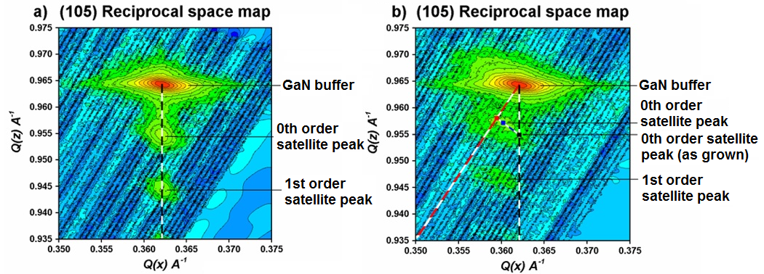
Figure 7.2 (a) (10-15) XRD RSMs for epiwafer B (fully stained line indicted by black dash); (b) (10-15) XRD-RSMs for nanorod B (fully strain-relaxed line by red dash line respectively), and the blue dash-line indicates a strain-variation line

Based on a standard RSM theory [15], a fully strained line (black dash) and a fully relaxed line (red dash) can be drawn as shown in Figure 7.2 (a) and 2(b). If the RLPs of the satellite peak from the MQWs fall on the fully strained line, it means that the MQWs is under a full strain as the InGaN crystal has the same in-plane lattice constant as the underlying GaN, while the MQWs are fully relaxed if the RLPs are on the fully relaxed line. If the RLP falls on the line in between them, it means that the MQW is partially relaxed. In this case, the degree of strain relaxation can be accurately determined. For nanorod B, the degree of strain relaxation is 80.4%. Similar study has been carried out on epiwafer A and nanorod A, showing that the centre position of the 0th order satellite peak of nanorod A is close to the fully relaxed line, which suggests that Nanorod A is nearly fully relaxed. The RSM analysis indicates that the majority of the strain in InGaN/GaN MQWs can be relaxed after being fabricated into nanorods. Note that the IQE enhancement is dependent on the strain-relaxation of nanorods produced by the nanorod fabrication, NOT on the absolute value of the strain-relaxation in nanorods. Though the strain of nanorod A is nearly fully relaxed, the strain-relaxation produced by the nanorod fabrication for nanorod B is higher because a larger strain exists in epiwafer B due to the higher indium composition. Therefore, the IQE enhancement factor for nearly fully relaxed nanorod A is lower than the 80.4% strain-relaxed nanorod B.
Moreover, our x-ray rocking curve measurements do not indicate an increase in dislocation density after the post-etching. We believe that the strain relaxation as a result of fabrication into nanorod is due to reduction in diameter not via formation of dislocations, which has been observed in deep etched Cd_{x}Zn_{1-x}Se/ZnSe quantum wires [16].

7.4 Optical properties of InGaN/GaN MQW nanorods
The photoluminescence (PL) spectra are measured using a 325 nm He-Cd laser to excite the investigated samples. In order to perform the temperature dependant PL, the samples are held in a closed-circuit helium refrigerator in a temperature range from 10 to 300 K. The luminescence is dispersed using a 0.5 m monochromator and detected using a charge-coupled device (CCD).

Figure 7.3 Room temperature PL spectra of (a) epiwafer A and nanorod A, and (b) of epiwafer B and nanorod B
Figure 7.4 PL spectra at 10 K of (a) epiwafer A and nanorod A, and (b) epiwafer B and nanorod B

Nanorod A and B were fabricated in the same batch, meaning that the fabrication has been carried out under identical processing conditions. The etching depth is around 400 nm in both cases. Figure 7.3 (a) shows the PL spectra of epiwafer A and nanorod A, measured under identical conditions at room temperature, while figure 7.3 (b) gives the PL spectra of epiwafer B and nanorod B, also measured under identical conditions at room temperature. Both epiwafer A and nanorod A show a single peak, while epiwafer B shows double peaks, often observed in an InGaN structure with a high indium content, in particular, in InGaN quantum dot (QD) samples with a green emission [17,18]. Looking at figure 7.3 (b) carefully, one can find that the double peaks in epiwafer B merge into a single peak but with a broad width. Further detailed experiments need to be carried out for understanding, which is on the way. Figure 7.3(a) indicates that the PL intensity of nanorod A can be enhanced by a factor of 5 compared with the as-grown sample, i.e., epiwafer A. In a remarkable contrast, the enhancement factor in PL intensity can be increased to 10 for nanorod B, compared with epiwafer B, as shown in Figure 7.3(b). The emission intensity is generally determined as the product of the internal quantum efficiency and light extraction efficiency. In order to identify which factors play larger roles in the increased emission intensity, low temperature PL measurements are also performed. Figure 7.4 shows the PL spectra of all four samples at 10 K. There is no big difference in the PL intensity between each pair, revealing that the light extraction efficiencies are nearly same for the as-grown samples and the nanorod sample, and formation of nanorods does not improve the light extraction efficiency [19]. It indicates that enhancement of internal quantum efficiency plays a dominant role in the increased emission intensity.

Figure 7.5(a) Normalized temperature dependent PL spectra for epiwafer A and nanorod A; (b) Arrhenius plots of the integrated PL intensities of four samples as a function of temperature from 10-300 K

To assess the enhancement in the internal quantum efficiency, temperature dependent PL measurements from 10 K to 300 K are carried out as well. Estimation of internal quantum efficiency (IQE) can be made through performing temperature dependent PL assuming that the internal quantum efficiency is unity at low temperature. Although this method cannot give IQE accurately, it is quite accurate to make comparison of IQE as long as the samples are measured under identical conditions. The temperature dependent PL measurements are carried out on all samples from 10 to 300 K under identical conditions. The normalized temperature dependent PL spectra for epiwafer A and nanorod A are shown in figure 7.5(a) as a representative. Figure 7.5 (b) shows the normalized integrated PL intensities of four samples as a function of temperature in an Arrhenius plot. Compared to the as-grown epiwafer A, the IQE of nanorod A is enhanced by a factor of 3.4 at room temperature. More significant enhancement in IQE for nanorod B (with higher Indium composition) has been observed in figure 7.5 (b), in which the enhancement factor is 8. It is worth highlighting that the Indium compositions for epiwafer B and nanorod B are higher than that of epiwafer A and nanorod A.
Furthermore, both emission peaks from nanorod A and B show a clear blueshift compared to their respective as-grown samples. The blueshift of the emission peak of nanorod B is estimated to be ~ 90 meV, whereas the blueshift for nanorod A is ~ 43 meV. With increasing the indium content, the emission peak moves toward long wavelength (i.e., low energy). Simultaneously, it also causes the enhanced lattice-mismatch, leading to stronger strain. It is well-known that the strain-induced piezoelectric fields in InGaN/GaN MQWs cause so-called quantum confined Stark effect (QCSE), leading to a red shift in emission peak. The clear blueshift of emission peaks of nanorods and enhancement in IQE indicated a reduction in QCSE, supporting the conclusion from the RSM results that the strain relaxation occurs to the InGaN/GaN MQWs in their nanorod array structures.
The above conclusions are also confirmed by performing power-dependent PL measurements at 10 K as shown in figure 7.6. When the excitation power is increased from 0.1 to 16 mW, epiwafer A and epiwafer B show a 3 meV and a 15 meV blueshift as shown in figure 7.6 (c) and 7.6 (a), respectively. In a contrast, an extremely small shift for Nanorod A and a negligible shift for nanorod B are observed with increasing the excitation power, as shown in figure 7.6(d) and 7.6(b), respectively. The excitation power induced blueshift is a ﬁngerprint of the existence of QCSE, generally observed in InGaN/GaN MQWs [20, 21]. Therefore, the power-dependent PL results confirm that there exists a strong QCSE in both as-grown MQWs as a result of the lattice-mismatch-induced strain, which is significantly enhanced with increasing indium composition in MQWs. For nanorod array structure such as nanorod A or B, the QSCE is effectively eliminated due to the occurrence of the strain relaxation. As a result the IQE can be improved. Therefore, fabrication into nanorods has a greater impact in the case where QCSE plays a dominant role, for example in highly strained InGaN/GaN MQWs with high indium composition. It indicates that utilizing nanorods is a very promising route to greatly improve the performance of emitters to fill the green gap for semiconductor based optoelectronics.
Figure 7.6 Power-dependent PL spectra for (a) epiwafer B, (b) nanorod B, (c) epiwafer A and (d) nanorod A, respectively, measured at 10 K with excitation power increased from 0.1 mW to 16 mW

7.5 Conclusions
Fabrication into InGaN/GaN based nanorod structures has lead to significant improvement in internal quantum efficiency compared to the as-grown MQWs, which exhibits much more pronounced for InGaN/GaN MQWs with a high indium content. Detailed X-ray RSM measurements results have confirmed that a significant strain relaxation occurs to the nanorod structures, which effectively reduces QCSE in the active region and thus improves the internal quantum efficiency. This has been proved by excitation-power dependant PL measurements. Especially for InGaN/GaN MQW structures with an emission wavelength in the green spectral region, fabrication into nanorods can potentially be one of best and simple approach to achieving great performance.

References
- N. Grandjean and M. Ilegems, Proceedings of the IEEE 95, 9 (2007)
- K. P. O'Donnell, R. W. Martin, and P. G. Middleton, Phys. Rev. Lett. 82, 237 (1999)
- T. Wang, J. Bai, S. Sakai and J. K. Ho, Appl. Phys. Lett. 78, 2617 (2001)
- S. Chichibu, A. Uedono, T. Onuma, B. A. Haskell, A. Chakraborty, T. Koyama, P. T. Fini, S. Keller, S. P. DenBaars, J. S. Speck, U. K. Mishra, S. Nakamura, S. Yamaguchi, S. Kamiyama, H. Amano, I. Akasaki, J. Han, and T. Sota, Nature Mater. 5, 810 (2006)
- A. Chakraborty, B. A. Haskell, S. Keller, J. S. Speck, S. P. DenBaars, S. Nakamura, and U. K. Mishra, Appl. Phys. Lett. 85, 5143 (2004)
- A. Chitnis, C. Chen, V. Adivarahan, M. Shatalov, E. Kuokstic, V. Mandavilli, J. Yang, and M. A. Khan, Appl. Phys. Lett. 84, 3663 (2004)
- R. Sharama, P. M. Pattison, H. Masui, R. M. Farrel, T. J. Baker, B. A. Haskell, F. Wu, S. P. Denbaars, J. S. Speck, and S. Nakamura, Appl. Phys. Lett. 87, 231110 (2005)
- H. Masui, S. Nakamura, S. P. DenBaars, and U. K. Mishra, IEEE Trans. Electron Devices 57, 88 (2010)
- V. Ramesh, A. Kikuchi, K. Kishino, M. Funato, and Y. Kawakami, J. Appl. Phys. 107, 114303 (2010)
- H. Ono, Y. Ono, K. Kashara, J. Mizuno, and S. Shoji, Jpn. J. Appl. Phys. 47, 933 (2008)
- C. H. Chiu, T. C. Lu, H. W. Huang, C. F. Lai, C. C. Kao, J. T. Chu, C. C. Yu, H. C. Kuo, S. C. Wang, C. F. Lin, and T. H. Hsueh, Nanotechnology 18, 445201 (2007)
- Y. R. Wu, C. H. Chiu, C. Y. Chang, P. C. Yu, and H. C. Kuo, IEEE J. Sel. Top. Quantum Electron. 15, 1226 (2009)

T. Wang, UK Patent Application GB1102122.7 (under pending)
- S. Pereira, M. R. Correia, E. Pereira, K. P. O'Donnell, E. Alves, A. D. Sequeira, N. Franco, I. M. Watson, and C. J. Deatcher, Appl. Phys. Lett. 80, 3913 (2002)
- H. Heinke, S. Einfeldt, B. Kuhn-Heinrich, G. Plahl, M.O. Möller, and G. Landwehr, J. Phys. D, 28 A104 (1995)
- T. Kümmell, G. Bacher, A. Forchel, G. Lermann, W. Kiefer, B. Jobst, D. Hommel, and G. Landwehr, Phys. Rev. B 57, 15439 (1998)

J. Bai, Q. Wang, T. Wang, A. G. Cullis and P. J. Parbrook, J. Appl. Phys. 105, 053505 (2009)
- Q. Wang, T. Wang, J. Bai, A. G. Cullis, P. J. Parbrook, and F. Ranalli, J. Appl. Phys. 103, 123522 (2008)
- Y. Kawakami, A. Kaneta, L. Su, Y.Zhu, K. Okamoto, M. Funato, A. Kikuchi and K. Kishino, J. Appl. Phys. 107, 023522 (2010)
- T. Takeuchi, S. Sota, M. Katsuragawa, M. Komori, H. Takeuchi, H. Amano, and I. Akasaki, Jpn. J. Appl. Phys., Part 2 36, L382 (1997)
- T. Nakaoka, S. Kako, and Y. Arakawa, Phys. Rev. B 73, 121305(R) (2006)

Chapter 8
Conclusions

The objectives of the research described in this thesis were to grow high quality III-nitride materials along c-(0001), a-(11-20) and r-(11-22) direction on c-(0001) plane, r-(10-12) plane and m-(10-10) plane sapphire substrate, respectively. For c-plane GaN, high temperature AlN buffer layer is introduced. Compared to conventional 2-step growth method, a high temperature AlN buffer can massively improve the crystal quality of the overlying GaN, especially when the “porous AlN layer” is introduced. In addition, AlN buffer layer is ideal buffer for the growth of AlGaN-based UV emitters, as the AlGaN grown on AlN suffers from compressive strain while AlGaN grown on GaN suffers from tensile strain which causes a serious cracking issue especially with high Al composition. In this research, multiple AlN buffer layer is introduced, which is made of repetition of porous/flat AlN layers in pair. That porous/flat AlN layers could effectively reduce the dislocation density, and the optimal number of repetition is 3 which can effectively reduce the dislocation density to 9.4×10⁸ cm⁻². Al_{0.05}Ga_{0.95}N/Al_{0.16}Ga_{0.84} MQW structures were grown based on the “multiple AlN buffer” and “GaN interlayer” techniques. Optical pumping measurements using edge geometry were performed on the MQWs and stimulated emission was observed at 340 nm. The threshold power density of MQWs based on “multiple AlN buffer” and “GaN interlayer” techniques were 600 and 700 kW/cm⁻², respectively. Polarization measurements were performed on the two samples with stimulated emission observed and clear TE mode emission spectra have been obtained supported the emissions were stimulated emissions.
The mechanism of the stimulated emission was studied. ASE measurement was set up and the anisotropic ASE measurements were performed on Al_{0.05}Ga_{0.95}N/Al_{0.16}Ga_{0.84} MQW structures grown based on “multiple AlN buffer” and “GaN interlayer” techniques along both m-(1-100) and a-(11-20) orientations. The ASE spectra were obtained, and the optical gains were calculated. The optical gains of the AlGaN MQWs grown based on “multiple AlN buffer” technique were 70 and 60 cm⁻¹ along m- and a-direction, while the optical gains of the AlGaN MQWs grown based on “GaN interlayer” technique were 100 and 70 cm⁻¹ along m- and a-orientations, respectively. X-ray RSM measurements were performed on these samples, and it was found that the MQW structure grown by “GaN interlayer” technique was fully strained while the MQW structure grown by “multiple AlN buffer” technique was slightly relaxed, where the compressive strain values were 0.0069 and 0.0054, respectively. According to the theoretical studies done by others, TE mode polarization is dominated by C-HH and C-LH transition, while TM mode is dominated by C-CH transition. Theoretical studies also show that the valence sub-band splitting between HH, LH and CH is enhanced by compressive strain In AlGaN layer with low Al composition, leading to an increase in optical gain. The result obtained in this research gave experimental evidence to support the theoretical studies.
In this research, non-polar (11-20) a-plane GaN was grown on r-plane (10-12) sapphire substrate. High temperature AlN buffer layer was introduced and the growth conditions were optimized for obtaining atomic flat surface. The standard GaN template was then fabricated into a nano-rod template with the diameter of the nano-rods ~100 nm by self-organised nickel/SiO₂ masks. After finishing the nano-rod fabrication, SiO₂ caps were left on the top of the nano-rods. As the dislocations majorly generate at the interface between sapphire and AlN and penetrate vertically to the overlying layer, SiO₂ caps were left to block the penetration of dislocations. In addition, voids would be formed during the coalescence between the nano-rods. The voids between nanorods act as second masks to block the penetration of dislocations. By optimizing the overgrowth conditions, non-polar GaN with atomic flat surface was obtained by growing GaN with a total thickness of 5 μm. X-ray rocking curve measurements were measured as a function of azimuth angle on both overgrown and standard non-polar GaN, indicating a massive improved crystal quality. By performing room temperature PL measurements, NBE was obtained from overgrown non-polar GaN while no NBE was obtained from standard non-polar GaN at all. InGaN/GaN MQW structures were grown on both standard and overgrown non-polar GaN. Temperature dependent PL measurements were performed on a non-polar overgrown InGaN/GaN MQW structure and a standard c-plane InGaN/GaN MQW structure. The IQE of overgrown InGaN/GaN MQWs was found to be enhanced by a factor of 7 compared to the standard InGaN/GaN MQWs. Power dependent PL measurements were performed on InGaN/GaN MQWs grown on overgrown non-polar GaN and standard c-plane GaN. A clear blue shift was observed with the increase of excitation power from c-plane InGaN/GaN MQWs while no blue shift was observed from the non-polar InGaN/GaN MQWs. The result proved that the enhancement of the IQE from overgrown InGaN/GaN MQW compared to standard c-plane InGaN/GaN MQW due to the massive reduction of QCSE. The mechanism of the reduction of dislocation density was also investigated by TEM measurements .
Finally, the optical properties of InGaN/GaN MQW nano-rod structures were studied. It was found that the PL intensity of InGaN/GaN MQWs was enhanced greatly by fabricating standard MQW structure into a nano-rod MQW structure. A blue shift in PL spectra was also observed due to the fabrication of nano-rod structures. Optical measurements such as temperature dependent and power dependent PL measurements were performed to compare the optical properties between the standard and nanorod InGaN/GaN MQW. It was found that the optical enhancement is mainly due to the reduction of strain induced QCSE. RSM measurements were also performed, showing that standard InGaN/GaN MQWs were fully strained due to the underlying GaN buffer, but by fabricating MQWs into a nanorod structure, the strain was fully relaxed or mostly relaxed, depending on the indium composition. Due to the nano-rod fabrication the degree of relaxation was large for InGaN/GaN MQW with high In composition, while the degree of relaxation was small for InGaN/GaN MQW with low In composition. The RSM result highly matched with the optical measurements.

Acknowledgements

Looking over the journey past in the last 4 years, there are so many people gave me support physically and mentally. I would like to sincerely thank all of them here.
Firstly, I would like to thank my supervisor Prof. Tao Wang. He was also my personal tutor during my undergraduate study in the University of Sheffield. He not only gave me guide on my study, but also provided me a chance to further carry on a PhD study with him. During the PhD study, he trained me about the operation of MOCVD. He trained me about how to think in a critical way to solve problems. He also tried hard to solve any problems in my daily life. He gave me so many help that I felt I could never repay him. I would like to show my highest respect to him.
I would also like to thank Dr. Jie Bai, Dr. Qi Wang, Dr. Jinfeng Zhang and Dr Yuanzheng Yue. They trained me on several experimental facilities at the beginning of my PhD. They also kindly shared their experience on PhD to make me more prepared. Dr. Qi Wang also trained me about the presentation skills and Dr. Jie Bai gave me help on writing skills. Without them, it would take much longer time for me to work as a PhD student.
Then, I would like to thank the technicians in EPSRC. I would like to firstly thank Mr. Paul Haines. Every time when there was a machine shut down in the clean room or other labs, he sorted out the problems, including MOCVD shut down, change of NH₃ cylinder, moving PL lab, etc. I would also like to thank Mr. Dave Morris, Mr. Jon Milner, Mr. Richard Frith, Mr. Rob Airey. They also gave me help or training in the clean room. Without them, it would be a mess in the lab and no one can work properly.
Next, I would like to thank my colleagues. Mr. Kun Xing fabricated nanorod templates for overgrowth. It was a bored and tired job, but he kept fabricating templates for 2 years. Mr. Xiang Yu and Mr. Benbo Xu did a lot of operation, measurement and maintenance work, which helped me save a lot of time. Mr. Paul Renwick and Mr. Rick Smith worked together with me on optical measurements. They also introduced British culture and kindly gave advice on dealing with daily issues. Mr. Rick Smith also setup several new experimental facilities, and established the measurement system. He never felt hesitate training his colleagues about how to use his system if they required. Dr. Jie Bai used her own time to fabricate nanorod template for about half year. She also did the TEM measurement that provides important data for part of my thesis. Dr. Yaonan Hou did HF treatment on Si substrates. Dr. Bin Liu and Miss Hao Tang gave me ideas on theoretical understanding of my project. Mr. Jon Benton and Mr. Modestos Athanasiou talked about their experience on how to generate new ideas. We worked as a team together and I would like to sincerely thank them all for the help they gave me.
Besides, I would like to thank several academic stuffs in department of EEE. Firstly, I would like to thank Prof. Tony Cullis who supported me to start PhD in the University of Sheffield. I would like to thank Dr. Martin Foster who gave me help on getting my visa application documents. I would then like to thank Prof. Richard Tozer as my examiner to pass my transfer viva. I would like to thank Dr. Thomas Walther as my second supervisor to guide me on several useful academic skills such as presentation skills. Finally, I would like to thank Prof. John David who organized our department well during my PhD and provided all the students a good environment.
I would like to thank our secretary Ms. Hilary Levesley, who always kindly sort out administrative issues during my study. I would also like to thank the cleaner in the clean room Mr. Gorder to make the clean room tidy every day.
Finally, I would like to thank my parents who supported my study abroad for 7 years. Not only did they provide me the funding, but also the courage and their life experiences. I would like to thank all again who gave me help in the last 4 years. Thank you so much and I will forever remember.

