Can the inhibition of TAFI affect kidney plasmin activity, ECM accumulation and the progression of experimental chronic kidney disease?

John Atkinson

Submitted for the degree of Doctor of Philosophy

Academic Unit of Nephrology, Department of Infection and Immunity, University of Sheffield

December 2013

Contents

Chapter One: Introduction……………………………………………………..1

1.1 Chronic Kidney Disease ……………………………………………………2
1.1.1 The anatomy and evolution of the kidney …………………………2
1.1.2 Kidney Function……………………………………………………. 6
1.1.3 Clinical Features and Epidemiology of Chronic Kidney Disease…….7
1.1.4 Histology …………………………………………………………....8
1.1.5 Risk Factors ……………………………………………………………10
1.1.6 Mechanisms of Progression ………………………………………….12
1.2 Kidney Scarring ……………………………………………………………20
1.2.1 Pathology of Renal Scarring ………………………………………….20
1.2: The Extracellular Matrix …………………………………………………..29
1.2.1 Structure and Function of the ECM …………………………………29
1.2.2 The Renal ECM ……………………………………………………………47
1.2.2 Deposition and Destruction of the ECM …………………………48
1.3 Plasmin ……………………………………………………………………..63
1.3.1 Plasminogen …………………………………………………………….63
1.3.2 Structure of Plasmin ……………………………………………………65
1.3.3 Function of Plasmin ……………………………………………………67
1.3.4 Activators of Plasminogen …………………………………………..69
1.3.5 Plasmin Inhibitors ……………………………………………………72
1.4 Changes in ECM Processing During Scarring …………………………74
1.4.1 Increased Synthesis of ECM Components …………………………76
1.4.2 Reduced ECM Degradation …………………………………………..78
1.4.3 ECM Stabilisation ……………………………………………………80
1.5 The Clotting System ……………………………………………………80
1.5.1 Coagulation and Fibrinolysis …………………………………………..80
1.6 TAFI ……………………………………………………………………..83
1.6.1 The Role of TAFI ……………………………………………………84
1.6.2 Why Might TAFI Affect Scarring? ………………………………….85
1.6.3 The TAFI Inhibitor UK-396082 …………………………………………..87
1.7 Thesis Rationale and Hypothesis …………………………………………..90
1.8 Aims and Objectives ……………………………………………………91

Chapter Two: Materials and Methods ………………………………….93

2.1 Cell Culture …………………………………………………………….94
2.1.1 Cell Lines …………………………………………………………….94
2.1.1 Cell counting protocol ……………………………………………………94
2.1.2 Culture Media …………………………………………………………….94
2.1.3 Immunofluorescence for cell markers ………………………………….95
2.1.4 Transfection of Renal Cells …………………………………………..96
2.1.5 In vitro model of diabetic nephropathy ………………………………….96
2.2 Colorimetric Enzyme activity Assays ………………………………….97
2.2.1 The Plasmin Assay ……………………………………………………97
2.2.2 The tPA assay …………………………………………………………….98
2.2.3 The uPA Assay …………………………………………………………….99
2.2.4 The TAFI Assay ……………………………………………………………100
2.3 Western Blotting ……………………………………………………………100
2.3.1 Polyacrylamide gel electrophoresis (SDS-PAGE) ………………..100
2.4 The Bicinchonic Acid (BCA) assay ………………………………….105
2.5 Molecular Biology …………………………………………………………….106
2.5.1 RT-QPCR ……………………………………………………………………..106
2.6 ECM Quantification …………………………………………………………….110
2.6.1 In Vitro ………………………………………………………………………………110
2.6.2 In Vitro ………………………………………………………………………………111
2.6.3 In Vivo ………………………………………………………………………………113
2.6.3.1 Assessment of kidney scarring …………………………………………...113
2.6.3.2 Immunohistochemistry for Collagens I, III & IV, Laminin & Fibronectin .113
2.6.4 Multiphase image analysis …………………………………………………….114
2.7 The TAFI Inhibitor ………………………………………………………………………115
2.7.1 In Vitro Applications ……………………………………………………………..115
2.7.2 In Vivo Applications ……………………………………………………………..117
2.8 In vivo modelling of CKD ……………………………………………………………..118
2.8.1 The rat 5/6th Subtotal Nephrectomy model of kidney fibrosis. …………………118
2.8.2 Cumulative Survival ……………………………………………………………..120
2.8.3 Clinical chemistry assessment of renal function & damage …………………120
2.8.4 Urine Biomarkers of renal injury and fibrosis …………………………………..121
2.8.5 Processing, fixation and homogenisation of kidney tissues …………………122
2.8.12 Blood Pressure ……………………………………………………………..123
2.8.13 Serum UK-396082 ……………………………………………………………..123
2.9 Statistical Analysis ……………………………………………………………..124

Chapter Three: In Vitro classification of the plasmin system in renal tubular epithelial, mesangial and fibroblast cell-lines …………………………………..125

3.1 Introduction ………………………………………………………………………126
3.2 Determination of the activity of fibrinolytic system proteins in NRK52E, 1097 and NRK49F cell lines ……………………………………………………………………...127
3.2.1 Plasmin ……………………………………………………………………………….127
3.2.2 TAFI ……………………………………………………………………………….130
3.2.3 tPA ……………………………………………………………………………….132
3.2.4 uPA ……………………………………………………………………………….134
3.3 The Effects of TAFI Inhibitor UK396082 on the fibrinolytic system in NRK52E, NRK49F and 1097 Cells ……………………………………………………………..136
3.3.1 Dose Response Effects on TAFI activity in different cell lines …………………136
3.3.2 Dose Response Effects on Plasmin ……………………………………………138
3.3.3 Dose Response Effects on tPA …………………………………………………….139
3.3.4 Dose Response Effects on uPA ……………………………………………140
3.4 Summary ……………………………………………………………………………….141
3.5 Discussion ……………………………………………………………………………….142

Chapter Four: Application of UK-396082 in an in vitro model of diabetic nephropathy ……………………………………………………………………………….147

4.1 Introduction ………………………………………………………………………148
4.2 Results ……………………………………………………………………………….151
4.2.1 The effect of manipulating plasmin activity on NRK52E cell ECM. ………...151
4.2.2 In vitro model of Diabetic Nephropathy ……………………………………………153
4.3 Discussion ………………………………………………………………………161

Chapter Five: Establishing an In Vivo Dose for effective TAFI inhibition with UK396082 in the Wistar rat ……………………………………………………………..166

5.1 Introduction …………………………………………………………….………..167
5.1.1 Previous Studies ……………………………………………………………..167
5.1.2 Dosing Considerations ……………………………………………………………168
5.1.3 Hypothesis …………………………………………………………………….169
5.2 Methods ……………………………………………………………………………...169
5.2.1 Experimental Animals …………………………………………………………….169
5.2.2 Dosing with Rat Chow containing TAFI inhibitor UK-396082 ………………...169
5.3 Results ………………………………………………………………………………170
5.3.1 TAFI Activity – 2 Weeks Dosing ……………………………………………170
5.3.2 TAFI Activity – 4 Weeks Dosing ……………………………………………170
5.3.3 TAFI Activity – Rats pre-conditioned with UK-396082 ………….………………170
5.3.4 Correlation ………………………………………………………………………170
5.4 Discussion ……………………………………………………………………………….173

Chapter Six: Application of TAFI inhibitor UK-396082 in a rat 5/6th subtotal nephrectomy model of Chronic Kidney Disease ……………………………………176

6.1 Introduction ………………………………………………………………………177
6.2 Experimental Design ……………………………………………………………..180
6.3.1 Serum Levels of Fibrinolytic Components …………………………………..183
6.3.2 Terminal Tissue Levels of Fibrinolytic components ………………………….191
6.3.3 Renal Function ………………………………………………………………………197
6.3.4 Biomarkers of kidney damage …………………………………………………….206
6.3.5 Renal Histology ……………………………………………………………….……..212
6.3.6 Blood Pressure ………………………………………………………………………230
6.3.7 Cumulative Survival ……………………………………………………………..230
6.3.8 Terminal Serum Concentration of UK-396082 …………………………………..230
6.4 Discussion ………………………………………………………………………………236
Chapter Seven: Human Relevance ……………………………………………………244
7.1 Introduction ……………………………………………………………………..245
7.2 Results ………………………………………………………………………………246
7.4 Discussion ………………………………………………………………………………248

Chapter Eight: General Discussion …………………………………………...249

References ……………………………………………………………………………….249

List of Figures
Figure 1.1: The Structure of the Nephron 4
Figure 1.2: The Structure of the Glomerulus 5
Figure 1.3: The progression of glomerular sclerosis (A-C) and tubulointerstitial fibrosis (D-F) 15
Figure 1.4: Progression of Renal Disease 22
Figure 1.5: Collagen Structures 25
Figure 1.6: Collagen Biosynthesis 29
Figure 1.7: Laminin and Fibronectin Act as a Scaffold for ECM Attachment 35
Figure 1.8: A representation of the structure of an MMP 43
Figure 1.9: Gelatinase Structure 45
Figure 1.10: Plasminogen 2D Structure 58
Figure 1.10: Plasminogen 3D Structure 59
Figure 1.11: Cleavage of human fibrinogen by plasmin and the fragments generated 61
Figure 1.12: tPA 3D Structure 63
Figure 1.13: uPA 3D Structure 65
Figure 1.14: PAI-1 3D Structure 67
Figure 1.15: PAI-2 3D Structure 68
Figure 1.16: Neuroserpin 3D Structure 71
Figure 1.17: The Coagulation Cascade 75
Figure 1.18: Interaction of Plasmin and TAFI 77
Figure 1.19: TAFI’s Effect On Plasmin 79
Figure 1.20: Steps in the production of UK-396082 82
Figure 1.21: TAFI 3D Structure 83
Figure 1.22: Interactions of the TAFI Inhibitor 84

Figure 2.1: SDS-PAGE 96
Figure 2.2: Tritiated Amino Acid Incorporation Assay 106
Figure 2.2: Phase Image Analysis 110
Figure 2.3: The Structure of UK-396082 112
Figure 2.4: Subtotal Nephrectomy procedure 114

Figure 3.1: Standard Curve of Plasmin Activity 124
Figure 3.2: Plasmin Activities in NRK52E, NRK49F and 1097 Cells 125
Figure 3.3: Quantification of Plasmin Activity in NRK52E, NRK49F and 1097 cells 125
Figure 3.4: Standard Curve of TAFI Activity 126
Figure 3.5: TAFI Activities in NRK52E, NRK49F and 1097 Cells 127
Figure 3.6: Quantification of TAFI Activity in NRK52E, NRK49F and 1097 Cells 127
Figure 3.7: Standard Curve of tPA Activity 128
Figure 3.8: tPA Activities in NRK52E, NRK49F and 1097 Cells 129
Figure 3.9: Quantification of tPA Activity in NRK52E, NRK49F and 1097 Cells 129
Figure 3.10: Standard Curve of uPA Activity 130
Figure 3.11: uPA Activities in NRK52E, NRK49F and 1097 Cells 131
Figure 3.12: Quantification of uPA Activity in NRK52E, NRK49F and 1097 Cells 131
Figure 3.13: Effect of UK-396082 on TAFI Activity in NRK52E, NRK49F and 1097 Cells 133
Figure 3.14: Effect of UK-396082 on Plasmin Activity 135
Figure 3.15: Effect of UK-396082 on tPA Activity 136
Figure 3.16: Effect of UK-396082 on uPA Activity 137

Figure 4.1: The Effect of Manipulating Plasmin Activity on ECM Levels 145
Figure 4.2: The Effect of High Glucose on TAFI and Plasmin Activity in Tubular Epithelial Cells. 147
Figure 4.3: The Effect of TAFI Inhibition on ECM levels in glucose treated NRK 52E cells 150
Figure 4.4: Masson’s Trichrome, Collagens I & IV, Laminin & Fibronectin immunofluorescence in glucose stimulated NRK52E cells treated with UK-396082 151
Figure 4.5: Quantification of Mason’s Trichrome staining plus Collagen, Laminin and Fibronectin immunofluorescence on glucose stimulated NRK52E cells treated with UK-396082 153
Figure 4.6: Increasing concentrations of UK-396082 reduce collagen accumulation in an activated system. 154
Figure 4.7 Changes in relative expression of fibrinolytic and ECM components in response to high glucose and 500nM UK-396082 155

Figure 5.1: Serum TAFI Activity after 2 Weeks Dosing with UK396082 166
Figure 5.2: Serum TAFI Activity after 4 Weeks dosing with UK396082 166
Figure 5.3: Inhibition of serum TAFI Activity after pre-conditioning of animals with 1 weeks of 20mg/kg UK396082 167
Figure 5.4: Correlation analysis between serum TAFI activity and amount of UK-396082 administered 168

Figure 6.0: Experimental plan for both preservation and reversal arms 177
Figure 6.1: Mean Serum TAFI Activities across all time points following UK396082 treatment in experimental CKD 181
Figure 6.2: Mean serum changes in TAFI Activity with time following UK396082 treatment in experimental CKD 182
Figure 6.3: Serum TAFI activity with time in individual animals following UK396082 treatment from the onset of disease in experimental CKD 183
Figure 6.4: Mean serum changes in plasmin Activity with time following UK396082 treatment in experimental CKD 184
Figure 6.5: Serum plasmin activity in individual animals with time following UK396082 treatment from the onset of disease in experimental CKD 185
Figure 6.6: Kidney TAFI activity in experimental CKD treated with TAFI inhibitor UK396082 188
Figure 6.7: Mean kidney plasmin activity in experimental CKD treated with TAFI inhibitor UK396082 189
Figure 6.8: Mean kidney uPA activity in experimental CKD treated with TAFI inhibitor UK-396082 190
Figure 6.9: Mean kidney tPA in experimental CKD treated with TAFI inhibitor UK396082 191
Figure 6.10: Mean Serum Creatinine with time following UK396082 treatment in experimental CKD 195
Figure 6.11: Serum Creatinine in individual animals with time following UK396082 treatment from the onset of disease in experimental CKD 196
Figure 6.12: Correlation of Terminal TAFI activity with terminal Serum Creatinine following treatment with UK396082 in experimental CKD 197
Figure 6.13: Mean Creatinine Clearance with time following UK396082 treatment in experimental CKD 198
Figure 6.14: Mean Proteinuria with time following UK396082 treatment in experimental CKD 199
Figure 6.15: Mean terminal Serum Urea with time following UK396082 treatment in experimental CKD 200
Figure 6.16: Changes in mean urinary NGAL level with time following UK396082 treatment in experimental CKD 203
Figure 6.17: Changes in mean urinary KIM-1 level with time following UK396082 treatment in experimental CKD 204
Figure 6.18: Changes in mean urinary TIMP-1 level with time following UK396082 treatment in experimental CKD 205
Figure 6.19: Changes in mean urinary TG2 level with time following UK396082 treatment in experimental CKD 206
Figure 6.20: Glomerularsclerosis and Tubulointerstitial Fibrosis following UK396082 treatment in experimental CKD 212
Figure 6.21: Assessment of renal scarring by multiphase image analysis in experimental CKD treated with TAFI inhibitor UK396082. 213
Figure 6.22: Collagen I Immunofluorescence following UK396082 treatment in experimental CKD 214
Figure 6.23: Assessment of Collagen I Immunofluorescence by multiphase images analysis in experimental CKD treated with TAFI inhibitor UK396082 215
Figure 6.24: Collagen III Immunofluorescence following UK396082 treatment in experimental CKD 216
Figure 6.25: Assessment of Collagen III by multiphase analysis in experimental CKD treated with TAFI inhibitor UK396082. 217
Figure 6.26: Collagen IV Immunofluorescence following UK396082 treatment in experimental CKD 218
Figure 6.27 Assessment of Collagen IV by multiphase analysis in experimental CKD treated with TAFI inhibitor UK396082. 219
Figure 6.28: Fibronectin Immunofluorescence following UK396082 treatment in experimental CKD 220
Figure 6.29: Assessment of Fibronectin by multiphase analysis in experimental CKD treated with TAFI inhibitor UK396082. 221
Figure 6.30: Laminin Immunofluorescence following UK396082 treatment in experimental CKD. 222
Figure 6.31: Assessment of Laminin by multiphase analysis in experimental CKD treated with TAFI inhibitor UK396082. 223
Figure 6.32: Kidney Hydroxyproline levels in experimental CKD treated with TAFI inhibitor UK396082 224
Figure 6.33: Terminal Blood Pressure in experimental CKD treated with TAFI inhibitor UK396082 227
Figure 6.34: Cumulative Survival from day 0 post SNx following treatment with UK396082 in experimental CKD 228
Figure 6.35: Cumulative Survival from day 35 post SNx following late treatment with UK396082 in experimental CKD 229
Figure 6.36: Terminal UK-396082 serum Concentration analysis in experimental CKD treated with TAFI inhibitor UK396082 230

Figure 7.1: Human Serum Plasmin and TAFI Activity 243

Acknowledgements

This thesis is dedicated to my parents. Without their love and support, it could never have been written. I’d also like to thank Colleen Clarke, for her constant support and cups of tea.

I would like to acknowledge the contributions of the following individuals and organisations to the completion of this PhD thesis:

Dr Tim Johnson: For considerable support, encouragement and guidance during the supervision of my PhD and for his reading, re-reading and sometimes re-re-reading of abstracts, manuscripts and appraisal of this thesis.

Dr Nick Pullen: For support and assistance with the preparation of abstracts and manuscripts, and as an invaluable contact with Pfizer, my CASE sponsors for this thesis.

Dr John Haylor: For surgical expertise in teaching the subtotal nephrectomy technique and his willingness to do so.

Mrs Lynne Williams: For assistance with performing the subtotal nephrectomy procedure and assistance with the husbandry of the animals.

Dr Linghong Huang: For assistance with various cell-line cultures and assistance with various assays.

Mrs Fiona Morrow: For assistance with Masson’s Trichrome staining and reminding me that it is a blue stain, not a green one.

Pfizer and the BBSRC: For sponsoring me as a CASE student for this PhD project and their invaluable financial support and funding the purchase of laboratory consumables and reagents, without which this thesis could not have been completed.

Abstract
Chronic kidney disease (CKD) is characterised by the pathological accumulation of extracellular matrix (ECM) proteins leading to progressive kidney scarring via glomerular and tubular basement membrane expansion. Increased ECM synthesis and deposition, coupled with reduced ECM breakdown contribute to the elevated ECM level in CKD.
Previous pre-clinical studies have demonstrated that increased plasmin activity has a beneficial effect in the protein overload model of CKD. As plasmin activation is down regulated by the action of the thrombin activated fibrinolytic inhibitor (TAFI), we tested the hypothesis that inhibition of TAFI might increase plasmin activity & reduce ECM accumulation in an in vitro model of glucose induced ECM expansion. Treatment of NRK52E tubular epithelial cells with increasing concentrations of glucose resulted in a 40% increase in TAFI activity, a 38% reduction in plasmin activity and a subsequent increase in ECM accumulation. In this model system, application of the previously reported TAFI inhibitor UK-396082 [(2S)-5-Amino-2-[(1-n-propyl-1H-imidazol-4-yl)methyl]pentanoic acid] caused a reduction in TAFI activity, increased plasmin activity and induced a parallel decrease in ECM levels. In contrast, RNAi knockdown of plasmin resulted in an increase in ECM levels.
An evaluation of serum TAFI and plasmin activity from individuals with CKD indicated a strong correlation between elevated TAFI and reduced plasmin levels with renal impairment. These findings correlated with similar observations made in the rat following sub-total nephrectomy. Pharmacological inhibition of TAFI with UK-396082 reduced glomerular and tubulointerstitial ECM deposition. Renal function, as measured by an increase in creatinine clearance and decrease in proteinuria, and survival improved with TAFI inhibition. Taken together, the data support the importance of the fibrinolytic axis in regulating renal fibrosis and point to a potentially important therapeutic role for TAFI inhibition.

Publications

Papers:
An Inhibitor Of Thrombin Activated Fibrinolysis Inhibitor (Tafi) Can Reduce Extracellular Matrix Accumulation In An In Vitro Model Of Glucose Induced ECM Expansion. J. M. Atkinson, N. Pullen, & T.S. Johnson. Accepted for publication by Matrix Biology, Jan 2013.
The Inhibition Of Thrombin Activated Fibrinolysis Inhibitor Reduces Renal Fibrosis And Improves Outcome In Rat Subtotal Nephrectomy. J. M. Atkinson, N. Pullen, M. Da Silva-Lodge, L. Williams & T.S. Johnson. Awaiting submission
Abstracts:
The Effects Of A Tafi Inhibitor On Plasmin Activity, Ecm Accumulation And Kidney Scarring. J. M. Atkinson, N. Pullen, & T.S. Johnson. Poster - Renal Association Manchester 2010
The Effects Of Inhibition Of Thrombin Activated Fibrinolytic Inhibitor (TAFI) On Plasmin Activity & ECM Accumulation In An In Vitro Model Of Diabetic Nephropathy. J. M. Atkinson, N. Pullen, & T.S. Johnson. Poster - Renal Association Birmingham 2011
Changes in plasmin activity and its regulatory system in experimental chronic kidney disease. J. M. Atkinson, N. Pullen, F. Nutter & T.S. Johnson. Poster - Renal Association Birmingham 2011
Inhibition Of Thrombin Activated Fibrinolysis Inhibitor (TAFI) Using UK-396082 Reduces Collagens I & IV, Laminin And Fibronectin Levels In Response To High Glucose In A Dose Dependant Manner. J. M. Atkinson, N. Pullen, & T.S. Johnson. Winner – Young Laboratory Science Investigator Award – Renal Association – Gateshead 2012

Establishing If UK 396082, An Inhibitor Of Thrombin Activatable Fibrinolysis Inhibitor (TAFI), Can Be Given Orally. J. M. Atkinson, N. Pullen, & T.S. Johnson. Poster – Renal Association Gateshead 2012

The Effects Of Inhibition Of Thrombin Activated Fibrinolytic Inhibitor (TAFI) On Tafi & Plasmin Activities & Renal Function In An In Vivo Model Of CKD. J.M. Atkinson. Winner – Infection and Immunity Department Research Day – Sheffield 2013

Inhibition Of Thrombin Activated Fibrinolysis Inhibitor (TAFI) Using UK-396082 Increases Survival And Halts The Progression Of Renal Fibrosis In Established Kidney Disease In The 5/6th Subtotal Nephrectomy (SNx) Model Of Chronic Kidney Disease (CKD). J. M. Atkinson, N. Pullen, M. Da Silva-Lodge, L. Williams & T.S. Johnson. Oral Presentation – Young Laboratory Science Investigator Award – Renal Association – Bournemouth 2013

Chapter One

Introduction

1.1 Chronic Kidney Disease

1.1.1 The anatomy and evolution of the kidney
The kidneys are located in the posterior part of the abdominal cavity. Human kidneys are 9 to 13 cm in diameter. The primary role of the kidney is to maintain the homeostatic balance of bodily fluids by filtering, reabsorbing and secreting metabolites and minerals from the blood. These metabolites and minerals are then excreted, along with water, as urine. To maintain fluid balance, the kidney must also selectively retain water and electrolytes. This maintenance of fluid balance is one of the reasons the kidney is essential for life.
In “From Fish To Philosopher” (Smith, 1959) the author proposes that the kidney may have evolved in the sea from early excretory systems. Smith suggests that the kidney evolved primarily to remove harmful chemicals, which diffusion could not remove alone, from complex animals. Elements of the first, simple protovertebrate, kidneys can be found in hagfish and lamprey. These are transiently represented in the pronephros of early-stage renal development in reptiles, birds and mammals (Vize et al., 1997).
After life migrated from the seas to freshwater, kidney function altered to provide homeostasis through removing excess water and conserving salt. The evolution of the glomerulus allowed this excess water to be removed. However this created a problem, as now a system to allow recapture of filtered solutes such as NaCl was required to prevent them being removed with the water. Amphibians, followed by reptiles, evolved a mechanism for absorbing salt without water beyond the proximal tubule - this eventually became the Loop of Henle. At this stage the urine could not be concentrated above the osmolarity of body fluids, leading to a limit on the survivable habitats colonised by these creatures (Dantzler, 1992). Additional mechanisms were therefore required to conserve water and regulate salt secretion. As a result of this, the system of the collecting duct evolved, followed by the Loop of Henle tubular segments and blood vessels in the medulla between proximal and distal tubules. A creation of a counter current for concentrating solutes in the renal medulla allowed the mammalian kidney to provide a mechanism by which mammals could live out of the water for extended periods of time (Grantham and Wallace, 2002).
A gross anatomical overview of the kidney often starts with the differences in texture between the outer cortex and the medulla. This difference is due to the location of different sections of the nephrons which make up the kidney. The cortex mostly contains convoluted tubules (both the distal and proximal) and renal corpuscles, whereas the medulla contains the loops of Henle and the collecting ducts, comprising millions of nephrons. The cortex and the medulla surround the hollow pelvis, which they drain into, and is the beginning of the ureter, being lined with transitional epithelial cells.
The kidney, as well as being divided into the medulla and the cortex, is also divided into lobes. Each lobe is made up of a medullary pyramid region which projects into the pelvis, and the associated region of the cortex. A renal lobule is the portion of the kidney served by a common collecting duct, therefore comprising several nephrons.
The blood is filtered by nephrons (Fig 1.1), which are the functional units of the kidneys. Each nephron begins in a renal corpuscle, made up of a glomerulus enclosed in a Bowman’s capsule (Fig 1.2). The process of ultra-filtration retains cells, proteins, and other large molecules, allowing an ultra-filtrate to enter the Bowman’s space. This ultra-filtrate then drains down the Proximal Convoluted Tubule, where proteins are reabsorbed, to the Loop of Henle where water and nutrients such as amino acids and glucose are reabsorbed by the proximal tubular epithelial cells. The rest of the filtrate then passes through the Distal Convoluted Tubule, where electrolytes and H⁺ ions are reabsorbed, to the Collecting Duct. Reabsorbtion of small ions can occur through the entire length of the nephron. As an example; 65% of filtered sodium (Na) is reabsorbed by the PT, but 25% is reabsorbed in the Loop of Henle, 8% in the distal tubule and 2% in the collecting duct, under the influence of the hormone aldosterone.
The resulting waste products are then excreted as urine. There are approximately 1 million nephrons in the human kidney, this number is established during prenatal development after which no new nephrons can be grown, or damaged ones be replaced.

Figure 1.1: The Structure of the Nephron
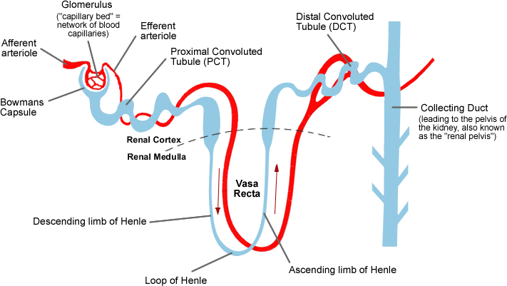

Figure 1.1 Blood flows into the kidney through the renal artery. This artery then branches into arterioles which feed the capillary bed in the individual nephrons. The blood flows from this capillary bed to an efferent arteriole which runs alongside the nephron, reabsorbing desired material that has been filtered. This then joins the renal vein which returns ‘clean’ blood to the body. Figure adapted from (Books, 1998)

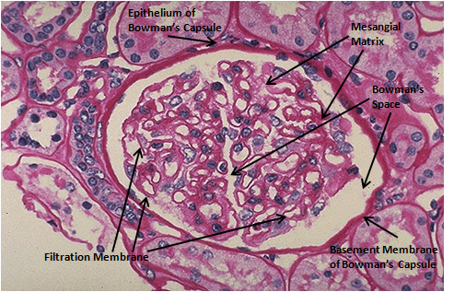
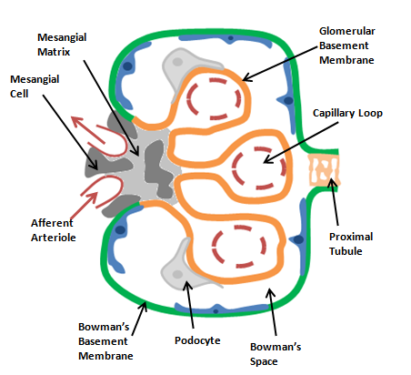
Figure 1.2: The Structure of the Glomerulus

A) B)

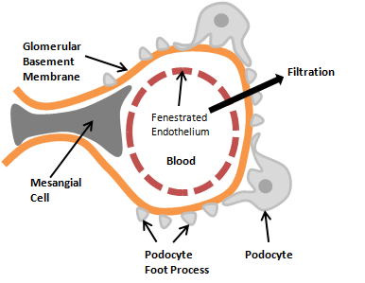
C) D)
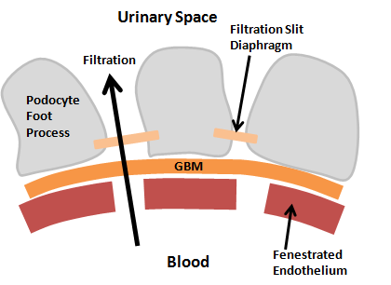

Figure 1.2 A) PAS Stained Glomerulus with clearly visible and labelled filtration membrane, basement membrane and mesangial matrix. B) Diagrammatic representation of glomerulus. Blood enters through the afferent arteriole and is filtered in the capillary loops, in the glomerular tuft. C) Diagrammatic representation of a glomerular capillary loop with podocyte and mesangial interaction shown. D) Enlarged diagram of the glomerular filtration barrier with fenestrated endothelium, glomerular basement membrane and podocyte foot processes shown. Figure adapted from (Leeuwis et al., 2010)

1.1.2 Kidney Function in CKD
The main measurement of renal function is the estimated Glomerular Filtration Rate (eGFR), which is usually based on serum creatinine, along with the race, age and sex of the patient. There are several equations for this, but the most widely used is the abbreviated Modification of Diet in Renal Disease (MDRD) equation:
Estimated GFR (ml/min/1.73m²) = 186 x (Creat / 88.4)^{-1.154}x (Age)^{-0.203} x (0.742 if female) x (1.210 if black)
Chronic Kidney Disease (CKD) is characterised by the World Health Organisation as a slow, progressive decline in kidney function over time. This can ultimately lead to End Stage Renal Disease (ESRD) which requires either transplantation or Renal Replacement Therapy (RRT) to prevent the death of the patient. CKD is defined as kidney damage or glomerular filtration rate (GFR) <60 mL/min/1.73 m² for 3 months or more, irrespective of the cause (Levey et al., 2005).
The incidence of CKD continues to increase worldwide, with a reported prevalence of CKD stages 1-4 in the most recent NHANES (national health and nutrition examination survey) of around 13% of the population (Bakris and Ritz, 2009) with recent studies suggesting that the incidence of RRT is rising (Bagshaw et al., 2008). The prevalence of CKD in the UK is estimated to be approximately 5,554 patients per million population (pmp) (John et al., 2004). In the UK the incidence of ESRD has doubled in the past decade and now affects around 100 new patients pmp (Meguid El Nahas and Bello, 2005). This figure is well below the European average of 135 per million. However the UK trend, like the trend in most developed countries, is expected to rise at an annual rate of 5-8% (Lysaght, 2002). It is unclear as to whether this constitutes a real increase in CKD or if it is merely an increase in the diagnosis (Hallan et al., 2006).
Renal healthcare services currently consume around 4-5% of the National Health Service (NHS) budget in the UK and this is set to rise with increasing numbers requiring RRT (Klebe et al., 2007). In addition to the financial burdens imposed by CKD, the disease can be severely debilitating and can greatly reduce the quality of life of patients affected by it. In addition to this, the disease is accompanied by high rates of morbidity and mortality. The major risk factors contributing to CKD include cardiovascular disease, diabetes, hypertension, smoking and obesity.
Although there are no current treatments to prevent the progression to End Stage Renal Failure, there are methods to detect its earlier stages, and strategies aiming to slow down its progression to the most severe form of CKD, stage 5 (see table 1.1) (Schoolwerth et al., 2006).

Table 1.1: Stages of Chronic Kidney Disease
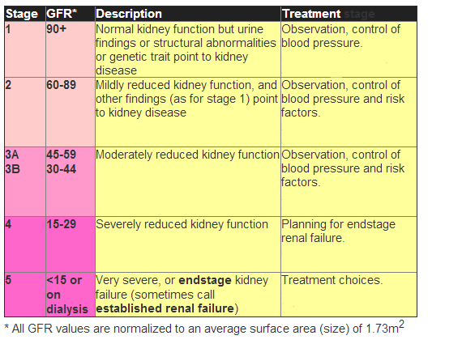
Table 1.1 The stages of CKD as defined by the KDOQI guidelines in 2011. (Adapted from: renal.org)

1.1.3 Risk Factors
There has been substantial evidence published to show links between several causative factors and the initiation and progression of CKD.
These risk factors include:
- Genetic predisposition
- Race (African or Native American)
- Low birth-weight
- Hypertension
- Diabetes
- Hyperlipidemia
- Obesity
- Smoking

These risk factors, especially diabetes and hypertension are also likely to affect the populations in those less developed countries that are adopting the “Western” way of life. For example, diabetic nephropathy is one of the leading causes of ESRD , in countries such as Qatar, Korea, Malaysia and Turkey averaging 30-40% of those needing RRT (Rashed and Aboud, 2004). The incidence and prevalence of ESRD in less developed countries is largely unknown due to a lack of renal registries and inadequate data collection. These countries often have high incidences of infection-related glomerulonephritits. The infections contributing to this include HIV, hepatitis C, malaria and tuberculosis along with parasitic diseases such as shistomiasis. The growth in the number of CKD cases that can be linked with these diseases is likely to parallel the forecast increases in these diseases themselves (Meguid El Nahas and Bello, 2005).
Some risk factors can also increase the risk of patients with CKD developing cardiovascular problems. These include (descending order of absolute risk); left ventricular hypertrophy (LVH), current smoking, physical inactivity, diabetes, elevated systolic blood pressure, and non-use of alcohol were associated with substantial increases in the risk of cardiovascular mortality among participants with chronic kidney disease (Shlipak et al., 2005). A separate study showed that an increased risk of ESRD was noted in non-diabetic nephropathies with increasing tobacco smoking. The report showed that the incidence of ESRD was increased by 5.9 times among people who are heavy smokers (>15 pack-years) (Orth et al., 1998).

1.1.4 NICE Guidelines

The NICE guidelines suggest that clinicians should use urine albumin:creatinine ratio (ACR) in preference to protein:creatinine ratio (PCR) to detect proteinuria. ACR has a greater sensitivity than PCR for low level of proteinuria. ACR is preferred for patients with diabetes.

Patients with diabetes (and non-diabetics with a GFR of less than 60mL/min/1.73m²) should have their urinary albumin/protein quantified. The first abnormal result should be confirmed with a morning sample.

For patients over the age of 70, an eGFR in the range of 45-59 mL/min/1.73m² (if stable over time and without evidence of renal damage) is unlikely to be associated with CKD.

Angiotensin-converting enzyme inhibitors (ACE-inhibitors) and angiotensin-II receptor blockers (ARBs) should be offered to non-diabetic patients with CKD and hypertenstion and an ACR of 30mg/mmol or greater (NICE, September 2008).

1.2 Kidney Scarring

1.2.1 Pathology of Renal Scarring
The endpoint of end-stage renal disease is the accumulation of an excess of extracellular matrix (ECM) which leads to scarring of the glomerulus (glomerulosclerosis), the renal interstitium (tubulointerstitial fibrosis) and the thickening of vascular walls (vascular sclerosis) (el Nahas et al., 1997). This is typically associated with the accumulation of ECM-producing fibroblasts (i.e. fibrosis) (Fig 1.3). The processes of glomerulosclerosis, tubulointerstitial fibrosis and vascular sclerosis are generally all present in renal scarring, regardless of the origin of the original disease, be it glomeruli, tubules or blood vessels. This indicates that the progression of the disease is related to the pathogenesis (el Nahas, 1995).
Glomerulosclerosis is characterised by a localised loss of glomeruli in addition to cellular proliferation in the remaining glomeruli. Loss of capillaries, expansion of the extra cellular matrix and tubular atrophy also are characteristics of this process.
1.2.1.1 Glomerulosclerosis (GS)
Glomerulosclerosis is the term used to describe the scarring and fibrosis of the glomeruli of the kidney. The glomerulus is a capillary network which is surrounded by the Bowman’s capsule in the nephron of the kidney. The glomerulus receives a blood supply from the afferent arteriole and drains into an efferent arteriole rather than a venule. The resistance of these arterioles results in the high pressure that drives the process of ultrafiltration, as a result, this is the functional unit of the kidney (Alexopoulos et al., 1990). As a process, glomerulosclerosis is very similar to the progression of atherosclerosis (Nahas, 1988).
Many of the risk factors that contribute to glomerulosclerosis are the same as those that can cause atherosclerosis; namely hypertension, smoking and obesity. In addition, both of these conditions are characterised by “endothelial damage and dysfunction, proliferation of smooth-muscle or mesangial cells, and injury to the pericyte or podocye” (Meguid El Nahas and Bello, 2005).
A normal glomerulus (Fig 1.3, A) is composed of a thin, discrete glomerular basement membrane with a visible Bowman’s space. Following endothelial damage, there is a cytokine cascade, leading to early scarring in the glomerulus (Fig 1.3, B). This consists of thickening of the glomerular basement membraneand thus the capillary walls. The control of basement membrane regulation leads to its thickening and its expansion into the Bowman’s space. There is cell infiltration into the renal capsule and intercellular mesangial expansion as the extracellular matrix expands in the mesangium. The loss of the podocyte is an important early event in the development of diabetic nephropathy (Pagtalunan et al., 1997) and can lead to mesangial expansion (Meyer et al., 1999).
However it is not only the podocytes that play an important role here; mesangial cells, endothelial cells and the cross-talk between all three (Isermann et al., 2007) also play important parts in the development of glomerulosclerosis (Qian et al., 2008). Signals from the damaged podocyte may provide a stimulus for mesangial cells to alter their expression of extracellular matrix, increasing synthesis or decreasing breakdown (Qian et al., 2008). It has also been shown that an influx of macrophages may play a role in the development of the disease (Chow et al., 2004, Okada et al., 2003).
The shear stress caused by hypertension leads to injury and activation of the glomerular endothelium. This process initiates the process of microinflammation within the glomerulus and damage to the endothelium which can lead to interactions between the inflammatory cells and the mesangial cells as well as platelet aggregation and a release of pro-inflammatory cytokines (El-Nahas, 2003).
Activated cells now begin to produce cytokines and growth factors (Cybulsky, 2000). These growth factors, transforming growth factor β (TGF β) in particular, cause the mesangial cells to regress to an embryonic phenotype. This embryonic phenotype is capable of production of excessive amounts of extracellular matrix. This serves to exacerbate the problem, leading to progressive scarring with macophages, epithelial cells, and fibroblasts filling the Bowman’s space. There is major deposition of collagens I and III, leading to a decrease in the size of the filtering unit and an obliteration of the glomerular capillaries caused by matrix expansion and podocyte death.
Another major contributor to the process of glomerulosclerosis is damage to the podocyte. This damage is mainly in the form of stretching, which leaves areas of denuded glomerular basement membrane (GBM) which is then replaced by excess ECM as interstitial collagens are produced to stabilise the lesion (Pavenstadt et al., 2003).
End stage renal failure (Fig 1.3, C) is characterised by major deposition of ECM leading to a loss of nearly all renal cell types. The mesangial cells are replaced by fibroblasts and ECM, leading to a complete loss of the filtration unit and loss of renal function.
1.2.1.2 Tubulointerstitial fibrosis
Tubulointerstitial fibrosis has been recognised as the final common pathway for all diseases of the kidney that lead to end-stage renal failure (Kuncio et al., 1991, Harris and Neilson, 2006).
In a healthy kidney (Fig 1.3, D) there is tight packing of the tubules with a high surface to volume ratio for efficient reabsorption. The interstitial space is small with few interstitial fibroblasts, a good blood supply and a huge brush border with a thin tubular basement membrane (TBM).
Similar to glomerulosclerosis, tubulointerstitial fibrosis involves inflammation, proliferation, apoptosis and fibrosis (El-Nahas, 2003). Following insult, the tubules become hypertrophic, losing their shape and thus their brush border. The tubule cells become atrophic and expansion of the TBM results from increased ECM deposition and reduced clearance thus increasing the interstitial space.
The histopathology of early scarring of the tubules is characterised by hypertrophy of the tubule wall with a distended lumen and loss of epithelial height and also includes interstitial matrix expansion, tubular cell loss, inflammatory and fibroblast cell infiltration and the rarefaction of the microvasculature of the peritubules (Bohle et al., 1979). There is evidence to suggest that proteinuria plays an important part in initiating tubulointerstitial inflammation (Schieppati and Remuzzi, 2003). Inflammatory mediators such as chemokines and certain cytokines can be released by proximal-tubule cells when exposed to high levels of albumin reabsorption. These mediators then attract inflammatory cells to the interstitium and initiate reactions with the fibroblasts present. The activation of these fibroblasts increases the synthesis of the ECM that contributes to interstitial fibrosis (Zeisberg et al., 2001b).
This progressive scarring (Fig 1.3, E) further deterioates tubular structure. They become irregular in shape and fewer in number with large increases in interstitial ECM. There are also huge increases in the number of inflammatory cells.
Interstitial fibroblasts, tubules, myofibroblasts and inflammatory cells have all been shown to play a role in the increased matrix production in tubulointerstitial fibrosis (Alpers et al., 1992a, Alpers et al., 1994, Hewitson et al., 1995). A variety of studies have shown that myofibroblasts make major contributions to the development of tubulointerstitial fibrosis (Johnson et al., 1991, Roberts et al., 1997).
It has also been shown that tubular epithelial cells, which can synthesise collagen both in vivo and in vitro, play a role in this fibrosis (Creely et al., 1992, Creely et al., 1988). TGF-β1 can influence some cells to transform into an embryonic phenotype, suggesting that tubular cells and other cell types such as pericytes, could contribute to the cells directly involved in renal fibrogenesis.
By end-stage renal failure (Fig 1.2, F), many tubules have collapsed due to a lack of blood supply and many others have filled with proteinous material. The interstitium is overrun with fibroblasts and the level of ECM accumulation prevents reabsorbtion from the filtrate.
The full extent of the injury in tubulointerstitial fibrosis is determined by factors such as the capacity for inflammation to regress, tubules to regenerate and ECM to be broken down. A continuous cycle of damage, inflammation and fibroblast activation will lead to irreversible fibrosis (Meguid El Nahas and Bello, 2005).

1.2.1.3 Common Events in Tubular and Glomerular Scarring
Endothelial Response
Damage to the endothelium is a common early event in kidney scarring, regardless of the mechanism (Lee et al., 1995). The cells of the endothelium lose their anti-coagulant and anti-inflammatory characteristics as a response to increased expression and secretion of soluble mediators such as platelet activating factor (PAF), cytokines and growth factors such as PDGF and TNF-α as well as chemokines like monocyte chemoattractant peptide (MCP-1) and macrophage inflammatory protein (MIP-2) (el Nahas et al., 1997). Pro-coagulant factors are expressed following endothelial damage and contribute to the aggregation of platelets within the capillaries of the glomerulus (Savage, 1994). This, coupled with the release of pro-inflammatory cytokines, and chemokines promotes the infiltration of neutrophils and monocytes by increasing expression of cell adhesion molecules such as selectins, ICAM-1 and VCAM-1 (Brady, 1994).
This pro-inflamatory/pro-coagulative phenotype in glomerular cells can be further promoted by reductions in the level of nitric oxide synthase (NOS) which has been shown to help maintain the glomerular vasculature by inhibiting platelet aggregation and leukocyte adhesion (Cattell, 2002).

Figure 1.3: The progression of glomerular sclerosis (A-C) and tubulointerstitial fibrosis (D-F)
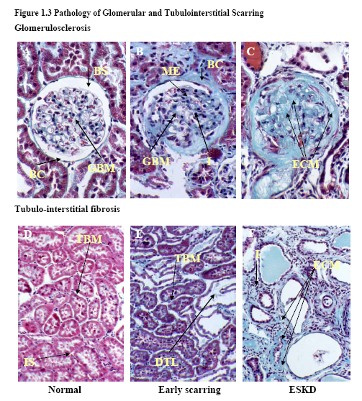
Figure 1.3 Masson’s Trichrome (Red= Cell Cytoplasm, Purple = Cell Nuclei, Blue= Collagens) stained sections showing: The normal glomerulus (A) is composed of the capillary tuft which is situated within a clearly visible Bowman’s space (BS) and surrounded by the Bowman’s capsule (BC). The endothelium of the capillary tuft is supported by a thin and discrete glomerular basement membrane (GBM). Early glomerular scarring (B) is characterised by thickening of the GBM and Bowman’s capsule, cell infiltration (I) and mesangial ECM expansion (ME). As scarring progresses to end stage kidney disease (ESKD) (C), the excess deposition of matrix (ECM) leads to the collapse of the capillary bed. The normal tubulointerstitium (D) comprises tightly packed tubules, surrounded by tubular basement membrane (TBM) and has little interstitial space (IS). Early scarring (E) is characterised distended tubular lumen (DTL), tubular atrophy and expansion of the tubular basement membrane (TBM). As scarring progresses to ESKD (F) there is substantial cell infiltration (I), excess deposition of interstitial ECM and the collapse of tubular structure. (Fisher, 2007)

Inflammation
In practically all renal disease there is infiltration of immune cells (Remuzzi and Bertani, 1998). Increased expression of CAMs and chemotactic factors by damaged cells promotes this influx of inflammatory cells. This is instigated by damaged endothelial cells, but exacerbated by the infiltrating cells as well as mesangial and tubular cells (Taal et al., 2000). A number of integrins associated with inflammatory cells have been recognised as mediators in the adhesion of infiltrating cells, these include α4β1 integrin and CD11a/CD18 (LFA-1) which interact with VCAM-1 and ICAM-1 on tubular and endothelial cell surfaces (Brady, 1994).
In the glomerulus, the main infiltrating cell types are monocytes and macrophages in both clinical and experimental glomerular injury (Floege et al., 1992, Nikolic-Paterson et al., 1994). These cells are also involved in the inflammation of the interstitium, but there is also the infiltration of large numbers of cytotoxic T-lymphocytes (Alexopoulos et al., 1989).
The mechanics & contribution of inflammatory cell infiltration to the progression of glomerular and tubulointerstitial scarring can vary. Macrophages, when activated, produce and secrete large amounts of pro-inflammatory mediators including IL-1 and TNF-α that promote inflammation through autocrine and paracrine activation of CAMs, chemokines and cytokines (Sean Eardley and Cockwell, 2005). Also, the release of such factors in association with the growth factors TGF-β1 and PDGF leads to changes both in the proliferation and phenotypes of cells of the mesangium and the fibroblasts, leading to increased ECM synthesis (Nikolic-Paterson et al., 1994). Scarring can also be contributed to by cytotoxic T-lymphocytes through their release of cytokines (Main and Atkins, 1995). In addition to this, the T-lymphocytes can also cause direct damage of tubular cells through the release of serine esterase and pore-forming proteins which disrupt the membranes of tubular cells (Bailey and Kelly, 1997).
Pro-fibrogenic Growth Factors
The synthesis and release of pro-fibrogenic growth factors by immune cells is recognised as a serious event in the development of glomerular and tubular scarring. The pathogenic formation of fibrosis is mediated by TGF-β1, although some studies have shown PDGF and connective tissue growth factor (CTGF) are involved.
TGF-β1 increases have been noted in several models of CKD such as 5/6th subtotal nephrectomy (Coimbra et al., 1996, Junaid et al., 1997), ureteric obstruction (Ishidoya et al., 1996), protein overload nephropathy (Eddy and Giachelli, 1995), and diabetic nephropathy (Ishidoya et al., 1996). Macrophages, myofibroblasts, tubular cells and podocytes have been shown to be the major contributors to increased TGF-β1 production (Abbate et al., 2002).
The effects of TGF-β1 on fibrogenesis are varied but are predominantly associated with changes in the phenotype and proliferation of mesangial and tubular cells. TGF-β1 stimulates the transdifferentiation of these mesangial and tubular cells into α-SMA expressing myofibroblasts (Fan et al., 1999, Johnson et al., 1992b). This change into myofibroblasts has been shown to increase the synthesis of ECM components and can, therefore, be suggested to increase scar formation. These myofibroblasts accumulate and are responsible for the increased and uncontrolled production on ECM which is the hallmark of fibrosis (Powell, et al., 1999). When activated, myofibroblasts secrete the cytokines and chemokines; interleukin-1 (IL-1), IL-6, tumor necrosis factor α (TNF-α), IL-10, IL-8, monocyte chemotactic protein-1 (MCP-1), macrophage inflammatory protein-1 (MIP-1) and MIP-2. In addition to these cytokines, myofibroblasts also produce the growth factors; TGF-β1, CSF-1, PDGF-AA, bFGF, IGF-1, NGF, KGF and HGF, all of which have been shown or suggested to be pro-inflamatory or pro-fibrotic (Wynn, et al., 2008; Baum, et al., 2011).
More indirectly, TGF-β1 has been show to up-regulate the synthesis and secretion of growth factors such as CTGF and fibroblast growth factor (Strutz et al., 2001, Yokoi et al., 2001). CTGF is a downstream mediator of TGF-β and is important in stimulating both matrix production, by increases in the synthesis of collagen I and fibronectin, and further contributing to fibrogenesis by promoting myofibroblast differentiation (Okada et al., 2005). FGF is also capable of promoting fibroblast proliferation and ECM synthesis (Strutz et al., 2001).
PDGF has also been shown to play a role in the pathogenesis of fibrosis. Glomerular and tubular expression of PDGF increases following a 5/6th subtotal nephrectomy procedure (Floege et al., 1992), and also in diabetic rats (Fukui et al., 1994), and also in humans (Matsuda et al., 1997). Studies performed in vitro have shown that PDGF can act in a way similar to TGF-β1, causing cell proliferation, transdifferentitation and increasing collagen synthesis through interacting with TGF-β1 itself (Battegay et al., 1990, Throckmorton et al., 1995). PDGF has also been targeted pharmaceutically, showing a benefit in experimental CKD (Boor et al., 2007) and in phase I trials (Hawthorne et al., 2008).
Proliferation and trans-differentitation
The cells of the tubules and the glomerulus respond to growth factors by increasing proliferation and changing phenotype to ultimately increase and deregulate the synthesis of ECM components.
Mesangial cells in the glomerulus respond to mitogens such as TGF-β1 and PDGF by transdifferentiating into a mesangioblast phenotype from their typical pericyte phenotype (El-Nahas, 2003). This mesangial transdifferentiation is associated with increased proliferation and characterised by expression of cytoskeletal proteins such as α-smooth muscle actin (α-SMA) (Johnson et al., 1992b). This shift to a myofibroblast phenotype with α-SMA expression is seen in both experimental disease (Kliem et al., 1996) and human disease (Alpers et al., 1992b). The presence of α-SMA expressing myofibroblasts in the glomerulus is a predictor of the development of glomerulosclerosis (Goumenos et al., 1998, Goumenos et al., 2001). Epithelial cells of the glomerulus are also capable of transdifferentiation into myofibroblasts by the process of epithelial-mesenchymal transformation (EMT) which is noted by a raised expression of α-SMA and a loss of epithelial markers such as E-cadherin (Ng et al., 1999).
EMT is a common process which occurs in the development of many organs, such as the heart, liver, lungs, and kidney, but has been widely reported to also promote differentiation of epithelial cells into myofibroblasts and drive fibrosis in these organs (Liebner et al., 2004, Yoshino et al., 2007, Zhang et al., 2007b, Cufi et al., 2010). It has been reported that EMT is reduced in UUO mice deficient in plasminogen (Zhang et al., 2007b), and that PAI-1 deficient cells are more susceptible to EMT (Ghosh et al., 2010), suggesting again that the plasmin system is important in this phenomenon. Until recently, EMT had been dismissed by some as a purely in vitro phenomenon, and, indeed, demonstrating EMT in vivo appears to be very challenging. However, some groups have now provided evidence for EMT in vivo, showing that 36% of FSP-1 positive fibroblasts in the interstitial space originate from tubular cells following UUO (Iwano et al., 2002) and has been shown to occur in other models, such as obstructive nephropathy (Yang and Liu, 2001, Zeisberg et al., 2008), diabetic nephropathy (Burns et al., 2006, Holian et al., 2008), and 5/6th subtotal nephrectomy (Lan, 2003, Liu et al., 2000).
As well as in the glomerulus, there also appears a large number of myofibroblasts in scarred areas of the tubulo-interstitium in both experimental (Kliem et al., 1996, Muchaneta-Kubara and el Nahas, 1997) and human disease (Goumenos et al., 1998, Goumenos et al., 2001). These myofibroblasts are partially derived from the resident interstitial fibroblasts which proliferate in response to PDGF, TGF-β1 and fibroblast growth factor 2 (FGF-2) (Zeisberg et al., 2001a) and also, in part, from EMT of tubular epithelial cells, pericytes and fibrocytes (El-Nahas, 2003, Ng et al., 1999, Humphreys et al., 2010, Willis et al., 2005). TGF-β1 released by the epithelial cells promotes this EMT, in addition to the composition of ECM (Fan et al., 1999, Zeisberg et al., 2001a).
ECM accumulation
The endpoint of all these events in the build up to tubulointerstitial and glomerular fibrosis is the expansion of the basement membranes due to increased accumulation of extracellular matrix (Fig 1.4).
In the kidney, as in other organs, the ECM is in a continual state of turnover with a balance maintained between the synthesis and breakdown being vital for the maintenance of tissue homeostasis. Increased synthesis and decreased breakdown of renal of the renal ECM has been shown to play a role in the formation of renal scars (Eddy, 1996). Fibroblasts increase the production of fibronectin and interstitial collagens (Zeisberg et al., 2000). It has been shown that mesangial cells in the glomerulus begin to synthesise collagens I and III, which are abnormal to the glomerulus (Floege et al., 1992, Minto et al., 1993). Epithelial cells also alter the composition of the ECM, either by assuming a myofibroblast phenotype via EMT, or through the processes of autophagy and fibrosis without EMT (Koesters et al., 2010).
As well as increased synthesis, alterations in the expression of ECM degrading enzymes such as MMPs and plasmin, as well as their respective inhibitors, lead to an overall increase in ECM accumulation due to reduced breakdown and increased deposition (Jones, 1996). The detailed mechanisms of ECM synthesis and degradation are discussed in section 1.3
Advanced Glycation End Products (AGE)
Advanced Glycation End Products (AGE) are the end-products of glycation and are well-known for their role and formation in diabetes. They are the result of chemical reactions following on from a glycation, which is the addition of a carbohydrate without catalysis by an enzyme (Brownlee, et al., 2005). In diabetes and diabetic nephropathy, cells such as endothelial cells are unable to regulate their glucose intake, leading to hyperglycemia and increased intracellular glucose. This in turn leads to increased NADH and FADH levels and results in ROS production by mitochondria. These ROS can damage DNA and activate PARP1 which can inactivate GADPH, an enzyme involved in glucose metabolism leading to an accumulation of metabolites and increased AGE production (Brownlee, et al., 2005; Dominiczak, et al., 2003; Gugliucci, et al., 2000).
The RAGE receptor (Receptor for AGE) is found on cells including endothelial cells and immune cells from the kidney. When AGE binds to the RAGE receptor, it contributes to diabetic-related inflammatory diseases such as asthma, arthritis and nephropathy. It has been suggested that this is through activation of NF-kappa-B, a promoter of inflammation (Alves, et al., 2005). In renal disease, large AGE are unable to enter the Bowman’s capsule and bind to mesangial cells and to the mesangial matrix (Gugliucci et al., 1996). Activation of RAGE on these cells induces TNF production, leading to reduced MMP activation and increased matrix production, leading to glomerulosclerosis.

1.2: The Extracellular Matrix

1.2.1 Structure and Function of the ECM
The extracellular matrix (ECM) is a vital component of most organs within the body. It forms the membranes vital for life, gives structural support and tissue strength, confers cells with protection, allows cells to receive feedback about their environment and provides a store for many essential molecules such as growth factors. The ECM also provides the body’s framework for cell adhesion and tissue development (Tanzer, 2006).
The ECM evolved approximately 850 million years ago (Rokas, 2008) in response to the increasing size and complexity of organisms and the increasing oxygen content of ocean oxygen at that time. The ECM hasn’t changed much in this time; fibrillar collagens and the basement-membrane forming collagen IV are present, along with the mechanisms required for the manufacture of collagen macromolecular structures that can be seen in premetazoan sponges (Exposito et al., 2010). The general ECM components pre-date even the origin of animals (Ozbek et al., 2010).
The general structure of the ECM we see is organised fibrous polymers that are embedded into an amorphous mixture of non-fibrous components (Tanzer, 2006). The amorphous substances are predominantly proteoglycans, which give turgor to the matrix (Iozzo, 1998). The extracellular matrix is composed of two major groups of biomaterials; the structural proteins and the proteoglycans.
The glomerular and tubular basement membranes, which expand in glomerulosclerosis and tubulointerstitial fibrosis respectively, are primarily made up of collagen type IV, laminins, nidogen, and types XV/XVIII collagen, all of which are found even in the most basic life forms. Many vertebrate ECM proteins however evolved much more recently with the elaboration of existing protein families such as collagens and laminins, and also the emergence of new proteins such as fibronectins (Hynes, 2009). These additional proteins are much more complex than is required for mere structural proteins, and indeed they have many functions beyond that, such as cell differentiation, migration, adhesion as well as phenotype and survival (Timpl et al., 1979).

Figure 1.4: Progression of Renal Disease

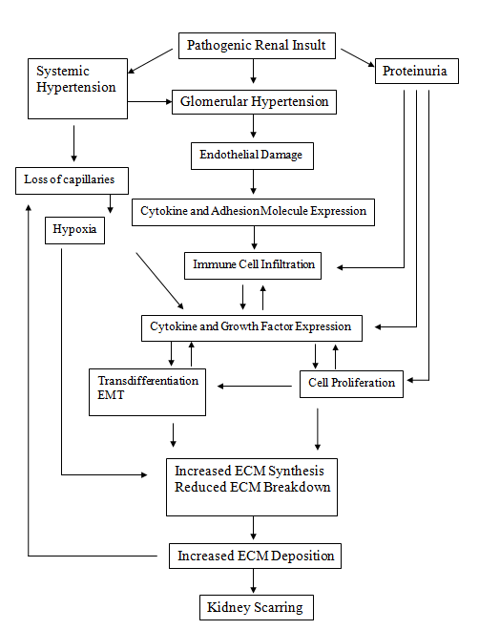

Figure 1.4: The progression of renal disease and the development of kidney scarring proceeds via a common pathway of events driven by glomerular and tubular injury that stimulates changes to the endothelium promoting infiltration of immune cells and the release of inflammatory cytokines/growth factors, followed by proliferation and trans-differentiation of resident cells and excess accumulation of ECM proteins
Basement membranes are found between cells or between cell surfaces and interstitium. They are often visualised using immunostain techniques targeting the four main basement membrane components (collagen IV, laminin, nidogen and perlecan). Single basement membranes can range from 50-100nm in thickness and usually have a distinctive electron-lucent layer between the plasma membrane and the outer electron dense layer. However, basement membranes appear homogenous when tissues are fixed using freeze-substitution (Yurchenco and Patton, 2009).
The ECM also plays important roles in cell-signalling through adhesion receptors like integrin (Hynes, 2002). Even the composition and the attributes of the ECM, such as its rigidity and malleability, have been shown to affect the proliferation, survival, polarity and the migration of cells (Discher et al., 2009).
1.2.1.1 Collagens
1.2.1.1.1 Overview
Collagens are a large family of triple helical proteins. They are the most abundant proteins found throughout the animal kingdom, and are also the main component of the extracellular matrix. They also have vital functions in structure, membrane formation, cell adhesion, signalling, cancer, angiogenesis and cell migration. There are around 30 genes for collagen found within the human genome, and these 30 proteins can combine in various ways to create around 20 types of collagen. Some collagens are used more for their tensile strength, such as collagens I, II and III which are the principal elements in tendons, bone, cartilage and skin. Collagen IV forms a two dimensional reticulum and is a major component of basement membranes, such as in the kidney glomerulus where it plays a role in filtration. There is some blurring in the definition of a ‘collagen’. There are triple-helical proteins that are called collagens, and those that are called ‘collagen-like proteins’. Vertebrate collagens are identified with a Roman numeral (Kadler et al., 2007).
Type I collagen is a fibril-forming collagen and as such is synthesized initially as a soluble pro-collagen composed of globular C and N pro-peptides. The C pro-peptides are cleaved by procollagen C-protienases (Greenspan, 2005) and are joined to their respective ends of the triple helix to other collagen molecules to form a fibrillar structure (Prockop and Kivirikko, 1995). Type I pro-collagen is made up of three chains; two 1 and one 2 chains. Each one of these chains is around 1000 amino acids. Once the pro-peptides have been secreted from the cells they are cleaved by C and N protienases to expose telopeptide sequences that are short extensions of the chains. These contain binding sites for the generation of fibrils (Prockop and Fertala, 1998). The collagen monomer is assembled into a polymer by the formation of non-reducible covalent bonds between residues in the triple helix and the telopeptides (Eyre et al., 1984). This is the form in which collagen is found in the tissues (Chapman, 1974). Collagen molecules then become cross-linked with adjacent collagen molecules, adding tensile strength and stability to the molecule.
Type IV collagens are the typical example of network-forming collagens. They play an important role in the maintenance of the ECM. They associate with other ECM proteins such as laminin to form the basal lamina (basement membrane) and generate a network through interactions of two trimeric NC1 domains stabilised by covalent Met-Lys bonds (Than et al., 2002). This is the layer to which the epidermal cells attach (Alberts, 2002). The protein laminin is made up of three polypeptides arranged in a cross-like manner. At the four points of the cross laminin is able to bind collagen IV and integrin receptors in the plasma membrane of cells. This allows laminin to form bridges between the basement membrane and the epithelial cells (Lodish, 2000).
Collagens are often vital for correct tissue structure and function. Therefore, a defect in the normal expression of collagen may produce either lethal or non-lethal mutant phenotypes (Myllyharju and Kivirikko, 2001b). Indeed, collagens are identified in a wide variety of diseases such as; “Alport syndrome (collagen IV), certain arterial aneurysms (collagen III), Bethlem myopathy and Ullrich muscular dystrophy (collagen VI) (Baker et al., 2005), certain chondrodysplasias (collagen IX and XI), some subtypes of the Ehlers-Danlos syndrome (collagen I and V), specific subtypes of epidermolysis bullosa (collagen VII), Kniest dysplasia (collagen II), Knobloch syndrome (collagen XVIII), osteogenesis imperfecta (collagen I) (Marini et al., 2007) some instances of osteoporosis and osteoarthrosis, and Stickler syndrome (collagen II, IX and XI) (Van Camp et al., 2006)” - (Kadler et al., 2007). The subclasses of collagens are illustrated in Figure 1.5. The collagens present in the normal renal ECM are collagens I and III in the interstitium, although these are at very low levels in non-disease states, and collagen IV in the glomerular and tubular basement membranes. Interstitial fibroblasts and mesangial cells are the key cell types involved in the synthesis of renal collagen.
1.2.1.1.2 Biosynthesis
Collagen biosynthesis is a multiple step process that is characterised by large numbers of both co-translational and post-translational modifications unique to collagens and collagen-like proteins (Myllyharju and Kivirikko, 2001a).
The α-chains of fibrillar collagens are synthesised on the rough endoplasmic reticulum by the ribosomes. They are initially synthesised as large precursors called pro-collagens (Church et al., 1971) that have N and C-terminus pro-peptide extensions. These precursors are translocated across the ER membrane and into the lumen, where modification takes place (Canty and Kadler, 2005). These intracellular modifications allow the molecules to form the triple helix structure of a pro-collagen molecule and include hydroxylation of proline and lysine residues to 4-hydroxyproline, 3-hydroxyproline and hydroxylysine. They also include glycosylation of some hydroxylysine residues to galactosyl-hydroxylysine and glucosylgalactosyl-hrdroxylysine. Glycosylation of some asparagine residues and the association of polypeptide chains leading to the folding of the triple helix.
The pro-collagen is then secreted from the cell and undergoes enzymatic processing into collagen fibrils (Fig 1.6). Interaction of the collagen with fibronectin and specific integrins at the cell surface or within the post Golgi carrier may be required to assist in this assembly into collagen fibrils (Canty and Kadler, 2005).

Figure 1.5: Collagen Structures
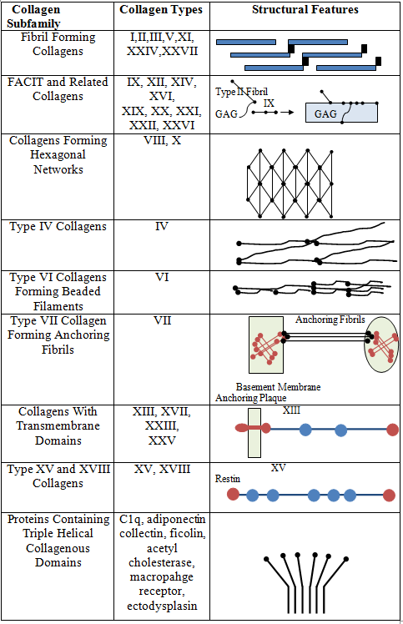
Figure 1.5: Collagen types are divided into 9 subfamilies based on the structures they form and other related features. Adapted from (Myllyharju and Kivirikko, 2001a)
It has been suggested that protein complexes COPI and COPII are required in the trafficking of the pro-collagen through the golgi via tubular-saccular vesicles (Stephens and Pepperkok, 2002). Once the pro-collagen has passed through the golgi, it is released into secretory vacuoles which migrate to the cell membrane and allow the secretion of the collagen through cellular recesses in the membrane (Birk and Trelstad, 1984, Birk and Trelstad, 1986, Ploetz et al., 1991). Once outside the cell, the N and C terminus pro-peptide extensions are cleaved, allowing the self-assembly of fibrils by nucleation and the formation of covalent crosslinks (Kadler et al., 1987).
Several very specific enzymes are involved in the post-translational modification of collagen. The intracellular modifications are performed by five major enzymes; prolyl-4-hydroxylase, prolyl-3-hydroxylase, lysyl-hydroxylase, hydroxylysyl-galactosyltransferase and galactosyl-hydroxylysyl-glucosyltransferase (Myllyharju and Kivirikko, 2001a). Outside of the cell, the major modification is the cleavage of the C and N terminal pro-peptides, which is mediated by pro-collagen N proteinase and procollagen C proteinase (Prockop et al., 1998). The enzyme lysyl oxidase is responsible for the formation of the covalent bonds which help the protein to fold (Kagan and Li, 2003).
It has been shown that peptidyl proline cis-trans isomerases and protein disulphide isomerase enzymes are essential in the production of collagen (Bassuk and Berg, 1989), as also is the molecular chaperone Hsp47 (Nakai et al., 1992).
Non-fibrillar collagens have a similar processing system to the fibrillar kind with only a few exceptions. The N and C terminus pro-peptides of many non-fibrillar collagens are not cleaved, some undergoing N-glycosylation or having additional processing steps such as the addition of glycosaminoglycan side chains (Myllyharju and Kivirikko, 2001a).

1.2.1.1.3 Regulation
Most of the data we have on collagen synthesis regulation comes from studies on collagen I (Ghosh, 2002, Ramirez et al., 2006). These studies suggest that control is primarily at the transcriptional level.
The aforementioned cis elements are also vital for the transcriptional response to cytokines such as TGF-β and TNF-α which play roles in tissue remodelling and scarring (Verrecchia and Mauviel, 2004). TGF-β1 regulated COLIA1 expression via the TGF-β activator signalling pathway and by binding to the TGF-β cis element found within the distal promoter region (Jimenez et al., 1994). COLIA2 modulation by TGF-β1 occurs via activation of transmembrane serine/threonine signals and the smad pathway (Chen et al., 1999). Smad2 and Smad3, upon ligand induced phosphorylation, promote the formation of a complex with Smad 4. This then translocates to the nucleus and activates gene transcription by binding CAGAC consensus sequences and also by interacting with transcription factors and co-activators (Zhang et al., 2000).
The role of TNF-α is as a negative regulator of collagen I gene expression via the TNFR1 and TNFR2 receptors which activate AP-1 and NF-κ-B transcription factors. These TFs inhibit collagen I expression (Kouba et al., 2001, Riches et al., 1996).

Figure 1.6: Collagen Biosynthesis
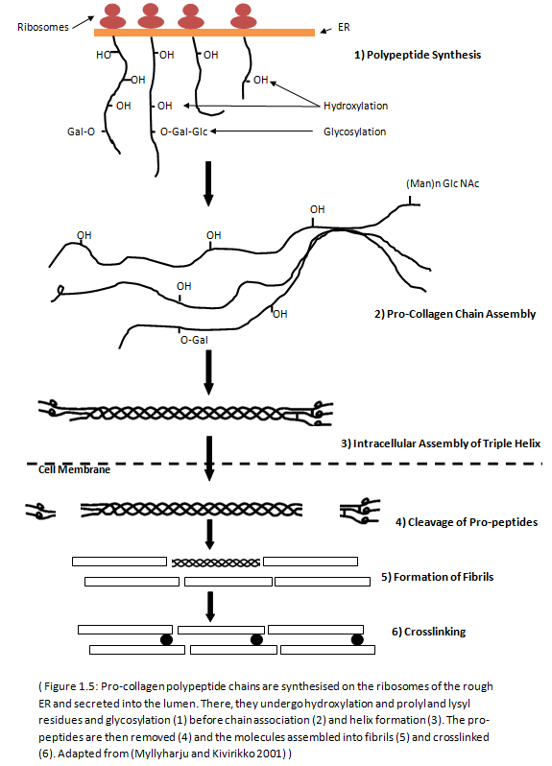
Figure 1.6: Pro-collagen polypeptide chains are synthesised on the ribosomes of the rough ER and secreted into the lumen. There, they undergo hydroxylation and prolyl and lysyl residues and glycosylation (1) before chain association (2) and helix formation (3). The pro-peptides are then removed (4) and the molecules assembled into fibrils (5) and crosslinked (6). Adapted from (Myllyharju and Kivirikko, 2001a)
1.2.1.1.4 Other Factors Affecting Collagen Levels
Age has been shown to lead to several alterations in the ECM as well as a loss of cell proliferation and reduced effectiveness of growth factors. It has been demonstrated that there are common age-related changes in the metabolism of collagen. The rate of collagen synthesis decreases in rats as they age, with the bulk of collagen produced being degraded (Mays et al., 1991). The relative levels of collagen synthesis in dermal fibroblasts from age-separated donors are inversely related to age (Phillips et al., 1994). It is thought that cysteine rich 61 (CYR61), an ECM associated signalling molecule belonging to the CCN family, is up-regulated in aged human skin (Quan et al., 2006). CYR61 up-regulates MMP1 via TFAP-1, down-regulates TGFβtype II receptor and also impairs the TGFβ pathway which is involved in the stimulation of collagen synthesis and the down –regulation of collagen degrading MMPs.
Injury to the liver associated with early stages of cirrhosis often leads to increased collagen levels. Both type I and type III collagens have been shown to increase with the progression of liver cirrhosis with an initial increase in type V also seen (Murata et al., 1984). This increased collagen leads to an observed distortion of the architecture of cirrhotic livers with increased stromal rigidity (Rojkind and Martinez-Palomo, 1976). One of the main causes of liver cirrhosis is alcohol, albeit through the indirect path of acetaldehyde which is produced by the enzyme alcohol dehydrogenase in the liver as a waste product of alcohol breakdown. Acetaldehyde has been shown to increase collagen production and pro-collagen secretion (Brenner and Chojkier, 1987). This occurs through the activation of c-jun N-terminal kinase (JUK) an enzyme which is involved in the signal transduction pathway. JUK phosphorolates c-jun which activates AP-1, which binds the promoter of the BTEB gene whose product, the BTEB protein, binds to the distal GC box of the α1 collagen gene and stimulates expression (Chen and Davis, 2000).
Exposure to radiation, as a result of radiation therapy or accidental exposure has been shown to increase collagen synthesis. This results in fibrosis with increased ECM deposition and significantly elevated collagen. This irradiation mediated collagen production is instigated by the release of TGFβ. The exposure to radiation of human intestinal smooth muscle cells increased collagen type III biosynthesis during the first 48 hours (Alexakis et al., 2001).
Ascorbate is essential for collagen to maintain its triple helix structure (Schwarz and Bissell, 1977). It is a co-factor for the prolyl and lysyl hydroxylase enzymes which stabilise and link the collagen molecules (Freedman and Hawkins, 1980). Total collagen can be increased by the addition of ascorbate (Murad et al., 1981).
High glucose has been shown to increase collagen levels (Benazzoug et al., 1998). Mimicking diabetic conditions, fibroblasts were grown in varying glucose concentrations and the effects on collagen and fibronectin monitored. In control conditions of 5mM glucose it was observed that collagen III increased along with cell aging. High glucose (10 and 15mM) increased collagen III synthesis at mRNA and protein levels, but there was no perceived increase in collagen I production. Fibronectin synthesis was also increased in the elevated glucose cells.
Human epidermal growth factor has a differential effect on collagen synthesis and that of other extracellular proteins. HEGF inhibits the production and accumulation of collagen I in fibroblasts and stimulates the production of non-collagenous proteins (Kurata and Hata, 1991). The levels of mRNA were reduced for both proα1 and proα2 chains. The levels of transcription of these genes were also reduced, although the mechanism for this has not been elucidated.
TNFα is a macrophage released cytokine which is responsible for a variety of metabolic responses and cellular activities. TNFα reduces ECM deposition by inhibiting the synthesis of its components. TNFα opposes the actions of TGFβ which stimulates collagen synthesis (Inagaki et al., 1995). TNFα mediates the down-regulation of the genes which code for the α1 chain of type I collagen (Greenwel et al., 2000). The action of TGFβ varies depending on the cells it is involved with. It has been shown to increase the transcription of collagen genes and stabilise procollagen mRNA (Ignotz and Massague, 1986, Penttinen et al., 1988) and has been suggested to play a vital role in the incorporation of proline into the collagen chain through downstream transcription factors (Roberts et al., 1986). The specific action of TGFβ is through the TGFβ receptor which transphosphorylates the signal transducer smads and transcriptional co-activators p300/CBP to regulate target transcription. This induces a promoter (COLI A2) of type I collagen mRNA (Ghosh and Varga, 2003).
Platelet derived growth factor (PDGF) also has been reported to play a role in collagen synthesis. It has been shown to increase the production of collagen types I and III in venous smooth muscle cells (Amento et al., 1991) and also in murine mesangial cells (Lei et al., 1998), and more recently in synthetic smooth muscle cells (Absood et al., 2004). However, it has also been reported that PDGF has a negative effect on human arterial smooth muscle cells (Okada et al., 1993).
1.2.1.2 Elastins
Elastins are found in most, if not all, of the tissues in the body. Organs such as the lung, the heart, blood vessels and the skin need to be elastic as well as strong in order to function properly and elastin is the ECM protein responsible for tissue elastic recoil. The network of elastins found in these tissues allows them to return to their original shape and structure after stretching or compression (Ashworth et al., 2000).
“The biology of elastic fibres is complex because they have multiple components, a tightly regulated developmental deposition, a multi-step hierarchical assembly and unique biomechanical functions.” (Kielty et al., 2002).
The elastin protein is an insoluble, cross-linked polymer assembled from monomers of tropoelastin (B. Alberts, 2008). It is encoded by one of the largest genes in the human genome, ELN on the long arm of chromosome 7 at position q11.23 and is comprised of 34 exons (Tassabehji et al., 1997). The gene’s initial product is tropoelastin (70kDa). There is a high incidence of splicing in the human tropoelastin exons 22, 23, 24, 26A, 30, 32 and 33, leading to the adaptation of elastin’s function in many tissues (Wise and Weiss, 2009, Piontkivska et al., 2004). Elastin is formed through the lysine-mediated cross-linking of tropoelastin by lysyl oxidase (Kagan and Sullivan, 1982). Once cross-linked, the elastin protein is insoluble and resistant to proteolytic cleavage (Mecham et al., 1997). Elastin is vital for the shape and form of tissues and membranes designed to cope with stress, such as the filtration pressure in the glomerular basement membrane (Gray et al., 2000). Elastin is most often found twined with collagen fibrils to regulate its stretching, preventing damage and allowing the elastic fibres to endure over a billion expansion and recoil cycles without breaking down (B. Alberts, 2008).
1.2.1.3 Fibronectin
Fibronectin is a vital glycoprotein present in both tissues (in its insoluble form) and blood plasma (in its soluble form). It is only present in vertebrates and its appearance in evolution seems to correlate with that of endothelial-lined vasculature (Hynes and Zhao, 2000, Whittaker et al., 2006). In terms of the extracellular matrix, fibronectin provides structural support and signalling mechanisms for cell survival, migration, differentiation and gene expression (Faralli et al., 2009). Fibronectins have multiple functions, allowing them to interact with a multitude of extracellular molecules such as collagen and fibrin and with specific membrane receptors (Mosher and Furcht, 1981). They are hetero-dimeric molecules and contain three types of repeating domain (termed I, II and III) of 220-250kDa that are joined by two di-sulphide bonds close to their C-terminus (Hynes, 1990). Type III repeats are the main unit of the chains and play a vital role in the activity of fibronectin (Main et al., 1992). These repeats lack intra-chain disulphide bonds, allowing novel ‘cryptic sites’ to be exposed upon mechanical perturbation or proteolysis (Faralli et al., 2009). The extensibility of these repeats is retained after fibronectin has been assembled into a fibril (Mao and Schwarzbauer, 2005). This gives the fibrils an elasticity which allows them to stretch to around four times their usual length (Faralli et al., 2009).
Fibronectin has binding sites which recognize a plethora of extracellular proteins such as fibrin, heperin and collagen (Tanzer, 2006).
A major feature of fibronectin is its flexible structure (Hynes, 1990). The active form of fibronectin is thought to be an insoluble fibril. The process of converting fibronectin to this fibril is a highly controlled cell-mediated process that involves the integrins (Mao and Schwarzbauer, 2005). Fibronectin is, in humans, a dimer composed of non-identical polypeptides joined by a disulphide bond at the carboxy-termini.
Many ECM proteins require fibronectin for incorporation into the matrix, including collagens, fibulin, fibrillin, TGF-β binding protein and tenascin-C (Chung and Erickson, 1997, Dallas et al., 2005, Kadler et al., 2008, Sottile and Hocking, 2002, Twal et al., 2001). Some of these associate directly with the fibronectin fibrils (Fig 1.7), where others use the matrix as a scaffold.
Initiation of basement membrane formation doesn’t involve fibronectin – it relies on laminin-integrin interactions with type IV collagens (Yurchenco and Patton, 2009).
1.2.1.4 Laminins
Laminins are a family of glycoproteins composed of α-β-γ heterotrimers. In vertebrates, isoforms are assembled from a selection of five α, three β and three γ subunits. Laminins have a branched structure with the separate N-terminal portions forming short ‘arms’ and attach to the cell membrane via a Dystroglycan complex (Yurchenco and Patton, 2009) (Fig 1.7).
In vivo and in vitro studies have both suggested that laminins are responsible for the organization of basement membrane assembly on the surface of cells. Purified laminins are able to assemble a sheet-like ECM on cell surfaces, even without other components (McKee et al., 2007). Laminins are, therefore, a principal component of basement membranes. It has been show that genetic mutations arising in the expression of laminin in certain tissues prevent the formation of basement membranes in those tissues, whereas the knock-out of type IV collagen, nidogens or perlecan was found not to affect the appearance of basement membranes until much later in development (Yurchenco et al., 2004). Laminins are critical to the scaffolding of basement membranes while collagens and the other components enhance stability (Willem et al., 2002).
Laminins tend to self assemble into a polymer in a two step process involving a calcium-independent nucleation step followed by a calcium-dependent propagation step (Yurchenco et al., 1985). The polymer that forms is a gel whose stiffness depends on laminin concentration or on modifying components, such as heperin (Yurchenco et al., 1990). Laminin molecules bind to each other via LN domains found on the end of the three short arms. Therefore there is one α, one β and one γ LN domain. The resulting network is polygonal and forms independently of aid from other molecules (Yurchenco et al., 1992). The polymerization is driven by the formation of a stable complex of interlocked LN domains. Some laminins, such as those containing the α3B or α4 subunits are unable to polymerise.
It is thought that, as laminins are secreted in soluble forms, the cell-surface provides a nucleation surface for laminin, favouring assembly on the surface of the cells (Yurchenco and Patton, 2009).

Figure 1.7: Laminin and Fibronectin Act as a Scaffold for ECM Attachment

Figure 1.7: The cross-shape of Laminin allows the α, β and γ ‘arms’ to simultaneously bind to collagen fibrils, with the β chain mainly binding to collagen type IV. Fibronectin is attached to integrin on the cell surface and binds to collagen in a dimer. Together, Laminin and fibronectin act as a scaffold, attaching the ECM to the cell and also playing a vital role in its development.

1.2.1.5 Proteoglycans
The proteoglycan aggrecan is crucial in its role of skeletal development. Genetic mutation produces animals which are dwarfs with very low levels of cartilage. This lack of cartilage prevents the proper formation of bones, as skeletal structure requires a cartilage template for its development (Tanzer, 2006). The proteoglycans retain water to form a gel-like substance which allows free passage of ions, hormones and nutrients. Their primary function is to provide charge for membranes. This is especially important in the glomerular basement membrane as it provides the negative charge allowing filtration of small proteins.
Proteoglycans also seem to have a role in the regulation of inter-cellular signalling. For example, the heperin sulphate chains of the proteoglycans are able to bind several different growth factors, including the fibroblast growth factors (FGFs) and aid them in their binding to specific receptors (Pellegrini et al., 2000).
Additionally, proteoglycans can bind endothelial cell surface chemokines and prolong an inflammatory response. Growth factors usually bind to the GAG chains of the proteoglycan, but members of the transforming growth factor beta (TGF-β) family can bind to the core protein of the decorin proteoglycan. TGF-β increases the expression of collagen, fibronectin and lysyl oxidase while reducing the expression of MMPs. This causes an increase in ECM deposition and a decrease in its destruction, leading to scarring. When TGF-β is bound by the decorin core protein it cannot bind to its specific receptor on target cells, which inhibits TGF-β activity (Kainulainen et al., 1998). The proteoglycan Syndecan 4 has recently been shown to function as TG2 co-factor in wounding (Scarpellini et al., 2009).
1.2.1.5.1 Perlecan
Perlecan is a heperin sulphate proteoglycan found in basement membranes. It is also found as a chondroitin sulfate proteoglycan in cartilage tissue (Noonan et al., 1991, Kallunki and Tryggvason, 1992). It is a large protein with a core of ~400kDa with a tandem arrangement of five domains. The fourth and fifth domains bind to a plethora of basement membrane proteins including nidogen-1, integrin α2β1 and α-dystroglycan (Yurchenco and Patton, 2009). The heparan sulfate chains of perlecan are located in the N-terminal domain I and bind to laminins and collagen IV. They also bind to FGF2 and other growth factors.
It is thought that perlecan plays a role in the maintenance of basement membranes, rather than in the development of them. Membranes were found to develop normally in mutant mice emryos which were homologous for a null-allele for the perlecan gene (Arikawa-Hirasawa et al., 1999, Costell et al., 1999).
1.2.1.5.1 Glycosaminoglycans
The main glycosaminoglycan (GAG) in the basement membranes is heparan sulfate. The heparan sulfate proteoglycans (HSPGs) have structural and regulatory functions in the ECM. They consist of a core protein with a covalently attached heparan sulphate side-chain. All HSPGs have a heparan sulfate side-chain and is a strongly negatively charged GAG (Lindahl et al., 1998). This side chain consists of around 300 alternating N-acetyl-glucosamine α1-4 glucuronate β1-4 residues (Rops et al., 2004). The charge-selective permeability of the golmerular basement membrane is determined mostly by the electrostatic properties of heparan sulphate in the membrane (Raats et al., 2000).
HSPGs are involved in glomerular inflammation as they are the binding sites for chemokines. These chemokines are capable of attracting a variety of leukocytes (Baggiolini, 1998). HSPGs are not only involved in the mobilization and attraction of inflammatory cells, they also promote adhesion, diapedesis, and migration (Rops et al., 2004).
1.2.1.6 Nidogens
Nidogen-1 and nidogen-2 are homologous 150kDa glycoproteins widely distributed in basement membranes. They consist of three globular domains, termed G1, G2 and G3 with rod-like regions in between (Salmivirta et al., 2002). G1 and G2 are found in the N-terminus and are separated by a small linkage region. The G3 domain is found in the carboxy-terminus with EGF-like repeats composing the central section. In nidogen-1, the G3 domain binds strongly to laminins via a specific sequence in the γ1 short arm of laminin (Takagi et al., 2003). The G2 domain of nidogen binds to collagen IV as well as perlecan and fibulins (Ries et al., 2001, Hopf et al., 1999). Therefore nidogen is responsible for the bringing together of the laminin and collagen IV networks (McKee et al., 2007). This linkage provides stability to the basement membranes which is particularly important when the tissues are involved in mechanical stress.
It has been shown, using nidogen-deficient mice, that an absence of nidogen or the nidogen binding site in laminin γ1 does not affect the accumulation of laminin or collagen IV in the basement membrane (Willem et al., 2002, Ackley et al., 2001, Bader et al., 2005). Therefore it has been argued that there must be additional interactions that incorporate collagen IV into the basement membrane, such as perlecan-mediated binding of collagen IV and laminin (Yurchenco and Patton, 2009).

1.2.2 The Renal ECM
The ECM found in the kidney forms the structural basis for the interstitium and the glomerular mesangium. It comprises the specialised matrices of both the tubular and glomerular basement membranes where it varies in both structural and functional roles.
1.2.2.1 Renal Interstitium and the Tubular Basement Membrane
Mainly collagens type I and III make up the renal interstitium by forming a fibrillar matrix hydrated by the proteoglycans and by fibronectin (Lemley and Kriz, 1991). In addition to these main two, the collagens type V, VI, VII and XV make up part of the interstitium (Eddy, 2000).
Surrounding the outer surface of each nephron is the tubular basement membrane, which separates the tubular epithelium from the renal interstitium. This membrane is composed of type IV collagen with laminin, entactin/nidogen and sulphated proteoglycans (Miner, 1999).
The function of the interstitium, produced by renal interstitial cells, is to provide support and protection to the tubules and vessels, aided by the basement membrane attachments to cell and matrix via glycoproteins such as fibronectin (Leblond and Inoue, 1989) and others containing heperin sulphate (Heremans et al., 1989). Its functional roles also include regulating differentiation and erythropoetin production (Koury and Koury, 1993). The tubular basement membrane also mediates interactions between the tubules and the interstitium, playing a role in the regulation of epithelial adhesion, migration and differentiation.
1.2.2.2 Glomerular Mesangium
The mesangium is a highly specialised part of the glomerulus containing mesangial cells. These cells are specialised pericytes, which control filtration and provide structural support as well as being able to perform phagocytosis. The single most abundant component of the mesangial matrix is fibronectin but it also contains type IV collagen, laminin and entactin (Bender et al., 1981).
In contrast to the interstitum, the mesangium lacks collagens I and III (D'Ardenne et al., 1983). The function of the mesangial matrix is mainly to provide structural support to the glomerular tuft and the maintenance of structural integrity of the capillary network of the glomerulus (Kriz et al., 1990). It also plays an important role in the modification of glomerular filtration by altering the contractions of mesangial cells. The matrix forms a three-dimensional mesh of fibronectin and microfibrils that connect the mesangial cells to the glomerular basement membrane (Schwartz et al., 1985).
1.2.2.3 Glomerular Basement Membrane (GBM)
The glomerular basement membrane separates the endothelial cells from the glomerular capillaries and the visceral capillaries of the urinary space. This forms the backbone of the glomerular tuft. Similar to the tubular basement membrane, that of the glomerulus is composed mainly of type IV collagen, laminin and entactin/nidogen (Miner, 1999). However, the GBM also contains heperin sulphate proteoglycans such as agrin and perlecan (Groffen et al., 1998, Groffen et al., 1999). The collagen IV forms a three-dimensional lattice network that conveys tensile strength and elasticity to the GBM (Timpl and Brown, 1996). The heperin sulphate proteoglycans are important in maintaining the GBM’s electronegative charge, providing a barrier to the loss of albumin and other proteins in the urine (Cantin, 1971, Kanwar and Farquhar, 1979). The agrin and perlecan, in addition to this, mediate the adhesion between the cell and the matrix in the GBM via α-dystroglycan and integrin interaction (Groffen et al., 1999).

1.2.2 Deposition and Destruction of the ECM
1.2.2.1 Deposition
The deposition of the ECM can be controlled at two points. Increased matrix deposition will occur if the synthesis of the ECM’s major components is up regulated (i.e. collagen) and will also occur if the mechanisms required to deposit these components is up regulated (Bennett and Schultz, 1993). The deposition pathway is critical, as ECM components are usually in excess.
The de novo synthesis of collagens and the other pro-peptides that make up the ECM is mainly controlled by growth factors and cytokines, for example TGF β1, IGF-1 and FGF. In addition to these growth factors, de novo synthesis is also induced by feedback from the ECM. This feedback utilises integrin receptors on the cell surface and causes responses to conditions such as excessive stretching due to hypertension or damage to the ECM (Bennett and Schultz, 1993).
The initial nascent ECM scaffold is formed via the cell surface-activated polymerisation of laminin. This allows the integration of nidogens, type IV collagen, perlecans and other components to produce a mature basement membrane. It has also been suggested that nidogen, collagen IV and perlecan are not required individually for the formation of basement membranes. It is postulated that they are assembled on this initial laminin scaffold and bestow resistance to mechanical stress upon the membrane (Yurchenco et al., 2004).
1.2.2.2 Degradation
The breakdown of the ECM utilises three main enzyme systems; the matrix metalloproteinases (MMPs), the serine proteases and the cysteine/aspartic proteinases. These are very specific enzymes, meaning that they only cleave at a particular motif within a particular molecule, making the target more susceptible to endopeptidase activity (Benyon and Arthur, 2001).
The up or down regulation of these enzymes obviously affects the ECM, however, these enzymes can also be hampered by the way in which the matrix is deposited.
For example: transglutaminase can crosslink the molecules of collagen 1 in the same N and C terminal regions that MMP1 acts in. This protects the ECM from MMP1 activity (Fisher et al., 2009).
In addition to these main systems, there are other processes and molecules which play a role in the breakdown of the ECM. It has been shown that phagocytes can control the deposition of ECM components by removing apoptotic myofibroblats (Douglass et al., 2008). In addition to this, macrophages can directly slow the progression of fibrosis by eliminating excess collagen from damaged tissues and phagocytosing the excess collagen produced in scar-tissue formation. It has been suggested that this mechanism works through milk fat globule epidermal growth factor 8 (mfge8), which targets collagen for phagocytosis (Atabai et al., 2009).
The ADAMTSs family of proteins has also been shown to be important in the breakdown of the ECM and will be discussed later.
1.2.2.2.1 Matrixmetalloproteinases
The MMPs are zinc-dependent endopeptidases that belong to a family of proteases called the metzincin superfamily. They are capable of cleaving all the components of the extracellular matrix and are also involved in cell surface receptor cleaving, FAS ligand release and chemokine activation (Van Lint and Libert, 2007). They are distinguished from other endopeptidases by their reliance on metal ions as cofactors and their ability to degrade the ECM.
MMPs were first described by Jerome Gross and Charles Lapiere in 1962 who observed their degradation of a collagen triple helix in tadpole tail metamorphosis (Gross and Lapiere, 1962). The enzyme responsible for this was MMP-1.
MMPs are synthesised as zymogens, which are inactive due to a pro-peptide domain that must be removed before the enzyme is active. This is part of the ‘cysteine switch’ that contains a conserved cysteine that reacts with the zinc in the active site to prevent binding and cleavage of the substrate, keeping the enzyme inactive (Pei et al., 2000).
X-ray crystallography of MMPs has shown that the catalytic domain is an ‘oblate sphere’ measuring around 3.5x3x3 nm. Within this sphere, is a 2nm groove that is the active site, containing the zinc ion bound by three histidine residues in the conserved zinc-binding sequence HExxHxxGxxH (Kleifeld et al., 2001, Gall et al., 2001, Iyer et al., 2006).
The C-terminus is a four-bladed β-propeller structure which provides a large surface for protein-protein interactions. This is also the site of interaction with TIMPs.
Three catalytic mechanisms have been published for MMPs. The first suggests an interaction between a water molecule and the zinc ion during acid-base catalysis (Kester and Matthews, 1977). The second proposed a base-catalysis mechanism performed by the conserved glutamate residue and the zinc ion (Browner et al., 1995). The third shows that coordination between water and zinc was unlikely and suggested a histidine allows the zinc ion to assume a ‘quasi-penta coordinated state’. Therefore the two histidine residues can polarize the glutamic acid’s oxygen atom and induce it to act as an electron donor. The water molecule then acts on the dissociated scissle bond and completes hydrolyzation of the substrate (Manzetti et al., 2003).
Traditionally, MMPs are divided into three major groups; the collagenases, the stromelysins (Fig 1.8) and the gelatinases (Fig 1.9) (Weckroth et al., 1996). Each of these groups has their own preferred substrate.

Figure 1.8: A representation of the structure of an MMP
Propeptide Catalytic Domain Pexin-like Domain

Zinc Binding Site Hinge Region
Figure 1.8 The structure of collagenases and stromelysins. The gelatinases have an alternative structure.

1.2.2.2.2 Interstitial Collagenases
Collagenases degrade triple-helical fibrillar collagens into ¾ and ¼ fragments that are quite distinctive. These collagens that are degraded are the major components of bone and cartilage. MMPs are the only known mammalian enzymes capable of degrading them. MMPs 1, 8 and 13 are collagenases. MMP 14 (an MT-MMP) has also been shown to have some collagenase ability against fibrillar collagen and MMP2 (a gelatinase) has also been shown to initiate the breakdown of collagen fibrils (Ohuchi et al., 1997, Aimes and Quigley, 1995).
The ¾ and ¼ length fragments resulting from the cleavage of collagen are unstable at body temperature and denature. However, degradation of collagen under aberrant conditions can lead to cancer, atherosclerosis, arthritis and fibrosis (Woessner, 1998, Brinckerhoff and Matrisian, 2002).
MMP1, in addition to its catalytic domain, requires a hemopexin domain in order to cleave all three chains of the triple helix (Clark and Cawston, 1992). The crystal structure of MMP1 has been determined and shows that the hemopexin domain undergoes a displacement towards the catalytic domain, widening the cleft between itself and the proteinase domain. This makes the active site residues more accessible for native collagen (Iyer et al., 2006). MMP-1 is not found in rodents. In these species, its role is thought to be taken over by MMP-13.
MMP8 is a neutrophil collagenase present in the connective tissue of most mammals. MMP8 is stored in secondary granules within neutrophils and activated by autolytic cleavage. It can degrade collagens I, II and III (Hasty et al., 1990) and can process interleukin-8 (Tester et al., 2007)
MMP13 cleaves type II collagen more efficiently than I or III and is involved in osteoarthritis and breast carcinoma (Freije et al., 1994).
The collagenases have also been shown to process protease-activated receptor-1 (Boire et al., 2005) and several insulin-like growth factor binding proteins (Overall et al., 2002).

1.2.2.2.3 Gelatinases
The gelatinase family (MMP2 and MMP9) contain Fibronectin type-II inserts within their catalytic region. This insert confers adhesive properties to the gelatinases and so makes them perfect for attaching to and breaking down basement membranes (Weckroth et al., 1996).
They are the most effective MMPs at breaking down the basement membranes and have the highest levels of expression of all MMPs in the kidney due to the large amount of tubular and glomerular basement membranes. The gelatinases are suited to the degradation of basement membranes due to their ability to break down collagen types I, IV, VII, X, IX, elastin, fibronectin, aggrecan and laminin (Overall et al., 2002) as well as pro-TNF and TGFb (Gearing et al., 1994) and MCP-1 (McQuibban et al., 2002)

Figure 1.9: Gelatinase Structure
Propeptide Catalytic Domain Pexin-like Domain

Fibronectin Type II Zinc Binding Site Hinge Region
Inserts

Figure 1.9 The structure of gelatinases is similar to that of MMPs, with a fibronectin type II insert in the catalytic domain.

1.2.2.2.4 Stromelysins
The stromelysins can cleave many ECM proteins but are unable to cleave the triple-helix fibrillar collagen I. The three members of this group are MMPs 3, 10 and 11.
MMP3 is able to degrade collagen II, III, IV, IX and X, proteoglycans, fibronectin, laminin and elastin. It is also able to activate MMPs 1, 7 and 9 (Ye et al., 1996) by removing the propeptide domain (Barksby et al., 2006) which makes MMP3 crucial in tissue remodelling. It can also process E-cadherin and pro-interleukin-1 beta (Overall et al., 2002).
MMP10 is important in the degradation of proteoglycans and fibronectin (Muller et al., 1988).
1.2.2.2.5 Additional MMPs
It is becoming increasingly clear that there are limitations to the traditional groupings of MMPs. There are several MMPs that do not fit into any of the groups
The main ‘new group’ is that of the membrane-type MMPs (MT-MMPs). The MT-MMPs (MMP14, 15, 16, 17, 24, and 25), in addition to having the highly conserved MMP functional domains, have additional insertion sequences conferring unique roles (Fillmore et al., 2001). MT-MMPs are membrane bound and have been shown to be activated either intracellularly or on the cell surface (Nagase and Woessner, 1999, Yana and Weiss, 2000). In terms of structure, the MT-MMPs are very similar to the secreted type; they contain a signal domain, a propeptide domain, a catalytic domain with a zinc binding site, a hinge region and a hemopexin domain. The difference is the addition of three homologous insertion sequences. They all contain a proprotein convertase cleavage sequence between the propeptide domain and the catalytic domain. They contain another insertion sequence in the catalytic domain which differs between MT-MMPs. The third insertion sequence contains the transmembrane and cytoplasmin domains and also differs between MT-MMPs (Fillmore et al., 2001). All six MT-MMPs have a furin cleavage site in the pro-peptide, as does MMP11 (Sato et al., 1996). MMP17 and 25 make up a subgroup of these MT-MMPs as they are bound to the cell surface via a GPI-anchor (Zucker et al., 2003).
Several MT-MMPs, including MMP14 have been shown to be upregulated in various types of cancer inclusing osteosarcoma (Uchibori et al., 2006) and hepatocellular carcinoma (Ip et al., 2007).
Matrilysin, also known as MMP7, is often grouped with MMP26 as the matrilysins. These MMPs are involved in the breakdown of proteoglycans, fibronectin, elastin and casein (Overall et al., 2002) and are involved in the shedding of Fas ligand (Wang et al., 2006) and E-cadherin (McGuire et al., 2003). The differ from the other MMPs in that they lacks a conserved C-terminus protein domain (Nagase and Woessner, 1999).
Metalloelastase, also known as MMP12, also fails to fit into either of the traditional groupings of MMPs. This MMP is cleaved at both ends, rather than just one but this has not yet been fully described. The enzyme is responsible for degrading soluble and insoluble elastin.

1.2.2.2.6 ADAMTS
The ADAMTS are a novel family of extracellular matrix proteases. They are present in both mammals and invertebrates. They are similar to the ADAM proteins (A Disintegrin And Metalloproteinase)(Wolfsberg et al., 1995) which are implicated in proteolytic processing of important cell surface molecules. The difference between ADAMs and ADAMTS is a thrombospondin type 1 repeat (Bornstein, 1992). These proteins also lack the ADAMs transmembrane domains and so are secreted directly into the ECM.
The ADAMTS (A Disintegrin And Metalloproteinase with ThromboSpondin motifs) interact with a number of ECM components such as procollagen (Jones and Riley, 2005). ADAMTS-1, 4, 5, 8, 9 and 15 are known as the proteoglycanases as they cleave the proteoglycans aggrecan, versican and brevican, resulting in the degradation of the ECM (Apte, 2009). ADAMTS 2 and 3 have been shown to cleave pro-collagens I, II and III N-propeptides. ADAMTS 13 cleaves von Willebrand factor (Zheng et al., 2001) and 15 cleaves aggrecan (Sugimoto et al., 1999). The actions of the other ADAMTS is currently unknown (Porter et al., 2005).
1.2.2.2.7 Regulation
Matrix degradation is not the only function of MMPs. Recent studies have shown they act on cytokines, chemokines, and receptors as processing agents of precursors (Parks et al., 2004). Therefore MMPs are now viewed as extracellular processing enzymes involved in a variety of processes such as cell-cell and cell-matrix signalling, rather than solely as proteinases of matrix catalysis (Page-McCaw et al., 2007, Vu and Werb, 2000).
The regulation of MMPs occurs at four points – gene expression, compartmentalization, activation and enzyme inactivation (Ra and Parks, 2007) – and is also controlled by the availability and affinity to substrates. MMPs 2, 19 and 28 are expressed in normal tissues, which implies an important role in homeostasis. Most MMPs, however, are produced in repair and remodelling processes in damaged, diseased or inflamed tissues. Due to the constant turnover of ECM, MMP activity is generally higher in organs with large amounts of basement membrane, such as the kidney.
1.2.2.2.7.1 The Cysteine Switch.
Pro-MMPs are produced and kept in an inactive state by an interaction between the thiol from the pro-domain cysteine residue and the zinc ion in the catalytic site. To become active, this interaction must be broken. There are three ways this can occur and the MMP can gain activity: 1) direct cleavage of the pro-domain by a different proteinase, 2) reduction of the free thiol via oxidants or reagents such as alkylating agents, disulfides and heavy metal ions, or 3) allosteric perturbation of the zymogen leading to cleavage of the pro-domain (Ra and Parks, 2007).
1.2.2.2.7.2 Allosteric Activation
In the cysteine switch mechanism, the pro-domain does not need to be fully removed for the zymogen to become active; all that is required is the disruption of the thiol-zinc interaction. However, in vivo the final step of MMP activation is considered to be proteolysis of the pro-domain. Pro-MMPs can interact with non-substrate macromolecules and can be post-translationally modified, both of which cause conformational changes favouring conversion to an active state. Allosteric disruption of the cysteine-zinc forms a transitional active state with allows autolytic cleavage of the pro-domain (Ra and Parks, 2007).
1.2.2.2.7.3 Furin Activation
Most MMPs are principally activated by proteolysis. One third of MMPs contain an RXKR or RRKR motif between the pro and catalytic domains. This serves as a target for pro-protein convertases or furins. Furin is a type-1 membrane, subtilisin-like serine protease present in the trans-Golgi network (Thomas, 2002). MMPs with a furin cleavage site are processed intracellularly before being secreted (Illman et al., 2003, Pei and Weiss, 1995). For other MMPs, the mode of activation is more presumed than known, and the in vivo activation for many non-furin cleaved pro-MMPs is via an unknown mechanism.
1.2.2.2.7.4 Activation of Pro-MMPs by MMPs
Several MMPs are able to cleave the pro-domain of other MMP zymogens and, as such, activate them. Active MMPs may mediate the final proteolytic step to produce the fully active enzyme (Nagase, 1997). Cleavage initially takes place courtesy of a serine protease or an MMP; however it is not clear if the activation is a result of direct proteolysis or of downstream mechanisms.
There are three important considerations that must be taken into account here: 1) it is not clear if the potentially activating MMPs are co-expressed or co-localised with their potential substrate pro-MMPs. MMP3 activated pro-MMPs1 and 7 in vivo (Imai et al., 1995, Ito and Nagase, 1988) but full activation requires a molar excess of MMP3 and extended incubation, suggesting the process is not efficient (Imai et al., 1995). Also, MMP1 is not usually co-expressed with MMP3 (Parks, 1999), nor is MMP3 with MMP7 (Dunsmore et al., 1998). 2) If co-localisation does occur, the potentially activating MMP may not be present at a high enough concentration to cleave the zymogen. 3) There are no studies in MMP null mice in which an observed phenotype has been shown to be due to inactivation of a different MMP (Parks et al., 2004).
Despite this, it is possible that MMP activation of pro-MMPs may yet occur for some MMPs. One of the best described non-furin activations of a pro-MMP is the cleavage of pro-MMP2 by MMP14 at the cell surface (Caterina et al., 2000, Strongin et al., 1995). Pro-MMP2 requires cooperative action of MMP14 and TIMP2 with a 1:1:1 stoichiometric ratio. The right amount of TIMP2 enhances proMMP2 activation (Strongin et al., 1995), but excess amounts, as you’d expect, block activation (Strongin et al., 1995, Worley et al., 2003). This involves the C-terminal end of TIMP2 interacting with both the C-terminus of proMMP2 and the N-terminus of activated MMP14 (Sato et al., 1996, Cao et al., 1996). TIMP2 brings the zymogen and active proteinase in close proximity so MMP4 can cleave the pro-domain.
This role of TIMP2 in pro-MMP2 activation is supported by a lack of activation in TIMP2 null mice (Wang et al., 2000b). However, a similar defect in MMP14 mice has not been seen and the activation of pro-MMP2 in fibroblasts does not seem to be affected by a deficiency of MMP14 (Ruangpanit et al., 2002). MMP14s role in the activation of MMP2 is also in doubt due to a lack of phenocopy between null mouse lines (Ra and Parks, 2007). MMP2 null mice have mild phenotypes (Berglin et al., 2003, Itoh et al., 2002) but MMP14 knock-outs have severe skeletal defects and defects in collagen 1 turnover (Holmbeck et al., 2003, Zhou et al., 2000). The data suggets that MMP14 is not required for MMP2 activation, but the possibility of another membrane-type MMP being involved is still present (Ra and Parks, 2007).
1.2.2.2.7.5 Activation by Plasmin and other Serine Proteases
The fibrinolytic (plasminogen/plasmin) system works in concert with the MMP system to degrade most ECM components. Plasmin can only degrade some ECM components, like laminin and fibronectin, directly (Lijnen, 2001). Other components such as collagen and elastin are degraded by the MMPs. The plasmin system can, however, play a role in the activation of several pro-MMPs (Galis and Khatri, 2002) including MMPs-1, 3, 7, 9, 10 and 13 (Amalinei et al., 2005).
In MMP9 deficient mice, there is an intermediate phenotype with less myocyte hypertrophy and LV wall thickness than in WT mice. This suggests that plasmin has many diverse effects in remodelling (Janssens and Lijnen, 2006).
In cell culture it has been shown that plasmin can activate both pro-MMP9 and 2 without requiring other proteases (Monea et al., 2002). However, other groups have reported that pro-MMP9 is not activated by plasmin (Okada et al., 1992), and that MMP-dependent activity in wound healing is not affected by lack of plasmin (Lund et al., 1999), so there is obviously some debate as to the involvement of plasmin in the activation of MMPs.
Another group of serine proteases which seem to activate MMPs are mast cell chymases (Fang et al., 1999). Mice lacking the mast cell chymase-4 have diminished activation of pro-MMPs 2 and 9 (Tchougounova et al., 2005). However, this absence does not completely abolish activation, so other processes are obviously occurring.
Several serine proteases have been shown to activate MMP-1, namely trypsin, neutrophil elastase, cathespin G, tryptase and chymase (Saunders et al., 2005).
1.2.2.2.7.6 Oxidative Control
Leukocyte generated oxidants, or indeed, those from other cells, can activate and inactivate MMPs. Activation occurs via oxidation of the pro-domain thiol and autolytic cleavage (Ra and Parks, 2007). A number of pro-MMPs have been shown to be activated by reactive oxygen species (ROS). These modify the thiol group on the cysteine and activate the pro-MMPs via autolytic cleavage. Hypochlorous acid (HOCl) activates pro-MMPs 1, 7 and 9 after being released from neutrophils (Fu et al., 2001) and peroxynitrate has been shown to activate pro-MMPs 1, 2 and 9 (Okamoto et al., 1997). It has been shown that higher concentrations of HOCl can act in the opposite manner and inactivate the enzyme (Fu et al., 2004), therefore the pericellular production of HOCl by phagocytes may provide a mechanism for the regulation of activity of MMPs within an inflammatory setting (Ra and Parks, 2007). It is the thiol found in the cysteine switch in the pro-domain which is the preferred target of the HOCl and oxidation of this leads to rapid activation. Increaded HOCl then can inactivate the enzymes. Therefore ROS could regulate the activity of MMPs. This is an alternative mechanism to that of TIMPs (Woessner, 1991).
1.2.2.7.7 Compartmentalisation
There is a significant overlap in the substrates cleaved by individual MMPs. This is particularly prevalent among the ECM substrates (Sternlicht and Werb, 2001). In disease environments where all the MMPs are present, such as cancer and chronic inflammation, this sharing of substrates would suggest redundancy. It seems, however, that selectivity is still present due to enzyme affinity and compartmentalization (Ra and Parks, 2007). Some enzymes degrade some substrates better than others; MMPs 2 and 9 degrade type 4 collagen better than other MMPs (Mackay et al., 1990), and MMP7 is better at breaking down elastase and proteoglycans than others (Filippov et al., 2003). In tissues, therefore, MMPs are selective catalysts regulated by affinity and substrate concentration as much as enzyme concentration.
The location and means by which an MMP is released into the pericellular environment is very important in the specificity of proteolysis. This is known as ‘compartmentalisation’. It is important to note that cells do not release proteases indiscriminately; they are anchored to the cell-membrane and therefore maintain a high concentration to target their catalytic activity to specific substrates within the pericellular space. Examples of this are MMP2 binding to the α_{v}β₃ Integrin (Brooks et al., 1996), MMP1 to the α₂β₁ integrin (Dumin et al., 2001), MMP9 to CD44 (Yu and Stamenkovic, 2000), and MMP7 to proteoglycans (Yu and Woessner, 2000), CD151 (Shiomi et al., 2005) and cholesterol (Yamamoto et al., 2006). This may act as a mediator for enzyme activation and substrate recruitment, increasing proteolysis (Ra and Parks, 2007).
1.2.2.2.5 TIMPs
Activated MMPs are also regulated by Tissue Inhibitors of MMPs (TIMPs). The TIMPs are regulated by concentrations of growth factors and are the endogenous inhibitors of MMPs. They therefore are vital in regulating ECM turnover.
TIMP-1 was discovered in the 1970’s in the form of a collagenase inhibitor in the media of cultured human skin fibroblasts (Bauer et al., 1975). When purified, this inhibitor was found to be a 25-31 kDa protein (Vater et al., 1979). This protein was then named ‘Tissue Inhibitor of MetalloProteinases’ or ‘TIMP’ as it did not only inhibit interstitial collagenases; it also inhibited gelatinases and proteoglycanase (Cawston et al., 1981). There are four genes in the human genome that encode TIMPs (1-4). All four of these TIMPs inhibit MMPs but their affinities differ for various inhibitor-protease pairs. Of these four, TIMP-3 inhibits the greatest range of MMPs, including the ADAM and ADAMTS families (Murphy, 2008). TIMP-3 also differs from the other three members of the family by being tightly bound to the ECM thus offering local protection to ECM breakdown (Pavloff et al., 1992).
TIMPs also have roles in cell proliferation, anti-angiogenesis and anti-apoptotic processes, many of which are independent of MMP activity (Brew and Nagase, 2010).
All mammalian TIMPs have two distinct domains, an N-terminal domain that is around 125 residues and a C-terminal domain with around 65 residues. These domains are stabilised by three disulfide bonds (Williamson et al., 1990). The four TIMPs found in humans all have around 40% sequence homology to each other. TIMPs 2 and 4 have the most homology with a 50% identical sequence. Recombinant forms of the N-terminal domains of some TIMPs (N-TIMPS) have stable structures and are able to act as inhibitors of MMPs and some disintegrin-metalloproteinases (ADAMs and ADAMTSs) (Huang et al., 1996, Kashiwagi et al., 2001). These N-TIMPs have been vital in the characterising of TIMP structure and function.
There are differences in the specificity of certain TIMPs. TIMP-1, for example, has a much more restricted inhibitory range than the others and has a low affinity for membrane-type MMPs, MMPs 14, 16 and 24 as well as 19 (Murphy, 2008). Other than the aforementioned TIMP-3, the other TIMPs have limited inhibitory ability for ADAMs and ADAMTS. TIMPs 1 and 2 inhibit ADAM10 and 12 respectively (Amour et al., 2000, Jacobsen et al., 2008). N-TIMP4, but not the full length version, can, along with TIMP-3, inhibit ADAMs17 and 28 (Lee et al., 2005, Mochizuki et al., 2004).
The structure of TIMPs have a ‘wedge-shaped’ appearance (Gomis-Ruth et al., 1997). The structures of TIMPs1 2 and 3 have all been determined by X-ray crystallography (Fernandez-Catalan et al., 1998, Tuuttila et al., 1998, Iyer et al., 2007, Maskos et al., 2007). The N-terminal structure is highly conserved in all TIMPs, showing how crucial it is to MMP inhibition.
The majority of interactions between a TIMP and an MMP are made by a continuous ridge formed by the N-terminal resudues Cys-Thr-Cys-Val-Pro and the loop connection the sC and sD residues Met-Glu-Ser-Val-Cys (correct residues for TIMP-1). The ridge inserts into the MMP active site in a way that the conserved N-terminal Cys of the TIMP covers the catalytic zinc ion of the MMP. This Cys displaces the water molecule the MMP requires for peptide bond hydrolysis (Brew and Nagase, 2010).
1.2.2.2.6 Qualitative changes
Tissue Transglutaminase (tTg or TG2) is up regulated and released from the tubular and mesangial cells of the kidney during the process of renal scarring. TG2 forms an irreversible crosslink bond between glutamine and lysine residues found on adjacent proteins. This crosslink acts to reduce the MMP’s ability to degrade ECM proteins and hence reduces the rate of ECM breakdown (Fisher et al., 2009). This TG2 crosslinking also serves to accelerate the rate of ECM deposition by supplementing the classical ECM deposition pathways (Griffin et al., 2002a). tTg also plays a major role in the activation of TGFβ (Nunes et al., 1997, Huang et al., 2010), which is the most potent growth factor associated with renal fibrosis (Lonrad, 1984).
1.2.2.2.7 Growth Factors and Cytokines
The majority of the regulation for ECM deposition occurs at the transcriptional level. Many of the processing enzymes are either present in copious amounts or are activated by the same transcription factors as the ECM components. Growth factors are, by far, the major influence on the levels of ECM protein synthesis. However, as some cells respond differently to the same growth factor, a GF that causes an increase in ECM deposition in one cell type could cause the opposite effect in another cell line. Just as likely is that one growth factor could affect the transcription of more than one ECM protein (Ito et al., 1998).
In addition to this, the gene expression of several MMPs is regulated at the transcriptional level. MMP promoters include several cis-elements which allow the regulation of MMPs by a range of trans-activators such as Ap-1, PEA3, Sp-1, β-catenin/Tcf-4 and NF-κβ (Yan and Boyd, 2007).
The MMP promoters can be divided into three groups. The first of these (most MMPs) contain a TATA box at roughly -30bp and an AP-1-binding site at around -70bp. Most of these also contain an upstream PEA3-binding site adjacent to the AP-1 binding site (Benbow and Brinckerhoff, 1997). The second group of promoters (MMPs 8, 11 and 21) also contain a TATA box, but lack the proximal AP-1 site. These promoters have a distinct regulation in comparison to the first group. The third group (MMPs 2, 14 and 28) do not have a TATA box, therefore transcription begins at multiple sites. The expression of this latter group is determined mainly by the Sp-1 family of transcription factors, binding to a proximal GC box (Chakraborti et al., 2003).
A large variety of cytokines and growth factors, such as interleukins, interferons, EGF, KGF, NGF, HGF, bFGF, VEGF, PDGF, TNF-α and TGF-β can trigger cell signalling which leads to activation of MMP promoters (Yan and Boyd, 2007).

1.2.2.2.8 Specific action of TGFβ
Research results show that TGFβ is the most potent fibrogenic growth factor in the kidney. In many of the renal cell types TGFβ is responsible for providing the drive for renal scarring by altering the cell phenotype, in terms of ECM processing. TGFβ is involved in the activation of many ECM components, as well as being involved in the inhibition of some MMPs (Pollanen et al., 1991). In addition to this it is also a potent TIMP activator. So, TGFβ is capable of both increasing the deposition of ECM proteins and also in down regulating their breakdown.
TGFβ blocks the actions of MMPs by blocking their transcription. The transcription sites for MMPs usually contain a TGFβ Inhibitory Element (TIE) in their promoter region. When TGFβ induces transcription factors to bind to this inhibitory element it can partially or completely block the activation of MMPs (Branton and Kopp, 1999).
TGFβ can also act in a synergistic fashion with several other growth factors such as TNFα. Acting on its own TGFβ may be able to induce collagen production to around 25% maximal induction of collagen. Similarly TNFα acting on its own may also be able to induce collagen production to 25% maximal. If both growth factors are present and act together however, the increase in collagen production can be up to 100% of maximal production despite the less than maximum level of each factor independently (Border, 1994).
TNFα has also been shown to mediate the anti-inflammatory and anti-fibrotic actions of TGFβ through the Smad7 pathway (Wang, et al., 2005).
1.2.2.2.9 Cell Crosstalk
Cell crosstalk is an important event in the environment of an organ where there is a constant mixture of growth factors and cytokines, each stimulating a response from one or several types of cells. In a complex process such as renal scarring the importance of this cross talk is very high. For example, TNFα can act on both tubular epithelial cells and on fibroblasts. TNFα stimulates the release of TGFβ and PDGF from the tubular epithelial cells. TNFα, TGFβ and PDGF then interact to stimulate the production of TIMPs and collagen in the fibroblasts. This shows that the TNFα can have a different effect on ECM deposition if the cells are in close proximity than the effect when they are apart (Hatfield et al., 2010).

1.3 Plasmin

The plasmin system plays a key role in the coagulation and fibrinolysis cascades in the blood. Plasmin is activated from its precursor (plasminogen) by two main physiological activators; tissue-type plasminogen activator (tPA) and urokinase type plasminogen activator (uPA). It is inhibited by α2-antiplasmin, α2-macroglobulin and the activities of tPA and uPA are both regulated by plasmin activator inhibitors 1 and 2 (PAI-1 and PAI-2)

1.3.1 Plasminogen

Human plasminogen (plasma concentration 100-200mg/l⁻¹) is a single chain, mutidomain glycoprotein of about 90kDa. It is a member of the S1 peptidase family and is present in the blood as a zymogen.

Plasminogen is synthesised mainly in the liver as a 810 residue protein (Raum et al., 1980). Mature plasminogen comprises 791 amino acids following the cleavage of a 19-residue signal peptide (Forsgren et al., 1987). Plasminogen is the pro-enzyme precursor of the serine protease plasmin. The PLG gene is 52.5kb and is located on chromosome 6q26-6q27 and is in the form of 19 exons which range from 75bp to 387bp (Murray et al., 1987, Petersen et al., 1990). In plasma, plasminogen partially binds to histidine-rich glycoprotein (P04196). Histidine-rich glycoprotein binds at the site of tissue injuries and can act as a high-affinity receptor for the immobilisation of plasminogen on cell surfaces (Lijnen et al., 1980, Jones et al., 2004).

The structure of plasminogen (Fig 1.10) is composed of an N-terminal peptide (Tordai et al., 1999), five triple loop structures which are stabilised by three intrachain disulfide bonds known as kringles (Sottrup-Jensen L, 1978), and the trypsin-like serine protease part which carries the catalytic trio of His⁶⁰³, Asp⁶⁴⁶, and Ser⁷⁴¹ (Wang et al., 1998b). Human plasminogen has partial N-glycosylation at Asn²⁸⁹ and is O-glycosylated at Ser²⁴⁹ and Thr³⁴⁶. This gives rise to plasminogen variants I (both Asn²⁸⁹ and Thr³⁴⁶) and II (only Thr³⁴⁶) which can be separated simply by affinity chromatography (Hayes and Castellino, 1979c, Hayes and Castellino, 1979a, Hayes and Castellino, 1979b). Additionally to this, plasminogen is partially phosphorylated at Ser⁵⁷⁸ (Wang et al., 1997a), although the function of this is currently unknown. Two forms of plasminogen with differing N-termini have been identified; Glu-Plasminogen and Lys-Plasminogen. Lys-Plasminogen is formed by the cleavage of the Lys⁷⁷-Lys⁷⁸ peptide found in Glu-Plasminogen which releases the N-terminus peptide (Violand and Castellino, 1976).

Plasminogen is activated to plasmin by two main physiological activators, tPA and uPA (Dano et al., 1985a).

1.3.2 Structure of Plasmin

Plasmin is a two-chain molecule which is held together by two interchain disulphide bridges (Cys⁵⁴⁸-Cys⁶⁶⁶, Cys⁵⁵⁸-Cys⁵⁶⁶). It is formed from plasminogen by the cleavage of the Arg⁵⁶¹-Val⁵⁶² peptide bond, releasing the 77-residue N-terminal peptide (Robbins et al., 1967, Wang et al., 2000a). Upon activation, plasmin undergoes a conformational change of a type not usually associated with proenzyme-enzyme pairs in the trypsin-type family (Wang et al., 2000a). Glu-Plasmniogen has a complex spiral shape, where Lys-Plasminogen and plasmin have open, elongated structures. Two bacterial proteins (streptokinase A/C and staphylokinase) can, in addition to tPA and uPA, act as plasminogen activators, forming equimolar complexes with plasminogen which can then activate plasminogen (Schick and Castellino, 1974, Kowalska-Loth and Zakrzewski, 1975).

Figure 1.10: Plasminogen 2D Structure

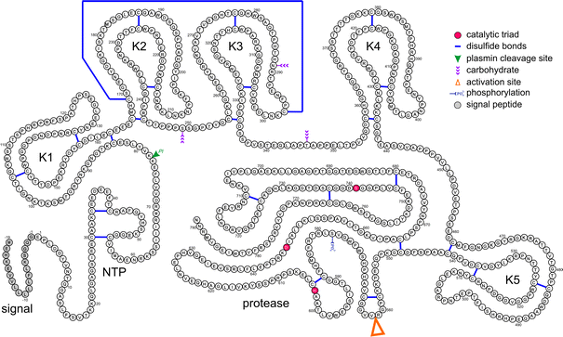

Figure 1.10: Representation of the primary structure of human plasminogen. Catalytic trio (His⁶⁰³, Asp⁶⁴⁶ and Ser⁷⁴¹), the activation site (Arg⁵⁶¹-Val⁵⁶²), the plasmin cleavage site (Lys⁷⁷-Lys⁷⁸), the phosphorylation site (Ser⁵⁷⁸) the CHO attachment sites (Asn²⁸⁹, Ser²⁴⁹ and Thr³⁴⁶), and the 24 disulphide bridges as well as the signal peptide are marked. NTP is the N-Terminal Peptide. K1-K1 are kringles 1-5

The heavy chain of plasmin is composed of 483 amino acids and contains five homologous kringle structures. These are known as K1 (Cys⁸⁴-Cys¹⁶²), K2 (Cys¹⁶⁶-Cys²⁴³), K3 (Cys²⁵⁶-Cys³³³), K4 (Cys³⁵⁸-Cys⁴³⁵) and K5 (Cys⁴⁶²-Cys⁵⁴¹). The disulphide bridges are arranged in the order; Cys¹-Cys⁶, Cys²-Cys⁴ and Cys³-Cys⁵ (Schaller and Gerber, 2011). Kringles 2 and 3 are linked in a clamp fashion by a disulphide bridge between Cys¹⁶⁹ and Cys²⁹⁷. Each kringle, except for K3, contains a lysine binding site characterised by anionic and cationic centres which are interspaced by a hydrophobic groove. In human plasmin K1, the centres contain two Asp and two Arg residues and the grove is lined with Trp, Tyr and Phe aromatic residues (Ramesh et al., 1987, Mathews et al., 1996).

The lysine binding site mediates the binding of plasmin to its substrate, fibrin(ogen) (Suenson and Thorsen, 1981) and to its inhibitor A2PI (Wiman et al., 1979). This site also allows binding to small molecules of the ω-aminocarboxylic acid type such as 6-aminohexanoic acid (Ponting et al., 1992). Additionally, the plasmin molecule can bind to bacterial and mammalian cell surfaces (Berge and Sjobring, 1993, Marti et al., 1994). K3 has a functionally inactive lysine binding domain (Marti et al., 1994) but it has been shown that the introduction of an Asp residue instead of Lys³¹¹ in the anionic centre of the lysine binding site can result in a weak affinity for ω-aminocarboxylic acids (Burgin and Schaller, 1999).

Currently there is no elucidated 3D structure for plasminogen. The best we have is based on known 3D structures of plasminogen fragments which show a spiral shape (Fig 1.10) (Gerber et al., 2010a). This resembles the shape of Glu-Plasminogen seen by electron microscopy (Tranqui et al., 1979).

Figure 1.10: Plasminogen 3D Structure

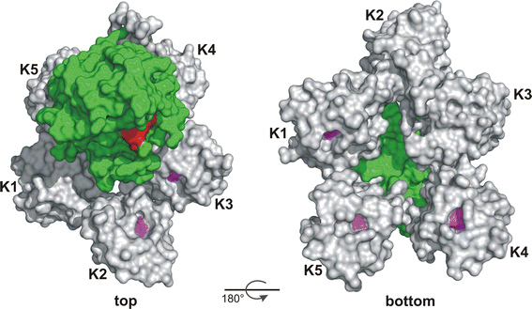

Figure 1.10: 3D views from the top and bottom of human plasminogen, based on overlapping 3D frament structures. Kringles are shown in grey, the central Trp residue in each lysine binding site is shown in magenta, the protease domain in green and the active site residues in red. (Gerber et al., 2010b)

1.3.3 Function of Plasmin

Plasmin’s primary function is the cleavage of insoluble fibrin polymers at specific sites, resulting in soluble fragments. The pattern of this cleavage is shown in Fig 1.11 (Walker and Nesheim, 1999). This cleavage releases the major fragments of fibrin, D and E, which are indicated by black arrows. Degradation of the fibrin polymer by plasmin begins with the cleavage of the Lys⁵³⁸-Met⁵⁸⁴ peptide bond in the Aα chain. This is followed by the cleavage of the bonds Lys²⁰⁶-Met²⁰⁷ and Lys²³⁰-Ala²³¹, which are also in the Aα chain. This releases a C-terminal 40kDa fragment which releases fragment X (260kDa). This fragment X is then cleaved, resulting in fragment Y (160kDa) and fragment D (100kDa). Further cleavage of fragment Y produces a second fragment D and fragment E (60kDa) (Walker and Nesheim, 1999).

Additionally, plasmin also plays a role in many physiological processes as a proteolytic factor. These include degrading the extracellular matrix, wound healing, tissue repair, angiogenesis, embryogensis and pathogen and tumour cell invasion (Dano et al., 1985b, Strickland et al., 1976, Gross et al., 1983, Ossowski and Reich, 1983, Schafer et al., 1994).

This broad specificity of plasmin results in the inactivation and degradation of extracellular matrix proteins such as collagens, fibronectin and laminins (Netzel-Arnett et al., 2002, Bonnefoy and Legrand, 2000, Nakagami et al., 2000), as well as blood proteins such as coagulation factor FVa, von Willebrand factor and thrombospondin (Bonnefoy and Legrand, 2000, Zeibdawi and Pryzdial, 2001, Hamilton et al., 1985). In vitro, plasmin has specificity similar to trypsin, cleaving peptide bonds after basic residues.

Mutations in the PLG gene are responsible for thrombophillia, a form of thrombosis characterised by a deficiency in type I plasminogen (Seligsohn and Lubetsky, 2001). Ligneous conjunctivitis is the most common form of type I plasminogen deficiency and is a rare form of chronic conjunctivitis characterised by chronic tearing and redness of the conjunctivae (Ichinose et al., 1991, Schuster and Seregard, 2003).

Figure 1.11: Cleavage of human fibrinogen by plasmin and the fragments generated

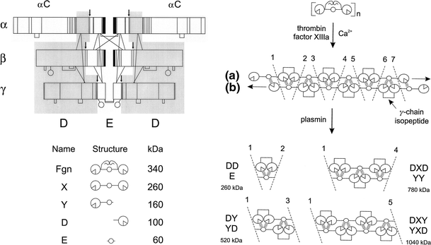

Figure 1.11: The major cleavage sites are identified by arrows and the fragments labelled X (260kDa), Y (160kDa), D (100kDa), and E (60kDa) (Walker and Nesheim, 1999)

Plasmin also has a role in the activation of signalling pathways through protease activated receptors. It has been shown to play a role in the regulation of nicotine reward by activation of PAR1 (Nagai et al., 2008) and also in the upregulation of tissue factor (TF) and PAI-1 via activation of PAR1. It has been suggested that statins may increase plasmin activity (through reduction of PAI-1) as they also impact upon the signalling of PAR1 (Fenton wt al., 2001)

1.3.4 Activators of Plasminogen

Plasminogen has two main physiological activators, tPA and uPA, which are multi-domain serine proteases. These activators both catalyse the same reaction; the activation of plasminongen to plasmin via the cleavage of the Arg⁵⁶¹-Val⁵⁶² peptide bond, therefore having the same molecular function. However, tPA and uPA have different biological roles. Whereas tPA is responsible for the dissolution of fibrin polymers by plasmin, aiding vascular haemostasis, uPA is mainly involved in the generation of pericellular plasmin activity such as the degradation of the ECM and other intercellular processes (Schaller and Gerber, 2011).
1.3.4.1 Tissue-type Plasminogen Activator

Human tPA, found in plasma at 5-10µg/l⁻¹, is synthesised by many cell types, including endothelial cells and keratinocytes (Levin, 1983) and is also produced in the brain (Sappino et al., 1993). It belongs to the peptidase S1 family (Pennica et al., 1983). The enzyme is a single-chain mulit-domain glycoprotein of around 70kDa (527 amino acids) containing one O-glycosylation site at Thr⁶¹ and three N-glycosylation sites at Asn¹¹⁷, Asn¹⁸⁴ and Asn⁴⁴⁸ (Pfeiffer et al., 1989, Harris et al., 1991).

tPA is encoded for by the PLAT gene, located on chromosome 8p12 (32.4kb) and is organised into 14 exons in the range of 43-914bp (Ny et al., 1984, Fisher et al., 1985). The single-chain proenzyme displays a high enzymatic activity compared to the fully active two-chain form held together by a disulphide bridge at Cys²⁶⁴-Cys³⁹⁵. This is formed following the cleavage of the Arg²⁷⁵-Ile²⁷⁶ peptide bond by plasminogen, plasma kallikrein (KLKB1) or coagulation factorXa (Loscalzo, 1988). The A-chain (275 amino acids) contains one FN1, one EGF-like, and two kringle domains, while the B-chain (252 amino acids) contains the serine protease section (Collen and Lijnen, 1991). The second kringle in the A-chain carries an active lysine-binding site, like the kringles in plasminogen (Byeon and Llinas, 1991). This is not found in kringle 1, due to a replacement of Trp by a Ser in the hydrophobic cleft of the lysine binding site in kringle 1 (de Vos et al., 1992).

The 3D structure of tPA has been determined by NMR spectroscopy (Fig 1.12) (Smith et al., 1995). The FN1 domain (43 amino acids) contains two anti-parallel β-sheets, a double stranded sheet and a triple stranded sheet stabilised by the disulphide bridges. The first of these bridges links the two β-sheets, the second is located within the triple-stranded β-sheet. The EGF-like domain (39 amino acids) contains two antiparallel, two-stranded β-sheets connected by a loop structure. This structure is then stabilised by disulfide bridges between the chains. The two kringles, the serine protease domain, and the FN1+EGF-like domain have all been implicated in the interaction of tPA and fibrin (Bennett et al., 1991, de Vries et al., 1989).

Figure 1.12: tPA 3D Structure

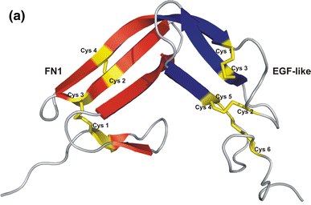

Figure 1.12: 3D structure of human tPA consisting of the fibrinectin type I (FN1) domain and the epidermal growth factor-like (EGF-like) domain as determined by NMR spectroscopy (Smith et al., 1995). Disulfide bridges have been highlighted in yellow.

The binding of tPA to fibrin is high affinity, resulting in increased activation of plasminogen by tPA. Fibrin contains exposed C-terminal Lys and Arg residues following proteolysis by plasmin. These residues bind to the LBS in the second kringle of tPA (Hoylaerts et al., 1982).

Interactions between tPA and endothelial or smooth muscle vascular cells have been shown to lead to increased activation of plasminogen. With the endothelial cells, the Ca²⁺/phospholipid-binding protein annexin A2 binds to the kringle-2 domain of tPA with its exposed C-terminal Lys and Arg residues (Hajjar et al., 1994, Cesarman et al., 1994).

The major inhibitors of tPA are PAI-1 and PAI-2 (discussed later).
1.3.4.2 Urokinase-type plasminogen activator

Human uPA is found in plasma at a concentration of 5-10µg/l⁻¹ and is synthesised mainly in the lungs and the kidneys. It is also produced by keratinocytes and endothelial cells (Bernik and Kwaan, 1969, Duffy, 1990). Urokinase-type plasminogen activator is a single-chain, multidomain glycoprotein of 55kDa and 411 amino acids (Nielsen et al., 1982, Wun et al., 1982). The enzyme contains an O-glycosylation site at the position Thr¹⁸ and one N-glycosylation site at the position Asn³⁰² and two phosphorylation sites at Ser¹³⁸ and Ser³⁰³ (Buko et al., 1991, Franco et al., 1997). It is the phosphorylation of these Ser residues that modulates the transducing ability of the UPAR receptor (Franco et al., 1997). Once human uPA has been converted into its active, two-chain high molecular weight form, by the cleavage of the Lys¹⁵⁸-Ile¹⁵⁹ peptide bond, it is held together by an interchain disulfide bridge between Cys¹⁴⁸ and Cys²⁷⁹ (Kobayashi et al., 1991). There is also a low molecular weight form of uPA, formed when uPA is cleaved by itself or by plasmin at the Lys¹³⁵-Lys¹³⁶ peptide bond. This is the form of uPA predominantly found in the urine (Steffens et al., 1982).

The 3-D structure of EGF-like+kringle double domain has been elucidated by NMR spectroscopy (Fig 1.13) (Hansen et al., 1994). The EGF-like region of uPA contains the same structural fold as that found in the same domain in tPA. The kringle domain of uPA lacks an active LBS due to the replacement of several essential residues in the anionic and cationic centres and residues in the hydrophobic groove of the LBS (Stephens et al., 1992).

Figure 1.13: uPA 3D Structure

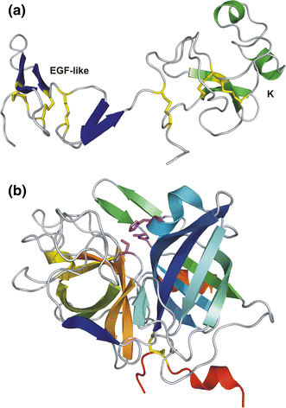

Figure 1.13: a) 3-D structure of EGF-like (blue) and kingle (green) domains of uPA determined by NMR spectroscopy (Hansen et al., 1994). b) 3-D structure of human LMW uPA determined by X-ray diffraction (Ploug et al., 1995).

1.3.5 Plasmin Inhibitors
1.3.5.1 α-2 Antiplasmin

Α2-antiplasmin is a member of the serpin family. It is a 67kDa single-chain plasma glycoprotein which is synthesised in the liver (Saito et al., 1982, Sumi et al., 1989). The protein contains four fully glycosylated N-glycosylation sites (Asn⁸⁷, Asn²⁵⁰, Asn²⁷⁰, Asn²⁷⁷) (Ries et al., 2002), a single disulphide bridge between residues Cys³¹-Cys¹⁰⁴, two undefined Cys residues (Cys⁶⁴ and Cys¹¹³) (Christensen et al., 1997) and a sulfated Tyr residue (Tyr⁴⁴⁵) (Hortin et al., 1987). Human plasma contains two N-terminally different forms of antiplasmin in circulation. The first is a 464 residue form with a Met residue at the N-terminus. The second is a 452 residue with an Asn as the N-terminal residue (Koyama et al., 1994, Lee et al., 2004). 30% of mature antiplasmin circulates in plasma as a C-terminally truncated form lacking around 26 amino acids (Sasaki et al., 1986). The truncated form inhibits the converstion of plasminogen to plasmin at a lower rate than mature antiplasmin (Clemmensen et al., 1981). Currently there is no 3-D structure of human antiplasmin.

α2-antiplasmin is the main physiological inhibitor of plasmin, but it also inhibits chymotrypsin and trypsin. Kinetic data has shown that the reaction for the inhibition of plasmin is a two-step process consisting of a reversible reaction with a k₁of about 3.8±0.4×10⁷M⁻¹s⁻¹, followed by an irreversible first-order reaction with a k₂ of about 4.2±0.4×10⁶M⁻¹s⁻¹ (Christensen and Clemmensen, 1977).

Defects in the SERPINF2 gene for antiplasmin can result in an antiplasmin deficiency which is an autosomal recessive disorder leading to an increase in haemorrhagic likelihood (Miura et al., 1989, Lind and Thorsen, 1999).
1.3.5.2 Plasmin Activator Inhibitor 1

Plasmin activator inhibitor 1 (PAI-1) is found in human plasma at a concentration of ~20µg/l⁻¹. It is a member of the serpin family and is produced in a wide range of cells including endothelial cells, smooth muscle cells and liver cells (Alessi et al., 1997). PAI-1 is a 50kDa single chain plasma glycoprotein made up of 379 amino acids, with two N-glycosylation sites at Asn²⁰⁹ and Asn²⁶⁵ and a potential third at Asn³²⁹ (Pannekoek et al., 1986). The 3-D structure of PAI-1 has been determined in complex with two RCL inhibitory pentapeptides by X-ray diffraction (Fig 1.14) (Xue et al., 1998). These pentapeptides (blue) bind in between β-strands 3 and 5 in β-sheet A (red). This prevents RCL insertion into the β-sheet, preventing the inhibition of the target.

Figure 1.14: PAI-1 3D Structure

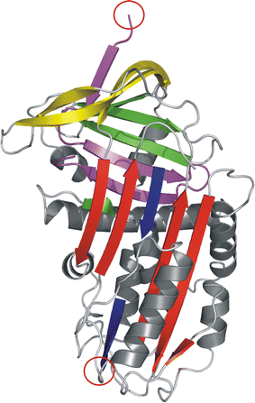

Figure 1.14: 3-D structure of human PAI-1 in a complex with two RCL inhibitory pentapeptides, determined by X-ray diffraction (Xue et al., 1998). The pentapeptides (blue) bind between β-strands 3 and 5 in β-sheet A (red). The C-terminal cleavage region is shown in magenta and the cleaved ends of the reactive peptide bonds circled in red.

PAI-1 is the main inhibitor of tPA and uPA with second order rate constants of 2.5–4×10⁷M⁻¹s⁻¹ for two-chain tPA and 1x10⁷M⁻¹s⁻¹for uPA, regulating fibrinolysis by limiting plasmin production (Schaller and Gerber, 2011). PAI can inhibit other serine proteases, but at much lower rates; e.g. thrombin at 1.1x10³ M⁻¹S⁻¹, plasmin at 6.6 x 10⁵ M⁻¹S⁻¹, and trypsin at 7 x 10⁶ M⁻¹S⁻¹ (Lawrence et al., 1989, Keijer et al., 1991, Hekman and Loskutoff, 1988). In both plasma and the ECM, PAI-1 is found bound to vitronectin (Sigurdardottir and Wiman, 1994). This binding to vitronectin increases the rate of inhibition of PAI-1 for thrombin up to 200-fold (Ehrlich et al., 1990). In vascular injury activated platelets can increase the concentration of PAI-1 in plasma ten-fold (Juhan-Vague et al., 1984). PAI-1 deficiency is characterised by abnormal bleeding, where high levels are associated with myocardial infarction (Fay et al., 1997, Hamsten et al., 1987).
1.3.5.3 Plasminogen Activator Inhibitor 2

Plasminogen activator inhibitor 2 (PAI-2) is found in human plasma at <5µg/l⁻¹. PAI-2 is a member of the serpin family of proteases and is produced by epithelial cells, monocytes and macrophages and keratinocytes (Webb et al., 1987, Wohlwend et al., 1987). PAI-2 lacks a signal sequence and so is poorly secreted (von Heijne et al., 1991). This causes PAI-2 to accumulate intracellularly as a 47kDa non-glycosylated protein (Genton et al., 1987). Single chain PAI-2 can be secreted in small amounts via a facultative translocation pathway as a 60kDa plasma glycoprotein (Belin et al., 1989). This version contains three possible N-glycosylation sites; Asn⁷⁵, Asn¹¹⁵ and Asn³³⁹ and a single di-sluphide bridge at Cys⁵-Cys⁴⁰⁵ (Kruithof et al., 1995). The 3D structure of a deletion (Asn⁶⁶-Gln⁹⁸) mutant has been elucidated with X-ray diffraction (Fig 1.15) (Harrop et al., 1999).

Figure 1.15: PAI-2 3D Structure

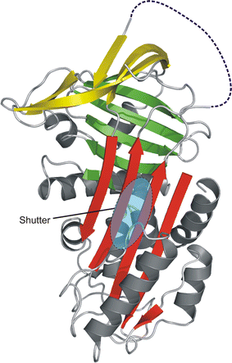

Figure 1.15: 3D structure of PAI-2 deletion mutant determined by X-ray diffraction (Harrop et al., 1999). Reactive Centre Loop is shown as a dashed blue line with the shutter region located beneath β-sheet A (red) and shown as a blue oval.

PAI-2 is an inhibitor of tPA and uPA with second order rate constants of 0.8–1.2×10⁴M⁻¹s⁻¹for two-chain tPA and 2.4–2.7×10⁶M⁻¹s⁻¹for uPA (Ny and Mikus, 1997). PAI-2 is only detectable in plasma during pregnancy and has been suggested to have a role in placental maintenance or the development of embryos (Lecander and Astedt, 1986). Intracellular PAI-2 plays roles in functions other than uPA and tPA inhibition; PAI-2 can influence cell proliferation and differentiation, inhibit apoptosis and can also alter gene expression (Schaller and Gerber, 2011). Currently, we know little with regards to PAI-2 defects in disease.
1.3.5.4 Neuroserpin

Neuroserpin is not usually detectable in plasma and is also a member of the serpin family. As suggested by its name, neuroserpin is predominantly expressed in the brain (Hastings et al., 1997, Schrimpf et al., 1997). It is a single-chain 55kDa glycoprotein of 394 amino acids with three possible glycosylation sites at Asn¹⁴¹, Asn³⁰⁵ and Asn³⁸⁵ (Hastings et al., 1997, Osterwalder et al., 1996, Yazaki et al., 2001). The 3D structure of neuroserpin has been elucidated by x-ray diffraction (Fig 1.16) and contains the same essential elements of the serpin core; three β-sheets (red, green and yellow), nine α-helices (grey) and an RCL (blue) (Hastings et al., 1997).

Plasmin, uPA and tPA have all been shown to be the targets of neuroserpin (Hastings et al., 1997, Ricagno et al., 2009). Neuroserpin has been shown to be involved in the formation and maintenance of synaptic connections and may be involved in protecting neurons from tPA mediated cell damage (Davis et al., 1999).

1.3.5.5 α2-Macroglobulin

The alpha macroglobulins are large glycoproteins which are found in the plasma of vertebrates, as well as the hemolymph of invertebrates and the albumen of bird and reptile eggs (Burescova, et al., 2009; Raymond, et al., 2009; Ma, et al., 2010). The macroglobulin family consists of α1 macroglobulin, α2 macroglobulin and the complement components C3, C4 and C5, which have been shown to be evolutionarily related (Kaur, et al., 2011).

Alpha-2-macroglobulin is the major anti-proteinase present in the plasma of vertebrates and is unique in that it can inhibit almost all proteinases, regardless of their specificity or mechanism of action (Rehman, et al., 2012). It can inhibit serine-, cysteine-, aspartic-, and metalloproteinases and inhibits both fibrinolysis (by inhibiting plasmin) and coagulation (by inhibiting thrombin) (de Bour, et al., 1993).

1.4 Changes in ECM Processing During Scarring

1.4.1 Increased Synthesis of ECM Components
One of the major characteristics of a pro-fibrotic phenotype displayed by renal cells during CKD, is the increased synthesis of ECM components. Activated fibroblasts in the interstitium are responsible for increased matrix synthesis and tubular cells along with other interstitial cells contribute to the production of matrix (Zeisberg et al., 2000). In the glomerulus, it is the mesangial cells which are the major ECM producer (Haralson et al., 1987).
The increased production of ECM components is a vital part of increased ECM accumulation. In particular, there is significant increase in interstitial collagens I and III, as well as collagen IV, laminin and fibronectin. Increased collagen synthesis has been observed both in several models of renal disease (Floege et al., 1991, Floege et al., 1992, Yamamoto et al., 1993, Johnson et al., 1997) and human disease (Razzaque et al., 1995, Stokes et al., 2000). Collagen IV specifically is seen to increase in models of glomerular nephritis (Floege et al., 1992) and subtotal nephrectomy (Johnson et al., 1997). In a similar manner, fibronectin mRNA expression is increased in models of glomerulonephritis (Yamamoto et al., 1994) and the remnant kidney model (Floege et al., 1992).

Figure 1.16: Neuroserpin 3D Structure

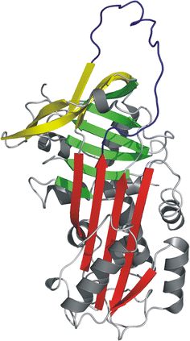

Figure 1.16: Structure of neuroserprin: Contains the same essential elements of the serpin core; three β-sheets (red, green and yellow), nine α-helices (grey) and an RCL (blue) (Hastings et al., 1997)
The increased production of fibronectin has been shown to be an early event in ECM accumulation and is thought to form a scaffold along with laminin for the deposition of other ECM proteins (Eddy, 2000).
Qualitative changes in the ECM, favouring deposition, accompany this increased synthesis. Collagen I and III levels are significantly increased in the glomerulus due to increased production of collagen I and III mRNA (Minto et al., 1993). Fibronectin has alternative splicing patterns, some of which are seen in both experimental and human disease (Van Vliet et al., 2001, Alonso et al., 1999). In addition laminin, which is expressed in the developing kidney but not normally expressed in mature renal tissue, has been shown to be expressed in renal disease (Fischer et al., 2000).
As well as increases in these major ECM proteins, there is also significant upregulation of some less abundant proteins. Proteoglycans such as decorin and biglycan have been shown to increase in renal disease (Stokes et al., 2000). Increases in the both mRNA for and protein SPARC are seen at sites of matrix expansion and fibrosis in the remnant kidney model, among others (Pichler et al., 1996). SPARC participates in the modulation of cytokine activity and has been shown to stimulate synthesis of laminin, collagen I and fibronectin, contributing to increased ECM accumulation (Kamihagi et al., 1994).
The increase in synthesis, while important, also requires increases in deposition pathways for the ECM to accumulate. Increases in deposition have been associated with a number of factors, such as the rennin-angiotensin system (Johnson et al., 1992a), MCP-1 and TGFβ1 (Schneider et al., 1999, Sharma and Ziyadeh, 1995, Schrijvers et al., 2004).

1.4.2 Reduced ECM Degradation
As well as increased synthesis, accumulation of ECM is exacerbated by reductions in the quantity and activity of proteolytic enzymes such as MMPs and plasmin. The consequence of this is reduced degradation, which favours the accumulation of ECM.
In several of the studies focussed on MMP and TIMP expression and activity, decreases in MMPs have been seen that are consistent with a fibrogenic phenotype. In a model of unilateral ureteral obstruction, there is a reduction in MMP1 and MMP9 activity (Gonzalez-Avila et al., 1998) both of which are anti-fibrotic. In models of diabetic nephropathy there is an overall down regulation of MMP activity, along with an increase in TIMP-1 (Reckelhoff et al., 1993, Reckelhoff et al., 1994) leading to the accumulation of ECM.
Several studies of experimental disease also have shown MMP down-regulation in response to TGF-β1 and elevated glucose (McLennan et al., 2000, Singh et al., 2001). However, there is some dispute in the literature regarding a decrease in MMPs, with some studies suggesting there is no change, or even an increase (Koide et al., 1997). This conflicting data has suggested that it is the TIMPs, particularly TIMP1, which are important in the reduction of ECM degradation. Several experimental disease models have shown increases in TIMP1 (Koide et al., 1997, Eddy, 1996, Schaefer et al., 1997). TIMP1 is likely to play an important role in matrix turnover due to its inhibition of all latent pro-MMPs as it has been shown that even with increased MMP mRNA in experimental nephritis, activity is still reduced due to the TIMPs (Johnson et al., 2002, Ahmed et al., 2007).
However, it is not only MMPs and TIMPs that play a role in the breakdown of the ECM. Alterations in the plasmin system are also likely to be important in regulating ECM turnover in disease and, indeed, are the main focus of this thesis. Increases in both uPA and its receptor UPAR have been shown in several models of renal disease (Kenichi et al., 2004, Lee et al., 2001). Changes in tPA have also been seen, with levels of tPA correlating with the degree of fibrosis in the UUO model (Yang et al., 2002b). These increases in uPA and tPA should lead to increased plasmin activity and a reduction in ECM accumulation but, for some reason, levels of plasmin have been shown to be static or even reduced in experimental renal disease (Malliaros et al., 1993, Rondeau et al., 1990, Bruno et al., 2008b). However, of the attention fostered on the plasmin system, most of it has been on the PAI-1 system (Rerolle et al., 2000). Increased expression and deposition of PAI-1 has been demonstrated in several animal models of renal disease and also in human disease (Yamamoto et al., 1993). TAFI has also been shown to modulate plasmin activity and, in knockout animals, has been shown to be protective against experimental renal disease in a similar manner to PAI-1 knockouts (Bruno et al., 2008b).

1.4.3 ECM Stabilisation
Crosslink formation both within and between adjoining ECM proteins is an important part of matrix generation. The enzymes lysyl oxidase and tissue transglutaminase are known to be involved in this process. The pyridinoline crosslinks formed by lysyl oxidase stabilise the fibrils of collagen during collagen synthesis (Kagan and Sullivan, 1982). Tissue transglutaminase is involved in the formation of ε(γ-glutamyl) lysine crosslinks between lysine and glutamine residues on several ECM components (Griffin et al., 2002b).
Upregulation of this crosslinking has been shown to contribute to ECM accumulation by increasing its resistance to degradation (Johnson et al., 1997).

1.5 The Clotting System

1.5.1 Coagulation and Fibrinolysis
As well as a role in the breakdown of the ECM, plasmin also has a major part to play in the clotting system. It is important to address this here as many of the interactions of plasmin with other peptidases have only been studied as part of the clotting system, despite the same interactions being present in the formation of scar tissue. The clotting system can be divided into two distinct cascades; the coagulation cascade and the fibrinolytic cascade (see Figure 1.17). The coagulation cascade is responsible for the deposition of fibrin at the site of an injury. Activation of the coagulation cascade results in the conversion of prothrombin to active thrombin, which in turn catalyses the conversion of soluble fibrinogen to the gel-like substance fibrin (Nesheim, 2003). Conversely, the fibrinolytic cascade causes the production of plasmin from plasminogen, which catalyses the solubilisation of fibrin.
The coagulation system is highly regulated by the endothelium, blood platelets, and the coagulation and fibrinolytic plasma proteins (Nesheim, 2003). One of the major regulators from both systems is the protein thrombomodulin (Esmon, 2000). Thrombomodulin is an integral membrane protein found on endothelial cells. Thrombomodulin binds to thrombin and modifies its substrate specificity, causing it to no longer recognise fibrinogen as a substrate. Thrombin now catalyses the conversion of protein C to activated protein C, an anti-coagulant. The activated protein C down-regulates the formation of thrombin from prothrombin (Nesheim, 2003).
Thrombin also catalyses the activation of thrombin-activatable fibrinolysis inhibitor (TAFI) to TAFIa, which down-regulates the production of plasmin from plasminogen and therefore reduces fibrinolysis (Bajzar, 2000).

Figure 1.17: The Coagulation Cascade
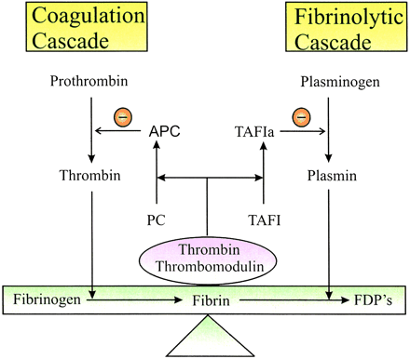

Figure 1.17: “The coagulation cascade ultimately generates thrombin, which catalyzes the conversion of fibrinogen to the fibrin clot. The fibrinolytic cascade generates plasmin, which catalyzes solubilization of the FN which is cross-linked into a clot by factor xiiia. The thrombin-thrombomodulin complex promotes down-regulation of thrombin formation by generating activated protein C (APC). It also suppresses fibrinolysis by forming TAFIa. The two cascades are thereby linked through the thrombin, thrombomodulin, and TAFI pathway. PC = protein C”. Figure and legend from (Nesheim, 2003)

1.5.1.1 Coagulation
Thrombin acts on the soluble monomer fibrinogen and catalyses the release of both fibrinopeptide A and fibrinopeptide B from the fibrinogen molecule. The fibrinogen molecule is made up of two globular D domains and a central, globular E domain. The removal of these peptide fragments exposes the polymerisation sites within the E domain. The E domains then bind tightly and non-covalently with D domains on adjacent molecules of fibrin. At the same time a transglutaminase called factor XIII is activated to factor XIIIa which catalyses the formation of isopeptide bonds between chains in D domains of adjacent monomers in the growing fibrin polymer. Occasionally branches can form leading to a ‘spider-web’ type mesh (Nesheim, 2003).
1.5.1.2 Fibrinolysis
Once the fibrin polymer is formed, it, along with tissue –type plasminogen activator (tPA), acts as a cofactor in the activation of Glu-plasmin. The plasmin catalyses the cleavage after specific arginine and lysine residues in the peptide chains of fibrin. This cleavage is the beginning of fibrin digestion and clot removal. The cleaved, modified fibrin is known as fibrin*. Fibrin* acts as a co-factor for tPA in the activation of Plasmin (Nesheim, 2003). In response to the complex of thrombomodulin bound to thrombin, TAFI is activated to TAFIa. On its own, thrombin is a very poor activator of TAFI; data has shown that thrombomodulin increases the catalytic efficacy of thrombin dependent TAFI activation by 1250-fold (Bajzar, 2000). This TAFIa (also known as Caboxypeptidase U) then catalyses the removal of carboxyl-terminal lysine residues present in fibrin*, producing a modified form of fibrin called fibrin** (Nesheim et al., 1997). This down-regulates the co-factor activity of fibrin on the activation of plasmin, so TAFI eliminates the positive feedback and substantially attenuates the activation of plasmin and fibrinolysis to protect the clot(Nesheim, 2003). These are highlighted in Fig 1.18
The fibrinolytic cascade has two other serine-protease inhibitors. These are plasminogen activator inhibitor type 1 (PAI-I) which inhibits tPA, and antiplasmin which targets plasmin.

Figure 1.18: Interaction of Plasmin and TAFI
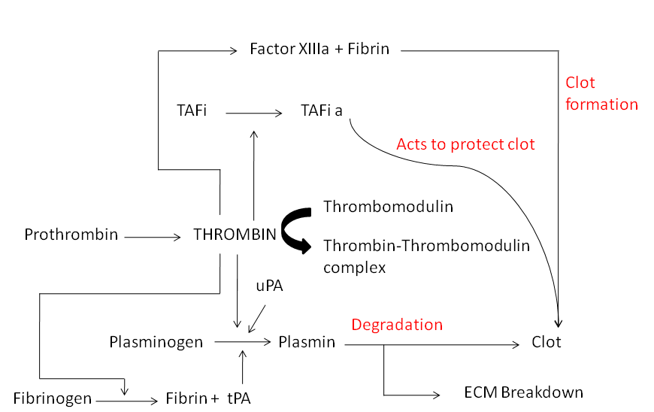

Figure 1.18: The roles of Thrombin and Plasmin in forming, maintaining and degrading a blood clot. The activation of fibrin causes the formation of the clot, and the active TAFi acts to preserve the clot. However, Thrombin also activates Plasmin to degrade the clot.

1.6 TAFI
The protein TAFI consists of a single chain of 401 amino acids (Eaton et al., 1991). It has a peptide molecular mass of 45,999Da and migrates in SDS-PAGE with an apparent weight of 60,000d, which is attributed to four glycosaminoglycan chains in the amino terminal region (Boffa et al., 1998). TAFI can be activated by trypsin, plasmin, thrombin or meizothrombin (Bajzar et al., 1995). This activation occurs by way of cleavage at Arg-92, which causes the release of a glycosylated activation peptide. TAFI activation by thrombin alone is a fairly inefficient process and is stimulated about 1250 fold by the addition of thrombomodulin (Boffa et al., 1998).

1.6.1 The Role of TAFI
Coagulation, the process of blood clotting, is initiated upon exposure of blood to tissue factor at the site of injury. The tissue factor recruits factor VII(a) and also activates factor X. This tissue factor pathway increases the production of thrombin and, once sufficient thrombin has been produced, also induces fibrin formation. After the clot has formed, thrombin continues to be produced within the fibrin clot, by thrombin-catalysed factor XI activation. This is the intrinsic pathway. Another, secondary, burst of thrombin is provided by the intrinsic pathway as factor XI is continually activated by thrombin.
The high concentrations of thrombin are required for the activation of TAFI and contrast the small amounts of thrombin required for the formation of a fibrin clot (Boffa et al., 1998).
The extrinsic pathway provides the thrombin required for the formation of the fibrin clot whereas the intrinsic pathway provides the thrombin needed for the protection of the clot against lysis. TAFI, activated by thrombin, is responsible for preventing this lysis of the fibrin clot (Bouma and Meijers, 2004). During fibrinolysis, plasminogen is converted to active plasmin, which cleaves fibrin after arginine and lysine residues (Suenson et al., 1984). TAFIa attenuates the process of fibrinolysis by removing exposed C-terminal lysine residues on fibrin, preventing the co-factor activity of tissue-type plasminogen activator (tPA) (Walker and Nesheim, 2001, Bajzar et al., 1995). The removal of these residues prevents plasmin activation (Wang et al., 1998a) and thus reduces fibrinolysis (Fig 1.19).

Figure 1.19: TAFI’s Effect On Plasmin

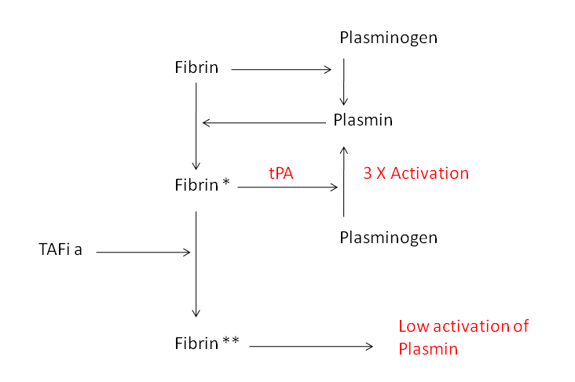

Figure 1.19: The activation of TAFi (ie to TAFia) leads to Fibrin being modified to Fibrin**, this is a much worse co-factor for tPA and results in tPA having a reduced ability to activate Plasmin from inactive Plasminogen

1.6.2 Why Might TAFI Affect Scarring?
The system of wound healing is a very complex process and involves the formation of a provisional membrane, cell infiltration and tissue remodelling. Intravascular platelet aggregation, formation of a fibrin clot and growth factor release, combined with increased vascular permeability, cause the migration of attracted inflammatory cells (Verderio et al., 2004). A disruption of the blood vessels, caused by tissue injury, can lead to the extravasation of plasma proteins, and the activation of the coagulation cascade. Platelets and macrophages are then activated and, as a result, produce growth factors for the initiation of granulation tissue formation (Inbal et al., 2005).
Once the fibroblasts have migrated to the damaged area, the proliferation phase begins with the endothelial cells contributing to angiogenesis. In unsutured wounds, during secondary wound healing, the epithelial cells migrate to the edges of the wound while they cover the wound (Inbal et al., 2005).
All of these processes; the migration of cells, angiogenesis and the formation of granulation tissue, are reliant of the extracellular matrix (ECM) remodelling (Drew et al., 2001).
In the context of chronic kidney disease, increases in the concentration of Plasmin Activator Inhibitor–1 (PAI-1) have been observed in the clinical specimens of patients suffering with this disease. The over-expression of PAI-1, in pre-clinical models, has been associated with the very worst outcome possible in obstructive nephropathy (Oda et al., 2001).
A deficiency in PAI-1 is conversely associated with a beneficial outcome in diabetic nephropathy (Oda et al., 2001). As Thrombin Activatable Fibrinolysis Inhibitor (TAFI) is a modulator of plasmin activity then its actions in the ECM could greatly affect the pathway that leads to scarring. It has been shown that TAFI knockout mice have increased plasmin activity in response to immune complex-mediated glomerulonephritis (Bruno et al., 2008b).
Studies carried out involving the role of TAFI in wound healing showed that mice lacking TAFI have impaired healing in two different models of tissue repair. The skin wound healing was different in TAFI – deficient mice; the re-epithelialization by keratinocytes in these mice was delayed and did not follow the normal pattern of migration. In normal episodes of wound healing, the keratinocytes migrate from one wound edge towards the opposite edge (Inbal et al., 2005). In order for this to be successful, the cells need contact with an intact ECM over which they migrate. In the TAFI deficient mice the direction of migration was mostly directed down into the dermal layer, which indicates a disruption of ECM structure and function. Without TAFI to modulate its activity, uncontrolled plasmin activation may cause unbalanced matrix degradation, leading to this altered structed of ECM. Ultimately the absence of TAFI leads to a wound-healing defect with disturbed keratinocyte migration. This indicates that TAFI is involved in tissue repair of injured animals (Inbal et al., 2005).
TAFI has also been shown to play a role in the generation and maintenance of the ECM in renal scarring. Elevated TAFI levels have been shown to lead to increased renal scarring in transplant patients (Schrijvers et al., 2004), as well as in models of experimental renal disease (Bruno et al., 2008c). This is an area that warrants further study, as the formation of scar tissue is caused by an excessive accumulation of extracellular matrix. Therefore the inhibition of TAFi could prevent the active TAFia blocking plasmin activation; therefore an increase in the activation of plasmin could lead to the breakdown of more ECM as has been shown previously. It is the excessive build up of ECM that causes the formation of renal scarring in chronic kidney disease (Oda et al., 2001) and therefore, if this could be pharmaceutically manipulated through the TAFI and plasmin systems, then ECM accumulation and renal scarring could be reduced.

1.6.3 The TAFI Inhibitor UK-396082
UK 396082 is a small molecule inhibitor of TAFi developed by Pfizer in 2007. UK-396082 is prepared as a single enantiomer using a lactam-based synthetic strategy commencing with the Boc-substituted piperidinone compound 45 (Flynn, 1983) (Fig 1.20). This compound 45 was then deprotonated with lithium hexamethyldisilazide (LHMDS), and the enolate was treated with carboxaldehyde 40. The aldol addition product was dehdrated to give compound 46. Catalytic hydrogenation of 46 over palladium-black, and chiral high-performance liquid chromatography (HPLC) resolution of the racemic product provided compound 47. Ring opening of the Boc-substituted lactam moiety in 47 was performed under mild lithium hydroxide conditions and the product subjected to acid hydrolysis and ion exchange chromatography to produce compound 21 (UK-396082) (Bunnage et al., 2007).
A study of enzyme kinetics showed UK-396082 is a competitive reversible inhibitor of TAFIa (with a Ki of 40nM). It also has an excellent selectivity for TAFIa (carboxypeptidase U) over carboxypeptidase N (CPN) of over 1000-fold (Bunnage et al., 2007).
UK-396082 was found to have moderate potency against porcine carboxypeptidase B. Therefore co-crystallization studies were performed with porcine CPB as a surrogate for TAFIa (Fig 1.21)

Figure 1.20: Steps in the production of UK-396082
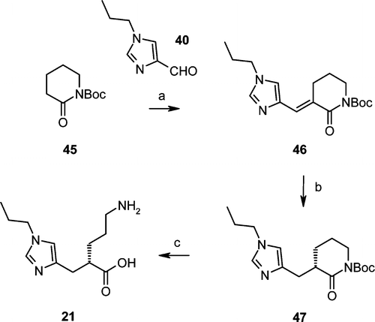

Figure 1.20: The production of UK-396082. a) i, deprotonation of 40 with lithium hexamethyldisilazide. , ii treatment with carboxyaldehyde and dehydration to comapound 46 b) i, catalytic hydrogenation over palladium-black; ii, chiral HPLC to form compound 47 c) i, Ring opening of the B0c-lactam moiety under lithium hydorxide conditions, ii subjected to acid hydrolysis and ion exchange chromotography to produce compound 21 (UK-396082) (Bunnage et al., 2007).

In addition to this x-ray structure, examination of the active site (Fig 1.22) confirms that the imidazole moiety in UK-396082 is involved in ligation of the catalytic zinc, highlighting that the use of an imidazole moiety is suitable in zinc-metalloprotease inhibitors. The primary amine in UK-396082 is bridged to the key Asp255 at the base of the S1‘ specificity pocket, the acid moiety formed a salt bridge with Arg145, mimicking the C-terminal acid of the substrate, and the
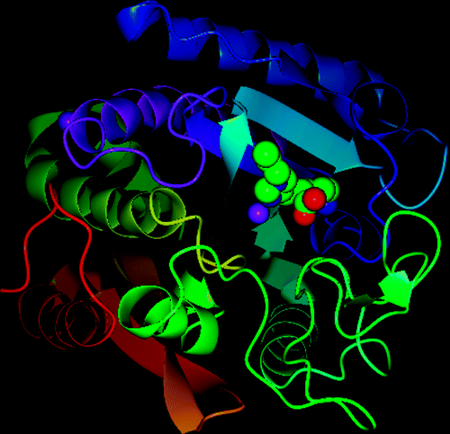
Figure 1.21: TAFI 3D Structure

Figure 1.21: Structure of UK-396082 in complex with porcine pCPB (Bunnage et al., 2007)
imidazole alkyl substituent is found to reside in a lipophilic channel, which projects out of the active site into solvent, adjacent to Tyr 199 (Bunnage et al., 2007) (Fig 1.22)
UK-396082 has pharmokinetics consistent with its physiochemical properties of low molecular weight (MW=239) and high hydrophilicity (log D=-2.8). A rat is considered a reliable predictor of paracellular absorption potential in man and UK-396082 was found to have ~20% gut absorption in rats suggesting sufficent bioavailability for humans (Bunnage et al., 2007).
In Phase I trials as an anti-thrombotic drug, compound 21 (UK-396082) was well tolerated and was shown to have an excellent pharmacokenetic profile. Human half-life following IV dosing was around 4 hours with a low total clearance (Clp=1.5-2mL/min/kg) and a low volume of distribution (0.5L/kg). Oral dosing (100-1000mg twice daily for 14 days) confirmed good oral bioavailability in humans (F_{oral} = 23%) and a T_{max} of 4-6 hours. Most notably, bioavailability was not affected by administration with food.

Figure 1.22: Interactions of the TAFI Inhibitor
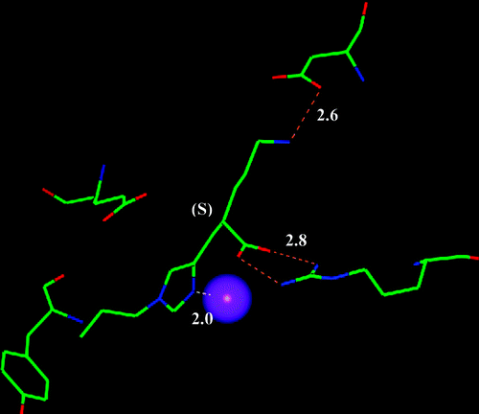

Figure 1.22: The structure of UK-396082 in porcine pCPB showing key interactions and distances (Å). The catalytic zinc in this representation is displayed as a purple sphere. From (Bunnage et al., 2007)
1.7 Thesis Rationale and Hypothesis
Studies in various models of renal disease have suggested that the plasmin and TAFI systems play important roles in both the metabolism of extracellular matrix, and the progression of chronic kidney disease.
Increases in the concentration of Plasmin Activator Inhibitor–1 (PAI-1) have been observed in clinical specimens of patients suffering with CKD. The over-expression of PAI-1, in pre-clinical models, has been associated with the very worst outcome possible in obstructive nephropathy (Oda et al., 2001).
A deficiency in PAI-1, leading to an increase in plasmin, is conversely associated with a beneficial outcome in the event of diabetic nephropathy (Oda et al., 2001). As Thrombin Activatable Fibrinolysis Inhibitor (TAFI) is a modulator of plasmin activity then its actions in the ECM could greatly affect the pathway that leads to scarring. It has been shown that TAFI knockout mice have increased plasmin activity in response to immune complex-mediated glomerulonephritis (Bruno et al., 2008b).
Studies carried out involving the role of TAFI in wound healing suggesting that, without TAFI to modulate its activity, uncontrolled plasmin activation may cause increased matrix degradation. Ultimately the absence of TAFI leads to a wound-healing defect with disturbed keratinocyte migration (Inbal et al., 2005).
As the formation of scar tissue is caused by an excessive accumulation of extracellular matrix, the inhibition of TAFI would prevent the active TAFIa blocking plasmin activation, therefore an increase in the activation of plasmin could lead to the breakdown of more ECM. It is the excessive build up of ECM that causes the formation of renal scarring in chronic kidney disease (Oda et al., 2001).
Therefore the overarching hypothesis to be tested, is that UK-396082 can reduce TAFI activity, leading to increased plasmin activity and that this increase in plasmin activity will be beneficial in reducing ECM accumulation in both in vitro and in vivo models of chronic kidney disease.

1.8 Aims and Objectives
To test the above hypotheis, the overall aim of the project is to determine if a TAFI inhibitor will increase plasmin activity and, ultimately, reduce kidney scarring. To address this in a logical manor, this study is therefore divided into in vitro and in vivo experimental sections, with a final part to determine the relevance of any potential benefits to CKD patients;

The in vitro section will aim to:
- Establish a suitable cell line for in vitro tissue culture studies based on the criteria that the cell line must produce suitable levels of; uPA, tPA, Plasmin, TAFI and ECM. The cell lines to be tested will be NRK 52E tubular epithelial cells, NRK 49F fibroblasts and 1097 mesangial cells.
- Determine the contribution of the plasmin system to ECM homeostasis in the selected cell line using siRNA knock down of plasminogen (ie can changes in plasmin affect ECM levels)
- Using an in vitro model of kidney fibrosis in the chosen line, establish if TAFI inhibitor UK396082 can influence ECM accumulation, and if so by altering levels of which ECM proteins.

If in vitro studies suggest TAFI inhibition can be benefitial, the in vivo component of the study will aim to:

- Establish a suitable oral dosing regime in rats to achieve 50% knockdown of blood TAFI activity.
- Apply this dose of UK396082 in the rat 5/6 subtotal nephrectomy model of kidney fibrosis with both prevention and remission arms.
- Establish the effect of therapy on kidney scarring and fibrosis, kidney function and the ECM proteins.
Finally, the study will establish the relevance of the experimental findings to the kidney patient by
- Measuring blood TAFI and plasmin activity in healthy volunteers and CKD patients
- Relate the levels of these to the stage and progression of CKD.

Chapter Two

Materials and Methods

2.1 Cell Culture

2.1.1 Cell Lines
NRK 52E proximal tubular epithelial cells (ATCC; CRL-1571), and NRK 49F fibroblast cells (ATCC; CRL-1570), were obtained from the European Cell Culture Collection.
1097 mesangial cells (Kakizaki et al., 1991) were obtained from Professor Robert Atkins (Monash Medical Centre, Australia).

2.1.1 Cell counting protocol
Cell counting was performed with a hemocytometer which holds a cover slip exactly 0.1mm above the chamber floor. The counting chamber is etched in a total surface area of 9mm². The calculation of cell concentration is based on the volume underneath the cover slip. One large square has a volume of 0.0001mL. The hemocytometer is filled by capillary action.
The cells are mixed with an equal volume of tryphan blue (0.4%w/v tryphan blue in PBS) to determine the live/dead count. A pipette filled with a well suspended mix of these cells is places at the notch on the edge of the hemocytometer then fluids expelled slowly so the fluid is drawn in by capillary action. Using a 10x light microscope the cells are counted in the four outer squares. Cell concentration is calculated as follows: Concentration per mL = total cell count in four squares x 2500 x dilution factor. So if 450 cells were counted after a 1:10 dilution, the concentration would be 450x2500x10 = 11,250,000/mL.

2.1.2 Culture Media
NRK 52E cells and 49F cells were cultured in Dulbecco’s Modified Eagles Medium (DMEM) (Biowhittaker, UK) containing 584 mg/L L-glutamine, 5% heat in-activated foetal calf serum, 20mM Glucose, 100 IU/ml penicillin, and 100 μg/ml streptomycin (Sigma, UK).
1097 cells were cultured in DMEM containing 584 mg/L Lglutamine, 10% heat inactivated foetal calf serum, 100 IU/ml penicillin, and 100 μg/ml streptomycin.
All cultures were maintained at 37°C in a humidified atmosphere of 5% CO₂ in air (Ig500 incubator, Jouan, France). These are normally grown in T75 flasks (Corning, UK) from an initial seeding of 1 x 10⁶ and passaged at ~5x 10⁶ after 48 hours. Cells are lifted with 0.05% Trypsin-EDTA (Gibco, UK) with shaking, no scraping. They are frozen in 70% Media, 20% FCS and 10% DMSO at -80ºC.

2.1.3 Immunofluorescence for cell markers
NRK52E cells were plated onto 22mm² glass coverslips at a density of 1x10⁶ per well in a 6 well plate (Iwaki, Japan) and cultured for 48 hours. Cells were rinsed in phosphate buffered saline (PBS) and fixed in methanol for 20 mins at -20°C. Cells were then blocked for 30 minutes with 5% BSA/0.1% TBS-tween 20 and immunoprobed for 1hr at 37ºC for either β-catenin (1:250 dilution in 3% BSA in PBS, Mouse Monoclonal 9F2, Abcam, Cambridge, UK) or α-smooth muscle actin (1:100 dilution in 3% BSA in PBS, Mouse Monoclonal, Dako, High Wycombe, UK). Antibody binding was revealed by incubation with anti-mouse FITC conjugated antibody (Dako, UK). Cells were washed with PBS and mounted with Vectashield fluorescent soft mount (Vector labs, Peterborough, UK). Fluorescence was visualised using an Olympus BX61 microscope at 494nm with excitation at 518nm.
To ensure no tubular epithelial cells had epithelial mesenchymal trans-differentiation to myofibroblast phenotype, cells were also tested for fibroblast cell surface antigen. The protocol for this was the same as above with the primary antibody being against fibroblast cell surface antigen (monoclonal clone, 1B10, Diluted 1:500 in 3%BSA in PBS, Sigma, UK) and the secondary being the anti mouse FITC conjugated antibody.

2.1.4 Transfection of Renal Cells
Transfection was attempted with lipid transfection reagents Lipofectin (Invitrogen) and Dharmofect (Dharmacon). However, these were unsuccessful in our hands and therefore nucleofection was used.
The nucleofection technique is a highly efficient electroporation technique that uses a combination of optimised electrical parameters and specific Nucleofector solutions to allow the direct delivery of DNA/RNA into the nucleus. Transfection using this technique was chosen due to low transfection efficiency with siRNA seen in cationic lipid transfection. NRK52E cells were grown as above and harvested with 0.05% typsin-EDTA and counted on a haemocytometer (Section 2.1.1). The cell pellet was re-suspended in 100 µL Nucleofector solution (Ingenio Mirus Bio, ILN00552, GeneFlow, UK) at room temperature to a concentration of 1.5x10⁶cells/1mL. Transfection was performed with anti-plasmin siRNA (L-001000-00-50, Custom ON-TARGETplus SMARTpool PLG, 50 nmol, Thermo Scientific) using nucleofection. To do this, 1mL cell suspension was combined with 100 nM siRNA. This was transferred into a nucloefection cuvette (GeneFlow) and transfection performed using programme X-001 in an Amaxa Nucleofector 1. The cells were incubated at room temperature for 10 mins in 500µl pre-warmed culture medium added to the transfection solution before being transferred to a six well plate (Iwaki, Japan). A nonsense siRNA (Thermo Scientific) was used to confirm the specificity of plasmin knockout.

2.1.5 In vitro model of diabetic nephropathy
1 x 10⁶ NRK52E cells were plated in 100mm² petri dishes (Iwaki, Japan) and allowed to attach overnight at 37°C in standard DMEM media. Cells were then cultured in DMEM containing 6 mM glucose (Glucose free DMEM (Gibco, UK) adjusted to required glucose concentration with filter-sterilised 300mM D-glucose (Sigma, UK)) for at least one week prior to experimental procedures to accustom them to normal glucose levels (NB. Most cell lines typically are grown in high glucose medium to facilitate rapid division). Cells were subsequently cultured in varying glucose concentrations for 96 hours.

2.2 Colorimetric Enzyme activity Assays
In all of the experiments the standards used are dilutions of a standardised blood plasma. Dilutions of 1 in 10, 1 in 20, 1 in 40 and 1 in 60 blood plasma were obtained and the subject to the same treatment as the sample.
These plasma standards were related back to the activity of recombinant protein so that the real protein activity of the plasma standards and, hence, of the samples could be established. This method was more cost effective than using the recombinant protein as a standard every time.
The assays used are colorimetric activity assays. The basic principle of all the assays is that the substrate used can be cleaved to release a molecule that either directly or indirectly forms coloured product that is proportional to enzyme activity that can then be detected using a plate reader. The assays performed were done on the conditioned medium samples of the cell lines tested rather than on the homogenised cell pellet as we obtained more consistent results this way in preliminary testing.

2.2.1 The Plasmin Assay
The plasmin assay utilises the colorimetric substrate V0882 (sigma). The functional section of this substrate is a N-L-valine-L-leucine-L-lycine (Val-Leu-Lys) peptide structure which is attached to a p-nitroaniline (pNA) molecule. The active plasmin forms a complex with this substrate and cleaves the bond that holds the pNA to the Val-Leu-Lys structure in the following reaction:

D-Val-Leu-Lys-pNa ^{Plasmin}> p-Nitroanilide + D-Val-Leu-Lys (El-Shabouri et al., 1989)

The pNA group is a chromophore which can then be detected as a yellow colouration in the sample once cleaved. The determination of activity is therefore based on the difference in yellow absorbance produced by the p-nitroaniline. The rate of pNA formation, i.e. the increase in absorbance per minute at 405nm, is proportional to the enzymatic activity and is conveniently determined with a photometer with time.
There are some other enzymes which could potentially cleave this substrate. Trypsin, kallikrein-related peptidase 8 and lysyl peptidase are among those listed on the MEROPS peptidase database. However, as this substrate is used to monitor plasmin activity with anti-plasmin siRNA later, and a very significant decrease in cleavage is seen, it seems that the substate is very specific for plasmin.
For cell medium activity, cells were grown in 6 well plates until confluent. The medium was then removed and replaced with 2mls of DMEM + FCS (containing plasmin) medium typically for 24hours unless specified. For rat serum, blood was taken from the tail vein of the rat. This was allowed to stand and clot for 30 minutes and centrifuged at 1500xg prior to pellet blood cells and allow the removal of serum. The serum was diluted 1 in 10 in 1M NaCl. For kidney homogenate, 100-200mg of snap-frozen kidney tissue was weighed and transferred to a small tube. To this was added 9 times the volume of STE buffer (0.32M sucrose, 5mM Tris, 2mM EDTA) containing protease inhibitors (1mM leupeptin, and 5mM benzamidine (Sigma, UK)) and the tissue homogenised using an Ultra Turrax T25 Homogeniser (Merck, UK). This produced a 10% (w/v) tissue homogenate. This was diluted to a 1% homogenate in STE buffer. 100ul sample of the media / serum / homogenate was mixed with 100ul of the D-Val-Leu-Lys-pNa substrate (3mM in 10 mM Potassium Phosphate, 70 mM Sodium Phosphate, 100 mM Lysine Buffer, pH 7.5) and pipette into a 96 well plate (Iwaki, Japan). The plate was incubated at 37°C in the dark, with absorbance read at 405nm at 0, 30, 60, 90 and 120 minutes on the Multiskan Ascent plate reader (Labsystems, UK). Plasmin activity was then determined using a standard curve of recombinant plasmin. A negative control of medium + FCS was used to subtract the activity of the FCS from cell activity.

2.2.2 The tPA assay
The tPA assay uses a very similar principle to the plasmin assay, however the substrate for the tPA assay is S-2222 (Chromagenix). In the S-2222 substrate the peptide structure is a little different. The amino acid chain is; N-a-Benzoyl-L-isoleucyl-L-glutamyl-L-glycyl-L-arginine-p-nitroanilide. The tPA enzyme cleaves the bond between the L-arginine and the pNA releasing the pNA molecule into the solution in the reaction:

N-a-Benzoyl-L-isoleucyl-L-glutamyl-L-glycyl-L-arginine-p-nitroanilide ^{tPA}> p-Nitroanilide + N-a-Benzoyl-L-isoleucyl-L-glutamyl-L-glycyl-L-arginine

This substrate is also used as a substrate for trypsin and Factor Xa, and therefore is not specific for tPA according to the MEROPS database.
The determination of activity is based on the difference in yellow absorbance at 405nm caused by the release of pNA into the solution. The rate of pNA formation, i.e. the increase in absorbance per minute at 405 nm, is proportional to the enzymatic activity and is conveniently determined with the Multiskan Ascent plate reader (Labsystems, UK).
The method for the tPA assay is the same as for the plasmin assay. 100ul triplicate samples of media / serum / homogenate are taken and mixed with the S-2222 substrate. The absorbance at 405nm is measured at 0, 30 ,60, 90 and 120 minutes.

2.2.3 The uPA Assay
The uPA assay has a similar principle to the previous two assays. The peptide structure present in the substrate S-2444 (chromagenix) used here is N-L-glutamine-L-glycine-L-arginine-pNA. The activity of the urokinase type plasminogen activator is determined by its cleavage of the L-arginine-pNA bond. The rate at which p-nitroaniline (pNA) is released is measured with the Multiskan Ascent plate reader (Labsystems, UK) at 405nm. The reaction for this assay is:

N-L-glutamine-L-glycine-L-arginine-pNA ^{uPA} > p-Nitroanilide + glutamine-L-glycine-L-arginine
MEROPS, the peptide database, identifies this substrate as being specific for uPA in mammals, as the form of trypsin which can also cleave this bond is only found in invertebrates.
Once again the method is a similar one to the methods seen above. 100ul triplicate samples of media / serum / homogenate are taken and mixed with the S-2244 substrate. The absorbance at 405nm is measured at 0 ,30, 60, 90 and 120 minutes.

2.2.4 The TAFI Assay
To measure TAFI activity, a TAFI assay kit (PefaKit, Pentapharm, Switzerland)) was used according to the manufacturer’s instructions. The principle of the assay is as follows:
The synthetic substrate is a substituted peptide mimetic consisting of an amino protected L lysine connected with an L arginine of which the α position of the side chain is a sulphur atom. It is degraded selectively and irreversibly by TAFIa producing a thiol derivative. This thiol reacts chemically with the colourless Ellman’s reagent (5,5’-Dithio-bis-(2) nitrobenzoic acid, DTNB) splitting off the yellow coloured 5-mercapto-2-nitro-benzoic acid. The excitation measurable at the wavelength of 405 nm at the end of the enzymatic reaction is directly proportional to the activity of TAFI activated by thrombin/thrombomodulin. This was performed on cell media, serum and homogenate in the same manner as the above procedures. The provided standard is a pool of TAFI samples and so corrections against recombinant TAFI is required with each kit. MEROPS, the peptidase database, does not list this substrate and no information on specificity is found in the insert. However, most of the Carboxypeptidase-U subtrates listed on MEROPS are also cleaved by Carboxypeptidase-B and so it is possible that this substrate is also.

2.3 Western Blotting

2.3.1 Polyacrylamide gel electrophoresis (SDS-PAGE)
Polyacrylamide gel electrophoresis was performed using the mini-protean 2 electrophoresis system (Biorad, Hemel Hemstead, UK).
Gel Preparation:
Firstly a 10% resolving gel was prepared by mixing together the following constituents in a small buchnar flask: 7.5 mls of 1.5M TRIS pH 8.8, 3.75 mls of 30% Acrylamide stock (Biorad, Hemel Hempstead, UK), 0.5mls of 1% Ammonium persulphate, 150ul of 10% SDS (Sodium dodecyl sulphate), 3.45 mls of pure water. A stopper was placed on the flask and the solution was degassed for 10 minutes by the attachment of a vacuum line. After 10 minutes of degassing the flask was removed from the vacuum line and 20ul of TEMED (N,N,N’,N’-tetramethylethylendiamine, Sigma, UK) added.
Using a 5ml pipette the gel was poured between the plates of the casting kit until it reached an appropriate height for the resolving gel (Fig 2.1). The gel was then over-laid with a small volume of water saturated butan-2-ol. The gel was then transferred to 37°C to polymerise for half an hour. Once the resolving gel had polymerised the stacking gel was prepared by mixing the following components in a flask: 5mls of 0.75M TRIS pH 6.8, 1.5mls of 30% Acrylamide Stock, 0.5mls of 1% Ammonium persulphate, 100ul of 10% SDS, 3.5mls of pure water, 35ul of TEMED. There was no need to degas the stacking gel. The butan-2-ol layer was removed from the top of the resolving gel using distilled water; this water was then removed using blotting paper. An appropriate comb was placed in between the glass plates and, using a 1ml pipette (Fig 2.1), the stacking gel was pipetted atop the resolving gel. It was vital to ensure that the stacking gel reached the top of the plates as there was shrinkage as the gel polymerises. The gels were then transferred to 37°C to polymerise for about half an hour.

Electrophoresis:
While the stacking gel was polymerising, the samples were prepared for loading. 10ul of sample (homogenate, lysate or media) was taken from each sample and the protein concentration determined with a BCA assay (see section 2.4). From this the required volume to give a protein load of 20ug was calculated.
This volume was diluted in PBS to 10ul and placed into an microfuge tube. To this volume an equal volume of sample buffer (1% SDS, 10% glycerol, 10 mM Tris-Cl, pH 6.8, 1 mM ethylene diamine tetraacetic acid (EDTA), 0.05mg/mL bromophenol blue) was added and boiled with 2-mercaptoethanol to reduce. Care was taken to ensure the total volume was not above 20µL.

Figure 2.1: SDS-PAGE
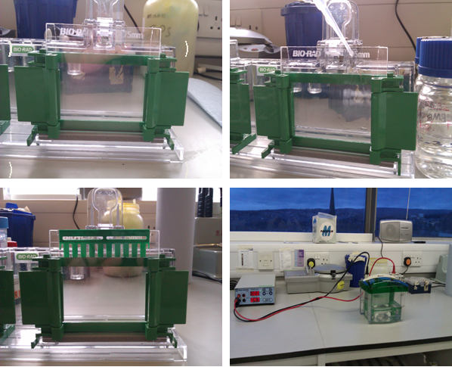
D)
C)
B)
A)
Figure 2.1: A) The plates were set up in the casting kit with spacers to keep them apart. B) The resolving gel is pipetted between the plates.C) One the resolving gel is polymerised, the comb is added and the stacking gel pipetted to create wells. D) 20µg of protein are loaded and the gel run at 100V
The comb was then removed from the gel and the wells are filled with running buffer. The samples are loaded at room temperature using a 5-50ul pipette. A suitable molecular weight marker was also loaded into the wells either side of the samples, typically the Broad Range Markers (Promega, UK) were used. The gels were then unclipped from the casting apparatus and clipped into the gel running kit. This was then placed into the gel tank and the tank filled with 1x running buffer (1x Tris-glycine SDS PAGE buffer, Geneflow, UK) until it was about 2 inches deep. Running buffer was poured between the two gels until it reached the tops of the glass slides (Fig 2.1).
The lid was then put on top of the gel tank and connected to the power pack. The gel was then run at 100V constant voltage for around 2 hours with a maximum current set at 50mA and stopped at 1cm from the end of the gel.
Western blotting (Semi Dry):
Eight pieces of filter paper were cut to approximately the same size as the gel, similarly one piece of nitrocellulose membrane (Bio Rad, UK) per blot was cut to the same size. The filter paper and the nitrocellulose membrane were soaked in the transfer buffer (25mM (w/v) Tris, 150mM (w/v) glycine, 20% (v/v) methanol) for around 15 minutes. Complete wetting of the membrane was required.
The gel was removed from the gel electrophoresis kit and the stacking gel removed. The resolving gel was then transferred to a small box containing transfer buffer and incubated for at least 10 minutes at RT.
Assembly of the Blot:
A semi dry blot system was used using a semidry transblotter (Biorad, UK) system. This consists of a lower anode plate and an upper cathode plate. The anode was wet with a small volume of ultra pure water before the blot is assembled. Four pieces of the pre-soaked filter paper were placed onto the anode, the air bubbles were removed by rolling a test tube over the filter paper. The pre-wetted nitrocellulose membrane was placed atop the filter paper and the air bubbles rolled out. The gel was then placed on top of the membrane, aligning the gel so that it was in the centre of the membrane. Any air bubbles were rolled out. The remaining four pieces of filter paper were then placed on top of the gel and the air bubbles removed. Excess water and transfer buffer was wiped away from the edges of the blot.
The cathode was then placed on top of the stack and the safety cover placed atop the cathode. The unit was then plugged into the power pack (Power 3000, Fisher, UK). The mini gels were transferred at 15V constant voltage for 30 minutes. Following the transfer the unit was disconnected from the power supply, the safety cover was removed and the blot removed. The positions of the marker bands were recorded using a needle to puncture the membrane. The membrane was washed with poncaeu red stain to ensure the transfer was successful. This stain was then washed off with 5% TBS Tween.
Immunoprobing:
Following the transfer, the membrane was taken and washed with TBS/tween (0.5M Tris Base, 9% NaCl, 0.5% Tween 20, pH 8.4) for 15 minutes. The membrane was then blocked overnight at 4°C in 5% fat free dry milk solution.
The membrane was then washed quickly using two changes of TBS/tween to remove excesses blocker. It was then washed for 15 minutes at room temperature and then twice more for 5 minutes with fresh changes of TBS/tween.
The primary antibody was diluted to the correct concentration in TBS/Tween, (Typically 1:1000 but dependent on antibody). The membrane was then incubated with 5mls of the primary antibody solution for two hours at room temperature or overnight at 4°C with shaking on an SSL4 orbital shaker (Stuart, UK). After this step the membrane was washed as before.
The secondary antibody was also diluted as required with TBS/tween and the membrane incubated with 5mls of this antibody for one hour at room temperature. The wash steps were then repeated as above.
Antibody binding was then revealed using the ECL detection kit (Amersham Biosciences, UK). Reagents 1 & 2 were mixed in equal volumes of around 5mLs. The membrane was washed and placed protein side up on a sheet of cling-film spread over the bench. The ECL reagent was spread over the surface and kept moving so that that blot did not dry out and incubated for 1 minute. The excess detection reagent was then drained off and the membrane placed between a folded acetate sheet. The membrane was then placed, protein side up in a film cassette.
This was then transferred to the dark room. Using a red safety light, a sheet of autoradiography film (Kodak Biomax light) was placed on top of the blots. The cassette closed and exposed for a suitable duration starting at 1 minute to assess the signal strength after which exposure time could be lengthened or shortened. Following exposure, the film was removed and developed using Kodak GBX developer (diluted 1:5 in tap water) (Sigma, UK) for 2 mins, followed by fixing for 2 mins with Kodak GBX fixer (diluted 1:5 with tap water) (Sigma, UK) and rinsing for 30 secs with water. Films were quantified for volume density using a Biorad GS-690 imaging densitometer and molecular analyst version4 software (Biorad, UK) using a global background setting. Determination of band size was by reference to Dual Stain Precision Plus Protein Standards (Biorad). Size of markers is shown in table 2.1
Table 2.1: Protein Markers
Protein | Colour | MW kDa
Myosin | Blue | 209
Β-galactosidase | Blue | 124
Bovine Serum Albumin | Pink | 80
Carbonic anhydrase | Blue | 34.8
Soybean trypsin inhibitor | Pink | 28.9
Lysozyme | Blue | 20.6
Aprotinin | Blue | 7.1

Table 2.1: Dual pre-stained protein markers adapted from the Biorad specifications.

2.4 The Bicinchonic Acid (BCA) assay
Firstly a BCA standard curve was generated using BSA from a 10mg/ml stock solution in H₂O. The concentrations were; 0, 0.4, 0.8, 1.2, 1.6, 2.0 mg/ml. BCA working solution was created freshly by mixing BCA solution A (1% bicinchoninic acid (sodium salt), 2% sodium carbonate, 0.16% sodium tartrate, 0.4% sodium hydroxide, 0.95% sodium hydrogen carbonate. This was pH adjusted to 11.25 with NaOH.) and BCA solution B (4% copper sulphate) in a ratio of 25 parts A to 1 part B:
1ml of this working solution was added to all samples and standards of 200µL. These were vortexed and the tubes left at 37°C for 30 minutes, the samples then turned a shade of purple.
200ul per well of standards and samples were pipetted, in duplicate, into a 96 well plate and read on a Mulitskan Ascent (Labsystems, UK) reader at 600nm with standard curve and concentration determined using genesis software (Genome, UK).

2.5 Molecular Biology

2.5.1 RT-QPCR
Real-time quantitative polymerase chain reaction (RT-QPCR) is used to amplify and quantify a specific molecule of DNA. The amplified DNA is detected as the reaction progresses in real time by the incorporation of a fluorescent dye (Sybr green, Applied Biosystems, UK) into the double strandard (ds)-DNA as it is produced, and this is detected using an RT-QPCR machine. This technique is often used to quantify mRNA in cells and tissues.
2.5.1.1 RNA Extraction from cell cultures
All RNA work was done on surfaces fully cleaned with RNase-away and using glassware baked at 110ºC. All plastics and gloves were treated with RNase-away and reagents used brand new or from designated RNA stocks.
From a confluent 10 cm dish of NRK52E cells, the medium was removed and the cell monolayer washed with 5mls PBS twice. 2mLs of TRIZOL was added to the cell monolayer and pipetted up and down ten times through a 21 gauge needle to sheer and lyse the cells. 2mLs of the resulting fluid was then transferred to 2 microfugef tubes. 0.2mls of chloroform was added and the tube shaken for 15 seconds strongly.The tube was allowed to stand for 2mins and then spun at 12,000 g for 15mins in a C-18k centrifuge (Sigma, UK). The clear top aqueous layer containing nucleic acids was then removed and placed in a clean endonuclease free tube and the lower phenol layer, containing dissolved protein and lipid, discarded. To the aqueous fraction was added to 0.5ml propan-2-ol to recover the RNA and placed on ice for 30 minutes before being spun again at 12,000 x g for 10mins. The resulting RNA pellet was then washed in 75% ethanol to precipitate the RNA, pulse spun to bring down liquid for removal and air-dried to remove ethanol. The pellet was then re-suspended in 100µL DEPC H₂O at 55°C for 10mins with frequent pipetting. The resulting concentration of the RNA was assessed using the nanodrop.
2.5.1.2 Reverse Transcription
RNA was converted to cDNA using a RETROscript kit (Ambian) as per manufactuers instructions. This was done using oligo(dT)s as these are best for gene quantification due to their specificity for mRNA.
1µg RNA was added to a microfuge tube with 50µM oligo(dT) primers and a 10mM DNTP mix and the final volume made up to 10µl with RNase free water. The lid of the tube was closed and the sample heated to 65°C for 5 minutes and then cooled in an ice bucket. The (Maloney Murine Leukaemia Virus reverse polymerase) MMLV mixture (Ambian) was then assembled on ice and then 10µl added to the RNA mixture. The sample was then vortexed and heated to 42°C for 60 minutes. cDNA was then stored at -20°C in DEPC treated water.
2.5.1.3 Primer Design
Primers were designed using Lasergene software (DNAStar). The protein sequences were determined using a gene ID and the primers designed using Primer-BLAST (NCBI). These were then refined in Lasergene following guidelines from Thermoscientific. The primers used are shown in table 2.2.
2.5.1.4 RT-PCR
250nM cDNA of the RT product was placed in a PCR tube on ice with 5µl PCR mix (Master Mix, Fast PCR, Primer Design, UK), 2.5µl dNTP mix (Primer Design Master Mix Primer Design, UK), 2.5µl PCR primers (5µM of each, Sigma), 1-2U of DNA polymerase (Primer Design Master Mix) and the solution made up to 50µl with Nuclease-free water.
The PCR programme was set as in Table 2.3.

Table 2.2: Primers
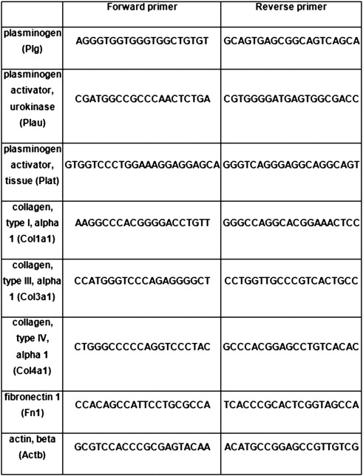
Table 2.2 Primers designed using Primer-BLAST and modified to remove GC repeats in Lasergene.

Table 2.3 PCR Programme
 | Stage | Reps | Temp | Time
Initial denaturation | 1 | 1 | 94-95°C | 2 - 4mins
 | 2 | 30 | 94°C | 20 - 30secs
Amplification |  |  | annealing temp (X to YºC) | 20 - 30secs
 |  |  | 72°C | 1min
Final Extension | 3 | 1 | 72°C | 5mins
Table 2.3 The annealing temperature is different for each set of primers and is suggested by primer design software.
2.5.1.5 Agarose gel electrophoresis
DNA samples were separated on a 1% (w/v) agarose gel prepared in 1xTris base-acetic acid-EDTA (TAE) buffer (diluted from 50x stock containing 2M Tris, 5% (v/v) glacial acetic acid 0.05M EDTA, pH8.0). Ethidium bromide was added to a final concentration of 0.5µg/ml prior to pouring. 1µg of DNA was mixed with 6x DNA loading dye (10%(w/v) ficoll 400, 0.25% (w/v) bromophenol blue, 0.25% (v/v) xylene cyanol FF, 0.4% orange G, 10mM Tris-HCl pH 7.5, 50mM EDTA (Promega, UK) ) and the mixture loaded onto the gel. 7.5µl of 1kb DNA marker (Promega, UK) was loaded and the gel electrophoresed at 80 volts (variable current with 240mA limit) (Power 3000, Fischer, UK) until the bromophenol blue front had run ¾ of the length of the gel. DNA was then visualised on a transilluminator and the image captured using the attached camera.
2.5.1.6 Bacterial amplification and purification of plasmids
IRBP36-c8 Image Clone (Geneservice) is a commercial vector used to contain genes for biological transfection. This was supplied as E. coli clone streaked on LB agar containing 50µg/mL ampicillin. These were re-streaked onto the same medium and incubated overnight at 37°C to obtain single colonies. 5ml LB medium was dispensed into a 50mL sterile tube with 50µg/ml ampicillin. Tubes were inoculated with a single colony and incubated overnight in a shaking incubator at 37°C and 170rpm. For a glycerol stock, 140µL of the 5 ml culture was aliquoted out to a 1.5mL microfuge tube. 40µL 80% glycerol was added, mixed and the stock frozen. 2mL of the remaining plasmid broth was transferred to a 2mL microfuge tube, and centrifuged for 15 mins at 3000xg to pellet bacteria. The supernatant was removed and discarded. The pellet was resuspended in 200µL GTE [0.5mL 20% glucose, 0.25mL 1M Tris/HCl pH7.5, 0.2mL 0.5M EDTA pH8.0, 9.05mL sterile distilled water]. 5µl RNAase stock A (10mg/mL) was added to this and incubated for 10mins at room temperature. For lysis, 400µL 0.2M NaOH/1%SDS (freshly made) was added and inverted to mix, then placed on ice for 10 mins. This was then centrifuged for 10 mins at 13000xg in a microfuge tube, and the supernatant decanted into a 1.5mL microfuge tube containing 1ml cold ethanol. This was vortexed and left to stand for 30mins on ice. The tube was then centrifuged for 10mins at 13000 g and the ethanol removed carefully. 200µL cold 70% ethanol was added to precipitate DNA and vortexed, then centrifuged at 13000xg for 10mins and the ethanol carefully removed. The pellet was then left to air dry and 50µL TE added to resuspend overnight at 4°C.

2.6 ECM Quantification

2.6.1 In Vitro Scintillation
2.6.1.1 Total ECM Protein measurement in vitro by ³H Amino acid incorporation
Cells were seeded at a density of 4x10⁶ per 100mm² Petri dish (Iwaki, Japan). ECM being synthesised was labelled by the addition of 20µCi of ³H amino acid mixture (Amersham Biosciences, UK) at the time of plating. After 72 hours the medium was removed and the cells washed with 1xPBS for 5 mins. Cells were removed with 0.25M ammonium hydroxide in 50mM Tris pH 7.4 at 37°C for 15 mins. The soluble fraction was collected and protein concentration determined using a BCA assay (section 2.4). The plates were washed with increasing volumes (10, 12, 15, 20 mL) of 1xPBS for at least 15 minutes per wash before the ³H labelled mature ECM was solubilised with 2.5% (w/v) SDS in 50mM Tris pH 6.8 for 1 hour at 37°C. The plate was then scraped to ensure total removal of the ECM and 200µl added to a cuvette with 1mL Ultima Gold scintillate (PerkinElmer, UK) measured for radioactivity in a Rack-Beta liquid Scintillation counter set to measure average beta radiation between channels 5-360 over 5 minutes (Packard Instruments, USA). The assay is illustrated in fig 2.1.
2.6.1.2 The measurement of total ECM collagen using ³H Proline incorporation
Cells were seeded at a density of 4x10⁶ per dish. Deposited collagen was labelled with the addition of 20µCi ^{3,4}H proline (1.0mCi/ml, ICN Biomedicals, Morgan Irvine, CA) at the time of plating. Recovery and analysis as described in section 2.6.1.

Figure 2.2: Tritiated Amino Acid Incorporation Assay
(1) Plate out cells; 4x10⁶ per plate
NRK 52E Cells

(2) Label for 72 hours with ³H proline (for collagen) or ³H amino acids (total ECM)
(7) Scintillation count
³H labelled cells / ECM

(3) Wash with PBS
(4) Remove cells with 0.25M NH₄OH
³H labelled ECM remains on plate

(5) ECM Solubilised with SDS overnight
(6) ECM scraped off the plate

Figure 2.2: Total ECM and total collagen levels were determined in vitro by labelling with 20µCi of ³H amino acid mixture (total ECM) or ³H proline (collagen). Cells solubilised with 0.25M ammonium hydroxide and ECM recovered. Label incorporation into the ECM was measured using a scintillation counter.

2.6.2 In Vitro Staining
2.6.2.1 Masson’s Trichrome staining
Cells were plated at a density of 0.5x10⁶ cells per well on 22mm² glass coverslips and grown for 72 hours prior to staining. After 72 hours, the medium was removed and the cells washed in PBS for 5 mins. Cells were fixed in cold methanol for 15 minutes at -20°C. Coverslips were air dried for 10 minutes at room temperature followed by a re-hydration wash with PBS. Cells were then stained with a Masson’s trichrome staining kit (Sigma). The degree of staining was determined using multiphase image analysis (section 2.8). Phase colours were assigned to cytosol, cell nuclei and ECM, and the ratios used to determine scarring (section 2.6.33).
2.6.2.2 Collagen Immunoflourescence
Cells were plated at a density of 0.5x10⁶ cells per well on 22mm² glass coverslips and grown for 72 hours under experimental conditions prior to collagen staining. After 72 hours, the medium was removed and the cells washed in PBS for 5 mins. Cells were fixed in cold methanol for 15 minutes at -20°C. Coverslips were air dried for 10 minutes at room temperature followed by re-hydration with PBS for X mins. Blocking was then performed using 5% (w/v) BSA in PBS for 30 minutes at room temperature. Collagens were detected by incubating overnight with either a mouse monoclonal anti Collagen I antibody at 1:50 dilution (Abcam, Cambridge, UK), goat anti-collagen III polyclonal antibody (Southern Biotech, Alabama, USA) at 1:10 dilution or a rabbit anti-Collagen IV polyclonal antibody (ICN, CA) at 1:35 dilution in 5% BSA in PBS. Primary antibody binding to tubular collagens was revealed by incubation with either an anti-mouse FITC conjugated antibody (Dako, UK) at 1:50 dilution (Collagen I), an anti-goat FITC conjugated antibody (Dako, UK), at 1:50 dilution (Collagen III) or an anti-rabbit FITC conjugated antibody (Dako, UK) at 1:40 dilution (Collagen IV) in 5% BCA for 30 minutes at room temperature.
Cells were washed, sealed and mounted with Vectashield soft fluorescent mount. Cell fluorescence was visualised using an Olympus BX61 microscope at 494nm with excitation at 518nm. Collagen immunoflourescence was quantified with multiphase image analysis using CellF software (Olympus, UK) (section 2.6.3).

2.6.3 In Vivo

2.6.3.1 Assessment of kidney scarring
Analysis of renal scarring was determined on 4µm thick formalin fixed paraffin embedded sections (2.10.5) that were stained using a Masson’s trichrome staining kit (Sigma, UK) as per the manufacturer’s instructions. The degree of scarring was carried out using multiphase analysis (2.8).

2.6.3.2 Immunohistochemistry for Collagens I, III & IV, Laminin & Fibronectin
Immunohistochemistry for collagens I, III and IV was performed on paraffin embedded sections prepared by the Histology Department, Medical School, Hallamshire Hospital, UK.
Paraffin sections were de-waxed by incubating in xylene for 10 minutes followed by re-hydrating through graded ethanol (100% for 5 mins, 90% for 5 mins, 75% for 5mins) then washed for 5 mins with distilled water. Following this, the sections were ringed with a hydrophobic oil-pen to prevent leakage of the antibodies. Sections were blocked with 5% (w/v) BSA in PBS for 1hr at room temperature. 100µl of the primary antibodies were applied at suitable concentrations in 5% (w/v) BSA in PBS overnight at 4°C. Primary antibodies were as follows; Goat anti collagen III (1:50, Southern Biotech), Mouse anti collagen I (1:100, Abcam), Rabbit anti collagen IV (1:200, MP), Rabbit anti laminin (1:100, Sigma) and Rabbit anti Fibronectin (1:100, Sigma).
Following this, the sections were washed twice in PBS+1%TWEEN 20 and twice more in PBS. The secondary antibody was then applied in 100µl volumes to the sections and incubated at 37°C for 1.5hrs. Secondary antibodies were; Goat anti rabbit FITC (Sigma), Goat anti mouse FITC (Sigma) and Donkey anti goat FITC (1:200, Santa Cruz Biotech).
The sections were then washed in the dark with two washes of PBS+1%TWEEN 20 and two washes of PBS. Sections were then air dried and mounted using mowinol mounting reagent (Sigma) with DAPI. Multiphase analysis was then performed as described in section 2.8.

2.6.4 Multiphase image analysis
Multiphase image analysis uses a pseudo colour overlay system in which differentially stained areas of a slide can be differentiated by assignment of representative colours or phases. The area covered by each phase as defined by upper and lower wavelength thresholds and intensity settings, can then be quantified by image analysis software to give a percentage area value. Multiphase analysis was performed on cells cultured on 22mm² coverslips,, on paraffin sections of kidney tissue,and on cryostat sections of kidney Staining included Masson’s Trichrome (assessment of kidney scarring) and immunofluorescence for things such as collagens and fibronectin
2.6.4.1 Selection of fields
To quantify the degree of collagen and ECM staining in cell cultures, ten random non-overlapping fields at 400x magnification were acquired from each coverslip or section using a CC-12 digital camera controlled by Cell F software (Olympus, UK) on an Olympus BX 61 microscope. For determination of tubulointerstitial scarring, ten non-overlapping cortical fields were acquired at 100x magnification to ensure complete coverage of the cortex and 10 glomeruli at 400x magnification.
2.6.4.2 Phase selection
For each field, the degree of positive staining was assessed by carrying out multiphase image analysis with 3 phases (phase 1 – positive stain, phase 2 – cytoplasm, and phase 3 – no stain). It was important to ensured that total phase coverage exceeded 95% of the section which has previously been shown by the research group to be essential for accurate quantification. Overlay colours were chosen for each phase. For the in vitro analysis of the ECM, phases were represented by the following colours; yellow (ECM) and blue (Nuclei). For in vivo analysis, phases were coloured; green (ECM), red (cytoplasm) and blue (Nuclei) (Fig 2.2)
2.6.4.3 Quantification
For the in vitro analysis of the ECM, the degree of positive staining was determined by dividing the percentage area of phase 1 by the percentage area of phase 2 to account for potential differences in cell number. Similarly, in vivo analysis of ECM staining and tubulointerstitial scarring was determined by dividing the green phase (ECM) by the yellow phase (cytoplasm) to correct for cell number and tubular dilation. Glomerular sclerosis was determined by dividing the ECM phase by the no stain phase to account for changes in the Bowman’s space, hypercellularity and inter capillary area.

2.7 The TAFI Inhibitor
UK-396082 ((2S)-5-Amino-2-[(1-n-propyl-1H-imidazol-4-yl)methyl]pentanoic Acid) (Bunnage et al., 2007) was synthesised according to published methods (Bunnage et al., 2007) and supplied as a powder by Pfizer. The chemical structure of this molecule is shown in figure 2.3.

2.7.1 In Vitro Applications
To calculate the best dose of UK-396082 to use for in vitro experimentation, NRK52E cells were grown in DMEM containing increasing concentrations of UK-396082 (0, 10nM, 50nM, 100nM, 250nM, 500nM, and 1µM) for 96 hours (UK-396082 was made up as a stock solution of 100µM in ddH₂O prior to dilutions. Plasmin, uPA, tPA, TAFI and ECM accumulation were measured and 500nM selected as the optimal dose of in vivo applications.
UK-396082 was subsequently used in vitro in the model of diabetic nephropathy were it was applied at a final concentration of 500nM for 48 hours when the cells were switched from low glucose to the low, medium or high glucose test conditions.

Figure 2.2: Phase Image Analysis
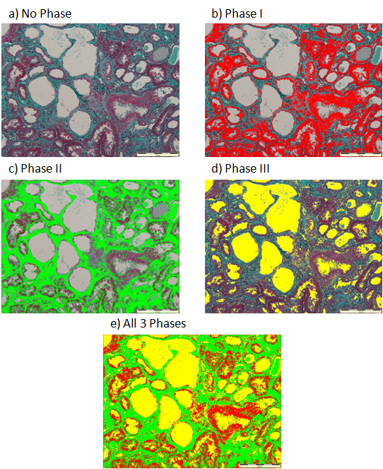
Figure 2.2: An example of the various phases used in Masson’s trichrome analysis on stained paraffin sections. (a) Normal Masson’s trichrome stain. (b) Phase I (red) representing cell cytoplasmn / nuclei. (c) Phase II (green) representing fibrosis. (d) Phase III (yellow) representing tubular lumen and vacuolation. (e) All three phases combined, with total phase coverage exceeding 95% of the section.

Figure 2.3: The Structure of UK-396082

Figure 2.3: UK-396082 is a competitive reversible inhibitor of TAFIa (with a Ki of 40nM). It also expressed an excellent selectivity for TAFIa (carboxypeptidase U) over carboxypeptidase N (CPN) of over 1000-fold. The primary amine binds to Asp255 at the base of the TAFI specificity pocket, with the acid moiety binding to Arg145 and the imidazole alkyl group sitting in a lipophillic channel, giving the compound a three-pronged method of inhibition (Bunnage et al., 2007)

2.7.2 In Vivo Applications
UK-396082 was incorporated into Harlan chow at 0.3mg/g of chow by Research Diets Inc (New Brunswick, USA). Male Wistar Rats were fed increasing doses of UK-396082 (0, 1.25, 2.5, 5, 20mg/kg/Day) by mixing with standard chow. Pre-conditioned rats (2 weeks at 20mg/kg/day) were fed 20, 30, 40 and 60mg/kg/day to establish any tolerance. Rats were monitored daily and blood samples taken weekly for measurement of TAFI activity in the serum using a colorimetric TAFI assay (Section 2.2.4.).
For application in a model of CKD, the experimental protocol was designed to allow us to assess the effectiveness of UK-396082 in two arms at once; a preservation arm and a reversal or therapy arm (Fig 6.1).
Sham operated rats were placed into three groups; a group fed normal rat chow (Harlan Teklad) and terminated at day 60, a group fed rat chow containing 60mg/kg/day UK-396082 (Research Diets, USA) and terminated at day 60, and a group fed normal rat chow and terminated at day 35.
SNx animals were placed into four groups; a group fed normal rat chow (Harlan Teklad) and terminated at day 60, a group fed normal rat chow and terminated at day 35, a group fed rat chow containing 60mg/kg/day UK-396082 (Research Diets, USA) from day 14 and a group fed rat chow containing 60mg/kg/day UK-396082 from day 35.
  - In vivo modelling of CKD
All in vivo work was carried out under Personal Licence number 40/10043 and Project Licence number 40/3037.

2.8.1 The rat 5/6th Subtotal Nephrectomy model of kidney fibrosis.
Male Wistar rats (Harlan, Han strain) of approximately similar weight (200-250g) and age (8-10 weeks) were anaesthetised with isofluorane (5% isofluorane, 4L/min O₂) via inhalation in a sealed induction chamber. Once anaesthetised, rats were transferred to a heated mat and anaesthesia was continued with a nose-cone (3% isofluorane, 1.5L/min O₂). The procedure was performed over two stages. In the first stage, the left kidney was externalised and decapsulated. A ligature was then placed around the upper and lower poles of the kidney and slowly tightened. The poles were then excised leaving one third of the kidney remaining (Fig 2.4). The poles were weighed to determine the degree of resection. The incision was then sutured and the animal allowed to recover for one week. After one week, the animal was anaesthetised as previously and the right kidney decapsulated, ligated and removed. This kidney was then weighed and the percentage resection determined, assuming a 0.1g increase in the right kidney due to compensatory renal growth.
Rats were allowed free access to rat chow (Harlan Teklad) for untreated and Harlan Teklad containing 0.3g/kg UK-396082 for the treated animals) and tap water and were housed 2-3 to a cage at 19-22°C and 45% humidity on a 12hr light/dark cycle.

Figure 2.4: Subtotal Nephrectomy procedure
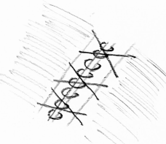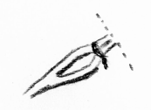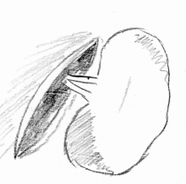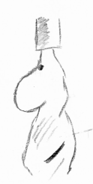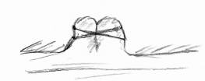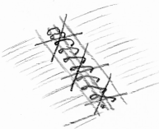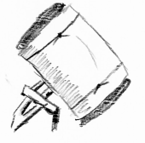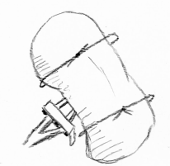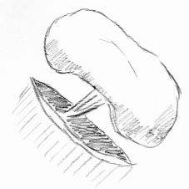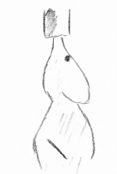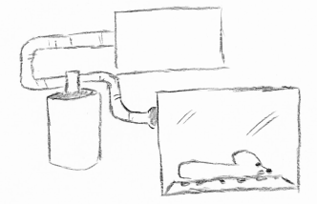
aA)
bB)
cC)
dD)
eE)
fF)
gG)
hH)
iI)
jJ)
kK)
Figure 2.4: a) The rat is anaesthetised with 5% isoflurane and removed from the induction chamber. b) Anaesthesia is maintained on 3% Isoflurane with a nose cone and a 45° incision made through the skin and muscle wall under the left ribs. c) The kidney is externalised and decapsulated. d) The renal hilum is clamped and mersilk ligatures are tied around the poles of the kidney. e) The ligatures are tightened and renal tissue cut away 1-2mm from the ligature. The ends of the kidney are staunched with histo-acryl tissue glue. f) The muscle wall is sutured using a continuous loop, and the skin is sutured using double sutures. g) The skin is pulled up allowing for improved healing and reduced likelihood of wound re-opening. h) One week later, the rat is anaesthetised again and a similar incision made on the right side. i) The right kidney is decapsulated and clamped. j) The hium is tied with mersilk and the kidney removed. k) The incisions are then sutured as described in (f).

2.8.2 Cumulative Survival
Survival of animals was measured over the course of the experiment. Animals were terminated either at pre-designated times (35 days / 60 days), when they developed symptoms of renal failure or when they exceeded the guidelines for a procedure of moderate severity.

2.8.3 Clinical chemistry assessment of renal function & damage
Urine creatinine measurements were performed on 24 hour urine samples collected from rats placed in metabolic cages at regular intervals. Serum creatinine analysis was performed on blood taken from the tail vein of the rat. This was allowed to stand and clot for 30 minutes and centrifuged at 1500xg prior to pellet blood cells and allow the removal of serum. The serum was stored at -20°C. Urine creatinine was analyses using the standard autoanalyser technique (Clinical Chemistry Department, Hallamshire Hospital, UK) and expressed as µmol/L. Serum creatinine analysis was performed using a serum creatinine kit (Arbor Assays) and expressed as µmol/L. These results were used to calculate creatinine clearance.
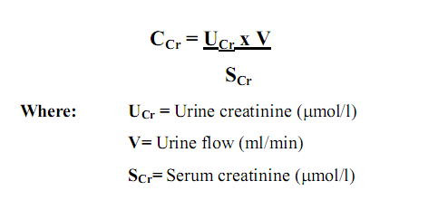

Proteinuria was determined in rat urine using a modification of the Lowry method (Lowry et al., 1951). A standard curve of 0, 0.4, 0.8, 1.2, 1.6 and 2mg/ml BSA in PBS was used. Samples were diluted 1:10 with PBS. 100µL 2% (w/v) SDS in distilled water was added to samples and standards to solubalise all protein. Tubes were vortexed and 1mL of Folin’s reagent (49 parts solution A (0.4% sodium hydroxide, 2% sodium carbonate, 0.02% sodium tartrate): 1part solution B (0.5% copper sulphate)). Tubes were then vortexed again and incubated at room temperature for 20 minutes. 100µl Folin’s Ciocalteau reagent (Sigma, UK) diluted 1:1 with distilled water was added to each tube. Samples were then vortexed and incubated at room temperature for 20 minutes. 200µL of each sample was transferred into a 96 well plate and the optical density read at 750nm (Multiskan Ascent, Labsystems, UK).

2.8.4 Urine Biomarkers of renal injury and fibrosis
TIMP-1, NGAL, KIM-1 and TG2 were measured in the urine as biomarkers of renal injury.
TIMP-1 was measured using a Rat TIMP-1 Quantikine ELISA Kit (R&D Systems) on urine diluted 1:20 with reaction buffer (R&D Systems). The capture antibody is reconsituted with PBS and a 96-well plate coated with 100µL per well. This is sealed and incubated overnight at room temperature. Each well is then aspirated and washed with the wash buffer three times. Any remaining wash buffer is removed by blotting the plate against paper towels. Each plate is then blocked with 3% BSA in PBS for 1 hour at room temperature and then washed again. 100µL of sample or provided standards is added per well and covered. The plate is then incubated at room temperature for 2 hours, washed and 100µL of the detection antibody added and incubated for 2 hours. The plate is then washed again and 100µL of Streptavidin-HRP added and incubated for 20 minutes. The plate is then washed again & 100µL of HRP substrate solution is then added and the plate incubated for 20 minutes before the addition of 50µL stop solution. Optical density is then determined on a microplate reader with Ascent software (Thermoscientific, UK) at 450nm.
NGAL was measured using a Rat Lipocalin-2/NGAL DuoSet (R&D Systems) on urine diluted 1:20 with 1% BSA in PBS in the same manner as above.
KIM-1 was measured using a Rat TIM-1/KIM-1/HAVCR DuoSet (R&D Systems) on urine diluted 1:20 with 1%BSA in PBS in the same manner as above.
TG2 was measured using a sandwich ELISA on urine diluted 1:25 with 1%BSA in PBS. For this method, a 96-well plate was coated overnight at 4°C with 100µl per well of a goat anti-transglutaminase type II antibody (AbCam, ab421) diluted 1:1000 in 50mM Carbonate Buffer (pH 9.6). The plate was then washed three times for 5 minutes each with PBS/0.1% Tween. The plate was then blocked for 1hr at room temperature with 200µl of 5% (w/v) BSA in PBS. The plate was again washed with 0.1%Tween in PBS as before. Standards and samples were then added in 100µl aliquots and incubated at room temperature for 2hrs. The plate was washed three times with 0.1% Tween in PBS as above. 100µl of CUB7402 monoclonal anti TG2 antibody (AbCam) diluted 1:1000 in 3% BSA in PBS was added to the wells and incubated at room temperature for 1hr followed by 3 further washes. 100µl of biotinylated goat anti mouse IgG (H+L) antibody (AbCam) was added to the wells and incubated for 1hr at room temperature. The plate was washed three times with 0.1% Tween in PBS as before being incubated with 100µl of 1µg/mL Streptavidin poly-HRP (R&D Systems, UK) diluted in PBS for 1hr. The plate was again washed three times with 0.1% Tween in PBS. After this wash, 100µl of HRP substrate 1-Step Ultra TMB-Elisa (Thermo Scientific) was added and the reaction allowed to proceed for 15 minutes. The reaction was then stopped with 100µl 1M H₂SO₄. Absorbance levels were then read at 405nm on a Multiskan Ascent plate reader (Labsystems, UK).

2.8.5 Processing, fixation and homogenisation of kidney tissues
Kidneys were quartered by cutting with a scalpel blade. One quarter was fixed overnight in 10% neutral buffered formalin and the other three quarters snap-frozen in liquid nitrogen. The fixed quarters were rinsed in PBS after no more than 48 hours and embedded in paraffin. Sections 4$µ$m thick were cut from paraffin blocks using a rotary microtome (Histopathology Department, Medical School, Royal Hallamshire Hospital) and mounted onto poly-L-lysine coated microscope slides (VWR, Poole, UK). These were stored at room temperature prior to performing immune and cytochemical staining
Snap-frozen tissue was mounted in OCT mounting medium (Raymond Lamb, UK). Cyostat sections of 10µm were cut at -12°C and mounted on poly-L-lysine coated microscope slides and stored at -20°C.
100-200mg of snap-frozen kidney tissue was weighed and transferred to a small tube. To this was added 9 times the volume of STE buffer (0.32M sucrose, 5mM Tris, 2mM EDTA) containing protease inhibitors (if not for plasmin, uPA or tPA analysis) (1mM leupeptin, 5mM benzamidine and 1mM phenylmethylsulphonylfluoride (Sigma, UK)) and the tissue homogenised using an Ultra Turrax T25 Homogeniser (Merck, UK). This produced a 10% (w/v) tissue homogenate. The homogenate was aliquoted and either used in the colourimetric activity assays (section 2.10.11), or stored at -80°C.

2.8.12 Blood Pressure
Blood pressure was measured using a non-invasive tail cuff method using a Model 229 blood pressure monitoring system (IITC, UK). Rats were placed into restraining cages and warmed with a heat lamp, causing dilation of the tail vein. Blood pressure was then measured with a photoelectric sensor attached to the cage. The tail cuff pressurises to restrict the blood flow which is detected by the sensor to determine blood pressure. Five readings per animal were recorded and the highest and lowest systolic eliminated and a mean taken from the remaining three.

2.8.13 Serum UK-396082
Circulating levels of UK396082 were measured in serum to ensure bioavailability and to determine if renal impairment caused UK396082 retention. samples were sent to York Bioanylitical Solutions LTD (UK) for measurements of UK-396082 in serum by HPLC analysis.

2.9 Statistical Analysis
Results are given as mean ± standard error of the mean (mean±SEM). Normality of distribution was determined using minitab (Minitab, USA). Data analyses were performed using unpaired student’s t-test with Bonferroni corrections. unless otherwise stated. Correlation analysis between variables was determined using Pearson’s correlation. A value of p<0.05 was taken as significant. Statistical analysis was performed using Minitab for windows version 16 with graphs prepared in Excel version 2007.

Chapter Three

In Vitro classification of the plasmin system in renal tubular epithelial, mesangial and fibroblast cell-lines

3.1 Introduction
In order to study the effect of TAFI inhibition in vitro on ECM processing, the first stage of this study was to select a suitable cell line for use in a model system. Due to the interplay of the numerous components of the fibrinolytic system on overall plasmin activity, it was important to select a cell line that not only manufactures significant levels of plasmin and TAFI, but also the two main plasmin activators; uPA and tPA, such that modulation of TAFI would be likely to have biological significance. In order to find a suitable cell line, cells representing key cell types in the development of fibrosis were analysed. These were normal Rat Kidney Proximal Tubular Epithelial Cells (NRK52E) (ATCC, CRL-1571), Normal Rat Kidney Renal Fibroblasts (NRK49F) (ATCC, CRL-1570) and the Rat Mesangial Cell Line HKT-1097 (gift from Jean Straer).
The proximal tubular epithelial cells have been shown to play a significant role in tubulointerstitial fibrosis. They release inflammatory mediators such as chemokines and certain cytokines when exposed to high levels of albumin reabsorption. These mediators also attract inflammatory cells to the renal interstitium and initiate interactions with proliferating fibroblasts, to increase synthesis of ECM components in which underlie interstitial fibrosis (El-Nahas, 2003, Zeisberg et al., 2001a). TGF-β1 can influence some TEC to transform into an embryonic phenotype by EMT, suggesting that tubular cells can contribute to renal fibrosis directly (El-Nahas, 2003). Tubular epithelial cells are also the main source of TG2 in renal fibrosis both experimentally (Johnson et al., 1997), and in human disease (Johnson et al., 2004). TECs also produce significant amounts of ECM (Razzaque et al., 1995).
Fibroblasts are believed to be a key cell in both TIF and GS. Typical matrix deposition follows the appearance of collagen nucleators in interstitial fluid with serve as a scaffold for the fibrillar collagens produced by fibroblasts (Kadler et al., 2008). Fibrosis generally initiates in small areas, at random sites of inflammation in damaged tissues before expanding. The accumulation of fibroblasts in these tissues is linked to the progression of fibrosis (Nishitani et al., 2005). Fibroblasts are known for high production of ECM components, and are the principal source collagens I and III, the fibrillar collagens. Fibrosis is inevitably associated with an accumulation of fibroblasts (Nishitani et al., 2005). During fibrosis, fibroblasts undergo both rapid proliferation (Muller and Rodemann, 1991) and in some cases have an activated phenotype leading to the expression of α-smooth muscle actin (αSMA) (Wynn, 2008).
In glomerular sclerosis there is proliferation of both smooth muscle and mesangial cells. Mesangial cells, along with their matrix, form the central stalk of the glomerulus and interact with the endothelial cells and the podocytes. They generate their own ECM which is different in composition to the glomerular basement membrane. The main component of mesangial matrix is collagen IV (only the α1 and α2 chains) along with collagen V, laminin A, B1 and B2, fibronectin, heperin sulphate, proteoglycans, nidogens and entactin. This composition is tightly controlled, but is altered largely during disease (Couchman et al., 1994, Mason and Wahab, 2003). Proteins such as collagens I and III are only expressed at the late stages of glomerulosclerosis and are not involved in the early expansion of the mesangium (Mason and Wahab, 2003).
All three cell types therefore, play vital roles in the development of glomerular sclerosis or tubulointerstitial fibrosis; both of which are mechanisms of kidney scarring and a symptom of chronic kidney disease.
Therefore in this chapter recognised cell lines representing these 3 cell types were assessed separately, for TAFI, Plasmin, uPA and tPA components of the fibrinolytic system using colorimetric activity assays in order to determine which would be the best cell line for use in an in vitro model of fibrosis that would be sensitive to changes in the plasmin system. The components assessed are not by any means the only proteins involved in the fibrinolytic system in vivo, however, they are the components most important to the mechanism of TAFI activity.
    - Validation of Epithelial Cell Lines
Cell line validation was carried out centrally by Mac (Che Yi Chou) for the cell lines NRK52E, NRK49F and 1097 cells. Markers for tubular epithelial cells were β-catenin and E-cadherin. For epithelial cells, green fluorescence was found between cells as E-cadherin and β-catenin are markers for cell junctions. In NRK49F Fibroblasts, the staining was located in the cytosol (Fig 3.0)

Figure 3.0: β-Catenin and E-Cadherin Staining in Cell Lines
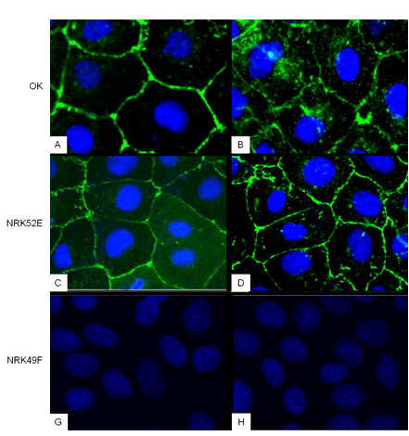
Figure 3.0: β-catenin and E-cadherin staining (green) and DAPI (blue) in OK (A,B), NRK52E (C,D) and NRK49F (E,F). In epithelial cells, E-cadherin and β-catenin are localised to cellular junctions. In NRK49F fibroblasts, the staining is located in the cytosol. (Adapted from Che Yi Chou 2012)

3.2 Determination of the activity of fibrinolytic system proteins in NRK52E, 1097 and NRK49F cell lines

3.2.1 Plasmin
To establish the levels of plasmin activity in each cell line, a plasmin enzyme activity assay was performed on 24hr conditioned medium from the three cell lines. This assay uses the specific plasmin substrate V0882 (Sigma). A standard curve (Fig 3.1) was used to measure the cleavage of substrate against time and determine relative activity (Fig 3.2). Initial characterisation showed that plasmin activity is higher in medium with foetal calf serum (FCS) than without, indicating that FCS contains either plasmin or plasminogen, seemingly despite the heat inactivation. Therefore all assays were performed with a set amount of FCS in the medium (5%).
Conditioned (24hr) medium from all three cell lines gave higher plasmin activity than in fresh complete unconditioned media, indicating that all three cell lines produce significant (P>0.05) levels of active plasmin. NRK52E cells produced the most plasmin with a reading of ~2.1µg activity per mg of cellular protein (after subtraction of the activity found in the media). The NRK49F cells, with an activity of 1.67µg/mg had significantly more activity than the 1097 cells, with 1.01 µg/mg (Fig 3.3).

Figure 3.1: Standard Curve of Plasmin Activity

Figure 3.1: Dilutions of recombinant plasmin were assayed for plasmin activity using substrate V0882 (Sigma). Data represents mean change in OD values ±SEM from 3 independent experiments and related to the activity of a set weight of recombinant protein.

Figure 3.2: Plasmin Activities in NRK52E, NRK49F and 1097 Cells

Figure 3.2: Conditioned medium from NRK52E cells, NRK 49F cells and 1097 mesangial cells was assayed for plasmin activity by cleavage of substrate V0882 (Sigma) with optical density read every 30 minutes for 150 minutes. Data represents mean OD±SEM n=3.

Figure 3.3: Quantification of Plasmin Activity in NRK52E, NRK49F and 1097 cells

Figure 3.3: The gradients from Fig 3.2 were used to calculate the relative plasmin activity in each cell line by reference to standard curve (Fig 3.1). Data represents mean relative plasmin activity ±SEM. n=3. Results were analysed using a student’s t-test. (* = p<0.05, ** = p<0.01 relative to Medium + FCS. † = p<0.05, ††=p<0.01 relative to 1097 cells).

3.2.2 TAFI
To establish the levels of TAFI activity in each cell line, the TAFI activity was measured in 24 hour conditioned medium from the cell lines; NRK52E, NRK49F and 1097. Cleavage of the TAFI-specific substrate (Pentapharm, Switzerland) resulted in a change in OD at 405nm which was monitored using a photometer. The activity of TAFI in the samples was determined by reference to a standard curve (Fig 3.4).
Initial characterisation showed that TAFI activity was present in the foetal calf serum added to the DMEM medium and so a set amount of FCS (5%) was used with all samples. Conditioned medium gave higher TAFI activities than complete media, indicating that all three cell lines produce TAFI. The 1097 mesangial cells produced the most TAFI with an activity with values equating to activity produced by 16.1ng of TAFI per mg of cellular protein (after the activity in the medium had been subtracted). NRK52E cells produced 14.1ng/mg and NRK49F cells produced 9.6ng/mg (Figure 3.5).

Figure 3.4: Standard Curve of TAFI Activity

Figure 3.4: Dilutions of recombinant TAFI were assayed for TAFI activity using the PefaKit TAFI Assay (Pentapharm) and related to the activity of a set weight of recombinant protein. Data represents mean change in OD values ±SEM n=3.

Figure 3.5: TAFI Activities in NRK52E, NRK49F and 1097 Cells

Figure 3.5: Conditioned medium from NRK52E cells, NRK 49F cells and 1097 mesangial cells assayed for TAFI activity with the PefaKit TAFI Assay (Pentapharm). Data represents mean OD±SEM n=3.

Figure 3.6: Quantification of TAFI Activity in NRK52E, NRK49F and 1097 Cells

Figure 3.6: The gradients from Fig 3.5 were used to calculate the relative TAFI activity in each cell line by reference to standard curve (Fig 3.4). Data represents mean relative TAFI activity ±SEM. n=3. Results were analysed using a student’s t-test. (* = p<0.05, ** = p<0.001 relative to Medium + FCS. † = p<0.05 relative to NRK49F cells.)

3.2.3 tPA
To establish the levels of tPA activity in each cell line, a tPA assay was performed on 24 hour conditioned medium from all three cell lines using a standard curve (Fig 3.7), with changes in optical absorbance with time resulting from cleavage of tPA specific substrate S-2222 (Chromogenix) tabulated (Fig. 3.8). The amount of tPA in each cell line was determined (Fig. 3.9).
Initial characterisation showed that tPA was higher in the medium with foetal calf serum than without, showing that FCS contains tPA. Therefore a set amount (5%) of FCS was used for this experiment. Conditioned medium from all three cell lines showed that all three produced tPA; the NRK49F cells producing slightly more, with 2.7ng/mg activity, while NRK52E and 1097 cells produced similar amounts with 2.1 and 2.2ng/mg respectively.

Figure 3.7: Standard Curve of tPA Activity

Figure 3.7: Dilutions of recombinant tPA were assayed for tPA activity using the specific substrate S-2222 (Chromogenix) and related to the activity of a set weight of recombinant protein. Data represents mean change in OD values ±SEM from 3 independent experiments.

Figure 3.8: tPA Activities in NRK52E, NRK49F and 1097 Cells

Figure 3.8: Conditioned medium from NRK52E, NRK 49F and 1097 cells was assayed for tPA activity by cleavage of tPA the specific substrate S-2222 (Chromogenix). Data represents mean OD±SEM n=3

Figure 3.9: Quantification of tPA Activity in NRK52E, NRK49F and 1097 Cells

Figure 3.9: The gradients from Fig 3.8 were used to calculate the relative tPA activity in each cell line by reference to standard curve (Fig 3.7). Data represents mean relative tPA activity ±SEM. n=3. Results were analysed using a student’s t-test. (** = p<0.01 relative to Medium + FCS. † = p<0.05 relative to 1097 cells)

3.2.4 uPA
To establish the levels of uPA activity in each cell line, the uPA activity assay was performed on 24hr conditioned medium from all cell lines. Changes in cleavage of substrate S-2244 (Chromogenix) were measured using a standard curve (Fig 3.10) against time (Fig. 3.11) and the activity of uPA produced by each cell line determined (Fig. 3.12).
This initial characterisation shows that uPA activity is higher in the medium than in medium without foetal calf serum, indicating that FCS contains a small amount of uPA. Therefore the same standard amount (5%) of FCS was used in the medium for each cell line.
All three cell lines showed uPA activities significantly higher than seen in the media, indicating that all three produce significant levels ( (P>0.05) of uPA. The activities in the three cell lines were not significantly different with NRK52E, NRK49F and 1097 cells producing 3.1, 3.5 and 2.9ng/mg respectively once the medium activity has been subtracted.

Figure 3.10: Standard Curve of uPA Activity

Figure 3.10: Dilutions of recombinant uPA were assayed for uPA activity using the specific substrate S-2244 (Chromogenix) and related to the activity of a set weight of recombinant protein. Data represents mean OD values ±SEM from 3 independent experiments.

Figure 3.11: uPA Activities in NRK52E, NRK49F and 1097 Cells

Figure 3.11: Conditioned medium from NRK52E, NRK 49F and 1097 cells assayed for uPA activity by cleavage of the uPA specific substrate S-2244 (Chromogenix) with OD readings taken every 30 mins for 2 hours. Data represents mean OD±SEM n=3

Figure 3.12: Quantification of uPA Activity in NRK52E, NRK49F and 1097 Cells

Figure 3.12: The gradients from Fig 3.8 were used to calculate the relative uPA activity in each cell line by reference to standard curve (Fig 3.10). Data represents mean relative uPA activity ± SEM. n=3. Results were analysed using a student’s t-test., (** = p<0.001 relative to Medium + FCS.)

3.3 The Effects of TAFI Inhibitor UK396082 on the fibrinolytic system in NRK52E, NRK49F and 1097 Cells
Having established that the basic elements of the fibrinolytic system were present in the three renal cell lines assessed, it was important to determine the effect of the TAFI inhibitor UK-396082 on these cell lines; whether the inhibitor effectively reduced TAFI activity and what knock-on effects this had on the other components of the fibrinolytic system.

3.3.1 Dose Response Effects on TAFI activity in different cell lines
Cells were plated out to the desired concentration and grown in six-well plates for 24 hours. At this point, medium was removed and replaced with medium containing UK-396082 at 100nM, 500nM, 1µM and 10µM. The inhibitor was dissolved in 2mls of DMEM medium containing 5% FCS and the cells incubated in this medium for 24 hours. The medium was then removed and assayed for TAFI activity (Fig. 3.13a)
With 50nM of Uk-396082 there was an effective inhibition of TAFI activity in all three cell lines of approximately 50%. In NRK52E cells, 1µM and 10µM concentrations showed further reductions at 100 and 1000nM, whereas NRK49F and 1097 cells did not show further inhibition at 100nM, but had increased inhibition of around 75-80% at 1000nM. Overall, the 1097 cells showed the greatest response to the TAFI inhibitor, with a fall in activity equivalent to 12.3ng of TAFI per mg of cellular protein, but the NRK52E cells showed the most convincing inhibitory dose response, and were therefore chosen for an extended dose response study to establish a maximal dose and optimal inhibition concentration.
A second, larger range, dose response was performed with just NRK52E cells. The cells were grown in DMEM containing increasing concentrations of UK-396082 (0, 10 nM, 50 nM, 100 nM, 250 nM, 500 nM, and 1 µM) for 96 hours. The TAFI activity was then measured (Fig 3.13b). A 10 nM concentration of UK-396082 gave a significant reduction in TAFI activity (-35%). As the concentration of UK-396082 was increased, there was a reduction in TAFI activity at 50 nM (-48%), 100 nM (-58%) and 500 nM (-67%). 1 µM provided no further significant inhibition.

Figure 3.13: Effect of UK-396082 on TAFI Activity in NRK52E, NRK49F and 1097 Cells
a)

b)

Figure 3.13: (a) Cells were incubated with increasing concentrations of UK-396082 for 24 hours and TAFI activity determined as described previously. (b) NRK52E cells were grown in DMEM containing increasing concentrations of UK-396082 (0, 10, 50, 100, 250 and 500nM, and 1 µM) for 96 hours. The TAFI activity was then measured using a TAFI activity assay (American Diagnostica). Data are represented as mean values ± SEM n=3. Paired t-tests compared with untreated NRK52E cells; *=p<0.05, **=p<0.01.

3.3.2 Dose Response Effects on Plasmin
Cells were plated out to the desired concentration and grown in six-well plates for 24 hours. At this point, medium was removed and replaced with medium containing UK-396082 at 50nM, 100nM and 1000nM. The inhibitor was dissolved in 2mls of DMEM medium containing 5% FCS and the cells incubated in this medium for 24 hours. The medium was then removed and assayed for plasmin activity (Fig. 3.14).
With 50nM of UK-396082 there was an increase in plasmin activity in NRK52E cells of approximately 110%. NRK49F and 1097 cells showed no increase in plasmin activity with 50nM UK-396082.
NRK49F cells showed a ~38% increase in plasmin activity when cultured with 100nM UK-396082. NRK52E cells’ plasmin activity was not significantly increased further.
The plasmin activity of 1097 cells was unchanged by UK-396082 at any concentration used.

Figure 3.14: Effect of UK-396082 on Plasmin Activity

Figure 3.14: Cells were incubated with varying concentrations of UK-396082 for 24 hours and plasmin activity determined as described previously. Data represents mean plasmin levels (µg) ±SEM n=3. Results were analysed using a student’s t-test., (** = p<0.001 relative to activity at previous concentration of UK-396082).

3.3.3 Dose Response Effects on tPA
Cells were plated out to the desired concentration and grown in six-well plates for 24 hours. At this point, medium was removed and replaced with medium containing UK-396082 500nM, 1µM and 10µM. The inhibitor was dissolved in 2mls of DMEM medium containing 5% FCS and the cells incubated in this medium for 24 hours. The medium was then removed and assayed for tPA activity (Fig. 3.15).
There were no significant changes in tPA activity in any of the cell lines assessed.

Figure 3.15: Effect of UK-396082 on tPA Activity

Figure 3.15: Cells were incubated with increasing concentrations of UK-396082 for 24 hours and tPA activity determined as described previously. Data represents mean plasmin levels (µg) ±SEM n=3. Results were analysed using a student’s t-test.

3.3.4 Dose Response Effects on uPA
Cells were plated out to the desired concentration and grown in six-well plates for 24 hours. At this point, medium was removed and replaced with medium containing UK-396082 at 500nM, 1µM and 10µM. The inhibitor was dissolved in 2mls of DMEM medium containing 5% FCS and the cells incubated in this medium for 24 hours. The medium was then removed and assayed for uPA activity (Fig. 3.16).
The uPA activity in NRK52E cells was unaffected by the TAFI inhibitor UK-396082 at any concentration. However, NRK49F and 1097 cells showed an increase of 166% and 158% respectively at the lowest (50nM) dose applied. There was no significant further increase above this with higher doses.

Figure 3.16: Effect of UK-396082 on uPA Activity

Figure 3.16: Cells were incubated with varying concentrations of UK-396082 for 24 hours and uPA activity determined as described previously. Data represents mean plasmin levels (µg) ±SEM n=3. Results were analysed using a student’s t-test., (** = p<0.001 relative to activity at previous concentration of UK-396082).

3.4 Summary
To ascertain values of fibrinolytic components produced by the cells, all values were corrected for levels seen in foetal calf serum. The data indicates that NRK52E cells produce the most plasmin, with levels of 2.1 µg/mg. The 1097 mesangial cells produce the most TAFI with levels of 16.1ng/mg, with the NRK52E cells also producing a large amount (14.1ng/mg). uPA activity was similar in the three renal cell lines with the NRK49F cells producing slightly more (3.5ng/mg), and tPA was again similar with NRK49F cells producing the most (2.7ng/mg) activity.
Application of the TAFI inhibitor UK-396082 at 50nM lowered the mean TAFI activity in all three cell lines, with the largest reduction being in the NRK52E tubular epithelial cells (-57%). At the highest dose tested (1000nM) the decrease in TAFI activity was highest in the 1097 cells (-75%). This decrease in TAFI activity was mirrored by an increase in plasmin activity in both the NRK52E (+109%) and the NRK49F (+38%) cell lines but not 1097.
There were no significant increases in tPA activity in any of the cell lines in response to dosing with UK-396082. However, there was a surprising and significant increase in uPA in both the NRK49F (+166%) and the 1097 (+158%) cells.
The largest decrease in TAFI activity was seen with the 500nM dose, and no further changes to fibrinolytic components were seen above this dose, therefore this dose was selected for the in vitro model. These results are summarised in tables 3.1 and 3.2.

3.5 Discussion
The overall aim of the project is to use TAFI inhibitor UK-396082 to reduce TAFI activity and, as a consequence, increase plasmin activity to determine the value of UK-396082 as an anti-fibrotic agent. It is therefore prudent to use a cell line which has a suitable response to the inhibitor for use in a cell culture model of fibrosis as a first step. Thus the purpose of this chapter has been to assess if three well described cell lines produce relevant components of the fibrinolytic system and if the application of UK-396082 subsequently affects these as predicted to ensure that subsequent studies in a cell culture fibrotic have the greatest chance of yielding usable data. Although FCS contains some peptidases and potential inhibitors of the plasmin system, heat-inactivation was used to attempt to mitigate this.
The TAFI levels seen in these cells are around 1000 times lower than levels seen in human plasma (2µg/mg) (Watanabe et al., 2001). There is almost no published data on TAFI activity in other cell lines and so it is difficult to compare the levels determined in this chapter to other data. The levels of plasmin, uPA and tPA are comparable with those found in human foetal mesangial cells (Fisher et al., 1997).

Table 3.1: The Activity of Fibrinolytic system Components in kidney Cells
 | Plasmin Activity (µg/mg) | TAFI Activity (ng/mg) | uPA Activity (ng/mg) | tPA Activity (ng/mg)
NRK52E Cells (rat) | 2.1± 0.3 | 14.1± 1.24 | 3.1± 0.34 | 2.1± 0.32
NRK49F Cells rat) | 1.67± 0.29 | 9.6± 0.93 | 3.5± 0.11 | 2.7± 0.04
1097 Cells (rat) | 1.01± 0.08 | 16.1± 2.18 | 2.9 ±0.28 | 2.2± 0.2

Table 3.1: Plasmin, tPA, uPA and TAFI activities in NRK52E tubular epithelial, NRK49F fibroblasts and I097 mesangial cells were determined by substrate cleavage colorimetric assays. Data represents the mean activity ±SEM presented as equivalent weights of activated recombinant protein/mg of cellular protein.
Table 3.2: Changes in the activity of fibrinolytic components in kidney cell lines treated with 500 nM of TAFI inhibitor UK-396082
 | Plasmin Activity (% Change) | TAFI Activity  (% Change) | uPA Activity  (% Change) | tPA Activity  (%Change)
NRK52E Cells | +109% ±5.9%** | -57.4%±1.2%** | NS | NS
NRK49F Cells | +38.3% ±7.4* | -56.9%±9.4%** | +166.2%±21.1%** | NS
1097 Cells | NS | -39%±12.1%* | +158.8%±15.9%** | NS

Table 3.2: Plasmin, tPA, uPA and TAFI activities in NRK52E tubular epithelial, NRK49F fibroblasts and I097 mesangial cells were measured after for 24 hrs exposure to 500 nM of TAFI inhibitor UK-396082 by substrate cleavage assay. Data represents mean percentage change ±SEM n=3 in activity with the application of UK-396082. Results were analysed using a student’s t-test, *=p<0.05 **=p<0.01, NS = no significant change.
The NRK52E proximal tubular epithelial cells have the greatest reduction in TAFI activity (-57%) in response to the inhibitor of all the cell lines tested at 500nM. This subsequently translates to the greatest increase in plasmin activity (+109%). This increase is similar to that seen in in vivo studies with TAFI knockout mice having an almost 100% increase in renal plasmin activity compared with wild type mice following unilateral ureteral obstruction (Bruno et al., 2008a), and around 70% in KO mice following induction of glomerulonephritis (Bruno et al., 2008b). It has also been shown that an increase in plasmin activity can lead to a reduction in TAFI activity, suggesting that the reduction of TAFI activity could have a much larger than expected response due to interference in a feedback-loop (Marx et al., 2002).
Both uPA and tPA are also present in NRK52E cells at levels similar to those seen in the other two cell lines. tPA is vital for the conversion of plasminogen into plasmin, as is uPA. Thus the production of these in cell lines is essential for studies on the plasmin axis.
As some of the substrates and assays used in this chapter are not 100% specific for a single enzyme, it would have been beneficial to perform mRNA expression analysis to ensure the cells produce plasmin, uPA, tPA and TAFI and that the proportions per cell are similar to the data from the activity assays.
It is TAFI’s conversion of fibrin* to fibrin** that causes it to act as a poor co-factor for tPA’s activation of plasmin. Therefore in our selection of a suitable cell line, it was preferable to see tPA and uPA activity stay the same in response to the TAFI inhibitor such that it removed a possible variable. However, there is evidence to suggest that a TAFI inhibitor can lead to an increase in tPA activity as the removal of TAFI would theoretically mean more Fibrin* is available (Bajzar et al., 1996). As this would undoubtedly find its way into the assay then theoretically the addition of a co-factor for tPA would mean a higher tPA activity in the assay even if tPA levels remained stable. To further complicate this scenario, a feedback loop exists where a decrease in tPA activity would usually be seen in response to increased plasmin (Syrovets and Simmet, 2004).
Fortunately in all three cell lines treated with UK-396082, tPA activity remained unchanged. However the reason for this lack of change cannot be ascertained from the activity assays used. On one hand a balance could have been achieved between the increased specific activity of having fibrin * as a co factor with reduced production due to high plasmin, while on the other neither could have played a role. However, an increase in tPA activity is seen in TAFI knockout mice following UUO (Bruno et al., 2008a). One cannot exclude the possibility that the tPA substrate used in our assays is not enough like plasmin to require fibrin as a cofactor, and therefore is unaffected by the changes in lysine cleavage following a reduction in TAFI activity.
In contrast to tPA, the activity of uPA was surprisingly increased in both 1097 and NRK49F cells by over 100% in response to the inhibitor. This was not seen in in vivo studies in the TAFI KO mouse (Nagashima et al., 2002b) and thus may be an off target effect of UK396082 or a function of TAFI or plasmin not previously described. This increase in uPA activity could be explained as system redundancy as iIt has been shown that the progression of anti-GBM nephritis is much worse in plasmin and tPA knockout mice compared to uPA knock-outs (Hertig and Rondeau, 2004), suggesting that uPA is able to take over the activity of tPA, but not the other way around. With the increased demand for plasmin activity, and tPA activity being suppressed by TAFI activity, it is possible that there is some sort of feedback loop that leads to uPA activity increase, although there have been no studies into this so far.
As we wish to measure plasmin increase as a response to decreased TAFI activity, it was preferable to select the cell line where uPA activity is unchanged, as this could increase plasmin activity artificially and not in direct response to the decrease of TAFI activity. In vivo however, this could well be an extra benefit of UK-396082. Therefore overall we decided that the NRK52E cells were the best choice as the cell line to use for use in a cell culture model of CKD. UK-396082 did not affect tPA or uniquely uPA thus excluding both as variables, but had comparable levels of both to the other 2 cell lines tested. NRK52E also had the highest plasmin activity of all 3 lines, and had a level of TAFI activity not significantly different from 1097 mesangial cells which showed the highest level. Perhaps most importantly NRK52E TECs also showed the biggest knockdown of TAFI activity at 500nM of UK396082 which equated to the biggest increase in plasmin activity. Thus NRK52E offered the greatest chance of manipulation of the TAFI system demonstrating a biological effect on the fibrosis pathway in a suitable model.

Chapter Four

Application of UK-396082 in an in vitro model of diabetic nephropathy

4.1 Introduction
The hypotheis to be tested in this chapter was that UK-396082 [(2S)-5-Amino-2-[(1-n-propyl-1H-imidazol-4-yl)methyl]pentanoic acid] could increase plasmin activity in the diseased kidney and subsequently reduce ECM accumulation and renal fibrosis. To assess this, we selected an established in vitro model of diabetic nephropathy (Skill et al., 2004) whereby tubular epithelial cells are exposed to increasing concentrations of glucose for up to 96 hours with and without a TAFI inhibitor and the level of ECM accumulation determined. Previously, this model has been used in opossum proximal tubular cells (OK Cells) (Gstraunthaler et al., 1999, Zhang et al., 1999) and also in studies aimed towards examining TG2 regulation and the relationship between this and scarring (Skill, Johnson et al. 2004). These studies showed the increased glucose concentrations stimulate synthesis of TG2, along with expression of fibronectin, collagens III and IV and an increase in total collagen (Skill et al., 2004). Glucose changes also modulate a range of growth factors (Yung et al., 2006) and shut down MMP activity (Singh et al., 2001) thus contributing to the reported ECM accumulation in this system (Skill et al., 2004). The model is physiologically relevent as it mimics the serum glucose concentrations seen in diabetic nephropathy patients, and therefore exposes the tubular epithelial cells to similar conditions as seen in vivo.
For this model we chose to use the NRK52E cell line based on the data generated in chapter 3 showing its response to TAFI inhibitor UK392086 and the activity of relevant fibrinolytic system proteins in these cells.

4.2 Results

4.2.1 The effect of manipulating plasmin activity on NRK52E cell ECM.
Initially it was necessary to establish the contribution of plasmin activity to ECM levels in NRK52E cells to determine if manipulation of this protease would have a suitable biological window for analysis. To do this, plasminogen production was reduced by transfection of siRNA targeting plasminogen (100 nM) using nonsense siRNA as control. After unsuccessful attempts at lipid transfection, this was performed using the Amaxa nucleofection device (Lonza) using programme X-001 and the standard Rodent Epithelial Cell Kit (Lonza, UK).
Untreated NRK52E cells had a plasmin activity equivalent to 2.2 µg plasmin/mg cellular protein. Transfection of an siRNA targeting plasminogen, reduced this activity by 93%. Nonsense siRNA did not cause a significant effect on plasmin activity in these cells and no increase in cell death was seen. In contrast, cells treated with the UK-396082 (500 nM) showed a significant 110% increase in the plasmin activity to 4.6 µg/mg. (Fig 4.1a).
To assess the effect of these changes in the plasmin system on ECM accumulation, ECM assays were performed using a tritium labelled amino acid mix and a tritium labelled proline. Modulation of plasmin activity consequently altered ECM levels. Cells grown with siRNA targeting plasminogen showed a 49% increase in ECM accumulation, whereas cells grown with nonsense siRNA showed no change in ECM (Fig 4.1b). In contrast, cells treated with the UK-396082 showed a 46% reduction in ECM levels (Fig 4.1b). Together, these data demonstrate that plasmin activity is an important modulator of ECM levels in NRK52E cells. The reductions in collagen were confirmed with ³H – Proline incorporation (Fig 4.1c).

Figure 4.1: The Effect of Manipulating Plasmin Activity on ECM Levels
- Plasmin Activity

- ECM levels

- Proline levels

Figure 4.1: NRK52E cells were either transfected with anti plasminogen (Plg) siRNA or exposed to 500 nM TAFI inhibitor UK-396082. A control of nonsense siRNA (N/A) was used to ensure any changes were not from the procedure of siRNA transfection. Plasmin activity was measured by a val-leu-lys colorimetric substrate cleavage assay at 24 hrs post treatment and is shown as an equivalent weight of recombinant protein (A). Overall ECM (B) and hydroxyproline levels (C) were determined by ³H amino acid or ³H proline incorporation assay respectively 72 hrs post plasmin. Data are represented as mean values ± SEM. Paired t-tests compared with untreated NRK52E cells; *=p<0.05, **=p<0.01.n=3.

4.2.2 High Glucose Model of ECM expansion
To test whether UK-396082 could be used to influence ECM levels in a stimulated system we used an established high glucose model of ECM expansion (Skill et al., 2004). NRK52E cells were subjected to increasing glucose concentrations (6, 15, 20 and 30 mM) in the presence or absence of UK-396082 (500 nM) and medium samples were taken at 24, 48, 72 and 96 hrs to determine the effect on TAFI activity. Cells were removing using 0.25M ammonium hydroxide and the ECM was solubilised with 2.5% SDS and scraped off the plate to determine ECM deposition.
4.2.2.1 TAFI Activity
Media samples taken at 24, 48, 72 and 96 hours were assayed for TAFI activity using the Peftakit TAFI assay (Pentapharm, SW). In the absence of UK-396082, 15 mM glucose maximally increased TAFI activity by 45% at 24hrs. TAFI activity was also increased 60% in 20 mM glucose at 48 hrs (Fig 2A). Application of UK-396082 more than halved the normal TAFI activity in 6 mM glucose, with values at higher glucose levels over the 96 hrs remaining at this level. An L-glucose control shows these effects are not due to osmotic imbalance.
4.2.2.2 Plasmin Activity
Plasmin activity progressively fell with increasing glucose concentration and time, with the lowest relative plasmin activity (approximately 33% reduction) being observed after 96 hrs with 30 mM glucose (Fig. 4.2B). Application of UK-396082 increased plasmin activity by 40% in cells grown in 6 mM glucose after 24 hrs. While the increased plasmin activity seen with UK 396082 progressively declined with increasing time and glucose concentration, the plasmin activity in the presence of the TAFI inhibitor remained at levels seen in cells grown in normal 6 mM glucose even when cultured for 96 hrs in 30 mM glucose (Fig 4.2B). Again, an L-glucose control has been used to show these effects are not due to osmotic imbalance.

Figure 4.2: The Effect of High Glucose on TAFI and Plasmin Activity in Tubular Epithelial Cells.

- TAFI Activity

- Plasmin Activity

Figure 4.2: NRK52E cells were incubated with or without UK-396082 for up to 96 hrs in medium containing either 6, 15, 20 or 30 mM glucose. Samples were taken at 24 hr intervals with TAFI (A) and plasmin (B) activity measured using colorimetric substrate cleavage activity assays. Osmotic controls of L-Glucose for 96 hours show the change is not due to the change in osmosis. Data represent the mean values of activity ± SEM n=3 with data presented as the equivalent weight of recombinant protein /mg of cellular protein. Statistical analysis was by two way ANOVA comparing against 6 mM glucose and 24 hrs glucose exposure; *=p<0.05, **=p<0.01)
4.2.2.3 ECM Levels
ECM levels were determined with tritium labelled amino acid mixtures, or through amino acid analysis. For the labelled assay, tritiated amino acids were added to the cells when they were plated, so that the radio-labelled amino acids would be incorporated into the ECM. Cells were removed with 0.25M ammonium hydroxide and the ECM solubilished with 2.5% SDS and removed. After 96 hrs, cells grown in 15 mM glucose had a 27% increase in ECM accumulation compared with cells grown in 6 mM glucose, rising to 127% in 30 mM glucose (Fig. 4.3A). The addition of TAFI inhibitor UK-396082 significantly reduced the ECM accumulation at all glucose concentrations to below normal with 34% and 58% reductions at 6 and 30 mM glucose concentrations respectively (Fig. 4.3A).
4.2.2.4 Collagen Levels
To determine if the reduction in overall ECM levels was associated with a reduction in collagen, the experiment was repeated by growing cells in the presence of ³H-proline (converted into ³H-hydroxyproline during collagen synthesis as labelled on Hydrogens 4 and 5 which are preserved in the conversion). In NRK52E cells, there was a progressive increase in ³H-proline incorporation in the ECM with increasing glucose concentration, reaching a maximum 52% increase in 30 mM glucose. When cells were grown in medium containing normal 6 mM glucose, there was a 69% decrease in ³H-proline incorporation in the presence of 500 nM UK-396082. This low level of collagen in the ECM resulting from TAFI inhibition was maintained despite increasing glucose concentration (Fig. 4.3B). These data indicate that increasing plasmin activity prevents an increase in ECM collagen levels in response to high glucose.
To confirm these changes in collagen ECM levels and establish which ECM proteins were being affected by TAFI inhibition, cells were stained using Masson’s Trichrome and immunofluorescence performed for collagens I & IV. Masson’s Trichrome staining was performed with a Masson’s Trichrome kit (Sigma, UK) and the antibodies used for collagen detection are described in section 2.6.2.2.
Collagen I was elevated 18 fold in high glucose but normalised by the addition of TAFI inhibitor (Fig 4.4 a-c & Fig 4.5a). Similarly collagen IV was elevated 8 fold in high glucose predominantly on the basal side of the cells and in the intercellular space forming a typical mesh-like structure, but again dramatically reduced with TAFI inhibition to almost normal levels (Fig 4.4 d-f & Fig 4.5b). Masson’s Trichome staining of the ECM was increased 6 fold in the presence of 30 mM glucose compared to 6mM, with stronger staining seen on the basolateral membrane and intercellular space (Fig 4.4h). This was reduced by around 40% with the addition of UK-396082 (Fig. 4.4i & 4.5c).
4.2.3.5 Laminin and Fibronectin
As Laminin and Fibronectin are the principal ECM substrates for active plasmin, the levels of these proteins in the ECM were also assessed using immunofluorescence microscopy using the antibodies detailed in section 2.6.2.2. Laminin levels were elevated 7-fold in the presence of 30mM glucose compared to normal levels at 6 mM glucose, with an intense pericellular pattern (Fig 4.4 j-l & Fig 4.5 d). This staining in 30mM glucose was dramatically reduced with the addition of the TAFI inhibitor (-71.5%). The increase in fibronectin when cells were grown in 30 mM glucose was particularly prevalent; with the formation of strong pericullar staining that formed a thick mesh-like structure around the cells giving a 17-fold increase in fibronectin. This was attenuated by UK-396082 (-66.7%) (Fig 4.4 m-o & Fig 4.5 d).

Figure 4.3: The Effect of TAFI Inhibition on ECM levels in glucose treated NRK 52E cells
a) Total ECM
b) Proline
Figure 4.3: NRK52E cells grown in 6, 15, 20 and 30 mM glucose for 92 hrs with and without exposure to 500nm of TAFI inhibitor UK-396082. Total ECM accumulation (A) or total collagen (hydroxyproline) (B) was measured using incorporation of [³H] amino acids or proline into mature matrix. Cellular material was removed with ammonium hydroxide and the ECM solubilised in 2.5% (w/v) SDS for scintillation counting. Data represents the mean ³H incorporation into the ECM/mg of cellular protein ±SEM n=3. Statistical analysis was performed by two-way ANOVA with differences compared against the untreated cells at each glucose concentration. *=p<0.05, **=p<0.01. †=p<0.05, ††=p<0.01).

Figure 4.4: Masson’s Trichrome, Collagens I & IV, Laminin & Fibronectin immunofluorescence in glucose stimulated NRK52E cells treated with UK-396082

Figure 4.4: NRK52E cells were grown in 30 mM glucose with (c, f, i, l, o) or without (b, e, h, k, n) the addition of TAFI inhibitor UK-396082 for 92 hrs using cells grown in 6 mM glucose as a control (a, d, g, j,m). Cells were subsequently immunostained for Collagen I (a-c), collagen IV (d-f), laminin (j-l), fibronectin (m-o) or cytochemically stained using Massons Trichrome (g-i). Magnification is x 400 (Masson’s Trichrome x 600).
4.2.2.6 Titration of UK-396082 concentration against Collagen accumulation
To show the effect of an increasing dose of UK-396082 in an activated system, NRK52E cells were grown in DMEM containing 30 mM glucose and increasing concentrations of UK-396082 applied (0, 10 nM, 50 nM, 100 nM, 250 nM, 500 nM, 1 µM and 2 µM) with the collagen accumulation assessed by ³H proline incorporation (Fig 4.6a) as described previously. At 10 nM and 50 nM UK-396082 there was no significant change in total collagen. At 100 nM a significant decrease in collagen was seen (-21%), with greater reductions of -28% and -59% at 250nM and 500nM concentrations respectively. At concentrations above 500nM (1 µM and 2 µM), decreases in collagen accumulation were not significantly different from those at 500nM. There was a tight correlation between the level of UK-396082 applied and collagen ECM levels (r= -0.784, p< 0.01). Importantly, the resulting TAFI activity post UK-396082 application had a strong correlation with levels of collagen in the ECM (r=0.756, p<0.01 (Fig 4.6b). If this correlation analysis was repeated with removal of cells not receiving UK-396082 then there was an almost perfect linear relationship (r=0.954, p<0.01)

Figure 4.5: Quantification of Mason’s Trichrome staining plus Collagen, Laminin and Fibronectin immunofluorescence on glucose stimulated NRK52E cells treated with UK-396082

Figure 4.5: Masson’s trichrome staining (A) plus Collagens I (B), Collagen IV (C), Laminin (D) and Fibronectin (E) immunoflurorescence from Figure 4 were quantified by multiphase image analysis using Cell F software (Olympus). Data represents the mean percentage area ±SEM of positive staining from at least 20, 200x magnification fields from confluent cell monolayers. T test with a Bonferroni post test correction was used to determine significance between UK-396082 treated and untreated cells at each glucose concentration. *=p <0.05 **=p<0.01 against untreated; †=p <0.05, ††= p<0.01 against 6mM glucose.

Figure 4.6: Increasing concentrations of UK-396082 reduce collagen accumulation in an activated system.
a) ECM Collagen vs UK-396082
b) TAFI Activity vs ECM Collagen

r=0.954, p<0.01
r=0.756, p<0.01

Figure 4.6: A) NRK52E cells were grown in DMEM containing 30mM glucose and either 0, 10, 50, 100, 250 or 500nM, or 1 or 2µM UK-396082 plus 20µCi ³H proline per mL. The processing and ECM incorporation of ³H proline as ³H hydroxyproline was used as a measure of total collagen levels after 72 hours. Data represents mean values ± SEM. Paired t-tests compared with untreated NRK52E cells; *=p<0.05, **=p<0.01. B) Correlation analysis between deposited ECM collagen and TAFI activity post application of UK-396082 (above) was plotted against the resulting collagen ECM levels. The grey line represents the best fit between all data points generated in A, with the black line showing the best linear fit after exclusion of untreated cells. Data represent mean values ± SEM n=3.
4.2.2.7 Effect of UK-396082 on mRNA levels of ECM proteins and plasmin family members
qPCR analysis showed that there were no changes in mRNA levels of plasmin, uPA or tPA in response to either increased glucose or UK-396082. The mRNA levels of fibronectin (x12) and collagens I (x16), III (x4) & IV (x8) were increased in response to the model, but unaffected by UK-396082 treatment (Fig 4.7).

Figure 4.7 Changes in relative expression of fibrinolytic and ECM components in response to high glucose and 500nM UK-396082
Treatment | mRNA measured ( relative fold change to 6mM glucose)
 | PLG | PLAU | PLAT | FN | COL1 | COL3 | COL4
6mM | 1±0.3 | 1±0.3 | 1±0.4 | 1±0.1 | 1±0.3 | 1±0.2 | 1±0.3
6mM +UK | 1.2±0.2 | 1.1±0.2 | 1±0.3 | 0.9±0.2 | 1.1±0.1 | 0.9±0.4 | 0.9±0.5
30mM | 1.3±0.4 | 1.2±0.3 | 0.9±0.4 | 11.8±0.7** | 15.7±2.4** | 4.1±0.5** | 8±1.3**
30mM+UK | 1.1±0.2 | 1.1±0.2 | 0.9±0.2 | 11±1.2** | 15.8±1.8** | 3.9±1.1** | 7.7±0.8**

Figure 4.7: Plasmin (PLG), uPA (PLAU), tPA (PLAT), Fibronectin (FN), Collagen I (COL1), Collagen III (COL3) and Collagen IV (COL4) mRNA expression were measured using Sybr Green real-time PCR in response to high glucose and 500nM UK-396082. Data represents mean ± SEM n=3 relative expression to 6mM glucose control using the ΔCT/ΔCT method. **=p<0.01 compared to 6mM glucose.

4.3 Discussion:
Many studies have been conducted on the activities of fibrinolytic components in blood and serum (Vague et al., 1986, Jorgensen et al., 1987). However, there have been relatively few studies into the activities of these components in tissue scarring and in particular their contribution to the scarring process in chronic kidney disease, which is surprising given the importance of plasmin in ECM clearance.
TAFI hinders fibrinolysis by removing carboxy-terminal lysines from partially degraded fibrin. The removal of lysine residues, a cofactor in the formation of the ternary complex of plasminogen and tPA, results in decreased plasmin formation and an inhibition of clot breakdown. This function of TAFI makes it an attractive target for the development of new fibrinolytic drugs (Buelens et al.), with experimental TAFI inhibitors demonstrating beneficial effects in models of thrombosis (Wang et al., 2007). We sought to determine whether the modulation of TAFI and plasmin activity could also alter the deposition of extracellular matrix contributing to scarring and fibrosis as this has been an overlooked potential mechanism.
We took advantage of a recently described small molecule inhibitor of TAFI, UK-396082, evaluating its effects in a number of cell based systems and their response to high glucose stimulation. NRK52E cells were selected for these studies as they had the highest plasmin activity of the three cell lines we initially tested and also showed the greatest change in plasmin activity in response to the inhibitor (+109%). Furthermore, NRK49F and 1097 cells also demonstrated increases in uPA activity in response to UK-396082 that was not seen in NRK52E cells. While this may be beneficial in terms of further increasing plasmin activity, it would also be a potential confounder in the interpretation of the study data, reinforcing the decision to use NRK52E cells. A 500 nM concentration of UK-396082 was selected for the in vitro studies as this was the lowest concentration that gave the maximal significant reduction in TAFI activity in NRK52E cells in prolonged cell culture. Lower concentrations did give comparable knockdown in short term cultures (not shown), but the potential degradation of UK-396082 in this 5 day experimental model may have been a potential confounder.
The knockdown of plasmin expression by siRNA reduced plasmin activity (-92%) which led to a significant increase in the ECM accumulation in NRK52E cells. In contrast, the application of a TAFI Inhibitor increased plasmin activity (+109%) & reduced the accumulation of ECM in NRK 52E cells. The measurement of proline here was included as proline makes up 17% of collagen, more than is found in any other protein. However, analysis of hydroxyproline using an amino acid analyser (as in Chapter 6) may have been a better method of confirming a collagen increase.
Together this data indicates that the manipulation of plasmin either directly or indirectly can influence ECM levels in tubular epithelial cells (TEC) and that plasmin makes a strong contribution to the clearance of ECM. These data are supported by the findings that a decrease in plasmin activator inhibitor 1 (PAI-1) , leads to an increase in plasmin activity and can slow the progression of experimental CKD and even facilitate its regression (Eddy and Fogo, 2006).
The data also demonstrates there is an increase in TAFI activity in TECs in the high glucose in vitro model of diabetic nephropathy (Skill et al., 2004). This observation is consistent with studies demonstrating that circulating TAFI activity is higher in patients with type two diabetes and higher still in diabetes patients with microalbuminuria (Yano et al., 2003). UK-396082 significantly reduced TAFI activity at all concentrations of glucose in TECs and had a knock on effect on plasmin activity. An osmotic control of L-glucose shows this not to be due to a change in osmotic balance. Many of the changes were seen at 15mM glucose, but we felt it was still important to increase the glucose concentration to 30mM to maximise response to glucose and minimise variation in induction. Further 30 mM is about the maximal blood glucose level seen in diabetic patients, and as we wanted the model to mimic the human disease as much as possible it was felt exceeding 30 mM would not be physiologically relevant.
There are only a few studies in the literature examining the contribution of changes in plasmin activity to the development of chronic kidney disease, however it has been shown that plasmin decreases with the progression of CKD (Ma et al., 2005). Further decreases in PAI-1, which can lead to an increase in plasmin activity, are regarded as beneficial (Ma et al., 2005, Ma et al., 2006). It has also been noted that the effect of glucose on both MMP activity and plasmin activity could suggest a role for these components in diabetic nephropathy (McLennan et al., 2000). Although plasmin plays a role in the activation of MMPs, specifically MMPs 1, 3 & 9, it has been shown using transgenic mice that the increased expression of MMP-2 in renal proximal tubules can cause the mice to develop interstitial fibrosis and tubular atrophy (Cheng et al., 2006), suggesting that the role of MMPs in the formation and breakdown of fibrosis may not be as clear as we would like. Indeed, there is some speculation as to the beneficial effect of plasmin itself, with some studies showing that an increase in plasmin activity can have a negative effect in a UUO model (Edgtton et al., 2004).
The level of ECM accumulation in response to elevated D-glucose in this system was as expected from previous studies (Ayo et al., 1990, Skill et al., 2004). These studies have also shown that ECM changes in this model are not dependent on osmotic potential, as L-glucose does not cause changes in the ECM [20, 34]. However, this is the first time these changes in ECM have been linked to changes in TAFI and plasmin activity in any in vitro model. This observation is in agreement with the existing literature performed in murine TAFI knockout models which have shown an almost 100% increase in renal plasmin activity compared with wild type mice undergoing unilateral ureteral obstruction (UUO) (Bruno et al., 2008a) or HSA injection (Bruno et al., 2008b). This compares favourably with our reported 109% increase in plasmin activity in the presence of UK-396082. Data from these animal fibrosis models are conflicting. In the UUO model, the increase in plasmin offered no protection from fibrosis, whereas following HSA challenge an amelioration of glomerulosclerosis was seen. We saught to de-convolute these seemingly conflicting observations in TAFI KO mice (Nagashima et al., 2002a, Bruno et al., 2008a, te Velde et al., 2003), using a specific TAFI inhibitor, UK-396082. In NRK52E cells, high concentrations of D-glucose induced a robust response on ECM deposition which was inhibited by increasing concentrations of UK-396082. We observed a near complete prevention of ECM accumulation in cells treated with 500 nM UK-396082 in response to 30 mM D-glucose. In our studies, we observed that a large part of the reduction in ECM levels was attributed to a reduction in collagens in the ECM, with total collagen falling by 50% and both collagens I and IV being nearly completely normalised. The reduction in ECM accumulation was much higher than expected, especially the normalisation of collagens I and IV. We had expected to see a reduction in collagen III as well, but were unable to detect collagen III laid down by these cells with the techniques used for collagens I and IV. An analysis of mRNA levels of fibrinolytic and ECM components showed that the reductions in collagens I, III, IV and fibronectin were not due to changes in transcription and therefore could not attributed to off target effects of UK-396082 on transcription. There are several advantages of using SYBR-Green over Taqman probes, such as simplicity and cost. There are, however, some disadvantages associated with SYBR-Green, such as non-specific reaction products and false positives. It is possible to eliminate the problem of non-specific amplification with the use of hot-start. This uses modified enzymes, primers or antibodies which inhinit the polymerase until the correct temperature for denaturation is reached. The lack of mRNA changes for plasmin and TAFI were also surprising, showing that the increase in TAFI in high glucose is not due to increased transcription, but perhaps increased activation. They are encouraging however; as they suggest that the amplifications of other genes are not due to non-specific amplification.
As plasmin is relatively ineffective in collagen degradation, this suggests that a large part of the benefits seen with increasing plasmin activity may be due to plasmin activating MMPs in the system by proteolytic cleavage of the MMP pro peptide (Vassalli et al., 1991). This would suggest, in contrast to other findings (Nagashima et al., 2002a), that MMP activity is an attenuator rather than a promoter of fibrosis; although these functions may overlap when the MMPs are considered individually. However, due to the dramatic decrease seen in ECM proteins fibronectin and laminin, which act as a “scaffold” for the deposition of collagen, it is possible that collagen levels are reduced via this route, unable to be properly deposited in the ECM without a proper laminin and fibronectin base (Willem et al., 2002, Shi et al., 2010).
Although the mechanism is still to be elucidated, we have shown that increasing concentrations of UK-396082 reduces the accumulation of collagen in the ECM with a high degree of correlation with the degree of TAFI inhibition. This suggests a direct link between TAFI activity, plasmin activity and ECM accumulation supporting a direct systematic mechanism. Taken together, the data reported in this chapter support the hypothesis that the TAFI inhibitor, UK-396082, can increase plasmin activity in tubular epithelial cells and reduce ECM accumulation in response to high glucose. As it has been recently reported that fibrinogen and its derivatives, such as fibrin, may also play a role in the development of tubulointerstitial fibrosis due to their stimulation of renal fibroblast proliferation (Sorensen et al., 2011), a TAFI inhibitor may be more effective in vivo than predicted here by not only preventing ECM accumulation, but also preventing TAFI’s reduction of fibrinolysis, leading to greater breakdown of fibrin and an attenuation of this increased fibroblast proliferation. Given UK-396082 is a viable pharmaceutical agent, then it can easily be assessed in an in vivo model of chronic kidney disease to determine the translational value of this approach in preserving renal function.

Chapter Five

Establishing an In Vivo Dose for effective TAFI inhibition with UK396082 in the Wistar rat

5.1 Introduction

5.1.1 Previous Studies
UK-396082 has been previously tested for antithrombotic potential in rabbit models of venous thrombosis and surgical bleeding. UK-396082 was shown to have efficacy in these models with a maximal inhibition of thrombus formation of around 35%, with no increase in bleeding in a surgical blood loss model (Bunnage et al., 2007). These data have also been replicated with inhibitors developed at Merck (Barrow et al., 2003) and Berlex (Wang et al., 2007).
In pharmokinetic studies, UK-396082 was shown to have, following a bolus IV administration in dogs, pharmokinetics characterised by low total plasma clearance (3.1 mL/min/Kg) consistent with normal renal elimination (GFR=3mL/min/Kg in dogs) meaning that the molecule was cleared normally through the kidneys. The volume of distribution was found to be low (0.35L/Kg). The renal elimination of UK-396082 was confirmed by urine excretion studies in which 96% of an IV dose was recovered as an unchanged drug. The half-life of UK-396082 was found to be 1.4h. These pharmokinetics are consistent with the chemical properties of UK-396082, namely that it is a low molecular weight compound (MW=239) and highly hydrophilic (log D = -2.8) (Bunnage et al., 2007).
In addition to IV dosing, oral pharmokinetic studies on dogs (1mg/Kg) showed an oral bioavailability of 42%. This means that 42% of the drug reached the systemic circulation unchanged with an oral dose. Obviously, the bioavailability for an IV administration is 100%. As UK-396082 has been shown to have non-hepatic clearance, it is thought that this moderate bioavailability is due to incomplete absorption through the paracellular route (through the junctions of cells in an epithelial layer) (Bunnage et al., 2007) as it has been shown that UK-396082 is unlikely to have transcellular absorption (Artursson et al., 1993). Absorption was also assessed in rats, as these are closer to humans in terms of paracellular absorption (He et al., 1998). There was around 20% absorption in rats, suggesting that there was good potential for oral dosing in humans (Bunnage et al., 2007).
In Phase I clinical studies as an anti-thrombotic agent, UK-396082 was well tolerated and presented a consistent profile. The human half-life in IV dosing was found to be 4 hours and there was a low clearance (1.5-2mL/min/Kg) in line with human GFR. Oral dosing in humans also showed a good bioavailability of 25% and a T_{max} of 4-6 hours. This is the time after dosing when plasma concentration is highest. UK-396082 also showed dose-linear pharmacokinetics and bioavailability and T_{max} were not altered with food intake.
Data in the previous chapters have suggested that the action of UK-396082 has a direct impact on ECM accumulation. Given the pharmacokinetic data discussed above it seems probable that the ECM reduction seen in vitro could be recreated in vivo using an oral dose. In this chapter we aim to establish a dose for an in vivo model of chronic kidney disease by establishing a 50% reduction in serum TAFI activity in the rat.

5.1.2 Dosing Considerations
UK-396082 has already been shown to have good oral bioavailability in the rat. Therefore an oral administration given in conjunction with the rat’s diet would provide the easiest administration route. The SNx model runs for around 60 days and an oral gavage or IV injection daily for the 50 or so rats required to fulfil the study requirements would potentially be prohibitive in terms of dosing time, with gavage carrying risk of pulmonary delivery over so many repeats. Therefore the aim was to establish an oral dose which would give significant effects on the TAFI and plasmin activities in the serum of the animals. Further to confirm that the drug could be given with food and still have this effect, as this would be a simple and stable method of delivery and would have a direct bearing on any future human application.
Previous studies had attempted to limit the C_{max} to below 3mg/Kg. However, we wished to see a reduction in TAFI activity of around 50%, lower than previous studies had shown. This level of knockdown is similar to that seen in the cell lines in the previous chapters and should give us a good reduction in ECM accumulation if the data was translatable in vivo. The dose range of 1.25-20mg/kg/day was chosen in an attempt to ensure we saw some knockdown of TAFI activity in the animal, and some impact on plasmin activity. As it happened, even this dose was below the requirement and further doses of up to 60mg/kg/day were required. The toxicity data from Pfizer suggested there would be no problems at doses on this scale.

5.1.3 Hypothesis
An orally given dose of 1.25-20mg/kg/day UK-396082, incorporated into or given alongside normal rat chow, will reduce TAFI activity by ~50%.

5.2 Methods

5.2.1 Experimental Animals
Male Wistar rats (Harlan, Han strain) of approximately similar weight (200-250g) and age (8-10 weeks) were used for the dosing study. Rats were allowed free access to rat chow (Harlan Teklad for untreated and Harlan Teklad containing UK-396082 for the treatment group as detailed in section 2.8.1). The animals were maintained at 20°C and 45% humidity on a 12-h light/dark cycle and allowed free access to food (containing UK-396082 for treatment groups) and tap water. All procedures were carried out under license according to regulations laid down by Her Majesty’s Government, United Kingdom (Animals Scientific Procedures Act 1986).

5.2.2 Dosing with Rat Chow containing TAFI inhibitor UK-396082
UK-396082 was incorporated into Harlan chow at 0.3mg/g of chow by Research Diets Inc (New Brunswick, USA). Initially to establish a dose able to inhibit serum TAFI activity by 50%, male Wistar Rats were fed increasing doses of UK-396082 (0, 1.25, 2.5, 5, and 20mg/kg/Day) by breaking up pellets and mixing with standard chow to dilute down UK-396082 with assessment every 7 days. Secondly, to determine if the dosing strategy had to take account of developing drug tolerance, pre-conditioned rats (i.e. 2 weeks at 20mg/kg/day UK-396082) were fed 20, 30, 40 and 60mg/kg/day. Rats were health monitored daily and blood samples taken weekly. TAFI activity in the serum measured using a colorimetric TAFI assay

5.3 Results

5.3.1 TAFI Activity – 2 Weeks Dosing
Animals dosed with 1.25mg/kg/day showed a significant (-33%) reduction in TAFI activity after 2 weeks. A dose of 2.5mg/kg reduced TAFI activity by a similar level. Both doses of 5mg/kg and 20mg/kg/day UK-396082 reduced TAFI activity by 50% after 2 weeks (Figure 5.1) (n=5 per group).

5.3.2 TAFI Activity – 4 Weeks Dosing
After 4 weeks, TAFI activity was still significantly reduced (-33%) with dose of 1.25 and 2.5mg/kg/day. However, those animals treated with higher doses (5 & 20 mg/kg/day) the mean TAFI activity rose to above 50% of untreated levels (Figure 5.2), suggesting higher doses are required to keep TAFI activity at levels below 50% of untreated animals (achieving a 50% knockdown in activity).

5.3.3 TAFI Activity – Rats pre-conditioned with UK-396082
Following a week of dosing at 20mg/kg/day, animals whose dose was maintained at 20mg/kg/day showed recovery of TAFI activity, with the level of inhibition dropping by 15% by 2 weeks of treatment. Animals receiving increased doses of 30 & 40 mg/kg/day (after conditioning at 20mg/kg/day for 1 week) saw a similar recovery in serum TAFI activity with some animals rising above the 50% inhibition point. Only in animals dosed at 60mg/kg/day (after conditioning at 20mg/kg/day for 1 week) did all animals remain above 50% inhibition over a 4 week period with a mean inhibition of 78% of normal TAFI activity (Fig 5.3) (n=5 per group).

5.3.4 Correlation
Significant negative correlation (r=-0.772) was seen between UK-396082 concentration and serum TAFI activity after 4 weeks dosing (Fig. 5.4).

Figure 5.1: Serum TAFI Activity after 2 Weeks Dosing with UK396082
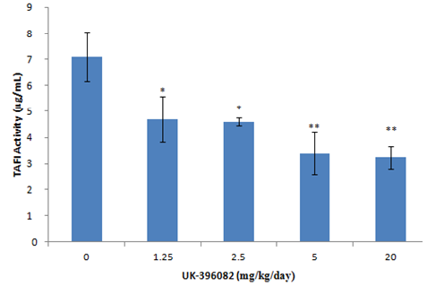
50% inhibition
Figure 5.1: 0.3mLs of blood was taken from the rat tail vein under anaesthesiac. Blood was left to clot for 30 mins and then spun at 400xg for 15 minutes to obtain serum. Serum TAFI activity was calculated using the Pentapharm TAFI activity kit. Data represents mean activity equivalent to recombinant human TAFI in ug/ml ±SEM, n=5, **p<0.01 (t-test) indicated significance against untreated.

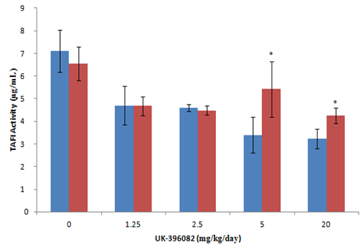
Figure 5.2: Serum TAFI Activity after 4 Weeks dosing with UK396082

50% inhibition

Figure 5.2: 0.3mLs blood was taken from the rat tail vein under anaesthesiac. Blood was allowed to clot and serum separated by centrifugation at 400xg for 15 minutes to obtain serum. Serum TAFI activity was calculated using Pentapharm TAFI activity assay kit. 4 weeks activity shown in red, two weeks in blue for comparison Data represents mean activity equivalent to recombinant human TAFI in ug/ml ±SEM, n=5, *p<0.05 (t-test) indicated significance against previous time-point.

Figure 5.3: Inhibition of serum TAFI Activity after pre-conditioning of animals with 1 weeks of 20mg/kg UK396082
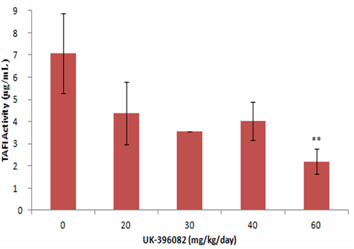
50% inhibition
Figure 5.3: Rats were dosed with 20mg/kg/day of UK396082 for 2 weeks and then dose increased to 30, 40 and 60 mg/kg/day. 0.3mLs blood was taken from rat tail vein under anaesthesia after 4 weeks of dosing following pre-conditioning, the blood allowed to clot and spun at 400xg for 15 minutes to obtain serum. Serum TAFI activity was determined using the pentapharm TAFI activity assay kit. Data represents mean activity equivalent to recombinant human TAFI in ug/ml ±SEM, n=5, **p<0.01 (t-test) indicated significance against previous dose.

Figure 5.4: Correlation analysis between serum TAFI activity and amount of UK-396082 administered
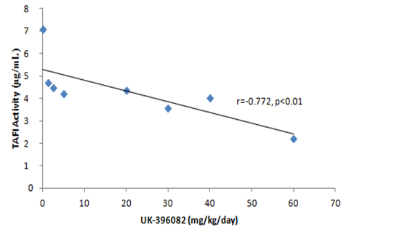
Figure 5.4: Correlation analysis between UK-396082 dose and serum TAFI activity post application of UK-396082. The black line represents the best fit between all data points generated. Data represent mean TAFI activity values at each dose ± SEM.

5.4 Discussion
In this chapter it has been shown that doses of 1.25mg/kg/day can inhibit seum TAFI activity significantly, however only doses over 20 mg/kg/day can consistently reduce TAFI by greater than 50% which was the target set on commencement. However, some tolerance did develop to this higher dose and it was only by using a dose of 60mg/kg/day that consistent inhibition of >50% could be achieved in all animals.
The range used was designed to take into account the low (20%) absorbance in rats and the level of inhibition (50%) required. Previous reports had seen an inhibition of 35% activity in dogs with a much higher absorbance (45%) and a dose of 1mg/kg (Bunnage et al., 2007). 1.25mg/kg was therefore seen to be a good starting point with increased doses to counter the lower absorption and increase the inhibition. The highest dose initially hypothesised to be a maximum (20mg/kg/day) was not enough to give a consistent 50% reduction in TAFI activity with levels of inhibition reducing with time. Animals pre-conditioned at 20mg/kg/day needed increased doses to maintain inhibition, and thus a dose of 60mg/kg/day was ultimately required.
The level of variation between animals was not large and there were no animals with anomalous results. The slight differences could be due to some animals eating more than others at certain times, so that their serum concentrations differed at the times of collection. Another reason could be that not all the animals gain weight at exactly the same rate and, as animals were kept four to a cage, the dose could have been slightly different as some animals gained more weight as the doses were based on an average weight. Ways to eliminate this would be to segregate the animals and give them their own food supply, or feed each animal their dose separately. This was a known consideration when planning the study and was not deemed too problematic as the animals all eat roughly the same amount of food per day – this is confirmed by the absence of major outliers. As most of the absorbance and bioavailability studies had been performed already, we felt that a low number of animals per group (n=5) was acceptable in accordance with the 3Rs and the ethics of animal testing (Festing and Wilkinson, 2007).
The mixing of ‘hot’ (containing UK-396082) and ‘cold’ (not containing UK-396082) food could also have caused problems as it is possible (however unlikely) that one animal could, by chance, eat none of the crumbs or pellets containing the drug. These pellets were mixed in to best effect and this is modified in the following chapter using the subtotal nephrectomy model of CKD so that all pellets contained the drug.
60mg/kg/day given orally roughly equates to 12mg/kg given via a daily injection. However, with the oral dose the animals were constantly consuming the drug and so were unexpected to see a dangerous C_{max} as could be seen with giving such a high dose IV.
It is possible that some animals developed tolerance to the drug, which could be due to homeostatic feedback mechanisms that haven’t been fully elucidated. This hasn’t been suggested in any previous studies. This could, however, be the reason that it requires an increase of around 58mg/kg/day to go from 30% inhibition to above 50% - there could be some feedback to prevent TAFI activity falling this low which is not yet fully understood, leading to pharmacokinetic or pharmacodynamic tolerance in which the drug is degraded or the response is decreased by cellular mechanisms. This would also explain why it hasn’t been reported before, as all previous studies have been with TAFI KO animals, rather than a therapeutic reduction.
As serum was tested for TAFI and Plasmin activity, rather than plasma, it is possible that several of the clotting factors required for correct activation of the two enzymes were not present. As both tests showed plasmin and TAFI activity, this seems unlikely but it is possible we did not see the full extent of the changes to the system due to the use of serum over plasma.
As the drug is cleared through the kidney, it was thought that serum levels would accurately reflect renal levels.

Chapter Six

Application of TAFI inhibitor UK-396082 in a rat 5/6th subtotal nephrectomy model of Chronic Kidney Disease

6.1 Introduction
Modelling human disease in animals is a major tool in identifying disease pathways and developing new therapeutics. Without such models the pre symptom stage of the disease could not be studied nor could interventional investigations be performed. Further it is not ethical to experiment in human subjects until considerable data is available to demonstrate efficacy of an intervention and the intervention is low risk. For these reasons animal models of thousands of human diseases have been developed over the years, and it fair to say that without such models medical science would be far less advanced that it is currently.
In the kidney there are numerous models of CKD, most notably developed in the rat. For example the Streptozotocin model of diabetic nephropathy, the unilateral ureteric model of blockage, the aristolochic acid model of tubulointerstitial nephrotoxicity and the nephrotoxic nephritis model of chronic glomerular nephritis are all widely used. However the most widely used model is the 5/6th subtotal nephrectomy model of hypertensive kidney fibrosis due to its ease, rapidity, reproducibility and characteristic fibrosis it develops. The roots of this model started in the late 1800’s.
The first human partial nephrectomy on record was performed in 1887 by Czerny, where the renal capsule was peeled back and the area resected (Goldstein, 1937) to remove malignant tumours of 21 patients. The first animal partial nephrectomy was performed two years later by Tuffier (Pearce, 1908), who removed one kidney and part of the contralateral of a dog in an attempt to develop a model of renal disease. No changes in the elimination of water or urea were seen.
In 1899 a three-quarter removal of canine renal mass was performed by Bradford in an attempt to create a model of kidney disease, resulting in both wasting and polyuria (Bradford, 1899).
It wasn’t until 1932 that the removal of five-sixths of a rat’s renal mass was attempted by Chanutin and Ferris to establish a model in rodents. They demonstrated that this removal caused the rats to become uremic and to remain so for a long time period (Chanutin A, 1932). The technique used for this pioneering surgery has remained basically unchanged since and forms the basis of the SNx model used to this day. The upper and lower poles of the left kidney were ligated and resected under anaesthesia, leaving one-third of the left renal parenchyma and renal hilum intact. One week later, the right kidney was removed in a nephrectomy procedure. In contrast to the modern technique, mortality rates in this initial study were considerable, with a quoted survival rate of six animals from the one hundred undergoing surgery (Chanutin A, 1932).
In 1952 the procedure was refined to include the control of bleeding using digital pressure (from the fingers or thumbs) (Platt et al., 1952), with other small revisions to reduce animal loss incorporated ever since. Revisions to this technique included wrapping the remnant kidney in hemostatic gauze or the application of thrombin solution to the cut ends (Chow KM, 2003). In addition to this, blood loss from the resection procedure has been minimised by the application of an artery clamp to the renal pedicle during the resection surgery (Chow KM 2003).
The SNx is mainly a glomerular hypertension model of kidney fibrosis, causing significant changes in systemic blood pressure. The histological and physiological changes that result are well catalogued. After the reduction in renal volume and nephron number, compensatory renal hypertrophy occurs in the remnant kidney. This process was identified as early as 1869 when Gustav Simon observed a 1.5-fold increase in the size of the remaining kidney in uninephrectomised dogs (Fine, 1986).
One of the most interesting features of the SNx is that it has considerable strain and species specific differences. For example most mice strains do not scar following SNx, whereas most rats do (although to differing extents). Glomerular scarring can be induced with minrealocorticoid-salt hypertension in B10.D2NSN mice (Raij et al., 1989) but it is not normally seen. In at least one rat strain there is a resistance to renal injury following nephrectomy, with an absence of arterial hypertension (Bidani et al., 1990). As well as this, the Wistar-Furth strain also fails to develop renal injury following nephrectomy (Kren and Hostetter, 1999).
Using micropuncture techniques, single nephron glomerular filtration rates have been measured in SNx and shown to increase uniformly within the remnant kidney; the magnitude of this increase closely correlated with the renal mass resected (Hostetter et al., 2001, Yoshida et al., 1988). This increased glomerular flow leads to capillary hypertension and subsequently tuft enlargement. The glomerular hypertension results in glomerosclerosis which can range from being highly focal to global, and is seen in hand with glomerulomegaly, mesangial expansion and both interstitial fibrosis and tubular atrophy. The increased blood pressure leads to endothelial damage and a cytokine cascade, causing the early scarring of the glomerulus and the tubules. This then leads to the thickening of the GBM and the TBM, with cell infiltration into the renal capsule and ECM expansion in the mesangium of the glomerulus and the interstitial space of the tubules.
This model has been used extensively by the research group at the Sheffield kidney Instutute (Oldroyd et al., 2006, Johnson et al., 1997, el Nahas et al., 1991, Muchaneta-Kubara et al., 1995) and the procedure developed to reduce blood loss using a ligature tied around each pole before resection and sealing the cut poles with a histo-acryl tissue glue to prevent bleeding (Haylor et al., 2009). In our hands this is a reproducible model of kidney fibrosis and ESKF that has been used to study MMPs(Douthwaite et al., 1999b), TG2 (Fisher et al., 2009, Johnson et al., 1997), gamma-interferon (Oldroyd et al., 2006), endothelin, (Douthwaite et al., 1999a), and a range of growth factors and cytokines (Muchaneta-Kubara et al., 1995)
In the previous chapter it was shown that the TAFI inhibitor UK-396082 could reduce TAFI activity consistently in the serum of normal rats by 50% at a dose of 60mg/kg/day. Using this dose in conjunction with the rat 5/6th subtotal nephrectomy model we sought to test the hypothesis that TAFI activity will increase and plasmin activity fall in conjunction with renal scarring and loss of kidney function. Further that restoration of TAFI activity using TAFI inhibitor UK-396082 will reduce TAFI activity, increase plasmin activity and, therefore, reduce the accumulation of scar tissue preserving kidney function.

6.2 Experimental Design
The experimental protocol was designed to allow assessment of the effectiveness of UK-396082 in preventing kidney fibrosis and preserving kidney function both as a preventative agent (i.e. treatment prior to fibrosis onset) and a reversal agent (i.e. treatment was disease was established) (Fig 6.0). Overall, 250 g male Wistar han rats were subjected to SNx and kept for 60 days for fibrosis to develop. Some rats were treated with UK396082 throughout the 60 days, whereas a second group just received treatment from day 35 when significant fibrosis and loss of function should have occurred.
In detail, sham operated rats were split into three groups. The first group of 5 were fed normal rat chow (Harlan Teklad) and terminated at day 60, a second group of 5 were fed rat chow containing 60mg/kg/day UK-396082 (Research Diets, USA) from day 35 and terminated at day 60, and a third group of 5 fed normal rat chow throughout and terminated at day 35.
SNx animals were split into into four groups; One group of 12 SNx rats was fed normal rat chow (Harlan Teklad) and terminated at day 60. A second group of 12 SNx rats was fed normal rat chow and terminated at day 35. A third group of 12 SNx rats was fed rat chow containing 60mg/kg/day UK-396082 (Research Diets, USA) from day 14 (ie 7 days after the nephrectomy) and a final group of 12 SNx rats fed chow containing 60mg/kg/day UK-396082 from day 35.
UK396082 treatment was not started for fourteen days post surgery to allow for wound healing. This was prudent, as a reduction in TAFI activity has been shown to have an adverse effect on wound healing (Inbal et al., 2005) and thus earlier treatment may have led to internal bleeding from the surgical wound. The prevention arm allows direct comparisons between treated and untreated animals after 60 days and provides data on the ability of TAFI inhibition to stop fibrosis development. The reversal arm allows assessment of the treatment from 35 days compared to the starting point (untreated animals terminated at day 35) and the untreated end-point (untreated animals terminated at day 60) providing data on the effectiveness of TAFI inhibition to arrest established fibrosis at a point that would be consistent with clinical presentation of CKD patients.
To protect animals from suffering, termination criteria outside of pre-determined time endpoints were:
1) An animal falls below 80% of its weight at the time of surgery
2) An animal fails to meet the Home Office criteria for a procedure of moderate severity by showing distress. In this study that would typically mean the rat was ureamic and in ESKF
As such, weight was monitored daily and piloerection, blood around the nose or eyes, gait, movement, and inquisitiveness were monitored twice daily.
Due to the increased mortality in the SNx untreated group, this group ran the risk of having a much lower number of late-stage and terminal samples than the other groups. Therefore, the number of animals in this group was bolstered by the addition of a second experiment which followed exactly the stages of the first and the data from these two experiments merged.

Figure 6.0: Experimental plan for both preservation and reversal arms

Figure 6.0: In the Preservation arm, 5 sham operated animals were untreated and a further 5 were treated from day 14 with UK-396082. 12 SNx animals were left untreated and 12 were treated from day 14. In the Reversal arm, 5 control animals were treated from day 35. 12 SNx animals were terminated and harvested at day 35 and 12 were treated from this time-point.

6.3.1 Serum Levels of Fibrinolytic Components
6.3.1.1 TAFI
Initially it was essential to establish that effective inhibition of TAFI had been achieved. To show the general trend, serum TAFI activity was averaged across all time points (days 21, 35, 42 and 60) (Fig 6.1). Both sham and sham animals treated from day 14 had serum TAFI activity of around 17µg/mL. Untreated SNx animals had a serum TAFI activity of 40µg/mL. SNx animals being treatment from day 14 onwards had serum TAFI activity of 22 µg/mL and animals treated from day 35 had a significantly reduced activity of 28 µg/mL.
TAFI activity was also measured in the serum with time, with values from all animals averaged at day 0, 21, 35, 42 & 60. There was a significant increase in the TAFI activity of sham rats following the sham operation (day 21, Fig 6.2) but this returned to normal levels by day 35. This initial increase in TAFI activity is not seen in sham animals treated from day 14. SNx animals show significant increases in TAFI activity over sham animals at day 21, but statistically do not increase further by day 60. SNx animals treated from day 14 show TAFI activity levels significantly lower than untreated animals at all time-points, with levels not statistically higher than untreated sham animals at any time-point except day 60.
Animals treated from day 35 show an increase in TAFI activity at day 21 (before treatment) which is statistically the same as that seen in untreated SNx animals. There is then a significant reduction in TAFI activity post-treatment at day 35 with levels at day 42 and day 60 being significantly lower than untreated SNx animal levels at those time-points (Fig 6.2).
6.3.1.2 Serum TAFI in individual animals
Serum TAFI levels for individual rats were plotted against time (Fig 6.3). Sham activity levels for all animals remained steady in a region of 10-18 µg/mL TAFI activity. Animals treated from day 14 had baseline levels similar to sham animals but, after surgery, TAFI activity increased to a region of 15-25 µg/mL with the range of activities being higher. The untreated SNx animals also had a similar baseline to the treated and the sham animals, but their TAFI activity increased sharply following surgery, with levels of 20-38 µg/mL by day 21 and increasing to 38-60 µg/mL by day 42. End-stage renal failure occurred in these animals within 1-5 days of their serum TAFI activity increasing above 42µg/mL, with all deaths occurring in this region. Indeed, the only death in the treated SNx group was in one animal whose serum TAFI was elevated above all the others to 50µg/mL at day 58.
For the ‘Reversal’ arm, serum TAFI activity was monitored in the same way (Fig 6.3b). As no animals were treated before day 35 in the ‘Reversal’ arm, the serum TAFI before this point behaves the same for both SNx groups, increasing from a range of 10-20 µg/mL TAFI activity, to a range of 20-40 µg/mL by day 35. After treatment, rat serum TAFI remained below 28 µg/mL in all but the two rats that were terminated at day 56. These rats exceeded 42 µg/mL serum TAFI and began to show symptoms of end-stage renal failure.
6.3.1.3 Serum Plasmin Activity
Plasmin activity was measured on days 0, 35, 42 and 60 (Fig 6.4). In both Sham animals, and Sham animals with treatment from day 14, there was no significant change in plasmin activity in the serum as the study progressed. In the untreated SNx animals, there was a significant decrease in serum plasmin activity (-19%) compared to the sham animals at days 42 and 60. SNx animals treated with UK-396082 from day 14 showed an increase in plasmin activity compared to untreated SNx at day 35 (+21%) which increased at day 42 (+41%) and day 60 (+52%). SNx animals treated from day 35 showed an increase in serum plasmin activity at days 42 (+51%) and 60 (+52%) compared to untreated SNx animals.
6.3.1.4 Serum Plasmin in individual animals
Serum plasmin levels were plotted against time for individual animals in both the prevention arm (Fig 6.5a) and the reversal arm (Fig 6.5b). All Sham and Sham animals treated from day 14 stayed relatively level at a range equivalent to 35-50µg/mL of recombinant human plasmin. Untreated SNx animals had a general downwards trend but there was not a clear ‘point of death’ as seen in TAFI activity. No untreated SNx animals after 35 days had a serum plasmin activity above 46µg/mL. SNx animals treated from day 14 had a generally upwards trend in serum plasmin activity with no treated animal after day 35 having a plasmin activity below 48µg/mL. One treated SNx animal had a rapidly increasing serum plasmin activity from the start of treatment and had to be terminated on day 56 with a serum plasmin activity of 88µg/mL (+41% compared to the next highest).
In the reversal arm (Fig 6.5b) the range of sham animal levels is from 36-57µg/mL. Before day 35 the SNx animals all show a downwards trend, with was reversed after therapy started with serum plasmin increasing in the treated animals after day 42. The two animals terminated after showing signs of renal failure at day 56 had serum plasmin activities within the range seen in sham animals.

Figure 6.1: Mean Serum TAFI Activities across all time points following UK396082 treatment in experimental CKD

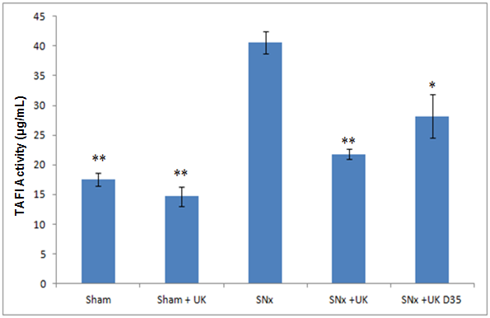
Figure 6.1: 0.3mLs blood was taken from the rat tail vein under anaesthesia and allowed to clot. Clotted blood was spun at 400xg for 15 minutes to obtain serum. Serum TAFI activity was measured using TAFI activity assay (Pentapharm). Data represents mean TAFI activity over days 0, 21, 35 and 60 in µg/mL ±SEM, n=5 for sham & sham+UK and n=12 for others. *p<0.05, **p<0.01 (t-test) indicated significance compared to SNx untreated animals.

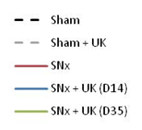
Figure 6.2: Mean serum changes in TAFI Activity with time following UK396082 treatment in experimental CKD

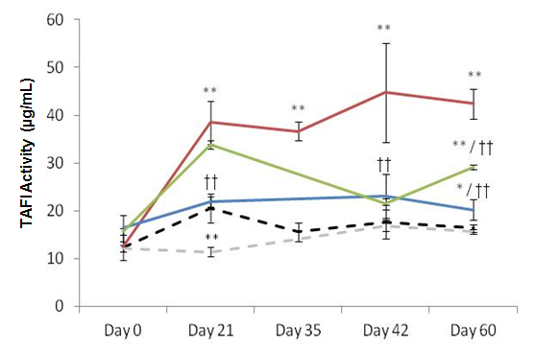

Figure 6.2: 0.3mLs blood was taken from the rat tail vein under anaesthesia at days 0, 21, 35, 42 and 60. Blood was clotted and then spun at 400xg for 15 minutes to obtain serum. Serum TAFI activity was measured using the TAFI activity assay (Pentapharm). Data represents mean TAFI activity in µg/mL ±SEM, n=5 for sham operated animal groups and n=12 for SNx animal groups. **p<0.01 (t-test) indicates significance against sham animals at the same time-point. ††p<0.01 (t-test) indicated significance against SNx animals at the same time-point.

Figure 6.3: Serum TAFI activity with time in individual animals following UK396082 treatment from the onset of disease in experimental CKD
A) Prevention Arm
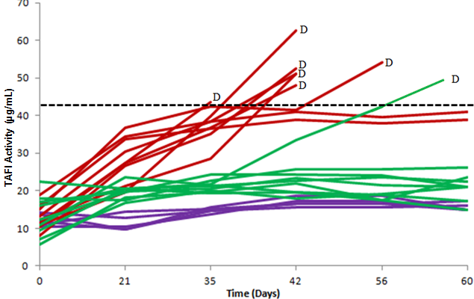
B) Reversal Arm
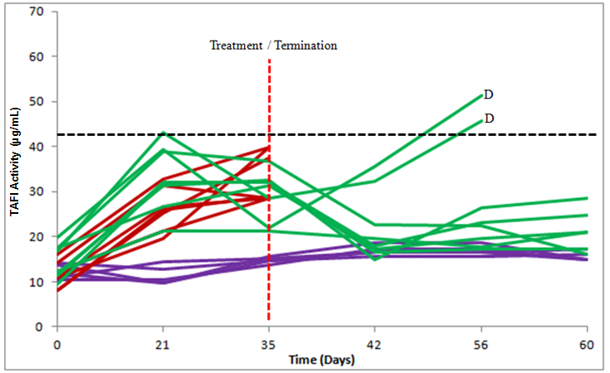
Figure 6.3: 0.3mLs of blood was taken from the rat tail vein under anaesthesia at days 0, 21, 35, 42 and 60 post SNx. Blood was clotted and then spun at 400xg for 15 minutes to obtain serum. Serum TAFI was measured using the Pentapharm TAFI activity assay). Data represents serum TAFI activity in µg/mL for individual rats in groups sham (Purple) (n=5), SNx Treated (Green) (n=12) and SNx Untreated (Red) (n=12). Times of death are denoted by Black letter ‘D’. A hypothetical upper limit of 42µg/mL TAFI activity above which animals went into end stage renal failure is shown by the Black dashed line (A). Untreated and treatment of SNx Treated occurred at day 35 (Red dashed line) and a hypothetical upper limit of 42µg/mL TAFI activity is shown (Black dashed line) (B).

Figure 6.4: Mean serum changes in plasmin Activity with time following UK396082 treatment in experimental CKD
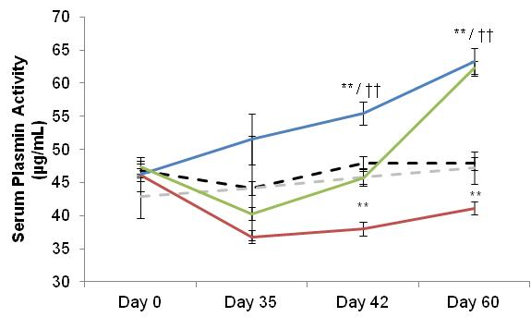
Figure 6.4: 0.3mLs blood was taken from the rat tail vein under anaesthetic at days 0, 21, 35, 42 and 60. Blood was clotted and spun at 400xg for 15 minutes to obtain serum. Serum Plasmin was calculated using the V0882 substrate (Sigma) detailed in section 2.2.1. Data represents mean activity in µg/mL ±SEM, n=5 for sham operated animal groups and n=12 for SNx animal groups. *p<0.05, **p<0.01 (t-test) indicates significance against sham animals at the same time-point. †p<0.05, ††p<0.01 (t-test) indicated significance against SNx animals at the same time-point.

Figure 6.5: Serum plasmin activity in individual animals with time following UK396082 treatment from the onset of disease in experimental CKD
A) Prevention Arm
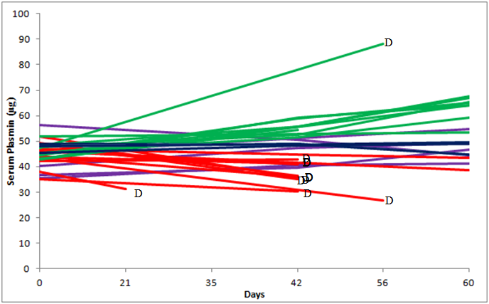
B) Reversal Arm
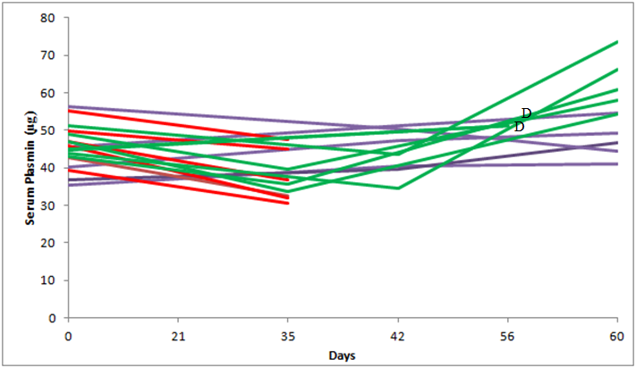
Figure 6.5: 0.3mLs blood was taken from the rat tail vein under anaesthesia at days 0, 21, 35, 42 and 60 post SNx. Blood was clotted and spun at 400xg for 15 minutes to obtain serum. Serum plasmin was measured using cleavage of the V0882 substrate (Sigma) detailed in section 2.2.1. Data represents serum plasmin activity in µg/mL for individual rats. Sham (Purple) (n=5), SNx Treated (Green) (n=12) and SNx Untreated (Red) (n=12). Times of death are shown by Black letter ‘D’.

6.3.2 Terminal Tissue Levels of Fibrinolytic components
6.3.2.1 TAFI
Terminal tissue TAFI activity was measured on 2% homogenised renal tissue in STE buffer. Sham operated animals had a renal TAFI activity of around 600µg/mL, which was unchanged over the time course. Treatment of sham operated animals with UK-396082 reduced renal TAFI activity (-33%) (Fig.6.6).
SNx operated animals had no increase in tissue TAFI activity to day 35, but had a significant increase by day 60 (+36%).
Treatment with UK-396082 from day 14 significantly reduced tissue TAFI activity to levels comparable with untreated sham animals (-49%). Treatment from day 35 prevented the increase in tissue TAFI activity seen between days 35 and 60.
6.3.2.2 Plasmin
Terminal tissue plasmin activity was measured on 2% homogenised renal tissue in STE buffer. Sham operated animals had consistent plasmin activities across the time-course (105µg/mL). Sham operated animals treated with UK-396082 showed a significant increased in tissue plasmin activity (155%, +54%) (Fig.6.7).
SNx operated animals had unchanged tissue plasmin activity after 35 and 60 days. SNx operated animals treated with UK-396082 from day 14 showed a significant increase in plasmin activity (~170µg/mL, +53%) and treatment from day 35 also produced a significant increase in renal plasmin activity (~160µg/mL, +20%).
6.3.2.3 uPA
Terminal tissue uPA activity was measured on 2% homogenised renal tissue in STE buffer. Sham operated animals had consistent uPA activities across the time-course (~600µg/mL). Treatment with UK-396082 had no effect on kidney uPA activity (Fig. 6.8).
SNx operated animals showed significant increases of uPA activity in renal tissue (~950µg/mL, +58%) after 35 days with no significant increase over this by day 60. Also, there was no effect on this increase when treated with UK-396082 from day 14 or day 35.

6.3.2.4 tPA
Terminal tissue tPA activity was measured on 2% homogenised renal tissue in STE buffer. Sham operated animals had consistent kidney tPA activities across the time-course with no significant difference seen with UK-396082 treatment (Fig.6.9).
SNx operated animals showed no significant change in tPA activity at day 35, but showed a small but significant increase by day 60 (~155µg/mL, +30%). Treatment with UK-396082 from day 14 showed a significant increase in tissue tPA activity (225µg/mL, +45%), while treatment from day 35, did not increase tPA activity higher than untreated SNx animals at day 35. SNx animals at day 35 showed increased tPA activity compared with sham animals at day 35 (~195µg/mL, +60%).

Figure 6.6: Kidney TAFI activity in experimental CKD treated with TAFI inhibitor UK396082

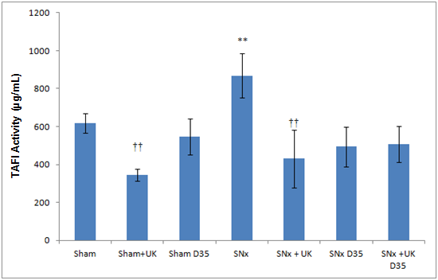
Figure 6.6: Snap-frozen kidney tissue was thawed and homogenised in STE buffer to a 2% homogenate. Tissue TAFI was measured using the Pentapharm TAFI activity assay. Data represents mean activity of TAFI in µg/mL equivalent to rh TAFI ± SEM. **p<0.01, *p<0.05 (t-test) indicates significance against sham operated animals (n=5). ††p<0.01, †p<0.05 (t-test) indicates significance against untreated SNx animals (n= 12 )
.

Figure 6.7: Mean kidney plasmin activity in experimental CKD treated with TAFI inhibitor UK396082

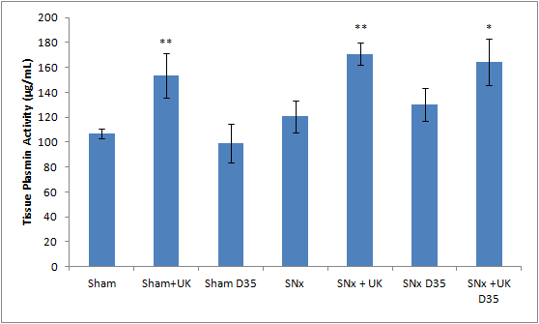
Figure 6.7: Snap-frozen kidney tissue was thawed and homogenised in STE buffer to a 2% homogenate. Tissue Plasmin was measured using cleavage of the plasmin substrate V-0882 (Sigma, UK). Data represents mean activity of plasmin in units equivalent ug/ml rh Plasmin ± SEM. **p<0.01, *p<0.05 (t-test) indicates significance against sham operated animals. ††p<0.01, †p<0.05 (t-test) indicates significance against untreated SNx animals .

Figure 6.8: Mean kidney uPA activity in experimental CKD treated with TAFI inhibitor UK-396082
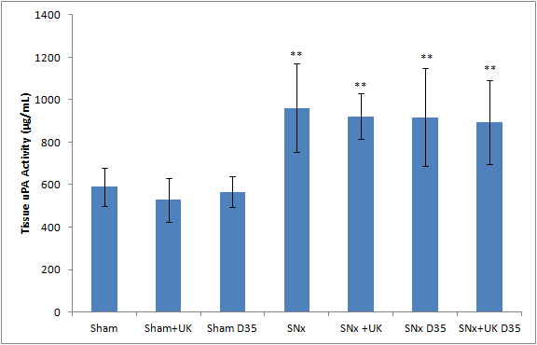
Figure 6.8: Snap-frozen kidney tissue was thawed and homogenised in STE buffer to a 2% homogenate. Tissue uPA activity was measured using cleavage of urokinase substrate S-2222 (Chromogenix, UK). Data represents mean activity of uPA in units equivalent to ug/ml rh uPA ± SEM. **p<0.01, *p<0.05 (t-test) indicates significance against sham operated animals (n=5). ††p<0.01, †p<0.05 (t-test) indicates significance against untreated SNx animals (n= 12 ).

Figure 6.9: Mean kidney tPA in experimental CKD treated with TAFI inhibitor UK396082
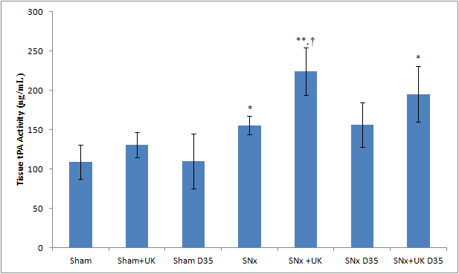
Figure 6.9: Snap-frozen kidney tissue was thawed and homogenised in STE buffer to a 2% homogenate. Tissue tPA activity was measured using cleavage of urokinase substrate S-2244 (Chromogenix, UK). Data represents mean activity of tPA in ug/ml ±SEM. **p<0.01, *p<0.05 (t-test) indicates significance against sham operated animals (n=5). ††p<0.01, †p<0.05 (t-test) indicates significance against untreated SNx animals (n=12 ).

6.3.3 Renal Function
6.3.3.1 Serum Creatinine
Serum creatinine was measured at days 0, 21, 35, 42, 56 and 60 (Fig 6.10). Both sham operated animal and sham animal treated from day 14 groups had stable serum creatinine levels of around 0.7µg/dL. Following the SNx surgery, serum creatinine levels increased to between 2 and 2.6µg/dL in the treated and untreated animals which most likely reflected the loss in renal mass. Untreated SNx animals continued to rise as the study progressed with serum creatinine levels of 2.6µg/dL (+270%) at day 21, 3.15µg/dL (+350%) at day 35, 3.5µg/dL (+400%) at day 42, 4µg/dL (+471%) at day 56 and 3.8µg/dL (+442%) at day 60.
SNx animals treated from day 14 showed a significant increase in serum creatinine at day 21 when compared with the sham animals (+180%), but this was also significantly lower than the untreated SNx animals (-22%). Treated animals had significantly lower serum creatinine levels that untreated animals at all time-points, with terminal serum creatinine levels of 2.5µg/dL (-35% compared to untreated).
SNx animals treated from day 35 had similar serum creatinine levels to SNx animals prior to treatment (day 31). At day 42, serum creatinine in these animals was 2.1µg/dL); significantly lower than the level seen at day 21 (-18%) and also significantly lower than the untreated SNx animals (-40%). SNx animals treated from day 35 had significantly lower levels of serum creatinine than untreated SNx animals as the study progressed, with serum creatinine values of 2.15µg/dL (-46% vs untreated SNx) at day 56 and 2.7µg/dL (-29% vs. untreated SNx) at day 60.
6.3.3.2 Serum Creatinine in individual animals
Serum creatinine levels were plotted against time for individual animals in both the prevention arm (Fig 6.11a) and the reversal arm (Fig 6.11b). Sham animals had stable serum creatinine levels of below 1µg/dL. In the prevention arm, after surgery creatinine levels increased in both SNx untreated and SNx animals treated from day 14. By day 35 the SNx untreated animals had a higher range of creatinine values (2.7 - 4.05µg/dL) than the animals treated from day 14 (1-2.8µg/dL). At this stage, one animal from the untreated SNx group had been terminated due to symptoms of end-stage renal failure. This animal had, at this stage, the highest serum creatinine value of 4.05µg/dL. By day 42, 5 more animals had serum creatinine values of above 4µg/dL and all were terminated within 1-2 days due to signs of renal failure. At this time-point, the treated SNx animals had a range of values similar to that seen at day 21, with no signs of increase and some falling. At day 56, another untreated SNx animal had a serum creatinine of above 4µg/dL and was terminated. By day 60, one of the untreated SNx animals had a serum creatinine of above 4µg/dL and was terminated due to signs of renal failure. By day 60, only two of the SNx untreated rats had serum creatinine values of below 4µg/dL and the remainder of the treated SNx had a similar range (1 – 2.9µg/dL) to that seen at day 21.
In the reversal arm (Fig 6.12), the sham operated rats had stable serum creatinine values of around 0.8µg/dL for the duration of the study. After surgery, both groups had an increase in serum creatinine with values at day 35 ranging from 1.8 – 3.8µg/dL. After treatment at day 35, 5 animals showed a decrease in creatinine by day 42 while the other 4 showed a slight increase. By day 56, two animals, which had previously seen a decrease in creatinine, had greatly increased creatinine above 4µg/dL and had to be terminated after developing symptoms of renal failure. Another two animals showed increases in creatinine, but not above 4µg/dL and the others either showed decreases or stayed level until day 60.
6.3.3.3 Serum Creatinine and TAFI
To establish if there was a link between the rise in TAFI activity and the serum creatinine, a Pearson’s correlation analysis was done between terminal TAFI and serum creatinine values. There was a strong correlation (r=0.7, p<0.05) between terminal serum creatinine and terminal serum TAFI activity (Figure 6.12).
6.3.3.4 Creatinine Clearance
Creatinine clearance was measured at days 0, 35, 42 and 60 (Fig 6.13). Sham operated animals and sham animals treated from day 14 had stable creatinine clearance values of around 1mL/min. The SNx untreated animals had a slightly high baseline creatinine clearance of 1.25mL/min and saw a significant reduction to 1mL/min at day 35 and further decreases at day 42 (-38% compared to sham animals at the same time-point) and day 60 (-37%). SNx animals treated from day 14 showed a drop from baseline levels of 1.2mL/min to 0.95mL/min at day 35, but remained at 0.95mL/min for the duration of the study, significantly higher than the SNx untreated animals (+26% at day 42 and +35% at day 60).
SNx animals treated from day 35 had a baseline creatinine clearance of 1mL/min. After surgery, this fell to 0.9 at day 35 (-5%) and 0.78 (-12%) at days 42 and 60. Although these levels were not significantly greater than the SNx untreated levels at days 45 and 60, the difference between baseline and day 60 was significantly greater in untreated animals than animals treated from day 35.
6.3.3.5 Proteinuria
Proteinuria was measured at days 0, 35, 42 and 60 (Fig 6.14). Both sham and sham animals treated from day 14 had baseline levels of proteinuria of 70-75mg/24Hr. These values increased over the course of the study to 140mg/24Hr. All SNx animals had a similar baseline of 70-75mg/24Hr. The SNx untreated animals, following surgery, saw an significant increase in proteinuria to 350mg/24Hr (+466%) by day 35 and a further increase to 460mg/24Hr (+328%) by days 42 and 60.
SNx animals treated from day 14 saw a significant increase above sham controls in proteinuria at day 35 (+215%) although this level was significantly below (-37%) untreated animal levels. Animals treated from day 14 saw further increases at day 42 (+261%) and day 60 (+214) compared to sham controls, but these levels were still significantly lower than untreated SNx animals (-45% and -37% respectively).
SNx animals treated from day 35 had the same day 35 value as untreated SNx animals (345mg/24Hrs). This increased to 355mg/24Hrs at day 42 (+3%) and 370mg/24Hrs at day 60 (+4%), however, these values were still significantly lower than the levels seen in untreated SNx animals (-26% and -23% respectively).
6.3.3.6 Serum Urea
Terminal serum urea was measured at day 60 or the time of termination if prior to that (Fig 6.15). Sham operated animals (untreated, treated from day 14 and terminated at day 35) had terminal serum urea values of 9-10mM/L. Untreated SNx animals terminated at day 35 had a significantly higher value of 91mM/L (+911%). Untreated SNx animals had a terminal serum urea value of 127mM/L when they entered ESRF or were terminated at day 60, significantly higher than both sham animals (+1311%) and SNx animals at day 35 (+ 39%). Treatment of SNx animals from day 14 significantly lowered terminal serum urea to 43mM/L (-65%). Treatment from day 35 also significantly lowered serum urea from this point to 62mM/L (-32%).

Figure 6.10: Mean Serum Creatinine with time following UK396082 treatment in experimental CKD
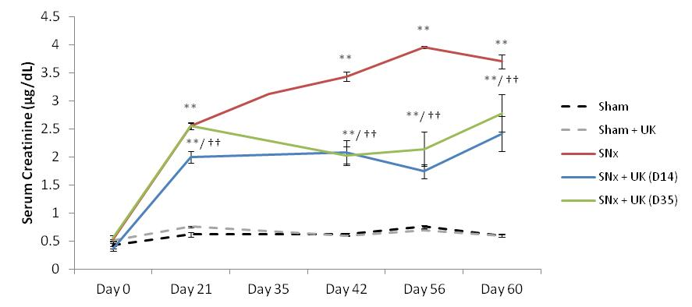

Figure 6.10: 0.3mLs blood was taken from the rat tail vein under anaesthetic at days 0, 21, 35, 42 and 60. Blood was spun at 400xg for 15 minutes to obtain serum. Serum creatinine was calculated using The Arbor Assays serum creatinine kit. Data represents mean serum creatinine in ug/dl ±SEM, n=5 for sham operated animal groups and n=12 for SNx animal groups. **p<0.01 (t-test) indicates significance against sham animals at the same time-point. †p<0.05, ††p<0.01 (t-test) indicated significance against SNx animals at the same time-point.

Figure 6.11: Serum Creatinine in individual animals with time following UK396082 treatment from the onset of disease in experimental CKD
A) Prevention Arm
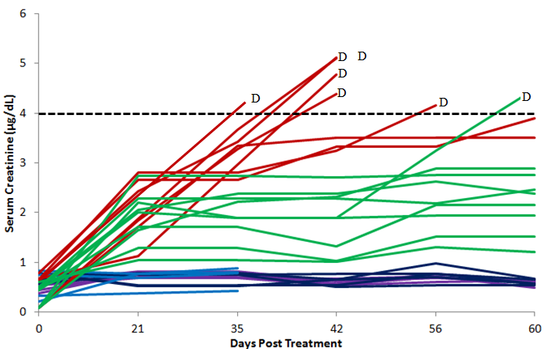
B) Reversal Arm
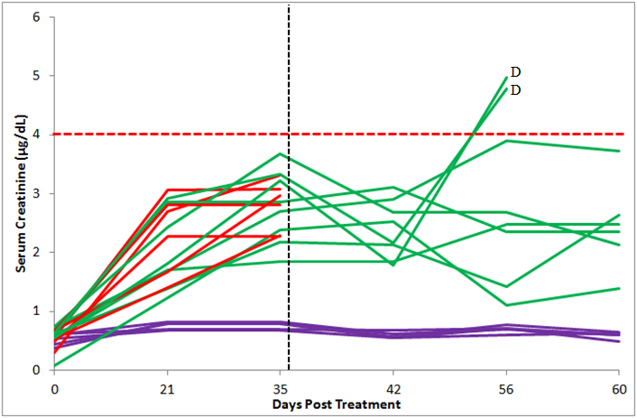
Figure 6.11: 0.3mLs blood was taken from the rat tail vein under anaesthesia at days 0, 21, 35, 42 and 60 post SNx. Blood was clotted and spun at 400xg for 15 minutes to obtain serum. Serum creatinine was measured using the Arbour Assays serum creatinine kit. Data represents serum creatinine in ug/dl for individual rats in groups sham (Purple) (n=5), SNx Treated (Green) (n=12) and SNx Untreated (Red) (n=12). Times of death are denoted by Black letter ‘D’. A hypothetical upper limit for rats entering end stage kidney failure of 4µg/dL serum creatinine is shown by the Black dashed line (A). Times of death are shown (Black letter ‘D’). Treatment of the late therapy group started at day 35 (Black dashed line) and a hypothetical upper limit of 4 µg/dL is shown (Red dashed line)(B).

Figure 6.12: Correlation of Terminal TAFI activity with terminal Serum Creatinine following treatment with UK396082 in experimental CKD
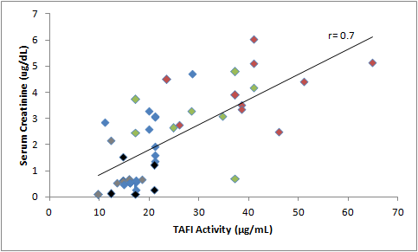
Figure 6.12: Terminal serum creatinine (ug/dl) was correlated against terminal TAFI activity and the correlation coefficient calculated using The Pearson method. Correlation coefficient is r=0.7 p<0.001. Sham animals are shown in black, treated sham animals in grey, SNx untreated in red, treated from day 14 in blue and from day 35 in green.

Figure 6.13: Mean Creatinine Clearance with time following UK396082 treatment in experimental CKD
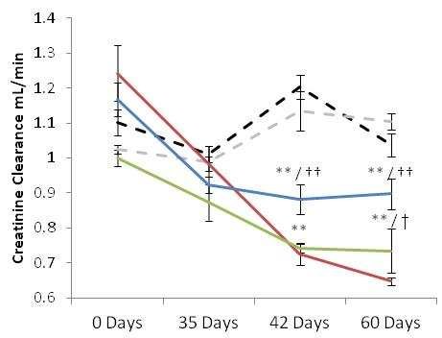
Figure 6.13: Creatinine clearance was calculated using the method described in section 2.10.4. Data represents mean creatinine clearance in ml/min ±SEM, n=5 for sham operated animal groups and n=12 for SNx animal groups. **p<0.01 (t-test) indicates significance against sham animals at the same time-point. ††p<0.01 (t-test) indicated significance against SNx animals at the same time-point.

Figure 6.14: Mean Proteinuria with time following UK396082 treatment in experimental CKD
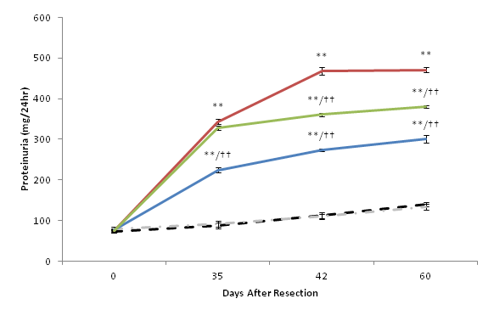
Figure 6.14: Proteinuria was calculated using the Lowry assay described in section 2.10.9. Data represents mean proteinuria in mg/24hrs ±SEM, n=5 for sham operated animal groups and n=12 for SNx animal groups. **p<0.01 (t-test) indicates significance against sham animals at the same time-point. ††p<0.01 (t-test) indicated significance against SNx animals at the same time-point.

Figure 6.15: Mean terminal Serum Urea with time following UK396082 treatment in experimental CKD

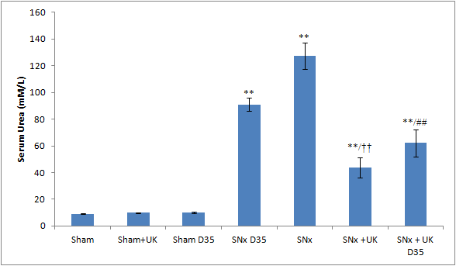
Figure 6.15: 0.3mLs blood was taken from the rat tail vein under anaesthesia at the time of termination. Blood was clotted and spun at 400xg for 15 minutes to obtain serum. Serum urea was determined by the Dept. Clinical Chemistry (Royal Hallamshire Hospital, Sheffield, UK). Data represents mean serum urea in mmol/L ±SEM. **p<0.01 (t-test) indicates significance against sham operated rats (n=5). ††p<0.01 (t-test) indicates significance against untreated SNx animals (n=12). ##p<0.01 (t-test) indicates significance against untreated SNx animals terminated at day 35 (n=12).

6.3.4 Biomarkers of kidney damage
Currently, proteinuria or albuminuria in conjunction with eGFR is the most effective biomarker for CKD. This, however, has many limitations. Recent studies have suggested several biomarkers that could be used to identify CKD progression in human disease, and these have been assessed here for their applicability in the SNx model of CKD.
6.3.4.1. NGAL
Neutrophil gelatinase-associated lipcalin (NGAL) is involved in innate immunity as an iron sequester, limiting bacterial growth. (Yang et al., 2002a). It has also been used as a biomarker of renal function, but mostly for Acute Kidney Injury (Devarajan, 2010).
Urinary NGAL was measured at days 0, 35 and 60 (Fig 6.16). Baseline NGAL levels for each group was between 3.1 and 3.3ng/mL. Sham operated animals had steady NGAL levels of around 3ng/mL as the study progressed. Untreated SNx animals had elevated NGAL levels of 24ng/mL at day 35 (+700%). SNx animals treated from day 14 had NGAL levels of 16.7ng/mL at day 35 (-33%), significantly lower than untreated SNx animals. Terminal NGAL values for untreated SNx rats (40ng/mL) were significantly higher than sham values (+1471%). SNx animals treated from day 14 and day 35 had terminal NGAL values of 27.5ng/mL and 30.4ng/mL respectively, both significantly (-31% and -24%) lower than untreated SNx values at the same time.
6.3.4.2. KIM-1
Kidney Injury Molecule 1 (KIM-1) is a type-1 transmembrane protein shown to be upregulated in the kidney’s of experimentally injured rodents (Han et al., 2002).
Urinary KIM-1 was measured at days 0, 35 and 60 (Fig 6.17). Baseline KIM-1 readings for each group were around 0.02 ng/mL. Sham operated animals had stable KIM-1 levels with no significant change over the course of the study. Untreated SNx animals had significantly elevated KIM-1 by day 35, with levels of 1.91ng/mL (+6550%) with statistically unchanged levels of 1.95ng/mL at day 60. SNx animals treated from day 14 had significantly reduced levels of 0.42ng/mL (-77.9%) at day 35 and 0.62ng/mL (-68.3%) at day 60. SNx animals which were treated from day 35 had a statistically similar level of Kim-1 at day 35 of 1.5ng/mL when compared with untreated SNx, by day 60 this was significantly lower than the untreated SNx animals with a value of 1.34ng/mL (-31.3%).
6.3.4.3. TIMP-1
TIMP-1 is a tissue inhibitor of metalloproteinases, and has been identified as a possible biomarker of renal injury in humans (Foteinopoulou, 2010).
Urinary TIMP-1 was measured at days 0, 35 and 60 (Fig 6.18). Baseline TIMP-1 for each group was not significantly different with values of 17-66pg/mL. Sham operated animals had stable TIMP-1 levels with no significant difference over time. Untreated SNx animals had significantly elevated TIMP-1 levels of 244pg/mL at day 35 (+397%) and 630pg/mL (+1212%) by day 60. SNx animals treated from day 14 had significantly elevated levels of 274pg/mL at day 35 compared to the sham operated groups, which were not significantly different to the untreated SNx. At day 35, the animals treated from day 14 and the untreated SNx animals had similar values of 196pg/mL. At day 60, Untreated SNx animals were significantly elevated over shams with levels of 629pg/mL (+1310%). Animals treated from day 14 had TIMP-1 levels of 879pg/mL (+39%) at day 60, significantly greater than untreated SNx animals. SNx animals treated from day 35 had levels of 1295pg/mL (+105%) at day 60, again significantly elevated above untreated SNx animals.
6.3.4.4. Transglutaminase type 2 (TG2)
TG2 is known to cross-link the ECM and has also been identified as a possible biomarker (da Silva Lodge et al., 2013).
Urinary TG2 was measured at days 0, 35 and 60 (Fig 6.19). Baseline TG2 was not significantly different for any group with values around 1.7µg/mL. Levels of TG2 in sham operated rats remained statistically unchanged as the study progressed. Untreated SNx animals had significantly elevated TG2 by day 35 with levels of 4.7µg/mL (+212%) and at day 60 with levels of 4.9µg/mL (+245%). SNx animals treated from day 14 had significantly reduced levels of TG2 at day 35, 2.6µg/mL, compared to untreated animals (-45%) and also at day 60, 3529ng/mL (-29%). SNx animals treated from day 35 were not significantly different to untreated SNx animals at day 35 or day 60.

Figure 6.16: Changes in mean urinary NGAL level with time following UK396082 treatment in experimental CKD
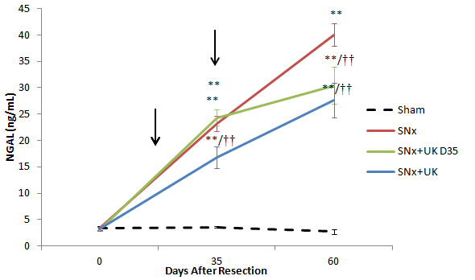

Figure 6.16: 24Hr urines were taken at days 0, 35 and 60. NGAL was measured using a Rat Lipocalin-2/NGAL DuoSet (R&D Systems) on urine diluted 1:20 with 1% BSA in PBS. Treatment times (D14 and D35) shown with black arrows. Data represents mean NGAL levels in ng/ml ±SEM. **p<0.01 (t-test) indicates significance against sham operated animals (n=5). ††p<0.01 (t-test) indicates significance against untreated SNx animals (n=12 ).

Figure 6.17: Changes in mean urinary KIM-1 level with time following UK396082 treatment in experimental CKD
Figure 6.17: 24Hr urines were taken at days 0, 35 and 60. Kim-1 was measured using a Rat Kim-1/Tim-1 DuoSet (R&D Systems) on urine diluted 1:20 with 1% BSA in PBS. Treatment times (D14 and D35) shown with black arrows. Data represents mean Kim-1 levels ±SEM. **p<0.01 (t-test) indicates significance against sham operated animals (n=5). ††p<0.01 (t-test) indicates significance against untreated SNx animals (n=12 ).

Figure 6.18: Changes in mean urinary TIMP-1 level with time following UK396082 treatment in experimental CKD
Figure 6.18: 24Hr urines were taken at days 0, 35 and 60. TIMP-1 was measured using a Rat TIMP-1 ELISA (R&D Systems) on urine diluted 1:20 with 1% BSA in PBS. Treatment times (D14 and D35) shown with black arrows. Data represents mean TIMP-1 levels in pg/ml ±SEM. **p<0.01 (t-test) indicates significance against sham operated animals (n=5). ††p<0.01 (t-test) indicates significance against untreated SNx animals (n=12).

Figure 6.19: Changes in mean urinary TG2 level with time following UK396082 treatment in experimental CKD
Figure 6.19: 24Hr urines were taken at days 0, 35 and 60. TG2 was measured using the Sandwich ELISA described in section 2.10.10 on urine diluted 1:20 with 1% BSA in PBS. Treatment times (D14 and D35) shown with black arrows. Data represents mean TG2 levels in ng/ml ±SEM. **p<0.01 (t-test) indicates significance against sham operated animals (n=5). ††p<0.01 (t-test) indicates significance against untreated SNx animals (n=12 ).

6.3.5 Renal Histology
6.3.5.1 Masson’s Trichrome
Analysis of renal scarring was performed on Masson’s Trichrome stained, paraffin embedded sections using multiphase image analysis (section 2.8). SNx animals developed progressive scarring, which led to significant glomerulosclerosis and tubulointerstitial fibrosis by day 35, that increased by day 60 post nephrectomy (Fig 6.20 & 6.21). Tubulointerstitial scarring was associated with extensive flattening of the tubular epithelium, leading to significant tubular atrophy and expansion of the tubular basement membrane (TBM) with increased interstitial cell infiltration. Glomerulosclerosis saw both mesangial and glomerular basement membrane (GBM) expansion leading to loss of the bowman’s space, which was associated with a cellular infiltrate and podocyte death. Animals treated with UK396082 from day 14 showed much less advanced disease in the remnant kidney and animals treated from day 35 showed no significant worsening of tubulointerstitial fibrosis and a partial remission of glomerulosclerosis.
Quantification of the scarring index was undertaken using multiphase image analysis. Tubulointerstitial scarring was significantly increased in SNx operated animals at day 35 post surgery (+233%), and further at day 60 (+1025%). This scarring was significantly reduced in animals treated from 14 days post surgery with UK-396082 (-77.3%) and prevented from further worsening by treatment from day 35 post surgery (Fig 6.21).
Glomerulosclerosis was also significantly increased in SNx operated animals at day 35 (+380%) and at day 60 (+920%). This was also significantly reduced in animals treated from day 14 with UK-396082 (-44.5%) and also reduced with treatment from day 35 (-25%).
Treatment with UK396085 did not alter Masson’s Trichrome staining in normal kidneys.

6.3.5.2 Collagen I
Analysis of kidney Collagen I was undertaken using immunofluorescence on paraffin embedded sections, with staining quantified using multiphase image analysis (section 2.8).
In sham operated animals some light collagen I staining was localised to the tubulo-interstitium, with light glomerular staining. This remained constant over the 60 days (Fig 6.22). SNx animals showed a small, but significant, increase in glomerular collagen I after 35 days (+53%), and a larger increase in tubule-interstitial collagen I (+310%). Multiphase image analysis (Fig 6.23) showed that after 60 days, collagen I in the mesangial matrix of sclerotic glomeruli (+200%), and in the tubular interstitium (+233%), was significantly elevated in untreated SNx animals compared to the shams. SNx animals treated with UK396082 from day 14 showed significantly reduced glomerular (-60%) and interstitial (-52%) collagen I compared to untreated SNx animals at day 60. SNx animals treated with UK396082 from day 35 showed no significant increase in glomerular collagen I compared to SNx animals sacrificed at day 35, and showed a small but significant reduction in interstitial collagen I (-13%).
6.3.5.3 Collagen III
Collagen III immunofluorescence was performed on paraffin embedded sections and quantified using multiphase image analysis (section 2.8).
Sham operated animals displayed normal, peri-tubular distribution of collagen III that increased slightly as the time-course progressed. This increase was prevented in these normal kidneys by treatment with UK-396082 (Fig. 6.24). Glomerular collagen III was restricted to the glomerular basement membrane, with no staining in the glomerular mesangium. Collagen III levels did not increase in sham operated glomeruli over the time-course.
SNx animals exhibited significantly increased levels of collagen III in both the tubular (+214%) and glomerular (+133%) compartments after 35 days, with no significant increase between this time-point and the termination of the study at day 60. Collagen III accumulation was seen in both the tubular basement membrane and the glomerular basement membrane, with no staining seen in the glomerular mesangium of SNx operated animals.
Treatment from day 14 with UK-396082 prevented the expansion of the tubular basement membrane (TBM) (Fig. 6.25) with significantly reduced collagen III (-55%) staining. However, treatment from day 35 had no effect on collagen III levels in the TBM and treatment from either day 14 or 35 had no effect on the increase in glomerular collagen III accumulation.
6.3.5.4 Collagen IV
Analysis of basement membrane expansion was performed using collagen IV immunostained paraffin embedded sections using multiphase image analysis (section 2.8).
Sham operated animals showed a normal distribution of collagen IV staining along tubular and glomerular basement membranes, with little change over the time course or following treatment with UK-396082 (Fig. 6.26).
SNx animals exhibited increased collagen IV levels after 35 days, in both the tubular (+163%) and glomerular (+100%) basement membranes (Fig. 6.27). After 60 days the tubular basement membranes were severely expanded with accumulation of collagen IV (+255%) especially in areas of significant tubular atrophy. In the glomerulus, both the peri-glomerular and mesangial areas were significantly expanded with accumulated collagen IV showing a 255% increase after 60 days. Treatment from day 14 with UK-396082 prevented this increase in the mesangial area (-57%), although thickening of the glomerular basement membrane was still seen. Treatment from this time-point also reduced collagen IV accumulation in the tubular basement membrane (-52.5%). Treatment from day 35 prevented any further increase of glomerular of tubular Collagen IV by day 60.
6.3.5.5 Fibronectin
Sham operated animals had a small amount of fibronectin in the peri-tubular area with stronger staining in the glomerular basement membrane and the glomerular mesangium (Fig. 6.28). This was unchanged over the time-course of the study.
SNx operated animals showed a significant increase in fibronectin staining in the tubular interstitium and tubular basement membrane after 35 days (+285%), which was significantly increased by 60 days (+373%) (Fig. 6.29). These SNx animals also showed significant fibronectin accumulation in the glomerular basement membrane and the glomerular mesangium at day 35 (+72%), with a significant increase in GBM staining by day 60 (+195%).
Treatment from day 14 significantly reduced the accumulation of fibronectin in the tubular basement membrane (-72%) and the glomerular basement membrane. Despite there being significant increases in fibronectin staining in the glomerular mesangium, total glomerular fibronectin staining was reduced (-46%) with treatment from day 14.
Treatment from day 35 prevented further increases in glomerular accumulation of fibronectin in the basement membrane, and significantly reduced fibronectin accumulation in the tubular basement membrane (-72% compared to day 35 SNx).
6.3.5.6 Laminin
Sham operated animals showed large amounts of laminin in the peri-tubular area and both the glomerular basement membrane and the glomerular mesangium (Fig. 6.30). This increased over the time-course of the study, with less laminin staining seen in sham animals sacrificed after 35 days compared to 60 days.
SNx operated animals showed a significant increase in laminin staining in the tubular basement membrane and the tubular interstitium after 35 days (+44%) which increased further by 60 days (+75%) (Fig 6.31). The SNx animals showed significant increases in laminin in both the glomerular basement membrane and the glomerular mesangium at day 35 (+250%), which showed no further increase to day 60.
Treatment from day 14 showed a small but significant reduction in laminin accumulation in glomerular sclerosis (-11%) and a large, significant reduction in the fibrotic regions of the tubules (-33%).
Treatment from day 35 showed a significant reduction in glomerular laminin accumulation (-17%) and laminin in the interstitial space and the tubular basement membrane (-44%).
6.3.5.7 Hydroxyproline
Terminal tissue hydroxyproline was measured on 1.5mg of homogenised renal tissue using an amino acid analyser (Biochrom 30). The estimated level of hydroxyproline in sham operated animals was consistently below 1nM/mg, with no changes seen over the time-course of the study or with application of UK-396082 (Fig. 6.32).
SNx operated animals had significantly increased hydroxyproline at day 35 (~2.5nM/mg, +212%) and further by day 60 (~4.9nM/mg, +500%).
Treatment from day 14 significantly reduced this increase by day 60, (~2.2, -65%), while treatment from day 35 prevented the levels of hydroxyproline from increasing further.

Figure 6.20: Glomerularsclerosis and Tubulointerstitial Fibrosis following UK396082 treatment in experimental CKD
Figure 6.20: Representative Masson’s Trichrome staining of SNx kidneys treated with TAFi inhibitor UK396082 in tubules (A) and glomeruli (B). SNx animals (D35 top, centre; D60 top right) and SNx treated with UK396082 from day 14 (bottom, right) or D35 post SNx (bottom, centre). Glomeruli are at 400x magnification and tubulointerstitium at 200x magnification.

Figure 6.21: Assessment of renal scarring by multiphase image analysis in experimental CKD treated with TAFI inhibitor UK396082.
i) Tubulointerstitial fibrosis
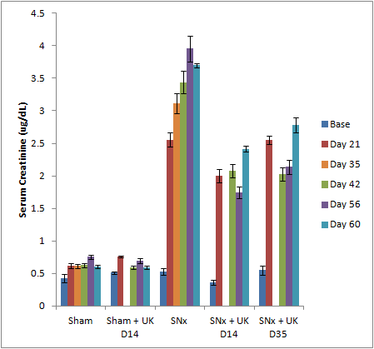
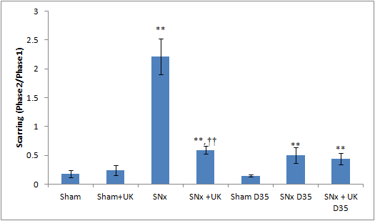
ii) Glomerulosclerosis
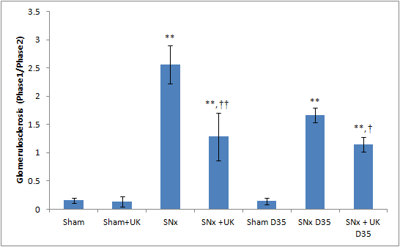
Figure 6.21: The level of tubulointerstitial fibrosis (i) and glomerulosclerosis (ii) in SNx rats treated with TAFI inhibitor UK396082 was assessed by multiphase image analysis of Masson’s Trichrome stained sections using three phases as described in section 2.8. 10 glomeruli (400x) or 10 cortical fields (200x ) were analysed for each animal. **p<0.01 (t-test) indicates significance against sham operated animals. ††p<0.01, †p<0.05 (t-test) indicates significance against

Figure 6.22: Collagen I Immunofluorescence following UK396082 treatment in experimental CKD
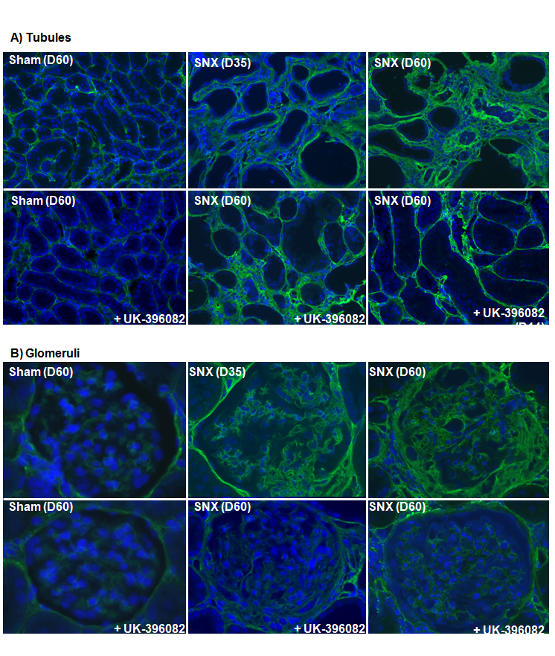
Figure 6.22: Representative collagen I Immunostaining of tubules (A) and glomeruli (B. , SNx animals (D35 top, centre; D60 top right in each panel) and SNx treated with UK396082 from day 14 (bottom, right) or D35 post SNx (bottom, centre). Glomeruli are at 400x magnification and tubulointerstitium at 200x magnification.

Figure 6.23: Assessment of Collagen I Immunofluorescence by multiphase images analysis in experimental CKD treated with TAFI inhibitor UK396082
i) Tubulointerstitial Fibrosis
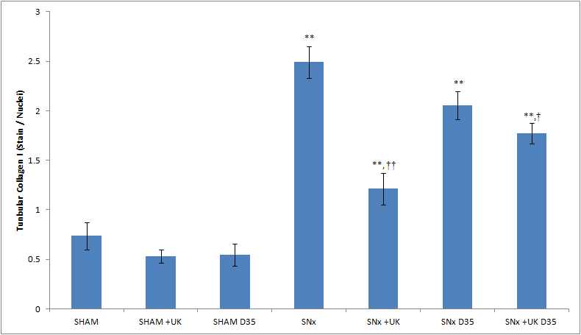
ii) Glomerular Sclerosis
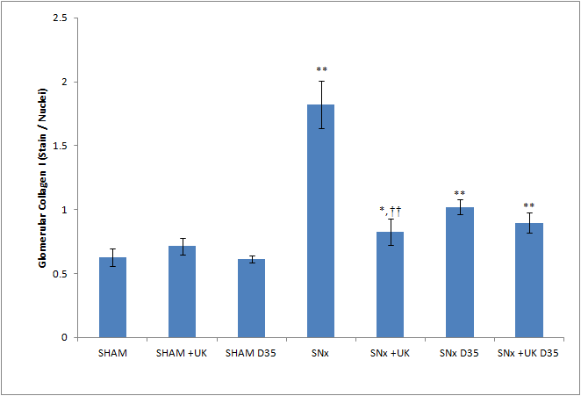
Figure 6.23: The level of collagen I in tubulointerstitial fibrosis (i) and glomerulosclerosis (ii) was assessed by multiphase image analysis of immuno fluorescentlystained sections using three phases as described in section 2.8. 10 glomeruli (400x) or 10 cortical fields (200x) were analysed for each animal. **p<0.01, *p<0.05 (t-test) indicates significance against sham operated animals. ††p<0.01, †p<0.05 (t-test) indicates significance against untreated SNx animals.

Figure 6.24: Collagen III Immunofluorescence following UK396082 treatment in experimental CKD
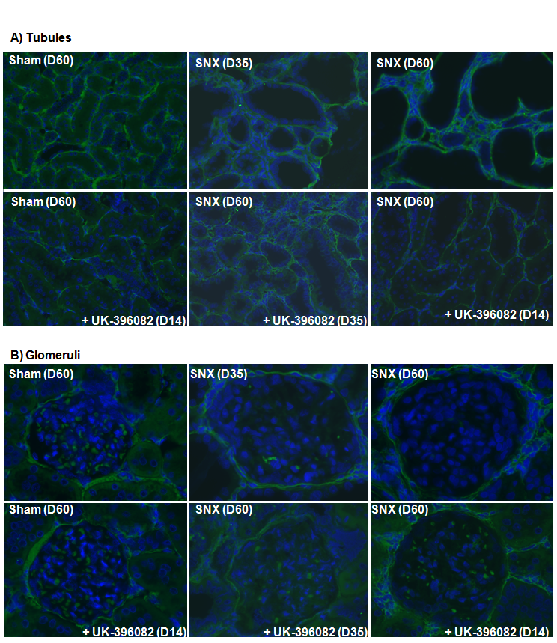
Figure 6.24: Representative collagen III Immunostaining of tubules (A) and glomeruli (B). SNx animals (D35 top, centre; D60 top right) and SNx treated with UK396082 from day 14 (bottom, right) or D35 post SNx (bottom, centre). Glomeruli are at 400x magnification and tubulointerstitium at 200x magnification.

Figure 6.25: Assessment of Collagen III by multiphase analysis in experimental CKD treated with TAFI inhibitor UK396082.
i) Tubulointerstitial Fibrosis
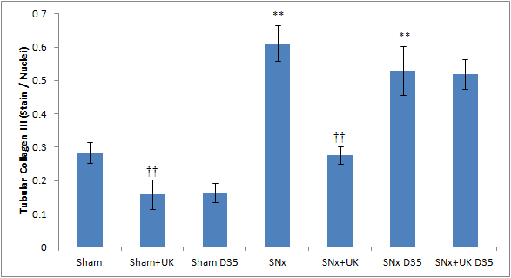
ii) Glomerular Sclerosis
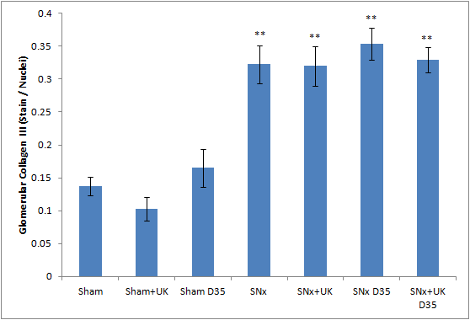
Figure 6.25: The level of collagen III in tubulointerstitial fibrosis (i) and glomerulosclerosis (ii) was assessed by multiphase image analysis of immunostained sections using three phases as described in section 2.8. 10 glomeruli (400x) or 10 cortical fields (200x) were analysed for each animal. **p<0.01, *p<0.05 (t-test) indicates significance against sham operated animals. ††p<0.01, †p<0.05 (t-test) indicates significance against untreated SNx animals.

Figure 6.26: Collagen IV Immunofluorescence following UK396082 treatment in experimental CKD
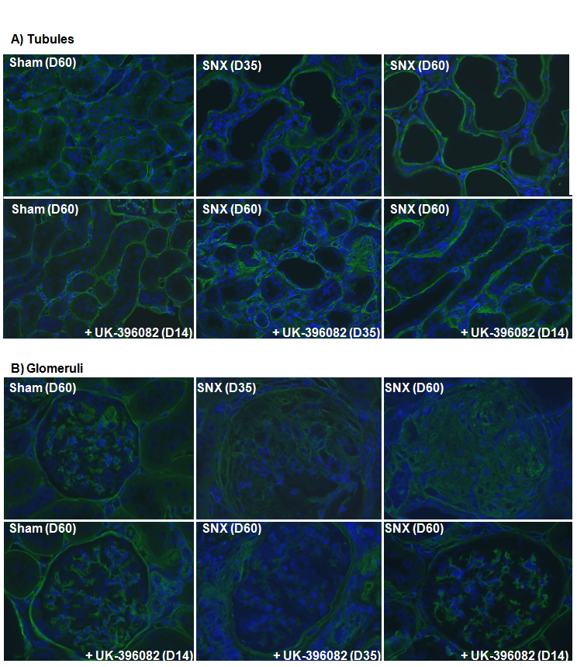
Figure 6.26: Representative collagen IV Immunostaining of tubules (A) and glomeruli (B. , SNx animals (D35 top, centre; D60 top right) and SNx treated with UK396082 from day 14 (bottom, right) or D35 post SNx (bottom, centre). Glomeruli are at 400x magnification and tubulointerstitium at 200x magnification.

Figure 6.27 Assessment of Collagen IV by multiphase analysis in experimental CKD treated with TAFI inhibitor UK396082.
i) Tubulointerstitial Fibrosis
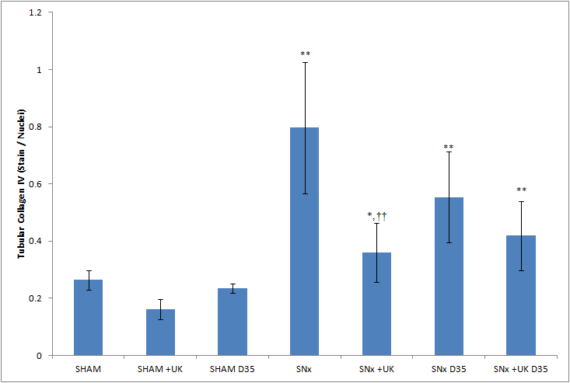
ii) Glomerular Sclerosis
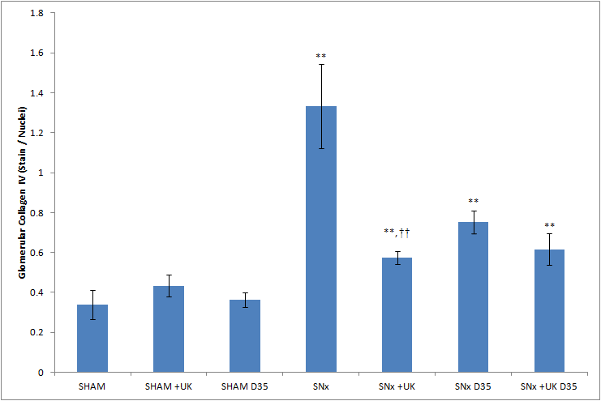
Figure 6.27: The level of collagen IV in tubulointerstitial fibrosis (i) and glomerulosclerosis (ii) was assessed by multiphase image analysis of immunostained sections using three phases as described in section 2.8. 10 glomeruli (400x) or 10 cortical fields (200x) were analysed for each animal. **p<0.01, *p<0.05 (t-test) indicates significance against sham operated animals. ††p<0.01, †p<0.05 (t-test) indicates significance against untreated SNx animals.

Figure 6.28: Fibronectin Immunofluorescence following UK396082 treatment in experimental CKD
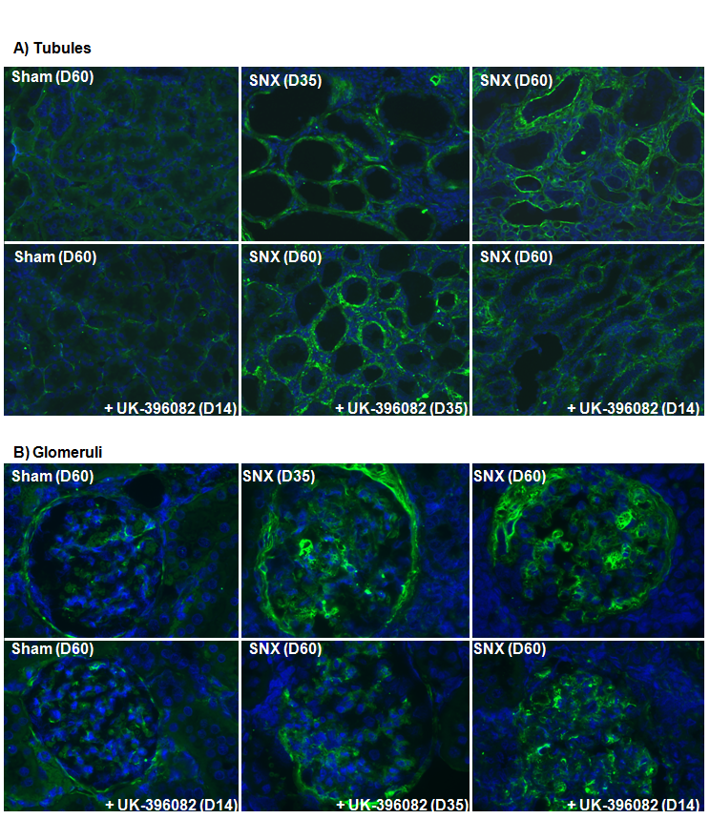
Figure 6.28: Representative fibronectin Immunostaining of tubules (A) and glomeruli (B). SNx animals (D35 top, centre; D60 top right) and SNx treated with UK396082 from day 14 (bottom, right) or D35 post SNx (bottom, centre). Glomeruli are at 400x magnification and tubulointerstitium at 200x magnification.

Figure 6.29: Assessment of Fibronectin by multiphase analysis in experimental CKD treated with TAFI inhibitor UK396082.
i) Tubulointerstitial Fibrosis
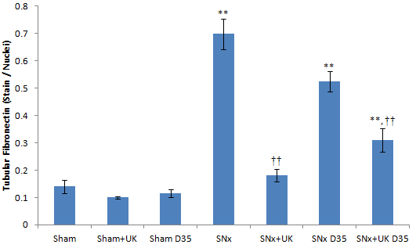
ii) Glomerular Sclerosis
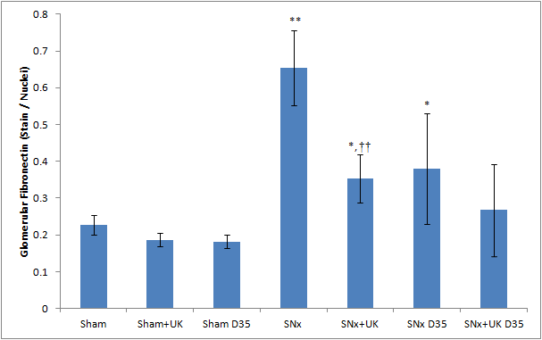
Figure 6.29: The level of fibronectin in tubulointerstitial fibrosis (i) and glomerulosclerosis (ii) was assessed by multiphase image analysis of immunostained sections using three phases as described in section 2.8. 10 glomeruli (400x)or 10 cortical fields (200x) were analysed for each animal. **p<0.01, *p<0.05 (t-test) indicates significance against sham operated animals . ††p<0.01, †p<0.05 (t-test) indicates significance against untreated SNx animals.

Figure 6.30: Laminin Immunofluorescence following UK396082 treatment in experimental CKD.
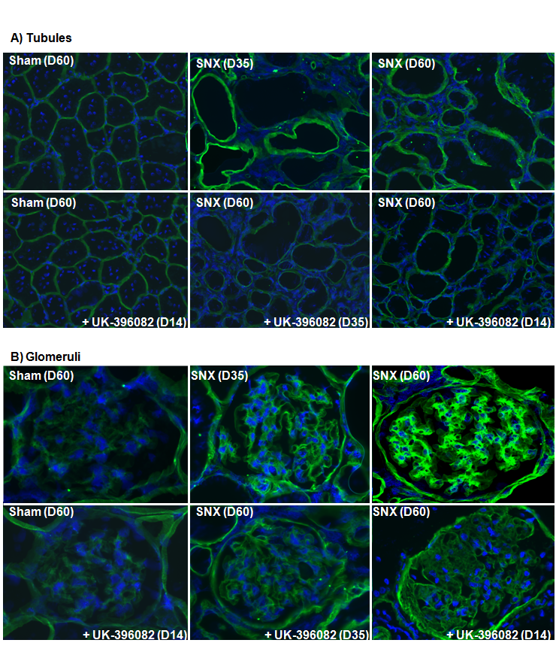
Figure 6.30: Representative laminin Immunostaining of tubules (A) and glomeruli (B). SNx animals(D35 top, centre; D60 top right) and SNx treated with UK396082 from day 14 (bottom, right )or D35 post SNx (bottom, centre). Glomeruli are at 400x magnification and tubulointerstitium at 200x magnification.

Figure 6.31: Assessment of Laminin by multiphase analysis in experimental CKD treated with TAFI inhibitor UK396082.
i) Tubulointerstitial Fibrosis
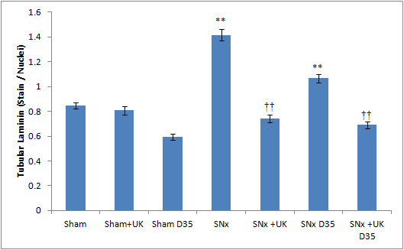
ii) Glomerular Sclerosis
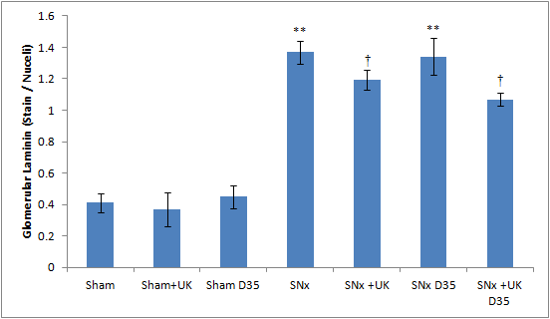
Figure 6.31: The level of laminin in tubulointerstitial fibrosis (i) and glomerulosclerosis (ii) was assessed by multiphase image analysis of immunostained sections using three phases as described in section 2.8. 10 glomeruli (400x) or 10 cortical fields (200x) were analysed for each animal. **p<0.01, *p<0.05 (t-test) indicates significance against sham operated animals. †p<0.05 (t-test) indicates significance against untreated SNx animals.

Figure 6.32: Kidney Hydroxyproline levels in experimental CKD treated with TAFI inhibitor UK396082

Figure 6.32: The level of hydroxyproline accumulation in renal tissue was assessed using Biochrom 30 Amino Acid Analyser (Biochrom, UK). Data represents mean concentration of hydroxyproline in nmol/ mg ±SEM. **p<0.01, *p<0.05 (t-test) indicates significance against sham operated animals (n=5). ††p<0.01, †p<0.05 (t-test) indicates significance against untreated SNx animals (n=12).

6.3.6 Blood Pressure
Systolic blood pressure was measured one day before termination of animals at the end-point of the study (Fig 6.33).
Following SNx surgery, the mean systolic blood pressure in all operated groups increased by 60%. There was no effect of sham operation on blood pressure when treated with UK-396082 and similarly there was no effect on SNx operated animals when treated with UK-396082 from day 14 or from day 35.

6.3.7 Cumulative Survival
Control animals with sham operations survived the full 60 days with no complications or deaths. Animals which were subjected to the SNx operation and received no treatment began to show symptoms of renal failure at day 20. Animals were terminated when they either showed signs of entering end-stage renal failure which typically meant when they reached the upper limit of moderate severity guidelines. The earliest SNx animal was terminated at day 20. At day 35, when the ‘Reversal’ arm of the study began, there was around 60% of the SNx animals still alive.
By day 60 there was 16% of untreated SNx animals alive. Animals which were treated from day 14 in the ‘Prevention’ arm of the study fared better, with a survival rate of 80%, the deaths of these 2 animals only occurring on day 55 (Fig 6.34).
Of the animals subjected to treatment from day 35, 75% of those starting treatment remained alive at day 60. In comparison, only 27% of those alive at day 35 that did not receive treatment were alive at day 35 (Fig 6.35).

6.3.8 Terminal Serum Concentration of UK-396082
Terminal serum samples were assessed for the concentration of UK-396082 present (Pfizer, UK).
Sham and SNx animals receiving no treatment had undetectable levels of UK-396082 as none was included in their diets.
The concentration of UK-396082 was lowest in sham operated animals, with serum levels averaging 105ng/mL. The concentration in the serum of animals treated from day 14 was higher than seen in sham animals (373ng/mL, +255%) and the levels seen in SNx operated animals treated from day 35 was highest of all (919ng/mL, +775%) (Fig 6.36).

Figure 6.33: Terminal Blood Pressure in experimental CKD treated with TAFI inhibitor UK396082

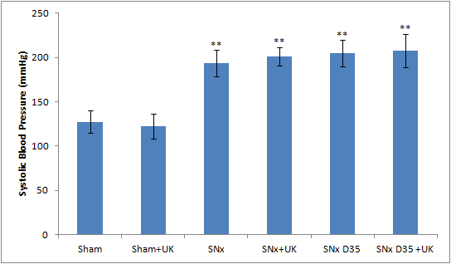
Figure 6.33. Blood pressure was measured using a tail-cuff, Model 229 blood pressure monitoring system, (IITC, UK) one day prior to termination. Data represents mean systolic blood pressure ±SEM. **p<0.01 (t-test) indicates significance against sham operated rats.

Figure 6.34: Cumulative Survival from day 0 post SNx following treatment with UK396082 in experimental CKD

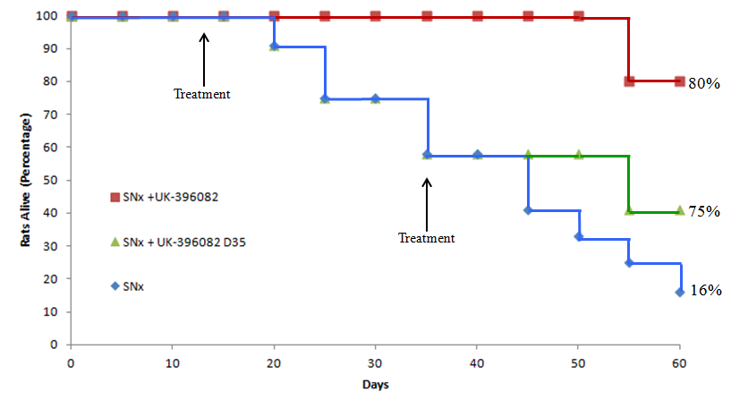
Figure 6.34: Animals were divided into SNx untreated (,Blue), SNx treated from day 14 (Prevention, Red) and SNx treated from day 35 (Reversal, Green). Animals were terminated when they showed signs of entering end-stage renal failure, or when they reached the upper limit of the Home Office guidelines for a moderate severity procedure. Data shown is percentage of rats alive against time, with start treatment times shown (Black arrows) and the percentage survival to day 60 shown as 16% in untreated animals, 80% in animals treated from day 14 and 75% in animals treated from day 35.

Figure 6.35: Cumulative Survival from day 35 post SNx following late treatment with UK396082 in experimental CKD
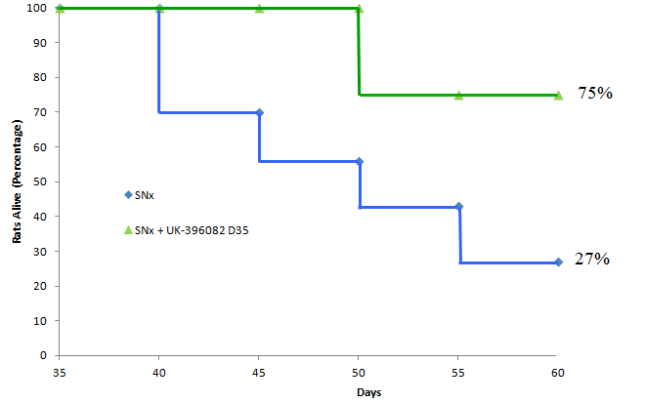
Figure 6.35: Animals were divided into SNx untreated (Blue) and SNx treated from day 35 (Reversal, Green). Animals were terminated when they showed signs of entering end-stage renal failure, or when they reached the upper limit of the Home Office guidelines for a moderate severity procedure. Data shown is the percentage of rats alive against time, with treatment commencing at day 35 and the percentage survival to day 60 calculated. Of the SNx animals surviving to day 35, 12 were selected at random and assigned to a UK-396082 treatment group. Percentage of untreated animal survival was based on all animals reaching day 35 acting as the denominator.

Figure 6.36: Terminal UK-396082 serum Concentration analysis in experimental CKD treated with TAFI inhibitor UK396082
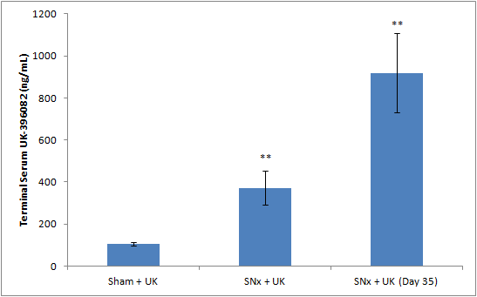
Figure 6.36: 0.3mLs blood was taken from the rat tail vein under anaesthesia at the time of termination. Blood was clotted and spun at 400xg for 15 minutes to obtain serum. Serum UK-396082 was determined by Pfizer, UK, by RP-HPLC. Data represents mean serum UK-396082 in ng/ml ±SEM. **p<0.01 (t-test) indicates significance against sham operated rats (n=5).

6.4 Discussion
Despite recent and significant increases in our understanding of the factors contributing to, and the processes of, chronic kidney disease, there is still no single effective therapeutic strategy to prevent its progression. The previous chapters demonstrated conclusively that in vitro inhibition of TAFI using UK-396082 resulted in a reduction in ECM levels in a cell culture model of kidney fibrosis and thus potentially this may be beneficial in vivo. Further that application of UK396082 in feed was an effective inhibitor of systemic TAFI activity at 60 mg/kg/day. Subsequently in this chapter the TAFI inhibitor UK-396082 has been applied in a 5/6th subtotal nephropathy model of chronic kidney disease with both early (day 14) and late (day 35) treatment arms.
In summary, UK-396082 applied at 60mg/kg/day was a highly effective anti-fibrotic agent. The survival rate with treatment from day 14 was 80%, and 75% from day 35, compared to 16% untreated and 25% of those untreated still alive at day 35. Serum TAFI activity was increased and plasmin activity decreased in the untreated SNx animals, with UK-396082 treatment reducing serum TAFI and increasing plasmin activity. Improved function was seen in the treatment animals, with serum creatinine lowered, creatinine clearance increased and proteinuria reduced with treatment. Scarring was reduced with total collagen reduced in the tubules and glomeruli with reductions seen in collagens I, III & IV along with laminin and fibronectin. This decrease in collagen was confirmed with total kidney hydroxyproline. UK-396082 treatment was shown to have no effect on blood pressure.
Initially, the SNx study was designed to run for 120 days as previously described in our laboratory (Yang et al., 2001, Johnson et al., 2007), however we found from periodic blood samples that the model was progressing faster than anticipated. In response to this, the duration of the model was lowered to 60 days. It is uncertain why the model progressed faster here than in previous studies. The volume of kidney resected (averaging 83%) was similar, and the overall procedure was identical to those performed previously by our group, and the SNx technique established in the literature (Johnson et al., 1997, Eddy et al., 1986, Lombet et al., 1989). However, the most likely cause is variation in the supplied rats as in recent years it has been noted by our group that disease post SNx develops at varying rates despite the same surgeon, food and strain of Wistar rat. Thus some flexibility in duration is required based on the rate of loss of kidney function.
Symptoms of renal failure began to appear in some animals following SNx surgery after just 20 days. These animals were terminated as their symptoms reached the upper limit of the home office guidelines for moderate severity procedures. These symptoms were, in every case, related to high serum creatinine (SCr) taken before termination. Indeed, by day 35 of the experiment, 40% of the untreated SNx animals had entered ESKF and been terminated. This may mean that the reversal arm was proceeding from a more substantial baseline than anticipated. We had wanted to start therapy at a stage equivalent to CKD stage 3 in man (i.e. lost approx. 50% of kidney function), however this is probably best assessed in the SNx model by a doubling of baseline SCr due to the hypertensive nature of the model and the resection which means that 40% loss of CrCl is fatal. However by 35 days in this model, the SCr was between 4 and 6 times baseline which we estimate equates better to CKD stage 4 and even 5 when their treatment began. Therefore the increased survival in the late treatment group is perhaps more impressive given the greater advancement of the disease. By day 60, only 16% of the untreated SNx animals remained outside of ESKF. In the group treated from day 14, 80% of the animals were still healthy and not showing signs of renal failure offering a dramatic improvement in survival. Of those animals alive at day 35, when the reversal arm began, 27% of the untreated animals survived to day 60. This increased to 75% with application of the UK-396082.
Due to this increased mortality, a secondary experiment was run and the data for these animals merged. Both SNx and SNx animals with treatment from day 35 had group members in this secondary experiment. This allowed the groups to retain statistical value and prevented any group from having an n-number too low. It was deemed that this was the best way to prevent this in light of the three R’s (Reduction, Replacement, and Refinement) rather than repeating the entire experiment. The disease seemed to progress at the same rate in these animals and the data from them integrated well with previous data. It is possibly, however, that the batch variation may have played a role here, with some animals being more resistant to fibrosis. However, as the animals were assigned treatment randomly, and the untreated animals progressed at the same rate as previously, it is unlikely that the animals treated from day 35 in this secondary experiment were more resistant to disease.
Serum concentrations of TAFI increased significantly following SNx surgery, with peak activity coming at day 21 and further time-points maintaining this elevated activity. SNx animals treated from day 14 show significantly reduced serum TAFI activity, showing that the TAFI inhibitor UK-396082 is lowering TAFI activity systemically. Treatment from day 35 also systemically reduced TAFI activity, with serum levels significantly lower than untreated animals at days 42 and 60. Interestingly, there seems to be a cut-off point of serum TAFI, above which survival is not possible in animals with CKD. All animals progressing to a TAFI activity of above 42% went into ESRF within 1-5 days, and the only death in the treated group was from an animal whose activity went above this. Closer monitoring could have meant that we were able to tailor individual diets to specific rats, with an increased dose being fed to any whose TAFI activity began to rise above 30%. Unfortunately, this was not possible in this study. This increase in TAFI activity is similar to the increase in TAFI activity seen in a horse-serum appoferritin (HSA) induced model of immune-complex (IMN)mediated nephropathy, and the subsequent decrease in TAFI knockout animals (Bruno et al., 2008b). However, a decrease in TAFI activity has been reported in the UUO model (Bruno et al., 2008a) which seems at odds with both our data and that of others. However the UUO model is one in which kidney function is maintained by the contralateral kidney and as such the effect of this may influence TAFI activity. It is possible, however, that the serum TAFI levels, which increased as GFR fell, could be due to a reduction in the clearance of TAFI by the failing kidney, and not a causative of renal disease.
Serum plasmin activity significantly decreased following the SNx procedure, suggesting that the systematic increase in TAFI activity can lead to a similarly systematic decrease in the levels of plasmin. This was also seen in wild-type mice subjected to HSA induced IMN. Treatment with UK-396082 supported this, with plasmin activity increasing in animals treated from days 14 and 35, as their TAFI activities fell, similar to the increase in TAFI knockout mice in the HSA-IMN model (Bruno et al., 2008b). There are also reports of an increase in plasmin seen in TAFI knockout animals subjected to the UUO model. Following UUO surgery, the TAFI KO animals have significantly elevated plasmin activity compared to the WT animals (Bruno et al., 2008a).
Unlike serum TAFI activity, there was no punitive ‘point-of-death’ for plasmin activity to go below. There was a general downwards trend in untreated animals and an upwards trend in treated animals. Indeed, the two animals entering ESRF after treatment from day 35 had plasmin levels within the range of sham animals. This seems to suggest that the manipulation of TAFI has either a more direct role than just affecting plasmin activity, or affects other systems at work here as well.
Despite the increase in serum TAFI translating to an increase in renal TAFI in the SNx animals, the decrease in plasmin was not seen in tissue levels. The implication of this is that plasmin activity is unchanged in the kidney. However, the fall in TAFI activity in the kidney should lead to an increase in plasmin activity. The failure of plasmin to increase when there is increased ECM production in a pro-scarring environment leads to a decrease in the homeostatic balance of deposition and clearance. This is restored with treatment with UK-396082, with all animals dosed having increased renal plasmin.
As serum was used, instead of plasma, it is possible that several clotting factors, including soluble fibrin, were not present in the assays for plasmin and TAFI. As both TAFI and plasmin activities were detected, this suggests that the two enzymes were present and active, but could be due to the specificity of the assays. If this were the case, then it re-enforces the possibility that a system other than the plasmin system is responsible for these changes.
Various methods were used to assess kidney function. Serum creatinine was shown to increase following SNx surgery, along with a reduction in creatinine clearance and an increase in proteinuria (showing glomerular damage) and serum urea. Treatment from day 14 seemed to improve renal function, with serum creatinine being lower, creatinine clearance higher, and both proteinuria and serum urea being lower in treated animals. Reversal treatment from day 35, also seemed to improve renal function, with reduced serum creatinine, improved creatinine clearance, reduced proteinuria and reduced serum urea in treated animals. This suggests that, as well as a systematic reduction in TAFI activity, treatment with UK-396082 has specific effects within the kidney and that these effects are instrumental in preserving kidney function following insult. That these effects are unrelated to hypertension underlines the importance of these results.
In this study, the use of 4 novel biomarkers of CKD progression identified in our laboratory was used to try and gain a better insight into the rate of disease progression and identify additional tools for any subsequent clinical trial. Increased urinary NGAL levels have been observed in patients with established renal failure (Bolignano et al., 2008). However, NGAL has typically been seen as a marker of acute renal injury (Mishra et al., 2006). It has been suggested that chronic renal damage can influence the balance of the protein, with increased NGAL production seen in chronically damaged tubular cells (Bolignano et al., 2008). The data presented here support the use of NGAL as a biomarker for CKD, with untreated SNx animals having urinary NGAL measurements which increase over time compared to static sham levels, culminating in a 700% increase in terminal samples. This increase was significantly reduced with treatment from day 14 (-48%) and day 35 (-30%) suggesting that UK-396082 prevents some of the tubular damage which occurs in CKD.
Kidney Injury Molecule 1 (kim-1) has been shown to be a good biomarker for renal injury for a number of reasons: kim-1 is expressed at only very low levels in the healthy kidney, it is up-regulated and inserted into the apical membrane of the proximal tubule and it persists in the epithelial cells (Bonventre, 2009). Serum creatinine and blood urea nitrogen are the classical markers of assessing renal function, but reflect changes in filtration capacity, rather than actual injury. Kim-1 is detectable in urine due to the rapid cleavage of its ectodomain into the lumens of renal tubules (Chaturvedi et al., 2009) and has been shown to increase in relation to the progression of CKD (Bonventre, 2009). The data presented is supported by these results, as we see no KIM-1 activity in sham animals, but significant levels in animals following surgery. Untreated animals, following SNx, show an increase in KIM-1 by week 4, however this does not increase between week 4 and the end of the study. Treatment from day 14 results in significantly lower KIM-1 activities at week 4 (-75%) and the time of termination (-72%). Treatment from day 35 also significantly reduces the amount of kim-1 seen in the urine at the time of termination (-30%). This supports the data from NGAL, suggesting that UK-396082 can prevent the tubular damage associated with CKD.
It has been shown in previous studies that increased levels of both serum and urinary TIMP-1 has a detrimental effect in terms of the progression of CKD (Da Silva, 2010b, Hansson et al., 2011, Liu et al., 2006) and in renal injury (Hoffmann et al., 2010). However, it has also been shown that in some examples of kidney disease, high serum TIMP-1 can be prognostic for survival, such as renal cancer (Pena et al., 2010). The data presented here shows that there is a significant increase in urinary TIMP-1 following SNx surgery. Untreated animals show an increase of around 200% by day 35, further increasing to 600% by day 60. However, treatment with UK-396082 from day 14, although having little effect by day 35, causes urinary TIMP-1 to increase dramatically (+800%) by day 60. Treatment from day 35 goes even further, with TIMP-1 levels increasing to 1200%. This data did not fit with initial expectations from human data that the level of TIMP-1 rises with the rate of CKD progression ((da Silva Lodge et al., 2013)) and thus we postulated that less damage would equate to less urinary TIMP-1. Opposingly the data suggested that increasing TIMP1 further was beneficial. However the reason for this is not clear from the available data as high TIMP-1 is associated with worse outcomes in models of CKD (Duymelinck et al., 2000). TAFI knockout mice have been shown to produce increased levels of MMPs 1, 2 & 9 in response to the HSA and UUO models of kidney disease (Bruno et al., 2008a, Bruno et al., 2008b), which could be responsible for the increase in TIMP-1 as increases in MMPs 1 & 9 have been shown to increase TIMP-1 production (Tamarina et al., 1997, Elmore et al., 1998).
Urinary transglutaminase-2 has recently been proposed as a possible biomarker for CKD progression, due to its role in the progression of the disease (Da Silva, 2010a, Johnson et al., 2007, Fisher et al., 2009). The data presented here supports this use of TG2 as a CKD biomarker as it correlates well with other parameters of damage. Sham levels of urinary TG2 remain static, whereas levels in untreated SNx animals increase dramatically (+150%) by day 35, and remain elevated until day 60. Treatment from day 14 reduces urinary TG2 by around 50% at day 35, and 25% by day 60. Treatment from day 35, however, does not significantly reduce urinary TG2 activity despite the mean being notably lower.
Masson’s trichrome data indicates that inhibition of TAFIa with UK-396082 was associated with an overall reduction of collagen at day 60 in both tubular and glomerular regions with treatment from day 14. With treatment from day 35, there was reduction in total glomerular collagen and a lack of further accumulation in tubular collagen, as supported by hydroxyproline amino acid analysis. There was also significant tubular atrophy with the tubules increasing in size and volume following the SNx procedure. This is also seen in the HSA and UUO models. In depth analysis shows reductions in collagen I in the tubulointerstitium with treatment from days 14 and 35, and in the glomerulus with treatment from day 14, and is prevented from increase with treatment from day 35. Collagen I appears to be the predominant ECM protein in the scarring process in this study and the one that shows the largest response to UK-396082. Collagen IV is reduced in the tubules and the glomerulus with treatment from day 14, and is prevented from increase in both with treatment from day 35. Collagen III is also reduced in the tubules with treatment from day 14. This data suggests that, while treatment seems effective in preventing the progression of glomerularsclerosis, it actively reverses the process of tubulointerstitial fibrosis. This is further supported by the reduction seen in kim-1 and NGAL, both of which are markers of tubular injury, and by data in the literature when a TAFI knockout has normalised total collagen and collagen I compared to wild type in an HSA model of IMN (Bruno et al., 2008b). However, matrix expansion and hydroxyproline levels are increased in the TAFI knockout mouse compared to a wild-type in a UUO model of renal damage(Bruno et al., 2008a) suggesting that the low-TAFI mechanism is not protective in all instances of renal disease.
The inhibition of TAFIa was also associated with a reduction of fibronectin in the tubules to baseline levels when treated from day 14, and a reduction when treated from day 35. In the glomerulus, fibronectin is reduced with treatment from day 14 and prevented from progression with treatment from day 35. Tubular laminin is significantly reduced in the tubules with treatment from both day 14 and day 35. In the glomerulus, laminin is slightly, but significantly, reduced with treatment from both time points. These results are very convincing in confirming our hypothesis that reduced TAFI and increased plasmin can have a positive effect in an in vivo model of CKD.
The serum concentration of UK-396082 was significantly elevated in animals with renal damage. This is due to the molecule being cleared through the kidney (Bunnage et al., 2007). Subsequently as the kidney becomes damaged and loses its ability to function correctly, filtration falls and the concentration of UK-396082 in the serum increases, leading to, effectively, an increased dose. It could be this increased dose that leads to such a beneficial effect in the animals treated from day 35. There were no side-effects observed as a result of this increased concentration however a upper toxicology limit for circulating UK-396082 has not been identified.
In conclusion, UK-396082 is a highly effective anti-fibrotic when applied in the SNx model of CKD, both as a preventative agent and in treating established CKD. The reduction seen in collagens suggests that the benefit of UK-396082 is mostly through protecting plasmin’s activation of MMPs, as collagens are poor plasmin substrates.
However, it is possible that the increased plasmin and reduced laminin and fibronectin could lead to a reduction in ECM accumulation, due to the lack of a laminin-fibronectin scaffold. This is an area that could be investigated further and expanded upon so the exact mode of action is better understood.
It is also possible that the TAFI inhibitor is working through a separate system entirely. As leupeptin, a serine protease inhibitor (and thus a plasmin inhibitor) was present in the STE buffer used to homogenise the samples, it is possible that the test for plasmin activity is not specific. This raises the possibility, as we see reduced collagen accumulation and reduced scarring, that TAFI may play a role in other systems, such as collagen deposition or a more direct role in the activation of MMPs, leading to this reduction in collagen.
The lack of effect on hypertension means that TAFI inhibition could be used therapeutically in conjunction with established practices such as ACE inhibitors and ARB therapy. The data presented here support the hypothesis that TAFI inhibition is a potential therapeutic target in kidney scarring and fibrosis.

Chapter Seven

Human Relevance

7.1 Introduction
The SNx model used in the previous chapter is the most widely used model of renal disease due to the reproducibility of the model and the characteristic developments, which closely mimic what is seen in human disease. Animal modelling is an important step in the development of a therapeutic, as the concept, though proven in a cell-culture environment, needs to be modelled in a living system before it can be deemed promising.
The data from the previous chapters provides compelling evidence that UK-396082 is a potent anti-fibrotic, and one which has considerable potential for therapeutic use. As an anti-thrombotic, UK-396082 has a clean toxicity screen and has been applied in phase 1 clinical trials, where it was well tolerated (Bunnage et al., 2007). The compound was given here with an IV bolus administration, with a human half-life of 4 hours, low clearance and a low volume of distribution. In a parallel study, oral dosing showed good bioavailability and dose-linear pharmacokinetics, which were unaffected by food (Bunnage et al., 2007).
A clinical trial of UK-396082 as a CKD therapeutic is outside the scope of this thesis, but, as the contribution of fibrinolytic impairment has been overlooked in the past, we attempted an evaluation of serum TAFI and plasmin activity with patients with CKD to see if this system was altered in human disease in a manner similar to which it is altered in the SNx model.

7.2 Results

7.2.1 Serum TAFI and plasmin activity are altered in patients with renal impairment and in rats following subtotal nephrectomy
To assess whether TAFI and plasmin activity are altered in patients with CKD, we analysed archival serum samples from individuals with a spectrum of disease presentation and renal impairment. Patients were non-diabetic and non-polycystic, all were diagnosed with CKD. Normal TAFI activity in humans was approximately 20μg/mL, but this increased to 50μg/mL in patients with CKD stages 4 and 5 (Fig 7.1B). In contrast, plasmin levels were 60-80μg/mL in normal individuals and reduced to 20-30μg/mL in patients with CKD stages 4 and 5 (Fig 7.1A). There was a strong correlation between the levels of TAFI and plasmin with eGFR (r=-0.793 and r=0.742 respectively) (Fig 7.1).

Figure 7.1: Human Serum Plasmin and TAFI Activity
Figure 7.1: Serum Plasmin (A) was measured by cleavage of the V0882 substrate (Sigma), Serum TAFI was by PeftaKit (Pentapharm, Swz) (B). Data represents individual eGFR and plasmin / TAFI activity for each sample. Correlation was measured using the Pearson product-moment correlation coefficient and the value of ‘r’ is displayed. (N= 7 for healthy volunteers – shown as blue squares, n= 31 for CKD patients, shown as red diamonds).

7.4 Discussion
In addition to the data from the SNx model in the previous chapter, this study has also shown for the first time that the SNx model closely mirrors the progression of human CKD in terms of fibrinolytic components, at least in the serum. We have shown strong correlations between falling eGFR and falling plasmin activity, along with increasing TAFI activity, in the serum. This data re-enforces the SNx study, as we saw similar increases in serum TAFI and reductions in serum plasmin in the untreated SNx animals, which were rescued with treatment with UK-396082, suggesting that this treatment may be equally beneficial in human patients. It is possible that the serum TAFI levels are only increased to a reduction in clearance by the failing kidney, therefore it is important to note that no causality can be assumed here. More work is needed to determine if TAFI is a potential driver of renal fibrosis.
The levels seen in normal patients were comparable with published data for both normal serum TAFI (Balcik et al., 2011) and plasminogen (Miyashita et al., 1988). That our data for plasmin activity is similar to published data for plasminogen suggests that, although most free plasmin is bound by α-2 antiplasmin (Collen, 1976, Aoki et al., 1978), it is still able to cleave our V0882 substrate. This suggests that the plasmin activity of the unbound plasmin, found on fibrin or ECM surfaces rather than in circulation (Lucas et al., 1983), would increase similarly.
There is now a clear need to test UK-396082 in other CKD models and more importantly in human disease.

Chapter Eight

General Discussion

Recent studies have suggested a link between Thrombin Activated Fibrinolysis Inhibitor and the accumulation of scar tissue in chronic kidney disease (Bruno et al., 2008b, Inbal et al., 2005). Other studies have shown that changes in plasmin activity, or the activity of its inhibitors, can have an effect on the progression of CKD (Oda et al., 2001, Eddy and Fogo, 2006). Further studies have established the link between TAFI and plasmin activity (Walker and Nesheim, 2001, Bajzar et al., 1995, Wang et al., 1998a). However, these previous studies did not establish how important the role plasmin is in the accumulation of ECM, with some even suggesting it was unimportant, and how much that can be affected by TAFI activity.
The overall aim of this study was to determine if a TAFI inhibitor could increase plasmin activity, and therefore reduce renal scarring, offering the possibility of a therapeutic intervention. To do this, it was necessary to assess the influence of the TAFI system on the plasmin and ECM systems in vitro, and then to apply a TAFI inhibitor to an in vitro model of renal scarring
In Chapter 3 the activities of several members of the plasmin system in several renal cell lines were investigated, and determined the effect of TAFI inhibition in these cells. This data revealed that a reduction in TAFI activity using UK-396082 can lead to an increase in plasmin activity in renal cells, similar to that seen with inhibition of PAI-1, suggesting that the increase of plasmin seen from reducing TAFI could have a similar beneficial effect to reducing PAI-1 (Eddy and Fogo, 2006).
Following this, the cell line NRK52E Tubular Epithelial Cells was selected for CKD modelling studies due to this cell line having the greatest response to the TAFI inhibitor in terms of TAFI reduction and plasmin increase, and also due to the lack of an increase in uPA seen in the other cells. In Chapter 4 the TAFI inhibitor UK-396082 was applied to an in vitro model of diabetic nephropathy whereby tubular epithelial cells are exposed to increasing concentrations of glucose (Skill et al., 2004) with and without a TAFI inhibitor and the level of ECM accumulation determined.
The data presented in this in vitro model showed that a reduction of TAFI activity lead to an increase in plasmin activity of +109% in kidney tubular epithelial cells. This observation is in agreement with the existing literature performed in TAFI knockout models which has shown an almost 100% increase in renal plasmin activity compared with wild type mice following unilateral ureteral obstruction (Bruno et al., 2008a). It has been shown previously that this model of diabetic nephropathy increases ECM accumulation (Ayo, Radnik et al. 1990; Skill, Johnson et al. 2004); however this is the first time these changes in ECM have been linked to changes in TAFI and plasmin activity in any in vitro model with specific reduction in collagens, with total collagen falling by 50% and both collagens I and IV being nearly completely normalised, with parallel reductions in both laminin and fibronectin (Atkinson et al., 2013).
The decision was taken on the strength of this data to move TAFI inhibitor UK-396082 into in vivo testing in a 5/6th subtotal nephrectomy (SNx) model of chronic kidney disease.
An effective dose was established in the dosing study undertaken in Chapter 5. This dose was then applied in the SNx model in Chapter 6 with UK-396082 applied at 60mg/kg/day. The data presented in this chapter showed that UK-396082 is a highly effective anti fibrotic agent. The survival rate with treatment from day 14 was 80%, and 75% from day 35, compared to 16% untreated and 25% of those untreated still alive at day 35. Serum TAFI activity was increased and plasmin activity decreased in the untreated SNx animals, with UK-396082 treatment reducing serum TAFI and increasing plasmin activity. Improved function was seen in the treatment animals, with serum creatinine lowered, creatinine clearance increased and proteinuria reduced with treatment. Scarring was reduced with total collagen reduced in the tubules and glomeruli with reductions seen in collagens I, III & IV along with laminin and fibronectin. This decrease in collagen was confirmed with total kidney hydroxyproline. UK-396082 treatment was shown to have no effect on blood pressure. With the confirmation in Chapter 7 that changes in plasmin and TAFI are present in human patients as well, the effectiveness of UK-396082 seems even more attractive.
The relationship between plasmin and TAFI is one that has been well established in terms of the coagulation and fibrinolytic cascades, with it being widely accepted that plasmin’s primary function is the cleavage of insoluble fibrin polymers at specific sites, resulting in soluble fragments (Walker and Nesheim, 1999). The role of plasmin has also been well established in degrading the extracellular matrix, wound healing, tissue repair, angiogenesis, embryogensis and pathogen and tumour cell invasion (Dano et al., 1985b, Strickland et al., 1976, Gross et al., 1983, Ossowski and Reich, 1983, Schafer et al., 1994).
It is only recently, however, that the relationship between TAFI and plasmin has been explored in the areas of ECM accumulation, scar tissue formation and wound healing. There have been several studies showing that TAFI activity plays a role in ECM accumulation, not all of them in agreement. TAFI knockout mice have been shown to have a reduced rate of decline in a horse serum apoferritin induced protein overload model of CKD (Bruno et al., 2008b). These mice have also been shown to have reduced wound healing and scar tissue formation in general (te Velde et al., 2003). They have also been shown to decline faster in a model of obstructive nephropathy (Bruno et al., 2008a). In the two papers by the Bruno group, TAFI deficiency was shown to be both protective and harmful. One of the key things that these papers identify is that these TAFI knockout mice produce elevated levels of plasmin.
The role of plasmin in renal disease has been debated for some time. It has been shown previously that reductions in PAI-1 were anti-fibrotic (Eddy and Fogo, 2006). However, the role of plasmin was not certain at this point, with plasmin activity shown to be similar in both wild type and PAI-1 null mice in response to the UUO model of renal injury. Other studies have been more favourable towards plasmin; it has been shown that TAFI knockout mice have increased plasmin activity, leading to reduced scarring, in response to immune complex-mediated glomerulonephritis (Bruno, Yano et al. 2008). Plasmin has also been shown to play a role in the inactivation and degradation of extracellular matrix proteins such as collagens, fibronectin and laminins (Netzel-Arnett et al., 2002, Bonnefoy and Legrand, 2000, Nakagami et al., 2000) along with blood proteins such as coagulation factor FVa, von Willebrand factor and thrombospondin (Bonnefoy and Legrand, 2000, Zeibdawi and Pryzdial, 2001, Hamilton et al., 1985).
There are only a few studies in the literature examining the contribution of changes in plasmin activity to the development of chronic kidney disease, however it has been shown that plasmin decreases with the progression of CKD (Ma et al., 2005) and decreases in PAI-1, which can lead to an increase in plasmin activity, are regarded as beneficial (Ma et al., 2005, Ma et al., 2006). It has also been noted that the effect of glucose on both MMP activity and plasmin activity could suggest a role for these components in diabetic nephropathy (McLennan et al., 2000). The work presented here, however, is the first time this has been linked to human disease. Although plasmin plays a role in the activation of MMPs, specifically MMPs 1, 3 & 9, it has been shown using transgenic mice that the increased expression of MMP-2 in renal proximal tubules can cause the mice to develop interstitial fibrosis and tubular atrophy (Cheng et al., 2006), suggesting that the role of MMPs in the formation and breakdown of fibrosis may not be as clear as we would like. Indeed, there is some speculation as to the beneficial effect of plasmin itself, with some studies showing that an increase in plasmin activity can have a negative effect in a UUO model (Edgtton et al., 2004). It is speculated that this is due to reduced plasmin leading to reduced MMP-2 expression.
The data presented here seems to sit very much on the ‘plasmin-positive’ side of the fence, with reductions in plasmin seen in both in vitro and in vivo models of renal disease. These models also showed increases in TAFI activity as they progressed. When this increase in TAFI was prevented, or even reversed, with UK-396082 we saw a concordant increase serum plasmin activity. This is in agreement with the increased plasmin levels seen by the Bruno group in TAFI knockout mice (Bruno et al., 2008a, Bruno et al., 2008b) and is as we predicted in our hypothesis. The beneficial effects of plasmin seem clear from the data presented in this thesis. There are significant increases in plasmin in response to the TAFI inhibitor in vitro and in vivo; both systemically and locally in the kidney. This is beneficial in both models, with reduced ECM accumulation in vitro, with reductions in collagens I and IV, laminin and fibronectin, and increased plasmin in vivo leading to increased renal function measured by serum creatinine, creatinine clearance and proteinuria. We also saw reductions in potential CKD urine biomarkers such as NGAL, KIM-1, TG2 and TIMP-1. In addition, the architecture of the kidney was improved with this increase in plasmin activity, with reductions in ECM accumulation shown by Masson’s Trichrome staining and hydroxyproline, with specific reductions in collagens I, III and IV, along with laminin and fibronectin. This data is in agreement with studies suggesting increased plasmin activity is protective in fibrosis (Bruno et al., 2008b, Kitching et al., 1997), however there is substantial evidence against plasmin as an attenuator of fibrosis, and significant evidence that it is in fact a promoter of fibrosis (Edgtton, 2004, Bruno et al., 2008a, Zhang et al., 2007a). Other studies suggest that plasmin activity has no effect at all on fibrosis, and involvement of tPA (Yang et al., 2002b) and PAI-1 (Oda et al., 2001) are independent of plasmin activity. Our data conflicts with these results, as we see a clear correlation between plasmin activity and reduced fibrosis and increased survival. It could be that our increase in plasmin is co-incidental and that the reduction of TAFI activity is working through some other method. This seems unlikely, given the previous evidence for plasmin’s involvement and our own data showing that removing plasmin using siRNA leads to increased ECM accumulation in vitro. Interestingly, increased tPA has been shown to be pro-fibrotic and responsible in part for EMT (Yang et al., 2002b) whereas our data showed an increase in tPA with treatment both in vitro in NRK49F and 1097 cells, and in vivo following SNx, as well as an increase in uPA as a result of SNx which was not altered with treatment. One of the major assumptions we have made about our data is that it is UK-396082’s protection and restoration of plasmin activity that is beneficial. There may, however, be many other pathways affected by TAFI, either directly or indirectly, which have yet to be elucidated that do not play a role through plasmin.
There seems to be a similarity between the knock-downs of PAI-1 and TAFI, with both of them shown to be beneficial in models of disease (Eddy and Fogo, 2006, Bruno et al., 2008b). Current understanding of both systems shows that neither affects plasmin directly, in fact they both work through affecting the activity of plasmin’s activators, with PAI-1 inhibiting uPA and tPA (Schaller and Gerber, 2011), and TAFI inhibiting tPA activity by modifying fibrin (Nesheim et al., 1997). In our cell culture work, we saw increases in uPA activity with application of the TAFI inhibitor in 1097 and NRK49F cells, but no change in tPA in any of the three cell lines. In vivo, however, we saw significant increases in tPA with treatment but no change in uPA with treatment. It is possible that fibrin does not act as a co-factor in the assay used and therefore an increase in tPA wouldn’t necessarily be expected in vitro. The pro/anti-fibrotic activities of tPA seem to be almost as hotly contested as plasmin, with reports that tPA deficiency is implicated in the pathogensis of crescentic glomerulonephritis (Kitching et al., 1997), with tPA treatment being reported to reduce glomerular matrix expansion (Haraguchi et al., 2001). These contrast with the reports that tPA can enhance renal fibrosis (Yang et al., 2002b) and may be harmful in fibrosis through the activation of MMP-9 (Kim et al., 2001). It seems that this rescue of tPA activity is as fraught with contradictions as the rescue of plasmin activity.
The TAFI knockout mouse has been shown to have increased levels of MMP-1 and MMP-9 in response to a protein overload model of renal disease (Bruno et al., 2008b). These MMPs are activated my plasmin (Nagase, 1997) and have also been shown to be elevated in PAI-1 knockouts (Gramley et al., 2007). However, once again, the pro/antifibrotic of these metalloproteinases cannot be agreed upon with MMP-9, which is abundant in the kidney, being shown to both decrease in UUO induced chronic injury and promote fibrosis (Kim et al., 2001), and also to promote fibrosis by degrading the tubular basement membrane and facilitating the migration of transdifferentiated tubular epithelia into the interstitium (Yang et al., 2002b). These differences could be down to dissimilarities in measuring. In homogenate studies, all cellular compartments are broken down and so the sum-total of the changes is analysed, rather than changes in individual compartments of the kidney.
The pro-fibrotic actions of both tPA and MMP-9, which are increased in TAFI knockouts and PAI-1 knockouts seem to mostly be down to their suspected involvement in epithelial-to-mesenchymal transition (EMT). Future work from the data generated in this thesis could be to investigate if MMP activity is increased and, in particular, if MMPs 2 and 9 are increased with UK-396082 treatment Along with the increase in tPA activity, this would seem to contradict the reports of these proteases increasing fibrosis by promoting EMT.
There are few other currently-known proteins that are acted upon by both TAFI and PAI-1 which could lead to an ‘off-plasmin’ effect of UK-396082. One possibility which could be explored in further work is that the increase in plasmin activity could lead to degradation of laminin and fibronectin, leading to reduced collagen matrix formation. Fibronectin is vital for the incorporation of many ECM proteins into the matrix, including collagens, fibulin, fibrillin, TGF-β binding protein and tenascin-C (Chung and Erickson, 1997, Dallas et al., 2005, Kadler et al., 2008, Sottile and Hocking, 2002, Twal et al., 2001). Some of these associate directly with the fibronectin fibrils, where others use the matrix as a scaffold. In addition to this, studies both in vitro and in vivo have shown that laminins are responsible for the organisation of the basement membranes with deficiencies in laminin preventing the formation of basement membranes (Yurchenco et al., 2004). This function of laminin is critical to the scaffolding of basement membranes and affects the formation much earlier than a reduction in collagen IV, nidogen or perlecan (Yurchenco et al., 2004, Willem et al., 2002). Reduced laminin and fibronectin are seen, along with increased plasmin (which degrades both laminin and fibronectin) in both our in vitro and in vivo data, which would, superficially, support this theory, but more work would be required to fully understand the mechanism by which a reduction in laminin and fibronectin affects ECM accumulation in models of CKD.
Plasmin(ogen) is mostly synthesised in the liver (Raum et al., 1980), but has been identified in a plethora of cell types from endothelial cells to pericytes and smooth muscle cells (Sato and Rifkin, 1989), as well as being seen in all three cell lines assessed in chapter 3 of this thesis. On the other hand, TAFI had not been as widely identified in individual cells, but had been reported in patients with diabetic nephropathy (Malyszko et al., 2004). Since this work began, TAFI has been identified in several cell types with links to inflammation and fibrosis (Ishii et al., 2009, Lin et al., 2011), and in other models of disease such as sepsis (Hayakawa et al., 2012) and inflammatory bowel disease (Owczarek et al., 2012) leaving behind somewhat its former characterisation as solely a member of the fibrinolytic system. It seems that recognition of TAFI as an important molecule in fibrosis and other diseases is now emerging, and inhibition seems to be an exciting new potential in terms of therapy for fibrosis.
The animal model used in this thesis, the 5/6th subtotal nephrectomy, has close parallels to the human progression of CKD. In both the SNx and in CKD we see a fall in plasmin levels and an increase in circulating TAFI. TAFI is most often thought of as originating from the liver, but as we have seen in this thesis, is also produced by a wide variety of cells. It is possible that the cytokines, hormones such as aldosterone and hypertension seen in both CKD and SNx lead to an increase in TAFI production from the liver, driving down plasmin activity through its effects on tPA. It is possible, however, that the TAFI is produced locally, as we see an increase in renal tissue TAFI as well as circulating TAFI in both SNx and human disease.
In this thesis we have demonstrated that TAFI inhibition is a potent anti-fibrotic therapy, with reductions in ECM accumulation and an increase in total survival both as a preventative and as an intervention. And addresses a situation seen in both animal models of disease and in the human disease. The TAFI inhibitor UK-396082 has been approved for use in humans and has a clean toxicology screen (Bunnage et al., 2007), meaning that it should have a relatively clear path to the clinic. The drug itself is cleared through the kidney and, as discussed in Chapter 6, this means that damaged kidneys tend to accumulate the drug, leading to higher serum concentrations. No side effects of this accumulation were observed in animals but, as the drug was developed as an anti-thrombotic originally (Bunnage et al., 2007), this accumulation could lead to some complications in humans such as increased bleeding or poor clot formation. However, complications of this kind have not been seen even in the TAFI knockout mouse, where TAFI deficiency did not lead to excess bleeding in a tail transection, or influence occlusion time in either arterial or venous injury models (Nagashima et al., 2002b). TAFI deficiency has been implicated in wound healing, however, with TAFI deficient mice taking longer to heal (te Velde et al., 2003). This would require monitoring, as wound healing is impaired in certain types of dialysis already (Tamura et al., 2003). However, one can not exclude the fact that fibrosis is aberrant wound healing and thus any effective intervention will almost certainly also affect normal would healing to some degree. As the drug has no effect on hypertension, then it could feasibly be given with both ACE and ARB therapy, which are currently used in treatment of CKD (Patel et al., 2007, Navaneethan et al., 2009).

References
1995. Effect of intensive therapy on the development and progression of diabetic nephropathy in the Diabetes Control and Complications Trial. The Diabetes Control and Complications (DCCT) Research Group. Kidney Int, 47, 1703-20.
ABBATE, M., ZOJA, C., MORIGI, M., ROTTOLI, D., ANGIOLETTI, S., TOMASONI, S., ZANCHI, C., LONGARETTI, L., DONADELLI, R. & REMUZZI, G. 2002. Transforming growth factor-beta1 is up-regulated by podocytes in response to excess intraglomerular passage of proteins: a central pathway in progressive glomerulosclerosis. Am J Pathol, 161, 2179-93.
ABSOOD, A., FURUTANI, A., KAWAMURA, T. & GRAHAM, L. M. 2004. A comparison of oxidized LDL-induced collagen secretion by graft and aortic SMCs: role of PDGF. Am J Physiol Heart Circ Physiol, 287, H1200-6.
ACKLEY, B. D., CREW, J. R., ELAMAA, H., PIHLAJANIEMI, T., KUO, C. J. & KRAMER, J. M. 2001. The NC1/endostatin domain of Caenorhabditis elegans type XVIII collagen affects cell migration and axon guidance. J Cell Biol, 152, 1219-32.
AGARWAL, R. 2005. Hypertension in chronic kidney disease and dialysis: pathophysiology and management. Cardiol Clin, 23, 237-48.
AHMED, A. K., HAYLOR, J. L., EL NAHAS, A. M. & JOHNSON, T. S. 2007. Localization of matrix metalloproteinases and their inhibitors in experimental progressive kidney scarring. Kidney International, 71, 755-763.
AIMES, R. T. & QUIGLEY, J. P. 1995. Matrix metalloproteinase-2 is an interstitial collagenase. Inhibitor-free enzyme catalyzes the cleavage of collagen fibrils and soluble native type I collagen generating the specific 3/4- and 1/4-length fragments. J Biol Chem, 270, 5872-6.
ALBERTS, B. 2002. Molecular Biology of the Cell, Garland.
ALESSI, M. C., PEIRETTI, F., MORANGE, P., HENRY, M., NALBONE, G. & JUHANVAGUE, I. 1997. Production of plasminogen activator inhibitor 1 by human adipose tissue. Possible link between visceral fat accumulation and vascular disease. Thrombosis and Haemostasis, P1455-P1455.
ALEXAKIS, C., GUETTOUFI, A., MESTRIES, P., STRUP, C., MATHE, D., BARBAUD, C., BARRITAULT, D., CARUELLE, J. P. & KERN, P. 2001. Heparan mimetic regulates collagen expression and TGF-beta 1 distribution in gamma-irradiated human intestinal smooth muscle cells. Faseb Journal, 15, 1546-1554.
ALEXOPOULOS, E., SERON, D., HARTLEY, R. B. & CAMERON, J. S. 1990. Lupus nephritis: correlation of interstitial cells with glomerular function. Kidney Int, 37, 100-9.
ALEXOPOULOS, E., SERON, D., HARTLEY, R. B., NOLASCO, F. & CAMERON, J. S. 1989. Immune mechanisms in idiopathic membranous nephropathy: the role of the interstitial infiltrates. Am J Kidney Dis, 13, 404-12.
ALFREY, A. C. 1994. Role of iron and oxygen radicals in the progression of chronic renal failure. Am J Kidney Dis, 23, 183-7.
ALONSO, J., MAMPASO, F., MARTIN, A., PALACIOS, I. & EGIDO, J. 1999. Changes in the pattern of fibronectin mRNA alternative splicing in acute experimental mesangioproliferative nephritis. Lab Invest, 79, 185-94.
ALPERS, C. E., HUDKINS, K. L., FLOEGE, J. & JOHNSON, R. J. 1994. Human renal cortical interstitial cells with some features of smooth muscle cells participate in tubulointerstitial and crescentic glomerular injury. J Am Soc Nephrol, 5, 201-9.
ALPERS, C. E., HUDKINS, K. L., GOWN, A. M. & JOHNSON, R. J. 1992a. Enhanced expression of "muscle-specific" actin in glomerulonephritis. Kidney Int, 41, 1134-42.
ALPERS, C. E., SEIFERT, R. A., HUDKINS, K. L., JOHNSON, R. J. & BOWEN-POPE, D. F. 1992b. Developmental patterns of PDGF B-chain, PDGF-receptor, and alpha-actin expression in human glomerulogenesis. Kidney Int, 42, 390-9.
ALTEMTAM, N., NAHAS, M. E. & JOHNSON, T. 2012. Urinary matrix metalloproteinase activity in diabetic kidney disease: a potential marker of disease progression. Nephron Extra, 2, 219-32.
AMENTO, E. P., EHSANI, N., PALMER, H. & LIBBY, P. 1991. Cytokines and growth factors positively and negatively regulate interstitial collagen gene expression in human vascular smooth muscle cells. Arterioscler Thromb, 11, 1223-30.
AMOUR, A., KNIGHT, C. G., WEBSTER, A., SLOCOMBE, P. M., STEPHENS, P. E., KNAUPER, V., DOCHERTY, A. J. & MURPHY, G. 2000. The in vitro activity of ADAM-10 is inhibited by TIMP-1 and TIMP-3. FEBS Lett, 473, 275-9.
ANDERSON, S., MEYER, T. W., RENNKE, H. G. & BRENNER, B. M. 1985. Control of glomerular hypertension limits glomerular injury in rats with reduced renal mass. J Clin Invest, 76, 612-9.
AOKI, N., MOROI, M. & TACHIYA, K. 1978. Effects of Alpha-2-Plasmin Inhibitor on Fibrin Clot Lysis - Its Comparison with Alpha-2-Macroglobulin. Thrombosis and Haemostasis, 39, 22-31.
APTE, S. S. 2009. A disintegrin-like and metalloprotease (reprolysin-type) with thrombospondin type 1 motif (ADAMTS) superfamily: functions and mechanisms. J Biol Chem, 284, 31493-7.
ARIKAWA-HIRASAWA, E., WATANABE, H., TAKAMI, H., HASSELL, J. R. & YAMADA, Y. 1999. Perlecan is essential for cartilage and cephalic development. Nat Genet, 23, 354-8.
ARTURSSON, P., UNGELL, A. L. & LOFROTH, J. E. 1993. Selective paracellular permeability in two models of intestinal absorption: cultured monolayers of human intestinal epithelial cells and rat intestinal segments. Pharm Res, 10, 1123-9.
ASHWORTH, J. L., KIELTY, C. M. & MCLEOD, D. 2000. Fibrillin and the eye. Br J Ophthalmol, 84, 1312-7.
ATABAI, K., JAME, S., AZHAR, N., KUO, A., LAM, M., MCKLEROY, W., DEHART, G., RAHMAN, S., XIA, D. D., MELTON, A. C., WOLTERS, P., EMSON, C. L., TURNER, S. M., WERB, Z. & SHEPPARD, D. 2009. Mfge8 diminishes the severity of tissue fibrosis in mice by binding and targeting collagen for uptake by macrophages. J Clin Invest, 119, 3713-22.
ATKINSON, J. M., PULLEN, N. & JOHNSON, T. S. 2013. An Inhibitor of Thrombin Activated Fibrinolysis Inhibitor (TAFI) can reduce Extracellular Matrix accumulation in an in vitro model of glucose induced ECM expansion. Matrix Biol.
AYO, S. H., RADNIK, R. A., GARONI, J. A., GLASS, W. F., 2ND & KREISBERG, J. I. 1990. High glucose causes an increase in extracellular matrix proteins in cultured mesangial cells. Am J Pathol, 136, 1339-48.
B. ALBERTS, A. J., J. LEWIS, M. RAFF, K. ROBERTS AND P. WALTER 2008. Molecular Biology of the Cell, New York, Garland Publishing.
BADER, B. L., SMYTH, N., NEDBAL, S., MIOSGE, N., BARANOWSKY, A., MOKKAPATI, S., MURSHED, M. & NISCHT, R. 2005. Compound genetic ablation of nidogen 1 and 2 causes basement membrane defects and perinatal lethality in mice. Mol Cell Biol, 25, 6846-56.
BAGGIOLINI, M. 1998. Chemokines and leukocyte traffic. Nature, 392, 565-8.
BAGSHAW, S. M., BERTHIAUME, L. R., DELANEY, A. & BELLOMO, R. 2008. Continuous versus intermittent renal replacement therapy for critically ill patients with acute kidney injury: a meta-analysis. Crit Care Med, 36, 610-7.
BAILEY, N. C. & KELLY, C. J. 1997. Nephritogenic T cells use granzyme C as a cytotoxic mediator. Eur J Immunol, 27, 2302-9.
BAJZAR, L. 2000. Thrombin activatable fibrinolysis inhibitor and an antifibrinolytic pathway. Arterioscler Thromb Vasc Biol, 20, 2511-8.
BAJZAR, L., MANUEL, R. & NESHEIM, M. E. 1995. Purification and characterization of TAFI, a thrombin-activable fibrinolysis inhibitor. J Biol Chem, 270, 14477-84.
BAJZAR, L., MORSER, J. & NESHEIM, M. 1996. TAFI, or plasma procarboxypeptidase B, couples the coagulation and fibrinolytic cascades through the thrombin-thrombomodulin complex. J Biol Chem, 271, 16603-8.
BAKER, N. L., MORGELIN, M., PEAT, R., GOEMANS, N., NORTH, K. N., BATEMAN, J. F. & LAMANDE, S. R. 2005. Dominant collagen VI mutations are a common cause of Ullrich congenital muscular dystrophy. Hum Mol Genet, 14, 279-93.
BAKRIS, G. L. & RITZ, E. 2009. The message for World Kidney Day 2009: Hypertension and kidney disease: a marriage that should be prevented. Nephrol Dial Transplant, 24, 695-7.
BALCIK, O. S., ALBAYRAK, M., UYAR, M. E., DAGDAS, S., YOKUS, O., CERAN, F., CIPIL, H., KOSAR, A. & OZET, G. 2011. Serum thrombin activatable fibrinolysis inhibitor levels in patients with newly diagnosed multiple myeloma. Blood Coagul Fibrinolysis, 22, 260-3.
BANDYOPADHYAY, R. S., PHELAN, M. & FALLER, D. V. 1995. Hypoxia induces AP-1-regulated genes and AP-1 transcription factor binding in human endothelial and other cell types. Biochim Biophys Acta, 1264, 72-8.
BARROW, J. C., NANTERMET, P. G., STAUFFER, S. R., NGO, P. L., STEINBEISER, M. A., MAO, S. S., CARROLL, S. S., BAILEY, C., COLUSSI, D., BOSSERMAN, M., BURLEIN, C., COOK, J. J., SITKO, G., TILLER, P. R., MILLER-STEIN, C. M., ROSE, M., MCMASTERS, D. R., VACCA, J. P. & SELNICK, H. G. 2003. Synthesis and evaluation of imidazole acetic acid inhibitors of activated thrombin-activatable fibrinolysis inhibitor as novel antithrombotics. J Med Chem, 46, 5294-7.
BASSUK, J. A. & BERG, R. A. 1989. Protein disulphide isomerase, a multifunctional endoplasmic reticulum protein. Matrix, 9, 244-58.
BATTEGAY, E. J., RAINES, E. W., SEIFERT, R. A., BOWEN-POPE, D. F. & ROSS, R. 1990. TGF-beta induces bimodal proliferation of connective tissue cells via complex control of an autocrine PDGF loop. Cell, 63, 515-24.
BAUD, L. & ARDAILLOU, R. 1993. Involvement of reactive oxygen species in kidney damage. Br Med Bull, 49, 621-9.
BAUER, E. A., STRICKLIN, G. P., JEFFREY, J. J. & EISEN, A. Z. 1975. Collagenase production by human skin fibroblasts. Biochem Biophys Res Commun, 64, 232-40.
BELIN, D., WOHLWEND, A., SCHLEUNING, W. D., KRUITHOF, E. K. & VASSALLI, J. D. 1989. Facultative polypeptide translocation allows a single mRNA to encode the secreted and cytosolic forms of plasminogen activators inhibitor 2. EMBO J, 8, 3287-94.
BENAZZOUG, Y., BORCHIELLINI, C., LABAT-ROBERT, J., ROBERT, L. & KERN, P. 1998. Effect of high-glucose concentrations on the expression of collagens and fibronectin by fibroblasts in culture. Exp Gerontol, 33, 445-55.
BENBOW, U. & BRINCKERHOFF, C. E. 1997. The AP-1 site and MMP gene regulation: what is all the fuss about? Matrix Biol, 15, 519-26.
BENDER, B. L., JAFFE, R., CARLIN, B. & CHUNG, A. E. 1981. Immunolocalization of entactin, a sulfated basement membrane component, in rodent tissues, and comparison with GP-2 (laminin). Am J Pathol, 103, 419-26.
BENNETT, N. T. & SCHULTZ, G. S. 1993. Growth factors and wound healing: biochemical properties of growth factors and their receptors. Am J Surg, 165, 728-37.
BENNETT, W. F., PAONI, N. F., KEYT, B. A., BOTSTEIN, D., JONES, A. J., PRESTA, L., WURM, F. M. & ZOLLER, M. J. 1991. High resolution analysis of functional determinants on human tissue-type plasminogen activator. J Biol Chem, 266, 5191-201.
BENYON, R. C. & ARTHUR, M. J. 2001. Extracellular matrix degradation and the role of hepatic stellate cells. Semin Liver Dis, 21, 373-84.
BERGE, A. & SJOBRING, U. 1993. PAM, a novel plasminogen-binding protein from Streptococcus pyogenes. J Biol Chem, 268, 25417-24.
BERGLIN, L., SARMAN, S., VAN DER PLOEG, I., STEEN, B., MING, Y., ITOHARA, S., SEREGARD, S. & KVANTA, A. 2003. Reduced choroidal neovascular membrane formation in matrix metalloproteinase-2-deficient mice. Invest Ophthalmol Vis Sci, 44, 403-8.
BERGMAN, S., KEY, B. O., KIRK, K. A., WARNOCK, D. G. & ROSTANT, S. G. 1996. Kidney disease in the first-degree relatives of African-Americans with hypertensive end-stage renal disease. Am J Kidney Dis, 27, 341-6.
BERL, T. & HENRICH, W. 2006. Kidney-heart interactions: Epidemiology, pathogenesis, and treatment. Clinical Journal of the American Society of Nephrology, 1, 8-18.
BERNIK, M. B. & KWAAN, H. C. 1969. Plasminogen activator activity in cultures from human tissues. An immunological and histochemical study. J Clin Invest, 48, 1740-53.
BIDANI, A. K., MITCHELL, K. D., SCHWARTZ, M. M., NAVAR, L. G. & LEWIS, E. J. 1990. Absence of glomerular injury or nephron loss in a normotensive rat remnant kidney model. Kidney International, 38, 28-38.
BIRK, D. E. & TRELSTAD, R. L. 1984. Extracellular Compartments in Matrix Morphogenesis - Collagen Fibril, Bundle, and Lamellar Formation by Corneal Fibroblasts. Journal of Cell Biology, 99, 2024-2033.
BIRK, D. E. & TRELSTAD, R. L. 1986. Extracellular Compartments in Tendon Morphogenesis - Collagen Fibril, Bundle, and Macroaggregate Formation. Journal of Cell Biology, 103, 231-240.
BOFFA, M. B., WANG, W., BAJZAR, L. & NESHEIM, M. E. 1998. Plasma and recombinant thrombin-activable fibrinolysis inhibitor (TAFI) and activated TAFI compared with respect to glycosylation, thrombin/thrombomodulin-dependent activation, thermal stability, and enzymatic properties. J Biol Chem, 273, 2127-35.
BOHLE, A., CHRIST, H., GRUND, K. E. & MACKENSEN, S. 1979. The role of the interstitium of the renal cortex in renal disease. Contrib Nephrol, 16, 109-14.
BOLIGNANO, D., DONATO, V., COPPOLINO, G., CAMPO, S., BUEMI, A., LACQUANITI, A. & BUEMI, M. 2008. Neutrophil gelatinase-associated lipocalin (NGAL) as a marker of kidney damage. Am J Kidney Dis, 52, 595-605.
BONNEFOY, A. & LEGRAND, C. 2000. Proteolysis of subendothelial adhesive glycoproteins (fibronectin, thrombospondin, and von Willebrand factor) by plasmin, leukocyte cathepsin G, and elastase. Thrombosis Research, 98, 323-332.
BONVENTRE, J. V. 2009. Kidney injury molecule-1 (KIM-1): a urinary biomarker and much more. Nephrol Dial Transplant, 24, 3265-8.
BOOKS, M. H. 1998. Oxford Concise Colour Medical Dictionary, Oxford Paperbacks.
BOOR, P., KONIECZNY, A., VILLA, L., KUNTER, U., VAN ROEYEN, C. R. C., LAROCHELLE, W. J., SMITHSON, G., ARROL, S., OSTENDORF, T. & FLOEGE, J. 2007. PDGF-D inhibition by CR002 ameliorates tubulointerstitial fibrosis following experimental glomerulonephritis. Nephrology Dialysis Transplantation, 22, 1323-1331.
BORDER, W. A. 1994. Transforming growth factor-beta and the pathogenesis of glomerular diseases. Curr Opin Nephrol Hypertens, 3, 54-8.
BORNSTEIN, P. 1992. Thrombospondins: structure and regulation of expression. FASEB J, 6, 3290-9.
BOUMA, B. N. & MEIJERS, J. C. 2004. New insights into factors affecting clot stability: A role for thrombin activatable fibrinolysis inhibitor (TAFI; plasma procarboxypeptidase B, plasma procarboxypeptidase U, procarboxypeptidase R). Semin Hematol, 41, 13-9.
BRADFORD, J. R. 1899. The results following partial Nephrectomy and the influence of the Kidney on Metabolism. J Physiol, 23, 415-96.
BRADY, H. R. 1994. Leukocyte adhesion molecules and kidney diseases. Kidney Int, 45, 1285-300.
BRANTON, M. H. & KOPP, J. B. 1999. TGF-beta and fibrosis. Microbes Infect, 1, 1349-65.
BRENNER, B. M. & CHERTOW, G. M. 1993. Congenital oligonephropathy: an inborn cause of adult hypertension and progressive renal injury? Curr Opin Nephrol Hypertens, 2, 691-5.
BRENNER, B. M., MEYER, T. W. & HOSTETTER, T. H. 1982. Dietary protein intake and the progressive nature of kidney disease: the role of hemodynamically mediated glomerular injury in the pathogenesis of progressive glomerular sclerosis in aging, renal ablation, and intrinsic renal disease. N Engl J Med, 307, 652-9.
BRENNER, D. A. & CHOJKIER, M. 1987. Acetaldehyde Increases Collagen Gene-Transcription in Cultured Human-Fibroblasts. Journal of Biological Chemistry, 262, 17690-17695.
BREW, K. & NAGASE, H. 2010. The tissue inhibitors of metalloproteinases (TIMPs): an ancient family with structural and functional diversity. Biochim Biophys Acta, 1803, 55-71.
BREZIS, M. & ROSEN, S. 1995. Hypoxia of the renal medulla--its implications for disease. N Engl J Med, 332, 647-55.
BREZIS, M., ROSEN, S., SILVA, P. & EPSTEIN, F. H. 1984. Renal ischemia: a new perspective. Kidney Int, 26, 375-83.
BRINCKERHOFF, C. E. & MATRISIAN, L. M. 2002. Matrix metalloproteinases: a tail of a frog that became a prince. Nat Rev Mol Cell Biol, 3, 207-14.
BROOKS, P. C., STROMBLAD, S., SANDERS, L. C., VON SCHALSCHA, T. L., AIMES, R. T., STETLER-STEVENSON, W. G., QUIGLEY, J. P. & CHERESH, D. A. 1996. Localization of matrix metalloproteinase MMP-2 to the surface of invasive cells by interaction with integrin alpha v beta 3. Cell, 85, 683-93.
BROWNER, M. F., SMITH, W. W. & CASTELHANO, A. L. 1995. Matrilysin-inhibitor complexes: common themes among metalloproteases. Biochemistry, 34, 6602-10.
BRUNO, N. E., YANO, Y., TAKEI, Y., GABAZZA, E. C., QIN, L., NAGASHIMA, M., MORSER, J., D'ALESSANDRO-GABAZZA, C. N., TAGUCHI, O. & SUMIDA, Y. 2008a. Protective role of thrombin activatable fibrinolysis inhibitor in obstructive nephropathy-associated tubulointerstitial fibrosis. J Thromb Haemost, 6, 139-46.
BRUNO, N. E., YANO, Y., TAKEI, Y., QIN, L., SUZUKI, T., MORSER, J., D'ALESSANDRO-GABAZZA, C. N., MIZOGUCHI, A., SUZUKI, K., TAGUCHI, O., GABAZZA, E. C. & SUMIDA, Y. 2008b. Immune complex-mediated glomerulonephritis is ameliorated by thrombin-activatable fibrinolysis inhibitor deficiency. Thromb Haemost, 100, 90-100.
BRUNO, N. E., YANO, Y., TAKEI, Y., QIN, L., SUZUKI, T., MORSER, J., D'ALESSANDRO-GABAZZA, C. N., MIZOGUCHI, A., SUZUKI, K., TAGUCHI, O., GABAZZA, E. C. & SUMIDA, Y. 2008c. Immune complex-mediated glomerulonephritis is ameliorated by thrombin-activatable fibrinolysis inhibitor deficiency. Thrombosis and Haemostasis, 100, 90-100.
BUCK, K. & FEEHALLY, J. 1997. Diabetes and renal failure in Indo-Asians in the UK-a paradigm for the study of disease susceptibility. Nephrol. Dial. Transplant., 12, 1555-1560.
BUELENS, K., HASSANZADEH-GHASSABEH, G., MUYLDERMANS, S., GILS, A. & DECLERCK, P. J. Generation and characterization of inhibitory nanobodies towards thrombin activatable fibrinolysis inhibitor. J Thromb Haemost, 8, 1302-12.
BUKO, A. M., KENTZER, E. J., PETROS, A., MENON, G., ZUIDERWEG, E. R. & SARIN, V. K. 1991. Characterization of a posttranslational fucosylation in the growth factor domain of urinary plasminogen activator. Proc Natl Acad Sci U S A, 88, 3992-6.
BUNNAGE, M. E., BLAGG, J., STEELE, J., OWEN, D. R., ALLERTON, C., MCELROY, A. B., MILLER, D., RINGER, T., BUTCHER, K., BEAUMONT, K., EVANS, K., GRAY, A. J., HOLLAND, S. J., FEEDER, N., MOORE, R. S. & BROWN, D. G. 2007. Discovery of potent & selective inhibitors of activated thrombin-activatable fibrinolysis inhibitor for the treatment of thrombosis. J Med Chem, 50, 6095-103.
BURGIN, J. & SCHALLER, J. 1999. Expression, isolation and characterization of a mutated human plasminogen kringle 3 with a functional lysine binding site. Cellular and Molecular Life Sciences, 55, 135-141.
BURNS, W. C., TWIGG, S. M., FORBES, J. M., PETE, J., TIKELLIS, C., THALLAS-BONKE, V., THOMAS, M. C., COOPER, M. E. & KANTHARIDIS, P. 2006. Connective tissue growth factor plays an important role in advance glycation end product-induced tubular epithelial-to-mesenchymal transition: Implications for diabetic renal disease. Journal of the American Society of Nephrology, 17, 2484-2494.
BYEON, I. J. & LLINAS, M. 1991. Solution structure of the tissue-type plasminogen activator kringle 2 domain complexed to 6-aminohexanoic acid an antifibrinolytic drug. J Mol Biol, 222, 1035-51.
CACHOFEIRO, V., GOICOCHEA, M., DE VINUESA, S. G., OUBINA, P., LAHERA, V. & LUNO, J. 2008. Oxidative stress and inflammation, a link between chronic kidney disease and cardiovascular disease. Kidney International, 74, S4-S9.
CANTIN, M. 1971. Ultrastructure of Juxtaglomerular Apparatus and of Glomerulus in Magnesium-Deficient Rats. Laboratory Investigation, 24, 425-&.
CANTY, E. G. & KADLER, K. E. 2005. Procollagen trafficking, processing and fibrillogenesis. Journal of Cell Science, 118, 1341-1353.
CAO, J., REHEMTULLA, A., BAHOU, W. & ZUCKER, S. 1996. Membrane type matrix metalloproteinase 1 activates pro-gelatinase A without furin cleavage of the N-terminal domain. J Biol Chem, 271, 30174-80.
CARRELL, R. W. B., D.R 1986. Serpins: the superfamily of plasma serine protease inhibitors. Proteinase Inhibitors, Barret, Salvesen, eds., 403-420.
CATERINA, J. J., YAMADA, S., CATERINA, N. C., LONGENECKER, G., HOLMBACK, K., SHI, J., YERMOVSKY, A. E., ENGLER, J. A. & BIRKEDAL-HANSEN, H. 2000. Inactivating mutation of the mouse tissue inhibitor of metalloproteinases-2(Timp-2) gene alters proMMP-2 activation. J Biol Chem, 275, 26416-22.
CATTELL, V. 2002. Nitric oxide and glomerulonephritis. Kidney Int, 61, 816-21.
CAWSTON, T. E., GALLOWAY, W. A., MERCER, E., MURPHY, G. & REYNOLDS, J. J. 1981. Purification of rabbit bone inhibitor of collagenase. Biochem J, 195, 159-65.
CESARMAN, G. M., GUEVARA, C. A. & HAJJAR, K. A. 1994. An endothelial cell receptor for plasminogen/tissue plasminogen activator (t-PA). II. Annexin II-mediated enhancement of t-PA-dependent plasminogen activation. J Biol Chem, 269, 21198-203.
CHAKRABORTI, S., MANDAL, M., DAS, S., MANDAL, A. & CHAKRABORTI, T. 2003. Regulation of matrix metalloproteinases: an overview. Mol Cell Biochem, 253, 269-85.
CHANA, R. S., WHEELER, D. C., THOMAS, G. J., WILLIAMS, J. D. & DAVIES, M. 2000. Low-density lipoprotein stimulates mesangial cell proteoglycan and hyaluronan synthesis. Nephrol Dial Transplant, 15, 167-72.
CHANUTIN A, F. E. 1932. Experimental renal insufficiency produced by partial nephrectomy. Arch Intern Med, 49, 767-87.
CHAPMAN, J. A. 1974. The staining pattern of collagen fibrils. I. An analysis of electron micrographs. Connect Tissue Res, 2, 137-50.
CHATURVEDI, S., FARMER, T. & KAPKE, G. F. 2009. Assay validation for KIM-1: human urinary renal dysfunction biomarker. Int J Biol Sci, 5, 128-34.
CHEN, A. & DAVIS, B. H. 2000. The DNA binding protein BTEB mediates acetaldehyde-induced, jun N-terminal kinase-dependent alphaI(I) collagen gene expression in rat hepatic stellate cells. Mol Cell Biol, 20, 2818-26.
CHEN, P., PODDAR, R., TIPA, E. V., DIBELLO, P. M., MORAVEC, C. D., ROBINSON, K., GREEN, R., KRUGER, W. D., GARROW, T. A. & JACOBSEN, D. W. 1999. Homocysteine metabolism in cardiovascular cells and tissues: implications for hyperhomocysteinemia and cardiovascular disease. Adv Enzyme Regul, 39, 93-109.
CHENG, S., POLLOCK, A. S., MAHIMKAR, R., OLSON, J. L. & LOVETT, D. H. 2006. Matrix metalloproteinase 2 and basement membrane integrity: a unifying mechanism for progressive renal injury. FASEB J, 20, 1898-900.
CHIEN, S., LI, S. & SHYY, Y. J. 1998. Effects of mechanical forces on signal transduction and gene expression in endothelial cells. Hypertension, 31, 162-9.
CHOBANIAN, A. V., BAKRIS, G. L., BLACK, H. R., CUSHMAN, W. C., GREEN, L. A., IZZO, J. L., JONES, D. W., MATERSON, B. J., OPARIL, S., WRIGHT, J. T., ROCCELLA, E. J. & PROG, N. H. B. P. E. 2003. Seventh Report of the Joint National Committee on Prevention, Detection, Evaluation, and Treatment of High Blood Pressure. Hypertension, 42, 1206-1252.
CHOW, F., OZOLS, E., NIKOLIC-PATERSON, D. J., ATKINS, R. C. & TESCH, G. H. 2004. Macrophages in mouse type 2 diabetic nephropathy: correlation with diabetic state and progressive renal injury. Kidney Int, 65, 116-28.
CHOW KM, L. Z., CHANG TMS 2003. Animal Remnant Kidney Model of Chronic Renal Failure Revisited. Hong Kong J Nephrol, 5, 57-64.
CHRISTENSEN, S., VALNICKOVA, Z., THOGERSEN, I. B., OLSEN, E. H. & ENGHILD, J. J. 1997. Assignment of a single disulphide bridge in human alpha2-antiplasmin: implications for the structural and functional properties. Biochem J, 323 ( Pt 3), 847-52.
CHRISTENSEN, U. & CLEMMENSEN, I. 1977. Kinetic properties of the primary inhibitor of plasmin from human plasma. Biochem J, 163, 389-91.
CHUNG, C. Y. & ERICKSON, H. P. 1997. Glycosaminoglycans modulate fibronectin matrix assembly and are essential for matrix incorporation of tenascin-C. J Cell Sci, 110 ( Pt 12), 1413-9.
CHURCH, R. L., PFEIFFER, S. E. & TANZER, M. L. 1971. Collagen Biosynthesis - Synthesis and Secretion of a High Molecular Weight Collagen Precursor (Procollagen). Proceedings of the National Academy of Sciences of the United States of America, 68, 2638-&.
CLARK, I. M. & CAWSTON, T. E. 1992. Fragments of human fibroblast collagenase: purification and characterisation. Matrix Suppl, 1, 73.
CLEMMENSEN, I., THORSEN, S., MULLERTZ, S. & PETERSEN, L. C. 1981. Properties of three different molecular forms of the alpha 2 plasmin inhibitor. Eur J Biochem, 120, 105-12.
COIMBRA, T. M., CARVALHO, J., FATTORI, A., DA SILVA, C. G. & LACHAT, J. J. 1996. Transforming growth factor-beta production during the development of renal fibrosis in rats with subtotal renal ablation. Int J Exp Pathol, 77, 167-73.
COLLEN, D. 1976. Identification and Some Properties of a New Fast-Reacting Plasmin Inhibitor in Human-Plasma. European Journal of Biochemistry, 69, 209-216.
COLLEN, D. & LIJNEN, H. R. 1991. Basic and clinical aspects of fibrinolysis and thrombolysis. Blood, 78, 3114-24.
COLLINS, S. J., ALEXANDER, S. L., LOPEZ-GUISA, J. M., CAI, X., MARUVADA, R., CHUA, S. C., ZHANG, G., OKAMURA, D. M., MATSUO, S. & EDDY, A. A. 2006. Plasminogen activator inhibitor-1 deficiency has renal benefits but some adverse systemic consequences in diabetic mice. Nephron Exp Nephrol, 104, e23-34.
COSTELL, M., GUSTAFSSON, E., ASZODI, A., MORGELIN, M., BLOCH, W., HUNZIKER, E., ADDICKS, K., TIMPL, R. & FASSLER, R. 1999. Perlecan maintains the integrity of cartilage and some basement membranes. J Cell Biol, 147, 1109-22.
COUCHMAN, J. R., BEAVAN, L. A. & MCCARTHY, K. J. 1994. Glomerular matrix: synthesis, turnover and role in mesangial expansion. Kidney Int, 45, 328-35.
CREELY, J. J., COMMERS, P. A. & HARALSON, M. A. 1988. Synthesis of type III collagen by cultured kidney epithelial cells. Connect Tissue Res, 18, 107-22.
CREELY, J. J., DIMARI, S. J., HOWE, A. M. & HARALSON, M. A. 1992. Effects of transforming growth factor-beta on collagen synthesis by normal rat kidney epithelial cells. Am J Pathol, 140, 45-55.
CUFI, S., VAZQUEZ-MARTIN, A., OLIVERAS-FERRAROS, C., MARTIN-CASTILLO, B., JOVEN, J. & MENENDEZ, J. A. 2010. Metformin against TGF beta-induced epithelial-to-mesenchymal transition (EMT) From cancer stem cells to aging-associated fibrosis. Cell Cycle, 9, 4461-4468.
CYBULSKY, A. V. 2000. Growth factor pathways in proliferative glomerulonephritis. Curr Opin Nephrol Hypertens, 9, 217-23.
D'ARDENNE, A. J., BURNS, J., SYKES, B. C. & KIRKPATRICK, P. 1983. Comparative distribution of fibronectin and type III collagen in normal human tissues. J Pathol, 141, 55-69.
DA SILVA LODGE, M., NAHAS, M. E. & JOHNSON, T. S. 2013. Urinary transglutaminase 2 as a potential biomarker of chronic kidney disease detection and progression. The Lancet, 381, Supplement 1, S33.
DA SILVA, M. Year. Urinary Transglutaminase 2 (TG2) as a potential biomarker of Chronic Kidney Disease detection and progression. In: Gordon Conference 2010a USA.
DA SILVA, M. Year. Urinary ε- γ (glutamyl) lysine: A novel biomarker of Chronic Kidney Disease. In: BRS/RA Conference, 2010b UK.
DALLAS, S. L., SIVAKUMAR, P., JONES, C. J., CHEN, Q., PETERS, D. M., MOSHER, D. F., HUMPHRIES, M. J. & KIELTY, C. M. 2005. Fibronectin regulates latent transforming growth factor-beta (TGF beta) by controlling matrix assembly of latent TGF beta-binding protein-1. J Biol Chem, 280, 18871-80.
DANO, K., ANDREASEN, P. A., GRONDAHL-HANSEN, J., KRISTENSEN, P., NIELSEN, L. S. & SKRIVER, L. 1985a. Plasminogen activators, tissue degradation, and cancer. Adv Cancer Res, 44, 139-266.
DANO, K., ANDREASEN, P. A., GRONDAHLHANSEN, J., KRISTENSEN, P., NIELSEN, L. S. & SKRIVER, L. 1985b. Plasminogen Activators, Tissue Degradation, and Cancer. Advances in Cancer Research, 44, 139-266.
DANTZLER, W. 1992. Comparative Aspects of Renal Function. The Kidney; Physiology and Pathophysiology
DAVIES, M. J. 2000. The pathophysiology of acute coronary syndromes. Heart, 83, 361-6.
DAVIS, R. L., SHRIMPTON, A. E., HOLOHAN, P. D., BRADSHAW, C., FEIGLIN, D., COLLINS, G. H., SONDEREGGER, P., KINTER, J., BECKER, L. M., LACBAWAN, F., KRASNEWICH, D., MUENKE, M., LAWRENCE, D. A., YERBY, M. S., SHAW, C. M., GOOPTU, B., ELLIOTT, P. R., FINCH, J. T., CARRELL, R. W. & LOMAS, D. A. 1999. Familial dementia caused by polymerization of mutant neuroserpin. Nature, 401, 376-9.
DE VINUESA, S. G., GOICOECHEA, M., KANTER, J., PUERTA, M., CACHOFEIRO, V., LAHERA, V., GOMEZ-CAMPDERA, F. & LUNO, J. 2006. Insulin resistance, inflammatory biomarkers, and adipokines in patients with chronic kidney disease: effects of angiotensin II blockade. J Am Soc Nephrol, 17, S206-12.
DE VOS, A. M., ULTSCH, M. H., KELLEY, R. F., PADMANABHAN, K., TULINSKY, A., WESTBROOK, M. L. & KOSSIAKOFF, A. A. 1992. Crystal structure of the kringle 2 domain of tissue plasminogen activator at 2.4-A resolution. Biochemistry, 31, 270-9.
DE VRIES, C., VEERMAN, H. & PANNEKOEK, H. 1989. Identification of the domains of tissue-type plasminogen activator involved in the augmented binding to fibrin after limited digestion with plasmin. J Biol Chem, 264, 12604-10.
DEVARAJAN, P. 2010. Review: neutrophil gelatinase-associated lipocalin: a troponin-like biomarker for human acute kidney injury. Nephrology (Carlton), 15, 419-28.
DIEPEVEEN, S. H., WETZELS, J. F., BILO, H. J., VAN TITS, L. J. & STALENHOEF, A. F. 2008. Cholesterol in end-stage renal disease: the good, the bad or the ugly? Neth J Med, 66, 53-61.
DISCHER, D. E., MOONEY, D. J. & ZANDSTRA, P. W. 2009. Growth factors, matrices, and forces combine and control stem cells. Science, 324, 1673-7.
DOBASHI, K., GHOSH, B., ORAK, J. K., SINGH, I. & SINGH, A. K. 2000. Kidney ischemia-reperfusion: modulation of antioxidant defenses. Mol Cell Biochem, 205, 1-11.
DOUGLASS, A., WALLACE, K., PARR, R., PARK, J., DURWARD, E., BROADBENT, I., BARELLE, C., PORTER, A. J. & WRIGHT, M. C. 2008. Antibody-targeted myofibroblast apoptosis reduces fibrosis during sustained liver injury. J Hepatol, 49, 88-98.
DOUTHWAITE, J. A., JOHNSON, T. S., HAYLOR, J. L., WATSON, P. & EL NAHAS, A. M. 1999a. Effects of transforming growth factor-beta1 on renal extracellular matrix components and their regulating proteins. J Am Soc Nephrol, 10, 2109-19.
DOUTHWAITE, J. A., JOHNSON, T. S., HAYLOR, J. L., WATSON, P. & EL NAHAS, A. M. 1999b. Effects of transforming growth factor-beta 1 on renal extracellular matrix components and their regulating proteins. Journal of the American Society of Nephrology, 10, 2109-2119.
DREW, A. F., LIU, H., DAVIDSON, J. M., DAUGHERTY, C. C. & DEGEN, J. L. 2001. Wound-healing defects in mice lacking fibrinogen. Blood, 97, 3691-8.
DUFFY, M. J. 1990. Plasminogen activators and cancer. Blood Coagul Fibrinolysis, 1, 681-7.
DUMIN, J. A., DICKESON, S. K., STRICKER, T. P., BHATTACHARYYA-PAKRASI, M., ROBY, J. D., SANTORO, S. A. & PARKS, W. C. 2001. Pro-collagenase-1 (matrix metalloproteinase-1) binds the alpha(2)beta(1) integrin upon release from keratinocytes migrating on type I collagen. J Biol Chem, 276, 29368-74.
DUNSMORE, S. E., SAARIALHO-KERE, U. K., ROBY, J. D., WILSON, C. L., MATRISIAN, L. M., WELGUS, H. G. & PARKS, W. C. 1998. Matrilysin expression and function in airway epithelium. J Clin Invest, 102, 1321-31.
DUYMELINCK, C., DAUWE, S. E., DE GREEF, K. E., YSEBAERT, D. K., VERPOOTEN, G. A. & DE BROE, M. E. 2000. TIMP-1 gene expression and PAI-1 antigen after unilateral ureteral obstruction in the adult male rat. Kidney Int, 58, 1186-201.
EATON, D. L., MALLOY, B. E., TSAI, S. P., HENZEL, W. & DRAYNA, D. 1991. Isolation, molecular cloning, and partial characterization of a novel carboxypeptidase B from human plasma. J Biol Chem, 266, 21833-8.
ECKARDT, K. U., BERNHARDT, W. M., WEIDEMANN, A., WARNECKE, C., ROSENBERGER, C., WIESENER, M. S. & WILLAM, C. 2005. Role of hypoxia in the pathogenesis of renal disease. Kidney Int Suppl, S46-51.
EDDY, A. A. 1989. Interstitial nephritis induced by protein-overload proteinuria. Am J Pathol, 135, 719-33.
EDDY, A. A. 1996. Molecular insights into renal interstitial fibrosis. J Am Soc Nephrol, 7, 2495-508.
EDDY, A. A. 2000. Molecular basis of renal fibrosis. Pediatr Nephrol, 15, 290-301.
EDDY, A. A. 2009. Serine proteases, inhibitors and receptors in renal fibrosis. Thromb Haemost, 101, 656-64.
EDDY, A. A., FALK, R. J., SIBLEY, R. K. & HOSTETTER, T. H. 1986. Subtotal nephrectomy in the rabbit: a model of chronic hypercalcemia, nephrolithiasis, and obstructive nephropathy. J Lab Clin Med, 107, 508-16.
EDDY, A. A. & FOGO, A. B. 2006. Plasminogen activator inhibitor-1 in chronic kidney disease: evidence and mechanisms of action. J Am Soc Nephrol, 17, 2999-3012.
EDDY, A. A. & GIACHELLI, C. M. 1995. Renal expression of genes that promote interstitial inflammation and fibrosis in rats with protein-overload proteinuria. Kidney Int, 47, 1546-57.
EDGTTON, K. L., GOW, R. M., KELLY, D. J., CARMELIET, P. & KITCHING, A. R. 2004. Plasmin is not protective in experimental renal interstitial fibrosis. Kidney Int, 66, 68-76.
EDGTTON, K. L., GOW, R. M., KELLY, D. J., KITCHING, A. R. 2004. Plasmin is not protective in experimental renal interstitial fibrosis. Kidney International, 66, 68-76.
EDWARDS, R. M. 1983. Segmental effects of norepinephrine and angiotensin II on isolated renal microvessels. Am J Physiol, 244, F526-34.
EHRLICH, H. J., GEBBINK, R. K., KEIJER, J., LINDERS, M., PREISSNER, K. T. & PANNEKOEK, H. 1990. Alteration of serpin specificity by a protein cofactor. Vitronectin endows plasminogen activator inhibitor 1 with thrombin inhibitory properties. J Biol Chem, 265, 13029-35.
EL-NAHAS, A. M. 2003. Plasticity of kidney cells: role in kidney remodeling and scarring. Kidney Int, 64, 1553-63.
EL-NAHAS, A. M., PARASKEVAKOU, H., ZOOB, S., REES, A. J. & EVANS, D. J. 1983. Effect of dietary protein restriction on the development of renal failure after subtotal nephrectomy in rats. Clin Sci (Lond), 65, 399-406.
EL-SHABOURI, S. R., HUSSEIN, S. A. & EMARA, S. E. 1989. Colorimetric determination of theophylline and aminophylline with diazotized p-nitroaniline. Talanta, 36, 1288-90.
EL NAHAS, A. M. 1995. Pathways to renal fibrosis. Exp Nephrol, 3, 71-5.
EL NAHAS, A. M., BASSETT, A. H., COPE, G. H. & LE CARPENTIER, J. E. 1991. Role of growth hormone in the development of experimental renal scarring. Kidney Int, 40, 29-34.
EL NAHAS, A. M., MUCHANETA-KUBARA, E. C., ESSAWY, M. & SOYLEMEZOGLU, O. 1997. Renal fibrosis: insights into pathogenesis and treatment. Int J Biochem Cell Biol, 29, 55-62.
ELMORE, J. R., KEISTER, B. F., FRANKLIN, D. P., YOUKEY, J. R. & CAREY, D. J. 1998. Expression of matrix metalloproteinases and TIMPs in human abdominal aortic aneurysms. Ann Vasc Surg, 12, 221-8.
ESMON, C. T. 2000. Regulation of blood coagulation. Biochim Biophys Acta, 1477, 349-60.
EXPOSITO, J. Y., VALCOURT, U., CLUZEL, C. & LETHIAS, C. 2010. The fibrillar collagen family. Int J Mol Sci, 11, 407-26.
EYRE, D. R., PAZ, M. A. & GALLOP, P. M. 1984. Cross-linking in collagen and elastin. Annu Rev Biochem, 53, 717-48.
FAN, J. M., NG, Y. Y., HILL, P. A., NIKOLIC-PATERSON, D. J., MU, W., ATKINS, R. C. & LAN, H. Y. 1999. Transforming growth factor-beta regulates tubular epithelial-myofibroblast transdifferentiation in vitro. Kidney Int, 56, 1455-67.
FANG, K. C., WOLTERS, P. J., STEINHOFF, M., BIDGOL, A., BLOUNT, J. L. & CAUGHEY, G. H. 1999. Mast cell expression of gelatinases A and B is regulated by kit ligand and TGF-beta. J Immunol, 162, 5528-35.
FARALLI, J. A., SCHWINN, M. K., GONZALEZ, J. M., JR., FILLA, M. S. & PETERS, D. M. 2009. Functional properties of fibronectin in the trabecular meshwork. Exp Eye Res, 88, 689-93.
FAY, W. P., PARKER, A. C., CONDREY, L. R. & SHAPIRO, A. D. 1997. Human plasminogen activator inhibitor-1 (PAI-1) deficiency: characterization of a large kindred with a null mutation in the PAI-1 gene. Blood, 90, 204-8.
FERNANDEZ-CATALAN, C., BODE, W., HUBER, R., TURK, D., CALVETE, J. J., LICHTE, A., TSCHESCHE, H. & MASKOS, K. 1998. Crystal structure of the complex formed by the membrane type 1-matrix metalloproteinase with the tissue inhibitor of metalloproteinases-2, the soluble progelatinase A receptor. EMBO J, 17, 5238-48.
FESTING, S. & WILKINSON, R. 2007. The ethics of animal research. Talking Point on the use of animals in scientific research. EMBO Rep, 8, 526-30.
FILIPPOV, S., CARAS, I., MURRAY, R., MATRISIAN, L. M., CHAPMAN, H. A., JR., SHAPIRO, S. & WEISS, S. J. 2003. Matrilysin-dependent elastolysis by human macrophages. J Exp Med, 198, 925-35.
FILLMORE, H. L., VANMETER, T. E. & BROADDUS, W. C. 2001. Membrane-type matrix metalloproteinases (MT-MMPs): expression and function during glioma invasion. J Neurooncol, 53, 187-202.
FINE, L. 1986. The biology of renal hypertrophy. Kidney Int, 29, 619-34.
FINE, L. G., BANDYOPADHAY, D. & NORMAN, J. T. 2000. Is there a common mechanism for the progression of different types of renal diseases other than proteinuria? Towards the unifying theme of chronic hypoxia. Kidney Int Suppl, 75, S22-6.
FISCHER, E., MOUGENOT, B., CALLARD, P., RONCO, P. & ROSSERT, J. 2000. Abnormal expression of glomerular basement membrane laminins in membranous glomerulonephritis. Nephrol Dial Transplant, 15, 1956-64.
FISHER, E. J., MCLENNAN, S. V., YUE, D. K. & TURTLE, J. R. 1997. High glucose reduces generation of plasmin activity by mesangial cells. Microvasc Res, 53, 173-8.
FISHER, M. 2007. The Role of Tissue Transglutaminase in the Extracellular Matrix Changes Associated With Kidney Scarring. University of Sheffield.
FISHER, M., JONES, R. A., HUANG, L., HAYLOR, J. L., EL NAHAS, M., GRIFFIN, M. & JOHNSON, T. S. 2009. Modulation of tissue transglutaminase in tubular epithelial cells alters extracellular matrix levels: a potential mechanism of tissue scarring. Matrix Biol, 28, 20-31.
FISHER, R., WALLER, E. K., GROSSI, G., THOMPSON, D., TIZARD, R. & SCHLEUNING, W. D. 1985. Isolation and characterization of the human tissue-type plasminogen activator structural gene including its 5' flanking region. J Biol Chem, 260, 11223-30.
FLOEGE, J., ALPERS, C. E., BURNS, M. W., PRITZL, P., GORDON, K., COUSER, W. G. & JOHNSON, R. J. 1992. Glomerular cells, extracellular matrix accumulation, and the development of glomerulosclerosis in the remnant kidney model. Lab Invest, 66, 485-97.
FLOEGE, J., JOHNSON, R. J., GORDON, K., IIDA, H., PRITZL, P., YOSHIMURA, A., CAMPBELL, C., ALPERS, C. E. & COUSER, W. G. 1991. Increased synthesis of extracellular matrix in mesangial proliferative nephritis. Kidney Int, 40, 477-88.
FLYNN, D. L. Z., R. E.; GRIECO, P. A. 1983. A mild two-step method for the hydrolysis/methanolysis of seconary amides and lactams. Journal of Organic Chemistryy, 2424-2426.
FOLEY, R. N., PARFREY, P. S. & SARNAK, M. J. 1998. Clinical epidemiology of cardiovascular disease in chronic renal disease. Am J Kidney Dis, 32, S112-9.
FORSGREN, M., RADEN, B., ISRAELSSON, M., LARSSON, K. & HEDEN, L. O. 1987. Molecular cloning and characterization of a full-length cDNA clone for human plasminogen. FEBS Lett, 213, 254-60.
FOTEINOPOULOU, E., ALTEMTAM, N, DASILVA, M, JOHNSON, T 2010. TISSUE INHIBITOR OF MATRIX METALLOPROTEINASE-1 (TIMP-1) AS A POTENTIAL BIOMARKER OF PROGRESSION IN HUMAN DIABETIC NEPHROPATHY. BRS.
FRANCO, P., IACCARINO, C., CHIARADONNA, F., BRANDAZZA, A., IAVARONE, C., MASTRONICOLA, M. R., NOLLI, M. L. & STOPPELLI, M. P. 1997. Phosphorylation of human pro-urokinase on Ser138/303 impairs its receptor-dependent ability to promote myelomonocytic adherence and motility. J Cell Biol, 137, 779-91.
FREEDMAN, R. B. & HAWKINS, H. C. 1980. The Enzymology of post-translational modification of proteins, London ; New York, Academic Press.
FREIJE, J. M., DIEZ-ITZA, I., BALBIN, M., SANCHEZ, L. M., BLASCO, R., TOLIVIA, J. & LOPEZ-OTIN, C. 1994. Molecular cloning and expression of collagenase-3, a novel human matrix metalloproteinase produced by breast carcinomas. J Biol Chem, 269, 16766-73.
FRIED, L., SOLOMON, C., SHLIPAK, M., SELIGER, S., STEHMAN-BREEN, C., BLEYER, A. J., CHAVES, P., FURBERG, C., KULLER, L. & NEWMAN, A. 2004. Inflammatory and prothrombotic markers and the progression of renal disease in elderly individuals. J Am Soc Nephrol, 15, 3184-91.
FU, X., KAO, J. L., BERGT, C., KASSIM, S. Y., HUQ, N. P., D'AVIGNON, A., PARKS, W. C., MECHAM, R. P. & HEINECKE, J. W. 2004. Oxidative cross-linking of tryptophan to glycine restrains matrix metalloproteinase activity: specific structural motifs control protein oxidation. J Biol Chem, 279, 6209-12.
FU, X., KASSIM, S. Y., PARKS, W. C. & HEINECKE, J. W. 2001. Hypochlorous acid oxygenates the cysteine switch domain of pro-matrilysin (MMP-7). A mechanism for matrix metalloproteinase activation and atherosclerotic plaque rupture by myeloperoxidase. J Biol Chem, 276, 41279-87.
FUKUI, M., NAKAMURA, T., EBIHARA, I., MAKITA, Y., OSADA, S., TOMINO, Y. & KOIDE, H. 1994. Effects of enalapril on endothelin-1 and growth factor gene expression in diabetic rat glomeruli. J Lab Clin Med, 123, 763-8.
GALIS, Z. S. & KHATRI, J. J. 2002. Matrix metalloproteinases in vascular remodeling and atherogenesis: the good, the bad, and the ugly. Circ Res, 90, 251-62.
GALL, A. L., RUFF, M., KANNAN, R., CUNIASSE, P., YIOTAKIS, A., DIVE, V., RIO, M. C., BASSET, P. & MORAS, D. 2001. Crystal structure of the stromelysin-3 (MMP-11) catalytic domain complexed with a phosphinic inhibitor mimicking the transition-state. J Mol Biol, 307, 577-86.
GENTON, C., KRUITHOF, E. K. & SCHLEUNING, W. D. 1987. Phorbol ester induces the biosynthesis of glycosylated and nonglycosylated plasminogen activator inhibitor 2 in high excess over urokinase-type plasminogen activator in human U-937 lymphoma cells. J Cell Biol, 104, 705-12.
GERBER, S. S., LEJON, S., LOCHER, M. & SCHALLER, J. 2010a. The human alpha(2)-plasmin inhibitor: functional characterization of the unique plasmin(ogen)-binding region. Cell Mol Life Sci, 67, 1505-18.
GERBER, S. S., LEJON, S., LOCHER, M. & SCHALLER, J. 2010b. The human alpha(2)-plasmin inhibitor: functional characterization of the unique plasmin(ogen)-binding region. Cellular and Molecular Life Sciences, 67, 1505-1518.
GHOSH, A. K. 2002. Factors involved in the regulation of type I collagen gene expression: Implication in fibrosis. Experimental Biology and Medicine, 227, 301-314.
GHOSH, A. K., BRADHAM, W. S., GLEAVES, L. A., DE TAEYE, B., MURPHY, S. B., COVINGTON, J. W. & VAUGHAN, D. E. 2010. Genetic Deficiency of Plasminogen Activator Inhibitor-1 Promotes Cardiac Fibrosis in Aged Mice Involvement of Constitutive Transforming Growth Factor-beta Signaling and Endothelial-to-Mesenchymal Transition. Circulation, 122, 1200-U108.
GHOSH, A. K. & VARGA, J. 2003. Transcriptional coactivators p300/CBP and Type I collagen gene expression. Current Science, 85, 155-161.
GLASSOCK, R. J. & WINEARLS, C. 2009. Ageing and the glomerular filtration rate: truths and consequences. Trans Am Clin Climatol Assoc, 120, 419-28.
GOICOECHEA, M., DE VINUESA, S. G., LAHERA, V., CACHOFEIRO, V., GOMEZ-CAMPDERA, F., VEGA, A., ABAD, S. & LUNO, J. 2006. Effects of atorvastatin on inflammatory and fibrinolytic parameters in patients with chronic kidney disease. J Am Soc Nephrol, 17, S231-5.
GOLDSTEIN, A. E., ABESHOUSE BS. 1937. Partial resection of the kidney: report of 6 cases and review of literature. J Urol, 38, 15-42.
GOMIS-RUTH, F. X., MASKOS, K., BETZ, M., BERGNER, A., HUBER, R., SUZUKI, K., YOSHIDA, N., NAGASE, H., BREW, K., BOURENKOV, G. P., BARTUNIK, H. & BODE, W. 1997. Mechanism of inhibition of the human matrix metalloproteinase stromelysin-1 by TIMP-1. Nature, 389, 77-81.
GONZALEZ-AVILA, G., ITURRIA, C., VADILLO, F., TERAN, L., SELMAN, M. & PEREZ-TAMAYO, R. 1998. 72-kD (MMP-2) and 92-kD (MMP-9) type IV collagenase production and activity in different histologic types of lung cancer cells. Pathobiology, 66, 5-16.
GOUMENOS, D., TSOMI, K., IATROU, C., OLDROYD, S., SUNGUR, A., PAPAIOANNIDES, D., MOUSTAKAS, G., ZIROYANNIS, P., MOUNTOKALAKIS, T. & EL NAHAS, A. M. 1998. Myofibroblasts and the progression of crescentic glomerulonephritis. Nephrol Dial Transplant, 13, 1652-61.
GOUMENOS, D. S., TSAMANDAS, A. C., OLDROYD, S., SOTSIOU, F., TSAKAS, S., PETROPOULOU, C., BONIKOS, D., EL NAHAS, A. M. & VLACHOJANNIS, J. G. 2001. Transforming growth factor-beta(1) and myofibroblasts: a potential pathway towards renal scarring in human glomerular disease. Nephron, 87, 240-8.
GRAMLEY, F., LORENZEN, J., PLISIENE, J., RAKAUSKAS, M., BENETIS, R., SCHMID, M., AUTSCHBACH, R., KNACKSTEDT, C., SCHIMPF, T., MISCHKE, K., GRESSNER, A., HANRATH, P., KELM, M. & SCHAUERTE, P. 2007. Decreased plasminogen activator inhibitor and tissue metalloproteinase inhibitor expression may promote increased metalloproteinase activity with increasing duration of human atrial fibrillation. J Cardiovasc Electrophysiol, 18, 1076-82.
GRANTHAM, J. J. & WALLACE, D. P. 2002. Return of the secretory kidney. Am J Physiol Renal Physiol, 282, F1-9.
GRAY, S. D., TITZE, I. R., ALIPOUR, F. & HAMMOND, T. H. 2000. Biomechanical and histologic observations of vocal fold fibrous proteins. Ann Otol Rhinol Laryngol, 109, 77-85.
GREENSPAN, D. S. 2005. Biosynthetic processing of collagen molecules. In: BRINCKMANN, J., NOTBOHM, H. & MULLER, P. K. (eds.) Collagen: Primer in Structure, Processing and Assembly. Berlin: Springer-Verlag Berlin.
GREENWEL, P., TANAKA, S., PENKOV, D., ZHANG, W., OLIVE, M., MOLL, J., VINSON, C., DI LIBERTO, M. & RAMIREZ, F. 2000. Tumor necrosis factor alpha inhibits type I collagen synthesis through repressive CCAAT/enhancer-binding proteins. Molecular and Cellular Biology, 20, 912-918.
GREIBER, S., KRAMER-GUTH, A., PAVENSTADT, H., GUTENKUNST, M., SCHOLLMEYER, P. & WANNER, C. 1996. Effects of lipoprotein(a) on mesangial cell proliferation and viability. Nephrol Dial Transplant, 11, 778-85.
GRIFFIN, K. A., PICKEN, M. & BIDANI, A. K. 1994. Radiotelemetric BP monitoring, antihypertensives and glomeruloprotection in remnant kidney model. Kidney Int, 46, 1010-8.
GRIFFIN, M., CASADIO, R. & BERGAMINI, C. M. 2002a. Transglutaminases: nature's biological glues. Biochem J, 368, 377-96.
GRIFFIN, M., CASADIO, R. & BERGAMINI, C. M. 2002b. Transglutaminases: Nature's biological glues. Biochemical Journal, 368, 377-396.
GROFFEN, A. J., RUEGG, M. A., DIJKMAN, H., VAN DE VELDEN, T. J., BUSKENS, C. A., VAN DEN BORN, J., ASSMANN, K. J., MONNENS, L. A., VEERKAMP, J. H. & VAN DEN HEUVEL, L. P. 1998. Agrin is a major heparan sulfate proteoglycan in the human glomerular basement membrane. Journal of Histochemistry & Cytochemistry, 46, 19-27.
GROFFEN, A. J. A., VEERKAMP, J. H., MONNENS, L. A. H. & VAN DEN HEUVEL, L. P. W. J. 1999. Recent insights into the structure and functions of heparan sulfate proteoglycans in the human glomerular basement membrane. Nephrology Dialysis Transplantation, 14, 2119-2129.
GROSS, J. & LAPIERE, C. M. 1962. Collagenolytic activity in amphibian tissues: a tissue culture assay. Proc Natl Acad Sci U S A, 48, 1014-22.
GROSS, J. L., MOSCATELLI, D. & RIFKIN, D. B. 1983. Increased Capillary Endothelial-Cell Protease Activity in Response to Angiogenic Stimuli Invitro. Proceedings of the National Academy of Sciences of the United States of America-Biological Sciences, 80, 2623-2627.
GSTRAUNTHALER, G., SEPPI, T. & PFALLER, W. 1999. Impact of culture conditions, culture medium volumes, and glucose content on metabolic properties of renal epithelial cell cultures. Are renal cells in tissue culture hypoxic? Cell Physiol Biochem, 9, 150-72.
HA, H. & LEE, H. B. 2005. Reactive oxygen species amplify glucose signalling in renal cells cultured under high glucose and in diabetic kidney. Nephrology (Carlton), 10 Suppl, S7-10.
HAASE, V. H. 2006. Hypoxia-inducible factors in the kidney. Am J Physiol Renal Physiol, 291, F271-81.
HADDAD, J. J. 2002. Redox regulation of pro-inflammatory cytokines and IkappaB-alpha/NF-kappaB nuclear translocation and activation. Biochem Biophys Res Commun, 296, 847-56.
HAJJAR, K. A., JACOVINA, A. T. & CHACKO, J. 1994. An endothelial cell receptor for plasminogen/tissue plasminogen activator. I. Identity with annexin II. J Biol Chem, 269, 21191-7.
HALLAN, S. I., CORESH, J., ASTOR, B. C., ASBERG, A., POWE, N. R., ROMUNDSTAD, S., HALLAN, H. A., LYDERSEN, S. & HOLMEN, J. 2006. International comparison of the relationship of chronic kidney disease prevalence and ESRD risk. J Am Soc Nephrol, 17, 2275-84.
HAMILTON, K. K., FRETTO, L. J., GRIERSON, D. S. & MCKEE, P. A. 1985. Effects of plasmin on von Willebrand factor multimers. Degradation in vitro and stimulation of release in vivo. J Clin Invest, 76, 261-70.
HAMSTEN, A., DE FAIRE, U., WALLDIUS, G., DAHLEN, G., SZAMOSI, A., LANDOU, C., BLOMBACK, M. & WIMAN, B. 1987. Plasminogen activator inhibitor in plasma: risk factor for recurrent myocardial infarction. Lancet, 2, 3-9.
HAN, W. K., BAILLY, V., ABICHANDANI, R., THADHANI, R. & BONVENTRE, J. V. 2002. Kidney Injury Molecule-1 (KIM-1): a novel biomarker for human renal proximal tubule injury. Kidney International, 62, 237-44.
HANSEN, A. P., PETROS, A. M., MEADOWS, R. P., NETTESHEIM, D. G., MAZAR, A. P., OLEJNICZAK, E. T., XU, R. X., PEDERSON, T. M., HENKIN, J. & FESIK, S. W. 1994. Solution structure of the amino-terminal fragment of urokinase-type plasminogen activator. Biochemistry, 33, 4847-64.
HANSSON, G. K. 2005. Inflammation, atherosclerosis, and coronary artery disease. N Engl J Med, 352, 1685-95.
HANSSON, J., VASAN, R. S., ARNLOV, J., INGELSSON, E., LIND, L., LARSSON, A., MICHAELSSON, K. & SUNDSTROM, J. 2011. Biomarkers of extracellular matrix metabolism (MMP-9 and TIMP-1) and risk of stroke, myocardial infarction, and cause-specific mortality: cohort study. PLoS One, 6, e16185.
HARAGUCHI, M., BORDER, W. A., HUANG, Y. & NOBLE, N. A. 2001. t-PA promotes glomerular plasmin generation and matrix degradation in experimental glomerulonephritis. Kidney Int, 59, 2146-55.
HARALSON, M. A., JACOBSON, H. R. & HOOVER, R. L. 1987. Collagen polymorphism in cultured rat kidney mesangial cells. Lab Invest, 57, 513-23.
HARRIS, D. C., TAY, Y. C., CHEN, J., CHEN, L. & NANKIVELL, B. J. 1995. Mechanisms of iron-induced proximal tubule injury in rat remnant kidney. Am J Physiol, 269, F218-24.
HARRIS, R. C. & NEILSON, E. G. 2006. Toward a unified theory of renal progression. Annu Rev Med, 57, 365-80.
HARRIS, R. J., LEONARD, C. K., GUZZETTA, A. W. & SPELLMAN, M. W. 1991. Tissue plasminogen activator has an O-linked fucose attached to threonine-61 in the epidermal growth factor domain. Biochemistry, 30, 2311-4.
HARROP, S. J., JANKOVA, L., COLES, M., JARDINE, D., WHITTAKER, J. S., GOULD, A. R., MEISTER, A., KING, G. C., MABBUTT, B. C. & CURMI, P. M. 1999. The crystal structure of plasminogen activator inhibitor 2 at 2.0 A resolution: implications for serpin function. Structure, 7, 43-54.
HASTINGS, G. A., COLEMAN, T. A., HAUDENSCHILD, C. C., STEFANSSON, S., SMITH, E. P., BARTHLOW, R., CHERRY, S., SANDKVIST, M. & LAWRENCE, D. A. 1997. Neuroserpin, a brain-associated inhibitor of tissue plasminogen activator is localized primarily in neurons - Implications for the regulation of motor learning and neuronal survival. Journal of Biological Chemistry, 272, 33062-33067.
HASTY, K. A., POURMOTABBED, T. F., GOLDBERG, G. I., THOMPSON, J. P., SPINELLA, D. G., STEVENS, R. M. & MAINARDI, C. L. 1990. Human neutrophil collagenase. A distinct gene product with homology to other matrix metalloproteinases. J Biol Chem, 265, 11421-4.
HATFIELD, K. J., REIKVAM, H. & BRUSERUD, O. 2010. The crosstalk between the matrix metalloprotease system and the chemokine network in acute myeloid leukemia. Curr Med Chem, 17, 4448-61.
HAWTHORNE, T., GIOT, L., BLAKE, L., KUANG, B., GERWIEN, R., SMITHSON, G., HAHNE, W., MANSFIELD, T., STARLING, G. C., POCHART, P., HOELSCHER, D. & HALVORSEN, Y. D. 2008. A Phase I study of CR002, a fully-human monoclonal antibody against platelet-derived growth factor-D. International Journal of Clinical Pharmacology and Therapeutics, 46, 236-244.
HAYAKAWA, M., SAWAMURA, A., GANDO, S., JESMIN, S., NAITO, S. & IEKO, M. 2012. A low TAFI activity and insufficient activation of fibrinolysis by both plasmin and neutrophil elastase promote organ dysfunction in disseminated intravascular coagulation associated with sepsis. Thrombosis Research, 130, 906-913.
HAYES, M. L. & CASTELLINO, F. J. 1979a. Carbohydrate of the human plasminogen variants. II. Structure of the asparagine-linked oligosaccharide unit. J Biol Chem, 254, 8772-6.
HAYES, M. L. & CASTELLINO, F. J. 1979b. Carbohydrate of the human plasminogen variants. III. Structure of the O-glycosidically linked oligosaccharide unit. J Biol Chem, 254, 8777-80.
HAYES, M. L. & CASTELLINO, J. F. 1979c. Carbohydrate of the human plasminogen variants. I. Carbohydrate composition, glycopeptide isolation, and characterization. J Biol Chem, 254, 8768-71.
HAYLOR, J., DENCAUSSE, A., IDEE, J. M. & MORCOS, S. K. 2009. CMR2009: 5.07: 5/6 subtotal nephrectomy: an animal model of nephrogenic systemic fibrosis in the rat. Contrast Medium & Molecular Imaging, 4, 275-275.
HE, Y. L., MURBY, S., WARHURST, G., GIFFORD, L., WALKER, D., AYRTON, J., EASTMOND, R. & ROWLAND, M. 1998. Species differences in size discrimination in the paracellular pathway reflected by oral bioavailability of poly(ethylene glycol) and D-peptides. J Pharm Sci, 87, 626-33.
HEITZER, T., SCHLINZIG, T., KROHN, K., MEINERTZ, T. & MUNZEL, T. 2001. Endothelial dysfunction, oxidative stress, and risk of cardiovascular events in patients with coronary artery disease. Circulation, 104, 2673-8.
HEKMAN, C. M. & LOSKUTOFF, D. J. 1988. Bovine plasminogen activator inhibitor 1: specificity determinations and comparison of the active, latent, and guanidine-activated forms. Biochemistry, 27, 2911-8.
HEREMANS, A., VAN DER SCHUEREN, B., DE COCK, B., PAULSSON, M., CASSIMAN, J. J., VAN DEN BERGHE, H. & DAVID, G. 1989. Matrix-associated heparan sulfate proteoglycan: core protein-specific monoclonal antibodies decorate the pericellular matrix of connective tissue cells and the stromal side of basement membranes. J Cell Biol, 109, 3199-211.
HERTIG, A. & RONDEAU, E. 2004. Role of the coagulation/fibrinolysis system in fibrin-associated glomerular injury. J Am Soc Nephrol, 15, 844-53.
HEWITSON, T. D., WU, H. L. & BECKER, G. J. 1995. Interstitial myofibroblasts in experimental renal infection and scarring. Am J Nephrol, 15, 411-7.
HOFFMANN, D., ADLER, M., VAIDYA, V. S., RACHED, E., MULRANE, L., GALLAGHER, W. M., CALLANAN, J. J., GAUTIER, J. C., MATHEIS, K., STAEDTLER, F., DIETERLE, F., BRANDENBURG, A., SPOSNY, A., HEWITT, P., ELLINGER-ZIEGELBAUER, H., BONVENTRE, J. V., DEKANT, W. & MALLY, A. 2010. Performance of novel kidney biomarkers in preclinical toxicity studies. Toxicol Sci, 116, 8-22.
HOLIAN, J., QI, W., KELLY, D. J., ZHANG, Y., MREICH, E., POLLOCK, C. A. & CHEN, X. M. 2008. Role of Kruppel-like factor 6 in transforming growth factor-beta 1-induced epithelial-mesenchymal transition of proximal tubule cells. American Journal of Physiology-Renal Physiology, 295, F1388-F1396.
HOLMBECK, K., BIANCO, P., CHRYSOVERGIS, K., YAMADA, S. & BIRKEDAL-HANSEN, H. 2003. MT1-MMP-dependent, apoptotic remodeling of unmineralized cartilage: a critical process in skeletal growth. J Cell Biol, 163, 661-71.
HOPF, M., GOHRING, W., KOHFELDT, E., YAMADA, Y. & TIMPL, R. 1999. Recombinant domain IV of perlecan binds to nidogens, laminin-nidogen complex, fibronectin, fibulin-2 and heperin. Eur J Biochem, 259, 917-25.
HORTIN, G., FOK, K. F., TOREN, P. C. & STRAUSS, A. W. 1987. Sulfation of a tyrosine residue in the plasmin-binding domain of alpha 2-antiplasmin. J Biol Chem, 262, 3082-5.
HOSTETTER, T. H., OLSON, J. L., RENNKE, H. G., VENKATACHALAM, M. A. & BRENNER, B. M. 1981. Hyperfiltration in remnant nephrons: a potentially adverse response to renal ablation. Am J Physiol, 241, F85-93.
HOSTETTER, T. H., OLSON, J. L., RENNKE, H. G., VENKATACHALAM, M. A. & BRENNER, B. M. 2001. Hyperfiltration in remnant nephrons: a potentially adverse response to renal ablation. J Am Soc Nephrol, 12, 1315-25.
HOY, W. E., HUGHSON, M. D., BERTRAM, J. F., DOUGLAS-DENTON, R. & AMANN, K. 2005. Nephron number, hypertension, renal disease, and renal failure. J Am Soc Nephrol, 16, 2557-64.
HOYLAERTS, M., RIJKEN, D. C., LIJNEN, H. R. & COLLEN, D. 1982. Kinetics of the activation of plasminogen by human tissue plasminogen activator. Role of fibrin. J Biol Chem, 257, 2912-9.
HUANG, L., HAYLOR, J. L., FISHER, M., HAU, Z., EL NAHAS, A. M., GRIFFIN, M. & JOHNSON, T. S. 2010. Do changes in transglutaminase activity alter latent transforming growth factor beta activation in experimental diabetic nephropathy? Nephrol Dial Transplant, 25, 3897-910.
HUANG, L. E., GU, J., SCHAU, M. & BUNN, H. F. 1998. Regulation of hypoxia-inducible factor 1alpha is mediated by an O2-dependent degradation domain via the ubiquitin-proteasome pathway. Proc Natl Acad Sci U S A, 95, 7987-92.
HUANG, W., SUZUKI, K., NAGASE, H., ARUMUGAM, S., VAN DOREN, S. R. & BREW, K. 1996. Folding and characterization of the amino-terminal domain of human tissue inhibitor of metalloproteinases-1 (TIMP-1) expressed at high yield in E. coli. FEBS Lett, 384, 155-61.
HUMPHREYS, B. D., LIN, S. L., KOBAYASHI, A., HUDSON, T. E., NOWLIN, B. T., BONVENTRE, J. V., VALERIUS, M. T., MCMAHON, A. P. & DUFFIELD, J. S. 2010. Fate Tracing Reveals the Pericyte and Not Epithelial Origin of Myofibroblasts in Kidney Fibrosis. American Journal of Pathology, 176, 85-97.
HYNES, R. 1990. Fibronectins, New York, Springer-Verlag.
HYNES, R. O. 2002. Integrins: bidirectional, allosteric signaling machines. Cell, 110, 673-87.
HYNES, R. O. 2009. The extracellular matrix: not just pretty fibrils. Science, 326, 1216-9.
HYNES, R. O. & ZHAO, Q. 2000. The evolution of cell adhesion. J Cell Biol, 150, F89-96.
ICHINOSE, A., ESPLING, E. S., TAKAMATSU, J., SAITO, H., SHINMYOZU, K., MARUYAMA, I., PETERSEN, T. E. & DAVIE, E. W. 1991. Two types of abnormal genes for plasminogen in families with a predisposition for thrombosis. Proc Natl Acad Sci U S A, 88, 115-9.
IGNOTZ, R. A. & MASSAGUE, J. 1986. Transforming growth factor-beta stimulates the expression of fibronectin and collagen and their incorporation into the extracellular matrix. J Biol Chem, 261, 4337-45.
ILLMAN, S. A., KESKI-OJA, J., PARKS, W. C. & LOHI, J. 2003. The mouse matrix metalloproteinase, epilysin (MMP-28), is alternatively spliced and processed by a furin-like proprotein convertase. Biochem J, 375, 191-7.
IMAI, K., YOKOHAMA, Y., NAKANISHI, I., OHUCHI, E., FUJII, Y., NAKAI, N. & OKADA, Y. 1995. Matrix metalloproteinase 7 (matrilysin) from human rectal carcinoma cells. Activation of the precursor, interaction with other matrix metalloproteinases and enzymic properties. J Biol Chem, 270, 6691-7.
IMIG, J. D. & INSCHO, E. W. 2002. Adaptations of the renal microcirculation to hypertension. Microcirculation, 9, 315-28.
INAGAKI, Y., TRUTER, S., TANAKA, S., DILIBERTO, M. & RAMIREZ, F. 1995. Overlapping Pathways Mediate the Opposing Actions of Tumor-Necrosis-Factor-Alpha and Transforming Growth-Factor-Beta on Alpha-2(I) Collagen Gene-Transcription. Journal of Biological Chemistry, 270, 3353-3358.
INBAL, A., LUBETSKY, A., KRAPP, T., CASTEL, D., SHAISH, A., DICKNEITTE, G., MODIS, L., MUSZBEK, L. & INBAL, A. 2005. Impaired wound healing in factor XIII deficient mice. Thromb Haemost, 94, 432-7.
IOZZO, R. V. 1998. Matrix proteoglycans: from molecular design to cellular function. Annu Rev Biochem, 67, 609-52.
ISEKI, K., IKEMIYA, Y., ISEKI, C. & TAKISHITA, S. 2003. Proteinuria and the risk of developing end-stage renal disease. Kidney Int, 63, 1468-74.
ISERMANN, B., VINNIKOV, I. A., MADHUSUDHAN, T., HERZOG, S., KASHIF, M., BLAUTZIK, J., CORAT, M. A., ZEIER, M., BLESSING, E., OH, J., GERLITZ, B., BERG, D. T., GRINNELL, B. W., CHAVAKIS, T., ESMON, C. T., WEILER, H., BIERHAUS, A. & NAWROTH, P. P. 2007. Activated protein C protects against diabetic nephropathy by inhibiting endothelial and podocyte apoptosis. Nat Med, 13, 1349-58.
ISHIDOYA, S., MORRISSEY, J., MCCRACKEN, R. & KLAHR, S. 1996. Delayed treatment with enalapril halts tubulointerstitial fibrosis in rats with obstructive nephropathy. Kidney Int, 49, 1110-9.
ISHII, H., KOJIMA, Y., MASUDA, Y., TAKADA, K., SUGIMOTO, K. & IKEDA, T. 2009. Expression of thrombin-activatable fibrinolysis inhibitor (TAFI) is up-regulated by increase in intracellular cyclic AMP levels in cultured HepG2 cells. Thrombosis and Haemostasis, 102, 1204-1211.
ITO, A. & NAGASE, H. 1988. Evidence that human rheumatoid synovial matrix metalloproteinase 3 is an endogenous activator of procollagenase. Arch Biochem Biophys, 267, 211-6.
ITO, Y., ATEN, J., BENDE, R. J., OEMAR, B. S., RABELINK, T. J., WEENING, J. J. & GOLDSCHMEDING, R. 1998. Expression of connective tissue growth factor in human renal fibrosis. Kidney Int, 53, 853-61.
ITOH, T., MATSUDA, H., TANIOKA, M., KUWABARA, K., ITOHARA, S. & SUZUKI, R. 2002. The role of matrix metalloproteinase-2 and matrix metalloproteinase-9 in antibody-induced arthritis. J Immunol, 169, 2643-7.
IWANO, M., PLIETH, D., DANOFF, T. M., XUE, C., OKADA, H. & NEILSON, E. G. 2002. Evidence that fibroblasts derive from epithelium during tissue fibrosis. Journal of Clinical Investigation, 110, 341-350.
IYER, S., VISSE, R., NAGASE, H. & ACHARYA, K. R. 2006. Crystal structure of an active form of human MMP-1. J Mol Biol, 362, 78-88.
IYER, S., WEI, S., BREW, K. & ACHARYA, K. R. 2007. Crystal structure of the catalytic domain of matrix metalloproteinase-1 in complex with the inhibitory domain of tissue inhibitor of metalloproteinase-1. J Biol Chem, 282, 364-71.
JABS, W. J., LOGERING, B. A., GERKE, P., KREFT, B., WOLBER, E. M., KLINGER, M. H., FRICKE, L. & STEINHOFF, J. 2003. The kidney as a second site of human C-reactive protein formation in vivo. Eur J Immunol, 33, 152-61.
JACOBSEN, J., VISSE, R., SORENSEN, H. P., ENGHILD, J. J., BREW, K., WEWER, U. M. & NAGASE, H. 2008. Catalytic properties of ADAM12 and its domain deletion mutants. Biochemistry, 47, 537-47.
JACOBSEN, P., ROSSING, K., TARNOW, L., ROSSING, P., MALLET, C., POIRIER, O., CAMBIEN, F. & PARVING, H. H. 1999. Progression of diabetic nephropathy in normotensive type 1 diabetic patients. Kidney Int Suppl, 71, S101-5.
JANSSENS, S. & LIJNEN, H. R. 2006. What has been learned about the cardiovascular effects of matrix metalloproteinases from mouse models? Cardiovasc Res, 69, 585-94.
JIMENEZ, S. A., VARGA, J., OLSEN, A., LI, L. Y., DIAZ, A., HERHAL, J. & KOCH, J. 1994. Functional-Analysis of Human Alpha-1(I) Procollagen Gene Promoter - Differential Activity in Collagen-Producing and Collagen-Nonproducing Cells and Response to Transforming Growth-Factor Beta(1). Journal of Biological Chemistry, 269, 12684-12691.
JOHN, R., WEBB, M., YOUNG, A. & STEVENS, P. E. 2004. Unreferred chronic kidney disease: a longitudinal study. Am J Kidney Dis, 43, 825-35.
JOHNSON, R. J., ALPERS, C. E., YOSHIMURA, A., LOMBARDI, D., PRITZL, P., FLOEGE, J. & SCHWARTZ, S. M. 1992a. Renal injury from angiotensin II-mediated hypertension. Hypertension, 19, 464-74.
JOHNSON, R. J., FLOEGE, J., YOSHIMURA, A., IIDA, H., COUSER, W. G. & ALPERS, C. E. 1992b. The activated mesangial cell: a glomerular "myofibroblast"? J Am Soc Nephrol, 2, S190-7.
JOHNSON, R. J., IIDA, H., ALPERS, C. E., MAJESKY, M. W., SCHWARTZ, S. M., PRITZI, P., GORDON, K. & GOWN, A. M. 1991. Expression of smooth muscle cell phenotype by rat mesangial cells in immune complex nephritis. Alpha-smooth muscle actin is a marker of mesangial cell proliferation. J Clin Invest, 87, 847-58.
JOHNSON, T. S., ABO-ZENAH, H., SKILL, J. N., BEX, S., WILD, G., BROWN, C. B., GRIFFIN, M. & EL NAHAS, A. M. 2004. Tissue transglutaminase: a mediator and predictor of chronic allograft nephropathy? Transplantation, 77, 1667-75.
JOHNSON, T. S., FISHER, M., HAYLOR, J. L., HAU, Z., SKILL, N. J., JONES, R., SAINT, R., COUTTS, I., VICKERS, M. E., EL NAHAS, A. M. & GRIFFIN, M. 2007. Transglutaminase inhibition reduces fibrosis and preserves function in experimental chronic kidney disease. J Am Soc Nephrol, 18, 3078-88.
JOHNSON, T. S., GRIFFIN, M., THOMAS, G. L., SKILL, J., COX, A., YANG, B., NICHOLAS, B., BIRCKBICHLER, P. J., MUCHANETA-KUBARA, C. & MEGUID EL NAHAS, A. 1997. The role of transglutaminase in the rat subtotal nephrectomy model of renal fibrosis. J Clin Invest, 99, 2950-60.
JOHNSON, T. S., HAYLOR, J. L., THOMAS, G. L., FISHER, M. & EL NAHAS, A. M. 2002. Matrix metalloproteinases and their inhibitions in experimental renal scarring. Experimental Nephrology, 10, 182-195.
JONES, A. L., HULETT, M. D., ALTIN, J. G., HOGG, P. & PARISH, C. R. 2004. Plasminogen is tethered with high affinity to the cell surface by the plasma protein, histidine-rich glycoprotein. Journal of Biological Chemistry, 279, 38267-38276.
JONES, C. L. 1996. Matrix degradation in renal disease. Nephrology, 2, 13-23.
JONES, G. C. & RILEY, G. P. 2005. ADAMTS proteinases: a multi-domain, multi-functional family with roles in extracellular matrix turnover and arthritis. Arthritis Res Ther, 7, 160-9.
JORGENSEN, K. A., KEMP, E., OLESEN, T. K., BARFORT, P., STARKLINT, H., PETERSEN, P. H., LARSEN, S. & MUNK-ANDERSEN, G. 1987. Activation of fibrinolysis during xenoperfusion. Thromb Res, 46, 473-8.
JUHAN-VAGUE, I., MOERMAN, B., DE COCK, F., AILLAUD, M. F. & COLLEN, D. 1984. Plasma levels of a specific inhibitor of tissue-type plasminogen activator (and urokinase) in normal and pathological conditions. Thromb Res, 33, 523-30.
JUNAID, A., ROSENBERG, M. E. & HOSTETTER, T. H. 1997. Interaction of angiotensin II and TGF-beta 1 in the rat remnant kidney. J Am Soc Nephrol, 8, 1732-8.
KADLER, K. E., BALDOCK, C., BELLA, J. & BOOT-HANDFORD, R. P. 2007. Collagens at a glance. J Cell Sci, 120, 1955-8.
KADLER, K. E., HILL, A. & CANTY-LAIRD, E. G. 2008. Collagen fibrillogenesis: fibronectin, integrins, and minor collagens as organizers and nucleators. Curr Opin Cell Biol, 20, 495-501.
KADLER, K. E., HOJIMA, Y. & PROCKOP, D. J. 1987. Assembly of Collagen Fibrils De Novo by Cleavage of the Type-I Pc-Collagen with Procollagen C-Proteinase - Assay of Critical Concentration Demonstrates That Collagen Self-Assembly Is a Classical Example of an Entropy-Driven Process. Journal of Biological Chemistry, 262, 15696-15701.
KAGAN, H. M. & LI, W. D. 2003. Lysyl oxidase: Properties, specificity, and biological roles inside and outside of the cell. Journal of Cellular Biochemistry, 88, 660-672.
KAGAN, H. M. & SULLIVAN, K. A. 1982. Lysyl oxidase: preparation and role in elastin biosynthesis. Methods Enzymol, 82 Pt A, 637-50.
KAINULAINEN, V., WANG, H., SCHICK, C. & BERNFIELD, M. 1998. Syndecans, heparan sulfate proteoglycans, maintain the proteolytic balance of acute wound fluids. J Biol Chem, 273, 11563-9.
KAKIZAKI, Y., KRAFT, N. & ATKINS, R. C. 1991. Differential control of mesangial cell proliferation by interferon-gamma. Clin Exp Immunol, 85, 157-63.
KALLUNKI, P. & TRYGGVASON, K. 1992. Human basement membrane heparan sulfate proteoglycan core protein: a 467-kD protein containing multiple domains resembling elements of the low density lipoprotein receptor, laminin, neural cell adhesion molecules, and epidermal growth factor. J Cell Biol, 116, 559-71.
KAMANNA, V. S. 2002. Low density lipoproteins and mitogenic signal transduction processes: role in the pathogenesis of renal disease. Histol Histopathol, 17, 497-505.
KAMIHAGI, K., KATAYAMA, M., OUCHI, R. & KATO, I. 1994. Osteonectin/SPARC regulates cellular secretion rates of fibronectin and laminin extracellular matrix proteins. Biochem Biophys Res Commun, 200, 423-8.
KANWAR, Y. S. & FARQUHAR, M. G. 1979. Presence of Heparan-Sulfate in the Glomerular Basement-Membrane. Proceedings of the National Academy of Sciences of the United States of America, 76, 1303-1307.
KARAKURUM, M., SHREENIWAS, R., CHEN, J., PINSKY, D., YAN, S. D., ANDERSON, M., SUNOUCHI, K., MAJOR, J., HAMILTON, T., KUWABARA, K. & ET AL. 1994. Hypoxic induction of interleukin-8 gene expression in human endothelial cells. J Clin Invest, 93, 1564-70.
KASHIWAGI, M., TORTORELLA, M., NAGASE, H. & BREW, K. 2001. TIMP-3 is a potent inhibitor of aggrecanase 1 (ADAM-TS4) and aggrecanase 2 (ADAM-TS5). J Biol Chem, 276, 12501-4.
KATOH, T., TAKAHASHI, K., KLAHR, S., REYES, A. A. & BADR, K. F. 1994. Dietary supplementation with L-arginine ameliorates glomerular hypertension in rats with subtotal nephrectomy. J Am Soc Nephrol, 4, 1690-4.
KEIJER, J., LINDERS, M., WEGMAN, J. J., EHRLICH, H. J., MERTENS, K. & PANNEKOEK, H. 1991. On the target specificity of plasminogen activator inhibitor 1: the role of heperin, vitronectin, and the reactive site. Blood, 78, 1254-61.
KENICHI, M., MASANOBU, M., TAKEHIKO, K., SHOKO, T., AKIRA, F., KATSUSHIGE, A., TAKASHI, H., YOSHIYUKI, O. & SHIGERU, K. 2004. Renal synthesis of urokinase type-plasminogen activator, its receptor, and plasminogen activator inhibitor-1 in diabetic nephropathy in rats: modulation by angiotensin-converting-enzyme inhibitor. J Lab Clin Med, 144, 69-77.
KESTER, W. R. & MATTHEWS, B. W. 1977. Crystallographic study of the binding of dipeptide inhibitors to thermolysin: implications for the mechanism of catalysis. Biochemistry, 16, 2506-16.
KIELTY, C. M., SHERRATT, M. J. & SHUTTLEWORTH, C. A. 2002. Elastic fibres. J Cell Sci, 115, 2817-28.
KIM, H., ODA, T., LOPEZ-GUISA, J., WING, D., EDWARDS, D. R., SOLOWAY, P. D. & EDDY, A. A. 2001. TIMP-1 deficiency does not attenuate interstitial fibrosis in obstructive nephropathy. J Am Soc Nephrol, 12, 736-48.
KITCHING, A. R., HOLDSWORTH, S. R., PLOPLIS, V. A., PLOW, E. F., COLLEN, D., CARMELIET, P. & TIPPING, P. G. 1997. Plasminogen and plasminogen activators protect against renal injury in crescentic glomerulonephritis. J Exp Med, 185, 963-8.
KLAHR, S., LEVEY, A. S., BECK, G. J., CAGGIULA, A. W., HUNSICKER, L., KUSEK, J. W. & STRIKER, G. 1994. The effects of dietary protein restriction and blood-pressure control on the progression of chronic renal disease. Modification of Diet in Renal Disease Study Group. N Engl J Med, 330, 877-84.
KLEBE, B., IRVING, J., STEVENS, P. E., O'DONOGHUE, D. J., DE LUSIGNAN, S., COOLEY, R., HOBBS, H., LAMB, E. J., JOHN, I., MIDDLETON, R., NEW, J. & FARMER, C. K. 2007. The cost of implementing UK guidelines for the management of chronic kidney disease. Nephrol Dial Transplant, 22, 2504-12.
KLEIFELD, O., KOTRA, L. P., GERVASI, D. C., BROWN, S., BERNARDO, M. M., FRIDMAN, R., MOBASHERY, S. & SAGI, I. 2001. X-ray absorption studies of human matrix metalloproteinase-2 (MMP-2) bound to a highly selective mechanism-based inhibitor. comparison with the latent and active forms of the enzyme. J Biol Chem, 276, 17125-31.
KLIEM, V., JOHNSON, R. J., ALPERS, C. E., YOSHIMURA, A., COUSER, W. G., KOCH, K. M. & FLOEGE, J. 1996. Mechanisms involved in the pathogenesis of tubulointerstitial fibrosis in 5/6-nephrectomized rats. Kidney Int, 49, 666-78.
KOBAYASHI, H., SCHMITT, M., GORETZKI, L., CHUCHOLOWSKI, N., CALVETE, J., KRAMER, M., GUNZLER, W. A., JANICKE, F. & GRAEFF, H. 1991. Cathepsin B efficiently activates the soluble and the tumor cell receptor-bound form of the proenzyme urokinase-type plasminogen activator (Pro-uPA). J Biol Chem, 266, 5147-52.
KOESTERS, R., KAISSLING, B., LEHIR, M., PICARD, N., THEILIG, F., GEBHARDT, R., GLICK, A. B., HAHNEL, B., HOSSER, H., GRONE, H. J. & KRIZ, W. 2010. Tubular overexpression of transforming growth factor-beta1 induces autophagy and fibrosis but not mesenchymal transition of renal epithelial cells. Am J Pathol, 177, 632-43.
KOIDE, H., NAKAMURA, T., EBIHARA, I. & TOMINO, Y. 1997. Effect of unilateral nephrectomy on gene expression of metalloproteinases and their inhibitors. Nephron, 75, 479-83.
KOUBA, D. J., NAKANO, H., NISHIYAMA, T., KANG, J., UITTO, J. & MAUVIEL, A. 2001. Tumor necrosis factor-alpha induces distinctive NF-kappa B signaling within human dermal fibroblasts. Journal of Biological Chemistry, 276, 6214-6224.
KOURY, S. T. & KOURY, M. J. 1993. Erythropoietin production by the kidney. Semin Nephrol, 13, 78-86.
KOWALSKA-LOTH, B. & ZAKRZEWSKI, K. 1975. The activation by staphylokinase of human plasminogen. Acta Biochim Pol, 22, 327-39.
KOYAMA, T., KOIKE, Y., TOYOTA, S., MIYAGI, F., SUZUKI, N. & AOKI, N. 1994. Different NH2-terminal form with 12 additional residues of alpha 2-plasmin inhibitor from human plasma and culture medium of Hep G2 cells. Biochem Biophys Res Commun, 200, 417-22.
KOZYRAKI, R., FYFE, J., VERROUST, P. J., JACOBSEN, C., DAUTRY-VARSAT, A., GBUREK, J., WILLNOW, T. E., CHRISTENSEN, E. I. & MOESTRUP, S. K. 2001. Megalin-dependent cubilin-mediated endocytosis is a major pathway for the apical uptake of transferrin in polarized epithelia. Proc Natl Acad Sci U S A, 98, 12491-6.
KRAMER, A. B., RICARDO, S. D., KELLY, D. J., WAANDERS, F., VAN GOOR, H. & NAVIS, G. 2005. Modulation of osteopontin in proteinuria-induced renal interstitial fibrosis. J Pathol, 207, 483-92.
KREN, S. & HOSTETTER, T. H. 1999. The course of the remnant kidney model in mice. Kidney International, 56, 333-7.
KRIZ, W., ELGER, M., LEMLEY, K. V. & SAKAI, T. 1990. Mesangial cell-glomerular basement membrane connections counteract glomerular capillary and mesangium expansion. Am J Nephrol, 10 Suppl 1, 4-13.
KRUITHOF, E. K., BAKER, M. S. & BUNN, C. L. 1995. Biological and clinical aspects of plasminogen activator inhibitor type 2. Blood, 86, 4007-24.
KUNCIO, G. S., NEILSON, E. G. & HAVERTY, T. 1991. Mechanisms of tubulointerstitial fibrosis. Kidney Int, 39, 550-6.
KURATA, S. & HATA, R. 1991. Epidermal Growth-Factor Inhibits Transcription of Type-I Collagen Genes and Production of Type-I Collagen in Cultured Human Skin Fibroblasts in the Presence and Absence of L-Ascorbic-Acid 2-Phosphate, a Long-Acting Vitamin-C Derivative. Journal of Biological Chemistry, 266, 9997-10003.
LABARRERE, C. A. & ZALOGA, G. P. 2004. C-reactive protein: from innocent bystander to pivotal mediator of atherosclerosis. Am J Med, 117, 499-507.
LAN, H. Y. 2003. Tubular epithelial-myofibroblast transdifferentiation mechanisms in proximal tubule cells. Current Opinion in Nephrology and Hypertension, 12, 25-29.
LANDRAY, M. J., WHEELER, D. C., LIP, G. Y., NEWMAN, D. J., BLANN, A. D., MCGLYNN, F. J., BALL, S., TOWNEND, J. N. & BAIGENT, C. 2004. Inflammation, endothelial dysfunction, and platelet activation in patients with chronic kidney disease: the chronic renal impairment in Birmingham (CRIB) study. Am J Kidney Dis, 43, 244-53.
LASAGNI, L. & ROMAGNANI, P. 2010. Glomerular epithelial stem cells: the good, the bad, and the ugly. J Am Soc Nephrol, 21, 1612-9.
LAWRENCE, D., STRANDBERG, L., GRUNDSTROM, T. & NY, T. 1989. Purification of active human plasminogen activator inhibitor 1 from Escherichia coli. Comparison with natural and recombinant forms purified from eucaryotic cells. Eur J Biochem, 186, 523-33.
LEBLOND, C. P. & INOUE, S. 1989. Structure, composition, and assembly of basement membrane. Am J Anat, 185, 367-90.
LECANDER, I. & ASTEDT, B. 1986. Isolation of a new specific plasminogen activator inhibitor from pregnancy plasma. Br J Haematol, 62, 221-8.
LEE, H. S., PARK, S. Y., MOON, K. C., HONG, H. K., SONG, C. Y. & HONG, S. Y. 2001. mRNA expression of urokinase and plasminogen activator inhibitor-1 in human crescentic glomerulonephritis. Histopathology, 39, 203-9.
LEE, K. N., JACKSON, K. W., CHRISTIANSEN, V. J., CHUNG, K. H. & MCKEE, P. A. 2004. A novel plasma proteinase potentiates alpha2-antiplasmin inhibition of fibrin digestion. Blood, 103, 3783-8.
LEE, L. K., MEYER, T. W., POLLOCK, A. S. & LOVETT, D. H. 1995. Endothelial cell injury initiates glomerular sclerosis in the rat remnant kidney. J Clin Invest, 96, 953-64.
LEE, M. H., RAPTI, M. & MURPHY, G. 2005. Total conversion of tissue inhibitor of metalloproteinase (TIMP) for specific metalloproteinase targeting: fine-tuning TIMP-4 for optimal inhibition of tumor necrosis factor-{alpha}-converting enzyme. J Biol Chem, 280, 15967-75.
LEEUWIS, J. W., NGUYEN, T. Q., DENDOOVEN, A., KOK, R. J. & GOLDSCHMEDING, R. 2010. Targeting podocyte-associated diseases. Adv Drug Deliv Rev, 62, 1325-36.
LEI, J., SILBIGER, S., ZIYADEH, F. N. & NEUGARTEN, J. 1998. Serum-stimulated alpha 1 type IV collagen gene transcription is mediated by TGF-beta and inhibited by estradiol. Am J Physiol, 274, F252-8.
LEMLEY, K. V. & KRIZ, W. 1991. Anatomy of the renal interstitium. Kidney Int, 39, 370-81.
LEVEY, A. S., ECKARDT, K. U., TSUKAMOTO, Y., LEVIN, A., CORESH, J., ROSSERT, J., DE ZEEUW, D., HOSTETTER, T. H., LAMEIRE, N. & EKNOYAN, G. 2005. Definition and classification of chronic kidney disease: a position statement from Kidney Disease: Improving Global Outcomes (KDIGO). Kidney Int, 67, 2089-100.
LEVIN, E. G. 1983. Latent tissue plasminogen activator produced by human endothelial cells in culture: evidence for an enzyme-inhibitor complex. Proc Natl Acad Sci U S A, 80, 6804-8.
LIBBY, P. 2002. Inflammation in atherosclerosis. Nature, 420, 868-74.
LIEBNER, S., CATTELINO, A., GALLINI, R., RUDINI, N., IURLARO, M., PICCOLO, S. & DEJANA, E. 2004. beta-Catenin is required for endothelial-mesenchymal transformation during heart cushion development in the mouse. Journal of Cell Biology, 166, 359-367.
LIJNEN, H. R. 2001. Plasmin and matrix metalloproteinases in vascular remodeling. Thromb Haemost, 86, 324-33.
LIJNEN, H. R., HOYLAERTS, M. & COLLEN, D. 1980. Isolation and characterization of a human plasma protein with affinity for the lysine binding sites in plasminogen. Role in the regulation of fibrinolysis and identification as histidine-rich glycoprotein. J Biol Chem, 255, 10214-22.
LIN, J. H. H., GARAND, M., ZAGORAC, B., SCHADINGER, S. L., SCIPIONE, C., KOSCHINSKY, M. L. & BOFFA, M. B. 2011. Identification of human thrombin-activatable fibrinolysis inhibitor in vascular and inflammatory cells. Thrombosis and Haemostasis, 105, 999-1009.
LIND, B. & THORSEN, S. 1999. A novel missense mutation in the human plasmin inhibitor (alpha(2)-antiplasmin) gene associated with a bleeding tendency. British Journal of Haematology, 107, 317-322.
LINDAHL, U., KUSCHE-GULLBERG, M. & KJELLEN, L. 1998. Regulated diversity of heparan sulfate. J Biol Chem, 273, 24979-82.
LIU, B. C., ZHANG, L., LV, L. L., WANG, Y. L., LIU, D. G. & ZHANG, X. L. 2006. Application of antibody array technology in the analysis of urinary cytokine profiles in patients with chronic kidney disease. Am J Nephrol, 26, 483-90.
LIU, Y. H., RAJUR, K., TOLBERT, E. & DWORKIN, L. D. 2000. Endogenous hepatocyte growth factor ameliorates chronic renal injury by activating matrix degradation pathways. Kidney International, 58, 2028-2043.
LLOYD, C. M., MINTO, A. W., DORF, M. E., PROUDFOOT, A., WELLS, T. N., SALANT, D. J. & GUTIERREZ-RAMOS, J. C. 1997. RANTES and monocyte chemoattractant protein-1 (MCP-1) play an important role in the inflammatory phase of crescentic nephritis, but only MCP-1 is involved in crescent formation and interstitial fibrosis. J Exp Med, 185, 1371-80.
LOCATELLI, F., CANAUD, B., ECKARDT, K. U., STENVINKEL, P., WANNER, C. & ZOCCALI, C. 2003. Oxidative stress in end-stage renal disease: an emerging threat to patient outcome. Nephrol Dial Transplant, 18, 1272-80.
LODISH, H. 2000. Molecular Cell Biology, New York, Freeman and Co.
LOMBET, J. R., ADLER, S. G., ANDERSON, P. S., NAST, C. C., OLSEN, D. R. & GLASSOCK, R. J. 1989. Sex vulnerability in the subtotal nephrectomy model of glomerulosclerosis in the rat. J Lab Clin Med, 114, 66-74.
LONRAD, L. A. C., S.M 1984. Transglutaminases. Mol Cell Biochem, 58, 9-35

LOSCALZO, J. 1988. Structural and kinetic comparison of recombinant human single- and two-chain tissue plasminogen activator. J Clin Invest, 82, 1391-7.
LOWRY, O. H., ROSEBROUGH, N. J., FARR, A. L. & RANDALL, R. J. 1951. Protein measurement with the Folin phenol reagent. J Biol Chem, 193, 265-75.
LUBBERS, D. W. & BAUMGARTL, H. 1997. Heterogeneities and profiles of oxygen pressure in brain and kidney as examples of the pO2 distribution in the living tissue. Kidney Int, 51, 372-80.
LUCAS, M. A., FRETTO, L. J. & MCKEE, P. A. 1983. The Binding of Human-Plasminogen to Fibrin and Fibrinogen. Journal of Biological Chemistry, 258, 4249-4256.
LUND, L. R., ROMER, J., BUGGE, T. H., NIELSEN, B. S., FRANDSEN, T. L., DEGEN, J. L., STEPHENS, R. W. & DANO, K. 1999. Functional overlap between two classes of matrix-degrading proteases in wound healing. EMBO J, 18, 4645-56.
LUYCKX, V. A. & BRENNER, B. M. 2010. The clinical importance of nephron mass. J Am Soc Nephrol, 21, 898-910.
LYSAGHT, M. J. 2002. Maintenance dialysis population dynamics: current trends and long-term implications. J Am Soc Nephrol, 13 Suppl 1, S37-40.
MA, J., WEISBERG, A., GRIFFIN, J. P., VAUGHAN, D. E., FOGO, A. B. & BROWN, N. J. 2006. Plasminogen activator inhibitor-1 deficiency protects against aldosterone-induced glomerular injury. Kidney Int, 69, 1064-72.
MA, L. J., NAKAMURA, S., ALDIGIER, J. C., ROSSINI, M., YANG, H., LIANG, X., NAKAMURA, I., MARCANTONI, C. & FOGO, A. B. 2005. Regression of glomerulosclerosis with high-dose angiotensin inhibition is linked to decreased plasminogen activator inhibitor-1. J Am Soc Nephrol, 16, 966-76.
MACÍAS-NÚÑEZ JF, L.-N. J. 2008. Physiology of the healthy aging kidney. In: MACÍAS-NÚÑEZ JF, C. J., OREOPOULOS DM, (ed.) The Aging Kidney in Health and Disease. New York: Springer.
MACKAY, A. R., HARTZLER, J. L., PELINA, M. D. & THORGEIRSSON, U. P. 1990. Studies on the ability of 65-kDa and 92-kDa tumor cell gelatinases to degrade type IV collagen. J Biol Chem, 265, 21929-34.
MAIN, A. L., HARVEY, T. S., BARON, M., BOYD, J. & CAMPBELL, I. D. 1992. The three-dimensional structure of the tenth type III module of fibronectin: an insight into RGD-mediated interactions. Cell, 71, 671-8.
MAIN, I. W. & ATKINS, R. C. 1995. The role of T-cells in inflammatory kidney disease. Curr Opin Nephrol Hypertens, 4, 354-8.
MALLIAROS, J., HOLDSWORTH, S. R., WOJTA, J., ERLICH, J. & TIPPING, P. G. 1993. Glomerular Fibrinolytic-Activity in Anti-Gbm Glomerulonephritis in Rabbits. Kidney International, 44, 557-564.
MALYSZKO, J., MALYSZKO, J. S., HRYSZKO, T. & MYSLIWIEC, M. 2004. Thrombin activatable fibrinolysis inhibitor (TAFI) and markers of endothelial cell injury in dialyzed patients with diabetic nephropathy. Thrombosis and Haemostasis, 91, 480-486.
MANZETTI, S., MCCULLOCH, D. R., HERINGTON, A. C. & VAN DER SPOEL, D. 2003. Modeling of enzyme-substrate complexes for the metalloproteases MMP-3, ADAM-9 and ADAM-10. J Comput Aided Mol Des, 17, 551-65.
MAO, Y. & SCHWARZBAUER, J. E. 2005. Fibronectin fibrillogenesis, a cell-mediated matrix assembly process. Matrix Biol, 24, 389-99.
MARINI, J. C., FORLINO, A., CABRAL, W. A., BARNES, A. M., SAN ANTONIO, J. D., MILGROM, S., HYLAND, J. C., KORKKO, J., PROCKOP, D. J., DE PAEPE, A., COUCKE, P., SYMOENS, S., GLORIEUX, F. H., ROUGHLEY, P. J., LUND, A. M., KUURILA-SVAHN, K., HARTIKKA, H., COHN, D. H., KRAKOW, D., MOTTES, M., SCHWARZE, U., CHEN, D., YANG, K., KUSLICH, C., TROENDLE, J., DALGLEISH, R. & BYERS, P. H. 2007. Consortium for osteogenesis imperfecta mutations in the helical domain of type I collagen: regions rich in lethal mutations align with collagen binding sites for integrins and proteoglycans. Hum Mutat, 28, 209-21.
MARTI, D., SCHALLER, J., OCHENSBERGER, B. & RICKLI, E. E. 1994. Expression, Purification and Characterization of the Recombinant Kringle 2 and Kringle 3 Domains of Human Plasminogen and Analysis of Their Binding-Affinity for Omega-Aminocarboxylic Acids. European Journal of Biochemistry, 219, 455-462.
MARX, P. F., DAWSON, P. E., BOUMA, B. N. & MEIJERS, J. C. 2002. Plasmin-mediated activation and inactivation of thrombin-activatable fibrinolysis inhibitor. Biochemistry, 41, 6688-96.
MASKOS, K., LANG, R., TSCHESCHE, H. & BODE, W. 2007. Flexibility and variability of TIMP binding: X-ray structure of the complex between collagenase-3/MMP-13 and TIMP-2. J Mol Biol, 366, 1222-31.
MASON, R. M. & WAHAB, N. A. 2003. Extracellular matrix metabolism in diabetic nephropathy. J Am Soc Nephrol, 14, 1358-73.
MATHEWS, II, VANDERHOFF-HANAVER, P., CASTELLINO, F. J. & TULINSKY, A. 1996. Crystal structures of the recombinant kringle 1 domain of human plasminogen in complexes with the ligands epsilon-aminocaproic acid and trans-4-(aminomethyl)cyclohexane-1-carboxylic Acid. Biochemistry, 35, 2567-76.
MATSUDA, M., SHIKATA, K., MAKINO, H., SUGIMOTO, H., OTA, K., AKIYAMA, K., HIRATA, K. & OTA, Z. 1997. Gene expression of PDGF and PDGF receptor in various forms of glomerulonephritis. American Journal of Nephrology, 17, 25-31.
MAYS, P. K., MCANULTY, R. J., CAMPA, J. S. & LAURENT, G. J. 1991. Age-Related-Changes in Collagen-Synthesis and Degradation in Rat-Tissues - Importance of Degradation of Newly Synthesized Collagen in Regulating Collagen Production. Biochemical Journal, 276, 307-313.
MCKEE, K. K., HARRISON, D., CAPIZZI, S. & YURCHENCO, P. D. 2007. Role of laminin terminal globular domains in basement membrane assembly. J Biol Chem, 282, 21437-47.
MCLENNAN, S. V., FISHER, E., MARTELL, S. Y., DEATH, A. K., WILLIAMS, P. F., LYONS, J. G. & YUE, D. K. 2000. Effects of glucose on matrix metalloproteinase and plasmin activities in mesangial cells: possible role in diabetic nephropathy. Kidney Int Suppl, 77, S81-7.
MECHAM, R. P., BROEKELMANN, T. J., FLISZAR, C. J., SHAPIRO, S. D., WELGUS, H. G. & SENIOR, R. M. 1997. Elastin degradation by matrix metalloproteinases. Cleavage site specificity and mechanisms of elastolysis. J Biol Chem, 272, 18071-6.
MEGUID EL NAHAS, A. & BELLO, A. K. 2005. Chronic kidney disease: the global challenge. Lancet, 365, 331-40.
MERINO, A., NOGUERAS, S., BUENDIA, P., OJEDA, R., CARRACEDO, J., RAMIREZ-CHAMOND, R., MARTIN-MALO, A. & ALJAMA, P. 2008. Microinflammation and endothelial damage in hemodialysis. Contrib Nephrol, 161, 83-8.
MEYER, T. W., BENNETT, P. H. & NELSON, R. G. 1999. Podocyte number predicts long-term urinary albumin excretion in Pima Indians with Type II diabetes and microalbuminuria. Diabetologia, 42, 1341-4.
MEYER, T. W. & HOSTETTER, T. H. 2007. Uremia. N Engl J Med, 357, 1316-25.
MEZZANO, S., AROS, C., DROGUETT, A., BURGOS, M. E., ARDILES, L., FLORES, C., SCHNEIDER, H., RUIZ-ORTEGA, M. & EGIDO, J. 2004. NF-kappaB activation and overexpression of regulated genes in human diabetic nephropathy. Nephrol Dial Transplant, 19, 2505-12.
MEZZANO, S. A., BARRIA, M., DROGUETT, M. A., BURGOS, M. E., ARDILES, L. G., FLORES, C. & EGIDO, J. 2001. Tubular NF-kappaB and AP-1 activation in human proteinuric renal disease. Kidney Int, 60, 1366-77.
MINER, J. H. 1999. Renal basement membrane components. Kidney Int, 56, 2016-24.
MINTO, A. W., FOGEL, M. A., NATORI, Y., O'MEARA, Y. M., ABRAHAMSON, D. R., SMITH, B. & SALANT, D. J. 1993. Expression of type I collagen mRNA in glomeruli of rats with passive Heymann nephritis. Kidney Int, 43, 121-7.
MISHRA, J., MA, Q., KELLY, C., MITSNEFES, M., MORI, K., BARASCH, J. & DEVARAJAN, P. 2006. Kidney NGAL is a novel early marker of acute injury following transplantation. Pediatr Nephrol, 21, 856-63.
MIURA, O., HIROSAWA, S., KATO, A. & AOKI, N. 1989. Molecular-Basis for Congenital Deficiency of Alpha-2-Plasmin Inhibitor - a Frameshift Mutation Leading to Elongation of the Deduced Amino-Acid Sequence. Journal of Clinical Investigation, 83, 1598-1604.
MIYASHITA, C., WENZEL, E. & HEIDEN, M. 1988. Plasminogen: a brief introduction into its biochemistry and function. Haemostasis, 18 Suppl 1, 7-13.
MOCHIZUKI, S., SHIMODA, M., SHIOMI, T., FUJII, Y. & OKADA, Y. 2004. ADAM28 is activated by MMP-7 (matrilysin-1) and cleaves insulin-like growth factor binding protein-3. Biochem Biophys Res Commun, 315, 79-84.
MONDORF, U. F., PIIPER, A., HERRERO, M., OLBRICH, H. G., BENDER, M., GROSS, W., SCHEUERMANN, E. & GEIGER, H. 1999. Lipoprotein(a) stimulates growth of human mesangial cells and induces activation of phospholipase C via pertussis toxin-sensitive G proteins. Kidney Int, 55, 1359-66.
MONEA, S., LEHTI, K., KESKI-OJA, J. & MIGNATTI, P. 2002. Plasmin activates pro-matrix metalloproteinase-2 with a membrane-type 1 matrix metalloproteinase-dependent mechanism. J Cell Physiol, 192, 160-70.
MONTGOMERY, A. M., DE CLERCK, Y. A., LANGLEY, K. E., REISFELD, R. A. & MUELLER, B. M. 1993. Melanoma-mediated dissolution of extracellular matrix: contribution of urokinase-dependent and metalloproteinase-dependent proteolytic pathways. Cancer Res, 53, 693-700.
MORIGI, M., MACCONI, D., ZOJA, C., DONADELLI, R., BUELLI, S., ZANCHI, C., GHILARDI, M. & REMUZZI, G. 2002. Protein overload-induced NF-kappaB activation in proximal tubular cells requires H(2)O(2) through a PKC-dependent pathway. J Am Soc Nephrol, 13, 1179-89.
MOSHER, D. F. & FURCHT, L. T. 1981. Fibronectin: review of its structure and possible functions. J Invest Dermatol, 77, 175-80.
MUCHANETA-KUBARA, E. C. & EL NAHAS, A. M. 1997. Myofibroblast phenotypes expression in experimental renal scarring. Nephrol Dial Transplant, 12, 904-15.
MUCHANETA-KUBARA, E. C., SAYED-AHMED, N. & EL NAHAS, A. M. 1995. Subtotal nephrectomy: a mosaic of growth factors. Nephrol Dial Transplant, 10, 320-7.
MULLER, D., QUANTIN, B., GESNEL, M. C., MILLON-COLLARD, R., ABECASSIS, J. & BREATHNACH, R. 1988. The collagenase gene family in humans consists of at least four members. Biochem J, 253, 187-92.
MULLER, G. A. & RODEMANN, H. P. 1991. Characterization of human renal fibroblasts in health and disease: I. Immunophenotyping of cultured tubular epithelial cells and fibroblasts derived from kidneys with histologically proven interstitial fibrosis. Am J Kidney Dis, 17, 680-3.
MUNZEL, T., HEITZER, T. & HARRISON, D. G. 1997. The physiology and pathophysiology of the nitric oxide/superoxide system. Herz, 22, 158-72.
MURAD, S., GROVE, D., LINDBERG, K. A., REYNOLDS, G., SIVARAJAH, A. & PINNELL, S. R. 1981. Regulation of Collagen-Synthesis by Ascorbic-Acid. Proceedings of the National Academy of Sciences of the United States of America-Biological Sciences, 78, 2879-2882.
MURATA, K., KUDO, M., ONUMA, F. & MOTOYAMA, T. 1984. Changes of Collagen Types at Various Stages of Human-Liver Cirrhosis. Hepato-Gastroenterology, 31, 158-161.
MURPHY, H. N. A. G. 2008. Tailoring TIMPs for selective metalloproteinase inhibition, New York, Springer Science.
MURRAY, J. C., BUETOW, K. H., DONOVAN, M., HORNUNG, S., MOTULSKY, A. G., DISTECHE, C., DYER, K., SWISSHELM, K., ANDERSON, J., GIBLETT, E. & ET AL. 1987. Linkage disequilibrium of plasminogen polymorphisms and assignment of the gene to human chromosome 6q26-6q27. Am J Hum Genet, 40, 338-50.
MYLLYHARJU, J. & KIVIRIKKO, K. I. 2001a. Collagens and collagen-related diseases. Annals of Medicine, 33, 7-21.
MYLLYHARJU, J. & KIVIRIKKO, K. I. 2001b. Collagens and collagen-related diseases. Ann Med, 33, 7-21.
NAGASE, H. 1997. Activation mechanisms of matrix metalloproteinases. Biol Chem, 378, 151-60.
NAGASE, H. & WOESSNER, J. F., JR. 1999. Matrix metalloproteinases. J Biol Chem, 274, 21491-4.
NAGASHIMA, M., YIN, Z. F., BROZE, G. J., JR. & MORSER, J. 2002a. Thrombin-activatable fibrinolysis inhibitor (TAFI) deficient mice. Front Biosci, 7, d556-68.
NAGASHIMA, M., YIN, Z. F., ZHAO, L., WHITE, K., ZHU, Y. H., LASKY, N., HALKS-MILLER, M., BROZE, G. J., FAY, W. P. & MORSER, J. 2002b. Thrombin-activatable fibrinolysis inhibitor (TAFI) deficiency is compatible with murine life. Journal of Clinical Investigation, 109, 101-110.
NAHAS, A. M. E. 1988. Glomerulosclerosis. nephrology, 2, 1206-20

NAKABEPPU, Y., SAKUMI, K., SAKAMOTO, K., TSUCHIMOTO, D., TSUZUKI, T. & NAKATSU, Y. 2006. Mutagenesis and carcinogenesis caused by the oxidation of nucleic acids. Biological Chemistry, 387, 373-379.
NAKAGAMI, Y., ABE, K., NISHIYAMA, N. & MATSUKI, N. 2000. Laminin degradation by plasmin regulates long-term potentiation. Journal of Neuroscience, 20, 2003-2010.
NAKAI, A., SATOH, M., HIRAYOSHI, K. & NAGATA, K. 1992. Involvement of the stress protein HSP47 in procollagen processing in the endoplasmic reticulum. J Cell Biol, 117, 903-14.
NAKAMURA, M., YAMABE, H., OSAWA, H., NAKAMURA, N., SHIMADA, M., KUMASAKA, R., MURAKAMI, R., FUJITA, T., OSANAI, T. & OKUMURA, K. 2006. Hypoxic conditions stimulate the production of angiogenin and vascular endothelial growth factor by human renal proximal tubular epithelial cells in culture. Nephrol Dial Transplant, 21, 1489-95.
NAVANEETHAN, S. D., PANSINI, F., PERKOVIC, V., MANNO, C., PELLEGRINI, F., JOHNSON, D. W., CRAIG, J. C. & STRIPPOLI, G. F. M. 2009. HMG CoA reductase inhibitors (statins) for people with chronic kidney disease not requiring dialysis. Cochrane Database of Systematic Reviews.
NELSON, M. C., GORDON-LARSEN, P., SONG, Y. & POPKIN, B. M. 2006. Built and Social Environments: Associations with Adolescent Overweight and Activity. American Journal of Preventive Medicine, 31, 109-117.
NESHEIM, M. 2003. Thrombin and fibrinolysis. Chest, 124, 33S-9S.
NESHEIM, M., WANG, W., BOFFA, M., NAGASHIMA, M., MORSER, J. & BAJZAR, L. 1997. Thrombin, thrombomodulin and TAFI in the molecular link between coagulation and fibrinolysis. Thromb Haemost, 78, 386-91.
NETZEL-ARNETT, S., MITOLA, D. J., YAMADA, S. S., CHRYSOVERGIS, K., HOLMBECK, K., BIRKEDAL-HANSEN, H. & BUGGE, T. H. 2002. Collagen dissolution by keratinocytes requires cell surface plasminogen activation and matrix metalloproteinase activity. Journal of Biological Chemistry, 277, 45154-45161.
NEWBY, A. C. & ZALTSMAN, A. B. 1999. Fibrous cap formation or destruction--the critical importance of vascular smooth muscle cell proliferation, migration and matrix formation. Cardiovasc Res, 41, 345-60.
NEWMAN, J. M., MARFIN, A. A., EGGERS, P. W. & HELGERSON, S. D. 1990. End State Renal-Disease among Native Americans, 1983-86. American Journal of Public Health, 80, 318-319.
NG, Y. Y., FAN, J. M., MU, W., NIKOLIC-PATERSON, D. J., YANG, W. C., HUANG, T. P., ATKINS, R. C. & LAN, H. Y. 1999. Glomerular epithelial-myofibroblast transdifferentiation in the evolution of glomerular crescent formation. Nephrol Dial Transplant, 14, 2860-72.
NICHOLAS, S. B., AGUINIGA, E., REN, Y., KIM, J., WONG, J., GOVINDARAJAN, N., NODA, M., WANG, W., KAWANO, Y., COLLINS, A. & HSUEH, W. A. 2005. Plasminogen activator inhibitor-1 deficiency retards diabetic nephropathy. Kidney Int, 67, 1297-307.
NIELSEN, L. S., HANSEN, J. G., SKRIVER, L., WILSON, E. L., KALTOFT, K., ZEUTHEN, J. & DANO, K. 1982. Purification of zymogen to plasminogen activator from human glioblastoma cells by affinity chromatography with monoclonal antibody. Biochemistry, 21, 6410-5.
NIKOLIC-PATERSON, D. J., LAN, H. Y., HILL, P. A. & ATKINS, R. C. 1994. Macrophages in renal injury. Kidney Int Suppl, 45, S79-82.
NISHITANI, Y., IWANO, M., YAMAGUCHI, Y., HARADA, K., NAKATANI, K., AKAI, Y., NISHINO, T., SHIIKI, H., KANAUCHI, M., SAITO, Y. & NEILSON, E. G. 2005. Fibroblast-specific protein 1 is a specific prognostic marker for renal survival in patients with IgAN. Kidney Int, 68, 1078-85.
NOONAN, D. M., FULLE, A., VALENTE, P., CAI, S., HORIGAN, E., SASAKI, M., YAMADA, Y. & HASSELL, J. R. 1991. The complete sequence of perlecan, a basement membrane heparan sulfate proteoglycan, reveals extensive similarity with laminin A chain, low density lipoprotein-receptor, and the neural cell adhesion molecule. J Biol Chem, 266, 22939-47.
NORMAN, J. T., CLARK, I. M. & GARCIA, P. L. 2000. Hypoxia promotes fibrogenesis in human renal fibroblasts. Kidney Int, 58, 2351-66.
NUNES, I., GLEIZES, P. E., METZ, C. N. & RIFKIN, D. B. 1997. Latent transforming growth factor-beta binding protein domains involved in activation and transglutaminase-dependent cross-linking of latent transforming growth factor-beta. J Cell Biol, 136, 1151-63.
NY, T., ELGH, F. & LUND, B. 1984. The structure of the human tissue-type plasminogen activator gene: correlation of intron and exon structures to functional and structural domains. Proc Natl Acad Sci U S A, 81, 5355-9.
NY, T. & MIKUS, P. 1997. Plasminogen activator inhibitor type-2. A spontaneously polymerizing serpin that exists in two topological forms. Adv Exp Med Biol, 425, 123-30.
ODA, T., JUNG, Y. O., KIM, H. S., CAI, X., LOPEZ-GUISA, J. M., IKEDA, Y. & EDDY, A. A. 2001. PAI-1 deficiency attenuates the fibrogenic response to ureteral obstruction. Kidney Int, 60, 587-96.
OHUCHI, E., IMAI, K., FUJII, Y., SATO, H., SEIKI, M. & OKADA, Y. 1997. Membrane type 1 matrix metalloproteinase digests interstitial collagens and other extracellular matrix macromolecules. J Biol Chem, 272, 2446-51.
OKADA, H., KIKUTA, T., KOBAYASHI, T., INOUE, T., KANNO, Y., TAKIGAWA, M., SUGAYA, T., KOPP, J. B. & SUZUKI, H. 2005. Connective tissue growth factor expressed in tubular epithelium plays a pivotal role in renal fibrogenesis. J Am Soc Nephrol, 16, 133-43.
OKADA, S., SHIKATA, K., MATSUDA, M., OGAWA, D., USUI, H., KIDO, Y., NAGASE, R., WADA, J., SHIKATA, Y. & MAKINO, H. 2003. Intercellular adhesion molecule-1-deficient mice are resistant against renal injury after induction of diabetes. Diabetes, 52, 2586-93.
OKADA, Y., GONOJI, Y., NAKA, K., TOMITA, K., NAKANISHI, I., IWATA, K., YAMASHITA, K. & HAYAKAWA, T. 1992. Matrix metalloproteinase 9 (92-kDa gelatinase/type IV collagenase) from HT 1080 human fibrosarcoma cells. Purification and activation of the precursor and enzymic properties. J Biol Chem, 267, 21712-9.
OKADA, Y., KATSUDA, S., WATANABE, H. & NAKANISHI, I. 1993. Collagen synthesis of human arterial smooth muscle cells: effects of platelet-derived growth factor, transforming growth factor-beta 1 and interleukin-1. Acta Pathol Jpn, 43, 160-7.
OKAMOTO, T., AKAIKE, T., NAGANO, T., MIYAJIMA, S., SUGA, M., ANDO, M., ICHIMORI, K. & MAEDA, H. 1997. Activation of human neutrophil procollagenase by nitrogen dioxide and peroxynitrite: a novel mechanism for procollagenase activation involving nitric oxide. Arch Biochem Biophys, 342, 261-74.
OLDROYD, S. D., MIYAMOTO, Y., MOIR, A., JOHNSON, T. S., EL NAHAS, A. M. & HAYLOR, J. L. 2006. An IGF-I antagonist does not inhibit renal fibrosis in the rat following subtotal nephrectomy. Am J Physiol Renal Physiol, 290, F695-702.
ONG, A. C., JOWETT, T. P., FIRTH, J. D., BURTON, S., KARET, F. E. & FINE, L. G. 1995. An endothelin-1 mediated autocrine growth loop involved in human renal tubular regeneration. Kidney Int, 48, 390-401.
ORPHANIDES, C., FINE, L. G. & NORMAN, J. T. 1997. Hypoxia stimulates proximal tubular cell matrix production via a TGF-beta1-independent mechanism. Kidney Int, 52, 637-47.
ORTH, S. R., STOCKMANN, A., CONRADT, C., RITZ, E., FERRO, M., KREUSSER, W., PICCOLI, G., RAMBAUSEK, M., ROCCATELLO, D., SCHAFER, K., SIEBERTH, H. G., WANNER, C., WATSCHINGER, B. & ZUCCHELLI, P. 1998. Smoking as a risk factor for end-stage renal failure in men with primary renal disease. Kidney Int, 54, 926-31.
OSSOWSKI, L. & REICH, E. 1983. Antibodies to Plasminogen-Activator Inhibit Human-Tumor Metastasis. Cell, 35, 611-619.
OSTERWALDER, T., CONTARTESE, J., STOECKLI, E. T., KUHN, T. B. & SONDEREGGER, P. 1996. Neuroserpin, an axonally secreted serine protease inhibitor. Embo Journal, 15, 2944-2953.
OWCZAREK, D., UNDAS, A., FOLEY, J. H., NESHEIM, M. E., JABLONSKI, K. & MACH, T. 2012. Activated thrombin activatable fibrinolysis inhibitor (TAFIa) is associated with inflammatory markers in inflammatory bowel diseases TAFIa level in patients with IBD. Journal of Crohns & Colitis, 6, 13-20.
OZBEK, S., BALASUBRAMANIAN, P. G., CHIQUET-EHRISMANN, R., TUCKER, R. P. & ADAMS, J. C. 2010. The evolution of extracellular matrix. Mol Biol Cell, 21, 4300-5.
PAGE-MCCAW, A., EWALD, A. J. & WERB, Z. 2007. Matrix metalloproteinases and the regulation of tissue remodelling. Nat Rev Mol Cell Biol, 8, 221-33.
PAGTALUNAN, M. E., MILLER, P. L., JUMPING-EAGLE, S., NELSON, R. G., MYERS, B. D., RENNKE, H. G., COPLON, N. S., SUN, L. & MEYER, T. W. 1997. Podocyte loss and progressive glomerular injury in type II diabetes. J Clin Invest, 99, 342-8.
PANNEKOEK, H., VEERMAN, H., LAMBERS, H., DIERGAARDE, P., VERWEIJ, C. L., VANZONNEVELD, A. J. & VANMOURIK, J. A. 1986. Endothelial Plasminogen-Activator Inhibitor (Pai) - a New Member of the Serpin Gene Family. Embo Journal, 5, 2539-2544.
PARKS, W. C. 1999. Matrix metalloproteinases in repair. Wound Repair Regen, 7, 423-32.
PARKS, W. C., WILSON, C. L. & LOPEZ-BOADO, Y. S. 2004. Matrix metalloproteinases as modulators of inflammation and innate immunity. Nat Rev Immunol, 4, 617-29.
PARSONS, S. L., WATSON, S. A., COLLINS, H. M., GRIFFIN, N. R., CLARKE, P. A. & STEELE, R. J. 1998. Gelatinase (MMP-2 and -9) expression in gastrointestinal malignancy. Br J Cancer, 78, 1495-502.
PATEL, A., MACMAHON, S., CHALMERS, J., NEAL, B., WOODWARD, M., BILLOT, L., HARRAP, S., POULTER, N., MARRE, M., COOPER, M., GLASZIOU, P., GROBBEE, D. E., HAMET, P., HELLER, S., LIU, L. S., MANCIA, G., MOGENSEN, C. E., PAN, C. Y., RODGERS, A. & WILLIAMS, B. 2007. Effects of a fixed combination of perindopril and indapamide on macrovascular and microvascular outcomes in patients with type 2 diabetes mellitus (the ADVANCE trial): a randomised controlled trial. Lancet, 370, 829-40.
PAVENSTADT, H., KRIZ, W. & KRETZLER, M. 2003. Cell biology of the glomerular podocyte. Physiol Rev, 83, 253-307.
PAVLOFF, N., STASKUS, P. W., KISHNANI, N. S. & HAWKES, S. P. 1992. A new inhibitor of metalloproteinases from chicken: ChIMP-3. A third member of the TIMP family. J Biol Chem, 267, 17321-6.
PEARCE, R. M. 1908. The Influence of the Reduction of Kidney Substance Upon Nitrogenous Metabolism. J Exp Med, 10, 632-44.
PEI, D., KANG, T. & QI, H. 2000. Cysteine array matrix metalloproteinase (CA-MMP)/MMP-23 is a type II transmembrane matrix metalloproteinase regulated by a single cleavage for both secretion and activation. J Biol Chem, 275, 33988-97.
PEI, D. & WEISS, S. J. 1995. Furin-dependent intracellular activation of the human stromelysin-3 zymogen. Nature, 375, 244-7.
PELLEGRINI, L., BURKE, D. F., VON DELFT, F., MULLOY, B. & BLUNDELL, T. L. 2000. Crystal structure of fibroblast growth factor receptor ectodomain bound to ligand and heperin. Nature, 407, 1029-34.
PENA, C., LATHIA, C., SHAN, M., ESCUDIER, B. & BUKOWSKI, R. M. 2010. Biomarkers predicting outcome in patients with advanced renal cell carcinoma: Results from sorafenib phase III Treatment Approaches in Renal Cancer Global Evaluation Trial. Clin Cancer Res, 16, 4853-63.
PENNICA, D., HOLMES, W. E., KOHR, W. J., HARKINS, R. N., VEHAR, G. A., WARD, C. A., BENNETT, W. F., YELVERTON, E., SEEBURG, P. H., HEYNEKER, H. L., GOEDDEL, D. V. & COLLEN, D. 1983. Cloning and expression of human tissue-type plasminogen activator cDNA in E. coli. Nature, 301, 214-21.
PENTTINEN, R. P., KOBAYASHI, S. & BORNSTEIN, P. 1988. Transforming growth factor beta increases mRNA for matrix proteins both in the presence and in the absence of changes in mRNA stability. Proc Natl Acad Sci U S A, 85, 1105-8.
PETERSEN, T. E., MARTZEN, M. R., ICHINOSE, A. & DAVIE, E. W. 1990. Characterization of the gene for human plasminogen, a key proenzyme in the fibrinolytic system. J Biol Chem, 265, 6104-11.
PFEIFFER, G., SCHMIDT, M., STRUBE, K. H. & GEYER, R. 1989. Carbohydrate structure of recombinant human uterine tissue plasminogen activator expressed in mouse epithelial cells. Eur J Biochem, 186, 273-86.
PHILLIPS, C. L., COMBS, S. B. & PINNELL, S. R. 1994. Effects of Ascorbic-Acid on Proliferation and Collagen-Synthesis in Relation to the Donor Age of Human Dermal Fibroblasts. Journal of Investigative Dermatology, 103, 228-232.
PICHLER, R. H., BASSUK, J. A., HUGO, C., REED, M. J., ENG, E., GORDON, K. L., PIPPIN, J., ALPERS, C. E., COUSER, W. G., SAGE, E. H. & JOHNSON, R. J. 1996. SPARC is expressed by mesangial cells in experimental mesangial proliferative nephritis and inhibits platelet-derived-growth-factor-medicated mesangial cell proliferation in vitro. Am J Pathol, 148, 1153-67.
PIONTKIVSKA, H., ZHANG, Y., GREEN, E. D. & ELNITSKI, L. 2004. Multi-species sequence comparison reveals dynamic evolution of the elastin gene that has involved purifying selection and lineage-specific insertions/deletions. BMC Genomics, 5, 31.
PLATT, R., ROSCOE, M. H. & SMITH, F. W. 1952. Experimental renal failure. Clin Sci (Lond), 11, 217-31.
PLOETZ, C., ZYCBAND, E. I. & BIRK, D. E. 1991. Collagen Fibril Assembly and Deposition in the Developing Dermis - Segmental Deposition in Extracellular Compartments. Journal of Structural Biology, 106, 73-81.
PLOUG, M., RAHBEKNIELSEN, H., ELLIS, V., ROEPSTORFF, P. & DANO, K. 1995. Chemical Modification of the Urokinase-Type Plasminogen-Activator and Its Receptor Using Tetranitromethane - Evidence for the Involvement of Specific Tyrosine Residues in Both Molecules during Receptor-Ligand Interaction. Biochemistry, 34, 12524-12534.
POLLANEN, J., STEPHENS, R. W. & VAHERI, A. 1991. Directed plasminogen activation at the surface of normal and malignant cells. Adv Cancer Res, 57, 273-328.
PONTING, C. P., MARSHALL, J. M. & CEDERHOLM-WILLIAMS, S. A. 1992. Plasminogen: a structural review. Blood Coagul Fibrinolysis, 3, 605-14.
PORTER, S., CLARK, I. M., KEVORKIAN, L. & EDWARDS, D. R. 2005. The ADAMTS metalloproteinases. Biochem J, 386, 15-27.
PROCKOP, D. J. & FERTALA, A. 1998. Inhibition of the self-assembly of collagen I into fibrils with synthetic peptides. Demonstration that assembly is driven by specific binding sites on the monomers. J Biol Chem, 273, 15598-604.
PROCKOP, D. J. & KIVIRIKKO, K. I. 1995. Collagens: molecular biology, diseases, and potentials for therapy. Annu Rev Biochem, 64, 403-34.
PROCKOP, D. J., SIERON, A. L. & LI, S. W. 1998. Procollagen N-proteinase and procollagen C-proteinase. Two unusual metalloproteinases that are essential for procollagen processing probably have important roles in development and cell signaling. Matrix Biology, 16, 399-408.
PURKERSON, M. L., JOIST, J. H., YATES, J. & KLAHR, S. 1987. Role of hypertension and coagulation in the progressive glomerulopathy of rats with subtotal renal ablation. Miner Electrolyte Metab, 13, 370-6.
QIAN, Y., FELDMAN, E., PENNATHUR, S., KRETZLER, M. & BROSIUS, F. C., 3RD 2008. From fibrosis to sclerosis: mechanisms of glomerulosclerosis in diabetic nephropathy. Diabetes, 57, 1439-45.
QUAN, T., HE, T., SHAO, Y., LIN, L., KANG, S., VOORHEES, J. J. & FISHER, G. J. 2006. Elevated cysteine-rich 61 mediates aberrant collagen homeostasis in chronologically aged and photoaged human skin. Am J Pathol, 169, 482-90.
RA, H. J. & PARKS, W. C. 2007. Control of matrix metalloproteinase catalytic activity. Matrix Biol, 26, 587-96.
RAATS, C. J., VAN DEN BORN, J. & BERDEN, J. H. 2000. Glomerular heparan sulfate alterations: mechanisms and relevance for proteinuria. Kidney Int, 57, 385-400.
RAIJ, L., DALMASSO, A. P., STALEY, N. A. & FISH, A. J. 1989. Renal injury in DOCA-salt hypertensive C5-sufficient and C5-deficient mice. Kidney International, 36, 582-92.
RAMESH, V., PETROS, A. M., LLINAS, M., TULINSKY, A. & PARK, C. H. 1987. Proton magnetic resonance study of lysine-binding to the kringle 4 domain of human plasminogen. The structure of the binding site. J Mol Biol, 198, 481-98.
RAMIREZ, F., TANAKA, S. & BOU-GHARIOS, G. 2006. Transcriptional regulation of the human alpha2(I) collagen gene (COL1A2), an informative model system to study fibrotic diseases. Matrix Biol, 25, 365-72.
RASHED, A. & ABOUD, O. 2004. Renal transplantation: seventeen years of follow-up in Qatar. Transplant Proc, 36, 1835-8.
RAUM, D., MARCUS, D., ALPER, C. A., LEVEY, R., TAYLOR, P. D. & STARZL, T. E. 1980. Synthesis of human plasminogen by the liver. Science, 208, 1036-7.
RAZZAQUE, M. S., KOJI, T., HORITA, Y., NISHIHARA, M., HARADA, T., NAKANE, P. K. & TAGUCHI, T. 1995. Synthesis of type III collagen and type IV collagen by tubular epithelial cells in diabetic nephropathy. Pathol Res Pract, 191, 1099-104.
RECKELHOFF, J. F., TYGART, V. L., MITIAS, M. M. & WALCOTT, J. L. 1993. STZ-induced diabetes results in decreased activity of glomerular cathepsin and metalloprotease in rats. Diabetes, 42, 1425-32.
RECKELHOFF, J. F., TYGART, V. L., RACUSEN, L. C. & DZIELAK, D. J. 1994. Glomerular metalloprotease activity in streptozotocin- treated rats and in spontaneously diabetic rats (BB/DP). Life Sci, 55, 941-50.
REMUZZI, G. & BERTANI, T. 1998. Pathophysiology of progressive nephropathies. N Engl J Med, 339, 1448-56.
REROLLE, J. P., HERTIG, A., NGUYEN, G., SRAER, J. D. & RONDEAU, E. P. 2000. Plasminogen activator inhibitor type 1 is a potential target in renal fibrogenesis. Kidney Int, 58, 1841-50.
RICAGNO, S., CACCIA, S., SORRENTINO, G., ANTONINI, G. & BOLOGNESI, M. 2009. Human Neuroserpin: Structure and Time-Dependent Inhibition. Journal of Molecular Biology, 388, 109-121.
RICHES, D. W. H., CHAN, E. D. & WINSTON, B. W. 1996. TNF-alpha-induced regulation and signalling in macrophages. Immunobiology, 195, 477-490.
RIES, A., GOHRING, W., FOX, J. W., TIMPL, R. & SASAKI, T. 2001. Recombinant domains of mouse nidogen-1 and their binding to basement membrane proteins and monoclonal antibodies. Eur J Biochem, 268, 5119-28.
RIES, M., EASTON, R. L., LONGSTAFF, C., ZENKER, M., MORRIS, H. R., DELL, A. & GAFFNEY, P. J. 2002. Differences between neonates and adults in carbohydrate sequences and reaction kinetics of plasmin and alpha(2)-antiplasmin. Thrombosis Research, 105, 247-256.
ROBBINS, K. C., SUMMARIA, L., HSIEH, B. & SHAH, R. J. 1967. The peptide chains of human plasmin. Mechanism of activation of human plasminogen to plasmin. J Biol Chem, 242, 2333-42.
ROBERTS, A. B., SPORN, M. B., ASSOIAN, R. K., SMITH, J. M., ROCHE, N. S., WAKEFIELD, L. M., HEINE, U. I., LIOTTA, L. A., FALANGA, V., KEHRL, J. H. & ET AL. 1986. Transforming growth factor type beta: rapid induction of fibrosis and angiogenesis in vivo and stimulation of collagen formation in vitro. Proc Natl Acad Sci U S A, 83, 4167-71.
ROBERTS, I. S., BURROWS, C., SHANKS, J. H., VENNING, M. & MCWILLIAM, L. J. 1997. Interstitial myofibroblasts: predictors of progression in membranous nephropathy. J Clin Pathol, 50, 123-7.
RODRIGUEZ, J. A., ORBE, J. & PARAMO, J. A. 2007. [Metalloproteases, vascular remodeling and atherothrombotic syndromes]. Rev Esp Cardiol, 60, 959-67.
ROJKIND, M. & MARTINEZ-PALOMO, A. 1976. Increase in type I and type III collagens in human alcoholic liver cirrhosis. Proc Natl Acad Sci U S A, 73, 539-43.
ROKAS, A. 2008. The origins of multicellularity and the early history of the genetic toolkit for animal development. Annu Rev Genet, 42, 235-51.
RONDEAU, E., MOUGENOT, B., LACAVE, R., PERALDI, M. N., KRUITHOF, E. K. & SRAER, J. D. 1990. Plasminogen activator inhibitor 1 in renal fibrin deposits of human nephropathies. Clin Nephrol, 33, 55-60.
ROPS, A. L., VAN DER VLAG, J., LENSEN, J. F., WIJNHOVEN, T. J., VAN DEN HEUVEL, L. P., VAN KUPPEVELT, T. H. & BERDEN, J. H. 2004. Heparan sulfate proteoglycans in glomerular inflammation. Kidney Int, 65, 768-85.
ROVIN, B. H. & TAN, L. C. 1993. LDL stimulates mesangial fibronectin production and chemoattractant expression. Kidney Int, 43, 218-25.
RUANGPANIT, N., PRICE, J. T., HOLMBECK, K., BIRKEDAL-HANSEN, H., GUENZLER, V., HUANG, X., CHAN, D., BATEMAN, J. F. & THOMPSON, E. W. 2002. MT1-MMP-dependent and -independent regulation of gelatinase A activation in long-term, ascorbate-treated fibroblast cultures: regulation by fibrillar collagen. Exp Cell Res, 272, 109-18.
RUIZ-ORTEGA, M., GOMEZ-GARRE, D., ALCAZAR, R., PALACIOS, I., BUSTOS, C., GONZALEZ, S., PLAZA, J. J., GONZALEZ, E. & EGIDO, J. 1994. Involvement of angiotensin II and endothelin in matrix protein production and renal sclerosis. J Hypertens Suppl, 12, S51-8.
RUSTOM, R., WANG, B., MCARDLE, F., SHALAMANOVA, L., ALEXANDER, J., MCARDLE, A., THOMAS, C. E., BONE, J. M., SHENKIN, A. & JACKSON, M. J. 2003. Oxidative stress in a novel model of chronic acidosis in LLC-PK1 cells. Nephron Exp Nephrol, 95, e13-23.
SAITO, H., GOODNOUGH, L. T., KNOWLES, B. B. & ADEN, D. P. 1982. Synthesis and secretion of alpha 2-plasmin inhibitor by established human liver cell lines. Proc Natl Acad Sci U S A, 79, 5684-7.
SALMIVIRTA, K., TALTS, J. F., OLSSON, M., SASAKI, T., TIMPL, R. & EKBLOM, P. 2002. Binding of mouse nidogen-2 to basement membrane components and cells and its expression in embryonic and adult tissues suggest complementary functions of the two nidogens. Exp Cell Res, 279, 188-201.
SAPPINO, A. P., MADANI, R., HUARTE, J., BELIN, D., KISS, J. Z., WOHLWEND, A. & VASSALLI, J. D. 1993. Extracellular proteolysis in the adult murine brain. J Clin Invest, 92, 679-85.
SARNAK, M. J., LEVEY, A. S., SCHOOLWERTH, A. C., CORESH, J., CULLETON, B., HAMM, L. L., MCCULLOUGH, P. A., KASISKE, B. L., KELEPOURIS, E., KLAG, M. J., PARFREY, P., PFEFFER, M., RAIJ, L., SPINOSA, D. J. & WILSON, P. W. 2003. Kidney disease as a risk factor for development of cardiovascular disease - A statement from the American Heart Association Councils on kidney in cardiovascular disease, high blood pressure research, clinical cardiology, and epidemiology and prevention. Hypertension, 42, 1050-1065.
SASAKI, T., MORITA, T. & IWANAGA, S. 1986. Identification of the plasminogen-binding site of human alpha 2-plasmin inhibitor. J Biochem, 99, 1699-705.
SATO, H., KINOSHITA, T., TAKINO, T., NAKAYAMA, K. & SEIKI, M. 1996. Activation of a recombinant membrane type 1-matrix metalloproteinase (MT1-MMP) by furin and its interaction with tissue inhibitor of metalloproteinases (TIMP)-2. FEBS Lett, 393, 101-4.
SATO, Y. & RIFKIN, D. B. 1989. Inhibition of Endothelial-Cell Movement by Pericytes and Smooth-Muscle Cells - Activation of a Latent Transforming Growth Factor-Beta-1-Like Molecule by Plasmin during Co-Culture. Journal of Cell Biology, 109, 309-315.
SAVAGE, C. O. 1994. The biology of the glomerulus: endothelial cells. Kidney Int, 45, 314-9.
SCARPELLINI, A., GERMACK, R., LORTAT-JACOB, H., MURAMATSU, T., BILLETT, E., JOHNSON, T. & VERDERIO, E. A. 2009. Heparan sulfate proteoglycans are receptors for the cell-surface trafficking and biological activity of transglutaminase-2. J Biol Chem, 284, 18411-23.
SCHAEFER, L., HAN, X., AUGUST, C., MATZKIES, F., LORENZ, T. & SCHAEFER, R. M. 1997. Differential regulation of glomerular gelatinase B (MMP-9) and tissue inhibitor of metalloproteinase-1 (TIMP-1) in obese Zucker rats. Diabetologia, 40, 1035-43.
SCHAEFFNER, E. S., KURTH, T., CURHAN, G. C., GLYNN, R. J., REXRODE, K. M., BAIGENT, C., BURING, J. E. & GAZIANO, J. M. 2003. Cholesterol and the risk of renal dysfunction in apparently healthy men. J Am Soc Nephrol, 14, 2084-91.
SCHAFER, B. M., MAIER, K., EICKHOFF, U., TODD, R. F. & KRAMER, M. D. 1994. Plasminogen Activation in Healing Human Wounds. American Journal of Pathology, 144, 1269-1280.
SCHALLER, J. & GERBER, S. S. 2011. The plasmin-antiplasmin system: structural and functional aspects. Cell Mol Life Sci, 68, 785-801.
SCHICK, L. A. & CASTELLINO, F. J. 1974. Direct evidence for the generation of an active site in the plasminogen moiety of the streptokinase-human plasminogen activator complex. Biochem Biophys Res Commun, 57, 47-54.
SCHIEPPATI, A. & REMUZZI, G. 2003. Proteinuria and its consequences in renal disease. Acta Paediatr Suppl, 92, 9-13; discussion 5.
SCHIFFRIN, E. L., LIPMAN, M. L. & MANN, J. F. E. 2007. Chronic kidney disease - Effects on the cardiovascular system. Circulation, 116, 85-97.
SCHMITT, R., MARLIER, A. & CANTLEY, L. G. 2008. Zag expression during aging suppresses proliferation after kidney injury. J Am Soc Nephrol, 19, 2375-83.
SCHNEIDER, A., PANZER, U., ZAHNER, G., WENZEL, U., WOLF, G., THAISS, F., HELMCHEN, U. & STAHL, R. A. 1999. Monocyte chemoattractant protein-1 mediates collagen deposition in experimental glomerulonephritis by transforming growth factor-beta. Kidney International, 56, 135-44.
SCHOOLWERTH, A. C., ENGELGAU, M. M., HOSTETTER, T. H., RUFO, K. H., CHIANCHIANO, D., MCCLELLAN, W. M., WARNOCK, D. G. & VINICOR, F. 2006. Chronic kidney disease: a public health problem that needs a public health action plan. Prev Chronic Dis, 3, A57.
SCHRECK, R., ALBERMANN, K. & BAEUERLE, P. A. 1992. Nuclear factor kappa B: an oxidative stress-responsive transcription factor of eukaryotic cells (a review). Free Radic Res Commun, 17, 221-37.
SCHRIJVERS, B. F., DE VRIESE, A. S. & FLYVBJERG, A. 2004. From hyperglycemia to diabetic kidney disease: The role of metabolic, hemodynamic, intracellular factors and growth factors/cytokines. Endocrine Reviews, 25, 971-1010.
SCHRIMPF, S. P., BLEIKER, A. J., BRECEVIC, L., KOZLOV, S. V., BERGER, P., OSTERWALDER, T., KRUEGER, S. R., SCHINZEL, A. & SONDEREGGER, P. 1997. Human neuroserpin (PI12): cDNA cloning and chromosomal localization to 3q26. Genomics, 40, 55-62.
SCHUREK, H. J., JOST, U., BAUMGARTL, H., BERTRAM, H. & HECKMANN, U. 1990. Evidence for a preglomerular oxygen diffusion shunt in rat renal cortex. Am J Physiol, 259, F910-5.
SCHUSTER, V. & SEREGARD, S. 2003. Ligneous conjunctivitis. Surv Ophthalmol, 48, 369-88.
SCHWARTZ, D., CHOI, Y., SANDELL, L. & HANSON, W. 1985. Quantitative analysis of collagen, protein and DNA in fixed, paraffin-embedded and sectioned tissue. 655-663.
SCHWARZ, R. I. & BISSELL, M. J. 1977. Dependence of Differentiated State on Cellular Environment - Modulation of Collagen-Synthesis in Tendon Cells. Proceedings of the National Academy of Sciences of the United States of America, 74, 4453-4457.
SCHWEDA, F., BLUMBERG, F. C., SCHWEDA, A., NABEL, C., HOLMER, S. R., RIEGGER, G. A., PFEIFER, M. & KRAMER, B. K. 2000. Effects of chronic hypoxia on renal PDGF-A, PDGF-B, and VEGF gene expression in rats. Nephron, 86, 161-6.
SEAN EARDLEY, K. & COCKWELL, P. 2005. Macrophages and progressive tubulointerstitial disease. Kidney Int, 68, 437-55.
SELA, S., SHURTZ-SWIRSKI, R., COHEN-MAZOR, M., MAZOR, R., CHEZAR, J., SHAPIRO, G., HASSAN, K., SHKOLNIK, G., GERON, R. & KRISTAL, B. 2005. Primed peripheral polymorphonuclear leukocyte: a culprit underlying chronic low-grade inflammation and systemic oxidative stress in chronic kidney disease. J Am Soc Nephrol, 16, 2431-8.
SELIGSOHN, U. & LUBETSKY, A. 2001. Genetic susceptibility to venous thrombosis. N Engl J Med, 344, 1222-31.
SEMENZA, G. L. 1998. Hypoxia-inducible factor 1: master regulator of O2 homeostasis. Curr Opin Genet Dev, 8, 588-94.
SHAH, S. V. 2004. Oxidants and iron in chronic kidney disease. Kidney Int Suppl, S50-5.
SHARMA, K. & ZIYADEH, F. N. 1995. Hyperglycemia and Diabetic Kidney-Disease - the Case for Transforming Growth-Factor-Beta as a Key Mediator. Diabetes, 44, 1139-1146.
SHI, F., HARMAN, J., FUJIWARA, K. & SOTTILE, J. 2010. Collagen I matrix turnover is regulated by fibronectin polymerization. American Journal of Physiology-Cell Physiology, 298, C1265-C1275.
SHIOMI, T., INOKI, I., KATAOKA, F., OHTSUKA, T., HASHIMOTO, G., NEMORI, R. & OKADA, Y. 2005. Pericellular activation of proMMP-7 (promatrilysin-1) through interaction with CD151. Lab Invest, 85, 1489-506.
SHLIPAK, M. G., FRIED, L. F., CUSHMAN, M., MANOLIO, T. A., PETERSON, D., STEHMAN-BREEN, C., BLEYER, A., NEWMAN, A., SISCOVICK, D. & PSATY, B. 2005. Cardiovascular mortality risk in chronic kidney disease: comparison of traditional and novel risk factors. Jama, 293, 1737-45.
SHREENIWAS, R., KOGA, S., KARAKURUM, M., PINSKY, D., KAISER, E., BRETT, J., WOLITZKY, B. A., NORTON, C., PLOCINSKI, J., BENJAMIN, W. & ET AL. 1992. Hypoxia-mediated induction of endothelial cell interleukin-1 alpha. An autocrine mechanism promoting expression of leukocyte adhesion molecules on the vessel surface. J Clin Invest, 90, 2333-9.
SIGURDARDOTTIR, O. & WIMAN, B. 1994. Identification of a PAI-1 binding site in vitronectin. Biochim Biophys Acta, 1208, 104-10.
SINGH, R., SONG, R. H., ALAVI, N., PEGORARO, A. A., SINGH, A. K. & LEEHEY, D. J. 2001. High glucose decreases matrix metalloproteinase-2 activity in rat mesangial cells via transforming growth factor-beta1. Exp Nephrol, 9, 249-57.
SKILL, N. J., JOHNSON, T. S., COUTTS, I. G., SAINT, R. E., FISHER, M., HUANG, L., EL NAHAS, A. M., COLLIGHAN, R. J. & GRIFFIN, M. 2004. Inhibition of transglutaminase activity reduces extracellular matrix accumulation induced by high glucose levels in proximal tubular epithelial cells. J Biol Chem, 279, 47754-62.
SMITH, B. O., DOWNING, A. K., DRISCOLL, P. C., DUDGEON, T. J. & CAMPBELL, I. D. 1995. The solution structure and backbone dynamics of the fibronectin type I and epidermal growth factor-like pair of modules of tissue-type plasminogen activator. Structure, 3, 823-33.
SMITH, H. 1959. From Fish To Philosopher, Boston, MA, Brown.
SORENSEN, I., SUSNIK, N., INHESTER, T., DEGEN, J. L., MELK, A., HALLER, H. & SCHMITT, R. 2011. Fibrinogen, acting as a mitogen for tubulointerstitial fibroblasts, promotes renal fibrosis. Kidney Int, 80, 1035-44.
SOTTILE, J. & HOCKING, D. C. 2002. Fibronectin polymerization regulates the composition and stability of extracellular matrix fibrils and cell-matrix adhesions. Mol Biol Cell, 13, 3546-59.
SOTTRUP-JENSEN L, C. H., ZAJDEL M, PETERSEN TE, MAGNUSSON S 1978. The primary structure of human plasminogen: isolation of two lysine-binding fragments and one ‘mini-’ plasminogen (MW 38,000) by elastase-catalyzed-specific limited proteolysis. In: DAVIDSON JF, R. R., SAMAMA MM, DESNOYERS PC (ed.) Progress in chemical fibrinolysis and thrombolysis. New York: Raven Press.
STEFFENS, G. J., GUNZLER, W. A., OTTING, F., FRANKUS, E. & FLOHE, L. 1982. The complete amino acid sequence of low molecular mass urokinase from human urine. Hoppe Seylers Z Physiol Chem, 363, 1043-58.
STENVINKEL, P. 2006. New insights on inflammation in chronic kidney disease-genetic and non-genetic factors. Nephrol Ther, 2, 111-9.
STEPHENS, D. J. & PEPPERKOK, R. 2002. Imaging of procollagen transport reveals COPI-dependent cargo sorting during ER-to-Golgi transport in mammalian cells. Journal of Cell Science, 115, 1149-1160.
STEPHENS, R. W., BOKMAN, A. M., MYOHANEN, H. T., REISBERG, T., TAPIOVAARA, H., PEDERSEN, N., GRONDAHL-HANSEN, J., LLINAS, M. & VAHERI, A. 1992. Heperin binding to the urokinase kringle domain. Biochemistry, 31, 7572-9.
STERNLICHT, M. D. & WERB, Z. 2001. How matrix metalloproteinases regulate cell behavior. Annu Rev Cell Dev Biol, 17, 463-516.
STOKES, M. B., HOLLER, S., CUI, Y., HUDKINS, K. L., EITNER, F., FOGO, A. & ALPERS, C. E. 2000. Expression of decorin, biglycan, and collagen type I in human renal fibrosing disease. Kidney Int, 57, 487-98.
STRICKLAND, S., REICH, E. & SHERMAN, M. I. 1976. Plasminogen Activator in Early Embryogenesis - Enzyme-Production by Trophoblast and Parietal Endoderm. Cell, 9, 231-240.
STRONGIN, A. Y., COLLIER, I., BANNIKOV, G., MARMER, B. L., GRANT, G. A. & GOLDBERG, G. I. 1995. Mechanism of cell surface activation of 72-kDa type IV collagenase. Isolation of the activated form of the membrane metalloprotease. J Biol Chem, 270, 5331-8.
STRUTZ, F., ZEISBERG, M., RENZIEHAUSEN, A., RASCHKE, B., BECKER, V., VAN KOOTEN, C. & MULLER, G. 2001. TGF-beta 1 induces proliferation in human renal fibroblasts via induction of basic fibroblast growth factor (FGF-2). Kidney Int, 59, 579-92.
SUENSON, E., LUTZEN, O. & THORSEN, S. 1984. Initial plasmin-degradation of fibrin as the basis of a positive feed-back mechanism in fibrinolysis. Eur J Biochem, 140, 513-22.
SUENSON, E. & THORSEN, S. 1981. Secondary-site binding of Glu-plasmin, Lys-plasmin and miniplasmin to fibrin. Biochem J, 197, 619-28.
SUGIMOTO, K., TAKAHASHI, M., YAMAMOTO, Y., SHIMADA, K. & TANZAWA, K. 1999. Identification of aggrecanase activity in medium of cartilage culture. J Biochem, 126, 449-55.
SUMI, Y., ICHIKAWA, Y., NAKAMURA, Y., MIURA, O. & AOKI, N. 1989. Expression and characterization of pro alpha 2-plasmin inhibitor. J Biochem, 106, 703-7.
SYROVETS, T. & SIMMET, T. 2004. Novel aspects and new roles for the serine protease plasmin. Cell Mol Life Sci, 61, 873-85.
TAAL, M. W., OMER, S. A., NADIM, M. K. & MACKENZIE, H. S. 2000. Cellular and molecular mediators in common pathway mechanisms of chronic renal disease progression. Curr Opin Nephrol Hypertens, 9, 323-31.
TAKAGI, J., YANG, Y., LIU, J. H., WANG, J. H. & SPRINGER, T. A. 2003. Complex between nidogen and laminin fragments reveals a paradigmatic beta-propeller interface. Nature, 424, 969-74.
TAMARINA, N. A., MCMILLAN, W. D., SHIVELY, V. P. & PEARCE, W. H. 1997. Expression of matrix metalloproteinases and their inhibitors in aneurysms and normal aorta. Surgery, 122, 264-71; discussion 271-2.
TAMURA, M., OSAJIMA, A., NAKAYAMADA, S., ANAI, H., KABASHIMA, N., KANEGAE, K., OTA, T., TANAKA, Y. & NAKASHIMA, Y. 2003. High glucose levels inhibit focal adhesion kinase-mediated wound healing of rat peritoneal mesothelial cells. Kidney International, 63, 722-731.
TANZER, M. L. 2006. Current concepts of extracellular matrix. J Orthop Sci, 11, 326-31.
TASSABEHJI, M., METCALFE, K., DONNAI, D., HURST, J., REARDON, W., BURCH, M. & READ, A. P. 1997. Elastin: genomic structure and point mutations in patients with supravalvular aortic stenosis. Hum Mol Genet, 6, 1029-36.
TCHOUGOUNOVA, E., LUNDEQUIST, A., FAJARDO, I., WINBERG, J. O., ABRINK, M. & PEJLER, G. 2005. A key role for mast cell chymase in the activation of pro-matrix metalloprotease-9 and pro-matrix metalloprotease-2. J Biol Chem, 280, 9291-6.
TE VELDE, E. A., WAGENAAR, G. T., REIJERKERK, A., ROOSE-GIRMA, M., BOREL RINKES, I. H., VOEST, E. E., BOUMA, B. N., GEBBINK, M. F. & MEIJERS, J. C. 2003. Impaired healing of cutaneous wounds and colonic anastomoses in mice lacking thrombin-activatable fibrinolysis inhibitor. J Thromb Haemost, 1, 2087-96.
THAN, M. E., HENRICH, S., HUBER, R., RIES, A., MANN, K., KUHN, K., TIMPL, R., BOURENKOV, G. P., BARTUNIK, H. D. & BODE, W. 2002. The 1.9-A crystal structure of the noncollagenous (NC1) domain of human placenta collagen IV shows stabilization via a novel type of covalent Met-Lys cross-link. Proc Natl Acad Sci U S A, 99, 6607-12.
THOMAS, G. 2002. Furin at the cutting edge: from protein traffic to embryogenesis and disease. Nat Rev Mol Cell Biol, 3, 753-66.
THROCKMORTON, D. C., BROGDEN, A. P., MIN, B., RASMUSSEN, H. & KASHGARIAN, M. 1995. PDGF and TGF-beta mediate collagen production by mesangial cells exposed to advanced glycosylation end products. Kidney Int, 48, 111-7.
TIMPL, R. & BROWN, J. C. 1996. Supramolecular assembly of basement membranes. Bioessays, 18, 123-132.
TIMPL, R., ROHDE, H., ROBEY, P. G., RENNARD, S. I., FOIDART, J. M. & MARTIN, G. R. 1979. Laminin--a glycoprotein from basement membranes. J Biol Chem, 254, 9933-7.
TORDAI, H., BANYAI, L. & PATTHY, L. 1999. The PAN module: the N-terminal domains of plasminogen and hepatocyte growth factor are homologous with the apple domains of the prekallikrein family and with a novel domain found in numerous nematode proteins. Febs Letters, 461, 63-67.
TRANQUI, L., PRANDINI, M. H. & CHAPEL, A. 1979. Structure of Plasminogen Studied by Electron-Microscopy. Biologie Cellulaire, 34, 39-42.
TUUTTILA, A., MORGUNOVA, E., BERGMANN, U., LINDQVIST, Y., MASKOS, K., FERNANDEZ-CATALAN, C., BODE, W., TRYGGVASON, K. & SCHNEIDER, G. 1998. Three-dimensional structure of human tissue inhibitor of metalloproteinases-2 at 2.1 A resolution. J Mol Biol, 284, 1133-40.
TWAL, W. O., CZIROK, A., HEGEDUS, B., KNAAK, C., CHINTALAPUDI, M. R., OKAGAWA, H., SUGI, Y. & ARGRAVES, W. S. 2001. Fibulin-1 suppression of fibronectin-regulated cell adhesion and motility. J Cell Sci, 114, 4587-98.
VAGUE, P., JUHAN-VAGUE, I., AILLAUD, M. F., BADIER, C., VIARD, R., ALESSI, M. C. & COLLEN, D. 1986. Correlation between blood fibrinolytic activity, plasminogen activator inhibitor level, plasma insulin level, and relative body weight in normal and obese subjects. Metabolism, 35, 250-3.
VAN CAMP, G., SNOECKX, R. L., HILGERT, N., VAN DEN ENDE, J., FUKUOKA, H., WAGATSUMA, M., SUZUKI, H., SMETS, R. M., VANHOENACKER, F., DECLAU, F., VAN DE HEYNING, P. & USAMI, S. 2006. A new autosomal recessive form of Stickler syndrome is caused by a mutation in the COL9A1 gene. Am J Hum Genet, 79, 449-57.
VAN LINT, P. & LIBERT, C. 2007. Chemokine and cytokine processing by matrix metalloproteinases and its effect on leukocyte migration and inflammation. J Leukoc Biol, 82, 1375-81.
VAN VLIET, A., BAELDE, H. J., VLEMING, L. J., DE HEER, E. & BRUIJN, J. A. 2001. Distribution of fibronectin isoforms in human renal disease. J Pathol, 193, 256-62.
VANHOLDER, R., DE SMET, R., GLORIEUX, G., ARGILES, A., BAURMEISTER, U., BRUNET, P., CLARK, W., COHEN, G., DE DEYN, P. P., DEPPISCH, R., DESCAMPS-LATSCHA, B., HENLE, T., JORRES, A., LEMKE, H. D., MASSY, Z. A., PASSLICK-DEETJEN, J., RODRIGUEZ, M., STEGMAYR, B., STENVINKEL, P., TETTA, C., WANNER, C. & ZIDEK, W. 2003. Review on uremic toxins: classification, concentration, and interindividual variability. Kidney Int, 63, 1934-43.
VASSALLI, J. D., SAPPINO, A. P. & BELIN, D. 1991. The plasminogen activator/plasmin system. J Clin Invest, 88, 1067-72.
VATER, C. A., MAINARDI, C. L. & HARRIS, E. D., JR. 1979. Inhibitor of human collagenase from cultures of human tendon. J Biol Chem, 254, 3045-53.
VERDERIO, E. A., JOHNSON, T. & GRIFFIN, M. 2004. Tissue transglutaminase in normal and abnormal wound healing: review article. Amino Acids, 26, 387-404.
VERRECCHIA, F. & MAUVIEL, A. 2004. TGF-beta and TNF-alpha: antagonistic cytokines controlling type I collagen gene expression. Cell Signal, 16, 873-80.
VIOLAND, B. N. & CASTELLINO, F. J. 1976. Mechanism of the urokinase-catalyzed activation of human plasminogen. J Biol Chem, 251, 3906-12.
VIZE, P. D., SEUFERT, D. W., CARROLL, T. J. & WALLINGFORD, J. B. 1997. Model systems for the study of kidney development: use of the pronephros in the analysis of organ induction and patterning. Dev Biol, 188, 189-204.
VON HEIJNE, G., LILJESTROM, P., MIKUS, P., ANDERSSON, H. & NY, T. 1991. The efficiency of the uncleaved secretion signal in the plasminogen activator inhibitor type 2 protein can be enhanced by point mutations that increase its hydrophobicity. J Biol Chem, 266, 15240-3.
VU, T. H. & WERB, Z. 2000. Matrix metalloproteinases: effectors of development and normal physiology. Genes Dev, 14, 2123-33.
WALKER, J. B. & NESHEIM, M. E. 1999. The molecular weights, mass distribution, chain composition, and structure of soluble fibrin degradation products released from a fibrin clot perfused with plasmin. Journal of Biological Chemistry, 274, 5201-5212.
WALKER, J. B. & NESHEIM, M. E. 2001. A kinetic analysis of the tissue plasminogen activator and DSPAalpha1 cofactor activities of untreated and TAFIa-treated soluble fibrin degradation products of varying size. J Biol Chem, 276, 3138-48.
WANG, G. L. & SEMENZA, G. L. 1993. General involvement of hypoxia-inducible factor 1 in transcriptional response to hypoxia. Proc Natl Acad Sci U S A, 90, 4304-8.
WANG, H., PROROK, M., BRETTHAUER, R. K. & CASTELLINO, F. J. 1997a. Serine-578 is a major phosphorylation locus in human plasma plasminogen. Biochemistry, 36, 8100-8106.
WANG, W., BOFFA, M. B., BAJZAR, L., WALKER, J. B. & NESHEIM, M. E. 1998a. A study of the mechanism of inhibition of fibrinolysis by activated thrombin-activable fibrinolysis inhibitor. J Biol Chem, 273, 27176-81.
WANG, W., HENDRIKS, D. F. & SCHARPE, S. S. 1994. Carboxypeptidase U, a plasma carboxypeptidase with high affinity for plasminogen. J Biol Chem, 269, 15937-44.
WANG, X., LIN, X., LOY, J. A., TANG, J. & ZHANG, X. C. 1998b. Crystal structure of the catalytic domain of human plasmin complexed with streptokinase. Science, 281, 1662-5.
WANG, X. Q., TERZYAN, S., TANG, J., LOY, J. A., LIN, X. L. & ZHANG, X. J. C. 2000a. Human plasminogen catalytic domain undergoes an unusual conformational change upon activation. Journal of Molecular Biology, 295, 903-914.
WANG, X. T., MARTINDALE, J. L., LIU, Y. S. & HOLBROOK, N. J. 1998c. The cellular response to oxidative stress: influences of mitogen-activated protein kinase signalling pathways on cell survival. Biochemical Journal, 333, 291-300.
WANG, Y., CHEN, J., CHEN, L., TAY, Y. C., RANGAN, G. K. & HARRIS, D. C. 1997b. Induction of monocyte chemoattractant protein-1 in proximal tubule cells by urinary protein. J Am Soc Nephrol, 8, 1537-45.
WANG, Y. X., ZHAO, L., NAGASHIMA, M., VINCELETTE, J., SUKOVICH, D., LI, W., SUBRAMANYAM, B., YUAN, S., EMAYAN, K., ISLAM, I., HRVATIN, P., BRYANT, J., LIGHT, D. R., VERGONA, R., MORSER, J. & BUCKMAN, B. O. 2007. A novel inhibitor of activated thrombin-activatable fibrinolysis inhibitor (TAFIa) - part I: pharmacological characterization. Thromb Haemost, 97, 45-53.
WANG, Z., JUTTERMANN, R. & SOLOWAY, P. D. 2000b. TIMP-2 is required for efficient activation of proMMP-2 in vivo. J Biol Chem, 275, 26411-5.
WATANABE, R., WADA, H., WATANABE, Y., SAKAKURA, M., NAKASAKI, T., MORI, Y., NISHIKAWA, M., GABAZZA, E. C., NOBORI, T. & SHIKU, H. 2001. Activity and antigen levels of thrombin-activatable fibrinolysis inhibitor in plasma of patients with disseminated intravascular coagulation. Thromb Res, 104, 1-6.
WEBB, A. C., COLLINS, K. L., SNYDER, S. E., ALEXANDER, S. J., ROSENWASSER, L. J., EDDY, R. L., SHOWS, T. B. & AURON, P. E. 1987. Human monocyte Arg-Serpin cDNA. Sequence, chromosomal assignment, and homology to plasminogen activator-inhibitor. J Exp Med, 166, 77-94.
WECKROTH, M., VAHERI, A., LAUHARANTA, J., SORSA, T. & KONTTINEN, Y. T. 1996. Matrix metalloproteinases, gelatinase and collagenase, in chronic leg ulcers. J Invest Dermatol, 106, 1119-24.
WHITTAKER, C. A., BERGERON, K. F., WHITTLE, J., BRANDHORST, B. P., BURKE, R. D. & HYNES, R. O. 2006. The echinoderm adhesome. Dev Biol, 300, 252-66.
WILLEM, M., MIOSGE, N., HALFTER, W., SMYTH, N., JANNETTI, I., BURGHART, E., TIMPL, R. & MAYER, U. 2002. Specific ablation of the nidogen-binding site in the laminin gamma1 chain interferes with kidney and lung development. Development, 129, 2711-22.
WILLIAMSON, R. A., MARSTON, F. A., ANGAL, S., KOKLITIS, P., PANICO, M., MORRIS, H. R., CARNE, A. F., SMITH, B. J., HARRIS, T. J. & FREEDMAN, R. B. 1990. Disulphide bond assignment in human tissue inhibitor of metalloproteinases (TIMP). Biochem J, 268, 267-74.
WILLIS, B. C., LIEBLER, J. M., LUBY-PHELPS, K., NICHOLSON, A. G., CRANDALL, E. D., DU BOIS, R. M. & BOROK, Z. 2005. Induction of epithelial-mesenchymal transition in alveolar epithelial cells by transforming growth factor-ss 1 - Potential role in idiopathic pulmonary fibrosis. American Journal of Pathology, 166, 1321-1332.
WIMAN, B., LIJNEN, H. R. & COLLEN, D. 1979. On the specific interaction between the lysine-binding sites in plasmin and complementary sites in alpha2-antiplasmin and in fibrinogen. Biochim Biophys Acta, 579, 142-54.
WISE, S. G. & WEISS, A. S. 2009. Tropoelastin. Int J Biochem Cell Biol, 41, 494-7.
WOESSNER, J. F., JR. 1991. Matrix metalloproteinases and their inhibitors in connective tissue remodeling. FASEB J, 5, 2145-54.
WOESSNER, J. F., JR. 1998. Role of matrix proteases in processing enamel proteins. Connect Tissue Res, 39, 69-73; discussion 141-9.
WOHLWEND, A., BELIN, D. & VASSALLI, J. D. 1987. Plasminogen activator-specific inhibitors produced by human monocytes/macrophages. J Exp Med, 165, 320-39.
WOLFSBERG, T. G., STRAIGHT, P. D., GERENA, R. L., HUOVILA, A. P., PRIMAKOFF, P., MYLES, D. G. & WHITE, J. M. 1995. ADAM, a widely distributed and developmentally regulated gene family encoding membrane proteins with a disintegrin and metalloprotease domain. Dev Biol, 169, 378-83.
WORLEY, J. R., THOMPKINS, P. B., LEE, M. H., HUTTON, M., SOLOWAY, P., EDWARDS, D. R., MURPHY, G. & KNAUPER, V. 2003. Sequence motifs of tissue inhibitor of metalloproteinases 2 (TIMP-2) determining progelatinase A (proMMP-2) binding and activation by membrane-type metalloproteinase 1 (MT1-MMP). Biochem J, 372, 799-809.
WRIGHT, J. T., JR., BAKRIS, G., GREENE, T., AGODOA, L. Y., APPEL, L. J., CHARLESTON, J., CHEEK, D., DOUGLAS-BALTIMORE, J. G., GASSMAN, J., GLASSOCK, R., HEBERT, L., JAMERSON, K., LEWIS, J., PHILLIPS, R. A., TOTO, R. D., MIDDLETON, J. P. & ROSTAND, S. G. 2002. Effect of blood pressure lowering and antihypertensive drug class on progression of hypertensive kidney disease: results from the AASK trial. JAMA, 288, 2421-31.
WUN, T. C., OSSOWSKI, L. & REICH, E. 1982. A proenzyme form of human urokinase. J Biol Chem, 257, 7262-8.
WUNG, B. S., CHENG, J. J., CHAO, Y. J., LIN, J., SHYY, Y. J. & WANG, D. L. 1996. Cyclical strain increases monocyte chemotactic protein-1 secretion in human endothelial cells. Am J Physiol, 270, H1462-8.
WYNN, T. A. 2008. Cellular and molecular mechanisms of fibrosis. J Pathol, 214, 199-210.
XUE, Y. F., BJORQUIST, P., INGHARDT, T., LINSCHOTEN, M., MUSIL, D., SJOLIN, L. & DEINUM, J. 1998. Interfering with the inhibitory mechanism of serpins: crystal structure of a complex formed between cleaved plasminogen activator inhibitor type 1 and a reactive-centre loop peptide. Structure with Folding & Design, 6, 627-636.
YAMAMOTO, K., HIGASHI, S., KIOI, M., TSUNEZUMI, J., HONKE, K. & MIYAZAKI, K. 2006. Binding of active matrilysin to cell surface cholesterol sulfate is essential for its membrane-associated proteolytic action and induction of homotypic cell adhesion. J Biol Chem, 281, 9170-80.
YAMAMOTO, T., NAKAMURA, T., NOBLE, N. A., RUOSLAHTI, E. & BORDER, W. A. 1993. Expression of transforming growth factor beta is elevated in human and experimental diabetic nephropathy. Proc Natl Acad Sci U S A, 90, 1814-8.
YAMAMOTO, T., NOBLE, N. A., MILLER, D. E. & BORDER, W. A. 1994. Sustained expression of TGF-beta 1 underlies development of progressive kidney fibrosis. Kidney Int, 45, 916-27.
YAN, C. & BOYD, D. D. 2007. Regulation of matrix metalloproteinase gene expression. J Cell Physiol, 211, 19-26.
YAN, S. F., TRITTO, I., PINSKY, D., LIAO, H., HUANG, J., FULLER, G., BRETT, J., MAY, L. & STERN, D. 1995. Induction of interleukin 6 (IL-6) by hypoxia in vascular cells. Central role of the binding site for nuclear factor-IL-6. J Biol Chem, 270, 11463-71.
YANA, I. & WEISS, S. J. 2000. Regulation of membrane type-1 matrix metalloproteinase activation by proprotein convertases. Mol Biol Cell, 11, 2387-401.
YANG, B., JOHNSON, T. S., THOMAS, G. L., WATSON, P. F., WAGNER, B., SKILL, N. J., HAYLOR, J. L. & EL NAHAS, A. M. 2001. Expression of apoptosis-related genes and proteins in experimental chronic renal scarring. J Am Soc Nephrol, 12, 275-88.
YANG, H. & FOGO, A. B. 2010. Cell senescence in the aging kidney. J Am Soc Nephrol, 21, 1436-9.
YANG, J., GOETZ, D., LI, J. Y., WANG, W., MORI, K., SETLIK, D., DU, T., ERDJUMENT-BROMAGE, H., TEMPST, P., STRONG, R. & BARASCH, J. 2002a. An iron delivery pathway mediated by a lipocalin. Mol Cell, 10, 1045-56.
YANG, J., SHULTZ, R. W., MARS, W. M., WEGNER, R. E., LI, Y., DAI, C., NEJAK, K. & LIU, Y. 2002b. Disruption of tissue-type plasminogen activator gene in mice reduces renal interstitial fibrosis in obstructive nephropathy. J Clin Invest, 110, 1525-38.
YANG, J. W. & LIU, Y. H. 2001. Dissection of key events in tubular epithelial to myofibroblast transition and its implications in renal interstitial fibrosis. American Journal of Pathology, 159, 1465-1475.
YANO, Y., KITAGAWA, N., GABAZZA, E. C., MORIOKA, K., URAKAWA, H., TANAKA, T., KATSUKI, A., ARAKI-SASAKI, R., HORI, Y., NAKATANI, K., TAGUCHI, O., SUMIDA, Y. & ADACHI, Y. 2003. Increased plasma thrombin-activatable fibrinolysis inhibitor levels in normotensive type 2 diabetic patients with microalbuminuria. J Clin Endocrinol Metab, 88, 736-41.
YASUDA, T., KONDO, S., HOMMA, T. & HARRIS, R. C. 1996. Regulation of extracellular matrix by mechanical stress in rat glomerular mesangial cells. J Clin Invest, 98, 1991-2000.
YASUNARI, K., WATANABE, T. & NAKAMURA, M. 2006. Reactive oxygen species formation by polymorphonuclear cells and mononuclear cells as a risk factor of cardiovascular diseases. Curr Pharm Biotechnol, 7, 73-80.
YAZAKI, M., LIEPNIEKS, J. J., MURRELL, J. R., TAKAO, M., GUENTHER, B., PICCARDO, P., FARLOW, M. R., GHETTI, B. & BENSON, M. D. 2001. Biochemical characterization of a neuroserpin variant associated with hereditary dementia. American Journal of Pathology, 158, 227-233.
YE, S., ERIKSSON, P., HAMSTEN, A., KURKINEN, M., HUMPHRIES, S. E. & HENNEY, A. M. 1996. Progression of coronary atherosclerosis is associated with a common genetic variant of the human stromelysin-1 promoter which results in reduced gene expression. J Biol Chem, 271, 13055-60.
YOKOI, H., SUGAWARA, A., MUKOYAMA, M., MORI, K., MAKINO, H., SUGANAMI, T., NAGAE, T., YAHATA, K., FUJINAGA, Y., TANAKA, I. & NAKAO, K. 2001. Role of connective tissue growth factor in profibrotic action of transforming growth factor-beta: a potential target for preventing renal fibrosis. Am J Kidney Dis, 38, S134-8.
YOSHIDA, Y., FOGO, A., SHIRAGA, H., GLICK, A. D. & ICHIKAWA, I. 1988. Serial micropuncture analysis of single nephron function in subtotal renal ablation. Kidney Int, 33, 855-67.
YOSHINO, I., KOMETANI, T., SHOJI, F., OSOEGAWA, A., OHBA, T., KOUSO, H., TAKENAKA, T., YOHENA, T. & MAEHARA, Y. 2007. Induction of epithelial-mesenchymal transition-related genes by Benzo[a]Pyrene in lung cancer cells. Cancer, 110, 369-374.
YU, Q. & STAMENKOVIC, I. 2000. Cell surface-localized matrix metalloproteinase-9 proteolytically activates TGF-beta and promotes tumor invasion and angiogenesis. Genes Dev, 14, 163-76.
YU, W. H. & WOESSNER, J. F., JR. 2000. Heparan sulfate proteoglycans as extracellular docking molecules for matrilysin (matrix metalloproteinase 7). J Biol Chem, 275, 4183-91.
YUNG, S., LEE, C. Y., ZHANG, Q., LAU, S. K., TSANG, R. C. & CHAN, T. M. 2006. Elevated glucose induction of thrombospondin-1 up-regulates fibronectin synthesis in proximal renal tubular epithelial cells through TGF-beta1 dependent and TGF-beta1 independent pathways. Nephrol Dial Transplant, 21, 1504-13.
YURCHENCO, P. D., AMENTA, P. S. & PATTON, B. L. 2004. Basement membrane assembly, stability and activities observed through a developmental lens. Matrix Biol, 22, 521-38.
YURCHENCO, P. D., CHENG, Y. S. & COLOGNATO, H. 1992. Laminin forms an independent network in basement membranes. J Cell Biol, 117, 1119-33.
YURCHENCO, P. D., CHENG, Y. S. & SCHITTNY, J. C. 1990. Heperin modulation of laminin polymerization. J Biol Chem, 265, 3981-91.
YURCHENCO, P. D. & PATTON, B. L. 2009. Developmental and pathogenic mechanisms of basement membrane assembly. Curr Pharm Des, 15, 1277-94.
YURCHENCO, P. D., TSILIBARY, E. C., CHARONIS, A. S. & FURTHMAYR, H. 1985. Laminin polymerization in vitro. Evidence for a two-step assembly with domain specificity. J Biol Chem, 260, 7636-44.
ZANDI-NEJAD, K., EDDY, A. A., GLASSOCK, R. J. & BRENNER, B. M. 2004. Why is proteinuria an ominous biomarker of progressive kidney disease? Kidney Int Suppl, S76-89.
ZEIBDAWI, A. R. & PRYZDIAL, E. L. G. 2001. Mechanism of factor Va inactivation by plasmin - Loss of A2 and A3 domains from a Ca2+-dependent complex of fragments bound to phospholipid. Journal of Biological Chemistry, 276, 19929-19936.
ZEISBERG, E. M., POTENTA, S. E., SUGIMOTO, H., ZEISBERG, M. & KALLURI, R. 2008. Fibroblasts in Kidney Fibrosis Emerge via Endothelial-to-Mesenchymal Transition. Journal of the American Society of Nephrology, 19, 2282-2287.
ZEISBERG, M., BONNER, G., MAESHIMA, Y., COLORADO, P., MULLER, G. A., STRUTZ, F. & KALLURI, R. 2001a. Renal fibrosis: collagen composition and assembly regulates epithelial-mesenchymal transdifferentiation. Am J Pathol, 159, 1313-21.
ZEISBERG, M., STRUTZ, F. & MULLER, G. A. 2000. Role of fibroblast activation in inducing interstitial fibrosis. J Nephrol, 13 Suppl 3, S111-20.
ZEISBERG, M., STRUTZ, F. & MULLER, G. A. 2001b. Renal fibrosis: an update. Curr Opin Nephrol Hypertens, 10, 315-20.
ZHANG, G., KERNAN, K. A., COLLINS, S. J., CAI, X., LOPEZ-GUISA, J. M., DEGEN, J. L., SHVIL, Y. & EDDY, A. A. 2007a. Plasmin(ogen) promotes renal interstitial fibrosis by promoting epithelial-to-mesenchymal transition: role of plasmin-activated signals. J Am Soc Nephrol, 18, 846-59.
ZHANG, G. Q., KERNAN, K. A., COLLINS, S. J., CAI, X. H., LOPEZ-GUISA, J. M., DEGEN, J. L., SHVIL, Y. & EDDY, A. A. 2007b. Plasmin(ogen) promotes renal interstitial fibrosis by promoting epithelial-to-mesenchymal transition: Role of plasmin-activated signals. Journal of the American Society of Nephrology, 18, 846-859.
ZHANG, S. L., FILEP, J. G., HOHMAN, T. C., TANG, S. S., INGELFINGER, J. R. & CHAN, J. S. 1999. Molecular mechanisms of glucose action on angiotensinogen gene expression in rat proximal tubular cells. Kidney Int, 55, 454-64.
ZHANG, W. & EDWARDS, A. 2002. Oxygen transport across vasa recta in the renal medulla. Am J Physiol Heart Circ Physiol, 283, H1042-55.
ZHANG, W., OU, J. W., INAGAKI, Y., GREENWEL, P. & RAMIREZ, F. 2000. Synergistic cooperation between Sp1 and Smad3/Smad4 mediates transforming growth factor beta 1 stimulation of alpha 2(I)-collagen (COL1A2) transcription. Journal of Biological Chemistry, 275, 39237-39245.
ZHENG, X., CHUNG, D., TAKAYAMA, T. K., MAJERUS, E. M., SADLER, J. E. & FUJIKAWA, K. 2001. Structure of von Willebrand factor-cleaving protease (ADAMTS13), a metalloprotease involved in thrombotic thrombocytopenic purpura. J Biol Chem, 276, 41059-63.
ZHOU, Z., APTE, S. S., SOININEN, R., CAO, R., BAAKLINI, G. Y., RAUSER, R. W., WANG, J., CAO, Y. & TRYGGVASON, K. 2000. Impaired endochondral ossification and angiogenesis in mice deficient in membrane-type matrix metalloproteinase I. Proc Natl Acad Sci U S A, 97, 4052-7.
ZOJA, C., MORIGI, M., FIGLIUZZI, M., BRUZZI, I., OLDROYD, S., BENIGNI, A., RONCO, P. & REMUZZI, G. 1995. Proximal tubular cell synthesis and secretion of endothelin-1 on challenge with albumin and other proteins. Am J Kidney Dis, 26, 934-41.

