A Critical Building Lifecycle Assessment Framework for Building Designers and Decision Makers

By
Ali Mohammad SAMI KASHKOOLI

Submitted for the degree of Doctor of Philosophy


The Univesrity of Sheffield
School of Architecture

September 2013

ABSTRACT
In the past few decades, world-wide interest in environmental preservation has involved researchers in a great challenge to find new approaches to manage the environmental impact of human activities. This challenge has been significantly highlighted in the construction sector. Lifecycle Assessment (LCA) has developed a variety of methodologies and tools to quantify and manage rates of consumption and emissions during the process of a building’s construction, service-life, and disposal. However, the building sector is not yet satisfied with the results of these methods and tools, due to the low level of sensitivity, lack of user-friendliness and precision.
The principal goal of this research is to determine the level of confidence in prospective building lifecycle assessment (BLCA) methodologies and tools in the UK and their applicability to design and decision making. In addition, it investigates the differentiation of the results according to climatic and geographical variation. Therefore, it introduces a new prospective semi-quantitative framework to calculate some key factors such as total energy (including embodied energy and operational energy) during the building’s lifecycle, as well as the embodied carbon, and total environmental impact. The capability of this framework was tested through 132 modelling scenarios of a real case study (‘The Arts Tower’ of Sheffield, United Kingdom).
In the study, a quantitative measurement approach was developed (an Excel-based spreadsheet) with a great flexibility in micro-detail modelling. This spreadsheet benefits from validated updatable databases and various-unlimited modelling programmes (such as Envest 2 and Ecotect 2011, in this research) to reach a more realistic decision in design. The results of this measurement approach were compared based on different modelling scenarios. The differences are based on the variety of building material scenarios through the case study building in Sheffield. The main outcome of this research is a framework of semi-quantitative prospective BLCA developed to achieve more precise results applicable to design and decision-making. The determination of the sensitivity and capability of this framework was conducted through both quantitative (132 modelling scenarios) and qualitative (surveys including questionnaires and interviews) approaches.

ACKNOWLEDGMENT
This study was carried out with the help of many. Firstly, my parents, brothers and parents-in-law who guided, supported, and encouraged me mentally and financially; my wife who has patiently assisted me at all times.
Furthermore, Special thanks to my supervisor, best friend and lecturer Dr. Haşim Altan and my ex-supervisor Professor Roger Plank, who opened some new doors in research, with their high level of responsibility, knowledge and experience. Also, the highest regards and respects to the professors who have shared the benefits of their experiences during my Doctoral programme.

TABLE OF CONTENTS
ABSTRACT i
ACKNOWLEDGMENT ii
List of Figures vii
List of Tables xi
List of Abbreviations xiii
CHAPTER 1: INTRODUCTION 1
1.1 Context 2
1.1.1 Core issue 2
1.1.2 Aims and objectives 4
1.1.3 Research questions 5
1.1.4 Scope of research 5
1.1.5 Limitations of research 6
1.2 Research Methodology 6
1.2.1 Structure of research process 6
1.2.2 Structure of thesis 8
1.3 Research Contribution 9
CHAPTER 2: BUILDING LIFECYCLE ASSESSMENT 11
2.1 Lifecycle Assessment (LCA) 12
2.1.1 Lifecycle and linear flow of building materials 12
2.1.2 The phases of LCA 13
2.1.3 Necessity of LCA 15
2.1.4 A brief history of lifecycle assessments 17
2.2 The Main Steps of BLCA and BEIA 19
2.3 Building Lifecycle Inventory (LCI) 21
2.4 The Impact of Geographical Variation on BLCI and BLCA 30
2.5 The Importance of Data Quality in LCI 30
2.6 Chapter Summary 31
CHAPTER 3: BUILDING LCA FAMEWORK AND METHODOLOGIES 32
3.1 Introduction 33
3.1.1 Drivers and barriers for using LCA in the building sector 34
3.1.2 Lifecycle thinking (a new mindset): Revision of the framework 35
3.1.3 Factors in developing a simplified BLCA methodology 38
3.2 Classification of BLCA Methodologies 39
3.2.1 Retrospective 40
3.2.2 Prospective 43
3.3 A Comparison of BLCA Methodologies 49
3.4 Advantages of the Existing BLCA Methodologies (Retrospective and Prospective) 50
3.5 Gaps and Disadvantages 51
3.6 Chapter Summary 52
CHAPTER 4: BUILDING LCA TOOLS 55
4.1 Background 56
4.2 The Existing BLCA Tools 57
4.3 Classification of the BLCA Tools 58
4.3.1 ATHENA classification system 59
4.3.2 IEA Annex 31 classification system 59
4.4 Comparison of Whole Building Design and Decision-support Tools 60
4.5 Envest 2 65
4.5.1 Advantages and weaknesses of Envest 2 66
4.5.2 Some requirements of the tool (Envest 2) 67
4.6 A Qualitative Survey 68
4.7 Chapter Summary 74
4.8 Summary of Literature Review Phase 74
CHAPTER 5: DEVELOPMENT OF A MEASUREMENT APPROACH FOR THE NEW FRAMEWORK 78
5.1 Development of a Micro-Detailed BLCA Spreadsheet 79
5.2 Using Different LCAs to Reflect Different Sources 80
5.2.1 Some advantages of this framework 86
5.3 A More Detailed Explanation of the Measurement Phases in the New Spreadsheet 87
5.3.1 Providing the basic data (EE, EC, volume of building elements, weights and densities of materials) 89
5.3.2 Importing the values to the new spreadsheet and final measurements 91
5.4 Chapter Summary 93
CHAPTER 6: CASE STUDY AND PRE-MODELLING 96
6.1 A Brief Background and General Structural Information 98
6.2 Pre-Modelling 101
6.2.1 Phase 1 - Modelling Based on the Material and Building Component Scenarios 101
6.2.2 Phase 2-Modelling Based On Regional Variation 107
6.3 Comparison of energy, carbon and Eco-point in case study based on regional variation 108
6.4 A Comparison of the OE measured by computer programme and by the traditional approach 110
6.5 Chapter Summary 111
CHAPTER 7: DEMONSTRATION OF THE NEW FRAMEWORK CAPABILITY 114
7.1 Final Modelling: Applying the Case Study to the New Measurement Approach 116
7.1.1 Scenario 1 117
7.1.2 Scenario 2 122
7.1.3 Scenario 3 123
7.1.4 Scenario 4 124
7.1.5 Scenario 5 125
7.1.6 Scenario 6 126
7.2 Comparison of Energy, Carbon and Eco-point in Case Study Based On Variation of Materials and Components 127
7.3 A Qualitative Survey 131
7.4 Application to the International Context and to Other Disciplines 138
7.4.1 Case1: Energy-based Application to a typical Mexican building block 138
7.4.2 Case 2: Carbon-based application to a typical Mexican building block 146
7.5 Application to Other Building Decision Making Disciplines: Considering Acoustic Factors as an Example 151
7.6 Chapter summary 156
CHAPTER 8: DISCUSSION AND CONCLUSION 160
8.1 Discussion: The Findings of This Research 161
8.1.1 Need For New BLCA Framework 161
8.1.2 Supporting A New Framework 162
8.1.3 The New BLCA Measurement Approach (Spreadsheet) 163
8.1.4 The Key Outcomes of This Research 167
8.1.5 Further Work 168
8.2 Conclusion 170
8.2.1 Conclusion Relevant to the BLCA Framework Introduced by This Research 170
8.2.2 General Conclusion 171
8.2.3 Some Recommendations for Existing Tools and Databases 171
REFERENCES 173
APPENDIXES 185
Appendix A: case study (Arts Tower of Sheffield) final modelling spreadsheet (new measurement approach) 186
Appendix B: Relevant publications of the author (PhD Candidate) 191
1. The published papers relevant to the PhD thesis 191
2. The other publications relevant to the field of study 201
Appendix C: General validation methodology for building energy simulation programmes 210

List of Figures

Figure 1.1: The diagram of the research process/structure of the thesis 7
Figure 2.1: The linear flow of material in the built environment (Jackson, 1996) 13
Figure 2.2: Schematic representation of the building lifecycle (Ortiz et al., 2007) 15
Figure 2.3: Example of a process tree (PRéConsultants, 2009) 22
Figure 2.4: Example of a classification (Raymond and Culaba, 2009) 25
Figure 2.5: A normalised effect score (Raymond and Culaba, 2009) 27
Figure 2.6: Adding the normalised effect scores after weighting (Raymond and Culaba, 2009) 28
Figure 2.7: Adding the weighted scores for final judgment (PRéConsultants, 2009) 28
Figure 3.1: Data sources for lifecycle analysis (Ramesh et al., 2010) 38
Figure 3.2: General structure of a simplified LCA methodology (Zabalza Bribián et al., 2009) 39
Figure 3.3: Diagram of comparison between retrospective and prospective LCA (Ekvall et al., 2005) 49
Figure 3.4: Limitations, problems and consequences of such problems in retrospective methodologies 53
Figure 3.5: Limitations, problems and consequences of such problems in prospective methodologies 53
Figure 4.1: The Questionnaire – Page 1/2 69
Figure 4.2: The Questionnaire – Page 2/2 70
Figure 4.3: The population of the participants at different levels of education and practice in the survey 71
Figure 4.4: The results of the questionnaire 1/2 73
Figure 4.5: The results of the questionnaire 2/2 73
Figure 5.1: An example of building simulation by Ecotect 2011 (the screen shot) (Autodesk, 2008) 80
Figure 5.2: ‘Analysis Menu\Thermal Analysis\Monthly Degree Day’ in ECOTECT software; Source: ECOTECT (Autodesk, 2008) 82
Figure 5.3: The new spreadsheet introduced by this research 88
Figure 5.4: High sensitivity of the new measurement approach in details of building materials and components 89
Figure 5.5: Calculation of the volume of concrete and virgin steel in floor of the basement in the case study 90
Figure 5.6: Calculation of the volume of wood, recycled paper, and resin in internal walls of the basement in the case study 90
Figure 5.7: Calculation of the total weight of materials in the basement of the case study 91
Figure 5.8: Calculation of the total EE and total EC of the materials 91
Figure 5.9: Calculation of the total EE, EC, OE, and Eco-point 92
Figure 6.1: Diagram of the Case study process 97
Figure 6.2: Arts Tower, the University of Sheffield, Sheffield, United Kingdom 99
Figure 6.3: General layout of structure and offices in Arts Tower, Sheffield, UK 100
Figure 6.4: Phase1: Scenarios for modelling the case study during preliminary and final modelling 102
Figure 6.5: Phase2: modelling of the case study on the basis of regional variation 107
Figure 6.6: Diversity of operational energy in the case study (The Arts Tower of Sheffield) in relation to geographical variation 109
Figure 7.1: Diagram of the validation process relevant to the BLCA framework introduced by this research 116
Figure 7.2: Modelling of Sheffield Arts Tower-Basement in new Measurement Approach 119
Figure 7.3: Comparison of EE and OE in the design sections of The Arts Tower of Sheffield: Scenario1 120
Figure 7.4: Comparison of total energy in the whole building and the floors in the design sections of The Arts Tower of Sheffield: Scenario1 121
Figure 7.5: Comparison of Eco-point (environmental impact) and EC in the design sections of The Arts Tower of Sheffield: Scenario1 121
Figure 7.6: A comparison of total EE between the scenarios 128
Figure 7.7: A comparison of total OE between the scenarios 128
Figure 7.8: A comparison of total energy between the scenarios 129
Figure 7.9: A comparison of total EC between the scenarios 129
Figure 7.10: A comparison of total environmental impact (Eco-point) between the scenarios 130
Figure 7.11: The population of the participants at different levels of education in the survey 131
Figure 7.12: The questionnaire 133
Figure 7.13: A sample of the questionnaire 134
Figure 7.14: The rate of the selected factors (simplicity, flexibility, adaptability and general capability for the BLCA) in the survey 135
Figure 7.15: The rate of the selected factors (covering higher number of values, preciseness, and the chance of success vs. existing BLCA tools) in the survey 135
Figure 7.16: The location of the case study in Mexico City, Mexico (North America). 139
Figure 7.17: The three scenarios of the case study with different shapes. 140
Figure 7.18: The detail of scenario1 - same in size, materials, and construction system with other scenarios. 141
Figure 7.19: a) View of a waffle slab; b) position of the reticular modules in plan; c) reinforcing steel in the slab’s ribs and removable fibreglass modules. 142
Figure 7.20: The typical wall section. 142
Figure 7.21 Modelling of scenario 1 in HAP: 1,207 tons of refrigeration (screenshot). 143
Figure 7.22: Modelling of scenario 1 in the new framework. 144
Figure 7.23: A comparison of the case study scenarios in terms of EE, OE, and total energy in 50 years of service life. 145
Figure 7.24: a) Location of the case study; b) Location of the case study scenarios (Mexico City, Veracruz and Acapulco) in Mexico. 147
Figure 7.25: The plan model of the proposed case study building cell. 148
Figure 7.26: The 3D model of the proposed case study building cell. 148
Figure 7.27: Modelling of scenario 1 in the new measurement approach. 150
Figure 7.28: A comparison of the scenarios on the basis of EC, SLC, and total carbon emissions in 50 years of service life. 151
Figure 7.29: General layout of structure and offices of a typical floor in the Arts Tower of Sheffield. 152
Figure 7.30: Modelling of Sheffield Arts Tower floors 1-18 in the new semi-quantitative measurement approach. 154
Figure 7.31: Percentage of changes in OE, RT and R_{w}+C_{tra} from scenario 1 to 2 and from scenario 1 to 3. 155
Figure A6: Modelling of Sheffield Arts Tower-Ground floor in new Measurement Approach 186
Figure A.7: Modelling of Sheffield Arts Tower-Mezzanine floor in new Measurement Approach 187
Figure A.8: Modelling of Sheffield Arts Tower- floors 1-18 in new Measurement Approach 188
Figure A.9: Modelling of Sheffield Arts Tower- floors 19 in new Measurement Approach 189
Figure A.10: Modelling of Sheffield Arts Tower- Roof floor in new Measurement Approach 190
Figure A11: The principle of the model validation methodology, PASSYS project (Jensen, 1995). 211
Figure A12: The standard testing cell, PASSYS project (Jensen, 1995). 213
Figure A3: Outline of the experimental, whole model validation (Jensen, 1995). 214

List of Tables

Table 2.1: An example of CO₂ emissions from the production of 1 kg of polyethylene and 1 kg of glass (PRéConsultants, 2009) 23
Table 3.1: Lifecycle stages of a building (Zabalza Bribián et al., 2009) 34
Table 3.2: A Summary of properties of retrospective and prospective LCA (Ekvall et al., 2005) 50
Table 4.1: Whole building design and decision-support tools (Haapio and Viitaniemi, 2008) 61
Table 4.2: The types of buildings assessed by each programme (Haapio and Viitaniemi, 2008) 62
Table 4.3: The types of buildings assessed by each program (Haapio and Viitaniemi, 2008) 63
Table 4.4: The categories of users of the tools (Haapio and Viitaniemi, 2008) 63
Table 4.5: The phases of the lifecycle covered by each tool (Haapio and Viitaniemi, 2008) 64
Table 4.6: The result of the questionnaire 72
Table 5.1: A comparison between Envest 2 and Ecotect 2011 81
Table 5.2: Local authority housing materials energy inputs, a,b (per m² of dwelling area), (Gartner and Smith, 1976) 83
Table 5.3: Spreadsheet: calculation of the total EE, EC, and the total environmental impact of construction in the simulated buildings 85
Table 5.4: Spreadsheet 2: Measurement of total energy use, CO₂ emissions, and environmental impact of a building during its construction and service life 86
Table 6.1: Eco-point of floors and building in the existing situation for the Arts Tower of Sheffield, resulting from Envest 2 104
Table 6.3: Operational energy of floors and building in the existing situation, derived from Ecotect 2011, for the Arts Tower of Sheffield 106
Table 6.4: Measurements of OE in four different geographical scenarios in 50 years - Arts Tower, Sheffield 108
Table 6.5: A comparison of operational energy measured by Ecotect 2011 and the real operational energy consumption of the building 110
Table 7.1: Total EE, EC, OE, and Eco-point in scenario 1, The Arts Tower of Sheffield 120
Table 7.2: Total EE, EC, OE, and Eco-point in scenario 2, The Arts Tower of Sheffield 122
Table 7.3: Total EE, EC, OE, and Eco-point in scenario 3, The Arts Tower of Sheffield 123

Table 7.4: Total EE, EC, OE, and Eco-point in senario4, The Arts Tower of Sheffield 124
Table 7.5: Total EE, EC, OE, and Eco-point in scenario 5, The Arts Tower of Sheffield 125
Table 7.6: Total EE, EC, OE, and Eco-point in scenario 5, The Arts Tower of Sheffield 126
Table 7.7: A comparison of total energy, EE, OE, EC and environmental impact (Eco-point) between the scenarios 127
Table 7.8: A comparison of the case study scenarios in terms of OE. 143
Table 7.9: A comparison of the scenarios in terms of EE, OE and total energy. 145
Table 7.10: The location profiles of the case study scenarios. 147
Table 7.11: The climatic profile of the case study scenarios. 147
Table 7.12: The service-life carbon of the case study cell resulting from the primary modally in IPCC. 149
Table 7.13: A comparison of the scenarios in terms of EC, SLC and total carbon emissions. 151
Table 7.14: Operational energy (OE) of the typical floor in the existing situation in the Arts Tower, calculated by Ecotect 2011 (scenario 1). 154
Table 7.15: Embodied (EE), operational (OE), and total energy; embodied carbon (EC); reverberation time (RT) and sound reduction index (R_{w}+C_{tra}) in the simulated scenarios. 155
Table 8.1: A comparison of the new measurment approach vs. Ecotect 2011 and Envest 2- the boundary of environmental assessment factors 166
Table 8.2: A comparison of the new measurement approach vs. Ecotect 2011 and Envest 2- the advantages and capabilities 167

List of Abbreviations

A

ACLCA: American Centre for Lifecycle Assessment
B

BEIA: Building Environmental Impact Assessments
BEQUEST: Building Environmental Quality for Sustainability through Time
BLCA: Building Lifecycle Assessment
BLCI: Building Lifecycle Inventory
BMCC: Building Materials and Components Combinations
BMS: Building Management System
BRE: Building Research Establishment, United Kingdom
BREEAM: Building Research Establishment Environmental Assessment Method
BS: British Standards Institution

C

CMLL: Institute of Environmental Sciences (University of Leiden)
CRISP: A European Thematic Network on Construction and City Related Sustainability Indicators

E

EC: Embodied Carbon
Eco-point: Environmental impact number, introduced by Envest 2-BRE
EE: Embodied Energy
EFM: Estates and Facilities Management of the University of Sheffield
EMAS: Eco-Management and Audit Scheme of European Commission Environment
EMS: Environmental Management System

G

GBC: Green Building Challenge

I

ICE: Inventory of Carbon & Energy
IEA Annex 31: Energy related Environmental Impact of Buildings
ISO: International Standard Organisation

L

LCA: Lifecycle Assessment
LCANET Report: Lifecycle Impact Assessment and Interpretation
LCCA: Lifecycle Carbon Assessment
LCEA: Lifecycle Energy Assessment
LCI: Lifecycle Inventory

O

OE: Operational Energy

P

TBLC: The British Land Company PLC
PRESCO: European Thematic Network on Practical Recommendations for Sustainable Construction

R

REPA: Resource and Environmental Profile Analyses
RT: Reverberation Time
Rw+Ctr: Sound Reduction Index

S

SEPA: Scottish Environment Protection Agency
SERT: Sustainable Energy Research Team
SETAC: Society of Environmental Toxicology and Chemistry

W

WPC: Whole Process of the Construction

CHAPTER 1: INTRODUCTION

- Introduction

1.1 Context
A new challenge has recently emerged as a result of rapid world urbanisation and increase in the consumption of resources. In the previous century, overall urban populations have risen from 15% to 50% and this is likely to rise to 70% within this century. Although urban centres occupy only 2% of the land area of the Earth they consume 75% of the Worlds natural resources. One reason is the growing demand for buildings and the consequent increased associated environmental impacts (Fletcher, 2001, King, 2004, Kohler, 1999).
This in turn, leaves future generations facing a lack of energy and natural recourses; this has enhanced the significance of looking for new approaches of saving energy and materials at all levels of the construction process. Not only do buildings consume half of all the primary energy produced, they also produce 50% of the man made carbon dioxide emissions and 50% of all materials entering the waste stream during construction, operation and demolition processes (Anink et al., 1996, Fletcher, 2001).

1.1.1 Core issue
The construction industry is an enormous consumer of energy and materials. Construction of buildings is increasing in complexity; and commonly has life lengths of several generations. However, the large range of construction parameters and users’ demands often lead to early demolition of buildings before structural or material failure (Golton et al., 1994, Hobday, 2006 );subsequent replacement creates comprehensive environmental impacts.
New structures are usually entirely constructed of resource intensive virgin materials. However, the multifarious combinations of materials used in the structures cannot be broken up and are often sent to landfill. These materials are collected from such different locations that the resulting ecological footprints of our buildings cover the Earth (Golton et al., 1994, Underwood and Alshawi, 2000, Wiedmann et al., 2006, Liu et al., 2010).
In contrast to the premature demolition of constructions and resource intensive replacement, a new design framework has been developed. The framework focuses on building modelling based on natural systems, typically characterised by cyclical processes and dependent relationships (Lawson, 1996, Fletcher, 2001, Liu et al., 2010).
This Framework has been called Lifecycle Assessment (LCA) and considers buildings as dynamic systems, operating at a number of scales, which are readily reusable and recyclable and respond to the changing requirements placed on them (Brand, 1994, Fletcher, 2001).
LCA creates easily adaptable buildings, improved resource efficiency and minimisation of wastage, whilst increasing the useful life of buildings and their components (Grammenos et al., 1997). This approach can be extended into different levels of energy consumption. Hence, according to The British Land Company (TBLC, 2004), in LCA, various factors should be considered such as: carbon emissions; embodied energy; energy consumption and monitoring; choice of energy supply; and transport energy use.
On the other hand, although LCA appears to be a flawless framework, there are still several questions to be answered e.g. ‘How precise are the results of LCA methodologies and tools?’, ‘Are these LCA tools in actual fact reliable?’
Neglecting the sensitivity of LCA in terms of software, database and micro-detail modelling leads the design process and project management in the wrong direction (Millet et al., 2007, Jeswani et al., 2010, Wittmaier et al., 2009). From this stand point, LCA can be just as harmful as previous approaches in terms of the aforementioned ecological damage and waste of energy, time, money and natural resources. In the long-term, it could be seen as socio-economically and environmentally disastrous (Srinivas and Nakagawa, 2008, Becker, 2000, Ingram et al., Young et al., 2004).

1.1.2 Aims and objectives
The principal goal of this research is to:
Provide an improved BLCA framework/mindset in terms of measuring total embodied energy, embodied carbon, and the impact of building on the environment in a more precise, creditable and flexible approach.
Accordingly, the following objectives had been followed:
- Determine the level of confidence with BLCA (Building Lifecycle Assessment) methodologies and tools in the UK in the category of building design and decision-support.
- Ascertain the impact of geographical variation on building design and decision making from the view point of energy.
- Determine the significance of differences between the results of two different methods of LCA calculation (computerised/scientific vs. physical/manual method) through a case study.
In other words, this research demonstrates how reliable results obtained using BLCA tools are when compared with collected field-based data.
This is explored at different scales through LCA methods, tools, variables and the regional impacts on the ecosystem, databases and LCA standards. In order to make these goals more manageable, a number of core objectives were considered such as:
- Study of the relevant terminology such as: sustainability, energy, carbon, LCA (background, and process) , BLCA methodologies, tools and categorisation, BLCA design and decision-support tools;
- Comparison of different BLCA design and decision-support software (e.g. Envest 2, ATHENA) and determination of the advantages and disadvantages of the British tool (Envest 2) regarding to their application to sensitive and reliable BLCAs;

1.1.3 Research questions
This research study proposes the following questions:
  - What is the role of BLCA in sustainability?
  - What are the BLCA methodologies (categorisation, limitations, and problems)?
  - What are the BLCA tools and how are they categorised?
  - How sensitive are the results of the BLCA tools to the input data and design parameters?
  - What impacts do the regional features have on BLCA, as well as design and decision making in the building sector?

Scope of research
The focus of this study is on the problems of measurements in existing BLCA framework on a more significant scale. Thus, ‘The Arts Tower of Sheffield (20 floors) was simulated and investigated as an accessible case study in different material and geographical scenarios. Moreover, to benefit from the existing databases concerning the effect of geographical variation on numerical measurements in England, the case study was examined within the UK.
Furthermore, the results of this study are focused on energy (embodied energy and operational energy), embodied carbon/CO₂ emission (as a significant source of pollution, global warming and other impacts to ecosystem), and also the total number of environmental impact (based on a variable defined by the UK Building Research Establishment (BRE) as ‘Eco-point’). The study measurements were carried out covering the whole construction phase and service-life of the building. Consequently, this study does not cover the other variables such as pollutants with the exception of CO₂ during the building’s lifecycle. However, the general framework can be applied to all levels of BLCA in future.

Limitations of research
Because of the financial and time limitations of the PhD, in this study, the used software, environmental modelling programmes and databases were chosen from the available UK and Sheffield University sources.

1.2 Research Methodology
The research presented in this thesis is based upon a ‘Quantitative’ method through the modelling of the case study scenarios, as a systematic logical examination of quantitative and numerical results.
Moreover, to complete the demonstration of the capability, precession and reliability of new BLCA framework introduced by this research a ‘Qualitative’ survey (questionnaire and interviews) was carried out during the presentations of the new framework to a group of audiences. Furthermore, the feedback from the conference panels and journal referees (see the published conference and journal papers in Appendix B) was gathered. In addition, the comments of the other specialists from the following organisations were considered:
- The Sheffield University Commercialisation Centre,
- The Building Research Establishment of the UK (BRE).

1.2.1 Structure of research process
The general structure of this research is outlined in following 4 stages (see figure 1.1):
- Literature Review and Terminology;
- Developing an Appropriate Spreadsheet;
- Case Study;
Stage 4: Numerical Comparisons.

Comparison of building design and decision support tools
Low level of confidence in the existing BLCA tools (including the British tool)

An improved BLCA Framework for designers and decision makers (semi-quantitative)
Determination of the new BLCA Framework capabilities in application to design and decision making processes
Call for determination of the new BLCA Framework capabilities
Call for providing an improved BLCA Framework
Figure 1.1: The diagram of the research process/structure of the thesis

1.2.2 Structure of thesis
This thesis continues with the following chapters:
Chapter 2: Lifecycle Assessment (LCA): History and theory, LCA process in constructions;
Chapter 3: BLCA methodologies, background, definitions and classifications;
Chapter 4: LCA tools in the building sector, lack of sensitivity in the required results.
Chapter 5: Development of a semi-quantitative measurement approach for the new framework (This is discussed in more detail in the case study chapter).
Chapter 6: A general background about the case study in Sheffield, United Kingdom, including the reasoning for its selection as a good representative of its type.
Chapter 7: Covers the determination process of the capabilities of the new semi-quantitative framework through Simulation of the case studies by changing materials and verity of geographical scenarios. The outcome is the calculation of the total energy (Embodied Energy (EE) + Operational Energy (OE)) and the total environmental impact (Eco-point) of the case study scenarios. At the end of this chapter a numerical comparison has been carried out to prove the effect of environmental differences on LCA results (EE, Embodied Carbon (EC), and Eco-point). Moreover, the capability of the new simplified semi-quantitative methodology in being applied to the similar case studies in a more precise approach will be demonstrated. In addition, the qualitative survey to finalise the validation process will be investigated;
Chapter 8: On the basis of the previous stages, this chapter covers the final discussion and conclusion of this research. The discussion section includes the final discussion about the findings of this research. The conclusion section contains the conclusions of this research. In addition, it provides some recommendations to existing BLCA tools and databases in order to improve the future programmes and database.

1.3 Research Contribution
The contribution of this thesis to the knowledge is as follows:
- Developing a framework/concept of a new semi-quantitative prospective BLCA to achieve more precise results applicable to design and decision-making.
- Developing and introducing an improved measurement approach (as an Excel-based spreadsheet) with a flexible nature in benefitting from updatable databases (LCIs) and various modelling programmes (to reach a more realistic decision in design).

The capability and advantages of this spreadsheet in micro-detail simulation, and sensitively highlighting of the difference of design scenarios (in comparison with the previous prospective LCAs) were tested and validated. This validation was conducted through the following process:
- Various material scenarios of a case study (a mega-structure, The Arts Tower of Sheffield);
- The qualitative survey including the questionnaire, interviews and feedback of the relevant specialist regarding the new methodology;
- Validation of the applicability of the new methodology to the international context;
- Validation of the capability of integration with other building decision making disciplines.
The aforementioned contributions have a long-term nature; due to the general attitude behind them. This attitude, gives designers, decision-makers and the future researchers the opportunity to develop further BLCAs based on a semi-quantitative attitude and approach.
The main achievements of this research are as follows:
- Indication of the low level of confidence to existing prospective BLCAs and relevant programmes;
- Understanding of the need to benefit from updatable databases and simulation programmes, and also semi-quantitative BLCAs to reach more realistic results;
- A new simplified spreadsheet, to be employed as a platform for future building designers, decision-makers and simulation-software developers.

CHAPTER 2: BUILDING LIFECYCLE ASSESSMENT
2. Building Lifecycle Assessment (BLCA)
Following the objectives of this study, Chapter 3 covers the subjects relevant to the BLCA. Accordingly, the following issues are investigated: LCA in general (definition, background, necessity of LCA); BLCA; the main steps of BLCA and BEIA; BLCI (definition and steps); the impact of geographical variations on BLCI and BLCA; and the importance of data quality in BLCI.

2.1 Lifecycle Assessment (LCA)
As aforementioned, LCA is a tool which helps us make appropriate decisions to save energy and natural resources (Erlandsson and Borg, 2003a, Zabalza Bribián et al., 2009). Through the objectives of this research, this chapter covers the background of LCA, its principles, and the general method of LCA in built environments.

2.1.1 Lifecycle and linear flow of building materials
ACLCA has defined ‘lifecycle’ as “consecutive and interlinked stages of a product system, from raw material acquisition or generation of natural resources to the final disposal”. Accordingly, raw material is defined as “primary or secondary material that is used to produce a product” (ACLCA, 2009, Kellenberger and Althaus, 2009a).
As previously stated, lifecycle includes all the processes from the raw materials stage (cradle) to the end of their life (grave) (Tillman, 2000a, Jeswani et al., 2010). Currently societies consume and discard resources in a linear way (see figure 5); new methods in fields such as sustainable product design, industrial ecology & eco-design have been introduced which are concerned with this linear flow path (Madival et al., 2009, Moberg et al., 2005) (see figure 2.1). These methods, in turn, pave the way to redesigning the industrial economy on a more cyclical basis (Jackson, 1996, Fletcher, 2001, Arup, 2004, Eaton and Amato, 1997).
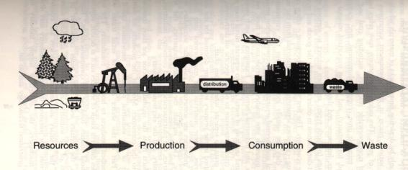
Figure 2.1: The linear flow of material in the built environment (Jackson, 1996)

2.1.2 The phases of LCA
One of the approaches in designing energy-efficient products is to assess the total use of materials and energy during their lifecycle and their impact as industrial artefacts or constructions, and measure them numerically. This method has been called LCA (Sobrino et al., 2011, Jönsson, 2000, Morais and Delerue-Matos, 2010, Nieuwlaar, 2004, Rebitzer and Buxmann, 2005).
LCA is an environmental management tool increasingly used to predict and compare the environmental impacts of a product or service, ‘from cradle to grave’(White et al., 1995). It is “a systemic analysis of the environmental effects caused by a product or a process from extraction of raw materials to waste treatment” (Elghaffar, 2007, Eaton and Amato, 1997, Hauschild, 2005, Hertwich, 2005).
It is also “a methodology for evaluating the environmental load of processes and products (goods and services) during their lifecycle from cradle to grave” (EPA, 1993, Sonnemann et al., 2003, Fava, 2004, Hauschild, 2005, Hobday, 2006 , Warburg, 2005).
In terms of methodology, “LCA is the compilation and evaluation of the inputs, outputs and the potential environmental impacts of a product system throughout its lifecycle” (ACLCA, 2009, Portha et al., 2010). Moreover, it is “a systems’ analysis tool to account for all the environmental impacts associated with a product or service, covering all stages in a product’s life, from the extraction of resources to ultimate disposal” (NatureWorksLLC, 2009, Klopffer, 2006).
LCA should not be criticised as a complex and time-consuming process. It is a scalable concept. Thus, it is possible to choose how detailed and precise the process should be. It is feasible to go from a full, ISO-compatible, peer-reviewed study to a screening that takes only a few days. An important factor is how much of the needed data is already available in the database of our LCA tool (Hauschild, 2005, PRéConsultants, 2009).
LCA models the complex interaction between a product and the environment from cradle to grave. It is also known as Lifecycle Analysis or Eco-balance (Hauschild, 2005).
“LCA has been used in the building sector since 1990 and is an important tool for assessing buildings” (Taborianski and Prado, 2004, Fava, 2006).
Figure 3.2 indicates the schematic representation of the building lifecycle through the phases of WPC and BMCC. Accordingly, the LCA considers the inputs and outputs of a construction process. The inputs and outputs are assessed in three general categories: ‘pre-construction’, ‘operation’, and ‘dismantling’. In each of these categories, the rates of consumption, emissions and, environmental impact are the subjects of investigation (see figure 2.2). Hence, the inputs can be energy and materials, and the outputs can be energy, heat, CO₂, and other emissions.
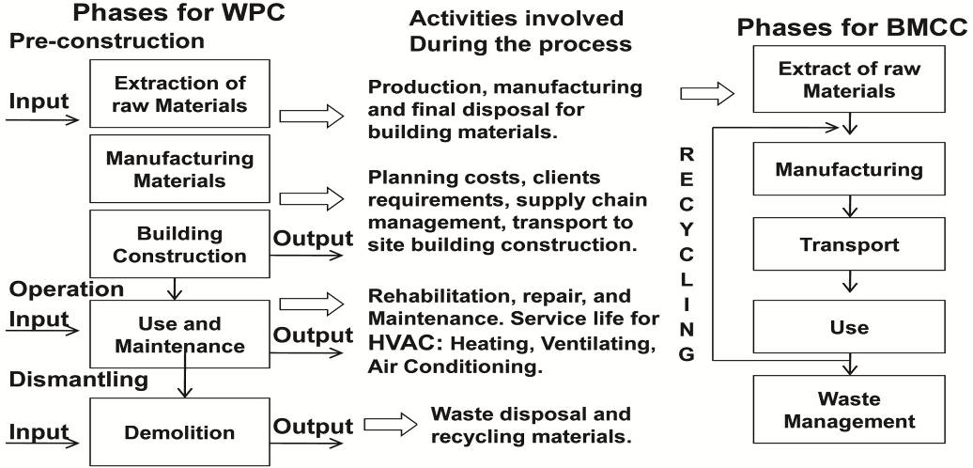
Figure 2.2: Schematic representation of the building lifecycle (Ortiz et al., 2007)

Figure 2.2 shows a schematic diagram of building lifecycle input-process-output investigation. This cyclical investigation of materials, energy, etc. has been highlighted as a new solution. Accordingly, it includes the summation and evaluation of the inputs and outputs, and the assessment of the potential environmental impacts of a built environment throughout its lifecycle (Ortiz et al., 2009, Eaton and Amato, 1997).
Thus, LCA is as an effective way to decrease waste in different stages of design, building or manufacture.

2.1.3 Necessity of LCA
LCA conquers the increasing concern with today’s resource depletion and addresses environmental considerations in both developed and developing countries; it can be applied to decision making in order to improve sustainability in the construction industry (Ortiz et al., 2007).
It also provides an objective tool for the stakeholders of the building and construction industry, including the government, developers, architects, engineers, constructors, and building operators, to assess the environmental impacts associated with the construction and operation of buildings and to develop strategies to improve our built environment and achieve the objective of sustainable construction (Arup, 2004, Hauschild, 2005).
Governments and customers hope that companies will pay attention to the environmental impacts of all products. EMAS, BSI and the ISO 14000 series demand continuous improvement in environmental management systems. The use of LCA for process improvement in built environments is the way to meet this demand (Hauschild, 2005, PRéConsultants, 2009).
Moreover, LCA and LCI are being used for a variety of reasons:
- to understand the lifecycle of biopolymer and the products made of it, and to use this information for comparison of products made of other biopolymer materials
- to make further environmental/economic improvements in the biopolymer production chain, which would include process improvements and the selection of raw materials, energy sources, production locations and waste management routes.
- LCI data are used to calculate contributions to particular impact categories, and to measure environmental performance against the incumbent products.
- LCI/LCA data are used by external LCA practitioners (governmental agencies, academics, non-governmental organisations, customers and consumers) in performing and improving their own studies.
Thus, LCA can be the key to answering questions such as:
- How is the environment affected at each stage of a building product’s lifecycle, from resource extraction through manufacturing, transportation and installation to eventual disposal?
- What are the system implications of selecting a particular structural product or material?
- What are the long-term operating implications of design decisions and material choices?
- In short, does the environment win or lose when one building design or material is selected over another?
It is “widely accepted within the environmental research community as one of the best ways to compare the environmental impacts of alternative materials, components and services” (Hauschild, 2005, Athena, 2009).

2.1.4 A brief history of lifecycle assessments
The REPAs of the late 1960s and early 1970s are generally accepted as the starting point of LCA in the 20th century. A series of studies were carried out by the Midwest Research Institute, and later by the consulting firm Franklin Associates Ltd., mostly for the private sector. The Coca Cola Company and Mobil Corporation were two of the firms that carried out REPA studies (Raymond and Culaba, 2009).
A REPA study of different beverage packaging systems by Hunt et al. (1974) was a typical example of these LCA predecessors. Interest continued through the 1980s, with studies by Gaines (1981) and Lundholm and Sundstrom (1985) being typical of the REPA studies used for policy- and decision-making. As the term REPA suggests, these early studies emphasized raw material demands, energy inputs, and waste generation flows; attempts at more sophisticated analysis through environmental impact classifications would come later in the evolution of LCA methodology (Raymond and Culaba, 2009).
Another early type of LCA emerged in the late 1970s in the form of net energy analysis (Boustead and Hancock, 1979).
During the global oil crises of 1973 and 1979, many countries, including the Philippines, the United States and Brazil, began to explore petroleum substitutes. Bio ethanol (ethyl alcohol produced through the fermentation of carbohydrate biomass) was one of the most extensively tested fuels; Brazil was particularly successful in its commercialization, and its ProAlcool program has continued for the past 20-odd years. One of the problems that became apparent was that the production of bio ethanol on a life-cycle basis was highly energy-intensive. Net energy analysis was used to compare the cumulative energy inputs into the bio ethanol lifecycle (including agricultural inputs for feedstock production) with the energy value of the final product; such a comparison gave a true indication of the extent to which a substitute fuel displaced conventional energy sources. Early studies in the United States found a net energy deficit – more energy was needed to make the alcohol than could be recovered from its eventual combustion. Such studies continued to be used for the assessment of bio ethanol and other alternative fuels, with the net energy approach being favoured in North America and an alternative energy ratio approach being more common in Europe. Eventually these energy analysis techniques led to the emergence of specialized LCAs for fuel and energy systems. These LCAs are now called Full Fuel Cycle Assessments (FFCAs). (Raymond and Culaba, 2009)
The development of standards in the 1990s was the foundation of modern LCA methodology. SETAC in 1991 published A Technical Framework for Lifecycle Assessments, the first attempt at an international LCA standard. It explicitly outlined the components of contemporary LCA: goal definition, inventory assessment, impact assessment, and improvement analysis. By extending LCA beyond the mere quantification of material and energy flows (the predominant theme in REPA, net energy analysis, and other early forms of LCA), SETAC paved the way for the use of LCA as a comprehensive decision-support tool. Similar developments took place sometime later in Northern Europe, particularly in Scandinavia. In 1995 detailed LCA protocols were specified in the ‘Nordic Guidelines on Lifecycle Assessments’ (Raymond and Culaba, 2009).
In the late 1990s, the ISO released the ISO 14040 series on LCA as an adjunct to the ISO 14000 Environmental Management Standards. The series includes standards for goal and scope definition and inventory assessment (ISO 14041, 1998), impact assessment (ISO 14042, 2000a), and interpretation (ISO 14043, 2000b), as well as a general introductory framework (ISO 14040, 1997). The ISO 14040 series actually bears a strong resemblance to the original SETAC framework; Azapagic’s review (1999) gives a comparison between the two LCA standards. However, because of ISO’s dominant position in the development of international standards, the ISO 14040 series may eventually supersede the SETAC guidelines among LCA practitioners (Raymond and Culaba, 2009).
According, ‘Lifecycle thinking’ (CIRAIG, 2005, Fletcher, 2001) has become known as the basis for environmental policy development in companies and governments. Constructions by themselves do not pollute: it is the factories that make their materials, the trucks that transport them, the construction companies that build them, the user who uses them, the incinerator burning their wastes, and their waste materials entering the ecosystem. Consequently, lifecycle thinking is needed to understand how industries affect the environment. Thus, to be more precise, lifecycle assessment (LCA) is needed to quantify and balance the impacts of constructions on nature through their lifetime, and to determine the best use of resources through the building lifecycle (Fletcher, 2001).

The Main Steps of BLCA and BEIA
Three main steps have been defined in building LCAs, as follows:
- defining goal and scope, which involves defining purpose, audiences and system boundaries (Ortiz et al., 2007)
- describing which emissions will occur and which raw materials are used during the life of a product, and collecting data for each unit process regarding all relevant inputs and outputs of energy and mass flow, as well as data on emissions to air, water and land: this phase includes calculating both the material and the energy input and output of a building system (Ortiz et al., 2007), and is called the ‘inventory’ step (LCI)
- assessing the impacts of these emissions and raw material depletions: this is referred to as the ‘impact assessment’ step (LCIA), and evaluates potential environmental impacts and estimates the resources used in the modelled system (Ortiz et al., 2007, PRéConsultants, 2009).
The building LCA methodology is described in detail by SETAC and CML. In SETAC’s Code of Practice, it is recommended that the LCA be split into four stages:
    - Planning
- statement of objectives;
- definition of the project and its alternatives;
- choice of system boundaries;
- choice of environmental parameters/geographical features;
- choice of aggregation and evaluation method;
- strategy for data collection.
    - Screening
- preliminary execution of the LCA;
- adjustment of plan.
Thus, to avoid the collecting of unnecessary data, the boundaries must be organised.

    - Data collection and data treatment
Measurements, interviews, literature search, theoretical calculations, database search, qualified guessing computation of the inventory table.
    - Evaluation
- lifecycle inventory (LCI) for each material;
- improvement assessment;
- sensitivity analysis;
- improvement priority and feasibility assessment.
It is generally recognised that the first stage is extremely important. The result of the LCA is heavily dependent on the decisions taken in this phase.
The screening stage is useful for checking the goal-definition phase. After screening it is much easier to plan the rest of the project.

Building Lifecycle Inventory (LCI)
The basis of any BLCA is the creation of a model that contains the amounts of all inputs and outputs of the processes that occur during the lifecycle of a product (Lu et al., 2011).
The lifecycle inventory analysis is a “phase of lifecycle assessment involving the compilation and quantification of inputs and outputs, for a given product system throughout its lifecycle” (Verbeeck and Hens, 2010a, Verbeeck and Hens, 2010b). Hence, “the outcome of a lifecycle inventory analysis includes the flows crossing the system boundary and provides the starting point for lifecycle impact assessment” (ACLCA, 2009, Ossés de Eicker et al., 2010, Li, 2006).
Quality of LCA results = quality of lifecycle inventory (Menzies et al., 2007). The LCI includes “the production phase, distribution, use and final disposal of the product” (Suh and Huppes, 2005, Gustavsson et al., 2010).
The inventory table is the most objective result of a LCA study. However, a long list of substances is difficult to interpret. A Lifecycle Impact Assessment (LCIA) is used for systematic evaluation of the impacts (Ortiz et al., 2007, PRéConsultants, 2009, Iosif et al., 2008).
Hence, to provide a complete and sensitive LCI it is important to divide the building materials (to measure the embodied energy in the construction procedure and linear flow of materials during their lifetime) and the building services (to measure the operational energy and carbon emission) into branches of a process tree. Figure 2.3 represents an example of an LCI process tree. Each box represents a process which forms part of the lifecycle. Every process also has defined inputs and outputs.
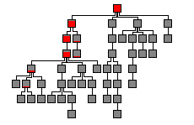
Figure 2.3: Example of a process tree (PRéConsultants, 2009)
The process ‘input’ can be defined as “material or energy which enters a unit process (materials may include raw materials and products). Thus, the energy input required for a unit process to operate the process or equipment within the process excluding energy inputs for production and delivery of this energy” (ACLCA, 2009, Xing et al., 2008).
Process inputs can be divided into two kinds:
- inputs of raw materials and energy resources (environmental input)
- inputs of products, semi-finished products or energy, which are outputs from other processes (economic input) (Ortiz et al., 2007, PRéConsultants, 2009, Mora et al., 2011).
Hence, the output is introduced as “material or energy which leaves a unit process (materials may include raw materials, intermediate products, products, emissions and waste)” (ACLCA, 2009, Boldrin et al., 2010, Pires et al., 2011).
Similarly, there are two kinds of outputs:
- outputs of emissions (environmental output)
- outputs of a product, a semi-finished product or energy (economic output) (Ortiz et al., 2007, Ardente et al., 2008, Malmqvist and Glaumann, 2009).
With information about each process and a process tree of the lifecycle, it is possible to draw up a lifecycle inventory of all the environmental inputs and outputs associated with the product. The result is called the table of impacts. Each impact is expressed as a particular quantity of a substance (Ortiz et al., 2007, Malmqvist and Glaumann, 2009).
Table 2.1 displays an example of a small part of the table of impacts for the production of two materials. Therefore, it indicates an example of a comparison between emissions of CO₂ from the production of 1kg of polyethylene and 1 kg of glass; a complete table can have hundreds of rows.
Table 2.1: An example of CO₂ emissions from the production of 1 kg of polyethylene and 1 kg of glass (PRéConsultants, 2009)
Emission | Polyethylene | Glass | Unit
CO₂ | 1.792 | 0.4904 | kg
It will be clear that such a table, or a similar one in terms of a material’s embodied energy, does not provide an immediate answer to a question such as whether 1 kg of polyethylene is more or less environmentally friendly than 1 kg of glass. Thus, ‘impact assessment’ methods have been developed to simplify this interpretation task. This in turn has led researchers and companies to provide some new variables to measure the environmental impact of material consumption and building services (e.g. Eco-point provided by Building Research Establishment, UK) (BRE, 2009).
  - Three Main Steps of Impact Assessments in Built Environments
CML and SETAC describe a general approach, through the calculation of environmental effects. There are three steps:
  - classification and characterisation
  - normalisation
  - evaluation or weighting (Ortiz et al., 2007, PRéConsultants, 2009, Raymond and Culaba, 2009).
Step 1: Classification and characterisation
- Classification mean allocating the materials and substances into different classes according to their effect on the environment (Suh and Huppes, 2005). For instance, “substances that contribute to the greenhouse effect or that contribute to ozone layer depletion are divided into two classes. Certain substances are included in more than one class. For example, ${NO}_{x}$ is found to be toxic, acidifying and causing eutrophication” (Sonnemann et al., 2003, Raymond and Culaba, 2009, PRéConsultants, 2009).
This in turn can be considered as the starting point of a spreadsheet for measuring the different numerical values.
- Characterisation means giving scores to the different materials according to their effect on the environment (Wright et al., 2000, Gambino et al., 1997). “It is not sufficient just to add up the quantities of substances involved without applying weightings” (Sonnemann et al., 2003).
Thus, a “factor derived from a Characterisation model which is applied to convert the assigned LCI results to the common unit of the category indicator. The common unit allows aggregation into category indicator result” (ACLCA, 2009).
Some materials might have a more intense effect than others. This problem is dealt with by applying weighting factors to the different materials. This issue should be considered at this stage (Sonnemann et al., 2003, PRéConsultants, 2009, Raymond and Culaba, 2009). Table 2.2 shows an example of the characterisation step. Emissions are multiplied by the corresponding weighting factor before being added up for each class. The results are called effect scores.

Table 2.2: Example of the characterisation step for a small inventory table (Raymond and Culaba, 2009)
Emission | Quantity (kg) | Greenhouse | Ozone layer depletion | Human toxicity | Acidification
CO₂ | 1.792 | x 1 | - | - | -
CO | 0.000670 | - | - | x 0.012 | -
NO_{x} | 0.001091 | - | - | x 0.78 | x 0.7
SO₂ | 0.000987 | - | - | x 1.2 | x 1
Effect scores: |  | 1.792 | 0 | 0.00204 | 0.0017
In the comparison between paper and polyethylene (LDPE) the calculated effect scores can be displayed as a graph. The highest calculated effect score is scaled to 100%. This means the materials can only be compared for each effect.
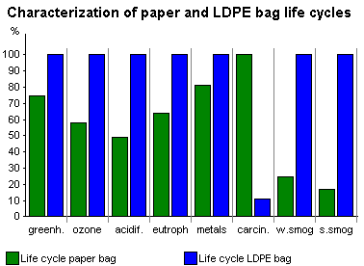
Figure 2.4: Example of a classification (Raymond and Culaba, 2009)
In figure 2.4 the highest score is scaled to 100%. The classes are: greenhouse effect, ozone layer depletion, acidification, eutrophication, heavy metals, carcinogen, winter smog, and summer smog(fictional example).
The interpretation of these scores might be less confusing than interpretation of a material list, but it is by no means without problems. If all the scores for one product are higher than those for another, it is possible to conclude which is the more environmentally friendly. But if one has a higher score for acidification, while the other has a higher score for its greenhouse effect, it becomes difficult to justify such a conclusion (Raymond and Culaba, 2009).
Interpretation depends on two factors:
- The relative size of the effect compared to the size of the other effects. Hence, in this instance it is important to see whether the eco-toxicity score of 100% refers to a very high or an extremely low effect level. This is called normalisation.
- The relative importance attached to the various environmental effects. This is called evaluation (Raymond and Culaba, 2009).
Step 2: Normalisation
In this phase, ‘normalisation’ can be considered as an approach to defining or combining the numerical results - which are applied to specific uses - using tools or software (Gäbel et al., 2004, Lautier et al., 2010). The principal goal of this stage is to gain a better understanding of the relative size of an environmental effect. Each effect calculated for the lifecycle of a built environment is measured against the known total effect for this class (Lundie et al., 2007). In many methods the impact category indicator results are compared by a reference (or ‘normal’) value. This means the impact category is divided by the reference. The reference may be specially chosen, but often the average yearly environmental load in a country or continent, divided by the number of inhabitants, is used as the reference (ACLCA, 2009, Boldrin et al., 2010).
Moreover, normalisation enables us to see the relative contribution from the production of the material to each already existing effect. Figure 3.5 shows a normalisation step (fictional data) (Raymond and Culaba, 2009, PRéConsultants, 2009). Thus, the result will be an open, comprehensive and understandable presentation of information, which is called ‘transparency’ (ACLCA, 2009).
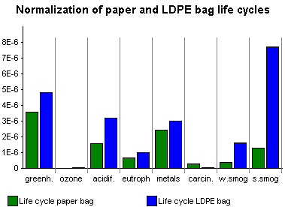
Figure 2.5: A normalised effect score (Raymond and Culaba, 2009)

In figure 2.5, the length of the columns is now scaled to a normalised effect score. After normalisation it becomes clear that the contributions to eco-toxicity, greenhouse effect, summer smog and human toxicity are relatively high. The contributions to the other effects are almost negligible (fictional example).
After normalisation, the impact category indicators all get the same unit (usually 1/yr), which makes it easier to compare them. Normalisation can also be applied to both characterisation and damage assessment results (ACLCA, 2009).
Step 3: Evaluation or weighting
After normalisation, in order to make the final judgment, the importance of each effect should be evaluated. This stage has been called ‘evaluation’ or ‘weighting’. In the evaluation phase the normalised effect scores are multiplied by a weighting factor representing the relative importance of the effect (Lu et al., 2011, Tan et al., 2007). Some methods allow weighting across impact categories. This means the impact (or damage) category indicator results are multiplied by the weighting factors, and are added to form a total score. Weighting can be applied to normalised or non-normalised scores (ACLCA, 2009, Raymond and Culaba, 2009, Kunnari et al., 2009).
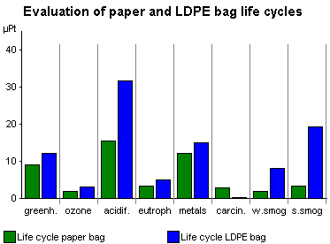
Figure 2.6: Adding the normalised effect scores after weighting (Raymond and Culaba, 2009)
After weighting, the relative values of the normalised effect scores are added. After weighting, eco-toxicity has clearly gained in significance (fictional example - figure 2.6). The length of the columns represents the seriousness of the effects. This makes it possible to add the columns to calculate a final result. 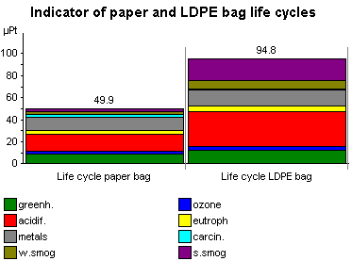
Figure 2.7: Adding the weighted scores for final judgment (PRéConsultants, 2009)
The weighted scores can be added for a final judgment. The higher the score, the higher the environmental impact. The figure above clearly shows a preference for paper (fictional example - figure 2.7).
An important goal for the building sector is to produce buildings with a minimum of environmental impacts. Impacts are measured in terms of a wide range of potential effects, such as:
- “Fossil fuel depletion;
- Other non-renewable resource use;
- Water use;
- Global warming potential;
- Stratospheric ozone depletion;
- Ground level ozone (smog) creation;
- Neutrification/eutrophication of water bodies;
- Acidification and acid deposition (dry and wet);
- Toxic releases to air, water and land” (SEPA, 1994, Eaton and Amato, 1997, Athena, 2009).
Thus, the “quantifiable representation of an impact category is called the lifecycle impact category indicator (the shorter expression ‘category indicator’ is used throughout the text of this International Standard for improved readability)” (Kunnari et al., 2009).
Therefore, ‘lifecycle impact assessment’ is defined as a phase of lifecycle assessment aimed at understanding and evaluating the magnitude and significance of the potential environmental impacts of a product system (ACLCA, 2009, Rydh and Sun).
Two problems exist in impact assessment:
- There are not sufficient data to calculate the damage to ecosystems by an impact.
- There is no consensus on the accepted way of assessing the value of the damage to ecosystems, if this damage can be calculated (Hauschild, 2005).
“One of the oldest impact assessment methods is the EPS (Environmental Priority Strategy) system as developed by the IVL in Sweden. In this method, the complete chain of cause and effect from each impact on a human equivalent is calculated. Another method is the Eco-points method, developed for the Swiss and UK governments. It is based on the distance-to-target principle. The distance between the current level of an impact and the target level is assumed to be representative of the seriousness of the emission” (BRE, 2009, PRéConsultants, 2009).

The Impact of Geographical Variation on BLCI and BLCA
Geographical variation (also defined as local environmental aspects) is defined as the “element of an organisation's activities, products or services that can interact with the environment” (ACLCA, 2009, von Bahr and Steen, 2004, Rebitzer et al., 2004). Thus, the system of physical, chemical and biological processes for a given impact category links the LCI results to category indicators and to category endpoints. This is called ‘environmental mechanism’ (ACLCA, 2009, Frischknecht and Rebitzer).
For example, the total energy use for the heating of a building in Sheffield, UK, is different from what it would be if the same building was built in Shiraz, Iran. This example can be used in terms of cooling, all building services, and also the construction materials used in the different locations (Rydh and Sun, Skone and Curran).

The Importance of Data Quality in LCI
Data quality is the “characteristic of data that bears on their ability to satisfy stated requirements” (ACLCA, 2009, Newell and Field, 1998, von Bahr and Steen, 2004, Skone and Curran). The reliability and credibility of input data can directly affect the sensitivity of lifecycle inventories (Yoshida et al., 2002, Su et al., 2010).
Chapter 4 considers the introduction of BLCA tools, as well as their categorization, and focuses mainly on building design and decision-support tools.

Chapter Summary
This chapter has investigated BLCA, as well as a brief history and the reasons behind the development of this approach. In addition, the general methodology of LCA in construction was elaborated, as well as the four main steps of BLCA: planning, screening, data collection and data treatment, and evaluation. Thus, the chapter introduced LCI, containing the standardised profiles of all inputs and outputs of the building lifecycle, as the basis of BLCA. Moreover, the three main steps of impact assessments in built environments have been reviewed as follows:
Step 1: classification and characterisation;
Step 2: normalisation;
Step 3: evaluation or weighting.
Finally, the chapter touched on the impact of geographical variation and the importance of data quality in LCI and BLCA.
The next chapter considers the background and general classification of BLCA tools, with a special focus on the category of design and decision-support tools.

CHAPTER 3: BUILDING LCA FAMEWORK AND METHODOLOGIES
3. Building LCA Methodologies

Introduction
As previously stated, the application of the BLCA is intended to assess the global environmental impact during the lifecycle of the built environment (Zabalza Bribián et al., 2009). Despite the fact that many European countries have developed an environmental certification process for the different types of buildings (residential buildings, offices, etc.), the indicators regarded to achieve the environmental qualification are not being calculated using an LCA approach (Zabalza Bribián et al., 2009). Reducing the environmental impact in the construction sector requires suitable assessment methodologies considering the following factors:
- “Environmental performance levels to be integrated into programmes (clients’ brief) by the authorities (e.g. requirements in municipal policy and building programmes);
- Advice to be provided to designers, architects and consultants, in order to reach such targets;
- Guidance for efficient operation and management of buildings, so that actual performance corresponds to design performance;
- Methods and tools to evaluate the most cost effective measures (actions) for energy savings and reduced environmental impact over the whole lifecycle”
(Zabalza Bribián et al., 2009).
Table 3.1 describes the general stages which are considered in a complete BLCA.

Table 3.1: Lifecycle stages of a building (Zabalza Bribián et al., 2009)
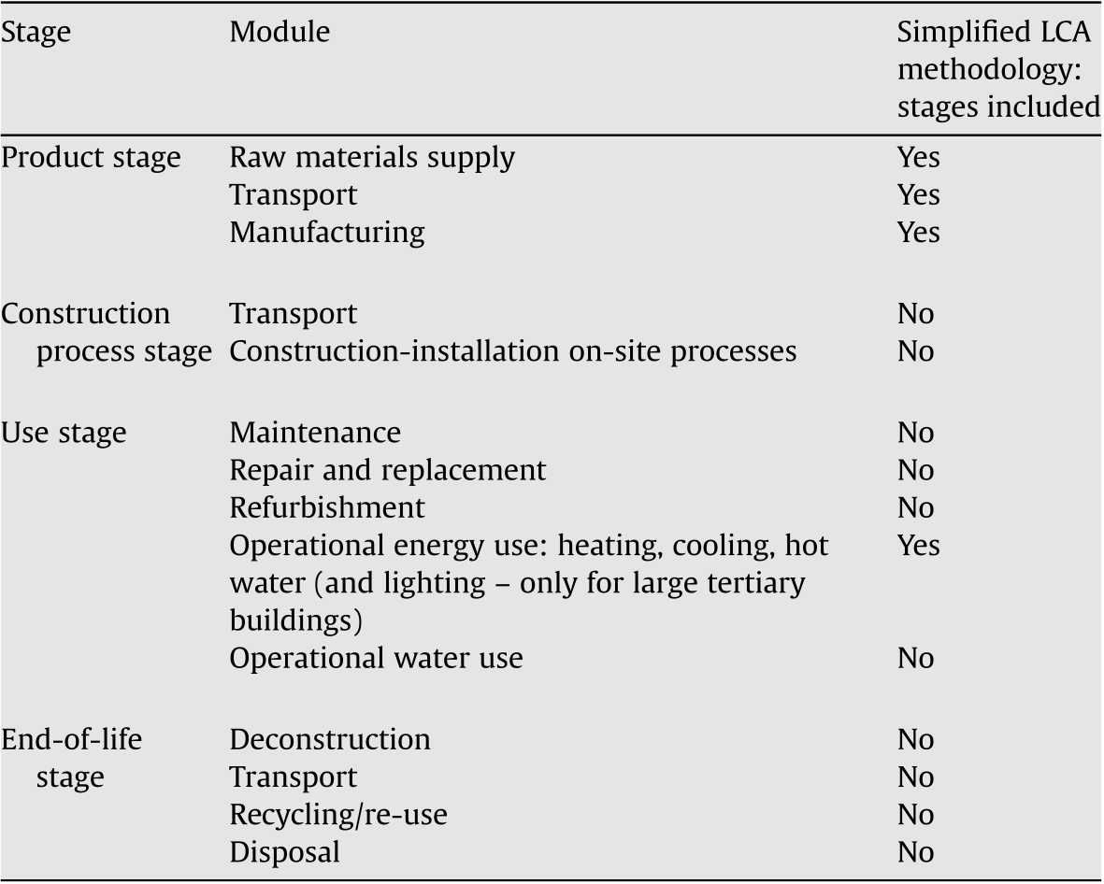

3.1.1 Drivers and barriers for using LCA in the building sector
Fundamentally, the major drivers of and barriers to LCA in the building sector are as follows (Zabalza Bribián et al., 2009):
- the market benefit
- The need for simplified data collection
- the demand for environmental labelling of the building
- the general environmental efficiency target in the building sector (in a global scope)
- the high cost of overcoming barriers to environmental impact reduction (i.e. loans and subsidies) and the calculation applications
- prejudices about LCA complexity, accuracy and illogical results
- lack of knowledge about environmental impact, possibilities and how to calculate them
- the complicated calculation applications and the lack of standardised guidelines in the BLCA programmes (e.g. CAD, tendering, building physics)
- the poor cooperation between application manufacturers and potential customers
- the different results displayed by the different applications
- the difficulties in understanding the BLCA results and applying them to design and decision making
- the lack of legal requirements and poor encouragements for the BLCA
- the weak connection between the existing calculation applications and the energy certification codes and databases.

3.1.2 Lifecycle thinking (a new mindset): Revision of the framework
Regarding the basic aim of this research, defining of a proper ‘BLCA Framework’ is considered as the foundation for better BLCA tools, methodologies and strategies. The starting point in this issue is the ‘lifecycle thinking’ concept which considers all interactions “between human and natural systems” (Ramesh et al., 2010) in any building activity. “Lifecycle thinking is defined as a production and consumption strategy that aims at taking into account all of the impacts (environmental, economic and social) that a product or service will have throughout its lifecycle, from cradle to grave” (GIRAIG, 2005).
‘Lifecycle thinking’ (CIRAIG, 2005, Fletcher, 2001) has become known as the basis for environmental policy development in companies and governments. Constructions by themselves do not pollute: it is the factories that make their materials, the trucks that transport them, the construction companies that build them, the user who uses them, the incinerator burning their wastes, and their waste materials entering the ecosystem. Consequently, lifecycle thinking is needed to understand how industries affect the environment, society and economy through their lifetime in a ‘Cradle to Grave’/’Cradle to Gate’/’Cradle to Site’/’Cradle to Cradle’ approach (Fletcher, 2001, Hernandez and Kenny, 2010).
Lifecycle thinking can be considered as one of the solutions to reach the concept of ‘Sustainability’. In that accordance, the lifecycle thinking includes an in-depth, process-based and detailed consideration of ‘environmental’, ‘social’ and ‘economic’ impacts from very basic stages of building design and decision-making (Ortiz et al., 2007). The following two general categories of actions are considered by lifecycle analysis (Hernandez and Kenny, 2010):
- Lifecycle: Building and Structure; which considers the process of building, landscape and city services’ construction, maintenance and deconstruction in a ‘Cradle to Cradle’ approach based on the ‘Embodied’ values such as energy, water, pollutants, cost etc (Ward, 2004, Attiwill et al., 2001).
- Lifecycle: Component Design; considers two dimensions of the building services as follows:
- Resource (such as energy, water etc.) consumption, pollutants’ emissions (e.g. CO₂), and costs to run the building or system/neighbourhood service-life (Ye et al., 2011, Ortiz et al., 2010). In the literatures, this value is known as ‘operational’ value e.g. ‘operational energy’, ‘service life carbon’ etc.;
- Embodied resources (such as energy, water etc.), embodied pollutants (e.g. CO₂), and embodied costs to produce, install, maintain, and re-use/recycle of the components and their infrastructures in buildings, and systems/neighbourhoods’ service-lives (Hernandez and Kenny, 2010).
Therefore, the holistic goal of lifecycle thinking in building sector is evaluation of the best strategies to cause the lowest social, environmental, and economic impacts during the aforementioned processes. Accordingly, by performing lifecycle analysis, the phases that have the highest impact can be “identified and targeted for improvement”(Ramesh et al., 2010).
This concept calls for more precession in the building/systems impact analysis and estimation of the social, environmental and economic impacts of the buildings/systems during manufacturing of construction and services’ materials, transportation, installations, maintenance, adaptation with changes of technology and changes of building/s’ and system functions (Adalberth, 1997b, Ramesh et al., 2010, Ortiz et al., 2007). Ramesh (Ramesh et al., 2010), categorises the key characters of lifecycle impact analysis in three levels as follows:
- Embodied impacts including ‘initial embodied impacts (e.g. initial embodied energy) and ‘recurring impacts (e.g. embodied energy)’;
Initial embodied impacts; are the sum of the environmental, social and economic impacts incurred for initial construction of the building (Asif et al., 2007).
Recurring impacts; are the sum of the environmental, social and economic impacts embodied in the material, used in the rehabilitation and maintenance.
Embodied impacts largely depend on “the type of the materials used, primary energy sources, and efficiency of conversion processes in making building materials and products” (Ramesh et al., 2010, ISO, 1997).
- ‘Operating impacts (e.g. operating energy)’; are the impacts caused by associated consumptions and emissions for maintaining comfort conditions and daily building maintenance i.e. the HVAC (heating, ventilation and air conditioning), domestic hot water, lighting, and for running appliances (Ye et al., 2011, Ortiz et al., 2010, Ramesh et al., 2010).
Operational impacts largely vary on “the level of comfort required, climatic conditions and operating schedules” (Ramesh et al., 2010).
- ‘Demolition impacts (e.g. demolition energy)’; are the impacts caused by demolishing the building at the end of its service-life and transportation of the waste material to landfill sites and/or recycling plants (Adalberth, 1997a, Ramesh et al., 2010).
Demolition impacts can also vary regarding the demolition techniques and the transpiration distance between the demolition sites and landfill sites and/or recycling plants.
There for, the lifecycle impact of the building is the sum of the all the impacts incurred in its lifecycle. It is hence expressed as:
Lifecycle Impacts = EI_{i}+EI_{r}+OI+DEI (Ramesh et al., 2010)
where EI_{i} = initial embodied impacts, EI_{r} = recurring impacts, OI = operating impacts, and DEI = demolition embodied impacts of the building.
The stated relationship can be translated into variety of BLCA factors e.g. energy, carbon etc. hence, in terms of energy the formula would be written as follows:
Lifecycle Energy = EE_{i}+EE_{r}+OE+DEE (Ramesh et al., 2010)
where EE_{i} = initial embodied energy, EE_{r} = recurring energy, OE = operating energy, and DEE = demolition embodied energy of the building.
- The role of transport
Munfred Lenzen (Lenzen, 2008) acknowledges from Handbook of transport and the environment (Lenzen et al., 2003) the high significance of the role of on energy and greenhouse gas intensities of transport modes, “reported as either monetary intensities (MJ and kg CO₂-e per unit of transport revenue/cost in$), or as physical intensities (MJ and kg CO₂-e per unit of transport task in net tonne
kilometres, ntkm). Lenzen (Lenzen, 1999) presents a comparison between energy intensities obtained from input output analysis and process analysis [...]”.
The transportation data can be achieved base on two major sources such as ‘Average distances for material transport’ and ‘Energy data for transport operations’(see figure 3.1)(Ramesh et al., 2010).
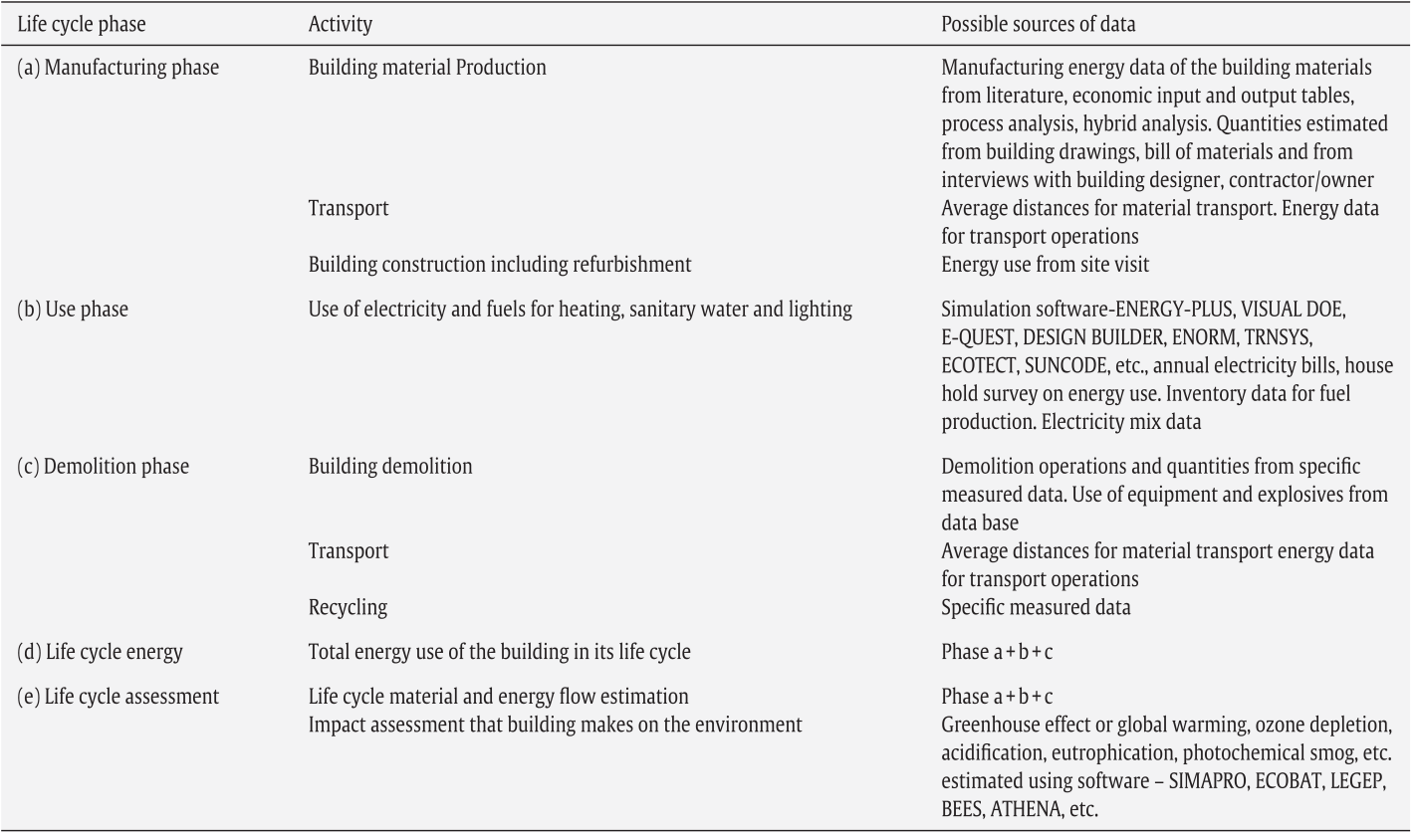
Figure 3.1: Data sources for lifecycle analysis (Ramesh et al., 2010)

3.1.3 Factors in developing a simplified BLCA methodology
Because of the great quantity of data required to complete a BLCA, it is recommended to use a tool application that makes the assessment much more efficient. To achieve this, one of the approaches is to simplify the methodologies.
Some BLCA simplifications consider the ignored transportation (particularly for short distances and light materials), the additional materials, the cutting of waste, etc. (Zabalza Bribián et al., 2009, Kellenberger and Althaus, 2009b). Accordingly, the selection of environmentally friendly materials improves the BLCA results. For instance, replacement of high EE materials (such as reinforced concrete) by alternative materials (such as hollow concrete blocks, stabilised soil blocks or fly ash) could save up to 20% of the building’s EE during its lifecycle (Zabalza Bribián et al., 2009, Huberman and Pearlmutter, 2008).
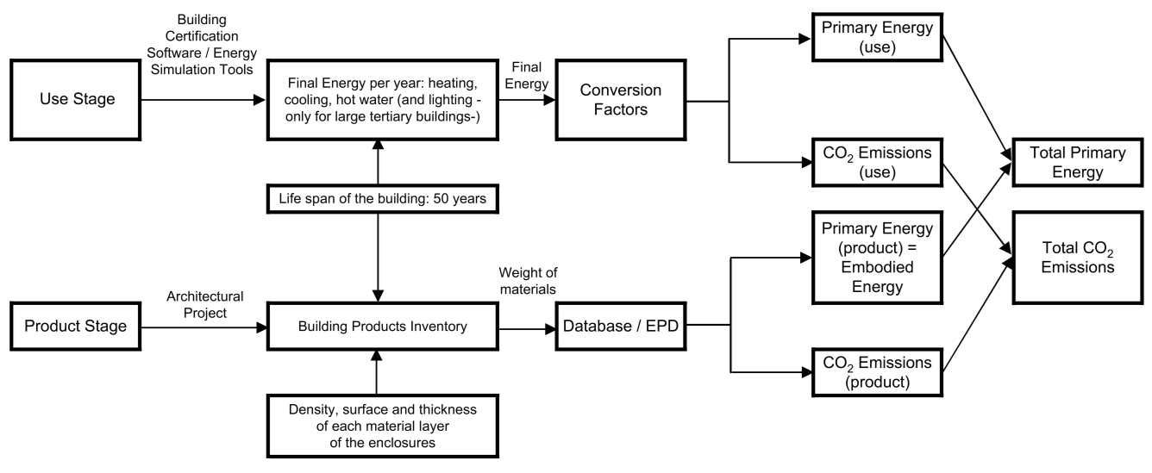
Figure 3.2: General structure of a simplified LCA methodology (Zabalza Bribián et al., 2009)

In order to develop a simplified LCA methodology some factors have to be considered (Zabalza Bribián et al., 2009), such as:
- The easy-to-find input data in the building project should be as brief as possible
- The selected indicators and the impact categories should be simple, so that architects, engineers, and final users can easily understand the results. For instance, if we consider eutrophication as an impact category, few people will understand the result (certainly among those from other disciplines). But water consumption, energy in general (including EE and OE), CO₂, waste generation, etc., are reasonably well known
- The selected indicators (energy, carbon etc.) should also be matched with the results of the indicator’s certification, in order to establish a strong link between BLCA and building certification methodologies (see figure 3.2).

3.2 Classification of BLCA Methodologies
Fundamentally, there are two main categories of LCA, which can also be applied to BLCA. These have been defined as retrospective (LCA with an accounting perspective) and prospective (LCA modelling the effects of changes). The categories may be broken down further, as in the LCANET report (Tillman, 2000a, Frischknecht, 1997a).
Similar distinctions have been made in several other publications, but often using other terms to indicate the two types of LCA, and sometimes including further subcategories within the aforementioned two main LCA types (Ekvall et al., 2005, Baumann, 1996, Cowell, 1998, Heintz and Baisnée, 1992, Weidema, 1993, Weidema, 1998 , Frischknecht, 1997b, Baumann, 1998, Hofstetter, 1998, Tillman, 2000b, Curran et al., 2005b).

3.2.1 Retrospective
A retrospective LCA provides information about the environmental properties of the investigated lifecycle, and of its subsystems (Ekvall et al., 2005, Tillman, 2000a). Retrospective LCA is defined by its focus on describing the environmentally relevant physical flows to and from a lifecycle and its subsystems (Ekvall et al., 2005, Curran et al., 2005a, Ekvall, 1999). Accordingly, a retrospective LCA presents an environmental assessment of the lifecycle and its subsystems.
Such information can be applied to further investigations, to decide whether or not to become a part of the system, for instance by buying the investigated product. In this type of LCA, from the ethical point of view, the rule can be expected to have positive consequences and the lowest negative environmental impacts (Ekvall et al., 2005). Therefore, in a BLCA of this type the monitoring of the environmental impact in the existing buildings is essential. Consequently, the retrospective BLCA investigates the existing buildings and compares the environmental impact of the different built environments, in order to apply the results to further design and construction activities.
Limitations of the retrospective methodology: This section discusses the limitations of the retrospective methodology with a focus on ‘system boundaries’ and ‘allocation problems’ (Ekvall et al., 2005). From this perspective, there are two major limitations in the BLCA retrospective methodologies: technical and ethical.
- Technical limitations:
A retrospective LCA focuses on assessing the environmentally relevant physical flows of a lifecycle and its subsystems. One problem in this context is that it is often unclear to what system or subsystems we become associated through the conductions.
For instance, it can be complicated to identify the system from which a customer buys electricity. Some customers buy electricity from a system/brand that consists of a specific electricity production technology which is not listed in the LCIs. This can also happen with other building components and materials (berger and Karlsson, 1998, Ekvall et al., 2005).
A practical example: Traditionally, LCIs that are conducted in Sweden use data on average Swedish electricity production for electricity that is used within the country. This is consistent with the view that the electricity is bought from the national electricity system. However, the electricity in Norway, Sweden, Denmark and Finland is freely traded on a common Nordic market, which is connected to the electricity grid of other European countries. This suggests that a Nordic consumer buys electricity from the Nordic electricity system or from one that is even larger. This can cause problems in assessing the real rates of environmental indicators (Ekvall et al., 2005, Frees and Weidema, 1998).
In this case, it has been suggested that a system is whatever is identified as a system (Gaines, 1979). Accordingly, the electricity system, for example, is what an informed observer perceives it to be. Hence, there is no objective answer to the question ‘from what system does the customer buy electricity?’. A Vattenfall customer in Sweden can defend the view that the electricity is bought from the Vattenfall production system, the Swedish electricity system, or the Nordic electricity system (Ekvall et al., 2005).
Therefore, if it is not clear from which system the electricity or other building materials are bought, then it is impossible to identify what average data to use in the retrospective BLCA: “technology averages, company averages, national averages, or regional averages” (Ekvall et al., 2005). The difference between these averages can be extremely large.
For example, in Norway more than 99% of the electricity production during 1998 was from hydropower. In Denmark, nearly 60% was based on coal. In the Nordic electricity system, 54% was from hydropower, 24% nuclear and 10% coal-based (Ekvall et al., 2005, Energifakta, 2001).
In terms of the kind of emissions normally accounted for in an LCI, there is an extremely significant difference between hydropower, nuclear power, and electricity produced from coal and oil. For example, while CO₂ emissions are less than 1 g/kWh for Vattenfall hydropower (including plant construction) (Brannstrom-Norberg et al., 1996, Ekvall et al., 2005), they can be nearly 1 kg/kWh for coal-based electricity production. Therefore, there is a very great difference between average emissions from electricity production in Nordic countries. This in turn highlights the problem of identifying the electricity system from which a Nordic consumer buys electricity. The problem is also significant outside the Nordic area (Ekvall et al., 2005, Dones R, 1998).
Another methodological problem of retrospective LCA is the choice of allocation methods. Many different approaches to the problem of allocation have been suggested (Huppes and Schneider, 1994, Ekvall et al., 2005). If the retrospective LCA has the particular goal of describing the causes of the environmental impacts of the lifecycle, it is reasonable to categorise the environmental impacts of a process with multiple products in proportion to the economic cost of these products. If not, it would be hard to find an objective basis for the choice of allocation method (Ekvall et al., 2005, Huppes, 1993).
- Ethical limitations:
The retrospective methodology can also be criticised from the perspective of teleological situation ethics. Such criticism is in fact a critique of the special case of rule ethics which is relevant to retrospective LCA: the case where one rule is to avoid environmentally poor systems. Hence, the limitations of this ethical rule can be highlighted again with an example from the Nordic electricity sector (Ekvall et al., 2005).
In this case, a university department is being considered as an environmentally suitable site for a conference. Thus, the aim is to avoid environmentally problematic systems, so the retrospective LCA of conference sites is used to produce relevant information as a methodological basis. “Thorskog Castle is a conference hotel near the West Coast of Sweden. Across the hotel site runs a brook. A small hydropower station at this brook makes the hotel self-sufficient with electricity. The hotel is connected to the national electricity grid, which makes it possible for the owners of the hotel to sell excess electricity from the brook” (Ekvall et al., 2005). To perceive the hotel and the hydropower station as the relevant electricity system in order to use environmental data from the local hydropower production in the quantities of CO₂, SO₂, NO_{X}, particulates etc. per kWh been monitored. These emissions were produced at the hydropower station, and the result was nearly zero. In terms of the kind of emissions normally accounted for in an LCI, the hotel and the hydropower station sounds fairly good as part of the Swedish electricity system (Ekvall et al., 2005).
On the other hand, the result in the long term would be to motivate the building or the site to consume more electricity because of its lower cost for that site, as a self-sufficient/off-grid system (Kashkooli et al., 2010, Ryker, 2005). This in turn would increase the further emissions of CO₂, SO₂, NO_{X}, particulates etc. on a much larger scale than indicated by the retrospective data (Ekvall et al., 2005).
Moreover, in cases where the total production volume of building materials is very high, the retrospective BLCA results do not reflect the consequences of individual actions. Thus, there is a risk that the environment can be harmed by actions that are recommended on the basis of a retrospective BLCA. In other words, a BLCA based on average data clearly does not identify any marginal effects, i.e., effects of small changes in the production volume. In contrast, most actions can be expected to cause changes that are small enough to be approximated as marginal effects on the production of bulk materials (e.g. steel, aluminium, polyethylene), energy carriers (e.g. electricity, heavy fuel oil, petrol), and services (e.g. waste management) in very high total production volumes. Hence, in a general perspective, there is a risk that undesirable effects can be caused by individual actions which are based on rule ethics, because rule ethics by definition does not take into account the consequences of individual actions, but look at conduct in general. Accordingly, a person who respects rule ethics is likely to consider this to be a serious limitation (Ekvall et al., 2005).

3.2.2 Prospective
Prospective lifecycle assessment (LCA) provides information on the environmental consequences of individual actions (Ekvall et al., 2005, Tillman, 2000a). Prospective LCA is defined by its aim to describe how environmentally relevant flows will change in response to possible decisions (Ekvall et al., 2005, Curran et al., 2005a, Ekvall, 1999). Accordingly, this methodology deals with the modelling of built environments and the assessment of their possible environmental impacts.
A prospective LCA can produce information not only on the consequences of a formal regulation but also on the consequences of any type of rule. This means that a prospective LCA can principally generate a part of the information which is relevant in the context of teleological rule ethics. This in turn requires an assessment of the ethical rules’ consequences. In practice, the causal and informal relations and the combined systems (which would be affected by an ethical rule) might be too complex to be modelled in this type of LCA methodology (Ekvall et al., 2005).
Ultimately, prospective LCAs can be employed for the assessment of actions or rules, as well as for developing teleological judgment rules, i.e. rules with good/better consequences. “As an example, a series of prospective LCAs that are carried out on several car components can show that the component weight is a critical factor. Such LCA results may form a basis for a rule that the weight should be minimised, or at least taken into account, in the design of all car components” (Ekvall et al., 2005). The same ruling can also be applied to building components in case of prospective BLCA, e.g. in the case of choosing the scenarios with lower rates of materials, as well as choosing the options with lower EE and EC, and to propose options for technology and building services with lower long-term consumption of OE.
Limitations of the prospective methodology: This section discusses the limitations of the prospective methodology, in terms of “completeness, uncertainty, complexity, etc.” (Ekvall et al., 2005). From this viewpoint, this methodology has the same two major limitations as the previous methodology: technical and ethical.
- Technical limitations:
As previously stated, prospective LCA aims to describe the consequences of possible decisions. However, it is generally impossible to model the full consequences of an action in an LCA. The full consequences depend on diverse types of causal/informal relationships, while a conventional prospective LCA accounts mainly for very simple causal relationships. This is probably the most important technical limitation of this type. For instance, the rate of purchase of a material or product usually has a simple effect on the production of the same quantity of that type of product (Ekvall et al., 2005). This in turn affects the total EE, EC and other emissions by changing the rules and techniques of production.
Basically, the prospective LCI methodology can be improved by introducing multiple simple market models (Ekvall, 1999, Ekvall, 2002, Ekvall et al., 2005). In a ‘‘radically effect-oriented’’ LCI the fact that our purchase of a product may result in reduced use by other customers is taken into account. For example, an increase in electricity demand in the lifecycle under investigation may contribute to an increase in the price of electricity. This in turn results in lower electricity consumption in other lifecycles. Hence, the increase in the total production of a material or product can be smaller than the increase in the quantity that is used in the lifecycle investigation (Ekvall et al., 2005).
Moreover, the environmental impact of our activities may depend on psychological causal relationships which are not considered in the simple market models. If a customer chooses to buy a building material or service on a contract that specifies the material/service production technology, he could influence other consumers to do the same. This in turn causes an increase in the total production of that product, which could be larger than the proposed increase in the quantity in the lifecycle model.
As a result, any action or change on the micro-level might even have a considerable impact on the macro-level. Thus, even if the dealer or service provider is near the site or the point from where the material/service is bought, the influence of a single purchase might increase widely, and indirectly affect a large proportion of the consumers. Such cases, which are potentially caused by an individual change, are not included in a prospective BLCA (Ekvall et al., 2005).
It is also difficult to know whether the consequences modelled in the prospective LCA are close to or very far from the full real consequences, as long as the significance of the excluded causal relationships is unknown. In some cases, it is still possible to model some of the causal relationships in a prospective BLCA.
It is not logical to imagine that ethics requires complete knowledge of the consequences of actions. However, it must be assumed that decisions should be based on the available information or information which can be obtained. From this viewpoint, this is an argument for modelling as much as possible of the causal relationships in a BLCA, even in a situation where it is not possible to model the full consequences. This in turn also depends on the available resources for the investigation. There is no objective declaration to this transaction between completeness and the quantity of resources spent. Hence, there is an element of subjectivity in this type of LCA as well as the previous type (retrospective) (Ekvall et al., 2005).
A further limitation of prospective LCA is the fact that the LCA is often conducted for learning purposes, without a particular action in mind (Baumann, 1998, Ekvall et al., 2005). It is not realistic to express the consequences of every possible action in a prospective LCA. When no action has been specified, the prospective LCA practitioner can only model an imaginary effect to be suggested to designers and decision makers in industry and the building sector. This is a part of the technical system which is likely to be influenced directly or indirectly by the decision makers. In such investigations, the studied system should ideally consist of activities in a situation where it is possible for the most important changes to be made by the decision makers (during the design and implementation process). Hence, technically, the results are likely to be unrealistic (Ekvall et al., 2005).
Activities which decision makers can only marginally affect should be modelled using marginal data, whereas activities in which the decision makers can make complete changes (i.e., the foreground system) should be modelled using average data.
The use of marginal data is typical for prospective LCIs, since most decisions have marginal effects on large production systems. A problem in this context is that it can be difficult to identify the technologies where marginal effects occur. Economists distinguish between short-term and long-term margins. The former are identified by using an economic model that assumes the production capacity to be fixed; i.e., only the utilisation of the capacity varies. The latter are identified with a model that allows the production capacity to vary. A procedure for identifying long-term margins in LCAs was presented by Weidema et al. (Weidema et al., 1999, Ekvall et al., 2005). However, modelling these effects on, e.g., the electricity system based on a single short-term or long-term margin is a simplification. A single action can often be expected to have short-term as well as multiple long-term effects on the dynamic electricity system. If an accurate identification of such complex marginal effects is possible, it requires fairly advanced, dynamic models of the systems affected (Ekvall et al., 2005, Mattsson et al., 2002).
Even if the possible macro-effects of changes on the micro-level are excluded, the uncertainties involved in a prospective LCI are likely to be large. As indicated above, the uncertainty in complex marginal effects can be quite large (Mattsson et al., 2002, Ekvall et al., 2005). We expect the uncertainties to be even more problematic in a radically effect-oriented LCI, because of the large uncertainties in the economic causal relationships. Furthermore, the prospective LCA results in a model that can be perceived as more complex than the lifecycle model obtained in a retrospective LCA.
This increases the risk of both calculation errors and misinterpretation of the results. It would be complicated to establish a compromise on a detailed prospective LCI methodology, at least in the near future. This makes it impossible, presently, to apply prospective methodology when a detailed standardisation of the methodology is required, such as for environmental product declarations (EPD). If the prospective methodology were to be preferred for this application, a long-term solution would be to develop a theoretical foundation for detailed prospective LCAs and then to try to establish a standard based on this foundation. This article can be regarded as one contribution, among others, to such a solution (Ekvall et al., 2005, Weidema et al., 1999, Ekvall, 1999, Azapagic, 1996).

- Ethical limitations:
In addition to the technical limitations, the prospective LCA methodology can be criticised with arguments concerning fairness and sub-optimised systems (Ekvall et al., 2005). Such criticism is really a critique of ethics as a basis for LCA methodology. This limitation of ethics can also be shown in the previously stated example of Thorskog Castle (refer to section 4.2.1 - Ethical limitations of retrospective LCA).
According to the guidelines of ethics, the choice of conference site is supposed to be based on a prospective study. As formerly stated, the consequences of using electricity at Thorskog Castle are approximately the same as those of using electricity at any other hotel in the Nordic countries. The effects arise on the boundary of the Nordic electricity production system in both cases. This means that the owners of Thorskog Castle do not benefit, in a prospective LCA, from operating an environmentally good part of the electricity system. This may well appear to be unfair, especially if the hydropower station and the connection to the electricity grid are deliberately maintained for environmental reasons (Ekvall et al., 2005).
It is reasonable to expect that conferences are more important to the economy of Thorskog Castle than the revenue from excess electricity. If the owners of the hotel decide to shut down the connection to the national electricity grid, the site would become an isolated electricity system. The consequence of choosing Thorskog Castle for the conference would then be that a larger share of the power from the brook is utilised for electricity production. This would have little or no effect on the emissions from the site, which would give Thorskog Castle an advantage in prospective LCAs. Hence, a widespread use of prospective studies would give the owners of the hotel an incentive to cut the connection to the national electricity grid. This would mean that the overload of electricity from the hydropower station is no longer utilised and, hence, that the national electricity system is sub-optimised. Accordingly, there is a risk that environmentally poor consequences, in terms of sub-optimised systems, result from a widespread use of prospective LCAs (Ekvall et al., 2005).

3.3 A Comparison of BLCA Methodologies
Decisions based on retrospective LCA can have environmentally undesirable consequences. On the other hand, prospective LCA can appear unfair and result in environmentally sub-optimised systems. Both types of LCA also have methodological limitations. We cannot conclude that one type is superior to the other, but the choice of methodology should be consistent with the information sought in the LCA (Ekvall et al., 2005).
Figure 3.3 presents a comparison between prospective and retrospective LCAs. Moreover, it shows the links between the information generated through different types of LCA, as well as the ethical preferences of the audience, and theories of normative ethics.
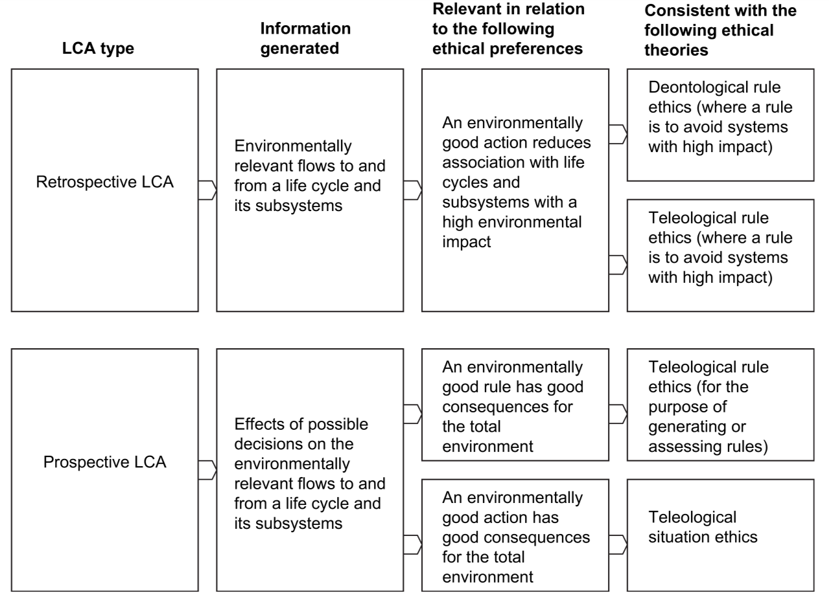
Figure 3.3: Diagram of comparison between retrospective and prospective LCA (Ekvall et al., 2005)

Advantages of the Existing BLCA Methodologies (Retrospective and Prospective)
In the BLCA typology where the distinction is based on the application, the retrospective BLCA is employed for learning purposes, while the prospective LCA is applied to generating information which is relevant for decisions (Baumann, 1996, Hofstetter, 1998, Tillman, 2000b, Ekvall et al., 2005). Moreover, from a broader viewpoint, both the prospective and the retrospective BLCAs can be used for decision making.
Furthermore, from a general perspective, both types of BLCA can also be employed for learning purposes, although the prospective BLCA, in this case, probably describes the sphere of influence of the decision makers rather than the consequences of specific changes.
It is undeniable that the retrospective and prospective BLCAs result in different types of information (see table 3.2). Moreover, these two types of information are related to different views, connected to different theories of normative moral philosophy on the characteristics of a good action. The prospective BLCA methodology is valid from the perspective of ethics. It is also effective for assessing or generating the rules in ethics. On the other hand, the retrospective BLCA methodology is valid for the special cases where the rule is to avoid being associated with systems with an undesirable environmental impact.
Table 3.2: A Summary of properties of retrospective and prospective LCA (Ekvall et al., 2005)
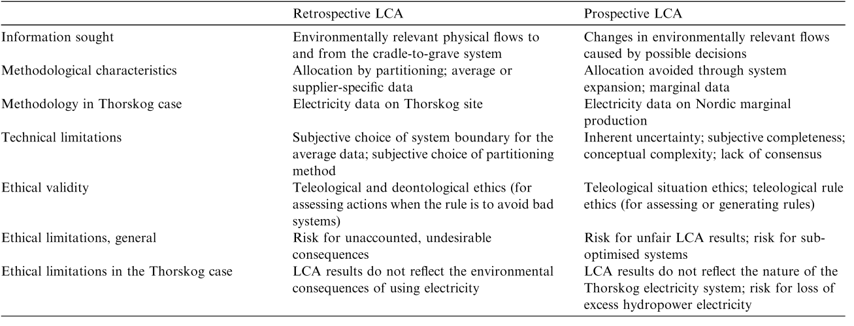

Gaps and Disadvantages
The BLCA represents an important part of these evaluation methods. Lots of previous studies have allowed the BLCA tools to be reviewed (Zabalza Bribián et al., 2009, Nibel et al., 2005, Haapio and Viitaniemi, 2008a, Erlandsson and Borg, 2003b). Nevertheless, there are some gaps regarding the environmental indicators, easily understandable presentation of the BLCA results to its users, simplification, and adaptation to various purposes or applications (e.g. early design phases) (Zabalza Bribián et al., 2009, Todd et al., 2001b).
LCA was mainly developed for designing low environmental impact products. As products, buildings are special since:
- They have a comparatively long life
- They undergo changes often (especially offices and commercial buildings)
- They often have multiple functions
- They contain many different components
- They are locally produced
- They are normally unique (there are not often many of the same kind)
- They cause local impacts
- They are integrated with the infrastructure, system boundaries are not clear, etc.
This implies that making a full BLCA is not a straightforward process as it is for many other consumer products (Zabalza Bribián et al., 2009).
Both retrospective and prospective BLCAs have methodological limitations. In a retrospective BLCA, for example, there seems to be no general, objective basis for the definition of subsystems or the choice of allocation methods. In these respects, the retrospective BLCA methodology relies on the establishment of standards when a detailed standardisation of the methodology is required. An example of such a convention for this type of BLCA is the product-specific rules (PSR) in the Swedish system for EPD (PSR, 2001, PSR, 2000, Ekvall et al., 2005). The need for conventions is emphasised by the fact that the PSRs for different types of products do not have the same conventions for calculating the average data for electricity production (Ekvall et al., 2005).
The methodological limitations of prospective LCA include the requirements for specifying what consequences should be modelled. They also include practical modelling problems. The full consequences of an action cannot usually be modelled in an LCA. It is, in general, not even possible to know whether the consequences modelled in a prospective LCA are close to, or very far from, the actual consequences of the action. We have found no general, objective basis for deciding what types of consequences should be included in a prospective LCA. Hence, prospective LCA methodologies probably also rely on the establishment of conventions when a detailed standardisation of the methodology is required (Ekvall et al., 2005).
Both retrospective and prospective LCAs also have ethical limitations. Decisions based on retrospective LCA can have environmentally undesirable consequences. On the other hand, a widespread use of prospective LCA can also have unwanted environmental consequences in terms of sub-optimised systems. Furthermore, actions based on teleological situation ethics may well appear unfair because producers that initiate or maintain good production systems might not get any benefit from them in a prospective LCA (Ekvall et al., 2005).

Chapter Summary
This chapter has investigated the categorisation of LCA methodologies, (focusing mainly on BLCA). Accordingly, two major categories have been identified: ‘retrospective’ and ‘prospective’. The chapter also dealt with the limitations (technical and ethical) of each category/type. The diagrams in figures 3.3 and 3.4 summarise the limitations of retrospective and prospective LCAs, as well as the problems and the consequences of such problems in terms of environment, economy and society (sustainability). This in turn highlights the gaps in present methodologies, and calls for the provision of more simplified but sensitive and detailed methodologies.
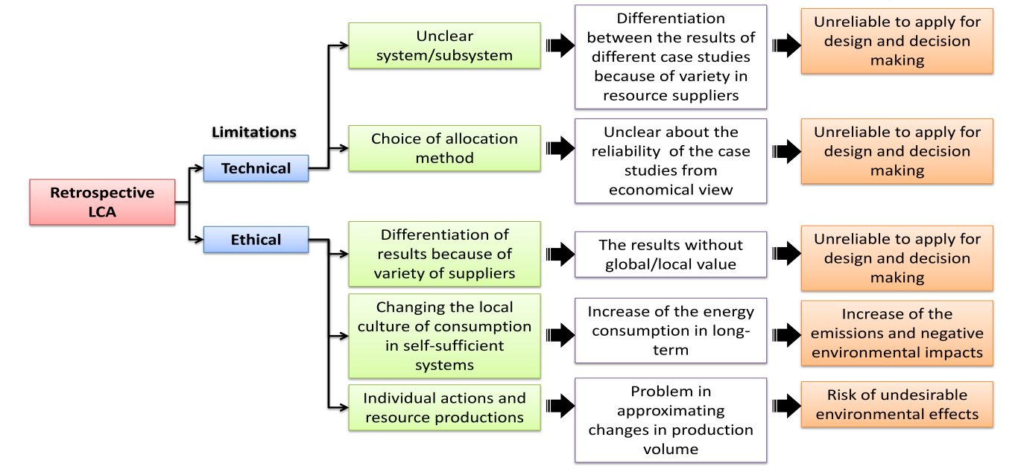
Figure 3.4: Limitations, problems and consequences of such problems in retrospective methodologies

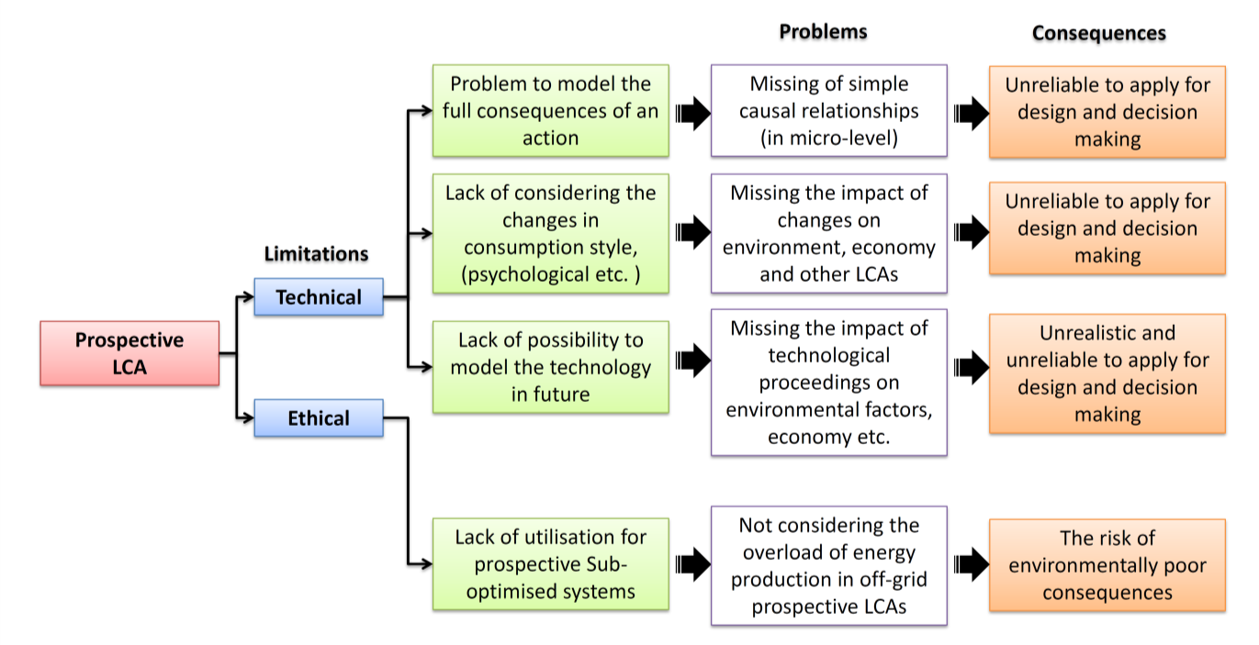
Figure 3.5: Limitations, problems and consequences of such problems in prospective methodologies

Hence, in both types, the lack of consideration of causal factors such as brands, individual different systems, and side-characters (i.e. consumption style factors such as local climate, culture, or psychology) causes some problems. In a broader perspective, the consequence would be the unreliability of these methods (true unrealistic results) and the high risk of negative environmental impacts.
In conclusion, in the case of this research, because of its particular attention to the BLCA precession, the following goals are going to be achieved (refer to chapter 5):
- flexibility to add the casual relationships at micro-levels
- flexibility to change/update the database of LCI in accordance with the local climate, standards, etc.
- a semi-quantitative approach to achieve more reliable results, which can be achieved by benefiting from different programmes; this would prove the greater reliability of the prospective modelling results from different perspectives. Hence, flexibility to choose/add the results of better and newer LCA modelling programmes would be another condition.
- The simplification of the modelling in the BLCA is another factor to make it develop more efficient results (which was investigated in this chapter). This in turn provides more clarity and understanding of the results to be applied by designers and decision makers from different backgrounds and disciplines in the building sector.
Thus, consideration of the factors mentioned above would assist us to reach a better prospective BLCA efficiency; i.e., reduce the negative environmental impacts. This research focused on the energy consumption, i.e. EE and OE, and carbon emissions (EC) of the building scenarios in future (prospective BLCA).

CHAPTER 4: BUILDING LCA TOOLS

4. Building LCA Tools
This chapter investigates the BLCA tools. This investigation is based on the following subjects: the background to the BLCA tools, an introduction to the existing tools, and the classification of the BLCA tools. Hence, considering the scope of this research, the chapter focuses on the category of ‘building design and decision-support tools’. Accordingly, the well-known tools in that category are investigated, and Envest 2 (the existing British tool developed by the BRE) is explored in greater depth.

Background
The recent concern of the building sector with assessment of their activities’ impact on the environment started in the 1990s. Considerable changes were suggested to reduce the environmental impact of the building sector. There was a significant call to focus on how buildings were designed, built and operated (Haapio and Viitaniemi, 2008b).
‘Public policy’ and ‘growth of the market demand’ were introduced as the two principal drivers for environmentally efficient buildings. Hence, a standard was needed for measuring the environmental performance of the buildings (Crawley and Aho, 1999, Haapio and Viitaniemi, 2008b). Accordingly, the specific definition of the term ‘building performance’ sounds complex, because of the variety of interests and requirements in different parts of the building sector (Cole, 1998, Haapio and Viitaniemi, 2008b). Economic performance, for example, interests investors, whereas the tenants are more interested in health- and comfort-related issues.
Separate environmental indicators were developed for the needs of relevant interest groups. However, the first actual attempt to “establish comprehensive means of simultaneously assessing a broad range of environmental considerations in buildings” was BREEAM (Crawley and Aho, 1999, Haapio and Viitaniemi, 2008b).
The first commercially available environmental assessment tool for buildings was BREEAM, which was established in 1990 in the UK (Grace, 2000, Haapio and Viitaniemi, 2008b). Since then, various tools have been developed around the world (e.g. DOE, IEA Annex 31, etc.) (DOE, 1996/2006b, IEA-Annex31, 2001, Reijnders and vanRoekel, 1999, Haapio and Viitaniemi, 2008b).

The Existing BLCA Tools
By development of the research areas in the building environmental assessment tools, and the sustainability in building construction, several international projects have started such as:
- BEQUEST (BEQUEST, 2000, Haapio and Viitaniemi, 2008b)
- CRISP (CRISP, 2004a, Haapio and Viitaniemi, 2008b)
- IEA Annex 31 (IEA-Annex31, 2001, Haapio and Viitaniemi, 2008b)
- PRESCO (Peuportier and Putzeys., 2005, Haapio and Viitaniemi, 2008b)
- GBC (Cole, 1999, Cole, 2001, Cole and Larsson, 1999, Kohler, 1999, Haapio and Viitaniemi, 2008b).
Thus, several studies have been carried out on the subject of building environmental assessment methods (Cole, 2004, Cooper, 1999, Crawley and Aho, 1999, Haapio and Viitaniemi, 2008b). In a few of these studies, the building environmental assessment tools are compared (Forsberg and vonMalmborg, 2004, Todd et al., 2001a, Haapio and Viitaniemi, 2008b), and in others the results of the tools are compared (Aotake et al., 2005 , Kawazu et al., 2005 , Haapio and Viitaniemi, 2008b).
Previously, the building environmental assessment tools have been analysed individually rather than as groups. Neither the shared aspects and common features nor the differences have been emphasised in the studies. The weaknesses or limitations have not been pointed out very strongly. However, these issues are important for the development of the building environmental assessment tools. Also, they affect the standardisation work (Haapio and Viitaniemi, 2008b).

4.3 Classification of the BLCA Tools
Considering the objectives of this research, the study now investigates the categories of building environmental assessment tools. Most of the building environmental assessment tools have been developed by research institutes in Europe, Australia and North America. Almost all of the tools can be bought, at various prices, and a few of them, e.g. BEES, can be downloaded freely from the Internet. Most of them have discounted prices for universities and educational purposes (Haapio and Viitaniemi, 2008b).
A variety of different tools exist for building components whole buildings, and whole building assessment frameworks. These tools cover different phases of the building lifecycle, as well as taking the different environmental issues into account. These tools are developed for global, national and, in some cases, local applications. A few of the national tools can also be applied as global ones, by changing the input databases to the global versions. The tools are developed for different purposes, such as research, consultation, decision making and maintenance. These tools are being employed by the different users, such as designers, architects, researchers, consultants, owners, tenants and authorities. Different tools are also applied to assess new and existing buildings.
Two famous classification systems have been defined for the BLCA tools: ‘ATHENA’ and ‘IEA Annex 31’ (Haapio and Viitaniemi, 2008b, Forsberga and Malmborgc, 2004).

4.3.1 ATHENA classification system
This classification system or ‘Assessment Tool Typology’ (referred to later as the ATHENA classification) is introduced by ATHENA (Trusty, 2000, Haapio and Viitaniemi, 2008b) and includes three levels:
Level 1: product comparison tools and information sources:
- BEES 3.0 and TEAM™
Level 2: whole building design or decision-support tools:
- ATHENA™, BEAT 2002, BeCost, Eco-Quantum, Envest 2, EQUER, LEGEP® and PAPOOSE
Level 3: whole building assessment frameworks or systems:
- BREEAM, EcoEffect, EcoProfile, Environmental Status Model, ESCALE, and LEED®.
BEAT (2002), BeCost, EQUER, Environmental Status Model, LEGEP® and PAPOOSE were not mentioned in the ATHENA classification (Haapio and Viitaniemi, 2008b).
The focus of the ATHENA classification is on the assessment tools. Accordingly, the tools are classified into different levels depending on where in the assessment process they are applied, and for what purpose (Trusty, 2000).

4.3.2 IEA Annex 31 classification system
In the IEA Annex 31 project, the assessment tools are categorised into five classes (IEA-Annex31, 2001, Haapio and Viitaniemi, 2008b). Here, the classification system is combined with the ATHENA classification system as follows:
1. Energy modelling software
2. Environmental LCA tools for buildings and building stocks
- Level 1 of ATHENA: BEES 3.0 and TEAM™
- Level 2 of ATHENA: ATHENA™, BEAT 2002, BeCost, Eco-Quantum, Envest 2, EQUER, LEGEP® and PAPOOSE
- Level 3 of ATHENA: EcoEffect and ESCALE.
3. Environmental Assessment Frameworks and Rating Systems
- Level 3 of ATHENA: BREEAM, EcoProfile, Environmental Status Model and LEED®.
4. Environmental Guidelines or Checklists for Design and Management of Buildings
5. Environmental Product Declarations, Catalogues, Reference Information, Certifications and Labels.

4.4 Comparison of Whole Building Design and Decision-support Tools
Considering the principal goal of this research, this section covers the comparison of the BLCA tools in Level 2 of the ATHENA classification, which is equivalent to Class 2 of the IEA Annex 31 (environmental LCA tools for buildings and building stocks). This level is defined as ‘whole building design or decision-support tools’ (Trusty, 2000, Haapio and Viitaniemi, 2008b), and includes: ATHENA™, BEAT 2002, BeCost, Eco-Quantum, Envest 2, EQUER, LEGEP® and PAPOOSE (Table 4.1).

Table 4.1: Whole building design and decision-support tools (Haapio and Viitaniemi, 2008)
Name | Developer | References
ATHENA™ Environmental  Impact Estimator | ATHENA Sustainable Materials  Institute; Canada | ATHENA Institute (2003); ATHENA™(2007); DOE (1996/2006a);  Trusty and Meil (2002a,b)
BEAT 2002 | Danish Building Research Institute  (SBI), Denmark | BEAT (2002 ); Forsberg and von Malmborg (2004); Hansen (2005); IEA Annex 31 (2001); Petersen (2002)
BeCost (previously known as LCA-house) | VTT, Finland | BeCost; CRISP (2004); IEA Annex 31 (2001)
Eco-Quantum | IVAM, the Netherlands | CRISP ; EcoQuantum IEA Annex 31 (2001); Peuportier and Putzeys (2005)
Envest 2 | Building Research Establishment (BRE), UK | DOE (1996/2006); CRISP; Envest 2 ; IEA Annex 31 (2001);  Peuportier and Putzeys (2005)
EQUER | Ècole des Mines de Paris,  Centre d'Énergétique et Procédés, France | DOE (1996/2006); EQUER ; IEA Annex 31 (2001); Nibel and Rialhe (2000); Peuportier and Putzeys (2005)
LEGEP® (previously known as Legoe) | University of Karlsruhe, Germany | IEA Annex 31 (2001); Kohler et al. (2005); LEGEP; Peuportier and Putzeys (2005)
PAPOOSE | TRIBU, France | IEA Annex 31 (2001); Nibel and Rialhe (2000); PAPOOSE

Table 4.2 compares the LCA tools mentioned above from the point of view of their coverage in assessing different kinds of buildings: existing, new, and refurbished.

Table 4.2: The types of buildings assessed by each programme (Haapio and Viitaniemi, 2008)
Assessment tool | Existing building | New building | Refurbishment of the building
ATHENATM
Beat 2002
BeCost
Eco-Quantum
Envest 2
EQUER
LEGEP
PAPOOSE

Moreover, Table 4.3 compares the same tools in terms of their coverage of various types of buildings such as offices, commercial buildings, and service rooms, as well as the individual lifecycle assessment of the building components. Table 5.4 compares the LCA tools mentioned above from the point of view of the users. This categorisation is based on previous surveys (Haapio and Viitaniemi, 2008, Trusty, 2000) by “AEC professionals (architects, engineers, and constructors)” (Haapio and Viitaniemi, 2008; Trusty, 2000). The surveys show the level of interest in each program among the AEC professionals.

Table 4.3: The types of buildings assessed by each program (Haapio and Viitaniemi, 2008)
Assessment tool | Commercial Buildings | Residential building (multi-unit) | Residential building (single family) | Office buildings | Other type of building | Building products/  components
ATHENATM
Beat 2002
BeCost
Eco-Quantum
Envest 2
EQUER
LEGEP
PAPOOSE
Table 4.4: The categories of users of the tools (Haapio and Viitaniemi, 2008)
Assessment tool | AEC Professional | Producers of Building Products | Investors, building owners | Consultants | Residents | Facilities managers | Researchers | Authorities
ATHENATM
Beat 2002
BeCost
Eco-Quantum
Envest 2
EQUER
LEGEP
PAPOOSE

Table 4.5 compares the aforementioned LCA tools from the point of view of their coverage of phases of the lifecycle.
Table 4.5: The phases of the lifecycle covered by each tool (Haapio and Viitaniemi, 2008)
Assessment tool | Production | Construction | Use/operation | Maintenance | Demolition | Disposal
ATHENATM
Beat 2002
BeCost
Eco-Quantum
Envest 2
EQUER
LEGEP
PAPOOSE

The following factors must be considered in choosing of one (a set of proper BLCA tool/s) for various building projects:
- Location; i.e. choosing of the tools which are designed for the location of project, e.g. Envest 2 for the UK projects, Athena for Canadian projects etc.;
- Type assessing building/s;
- Scope of building practice/project and the level of sensitivity and precision that the project is strategised for;
- The extra need of BLCA to be supported by external environmental modelling programmes e.g. Ecotect, Design Builder etc. As previously mentioned, the basic role of BLCA in building design, from the very early stages, is to provide a lifecycle and long-term over-view for building design and decision-making sector. However, the existing BLCA are not capable enough to cover this entire mind map. Accordingly, the need for being supported by external environmental modelling programmes (e.g. Ecotect, Design Builder etc.) is being detected. This is called as semi-quantitative approach of LCA (to be discussed in the later sections), which is proposed to add values to precision and reliability of BLCA.

Envest 2
Considering the purpose of this research, this section investigates the Envest 2 tool developed by the UK Building Research Establishment (BRE) as the only British BLCA tool in the category of building design and decision-support. According to the BRE, Envest 2 is a web-based software tool designed to simplify the process of designing buildings with low environmental impact, as well as calculating the whole life costs. Therefore, it has been developed to allow the environmental and financial tradeoffs to be made precise in the design process, in order to provide their clients with an optimisation of the best value the concept considering the clients’ priorities (BRE, 2009).
Hence, the building specifications (height, number of storeys, window area, etc.) and the choices of elements (external walls, roof coverings, etc.) are imported into the program. On the basis of the identification of those elements, the program measures the biggest effect on the building’s environmental impact (as an ‘Eco-point’ value) and whole life cost. Moreover, it indicates the effects of altering the choices of building materials. It also aims to predict the environmental and cost impact of diverse strategies for heating, cooling and operation of buildings (BRE, 2009).
The program also compares the different buildings and specifications, and graphically demonstrates the environmental and financial credentials of the different designs. The summary information is reported in charts and graphs.
The environmental data may be presented as an assortment of twelve impacts, from climate change to toxicity, as well as a single Eco-point score (the total environmental impact). Costs are quantified in £ Sterling according to the net present value, discounted at 2002 Treasury rates or a discounted rate set by the user (BRE, 2009).
- Two versions of Envest 2
- Envest 2 estimator uses the default environmental and financial data about the building’s whole life performance. It is designed to be applied by designers who are predominantly interested in the environmental performance of the buildings, and estimates the relative whole life costs for the different designs (BRE, 2009).
- Envest 2 calculator provides the default environmental data as well as allowing the users to enter their own information on capital and lifetime financial costs. This capability of the tool is for designers for whom the whole life costs are of prime importance, who have their own specific data available and who also have access to the environmental performance of the design (BRE, 2009).
- Eco-points
The ‘Eco-point’ is a value introduced by Envest 2 which is designed to indicate the embodied environmental impacts for each element of the building. The value is calculated by estimating the quantity of each material used in individual elements over the life of the building, and multiplying it by the Eco-points per tonne of that material (the exact measurement formula belongs to the BRE, and is not clearly explained in the program). The maintenance and replacement interval of each element has also been taken into account (BRE, 2009). This value appears in different programs developed by other countries under diverse names.

4.5.1 Advantages and weaknesses of Envest 2
At this stage the study investigates the advantages and disadvantages of Envest 2 as the only popular British BLCA tool at present in the category of ‘whole building design and decision-support’ (Haapio and Viitaniemi, 2008b, Trusty, 2000).
- Advantages: On the one hand, Envest 2 covers all the phases of the building lifecycle, including production, construction, operation, maintenance and disposal. From that perspective, it works in a similar way to programs such as Eco-Quantum, EQUER, LEGEP, and PAPOOSE (refer to table 5.5) (Haapio and Viitaniemi, 2008b, Envest2).
- Weaknesses: On the other hand, the weaknesses of the tool overshadow its advantages. In contrast with the other whole building design and decision-support tools, Envest 2 covers assessments of a limited range of building types (refer to table 5.3). Accordingly, in terms of assessment it only covers office buildings (Haapio and Viitaniemi, 2008b, Trusty, 2000, Envest2).
Moreover, in comparison with the other whole building design and decision-support tools, it is supplied to a limited set of users. Hence, the producers of building products, investors, building owners, and residents do not have access to this tool (Haapio and Viitaniemi, 2008b, Trusty, 2000).
The unspecific and invalidated input data is another problem of Envest 2. In addition, whole items of the construction must be imported manually into the programme. In this case, there is a considerable lack of flexibility in the alternatives and the categorisation of the materials and techniques of construction (Envest2).
Moreover, the existing default input system is not defined to show the impact of the alterations in the building locations and climatic situations on the calculations. As a result, the programme does not cover the whole of the United Kingdom; also it cannot be applied internationally. Consequently, the output of the programme cannot be considered as a sensitive and creditable result for ‘building design and decision-support’.
Furthermore, the programme is not connected to the online databases provided by the other research and environmental analysis establishments (unlike some of the other similar tools). Hence, it is not possible to update the input data.

4.5.2 Some requirements of the tool (Envest 2)
To develop more realistic and creditable BLCA results, Envest 2 has the following requirements:
- It needs to be connected to the online databases of the other research and environmental analysis establishments; this would provide the capability to adapt the calculations to the reality of geographical scenarios and the local climatic changes/climatic profiles.
- It needs to be updated in terms of input data (e.g. EE, EC), and to be linked to the sensitive and creditable lifecycle inventories from the UK and from other countries in the future (e.g. the Inventory of Carbon and Energy (ICE) developed by the Sustainable Energy Research Team (SERT) at the Department of Mechanical Engineering, the University of Bath, UK) (Hammond and Jones, 2010a, Hammond and Jones, 2008).
- New values and variables need to be added to cover broader types of buildings such as residential and commercial buildings.
These requirements led this research to develop a new semi-quantitative approach to achieve more sensitive results from the calculations.

4.6 A Qualitative Survey
In relation to the general findings about disadvantages and omissions of the existing BLCA tools and methodologies, in category of Building Design and Decision-support, a qualitative survey was conducted through questionnaire and interviews with a population of 60 people (see figures 4.1 and 4.2).

Figure 4.1: The Questionnaire – Page 1/2

Figure 4.2: The Questionnaire – Page 2/2

This population included specialists from leading professors, practitioners, researchers, and PhD candidates from the following institutions (see figure 4.3):
- The University of Sheffield, UK;
- University of Central Lancashire (UCLan), United Kingdom;
- Loughborough University, United Kingdom;
- Leeds Metropolitan University, United Kingdom;
- Manchester Metropolitan University, United Kingdom;
- Nottingham Trent University, United Kingdom;
- Cardiff Metropolitan University (UWIC), Cardiff, United Kingdom;
- BRE (Building Research Establishment – United Kingdom);
- ARUP – United Kingdom;
- SIEMENS – VAI Metals Technologies Limited;
- Sheffield City Council;
- Wardell Armstrong, Sheffield, United Kingdom;
- Elipse Co, Sheffield, United Kingdom.

Figure 4.3: The population of the participants at different levels of education and practice in the survey

The result of the questionnaire was as shown in Table 4.6 and figures 4.4 and 4.5. The highest percentage of the participants were not optimistic about the existing BLCA computerised tools and Methodologies. The participants were significantly unsatisfied with performance of the existing methodologies and programmes in that category. The highest complains were from the following weaknesses of these tools: unreliable databases; lack of user-friendliness; limited profile of building components and material types; the difference between the calculation results and real practical environmental impacts; low flexibility in modification and being updated regarding the progress of technologies.
Table 4.6: The result of the questionnaire
Question | Strongly Disagree | Disagree | Agree | Strongly agreed | Do not know
Is the tool simple enough to be used by practitioners from different building disciplines? | 37 | 23 | 0 | 0 | 0
Is the tool simple enough to be used by building practitioners from different levels of knowledge? | 48 | 12 | 0 | 0 | 0
Is the tool flexibility enough to consider all details of building components? | 52 | 8 | 0 | 0 | 0
Is the tool flexibility enough to consider all details of building components? | 54 | 6 | 0 | 0 | 0
Is the tool flexibility enough to consider all verities of building material types? | 38 | 22 | 0 | 0 | 0
Is the tool adaptable to all local environmental codes of standards in the world? | 28 | 32 | 0 | 0 | 0
Is the tool in general capable for a realistic BLCA? | 31 | 23 | 6 | 0 | 0
Is the tool covering all requires values of assessment for your field of practice/research? | 21 | 32 | 7 | 0 | 0
Is the tool covering all required values of assessment for BLCA? | 38 | 22 | 0 | 0 | 0
Ho preciseness is the results of calculations in comparison with the manual monitoring and traditional assessment methods? | 52 | 8 | 0 | 0 | 0
Indeed how likely do you trust in the existing computerised BLCA tools | 21 | 37 | 2 | 0 | 0

Figure 4.4: The results of the questionnaire 1/2

Figure 4.5: The results of the questionnaire 2/2

4.7 Chapter Summary
This chapter has covered the investigation of the BLCA tools which have been developed to assess the impact of buildings and construction activities on the environment. Accordingly, the two well-known systems of BLCA tools classification (ATHENA and IEA Annex 3) have been considered.
Therefore, in view of the scope of this research, the category of ‘building design and decision-support’ (Level 2 of the ATHENA classification and Level 2.2 of the IEA Annex 31 classification) has been elaborated. Hence, the well-known tools of this category (such as ATHENA™, BEAT 2002, BeCost, Eco-Quantum, Envest 2, EQUER, LEGEP® and PAPOOSE) have been compared from the following points of view:
- the users of the tools
- the kinds (existing, new and refurbished) and the types (offices, residential etc.) of the assessed buildings
- the phases of the BLCA that are covered.
In addition, to provide a basis to achieve the goal of this study, an in-depth investigation was carried out on the British tool (Envest 2), and a value of environmental impact measured by this program defined as the Eco-point was introduced.
Moreover, the chapter highlighted the weaknesses of the existing British BLCA tool in the category of ‘whole building design and decision-support’ (Envest 2).
Finally, the results of a qualitative survey in the UK among the population of 60 people regarding the advantages and weaknesses of the existing BLCA tools and methodologies in aforementioned category was discussed.

4.8 Summary of Literature Review Phase
From the conducted literature review (refer to chapter 2-5) the following results have been obtained:
- A better understanding of ‘building lifecycle assessment (BLCA)’,
- The significant impact of geographical variation on building design and decision making from view of energy has been determined. This means climatic changes, and transport destinations (form the material sources, to the sites) are directly affecting OE, and EE. Hence, in building design and decision making, special attention must be paid to the suitability of the material profiles (matched with the nearest sources to the projects) in order to reduce the EE in constructions. Moreover, there is a need to consider the best profile of building services matched with local climatic profile to reduce the OE through the building service-life. Furthermore, the mentioned impacts must be taken into account in numerical calculations of BLCA through the processes of design and decision making;
- A review of the BLCA methodologies and tools also highlighted the lack of sensitivity, flexibility (in terms of: building components, brands of materials, and technology) and non-credible input data in existing BLCA methodologies, as well as a low level of confidence in existing BLCA tools in the UK (and in general) in category of building design and decision-support. Furthermore, the methodology behind the Eco-point value (introduced by Envest 2-BRE) is not clear. In addition to this, a number of weaknesses have been identified (Haapio and Viitaniemi, 2008b, Trusty, 2000). Firstly, the existing methodologies and programmes are not sensitive enough to cover the whole UK nor the global BLCAs on a credible basis. The methodologies and programmes are also not connected to updatable online databases. These databases are being provided by other research, experiment, and environmental-analysis establishments and consequently are neither sensitive nor creditable enough to be used by ‘building designers and decision makers’.
The most crucial decisions made in this research were as follows:
- To choose the most important variables/factors for environmental impact (Energy, Carbon and the total environmental-impact-number);
- To choose the gap in BLCA to deal with;
- To choose the most fundamental problem to solve in BLCA (which was the problem in methodology);
- To choose the most suitable ‘programmes and databases’ for achieving the required ‘result’;
- To choose the suitable case study to examine the developed and supported attitude/methodology. Moreover, ‘how many case-studies, scenarios, and in which scales (high-rise, low-rise etc.)?’.
As previously stated the literature-review (terminology and background) provided a foundation for understanding and highlighting of the problem (the motivation of this research). Moreover, it provided background about the research area and its principle, as well as some relevant fields.
The next chapter describes the new measurement approach for the framework introduced by this research.

CHAPTER 5: DEVELOPMENT OF A MEASUREMENT APPROACH FOR THE NEW FRAMEWORK
5. Development of a Measurement Approach for the New Framework

5.1 Development of a Micro-Detailed BLCA Spreadsheet
Although several BLCA tools and programmes have been introduced and offered to the global market, some questions have still not been clearly answered (Blengini and Di Carlo, 2010, Zabalza Bribián et al., 2009, Erlandsson and Borg, 2003a), such as:
- How sensitive and reliable are these tools?
- What are the impacts of geographical and climatic changes on the building lifecycle inventory (LCI) data?
- Do these BLCA tools offer the calculations in a global value or they are usable only for developed countries?
These questions and the incompleteness of the outputs of these BLCAs, together with the general limitations and problems of the ‘prospective BLCAs’ (refer to Chapter 4), motivated this research to look for a more simplified, complete and sensitive prospective calculation method. This method is designed to be applied to the modelling of building scenarios for designers and decision-makers in the building sector. Moreover, it is capable of considering the impact of differences in geographical/climatic scenarios in its calculations.
In order to achieve a better understanding and determination of the advantages of the new BLCA framework, a building type, high-rise office buildings, was selected. This selection was established on the high level of resource consumption and the environmentally and economically sensitive role of this type in the building sector.
For buildings, the two most widely used LCA indicators are energy, as an input, and carbon dioxide, as an output. These are considered in terms of both the embodied energy-CO₂ (which is bound up in the materials) and the operational energy-CO₂ (which is used or emitted during the building’s service life). Continuing with this approach, this research adapts these indicators.

5.2 Using Different LCAs to Reflect Different Sources
The new framework tried to cover the common parameters demanded by the building sector, such as EE, OE, EC, OC, and the total energy consumption and carbon emissions of the building during its service life. Accordingly, as a solution, the new methodology is intended to benefit from the results of the other existing BLCA tools and environmental assessment programmes. Therefore, at the end of the calculation, more values are being offered to the user of the methodology which have a broader overview, but which can be more efficiently applied to design and decision making.
Part of the primary modelling and simulations of the case study was carried out in the Ecotect 2011 programme (Autodesk, 2008). The advantage of Ecotect 2011 at this stage was its accessibility in the UK and in the School of Architecture at the University of Sheffield, as well as the user-friendly nature of the programme (more details in Chapter 6) (see figure 5.1).

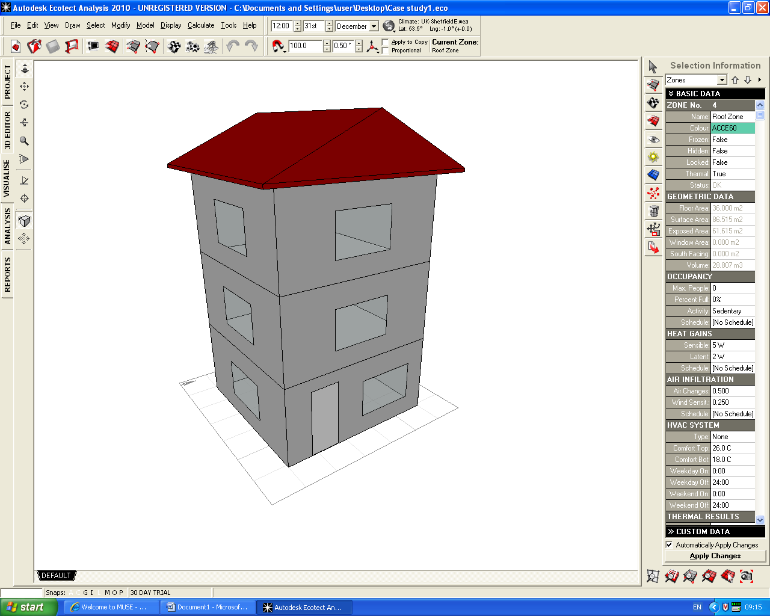
Figure 5.1: An example of building simulation by Ecotect 2011 (the screen shot) (Autodesk, 2008)

The impact of the building material changes on the environment is also being calculated by the Envest 2 (refer to the chapter 4). Table 5.1 compares the capabilities of Ecotect 2011 and Envest 2 in BLCA.
Table 5.1: A comparison between Envest 2 and Ecotect 2011
 | Envest | Ecotect
- Thermal analysis |  | •
- Solar exposure |  | •
- Material costs | • | •
- Resource consumption | • | •
- Reverberation times |  | •
- Acoustic response |  | •
- Environmental impact of building materials and services (Eco-point) | •
- The bullets show the availability of each service in each programme
The operational energy (OE) is calculated by Ecotect 2011; the calculation tool is in the ‘Thermal Analysis\Monthly Degree Day’ at the left side of the screen, in the Ecotect 2011 environment (see figure 5.2).
Accordingly, this research employed both the programmes (Envest 2 and Ecotect 2011) during its preliminary modelling. This approach is defined as the ‘semi-quantitative methodology’ (Ortiz et al., 2007, Ong et al., 1999, Kaebemick et al., 2003).

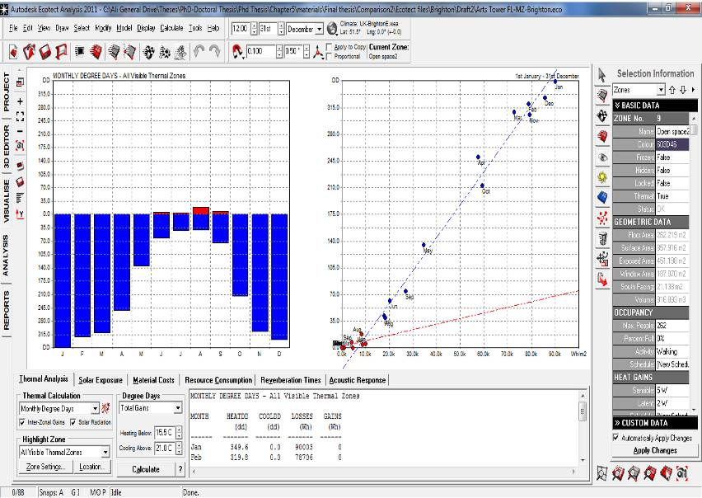
Figure 5.2: ‘Analysis Menu\Thermal Analysis\Monthly Degree Day’ in ECOTECT software; Source: ECOTECT (Autodesk, 2008)

A similar research technique was employed in 1976 by Gartner and Smith in the BRE, in order to calculate and compare the embodied energy in four types of domestic buildings (Gartner and Smith, 1976) (see table 5.2).

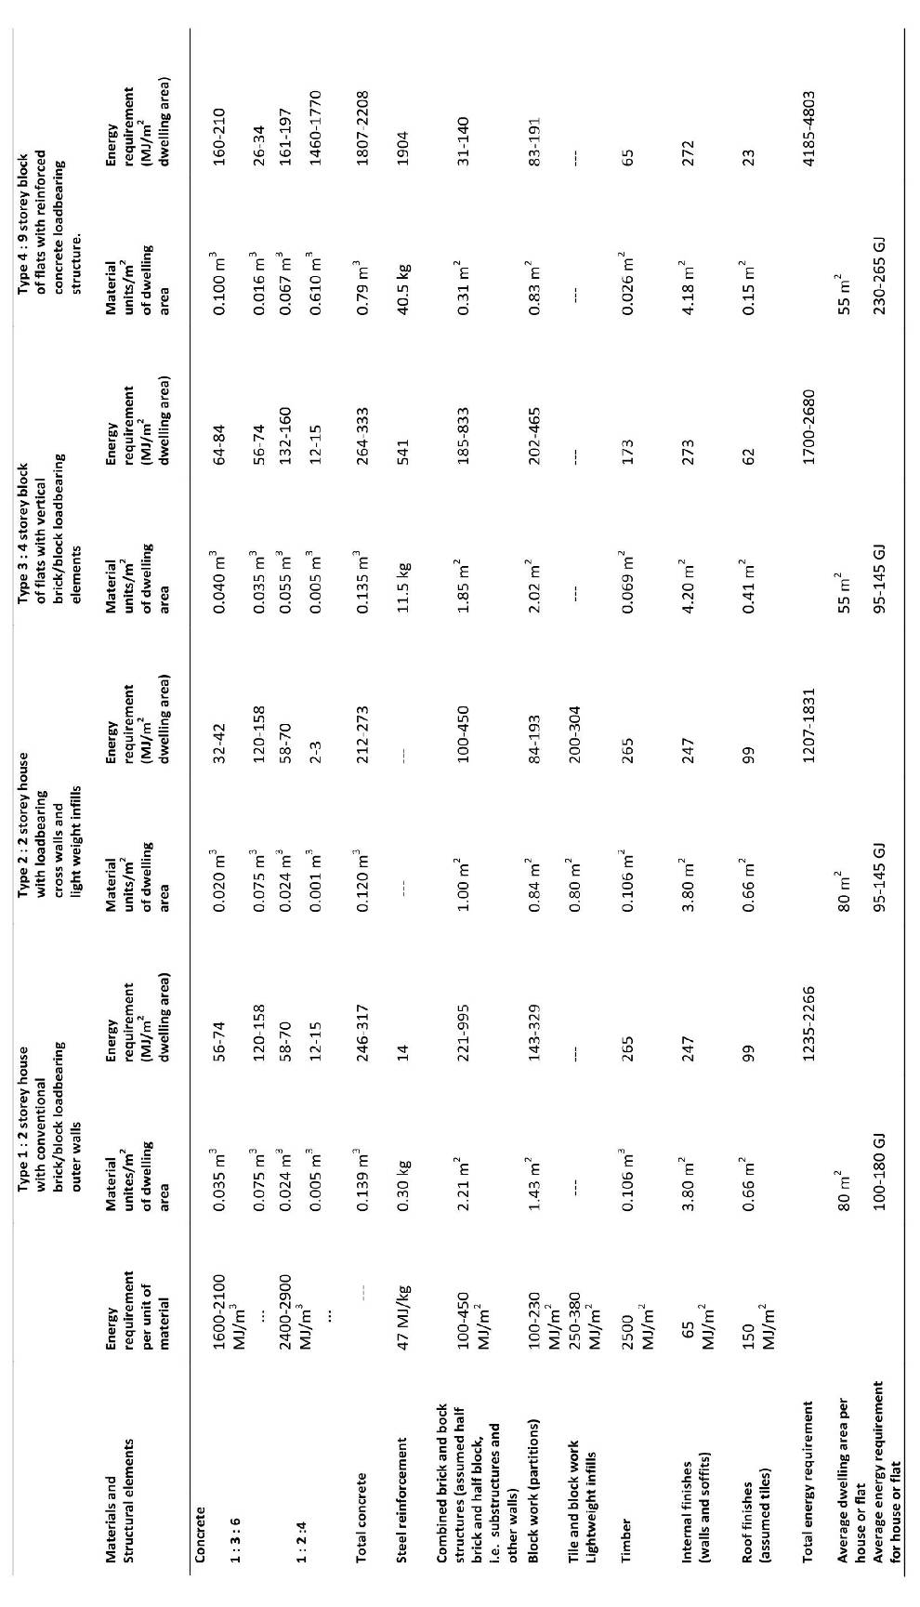
Table 5.2: Local authority housing materials energy inputs, a,b (per m² of dwelling area), (Gartner and Smith, 1976)

As previously stated, this research has tried to develop an improved approach considering different quantities of the data which are related to values such as:
- the size of the buildings;
- the quantity of materials consumed;
- the EE and EC of the materials used during the building’s fabrication.
These values are being manually imported into the spreadsheet (see table 6.3, and refer to the next chapter for more detail). Each of these variables can be imported from the different BLCA tools (such as Envest 2), environmental simulation programmes (such as Ecotect 2011), and LCA databases (such as ICE 2011).
Moreover, some materials have not been defined in the aforementioned programmes (where they appear as default values). Accordingly, their quantities (kg/$m^{2}$) can be calculated from handbooks or inventories which show the density of materials per m³. In this case, the data were provided by the SI metric electronic handbook (Walker, 2009). The density of materials in this handbook is assessed in kg/m³. Therefore, to calculate the weight of each m² of the materials, the 100 centimetres of the thickness in 1 m³ must be divided into the thickness of material in the particular building.
In the next step, the EE and EC of each material were imported from the Inventory of Carbon and Energy (ICE 2011) developed by the University of Bath, UK (Hammond and Jones, 2008), in mega joules (MJ) per kg (for EE), and kg CO₂ per kg (for EC) (see table 5.3).

Table 5.3: Spreadsheet: calculation of the total EE, EC, and the total environmental impact of construction in the simulated buildings
Building Component | Value Units (m2) | Weight (kg) | EE (MJ/kg) | EC (kg ${CO}_{2}$CO₂) | Total EE for each material  (MJ) | Total EC for each material  (kg CO₂) | Total environmental impact for each material/Eco- point
ConcSlab_OnGround | 50 | 35415 | 0.95 | 0.13 | 33644.25 | 4603.95 | …
Plaster_Insulation_Suspended (General Insulation in this case) | 61.05 | 811.66 | 45 | 1.86 | 36524.7 | 858.52 | …
SolidCore_PineTimber (General Timber in this case) | 1.89 | 41.58 | 8.5 | 0.46 | 353.43 | 19.1268 | …
BrickTimberFrame(General Brick in this case) | 135.15 | 31435.62 | 3 | 0.22 | 94306.86 | 6915.836 | …
SingleGlazed_TimberFrame | 12.96 | 133.695 | 15 | 0.85 | 2005.425 | 113.6408 | …
MetalDeck (Sheet-Virgin in this case) | 50.515 | 796.119 | 31.5 | 2.51 | 25077.75 | 1998.259
Total |  |  |  |  | Total EE for Building  (MJ) | Total EC for Building  (kg CO₂) | Total Eco-point for construction
 |  |  |  |  | 191912.4 | 14509.33 | ….

Consequently, this framework suggests benefitting from a combination of the different calculation approaches, which benefits from the output of the different BLCA tools, programmes, and databases, and which aims to calculate the total EE, EC, and Eco-point (environmental impact) of buildings in the case studies. The results reveal the higher sensitivity and level of confidence of this methodology (refer to the next chapter).
Moreover, different types of materials can be considered in the spreadsheet. This shows the flexibility of the measurement approach to include virgin (or fresh/brand-new) materials, recycled materials, and eco-agro materials (including lower embodied energy and high construction performance) in design scenarios.

5.2.1 Some advantages of this framework
Some advantages of this framework are as follows:
- It can be applied to the whole building process
- It provides the capability of being updated in terms of input data (EE, EC, OE, local climatic data, local materials etc.)
- It can be applied to whole types of buildings
- The outcome offers the pure numbers of energy consumption, carbon emissions, and the building’s environmental impacts (EE, EC, OE, Eco-point)
- The employment of the more creditable LCI, local climatic data, and detailed data on materials makes it sound more realistic in terms of its results.
The final results can be applied by architects, designers, engineers, and the decision makers in the building sector to select the right structural system, as well as better packages of building materials regarding local climatic scenarios, low EE-EC, and environmental impact (Eco-point) design concepts.

Table 5.4: Spreadsheet 2: Measurement of total energy use, CO₂ emissions, and environmental impact of a building during its construction and service life
 | Total EE | Total EC | Total OE | Total Energy | Total pollution/ CO₂ emission | Total Environmental Impact/Eco-point (construction + services)
Case study1 | … | … | … | … | … | …
Case study2 | … | … | … | … | … | …
Case study n | … | … | … | … | … | …

As table 5.4 shows, in the second stage, the total OE and the total EE of the case studies in the different geographical scenarios are added up. The result would be the total energy consumption during the life of the building. Furthermore, the total CO₂ emission and total environmental impact of the building during its service life are calculated.
In the next stage, the results of this spreadsheet through the case study for the different geographical scenarios (different locations in the UK) were compared in a statistical approach (using Microsoft Excel/SPSS). Therefore, the impact of geographical variation and climatic change on the BLCA was highlighted (refer to Chapter 8). Hence, as a principal goal of this research, the level of confidence that might be expected from the BLCA was determined.

5.3 A More Detailed Explanation of the Measurement Phases in the New Spreadsheet
The measurement spreadsheet to demonstrate the guideline of the new framework introduced by this research was developed established on calculation of the following values (see figure 5.3):
- section
- detail
- material
- area (m²)
- height (m)
- volume (m³)
- density (kg/m³)
- total weight (in kg and tonnes)
- EE per m³
- EC per m³
- Total EE
- Total EC
- Total OE (resulting from the Ecotect 2011 modelling)
- Total Eco-point (resulting from the Envest 2 modelling).

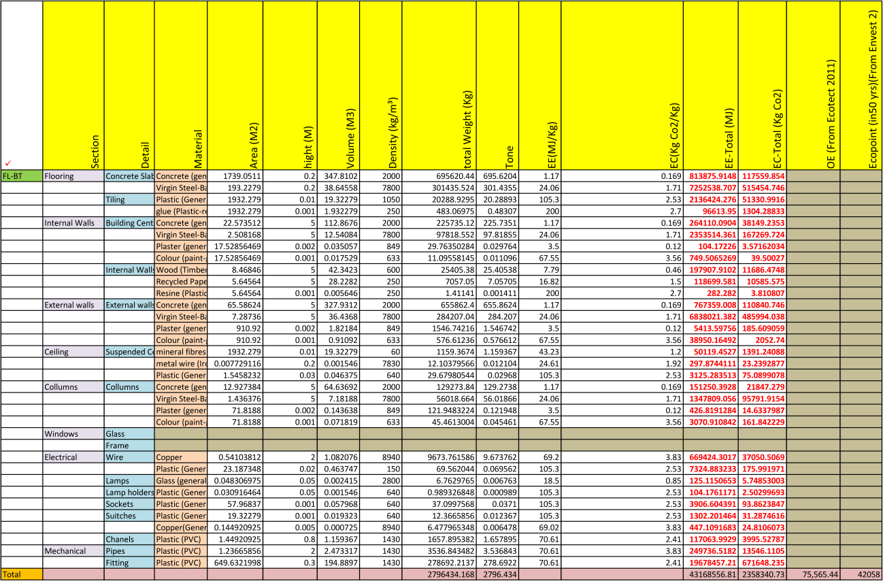
Figure 5.3: The new spreadsheet introduced by this research

As previously stated, one of the advantages of this measurement approach is the high sensitivity in terms of material details (see figure 5.4).


Figure 5.4: High sensitivity of the new measurement approach in details of building materials and components

5.3.1 Providing the basic data (EE, EC, volume of building elements, weights and densities of materials)
The areas (m²) were calculated on the basis of the original plans of the building (it can be measured either in Auto-CAD or manually). The volumes of the elements were calculated according to the following approach:
Volume of element (m³) = (Area of element in m²) × (height of element in metres)
e.g. floor area × floor thickness, or wall area × height of walls. Hence, in breaking down the materials the volume of each material has been measured by considering the percentage of that material in the considered element. For example, the volumes of steel (as bars and rods) and concrete (general type) are calculated by respectively timing the volume of reinforced concrete to 0.1 and 0.9 (the considered rate in this case study) (see figure 6.5).
Volume of reinforced concrete × 0.1 = Volume of steel
Volume of reinforced concrete × 0.9 = Volume of concrete

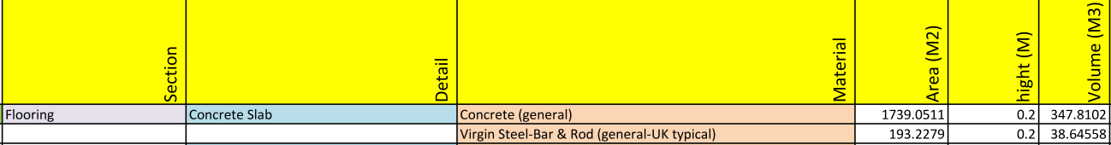
Figure 5.5: Calculation of the volume of concrete and virgin steel in floor of the basement in the case study

Accordingly, in the case of the volume of materials in the composite walls of this case study the calculation process is as follows (also see figure 5.6):

Volume of walls × 0.4 = Volume of wood (timber - general)
Volume of walls × 0.4 = Volume of recycled paper (general - predominantly recycled)
Volume of walls × 0.004 = Volume of resin (plastic - resin - general purpose polystyrene)
Figure 5.6: Calculation of the volume of wood, recycled paper, and resin in internal walls of the basement in the case study

5.3.2 Importing the values to the new spreadsheet and final measurements
In the next step, the EE, EC (based on ICE 2010), and density of materials (based on the standard of CIBSE) for each square metre have been imported to the spreadsheet (see figure 5.7).
EC of 1Kg of material
(Taken from ICE2010)

Density of 1m³ of material
(Taken form CIBSE)

EE of 1Kg of material
(Taken from ICE2010)

Hence, the total weights of the materials are calculated by the following method (see figure 5.7):
Figure 5.7: Calculation of the total weight of materials in the basement of the case study
Density of 1m³ of material × Total volume of material = Total weight (Kg)
Accordingly the total EE and EC of each material are calculated by multiplying the total weight by the EE and EC of one kilogram of that material as follows (see figure 6.8):
Total weight of material × EE of 1Kg of material = Total EE of material in the floor
Total weight of material × EC of 1Kg of material = Total EC of material in the floor

Figure 5.8: Calculation of the total EE and total EC of the materials

Therefore, the total EE and EC of the floor are calculated by adding up all total EEs and ECs.
To continue, the results of the preliminary modelling of the case study floors (OE from Ecotect 2011, and Eco-point from Envest 2) are entered onto the spreadsheet. This is done to find the total amount of energy consumption and environmental impact during the construction process and service life of the building. In this case the service life has been considered as 50 years, so the total OE resulting from Ecotect 2011 is multiplied by 50 (see figure 5.9).
OE (Resulting from Ecotect 2011) × 50 = OE in 50 years of the building’s service life

Figure 5.9: Calculation of the total EE, EC, OE, and Eco-point

Indeed, the sum of the results of all spreadsheets relevant to different typical floors provides us with the total EE, EC, OE, and Eco-point of the building (In this case study, six typical floors have been modelled as: basement, ground floor, mezzanine floor, floors 1-18, floor 19, and roof level).
The sum of total EE and total OE (calculated in relation to the service life of the building) provides the total energy consumption in this scenario of materials and building components:
Total OE (OE × 50) + Total EE = Total energy use in 50 years of the building’s service life
The same process can be carried out regarding a variety of building scenarios to calculate some essential values such as total energy, total EC, and total Eco-point so that building designers and decision makers can prioritise the best scenario/s.

5.4 Chapter Summary
This chapter covered the following subjects:
- introduction of the new semi-quantitative measurement approach (spreadsheet) developed by this research;
- investigation of the advantages of this measurement approach as an interdisciplinary quantitative approach based on the updatable databases, LCA tools, environmental assessment programmes;
- and more detailed explanation of the process of modelling in the in the new spreadsheet developed by this research.
The principal motivations to develop such methodology were as follows:
- The aforementioned limitations of the prospective BLCA methodologies,
- and the weaknesses of the Envest 2 as the only existing British BLCA design and decision-support tool (refer to chapter 3 and 4).
Hence, at this stage an improved, simplified, prospective BLCA measurement approach in terms of measuring total embodied energy, embodied carbon, and the impact of building on environment was introduced and called semi-quantitative approach. This has been based on more detailed calculations (in terms of total EE, total EC) and support from existing programmes (Envest 2 and Ecotect 2011) in terms of Eco-point and OE (see figure 5.10).
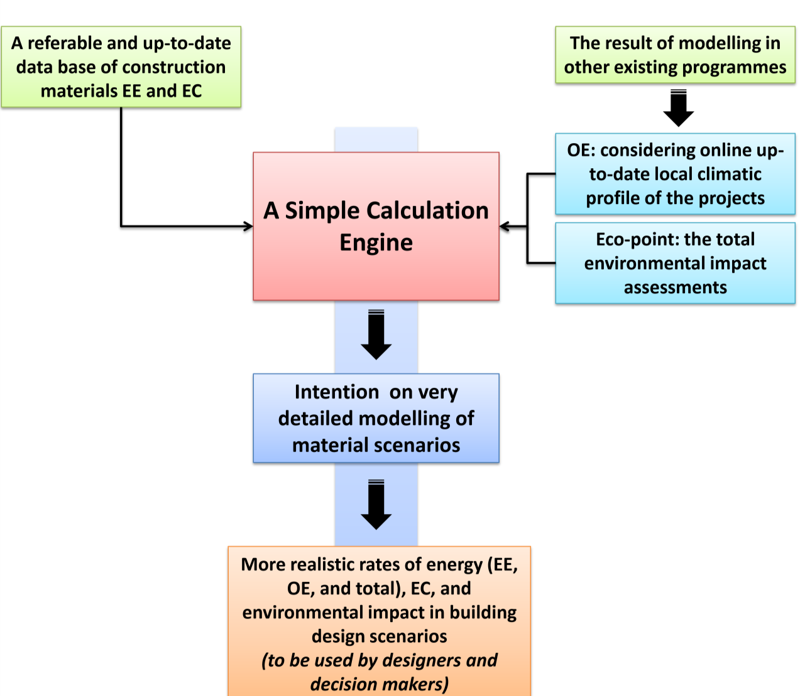 Figure 5.10: Diagram of the new framework of BLCA for building design and decision-support introduced by this research
A detailed Spreadsheet (Measurement Approach)
A referable and up-to-date database of construction materials EE and EC

Accordingly, it has highlighted the advantages of this prospective methodology as follows:
- simplicity of being-learned measurement and calculations in comparison with the existing prospective BLCA tools;
- covering of more key values for building designers and decision makers, such as total energy, EC, and Eco-point;
- more sensitivity than previous prospective BLCAs because of its high flexibility and adaptability to all material details, brands, suppliers and building components;
- its multidisciplinary (semi-quantitative) nature, which enables it to benefit from other programs through its preliminary modelling and thereby provide more precise and reliable results than the existing prospective BLCA tools;
- high flexibility to change the databases and LCIs in case of geographical and/or standard changes, and in case of better or more up-to-date LCIs being found;
- its adaptability and its compatibility with other methods of calculation, in case other values (e.g. acoustics) need to be included (refer to Appendix B: relevant published paper in 5th International Symposium of Temporal Design (ISTD), Sheffield, UK).
The next chapter covers the background of the case study and the process of the primary modelling.

CHAPTER 6: CASE STUDY AND PRE-MODELLING
6. Case Study and Pre-Modelling
Chapter 6 investigates the application of the case study to the different material and climatic scenarios according to the measurement approach introduced by this research (see figure 6.1).
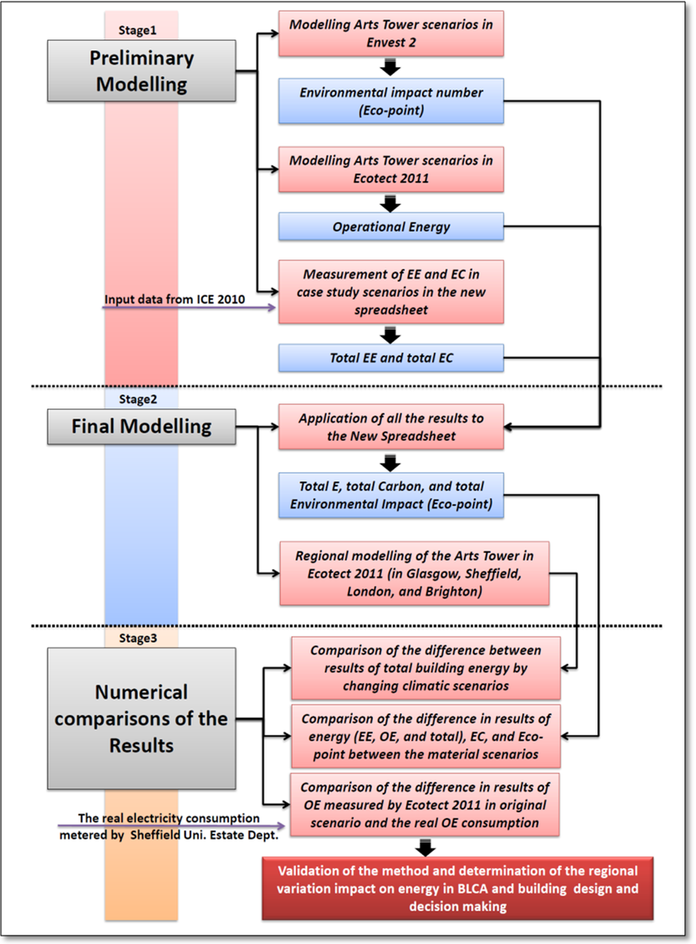
Demonstration of the capabilities of new framework and determination of the regional variation impact on energy in BLCA and building design and decision making
EFM
Figure 6.1: Diagram of the Case study process
As previously stated, this research investigates a high-rise office building as the case study. The reasons for selecting this type were the high quantity of materials and the great scale of energy consumption during their lifecycle.
Accordingly, The Arts Tower of Sheffield was selected as the case study. This selection was based on the significant situation of the tower regarding its recent refurbishment (2009-2011). This in turn provided a great opportunity to investigate the building through its 50 or so years of service life, as well as the data provided by the Estates and Facilities Management of Sheffield University.
In phase 1, to validate the sensitivity and reliability of the new methodology in terms of its application to building design and decision-support, the modelling of the case study was carried out in six scenarios of building materials and components. Hence, the results show the difference in the total energy, carbon, and environmental impact of the building in the case of very simple changes in building materials (for instance, in the type of cement or windows) (see figure 7.4).
In phase 2, the model of the original material scenario of the case study was examined in Ecotect 2011 in four different climatic situations (Glasgow, Sheffield, London, and Brighton). This phase was intended to determine the impact of regional variation on BLCA, and on building design and decision making (see chapter 1, figure 1.1).

6.1 A Brief Background and General Structural Information
This section provides a background to the case study of this research, which is the Arts Tower of Sheffield. The building is located at 12 Bolsover Street in Sheffield, England, and belongs to the University of Sheffield (see figure 6.2). It is known as one of the most elegant university tower blocks in Britain of its period. At 255 feet (78 m) tall, it is the tallest building in the city, after the St. Pauls Tower on Arundel Gate. It is also the tallest university building in the UK (Schneider, 2008).
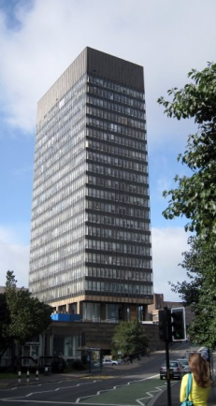
Figure 6.2: Arts Tower, the University of Sheffield, Sheffield, United Kingdom

The building was designed by architects Frank Gollins, James Melvin, Edmond Fisher Ward & Partners, and won the first prize in the 1953 open competition for a master-plan for the central development of the University of Sheffield. Construction of the tower started in 1961 and lasted four years (Schneider, 2008).
The building was officially opened by Queen Elizabeth the Queen Mother in June 1966; it has 20 storeys and a mezzanine level above ground. Before 2009, it contained the Departments of Landscape, Modern Languages, Philosophy, Biblical Studies, and Architecture as well as the library administration. As its name suggests, the building originally housed all the University’s arts departments, which had far fewer students in the 1960s (Mathers, 2005).
There are also two floors below ground level that house nine lecture theatres. The building contains a cafe in the basement. It has a student computer room on the twelfth floor, and a self-service language teaching centre on the second. Circulation is through two ordinary lifts and a paternoster lift, with 38 cars.
In December 2007, the University announced the plans for a major refurbishment of the Arts Tower. The refurbishment was to include a major reorganisation of the building’s interior, as well as a new façade, and coincided with the move of the Modern Languages department to the former Jessop Hospital site. The building was vacated in April 2009, and the refurbishment took approximately two years.
From the typology viewpoint, the tower is design as a mixture of core and casing high-rise families. The structure of the Arts Tower building is created from the reinforced concrete columns and slabs of floors, in 23 storeys (20 plus mezzanine and 2 basement floors) (see figure 6.3).
All the toilets, lifts, paternosters and stairways, and the electrical-mechanical utility ducts, are located in the central core, which is constructed from the reinforced concrete load-bearing walls (see figure 6.3).

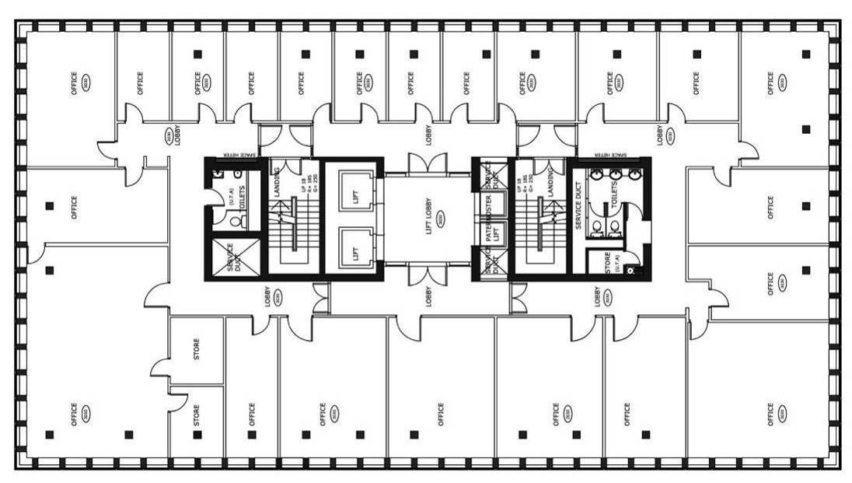
Figure 6.3: General layout of structure and offices in Arts Tower, Sheffield, UK

6.2 Pre-Modelling

6.2.1 Phase 1 - Modelling Based on the Material and Building Component Scenarios
As formerly stated, phase 1 covers the modelling process of the case study, based on six scenarios of building materials and components (to be considered in this chapter and Chapter 7). This was conducted to demonstrate the capabilities of the new framework and its introduced measurement approach, and to show its sensitivity in terms of values such as the total energy, carbon, and environmental impact of the buildings in the case of very simple changes in building materials (e.g. changing the type of cement or windows) (see figure 6.4).

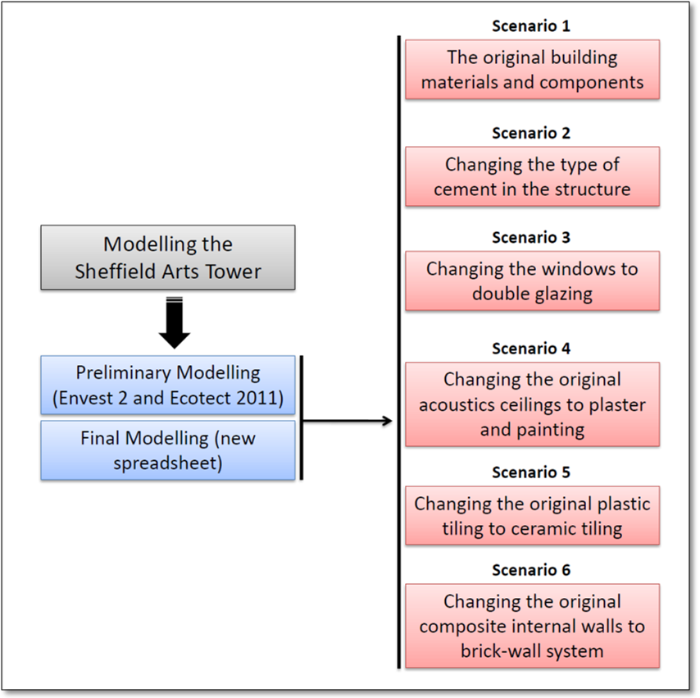
Final Modelling
(new spreadsheet)
Figure 6.4: Phase1: Scenarios for modelling the case study during preliminary and final modelling
To achieve the objectives of this research, preliminary modelling was carried out to establish two important variables: OE (calculated by Ecotect 2011), and total environmental impact of the building/Eco-point (calculated by Envest 2) (see figure 6.5).
A) Modelling of the Arts Tower of Sheffield in Envest 2
At this stage, the floors have been divided into six categories according to size and layout as follows:
- Basement floor/FL-BT
- Ground floor/FL-GR
- Mezzanine floor/FL-MZ
- Floors 1-18/FL-1-18
- Floor 19
- Roof floor/FL-RF.
Each building profile includes the following information:
- size (area and height) of the floors (total area, areas of tiling, internal walls, doors, windows, external walls, and ceiling)
- type and materials of structural details (floors, walls, windows, doors, ceilings, etc.)
- building utilities (in this case: heating, lighting, and lifts)
- the source of heating, defined as electricity
The outcome of the programme was two values: cost and Eco-point (for the building in detail and in total) (BRE, 2009). Eco-point values for the original scenario (the existing situation) are shown in table 6.1.

Table 6.1: Eco-point of floors and building in the existing situation for the Arts Tower of Sheffield, resulting from Envest 2
Floor | Eco-point
Floor | Fabric & Structure | Services | Total/floor
Basement floor/FL-BT | 8,034 | 34,024 | 42,058
Ground floor/FL-GR | 1,338 | 2,803 | 4,141
Mezzanine floor/FL-MZ | 2,312 | 3,306 | 5,618
Floors 1-18/FL-1-18 | 4,371×18  =78,678 | 47,720×18  =858,960 | 52,091×18  =937,638
Floor 19 | 1,615 | 9,796 | 11’411
Roof floor/FL-RF | 1,840 | 4,656 | 6,496
Total | 93,890 | 913,535 | 1,007,362

This process was carried out for six material scenarios (refer to figure 7.4, and section 6.2.2), in order to provide the basic data (Eco-Point) for the final modelling (refer to section 6.2.2).
- Gaps and disadvantages of Envest 2 in the modelling of the case study:
- The categorisation of the materials in the structural detail section is very limited, and does not cover enough variety of materials and techniques of construction. ,
- In terms of utilities, factors as security systems or various types of lifts (e.g. paternoster) are not defined in the programme. Also, the heating and lighting system is given in the programme and is not flexible.
B) Modelling of the Arts Tower of Sheffield in Ecotect 2011
At this stage one of the validated products of Autodesk in terms of thermal simulation named ‘Ecotect’ (Al-Shibami, 2004) was employed to calculate the operational energy in the tower. Ecotect 2011 was used in this research because of the following advantages of the programme:
- allowing the designers to work easily in the 3D environment
- the capability of defining the various design scenarios in terms of different geographical profiles (the programme has access to more than 90 weather data files based on the climate of several countries) (Autodesk, 2011), because of which it sounds suitable for the second comparison of the case study scenarios, which will be considered later (refer to Chapter 8)
- the possibility of importing Auto-CAD plans into the programme, which provides the opportunity to match the 3D design with original plans of the tower
- the possibility of defining various options (e.g. programme of using the spaces, function of spaces, type of occupancy, average number of people and activities, more detailed thermal systems)
- Moreover, the wide accessibility of the programme in the UK, because of which it was used as a representative of environmental modelling programmes at this stage.
Therefore, at this stage, the same modelling categorisation that was used previously in Envest-2 was carried out in Ecotect 2011. Hence, the building was divided into six categories as follows:
- Basement floor/FL-BT
- Ground floor/FL-GR
- Mezzanine floor/FL-MZ
- Floors 1-18/FL-1-18
- Floor 19
- Roof floor/FL-RF.
Accordingly, six Ecotect 2011 files were defined. In this case, to choose the best approach, the modelling was conducted twice:
- Modelling based on building plan:
This type of modelling was based on the 3D CAD Modelling programme. Hence, all the details of the floors have been imported into Ecotect 2011. In this case, the programme did not provide a clear result. The reason was that the walls (internal and external) were considered by the programme as separate boxes including spatial thermal profiles.

- Modelling based on thermal zones: In this case, the modelling was based on the spaces in each floor which provide separate thermal zones.
To continue, the values of OE calculated by the programme were converted to MJ (mega joules), and multiplied by 50, to show the total OE of the tower during a 50year period of service life, in the climatic situation of Sheffield (see table 6.3).
Table 6.3: Operational energy of floors and building in the existing situation, derived from Ecotect 2011, for the Arts Tower of Sheffield
Floor | OE/operational energy (MJ)
Floor | Annual | Total in 50 years of Service life
Basement floor/FL-BT | 1,618.765 | 80,938.26
Ground floor/FL-GR | 2,571.484 | 128,574.2
Mezzanine floor/FL-MZ | 2,585.106 | 129,255.3
Floors 1-18/FL-1-18 | 25,865.96 | 1,293,298
Floor 19 | 1,780.816 | 89,040.78
Roof floor/FL-RF | 705.5136 | 35,275.68
Total | 35,127.64 | 1,756,382.22

Table 6.3 shows the total operational energy in the floors and in the building (The Arts Tower of Sheffield) in the existing scenario (existing materials and structural system, location: Sheffield, UK) calculated by Ecotect 2011.
This process was also performed in six material scenarios (refer to figure 6.4) to provide the basic data (OE) for the final modelling (refer to section 6.3.2).
On the other hand, in future, the programme needs to be developed with consideration of locations provided in climatic profiles, to cover more climatic scenarios. Moreover, in the similar cases, the calculation is based on the default services of Ecotect 2011 (in terms of building utilities), which prevents the assessment from being more sensitive and realistic.

6.2.2 Phase 2-Modelling Based On Regional Variation
As previously discussed, this phase has been carried out to achieve the other goal of this study: to determine the impact of regional variation on the results of BLCA in building design and decision-support in terms of energy. Accordingly, phase 2 deals with an examination of the model of the case study’s original material scenario in Ecotect 2011 in four different climatic situations (Glasgow, Sheffield, London and Brighton) (see figure 6.5).
Figure 6.5: Phase2: modelling of the case study on the basis of regional variation

Hence, table 6.4 shows the difference in OE in the case study (with the existing structural situation and utilities – electrical, mechanical, etc.) in four cities in the south, middle and north of the United Kingdom: Brighton, London, Sheffield (the existing location), and Glasgow.
From this point of view, it can be concluded that the total energy through the expected service life of a building can vary in relation to the diversity of geographical scenarios (see figure 6.11).

6.3 Comparison of energy, carbon and Eco-point in case study based on regional variation
This comparison assists the designers and decision makers in the construction industry to choose the best options in terms of building materials and utilities in relation to geographical diversity. In this comparison, OE (measured by Ecotect 2011) plays the main role in building design and decision making. This is based on the following reasons:
  - The EE and EC of the materials provided by ICE 2010 are based on typical ‘cradle to gate’ measurements. Hence, regional variation does not affect the result of measurements based on this database.
  - Envest 2 does not consider the global and local climatic profiles through its Eco-point measurements.

Consequently, the main factor of assessment here would be OE (see table 6.4 and figure 6.6).
Table 6.4: Measurements of OE in four different geographical scenarios in 50 years - Arts Tower, Sheffield
Arts Tower  Sheffield-  Climatic  Scenarios | OE in 50yrs of Service-life (MJ)
Arts Tower  Sheffield-  Climatic  Scenarios | Floor-BT | Floor-GR | Floor-MZ | Floor-1-18 | Floor-19 | Floor-RF | Total
Scenario 1 – Sheffield | 75,565.44 | 116,524.8 | 120,181 | 967,195.1 | 129,173 | 33,135.84 | 1,441,775
Scenario 2 - London | 64,133.64 | 98,788.68 | 101,902.7 | 855,667.8 | 109,288.6 | 28,363.14 | 1,258,145
Scenario 3 – Brighton | 73,128.78 | 111,840.3 | 115,377.3 | 953,493.1 | 124,798.1 | 32,258.88 | 1,410,897
Scenario 4 - Glasgow | 76,004.46 | 117,559.1 | 121,233.2 | 986,097.2 | 130,668.7 | 33,257.7 | 1,464,820

Figure 6.6: Diversity of operational energy in the case study (The Arts Tower of Sheffield) in relation to geographical variation

6.4 A Comparison of the OE measured by computer programme and by the traditional approach
At this stage, regarding the objectives of this research, the total OE of the case study (the The Arts Tower of Sheffield) in the original material and climatic scenario is compared with the result obtained by the traditional method. Table 6.5 shows the operational energy measured by Ecotect 2011 (Autodesk, 2011), as well as the result of the traditional approach (electricity meter monitoring) carried out by the Estates and Facilities Management of the University of Sheffield (UoS).

Table 6.5: A comparison of operational energy measured by Ecotect 2011 and the real operational energy consumption of the building
 | OE Measured by Ecotect 2011 |  | OE (Electricity) Monitored by Estate Dpt. UoS |  | Percentage of difference  %
 | Annual  (MJ) | In 50 yrs (MJ) | Annual  (MJ) | In 50 yrs (MJ) | Percentage of difference  %
The case study (The Arts Tower of Sheffield) | 28,835.5 | 1,441,775 | 6,123,117.3 | 306,155,863 | 90.1

This shows a difference of 90.1% between the computer programme (Ecotect 2011) and the real operational energy consumption of the building, which is a very significant dissimilarity.
This difference can be caused by several factors as follows:
- disregarding the factor of life-styles, cultures and local styles of energy consumption in existing computer programmes such as Ecotect 2011
- failing to take into account variations in utilities (mechanical, electrical), such as security systems, and heating, cooling and lighting systems produced by different suppliers and to different specifications
and many other reasons which can be the subject of research programmes in the future.
In conclusion, programmes available in the UK such as Ecotect 2011 are not credible enough to be involved in sensitive operational energy measurements. The same result can be obtained for other similar tools.
They can be employed only for some rough comparisons of material and operational scenarios in some general building design and decision-making activities. Hence, semi-quantitative methods such as the one introduced by this research can be employed for more precise measurements through building lifecycle assessments (BLCA).

6.5 Chapter Summary
In summary, this covered the following subjects:
- introduction of the case study as well as its significant situation to be selected for the investigation of this research;
- a general introduction to the strategy of the case study modelling in phase 1 of the new measurement approach (refer to the diagram in figure 7.4);
- the preliminary modelling of the case study scenarios;
- a more detailed explanation of the process of modelling in the new spreadsheet developed by this research.
Accordingly, 24 scenarios of typical floors (basement, mezzanine, ground floor, floors 1-18, floor 19, and roof floor) in four locations in the UK (Glasgow, Sheffield, London, and Brighton) in Ecotect 2011, to find the total OE of the scenarios (Phase 2). In this phase six scenarios have been imported from phase 1 (the original material scenarios based on the climate of Sheffield).
Hence, the results of phases 1 and 2 have been compared, and the OE in the original scenario (measured by Ecotect 2011) has been compared with the real OE of the building (monitored by the Sheffield University Estates and Facilities Management).
In accordance, the impact of regional variation on BLCA, and building design and decision making was determined. Accordingly, the significant role of right design and decision making in terms of choosing the suitable scenarios of materials and building components have been highlighted.
Furthermore, the low level of confidence in Ecotect 2011 (in terms of sensitive measurement) have been reconfirmed by the last comparison (refer to section 7.4). Accordingly, the programme is suggested to be used in cases of rough building design and decision making procedures.

CHAPTER 7: DEMONSTRATION OF THE NEW FRAMEWORK CAPABILITY
7. Demonstration of the Precession and Reliability of New Framework through Case Study Scenarios
As a brief definition, ‘validation’ is a precise and sensitive testing of a programme/methodology, including its theoretical basis, software/simulation implementation and user interface, under a series of conditions typical for the expected use of the programme/methodology (Jensen, 1995, Roache, 1998b, AIAA, 2001, Zienkiewicz and Zhu, 1992a, Zienkiewicz and Zhu, 1992b, Crawford, 2008) (to read more please refer to Appendix B). Hence, on the basis of the nature of this research, the following stages were considered (see figure 7.1):
- “Definition of scope, type and nature of the physical and numerical experiment,
- Processing of the measured data,
- Performance of simulations,
- Analysis of the results and assessment of the sensitivity,
- Documentation of the dataset and validation work” (Watson et al., 2011, Oberkampf and Trucano, 2002, Roache, 1998b, Robert H, 2008).
Following the objectives of this research, this chapter investigates the modelling of the case study (refer to chapter 6) in the new methodology, to determine the capability of the new framework introduced by this research.
In addition, the chapter investigates a qualitative survey (questionnaire and interviews) which was carried out during the presentations of the new methodology to the following audiences and bodies:
- The audiences of the following conferences:
- The 9th International Detail Design in Architecture Conference, University of Central Lancashire (UCLan), Preston, United Kingdom, 2010
- The 5th International Symposium of Temporal Design (ISTD), Sheffield, United Kingdom, 2011
- Interviews with and comments by the following people:
  - Referees of the International Journal of Temporal Design (IJTD), Vol. 11, No. 1
  - The University of Sheffield Commercialisation Department
  - The BRE (Building Research Establishment of the UK).
Determination of usability, reliability and sensitivity of the framework
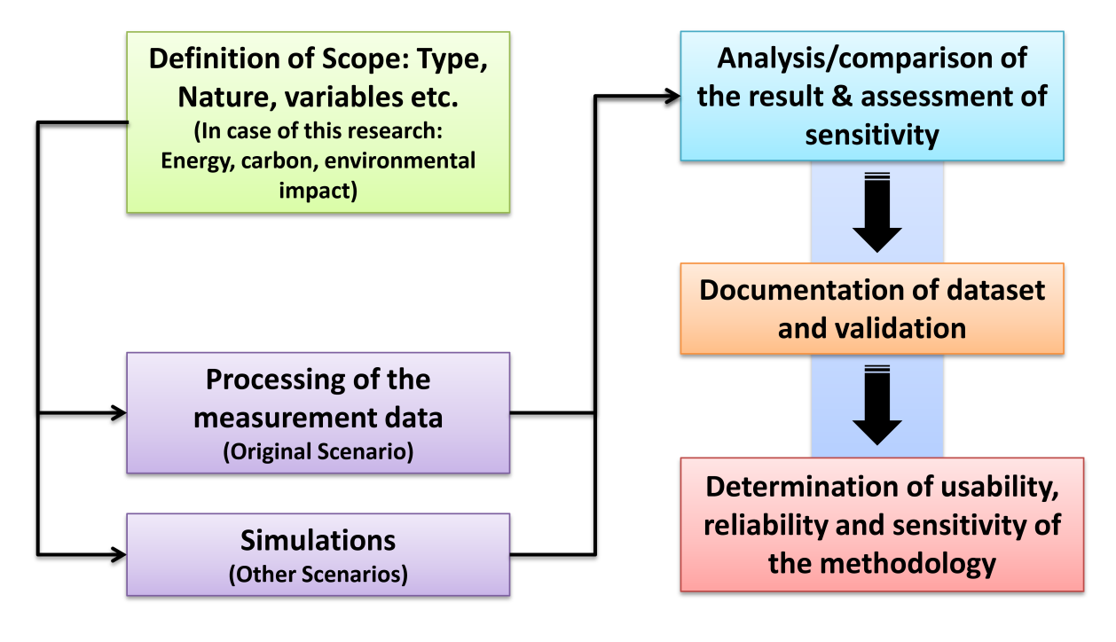
Figure 7.1: Diagram of the validation process relevant to the BLCA framework introduced by this research

7.1 Final Modelling: Applying the Case Study to the New Measurement Approach
At this stage, the results of the previous programmes (Envest 2 and Ecotect 2011), and the input data (EE and EC) from the inventory of Bath University (Hammond and Jones, 2010a), have been imported into the spreadsheet as input data.
(Note: ICE 2010 measures EE and EC on a ‘cradle to gate’ basis (Hammond and Jones, 2010a); hence the scope of measurement of EE and EC in the present modelling is ‘cradle to gate’.)
The same modelling categorisation as with Envest 2 and Ecotect 2011 was carried out in terms of floors. Hence, the building was divided into six categories as follows:
- Basement floor/FL-BT
- Ground floor/FL-GR
- Mezzanine floor/FL-MZ
- Floors 1-18/FL-1-18
- Floor 19
- Roof floor/FL-RF.
However, at this time, all the modelling was held in one spreadsheet.
At this stage, it should be noted that advantage of this method is that the case studies can be investigated and compared in three ways, which will be investigated:
- comparison of the EE and EC in a case study in various structural systems and material profiles
- comparison within a case study of various utility profiles and operational performance scenarios in relation to geographical variation
- comparison of the OE calculated by a computer programme (Ecotect 2011) with the result of a real traditional approach (reading the electricity meter of the building at different times).

7.1.1 Scenario 1
This scenario is based on the original structural system and materials, and utilities (heating, lighting, security, lifts, and paternosters), of the Arts Tower of Sheffield. Thus, the same modelling categorisation (based on six overall sections) has been employed in the modelling of the Tower.
In this scenario, the structure and central core of the building have been considered as reinforced concrete made from a ‘general’ type of concrete (Hammond and Jones, 2010a), and virgin steel. Plastic tiling (general type) (Hammond and Jones, 2010a), suspended ceilings (made of mineral fibres/mineral wool), windows (single glazing-general glass + aluminium profile-UK typical) have also been included.
One advantage of this method is that all the small details such as the plastering and painting of walls, iron wires and plastic pins used to fix the suspended ceilings, electrical wires and sockets (copper and plastic covers), and mechanical utilities (PVC pipes, joints, etc.) have been taken into account.
In addition in the case of floors 1-18 the results have been multiplied by 18 because the floors have the same plan and function.
To make the input data more credible the same weighting standard for materials (kg/m³) as the one which has been used for the Inventory of Bath University (ICE 2010) has been used. The data were originally taken from CIBSE (the Chartered Institution of Building Services Engineers in the UK) (Hammond and Jones, 2010a).
As revealed in figures 7.2, the input data of each floor, including all the materials in great detail, have been entered onto the spreadsheet. These data have been provided from the previous models in Envest 2 and Ecotect 2011, the original Auto-CAD files of the tower’s plans, and the information taken from the Estates and Facilities Management of the University of Sheffield (including areas and total annual electricity consumption).
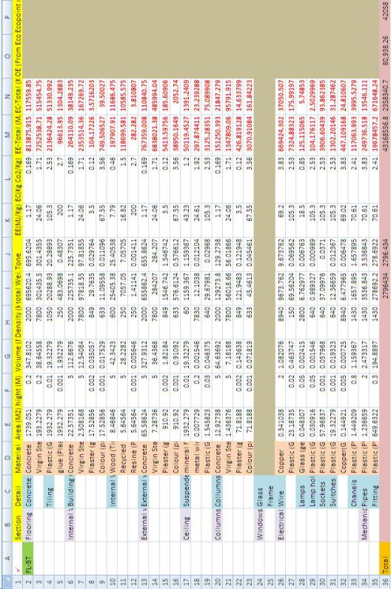
Figure 7.2: Modelling of Sheffield Arts Tower-Basement in new Measurement Approach

Another advantage of this methodology is the flexibility to add/remove building components and details and their EE and EC profiles as much as required for the various ranges of projects. Moreover, the materials of the building utilities such as boilers, coolers, and security systems can be added according to the decision of designers and building in projects. Furthermore, whole phases of building maintenance during the building’s service life can be added, including the materials for devices and utilities (table 7.1).
Table 7.1: Total EE, EC, OE, and Eco-point in scenario 1, The Arts Tower of Sheffield
The Arts Tower of Sheffield, Scenario 1 | Energy  (MJ) |  |  | EC  (Kg) | Eco-point
The Arts Tower of Sheffield, Scenario 1 | Embodied  (EE) | Operational  (OE) | Total | EC  (Kg) | Eco-point
Basement floor/FL-BT | 43,168,557 | 75,565.44 | 43,244,122.44 | 2,358,341 | 42,058
Ground floor/FL-GR | 6,525,120 | 116,524.80 | 6,641,644.80 | 393,510.3 | 4,141
Mezzanine floor/FL-MZ | 6,027,637.60 | 120,181.00 | 6,147,818.60 | 370,861.3 | 5,618
Floors 1-18/FL-1-18 | 273,348,263 | 967,195 | 274,315,458.10 | 14,299,211 | 935,838
Floor 19 | 15,112,604 | 129,173.00 | 15,241,777.00 | 837,030.8 | 11439
Roof floor/FL-RF | 12,402,373 | 33,135.84 | 12,435,508.84 | 801,804 | 6,870
Total for Building | 356,584,555 | 1,441,775.18 | 358,026,329.78 | 19,060,758 | 1,005,964

Figures 7.3 to 7.5 reveal comparisons of EE, OE, Total energy, EC, and Eco-point in the design sections of The Arts Tower of Sheffield in pie charts.
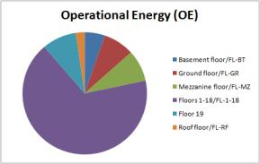
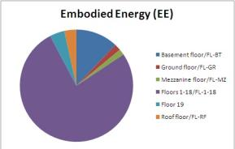
Figure 7.3: Comparison of EE and OE in the design sections of The Arts Tower of Sheffield: Scenario1

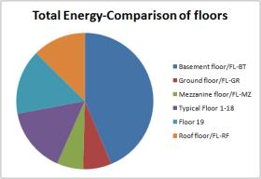
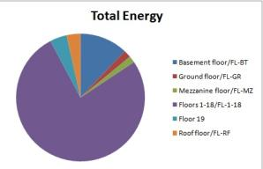
Figure 7.4: Comparison of total energy in the whole building and the floors in the design sections of The Arts Tower of Sheffield: Scenario1

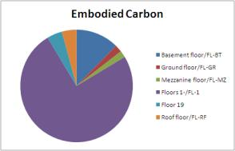
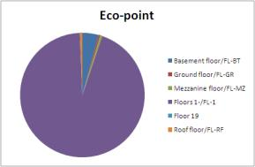
Figure 7.5: Comparison of Eco-point (environmental impact) and EC in the design sections of The Arts Tower of Sheffield: Scenario1

7.1.2 Scenario 2
In this scenario, in the same building (The Arts Tower of Sheffield), the type of concrete is altered to ‘precast concrete’ with 1:1:2 (Cement: Sand: Aggregate) composition, to see the impact of this change in a large-scale structure such as the tower in terms of EE, embodied carbon, and total amount of energy through 50 years of its lifecycle including construction and service life (table 7.2).
Table 7.2: Total EE, EC, OE, and Eco-point in scenario 2, The Arts Tower of Sheffield
The Arts Tower of Sheffield, Scenario 2 | Energy  (MJ) |  |  |  | EC  (Kg) |  |  | Eco-point
The Arts Tower of Sheffield, Scenario 2 | Embodied  (EE) | Operational  (OE) |  | Total |  |  |  | Eco-point
Basement floor/FL-BT | 43,828,628 | 75,565.44 | 43,904,193.28 |  |  | 414,032 | 42,058
Ground floor/FL-GR | 6,647,089 | 116,524.80 | 6,763,614.13 |  |  | 414,031.94 | 4,141
Mezzanine floor/FL-MZ | 6,145,329.07 | 120,181.00 | 6,265,510.07 |  |  | 390,663.13 | 5,618
Floors 1-18/FL-1-18 | 276,858,173 | 967,195 | 277,825,368.19 |  |  | 14,889,762 | 935,838
Floor 19 | 15,288,208 | 129,173.00 | 15,417,380.64 |  |  | 867,048.07 | 11439
Roof floor/FL-RF | 12,612,575 | 33,135.84 | 12,645,710.68 |  |  | 837,171 | 6,870
Total for Building | 361,380,002 | 1,441,775.18 | 362,821,776.98 |  |  | 19,868,075 | 1,005,964

7.1.3 Scenario 3
In scenario 3, in the same building (The Arts Tower of Sheffield), the size of the aluminium profiles of the windows are changed to 100×100mm. Moreover, instead of single glazing, double glazing is considered.
In this case, as well as changing the rate of glass in the windows and the size of the aluminium profiles in the spreadsheet (table 7.3).
Table 7.3: Total EE, EC, OE, and Eco-point in scenario 3, The Arts Tower of Sheffield
The Arts Tower of Sheffield, Scenario 3 | Energy  (MJ) |  |  | EC  (Kg) | Eco-point
The Arts Tower of Sheffield, Scenario 3 | Embodied  (EE) | Operational  (OE) | Total | EC  (Kg) | Eco-point
Basement floor/FL-BT | 43,168,557 | 75,565.44 | 43,244,122.25 | 2,358,341 | 42,058
Ground floor/FL-GR | 6,799,243 | 83,846.52 | 6,883,089.36 | 404,867.35 | 4,766
Mezzanine floor/FL-MZ | 6,301,760.42 | 95,166.72 | 6,396,927.14 | 382,218.29 | 6,060
Floors 1-18/FL-1-18 | 278,282,474 | 1,860,583 | 280,143,056.79 | 14,503,638 | 940,104
Floor 19 | 15,142,207 | 130,820.90 | 15,273,028.05 | 838,420.79 | 11567
Roof floor/FL-RF | 12,676,496 | 19,826.28 | 12,696,322.42 | 813,161 | 6,496
Total for Building | 362,370,737 | 2,265,808.86 | 364,636,546.01 | 19,300,646 | 1,011,051

7.1.4 Scenario 4
In this scenario, in the same building (The Arts Tower of Sheffield), the type of ceiling is changed. Instead of acoustic suspended ceilings (used in scenario 1), normal ceilings (based on plaster and paint) are proposed (table 7.4).
Table 7.4: Total EE, EC, OE, and Eco-point in senario4, The Arts Tower of Sheffield
The Arts Tower of Sheffield, Scenario 4 | Energy  (MJ) |  |  | EC  (Kg) | Eco-point
The Arts Tower of Sheffield, Scenario 4 | Embodied  (EE) | Operational  (OE) | Total | EC  (Kg) | Eco-point
Basement floor/FL-BT | 43,209,120 | 10,242.72 | 43,219,363.06 | 2,361,599 | 42,039
Ground floor/FL-GR | 6,337,410 | 47,982.78 | 6,385,392.87 | 383,736.86 | 4,540
Mezzanine floor/FL-MZ | 5,839,282.76 | 54,550.26 | 5,893,833.02 | 361,036.00 | 5,828
Floors 1-18/FL-1-18 | 270,167,649 | 1,107,351 | 271,274,999.52 | 14,139,208 | 935,586
Floor 19 | 15,127,510 | 68,366.34 | 15,195,876.26 | 838,228.18 | 11355
Roof floor/FL-RF | 12,219,374 | 19,826.28 | 12,239,200.01 | 792,409 | 6,566
Total for Building | 352,900,345 | 1,308,319.38 | 354,208,664.74 | 18,876,217 | 1,005,914

7.1.5 Scenario 5
In this scenario, in the same building (The Arts Tower of Sheffield), the type of flooring is changed. Hence, rather than plastic tiling, ceramic tiling is proposed (table 7.5).

Table 7.5: Total EE, EC, OE, and Eco-point in scenario 5, The Arts Tower of Sheffield
The Arts Tower of Sheffield, Scenario 5 | Energy  (MJ) |  |  | EC  (Kg) | Eco-point
The Arts Tower of Sheffield, Scenario 5 | Embodied  (EE) | Operational  (OE) | Total | EC  (Kg) | Eco-point
Basement floor/FL-BT | 42,721,524 | 65,512.26 | 42,787,036.32 | 2,425,275 | 41,330
Ground floor/FL-GR | 6,482,177 | 74,416.32 | 6,556,593.39 | 399,940.17 | 4,421
Mezzanine floor/FL-MZ | 5,991,801.96 | 106,561.40 | 6,098,363.36 | 376,226.93 | 5,575
Floors 1-18/FL-1-18 | 270,391,410 | 2,112,697 | 272,504,107.38 | 14,741,940 | 931,158
Floor 19 | 15,003,225 | 120,351.40 | 15,123,576.77 | 853,408.06 | 11142
Roof floor/FL-RF | 12,292,995 | 19,826.28 | 12,312,820.80 | 818,181 | 6,421
Total for Building | 352,883,133 | 2,499,364.66 | 355,382,498.03 | 19,614,972 | 1,000,047

7.1.6 Scenario 6
In this scenario, in the same building (The Arts Tower of Sheffield), the type of internal walls is changed. Hence, rather than composite walls (as in scenario 1), a brick wall system based on lightweight bricks is considered (table 7.6).
Table 7.6: Total EE, EC, OE, and Eco-point in scenario 5, The Arts Tower of Sheffield
The Arts Tower of Sheffield, Scenario 6 | Energy  (MJ) |  |  | EC  (Kg) | Eco-point
The Arts Tower of Sheffield, Scenario 6 | Embodied  (EE) | Operational  (OE) | Total | EC  (Kg) | Eco-point
Basement floor/FL-BT | 42,945,670 | 79,902.36 | 43,025,572.78 | 2,377,489 | 42,024
Ground floor/FL-GR | 6,525,120 | 105,457.50 | 6,630,577.53 | 393,510.32 | 4,540
Mezzanine floor/FL-MZ | 6,027,637.61 | 119,932.70 | 6,147,570.31 | 370,861.27 | 5,369
Floors 1-18/FL-1-18 | 269,450,384 | 2,277,506 | 271,727,889.79 | 14,634,352 | 935,460
Floor 19 | 15,050,833 | 132,176.90 | 15,183,009.67 | 842,341.91 | 11388
Roof floor/FL-RF | 12,315,391 | 19,826.28 | 12,335,217.76 | 809,259 | 6,561
Total for Building | 352,315,036 | 2,734,801.74 | 355,049,837.84 | 19,427,814 | 1,005,342

7.2 Comparison of Energy, Carbon and Eco-point in Case Study Based On Variation of Materials and Components
Table 7.7 and figures 7.6 to 7.10 show the comparison of scenarios 1-6 in terms of EE, EC, OE and Eco-point in relation to alterations in structural systems and material profiles:

Table 7.7: A comparison of total energy, EE, OE, EC and environmental impact (Eco-point) between the scenarios
The Arts Tower of Sheffield  Scenarios | Energy  (MJ) |  |  | EC  (Kg) | Eco-point
The Arts Tower of Sheffield  Scenarios | Embodied  (EE) | Operational  (OE) | Total | EC  (Kg) | Eco-point
Scenario 1 | 356,584,555 | 1,441,775.18 | 358,026,329.78 | 19,060,758 | 1,005,964
Scenario 2 | 361,380,002 | 1,441,775.18 | 362,821,776.98 | 19,868,075 | 1,005,964
Scenario 3 | 362,370,737 | 2,265,808.86 | 364,636,546.01 | 19,300,646 | 1,011,051
Scenario 4 | 352,900,345 | 1,308,319.38 | 354,208,664.74 | 18,876,217 | 1,005,914
Scenario 5 | 352,883,133 | 2,499,364.66 | 355,382,498.03 | 19,614,972 | 1,000,047
Scenario 6 | 352,315,036 | 2,734,801.74 | 355,049,837.84 | 19,427,814 | 1,005,342

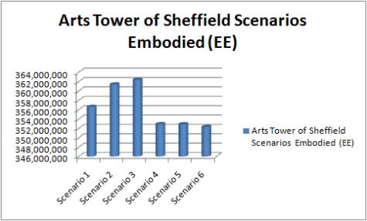
Embodied Energy
Figure 7.6: A comparison of total EE between the scenarios

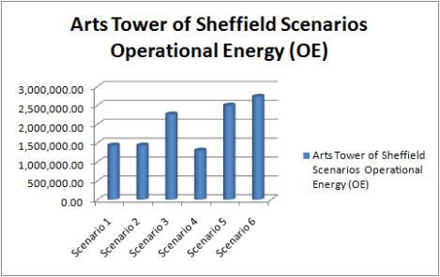
Figure 7.7: A comparison of total OE between the scenarios

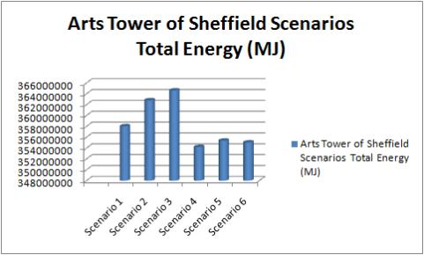
Figure 7.8: A comparison of total energy between the scenarios

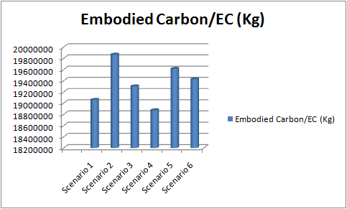
Figure 7.9: A comparison of total EC between the scenarios

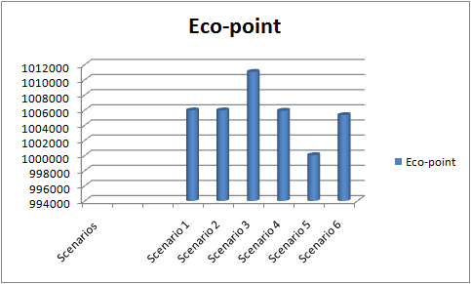
Figure 7.10: A comparison of total environmental impact (Eco-point) between the scenarios

7.3 A Qualitative Survey
In relation to the subject of this research, while it was being carried out (2008-2012), five conference papers (Kashkooli and Altan, 2010, Kashkooli et al., 2012b, Kashkooli et al., 2011a, Kashkooli and Altan, 2012, Kashkooli et al., 2012a) and one journal paper (Kashkooli et al., 2011b) were developed and published (also refer to Appendix B).
Accordingly, the capability, reliability and precision of new framework was determined through qualitative surveys conducted among the following sources:
- The LCA specialists including leading professors, practitioners, researchers, and PhD candidates from different countries and institutions, during the presentation of the papers in the following conferences:
- The 9th International Detail Design in Architecture Conference, University of Central Lancashire (UCLan), Preston, United Kingdom, 2010
- The 5th International Symposium of Temporal Design (ISTD), Sheffield, United Kingdom, 2011.
The survey (for the questionnaire see figure 7.11 and 7.12) was carried out among a total of 50 people through interviews and comments during the presentation of the framework in both conferences (see figure 7.11).

Figure 7.11: The population of the participants at different levels of education in the survey

The aforementioned participants were from the following universities and institutions:
- University of Central Lancashire (UCLan), United Kingdom
- Loughborough University, United Kingdom
- The Pennsylvania State University, United States of America
- University of Derby, United Kingdom
- Bangor University, United Kingdom
- Manchester Metropolitan University, United Kingdom
- Nottingham Trent University, United Kingdom
- Leeds Metropolitan University, United Kingdom
- Eindhoven Technical University, The Netherlands
- Southeast University, Nanjing, Peoples Republic of China
- Cardiff Metropolitan University (UWIC), Cardiff, United Kingdom
- The British University in Egypt, Egypt
- Liverpool John Moores University, United Kingdom
- University of Hawaii, United States of America
- Technical University of Denmark
- National Cheng Kung University, Taiwan
- Rachel Bevan Architects, United Kingdom
- University of British Columbia (UBC), Canada
- Israel Institute of Technology, Israel
- The Norwegian Building Research Institute to merge with SINTEF, Norway
- Joint Origin, Zevenaar, The Netherlands
- Center for Bydesign, Copenhagen, Denmark

Questionnaire
Question: What is your opinion about the new simplified Building Lifecycle Assessment (BLCA) methodology developed in school of architecture, the University of Sheffield, introduced by Kashkooli A.M.S and Altan H.?

Some information regarding the participant
Occupation:
University professor from UK □ University professor from EU □
University professor from Non UK/EU □ University Student □
Other Institutions □
Level of Education ..................................
Name of Institution .................................
Please help us by answering the following questions. Do not give your name. Results will be grouped, and all individual comments will be anonymous.

Preferences: Please indicate the extent which you agree or disagree with the following statement by putting a √ in the appropriate box.

 | Strongly disagree | Disagree | Agree | Strongly agree | Do not know
Simplicity | □ | □ | □ | □ | □
Flexibility | □ | □ | □ | □ | □
Adaptability | □ | □ | □ | □ | □
General capability for BLCA | □ | □ | □ | □ | □
Covering a higher number of values | □ | □ | □ | □ | □
Preciseness | □ | □ | □ | □ | □
The chance of success vs. the existing BLCA tools | □ | □ | □ | □ | □
Other comments/suggestions:

Thanks you so much for your time and cooperation
Figure 7.12: The questionnaire

Figure 7.13: A sample of the questionnaire

The graphs in figures 7.14 and 7.15 show the rate of the selected factors included in the questioners (the population of 50 people). The majority of the participants were ‘completely agreed’ that the framework (which has been introduced as a methodology, during does events) offered simplicity, flexibility, adaptability, general capability for BLCA, preciseness and a chance of success compared with the existing BLCA tools, and covered a larger number of values.
.

Figure 7.14: The rate of the selected factors (simplicity, flexibility, adaptability and general capability for the BLCA) in the survey

Figure 7.15: The rate of the selected factors (covering higher number of values, preciseness, and the chance of success vs. existing BLCA tools) in the survey

The following sentences are highlighted within the comments of the participants:
“This is the first time I am hearing someone is talking about simplicity of LCA!!!”(9th International Detail Design in Architecture Conference, University of Central Lancashire (UCLan), Preston, United Kingdom)
“The idea of multidisciplinary decision making is the factor which makes this methodology more reliable for designers, investors and authorities from other disciplines!!!” (Professor Ken Ito - Chair of the conference) (The 5th International Symposium of Temporal Design (ISTD), Sheffield, United Kingdom, 2011)
- Comments of the referees/reviewers of the International Journal of Temporal Design (IJTD), Vol. 11, No. 1:
“We’ve read the paper and we think it’s OK. The idea of semi-quantitative assessment sounds interesting, which can improve the accuracy of the design and decision making, with a high flexibility of updating the factors and standards!!!”
- Comments of the University of Sheffield Commercialisation Department, which has agreed to invest in the methodology to be developed as a new online BLCA programme; the agreement was acknowledged in May 2011, and the professional marketing is in process:
“During the last 6 months, we have evaluated your proposal and application for developing the new web-based tool based on the methodology introduced by Ali’s thesis from the perspective of marketing. We believe that there are lots of potentials in the UK and international market to develop and offer the new programme, based on this methodology. We think the idea can attract industrial interest to part-fund conversion of the tool to a simplified/user-friendly version. This could be structured either as a collaborative development project or as part of a licence deal. Part-funding may be available either through KTA or HEIF!!!” (COD 31010 - Software Tool for Building Lifecycle Assessment-31/08/2011)
- The comments of the BRE (Building Research Establishment of the UK), which has shown interest in collaboration in the aforementioned proposed project as partner/shareholder:
“It needs to be invested in and developed in the future, to be available as a new tool for Building Lifecycle Assessment in the market!!!”
The results confirmed the capability of the framework in generating more ‘precise’ and ‘simplified’ calculations. Moreover, the ‘multidisciplinary nature’ and ‘flexibility in adaptation’ to all databases, BLCA and environmental modelling programmes were highlighted.

7.4 Application to the International Context and to Other Disciplines
This section covers part of the capability determination process of the new framework’s applicability to the international context. Accordingly, it investigates the two following applications to Mexico context as an example as follows:
- an energy-based application of the new methodology to a typical building block in Mexico focusing on the shortlist of the best choices of building shape design;
- and a carbon-based application to a typical building block proposed in three cities of Mexico focusing on the change of the climatic region.
In each of the aforementioned exercises, different local environmental modelling programmes were used to determine the adaptability of the new framework to the local tools and standards.

7.4.1 Case1: Energy-based Application to a typical Mexican building block
At this stage the study adapts the new semi-quantitative BLCA framework to a typical Mexican office-building block. This investigation was based on energy calculations (EE, OE and total energy) in a case study in Mexico with the same orientation, size and martial profile, but different shapes. The results will assist designers and decision makers to shortlist the best choices of building shape design from the energy viewpoint, in another location rather than the UK.
In this case, in terms of operational energy, the new methodology has benefited from a local software called HAP (Hourly Analysis Programme) developed by the Carrier Corporation for designing HVAC (heating, ventilation and air conditioning) systems.
Note 1: The pre-modelling (in HAP) and the gathering of the local information about the proposed building cell were conducted by Gloria Vargas Palma (from Mexico), PhD candidate in School of Architecture at Sheffield University, in a collaboration which led to the development of a paper submitted to the SET2012 conference (refer to Appendix B).
Note 2: In this study, because of the lack of official local energy inventories in Mexico, the input data for EE were imported from the original Inventory of Carbon and Energy (ICE 2011) developed at Bath University, UK (Hammond and Jones, 2010a). However, in future, this could be replaced by a local data, once this is available.
- The building block
The proposed location for the building investigated for this stage was in Mexico City, Mexico, in North America (see figure 7.16).
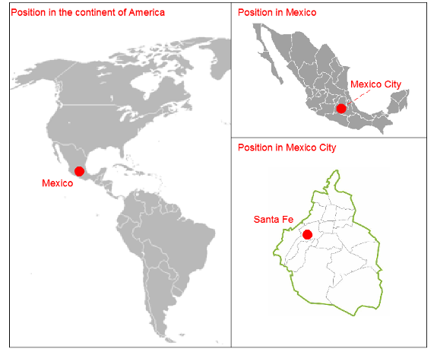
Figure 7.16: The location of the case study in Mexico City, Mexico (North America).
The building blocks considered in this exercise are the three typical floors of three 22-storey office buildings. The prototypes are proposed to be located in Mexico City on an unobstructed plot of land in Santa Fe district. All the design parameters were kept constant in the simulations, except their shape.
Design assumptions such as lighting, equipment loads, number of occupants and air changes were considered in accordance with the local codes and international standards of ASHRAE (American Society of Heating, Refrigerating and Air-conditioning Engineers). The same location, use, volume, facade material, area per floor, air conditioning system and operation were considered throughout the simulations. The basic results taken from the pre-modelling simulations (using HAP) were expressed in tons of refrigeration.
The three scenarios were proposed in ‘core and shell’ high-rise buildings with typical floor area of 1,250m² and central core of 220m². ‘Scenario 1’ is designed with a rectangular floor plan, ‘Scenario 2’ with a square floor plan and ‘Scenario 3’ with a circular floor plan (see figure 7.17). As previously stated, the three typical floor plans have the same construction, size and material amounts.
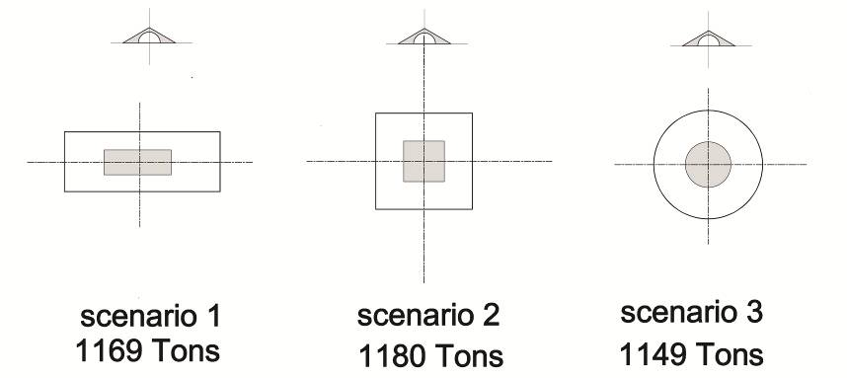
Figure 7.17: The three scenarios of the case study with different shapes.
The facades of the building scenarios consist of aluminium-framed windows with transparent glass with a U value of 5.7m²/W and a shading coefficient of 66. The facade devices such as overhangs, fins, dampers, and louvers were not included in the pre-modelling. Figure 8.23 shows the detailed plan of scenario 1, which is proposed to have the same size, amounts of materials, and construction system as the other scenarios.
Figure 7.18: The detail of scenario1 - same in size, materials, and construction system with other scenarios.
The general structure of the building scenarios is proposed to be reinforced concrete (see figure 7.18). The central core includes the following materials:
- Walls (central core): brick, plaster and paint
- Lobbies: granite stone on floors and walls, ceilings made of gypsum/acoustic boards
- Toilets: granite stone on floors and walls, ceilings made of gypsum/acoustic boards
- Stairs and service areas: gypsum with paint.
In the rented areas the following materials were considered:
- Ceiling: it is a core and shell building, so the ceiling can vary along the building; generally, in Mexico, ceilings are made of suspended gypsum boards.
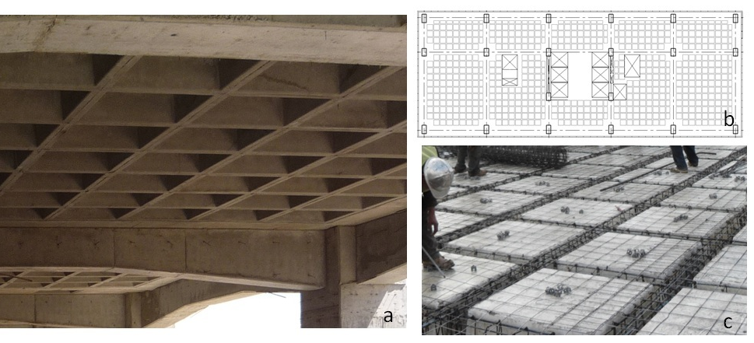
Figure 7.19: a) View of a waffle slab; b) position of the reticular modules in plan; c) reinforcing steel in the slab’s ribs and removable fibreglass modules.
- Walls: tenants prefer insulated gypsum walls (sound protection).
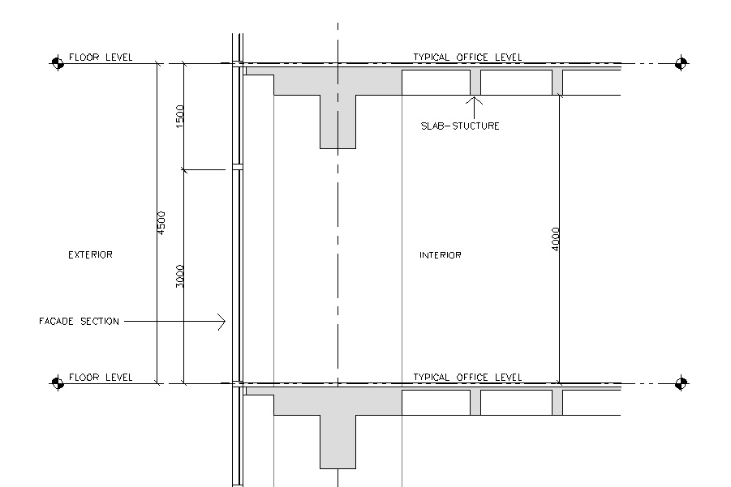
Figure 7.20: The typical wall section.
The height of the ceiling areas is 3-4 metres; however some tenants prefer just to paint the concrete slab and have exposed installations (see figure 7.20).
- Preliminary Modelling of the building block scenarios in HAP
Scenario 1: The first position of the building with a rectangular floor plan is with a north–south orientation in its longer facades (more details in Appendix A). The result shows that the building will require 1,248 tons of refrigeration, which is equivalent to 15,833.4274 joules/hour (see figure 7.21).
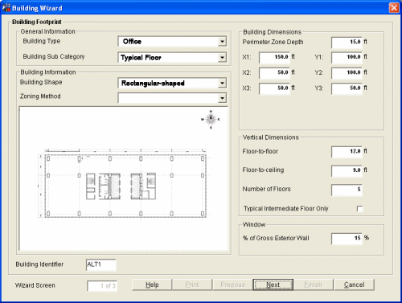
Figure 7.21 Modelling of scenario 1 in HAP: 1,207 tons of refrigeration (screenshot).
Scenario 2: The second scenario has a square floor with a north–south orientation in two of its sides. The result shows that the building will require 1,207 tons of refrigeration, which is equal to 15,314.2887 joules/hour.
Scenario 3: Prototype 3 has a circular shape with a northward orientation. The result shows that the building will require 1,149 tons of refrigeration, which is equal to 15,339.6125 joules/hour.
Table 7.8 presents the results of the primary OE modelling in HAP.
Table 7.8: A comparison of the case study scenarios in terms of OE.
 | shape | Tons of refrigeration | joules/hr
Scenario 1 | square floor plate | 1,207 | 15,314.2887
Scenario 2 | rectangular floor plate | 1,248 | 15,833.4274
Scenario 3 | circular floor plate | 1,149 | 15,339.6125

- Applying the results to the new Measurement Approach
The results taken from HAP and the data on EE from the inventory of Bath University (Hammond and Jones, 2010a) were imported to the spreadsheet as input data (see figure 7.22).
Scenario 1: In this scenario, the structure and central core of the building were considered as reinforced concrete made from ‘general’ concrete (Hammond and Jones, 2010a) and virgin steel. Plastic tiling (general type) (Hammond and Jones, 2010a), suspended ceilings (made of mineral fibres/mineral wool), and windows (single glazing - general glass, + aluminium profile - UK typical) were also counted.
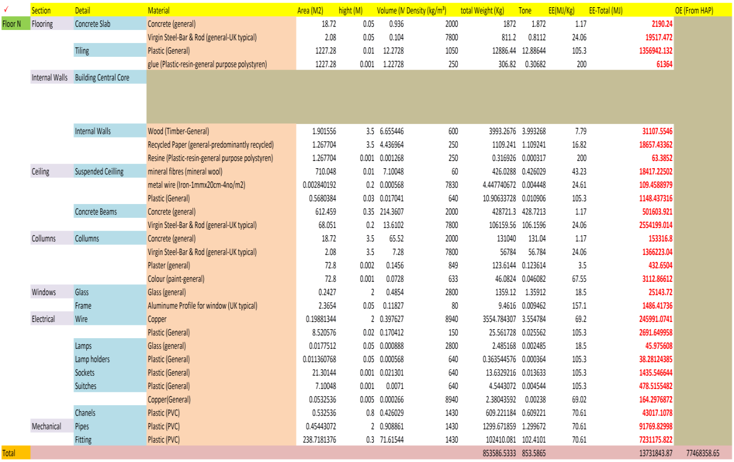
As revealed in figure 8.27, the input data including all of the materials in great detail were entered into the spreadsheet (including floor areas, total annual electricity consumption, etc.).
Figure 7.22: Modelling of scenario 1 in the new framework.
- Results and discussion
Comparison of EE, OE and total energy in three case study scenarios:
Table 7.9 and Figure 7.23 show a comparison of scenarios 1-3 according to the different building shape scenarios. In terms of EE all the scenarios are the same. This is because the proposed materials, size and location are the same.
However, the difference is in the OE during the service life of the different scenarios. In that respect, scenario 1 presents the best OE performance with the lowest OE consumption, and scenario 2 is the worst. Moreover, the same hierarchy is being resulted in terms of the ‘total energy’. Accordingly, by considering this method, the best choice of materials in a building (from the point of view of carbon efficiency) can be made during the design and decision-making process.
Table 7.9: A comparison of the scenarios in terms of EE, OE and total energy.
The Typical Floor Scenarios | Energy (MJ/50yrs)
The Typical Floor Scenarios | EE (MJ) | OE (MJ) | Total Energy (MJ)
Scenario 1 | 13,731,844 | 6,693,926,598.72 | 6,707,658,442.72
Scenario 2 | 13,731,844 | 6,921,309,358.08 | 6,935,041,202.08
Scenario 3 | 13,731,844 | 6,705,018,440.64 | 6,718,750,284.64

Figure 7.23: A comparison of the case study scenarios in terms of EE, OE, and total energy in 50 years of service life.

7.4.2 Case 2: Carbon-based application to a typical Mexican building block
At this stage the study applies the new semi-quantitative BLCA framework (a new measurement approach) to a typical Mexican office block. This investigation was based on calculation of carbon emissions (EC, service-life carbon (SLC) and total carbon emissions) in a typical building cell in Mexico in three geographical scenarios. Hence, the measurement approach takes into account the methodology of the IPCC (Intergovernmental Panel on Climate Change) (IPCC, 2007) for calculation of the SLC.
This exercise was to determine the adaptability of the new semi-quantitative BLCA framework to the local programmes in the calculation of the total carbon footprint, while showing the best choices of design from the carbon efficiency viewpoint in other locations around the world (outside the UK). During this determination, reference was made to the IPCC for OE calculations of the building’s service life in different scenarios.
Note 1: In this exercise, because of the lack of official local energy inventories in Mexico, the input data for EC were imported from the Inventory of Carbon and Energy (ICE 2011) developed at Bath University, UK (Hammond and Jones, 2010a). However, in future, this could be replaced with the local data.
Note 2: The pre-modelling (use of IPCC) and gathering of the local climatic information (Mexico) were conducted by Rafael M. Eufrasio (from Mexico), PhD candidate in School of Architecture at Sheffield University, in a collaboration which led to the development of a paper submitted to the SET2012 conference (refer to Appendix B).
- The building cell
The typical building cell of this investigation was proposed to be located in three cities in Mexico with different climatic scenarios: Mexico City, Veracruz and Acapulco. Figure 7.24 shows the location of the case study scenarios in North America and Mexico.
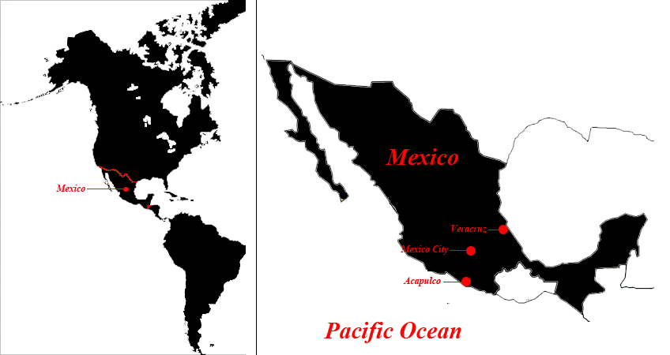
a
b
Figure 7.24: a) Location of the case study; b) Location of the case study scenarios (Mexico City, Veracruz and Acapulco) in Mexico.
Table 7.10 presents the location profiles of the case study scenarios considered in the study.
Table 7.10: The location profiles of the case study scenarios.

Table 7.11 presents the different weather conditions of the case scenarios.
Table 7.11: The climatic profile of the case study scenarios.

The building cell for this stage of the study was proposed as a simple 51.66 m² dwelling. This building type is very common within Mexican social housing.
The dwelling is built with a 10-cm thickness of reinforced concrete covered by external and internal plaster. The standard ceiling height is 2.40m. The typical window in this case study is a single glazing with aluminium frame (see figures 7.25 and 7.26).
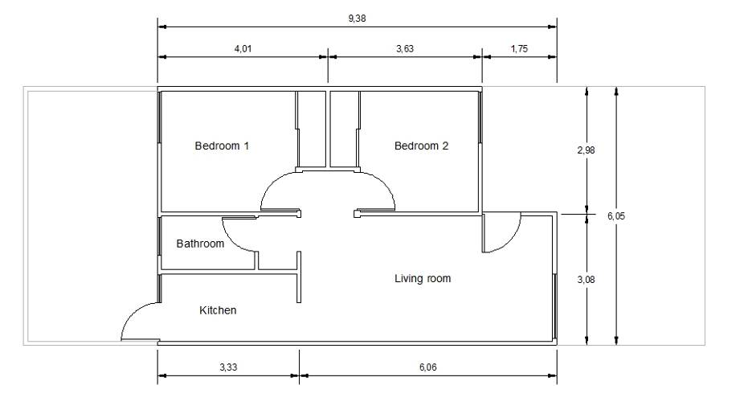
Figure 7.25: The plan model of the proposed case study building cell.

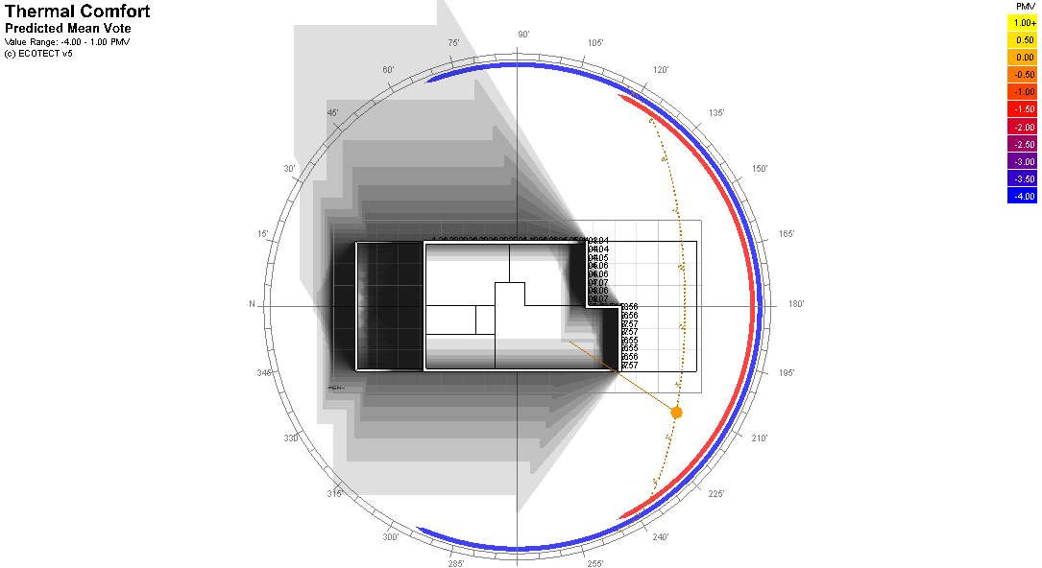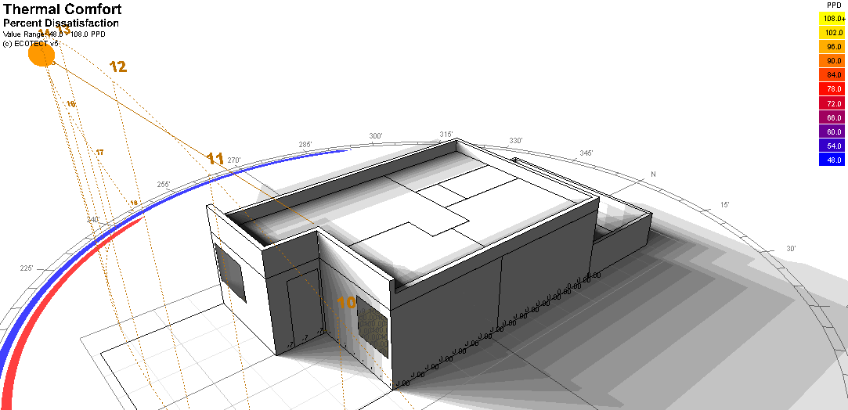

Figure 7.26: The 3D model of the proposed case study building cell.

- Primary Modelling using IPCC - Scenario 1: Mexico City
In this scenario the case study is being applied to the climatic profile of Mexico City.
The CO₂ emissions for this building cell were calculated in two phases as follows (more details in Appendix A):
- Calculation of CO₂ emissions caused by lighting;
- Calculation of CO₂ emissions caused by water heating.
The results of the calculations (SLC) are shown in table 7.12.
Table 7.12: The service-life carbon of the case study cell resulting from the primary modally in IPCC.

- Applying the results to the new methodology
The results taken from IPCC and the input data (EC) from the inventory of Bath University were imported as input data to the new spreadsheet (see Figure 7.27).
Scenario 1: In this scenario, the structure and central core of the building were assumed to be reinforced concrete made from ‘general’ concrete and virgin steel. Plastic tiling (general type), suspended ceilings (made of mineral fibres/mineral wool), and windows (single glazing - general glass, + aluminium profile - UK typical) have also been counted.
As revealed in figure 7.27, the input data of the building cell, including the full list of materials in very detailed format, were entered on to the spreadsheet (including floor areas, total annual electricity consumption, etc.).
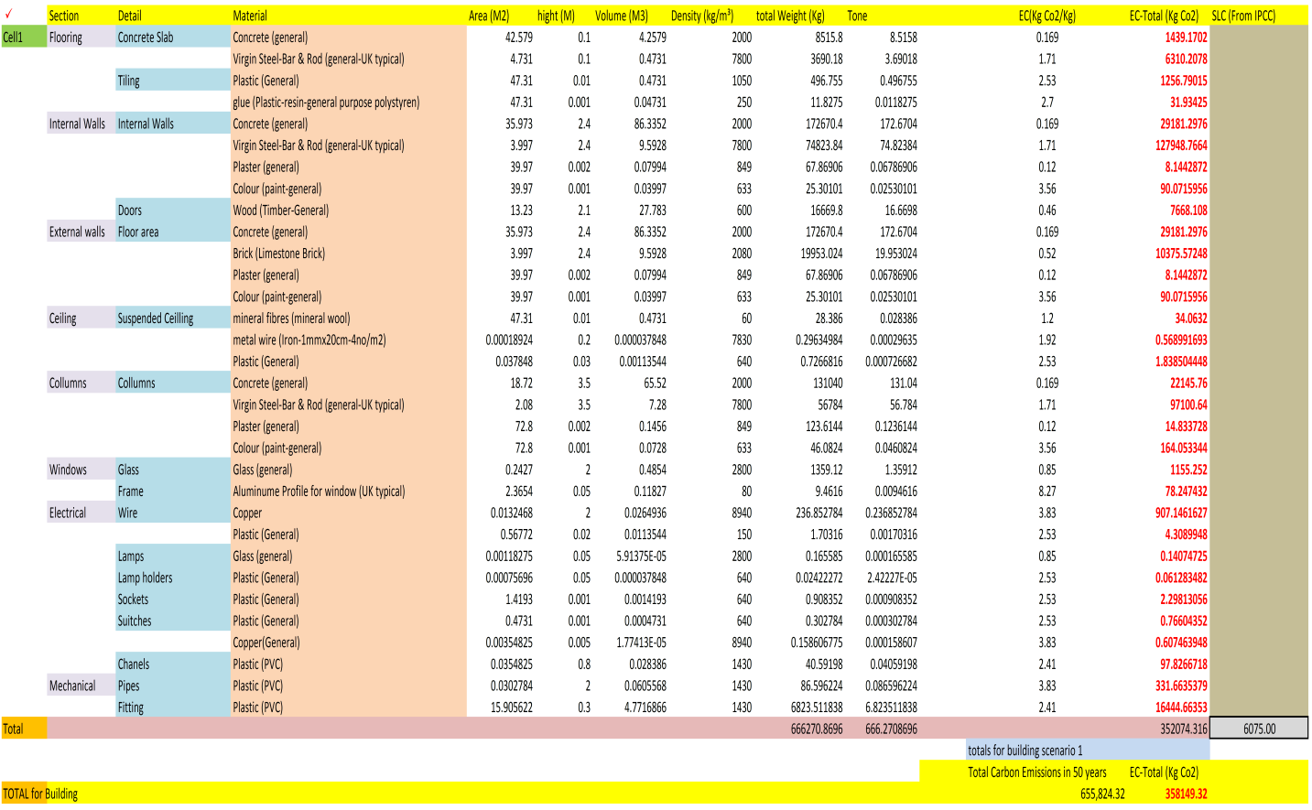
Figure 7.27: Modelling of scenario 1 in the new measurement approach.

- Results and discussion
Table 7.13 and figure 7.28 show the comparison of EC, SLC and total carbon emissions in three different climatic scenarios for the proposed building block.
In terms of EC all the scenarios are the same. This is because the proposed materials, size and location are the same. However, there is a difference in the SLC of the scenarios. In that respect, scenario 2 (the building in Mexico City) presents the best and/or lowest carbon emissions with the lowest SLC, and scenario 3 (the building in Acapulco) gives the worst case result.
Moreover, the same hierarchy is produced in terms of the ‘total energy’. Accordingly, if this method is followed, the best materials for a building (from the point of view of carbon efficiency) can be chosen during the design and decision-making process.

Table 7.13: A comparison of the scenarios in terms of EC, SLC and total carbon emissions.
The Typical Floor Scenarios | Total Carbon Emissions in 50 yrs  (MJ/50yrs)
The Typical Floor Scenarios | EC  (kg) | SLC  (kg) | Total Carbon  (kg)
Mexico City | 358,149 | 160,750.00 | 518,899.32
Veracruz, Ver. | 358,149 | 303,750.00 | 661,899.32
Acapulco, Gro. | 358,149 | 314,750.00 | 672,899.32

Figure 7.28: A comparison of the scenarios on the basis of EC, SLC, and total carbon emissions in 50 years of service life.

7.5 Application to Other Building Decision Making Disciplines: Considering Acoustic Factors as an Example
The main purpose of this exercise was to determine the adaptability of the new semi-quantitative measurement approach to the key factors of other disciplines (e.g. acoustics), and to highlight the relationship between energy/carbon efficiency and parameters essential for acoustic comfort in buildings (e.g. sound reduction index (Rw+Ctr) and reverberation time (RT)).
The exercise also aimed to highlight the role of each parameter in a multidisciplinary building design and decision-making process, and to examine the results of the measurement approach in terms of showing the best choices of design from the point of view of energy, carbon, and acoustics.
The OE was calculated with Ecotect 2011, while reverberation time of simulated spaces was calculated with CRR combined raytracing and radiosity, developed by the University of Sheffield (more details in Appendix A) (Meng and Kang, 2007).
Note: The pre-modelling in CRR was conducted by Yuliya Smyrnova (from Ukraine), Postdoctoral researcher at the School of Architecture of Sheffield University, in a collaboration which led to the development of two papers published in the ISTD conference proceedings and the JTD international journal (refer to Appendix B).
- The building cell
For this investigation a typical floor of the Arts Tower of Sheffield, UK (see figure 7.29) was selected.
Space simulated with CRR

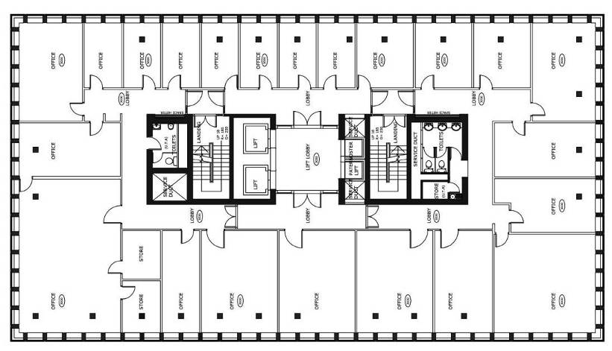
Figure 7.29: General layout of structure and offices of a typical floor in the Arts Tower of Sheffield.
To continue, three material scenarios of the typical floor were modelled in two phases of modelling (preliminary and final modelling), as follows:

Scenario 1
This scenario is based on the original structural system and materials and the original utilities of the Arts Tower. In this scenario, the structure and central core of the building were considered as reinforced concrete made of ‘general’ concrete (Hammond and Jones, 2010b) and virgin steel. Plastic tiling (general type) (Hammond and Jones, 2010b), suspended ceilings (made of mineral fibres/mineral wool), and windows (single glazing - general glass of 6mm width, + aluminium profile - UK typical) have also been counted.
Scenario 2
In scenario 2 the size of the aluminium profiles of the windows is changed to 100 × 100 mm and the single glazing is changed to 10 mm × 12 mm with a 6-mm cavity between the panes. The ceiling is an acoustic suspended ceiling, as in scenario 1.
Scenario 3
In this scenario the type of ceiling is changed. Instead of acoustic suspended ceilings (used in scenario 1), normal ceilings (based on plaster and paint) are proposed. The same profile of windows as in scenario 1 is considered.
- Preliminary modelling of the typical floor in Ecotect 2011 and CRR
As formerly stated, during the preliminary modelling Ecotect 2011was employed to measure the OE on the basis of the original structure and materials (scenario 1). Established on the nature of the programme, the modelling was carried out according to thermal zones. The spaces in each floor which provide separate thermal zones were considered on the basis of the existing materials of construction (floors, walls, ceiling, and utilities).
The calculated OE of the typical floor during 50 years of service -life, using the climate data of Sheffield, was 1,293,298 MJ (see table 7.14).

Table 7.14: Operational energy (OE) of the typical floor in the existing situation in the Arts Tower, calculated by Ecotect 2011 (scenario 1).
Floor | OE (MJ)
Floor | Annual | Total in 50 years of service life
Floors 1-18/FL-1-18 | 25,865.96 | 1,293,298

To conduct an acoustic simulation with CRR, a model of an inner space of the floor that includes a corridor, lift and paternoster (see figure 7.29) was created. It was chosen for the purpose of comparison in the simulation scenarios. Acoustic properties of the materials were based on the previously stated material profiles of the building scenarios, as described in Section 3.
Simulation of sound propagation was performed in full octave bands. The results of RT are presented only for 1kHz octave (to be used for purposes of comparison). Moreover, the sound reduction index was calculated on the basis of the previously mentioned case study material scenarios. In this case, spectral adaptation for traffic noise (as Rw+Ctr) of windows represents the ability of glass to reduce the road traffic noise (ERD, 2004), applied in a simulation of the case study scenarios.

- Applying the results to the new measurement approach
In the final modelling phase, the whole of the modelling was performed on one spreadsheet based on the results imported from previous modelling phases, performed by programmes mentioned above (Ecotect 2011 and CRR) (see figure 7.30).
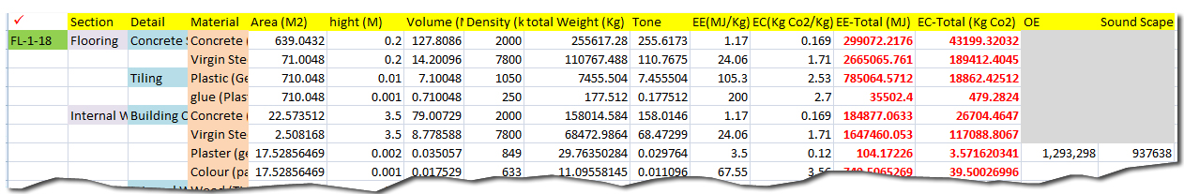
Acoustic
environment
Figure 7.30: Modelling of Sheffield Arts Tower floors 1-18 in the new semi-quantitative measurement approach.
The results of previous programmes (Ecotect 2011 and CRR), and the input data (EE and EC) from the inventory of Bath University (Hammond and Jones, 2010b), were imported to the final spreadsheet.
- Results and discussion
Table 7.15 shows EE, OE, total energy, EC, and acoustic parameters in relation to varying structural systems and material profiles in the three simulated scenarios of the case study.
Table 7.15: Embodied (EE), operational (OE), and total energy; embodied carbon (EC); reverberation time (RT) and sound reduction index (R_{w}+C_{tra}) in the simulated scenarios.
Scenario | Energy, MJ |  |  | EC, Kg | RT, s | R_{w}+C_{tra}, dB
Scenario | EE | OE | Total | EC, Kg | RT, s | R_{w}+C_{tra}, dB
Scenario 1 | 356,584,555 | 1,756,382 | 358,340,937 | 19,060,758 | 1.8 | 26
Scenario 2 | 362,370,737 | 2,265,809 | 364,636,546 | 19,300,646 | 1.8 | 32
Scenario 3 | 352,900,345 | 1,308,319 | 354,208,665 | 18,876,217 | 2.4 | 26

Figure 7.31: Percentage of changes in OE, RT and R_{w}+C_{tra} from scenario 1 to 2 and from scenario 1 to 3.
According to the results presented in table 7.15, the change of building materials from scenario 1 to 2 results in an increase of OE by 29% (negative impact), an increase of EE and total energy by 2%, and an increase of EC by 1%.
However, scenario 2 significantly increases the sound insulation of external walls by 21% (positive impact) compared to scenario 1. On the other hand, in the comparison between scenario 1 and scenario 3, a significant drop in OE by 25% can be observed; however, EE and total energy increase by 1%, while EC decreases by 1% and RT is increased by 33% (negative impact).
If we compare the obtained results, we can see that changes in EE, total energy and EC are insignificant. Thus, the decisions regarding the selection of the optimal scenario should be based on changes in OE, RT, and R_{w}+C_{tra}. In order to support the decision making, a graph that reflects percentages of positive and negative changes in these parameters has been proposed (see figure 7.31). In scenario 2 (in comparison with scenario 1), it can be seen that the only negative impact is in OE. However, in scenario 3, although the negative impact of OE is less than in scenario 2, a significant negative impact of RT is highlighted. Thus, it is possible to conclude on a logical basis that scenario 3 should be rejected in favour of scenario 2.
The obtained results outline a logical basis for building design and decision support established on a multidisciplinary assessment methodology, in terms of EE, OE, carbon, and parameters that represent the quality of the acoustic environment in a building unit. This, in turn, confirms the advantages of the introduced semi-quantitative method. Moreover, the exercise confirms the capability of the new BLCA methodology introduced by this research to integrate with other environmental assessment disciplines such as acoustics.

7.6 Chapter summary
Chapter 7 investigated the determination process of the capabilities of new BLCA framework introduced by this research in four general stages:
- The quantitative stage: modelling of the case study (the Arts Tower of Sheffield) in a total of 108 scenarios as follows:
- 36 scenarios of materials and components of typical floors (basement, mezzanine, ground floor, floors 1-18, floor 19, and roof level) in Envest 2, to find the total Eco-point of the scenarios (Phase 1 - preliminary modelling)
- 36 scenarios of materials and components of typical floors (basement, mezzanine, ground floor, floors 1-18, floor 19, and roof level) in Ecotect 2011, to find the total OE of the scenarios (Phase 1 - preliminary modelling)
- 36 scenarios of materials and components of typical floors (basement, mezzanine, ground floor, floors 1-18, floor 19, and roof floor) in the new spreadsheet, to find the total energy, total EE, total EC, total OE (imported from Ecotect 2011 modelling) and total Eco-point (imported from Envest 2 modelling) of the scenarios
The results of the mentioned modelling and comparisons have revealed the capabilities of the new framework introduced by this research to be employed by building designers and decision makers in the building sector (in terms of energy (EE, EC, and total), EC, and environmental impact measurements in design scenarios)

- The qualitative stage: determination of the advantages of the new BLCA framework through qualitative surveys such as questionnaires, interviews and publications. As previously stated (refer to section 7.5), the results of this stage also reconfirmed the advantages of this framework and the semi-quantitative mindset behind it through the following factors:
- It is capable of generating more ‘precise’ and ‘simplified’ calculations in comparison with existing tools and methodologies.
- Its ‘multidisciplinary nature’ and ‘flexibility in adaptation’ to all databases, BLCA and environmental modelling programmes are considerable as the significant points of optimisation.
- Application to international context: determination of the applicability of the new semi-quantitative BLCA framework and measurement approach to the international context other than the UK.
Accordingly, the new framework was examined from the perspective of its adaptation to the programmes and databases from other countries (rather than the UK). As an example, building blocks and climatic scenarios in Mexico were proposed. The full modelling and the process of this investigation are published in two conference papers submitted to SET2012 (Sustainable Energy Technology Conference 2012, Vancouver, Canada - refer to appendix A) (Kashkooli et al., 2012b, Kashkooli et al., 2012a).

- Integration with other disciplines: its capability of integration with other environmental assessment disciplines (e.g. acoustics).
Moreover, the capability of the new framework in adaptation to other disciplines (e.g. acoustics) through multi-disciplinary decision making was determined. The full modelling and the process of this investigation are published in one conference paper (at the 5th International Symposium on Temporal Design 2011 (ISTD)) (Kashkooli et al., 2011a) and one journal paper (in the International Journal of Temporal Design (IJTD)) (Kashkooli et al., 2011b) (refer to appendix B).

CHAPTER 8: DISCUSSION AND CONCLUSION

8.1 Discussion: The Findings of This Research
This chapter covers the academic and scientific findings of this research. The general findings of this research can be categorised in three sections as follows: identification of the significant need for new BLCA calculation tools; supporting a new framework to reach better BLCA results; and developing a new BLCA measurement approach (spreadsheet).

8.1.1 Need For New BLCA Framework
One of the findings of this research was the urgent need of the world of technology in BLCA to more precise and reliable BLCA framework.
This demand was detected through the phase of literature review and the interviews with the practitioners in construction companies. The in-depth review of the relevant subjects such as ‘frameworks of environmental sustainability and waste management’ as the basis of BLCA showed the significant need to minimise the environmental calculation mistakes (refer to chapters 2 and 3).
However, the review of the BLCA methodologies showed that the existing ‘prospective’ and ‘retrospective’ methodologies do not cover the details of all the construction, service-life and variation of the construction products. Moreover, in the existing LCI databases there are still lots of omissions in showing of the exact variation of the assessment factors such as EE and EC (refer to limitations of BLCA methodologies in chapter 4) regarding the geographical variation.
In chapter 5 the review of the BLCA tools and their categorisation led the research to select the right category of investigating tools regarding the basic aims this research and the field of Architecture. The focusing category was ‘Design and Decision-Support tools’. This helps the building sector to select the right options of building material, services and structural systems in order to provide the best environmental performance.
One of the problem of the existing BLCA tools which was identified from this review phase and practical testing of some accessible programmes such as Envest 2 and Ecotect 2011was the limitations of the existing programmes to cover all the required calculation values needed for a logic decision making. In some programmes such as Envest 2, the geographical variation is not considered and the programme does not cover enough details of building materials.
For instance, the type of concrete and steel is not mentioned, which causes great mistake in realistic and practical calculation of EE and EC. Moreover, the methodology behind the calculation system of the programme is not clear enough for the user. Accordingly, the total calculated energy which is supposed to assist the designer and decision maker, particularly in sensitive projects, is not enough reliable.
In some other environmental modelling programmes such as Ecotect 2011, the geographical variation is considered. However, as the other mentioned programmes, the modelling is not being conducted in micro-detail. In this case also, the result is causing the difference between the practical environmental impacts and the calculated ones, certainly in the big projects and super structures (e.g. high-rise buildings) with very high consumption of materials.
Moreover, the complexity of the existing tools in terms of user-friendliness, regarding the results and learning by the decision makers in building sector is another problem. The existing results also are not understandable by other disciplines rather than environmental research (e.g. Eco-point, EE and EC). The understandable values for all decision makers are: total energy and total carbon.
The other problem of the existing BLCA methodologies is their consideration to single disciplines of decision making. For instance, in some BLCA centres all the consideration is on energy-based or acoustic-based or economy-based assessment. However, for a logic decision making all the aspects must be considered together. Otherwise, a design will be acceptable from perspective of energy but a failure from viewpoint of acoustic/economy/other BLCA factors.

8.1.2 Supporting A New Framework
The aforementioned problems of the existing BLCA methodologies and tools led this research to support a new framework which is ‘semi-quantitative’. This framework/mindset commits the designers and decision makers to rely on more than one BLCA programme, value and discipline (multi-disciplinary decision making).
Moreover, to provide the opportunity and flexibility of employing better BLCA programmes as well as involving multi-disciplinary building assessment programmes (e.g. energy, acoustics, economy, social etc).
Furthermore, the flexibility of the measurement approach to be updated by the new validated LCIs and input databases is essential. Additionally, the ‘micro-detailed modelling’ is crucial, to take as much details of the building components and materials as possible to account. The variation of the building material types i.e. type of concrete, cement, steel etc. also must be considered. Including the geographical variation and local profile of the projects is also essential.
Accordingly, the decision making would be based on a more realistic and logic measurement processes, and values.

8.1.3 The New BLCA Measurement Approach (Spreadsheet)
On the basis of the mentioned Framework, an improved prospective BLCA spreadsheet in terms of measuring total embodied energy, embodied carbon, and the impact of building on environment was introduced and called semi-quantitative measurement approach. This spreadsheet is based on more detailed calculations (in terms of total EE, total EC) and support from existing programmes (Envest 2 and Ecotect 2011) in terms of Eco-point and OE (refer to chapter 5).
To provide more simplicity in terms of learning and user-friendliness, the measurement approach is designed as an Excel-based spreadsheet with high flexibility of modifications in terms of input database, type and levels of building components, and benefitting from various and up-to-date assessment programmes (refer to chapter 5).
- The demonstration process
The demonstration process of the capability, precision, and reliability of the new framework was conducted in four following stages (refer to chapter 7):
- The quantitative determination of capability to provide a reasonable platform for precise and micro-detailed modelling;
- The qualitative determination of the framework capabilities through its presentations to the BLCA specialists and collecting their feedback during the questionnaires and interviews;
- The demonstration of the applicability of the new framework to international context;
- The demonstration of the framework’s applicability to integration with all other disciplines of BLCA (e.g. energy-based, carbon-based, acoustic-based, social-based, economic-based, etc.) for logic decision makings.
As previously stated, to examine and determine the capabilities of the new BLCA framework, chapters 7 investigated the adaptation of the spreadsheet with a case study (the Arts Tower of Sheffield, Sheffield, United Kingdom) in different scenarios based on variations in building materials and components. Moreover, a qualitative survey reconfirmed the advantages of the new framework vs. the existing BLCA tools and methodologies (refer to chapter 7).
As previously discussed in chapter 7, the Arts Tower of Sheffield was selected as a mega-building/super-structure, containing a huge amount of materials, plan-details, services and building components. Hence, the variation in the results of prospective simulation in material scenarios (132 scenarios in total) was considerable and suitable for further discussions (in comparison with low-rise and smaller buildings).
Moreover, the recent refurbishments of the building during 2009-2011 have provided a great chance to investigate the building performance through its previous 60 years of service-life, as well as collecting the data, that is building performance profile (for instance energy and water consumption) from the responsible authorities (such as the Estates and Facilities Management of the University of Sheffield). This therefore, shows the Tower to be a reasonable and accessible case study for this research.
Moreover, because of the importance of the geographical matters (a major cause of problem in validity of the BLCA results), another type of modelling and comparison was conducted based on regional variation. Accordingly, the original model of the case study material scenario was tested in the climatic profiles of Glasgow, Sheffield, London, and Brighton (in Ecotect 2011). This action was carried out to confirm the impact of geographical variation on building design and decision making in terms of energy in a practical approach (refer to chapter 6).
Furthermore, the last comparison was conducted between the result of computer modelling by Ecotect 2011 and the real result of OE consumption monitored by the Sheffield University Estates and Facilities Management (refer to chapter 8). This comparison was conducted to determine the significance of difference between two different methods of BLCA calculation (computerised/scientific vs. Physical/manual method). Hence as formerly stated in chapter 8, the low level of confidence in Ecotect 2011 (in terms of sensitivity of measurement) has been realised, and the programme has been suggested to be used in cases of less detailed building design and decision making procedures.
The reason for selecting Ecotect 2011 in this research was not to criticise the programme as a product of Autodesk. The main reason at this stage was availability and common use of the programme nowadays in the market of the United Kingdom. Hence, the programme has been employed as an example/representative of lots of other computerised programmes with partially the same services (for example Design Builder). However, the same or slightly different results might be achieved by using other programmes (for OE measurements).
There is always a difference between the programmes’ results and the real results taken from practical monitoring (refer to chapter 6). The reason would be assessment limitations of such programmes and their lack of consideration of the humanistic and social factors such as local culture of consumption, psychological issues etc. on levels of OE consumption in different buildings and locations.
The same problem is indicated in the existing databases and LCIs (such as ICE 2010-developed in the University of Bath) in case of difference in EE which is being caused by the changing of material sources and places of the projects (the majority in transportation), type/strategies of project management, etc. Hence, the choosing of the ICE 2010 database, and the programmes such as Envest 2 and Ecotect 2011 is not the main issue of this research, since they can be replaced by better and more precise sources and modelling tools in the future.
Table 8.1 indicates a comparison of the advantages of using the new measurement approach of this research framework vs. reliance on one programme e.g. Ecotect 2011 (as a representative of environmental modelling programmes) and Envest 2 (as a representative of BLCA tools in category of design and decision making). This comparison is from the perspective of the boundary of environmental assessment factors (refer to chapter 7 for more details).
Table 8.2 indicates the comparison of the advantages of using the new measurement approach vs. reliance on one programme such as Ecotect 2011 and Envest 2. This comparison is from the perspective of the advantages and capabilities (refer to chapter 8 for more details).
Table 8.1: A comparison of the new measurment approach vs. Ecotect 2011 and Envest 2- the boundary of environmental assessment factors
 | EE | EC | OE | Total E | Total C | Total environmental impact | Other environmental assessment factors (acoustics, etc.)
Ecotect 2011 |  |  | ● |  |  |  | ●
Envest 2 |  |  |  |  |  | ●
New Measurement Approach | ● | ● | ● | ● | ● | ● | ●
*The sizes of bullets present the level of capability

Table 8.2: A comparison of the new measurement approach vs. Ecotect 2011 and Envest 2- the advantages and capabilities
 | User Friendliness | Flexibility | Updatability | Adaptability with other programmes | Multi-disciplinary assessment | Simplicity of results (usability for other disciplines) | Micro-detail modelling
Ecotect 2011 | ● | ● | ● |  | ● | ● | ●
Envest 2 | ● |  | ● |  | ● |  | ●
New Measurement  Approach | ● | ● | ● | ● | ● | ● | ●
*The sizes of bullets present the level of capability
Thus, the result would be a more sensitive and reliable prospective BLCA, which is applicable to a more sensitive building design and decision making. The aforementioned issues have been confirmed during both ‘quantitative’ and ‘qualitative’ determinations of the framework’s capabilities.

8.1.4 The Key Outcomes of This Research
During this PhD research, the following issues were scientifically proven:
- The weakness of the existing BLCA tools and methodologies in providing reliable and credible outcomes to be applied to construction practice, as well as complexity and lack of preciseness;
- The need for development of a new framework with specific intention on micro-detailed, and up-to-date BLCA measurement approaches;
The significant advantages of the new framework of semi-quantitative BLCA vs. the existing ones (based on limited programmes, databases, and assessment factors) were proven as follows:
  - Flexibility of input data (updatable by developments and changes in user behaviours, technology and research);
  - Efficiency to provide more applicable results to practice in comparison with the existing complex simulation programmes with low reliability of results;
  - Very detailed (at the micro level) modelling in terms of building materials and components;
  - Not to rely on just one or two programmes in design and decision making, and get support from various modelling tools and programmes designed for assessment within different disciplines,.
This framework can generalise to all prospective and retrospective BLCAs including all kinds of emissions and effective factors in a sustainably efficient building design and decision-making.
The new measurement approach (the spreadsheet) is the other outcome of this PhD research. The demonstration process of the capability of new measurement approach proved the following issues:
- The framework is capable to provide a reasonable platform for precise and micro-detailed modelling;
- The framework provides the chance for a more logic multi-disciplinary decision making based on benefitting from a unlimited building assessment programmes and validated up-to-date databases;
- The framework is applicable to international context with a high adaptability to local standards, programmes and databases;
- The framework is applicable to integration with all other disciplines of BLCA (e.g. energy-based, carbon-based, acoustic-based, social-based, economic-based, etc.) for logic decision makings.

8.1.5 Further Work
Following this PhD research, a further programme of development has been proposed for the commercialisation of the new framework. This proposal is based on developing a Building Lifecycle Analysis (sBLCA) tool/programme to provide precise and sensitive analysis in comparison with existing building analysis tools. The measurements include the most important values required to produce low impact and environmentally friendly building design.
The sBLCA tool will help designers and decision makers to take into consideration the whole lifecycle analysis by comparing different scenarios of building, urban and landscape design. The simplified methodology adopts a systematic approach guiding the user through the whole lifecycle process and clarifying key issues that usually cause difficulty, e.g. choice of assessment tool, definition of system boundaries and options for simplifying the process.
The proposed sBLCA tool will have many advantages to offer compared with the rest of the tools on the market. The main advantage is that the proposed tool is more simplified and complete and it will have a more realistic database giving more sensitive calculations. There are opportunities for the proposed tool to be widely used and be a profitable asset to the University of Sheffield. The tool can be used in teaching and training in the Further and Higher Education Sector giving it the opportunity to be known to all young professionals at early stages of their education. The proposed tool, after accreditation, could be introduced to the major professionals and consultants in UK and also it could appear in the international market.

8.2 Conclusion

8.2.1 Conclusion Relevant to the BLCA Framework Introduced by This Research
The new semi-quantitative framework introduced by this study enables designers and decision makers (in the construction industry) to evaluate and select the best option of building materials, structural systems, and utilities (electrical, mechanical, security etc.). This selection would be in respect of the concept of low ‘energy, carbon, and environmental impact’ design (see figure 8.1).
In other words, this framework can lead the BLCA practice to more sensitive and effective approaches in comparison with the existing BLCA tools in the design and decision-support category. Thus, it assists the process of ‘energy, carbon emissions, and environmental impact’ management in built environments, in a precise approach through detailed and specified modelling. Moreover, the final results such as ‘total energy of structure, total carbon emissions and environmental impact’ are more normalised, user-friendly and simple-to-understand. Therefore, in practice these values can be presented to non-specialists in prospective BLCAs (e.g. stakeholders, investors, decision makers, authorities etc.) without specific training in whole energy aspects, LCA, sustainability etc.
Thus, by developing the semi-quantitative framework introduced by this research, the following advantages can be achieved:
- Benefitting from the existing BLCAs and environmental modelling tools (e.g. Envest 2, and Ecotect 2011 etc.) in measuring the environmental impact of buildings/Eco-point, and OE.
- Flexibility to add/remove building components and details, also the flexibility to adapt the framework with new technologies, and their EE and EC profile as much as required for the range of projects.
- Adding whole materials of the building utility supporters as boiler, coolers, and security systems etc. regarding the decision of designers and building in projects.
- Application of the framework to the whole building process.
- Adding whole phases of building maintenance during the building service-life including the materials of devices and utilities;
- Capability of being updated in terms of input data (EE, EC, OE, local climatic data, local materials, etc.).
- Application to all types of buildings.
- Achievement of pure numbers of energy use and environmental impacts of buildings (EE, EC, OE, Eco-point).
- Realistic results based on more credible LCI, local climatic data, and detailed materials.
- Capability of dealing with all the materials in various scopes (e.g. plastic used in sockets, lamp holders etc.).
- Selection of more specific types of materials during modelling will gives us more accuracy in BLCA results.

8.2.2 General Conclusion
This research highlighted the importance of considering the following points in building design and decision making:
- The existing computerised BLCA methodologies and simulation programmes are not reliable enough (in terms of energy, EC, environmental impact assessments etc.) to be employed and relied on in sensitive design projects.
- The significant role of geographical variation on building design and decision making from view of energy, carbon, and environmental impact assessments must be considered.
- The advantages of semi-quantitative and flexible modelling and assessments established on benefitting from capabilities of different BLCA programmes, methodologies were highlighted.

8.2.3 Some Recommendations for Existing Tools and Databases
- To database providers: Specific and normalised items should be added to their lists of materials to cover more types of construction techniques, and to keep the list up to date by progress of technology; moreover, EE and EC Installment of structure, building components, and utilities is missed which might be helpful to be measured, standardised, and considered in future.
- To environmental-simulation-tool providers: In future the programmes need to be developed in terms of locations provided in climatic profiles, to cover more climatic scenarios. Moreover, in some cases the measurement is being done based on the default services of the programme (in terms of building utilities), which prevents the sensitivity and realism of the assessment.
Moreover, as previously stated, the categorisation of materials of structural details should be developed to cover enough variety of materials and of techniques of construction.
In addition, in terms of utilities, factors as security system or various types of lifts (e.g. paternoster) should be defined in the programme. Also, the heating and lighting system is defined as default of the programme, which requires being flexible.
This research opened new doors to further research and projects to provide more sensitive tools and methodologies with more credible results in terms of EE, EC, and environmental impact of buildings.

REFERENCES
ACLCA. 2009. LCA Definitions [Online]. Boston, United States of America: American Center for Life Cycle Assessment. Available: www.lcacenter.org/LCA/LCA-definitions.html [Accessed].
ADALBERTH, K. 1997a. Energy use during the life cycle of buildings: a method. Building and Environment, 32, 317-320.
ADALBERTH, K. 1997b. Energy use during the life cycle of single-unit dwellings: Examples. Building and Environment, 32, 321-329.
AIAA 2001. Guide to verification and validation of CFD results, Reston, Virginia, USA, AIAA.
AL-SHIBAMI, F. H. 2004. Thermal Comfort and Energy Efficiency in Yemeni Houses. PhD Thesis, The University of Sheffield.
ANINK, D., BOONSTRA, C. & MARK, J. 1996. Handbook of Sustainable Building: An environmental Preference Method for Selection of Materials for Use in Construction and Refurbishment, London, United Kingdom, James & James.
AOTAKE, N., OFUIJI, N., MIURA, M., SHIMADA, N. & NIWA, H. Year. Comparison among results of various comprehensive assessment systems — a case study for a model building using CASBEE, BREAAM and
LEED. In: Sustainable Building Conference (SB05), 2005 Tokyo, Japan.
ARDENTE, F., BECCALI, M., CELLURA, M. & MISTRETTA, M. 2008. Building energy performance: A LCA case study of kenaf-fibres insulation board. Energy and Buildings, 40, 1-10.
ARUP. 2004. Developing Life Cycle Assessment Tool for Buildings in Hong Kong [Online]. Available: www.arup.com/_assets/_download/download298.pdf [Accessed February 2009].
ASIF, M., MUNEER, T. & KELLEY, R. 2007. Life cycle assessment: A case study of a dwelling home in Scotland. Building and Environment, 42, 1391-1394.
ATHENA-INSTITUTE. 2003. Newsletter [Online]. Available: http://www.athena.smi.ca. [Accessed May 2010].
ATHENA. 2009. The Athena Institute - Impact Estimator for buildings [Online]. Available: www.athenasmi.ca/tools/impactEstimator/ [Accessed March 2009].
ATHENA™. 2007. homepages of ATHENA™ [Online]. Available: http://www.athena.smi.ca. [Accessed May 2010].
ATTIWILL, P., ENGLAND, J. & WHITTAKER, K. 2001. The environmental credentials of production, manufacture and re-use of wood fibre in Australia. Australia: Australian Hardwood & The Environment.
AUTODESK. 2008. ECOTECT Building Analysis for Designers [Online]. Available: www.ecotect.com [Accessed June 2009].
AUTODESK. 2011. ECOTECT Building Analysis for Designers [Online]. Available: www.ecotect.com [Accessed June 2011].
AZAPAGIC, A. 1996. Environmental system analysis: the application of linear programming to life cycle assessment e vol. 1. PhD thesis, University of Surrey, Guilford, UK.
BAUMANN, H. 1996. LCA use in Swedish industry. Int J LCA 1 3, 122–126.
BAUMANN, H. 1998. Life cycle assessment and decision making – theories and practices. PhD thesis, Chalmers University of Technology, Gothenburg, Sweden.
BEAT. 2002 homepages of BEAT 2002 [Online]. Available: http://www.sbi.dk/en [Accessed May 2010].
BECKER, S. M. 2000. Environmental disaster education at the university level: an integrative approach. Safety Science, 35, 95-104.
BEQUEST. 2000. Homepages of BEQUEST [Online]. Available: http://research.scpm.salford.ac.uk/bqextra/ [Accessed 2010].
BERGER, T. K. & KARLSSON, R. 1998. Electricity from a competitive market in life-cycle analysis. J Cleaner Prod 6(2), 103-9.
BLENGINI, G. A. & DI CARLO, T. 2010. The changing role of life cycle phases, subsystems and materials in the LCA of low energy buildings. Energy and Buildings, 42, 869-880.
BOLDRIN, A., HARTLING, K. R., LAUGEN, M. & CHRISTENSEN, T. H. 2010. Environmental inventory modelling of the use of compost and peat in growth media preparation. Resources, Conservation and Recycling, 54, 1250-1260.
BOUSTEAD, I. & HANCOCK, G. F. 1979. Handbook of Industrial Energy Analysis, John Wiley and sons.
BRAND, S. 1994. How Buildings Learn, What happens after they're built, New York, United States of America, Penguin Books.
BRANNSTROM-NORBERG, B. M., DETHLEFSEN, U., JOHANSSON, R., SETTERWALL, C. & TUNBRANT, S. 1996. Life-cycle assessment for vattenfall’s electricity generation e summary report. Stockholm, Sweden: Vattenfall AB.
BRE. 2009. Envest... envest 2. Environmental impact and Whole Life Costs analysis for buildings [Online]. Available: http://envestv2.bre.co.uk [Accessed February 2009].
CIRAIG. 2005. Life Cycle Thinking [Online]. Interuniversity Research Centre For the Life Cycle of Products, Processes and Services. Available: http://www.ciraig.org/en/pensee_e.html [Accessed 2012].
COLE, R. J. 1998. Emerging trend in building environmental assessment methods. Build Res Inf, 26, 3–16.
COLE, R. J. 1999. Building environmental assessment methods: clarifying intensions Build Res Inf 27, 230–46.
COLE, R. J. 2001. Lessons learned, future directions and issues for GBC. Build Res Inf, 29, 355–73.
COLE, R. J. 2004. Changing context for environmental knowledge. Build Res Inf 32, 91–109.
COLE, R. J. & LARSSON, N. K. 1999. GBC '98 and GBTool: background. Build Res Inf 27, 221–9.
COOPER, I. 1999. Which focus for building assessment methods — environmental performance of sustainability? BuildRes Inf, 27, 321–31.
COWELL, S. J. 1998. Environmental life cycle assessment of agricultural systems: integration into decision-making. PhD thesis, University of Surrey, Guilford, UK.
CRAWFORD, R. H. 2008. Validation of a hybrid life-cycle inventory analysis method. Journal of Environmental Management 88 496–506.
CRAWLEY, D. & AHO, I. 1999. Building environmental assessment methods: applications and development trends. Build Res Inf 27, 300–8.
CRISP. 2004a. A European Thematic network on Construction and City Related Sustainability Indicators, Final report, Publishable part [Online]. Available: http://crisp.cstb.fr/PDF/CRISP_Final_Report. [Accessed 2010].
CRISP. 2004b. A European Thematic network on Construction and City Related Sustainability Indicators, Final report, Publishable part; 2004 [Online]. Available: http://crisp.cstb.fr/PDF/CRISP_Final_Report.pdf [Accessed May 2010].
CURRAN, M. A., MANN, M. & NORRIS, G. 2005a. The international workshop on electricity data for life cycle inventories. J Cleaner Prod
13 (8), 853-62.
CURRAN, M. A., MANN, M. & NORRIS, G. 2005b. International workshop on electricity data for life cycle inventories. J Cleaner Prod 13 (8), 853–862.
DOE. 1996/2006a. Energy Efficiency and Renewable Energy, Building Energy Software Tool Directory [Online]. Available: http://www.eere.energy.gov/buildings/tools_directory.Accessed [Accessed May 2010].
DOE. 1996/2006b. Energy Efficiency and Renewable Energy, Building Energy Software Tool Directory [Online]. Available: http://www.eere.energy.gov/buildings/tools_directory [Accessed 2010].
DONES R, M. N. M., GANTNER U. Year. Choice of electricity-mix for different LCA applications. In: Proceedings of the 6th LCA case studies symposium, 1998 Brussels, Belgium.
EATON, K. & AMATO, A. 1997. life Cycle Assesment. New Steel Consruction, 16,17.
EKVALL, T. 1999. System expansion and allocation in life cycle assessment. Ph.D. thesis, Chalmers University of Technology, Gothenburg, Sweden.
EKVALL, T. 2002. Cleaner production tools e LCA and beyond. J Cleaner Prod 10(5), 403-6.
EKVALL, T., TILLMAN, A.-M. & MOLANDER, S. 2005. Normative ethics and methodology for life cycle assessment. Journal of Cleaner Production, 13, 1225-1234.
ELGHAFFAR, M. A. E. A. 2007. Life-cycle Assessment Tools for Maintenance Management and Resource Conservation. Assuit University Bultein for Environmental Researches, 10.
ENERGIFAKTA 2001. AB Svensk Energifo¨ rso¨ rjning [in Swedish]. Stockholm, Sweden.
ENVEST2. homepage of Envest2 [Online]. Available: http://envest2.bre.co.uk [Accessed May 2010].
EPA 1993. Life Cycle Assessment: Inventory Guidelines and Principles. US: United State Environmental Protection Agency, Office of Research and Development.
ERD 2004. Planning guidance note for Developers:Noise Control. Warrington, UK: Environment & Regeneration Department.
ERLANDSSON, M. & BORG, M. 2003a. Generic LCA-methodology applicable for buildings, constructions and operation services--today practice and development needs. Building and Environment, 38, 919-938.
ERLANDSSON, M. & BORG, M. 2003b. Generic LCA-methodology applicable for buildings, constructions and operation services – today practice and development needs. Building and Environment, 38, 919–38.
FAVA, I. A. 2004. Why take a life cycle approach? Life cycle initiative [Online]. Available: http://lcinitia tive. unepJr/ defa ult.aspjsi te= lcinit&pagc_id=A9F77540-6A84-4D7D-8F I C-7ED9276EEDE3 [Accessed February 2009].
FAVA, I. A. 2006. Will the next 10 years be as productive in advancing life cycle approaches as the last 15 years? . International Journal of Life Cycle Assessments 11, 6-8.
FLETCHER, S. L. 2001. Design For Resilience. PhD, The University of Sheffield.
FORSBERG, A. & VON-MALMBORG, F. 2004. Tools for environmental assessment of the built environment. Build Environ 39, 223–8.
FORSBERG, A. & VONMALMBORG, F. 2004. Tools for environmental assessment of the built environment. Build Environ 39, 223–8.
FORSBERGA, A. & MALMBORGC, F. V. 2004. Tools for environmental assessment of the built environment. Building and Environment, 39 223 – 228.
FREES, N. & WEIDEMA, B. 1998. Life cycle assessment of packaging systems for beer and soft drinks e energy and transport scenarios. Environmental project no. 406. Copenhagen, Denmark. Danish Environmental Protection Agency.
FRISCHKNECHT, R. 1997a. Goal and scope definition and inventory analysis in LCANET, European network for strategic life cycle assessment research and development, Bayreuth, Germany, Eco-Informa Press.
FRISCHKNECHT, R. 1997b. R. Frischknecht, Goal and scope definition and inventory analysis. In: H.A. Udo de Haes and N. Wrisberg, Editors, Life cycle assessment: state-of-the-art and research priorities vol. 1, LCA documents., Bayreuth, Germany, Eco-Informa Press.
FRISCHKNECHT, R. & REBITZER, G. The ecoinvent database system: a comprehensive web-based LCA database. Journal of Cleaner Production, 13, 1337-1343.
GÄBEL, K., FORSBERG, P. & TILLMAN, A.-M. 2004. The design and building of a lifecycle-based process model for simulating environmental performance, product performance and cost in cement manufacturing. Journal of Cleaner Production, 12, 77-93.
GAINES, B. 1979. General systems research: quo vadis? General systems yearbook.
GAMBINO, R., RUIU, G., PAGANO, G. & CASSADER, M. 1997. Characterization and representative structures of N-oligosaccharides bound to apolipoprotein H. Journal of Lipid Mediators and Cell Signalling, 17, 191-205.
GARTNER, E. M. & SMITH, M. A. 1976. Energy Cost of House Construction. Energy Policy. Garston, Watford, United Kingdom: Building Research Establishment (BRE).
GOLTON, B., HILEY, A. & AL, E. 1994. Development of a model of environmental impact use and recycling of building demolition materials. Proceedings of First International Conference of CIB TG 16. Florida, United States of America.
GRACE, M. Year. BREEAM — a practical method for assessing the sustainability of buildings for the new millennium. In: the Sustainable Building Conference 2000, 2000 The Netherlands. Maastricht.
GRAMMENOS, F., RUSSELL, P. & 1997. Building Adaptability: A view from the future. Second International Conference Buildings and the Environment. Paris, France.
GUSTAVSSON, L., JOELSSON, A. & SATHRE, R. 2010. Life cycle primary energy use and carbon emission of an eight-storey wood-framed apartment building. Energy and Buildings, 42, 230-242.
HAAPIO, A. & VIITANIEMI, P. 2008a. A critical review of building environmental assessment tools. Environmental Impact Assessment Review, 28, 469–82.
HAAPIO, A. & VIITANIEMI, P. 2008b. A critical review of building environmental assessment tools. Environmental Impact Assessment Review, 28, 469-482.
HAMMOND, G. & JONES, C. 2008. Inventory of Carbon and Energy (ICE) April 2009 ed.: Sustainable Energy Research Team (SERT), Department of Mechanical Engineering, University of Bath, UK.
HAMMOND, G. & JONES, C. 2010a. Inventory of Carbon & Energy (ICE); Annex A: Methodologies for Recycling. Sustainable Energy Research Team (SERT), Department of Mechanical Engineering, University of Bath, UK.
HAMMOND, G. & JONES, C. 2010b. Inventory of Carbon and Energy (ICE) [Online]. Available: http://www.bath.ac.uk/mech-eng/sert/embodied/ Sustainable Energy Research Team (SERT), Department of Mechanical Engineering, University of Bath, Bath, United Kingdom [Accessed April 2010].
HANSEN, K. 2005. Environmental indicators for buildings-a Danish approach. In proceedings of the 2005 Sustainable Building Conference (SB05), Tokyo, Japan.
HAUSCHILD, M. Z. 2005. Assessing environmental impacts in a life-cycle perspective. Environmental Science & Technology 39(4), 81a-8a.
HEINTZ, B. & BAISNÉE, P. F. 1992. System boundaries. In: Life cycle assessment, Workshop report, Leiden, The Netherlands. Brussels, Belgium: SETAC.
HERNANDEZ, P. & KENNY, P. 2010. From net energy to zero energy buildings: Defining life cycle zero energy buildings (LC-ZEB). Energy and Buildings, 42, 815-821.
HERTWICH, E. G. 2005. Life cycle approaches to sustainable consumption: a critical review. Environmental Science Technology, 39( 13), 4673-84.
HOBDAY, R. 2006 Energy Related Environmental Impact of Buildings: technical synthesis report annex 31 [Online]. International energy agency buildings and community systems. Available: http://www.ecbcs.org/docs/ annex_3 l jsrweb.pdf [Accessed February 2009].
HOFSTETTER, P. 1998. Perspectives in life cycle impact assessment – a structured approach to combine models of the technosphere, ecosphere and valuesphere. PhD thesis, Swiss Federal Institute of Technology, Zürich. Dordrecht, The Netherlands: Kluwer Academic Publishers.
HUBERMAN, N. & PEARLMUTTER, D. 2008. A life-cycle energy analysis of building materials in the Negev desert. Energy and Buildings 40, 837–48.
HUPPES, G. 1993. Macro-environmental policy: principles and design. PhD thesis, Leiden University. Amsterdam, The Netherlands: Elsevier.
HUPPES, G. & SCHNEIDER, F. Year. In: Proceedings of the European workshop on allocation in LCA, 1994 Leiden, Brussels, Belgium. SETAC-Europe.
IEA-ANNEX31. 2001. Energy related environmental impact of buildings [Online]. Available: http://www.annex31.com/ [Accessed April 2010].
INGRAM, J. C., FRANCO, G., RIO, C. R.-D. & KHAZAI, B. Post-disaster recovery dilemmas: challenges in balancing short-term and long-term needs for vulnerability reduction. Environmental Science & Policy, 9, 607-613.
IOSIF, A.-M., HANROT, F. & ABLITZER, D. 2008. Process integrated modelling for steelmaking Life Cycle Inventory analysis. Environmental Impact Assessment Review, 28, 429-438.
IPCC 2007. Climate Change 2007. The Physical Science Basis, Summary for Policemakers. Geneve, Switzerland: Intergovernmental Pane of Climate Change.
ISO 1997. ISO 14040, Environmental Management—Life Cycle Assessment—Principles and Framework, International Organization for Standardization.
JACKSON, T. 1996. Material Concerns. Pollution, Profit and Quality of Life, London, United Kingdom, Routledge.
JENSEN, S. Ø. 1995. Validation of building energy simulation programs: a methodology. Energy and Buildings, 22, 133-144.
JESWANI, H. K., AZAPAGIC, A., SCHEPELMANN, P. & RITTHOFF, M. 2010. Options for broadening and deepening the LCA approaches. Journal of Cleaner Production, 18, 120-127.
JÖNSSON, Å. 2000. Is it feasible to address indoor climate issues in LCA? Environmental Impact Assessment Review, 20, 241-259.
KAEBEMICK, H., SUN, M. & KARA, S. 2003. Simplified Lifecycle Assessment for the Early Design Stages of Industrial Products. CIRP Annals - Manufacturing Technology, 52, 25-28.
KASHKOOLI, A. M. S., A.VARGAS, G. & ALTAN, H. 2012a. Lifecycle energy analysis of a typical office building block in mexico- warm and humid climate. SET 2012 (Sustainable Energy Technology Conference 2012). Vancouver, Canada
KASHKOOLI, A. M. S. & ALTAN, H. Year. Critical Building Life-cycle Assessment Methodology: Developing a simple tool. In: the 9th International Detail Design in Architecture Conference, 2010 Preston, UK. University of Central Lancashire (UCLan).
KASHKOOLI, A. M. S. & ALTAN, H. 2012. A Semi-Quantitative Methodology of Building Life Cycle Assessment (BLCA): Demonstrated through a case study in Sheffield, UK. SET 2012 (Sustainable Energy Technology Conference 2012). Vancouver, Canada
KASHKOOLI, A. M. S., EUFRASIO, R. M. & ALTAN, H. 2012b. Measuring lifecycle carbon footprint of a case study in mexico. SET 2012 (Sustainable Energy Technology Conference 2012). Vancouver, Canada
KASHKOOLI, A. M. S., KIM, Y. & ALTAN, H. Year. Employing Renewable Energy in Buildings and Urban Areas: Case of Off-Grid City 2009, South Korea. In: Proceeding of 10th International Conference on Clean Energy (ICCE-2010), 2010 Famagusta, N. Cyprus. Eastern Mediterranean University.
KASHKOOLI, A. M. S., SMYRNOVA, Y., ALTAN, H. & KANG, J. Year. Comparison of energy and carbon efficiency vs. acoustic environment in building life cycle assessment (BLCA): A simple methodology for building designers and decision makers. In: 5th International Symposium on Temporal Design (ISTD), 2011a Sheffield, United Kingdom.
KASHKOOLI, A. M. S., SMYRNOVA, Y., ALTAN, H. & KANG, J. 2011b. Multi-disciplinary performance assessment of a building unit using a new semi-quantitative method of building lifecycle assessment. International Journal of Temporal Design (IJTD), 11.
KAWAZU, Y., SHIMADA, N., YOKOO, N. & OKA, T. Year. Comparison of the assessment results of BREEAM, LEED, GBTool and CASBEE.
. In: Sustainable Building Conference (SB05), 2005 Tokyo, Japan.
KELLENBERGER, D. & ALTHAUS, H.-J. 2009a. Relevance of simplifications in LCA of building components. Building and Environment, 44, 818-825.
KELLENBERGER, D. & ALTHAUS, H. J. 2009b. Relevance of simplifications in LCA of building components. Building and Environment 44, 818–25.
KING, D. 2004. Climate Change Science: adapt, militage, or ignore? Science, 303, 176-177.
KLOPFFER, W. 2006. The role of SETAC in the development of LCA. International Journal of Life Cycle Assessments, 11, 116-22.
KOHLER, N. 1999. The relevance of Green Building Challenge: an observer's perspective. Build Res Inf 27, 309–20.
KUNNARI, E., VALKAMA, J., KESKINEN, M. & MANSIKKAMÄKI, P. 2009. Environmental evaluation of new technology: printed electronics case study. Journal of Cleaner Production, 17, 791-799.
LAUTIER, A., ROSENBAUM, R. K., MARGNI, M., BARE, J., ROY, P.-O. & DESCHÊNES, L. 2010. Development of normalization factors for Canada and the United States and comparison with European factors. Science of The Total Environment, 409, 33-42.
LAWSON, W. 1996. Building Materials Energy and the Environment: Towards Ecological Sustainable Development, Canberra, Australia, Royal Australian Institute of Architects.
LENZEN, M. 1999. Total requirements of energy and greenhouse gases for Australian transport. Transportation Research Part D: Transport and Environment, 4, 265-290.
LENZEN, M. 2008. Life cycle energy and greenhouse gas emissions of nuclear energy: A review. Energy Conversion and Management, 49, 2178-2199.
LENZEN, M., DEY, C. & HAMILTON, C. 2003. Climate change: Handbook of transport and the environment, Amsterdam, Netherlands: Elsevier B.V., Hensher DA, Button KJ, editors.
LI, Z. 2006. A new life cycle impact assessment approach for buildings. Building and Environment, 41, 1414-1422.
LIU, M., LI, B. & YAO, R. 2010. A generic model of Exergy Assessment for the Environmental Impact of Building Lifecycle. Energy and Buildings, 42, 1482-1490.
LU, D., OVERCASH, M. & REALFF, M. J. 2011. A mathematical programming tool for LCI-based product design and case study for a carpet product. Journal of Cleaner Production, 19, 1347-1355.
LUNDIE, S., HUIJBREGTS, M. A. J., ROWLEY, H. V., MOHR, N. J. & FEITZ, A. J. 2007. Australian characterisation factors and normalisation figures for human toxicity and ecotoxicity. Journal of Cleaner Production, 15, 819-832.
MADIVAL, S., AURAS, R., SINGH, S. P. & NARAYAN, R. 2009. Assessment of the environmental profile of PLA, PET and PS clamshell containers using LCA methodology. Journal of Cleaner Production, 17, 1183-1194.
MALMQVIST, T. & GLAUMANN, M. 2009. Environmental efficiency in residential buildings - A simplified communication approach. Building and Environment, 44, 937-947.
MATHERS, H. 2005. Steel City Scholars, The Centenary History of the University of Sheffield, London, United Kingdom, James and James.
MATTSSON, N., UNGER, T. & EKVALL, T. 2002. Effects of perturbations in a dynamic system e the case of Nordic power production. J Ind Ecol, submitted for publication.
MENG, Y. & KANG, J. Year. Combined ray tracing and radiosity simulation for urban open spaces. In: the 19th International Conference on Acoustics (ICA), 2007 Madrid, Spain.
MENZIES, G. F., TURAN, S. & F.G.BANFILL, P. 2007. Life-cycle Assessment and Embodied Energy : a review. Proceedings of The Institute of Civil Engineers - Construction Materials, 160, 135 -143.
MILLET, D., BISTAGNINO, L., LANZAVECCHIA, C., CAMOUS, R. & POLDMA, T. 2007. Does the potential of the use of LCA match the design team needs? Journal of Cleaner Production, 15, 335-346.
MOBERG, Å., FINNVEDEN, G., JOHANSSON, J. & LIND, P. 2005. Life cycle assessment of energy from solid waste--part 2: landfilling compared to other treatment methods. Journal of Cleaner Production, 13, 231-240.
MORA, R., BITSUAMLAK, G. & HORVAT, M. 2011. Integrated life-cycle design of building enclosures. Building and Environment, 46, 1469-1479.
MORAIS, S. A. & DELERUE-MATOS, C. 2010. A perspective on LCA application in site remediation services: Critical review of challenges. Journal of Hazardous Materials, 175, 12-22.
NATUREWORKSLLC. 2009. Life Cycle Assessment [Online]. Available: www.natureworksllc.com/our-values-and-views/life-cycle-assessment.aspx [Accessed 2010].
NEWELL, S. A. & FIELD, F. R. 1998. Explicit accounting methods for recycling in LCI. Resources, Conservation and Recycling, 22, 31-45.
NIBEL, S., LUETZKENDORF, T., KNAPEN, M., BOONSTRA, C. & MOFFAT, S. 2005. Annex 31: energy related environmental impact of buildings, technical synthesis report [Online]. International Energy Agency. Available: http://www.iisbe.org/annex31/index.html [Accessed 2011].
NIEUWLAAR, E. 2004. Life Cycle Assessment and Energy Systems. In: CUTLER, J. C. (ed.) Encyclopedia of Energy. New York: Elsevier.
OBERKAMPF, W. L. & TRUCANO, T. G. 2002. Verification and validation in computational fluid dynamics. Prog Aerosp Sci 38, 209–72.
ONG, S. K., KOH, T. H. & NEE, A. Y. C. 1999. Development of a semi-quantitative pre-LCA tool. Journal of Materials Processing Technology, 89-90, 574-582.
ORTIZ, O., CASTELLS, F. & SONNEMANN, G. 2007. Sustainability in the Construction Industry: A review of recent developments based on LCA
Construction and Building Materials, 23, 28-39
ORTIZ, O., CASTELLS, F. & SONNEMANN, G. 2009. Sustainability in the construction industry: A review of recent developments based on LCA. Construction and Building Materials, 23, 28-39.
ORTIZ, O., CASTELLS, F. & SONNEMANN, G. 2010. Operational energy in the life cycle of residential dwellings: The experience of Spain and Colombia. Applied Energy, 87, 673-680.
OSSÉS DE EICKER, M., HISCHIER, R., KULAY, L. A., LEHMANN, M., ZAH, R. & HURNI, H. 2010. The applicability of non-local LCI data for LCA. Environmental Impact Assessment Review, 30, 192-199.
PETERSEN, E. H. 2002. BEAT 2002-an LCA based assessment tool for the building industry. In proceedings of the Sustainable Building Conference 2002,Oslo, Norway, 2002a.
PEUPORTIER, B. & PUTZEYS, K. 2005. PRESCO, WP2 intercomparison and benchmarking of LCA-based environmental assessment and design tools for buildings. Final report.
PEUPORTIER, B. & PUTZEYS., K. 2005. PRESCO, WP2 intercomparison and benchmarking of LCA-based environmental assessment and design tools for buildings. Final report
PIRES, A., MARTINHO, G. & CHANG, N.-B. 2011. Solid waste management in European countries: A review of systems analysis techniques. Journal of Environmental Management, 92, 1033-1050.
PORTHA, J.-F., LOURET, S., PONS, M.-N. & JAUBERT, J.-N. 2010. Estimation of the environmental impact of a petrochemical process using coupled LCA and exergy analysis. Resources, Conservation and Recycling, 54, 291-298.
PRÉCONSULTANTS 2009. PRé Consultants: Life Cycle consultancy and software solutions. Amersfoort , The Netherlands.
PSR. 2000. Product-specific requirements for rotating electrical machines [Online]. Available: http://www.environdec.com/psr/e_psr0002.pdfO [Accessed 2011].
PSR. 2001. Product specific rules for household refrigeration appliances [Online]. Available: http://www.environdec.com/psr/e_psr0001.pdfO [Accessed 2011].
RAMESH, T., PRAKASH, R. & SHUKLA, K. K. 2010. Life cycle energy analysis of buildings: An overview. Energy and Buildings, 42, 1592-1600.
RAYMOND, R. T. & CULABA, A. B. 2009. Environmental Life-Cycle Assessment: A Tool for Public and Corporate Policy Development [Online]. Available: www.lcacenter.org/library/pdf/PSME2002a.pdf [Accessed February 2009].
REBITZER, G. & BUXMANN, K. 2005. The role and implementation of LCA within life cycle management at Alcan. Journal of Cleaner Production, 13, 1327-1335.
REBITZER, G., EKVALL, T., FRISCHKNECHT, R., HUNKELER, D., NORRIS, G., RYDBERG, T., SCHMIDT, W. P., SUH, S., WEIDEMA, B. P. & PENNINGTON, D. W. 2004. Life cycle assessment: Part 1: Framework, goal and scope definition, inventory analysis, and applications. Environment International, 30, 701-720.
REIJNDERS, L. & VANROEKEL, A. 1999. Comprehensive and adequacy of tools for the environmental improvement of buildings. . J Clean Prod, 7, 221–5.
ROACHE, P. G. 1998a. Verification and validation in computational science and engineering. 1st ed., Albuquerque, New Mexico, Hermosa.
ROACHE, P. J. 1998b. Verification and validation in computational science and engineering. 1st ed, Albuquerque, New Mexico, Hermosa.
ROBERT H, C. 2008. Validation of a hybrid life-cycle inventory analysis method. Journal of Environmental Management, 88, 496-506.
RYDH, C. J. & SUN, M. Life cycle inventory data for materials grouped according to environmental and material properties. Journal of Cleaner Production, 13, 1258-1268.
RYKER, L. 2005. OFF THE GRID: Modern Homes + Alternative Energy, Gibbs Smith Publisher.
SCHNEIDER, T. 2008. This Building Should Have Some Sort of Distivctive Shape-The Story of Arts Tower in Sheffield, Sheffield, United Kingdom, PAR (Praxics for Architectural Research).
SEPA 1994. Waste Management Licensing Regulations. Stirling, Scotland, United Kingdom: Scottish Environment Protection Agency.
SKONE, T. J. & CURRAN, M. A. LCAccess - Global Directory of LCI resources. Journal of Cleaner Production, 13, 1345-1350.
SOBRINO, F. H., MONROY, C. R. & PÉREZ, J. L. H. 2011. Biofuels and fossil fuels: Life Cycle Analysis (LCA) optimisation through productive resources maximisation. Renewable and Sustainable Energy Reviews, 15, 2621-2628.
SONNEMANN, G., CASTELLS, F. & SCHUHMACHER, M. 2003. Integrated Life - Cycle and Risk Assessment for Industrial Processes: Advanced methods in resource and waste management, United States of America, Lewis Publishers.
SRINIVAS, H. & NAKAGAWA, Y. 2008. Environmental implications for disaster preparedness: Lessons Learnt from the Indian Ocean Tsunami. Journal of Environmental Management, 89, 4-13.
STRACHAN, P. 1993. Model validation using the PASSYS Test cells. Building and Environment, 28, 153-165.
SU, B., HUANG, H. C., ANG, B. W. & ZHOU, P. 2010. Input-output analysis of CO2 emissions embodied in trade: The effects of sector aggregation. Energy Economics, 32, 166-175.
SUH, S. & HUPPES, G. 2005. Methods for Life Cycle Inventory of a product. Journal of Cleaner Production, 13, 687-697.
TABORIANSKI, V. M. & PRADO, R. T. A. 2004. Evaluation of the Contribution of Residential Water Heating Systems to the Variation of Greenhouse Gases Stock in the Atmosphere. Build Environ 39( 6), 645-52.
TAN, R. R., BRIONES, L. M. A. & CULABA, A. B. 2007. Fuzzy data reconciliation in reacting and non-reacting process data for life cycle inventory analysis. Journal of Cleaner Production, 15, 944-949.
TBLC 2004. Sustainability Brief. The British Land Company PLC, UK.
TILLMAN, A.-M. 2000a. Significance of decision-making for LCA methodology. Environmental Impact Assessment Review, 20, 113-123.
TILLMAN, A. M. 2000b. Significance of decision-making for LCA methodology. Environ Impact Assess Rev 20, 113–123. .
TODD, J. A., CRAWLEY, D., GEISSLE, S. & LINDSEY, G. 2001a. Comparative assessment of environmental performance tools and the role of the Green Building Challenge. Build Res Inf 29, 324–35.
TODD, J. A., CRAWLEY, D., GEISSLER, S. & LINDSEY, G. 2001b. Comparative assessment of environmental performance tools and the role of the Green Building Challenge. Building Research and Information 29, 324–35.
TRUSTY, W. B. 2000. Introducing assessment tool classification system. Advanced Building Newsletter. Athena Sustainable Materials Institute
TRUSTY, W. B. & MEIL, J. K. 2002a. Creating publicly available LCI data modules: an up-date of the US LCI database project. In proceedings of the Sustainable Building Conference 2002, Oslo, Norway, 2002b.
TRUSTY, W. B. & MEIL, J. K. 2002b. Introducing ATHENA™ v. 2.0: an LCA based decision support tool for assessing the environmental impact of the built environment. In proceedings of eSim 2002, the Canadian conference on building energy simulation, Montréal, Canada, 2002a.
UNDERWOOD, J. & ALSHAWI, M. 2000. Forecasting building element maintenance within an integrated construction environment. Automation in Construction, 9, 169-184.
VERBEECK, G. & HENS, H. 2010a. Life cycle inventory of buildings: A calculation method. Building and Environment, 45, 1037-1041.
VERBEECK, G. & HENS, H. 2010b. Life cycle inventory of buildings: A contribution analysis. Building and Environment, 45, 964-967.
VON BAHR, B. & STEEN, B. 2004. Reducing epistemological uncertainty in life cycle inventory. Journal of Cleaner Production, 12, 369-388.
WALKER, R. 2009. Mass, Weight, Density or Specific Gravity of Bulk Materials [Online]. SIMetric.co.uk. Available: www.simetric.co.uk/si_materials.htm [Accessed June 2009].
WARBURG, N. 2005. Environmental indicators for ICT products - a practical approach based on four steps. The International Society of Ecological Economics.
WARD, I. C. 2004. Energy and Environmental Issues: For the practicing architect; Aguide to help at the initial design stage, London, United Kingdom, Thomas Telford.
WATSON, I., BARBER, T. & LEONARDI, E. 2011. Whole field validation of numerical and experimental results. Computers &amp; Fluids, 40, 12-27.
WEIDEMA, B. 1998 Application typologies for life cycle assessment – a review. Int J LCA 3, 4, 237–240.
WEIDEMA, B. P. 1993. Development of a method for product life cycle assessment with special references to food products (summary). PhD thesis, Technical University of Denmark.
WEIDEMA, B. P., FREES, N. & NIELSEN, P. 1999. Marginal production technologies for life cycle inventories. Int J LCA 4(1), 48-56.
WHITE, P., FRANKE M. & P.HINDLE 1995. Integrated solid waste management : a lifecycle inventory, London, United Kingdom, London : Blackie Academic & Professional.
WIEDMANN, T., MINX, J., BARRETT, J. & WACKERNAGEL, M. 2006. Allocating ecological footprints to final consumption categories with input-output analysis. Ecological Economics, 56, 28-48.
WITTMAIER, M., LANGER, S. & SAWILLA, B. 2009. Possibilities and limitations of life cycle assessment (LCA) in the development of waste utilization systems - Applied examples for a region in Northern Germany. Waste Management, 29, 1732-1738.
WRIGHT, L. M., REYNOLDS, C. D., RIZKALLAH, P. J., ALLEN, A. K., VAN DAMME, E. J. M., DONOVAN, M. J. & PEUMANS, W. J. 2000. Structural characterisation of the native fetuin-binding protein Scilla campanulata agglutinin: a novel two-domain lectin. FEBS Letters, 468, 19-22.
XING, S., XU, Z. & JUN, G. 2008. Inventory analysis of LCA on steel- and concrete-construction office buildings. Energy and Buildings, 40, 1188-1193.
YE, H., WANG, K., ZHAO, X., CHEN, F., LI, X. & PAN, L. 2011. Relationship between construction characteristics and carbon emissions from urban household operational energy usage. Energy and Buildings, 43, 147-152.
YOSHIDA, Y., ISHITANI, H., MATSUHASHI, R., KUDOH, Y., OKUMA, H., MORITA, K., KOIKE, A. & KOBAYASHI, O. 2002. Reliability of LCI considering the uncertainties of energy consumptions in input-output analyses. Applied Energy, 73, 71-82.
YOUNG, S., BALLUZ, L. & MALILAY, J. 2004. Natural and technologic hazardous material releases during and after natural disasters: a review. Science of The Total Environment, 322, 3-20.
ZABALZA BRIBIÁN, I., ARANDA USÓN, A. & SCARPELLINI, S. 2009. Life cycle assessment in buildings: State-of-the-art and simplified LCA methodology as a complement for building certification. Building and Environment, 44, 2510-2520.
ZIENKIEWICZ, O. C. & ZHU, J. Z. 1992a. The superconvergent patch recovery and a posteriori error estimates part 1: the recovery technique. Int J Numer Methods Eng, 33, 1331–64.
ZIENKIEWICZ, O. C. & ZHU, J. Z. 1992b. The superconvergent patch recovery and a posteriori error estimates part 2: error estimates and adaptivity. Int J Numer Methods Eng 33, 1365–82.

APPENDIXES

Appendix A: case study (Arts Tower of Sheffield) final modelling spreadsheet (new measurement approach)
The figures A6 to A10 show the full details of the case study (Arts Tower of Sheffield) final modelling spreadsheet.
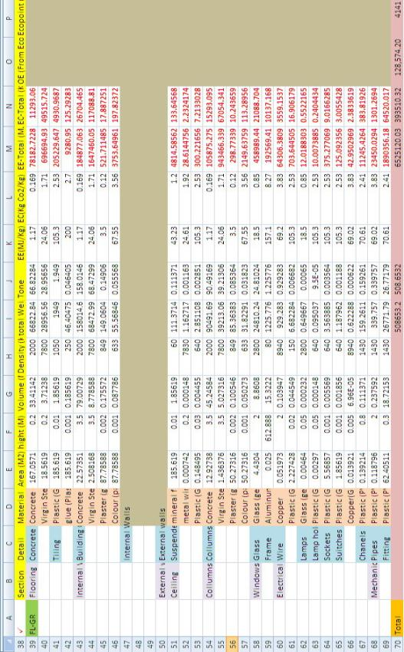
Figure A6: Modelling of Sheffield Arts Tower-Ground floor in new Measurement Approach

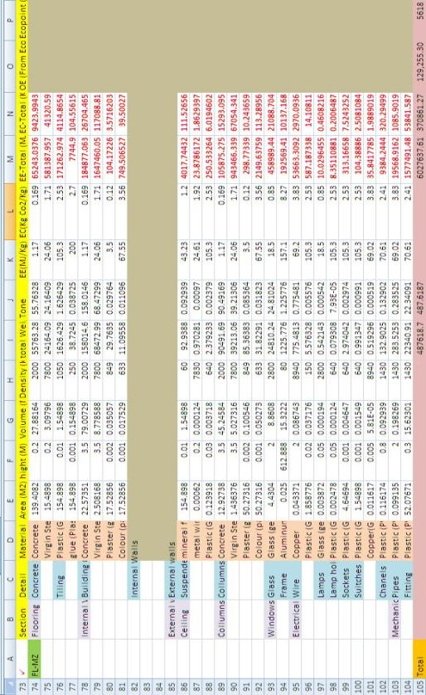
Figure A.7: Modelling of Sheffield Arts Tower-Mezzanine floor in new Measurement Approach

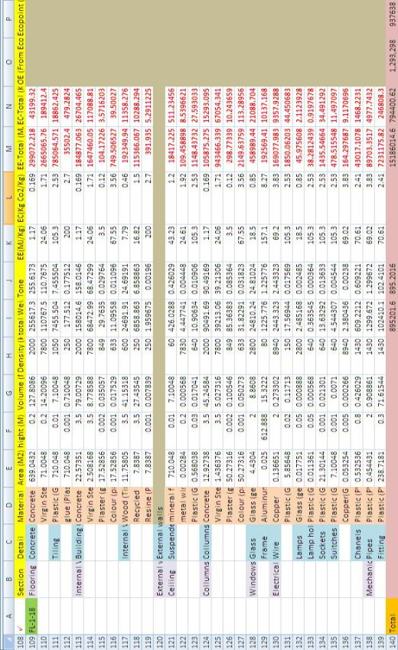
Figure A.8: Modelling of Sheffield Arts Tower- floors 1-18 in new Measurement Approach

Author)

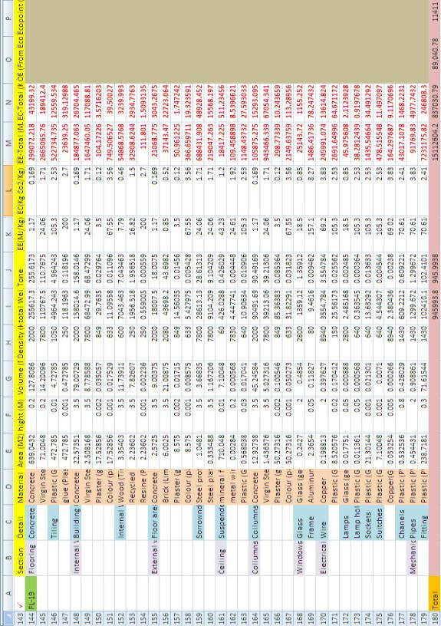
Figure A.9: Modelling of Sheffield Arts Tower- floors 19 in new Measurement Approach

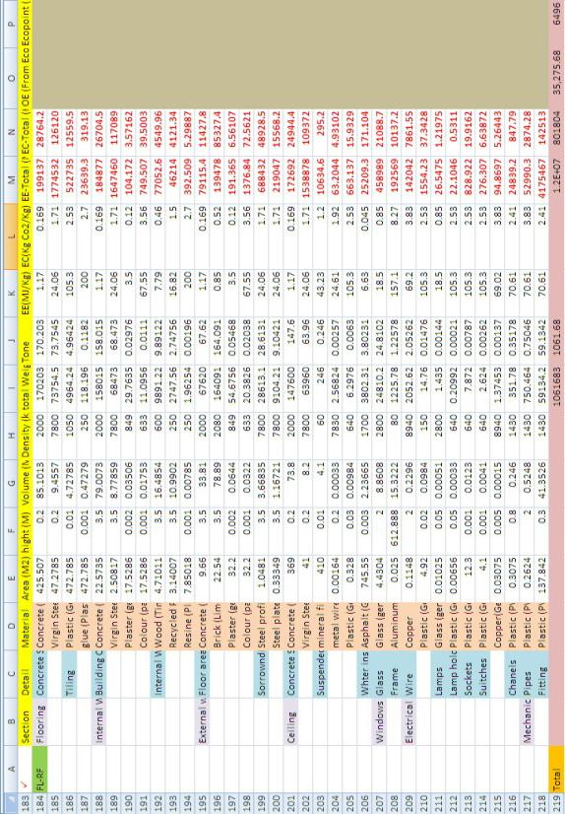
Figure A.10: Modelling of Sheffield Arts Tower- Roof floor in new Measurement Approach

Appendix B: Relevant publications of the author (PhD Candidate)
- The published papers relevant to the PhD thesis
During the period of PhD (2008-2012) the following papers have been published in the international conferences relevant to the methodology and attitude of this research by the author. The mentioned papers are as follows:
- Kashkooli, Ali.M.S., Altan, H. (2012) “A Semi-Quantitative Methodology of Building Lifecycle Assessment (BLCA): Demonstrated through a Case Study in Sheffield, UK”, 11th International Conference on Sustainable Energy technologies (SET-2012), Vancouver, Canada
- Kashkooli, Ali.M.S.,Eufrasio, R. M., Altan, H. (2012) “Measuring Lifecycle Carbon Footprint of A Case Study In Mexico”, 11th International Conference on Sustainable Energy technologies (SET-2012), Vancouver, Canada
- Kashkooli, Ali.M.S.,Vargas, G. A., Altan, H. (2012) “Lifecycle Energy Analysis of A Typical Office Building Block In Mexico- Warm And Humid Climate”, 11th International Conference on Sustainable Energy technologies (SET-2012), Vancouver, Canada
- Kashkooli, A.M.S., Smyrnova, Y., Altan, H., Kang, J. (2011) “Comparison of energy and carbon efficiency vs. acoustic environment in building Lifecycle assessment (BLCA): A simple methodology for building designers and decision makers”, 5th International Symposium of Temporal Design (ISTD), Sheffield, United Kingdom
- Kashkooli, Ali.M.S., Smyrnova, Y., Altan, H., Kang, J. (2011) “Multi-disciplinary performance assessment of a building unit using a new semi-quantitative method of building lifecycle assessment”, International Journal of Temporal Design (IJTD), Vol. 11, No. 1
- Kashkooli, A.M.S. and Altan, H. (2010) “Critical Building Life-cycle Assessment Methodology: Developing a simple tool” 9th International Detail Design in Architecture Conference, University of Central Lancashire (UCLan), Preston, United Kingdom

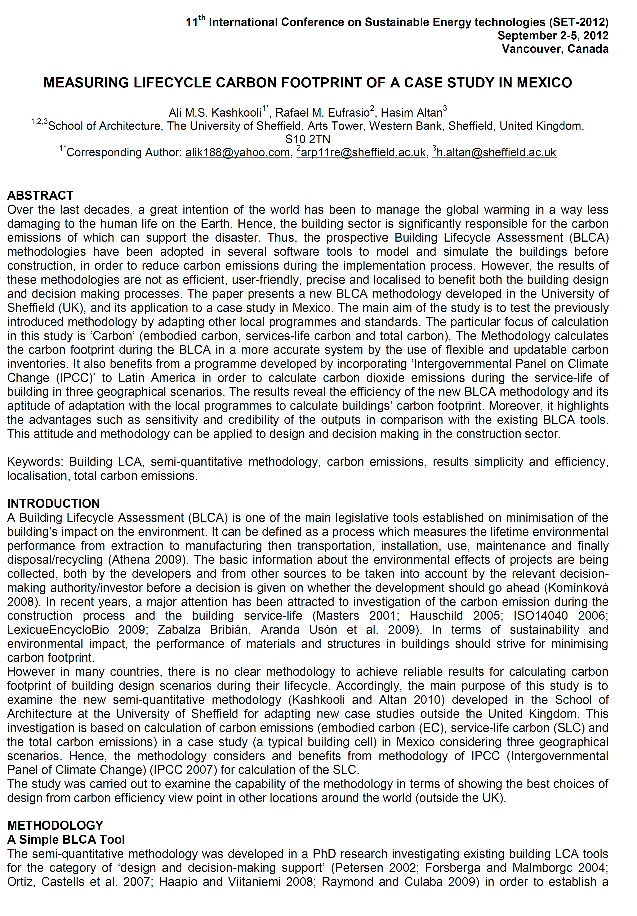

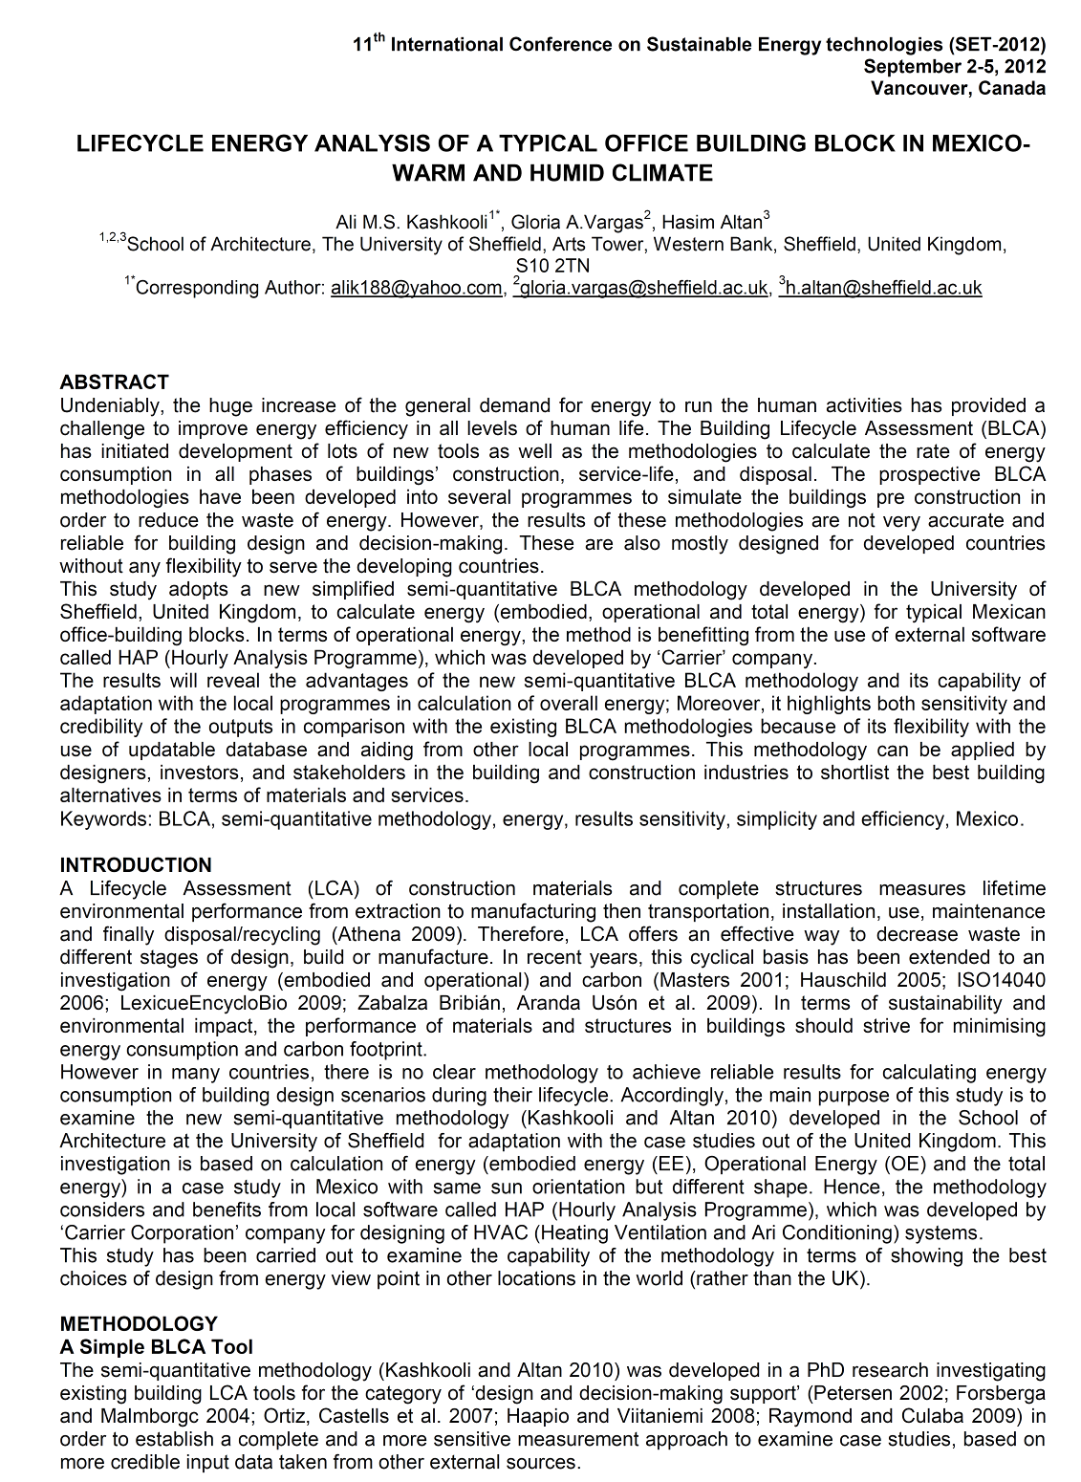

- The other publications relevant to the field of study
The following publications also have been carried out as book, international journal paper, and conference papers relevant to the field of this study (sustainability, design, energy, environment etc.):
- Book:
- Kashkooli, A.M. S. (2010) “Considering Re-usability in Design of High-rise Buildings: A guidebook for architects and structural designers to increase high-rise buildings' service-life through their design” LAP Lambert Academic Publishing, Germany, ISBN 978-3-8383-4100-2

- International Journal paper:
- Kashkooli, A.M.S. and Altan, H. (2010) "Re-Usability of High-Rise Buildings: A Case study of the Arts Tower in Sheffield, United Kingdom," in ArchNet-IJAR: International Journal of Architectural Research, vol. 4, issue 1 (2010)

- Conference papers:
- Kashkooli, A.M.S., Zahiri, S., Altan, H. (2011) “The Impact of Bionic Design in Proposing Energy Efficient Future: Case study of Ocean Scraper 2050” 10th International Conference on Sustainable Energy Technologies (SET 2011), Istanbul, Turkey
- Kashkooli, A.M.S., Altan, H. (2011) “The Influence of Bionic Design in Planning for a Sustainable Future: The Design of Ocean-Scraper 2050” International Bionic Engineering Conference 2011, Boston, USA (Refer to page A-33)
- Kashkooli, A.M.S., Kim, Y., Altan, H. (2010) “Employing Renewable Energy in Buildings and Urban Areas: Case of Off-Grid City 2009, South Korea”, 10th International Conference on Clean Energy (ICCI-2010), Gazimagusa – Northern Cyprus
- Kashkooli, A.M.S. (2010) “Re-usability, a solution to save energy in high-rise buildings: the Case study of Arts Tower, Sheffield, United Kingdom”, 3rd International Conference on Passive and Low Energy Cooling for the Built Environment (PALENC 2010), Greece
- Vadiati, N., and Kashkooli, A.M.S. (2011) “Environmental sustainability of newly developed city squares in historic cities: Case study of Isfahan-Iran”, 2011 International Conference on Green Buildings and Sustainable Cities (GBSC 2011), Bologna, Italy

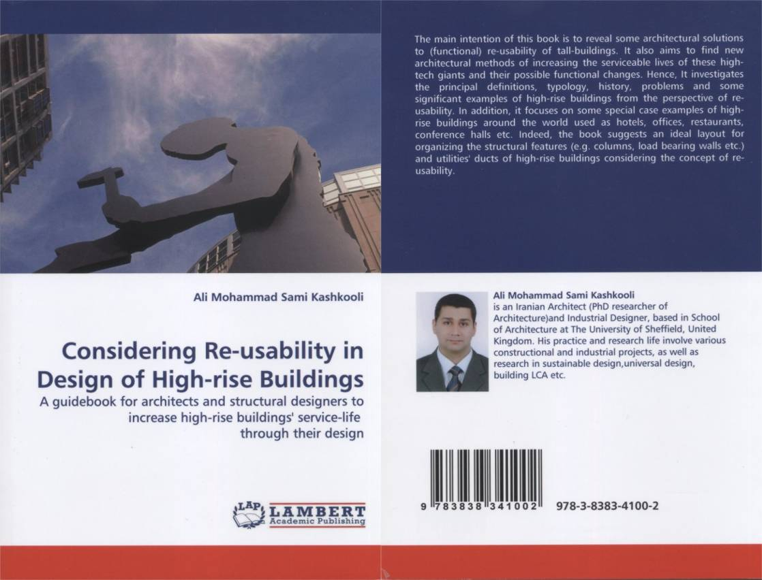

Book:

Considering Re-usability in Design of High-rise Buildings:
A guidebook for architects and structural designers to increase high-rise buildings' service-life through their design

Author: Ali M. S. Kashkooli

Abstract:
The main intention of this book is to reveal some architectural solutions to (functional) re-usability of tall-buildings. It also aims to find new architectural methods of increasing the serviceable lives of these high-tech giants and their possible functional changes. Hence, It investigates the principal definitions, typology, history, problems and some significant examples of high-rise buildings from the perspective of re-usability. In addition, it focuses on some special case examples of high- rise buildings around the world used as hotels, offices, restaurants, conference halls etc. Indeed, the book suggests an ideal layout for organizing the structural features (e.g. columns, load bearing walls etc.) and utilities' ducts of high-rise buildings considering the concept of re- usability.

--------------------------------------
LAP Lambert Academic Publishing, Germany
ISBN 978-3-8383-4100-2

“Archnet-IJAR International Journal of Architectural Research is an interdisciplinary, fully-refereed scholarly online journal of architecture, planning, and built environment studies. Two international boards (advisory and editorial) ensure the quality of scholarly papers and allow for a comprehensive academic review of contributions spanning a wide spectrum of issues, methods, theoretical approaches and architectural and development practices.
ArchNet-IJAR provides a comprehensive academic review of a wide spectrum of issues, methods, and theoretical approaches. It aims to bridge theory and practice in the fields of architectural/design research and urban planning/built environment studies, reporting on the latest research findings and innovative approaches for creating responsive environments. Articles are listed individually and can be sorted by author, title or year.”

URL: http://archnet.org/library/documents/one-document.jsp?document_id=11074

3rd International Conference on Passive and Low Energy Cooling for the Built Environment (PALENC), September 2010, Rhodes, Greece

2011 International Conference on Green Buildings and Sustainable Cities (GBSC 2011), Bologna, Italy,
Sep 15-16, 2011

Appendix C: General validation methodology for building energy simulation programmes
Validation is a precise and sensitive testing of a programme/methodology including its theoretical basis, software/simulation implementation and user interface under a series of conditions typical for the expected use of the programme/methodology (Jensen, 1995, Roache, 1998b, AIAA, 2001, Zienkiewicz and Zhu, 1992a, Zienkiewicz and Zhu, 1992b, Crawford, 2008).
In 1986 a project (PASSYS) has been conducted by ‘the Commission of the European Communities (CEC)’, in which a part of that project was the approval/development of a standard for European validation methodology for building energy simulation programmes (Jensen, 1995, Strachan, 1993).
According to PASSYS project, a validation methodology should be comprehensive, which mean to contain non-empirical as well as experimental validation techniques. Hence, the application could be both at the level of single processes and the level of whole models. A full comprehensive validation should include: a literature review, code checking, analytical verification, inter-model comparison, sensitivity studies and experimental validation (in case of programmes and software) (Jensen, 1995, Strachan, 1993). Also, the validation should be established on a interdisciplinary nature (Watson et al., 2011, Oberkampf and Trucano, 2002), which calls for a qualitative manner in case of programmes and software. As shown in figure A6 “a validation methodology comprises the following steps:
• A critical evaluation of the theory used in the simulation programmes to model the different building processes, including an investigation of possible alternatives.
• A check/review of the equivalent source code segments when possible (separately and jointly).
• Application of the analytical (for single processes) and inter-model comparison (for single processes and Use of sensitivity analysis for internal consistency and quality assurance checks (for single processes and whole model), and for investigating the overall uncertainty of the programme/model prediction due to uncertainty in the input parameters.
• Identification, design and implementation of empirical validation experiments. These experiments may be at the process level or for whole model validation. The experimental design includes use of sensitivity analysis to determine the principal factors of the experiment, and to assess overall uncertainty.
• Application of statistical analysis techniques to determine the acceptability or otherwise of the matched predictions and measured data sets and to help identify possible sources of discrepancy.
• Based on the above-mentioned validation techniques, recommendations should be given on modifications to the programme/model under study” (Jensen, 1995, Strachan, 1993, Crawford, 2008).
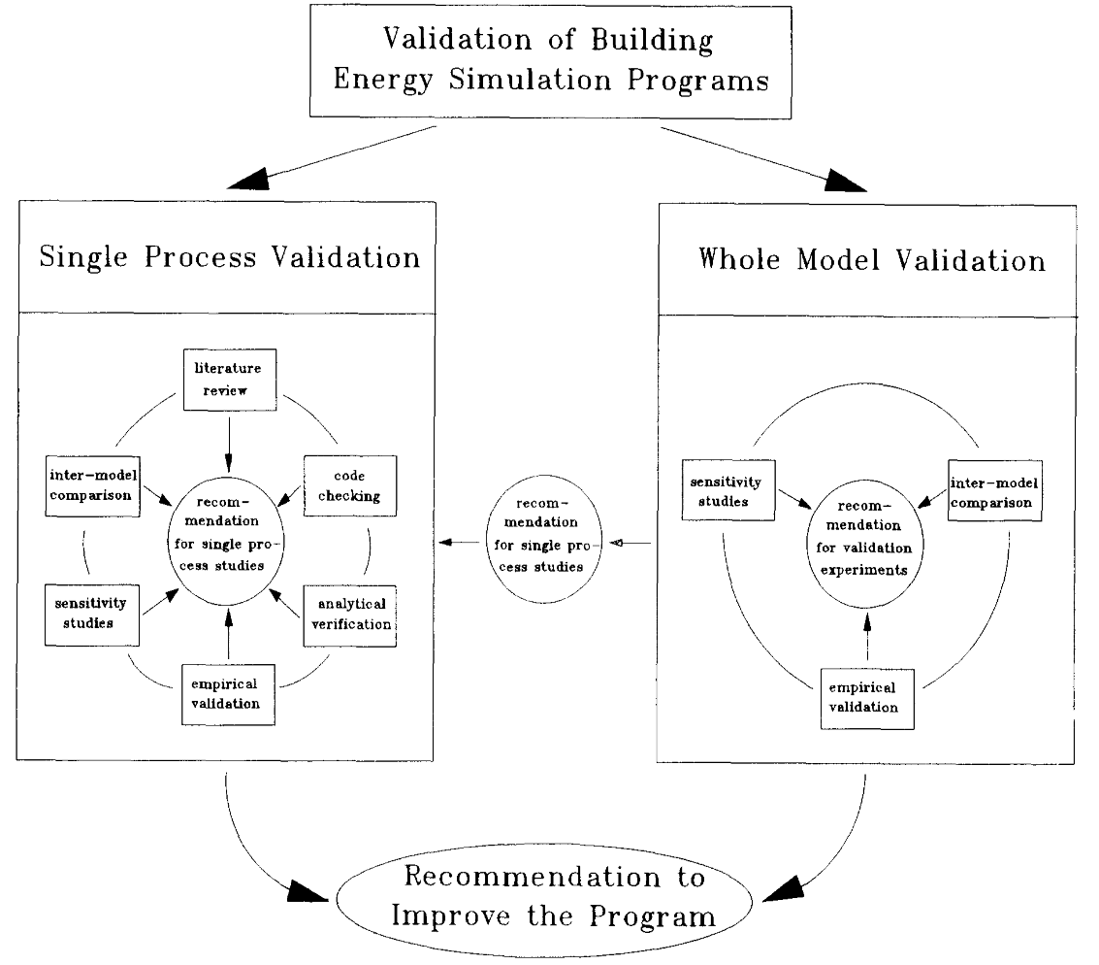
Figure A11: The principle of the model validation methodology, PASSYS project (Jensen, 1995).

In practice it is not possible to perform a complete validation of a programme - there are, especially for building energy simulation programmes, too many interlinked factors and too many possible applications to test all combinations. It is, however, possible to increase the confidence in a simulation programme by applying a well documented and comprehensive validation methodology combining several validation techniques (Jensen, 1995).
An empirical validation study should be planned carefully before starting. The experiment should be devised so that the necessary data are available in terms of, for example, scanning interval, location and accuracy of sensors. Guidance in this area can be obtained by modelling the phenomena before doing the experiments. Also, the expected analysis of the data should be planned before the study.
As previously stated, in case of software and programmes there is a need for an experimental, whole model validation. Such a methodology has been developed by the Model Validation and Development Subgroup, a methodology which ensures that the information on programme performance and the cause of discrepancies is maximised. The methodology comprises the following six stages (see figure A12):
- Definition of scope, type and nature of the physical and numerical experiment,
- Implementation of the physical experiment/monitoring on site (in case of programmes and software),
- Processing of the measured data,
- Performance of simulations,
- Analysis of the results and assessment of the sensitivity,
- Documentation of the data set and validation work.
Nonetheless, at its most detailed level model validation may still require specialised experiments (Watson et al., 2011, Oberkampf and Trucano, 2002, Roache, 1998a) and detailed extra work. “These also require an exclamation scheme to compare data positioned at different locations, and do not offer sensible treatment of spatially coherent disparities, such as shifted structures or amplifications. By contrast in the present work, it is asserted that whilst two datasets may not agree on a point-wise basis, they may still correlate well if there exists a reliable way of mapping between them” (Watson et al., 2011).
The basic validation techniques in lots of projects (e.g. PASSYS project) have been carried out established on a simple testing cell (see figure A12). However, in case of this research a greater scale (a tower) has been considered to highlight the variation of the spreadsheet results in a more sensitive perspective.
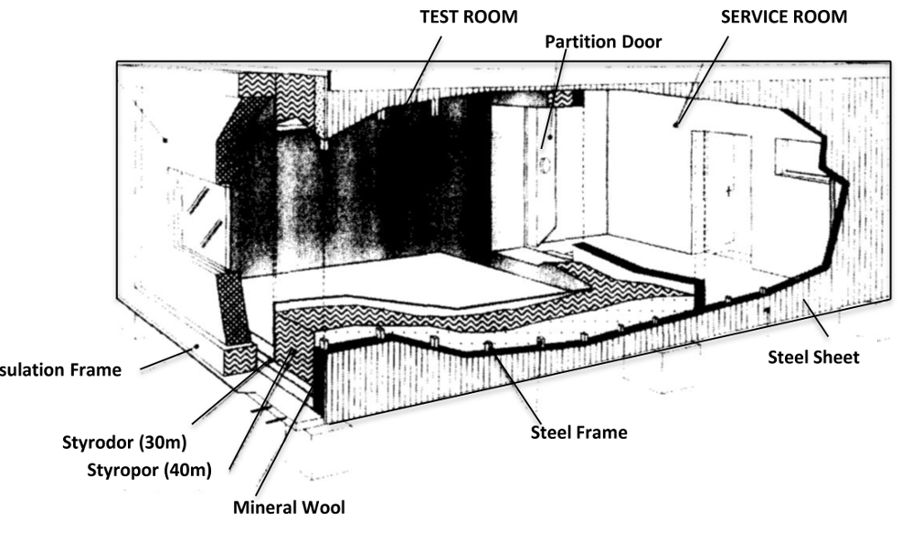
Figure A12: The standard testing cell, PASSYS project (Jensen, 1995).

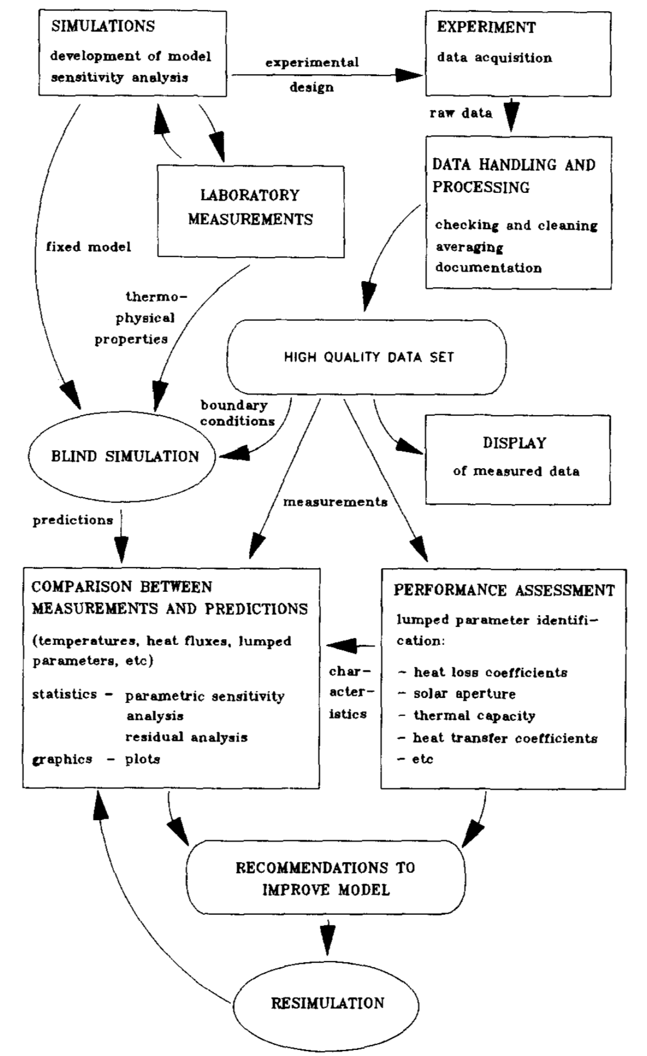
Figure A3: Outline of the experimental, whole model validation (Jensen, 1995).

BEIA: Building Environmental Impact Assessments
BLCI: Building Lifecycle Inventory
ACLCA: American Centre for Lifecycle Assessment
WPC: Whole Process of Construction
BMCC: Building Materials and Components Combinations
EMAS: Eco-Management and Audit Scheme of European Commission Environment
BS: British Standards Institution
ISO: International Standard Organisation
LCI: Lifecycle Inventory
REPA: Resource and Environmental Profile Analysis
SETAC: Society for Environmental Toxicology and Chemistry
ISO: International Organisation for Standardisation
Lifecycle thinking: “Lifecycle thinking is defined as a production and consumption strategy that aims at taking into account all of the impacts (environmental, economic and social) that a product or service will have throughout its lifecycle, from cradle to grave” (GIRAIG, 2005).
BEIA: Building Environmental Impact Assessment
SETAC: Society of Environmental Toxicology and Chemistry
CMLL: Institute of Environmental Sciences (University of Leiden)
ACLCA: American Center for Lifecycle Assessment
CML: Institute of Environmental Sciences
-Eutrophication is when the environment becomes enriched with nutrients. This can be a problem in aquatic habitats such as lakes as it can cause algal blooms.
Eutrophication or more precisely hypertrophication, is the ecosystem response to the addition of artificial or natural substances, such as nitrates and phosphates.
A carcinogen is any substance, radionuclide, or radiation that is an agent directly involved in causing cancer.
LCANET Report: Lifecycle Impact Assessment and Interpretation
In this case, it means to be faithful to general global values and parameters which are globally accepted as relevant to the environment.
BRE: Building Research Establishment, United Kingdom
BREEAM: Building Research Establishment Environmental Assessment Method
BEQUEST: Building Environmental Quality for Sustainability through Time
CRISP: A European Thematic Network on Construction and City Related Sustainability Indicators
IEA Annex 31: Energy-related Environmental Impact of Buildings
PRESCO: European Thematic Network on Practical Recommendations for Sustainable Construction
GBC: Green Building Challenge
ATHENA Institute: registered in Canada and North America as: ATHENA Sustainable Materials Institute
IEA Annex 31: Energy related environmental impact of buildings (previously mentioned)
Core and shell: Consisting of a core in the centre, and a surrounding tube as the supporting structure.
The U-value (or U-factor): also called the overall heat transfer coefficient; shows how well a building element conducts heat. It measures the rate of heat transfer through a building element over a given area, under standardised conditions in a usual temperature gradient of 24 °C, at 50% humidity, with no wind (a smaller U-value represents a lower heat transfer).

