Chapter 4
Inhibition of mediator release from the urothelium.
The effects of blocking urothelial mediator release, by the use of a calcium free external Krebs solution, on bladder afferent nerve firing

Investigating the effects of Ca²⁺ free Krebs exposure on compliance and afferent nerve sensitivity of the mouse bladder.

4.1 Introduction

Many physiological processes in the bladder, and indeed the rest of the body, require Ca²⁺ signalling for release, activation or synthesis. These processes are vast and varied, ranging from Ca²⁺ dependent exocytosis of ATP from the urothelium (Birder et al., 2003), to contraction and relaxation of the detrusor muscle (Sui et al., 2009) as described in detail in chapter 1. The main uses of Ca²⁺ in the bladder are summarised in figure 4.1.

To enable contraction and relaxation of the detrusor muscle

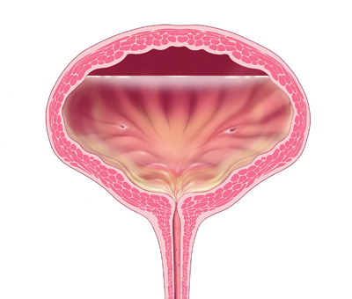
Ca²⁺ is required for the activity of bladder cells including interstitial cells
For the breakdown of ATP, as ATPase activity is Ca²⁺ dependent
Ca²⁺ dependent release of mediators from the urothelium (Chapter 1)
Why does the bladder require Ca²⁺?

Figure 4.1: Uses of Ca²⁺ in the bladder. Ca²⁺ is required in the bladder for muscle and cellular activity, and in the release and breakdown of urothelially released mediators.

4.2 Aims and hypothesis

The model of the ‘sensory web’ proposes release of mediators from the urothelium that alter bladder function, for example via changes in afferent nerve sensitivity (Apodaca et al., 2007). The aim of these experiments was to investigate the effect of inhibition of urothelial mediator release on afferent nerve activity and bladder compliance by using externally perfused Ca²⁺ free Krebs exposure to block Ca²⁺ dependent mediator synthesis and release, with the hypothesis that afferent nerve firing would be altered dependent on the balance of inhibitory and excitatory Ca²⁺ dependent mediators in the urothelium.
It was hypothesised that if the contribution of Ca²⁺ dependent inhibitory mediators was greater than the contribution of Ca²⁺ dependent excitatory mediators, inhibition of mediator release by external perfusion of Ca²⁺ free Krebs solution would increase afferent nerve sensitivity during distension and at rest. Alternatively, if the predominant role of the urothelium was in the release of Ca²⁺ dependent excitatory mediators, one would hypothesise that inhibition via perfusion of Ca²⁺ free Krebs solution would decrease afferent nerve sensitivity.
However, as previously described, exposure of the bladder to Ca²⁺ free Krebs solution has multiple effects on many signalling processes crucial for normal bladder function, for example, ectoATPase activity and muscle contraction. Therefore, as a secondary aim, it was important to eliminate the effects of Ca²⁺ free Krebs exposure on these processes, with the hypothesis that exposure to the Ca²⁺ free Krebs solution may have a secondary effect on afferent nerve firing as a result of alterations in muscle contractility and ectoATPase activity.

4.3 Experimental method

Solutions

Extraluminal (bath) solution

Standard Krebs solution (table 4.1) was used for experimental set-up, control and washout periods. Pre-carbogenated Ca²⁺ free Krebs solution, as previously used (Zagorodnyuk et al., 2009) in which CaCl₂ (1.9mM) was omitted and replaced with MgCl₂ (6.4mM) with the addition of 1mM Ca²⁺ chelating agent EDTA was perfused for 30 minutes following the control period.

Intraluminal (bladder) solution

The internal solution (150mM NaCl) used for intraluminal bladder perfusion and for bladder distension remained constant throughout the experiment.

 | Standard Krebs solution | Ca²⁺ free Krebs solution
Components(mM)

NaCl | 118.4 | 118.4
Glucose | 11.7 | 11.7
NaHCO₃ | 24.9 | 24.9
KCl | 4.6 | 4.6
MgSO₄ | 1.2 | 1.2
KH₂PO₄ | 1.2 | 1.2
CaCl₂ | 1.9 | 0.0
MgCl₂ | 0.0 | 6.4
EDTA | 0.0 | 1.0

Table 4.1: Differences between the standard (control) Krebs solution and Ca²⁺ free Krebs solution.
Components of the Ca²⁺ free Krebs solution remained the same as control Krebs solution apart from(shown in red) removal of CaCl₂ (0mM) and replacement with MgCl₂ (6.4mM), and the addition of EDTA (1.0mM) as previously described (Zagorodnyuk et al., 2009).

Protocol

The mouse bladder was prepared for electrophysiological recording as described in detail in chapter 2
A schematic of the protocol used for Ca²⁺ free Krebs experiments, also detailing where control, 10 and 30minutes Ca²⁺ free Krebs solution and washout measurements were taken from is shown in figure 4.2.
The total ‘deadspace’ of the perfusion system tubing and recording chamber volume for the external bath solution required 3 minutes for complete replacement of the recording chamber with the Ca²⁺ free Krebs solution, but to avoid variability, 10 minutes was counted from the onset of Ca²⁺ free Krebs perfusion (i.e. before the total volume of the recording chamber had been replaced with Ca²⁺ free Krebs). This was also the case when reverting from the Ca²⁺ free Krebs solution to standard Krebs solution for washout.

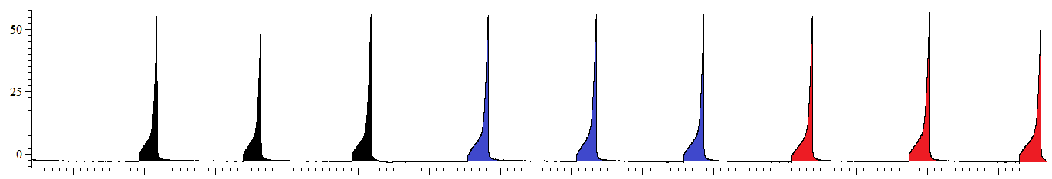
IP (mmHg)
10 mins
Control
Internal: 150mM NaCl
External: Standard Krebs

Ca²⁺ free Krebs
Internal: 150mM NaCl
External: Ca²⁺ free Krebs

Washout
Internal: 150mM NaCl
External: Standard Krebs

Control measurement
10mins measurement
30mins measurement
Washout measurement
Figure 4.2: A schematic of the Ca²⁺ free protocol.
Following 3 control distensions (standard Krebs solution), Ca²⁺ free Krebs solution was extraluminally perfused for 30minutes, before reverting to the standard Krebs solution for 30 minutes washout. Data was analysed at 30minutes, standard Krebs, control (+ 5 minute period baseline afferent nerve firing prior to distension), 10 minutes Ca²⁺ free Krebs (+ 5 minute period baseline afferent nerve firing prior to distension), 30minutes Ca²⁺ free Krebs (+ 5 minute period baseline afferent nerve firing prior to distension), and 30 minutes, standard Krebs, washout (+ 5 minute period baseline afferent nerve firing prior to distension).

4.4 Results: Effects of Ca²⁺ free Krebs on afferent nerve firing and bladder compliance.

Overview
Exposure of the bladder to Ca²⁺ free Krebs solution significantly increased mechanosensitivity and baseline afferent nerve firing without affecting bladder compliance, as shown in figure 4.3.

Exposure to Ca²⁺ free Krebs solution significantly augmented the afferent nerve response to bladder distension.

After obtaining 3 consecutive reproducible distension responses, the Krebs perfusion solution was replaced with a pre-carbogenated Ca²⁺ free Krebs solution as outlined in section 4.3. 10 minutes exposure to Ca²⁺ free Krebs solution increased afferent firing in response to bladder distension, relative to control distensions (figure 4.4A). Following bath perfusion of Ca²⁺ free Krebs solution for 30 minutes, afferent nerve firing in response to bladder distension was significantly increased as shown in figure 4.4B. This excitatory effect was fully reversed following a 30 minute washout period, in which the external solution was reversed back to the standard Ca²⁺ containing Krebs solution (figure 4.4C).
In control conditions (standard Ca²⁺ Krebs), peak firing rate (the maximum firing of the afferent nerves during bladder distension, regardless of the pressure point at which it occurred) averaged 181.2 ± 39.44 imp s⁻¹, and following exposure to Ca²⁺ free Krebs solution remained statistically unchanged at both 10 (226.3 ± 42.35 imp s⁻¹) and 30 minutes (197.9 ± 38.24 imp s⁻¹), as shown in figure 4.5A. Interestingly however, the pressure point at which peak firing occurred within the distension was significantly decreased, from control ( 39.17 ± 3.27 mmHg) at both 10 (21.67 ± 4.77 mmHg) and 30 minutes (16.67 ± 3.07 mmHg) exposure to Ca²⁺ free Krebs bath solution (figure 4.5B)
From the 6 experiments performed, 4 yielded nerve units displaying sufficiently different spike shape and amplitude to enable accurate discrimination of individual spikes by single unit analysis as summarised in figure 4.6A. 13 low threshold and 17 high threshold nerve fibres were identified and analysed. Following 10 minutes exposure to the Ca²⁺ free Krebs solution, low threshold firing was increased in response to bladder distension as shown in figure 4.6B whilst high threshold afferent nerve fibres remained unaffected (figure 4.6C). Low threshold nerve firing was significantly augmented relative to control, following 30 minutes exposure to the Ca²⁺ free Krebs solution (figure 4.7A). In contrast, high threshold nerve firing was inhibited, relative to control, following 30 minutes exposure to the Ca²⁺ free Krebs solution (figure 4.7B).

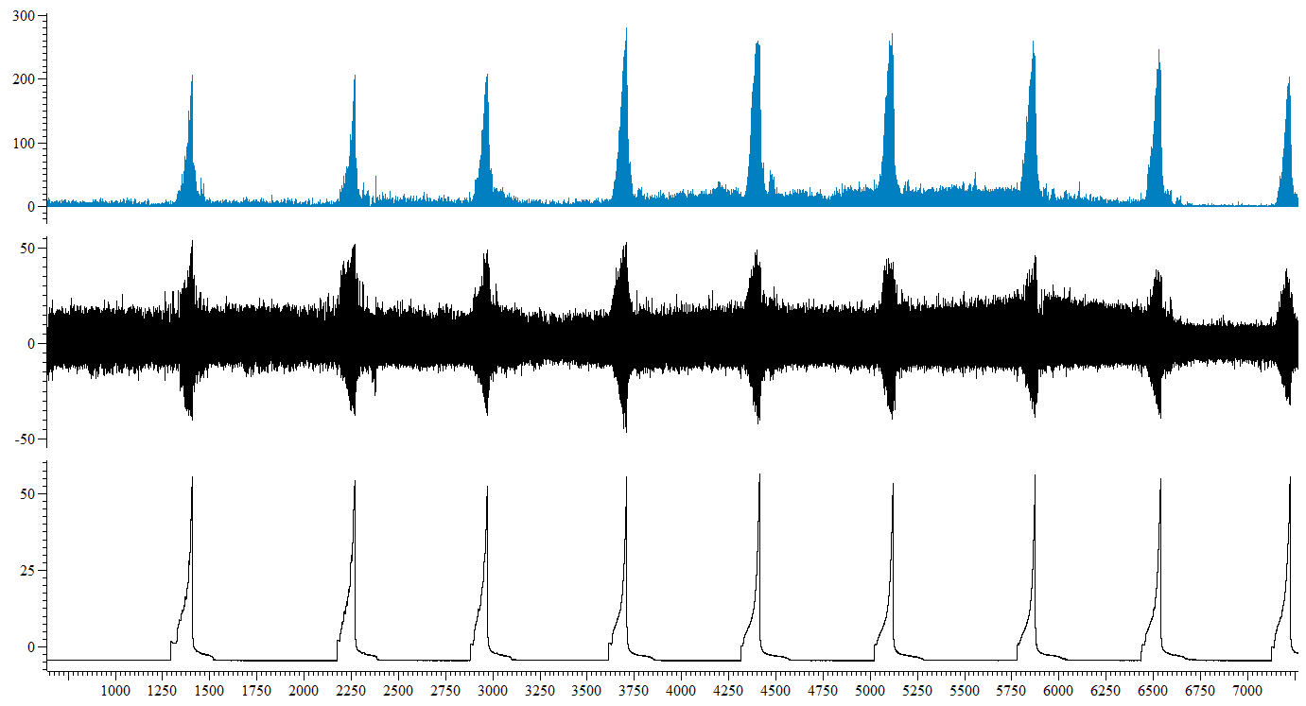
Figure 4.3: Screen-shot representative trace from a single Ca²⁺ free Krebs experiment. Ca²⁺ free Krebs exposure significantly increased mechanosensitivity and baseline afferent nerve firing without affecting bladder compliance, (n=6).

Ca²⁺ free Krebs solution
Standard Krebs solution
Standard Krebs solution
Mean firing (imp s⁻¹)
Nerve firing (µV)
IP (mmHg)
Time (s)
A.
B.
Figure 4.4: Exposure to Ca²⁺ free Krebs significantly increased afferent nerve firing in response to bladder distension. A, 10 minutes exposure to Ca²⁺ free Krebs solution augmented the afferent nerve response to bladder distension relative to control standard Krebs solution (**P=0.005, n=6). B, 30 minutes exposure to Ca²⁺ free Krebs solution significantly augmented afferent nerve firing in response to ramp distension of the bladder (*P=0.03, n=6). C, The excitatory effect of Ca²⁺ free Krebs exposure on mechanosensitivity was fully reversed following a 30 minute washout period with standard Krebs solution (P=0.72, n=6)
C.

A.
Figure 4.5: Exposure to a Ca²⁺ free Krebs solution had no effect on peak afferent nerve firing, but significantly reduced the pressure point at which peak afferent nerve firing occurred within the ramp distension. A, peak afferent firing was not significantly affected by exposure to the Ca²⁺ free Krebs solution (P=0.44, 1 way RM ANOVA with Bonferroni post-test, n=6), however, B, the pressure point during the distension at which peak firing occurred was significantly decreased following exposure to the Ca²⁺ free Krebs solution at both 10 and 30 minutes (**P=0.002, 1 way RM ANOVA with Bonferroni post-test, n=6).
B.

A. | Number of experiments (N) | Number of units identified (n) | % of total units identified
Low threshold | 4 | 13 | 65
High threshold | 4 | 7 | 35
Total | 4 | 20 | 100

B.

Figure 4.6: Single unit analysis revealed 10 minutes exposure to Ca²⁺ free Krebs solution significantly augmented low threshold nerve fibre firing, but had no effect on high threshold nerve fibres. A, 4 experiments were suitable for single unit analysis and allowed the identification of 13 low threshold and 7 high threshold afferent nerve fibres. B, following 10 minutes exposure to Ca²⁺ free Krebs solution, low threshold afferent nerve firing in response to bladder distension was augmented, relative to control standard Krebs solution (****P<0.0001, n=13, N=4). C, In contrast, the response of high threshold afferent nerve fibres to bladder distension was not affected by exposure to Ca²⁺ free Krebs solution (P=0.27, n=7, N=4).
C.

A.

B.
Figure 4.?: Single unit analysis revealed antagonistic mechanosensitivity responses of low threshold and high threshold firing following exposure to the Ca²⁺ free Krebs solution. A, From the 4 experiments analysed, 13 low threshold and 7 high threshold fibres were confidently identified. B, Low threshold firing was significantly increased, relative to control, following 30 minutes exposure to the Ca²⁺ free Krebs solution (****P<0.0001, n=6). C, conversely, high threshold firing was significantly inhibited relative to control following exposure to the Ca²⁺ free external Krebs solution (*P=0.02, n=6).
Figure 4.7: Single unit analysis. 30 minutes exposure to Ca²⁺ free Krebs solution augmented low threshold nerve fibre firing in response to bladder distension, but inhibited the high threshold nerve response to distension. A, 30 minutes exposure to Ca²⁺ free Krebs solution significantly increased low threshold afferent nerve firing in response to bladder distension relative to control standard Krebs solution(****P<0.0001, n=13, N=4). B, In contrast, the response of high threshold afferent nerve fibres to bladder distension was inhibited, relative to standard Krebs solution, following exposure to Ca²⁺ free Krebs solution (*P=0.02, n=7, N=4).

Exposure to Ca²⁺ free Krebs solution had no effect on bladder compliance

Bladder compliance remained stable for 3 consecutive distensions before the commencement of the Ca²⁺ free Krebs solution protocol.
As shown in figure 4.8A, following 10 minutes exposure to Ca²⁺ free Krebs solution, bladder compliance remained unaffected. Similarly, bladder compliance remained stable following 30 minutes exposure to Ca²⁺ free Krebs solution (figure 4.8B) and remained stable following 30 minutes re-exposure to the standard Krebs solution during the washout period (figure 4.8C), suggesting the change in afferent firing following Ca²⁺ free exposure was not secondary to a change in bladder compliance.

Exposure to Ca²⁺ free Krebs solution increased mean baseline firing

Exposure to Ca²⁺ free Krebs solution increased baseline afferent nerve firing as shown in figure 4.9. Bonferroni post-test revealed significance between control and 30 minutes exposure to the Ca²⁺ free Krebs solution, an increase in mean firing of 18.25 imp s⁻¹ (from 3.92 ± 1.14 imp s⁻¹ to 22.17 ± 6.15 imp s⁻¹). Following 25 minutes washout with standard Krebs solution in the 5 minute period prior to bladder distension (at 30minutes), the excitatory effect of Ca²⁺ free exposure on mean baseline afferent nerve firing was reversed, showing a decrease in mean firing of 16.68 imp s⁻¹ (from 22.17 ± 6.15 imp s⁻¹ to 5.48± 1.20 imp s⁻¹).

A.
B.
B.
Figure 4.8: Bladder compliance was unaffected by exposure to Ca²⁺ free Krebs solution. A, Relative to control distension, bladder compliance was unaffected by 10 minutes exposure to Ca²⁺ free Krebs solution (P=0.51, n=6). B, compliance remained statistically unchanged to control distension following 30 minutes Ca²⁺ free Krebs solution exposure (P=0.65, n=6). C, bladder compliance remained unchanged for the entire duration of the protocol (P=0.72, n=6).

Figure 4.9: Exposure to Ca²⁺ free Krebs increased mean baseline afferent nerve firing (**P=0.003, 1 way RM ANOVA with Bonferroni post-test, n=6). Bonferroni post-test revealed a significant increase in mean baseline afferent nerve firing for 25-30 minutes exposure to Ca²⁺ free Krebs (**P<0.001, n=6), and a decrease in mean afferent firing from a mean firing of 22.17 ± 6.15 imp s⁻¹ at 25-30minutes Ca²⁺ free exposure to a mean firing rate of 5.48± 1.20 imp s⁻1 for the 25-30 minute washout period (*P<0.05, Bonferroni post-test, n=6).

Investigating the effects of detrusor muscle paralysis on bladder compliance and afferent nerve firing in the mouse.

4.5 Aim and hypothesis:

Exposure of the mouse bladder to externally perfused Ca²⁺ free Krebs augmented afferent nerve firing both in response to bladder distension and at baseline between distensions without affecting bladder compliance. Ca²⁺ primarily regulates contractions of smooth muscle (Clinton Webb, 2003) and contraction of the bladder detrusor is no exception (Fry et al., 2010). Contractions of the detrusor muscle also evoke afferent nerve firing as demonstrated previously in the mouse bladder (McCarthy et al., 2009). This suggests that if the effect of Ca²⁺ free Krebs on afferent nerve firing in this preparation were due to paralysis of muscle contraction then afferent nerve firing would have been decreased, not increased as demonstrated in the data presented in section 4.4.
The aim of the experimental data presented in this section was to examine a major pathway of Ca²⁺ dependent activation of muscle contraction through Ca²⁺ entry via L-type Ca²⁺ channels, and investigate the effects of L-type Ca²⁺ channel inhibition (by nifedipine) on muscle compliance and afferent nerve activity, with the hypothesis that if the augmentation of afferent nerve firing observed in Ca²⁺ free experiments was secondary to paralysis of or a decrease in muscle activity, then the augmentation in firing should be replicated following inhibition of L-type Ca²⁺ channels, a major source of Ca²⁺ entry for the development of muscle contraction (Wu et al., 2002).
Data from Ca²⁺ free experiments would suggest that decreased muscle activity or paralysis (by exposure to Ca²⁺ free solution) causes an increase in afferent nerve firing, if indeed this was the mechanism by which Ca²⁺ free exerted its excitatory effect on afferent nerve activity. However this mechanism seems unlikely, as it is contractions of the detrusor muscle that are known to evoke afferent nerve firing, not muscle inactivity (McCarthy et al., 2009). Consequently it was hypothesised that the increase in afferent nerve firing observed following Ca²⁺ free Krebs exposure was not due to an inhibition of muscle contraction.

4.6 Experimental method

Solutions

Nifedipine

Nifedipine (L-Type Ca²⁺ channel blocker) was obtained from Sigma-Aldrich UK, and dissolved in 100% ethanol to obtain a 10mM stock solution, which was then aliquoted and stored in foil covered eppendorfs, in the dark, at -20°C until use.
Immediately prior to use, in the absence of light, the 10mM stock solution of nifedipine was further dissolved in standard Krebs solution to obtain a final bath concentration of 1µM with a final percentage vehicle of 0.01% ethanol. The concentration of nifedipine used was decided by previous studies in the laboratory and from a literature search which suggested that 1µM nifedipine was sufficient to block electrically evoked contractions by 75% in a rat bladder preparation (Somogyi et al., 1997). The standard Krebs and 1 µM nifedipine solution was carbogenated (95% O₂/5% CO₂) and pH and osmolarity recorded prior to extraluminal perfusion of the bladder.

Extraluminal (bath) solution

Standard Krebs solution (table 4.1) continuously oxygenated (95% O₂ and 5% CO₂) at 35ºC and externally perfused into the recording chamber was used throughout the protocol, with the addition of 1µM nifedipine for 30 minutes following the control period.

Intraluminal (bladder) solution

The internal solution (150mM NaCl) used for intraluminal bladder perfusion and for bladder distension remained constant throughout the experiment.

Protocol

A schematic of the protocol used for 1µM nifedipine experiments, also detailing where control, 10 and 30minutes 1µM nifedipine, and washout measurements were taken from is shown in figure 4.10.
Following set-up, the lights in the laboratory were turned off prior to commencement of the protocol due to the potential inactivation of nifedipine due to its photo-sensitive reactivity.

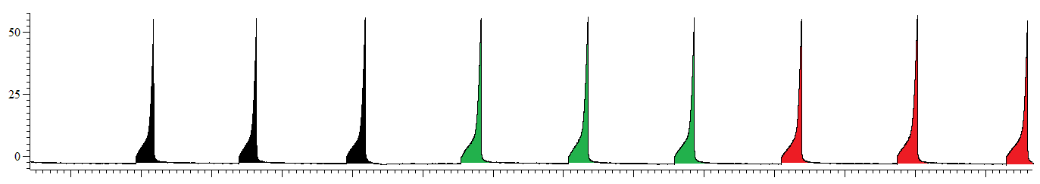
IP (mmHg)
10 mins
Control
Internal: 150mM NaCl
External: Standard Krebs

Washout
Internal: 150mM NaCl
External: Standard Krebs

+1µM nifedipine
Internal: 150mM NaCl
External: Standard Krebs + 1µM nifedipine

Control measurement
10mins measurement
30mins measurement
30mins measurement

Figure 4.10: A schematic of the protocol for extraluminal application of 1µM nifedipine.
Following 3 control distensions (standard Krebs solution), 1µM nifedipine was extraluminally perfused for 30minutes in the standard Krebs solution, before reverting to the standard Krebs solution for 30 minutes washout. Data was analysed at 30minutes, standard Krebs, control (+ 5 minute period baseline afferent nerve firing prior to distension), 10 minutes 1µM nifedipine in standard Krebs solution (+ 5 minute period baseline afferent nerve firing prior to distension), 30minutes 1µM nifedipine in standard Krebs solution (+ 5 minute period baseline afferent nerve firing prior to distension), and 30 minutes, standard Krebs washout (+ 5 minute period baseline afferent nerve firing prior to distension). The whole protocol was performed in the absence of light due to the photo-sensitivity of nifedipine.

4.7 Results: Effects of nifedipine on afferent nerve firing and bladder compliance.

Overview

The presence of 1µM nifedipine in the external standard Krebs solution had no effect on mechanosensitivity, baseline afferent nerve firing, or on bladder compliance as shown in figure 4.11. This data suggests that the augmentation of firing observed in Ca²⁺ free Krebs experiments was probably not due to decreased activity of the detrusor muscle, as afferent nerve firing was unchanged in separate experiments in which muscle activity was paralysed by L-type Ca²⁺ channel antagonist nifedipine, leaving the possibility that afferent nerve firing was increased following Ca²⁺ free Krebs exposure due to the decreased activity of ectoATPases, or as a result of decreased release of inhibitory mediators from the urothelium, as initially proposed.

External perfusion of 1µM nifedipine in the external bath standard Krebs solution had no effect on mechanosensitivity.

The afferent nerve response to bladder distension remained stable for 3 consecutive distensions prior to perfusion with 1µM nifedipine. Following 10 minutes perfusion of 1µM nifedipine in the standard Krebs solution, the afferent nerve response to bladder distension remained unaffected (figure 4.12A). Similarly, 30 minutes exposure to 1µM nifedipine had no effect on mechanosensitivity (figure 4.12B). Mechanosensitivity remained unchanged for the entire duration of the protocol, and was unchanged following 30 minutes saline washout, as shown in figure 4.12C.

Externally applied 1µM nifedipine had no effect on peak afferent nerve firing, nor on the pressure point during the distension at which peak firing occurred.

Peak afferent nerve firing during ramp distension under control conditions occurred at the peak distension pressure (50mmHg), as described in chapter 3. In the presence of 1µM nifedipine, peak afferent nerve firing remained unchanged following 10 and 30 minutes exposure (figure 4.13A), as did the pressure point at which peak firing occurred (figure 4.13B).

Single unit analysis revealed that neither low nor high threshold bladder afferents were affected by external application of 1µM nifedipine.

Single unit analysis was performed on 4 individual experiments, and identified 20 single afferent nerve fibres, consisting of 13 low and 7 high threshold fibres as described in figure 4.14A. Low threshold afferent nerve firing was unaffected by 30 minutes external application of 1µM nifedipine (figure 4.14B). Similarly, as shown in figure 4.14C, high threshold afferent nerve firing was unaffected following 30 minutes (bath applied) exposure to 1 µM nifedipine.

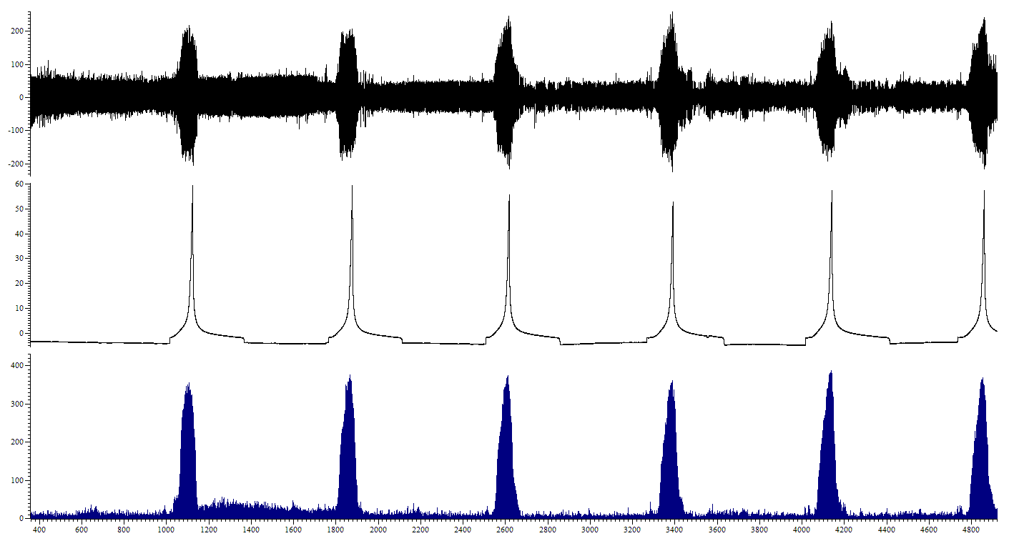
IP (mmHg)
Mean firing (imp s⁻¹)
Nerve firing (µV)
Time (s)
Control
+1µM nifedipine

Figure 4.11: Screen-shot representative trace from a single 1 µM nifedipine experiment.
1µM nifedipine in the external Krebs solution had no effect on mechanosensitivity nor baseline afferent nerve firing, nor on bladder compliance (n=6).

A.
B.
Figure 4.12: Addition of 1µM nifedipine to the external Krebs solution had no effect on mechanosensitivity. A, 10 minutes exposure to 1µM nifedipine in the external Krebs solution had no effect on the afferent nerve response to bladder distension, relative to control (P=0.69, n=6). B, The afferent nerve response to bladder distension following 30 minutes exposure to Krebs applied 1µM nifedipine remained unchanged, relative to control distension (P=0.25, n=6). C, Mechanosensitivity remained unchanged following 30 minutes washout (P=0.94, n=6).
C.

A.
B.
Figure 4.13:1µM nifedipine had no effect on peak afferent firing, nor on the pressure point during the distension at which peak firing occurred. A, peak afferent firing was not affected by external application of 1µM nifedipine, at 10 nor 30 minutes exposure (P=0.23, 1 way RM ANOVA with Bonferroni post-test, n=6). B, similarly, the pressure point during distension at which peak firing occurred was also unaffected following both 10 and 30 minutes exposure to externally applied 1µM nifedipine (P=0.63, 1 way RM ANOVA with Bonferroni post-test, n=6).

A. | Number of experiments (N) | Number of units identified (n) | % of total units identified
Low threshold | 4 | 13 | 65
High threshold | 4 | 7 | 35
Total | 4 | 20 | 100

B.
C.
Figure 4.14: Addition of 1µM nifedipine to the external Krebs solution had no effect on low nor high threshold afferent nerve firing. A, Single unit analysis identified 13 low threshold and 7 high threshold afferent nerve fibres from 4 experiments. B, Low threshold afferent nerve firing was unaffected by 30 minutes (Krebs applied) exposure to 1µM nifedipine (P=0.94, n=13, N=4). C, Similarly, high threshold afferent nerve firing also remained unaffected following 30 minutes (bath applied) exposure to 1µM nifedipine (P=0.58, n=7, N=4) .

Bladder compliance and baseline afferent nerve firing were unaffected by the presence of 1µM nifedipine in the external Krebs solution.

Relative to control distension, bladder compliance remained unchanged following bath perfusion of 1µM nifedipine at both 10 (figure 4.15A) and 30 minutes (figure 4.15B), and remained unchanged following a 30 minute washout period (figure 4.15C). Baseline afferent nerve firing was also unaffected by exposure to 1µM nifedipine in the external Krebs solution (figure 4.16)

A.
B.
C.
Figure 4.15: Bladder compliance was unaffected by exposure to 1µM nifedipine. A, Relative to control distension, bladder compliance was unaffected by 10 minutes exposure to 1µM nifedipine (P=0.11, n=6). B, Compliance remained statistically unchanged to control distension following 30 minutes exposure to 1µM nifedipine (P=0.08, n=6). C, Bladder compliance remained unchanged for the entire duration of the protocol (P=0.48, n=6).

Figure 4.16: External perfusion of 1µM nifedipine had no effect on mean baseline afferent nerve firing. (P=0.39, 1 way RM ANOVA with Bonferroni post-test, n=6).

Investigating the effects of Ca²⁺ free Krebs exposure, in the presence of PPADS, on compliance and afferent nerve sensitivity of the mouse bladder.

4.8 Aim and hypothesis:

The aim of the final set of experiments in this chapter was to ascertain whether the excitatory effect of Ca²⁺ free Krebs solution on afferent nerve firing in the bladder was due to an increase in ATP concentration due to diminished release of Ca²⁺ dependent ecto-ATPases.
By inhibiting ATP signalling via P₂ receptors (with PPADS) during exposure of the bladder to Ca²⁺ free Krebs solution the effect of diminished ecto-ATPase activity could be compensated for, therefore it was hypothesised that if the increase in afferent nerve firing during Ca²⁺ free Krebs solution exposure was due to diminished ATPase activity, this effect would be masked by PPADS resulting in no augmentation of afferent nerve sensitivity in response to Ca²⁺ free Krebs. However, if the augmentation of firing was due to decreased release of inhibitory mediators from the urothelium, one would hypothesise that the augmentation of firing in Ca²⁺ free Krebs in the presence of PPADS would persist.

4.9 Experimental method

Drugs and dilutions

PPADS

Pyridoxalphosphate-6-azophenyl-2’,4’-disulfonic acid tetrasodium salt (PPADS) was obtained from Tocris Bioscience UK, and dissolved in 100% distilled H₂O (dH₂O) to obtain a 100mM stock solution which was then aliquoted and stored at -20°C until use.
Immediately prior to use, 1 eppendorf of PPADS stock solution was defrosted, and then dissolved in either Ca²⁺ free Krebs solution for extraluminal application to obtain a final bath concentration of 30µM with a final percentage vehicle of 0.03% H₂O, or in 150mM NaCl for intraluminal application, to obtain a final stable concentration of 300µM with a final percentage vehicle of 0.3% H₂O, as summarised in table 4.2.
The concentrations of PPADS used were decided from a review of the literature. 300 µM PPADS was used as in a previous study, the neural response to P₂X agonists was blocked by intraluminal application of 300 µM PPADS in a similar mouse bladder preparation (Vlaskovska et al., 2001). In another study, 30 µM PPADS was applied extraluminally in the Krebs bath solution to a flat sheet preparation of guinea pig bladder and effectively antagonised the excitatory effects of α,ß-me-ATP (Zagorodnyuk et al., 2009). To ensure maximal block of ATP release, extraluminal and intraluminal application of PPADS was used in these experiments.

Solutions

Extraluminal (bath) solution

The external solution was continuously carbogenated with 95% O₂ and 5% CO₂ and heated to 35ºC upon delivery to the recording chamber.
Standard Krebs solution (see table 4.1) was used for experimental set-up, control and washout periods. Ca²⁺ free Krebs solution as previously used for preliminary Ca²⁺ free experiments, with the addition of 30µM PPADS (table 4.2) was perfused for 30 minutes following the control period.

Intraluminal (bladder) solution

150mM NaCl was used for intraluminal bladder perfusion and for bladder distension in control and washout distensions, with the addition of 300µM PPADS during the 30 minutes of extraluminal exposure to Ca²⁺ free Krebs.

PPADS | Intraluminal application | Extraluminal application
Use | Non-selective P2 purinergic antagonist | Non-selective P2 purinergic antagonist
Dissolved in (vehicle) | 100% dH₂O | 100% dH₂O
Stock concentration | 100mM | 100mM
Final concentration | 300µM | 30µM
Final percentage vehicle | 0.3% | 0.03%
Table 4.2: Summary of PPADS preparation and administration

Protocol

A schematic of the protocol used for Ca²⁺ free Krebs + PPADS experiments, also detailing where control, 10 and 30 minutes Ca²⁺ free Krebs + PPADS, and washout measurements were taken from is shown in figure 4.17.

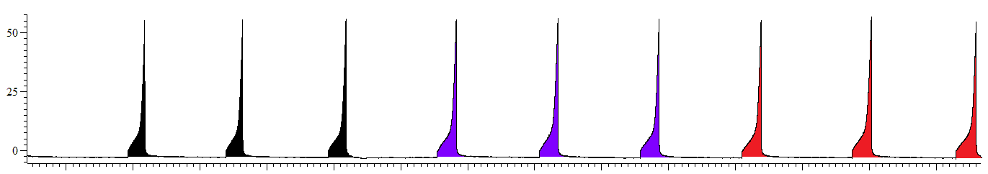
IP (mmHg)
10 mins
Control
Internal: 150mM NaCl
External: Standard Krebs

Washout
Internal: 150mM NaCl
External: Standard Krebs

Ca²⁺ free Krebs + PPADS
Internal: 150mM NaCl + 300µM PPADS
External: Ca²⁺ free Krebs + 30µM PPADS

Control measurement
10 mins measurement
30 mins measurement
Washout measurement

Figure 4.17: A schematic of the protocol for Ca²⁺ free Krebs solution exposure with the intraluminal (300µM) and extraluminal (30µM) application of PPADS.
Following 3 control distensions (standard Krebs solution), the bladder was extraluminally exposed to Ca²⁺ free Krebs solution with intraluminal (300µM) and extraluminal (30 µM) application of PPADS for 30minutes, before reverting to the standard Krebs solution for 30 minutes washout. Data was analysed at 30minutes, standard Krebs, control (+ 5minute period baseline afferent nerve firing prior to distension), 10 minutes PPADS in Ca²⁺ free Krebs solution (+ 5minute period baseline afferent nerve firing prior to distension), 30minutes PPADS in Ca²⁺ free Krebs solution (+ 5 minute period baseline afferent nerve firing prior to distension), and 30 minutes, standard Krebs washout (+ 5minute period baseline afferent nerve firing prior to distension).

4.10 Results: Effects of inhibition of purinergic signalling with PPADS during exposure of the bladder to Ca²⁺ free Krebs solution on afferent nerve firing and bladder compliance.

Overview

Exposure of the bladder to Ca²⁺ free Krebs solution, in the presence of extraluminal (30µM) and intraluminal (300µM) PPADS, significantly altered mechanosensitivity, and augmented baseline afferent nerve firing and bladder compliance, as shown in figure 4.18.
The data suggests that PPADS was insufficient to block the augmentation of afferent nerve firing in low threshold afferent nerve fibres, suggesting an alternative mechanism for the augmentation of firing in response to Ca²⁺ free Krebs solution.
Exposure to Ca²⁺ free Krebs solution in the presence of PPADS had an additional effect on high threshold afferent nerve firing during distension, causing a decrease in firing supporting previous findings that ATP signalling is predominantly involved in afferent nerve firing specifically in the noxious, pathophysiological range of distension, i.e. above an intraluminal pressure of approximately 15mmHg.
Bladder compliance was also increased during exposure to Ca²⁺ free Krebs solution in the presence of PPADS, suggesting that in the absence of intact purinergic signalling via P₂ receptors, the detrusor muscle was more relaxed as previously suggested (King et al., 1997).

The afferent nerve response to distension was altered following 30 minutes exposure to Ca²⁺ free Krebs solution in the presence of PPADS.

The afferent nerve response to bladder distension remained stable for 3 consecutive distensions prior to commencement of the protocol. Following 10 minutes exposure to Ca²⁺ free Krebs solution, in the presence of PPADS (both intraluminally (300µM) and extraluminally (30µM) applied), there was no effect on the afferent nerve response to bladder distension (figure 4.19A). 30 minutes exposure to Ca²⁺ free Krebs, in the presence of PPADS evoked an increase in the afferent nerve response to bladder distension at low intraluminal pressures (0-10mmHg), yet decreased afferent nerve firing at higher pressures (20-50mmHg) during bladder distension (figure 4.19B).
The effect of Ca²⁺ free Krebs, in the presence of PPADS, was fully reversed following a 30 minute washout period as shown in figure 4.19C.

Exposure to Ca²⁺ free Krebs, in the presence of extraluminal (30µM) and intraluminal (300µM) PPADS significantly changed the standard mechanosensitivity profile. Whilst the peak afferent nerve firing (regardless of pressure point at which the peak firing rate was observed) remained unchanged relative to the control distension (figure 4.20A) the pressure point at which peak firing occurred was decreased relative to control distension at both 10 and 30 minutes exposure to Ca²⁺ free Krebs in the presence of PPADS (figure 4.20B). Following 10 minutes exposure to Ca²⁺ free Krebs in the presence of PPADS, the intraluminal pressure at which peak firing was observed decreased from 43.33 ± 2.47 mmHg to 27.50 ± 4.23 mmHg (figure 4.20B). This decrease was further augmented between 10 and 30 minutes exposure to Ca²⁺ free Krebs and PPADS (figure 4.20B) resulting in, a decrease from control from 43.33 ± 2.47 mmHg to 17.50 ±2.81 mmHg following 30 minutes exposure (figure 4.20B).

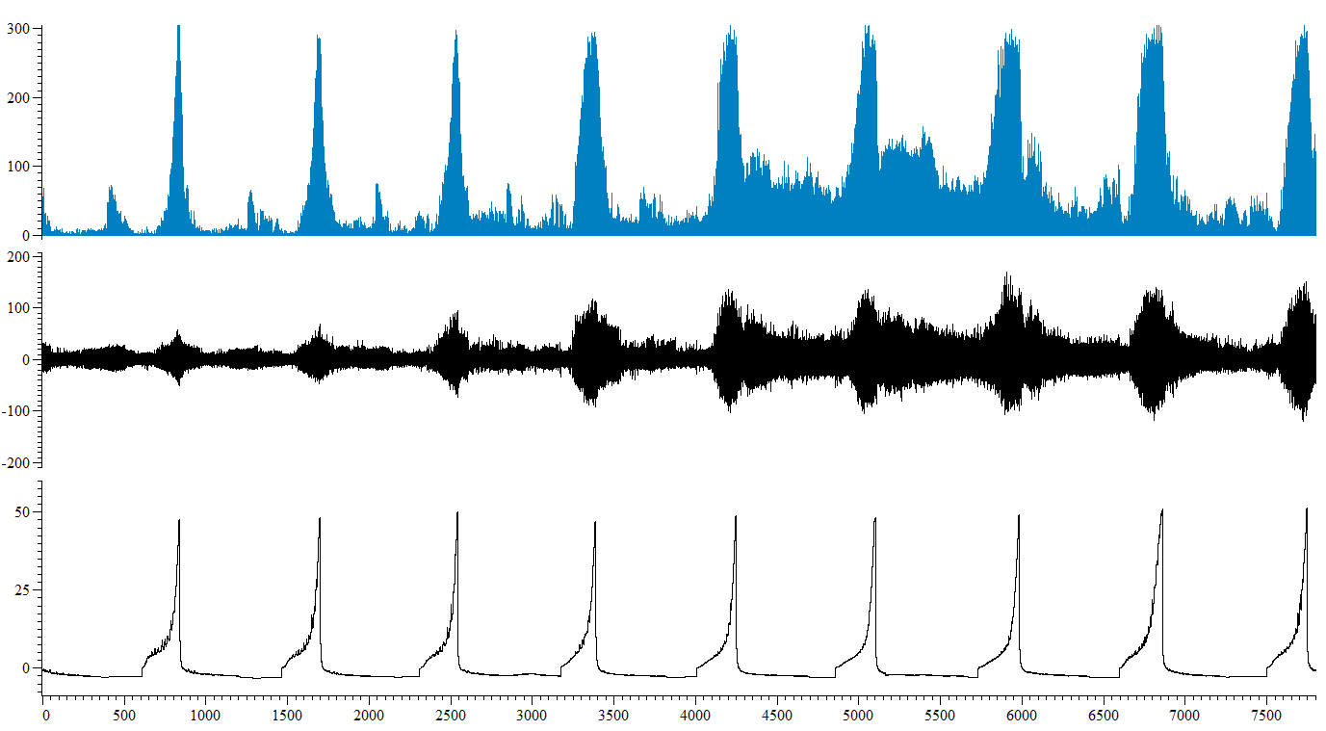
Ca²⁺ free Krebs + PPADS
Standard Krebs solution
Nerve firing (µV)
Mean firing (imp s⁻¹)
IP (mmHg)
Time (s)
Standard Krebs solution

Figure 4.18: Screen-shot representative trace from a single Ca²⁺ free Krebs + PPADS experiment. Ca²⁺ free Krebs exposure in the presence of intraluminal (300µM) and extraluminal (30µM) PPADS, significantly altered mechanosensitivity, and augmented baseline afferent nerve firing and bladder compliance, (n=6).

A.

B.
Figure 4.19 Exposure to Ca²⁺ free Krebs in the presence of extra (30µM) and intraluminal (300µM) PPADS ,altered the afferent nerve response to bladder distension. A, 10 minutes exposure to Ca²⁺ Krebs solution, in the presence of PPADS had no effect on mechanosensitivity (P=0.10, n=6). B, However, 30 minutes exposure to Ca²⁺ free Krebs, in the presence of PPADS, increased afferent nerve firing at low pressures (0-10mmHg) during bladder distension, but decreased afferent nerve firing at higher intraluminal pressures (20-50mmHg) (*P=0.02, n=6). C, Following 30 minutes washout period (standard Krebs solution), the changes in mechanosensitivity were fully reversed, and there was no difference in the afferent nerve response to distension between 30minutes control and 30 minutes washout distensions (P=0.70, n=6)
C.

A.
B.
Figure 4.20: Exposure to Ca²⁺ free Krebs in the presence of extraluminal (30µM) and intraluminal (300µM) PPADS had no effect on peak afferent nerve firing, but significantly reduced the pressure point at which peak afferent nerve firing occurred within the distension. A, peak afferent firing was not significantly affected by exposure to Ca²⁺ free Krebs solution in the presence of PPADS (P=0.07, 1 way RM ANOVA with Bonferroni post-test, n=6), however, B, the pressure point during the distension at which peak firing occurred was significantly decreased following exposure to the Ca²⁺ free Krebs solution in the presence of PPADS at both 10 (**P<0.01, n=6) and 30 minutes(****P<0.0001, n=6) relative to control (****P<0.0001, 1 way RM ANOVA with Bonferroni post-test, n=6). Bonferroni post-test also revealed a significant decrease between 10 and 30 minutes exposure to Ca²⁺ free Krebs in the presence of PPADS (*P<0.05, n=6).

Single unit analysis revealed differential effects of low and high threshold afferent nerve responses to bladder distension following exposure to Ca²⁺ free Krebs in the presence of extraluminal (30µM) and intraluminal (300µM) PPADS.

3 out of 6 experiments yielded nerve units displaying sufficiently different spike shape and amplitude to enable accurate discrimination of individual spikes by single unit analysis 20 low threshold and 7 high threshold afferent nerve fibres were confidently identified as summarised in figure 4.21A.
Low threshold afferent nerve firing in response to bladder distension was unaffected by 10 minutes exposure to Ca²⁺ free Krebs in the presence of PPADS (figure 4.21B). Similarly, the response of high threshold afferent nerve fibres to bladder distension remained unaffected following 10 minutes Ca²⁺ free Krebs with PPADS (figure 4.21C).
Following 30 minutes exposure to Ca²⁺ free Krebs in the presence of PPADS, low threshold afferent nerve firing in response to distension of the bladder was increased relative to control distension (figure 4.22A). In contrast, the response of high threshold afferents was decreased relative to control standard Krebs solution (figure 4.22B).

Ca²⁺ free Krebs in the presence of extraluminal (30µM) and intraluminal (300µM) PPADS increased bladder compliance and baseline afferent nerve activity.

Bladder compliance remained stable for 3 consecutive distensions prior to exposure to Ca²⁺ free Krebs solution and PPADS.
Following 10 minutes exposure to Ca²⁺ free Krebs and PPADS, bladder compliance was increased, with the bladder requiring a larger volume (µl) of saline to distend to low intraluminal pressures, relative to control distension (figure 4.23A) Interestingly, this increase occurred at low intraluminal pressure (0-25mmHg), and had little effect on higher intraluminal pressures (>25mmHg). Bonferroni post-test revealed a significant increase in the volume of saline (µl) required to distend the bladder to 5mmHg (figure 4.23A) following 10 minutes exposure to Ca²⁺ free Krebs and PPADS.
30 minutes exposure to Ca²⁺ free Krebs and PPADS resulted in a further increase in bladder compliance (figure 4.23B). Bonferroni post-test revealed a significant increase in the volume of saline (µl) required to distend the bladder to 5mmHg (figure 4.23B), further suggesting that the augmentation of bladder compliance occurred at low intraluminal pressures in comparison to higher pressures.
The effect of Ca²⁺ free Krebs and PPADS on bladder compliance was not fully reversed following 30 minutes washout with standard Krebs solution. Compliance remained increased relative to control distension (figure 4.23C).
Mean baseline afferent nerve firing was increased following exposure to Ca²⁺ free Krebs in the presence of extraluminal (30µM) and intraluminal (300µM) PPADS, (figure 4.24). Bonferroni post-test revealed an increase in mean baseline afferent nerve firing for 25-30 minutes exposure to Ca²⁺ free Krebs and PPADS. Mean baseline firing was increased from control (11.63±4.81 imp s⁻¹), to 81.00±5.95 imp s⁻¹ at 25-30 minutes exposure (figure 4.24).

A. | Number of experiments (N) | Number of units identified (n) | % of total units identified
Low threshold | 3 | 20 | 74
High threshold | 3 | 7 | 26
Total | 3 | 27 | 100
B.

C.
Figure 4.21: Single unit analysis revealed 10 minutes exposure to Ca²⁺ free Krebs solution in the presence of extraluminal (30µM) and intraluminal (300µM) PPADS had no effect on low nor high threshold afferent nerve fibres in response to bladder distension. A, 3 experiments were suitable for single unit analysis and allowed the identification of 20 low threshold and 7 high threshold afferent nerve fibres. B, following 10 minutes exposure to Ca²⁺ free Krebs solution in the presence of PPADS, low threshold afferent nerve firing in response to bladder distension remained unaffected, relative to control standard Krebs solution (P=0.17, n=20, N=3). C, Similarly, the response of high threshold afferent nerve fibres to bladder distension was not affected by exposure to Ca²⁺ free Krebs solution in the presence of PPADS (P=0.36, n=7, N=3).

A.

B.
Figure 4.22: Single unit analysis. 30 minutes exposure to Ca²⁺ free Krebs solution in the presence of extraluminal (30µM) and intraluminal (300µM) PPADS augmented low threshold nerve fibre firing in response to bladder distension, but inhibited the high threshold nerve response to distension. A, 30 minutes exposure to Ca²⁺ free Krebs solution and PPADS significantly increased low threshold afferent nerve firing in response to bladder distension relative to control standard Krebs solution(****P<0.0001, n=20, N=3). B, In contrast, the response of high threshold afferent nerve fibres to bladder distension was inhibited, relative to standard Krebs solution, following exposure to Ca²⁺ free Krebs solution and PPADS (**P=0.007, n=7, N=3).

A.
B.
Figure 4.23: Bladder compliance was increased following exposure to Ca²⁺ free Krebs solution in the presence of extraluminal (30µM) and intraluminal (300µM) PPADS. A, Relative to control distension, bladder compliance was increased following 10 minutes exposure to Ca²⁺ free Krebs solution and PPADS (*P=0.02, n=6). Bonferroni post-test also revealed a significant increase in volume (µl) of saline required to distend the bladder to 5mmHg (*P<0.05, n=6). B, Bladder compliance was further increased following 30 minutes exposure to Ca²⁺ free and PPADS (***P=0.0001, n=6), and Bonferroni post-test revealed a significant increase in the volume of saline required to distend the bladder to an intraluminal pressure of 5mmHg (***P<0.001, n=6). C, The effect of Ca²⁺ free on bladder compliance was not fully reversed following 30 minutes washout with the standard Krebs solution, and remained statistically increased relative to control distension (**P=0.002, n=6).
C.

Figure 4.24: 25-30 minutes exposure to Ca²⁺ free Krebs in the presence of extraluminal (30µM) and intraluminal (300µM) increased mean baseline afferent nerve firing (*P=0.01, 1 way RM ANOVA with Bonferroni post-test, n=6). Bonferroni post-test revealed a significant increase in mean baseline afferent nerve firing for 25-30 minutes exposure to Ca²⁺ free Krebs and PPADS relative to control (*P<0.05, n=6).

4.11 Discussion

The afferent nerve response to distension was increased following Ca²⁺ free Krebs solution perfusion, and further experimentation provided evidence to suggest that this enhanced activity was not due to a reduction in ecto-ATPase activity, nor due to a change in detrusor contractility.

Ca²⁺ free Krebs bath perfusion had a dual effect on afferent nerve discharge in response to bladder distension, as low threshold afferent nerve firing was increased, and high threshold nerve activity was decreased. This finding was in contrast to a previous study, in which bath perfusion of the Ca²⁺ free Krebs solution (with the same composition as the Ca²⁺ free Krebs solution used in these experiments) had no effect on stretch-evoked or stroking-induced afferent nerve firing suggesting that release of mediators was not dependent on Ca²⁺ dependent exocytotic release, yet there was a small reduction in tension responses (Zagorodnyuk et al., 2009). As the Ca²⁺ free Krebs solutions used in this study and in the study by Zagorodnyuk and colleagues were the same (Zagorodnyuk et al., 2009), this cannot offer an explanation into the discrepancy between findings. However the discrepancy could have been due to variability between the two experimental preparations. The preparation used to generate the data in this thesis used a whole, intact bladder preparation, whereas previous studies have used flat-sheet bladder strip preparations. Not only does this flat sheet preparation exert more stress and damage to the bladder tissue during preparation, but also the bladder is pinned out and experimented upon in a relatively unphysiological manner compared to the whole organ set-up, thereby various activities of the bladder could have been altered. Also, in the flat sheet preparation used previously, the Ca²⁺ free Krebs solution had increased free access to both the serosal and mucosal surfaces of the bladder, suggesting that different effects of Ca²⁺ free Krebs were observed due to augmented penetration of the tissue in the flat sheet preparation. It is also noteworthy that two different animal preparations were used in the experimental set-ups: mouse in the present experiments, and guinea pig in previous studies, and previous studies have highlighted species differences in bladder function(de Wachter, 2011).
Another explanation for the discrepancy in findings of the effect of Ca²⁺ free Krebs on mechanosensitivity is in the fact that in the study by Zagorodnyuk and colleagues, the activity from only 2 types of bladder afferents was recorded. The two afferents examined had their nerve terminals in the vicinity of the urothelium and were classified as stretch-sensitive muscle-mucosal mechanoreceptors and stretch insensitive mucosal high-responding afferent nerve fibres. There is a possibility that in the multi-unit recordings performed in this thesis that another type of afferent nerve fibre was responsible for the augmentation in afferent nerve firing in response to Ca²⁺ free Krebs exposure, for example muscle mechanoreceptors which have previously been demonstrated to be stretch sensitive (Zagorodnyuk et al., 2007). The two different types of stimuli used to stretch the bladder tissue could also account for the variable responses between the two studies, as stretch via a strain gauge (Zagorodnyuk et al., 2009), provides a very different stimulus to the comparatively passive process of ramp distension as in the current study. It is possible that both stimuli activate subsets of afferent nerve fibres to a varying degree, which may explain the differences between observations.
Differences between the afferent nerve bundles recorded in both studies could also account for the differences between the data in this thesis and that previously described by Zagorodnyuk and colleagues. In the previous study, electrophysiological recordings were made from nerve fibres originating from the pelvic ganglia (Zagorodnyuk et al., 2009), whereas in the current study, recordings were made from multi-unit afferent nerve fibre bundles, consisting of both pelvic and hypogastric nerve units. This suggests that the effect of Ca²⁺ free Krebs on afferent nerve firing may be more profound on hypogastric nerve bladder innervating fibres rather than via the pelvic nerve supply, but there is not enough evidence to conclude this. However, this again highlights the importance of multiunit recordings in elucidating the entire effect on afferent nerve firing in bladder function in response to various pharmacological and experimental interventions.
As previously described in chapter 1 of this thesis, Ca²⁺ is critically required for muscle contraction, therefore it was hypothesised that as contractions of the detrusor have been reported to simultaneously elicit afferent nerve discharge (McCarthy et al., 2009), that changes in muscle contractility by exposure to Ca²⁺ free Krebs solution could cause secondary alterations in afferent nerve sensitivity. It is unlikely that the augmentation of mechanosensitivity during exposure to Ca²⁺ free Krebs solution in this thesis can be attributed to a change in bladder contractility, as perfusion of nifedipine in the external bath solution had no effect on afferent nerve firing or neither low nor high afferent nerve fibres. Extraluminal perfusion of nifedipine has previously been shown to have no effect on mechanosensitivity nor bladder compliance in the same recording set-up and at the same concentration as used in this thesis (Daly et al., 2010).
Another possible explanation for the augmentation of mechanosensitivity in response to Ca²⁺ free Krebs exposure is as a result of the reduced activity of Ca²⁺ dependent ATPases, consequently leading to elevated ATP concentrations and excitement of afferent nerve fibres. At least for low threshold afferent nerve fibres contributing to the recorded distension response, this does not appear to be the case. In the presence of Ca²⁺ free Krebs solution with the addition of P₂ receptor antagonist PPADS, the augmentation of the low threshold mechanosensitivity response persisted following 30 minutes exposure. However, the onset of the excitatory response to Ca²⁺ free Krebs solution perfusion was delayed in the presence of PPADS, as when the Ca²⁺ free Krebs solution was perfused in the absence of PPADS, mechanosensitivity was immediately augmented (following 10 minutes exposure), whereas there was no significant change in the mechanosensitivity response at 10 minutes exposure to Ca²⁺ free Krebs solution in the presence of PPADS. This suggests that inhibition of ATP signalling (by PPADS) is initially sufficient to compensate for the raise in intracellular ATP concentration, as small levels of ecto-ATPase activity still remain, or the release of inhibitory mediators persists until the majority of the intracellular Ca²⁺ has been depleted from the bath solution and intracellular stores. The data suggests that as time progresses, and Ca²⁺ dependent processes are diminished, the concentration of PPADS used, or indeed the inhibition of P₂ receptor signalling is insufficient to compensate for the large increase in ATP concentration as a result of cessation of ATPase activity. However, that the augmentation in low threshold afferent nerve firing still occurs following 30 minutes Ca²⁺ free Krebs solution + PPADS exposure, suggests that reduced ATPase activity is not the critical mechanism for the augmentation of afferent nerve sensitivity.
Conversely, the reduction in high threshold afferent nerve firing by Ca²⁺ free exposure was augmented following 30 minutes perfusion of Ca²⁺ free Krebs solution in the presence of PPADS. This data suggests that as previous studies have observed, low threshold and high threshold afferent nerve firing is mediated by different mechanisms. It is well documented that exposure of the bladder to purinergic receptor antagonists, or in purinergic receptor knockout mice, that there is a reduction in afferent nerve firing in response to distension of the bladder (Cockayne et al., 2005; Vlaskovska et al., 2001). However, it has also been shown that although purinergic receptor mediated mechanisms contribute to both innocuous and nociceptive sensory transduction ion the bladder, low threshold afferent nerve fibres are less sensitive to ATP than high threshold afferent nerve fibres. One study showed that peak afferent nerve firing following perfusion of P₂X₃ antagonist, 2’,3’-0 trinitrophenyl-ATP (TNP-ATP) was decreased in 43% of low threshold afferent nerve fibres, whereas peak afferent nerve firing was reduced in 81% of high threshold afferent nerve fibres, suggesting that P₂X₃ contributes to both innocuous and noxious ranges of bladder sensation, but has a more prevalent role in the mediation of high threshold afferents during noxious stimulation (Rong et al., 2002). This data is also concurrent with the proposed idea that ATP is released from the urothelium as a sensory mediator to convey the degree of bladder distension (Ferguson et al., 1997).
The observation that high threshold afferent nerve fibres responded differently to inhibition of purinergic signalling than low threshold afferent nerve fibres has also been previously observed in another study, where perfusion of PPADS in standard Krebs solution did not affect stretch-induced afferent nerve firing by low threshold afferent nerve fibres, but significantly reduced high threshold afferent nerve firing associated with increases in intramural tension (Zagorodnyuk et al., 2006), further supporting the hypothesis that low and high threshold afferent nerve fibres of the bladder are mediated by different mechanisms.
The dual afferent nerve response to bladder distension in the presence of Ca²⁺ free Krebs solution was replicated in experiments with Ca²⁺ free Krebs +PPADS, suggesting that reduced activity of ATPases does not offer a likely explanation for the augmentation of firing seen in the low threshold component of the mechanosensory response. The inhibition of high threshold afferent nerve firing in Ca²⁺ free Krebs solution was augmented in the presence of PPADS, suggesting that total inhibition of purinergic signalling has a profound effect on mechanosensory transduction of high threshold afferents as described previously (Zagorodnyuk et al., 2006).
The release of ATP from the urothelium has been shown to be Ca²⁺ dependent (Birder et al., 2003), therefore it is possible that in Ca²⁺ free Krebs experiments, Ca²⁺ dependent ATP release from the bladder urothelium was decreased, consequently resulting in decreased high threshold afferent nerve firing. However, it has also been shown that release of ATP from the urothelium is reduced in Ca²⁺ containing solutions, although in these studies no Ca²⁺ chelator was used, so true Ca²⁺ free conditions were not fully established (Ferguson et al., 1997; Matsumoto-Miyai et al., 2009).
Many of the mediators released from the urothelium rely on Ca²⁺ signalling for either synthesis, for example nitric oxide (NO) or release, in the case of ATP. Afferent nerve firing in both types of afferent nerve fibre is differentially affected depending on the composition of receptors and sensitivity of each fibre to various excitatory and inhibitory, urothelially released mediators. Ca²⁺ free Krebs experiments were conducted to crudely block mediator release and synthesis of mediators from the urothelium, and thereby alter urothelial/sensory nerve signalling. These data suggest that by inhibiting mediator release (or synthesis) from the urothelium with the Ca²⁺ free Krebs solution, the delicate balance between excitatory and inhibitory mediator release is disturbed, consequently resulting in inhibition of high threshold, and augmentation of low threshold afferent nerve firing. However, more experiments are required to elucidate the role of the urothelium in afferent nerve activity as the observations in these experiments may have been due to the effect of Ca²⁺ removal on neural excitability. If the response of low threshold afferent nerve firing is considered to signal during the innocuous range of bladder distension, then this data suggests that an important role of the urothelium is to inhibit afferent nerve firing in the physiological, innocuous range, thereby preventing pain sensation. This also offers an explanation as to how reduced mediator release from the urothelium due to urothelial damage or decreased mediator release can give rise to painful sensations in the pathological bladder, as the inhibitory role of the urothelium is compromised and therefore innocuous stimuli are perceived as painful. The decreased activity of high threshold afferent nerve fibres can also be explained with this idea, as if excitatory transmitters, for example ATP, have greater potency on high threshold afferent nerve fibres, then reduced ATP release from the urothelium as a consequence of Ca²⁺ free Krebs exposure would lead to a decrease in afferent nerve sensitivity. If indeed this were the case, and changes in mediator release from the urothelium are responsible for these effects, then the composition of receptors on afferent nerve subtypes could explain the differential effects of low and high threshold afferents to Ca²⁺ free Krebs exposure.
Interestingly, further to these observations, these experiments also showed that the sensitivity of afferent nerve fibres in response to bladder distension was increased during Ca²⁺ free Krebs exposure, as peak afferent nerve firing during distension occurred at lower pressures than under control conditions, although maximum peak afferent nerve discharge remained unchanged. This suggests that in response to Ca²⁺ free Krebs solution, the afferent nerve response to distension was shifted to the left, demonstrating increased afferent nerve sensitivity, which is often associated with various pathologies, where previously innocuous stimuli are perceived as painful.
The observation that Ca²⁺ free Krebs caused peak afferent nerve firing to occur at lower intraluminal pressures in comparison to controls further supports the evidence for a role of Ca²⁺ dependent release of mediators from the urothelium in the inhibition and regulation of afferent nerve firing. As the observation of peak firing occurring at lower intraluminal pressures persisted in Ca²⁺ free Krebs in the presence of PPADS, and was not replicated by nifedipine experiments, it seems likely that this shift in afferent nerve activity was a result of attenuated mediator release from the urothelium, and as afferent nerve firing was augmented, this suggest that a Ca²⁺ dependent inhibitory mediator was responsible for these effects.
Interestingly, mean baseline afferent nerve activity was augmented following exposure of the bladder to the Ca²⁺ free Krebs solution. The augmentation of afferent nerve activity was fully reversed relative to control following 30 minutes washout, suggesting that the mechanism mediating this excitatory response is not permanently altered by Ca²⁺ free Krebs exposure. Perfusion of nifedipine did not affect baseline afferent nerve activity, suggesting that the increase in baseline afferent nerve firing was unlikely to be mediated by L-type Ca²⁺ channels or secondary to a change in muscle tone. Furthermore, the augmentation in baseline afferent nerve activity during Ca²⁺ free Krebs perfusion persisted in the presence of PPADS, providing evidence that the up regulation of ATP due to reduced ATPase activity was not responsible for the augmentation in afferent nerve firing. This data supports a role for urothelial mediator release in determining resting excitability and inhibiting exaggerated sensory signals to non-painful stimuli via release of a or multiple inhibitory mediators from the urothelium.
With additional time and resources, it would have been interesting to measure this directly, for example measuring transmitter release from the urothelium in the presence of the standard and Ca²⁺ free Krebs solutions. Urothelial cell studies may be of particular benefit here as all muscle and afferent nerve influence would be removed, and the release of mediators from isolated urothelial cells could be measured more accurately, in both solutions.

Ca²⁺ free Krebs solution perfusion had no effect on bladder compliance, suggesting that the augmentation of afferent nerve firing was not secondary to a change in muscle contractility.

Perfusion of the Ca²⁺ free Krebs solution had no effect on bladder compliance, suggesting that L-type Ca²⁺ channels are not important in the maintenance of muscle tone in this preparation. This finding was in contrast to previous studies, where Ca²⁺ free Krebs solution (with the addition of Ca²⁺ chelator EGTA), has been used as a method of eliciting relaxation of the bladder detrusor smooth muscle (Liu et al., 2005). However, it has also been demonstrated that in Ca²⁺ free Krebs + EGTA solution, carbachol was able to produce sustained contractions in rabbit bladder strips, suggesting that contraction of the detrusor muscle can occur in Ca²⁺ free conditions via stimulation of muscarinic receptors (Yoshimura et al., 1997). The observation in the present study was unexpected as the sequestration of Ca²⁺ is imperative for smooth muscle relaxation, and with no Ca²⁺ present to sustain bladder contraction in Ca²⁺ free Krebs conditions, it was expected that the bladder should have been relaxed in comparison to controls. It is possible that whilst Ca²⁺ free Krebs would have blocked L-type Ca²⁺ channel mediated Ca²⁺ entry, therefore caused relaxation of the bladder, that maybe other effects of Ca²⁺ free Krebs exposure, such as elevated ATP concentration were responsible for the maintenance of muscle activity and bladder compliance, thereby masking the changes in bladder compliance that would otherwise be evident as a consequence of inhibited Ca²⁺ influx via L-type Ca²⁺ channels. However in separate experiments, when the bladder was exposed to nifedipine alone to investigate whether the change in afferent nerve firing following Ca²⁺ free Krebs exposure was secondary to a change in muscle tone, compliance was unaffected. This data suggests that, in the absence of parasympathetic release of ACh from efferent nerves, there is no on-going cholinergic tone, and in the absence of a stimulus, for example carbachol, no changes in compliance would have been observed.
A previous study in human bladder strips demonstrated that in the presence of nifedipine, KCl induced contractions were abolished, and carbachol induced contractions were reduced, yet endothelin induced contractions were not affected, suggesting multiple sources of Ca²⁺ for detrusor muscle contraction exist (Maggi et al., 1989). In a 2nd human study ,all L-type Ca²⁺ channel antagonists tested suppressed the carbachol induced maximum contraction (Badawi et al., 2006), and this was also shown in guinea pig bladder muscle strips (Rivera et al., 2006). Species differences in the degree of reduction of carbachol induced contractions in the presence of nifedipine have been observed, where in the porcine bladder, contractions were reduced to 18% of control, and similarly in mouse were reduced to 27% of control, yet had least effect on human tissue strips, only reducing carbachol induced contractions to 74% of control (Wuest et al., 2007).
Whilst perfusion of Ca²⁺ free Krebs solution alone had no effect on bladder compliance, in the presence of PPADS, compliance was increased, suggesting relaxation of the detrusor muscle following inhibition of purinergic signalling pathways to compensate for the enhanced ATP concentration due to reduced activity of Ca²⁺ dependent ATPases. This observation supports previous published data, concluding that contractions of the guinea pig bladder induced by diadenosine tetraphosphate (AP₄A), were inhibited by PPADS (Usune et al., 1996), and similarly in P₂X₁ deficient mice, where contractions of the detrusor muscle were abolished (Vial et al., 2000). These data conclude that, in rodents, a large proportion of the contractile response of the bladder, and the maintenance of compliance rely on purinergic mediated signalling via activation of P₂X receptors by ATP signalling. The consequential generation of an inward, depolarising current of Na⁺ and Ca²⁺ ions sufficient enough to cause the activation of L-type Ca²⁺ channels and further influx of Ca²⁺ leads to activation of contractile apparatus myosin and actin. The observation that there was no change in compliance in Ca²⁺ free Krebs experiments suggests that the increase in compliance observed in Ca²⁺ free Krebs + PPADS experiments was the result of inhibition of purinergic signalling by PPADS, and not as a direct effect mediated by Ca²⁺ free Krebs conditions.

4.12 Summary of findings.

The data presented in this chapter showed that:-
- Ca²⁺ free Krebs solution augmented the low threshold mechanosensory response, but decreased high threshold afferent nerve firing in response to distension. Baseline afferent nerve firing was also similarly increased by Ca²⁺ free Krebs exposure.
- This effect is likely not due to a change in bladder compliance, as perfusion of nifedipine was unable to replicate these effects on mechanosensitivity and baseline afferent nerve firing.
- It is also unlikely that the observed augmentation of afferent nerve firing was due to decreased ATPase activity, as the augmentation of low threshold afferent nerve firing and baseline afferent nerve activity persisted in the presence of PPADS.
- Compliance was increased following perfusion of the bladder with the Ca²⁺ free Krebs solution in the presence of PPADS, suggesting purinergic signalling is critical to the maintenance of bladder compliance, at least in this mouse bladder preparation.

The data from the experiments presented in this chapter suggest that the effects of Ca²⁺ free Krebs on afferent nerve firing were due to inhibition of Ca²⁺ dependent release and synthesis of mediators, or attributable to a change in tissue excitability. As such, the urothelium provides an excellent point for commencement because of its emerging role in signalling processes that control bladder function in both health and disease (Birder, 2010).
Following analysis of this data it was hypothesised that the urothelium is capable of releasing numerous mediators that regulate bladder function, therefore in the following chapter instead of inhibiting their release, the release of mediators from the urothelium was stimulated by high K⁺ exposure.

References

Apodaca, G., Balestreire, E., & Birder, L. A. (2007). The Uroepithelial-associated sensory web. Kidney International, 72, 1057-1064.
Badawi, J. K., Li, H., Langbein, S., Kamp, S., Guzman, S., & Bross, S. (2006). Inhibitory effects of various L-type and T-type calcium antagonists on electrically generated, potassium-induced and carbachol-induced contractions of porcine detrusor muscle. Journal of Comparative Physiology B, 176, 429-439.
Birder, L. A. (2010). Urothelial Signaling. Autonomic Neuroscience: Basic and Clinical, 153, 33-40.
Birder, L. A., Barrick, S. R., Roppolo, J. R., Kanai, A. J., de Groat, W. C., Kiss, S., & Buffington, C. A. (2003). Feline interstitial cystitis results in mechanical hypersensitivity and altered ATP release from bladder urothelium. American Journal of Physiology, 285, 423-429.
Clinton Webb, R. (2003). Smooth muscle contraction and relaxation. Advances in Physiology Education 27, 201-206.
Cockayne, D. A., Dunn, P. M., Zhong, Y., Rong, W., Hamilton, S. G., Knight, G. E., Ruan, H., Ma, B., Yip, P., Nunn, P., McMahon, S. B., Burnstock, G., & Ford, A. P. D. W. (2005). P2X₂ knockout mice and P2X₂/P2X₃ double knockout mice reveal a role for the P2X₂ receptor subunit in mediating multiple sensory effects of ATP. The Journal of Physiology, 567(2), 621-639.
Daly, D., Chess-Williams, R., Chapple, C., & Grundy, D. (2010). The inhibitory role of acetylcholine and muscarinic receptors in bladder afferent activity. European Urology, 58, 22-28.
de Wachter, S. (2011). Afferent signaling from the bladder: species differences evident from extracellular recordings of pelvic and hypogastric nerves. Neurourology and Urodynamics 30(5), 647-652.
Ferguson, D. R., Kennedy, I., & Burton, T. J. (1997). ATP is released from rabbit urinary bladder epithelial cells by hydrostatic pressure changes - a possible sensory mechanism? Journal of Physiology, 505(2), 503-511.
Fry, C. H., Meng, E., & Young, J. S. (2010). The physiological function of lower urinary tract smooth muscle. Autonomic neuroscience, 154, 3-13.
King, J. A., Huddart, H., & Staff, W. G. (1997). Purinergic modulation of rat urinary bladder detrusor smooth muscle. Gen. Pharmacol., 29, 597-604.
Liu, L., Ishida, Y., Okunade, G., Shull, G. E., & Paul, R. J. (2005). Role of plasma membrane Ca²⁺-ATPase in contraction-relaxation processes of the bladder: evidence from PMCA gene-ablated mice. American Journal of Physiology - Cell Physiology, 290, 1239-1247.
Maggi, C. A., Giuliani, S., Patacchini, R., Turini, D., Barbanti, G., Giachetti, A., & Meli, A. (1989). Multiple sources of calcium for contraction of the human urinary bladder muscle. British Journal of Pharmacology, 98, 1021-1031.
Matsumoto-Miyai, K., Kagase, A., Murakawa, Y., Momota, Y., & Kawatani, M. (2009). Extracellular Ca²⁺ regulates the stimulus-elicited ATP release from urothelium. Autonomic Neuroscience: Basic and Clinical, 150, 94-99.
McCarthy, C. J., Zabbarova, I. V., Brumovsky, P. R., Roppolo, J. R., Gebhart, G. F., & Kanai, A. J. (2009). Spontaneous contractions evoke afferent nerve firing in mouse bladders with detrusor overactivity. Journal of Urology, 181, 1459-1466.
Rivera, L., & Brading, A. F. (2006). The role of Ca²⁺ influx and intracellular Ca²⁺ release in the muscarinic-mediated contraction of mammalian urinary bladder smooth muscle. British Journal of Urology International, 98, 868-875.
Rong, W., Spyer, K., & Burnstock, G. (2002). Activation and sensitisation of low and high threshold afferent fibres mediated by P2X receptors in the mouse urinary bladder. The Journal of Physiology, 541, 591-600.
Somogyi, G. T., Zernova, G. V., Tanowitz, M., & de Groat, W. C. (1997). Role of L- and N-type Ca²⁺ channels in muscarinic receptor-mediated facilitation of ACh and noradrenaline release in the rat urinary bladder. Journal of Physiology, 499.3, 645-654.
Sui, G., Fry, C. H., Malone-Lee, J., & Wu, C. (2009). Aberrant Ca²⁺ oscillations in smooth muscle cells from overactive human bladders. Cell Calcium, 45, 456-464.
Usune, S., Katsuragi, T., & Furukawa, T. (1996). Effects of PPADS and suramin on contractions and cytoplasmic Ca²⁺ changes evoked by AP₄A, ATP and α,β-methylene ATP in guinea-pig urinary bladder. British Journal of Pharmacology, 117, 698-702.
Vial, C., & Evans, R. J. (2000). P2X receptor expression in mouse urinary bladder and the requirement of P2X₁ receptors for functional P2X receptor responses in the mouse urinary bladder smooth muscle. British Journal of Pharmacology, 131, 1489-1495.
Vlaskovska, M., Kasakov, L., Rong, W., Bodin, P., Bardini, M., Cockayne, D. A., Ford, A. P. D. W., & Burnstock, G. (2001). P2X₃ knock-out mice reveal a major sensory role for urothelially released ATP. The Journal of Neuroscience, 21(15), 5670-5677.
Wu, C., Sui, G., & Fry, C. H. (2002). The role of the L-type Ca²⁺ channel in refilling functional intracellular Ca²⁺ stores in guinea-pig detrusor smooth muscle. Journal of Physiology, 538(2), 357-369.
Wuest, M., Hiller, N., Braeter, M., Hakenberg, O. W., Wirth, M. P., & Ravens, U. (2007). Contribution of Ca²⁺ influx to carbachol-induced detrusor contraction is different in human urinary bladder compared to pig and mouse. European Journal of Pharmacology, 565, 180-189.
Yoshimura, Y., & Yamaguchi, O. (1997). Calcium Independent Contraction of Bladder Smooth Muscle. International Journal of Urology, 4, 62-67.
Zagorodnyuk, V. P., Brookes, S. J. H., Spencer, N. J., & Gregory, S. (2009). Mechanotransduction and chemosensitivity of two major classes of bladder afferents with endings in the vicinity to the urothelium. The Journal of Physiology, 587, 3523-3538.
Zagorodnyuk, V. P., Costa, M., & Brookes, S. J. H. (2006). Major classes of sensory neurons to the urinary bladder. Autonomic neuroscience, 126, 390-397.
Zagorodnyuk, V. P., Gibbins, I. L., Costa, M., Brookes, S. J. H., & Gregory, S. (2007). Properties of the major classes of mechanoreceptors in the guinea pig bladder. Journal of Physiology, 585, 147-163.

