Chapter 3
The response to bladder distension
Presentation and discussion of the control response to bladder distension.

3.1 Aim of this chapter

The aim of this chapter is to demonstrate and discuss the ‘normal’ responses of the bladder to distension, and to provide evidence regarding the stability of the experimental preparation over time.
It is important to state here that this chapter offers details for the normal response of the bladder to ramp distension from the 3rd control distension from 100 of the total experiments performed in this thesis, and time control data from a total of 6 experiments. This data is intended to provide a solid understanding of the standard response to distension in order to highlight the differences in distension response following drug treatment throughout this thesis in further experiments. Time control data provides evidence of the stability of the recording preparation over a longer time period than the maximum times of future protocols in this thesis.
All protocols in this thesis had their own in built control (i.e. were compared to the third control distension in the individual experiment) to which experimental data was statistically analysed. Statistical comparisons to the control data in this chapter were not made, however, throughout this thesis, references will be made to the ‘normal’ neuronal and muscular responses to bladder distension as shown in this chapter.

3.2 The response to ramp distension of the bladder

The afferent nerves convey nerve impulses from the bladder towards the central nervous system. By using the electrophysiological recording method described in chapter 2, this journey of sensory information was modelled.

Afferent nerve firing, prior to, during and following bladder ramp distension.

In the 10 minute period between distensions, when intraluminal pressure was 0mmHg, there was baseline afferent nerve firing in the majority of preparations, as shown in figure 3.1A and B, equating to an average of approximately 17.24 ± 2.04 imp s⁻¹ (n=100) contrary to previous findings (Rong et al., 2002), (Daly et al., 2007)
As the intraluminal pressure rose during distension, the afferent nerve firing increased progressively (figure 3.2, figure3.3), a response used as the identification process for a ‘standard’ distension sensitive bladder afferent nerve fibre. The typical afferent nerve response to bladder distension consisted of two clearly identifiable phases (figure 3.2). The first phase (approx. 0-15mmHg) was slower, requiring a large volume of saline to fill to 15mmHg (relative to the second part of the distension) and consisted of a large increase in afferent nerve firing (relative to baseline nerve activity). The second phase of the distension (>15 – 50mmHg), elicited a continued increase in afferent nerve firing with a relatively fast increase in intraluminal pressure compared to the first phase of the distension response. Afferent nerve firing at 15 mmHg averaged 154 ±11 imp s⁻¹, and 248 ± 13 imp s⁻¹ by 50mmHg (figure 3.4A). Compliance was measured as a relationship between intraluminal pressure of the bladder and the volume of solution (e.g. saline in controls) required to distend the bladder to a given pressure. To distend the bladder to 15mmHg intraluminal pressure, the volume of saline required averaged 149.3 ± 8.6 µl. Furthermore, the bladder required an average of 198.7 ± 9.5 µl to distend to the maximum intraluminal pressure of 50mmHg (figure 3.4B).
Immediately following bladder distension following evacuation of saline from the bladder and the return of intraluminal pressure to 0mmHg, there was a burst of afferent nerve firing in approximately 50% of experiments as shown in figure 3.5.

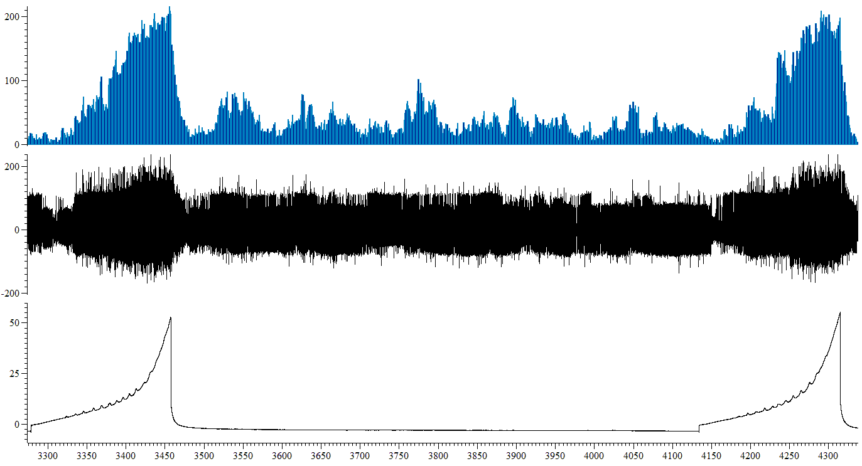
A.
Nerve firing (µV)
IP (mmHg)
Nerve firing (µV)
Mean firing (imp s⁻¹)
100 seconds
Ramp distension
Spontaneous activity (10 minutes between distensions)

B.
Figure 3.1: Spontaneous afferent nerve firing occurred between distensions of the bladder. A, A representative trace from a single, control, experiment clearly showing the spontaneous afferent nerve firing between repeated bladder distensions. B, Graphical representation of spontaneous afferent nerve firing between control (saline) distensions, obtained from recording the mean imp s⁻¹ every 30 seconds for 10 minutes (600 seconds) between distensions (n=100).

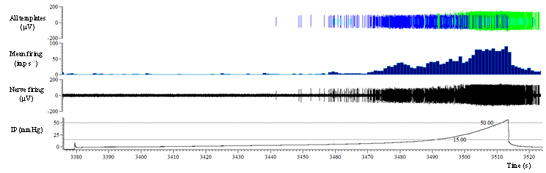
All templates (µV)
Mean firing (imp s⁻¹)

Nerve firing (µV)
IP (mmHg)
Time (s)
Phase 1
Phase 2

Figure 3.2: A representative, annotated trace showing the standard afferent nerve response to bladder distension. Distension of the bladder with 150mM NaCl at 100µl/min to a maximal intraluminal pressure of 50mmHg caused a biphasic increase in afferent nerve firing consisting of two clearly identifiable phases. Phase 1(0-15mmHg) was longer in duration, relative to phase 2 (>15-50mmHg).

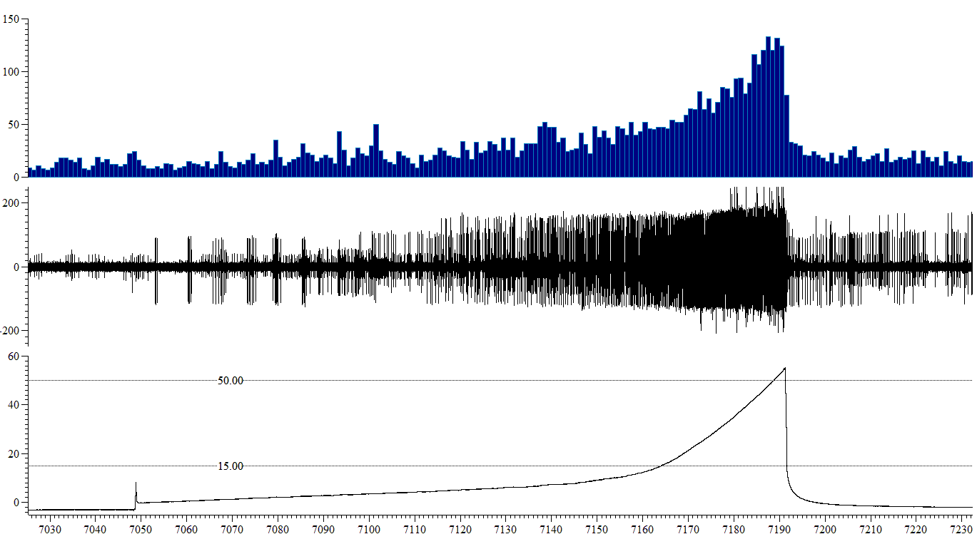
Figure 3.3: A representative, annotated trace showing the standard afferent nerve response to bladder distension. Distension of the bladder with 150mM NaCl at 100µl/min to a maximal intraluminal pressure of 50mmHg caused a biphasic increase in afferent nerve firing. A, B and C are actual afferent nerve recordings from the time points indicated and demonstrate the increase in afferent nerve firing at different pressure points during a distension.
IP (mmHg)
Nerve firing (µV)
Histo. firing (imp s⁻¹)

Time (s)

Nerve firing (µV)
Nerve firing (µV)
Nerve firing (µV)

7080–7090 s
7140–7150 s
7170–7180 s

10 seconds
A
B
C
A
B
C
A.

B.

Figure 3.4: The standard response to distension of the bladder. A, Afferent nerve firing was increased as intraluminal pressure increased by distension of the bladder with 150mM NaCl at a rate of 100µl/min to a maximal intraluminal pressure of 50mmHg (n=100). B, The standard pressure-volume relationship (compliance), in response to ramp distension of the bladder with 150mM NaCl at a rate of 100µl/min to a maximal intraluminal pressure of 50mmHg (n=100).

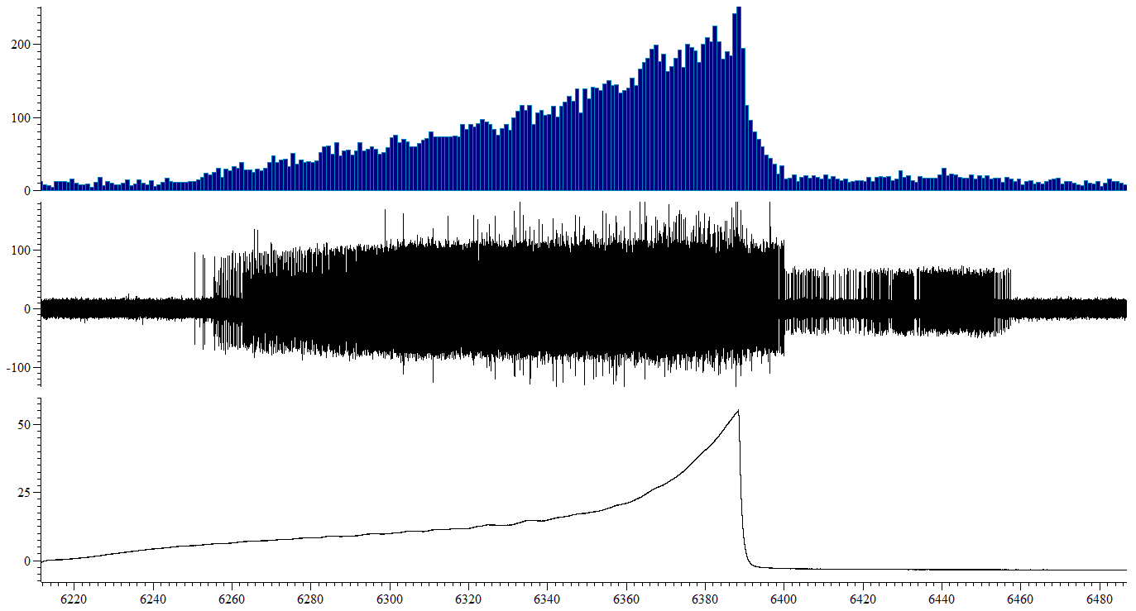
Mean firing (imp s⁻¹)
Nerve firing (µV)
Nerve firing (µV)
IP (mmHg)
Time (s)

Figure 3.5: The after distension response of afferent nerve fibres was evident in approximately half of all experiments performed. Immediately following bladder distension, once intraluminal pressure had returned to 0mmHg, there was a transient increase in afferent nerve firing in the absence of any mechanical or chemical stimuli.

Single unit analysis – Low and high threshold afferent nerve fibres

In experiments where single nerve units were clearly identifiable, displaying sufficiently different spike shape and amplitude to enable accurate discrimination of individual spikes single unit analysis was performed as previously described in chapter 2 (section 2.5). The majority of these fibres were silent at resting intraluminal pressure (0mmHg) and the spontaneous activity described predominantly consisted of low threshold fibre afferents.
Low threshold afferents were active at baseline, and afferent nerve firing increased as intraluminal pressure increased, reaching a maximal firing rate at 30-35mmHg as shown in figure 3.6C. High threshold afferents began to fire at approximately 15mmHg and firing increased as intraluminal pressure increased. It is important to note that whilst maximal firing rate was reached by the low threshold afferents, high threshold nerve fibres did not reach a maximal firing rate and afferent nerve firing continued to increase beyond 50mmHg as shown in figure 3.7A, B, C. Within the constraints of this experimental method, high threshold afferent nerves did not reach the same maximum frequency as low threshold afferent nerves.

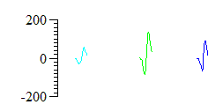
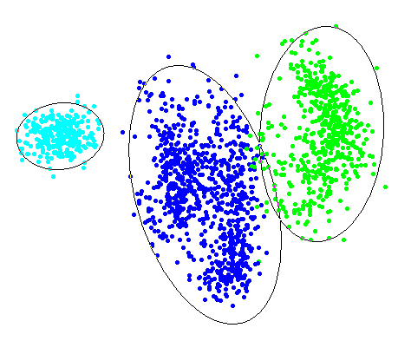
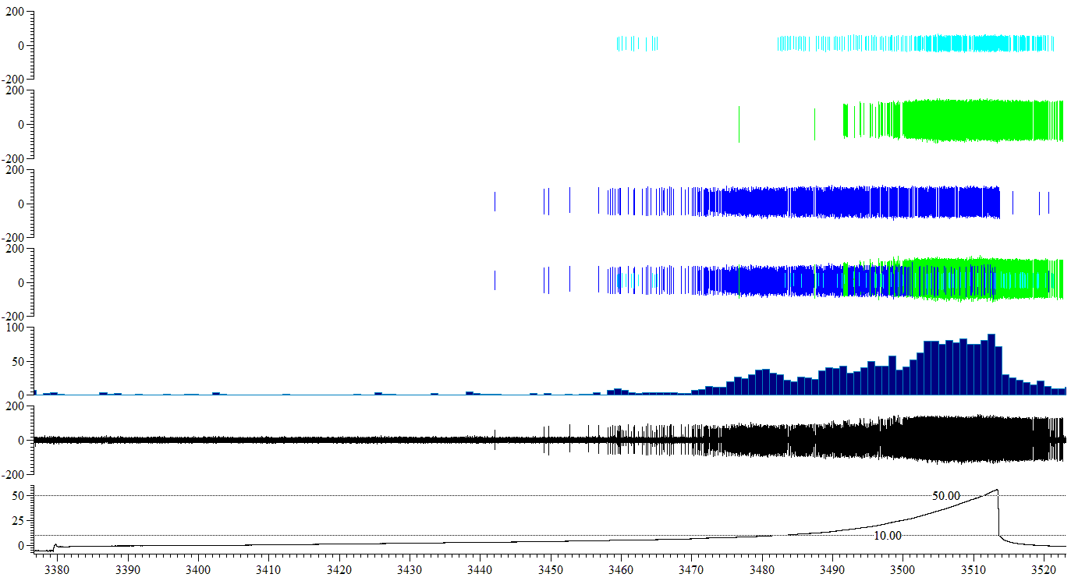
B.
Templates Nerve firing (µV)
A
B
C
IP (mmHg)
Mean firing (imp s⁻¹)

Nerve firing (µV)
Template A (µV)
Template B (µV)
Template C (µV)
All templates (µV)
Time (s)

A.

C.

Figure 3.6: The standard (control) response of low and high threshold afferent nerve fibres to distension of the bladder. A Templates identified and used for single unit analysis of a control distension (A = high threshold afferent nerve fibre, B = high threshold afferent nerve fibre, C = low threshold afferent nerve fibre). B, Principal component analysis confirmed that the identified action potential templates were sufficiently unique in comparison to each other to be classed as different single nerve units. C, A representative trace from a control distension, showing the activation thresholds of each of the identified single units. Although units A and B displayed a spontaneous burst of firing below 15mmHg, activation of these afferents at or above 15mmHg and the linearly increasing response profile allowed confident classification as high threshold afferents. Unit C was activated at low IP, therefore was classified as a low threshold afferent nerve fibre.

A.
B.
C.
Figure 3.7: The characteristic (control) response profile of low and high threshold afferent nerve fibres. A, Low threshold afferent nerve fibres were active at baseline, and firing rate increased as the bladder distended up to approximately 30-35mmHg IP, at which firing rate remained relatively constant, with little increase in nerve activity (n=84, N=24). B, High threshold afferent nerve fibres began to fire at approximately 15mmHg, and unlike low threshold afferent nerve fibres, firing increased linearly up to, and beyond, the maximum IP of 50mmHg (n=18, N=24). C, A comparison of the response profiles of both low and high threshold afferent nerve fibres in response to bladder distension.

The response of the detrusor muscle to ramp distension of the bladder.

Distension of the bladder with isotonic saline to a maximal pressure of 50mmHg evoked a biphasic increase in pressure as shown in figure 3.2. The first phase, consisted of a small change in pressure for a large volume of isotonic saline administered, a typical property of the compliant properties of the bladder detrusor (Fry et al., 2010). The second phase of the distension, (>15-50mmHg) resulted in larger changes in intraluminal pressure compared to the volume of saline administered.
Contractions, shown by transient rise and fall patterns in intraluminal pressure, occurred in a small number of experiments (approx. 25%) whilst the bladder was being filled. An example of this activity can be seen in figure 3.8.

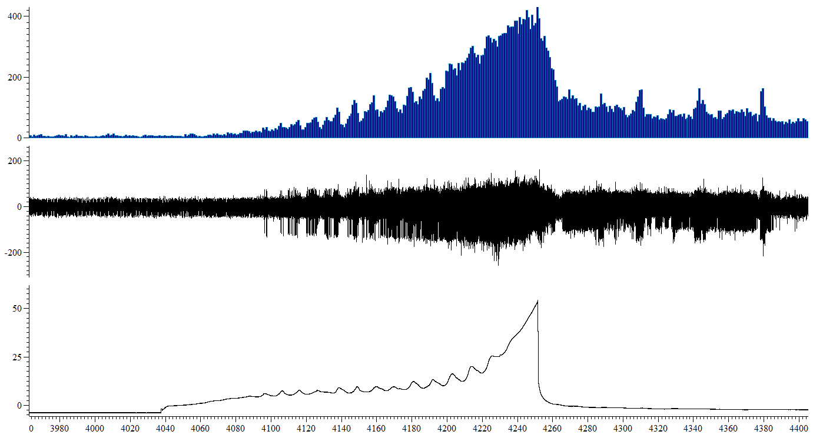
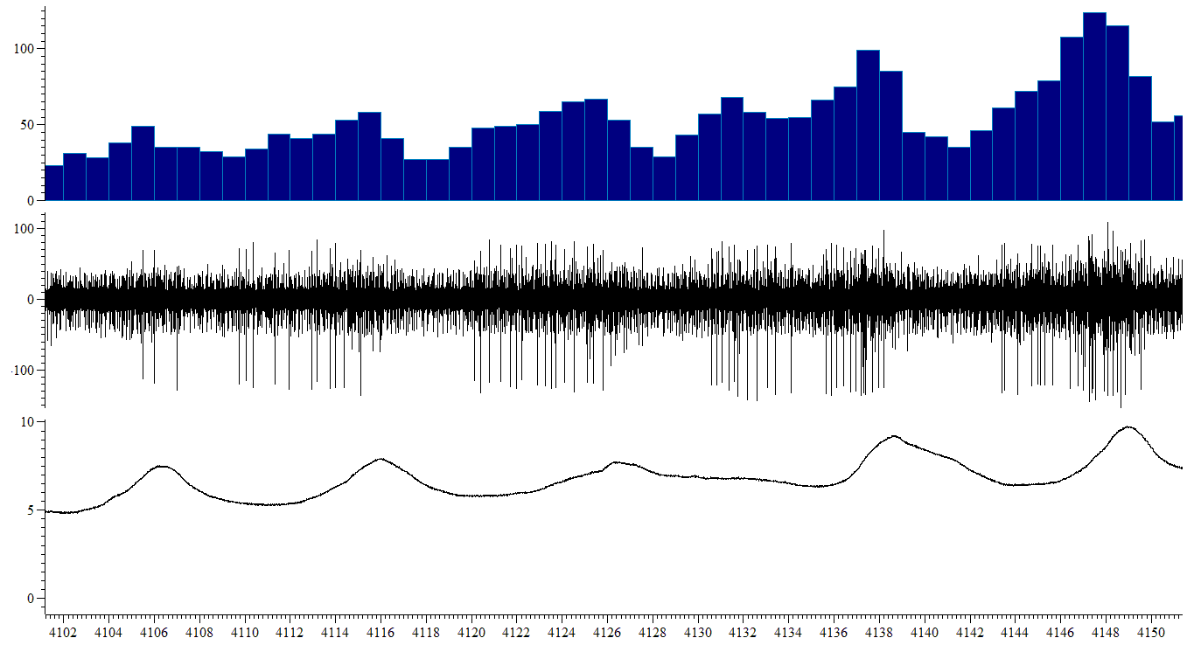
Micro-contractions of bladder muscle

Nerve firing (µV)
IP (mmHg)
Time (s)
Mean firing (imp s⁻¹)

Time (s)
Mean firing (imp s⁻¹)
Nerve firing (µV)
IP (mmHg)

Figure 3.8: Phasic contractions of the bladder muscle occurred during distension of the bladder in approximately 50% of control distensions. Phasic contraction of the bladder muscle was observed during distension of the bladder and this activity corresponded to transient bursts of afferent nerve firing.

3.3 Stability of the preparation – Time

Aim

This preparation has previously been used to assess the effect of pharmacological agents on muscle activity and afferent nerve firing, however with obvious constraints of the artificial environment supporting the tissue during experimental procedure, and the extensive trauma and pressure served to the bladder during both set-up and repeated distension both to a higher than physiological pressure, and repeated at an intensive frequency (10mins) it was necessary to perform time controls to provide evidence for the stability and viability of the preparation. In all studies using this method, an appropriate period (30mins-1 hour) of equilibration was necessary to ensure the stability of the neuronal and pressure responses to intraluminal distension (Rong et al., 2002), (Daly et al., 2007). However, due to the lengthy experimental protocols used in this thesis in comparison to other studies, it was necessary to ensure that the preparation remained stable, under control conditions, for a period equal to the length of the longest protocol.

Hypothesis

The aim of these experiments was to provide evidence to support the hypothesis that the recording preparation was capable of remaining stable and reproducible across all recorded parameters across the longest experimental time used in this thesis (3 hour period).

Results

Overview

Both the afferent nerve response to ramp distension and bladder compliance remained stable at every time point analysed, throughout the 3 hour time period. The level of spontaneous afferent nerve firing was variable over the 3 hour period, yet mean baseline afferent nerve firing remained statistically unchanged relative to 30 minutes control.

Mechanosensitivity remained stable for the full duration of the protocol.

Afferent nerve firing in response to bladder distension remained stable for the entire duration of the protocol. The stability of the afferent nerve response to distension, relative to 30 minutes saline control was verified at 60 minutes, (figure 3.9A) 90 minutes (figure 3.9B) 120 minutes (figure 3.9C), 150 minutes (figure 3.10A) and 180 minutes intraluminal perfusion of saline (figure 3.10B).

Bladder compliance remained stable following distension of the bladder with saline, every 10 minutes, for 3 hours.

Repeated distension of the bladder to a maximum pressure of 50mmHg, every ten minutes, for a period of 3 hours had no effect on bladder compliance. Compliance remained stable, relative to 30 minutes control, at 60 minutes (figure 3.11A), 90 minutes (figure 3.11B), 120 minutes (figure3.11C), 150 minutes (figure 3.12A) and 180 minutes saline exposure (figure 3.12B).

A.
B.
C.
Figure 3.9: Mechanosensitivity remained stable, under control conditions, for the duration of the protocol.
A, The afferent response to bladder distension remained unchanged 60 minutes into the protocol relative to 30 minutes saline control (P=0.52, n=6). B, Mechanosensitivity remained unchanged, relative to 30 minutes control at 90 minutes (P=0.45, n=6). C, Afferent nerve firing in response to bladder distension at 120 minutes remained unchanged relative to 30 minutes control (P=0.41, n=6).

A.

B.

Figure 3.10: Mechanosensitivity remained stable, under control conditions, for the entire duration of the protocol.
Stability of the preparation, relative to 30 minutes saline control was verified at 150 and 180 minutes. A, The afferent nerve response to bladder distension remained unchanged at 150 minutes relative to 30 minutes saline control (P=0.87, n=6). B, 180 minutes into the protocol afferent nerve firing in response to distension was unchanged, relative to 30 minutes saline control (P=0.27, n=6).

A.
B.
C.
Figure 3.11: Bladder compliance remained stable, under control conditions, for the duration of the protocol.
A, Bladder compliance remained unchanged 60 minutes into the protocol, relative to 30 minutes saline control (P=0.90, n=6). B, Compliance remained unchanged, relative to 30 minutes control at 90 minutes (P=0.26, n=6). C, 120 minutes into the protocol, compliance remained unchanged relative to 30 minutes control (P=0.76, n=6).

A.

B.

Figure 3.12: Bladder compliance remained stable, under control conditions, for the duration of the protocol.
Stability of bladder compliance was verified, relative to 30 minutes saline control at 180 and 210 minutes. A, Bladder compliance remained unchanged at 180 minutes, relative to 30 minutes saline control (P=0.51, n=6). B, Compliance remained stable, relative to 30 minutes saline control, for the entire duration of the protocol (210 minutes, P=0.53, n=6).

Spontaneous afferent nerve firing was increased over time under control conditions.

During 50-60 minutes intraluminal perfusion of the bladder with isotonic saline, spontaneous afferent nerve firing was increased by 179% relative to 20-30 minutes control (figure 3.13A) Similarly the spontaneous nerve firing was increased by 132%, during 80-90 minutes saline perfusion relative to 20-30 minutes saline control (figure 3.13B).
During 110-120 minutes intraluminal perfusion of saline, spontaneous afferent nerve firing was increased by 116% relative to 20-30 minutes saline control (figure 3.13C). An increase in spontaneous afferent nerve activity was also observed during 140-150 minutes, where nerve activity was increased by 67% relative to 20-30 minutes saline control (figure 3.14A). In contrast, by the end of the protocol (during 170-180 minutes saline perfusion), spontaneous afferent nerve firing was decreased by 11% relative to 20-30 minutes saline control (figure 3.14B).
Mean baseline afferent nerve firing however remained unaffected throughout the protocol as shown in figure 3.15.

A.
B.

C.
Figure 3.13: Spontaneous afferent nerve firing was increased over time. A spontaneous afferent nerve firing was increased relative to 20- 30 minutes saline control, during 50-60 minutes intraluminal perfusion of isotonic saline solution (****P< 0.0001, n=6). B Similarly, during 80-90 minutes intraluminal perfusion of the bladder with saline solution, spontaneous afferent nerve firing was increased relative to 20-30 minutes saline control (****P<0.0001, n=6). Spontaneous afferent nerve firing was increased during the 110-120 minute period of saline perfusion, relative to 20-30 minutes saline control (****P<0.0001, n=6).

A.

B.

Figure 3.14: Spontaneous afferent nerve firing does not remain stable over the duration of the protocol. A spontaneous afferent nerve firing was increased during 140-150 minutes saline perfusion relative to 20-30 minutes saline control (***P=0.0002, n=6). B, During 170-180 minutes perfusion of the bladder with isotonic saline, spontaneous afferent nerve firing was reduced relative to 20-30 minutes saline control (**P=0.002, n=6).

Figure 3.15: Mean baseline afferent nerve firing remained unaffected throughout the protocol. P=0.09, 1 way RM ANOVA with Bonferroni post-test, n=6.

3.4 Discussion

The afferent nerve response to distension of the bladder.

Ramp distension of the bladder, with isotonic saline at a rate of 100µl/min, caused a progressive increase in intraluminal pressure (to a maximum intraluminal pressure of 50mmHg) and a simultaneous increase in afferent nerve firing. The distension profile consisted of two distinct phases. During the 1st phase, intraluminal pressure increased slowly, and the simultaneous afferent nerve firing was disproportionately higher than the increase in pressure. At approximately 10-15mmHg IP (the beginning of the 2nd phase of distension), intraluminal pressure began to increase more rapidly in response to increasing volume, and afferent nerve firing continued to increase, although not at as fast a pace as during the 1st phase.
In this thesis, distension of the bladder was performed to, and not exceeding, a maximum intraluminal pressure of 50mmHg. Distension of the bladder to 50mmHg was selected as it enabled both innocuous (0-15mmHg) and noxious (15-50mmHg) stimulation of the bladder, and the subsequent activation of both low and high threshold afferent nerve fibres (Rong et al., 2002). Distension of the mouse bladder to an intraluminal pressure of 50mmHg has been successfully used in this model (Daly et al., 2010) and demonstrated the activation of both low and high threshold afferent nerves whilst causing no damage to detrusor and urothelial structure. In an anaesthetised rat preparation, the bladder was repeatedly distended to an intraluminal pressure of 80mmHg (Sengupta et al., 1994) but it remains unclear as to whether distension to high intraluminal pressures such as this causes changes in detrusor and urothelial morphology.
Time control experiments demonstrated the stability of the afferent nerve response to bladder distension over a 3 hour period allowing the effects of pharmacological agents used in this thesis to be tested to be confidently compared to their own experimental control.

The afferent nerve response to distension of the bladder is mediated by mechanosensitive afferent nerve fibres that act as in series (with muscle fibres) tension receptors that respond to passive distension and to contraction (Iggo, 1955), however this was challenged by studies in the rat, describing the presence of vesical mechanoreceptors that respond to distension but not to contraction, defined as ‘volume’ receptors (Morrison, 1997) . From various in vivo and in vitro studies, bladder innervating afferents have been divided into a number of categories both based on the location of their receptive field (Zagorodnyuk et al., 2007), (Zagorodnyuk et al., 2009), activation threshold (Rong et al., 2002), and response to various stimuli (Moss et al., 1997), (Zagorodnyuk et al., 2007) as discussed in detail in chapter 1. One of the limitations of this preparation is its inability to map the receptive fields of the recorded afferent nerve fibres within a preparation, yet using the wavemarking and single unit analysis function in Spike software, spikes could be grouped and classified as a low or high threshold afferent nerve fibre depending on their activation threshold as previously described (Rong et al., 2002), (Daly et al., 2007).

Low and high threshold afferent fibres.

A dual innervation system travelling via both the hypogastric, pelvic and lumbar splanchnic nerves provides the afferent nerve supply of the bladder (Cervero, 1994), although human clinical investigations have indicated that all sensations of the bladder, including innocuous and painful filling are signalled in the main by the pelvic afferent nerves (Kuru, 1965) . The recording preparation used throughout this thesis records afferent nerve activity from a mixed population of afferent nerves, thus assessment of the specific effects of pharmacological agents on individual nerve classes was not possible. However, the pelvic and hypogastric bundles are easily identifiable (from their location entering the spinal cord), and so this preparation possesses the potential for further development of dual recordings in the same preparations of both afferent nerve subtypes simultaneously. The primary advantage of recording afferent nerve activity from a mixed bundle of afferent nerve fibres is that it enables bladder behaviour to be considered on a more complex and complete basis, i.e. the activities of both pelvic and hypogastric nerves can be measured in the same bundle simultaneously, whilst measuring the overall response of the whole bladder to various stimuli.
The 2 phases of the afferent nerve response to distension of the bladder comprise of the activation of low (0-15mmHg) and high (15-50+ mmHg) threshold afferent nerve firing. Activation of low threshold afferent nerve fibres is considered to be primarily involved in the triggering of micturition, with their activation threshold lying within the normal, innocuous range of perception. Conversely, high threshold afferent nerve fibres respond to distension of the bladder at high intraluminal pressures and are associated with the initiation of the perception of discomfort and, eventually, pain.
Many researchers believe that the low threshold component (non- painful micturition reflex) of the bladder is mediated predominantly by myelinated Aδ fibres (Bahns et al., 1987), (Mallory et al., 1989), whereas unmyelinated C fibres are activated under pathophysiological conditions thereby signalling the perception of pain (Habler et al., 1990). However, later studies contradicted previous work and suggested that there was no direct correlation between the response threshold of the nerve and its conduction velocity, demonstrating that in a population of high threshold afferent fibres in the bladder of the rat half were Aδ fibres and half were C fibres (Sengupta et al., 1994). Unfortunately, in this preparation, accurate determination of whether the afferent nerve bundles recorded from were myelinated or unmyelinated was not possible.
Distension of the bladder in this thesis using the distension protocol explained in chapter 2 enabled the recruitment of both low and high threshold afferents with the majority of fibres activated at low intraluminal pressures, thereby suggesting that the largest sup population of afferents in the bladder is of the low threshold variety. Figure 3.6 shows the responses of low and high threshold afferent nerves to distension. It is interesting to note that whilst the activity of the low threshold afferents peaks and plateaus at approximately 30-35 mmHg, high threshold activity continues to increase beyond the limits of the maximum intraluminal distension pressure used in this thesis, thereby further suggesting a role of high threshold afferents in the signalling of pain and inflammation. The activation threshold for each subset and number of fibres identified of each variety within a preparation is consistent with previous reports in the cat bladder, showing that only a small subpopulation of unmyelinated visceral afferents respond to high intraluminal pressure and intraluminal perfusion of chemical irritants (Habler et al., 1990), and also confirmed by a separate study in rats which concluded that 80% of the afferent nerve fibres innervating the bladder were activated at low intraluminal pressures during distension of the bladder and the remaining 20% were high threshold afferent nerve fibres (Sengupta et al., 1994).

Spontaneous/baseline afferent nerve activity

In this recording preparation, spontaneous afferent nerve firing was recorded during inter-distension periods, when the bladder was empty as shown in figure 3.1A and 3.1B, equating to approximately 17.24 ± 2.04 imp s⁻¹ (n=100). This was observed in preparations where the bladder was and wasn’t continuously perfused, reducing the possibility that this on-going activity could be attributed to stimulation of afferents in response to intraluminal flow of solution. Incidentally, this activity was also present and persisted during the 1 hour equilibration period. This finding is in contrast to previous reports in the same in vitro model, that suggested that there was very little (<10 imp s⁻¹) (Rong et al., 2002) or no ( 0.2 ± 0.04 imp s⁻¹) spontaneous activity in wild type mice (Daly et al., 2007) or prior to stimulation in the in vivo rat bladder model (Shea et al., 2000).
However, spontaneous afferent nerve firing of the bladder afferent nerve fibres has been observed in an in vivo rat bladder preparation where it was reported that 49% of afferent nerve fibres that were responsive to urinary bladder distension had some baseline resting afferent nerve activity, approximately 1.7 ± 0.3 imp s⁻¹ (Sengupta et al., 1994). Resting baseline nerve firing was also observed in a later study in which 46 pelvic afferent nerve units out of a total of 49 had a resting nerve discharge, with a reported mean firing rate of 1.1 ± 0.2 imp s⁻¹ (Su et al., 1997).
The discrepancy between these findings may lie in the fact that there is some uncertainty as to the level of activity (imp s⁻¹) that constitutes the presence of baseline afferent nerve activity, as if the figure of <10 imp s⁻¹ is to dictate no significant baseline afferent activity (Rong et al., 2002), then studies that claim the presence of spontaneous nerve activity with lower nerve activity than this figure may be misleading. In any case, the mean level of activity calculated from 100 experiments that comprise this thesis far exceeds 10 imps⁻¹.
There are many explanations as to what could cause spontaneous afferent nerve firing of the bladder in the recording preparation used to generate the data in this thesis;
- Micro-motions of detrusor muscle
Afferent nerve fibres respond to many stimuli in the detrusor wall, including stretch and tension to convey sensations ranging from empty, to fullness, discomfort and eventually pain. Although no changes in intraluminal pressure were recorded it may be that the sensitivity of the pressure recording system was insufficient to measure tiny fluctuations in pressure, so the origin of spontaneous afferent nerve activity could be attributed to the presence of undetected micro-motions of the bladder wall (McCarthy et al., 2009).

- Urothelial mediator release following distension of the bladder to noxious intraluminal pressures (50mmHg)
Over-distension of the bladder beyond physiological intraluminal pressure into the noxious range of distension could be responsible for spontaneous afferent nerve activity between bladder distensions. ATP, amongst other mediators, has been shown to be released in the rabbit, from urothelial cells during distension, and so may still be present following distension of the bladder, particularly because of distension to such high intraluminal pressure, depending on the ability of ecto-ATPases to breakdown residual ATP (Ferguson et al., 1997).

- Afferent nerve firing from afferent nerve fibres innervating other visceral organs
As afferent nerve recording in this preparation uses a multi-unit bundle, it is possible that some of the fibres within the bundle innervate other nearby visceral structures, for example the colonic or urethral afferents, which are known to exhibit a high level (20.1 ± 2.8 imp s⁻¹) of spontaneous afferent nerve firing (Rong et al., 2007).

- Trauma to the bladder dome or afferent nerve terminals following set-up of the recording preparation
Although great care was taken to minimise trauma, there is no doubt that the process of setting-up the recording preparation is both invasive and traumatic to the bladder tissue and afferent nerve fibres. Firstly, the process of insertion of the double lumen catheter into the dome of the bladder not only damages the detrusor muscle itself, but also the underlying urothelial layer, thereby possibly creating inflammation and subsequent release of mediators. Mediator release from the urothelium as a result of trauma, or the dissection and damage of afferent nerve bundles for recording could explain the presence of spontaneous afferent nerve activity in these preparations.

- Urethral afferent nerve fibres
Branches of the pelvic and hypogastric nerves that innervate the bladder also innervate the urethral smooth muscles, and close proximity pudendal nerve fibres innervate striated muscles of the external urethral sphincter. It is possible that some nerve units within the recorded bundle in individual preparations were relaying sensory information from the urethra.

Time control experiments showed that spontaneous activity not only varied within the 10 minutes between distensions, but also was increased relative to control between successive distensions of the bladder over the 3 hour control protocol. As the origin of this activity still remains unclear and indeed because there is huge variability in spontaneous activity, particularly within the first 5 minutes following distension, between preparations, it was difficult to measure spontaneous activity accurately. Furthermore, measurement of the whole ten minute period at 10 second intervals provides many data points, increasing the possibility that statistical relevance could be due to chance.
As spontaneous afferent nerve activity accounted for a proportion of the afferent nerve response to distension, it was necessary to remove the spontaneous activity component in order to clearly demonstrate the purely mechanosensory response to bladder filling. As the first 5 minutes of the 10 minute interval between distensions was highly variable, and contained the ‘after distension response’, this time period was not used as a baseline afferent nerve discharge measurement. In the final 5 minutes before distension, the afferent nerve activity remained more consistent, and so the average nerve firing over this 5 minute was calculated and then removed from the mechanosensitivity response. Incidentally, mean baseline afferent nerve activity remained stable for the entire 3 hour duration of the time control experiments, suggesting that spontaneous afferent nerve firing is most variable in the first 5 minutes following distension and so may logically be associated with recovery of the bladder after a noxious level of distension. In this thesis, baseline afferent nerve firing refers to the average afferent nerve activity of the 5 minute period immediately prior to distension. This is the value that was subsequently removed from mechanosensitivity measurements.

The ‘after distension response’ of the bladder afferent nerves

Firing of most of the mechanosensitive afferent nerves evoked by distension of the bladder ceased when the tap on the outflow catheter was opened and the bladder was allowed to empty. However, as shown in figure 3.5, some afferent nerve units continued to fire during and up to 1 - 2 minutes after bladder emptying. This activity is referred to in this thesis as the ‘after distension response’. This interesting observation occurred in the majority of preparations, although the time of onset and duration of firing were variable between preparations. It has been suggested that this activity may be a result of mucosal receptors (Zagorodnyuk et al., 2006) in the bladder making contact with each other as the bladder becomes empty. The after distension response also resembles continued elevated activity of C- fibre afferent nerves up to a minute after bladder emptying observed in the rat (Shea et al., 2000). The authors concluded that this activity resembled nerve activity of A δ fibres described previously in rat that were proposed to signal that the bladder was empty (Morrison, 1997). In short, the origin of this activity remains unclear and requires further investigation
The variability of this response made it difficult to assign appropriate parameters for measurement, and therefore for comparisons to be made between different pharmacological treatments. Analysis of this activity was not undertaken.

Bladder compliance

In order for successful filtration and consequent urine production by the kidneys, filtration pressure in the glomerulus of the healthy kidneys remains low. It is suggested that any rise in bladder pressure prevents effective filtration by the kidneys and therefore urine production will cease, however this is arguable unless vesicoureteric reflux is present. The ability of the bladder to store reasonable volumes of urine without a drastic change in intraluminal pressure, and to expel contents rapidly when convenient, requires that the bladder wall be extremely compliant. Alongside the storage function of the bladder the detrusor muscle must also be able to respond to a stimulus with synchronous contractions that elevate intraluminal pressure and signal the desire to void.
In the healthy bladder, these two functions are achieved; the bladder is able to store urine without leakage for extended period of time if required, and then rapidly expel them when micturition is convenient. This is achieved by a complex interaction between nervous control systems and the anatomical properties of the bladder itself.
During filling, the smooth muscle cells of the detrusor have to relax, elongate and rearrange themselves over a larger bladder length. Conversely at the initiation and for the duration of micturition, force generation and shortening of muscle cells must occur comparatively faster, whilst remaining synchronised and occurring over a large area of bladder tissue.
However, in bladder disorders, compliance is often altered and storage and rapid expulsion of urine is deteriorated making this another possible avenue for investigation and intervention for treatment and maintenance of bladder disorders.
Bladder compliance describes the relationship between volume and pressure and is measured clinically from a cystometric pressure/ volume curve, and is calculated clinically from the equation ∆V/∆P, where ∆ = change, V= volume, and P = pressure. Compliance is then expressed as ml/cm H₂O. Experimental studies have indicated that a variety of processes determine the ability of the bladder to accommodate changes in volume for little changes to intraluminal pressure, including detrusor muscle (Brading, 1997), and neural (de Groat, 1997) properties. It is also possible that the urothelium and afferent nerve fibres are capable of releasing mediators that directly influence detrusor muscle tone (Birder et al., 2007).
Bladder compliance in these experiments was inferred from the pressure volume relationship. Bladder distension caused a characteristic bi-phasic, non-linear profile, as both pressure and volume were increased. Over the three hour distension protocol, bladder compliance remained stable relative to control, allowing changes in bladder compliance due to pharmacological treatments to be reliably noted because of the consistent, reproducible responses to bladder distension over time.

Micro-motions of the detrusor muscle

As shown in figure 3.8, during distension of the bladder, spontaneous micro motions of the bladder were observed in approximately 25% of experiments performed in this thesis. These transient patterns of rising and falling in intraluminal pressure coincided with bursts of afferent nerve firing. In these experiments it was difficult to determine the source of these contractions, as their occurrence was so sparse and even if the preparation displayed these contractions, they had mostly disappeared following 1 hour equilibration period of the preparation.
Transient changes in pressure have been observed during the physiological filling phase, and autonomous contractile activity of the detrusor has been demonstrated in the guinea pig bladder (Drake et al., 2002), and in the isolated bladder of the rat (Sugaya et al., 2000). These transient rises in pressure have also been observed in patients with normal bladders during filling of the bladder at physiological rates. Further to this, cells resembling interstitial cells of Cajal (ICCs) found in the gut, also reside in the bladder detrusor (Sui et al., 2002). The origin of these contractions remains unknown, but a number of hypotheses have been put forward to help explain this activity. These hypotheses broadly form 4 categories;

- Myogenic hypothesis - Intrinsic properties of the bladder wall - It has been postulated that the bladder, ICCs, and surrounding nerves provide a pacemaker function, similar to that found in the gut, and thereby form the basis for the initiation of these spontaneous detrusor micro-motions (Drake et al., 2002). It has been hypothesised that spontaneous activity of bladder myocytes and extensive coupling between cells generates these spontaneous contractions from several muscle bundles (Fry et al., 2010). Also, in preparations where TTX was administered into the bladder these contractions persisted (Drake et al., 2002), suggesting that they cannot be driven by a central mechanism and probably have a largely myogenic origin. Incidentally, in this recording preparation there is no efferent input to the bladder, therefore suggesting that these contractions are either myogenic or urotheliogenic in origin.

- Integrative hypothesis – An interplay between interstitial cells and other cell types - Determined by the activity of interstitial cells and their interactions with other cell types in the bladder, including neuronal and urothelial cells, the integrative hypothesis suggests that the spontaneous micromotions of the bladder muscle are a normal, physiological mechanism for reporting the state of bladder filling. It has been suggested that alterations in the activity of any of these cells will lead to exaggerated contractions and ultimately lead to symptoms of overactive bladder or detrusor overactivity (Drake et al., 2001). Furthermore, in an isolated rat bladder preparation it has been shown that interstitial cells drive autonomous activity of the detrusor (Lagou et al., 2006). Understanding the interplay between bladder cells may aid in the development of new, more effective treatments for bladder disorders.

- Urotheliogenic hypothesis – Release of mediators from the urothelium – Activity of the urothelial and suburothelial layers has been demonstrated to influence detrusor function, both increasing and decreasing detrusor contractile modalities. It is suggested that spontaneous activity can originate in these layers and then propagate to the detrusor muscle where spontaneous contractions are generated (Ikeda et al., 2008).

- Neurogenic hypothesis – In 1882 Mosso and Pellacani observed contractions in the bladder that were abolished following transection of the spinal cord, and concluded that these contractions were driven by central mechanisms (Mosso et al., 1882), reviewed in (Gillespie, 2004). However in 1892, Sherrington discovered the presence of these contractions in the bladders of the cat, dog and monkey, and reported that following transection of the spinal cord the contractions persisted. Even when the bladder was removed from the animal and maintained in vitro for several hours this contractile activity persisted (Sherrington, 1892) suggesting that contractions of the bladder do not have a neurogenic origin. The presence of these bladder contractions in this recording preparation used to generate data in this thesis suggests that these contractions do not have a neurogenic origin as the preparation does not possess an intact efferent nerve supply.
Unfortunately, because of the unpredictability and limited presence of these contractions in the recordings in this thesis, these contractions were not investigated.

3.5 Concluding comments

This recording preparation enabled ramp distension of the bladder and simultaneous measurement of intraluminal pressure and afferent nerve firing thereby allowing correlation between detrusor activity and afferent nerve firing. Importantly the preparation remained stable enabling comparisons to be made within an experiment to in built controls. In accordance with the majority of the literature, ramp distension activated afferent nerve fibres to fire, and using their activation characteristics low and high threshold afferent nerve fibres could be identified.
Bladder compliance remained stable following successive control distensions of the bladder. This model suggests that bladder compliance is, at least in part, regulated either by intrinsic properties of the bladder wall, or by a urothelial mechanism, as the efferent nerve supply in this preparation was not intact, however, with that in mind, it is likely that bladder compliance measurements would be very different in the presence of an intact efferent input. The prime advantage of this model is that afferent nerve pathways are studied in isolation without any of the efferent influences which could contribute to the results. The absence of the efferent limb of nervous control is useful in enabling the afferent limb of the system to be considered independently of efferent nerve input. However, this considered, it is important to state that control of the bladder is multifactorial, and by cutting off the efferent limb and higher CNS pontine control, the bladder may indeed behave differently to its normal behaviour in an intact whole system.
Another advantage of this model is that the bladder remains intact rather than stretched out as a flat-sheet preparation. The flat sheet preparation is used and afferent nerve firing is recorded in response to stretch (via a strain gauge). Whilst the preparation is useful for the mapping of receptive fields, and for the stimulation of mucosal afferents (which would not be activated by ramp distension of the bladder) as previously shown (Zagorodnyuk et al., 2006), (Zagorodnyuk et al., 2007), (Zagorodnyuk et al., 2009), the preparation used throughout this thesis is useful in that it uses an intact bladder, which is distended, albeit at a faster rate, in a similar way to in vivo filling of the bladder. It is important to highlight that whilst stretch can induce tension, stretch and distension are 2 very different mechanical stimuli, and so direct comparisons between data should be made with caution between these two preparations.
In contrast to previous reports, spontaneous activity of the afferent nerves was identified in the majority of preparations. In the 10 minute period between distensions, during the first 5 minute period, spontaneous nerve activity was highly irregular, but remained stable in the final 5 minute period before distension. The mean afferent nerve firing over the final 5 minute period before distension was used as a baseline afferent nerve firing measurement, and was subtracted from afferent nerve firing during distension so that a true mechanosensory response could be calculated.
In conclusion, the recording preparation is sufficiently stable, reproducible and reliable to enable confident conclusions to be made from the generated data.

References

Bahns, E., Halsband, U., & Janig, W. (1987). Responses of sacral visceral afferents from the lower urinary tract, colon and anus to mechanical stimulation. European Journal of Physiology, 410, 296-303.
Birder, L. A., & de Groat, W. C. (2007). Mechanisms of Disease: involvement of the urothelium in bladder dysfunction. Nature Clinical Practice Urology, 4, 46-54.
Brading, A. F. (1997). A myogenic basis for the overactive bladder. Urology, 50, 57-67.
Cervero, F. (1994). Sensory innervation of the viscera: Peripheral basis of visceral pain. Physiological reviews, 74, 95-138.
Daly, D., Chess-Williams, R., Chapple, C., & Grundy, D. (2010). The inhibitory role of acetylcholine and muscarinic receptors in bladder afferent activity. European Urology, 58, 22-28.
Daly, D., Rong, W., Chess-Williams, R., Chapple, C. R., & Grundy, D. (2007). Bladder afferent sensitivity in wildtype and TRPV1 knockout mice. The Journal of Physiology, 583, 663-674.
de Groat, W. C. (1997). A neurologic basis for the overactive bladder. Urology, 50, 36-52.
Drake, M. J., Harvey, I. J., & Gillespie, J. I. (2002). Autonomous activity in the isolated guinea pig bladder. Experimental Physiology, 88, 19-30.
Drake, M. J., Mills, I. W., & Gillespie, J. I. (2001). Model of peripheral autonomous modules and a myovesical plexus in normal and overactive bladder function. . Lancet, 358 401–403.
Ferguson, D. R., Kennedy, I., & Burton, T. J. (1997). ATP is released from rabbit urinary bladder epithelial cells by hydrostatic pressure changes - a possible sensory mechanism? Journal of Physiology, 505(2), 503-511.
Fry, C. H., Meng, E., & Young, J. S. (2010). The physiological function of lower urinary tract smooth muscle. Autonomic neuroscience, 154, 3-13.
Gillespie, J. I. (2004). The autonomous bladder: a view of the origin of bladder overactivity and sensory urge. BJU International, 93, 478-483.
Habler, H. J., Janig, W., & Koltzenburg, M. (1990). Activation of unmyelinated afferent fibres by mechanical stimuli and inflammation of the urinary bladder in the cat. Journal of Physiology, 425, 545-562.
Iggo, A. (1955). Tension receptors in the stomach and the urinary bladder. Journal of Physiology, 128, 593-607.
Ikeda, Y., & Kanai, A. J. (2008). Urotheliogenic modulation of intrinsic activity in spinal cord-transected rat bladder: role of mucosal muscarinic receptors. American Journal of Physiology, Renal Physiology, 295, 454-461.
Kuru, M. (1965). Nervous control of micturition. Physiological reviews, 45, 425-494.
Lagou, M., Drake, M. J., Ittersum, M. M., de Vente, J., & Gillespie, J. I. (2006). Interstitial cells and phasic activity in the isolated mouse bladder. BJU International, 98, 643-650.
Mallory, B., Steers, W. D., & de Groat, W. C. (1989). Electrophysiological study of micturition reflexes in rats. American Journal of Physiology, 257, 410-421.
McCarthy, C. J., Zabbarova, I. V., Brumovsky, P. R., Roppolo, J. R., Gebhart, G. F., & Kanai, A. J. (2009). Spontaneous contractions evoke afferent nerve firing in mouse bladders with detrusor overactivity. Journal of Urology, 181, 1459-1466.
Morrison, J. (1997). The physiological mechanisms involved in bladder emptying Scandanavian Journal of Urology, 184, 15-18.
Moss, N. G., Wallace Harrington, W., & Tucker, S. (1997). Pressure, volume, and chemosensitivity in afferent innervation of urinary bladder in rats. American journal of physiology, 272, 695-703.
Mosso, M. A., & Pellacani, P. (1882). Sur le fonctions de la vessie. Archives Italiennes de Biologie, 1, 291-324.
Rong, W., Spyer, K., & Burnstock, G. (2002). Activation and sensitisation of low and high threshold afferent fibres mediated by P2X receptors in the mouse urinary bladder. The Journal of Physiology, 541, 591-600.
Rong, W., Winchester, W. J., & Grundy, D. (2007). Spontaneous hypersensitivity in mesenteric afferent nerves of mice deficient in the sst2 subtype of somatostatin receptor. Journal of Physiology, 581(2), 779-786.
Sengupta, J. N., & Gebhart, G. F. (1994). Mechanosensitive properties of pelvic nerve afferent fibres innervating the urinary bladder of the rat. Journal of Neurophysiology, 72, 2420-2430.
Shea, V. K., Cai, R., Crepps, B., Mason, J. L., & Perl, E. R. (2000). Sensory fibers of the pelvic nerve innervating the rat's urinary bladder. The Journal of Neurophysiology, 84, 1924-1933.
Sherrington, C. S. (1892). Notes on the arrangement of some motor fibres in the lumbo-sacral plexus. Journal of Physiology, 13, 621-772.
Su, X., Sengupta, J. N., & Gebhart, G. F. (1997). Effects of opioids on mechanosensitive pelvic nerve afferent nerve fibers innervating the urinary bladder of the rat. The Journal of Neurophysiology, 77, 1566-1580.
Sugaya, K., & de Groat, W. C. (2000). Influence of temperature on activity of the isolated whole bladder preparation of neonatal and adult rats. American Journal of Physiology, 278, 238-246.
Sui, G. P., Rothery, S., Dupont, E., Fry, C. H., & Severs, N. J. (2002). Gap junctions and connexin expression in human suburothelial interstitial cells. BJU International, 90, 118-129.
Zagorodnyuk, V. P., Brookes, S. J. H., Spencer, N. J., & Gregory, S. (2009). Mechanotransduction and chemosensitivity of two major classes of bladder afferents with endings in the vicinity to the urothelium. The Journal of Physiology, 587, 3523-3538.
Zagorodnyuk, V. P., Costa, M., & Brookes, S. J. H. (2006). Major classes of sensory neurons to the urinary bladder. Autonomic neuroscience, 126, 390-397.
Zagorodnyuk, V. P., Gibbins, I. L., Costa, M., Brookes, S. J. H., & Gregory, S. (2007). Properties of the major classes of mechanoreceptors in the guinea pig bladder. Journal of Physiology, 585, 147-163.

