Chapter 2
Materials and Methods
A discussion of the electrophysiological recording method and histology methods used to generate the data in this study

2.1 Simultaneous recording of intraluminal pressure and afferent nerve activity

Animals

All experiments were performed using 6-8 week old, C57/Bl6, male mice weighing between 25-30g, obtained from Charles Rivers.
On delivery, mice were allowed to rest for 1 week prior to use in order to reduce any stress caused by transportation. All mice had free access to food and water and were examined daily for signs of injury or disease.
Immediately prior to use, mice were humanely sacrificed by cervical dislocation in accordance with UK home office legislation regulating schedule one procedures.

Dissection and afferent nerve preparation and recording

Following sacrifice of the mouse, an abdominal, midline incision along the caudo-cranial axis was performed. The small intestine, stomach and overlying visceral organs were removed, before cutting through the spinal cord at the level just above the kidneys (L1-L2) as shown in figure 2.1.
The tail and both hind limbs were removed, and the whole pelvic region, containing the bladder, urethra, testes, vas deferens, seminal vesicles, ureters, and kidneys were removed and placed in the recording chamber.
In a Faraday cage, the recording chamber was continually perfused with carbogenated (95% O₂/5% CO₂) Krebs bicarbonate solution (composition, mM: NaCl 118.4, NaHCO₃ 24.9, CaCl₂ 1.9, MgSO₄ 1.2, KCl, KH₂PO₄ 1.2, glucose 11.7) which was warmed on delivery to the chamber by a water heater to 34°C, thereby providing an optimum, physiologically relevant, environment for afferent nerve recording.
Under a dissection microscope (Nikon, SMZ645), the ureters were identified and tied with suture (US 7/0) to prevent flow from the kidneys into the bladder, or potential back flow from the bladder. The testes, vas deferens and seminal vesicles were identified and removed, before dissecting away the overlying tissue from the pubic symphysis. The pubic symphysis was cut centrally and removed, exposing the urethra.
A polythene catheter (0.28mm outer diameter), connected to a syringe pump (Genie kent multiphaser model NE-1000) was inserted into the urethral lumen and gently pushed through the bladder neck into the lumen of the bladder and secured with suture ligatures.
The bladder was partially filled with saline (150mM), before making a small incision with a surgical needle (BD microlance, 19 G2) in the bladder dome. A double lumen catheter was carefully inserted through the incision into the bladder dome, and secured with suture. One port of the catheter was attached to a pressure transducer (DTX plus DT-XX, Becton Dickinson) to enable the recording of intraluminal bladder pressure, and a slightly larger tube, controlled by a 3-way tap, was attached to the second port thereby allowing effective drainage of the bladder after filling (figures 2.2A/B).
Under the dissection microscope, the neurovascular bundles were located, and the surrounding fat and connective tissue was gently removed using fine forceps (WPI, titanium forceps, size 4) allowing further fine dissection of the nerve bundles into single branches (figure 2.3A).
A platinum ground electrode was placed into the recording bath before a single branch of nerve fibres was cut and gently sucked into a glass electrode (50µm - 100µm tip diameter) attached to a Neurolog headstage (NL 100, Digitimer Ltd, UK) and an AC amplifier (NL104) enabling recording of multi-unit afferent nerve activity (figure 2.3B). Nerve signals were amplified (x 10,000), filtered (NL125 band pass filter), and recorded on a computer via a power1401 analogue to digital interface and Spike 2 software (Version 7, Cambridge Electronic Design, UK).
A spike processor (Digitimer D130), counting the number of field potentials crossing a pre-set threshold was used to quantify the whole nerve, multi-unit afferent nerve activity. The threshold for spike counting was set to the peak of the smallest identifiable action potential spike as shown in figure 2.4.

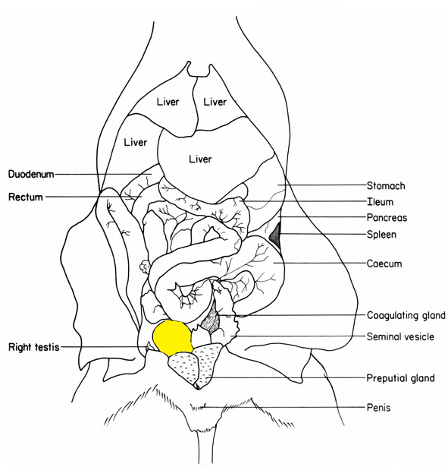
Bladder
Rostral
Caudal

Figure 2.1: Abdominal viscera of the mouse in situ following rostral-caudal midline incision. The whole pelvic region, containing the bladder, urethra, testes, vas deferens, seminal vesicles, ureters, and kidneys was removed and placed in the recording chamber. Diagram adapted from Margaret J. Cook’s “Anatomy of the laboratory mouse”.

A.
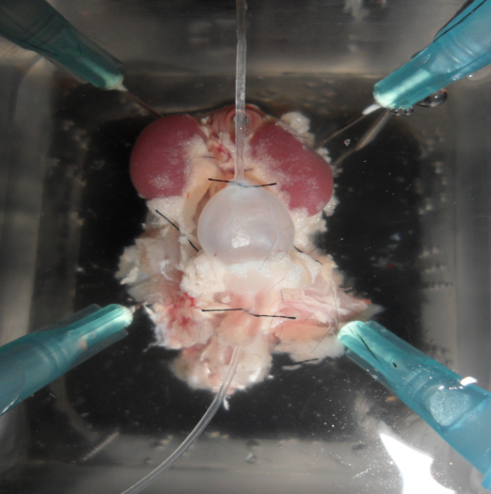
1
2
3
4
6
7
8
- Bladder
- Right kidney
- Left kidney
- Ureter
- Urethra
- Double lumen catheter
- Urethral catheter
- Recording chamber
5

B.

Pressure transducer
Outflow
3-way tap
Double lumen catheter
Bladder
Urethra
Infusion pump
Catheter
Afferent nerve bundles
Glass electrode

Figure 2.2: The experimental preparation enabled simultaneous recording of intraluminal pressure and afferent nerve firing in response to distension of the bladder. A, A photograph of the catheterised pelvic region within the recording chamber. B, A cartoon of the recording preparation.
- Urinary bladder
- Urethra
- Right ureter
- Left ureter
- Right kidney
- Left kidney
- Nerve bundles
- Catheter in urethra
- Catheter in bladder dome
- Recording chamber inflow
- Recording chamber outflow
- Black polythene
- Glass electrode

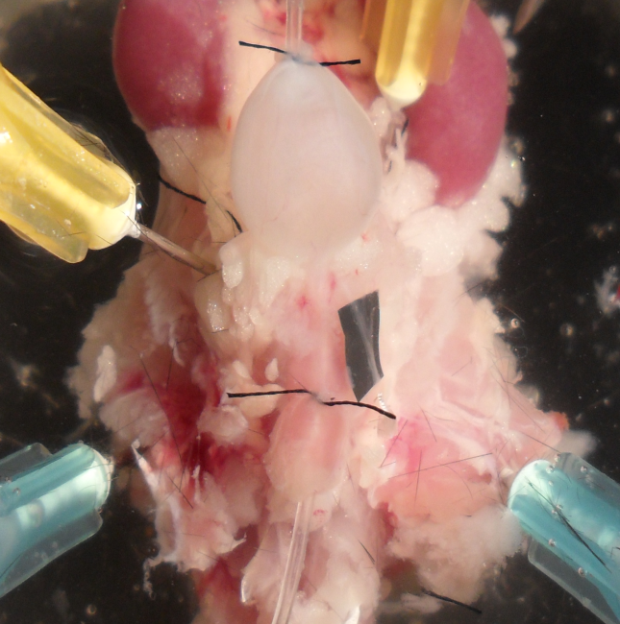
- Bladder
- Right kidney
- Left kidney
- Ureter
- Urethra
- Double lumen catheter
- Urethral catheter
- Afferent nerve bundle
1
2
3
4
5
6
7
8
A.

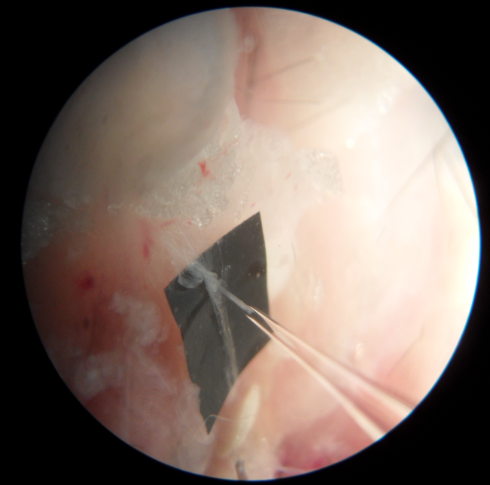
- Bladder
- Afferent nerve bundle
- Glass recording electrode
1
2
3
B.

Figure 2.3: Afferent nerve dissection of the mouse urinary bladder. A, A photograph of the catheterised pelvic region within the recording chamber detailing the location of the afferent nerve fibres. The afferent nerve fibres extended from the base of the bladder extending to the spinal cord. B, A photograph of an afferent nerve bundle inserted into the recording electrode.

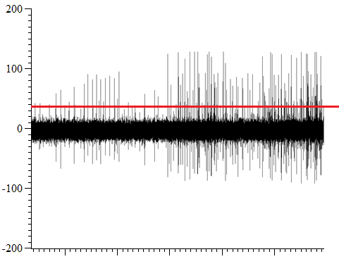
Afferent nerve firing (µV)
5 s
Time (s)

Figure 2.4: Example of threshold setting for ‘spike counting’.
The threshold (shown here by a horizontal red line) for spike counting was set to the peak of the smallest identifiable action potential spike. Any spike with amplitude above the set threshold was counted, any with a smaller amplitude were recorded but not counted in the histogram of afferent nerve response.

2.2 Experimental Protocol

Tissue viability, nerve reproducibility and ramp distension of the bladder.

Following set –up of the recording preparation, the bladder was filled at a rate of 100µl/min with isotonic saline to a maximum intraluminal pressure of 50mmHg, by closing the tap on the outflow catheter and turning on the infusion pump. When an intraluminal pressure (IP) of 50mmHg was reached, the tap was opened and the infusion pump turned off, allowing the bladder to drain.
The intraluminal pressure trace of this distension was examined to ensure that;
- the bladder was able to distend to 50mmHg
- following distension of the bladder, once the outflow tap was opened, the intraluminal pressure of the bladder returned to baseline (0mmHg) directly, demonstrating effective drainage of the bladder
Likewise, the afferent nerve response to distension was examined to ensure that;
- the afferent nerve units in the selected recording bundle were distension sensitive
- afferent nerve firing continued to 50mmHg, and that nerve units were not dislodged from the recording electrode by distortion of the bladder wall as a result of distension

Following observation of this distension, any necessary adjustments were made to the preparation, for example adjusting the sutures to correct bladder filling, or adjustment of the recording threshold (figure 2.4) and again the distension and observation process repeated to ensure stability and viability of the mouse bladder preparation.

Equilibration and control distension

Following successful identification of an afferent nerve bundle and assessment of tissue viability, the preparation was allowed to rest (no distension and intraluminal perfusion halted) for 1 hour to allow recovery from trauma as a consequence of tissue and nerve dissection. A distension of the bladder was performed following 60 minutes equilibration to ensure no demise of the afferent nerve response or disruption of bladder filling or emptying during the equilibration period.
At this point assuming all parameters were stable, no further adjustments to the recording preparation or threshold determination for afferent nerve recording were performed.
Before application of any experimental solutions, three control distensions were performed displaying reproducibility in all assessed parameters, i.e. compliance and afferent nerve firing in response to distension and at baseline.
Throughout all experiments in this thesis, distension of the bladder was performed every 10 minutes by closure of the outflow tap and perfusion of the intraluminal solution at 100µl/min, to a maximum IP of 50mmHg, at which point the outflow tap was opened and the bladder freely drained of intraluminal fluid. The bladder was continuously perfused with the intraluminal solution during the 10 minute period between bladder distensions at 100 µl/min with no rise in intraluminal pressure ensured by a significantly larger outflow tube on the double lumen catheter relative to the tube for measurement of intraluminal pressure. Any amendment to this standard procedure is described in the relevant section of this thesis.

Continued vs. discontinued perfusion during the period between bladder distensions.
During set-up and equilibration of the preparation, the bladder was not continuously perfused with the saline solution.
In order to allow continued and maximum exposure of the bladder to certain pharmacological agents in this thesis, it was necessary to continuously perfuse the lumen of the bladder during the 10 minutes between bladder distensions. In order to control for this, during the control period the bladder lumen was continuously perfused at 100 µl/min during control periods.
To achieve continuous perfusion of the bladder without causing bladder distension, it was important to ensure that the outflow catheter was significantly large enough to allow efficient and complete drainage whilst the bladder was continually filled by the infusion pump at 100 µl/min via the urethral catheter. Continuous intraluminal perfusion was used throughout this thesis, unless otherwise stated in experimental protocols in the individual results sections.

2.3 Drugs, dilutions and their application

Drugs

Drugs were obtained from either Sigma-Aldrich (UK), or Tocris Bioscience (Bristol, UK), and stored according to manufacturer specifications until use. The concentrations used were determined using data in the literature, or derived from preliminary laboratory experiments.

Solubility and dilution

Data from the drug manufacturer was used to determine solubility, and used to dilute the drug to a stock concentration.
The stock solution was then further dissolved in either isotonic saline or Krebs- bicarbonate solution, for intraluminal and extraluminal application respectively.
For clarity, specific details for each drug used in this thesis can be found in each individual chapter.

Intraluminal drug application

Drug/solution application to the bladder lumen and urothelial surface was achieved by dilution of the drug in the syringe solution, isotonic saline, unless otherwise stated. All drugs could be applied continually in this manner via the urethral catheter at a stable rate (100ul-min), without causing bladder distension if the tap on the outflow port was left open.

Extraluminal drug application

Application of drugs to the extraluminal surface of the bladder was achieved by diluting the drug in the Krebs solution and allowing it to perfuse into the bath. In the case of the low Ca²⁺ experiments, the external Krebs solution was replaced via bath perfusion with a low Ca²⁺ Krebs bicarbonate solution previously bubbled with carbogen (95%O₂/5%CO₂) to ensure constant pH and oxygenation.
Specific details regarding timing of drug exposure and dilution are described individually in each chapter.

2.4 Statistical analysis of data obtained from electrophysiology recordings

The in vitro preparation described enabled the measurement of different parameters simultaneously, providing experimental evidence to give insight into both neuronal and muscular properties of the bladder.

Mean baseline afferent nerve firing

Baseline nerve activity was determined by calculation of the mean afferent nerve activity (imp s⁻¹) during the 300 second (5 minute) period immediately prior to bladder distension, and then subtracting this value from the afferent nerve discharge at every 5 mmHg increase in intraluminal pressure during the distension, from 0 to 50mmHg.
Data was plotted as bar graphs of time (mins) versus afferent nerve firing (imp s⁻¹) and statistical analysis performed using 1-way repeated measures ANOVA with Bonferroni post-test, where P<0.05 was deemed statistically significant.

The afferent nerve response to ramp distension of the mouse bladder

Changes in afferent firing in response to bladder distension were expressed as the change (∆) in afferent nerve activity per second from baseline nerve activity (imp s⁻¹). Data was plotted as an x/y plot of intraluminal pressure (mmHg) and change in afferent nerve firing from baseline (∆ imp s⁻¹) and statistical analysis performed using 2-way repeated measures ANOVA with Bonferroni post-test, where P<0.05 was deemed statistically significant.

Bladder compliance

The relationship between bladder intraluminal pressure (mmHg) and volume (µl) was used as a measure of bladder compliance. As the bladder was filled at a constant rate (100µl/min), it was possible to calculate volume from the time taken to fill the bladder to 50mmHg from the equation: Volume (µl) = Perfusion rate (µl/min) x Time (s).
In contrast to other studies where compliance is expressed as pressure at a specific volume, in these experiments the bladders were filled to a known pressure at a constant rate rather than to a set volume. This ensured that each bladder received the same mechanical stimulus, and controlled for the variability between biological variations in bladder size. Bladder compliance was plotted as an x/y plot of intraluminal pressure (mmHg) and bladder volume (µl) and statistical significance calculated by 2 way-repeated measures ANOVA with Bonferroni post-test, with P<0.05 deemed significant.

Statistical analysis and significance
The data in this thesis was presented as mean ± S.E.M and, the majority (mechanosensitivity responses and compliance data) analysed using 2 way repeated measures (RM) analysis of variance (ANOVA) with Bonferroni post-test. All data analysis was performed using GraphPad Prism version 5.00 (for Windows, GraphPad Software, San Diego California USA, www.graphpad.com). Baseline afferent nerve activity was analysed using 1 way repeated measures ANOVA with Bonferroni post-test. Where different, details of the statistical test used for analysis is described in the relevant sections.
All protocols in this thesis had their own in built control (i.e. were compared to the third control distension in the individual experiment) to which experimental data was statistically analysed. Washout measurements were obtained from the 30 minutes washout distension.
Area under the curve (AUC) analysis was conducted to calculate the area under individual response curves, in each experiment, to enable the percentage change (from AUC values) for a particular parameter between different time points to be calculated. The mean percentage change was then calculated from the total number of experiments and quoted in the text to give an insight into the magnitude of change.
P values, as determined by statistical analysis, were quoted, with P<0.05 deemed significant. The asterisk (*) rating system was also used alongside quotation of the P value, where * = P<0.05, ** = P<0.01, *** = P<0.001 and **** = P<0.0001.
Statistical significance as calculated from the Bonferroni post-test was indicated with asterisks (*) on the appropriate data points within the graph (where* =P<0.05, **=P<0.01, ***= P<0.001, ****=P<0.0001).

2.5 Single unit analysis

In experiments where single nerve units were clearly identifiable, displaying sufficiently different spike shape and amplitude to enable accurate discrimination of individual spikes, single unit analysis was performed.
The electrophysiological recording method used for recording afferent nerve activity in this thesis enabled ‘multi-unit’ recording from a number of branches of both the hypogastric and pelvic afferent nerves innervating the bladder. Further to this, by distending the bladder beyond physiological pressures (approx. 15mmHg) to 50mmHg, the activity of both low and high threshold afferents could be measured. By performing ‘offline’ analysis of the recorded data using the wavemarking function of Spike 2 software (Version 7.02), the individual single units within the recording bundle could be identified.

Template set-up
Templates were created for action potential spikes within each individual experiment as demonstrated in figure 2.5A. The number of similar spikes to warrant creation of a template was set to 100, and no template was created for shapes rarer than 1 in 50.

Matching ‘spikes’ to templates (‘wavemarking’)
Individual spikes were then classified to a particular template. Spikes were assigned to a particular template based on a minimum of 75% of the spike shape fitting within the template, allowing for a maximum of 10% change in amplitude as a result of experimental procedures.

Verification of templates using principal component analysis
Principal component analysis (PCA) is a mathematical procedure based on singular value decomposition (SVD) that extracts features of the waveform data that contribute greatly to the differences between the waveforms that make up the spike shape. The analysis uses SVD to separate the shapes of individual single units to generate arbitrary waveforms based on amplitude, latency, slope and area measurements of each spike shape. These data were then normalised, shifted and scaled using three scale factors, and the clusters could then be visualised in 3D. The degree of overlap between clusters was analysed by eye using the 3 dimensional display software in Spike 2 (V7.02). Clusters that overlapped were considered not significantly different enough to be classified as distinct single units, and therefore were re-classified as a single nerve fibre. Using this software, template parameters and spike matching by single unit analysis was verified. An example of PCA analysis is shown in figure 2.6B.

Single unit data presentation and analysis

Following successful PCA verified spike sorting to the defined templates, each unit was then further categorised into low and high threshold afferent fibres, based on activation threshold. Units that were activated below 15mmHg intraluminal pressure were classified as low threshold afferent fibres, and those activated at 15mmHg or above were classified as high threshold afferents (Rong W et al., 2002).
Afferent nerve firing data for each single unit was collated depending on activation threshold, and two x/y plots were produced to display low and high threshold nerve firing separately.
Data was plotted as an x/y plot of pressure (mmHg) and afferent nerve firing ( imp s⁻¹) and statistical analysis performed using 2-way repeated measures ANOVA with Bonferroni post-test, where P<0.05 was deemed significant.

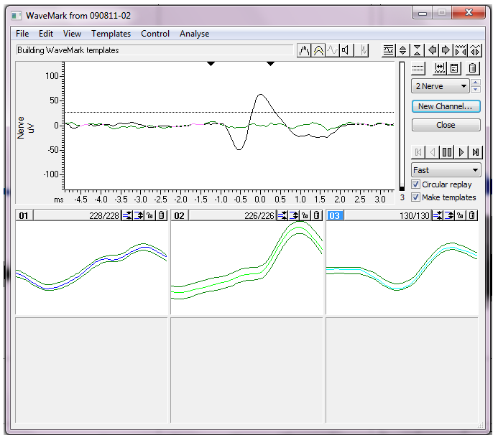
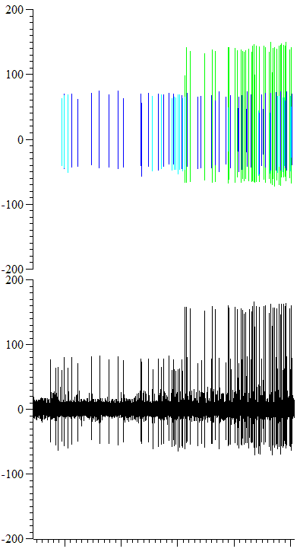
A.
Nerve (µV)
Wavemark (µV)
Raw nerve activity
Templates shapes / coding
Wavemark
Raw nerve activity
5 s
Time (s)
Nerve (µV)

B.

Figure 2.5: Example of threshold setting for ‘spike counting’.
A, One template was created per similar spike shape that occurred at least 100 times. Spikes were matched to the created templates based on a minimum of 75% of a spike shape lying within the template. B, individual spikes of the raw nerve activity were assigned codes following spike matching.

B.
A.
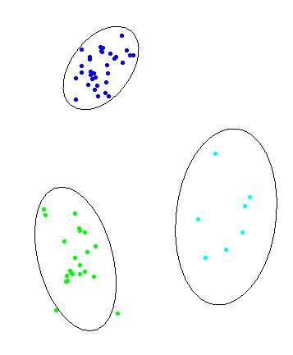
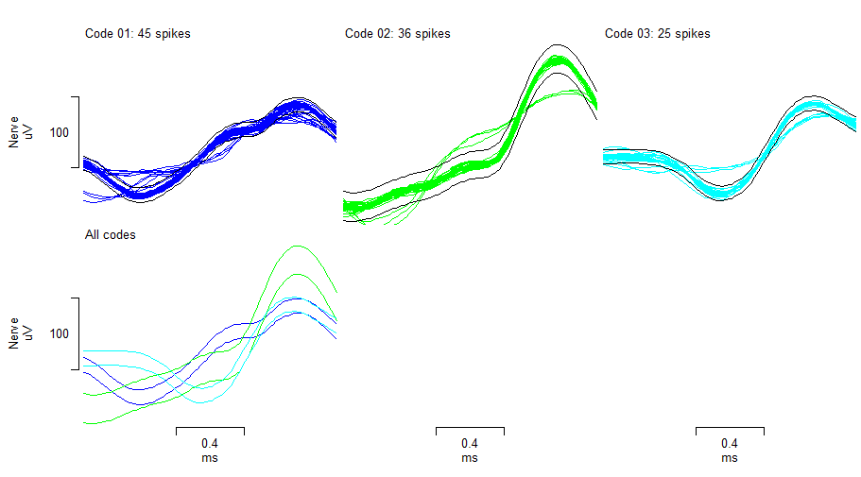

Figure 2.6: Principal component analysis confirmed that the created templates used for wavemarking were sufficiently different from each other to be classified as unique units.
A, Action potential spikes were matched to the templates based on a minimum of 75% of a spike shape lying within the template. The variability between the different template shapes is clearly shown in this example. B, Templates were verified as unique in comparison to one another by principal component analysis. Clusters that overlapped were considered not significantly different enough to be classified as distinct single units, and therefore the templates and spikes were re-classified as a single nerve fibre. In the example shown, no overlapping of clusters occurred confirming that the templates used for wavemarking of action potentials were significantly different to one another to be deemed separate units.

2.6 Bladder Histology

In order to assess the integrity of the bladder urothelium following control procedures and score the degree of urothelial damage by protamine sulphate (see chapter 5) it was necessary to demonstrate and score the integrity of the urothelium using histology and a specifically designed scoring process.

Fixation
Following experimental procedures, bladders were immediately placed in a vial containing 10% formalin solution (Sigma Aldrich UK), typically 10 times the volume of tissue to be fixed.

JB4 resin embedding

Following fixation, the bladder samples were removed from the formalin, and washed twice in PBS (1 hour per wash) in order to remove the excess, un-reacted fixative. Samples were then dehydrated through increasing concentrations of ethanol (70%, 90%, 100%, fresh 100%), 1 hour per concentration, before infiltration in freshly prepared catalysed JB4 solution A, (100ml JB-4 solution A, 0.9g benzoyl peroxide) overnight as a minimum, or until the samples had sunk to the bottom of the specimen jar. The samples were then embedded in fresh catalysed JB4 solution plus accelerator solution, (50ml JB4 solution A, 0.45g benzoyl peroxide, 0.8ml JB4 solution B), mounted on an aluminium stub, and left in a 4ºC fridge over-night to harden.
Once hardened, the blocks were washed in 70% alcohol in order to remove excess unpolymerised resin, and then left to dry in a fume hood for 2 hours.

Sectioning

Resin embedded bladders were sectioned at 2µm using a microtome (LKB Bromma historange model 2218) and glass blade. Sectioning began 20µm down the block from the beginning of the tissue (i.e. when the bladder tissue was present on the section) at which point one section was made (2 µm thickness), and then moved down the block 10µm before taking a second section, another 10µm through the block for section 3, and so forth up to a maximum of 6 sections per bladder. This enabled the assessment of urothelial integrity throughout a larger proportion of the bladder and allowed for possible regional variation within the bladder Following sectioning, each section was allowed to float on room temperature distilled water to straighten out any creases as a result of sectioning, before finally being placed onto a microscope slide (Fisherbrand, frosted microscope slides), and dried on a hotplate overnight.

H&E Staining
Haematoxylin and Eosin Y staining (H&E) was used to visualise the gross morphology of the bladder and enabled differences in urothelial integrity as a result of different treatments to be examined. The sections were first stained with Gills haematoxylin (Sigma Aldrich UK) for 5 minutes, by applying, in excess, to the surface of the section. The slides were then rinsed in running water to remove excess dye. Sections were then counterstained in 1% eosin Y (Sigma Aldrich UK) in phosphate buffer for 1 minute, and then were again washed in running water to remove the excess stain. Slides were left to dry on a hotplate at 20ºC and finally mounted with a glass coverslip using polymount solution (Fisher Scientific).

Imaging and scoring
Sections were visualised using a standard light microscope (Olympus BX51) at x 20 magnification and photographs of sample sections were taken using an Olympus Colourview II camera. The whole urothelial surface was examined for damage and scored based on a 5 point scale as outlined in table 2.1. 6 bladders per experimental treatment procedure were embedded and 6 repeat sections were made per bladder sample (as described), yielding 36 sections to be scored per experimental procedure. All sections were scored and then second scored by an independent histologist.

Score | Urothelial damage (%)
0 | 0
1 | <25%
2 | 25 - 50%
3 | 50% - 75%
4 | 75% - 100%

Table 2.1: Graded scoring system devised to assess the integrity of the urothelium.

Data analysis
Both sets of scores were collated, and the mean score per bladder was calculated. Finally, bladder samples were sorted into their respective treatment groups (either control or protamine sulphate), and the mean score for each bladder was plotted on a scatter plot of treatment and urothelial damage score. Data was analysed using unpaired student’s T-test, with P<0.05 deemed significant.

References

Rong W, Spyer KM, & Burnstock G. (2002). Activation and sensitisation of low and high threshold afferent fibres mediated by P2X receptors in the mouse urinary bladder. The Journal of Physiology, 541, 591-600.

