|  |
| --- |
| Chapter 6 |
| Mechanism |
| Use of a pharmacological cocktail to inhibit urothelial mediator release |

# 6.1 Introduction

Classically, the bladder urothelium has been appreciated primarily for its barrier function preventing the passage of toxic substances in the urine from penetrating into the deeper muscle tissue layers and altering afferent nerve firing or affecting muscle contractions and tone. However, recent evidence is accumulating to support the role of the urothelium as a mechanosensor, with the ability to detect and respond to, and release mediators, as shown in figure 6.1, thereby altering either, or both, muscle function or the sensitivity of the afferent nerve fibres depending on their specific actions and the level of mediator in the bladder (Birder, 2010).

Examples of the expression of numerous receptors and ion channels present on the urothelium include receptors for purines (P2X1-7, P2Y1,2,4), ACh, (muscarinic and nicotinic), cannabinoids (CB1 and CB2) and various TRP channels (TRPV1, TRPV2, TRPV4, TRPM8, TRPA1), amongst others. As well as expressing appropriate receptors on the urothelium in order to respond to stimulated release of mucosal and neuronal mediators, the urothelium also has been shown to be capable of modulating, inhibiting or exciting sensory nerve activity and muscle function. Neuromediators released from the urothelium include, ATP, ACh, prostaglandins, cannabinoids, nitric oxide (NO), substance P, nerve growth factor, and the unidentified urothelial derived inhibitory factor (UDIF). Studies have shown that in response to urothelial release of these mediators both afferent nerve and muscle activity could be inhibited or facilitated, depending on the mediator affected. These transmitters and receptors/ion channel signalling pathways, and specifically their effect on afferent nerve firing and the detrusor smooth muscle are discussed in detail in chapter 1.

The close anatomical proximity and complimentary release and binding of neuromodulators between the urothelium and afferent nerve terminals and the observed signalling between the urothelium, detrusor muscle and afferent nerve fibres led to the proposal of the ‘sensory web’ mechanism encompassing all the signalling processes and interactions between efferent and afferent bladder nerves, urothelial cells, myofibroblasts and the detrusor smooth muscle (Apodaca *et al.*, 2007).

In some pathological conditions of the bladder, for example in interstitial cystitis, the urothelial layer is disrupted; therefore there is increased permeability of the bladder to potentially toxic substances in the urine. Aside from this, alterations in the levels of chemical neuromediators such as ATP and NO have been reported, and it is hypothesised that these changes in mediator release lead to the increase in afferent nerve sensitivity and therefore the symptom of pain that accompanies interstitial cystitis (Apodaca *et al.*, 2003). Therefore, more recently research has begun to focus on the signalling between the urothelium and afferent nerve terminals with a view for development of potential therapeutic pathways for various bladder disorders.

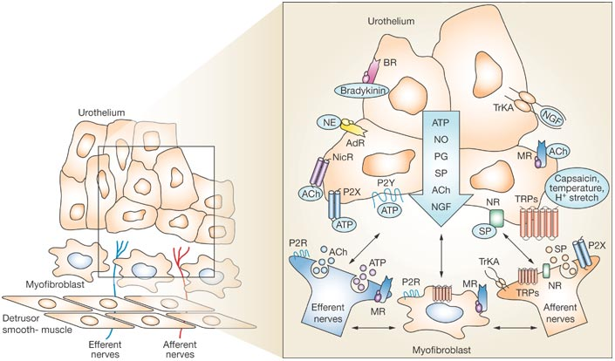

**Figure 6.1: Hypothetical model depicting possible interactions between the urothelium, myofibroblasts, the detrusor muscle and the underlying nerve supply.**

Stimulation of the receptors and ion channels on urothelial cells either via autocrine (i.e. release of mediators from urothelial cells) or paracrine mechanisms (i.e. release from nearby nerve terminals), initiates mediator release from the urothelium. These mediators then target bladder nerves, detrusor muscle cells, myofibroblasts and other cell types for example inflammatory cells (not shown). Abbreviations: NO, nitric oxide; PG, prostaglandins; SP, substance P; Ach, acetylcholine; NGF, nerve growth factor; AdR, adrenergic receptor; NicR, nicotinic receptor; MR, muscarinic receptor; P2X/P2Y, purinergic receptors; P2R, purinergic 2 unidentified subtype; Trk-A, receptor tyrosine kinase A; TRPs, transient receptor potential channels, (Birder *et al.*, 2007)

# Investigating the identity of the inhibitory pathway stimulated by high K+ solution perfusion.

# 6.2 Aims and hypothesis

The model of the ‘sensory web’ proposes release of mediators from the urothelium that alter bladder function, for example muscle contractility and afferent nerve sensitivity (Apodaca *et al.*, 2007). Following stimulation of urothelial mediator release with perfusion of a high K+ solution afferent nerve sensitivity at baseline and in response to distension of the bladder was decreased, an effect that was abolished in mice bladders pre-treated with protamine sulphate, suggesting a urothelial origin for the mediator (s) responsible for the inhibitory effect on sensory nerve activity (see chapter 5).

The aim of the experiments presented in this chapter was to determine the urothelial neurotransmitter mechanism stimulated by high K+ solution exposure, in order to identify the pathway involved in mediating the inhibitory response.

By using a cocktail of antagonists to inhibit certain signalling pathways, it was hypothesised that the inhibitory effect on sensory nerve activity following perfusion of the high K+ solution would be abolished. It would then be possible to identify the pathway responsible for the inhibitory effect by removing antagonists to each pathway one by one from the cocktail, until the reappearance of the inhibition of afferent nerve firing in response to high K+ stimulation.

Following a literature search for potential candidates for the mediator(s) responsible for this inhibition of afferent nerve firing in response to high K+ perfusion, it was hypothesised that this inhibitory effect could have been due to ATP, cannabinoids, prostaglandins, nitric oxide or ACh signalling (as summarised in figure 6.2), and so antagonists to these pathways were used as a starting point for investigation.

**?**

**?**

**?**

**?**

**?**

**Figure 6.2: Hypothesised candidates for the mediator/s responsible for the inhibition in afferent nerve firing in response to distension following high K+ stimulation.**

It is hypothesised that the inhibitory effect on mechanosensitivity caused by high K+ solution perfusion is due to ATP, cannabinoids, prostaglandins, nitric oxide or/and ACh signalling. ‘Cocktails’ of antagonists were used to elucidate the mechanism. Details of the corresponding section of this chapter in which data relating to each mediator is presented are shown.

# 6.3 Experimental Method

## Drugs and dilutions

A previous study investigating the urothelial source of an inhibitory factor responsible for inhibition of detrusor smooth muscle contractions blocked, amongst other pathways, NO pathways (50µM L-NOARG), prostaglandins (5µM indomethacin) and purinergic signalling (100µM suramin) by bath application of the antagonists (Hawthorn *et al.*, 2000).

Muscarinic receptor pathways have been implicated in the depression of sensory transduction in the mouse bladder, and stimulation of muscarinic receptors with a range of agonists, significantly inhibited the afferent response to bladder distension (Daly *et al.*, 2010).

Cannabinoid receptors have also been implicated in mediating inhibition of detrusor muscle contraction. CB1 receptors have been shown to mediate the inhibition of electrically induced detrusor muscle contractions in the mouse bladder (Pertwee *et al.*, 1996). Previous animal bladder experiments have also suggested a role of CB2 receptors in cholinergic nerve activity and afferent nerve signalling, and shown that following CB2 receptor activation, nerve induced bladder contractions were decreased, and there was an increase in the intervals between micturition (Gratzke *et al.*, 2009) .

Cannabinoid receptors 1 and 2, Ach/muscarinic receptor pathways, prostaglandins, purinergic signalling/ATP, and nitric oxide pathways were blocked with the appropriate antagonists in a specifically designed ‘cocktail’ which was applied intraluminally to ensure complete block of the individual pathways (table 6.1). Table 6.2 summarises the drugs used in the various pharmacological cocktails.

|  |  |  |  |  |  |  |
| --- | --- | --- | --- | --- | --- | --- |
| **Drug** | **Use** | **Supplier** | **[Stock]** | **Vehicle** | **Final**  **[intraluminal]** | **\*\*% vehicle** |
| **SR141716A** | CB1receptor  antagonist | GSK | 30mM | 100% DMSO | 10µM | 0.03% DMSO |
| **SR144528** | CB2 receptor antagonist | GSK | 30mM | 100% DMSO | 10µM | 0.03% DMSO |
| **Atropine** | Competitive nonselective antagonist of muscarinic acetylcholine receptors. | Sigma | 30mM | 100% H2O | 10µM | 0.03% H2O |
| **Suramin** | Non-selective P2 purinergic antagonist | Sigma | *N/A | *N/A | 500 µM | *N/A |
| **Indomethacin** | Cyclooxgenase (COX) inhibitor | Sigma | 100mM | 100% DMSO | 50µM | 0.05% DMSO |
| **L-NAME** | NO synthase inhibitor | Sigma | 100mM | 100% H2O | 1mM | 1% H2O |

*Supplier product information specifications stated that suramin stock solutions deteriorate on storage and therefore should be used immediately following preparation, so suramin was dissolved directly into the perfusion solution (saline/ high K+ solution) immediately prior to use. Incidentally, manufacturer specifications also stated that suramin should be protected from light, so the entire protocol from suramin preparation and experimental application was performed in the dark.

**These vehicle concentrations were used in subsequent vehicle control experiments (see section 6.4).

**Table 6.1: Antagonists used in the cocktails used to investigate the identity of the pathway activated by high K+ stimulation.** Antagonists were diluted to the final concentrations as stated above from the stock solutions. The final percentage vehicle of the antagonists was calculated and used in vehicle control experiments.

|  |  |  |  |  |  |  |  |
| --- | --- | --- | --- | --- | --- | --- | --- |
| Name of cocktail | Section | SR141716A (10µM) | SR144528  (10µM) | Atropine  (10µM) | Suramin  (500µM) | Indomethacin  (50µM) | L-NAME  (1mM) |
| Cocktail | 6.5 | ✓ | ✓ | ✓ | ✓ | ✓ | ✓ |
| Cocktail 2 | 6.6 | 🗶 | 🗶 | ✓ | ✓ | ✓ | ✓ |
| Cocktail 3 | 6.7 | 🗶 | 🗶 | 🗶 | ✓ | ✓ | ✓ |
| Indomethacin/L-NAME | 6.8 | 🗶 | 🗶 | 🗶 | 🗶 | ✓ | ✓ |
| Indomethacin | 6.9 | 🗶 | 🗶 | 🗶 | 🗶 | ✓ | 🗶 |
| L-NAME | 6.10 | 🗶 | 🗶 | 🗶 | 🗶 | 🗶 | ✓ |

**Table 6.2: Composition of the antagonists used in each cocktail, with details of the section number in this chapter where data for each individual cocktail can be found.** ✓indicates present in the cocktail, 🗶 indicates not present in the cocktail.

## Solutions

### Extraluminal solution

Carbogenated (95% O2 and 5% CO2) standard Krebs solution (as described in chapter 2) was continuously perfused throughout the protocol.

### Intraluminal solution

During control and washout periods, the bladder was continuously perfused with standard saline solution (150mM NaCl) at a constant rate of 100µl/min.

As highlighted in table 6.2, each cocktail was dissolved, in turn, in 150mM NaCl (saline) and applied to the lumen of the bladder via continuous intraluminal perfusion at 100µl/min.

The same cocktail solution was then dissolved in the high K+ solution (50mM KCl/ 100mM NaCl) used previously (see chapter 5) and again applied to the urothelial surface of the bladder via continuous intraluminal perfusion at 100 µl/min.

## Protocol

Figure 6.3 shows a schematic of the protocol used for administration of each of the pharmacological cocktails designed to block a selection of urothelial pathways prior to and during high K+ stimulation.

The mouse bladder was prepared for electrophysiological recording as previously described in detail in chapter 2.

In order to ensure complete block of the inhibitory urothelial pathways, and to assess the effect of the cocktail alone on bladder afferent nerve firing and compliance, following 30 minutes control, the bladder was continuously perfused (100µl/min) with one of the cocktails of antagonists (for composition of individual cocktails see table 6.2) in saline for 1 hour. The large outflow port of the catheter allowed efficient drainage of the internally perfused solution, and ensured no distension or pressure increase of the bladder during continuous perfusion. Distensions to 50mmHg IP were performed every 10 minutes with the saline/cocktail solution, by closing the outflow tap on the double lumen catheter.

Following 1 hour intraluminal perfusion with the cocktail (in saline), the high K+ solution (50mM KCl/ 100mM NaCl), in the presence of the cocktail of antagonists was continuously perfused, intraluminally, for 30 minutes. Distension to 50mmHg intraluminal pressure was performed every 10 minutes as previously.

Immediately following the 3rd distension with the high K+ solution in the presence of the cocktail, 150mM NaCl control saline solution was re-perfused. 3 washout distensions were performed (to 50mmHg intraluminal pressure, every 10 minutes), before completion of the experiment.

It is important to note that the ‘dead space’ of the catheter tubing, from syringe pump to bladder, required approximately 10 seconds to deliver the solution, and approximately 30 seconds for the bladder to completely empty following distension. However, to avoid variability due to bladder size, the 10 minutes between distensions was timed from the end of the previous distension (i.e. as soon as the tap was opened on the drainage port of the double lumen catheter).

IP (mmHg)

10 mins

**Control**

**Internal**: 150mM NaCl

**External:** Standard Krebs

**Washout**

**Internal**: 150mM NaCl

**External:** Standard Krebs

**Cocktail in saline**

**Internal**: 150mM NaCl + cocktail

**External:** Standard Krebs



**High K+ with cocktail**

**Internal**: 50mM/100 NaCl + cocktail

**External:** Standard Krebs



10 mins measurement

30 mins measurement

Washout measurement

Control measurement

30mins measurement

60 mins measurement (‘new control’)

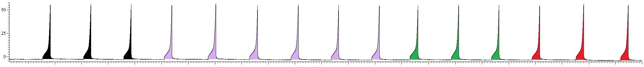

0

**Figure 6.3: A schematic of the protocol for intraluminal application of the cocktail alongside high K+ stimulation.**

Following 3 control distensions, the intraluminal perfusion solution was replaced with one of the ‘cocktails’ of antagonists (see table 6.2) in saline and continuously perfused (at 100µl/min) for 60 minutes, with a distension to 50mmHg IP performed every 10 minutes. The intraluminal perfusion solution was then changed to cocktail in the high K+ solution (50mM KCl/100mM NaCl) and continuously perfused (at 100µl/min) for 30 minutes, with a distension to 50mmHg IP performed every 10 minutes. Finally, the bladder was intraluminally perfused (at 100µl/min) with standard saline solution for 30 minutes, with a distension to 50mmHg IP performed every 10 minutes. Measurements for data analysis were taken from the time points indicated.

## Data Analysis

Data was analysed as previously described, in detail, in chapters 2 and 3.

30 and 60 minutes cocktail in saline were compared to 30 minutes saline control in order to establish the effects of the cocktail alone on afferent nerve firing and compliance. 60 minutes cocktail in saline was then used as the ‘new control’, to which 10 and 30minutes high K+ plus cocktail and 30 minutes saline washout were compared.

In all analysis and data presentation in this chapter, high K+ refers to the 50mMKCl/ 100mM NaCl solution concentration and details of the specific compositions of each cocktail are provided in table 6.2.

Percentages quoted with regard to percentage change in afferent nerve firing or bladder compliance were calculated in each individual experiment by calculating the percentage change for each parameter to control, and then calculating the mean percentage change for the total number of experiments performed.

# 6.4 Vehicle control (full cocktail)

## Aim

Prior to conducting the high K+ experiments in the presence of the inhibitors as previously outlined, a series of vehicle controls were performed to ensure that;

1. the presence of the vehicle used to dilute each of the drugs had no effect on mechanosensitivity, compliance or spontaneous afferent nerve firing alone
2. the presence of the drug vehicles did not by themselves prevent the effects of high K+ solution perfusion.

In these experiments, the full cocktail vehicle was perfused following the same protocol as for perfusion of the individual cocktails as shown in figure 6.3.

## Results

### Overview

The data from these experiments demonstrated that exposure of the bladder to the full cocktail vehicle in saline (0.11% DMSO, and 1.03% H2O), had no effect on mechanosensitivity or on bladder compliance (figure 6.4).

When applied with the high K+ solution, the inhibition of afferent nerve firing in response to distension and at baseline persisted, confirming that the antagonist vehicle alone was not sufficient to attenuate the inhibitory effect seen following high K+ stimulation (figure 6.4). Furthermore, compliance remained unaffected by the presence of the full cocktail vehicle in the high K+ solution.

These data show that the cocktail vehicle itself is insufficient to alter the inhibitory effect seen following high K+ stimulation, thereby providing evidence that any effect of the cocktails used throughout this chapter was not due to the presence of the antagonist vehicle.

### Perfusion of the cocktail vehicle in saline had no effect on the afferent nerve response to distension.

Afferent nerve firing in response to bladder distension remained stable for 3 consecutive distensions prior to intraluminal perfusion of the cocktail vehicle in saline solution.

Following 30 minutes continuous intraluminal perfusion of the bladder with the cocktail vehicle in saline, afferent nerve firing in response to ramp distension was unaffected, relative to 30 minutes saline control (figure 6.5A). Similarly, following 60 minutes intraluminal perfusion of the cocktail vehicle in saline, the afferent nerve response to distension was unaffected, relative to 30 minutes saline control (figure 6.5B).

### Intraluminal perfusion of the high K+ solution exerted the same inhibitory effect even in the presence of the cocktail vehicle.

Immediately following intraluminal perfusion of the bladder with the cocktail vehicle in saline, the bladder was perfused with the high K+ solution, in the presence of the cocktail vehicle. 10 minutes intraluminal perfusion of the bladder with the high K+ solution in the presence of the cocktail vehicle decreased the afferent nerve response to distension by 34%, relative to 60 minutes vehicle in saline control (figure 6.6A). The reduction in the afferent nerve response to bladder distension was further augmented to a 57% decrease relative to 60 minutes vehicle in saline control, following 30 minutes intraluminal perfusion with the high K+ solution in the presence of the cocktail vehicle (figure 6.6B).

Following a 30 minute saline washout period, the afferent nerve response to bladder distension was unaffected relative to 60 minutes cocktail vehicle in saline control suggesting reversal of the inhibitory effect of high K+ and cocktail vehicle solution perfusion (figure 6.6C).

### Bladder compliance was unaffected by intraluminal perfusion of the cocktail vehicle in saline, and remained unaffected following intraluminal perfusion of the high K+ solution in the presence of the cocktail vehicle.

Bladder compliance remained stable for 3 consecutive distensions prior to continuous intraluminal perfusion of the cocktail vehicle in saline solution.

Following 30 minutes intraluminal perfusion of the bladder with the cocktail vehicle in saline, bladder compliance was unaffected relative to 30 minutes saline control (figure 6.7A). Bladder compliance remained unaffected, relative to 30 minutes saline control, following 60 minutes intraluminal perfusion of the cocktail vehicle in saline (figure 6.7B).

Subsequent intraluminal perfusion of the high K+ solution in the presence of the cocktail vehicle, for 10 minutes, had no effect on bladder compliance relative to 60 minutes cocktail vehicle in saline control (figure 6.8A). Similarly, 30 minutes intraluminal perfusion of the bladder with the high K+ solution in the presence of the cocktail vehicle had no effect on compliance of the bladder relative to 60 minutes cocktail vehicle in saline control (figure 6.8B).

Following exposure of the bladder to the high K+ and cocktail vehicle solution, saline was continuously perfused into the bladder for a 30 minute washout period. Bladder compliance remained unchanged relative to 60 minutes cocktail vehicle in saline control following 30 minutes saline washout (figure 6.8C).

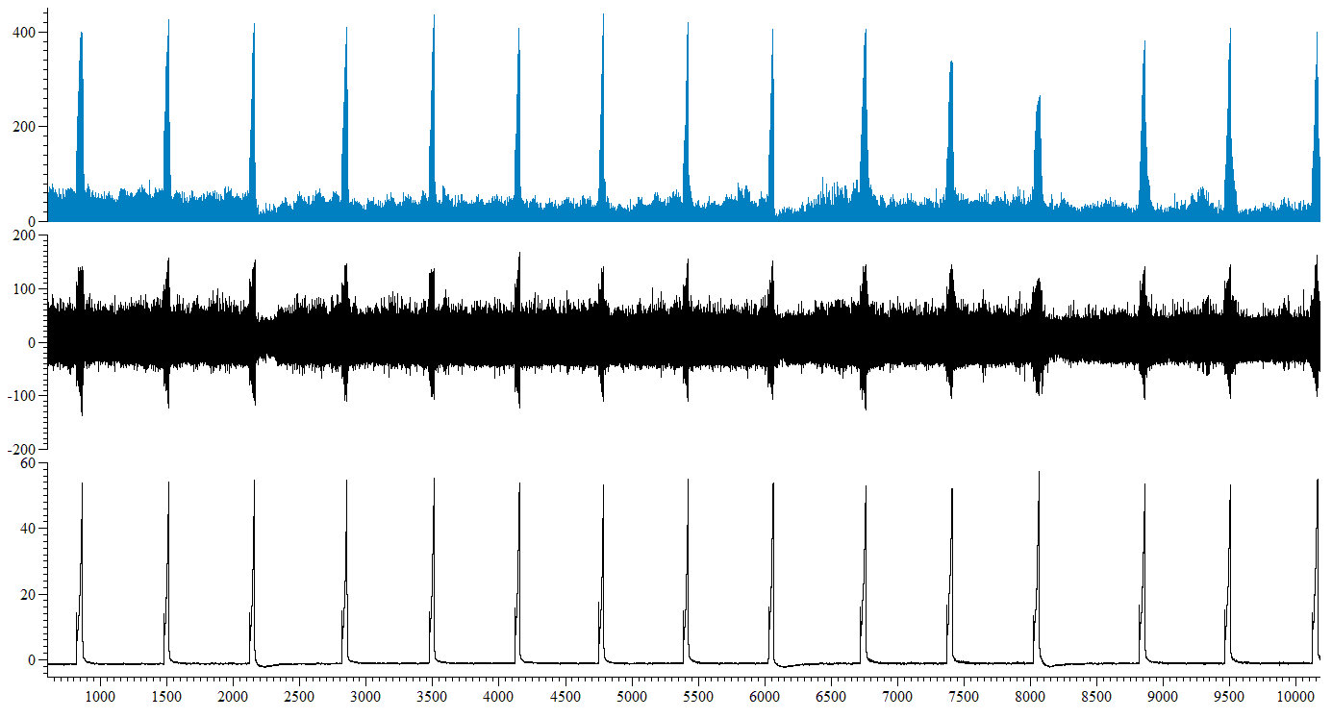

Saline

Saline

High K+ + cocktail vehicle

Saline + cocktail vehicle

Mean firing (imp s-1)

Nerve firing (µV)

IP (mmHg)

10 mins

Time (s)

**Figure 6.4: Screen-shot representative trace from a single experiment in which the cocktail vehicle was perfused intraluminally in saline.** Intraluminal perfusion of the cocktail vehicle in saline had no effect on mechanosensitivity, bladder compliance nor mean baseline afferent nerve firing, yet altered spontaneous afferent nerve firing. Mechanosensitivity, spontaneous and baseline afferent nerve firing were decreased following perfusion of the high K+ solution in the presence of the cocktail vehicle, whilst bladder compliance remained unaffected (n=6).



**A.**



**B.**

**Figure 6.5: Mechanosensitivity was unaffected by intraluminal perfusion of the bladder with the cocktail vehicle in saline.** A, 30 minutes intraluminal perfusion of the bladder with the cocktail vehicle in saline had no effect on the afferent nerve response to bladder distension, relative to 30 minutes saline control (P=0.29, n=6). B, Mechanosensitivity remained unaffected, relative to 30 minutes saline control ,following 60 minutes intraluminal perfusion of the cocktail vehicle in saline (P=0.18, n=6).



**A.**



**B.**



**C.**

**Figure 6.6: Intraluminal perfusion of the bladder with the high K+ solution in the presence of the cocktail vehicle inhibited the afferent nerve response to bladder distension.** A, Afferent nerve firing in response to distension was decreased, relative to 60 minutes cocktail vehicle in saline, following 10 minutes intraluminal perfusion of the bladder with the high K+ solution in the presence of the cocktail vehicle (*P=0.03, n=6). B, The afferent nerve response to bladder distension was inhibited, relative to 60 minutes vehicle in saline control, following 30 minutes exposure to the high K+ solution in the presence of the cocktail vehicle (*P=0.02, n=6). C, The afferent nerve response to distension at 30 minutes saline washout was unaffected relative to 60 minutes saline and cocktail vehicle control (P=0.22, n=6).



**A.**



**B.**

**Figure 6.7: Bladder compliance was unaffected by intraluminal perfusion of the bladder with the cocktail vehicle in saline.** A, 30 minutes intraluminal perfusion of the bladder with the cocktail vehicle in saline had no effect on bladder compliance relative to 30 minutes saline control (P=0.42, n=6). B, Compliance remained unaffected, relative to 30 minutes saline control ,following 60 minutes intraluminal perfusion of the cocktail vehicle in saline (P=0.75, n=6).



**A.**



**B.**



**C.**

**Figure 6.8: Bladder compliance was unaffected by intraluminal perfusion of the bladder with the high K+ solution in the presence of the cocktail vehicle.** A, 10 minutes intraluminal perfusion of the bladder with the high K+ solution in the presence of the cocktail vehicle had no effect on bladder compliance relative to 60 minutes vehicle in saline control (P=0.49, n=6). B, Compliance remained unaffected, relative to 60 minutes vehicle in saline control ,following 30 minutes intraluminal perfusion of the high K+ solution in the presence of the cocktail vehicle (P=0.42, n=6). C, Bladder compliance remained stable following 30 minutes saline washout, relative to 60 minutes vehicle in saline control (P=0.54, n=6).

### Mean baseline afferent nerve firing remained unaffected by intraluminal perfusion of the cocktail vehicle in saline, but was decreased following intraluminal perfusion of the high K+ solution in the presence of the cocktail vehicle.

Mean baseline afferent nerve firing was not altered by intraluminal perfusion of the cocktail vehicle in saline (figure 6.9A). However, following intraluminal perfusion of the bladder with the high K+ solution in the presence of the cocktail vehicle, mean baseline afferent nerve firing was decreased relative to 55-60 minutes cocktail vehicle in saline control (figure 6.9B). Mean baseline afferent nerve firing was reduced by 88% relative to 55-60 minutes intraluminal perfusion of the cocktail vehicle in saline during 25-30 minutes perfusion of the high K+ solution in the presence of the cocktail vehicle (figure 6.9B).



**A.**



**B.**

**Figure 6.9: Mean baseline afferent nerve firing was unaffected by intraluminal perfusion of the cocktail vehicle in saline, but was decreased following perfusion of the high K+ solution in the presence of the cocktail vehicle.** A, Mean baseline afferent nerve firing was unaffected by intraluminal perfusion of the cocktail vehicle in saline (P=0.20, 1 way RM ANOVA with Bonferroni post-test, n=6). B, Following intraluminal perfusion of the high K+ solution in the presence of the cocktail vehicle, mean baseline afferent nerve firing was decreased (* P=0.02, 1 way RM ANOVA, n=6). Mean baseline afferent nerve firing was reduced , relative to 55-60 minutes intraluminal perfusion of the cocktail vehicle in saline during 25-30 minutes perfusion of the high K+ solution in the presence of the cocktail vehicle (*P<0.05, Bonferroni post-test, n= 6).

# 6.5 Results – Full cocktail

### Overview

The effect of intraluminal perfusion of the cocktail itself on afferent nerve activity and bladder compliance was assessed by intraluminal perfusion of the bladder with the cocktail in standard saline solution (150mM NaCl) firstly to elucidate the effect of blocking various mediator pathways on bladder function under control conditions, and secondly to ensure complete block of the various signalling and receptor pathways prior to high K+ solution stimulation.

Intraluminal perfusion of the cocktail in saline had no effect on mechanosensitivity. Baseline afferent nerve firing was decreased following perfusion of the cocktail in saline, as was bladder compliance (figure 6.10).

### Intraluminal perfusion of the cocktail in saline had no effect on afferent nerve firing in response to ramp distension of the bladder.

Afferent nerve firing in response to bladder distension remained stable for 3 consecutive distensions prior to intraluminal perfusion of the cocktail in saline solution.

Following 30 minutes continuous intraluminal perfusion of the bladder with the cocktail in saline, afferent nerve firing in response to ramp distension (to 50mmHg IP) was unaffected, relative to control distension (figure 6.11A). Similarly, following 60 minutes continuous intraluminal of the cocktail in saline, afferent nerve firing remained unchanged relative to control (figure 6.11B).

### Bladder compliance was decreased, relative to control, following intraluminal perfusion of the cocktail in saline.

Bladder compliance remained stable for 3 consecutive distensions prior to continuous intraluminal perfusion of the cocktail in saline solution.

Following 30 minutes intraluminal perfusion of the bladder with the cocktail in saline, bladder compliance was decreased by 11% relative to control compliance, requiring a smaller volume of perfusion solution to distend the bladder to 50mmHg IP than control (figure 6.12A). Bladder compliance was further decreased (15%), relative to control, following 60 minutes intraluminal perfusion of the cocktail in saline (figure 6.12B).

### Baseline afferent nerve firing was decreased relative to control following intraluminal perfusion of the cocktail in standard saline solution.

Mean baseline afferent nerve firing remained stable during the 1 hour equilibration period and during the 30 minutes control period prior to intraluminal perfusion of the cocktail in saline.

Mean baseline afferent nerve firing of the 55-60 minute period of intraluminal perfusion of the cocktail in saline was decreased relative to control (figure 6.13)

Further analysis, using Bonferroni post-test, revealed a significant decrease in mean baseline afferent nerve firing from control (19.50 ±3.36 imp s-1) to 55-60 minute period (11.38 ± 1.94 imp s-1) of intraluminal perfusion of the cocktail in saline. Mean baseline afferent nerve firing was also significantly decreased from 25-30 minutes cocktail in saline (18.50 ±3.99 imp s-1) to 55-60 minutes cocktail in saline (11.38 ± 1.94 imp s-1).

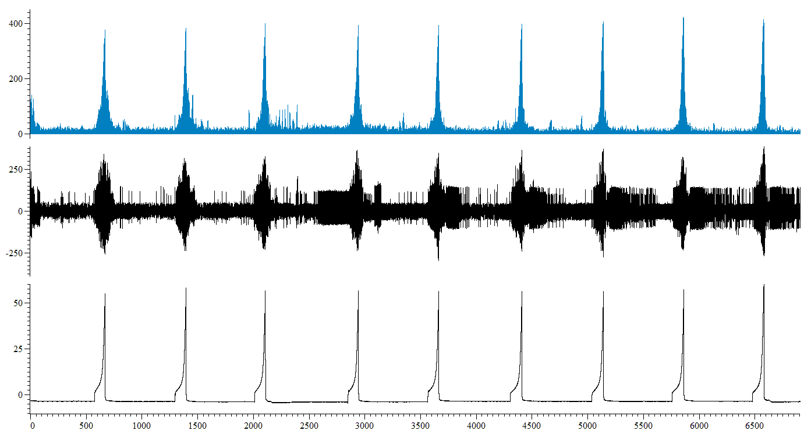

Control

Cocktail in saline

Mean firing (imp s-1)

Nerve firing (µV)

IP (mmHg)

10 mins

Time (s)

**Figure 6.10: Screen-shot representative trace from a single experiment in which the cocktail was perfused intraluminally in saline.** Intraluminal perfusion of the cocktail in saline had no effect on mechanosensitivity. Spontaneous and baseline afferent nerve firing were decreased following perfusion of the cocktail in saline, as was bladder compliance (n=7).



**A.**



**B.**

**Figure 6.11: Intraluminal perfusion of the cocktail in saline had no effect on the afferent nerve response to bladder distension.** A, following 30 minutes intraluminal perfusion of the cocktail in saline, the afferent nerve response to bladder distension remained unchanged relative to control (P=0.68, n=7). B, afferent nerve firing in response to bladder distension was unaffected, relative to control, by 60 minutes intraluminal perfusion of the cocktail in saline (P=0.38, n=7).

**A.**





**B.**

**Figure 6.12: Intraluminal perfusion of the cocktail in saline decreased bladder compliance.** A, following 30 minutes intraluminal perfusion of the cocktail in saline, bladder compliance was decreased relative to control (*P=0.03, n=7). B, 60 minutes intraluminal perfusion of the cocktail in saline decreased bladder compliance, relative to control (**P=0.009, n=7).



**Figure 6.13: Mean baseline afferent nerve firing of the 55-60 minute period of intraluminal perfusion of the cocktail in saline was decreased relative to control (**P=0.006, 1 way RM ANOVA with Bonferroni post-test, n=7).** Bonferroni post-test revealed a significant decrease in mean baseline afferent nerve firing of the 55-60 minute period of intraluminal perfusion of the bladder with the cocktail in saline, relative to control (**P<0.01, n=7), and 25-50 minutes cocktail in saline (*P<0.05, n=7).

### Overview

Following pharmacological block of various bladder signalling pathways and receptors by 1 hour continuous perfusion of the bladder with the cocktail in saline, the high K+ solution was perfused into the bladder in the presence of the cocktail to assess whether blockade of these signalling pathways could reverse the inhibitory effect of high K+ perfusion.

Intraluminal perfusion of the high K+ solution in the presence of the cocktail did not inhibit the afferent nerve response to bladder distension, confirming that one or multiple signalling pathways inhibited by the selection of antagonists in the full cocktail was responsible for activating the inhibitory effect. Both bladder compliance and mean baseline afferent nerve firing were unaffected by high K+ exposure in the presence of the cocktail (figure 6.14).

### Following 1 hour cocktail (in saline) perfusion of the bladder, high K+ intraluminal perfusion (in the presence of the cocktail) did not inhibit mechanosensitivity.

10 minutes intraluminal perfusion of the high K+ solution in the presence of the cocktail increased the afferent nerve response to bladder distension relative to 60 minutes cocktail in saline control (figure 6.15A). This initial augmentation of the mechanosensitivity response was not maintained for 30 minutes, and by 30 minutes intraluminal perfusion of the high K+ solution in the presence of the cocktail, the afferent nerve response to distension was unchanged relative to 60 minutes cocktail in saline control (figure 6.15B).

Following 30 minutes washout (continuous intraluminal perfusion of the standard saline solution), distension induced afferent nerve firing was decreased relative to the mechanosensitivity response of 60 minutes cocktail in saline control (figure 6.15C).

### Bladder compliance was unaffected by intraluminal perfusion of the high K+ solution in the presence of the cocktail.

Following 10 minutes intraluminal perfusion of the high K+ solution in the presence of the cocktail, bladder compliance was unaffected, relative to 60 minutes cocktail in saline control (figure 6.16A). Similarly, 30 minutes continuous intraluminal perfusion of the bladder with the high K+ solution in the presence of the cocktail had no effect on compliance of the bladder relative to 60 minutes cocktail in saline control (figure 6.16B). Following high K+ and cocktail exposure, saline was continuously perfused into the bladder for a 30 minute washout period. Bladder compliance remained unchanged relative to 60 minutes cocktail in saline control following 30 minutes saline washout (figure 6.16C).

### Mean baseline firing remained unaffected following intraluminal perfusion of the high K+ solution in the presence of the pharmacological cocktail.

Mean baseline afferent nerve firing was not altered following exposure to the high K+ solution in the presence of the cocktail, nor following a 30 minute washout period (figure 6.17).

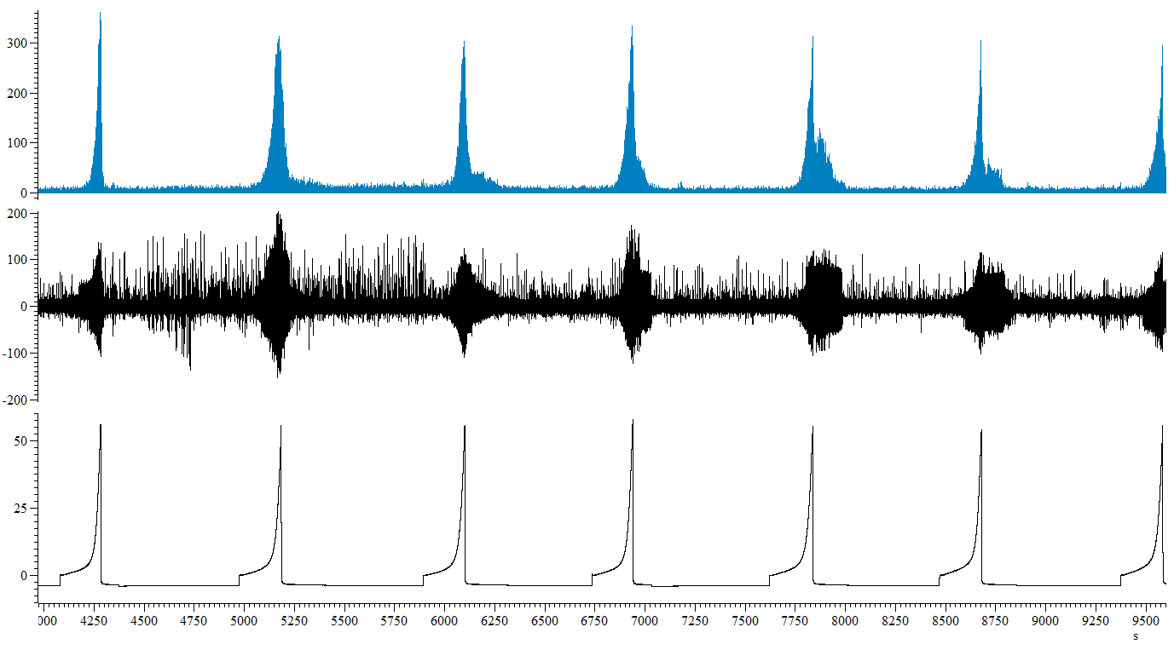

Cocktail in saline

High K+ + cocktail

Washout

**Figure 6.14: Screen-shot representative trace from a single experiment in which following 1 hour perfusion of the cocktail in saline, the high K+ solution was perfused intraluminally in the presence of the cocktail.** Intraluminal perfusion of the high K+ solution in the presence of the cocktail did not inhibit the afferent nerve response to bladder distension. Spontaneous afferent nerve firing was decreased following perfusion of the high K+ solution in the presence of the cocktail. Both bladder compliance and mean baseline afferent nerve firing were unaffected by high K+ exposure in the presence of the cocktail (n=7).

Mean firing (imp s-1)

Nerve firing (µV)

IP (mmHg)

10 mins

Time (s)



**A.**



**B.**



**Figure 6.15: Following 1 hour continuous intraluminal perfusion of the cocktail in saline, intraluminal perfusion of the high K+ solution in the presence of the cocktail did not inhibit afferent nerve firing in response to ramp distension.** A, 10 minutes intraluminal perfusion of the high K+ solution in the presence of the cocktail increased the afferent nerve response to bladder distension relative to 60 minutes cocktail in saline control (*P=0.03, n=7). B, 30 minutes intraluminal perfusion of the high K+ solution in the presence of the cocktail did not alter the afferent nerve response to bladder distension relative to 60 minutes cocktail in saline control (P=0.06, n=7). C, following 30 minutes saline washout afferent nerve firing in response to ramp distension was decreased compared to 60 minutes cocktail in saline control (***P=0003, n=7).

**C.**



**A.**



**B.**



**C.**

**Figure 6.16: Following 1 hour intraluminal perfusion of the cocktail in saline, intraluminal perfusion of the high K+ solution in the presence of the cocktail had no effect on bladder compliance.** A, following 10 minutes intraluminal perfusion of the high K+ solution in the presence of the cocktail, bladder compliance was not altered from 60 minutes cocktail in saline control (P=0.59, n=7). B, 30 minutes intraluminal perfusion of the bladder with the high K+ solution in the presence of the cocktail had no effect on compliance, relative to 60 minutes cocktail in saline control (P=0.45, n=7). C, Bladder compliance was not affected by exposure to the high K+ solution in the presence of the cocktail, and washout compliance remained statistically unchanged from 60 minutes cocktail in saline control (P=0.75, n=7).



**Figure 6.17: Following intraluminal perfusion of the bladder with the cocktail in saline, intraluminal perfusion of the high K+ solution in the presence of the cocktail had no effect on mean baseline afferent nerve firing relative to 55-60 minutes cocktail in saline control** (P=0.19, 1 way repeated measures ANOVA with Bonferroni post-test, n=7).

## Summary and rationale for experimental data presented in the remainder of this chapter.

The data shown in section 6.5 indicates that perfusion of the full cocktail alongside perfusion of the high K+ solution abolished the inhibition of the mechanosensitivity response observed in response to perfusion of the high K+ solution alone providing evidence to support the role of one or multiple mediators inhibited by the pharmacological cocktail in the inhibitory response seen following high K+ solution stimulation alone in intact bladders.

Therefore, in subsequent experiments antagonists were removed from the cocktail, one signalling pathway inhibitor at a time, with the hypothesis that when the antagonist(s) for the pathway responsible for the inhibitory effect was removed from the cocktail, the inhibition of mechanosensitivity in response to high K+ stimulation would reappear, highlighting the pathway(s) responsible for this effect. The data from these experiments is presented in sections 6.6, 6.7, 6.8, 6.9, and 6.10 of this thesis.

# 6.6 Is the inhibitory response to high K+ stimulation mediated by the cannabinoid signalling pathway?

## Aim

* To investigate whether the inhibitory effect following K+ stimulation is due to cannabinoid signalling.

## Amendment to the cocktail/protocol

The experimental protocol and data analysis remained as previously described (section 6.3). The only amendment made was the composition of the cocktail, where CB1 and CB2 receptor antagonists (10µM SR141716A and10µM SR144528) were removed.

The cocktail comprised of 10µM atropine, 500µM suramin, 50µM indomethacin, and 1mM L-NAME. For ease of explanation, this cocktail (in which CB1 and CB2 antagonists were removed) is referred to as cocktail 2 in subsequent analysis and data presentation.

## Results

### Overview

Exposure of the bladder to cocktail 2 in saline decreased the afferent nerve response to bladder distension following 60 minutes perfusion, an effect independent of alterations in bladder compliance, thereby supporting evidence in the literature of an inhibitory role of cannabinoid signalling bladder sensory signalling, as this effect was absent following perfusion of the full cocktail in previous experiments. However, this is difficult to conclude as this effect could be due to alterations in signalling by the remainder of the constituents of cocktail 2. Mean baseline afferent nerve firing remained unaffected (figure 6.18).

### Afferent nerve firing in response to bladder distension was decreased relative to control following intraluminal perfusion of cocktail 2 in saline.

Afferent nerve firing in response to bladder distension remained stable for 3 consecutive distensions prior to commencement of the protocol.

Intraluminal perfusion of cocktail 2 in saline had no effect on the afferent nerve response to bladder distension following 30 minutes exposure (figure 6.19A). However, following 60 minutes perfusion of cocktail 2 in saline, afferent nerve firing in response to bladder distension was decreased by ~16%, relative to control (figure 6.19B).

### Bladder compliance and baseline afferent nerve firing were not affected by intraluminal perfusion of cocktail 2 in saline.

Bladder compliance remained stable for 3 consecutive distensions prior to continuous intraluminal perfusion of cocktail 2 in saline solution.

Bladder compliance was unaffected following both 30 (figure 6.20A) and 60 minutes (figure 6.20B) intraluminal perfusion of cocktail 2 in saline.

Mean baseline afferent nerve firing was unaffected by intraluminal perfusion of cocktail 2 in saline (figure 6.21).

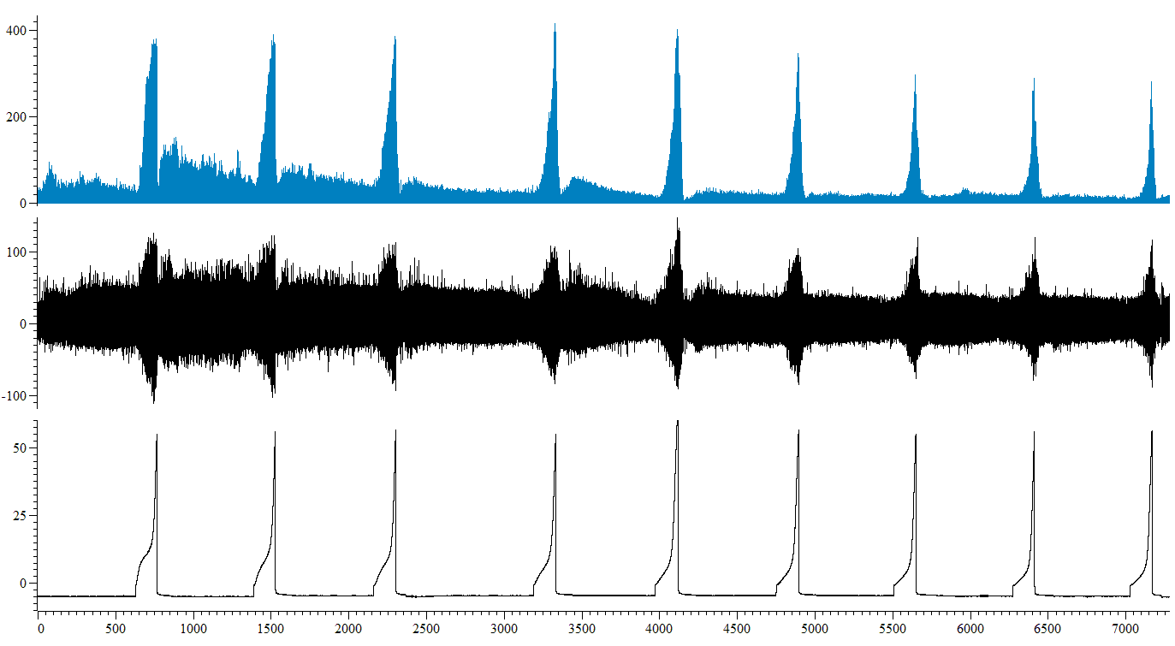

Mean firing (imp s-1)

Nerve firing (µV)

IP (mmHg)

Cocktail 2 in saline

Control

10 mins

Time (s)

**Figure 6.18: Screen-shot representative trace from a single experiment in which cocktail 2 was perfused intraluminally in saline.** Intraluminal perfusion of cocktail 2 in saline decreased mechanosensitivity. Spontaneous nerve firing was increased by intraluminal perfusion of cocktail 2 in saline. Mean baseline afferent nerve firing and bladder compliance were unaffected (n=6).



**A.**



**B.**

**Figure 6.19: 60 minutes intraluminal perfusion of cocktail 2 in saline decreased the afferent nerve response to bladder distension.** A, following 30 minutes intraluminal perfusion of cocktail 2 in saline, the afferent nerve response to bladder distension remained unchanged relative to control (P=0.86, n=6). B, afferent nerve firing in response to bladder distension was decreased, relative to control, by 60 minutes intraluminal perfusion of cocktail 2 in saline (*P=0.03, n=6).



**A.**



**B.**

**Figure 6.20: Intraluminal perfusion of cocktail 2 in saline did not affect bladder compliance.** A, following 30 minutes intraluminal perfusion of cocktail 2 in saline, bladder compliance remained unchanged relative to control (P=0.27, n=6). B, bladder compliance was unchanged, relative to control, by 60 minutes intraluminal perfusion of cocktail 2 in saline (P=0.33, n=6).



**Figure 6.21: Mean baseline afferent nerve firing was not affected by intraluminal perfusion of cocktail 2 in saline** (P=0.52, 1 way RM ANOVA with Bonferroni post-test, n=6).

### Overview

Following 1 hour continuous intraluminal perfusion of the bladder with cocktail 2 in saline, cocktail 2 in the high K+ solution was perfused into the bladder. Mechanosensitivity, bladder compliance and baseline afferent nerve firing were unaffected by intraluminal perfusion of the high K+ solution in the presence of cocktail 2 relative to 60 minutes cocktail in saline control (figure 6.22).

The data suggests that the identity of the urothelial mediator responsible for the inhibitory effect following high K+ stimulation is unlikely to be due to cannabinoid signalling, as the antagonists in cocktail 2 were sufficient to abolish the inhibitory response.

### Afferent nerve firing in response to bladder distension was unaffected by intraluminal perfusion of the high K+ solution in the presence of cocktail 2.

10 minutes intraluminal perfusion of the bladder with the high K+ solution in the presence of cocktail 2 had no effect on the afferent nerve response to bladder distension compared with the afferent nerve response at 60 minutes cocktail 2 in saline control (figure 6.23A). Similarly, afferent nerve firing in response to distension of the bladder was unaffected by 30 minutes intraluminal perfusion of the high K+ solution in the presence of cocktail 2 (figure 6.23B).

Following intraluminal exposure of the high K+ solution in the presence of cocktail 2, the bladder was re-perfused with the standard saline solution. Following 30 minutes saline washout, afferent nerve firing in response to distension of the bladder remained unchanged relative to 60 minutes cocktail 2 in saline control (figure 6.23C).

### Bladder compliance and baseline afferent nerve activity were unaffected by intraluminal perfusion of the high K+ solution in the presence of cocktail 2.

Intraluminal perfusion of the high K+ solution in the presence of cocktail 2 had no effect on bladder compliance following both 10 (figure 6.24A), and 30 minutes (figure 6.24B) exposure relative to 60 minutes cocktail 2 in saline control.

30 minutes saline solution washout also had no effect on the compliance of the bladder, and compliance remained unchanged from 60 minutes cocktail 2 in saline control (figure 6.24C).

Mean baseline afferent nerve firing was not altered following exposure to the high K+ solution in the presence of cocktail 2, nor following a 30 minute washout period (figure 6.25).

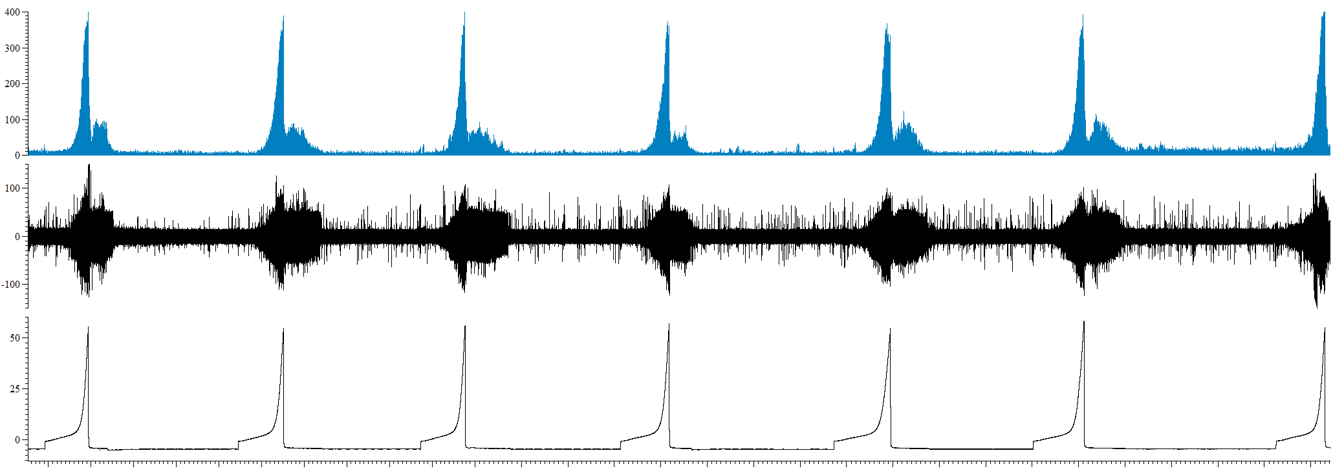

Mean firing (imp s-1)

Nerve firing (µV)

IP (mmHg)

10 mins

Time (s)

1 hour cocktail 2 in saline

High K+ plus cocktail 2

Washout

**Figure 6.22: Screen-shot representative trace from a single experiment. Following 1 hour intraluminal perfusion of cocktail 2 in saline, the high K+ solution was intraluminally perfused in the presence of cocktail 2.** Intraluminal perfusion of the high K+ solution in the presence of cocktail 2 had no effect on mechanosensitivity, mean baseline afferent nerve firing nor on bladder compliance. Spontaneous nerve firing was decreased following intraluminal perfusion of the high K+ solution in the presence of cocktail 2 (n=6).



**A.**



**B.**



**Figure 6.23: Following 1 hour continuous intraluminal perfusion of cocktail 2 in saline, intraluminal perfusion of the high K+ solution in the presence of cocktail 2 had no effect on afferent nerve firing in response to ramp distension.** A, 10 minutes intraluminal perfusion of the high K+ solution in the presence of cocktail 2 had no effect on the afferent nerve response to bladder distension relative to 60 minutes cocktail 2 in saline control (P=0.79, n=6). B, 30 minutes intraluminal perfusion of the high K+ solution in the presence of cocktail 2 did not alter the afferent nerve response to bladder distension relative to 60 minutes cocktail in saline control (P=0.12, n=6). C, following 30 minutes saline washout, afferent nerve firing in response to ramp distension was unchanged from 60 minutes cocktail 2 in saline control (P=0.09, n=6).

**C.**



**A.**



**B.**



**Figure 6.24: Bladder compliance was unaffected by intraluminal perfusion of the high K+ solution in the presence of cocktail 2.** A, 10 minutes intraluminal perfusion of the high K+ solution in the presence of cocktail 2 had no effect on bladder compliance relative to 60 minutes cocktail 2 in saline control (P=0.35, n=6). B, Similarly, 30 minutes intraluminal perfusion of the high K+ solution in the presence of cocktail 2 did not affect compliance relative to 60 minutes cocktail in saline control (P=0.98, n=6). C, following 30 minutes saline washout, bladder compliance remained unchanged from 60 minutes cocktail 2 in saline control (P=0.61, n=6).

**C.**



**Figure 6.25: Mean baseline afferent nerve firing was not affected by intraluminal perfusion of the high K+ solution in the presence of cocktail 2.** P=0.12, 1 way RM ANOVA with Bonferroni post-test, n=6.

# 6.7 Is the inhibitory response to high K+ stimulation mediated by ACh/ muscarinic receptor signalling pathway?

## Aim

* To investigate whether the inhibitory effect following K+ stimulation is due to muscarinic receptor signalling.

## Amendment to the cocktail/protocol

The experimental protocol and data analysis remained as previously described (section 6.3). Again, only the composition of the cocktail was altered. As the omission of CB1 and CB2 receptor antagonists (10µM SR141716A and10µM SR144528) from the cocktail maintained the block of inhibition in response to high K+ perfusion as per full cocktail, CB1 and CB2 receptor antagonists (10µM SR141716A and10µM SR144528) were removed again along with the muscarinic receptor antagonist (10µM atropine).

The cocktail comprised of suramin (500µM), indomethacin (50µM), and L-NAME (1mM), and was dissolved in both saline and the high K+ solution for intraluminal perfusion.

For ease of explanation, this cocktail, in which CB1/CB2 and muscarinic receptor antagonists were removed (suramin 500µM, indomethacin 50µM, and L-NAME 1mM) is referred to as cocktail 3 in subsequent analysis and data presentation.

## Results

### Overview

Continuous intraluminal perfusion of the bladder with cocktail 3 in saline had no effect on mechanosensitivity, bladder compliance, nor mean baseline afferent nerve firing, (figure 6.26).

### Mechanosensitivity responses were unaffected by intraluminal perfusion of cocktail 3 in saline.

The afferent nerve response to bladder distension remained stable for 3 consecutive distensions prior to intraluminal perfusion of cocktail 3 in saline.

30 minutes intraluminal perfusion of cocktail 3 in saline had no effect on the afferent nerve response to bladder distension, relative to saline control (figure 6.27A). Similarly, following 60 minutes intraluminal perfusion of cocktail 3 in saline, the afferent nerve response to distension of the bladder was unaffected relative to saline control (figure 6.27B).

### Bladder compliance and baseline afferent nerve activity were unaffected by intraluminal perfusion of cocktail 3 in saline.

Bladder compliance remained stable for 3 consecutive distensions prior to intraluminal perfusion of cocktail 3 in saline.

Intraluminal perfusion of cocktail 3 in saline, did not affect bladder compliance, relative to saline control following both 30 minutes (figure 6.28A) and 60 minutes intraluminal perfusion (figure 6.28B).

Mean baseline afferent nerve firing remained stable for 1 hour prior to commencement of the protocol and remained unaffected following intraluminal perfusion of cocktail 3 in saline (figure 6.29).

Cocktail 3 in saline

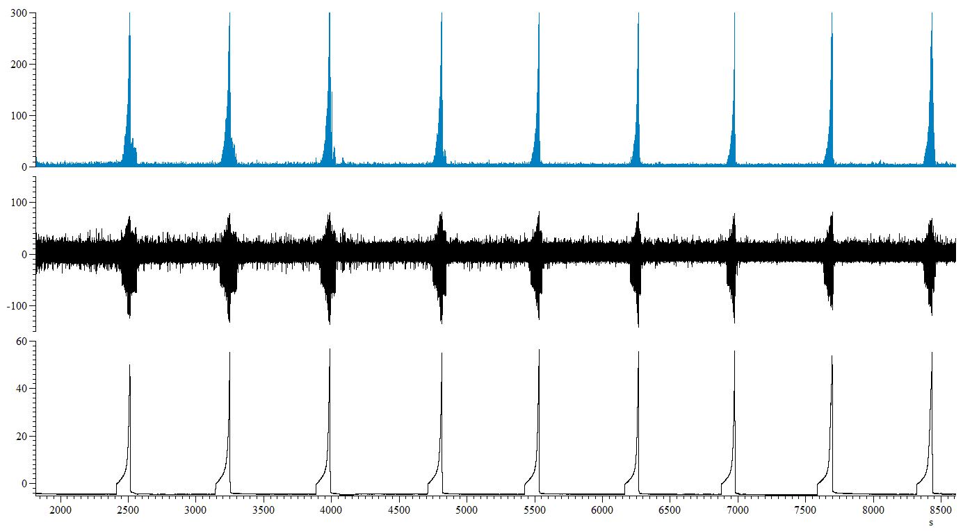

Control

Mean firing (imp s-1)

Nerve firing (µV)

IP (mmHg)

10 mins

Time (s)

**Figure 6.26: Screen-shot representative trace from a single experiment in which cocktail 3 was perfused intraluminally in saline.** Intraluminal perfusion of cocktail 3 in saline had no effect on mechanosensitivity, bladder compliance nor mean baseline afferent nerve firing, but significantly increased spontaneous afferent nerve firing (n=6).



**A.**



**B.**

**Figure 6.27: Intraluminal perfusion of cocktail 3 in saline had no effect on the afferent nerve response to bladder distension.** A, following 30 minutes intraluminal perfusion of cocktail 3 in saline, the afferent nerve response to bladder distension remained unchanged relative to control (P=0.17, n=6). B, afferent nerve firing in response to bladder distension was unaffected, relative to control, by 60 minutes intraluminal perfusion of cocktail 3 in saline (P=0.23, n=6).



**A.**



**B.**

**Figure 6.28: Intraluminal perfusion of cocktail 3 in saline had no effect on bladder compliance.** A, following 30 minutes intraluminal perfusion of cocktail 3 in saline, bladder compliance remained unchanged, relative to control (P=0.39, n=6). B, bladder compliance was unaffected, relative to control, by 60 minutes intraluminal perfusion of cocktail 3 in saline (P=0.85, n=6).



**Figure 6.29: Mean baseline afferent nerve firing was not affected by intraluminal perfusion of cocktail 3 in saline** (P=0.25, 1 way RM ANOVA with Bonferroni post-test, n=6).

### Overview

Following 1 hour continuous intraluminal perfusion of cocktail 3 in saline in order to maximise action of the antagonists on the various pathways, the high K+ solution plus cocktail 3 was intraluminally perfused.

Mechanosensitivity and bladder compliance were unaffected by intraluminal perfusion of the high K+ solution in the presence of cocktail 3. Mean baseline afferent nerve firing however was decreased following intraluminal perfusion of the high K+ solution in the presence of cocktail 3, relative to 1 hour cocktail 3 in saline (figure 6.30).

### Afferent nerve firing in response to bladder distension was unaffected by intraluminal perfusion of the high K+ solution in the presence of cocktail 3.

Perfusion of the high K+ solution in the presence of cocktail 3 had no effect on the afferent nerve response to bladder distension, relative to 60 minutes cocktail 3 in saline control at both 10 minutes (figure 6.31A) and 30 minutes exposure (figure 6.31B).

Standard saline solution was perfused into the bladder following high K+ solution plus cocktail 3 exposure for 30 minutes washout period. Afferent nerve firing in response to bladder distension was not affected relative to 60 minutes cocktail 3 in saline control following 30 minutes washout, (figure 6.31C).

### Bladder compliance was unaffected by intraluminal perfusion of the high K+ solution in the presence of cocktail 3.

Intraluminal perfusion of the high K+ solution in the presence of cocktail 3 had no effect on bladder compliance relative to 60 minutes cocktail 3 in saline control, following both 10 minutes (figure 6.32A), and 30 minutes exposure (figure 6.32B).

Similarly, 30 minutes saline washout following high K+ solution and cocktail 3 perfusion, did not affect compliance relative to 60 minutes cocktail 3 in saline control (figure 6.32C).

### Mean baseline nerve firing was decreased following intraluminal perfusion of the high K+ solution in the presence of cocktail 3.

Mean baseline afferent nerve firing was decreased following intraluminal perfusion of the high K+ solution in the presence of cocktail 3 (figure 6.33). Mean baseline afferent nerve firing at 25-30 minutes high K+ solution in the presence of cocktail 3 was decreased relative to 55-60 minutes cocktail 3 in saline control from 4.89 ± 0.99 to 2.23 ± 1.75 imp s-1 (figure 6.33**).**

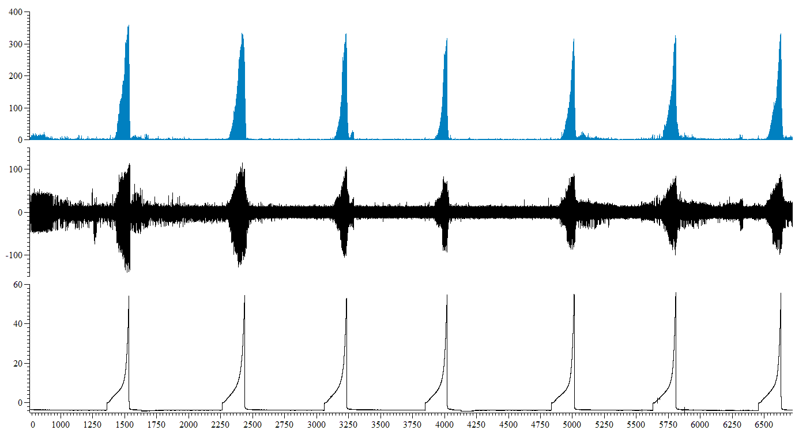

Mean firing (imp s-1)

Nerve firing (µV)

IP (mmHg)

10 mins

Time (s)

Washout

1 hour cocktail 3 in saline

High K+ plus cocktail 3

**Figure 6.30: Screen-shot representative trace from a single experiment.** Following 1 hour intraluminal perfusion of cocktail 3 in saline, the high K+ solution was intraluminally perfused in the presence of cocktail 3.Intraluminal perfusion of the high K+ solution in the presence of cocktail 3 had no effect on mechanosensitivity or on bladder compliance. Spontaneous and mean baseline afferent nerve firing were both decreased following intraluminal perfusion of the high K+ solution in the presence of cocktail 3 (n=6).



**A.**



**B.**



**C.**

**Figure 6.31: Following 1 hour continuous intraluminal perfusion of cocktail 3 in saline, intraluminal perfusion of the high K+ solution in the presence of cocktail 3 had no effect on afferent nerve firing in response to bladder distension.** A, 10 minutes intraluminal perfusion of the high K+ solution in the presence of cocktail 3 had no effect on the afferent nerve response to bladder distension relative to 60 minutes cocktail 3 in saline control (P=0.36, n=6). B, 30 minutes intraluminal perfusion of the high K+ solution in the presence of cocktail 3 did not alter the afferent nerve response to bladder distension relative to 60 minutes cocktail 3 in saline control (P=0.36, n=6). C, following 30 minutes saline washout, afferent nerve firing in response to ramp distension was unchanged from 60 minutes cocktail 3 in saline control (P=0.12, n=6).



**A.**



**B.**



**C.**

**Figure 6.32: Bladder compliance was unaffected by intraluminal perfusion of the high K+ solution in the presence of cocktail 3.** A, 10 minutes intraluminal perfusion of the high K+ solution in the presence of cocktail 3 had no effect on bladder compliance relative to 60 minutes cocktail 2 in saline control (P=0.30, n=6). B, Similarly, 30 minutes intraluminal perfusion of the high K+ solution in the presence of cocktail 3 did not affect compliance relative to 60 minutes cocktail 3 in saline control (P=0.37, n=6). C, following 30 minutes saline washout, bladder compliance remained unchanged from 60 minutes cocktail 3 in saline control (P=0.18, n=6).



**Figure 6.33: Mean baseline afferent nerve firing was decreased following intraluminal perfusion of the high K+ solution in the presence of cocktail 3 * P=0.04, 1 way RM ANOVA with Bonferroni post-test, n=6**. Bonferroni post-test revealed a decrease in mean baseline afferent nerve firing at 25-30 minutes high K+ solution in the presence of cocktail 3 perfusion relative to mean baseline afferent nerve firing of 55-60 minutes cocktail 3 in saline control (*P<0.05, n=6).

# 6.8 Is the inhibitory response to high K+ stimulation mediated by the purinergic signalling pathway?

## Aim

* To investigate whether the inhibitory effect following K+ stimulation is due to a purinergic receptor signalling mechanism.

## Amendment to the cocktail/protocol

The experimental protocol and data analysis remained as previously described (section 6.3). The composition of the cocktail was amended and compared to the full cocktail, CB1 and CB2 receptor antagonists (10µM SR141716A and10µM SR144528), muscarinic receptor antagonist (10µM atropine) and purinergic receptor antagonist (500µM suramin) were removed.

50µM indomethacin, and 1mM L-NAME were dissolved in both the standard saline solution and the high K+ solution and perfused intraluminally, as previously described.

## Results

### Overview

Mechanosensitivity and compliance were unaffected by intraluminal perfusion of 50µM indomethacin and 1mM L-NAME in saline, yet mean baseline afferent nerve firing was decreased following perfusion of 50µM indomethacin and 1mM L-NAME in saline (figure 6.34).

### Afferent nerve firing in response to bladder distension was unaffected by intraluminal perfusion of 50µM indomethacin and 1mM L-NAME in saline.

Following a 30 minute control period, where the afferent nerve response to bladder distension with 150mM NaCl remained stable for 3 consecutive distensions, 50µM indomethacin and 1mM L-NAME in saline was continuously perfused into the mouse bladder for 1 hour with a distension of the bladder to 50mmHg every 10 minutes.

30 minutes intraluminal perfusion of 50µM indomethacin and 1mM L-NAME in saline had no effect, relative to 30 minutes saline control, on the afferent nerve response to bladder distension (figure 6.35A). Similarly, 60minutes intraluminal perfusion of the bladder with 50µM indomethacin and 1mM L-NAME in saline had no effect on mechanosensitivity, relative to 30 minutes saline control (figure 6.35B).

### Bladder compliance remained unchanged, relative to 30 minutes saline control, following intraluminal perfusion of 50µM indomethacin and 1mM L-NAME in saline.

Bladder compliance remained stable for 3 consecutive distensions prior to intraluminal perfusion of the bladder with 50µM indomethacin and 1mM L-NAME in saline.

Bladder compliance was unaffected by intraluminal perfusion of 50µM indomethacin and 1mM L-NAME in saline, relative to 30 minutes saline control, following 30 minutes (figure 6.36A) and 60 minutes exposure (figure 6.36B).

Mean baseline firing was reduced following intraluminal perfusion of the bladder with 50µM indomethacin, and 1mM L-NAME in saline (figure 6.37). Mean baseline firing was significantly reduced from 14.25 ± 4.05 imp s-1 during 25-30 minutes saline control, to 7.36 ± 2.04 imp s-1 during 55-60 minutes 50µM indomethacin and 1mM L-NAME in saline.

10 mins

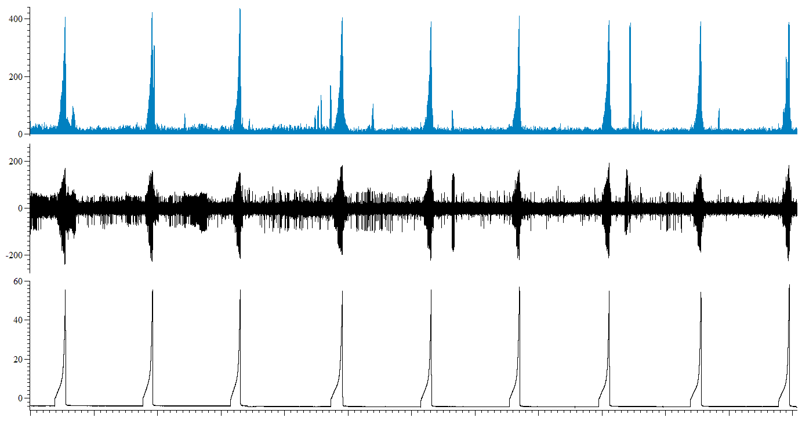

Mean firing (imp s-1)

Nerve firing (µV)

IP (mmHg)

Time (s)

Indomethacin (50µM) and L-NAME (1mM) in saline

Control

**Figure 6.34: Screen-shot representative trace from a single experiment in which 50µM indomethacin and 1mM L-NAME were perfused intraluminally in saline.** Intraluminal perfusion of 50µM indomethacin and 1mM L-NAME in saline had no effect on neither mechanosensitivity nor bladder compliance. Mean baseline afferent nerve firing and spontaneous afferent nerve firing were both significantly decreased following intraluminal perfusion of 50µM indomethacin and 1mM L-NAME in saline (n=6).



**A.**



**B.**

**Figure 6.35: Intraluminal perfusion of 50µM indomethacin, and 1mM L-NAME in saline had no effect on the afferent nerve response to bladder distension.** A, following 30 minutes intraluminal perfusion of 50µM indomethacin, and 1mM L-NAME in saline, the afferent nerve response to bladder distension remained unchanged relative to control (P=0.33, n=6). B, afferent nerve firing in response to bladder distension was unaffected, relative to control, by 60 minutes intraluminal perfusion of 50µM indomethacin, and 1mM L-NAME in saline (P=0.98, n=6).





**B.**

**A.**

**Figure 6.36: Intraluminal perfusion of 50µM indomethacin, and 1mM L-NAME in saline had no effect on bladder compliance.** A, following 30 minutes intraluminal perfusion of 50µM indomethacin, and 1mM L-NAME in saline, bladder compliance remained unchanged, relative to control (P=0.19, n=6). B, bladder compliance was unaffected, relative to control, by 60 minutes intraluminal perfusion of 50µM indomethacin, and 1mM L-NAME in saline (P=0.37, n=6).



**Figure 6.37: Mean baseline afferent nerve firing was decreased following intraluminal perfusion of the bladder with 50µM indomethacin, and 1mM L-NAME in saline** (*P=0.03, 1 way RM ANOVA with Bonferroni post-test, n=6). Mean baseline afferent nerve firing was decreased, relative to mean firing of 25-30 minutes saline control during average firing of 55-60 minutes intraluminal perfusion of 50µM indomethacin, and 1mM L-NAME in saline (*P<0.05, Bonferroni post-test, n=6).

### Overview

Following 60 minutes intraluminal perfusion of the bladder with 50µM indomethacin and 1mM L-NAME in saline, the high K+ solution (50mMKCl/ 100m NaCl) was perfused into the bladder in the presence of 50µM indomethacin and 1mM L-NAME. The inhibitory effect of high K+ solution perfusion on mechanosensitivity was not observed following perfusion of the high K+ solution in the presence of 50µM indomethacin and 1mM L-NAME. Bladder compliance and mean baseline afferent nerve activity remained unaffected, (figure 6.38). This data highlights a role for either, or both, prostaglandins and nitric oxide in the inhibition of afferent nerve firing in response to high K+ stimulation.

### Intraluminal perfusion of the high K+ solution in the presence of 50µM indomethacin and 1mM L-NAME did not inhibit mechanosensitivity.

10 minutes intraluminal perfusion of the high K+ solution, in the presence of 50µM indomethacin and 1mM L-NAME, augmented the afferent nerve response to ramp distension by 30%, relative to 60 minutes 50µM indomethacin and 1mM L-NAME in saline control (figure 6.39A).

Following 30 minutes intraluminal perfusion of the high K+ solution, in the presence of 50µM indomethacin and 1mM L-NAME, the afferent nerve response to distension was not altered from 50µM indomethacin and 1mM L-NAME in saline control (figure 6.39B).

30 minutes saline washout, following exposure of the bladder to the high K+ solution, in the presence of 50µM indomethacin and 1mM L-NAME, decreased mechanosensitivity by 10% relative to 60 minutes 50µM indomethacin and 1mM L-NAME in saline control (figure 6.39C).

### Bladder compliance and baseline afferent nerve firing were unaffected by intraluminal perfusion of the high K+ solution in the presence of 50µM indomethacin and 1mM L-NAME.

Relative to 50µM indomethacin and 1mM L-NAME in saline control, intraluminal perfusion of the bladder with the high K+ solution in the presence of 50µM indomethacin and 1mM L-NAME had no effect on compliance following 10 minutes (figure 6.40A, P=0.39, n=6) and 30 minutes (figure 6.40B) exposure.

30 minutes saline washout also had not effect on compliance, relative to 50µM indomethacin and 1mM L-NAME in saline control (figure 6.40C).

Mean baseline afferent nerve firing was unaffected by intraluminal perfusion of the high K+ solution in the presence of 50µM indomethacin and 1mM L-NAME (figure 6.41).

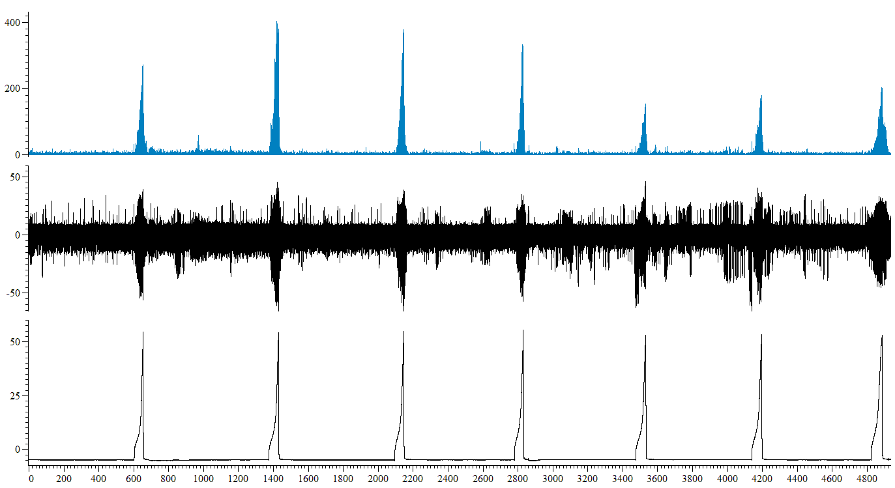

10 mins

Mean firing (imp s-1)

Nerve firing (µV)

IP (mmHg)

Time (s)

1 hour indomethacin (50µM) and L-NAME (1mM) in saline

Washout

High K+ + indomethacin (50µM) and L-NAME (1mM)

**Figure 6.38: Screen-shot representative trace from a single experiment.** Following 1 hour intraluminal perfusion of 50µM indomethacin, and 1mM L-NAME in saline, the high K+ solution was intraluminally perfused in the presence of 50µM indomethacin, and 1mM L-NAME. Intraluminal perfusion of the high K+ solution in the presence of 50µM indomethacin, and 1mM L-NAME initially augmented mechanosensitivity responses, but following 30 minutes perfusion, mechanosensitivity was unchanged relative to 60 minutes 50µM indomethacin, and 1mM L-NAME in saline control (n=6). Spontaneous afferent nerve firing was decreased following intraluminal perfusion of the high K+ solution in the presence of 50µM indomethacin, and 1mM L-NAME (n=6). Bladder compliance and mean baseline afferent nerve activity were unaffected (n=6).



**A.**



**B.**



**C.**

**Figure 6.39: Intraluminal perfusion of the high K+ solution in the presence of 50µM indomethacin and 1mM L-NAME did not inhibit mechanosensitivity.** A, 10 minutes intraluminal perfusion of the high K+ solution in the presence of 50µM indomethacin and 1mM L-NAME augmented the afferent nerve response to bladder distension relative to 60 minutes 50µM indomethacin and 1mM L-NAME in saline control (*P=0.01, n=6). B, 30 minutes intraluminal perfusion of the high K+ solution in the presence of 50µM indomethacin and 1mM L-NAME did not alter the afferent nerve response to bladder distension relative to 60 minutes 50µM indomethacin and 1mM L-NAME in saline control (P=0.52, n=6). C, following 30 minutes saline washout, afferent nerve firing in response to ramp distension was decreased relative to 60 minutes 50µM indomethacin and 1mM L-NAME in saline control (***P=0.0006, n=6).



**A.**



**B.**



**C.**

**Figure 6.40: Bladder compliance was unaffected by intraluminal perfusion of the high K+ solution in the presence of 50µM indomethacin and 1mM L-NAME.** A, 10 minutes intraluminal perfusion of the high K+ solution in the presence of 50µM indomethacin and 1mM L-NAME had no effect on bladder compliance relative to 60 minutes 50µM indomethacin and 1mM L-NAME in saline control (P=0.39, n=6). B, Similarly, 30 minutes intraluminal perfusion of the high K+ solution in the presence of 50µM indomethacin and 1mM L-NAME 3 did not affect compliance relative to 60 minutes 50µM indomethacin and 1mM L-NAME in saline control (P=0.49, n=6). C, following 30 minutes saline washout, bladder compliance remained unchanged relative to 60 minutes 50µM indomethacin and 1mM L-NAME in saline control (P=0.93, n=6).



**Figure 6.41: Mean baseline afferent nerve firing was unaffected by intraluminal perfusion of the high K+ solution in the presence of 50µM indomethacin and 1mM L-NAME,** P=0.69, 1 way RM ANOVA with Bonferroni post-test, n=6.

# 6.9 Is the inhibitory response to high K+ stimulation blocked by prostaglandin antagonist?

## Aim

* To investigate whether the inhibitory effect following K+ stimulation is due to activation of prostaglandin signalling.

## Amendment to the cocktail/protocol

The experimental protocol and data analysis remained as previously described (section 6.3). In these experiments, 50µM indomethacin (COX enzymes/prostaglandins inhibitor) was dissolved in both the standard saline solution and the high K+ solution and perfused intraluminally, as previously described.

## Results

### Overview

50µM indomethacin was perfused in the standard saline solution for 1 hour prior to the high K+ challenge to ensure optimum inhibition of COX enzymes by the antagonist. This process also enabled the measurement of the effects of indomethacin perfusion alone (in saline) on bladder compliance and sensory nerve activity. Intraluminal perfusion of the bladder with 50µM indomethacin in saline did not effect mechanosensitivity, bladder compliance, or mean baseline afferent nerve firing (figure 6.42).

### Mechanosensitivity was unaffected by intraluminal perfusion of the bladder with 50µM indomethacin in saline.

The afferent nerve response to bladder distension remained stable for 3 consecutive distensions prior to commencement of the protocol. Intraluminal perfusion of the bladder with 50µM indomethacin in saline had no effect on the afferent nerve response to bladder distension, relative to 30 minutes saline control, following 30 minutes (figure 6.43A), and 60 minutes exposure (figure 6.43B).

### Bladder compliance and baseline afferent nerve activity were unaffected by intraluminal perfusion of the bladder with 50µM indomethacin in saline.

Bladder compliance remained stable for 3 consecutive distensions prior to intraluminal perfusion of 50µM indomethacin in saline. Following 30 minutes continuous intraluminal perfusion of 50µM indomethacin in saline, bladder compliance was unaffected relative to 30 minutes saline control (figure 6.44A). Compliance remained unaffected, relative to 30 minutes saline control, following 60 minutes intraluminal perfusion of 50µM indomethacin in saline (figure 6.44B).

Mean baseline afferent nerve activity was not affected by intraluminal perfusion of 50µM indomethacin in saline, relative to control (figure 6.45).

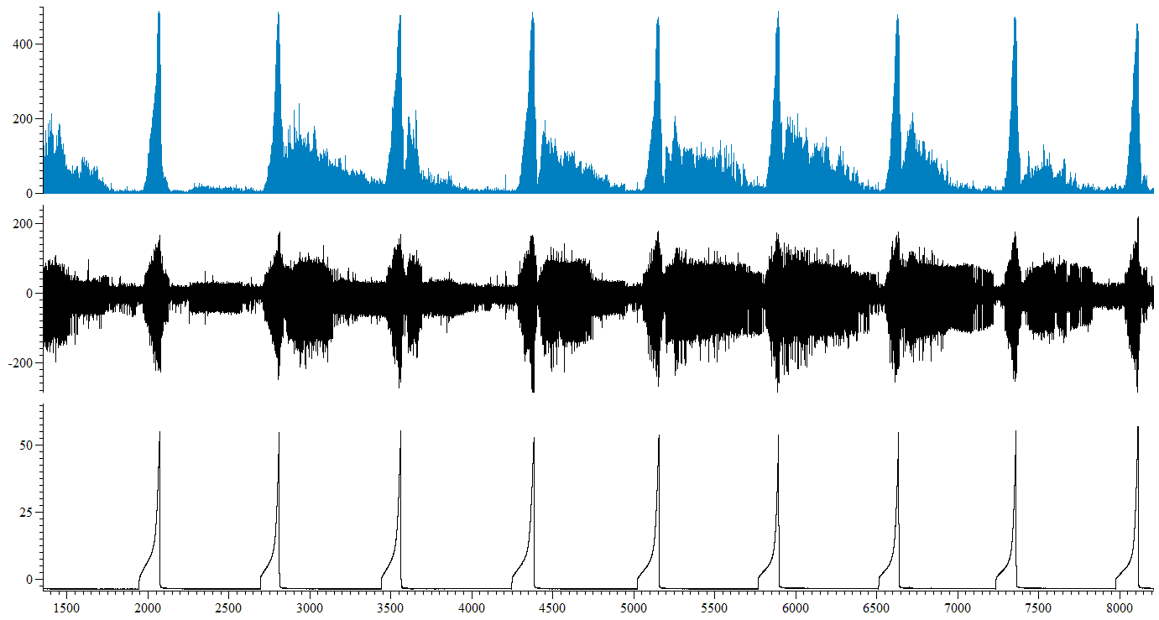

10 mins

Mean firing (imp s-1)

Nerve firing (µV)

IP (mmHg)

Time (s)

Indomethacin (50µM) in saline

Control

**Figure 6.42: Screen-shot representative trace from a single experiment in which 50µM indomethacin was perfused intraluminally in saline.** Intraluminal perfusion of 50µM indomethacin in saline had no effect on mechanosensitivity, bladder compliance nor on mean baseline afferent nerve firing. Spontaneous afferent nerve firing was significantly decreased following intraluminal perfusion of 50µM indomethacin in saline (n=6).



**A.**



**B.**

**Figure 6.43: Intraluminal perfusion of 50µM indomethacin in saline, had no effect on mechanosensitivity.** A, Following 30 minutes continuous intraluminal perfusion of the bladder with 50µM indomethacin in saline, the afferent nerve response to bladder distension was unchanged, relative to 30 minutes saline control (P=0.52, n=6). B, Similarly, 60 minutes intraluminal perfusion with 50µM indomethacin in saline had no effect on mechanosensitivity, relative to 30 minutes saline control (P=0.77, n=6).



**A.**



**B.**

**Figure 6.44: Intraluminal perfusion of 50µM indomethacin in saline, had no effect on bladder compliance.** A, Following 30 minutes continuous intraluminal perfusion of 50µM indomethacin in saline bladder compliance was unaffected relative to 30 minutes saline control (P=0.66, n=6). B, Similarly, 60 minutes intraluminal perfusion of 50µM indomethacin in saline had no effect on compliance relative to 30 minutes saline control (P=0.54, n=6).



**Figure 6.45: Mean baseline afferent nerve firing was not affected by intraluminal perfusion of 50µM** **indomethacin in saline** P=0.42, 1 way RM ANOVA with Bonferroni post-test, n=6.

### Overview

Following 60 minutes intraluminal perfusion of the bladder with 50µM indomethacin in saline, the high K+ solution (50mMKCl/ 100m NaCl) was perfused into the bladder in the presence of 50µM indomethacin.

30 minutes intraluminal perfusion of the high K+ solution in the presence of 50µM indomethacin caused an inhibition of the afferent nerve response to bladder distension, indicating that blockade of prostaglandin synthesis was insufficient to prevent the attenuation of mechanosensitivity in response to high K+ solution stimulation of the bladder.

Bladder compliance and mean baseline afferent nerve firing were unaffected (figure 6.46).

### Afferent nerve firing in response to bladder distension was decreased following intraluminal perfusion of the bladder with the high K+ solution in the presence of 50µM indomethacin.

Afferent nerve firing in response to distension of the bladder was unaffected, relative to 60 minutes 50µM indomethacin in saline control, by 10 minutes continuous intraluminal perfusion of the bladder with the high K+ solution in the presence of 50µM indomethacin (figure 6.47A). However, following 30 minutes intraluminal perfusion of the high K+ solution in the presence of 50µM indomethacin, afferent nerve firing in response to bladder distension was decreased by 42%, relative to 60 minutes 50µM indomethacin in saline control (figure 6.47B).

Following 30 minutes exposure of the bladder to the high K+ solution (with 50µM indomethacin), the standard saline solution was perfused into the bladder for a 30 minute washout period. Following 30 minutes saline washout, the afferent nerve response to ramp distension of the bladder remained decreased by ~25% relative to 60 minutes 50µM indomethacin in saline control (figure 6.47C).

### Bladder compliance and baseline afferent nerve firing were unaffected by intraluminal perfusion of the high K+ solution in the presence of 50µM indomethacin.

Following 10 minutes intraluminal perfusion of the bladder with the high K+ solution in the presence of 50µM indomethacin, bladder compliance remained unaffected, relative to 60 minutes 50µM indomethacin in saline control (figure 6.48A). Similarly, 30 minutes intraluminal perfusion with the high K+ solution in the presence of 50µM indomethacin had no effect on compliance, relative to 60 minutes 50µM indomethacin in saline control (figure 6.48B).

30 minutes saline washout did not alter bladder compliance, relative to 60 minutes 50µM indomethacin in saline control (figure 6.48C).

Mean baseline afferent nerve firing was unaffected by intraluminal perfusion of the high K+ solution in the presence of 50µM indomethacin, relative to 50µM indomethacin in saline control (figure 6.49).

1 hour indomethacin (50µM) in saline

Mean firing (imp s-1)

Washout

High K+ + indomethacin (50µM)

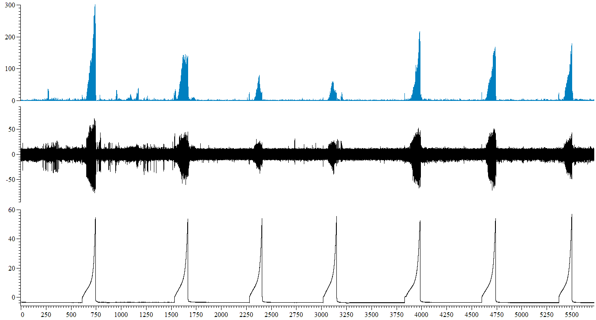

Nerve firing (µV)

Time (s)

10 mins

IP (mmHg)

**Figure 6.46: Screen-shot representative trace from a single experiment.** Following 1 hour intraluminal perfusion of 50µM indomethacin in saline, the high K+ solution was intraluminally perfused in the presence of 50µM indomethacin. Intraluminal perfusion of the high K+ solution in the presence of 50µM indomethacin inhibited the afferent nerve response to bladder distension and decreased spontaneous afferent nerve firing (n=6). Bladder compliance and mean baseline afferent nerve activity were unaffected (n=6).



**A.**



**B.**



**C.**

**Figure 6.47: Intraluminal perfusion of the high K+ solution in the presence of 50µM indomethacin inhibited the afferent nerve response to bladder distension.** A, 10 minutes intraluminal perfusion of the high K+ solution in the presence of 50µM indomethacin had no effect on the afferent nerve response to bladder distension relative to 60 minutes 50µM indomethacin in saline control (P=0.08, n=6). B, 30 minutes intraluminal perfusion of the high K+ solution in the presence of 50µM indomethacin attenuated the afferent nerve response to bladder distension relative to 60 minutes 50µM indomethacin in saline control (****P<0.0001, n=6). C, following 30 minutes saline washout, afferent nerve firing in response to ramp distension was decreased relative to 60 minutes 50µM indomethacin in saline control (**P=0.001, n=6).



**A.**



**B.**



**C.**

**Figure 6.48: Bladder compliance was unaffected by intraluminal perfusion of the high K+ solution in the presence of 50µM indomethacin.** A, 10 minutes intraluminal perfusion of the high K+ solution in the presence of 50µM indomethacin had no effect on bladder compliance relative to 60 minutes 50µM indomethacin in saline control (P=0.56, n=6). B, 30 minutes intraluminal perfusion of the high K+ solution in the presence of 50µM indomethacin had no effect on bladder compliance relative to 60 minutes 50µM indomethacin in saline control (P=0.88, n=6). C, following 30 minutes saline washout, bladder compliance remained unaffected relative to 60 minutes 50µM indomethacin in saline control (P=0.20, n=6).



**Figure 6.49: Mean baseline afferent nerve firing was unaffected by intraluminal perfusion of the high K+ solution in the presence of 50µM indomethacin,** P=0.21, 1 way RM ANOVA with Bonferroni post-test, n=6.

# 6.10 The inhibitory response to high K+ stimulation is mediated by the nitric oxide (NO) signalling pathway.

Collectively, the data presented in this chapter suggests that the inhibition of mechanosensitivity seen in intact bladders following high K+ perfusion is mediated by a nitric oxide signalling pathway, as inhibition was abolished in all experiments in which nitric oxide signalling was blocked.

In this section, the nitric oxide (NO) signalling pathway was investigated as a likely candidate for mediation of the inhibitory effect on mechanosensitivity in response to high K+ solution perfusion, with the hypothesis that in the presence of a non-specific NO antagonist (L-NAME), the inhibition of afferent nerve firing in response to bladder distension following high K+ perfusion would be abolished if K+ is responsible for the stimulation of NO release.

## Aim

* To investigate whether the inhibitory effect following K+ stimulation is due to nitric oxide signalling.

## Amendment to the cocktail/protocol

The experimental protocol and data analysis remained as previously described (section 6.3). In these experiments, 1mM L-NAME, a non-selective nitric oxide synthase (NOS) inhibitor, was dissolved in both the standard saline solution and the high K+ solution and perfused intraluminally, as previously described.

## Results

### Overview

1mM L-NAME was perfused in the standard saline solution for 1 hour prior to the high K+ challenge to ensure optimum inhibition of NOS enzymes by the antagonist. This process also enabled the measurement of the effects of L-NAME perfusion alone (in saline) on bladder compliance and sensory nerve activity. Intraluminal perfusion of the bladder with 1mM L-NAME in saline did not effect mechanosensitivity, bladder compliance, or mean baseline afferent nerve firing (figure 6.50).

### Afferent nerve firing in response to ramp distension of the bladder was unaffected by intraluminal perfusion of 1mM L-NAME in saline.

The afferent nerve response to bladder distension remained stable for 3 consecutive distensions prior to commencement of the protocol. Intraluminal perfusion of the bladder with 1mM L-NAME in saline had no effect on the afferent nerve response to bladder distension, relative to 30 minutes saline control, following 30 minutes (figure 6.51A), and 60 minutes exposure (figure 6.51B).

### Bladder compliance and baseline afferent nerve activity were unaffected by intraluminal perfusion of the bladder with 1mM L-NAME in saline.

Bladder compliance remained stable for 3 consecutive distensions prior to intraluminal perfusion of 1mM L-NAME in saline. Following 30 minutes continuous intraluminal perfusion of 1mM L-NAME in saline, bladder compliance was unaffected relative to 30 minutes saline control (figure 6.52A). Compliance remained unaffected, relative to 30 minutes saline control, following 60 minutes intraluminal perfusion of 50µM indomethacin in saline (figure 6.52B).

Mean baseline afferent nerve activity was not affected by intraluminal perfusion of 1mM L-NAME in saline, relative to control (figure 6.53).

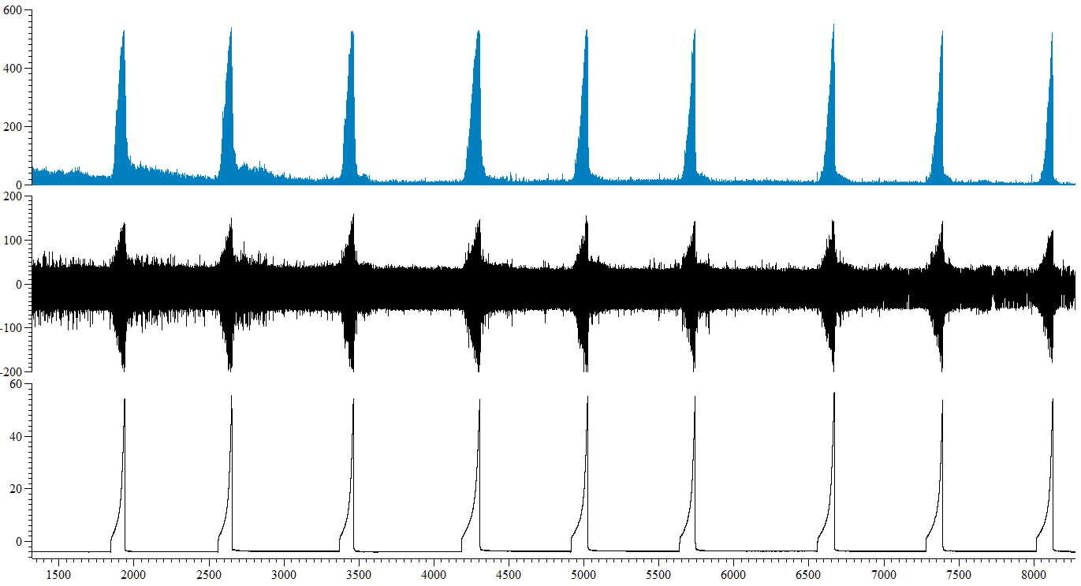

10 mins

Mean firing (imp s-1)

Nerve firing (µV)

IP (mmHg)

Time (s)

L-NAME (1mM) in saline

Control

**Figure 6.50: Screen-shot representative trace from a single experiment in which 1mM L-NAME (in saline) was perfused into the lumen of the bladder.** Intraluminal perfusion of 1mM L-NAME in saline had no effect on mechanosensitivity, bladder compliance nor on mean baseline afferent nerve firing. Spontaneous afferent nerve firing was significantly decreased following intraluminal perfusion of 1mM L-NAME in saline (n=6).



**A.**



**B.**

**Figure 6.51: Intraluminal perfusion of 1mM L-NAME in saline had no effect on mechanosensitivity.** A, Following 30 minutes continuous intraluminal perfusion of the bladder with 1mM L-NAME in saline, the afferent nerve response to bladder distension was unchanged, relative to 30 minutes saline control (P=0.12, n=7). B, Similarly, 60 minutes intraluminal perfusion with 1mM L-NAME in saline had no effect on mechanosensitivity, relative to 30 minutes saline control (P=0.25, n=7).



**A.**



**B.**

**Figure 6.52: Intraluminal perfusion of 1mM L-NAME in saline had no effect on bladder compliance.** A, Following 30 minutes continuous intraluminal perfusion of the bladder with 1mM L-NAME in saline, bladder compliance was unchanged, relative to 30 minutes saline control (P=0.69, n=7). B, Similarly, 60 minutes intraluminal perfusion with 1mM L-NAME in saline had no effect on compliance, relative to 30 minutes saline control (P=0.15, n=7).



**Figure 6.53: Mean baseline afferent nerve firing was not affected by intraluminal perfusion of 1mM L-NAME in saline** P=0.17, 1 way RM ANOVA with Bonferroni post-test, n=7.

### Overview

Following one hour perfusion and continued presence of NO inhibitor L-NAME, intraluminal perfusion of the bladder with the high K+ solution had no effect on the afferent nerve response to bladder distension or on bladder compliance thereby implicating NO signalling in the mediation of the inhibitory response identified in response to high K+ stimulation in this thesis (figure 6.54).

Interestingly, mean baseline afferent nerve firing was inhibited following high K+ stimulation even in the presence of NO inhibitor L-NAME (figure 6.54), suggesting that the nerve activity between distensions and during distension are mediated by different mechanisms.

### Afferent nerve firing in response to bladder distension was unaffected following intraluminal perfusion of the bladder with the high K+ solution in the presence of 1mM L-NAME.

Afferent nerve firing in response to distension of the bladder was unaffected, relative to 60 minutes 1mM L-NAME in saline control, by 10 minutes continuous intraluminal perfusion of the bladder with the high K+ solution in the presence of 1mM L-NAME (figure 6.55A). Following 30 minutes intraluminal perfusion of the high K+ solution in the presence of 1mM L-NAME, afferent nerve firing in response to bladder distension remained unaffected relative to 60 minutes 1mM L-NAME in saline control (figure 6.55B).

Following 30 minutes exposure of the bladder to the high K+ solution (in the presence of 1mM L-NAME), the standard saline solution was perfused into the bladder for a 30 minute washout period. Following 30 minutes saline washout, the afferent nerve response to ramp distension of the bladder remained unaffected relative to 60 minutes 1mM L-NAME in saline control (figure 6.55C).

### Bladder compliance was unaffected by intraluminal perfusion of the high K+ solution in the presence of 1mM L-NAME.

Following 10 minutes intraluminal perfusion of the bladder with the high K+ solution in the presence of 1mM L-NAME, bladder compliance remained unaffected, relative to 60 minutes 1mM L-NAME in saline control (figure 6.56A). Similarly, 30 minutes intraluminal perfusion with the high K+ solution in the presence of 1mM L-NAME had no effect on compliance, relative to 60 minutes 1mM L-NAME in saline control (figure 6.56B).

30 minutes saline washout did not alter bladder compliance, relative to 60 minutes 1mM L-NAME in saline control (figure 6.56C).

### Mean baseline afferent nerve firing was decreased following intraluminal perfusion of the high K+ solution in the presence of 1mM L-NAME.

Mean baseline afferent nerve firing was decreased following intraluminal perfusion of the high K+ solution in the presence of 1mM L-NAME, relative to 1mM L-NAME in saline control (figure 6.57).

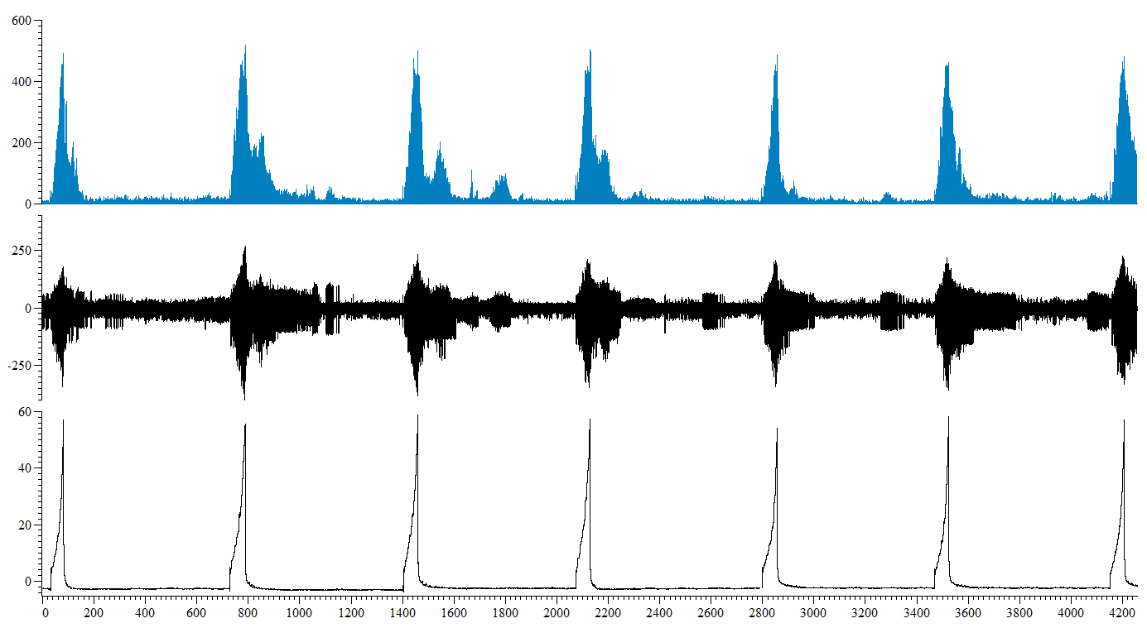

10 mins

Mean firing (imp s-1)

Nerve firing (µV)

IP (mmHg)

Time (s)

1 hour L-NAME (1mM) in saline

Washout

High K+ + L-NAME (1mM)

**Figure 6.54: Screen-shot representative trace from a single experiment.** Following 1 hour intraluminal perfusion of 1mM L-NAME in saline, the high K+ solution was intraluminally perfused in the presence of 1mM L-NAME. Intraluminal perfusion of the high K+ solution in the presence of 1mM L-NAME had no effect on the afferent nerve response to bladder distension or bladder compliance(n=6). Both spontaneous afferent nerve firing and mean baseline afferent nerve activity were decreased relative to 60 minutes 1mM L-NAME in saline control (n=6).



**A.**



**B.**



**C.**

**Figure 6.55: Intraluminal perfusion of the high K+ solution in the presence of 1mM L-NAME had no effect on the afferent nerve response to bladder distension.** A, 10 minutes intraluminal perfusion of the high K+ solution in the presence of 1mM L-NAME had no effect on the afferent nerve response to bladder distension relative to 60 minutes 1mM L-NAME in saline control (P=0.88, n=7). B, Similarly, 30 minutes intraluminal perfusion of the high K+ solution in the presence of 1mM L-NAME had no effect on the afferent nerve response to bladder distension relative to 60 minutes 1mM L-NAME in saline control (P=0.18, n=7). C, following 30 minutes saline washout, afferent nerve firing in response to ramp distension remained unaffected relative to 60 minutes 1mM L-NAME in saline control (P=0.08, n=7).



**A.**



**B.**



**C.**

**Figure 6.56: Bladder compliance was unaffected by intraluminal perfusion of the high K+ solution in the presence of 1mM L-NAME.** A, 10 minutes intraluminal perfusion of the high K+ solution in the presence of 1mM L-NAME had no effect on bladder compliance relative to 60 minutes 1mM L-NAME in saline control (P=0.11, n=7). B, 30 minutes intraluminal perfusion of the high K+ solution in the presence of 1mM L-NAME had no effect on bladder compliance relative to 60 minutes 1mM L-NAME in saline control (P=0.81, n=7). C, following 30 minutes saline washout, bladder compliance remained unaffected relative to 60 minutes 1mM L-NAME in saline control (P=0.36, n=7).



**Figure 6.57: Mean baseline afferent nerve firing was decreased by intraluminal perfusion of the high K+ solution in the presence of 1mM L-NAME.** *P=0.03, 1 way RM ANOVA with Bonferroni post-test, n=7.

# 6.11 NO signalling mediates the inhibition of afferent nerve sensitivity in response to high K+ stimulation. Is this effect attributable to eNOS?

In order to investigate this mechanism further, the final series of experiments performed attempted to provide an indication of the specific NO pathway activated by high K+ stimulation. As previously described in chapter 1, nitric oxide synthase (NOS) enzymes synthesise the production of the free radical NO and 3 types of NOS have been identified:

1. neuronal NOS (nNOS) – a constitutively expressed, Ca2+ dependent, enzyme,
2. epithelial NOS (eNOS) - a constitutively expressed, Ca2+ dependent, enzyme,
3. inducible/inflammatory NOS (iNOS) – inducible expression, Ca2+ independent.

As L-NAME is a non-specific NO inhibitor, all 3 NOS enzymes would have been inhibited in these experiments, therefore the logical progression from these experiments was to identify the specific NOS enzyme (s) involved in mediating this response. Taking into consideration previous findings in this thesis, data from protamine sulphate induced urothelial damaged preparations would suggest that the mediator responsible for the inhibition in afferent nerve firing in response to distension following high K+ stimulation was urothelially released which would suggest that as the expression of eNOS and iNOS isoforms have been found within the urothelium that both are potential candidates for the NOS enzyme pathway involved in this inhibitory mechanism (Burnett *et al.*, 1997; Lemack *et al.*, 1999). Additionally, in experiments in which Ca2+ dependent mediator release was inhibited by exposure of the bladder to Ca2+ free Krebs solution, afferent nerve firing in response to distension was increased, suggesting the presence of a Ca2+ dependent mediator that was released from the bladder in order to regulate afferent nerve sensitivity. As eNOS is expressed on the urothelium and its activity is Ca2+ dependent, it was hypothesised that synthesis of NO by eNOS was responsible for the inhibitory effect on mechanosensitivity observed following high K+ stimulation.

In the final series of experiments presented in this thesis, the effect of high K+ perfusion in the presence of selective eNOS inhibitor L-NIO was investigated, with the hypothesis that high K+ stimulates the urothelial release of NO (via eNOS) and consequently causes attenuation of the afferent nerve response to bladder distension. Therefore, in the presence of L-NIO, the attenuation of afferent nerve firing following high K+ stimulation would be abolished.

## Amendment to the cocktail/protocol

The experimental protocol and data analysis remained as previously described (section 6.3). N5-(1-Iminoethyl)-L-ornithine dihydrochloride (L-NIO), a potent inhibitor of endothelial nitric oxide synthase (eNOS) was obtained from Tocris bioscience, dissolved in distilled H20 and stored at -20°C as a 1mM stock solution. Immediately prior to use L-NIO was dissolved in both the standard saline solution and the high K+ solution to a final concentration of 10µM in both solutions and perfused intraluminally as previously described with a final percentage vehicle (distilled water) of 0.1% .

## Results

### Overview

10µM L-NIO was perfused in the standard saline solution for 1 hour prior to the high K+ challenge to ensure optimum inhibition of endothelial nitric oxide synthase (eNOS) by the antagonist, thereby also enabling the measurement of the effects of L-NIO perfusion alone (in saline) on bladder compliance and sensory nerve activity. Intraluminal perfusion of the bladder with 10µM L-NIO in saline had no effect on mechanosensitivity or bladder compliance. Similarly, mean baseline afferent nerve firing remained unaffected (figure 6.58).

### Afferent nerve firing in response to ramp distension of the bladder was unaffected by intraluminal perfusion of 10µM L-NIO in saline.

The afferent nerve response to bladder distension remained stable for 3 consecutive distensions prior to commencement of the protocol.

Intraluminal perfusion of the bladder with 10µM L-NIO in saline had no effect on the afferent nerve response to bladder distension, relative to 30 minutes saline control, following 30 minutes (figure 6.59A), and 60 minutes exposure (figure 6.59B).

### Bladder compliance and baseline afferent nerve activity were unaffected by intraluminal perfusion of the bladder with 10µM L-NIO in saline.

Bladder compliance remained stable for 3 consecutive distensions prior to intraluminal perfusion of 10µM L-NIO in saline. Following 30 minutes continuous intraluminal perfusion of 10µM L-NIO in saline, bladder compliance was unaffected relative to 30 minutes saline control (figure 6.60A). Compliance remained unaffected, relative to 30 minutes saline control, following 60 minutes intraluminal perfusion of 10µM L-NIO in saline (figure 6.60B).

Mean baseline afferent nerve activity was not affected by intraluminal perfusion of 10µM L-NIO in saline, relative to control (figure 6.61).

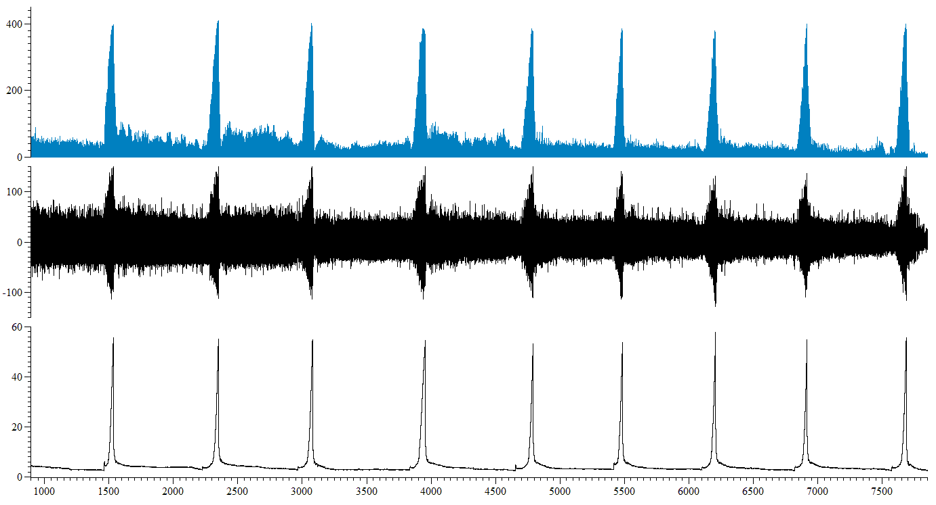

10 mins

Mean firing (imp s-1)

Nerve firing (µV)

IP (mmHg)

Time (s)

L-NIO (10µM) in saline

Control

**Figure 6.58: Screen-shot representative trace from a single experiment in which 10µM L-NIO (in saline) was perfused into the lumen of the bladder.** Intraluminal perfusion of 10µM L-NIO in saline had no effect on mechanosensitivity, bladder compliance nor on mean baseline afferent nerve firing or spontaneous afferent nerve firing relative to saline control (n=6).



**A.**



**B.**

**Figure 6.59: Intraluminal perfusion of 10µM L-NIO in saline had no effect on mechanosensitivity.** A, Following 30 minutes continuous intraluminal perfusion of the bladder with 10µM L-NIO in saline, the afferent nerve response to bladder distension was unchanged, relative to 30 minutes saline control (P=0.47, n=6). B, Similarly, 60 minutes intraluminal perfusion with 10µM L-NIO in saline had no effect on mechanosensitivity, relative to 30 minutes saline control (P=0.21, n=6).



**A.**



**B.**

**Figure 6.60: Intraluminal perfusion of 10µM L-NIO in saline had no effect on bladder compliance.** A, Following 30 minutes continuous intraluminal perfusion of the bladder with 10µM L-NIO in saline, compliance was unchanged, relative to 30 minutes saline control (P=0.23, n=6). B, Similarly, 60 minutes intraluminal perfusion with 10µM L-NIO in saline had no effect on bladder compliance, relative to 30 minutes saline control (P=0.19, n=6).



**Figure 6.61: Mean baseline afferent nerve firing was not affected by intraluminal perfusion of 10µM L-NIO in saline** P=0.98, 1 way RM ANOVA with Bonferroni post-test, n=6.

### Overview

Following 60 minutes intraluminal perfusion of the bladder with 10µM L-NIO in saline, the high K+ solution (50mMKCl/ 100m NaCl) was perfused into the bladder in the presence of 10µM L-NIO. 30 minutes intraluminal perfusion of the high K+ solution in the presence of 10µM L-NIO had no effect on the afferent nerve response to bladder distension, or on bladder compliance. Mean baseline afferent nerve firing was unaffected (figure 6.62).

### Afferent nerve firing in response to bladder distension was unaffected following intraluminal perfusion of the bladder with the high K+ solution in the presence of 10µM L-NIO.

Afferent nerve firing in response to distension of the bladder was unaffected, relative to 60 minutes 10µM L-NIO in saline control, by 10 minutes continuous intraluminal perfusion of the bladder with the high K+ solution in the presence of 10µM L-NIO (figure 6.63A). Following 30 minutes intraluminal perfusion of the high K+ solution in the presence of 10µM L-NIO, afferent nerve firing in response to bladder distension remained unaffected relative to 60 minutes 10µM L-NIO in saline control (figure 6.63B).

Following 30 minutes exposure of the bladder to the high K+ solution (in the presence of 10µM L-NIO), the standard saline solution was perfused into the bladder for a 30 minute washout period. Following 30 minutes saline washout, the afferent nerve response to ramp distension of the bladder remained unaffected relative to 60 minutes 10µM L-NIO in saline control (figure 6.63C).

### Bladder compliance and baseline afferent nerve activity were unaffected by intraluminal perfusion of the high K+ solution in the presence of 10µM L-NIO.

Following 10 minutes intraluminal perfusion of the bladder with the high K+ solution in the presence of 10µM L-NIO, bladder compliance remained unaffected, relative to 60 minutes 10µM L-NIO in saline control (figure 6.64A). Similarly, 30 minutes intraluminal perfusion with the high K+ solution in the presence of 10µM L-NIO had no effect on compliance, relative to 60 minutes 10µM L-NIO in saline control (figure 6.64B).

30 minutes saline washout did not alter bladder compliance, relative to 60 minutes 10µM L-NIO in saline control (figure 6.64C).

Mean baseline afferent nerve firing was unaffected by intraluminal perfusion of the high K+ solution in the presence of 10µM L-NIO, relative to 10µM L-NIO in saline control (figure 6.65).

10 mins

L-NIO (10µM) in saline

Washout

High K+ + L-NIO (10µM)

Mean firing (imp s-1)

Nerve firing (µV)

IP (mmHg)

Time (s)

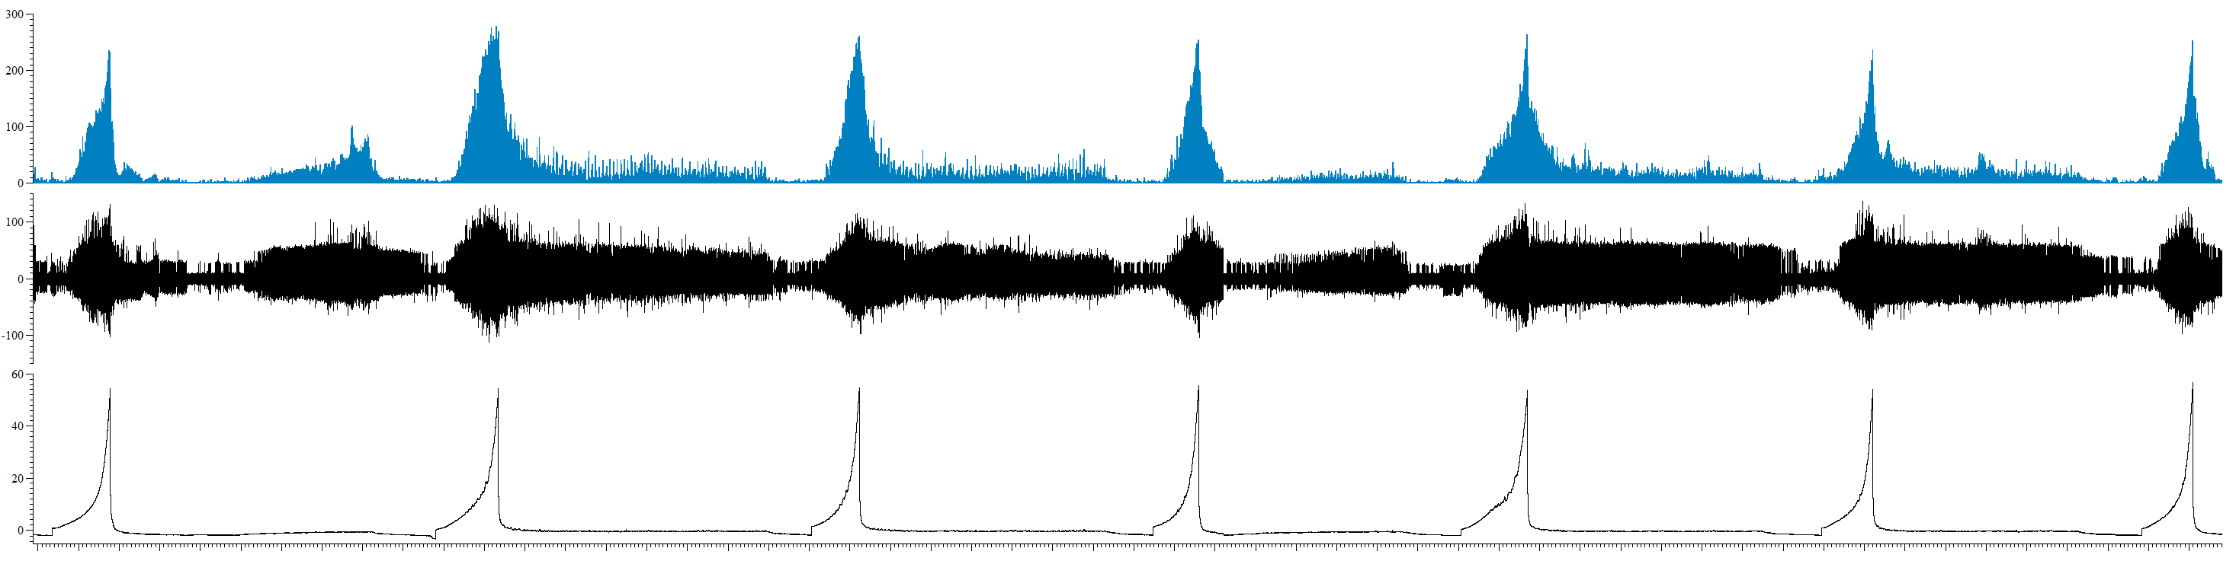

**Figure 6.62: Screen-shot representative trace from a single experiment.** Following 1 hour intraluminal perfusion of 10µM L-NIO in saline, the high K+ solution was intraluminally perfused in the presence of 10µM L-NIO. Intraluminal perfusion of the high K+ solution in the presence of 10µM L-NIO had no effect on the afferent nerve response to bladder distension or bladder compliance (n=6). Spontaneous afferent nerve firing was decreased relative to 60 minutes 10µM L-NIO in saline control (n=6). Mean baseline afferent nerve activity remained unaffected (n=6).



**A.**



**B.**



**C.**

**Figure 6.63: Intraluminal perfusion of the high K+ solution in the presence of 10µM L-NIO had no effect on the afferent nerve response to bladder distension.** A, 10 minutes intraluminal perfusion of the high K+ solution in the presence of 10µM L-NIO had no effect on the afferent nerve response to bladder distension relative to 60 minutes 10µM L-NIO in saline control (P=0.25, n=6). B, Similarly, 30 minutes intraluminal perfusion of the high K+ solution in the presence of 10µM L-NIO had no effect on the afferent nerve response to bladder distension relative to 60 minutes 10µM L-NIO in saline control (P=0.47, n=6). C, following 30 minutes saline washout, afferent nerve firing in response to ramp distension remained unaffected relative to 60 minutes 10µM L-NIO in saline control (P=0.62, n=6).



**A.**



**B.**



**C.**

**Figure 6.64: Bladder compliance was unaffected by intraluminal perfusion of the high K+ solution in the presence of 10µM L-NIO.** A, 10 minutes intraluminal perfusion of the high K+ solution in the presence of 10µM L-NIO had no effect on bladder compliance relative to 60 minutes 10µM L-NIO in saline control (P=0.23, n=6). B, 30 minutes intraluminal perfusion of the high K+ solution in the presence of 10µM L-NIO had no effect on bladder compliance relative to 60 minutes 10µM L-NIO in saline control (P=0.53, n=6). C, following 30 minutes saline washout, bladder compliance remained unaffected relative to 60 minutes 10µM L-NIO in saline control (P=0.55, n=6).



**Figure 6.65: Mean baseline afferent nerve firing was unaffected by intraluminal perfusion of the high K+ solution in the presence of 10µM L-NIO.** P=0.13, 1 way RM ANOVA with Bonferroni post-test, n=6.

# 6.12 Discussion

## High K+ stimulates the release of NO from the intact urothelium thereby inhibiting the afferent nerve response to bladder distension.

Intraluminal perfusion of the high K+ solution in the presence of the full cocktail abolished the high K+ induced inhibition observed in previous experiments as shown in chapter 5. Subsequent experimentation and analysis revealed nitric oxide as the mediator responsible for this inhibitory mechanism, and further experimentation showed that specific inhibition of eNOS mediated synthesis of NO, by L-NIO perfusion, was sufficient to abolish the inhibition of mechanosensitivity in response to high K+ stimulation.

Following 1 hour perfusion of NO inhibitor L-NAME, perfusion of the high K+ solution in the continued presence of L-NAME had no effect on the afferent nerve response to bladder distension, showing that NO is released in response to high K+ stimulation, in the intact bladder, to downregulate sensory nerve activity.

Patch clamp recordings in dissociated afferent neurons innervating the rat urinary bladder have shown that during exposure to NO donor SNAP (S-nitroso-N-acetyl-penicillamine), high-voltage-activated Ca2+ channel currents were suppressed by 30% suggesting that NO has a modulatory effect on the bladder afferent pathway (Ozawa *et al.*, 1999). Other studies have also hypothesised a role of NO in afferent nerves of the bladder following observations in rat cystometry experiments, where application of NO donor SNP and cGMP dependent protein kinase agonist 8Br-cGMP or phosphodiesterase inhibitor PDE5-1 during intravesical instillation of capsaicin, increased the micturition pressure threshold and the intercontraction interval (Caremel *et al.*, 2010), two urodynamic parameters which are closely related to the sensory component of the micturition reflex and therefore activity of afferent nerve fibres (Nagabukuro *et al.*, 2010). This data showed that activation of the NO/cGMP signalling pathway exerted an inhibitory effect on bladder afferent nerve sensitivity, thereby preventing hyper-excitability of C fibre afferents and consequently bladder hyperactivity (Caremel *et al.*, 2010). These results were in agreement with previous findings that demonstrated that intravesical administration of L-NAME (a NO inhibitor) in rats with capsaicin-induced detrusor overactivity, decreased the intercontraction interval (Masuda *et al.*, 2007), and in a model of bladder irritation induced by cyclophosphamide treatment in the rat bladder, NO donor SNP increased the inter-contraction interval (Ozawa *et al.*, 1999). The depression of sensory nerve signalling in the bladder by NO signalling has also been inferred in studies in which inhibition of PDE5, thereby the inhibition of cGMP degradation by phosphodiesterase type 5, resulted in a decrease in the non-voiding contractions during the filling phase of the micturition reflex in a bladder hyperactivity model induced by bladder outlet obstruction in the rat, which may have resulted in part from an increase in sensory nerve activity (Filippi *et al.*, 2007; Tinel *et al.*, 2006). Furthermore, more recently, evidence of an inhibition of bladder afferent nerve firing following PDE5 inhibition by Vardenafil has been reported in spinal-cord injured rats (Behr-Roussel *et al.*, 2011).

Interestingly, perfusion of L-NAME alone in saline had no effect for the entire 1 hour period of intraluminal perfusion on the afferent nerve response to bladder distension in this preparation. This is in contrast to recent findings by another group who showed that intravesical instillation of the rat bladder with L-NAME increased the activity of both Aδ and C fibre afferent nerve fibres in the control bladder (Aizawa *et al.*, 2011). However, in the experiments performed by Aizawa and colleagues, in order to facilitate the permeability of the urothelium for drug administration, protamine sulphate solution (10mg/ml) was perfused into the bladder for 60 minutes prior to obtaining the reading for ‘control’ effect of L-NAME perfusion on the mechanosensitivity response. The effect of protamine sulphate on the integrity of the bladder urothelium or on afferent nerve sensitivity was not reported, however in the experiments performed in this thesis, intraluminal perfusion of the same dose of protamine sulphate, for the same exposure period was sufficient to cause gross morphological changes in urothelial integrity, and reduced the afferent nerve response to distension, potentially as a direct result of damage to urothelial afferent nerve endings, as discussed in chapter 5. This would suggest that a similar degree of damage to urothelial integrity may have been observed in this rat preparation, and suggests that the increase in afferent nerve firing observed in this previous study is attributable to bladder hyperactivity as a result of urothelial damage by protamine sulphate perfusion (Aizawa *et al.*, 2011).

In addition, this recent study reported an excitation of both A δ and C fibre afferent nerve firing in response to bladder distension following acrolein treatment that was significantly inhibited by pre-treatment with NO donor L-arginine, suggesting that in this model of bladder hyperactivity NO can inhibit increased sensory sensitivity (Aizawa *et al.*, 2011). This suggests that in this thesis, further experiments could have been performed in the protamine sulphate damaged bladders, to investigate whether the excitation of firing following high K+ stimulation could be attenuated by administration of a NO donor. A similar mechanism has been proposed previously, in experiments in which oxyhaemoglobin, a NO scavenger, instilled into the rat bladder induced bladder hyperactivity. It was concluded that NO released from the urothelium by distension or following urothelial stimulation (for example following K+ infusion), may hyperpolarise afferent nerves in the bladder, thereby increasing the threshold for activation of afferent nerve firing during bladder filling and decreasing bladder hyperactivity (Pandita *et al.*, 2000).

Further investigations were required in the study by Aizawa and colleagues in order to determine the isoform(s) of NOS responsible for the observed effects, however, unfortunately at present, no further data has been published. In this thesis, experiments suggested that the mediator responsible for the inhibition of afferent nerve sensitivity in response to bladder distension was both urothelially released, as protamine sulphate damage of the bladder abolished the inhibitory effect, and Ca2+ dependent, as Ca2+ free Krebs experiments displayed augmented mechanosensitivity responses, therefore eNOS was investigated as a likely candidate after the observation that the NO pathway was responsible for the inhibition in firing following high K+ stimulation. Furthermore the urothelium of the bladder in the pig (Persson *et al.*, 1993), human (Smet *et al.*, 1994), and rat (Alm *et al.*, 1995), amongst other species has been shown to display NADPH-diaphorase labelling, and both eNOS and iNOS isoforms have been found within the urothelium (Burnett *et al.*, 1997; Lemack *et al.*, 1999). RT-PCR in isolated rat bladders has also confirmed the presence of eNOS and iNOS in urothelial cells (Birder *et al.*, 2002).

Perfusion of selective eNOS antagonist L-NIO abolished the inhibitory effect on mechanosensitivity by high K+ stimulation observed in experiments in which the high K+ solution was perfused alone, thereby providing evidence that NO specifically via eNOS synthesis was responsible for the inhibitory effect in mechanosensitivity in high K+ experiments. However, further evidence is required to support these findings, for example with different eNOS inhibitors, or by directly measuring the NO release from the urothelium in intact and protamine sulphate bladders following high K+ stimulation either by a microsensor (Birder *et al.*, 1998), or by the use of a NO analyser (Munoz *et al.*, 2010).

## Bladder compliance was unaffected by perfusion of the high K+ solution in the presence of each of the cocktails of antagonists.

One of the justifications for the choice of the 50mM KCl/ 100mM NaCl high K+ solution to use to stimulate mediate release from the urothelium in both protamine sulphate and cocktail experiments was the ability of this K+ solution to attenuate the mechanosensitivity response, yet cause no change in bladder muscle compliance, in order to measure the direct effects of mediator release on afferent nerve activity without secondary effects on sensory nerves from changes in muscle contractility and compliance. Therefore, it was unsurprising that, in the presence of all cocktails of antagonists, high K+ perfusion had no effect on bladder compliance.

Interestingly however, when the full cocktail was applied in the intact bladder, in saline, without high K+ stimulation, bladder compliance was decreased, suggesting that the detrusor muscle was comparatively more contracted to saline control. As multiple pathways had been inhibited by the various antagonists in the cocktail, it is difficult to identify the mechanism(s) responsible for this effect, as importantly it may be that this effect emerges due to the combination of the antagonists used in the pharmacological cocktail and a change in the balance of inhibitory and excitatory mediators, rather than as a result of individual specific mediators acting directly on the detrusor muscle.

It would have been reasonable to expect that, as NO has a well-established role in muscle relaxation in various tissues throughout the body, inhibition of NO signalling may result in increased muscle contraction and decreased bladder compliance if NO signalling has a major role in the regulation of detrusor muscle activity in this preparation. Interestingly however, perfusion of either L-NAME or L-NIO in saline had no effect on bladder compliance, a finding rather surprising when making comparisons between this study and previous published work. Having said that NO has only a very short half-life, therefore suggesting that there may simply not be a high enough concentration of NO release in a short period of time to cause an effect on compliance. Equally, the presence of a plexus of blood vessels between the urothelium and underlying muscle layers may disrupt the signalling transduction between these layers, providing an explanation as to why perfusion of NO inhibitors used in this preparation had no effect on bladder compliance.

However, previous studies regarding the effects of NO on the contractile state of the bladder have been performed on tissue from animals and humans that had been pharmacologically pre-contracted. Detrusor muscle strips from the rat bladder, pre-contracted by carbachol or K+ solution developed contractions in response to electrical stimulation. These contractions persisted even following treatment with α, ß-methylene ATP and/or atropine, suggesting that modulation of purinergic or muscarinic receptor signalling was insufficient to stimulate relaxation of the detrusor muscle strips. However, small relaxations of the detrusor muscle strips were observed following application of NO donors SNP, SIN-1 and NO, however, these NO donors caused greater relaxation in isolated pre-contracted urethral preparations (Persson *et al.*, 1992). This study suggests that whilst NO may play a small role in relaxation of the detrusor muscle, the predominant site of NO signalling and activity is in the bladder urethra (Persson *et al.*, 1992). In contrast, in the porcine bladder, detrusor muscle strips pre-contracted with carbachol were concentration-dependently relaxed by exogenous administration of NO (by 63%) and NO donor SIN-1 (by 70%) , revealing species differences in the contribution of NO mediated relaxation of the detrusor muscle (Persson *et al.*, 1992).

Similarly to the results obtained in the experiments in this thesis, intravesical administration of L-NAME during continuous bladder perfusion in anaesthetised rats, did not change the amplitude and duration of reflex bladder contractions or the intercontraction interval (Ozawa *et al.*, 1999). Authors concluded that whilst this data may suggest that NO may not be responsible for the emergence of hyperactivity in cyclophosphamide treated animals, it was also possible that intravesical application of L-NAME does not penetrate the urothelium and enter the mucosal layer, thereby unable to directly modulate detrusor activity (Ozawa *et al.*, 1999). However, results also indicated that exogenous application of NO produced stabilisation of the detrusor smooth muscle in rats with cyclophosphamide induced bladder hyperactivity. This effect was concluded to be unlikely due to direct action on the detrusor smooth muscle as the amplitude of detrusor muscle contractions (a parameter associated with muscle activity) was unchanged in both control and cyclophosphamide treated animals, and it was hypothesised that these effects were due to modulation of afferent nerve sensitivity, as the intercontraction interval (a parameter associated with sensory nerve activity) was increased (Ozawa *et al.*, 1999).

Similarly, in a recent study in a similar preparation as used in this thesis in rat, L-NAME instillation had no effect on bladder compliance, even following protamine sulphate treatment to aid permeability of drugs across the urothelial layer (Aizawa *et al.*, 2011). This suggests that an inability of L-NAME to penetrate the urothelium and thereby modulate detrusor activity directly is a less likely explanation for data obtained in the study by Ozawa and colleagues (Ozawa *et al.*, 1999).

Taken together, these data suggest that in the unstimulated, relaxed bladder, as in the experiments in this thesis not exposed to the high K+ solution, modulation of NO pathways has no effect on bladder detrusor muscle compliance. However, following stimulation or pre-contraction, administration of NO donors decreases detrusor muscle hyperactivity, but it is postulated that this effect occurs predominantly via modulation of sensory signalling rather than a direct effect on smooth muscle cells. In any case, the low concentration of high K+ solution used in these experiments, for reasons previously explained, was insufficient to stimulate contraction of the detrusor muscle; therefore no evidence was provided by this study to contribute to knowledge with regards to the effect of NO on bladder compliance and muscle behaviour in the contracted bladder.

## The mechanism responsible for the high K+ induced inhibition in the afferent nerve firing between distensions remains unclear.

The aim of the experiments with the various pharmacological antagonists was to identify the mediator responsible for the inhibition of afferent nerve firing in response to bladder distension observed in response to high K+ stimulation; however it was also possible to analyse the afferent nerve activity between distensions.

Interestingly, perfusion of the full cocktail in saline decreased baseline afferent nerve firing following 1 hour perfusion suggesting that one or more of the pathways inhibited by the pharmacological cocktail are involved in mediating baseline afferent nerve firing. However due to the complexity of the cocktail, the specific pathway(s) involved in mediating this response could not be identified.

High K+ perfusion of the bladder resulted in attenuated afferent nerve firing at baseline, (see chapter 5). However, perfusion of the full cocktail with the high K+ solution had no effect on baseline afferent nerve firing indicating that one or more of the mediators blocked by perfusion of the full pharmacological cocktail were responsible for the decrease in baseline afferent nerve activity by high K+ stimulation. Successive experiments, in turn, indicated a potential role for a number of mediators in preventing the inhibition of baseline afferent nerve firing in response to high K+ perfusion, including, prostaglandins (as perfusion of high K+ had no effect on baseline afferent nerve firing in the presence of indomethacin alone), and, as identified as the pathway responsible for mediating the inhibitory response to high K+ stimulation in the mechanosensitivity response, NO via eNOS mediated synthesis (as perfusion of high K+ had no effect on baseline afferent nerve firing in the presence of L-NIO alone).

It is also possible that ACh plays a role in the inhibitory response to high K+ stimulation as removal of atropine from the pharmacological cocktail (as in cocktail 3) saw the reappearance of the inhibition in baseline afferent nerve firing in response to high K+ stimulation. However it is important to note that as multiple antagonists for various signalling pathways were perfused together in this cocktail, and at a high concentration to ensure inhibition of the various signalling pathways particularly to compensate for the barrier function of the urothelium, it is difficult to draw firm conclusions from the data. Compensatory mechanisms may have been activated in an attempt to modulate afferent nerve activity following blockade of various signalling pathways by the different pharmacological cocktails, or have arisen because of the effect of blocking several mediator pathways simultaneously.

An interaction between NO and prostaglandins has also been identified in the rabbit bladder, where results showed that iNOS induced NO synthesis increased prostaglandin synthesis via COX-2, suggesting that both mechanisms may work simultaneously (Masuda *et al.*, 2009). Complex interactions have also been observed in the urothelium involving ATP, NO, ACh and prostaglandins. ATP and PGE2 stimulate the release of ACh from the guinea pig urothelium, and similarly ACH can also modulate the release of PGE2 (Nile *et al.*, 2012). In the rat bladder, NO has been shown to inhibit ACh and ATP dependent synthesis of PGE2. The findings in the literature also suggest that COX enzymes can be activated by ACh and ATP to induce PGE2 expression, and show that NO has the ability to inhibit COX enzymes, thereby downregulate PGE2 and sensory signalling (Nile *et al.*, 2012). These studies together suggested a complex, multifactorial signalling mechanism that could have been generating the inhibition in baseline firing in response to high K+ solution stimulation in these experiments.

The data generated in these experiments suggests possible avenues for further investigation regarding the mediator(s) responsible for mediating the inhibition in baseline afferent nerve firing in response to high K+ stimulation, either in this preparation without a distension protocol, or perhaps in a urothelial cell line, where mediator release in response to stimulation and at baseline could be measured without interference from muscle or nerve fibres.

It is important to identify that the adopted pharmacological cocktail experiments used in this thesis are a potential limitation. High concentrations of drugs were used with potential for interactions with each other (both physical and chemical) and the likely differing degrees to which each drug can penetrate through the urothelium make biological findings very hard to interpret. However, despite this, these experiments identify and prove a mechanism for the high K+ response.

# 6.13 Summary of findings presented in this chapter.

The data presented in this chapter showed that:-

1. High K+ stimulation of the bladder induces activation of NO that inhibits the afferent nerve response to bladder distension.
2. Evidence suggests that NO production catalysed by eNOS is responsible for this inhibitory effect, as following specific inhibition of eNOS activity, the inhibitory effect on afferent nerve firing in response to bladder distension induced by high K+ stimulation is abolished.
3. The afferent nerve firing between bladder distensions was unaffected by high K+ perfusion in the presence of the full cocktail. Further analysis identified ACh, prostaglandins and NO pathways, or a combination of the three may be responsible for the high K+ induced inhibition in baseline afferent nerve firing, however further studies are required.
4. Bladder compliance was unaffected by perfusion of NO inhibitor L-NAME, however the effect of L-NAME on the pre-contracted bladder (i.e. by the use of higher concentrations of high K+ solution as used previously in chapter 5) has not been investigated.

These data show for the first time, to our knowledge, that direct stimulation of urothelial mediator release (by high K+) induces the release of nitric oxide which acts on sensory nerve terminals to downregulate afferent nerve firing in response to bladder distension, thereby suggesting a protective mechanism of the healthy urothelium in preventing bladder hypersensitivity.

In the final chapter, the entire data set produced in this thesis has been discussed and a hypothetical model has been proposed to explain how these findings can be extrapolated into a potential use in clinical diagnostics and treatment for bladder disorders.

# References

Aizawa, N., Igawa, Y., Nishizawa, O., & Wyndaele, J. (2011). Effects of Nitric Oxide on the Primary Bladder Afferent Activities of the Rat With and Without Intravesical Acrolein Treatment. *European Urology, 59*, 264-271.

Alm, P., Zygmunt, P. K. E., Iselind, C., Larssonb, B., Uveliusc, B., Wernerb, S., & Andersson, K. (1995). Nitric oxide synthase immunoreactive adrenergic, cholinergic and peptidergic nerves of the female rat urinary tract: a comparative study *J. Auton. Nerv, Syst., 56*, 105-114.

Apodaca, G., Balestreire, E., & Birder, L. A. (2007). The Uroepithelial-associated sensory web. *Kidney International, 72*, 1057-1064.

Behr-Roussel, D., Oger, S., Caisey, S., Sandner, P., Bernabe, J., Alexandre, L., & Giuliano, F. (2011). Vardenafil Decreases Bladder Afferent Nerve Activity in Unanethetised, Decerebrate, Spinal-Cord-Injured Rats. *European Urology, 59*, 272-279.

Birder, L. A., Apodaca, G., de Groat, W. C., & Kanai, A. J. (1998). Adrenergic- and capsaicin-evoked nitric oxide release from urothelium and afferent nerves in urinary bladder. *American Journal of Physiology: Renal Physiology, 275*, 226-229.

Birder, L. A., & de Groat, W. C. (2007). Mechanisms of Disease: involvement of the urothelium in bladder dysfunction. *Nature Clinical Practice Urology, 4*, 46-54.

Birder, L. A., Nakamura, Y., Kiss, S., Nealen, M. L., Barrick, S. R., Kanai, A. J., Wang, E., Ruiz, W. G., de Groat, W. C., Apodaca, G., Watkins, S., & M.J., C. (2002). Altered urinary bladder function in mice lacking the vanilloid receptor TRPV1. *Nat. Neurosci., 5*, 856-860.

Burnett, A. L., Calvin, D. C., Chamness, S. L., Liu, J., Nelson, R. J., Klein, S. L., Dawson, V. L., Dawson, T. M., & Snyde, S. H. (1997). Urinary bladder urethral sphincter dysfunction in mice with targeted disruption of neuronal nitric oxide synthase models idiopathic voiding disorders in humans. *Nature Med., 3*, 571-574.

Caremel, R., Oger-Roussel, S., Behr-Roussel, D., Grise, P., & Giuliano, F. A. (2010). Nitric Oxide/Cyclic Guanosine Monophosphate Signalling Mediates an Inhibitory Action on Sensory Pathways of the Micturition Reflex in the Rat *European Urology, 58*, 616-625.

Daly, D., Chess-Williams, R., Chapple, C., & Grundy, D. (2010). The inhibitory role of acetylcholine and muscarinic receptors in bladder afferent activity. *European Urology, 58*, 22-28.

Filippi, S., Morelli, A., Sandner, P., Fibbi, B., Mancina, R., Marini, M., Gacci, M., Vignozzi, L., Vannelli, G. B., Carini, M., Forti, G., & Maggi, M. (2007). Characterisation and functional role of androgen-dependetn PDE5 activity in the bladder. *Endocrinology, 148*, 1019-1029.

Gratzke, C., Streng, T., Park, A., Christ, G., Stief, C. G., Hedlund, P., & Andersson, K. (2009). Distribution and function of cannabinoid receptors 1 and 2 in the rat, monkey and human bladder. *Journal of Urology, 181*, 1939-1948.

Hawthorn, M. H., Chapple, C. R., Cock, M., & Chess-Williams, R. (2000). Urothelium-derived inhibitory factor(s) influences on detrusor muscle contractility in vitro. *British Journal of Pharmacology, 129*(3), 416-419.

Lemack, G. E., Burkhard, F., Zimmern, P. E., McConnell, J. D., & Lin, V. K. (1999). Physiologic sequelae of partical infravesical obstruction in the mouse: role of inducible nitric oxide synthase. *Journal of Urology, 161*, 1015-1022.

Masuda, H., Kawano, K., Matsuoka, Y., Yokoyama, M., Koga, F., Saito, K., Kihara, K., & Azuma, H. (2009). Interactions between inducible nitric oxide synthase and cyclooxygenase-2 in response to ischaemia-reperfusion of rabbit bladder. *BJU International, 106*, 716-722.

Masuda, H., Kim, J. H., Kihara, K., Chancellor, M. B., de Groat, W. C., & Yoshimura, N. (2007). Inhibitory roles of peripheral nitregic mechanisms in capsaicin-induced detrusor overactivity in the rat. *BJU International, 100*, 912-918.

Munoz, A., Gangitano, D. A., Smith, C. P., Boone, T. B., & Somogyi, G. T. (2010). Removal of urothelium affects bladder contractility and release of ATP but not release of NO in rat urinary bladder. *BMC Urology, 10*, 1-7.

Nagabukuro, H., Degenhardt, A., Villa, K. L., Mistry, S. L., Gichuru, L., Jochnowitz, N., & Abbadie, C. (2010). Correlation between pharmacologically-induced changes in cystometric parameters and spinal c-Fos expression in rats. *Autonomic Neuroscience, 156*, 19-26.

Nile, C. J., & Gillespie, J. I. (2012). Interactions Between Cholinergic and Prostaglandin Signaling Elements In the Urothelium: Role for Muscarinic Type 2 Receptors. *Urology, 79*, 17-23.

Ozawa, H., Chancellor, M. B., Jung, S., Yokoyama, T., Fraser, M. O., Yu, Y., de Groat, W. C., & Yoshimura, N. (1999). Effect of intravesical nitric oxide therapy on cyclophosphamide-induced cytsitis. *The Journal of Urology, 162*, 2211-2216.

Pandita, R. K., Mizusawa, H., & Andersson, K. (2000). Intravesical oxyhemoglobin initiates bladder overactivity in conscious, normal rats. *The Journal of Urology, 164*, 545-550.

Persson, K., Alm, P., Johansson, K., Larsson, B., & Andersson, K. (1993). Nitric oxide synthase in pig lower urinary tract: immunohistochemistry NADPH diaphorase histochemistry and functional effects. *British Journal of Pharmacology, 110*, 521-530.

Persson, K., & Andersson, K. (1992). Nitric oxide and relaxation of pig lower urinary tract. *British Journal of Pharmacology, 106*, 416-422.

Persson, K., Igawa, Y., Mattiasson, A., & Andersson, K. (1992). Effects of inhibition of the L-arginine/nitric oxide pathway in the rat lower urinary tract in vivo and in vitro. *British Journal of Pharmacology, 107*, 178-184.

Pertwee, R. G., & Fernando, S. R. (1996). Evidence for the presence of cannabinoid CB1 receptors in mouse urinary bladder. *British Journal of Pharmacology, 118*(8), 2053-2058.

Smet, P. J., Edyvane, K. A., Jonavicius, J., & Marshall, V. R. (1994). Distribution of NADPH-diaphorase positive nerves supplying the human urinary bladder. *J. Auton. Nerv. Syst., 47*, 109-113.

Tinel, H., Stelte-Ludwig, B., Hutter, J., & Sandner, P. (2006). Pre-clinical evidence for the use of phosphodiesterase-5 inhibitops for treating benign prostatic hyperplasia and lower urinary tract symptoms. *BJU International, 98*, 1259-1263.