**Systems Biology study of distinct actions by short-chain fatty acids in colon cancer cell-lines**

**Thesis submitted for the degree of**

**Doctor of Philosophy**

**The University of Sheffield**

by

Josephine Kilner

Chemical and Biological Engineering

Department of Oncology, The Medical School

The University of Sheffield

July 2013

J Kilner

**Abstract**

Colorectal cancer (CRC) is the third largest cause of cancer deaths worldwide. Short-chain fatty acids (SCFA) are reported to be chemoprotective against CRC and are beneficial to colon epithelia by virtue of being their preferred energy source. Despite being essential to human metabolism and health, SCFAs are only accessible to humans as nutritional by-products of the anaerobic fermentation of dietary fibre by gut bacteria. Identifying novel chemotherapeutic roles for SCFAs is attractive due to their high tolerance by colonocytes, however the underlying metabolic actions are not fully understood. This project took a Systems Biology approach by employing high-throughput, quantitative proteomic and cellomic experimentation to investigate whether the three principle SCFAs in colon epithelia, butyrate, propionate and valerate, display unique roles with potentially chemoprotective actions. A hypothesised anti-mitotic pathway was formulated in which odd-chain SCFAs at above physiological concentrations induce downstream epigenetic acetylation of transcriptional regulators to differentially regulate β-tubulin isotypes. This creates an aberrant tubulin code leading to the disruption of microtubule (MT) dynamics, failure of critical MT cellular functions and eventual cell death. The pathway was simulated by computational dynamical modelling to predict the behaviour of SCFAs in relation to MT dynamics under both treatment and physiological conditions. This verified the plausibility of the hypothesis and provided valuable insights into the underlying mechanisms. Bioinformatic searches, combined with proteomic evidence, indicated that propionate and valerate, the odd-chain SCFAs, differentially regulated pro-tumourigenic β-tubulin isotypes. The alteration of the β-tubulin expression pattern countered potential metabolic adaptions in colon cancer cells, suggesting a chemopreventive action. Anti-microtubule drugs (AMD) are among the most successful chemotherapies to date, however their toxicity and drug resistance increase with successive rounds of treatment. This project has demonstrated that odd-chain SCFAs may act as novel chemotherapeutics by reducing the negative effects of AMDs while enhancing their efficacy.

**Acknowledgements**

It could not have achieved this doctoral thesis without the help of many good friends and colleagues. Although it is not possible to mention everyone here, I would like them to know how much I have appreciated their support.

I am extremely grateful to my supervisors Dr Stephen Wilkinson and Dr Bernard Corfe for giving me this wonderful opportunity, and for their guidance and enthusiasm throughout this project. Many thanks go to my colleagues and friends at the University. I would especially like to thank Dr Caroline Evans and Joanna Chowdry for sharing their expertise in iTRAQ mass spectrometry and High Content Biology. I enjoyed our collaborations.

A special thank you goes to all my family and friends for their support and encouragement - and for reminding me there is life beyond research.

Above all, my deepest thanks go to my Mum, my brother Dave and Clare Parkin, who’s been the greatest friend. They never stopped believing in me, helped me through the toughest times and shared the good times.

I am grateful to the EPSRC for providing the funding (EP/E036252/1) for this research.

**Author Publications**

**Submitted and published during the course of this doctoral project; 2010–2013**

1. Corfe BM, **Kilner J**, Chowdry J, Benson RSP, Griffiths GJ, Evans CA. [Application of High Content Biology to yield Quantitative Spatial Proteomic Information on Protein Acetylations](http://www.springer.com/new+%26+forthcoming+titles+(default)/book/978-1-62703-304-6). Methods in molecular biology (Clifton, N.J.) 2013;981:37-45.
2. **Kilner J**, Waby JS, Chowdry J, Khan AQ, Noirel J, Wright PC, *et al*. [A proteomic analysis of differential cellular responses to the short-chain fatty acids butyrate, valerate and propionate in colon epithelial cancer cells](http://www.ncbi.nlm.nih.gov/pubmed/22075547). Molecular Biosystems 2012;8(4):1146-56.
3. **Kilner J**, Corfe BM, Wilkinson SJ. [Modelling the microtubule: towards a better understanding of short-chain fatty acid molecular pharmacology](http://www.ncbi.nlm.nih.gov/pubmed/21283865). Molecular Biosystems 2011;7(4):975-83.
4. **Kilner J**, Zhu L, Ow SY, Evans C, Corfe BM. [Assessing the Loss of Information through Application of the ‘Two-hit Rule’ in iTRAQ Datasets](http://www.jiomics.com/index.php/jio/article/viewArticle/53). JIOMICS 2011;1:124-34.

**Contents**

Abstract ii

Acknowledgements iii

Author Publications v

Contents vi

List of Figures XII

List of Tables xvi

Abbreviations xviii

1. Introduction 1

1.1. Research aim 1

1.1.1. Project purpose 1

1.1.2. Principle outcomes and contributions to future science and medicine 2

1.1.3. Metabolic pathway and protein selection 3

1.1.4. Formulation of the hypothesis 4

1.2. Thesis Structure 4

1.3. Colorectal cancer 7

1.3.1. Background and current status of colorectal cancer 7

1.3.2. The cellular structure, roles and health of colon epithelia 7

1.4. Short-chain fatty acids 9

1.4.1. Physiological structures and functions of short-chain fatty acids (SCFA) 9

1.4.2. SCFAs in a physiological environment 11

1.4.3. Chain-length dependent functions of SCFAs 12

1.4.4. SCFAs as inhibitors of histone deacetylases and promoters of acetylation 13

1.4.5. SCFAs as regulators of gene expression in colon epithelial cells 14

1.4.6. SCFAs in colorectal cancer 14

1.5. Microtubules and the Cellular cytoskeleton 15

1.5.1. The cellular cytoskeleton 15

1.5.2. Microtubules 15

1.5.3. The tubulin code 16

1.5.4. The roles of β-tubulin isotypes in cancer 17

1.5.5. Microtubule dynamics and dynamic instability 19

1.5.6. Anti-microtubule drugs 23

1.5.7. β-tubulin nomenclature 24

1.6. Systems Biology 25

2. Colon cancer cell lines and cell culture 27

2.1. Introduction to cell lines 27

2.2. Introduction to cell culture 29

2.3. Cell culture, treatment and harvesting 30

2.3.1. Cell culture pipeline 30

2.3.2. Cell culture reagents 32

2.3.3. Cell culture protocol 32

2.3.4. SCFA treatment and harvesting protocols 33

2.3.5. Preparation of whole cell lysates for proteomic studies 34

2.3.6. Preparation of whole cell samples for flow cytometry analyses 35

2.3.7. Protein concentration assays 35

2.3.8. Protein integrity assays by polyacrylamide gel electrophoresis (PAGE) 35

2.4. Cell culture results 36

2.4.1. The half maximal inhibitory concentration (IC50) 36

2.4.2. Biological replicates and protein integrity 39

3. Multi-plex iTRAQ proteomics confirmed that odd and even-chain SCFAs differentially regulate distinct sets of proteins in HCT116 colon cancer cells, including β-tubulin isotypes 40

3.1. Contribution of multi-plex iTRAQ to the overall project 40

3.2. Introduction to proteomics 40

3.2.1. Multi-plex iTRAQ proteomics 40

3.1.2. Multi-plex iTRAQ analysis of cytoskeletal proteins 43

3.3. Multi-plex iTRAQ: Project outline 44

3.3.1. Experimental approaches 44

3.3.2. Data analysis and data-mining 45

3.3.3. Multi-plex iTRAQ analyses pipelines 46

3.3.4. SCFA biological replicates 48

3.4. Multi-plex iTRAQ: Experimental methods 49

3.4.1. Multi-plex iTRAQ reagents and solutions for protein labelling 49

3.4.2. Strong cation exchange (SCX) and High-performance liquid chromatography (HPLC) 50

3.4.3. Multi-plex iTRAQ tandem-mass spectrometry 51

3.4.4. Multi-plex iTRAQ spectra analysis 51

3.4.5. Phenyx analysis (post-mass spectrometry) 52

3.4.6. Post-Phenyx analysis 54

3.4.7. uTRAQ quantitation 54

3.4.8. SignifiQuant quantitation 55

3.4.9. Multi-plex iTRAQ quality control by correlation plots and dendrograms 56

3.5. Multi-plex iTRAQ: Results 57

3.5.1. Relative quantification by multi-plex iTRAQ mass spectrometry 57

3.5.2. Propionate quadruplet results: Protein matches and quantification data 61

3.5.3. SCFA duplicate data-mining: Protein matches and quantification data 61

3.5.4. Differential regulation of cytoskeletal proteins 62

3.5.5. Correlation and cluster analyses of the biological replicates 65

3.5.6. Orthogonal validation of differential regulated proteins 67

3.6. Multi-plex iTRAQ: Discussion 68

3.7. Multi-plex iTRAQ: Key Conclusions 72

4. High Content Analysis showed that odd-chain SCFAs distinctly perturb MT cytoskeletal integrity and mitotic pathways compared to even-chain SCFAs 73

4.1. Contribution of High Content Analysis to the overall project 73

4.2. Introduction to High Content Analysis 73

4.2.1. HCA background 73

4.2.2. HCA study aims 74

4.3. HCA: Project outline 76

4.3.1. HCA of MT cytoskeletal integrity 76

4.3.2. HCA of cell cycle progression and the biphasic response 76

4.4. HCA: Experimental methods 77

4.4.1. General reagents and solutions 77

4.4.2. HCT116 cell culture and treatment in 96 well-plates 78

4.4.3. Immunocytochemistry of actin and tubulin cytoskeletal structures 79

4.4.4. HCA quantification of cytoskeletal integrity 79

4.4.5. Data-mining HCA cell cycle data for the biphasic response 81

4.4.6. HCA statistical analysis 81

4.5. HCA: Results 82

4.5.1. Defining a novel parameter for MT-fibre integrity 82

4.5.2. Effect of SCFA treatments on MT cytoskeletal integrity 83

4.5.3. HCA cell cycle progression and the biphasic response 86

4.6. HCA: Discussion 92

4.7. HCA: Key Conclusions 94

5. Flow cytometry indicated a time-dependent difference in cell cycle response in HCT116 cells between odd and even-chain SCFA treatments 95

5.1. Contribution of flow cytometry to the overall project 95

5.2. Flow cytometry in Systems Biology 95

5.3. The cell cycle 96

5.3.1. The cell cycle and checkpoints 96

5.3.2. The cell cycle’s role in cancer development 98

5.4. Introduction to flow cytometry 99

5.4.1. Flow cytometry cell cycle analysis 99

5.4.2. Flow cytometry analysis of cell cycle arrest 101

5.4.3. The effect of aneuploidy and hyperploidy in flow cytometry analysis 102

5.5. Flow cytometry: Project outline 102

5.6. Flow cytometry: Experimental methods 103

5.7. Flow cytometry: Results 106

5.7.1. Flow cytometry cell cycle spectra 106

5.7.2. Flow cytometry cell cycle data 109

5.8. Flow cytometry: Discussion 112

5.9. Flow cytometry: Key Conclusions 113

6. Western blot analysis provided orthogonal validation of the multi-plex iTRAQ results in respect of β-tubulin isotype expression in HCT116 cells treated with SCFAs 114

6.1. Contribution of Western blotting to the overall project: 114

6.2. Introduction to Western blotting 114

6.2.1. Western blotting background 114

6.3. Western blotting: Experimental methods 115

6.3.1. Western blotting and densitometry protocols 115

6.3.2. Statistical analysis 116

6.4. Western blotting: Results 116

6.4.1. Overview of the Western blotting results 116

6.4.2. Expression levels of β-tubulin isotypes following 24 h SCFA treatments 118

6.4.3. Expression levels of β-tubulin isotypes following time-course SCFA treatments 119

6.4.4. Western blot analysis of loading controls 119

6.4.5. Western blot densitometry data 120

6.5. Western blotting: Discussion 122

6.6. Key Conclusions: Western blotting 123

7. Bioinformatics and pathway analysis confirmed that odd-chain SCFAs, propionate and valerate, uniquely target mitotic events in HCT116 colon cancer cells, distinctly from butyrate. 124

7.1. Contribution of bioinformatics to the overall project 124

7.2. Bioinformatics: Project outline 124

7.3. Bioinformatic tools and resources 126

7.3.1. Phenyx 126

7.3.2. UniProt and NCBInr 126

7.3.3. BLAST 127

7.3.4. SABioscience 127

7.3.5. Gene Expression Atlas, GXA 128

7.3.6. Reactome’s Pathway Expression and ID mapping tools 128

7.3.7. STRING 130

7.4. Bioinformatics Results 130

7.4.1. Phenyx 130

7.4.2. BLAST 130

7.4.3. SABioscience 131

7.4.4. The Gene Expression Atlas (GXA) 132

7.4.5. Pathway mapping and expression analysis 133

7.4.6. String Functional Partners 142

7.5. Bioinformatics: Discussion 143

7.6. Key Conclusions: Bioinformatics 144

8. Computational dynamical modelling supports a hypothesised SCFA-targeted mitotic pathway in which odd-chain SCFAs act as anti-mitotic destabilising agents by disrupting MT-dynamic instability 145

8.1. Contribution of computational dynamical modelling to the overall project 145

8.2. Introduction to computational dynamical modelling 145

8.2.1. Computational dynamical modelling of the hypothesised pathway 145

8.2.2. Microtubules and dynamic instability 146

8.3. Model design and kinetic parameters 148

8.3.1. Design rationale 150

8.3.2. Kinetic equations (ODE) 153

8.3.3. Kinetic rate constants 155

8.3.4. Initial reactant concentrations 157

8.3.5. Physiological predictions. 161

8.3.6. Comparison of computational model parameters to reported experimental in vitro data 162

8.3.7. Comparison of computational model parameters to experimental data 163

8.4. Time-course simulations 164

8.5. Computational dynamical modelling: Results 166

8.6. Discussion and Future Directions 178

9. Project Conclusion 180

9.1. Hypotheses formulation 180

9.1.1. The hypothesis 180

9.1.2. Experimental and bioinformatic contributions 181

9.1.3. Impact of computational dynamical modelling 182

9.2. Project conclusions and contributions to science and medicine 183

Bibliography 185

Appendix I: Multi-plex iTRAQ quantitation 195

Appendix II: Bioinformatics and Pathway analyses 207

**List of Figures**

Figure 1.1. Thesis navigation map

Figure 1.2. Micrograph of colon epithelia

Figure 1.3. HDAC classes: Pathways in cancer

Figure 1.4. The MT cycle of dynamic instability

Figure 1.5. Schematic ‘monte carlo’ illustration of the MT capping model

Figure 1.6. Facilitated diffusion

Figure 2.1. HCA micrograph of the cellular cytoskeleton of HCT116 colon cancer cells

Figure 2.2. Micrograph HCT116 cells at low density and at log growth (~70%–80% confluence)

Figure 2.3. IC50 values for SCFA treatments of HCT116

Figure 2.4. Protein integrity SDS-PAGE gel for SCFA-treated HCT116 cells

Figure 3.1. Multi-plex iTRAQ analysis pipeline for a) Propionate quadruplet experiment; b) SCFA duplicate experiments

Figure 3.2. Multi-plex iTRAQ QSTAR SCX spectrum showing the isobaric ion peaks

Figure 3.3. Multi-plex iTRAQ histogram of linear fold-changes of differentially regulated cytoskeletal proteins in SCFA-treated HCT116 cells

Figure 3.4. Multi-plex iTRAQ Venn diagram showing differentially regulated cytoskeletal proteins in SCFA-treated HCT116 cells

Figure 3.5. Multi-plex iTRAQ correlation plots for the propionate quadruplet biological replicates

Figure 3.6. Multi-plex iTRAQ dendrogram for the propionate quadruplet biological replicates

Figure 4.1. HCA 96-well plate plan and resulting fluorescent micrographs of the HCT116 cellular cytoskeleton after SCFA treatments

Figure 4.2. HCA micrographs of the cellular cytoskeleton in SCFA-treated HCT116 cells

Figure 4.3. HCA quantification of MT-fibre integrity in SCFA-treated HCT116 cells

Figure 4.4. HCA cell cycle analysis of SCFA-treated HCT116 cells at 24 h and 48 h

Figure 5.1. The cell cycle diagram describing the different phases and checkpoints

Figure 5.2. A typical flow cytometry histogram (sprectra0 for normal untreated cells

Figure 5.3. Representative flow cytometry dot plots showing sub-population grouping of cells and gating

Figure 5.4. Flow cytometry plots for untreated and SCFA-treated HCT116 cells

Figure 5.5. Flow cytometry histograms of cell count vs. cell cycle phase for the time-course SCFA treatment of HCT116 cells

Figure 5.6. Flow cytometry histograms showing the time course tends in the cell cycle with SCFA-treated HCT116 cells

Figure 6.1. Western blot immunofluorescent images of differentially expressed β-tubulin isotypes in SCFA-treated HCT116 cells

Figure 6.2. Western blot densitometry histograms differentially expressed β-tubulin isotypes in SCFA-treated HCT116 cells

Figure 7.1. Gene Expression Atlas (GXA) bioinformatic data compared to multi-plex iTRAQ results for β-tubulin isotype expression in HCT116 cells

Figure 7.2. Reactome ‘Starry-sky’ map of biological metabolic pathways

Figure 7.3. Pathway ID Mapping colour-coded hierarchy tree of multi-plex iTRAQ data from SCFA-treated HCT226 cells

Figure 7.4. Mitotic pathways enriched in proteins differentially expressed in SCFA-treated HCT116 cells

Figure 7.5. Pathway-mining to sub-mitotic pathways from multi-plex iTRAQ data of SCFA-treated HCT116 cells

Figure 7.6. Protein-Protein interactions [STRING] between β2c-tubulin, β3-tubulin, β1-tubulin and closest functional partners

Figure 8.1. Qualitative schematic model of the hypothesised metabolic pathway

Figure 8.2. MT ‘Dynamicity’: *in silico* relationships between MT-dynamic instability parameters

Figure 8.3. Inter-relationship between MT-fibres and β-tubulin subunits through polymerisation; hydrolysis; and re-phosphorylation

Figure 8.4. Parameter matching of in *silico* *Tubb* concentrations vs. *in vitro* multi-plex iTRAQ data for β-tubulin isotypes at steady state

Figure 8.5. Dynamical Simulations showing suppression of MT-dynamics as a consequence of SCFA treatments

Figure 8.6. Comparisons of computational model predictions vs. experimental HCA and flow-cytometry data

Figure 8.7. Model predictions vs. reported experimental observations for MT-stabilising and destabilising treatments

Figure 8.8. Model predictions vs. reported experimental observations of physiological metabolic behaviour

**List of Tables**

Table 1.1. Chemical structure and carbon chain length of SCFAs in the colon.

Table 1.1. Chemical structure and carbon chain length of SCFAs in the colon

Table 1.2. The β-tubulin (β1, β3, β2c) expression profiles in tumour and normal tissues

Table 1.3. The approved nomenclature for β-tubulin genes

Table 2.1. IC50 values for the cell cycle check points induced by SCFA treatments of HCT116 colon cancer cells

Table 3.1. Multi-plex iTRAQ–Phenyx; Quantification parameters; and protein numbers

Table 3.2. Multi-plex iTRAQ data for significantly differentially cytoskeletal proteins

Table 3.3. Summary of the twenty proteins having the greatest fold-changes in SCFA-treated HCT116 colon cancer cells

Table 4.1. HCA MT-fibre integrity in SCFA-treated HCT116 colon cancer cells

Table 4.2. HCA MT-fibre fragmentation in SCFA-treated HCT116 colon cancer cells

Table 4.3a 24 h HCA cell cycle analysis for SCFA-treated HCT116 cells

Table 4.3b 48 h HCA cell cycle analysis for SCFA-treated HCT116 cells

Table 5.1. Flow cytometry: mean percentage of cells at each cell cycle phases in SCFA-treated HCT116

Table 6.1. Western blot densitometry analyses for β-tubulin isotypes differentially regulated in SCFA-treated HCT116

Table 7.1. Pathway expression analyses of mitotic pathways enriched by SCFA-treatment of HCT116 cells

Table 8.1. Ordinary Differential Equations (ODE) defining the kinetic reactions in the computationally modelled hypothesised pathway

Table 8.2. Parameter overview of the computational dynamical model for the hypothesised mitotic pathway

Table 8.3. Parameter values and ranges used in the model based on best estimates

Table 8.4. Parameter overview of the initial concentrations selected for the computational dynamical model

Table 8.5. Definition of the *in silico* *Tubb* parameter: The weighted combined fold-change of β-tubulin isotypes

Table 8.6. Reported experimental data for MT-dynamicity parameters from time-lapse fluorescence microscopy studies (Destabilisation; Stabilisation; Physiological)

Table 8.7. Computational model outputs for MT-dynamicity parameters and steady-state protein concentrations for simulated SCFA-treatments in the hypothesised anti-mitotic pathway

Table 8.8. Comparisons between experimental the reported experimental data (destabilisation; stabilisation) and computational model outputs of MT-dynamicity parameters

Table 8.9. Physiological predictions: Comparisons between computational model outputs of MT-dynamicity parameters with reported experimental physiological data

**Abbreviations**

*[Grouped by association]*

SCFA Short-chain fatty acid

CRC Colorectal cancer

IBD Inflammatory bowel disease

HDAC Histone deacetylase

HDACi Histone deacetylase inhibitor

PTM Post-translational modification

MT Microtubules

IF Intermediate filaments

TF Transcription factor

MAP Microtubule associated protein

AMD Anti-microtubule drug

iTRAQ isobaric Tag for Relative and Absolute Quantitation

LC MS/MS Liquid chromatography-tandem mass spectrometry

SCX Strong cation exchange

OHW One-hit wonder

IC Isotope correction

MC Median correction

MTC Multi-test correction

HCA High Content Analysis

FACS Fluorescent activated cell sorting

ICC Immunocytochemistry

PAGE Polyacrylamide gel electrophoresis

SBML Systems Biology mark-up language

ODE Ordinary differential equation

GTP Guanosine diphosphate

GDP Guanosine triphosphate

CC Critical concentration (tubulin)

# 1. Introduction

## 1.1. Research aim

### *1.1.1. Project purpose*

Butyrate, propionate and valerate are short-chain fatty acids (SCFA) produced by anaerobic fermentation of dietary fibre by gut bacteria. They are associated with health-promoting benefits in colon epithelial cells, including chemoprevention of colorectal cancer (CRC) by acting through metabolic pathways that promote acetylation [1-3], however the details underlying the mechanisms are not fully established. In the preceding study by the author it was found that these SCFAs differentially regulated unique sets of proteins [4], therefore the purpose of this project was to identify and investigate one or more of the mechanisms involved. A Systems Biology approach was employed in which the wealth of quantitative experimental data generated in this and the preceding project was analysed while exploiting the rapidly expanding genomic and protein databases and pathway analysis tools that are now available [4, 90]. The plausibility of the resulting hypothesis was tested by developing a computational mechanistic model to replicate and perform temporal simulations of the proposed pathway *in silico*. Additional ‘what if’ scenarios were simulated to make experimentally testable predictions and provide directions for future investigations.

In order to identify potential pathways for investigation, data from the preceding project were mined [4, 90]. As a result, the initial focus of this project was microtubule (MT) structural and functional mechanisms. This combination of hypothesis-driven and data-driven approaches proved to be an effective technique for advancing understanding of SCFA behaviour in colon epithelial cells and to identify candidate molecular targets associated with SCFAs to act in novel chemotherapies of CRC.

### *1.1.2. Principle outcomes and contributions to future science and medicine*

* This project has confirmed that different SCFAs have distinct and shared metabolic actions in colon cancer epithelial cells.
* The project has identified and verified a metabolic pathway by which MT structural dynamics are distinctly targeted by propionate and valerate, the odd-chain SCFAs, in HCT116 colon cancer cells.
* The project has reinforced the value of employing a Systems Biology approach including computational mechanistic modelling for studying biological systems in a post-omic era.
* A simple but effective computational dynamical model has been developed that may be adapted for similar MT-targeted investigations.
* Although the evidence in this project was derived from colon cancer lines *in vitro*, the implications of the results may have pharmacological value for other colonic diseases, such as inflammatory bowel disease (IBD), Crohn's disease and ulcerative colitis (UC).

### *1.1.3. Metabolic pathway and protein selection*

The purpose of this project was to explore the pathways that were unique to individual SCFA treatments in colon cancer epithelial cells. In order to determine the most probable pathways for initial investigation a preliminary examination of the existing proteomic evidence [4, 90] was carried out. The twenty proteins with the greatest fold changes following SCFA treatments of HCT116 colon cancer cells relative to untreated cells were identified. The proteins that were common to all SCFAs were primarily involved in diverse generic functions such as glycolysis or protein folding. Nine of the remaining proteins were distinctly regulated by either propionate and/or valerate (the odd-chain SCFAs) including four β-tubulin isoforms. No other protein family was similarly represented. This data is described in Table 3.3 in the mass spectrometry chapter. Further evidence supporting an MT-based pathway was provided by quantitative cellomic experimentation and bioinformatic pathway analysis. It is acknowledged that there will be other candidate pathways, however among the top twenty proteins displaying the greatest distinct fold changes, the β-tubulins isoforms were those most worth investigating.

### *1.1.4. Formulation of the hypothesis*

As the project progressed, the decision to explore an MT pathway was consistently verified by the experimental evidence, leading to the formulation of the following hypothesis. The plausibility of this hypothesis was then successfully tested by computational dynamical modelling.

*“At above-physiological concentrations, the odd-chain SCFAs, propionate and valerate, promote downstream epigenetic acetylation at specific β-tubulin transcriptional binding sites in HCT116 colon cancer cells, thereby altering the expression profile of β-tubulin isotypes. This in turn creates an aberrant tubulin code which perturbs microtubule dynamic instability and prevents microtubules from correctly performing their cellular functions, eventually leading to mitotic arrest and cell death.”*

## 1.2. Thesis Structure

This study applied a Systems Biology approach to observe the effects of treating HCT116 colon cancer cells with SCFAs [5, 6]. Complementary high-performance experimental, bioinformatic and computational techniques were combined to provide a system-wide view. Each contributed independent and valuable evidence into a cohesive whole, leading to the modular design of this thesis.

The rationale behind the organisation of this thesis was to present the central themes of the project: colorectal cancer; short-chain fatty acids; and microtubules in the main introduction. Each of the subsequent chapters describes an individual experimental, bioinformatic or computational sub-project along with their contribution to the whole project. Each chapter is divided into the following sections: an overview or background of that study or technique; the experimental outline or model design; a description of the methods and tools employed; followed by the results and discussion. A final chapter brings together the key findings of the whole project into a conclusion. Figure 1.1 provides a navigation map.

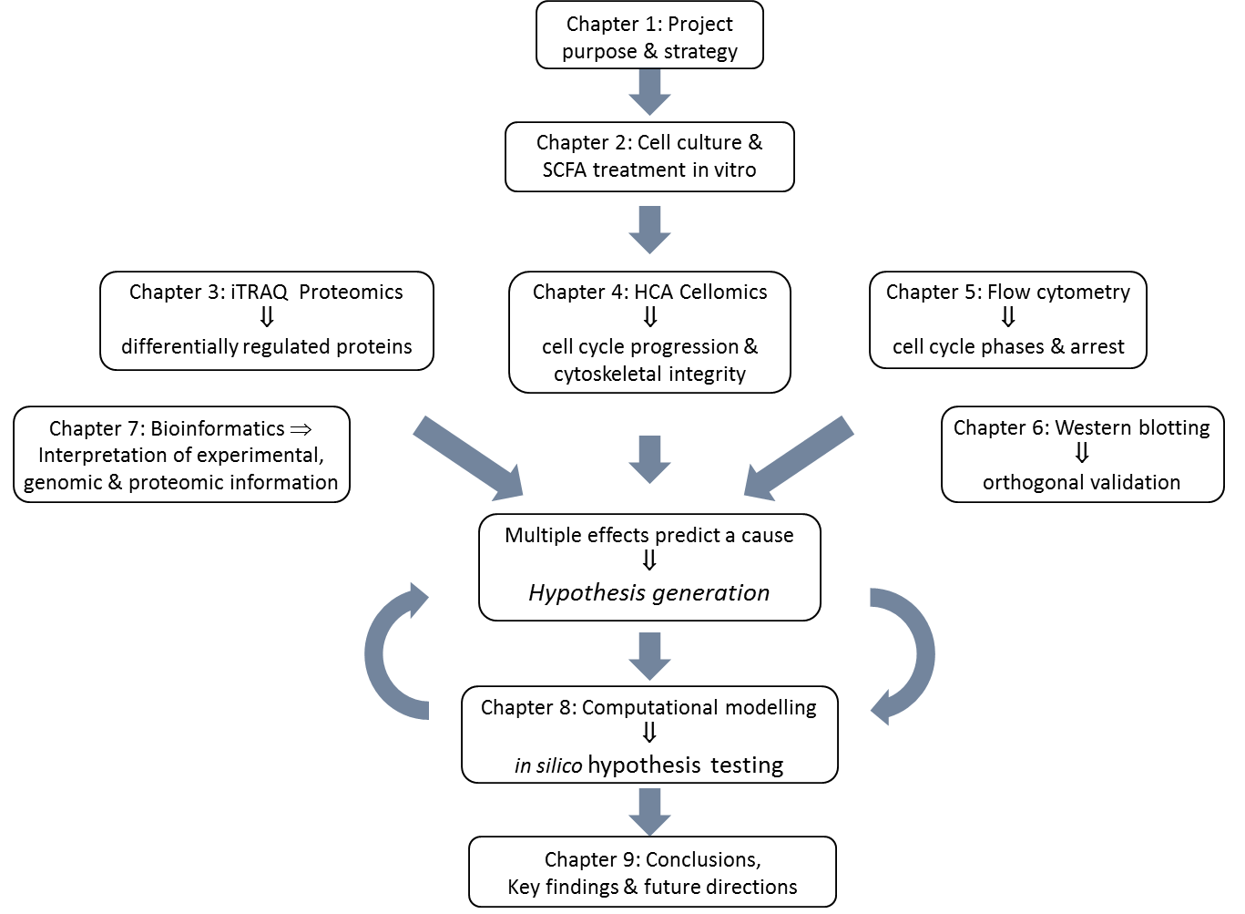

**Figure 1.1.** Navigation map of the thesis.

1. Chapter 1: The introduction chapter states the purpose, study plan and central themes of the project: colorectal cancer; short-chain fatty acids (SCFA); microtubules (MT) and their dynamics, and discusses how these may be connected in the progression of colorectal cancer (CRC).
2. Chapter 2: Describes the cell culture and SCFA treatment protocols of HCT116 colon cancer cell lines that were used throughout this project.
3. Chapter 3: Multi-plex iTRAQ mass spectrometry, a high-throughput proteomic technique, was used to identify significantly differentially expressed β-tubulin isotype proteins in SCFA-treated HCT116 cells.
4. Chapter 4: High Content Analysis (HCA) quantitative microscopy was the cellomic technique used for investigating MT cytoskeletal integrity in HCT116 cells following SCFA treatments.
5. Chapter 5: Flow cytometry cell cycle analysis provided time-response evidence to support the HCA cell cycle results.
6. Chapter 6: Western blotting provided orthogonal validation of the multi-plex iTRAQ mass spectrometry results.
7. Chapter 7: Bioinformatics was invaluable for interpreting the wealth of experimental data generated by the high-throughput experimental techniques in this project and offered revealing insights into the mechanisms involved.
8. Chapter 8: Computational dynamical modelling replicated and simulated the hypothesised pathway, testing its plausibility and offering directions and predictions for future investigations.
9. Chapter 9: The project conclusion brings together the contributions from each of the experimental, bioinformatic and computational modelling steps to formulate a final hypothesis. The potential importance of this work in understanding SCFA metabolic actions in colon epithelial cancer cells and potential CRC therapies it discussed.

## 1.3. Colorectal cancer

### *1.3.1. Background and current status of colorectal cancer*

Colorectal cancer is the third most common cancer and fourth highest cause of cancer-related deaths worldwide. In the UK, where CRC is the fourth most common cancer and the second highest cause of cancer death, approximately 110 people were newly diagnosed with bowel cancer every day in 2010 [7].

Despite improvements in screening and treatment, the incidence and mortality rates remain high. Much of this is due to a ‘Western diet’ and lifestyle, such as red and processed meat, obesity and physical inactivity. Furthermore, epidemiological evidence is showing rapid increases in the incidences of CRC in countries adopting more westernised lifestyles and in migrants moving from low to high-risk countries. Conversely, changes in diet and lifestyle have been found to reduce the risk [7].

### *1.3.2. The cellular structure, roles and health of colon epithelia*

The primary role of the colon is the reabsorption of water during stool formation and the absorption of small nutrients [8]. The inner layer of the colon wall, the mucosa, contains crypts (Figure 1.2) and multiple digestive glands [9]. Colon epithelia are continually exposed to hydrochloric acids and digestive enzymes and therefore have one of the fastest cell turnover rates and are among the most dynamic cells in the body [10]. It is estimated that the entire colonic epithelial population is renewed every three days in humans. New epithelial cells are developed at the base of the crypts where some remain to undergo further division while others migrate to the surface to replace existing cells. The old cells undergo programmed cell death, or apoptosis, and are eventually shed into the stools. If coordination is lost between cell proliferation at the base of the crypts and cell death at the top, for example due to genetic mutations, there can be an excessive increase in the number of cells generated, which can cause crypt fission and the development of polyps. If further mutations occur, this process can lead to the development of malignant tumours and cancer [11].

The health of the colon is intimately linked with the diet by virtue of physical proximity, physiology and metabolic functions. Although SCFAs are essential to human metabolism and have a positive impact on colon health, we are unable to manufacture them ourselves. Instead, we rely on gut bacteria to produce them as a side product of anaerobic fermentation of ingested fibre. As such, the colon has a close symbiotic relationship with the gut flora that inhabit it [12]. In return, we offer them a host environment and, ideally, a ready supply of dietary fibre [12, 13].

Diseases of the colon that are associated with low fibre diets include ulcerative colitis (UC), inflammatory bowel disease (IBD) and Crohn’s disease, which is a form of IBD. An exception is coeliac disease which is exacerbated by fibre, requiring a gluten free diet [14].

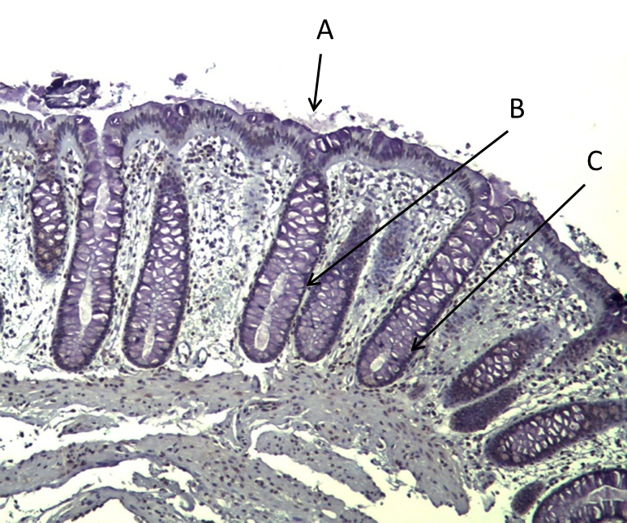

**Figure 1.2.** The colon wall is composed of (A) columnar epithelia which contain (B) gland, or goblet, cells and (C) stem cells. The stem cells originate at the base of the crypts and migrate to the surface to replace mucosa cells which are continually subject to damage from bile and gastric acids and shed into the stools. This micrograph was kindly donated by J. Wild, Department of Oncology, The University of Sheffield [9].

## 1.4. Short-chain fatty acids

### *1.4.1. Physiological structures and functions of short-chain fatty acids (SCFA)*

Short-chain fatty acids (SCFA) are short un-branched chains 2 to 6 carbons in length (Table 1.1) [3]. They are naturally occurring by-products of the diet and as such, are directly absorbed into the colon lumen where they are preferentially utilised as fuel by colon epithelial cells [15]. In addition to being a fuel source, SCFAs have metabolic actions in colon epithelia with health-promoting and chemopreventive effects. These are discussed extensively in several reviews [1-3].

In order of carbon chain length, the principle SCFAs are acetate (2C); propionate (3C); butyrate (4C); valerate (5C); and caproate (6C). In addition, there are several related branched chain molecules including valproic acid (VPA; 8C), a derivative of valerate, and organic anions such as lactate, formate and succinate. However, it is the SCFAs with less than 5Cs that are most associated with altering the acetylation status in colon epithelia [3, 16]. These are the focus of this project.

**Table 1.1**. Chemical structure and carbon chain length of SCFAs

|  |  |  |
| --- | --- | --- |
| SCFA | Structure | No. of C atoms |
| Acetate | CH3COOH | 2 |
| Propionate | C2H5-COOH | 3 |
| Butyrate | C3H7-COOH | 4 |
| Valerate | C4H9-COOH | 5 |
| Caproate | File:Caproic-acid-3D-balls.png  C5H11-COOH | 6 |

Acetate, butyrate and propionate are found at molar ratios of 60:20:20 in the colon, at concentrations between 40–80 mM, 10–20 mM and 10–25 mM, respectively [16-18]. Valerate and caproate are produced in lesser amounts.

Following absorption, the SCFAs are utilised by the colon epithelia and/or transported into the portal vein and from there to the liver and peripheral tissues where they are metabolised [19]. Unlike the other SCFAs, acetate is rapidly transported to the liver where it is either used in the synthesis of long chain fatty acids during the final stages of cholesterol synthesis or used as an energy source by peripheral tissues. Conversely, 70%–90% of butyrate remains in the colon epithelia where it is utilised as their preferred fuel source. Propionate acts as both a fuel source for colon epithelia and as a substrate for gluconeogenesis in the liver. Similarly, valerate is metabolised in the colon epithelia and transported to the liver where it is both glucogenic and ketogenic. Caproate is the most efficiently extracted of all the SCFAs and is taken up by the liver where it is strongly ketogenic. These metabolic actions are described in a variety of publications [12, 13, 17, 20, 21]. The efficiency of SCFA absorption from the colon into the epithelia and from there to the liver and peripheral tissues is thought to be chain-length specific [1].

### *1.4.2. SCFAs in a physiological environment*

Nutritional metabolites, including SCFAs, frequently work in collaboration within the human body. There is evidence that SCFAs not only act together synergistically or additively within colon epithelia *in vivo* [22-24], but also competitively or individually in specific metabolic pathways [23, 25]. Much of this evidence has been derived from ruminant or animal feeds studies [24, 25]; for example, antibiotics can be most effective when administered in the presence of all three SCFAs [26]. Butyrate is acknowledged to be the most potent of the SCFAs in apoptotic pathways and some apoptotic effects related to hyperacetylation are only observed with butyrate [3, 23]; conversely other effects are only related to the odd-chain SCFAs, i.e. propionate and valerate [3]. Propionate has been observed together with butyrate in certain pathways; whereas propionate acts alone or inhibits butyrate in others [24]. Valerate and butyrate have also been found to act competitively [26]. Although it is generally accepted that butyrate is chemopreventive against CRC, butyrate has been found to promote tumour formation under certain conditions. This is termed the ‘butyrate paradox’ and may be linked to confounding factors that exist *in vivo* [22]. To date, butyrate has been the most extensively researched of the SCFAs in colon epithelia [1, 3].

### *1.4.3. Chain-length dependent functions of SCFAs*

Propionate (3C) and valerate (5C) are odd-chain SCFAs, whereas acetate (2C) and butyrate (4C) are even-chain SCFAs; furthermore, each SCFA has a unique concentration in the colon [16]. This offers the possibility that their shared and distinct actions are not only a function of structural interactions but are also based on their physiological concentration [3, 25], with evolutionary foundations related to dietary sources [26].

The different SCFAs differentially target different classes of histone deacetylases (HDAC) [27]. This would have consequences in cancer development where HDAC classes are involved in specific aspects of tumourigenesis (Figure 1.3). For example, HDAC1, which is primarily associated with butyrate [28], has roles in apoptosis, proliferation and resistance, whereas HDAC4 acts in differentiation and angiogenesis. However, SCFAs do not target HDAC6, the HDAC associated with MTs, so cannot alter MT function through this acetylation pathway. As such, any actions SCFAs have in MTs must be though alternative pathways; for example, by targeting MT dynamics *via* indirect synthesis of tubulin subunits, as is the hypothesis of this study. This is supported by the observation that SCFAs act in a chain-length manner in certain tissues leading to a proposal that individual SCFAs are involved in determining which genes are transcribed [1]. A similar effect is observed in intermediate filaments (IF) where SCFAs have a direct effect on the structural integrity and functions of IFs *via* post-translational acetylation of keratin subunits, K8 and K18 [29-31].

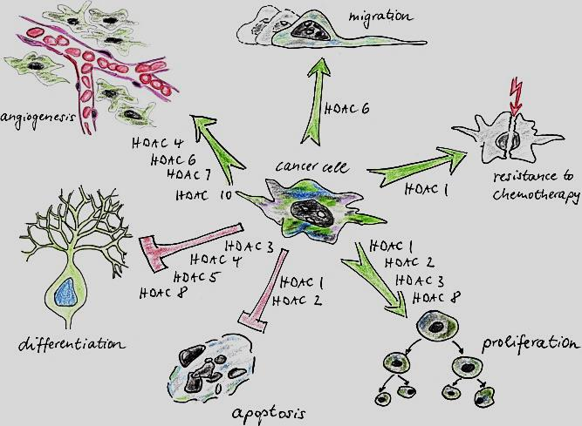

**Figure 1.3.** Individual HDACs or classed target distinct aspects of cancer development: apoptosis, proliferation, differentiation, angiogenesis, migration, drug resistance. Image printed with kind permission of Elsevier, Oxford, UK; Witt *et al*. Cancer Letters 2009; 277(1): 8-21 [32].

### *1.4.4. SCFAs as inhibitors of histone deacetylases and promoters of acetylation*

SCFAs drive downstream epigenetic post-translational acetylation of both histone and non-histone proteins [13]; however, the mechanisms are currently under debate. The established view is that they are histone deacetylase inhibitors (HDACi) [3, 33]. The more recent hypothesis is that SCFAs mediate acetylation by virtue of having different intermediates in beta-oxidation [34], thereby shifting the balance of acetylation-deacetylation reactions towards acetylation. The even-chain SCFAs (acetate & butyrate) enter the TCA cycle *via* acetyl- and butyryl-CoA pathways; whereas the odd-chain SCFAs (propionate and valerate) enter the TCA cycle *via* propionyl-, valeryl-CoA and succinate pathways [8]. Maps describing the underlying metabolisms are provided by KEGG, an open-access resource [35].

### *1.4.5. SCFAs as regulators of gene expression in colon epithelial cells*

By promoting histone acetylation, SCFAs alter gene expression through chromatin remodelling, thereby opening up DNA to transcription. In contrast, by promoting acetylation of non-histone regulatory proteins, cofactors and transcription factors (TF), SCFAs have more specific roles in altering gene expression [36]. These have been found to include genes involved in DNA synthesis, such as Sp1, p53, p21, p27, [36, 37] the anti-apoptotic Bcl-z and pro-apoptotic Bid and Bim genes [38], and critical cell cycle regulators, such as cyclins A and D1, leading to G1 cell cycle arrest and inhibition of cell cycle progression [39]. *In vitro* studies in colon cancer cells have reported that butyrate initiates apoptosis [1, 45], inhibits proliferation and promotes differentiation by upregulation of BAK, downregulation of BclxL, downregulation of the Bcl2 family of proteins [13], downregulation of cyclin B1, a protein involved in the regulation of mitosis, and increased expression of the cell cycle inhibitor p21 [40].

### *1.4.6. SCFAs in colorectal cancer*

Increasing attention is being directed towards discovering regulatory proteins that can act synergistically with anti-cancer drugs in order to reduce the negative effects of drug resistance and toxicity [41]. These include proteins that regulate transcription by inhibiting or inducing post-translational modifications (PTM), such as HDACis. However, despite their initial promise, several clinical trials have been halted due to excess toxicity or other negative effects; for example, Vorinostat, an HDACi with drug approval as an anti-cancer agent [42], was found to cause excessive toxicity with minimal beneficial outcome if used in combination with other anti-cancer drugs [43].

In contrast, SCFAs are natural dietary products that are not only tolerated by colon epithelia but offer beneficial effects. Therefore, they offer attractive possibilities for the treatment and prevention of CRC.

## 1.5. Microtubules and the Cellular cytoskeleton

### *1.5.1. The cellular cytoskeleton*

The cellular cytoskeleton is composed of three principle structures: actin microfilaments; intermediate filaments (IF); and microtubule fibres (MT). Both actin microfilaments and IFs maintain cell shape by acting as tensors; conversely, MTs act as ‘beams’ [8]. IFs are composed of keratins, with keratins 8, 18 and 19 those most associated with colon epithelia [29]. MTs are composed of α- and β- tubulin subunits in the form of heterodimers.

### *1.5.2. Microtubules*

Microtubules are central to many cellular functions including maintaining cell shape, intra and inter cell motility and formation and function of the mitotic spindle during mitosis and cell division. The α- and β- tubulin subunits form αβ-heterodimers; these polymerise in a head-to-tail manner to form protofilaments; the protofilaments align in a cylindrical arrangement to form fibres 25 to 30 nm in diameter. Typically there are 13 protofilaments in each MT fibre [8]. The polarity of the αβ-heterodimers preferentially promotes assembly at the plus end with the minus end associated with anchoring. There are believed to be 8 α and 7 β tubulin isoforms [44]. The ability of MT-fibres to rapidly disassemble and reassemble allows them to respond to cellular cues, such as formation of the mitotic spindle during cell division [45].

### *1.5.3. The tubulin code*

Tubulin isoforms are evolutionarily highly conserved with most variations occurring in the last 15 sequences of the β-tubulin c-termini tails (CTT) [45]. These variations define how they will interact with microtubule associated proteins (MAP), kinesin and dynein motors and which PTMs they will undergo [46]. The combinatorial multiplication of β-tubulin isoforms, MAPs and PTMs creates a complex ‘tubulin code’ [44, 47] which directs tubulin functions, alters MT architecture and dictates MT dynamics [48]. Different β-tubulin isotypes are often tissue specific and associated with tissue-specific functions [45]. In addition, β-tubulin isotypes often cluster in families of identical or similar isoforms to attract groups of MAPs which work together to perform specialised tasks [49]. These clusters contribute to the code.

The proportion and arrangement of β-tubulin isotypes along the fibres defines the tubulin code, therefore changing their overall balance and distribution through differential regulation can perturb the code. This can be exploited by drug treatments to prevent cancer cells from proliferating [50], making this mechanism an attractive target for chemotherapeutics. However, the complexity of the code prevents simple predictions of how different actions may affect cellular processes in cancer cells; for example, upregulation of one β-tubulin isoform may advantageously alter MT-dynamics but also alter the expression and behaviour of neighbouring β-tubulin isoforms [46].

### *1.5.4. The roles of β-tubulin isotypes in cancer*

The different expression patterns of β-tubulin isoforms between cancer cells and normal cells may reflect how they oppose normal MT function [51, 52]. Changes in expression patterns have been observed in early and advanced stage tumours [53, 54]. MT metabolic adaptions have been implicated in enhanced proliferation, drug resistance and the grade and advancement of cancer [41]. The β3-tubulin, β1-tubulin and β2c-tubulin isotypes have all been associated with cancer progression [55, 56]. β3-tubulin is almost exclusively found in neuronal cells where it is associated with low-grade glioma in brain tumours [57]. It is only present at very low levels in other non-tumour tissues and almost absent in neoplastic tumours and well-differentiated tumours [45, 55]. However its overexpression in almost all other cancer tissue types is associated with the most advanced, invasive and poorly differentiated tumours [56, 58]. Both β3-tubulin and β1-tubulin are linked to drug resistance [55, 56] and over-expression of β3-tubulin and β5-tubulin has been found to destabilise MT-dynamics in ovarian and lung cancer cells [56, 58] and may be implicated in opposing the stabilising effect of anti-microtubule drugs, such as paclitaxels. Both β3-tubulin and β6-tubulin overexpression are being explored as biomarkers [55, 58].

The expression patterns of β-tubulin isoforms are often different between tumour tissues (*in vivo*) and cell lines (*in vitro*) [52]. For example, ovarian, kidney, prostate, breast and lung cancer tissues all upregulate β1-tubulin and β3-tubulin but downregulate β2c-tubulin [51]; whereas their corresponding cell lines upregulate all three β-tubulin isoforms [51].Metastasising cells are an exception as they are reported to upregulate β2c-tubulin in lymph nodes [59]. This suggests the expression patterns may be associated with rapidly growing and aggressive cancer cells as oppose to tissue type.

Although information on β-tubulin isotype expression in CRC is scarce, both colon tumour tissues and HCT116 cells display similar patterns [52]: both upregulate β1-tubulin in common with most other cancer types, but both also and downregulate β3-tubulin and β2c-tubulin [51]. These patterns are summarised in Table 1.2

**Table 1.2.** The β-tubulin (β1, β3, β2c) expression patterns show that unlike other cancers, colon cancer cell lines display similar patterns in both tumour tissues and cell lines. The final row in this table indicates that SCFA treatment of HCT116 colon cancer cells induces the reverse pattern compared to untreated cells.

|  |  |  |  |
| --- | --- | --- | --- |
| **Tissue / Cell line** | **β1-tubulin** | **β3-tubulin** | **β2c-tubulin** |
| Tumour tissues  (ovarian; kidney; prostate; breast; lung) | **↑** | **↑** | **↓** |
| (lymph nodes) | **↑** | **↑** | **↑** |
| Cell lines  (ovarian; kidney; prostate; breast; lung) | **↑** | **↑** | **↑** |
| **Colon Cancer** | | | |
| Tissues & Cell lines  (untreated) | **↑** | **↓** | **↓** |
| HCT116 cell lines  (SCFA-treated) | **↓** | **↑** | **↑** |

Specific MAPs are recruited by different β-tubulin isotypes. The MAPs have characteristics that determine the rate of MT growth [60], therefore different classes of β-tubulin isoforms are either associated with MT-stabilising or MT-destabilising actions [61]. It is possible that cancer cells require a balance between destabilising MTs, to increase MT dynamics in order to enhance proliferation and invasiveness, and stabilising MTs to maintain sufficient control to ensure that functions such as formation of the mitotic spindle are performed correctly for cell division. HCT116 colon cancer cells are inherently highly dynamic [10], therefore the downregulation of β3-tubulin which has been reported to destabilise MT-dynamics [56, 58], may indicate that HCT116 cells need to shift the balance towards stabilisation. In contrast, ovarian and lung cancer cells which have slower turnover rates may need to upregulate β3-tubulin in order to increase MT dynamics to enhance proliferation [50]. This offers cells a mechanism of regulatory control at different stages of the cell cycle and between different tissues by β-tubulin recruitment of specific MAPs according to their need [62].

An extensive review of MT structural processes has been provided by Nogales [63].

### *1.5.5. Microtubule dynamics and dynamic instability*

MTs perform their multiple roles by being able to rapidly grow or shrink in response to cellular cues through a mechanism termed dynamic instability [62, 64]. This is a cycle of growth through subunit assembly (or rescue), followed by rapid dissociation (or catastrophe). Despite intensive investigations, many details of MT dynamics are poorly understood. Time-lapse microscopy [65], high resolution crystallographic structural studies [66], biochemical, biophysical and computational modelling have provided valuable insights [67, 68]. The favoured view is the GTP capping model [69]. This is based on the premise that each α- and β-tubulin subunit has a single GTP binding site and can only polymerise onto MT-fibres in their phosphorylated form. Once assembled, the α-tubulin-GTP sites are non-exchangeable and these subunits remain stable within the fibre. In contrast, the β-tubulin-GTP sites readily, though irreversibly, hydrolyse to GDP once a new β-tubulin-GTP subunit has attached to them. The GDP subunits are unstable and the fibre is only protected by the single layer of protective β-tubulin-GTP subunits at the MT tip, known as a cap. It is this close coupling of β-tubulin polymerisation and hydrolysis that releases the energy required for continued polymerisation [48].

MT growth continues until the supply of free β-tubulin-GTP subunits in the vicinity of the fibre tip falls below a critical concentration (CC) [64]. This exposes the unstable hydrolysed GDP-subunits, causing rapid disassembly of the MT-fibre, termed catastrophe. Once free in the cytosol, the released β-tubulin-GDP subunits are able to re-phosphorylate, restoring the CC, allowing fibre growth to resume, termed rescue. CC is not only a function of tubulin subunit availability but also related to the state of MT dynamics, so during destabilisation, when catastrophe events increase, the CC for rescue also increases [69].

The loss of the cap and subsequent catastrophe and rescue describe a non-equilibrium, but highly orchestrated, cycle of growth and shrinkage. This is illustrated in Figure 1.4.

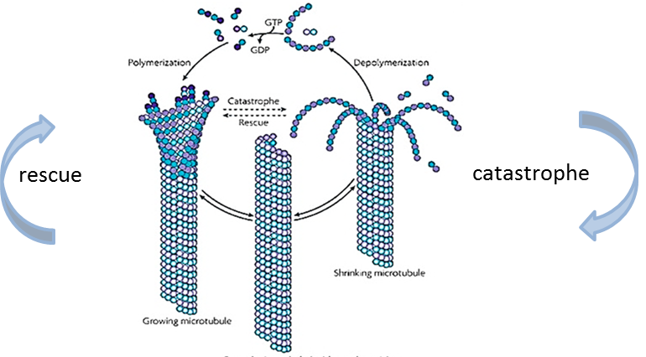

**Figure 1.4.** The MT cycle of dynamic instability. Slow growth is followed by rapid dissociation (catastrophe) until regrowth (rescue) can resume. The switch between the two states depends on the number of free phosphorylated (GTP) β-tubulin subunits in the cytosol. Image printed with permission of the American Society for Cell Biology, Bethesda, MD, USA. Kline-Smith SL, Walczak. Molecular Biology of the Cell 2002;13(8):2718-31 [132].

The formation of the protective cap is a cooperative event with the addition of each new tubulin-GTP subunit increasing the number of binding sites available for further subunit attachment [70, 71]. This may act in parallel with facilitated, or directed diffusion in which the probability of a free β-tubulin-GTP subunit encountering an MT-fibre increases as the length and number of MT-fibres increases [72]. The polarity of MT-fibres, by virtue of the αβ-heterodimers, directs a colliding subunit toward the plus, or growth, end. Both these mechanisms are illustrated in Figures 1.5 and 1.6 [73, 72].

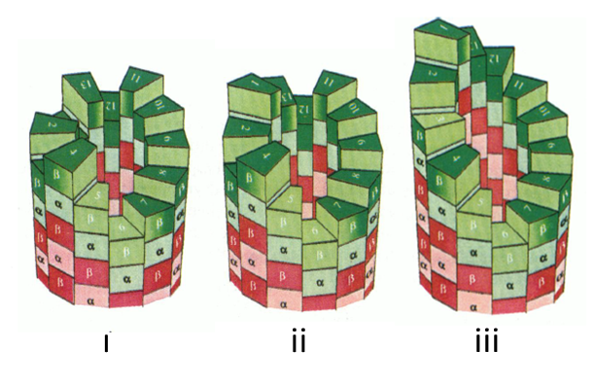

**Figure 1.5.** Schematic ‘monte carlo’ illustration of the MT capping model. The layer of β-tubulin-GTP subunits forms a protective cap at the end of the MT fibre. The attachment of each β-tubulin-GTP subunit provides an extra binding site for a subsequent attachment. Eventually the number of free subunits in the vicinity of the fibre tip falls below a critical concentration (CC) and the cap is lost, leading to rapid dissociation of the unprotected αβ-subunits, termed catastrophe. [dark green, β-tubulin-GTP; dark red, β-tubulin-GDP; light green/red, α-tubulin]. Image printed with permission from NCBI PubMed, Bethesda, MD, USA. Martin *et al*. Biophysical Journal 1993; 65(2):578-96 [70].

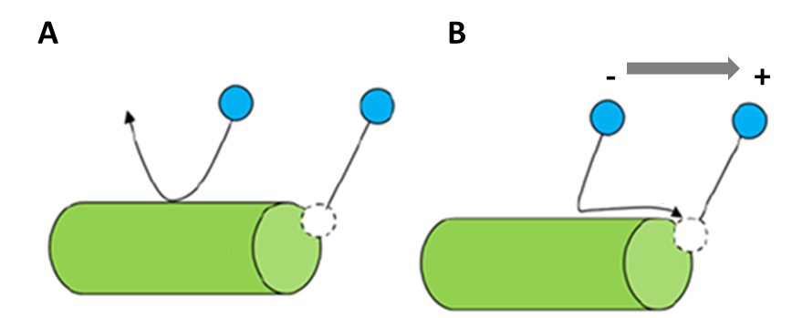

**Figure 1.6.** Illustration of facilitated diffusion. Collisions between subunits and the MT fibre are random. (A) In the classical view the probability that a free β-tubulin-GTP subunit will encounter a fibre tip is low. (B) The presence of an attractive force, by virtue of the αβ-heterodimer polarity, facilitates colliding subunits to ‘slide’ along the fibre towards the ‘+’ tip, thereby increasing the probability of subunit attachment. Image printed with permission of PLos. Mechulam *et al*. Computational Biology 2009; 5(1) [72].

Additional contributory factors include the formation of β-tubulin-GTP rescue islands during MT-fibre assembly [73]. This proposes that because some β-tubulin isoforms are more hydrolysis-resistant than others, they remain as tubulin-GTP remnants within the MT-fibre in order to act as transient protective caps. This introduces pauses during depolymerisation thereby reducing the number of catastrophes. β5-tubulin forms such stabilising patches suggesting that downregulation of β5-tubulin will increase destabilising activity [48]. A second consideration is the effect of cell boundaries *in vivo*. These could restrict the number of free tubulin-GTP subunits available for assembly, forcing MTs to compete for a limited supply [68].

### *1.5.6. Anti-microtubule drugs*

Targeting MTs, in particular their role in mitosis, has proved to be one of the most successful anti-cancer strategies to date [53]. Paclitaxels and vinca alkaloids are among the most widely used anti-microtubule drugs (AMD). They act by disrupting MT dynamics though over-stabilisation or destabilisation, respectively, leading to an inability to undergo dynamic instability, or else undergo excessive dissociation. However, AMDs show varying degrees of toxicity and increasing drug resistance with successive rounds of treatment.

It is increasingly recognised that regulation of complex MT cellular pathways originates with β-tubulin isotype transcription [60]. This offers an alternative approach to traditional stabilising-destabilising AMDs by regulating transcription of different β-tubulin isoforms or MAPs by targeting the regulatory proteins involved their transcription. In this way SCFAs, which alter post-translational acetylation of histones and TFs, may act as anti-mitotic agents in parallel with other anti-microtubule agents. Therefore, understanding how MT dynamics can be altered though differential expression of β-tubulin isotypes may enable targeted chemotherapeutic strategies to be devised. In addition, by determining the net effect of β-tubulin isoform patterns at particular stages of cancer progression may help avoid potential conflicts or improve current therapies when drugs and anti-mitotic agents are used in combination.

### *1.5.7. β-tubulin nomenclature*

There are several commonly used synonyms for each β-tubulin isotype. The approved nomenclature for β-tubulin genes and proteins is defined by The HUGO Gene Nomenclature Committee (HGNC). In general, these have been used throughout this project. However, to avoid confusion between the β-tubulin isotype and generic β-tubulin, the alternative synonym was adopted (β1-tubulin); and because the Phenyx analysis of the multi-plex iTRAQ data returned the synonym, β2c-tubulin, in place of the HUGO-approved β4b-tubulin, β2c-tubulin was also adopted for this project (Table 1.3).

**Table 1.3**. The approved nomenclature for β-tubulin genes as defined by The HUGO Gene Nomenclature Committee (HGNC). The names adopted in this project are highlighted in bold text.

|  |  |  |
| --- | --- | --- |
| Approved Name | Approved Symbol | Synonyms, previous names and previous symbols |
| β-tubulin  (**β1-tubulin**) | *TUBB* | beta1-tubulin; *Tubb*5; ***TUBB1****; TUBB5* |
| **β3-tubulin** | *TUBB*3 | beta-4; *TUBB4* |
| β4b-tubulin  (**β2c-tubulin**) | *TUBB*4B | tubulin, beta 2C; ***TUBB*2C** |
| *β5-tubulin* | *(refer to β1-tubulin)* |  |

## 1.6. Systems Biology

Systems Biology is an inter-disciplinary field that is rapidly is gaining attention in bioscience research as a technique for studying complex biological systems [6, 74, 5]. It is especially relevant in this post-genomic era where many areas of research are rich in data but hypothesis-poor [75]. Although Systems Biology is a relatively new field in oncology research, it is proving a valuable tool for understanding the biological mechanisms underlying tumour development and for identifying novel targets for cancer therapeutics [76, 77].

A key aspect of Systems Biology is that it can be both data-driven and hypothesis-driven [75]. The two approaches complement each other when attempting to understand the relationships between ‘causes’ and ‘effects’ [78]. A hypothesis-driven approach links a proposed ‘cause’ or ‘theory’ to observed ‘effects’ and ‘evidence’ and is often applied to prove or disprove a hypothesis. A data-driven approach evaluates multiple ‘effects’ to predict a ‘cause’ in order to formulate a new hypothesis; this can then be tested experimentally *via* a second hypothesis-driven approach, thereby forming a ‘cycle of knowledge’ [75]. This iterative cycle enables the wealth of information that can be generated through quantitative high-throughput technologies, and data from the rapidly expanding bioinformatic databases, to be maximised [75].

Computational mechanistic or dynamical modelling is becoming an integral part of Systems Biology, due in part to being able to manage the large number of molecular components and their complex interactions when conducting a system-wide study.

# 2. Colon cancer cell lines and cell culture

## 2.1. Introduction to cell lines

Human immortal cell lines provide biological models for observing and manipulating metabolic pathways and mechanisms *in vitro*. Their wide availability and reproducibility enable multiple experiments to be carried out and directly compared within an experiment, between studies or globally between different groups. Guidelines to their use are provided by the UKCCCR (UK Coordinating Committee on Cancer Research). More recently detailed bioinformatic information on the genetic makeup of cell lines has added to their value [81] . In oncology research, cell lines are frequently employed to explore the efficacy of drugs or to discover potential molecular targets for chemotherapies.

Each cell line originates from a single cell source and is associated with a specific organism and disease state; for example, HCT116 cells for human colon cancer. Cell lines have several advantages over *in vivo* models in that they avoid many the confounding factors and non-uniformities that are associated with *in vivo* models [82] . Although laboratory animal models being based on a single genetic line can also overcome many of these limitations, there are differences between human and animal metabolisms. However, each cell line has its own unique characteristics and mutations which may not be translatable across phenotypes and must be considered.

The choice of cell line depends on the requirements of the study. HCT116 cells are a primary colon carcinoma cell line, originating from the large intestine of a human male [83]. At the initiation of this project, the direction of focus had not been established, therefore HCT116 cells were selected for reasons of consistency with previous studies. In addition, they have the ability to grow fast, with high reproducibility, and are robust compared to most other colon carcinoma cell lines, such as Caco-2 or HT29 [84]. Conversely, their small size and reduced ability to form an epithelium-like layer can make them less suitable for microscopy visualisation of internal cellular structures compared to CaCo-2 cells, which are larger and more appropriate for cytoskeletal observations [84]. However, recent developments in cellomic techniques, such HCA, have allowed high-quality micrographs of HCT116 cells to be obtained for cytoskeletal research (Figure 2.1) [85], including several published studies by our group [29, 31].

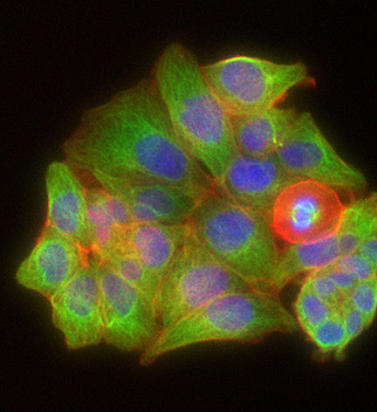

**Figure 2.1.** HCA micrograph of the cellular cytoskeleton in HCT116 colon cancer cells. The red cell is undergoing mitosis displaying reorganisation of the actin cytoskeleton: [green, microtubules; red, actin; blue, nuclei]. This micrograph, was kindly donated by J. Chowdry [85] and taken using the HCA facility at Imagen Biotech Ltd, Manchester [86].

## 2.2. Introduction to cell culture

Cell culture is a method used to grow live cells under controlled conditions, allowing a small number of cells to be amplified into a much larger population for experimentation. Starter cell lines are maintained in liquid nitrogen until required and then recovered for culture. A series of cultures from the same source can be grown under identical environmental conditions for biological replicates or different treatment regimens.

In order to keep cells viable and free from contamination, cell culture must be carried out under strict sterile conditions and the cells supplied with sufficient nutrients by the growth media. Typically, cells are maintained at 37°C in a humidified atmosphere of 5% CO2. To minimise the risk of contamination from bacteria or yeast in the atmosphere, cell culture is performed in a sterile laminar flow cabinet and antibiotics, such as penicillin-streptomycin are added to the growth media.

Depending on the cell line, cells are either grown in suspension or on surfaces in flat flasks or plates. Colon epithelial cells are adherent, therefore the latter approach is adopted. During propagation they proceed from a lag phase, as they adjust to their environment, to a logarithmic phase when they begin to multiply exponentially, until they eventually reach full confluence (100%) and cover the entire substrate area (Figure 2.2). At this point the nutrients become depleted and overcrowding leads to cell senescence and an accumulation of floating apoptotic and necrotic cells. To overcome this, a technique known as passaging is adopted whereby a small subculture of cells is split from the growing population and reseeded in fresh media. Growing cells are at their most viable during their logarithmic phase, at approximately 70%–80% confluence, and this is the optimal density to sub-divide them; however, passaging cannot be continued indefinitely as senescence begins to occur after approximately 50 passages. At this stage a new starter culture needs to be recovered from storage and the process started again.

Once the cells have established and a sufficient number have grown, usually at pre-logarithmic phase, the cells can be treated with the required drugs or compounds, harvested and prepared for subsequent experimentation.

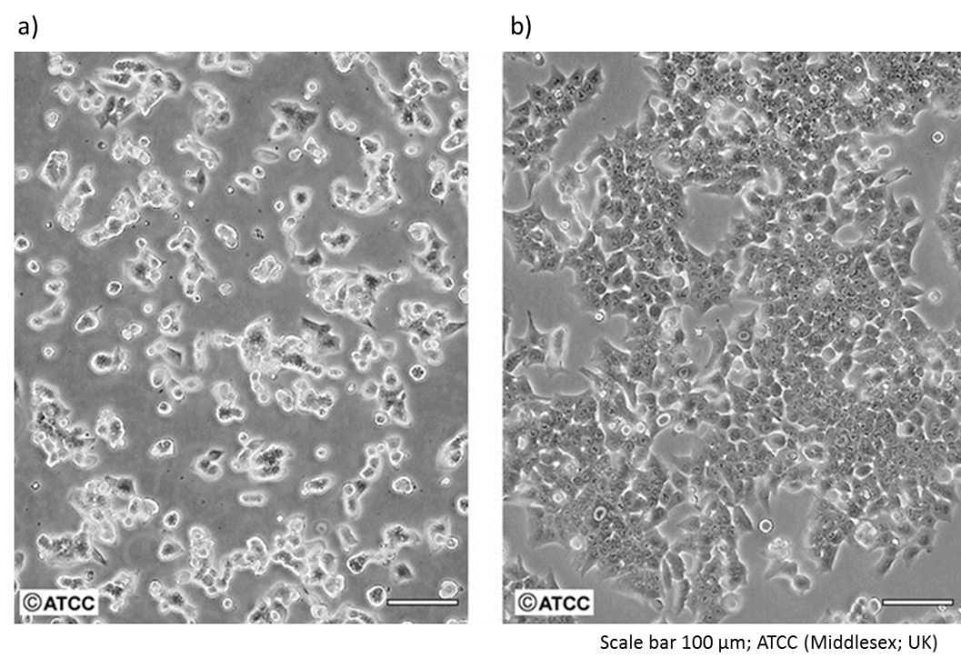

**Figure 2.2.** HCT116 cells under culture: a) at low density as they become established; b) at logarithmic stage (~70%–80%). Micrographs printed with permission of ATCC, Middlesex, UK; Cat. No. CCL-247.

## 2.3. Cell culture, treatment and harvesting

### *2.3.1. Cell culture pipeline*

The HCT116 human colon cancer cell line was used as the starter cell line for all experiments. After culture and amplification, the cells were treated with butyrate, propionate or valerate. Untreated cells were cultured under the same environmental conditions as controls. The following treatment times and SCFA concentrations were applied depending on the requirements of the proteomic and cellomic experiments:

For multi-plex iTRAQ proteomic studies, approximately 100µg per sample were required; for HCA cellomics, approximately 1 x 104 cells per 100μl well were required; for flow cytometry, approximately 1 x 106 per sample were required; and for Western blotting, approximately 10 μg protein per sample were required.

1. For the SCFA studies, the treatment concentrations were butyrate, 4mM; propionate, 11 mM; and valerate, 9 mM. These were used for SCFA multi-plex iTRAQ mass spectrometry and Western blotting quality control experiments.
2. For the propionate multi-plex iTRAQ experiment experiments, the treatment concentration was 11 mM.
3. For the SCFA dose response experiments, the treatment concentrations were between 0 mM and 20 mM SCFA for 24 h. These were used for the HCA cytoskeletal experiments.
4. For the SCFA time-course experiments, the treatment concentrations butyrate, 4mM; propionate, 11 mM; and valerate, 9 mM for 3 h, 6 h, 12 h and 24 h. These were used for flow cytometry cell cycle analysis experiments.

Four to six individual cell cultures were prepared for each experimental condition to ensure sufficient biological replicates for statistical analyses. The cultures selected were those with the highest yields and the greatest protein integrity.

The experimental pipeline was as follows:

1. Cell culture and amplification
2. Treatment with SCFAs (butyrate, propionate, valerate or untreated controls)
3. Harvesting
4. Preparation of whole cells or proteins from whole cell lysates
5. Protein concentration assays
6. Protein integrity analysis by SDS-PAGE (polyacrylamide gel electrophoresis).

### *2.3.2. Cell culture reagents*

Phosphate-buffered saline Dulbecco “A” solution (PBS) was supplied by Oxoid (Basingstoke, UK). DMEM (Dulbecco/Vogt-modified Minimal Essential Medium) with 1 g/l D-glutamine, 4 mM L-glutamine, 110 mg/l sodium pyruvate and 25 mM HEPES was supplied by Gibco Life Technologies (Invitrogen, UK) was supplemented with penicillin (5% (v/v); 10,000 units/ml), streptomycin (10,000 μg/ml), both from Gibco, and 10% (v/v) heat-deactivated fetal calf serum (FCS), supplied by Biosera (Sussex, UK). Butyrate, propionate and valerate were supplied by Sigma (UK). Corning T25, T125 or T175 culture flasks (25 ml, 125 ml or 175 ml, respectively) were used for cell culture and were purchased from Sigma.

HCT116 colon carcinoma cell lines were laboratory stocks. All cell lines used in this laboratory are screened bimonthly for mycoplasma contamination. No mycoplasma was detected in these cells or any other in the laboratory during this study.

For polyacrylamide gel electrophoresis (PAGE), ‘All Blue Precision Plus’ protein standards and ‘Instant Blue Coomassie’ stain were supplied by BioRad (UK).

### *2.3.3. Cell culture protocol*

HCT116 cells double their number approximately every 24 h with an optimal time for passaging at around four days depending on the seeding density. In general, two to three passages were performed to amplify enough cells for four flasks, one for each SCFA treatment plus an untreated control, with each flask prepared using the same media and under identical environmental conditions.

Cell culture was carried out following established procedures. Briefly, a starter aliquot of HCT116 colon carcinoma cell line was recovered from liquid nitrogen; seeded in T25, T125, or T175 flasks at a density of 1.6 x103 cells/cm; cultured in DMEM media and incubated for four days at 37°C in a humidified incubator at 5% CO2. They were passaged at the logarithmic stage (70%–80% confluence). Cells were detached between passages by trypsinization for 4 min at 37°C. Confluency was assessed under an optical microscope; viability and cell counts were determined by loading 20 µl culture on a haemocytometer (Improved Neubauer chamber) with Trypan Blue vital stain in a 1:1 ratio to distinguish viable (unstained cells) from non-viable cells (blue). The passages were repeated until four flasks were populated ready for the different treatments.

### *2.3.4. SCFA treatment and harvesting protocols*

After seeding flasks for the final passage, the cells were grown under culture for 24 h to allow the cells to adhere to the flask surface. They were then treated with SCFAs at either IC50 (G2/M) concentrations or between 0–20 mM for dose response experiments. Untreated cells were prepared for controls. After treating, the cells were returned to the incubator to continue growing for the specified times (either 24 h or 0–24 h for the time course experiments). Depending on the severity of treatments, they each acquired different levels of confluence, health and viability.

With the exception of the HCA experiments which were performed in 96-well plates as described below, the cells were harvested after treatment by scraping to release them from the plate surfaces (instead of trypsinization), transferred to PBS buffer in Falcon tubes (Sigma) and centrifuged to remove any residual media by discarding the supernatant. The cell pellet was resuspended in PBS buffer for subsequent lysis or whole cell analysis.

For HCA, both culture and treatment protocols were carried out in 96-well plates. Instead of being harvested, the cells were fixed *in situ* and stained with fluorescent antibodies to highlight cellular proteins and structures of interest, or with Hoescht to identify the nuclei. These procedures are described in detail in the following sections.

### *2.3.5. Preparation of whole cell lysates for proteomic studies*

Lysis was performed to release the proteins from the cells for proteome analysis. The cells were resuspended in 1 M TEAB-0.05% SDS lysis buffer. Sodium dodecyl sulfate (SDS) is a detergent which ruptures the nuclear membrane to solubilise the proteins. Proteolysis and degradation of the proteins was minimised by adding a protease inhibitor cocktails and keeping the samples on ice at -4°C. In order to fragment the DNA, which otherwise remains as a dense gel, the samples were sonicated using a Bioruptor (Diagenode) for 10–15× 30 s cycles. The whole cell lysates were stored at -80°C until required.

### *2.3.6. Preparation of whole cell samples for flow cytometry analyses*

Harvested cells in PBS were gently centrifuged in a microfuge at 1000 rpm, and then fixed by resuspension in 1 ml 70% ice-cold ethanol which was added drop-wise and vortexed to prevent aggregation and clumping. RNAse was added to remove RNA from the cells which could distort the results. The cells were then flash frozen in liquid nitrogen and stored at -80°C until required.

### *2.3.7. Protein concentration assays*

In order to measure the protein concentrations of the cell lysates, protein assays were performed in comparison to standard Bradford protein assay reagents (BSA; BioRad, UK). The lysates were loaded in a 96-well microplate, in triplicate, alongside a BSA concentration series and their absorbance was measured at 595 nm using a Multi-detection Reader (BioTek). The protein concentrations were determined by plotting their absorbance against the standard BSA curve.

### *2.3.8. Protein integrity assays by polyacrylamide gel electrophoresis (PAGE)*

For confirmation of protein integrity, the lysates were resolved by electrophoresis on a one-dimensional 10% SDS-PAGE gel against an All Blue Precision Plus (BioRad) standard molecular weight ladder, following standard protocols. This technique separates proteins on a gel according to their molecular weights. The proteins are negatively charged to enable them to migrate between electrodes. Smaller proteins migrate faster through the pores of the gel compared to larger proteins. The key elements of the SDS-PAGE protocol are as follows:

1. Proteins were denatured to unfold them and conferred with a negative charge by using an SDS-based buffer followed by heat shock at 95°C for 5 min.
2. Lysates containing equal amounts of protein (30–50 μg) were loaded onto the gel to ensure direct comparisons. Laemmli blue loading buffer was added to the lysates so that the leading edge of the proteins could be tracked during electrophoresis. This is a glycerol-based buffer so the samples sink the base of the loading pockets and don’t diffuse into the electrophoresis buffer during loading. The All Blue standard protein ladder was also loaded into one of the pockets.
3. After migrating, the proteins were stained by immersing the gel in Coomassie blue stain on a rocking bed for 30 min at room temperature. The protein bands were visualised and photographed on a white-light box.

## 2.4. Cell culture results

### *2.4.1. The half maximal inhibitory concentration (IC50)*

The half maximal inhibitory concentration (IC50) is the amount of drug, in this case SCFA, required to inhibit a metabolic process by half. The corresponding half maximal effective concentration (EC50) is the amount of substance required to induce an effect. Because many biological functions are sigmoidal, both are useful measures of a drug’s effectiveness. In the preceding project [4, 90], the high-throughput capacity of HCA was exploited to quantify the effect of different SCFAs in HCT116 cells in a dose response experiment. The cells were treated with butyrate, propionate or valerate at concentrations between 0–20 mM for treatment times of 24 h or 48 h. The data were compiled to calculate the cell count and percentage of cells at each phase of the cell cycle, for each treatment condition. Each treatment was performed in triplicate to allow statistical analysis to be carried out. The results were analysed by the author and by Dr J Waby. A consensus was reached that the statistically most robust results were the IC50 values for G2/M arrest at 24 h. Table 2.1 gives the mean SCFA IC50 values for each treatment condition. Figure 2.3 gives a graphical overview of the cell counts, cell cycle and IC50 results at both 24 h and 48 h treatment times.

**Table 2.1.** IC50 values for different cell cycle check points induced by SCFA treatments of HCT116 colon cancer cells. The quantitative data was compiled by HCA and statistical analysis performed using GraphPad Prism v5. Software. A graphical overview is shown in Figure 2.3.

|  |  |  |  |  |  |  |  |
| --- | --- | --- | --- | --- | --- | --- | --- |
| Cell cycle | IC50 [mM] | | |  | SD | | |
| (treatment time) | butyrate | propionate | valerate |  | butyrate | propionate | valerate |
| G1 (24 h) | 4.5 | 10.9 | 10.0 |  | 1.18 | 1.30 | n/a |
| G2/M (24 h) | 3.9 | 10.6 | 9.0 |  | 1.13 | 1.18 | n/a |
| G1 (48 h) | 2.0 | 2.0 | 1.9 |  | indeterminate | | |
| G2/M (48 h) | 3.1 | 14.3 | 10.1 |  | 1.25 | indeterminate | |

|  |  |
| --- | --- |
| a) Cell count of HCT116 cells after 24 h treatment with SCFAs between 0–20 mM) |  |
| b) Cell count of HCT116 cells after 48 h treatment with SCFAs between 0–20 mM) |  |
| c) IC50 values for SCFA treatments of HCT116 at 24 h and 48 h. Values for G1 cell cycle arrest and G2/M cell cycle arrest (Table 2.1). |  |

**Figure 2.3.** Determination of treatment conditions: HCT116 cells were treated with SCFAs between 0–20 mM for 24 h or 48 h. The cell counts and the percentages of cells at each phase of the cell cycle were quantified by HCA. There is a clear reduction in cell count with each treatment. A consensus was reached based on these results that the IC50 values for G2/M arrest were the statistically most robust for subsequent experimentation.

### *2.4.2. Biological replicates and protein integrity*

A sufficient number of biological replicates of SCFA-treated HCT116 colon cancer cells were prepared to give the required protein yields at high protein integrity (Figure 2.4) for subsequent experimentation. Protein lysates and whole cell samples were prepared with minimal protein degradation of aggregation.

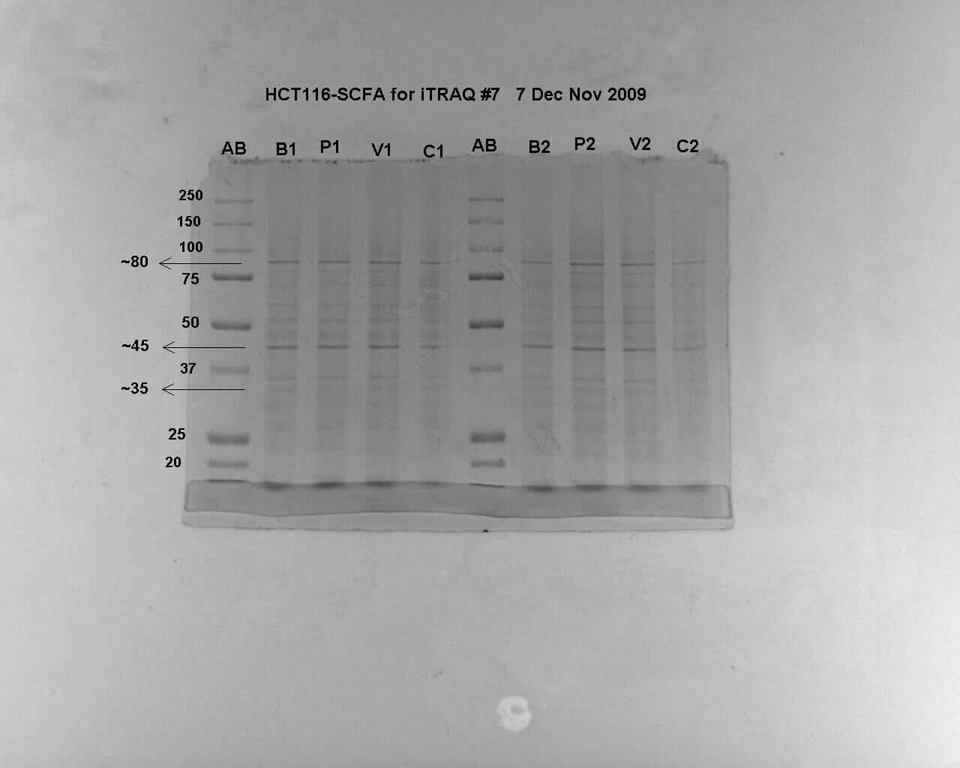

**Figure 2.4.** 10% SDS-PAGE protein gel showing protein integrity of the HCT116 cells after culture and treatment with SCFAs. [AB, all-blue protein marker; B, butyrate; P, propionate; V, valerate; C, untreated control. The AB ladder gives protein masses in kDa].

# 3. Multi-plex iTRAQ proteomics confirmed that odd and even-chain SCFAs differentially regulate distinct sets of proteins in HCT116 colon cancer cells, including β-tubulin isotypes

## 3.1. Contribution of multi-plex iTRAQ to the overall project

* Multi-plex iTRAQ is a state-of-the art proteomic technique that can identify changes to the whole proteome by different treatments in cells, and identify those that are unique to an individual treatment.
* Multi-plex iTRAQ was able to determine if the odd and even-chain SCFAs displayed distinct actions in HCT116 colon cancer cells.
* Multi-plex iTRAQ provided high-quality quantitative data from multiple biological replicates of HCT116 cells treated with SCFAs.

## 3.2. Introduction to proteomics

Global proteomics is one of a new set of ‘omics’ techniques, which also encompass genomics, metabolomics and cellomics. These can deliver vast amounts of data on molecular systems. Bioinformatics and pathway analysis can put the ‘omics’ data into context to enable advances to be made in understanding complex biological processes and mechanisms from which hypotheses can be generated.

### *3.2.1. Multi-plex iTRAQ proteomics*

Multi-plex iTRAQ (isobaric tag for relative and absolute quantitation) mass spectrometry is a state-of-the-art proteomic technique, able to assess the entire proteome of treated cells at specific points of the cell cycle and investigate changes in protein expression by identifying which proteins are significantly up or downregulated relative each other, control samples, different treatments conditions or PTMs. High-quality data generation and developments in proteomic approaches enable valuable insights to be gained into many cellular processes [29, 87].

Multi-plex describes the use of isobaric tags to label different samples with unique stable reporter ions to identify and relatively quantify the large number of peptides and proteins generated upon fragmentation. Ground-up shotgun proteomics, named from the early mass spectrometry analysis of DNA, and liquid chromatography tandem mass spectrometry (LC MS/MS), which exploits nano-chromatography, are able to provide high-resolution separation of peptide fragments prior to analysis. Each fragmented peptide has a distinct signature based upon its mass/charge (m/z) ratio. The relative expression of the proteome from up to eight biological replicates or different treatment conditions can be evaluated reproducibly within a single experiment. Amine-reactive isobaric tags are utilised to label the primary amines of all the peptides on trypsin digestion. Their associated stable reporter ions enable the resulting spectra to be relatively quantified by analysing the reporter groups. The isotype reporter ions have masses of 113, 114, 115, 116, 117, 118, 119, and 121. A reporter ion with a mass of 120 is not used, as this is the mass of phenylalanine immonium and would therefore obscure the results. By combining the tagged samples in a 1:1 ratio, the relative intensities of the signals will represent the relative abundances of the analysed peptides in each sample, as the resulting protein expression profiles can be compared on a ratiometric basis to determine the relationships between them.

Although multi-plex iTRAQ has proved to be an effective and robust tool, which has successfully contributed to advances in understanding complex biological mechanisms [87], it is necessary to validate and support the results by independent, complementary experiments. This is because the analyses rely on statistical comparisons between peptides and protein databanks. In addition, multi-plex iTRAQ using the shotgun approach underestimates the results. The reasons, and strategies to ameliorate this, are discussed in detail in ‘iTRAQ Underestimation in Simple and Complex Mixtures: “The Good, the Bad and the Ugly” by Ow *et al* [88]..

A review comparing mass spectrometry techniques is given by Evans *et al* [89]. These include the following: if two or more precursor ions with similar m/z ratios, and similar passage times during HPLC, are selected for fragmentation they will be sequenced and quantified at the same time [89]. In addition, when comparing multiple replicates, the number of peptides identified by all the replicates will be lower than the total because the set of peptides identified by each assay is random. Hardware and software approaches, such as isotopic correction [88], can improve accuracy, and despite the underestimation in protein abundance, the direction of differential up or down regulation is generally unaffected [88, 89]. For this study, multi-plex iTRAQ was considered the best technique to use by offering high-throughput quantitative capability with proven results. A strength of iTRAQ is that it can be utilised in discovery mode, meaning samples can be objectively analysed for differences, from which pathways emerge. This was a key aim of the project.

### *3.1.2. Multi-plex iTRAQ analysis of cytoskeletal proteins*

Interpreting multi-plex iTRAQ data and understanding the implications of changes within the proteome can be highly complex because of the many different interlinking pathways and mechanisms involved. For this reason, observations from complementary techniques are often employed to suggest directions for focus. In this study, evidence from HCA quantitative cellomics had indicated that the SCFAs induced MT cytoskeletal breakdown with a concurrent increase in G2/M mitotic arrest in HCT116 cells. Preliminary analysis of the iTRAQ data had identified β-tubulin isotypes as being among the most differentially regulated protein group between the SCFAs (Table 3.3) [4]. A recent hypothesis proposing a ‘tubulin code’ [47], suggested that cytoskeletal formation and function may be linked with β-tubulin isotype expression. Although cytoskeletal proteins are relatively abundant in cells, and therefore small differences between samples are frequently detected, there was increased interest in these specific β-tubulin isotypes as they were uniquely targeted by the odd-chain SCFAs and have been associated with invasive and aggressive colon cancers [56]. Taken together, the evidence directed the focus of this project towards β-tubulin isotypes and MT cytoskeletal proteins with an aim to understand the pathways involved.

## 3.3. Multi-plex iTRAQ: Project outline

*Detailed descriptions are given in the experimental methods.*

### *3.3.1. Experimental approaches*

This study took two separate approaches to determine the proteins differentially regulated in HCT116 colon cancer cells by SCFA treatments. The first involved a multi-plex iTRAQ experiment carried out on quadruplicate biological replicates of propionate treated samples compared to untreated control samples. The second approach was based solely on targeted data-mining of the raw, but still unexplored, multi-plex iTRAQ data generated in the previous multi-plex iTRAQ experiment [4, 90]. This has been performed on biological duplicates of butyrate, propionate and valerate treated samples.

As discussed above, orthogonal validation is essential when interpreting iTRAQ results. In this study, Western blotting confirmed the iTRAQ observations in relation to the direction of change (up or down regulation).

The peptide fragments identified by the multi-plex iTRAQ experiments were matched against the following protein databanks: SwissProt/TrEMBL (also known as UniProt) [91] and NCBInr [92]. Each has their own advantages. SwissProt is manually curated and cross-referenced and TrEMBL is computationally analysed and includes entries awaiting full manual annotation. Although SwissProt/TrEMBL often lags behind other databases in numbers of proteins, it is considered the ‘gold standard’ database. NCBInr is also an established protein databank respected by the scientific community. It is a non-redundant database compiled from several other databases, including SwissProt, and has the advantage of being more up-to-date and can therefore identify additional proteins.

A quality control overview of the experimental protocols and data processing was gained by analysing the iTRAQ labelling efficiencies, percentages of peptide hits, coverage and confidence values (Table 3.1). Correlation plots (scatter plots) and dendrograms (cluster analysis) provided quality assurance for the biological replicates.

### *3.3.2. Data analysis and data-mining*

Quantitation analyses of the multi-plex iTRAQ-Phenyx data was performed using ‘uTRAQ’ and ‘SignifiQuant’ statistical software applications developed in house. The methods underlying uTRAQ and SignifiQuant are described in greater detail in the experimental methods. (*Application creator, J. Noirel, The University of Sheffield* [93])*.*

Propionate was selected for the quadruplet iTRAQ experiment because it shared regulatory effects with both butyrate and valerate. By increasing the number of biological replicates to the maximum of four (with four corresponding control samples), confidence in the statistical analyses and quality control assessments could be enhanced. The analysis pipeline for the propionate quadruplet biological replicate data is shown in Figure 3.1.

The SCFA duplicate biological replicate data generated during the preceding multi-plexiTRAQ experiment had already been analysed using high-stringency SignifiQuant quantitation and had been published [90]; however, a considerable wealth of quantitation data from uTRAQ analysis remained unexplored. This was mined more comprehensively by cross-referencing the uTRAQ and SignifiQuant analysis results against the UniProt and NCBInr databases to exploit the respective advantages of both. Although SignifiQuant is the ‘Gold standard’ technique for determining differential regulation, the added layer of analysis often causes potentially important significantly differentiated proteins to be suppressed. In contrast, uTRAQ identifies all the proteins that are significantly differentially regulated >SD from the mean, and therefore includes false negatives that are excluded by SignifiQuant. By understanding their relative strengths and weaknesses, the two approaches can be complementary, maximising the information returned.

### *3.3.3. Multi-plex iTRAQ analyses pipelines*

The multi-plex iTRAQ analysis pipelines are given in Figure 3.1. (a) For the propionate quadruplet experiment, where both the iTRAQ experiment and data analysis were performed in this project, the complete pipeline was followed. (b) For the SCFA duplicate experiment, only the data-mining pipeline was followed in order to comprehensively explore the differential expression of cytoskeletal proteins, particularly those associated with MT β-tubulin subunits.

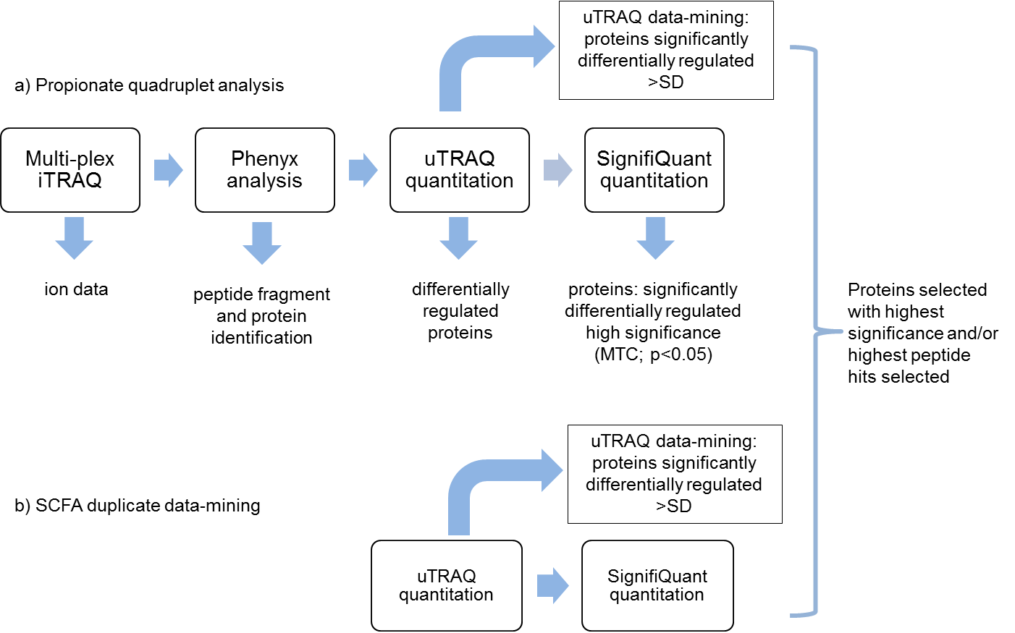

**Figure 3.1.** Multi-plex iTRAQ analysis pipeline for proteins significantly differentially regulated by SCFA treatments of HCT116 cells: a) Propionate quadruplet experiment; b) SCFA duplicate experiment. After quantification, protein data from both experiments were combined and proteins differentially regulated with the highest significances and/or greatest number of peptide hits were selected.

1. Pipeline for SignifiQuant analysis (highest stringency analysis):
   1. Multi-plex iTRAQ data were submitted to Phenyx to generate peptide fragment and protein data.
   2. The results were quantitated by uTRAQ statistical analysis to identify proteins differentially regulated [93].
   3. uTRAQ data was taken forward for SignifiQuant [93] analysis.
   4. Proteins differentially regulated with the highest significance (MTC; p<0.05) were selected.
2. Pipeline for data-mining by uTRAQ frequency (SD) analysis to identify all proteins significantly differentially expressed including those suppressed by SignifiQuant analysis:
   1. uTRAQ quantitation identified the linear fold changes of proteins differentially regulated by SCFA treatments relative to untreated HCT116 cells.
   2. The means and SD of the fold-changes were calculated, and proteins with fold changes >SD were considered significantly differentially regulated.
3. Further, complementary experimentation and bioinformatic analyses:
   1. Data from both multi-plex iTRAQ experiments (propionate quadruplets and SCFA duplicates) and both analysis methods (SignifiQuant and uTRAQ data-mining) were compiled and combined.
   2. Cytoskeletal proteins differentially regulated with the highest level of significance were selected for comparison with the complementary HCA cellomic data.
   3. β-tubulin fold change data were taken forward to the computational dynamical model for parameter matching (Modelling chapter).
   4. All data for differentially regulated proteins were submitted for bioinformatic pathway analyses, described in detail in the Bioinformatics chapter.

### *3.3.4. SCFA biological replicates*

Sample reproducibility is essential to ensure that significant changes can be distinguished from random variations. Reproducible trends in proteomic methods can be achieved with two or three biological replicates [94], however multi-plex iTRAQ enables up to eight samples to be compared. In the previous SCFA experiment, biological duplicates of three different SCFA treatments and untreated controls had been compared [4, 90]. For the propionate experiment carried out in this project, biological quadruplets of propionate samples were compared to quadruplet replicates of untreated control samples. The reproducibly between the biological replicates was determined by constructing correlation plots to measure how closely the replicates grouped (Figure 3.5).

## 3.4. Multi-plex iTRAQ: Experimental methods

### *3.4.1. Multi-plex iTRAQ reagents and solutions for protein labelling*

Biological replicates of total cell lysates from SCFA-treated and untreated HCT116 cells were prepared as previously described. Four biological replicates of propionate treated samples and four untreated control samples were taken forward for the 8-plex iTRAQ experiment. These were proteolytically digested with trypsin and labelled according to the protocol outlined by Applied Biosystems. This entailed taking the samples to a final volume of 21 μl at 5 mg protein/ml in 1 M TEAB/0.05% SDS. The samples were reduced by adding 2 μl 50 mM TCEP (Sigma) and incubated at 60°C for 1 h. Cysteine residues were blocked by adding 1 μl MMTS (Sigma) at room temperature for 10 min. Trypsin at 4 μg/μl in resuspension buffer (50 mM acetic acid) was made up to 1 μg/μl in TEAB to the correct pH, 10 μg was then added to each sample which were incubated overnight at 37°C in a humidified atmosphere of 5% CO2. The trypsin digest was verified by SDS-PAGE using 5 μg of each sample. Isopropanol (50 μl) was added to each of the 8-iTRAQ reagents (Applied Biosystems) before they were added to their respective biological replicates. The isobaric labels were assigned as follows for the propionate quadruplet experiment: propionate, 113, 114, 115, 116; untreated, 117, 118, 119, 121. In the previous SCFA experiment: untreated, 113, 114; butyrate, 115, 116; propionate, 117, 118; valerate, 119, 121. The samples were incubated at room temperature for 2 h. All the samples were pooled in a 1:1 ratio and dried in a vacuum centrifuge (Eppendorf Concentrator 5301). The samples were reconstituted in 90 μl of 20% acetonitrile and 0.1% formic acid. The pH was adjusted to pH2, the 8-plex peptide mixture was sonicated and any precipitate was pelleted and discarded by centrifugation.

### *3.4.2. Strong cation exchange (SCX) and High-performance liquid chromatography (HPLC)*

Peptide pre-fractionation was carried out on a BioLC HPLC (Dionex, Surrey, UK) using a PolySulfoethyl-A Pre-Packed Column (PolyLC, Columbia, MD) with a 5 μm particle size and column dimensions of 100 mm × 4.6 mm i.d., 200 Å pore size. SCX was achieved using a low ionic buffer A (20% acetonitrile, 0.1% formic acid) and a high ionic buffer B (20% acetonitrile, 0.1% formic acid, 500 mM KCl). Each sample was loaded onto the column and washed for at least 60 min at a flow rate of 0.4 ml/min with 100% SCX Buffer A to remove salts, TCEP and unincorporated iTRAQ reagent. Peptides were separated using a gradient of SCX Buffer B at the same flow rate of 400 μl/min. Buffer B levels were increased from 0%–25% from 5 min to 30 min; then from 25%–100% over 5 min; followed by 26%–100% over the next 15 min. Buffer B was held for another 5 min for isocratic washing prior to column re-equilibration with buffer A. The sample injection volume was 100 μl and the liquid flow rate was 0.4 ml/min. The SCX chromatogram was monitored using UVD170U ultraviolet detector and Chromeleon software v.6.50 (Dionex LC Packings). Fractions were collected using a Foxy Jr. (Dionex) fraction collector in 30 s intervals (between 16–32 min) or 1 min intervals (0–16 min and 32–49 min) in low-binding 1.5 ml microcentrifuge (Eppendorf) tubes to minimise unspecific binding loss. Fractions were vacuum-concentrated prior to LC-MS/MS analysis.

### *3.4.3. Multi-plex iTRAQ tandem-mass spectrometry*

Fractions that had been collected by offline separation were eluted through the Famos-Ultimate 3000 nano-LC system (Dionex LC Packings) interfaced with a QSTAR XL (Applied Biosystems; MDS-Sciex) tandem ESI-QUAD-TOF MS. Vacuum dried fractions were resuspended in loading buffer (3% acetonitrile, 0.1% trifluoroacetic acid) and injected and captured into a 0.3 × 5 mm trap column (3 μm C18 Dionex-LC Packings). Trapped samples were then eluted into a 0.075 × 150 mm analytical column (3 μm C18 Dionex-LC Packings) using an automated binary gradient with a flow of 300 nl/min from 95% buffer A to 35% buffer B over 90 min, followed by a 5 min ramp to 95% buffer B with isocratic washing for 10 min. Predefined 1 s 350−1600 m/z MS survey scans were acquired with up to two dynamically excluded precursors selected for a 3 s MS/MS (m/z 65−2000) scan. The collision energy range was increased by 20% compared to the unlabelled peptides in order to overcome the stabilising effect of the basic N-terminal derivatives and to achieve equivalent fragmentation as recommended by Applied Biosystems.

### *3.4.4. Multi-plex iTRAQ spectra analysis*

Multi-plexiTRAQ data analysis was carried out following established protocols as previously described [95]. Tandem MS data generated from the QSTAR XL were first converted to Mascot generic format (MGF) peaklists *via* the mascot.dll embedded script (v.1.6; release No. 25) in Analyst QS v.1.1 (Applied Biosystems; MDS-Sciex). The spectra deconvolution was disabled around the iTRAQ reporter region (113–119 and 121 m/z).

### *3.4.5. Phenyx analysis (post-mass spectrometry)*

The MGF files were submitted *via* remote access to Phenyx (GeneBio, Geneva), an open-source search engine which calculates the intensity of the iTRAQ reporter ions relative to precursor mass intensity. Phenyx returned peptide fragments matched against user selected protein databanks to identify the statistically most likely proteins. Relative quantification was achieved by referencing the iTRAQ reporter intensities for the peptides to the centroided data provided in the MGF peak-lists. The calculation performs fixed modification of MMTS cysteines and 8-plex iTRAQ modifications on N-terminal lysines (K). User defined criteria for the Phenyx analysis included setting the databanks and tolerances. For this study, the following criteria were applied:

1. Protein databanks for the SCFA experiment: NCBInr (20080221), accessed 23/07/2009; SwissProt (20100511), accessed 09/08/2010.
2. For the propionate experiment: SwissProt (20100427), accessed 05/05/2010.
3. Mass tolerances for identification were set to 0.4 Da MS and 0.4 Da MS/MS.
4. Peptide level filters were set to a z-score of 5.0.
5. Significance was set to a p-value of 0.0001.
6. Phenyx protein scores were set using a total z-score of 20.

Phenyx returned the following protein and peptide metadata (Table 3.1):

1. Databank ID: The Databank name and corresponding protein ID (UniProt, AC; NCBInr, gi).
2. score: The protein score based on the Databank ID score.
3. valid pept. seq: The number of validated unique peptide sequences on the protein. This number directly influences the protein coverage.
4. valid pept†: The number of valid peptides on the protein, taking into consideration any redundant valid peptides.
5. pept*: The total number of identified peptides (valid and non-valid).
6. % Cov: The % coverage of the protein by the validated non-redundant peptides.
7. Description: The full protein description.

* Valid vs. non-valid peptides: There will be some peptides returned by Phenyx that are shared by two or more isoforms of the same protein. The software assigns the peptide sequence to the more abundant protein isoform, i.e. the isoform which has more supporting peptides in the data set. This will be set as the 'valid' peptide. Although the ‘invalid’ peptide has the same sequence as the 'valid', it is assigned to the less abundant protein isoform. It should be noted that the assignment is not always correct and is a compromise made by the software.

† Valid peptide sequence (‘valid pept seq’) is the parameter used for interpretation of the iTRAQ results. This gives the number of validated unique peptide sequences on the protein. Because trypsin cleavages occur at the c-termini of lysine (K) and arginine (R), a peptide sequence can be validated by several peptides, e.g. the sequence QIGAEKRCSSTR can be represented by QIGAEKR or QIGAEK, which represent 2, 1 and 0 missed cleavages. These peptides are mapped back to the full protein sequence which determines the protein coverage (the percentage of the protein sequence covered).

Proteins identified by <3 peptides, along with reverse hits (REVS), were discounted from further analyses. By convention, one-hit wonders, (OHW) are extended to include proteins identified by 2 peptides (i.e. <3 peptides); however, this approach is currently under debate [96, 97]. The confidence and quality of the data were established based on these parameters.

### *3.4.6. Post-Phenyx analysis*

Phenyx data from successful peptide matches were submitted for protein quantitation analysis (Quant) to generate protein fold change data between samples and controls. The process was automated using software tools developed in-house (uTRAQ and SignifiQuant) [88, 93, 98]. Briefly, the reporter ion intensities were relatively compared to generate lists of ratios, these were median-normalised and false positives were limited by setting a z-score (z = 7) and logarithmic *p*-value (p = 10‑6).

### *3.4.7. uTRAQ quantitation*

*Application creator, J. Noirel, The University of Sheffield* [93]*.*

uTRAQ returned the relative fold levels of differential expression between proteins from treated samples relative to those from control samples [93]. Results were given as log and linear values, with isotope correction and median correction applied and associated error factors, as described below. To identify proteins significantly differentially expressed, a frequency plot was constructed as follows: the means and standard deviation (SD) of the uTRAQ data were calculated and proteins with fold changes >1 SD from the mean were considered significant (#); and those >2 SD from the mean were considered highly significant (##).

Isotope correction (IC) was performed by an algorithm which takes the similarity of reporter intensity profiles into account. Median correction (MC) applies a baseline correction so that sample-to-sample comparisons can be performed.

### *3.4.8. SignifiQuant quantitation*

*Application creator, J. Noirel, The University of Sheffield* [93]*.*

SignifiQuant is a theoretically improved analysis tool compared to uTRAQ frequency plots that processes the uTRAQ data using a statistical strategy to apply higher levels of stringency to the data [88, 93]. In addition to setting p-values, SignifiQuant gives an option for multiple test correction (MTC) which reduces the number of false positives; however, this is often at the expense of false negatives, therefore it may reject some of the proteins which are significantly differentially regulated. In contrast, the uTRAQ SD-frequency analysis ensures that more false negatives are correctly identified but may accept more false positives. The choice of p-value was based on experience, this is because the p-values are arbitrary and the FDR (false discovery rate) cannot be inferred from a threshold p-value. A p-value of 0.05 (without MTC) for two replicates has been found to give an FDR less than 1%, therefore this value was applied.

A decision was made to target the cytoskeletal proteins in the SCFA-duplicate dataset by uTRAQ SD-frequency analysis, but to restrict analysis of the propionate quadruplet dataset to SignifiQuant as this data had not previously been analysed.

### *3.4.9. Multi-plex iTRAQ quality control by correlation plots and dendrograms*

Quality control of the multi-plex iTRAQ protocol was performed by constructing correlation (or scatter) plots, and dendrograms (cluster analysis) to determine how closely the biological replicates matched, and how the different treatments clustered relative to each other. The correlation plots gave pair-wise comparisons between the biological replicates by plotting log2 fold-changes for each dataset against another. Ideally these should follow a straight line with a gradient of 1 but in reality there is always an element of scatter. Pearson’s correlation coefficient is frequently used to measure the strength of linear correlation between two sets of data when data is parametric, i.e. both measurements are continuous and normally distributed, and this was the method adopted here. This gives a value between +1 and -1, where +1 is maximum positive correlation (dependence) and -1 is maximum independence. Correlations were performed between each pair of data (117:118 and 119:121), each having a total of 331 rows. A second correlation was performed between all four replicates in a two-dimensional array, calculated by comparing each replicate against the others, giving a total of 1986 rows, as follows:

|  |
| --- |
| P117:P118 |
| P117:P119 |
| P117:P121 |
| P118:P119 |
| P118:P121 |
| P119:P121 |

The dendrograms showed how the reporter ions, and therefore the peptides, from the treated and untreated biological replicates clustered. High correlation between replicates gives maximum overlap indicating high reproducibility. Ideally there should be low divergence between similar treatments, particularly between the reference controls where they have important consequences on the quality of data. iTRAQ is a shotgun proteomic technique, therefore the peptides identified for each sample are random so the overlap between replicates can vary in the dendrogram. In the event of a significant mismatch, it is often preferable to discount one of the replicates. The replicate that is discarded is generally the one that produces the highest levels of scatter.

## 3.5. Multi-plex iTRAQ: Results

### *3.5.1. Relative quantification by multi-plex iTRAQ mass spectrometry*

Relative quantification was derived by comparing the individual iTRAQ reporter ion intensities, with each sample tagged by a unique reporter ion representing a different SCFA treatment. Peptide fragments are identified by their m/v signatures following fragmentation, and SCX fractionation enabled single peptide spectra to be analysed. Figure 3.2 is a representative MS/MS spectrum showing the isobaric reporter ion peaks, 113–121, for a trypsin labelled peptide fraction from an SCFA-treated HCT116 sample.

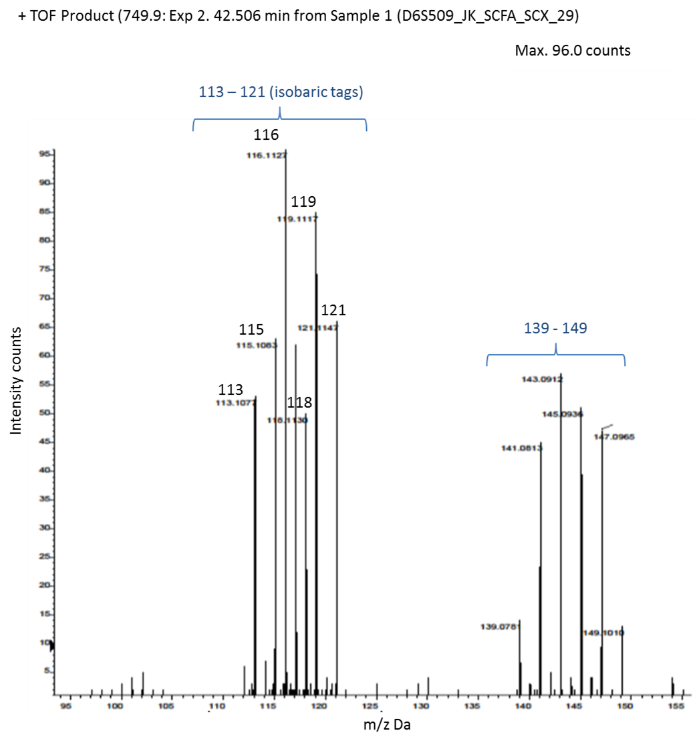

**Figure 3.2.** Representative QSTAR spectrum for an SCX fraction (#29) showing the isobaric ion peaks (113–121) for the pooled trypsin tagged SCFA-treated and untreated HCT116 samples. MS/MS Information about this fraction is given at the top left including fraction number and mass to charge ratio (749.9 m/z).

Labelling efficiency, the percentage of lysines tagged by the reporter ions, the percentage of reverse peptide hits (REV) and percentage of one-hit wonders (OHW), where a protein was identified by <3 valid peptides, were calculated from the Phenyx peptide fragment data and Phenyx summary data, as described in the experimental methods. The labelling efficiency was >95% and the percentage of reverse peptide hits <5%. These verified the quality of the multi-plex iTRAQ protocol providing confidence in the final data set. OHW and REVs were excluded from any further analyses. All these parameter data are presented in Table 3.1 for the propionate quadruplet experiment; parameters for the SCFA duplicate data from the preceding multi-plex iTRAQ experiment have been included for comparison [90]. The full list of identified proteins is given in Appendix I.

**Table 3.1.** (a) Phenyx analysis parameters, including the numbers of peptides and proteins identified, are listed for each multi-plex iTRAQ experiment with respect to their chosen protein databank. (b) After submitting the Phenyx data for quantification analysis by uTRAQ and SignifiQuant [93], the proteins differentially regulated by each SCFA treatment relative to untreated controls were quantified. The complete list of proteins is provided in Appendix I.

a)

|  |  |  |  |
| --- | --- | --- | --- |
| **Parameters** | SCFA duplicates | SCFA duplicates | Propionate quadruplets |
| Databank and | NCBInr | UniProt | UniProt |
| Date accessed | 23/07/2009 | 09/08/2010 | 05/05/2010 |
| p-value (min peptide p value) | 1x10-6 | 1x10-6 | 1x10-4 |
| z score (min peptide z score) | 7 | 6 | 5 |
| Peptide matches (not including reverse hits [REV]) | 705 | 1191 | 5266 |
| Protein matches | 256 | 313 | 599 |
| No. one-hit-wonders (OHW) | *140* | *151* | *340* |
| No. protein matches #valid peptide seq. >1 | 116 | 162 | 259 |
| No. protein matches #peptide >1 | 132 | 182 | 359 |
| % OHW (OHW / protein matches) | 55% | 48% | 57% |
| % Revs (needs to be <5%) | *0.42%* | *1.57%* | *0.00%* |
| Labelling efficiency (needs >95%) | 97.5% | 96.2% | 100.0% |

b)

|  |  |  |  |
| --- | --- | --- | --- |
| **Quantifications** | SCFA (NCBInr) | SCFA (UniProt) | Propionate (UniProt) |
| No. of proteins differentially regulated (uTRAQ ‘Quant’ analysis) | 82 | 102 | 331 |
| * uTRAQ >SD (68%) | 26; 18; 24 | n/a | 78 |
| * uTRAQ >2 SD (95%) | 4; 6; 4 | n/a | 17 |
| * SignifiQuant (MTC off; p=0.05) | n/a | 36 | 21 |

n/a: quantification analysis was not carried out by that method or against that databank for that dataset.

### *3.5.2. Propionate quadruplet results: Protein matches and quantification data*

Phenyx analysis identified 599 proteins with 100% labelling efficiency and 0.0% reverse hits. There were 359 protein matches >OHW. Quantification by uTRAQ referenced against the UniProt databank identified 331 differentially regulated proteins relative to untreated controls for all four propionate replicates (160 upregulated; 171 downregulated). Frequency analysis of the uTRAQ data showed that 61 proteins were differentially regulated >SD (68%) and 17 by >2 SD (95%). Subsequent quantification of the uTRAQ data by SignifiQuant identified 21 proteins that were differentially regulated with very high significance (MTC off; p<0.05). Although the uTRAQ frequency analysis returned more proteins as significantly differentially regulated, the proteins identified by SignifiQuant could be accepted with higher confidence. These figures are summarised in Table 3.1a. The full protein lists are provided in Appendix I.

### *3.5.3. SCFA duplicate data-mining: Protein matches and quantification data*

Quantification by uTRAQ, referenced against NCBInr and UniProt databanks, identified 82 and 102 proteins, respectively, as differentially regulated by SCFA treatments relative to untreated controls. Frequency analysis of the uTRAQ data against NCBInr showed that of these, butyrate, propionate and valerate differentially regulated 26, 18 and 24 proteins >SD; and 4, 6 and 4 proteins >2 SD, respectively. Quantification by SignifiQuant against UniProt identified 36 proteins as differentially regulated with a significance of p<0.05 (MTC off). These figures are summarised in Table 3.1b.

### *3.5.4. Differential regulation of cytoskeletal proteins*

The quantifications identified several of the principle cytoskeletal proteins as significantly differentially regulated, including a group of β-tubulin isotypes. In addition, three cytoskeletal-associated proteins were significantly differentially regulated. These were HSP, cofilin and profilin, all of which have functions in the stabilisation and restructuring of actin. The differential fold changes of these cytoskeletal proteins from both data sets and quantification methods were collated and selected based on their highest stringencies and p-values. The results are summarised in Table 3.2 and Figures 3.3 & 3.4 give a graphical overview as a histogram and Venn diagram, respectively. The following list gives the cytoskeletal proteins differentially regulated by each of the SCFAs:

* Butyrate: actin; keratin k19 (upregulated)
* Propionate: actin; keratin k19, k18, k8; tubulin α, β, TUBB3, β2c-tubulin (upregulated); TUBB/TUBB5 (downregulated)
* Valerate: keratin k19; β-tubulin, TUBB3, β2c-tubulinβ (upregulated)

The fold changes were only significant at the highest stringencies (MTC on; p<0.05) by propionate and valerate. Furthermore, only propionate and valerate, which are the odd-chain SCFAs, significantly upregulated the β-tubulin isotypes, and only valerate did so with the highest significance (MTC on; p<0.05).

Keratins 8, 18 and 19 are those most associated with the IFs in colon epithelia and have previously been reported as differentially regulated by SCFA treatments, in particular by butyrate [29]. Therefore, these results verified these earlier reports.

The Venn diagram shows which SCFAs each of the differentially regulated cytoskeletal proteins were regulated by, i.e. to an individual, a pair or all three SCFAs. This shows that butyrate had no significant effect on the tubulins, whereas valerate had the greatest effect on β2c-tubulin (*** MTC on; p<0.05). Propionate had effects in common with both butyrate and valerate. Keratin K19 was significantly differentially regulated by all three SCFAs.

**Table 3.2.** Summary of cytoskeletal proteins identified as significantly differentially regulated in SCFA-treated HCT116 cells relative to untreated controls. Fold changes are the mean linear fold changes of all biological replicates for each SCFA. Approved protein names have been adopted [91]. [B, butyrate; P, propionate; V, valerate; U, untreated].

|  |  |  |  |  |  |  |  |  |
| --- | --- | --- | --- | --- | --- | --- | --- | --- |
| Protein  (Gene name) | AC | #valid  peptide seq. | B:U | P:U  **+** | V:U | B:U | P:U  **+** | V:U |
| actin | P60709 | 22 | 1.19 | 1.36 |  | ** | *** |  |
| keratin 18 | B2RA03 | 5 |  | 1.78 |  |  | * |  |
| keratin 19 | P08727 | 10 | 1.76 | 1.43 | 1.83 | ** | *** | ** |
| keratin 8 | P05787 | 25 |  | 1.25 |  |  | *** |  |
| α-tubulin | P68363 | 9 | *1.01* | *1.30* | *0.98* |  | # |  |
| β-tubulin | Q5JP53 | 7 | *1.06* | 1.44 | 1.65 |  | # | # |
| TUBB3 | Q9BV28 | 7 | *1.04* | 1.33 | 1.48 |  | # | # |
| tubulin β-2C | P68371 | 11 | 1.08 | 1.46 | 1.48 |  | * | *** |
| TUBB/TUBB5 | P07437 | 19 |  | 0.73 |  |  | * |  |

# >SD (68%); * MTC off p<0.05; ** MTC off p<0.01; *** MTC on p<0.05

(**+** combined propionate results from the duplicate and quadruplet replicate experiments. The fold changes are those with highest stringency)

|  |
| --- |
|  |
| # >SD (68%); * MTC off p<0.05; ** MTC off p<0.01; *** MTC on p<0.05 |

**Figure 3.3.** Histogram showing linear fold-changes for differentially regulated cytoskeletal proteins in SCFA-treated HCT116 cells relative to untreated cells (actins, keratins and tubulins). The fold-changes are those at the highest significance, compiled from the two multi-plex iTRAQ experiments (SCFA-duplicates and propionate quadruplets). The data is given in Table 3.2.

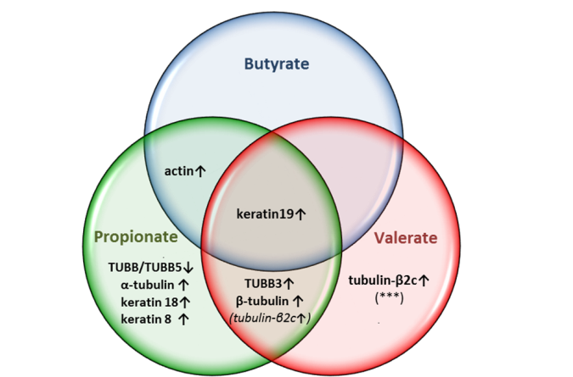

**Figure 3.4.** Venn diagram showing how the differentially regulated cytoskeletal proteins are related to the different SCFA treatments. The interlinks show if they are common to all SCFA-treatments, a pair, or unique to a single SCFA-treatment. Of note is that butyrate has no significant effect on tubulin isotypes; valerate has the greatest effect on β2c-tubulin (*** MTC on, p<0.05); and propionate shares effects with both butyrate and valerate. Fold-change data is provided in Table 3.2. [Arrows denote up or downregulation; *** indicates MTC on, p<0.05].

### *3.5.5. Correlation and cluster analyses of the biological replicates*

The reproducibility of the biological replicates and iTRAQ data for the propionate treated HCT116 samples was determined by Pearson’s correlation coefficient, as described in the experimental methods. The plots in Figure 3.5 show positive correlation between all the propionate samples, providing confidence in the results. Figures 3.5a & b show the correlation between pairs of data (117:118 and 119:121). Figure 3.5c shows the correlation between all four replicates as a two-dimensional array. A positive correlation coefficient of r > 0.5 indicates a satisfactory level of reproducibility between the replicates.

|  |  |
| --- | --- |
| a) propionate duplicates (117:118)  correlation r = 0.704 | b) propionate duplicates (117:118)  correlation r = 0.651 |
|  |  |
| c) propionate quadruplets (117:118:119:121)  correlation r = 0.674 | |
|  |  |

**Figure 3.5.** Correlation plots for the propionate biological replicates. The correlation coefficients (r) for the duplicate comparisons are (a) 0.704 and (b) 0.651. The coefficient for the quadruplet comparison is (c) 0.674. These results demonstrate that the propionate samples were positively correlated, indicating satisfactory reproducibility and providing confidence to the results. [Microsoft Excel 2010].

A dendrogram tree (cluster analysis) was constructed (Figure 3.6). This showed that the propionate replicate data clustered distinctly from the untreated data and that both sets of replicate data clustered together within their own groups. This again verified the reproducibility of data generated by the multi-plex iTRAQ experiment.

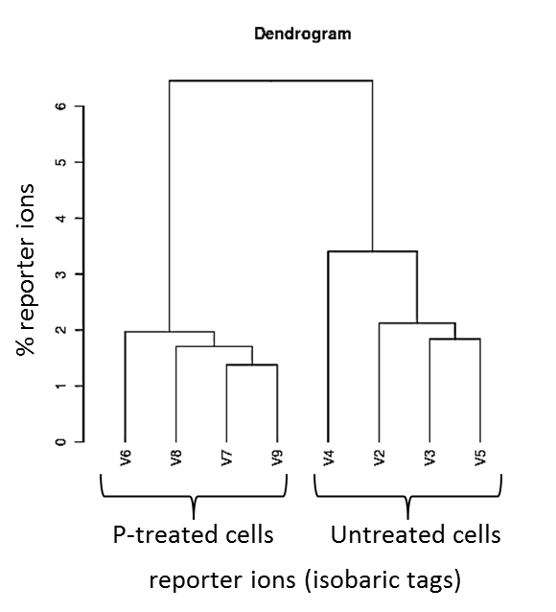

**Figure 3.6.** Dendrogram tree for the propionate quadruplet biological replicates for treated HCT116 cells compared to untreated cells. Propionate samples (117, 118, 119, 121) cluster together on the left; untreated samples (113, 114, 115, 116) cluster together on the right. The treated and untreated samples cluster distinctly from each other (separated by the main branch), yet together within their own groups, verifying the quality of the experimental protocols. Application creator, J. Noirel, The University of Sheffield [93].

### *3.5.6. Orthogonal validation of differential regulated proteins*

Western blot analysis was employed for orthogonal validation of the multi-plex iTRAQ data. The proteins selected for validation were β2c-tubulin and β3-tubulin, and the results confirmed the multi-plex iTRAQ results. The membrane photographs and densitometry results are given in the relevant chapter.

## 3.6. Multi-plex iTRAQ: Discussion

The purpose of this project had been to identify and study one or more of the pathways that was unique to propionate and/or valerate, distinct from butyrate. A preliminary examination of the existing proteomic data was carried out to identify candidate proteins and pathways for further investigation [4]. The twenty proteins with the greatest fold changes from each SCFA treatment were compared. The results are summarised in Table 3.3. A total of 32 proteins were identified which belonged to 23 functional types (for example, ribosomes or chaperonins). Of these, nine proteins were common to all three SCFAs. These were primarily involved in diverse generic functions such as glycolysis, ATP metabolism and protein folding. Butyrate and propionate had four and three unique proteins, respectively, which were also involved in generic functions. In contrast, valerate uniquely upregulated three proteins of which two were β-tubulin isotypes. Together, valerate and propionate differentially regulated a further three proteins including two more β-tubulins isotypes and alpha actinin, another member of the cytoskeletal superfamily. No other family of proteins was similarly represented. Further evidence that an MT pathway was targeted by the odd-chain SCFAs was provided by the complementary HCA cellomic results, which had shown that the odd-chain SCFAs were involved in cytoskeletal breakdown and G2/M (mitotic) arrest. This was supported by preliminary pathway expression analysis, using Reactome’s pathway tools [99], which showed that seven of the twenty pathways most enriched by SCFA treatments involved β2c-tubulin and β3-tubulin isotypes, including the pathway representing mitotic M-M/G1 transition.

The multi-plex iTRAQ results generated by the subsequent propionate quadruplet experiment performed during this project, and the data-mining of the SCFA duplicate data, provided further evidence of the distinct differential regulation of β-tubulin isoforms by the odd-chain SCFAs, propionate and valerate.

**Table 3.3**. Summary of the twenty proteins identified by multi-plex iTRAQ as having the greatest fold changes in SCFA-treated HCT116 colon cancer cells. This shows which of the proteins were common to all SCFA treatments and which were distinctly targeted by an individual SCFA. The results show that the β-tubulin isotypes were uniquely regulated by propionate and valerate, suggesting that the odd-chain SCFAs target an MT pathway. [B, butyrate; P, propionate; V, valerate; C, untreated; * proteins associated with cytoskeletal functions; ** β-tubulin isotypes].

|  |  |  |  |  |
| --- | --- | --- | --- | --- |
| Protein name  (or functional type) | B:C | P:C | V:C | Primary Function |
| Mean fold change | | |
| Annexin* | 1.79 | 1.71 | 1.65 | Diverse cellular processes including linkage of membrane-associated protein complexes to the actin cytoskeleton. |
| Fatty acid synthase | 0.32 | 0.34 | 0.32 | Belongs to the family of transferases, specifically acyltransferases. |
| Creatine kinase | 1.73 | 1.66 | 1.78 | Catalyzes the transfer of phosphate between ATP and phosphogens. |
| Peroxiredoxin | 1.60 | 1.55 | 1.70 | May have a proliferative effect and play a role in cancer development or progression. |
| Chaperonin | 0.51 | 0.44 | 0.52 | Molecular chaperones assist in the folding of proteins upon ATP hydrolysis. |
| hCG | 1.54 | 1.64 | 1.67 | Human chorionic gonadotropin (hCG) is a hormone. |
| Tyrosine | 1.52 | 1.55 | 1.46 | Involved in protein synthesis. |
| ATP synthase | 1.43 | 1.63 | 1.77 | Provides energy for synthesis of ATP. |
| Ribosomal | 0.69 | 0.59 | 0.55 | Ribosomes link amino acids together in the order specified by messenger RNA (mRNA). |
| Cyclophilin A | 1.42 | 1.36 |  | A highly abundant protein that binds to cyclosporine, an immunosuppressant. |
| Protein Disulfide Isomerase | 1.54 |  |  | Catalyses protein folding. |
| HSP90 | 1.38 |  |  | HSPs are involved in protein folding; triggered by environmental stress, such as inflammation. |
| SYNCRIP | 0.69 |  |  | Involved in nucleotide binding |
| Aldolase | 0.71 |  |  | Involved in glycolysis |
|  |  |  |  |  |
| Histone |  | 0.60 |  | Packages and orders DNA; primary protein component of chromatin. |
| *unknown* |  | *0.71* |  | *unknown* |
| Enolase |  | 0.72 |  | Involved in the penultimate step of glycolysis. |
|  |  |  |  |  |
| **Tubulin β |  | 1.44 | 1.65 | Cytoskeletal (microtubules). |
| **Tubulin β1 |  | 1.37 | 1.49 | Cytoskeletal (microtubules). |
| *Alpha actinins |  | 1.34 | 1.51 | Alpha actinins belong to the superfamily of cytoskeletal proteins. |
|  |  |  |  |  |
| **Tubulin β2c |  |  | 1.67 | Cytoskeletal (microtubules). |
| Nucleophosmin |  |  | 1.65 | Associated in the binding of single-stranded nucleic acids. |
| **Tubulin β3 |  |  | 1.48 | Cytoskeletal (microtubules). |

Altering the overall balance of β-tubulin isoforms through differential regulation creates an aberrant tubulin code [41, 47]. This prevents the cell from correctly performing many critical cellular functions associated with MTs, including formation of the mitotic spindle and accurate progression through mitosis. This may explain the loss of MT cytoskeletal integrity observed by HCA and the shift towards mitotic arrest observed by flow cytometry.

Cancer cells display different β-tubulin expression patterns compared to normal cells [51]. HCT116 colon cancer cells have been reported to downregulate β2c-tubulin and β3-tubulin isotypes and to upregulate β1-tubulin relative to non-tumour tissues [51]. Different β-tubulin isotypes are associated with specific actions, such as rapid growth of MT fibres or mitosis, therefore these pattern changes have been linked to enhanced proliferation and invasiveness in tumours [56, 58]. The multi-plex iTRAQ data showed that propionate and valerate treatment induced the opposite regulatory effects by upregulating β2c-tubulin and β3-tubulin and downregulating β1-tubulin, suggesting they may counter the tumourigenic actions of HCT116 cancer cells.

The majority of established anti-microtubule drugs are designed to either destabilise or over-stabilise MT dynamics, thereby disrupting their cellular functions. However, many AMDs show increasing cytotoxicity and drug resistance with successive rounds of treatments. Identifying alternative mechanisms to disrupt MT dynamics, for example, through differential regulation of the β-tubulin subunits, is an attractive target in chemotherapeutics.

In summary, these multi-plex iTRAQ experiments have provided high-quality proteomic data from HCT116 cells treated with multiple biological replicates of butyrate, propionate and valerate. The results indicate that propionate and valerate, the odd-chain SCFAs, may uniquely alter expression of the three key β-tubulin isotypes most associated with HCT116 colon cancer cell progression. Furthermore, quantification of the fold changes showed that valerate had the greatest and most significant effect. In combination with the cellomic and bioinformatic evidence, these results suggest that propionate and valerate may act as anti-mitotic agents *via* differential regulation of β-tubulin isotypes, offering a novel role for odd-chain SCFAs, in particular valerate, as potential chemopreventives against colorectal cancer.

## 3.7. Multi-plex iTRAQ: Key Conclusions

* The odd-chain SCFAs, propionate and valerate, uniquely differentially regulated three key β-tubulin isotypes associated with HCT116 colon cancer cell progression.
* Valerate had the greatest effect in regulating these β-tubulin isotypes. Propionate displayed similar actions to valerate, but at lower potency. Conversely, butyrate, the even-chain SCFA, induced no significant effect in β-tubulin isotype regulation.
* The direction of differential change induced by the valerate and propionate (upregulation of β3-tubulin and β2c-tubulin, and downregulation of β1-tubulin) countered the reported pattern of β-tubulin isotype expression in colon cancer cells, believed to enhance invasiveness, aggression and proliferation [51].

# 4. High Content Analysis showed that odd-chain SCFAs distinctly perturb MT cytoskeletal integrity and mitotic pathways compared to even-chain SCFAs

## 4.1. Contribution of High Content Analysis to the overall project

* High Content Analysis (HCA) is a high-throughput cellomic technique that provides both quantitative and qualitative data on cellular structures.
* HCA provided high-quality micrographs to highlight changes to cytoskeletal integrity though fluorescent microscopy.
* HCA provided quantitative cell cycle data to show different responses to odd and even-chain SCFA treatments.
* The HCA quantitative and qualitative results were complementary to multi-plex iTRAQ proteomic analyses.

## 4.2. Introduction to High Content Analysis

### *4.2.1. HCA background*

High Content Analysis (HCA), also known as High Content Biology, is an advanced cellomic technique in fluorescence microscopy that replaces the human microscopist with computer algorithms while retaining the information-rich images for qualitative interpretation. By staining molecules and proteins of interest with fluorescent antibodies, HCA generates quantitative data on cellular structures, processes or post-translational changes, and simultaneously produces high-quality micrographs of individual cells, cellular components and cell populations. The high-throughput capacity of HCA, samples can be analysed in 96-well plates enabling throughput technology of HCA, utilising 96-well plates, enables replicate samples and treatments to be compared providing robust statistical analyses without operator bias. Furthermore, systematic errors can be minimised as treatments are carried out under identical environmental conditions. The inclusion of immunocytochemistry (ICC), employing targeted primary antibodies with fluorescent ‘Alexa Fluor’ secondary antibodies, can provide information on post-translational modifications to specific proteins, including acetylation. An optional step involves staining cells with Cellomics Whole-Cell Red Stain to visualise cell shape and cytosolic area.

HCA combines the advantages of ELISA (medium-throughput and quantitative, but not at the individual cell level); fluorescent microscopy (qualitative micrographs with organisational information, but not quantitative or high-throughput); flow-cytometry (quantitative cell cycle data, but not high-throughput, and not at the individual cell level) and Western blotting (quantitative, but again not high-throughput, not at the individual cell level, and with greater error potential).

In conclusion, HCA is a valuable tool for advancing understanding of metabolic mechanisms and processes.

### *4.2.2. HCA study aims*

The first part of this HCA project was to acquire and analyse quantitative cellomic data on changes to the MT cytoskeleton (MT fibre texture, area and staining intensity) within HCT116 cells in response to SCFA treatments. The high-throughput capacity of HCA could be exploited to analyse a range of SCFA treatment concentrations between 0 and 20 mM in parallel.

The second part of this study was to mine the unexplored HCA data on cell cycle progression generated during the preceding study [4]. In addition to the 24 h dose response data that had established the optimal IC50 treatment conditions for further experimentation including multi-plex iTRAQ mass spectrometry, cell cycle data had also been generated at 48 h over the same SCFA concentration range. Although initial observations had implied a biphasic response in G1 and G2 cell cycle progression that were unique to propionate and valerate treatments, these data remained unexplored. The aim in this study was to interpret the 48 h biphasic data in relation to the corresponding proteomic and HCA cytoskeletal experimental observations.

Biphasic responses are defined as mechanisms which display two distinct responses separated in time. Biphasic responses can facilitate identification of optimum treatment conditions and provide valuable insights into the processes and mechanisms involved. They frequently describe a reduction in the population of an activating protein as it binds to the target proteins, whereas the target proteins continue to replicate and recover. However, SCFAs behave as coenzymes, catalysing acetylation reactions without loss of concentration, suggesting that the biphasic response triggered by propionate and valerate did not involve irreversible binding to target proteins. This mechanism remained to be determined.

The cell cycle is described in detail in the flow cytometry chapter. Briefly, it is a series of steps in which cells progress from a stage of resting, or performing their normal functions (G0/G1 phases), to actively dividing by first synthesising DNA (S phase), then increasing in size before undergoing mitosis (G2/M phases) and separating into two daughter cells. The checkpoints at G1 and G2/M ensure the preceding steps are completed accurately before allowing the next step to progress. Cell cycle arrest commonly leads to apoptosis or necrosis and cell death, which is reflected as a decrease in cell numbers. Drug treatments often act by perturbing cellular processes in the preceding steps or by preventing cells progressing to the following steps, for example, anti-mitotic treatments arrest cells at G2/M phase. HCA is able to quantitatively analyse these cell cycle parameters.

## 4.3. HCA: Project outline

### *4.3.1. HCA of MT cytoskeletal integrity*

The HCA experiment was part of a collaborative project investigating the effects of SCFA treatments on cytoskeletal integrity. Whereas this aspect of the project investigated MT cytoskeletal structure, the collaborative project investigated intermediate filaments (IF) *via* acetylation of their keratins subunits [85]. MT composition, functions and dynamics were discussed in detail in the introduction chapter. In relation to HCA, the three key parameters that define MT structure are texture (or co-occurrence), fibre area (or spot-fibre size) and fluorescent intensity. These parameters are determined by measuring the fluorescence of pixels in the micrographs and their contrast to the background. Together they can give a measure of filamentousness and MT-fibre integrity. The algorithms underlying these parameters are described in the experimental methods.

### *4.3.2. HCA of cell cycle progression and the biphasic response*

All the HCA experiments were performed at treatment conditions between 0–20 mM SCFA; as such, they encompassed the physiological concentrations for butyrate, propionate and valerate but were below the acidity levels which may compromise the results.

A biphasic dose-response between G1 and G2/M of the cell cycle had been observed previously at 48 h treatment times that had been unique to the odd-chain SCFAs (propionate and valerate) [4]. However, this data had remained unexplored so was retrospectively examined in this project to determine the underlying mechanisms. This effect suggested a link with the multi-plex iTRAQ observations that had also shown distinct effects with propionate and valerate. The biphasic response is shown as a quantitative plot in Figure 4.4.

## 4.4. HCA: Experimental methods

### *4.4.1. General reagents and solutions*

Cell culture for HCA was carried out in 96-well plates. The reagents and methods were as described in the cell culture chapter unless otherwise stated. All incubations were carried out at 37°C in a humidified atmosphere of 5% CO2.

ICC antibodies and reagents were as follows: Hoescht 33342 (Invitrogen) was used to stain nuclei; Phalloidin and anti-β tubulin antibodies were used to stain actin and β-tubulin, respectively. These were supplied, and applied, by Imagen Biotech Ltd. (Manchester, UK). The secondary antibodies (Invitrogen) were Alexa Fluor 488-donkey anti-rabbit (red) or Alexa Fluor 555-donkey anti-rabbit (green). Digitonin and formaldehyde were purchased from Sigma.

### *4.4.2. HCT116 cell culture and treatment in 96 well-plates*

Prior to cell culture, a plate map was drawn (Figure 4.1) to specify the treatment conditions for each well: SCFA concentration; treatment time; and primary antibody. Each treatment condition was repeated in triplicate for statistical analysis.

The HCT116 cells were cultured in Black-sided Costar 96-well plates treated for cell culture (Sigma) following the steps described in cell culture methods. The cells were plated at 8 x 103 cells per 100 μl well in DMEM media; incubated for a 24 h laying-down period at 37°C; the media were replaced with 160 μl DMEM per well; and the cells were simultaneous treated by adding 40 μl SCFA per well (5 x SCFA stock solutions in PBS) using a multi-channel pipette (Labret Biopette) to give a final volume of 200 μl per well. Treatment concentrations were 0 mM, 1 mM, 5 mM, 10 mM, and 20 mM SCFA; the cells were incubated at 37°C for 24 h before being fixed in 4 % formalin for 15 min at room temperature. Untreated samples were included as controls.

|  |  |
| --- | --- |
| a) HCT116 cytoskeletal (actin-tubulin) plate map | b) Representative plate micrograph |
|  |  |

**Figure 4.1.** HCA 96-well plate plan and micrographs of HCT116 cells after treatment with SCFAs. a) Top panel: colour key showing SCFA treatment concentrations; Lower panel: the plate map rows represent triplicate treatments. b) The ICC micrograph shows green fluorescent anti-body staining of cytoskeletal structure and blue (Hoescht) nuclei. The inset represents a single well. [vp, valproic acid; P, propionate; B, butyrate; V, valerate].

### *4.4.3. Immunocytochemistry of actin and tubulin cytoskeletal structures*

After fixing, the nuclei were stained with Hoechst (blue) at a ratio of 1:1250 in digitonin and incubated for 30 min at room temperature. After staining, the cells were washed three times with PBS. The plates were sealed with a sealing film and transported on ice at 4°C to Imagen Biotech, Manchester, where they were stained with Phalloidin for actin and an anti-β tubulin antibody prior to HCA analysis.

### *4.4.4. HCA quantification of cytoskeletal integrity*

HCA imaging and analysis was carried out at Imagen Biotech using x10 and x20 objectives and ArrayScan II software (v. 3.5.1.2).

Hoechst nuclear staining enabled Regions of Interest (ROIs) per well to be identified and corrections to background fluorescence to be made. The total staining intensity of the structures of interest was averaged across the ROI. The cellomics proprietary software and a compartmental analysis algorithm averaged data from internal triplicates for each treatment with >95% confidence.

The three principle parameters in the micrographs for defining cytoskeletal integrity are texture and contrast, fibre area and intensity. These were measured by a morphology algorithm as follows:

* Texture was calculated as the co-occurrence intensity of structural staining and was based on the number of occurrences of adjacent pixels at a certain intensity. High variations give a high value of co-occurrence indicating strong texture and filamentousness. This is where the pixels that make up the filament have very different values from the pixels in their neighbourhood. Conversely, uniform staining gives a low value of co-occurrence indicating cellular depolymerisation.
* Fibre area was determined by spot-fibre size analysis which identifies which pixels belong to spots and which to fibres. The mean area of all the fibres was calculated and returned as a single measurement.
* The intensity, or mean total intensity, was the averaged value of all the ROIs, calculated as the sum of all the pixel values within each fibre ROI. Applying background correction differentiated between genuine spots and fibres and intracellular noise.
* The intensity parameter is most often used as a quality control measure of the experimental and staining protocol; however, it can also be used to assess fibre integrity. The fluorescence from healthy, intact fibres should be in sharp contrast to the background, with every pixel within the fibre’s region of interest (ROI) having approximately the same intensity. As such, the SD of the pixel-intensity within a fibre’s ROI will be low. As the fibre dissociates and becomes diffuse, there will be both darker and brighter areas within the ROI, leading to an increase in SD: the larger the SD, the lower the fibre integrity.

### *4.4.5. Data-mining HCA cell cycle data for the biphasic response*

In addition to the structural parameters, other cell parameters were returned by a cell cycle algorithm. These included the total cell count and numbers of cells at each phase of the cell cycle (sub-G1; G1; S; G2/M; post-G2/M).

Quantitative HCA cell cycle data acquired from the earlier 48 h dose-response treatment of HCT116 cells by SCFAs (0–20 mM) [4], was retrospectively analysed using Prism software (GraphPad v.5). This had shown a biphasic response at low SCFA concentrations (<5 mM) in the G1 and G2/M phases which was unique to propionate and valerate treatments, but not observed with butyrate. The data had been compiled from three internal repeats allowing means and SEM values to be calculated (CI >95%). The data were plotted using Prism software (Graphpad v.5) and Microsoft Excel 2010 (Microsoft, Redmond, W.A., USA).

### *4.4.6. HCA statistical analysis*

Statistical analyses were performed using Prism software (GraphPad v.5) and Microsoft Excel. All SCFA treatments had been performed in triplicate allowing the means and SEMs to be calculated (CI >95%). Student’s t-tests (two-tailed) were used to give p-values for the fibre integrity results for SCFA treatments relative to untreated cells. The generated data were plotted for the cell cycle analysis and MT cytoskeletal integrity results over the range of dose-response concentrations (0–20 mM SCFA).

## 4.5. HCA: Results

### *4.5.1. Defining a novel parameter for MT-fibre integrity*

Interpretations of HCA data are generally made by analysing each parameter and comparing the results individually; however, the unique behaviour of MT dynamics meant there was a direct relationship between MT-fibre texture (co-occurrence) and fibre area (spot-fibre size). For the purposes of this project, including providing a single measure for parameter matching in the computational model, this relationship was exploited to provide a single, novel, measure of ‘fibre integrity’, defined as the ratio of co-occurrence:fibre-area. MT-fibres should be a tight linear assembly of typically 13 protofilaments. If these dissociate, the protofilaments separate laterally and the subunits disassemble from the tips leading to an increase in overall fibre volume but a decrease in density. In terms of HCA quantification, this will be reflected as a loss of co-occurrence, as tubulin subunits depolymerise, with a concurrent increase in fibre area as the protofilaments “spread out”. Consequently, co-occurrence:fibre-area decreases as MT integrity is lost. This effect is specific to structures with behaviours similar to MT fibres; in contrast, an increase in fibre area may reflect positive growth and increased integrity in other molecules, therefore this novel parameter would be inappropriate.

### *4.5.2. Effect of SCFA treatments on MT cytoskeletal integrity*

The fluorescent micrograph in Figure 4.2 shows the organisation and localisation of microtubule and actin filaments within the HCT116 cells after treatment with the maximum concentration of SCFA (20 mM) showed that butyrate and valerate produced the most diffuse MT fibres compared to propionate and untreated cells (Figure 4.2). The mean fibre integrity ± SEM (n = 3) for 20 mM butyrate, propionate and valerate was 49% ± 6%, 69% ± 11% and 30% ± 6%, respectively (Table 4.1a). This is shown graphically by the histograms of MT-fibre integrity (texture:area) in Figure 4.3a.

At IC50 (G2/M) concentrations, the MT-fibre integrity was 47% ± 6%, 43% ± 4% and 27% ± 3% following treatment with butyrate, propionate and valerate, respectively (mean ± SEM, n = 3; Table 4.1b), showing the greatest loss with propionate and valerate (Figure 4.3b).

Student’s t-tests (two-tailed) showed that the results for valerate at 20 mM and for both propionate and valerate at IC50 (G2/M) concentrations had the greatest significance (p<0.05; Table 4.1a).

The histogram of mean intensity-SD (Figure 4.3c; Table 4.2) further supported the fibre integrity results by showing the greatest level of fragmentation occurred with butyrate and valerate, when averaged over all treatment concentrations (0–20 mM).

|  |  |  |  |
| --- | --- | --- | --- |
| Untreated | Butyrate | Propionate | Valerate |
|  |  |  |  |

**Figure 4.2.** HCA micrographs of HCT116 cellular cytoskeletal integrity after 20 mM SCFA treatments. SCFA treated cells show more diffuse MT fibres compared to the filamentous fibres in untreated cells. Butyrate and valerate show the greatest loss in MT integrity (filamentousness). [green, MT fibres; red, actin; blue, nuclei].

loss of MT-fibre integrity



|  |  |  |  |
| --- | --- | --- | --- |
| % integrity  (co-occurence:fibre-area) |  |  |  |
|  | a) SCFA dose-response [mM] | b) SCFA IC50 (G2/M) | c) mean fibre intensity SD |

*p<0.05

**Figure 4.3.** Quantification of MT-fibre integrity in HCT116 cells after SCFA treatments. These histograms are graphical representations of the micrographs in Figure 4.2. The y-axis gives % integrity (co-occurrence:fibre-area) relative to untreated cells; the x-axis gives the SCFA concentration. (a) Dose response effect: increasing loss of MT fibre integrity with increasing SCFA concentration shows that valerate induces the greatest effect. (b) Loss of MT-fibre integrity at IC50 (G2/M) treatment concentrations (butyrate, 4 mM; propionate, 11 mM; valerate, 9 mM) again show that valerate induces the greatest loss of integrity and butyrate induces the least. (c) An alternative measure of MT fibre fragmentation is shown by the increase in intensity-SD (variation within pixel intensity). These show that both valerate and butyrate induce the greatest level of MT fibre fragmentation. In contrast to the results in (a) and (b) the SD-values are the mean of all treatment concentrations. [B, butyrate; P propionate; V valerate].

**Table 4.1.** MT-fibre integrity (co-occurrence:fibre-area) in HCT116 colon cancer cells relative after treatment with SCFAs at the following concentrations (a) 0–20 mM; (b) at IC50 (G2/M) concentrations (butyrate, 4 mM; propionate, 11 mM; valerate, 9 mM). Significant results (p<0.05) are shown as bold/italics.

a)

|  |  |  |  |  |  |  |  |  |  |  |  |  |
| --- | --- | --- | --- | --- | --- | --- | --- | --- | --- | --- | --- | --- |
| SCFA | MT-fibre integrity  relative to untreated samples  (co-occurrence:fibre-area) | | | | SEM (n = 3) | | | | p-value | | | |
| [mM] | 1 | 5 | 10 | 20 | 1 | 5 | 10 | 20 | 1 | 5 | 10 | 20 |
| B | 164% | 47% | 89% | 49% | 33% | 6% | 19% | 6% | 0.46 | 0.15 | 0.43 | 0.21 |
| P | 175% | 136% | 43% | 69% | 6% | 25% | 4% | 11% | 0.12 | 0.57 | ***0.05*** | 0.39 |
| V | 148% | 107% | 27% | 30% | 10% | 17% | 3% | 6% | 0.30 | 0.87 | ***0.04*** | ***0.02*** |

b)

|  |  |  |
| --- | --- | --- |
| SCFA | MT-fibre integrity | |
|  | IC50 (G2/M) | SEM |
| B | 47% | 6% |
| P | 43% | 4% |
| V | 27% | 3% |

B, butyrate; P propionate; V valerate

**Table 4.2.** Mean MT-fibre fragmentation (pixel intensity SD) in HCT116 colon cancer cells after treatment with 0–20 mM SCFAs. Low SD: healthy cells, high integrity; High SD: loss of integrity. The results at IC50 G2/M treatment concentrations are given as ***bold italics****.*

|  |  |  |  |  |  |  |
| --- | --- | --- | --- | --- | --- | --- |
| SCFA | MT-fibre fragmentation  (pixel intensity SD) | | | | pixel intensity SD | |
| [mM] | 1 | 5 | 10 | 20 | mean | SEM |
| B | 13% | ***22%*** | 12% | 39% | 21% | 5% |
| P | 5% | 22% | ***19%*** | 8% | 14% | 4% |
| V | 11% | 24% | ***20%*** | 32% | 22% | 4% |

B, butyrate; P propionate; V valerate

### *4.5.3. HCA cell cycle progression and the biphasic response*

HCA cell cycle data were averaged for triple replicates to give the mean percentage of HCT116 cells at G1, S and G2/M phases at both 24 h and 48 h SCFA treatment times. The mean corresponding cell counts were also calculated. HCA cell cycle data is given in Tables 4.3 a–b.

1. The cell count data at both 24 h and 48 h (Figure 4.4a) showed a dramatic decrease in the number of cells after 0–20 mM SCFA treatments, indicating that the SCFAs halted cell proliferation in a dose-dependent manner. The cell count decreased from approximately >6500 to <2000 cells at 24 h, and from >12000 to <2000 at 48 h.
2. The 24 h cell cycle results (Figure 4.4b) showed an increase in the proportion of cells accumulating (arrested) at G2/M phase and a corresponding decrease in cells arrested at G1 phase from 0–20 mM SCFA. This change was initiated at a lower concentration by butyrate (2 mM) compared to propionate and valerate (5–10 mM). The percentage cells accumulating at each phase reached a plateau (steady-state) at approximately 5 mM (butyrate) and at 10 mM (propionate and valerate). The profile of S phase was least affected by all treatments.
3. The 48 h cell cycle results (Figure 4.4c) showed a marked difference in cell cycle profiles between treatments with butyrate (even-chain) and propionate and valerate (odd-chain). Butyrate displayed similar cell cycle profiles at both 24 h and 48 h. In contrast, propionate and valerate displayed a characteristic biphasic response at 48 h: the profiles showed an initial increase in cells accumulating at G1 at low treatment concentrations (<7.5 mM) with a corresponding decrease in cells at G2/M; as the treatment concentration increased (>5–20 mM), G2/M arrest again became dominant.
4. The proportion of cells arrested at G2/M was consistently higher by 10%–20% when induced by butyrate compared to propionate and valerate regardless of treatment concentrations or treatment time (i.e. at 0–20 mM SCFA and at 24 h and 48 h). This suggested that the shift back to G1 was a constant phenomenon, and not dose dependant.

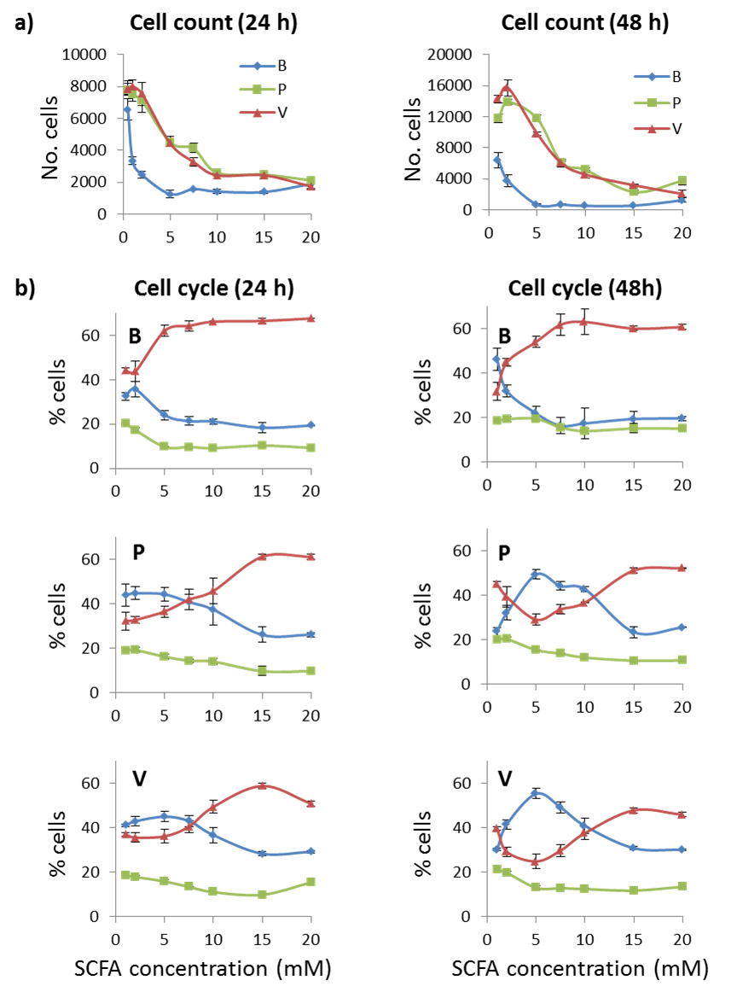

**Figure 4.4.** HCA profiles of HCT116 colon cancer cells after treatment with 0–20 mM SCFA for 24 h or 48 h. (b) % cells at G1, S and G2/M phase. (a) The cell count profiles for all three SCFAs are similar for all SCFAs at both 24 h and 48 h, however the drop in cell count is most rapid with butyrate (<5 mM). (b) In contrast, the cell cycle profiles are different at 24 h and 48 h between butyrate (even-chain) and propionate and valerate (odd-chain). Butyrate displays similar profiles at both 24 h and 48 h. In contrast, propionate and valerate display a biphasic response in G1 and G2 phases at 48 h. [G1 (blue ♦); S (green ); G2 (red Δ); B, butyrate; P, propionate; V, valerate].

To confirm that butyrate had not undergone a similar biphasic effect at a much lower SCFA concentrations as a result of its more rapid loss of cell count, the cell cycle analysis was repeated at very low SCFA concentrations (0.1, 0.5, 1.0, 2.0 mM). The results confirmed that the biphasic effect was unique to the odd-chain SCFAs, propionate and valerate.

**Table 4.3 (a)** **24 h** HCA cell cycle analysis for SCFA-treated HCT116 cells showing the % cells at each phase (G1, S, G2); SEM: n = 3.

i) Butyrate

|  |  |  |  |  |  |  |  |  |  |
| --- | --- | --- | --- | --- | --- | --- | --- | --- | --- |
| SCFA | mean % cells | | | SEM (n = 3) | | | SEM (%) | | |
| mM | G1 | S | G2 | G1 | S | G2 | G1 | S | G2 |
| 0 | 31.80 | 19.66 | 45.77 | 1.66 | 0.74 | 1.00 | 5% | 4% | 2% |
| 0.1 | 35.09 | 18.87 | 42.81 | 2.08 | 1.06 | 1.64 | 6% | 6% | 4% |
| 0.5 | 32.24 | 20.05 | 44.33 | 1.50 | 0.56 | 1.25 | 5% | 3% | 3% |
| 1.0 | 32.58 | 20.41 | 44.09 | 0.23 | 0.51 | 0.68 | 1% | 2% | 2% |
| 2.0 | 35.82 | 17.42 | 43.82 | 3.63 | 2.36 | 1.47 | 10% | 14% | 3% |
| 5.0 | 24.19 | 9.83 | 62.14 | 1.35 | 1.20 | 1.12 | 6% | 12% | 2% |
| 7.5 | 21.48 | 9.78 | 64.37 | 0.40 | 0.61 | 0.46 | 2% | 6% | 1% |
| 10.0 | 21.26 | 9.31 | 66.25 | 1.11 | 1.43 | 2.02 | 5% | 15% | 3% |
| 15.0 | 18.46 | 10.41 | 66.61 | 0.55 | 0.99 | 1.26 | 3% | 10% | 2% |
| 20.0 | 19.47 | 9.39 | 67.74 | 0.75 | 0.49 | 1.11 | 4% | 5% | 2% |

ii) Propionate

|  |  |  |  |  |  |  |  |  |  |
| --- | --- | --- | --- | --- | --- | --- | --- | --- | --- |
| SCFA | mean % cells | | | SEM (n = 3) | | | SEM (%) | | |
| mM | G1 | S | G2 | G1 | S | G2 | G1 | S | G2 |
| 0 | 35.05 | 19.83 | 41.87 | 1.29 | 0.43 | 0.98 | 4% | 2% | 2% |
| 0.1 | 38.15 | 20.08 | 38.64 | 1.34 | 0.63 | 0.94 | 4% | 3% | 2% |
| 0.5 | 43.16 | 19.56 | 32.34 | 5.21 | 0.90 | 6.70 | 12% | 5% | 21% |
| 1.0 | 43.92 | 19.00 | 32.21 | 5.11 | 0.85 | 7.31 | 12% | 4% | 23% |
| 2.0 | 44.81 | 19.17 | 32.75 | 4.21 | 1.21 | 5.87 | 9% | 6% | 18% |
| 5.0 | 44.29 | 16.19 | 36.56 | 3.51 | 0.56 | 3.10 | 8% | 3% | 8% |
| 7.5 | 40.78 | 14.34 | 41.93 | 1.08 | 0.92 | 0.62 | 3% | 6% | 1% |
| 10.0 | 37.37 | 13.96 | 45.83 | 1.94 | 0.75 | 0.71 | 5% | 5% | 2% |
| 15.0 | 26.01 | 9.65 | 61.26 | 0.83 | 0.51 | 0.45 | 3% | 5% | 1% |
| 20.0 | 26.11 | 9.62 | 61.21 | 1.22 | 0.21 | 0.80 | 5% | 2% | 1% |

iii) Valerate

|  |  |  |  |  |  |  |  |  |  |
| --- | --- | --- | --- | --- | --- | --- | --- | --- | --- |
| SCFA | mean % cells | | | SEM (n = 3) | | | SEM (%) | | |
| mM | G1 | S | G2 | G1 | S | G2 | G1 | S | G2 |
| 0 | 40.00 | 20.00 | 37.09 | 0.90 | 0.16 | 0.90 | 2% | 1% | 2% |
| 0.1 | 37.32 | 18.53 | 41.38 | 1.83 | 0.72 | 1.07 | 5% | 4% | 3% |
| 0.5 | 41.47 | 19.17 | 35.45 | 1.15 | 0.73 | 1.71 | 3% | 4% | 5% |
| 1.0 | 41.07 | 18.49 | 36.90 | 2.48 | 0.30 | 2.39 | 6% | 2% | 6% |
| 2.0 | 42.89 | 17.80 | 35.57 | 0.77 | 0.18 | 0.68 | 2% | 1% | 2% |
| 5.0 | 44.99 | 15.77 | 36.13 | 0.71 | 0.52 | 0.81 | 2% | 3% | 2% |
| 7.5 | 42.97 | 13.32 | 40.51 | 0.82 | 0.06 | 0.82 | 2% | 0% | 2% |
| 10.0 | 36.65 | 10.97 | 49.38 | 0.76 | 0.19 | 0.76 | 2% | 2% | 2% |
| 15.0 | 28.29 | 9.75 | 58.85 | 0.48 | 0.26 | 0.17 | 2% | 3% | 0% |
| 20.0 | 29.16 | 15.35 | 50.83 | 1.04 | 1.19 | 0.94 | 4% | 8% | 2% |

**Table 4.3 (b)** **48 h** HCA cell cycle analysis for SCFA-treated HCT116 cells showing the % cells at each phase (G1, S, G2); SEM: n = 3.

i) Butyrate

|  |  |  |  |  |  |  |  |  |  |
| --- | --- | --- | --- | --- | --- | --- | --- | --- | --- |
| SCFA | mean % cells | | | SEM (n = 3) | | | SEM (%) | | |
| mM | G1 | S | G2 | G1 | S | G2 | G1 | S | G2 |
| 0 | 39.62 | 19.85 | 37.57 | 5.05 | 1.53 | 4.13 | 13% | 8% | 11% |
| 0.1 | 36.98 | 19.64 | 39.38 | 2.82 | 1.25 | 1.65 | 8% | 6% | 4% |
| 0.5 | 40.82 | 18.66 | 37.21 | 3.08 | 1.10 | 2.50 | 8% | 6% | 7% |
| 1.0 | 46.17 | 18.37 | 31.68 | 3.63 | 0.82 | 4.75 | 8% | 4% | 15% |
| 2.0 | 31.99 | 19.27 | 44.86 | 6.83 | 1.25 | 5.83 | 21% | 6% | 13% |
| 5.0 | 21.85 | 19.41 | 54.10 | 3.47 | 2.13 | 0.96 | 16% | 11% | 2% |
| 7.5 | 16.24 | 15.57 | 61.77 | 0.97 | 1.15 | 1.10 | 6% | 7% | 2% |
| 10.0 | 17.32 | 13.94 | 63.05 | 1.42 | 1.22 | 1.15 | 8% | 9% | 2% |
| 15.0 | 19.34 | 15.01 | 60.10 | 2.89 | 3.32 | 1.38 | 15% | 22% | 2% |
| 20.0 | 19.53 | 14.97 | 60.77 | 1.21 | 0.99 | 2.11 | 6% | 7% | 3% |

ii) Propionate

|  |  |  |  |  |  |  |  |  |  |
| --- | --- | --- | --- | --- | --- | --- | --- | --- | --- |
| SCFA | mean % cells | | | SEM (n = 3) | | | SEM (%) | | |
| mM | G1 | S | G2 | G1 | S | G2 | G1 | S | G2 |
| 0 | 28.91 | 19.50 | 40.33 | 1.83 | 0.58 | 1.37 | 6% | 3% | 3% |
| 0.1 | 32.01 | 19.10 | 36.17 | 3.31 | 0.97 | 4.52 | 10% | 5% | 13% |
| 0.5 | 30.51 | 21.09 | 39.12 | 2.14 | 0.15 | 2.39 | 7% | 1% | 6% |
| 1.0 | 23.74 | 19.89 | 44.99 | 1.97 | 0.20 | 2.23 | 8% | 1% | 5% |
| 2.0 | 32.00 | 20.27 | 39.29 | 1.09 | 0.12 | 0.27 | 3% | 1% | 1% |
| 5.0 | 49.33 | 15.34 | 29.00 | 2.49 | 0.91 | 1.11 | 5% | 6% | 4% |
| 7.5 | 44.15 | 13.74 | 33.64 | 0.26 | 0.33 | 0.08 | 1% | 2% | 0% |
| 10.0 | 42.76 | 11.93 | 36.74 | 1.14 | 0.18 | 1.04 | 3% | 1% | 3% |
| 15.0 | 23.41 | 10.55 | 51.21 | 1.35 | 1.01 | 0.60 | 6% | 1% | 1% |
| 20.0 | 25.53 | 10.64 | 52.21 | 0.88 | 0.93 | 0.87 | 3% | 9% | 2% |

iii) Valerate

|  |  |  |  |  |  |  |  |  |  |
| --- | --- | --- | --- | --- | --- | --- | --- | --- | --- |
| SCFA | mean % cells | | | SEM (n = 3) | | | SEM (%) | | |
| mM | G1 | S | G2 | G1 | S | G2 | G1 | S | G2 |
| 0 | 36.41 | 19.11 | 32.61 | 0.66 | 0.50 | 0.76 | 2% | 3% | 2% |
| 0.1 | 30.13 | 19.87 | 39.21 | 2.19 | 0.65 | 2.09 | 7% | 3% | 5% |
| 0.5 | 34.64 | 20.86 | 34.49 | 2.26 | 0.86 | 3.12 | 7% | 4% | 9% |
| 1.0 | 30.15 | 21.03 | 39.50 | 2.44 | 0.20 | 2.76 | 8% | 1% | 7% |
| 2.0 | 41.51 | 19.68 | 29.11 | 3.52 | 0.32 | 2.84 | 8% | 2% | 10% |
| 5.0 | 55.33 | 12.90 | 24.80 | 0.88 | 0.03 | 1.17 | 2% | 0% | 5% |
| 7.5 | 49.17 | 12.70 | 29.66 | 0.50 | 0.34 | 1.01 | 1% | 3% | 3% |
| 10.0 | 40.81 | 12.34 | 37.56 | 0.45 | 0.89 | 1.15 | 1% | 7% | 3% |
| 15.0 | 30.77 | 11.64 | 47.86 | 0.51 | 0.23 | 0.77 | 2% | 2% | 2% |
| 20.0 | 30.05 | 13.37 | 45.86 | 1.07 | 1.01 | 1.55 | 4% | 8% | 3% |

## 4.6. HCA: Discussion

HCA showed that the SCFAs induced a dose-response effect in halting cell proliferation at both 24 h and 48 h treatment times. The decrease in cell count correlated with an increase in SCFA concentration until approximately 15 mM and then stabilised to a steady-state.

In addition, HCA showed that MT cytoskeletal integrity was catastrophically impaired in HCT116 colon cancer cells after treatment with SCFAs with the greatest loss of integrity induced by valerate. It has been established that butyrate is a strong effector of apoptotic pathways in colon epithelial cancer cells by altering expression of both pro- and anti- apoptotic proteins leading to both G1 and G2/M cell cycle arrest and inevitable cytoskeletal breakdown [37, 100]. This includes upregulation of p53, a pro-apoptotic tumour suppressor, which in turn promotes p53/Bax leading to G1 arrest, and upregulation of p53/Ser-15 which leads to G2 arrest [101].

It is similarly reported that propionate and valerate are poorer effectors of these apoptotic pathways [100]. The HCA evidence in this project indicated that valerate was as effective as butyrate at inducing MT fibre fragmentation and more effective at IC50 (G2/M) treatment concentrations (Figures 4.2 & 4.3). This suggested that valerate acted through alternative, potentially anti-mitotic pathways, supporting the multi-plex iTRAQ results.

At 48 h, a clear distinction in the dose-response cell cycle profiles was observed between the odd and even-chain SCFAs. Propionate and valerate induced a characteristic biphasic effect in G1 and G2/M arrest at low concentrations (<7.5 mM), with an initial increase in cells accumulating at G1 before G2/M arrest became more dominant at higher concentrations (>5 mM). Of note, was that the biphasic effect was not observed until 48 h, when the majority of cells that had survived the first 24 h treatment would have undergone cell division. This suggested that the biphasic effect may be phenotype dependant and not dose-dependent.

Furthermore, the G2/M cell cycle profile for butyrate was consistently higher by 10%–20% than the profiles for propionate and valerate, independent of treatment concentration. This could be explained by a phenomenon termed mitotic slippage, or mitotic catastrophe [102], in which a fixed proportion of cells, matching a specific phenotype, are able to evade the G2/M checkpoint, but are subsequently halted at G1 in the next cell cycle.

Another study reported a biphasic mitotic effect and proposed a coupling of pre-mitotic cell cycle progression with MT integrity, indicating a possible MT checkpoint [103].

In conclusion, the HCA results, combined with reports from the literature, supported the hypothesis that the odd-chain SCFAs, propionate and valerate, induced G2/M arrest through mitotic pathways, in contrast to butyrate which acts through apoptotic pathways.

## 4.7. HCA: Key Conclusions

* HCA quantitative microscopy demonstrated that propionate and valerate, the odd-chain SCFAs, followed a distinct mitotic pathway from butyrate.
* The HCA results showed that valerate had the greatest overall impact in perturbing MT cytoskeletal integrity in HCT116 cells.
* Cell cycle analysis indicated propionate and valerate induced a unique biphasic G2/M response. This effect was characteristic of a phenomenon termed mitotic slippage.
* These HCA observations were in accord with the multi-plex iTRAQ results which had shown that propionate and valerate significantly differentially regulated β-tubulin isotypes in contrast to butyrate.

# 5. Flow cytometry indicated a time-dependent difference in cell cycle response in HCT116 cells between odd and even-chain SCFA treatments

## 5.1. Contribution of flow cytometry to the overall project

* Flow cytometry is a high-throughput technique that is able to provide quantitative information on cell cycle progression from multiple treatments.
* Flow cytometry could support both the multi-plex iTRAQ proteomics and HCA cellomics results by providing time-response evidence for cell cycle progression to verify the distinct effects observed between odd and even-chain SCFAs.
* In comparison to multi-plex iTRAQ proteomics and HCA cellomics, flow cytometry is relative low-cost and can return multiple results relatively quickly

## 5.2. Flow cytometry in Systems Biology

Understanding the complexity of bimolecular systems in an era of rapidly expanding in genomic, proteomic and pathway knowledgebases is demanding new tools and methodologies. These include large scale high-throughput quantitative techniques, advances in computation, software and data-handling applications and new approaches, such as Systems Biology. Flow cytometry is able to make quantitative measurements of cells and cellular components on a molecular scale and recent technological developments are increasing its role as a valuable and versatile tool in the field of Systems Biology [104]. One of its advantages is the ability to rapidly and quantifiably measure the proportion and state of cells at different phases of the cell cycle over a wide range of treatment conditions.

Based on the results from both the multi-plex iTRAQ and HCA experiments it had been proposed that cells were arrested by the odd-chain SCFAs through anti-mitotic events. Flow cytometry could validate this proposition by demonstrating a shift towards cell cycle arrest at G2/M phase, i.e. a failure to progress through mitosis.

A second purpose of the flow cytometry study was to determine whether the biphasic effect in G1 and G2/M phase observed by HCA at 48 h but not at 24 h, could be observed during a time-course flow cytometry experiment. This could identify the time point at which it was initiated and confirm that the effect was unique to propionate and valerate, the odd-chain SCFAs.

Interpreting flow cytometry analyses requires knowledge of the cell cycle and the mechanisms that cause cell cycle arrest at each cell cycle checkpoint.

## 5.3. The cell cycle

### *5.3.1. The cell cycle and checkpoints*

The cell cycle describes the cycle of events that lead to cell division. It is a series of distinct phases as follows: G0 (resting, quiescence); G1 (performing regular functions; not dividing); S (synthesis; DNA replication); G2 (growth; preparing for mitosis); M (mitosis; cell division and separation into two daughter cells). Figure 5.1 is a schematic of the cell cycle, describing the steps that lead to cell division.

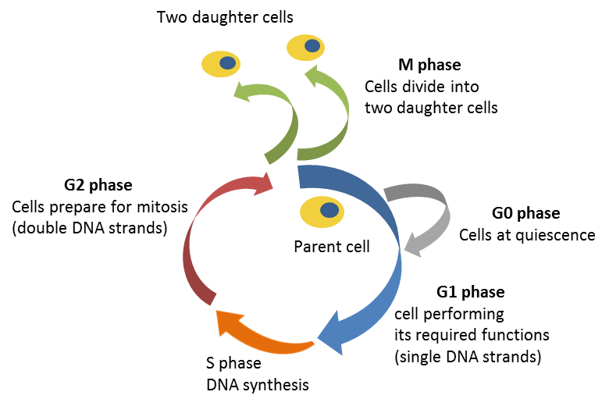

**Figure 5.1.** The cell cycle describing progression from interphase either resting (G0; grey) or performing their cellular functions (G1, blue). As cells prepare to divide they first duplicate their DNA *via* synthesis (S; orange) and grow increasing their cytoplasm (G2; red); before progressing to mitosis (M; green) where they divide into two daughter cells.

* G0 is not strictly part of the cycle, but a period of quiescence when the cell effectively leaves the cell cycle and rests. Cells can remain in G0 for long periods of time.
* In both normal and cancerous cells, the majority of cells will be at G0/G1 phase while taking in nutrients prior to division.
* M phase is two events known as mitosis, and cytokinesis. The nucleus divides during mitosis then the cytoplasm splits during cytokinesis into two daughter cells, each with its own nucleus and one complete set of DNA. M phase is subdivided into intermediate steps as follows: prophase; metaphase; anaphase; and telophase. Typically mitosis only takes up 10% of the total cell cycle time.

The time each cell spends completing the cell cycle is cell type or tissue dependent; however, the relative proportion of time spent at each phase is generally similar between tissues. Kidney and neural cells can remain quiescent indefinitely, whereas colon epithelial cells have a high turnover and one of the most rapid cell cycle rates, approximately 24 h.

There are checkpoints at the interphase of G1 and G2 to ensure the preceding phase has completed accurately before the cell can progress to the next stage. Defects, such as DNA mutations (detected at the G1/GS checkpoint) or incomplete or inaccurate synthesis of the sister chromosome (detected at the G2/M checkpoint) will drive normal cells into arrest (or pause), either allowing the defect to be corrected or the cell to enter controlled death (apoptosis). Apoptosis is a critical mechanism for recycling or controlling the number of cells and insufficient or excessive apoptosis can lead to cancer or degenerative diseases.

An additional important checkpoint is the mitotic, or spindle, checkpoint (SAC) which ensures that chromosomes are correctly attached to the mitotic spindle before cell division proceeds. If SAC is triggered this should lead to apoptosis. Failure of SAC can lead to aneuploidy, where the wrong numbers of chromosomes are pulled towards each daughter cell. Aneuploidy may generate phenotypes which induce cancer or other well-known conditions, for example Down’s syndrome.

### *5.3.2. The cell cycle’s role in cancer development*

If a checkpoint fails, defective cells can proceed and the cells can multiply uncontrollably to become immortal and/or form tumours. A characteristic of tumour development is that a high proportion of cells are actively dividing and therefore at G2/M phases. This leaves more of their DNA exposed compared to normal cells, which can be exploited by anti-cancer treatments.

Other regulatory proteins involved in cell cycle regulation and apoptosis include tumour suppressors. If these are mutated the checkpoints can again fail allowing cells to evade apoptosis, as observed in cancer. Butyrate is known to be closely associated with both G0/GI and G2/M arrest through apoptotic pathways and regulatory proteins [100, 105, 106], such as the transcription factor Sp1 and Sp1-regulated genes, including p21, Bak, the tumour suppressor, p53 and the p53/p21 pathway. Propionate and valerate are reported to be weaker inhibitors of these pathways [100].

Understanding the cell cycle can provide important insights into the molecular mechanisms involved in cancer progression, enabling anti-cancer therapies to be designed that target the cells at critical phases.

## 5.4. Introduction to flow cytometry

### *5.4.1. Flow cytometry cell cycle analysis*

One of the primary applications of flow cytometry is cell cycle analysis. It is a technique that can distinguish between cells at different phases of the cell cycle by measuring the amount of DNA in the cells. In order to achieve this, the DNA is stained with a fluorescent dye. The fluorescence intensity at the dye’s wavelength is directly proportional to the amount of DNA in a cell, as follows: cells at G0 and G1 phases have a single strand of DNA for each chromosome; during S phase the DNA is actively undergoing syntheses and DNA replication; at G2 and M phases the chromosomes each have two strands of DNA, before separating into two daughter cells which each have a single set of chromosomes. Therefore the fluorescence intensity of a cell at G2/M phase will be twice that of a cell at G0/G1 phase and the relative proportion of cells at each phase can be represented as a peak in a histogram. The fluorescent profile acts as a signature of the cells’ condition.

Figure 5.2 is a representative flow cytometry histogram for normal, non-cancerous cells, showing the typical proportion of cells at each phase of the cycle. The G1 peak represents the largest proportion of cells, as the majority are undergoing their normal functions. The G2/M peak is smaller because cells typically only remain in mitosis for 10% of the total cell cycle. However, if cells are arrested or paused at either of these checkpoints, this will be reflected as an increase in the corresponding peak in the histogram.

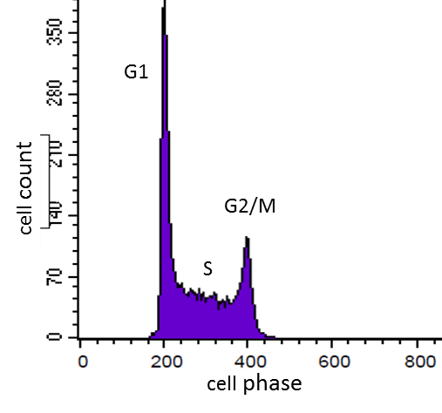

**Figure 5.2.** Example of a typical flow cytometry histogram profile for normal untreated cells, giving cell count (reflected by the intensity) vs. the amount of cellular DNA (reflected by the voltage). The majority of cells reside at G1 phase, reflected as a much higher peak; the G2/M peak reflects the smaller amount of time cells spend at mitosis (10%) and therefore a smaller proportion of cells; S phase spans a wider range of DNA/cell while the cells are actively synthesising a second set of chromosomes, and so appears as a broader, lower band [107].

It is important to note that flow cytometry records data from a fixed number of cells, or gated events, per sample and not from a fixed sample volume. Therefore flow cytometry gives the relative proportions of cells at each phase, and not the total cell count of a sample.

### *5.4.2. Flow cytometry analysis of cell cycle arrest*

Cell cycle arrest can arise for a number of reasons. In normal cells it usually reflects an error in the preceding phase, such as DNA mutations, and the cycle is paused either to correct the error or initiate apoptosis. Tumour cells have metabolic adaptions that enable them to evade these checkpoints, allowing mutated cells or cells equipped for invasion to proceed; however, these adaptions often involve differential expression of genes and proteins which can be targeted by drug treatments which won’t impact on normal cells [108]. Depending on the drug’s mechanism, this can trigger arrest at the G1 or G2 checkpoints, by targeting exposed DNA or anti-tumour and apoptotic proteins, or at the G2/M and mitotic checkpoints by disrupting formation of the mitotic spindle.

A change in cell cycle arrest, either as a result of tumour progression or a drug treatment, will cause a shift in the proportion of cells at one phase in favour of the other phases. Flow cytometry represent the different scenarios as follows:

1. When cell cycle arrest occurs solely at G1, it prevents cells progressing to S phase. Consequently, the number of cells at S phase decreases as those that progress to G2 are not replaced. The proportion of cells at G2 phase may also decreases as they are resupplied by a declining number from S phase. The resulting profile will display a very high peak at G1, a smaller peak at G2/M, and very low level at S phase. The hallmark of G1 arrest is this rapid reduction in S phase cells compared to a normal cell cycle profile.
2. When cell cycle arrest occurs at both G1 and G2/M checkpoints, cells no longer progress from G1 to S phase or from G2/M to G0/G1 phase. Consequently, there will be an accumulation of cells at both these checkpoints, with the peaks approaching equilibrium, and again a marked decrease at S phase as cells continue to proceed to G2 phase but are not replaced from G1.
3. When cell cycle arrest occurs solely at G2/M, cells no longer progress from G2/M to G0/G1; however they continue to progress from G1, *via* S phase, to G2 phase. This is reflected by an increase in the G2/M peak, a concurrent decease in the G1 peak, but little change in the level of S phase.

### *5.4.3. The effect of aneuploidy and hyperploidy in flow cytometry analysis*

In order to interpret flow cytometry results, certain effects need to be taken into account including the presence of doublets or aggregates which occur during the fixation process prior to staining. These produce false positives because a doublet at G0/G1 contains the same amount of DNA as a single cell at G2/M, therefore they falsely appear as dividing cells. In order to discriminate against doublets, flow cytometry allows gating to be applied so that doublets, which also have double the area of a single cell, can be excluded from analysis.

## 5.5. Flow cytometry: Project outline

For the purposes of this project, flow cytometry was employed to analyse the effect of different SCFA treatments on the cell cycle of HCT116 colon cancer cells in a time-dependant manner. This was achieved by treating cultured HCT116 cells at IC50 (G2/M) concentrations and harvesting the cells at set time points (3 h, 6 h, 12 h, 24 h). Untreated were also prepared as controls. Following harvesting, whole cells were stained with propidium idodide fluorochrome dye (PI) and then injected into a flow cytometer fluid system where they were individually passed through a laser within a very narrow stream. The fluorescent pulse from each cell (488 nm) was detected at both the forward and sideways directions allowing cell height, width and area (H, W, A) to be measured. Data were presented in the form of 2-dimensional dot plots and histograms, with accompanying quantification and statistics.

## 5.6. Flow cytometry: Experimental methods

*The basic principles of flow cytometry and its multiple applications have been extensively described by Shapiro* [109] *and in multiple guides and manuals* [110, 111].

The cells were prepared for flow cytometry as follows: HCT116 cells were cultured, treated with SCFAs at pre-established IC50 (G2/M) concentrations (butyrate, 4 mM; propionate, 11 mM; valerate, 9 mM) and harvested at 3 h, 6 h, 12 h and 24 h. Untreated cells were also harvested at these time points as controls. Whole cells were fixed in 70% ice-cold ethanol, added drop-wise and vortexed to prevent aggregation and cell clumping. RNAse was added to remove RNA which would also have been stained and therefore distorted the results. Cells were flash frozen and stored at -80°C until required. Prior to the flow cytometry experiment, the cells were brought up to 4°C on ice and permeablilised to allow fluorescent PI dye to pass though the plasma membrane and bind to the DNA. Stained cells were kept in the dark until they were injected into the flow cytometer.

Flow cytometry was carried out at The Medical School, The University of Sheffield, UK, using the fluorescent activated cell sorting (FACSCalibur) core facility service. The procedure was carried out following established guidelines. Light scattered from the cells in both the forward and sideways directions was detected and amplified by photomultipliers at the flourochrome excitation wavelength. PI dye fluoresces red at 488 nm. The voltage of a pulse is proportional to fluorescence from a cell, and therefore to the amount of DNA in each cell, so that a cell with double the DNA gives a pulse at double the voltage. The total number of pulses at each voltage reflects the number of cells containing the corresponding amount of DNA, i.e. the number of cells at that phase of the cell cycle. Forward scattered light (FSC) provided information on cell size; sideways scattered light (SSC) provided information on the volume, granularity and complexity of the cells [112]. Cell height, width and area (H, W, A) were measured at both FSC and SSC. The fluoroscans were analysed using CellQuest Pro software v.5.1 (BD Biosciences, US) and the data was plotted in the form of histograms and two-dimensional dot plots, with accompanying quantification and statistics. These were as follows: forward vs. sideways dot-plots (FSC-H vs. SSC-H) sub-divided cells into populations; forward area vs. forward width dot-plots (FL3-A vs. FL3-W) gave information on approximate cell size; histograms of total intensity (pulse counts, or total number of cells) vs. forward voltage (FL3-W), which was proportional to the amount of DNA in the cell, provided peaks which corresponded to the cell count at each phase of the cell cycle (subG1; G1; S; G2; >G2). The sub-population dot plot indicated the health of a sample, as dead cells group separately from healthy cells [110]. As shown in Figure 5.3, single cells formed a lower G0/G1 group and upper G2/M group; doublets and aggregates formed a group to the right of the G2/M group, having the same area but double the width; apoptotic cells appeared as a smear below and to the left of the G1 group; a continuum of diploid and hyperploid cells (those with an excess of chromosomes) extended above the G2/M group.

|  |  |
| --- | --- |
| a) | b) |
|  |  |

**Figure 5.3.** Representative flow cytometry dot plots: (a) sub-populations of cells. The red square highlights the single cell population of interest; (b) gating of single cells at G1, S, and G2 phases. This excluded aggregates, hyperploid and apoptotic cells [107].

Gating is a method by which the user can outline the populations of interest (Figure 5.3b). This ensures that apoptotic, hyperploid or aggregated cells are excluded from the analyses. In the case of an experiment studying hyperploidy, the gate would be extended to include those cells [113].

User defined parameters were set to optimise the analyses. These included setting the total (gated) cell count for each sample to give the optimal number of cells required for confidence and statistical analysis; setting the rate of injection to ensure the cells were sufficiently separated as they passed through the laser; the recording voltages were fine-tuned so that the G1 peak was observed at 200 V, the G2/M peak at 400 V and doublets at 800 V. These voltages are typical for a histogram of cells containing PI DNA-binding dye (fluorescent wavelength, 488 nm).

In addition to the histograms and dot plots, the analysis software returned tabular data and statistical analysis of the relative proportions of cells at each phase of the cell cycle (Table 5.1).

## 5.7. Flow cytometry: Results

### *5.7.1. Flow cytometry cell cycle spectra*

Flow cytometry population dot plots and cell cycle histograms were collected for HCT116 cells at each treatment condition at each time point (3 h, 6 h, 12 h, 24 h). Untreated HCT116 cells were used as controls. The data, with mean and SD values, from the three independent experiments, are given in Table 5.1. Figure 5.4 shows a representative dot plot and spectra histogram for HCT116 cells treated with valerate at IC50 (G2/M) concentration (9 mM) harvested at 24 h, compared to untreated cells,. These show the shift from cells at GI (typical profile for untreated cells) to G2/M following treatment.

|  |  |
| --- | --- |
| **untreated cells (at 24 h)** | **Valerate treated cells (9 mM at 24 h)** |
| a) | b) |
| c) | d) |

**Figure 5.4.** Flow cytometry experimental spectra: (a & c) untreated HCT116 cells; (b & d) valerate-treated cells (9 mM at 24 h). The top dot plots (a & b) show how the G1 and G2 cell populations are grouped and the extent of the gating. The lower histograms (c & d) show the fluorescence intensity (cell count) vs. pulse voltage (corresponding to DNA quantity), giving the number of cells at each phase of the cell cycle (subGI; G1; S; G2; >G2). There is a clear shift from G1 to G2/M phase following valerate treatment at 24 h. The bars (M1, M2, M3) correspond to the phases (G1, S, G2). These are set by the user to specify the extent of each peak for quantification and analysis of the cells at each phase.

The complete time-course series of histograms for all three SCFA treatments (butyrate, propionate and valerate) and untreated controls is shown in Figure 5.5. The heights of the peaks represent the relative proportion of cells at each phase of the cell cycle, providing a qualitative overview of the different treatments. Untreated cells show little change in profile with time, with the majority of cells in the G1 peak and a much smaller proportion undergoing mitosis in the G2/M peak. In contrast, the treated cells show a shift of cells accumulating at G2/M which increases with treatment time.

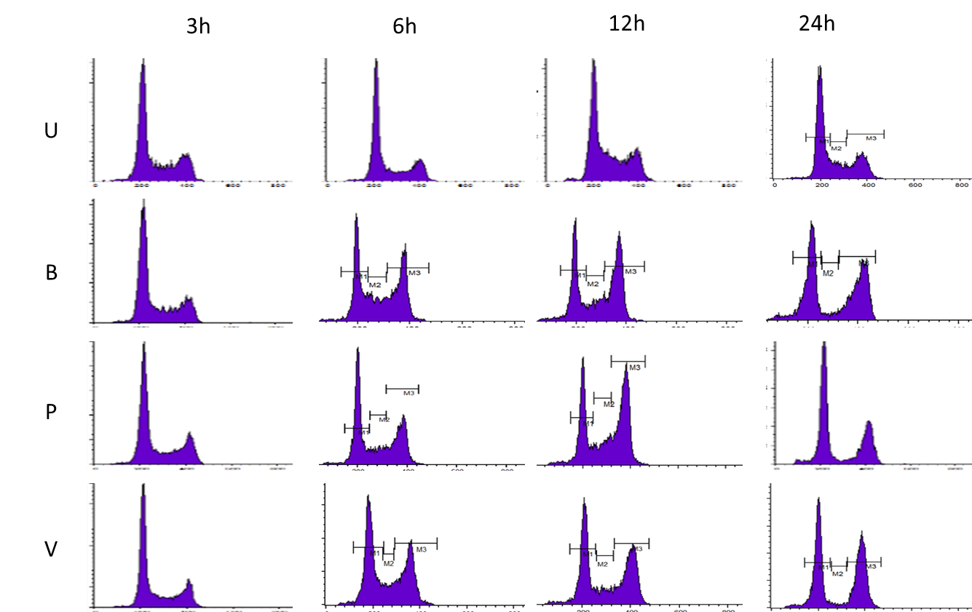

**Figure 5.5.** These flow cytometry histogram spectra show cell count vs. cell cycle phase for the time-course series of SCFA-treatment HCT116 cells. Whereas untreated cells show a typical normal cell cycle profile, with the majority of cells at G1, and little change over time, there is a clear shift in the proportion of treated cells from G1 to G2/M arrest. Based on the area under curve values (Table 5.1), the shift reaches a maximum at 12 h, where it remains constant for butyrate-treated cells, but shows a slight reversal back towards G1 following propionate and valerate treatments. This reversal is most noticeable with propionate.

### *5.7.2. Flow cytometry cell cycle data*

The flow cytometry data were quantified using CellQuest Pro v.5.1, which calculated the percentage of gated cells at each cell cycle phase (G1, S, G2, M) for each SCFA treatment (butyrate, propionate, valerate, and untreated) at 3 h, 6 h, 12 h and 24 h. The data were presented as means and SD. Three repeat experiments were performed allowing SEM values to be calculated (n = 3). These data are presented in Table 5.1. The histograms in Figure 5.6 give a quantitative representation of the spectra in Figure 5.5.

**Table 5.1.** Mean percentage of cells at each phase of the cell cycle (G1, S, G2) for each SCFA treatment, at the four time points (3 h, 6 h, 12 h, 24 h). The data represents the gated cells and was calculated from the area under curve in the spectra (Figure 5.5). Each result is the mean of three experiments. The SEM (n = 3) are given in the lower rows.

|  |  |  |  |  |  |  |  |  |  |  |  |  |
| --- | --- | --- | --- | --- | --- | --- | --- | --- | --- | --- | --- | --- |
| **%cells** | Untreated | | | Butyrate | | | Propionate | | | Valerate | | |
| Hrs. | G1 | S | G2 | G1 | S | G2 | G1 | S | G2 | G1 | S | G2 |
| 3 | 57.8% | 12.9% | 28.8% | 64.6% | 14.0% | 21.0% | 55.3% | 13.2% | 31.2% | 64.9% | 11.7% | 22.4% |
| 6 | 54.8% | 15.0% | 29.7% | 53.8% | 13.1% | 32.5% | 49.9% | 14.7% | 34.3% | 50.1% | 13.2% | 35.5% |
| 12 | 54.8% | 16.5% | 27.6% | 45.5% | 11.9% | 40.1% | 46.1% | 11.6% | 40.3% | 46.6% | 11.1% | 40.6% |
| 24 | 65.0% | 11.0% | 23.1% | 53.4% | 3.4% | 40.0% | 57.4% | 4.4% | 36.1% | 51.5% | 7.7% | 38.0% |
| **SEM** | Untreated | | | Butyrate | | | Propionate | | | Valerate | | |
| Hrs. | G1 | S | G2 | G1 | S | G2 | G1 | S | G2 | G1 | S | G2 |
| 3 | 3% | 1% | 4% |  |  |  | 5% | 0% | 5% |  |  |  |
| 6 | 5% | 2% | 4% | 8% | 3% | 5% | 7% | 2% | 5% | 6% | 3% | 5% |
| 12 | 1% | 3% | 2% | 7% | 3% | 4% | 9% | 2% | 7% | 7% | 3% | 4% |
| 24 | 3% | 2% | 1% | 4% | 0% | 5% | 3% | 1% | 2% | 5% | 5% | 5% |

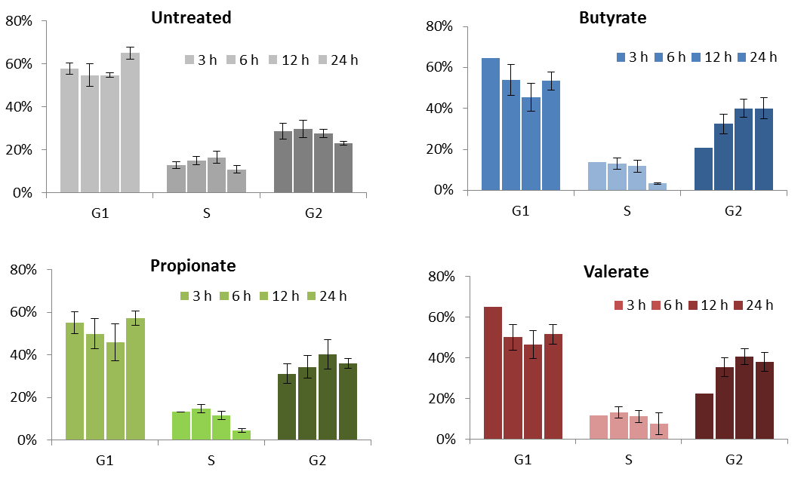

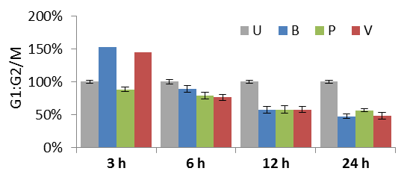

**Figure 5.6.** The histograms are a quantitative representation of the flow cytometry spectra in Figure 5.5 and the data in Table 5.1. These show the percentages of cells at each cell cycle phase with increasing treatment times (3 h, 6 h, 12 h, 24 h). Untreated (U) cells show little change in the distribution of cells; in contrast, the treated cells show an increasing proportion of cells accumulating at G2/M phase with time. This shift in G2/M accumulation reaches a maximum at 12 h, after which the level remains constant for butyrate (B) treated-cells but shows a marginal shift back to G1 with the propionate (P) and valerate (V) treated cells. [Data are the means of 3 independent repeats].

The histograms (Figure 5.6) show that the different SCFAs induced different trends in cell cycle arrest, suggesting different mechanisms. Untreated cells displayed a typical normal profile with little change over time, with G1 cells remaining at approximately 55%–65%, S phase cells at 10%–15% and G2/M cells at 25%–30%. However, there was an increase of cells accumulating at G1 phase at 24 h, with a 10% increase in cells at G1 and 5% decrease at S and G2 phase. This was characteristic of G1 arrest, as described in the introductory section. The cause is unknown.

In contrast, the SCFA treatments showed a marked increase in cells accumulating at G2/M phase, from 20%–30% at 3 h, to a peak of 40% at 12 h. This trend was similar with all SCFA treatments until 12 h. Between 12 h and 24 h, differences in behaviour between the SCFAs were observed in that propionate and valerate treated cells showed a marginal shift back to G1 arrest. However these differences were small, approximately 2%, and could not be considered conclusive. These observations are described in relation to the characteristic profiles discussed in the introductory section as follows:

**Butyrate:** The proportion of cells at G2/M remained approximately constant between 12 h and 24 h, however this was accompanied by an increase in cells at G1 with four-fold decrease in cells at S phase. This was characteristic of G1 arrest.

**Propionate:** Between 12 h and 24 h, there was a slight decrease in the proportion of cells at G2/M phase while the proportion at G1 increased. Furthermore, in common with butyrate, there was a marked decrease in cells at S phase. This was most characteristic of cell cycle arrest at both G1 and G2/M phase.

**Valerate:** In common with propionate, the proportion of cells at G2/M showed a slight decrease between 12 h and 24 h while the proportion at G1 increased (~10%). However, in contrast to propionate, there was little change in the proportion of cells at S phase, less than one-fold. This was most characteristic of cell cycle arrest at G2/M phase.

## 5.8. Flow cytometry: Discussion

The time-course flow cytometry results showed that SCFAs arrested HCT116 colon cancer cells at G2/M phase in a time-dependent manner. All the SCFAs, butyrate, propionate and valerate, displayed similar cell cycle profiles between 0 h and 12 h treatments; however, between 12 h and 24 h, the SCFAs displayed different behaviours. Both butyrate and propionate showed a four-fold decrease in the proportion of cells at S phase in favour of G1 accumulation, but whereas butyrate showed no corresponding change in the proportion of cells at G2/M phase, propionate showed a slight reversal in favour of G1 (~2%). In contrast, valerate showed little change in the proportion of cells at S phase but in common with propionate, valerate also showed a slight reversal in cells arrested at G2/M in favour of GI. This apparent reversal was only observed at the longer treatment times (12 h to 24 h). The effect is characteristic of a process termed mitotic slippage [102], whereby phenotypes with a greater capability of survival slip through G2/M but are subsequently arrested at G1. As treatment times increase, the surviving cells will include a larger proportion of the G2/M-evading phenotypes, thereby reducing the number arrested at G2/M and increasing those arrested at G1 phase.

In summary, these trends reflect the following distinct behaviours between the SCFAs: butyrate primarily induced G1 arrest, which is characteristic of its pro-apoptotic functions [100]; valerate primarily induced G2/M arrest, characteristic of anti-mitotic actions; and propionate displayed actions in common with both butyrate and valerate.

These distinct behaviours between the odd-chain and even SCFAs reinforced the observations of the multi-plex iTRAQ proteomic and HCA cellomic experiments. Although the results were not significantly conclusive, the time-dependant reversal from G2/M arrest to G1 arrest observed with propionate and valerate was in accord with the biphasic response observed by HCA. HCA had indicated that the effect was a constant phenomenon and not dose dependant. This suggested the effect may be a mechanism termed mitotic slippage, which favours specific phenotypes.

## 5.9. Flow cytometry: Key Conclusions

* Flow cytometry added evidence to the hypothesis that odd and even-chain SCFAs induce unique and distinct effects in HCT116 colon cancer cells.
* The results demonstrated a time-dependant a trend in the proportion of cells arrested at G2/M phase following SCFA treatments.
* Treatment with the different SCFAs induced different responses. Whereas the effect with butyrate was characteristic of G1 arrest, propionate showed characteristics of both G1 and G2/M arrest, and valerate was characteristic of G2/M arrest.
* The flow cytometry results were in accord with the biphasic response observed by HCA with the odd-chain SCFAs, which could be explained by a phenomenon termed mitotic slippage.
* In agreement with the multi-plex iTRAQ results, valerate treatment induced the greatest changes in cell cycle response in HCT116 colon cancer cells.

# 6. Western blot analysis provided orthogonal validation of the multi-plex iTRAQ results in respect of β-tubulin isotype expression in HCT116 cells treated with SCFAs

## 6.1. Contribution of Western blotting to the overall project:

* Western blotting provided orthogonal validation of the multi-plex iTRAQ results in respect of differential expression of β-tubulin isotypes in HCT116 cells following SCFA treatments.
* Western blotting was able to confirm whether the distinct effects between odd and even-chain SCFAs were time-dependant as indicated by flow cytometry

## 6.2. Introduction to Western blotting

### *6.2.1. Western blotting background*

Western blotting is a reliable method for validating results from other experimental techniques, particularly where protein identification and differential quantification is based on statistical algorithms, such as multi-plex iTRAQ mass spectrometry.

Western blotting enables proteins to be relatively quantified between different cell samples by targeting them with antibodies. The amount of antibody taken up by a cell is directly proportional to the concentration of its respective protein expressed within that cell. The technique involves two-dimensional electrophoresis. The first dimension separates proteins according to their molecular weight by SDS-PAGE; the second ‘sideways’ dimension involves transferring the proteins to a membrane platform with a high capacity for protein binding. The bound proteins are subsequently targeted by antibodies before being visualised by immunofluorescence and quantified by densitometry analysis. The blot is the membrane.

## 6.3. Western blotting: Experimental methods

### *6.3.1. Western blotting and densitometry protocols*

1. The first dimension was carried out by loading whole cell lysates from SCFA-treated HCT116 cells onto a 10% SDS-PAGE gel. Each sample contained 10 μg total protein, as measured by protein assay. Both these techniques are described in detail in the cell culture chapter. During this stage, the proteins were unfolded by the SDS buffer, opening them up to antibody binding.
2. Following SDS-PAGE, the gel was mounted adjacent to a polyvinylidene difluoride (PVDF) membrane (Immobilon, Millipore) and the protein was transferred from the gel to the membrane *via* a second ‘sideways’ dimension of electrophoresis.
3. The membranes were then blocked to prevent non-specific background binding of the antibodies to the membrane. This was achieved by immersing the membranes in Tris-buffered saline containing 0.1% Tween20 (TBST) with 5% non-fat milk for 1 h at 4°C while gently shaking on a rocking bed.
4. The membranes were probed with the primary antibodies in 0.05% TBST by incubation overnight at 4°C, again under agitation on a mechanical rocker. The antibody dilution factors were specific to each antibody, as recommended by the supplier, and are typically in the range of 1:500 to 1:2000 in TBST buffer.
5. Followed incubation with primary antibodies, the membranes were incubated with goat anti-rabbit or anti-mouse conjugated to horseradish peroxidase (HRP) secondary antibodies (Dako, Cambridge, UK) in 5% non-fat milk/0.05% TBST (1:1000) for 1 h at 4°C.
6. The fluorescence intensities of the bound primary antibodies were visualised by enhanced chemiluminescence (ECL). The images were recorded using GeneSnap software (Syngene).
7. Quantification of the relative fluorescent intensities of the antibodies, and thereby the relative concentrations of their respective proteins, was determined by densitometry using GeneTools software (Syngene).
8. It was necessary to use a loading control for normalisation. For this study, either actin or α-tubulin was selected, as these are thought to be unaltered between the different SCFA treatments.

### *6.3.2. Statistical analysis*

Where possible, Western blot analysis was repeated up to four times for each protein in order to validate the proteomic or flow cytometry experiments. Statistical analyses were performed using Microsoft Excel to give means and SEMs.

## 6.4. Western blotting: Results

### *6.4.1. Overview of the Western blotting results*

The selected proteins were β-tubulin, β3-tubulin and β2c-tubulin, with actin or α-tubulin used as loading controls. The Western blot images are shown in Figure 6.1. Relative quantification data are given in Table 6.1. These were determined by densitometry measurement of the fluorescent intensities of bound antibodies, normalised to actin or α-tubulin loading controls. The accompanying histograms are shown in Figure 6.2. The results indicated which β-tubulin isotypes were up or downregulated relative to untreated samples, thereby validating the multi-plex iTRAQ proteomic data for differentially regulated β-tubulin isotypes, and the time-course trends observed by flow cytometry cell cycle analysis. The densitometry data are given as means and SEM from two to four independent gels. The histogram error bars give the SEMs. SEM<10% was considered significant; SEM<5% was taken to be highly significant (* and **, respectively). The highest confidence results were achieved with the valerate-treated samples.

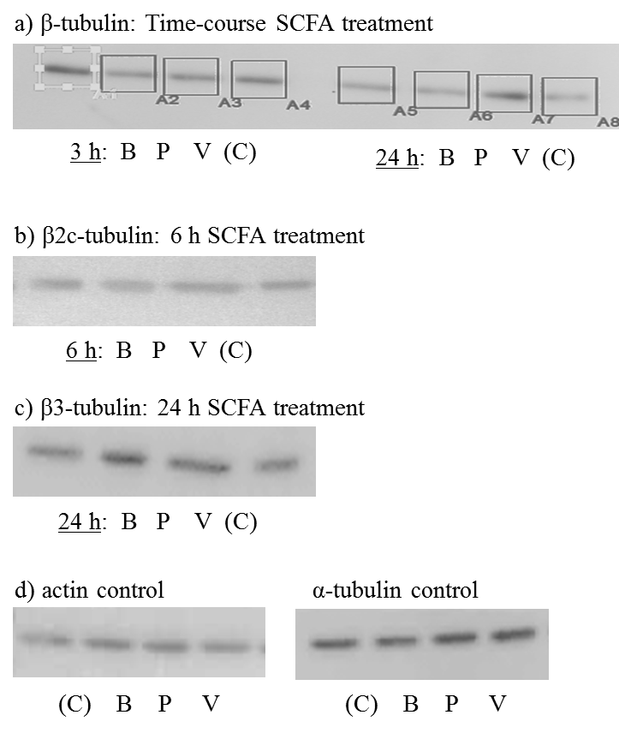

**Figure 6.1.** Representative Western blot immunofluorescent images of antibodies bound to β-tubulin isotypes in HCT116 colon cancer cells after SCFA treatments at IC50 (G2/M) concentrations: (a) β-tubulin from time-course treatments at 3 h and 24 h; (b) β2c-tubulin from time-course treatments at 6 h; (c) β3-tubulin from the iTRAQ experiment at 24 h treatment; (d) actin and α-tubulin loading controls.

### *6.4.2. Expression levels of β-tubulin isotypes following 24 h SCFA treatments*

The histogram in Figure 6.2a shows the fold changes of β2c-tubulin, β3-tubulin and β-tubulin relative to untreated samples after treatment with SCFAs (butyrate, propionate, valerate) for 24 h at IC50 (G2/M) concentrations (Table 6.1a). The results confirmed that upregulation of these β-tubulin isotypes was greatest with propionate and valerate compared to butyrate. Valerate showed the greatest effect with the highest confidence (SEM<10% and SEM<5%, for β2c-tubulin and βc-tubulin, respectively).

### *6.4.3. Expression levels of β-tubulin isotypes following time-course SCFA treatments*

The histogram in Figure 6.2b shows the fold changes of β-tubulin and β2c-tubulin relative to untreated samples for the time-course flow cytometry experiment. The HCT116 cells had been treated with SCFAs (butyrate, propionate and valerate) at IC50 (G2/M) treatment concentrations for at 3 h, 6 h, 12 h and 24 h. The results showed that at 3 h there is little change in the regulation of these two β-tubulin isotypes. At longer treatment times, 6 h and 24 h, valerate again showed the greatest effect on β-tubulin and β2c-tubulin expression (Table 6.1b). However Western blotting of the flow cytometry time course samples indicated increased upregulation of β-tubulin by butyrate following 24 h treatment. This did not reflect the multi-plex iTRAQ results. The discrepancy may be a consequence of a loading error. Additional checks were not possible due to the limitation of available samples.

### *6.4.4. Western blot analysis of loading controls*

The histogram and densitometry data (Figure 6.2c; Table 6.1c) for the loading controls (α-tubulin and actin) show there was little change in regulation between the different SCFA treatments. These results had high confidence (SEM<10% and SEM<5%, respectively), confirming that these were suitable controls for quantification of the Western blot analyses.

|  |  |  |
| --- | --- | --- |
| a) | b) | c) |
|  |  |  |

**Figure 6.2.** Western blot densitometry results for β2c-tubulin, β3-tubulin and β-tubulin in HCT116 colon cancer cells following SCFA treatments at IC50 (G2/M) concentrations. The histograms show the fold-change data for these β-tubulin isotypes relative to untreated samples. The data are normalised to α-tubulin or actin controls. (a) samples from the iTRAQ proteomic experiment at 24 h (b) samples from the flow cytometry time-course treatments at 3 h, 6 h and 24 h; (c) actin and α-tubulin controls.

### *6.4.5. Western blot densitometry data*

Tables 6.1 a–c give the densitometry quantification results for the β-tubulin isotypes (β-tubulin; β3-tubulin; β2c-tubulin) in HCT116 colon cancer cells after SCFA treatments. The results are the mean fluorescent intensity after background correction normalised to actin or α-tubulin loading controls. The percentages indicate which whether the isotypes were up or downregulated relative to untreated samples. These observations were used for validation of multi-plex iTRAQ proteomic results and flow cytometry time-course progression

**Table 6.1a.** 24 h SCFA treatment s at IC50 (G2/M) concentrations: β2c-tubulin; β3-tubulin; β-tubulin, normalised to controls, relative to untreated samples. [** SEM<5%; * SEM<10%].

|  |  |  |  |  |  |
| --- | --- | --- | --- | --- | --- |
| tubulin isotype | SCFA | % change | SEM | n |  |
|  |  |  |  |  |  |
| β2c-tubulin | B | 71% | 15% | 3 |  |
|  | P | 91% | 18% | 3 |  |
|  | V | 128% | 3% | 3 | **\*\*** |
|  |  |  |  |  |  |
| β3-tubulin | B | 95% | 11% | 4 |  |
|  | P | 130% | 23% | 4 |  |
|  | V | 148% | 24% | 4 |  |
|  |  |  |  |  |  |
| β-tubulin | B | 60% | 27% | 4 |  |
|  | P | 101% | 20% | 4 |  |
|  | V | 118% | 9% | 4 | **\*** |

B, butyrate; P, propionate; V, valerate

**Table 6.1b**. Time-course SCFA treatments at IC50 (G2/M) concentrations: β-tubulin; β2c-tubulin, normalised to controls, relative to untreated samples.

|  |  |  |
| --- | --- | --- |
| β-tubulin isotype [treatment time] | SCFA | % change |
| β [3h] | B | 120% |
|  | P | 73% |
|  | V | 99% |
| β2c [6h] | B | 86% |
|  | P | 98% |
|  | V | 128% |
| β [24h] | B | 260% |
|  | P | 205% |
|  | V | 324% |

B, butyrate; P, propionate; V, valerate

**Table 6.1c**. 24 h SCFA treatment at IC50 (G2/M) concentrations: α-tubulin and actin controls [** SEM<5%; * SEM<10%].

|  |  |  |  |  |  |
| --- | --- | --- | --- | --- | --- |
| control | SCFA | % change | SEM | n |  |
| α-tubulin | B | 79% | 8% | 2 | **\*** |
|  | P | 95% | 1% | 2 | **\*\*** |
|  | V | 104% | 1% | 2 | **\*\*** |
|  |  |  |  |  |  |
| actin | B | 94% | 2% | 2 | **\*\*** |
|  | P | 98% | 16% | 2 |  |
|  | V | 89% | 10% | 2 | **\*** |

B, butyrate; P, propionate; V, valerate

## 6.5. Western blotting: Discussion

The Western blot analyses results supported previous observations that valerate was the most potent of the SCFAs in upregulating β-tubulin, β3-tubulin and β2c-tubulin at IC50 (G2/M) treatment concentrations. At 24 h, both propionate and valerate showed greater fold-changes than butyrate in upregulating these β-tubulin isotypes relative to untreated samples. This confirmed the multi-plex iTRAQ proteomic data. Comparisons with the flow cytometry time-course results were less clear; however they did confirm that there was little change in the upregulation of β-tubulin isotypes at 3 h and reflected the trend for increased upregulation at longer treatment times. The Western blot results with the highest confidence were those for valerate treatments. In summary, Western blot analysis validated the multi-plex iTRAQ and flow cytometry results, supporting the hypothesis that odd-chain SCFAs distinctly target β-tubulin isotypes.

## 6.6. Key Conclusions: Western blotting

* Western blotting provided orthogonal validation of the multi-plex iTRAQ results by showing similar patterns of β-tubulin isotype expression following SCFA treatments.
* Although less conclusive, Western blotting also supported the flow cytometry results by indicating that differential regulation of the β-tubulin isotypes by SCFA treatments was a time-response effect.
* In agreement with the iTRAQ proteomic, HCA cellomic and flow cytometry observations, Western blotting showed that valerate was the most potent effector of differential regulation of the β-tubulin isotypes associated with MT integrity and function in HCT116 colon cancer cells.

# 7. Bioinformatics and pathway analysis confirmed that odd-chain SCFAs, propionate and valerate, uniquely target mitotic events in HCT116 colon cancer cells, distinctly from butyrate.

## 7.1. Contribution of bioinformatics to the overall project

* The open-access genomic and proteomic knowledgebases verified the hypothesis by providing details on post-translational acetylation of the transcriptional regulators targeted by SCFA treatments in HCT116 cells. This facilitated design of the computational models.
* Pathway expression analysis identified the pathways and events associated with the proteins differentially regulated by SCFA treatments in HCT116 cells, based on the multi-plex iTRAQ data.
* In combination, bioinformatics could support the interpretations of the experimental results and provide valuable insights into the underlying mechanisms.

## 7.2. Bioinformatics: Project outline

Advances in bioinformatic applications, along with the rapidly expanding proteomic and genomic databases since completion of the genome project, are proving invaluable in forwarding understanding of biological processes.

In order to explore the distinct and unique actions of SCFAs in HCT116 colon cancer cells, a considerable amount of data had been generated by high-throughput, quantitative proteomic and cellomic experimentation, including multi-plex iTRAQ mass spectrometry, HCA microscopy and time-response flow cytometry cell cycle analysis. These had indicated that propionate and valerate, the odd-chain SCFAs, uniquely followed anti-mitotic pathways by differentially regulating β-tubulin isotypes. In contrast, butyrate, the even-chain SCFA, was associated with pro- and anti-apoptotic proteins and pathways.

The various bioinformatic tools and resources employed by this project, and their contributions to the overall findings, are summarised as follows.

* Phenyx analysis matched the peptide data from multi-plex iTRAQ against UniProt and NCBI protein databases to return a list of proteins differentially expressed in HCT116 cells by each of the SCFA treatments relative to untreated cells.
* BLAST protein matches confirmed the Phenyx identifications and provided additional information on proteins with shared sequence coverage, in particular between the β-tubulin isotypes.
* The SAB text mining application predicted the most likely transcriptional binding sites at these β-tubulin genes, and offered links to the literature so that the consequences of acetylation at these transcriptional binding sites could be determined.
* The Gene Atlas [52] provided data on the expression profile of β-tubulin isotypes in untreated HCT116 colon cancer cells relative to normal colonocytes. This gave a baseline for comparing the experimental observations from SCFA treated HCT116 cells.
* STRING [114] produced web-network diagrams of protein-protein interactions between functional partners and shared metabolic pathways of the β-tubulin isotypes, providing additional information on the mechanisms involved.
* Reactome’s [99] Pathway Analysis tools delivered detailed information on the mitotic pathways most affected by differential regulation of β2c-tubulin, β3-tubulin and β1-tubulin isotypes for each SCFA treatment.

Bioinformatics provided evidence to support the formulation of the hypothesis and contributed to the experimental interpretations. Furthermore, bioinformatics offered valuable insights into the underlying mechanisms.

## 7.3. Bioinformatic tools and resources

### *7.3.1. Phenyx*

Phenyx [115] is a software platform for identifying and characterising peptides and proteins from mass spectrometry experiments. Phenyx matches peptide reporter ion intensities against protein databases to predict the statistically most likely proteins from a peptide sequence. Isobaric tagging of the samples enables relative quantification of the protein results to be performed by in-house software tools. Confidence values are established by applying strict user-defined acceptance levels. Details of the methods and algorithms are given in the proteomics methods chapter.

### *7.3.2. UniProt and NCBInr*

UniProt and NCBI the protein databases [91, 92] were selected for Phenyx analyses. UniProt combines the SwissProt and TrEMBL protein databases. Whereas SwissProt is manually annotated and reviewed, TrEMBL is automatically annotated but not reviewed. NCBI accesses annotated sequence data from multiple sources including GenBank, RefSeq and TPA plus records from SwissProt, PIR, PRF, and PDB.

### *7.3.3. BLAST*

BLAST [116], Basic Local Alignment Search Tool, uses sequence-similarity searching to identify proteins by aligning a submitted peptide sequence to similar nucleotide sequences within a gene and calculating the statistical significance of a match [116]. Confidence is increased when several peptide sequences from a single protein can be aligned to a single gene; confidence is decreased if alignments occur over multiple genes. Similarities between identified proteins are calculated by the percentage of shared coverage; for example, highly conserved isotypes which have little variability in sequences show high percentages of coverage. BLAST also identifies binding sites for specific molecules on a gene including transcription factors (TF) and drugs, such as GTP or paclitaxels. BLAST enabled protein identifications to be made where Phenyx gave ambiguous or unknown matches

### *7.3.4. SABioscience*

The SABioscience [117] platform predicts the most relevant transcriptional binding sites associated with a named gene by searching for ChiP qPCR primers for the TF. The search portal is based on a proprietary DECODE (DECiphermentOfDNAElements) database combined with the UCSC Genome Browser and a text mining tool. These enable SAB to compile a list of predicted binding sites for known genes from the human genome. The UCSC Genome Browser is a bioinformatics pool of genome reference sequences compiled from annotated chromosomes; the text mining application recognises and extracts relationships between biological compounds from published reports and knowledgebases and uses internal recognition systems to identify the genes that are regulated by specific TFs. At the time of access (July 2012) the DECODE database contained of over 200 human TFs.

### *7.3.5. Gene Expression Atlas, GXA*

The Gene Expression Atlas, GXA [52], is an EMBL-EBI project [118] that incorporates a database of expression levels for each known gene in a cell type; tissue type; species; or disease condition. GXA identifies differential expression patterns by re-analysing publically available gene expression data against normalised expression data based on microarray analysis. This allows it to determine whether they are significantly different from the mean expression for all conditions. Eligible contributory experiments are curated before inclusion in the database.

### *7.3.6. Reactome’s Pathway Expression and ID mapping tools*

Reactome’s Pathway Expression [99] analysis tool contains the total number of genes and details of each known reaction event, and is built on a database of curated, peer-reviewed human pathway data, cross-referenced to multiple bioinformatics databases. Reaction events are grouped into pathways that are displayed as a network map of biological interactions. By taking protein identifiers from a submitted list, such as relative fold-changes or treatment times, and assigning them to each known event within the database, it calculates the total number of submitted genes that participate in that event and the probability of observing at least that number by chance (using a one-tailed Fishers exact test). It then determines which pathways are statistically overrepresented in the submitted proteins.

The Pathway Expression analysis tool returns the over-represented pathways as a percentage score of submitted proteins associated with that pathway relative to the total number of proteins belonging to that pathway. Links to a cellular network map allow each event or pathway of interest to be further mined to reveal a grid of participatory proteins with the levels of enrichment colour-coded according to a hierarchy spectrum.

The corresponding ID mapping tool displays the results as a colour-coded hierarchical tree giving a visual representation of the overrepresented pathways. Although all pathways in the tree are strongly enriched in submitted protein identifiers, some are more enriched than others. The colour of each pathway within the tree reflects the number of participating protein identifiers, ranging from red, or “hot”, for those with the most participants, fading down through a colour spectrum to blue, or “cool”, for those with the least. Those highest in the tree have the lowest p-values; however, the two measurements provide different information and do not necessarily correspond. Each parent pathway in the tree is expandable to reveal a list of child pathways and participating protein identifiers, with interactive links to provide additional information about each event or pathway. As well as the hierarchical tree, the results can be displayed as a colour-coded ‘starry-sky’ map and in tabular format.

### *7.3.7. STRING*

STRING [114], Search Tool for the Retrieval of Interacting Genes/Proteins*,* mines databases and the literature by performing genomic context analyses to find information on known and predicted protein-protein interactions. Results are displayed as web-network diagrams, centred on the protein of interest, with links to their closest functional partners, either directly through physical binding or indirectly through shared metabolic pathways, based on mutual actions, evidence or confidence.

## 7.4. Bioinformatics Results

### *7.4.1. Phenyx*

The protein lists returned by Phenyx [115] analyses from the two multi-plex iTRAQ experiments of SCFA-treated HCT116 colon cancer cells had included β2c-tubulin, β3-tubulin and β1-tubulin. The protein identifications were sourced from both the UniProt and NCBI databases. Subsequent quantification showed that β2c-tubulin and β3-tubulin were upregulated by valerate and propionate and β1-tubulin was downregulated by propionate. The results are discussed in detail in the multi-plex iTRAQ chapter.

### *7.4.2. BLAST*

BLAST [116] queries showed there were no unrelated protein matches to β2c-tubulin, β3-tubulin or β1-tubulin, adding confidence to the multi-plex iTRAQ results. However the results did show shared coverage between generic β-tubulin isoforms. This is expected as tubulin isoforms are highly conserved with most variations only occurring in the last 15 sequences of their c-termini tails (CTT) [48]. Percentage shared-coverage between β2c-tubulin, β3-tubulin and β1-tubulin were between 94% and 96%.

### *7.4.3. SABioscience*

The SABioscience [117] search portal predicted the most relevant transcriptional binding sites at β2c-tubulin, β3-tubulin and β1-tubulin genes. Cross-referencing to linked reports and extensive literature searches provided the necessary information to determine how these transcriptional regulators would respond to SCFA-induced acetylation. Most were enhanced or switched to transcriptional activators and all were found to be present in colonocytes. These transcriptional regulators promoted histone acetylation at these β-tubulin isotype genes by acting as histone deacetylases (HDACi) or histone acetyl transferases (HAT) to open up the DNA to TFs.

The acetylation mechanisms for each of these transcriptional regulators are summarised as follows: acetylation of RFX and PPAR-gamma-1 & 2 enhances transcription at the β2c-tubulin gene [119-123]; acetylation inhibits NSFR silencing activity thereby enhancing transcription at the β3-tubulin gene [124, 125]; acetylated NF-kappaB downregulates β1-tubulin expression by modulating transcriptional activity. However acetylation at this gene both raises and inhibits oncogenic activity by enhancing transcriptional activity of the p53 tumour suppressor but also enhancing AP-1 and c-jun activity [126, 127], which are both members of oncogene families. In addition, NF-kappaB has been linked to increased cancer risk in patients with IBD [128].

### *7.4.4. The Gene Expression Atlas (GXA)*

GXA indicated that β2c-tubulin (TUBB2C) and β3-tubulin (TUBB3) were downregulated and β1-tubulin (TUBB) was upregulated in untreated HCT116 cells relative to non-tumour cells (Figure 7.1a). This is believed to be a metabolic adaption by the cancer cells to promote proliferation, invasion and to evade cell cycle checkpoints, as discussed in the flow cytometry chapter. Similar findings were reported based on mRNA expression analysis from a study on the abundance of β-tubulin isoforms in human tumoural and non-tumoural colonocytes [51]. The multi-plex iTRAQ proteomic data had shown that treatment of HCT116 cancer cells with propionate and valerate, the odd-chain SCFAs, produced the opposite expression pattern. This suggested that odd-chain SCFAs are able to counter the metabolic adaptions in HCT116 colon cancer cells (Figure 7.1b).

|  |  |
| --- | --- |
| a)      b) | **Figure 7.1.** Histograms of (a) Gene Expression Atlas (GXA) predictions compared to (b) multi-plex iTRAQ data for β-tubulin isotype expression in HCT116 colon cancer cells. a) GXA expression data shows that β2c-tubulin and β3-tubulin are downregulated and β1-tubulin is upregulated in untreated HCT116 cells relative to non-tumoural cells (Affymetrix GeneChip array design); b) In contrast, multi-plex iTRAQ data shows that treatment with propionate and valerate counters this aberrant β-tubulin isotype expression pattern. |

### *7.4.5. Pathway mapping and expression analysis*

Accession numbers (AC), identified by the duplicate SCFA (butyrate, propionate, valerate) and the quadruplet propionate multi-plex iTRAQ experiments for SCFA-treated HCT116 colon cancer cells, were submitted for pathway ID mapping and expression analysis [99]. The hierarchy tree of overrepresented pathways was expanded to reveal the biological pathways in which β-tubulin isotypes participated (Figure 7.3). The most enriched pathways were metabolism-of-proteins (yellow; β2c- & β3-tubulin); membrane-trafficking (turquoise; β3- & β2c-tubulin); haemostasis (turquoise; β2c- & β3-tubulin). The “cooler” pathways, though still enriched, were developmental-biology (blue; β3- & β2c-tubulin); cell cycle (blue; β3-, β2c-, β1-, β-tubulin); DNA-replication (blue; β3- & β2c-tubulin); mitotic M-M/G1 phases (blue; β3- & β2c-tubulin). The p-values ranged from 1.1x10-6 for metabolism-of-proteins, with 14 participatory proteins out of a total of 461, to mitotic M-M/G1 phases, 2.9x10-2 with 4 out of 199 participatory proteins. The ‘starry sky’ network map, colour coded for the pathways involved, is shown in Figure 7.2.

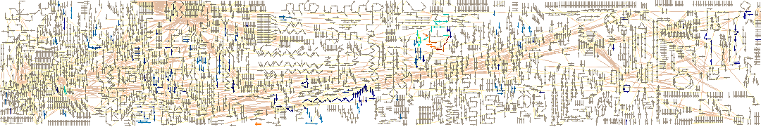

**Figure 7.2.** The interactive ‘starry-sky’ map in which participatory biological pathways highlighted and colour-coded according to an enrichment hierarchy spectrum.

|  |  |
| --- | --- |
|  | **Figure 7.3.** Reactome ID mapping [99] takes proteomic data from multi-plex iTRAQ and returns a colour-coded hierarchy tree. Each biological pathway in the tree is enriched in the submitted proteins. The tree is ordered by the most significant p-values and each pathway is coloured according to the number of participating protein identifiers based on the colour spectrum (above), where red are the most over-represented and blue the least. Each pathway can be expanded to reveal sub-pathways and the identifiers of participating proteins. [Total number of events accessed: 6874; No. of matching events: 189; No. of genes matching submitted identifiers: 38]. |

The Pathway Expression analyses provided more informative results by including fold-change data from the multi-plex iTRAQ experiments for each of the different SCFA treatments. Reactome has 273 available pathways, of these butyrate participated in 82; propionate participated in 96, and valerate participated in 34. The pathway expression results gave the number and percentage of these differentially regulated proteins that were overexpressed in each pathway.

By mining the network map, sub-pathways, reaction events and participatory proteins for each of the mitotic pathways (mitotic G1-G1/S; M-M/G1; and G2-G2/S phases) were revealed, along with the enrichment level and “colour” for each SCFA according to the hierarchy spectrum. The results are presented in Figures 7.5 a–c with examples of the network mining for each of the mitotic pathways. The following differences were found between the three SCFAs, butyrate, propionate and valerate: Butyrate was solely represented in the three G1-related mitotic pathways through non-tubulin proteins. Valerate was solely represented in the G2-related events through β2c-tubulin and β-tubulin isotypes. Propionate was represented in all five mitotic pathways but at lower levels of enrichment, which included both G1 and G2-related events and both β-tubulin and non-tubulin proteins.

The relative contribution of each in these mitotic events is graphically displayed in pie charts (Figure 7.4). The full tabular list of all statistically over-represented pathways and events for is given in Appendix II.

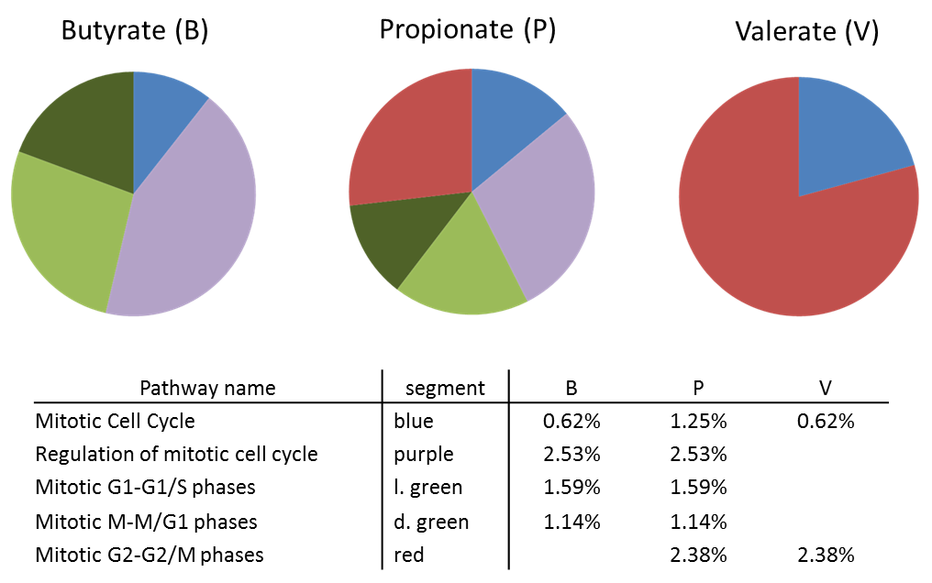

**Figure 7.4.** Reactome expression analysis [99] of mitotic pathways enriched in β-tubulin isotypes differentially expressed in HCT116 cells by SCFA treatments. The mitotic cell cycle is the parent pathway, the sub-pathways are those listed in the table, along with the colour of the corresponding segment and level of enrichment. Only butyrate and propionate contribute to regulation of the cell cycle; butyrate is only involved in G1 pathways; valerate is only involved in G2 pathways; propionate contributes to both G1 and G2 events but to a lower level of enrichment. The table below the pie charts gives the percentage contribution of each SCFA to the total number of proteins in each pathway. [B, butyrate; P, propionate; V, valerate].

The following tables and figures (7.5 a–c) show the pathway-mining results of sub-mitotic pathways within the full known metabolic pathway map (‘Starry sky’; Figure 7.2). By submitting the differential protein expression levels induced by each SCFA treatment (butyrate, propionate, valerate) from the multi-plex iTRAQ data, it was possible to determine which events each individual SCFA enriched. Each of the enriched pathways (black-box) could be further interrogated for the level of enrichment by each SCFA-treatment. These are shown in grids with the level of enrichment given both quantitatively and colour coded according to the hierarchy spectrum.

The following representative pathways were selected. These are circled in red and expanded in the figure insets:

(a) Mitotic G1-G1/S [G1/S Transition and G1 phase]

(b) Mitotic M-M/G1 [M/G1 Transition (DNA replication)]

(c) Mitotic G2-G2/M [G2/M Transition].

Mitotic G1-G1/S phases. Protein: ‘Ubiquitin-60S ribosomal protein L40 (CEP52)’; AC: P62988.

|  |  |  |  |  |
| --- | --- | --- | --- | --- |
| Sub-Pathway | Pathway event | Level and enrichment colour | | |
|  |  | B | P | V |
| G1/S Transition | Ubiquitin | 1.39  (red) | 1.27  (blue) | null  (blue) |
| G1/S Transition | Cyclin E/A:Cdk2: multi-ubiquitinated phospho-p27/p21:SCF (Skp2): Cks1 complex | 1.39  (red) | 1.27  (blue) | null  (blue) |
| G1 phase | Ubiquitin | 1.39  (red) | 1.27  (blue) | null  (blue) |
| G1 phase | Ub-p-T401,S672,1035-RBL2 | 1.39  (red) | 1.27  (blue) | null  (blue) |

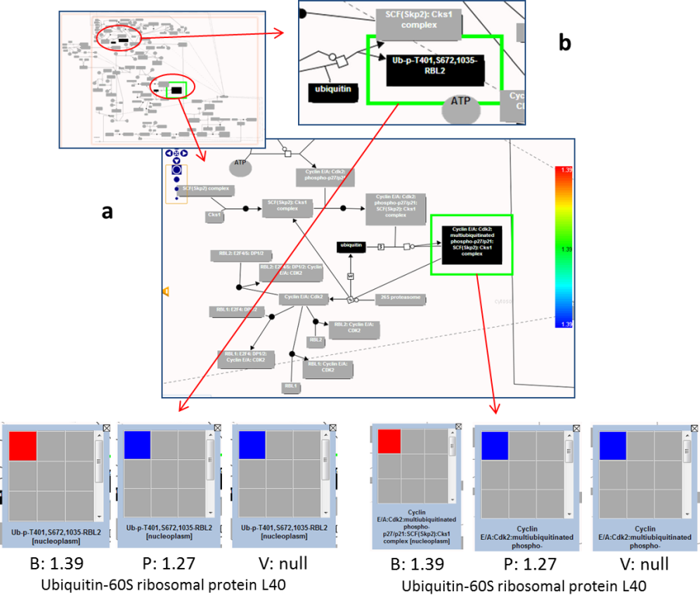

**Figure 7.5a.** Mitotic G1-G1/S *[G1/S Transition and G1 phase]:* SCFA enrichment levels for two representative G1/S pathway maps focusing on events in ‘G1/S transition’ and ‘G1 phase’: (a) ‘*cyclin E/A:Cdk2:multiubiquitinated phospho-p27/p21:SCF(Skp2):Cks1 complex’*; (b) ‘*Ub-p-T401,S672,1035-RBL2*’. Only butyrate and propionate contribute to these G1/S events with enrichment levels: B = 1.39 (red); P = 1.27 (blue); V = null (blue). Red (butyrate) indicates the highest levels of enrichment; in contrast, valerate did not contribute to these G1 events. [B, butyrate; P, propionate; V, valerate; hierarchy spectrum is shown on the right].

Mitotic M-M/G1 phases. Protein: ‘Ubiquitin-60S ribosomal protein L40 (CEP52)’; AC: P62988.

|  |  |  |  |  |
| --- | --- | --- | --- | --- |
| Sub-Pathway | Pathway event | Level and enrichment colour | | |
|  |  | B | P | V |
| M/G1 Transition  (DNA replication) | ubiquitin | 1.39  (red) | 1.27  (blue) | null  (blue) |
| M/G1 Transition  (DNA replication) | geminin: ubiquitin complex | 1.39  (red) | 1.27  (blue) | null  (blue) |

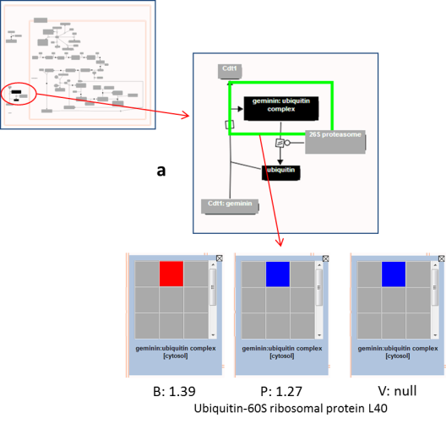

**Figure 7.5b.** Mitotic M-M/G1 *[M/G1 Transition (DNA replication)]:* SCFA enrichment levels for a representative M/G1 pathway map focusing on events in ‘M/G1 Transition (DNA replication)’: (a) ‘*geminin: ubiquitin complex*’. Again, only butyrate and propionate contribute to this M/G1 event with enrichment levels: B = 1.39 (red); P = 1.27 (blue); V = null (blue). Red (butyrate) indicates the highest levels of enrichment; in contrast, valerate did not contribute to this G1 events. [B, butyrate; P, propionate; V, valerate].

Mitotic G2-G2/M phases and Mitotic G2-G2/M phases. Proteins: ‘β2c-tubulin’; AC: Q8N6N5 and ‘β-tubulin’; AC: Q5JP53.

i) Mitotic G2-G2/M phases. Protein: ‘β2c-tubulin’; AC: Q8N6N5

|  |  |  |  |  |
| --- | --- | --- | --- | --- |
| Sub-Pathway | Pathway event | Level and enrichment colour | | |
|  |  | B | P | V |
| G2/M Transition | Centrosome-nucleated microtubules | 0.0  (blue) | 0.0  (blue) | 1.67  (red) |
| G2/M Transition | NuMA-bound microtubules | 0.0  (blue) | 0.0  (blue) | 1.67  (red) |
| G2/M Transition | centrosome-associated NuMA | 0.0  (blue) | 0.0  (blue) | 1.67  (red) |

ii) Mitotic G2-G2/M phases. Protein: ‘β-tubulin’; AC: Q5JP53

|  |  |  |  |  |
| --- | --- | --- | --- | --- |
| G2/M Transition | centrosome | 0.0  (blue) | 1.44  (orange) | 1.65  (red) |
| G2/M Transition | Nip-depleted centrosome | 0.0  (blue) | 1.44  (orange) | 1.65  (red) |
| G2/M Transition | Centrosome associated Pk1 | 0.0  (blue) | 1.44  (orange) | 1.65  (red) |
| G2/M Transition | cNAP-1-depleted centrosome | 0.0  (blue) | 1.44  (orange) | 1.65  (red) |
| G2/M Transition | centrosome containing phosphorylated Nip | 0.0  (blue) | 1.44  (orange) | 1.65  (red) |
| G2/M Transition | Centrosomes containing recruited CDK11p58 | 0.0  (blue) | 1.44  (orange) | 1.65  (red) |
| G2/M Transition | Mature centrosomes enriched in gamma-TURC complexes | 0.0  (blue) | 1.44  (orange) | 1.65  (red) |

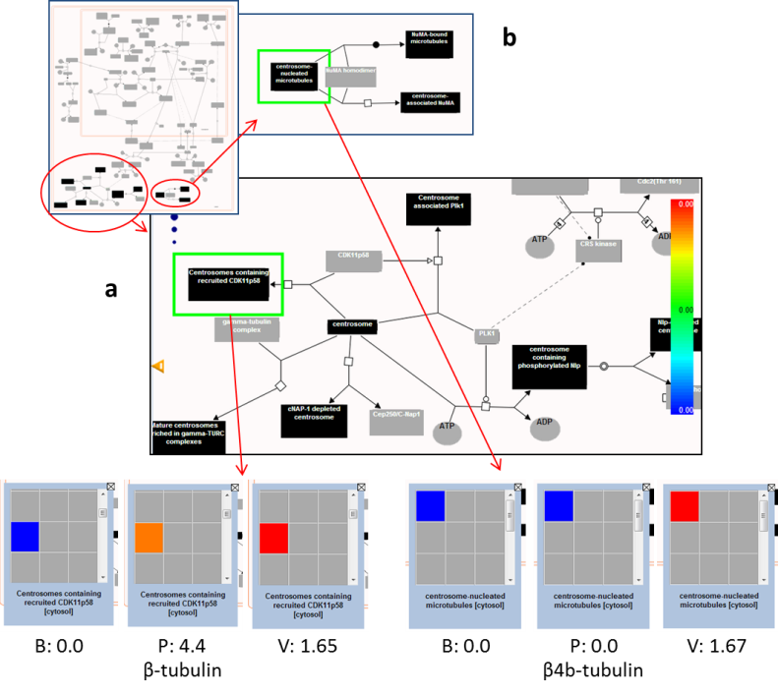

**Figure 7.5c.** Mitotic G2-G2/M *[G2/M Transition]*: SCFA enrichment levels for two representative G2-G2/M pathway maps focusing on events in ‘G2-G2/M phases’: (a) ‘*Centrosome containing recruited CDK11p58*’; (b) ‘*Centrosome-nucleated microtubules’*. The participating proteins were βb-tubulin and β2c-tubulin respectively. Only valerate and propionate contributed to these G2/M events with enrichment levels: (a) B = 0.00 (blue); P = 4.4 (orange). V = 1.65 (red); (b) B = 0.00 (blue); P = 0.0 (blue). V = 1.67 (red). Red (valerate) indicates the highest levels of enrichment; orange (propionate) indicates medium enrichment; in contrast, butyrate did not contribute to these G2 events. [B, butyrate; P, propionate; V, valerate; hierarchy spectrum is shown on the right].

### *7.4.6. String Functional Partners*

Searches for the functional partners associated with β2c-tubulin, β3-tubulin and β1-tubulin showed there were no direct interactions between β2c-tubulin and β3-tubulin (Figure 7.6). However there was a weak connection between β2c-tubulin (TUBB2C) and generic β-tubulin (TUBB) and a weak indirect connection *via* α-tubulin between β3-tubulin (TUBB3) and β1-tubulin (synonym, TUBB5). All three β-tubulin isotypes interacted with multiple α-tubulin isotypes, as expected though αβ-dimerisation, and to other protein partners in shared metabolic pathways.

|  |  |
| --- | --- |
| a) β2c-tubulin (TUBB2C) action network | b) β3-tubulin (TUBB3) action network |
|  |  |

**Figure 7.6.** STRING web-network diagrams of protein-protein interactions for β2c-tubulin, β3-tubulin and β1-tubulin isotypes, showing the closest functional partners directly linked by physical binding or indirectly associated through shared metabolic pathways. (a) There is a weak connection between β2c-tubulin (TUBB2C) and the generic β-tubulin (TUBB); (b) and a weak indirect connection, *via* α-tubulin isoforms, between β3-tubulin (TUBB3) and β1-tubulin (synonym, TUBB5). However, there are no direct connections between β2c-tubulin and β3-tubulin. As expected though αβ-dimerisation, all three β-tubulin isotypes are physically bound to multiple α-tubulin isotypes.

## 7.5. Bioinformatics: Discussion

Bioinformatics informed, validated and interpreted each step of the project by exploiting the vast resource of available, ever-expanding, inter-connected gene and protein databases and knowledgebases and by utilising open-source data and text mining tools. The selected databases were compiled from curated and annotated sources, thereby ensuring the information was robust.

The pathway expression analyses (Reactome) supported the proposal, based on the experimental evidence, that the odd-chain SCFAs, propionate and valerate, distinctly targeted the mitotic pathways. This was in contrast to butyrate, the even-chain SCFA, which is associated with apoptotic pathways [106]. Furthermore, the levels of pathway enrichment agreed with the experimental observations that valerate was the most potent effector in G2-related pathway events. The bioinformatic searches indicated that whereas butyrate only participated in G1 mitotic-events *via* non-tubulin proteins, valerate was solely involved in G2-mitotic events *via* β2c-tubulin and β-tubulin isotypes. Propionate contributed to both these G1 and G2 event, but as a weaker partner.

By exploring the protein-protein interactions between these β-tubulin isotypes [114], STRING confirmed that all three β-tubulin isotypes interacted with α-tubulin isotypes, as expected through αβ-tubulin dimerisation. However, STRING also showed that β2c-tubulin and β3-tubulin act independently of each other but both interacted with β1-tubulin. This may suggest that upregulation of β2c-tubulin and β3-tubulin could provoke downregulation of β1-tubulin through competitive actions. This proposition will require further investigation.

Bioinformatic information derived from the Gene Expression Atlas indicated that the observed upregulation of β2c-tubulin [52], β3-tubulin and downregulation of β1-tubulin in HCT116 cells following treatment by propionate and valerate could potentially counteract the metabolic adaptions of colon cancer cells [108], which promote the opposing β-tubulin expression profile [51]. As discussed in the introduction, these three β-tubulin isotypes have been associated with the most aggressive and invasive cancers.

Overall, the findings and evidence from the bioinformatic searches and explorations have provided revealing insights into previously unexplored metabolic actions of SCFAs in colonocytes, supporting a novel pathway by which odd-chain SCFAs could act as chemopreventives in colon cancer epithelial cells.

## 7.6. Key Conclusions: Bioinformatics

* Bioinformatics supported the key suppositions in the hypothesised pathway by confirming that epigenetic post-translational acetylation promoted transcription at the β-tubulin isotype genes identified as differentially regulated by multi-plex iTRAQ.
* Pathway expression analysis, based on the multi-plex iTRAQ fold-change data showed that the odd and even-chain SCFAs were associated with distinct mitotic events: butyrate was solely associated with G1-mitotic events; valerate was solely involved with G2-mitotic events; propionate was associated with both G1 and G2-mitotic events, but as a weaker partner.

# 8. Computational dynamical modelling supports a hypothesised SCFA-targeted mitotic pathway in which odd-chain SCFAs act as anti-mitotic destabilising agents by disrupting MT-dynamic instability

## 8.1. Contribution of computational dynamical modelling to the overall project

* State-of-the-art, high-throughput, quantitative experimentation had generated a considerable volume of complex inter-related information. Systems Biology, through a bottom up approach, could facilitate formulation of a hypothesis.
* Computational dynamical modelling was able to test the plausibility of the proposed hypothesis, make testable predictions for further investigation and provide revealing insights into the mechanisms involved.

## 8.2. Introduction to computational dynamical modelling

### *8.2.1. Computational dynamical modelling of the hypothesised pathway*

Systems Biology is a valuable technique for studying complex biological processes, as discussed in the introduction chapter. Part of this approach is to combine computational dynamical modelling with experimental observations. A well-designed model is one that is simple enough to avoid the complexities of biological systems, yet accurate enough to mimic the pathways being investigated. The computational model enabled the hypothesised metabolic pathway of SCFAs in HCT116 colon cancer cells to be broken down into its known or derived kinetic reactions, which were then translated into ordinary differential equations (ODE). These were linked according to set rules to allow the reactants to interact *in silico*. The hypothesis is validated if simulated outcomes match experimental observations, conversely a model can show that the assumptions underlying the hypotheses may be incorrect and need to be revised.

The model design was refined by parameter matching the data from the multi-plex iTRAQ and HCA cellomics experiments with the simulated outputs [75]. In addition to testing the plausibility of the hypothesis, the model was employed to predict the effects of different SCFA-treatment conditions and physiological scenarios by altering their input concentrations and combinations.

### *8.2.2. Microtubules and dynamic instability*

Microtubules (MT) are cytoskeletal proteins with critical roles in many cellular functions, including mitosis. Their structure and functions have been described in the introduction chapter. Their ability to rapidly grow and shrink in response to cellular cues is central to performing their multiple roles and is achieved by sequential addition of α and β tubulin subunits onto the fibre (polymerisation), or by dissociation of the subunits back into the cytosol. The mechanism is termed dynamic instability [62].

Disruption of MT dynamics is a strategy adopted by many cancer therapies. This makes the proposed anti-mitotic behaviour of the odd-chain SCFAs in HCT116 colon cancer cells attractive as it suggests they may be potential chemopreventives against colorectal cancer (CRC).

The tubulin code hypothesises that the relative proportion and arrangement of the β-tubulin isotypes along the fibre [47], and their interactions with microtubule associated proteins (MAP), determine the behaviour of the MTs. For example, whether the fibre will grow or shrink or whether the MAPs are involved in cellular transport [60, 61]. Therefore perturbing this code by differentially regulating β-tubulin isotypes can therefore bring about failure of critical cellular processes, including formation of the mitotic spindle, leading to cell death.

The favoured mechanism of MT dynamics is the GTP capping model [69]. This is described as follows: each α- and β-tubulin subunit has a single GTP binding site and can only assemble into MT-fibres in their phosphorylated form. Following polymerisation, β-tubulin-GTP subunits are readily, though irreversibly, hydrolysed to GDP whereas α-tubulin-GTP subunits remain non-exchangeable. Only when β-tubulin is released back into solution can it be re-phosphorylated. The β-tubulin-GTP form a protective, stabilising cap at the tip of MT-fibres. This is closely coupled with the rapid hydrolysis of the preceding β-subunits, releasing the energy required for continued polymerisation [48]. MT growth continues until the supply of free β-tubulin-GTP subunits in the vicinity of the fibre tip falls below a critical concentration (CC) [64]. The unstable hydrolysed GDP-subunits are exposed causing rapid disassembly of the MT-fibre, termed catastrophe. The released β-tubulin-GDP subunits re-phosphorylate back to their GTP-form, restoring the CC, enabling fibre growth to resume, termed rescue. Catastrophe and rescue describe a non-equilibrium, stochastic, but highly orchestrated, cycle of MT growth and shrinkage.

Formation of the protective cap is a cooperative event in which the addition of each new tubulin-GTP subunit expands the number of available binding sites for further subunit attachment [70, 71]. This process may act in parallel with facilitated, or directed, diffusion [72], which proposes that the probability of free tubulin-GTP subunits encountering an MT-fibre increases as the length and number of MT-fibres increases. The polarity of MT-fibres, by virtue of the αβ-heterodimers, then directs the subunits toward the plus, or growth, ends of the fibres, increasing the rate of assembly. This has also been discussed in greater detail in the introduction.

## 8.3. Model design and kinetic parameters

The purpose of the computational dynamical model was to construct a simple replication of MT-dynamic instability and simulate the SCFA-induced mechanisms that might disrupt it. The steps of the hypothesised pathway, described below, shaped the framework of the model. The aim of the design was to include the principle kinetic steps of the pathway while avoiding the biological complexities that make interpreting *in vivo* and *in vitro* observations difficult. This balance of simplicity and accuracy is fundamental to good model design.

The model design, shown schematically in Figure 8.1, follows a metabolic signalling cascade initiated by SCFAs and culminating in perturbation of MT-dynamic instability. The steps are as follows: (i) SCFA input provokes acetylation of transcriptional regulators at specific β-tubulin genes (β2c-tubulin, β3-tubulin, β1-tubulin) to enhance, or switched these regulators to transcriptional activators; (ii) these act by driving histone acetylation to remodel chromatin, which alters the transcriptional balance at those genes; (iii) synthesis of β2c-tubulin and β3-tubulin is prolonged, leading to upregulation; consequently synthesis of β1-tubulin is suppressed, leading to downregulation; (iv) the resulting aberrant expression of β-tubulin isotypes shifts the balance of recruited MAPs towards destabilisation; (v) thereby disrupting the cycle of MT-dynamic instability.

This model will be submitted to the BioModels database [129].

|  |  |
| --- | --- |
|  | |
| key | |
| SCFA input (drug) treatment  TF transcriptional regulator  *Tubb* differentially expressed β-tubulin isotypes  src source in *Tubb* synthesis  MAP destabilising MT associated proteins  [Cell Designer v.4.2] | Tu-GDP GDP form of β-tubulin  Tu-GTP GTP form of β-tubulin  MT microtubule fibres (MT)  ac acetylation  P phosphorylation   * grey boxes: active compounds * white boxes: inactive compounds * arrows: direction of reaction * circled arrows: activation modifier |

**Figure 8.1.** Qualitative schematic model describing the key kinetic reactions in the hypothesised metabolic pathway. Reactants interact *in silico* according to kinetic rules defined by ODEs. Input of SCFA (drug) at the top right-hand corner leads to a cascade of downstream epigenetic acetylation reactions culminating in perturbation of MT-dynamic instability (shown in the lower left hand corner). The ODEs are described in Table 8.1.

### *8.3.1. Design rationale*

1. The Qualitative Schematic Model (Figure 8.1) was designed using CellDesigner v4.2 [130] and the computational mechanistic model was built in COPASI v4.7 [131]. COPASI was designed, and is continually being developed, to construct, simulate and analyse complex biochemical networks and their dynamics. It is a biochemical network simulator that utilises the cross-platform standard Systems Biology Mark-up Language (SBML) for inputting ODEs. COPASI can perform both deterministic and stochastic time course simulations through ODEs and algorithms. Added benefits include the ability to visualise temporal and steady-state simulations of biological behaviour through customisable plots, parameter scans or animations. Furthermore, it provides tools for optimisation and sensitivity analyses and enables parameter estimation by linking with experimental data. This allows a model to be continually refined through a cycle of input experimental data and output testable predictions, in accord with a Systems Biology approach.
2. A single compartment was specified, the cell; volume units were set to [l]; concentration units were set to [μM]; and time units were set to [s]. Although computational models typically describe single cell compartments, this was acknowledged to be a simplification as experimental measurements represent the combined actions of many millions of cells. The concentration units were comparable with reported MT concentrations *in vitro* (~7 μM) [132]. Similarly, DNA and histones exist at μM concentrations within cells, as determined through simple estimations based on the molecular mass of DNA (330 Da) and the typical number of bp in a cell (~109). The time units were compatible with the reported rate of MT-dynamic instability in which MTs were observed to grow for approximately 80 s then rapidly dissociate [64]. MTs have multiple functions including mitosis and therefore they undergo multiple transitions during the lifetime of a cell.
3. The choice of rate law depends on the biological system being studied and the requirements of the modeller. *In vitro* and *in vivo* MT-dynamic instability is a stochastic, unpredictable event, appearing to be random [64]. Stochastic simulations are best at providing information on individual behaviour but are computationally expensive. Deterministic simulations are better at giving an overview of a whole system. They numerically integrate many stochastic events and so are more efficient but at the loss of individual behaviour [133]. Because MTs display a wide range of behaviour, a deterministic approach was applied for this model.
4. Computational dynamical models can simulate changes to reactant concentrations or particle numbers over time. By conserving moiety, changes in MT-concentration were matched by changes in free tubulin concentrations, and therefore reflected tubulin subunit assembly and disassembly. Concentration based simulations were performed with this model.
5. Reactions involving non-participatory species have been omitted. For example, α-tubulin subunits make up one-half of the αβ-heterodimer but are not hydrolysed in MT-fibres and do not contribute to MAP recruitment and changes to MT-dynamic instability. Therefore processes involving α-tubulin, such as αβ-dimerisation, were not included in the model design.
6. Perturbation of MT-dynamic instability by MAPs was set at the dissociation step of the cycle. This assumption was based on experimental evidence from HCA cellomics, which had demonstrated a loss of MT fibre integrity following SCFA treatment.
7. The 3-step MT-dynamic instability cycle model was adapted from Tyson’s 2-species cell cycle model and incorporated as a module into the pathway [134]. This established model has been extensively cited in BioModels and subsequent publications [129]. Both the 2-step cell cycle model and simplified MT-dynamic instability mechanism can be described by similar kinetic equations. In addition, the rate-limited instability of the Tyson model drives spontaneous oscillations when constrained between upper and lower kinetic limits, and changes to kinetic rate constants within these limits produce different behavioural responses. These oscillations are similar to those describing MT-dynamic instability and changes to input conditions can reflect increased or decreased stabilisation.
8. β-tubulin isotypes were both participants and indirect modifiers of MT-dynamic instability, *via* their recruitment of MAPs.
9. Parameter matching was carried out at the β-tubulin synthesis step. There were no pre-conceptions as to how these changes in β-tubulin isotype expression rates would affect the simulated behaviour of the MT-dynamic instability model. This ensured that comparisons with reported experimental observations were objective.
10. The following abbreviations were adopted: Tu-GTP, (the GTP form of tubulin subunits); Tu-GDP, (the GDP form of tubulin subunits); *Tubb r*efers to the combined weighted concentration of the differentially regulated β-tubulin isotypes (β3-tubulin, β2c-tubulin, β1-tubulin) according to their relative abundance in colon epithelial cells. This is described in detail in the conversion section.

### *8.3.2. Kinetic equations (ODE)*

Irreversible mass action-based kinetics were applied to describe the forward and backward reactions for acetylation, deacetylation and phosphorylation reactions. Synthesis of β-tubulin was described as constant flux [135, 136]. Reactions were activated or inhibited by the product of the preceding reaction based on the concentration of that product [135, 136].

The established kinetic view of MT-dynamic instability follows three key steps [70, 71]: co-operative second-order tubulin subunit assembly closely coupled with GTP hydrolysis; rapid first order MT-fibre disassembly; and zero-order re-phosphorylation of free β-tubulin-GDP. Catastrophe occurs when the concentration of phosphorylated β-tubulin subunits (Tu-GTP) falls below CC; rescue, or re-growth, resumes when the concentration rises above CC. (The ODEs are presented in Table 8.1).

**Table 8.1**. Ordinary Differential Equations (ODE) and rate law descriptions defining the kinetic reactions of the computationally modelled hypothesised pathway.

|  |  |
| --- | --- |
| **Reaction** | **ODE and rate law description** |
| TF acetylation | v_ac_tf = kac_tf [TF] [drug_SCFA] |
| TF deacetylation | v_dac_tf = kdac_tf [TF_ac] |
| * mass action: activator, SCFA (drug) * mass action: deacetylation | |
| Histone acetylation | v_ac_h = kac_h [hist] [TF_ac] |
| Histone deacetylation | v_dac_h = kdac_h [hist_ac] |
| * mass action: activator, acetylated-TF * mass action: deacetylation | |
| *Tubb* synthesis | v_syn = ksyn [hist_ac] |
| *Tubb* degradation | v_deg = kdeg [TUBB] |
| * constant flux: activator, acetylated-histones, i.e. remodelled chromatin and open DNA * mass action: degradation | |
| MAP recruitment | TUBB = MAP |
| * concentration of destabilising MAP = concentration of recruiting *Tubb* | |
| MT catastrophe | v_catas = kcatas [MT] [MAP] |
| * mass action: activator, destabilising MAPs | |
| Tu-GDP phosphorylation | v_phos = kphos |
| * first order phosphorylation of free β-tubulin-GDP prior to capping | |
| MT rescue | v_resc = [Tu_GTP] (kresc_prime + kresc [MT]^2) |
| Tu-GTP dephosphorylation | v_dephos = kdephos [Tu_GTP] |
| * second order, cooperative association (capping) * closely coupled with dephosphorylation of preceding β-tubulin-GTP subunit | |

### *8.3.3. Kinetic rate constants*

Kinetic rate constants were determined by searching for similar kinetic reactions in curated BioModels [129], the Brenda enzyme database [137] and reports in the literature. Where data were unavailable or limited, informed estimates were made. The following assumptions and approximations were applied:

1. Kinetic rate constants were inferred and local parameters added to reactions where appropriate [134, 136].
2. Although kinetic information on acetylation of specific TFs was scarce, there was a wealth of information on phosphorylation. As acetylation and phosphorylation are kinetically similar PTMs, with equal importance in many biological processes, an assumption was made that they were interchangeable.
3. Rate constants for synthesis and degradation span a wide range of values. In addition, the basal rate of transcription is reported to be independent of substrate concentration [138]. Mid-range values were adopted for this model.
4. Although rate constants can often be altered by the PTMs of modifying or catalysing proteins, this was not taken into consideration in this simplified model [34].

The rate constants selected for the model are given in Table 8.2. The references and kinetic ranges used to inform any estimates are detailed in Table 8.3.

**Table 8.2**. Parameter overview of the rate constants selected for the computational dynamical model. The sources of these parameter values are given in the following Table 8.3.

|  |  |  |  |  |
| --- | --- | --- | --- | --- |
| Reaction parameters | | | | |
| Reaction | k rate constant | value |  |  |
|  |  |  |  |  |
| MT catastrophe | kcatas | 0.865 | l/(µM*s) | * |
| MT rescue | kresc | 180 | s-1 | * |
|  | kresc_prime | 0.018 | s-1 | * |
| Tu-GDP phoshorylation | kphos | 0.0125 | µM/(l*s) | * |
| Tu-GTP dephoshorylation | kdephos | 0.001 | s-1 | * |
| β-tubulin synthesis | ksyn | 0.25 | s-1 | † |
| β-tubulin degradation | kdeg | 0.01 | s-1 | † |
| TF acetylation | kac_tf | 0.3 | l/(µM*s) | † |
| TF deacetylation | kdac_tf | 0.25 | s-1 | † |
| Histone acetylation | kac_h | 0.3 | l/(µM*s) | † |
| Histone deacetylation | kdac_h | 0.05 | s-1 | † |

* Tyson (1991) [134]

† refer to Table 8.3

**Table 8.3**. The parameter values used in the model were based on best estimates from those reported in the literature, the Brenda enzyme database [137] or similar modelled processes in BioModels [129].

|  |  |  |
| --- | --- | --- |
| **Reaction** | **Typical k-rates from the literature** | ***Ref.*** |
| Histone & TF acetylation/ phosphorylation | k = 0.2 to 5 [l/(µM*s)] | *[**139**] [**140**]* |
|  | kcat = 0.3 [s-1]  kcat/km = 0.9  (kcat 0.35; km 0.38) | *[**141**]*  *[**137**]* |
| deacetylation | k = 0.2 to 5 [s-1] | *[**140**] [**141**]* |
| *Tubb* synthesis  *(synthesis covers a wide range of k-rates depending on cell requirements at different phases.)* | k = 0.01 to 0.215 [s-1]  k = 0.015 [s-1]  k = 0.01 to 0.2 [s-1]  k = 0.08 [s-1] | *[**135**]*  *[**134**]*  *[**136**]*  *[**142**]* |
| *Tubb* degradation | k= 0.1 to 0.6 [s-1]  k= 0.06 to 2 [s-1] | *[**134**]*  *[**136**]* |
| Tu-GDPphosphorylation | k = 500 [s-1]  k = 0.962 [s-1] | *[**142**]*  *[**140**]* |
| Tu-GTPde-phosphorylation | k = 0.0012 [s-1]  k = 0.05 [s-1] | *[**142**] [**140**]* |
| *(ratio of phosphorylation:de-phosphylation)* | (100 to 1000) | *[**134**]* |

### *8.3.4. Initial reactant concentrations*

This is a semi-quantitative computational model aimed at understanding qualitative MT behaviour as oppose to quantitative optimisation. As such, the following valid approaches consistent with hypothetical modelling have been applied. The initial concentrations selected for the computational dynamical model are given in Table 8.4.

1. The total tubulin concentration (MT, Tu-GDP and Tu-GTP) was set at 4.5 μM. This was based on *in vitro* concentrations reported in the literature from experimental studies on tubulin dynamics [49, 64, 69, 132]. Conservation of moiety was maintained (MT + Tu-GDP + Tu-GTP = constant) so that an increase in MT concentration (mass/cell) was accompanied by a matched decrease in tubulin subunit concentration, and *vice versa*.
2. The initial concentration of *Tubb* was estimated from the total concentration of DNA/chromatin in the cell and the relative abundances of β2c-tubulin, β3-tubulin and β1-tubulin in colon epithelial cells in relation to total β-tubulin. These are 25%, 1% and 5%, respectively [61, 143].
3. The steady-state values of *Tubb* for each SCFA input were set to match the differential expression (fold-change) as determined by multi-plex iTRAQ. This was achieved by manually adjusting the input SCFA activation coefficient, in accord with previous authors [67]. In order to combine the iTRAQ fold changes from the three individual β-tubulin isotypes into a single *Tubb* parameter, their relative abundances were taken into account and the fold-changes weighted accordingly. This is described in Table 8.5. The resulting steady-state *Tubb* values were 1.18 (butyrate); 1.33 (propionate); and 1.40 (valerate).
4. The different activation coefficients assigned to each SCFA was dependent on structural characteristics, such as chain length and odd-eveness, and was unique to this metabolic pathways.
5. MAPs are recruited by β-tubulin isotypes in MT-fibres, therefore their concentration was assumed to be directly proportional to *Tubb*. According to the model hypothesis, the MAPs recruited by β2c-tubulin, β3-tubulin and β1-tubulin were MT-destabilising MAPs.
6. The initial concentrations for TFs and histones had minimal effect on the simulated rates of transcription, therefore they could be set to arbitrary values in line with approaches taken by previous authors [140, 138].
7. The concentration of protein depends on the relative forward and backward rates of synthesis and degradation. These in turn depend on upstream PTMs of transcriptional regulators and histones (which open up chromatin DNA to transcription factors). In this model, *Tubb* synthesis and degradation rates depended on histone acetylation and deacetylation induced by TF acetylation and deacetylation.

**Table 8.4**. Parameter overview of the initial concentrations selected for the computational dynamical model.

|  |  |  |
| --- | --- | --- |
| Initial Concentrations | | |
| Parameter | Definition (where relevant) | Value |
|  |  |  |
| *moiety* | *[MT + Tu_GDP + Tu_GTP]* | *4.5 µM* |
| MT |  | 1.5 µM |
| Tu_GDP |  | 2.5 µM |
| Tu_GTP |  | 0.5 µM |
|  |  |  |
| *drug_SCFA* | *Activation coefficient manually set for parameter matching iTRAQ fold change to in silico ‘Tubb’.* | *1–2.8 \** |
| *Tubb*/MAP | Initial concentration | 0.5 µM |
| *Tubb*/MAP | Steady-state *Tubb* = iTRAQ fold change | 1–1.40 µM † |
|  |  |  |
| hist | estimated from DNA per cell | 0.3 µM |
| hist_ac |  | 0 µM |
| TF | estimated from BioModels | 0.05 µM |
| TF_ac |  | 0 µM |

* refer to Table 8.6; † refer to Table 8.7

The SCFA (drug) activation coefficients were the only manually adjusted parameter in the model [67]. All others parameters were dependant on their initial values, rate constants and the cascading effect of each SCFA input coefficient during model simulations. As such, the outcomes could not be pre-determined and depended solely on the actions of the hypothesised pathway.

**Table 8.5**. Calculation of the *in silico* *Tubb* parameter: The combined fold-change of differentially expressed β-tubulin isotypes (determined by multi-plex iTRAQ) was weighted according to their abundance in colonocytes

|  |  |  |  |  |
| --- | --- | --- | --- | --- |
| Parameter | β2c-tubulin | β3-tubulin | β1-tubulin | *Tubb*  *(*β2c, β3, β1) |
| Abundance in colonocytes  a) relative to total β-tubulin | 25% | 1% | 5% | (31%) |
| b) relative to β2c, β3, β1 (*Tubb*) | 81% | 3% | 16% | (100%) |
| multi-plex iTRAQ fold-change  (relative to untreated) | 1.22 | 1.04 | --- | B |
| 1.46 | 1.33 | 0.73 | P |
| 1.48 | 1.48 | --- | V |
| % fold-change  (before weighting) | 22% | 4% | --- | B |
| 46% | 33% | 27% | P |
| 48% | 48% | --- | V |
| % fold-change  (after weighting) | 18% | 0% | --- | B |
| 36% | 1% | -4% | P |
| 38% | 2% | --- | V |

B, butyrate; P, propionate; V, valerate

The final steady-state values of *Tubb* are given below. These were calculated by combining their individual weighted fold-changes. The corresponding SCFA activation coefficients were determined by parameter matching the iTRAQ results to simulated *Tubb* expression. Untreated input was set as unity:

|  |  |  |  |
| --- | --- | --- | --- |
| SCFA coefficient | B: 1.37 | P: 2.15 | V: 2.80 |
| *Tubb* [µM] | 1.18 | 1.33 | 1.41 |

### *8.3.5. Physiological predictions.*

An important application in computational dynamical modelling is the ability to predict theoretical outcomes for experimental testing and validation. As such, the model was used to predict how SCFA might behave under physiological conditions when they would act in combination and under different concentrations.

Having calculated the SCFA activation coefficients at the following IC50 (G2/M) treatment conditions: butyrate 4mM (B); propionate 11mM (P); valerate 9mM (V), it was possible to combine them in different scenarios, e.g. additive (B + P + V); odd-chain only (P + V); antagonistic (P + V vs. B) and adjust the activation weighting according to their physiological concentrations. The physiological concentrations were based on a study of 87 patients diagnosed as normal, with adenoma or with colon cancer (butyrate, 6.2 mM; propionate, 7.1 mM; valerate, 1.0 mM) [13, 144]. Of note was how these physiological concentrations, taken from both normal and colon cancer patients, compared to the IC50 (G2/M) treatment concentrations in HCT116 colon cancer cells where each SCFA was in isolation *in vitro*. This indicated that the physiological value for butyrate was higher, whereas those for propionate and valerate were lower. A further observation was that the IC50 (G2/M) coefficient for butyrate was the same as that predicted for the physiological ‘antagonistic’ SCFA scenario, where butyrate acted in opposition to propionate and valerate in this anti-mitotic pathway. The predicted SCFA coefficients are given below and the corresponding *Tubb* concentrations were derived from the simulated outputs:

|  |  |  |  |
| --- | --- | --- | --- |
| SCFA (drug) | antagonistic  (P + V - B) | odd-chain  (P + V) | additive  (B + P + V) |
| SCFA coefficient | 1.37 | 1.94 | 2.52 |
| *Tubb* [µM] | 1.18 | 1.30 | 1.38 |

### *8.3.6. Comparison of computational model parameters to reported experimental in vitro data*

The *in silico* outputs of the MT-dynamic parameters under different input scenarios (Tables 8.6) were compared to reported *in vitro* data for MTs under similar conditions, based on time-lapse microscopy measurements of growing and shrinking MTs (Table 8.7) [64, 69, 132]. The results provided valuable insights into SCFA behaviours in mitotic events.

**Table 8.6**. Reported *in vitro* MT-dynamicity data from destabilisation, stabilisation and physiological time-lapse fluorescence microscopy studies of PtK2 cells [132].

|  |  |  |  |  |  |
| --- | --- | --- | --- | --- | --- |
| MT-dynamicity parameters | *in vitro* destabilisation  treatments | | | *in vitro* stabilisation  treatments | |
|  | control | untreated (GFP) | destabilised  (GFP-XKCM1) | control  (IgG) | stabilised  (anti-XKCM1) |
| growth rate [µM.s-1] | 4.5 | 3.60 | 6.00 | 4.00 | 4.00 |
| shrinkage rate [µM.s-1] | 10.9 | 9.50 | 6.90 | 6.40 | 10.00 |
| catastrophe frequency [s-1] | 0.004 | 0.004 | 0.018 | 0.012 | 0.006 |
| rescue frequency [s-1] | 0.029 | 0.036 | 0.021 | 0.020 | 0.038 |
| elongation time [s] | 52.0 | 66.2 | 34.1 | 38.7 | 63.8 |
| shrinkage time [s] | 5.8 | 7.2 | 29 | 19.9 | 7.6 |

In the absence of *in vitro* data for MT-dynamicity parameters in colonocytes, data from an *in vitro* experiment based on PtK2 cells was chosen for the *in silico* comparisons [132]. The selection was based on the following criteria: PtK2 cells are an established model for studying MT-dynamics and the mitotic process [49, 64, 69, 145]; in common with HCT116 cells, PtK2 renal cells are an epithelial cell line; the selected study included all three scenarios of interest (stabilising, destabilising and physiological) thereby providing consistency for the different comparisons. Relative values based on fold-change data were used for the comparisons, as oppose to absolute values, because HCT116 and PtK2 cell-lines are derived from different tissues. The PtK2 destabilising enzyme was XKCM1 with non-expressing transfected cells used as a control. Anti-XKCM1 had been used for the stabilising treatment. Normal, GFP expressing PtK2 cells were used for the physiological comparisons.

### *8.3.7. Comparison of computational model parameters to experimental data*

In order to make comparisons between the simulated outputs and experimental data from this project, conversion factors had to be derived. The *in silico* values are given in Table 8.6 and were averaged over 750 s. The comparisons are given in Figure 8.6.

1. **HCA MT-cytoskeletal integrity comparison**: The assumption was made that MT-fibre integrity was related to MT dissociation and thereby MT-concentration. As such, the loss of MT-fibre integrity quantified by HCA would parallel the decrease in mean *in silico* MT-concentration. A novel single HCA fibre-integrity parameter had been defined based on MT-fibre area and texture, which allowed direct comparisons to be made. This has been described in the HCA chapter.
2. **Flow-cytometry cell cycle parameters**: Cell cycle analysis of HCT116 cells undergoing SCFA treatments was quantified by time-course flow-cytometry. The observed shift in cell accumulation from G1 to G2/M phase under different SCFAs treatment conditions had been associated with failure to undergo mitosis due to loss of MT-fibre integrity and mitotic breakdown in line with the HCA observations. Therefore, the flow cytometry results were again compared to the computational outputs for mean MT-concentration.

## 8.4. Time-course simulations

Computational simulations were started a time t = 0 (model time), however a suppression period of 500 s was applied to allow perturbation reactants (*Tubb* and MAP) to reach steady-state concentrations before MT-dynamic instability parameters were analysed. MT-dynamic instability output data were recorded between 500 s and 750 s to give a sufficient number of oscillations for MT-dynamic parameter calculations. The long-term effects on MT behaviour were observed over time periods up to 5000 s. Time-course data were output from COPASI v4.7 [131]. The data were analysed using Microsoft Excel and the results are presented in both tabular and graphical format.

The key parameters, termed MT ‘dynamicity’ [53], are catastrophe frequency, rescue frequency, growth rates and shrinkage rates. Other parameters include elongation and shrinkage periods, mean MT concentration and the critical concentration, CC. These are described with reference to computational simulations in Figure 8.2 as follows:

* growth rate [µM.s-1]: increase of MT-concentration/elongation time
* shrinkage rate [µM.s-1]: decrease of MT- concentration/shrinkage time
* elongation period [s]: time between MT minima and maxima
* shrinkage period [s]: time between MT maxima and minima
* growth:shrinkage rate: growth rate/shrinkage rate
* mean MT [µM]: mean MT-concentration over total simulation time
* catastrophe frequency [s-1]: No. catastrophe events/total elongation time
* rescue frequency [s-1]: No. rescue events/total shrinkage time
* CC [µM]: free Tu-GTP concentration at the switch between catastrophes and rescues (Figure 8.3a).

|  |  |
| --- | --- |
|  |  |

**Figure 8.2.** The simulations show the relationships between MT-dynamic instability parameters, termed ‘Dynamicity’: (a) shows slow growth followed by rapid shrinkage; (b) shows the relationship between catastrophe and rescue frequencies (defined above). Total elongation and shrinkage times for the number of maxima, or minima are calculated by summing all the ‘arrows’.

**Table 8.7**. Computational model outputs (absolute values) for MT-dynamicity parameters and steady-state protein concentrations from simulated SCFA-treatments.

|  |  |  |  |  |  |  |  |
| --- | --- | --- | --- | --- | --- | --- | --- |
| SCFA (drug) | U | B | P | V | antagonistic  (P+V vs. B) | odd-chain  (P+V) | additive  (B+P&V) |
| SCFA coefficient | 1.00 | 1.37 | 2.15 | 2.80 | 1.37 | 1.94 | 2.52 |
| *Tubb* (MAP) [µM] | 1.05 | 1.18 | 1.33 | 1.41 | 1.18 | 1.30 | 1.38 |
| growth:shrinkage rate | 0.232 | 0.171 | 0.242 | 1.273 | 0.171 | 0.359 | 0.883 |
| catastrophe frequency [s-1] | 0.030 | 0.024 | 0.027 | 0.068 | 0.024 | 0.026 | 0.063 |
| rescue frequency  [s-1] | 0.128 | 0.143 | 0.116 | 0.065 | 0.143 | 0.072 | 0.071 |
| mean elongation period [s] | 33.6 | 41.0 | 36.8 | 14.7 | 41.0 | 38.5 | 16.0 |
| mean shrinkage period [s] | 7.8 | 7.0 | 8.6 | 15.5 | 7.0 | 13.8 | 14.1 |
| mean MT [µM] | 0.013 | 0.012 | 0.010 | 0.010 | 0.012 | 0.012 | 0.010 |
| CC [Tu-GTP] [µM] | 0.067 | 0.046 | 0.247 | 0.338 | 0.046 | 0.083 | 0.330 |

U, untreated; B, butyrate; P, propionate; V, valerate

## 8.5. Computational dynamical modelling: Results

The concentration-rate plots ([μM/(l*s)] vs. time [s]) describe the inter-relationship between MT fibres and β-tubulin subunits through polymerisation, hydrolysis and re-phosphorylation (Figure 8.3a). Because conservation of moiety was maintained, a decrease in free Tu-GTP subunit concentration was accompanied by an increase in MT concentration, reflecting Tu-GTP subunit assembly on to the MT-fibres. Conversely, a decrease in MT concentration reflected dissociation of hydrolysed Tu-GDP subunits, which re-phosphorylated to Tu-GTP subunits once back in solution. With increasing destabilisation (from untreated to valerate treated cells) the critical Tu-GTP concentration (CC) at which catastrophe switches to rescue increased as the catastrophe frequency increased and MT concentration decreased [69]. As growth-rates increased, a shorter elongation period was required to reach a set MT-concentration. Similarly, a decrease in shrinkage-rates resulted in longer shrinkage periods. Consequently the growth:shrinkage ratio increased. As the number of oscillations increased and total elongation period decreased, the catastrophe frequency increased. Conversely a decrease in the total shrinkage period caused a reduction of the rescue frequency.

The elongation and shrinkage periods of the simulations were found to be comparable to the reported periodicity of dynamic instability recorded *in* vitro in which MTs were observed to grow for approximately 80 s and then rapidly dissociate [64]. In this model, elongation periods were of the order of 35 s in untreated cells with shrinkage rates of 10 s. (Table 8.6).

The computational output data for each simulated SCFA-treatment is given in Table 8.7.

|  |  |
| --- | --- |
| a) |  |
| b) |  |
| c) |  |

**Figure 8.3.** (a) The inter-relationship between MT fibres and their β-tubulin subunits (Tu-GTP) through association and dissociation. CC is the free Tu-GTP concentration at the point where catastrophe switches to rescue, and *vice versa*. (b) The relationship between MT-concentration and gowth:shrinkage rates, shows the shift from long-growth/rapid-shrinkage periods to shorter-growth/longer-shrinkage periods with increasing perturbation by *Tubb*; (c) The relationship between catastrophe and rescue frequencies and elongation and shrinkage periods shows a greater number of catastrophes (maxima) with increasing *Tubb* perturbation, and concurrent suppression of MT dynamicity. [*Tubb* is the weighted concentration of β-tubulin isotypes (Table 8.5)].

The parameter scan of simulated *Tubb* synthesis (Figure 8.4a) covers the range of input SCFA activation coefficients (1–2.80) which represent the experimental SCFA IC50 (G2/M) treatment concentrations (4 mM, 11 mM, and 9 mM for butyrate, propionate and valerate, respectively). The resulting steady-state concentrations (Figure 8.4b) for *Tubb* were parameter-matched to the fold-changes of differentially expressed β-tubulin isotypes from the multi-plex iTRAQ experiment.

|  |  |
| --- | --- |
| a) Computational parameter scan of *Tubb\** synthesis | b) Fold-change values for *Tubb*\* *in silico* after parameter matching to the multi-plex iTRAQ fold-changes for β-tubulin isotypes relative to untreated samples. |
|  |  |

**Figure 8.4.** The *in silico Tubb* concentrations were matched to fold-change data of differentially expressed β-tubulin isotypes from the multi-plex iTRAQ experiment by manual adjustment of *in silico* SCFA activation-coefficients: (a) Temporal simulations of *Tubb* synthesis for each SCFA-treatment. (b) A histogram of the steady-state *in silico* values of *Tubb* after parameter matching to the multi-plex iTRAQ data. The consequences to downstream MT-dynamic instability were then evaluated (Table 8.7). [* *Tubb* is the weighted concentration of β-tubulin isotypes (Table 8.5); B, butyrate; P, propionate; V, valerate].

*Tubb* expression levels were dependent on SCFA type and concentration. Following the simulated introduction of SCFA, the steady-state *Tubb* values increased from their untreated value to their treated values, reflecting an increase in synthesis rates, and MT-dynamic instability was concurrently suppressed. This is shown by the series of simulations in Figure 8.5. This starts with the untreated simulation, then steps through simulated treatments for butyrate, propionate and valerate, and each hypothesised physiological SCFA combination (antagonistic, odd-chain and additive), based on predicted *Tubb* concentrations. The simulations display continuous oscillations for untreated, butyrate, physiological-odd-chain and physiological-antagonistic treatments, indicating that these treatments allow MT-dynamic instability to proceed correctly. In contrast, simulations for propionate, valerate and physiologically-additive treatments display increasing dampening of the MT-dynamic oscillations, with a concurrent reduction in MT concentration. This indicates that propionate and valerate act as anti-mitotic agents at these treatment concentrations. In addition, the physiological simulations indicate that for MT-dynamic instability to proceed correctly, butyrate either plays no part or acts in competition to propionate and valerate in this mitotic pathway. When butyrate combines with propionate and valerate in the additive scenario, MT-dynamics collapse.

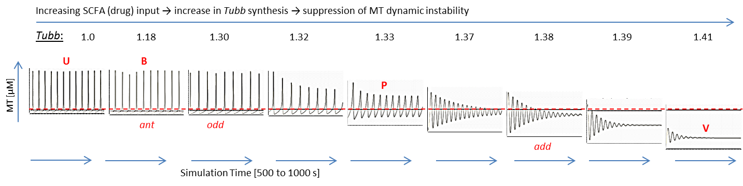

Key: ant = antagonistic (even-chain [B] vs. odd-chain [P & V]); odd = odd-chain [P & V];

add = additive [B, P & V together].

**Figure 8.5.** The dynamical simulations show the suppression of MT-dynamics as a consequence of SCFA (drug) treatments. Each simulation represents a different level of SCFA input. The top arrow (left to right) indicates increasing *Tubb* concentrations and perturbation as a consequence of SCFA-induced TF acetylation. Simulations for butyrate, propionate and valerate at treatment concentrations, and SCFA combinations at physiological antagonistic, odd-chain only and additive concentrations, are indicated. These show a dampening of MT-dynamic instability with concurrent loss of MT-fibre concentration as perturbation due to SCFA treatments increases. Evaluation of the plot data shows an increase in MT-shrinkage time, decrease in MT-elongation time, increase in catastrophe frequency, decrease in rescue frequency and increase in growth:shrinkage rates (Table 8.7). This is consistent with *in-vitro* evidence for MT-destabilisation treatments.1 The plot gives MT concentration [μM] vs. time [s]; the simulation time of 250–500 s was selected to ensure *Tubb* had reached steady-state prior to evaluation of MT dynamicity; the axis provides a constant frame of reference.

Computational model predictions of mean MT-concentration with simulated SCFA IC50 (G2/M) treatments were compared to HCA MT fibre integrity data and time-course flow-cytometry cell cycle data (Figure 8.6). The three plots displayed similar profiles: the reduction of *in silico* MT-concentration reflects suppression of MT-dynamic instability; the HCA results show loss of MT-fibre integrity; and the shift from GI to G2/M (ratio of G1:G2/M) reflects increasing mitotic arrest. These clearly similar profiles between *in silico* and *in vitro* results support the modelled metabolic pathway and thereby the plausibility of the hypothesis. The exception was with the butyrate simulations. Whereas the model predicted little, or no, involvement by butyrate in the modelled anti-mitotic pathway, the experimental evidence showed that butyrate induced significant loss of MT-fibre integrity and G2/M cell cycle arrest. This discrepancy was because the computational model simulated a single metabolic pathway; whereas the results from the HCA and flow-cytometry experiments were the consequence of multiple pathways involved in cytoskeletal breakdown and G1-G2 cell cycle arrest [100, 105]. These will include apoptotic pathways known to be associated with butyrate [106], which also lead to cellular and cytoskeletal breakdown [100].

|  |  |  |
| --- | --- | --- |
| a) *in silico*: mean MT concentration over simulated time. | b) *in vitro* (HCA): MT-fibre integrity at SCFA IC50 concentrations. | c) *in vitro* (flow cytometry); shift from G1 to G2 phase (G1:G2-M) with increasing SCFA treatment times. |
|  |  |  |

**Figure 8.6.** The histograms represent the comparisons between *in silico* computational model predictions and experimental *in vitro* observations by HCA and flow-cytometry. In order to equate computational model outputs with experimental data, common factors had to be identified: model simulations showed that suppression of dynamic instability was accompanied by a decline in mean MT-concentration (Figure 8.5); HCA data showed that a loss of MT integrity indicated MT-fibre dissociation and consequently a decrease in MT concentration; the time-response flow-cytometry data showed an increase in mitotic arrest, measured as a reduction in G1:G2-M ratio, with increasing treatment times and SCFA potency. The histograms all show a similar profile, validating the model and supporting the hypothesis. All the plots are relative to untreated controls.

The hypothesised pathway proposed that odd-chain SCFAs, propionate and valerate, destabilise MT dynamics and disrupt MT structural integrity. This was based on HCA experimental evidence. To test this assumption model predictions were compared to published quantitative experimental data on MT-dynamicity parameters following stabilising or destabilising treatments [132]. The histograms (Figure 8.7) compare *in silico* outputs to (a) *in vitro* MT-destabilising treatments and (b) MT-stabilising treatments [132]. Each bar shows the % fold-change of a parameter relative to untreated cells. These were plotted as log2 for clarity. There was a clear similarity in behaviour between simulated valerate treatments and destabilising treatments, and opposing behaviour in comparison to MT-stabilising treatments. This positively supported the hypothesis that the odd-chain SCFAs, propionate and valerate, were MT destabilising agents. (The data is presented in Table 8.8).

|  |  |
| --- | --- |
| a) MT-Destabilising Comparisons | b) MT-Stabilising Comparisons |
|  |  |

* key
* *in vitro*: destabilising / Stabilising treatments (PtK2)
* cat [s-1]: catastrophe frequency
* res [s-1]: rescue frequency
* elong [s]: elongation period
* shrink [s]: shrinkage period
* G:S rate: ratio of growth rate to shrinkage rate

**Figure 8.7.** The histograms compare MT-dynamicity parameters between *in silico* simulated treatments of HCT116 cells (colon cancer epithelial cell line) and *in vitro* experimental destabilising (a) and stabilising (b) treatments of PkT2 cells (renal epithelial cell lines) [132]. The results show a close correlation between valerate treatment and *in vitro* MT-destabilising treatment, with both displaying the same fold-change pattern relative to their respective untreated controls. In contrast, comparisons with *in vitro* MT-stabilising treatments show opposing effects. These results clearly demonstrate that valerate acts in the same manner as MT-destabilisers. [Log2 plots are used for clarity; data is presented in Table 8.8].

**Table 8.8**. MT-dynamicity comparisons between *in vitro* treated cells (destabilisation and stabilisation) and computational model outputs from simulated SCFA treatments (% fold-change data relative to untreated controls) [132]. These data are shown graphically in Figure 8.7.

|  |  |  |  |  |  |  |  |  |
| --- | --- | --- | --- | --- | --- | --- | --- | --- |
| SCFA (drug) | *in vitro*  destabilisation |  | B | P | V |  | *in vitro*  stabilisation |  |
| growth:shrinkage rate | 211% | **↑** | 74% | 104% | 549% | **↑** | 64% | **↓** |
| catastrophe frequency [s-1] | 492% | **↑** | 82% | 91% | 228% | **↑** | 48% | **↓** |
| rescue frequency [s-1] | 74% | **↓** | 112% | 91% | 51% | **↓** | 186% | **↑** |
| mean elongation period [s] | 66% | **↓** | 122% | 109% | 44% | **↓** | 165% | **↑** |
| mean shrinkage period [s] | 500% | **↑** | 89% | 110% | 198% | **↑** | 38% | **↓** |

**Table 8.9**. Physiological comparisons between MT-dynamicity parameters for simulated *in silico* physiological SCFA combinations (antagonistic; odd-chain; additive) against *in vitro* data from normal, untreated cells [% fold changes relative to untreated controls]. The closest comparisons (starred bold/italics) suggest that SCFA physiological behaviour is most probably antagonistic. These data are shown graphically in Figure 8.8.

|  |  |  |  |  |
| --- | --- | --- | --- | --- |
| SCFA (drug) | *in vitro*  normal, untreated | antagonistic  (P&V vs. B) | odd-chain  (P&V) | additive  (B&P&V) |
| growth:shrinkage rate | ***92% \**** | ***74% \**** | 55% | 420% |
| catastrophe frequency [s-1] | ***108% \**** | ***83% \**** | 68% | 216% |
| rescue frequency [s-1] | ***125% \**** | 113% | ***120% \**** | 56% |
| mean elongation period [s] | ***127% \**** | ***122% \**** | 152% | 48% |
| mean shrinkage period [s] | ***124% \**** | ***89% \**** | 84% | 180% |

Of interest is how SCFAs behave under physiological conditions to ensure MTs function correctly. To replicate possible physiological SCFA combinations *in silico*, the SCFA-activation coefficient for each of the following scenarios had to be calculated, as described in the conversion section above: additive (propionate, valerate and butyrate acting together); odd-chain only (propionate and valerate); or antagonistic (butyrate opposing propionate and valerate). The *in silico* output data for MT-dynamicity parameters were compared to published *in vitro* data for non-tumoural untreated cells under physiological conditions (PtK2 epithelial cells were again used for these *in vitro* comparisons [132]). The results are shown as a histogram (Figure 8.8). Although they are less conclusive than the treated comparisons (Figure 8.7), they do give an indication of the most probable behaviour of SCFAs in HCT116 cells bathed in SCFAs under colonic physiological conditions. The closest similarity was observed with antagonistic simulations and some similarity was observed with the odd-chain-only predictions. In contrast, the additive predictions were clearly different from experimental observations. These findings suggest that butyrate either behaves competitively or is not involved in this mitotic pathway. Competitive actions between butyrate and valerate have been reported for other mechanisms [25]. These findings suggest possible new directions for future investigations.

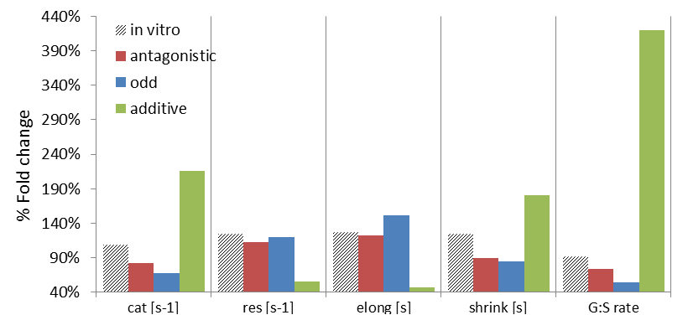

* key
* *in vitro*: Normal, untreated cells
* antagonistic: even vs. odd-chain SCFAs (B vs. P & V)
* odd: odd-chain SCFAs (P & V)
* additive: B, P & V acting together
* cat [s-1]: catastrophe frequency
* res [s-1]: rescue frequency
* elong [s]: elongation period
* shrink [s]: shrinkage period
* G:S rate: ratio of growth rate to shrinkage rate

[B, butyrate; P, propionate; V, valerate]

**Figure 8.8.** The histogram gives *in silico* predictions of MT-dynamicity parameters for three possible physiological SCFA combinations: antagonistic (B acting against P & V); odd-chain only (P & V acting distinctly from B); and additive (P, V & B acting together). These are compared with reported *in vitro* physiological metabolic behaviour based on observations from normal untreated epithelial cells [132]. Percentage fold-changes relative to control cells are given. Although the pattern matches are less conclusive than the previous comparisons for treated cells (Figure 8.7), the *in silico* predictions of SCFA-antagonistic behaviour shows the closest similarity to *in vitro* physiological cells (Table 8.9). These findings provide an indication of how SCFAs may behave in this mitotic pathway under physiological conditions.

An additional test of the model’s robustness and possible versatility was performed to establish whether it could replicate the opposing mechanism, i.e. MT-stabilisation, by inhibiting MT-dissociation instead of inducing it. This was simulated by adjusting the SCFA-activation coefficients to downregulate *Tubb* synthesis. The simulations showed that MT elongation (growth) periods were extended and shrinkage periods were shortened. This was the converse of MT-destabilising simulations (Figure 8.7). This test not only strengthened the validity of the computational model, it also demonstrated the model’s potential for simulating similar or related biological processes. For example, the model could be adapted to simulate stabilising anti-mitotic treatments, such as paclitaxels. *(The full results and figures for this simulation are not included in this project).*

## 8.6. Discussion and Future Directions

The computational dynamical model, in combination with the experimental and bioinformatic data, has demonstrated the plausibility of the hypothesis which proposed that the odd-chain SCFAs may act as anti-mitotic agents. *In silico* simulations of the hypothesised pathway demonstrated that at treatment concentrations, valerate, and to a lesser extent propionate, suppress MT-dynamic instability by promoting downstream epigenetic acetylation of transcriptional regulators, thereby differentially expressing β-tubulin isoforms to perturb the tubulin code and alter the cycle of dynamic instability. Dynamic instability is central to MT functionality, therefore disrupting it can lead to failure to perform critical cellular functions, such as mitosis.

Furthermore, the model predicted that under physiological conditions only the odd-chain SCFAs are required to ensure MT-dynamic instability proceeds correctly. Butyrate either plays no role in this pathway or has actions that modulate the net effect by competing antagonistically against propionate and valerate.

The model predictions are consistent with experimental data from both this project and those reported in the literature [132], supporting the proposition that SCFAs at above-physiological concentrations act as MT-destabilising agents by promoting dissociation of the MT-fibre. This has consequences that could be exploited for cancer therapeutics. Established AMDs act by overstabilising or destabilising MT-dynamic instability, suppression of MT-dynamic instability by anti-mitotic agents has also been shown to re-activate the mitotic checkpoint [103], preventing cells from exiting mitosis, halting proliferation and inducing cell death. However, many of these established treatments are associated with toxicity and drug resistance. Therefore, identifying new treatments that will be tolerated by colonocytes is an attractive option for CRC therapeutics.

Although this model only reflects a small element of SCFA actions in colon cancer cells, in combination with the quantitative experimental data it has demonstrated the plausibility of a novel SCFA-driven anti-mitotic pathway in HCT116 colon cancer cells that is unique to the odd-chain SCFAs, propionate and valerate, offering new directions for further investigations.

# 9. Project Conclusion

## 9.1. Hypotheses formulation

This research project adopted a Systems Biology approach, combining state-of-the-art high-throughput proteomic and cellomic experimentation with computational dynamical modelling, supported by the wealth of information openly available in proteomic and genomic knowledgebases. The aim was to explore and validate the plausibility a novel hypothesis that SCFAs, which are essential components of the human diet, play distinct metabolic roles in colon epithelia by virtue of their carbon chain lengths. These may include chemoprotective actions, however the mechanisms are not yet fully established.

### *9.1.1. The hypothesis*

*“At above-physiological concentrations, the odd-chain SCFAs, propionate and valerate, promote downstream epigenetic acetylation at specific β-tubulin transcriptional binding sites in HCT116 colon cancer cells, thereby altering the expression profile of β-tubulin isotypes. This in turn creates an aberrant tubulin code which perturbs microtubule dynamic instability and prevents microtubules from correctly performing their cellular functions, eventually leading to mitotic arrest and cell death.”*

### *9.1.2. Experimental and bioinformatic contributions*

Each element of this research project, proteomic, cellomic, bioinformatic pathway analyses and computational modelling, contributed crucial evidence to support this hypothesis:

1. Multi-plex iTRAQ showed that both propionate and valerate, the odd-chain SCFAs, upregulated β2c-tubulin and β3-tubulin isotypes and downregulated β1-tubulin in HCT116 colon cancer cells *in vitro*. Valerate had the greatest effect, whereas butyrate, the even-chain SCFA, had no significant effect.
2. High Content Analysis (HCA) showed that valerate achieved the same efficacy as butyrate in promoting loss of MT cytoskeletal integrity, despite being reported to have a minor role in the other apoptotic pathways induced by butyrate [100]. This suggested that valerate might act through an alternative, anti-mitotic pathway. Propionate displayed roles in both pathways, but to a lesser extent.
3. HCA cell cycle analyses displayed a unique biphasic response in cell cycle progression induced by propionate and valerate. An increase in G2/M (mitotic) arrest was reversed in favour of G1 arrest at low treatment concentrations [4]. The effect was not dose-dependent and was masked by the G2/M effect at higher SCFA concentrations. This is characteristic of mitotic slippage [102], suggesting it may be phenotype dependant. Flow cytometry supported this interpretation by displaying a minor time-dependant biphasic response. This was only apparent at longer treatment times when the phenotypes with a greater capacity for survival would contribute a larger proportion of the remaining cells.
4. Flow cytometry showed characteristic cell cycle behaviours that suggested butyrate primarily induced G1 arrest (characteristic of apoptotic pathways) [100], valerate primarily induced G2/M arrest (characteristic of mitotic pathways) and propionate had roles in both pathways. Although the flow cytometry results were not significantly conclusive, they did support the other experimental observations.
5. Extensive bioinformatic searches contributed, supported and validated the experimental observations and hypothesis generation. These searches provided evidence that downstream epigenetic acetylation at β2c-tubulin, β3-tubulin and β1-tubulin transcriptional sites promoted differential regulation of these isotypes *via* acetylation of transcriptional regulators and subsequent chromatin remodelling.
6. Pathway expression analysis identified the unique pathways targeted by each SCFA based on the experimental evidence. These indicating that butyrate was solely involved in G1-mitotic events *via* non-tubulin proteins, valerate was solely involved in G2-mitotic events *via* β2c-tubulin and β-tubulin, and propionate displayed roles in common with both.
7. Western blotting and the use of biological replicates provided orthogonal confirmation and quality control of the experimental techniques.

### *9.1.3. Impact of computational dynamical modelling*

A central part of this research project was to design a computational dynamical model to replicate the hypothesised pathway so that temporal simulations could be performed *in silico*. By matching the simulated outputs to *in vitro* experimental observations, the plausibility of the hypothesis could be validated. Furthermore, by making experimentally testable predications, the model provided valuable insights into the underlying mechanisms and behaviour of SCFAs in colonocytes, both at treatment concentrations and under physiological conditions. In addition, these predictions offered directions for further investigations.

## 9.2. Project conclusions and contributions to science and medicine

The findings of this research project have conclusively established that the odd-chain SCFAs, propionate and valerate, have unique metabolic actions distinct from butyrate, the even-chain SCFA. Based on initial proteomic evidence, a potential anti-mitotic pathway was identified and explored through further state-of-the-art experimentation. Bioinformatic searches and computational dynamical modelling supported the plausibility of this proposed pathway.

The pathway described a process in which downstream epigenetic acetylation of transcriptional regulators at specific β-tubulin binding sites was induced by the odd-chain SCFAs. This resulted transcriptional activation, via chromatin remodelling, and differential regulation of β2c-tubulin, β3-tubulin and β1-tubulin isotypes, which are reported to be pro-tumourigenic in colon epithelia [10, 55, 56]. By altering the balance and arrangement of β-tubulin isotypes in MT fibres, this action would create an aberrant tubulin code [47], leading to loss of MT structural integrity and failure of critical MT cellular functions, including mitosis, resulting in G2/M mitotic arrest and eventual cell death. In contrast, butyrate, which is known to be a potent antagonist of colon cancer cells *via* anti-apoptotic pathways [100, 105], showed no significant role in this mitotic pathway.

In addition, model predictions suggested that the odd-chain SCFAs were uniquely involved in the correct functioning of this mitotic pathway at physiological concentrations.

The experimental evidence indicated that at above physiological concentrations, valerate, which is a minor player in the apoptotic pathways induced by butyrate [3], was the dominant effector in this anti-mitotic pathway in HCT116 colon cancer cells.

The differential expression of β2c-tubulin, β3-tubulin, and β1-tubulin, in HCT116 cells following SCFA treatments opposed the expression pattern of these three β-tubulin isotypes in untreated HCT116 colon cancer cells relative to normal cells. This suggested that propionate and valerate could effectively counter these potential tumour adaptations.

Established anti-microtubule drugs (AMD), such as the paclitaxels or vinca alkaloids, are among the most successful chemotherapies to date. In general AMDs act by over-stabilising or destabilising MT dynamics, however their toxicity and drug resistance increases with successive rounds of treatment [146]. There is increasing interest in identifying anti-mitotic agents that act *via* alternative pathways, such as differential regulation of MT β-tubulin subunits [41] and perturbation of the tubulin code [147]. The findings of this project suggest that propionate and valerate could act prior to, or in combination with AMDs, allowing them to be administered at suboptimal doses to reduce their negative effects, while enhancing their efficacy. SCFAs are natural dietary compounds, not only tolerated by normal colon epithelia but central to their metabolism and human health. As such, propionate and valerate may serve as novel chemotherapeutics in colorectal cancer.

# Bibliography

1. Siavoshian, S., et al., *Comparison of the effect of different short chain fatty acids on the growth and differentiation of human colonic carcinoma cell lines in vitro.* Cell Biol Int, 1997. **21**(5): p. 281-7.

2. Augenlicht, L.H., et al., *Short chain fatty acids and colon cancer.* Journal of Nutrition, 2002. **132**(12): p. 3804S-3808S.

3. Hinnebusch, B.F., et al., *The effects of short-chain fatty acids on human colon cancer cell phenotype are associated with histone hyperacetylation.* J Nutr, 2002. **132**(5): p. 1012-17.

4. Kilner, J., *Cellular Response of epithelial cancer cells of the colon to the short-chain fatty acids; Butyrate, Propionate & Valerate – using proteomic approaches*, in *Department of Oncology,* 2009, The University of Sheffield: Sheffield.

5. Westerhoff, H.V., et al., *Systems biology towards life in silico: mathematics of the control of living cells.* J Math Biol, 2009. **58**(1-2): p.7-34.

6. Sauer, U., M. Heinemann, and N. Zamboni, *Genetics - Getting closer to the whole picture.* Science, 2007. **316**(5824): p. 550-551.

7. CancerResearchUK. *Cancer Research UK: CancerStats Key Facts*. 2013; Available from: <http://www.cancerresearchuk.org>.

8. Alberts, B., et al., eds. *Molecular biology of the cell* 2002, Garland Science: New York.

9. Wild, J., *Micrograph of colon epithelia*, 2012.

10. Creamer, B., *Turnover of epithelium of small intestine.* British Medical Bulletin, 1967. **23**(3): p. 226-230.

11. Integrative-Biology, *Colorectal Carcinogenesis.* 2013.

12. Lenoir-Wijnkoop, I. and M. Hopkis, eds. *The Intestinal Microflora. Understanding the Symbiosis*. Lenoir-Vijnkoop 2003, John Libbey Eurotext.

13. Corfe, B.M., et al., *A study protocol to investigate the relationship between dietary fibre intake and fermentation, colon cell turnover, global protein acetylation and early carcinogenesis: the FACT study.* BMC Cancer, 2009. **9**: p. 332-338.

14. Baumgart, D.C. and S.R. Carding, *Gastroenterology 1 - Inflammatory bowel disease: cause and immunobiology.* Lancet, 2007. **369**(9573): p. 1627-1640.

15. Roediger, W.E.W., *Utilization of Nutrients by Isolated Epithelial-cells of the Rat Colon.* Gastroenterology, 1982. **83**(2): p. 424-429.

16. Cummings, J.H., et al., *Digestion and physiological properties of resistant starch in the human large bowel.* British Journal of Nutrition, 1996. **75**(5): p. 733-747.

17. Topping, D.L. and P.M. Clifton, *Short-chain fatty acids and human colonic function: roles of resistant starch and nonstarch polysaccharides.* Physiol Rev, 2001. **81**(3): p. 1031-64.

18. Kiefer, J., G. Beyer-Sehlmeyer, and B.L. Pool-Zobel, *Mixtures of SCFA, composed according to physiologically available concentrations in the gut lumen, modulate histone acetylation in human HT29 colon cancer cells.* British Journal of Nutrition, 2006. **96**(5): p. 803-810.

19. Graz, C.J.M. and H.M. Cowley, *Energy state in HT-29 cells is linked to differentiation.* *In Vitro* Cellular & Developmental Biology-Animal, 1997. **33**(4): p. 277-281.

20. Wong, J.M.W., et al., *Colonic health: Fermentation and short chain fatty acids.* Journal of Clinical Gastroenterology, 2006. **40**(3): p. 235-243.

21. Vogt, J.A. and T.M.S. Wolever, *Fecal acetate is inversely related to acetate absorption from the human rectum and distal colon.* Journal of Nutrition, 2003. **133**(10): p. 3145-3148.

22. Lupton, J.R., *Microbial degradation products influence colon cancer risk: the butyrate controversy.* Journal of Nutrition, 2004. **134**(2): p. 479-482.

23. Emenaker, N.J., *Short chain fatty acids inhibit extravasation of invasive and metastatic human colon cancer cells.* Faseb Journal, 2001. **15**(5): p. A1079-A1079.

24. Hijova, E. and A. Chmelarova, *Short chain fatty acids and colonic health.* Bratislava Medical Journal-Bratislavske Lekarske Listy, 2007. **108**(8): p. 354-358.

25. Kristensen, N.B. and D.L. Harmon, *Effects of adding valerate, caproate, and heptanoate to ruminal buffers on splanchnic metabolism in steers under washed-rumen conditions.* Journal of Animal Science, 2005. **83**(8): p. 1899-1907.

26. Sunkara, L.T., W. Jiang, and G. Zhang, *Modulation of Antimicrobial Host Defense Peptide Gene Expression by Free Fatty Acids.* PLoS One, 2012. **7**(11).

27. Durham, B., *Novel histone deacetylase (HDAC) inhibitors with improved selectivity for HDAC2 and 3 protect against neural cell death.* Bioscience Horizons, 2012. **5**.

28. Bolden, J.E., M.J. Peart, and R.W. Johnstone, *Anticancer activities of histone deacetylase inhibitors.* Nature Reviews Drug Discovery, 2006. **5**(9): p. 769-784.

29. Drake, P.J., et al., *Application of high-content analysis to the study of post-translational modifications of the cytoskeleton.* J Proteome Res, 2009. **8**(1): p. 28-34.

30. Khan, A.Q., et al., *Application of high content biology demonstrates differential responses of keratin acetylation sites to short chain fatty acids and to mitosis.* Journal of Integrated Omics, 2011. submitted.

31. Leech, S.H., et al., *Proteomic analyses of intermediate filaments reveals cytokeratin8 is highly acetylated--implications for colorectal epithelial homeostasis.* Proteomics, 2008. **8**(2): p. 279-88.

32. Witt, O., et al., *HDAC family: What are the cancer relevant targets?* Cancer Lett, 2009. **277**(1): p. 8-21.

33. Scheppach, W., H.P. Bartram, and F. Richter, *Role of short-chain fatty acids in the prevention of colorectal cancer.* Eur J Cancer, 1995. **31A**(7-8): p. 1077-80.

34. Corfe, B.M., *Hypothesis: butyrate is not an HDAC inhibitor, but a product inhibitor of deacetylation.* Mol. BioSyst, 2012. **8**: p. 1609–1612.

35. Kanehisa, M., et al., *KEGG for integration and interpretation of large-scale molecular data sets.* Nucleic Acids Research, 2012. **40**(D1): p. D109-D114.

36. Hague, A., et al., *Sodium butyrate induces apoptosis in human colonic tumour cell lines in a p53-independent pathway: implications for the possible role of dietary fibre in the prevention of large-bowel cancer.* Int J Cancer, 1993. **55**(3): p. 498-505.

37. Waby, J.S., C.D. Bingle, and B.M. Corfe, *Post-translational control of sp-family transcription factors.* Curr Genomics, 2008. **9**(5): p. 301-11.

38. Chen, J.S., D.V. Faller, and R.A. Spanjaard, *Short-Chain Fatty Acid Inhibitors of Histone Deacetylases: Promising Anticancer Therapeutics?* , in *Current Cancer Drug Targets*2003, Bentham Science Publishers. p. 219-236.

39. Smith, K.T. and J.L. Workman, *Histone deacetylase inhibitors: Anticancer compounds.* International Journal of Biochemistry & Cell Biology, 2009. **41**(1): p. 21-25.

40. Kim, O.H., et al., *Influence of p53 and p21(Waf1) expression on G2/M phase arrest of colorectal carcinoma HCT116 cells to proteasome inhibitors.* International Journal of Oncology, 2004. **24**(4): p. 935-941.

41. Jordan, M.A. and L. Wilson, *Microtubules as a target for anticancer drugs.* Nature Reviews Cancer, 2004. **4**(4): p. 253-265.

42. Fiskus, W., et al., *Co-treatment with vorinostat synergistically enhances activity of Aurora kinase inhibitor against human breast cancer cells.* Breast cancer research and treatment, 2012. **135**(2): p. 433-44.

43. Schneider, B.J., et al., *Phase I study of vorinostat (suberoylanilide hydroxamic acid, NSC 701852) in combination with docetaxel in patients with advanced and relapsed solid malignancies.* Investigational New Drugs, 2012. **30**(1): p. 249-257.

44. Verdier-Pinard, P., et al., *Tubulin proteomics: towards breaking the code.* Anal Biochem, 2009. **384**(2): p. 197-206.

45. Luduena, R.F., *Are tubulin isotypes functionally significant.* Mol Biol Cell, 1993. **4**(5): p. 445-57.

46. Janke, C. and J.C. Bulinski, *Post-translational regulation of the microtubule cytoskeleton: mechanisms and functions.* Nature Reviews Molecular Cell Biology, 2011. **12**(12): p. 773-786.

47. Verhey, K.J. and J. Gaertig, *The tubulin code.* Cell Cycle, 2007. **6**(17): p. 2152-60.

48. Bhattacharya, R., H. Yang, and F. Cabral, *Class V beta-tubulin alters dynamic instability and stimulates microtubule detachment from centrosomes.* Molecular Biology of the Cell, 2011. **22**(7): p. 1025-1034.

49. Caplow, M. and J. Shanks, *Induction of microtubule catastrophe by formation of tubulin - gdp and apotubulin subunits at microtubule ends.* Biochemistry, 1995. **34**(48): p. 15732-15741.

50. Ohishi, Y., et al., *Expression of beta-tubulin isotypes in human primary ovarian carcinoma.* Gynecologic Oncology, 2007. **105**(3): p. 586-592.

51. Leandro-Garcia, L.J., et al., *Tumoral and Tissue-Specific Expression of the Major Human beta-Tubulin Isotypes.* Cytoskeleton, 2010. **67**(4): p. 214-223.

52. Gene-Expression-Atlas, G., *Gene Expression Atlas*, in *EMBL-EBI* 2012.

53. Kavallaris, M., *Microtubules and resistance to tubulin-binding agents.* Nature Reviews Cancer, 2010. **10**(3): p. 194-204.

54. Izutsu, N., et al., *Epigenetic modification is involved in aberrant expression of class III beta-tubulin, TUBB3, in ovarian cancer cells.* International Journal of Oncology, 2008. **32**(6): p. 1227-1235.

55. Jirasek, T., et al., *Expression of class III beta-tubulin in colorectal carcinomas: an immunohistochemical study using TU-20 & TuJ-1 antibody.* Indian Journal of Medical Research, 2009. **129**(1): p. 89-94.

56. Magnani, M., et al., *The beta I/beta III-tubulin isoforms and their complexes with antimitotic agents.* Febs Journal, 2006. **273**(14): p. 3301-3310.

57. Katsetos, C.D., P. Draber, and M. Kavallaris, *Targeting beta III-Tubulin in Glioblastoma Multiforme: From Cell Biology and Histopathology to Cancer Therapeutics.* Anti-Cancer Agents in Medicinal Chemistry, 2011. **11**(8): p. 719-728.

58. Mariani, M., et al., *Class III beta-Tubulin (TUBB3): More than a Biomarker in Solid Tumors?* Current Molecular Medicine, 2011. **11**(9): p. 726-731.

59. He, Z.-Y., et al., *Up-regulation of hnRNP A1, Ezrin, tubulin beta-2C and Annexin A1 in sentinel lymph nodes of colorectal cancer.* World Journal of Gastroenterology, 2010. **16**(37): p. 4670-4676.

60. Cassimeris, L., *Accessory protein regulation of microtubule dynamics throughout the cell cycle.* Current Opinion in Cell Biology, 1999. **11**(1): p. 134-141.

61. Sullivan, K.F., *Structure and utilization of tubulin isotypes.* Annual Review of Cell Biology, 1988. **4**: p. 687-716.

62. Desai, A. and T.J. Mitchison, *Microtubule polymerization dynamics.* Annual Review of Cell and Developmental Biology, 1997. **13**: p. 83-117.

63. Nogales, E., *Structural insights into microtubule function.* Annu Rev Biochem, 2000. **69**: p. 277-302.

64. Walker, R.A., et al., *Dynamic instability of individual microtubules analyzed by video light-microscopy - rate constants and transition frequencies.* Journal of Cell Biology, 1988. **107**(4): p. 1437-1448.

65. Mitchison, T. and M. Kirschner, *Dynamic instability of microtubule growth.* Nature, 1984. **312**(5991): p. 237-242.

66. Nogales, E., *Structural insights into microtubule function.* Annual Review of Biochemistry, 2000. **69**: p. 277-302.

67. Caydasi, A.K., et al., *A dynamical model of the spindle position checkpoint.* Molecular Systems Biology, 2012. **8**: 582.

68. Gregoretti, I.V., et al., *Insights into cytoskeletal behavior from computational modeling of dynamic microtubules in a cell-like environment.* J Cell Sci, 2006. **119**(Pt 22): p. 4781-8.

69. Drechsel, D.N., et al., *Modulation of the dynamic instability of tubulin assembly by the microtubule-associated protein tau.* Molecular Biology of the Cell, 1992. **3**(10): p. 1141-1154.

70. Martin, S.R., M.J. Schilstra, and P.M. Bayley, *Dynamic Instability of Microtubules - Monte-Carlo Simulation and Application to Different Types of Microtubule Lattice.* Biophysical Journal, 1993. **65**(2): p. 578-596.

71. Bayley, P.M., M.J. Schilstra, and S.R. Martin, *Microtubule dynamic instability - numerical-simulation of microtubule transition properties using a lateral cap model.* Journal of Cell Science, 1990. **95**: p. 33-48.

72. Mechulam, A., et al., *Polyamine Sharing between Tubulin Dimers Favours Microtubule Nucleation and Elongation via Facilitated Diffusion.* PLos Computational Biology, 2009. **5**(1).

73. Tropini, C., et al., *Islands Containing Slowly Hydrolyzable GTP Analogs Promote Microtubule Rescues.* PLoS One, 2012. **7**(1).

74. Noble, D., *The Music of Life:Biology beyond the Genome*2006: OUP Oxford.

75. Kell, D.B. and S.G. Oliver, *Here is the evidence, now what is the hypothesis? The complementary roles of inductive and hypothesis-driven science in the post-genomic era.* Bioessays, 2004. **26**(1): p. 99-105.

76. Kreeger, P.K. and D.A. Lauffenburger, *Cancer systems biology: a network modeling perspective.* Carcinogenesis, 2010. **31**(1): p. 2-8.

77. Gentles, A.J. and D. Gallahan, *Systems Biology: Confronting the Complexity of Cancer.* Cancer Research, 2011. **71**(18): p. 5961-5964.

78. Smallbone, K., et al., *Metabolic changes during carcinogenesis: Potential impact on invasiveness.* Journal of Theoretical Biology, 2007. **244**(4): p. 703-713.

79. Smallbone, K., et al., *Towards a genome-scale kinetic model of cellular metabolism.* BMC Systems Biology, 2010. **4**.

81. Wellcome-Trust. *Sanger Institute*. Sanger Institute 2010; Available from: <http://www.sanger.ac.uk>.

82. Gazdar, A.F., B. Gao, and J.D. Minna, *Lung cancer cell lines: Useless artifacts or invaluable tools for medical science?* Lung Cancer, 2010. **68**(3): p. 309-318.

83. Brattain, M.G., et al., *Heterogeneity of malignant-cells from a human colonic-carcinoma.* Cancer Research, 1981. **41**(5): p. 1751-1756.

84. Yeung, T.M., et al., *Cancer stem cells from colorectal cancer-derived cell lines.* Proc Natl Acad Sci U S A, 2010. **107**(8): p. 3722-3727.

85. Chowdry, J. and R.P. Benson, *HCA fluorescent micrograph of cytoskeleton in HCT116 colon cancer cells*, 2010, Courtesy of Imagen Biotech Ltd.

86. Imagen-Biotech, *High Content Analysis*, in *Manchester, UK* 2010.

87. Aggarwal, K., L.H. Choe, and K.H. Lee, *Shotgun proteomics using the iTRAQ isobaric tags.* Brief Funct Genomic Proteomic, 2006. **5**(2): p. 112-20.

88. Ow, S.Y., et al., *iTRAQ Underestimation in Simple and Complex Mixtures: "The Good, the Bad and the Ugly".* J Proteome Res, 2009. **8**(11): p. 5347-5355.

89. Evans, C., et al., *An insight into iTRAQ: where do we stand now?* Analytical and Bioanalytical Chemistry, 2012. **404**(4): p. 1011-1027.

90. Kilner, J., et al., *A proteomic analysis of differential cellular responses to the short-chain fatty acids butyrate, valerate and propionate in colon epithelial cancer cells.* Molecular Biosystems, 2012. **8**(4): p. 1146-1156.

91. UniProtKB, *UniProt Knowledgebase*, EBI, SIB, PIR, 2012.

92. NCBI, N.C.f.B.I., *Protein database*, 2009.

93. Noirel, J., et al., *Methods in Quantitative Proteomics: Setting iTRAQ on the Right Track.* Current ProteomicsNoirel et al, Current Proteomics, Volume 8, Number 1, April 2011 , pp. 17-30 2011. **8**(1): p. 13.

94. Wei, C.M., J.N. Li, and R.E. Bumgarner, *Sample size for detecting differentially expressed genes in microarray experiments.* BMC Genomics, 2004. **5**: 87.

95. Gan, C.S., et al., *Technical, experimental, and biological variations in isobaric tags for relative and absolute quantitation (iTRAQ).* J Proteome Res, 2007. **6**: p. 821-827.

96. Gupta, N. and P.A. Pevzner, *False Discovery Rates of Protein Identifications: A Strike against the Two-Peptide Rule.* J Proteome Res, 2009. **8**(9): p. 4173-4181.

97. Kilner, J., et al., *Assessing the Loss of Information through Application of the ‘Two-hit Rule’ in iTRAQ Datasets.* JIOMICS, 2011. **1**: p. 124-134.

98. D'Ascenzo, M., L. Choe, and K.H. Lee, *iTRAQPak: an R based analysis and visualization package for 8-plex isobaric protein expression data.* Brief Funct Genomic Proteomic, 2008. **7**(2): p. 127-135.

99. Reactome, *REACTOME: a manually curated and peer-reviewed pathway database*, 2010.

100. Heerdt, B.G., M.A. Houston, and L.H. Augenlicht, *Short-chain fatty acid-initiated cell cycle arrest and apoptosis of colonic epithelial cells is linked to mitochondrial function.* Cell Growth & Differentiation, 1997. **8**(5): p. 523-532.

101. Ito, K., et al., *Caffeine induces G(2)/M arrest and apoptosis via a novel p53-dependent pathway in NB4 promyelocytic leukemia cells.* Journal of Cellular Physiology, 2003. **196**(2): p. 276-283.

102. Vakifahmetoglu, H., M. Olsson, and B. Zhivotovsky, *Death through a tragedy: mitotic catastrophe.* Cell Death and Differentiation, 2008. **15**(7): p. 1153-1162.

103. Blajeski, A.L., et al., *G(1) and G(2) cell-cycle arrest following microtubule depolymerization in human breast cancer cells.* Journal of Clinical Investigation, 2002. **110**(1): p. 91-99.

104. Nolan, J.P. and L. Yang, *The flow of cytometry into systems biology.* Brief Funct Genomic Proteomic, 2007. **6**(2): p. 81-90.

105. Waby, J.S., et al., *Sp1 acetylation is associated with loss of DNA binding at promoters associated with cell cycle arrest and cell death in a colon cell line.* Molecular Cancer, 2010. **9**: 275.

106. Milovic, V., et al., *Effect of structural analogues of propionate and butyrate on colon cancer cell growth.* International Journal of Colorectal Disease, 2000. **15**(5-6): p. 264-270.

107. Institute, W.I.f.B.R.a.t.U.C. *Cell Cycle Fundamentals: Flow Cytometry Cell Cycle Data: Due Diligence.* 2010; Available from: http://www.icmb.utexas.edu/core/Microscopy/pdf/cell_cycle_fundamentals.pdf.

108. Jin, Z., D.T. Dicker, and W.S. El-Deiry, *Enhanced sensitivity of G1 arrested human cancer cells suggests a novel therapeutic strategy using a combination of simvastatin and TRAIL.* Cell cycle (Georgetown, Tex.), 2002. **1**(1): p. 82-9.

109. Shapiro, H.M., *Practical flow cytometry, Third edition*. Practical flow cytometry, Third edition1995.

110. Rahman, M., *Introduction to Flow Cytometry*, 2006, AbD SeroTec.

111. Biosciences, B., *Introduction to Flow Cytometry: A Learning Guide*, 2000, 'BD Biosciences'.

112. Kowaltowski, A.J., et al., *Effect of Bcl-2 overexpression on mitochondrial structure and function.* Journal of Biological Chemistry, 2002. **277**(45): p. 42802-42807.

113. Prais, A.L., C. Dive, and B.M. Corfe, *Butyrate-mediated cell cycle arrest of HCT116 colon carcinoma cells is accompanied by hyperploidy*, in *Gums and Stabilizers for the Food Industry 12*, P.A. Williams and G.O. Phillips, Editors. 2004. p. 535-538.

114. STRING, *STRING 9.0 Known and Predicted Protein-Protein Interactions*, EMBL-EBI, 2004.

115. Phenyx, *MS/MS protein identification software*, in *GeneBio* 2009.

116. BLAST, *BLAST, Basic Local Alignment Search Tool*, in *NCBI, National Center for Biotechnology Information* 2009.

117. SABiosciences, *Transcription Regulator Search Portal*, 2010, Qiagen Inc. USA.

118. Kapushesky, M., et al., *Gene Expression Atlas at the European Bioinformatics Institute.* Nucleic Acids Research, 2010. **38**: p. D690-D698.

119. Zhang, X.Y., et al., *The major histocompatibility complex class-ii promoter-binding protein rfx (nf-x) is a methylated dna-binding protein.* Molecular and Cellular Biology, 1993. **13**(11): p. 6810-6818.

120. Xu, Y., et al., *Regulatory factor for X-box family proteins differentially interact with histone deacetylases to repress collagen alpha 2(I) gene (COL1A2) expression.* Journal of Biological Chemistry, 2006. **281**(14): p. 9260-9270.

121. Annicotte, J.-S., S. Culine, and L. Fajas, *Role of PPAR gamma in the control of prostate cancer growth a new approach for therapy.* Bulletin Du Cancer, 2007. **94**(2): p. 135-137.

122. Lefterova, M.I., et al., *Cell-Specific Determinants of Peroxisome Proliferator-Activated Receptor gamma Function in Adipocytes and Macrophages.* Molecular and Cellular Biology, 2010. **30**(9): p. 2078-2089.

123. Sarraf, P., et al., *Loss-of-function mutations in PPAR gamma associated with human colon cancer.* Molecular Cell, 1999. **3**(6): p. 799-804.

124. Naruse, Y., et al., *Neural restrictive silencer factor recruits mSin3 and histone deacetylase complex to repress neuron-specific target genes.* Proc Natl Acad Sci U S A, 1999. **96**(24): p. 13691-13696.

125. Kurschat, P., et al., *Neuron restrictive silencer factor NRSF/REST is a transcriptional repressor of neuropilin-1 and diminishes the ability of semaphorin 3A to inhibit keratinocyte migration.* Journal of Biological Chemistry, 2006. **281**(5): p. 2721-2729.

126. Chen, L.F. and W.C. Greene, *Assessing acetylation of NF-kappa B.* Methods, 2005. **36**(4): p. 368-375.

127. Crump, N.T., et al., *Dynamic acetylation of all lysine-4 trimethylated histone H3 is evolutionarily conserved and mediated by p300/CBP.* Proc Natl Acad Sci U S A, 2011. **108**(19): p. 7814-7819.

128. Wang, S., et al., *NF-kappa B Signaling Pathway, Inflammation and Colorectal Cancer.* Cellular & Molecular Immunology, 2009. **6**(5): p. 327-334.

129. BioModels-Database, *BioModels Database*, in *EMBL-EBI*2012.

130. Cell-Designer. *The Systems Biology Institute*. 2012 [Available from: <http://www.celldesigner.org/>.

131. COPASI. *COPASI: biochemical network simulator*. 2011; Available from: <http://www.copasi.org>.

132. Kline-Smith, S.L. and C.E. Walczak, *The microtubule-destabilizing kinesin XKCM1 regulates microtubule dynamic instability in cells.* Molecular Biology of the Cell, 2002. **13**(8): p. 2718-2731.

133. Schilstra, M.J., S.R. Martin, and S.M. Keating, *Methods for simulating the dynamics of complex biological processes*, in *Biophysical Tools for Biologists: Vol 1 in Vitro Techniques*, J.J. Correia and H.W. Detrich, Editors. 2008. p. 807-842.

134. Tyson, J.J., *Modeling the cell-division cycle - cdc2 and cyclin interactions.* Proc Natl Acad Sci U S A, 1991. **88**(16): p. 7328-7332.

135. Schulz, E.G., et al., *Sequential Polarization and Imprinting of Type 1 T Helper Lymphocytes by Interferon-gamma and Interleukin-12.* Immunity, 2009. **30**(5): p. 673-683.

136. Chen, K.C., et al., *Integrative analysis of cell cycle control in budding yeast.* Molecular Biology of the Cell, 2004. **15**(8): p. 3841-3862.

137. BRENDA, *The Comprehensive Enzyme Information System*, 2012.

138. Smolen, P., et al., *Simulation of Drosophila circadian oscillations, mutations, and light responses by a model with VRI, PDP-1, and CLK.* Biophysical Journal, 2004. **86**(5): p. 2786-2802.

139. Stoops, J.K., N. Singh, and S.J. Wakil, *The yeast fatty-acid synthase - pathway for transfer of the acetyl group from coenzyme a to the cys-sh of the condensation site.* Journal of Biological Chemistry, 1990. **265**(28): p. 16971-16977.

140. Chan, C., J. Stark, and A.J.T. George, *Feedback control of T-cell receptor activation.* Proceedings of the Royal Society B-Biological Sciences, 2004. **271**(1542): p. 931-939.

141. Cheung, P., et al., *Synergistic coupling of histone H3 phosphorylation and acetylation in response to epidermal growth factor stimulation.* Molecular Cell, 2000. **5**(6): p. 905-915.

142. Aslam, N. and H.Z. Shouval, *Regulation of cytoplasmic polyadenylation can generate a bistable switch.* BMC Systems Biology, 2012. **6**.

143. Bhattacharya, R., A. Frankfurter, and F. Cabral, *A minor beta-tubulin essential for mammalian cell proliferation.* Cell Motil Cytoskeleton, 2008. **65**(9): p. 708-20.

144. Corfe, B.M. et al, *in preparation.* 2012.

145. Rusan, N.M., et al., *Cell cycle-dependent changes in microtubule dynamics in living cells expressing green fluorescent protein-alpha tubulin.* Molecular Biology of the Cell, 2001. **12**(4): p. 971-980.

146. Huzil, J.T., et al., *The Roles of beta-Tubulin Mutations and Isotype Expression in Acquired Drug Resistance.* Cancer Inform, 2007. **3**: p. 159-81.

147. Zhou, J. and P. Giannakakou, *Targeting microtubules for cancer chemotherapy.* Current Medicinal Chemistry - Anti-Cancer Agents, 2005. **5**(1): p. 65-71.

## Appendix I: Multi-plex iTRAQ quantitation

**Tables A1a–d:** Multi-plex iTRAQ quantitation (uTRAQ and SignifiQuant) listing linear fold changes and significances of proteins differentially regulated by SCFA treatments in HCT116 cells relative to untreated controls [93].

1. SCFA duplicates uTRAQ analysis (ref NCBInr)
2. SCFA duplicates SignifiQuant analysis (ref UniProt)
3. P quadruplets uTRAQ analysis (ref UniProt)
4. P quadruplets SignifiQuant analysis (ref UniProt)

| Protein ID | Short Description | Pep. | B:C | SD | P:C | SD | V:C | SD |
| --- | --- | --- | --- | --- | --- | --- | --- | --- |
| 49168528 | ANXA5 | 4 | 1.79 | >2SD | 1.71 | > SD | 1.65 | >SD |
| 180555 | creatine kinase-B | 3 | 1.73 | >SD | 1.66 | > SD | 1.78 | >SD |
| 119627382 | peroxiredoxin 1 | 4 | 1.60 | >SD | 1.55 | > SD | 1.70 | >SD |
| 159162689 | A Chain A | 3 | 1.54 | >SD | 1.21 |  | 1.16 |  |
| 119621875 | hCG23783 | 7 | 1.54 | >SD | 1.64 | > SD | 1.67 | >SD |
| 54696890 | tyrosine 3-monooxygenase | 3 | 1.52 | >SD | 1.55 | > SD | 1.46 | >SD |
| 89574029 | mitochondrial ATP synthase | 8 | 1.43 | >SD | 1.63 | > SD | 1.77 | >SD |
| 1633054 | A Chain A, Cyclophilin A | 8 | 1.42 | >SD | 1.36 | > SD | 1.43 | >SD |
| 5032051 | ribosomal protein S14 | 4 | 1.40 | >SD | 1.20 |  | 1.07 |  |
| 124256496 | heat shock 70kDa protein | 9 | 1.38 | >SD | 1.24 |  | 1.04 |  |
| 119584991 | ribosomal protein SA | 4 | 1.37 | >SD | 1.21 |  | 1.58 | >SD |
| 31418053 | CCT8 protein | 3 | 1.36 | >SD | 1.42 | > SD | 1.37 |  |
| 24234699 | ***keratin 19*** | 6 | 1.34 | >SD | 1.29 |  | 1.21 |  |
| 167466173 | heat shock 70kDa protein 1B | 12 | 1.34 | >SD | 1.22 |  | 1.02 |  |
| 16198386 | Eukaryotic translation initiat | 4 | 1.29 |  | 1.28 |  | 1.28 |  |
| 31416989 | Pyruvate kinase | 15 | 1.28 |  | 1.20 |  | 1.11 |  |
| 161172138 | A Chain A, Phosphorylation | 5 | 1.26 |  | 1.17 |  | 1.15 |  |
| 553163 | ***keratin 8*** | 4 | 1.25 |  | 1.19 |  | 1.21 |  |
| 12653819 | ***Keratin 18*** | 4 | 1.25 |  | 1.27 |  | 1.17 |  |
| 119610572 | eukaryotic translation initiat. | 4 | 1.24 |  | 1.20 |  | 1.23 |  |
| 40353734 | nucleophosmin 1 | 3 | 1.21 |  | 1.28 |  | 1.65 | >SD |
| 15277503 | ACTB protein | 20 | 1.20 |  | 1.05 |  | 1.00 |  |
| 49456871 | ***TUBB*** | 8 | 1.13 |  | 1.37 | > SD | 1.49 | >SD |
| 62913980 | ***KRT8 protein*** | 20 | 1.13 |  | 1.04 |  | 1.03 |  |
| 1419564 | ***cytokeratin*** | 18 | 1.12 |  | 1.02 |  | 1.03 |  |
| 20070125 | prolyl 4-hydroxylase, beta | 5 | 1.12 |  | 1.08 |  | 0.94 |  |
| 18645167 | Annexin A2 | 16 | 1.10 |  | 1.05 |  | 0.98 |  |
| 49259209 | A Chain A, Human B Lactate | 5 | 1.09 |  | 1.13 |  | 1.03 |  |
| 181250 | cyclophilin | 4 | 1.09 |  | 1.03 |  | 1.13 |  |
| 119593153 | filamin A, alpha, actin binding | 3 | 1.08 |  | 0.95 |  | 0.95 |  |
| 20809886 | ***Tubulin, beta 2C*** | 16 | 1.08 |  | 1.30 |  | 1.67 | >SD |
| 5729877 | heat shock 70kDa protein 8 | 16 | 1.08 |  | 1.00 |  | 0.85 |  |
| 157829895 | A Chain A, Crystal Structure | 6 | 1.06 |  | 1.01 |  | 1.08 |  |
| 57209813 | ***tubulin, beta polypeptide*** | 12 | 1.06 |  | 1.44 | > SD | 1.65 | >SD |
| 704416 | elongation factor Tu | 3 | 1.05 |  | 1.21 |  | 0.98 |  |
| 21614499 | ezrin | 9 | 1.05 |  | 1.01 |  | 1.19 |  |
| 38014278 | ***TUBB3 protein*** | 10 | 1.04 |  | 1.33 | > SD | 1.48 | >SD |
| 119609105 | prohibitin 2 | 3 | 1.04 |  | 1.08 |  | 0.81 |  |
| 14043072 | heterogeneous nuclear ribo | 7 | 1.02 |  | 1.03 |  | 1.07 |  |
| 66267425 | EEF1D protein | 3 | 1.02 |  | 0.89 |  | 1.01 |  |
| 33874637 | ACTN4 protein | 6 | 1.02 |  | 1.34 | > SD | 1.51 | >SD |
| 21619981 | LMNA protein | 7 | 1.01 |  | 0.97 |  | 1.04 |  |
| 12667788 | myosin, heavy polypeptide 9 | 8 | 1.01 |  | 1.20 |  | 1.13 |  |
| 340021 | ***alpha-tubulin*** | 15 | 1.01 |  | 0.98 |  | 0.98 |  |
| 31645 | glyceraldehyde-3-phosphate | 12 | 1.00 |  | 0.89 |  | 0.88 |  |
| 13786849 | A Chain A, Human Muscle L- | 3 | 0.99 |  | 1.03 |  | 1.05 |  |
| 159163287 | A Chain A, Solution Structure | 3 | 0.97 |  | 0.77 |  | 1.15 |  |
| 153267427 | enolase 3 | 5 | 0.94 |  | 0.93 |  | 0.74 |  |
| 154146191 | heat shock protein 90kDa | 15 | 0.93 |  | 0.90 |  | 0.89 |  |
| 181965 | elongation factor 1 alpha | 5 | 0.93 |  | 0.87 |  | 0.90 |  |
| 62088648 | tumor rejection antigen, gp96 | 4 | 0.92 |  | 1.05 |  | 1.05 |  |
| 4506671 | ribosomal protein P2 | 3 | 0.90 |  | 0.87 |  | 0.61 | >SD |
| 4503483 | eukaryotic translation elong.n | 11 | 0.90 |  | 0.93 |  | 0.90 |  |
| 6470150 | AF188611_1 BiP | 9 | 0.90 |  | 0.92 |  | 1.04 |  |
| 6807647 | hypothetical protein | 17 | 0.90 |  | 0.81 |  | 0.88 |  |
| 158259731 | unnamed protein product | 15 | 0.89 |  | 0.88 |  | 0.86 |  |
| 33096800 | hypothetical protein | 3 | 0.87 |  | 1.00 |  | 1.03 |  |
| 12653415 | Heat shock 70kDa protein 9 | 4 | 0.87 |  | 1.10 |  | 1.17 |  |
| 124504316 | HIST2H4B protein | 9 | 0.86 |  | 0.60 | > SD | 0.66 | >SD |
| 62988641 | unknown | 3 | 0.84 |  | 0.71 | > SD | 0.92 |  |
| 4503571 | enolase 1 | 14 | 0.81 |  | 0.72 | > SD | 0.73 | >SD |
| 89574129 | mitochondrial malate dehyd | 4 | 0.80 |  | 0.77 |  | 0.82 |  |
| 75517570 | HNRPA1 protein | 5 | 0.80 |  | 0.91 |  | 1.09 |  |
| 14625824 | AF295356_1 moesin | 3 | 0.79 |  | 0.72 | > SD | 1.05 |  |
| 157838211 | A Chain A, Human Platelet | 7 | 0.78 |  | 0.76 |  | 0.72 | >SD |
| 999892 | A Chain A, Crystal Structure | 7 | 0.78 |  | 0.78 |  | 0.84 |  |
| 15126735 | Heat shock 27kDa protein 1 | 3 | 0.77 |  | 0.81 |  | 0.67 | >SD |
| 88942427 | PREDICTED: similar to 40S | 4 | 0.75 |  | 0.57 | > SD | 0.64 | >SD |
| 15277711 | AF397403_1 translation | 8 | 0.75 |  | 0.81 |  | 0.78 |  |
| 39644481 | RPS2 protein | 3 | 0.74 |  | 0.77 |  | 0.58 | >SD |
| 4505763 | phosphoglycerate kinase 1 | 3 | 0.74 | >SD | 0.93 |  | 0.89 |  |
| 3387905 | glucose transporter glycoprot | 3 | 0.74 | >SD | 0.78 |  | 0.97 |  |
| 119593147 | ribosomal protein L10 | 3 | 0.73 | >SD | 0.81 |  | 1.07 |  |
| 10120904 | A Chain Importin-Beta-Fxfg | 3 | 0.71 | >SD | 0.80 |  | 0.92 |  |
| 4930167 | A Chain Human Muscle Aldol | 6 | 0.71 | >SD | 0.77 |  | 0.76 |  |
| 119575944 | hCG2039566, isoform CRA | 4 | 0.70 | >SD | 0.72 | > SD | 0.65 | >SD |
| 31542947 | chaperonin | 15 | 0.70 | >SD | 0.65 | > SD | 0.77 |  |
| 13097600 | AAH03518 Similar to riboso | 3 | 0.69 | >SD | 0.59 | > SD | 0.55 | >SD |
| 33874520 | SYNCRIP protein | 3 | 0.69 | >SD | 0.81 |  | 0.86 |  |
| 119620390 | chaperonin containing TCP1 | 4 | 0.60 | >SD | 0.53 | > 2SD | 0.67 | >SD |
| 119617636 | chaperonin containing TCP1 | 5 | 0.51 | >2SD | 0.44 | > 2SD | 0.52 | >2SD |
| 119610151 | fatty acid synthase | 11 | 0.32 | >3SD | 0.34 | > 3SD | 0.32 | >3SD |
| **Mean fold change (SD):** | |  | **1.03** | **0.28** | **1.03** | **0.29** | **1.05** | **0.32** |

b) SCFA duplicates SignifiQuant [93] analysis (ref UniProt); significances: *** MTC on p<0.05; ** MTC on p<0.01; * MTC off p<0.05)

|  |  |  |  |  |  |  |  |
| --- | --- | --- | --- | --- | --- | --- | --- |
| AC | Short Description | B:U | P:U | V:U | B | P | V |
| B0ZBD0 | 40S ribosomal S19 | 0.745 |  |  | * |  |  |
| Q8WVW5 | ***Actin*** | 1.193 |  |  | ** |  |  |
| Q96BG6 | ACTN4 |  |  | 1.861 |  |  | * |
| P08758 | Annexin A5 | 1.811 | 2.150 | 1.581 | * | ** | ** |
| Q0QEN7 | ATP synthase |  | 2.168 | 2.366 |  | * | * |
| Q7Z759 | CCT8 | 2.021 | 2.435 | 2.341 | ** | ** | * |
| Q96M80 | Caspr | 0.624 | 0.700 | 0.629 | ** | * | * |
| B4DP56 | Creatine kinase B | 2.268 | 2.264 | 2.241 | * | * | * |
| A8K7F6 | EIF4A1 | 1.750 | 1.958 | 1.858 | * | * | * |
| Q9BT62 | Enolase | 1.277 |  | 1.371 | * |  | * |
| B7Z5V2 | Ezrin | 1.590 |  | 1.592 | * |  | * |
| B3KTA3 | FASCIN |  |  | 2.101 |  |  | * |
| Q2TSD0 | G3PDH | 1.224 |  |  | ** |  |  |
| P09382 | Galectin-1 | 1.331 | 1.472 |  | * | * |  |
| B4DMJ7 | HCG2015269 | 0.490 | 0.419 | 0.465 | * | * | * |
| P16403 | Histone H1.2 | 0.332 | 0.295 | 0.278 | ** | ** | ** |
| P10412 | Histone H1.4 | 0.342 | 0.306 | 0.281 | *** | *** | ** |
| Q96KK5 | Histone H2A | 0.432 | 0.427 | 0.388 | * | * | * |
| B7Z597 | HSP60 | 0.583 | 0.602 | 0.678 | *** | *** | ** |
| B4E3B6 | HSP70 | 1.285 | 1.291 |  | * | * |  |
| B2RA03 | ***Keratin 18*** |  | 1.776 |  |  | * |  |
| P08727 | ***Keratin 19*** | 1.760 | 1.924 | 1.828 | ** | ** | ** |
| Q5U077 | L-lactate dehydrogenase | 0.880 |  |  | * |  |  |
| P14174 | MIF |  |  | 2.944 |  |  | * |
| P06748 | Nucleophosmin | 0.742 |  |  | * |  |  |
| P07237 | PDI | 1.285 | 1.254 |  | * | * |  |
| D3DPZ8 | Peroxiredoxin 1 |  | 1.404 |  |  | * |  |
| B4DM82 | PPIase c | 1.590 | 1.654 | 1.682 | * | * | * |
| P07737 | Profilin-1 | 0.472 | 0.452 | 0.506 | *** | ** | ** |
| B4DNK4 | Pyruvate kinase | 1.299 | 1.358 | 1.217 | * | ** | * |
| C9JD32 | ribosomal L14P |  |  | 0.501 |  |  | * |
| C9J9K3 | ribosomal S2P | 2.169 | 2.570 | 2.697 | * | * | * |
| B4DVU1 | Transketolase | 1.850 |  |  | * |  |  |
| P60174 | Triosephosphate | 0.597 | 0.631 |  | * | * |  |
| P68371 | ***Tubulin β-2C*** |  | 1.455 | 1.479 |  | * | *** |
| P62988 | Ubiquitin | 1.385 | 1.266 |  | * | * |  |

c) P quadruplets uTRAQ [93] analysis (ref NCBInr); significances: >SD; >2SD; >3SD

| Protein ID | Short Description | Pep. | P:C | SD |
| --- | --- | --- | --- | --- |
| P61604 | 10 kDa heat shock protein | 20 | 0.925 |  |
| P62258 | 14-3-3 protein epsilon (1 | 5 | 0.913 |  |
| P27348 | 14-3-3 protein theta | 2 | 1.416 | >SD |
| P63104 | 14-3-3 protein zeta/delta | 25 | 1.062 |  |
| P62191 | 26S protease regulatory s | 2 | 0.866 |  |
| P46783 | 40S ribosomal protein S10 | 14 | 0.920 |  |
| P62280 | 40S ribosomal protein S11 | 5 | 0.946 |  |
| P25398 | 40S ribosomal protein S12 | 8 | 0.978 |  |
| P62277 | 40S ribosomal protein S13 | 6 | 0.874 |  |
| P62263 | 40S ribosomal protein S14 | 5 | 1.461 | >SD |
| P62841 | 40S ribosomal protein S15 | 3 | 1.044 |  |
| P62244 | 40S ribosomal protein S15 | 6 | 0.794 | >SD |
| P62249 | 40S ribosomal protein S16 | 13 | 0.735 | >SD |
| P08708 | 40S ribosomal protein S17 | 2 | 0.994 |  |
| P62269 | 40S ribosomal protein S18 | 18 | 0.889 |  |
| P39019 | 40S ribosomal protein S19 | 16 | 1.097 |  |
| P15880 | 40S ribosomal protein S2 | 5 | 1.085 |  |
| P60866 | 40S ribosomal protein S20 | 4 | 0.901 |  |
| P62266 | 40S ribosomal protein S23 | 4 | 0.914 |  |
| P62847 | 40S ribosomal protein S24 | 2 | 0.706 | >SD |
| P62851 | 40S ribosomal protein S25 | 15 | 0.971 |  |
| P62854 | 40S ribosomal protein S26 | 4 | 0.801 |  |
| P62857 | 40S ribosomal protein S28 | 7 | 1.034 |  |
| P23396 | 40S ribosomal protein S3 | 6 | 0.989 |  |
| P62861 | 40S ribosomal protein S30 | 2 | 0.827 |  |
| P61247 | 40S ribosomal protein S3a | 8 | 1.229 |  |
| P62701 | 40S ribosomal protein S4, | 12 | 0.931 |  |
| P46782 | 40S ribosomal protein S5, | 11 | 0.836 |  |
| P62753 | 40S ribosomal protein S6 | 8 | 0.946 |  |
| P62241 | 40S ribosomal protein S8 | 8 | 1.007 |  |
| P46781 | 40S ribosomal protein S9 | 6 | 1.017 |  |
| P08865 | 40S ribosomal protein SA | 22 | 0.969 |  |
| P08195 | 4F2 cell-surface antigen | 4 | 0.773 | >SD |
| P10809 | 60 kDa heat shock protein | 127 | 0.969 |  |
| P05388 | 60S acidic ribosomal prot | 7 | 1.080 |  |
| P05386 | 60S acidic ribosomal prot | 9 | 1.076 |  |
| P05387 | 60S acidic ribosomal prot | 14 | 1.011 |  |
| P27635 | 60S ribosomal protein L10 | 13 | 0.735 | >SD |
| P62906 | 60S ribosomal protein L10 | 3 | 0.968 |  |
| P62913 | 60S ribosomal protein L11 | 3 | 0.919 |  |
| P30050 | 60S ribosomal protein L12 | 5 | 1.123 |  |
| P26373 | 60S ribosomal protein L13 | 12 | 0.807 |  |
| P40429 | 60S ribosomal protein L13 | 4 | 0.896 |  |
| P50914 | 60S ribosomal protein L14 | 7 | 0.920 |  |
| P61313 | 60S ribosomal protein L15 | 7 | 0.990 |  |
| P18621 | 60S ribosomal protein L17 | 10 | 0.933 |  |
| Q07020 | 60S ribosomal protein L18 | 2 | 0.999 |  |
| P84098 | 60S ribosomal protein L19 | 5 | 0.718 | >SD |
| Q6P5R6 | 60S ribosomal protein L22 | 4 | 0.812 |  |
| P62829 | 60S ribosomal protein L23 | 5 | 0.794 | >SD |
| P62750 | 60S ribosomal protein L23 | 2 | 0.923 |  |
| P83731 | 60S ribosomal protein L24 | 7 | 1.134 |  |
| Q9UNX3 | 60S ribosomal protein L26 | 2 | 0.994 |  |
| P46776 | 60S ribosomal protein L27 | 10 | 0.854 |  |
| P39023 | 60S ribosomal protein L3 | 4 | 1.111 |  |
| P62899 | 60S ribosomal protein L31 | 10 | 0.771 | >SD |
| Q9Y3U8 | 60S ribosomal protein L36 | 8 | 0.821 |  |
| P63173 | 60S ribosomal protein L38 | 3 | 0.689 | >SD |
| P62891 | 60S ribosomal protein L39 | 3 | 0.828 |  |
| P36578 | 60S ribosomal protein L4 | 19 | 0.924 |  |
| P46777 | 60S ribosomal protein L5 | 2 | 1.007 |  |
| Q02878 | 60S ribosomal protein L6 | 13 | 0.931 |  |
| P18124 | 60S ribosomal protein L7 | 10 | 0.904 |  |
| P62424 | 60S ribosomal protein L7a | 3 | 1.013 |  |
| P62917 | 60S ribosomal protein L8 | 6 | 0.752 | >SD |
| P11021 | 78 kDa glucose-regulated | 62 | 0.909 |  |
| P39687 | Acidic leucine-rich nucle | 3 | 1.009 |  |
| Q92688 | Acidic leucine-rich nucle | 4 | 0.978 |  |
| P60709 | ***Actin, cytoplasmic 1, N-t*** | 192 | 1.355 | >SD |
| O95433 | Activator of 90 kDa heat | 4 | 0.738 | >SD |
| P07741 | Adenine phosphoribosyltra | 3 | 0.953 |  |
| P23526 | Adenosylhomocysteinase (A | 3 | 0.920 |  |
| P05141 | ADP/ATP translocase 2 (AN | 14 | 1.277 |  |
| P62330 | ADP-ribosylation factor 6 | 2 | 0.763 | >SD |
| O43707 | Alpha-actinin-4 | 30 | 1.032 |  |
| P06733 | Alpha-enolase (NNE) | 96 | 1.023 |  |
| P04083 | Annexin A1 | 22 | 1.041 |  |
| P07355 | Annexin A2 (PAP-IV) | 54 | 1.173 |  |
| P12429 | Annexin A3 (PAP-III) | 11 | 0.786 | >SD |
| P08758 | Annexin A5 (CBP-I) (PAP-I | 26 | 1.360 | >SD |
| P08133 | Annexin A6 (CPB-II) | 2 | 1.526 | >SD |
| P54136 | Arginyl-tRNA synthetase, | 6 | 1.072 |  |
| P08243 | Asparagine synthetasegl | 2 | 1.160 |  |
| P00505 | Aspartate aminotransferas | 4 | 1.120 |  |
| P14868 | Aspartyl-tRNA synthetase, | 5 | 1.308 | >SD |
| P05496 | ATP synthase lipid-bindin | 2 | 1.229 |  |
| P25705 | ATP synthase subunit alph | 20 | 1.169 |  |
| P06576 | ATP synthase subunit beta | 44 | 1.155 |  |
| Q08211 | ATP-dependent RNA helicas | 4 | 1.258 |  |
| O00148 | ATP-dependent RNA helicas | 3 | 1.028 |  |
| O15523 | ATP-dependent RNA helicas | 2 | 0.557 | >SD |
| O75531 | Barrier-to-autointegratio | 3 | 1.576 | >2SD |
| Q9Y6E2 | Basic leucine zipper and | 2 | 0.721 | >SD |
| P35613 | Basigin (EMMPRIN) (TCSF) | 2 | 0.916 |  |
| Q9BYX7 | Beta-actin-like protein 3 | 2 | 1.395 | >SD |
| Q9HB71 | Calcyclin-binding protein | 2 | 0.599 | >SD |
| P62158 | Calmodulin (CaM) | 4 | 1.269 |  |
| P27824 | Calnexin | 5 | 0.888 |  |
| P27797 | Calreticulin (ERp60) | 6 | 1.206 |  |
| P60953 | Cell division control pro | 4 | 0.943 |  |
| O00299 | Chloride intracellular ch | 4 | 1.072 |  |
| Q13185 | Chromobox protein homolog | 2 | 0.903 |  |
| O75390 | Citrate synthase, mitocho | 3 | 1.152 |  |
| Q00610 | Clathrin heavy chain 1 (C | 18 | 1.138 |  |
| Q9H0L4 | Cleavage stimulation fact | 3 | 1.944 | >3SD |
| P23528 | Cofilin-1 (p18) | 12 | 1.276 |  |
| Q8NEF3 | Coiled-coil domain-contai | 2 | 1.199 |  |
| Q8N4S0 | Coiled-coil domain-contai | 3 | 1.162 |  |
| Q07021 | Complement component 1 Q | 3 | 0.746 | >SD |
| O75131 | Copine-3 | 2 | 0.979 |  |
| P36551 | Coproporphyrinogen-III ox | 4 | 0.932 |  |
| P12277 | Creatine kinase B-type | 33 | 1.999 | >3SD |
| P04080 | Cystatin-B | 4 | 0.893 |  |
| O43169 | Cytochrome b5 type B | 7 | 1.302 | >SD |
| P00403 | Cytochrome c oxidase subu | 7 | 1.056 |  |
| P13073 | Cytochrome c oxidase subu | 4 | 1.145 |  |
| P10606 | Cytochrome c oxidase subu | 2 | 1.123 |  |
| O00154 | Cytosolic acyl coenzyme A | 4 | 1.528 | >SD |
| O43175 | D-3-phosphoglycerate dehy | 5 | 0.971 |  |
| P09622 | Dihydrolipoyl dehydrogena | 2 | 0.974 |  |
| P11387 | DNA topoisomerase 1 | 4 | 0.921 |  |
| P78527 | DNA-dependent protein kin | 3 | 1.272 |  |
| P04843 | Dolichyl-diphosphooligosa | 5 | 1.063 |  |
| P68104 | Elongation factor 1-alpha | 53 | 0.939 |  |
| P29692 | Elongation factor 1-delta | 5 | 1.028 |  |
| P26641 | Elongation factor 1-gamma | 28 | 0.989 |  |
| P13639 | Elongation factor 2 (EF-2 | 63 | 0.986 |  |
| P49411 | Elongation factor Tu, mit | 16 | 1.207 |  |
| Q9Y371 | Endophilin-B1 (Bif-1)IS | 2 | 1.713 | >2SD |
| P14625 | Endoplasmin (GRP-94) | 18 | 1.031 |  |
| Q14240 | Eukaryotic initiation fac | 10 | 1.317 | >SD |
| P38919 | Eukaryotic initiation fac | 2 | 0.946 |  |
| Q14152 | Eukaryotic translation in | 13 | 0.554 | >SD |
| P23588 | Eukaryotic translation in | 2 | 0.663 | >SD |
| P63241 | Eukaryotic translation in | 7 | 0.879 |  |
| P15311 | Ezrin | 80 | 1.106 |  |
| Q92945 | Far upstream element-bind | 2 | 0.992 |  |
| Q16658 | Fascin | 10 | 1.455 | >SD |
| P49327 | Fatty acid synthase | 23 | 0.868 |  |
| Q01469 | Fatty acid-binding protei | 3 | 1.043 |  |
| P20930 | Filaggrin | 9 | 0.607 | >SD |
| P21333 | Filamin-A (FLN-A) (ABP-28 | 14 | 1.390 | >SD |
| O75369 | Filamin-B (FLN-B) (Trunca | 2 | 2.167 | >3SD |
| P39748 | Flap endonuclease 1 (FEN- | 2 | 0.996 |  |
| P04075 | Fructose-bisphosphate ald | 52 | 1.241 |  |
| P09382 | Galectin-1 (Gal-1) (HLBP1 | 11 | 1.790 | >2SD |
| P06744 | Glucose-6-phosphate isome | 8 | 1.127 |  |
| P14314 | Glucosidase 2 subunit bet | 2 | 0.717 | >SD |
| P09211 | Glutathione S-transferase | 9 | 1.079 |  |
| P04406 | Glyceraldehyde-3-phosphat | 142 | 1.161 |  |
| P41250 | Glycyl-tRNA synthetase (G | 4 | 1.311 | >SD |
| P62826 | GTP-binding nuclear prote | 5 | 0.950 |  |
| P63244 | Guanine nucleotide-bindin | 3 | 1.093 |  |
| P08107 | Heat shock 70 kDa protein | 43 | 1.148 |  |
| P34932 | Heat shock 70 kDa protein | 3 | 0.809 |  |
| P11142 | Heat shock cognate 71 kDa | 111 | 0.994 |  |
| P04792 | Heat shock protein beta-1 | 16 | 0.913 |  |
| P07900 | Heat shock protein HSP 90 | 91 | 1.088 |  |
| P08238 | Heat shock protein HSP 90 | 199 | 0.893 |  |
| Q99729 | Heterogeneous nuclear rib | 5 | 1.583 | >2SD |
| P09651 | Heterogeneous nuclear rib | 23 | 0.960 |  |
| P51991 | Heterogeneous nuclear rib | 8 | 1.074 |  |
| Q14103 | Heterogeneous nuclear rib | 14 | 0.897 |  |
| P52597 | Heterogeneous nuclear rib | 5 | 0.849 |  |
| P38159 | Heterogeneous nuclear rib | 6 | 0.739 | >SD |
| P61978 | Heterogeneous nuclear rib | 16 | 0.954 |  |
| P52272 | Heterogeneous nuclear rib | 7 | 1.032 |  |
| O60506 | Heterogeneous nuclear rib | 8 | 0.891 |  |
| Q00839 | Heterogeneous nuclear rib | 9 | 1.060 |  |
| P22626 | Heterogeneous nuclear rib | 26 | 0.898 |  |
| P07910 | Heterogeneous nuclear rib | 19 | 0.970 |  |
| P09429 | High mobility group prote | 9 | 0.986 |  |
| P17096 | High mobility group prote | 6 | 1.342 | >SD |
| Q9Y5N1 | Histamine H3 receptor (HH | 2 | 0.990 |  |
| P07305 | Histone H1.0 | 5 | 1.809 | >3SD |
| P16403 | Histone H1.2 | 4 | 0.719 | >SD |
| P10412 | Histone H1.4 | 30 | 0.839 |  |
| Q96QV6 | Histone H2A type 1-A | 4 | 1.026 |  |
| Q96KK5 | Histone H2A type 1-H | 88 | 0.941 |  |
| P0C0S5 | Histone H2A.Z (H2A/z) | 10 | 1.075 |  |
| O60814 | Histone H2B type 1-K (H2B | 106 | 0.898 |  |
| P68431 | Histone H3.1 | 38 | 0.742 | >SD |
| P62805 | Histone H4 | 122 | 0.883 |  |
| Q14974 | Importin subunit beta-1 ( | 3 | 0.847 |  |
| O00410 | Importin-5 (Imp5) (RanBP5 | 3 | 0.858 |  |
| P09529 | Inhibin beta B chain | 2 | 1.515 | >SD |
| P12268 | Inosine-5'-monophosphate | 13 | 1.047 |  |
| Q12905 | Interleukin enhancer-bind | 5 | 0.744 | >SD |
| Q12906 | Interleukin enhancer-bind | 9 | 1.136 |  |
| O75874 | Isocitrate dehydrogenase | 3 | 1.663 | >2SD |
| P05783 | ***Keratin, type I cytoskele*** | 41 | 1.083 |  |
| P08727 | ***Keratin, type I cytoskele*** | 98 | 1.430 | >SD |
| P05787 | ***Keratin, type II cytoskel*** | 126 | 1.253 |  |
| Q04760 | Lactoylglutathione lyase | 4 | 1.019 |  |
| P02545 | Lamin-A/CISOFORM C | 29 | 1.173 |  |
| P20700 | Lamin-B1 | 4 | 0.891 |  |
| Q01650 | Large neutral amino acids | 3 | 0.894 |  |
| P42704 | Leucine-rich PPR motif-co | 6 | 1.333 | >SD |
| Q96AG4 | Leucine-rich repeat-conta | 4 | 1.088 |  |
| P00338 | L-lactate dehydrogenase A | 28 | 1.040 |  |
| P07195 | L-lactate dehydrogenase B | 26 | 0.887 |  |
| Q7Z4F1 | Low-density lipoprotein r | 2 | 0.833 |  |
| P05455 | Lupus La protein (SS-B) | 2 | 1.366 | >SD |
| P14174 | Macrophage migration inhi | 13 | 0.993 |  |
| P40925 | Malate dehydrogenase, cyt | 2 | 1.658 | >2SD |
| P40926 | Malate dehydrogenase, mit | 21 | 1.185 |  |
| O15479 | Melanoma-associated antig | 5 | 1.396 | >SD |
| P55145 | Mesencephalic astrocyte-d | 3 | 0.807 |  |
| Q16891 | Mitochondrial inner membr | 2 | 0.831 |  |
| O15427 | Monocarboxylate transport | 3 | 0.989 |  |
| P60660 | Myosin light polypeptide | 6 | 1.232 |  |
| P35579 | Myosin-9 (NMMHC II-a) (NM | 11 | 1.121 |  |
| Q13423 | NAD(P) transhydrogenase, | 2 | 0.759 | >SD |
| P15559 | NAD(P)H dehydrogenasequ | 2 | 1.164 |  |
| P20929 | Nebulin | 3 | 1.133 |  |
| Q14697 | Neutral alpha-glucosidase | 7 | 0.811 |  |
| P05204 | Non-histone chromosomal p | 4 | 0.922 |  |
| Q15233 | Non-POU domain-containing | 2 | 0.846 |  |
| Q9Y2X3 | Nucleolar protein 58 | 4 | 0.791 | >SD |
| Q9NR30 | Nucleolar RNA helicase 2 | 8 | 0.783 | >SD |
| P19338 | Nucleolin | 48 | 0.881 |  |
| P06748 | Nucleophosmin (NPM) | 39 | 1.073 |  |
| P22392 | Nucleoside diphosphate ki | 29 | 0.933 |  |
| P55209 | Nucleosome assembly prote | 6 | 1.001 |  |
| Q9NTK5 | Obg-like ATPase 1ISOFOR | 8 | 1.095 |  |
| A3KFT3 | Olfactory receptor 2M5 | 2 | 0.808 |  |
| P04181 | Ornithine aminotransferas | 8 | 1.745 | >2SD |
| P62937 | Peptidyl-prolyl cis-trans | 60 | 1.036 |  |
| P23284 | Peptidyl-prolyl cis-trans | 18 | 0.878 |  |
| Q02790 | Peptidyl-prolyl cis-trans | 5 | 0.772 | >SD |
| O60664 | Perilipin-3 (47 kDa MPR-b | 2 | 1.494 | >SD |
| Q06830 | Peroxiredoxin-1 (PAG) (NK | 46 | 1.174 |  |
| P32119 | Peroxiredoxin-2 (TSA) (NK | 8 | 1.283 |  |
| P30041 | Peroxiredoxin-6 (1-Cys PR | 9 | 1.091 |  |
| P00558 | Phosphoglycerate kinase 1 | 18 | 0.971 |  |
| P18669 | Phosphoglycerate mutase 1 | 10 | 1.024 |  |
| Q8NC51 | Plasminogen activator inh | 2 | 0.959 |  |
| P68402 | Platelet-activating facto | 2 | 1.139 |  |
| Q15102 | Platelet-activating facto | 2 | 1.239 |  |
| Q15149 | Plectin-1 (PLTN) (PCN) (H | 8 | 1.100 |  |
| P09874 | PolyADP-ribose polymer | 7 | 1.042 |  |
| Q15366 | Poly(rC)-binding protein | 2 | 0.962 |  |
| P11940 | Polyadenylate-binding pro | 3 | 0.524 | >2SD |
| P26599 | Polypyrimidine tract-bind | 2 | 0.914 |  |
| Q9UMS4 | Pre-mRNA-processing facto | 6 | 1.101 |  |
| P17844 | Probable ATP-dependent RN | 9 | 0.901 |  |
| P07737 | Profilin-1 | 20 | 0.837 |  |
| P35232 | Prohibitin | 12 | 0.932 |  |
| P12004 | Proliferating cell nuclea | 8 | 0.961 |  |
| Q9UQ80 | Proliferation-associated | 6 | 0.729 | >SD |
| Q15185 | Prostaglandin E synthase | 3 | 0.880 |  |
| P25786 | Proteasome subunit alpha | 2 | 0.845 |  |
| P28066 | Proteasome subunit alpha | 3 | 1.241 |  |
| P07237 | Protein disulfide-isomera | 53 | 1.295 | >SD |
| P30101 | Protein disulfide-isomera | 18 | 0.999 |  |
| P13667 | Protein disulfide-isomera | 5 | 1.015 |  |
| Q15084 | Protein disulfide-isomera | 2 | 1.096 |  |
| Q99497 | Protein DJ-1 | 5 | 1.010 |  |
| O60237 | Protein phosphatase 1 reg | 2 | 1.332 | >SD |
| P31949 | Protein S100-A11 (MLN 70) | 4 | 1.213 |  |
| P06703 | Protein S100-A6 (PRA) | 25 | 0.989 |  |
| Q01105 | Protein SET (I-2PP2A) (TA | 6 | 0.911 |  |
| Q96L16 | Putative ALMS1-like prote | 4 | 1.664 | >2SD |
| Q8IZP2 | Putative protein FAM10A4 | 3 | 1.123 |  |
| Q92928 | Putative Ras-related prot | 4 | 1.059 |  |
| P32322 | Pyrroline-5-carboxylate r | 4 | 0.949 |  |
| P14618 | Pyruvate kinase isozymes | 56 | 1.033 |  |
| Q9UN86 | Ras GTPase-activating pro | 2 | 0.911 |  |
| P61026 | Ras-related protein Rab-1 | 5 | 0.885 |  |
| P51149 | Ras-related protein Rab-7 | 3 | 0.934 |  |
| Q96AH8 | Ras-related protein Rab-7 | 6 | 0.919 |  |
| P18754 | Regulator of chromosome c | 2 | 1.097 |  |
| P52565 | Rho GDP-dissociation inhi | 3 | 1.124 |  |
| P35637 | RNA-binding protein FUS | 2 | 1.086 |  |
| Q9BVN2 | RUN and SH3 domain-contai | 2 | 0.922 |  |
| Q9Y230 | RuvB-like 2 (48 kDa TBP-i | 4 | 0.852 |  |
| P34897 | Serine hydroxymethyltrans | 2 | 1.282 |  |
| P36873 | Serine/threonine-protein | 4 | 1.274 |  |
| P50454 | Serpin H1 (Colligin) (AsT | 5 | 1.246 |  |
| P37108 | Signal recognition partic | 4 | 1.178 |  |
| P62316 | Small nuclear ribonucleop | 2 | 0.677 | >SD |
| P62318 | Small nuclear ribonucleop | 2 | 0.869 |  |
| P54709 | Sodium/potassium-transpor | 2 | 0.909 |  |
| P11166 | Solute carrier family 2, | 7 | 0.586 | >SD |
| Q07955 | Splicing factor, arginine | 4 | 0.760 | >SD |
| Q13242 | Splicing factor, arginine | 2 | 1.788 | >2SD |
| P23246 | Splicing factor, proline- | 9 | 0.807 |  |
| P16949 | Stathmin (pp19) (Op18) | 2 | 0.859 |  |
| P38646 | Stress-70 protein, mitoch | 30 | 1.035 |  |
| P31948 | Stress-induced-phosphopro | 12 | 1.008 |  |
| Q96SB8 | Structural maintenance of | 2 | 1.226 |  |
| P00441 | Superoxide dismutaseu- | 2 | 1.161 |  |
| P23381 | T2-TrpRS2 | 2 | 1.689 | >2SD |
| P17987 | T-complex protein 1 subun | 6 | 0.870 |  |
| P78371 | T-complex protein 1 subun | 24 | 0.987 |  |
| P50991 | T-complex protein 1 subun | 13 | 0.872 |  |
| P48643 | T-complex protein 1 subun | 8 | 0.791 | >SD |
| Q99832 | T-complex protein 1 subun | 11 | 0.830 |  |
| P49368 | T-complex protein 1 subun | 24 | 0.976 |  |
| P50990 | T-complex protein 1 subun | 16 | 0.916 |  |
| P40227 | T-complex protein 1 subun | 13 | 0.861 |  |
| P10599 | Thioredoxin (Trx) (ADF) ( | 7 | 1.187 |  |
| P30048 | Thioredoxin-dependent per | 2 | 1.913 | >3SD |
| P06454 | Thymosin alpha-1 | 5 | 1.011 |  |
| P63313 | Thymosin beta-10PEPTIDE | 4 | 0.879 |  |
| P37837 | Transaldolase | 3 | 1.181 |  |
| Q13263 | Transcription intermediar | 2 | 1.145 |  |
| P55072 | Transitional endoplasmic | 2 | 1.714 | >2SD |
| P29401 | Transketolase (TK) | 7 | 1.148 |  |
| Q5SNT2 | Transmembrane protein 201 | 2 | 0.822 |  |
| P60174 | Triosephosphate isomerase | 43 | 1.223 |  |
| P06753 | Tropomyosin alpha-3 chain | 16 | 1.543 | >SD |
| P67936 | Tropomyosin alpha-4 chain | 3 | 0.998 |  |
| Q71U36 | ***Tubulin alpha-1A chain*** | 5 | 1.303 | >SD |
| P68363 | ***Tubulin alpha-1B chain*** | 49 | 1.047 |  |
| P07437 | ***Tubulin beta chain*** | 11 | 0.729 | >SD |
| P68371 | ***Tubulin beta-2C chain*** | 112 | 1.130 |  |
| P08579 | U2 small nuclear ribonucl | 3 | 1.220 |  |
| P62988 | Ubiquitin | 40 | 1.130 |  |
| P68036 | Ubiquitin-conjugating enz | 2 | 1.492 | >SD |
| P61088 | Ubiquitin-conjugating enz | 2 | 1.127 |  |
| P22314 | Ubiquitin-like modifier-a | 9 | 1.144 |  |
| Q86T90 | Uncharacterized protein K | 3 | 1.013 |  |
| Q9BTE3 | UPF0557 protein C10orf119 | 2 | 1.202 |  |
| Q9Y224 | UPF0568 protein C14orf166 | 2 | 0.872 |  |
| Q96QK1 | Vacuolar protein sorting- | 2 | 1.035 |  |
| A5D8V6 | Vacuolar protein sorting- | 2 | 0.886 |  |
| P45880 | Voltage-dependent anion-s | 2 | 0.738 | >SD |
| P13010 | X-ray repair cross-comple | 7 | 1.267 |  |
| P12956 | X-ray repair cross-comple | 21 | 0.909 |  |
| Q9BY31 | Zinc finger protein 717 | 2 | 0.962 |  |
| **Mean fold change (SD):** | |  | **1.04** | **0.25** |

d) P quadruplets SignifiQuant [93] analysis (ref UniProt); significances: *** MTC on p<0.05; ** MTC on p<0.01; * MTC off p<0.05)

|  |  |  |  |
| --- | --- | --- | --- |
| AC | Short Description | peptides | P:C |
| P04075 | Fructose-bisphosphate aldolase A | 52 | 1.24 |
| P04181 | Ornithine aminotransferase, renal form | 8 | 1.75 |
| P04406 | Glyceraldehyde-3-phosphate dehydrogenase (GAPDH) | 142 | 1.16 |
| P05787 | ***Keratin 8*** | 126 | 1.25 |
| P06753 | Tropomyosin alpha-3 chain (hTM5) | 16 | 1.54 |
| P07237 | Protein disulfide-isomerase (PDI) | 53 | 1.30 |
| P07305 | Histone H1.0 | 5 | 1.81 |
| P07355 | Annexin A2 (PAP-IV) | 54 | 1.17 |
| P07437 | ***Tubulin beta chain (TUBB/TUBB5)*** | 11 | 0.73 |
| P08727 | ***Keratin 19*** | 98 | 1.43 |
| P08758 | Annexin A5 (CBP-I) (PAP-I) (PP4) (VAC-alpha) | 26 | 1.36 |
| P09382 | Galectin-1 (Gal-1) (HLBP14) | 11 | 1.79 |
| P10412 | Histone H1.4 | 30 | 0.84 |
| P11166 | facilitated glucose transporter member 1 (GLUT-1) | 7 | 0.59 |
| P12277 | Creatine kinase B-type | 33 | 2.00 |
| P16403 | Histone H1.2 | 4 | 0.72 |
| P60174 | Triosephosphate isomerase (TIM) | 43 | 1.22 |
| P60709 | ***Actin*** | 192 | 1.36 |
| P68431 | Histone H3.1 | 38 | 0.74 |
| Q06830 | Peroxiredoxin-1 (PAG) (NKEF-A) | 46 | 1.17 |
| Q16658 | Fascin | 10 | 1.46 |

## Appendix II: Bioinformatics and Pathway analyses

**Tables A2:** Reactome pathway expression analysis of Statistically over-represented events. Table 1 lists event name, probability and number of participatory genes; Table 2 includes protein identifiers. (Data accessed 24/09/12).

a) Total number of genes involved in this Event

b) Un-adjusted probability of seeing N or more genes in this Event by chance

c) Number of genes in your query which map to this Event

| Name of this Event | a | b | c |
| --- | --- | --- | --- |
| Glycolysis | 27 | 4.0E-07 | 5 |
| Apoptosis induced DNA fragmentation | 13 | 7.1E-07 | 4 |
| Activation of DNA fragmentation factor | 13 | 7.1E-07 | 4 |
| Gluconeogenesis | 31 | 8.3E-07 | 5 |
| Metabolism of proteins | 461 | 1.1E-06 | 13 |
| Association of DFF40 with chromatin | 7 | 6.5E-06 | 3 |
| Cleavage of DNA by DFF40 | 7 | 6.5E-06 | 3 |
| Aminoacyl-tRNA binds to the ribosome at the A-site | 88 | 1.1E-05 | 6 |
| Hydrolysis of eEF1A:GTP | 88 | 1.1E-05 | 6 |
| Peptide chain elongation | 89 | 1.1E-05 | 6 |
| Translocation of ribosome by 3 bases in the 3' direction | 89 | 1.1E-05 | 6 |
| Eukaryotic Translation Elongation | 92 | 1.4E-05 | 6 |
| Prefoldin mediated transfer of substrate to CCT/TriC | 26 | 1.4E-05 | 4 |
| Actin/tubulin:prefoldin complex associates with CCT/TriC | 26 | 1.4E-05 | 4 |
| Cooperation of Prefoldin and TriC/CCT in actin and tubulin folding | 27 | 1.6E-05 | 4 |
| Glucose metabolism | 62 | 2.8E-05 | 5 |
| Influenza Life Cycle | 116 | 5.2E-05 | 6 |
| Influenza Infection | 121 | 6.6E-05 | 6 |
| Gap junction trafficking | 42 | 9.9E-05 | 4 |
| Recycling pathway of L1 | 42 | 9.9E-05 | 4 |
| Interaction of Afadin with F-actin | 3 | 1.0E-04 | 2 |
| Gap junction trafficking and regulation | 44 | 1.2E-04 | 4 |
| Release of 40S and 60S subunits from the 80S ribosome | 87 | 1.4E-04 | 5 |
| Peptide transfer from P-site tRNA to the A-site tRNA | 87 | 1.4E-04 | 5 |
| Synthesis of nascent polypeptide containing signal sequence | 87 | 1.4E-04 | 5 |
| unfolded actin/tubulin associates with prefoldin | 18 | 1.5E-04 | 3 |
| eIF5B:GTP is hydrolyzed and released | 88 | 1.5E-04 | 5 |
| The 60S subunit joins the translation initiation complex | 88 | 1.5E-04 | 5 |
| Synthesis of PB1-F2 | 88 | 1.5E-04 | 5 |
| Eukaryotic Translation Termination | 89 | 1.6E-04 | 5 |
| Polypeptide release from the eRF3-GDP:eRF1:mRNA:80S Ribosome complex | 89 | 1.6E-04 | 5 |
| GTP Hydrolysis by eRF3 bound to the eRF1:mRNA:polypeptide:80S Ribosome complex | 89 | 1.6E-04 | 5 |
| GTP bound eRF3:eRF1 complex binds the peptidyl tRNA:mRNA:80S Ribosome complex | 89 | 1.6E-04 | 5 |
| Chaperonin-mediated protein folding | 48 | 1.7E-04 | 4 |
| Formation of UPF1:eRF3 Complex on mRNA with a Premature Termination Codon and No Exon Junction Complex | 93 | 1.9E-04 | 5 |
| Nonsense Mediated Decay Independent of the Exon Junction Complex | 93 | 1.9E-04 | 5 |
| Hydrolysis of ATP and release of tubulin folding intermediate from CCT/TriC | 20 | 2.0E-04 | 3 |
| Formation of tubulin folding intermediates by CCT/TriC | 20 | 2.0E-04 | 3 |
| ADP is exchanged for ATP in the (ADP:CCT/TriC):tubulin complex | 20 | 2.0E-04 | 3 |
| Shootin-1 links L1 and retrograde actin flow | 4 | 2.0E-04 | 2 |
| Release of (inferred) platelet cytosolic components | 4 | 2.0E-04 | 2 |
| AKT2 Phosphorylates Myosin 5A | 4 | 2.0E-04 | 2 |
| Association of a nascent polypeptide:mRNA:ribosome complex with a signal recognition particle (SRP) | 95 | 2.2E-04 | 5 |
| Translation | 151 | 2.2E-04 | 6 |
| Apoptotic execution phase | 52 | 2.3E-04 | 4 |
| The SRP receptor binds the SRP:nascent peptide:ribosome complex | 97 | 2.4E-04 | 5 |
| Protein folding | 53 | 2.5E-04 | 4 |
| Formation of a pool of free 40S subunits | 98 | 2.5E-04 | 5 |
| Viral Protein Synthesis | 104 | 3.3E-04 | 5 |
| UPF1 Binds an mRNP with a Termination Codon Preceding an Exon Junction Complex | 104 | 3.3E-04 | 5 |
| SMG1 Phosphorylates UPF1 (Enhanced by Exon Junction Complex) | 104 | 3.3E-04 | 5 |
| Signal peptide cleavage from ribosome-associated nascent protein | 104 | 3.3E-04 | 5 |
| MigFilin associates with Filamin and F-actin | 5 | 3.4E-04 | 2 |
| F-actin capping protein binds to the barbed end of elongating F-actin | 5 | 3.4E-04 | 2 |
| RALA:GTP Activates MYO1C | 5 | 3.4E-04 | 2 |
| Viral mRNA Translation | 105 | 3.4E-04 | 5 |
| SMG6 Cleaves mRNA with Premature Termination Codon | 107 | 3.8E-04 | 5 |
| L13a-mediated translational silencing of Ceruloplasmin expression | 109 | 4.1E-04 | 5 |
| 3' -UTR-mediated translational regulation | 109 | 4.1E-04 | 5 |
| Translocation of signal-containing nascent peptide to Endoplasmic Reticulum | 109 | 4.1E-04 | 5 |
| GTP hydrolysis and joining of the 60S ribosomal subunit | 110 | 4.3E-04 | 5 |
| Nonsense-Mediated Decay | 110 | 4.3E-04 | 5 |
| Phosphorylated UPF1 Recruits SMG5, SMG7, SMG6, and PP2A | 110 | 4.3E-04 | 5 |
| Nonsense Mediated Decay Enhanced by the Exon Junction Complex | 110 | 4.3E-04 | 5 |
| Translocation of GLUT4 to the Plasma Membrane | 62 | 4.5E-04 | 4 |
| Influenza Viral RNA Transcription and Replication | 112 | 4.6E-04 | 5 |
| Linkage of L1 with treadmilling F-actin | 6 | 5.0E-04 | 2 |
| Dephosphorylation of pL1 (Y1176) | 6 | 5.0E-04 | 2 |
| SRP-dependent cotranslational protein targeting to membrane | 114 | 5.0E-04 | 5 |
| Eukaryotic Translation Initiation | 117 | 5.7E-04 | 5 |
| Cap-dependent Translation Initiation | 117 | 5.7E-04 | 5 |
| Membrane Trafficking | 192 | 8.1E-04 | 6 |
| Beta-tubulin:GTP + Cofactor A -> Beta-tubulin:GTP: Cofactor A | 8 | 9.3E-04 | 2 |
| Beta-tubulin:GTP + Cofactor D -> Beta-tubulin:GTP: Cofactor D | 8 | 9.3E-04 | 2 |
| Platelet degranulation | 78 | 1.1E-03 | 4 |
| Factors involved in megakaryocyte development and platelet production | 136 | 1.1E-03 | 5 |
| Dab2 is recruited to the junctional plaques | 9 | 1.2E-03 | 2 |
| Beta-tubulin:GTP: Cofactor A+ Cofactor D -> Beta-tubulin:GTP:Cofactor D + Cofactor A | 9 | 1.2E-03 | 2 |
| Folding of actin by CCT/TriC | 9 | 1.2E-03 | 2 |
| Hydrolysis of ATP and release of folded actin from CCT/TriC | 9 | 1.2E-03 | 2 |
| Exchange of ADP for ATP in CCT/TriC:actin complex | 9 | 1.2E-03 | 2 |
| Response to elevated platelet cytosolic Ca2+ | 83 | 1.4E-03 | 4 |
| Apoptosis | 144 | 1.5E-03 | 5 |
| Hemostasis | 477 | 1.5E-03 | 9 |
| Ubiquitination of AUF1 (hnRNP D0) | 10 | 1.5E-03 | 2 |
| Metabolism of mRNA | 224 | 1.8E-03 | 6 |
| Dynamin is recruited to the gap junction plaque | 11 | 1.8E-03 | 2 |
| Formation of annular gap junctions | 11 | 1.8E-03 | 2 |
| Internalization of gap junction plaques | 12 | 2.2E-03 | 2 |
| Lysosomal degradation of gap junction plaques | 12 | 2.2E-03 | 2 |
| Gap junction degradation | 12 | 2.2E-03 | 2 |
| eIF3 and eIF1A bind to the 40S subunit | 46 | 2.4E-03 | 3 |
| Metabolism of carbohydrates | 238 | 2.5E-03 | 6 |
| Association of Golgi transport vesicles with microtubules | 13 | 2.5E-03 | 2 |
| Microtubule-dependent trafficking of connexons from Golgi to the plasma membrane | 13 | 2.5E-03 | 2 |
| Insertion of connexons into the plasma membrane resulting in the formation of hemi-channels | 13 | 2.5E-03 | 2 |
| Docking of connexons into junctional, double-membrane spanning channels | 13 | 2.5E-03 | 2 |
| L1 linked to actin cytoskeleton by ankyrin | 13 | 2.5E-03 | 2 |
| Formation of the 43S pre-initiation complex | 49 | 2.9E-03 | 3 |
| Formation of the ternary complex, and subsequently, the 43S complex | 49 | 2.9E-03 | 3 |
| Transport of connexons to the plasma membrane | 14 | 3.0E-03 | 2 |
| Beta-tubulin:GTP:Cofactor D+alpha-tubulin:GTP:Cofactor E-> Beta-tubulin:GTP:Cofactor D:alpha-tubulin:GTP:Cofactor E | 14 | 3.0E-03 | 2 |
| Metabolism of RNA | 249 | 3.1E-03 | 6 |
| Beta-tubulin:GTP:Cofactor D:alpha-tubulin:GTP:Cofactor E+ Cofactor C-> Beta-tubulin:GTP:Cofactor D:alpha-tubulin:GTP:Cofactor E:Cofactor C | 15 | 3.4E-03 | 2 |
| Beta-tubulin:GTP:Cofactor D:alpha-tubulin:GTP:Cofactor E:Cofactor C-> Beta-tubulin:GDP :alpha-tubulin:GTP heterodimer +Cofactor E+ Cofactor D+ Cofactor C+ Pi | 15 | 3.4E-03 | 2 |
| Dissociation of L13a from the 60s ribosomal subunit | 52 | 3.4E-03 | 3 |
| L1CAM interactions | 108 | 3.6E-03 | 4 |
| RAB4A:GTP Activates KIF3 | 16 | 3.9E-03 | 2 |
| Translocation of GLUT4 Vesicle and Docking at the Plasma Membrane | 16 | 3.9E-03 | 2 |
| Ribosomal scanning | 56 | 4.2E-03 | 3 |
| Formation of translation initiation complexes containing mRNA that does not circularize | 56 | 4.2E-03 | 3 |
| Post-chaperonin tubulin folding pathway | 17 | 4.4E-03 | 2 |
| eIF2:GTP is hydrolyzed, eIFs are released | 57 | 4.5E-03 | 3 |
| Translation initiation complex formation | 57 | 4.5E-03 | 3 |
| Start codon recognition | 57 | 4.5E-03 | 3 |
| Ribosomal scanning and start codon recognition | 57 | 4.5E-03 | 3 |
| Formation of translation initiation complexes yielding circularized Ceruloplasmin mRNA in a 'closed-loop' conformation | 57 | 4.5E-03 | 3 |
| Activation of the mRNA upon binding of the cap-binding complex and eIFs, and subsequent binding to 43S | 58 | 4.7E-03 | 3 |
| Association of phospho-L13a with GAIT element of Ceruloplasmin mRNA | 58 | 4.7E-03 | 3 |
| Cell-extracellular matrix interactions | 18 | 4.9E-03 | 2 |
| TOMM40 Complex Transports Proteins Across the Outer Mitochondrial Membrane | 19 | 5.5E-03 | 2 |
| Association of NuMA with microtubules | 21 | 6.6E-03 | 2 |
| Translocation of NuMA to the centrosomes | 21 | 6.6E-03 | 2 |
| Recruitment of NuMA to mitotic centrosomes | 23 | 7.9E-03 | 2 |
| Reinsertion of L1 into the plasma membrane | 23 | 7.9E-03 | 2 |
| Transport of L1 from C-domain to P-domain | 23 | 7.9E-03 | 2 |
| Ankyrins link voltage-gated sodium and potassium channels to spectrin and L1 | 27 | 1.1E-02 | 2 |
| Recruitment of mitotic centrosome proteins and complexes | 80 | 1.1E-02 | 3 |
| Centrosome maturation | 80 | 1.1E-02 | 3 |
| Interaction between L1 and Ankyrins | 28 | 1.2E-02 | 2 |
| Rev associates with B23 | 31 | 1.4E-02 | 2 |
| Gap junction assembly | 31 | 1.4E-02 | 2 |
| Adherens junctions interactions | 31 | 1.4E-02 | 2 |
| Association of Ran-GTP with importin-beta | 32 | 1.5E-02 | 2 |
| Disassembly of the Rev-importin beta-B23:Ran-GTP complex | 32 | 1.5E-02 | 2 |
| G2/M Transition | 91 | 1.6E-02 | 3 |
| Mitotic G2-G2/M phases | 94 | 1.8E-02 | 3 |
| Kinesins move along microtubules consuming ATP | 38 | 2.1E-02 | 2 |
| Kinesins bind microtubules | 38 | 2.1E-02 | 2 |
| Kinesins | 40 | 2.3E-02 | 2 |
| Axon guidance | 280 | 2.3E-02 | 5 |
| Mitotic M-M/G1 phases | 199 | 2.9E-02 | 4 |
| Exocytosis of platelet alpha granule contents | 47 | 3.1E-02 | 2 |
| Platelet activation, signaling and aggregation | 205 | 3.2E-02 | 4 |
| Cell Cycle | 422 | 3.5E-02 | 6 |
| Mitochondrial Protein Import | 52 | 3.7E-02 | 2 |
| Destabilization of mRNA by AUF1 (hnRNP D0) | 54 | 4.0E-02 | 2 |
| DNA Replication | 221 | 4.0E-02 | 4 |
| Rev:importin beta:B23 recruited to the nuclear pore | 58 | 4.6E-02 | 2 |
| Translocation of Rev:importin-beta:B23 to the nucleus | 58 | 4.6E-02 | 2 |
| Cell-Cell communication | 137 | 4.6E-02 | 3 |
| Nuclear import of Rev protein | 60 | 4.9E-02 | 2 |
| Cell-cell junction organization | 61 | 5.0E-02 | 2 |