Declaration
The work described in this thesis was undertaken at the University of Sheffield between October 2009 and April 2013, under the supervision of Professor S. P. Armes. Unless otherwise stated, it is the work of the author and has not been submitted in whole or any other part for any other degree at this or any other institute.

Signature: _______________________

Andrew John Morse July 2013

Acknowledgements
First of all, I would like to thank my supervisor, Prof. Steve Armes for his continued guidance, enthusiasm and encouragement throughout my time in the Armes research group. Steve’s knowledge and experience helped me stay focussed and motivated rather than leaving and becoming an accountant or career architect.

Cytec are thanked for industrial funding. Particular, thanks go to my industrial contacts Dr Ron Swart and Dr Peter Mills who have provided fruitful discussions throughout the project. I would also like to thank Prof. Erica Wanless and her research group for the opportunity to work alongside them at the University of Newcastle, Australia, and helping me to enjoy time there. Dr Claire Hurley is thanked for XPS studies.

I would like to thank all past and present members of the Armesgroup. Particular appreciation to: Dr DamDam “PD” Dupin for his advice, guidance, afternoon beers and 6 Nations discussions/trips; Dr Kate “The Colloidosome Queen” Kirkham (nee The Kate Thompson) for her tireless patience and “young parent workshops”; and of course Dr Lee “wasssuupppp” Fielding who put up with my relentless technological questions, performing TEM studies, and discussing the future of the Blackburn Chickens. A-Team members Dr Nick “7-goals” Warren and Mark Williams (JLS are better than The Wanted) are also thanked for an awful trip to Atlanta…..as well as useful discussions Dr Adam “BGB” Blanazs, Dr Julien Rosselgong, and the team of ‘Vincent and Mona’ are all thanked for making the Armesgroup a pleasure to be in, as well as many Friday nights in Interval drinking Irish car bombs. Not forgetting Hot Liam R, Lizzy Jones, Joe Lovett, Matt Damon, Dave Growney, Vicki Cunningham, and Daniel Zehm. A special mention to Charlotte Maybel to, who is only just beginning the long PhD path.

I would like to thank everyone I’ve lived with between 2005 and 2013, importantly; Dr Phelps Enevoldson, Tom “rules-don’t-apply-to-me” Durham, Michael “goobs” Murphy, The Happy Dan Oram, Andrew Young (Britain’s next top model), Nick “rainman” Connor, you-owe-me-a-marathon Sanj Deb, Hollyoaks star Simon Donohue and Steve The Cat. Lads lads lads! All of you can get paid! A special mention for “luke-warm” Shell, and happy-go-lucky Kat who I can honestly say are two incredible girls, and will one day make a very happy couple. Not forgetting silly Sundays with the generic-faced Mark Menon, James “no sleeves” Farrell and Dave is all White.

Steven Henton for being an absolute legend/hero/role model and not coming back and picking me up ~8 years ago. Alex Newton, Mark Moxey and Pareen Patel are also thanked. Chris, Tony and Corrine at CTC are thanked for my hard-working summers. I’d also like to thank Denise, Louise, Rachel, Pauline, Nick and Pete for being awesome and making the department a pleasure to work in. My brother David is thanked for generally being out of the country his whole life and being awesome.

Finally I would like to thank my mother and father, aka the Old Man and the Old Maid. I think I only started this PhD so my mother could actually attend a graduation (know your limits mother), but I’d also like to thank them both for all the encouragement and advice a son could want. I dedicate this thesis to them, although I’m sure it will be “something to show the neighbours” rather than quiet read on a Sunday. I feel like I’ve come a long way from Clarbeston Road, but I always know where home is.

Publications
Primary publications resulting from work in this thesis
- “Novel Pickering Emulsifiers based on pH-Responsive Poly(tert-butylaminoethyl methacrylate) Latexes” A. J. Morse, D. Dupin, K. L. Thompson, S. P. Armes, K. Ouzineb, P. Mills, and R. Swart. Langmuir, 2012, 28, 11733.

- “Novel Pickering Emulsifiers based on pH-Responsive Poly(2-(diethylamino)ethyl methacrylate) Latexes” A. J. Morse, S. P. Armes, K. L. Thompson, D. Dupin, L. A. Fielding, P. Mills, R. Swart. Langmuir, 2013, 29, 5466-5474.

- “Novel Covalently Cross-linked Colloidosomes Based on pH-Responsive Poly(tert-butylaminoethyl methacrylate) Latexes” A. J. Morse, D. J Growney, S. P. Armes, K. L. Thompson, L. A. Fielding, P. Mills, R. Swart. Manuscript in preparation.

- “Swelling Kinetic Studies of Four Polyamine pH-Responsive Latexes” A. J. Morse, D. Dupin, S. P. Armes, P. Mills, R. Swart. Submitted to Soft Matter.

Secondary publications resulting from work conducted on other projects
- “Direct Observations of Pickering Emulsion Droplet Interactions Stabilised by pH-responsive Poly(tert-butylaminoethyl methacrylate) Latexes” A. J. Morse, S. Y. Tan, E. C. Giakoumatos, G. B. Webber, S. P. Armes, S. Ata, E. J. Wanless. Manuscript in preparation.

- “Direct Observations of Colloidosome Droplet Interactions Stabilised by Poly(tert-butylaminoethyl methacrylate) Latexes:How Does the pH-Jump Effect Coalescence?” A. J. Morse, S. Y. Tan, E. C. Giakoumatos, G. B. Webber, S. P. Armes, S. Ata, E. J. Wanless. Manuscript in preparation.

- “Direct Observations of Arrested Coalescence Following Contact Between A Poly(tert-butylaminoethyl methacrylate)-Stabilised Pickering Emulsion and Colloidosome” A. J. Morse, S. Y. Tan, E. C. Giakoumatos, G. B. Webber, S. P. Armes, S. Ata, E. J. Wanless. Manuscript in preparation.
- “Optimization of the bulk and adhesive properties of a waterborne pressure-sensitive adhesive through the addition of a poly(acrylic acid)-based diblock copolymer and pH adjustment” R. S. Gurney, A. J. Morse, E. Siband, D. Dupin, S. P. Armes, J. L. Keddie. Manuscript in preparation

Oral presentations at conferences
- “pH-responsive Pickering emulsions based on methacrylate-based latexes” A. J. Morse, S. P. Armes, D. Dupin, The 2012 Spring Materials Research Society Meeting, 8th-13th April 2012, San Francisco, USA.

- “Novel Pickering emulsions based on pH-responsive poly(tert-butylaminoethyl methacrylate) latexes” A. J. Morse, S. P. Armes, D. Dupin, K. L. Thompson, 245th ACS National Meeting, 7th 11th April 2013, New Orleans, USA.

Poster presentations at conferences
- “Synthesis and Characterisation of Poly(2-(diethylamino)ethyl Methacrylate) Latexes and their use as pH-responsive Pickering Emulsifier” A. J. Morse, D. Dupin, S. P. Armes, UK Colloids 2011, 4th-6th July, 2011, London, UK.

- “Synthesis and Characterisation of Poly(2-(diethylamino)ethyl Methacrylate) Latexes and their use as pH-responsive Pickering Emulsifier” A. J. Morse, D. Dupin, S. P. Armes, Macro Group Young Researchers Meeting, 11th-12th July, 2011, Liverpool, UK.

- “Stopped-Flow Kinetics of pH-Responsive Particles: How Fast is the Latex-to-Microgel Transition” A. J. Morse, D. Dupin, S. P. Armes, Macro Group 2012 Polymer Conference, 9th-12th July, Warwick, UK.

- “Novel Pickering Emulsions based on pH-Responsive poly(tert-butylaminoethyl methacrylate) Latexes” A. J. Morse, D. Dupin, K. L. Thompson, S. P. Armes, Macro Group Young Researchers Meeting, 24th-25th June, 2013, Nottingham, UK.
Abstract.
Emulsion copolymerisation of 2-(tert-butylamino)ethyl methacrylate (TBAEMA) at 70 °C afforded sterically-stabilised latexes at approximately 10% solids. Dynamic light scattering (DLS) and scanning electron microscopy (SEM) studies confirmed that relatively narrow size distributions were obtained. Lightly cross-linked latexes acquired cationic microgel character upon lowering the solution pH, as expected. Poly(2-(tert-butylamino)ethyl methacrylate) (PTBAEMA) latex proved to be an effective Pickering emulsifier at pH 10, forming stable oil-in-water emulsions when homogenised with either n-dodecane or sunflower oil. These Pickering emulsions exhibited pH-responsive behavior: lowering the solution pH to 3 resulted in immediate demulsification due to spontaneous desorption of the cationic microgels from the oil/water interface. The secondary amine groups present on TBAEMA residues can react with isocyanates forming a urea linkage. Thus PTBAEMA latex-stabilised Pickering emulsions were readily converted into covalently cross-linked colloidosomes following reaction with a polymeric diisocyanate (which was dissolved in the oil phase prior to homogenisation). Such colloidosomes survived both an acid and ethanol challenge, confirming their robust latex super-structure. Copolymerisation of TBAEMA with styrene (S) afforded copolymer latexes with higher glass transition temperatures, which facilitated imaging of colloidosomes via SEM. However, the shell of these colloidosomes was found to be highly permeable, with the rapid release of a small molecule dye being observed by UV visible adsorption spectroscopy.
Lightly cross-linked poly(2-(diethylamino)ethyl methacrylate) (PDEA) latex particles of 190 to 240 nm were prepared via emulsion copolymerisation at 10% solids in the presence of a hydrophilic poly(ethylene glycol)-based macromonomer. A latex-to-microgel transition occurred on lowering the solution pH below the latex pK_{a} of 6.9. When using dilute HCl/KOH to adjust the aqueous pH, a systematic reduction in the cationic microgel hydrodynamic diameter of 80 nm was observed over ten pH cycles. No such size reduction was observed when using CO₂/N₂ gases to regulate the aqueous pH. PDEA microgels do not stabilise Pickering emulsions when homogenised at pH 3 with n-dodecane, sunflower oil, isononyl isononanoate or isopropyl myristate. In contrast, PDEA latexes proved to be a ubiquitous Pickering emulsifier at pH 10, forming stable oil-in-water emulsions with each of these four model oils. Lowering the solution pH from 10 to 3 resulted in demulsification within seconds due to spontaneous desorption of the swollen cationic microgels. Six successive demulsification/emulsification cycles were performed on these Pickering emulsions using HCl/KOH to adjust the solution pH. Demulsification could also be achieved by purging with CO₂ gas to lower the aqueous pH to pH 4.8. However, this required prolonged purging for 2 h.
Finally, the kinetics of swelling of near-monodisperse, lightly cross-linked 200 nm PTBAEMA, PDEA, poly(2-vinylpyridine) (P2VP) and poly(2-(diisopropylamino)ethyl methacrylate) (PDPA) latexes was investigated by the pH-jump method using a commercial stopped-flow instrument. The kinetics of swelling of each latex-to-microgel transition for sub-stoichiometric acid/amine molar ratios (at the particle pK_{a}), stoichiometric and excess acid was examined. Fastest swelling times (tens of milliseconds) were observed for P2VP particles, followed by PTBAEMA and PDEA, (for which swelling times were comparable), with PDPA latexes swelling the slowest. This rank order correlates with the monomer repeat unit mass, which suggests that the cationic charge density plays an important role in determining the swelling kinetics Kinetics of deswelling for P2VP and PTBAEMA were also examined. Slower deswelling time scales (tens of seconds) were observed which we attribute to the formation of a latex-type skin upon deprotonation.
Contents
Declaration……………………………………………………………………………..i
Acknowledgements……………………………………………………………………ii
Publications…………………………………………………………………………...iii
Primary……………………………………………………………………………iii
Secondary…………………………………………………………………………iii
Oral Presentations………………………………………………………………...iv
Posters Presentations……………………………………………………………...iv
Abstract………………………………………………………………………………..v
Contents……………………………………………………………………………….vi
List of Tables………………………………………………………………………..viii
List of Figures………………………………………………………………………...ix
List of Abbreviations…………………………………………………………………xx
Chapter One: Introduction…………………………………………………………….1
Free Radical Polymerisation………………………………………………………2
Emulsion Polymerisation…………………………………………………………6
Stimulus-Responsive Polymers………………………………………………….20
Pickering Emulsions……………………………………………………………...30
Colloidosomes……………………………………………………………………36
Outline Of This Thesis…………………………………………………………...43
References………………………………………………………………………..44
Chapter Two: Novel Pickering Emulsifiers based on pH-Responsive Poly(2-(tert-butylamino)ethyl methacrylate) Latexes
Introduction……………………………………………………………………....50
Experimental Details……………………………………………………………..52
Results and Discussion…………………………………………………………...55
Conclusions………………………………………………………………………76
References………………………………………………………………………..77
Chapter Three: Covalently Cross-linked Colloidosomes Based on pH-Responsive Poly(2-(tert-butylamino)ethyl methacrylate) Latexes
Introduction………………………………………………………………………81
Experimental……………………………………………………………………..83
Results and Discussion…………………………………………………………...89
Conclusions. …………………………………………………………………...109
References……………………………………………………………………...110
Chapter Four: Novel Pickering Emulsifiers Based on pH-Responsive Poly(2-(diethylamino)ethyl methacrylate) Latexes.
Introduction…………………………………………………………………….112
Experimental……………………………………………………………………114
Results and Discussion…………………………………………………………117
Conclusions……………………………………………………………………..134
References………………………………………………………………………136
Chapter Five: Stopped-Flow Kinetics of pH-Responsive Polyamine Latexes: How Fast Is The Latex-To-Microgel Transition?
Introduction. ……………………………………………………………………139
Experimental……………………………………………………………………143
Results and Discussion………………………………………………………….148
Conclusions…………………………………………………………………......162
References………………………………………………………………………163
Chapter Six: Conclusions and Future Work
Conclusions……………………………………………………………………..166
Prospect…………………………………………………………………………168

List of Tables
Table 2.1. Effect of variation of the synthesis parameters on the mean diameters of poly(2-(tert-butylamino)ethyl methacrylate) latexes prepared using PEGMA stabiliser, DVB cross-linker and APS initiator at 70 °C. The wt % values in columns 2 and 4 are for DVB/TBAEMA comonomer mixtures. All latexes were prepared by emulsion copolymerisation at pH 10 under monomer-starved conditions at 10 % solids, unless otherwise stated………………………………………………………………………...61

Table 3.1. Effect of varying the synthesis parameters on the mean diameters of poly(2-(tert-butylamino)ethyl methacrylate) and poly((2-tert-butylamino)ethyl methacrylate-co-styrene) latexes prepared using PEGMA stabiliser, DVB cross-linker and APS initiator at 70 °C. The wt % values in columns 2, and 4 are based on comonomer mixtures. All latexes were prepared by emulsion (co)polymerisation at pH 10 at 10 % solids……................................................................................................89

Table 4.1. Effect of variation of the synthesis parameters on the mean diameters of poly(2-diethylamino)ethyl methacrylate latexes using PEGMA stabiliser, DVB cross-linker and various initiators. The wt % values in columns 2, 4 and 5 are based on the DVB/DEA co-monomer mixture. All polymerisations were prepared by emulsion polymerisation at approximately 10 % solids using a ‘one-shot’ polymerisation……120

Table 5.1. Summary of the glass transition temperatures, intensity-average diameters and characteristic swelling times (t*) for PEGMA-stabilised P2VP, PTBAEMA, PDEA and PDPA particles at pH 10 (latex form) and pH 3 (microgel form). The latter parameter was determined via stopped-flow experiments using a 2.00 HCl/amine molar ratio. In all cases 0.80 % DVB cross-linker was used for these latex syntheses……..152

List of Figures

Figure 1.1. Illustration of the mechanism of FRP: (A) thermal decomposition of initiator (in this case, 2,2’-azobisisobutyronitrile (AIBN)) forming free radicals, (B) initiation of a monomer (in this case, styrene), (C) propagation of the growing polystyrene radical, (D) termination by either combination (1.4) or disproportionation (1.5)……………………………………………………………………………………...4

Figure 1.2. Common vinyl monomers that are polymerisable by free radicals in the production of latex particles via aqueous emulsion polymerisation. …………………...7

Figure 1.3. Spontaneous formation of surfactant micelles above the critical micelle concentration, or CMC. Note, excess surfactant in solution despite CMC being reached.……………………………………………………………………………….....8

Figure 1.4. Rate of polymerisation (blue line) for a typical emulsion polymerisation showing the difference between interval I (A), interval II (B), and interval III (C)…...10

Figure 1.5. Schematic representation illustrating the main components present in an emulsion polymerisation during intervals I to III.……………………………………..15

Figure 1.6. (A) Close approach of two anionic colloidal particles surrounded by EDLs, which lead to charge stabilisation. (B) Potential energy curve for the same two charge-stabilised particles as a function of particle separation, R.…………………………….16

Figure 1.7. Potential energy curve for two sterically stabilised particles each with a stabiliser thickness δ, and with separation distances of (1) less than 2 δ, (2) equal to 2 δ, and (3) greater than 2 δ.⁵ Inset: Some common steric stabilisers, (A) poly(N-vinylpyrrolidone) (PNVP) and (B) poly(ethylene glycol) methacrylate (PEGMA) used to provide steric stability.………………………………………………………………17

Figure 1.8. Schematic representation of the formation of microgels from cross-linked nanoparticles.…………………………………………………………………………..20

Figure 1.9. Schematic representation of calcium cross-linking in homogalacturonan (HG) polysaccharides. These properties favour the gelation process [reproduced with permission].⁴² ………………………………………………………………………….21

Figure 1.10. Common divinyl monomers that are polymerisable by free radicals during the synthesis of latex particles via emulsion polymerisation to produce cross-linked particles.………………………………………………………………………………..22

Figure 1.11. The thermo-responsive transition of PNIPAm showing the polymer-solvent interactions present below the LCST, and the polymer-polymer interactions above the LCST.……………………………………………………………………….23

Figure 1.12. Hydrodynamic diameter vs temperature for 190 nm (20 °C) PNIPAm microgels prepared via emulsion polymerisation in the presence of BIS cross-linker and SDS. NaCl concentration (wt %) = 0 (☆), 0.9 (□), 3.0 (○) and 5.0 (Δ).⁵³………….24

Figure 1.13. Schematic representation of the formation of swollen zwitterionic microgels from PEGMA-P(MAA-DEA) cross-linked latex particles at both high and low pH (not drawn to scale).…………………………………………………………...26

Figure 1.14. Schematic representation of the formation of microgel-based syntheses of hybrid core-shell particles.⁵⁶ …………………………………………………………..26

Figure 1.15. Variation of the hydrodynamic diameter with solution pH for P2VP microgels prepared with various DVB concentrations (wt %); (●) 0.25; (■) 0.5; (▲) 1.5.⁴⁶……………………………………………………………………………………27

Figure 1.16. Variation of mean hydrodynamic diameter with solution pH for aqueous solutions of PEGMA-stabilised P2VP latexes with hydrodynamic diameters at pH 10 of: 370 nm (□), 480 nm (■), 560 nm (●), 640 nm (▲), 830 nm (★), and 1010 nm (Δ).⁴⁷………………………………………………………………………………28

Figure 1.17. Variation of mean hydrodynamic diameter with solution pH for aqueous solutions of PDMA₅₀-PDEA (▲), PEGMA-stabilised PDEA (●), and PEGMA-PDPA (■).⁶¹………………………………………………………………….29

Figure 1.18. Location of particles at the oil/water interface exhibiting different contact angles, which affects the type of Pickering emulsions produced. If the emulsifier particles are hydrophilic (left), their contact angle is less than 90°, producing oil-in-water emulsions. If the particles are hydrophobic, then the contact angle is more than 90° and water-in-oil emulsions are produced.³………………………………………...31

Figure 1.19. Schematic representation of the effect of solution pH on attempted emulsification for the n-dodecane/water system. Stable n-dodecane-in-water emulsions are obtained at pH 8, but no emulsion is formed at pH 3.^{77, 78}…………………………33

Figure 1.20. Schematic representation of the pH-induced demulsification of an o/w emulsion using lightly cross-linked P4VP/SiO₂ nanocomposites as Pickering emulsifiers.⁷⁹…………………………………………………………………………...33

Figure 1.21. Schematic representation of the variation of the mean hydrodynamic diameter with solution pH for a 0.01 wt % aqueous solution of PDMA-P2VP latex in the presence of 0.01 M NaCl.⁶⁰………………………………………………………...34

Figure 1.22. Schematic representation on the effect of temperature, T, on the position of a sterically stabilised polystyrene latex particle adsorbed at an oil–water interface. Emulsions stabilised by such particle monolayers are o/w at low T and w/o at high T.⁸⁴……………………………………………………………………………………...35

Figure 1.23. (A) Scanning electron microscope image of a dried, 10 μm diameter colloidosome composed of 0.9 μm diameter polystyrene latex sintered at 105°C for 5 min. (B and C) High magnification images of (A) and (B), respectively.⁸⁶ …………..36

Figure 1.24. Covalently cross-linked colloidosomes prepared by self-assembly of PGMA₅₀-PS latex particles around oil droplets in the presence of the oil-soluble PPG-TDI cross-linker.¹⁶……………………………………..………………………………38

Figure 1.25. Scanning electron micrographs of cross-linked colloidosomes prepared with 118 nm PGMA₅₀-PS latex and sunflower oil encapsulated with fluorescein dye: (A) no polypyrrole, (B) 0.66 wt % polypyrrole loading and (C) 1.32 polypyrrole loading.¹⁶……………………………………………………………………………….39

Figure 1.26 Release curves obtained at pH 9 for fluorescein dye diffusing from: sunflower oil control (closed diamonds), uncoated cross-linked colloidosomes prepared with 1188 nm PGMA₅₀-PS particles (open squares), cyclohexane-annealed colloidosomes (4:1 n-dodecane/cyclohexane oil phase, open triangles), cross-linked colloidosomes after coating with 0.66 wt % polypyrrole (closed triangles) and cross-linked colloidosomes after coating with 1.32 wt% polypyrrole (closed circles).¹⁶……40

Figure 1.27. Reaction scheme for the formation of colloidosomes at 50 vol % using a PEI-stabilized PS latex at pH 9 and 20 °C. Route A represents colloidosomes formed using an oil-soluble cross-linker (PPG-TDI or PPG-DGE) dissolved in the oil droplet phase. Route B represents colloidosomes formed using a water-soluble cross-linker (PEG-DGE) dissolved in the aqueous continuous phase. ……………………………..41

Figure 1.28. Schematic representation of the formation of PEI/Laponite colloidosomes following covalent cross-linking of the amine functional groups on PEI with either an oil-soluble or water soluble cross-linker.⁹⁸ ……………………………………………42

Figure 2.1. Schematic representation of the synthesis of PEGMA-PTBAEMA latex particles via emulsion polymerisation at 70 °C and their subsequent acid-induced swelling behaviour in aqueous solution at 20 °C to form cationic microgels…………56

Figure 2.2. DLS curves following three freeze-thaw cycles for (a) PEGMA-stabilised PTBAEMA latex (entry 4, Table 2.1) and (b) charge-stabilised PTBAEMA (entry 10, Table 2.1). Corresponding DLS diameters obtained before freeze-thaw cycles can be found in Table 2.1. Inset: digital images showing (a) no flocculation of PEGMA-stabilised PTBAMEA latex particles and (b) flocculation of charge-stabilised PTBAMEA latex particles following three freeze-thaw cycles………………………..57

Figure 2.3. Acid titration curves for; (●) linear PEGMA-PTBAEMA latex (entry 9, Table 2.1), and selected DVB cross-linked PEGMA-PTBAEMA latexes; (▲) 0.8 mol % cross-linked PEGMA-PTBAEMA (entry 2, Table 2.1), (♦) 2.4 mol % cross-linked PEGMA-PTBAEMA (entry 5, Table 2.1) and (■) 4.0 mol % cross-linked PEGMA-PTBAEMA (entry 7, Table 2.1). ……………………………………………………...58

Figure 2.4. DSC trace obtained for a PEGMA-stabilised cross-linked PTBAEMA latex prepared using 0.8 mol% DVB (see entry 3 in Table 2.1). ……………………………59

Figure 2.5. Scanning electron microscopy images obtained for (A) 540 nm 0.8 mol % DVB cross-linked PTBAEMA latex (entry 1, Table 2.1), (B) 430 nm non cross-linked PTBAEMA latex (entry 8, Table 2.1), (C) 200 nm 0.8 mol % DVB cross-linked PTBAEMA latex (entry 2, Table 2.1), (D) 200 nm 0.8 mol % DVB cross-linked PTBAEMA latex (entry 3, Table 2.1). ………………………………………………...60

Figure 2.6. ¹H NMR spectra (CDCl₃) recorded for linear PTBAEMA latexes prepared by emulsion polymerisation: (a) in the presence of PEGMA macromonomer (entry 9 in Table 2.1) and (b) in the absence of PEGMA macromonomer (entry 11 in Table 2.1).63

Figure 2.7 ¹H NMR spectra recorded for PEGMA-stabilised PTBAEMA latex dispersed in DCl/D₂O (a) and in D₂O (b), and charge-stabilised PTBAEMA latex dispersed in DCl/D₂O (c) and in D₂O (d).……………………………………………..64

Figure 2.8. Influence of the degree of DVB cross-linker of the pK_{a} of PEGMA-PTBAEMA latexes as determined by acid titration studies. In each case, the degree of cross-linking has been corrected to allow for the 80 mol % purity of the DVB cross-linker. The linear PEGMA-PTBAEMA latex is entry 9 in Table 2.1…………………65

Figure 2.9. Variation of the hydrodynamic diameter (a) and zeta potential (b) with solution pH for (♦) 0.8 mol % cross-linked PEGMA-PTBAEMA (entry 3, Table 2.1), (■) 1.6 mol % cross-linked PEGMA-PTBAEMA (entry 4, Table 2.1), (▲) 2.4 mol % cross-linked PEGMA-PTBAEMA (entry 5, Table 2.1) and (●) charge-stabilised PTBAEMA (entry 10, Table 2.1).…………………………………………………….67

Figure 2.10. Digital photographs of: (left) the initial PEGMA-PTBAEMA latex (1.1 % solids) with n-dodecane oil (dyed with Sudan Red G for clarity) added directly to the vial, (middle) the subsequent n-dodecane-in-water emulsion stabilised by this PEGMA-PTBAEMA latex and (right) creaming of the less dense oil droplets and the underlying excess latex. (a) Optical microscope image and (b) Mastersizer size distribution for n-dodecane-in-water droplets stabilised using 200 nm PEGMA-PTBAEMA latex…….69

Figure 2.11. Digital photographs of: (a) charge-stabilised PTBAEMA latex (pH 10.5, 4 mL) plus n-dodecane (4 mL) for varying latex solids before homogenisation, (b) PTBAEMA stabilised n-dodecane-in-water emulsion after homogenisation at 12,000 rpm for 2 mins, (c) subsequent creaming of the less dense oil droplets 2 h after homogenisation, (d) demulsification of the Pickering emulsion after treatment with 2 drops of conc. HCl. Effective latex solids in each photograph as determined by gravimetry: (1) 2.9 wt % (2) 2.0 wt % (3) 1.20 wt % (4) 0.80 wt % (5) 0.60 wt % (6) 0.30 wt % (7) 0.20 wt %.………………………………………………………………71

Figure 2.12. Relationship between mean oil droplet diameter and latex concentration for Pickering emulsions prepared using 220 nm surfactant-free PTBAEMA (entry 10, Table 2.1) with n-dodecane as the oil phase. Latex dispersions were adjusted to pH 10.5 using 0.1 M KOH and homogenised at 12,000 rpm for 2 minutes. Optical microscopy (OM) images for selected entries are shown for the corresponding Pickering emulsions. Scale bars in all OM images are 200 µm.……………………………………………...73

Figure 2.13. Volume-average droplet diameter distribution curves obtained by laser diffraction for (a) PTBAEMA stabilised n-dodecane-in-water emulsions (1.1 % solids) at pH 10 and (b) the resulting reduction in concentration after inverting the pH to 3.05. Measurements were taken every 3 minutes for 60 minutes with the acid being added after the first 5 measurements.…………………………………………………………75

Figure 3.1. Schematic representation of release studies of a pH-responsive oil soluble dye from covalently cross-linked colloidosomes using UV-visible spectrometry…….87

Figure 3.2 ¹H NMR spectra recorded for: (a) TBAEMA monomer; (b) 2,4-diisocyanate-terminated poly(propylene glycol) (PPG-TDI) cross-linker; (c) 10:1 TBAEMA/PPG-TDI molar ratio; (d) 4:1 TBAEMA/PPG-TDI molar ratio; (e) 2:1 TBAEMA/PPG-TDI molar ratio; (f) 1:1 TBAEMA/PPG-TDI molar ratio; (g) excess PPG-TDI. All spectra were recorded in CDCl₃………………………………………..90

Figure 3.3. Reaction scheme for the formation of pH-responsive Pickering emulsions and cross-linked colloidosomes at 50 vol % using PEGMA-PTBAEMA latex at pH 10. Route A represents an o/w pH-responsive Pickering emulsion formed from homogenisation at 20 °C with oil. Route B represents colloidosomes formed from an o/w Pickering emulsion using PPG-TDI following homogenisation at 0 °C. In both cases homogenisation was conducted at 12,000 rpm for 2.0 minutes…………………91
Figure 3.4. Variation of the hydrodynamic diameter with solution pH for: (a) (■) 0.8 mol % cross-linked PEGMA-PTBAEMA (entry 1, Table 3.1), (▼) 2.4 mol % cross-linked PEGMA-PTBAEMA (entry 2, Table 3.1), (▲) 4.0 mol % cross-linked PEGMA-PTBAEMA (entry 3, Table 3.1), and (●) 0.8 mol % cross-linked charge-stabilised PTBAEMA (entry 4, Table 3.1). (b) PEGMA-P(TBAEMA/S) copolymer latexes with TBAEMA:styrene molar ratios of (□) 90:10 (entry 5, Table 3.1), (○) 50:50 (entry 7, Table 3.1) and (◊) 40:60 (entry 8, Table 3.1).………………………………………….92

Figure 3.5. X-ray photoelectron spectra recorded for: (a) charge-stabilised PTBAEMA (entry 4, Table 3.1), (b) PEGMA-PTBAEMA (entry 1, Table 3.1), PEGMA-P(TBAEMA/S) copolymer latexes with TBAEMA:styrene molar ratios of (c) 90:10 (entry 5, Table 3.1) (d) 70:30 (entry 6, Table 3.1) (e) 50:50 (entry 7, Table 3.1) (f) 40:60 (entry 8, Table 3.1) and (g) PEGMA-PS particles (entry 9, Table 3.1). Particles were dried onto silicon wafers at 20 °C. Spectra are vertically offset for clarity. …………………………………………………………………………………93

Figure 3.6. Core-line C1s XPS spectra indicating the presence of C-C, C-O and C=O species for; (a) charge-stabilised PTBAEMA (entry 4, Table 3.1), (b) PEGMA-PTBAEMA (entry 1, Table 3.1), PEGMA-P(TBAEMA/S) copolymer latexes with TBAEMA:styrene molar ratios of (c) 90:10 (entry 5, Table 3.1) (d) 70:30 (entry 6, Table 3.1) (e) 50:50 (entry 7, Table 3.1) (f) 40:60 (entry 8, Table 3.1) and (g) PEGMA PS particles (entry 9, Table 3.1). Particles were dried onto silicon wafers at 20 °C. Spectra are vertically offset for clarity.………………………………………………..94

Figure 3.7. Digital photographs and optical microscopy images obtained for PEGMA-PTBAEMA stabilised n-dodecane-in-water emulsions after homogenisation (12,000 rpm, 2 mins) (a) in the absence of PPG-TDI cross-linker, and (b) in the presence of PPG-TDI cross-linker (1 mg mL⁻¹) before and after an acid challenge….97

Figure 3.8. Volume-average droplet diameter distribution curves obtained by laser diffraction for (a) PTBAEMA-stabilised n-dodecane-in-water colloidosomes at pH 10 and (b) the resulting size distribution after lowering the pH to 3 using HCl. Measurements were taken every 3 minutes for 60 minutes with the acid being added after the first 5 measurements.…………………………………………………………98

Figure 3.9. Scanning electron microscopy images obtained for PPG-TDI cross-linked colloidosomes prepared using; (a) 0.8 mol % DVB cross-linked PEGMA-PTBAEMA (entry 1, Table 3.1), (b) and (c) 2.4 mol % DVB cross-linked PEGMA-PTBAEMA (entry 2, Table 3.1), and (d) 4.0 mol % DVB cross-linked PEGMA-PTBAEMA (entry 3, Table 3.1) following an ethanol challenge.………………………………………...100

Figure 3.10 Representative TEM images of PEGMA-P(TBAEMA/S) copolymer latexes with TBAEMA:styrene initial molar ratios of; 90:10 (a + b, entry 5, Table 3.1), 70:30 (c + d, entry 6, Table 3.1), 50:50 (e + f, entry 7, Table 3.1) and 40:60 (g + h, entry 8, Table 3.1).……………………………………………………………………103

Figure 3.11. Covalently cross-linked colloidosomes prepared using 4.0 mL n-dodecane, 12 mg PPG-TDI and 4.0 mL of 1.0 wt % PEGMA-P(TBAEMA/S) latex at pH 10 (50:50 TBAEMA:styrene molar ratio, entry 7, Table 1). The mixture was homogenised for 2 mins at 12 000 rpm, and allowed to stand for 1 h before the OM image (a) was taken. Image (b) shows an OM image recorded for the surviving colloidosomes after washing with excess ethanol, and (c + d) are SEM images of the dried colloidosomes, which collapse completely under the ultra-high vacuum conditions required for SEM studies.………………………………………………...104

Figure 3.12. Covalently cross-linked colloidosomes prepared using 5.0 mL n-dodecane, 25 mg PPG-TDI and 5.0 mL of 0.8 wt % PEGMA-P(TBAEMA/S) latex at pH 10 (40:60 TBAEMA:styrene molar ratio, entry 8, Table 1). The mixture was homogenised for 2 mins at 12 000 rpm, and allowed to stand for 1 h before the OM image shown in (a) was taken. Image (b) shows an OM image recorded for the surviving colloidosomes after washing with excess ethanol. Image (c) is a low magnification SEM image showing multiple colloidosomes after drying, which collapse completely under ultra-high vacuum conditions. Images (d – f) are higher magnification SEM images of (c), which confirm the particulate nature of the colloidosome shell...107

Figure 3.13. Dye release curves obtained at pH 4 for a Malachite Green dye diffusing from a 45 μm diameter sunflower oil-in-water Pickering emulsion prepared using PEGMA-PTBAEMA particles (●) and PTBAEMA-stabilised colloidosomes prepared with 2.0 mgml⁻¹ PPG-TDI cross-linker (♦). A control experiment using pure sunflower oil (■) is also shown. In all cases, the release of Malachite Green is essentially complete within 20 h.…………………………………………………………………………...108

Figure 4.1. Synthesis routes of switchable amidine comonomers via emulsion polymerisation with styrene. Inset: schematic representation of reversible coagulation and re-dispersion of PS latex triggered by CO₂ purging.¹⁷…………………………..113

Figure 4.2. Schematic representation of the synthesis of PEGMA-PDEA latex particles via emulsion polymerisation at 70 °C and their subsequent acid-induced swelling behaviour in aqueous solution at 20 °C to form cationic microgels.…………………117

Figure 4.3. Acid titration curves for (●) 0.8 mol % DVB cross-linked PEGMA-PDEA latex (entry 1, Table 4.1).……………………………………………………………..118

Figure 4.4. ¹H NMR spectra (CDCl₃) recorded for linear PDEA latexes prepared by emulsion polymerisation: (a) in the presence of 10 wt % PEGMA macromonomer (entry 9, Table 4.1); (b) in the presence of 5 wt % PEGMA macromonomer (entry 10, Table 4.1); (c) in the presence of 1 wt % PEGMA macromonomer (entry 11, Table 4.1) and (d) in the absence of PEGMA macromonomer (entry 12, Table 4.1)……………120

Figure 4.5. Transmission electron microscopy image obtained for 0.8 mol % DVB cross-linked PEGMA-PDEA latex (entry 4, Table 4.1).……………………………..122

Figure 4.6. Variation of mean hydrodynamic diameter (♦) and zeta potential (●) with solution pH for a 0.01 wt % aqueous solution of 0.8 mol % DVB cross-linked PEGMA-PDEA (entry 1, Table 4.1).…………………………………………………………...123

Figure 4.7. Variation of hydrodynamic diameter (♦) with pH cycles showing the hysteresis of the particles following a pH-induced latex-to-microgel transition between pH ~4.8 and ~7.7 for 0.8 mol % DVB cross-linked PEGMA-PDEA latex (entry 1, Table 4.1) using (a) 0.1 M HCl/KOH, and (b) purging with CO₂/N₂………………..125

Figure 4.8. Digital photographs of PEGMA-PDEA latex (pH 10.1, 2mL) plus 2mL of; (a) n-dodecane, (b) sunflower oil, (c) isononyl isononanoate, (d) methyl myristate (e) isopropyl myristate before and after homogenisation. Optical microscopy (OM) images for selected entries are shown for the corresponding Pickering emulsions. Scale bars in all OM images are 200 µm.…………………………………………………...127

Figure 4.9 Digital photographs of PEGMA-PDEA latex (pH 3.2, 2mL) plus 2 mL of; (1) n-dodecane and (2) sunflower oil before and after homogenisation……………...128

Figure 4.10. Relationship between mean oil droplet diameter and latex concentration for Pickering emulsions prepared using 230 nm PEGMA-PDEA (entry 1, Table 4.1) with n-dodecane as the oil phase. Latex dispersions were adjusted to pH 10.1 using 0.1 M KOH and homogenised at 12 000 rpm for 2 minutes. Optical microscopy (OM) images for selected entries are shown for the corresponding Pickering emulsions. Scale bars in all OM images are 200 µm.…………………………………………………...129

Figure 4.11. Digital photographs of: (a) PEGMA-PDEA stabilised oil-in-water emulsions after homogenisation at 12,000 rpm for 2 mins, (b) subsequent creaming of the less dense oil droplets 1 h after homogenisation, (c) demulsification of the Pickering emulsion after treatment with 0.1 M HCl, (d) treatment with 0.1 M KOH for microgel-to-latex transition for homogenisation. Oils in each photograph: (1) n-dodecane (2) sunflower oil (3) isononyl isononanoate (4) isopropyl myristate. …………………..130

Figure 4.12. Volume-average droplet diameter distribution curves obtained by laser diffraction for (a) PEGMA-PDEA stabilised n-dodecane-in-water emulsions (1.0 % solids) at pH 10.1 and (b) the resulting reduction in concentration after inverting the pH to 3.2. Inset: cartoon representation of cationic microgel PEGMA-PDEA leaving oil droplet surface.………………………………………………………………………..131

Figure 4.13. Digital photographs of: (a) PEGMA-PDEA (pH 8.4, 2 mL) plus isopropyl myristate dyed with Sudan Red G (2 mL) before homogenisation, (b) creaming of PEGMA-PDEA stabilised isopropyl myristate-in-water emulsion after homogenisation at 12 000 rpm for 2 mins, (c) demulsification of the Pickering emulsion after purging with CO₂ for approximately 4 hours, (d) purging with N₂ for microgel-to-latex transition. Insets: DLS size distributions for the PEGMA-PDEA aqueous phase after purging with CO₂/N₂ respectively. …………………………………………………..132

Figure 5.1. Schematic representation of the latex-to-microgel swelling transition observed for lightly cross-linked sterically-stabilised PEGMA-PTBAEMA latex particles on lowering the solution pH from 10 to 3. Note the significant reduction in turbidity from milky that occurs on swelling.………………………………………...139

Figure 5.2. (a) Normalised absorbance vs. time plots for the latex-to-microgel swelling transition observed in pH jump experiments conducted on six near-monodisperse sterically-stabilised P2VP latexes using a commercial stopped-flow Bio-Logic Science instrument at a 5:1 latex/buffer molar ratio for a pH jump from pH 10 to 2; (b) linear correlation between the characteristic swelling time, t*, and the square of the initial latex particle radius, R₀, observed for the same six P2VP latexes.⁸………………….140

Figure 5.3. Relative rates of swelling for two sterically-stabilised poly(tertiary amine methacrylate) latexes (PDEA and PDPA) compared to a 480 nm diameter P2VP latex obtained via pH jump using a commercial stopped-flow Bio-Logic instrument. Each of these three latexes was prepared using the same 0.8 mol % DVB cross-linker.⁸……141

Figure 5.4. Schematic representation of the Bio-Logic Science SFM 300 instrument stopped-flow instrument used to rapidly mix the dilute aqueous latex (or microgel) dispersion with the appropriate buffer. The dead time for the particular cell set-up used in this work was 2.5 ms.……………………………………………………………...146

Figure 5.5. Schematic representation of the synthesis of lightly cross-linked PEGMA-stabilised latexes via emulsion copolymerisation at 70 °C (or 60 °C for 2VP) and their subsequent acid-induced swelling behaviour in aqueous solution at 20 °C to form cationic microgels.……………………………………………………………...148

Figure 5.6. Representative TEM images obtained for lightly cross-linked PEGMA-stabilised particles; (a) 205 nm P2VP latex (entry 1, Table 5.1), (b) 210 nm PTBAEMA latex (entry 2, Table 5.1), (c) 220 nm PDEA latex (entry 3, Table 5.1), and (d) 210 nm PDPA latex (entry 4, Table 5.1).…………………………………………150

Figure 5.7. Variation of mean hydrodynamic diameter (♦) and zeta potential (●) with solution pH for 0.01 wt % aqueous dispersions of 0.8 mol % DVB cross-linked PEGMA-stabilised particles: (a) 205 nm P2VP latex (entry 1, Table 5.1), (b) 210 nm PTBAEMA latex (entry 2, Table 5.1), (c) 220 nm PDEA latex (entry 3, Table 5.1), and (d) 210 nm PDPA latex (entry 4, Table 5.1).…………………………………………152

Figure 5.8. A representative absorbance vs. time plot for the latex-to-microgel swelling transition of a PEGMA-P2VP latex with a mean particle diameter of 205 nm (entry 1, Table 5.1) obtained by the pH jump stopped-flow technique using an HCl/amine molar ratio of 0.50 (sub-stoichiometric). The data are averaged over three runs. The characteristic swelling time, t*, is arbitrarily defined as t* = A_{i} - 0.70(A_{i} - A_{f}), as described by Dupin et al.,¹² and is found to be 11.5 ms.……………………………..154

Figure 5.9. Normalised absorbance vs. time plots for the latex-to-microgel swelling transition for PEGMA-PDEA particles (entry 3, Table 5.1) obtained with the pH jump stopped-flow apparatus for HCl/amine molar ratios of: ∆ = 0.33, ▲ = 0.50 (pK_{a}), ■ = 0.67, ● = 1.00 (stoichiometric), and ♦ = 2.00 (two-fold excess HCl)…………...155

Figure 5.10. Absorbance vs. time plots of the latex-to-microgel swelling transition obtained for the following PEGMA-stabilised latexes (a) P2VP (entry 1, Table 5.1), (b) PTBAEMA (entry 2, Table 5.1), (c) PDEA (entry 3, Table 5.1), and (d) PDPA (entry 4, Table 5.1). All experiments were performed via a pH jump stopped-flow experiment using HCl/amine molar ratios of: ▲ = 0.50 (pK_{a}), ● = 1.00 (stoichiometric), and ♦ = 2.00 (two-fold excess HCl).…………………………………………………………..158

Figure 5.11. Normalised rates of swelling observed for four PEGMA-stabilised polyamine latexes (see entries 1 to 4, Table 5.1) via pH jump stopped-flow experiments performed at a HCl/amine molar ratio of 2.0 (i.e. two-fold excess acid). Each of these four latexes was prepared using the same amount of DVB cross-linker (0.80 mol%).158

Figure 5.12. Normalised absorbance vs. time plots for the microgel-to-latex deswelling transition observed for PEGMA-P2VP (●) and PEGMA-PTBAEMA (♦) microgels with an initial swollen diameter of either 640 nm (P2VP, entry 1, Table 5.1) or 660 nm (PTBAEMA, entry 2, Table 5.1) obtained by the pH jump stopped-flow technique using a KOH/amine ratio of 2.0 (i.e. a two-fold excess of base). The data are averaged over three runs.……………………………………………………………………….160

Figure 5.13. Schematic illustration of the in situ formation of a latex-like “skin” during the alkali-induced microgel-to-latex deswelling transition for a pH jump from pH 3 to 10 for PEGMA-stabilised P2VP or PTBAEMA microgels in aqueous solution at 25 °C..………………………………………………………………………………...161

Abbreviations
Ammonium persulfate (APS)
Atom transfer radical polymerisation (ATRP)
2,2’-azobisisobutyronitrile (AIBN)
2,2'-azobis[2-methylpropionamidine] dihydrochloride (AIBA)
1,2-Bis-(2-iodoethoxy)ethane (BIEE)
Bis(2-methacryloyl)oxyethyl disulfide (DSDMA)
Characteristic swelling time (t*)
Critical micelle concentration (CMC)
Degree of polymerisation (DP)
Deuterated Chloroform (CDCl₃)
Divinylbenzene (DVB)
2-(Diethylamino)ethyl methacrylate (DEA)
2-(Diisopropylamino)ethyl methacrylate (DPA)
4-[(4-Dimethylaminophenyl)phenyl-methyl]-N,N-dimethylaniline (Malachite Green)
Dynamic light scattering (DLS)
Electrical double layer (EDL)
Ethylene glycol dimethacrylate (EDGMA)
Film calliper method (FCM)
Film trapping technique (FFT)
Free radical polymerisation (FRP)
Gel trapping technique (GTT)
Glass transition temperature (T_{g})
Growing polymer chain (P)
Highly methylated homogalacuronans (HGs)
Isoelectric point (IEP)
Lower critical solution temperature (LCST)
N,N’-Methylenebis(acrylamide) (BIS)
Molecular weight cut off (MWCO)
Monomer (M)
Monomethoxy-capped poly(ethylene glycol) methacrylate (PEGMA)
Nuclear magnetic resonance (NMR)
Oil-in-water (o/w)
Optical microscopy (OM)
Particle contact angle (θ)
Poly(2-(diethylamino)ethyl methacrylate) (PDEA)
Poly(2-(dimethylamino)ethyl methacrylate) (PDMA)
Polydispersity index (PDI)
Poly(ethylene glycol) diglycidyl ether (PEG-DGE)
Poly(ethylene imine) (PEI)
Poly(glycerol monomethacrylate) (PGMA)
Poly(N-isopropylacrylamide) (PNIPAm)
Poly(methacrylic acid) (PMMA)
Poly(propylene glycol) diacrylate (PPGDA)
Poly(propylene glycol) diglycidyl ether (PPG-DGE)
Poly(styrene) (PS)
Poly(2-(tert-butylamino)ethyl methacrylate) (PTBAEMA)
Poly(vinyl alcohol) (PVA)
Poly(2-vinylpyridine) (P2VP)
Poly(N-vinyl pyrrolidone) (PNVP)
Potassium chloride (KCl)
Primary radical (R●)
Rate of polymerisation (R_{p})
Reversible addition−fragmentation chain transfer (RAFT)
Scanning electron microscopy (SEM)
Sodium chloride (NaCl)
Sodium dodecyl sulfate (SDS)
Stimulus-responsive polymers (SRPs)
Styrene (S)
2-(tert-Butylamino)ethyl methacrylate (TBAEMA)
Toluene 2,4-diisocyanate-terminated poly(propylene glycol) (PPG-TDI)
Transmission electron microscopy (TEM)
Ultrahigh vacuum (UHV)
2-Vinylpyridine (2VP)
4-Vinylpyridine (4VP)
Volatile organic compounds (VOC)
Volume phase transition temperature (VPTT)
Water-in-oil (w/o)
X-ray photoelectron spectroscopy (XPS)

Chapter One

Introduction

Introduction

The use of particles to stabilise emulsions has been documented for well over a century. It was first reported by Ramsden in 1903¹, who noted the formation of oil droplets within a water phase stabilised by a solid membrane of particles. However, only work reported four years later led to the deliberate use of solid particles (iron and copper sulphates, in particular) as emulsifiers to produce so-called Pickering emulsions.² Amphiphilic surfactants that stabilise emulsions rely on the hydrophile-lipophile balance to determine whether a given surfactant stabilises oil-in-water (o/w) or water-in-oil (w/o) emulsions.³ The so-called packing parameter of the surfactant at the oil/water interface determines the curvature of the surfactant to favour either the oil or water phase.⁴ For example, for a hydrophilic surfactant, if the effective area of the hydrated polar head group is larger than its lipophilic tail, so monolayers will tend to curve around the oil, forming o/w emulsions. The converse is true for lipophilic surfactants, which form w/o emulsions. The type of emulsion formed by a Pickering emulsifier is dictated by its contact angle. Pickering emulsifiers are generally considered to produce much more stable emulsions than surfactant-stabilised emulsions.³
Inorganic particles such as iron oxides, metal sulfates, silica and clays were among the first solid particles shown to stabilise emulsions. More recently, considerable attention has been paid to the use of organic (e.g. polymer latex) particles as emulsion stabilisers. Latexes particles offer advantages over conventional surfactants such as: 1) more robust formulations; 2) reduced foaming problems; 3) lower toxicity; 4) better reproducibility and 5) lower cost.
Free-Radical Polymerisation
Polymerisation is the process whereby small molecule monomer units (M) are joined together to form long macromolecules, known as a polymers. Free radical polymerisation (FRP) is a relatively inexpensive process, and is widely used in industry. FRP has a much better tolerance towards impurities and functional monomers compared to living ionic polymerisation techniques. The former technique can be utilised in protic solvents (such as water or ethanol), whereas termination of anionic polymerisations would be instantaneous in such media. FRP can also be carried out in the bulk, (i.e. just monomer and initiator), in solution, via emulsion polymerisation, (contains a non-solvent for the monomer and polymer) or under dispersion polymerisation (contains a solvent for the monomer but not polymer) conditions. FRP of unsaturated vinyl monomers is the most widely used form of chain polymerisation⁵ and involves four distinct steps (see Figure 1.1).

The first step of FRP is the formation of primary radicals (R●), which is usually achieved by homolytic cleavage via thermal decomposition of an azo (-N≡N-) or peroxide (-O=O-) containing initiator (see Figure 1.1a) producing a pair of radicals. In this reaction, k_{d} is the rate constant for the dissociation of the initiator. Recombination pathways can occur that lead to inefficient propagating steps, but generally such events are less likely, because the initiation step is fast.⁶ Initiation occurs when these radicals react with the vinyl groups on monomer units (M) to form a chain-initiating radical adduct, RM● (see Figure 1.1b). The rate constant for this step, k_{i}, depends on the reactivity of R● with M. Propagation proceeds via rapid sequential addition of x monomer units to the radical active centre (see Figure 1.1c), where k_{p} is the rate constant. This step continues until either the monomer supply is exhausted, or the RM_{x}● species is annihilated via termination. Termination can occur via two processes. Two RM_{x}● chains combine to produce a single longer chain (see Figure 1.1d). This is called termination by combination, and results in one long saturated polymer chain (with rate constant k_{tc}). Alternatively, abstraction of a hydrogen atom from one of the propagating chains by another leads to termination by disproportionation (see Figure 1.1d).
Figure 1.1. Illustration of the mechanism of FRP: (A) thermal decomposition of initiator (in this case, 2,2’-azobisisobutyronitrile (AIBN)) forming free radicals, (B) initiation of a monomer (in this case, styrene), (C) propagation of the growing polystyrene radical, (D) termination by either combination (1.4) or disproportionation (1.5).

This produces two polymer chains; one is saturated, the other has an unsaturated pendent group, and proceeds with a rate constant k_{td}. The tendency for monomers to undergo termination by either of these routes depends on steric factors. Methyl methacrylate tends to undergo termination via disproportionation due to greater steric congestion, whereas styrene preferentially undergoes termination by combination.⁷ Other methods of termination include interactions with impurities, such as oxygen, producing peroxy radicals which are much less reactive than the original carbon-based radical. This termination can be controlled by using an inert atmosphere, or be utilised in quenching reactions.
Another crucial aspect of FRP is chain transfer. This occurs when a labile hydrogen (or halogen) is abstracted by RM_{x}● radical from another polymer chain, (P) or solvent, and transfers the radical centre. The rate constant for this step is k_{ct}, see equation 1.6. Chain transfer is often undesirable, since it reduces control over polymer architecture and often lowers the number-average molecular weight.

$\text{RM∙ +P' }\underset{→}{\text{k}\text{ct}}\text{ RM +P'∙}$ (1.6)

During FRP, initiation, propagation and termination all occur at the same time, and the relative rates of each step determines the overall kinetics for the polymerisation. If it is assumed that the rates of formation and destruction of radicals are approximately equal (the so-called ‘steady-state’ approximation), then the instantaneous concentration of polymer radicals remains constant. Using this assumption, together with equations 1.1 to 1.5, we can express the rate of polymerisation (R_{p}) as the rate at which monomer is consumed, see equation 1.7.

$\frac{\text{-d}\left[\text{M}\right]}{\text{dt}}\text{=R}\text{p}\text{=k}\text{i} \left[\text{R∙}\right]\left[\text{M}\right] \text{+ k}\text{p}\left[\text{RM}\text{n}\text{∙}\right]\text{[M] }$ (1.7)

For a sufficiently high degree of polymerisation (DP), the amount of M consumed in the initiation stage is likely to be relatively low compared to that incorporated into the growing polymer chains during propagation. Therefore, we can simplify equation 1.7 to produce 1.8:

$\text{R}\text{p}\text{=k}\text{p}\text{ [RM}\text{n}\text{∙][M]}$ (1.8)

Therefore, the rate of polymerisation can be classed as first order with respect to monomer concentration.

When compared to living polymerisations, the main disadvantage of FRP is the relative lack of control over the polymer architecture and molecular weight distribution. Relatively slow initiation combined with fast propagation, extensive termination and chain transfer reactions results in relatively high molecular weights with broad distributions.

Emulsion Polymerisation
The history of emulsion polymerisation dates back as far as 1909, where the idea of using a suspension or emulsion for the production of synthetic rubber was conceived by the German chemical company Bayer.⁸ Natural polymers, such as gelatin, were used to stabilise the rubber latex formed in this process. However, the first “true” emulsion polymerisations, which utilised the idea of a surface-active agent, were not developed until the 1920s. The refinement of this method continued throughout the 1940s, largely because of the massive demand for rubber by the Allies during the Second World War.⁹ Apparently, many efficient methods of synthetic rubber production using emulsion polymerisation were developed, but very few examples were reported in the literature due to the constraints of wartime secrecy. The development of synthetic rubber continued in the 1950s. It was found that certain organometallic species could be used as catalysts, giving better control during polymerisations compared to previous techniques.⁵ These early experiments produced dispersed polymer particles known as latexes, and led to many further developments of emulsion polymerisation up to the present day, where it is now fairly well understood.⁵
FRP can be readily used to obtain microscopic polymer latexes via the aggregation of small particles. Other examples of polymerisations comprising a dispersed phase include dispersion polymerisation, suspension, precipitation, emulsion or miniemulsion. All of these formulations have various advantages and disadvantages. Only emulsion polymerisation is utilised in this thesis because of the advantages associated with it (see later). Figure 1.2 shows chemical structures of selected monomers that can be polymerised using this technique.
Components of Emulsion Polymerisation
There are four main components which make up emulsion polymerisation.⁵ These are the solvent, monomer, initiator and surfactant. The solvent is the continuous phase in which the particles are dispersed after polymerisation. This is usually water, because this solvent offers several advantages, as summarised below. The initiator is chosen to be water-soluble. Radicals are generated by either thermal decomposition or by a redox system (an oxidising agent coupled with a reducing agent), as discussed earlier.
Figure 1.2. Common vinyl monomers that are polymerisable by free radicals in the production of latex particles via aqueous emulsion polymerisation.

The vinyl monomer must be water-insoluble (or have limited water solubility, see structures in Figure 1.2) and be polymerisable by free radicals. The use of a surfactant allows the monomer to become stabilised in the continuous phase as large droplets (1-10 μm diameter), which are created once shear is applied to the system. The water-soluble surfactant forms spherical aggregates known as micelles (see Figure 1.3). Only a small fraction of monomer is solubilised by the surfactant micelles. Surfactants consist of a hydrophobic “tail”, and a hydrophilic “head”. When surfactant is added to the water, its hydrophobic tail is adsorbed at the air/water interface and its hydrophilic head group is hydrated. As more surfactant is added, the concentration becomes so great that no more surfactant can adsorb at on the surface, so micelles are formed in bulk solution. This concentration is called the critical micelle concentration, or CMC (see Figure 1.3). A micelle consists of a hydrophobic core and a hydrophilic corona. These small micelles (~5 nm diameter) can solubilise some of the water-immiscible monomer to produce monomer-swollen micelles of 10-50 nm.

Advantages of Emulsion Polymerisation
The choice of water as the continuous phase is particularly attractive as an alternative to expensive volatile organic compounds (VOCs). This is because it is cheap, non-toxic, non-flammable, and has a high heat capacity, which allows efficient removal of heat from the reaction mixture.⁵ Emulsion polymerisation also allows high molecular weight polymers to be produced quickly whilst maintaining a relatively low overall viscosity. In contrast, bulk or solution free radical polymerisation involve a trade-off between high molecular weight and the rate of reaction. Emulsion polymerisations also achieve very high conversions (>99 %) with very little toxic organic waste and are considered to be highly environmentally-friendly.
Figure 1.3. Spontaneous formation of surfactant micelles above the critical micelle concentration, or CMC. Note, excess surfactant in solution despite CMC being reached.
Disadvantages of Emulsion Polymerisation
One problem associated with emulsion polymerisation is that excess surfactant can affect the physical properties of the final latex. Removal of excess surfactant can be achieved using either centrifugation or dialysis. However, this purification is rarely performed on an industrial scale.
The Three Stages of Emulsion Polymerisation
For the majority of emulsion polymerisations, there are three distinct stages.⁵ The rate of polymerisation is very different in each stage (see Figure 1.4). A schematic of this process illustrating the various species present on colloidal length scale is shown in Figure 1.5.
Interval I
In interval I, micelles are formed since the surfactant concentration is above the CMC. High shear produces both monomer-swollen micelles and surfactant-stabilised monomer droplets (see Figure 1.5 I). Water-soluble radicals are also generated by thermal (or redox) decomposition of the initiator species. These radicals can then enter the monomer-swollen micelles to begin polymerisation (so-called micellar nucleation). Radicals preferentially enter micelles rather than monomer droplets. This is because the micelles (typically 10-50 nm) have a much larger surface area than the 1-10 µm monomer droplets. Thus 99 % of polymerisation occurs inside the micelles. Radicals present in the aqueous phase that do not enter micelles can react with the relatively small amount of monomer dissolved in the aqueous phase to form water-soluble oligomers. Once the characteristic critical chain length j_{z} has been reached, the oligomers may enter the monomer-swollen micelles and continue the polymerisation. If they do not enter micelles, they can continue reacting with monomer until they reach a second critical chain length, j_{crit}, and are no longer water-soluble. The value of j_{crit} generally depends on the water-solubility of the monomer. The oligomers then precipitate to form primary nano-sized particles, which adsorb excess dissolved surfactant and form a new polymer particle. This is called homogeneous nucleation.⁵
The overall polymerisation rate during this stage is high due to the excess monomer and the large amount of surfactant that stabilises new polymer particles. Interval I is deemed over when the surfactant concentration drops below the CMC, which breaks up the residual micelles so that no more new polymer particles can be stabilised.
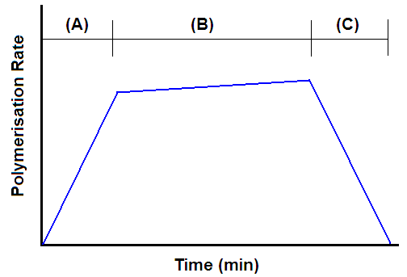
Figure 1.4. Rate of polymerisation (blue line) for a typical emulsion polymerisation showing the difference between interval I (A), interval II (B), and interval III (C).

Interval II
In interval II, the surfactant concentration is now below the CMC, so no more new polymer particles are generated. This means that the polymerisation rate will remain fairly constant (although there may be a slight increase due to the Trommsdorff-Norrish effect)¹⁰ throughout interval II as the monomer supply to polymer particles remains constant. Polymer particles swell with monomer during interval II and higher molecular weight polymer chains are formed (see Figure 1.5 II). This is at the expense of monomer droplets, which act as a reservoir for the particles. Once all the monomer droplets are depleted, interval II is over. No new particles are made in interval II, thus the final size of the polymer particles is essentially determined during interval I.⁵

Interval III
In interval III, the polymerisation rate decreases as the monomer supply is depleted. Ideally, the polymerisation will continue until all the monomer has been used up, reaching a high conversion (>99 %). This is also aided by the relatively low viscosity associated with emulsion polymerisations, since high molecular weight polymer chains are produced in the form of non-solvated latex particles.⁵ Examples of emulsion polymerisation formulations that do not proceed via these stages are monomer-starved (see later) or pre-emulsion polymerisations.
Kinetics of Emulsion Polymerisation
The kinetics of FRP, which include the initiation, propagation and termination steps has already been discussed. Harkins, Smith and Ewart originally studied the kinetics of emulsion polymerisation.^{11, 12} The locus of polymerisation is the monomer-swollen micelles, and the rate of polymerisation can be expressed by equation 1.9:
$R\text{p }\text{= }\frac{\text{k}\text{p}\text{∙n∙C}\text{m,p}\text{∙N}}{\text{N}\text{av}}\text{ ∙}\frac{\text{mol}}{\text{m}\text{w}\text{3}\text{∙s}}$ (1.9)
where k_{p} is the propagation rate coefficient, n is the average number of radicals per particle, C_{m,p} is the average monomer concentration in the particles, N is the number of particles and N_{av} is Avogadro’s number. C_{m,p} is assumed to be constant for interval II, but decreases in interval III.
The average number of radicals per particles is affected by three processes: (1) the absorption of radicals from the aqueous phase into the particles (entry), (2) desorption of radicals from the particle (exit) and (3) termination of the original propagating radical following entry by another radical. This has been studied in detail by Smith and Ewart, who presented three different cases depending on the relative rates of entry, exit and termination.¹²

Case 1: n << 0.5
Exit of radical species is faster than their entry. This can be due to chain transfer to monomer leading to desorption of the propagating polymer chain. Thus particles contain either one polymer radical or no radicals.
Case 2: n = 0.5
Here it is assumed that, when a radical enters a particle, it must remain there until another radical enters to terminate it (absorption is faster than desorption). Since the concentration of polymer radicals [R·] in the reaction medium is constant, the rate of initiation must equal the rate of termination; R_{i} = R_{t}.¹³ Therefore, at any given time, half the particles contain radicals and half do not. This is the most interesting case, as it is the most applicable to real emulsion polymerisations.
Case 3: n >> 0.5
In case 3, when a second radical enters a particle, termination does not occur immediately. Radical desorption is also negligible, meaning that more than one radical can exist per particle.
As discussed earlier for FRP, the rate of appearance of polymer radicals is equal to the rate of their disappearance. Hence new polymer radicals are formed when a particle with n-1 radicals gains a radical.
Predicting the number of particles, N, is rather complicated. Smith and Ewart predicted two cases for the number of particles, N. These concepts are based on ideas originally proposed by Harkins¹⁴ involving the formation of polymer particles by surfactant micelles. However, because of the laws of diffusion, the number of radicals entering a particle will be proportional to its radius. Hence the number entering a given area will be inversely proportional to the radius.¹² Therefore, the number of particles, N, is difficult to predict. The two approximations for dealing with this are “too many particles” and “too few particles”.

“Too many particles” assumes that all free radicals produced will be captured by the very small micelles present during interval I, as long as micelles are still present in the system. Then the rate of formation of new particles, dN /dt, is assumed to be equal to the rate of formation of free radicals:
$\frac{\text{d}\text{N}}{\text{dt}}\text{= ρ}$ (1.10)
where ρ is the rate of formation of free radicals per unit volume of aqueous solution. This prediction ignores the fact that particles, which can also capture radicals, are already present during interval I. Therefore, this calculation over-estimates N. The detailed prediction for N in interval I is given in equation 1.11 below:
$\text{N}\text{ = 0.53 }{\text{(}\frac{\text{ρ}}{\text{μ}}\text{)}}^{\frac{\text{2}}{\text{5}}}\text{ ∙}{\text{(a}\text{e}\left[\text{S}\right]\text{)}}^{\frac{\text{3}}{\text{5}}}$ (1.11)
where μ is the rate of increase in volume of a particle (μ = dv/dt), a_{s} is the surface area occupied by one mole of surfactant, and S is the total amount of surfactant per unit volume of the aqueous phase.
“Too few particles” assumes that a given interfacial area always has the same effectiveness in capturing radicals, irrespective of its surface curvature. However, classical diffusion theory indicates that the diffusion rate, and consequently radical capture, is reduced as surface curvature increases. This prediction leads to an underestimate of N, leading to equation 1.12;
$\text{N}\text{ = 0.37 }{\text{(}\frac{\text{ρ}}{\text{μ}}\text{)}}^{\frac{\text{2}}{\text{5}}}\text{ ∙}{\text{(a}\text{e}\left[\text{S}\right]\text{)}}^{\frac{\text{3}}{\text{5}}}$ (1.12)
Equation 1.12 is identical to equation 1.11, apart from the numerical constant. The actual value lies somewhere between 0.37 and 0.53, as predicted by Smith and Ewart.¹² The dependence of the rate of polymerisation, R_{p}, on the particle number, N, initiator (I) and surfactant (S) concentration is represented in equation 1.13:
$\text{R}\text{p}\text{ \sim }\text{N} {\text{(I)}}^{\frac{\text{2}}{\text{5}}}\text{ ∙}{\text{(S)}}^{\frac{\text{3}}{\text{5}}}$ (1.13)

Colloidal Stabilisation
Flocculation of these latex particles can occur when their colloidal stability is not sufficient to prevent aggregation. Aggregation can be prevented by the use of certain additives such as surfactants, polymeric stabilisers or solid particles. The surfactant can be merely physically adsorbed to the surface of the latex, or it can be chemically grafted. The colloidal stability is determined by the type of stabiliser used. There are two important colloid stability mechanisms: charge and steric stabilisation. Some stabilisers can incorporate both mechanisms, and are said to exhibit electrosteric stabilisation.¹⁵
Charge Stabilisation⁵
Charge (or electrostatic) stabilisation involves ion ordering around charged colloidal particles in high dielectric constant solvents such as water. The charge arising from the ionised surface groups leads to a build-up of a diffuse layer of oppositely-charged ions around the particles. This is known as an electrical double layer, or EDL (see Figure 1.6a). This ionic atmosphere can be created using an ionic initiator such as ammonium persulfate (APS) or 2,2'-azobis[2-methylpropionamidine] dihydrochloride (AIBA). Each initiator fragment confers either a negative charge (APS) or a positive charge (AIBA). Alternatively, charged surfactants, such as sodium dodecyl sulfate (SDS), can be adsorbed to the surface of the particles during polymerisation to create the EDL, thus preventing particle aggregation. When two particles approach, EDL interpenetration is energetically unfavourable (see Figure 1.6b), leading to particle repulsion. This is due to a large potential energy maximum (ΔE_{max}) relative to kT (where k is the Boltzmann constant and T is the solution temperature), which provides an effective barrier to aggregation. Charge stabilisation can be reduced when using a less polar solvent or by the addition of electrolytes. This reduces the kinetic energy barrier ΔE_{max}, leading to flocculation of the particles.

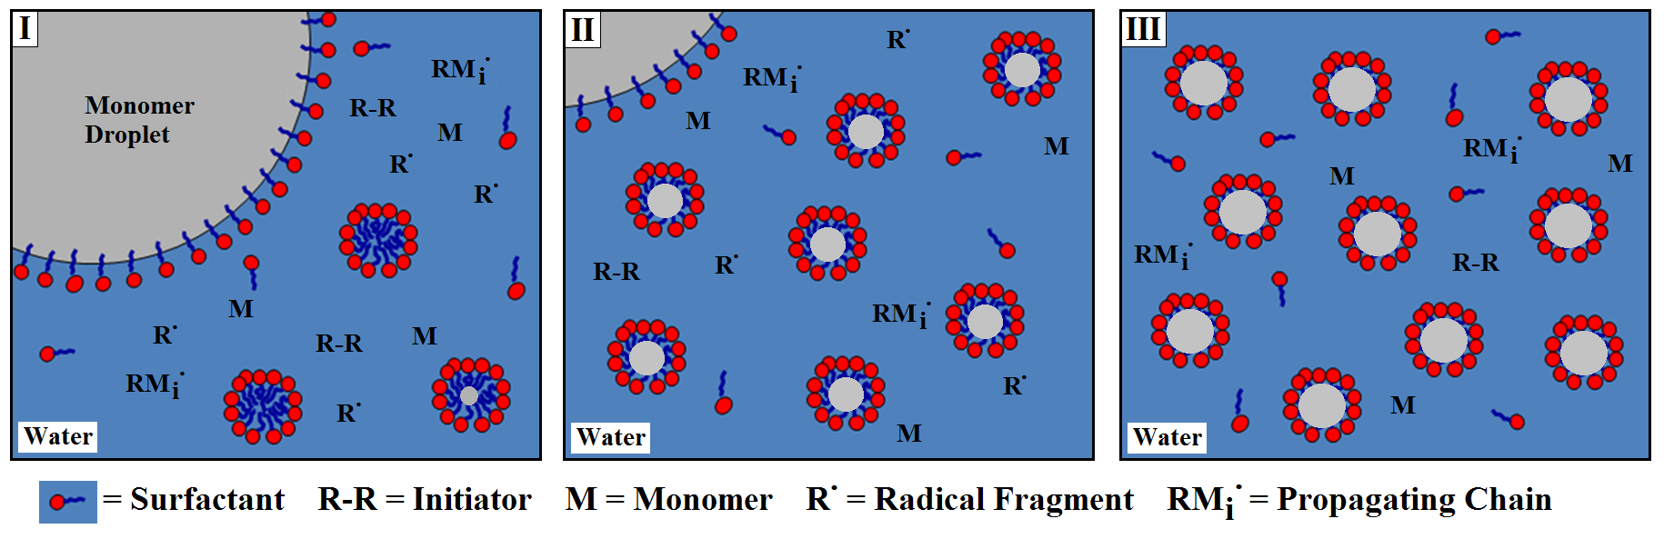
Chapter One - Introduction
Figure 1.5. Schematic representation illustrating the main components present in an emulsion polymerisation during intervals I to III.
15

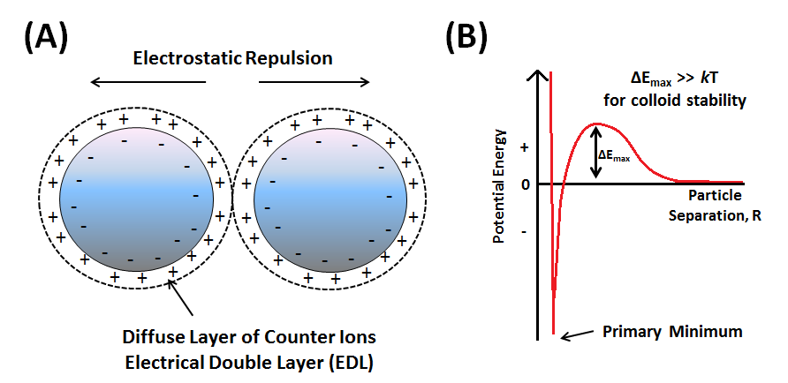
Figure 1.6. (A) Close approach of two anionic colloidal particles surrounded by EDLs, which lead to charge stabilisation. (B) Potential energy curve for the same two charge-stabilised particles as a function of particle separation, R..

Steric Stabilisation⁵
This colloidal stability mechanism utilises adsorbed polymer layers to prevent irreversible aggregation of particles.⁵ Certain homopolymers, such as poly(N-vinyl pyrrolidone) (PNVP) can be used as steric stabilisers, but generally block, graft or statistical copolymers are more effective. In addition, macromonomers such as monomethoxy-capped poly(ethylene glycol) methacrylate (PEGMA) can be chemically grafted onto the latex surface during in situ copolymerisation (see inset, Figure 1.7 A and B).
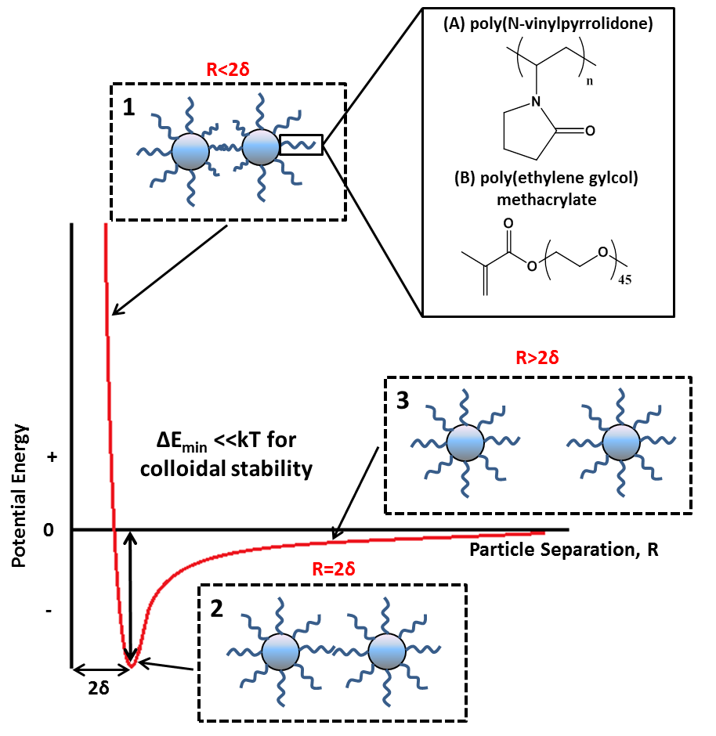
Figure 1.7. Potential energy curve for two sterically stabilised particles each with a stabiliser thickness δ, and with separation distances of (1) less than 2 δ, (2) equal to 2 δ, and (3) greater than 2 δ.⁵ Inset: Some common steric stabilisers, (A) poly(N-vinylpyrrolidone) (PNVP) and (B) poly(ethyleneglycol) methacrylate (PEGMA) used to provide steric stability.

Macromonomers can be prepared via living radical polymerisation using a tertiary amine-functional initiator, followed by quaternisation of the terminal amine groups using 4-vinylbenzyl chloride.¹⁶ The stabiliser thickness (δ) around the particles dictates whether they are dispersed or flocculated. When two particles come together, the distance between them, R, is 2δ. If R is less than 2δ, then the ever present Van der Waals attractive forces operating between the particles can cause flocculation. If R is greater than 2δ then particle separation can occur. The value of δ will depend on how long and hydrated the stabiliser chains are. For example, if a poor solvent is used, then δ is reduced accordingly as the stabiliser chains collapse. Sterically stabilised particles are much more tolerant to added electrolyte (presence of salt) as they do not rely on EDL formation (c.f. charge-stabilised particles). Such sterically-stabilised particles are thermodynamically stable, provided that ΔE_{min} is less than kT (where k is the Boltzmann constant and T is the temperature of the system, see Figure 1.7). If ΔE_{min} exceeds kT, the particles become flocculated since they do not have enough kinetic energy to escape the potential energy well. However, this can be reversed if sufficient energy is applied to the system. Steric stabilisation can also work well for concentrated dispersions, even in non-polar media.⁵
Monomer-Starved Emulsion Polymerisation
Monomer-starved emulsion polymerisation is a type of semi-batch polymerisation, and is the most widely used of all emulsion polymerisation formulations. The most important factor for such processes is the controlled introduction of monomer (or copolymer) to the reaction vessel during polymerisation. However, in order to obtain control over the particle size distribution, 5-10% of the total monomer contribution is added at the beginning of the reaction and allowed to reach complete conversion. This is known as the seed stage.⁵ The surfactant concentration is also carefully monitored during the polymerisation. This component is normally introduced at the outset of polymerisation. If the surfactant concentration becomes too high, new particles can be formed; this is known as secondary nucleation. Conversely, if the surfactant concentration is too low, seed particles are more likely to coagulate, which can lead to decreasing particle numbers, and a larger final particle size.⁵ In terms of ensuring semi-batch conditions, the rate of monomer addition is the most important parameter. Monomer is added either alone (monomer addition) or as an emulsion (emulsion addition). It should be noted here that both types of addition can have varying effects on the final particle size and the particle size distribution.⁵ For example, during “emulsion addition”, the surfactant concentration will be lower during the seed stage. Therefore, in comparison to “monomer addition”, all the surfactant is present at the start, so the number of particles formed will be greater than that achieved during “emulsion addition”.
The rate of monomer addition also determines whether the polymerisation behaves as a batch or semi-batch process. This is because it controls the availability of monomer. If the rate of monomer introduction, R_{m}, is faster than the maximum rate of polymerisation, R_{p}^{max}, (i.e. R_{m} > R_{p}^{max}) then the conditions are essentially monomer-flooded, and become indistinguishable from a conventional batch polymerisation. Only when R_{m} < R_{p}^{max} do monomer-starved conditions prevail.⁵
Monomer starved emulsion polymerisation processes advantages over conventional polymerisations such as: 1) flexibility of adding more reactants over time; 2) improved monomer selectivity; 3) better control over temperature, especially exothermic polymerisations; 4) continuous product removal and 5) minimised unwanted side products.
Stimulus-Responsive Hydrogels
Stimulus-responsive polymers (SRPs) are smart materials that can rapidly change their configuration, dimension or physical properties when subjected to changes in external stimulus. Such materials can be sensitive to changes in temperature,¹⁷⁻²⁰ pH,²¹⁻²⁴ ionic strength,^{25, 26} and electric field.²⁷ Over the past decade, much research interest has focused on the design of various stimulus-responsive hydrogels. These hydrogels are cross-linked polymer networks that but swell (or collapse) when immersed in aqueous solution under various conditions (see Figure 1.8). They are classed as either macrogels²⁸⁻³¹ or microgels³²⁻³⁴ according to their size. These hydrogels are cross-linked polymer networks, which prevent the dissolution of the hydrophilic polymer chains. The main advantage of such water-swellable hydrogels is that they can adsorb up to one thousand times their dry weight in water.^{35, 36} This property has found use in devices such as contact lenses,³⁷ drug delivery,³⁸ and tissue engineering.³⁹⁻⁴¹
Figure 1.8. Schematic representation of the formation of microgels from cross-linked nanoparticles.
Cross-Linking of Hydrogels
In order for the hydrogel network to remain intact and prevent dissolution following hydration, cross-links are required so that the original polymer architecture is “remembered”. Hydrogels can be classified in terms of their size (macrogels vs microgels, see above) as well as the type of cross-linking used to maintain the swollen hydrogel structure. There are two types of cross-linking that can maintain the hydrogel structure; physically cross-linked and chemically cross-linked hydrogels.
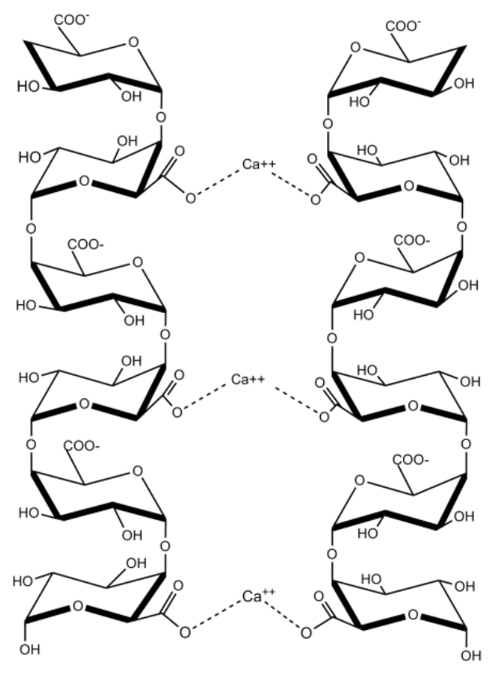
Figure 1.9. Schematic representation of calcium cross-linking in homogalacturonan (HG) polysaccharides. These properties favour the gelation process [reproduced with permission].⁴²

Physically cross-linked hydrogels generally rely on non-covalent attractive forces between polymer chains, which are usually either hydrophobic in nature, ionic interactions or hydrogen bonding. These hydrogels were originally designed to be degradable once inside the body, therefore delivering a water-soluble payload following dissolution of the polymer network.⁴³ Wu et al, demonstrated that hydrogels composed of poly(vinyl alcohol) (PVA) and amine-terminated polyamidoamine dendrimer could be prepared by simple mixing, followed by freeze-thaw cycling the solution.⁴⁴ Another example of ionic cross-linking is that of polysaccharides, which form hydrogels in the presence of Ca ²⁺ ions (see Figure 1.9). Such gels have been used by food technologists for the preparation of jams, candies and processed fruit products. These gels comprise highly methylated homogalacuronans (HGs); they have a short compact structure, are transparent and allow good preservation of original flavours; such gels are also thermo-reversible. In contrast, HGs with relatively low degrees of methylation are thermally-irreversible materials that only gel in the presence of multivalent ions (Ca ²⁺, Mg ²⁺).

Chemically cross-linked hydrogels are more stable than physically cross-linked hydrogels, due to the formation of covalent bonds between the polymer chains. This type of hydrogel is often produced by polymerising monomers in the presence of a divinyl cross-linking agent, see Figure 1.10.

Figure 1.10. Common divinyl monomers that are polymerisable by free radicals during the synthesis of latex particles via emulsion polymerisation to produce cross-linked particles.

Various physical properties of hydrogels such as their swelling capacity,^{45, 46} their effective pK_{a} (hereafter referred to as simply the pK_{a} in this thesis)^{47, 48} or hydrophobicity⁴⁵ can be controlled by varying the amount of cross-linker. Hydrogels can also be cross-linked via various functional groups present on the polymer backbone.⁴⁵ Recently, Rosselgong et al.^{49, 50} utilised disulfide-based cross-linkers (DSDMA) as a tool for the quantification of intra-vs inter-molecular branches via ¹H NMR. It was shown that, for polymerisations conducted at relatively high concentrations (50 %), intermolecular branching becomes more prevalent, whereas intramolecular branching is favoured at lower concentrations (10%). However, it should be noted that reversible addition−fragmentation chain transfer (RAFT) polymerization and atom transfer radical polymerization (ATRP) were utilised in the synthesis of these soluble branched polymers, rather than conventional FRP.

Thermo-Responsive Hydrogels

The most studied example of a synthetic thermo-responsive hydrogel is poly(N-isopropylacrylamide) (PNIPAm) due to its distinctive behaviour in aqueous solution. PNIPAm undergoes a relatively sharp coil-to-globule transition in water at 32 °C.⁵¹ At temperatures below this lower critical solution temperature (LCST), water is strongly hydrogen-bonded to the amide side chains, as well as forming some structured water around the isopropyl group (see Figure 1.11). Hence the polymer is water-soluble below its LCST. Above this LCST, the hydrogen-bonded water molecules are released from the isopropyl groups, with polymer-polymer interactions becoming favoured (see Figure 1.11.).
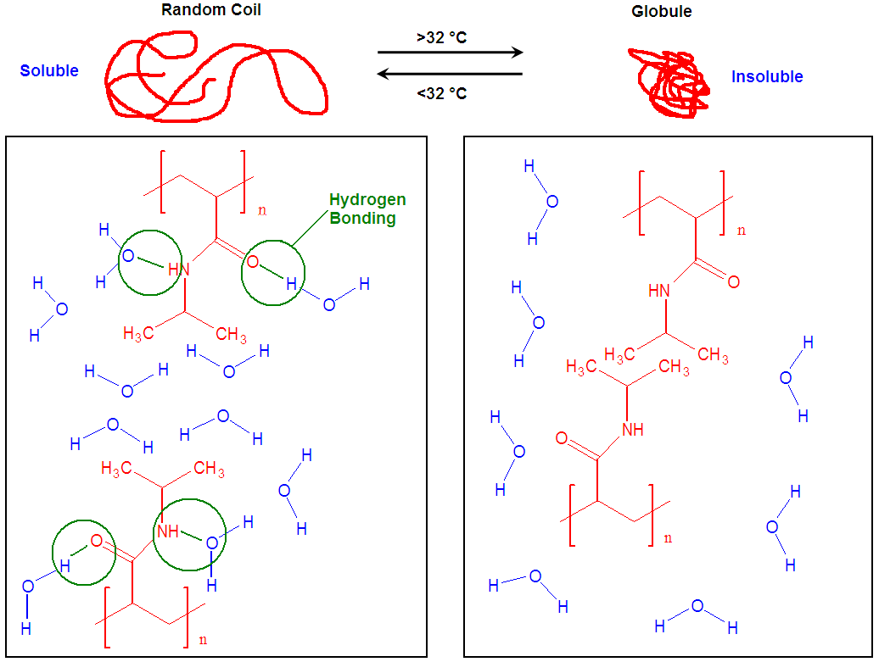
Figure 1.11. The thermo-responsive transition of PNIPAm showing the polymer-solvent interactions present below the LCST, and the polymer-polymer interactions above the LCST.
Microgels based on PNIPAm also display the temperature responsive behaviour noted above. Microgels between 50 nm and 5 μm have been reported.⁵¹ When cross-links are employed, the dissolution of linear polymer at temperatures below 32 °C is prevented. Hu et al.⁵² synthesised microgels with interpenetrating polymer networks composed of PNIPAm and poly(acrylic acid), and found its dispersion upon heating. Liao et al.⁵³ prepared PNIPAm microgels of 190 nm via emulsion polymerisation in the presence of N,N’-methylenebis(acrylamide) (BIS), and SDS surfactant. These particles were found to exhibit a volume phase transition temperature (VPTT) associated with such thermo-responsive microgels. At temperatures below 32 °C a swollen microgel state is observed, see Figure 1.12. Polymerisation of NIPAm under emulsion conditions is preferred at high temperature since both the monomer and latex remains insoluble at temperatures above 32 °C, hence avoiding gelation.

Figure 1.12. Hydrodynamic diameter vs temperature for 190 nm (20 °C) PNIPAm microgels prepared via emulsion polymerisation in the presence of BIS cross-linker and SDS. NaCl concentration (wt %) = 0 (☆), 0.9 (□), 3.0 (○) and 5.0 (Δ).⁵³

Choi et al.⁵⁴ also utilised copolymers of PNIPAm with poly(acrylic acid) for the targeting cells. The acid functional groups present on the acrylic acid were reacted with excess ethylene diamine to convert them into amine groups. Conjugation of galactose to these amine groups then allowed the microgels for the targeted delivery of drug carriers.
pH-Responsive Hydrogels
Polymers that contain ionisable functional groups that show a response to changes in pH are referred to as pH-responsive polymers. Protonation (or deprotonation) along a polymer backbone generates charge, which dramatically increases the repulsion between monomer repeat units. This charge repulsion results in a substantial increase in the hydrodynamic volume of the polymer. If cross-linked, the particle undergoes a swelling transition, usually from a latex to a microgel. Some polymers that show such a pH response are poly(acrylic acid), poly(methacrylic acid) (PMMA), poly(2-vinylpyridine) (P2VP), poly(2-(diisopropylamino)ethyl methacrylate) (PDPA), poly(2-(diethylamino)ethyl methacrylate) (PDEA), poly(2-dimethylamino)ethyl methacryl and poly(ethyleneimine) (PEI). The corresponding pH-responsive hydrogels can be separated into two categories according to their chemical structures: polyacid hydrogels are based on acid monomers, and generally swell at high pH, whereas polybase hydrogels are based on amino monomers, and generally swell at low pH. Other pH-responsive hydrogels can be prepared comprising both acidic and basic monomers. These are called zwitterionic hydrogels, which become hydrated at both high and low pH. However, there are very few literature examples on these zwitterionic hydrogels, because their synthesis is demanding. Tan et al. has shown that emulsion copolymerisation of MAA and DEA in the presence of PEGMA macromonomer can yield zwitterionic latex particles of ~100 nm.⁵⁵ These particles produced highly swollen microgels at both low pH (from protonation of PDEA units) and high pH (from deprotonation of PMAA), see Figure 1.13).

Figure 1.13. Schematic representation of the formation of swollen zwitterionic microgels from PEGMA-P(MAA-DEA) cross-linked latex particles at both high and low pH (not drawn to scale).

Polyacid Hydrogels
Polyacid hydrogels are cross-linked polymer networks that contain acidic groups. These become deprotonated at high pH, increasing the hydrodynamic diameter upon hydration. The majority of polyacid hydrogels are based on acrylic or methacrylic acid monomers. Xu et al.⁵⁶ utilised the electrostatically driven interaction between ionic groups present at high pH and precursor cations into the interior of the microgel (see Figure 1.14).
Figure 1.14. Schematic representation of the formation of microgel-based syntheses of hybrid core-shell particles.⁵⁶
Following this, the cations were reacted with an anion (to produce semiconductor nanoparticles) or treated with a reducing agent (to produce metal nanoparticles). Upon heating, the thermo-response of the PNIPAm allowed the VPTT behaviour to expel water, forming a hydrophobic polymeric shell.⁵⁶
Polybasic Hydrogels
Polybasic hydrogels are cross-linked polymer networks that contain amine functional groups. These become protonated at low pH, increasing the hydrodynamic diameter upon hydration. The structures of basic monomers (2VP, 4VP, DEA) that have been synthesised by emulsion polymerisation to produce pH-responsive particles are shown in Figure 1.2. Loxley and Vincent reported the syntheses of near-monodisperse charge-stabilised P2VP latexes with various amounts of divinylbenzene (DVB) cross-linker.⁴⁶ These particles were found to produce swollen microgel particles below pH 4.5 (see Figure 1.15). However, the initial DVB concentration was found to have an effect on the swollen microgel diameter at pH 3.6. Smaller swelling ratios were obtained by increasing the DVB concentration. Such cross-linking was also found to limit the maximum transmission when a pH-jump to 3.8 was monitored using a stopped-flow apparatus.⁴⁶ Interestingly, incorporation of 20 mol % styrene was found to have a similar effect.
Figure 1.15. Variation of the hydrodynamic diameter with solution pH for P2VP microgels prepared with various DVB concentrations (wt %); (●) 0.25; (■) 0.5; (▲) 1.5.⁴⁶
More recently, Dupin et al.⁴⁷ developed the synthesis of PEGMA-stabilised P2VP latexes by aqueous emulsion polymerisation. It was shown that judicious selection of the synthesis parameters allowed precise variation in the final latex diameter between 370 and 1010 nm .The pK_{a} for such particles was reported to be 4.2 (0.8 mol % DVB cross-linked)⁴⁷, below which the latex-to-microgel transition was observed for each diameter (see Figure 1.16).
Figure 1.16. Variation of mean hydrodynamic diameter with solution pH for aqueous solutions of PEGMA-stabilised P2VP latexes with hydrodynamic diameters at pH 10 of: 370 nm (□), 480 nm (■), 560 nm (●), 640 nm (▲), 830 nm (★), and 1010 nm (Δ).⁴⁷

The kinetics of swelling for these P2VP particles was also reported.⁵⁷ The latex-to-microgel swelling transition occurred rapidly, and the characteristic swelling time for each particle correlated that predicted by the Tanaka equation.⁵⁸ Moreover, the swelling kinetics for P2VP was found to be considerably faster than methacrylic latex particles based on PDPA or PDEA. It was hypothesised that the low T_{g} methacrylic particles would swell quicker from faster diffusion of the hydrogen atom, however this was not observed. The deswelling kinetics for the microgel-to-latex transition was also reported, and required much longer timescales compared to the swelling (0.5-1.0 seconds).⁵⁹ This topic is covered in more detail in Chapter five.
Dupin et al. also synthesised P2VP particles in the presence of a styrene-functionalised PDMA macromonomer.⁶⁰ The conditions required for efficient polymerisation were found to be crucial. The pK_{a} for the PDMA macromonomer was reported to be approximately 6.9, therefore the initial solution pH was adjusted (to either 6.9 or 7.5) in order for well-defined PDMA-P2VP particles to be synthesised. The advantage of a pH-responsive steric stabiliser, as well as a pH-responsive core allowed three separate morphologies to be attained: 1) swollen cationic microgels were obtained below pH 4.1, 2) nonsolvated latex particles with a cationic stabiliser layer were obtained at intermediate pH, and 3) flocculated latex particles with neutral PDMA stabiliser chains were obtained at around pH 8.5. The aqueous was found determine the Pickering emulsifier performance of these particles (see later).
There are relatively few literature studies on acid-swellable, methacrylic-based microgels. This is potentially because the methacrylic polymers have a relatively low T_{g}, compared to P2VP or P4VP, making them soft and film forming. Amalvy et al.⁶¹ reported the synthesis of PEGMA and PDMA₅₀-stabilised PDEA and PDPA latexes via aqueous emulsion polymerisation at pH 8-9. These particles were lightly cross-linked with poly(propylene glycol) diacrylate (PPGDA) to provide reversible pH behaviour. The critical swelling pH, for both PDEA and PDPA, was close to the respective pK_{a} suggesting that 50 % protonation of the polymeric core is sufficient to induce the latex-to-microgel transition. However, the PDEA and PDPA latexes prepared in this study were polydisperse in nature, with no control over the final particle diameter.
Figure 1.17. Variation of mean hydrodynamic diameter with solution pH for aqueous solutions of PDMA₅₀-PDEA (▲), PEGMA-stabilised PDEA (●), and PEGMA-PDPA (■).⁶¹
Pickering Emulsions
As stated at the start of this Chapter, emulsions stabilised by solid particles that self-assemble at the oil/water interface to prevent the coalescence of two liquids are known as Pickering emulsions. Colloidal particles are not amphiphilic like conventional surfactants. Instead, particles but adsorb at interfaces simply to minimise their interfacial area. Consider particles that adsorb at the oil/water interface, and are small enough to neglect the effect of gravity (i.e. are less than a few microns in diameter). Thus the energy, E, required to remove the particle from the interface is expressed by equation 1.14:
$\text{E }\text{=} \text{π}\text{r}\text{2}\text{γ}\text{ab} \text{(1±}\text{cos}{\text{θ}\text{)}\text{2}}$ (1.14)
Where r is the radius of a spherical particle, γ_{ab} is the tension at the fluid-fluid interface (typically oil/water) and θ is the particle contact angle. The sign in the brackets is negative for the removal of the particle into the aqueous phase, and positive for its removal into the oil phase. Therefore, it is easier (less energy required) to detach the particle into the water phase if θ < 90°, and easier to detach it into the oil phase if the θ > 90°. If we consider particles adsorbed at the oil/water interface, the calculated E is greatest for θ = 90° and falls rapidly at either higher or lower θ. Hence, particles with θ close to 90° form stable Pickering emulsions. Those which are highly hydrophobic or hydrophilic (θ = 20° or 160°, respectively) do not act as Pickering emulsifiers. Therefore, if the emulsifier wettability is too hydrophilic or hydrophobic, then the particles will remain dispersed in either the aqueous or oil phase and stable emulsions may not be formed. Indeed, this is a major advantage of designing responsive organic particles that can have their properties tuned. Thus particle wettability is one of the major factors that affect Pickering emulsifier performance.⁶² Other important parameters include particle size, shape, concentration, particle-particle interactions, temperature and electrolyte concentration.^{62, 63} Changing any one of these parameters can have a significant effect on the emulsifier performance.
Particle wettability dictates whether emulsifiers produce w/o or o/w emulsions.⁶⁴ If particles are hydrophilic, θ will be less than 90°, and the particles are located preferentially in the water phase (see Figure 1.18). This favours the formation of oil-in-water emulsions. If the particles are more hydrophobic (θ > 90°), the adsorbed particle will preferentially reside more in the oil phase, producing water-in-oil emulsions (see Figure 1.18). It should be noted that this holds true when the volume fraction is 0.5. Changing the volume fraction can lead to phase inversion.³
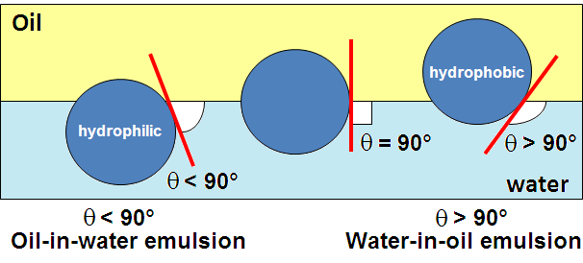
Figure 1.18. Location of particles at the oil/water interface exhibiting different contact angles, which affects the type of Pickering emulsions produced. If the emulsifier particles are hydrophilic (left), their contact angle is less than 90°, producing oil-in-water emulsions. If the particles are hydrophobic, then the contact angle is more than 90° and water-in-oil emulsions are produced.³

There have been many reported methods of measuring the particle contact angle at the oil/water interface. Some examples include: (i) measuring the liquid penetration rate on a compressed powder bed;⁶⁵⁻⁶⁷ (ii) measuring the contact angle directly from a water drop on a powder tablet;⁶⁸ (iii) using optical microscopy to image the particle at the interface;⁶⁹ (but the lower limit particle size for this technique is 20-30 µm); and by (iv) by trapping techniques.^{70, 71} The latter approach involves trapping the particles at the air-water or oil-water interface either by using films (the so-called film trapping technique, or FTT)⁷⁰ or by using gels ( the so-called gel trapping technique, or GTT)⁷¹.
However, these techniques require numerical solutions to equations and are highly susceptible to error (FFT) or require imaging of many particles using SEM (GTT), making each measurement rather time-consuming. More recently, Horozov et al. reported the determination of particle contact angles directly using the film calliper method (FCM).⁷² FCM utilises the particle behaviour when it is in contact with both surfaces. It can be performed in real time, and contact angles measured by this method agree with those from other techniques. However, the lower limit particle diameter is only around 600-800 nm.
As stated previously, one of the major factors in the stability of these Pickering emulsions is the use of particles with appropriate wettability. An advantage of using organic latex particles as the emulsifier is that their surface properties can be readily designed by varying the comonomer/stabiliser composition. This allows the particle contact angle to be varied. One of the first reports of the use of these latexes to stabilise Pickering emulsions was by Velev and co-workers, who used charge-stabilised polystyrene (PS) particles to stabilise 1-octanol droplets.⁷³ In this case, surface functional groups (either sulfate or amidine) conferred charge stabilisation. Other research groups used charge-stabilised PS latex to investigate the packing of particles at the interface. For example, Aveyard et al. reported the formation of ordered monolayers by sulfate-functionalised PS latexes of 0.2 to 2.6 µm diameter at both the air/water and oil/water interface.⁷⁴
Other literature examples of latex-based Pickering emulsifiers have utilised the pH-responsive nature of steric stabiliser chains to tailor their emulsifier performance. The use of a polyamine-based steric stabiliser allows the latex surface wettability to be tuned by varying the solution pH. For example, poly[2-(dimethylamino)ethyl methacrylate-block-methyl methacrylate] [PDMA-PMMA] has been used as a steric stabiliser for the synthesis of PS latexes.⁷⁵⁻⁷⁸ If n-dodecane is used as the oil phase, and the solution pH is 2-3 (i.e. below the pK_{a} of the PDMA stabiliser), then these particles do not stabilise Pickering emulsions. However, if the PDMA chains are deprotonated, and homogenisation is undertaken above their pK_{a} of ~7.0,⁷⁷ stable Pickering emulsions can be formed using n-dodecane (see Figure 1.19). These can be classed as pH-dependent emulsifiers, as the solution pH is critical to whether a Pickering emulsion is formed. ^{77, 78} The first reported example of pH-responsive Pickering emulsifiers was by Fujii et al., who used poly(4-vinyl pyridine)/silica (P4VP/SiO₂) nanocomposite microgels to stabilise n-dodecane, methyl myristate and 1-undecanol droplets.⁷⁹ These emulsions were readily broken on dropping the solution pH below the pK_{a} of the P4VP chains, see Figure 1.20.^{79, 80} The pH-responsive nature of these nanocomposite emulsifiers is due to protonation of the pyridine groups.^{81, 82} If lightly cross-linked using ethylene glycol dimethacrylate [EGDMA], the nanocomposite particles acquire microgel character, rather than undergo dissolution.
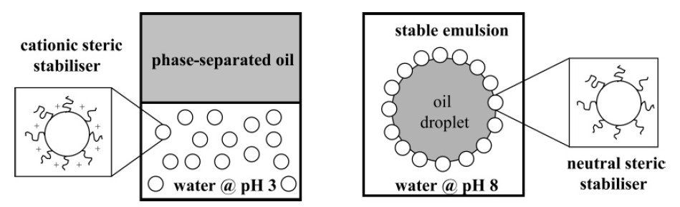
Figure 1.19. Schematic representation of the effect of solution pH on attempted emulsification for the n-dodecane/water system. Stable n-dodecane-in-water emulsions are obtained at pH 8, but no emulsion is formed at pH 3.^{77, 78}

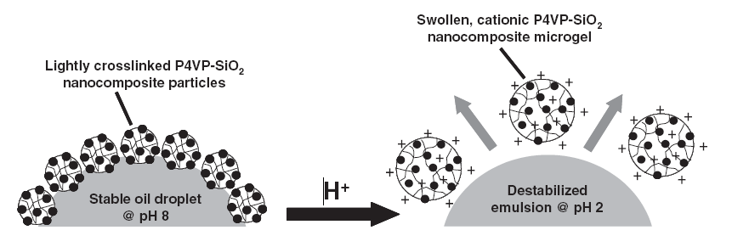
Figure 1.20. Schematic representation of the pH-induced demulsification of an o/w emulsion using lightly cross-linked P4VP/SiO₂ nanocomposites as Pickering emulsifiers.⁷⁹

The swollen microgel particles exert substantial lateral pressure on their neighbours, leading to their spontaneous desorption from the oil/water interface. Subsequent deprotonation of the nanocomposite microgel and re-homogenisation of the oil phase allows the particles to be re-used as a Pickering emulsifier, although some loss of silica occurs and the new emulsion is typically somewhat coarser.^{79, 83} Interestingly, in the absence of any cross-linker, demulsification does not occur because the dissolved cationic polyelectrolyte chains substantially increase the viscosity of the aqueous phase and hence dramatically retard the rate of droplet coalescence.⁸⁰

As stated earlier, Dupin et al. found that pH-responsive latexes based on 2VP could be synthesised using a pH-responsive steric stabiliser, PDMA.⁶⁰ The P2VP core and the PDMA stabiliser have differing pK_{a} values (4.1 and 7.0, respectively). Thus these particles can exist in three different states (see Figure 1.21). Such latexes were found to be both pH-dependent and pH-responsive Pickering emulsifiers for 1-undecanol. Surprisingly, water-in-1-undecanol emulsions were obtained above pH 8, in contrast to o/w emulsions formed by earlier PDMA-stabilised latexes.⁷⁷ Such changes in the Pickering emulsifier performance upon protonation of the PDMA chains highlights crucial role played by the stabiliser in determining particle wettability.
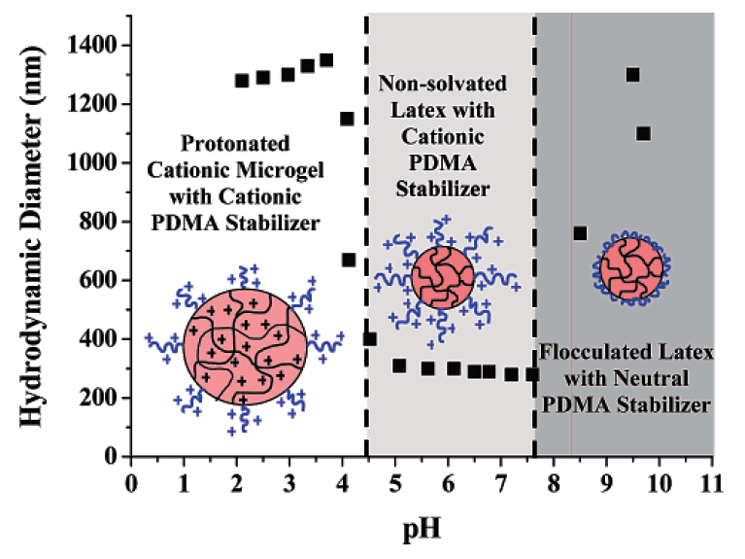
Figure 1.21. Schematic representation of the variation of the mean hydrodynamic diameter with solution pH for a 0.01 wt % aqueous solution of PDMA-P2VP latex in the presence of 0.01 M NaCl.⁶⁰

Binks et al.⁸⁴ prepared stimulus-responsive PS particles using a poly[2-(dimethylamino)ethyl methacrylate-block-PMMA] (PDMA-b-PMMA) steric stabiliser. These particles acted as effective Pickering emulsifiers for o/w emulsions when n-hexadecane was homogenised at pH 8.1 and 25 °C. Once formed, the stable emulsions were heated to 70 °C (above the LCST of the PDMA), which resulted in significant coalescence. In contrast, w/o emulsions were stabilised if the heat cycle to 70 °C was performed prior to homogenisation (see Figure 1.22). This is due to disruption of the water molecules around the PDMA stabiliser chains, causing an increase in hydrophobicity. Thus, the lipophilic particles prepared via heating preferentially wetted the oil phase when homogenised with n-hexadecane. This system is best described as temperature-dependent, rather than temperature-responsive.
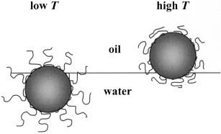
Figure 1.22. Schematic representation on the effect of temperature, T, on the position of a sterically stabilised polystyrene latex particle adsorbed at an oil–water interface. Emulsions stabilised by such particle monolayers are o/w at low T and w/o at high T.⁸⁴

Colloidosomes
Colloidosomes are microcapsules whose shells are composed of colloidal particles that are locked in place, conferring additional stability to the emulsion.⁸⁵ Pickering emulsions have been used to prepare so-called colloidosomes due to the close-packing of colloidal particles at the oil/water interface. These particle superstructures have attracted much interest due to their possible use as an efficient and non-destructive encapsulation vehicle for the controlled delivery of payloads.⁸⁶ In principle, colloidosomes could be used for the release of drugs, pesticides, insecticides and perfumes, making them commercially attractive.
The first reported case of colloidosomes was in 1996 by Velev and co-workers, who reported the adsorption of latex particles onto emulsion droplets to form hollow “supraparticles”.⁷³ However, the term “colloidosome” was not coined until 2002, when Dinsmore et al. sintered latexes to form permeable microcapsules made up of colloidal particles (see Figure 1.23).⁸⁶ In this work, micrometer-sized PS or PMMA latexes were used to prepare Pickering emulsions with a 50:50 mixed oil phase comprising vegetable oil and toluene. This emulsion was heated to 105 °C for 5 minutes to fuse the PS particles together to form the colloidosome microcapsules (the glass transition temperature (T_{g}) of PS is ~100 °C).
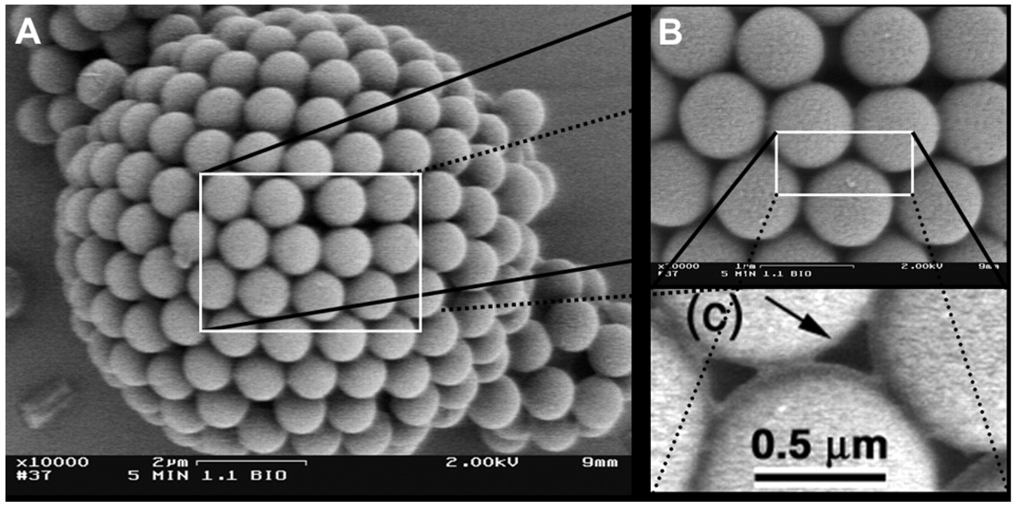
Figure 1.23. (A) Scanning electron microscope image of a dried, 10 μm diameter colloidosome composed of 0.9 μm diameter polystyrene latex sintered at 105°C for 5 min. (B and C) High magnification images of (A) and (B), respectively.⁸⁶
However, due to the hexagonal close-packing of the spherical particles at the oil/water interface,^{87, 88} interstices in the colloidosome shell will always be present (see Figure 1.23C), making encapsulation of active agents highly problematic. In principle, varying the comonomer composition of the latex enables a reduction in the latex particle T_{g}, which can significantly reduce the temperature required to sinter the particles.⁸⁹ Furthermore, using a known co-solvent for the latex (as part of the oil phase) can effectively reduce the temperature required for the sintering of PS shells. For example, PS has a UCST of 35 °C in cyclohexane. Thompson et al. incorporated 20 % cyclohexane into the oil phase, and found that sintering the emulsion at 70 °C was sufficient in closing most of the colloidosome interstices ¹⁶ Reducing the effective particle T_{g} may also allow film-forming particles to close these interstices. Low T_{g} methacrylates are known to be very difficult to image via electron microscopy,⁶¹ but this may be an attribute when encapsulating an active agent. This could also be potentially beneficial for the encapsulation of thermally sensitive compounds. Routh et al.^{90, 91} used styrene/n-butyl acrylate copolymer latexes to prepare water-core colloidosomes of a few microns in size. Sintering was conducted between 35 and 65 °C, but a co-surfactant (Span 50) was required to ensure efficient adsorption of the particles at the interface. Yuan et al.⁹² also prepared thermally annealed colloidosomes based on P(DMA-MMA)-stabilised PS particles. These particles were also covalently cross-linked using 1,2-bis-(2-iodoethoxy)ethane (BIEE) to quaternise the PDMA surface-grafted amine groups.
Techniques other than sintering of interfacially-adsorbed latex particles include in situ gelation⁹³ or covalent cross-linking.¹⁶ Cayre et al. found that w/o emulsions prepared using PS latexes could be further stabilised by gelling the aqueous phase using an appropriate water-soluble hydrocolloid.⁹³ Aqueous gelators were found to be crucial in the formation of stable colloidosomes (with respect to ethanol washing and centrifugation), which were confirmed via electron microscopy.
Colloidosomes have also been obtained within the Armes group by utilising surface functional groups on latexes to covalently cross-link the particles at the oil/water interface. This method removes the need for an internal aqueous gelator, and also the high temperatures required for sintering. Thompson et al. recently demonstrated this concept by using a near-monodisperse poly(glycerol monomethacrylate) (PGMA; mean degree of polymerisation, DP = 30, 50 or 70) macromonomer to prepare PGMA-PS latexes, which in turn stabilise o/w emulsions.¹⁶ The hydroxyl functional stabiliser chains can then be cross-linked using toluene 2,4-diisocyanate-terminated poly(propylene glycol) (PPG-TDI) to form a urethane bond (see Figure 1.24). The internal oil phase (plus any unreacted PPG-TDI) was removed via an alcohol wash to leave the original latex superstructure intact, as judged by SEM (see Figure 1.25(A)). The release of a small molecule (fluorescein dye) from within these colloidosomes was not retarded when dissolved in the oil phase prior to homogenisation, indicating the highly “leaky” nature of colloidosomes. Furthermore, release of the dye (up to 40 %) was reported within 20 hours even when the colloidosome microcapsules were coated in an overlayer of a conducting polymer, polypyrrole (see Figure 1.26).
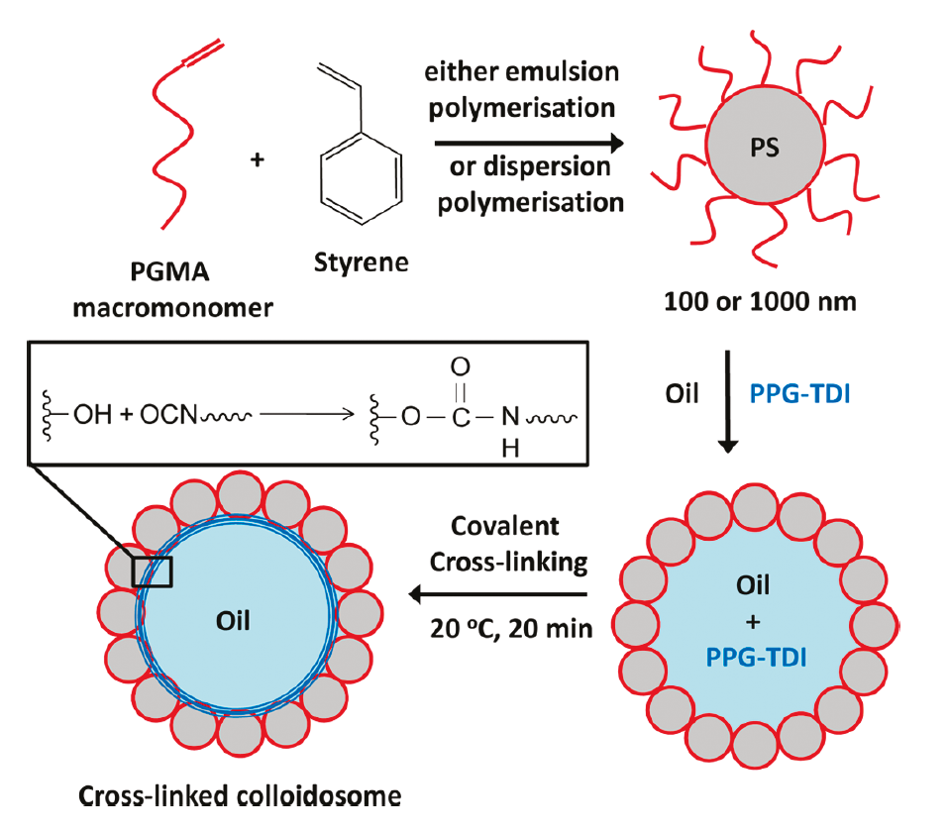
Figure 1.24. Covalently cross-linked colloidosomes prepared by self-assembly of PGMA₅₀-PS latex particles around oil droplets in the presence of the oil-soluble PPG-TDI cross-linker.¹⁶

However, it has been shown that colloidosomes can successfully retain colloidal particles or macromolecules, as long as the active agent is larger than the defects that are present in the colloidosome microstructure. Rosenberg and Dan⁹⁴ found that the release of caffeine, aspirin and dextran from hydrogels covered with a monolayer of spherical particles was slightly retarded compared to uncoated hydrogels. Furthermore, the rate of release was independent of the shell particle diameter. Recently, Keen et al. demonstrated that yeast cells could be readily encapsulated and subsequently used to metabolise glucose within colloidosomes composed of a copolymer poly(methyl methacrylate-co-butyl acrylate) latex shell.⁹⁵
Figure 1.25. Scanning electron micrographs of cross-linked colloidosomes prepared with 118 nm PGMA₅₀-PS latex and sunflower oil encapsulated with fluorescein dye: (A) no polypyrrole, (B) 0.66 wt % polypyrrole loading and (C) 1.32 polypyrrole loading.¹⁶
Figure 1.26 Release curves obtained at pH 9 for fluorescein dye diffusing from: sunflower oil control (closed diamonds), uncoated cross-linked colloidosomes prepared with 1188 nm PGMA₅₀-PS particles (open squares), cyclohexane-annealed colloidosomes (4:1 n-dodecane/cyclohexane oil phase, open triangles), cross-linked colloidosomes after coating with 0.66 wt % polypyrrole (closed triangles) and cross-linked colloidosomes after coating with 1.32 wt% polypyrrole (closed circles).¹⁶

The oil-soluble cross-linker, PPG-TDI, was also found to react with amine-functional steric stabilisers on the surface of PS latexes. These PEI-stabilised latexes were found to stabilise o/w emulsions when homogenised with sunflower oil.^{96, 97} Walsh et al. reported that both oil-soluble and water-soluble cross-linkers could be used to cross-link PEI (see Figure 1.27).⁹⁷ Covalent cross-linking within the oil droplets was achieved not only with PPG-TDI, but also using poly(propylene glycol) diglycidyl ether (PPG-DGE). A water-soluble cross-linker poly(ethylene glycol) diglycidyl ether (PEG-DGE), also produced stable colloidosomes when cross-linking the particles from the aqueous phase.^{96, 97} Surprisingly, the latter approach did not lead to inter-colloidosome cross-linking, even when cross-linking was conducted at 50 % solids.
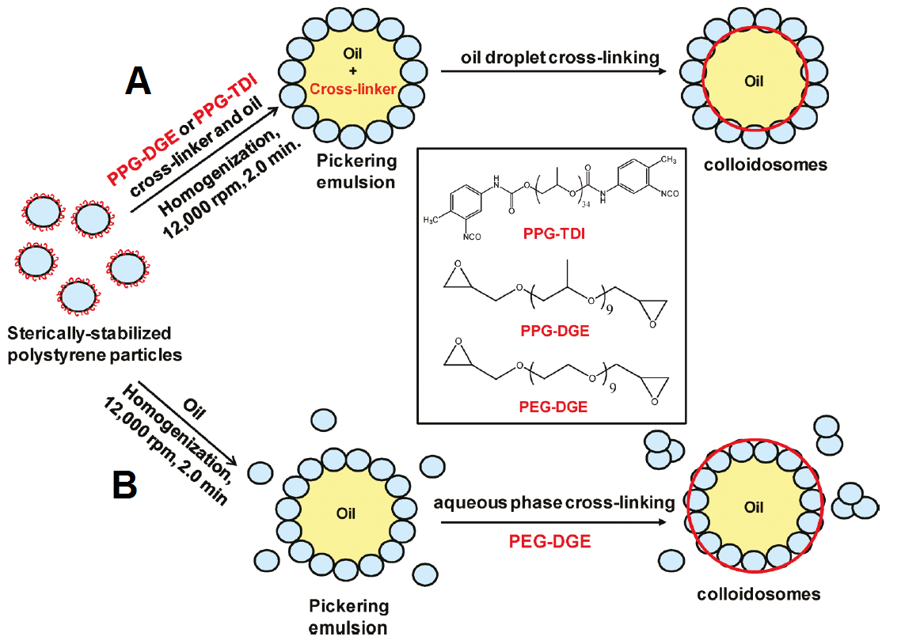
Figure 1.27. Reaction scheme for the formation of colloidosomes at 50 vol % using a PEI-stabilized PS latex at pH 9 and 20 °C. Route A represents colloidosomes formed using an oil-soluble cross-linker (PPG-TDI or PPG-DGE) dissolved in the oil droplet phase. Route B represents colloidosomes formed using a water-soluble cross-linker (PEG-DGE) dissolved in the aqueous continuous phase.

Williams et al.⁹⁸ recently used 30 nm PEI/Laponite hybrid particles as effective Pickering emulsifiers for the formation of colloidosomes (see Figure 1.28). It was originally believed a layer-by-layer would be formed at the oil/water interface, which would produce an impermeable colloidosome shell, and hence retain certain small molecule agents. Colloidosome formation was achieved when PEI/Laponite particles were homogenised with sunflower oil (containing PPG-TDI or PEG-DGE cross-linker). These colloidosomes were able to withstand an alcohol challenge, but dye release studies indicated that the PEI/Laponite walls were in fact highly permeable and offered no effective barrier to small molecule encapsulation. This is because the PEI/Laponite complex was rather disordered and ill-defined, which prevented the formation of a well-defined layer-by-layer structure.

Figure 1.28. Schematic representation of the formation of PEI/Laponite colloidosomes following covalent cross-linking of the amine functional groups on PEI with either an oil-soluble or water soluble cross-linker.⁹⁸

Stimulus-Responsive Colloidosomes
Very few examples of stimulus-responsive colloidosomes are present in the literature. However, being able to tailor the particles that compose the colloidosome shell has led to the production of pH-responsive colloidosomes. Recently, Cayre et al.⁹⁹ demonstrated that incorporation of PDMA-PMMA diblock copolymer stabiliser onto latex particles can produce pH-responsive colloidosomes. It is perhaps worth noting that homogenisation of the oil/water at pH 4.9 and 5.7 (close to the pK_{a} of PDMA) did not produce stable emulsions. Latex particles were cross-linked at the oil/water interface by two methods, either; 1) quaternisation of the amine functionality with oil-soluble BIEE, or 2) reaction of the tertiary amine with epoxy-end groups of PPG-DGE cross-linker. For such colloidosomes, both the loading and unloading of labelled dextran can be controlled by pH. The release of such active agents was also monitored as a function of pH, with release of the dextran being adsorbed at pH 3, compared to incorporation at pH 10.
Outline of this Thesis
The present thesis focuses on the preparation of PEGMA-stabilised latex particles and follows their aqueous solution behaviour, their Pickering emulsifier performance and their subsequent use as pH-responsive colloidosomes.
Chapter 2 reports the preparation of novel pH-responsive latexes based on poly(2-(tert-butylamino)ethyl methacrylate) (PTBAEMA). Such particles were found to exhibit a latex-to-microgel transition and become highly swollen below the pK_{a} of 7.9. The Pickering emulsifier performance of these particles at both high and low pH is also examined, with specific attention being paid to their response with regard to a change in solution pH.
Chapter 3 reports the cross-linking of PTBAEMA-based particles via their secondary amine functional groups when adsorbed at the o/w interface. The resulting colloidosomes were also assessed in terms of their pH-responsive character following cross-linking from within the oil droplets to lock in the latex suprastructure.
Chapter 4 investigates the use of PDEA latex particles as a pH-responsive Pickering emulsifier. Such particles were found to respond to changes in pH from the addition of aqueous HCl/KOH, as well as CO₂/N₂ cycling. However, the latter approach offers an advantage for repeated pH cycles.
Chapter 5 focuses on the kinetics of swelling for 200 nm PEGMA-stabilised polyamine latexes when subjected to various amounts of added HCl. Interestingly, the kinetics of swelling is not related to changes in latex T_{g}, but correlates better with the monomer repeat unit mass, which suggests that cationic charge density plays an important role.
Finally, Chapter 6 summarises the results of all the work described in this thesis, and suggestions for future work are made.

References
1. W. Ramsden, Proceedings of the Royal Society of London, 1903, 72, 156-164.
2. S. U. Pickering, Journal of the Chemical Society, 1907, 2001-2021.
3. B. P. Binks, Current Opinion in Colloid & Interface Science, 2002, 7, 21-41.
4. J. N. Israelachvili, D. J. Mitchell and B. W. Ninham, Journal of the Chemical Society-Faraday Transactions Ii, 1976, 72, 1525-1568.
5. P. A. Lovell and M. S. El-asser, Emulsion polymerization and emulsion polymers, Wiley, Chichester, 1997.
6. J. Brandrup, E. H. Immergut, E. A. Grulke, A. Abe and D. R. Bloch, Polymer Handbook, 2005, 4th ed.; John Wiley and Sons: New York.
7. G. Odian, in Principles of Polymerization, John Wiley & Sons, Inc., 2004, pp. 198-349.
8. G. P. 250 and A. G. Bayer, 1909, 690.
9. G. Patent and 558890, 1927.
10. M. Tirrell and T. J. Tulig, Macromolecules, 1982, 459-463.
11. W. D. Harkins, Journal of the American Chemical Society, 1947, 69, 1428-1444.
12. W. V. Smith and R. H. Ewart, Kinetics of Emulsion Polymerization, AIP, 1948.
13. E. Van Der Hoff B. M, in Polymerisation and Polycondensation Prosesses, American Chemical Society, 1962, vol. 34, ch. 1, pp. 6-31.
14. W. D. Harkins, Journal of Chemical Physics, 1945, 13, 381-382.
15. L. Leemans, R. Fayt, P. Teyssie and N. C. De Jaeger, Macromolecules, 1991, 24, 5922-5925.
16. K. L. Thompson, S. P. Armes, J. R. Howse, S. Ebbens, I. Ahmad, J. H. Zaidi, D. W. York and J. A. Burdis, Macromolecules, 2010, 43, 10466-10474.
17. A. S. Hoffman, Journal of Controlled Release, 1987, 6, 297-305.
18. A. S. Huffman, A. Afrassiabi and L. C. Dong, Journal of Controlled Release, 1986, 4, 213-222.
19. A. Afrassiabi, A. S. Hoffman and L. A. Cadwell, Journal of Membrane Science, 1987, 33, 191-200.
20. T. Okano, Y. H. Bae, H. Jacobs and S. W. Kim, Journal of Controlled Release, 1990, 11, 255-265.
21. C. Zhao, S. Nie, M. Tang and S. Sun, Progress in Polymer Science, 2011, 36, 1499-1520.
22. J. Hendri, A. Hiroki, Y. Maekawa, M. Yoshida and R. Katakai, Radiation Physics and Chemistry, 2001, 60, 617-624.
23. H. Park, H.-S. Jin, S. Yang and J.-D. Kim, Colloid Polym. Sci., 2009, 287, 919-926.
24. V. Sáez-Martínez, L. Pérez-Álvarez, M. T. Merrero, E. Hernáez and I. Katime, European Polymer Journal, 2008, 44, 1309-1322.
25. D. Duracher, F. Sauzedde, A. Elaissari, A. Perrin and C. Pichot, Colloid Polym. Sci., 1998, 276, 219-231.
26. D. Duracher, F. Sauzedde, A. Elaïssari, C. Pichot and L. Nabzar, Colloid Polym. Sci., 1998, 276, 920-929.
27. T. Tanaka, I. Nishio, S.-T. Sun and S. Ueno-Nishio, Science, 1982, 218, 467-469.
28. Y. Li and T. Tanaka, The Journal of Chemical Physics, 1989, 90, 5161-5166.
29. Y. Li and T. Tanaka, The Journal of Chemical Physics, 1990, 92, 1365-1371.
30. T. Tanaka, D. Fillmore, S.-T. Sun, I. Nishio, G. Swislow and A. Shah, Physical Review Letters, 1980, 45, 1636-1639.
31. T. Tanaka, C. Wang, V. Pande, A. Y. Grosberg, A. English, S. Masamune, H. Gold, R. Levy and K. King, Faraday Discussions, 1995, 101, 201-206.
32. D. Gan and L. A. Lyon, Macromolecules, 2002, 35, 9634-9639.
33. C. D. Jones and L. A. Lyon, Macromolecules, 2000, 33, 8301-8306.
34. C. D. Jones and L. A. Lyon, Macromolecules, 2003, 36, 1988-1993.
35. A. S. Hoffman, Annals of the New York Academy of Sciences, 2001, 944, 62-73.
36. S. Gehrke, in Responsive Gels: Volume Transitions II, ed. K. Dušek, Springer Berlin Heidelberg, 1993, vol. 110, ch. 5, pp. 81-144.
37. V. Compañ, A. Andrio, A. López-Alemany, E. Riande and M. F. Refojo, Biomaterials, 2002, 23, 2767-2772.
38. S. Kim, Y. Bae and T. Okano, Pharm Res, 1992, 9, 283-290.
39. K. Y. Lee and D. J. Mooney, Chemical Reviews, 2001, 101, 1869-1880.
40. J. L. Drury and D. J. Mooney, Biomaterials, 2003, 24, 4337-4351.
41. K. T. Nguyen and J. L. West, Biomaterials, 2002, 23, 4307-4314.
42. M. Ochoa-Villarreal, E. Aispuro-Hernández, I. Vargas-Arispuro and M. A. Martínez-Téllez, in Polymerization, ed. A. D. S. Gomes, InTech, 2012.
43. N. A. Peppas and E. W. Merrill, J. Biomed. Mater. Res., 1977, 11, 423-434.
44. X.-Y. Wu, S.-W. Huang, J.-T. Zhang and R.-X. Zhuo, Macromolecular Bioscience, 2004, 4, 71-75.
45. W. E. Hennink and C. F. van Nostrum, Adv. Drug Deliv. Rev., 2002, 54, 13-36.
46. A. Loxley and B. Vincent, Colloid & Polymer Science, 1997, 275, 1108-1114.
47. D. Dupin, S. Fujii, S. P. Armes, P. Reeve and S. M. Baxter, Langmuir, 2006, 22, 3381-3387.
48. A. J. Morse, D. Dupin, K. L. Thompson, S. P. Armes, K. Ouzineb, P. Mills and R. Swart, Langmuir, 2012, 28, 11733-11744.
49. J. Rosselgong and S. P. Armes, Macromolecules, 2012, 45, 2731-2737.
50. J. Rosselgong, S. P. Armes, W. R. S. Barton and D. Price, Macromolecules, 2010, 43, 2145-2156.
51. R. Pelton, Advances in Colloid and Interface Science, 2000, 85, 1-33.
52. Z. Hu and X. Xia, Advanced Materials, 2004, 16, 305-309.
53. W. Liao, Y. Zhang, Y. Guan and X. X. Zhu, Macromolecular Chemistry and Physics, 2011, 212, 2052-2060.
54. S. H. Choi, J. J. Yoon and T. G. Park, Journal of Colloid and Interface Science, 2002, 251, 57-63.
55. B. H. Tan, P. Ravi, L. N. Tan and K. C. Tam, Journal of Colloid and Interface Science, 2007, 309, 453-463.
56. S. Xu, J. Zhang, C. Paquet, Y. Lin and E. Kumacheva, Advanced Functional Materials, 2003, 13, 468-472.
57. D. Dupin, J. Rosselgong, S. P. Armes and A. F. Routh, Langmuir, 2007, 23, 4035-4041.
58. T. Tanaka and D. J. Fillmore, J. Chem. Phys., 1979, 70, 1214-1218.
59. J. Yin, D. Dupin, J. Li, S. P. Armes and S. Liu, Langmuir, 2008, 24, 9334-9340.
60. D. Dupin, S. P. Armes, C. Connan, P. Reeve and S. M. Baxter, Langmuir, 2007, 23, 6903-6910.
61. J. I. Amalvy, E. J. Wanless, Y. Li, V. Michailidou, S. P. Armes and Y. Duccini, Langmuir, 2004, 20, 8992-8999.
62. B. P. Binks, Current Opinion in Colloid and Interface Science, 2002, 7, 21-41.
63. V. N. Paunov, B. P. Binks and N. P. Ashby, Langmuir, 2002, 18, 6946-6955.
64. P. Finkle, H. D. Draper and J. H. Hildebrand, Journal of the American Chemical Society, 1923, 45, 2780-2788.
65. E. W. Washburn, Physics Review, 1921, 17, 273-283.
66. E. K. Rideal, Philosophical Magazine, 1922, 44, 1152-1159.
67. E. Chilbowski and L. Holysz, Langmuir, 1992, 8, 710-716.
68. C. Jouany and P. Chassin, Colloids and Surfaces, 1987, 27, 289-303.
69. Z. Hórvölgyi, S. Németh and J. H. Fendler, Colloids and Surfaces A: Physicochemical and Engineering Aspects, 1993, 71, 327-335.
70. A. Hadjiiski, R. Dimova, N. D. Denkov, I. B. Ivanov and R. Borwankar, Langmuir, 1996, 12, 6665-6675.
71. V. N. Paunov, Langmuir, 2003, 19, 7970-7976.
72. T. S. Horozov, D. A. Braz, P. D. I. Fletcher, B. P. Binks and J. H. Clint, Langmuir, 2007, 24, 1678-1681.
73. O. D. Velev, K. Rurusawa and K. Nagayama, Langmuir, 1996, 12, 2374-2384.
74. R. Aveyard, J. H. Clint, D. Nees and V. N. Paunov, Langmuir, 2000, 16, 1969-1979.
75. J. I. Amalvy, S. P. Armes, B. P. Binks, J. A. Rodrigues and G. F. Unali, Chemical Communications, 2003, 1826-1827.
76. J. I. Amalvy, G. F. Unali, Y. Li, S. Granger-Bevan, S. P. Armes, B. P. Binks, J. A. Rodrigues and C. P. Whitby, Langmuir, 2004, 20, 4345-4354.
77. E. S. Read, S. Fujii, J. I. Amalvy, D. P. Randall and S. P. Armes, Langmuir, 2004, 20, 7422-7429.
78. E. S. Read, S. Fujii, J. I. Amalvy, D. P. Randall and S. P. Armes, Langmuir, 2005, 21, 1662-1662.
79. S. Fujii, E. S. Read, B. P. Binks and S. P. Armes, Advanced Materials, 2005, 17, 1014-1018.
80. S. Fujii, S. P. Armes, B. P. Binks and R. Murakami, Langmuir, 2006, 22, 6818-6825.
81. B. P. Binks, R. Murakami, S. P. Armes and S. Fujii, Langmuir, 2006, 22, 2050-2057.
82. S. Fujii, S. P. Armes, T. Araki and H. Ade, Journal of the American Chemical Society, 2005, 127, 16808-16809.
83. S. Fujii, S. P. Armes, B. P. Binks and R. Murakami, Langmuir, 2006, 22, 6818-6825.
84. B. P. Binks, R. Murakami, S. P. Armes and S. Fujii, Angewandte Chemie International Edition, 2005, 44, 4795-4798.
85. H. N. Yow and A. F. Routh, Soft Matter, 2006, 2, 940-949.
86. A. D. Dinsmore, M. F. Hsu, M. G. Nikolaides, M. Marquez, A. R. Bausch and D. A. Weitz, Science, 2002, 298, 1006-1009.
87. J. A. Balmer, S. P. Armes, P. W. Fowler, T. Tarnai, Z. Gáspár, K. A. Murray and N. S. J. Williams, Langmuir, 2009, 25, 5339-5347.
88. K. Thompson and S. P. Armes, Chemical Communications, 2010, 46, 5274-5276.
89. H. N. Yow and A. Routh, Langmuir, 2009, 159-166.
90. S. Laïb and A. F. Routh, Journal of Colloid and Interface Science, 2008, 317, 121-129.
91. H. N. Yow and A. F. Routh, Langmuir, 2008, 25, 159-166.
92. Q. Yuan, O. J. Cayre, S. Fujii, S. P. Armes, R. A. Williams and S. Biggs, Langmuir, 2010, 26, 18408-18414.
93. O. J. Cayre, P. F. Noble and V. N. Paunov, Journal of Materials Chemistry, 2004, 14, 3351-3355.
94. R. T. Rosenberg and N. Dan, Langmuir, 2011, 27, 8729-8734.
95. P. H. R. Keen, N. K. H. Slater and A. F. Routh, Langmuir, 2011, 28, 1169-1174.
96. A. Walsh, University of Sheffield, 2010, MChem Thesis.
97. A. Walsh, K. L. Thompson, S. P. Armes and D. W. York, Langmuir, 2010, 26, 18039-18048.
98. M. Williams, S. P. Armes and D. W. York, Langmuir, 2011, 28, 1142-1148.
99. O. J. Cayre, J. Hitchcock, M. S. Manga, S. Fincham, A. Simoes, R. A. Williams and S. Biggs, Soft Matter, 2012, 8, 4717-4724.

Chapter Two

Novel Pickering Emulsifiers based on pH-Responsive Poly(2-(tert-butylamino)ethyl methacrylate) Latexes

Reproduced in part with permission from [Morse, A. J.; Dupin, D; Thompson, K. L.; Armes. S. P.; Ouzineb, K.; Mills, P.; Swart, R., Langmuir, 2012, 28, 11733-11744.] Copyright [2012] American Chemical Society.
Introduction
Pickering emulsions involve the self-assembly of colloidal particles at the interface between two immiscible liquids (typically oil and water) to prevent coalescence of the droplet phase.^{1, 2,3} In principle, Pickering emulsifiers offer a number of advantages over conventional surfactants such as (i) more robust and reproducible formulations, (ii) reduced foaming problems and (iii) lower toxicity (at least compared to certain surfactants). There are many literature examples describing the use of inorganic particles such as silica,^{4, 5} barium sulphate⁶ or calcium carbonate⁷ as Pickering emulsifiers. Recently, considerable attention has been devoted to the use of organic (e.g. polymer latex) particles as emulsifiers. Velev and co-workers were the first to report latex-based Pickering emulsifiers, with charge-stabilised polystyrene latex being utilised to stabilise 1-octanol droplets.⁸ In this case, either sulphate or amidine surface groups conferred charge stabilisation. Other groups have also investigated the interfacial packing of charge-stabilised latexes. For example, Aveyard et al. reported the formation of ordered monolayers using sulphate-functionalised polystyrene latexes ranging from 0.2 to 2.6 µm diameter at both the air/water and oil/water interface.⁹ The propensity for solid particles to self-assemble at the oil/water interface primarily depends on the particle wettability.³ This parameter is directly related to the contact angle, θ, made by a particle when it is adsorbed at the oil/water interface. θ is always less than 90° for hydrophilic particles, which are located preferentially in the water phase; the resulting curvature favours oil-in-water emulsions. On the other hand, θ exceeds 90° for hydrophobic particles, which reside preferentially in the oil phase; this scenario inevitably leads to water-in-oil emulsions.^{10, 11} We are aware of some literature describing the use of pH-sensitive inorganic particles. e.g. silica.^{5, 12, 13} However, polymer latexes have become widely used as Pickering emulsifiers due to the ability to tailor their surface properties during their synthesis. It is also worth mentioning the work by Dai’s group, who reported the production of stable Pickering emulsions at substantially below monolayer coverage using micrometer-sized polystyrene latex particles. This phenomenon appears to be due to strong lateral repulsion between the adsorbed charged particles.¹⁴

Previous reports of pH-responsive Pickering emulsifiers.
The first genuine example of a pH-responsive Pickering emulsifier was reported by Fujii et al., who used poly(4-vinylpyridine)/silica (P4VP/SiO₂) nanocomposite microgels to stabilise n-dodecane, methyl myristate or 1-undecanol droplets.¹⁵ These emulsions were readily broken on lowering the solution pH below the pK_{a} of the P4VP chains,^{15, 16} since the protonated microgel particles spontaneously desorbed from the emulsion droplet interface.^{17, 18} More recently, Dupin et al. found that pH-responsive sterically-stabilised latexes based on 2-vinylpyridine (2VP) could be synthesised using a PDMA-based macromonomer.¹⁹ The poly(2-vinylpyridine) (P2VP) core and the PDMA stabiliser have differing pK_{a} values (4.1 and 7.0, respectively), thus these particles can exist in three different states (protonated microgel at low pH, cationic stable latex at intermediate pH or flocculated latex above pH 8). Depending on the conditions, this PDMA-P2VP latex could act as either a pH-dependent or a pH-responsive Pickering emulsifier for water droplets dispersed in 1-undecanol.¹⁹
There are many reports describing the synthesis of well-defined block copolymers based on either primary or tertiary amine methacrylates.²⁰⁻²³ Moreover, there are also several examples of tertiary amine methacrylate-based latexes prepared via aqueous emulsion polymerisation.^{24, 25} However, as far as we are aware, there are relatively few literature reports concerning secondary amine methacrylates such as 2-tert-butylaminoethyl methacrylate (TBAEMA). In our experience, primary amine-based methacrylates undergo facile intermolecular rearrangement to form the corresponding methacrylamide.²⁶ Smith et al. also reported that the hydrolysis of such amine-functional methacrylates was greatly diminished after their polymerisation.²⁷ In principle, secondary amine methacrylates are also susceptible to this undesirable side reaction. However, in the case of TBAEMA its t-butyl substituent provides sufficient steric congestion to confer stability.^{27, 28} Creutz et al. used anionic polymerisation to synthesise a series of well-defined TBAEMA-based homopolymers and diblock copolymers in THF at -78 °C.²⁸ Later, de Paz Báñez et al. reported using oxyanion-initiated polymerisation at room temperature to produce both TBAEMA homopolymers and also diblock copolymers with other tertiary amine methacrylates.²⁹ The preparation of PTBAEMA brushes using living radical polymerisation has also been reported.³⁰ However, to the best of our knowledge, there have been no studies of the synthesis of PTBAEMA latexes via aqueous emulsion polymerisation.
The Present Work.
In this chapter we explore the synthesis of novel PTBAEMA latexes prepared by emulsion polymerisation using varying amounts of divinylbenzene (DVB) cross-linker in the presence or absence of a commercial monomethoxy-capped poly(ethylene glycol) methacrylate (PEGMA) macromonomer. The aqueous solution behaviour of these pH-sensitive latexes was studied using DLS and aqueous electrophoresis. Finally, we examined whether such latexes could act as pH-responsive Pickering emulsifiers for a range of model oils. In this context, it was interesting to consider whether the presence of the PEGMA stabiliser affected the particle wettability at the oil /water interface.
Experimental Section
Materials. 2-(tert-Butylamino)ethyl methacrylate (TBAEMA; 97%; Aldrich) and divinylbenzene (DVB; 80 mol % 1,4-divinyl content; Fluka, UK) were treated with basic alumina to remove any inhibitor and stored at -20 °C prior to use. The PEGMA macromonomer (kindly donated by Cognis Performance Chemicals, Hythe, UK) had a mean degree of polymerisation (DP) of 45 and an M_{w}/M_{n} of 1.10. Ammonium persulfate (APS; > 98%), n-dodecane, isopropyl myristate and sunflower oil were each purchased from Aldrich and used as received. Deionised water was obtained using an Elga Elgastat Option 3 system. NMR solvents (CDCl₃) and ethanol were purchased from Fisher Scientific. Dialysis tubing (molecular weight cut-off of 100 kDaltons) was purchased from Fisher Scientific and stored in a moist environment at 4 °C until use.
Aqueous Emulsion Polymerisation. The appropriate amount of PEGMA (0.50-1.00 g) was weighed into a 100 mL two-neck round-bottomed flask equipped with a magnetic flea. Deionised water (40.0 g) was added, followed by TBAEMA “head monomer” (0.50 g) and the initial solution pH was recorded. This emulsion was purged with nitrogen gas for 15 minutes using a cannula, then heated to 70 °C with the aid of an oil bath and stirred at 250 rpm using a magnetic stirrer. After 10 minutes, the appropriate amount of APS initiator (1.0-2.0 wt % based on TBAEMA) dissolved in deionised water (5.0 g) was injected into the reaction vessel to commence the first-stage polymerisation. After 1 h, further TBAEMA monomer (4.25–4.50 g) together with the appropriate amount of DVB (0-0.25 g) was added dropwise (3.0 ml h⁻¹) using a syringe pump. The reaction solution gradually turned milky-white within 30 minutes and was stirred for a total of 24 h at 70 °C. Charge-stabilised PTBAEMA latex was also prepared using the same protocol, but without the addition of PEGMA. In addition, a ‘one-shot’ batch polymerisation of TBAEMA was conducted using 10 wt. % PEGMA stabiliser, 0.8 mol % DVB cross-linker and 2.0 wt. % APS initiator at 70 °C for 24 h.
Purification. The PEGMA-stabilised latexes were purified by centrifugation at 20 000 rpm for 2 h, followed by careful decantation of the supernatant and replacement with fresh deionised water at pH 9.5. The sedimented particles were redispersed in each case with the aid of an ultrasonic bath. This protocol was repeated for a further nine centrifugation/redispersion cycles to remove any unreacted TBAEMA, APS initiator and non-grafted PEGMA macromonomer. Purification was continued until the surface tension of the supernatant was close to that of pure water (70 ± 2 mN m⁻¹). Charge-stabilised latexes were purified via dialysis to remove excess TBAEMA and APS initiator until the surface tension was close to that of pure water (71 ± 1 mN m⁻¹).
Pickering Emulsion Preparation. The redispersed PTBAEMA latex was adjusted to approximately 1.1 % solids using deionised water (assessed by gravimetry using a moisture analyser) and the latex dispersion was adjusted to approximately pH 10.5 using either 0.1 M HCl or 0.1 M NaOH as appropriate. The PTBAEMA latex (4.0 mL) was then added to a 14 mL vial, to which the same volume of oil (e.g. n-dodecane or sunflower oil) was added. This oil/water mixture was then homogenised for 2 minutes using an IKA Ultra-Turrax T-18 homogeniser with a 10 mm dispersing tool operating at 12 000 rpm. The resulting Pickering emulsion was allowed to stand at 20 °C for 30 minutes.
Latex Characterisation
¹H NMR spectroscopy. All ¹H NMR spectra were recorded in CDCl₃ using a 400 MHz Bruker Avance-400 spectrometer.
Dynamic Light Scattering (DLS). Hydrodynamic diameters were measured at 25 °C using a Malvern Zetasizer NanoZS Model ZEN 3600 instrument equipped with a 4 mW He-Ne solid-state laser operating at 633 nm. Back-scattered light was detected at 173° and the mean particle diameter was calculated from the quadratic fitting of the correlation function over thirty runs of ten seconds duration. All measurements were performed three times on 0.01 w/v % aqueous latex solutions. The pH of the deionised water used to dilute the latex was matched to that of the latex (typically around pH 10) and was ultra-filtered through a 0.20 μm membrane so as to remove any dust.
Scanning Electron Microscopy (SEM). SEM studies were performed using a FEI Sirion field mission gun scanning electron microscope using a beam current of 244 μA and a typical operating voltage of 20 kV. Latexes were dried directly onto carbon tape and allowed to dry overnight before being sputter-coated with a thin layer of gold prior to examination so as to prevent sample charging.
Aqueous Electrophoresis. Zeta potentials were determined in the presence of 1 mM KCl using the same Malvern Zetasizer NanoZS Model ZEN 3600 instrument equipped with an autotitrator (MPT-2 multipurpose titrator, Malvern instruments). The solution pH was lowered from 10 to 3 using dilute HCl.
Pickering Emulsion Characterisation
Conductivity Measurements. The conductivity of the continuous phase was measured using a digital conductivity meter (Hanna model Primo 5). Conductivities well above 10 μS cm⁻¹ indicated that water was the continuous phase (i.e. an o/w emulsion). In contrast, conductivities below 10 μS cm⁻¹ indicated that oil was the continuous phase (i.e. a w/o emulsion).
Drop Test. This test was used to confirm the continuous phase indicated by the conductivity measurement. An emulsion droplet was placed into either deionised water or oil. When dropped into the same liquid as the continuous phase, the droplet disperses rapidly. If dropped into the liquid of the internal droplet phase, the droplet remains intact, with little or no dispersion.
Laser Diffraction. A Malvern Mastersizer 2000 instrument equipped with a small volume Hydro 2000SM sample dispersion unit (ca. 50 mL), a HeNe laser operating at 633 nm, and a solid-state blue laser operating at 466 nm was used to size the emulsion droplets at pH 10. The stirring rate was adjusted to 1000 rpm in order to avoid creaming of the emulsion during analysis. The mean droplet diameter was taken to be the volume mean diameter (D_{4/3}), which is mathematically expressed as D_{4/3} = ΣD_{i}⁴N_{i}/ΣD_{i}³N_{i}. The standard deviation for each diameter provides an indication of the width of the size distribution. After each measurement, the cell was rinsed once with ethanol, followed by three rinses using water. The glass walls of the cell were carefully wiped with lens cleaning tissue to avoid cross-contamination, and the laser was aligned centrally on the detector. This set-up allowed continuous measurements to be made after the sample chamber pH had been adjusted from 10 to 3. This allowed droplet stability to be examined with regard to any changes in pH.
Acid Challenge. The Pickering emulsion (1.0 mL) was added to a 1.5 mL vial to which sufficient HCl was added to lower the solution pH to around 3. This protocol allows visual confirmation of demulsification.
Optical Microscopy. A drop of the diluted emulsion was placed on a microscope slide and viewed using an optical microscope (James Swift MP3502, Prior Scientific Instruments Ltd.) connected to a PC laptop to record images. This technique was used to estimate the mean droplet diameter. The response of the o/w emulsion droplets following in situ acidification of the aqueous phase was also assessed using this equipment.
Results and Discussion
Latex Preparation and Characterisation
The two main classes of acid-swellable latexes reported in the literature are based on poly(2-vinylpyridine)^{19, 31, 32} and poly(2-(diethylamino)ethyl methacrylate) (PDEA).^{24, 25} The synthetic route for the preparation of a new class of acid-swellable latex based on lightly cross-linked PTBAEMA particles is outlined in Figure 2.1. The steric stabilisation shown in Figure 2.1 is supported by freeze-thaw experiments, which confirm that PEGMA-PTBAEMA latex has much better colloidal stability than the charge-stabilised PTBAEMA latex, as expected (see Figure 2.2). More specifically, PEGMA-PTBAEMA latex (entry 4, Table 2.1) survived three freeze-thaw cycles, whereas charge-stabilised PTBAEMA latex (entry 10, Table 2.1) flocculated upon thawing, as confirmed by DLS studies. However, we cannot rule out the possibility that some fraction of the PEGMA chains may be located within the latex particles.
Figure 2.1. Schematic representation of the synthesis of PEGMA-PTBAEMA latex particles via emulsion polymerisation at 70 °C and their subsequent acid-induced swelling behaviour in aqueous solution at 20 °C to form cationic microgels.

It is worth briefly comparing the physical properties of PTBAEMA with that of PDEA, which has already been prepared in latex form.²⁴ Acid titration (see Figure 2.3) indicates that linear PTBAEMA latex has a pK_{a} of 8.0, which is slightly higher than the literature value of 6.8-7.2 for linear PDEA latex.^{20, 24} The glass transition temperature (T_{g}) of PTBAEMA latex was determined to be 38.5 ºC by differential scanning calorimetry (see Figure 2.4), whereas the literature value is around 16 to 24 °C³³ for PDEA homopolymer and -5 °C³⁴ for PDEA latex, respectively. In principle, this should make electron microscopy studies of the former latex less problematic than that of the latter, for which partial film formation has been observed.²⁴ However, in the light of recent work by Tsavalas and co-workers it seems likely that the N-H bonds on the TBAEMA residues may promote hydroplasticisation, which would lower the effective T_{g} of the aqueous latex dispersion.³⁵
Figure 2.2. DLS curves following three freeze-thaw cycles for (a) PEGMA-stabilised PTBAEMA latex (entry 4, Table 2.1) and (b) charge-stabilised PTBAEMA (entry 10, Table 2.1). Corresponding DLS diameters obtained before freeze-thaw cycles can be found in Table 2.1. Inset: digital images showing (a) no flocculation of PEGMA-stabilised PTBAMEA latex particles and (b) flocculation of charge-stabilised PTBAMEA latex particles following three freeze-thaw cycles.
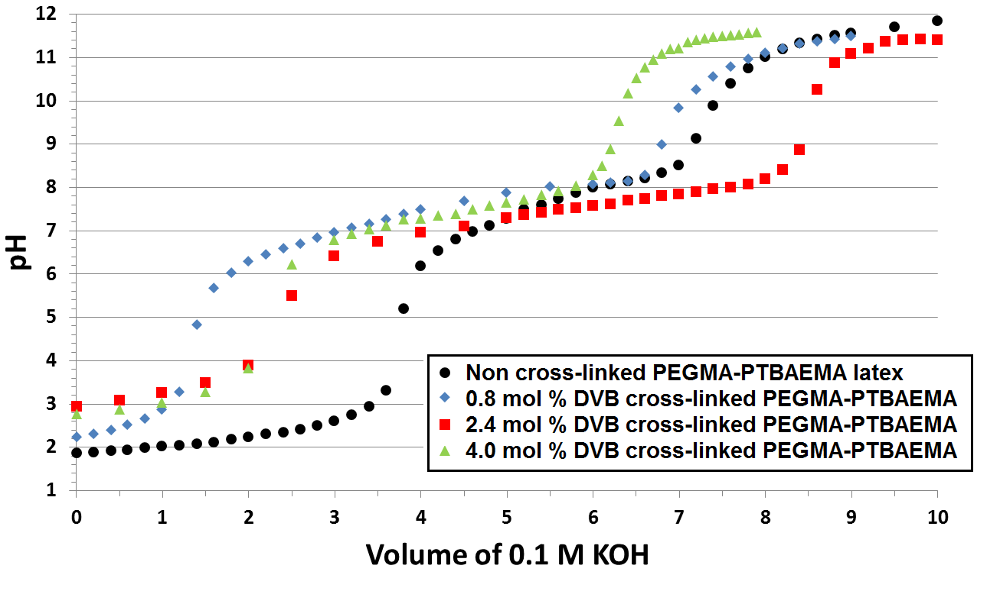
Figure 2.3. Acid titration curves for; (●) linear PEGMA-PTBAEMA latex (entry 9, Table 2.1), and selected DVB cross-linked PEGMA-PTBAEMA latexes; (▲) 0.8 mol % cross-linked PEGMA-PTBAEMA (entry 2, Table 2.1), (♦) 2.4 mol % cross-linked PEGMA-PTBAEMA (entry 5, Table 2.1) and (■) 4.0 mol % cross-linked PEGMA-PTBAEMA (entry 7, Table 2.1).

These syntheses were typically conducted via aqueous emulsion copolymerisation at approximately 10 % solids under monomer-starved conditions at 70 °C; relevant synthesis parameters are summarised in Table 2.1. Under mildly alkaline conditions (initially around pH 10) monomer conversions of at least 90 % were routinely obtained, see Table 2.1. After polymerisation, the final pH is around pH 9.5, which is still well above the pK_{a} for the PTBAEMA chains. This pH drift is associated with the choice of initiator. Nevertheless, the final pH is sufficiently high to ensure that the PTBAEMA is obtained in its non-protonated latex form, rather than as a soluble cationic polyelectrolyte.

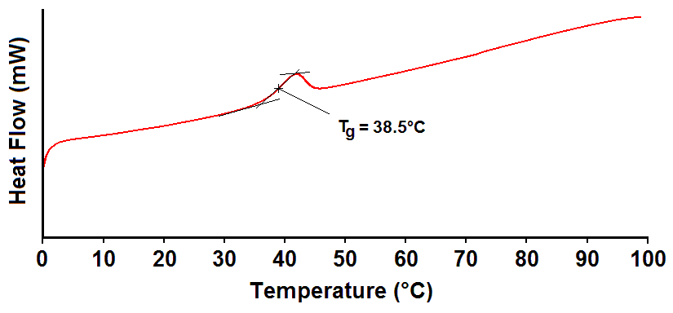
Figure 2.4. DSC trace obtained for a PEGMA-stabilised cross-linked PTBAEMA latex prepared using 0.8 mol% DVB (see entry 3 in Table 2.1).

The ‘one-shot’ batch synthesis of PTBAEMA particles using 10 wt % PEGMA macromonomer and 0.8 mol % DVB cross-linker produced a relatively polydisperse latex with a hydrodynamic diameter of 540 nm (see entry 1, Table 2.1). Inspection of these particles by SEM indicated an ill-defined, non-spherical morphology, see Figure 2.5a. There is some literature evidence to suggest that this non-spherical morphology might be related to cross-linking. For example, Song et al. had reported similar observations for the alcoholic dispersion polymerisation of styrene using the same DVB cross-linker.³⁶⁻³⁸ Therefore the ‘one-shot’ batch formulation was repeated in the absence of any cross-linker (see entry 8, Table 2.1). DLS studies reported an intensity-average diameter of 430 nm for the resulting linear latex, while SEM indicated the formation of well-defined spherical particles, see Figure 2.5b. This linear latex dissolves molecularly at low pH and ultimately proved to be a useful reference material for ¹H NMR spectroscopy studies. However, the main aim of the present work was to develop a new class of acid-swellable latexes that exhibit a reversible latex-to-microgel transition. Thus omission of the DVB cross-linker was not desirable, since cross-linking is essential to prevent latex dissolution at low pH. Instead, an alternative seeded emulsion polymerisation formulation under monomer-starved conditions was examined, which fortunately produced reasonably spherical latex particles even in the presence of DVB cross-linker; see Figures 2.5c and 2.5d.
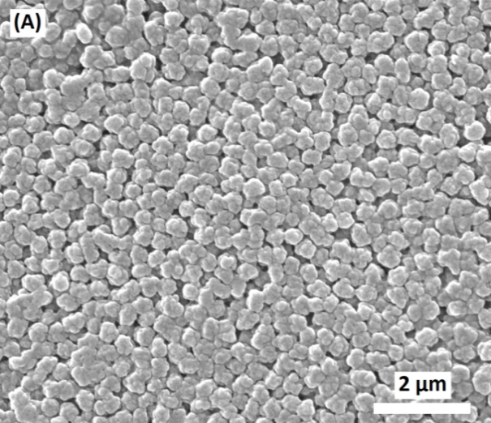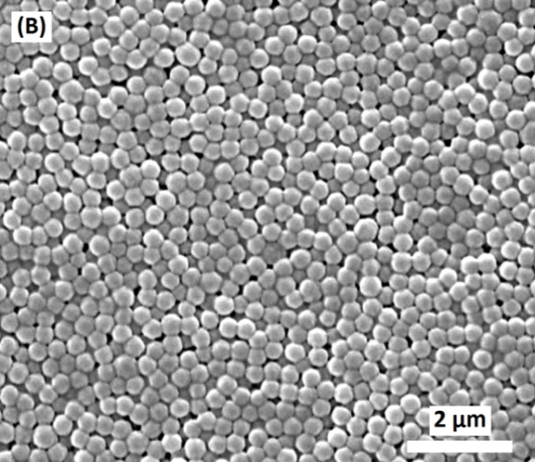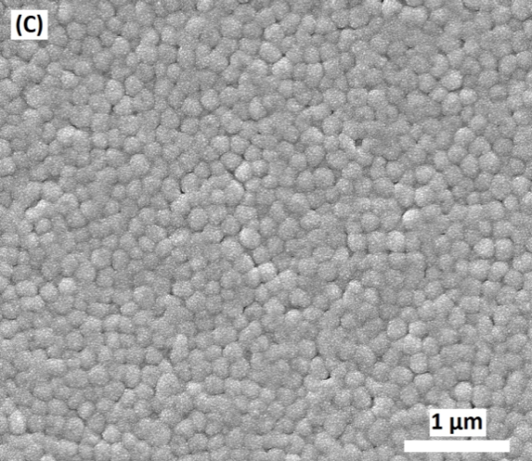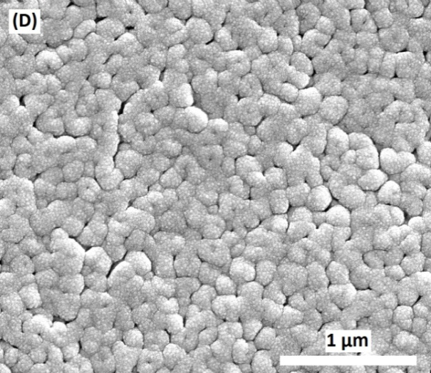
Figure 2.5. Scanning electron microscopy images obtained for (A) 540 nm 0.8 mol % DVB cross-linked PTBAEMA latex (entry 1, Table 2.1), (B) 430 nm non-cross-linked PTBAEMA latex (entry 8, Table 2.1), (C) 200 nm 0.8 mol % DVB cross-linked PTBAEMA latex (entry 2, Table 2.1), (D) 200 nm 0.8 mol % DVB cross-linked PTBAEMA latex (entry 3, Table 2.1).

Table 2.1. Effect of variation of the synthesis parameters on the mean diameters of poly(2-tert-butylamino)ethyl methacrylate) latexes prepared using PEGMA stabiliser, DVB cross-linker and APS initiator at 70 °C. The wt % values in columns 2 and 4 are for DVB/TBAEMA comonomer mixtures. All latexes were prepared by emulsion copolymerisation at pH 10 under monomer-starved conditions at 10 % solids, unless otherwise stated.

Entry no. | PEGMA stabiliser  (wt %) | DVB  cross-linker  (mol %) | APS initiator  (wt %) | TBAEMA monomer conversion  (%)ª | Intensity-average^{b} diameter  (nm) | Polydispersity index^{b}
1^{c} | 10.0 | 0.8 | 2.0 | 99 | 540  Chapter Two – Novel Pickering Emulsifiers based on pH-Responsive Poly(tert-butylaminoethyl methacrylate) Latexes | 0.11
2 | 10.0 | 0.8 | 2.0 | 95 | 200 | 0.02
3 | 5.0 | 0.8 | 2.0 | 91 | 200 | 0.02
4 | 5.0 | 1.6 | 2.0 | 99 | 160 | 0.01
5 | 5.0 | 2.4 | 2.0 | 96 | 155 | 0.01
6 | 5.0 | 3.2 | 1.0 | 94 | 150 | 0.02
7 | 5.0 | 4.0 | 1.0 | 95 | 160 | 0.01
8^{c} | 10.0 | 0 | 2.0 | 99 | 430 | 0.05
9 | 5.0 | 0 | 1.0 | 97 | 175 | 0.05
10^{d} | 0 | 0.8 | 1.0 | 98 | 220 | 0.04
11^{c,d} | 0 | 0 | 1.0 | 87 | 350 | 0.24
a. Determined using gravimetry. b. Determined by dynamic light scattering at 20 °C. c. Prepared using one-shot batch copolymerisation. d. Prepared by surfactant-free emulsion copolymerisation
61

In each case near-monodisperse cross-linked PTBAEMA latexes ranging from 150 nm to 200 nm diameter were obtained in high yield, see entries 2-7 in Table 2.1. There is some evidence that cross-linking leads to smaller particles (compare entries 2 and 8 and also entries 3 and 4 in Table 2.1). In addition, a linear PEGMA-stabilised PTBAEMA latex was prepared in the absence of any DVB cross-linker using a monomer-starved protocol (see entry 9 in Table 2.1). A charge-stabilised DVB cross-linked PTBAEMA latex was also prepared in the absence of any PEGMA steric stabiliser (entry 10 in Table 2.1). DLS studies of this charge-stabilised latex indicated a relatively narrow particle size distribution and an intensity-average diameter of 220 nm, which is only slightly larger than that achieved in the presence of the PEGMA stabiliser. The charge-stabilised nature of this 220 nm latex is most likely due to the use of a persulfate initiator and was confirmed by three freeze-thaw cycles (see Figure 2.2). However, it should be emphasised that the latex showed no signs of sedimentation or flocculation over long periods of time (months). In principle, the PEGMA content of the sterically-stabilised latexes can be determined by ¹H NMR spectroscopy. In practice, this proved problematic for latexes prepared using 0.8 mol % DVB cross-linker since they become highly viscous in their swollen microgel form, which leads to significant line-broadening and hence overlapping NMR signals.³¹ The linear PTBAEMA latexes prepared under the same reaction conditions in the absence of DVB proved useful, since their molecular dissolution in CDCl₃ led to well-resolved ¹H NMR spectra.
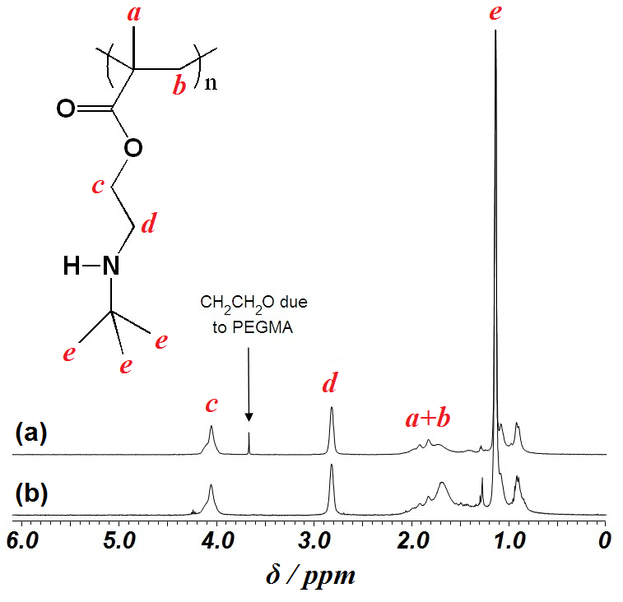
Figure 2.6. ¹H NMR spectra (CDCl₃) recorded for linear PTBAEMA latexes prepared by emulsion polymerisation: (a) in the presence of PEGMA macromonomer (entry 9 in Table 2.1) and (b) in the absence of PEGMA macromonomer (entry 11 in Table 2.1).

Figure 2.6 shows the ¹H NMR spectra recorded in CDCl₃ for a purified PEGMA-stabilised linear PTBAEMA latex (entry 9 in Table 2.1; spectrum A) and a charge-stabilised linear PTBAEMA latex (entry 11 in Table 2.1; spectrum B). The additional signal observed at δ 3.7 ppm in the former case is assigned to the oxyethylene protons due to the PEGMA chains;^{31, 39} comparison of this peak integral with that signal at δ 4.05 ppm due to the oxymethylene protons adjacent to the ester group of the PTBAEMA residues indicated a PEGMA content of approximately 3.3 mol %. Given the comparable particle diameters obtained for the cross-linked and linear PTBAEMA particles (see Table 2.1), the former latexes should contain similar amounts of PEGMA stabiliser to the latter. However, this assumes that introducing the DVB cross-linker does not affect the grafting efficiency of the PEGMA stabiliser. If the PEGMA chains are located exclusively at the particle surface, an adsorbed amount of PEGMA, or Г (in mg m⁻²), can be estimated. Г was calculated to be 1.8 mg m⁻² for the linear PTBAEMA latex, which is consistent with values reported by Dupin et al.³¹ for a PEGMA-stabilised P2VP latex and by Amalvy et al.⁴⁰ for poly(tertiary amine methacrylate) latexes.
Figure 2.7 ¹H NMR spectra recorded for PEGMA-stabilised PTBAEMA latex dispersed in DCl/D₂O (a) and in D₂O (b), and charge-stabilised PTBAEMA latex dispersed in DCl/D₂O (c) and in D₂O (d).

The PEGMA content of DVB cross-linked PTBAEMA latexes was also assessed. Thus selected latexes (initially at pH 10) were centrifuged at 13 000 rpm for 1 h (Heraeus Biofuge Pico microcentrifuge) and the sedimented particles were redispersed into D₂O. However, the resulting ¹H NMR spectra were only very poorly resolved (see Figure 2.7). The appearance of signals attributable to the PTBAEMA chains after protonation using DCl was anticipated, since acidification induces a latex-to-microgel transition. In addition, the relatively sharp signal at ~ 3.7 ppm observed in spectra (a) and (b) (see Figure 2.7; entry 4 in Table 2.1) can be assigned to the oxyethylene protons of the grafted PEGMA stabiliser.^{35,40} As expected, this signal is not present in spectra (c) and (d) recorded for the charge-stabilised microgel (see Figure 2.7; entry 10 in Table 2.1). However, due to significant line broadening and overlapping NMR signals in the protonated microgel spectra, linear PTBAEMA latexes of similar diameter were used in order to estimate the extent of PEGMA incorporation (see above).
Figure 2.8. Influence of the degree of DVB cross-linker of the pK_{a} of PEGMA-PTBAEMA latexes as determined by acid titration studies. In each case, the degree of cross-linking has been corrected to allow for the 80 mol % purity of the DVB cross-linker. The linear PEGMA-PTBAEMA latex is entry 9 in Table 2.1.

The pK_{a} values for a linear PTBAEMA latex (prepared by aqueous emulsion polymerisation in the absence of DVB cross-linker, entry 9, Table 2.1) were calculated by acid titration and compared to the pK_{a} values calculated for a series of cross-linked PTBAEMA latexes, see Figure 2.8. Targeting higher degrees of cross-linking clearly leads to a systematic reduction in pK_{a}, which indicates a reduction in basicity for the non-protonated PTBAEMA chains. Similar observations were made by Dupin et al.³¹ for cross-linked poly(2-vinylpyridine) latexes. In both cases an approximately linear relationship is observed, with a systematic lowering of the pK_{a} by more than half a pH unit as the degree of cross-linking is increased. The rationale here is that it is more difficult to protonate cross-linked polybase chains because they have less scope to reduce the build-up of cationic charge density via intra-chain expansion compared to linear chains. Acid titrations were always conducted starting at low pH, so the initial physical state is molecular dissolution in both cases.
Acid-induced swelling of selected PEGMA-PTBAEMA latexes (entries 3-5, Table 2.1) was monitored using DLS. Latex-to-microgel transitions are observed at around pH 8 for PEGMA-stabilised PTBAEMA prepared with either 0.8 or 1.6 mol. % DVB (see Figure 2.9a). This is close to the pK_{a} values of these particles, which suggests that a degree of protonation of approximately 50% is sufficient to induce the latex-to-microgel transition. This is similar to observations reported by Dupin et al. for cross-linked P2VP microgels, who reported that cross-linked P2VP latexes exhibit a latex-to-microgel transition between pH 4.0 and 4.5 (the corresponding pK_{a} of these latexes was around 4.1).³¹ The highly swollen cationic PTBAEMA microgels formed below pH 8 possess hydrodynamic diameters of 600-700 nm, which corresponds to a volumetric expansion of more than 27. However, increasing the DVB cross-linker content to 2.4 mol % reduces the swollen microgel diameter significantly (to less than 300 nm) and the critical pH for the latex-to-microgel transition shifts from 7.9 to approximately 7.5. This correlates with the reduction in pK_{a} observed for higher degrees of cross-linking, as discussed earlier. There also appears to be relatively little difference in swelling behaviour between charge-stabilised and PEGMA-stabilised PTBAEMA latexes prepared using the same target degree of DVB cross-linker (entry 10, Table 2.1). The former particles also exhibited a latex-to-microgel transition upon lowering the pH, as confirmed by DLS. Particle swelling occurred at the same pH as that observed for 0.8 mol % DVB cross-linked PEGMA-stabilised particles (see Figure 2.9a). The charge-stabilised swollen microgel had a hydrodynamic diameter of 625 nm upon full protonation of its secondary amine groups.
Figure 2.9. Variation of the hydrodynamic diameter (a) and zeta potential (b) with solution pH for (♦) 0.8 mol % cross-linked PEGMA-PTBAEMA (entry 3, Table 2.1), (■) 1.6 mol % cross-linked PEGMA-PTBAEMA (entry 4, Table 2.1), (▲) 2.4 mol % cross-linked PEGMA-PTBAEMA (entry 5, Table 2.1) and (●) charge-stabilised PTBAEMA (entry 10, Table 2.1).

Aqueous electrophoresis measurements were conducted on three cross-linked PEGMA-stabilised PTBAEMA latexes (see Figure 2.9b). The zeta potential is a shear plane measurement that is sensitive to the nature of the stabiliser chains, as well as the particle cores. Given that the PEGMA chains are non-ionic, changes in zeta potential are dominated by the PTBAEMA chains (and possibly also surface sulphate groups derived from APS initiator fragments). All latexes exhibited an isoelectric point (IEP) of approximately pH 8.9. No flocculation occurred at this pH as judged by DLS due to steric stabilisation conferred by the surface-grafted PEGMA stabiliser. As expected, protonation of the secondary amine groups led to cationic character below pH 8.9, with zeta potentials ranging from +28 to +44 mV. The charge-stabilised latex was also subjected to aqueous electrophoresis studies as a function of pH. The PEGMA stabiliser chains appeared to have little shielding effect on the overall surface charge of the particles. Surprisingly, no flocculation was observed for the charge-stabilised PTBAEMA particles, even at their IEP of pH 8.9 (see Figure 2.9b). This may be because around 10 % of the secondary amine groups are protonated under these conditions. Considering the DLS and zeta potential data together, three distinct physical states for these PTBAEMA particles could be identified. Highly cationic swollen microgels are formed below pH 8, weakly cationic latexes are obtained at pH 8 to 8.9 and anionic latexes are produced above pH 8.9. Compared to the PEGMA-stabilised P2VP latexes prepared by Dupin et al.,³¹ these PEGMA-stabilised PTBAEMA latexes are significantly more anionic in alkaline solution. This difference is attributed to the cationic initiator used to prepare the P2VP latexes, as opposed to the anionic initiator (APS) used in the present work.
Pickering emulsifier performance of PTBAEMA latexes
It is well-known that Pickering emulsifiers require appropriate surface wettability for strong adsorption onto emulsion droplets.^{4, 17, 41-43} PEGMA-PTBAEMA latexes proved to be excellent Pickering emulsifiers when homogenised at pH 10 at 12 000 rpm for 2 minutes using either n-dodecane or sunflower oil. In each case very stable emulsions were obtained when a 50:50 oil/aqueous latex volume ratio was employed. The aqueous latex concentration was adjusted to approximately 1.1 wt % (determined by gravimetry) to provide a total latex surface area of 1.13 m² for 4.0 mL of latex (assuming a PTBAEMA latex density of 1.17 g cm⁻³).
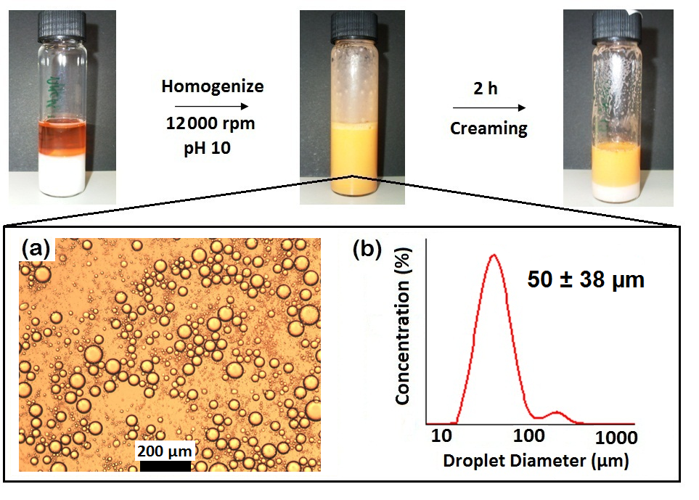Figure 2.10. Digital photographs of: (left) the initial PEGMA-PTBAEMA latex (1.1 % solids) with n-dodecane oil (dyed with Sudan Red G for clarity) added directly to the vial, (middle) the subsequent n-dodecane-in-water emulsion stabilised by this PEGMA-PTBAEMA latex and (right) creaming of the less dense oil droplets and the underlying excess latex. (a) Optical microscope image and (b) Mastersizer size distribution for n-dodecane-in-water droplets stabilised using 200 nm PEGMA-PTBAEMA latex.

It is worth emphasising that Pickering emulsions were not obtained if the aqueous dispersion was adjusted to pH 3 to produce cationic PTBAEMA microgels. Presumably, the contact angle made by these highly hydrophilic particles at the o/w interface is simply too low for the particles to be efficiently adsorbed. The particles can therefore be classified as being pH-dependent in terms of their Pickering emulsifier performance.^{19, 44, 45} Oil-in-water Pickering emulsions were confirmed by both conductivity measurements and the ‘drop test’. After allowing the emulsions formed at pH 10 to cream on standing, visual inspection confirmed that the lower aqueous phase always contained some non-adsorbed latex, regardless of the initial latex concentration (see Figure 2.10). This is in contrast to the unusually efficient sterically-stabilised latex-based Pickering emulsifiers reported previously by Thompson et al., where a transparent lower aqueous phase indicated no excess latex below a certain critical latex concentration.⁴⁶ In the present work, optical microscopy studies confirmed the polydisperse nature of these droplets, which ranged in size from 15 to 100 µm (see Figure 2.10b). Relatively high polydispersities are typical for Pickering emulsions prepared via high shear homogenisation. However, it has been recently shown that more uniform Pickering emulsions can be produced using other methods such as membrane emulsification.^{47, 48} The mean droplet diameter was determined to be 50 ± 38 µm as judged by laser diffraction. In this context, the very poor Pickering emulsifier performance of PEGMA-P2VP latexes prepared by Dupin et al. is noteworthy.¹⁹ No stable Pickering emulsions could be formed at either pH 3 or 10 using PEGMA-P2VP (or charged-stabilised P2VP) latex after homogenisation with a range of oils, including n-dodecane, methyl myristate and 1-undecanol. We have no satisfactory explanation for the dramatically improved Pickering emulsifier performance exhibited by the PEGMA-PTBAEMA latexes in the present work and assume this must be down to stronger adsorption of the PTBAEMA-based latex particles. In view of this situation, a charge-stabilised PTBAEMA latex (entry 10, Table 2.1) was also examined as a Pickering emulsifier in order to investigate the influence of the PEGMA chains in determining surface wettability. This charge-stabilised latex was found to be an efficient oil-in-water Pickering emulsifier when homogenised with either n-dodecane or sunflower oil, supporting the statement above assuming PEGMA stabiliser has minimal effect, and it is particle core that determines Pickering emulsifier performance. In fact, somewhat finer (and less polydisperse) oil droplets of 42 ± 17 µm diameter were obtained when using n-dodecane. One advantage of using such a charge-stabilised PTBAEMA latex is its relative ease of purification: extensive dialysis was sufficient to remove unreacted small molecule impurities, which is more feasible than centrifugation on an industrial scale. Although both PEGMA-stabilised and charge-stabilised PTBAEMA latexes proved to be efficient Pickering emulsifiers, the rest of this article is focused exclusively on the performance of the charge-stabilised PTBAEMA particles.
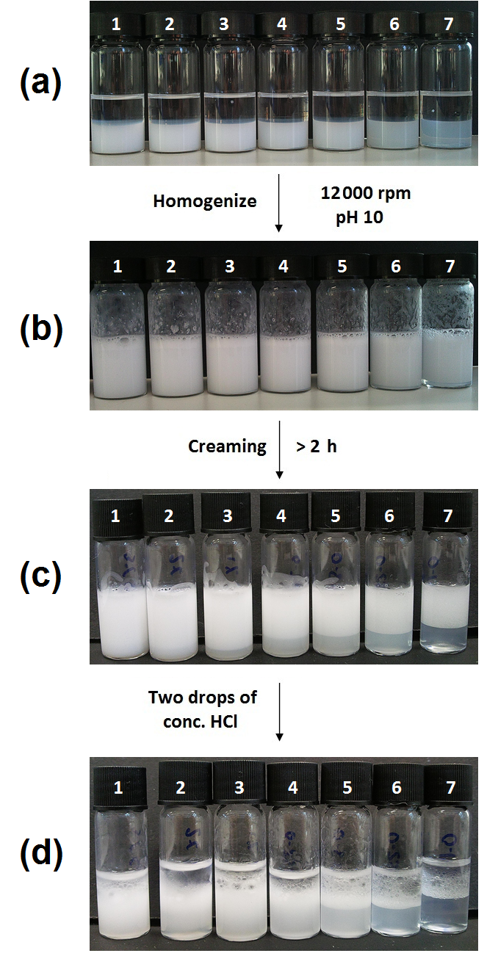
Figure 2.11. Digital photographs of: (a) charge-stabilised PTBAEMA latex (pH 10.5, 4 mL) plus n-dodecane (4 mL) for varying latex solids before homogenisation, (b) PTBAEMA stabilised n-dodecane-in-water emulsion after homogenisation at 12,000 rpm for 2 mins, (c) subsequent creaming of the less dense oil droplets 2 h after homogenisation, (d) demulsification of the Pickering emulsion after treatment with 2 drops of conc. HCl. Effective latex solids in each photograph as determined by gravimetry: (1) 2.9 wt % (2) 2.0 wt % (3) 1.20 wt % (4) 0.80 wt % (5) 0.60 wt % (6) 0.30 wt % (7) 0.20 wt %.

According to Thompson et al., reducing the initial latex concentration should produce larger oil droplets.^{46,49} Moreover, if all the latex particles are adsorbed onto the oil droplets, the (lower) aqueous continuous phase obtained after creaming should become clear. Charge-stabilised PTBAEMA particles were homogenised with n-dodecane at various latex concentrations (0.20 to 2.90 wt %). Digital images confirm complete emulsification of n-dodecane could be achieved even when using latex concentrations as low as 0.20 wt % (see digital photographs a and b in Figure 2.11). However, inspection of the aqueous phase obtained after creaming (see photograph c in Figure 2.11) indicated appreciable turbidity, which suggested that even this relatively low latex concentration was insufficient to achieve full adsorption of particles. This preliminary conclusion was confirmed by carefully removing a portion of this aqueous continuous phase and calculating its solids content. The final latex concentration was typically only 10-20 % less than the original concentration. Similar results were recently reported by Walsh et al. for polyamine-stabilised latexes: efficient adsorption of the particles at the interface was not achieved even when lowering their concentration to as little as 0.3 wt %.⁵⁰ In contrast, the PGMA-stabilised PS particles evaluated by Thompson et al. adsorbed efficiently onto oil droplets, forming close-packed latex monolayers as judged by fluorescence microscopy studies.⁴⁶
The relationship between the mean n-dodecane droplet diameter (reported by laser diffraction) and initial PTBAEMA latex concentration is shown in Figure 2.12, with selected optical micrographs shown as insets. These images confirm the change in mean droplet diameter and also serve to illustrate the polydisperse nature of these emulsions. As the latex concentration is reduced below approximately 1.0 wt %, larger oil droplets are formed. Oil droplets of around 120 µm diameter were obtained when using 0.20 wt % latex. However, it is important to mention that the packing efficiency of these particles is well below that required for monolayer coverage. Similar observations have been reported previously by Dai’s group,¹⁴ who observed the production of stable Pickering emulsions at substantially below monolayer coverage using micrometer-sized polystyrene latex particles. Other research groups have noted the formation of stable Pickering emulsions well below monolayer coverage of the droplets.⁵¹⁻⁵³ It is believed that the EDL associated with the particles, which is suppressed in the aqueous phase because of the presence of electrolyte, becomes much larger once the particles become adsorbed at the oil/water interface due to the relative lack of electrolyte. In the case of 3 μm silica particles, this can lead to inter-particle separations that are three-fold greater than the particle diameter.⁵¹ This effect, plus the strong lateral repulsion between the charge-stabilised PTBAEMA latex particles used in the present study, is presumably sufficient to stabilise oil-in-water Pickering emulsions at unusually low concentrations (and surface coverages).
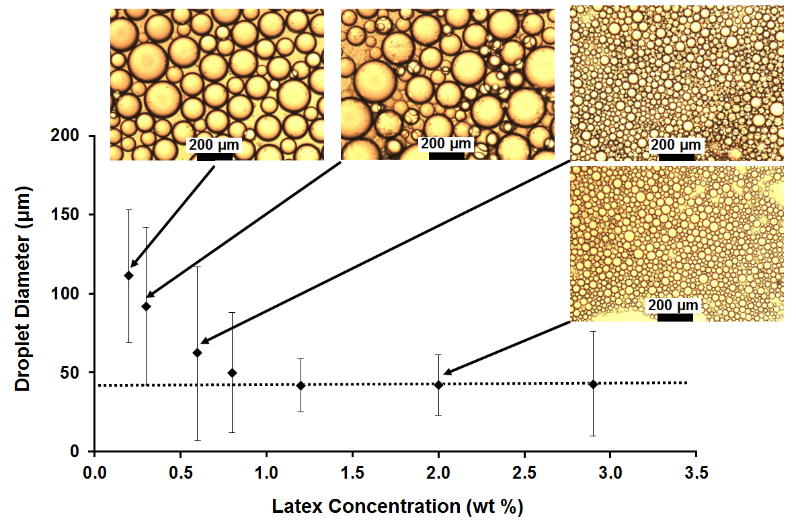
Figure 2.12. Relationship between mean oil droplet diameter and latex concentration for Pickering emulsions prepared using 220 nm surfactant-free PTBAEMA (entry 10, Table 2.1) with n-dodecane as the oil phase. Latex dispersions were adjusted to pH 10.5 using 0.1 M KOH and homogenised at 12,000 rpm for 2 minutes. Optical microscopy (OM) images for selected entries are shown for the corresponding Pickering emulsions. Scale bars in all OM images are 200 µm.

DLS studies had already confirmed the pH-responsive nature of the charge-stabilised PTBAEMA latex in aqueous solution, with a latex-to-microgel swelling transition being observed (see above). An obvious question is whether this leads to pH-responsive Pickering emulsifier behaviour. Accordingly, approximately five drops of 0.10 M HCl was added to the stable Pickering emulsion. This acidification led to rapid phase separation (see digital photograph d in Figure 2.11). On protonation, the swollen microgel particles desorb spontaneously from the oil/water interface, leaving bare oil droplets that undergo immediate coalescence. Similarly efficient demulsification was also achieved using sunflower oil and isopropyl myristate. However, sunflower oil-based emulsions demulsified slower than those prepared using either n-dodecane or isopropyl myristate. Presumably, this is simply due to the increased viscosity associated with the former oil. Similar pH-responsive emulsion behaviour was also observed for PEGMA-PTBAEMA latexes when using n-dodecane, sunflower oil or isopropyl myristate as the droplet phase. Thus, both types of PTBAEMA latexes act as generic pH-responsive Pickering emulsifiers.
A Pickering emulsion with a mean droplet diameter of 72 µm (prepared using 2.0 mL of 0.80 wt. % charge-stabilised PTBAEMA latex and 2.0 mL n-dodecane) was subjected to an acid challenge, which led to its immediate demulsification. The two-phase solution was treated with base to induce the microgel-to-latex transition and re-homogenised once more at pH 10 (12 000 rpm for 2 min). This second Pickering emulsion was also of the oil-in-water type, and its mean diameter was comparable to the first emulsion within experimental error. Four further demulsification/emulsification cycles were conducted, after which no demulsification occurred on addition of excess acid. This is most likely due to the build-up of background salt preventing efficient swelling of the adsorbed latex particles. To examine whether this hypothesis is correct, the same original Pickering emulsion was prepared at pH 10 in the presence of 0.01 M NaCl. In contrast, acidification of this emulsion did not lead to its destabilisation, which suggests that the background salt effectively suppressed microgel swelling so that no interfacial desorption occurs. Similar results were also obtained for pH cycling experiments conducted in the absence of background salt with either sunflower oil or isopropyl myristate. It is perhaps worth noting that Pickering emulsions prepared using linear PTBAEMA latexes also demulsified. However, in the absence of any cross-linker the soluble PTBAEMA chains were unable to “remember” their original latex form, and simply produced a white precipitate within the aqueous phase on neutralisation with NaOH.
Demulsification of diluted Pickering emulsions was also monitored using a Malvern Mastersizer instrument fitted with a small volume Hydro 2000SM sample dispersion unit. The solution pH was adjusted to pH 10 prior to the addition of the oil-in-water emulsion. Five measurements were recorded over 15 min to confirm the stability of the oil droplets prior to the solution pH being lowered (see Figure 2.13a). Acid (0.1 M HCl) was then added directly to the sample chamber so that the change in oil droplet diameter could be monitored in situ at approximately pH 3. However, over the following 45 min the oil droplet concentration decreased significantly and there was also a discernible shift to smaller droplets (see Figure 2.13b). The longer time scale required for demulsification in this experiment compared to the experiments conducted with sample vials simply reflects the much lower oil droplet concentration: droplet coalescence can only occur when bare droplets collide with each other. In this context it is worth emphasising that, when the solution pH is maintained at around pH 10, both the oil droplet concentration and mean droplet diameter remain relatively constant for the duration of the experiment (i.e. for at least 1 h at ambient temperature). Thus emulsion destabilisation is solely due to the latex-to-microgel transition that occurs on lowering the solution pH. Overall, these studies provide convincing evidence that the charge-stabilised PTBAEMA latex acts as an efficient recyclable pH-responsive Pickering emulsifier.
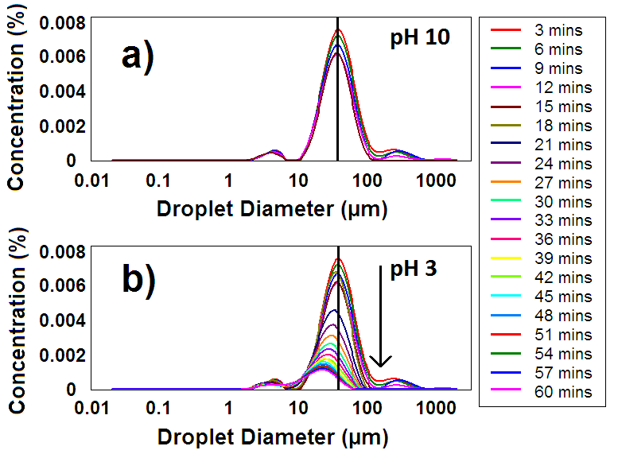
Figure 2.13. Volume-average droplet diameter distribution curves obtained by laser diffraction for (a) PTBAEMA stabilised n-dodecane-in-water emulsions (1.1 % solids) at pH 10 and (b) the resulting reduction in concentration after inverting the pH to 3.05. Measurements were taken every 3 minutes for 60 minutes with the acid being added after the first 5 measurements.
Conclusions
Novel PEGMA-stabilised and charge-stabilised PTBAEMA latexes have been synthesised by seeded emulsion polymerisation with hydrodynamic diameters ranging from 150 to 220 nm. Unlike the PDEA latexes reported earlier, the glass transition temperature of these PTBAEMA latexes is sufficiently high to allow SEM imaging at ambient temperature, although some deformation due to hydroplasticisation³⁵ is evident. The pK_{a} of these PTBAEMA particles ranges from 8.0 to 7.3, with lower values being obtained at higher degrees of cross-linking as expected. Linear PTBAEMA latexes dissolved in dilute acidic solution due to protonation of the secondary amine groups on the PTBAEMA chains. In contrast, cross-linked PTBAEMA latexes undergo a reversible latex-to-microgel swelling transition, which was characterised by DLS studies and aqueous electrophoresis. Microgel/latex swelling ratios of up to 3.3 were observed at DVB contents of 0.8 mol %. PTBAEMA latexes act as effective Pickering emulsifiers when homogenised with either n-dodecane, sunflower oil or isopropyl myristate, producing stable oil-in-water emulsions. However, stable emulsions were only obtained if homogenisation was conducted above the latex pK_{a} (i.e. at around pH 10). The presence of chemically-grafted PEGMA chains at the latex surface appeared to have little or no effect on its Pickering emulsifier performance: stable emulsions could be obtained using both charge-stabilised and sterically-stabilised PTBAEMA latexes upholding that PTBAEMA particles are better emulsifiers than P2VP for the oils studied. Larger oil droplets were obtained at lower latex concentrations, as expected. However, excess non-adsorbed latex was always observed over the entire concentration range investigated. These Pickering emulsions proved to be pH-responsive on lowering the pH: protonation of the secondary amine groups leads to spontaneous desorption of cationic microgels from the surface of the emulsion droplets, which subsequently undergo coalescence within seconds. Demulsification was monitored using both optical microscopy and laser diffraction. Four successive demulsification/emulsification pH cycles could be achieved without discernible loss in performance (with homogenisation being required at high pH to reform the emulsion after each cycle). However, after five cycles the resulting emulsion remained stable after acidification. Presumably, this is simply due to the build-up of background salt.
References
1. S. U. Pickering, Journal of the Chemical Society, 1907, 91, 2001-2021.
2. W. Ramsden, Proceedings of the Royal Society of London, 1903, 72, 156-164.
3. P. Finkle, H. D. Draper and J. H. Hildebrand, Journal of the American Chemical Society, 1923, 45, 2780-2788.
4. B. P. Binks and S. O. Lumsdon, Langmuir, 2000, 16, 2539-2547.
5. B. P. Binks and S. O. Lumsdon, Physical Chemistry Chemical Physics, 2000, 2, 2959-2967.
6. J. H. Schulman and J. Leja, Transactions of the Faraday Society, 1954, 50, 598-605.
7. R. Aveyard, B. P. Binks, P. D. I. Fletcher and C. E. Rutherford, Colloids and Surfaces A: Physicochemical and Engineering Aspects, 1994, 83, 89-98.
8. O. D. Velev, K. Furusawa and K. Nagayama, Langmuir, 1996, 12, 2374-2384.
9. R. Aveyard, J. H. Clint, D. Nees and V. N. Paunov, Langmuir, 1999, 16, 1969-1979.
10. B. P. Binks, Current Opinion in Colloid & Interface Science, 2002, 7, 21-41.
11. V. N. Paunov, B. P. Binks and N. P. Ashby, Langmuir, 2002, 18, 6946-6955.
12. M. F. Haase, D. Grigoriev, H. Moehwald, B. Tiersch and D. G. Shchukin, The Journal of Physical Chemistry C, 2010, 114, 17304-17310.
13. J. Li and H. D. H. Stöver, Langmuir, 2008, 24, 13237-13240.
14. S. Tarimala and L. L. Dai, Langmuir, 2003, 20, 3492-3494.
15. S. Fujii, E. S. Read, B. P. Binks and S. P. Armes, Advanced Materials, 2005, 17, 1014-1018.
16. S. Fujii, S. P. Armes, B. P. Binks and R. Murakami, Langmuir, 2006, 22, 6818-6825.
17. B. P. Binks, R. Murakami, S. P. Armes and S. Fujii, Langmuir, 2006, 22, 2050-2057.
18. S. Fujii, S. P. Armes, T. Araki and H. Ade, Journal of the American Chemical Society, 2005, 127, 16808-16809.
19. D. Dupin, S. P. Armes, C. Connan, P. Reeve and S. M. Baxter, Langmuir, 2007, 23, 6903-6910.
20. V. Bütün, S. P. Armes and N. C. Billingham, Polymer, 2001, 42, 5993-6008.
21. V. Bütün, S. P. Armes and N. C. Billingham, Macromolecules, 2001, 34, 1148-1159.
22. L. He, E. S. Read, S. P. Armes and D. J. Adams, Macromolecules, 2007, 40, 4429-4438.
23. E. S. Read, K. L. Thompson and S. P. Armes, Polymer Chemistry, 2010, 1, 221-230.
24. J. I. Amalvy, E. J. Wanless, Y. Li, V. Michailidou, S. P. Armes and Y. Duccini, Langmuir, 2004, 20, 8992-8999.
25. H. Hayashi, M. Iijima, K. Kataoka and Y. Nagasaki, Macromolecules, 2004, 37, 5389-5396.
26. K. L. Thompson, E. S. Read and S. P. Armes, Polym. Degrad. Stabil., 2008, 93, 1460-1466.
27. D. A. Smith, R. H. Cunningham and B. Coulter, Journal of Polymer Science Part A-1: Polymer Chemistry, 1970, 8, 783-784.
28. S. Creutz, P. Teyssié and R. Jérôme, Journal of Polymer Science Part A: Polymer Chemistry, 1997, 35, 2035-2040.
29. M. V. de Paz Báñez, K. L. Robinson, V. Bütün and S. P. Armes, Polymer, 2001, 42, 29-37.
30. S. Ding, J. A. Floyd and K. B. Walters, Journal of Polymer Science Part A: Polymer Chemistry, 2009, 47, 6552-6560.
31. D. Dupin, S. Fujii, S. P. Armes, P. Reeve and S. M. Baxter, Langmuir, 2006, 22, 3381-3387.
32. A. Loxley and B. Vincent, Colloid Polym. Sci., 1997, 275, 1108-1114.
33. J. Brandrup, E. H. Immergut, E. A. Grulke, A. Abe and D. R. Bloch, Polymer Handbook, 2005, 4th ed.; John Wiley and Sons: New York.
34. P. A. FitzGerald, J. I. Amalvy, S. P. Armes and E. J. Wanless, Langmuir, 2008, 24, 10228-10234.
35. B. Jiang, J. Tsavalas and D. Sundberg, Langmuir, 2010, 26, 9408-9415.
36. M. Okubo, T. Fujiwara and A. Yamaguchi, Colloid & Polymer Science, 1998, 276, 186-189.
37. M. Okubo, Y. Katsuta and T. Matsumoto, Journal of Polymer Science Part C-Polymer Letters, 1980, 18, 481-486.
38. J.-S. Song and M. A. Winnik, Macromolecules, 2005, 38, 8300-8307.
39. D. B. Cairns, S. P. Armes, M. M. Chehimi, C. Perruchot and M. Delamar, Langmuir, 1999, 15, 8059-8066.
40. J. I. Amalvy, G. F. Unali, Y. Li, S. Granger-Bevan, S. P. Armes, B. P. Binks, J. A. Rodrigues and C. P. Whitby, Langmuir, 2004, 20, 4345-4354.
41. B. P. Binks, Advanced Materials, 2002, 14, 1824-1827.
42. B. P. Binks and M. Kirkland, Physical Chemistry Chemical Physics, 2002, 4, 3727-3733.
43. B. P. Binks and S. O. Lumsdon, Langmuir, 2001, 17, 4540-4547.
44. E. S. Read, S. Fujii, J. I. Amalvy, D. P. Randall and S. P. Armes, Langmuir, 2004, 20, 7422-7429.
45. E. S. Read, S. Fujii, J. I. Amalvy, D. P. Randall and S. P. Armes, Langmuir, 2005, 21, 1662-1662.
46. K. L. Thompson, S. P. Armes, J. R. Howse, S. Ebbens, I. Ahmad, J. H. Zaidi, D. W. York and J. A. Burdis, Macromolecules, 2010, 43, 10466-10474.
47. Q. Yuan, O. J. Cayre, M. Manga, R. A. Williams and S. Biggs, Soft Matter, 2010, 6, 1580-1588.
48. K. Thompson, S. P. Armes and D. W. York, Langmuir, 2011, 27, 2357-2363.
49. R. Aveyard, B. P. Binks and J. H. Clint, Advances in Colloid and Interface Science, 2003, 100-102, 503-546.
50. A. Walsh, University of Sheffield, 2010, MChem Thesis.
51. T. S. Horozov, R. Aveyard, J. H. Clint and B. P. Binks, Langmuir, 2003, 19, 2822-2829.
52. T. S. Horozov and B. P. Binks, Angew. Chem.-Int. Edit., 2006, 45, 773-776.
53. E. Vignati, R. Piazza and T. P. Lockhart, Langmuir, 2003, 19, 6650-6656.

Chapter Three

Covalently Cross-linked Colloidosomes based on pH-Responsive Poly(2-(tert-butylamino)ethyl methacrylate) Latexes

Introduction
Colloidosomes are an interesting class of microcapsules whose shells are composed of colloidal particles locked in place, which confers additional stability to the original Pickering emulsion.¹ Pickering emulsion droplets may be stabilised by thermal annealing,² polyelectrolyte adsorption,² gel trapping,³ or covalent cross-linking.⁴⁻⁷ These superstructures have attracted much interest due to their possible use as an efficient delivery vehicle for the controlled delivery of active agents.² The first example of colloidosomes was reported in 1996 by Velev and co-workers, who described the adsorption of latex particles onto emulsion droplets to form hollow “supraparticles”.⁸ However, the term “colloidosome” was not coined until 2002, when Dinsmore et al. sintered latexes to form microcapsules of tunable permeability.² In this case, micrometer-sized PS or PMMA latexes were used to prepare Pickering emulsions with a mixed oil phase comprising 50 % vegetable oil and 50 % toluene. This emulsion was heated to 105 °C for 5 minutes to fuse the PS particles together to form the colloidosome microcapsules (the glass-transition temperature of PS is around 103 °C).⁹ Covalent cross-linking of colloidosomes was recently reported by Thompson et al., who used a near-monodisperse PGMA macromonomer to prepare PGMA-PS latexes, which in turn stabilise o/w emulsions.^{5, 6} The hydroxyl-functional PGMA stabiliser chains was then be cross-linked using toluene 2,4-diisocyanate-terminated poly(propylene glycol) (PPG-TDI) to form a urethane bond. These colloidosomes were shown to be sufficiently robust to survive an ethanol challenge, which removes the oil droplet phase.
Walsh et al. replaced the above PGMA-based stabiliser with poly(ethylene imine) (PEI). Thus PEI was functionalised using 4-chloromethyl styrene and used as a reactive steric stabiliser for the emulsion polymerisation of styrene. The resulting PEI-stabilised PS latex particles were used to stabilise o/w Pickering emulsions, which could be converted into covalently cross-linked colloidosomes using PPG-TDI or poly(propylene glycol) diglycidyl ether (PPG-DGE).⁷ However, this cross-linking had to be conducted at 0 °C to obtain well-defined microcapsule when n-dodecane was used as the oil phase. Furthermore, these PEI-stabilised PS latexes could also be cross-linked from the aqueous phase using a water-soluble cross-linker, poly(ethylene glycol) diglycidyl ether (PEG-DGE). Surprisingly, the latter approach did not lead to inter-colloidosome cross-linking, even when cross-linking was conducted at 50 % solids.
The variable permeability of such microcapsules has been assessed via dye release studies.¹⁰ However, the release of such dyes has mainly focussed on colloidosomes that are comprised from spherical particles.^{4, 5, 10} Such packing of spheres on oil droplets inevitably leads to interstices between adjacent particles. These relatively large defects cannot be eliminated by thermal annealing or coating with polypyrrole. An attempt to use Laponite clay nanoparticles to form an impermeable shell has also been reported. PEI was adsorbed onto the surface of Laponite clay nanoparticles which adsorb at the o/w interface to produce o/w Pickering emulsions. Such emulsions could be cross-linked using either oil-soluble PPG-DGE or water-soluble PEG-DGE to form colloidosomes. It was hypothesised that this disc-shaped nanoparticle would produce “clay-armoured”¹¹ colloidosomes that would impede the release of a dye due to the closing of these interstices. However, dye release studies conducted by Williams et al. reported that these microcapsules are also highly permeable and hence do not provide an effective barrier for retarding small molecules.¹²
Present work
In this Chapter we examine the use of PTBAEMA-based latexes (as described in Chapter Two) as pH-responsive Pickering emulsifiers for a range of model oils. Accordingly, a series of TBAEMA/styrene copolymer latexes were prepared with various TBAEMA contents via aqueous emulsion polymerisation. The conditions required for successful emulsification have already been discussed, and the resulting emulsions are characterised in terms of their emulsion type (o/w) and droplet size distribution. The secondary amine functionality on the TBAEMA residues was reacted with an oil-soluble polymeric diisocyanate, producing so-called ‘colloidosome’ microcapsules composed of either PEGMA-PTBAEMA or PEGMA-P(TBAEMA/S) shells. These cross-linked colloidosomes are sufficiently robust to survive both acid and ethanol challenges. The pH-responsive nature of the TBAEMA residues leads to the formation of microgel colloidosomes when the solution pH is lowered below their pK_{a}. The introduction of styrene as a comonomer is beneficial since it is significantly cheaper than TBAEMA monomer (TBAEMA = £138 L⁻¹, styrene = £11 L⁻¹). Polystyrene also has a higher T_{g} than the film-forming PTBAEMA, allowing better imaging of copolymer latex particles and colloidosomes via electron microscopy. However, the inclusion of styrene not only reduces the swelling capabilities of the particles at low pH, but may also prevent cross-linking of styrene-rich copolymer particles with PPG-TDI at the oil/water interface.
Experimental Section
Materials. 2-(tert-Butylamino)ethyl methacrylate (TBAEMA; 97%; Aldrich), styrene (S; >99%, Aldrich) and divinylbenzene (DVB; 80 mol % 1,4-divinyl content; Fluka, UK) were treated with basic alumina to remove any inhibitor and stored at -20 °C prior to use. The monomethoxy-capped poly(ethylene glycol) methacrylate macromonomer (PEGMA, kindly donated by Cognis Performance Chemicals, Hythe, UK) had a mean degree of polymerisation (DP) of 45 and an M_{w}/M_{n} of 1.10. Ammonium persulfate (APS; >98%), n-dodecane, sunflower oil, 4-[(4-dimethylaminophenyl)phenyl-methyl]-N,N-dimethylaniline (Malachite Green) and tolylene 2,4-diisocyanate-terminated poly(propylene glycol) (PPG-TDI) were all purchased from Aldrich and were used as received. Deionised water was obtained using an Elga Elgastat Option 3 system.
Aqueous Emulsion Polymerisation. PEGMA-PTBAEMA latexes of 200 nm (0.8 mol % DVB cross-linker), 150 nm (3.2 mol % DVB) and 160 nm (4 mol % DVB cross-linker) were prepared via emulsion polymerisation. Full details of these latex syntheses have been reported in Chapter Two. PEGMA-stabilised copolymer latexes were also prepared via ‘one-pot’ emulsion copolymerisation of TBAEMA and styrene. PEGMA (1.00 g) was weighed into a 100 mL one-neck round-bottomed flask equipped with a magnetic flea. Deionised water (40.0 g) was added, followed by the appropriate TBAEMA/styrene comonomer mixture (total 5.0 g). DVB cross-linker was kept constant at 0.8 mol % for all copolymer latexes. Each flask was sealed with a rubber septum and the aqueous solution was degassed at ambient temperature using five vacuum/nitrogen cycles. The degassed solution was stirred at 250 rpm and heated to 70 °C with the aid of an oil bath. After 10 minutes, the appropriate amount of APS (1.0 wt % based on total monomer) dissolved in deionised water (5.0 g) was injected into the reaction vessel to commence copolymerisation. The copolymerising solution turned milky-white within 10 min and stirring was continued for 24 h at 70 °C.
Purification. All PEGMA-stabilised latexes were purified via centrifugation to remove excess monomer(s), non-grafted PEGMA macromonomer and APS initiator fragments. Each successive supernatant was analysed until the surface tension was close to that of pure water (71 ± 1 mN m⁻¹).
Pickering Emulsion Preparation. The purified PEGMA-PTBAEMA (or PEGMA-P(TBAEMA-S)) latex was diluted to approximately 1.0 % solids (assessed using gravimetry) using deionised water and adjusted to pH 10 using 0.1 M KOH. Aqueous latex dispersion (4.0 mL) was then added to a 14 mL vial, to which the same volume of oil was added. The 50:50 v/v latex:oil mixture was then homogenised for 2 minutes using an IKA Ultra-Turrax T-18 homogeniser with a 10 mm dispersing tool operating at 12 000 rpm. The resulting Pickering emulsion was allowed to stand at 20 °C for 30 minutes.
Colloidosome Preparation with 2,4-Diisocyanate-Terminated Poly(propylene glycol) (PPG-TDI) Cross-Linker. PPG-TDI oil-soluble cross-linker (1-5 mg ml⁻¹) was dissolved in n-dodecane or sunflower oil in a 14 mL vial and this solution was immersed in ice for 30 minutes. The appropriate latex (either PEGMA-PTBAEMA or PEGMA-P(TBAEMA-S)) was also cooled separately in ice for 30 minutes. The oil (4.0 mL) was then added to the latex (4.0 mL), which was surrounded in an ice jacket. Emulsification was achieved using an IKA Ultra-Turrax T-18 homogeniser, as stated previously. The resulting emulsion was then allowed to stand unstirred for 30 minutes in an ice bath, and then left for a further 30 minutes at 20 °C to ensure colloidosome formation.
Latex Characterisation
¹H NMR spectroscopy. All ¹H NMR spectra were recorded in CDCl₃ using a 400 MHz Bruker Avance-400 spectrometer.
Dynamic Light Scattering (DLS). Hydrodynamic diameters were measured at 25 °C using a Malvern Zetasizer NanoZS Model ZEN 3600 instrument equipped with a 4 mW He-Ne solid-state laser operating at 633 nm. Back-scattered light was detected at 173° and the mean particle diameter was calculated from the quadratic fitting of the correlation function over thirty runs of ten seconds duration per run. All measurements were performed three times on 0.01 w/v % aqueous latex dispersions. The pH of the deionised water used to dilute the latex was matched to that of the latex solution (around pH 10) and was ultra-filtered through a 0.20 μm membrane so as to remove any dust.
Transmission Electron Microscopy (TEM). Images were recorded using a Phillips CM100 instrument operating at 100 kV and equipped with a Gatan 1k CCD camera. Dilute latex dispersions (0.01 wt %) were prepared at pH 10 and dried onto a carbon-coated copper grid at room temperature.
X-ray Photoelectron Spectroscopy (XPS). Studies were conducted on latexes dried onto silicon wafers (at 20 °C for 24 h) using a Kratos Axis Ultra ‘DLD’ instrument equipped with a monochromatic Al K α x-ray source (hν = 1486.6 eV) operating at a base pressure in the range of 10⁻⁸ to 10⁻¹⁰ mbar.
Field Emission Scanning Electron Microscopy (SEM). SEM studies were performed using a FEI Sirion field mission gun scanning electron microscope using a beam current of 244 μA and a typical operating voltage of 20 kV. Latexes were dried directly onto carbon tape and allowed to dry overnight before being sputter-coated with a thin layer of gold prior to examination in order to prevent sample charging.
Aqueous Electrophoresis. Zeta potentials were determined in the presence of 1 mM KCl using the same Malvern Zetasizer NanoZS Model ZEN 3600 instrument equipped with an autotitrator (MPT-2 multipurpose titrator, Malvern instruments). The solution pH was lowered from 10 to 3 using dilute HCl.
Pickering Emulsion/Colloidosome Characterisation
Conductivity Measurements. The conductivity of the continuous phase was measured using a digital conductivity meter (Hanna model Primo 5). Conductivities well above 10 μS cm⁻¹ indicated that water was the continuous phase (i.e. an o/w emulsion). In contrast, conductivities below 10 μS cm⁻¹ indicated that oil was the continuous phase (i.e. a w/o emulsion).
Drop Test. This was used to confirm the continuous phase indicated by the conductivity measurements. An emulsion droplet was placed into either deionised water or oil. When dropped into the same liquid as the continuous phase, the droplet disperses rapidly. If dropped into the liquid of the internal droplet phase, the droplet remains intact, with little or no dispersion.
Laser Diffraction. A Malvern Mastersizer 2000 instrument equipped with a small volume Hydro 2000SM sample dispersion unit (ca. 50 mL), a HeNe laser operating at 633 nm, and a solid-state blue laser operating at 466 nm was used to size the emulsion droplets at pH 10. The stirring rate was adjusted to 1000 rpm in order to avoid creaming of the emulsion during analysis. The mean droplet diameter was taken to be the volume mean diameter (D_{4/3}), which is mathematically expressed as D_{4/3} = ΣD_{i}⁴N_{i}/ΣD_{i}³N_{i}. The standard deviation for each diameter provides an indication of the width of the size distribution. After each measurement, the cell was rinsed once with ethanol, followed by three rinses using water. The glass walls of the cell were carefully wiped with lens cleaning tissue to avoid cross-contamination, and the laser was aligned centrally on the detector. This set-up allowed continuous measurements to be made after the sample chamber pH had been adjusted from 10 to 3. This allowed droplet stability to be examined with regard to any changes in pH.
Acid Challenge. The Pickering emulsion/colloidosome solution (1.0 mL) was added to a 1.5 mL vial to which sufficient HCl was added to lower the solution pH to around 3. This protocol allows demulsification to be readily assessed by visual inspection.
Encapsulation and Release studies of Malachite Green from Colloidosomes. Malachite Green (40.0 mg) was dissolved in sunflower oil (10.0 mL). This stock solution was then used to prepare various concentrations of PPG-TDI (1-5 mg mL⁻¹) in sunflower oil. The dye/oil mixture (2.0 mL) was then added to a vial and cooled to 0 °C in an ice bath for 30 min. In a separate vial, PEGMA-PTBAEMA (2.0 mL, pH 10, 1.1 wt %) was also cooled in an ice bath (for 30 min), before addition of the oil mixture and homogenisation using a IKA Ultra-Turrax T-18 homogeniser equipped with a 10 mm dispersing tool and operating at 12 000 rpm. The resulting emulsions were allowed to stand in ice for a further 30 min followed by 30 min at 20 °C to allow the urea cross-linking reaction to occur. Release studies were conducted using a PC-controlled Perkin-Elmer Lambda 25 UV-visible spectrophotometer operating in time drive mode. A known volume (0.10 mL) of colloidosome suspension was placed on top of an aqueous solution (3.0 mL, pH 3) in a plastic cuvette equipped with a magnetic stirrer (see Figure 3.1). The absorbance at 426 nm due to the released dye was monitored as a function of time. Since oil is less dense than water, the oil-filled colloidosome microcapsules are buoyant and hence remain above the cell volume that is sampled by the transmitted beam. As a control experiment, pure oil containing the same concentration of dissolved dye was also examined. The same release experiment was also conducted on non-cross-linked dye-loaded Pickering emulsions prepared in the same manner, but in the absence of PPG-TDI cross-linker.
Figure 3.1. Schematic representation of release studies of a pH-responsive oil soluble dye (small molecule) from covalently cross-linked colloidosomes using UV-visible spectrometry.
Entry No | PEGMA stabiliser  (wt %) | DVB cross-linker  (mol %) | APS  (wt %) | TBAEMA:styrene  molar ratio | Comonomer conversion  (%)ª | Theoretical T_{g} (°C) | Intensity-average diameter (nm)^{b} | Polydispersity index^{b}
1 | 10 | 0.8 | 2.0 | 100:0 | 95 | 39 | 200 | 0.02
2 | 5.0 | 2.4 | 2.0 | 100:0 | 96 | 39 | 155  Chapter Three – Covalently Cross-linked Colloidosomes based on pH-Responsive Poly(2-(tert-butylamino)ethyl methacrylate Latexes | 0.01
3 | 5.0 | 4.0 | 1.0 | 100:0 | 95 | 39 | 160 | 0.01
4 | 0 | 0.8 | 1.0 | 100:0 | 98 | 39 | 220 | 0.05
5 | 10 | 0.8 | 1.0 | 90:10 | 89 | 43 | 340 | 0.08
6 | 10 | 0.8 | 1.0 | 70:30 | 90 | 54 | 215 | 0.08
7 | 10 | 0.8 | 1.0 | 50:50 | 93 | 66 | 200 | 0.05
8 | 10 | 0.8 | 1.0 | 40:60 | 90 | 72 | 250 | 0.10
9^{c} | 10 | 0 | 1.0 | 0:100 | 95 | 100 | 450 | 0.16
Table 3.1. Effect of varying the synthesis parameters on the mean diameters of poly(2-tert-butylamino)ethyl methacrylate) and poly((2-tert-butylamino)ethyl methacrylate-co-styrene) latexes prepared using PEGMA stabiliser, DVB cross-linker and APS initiator at 70 °C. The wt % values in columns 2, and 4 are based on comonomer mixtures. All latexes were prepared by emulsion (co)polymerisation at pH 10 at 10 % solids.
- Determined using gravimetry. b. Determined by dynamic light scattering at 20 °C. c. This PEGMA-polystyrene latex was made as a reference material for XPS studies.
88

Results and Discussion
Latex Preparation and Characterisation
It is worth briefly commenting on the series of PEGMA-PTBAEMA latexes that have previously been discussed in Chapter 2. These syntheses were conducted via aqueous emulsion copolymerisation in the presence of a hydrophilic macromonomer at approximately 10 % solids (see Figure 2.1). Latexes were produced ranging from 150 to 220 nm depending on the initial DVB cross-linker concentration. Such PEGMA-PTBAEMA latexes produce stable o/w Pickering emulsions when homogenised at pH 10 with n-dodecane or sunflower oil. No stable Pickering emulsions were formed when these PTBAEMA particles were homogenised in their microgel state at pH 3. Such Pickering emulsifiers were found to be pH-responsive, since the Pickering emulsion underwent demulsification upon lowering the aqueous solution pH from 10 to 3.
Reaction of the TBAEMA residues with 2,4-diisocyanate-terminated poly(propylene glycol)
Previously, it has been shown that PEI-stabilised polystyrene latexes could be cross-linked using an oil-soluble polymeric cross-linker, PPG-TDI, to form covalently-stabilised colloidosomes (see Figure 1.27 in Chapter One).⁷ This was simply achieved by dissolving PPG-TDI in the oil phase prior to homogenisation. The primary and secondary amine groups on the PEI stabiliser chains react with the isocyanate groups on the PPG-TDI to form urea-based cross-links. The resulting colloidosomes survived an ethanol challenge and could be imaged using both optical microscopy and scanning electron microscopy.
¹H NMR spectroscopy was used to monitor the model reaction between the secondary amine on the TBAEMA monomer and the isocyanate groups present on PPG-TDI, (see Figure 3.2). Spectrum (a) and (b) shows the TBAEMA monomer and PPG-TDI alone in CDCl₃ (N.B. signals between 3.0 and 4.0 ppm in (b) correspond to the poly(propylene glycol) backbone). The signals at 1.16 and 2.85 ppm in spectrum (a) correspond to the tert-butyl and CH₂ group, respectively, attached to the secondary amine. These signals exhibit the largest shifts (1.46 [tert-butyl] and 3.4 [CH₂] ppm) after reaction with the isocyanate groups on PPG-TDI cross-linker. The CH₂ signal also becomes obscured by the poly(propylene glycol) backbone signals present in the PPG-TDI. The -OCH₂ signal at 4.23 ppm in spectrum (a) is also shifted to 4.33 ppm. Spectra (c) to (g) in Figure 3.2 indicate the progress of the reaction once TBAEMA and PPG-TDI have been mixed together at various molar ratios. As more PPG-TDI is added, the monomer signal at 4.23 ppm shifts gradually to 4.33 ppm. The shift in the two protons (e) adjacent to the secondary amine group (originally at 2.85 ppm) is not discernible, since this signal is obscured by the polymer backbone at 3.40 ppm. Increasing the PPG-TDI concentration in the reaction solution leads to the disappearance of the peak at 2.85 ppm, since all of the secondary amine eventually reacts with the isocyanate groups on the PPG-TDI.
Figure 3.2 ¹H NMR spectra recorded for: (a) TBAEMA monomer; (b) 2,4-diisocyanate-terminated poly(propylene glycol) (PPG-TDI) cross-linker; (c) 10:1 TBAEMA/PPG-TDI molar ratio; (d) 4:1 TBAEMA/PPG-TDI molar ratio; (e) 2:1 TBAEMA/PPG-TDI molar ratio; (f) 1:1 TBAEMA/PPG-TDI molar ratio; (g) excess PPG-TDI. All spectra were recorded in CDCl₃.
PPG-TDI cross-linker was chosen because it is significantly less toxic than small molecule diisocyanates. Its oil solubility also confines the cross-linking reaction within the oil droplets (see Figure 3.3). Thus cross-linking only occurs within individual droplets, rather than between adjacent droplets. Its insolubility in water also prevents partitioning between the oil droplets and the aqueous continuous phase. The urea bonds cross-link neighbouring PTBAEMA particles around the emulsion droplets, so the latex superstructure is locked in place as colloidosome microcapsules. The mechanical integrity of these colloidosomes can be readily tested using an acid or ethanol challenge.
Figure 3.3. Reaction scheme for the formation of pH-responsive Pickering emulsions and cross-linked colloidosomes at 50 vol % using PEGMA-PTBAEMA latex at pH 10. Route A represents an o/w pH-responsive Pickering emulsion formed from homogenisation at 20 °C with oil. Route B represents colloidosomes formed from an o/w Pickering emulsion using PPG-TDI following homogenisation at 0 °C. In both cases homogenisation was conducted at 12,000 rpm for 2.0 minutes.
In comparison to the PTBAEMA-stabilised Pickering emulsions that readily demulsify upon addition of acid (see Chapter Two), these cross-linked PTBAEMA-based colloidosomes were expected to survive the acid challenge. The latex-to-microgel transition should still ensue once cross-linked, but the swollen microgel layer should remain intact within the colloidosome structure, forming a microgel colloidosome (see Route B, Figure 3.3). The mechanical integrity of the colloidosomes can also be evaluated using an “alcohol challenge”, whereby the oil droplet phase is completely removed using excess ethanol.⁵⁻⁷ If the resulting colloidosomes remain intact, this should allow their observation by optical microscopy and SEM. However, for successful cross-linking, the secondary amine groups must be present on the latex particle surface at a sufficiently high concentration. Acid-induced swelling of PTBAEMA latexes (entries 1-4, Table 3.1) was monitored by DLS and has already been discussed in detail in Chapter 2. Briefly, latex-to-microgel transitions are observed at around pH 8 for PTBAEMA particles prepared with 0.8 mol. % DVB (see Figure 3.4a). The highly swollen cationic PTBAEMA microgels formed below pH 7.5 possess hydrodynamic diameters of 600-700 nm, which corresponds to a volumetric expansion of more than 27. However, increasing the DVB cross-linker content to 2.4 or 4.0 mol % reduces the swollen microgel diameter significantly (to less than 300 nm) and the critical pH for the latex-to-microgel transition shifts from 7.9 to approximately 7.5.
Figure 3.4. Variation of the hydrodynamic diameter with solution pH for: (a) (■) 0.8 mol % cross-linked PEGMA-PTBAEMA (entry 1, Table 3.1), (▼) 2.4 mol % cross-linked PEGMA-PTBAEMA (entry 2, Table 3.1), (▲) 4.0 mol % cross-linked PEGMA-PTBAEMA (entry 3, Table 3.1), and (●) 0.8 mol % cross-linked charge-stabilised PTBAEMA (entry 4, Table 3.1). (b) PEGMA-P(TBAEMA/S) copolymer latexes with TBAEMA:styrene molar ratios of (□) 90:10 (entry 5, Table 3.1), (○) 50:50 (entry 7, Table 3.1) and (◊) 40:60 (entry 8, Table 3.1).
Introduction of 10, 50 and 60 mol % styrene into the latex synthesis produced copolymer particles with hydrodynamic diameters of 340, 200 and 250 nm (see Table 3.1). Styrene appears to have little effect on the final particle diameter until 60 mol% where the polydispersity becomes affected. Acid-induced swelling of selected PEGMA-P(TBAEMA/S) copolymer latexes (entries 5,7 and 8, Table 3.1) was monitored by DLS (see Figure 3.4b). Increasing the amount of styrene into the copolymer latex synthesis resulted in a reduced swollen microgel diameter at low pH, as expected.
Figure 3.5. X-ray photoelectron spectra recorded for: (a) charge-stabilised PTBAEMA (entry 4, Table 3.1), (b) PEGMA-PTBAEMA (entry 1, Table 3.1), PEGMA-P(TBAEMA/S) copolymer latexes with TBAEMA:styrene molar ratios of (c) 90:10 (entry 5, Table 3.1) (d) 70:30 (entry 6, Table 3.1) (e) 50:50 (entry 7, Table 3.1) (f) 40:60 (entry 8, Table 3.1) and (g) PEGMA-PS particles (entry 9, Table 3.1). Particles were dried onto silicon wafers at 20 °C. Spectra are vertically offset for clarity.
Figure 3.6. Core-line C1s XPS spectra indicating the presence of C-C, C-O and C=O species for; (a) charge-stabilised PTBAEMA (entry 4, Table 3.1), (b) PEGMA-PTBAEMA (entry 1, Table 3.1), PEGMA-P(TBAEMA/S) copolymer latexes with TBAEMA:styrene molar ratios of (c) 90:10 (entry 5, Table 3.1) (d) 70:30 (entry 6, Table 3.1) (e) 50:50 (entry 7, Table 3.1) (f) 40:60 (entry 8, Table 3.1) and (g) PEGMA PS particles (entry 9, Table 3.1). Particles were dried onto silicon wafers at 20 °C. Spectra are vertically offset for clarity.
XPS has a typical sampling depth of 2 to 5 nm.¹³⁻¹⁵ This allows elemental surface compositions to be obtained for the near-surface of a charge-stabilised PTBAEMA and a PEGMA-PTBAEMA latex. Figure 3.5 shows the XPS survey spectra recorded for (a) a charge-stabilised PTBAEMA latex and (b) a PEGMA-PTBAEMA latex dried at 20 °C on silicon wafers. Both spectra contain N1s signals at 396 eV respectively, which indicates the presence of nitrogen atoms at the surface of the particles. The nitrogen surface contents are 5.1 atom % and 4.8 % for charge-stabilised and PEGMA-PTBAEMA latexes, respectively. This reduction in surface nitrogen concentration suggests a PEGMA surface concentration of 5.8 %. Both spectra also contain C1s (283 eV) and O1s (530 eV) signals as well as Cl2s (267 eV), Cl2p (198 eV) and Na KLL (469 eV). The presence of the latter signals is thought to be due to background electrolyte (NaCl). It is also noteworthy that the low T_{g} film-forming nature of the PTBAEMA latexes shields underlying Si1s and Si2s signals from the underlying silicon wafer. This is in contrast to higher T_{g} latex particles that crack upon drying, revealing the underlying silicon signals. Although it cannot be observed in the survey spectrum shown, the core-line C1s signal partially resolve into four sub-peaks for both latexes, revealing the presence of C–C, C-O, C–N and C=O species at the surface of the latex particles (see Figure 3.6 a+b). This is due to the presence of ester carbonyls in the PTBAEMA residues, as well as the secondary amine groups.
PEGMA-PTBAEMA Based Colloidosomes
PPG-TDI (1-5 mg mL⁻¹) was dissolved via sonication in n-dodecane (or sunflower oil) (4.0 mL) and cooled to 0 °C in an ice bath. An equal volume of aqueous PEGMA-PTBAEMA latex particles (1.2 wt %, pH 10, entry 1, Table 3.1,) was also added to a vial and cooled to 0 °C for 30 minutes. The oil was added via pipette to the vial containing the latex, and homogenised for 2 minutes at 12 000 rpm within an ice jacket. This emulsion was allowed to stand in ice for 30 minutes, followed by a further 30 minutes at 20 °C. It is perhaps worth noting that liquids were cooled close to 0 °C prior to homogenisation because the same reaction conducted at 20 °C allowed PPG-TDI to cross-link with the secondary amine too quickly, resulting in a viscous gel and no Pickering emulsion. Presumably, the secondary amine groups became cross-linked with the PPG-TDI during homogenisation, but prior to the formation of a stable emulsion. However, a stable Pickering emulsion was formed when homogenisation was conducted at 0 °C in the presence of PPG-TDI, confirming that this cross-linker had little or no effect on the wettability of the oil, and that PEGMA-PTBAEMA latexes still adsorbed at the o/w interface. Full emulsification of the oil phase was achieved, despite the presence of excess latex particles in the aqueous phase following creaming of the less dense colloidosomes. However, laser diffraction studies indicated a significant difference in the oil droplet diameter following homogenisation in the presence of cross-linker. Laser diffraction reported a mean n-dodecane diameter of 230 ± 90 µm, compared with an n-dodecane diameter of 50 ± 38 µm when Pickering emulsions were prepared in the absence of PPG-TDI. Similar diameters were observed when n-dodecane was replaced with sunflower oil. Relatively high polydispersities were obtained for colloidosomes prepared via high shear homogenisation. This is not uncommon, but it is worth noting that more monodisperse emulsions (and colloidosomes) have been prepared via membrane emulsification.¹⁶ This increase in oil droplet diameter suggests that the PPG-TDI does have some secondary effect on droplet formation during homogenisation. Presumably, the rapid reaction of the secondary amine (as observed when homogenisation was performed at 20 °C) with the PPG-TDI occurs before the formation of stable oil droplets. This problem was also reported when using n-dodecane as the oil phase for colloidosome formation using PEI-stabilised PS latexes with PPG-TDI cross-linker.⁷ In retrospect, it is possible that a UV cross-linker could have been pre-dissolved in the oil phase prior to emulsification. However, such a cross-linker was not available to us in this work.
The resistance to demulsification for these colloidosomes (compared to Pickering emulsions prepared in the absence of PPG-TDI) was tested via an acid challenge. Approximately 1.0 mL of each emulsion was placed in a 2 mL vial and treated with approximately five drops of 0.10 M HCl to induce the latex-to-microgel transition. The Pickering emulsion prepared in the absence of PPG-TDI demulsifies within a few tens of seconds, whereas the cross-linked colloidosomes show no demulsification (see digital photos, Figure 3.7a, 3.7b). In situ demulsification was also observed when acid was added directly to the microscope slide to visualise the effect of protonation. Demulsification could be observed during acid diffusion across the microscope slide as the PEGMA-PTBAEMA microgels desorbed from the o/w interface, allowing oil droplet coalescence (see Figure 3.7a, right OM). In contrast, PPG-TDI cross-linked colloidosomes showed no demulsification when acid was added to the microscope slide, with only dilution being observed (see Figure 3.7b).
Figure 3.7. Digital photographs and optical microscopy images obtained for PEGMA-PTBAEMA stabilised n-dodecane-in-water emulsions after homogenisation (12 000 rpm, 2 mins) (a) in the absence of PPG-TDI cross-linker, and (b) in the presence of PPG-TDI cross-linker (1 mg mL⁻¹) before and after an acid challenge.

This acid challenge was also monitored on diluted emulsions using a Malvern Mastersizer instrument fitted with a small volume Hydro 2000SM sample dispersion unit. The solution pH was adjusted to pH 10 prior to addition of the Pickering emulsion/colloidosome, respectively. Figure 2.13 (Chapter 2) shows the relationship between oil droplet concentration and the droplet diameter over 60 mins for PTBAEMA-stabilised Pickering emulsions. Five measurements were recorded over 15 min at pH 10 to confirm the excellent stability of the oil droplets prior to the solution pH being lowered. Acid (0.1 M HCl) was then added directly to the sample chamber and changes in oil droplet diameter and concentration were observed in situ at pH 3.
Figure 3.8. Volume-average droplet diameter distribution curves obtained by laser diffraction for (a) PTBAEMA-stabilised n-dodecane-in-water colloidosomes at pH 10 and (b) the resulting size distribution after lowering the pH to 3 using HCl. Measurements were taken every 3 minutes for 60 minutes with the acid being added after the first 5 measurements.

The oil droplet concentration for PTBAEMA-stabilised Pickering emulsions decreased significantly over the following 45 min, but it did not fully disappear (see Figure 2.13). In contrast, the covalently cross-linked colloidosomes showed no such reduction; their concentration remained constant for the entire duration (see Figure 3.8b). A slight shoulder at lower diameter begins to appear, suggesting that not all colloidosome particles were fully cross-linked and a small degree of demulsification occurs. However, no macroscopic oil was present in the sample chamber after the pH jump, unlike that found after protonation of the Pickering emulsions, confirming that these colloidosomes survive an acid challenge.
The mechanical integrity of these colloidosomes was also tested via an ‘alcohol challenge’, whereby the oil phase is completely removed using excess alcohol (i.e. either ethanol or isopropanol).^{4-7, 12} Non-cross-linked PTBAEMA-based Pickering emulsions do not survive such a challenge. However, in the case of colloidosomes, the internal oil phase is removed but the cross-linked microcapsule shell should remain intact. Unfortunately, the low T_{g} of PTBAEMA causes their coalescence and/or film formation upon drying. Another problem is that the ethanol used to remove the oil phase is a good solvent for PTBAEMA, leading to latex swelling. This makes it difficult to image individual colloidosomes prepared using lightly DVB-cross-linked PEGMA-PTBAEMA particles (entry 1, Table 3.1) via OM, but the colloidosomes could still be observed by SEM (see Figure 3.9a) following drying at 20 °C from ethanol. Although these microstructures could be observed, higher magnification images were not possible due to the low T_{g} film-forming nature of the colloidosome shells. Therefore a new approach was investigated in order to limit the degree of swelling of PTBAEMA microgels during an ethanol challenge. Various other solvents were investigated in an attempt to remove the internal oil phase without causing swelling of the PTBAEMA particles, but unfortunately no such solvent was discovered.
Instead, to better visualise the colloidosome microcapsules by SEM, the DVB cross-linker content was increased to limit the swelling of the PTBAEMA microgels following an ethanol challenge (see entries 3-7, Table 2.1). Increasing the DVB cross-linker content to 2.4 mol % limits the swollen microgel diameter significantly (to less than 300 nm), see Figure 2.9, Chapter 2. Figures 3.9b and 3.9c show images obtained for these more highly cross-linked PEGMA-PTBAEMA colloidosomes after an ethanol challenge.
Figure 3.9. Scanning electron microscopy images obtained for PPG-TDI cross-linked colloidosomes prepared using; (a) 0.8 mol % DVB cross-linked PEGMA-PTBAEMA (entry 1, Table 3.1), (b) and (c) 2.4 mol % DVB cross-linked PEGMA-PTBAEMA (entry 2, Table 3.1), and (d) 4.0 mol % DVB cross-linked PEGMA-PTBAEMA (entry 3, Table 3.1) following an ethanol challenge.

The most notable difference is that the structural outline of these colloidosomes can now be more clearly discerned. However, higher magnification images proved difficult, as the ethanol-swollen particles still possess some film-forming character on drying. Again, OM proved difficult for imaging the colloidosomes, which is believed to be related to the reduction in the refractive index of the swollen microgel following exposure to ethanol. Figure 3.9d shows an SEM image obtained when the DVB cross-linker content was increased to 4.0 mol %. Again, the particulate morphology proved difficult to image, most likely due to plasticisation and/or the low T_{g} associated with PTBAEMA particles. Nevertheless, intact colloidosome structures could be discerned on the SEM stub.
A final attempt to visualise the colloidosome structures involved replacing some of the TBAEMA with a higher T_{g} comonomer, namely styrene. Polystyrene homopolymer has a T_{g} of 103 °C ⁹ and is known to withstand an ethanol challenge on removing the internal oil phase.⁵⁻⁷ Styrene comonomer also offers a commercial benefit for the production of such microcapsules since it is significantly cheaper than TBAEMA.
Copolymerisation of 2-(tert-butylamino)ethyl methacrylate with styrene
Colloidal P(TBAEMA/S) particles were prepared by ‘one-pot’ emulsion polymerisation at pH 9 in the presence of PEGMA macromonomer and 0.8 mol % DVB cross-linker. Entries 5-8 in Table 3.1 summarise the statistical copolymer latexes prepared in this work. Entry 5 is a PEGMA-P(TBAEMA/S) latex prepared using a 90:10 TBAEMA:styrene comonomer molar ratio, which produced particles with a hydrodynamic diameter of 340 nm and a polydispersity index (PDI) of 0.08 (as judged by DLS. Despite the addition of 10 mol % styrene, these copolymer particles still proved difficult to image by TEM (see Figure 3.10a + 3.10b) and SEM (images not shown) due to their film-forming nature. Therefore, the introduction of 30, 50 or 60 mol % styrene into the copolymer latex formulation was investigated. These syntheses were also performed by one-pot emulsion polymerisation in the presence of 0.8 m % DVB and 10 wt % PEGMA macromonomer. Entries 6, 7 and 8 in Table 3.1 are PEGMA-P(TBAEMA/S) latexes prepared using 70:30, 50:50 and 40:60 TBAEMA:styrene comonomer molar ratios, with hydrodynamic diameters of 215 nm (PDI = 0.08), 200 nm (PDI = 0.05) and 240 nm (PDI = 0.1) respectively. Figure 3.10 shows TEM images obtained for these copolymer latexes. Better images are observed for particles containing a higher proportion of styrene, as expected. Despite this, some film formation is still evident. Stable o/w Pickering emulsions were formed when all of these copolymer latex particles were homogenised in turn with either n-dodecane or sunflower oil in the absence of PPG-TDI at 20 °C. The initial latex concentration was adjusted to 1.1 wt % prior to homogenisation. Following homogenisation, the oil droplet diameters were comparable to o/w Pickering emulsions prepared via homogenisation using PEGMA-PTBAEMA particles at similar concentrations. However, an important question is whether the surface concentration of TBAEMA remains sufficient to enable colloidosome cross-linking.
Figure 3.5 shows the XPS survey spectra recorded for a series of PEGMA-P(TBAEMA/S) copolymer latexes (b, c, d, and e) prepared using various TBAEMA:styrene molar ratios, as well as a PEGMA-PS latex (a) for comparison. The addition of a N1s signal can clearly be observed at 396 eV for spectra (b) to (e), respectively, indicating the presence of nitrogen atoms at the surface of the latex particles. The nitrogen surface contents (in atom %) are: (b) 1.45, (c) 2.7, (d) 3.9, and (e) 4.3, respectively. This progressive increase in surface nitrogen concentration is consistent with the higher proportion of TBAEMA comonomer. As expected, spectrum (a) has no nitrogen 1s signal since these PS particles were prepared in the absence of any TBAEMA. All spectra also contain C1s (283 eV) and O1s (530 eV) signals. Figure 3.6 shows the C1s core-link spectra for each of the above. The shape of the core-line C1s signal suggests the presence of C–C, C–O C–N and C=O sub-peaks. The presence of PS in the particles will no doubt effect the contact angle of the particle at the oil/water interface. However, provided that the particles produce stable Pickering emulsions, the change in the contact angle is insignificant in the context of producing higher T_{g} colloidosomes.

Figure 3.10 Representative TEM images of PEGMA-P(TBAEMA/S) copolymer latexes with TBAEMA:styrene initial molar ratios of; 90:10 (a + b, entry 5, Table 3.1), 70:30 (c + d, entry 6, Table 3.1), 50:50 (e + f, entry 7, Table 3.1) and 40:60 (g + h, entry 8, Table 3.1).
Figure 3.11. Covalently cross-linked colloidosomes prepared using 4.0 mL n-dodecane, 12 mg PPG-TDI and 4.0 mL of 1.0 wt % PEGMA-P(TBAEMA/S) latex at pH 10 (50:50 TBAEMA:styrene molar ratio, entry 7, Table 1). The mixture was homogenised for 2 mins at 12 000 rpm, and allowed to stand for 1 h before the OM image (a) was taken. Image (b) shows an OM image recorded for the surviving colloidosomes after washing with excess ethanol, and (c + d) are SEM images of the dried colloidosomes, which collapse completely under the ultra-high vacuum conditions required for SEM studies.

Once XPS had confirmed that the TBAEMA residues were present at the surface of all the copolymer latexes, emulsification with n-dodecane to form stable Pickering emulsions was investigated. 4.0 mL of the 50:50 TBAEMA/styrene molar ratio (entry 7, Table 1, 1.0 wt %, pH 10) was added to a vial and cooled to 0 °C. PPG-TDI (12 mg) was sonicated in 4.0 mL n-dodecane and cooled to 0 °C in an ice bath. Following homogenisation at 12 000 rpm for 2 mins, the emulsion was allowed to stand in ice for 30 mins, followed by a further 30 mins at 20 °C. No Pickering emulsion was formed, presumably due to the reduced nitrogen content at the particle surface. Therefore, the same protocol was repeated with cross-linking at 20 °C, and the resulting stable colloidosome solution was left to stand at 20 °C for 1 h. Laser diffraction studies indicated an oil droplet diameter of 138 ± 100 µm, which was supported by OM studies (see Figure 3.11a). These colloidosomes were subjected to an ethanol challenge in order to remove the internal oil phase, leaving behind the intact microcapsule.
Figure 3.11b shows a typical OM image obtained for colloidosomes prepared using entry 7, Table 3.1, after an ethanol challenge. These colloidosomes are much easier to visualise than the PEGMA-PTBAEMA colloidosomes, since the ethanol does not solvate the copolymer chains. The surviving microcapsules provide good evidence for effective inter-particle cross-linking. The structures appear to be hollow when viewed on the microscope slide. However, the colloidosomes collapse following evaporation of ethanol, allowing higher contrast images. An ethanol challenge conducted on Pickering emulsions prepared using the same copolymer latex in the absence of any PPG-TDI produced no such structures. SEM images of dried colloidosomes are shown in Figure 3.11c and 3.11d. In all cases, the colloidosomes are fully collapsed due to the UHV conditions and appear to be flattened 2D ‘pancakes’ rather than hollow, spherical structures. Figure 3.11c shows several colloidosomes clustered together. This is believed to be a drying effect, rather than inter-colloidosome cross-linking, as individual colloidosomes were also observed (see Figure 3.11d). This theory is also supported by laser diffraction evidence. Although better images were obtained with these copolymer latexes, it was still difficult to observe the individual copolymer latex particles that make up the colloidosome shell.
Since the copolymer latex prepared using 60 mol % styrene also contained surface nitrogen atoms (as judged by XPS) they were investigated as Pickering emulsifiers with PPG-TDI present in the oil phase. 5.0 mL of the latex solution (entry 8, Table 3.1, 1.6 wt %, pH 10) was added to a vial. PPG-TDI (25 mg) was sonicated in 5.0 mL n-dodecane and homogenised at 12 000 rpm for 2 mins, with the latex in order to allow cross-linking to occur at 20 °C. Following standing at 20 °C for 1 h, laser diffraction studies indicated a mean oil droplet diameter of 160 ± 90 µm for the emulsion, which was confirmed by OM studies (see Figure 3.12a). This emulsion was subjected to an ethanol challenge in order to remove the internal oil phase, leaving behind the colloidosome microcapsule. Figure 3.12b shows a typical OM obtained for colloidosomes prepared using entry 8 (see Table 3.1) after an ethanol challenge. These colloidosomes are much easier to visualise than the PEGMA-PTBAEMA colloidosomes, since the ethanol does not solvate the PS chains. Figures 3.12c and 3.12d are SEM images of collapsed colloidosomes, which again appear as flattened ‘pancakes’ rather than spherical free-standing structures. This is due to these microcapsules collapsing under the UHV conditions of the SEM. However, higher magnification images (see Figure 3.12e and 3.12f) clearly show that these colloidosome shells are composed of particles.
Release of small molecules from PTBAEMA-based colloidosomes
It has been previously shown that small molecule fluorescent dyes are rapidly released from colloidosomes prepared from sterically stabilised latexes.^{4,6} Microcapsule permeability could be significantly reduced by the deposition of a polypyrrole over-layer, although some permeability was still observed. This is attributed to the intrinsic pentagonal packing defects present when spherical spheres are close-packed.¹⁷ These defects are directly related to the original size of the latex, which in turn dictates the dimensions of the species that can be contained. Recently, Williams et al.¹² demonstrated that the release of a small molecule dye from colloidosomes comprising disordered nano-sized Laponite clay particles also occurs within a short time scale (15 h). This suggests that the encapsulation of a molecular species (e.g. a dye) within such colloidosomes is problematic.
In order to compare the encapsulation behaviour of these PTBAEMA-cased colloidosomes with previous studies, dye release studies were conducted. Malachite Green (pK_{a} ~ 6.9) was chosen as the model dye, since it is sufficiently oil-soluble in its unprotonated form to ensure efficient encapsulation at high pH. On lowering the pH of the external aqueous phase, this dye becomes protonated and water-soluble, which leads to its diffusion from the oil droplets. Thus o/w colloidosomes were prepared at pH 10 with encapsulated Malachite Green within the oil cores, and the dye release was subsequently triggered at 20 °C by adjusting the pH of the aqueous phase to pH 3. Detection of the released protonated dye at 426 nm¹² was readily achieved using visible absorption spectroscopy using the set-up shown in Figure 3.1.
Figure 3.12. Covalently cross-linked colloidosomes prepared using 5.0 mL n-dodecane, 25 mg PPG-TDI and 5.0 mL of 0.8 wt % PEGMA-P(TBAEMA/S) latex at pH 10 (40:60 TBAEMA:styrene molar ratio, entry 8, Table 1). The mixture was homogenised for 2 mins at 12 000 rpm, and allowed to stand for 1 h before the OM image shown in (a) was taken. Image (b) shows an OM image recorded for the surviving colloidosomes after washing with excess ethanol. Image (c) is a low magnification SEM image showing multiple colloidosomes after drying, which collapse completely under ultra-high vacuum conditions. Images (d – f) are higher magnification SEM images of (c), which confirm the particulate nature of the colloidosome shell.
Figure 3.13 shows the release curves obtained for the pH-triggered release of Malachite Green from a PEGMA-PTBAEMA stabilised Pickering, as well as a covalently cross-linked PEGMA-PTBAEMA colloidosome. A sunflower oil control is also shown. The absorbance due to the Malachite Green at low pH is increased from Pickering emulsions and colloidosomes alike. No retardation to the release is shown when PPG-TDI is used to cross-link the particles. It is perhaps not surprising that the release from the dye from both Pickering emulsions and colloidosomes is somewhat faster than the sunflower oil control. Presumably, this apparent anomaly simply reflects the much higher interfacial surface area of the colloidosomes (5000 cm²) compared to that of the macroscopic oil phase (1 cm²). There are two possible reasons behind the dye release: 1) the hydrophilic Malachite Green can diffuse through the hydrated microgel shell once protonated, or 2) the PEGMA-PTBAEMA particles at the interface are in a relatively disordered (and hence porous) structure, hence dye release.
Figure 3.13. Dye release curves obtained at pH 4 for a Malachite Green dye diffusing from a 45 μm diameter sunflower oil-in-water Pickering emulsion prepared using PEGMA-PTBAEMA particles (●) and PTBAEMA-stabilised colloidosomes prepared with 2.0 mgml⁻¹ PPG-TDI cross-linker (♦). A control experiment using pure sunflower oil (■) is also shown. In all cases, the release of Malachite Green is essentially complete within 20 h.

Conclusions
The secondary amine group present on the monomer repeat units was found to react with isocyanate groups present on a polymeric cross-linker. Such cross-linking produced stable colloidosomes, which were resistant to an acid challenge, unlike the non PPG-TDI cross-linked Pickering emulsions (see Chapter Two). However, the removal of the internal oil phase of these colloidosomes using ethanol was found to be a solvent for the PTBAEMA particles, swelling the colloidosome shell to a microgel state. Increasing the cross-linking density of the original PTBAEMA particles reduced the swelling transition allowing better imaging of the colloidosomes using SEM. However due to the low T_{g} associated with PTBAEMA, the colloidosomes still proved difficult to image. Better imaging of the colloidosomes was achieved by copolymerising TBAEMA with styrene via ‘one-pot’ emulsion polymerisation. This effectively raised the glass transition temperature of the particles. X-ray photoelectron spectroscopy confirmed surface nitrogen (from the secondary amine) required for cross-linking. Such copolymer latex particles were found to stabilise o/w Pickering emulsion with both n-dodecane and sunflower oil. These Pickering emulsions could be readily converted into colloidosomes by dissolving PPG-TDI in the oil phase prior to homogenisation. However, no sintering of colloidosomes was investigated. Release of Malachite Green into acidic solution is observed to be complete after 20 h in all cases investigated. This is not unexpected since the encapsulation of small molecules has proven difficult in the past.

References
1. H. N. Yow and A. F. Routh, Soft Matter, 2006, 2, 940-949.
2. A. D. Dinsmore, M. F. Hsu, M. G. Nikolaides, M. Marquez, A. R. Bausch and D. A. Weitz, Science, 2002, 298, 1006-1009.
3. O. J. Cayre, P. F. Noble and V. N. Paunov, Journal of Materials Chemistry, 2004, 14, 3351-3355.
4. L. A. Fielding and S. P. Armes, Journal of Materials Chemistry, 2012, 22, 11235-11244.
5. K. L. Thompson and S. P. Armes, Chemical Communications, 2010, 46, 5274-5276.
6. K. L. Thompson, S. P. Armes, J. R. Howse, S. Ebbens, I. Ahmad, J. H. Zaidi, D. W. York and J. A. Burdis, Macromolecules, 2010, 43, 10466-10474.
7. A. Walsh, K. L. Thompson, S. P. Armes and D. W. York, Langmuir, 2010, 26, 18039-18048.
8. O. D. Velev, K. Furusawa and K. Nagayama, Langmuir, 1996, 12, 2374-2384.
9. J. G. Tsavalas and D. C. Sundberg, Langmuir, 2010, 26, 6960-6966.
10. H. N. Yow and A. F. Routh, Langmuir, 2008, 25, 159-166.
11. S. A. F. Bon and T. Chen, Langmuir, 2007, 23, 9527-9530.
12. M. Williams, S. P. Armes and D. W. York, Langmuir, 2011, 28, 1142-1148.
13. S. Hofmann, Surface and Interface Analysis, 1986, 9, 3-20.
14. G. Beamson and D. Briggs, Journal of Chemical Education, 1993, 70, A25.
15. M. J. Percy, J. I. Amalvy, C. Barthet, S. P. Armes, S. J. Greaves, J. F. Watts and H. Wiese, Journal of Materials Chemistry, 2002, 12, 697-702.
16. K. Thompson, S. P. Armes and D. W. York, Langmuir, 2011, 27, 2357-2363.
17. A. R. Bausch, M. J. Bowick, A. Cacciuto, A. D. Dinsmore, M. F. Hsu, D. R. Nelson, M. G. Nikolaides, A. Travesset and D. A. Weitz, Science, 2003, 299, 1716-1718.

Chapter Four

Novel Pickering Emulsifiers based on pH-Responsive Poly(2-(diethylamino) ethyl methacrylate) Latexes

Reproduced in part with permission from [Morse, A. J.; Armes. S. P.; Thompson, K. L.; Dupin, D; Fielding, L. A., Mills, P.; Swart, R., Langmuir, 2013, 29, 5466-5474.] Copyright [2013] American Chemical Society.
Introduction
The use of colloidal particles to stabilise emulsions (so-called Pickering emulsions) has been recognised for more than a century.¹⁻³ Pickering emulsions require the self-assembly of colloidal particles at the interface between two immiscible liquids, typically oil and water, preventing coalescence of the liquid droplets.¹ In principle, Pickering emulsifiers offer a number of advantages over conventional surfactants, such as (i) more robust and reproducible formulations, (ii) reduced foaming problems and (iii) lower toxicity (compared to various surfactants). There are many literature examples describing the use of inorganic particles such as silica,^{4, 5} barium sulfate⁶ or calcium carbonate⁷ as Pickering emulsifiers. Recently, considerable attention has been devoted to the use of organic (e.g. polymer latex) particles as emulsifiers. Velev and co-workers were the first to report latex-based Pickering emulsifiers, with charge-stabilised polystyrene particles being utilised to stabilise 1-octanol droplets.⁸ The propensity for solid particles to self-assemble at the oil/water interface primarily depends on their wettability.¹ This parameter is directly related to the contact angle, θ, made by a particle when it is adsorbed at the oil/water interface. The contact angle, θ, is always less than 90° for hydrophilic particles, which are located preferentially in the water phase; the resulting curvature favours oil-in-water (o/w) emulsions. On the other hand, θ exceeds 90° for hydrophobic particles, which reside preferentially in the oil phase; this scenario inevitably leads to water-in-oil (w/o) emulsions.^{9, 10}
Previous reports of CO₂ responsive particles.
Recently, CO₂-switchable surfactants and latexes have been developed. For example, Cunningham’s group developed amidine-based surfactants for latex syntheses.¹¹ Alternative amidine-functional surfactants that undergo reversible protonation on exposure to CO₂ have also been reported. ¹²⁻¹⁴ Furthermore, CO₂ has been used to protonate initiator-derived amidine/amine groups present at the surface of particles. This protonation has been used to aid re-dispersion of the colloidal dispersion (see Figure 4.1).¹⁵⁻¹⁷

Figure 4.1. Synthesis routes of switchable amidine comonomers via emulsion polymerisation with styrene. Inset: schematic representation of reversible coagulation and re-dispersion of PS latex triggered by CO₂ purging.¹⁷

Protonation of the amidine group occurs as a result of the formation of carbonic acid; this approach has been used to assist re-dispersion of latexes. However, as far as we are aware, CO₂ has not been used to induce a latex-to-microgel transition in the context of pH-responsive Pickering emulsifiers.
The Present Work.
In the present study, we revisit the synthesis of PDEA latexes prepared by aqueous emulsion polymerisation using varying amounts of PEGMA stabiliser in the presence of a divinylbenzene (DVB) cross-linker. The latex-to-microgel transition of these near-monodisperse pH-sensitive latexes can be induced by either HCl addition or by CO₂ purging. Finally, we examine whether CO₂/N₂ purging offers any advantages over HCl/KOH addition for the efficient recycling of these particles in the context of their performance as pH-responsive Pickering emulsifiers.
Experimental Section
Materials. 2-(Diethylamino)ethyl methacrylate (DEA; 97%; Aldrich) and divinylbenzene (DVB; 80 mol % 1,4-divinyl content; Fluka, UK) were treated with basic alumina to remove any inhibitor and stored at -20 °C prior to use. Monomethoxy-capped poly(ethylene glycol) methacrylate (PEGMA; kindly donated by Cognis Performance Chemicals, Hythe, UK) had a mean degree of polymerisation (DP) of 45 and an M_{w}/M_{n} of 1.10. Ammonium persulfate (APS;>98%), 2,2′-azobis(isobutyramidine) dihydrochloride (AIBA), 1-(2-methoxyphenylazo)-2-naphthol (Sudan Red G), n-dodecane, isopropyl myristate, sunflower oil, and methyl myristate were purchased from Aldrich and used as received. NMR solvent (CDCl₃) was purchased from Fisher Scientific (UK). Deionised water was obtained using an Elga Elgastat Option 3 system. Dialysis tubing with a molecular weight cut off (MWCO) of 100 Da was purchased from Fisher Scientific and stored in a moist environment at 4 °C prior to use.
Aqueous Emulsion Polymerisation. A typical latex synthesis was conducted as follows. The appropriate amount of PEGMA (0-1.0 g) was weighed into a 100 mL round-bottomed flask, to which 40 g deionised water was added. 0.05 g DVB was added to 4.95 g of DEA and this was added to the flask. The reaction solution was degassed using five vacuum/nitrogen cycles. The flask was sealed under a positive nitrogen flow and heated to 70 °C with the aid of an oil bath and stirred at 250 rpm using a magnetic flea. After 15 minutes, the appropriate amount of APS initiator (0.05 g, 1 wt % based on monomer) dissolved in 5.0 g deionised water was then injected into the reaction vessel to initiate polymerisation at pH 9. The solution turned milky-white within 30 minutes and was stirred for a further 24 h. After the reaction, the milky-white solution was filtered using glass wool and purified. Linear PDEA latexes were also synthesised both in the presence and absence of PEGMA macromonomer simply by omitting the DVB cross-linker. These latexes proved useful for assessing the extent of PEGMA incorporation via ¹H NMR spectroscopy.
Purification. PEGMA-stabilised PDEA latexes were purified via dialysis to remove excess DEA, non-grafted PEGMA macromonomer and APS initiator fragments. The dialysis water was changed twice daily until the surface tension was close to that of pure water (71 ± 1 mN m⁻¹). The mother liquor pH was maintained at around pH 9 to ensure that the PDEA particles remained in their latex form.
Pickering Emulsion Preparation. The purified aqueous PEGMA-PDEA latex was diluted to approximately 1.0 % solids (assessed using gravimetry) using deionised water and adjusted to pH 10 using 0.1 M KOH. The latex (2.0 mL) was then added to a 10 mL vial, to which the same volume of oil (e.g. n-dodecane, sunflower oil, isononyl isononanoate, isopropyl myristate or methyl myristate) was added. The 50:50 v/v latex:oil mixture was then homogenised for 2 minutes using an IKA Ultra-Turrax T-18 homogeniser with a 10 mm dispersing tool operating at 12 000 rpm. The resulting Pickering emulsion was allowed to stand at 20 °C for 30 minutes.

Latex Characterisation
¹H NMR spectroscopy. All ¹H NMR spectra were recorded in CDCl₃ using a 400 MHz Bruker Avance 400 spectrometer. All spectra were averaged over 16 scans.
Dynamic Light Scattering (DLS). Hydrodynamic diameters were measured at 25 °C using a Malvern Zetasizer NanoZS Model ZEN 3600 instrument equipped with a 4 mW He-Ne solid-state laser operating at 633 nm. Back-scattered light was detected at 173° and the mean particle diameter was calculated from the quadratic fitting of the correlation function over thirty runs of ten seconds duration. All measurements were performed three times on 0.01 w/v % aqueous latex solutions. The pH of the deionised water used to dilute the latex was matched to that of the latex solution (~ pH 10) and was ultra-filtered through a 0.20 μm membrane so as to remove any dust.
Aqueous Electrophoresis. Zeta potentials were determined in the presence of 1 mM KCl using the same Malvern Zetasizer NanoZS Model ZEN 3600 instrument equipped with an autotitrator (MPT-2 multipurpose titrator, Malvern instruments). The solution pH was lowered from 10 to 3 using dilute HCl.
Transmission Electron Microscopy. Images were recorded using a Phillips CM100 instrument operating at 100 kV and equipped with a Gatan 1k CCD camera. Dilute latex dispersions (0.01 wt %) were prepared at pH 10 and dried onto a carbon-coated copper grid at room temperature.
Pickering Emulsion Characterisation
Conductivity Measurements. The conductivity of the continuous phase was measured using a digital conductivity meter (Hanna model Primo 5). Conductivities well above 10 μS cm⁻¹ indicated that water was the continuous phase (i.e. an o/w emulsion). In contrast, conductivities below 10 μS cm⁻¹ indicated that oil was the continuous phase (i.e. a w/o emulsion).
Drop Test. This test was used to confirm the continuous phase indicated by the conductivity measurement. An emulsion droplet was placed into either deionised water or oil. When dropped into the same liquid as the continuous phase, the droplet disperses rapidly. If dropped into the liquid of the internal droplet phase, the droplet remains intact, with little or no dispersion.
Laser Diffraction. A Malvern Mastersizer 2000 instrument equipped with a small volume Hydro 2000SM sample dispersion unit (ca. 50 mL), a HeNe laser operating at 633 nm, and a solid-state blue laser operating at 466 nm was used to size the emulsion droplets at pH 10. The stirring rate was adjusted to 1000 rpm in order to avoid creaming of the emulsion during analysis. The mean droplet diameter was taken to be the volume mean diameter (D_{4/3}), which is mathematically expressed as D_{4/3} = ΣD_{i}⁴N_{i}/ΣD_{i}³N_{i}. The standard deviation for each diameter provides an indication of the width of the size distribution. After each measurement, the cell was rinsed once with ethanol, followed by three rinses using water. The glass walls of the cell were carefully wiped with lens cleaning tissue to avoid cross-contamination, and the laser was aligned centrally on the detector. This set-up allowed continuous measurements to be made after the sample chamber pH had been adjusted from 10 to 3. This allowed droplet stability to be examined with regard to any changes in pH.
Optical Microscopy. A drop of the diluted emulsion was placed on a microscope slide and viewed using an optical microscope (James Swift MP3502, Prior Scientific Instruments Ltd.) connected to a PC laptop to record images. This technique was used to estimate the mean droplet diameter. The response of the o/w emulsion droplets following in situ acidification of the aqueous phase was also assessed using this equipment.

Results and Discussion
Latex Preparation and Characterisation
The synthetic route for the preparation of sterically-stabilised, acid-swellable, lightly cross-linked PDEA latex is outlined in Figure 4.2. These syntheses were conducted via aqueous emulsion copolymerisation at approximately 10 % solids under ‘one-shot’ batch conditions at 70 °C for 24 h (or 60 °C for the AIBA initiator); the relevant synthesis parameters are summarised in Table 4.1. The pK_{a} of the DEA monomer was determined via acid titration and found to be 7.2. Therefore, mildly alkaline conditions (pH > 9.0) were necessary to ensure that this monomer remained in its non-protonated water-immiscible form during the emulsion copolymerisation. All entries shown in Table 4.1 resulted in the formation of milky-white latexes. After polymerisation was complete, the final pH was approximately 8.5, which is still well above the pK_{a} for the PDEA chains. Acid titration (see Figure 4.3) indicates that the PEGMA-PDEA particles have a pK_{a} of 6.9. This is lower than that of linear PDEA reported previously, but it is not uncommon for pH-responsive latexes to exhibit lower pK_{a} values when lightly cross-linked.^{18, 19} This pH drift following reaction is associated with the choice of free radical initiator. Nevertheless, the final pH is still sufficiently high to ensure that PDEA particles are obtained in their non-protonated latex form, rather than as a soluble cationic polyelectrolyte.
Figure 4.2. Schematic representation of the synthesis of PEGMA-PDEA latex particles via emulsion polymerisation at 70 °C and their subsequent acid-induced swelling behaviour in aqueous solution at 20 °C to form cationic microgels.

Figure 4.3. Acid titration curves for (●) 0.8 mol % DVB cross-linked PEGMA-PDEA latex (entry 1, Table 4.1) at 0.1 wt % solution in 50 mL deionised H₂O.

It is perhaps worth noting that the ‘one-shot’ batch polymerisation of 2-(tert-butylamino)ethyl methacrylate produced non-spherical polydisperse particles of around 500 nm, see Chapter Two.¹⁹ However, this ill-defined morphology was not observed when DEA was polymerised under the same conditions. DLS studies reported an intensity-average diameter of 230 nm with a relatively narrow size distribution (see entry 1, Table 4.1). The initial PEGMA stabiliser concentration was found to have relatively little effect on the final particle diameter, as several attempts at producing larger PDEA particles by reducing the initial PEGMA concentrations were investigated (see entries 1-5, Table 4.1). Reducing the APS concentration also appeared to have little effect on final PDEA particle diameter, but higher polydispersities were observed and some coagulum (20-30%) was formed (see entries 6 and 7, Table 4.1). It is perhaps worth noting that larger PEGMA-PDEA latexes were obtained using a cationic AIBA initiator (~900 nm). However, DLS studies indicated that these particles were rather polydisperse, and a relatively large amount of coagulum (> 40%) was produced under these conditions (see entry 8, Table 4.1).

Table 4.1. Effect of variation of the synthesis parameters on the mean diameters of poly(2-diethylamino)ethyl methacrylate latexes using PEGMA stabiliser, DVB cross-linker and various initiators. The wt % values in columns 2, 4 and 5 are based on the DVB/DEA co-monomer mixture. All polymerisations were prepared by emulsion polymerisation at approximately 10 % solids using a ‘one-shot’ polymerisation.

Entry no. | PEGMA stabiliser  (wt %) | DVB cross-linker  (mol %) | Initiator  (wt %) | Monomer Conversion  (%)ª | Intensity-average^{b} diameter  (nm) | Polydispersity index ^{b}
1 | 10.0 | 0.8 | 1.0 | 94 | 230 | 0.02
2 | 7.0 | 0.8 | 1.0 | 95 | 190 | 0.05
3 | 5.0 | 0.8 | 1.0 | 93 | 200  Chapter Four – Novel Pickering Emulsifiers based on pH-Responsive Poly(2-(diethylamino)ethyl methacrylate) Latexes | 0.07
4 | 3.0 | 0.8 | 1.0 | 92 | 200 | 0.05
5 | 1.0 | 0.8 | 1.0 | 96 | 240 | 0.03
6 | 1.0 | 0.8 | 0.75 | 80 | 280 | 0.11
7 | 1.0 | 0.8 | 0.50 | 69 | 310 | 0.14
8 | 1.0 | 0.8 | 1.0^{c} | 52 | 900 | 0.21
9 | 10.0 | 0 | 1.0 | 92 | 250 | 0.02
10 | 5.0 | 0 | 1.0 | 91 | 280 | 0.07
11 | 1.0 | 0 | 1.0 | 95 | 280 | 0.11
12 | 0 | 0 | 1.0 | 91 | 300 | 0.12

a. Determined using gravimetry. b. Determined by dynamic light scattering at pH 10 and at 20 °C. ^{c}. Prepared using AIBA initiator.
119

Linear PEGMA-PDEA latexes were also prepared in the absence of DVB cross-linker (see entries 9-11, Table 4.1). Unlike the PTBAEMA particles reported previously,¹⁹ the charge-stabilised PDEA latexes formed in the absence of any PEGMA stabiliser comprised large, polydisperse particles with a relatively broad size distribution (see entry 12, Table 4.1). The steric stabilisation mechanism depicted in Figure 4.2 is supported by freeze-thaw and salt addition experiments, since PEGMA-PDEA latex exhibited much better colloidal stability than charge-stabilised PDEA particles. The latter PDEA particles also showed signs of sedimentation on standing for 4-5 days.
Figure 4.4. ¹H NMR spectra (CDCl₃) recorded for linear PDEA latexes prepared by emulsion polymerisation: (a) in the presence of 10 wt % PEGMA macromonomer (entry 9, Table 4.1); (b) in the presence of 5 wt % PEGMA macromonomer (entry 10, Table 4.1); (c) in the presence of 1 wt % PEGMA macromonomer (entry 11, Table 4.1) and (d) in the absence of PEGMA macromonomer (entry 12, Table 4.1)

Latexes prepared in the presence of DVB cross-linker proved problematic to analyse using ¹H NMR, since they become highly viscous in their swollen microgel form, which causes significant line-broadening. However, the corresponding linear PEGMA-PDEA latexes prepared in the absence of DVB proved to be useful in estimating the extent of incorporation of PEGMA macromonomer. Figure 4.4 shows the ¹H NMR spectra recorded in CDCl₃ for purified linear PEGMA-PDEA latexes (spectra A, B and C; entries 9, 10, and 11, Table 4.1) and a linear charge-stabilised linear PDEA latex (spectrum D; entry 12, Table 4.1). The additional signal observed at δ 3.65 in the former spectra is assigned to the oxyethylene protons of the PEGMA chains.^{18, 20} Comparing this peak integral with the integrated signal at δ 4.0 due to the oxymethylene protons adjacent to the methacrylic ester in the DEA residues indicated a PEGMA content of approximately 2.6 mol % for spectrum A, 2.2 mol % for spectrum B and 0.53 mol % for spectrum C. Given the similar particle diameters obtained for the cross-linked and linear PDEA particles (see Table 4.1), theses latexes should contain comparable amounts of PEGMA stabiliser. However, this assumes that introducing the DVB cross-linker does not affect the grafting efficiency of the PEGMA stabiliser. If the PEGMA chains are located exclusively at the particle surface, an adsorbed amount, Г (in mg m⁻²), can be estimated. For the linear PEGMA-DEA latexes, Г was calculated to be 1.27 mg m⁻² for spectrum A, 1.20 mg m⁻² for spectrum B and 0.23 mg m⁻² for spectrum C. However, the possibility that some fraction of the PEGMA chains may be located within the latex particles cannot be excluded.
Electron microscopy studies of low T_{g} methacrylic particles have often proven problematic due to their soft, film-forming nature.^{19, 21} Nevertheless, inspection of PEGMA-PDEA (entry 4, Table 4.1) by transmission electron microscopy (TEM) allowed a number-average diameter of 240 ± 20 nm to be estimated (see Figure 4.5). The TEM grid was prepared by diluting the aqueous latex to 0.01 wt % at pH 10 to minimise particle coalescence. However, this TEM diameter is somewhat larger than the DLS diameter of 200 nm. Given that the latter technique usually oversizes relative to TEM, this suggests that the low T_{g} film-forming nature of the PDEA latex allows partial deformation to occur during TEM sample preparation.

Figure 4.5. Transmission electron microscopy image obtained for 0.8 mol % DVB cross-linked PEGMA-PDEA latex (entry 4, Table 4.1).

Acid-induced swelling of a PEGMA-PDEA latex prepared using 0.8 mol. % DVB cross-linker (entry 1, Table 4.1) was monitored using DLS. A latex-to-microgel transition was observed at pH 7 (see Figure 4.6). This is close to the pK_{a} value of 6.9 for these particles, which suggests that a degree of protonation of approximately 50% is sufficient to induce the latex-to-microgel transition. This is similar to our earlier observations reported for PEGMA- PTBAEMA latexes, which exhibit a latex-to-microgel transition at pH 8 (the corresponding pK_{a} for 0.8 mol. % DVB cross-linked PTBAEMA particles was 7.9)¹⁹. The highly swollen cationic PEGMA-PDEA microgels formed below pH 5.5 possess hydrodynamic diameters of more than 600 nm, corresponding to a microgel/latex linear swelling ratio of 2.6. The physical appearance of these aqueous dispersions also changes on switching from high pH (milky, turbid latex) to low pH (almost transparent, swollen microgel), see inset in Figure 4.6. This transition was found to be initially reversible after a pH switch. However, the gradual build-up of background salt after multiple pH cycles adversely affected the reversibility of this latex/microgel transition.
Figure 4.6. Variation of mean hydrodynamic diameter (♦) and zeta potential (●) with solution pH for a 0.01 wt % aqueous solution of 0.8 mol % DVB cross-linked PEGMA-PDEA (entry 1, Table 4.1).

Aqueous electrophoresis measurements were also conducted on the same cross-linked PEGMA-PDEA latex (see Figure 4.6). The zeta potential is a shear plane measurement that might be expected to be sensitive to the nature of the stabiliser chains, rather than the particle cores. However, in this case the change in zeta potential seems to be dominated by the cationic PDEA cores (and possibly also surface sulfate groups derived from APS initiator fragments), rather than the non-ionic PEGMA stabiliser. The PEGMA-PDEA particles exhibited an isoelectric point (IEP) at approximately pH 8.2. No flocculation occurred at this IEP (as judged by DLS) due to the steric stabilisation conferred by the PEGMA stabiliser. Above the IEP, the surface charge was reduced to -37 mV at pH 9.8. Below the IEP, the zeta potential became cationic, due to protonation of the tertiary amine groups and increased to +41 mV at pH 3.2. Considering the combined DLS and zeta potential data, three distinct physical states for these PEGMA-PDEA particles could be identified. Highly cationic swollen microgels are formed below pH 7, weakly cationic latexes are obtained between pH 7 and 8.2, and anionic latexes are produced above pH 8.2. These zeta potentials at high pH are comparable to those obtained for PEGMA-PTBAEMA particles prepared with the same anionic initiator.¹⁹ It is perhaps worth noting that lowering the aqueous pH (below the pK_{a}) for linear PEGMA-PDEA latexes also reduced the turbidity of the dispersion. However, upon increasing the pH in this case, a white precipitate was observed within the aqueous phase. This is due to the soluble cationic PDEA chains being unable to “remember” their original latex form in the absence of any DVB cross-linker, leading to their macroscopic precipitation on deprotonation in alkaline solution.
In order to investigate the reversibility of the pH cycling, the PEGMA-PDEA particles were subjected to ten pH cycles using 0.1 M HCl and 0.1 M KOH (see Figure 4.7a). A systematic reduction in the swollen microgel hydrodynamic diameter at low pH was observed after each cycle. Following the tenth pH cycle, the final microgel diameter was judged to be only 470 nm by DLS, which is 80 nm less than the original swollen diameter. This size reduction is because of the build-up of background salt (KCl), which screens the electrostatic repulsion between the cationic PDEA chains. This was confirmed by preparing PEGMA-PDEA microgels at pH 3 with a background salt concentration of 0.1 M KCl. A comparable hydrodynamic diameter of 500 nm was indicated by DLS studies under these conditions. At relatively high salt concentration, the osmotic pressure prevents full hydration of the cationic microgel following protonation of the PDEA chains.
An alternative approach to such HCl/KOH pH cycling is to use CO₂ and N₂ gas to adjust the solution pH.¹¹⁻¹⁵ A 0.01 wt % PEGMA-PDEA latex solution was purged for two minutes with CO₂ gas which resulted in a reduction in pH from 8.6 to 4.9 due to the in situ formulation of carbonic acid (see Figure 4.7b). This was sufficient to induce the latex-to-microgel transition and hence reduce the turbidity of the dispersion. At this low pH, DLS reported a hydrodynamic diameter of 580 nm, as expected for the fully swollen microgel. Subsequent purging with N₂ gas for 20 minutes was sufficient to remove most of the dissolved CO₂ and increase the pH to 7.4. A distinct increase in turbidity was also observed. At this higher pH, DLS reported a hydrodynamic diameter of 230 nm for the particles. Although N₂ purging was not sufficient to completely restore the initial pH, the original particle diameter was attained (see Figure 4.7b).
Figure 4.7. Variation of hydrodynamic diameter (♦) with pH cycles showing the hysteresis of the particles following a pH-induced latex-to-microgel transition between pH ~4.8 and ~7.7 for 0.8 mol % DVB cross-linked PEGMA-PDEA latex (entry 1, Table 4.1) using (a) 0.1 M HCl/KOH, and (b) purging with CO₂/N₂.
This latex-to-microgel-to-latex cycle was repeated nine times using successive CO₂ and N₂ purges, in which time the swollen microgel hydrodynamic diameter (at pH < 5) showed no reduction and remained consistently above 560 nm (see Figure 4.7b). Thus, compared to pH cycles using HCl and KOH, the CO₂/N₂ purging strategy avoids the irreversible behaviour associated with the build-up of background salt. However, it should be noted that N₂ purging had an important effect on the zeta potential of the latex particles formed at high pH. The solution pH could not be raised above 8, therefore these particles always exhibited a positive surface charge as the latex IEP of 8.2 could not be attained.
Pickering emulsifier performance of PDEA latexes
It is well known that Pickering emulsifiers require appropriate surface wettability for strong adsorption onto emulsion droplets. PEGMA-PDEA latexes proved to be excellent Pickering emulsifiers when homogenised at pH 10 with n-dodecane, sunflower oil, isononyl isononanoate or isopropyl myristate, see Figure 4.8. Homogenisation with methyl myristate did not produce a stable Pickering emulsion, presumably due to the higher polarity associated with this oil.^{22, 23} In all cases, o/w emulsions were confirmed via conductivity and drop test measurements. Stable emulsions were obtained when a 50:50 oil/aqueous volume ratio was employed. Mean oil droplet diameters (as judged by laser diffraction) were 55 ± 24 µm for n-dodecane, 35 ± 27 µm for sunflower oil, 45 ± 36 µm for isononyl isononanate and 43 ± 37 µm for isopropyl myristate.
Large standard deviations (indicating broad size distributions) are not uncommon for Pickering emulsions prepared via high shear homogenisation.^{19, 24} Homogenisation with n-dodecane and sunflower oil using the same particles in their microgel form at pH 3 did not produce stable Pickering emulsions, with phase separation being observed within minutes (see Figure 4.9). We assume that this is due to the hydrophilic character associated with the swollen microgel: the contact angle at the o/w interface is simply too low for the particles to be efficiently adsorbed.⁹
Figure 4.8. Digital photographs of PEGMA-PDEA latex (pH 10.1, 2mL) plus 2mL of; (a) n-dodecane, (b) sunflower oil, (c) isononyl isononanoate, (d) methyl myristate (e) isopropyl myristate before and after homogenisation. Optical microscopy (OM) images for selected entries are shown for the corresponding Pickering emulsions. Scale bars in all OM images are 200 µm.

It has been shown previously that, when using pH-responsive methacrylic latexes as Pickering emulsifiers, increasing the initial particle concentration reduces the mean oil droplet diameter.¹⁹ Furthermore, concentrations as low as 0.20 wt % produced stable o/w emulsions, even without achieving full adsorption (monolayer coverage) of particles.¹⁹ It is not fully understood how sub-monolayer coverage can stabilise oil droplets, but Dai’s group also reported the production of stable Pickering emulsions at substantially below monolayer coverage using micrometer-sized polystyrene particles.²⁵ PEGMA-PDEA latex of varying concentrations (0.20 to 4.00 wt %) were homogenised at pH 10 with n-dodecane. The relationship between the mean n-dodecane droplet diameter (determined by laser diffraction) and initial PEGMA-PDEA latex concentration is shown in Figure 4.10, with selected optical micrographs shown as insets. These images confirm the change in mean droplet diameter and also serve to illustrate the rather polydisperse nature of these emulsions. However, the creamed aqueous phase never became clear, even at latex concentrations as low as 0.20 wt %. This is not unexpected, and has been observed previously for PTBAEMA latexes¹⁹ and poly(ethylene imine)-stabilised polystyrene latexes.²⁶ As the latex concentration was reduced below 2.0 wt %, larger oil droplets were formed. Polydisperse oil droplets of 96 µm were obtained when using 0.20 wt % latex. However, only 90 % emulsification of the oil phase was achieved under the latter conditions, whereas full emulsification was achieved for all other latex concentrations.
Figure 4.9 Digital photographs of PEGMA-PDEA latex (pH 3.2, 2mL) plus 2 mL of; (1) n-dodecane and (2) sunflower oil before and after homogenisation.

DLS studies had already confirmed the pH-responsive nature of the PEGMA-PDEA latex in aqueous solution, with a latex-to-microgel swelling transition being observed at pH 7.0. In order to determine whether the PEGMA-PDEA could act as a pH-responsive Pickering emulsifier, two drops of concentrated HCl was added to the Pickering emulsions prepared at pH 10. This acidification led to rapid phase separation occurring for all emulsions (see Figure 4.11). On protonation, the swollen microgel particles desorbed spontaneously from the oil/water interface, leaving bare oil droplets that undergo immediate coalescence. Thus PEGMA-PDEA latex can be classed as a pH-responsive Pickering emulsifier. These two-phase oil/aqueous latex mixtures were treated with base to induce the microgel-to-latex transition (see Figure 4.11d) and re-homogenised once more at pH 10 (12 000 rpm for 2 min). The resulting Pickering emulsions were also confirmed as o/w in nature, and their mean oil droplet diameters were (within experimental error) comparable to those of the original emulsions. As fairly good reversibility was observed for the latex-to-microgel transition upon pH cycling, this emulsification/demulsification protocol was repeated a further five times. Here it is interesting to compare the Pickering emulsifier performance of this PEGMA-PDEA latex to that previously observed for charge-stabilised PTBAEMA latex.¹⁹
Figure 4.10. Relationship between mean oil droplet diameter and latex concentration for Pickering emulsions prepared using 230 nm PEGMA-PDEA (entry 1, Table 4.1) with n-dodecane as the oil phase. Latex dispersions were adjusted to pH 10.1 using 0.1 M KOH and homogenised at 12 000 rpm for 2 minutes. Optical microscopy (OM) images for selected entries are shown for the corresponding Pickering emulsions. Scale bars in all OM images are 200 µm.

In the latter case, only five pH cycles could be conducted before demulsification was no longer observed (due to build-up of background salt). In contrast, despite the systematic reduction in PEGMA-PDEA microgel diameter following successive pH cycles, the former Pickering emulsions could still be demulsified on acidification after the sixth pH cycle. However, the use of dilute HCl/KOH solutions led to a progressive increase in volume of the aqueous continuous phase over six cycles and the total liquid volume became comparable to that of the sample vial. Thus no further cycles were conducted.
Figure 4.11. Digital photographs of: (a) PEGMA-PDEA stabilised oil-in-water emulsions after homogenisation at 12,000 rpm for 2 mins, (b) subsequent creaming of the less dense oil droplets 1 h after homogenisation, (c) demulsification of the Pickering emulsion after treatment with 0.1 M HCl, (d) treatment with 0.1 M KOH for microgel-to-latex transition for homogenisation. Oils in each photograph: (1) n-dodecane (2) sunflower oil (3) isononyl isononanoate (4) isopropyl myristate.

Demulsification of diluted Pickering emulsions was also monitored using a Malvern Mastersizer instrument fitted with a small volume Hydro 2000SM sample dispersion unit. The solution pH was adjusted to around pH 10 prior to the addition of the Pickering emulsion. Five measurements were recorded over 15 min to confirm the stability of the initial oil droplets (see Figure 4.12a) prior to the solution pH being lowered. Sufficient 0.1 M HCl was then added directly to the sample chamber so that the change in oil droplet diameter could be monitored in situ at approximately pH 3. Over the following 45 min, the oil droplet concentration decreased significantly and there was also a discernible shift to smaller droplets (see Figure 4.12b).
Figure 4.12. Volume-average droplet diameter distribution curves obtained by laser diffraction for (a) PEGMA-PDEA stabilised n-dodecane-in-water emulsions (1.0 % solids) at pH 10.1 and (b) the resulting reduction in concentration after inverting the pH to 3.2. Inset: cartoon representation of cationic microgel PEGMA-PDEA leaving oil droplet surface.

The longer time scale required for demulsification in this experiment compared to those conducted with sample vials simply reflects the much lower oil droplet concentration in the former case: droplet coalescence can only occur when bare droplets collide with each other. It is worth emphasising that, in control experiments conducted when the solution pH is not adjusted using acid, the concentration and mean diameter of the oil droplet remained relatively constant for the duration of the experiment.

Figure 4.13. Digital photographs of: (a) PEGMA-PDEA (pH 8.4, 2 mL) plus isopropyl myristate dyed with Sudan Red G (2 mL) before homogenisation, (b) creaming of PEGMA-PDEA stabilised isopropyl myristate-in-water emulsion after homogenisation at 12 000 rpm for 2 mins, (c) demulsification of the Pickering emulsion after purging with CO₂ for approximately 4 hours, (d) purging with N₂ for microgel-to-latex transition. Insets: DLS size distributions for the PEGMA-PDEA aqueous phase after purging with CO₂/N₂ respectively.

DLS studies had already confirmed that purging with CO₂ for 2 minutes was sufficient to induce the latex-to-microgel transition (see Figure 4.7b). In order to investigate whether demulsification occurred, a PEGMA-PDEA latex stabilised isopropyl myristate-in-water Pickering emulsion was purged with CO₂ (see Figure 4.13). In these experiments the oil phase was dyed with Sudan Red G to aid visual inspection. Demulsification was eventually observed following purging for 4 h. Some foaming was observed during this time, presumably from cationic microgels stabilising CO₂ bubbles. Following this CO₂ purge, DLS studies of the lower aqueous phase confirmed the presence of PEGMA-PDEA particles of 540 nm, which is consistent with highly swollen microgels. This CO₂-induced demulsification was also observed using n-dodecane and sunflower oil. Purging with N₂ for more than 1 h raised the aqueous pH to around 7.8, and DLS studies confirmed a latex diameter of 260 nm. However, following homogenisation, no stable Pickering emulsion was produced. Further N₂ purging was unable to raise the pH any higher, which is presumably why these slightly swollen cationic particles are not able to re-stabilise the Pickering emulsion. This interpretation was supported by the following experiment. The solution pH of a 1.0 wt % PEGMA-PDEA latex was adjusted to 7.9 using 0.1 M HCl. Homogenisation of this aqueous dispersion with isopropyl myristate (or n-dodecane or sunflower oil) produced no stable emulsion. This suggests that it is indeed the swollen nature of the PEGMA-PDEA particles that prevents them from acting as an effective Pickering emulsifier.

Conclusions
A series of sterically-stabilised, lightly cross-linked, pH-responsive poly((2-diethylamino)ethyl methacrylate)-based latexes have been synthesised at 10% solids by emulsion polymerisation at pH 9 using a monomethoxy-capped poly(ethylene glycol) monomethacrylate macromonomer as a reactive stabiliser. Like the low T_{g} poly((2-(tert-butylamino)ethyl methacrylate) reported previously, these tertiary amine methacrylate-based particles are rather soft and film-forming at 20 °C when dried at pH 10. Perhaps surprisingly, variation of the PEGMA stabiliser concentration provided no control over the mean latex diameter. However, latexes of 190-240 nm diameter with narrow size distributions were obtained in each case, as judged by DLS. The critical pH for the latex-to-microgel swelling transition was pH 7. Acid titration studies indicated a pK_{a} of approximately 6.9, which suggests that the initial latex swelling coincides with the pK_{a}. A microgel latex linear swelling ratio of 2.6 was confirmed by DLS. Aqueous electrophoresis confirmed that the latexes are negatively charged at high pH, but the microgels become highly cationic at low pH, as expected. A gradual reduction in the extent of swelling was observed over ten pH cycles due to the build-up of background salt, which screens the electrostatic repulsion between cationic DEA residues. No significant changes in zeta potential were observed after ten pH cycles using dilute acid and base. No such swelling reduction was observed when CO₂/N₂ purging was used to protonate/deprotonate the PEGMA-PDEA latex/microgel, respectively. Presumably, the lack of background salt under these conditions allows full swelling of the microgel particles.
These PEGMA-PDEA latexes act as effective Pickering emulsifiers when homogenised with either n-dodecane, sunflower oil, isononyl isononanoate or isopropyl myristate, producing stable o/w emulsions in each case. However, stable emulsions were only obtained if homogenisation was conducted above the latex pK_{a} (i.e. approximately pH 10). Larger oil droplets were obtained at lower latex concentrations, as expected. However, excess non-adsorbed latex was always observed over the entire concentration range investigated. These Pickering emulsions proved to be pH-responsive on lowering the solution pH: protonation of the tertiary amine groups leads to spontaneous desorption of the highly cationic microgels from the surface of the emulsion droplets, which subsequently undergo coalescence within seconds. Such demulsification could be achieved using either 0.1 M HCl or CO₂ gas to lower the solution pH. Six successive demulsification/emulsification cycles could be achieved when using HCl/KOH without discernible loss in performance (with homogenisation being required at high pH after each cycle to reform the emulsion). However, only one demulsification cycle could be achieved when using CO₂/N₂ as the aqueous pH could not be raised above the IEP of the PEGMA-PDEA particles, which proved to be ineffective Pickering emulsifiers in their slightly swollen cationic latex form.

References
1. P. Finkle, H. D. Draper and J. H. Hildebrand, Journal of the American Chemical Society, 1923, 45, 2780-2788.
2. S. U. Pickering, Journal of the Chemical Society, 1907, 91, 2001-2021.
3. W. Ramsden, Proceedings of the Royal Society of London, 1903, 72, 156-164.
4. B. P. Binks and S. O. Lumsdon, Langmuir, 2000, 16, 2539-2547.
5. B. P. Binks and S. O. Lumsdon, Physical Chemistry Chemical Physics, 2000, 2, 2959-2967.
6. J. H. Schulman and J. Leja, Transactions of the Faraday Society, 1954, 50, 598-605.
7. R. Aveyard, B. P. Binks, P. D. I. Fletcher and C. E. Rutherford, Colloids and Surfaces A: Physicochemical and Engineering Aspects, 1994, 83, 89-98.
8. O. D. Velev, K. Furusawa and K. Nagayama, Langmuir, 1996, 12, 2374-2384.
9. B. P. Binks, Current Opinion in Colloid & Interface Science, 2002, 7, 21-41.
10. V. N. Paunov, B. P. Binks and N. P. Ashby, Langmuir, 2002, 18, 6946-6955.
11. Y. Liu, P. G. Jessop, M. Cunningham, C. A. Eckert and C. L. Liotta, Science, 2006, 313, 958-960.
12. P. G. Jessop, S. M. Mercer and D. J. Heldebrant, Energy & Environmental Science, 2012, 5, 7240-7253.
13. C. I. Fowler, P. G. Jessop and M. F. Cunningham, Macromolecules, 2012, 45, 2955-2962.
14. Q. Zhang, G. Yu, W.-J. Wang, H. Yuan, B.-G. Li and S. Zhu, Langmuir, 2012, 28, 5940-5946.
15. M. Mihara, P. Jessop and M. Cunningham, Macromolecules, 2011, 44, 3688-3693.
16. X. Su, P. G. Jessop and M. F. Cunningham, Macromolecules, 2012, 45, 666-670.
17. Q. Zhang, W.-J. Wang, Y. Lu, B.-G. Li and S. Zhu, Macromolecules, 2011, 44, 6539-6545.
18. D. Dupin, S. Fujii, S. P. Armes, P. Reeve and S. M. Baxter, Langmuir, 2006, 22, 3381-3387.
19. A. J. Morse, D. Dupin, K. L. Thompson, S. P. Armes, K. Ouzineb, P. Mills and R. Swart, Langmuir, 2012, 28, 11733-11744.
20. D. B. Cairns, S. P. Armes, M. M. Chehimi, C. Perruchot and M. Delamar, Langmuir, 1999, 15, 8059-8066.
21. J. I. Amalvy, E. J. Wanless, Y. Li, V. Michailidou, S. P. Armes and Y. Duccini, Langmuir, 2004, 20, 8992-8999.
22. B. P. Binks and J. H. Clint, Langmuir, 2002, 18, 1270-1273.
23. E. S. Read, S. Fujii, J. I. Amalvy, D. P. Randall and S. P. Armes, Langmuir, 2004, 20, 7422-7429.
24. A. Walsh, K. L. Thompson, S. P. Armes and D. W. York, Langmuir, 2010, 26, 18039-18048.
25. S. Tarimala and L. L. Dai, Langmuir, 2003, 20, 3492-3494.
26. A. Walsh, University of Sheffield, 2010, MChem Thesis.

Chapter Five

Stopped-Flow Kinetics of pH-Responsive Polyamine Latexes: How fast is the Latex-To-Microgel Transition?

Introduction
There have been numerous examples of pH-responsive microgels reported in the literature over the last decade or so.¹⁻¹³ However, very few studies have focused on the kinetics of the latex-to-microgel transition. This is perhaps surprising, because the rate of latex swelling can be conveniently studied via pH jump stopped-flow experiments. This approach enables the observed reduction in turbidity of dilute aqueous dispersions to be monitored over time scales as short as a few milliseconds. Figure 5.1 illustrates the physical changes that occur on addition of acid to a dilute aqueous PEGMA-PTBAEMA latex. This physical change is a direct consequence of the latex-to-microgel transition. Although larger particles normally scatter more light, the refractive index difference between the highly swollen cationic microgel particles and the aqueous solution is so small that a reduction in turbidity is observed. The swelling kinetics of such latex-to-microgel transitions were first reported by Loxley and Vincent, who examined the acid-induced swelling of a charge-stabilised lightly cross-linked poly(2-vinylpyridine) (P2VP) latex of approximately 200 nm diameter.¹⁰ However, the rates of swelling observed for these particles were several orders of magnitudes below that predicted by the Tanaka equation.^{14, 15} Statistical copolymerisation of styrene with 2VP led to copolymer latexes that exhibited even slower swelling kinetics. However, it is noteworthy that Loxley and Vincent only used stoichiometric amounts of acid to induce the swelling transition, rather than excess acid.¹⁰
Figure 5.1. Schematic representation of the latex-to-microgel swelling transition observed for lightly cross-linked sterically-stabilised PEGMA-PTBAEMA latex particles on lowering the solution pH from 10 to 3. Note the significant reduction in turbidity from milky that occurs on swelling.

Figure 5.2. (a) Normalised absorbance vs. time plots for the latex-to-microgel swelling transition observed in pH jump experiments conducted on six near-monodisperse sterically-stabilised P2VP latexes using a commercial stopped-flow Bio-Logic Science instrument at a 5:1 latex: buffer ratio for a pH jump from pH 10 to 2; (b) linear correlation between the characteristic swelling time, t*, and the square of the initial latex particle radius, R₀, observed for the same six P2VP latexes.⁹

Subsequently, Dupin et al. investigated the swelling kinetics of a series of six near-monodisperse sterically-stabilised P2VP particles with intensity-average diameters ranging from 380 to 1010 nm (see Figure 5.2a).⁹ A characteristic swelling time, t*, was arbitrarily defined as the time required for the initial absorbance to be reduced to 70 % of its original value. A linear relationship was observed between t* and the square of the latex particle radius, as predicted by Tanaka and co-workers (see Figure 5.2b).^{9, 14, 15} Moreover, the characteristic timescale for the latex-to-microgel transition was of the order of tens of milliseconds, as expected for such microscopic particles.

A brief comparison between P2VP and two other polyamine microgels (PDEA and PDPA) was also reported by Dupin et al.⁹ It was originally hypothesised that the relatively low glass transition temperatures (T_{g}) values of the two methacrylic latexes (T_{g} < 20 °C) might enable these particles to swell faster than the high T_{g} P2VP latex (T_{g} > 100 °C) due to faster proton diffusion through the relatively mobile latex cores. However, the PDEA and PDPA latexes actually swelled much more slowly than the P2VP particles on addition of excess acidic buffer, although the former two methacrylic latexes were relatively polydisperse in nature (see Figure 5.3). In view of the particle size dependence on t* noted by Dupin et al. for the series of near-monodisperse P2VP latexes,⁹ a meaningful comparison of the kinetics of swelling of differing latexes clearly requires their mean particle diameters to be as close as possible, preferably with relatively narrow particle size distributions.

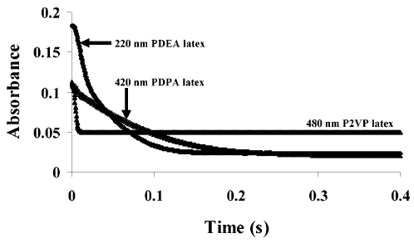
Figure 5.3. Relative rates of swelling for two sterically-stabilised poly(tertiary amine methacrylate) latexes (PDEA and PDPA) compared to a 480 nm diameter P2VP latex obtained via pH jump using a commercial stopped-flow Bio-Logic instrument. Each of these three latexes was prepared using the same 0.8 mol % DVB cross-linker.⁹

The Present Work

The aim of this Chapter is to compare the kinetics of swelling of four acid-swellable polyamine latexes: P2VP, PTBAEMA, PDEA, and PDPA. Use of a poly(ethylene glycol) monomethacrylate (PEGMA) macromonomer and divinylbenzene (DVB) cross-linker for the convenient synthesis of near-monodisperse, sterically-stabilised PTBAEMA and PDEA latexes has already been reported in this thesis (see Chapters Two and Four, respectively). The aqueous solution behaviour of all four of these pH-sensitive latexes was also studied using DLS and aqueous electrophoresis. Given the prior work by Dupin et al.⁹ it is clear that such a comparison ideally requires that both the particle size and the degree of cross-linking should be held constant. For a given particle size, cross-linker type and mean degree of cross-linking, any observed differences in the rate of swelling can then be correlated with other physical parameters, such as the latex T_{g} or polyamine pK_{a}. In addition, the effect of varying the acid/amine molar ratio (i.e. addition of sub-stoichiometric, stoichiometric or excess acid) on the rate of swelling was examined and a preliminary evaluation of the kinetics of deswelling of two of the four types of polyamine particles was undertaken.

Experimental Section
Materials. 2VP (97%; Aldrich), TBAEMA (97%; Aldrich), DEA (99%; Aldrich), DPA (97%; Aldrich) and DVB (80 mol % 1,4-divinyl content; Fluka, UK) were treated with basic alumina to remove inhibitor and stored at -20 °C prior to use. The PEGMA macromonomer (kindly donated by GEO Speciality Chemicals, Hythe, UK) had a mean degree of polymerisation (DP) of 45 and an M_{w}/M_{n} of 1.10. Ammonium persulfate (APS; > 98%; Aldrich), α,α’-azodiisobutyramidine dihydrochloride (AIBA; 97%; Aldrich) and a cationic surfactant, Aliquat 336 (H₃C-N⁺[(CH₂)₇CH₃]₃Cl⁻; Aldrich) were used as received. Deionised water was obtained using an Elga Elgastat Option 3 system. Dialysis tubing (molecular weight cut-off, MWCO = 100 kDa) was purchased from Fisher Scientific (UK) and stored in a moist environment at 4 °C until use.
Poly(2-vinylpyridine) Latex Synthesis via Aqueous Emulsion Polymerisation. These syntheses have been described elsewhere.^{16, 17} PEGMA stabiliser (0.45 g of a 50.0 wt % aqueous solution) and the cationic Aliquat 336 surfactant (0.075 g) were weighed into a 100 mL round-bottomed flask, to which deionised water (39.475 g) was added. DVB (0.025 g) was added to 2VP (2.475 g) and this comonomer mixture was added to the flask. The flask was sealed and the solution was repeatedly degassed via five vacuum/nitrogen cycles. The flask was maintained under a positive nitrogen flow and was heated to 60 °C with the aid of an oil bath and stirred at 250 rpm using a magnetic flea. After 15 minutes, the appropriate amount of AIBA initiator (25.0 mg) dissolved in deionised water (5.0 g) was then injected into the reaction vessel to initiate the copolymerisation. The reaction solution gradually turned milky-white within 30 minutes and was stirred at 60 °C for 24 h.
Poly(2-(tert-butylamino)ethyl methacrylate) Latex Synthesis via Aqueous Emulsion Polymerisation. These syntheses have already been described in detail in Chapter Two and elsewhere.¹⁸ PEGMA stabiliser (1.00 g of a 50.0 wt % aqueous solution) was weighed into a 100 mL two-neck round-bottomed flask equipped with a magnetic follower. Deionised water (40.0 g) was added, followed by TBAEMA “head monomer” (0.50 g) and the initial solution pH was recorded. This emulsion was purged with nitrogen gas for 15 minutes, then heated to 70 °C with the aid of an oil bath and stirred at 250 rpm using a magnetic flea. After 10 minutes, APS initiator (2.0 wt % based on TBAEMA) dissolved in deionised water (5.0 g) was injected into the reaction vessel to commence the first-stage polymerisation. After 1 h, further TBAEMA monomer (4.45 g) pre-mixed with DVB (0.05 g) was added dropwise (3.0 ml h⁻¹) using a syringe pump. The reaction mixture gradually turned milky-white within 30 minutes and was stirred at 70 °C for 24 h.
Poly(2-(diethylamino)ethyl methacrylate) Latex Synthesis via Aqueous Emulsion Polymerisation. These syntheses were described elsewhere.¹⁹ PEGMA stabiliser (1.0 g of a 50.0 wt % aqueous solution) was weighed into a 100 mL round-bottomed flask, to which deionised water (40 g) was added. DVB (0.05 g) was added to DEA (4.95 g) and this comonomer mixture was added to the flask. The flask was sealed and the reaction solution was repeatedly degassed via five vacuum/nitrogen cycles. The flask was maintained under a positive nitrogen flow, heated to 70 °C with the aid of an oil bath and stirred at 250 rpm using a magnetic flea. After 15 minutes, APS initiator (0.05 g) dissolved in deionised water (5.0 g) was then injected into the reaction vessel to initiate polymerisation. The reaction mixture gradually turned milky-white within 30 minutes and was stirred at 70 °C for 24 h.
Poly(2-(diisopropylamino)ethyl methacrylate) Latex synthesis via Emulsion Polymerisation. PEGMA stabiliser (2.00 g of a 50.0 wt % aqueous solution) was weighed into a 100 mL round-bottomed flask, to which deionised water (40 g) was added. DVB (0.05 g) was added to DPA (4.95 g) and this was added to the flask. The flask was sealed and the solution was repeatedly degassed via 5 vacuum/nitrogen cycles. The flask was maintained under a positive nitrogen flow, heated to 70 °C with the aid of an oil bath and stirred at 250 rpm using a magnetic follower. After 15 minutes, the appropriate amount of APS initiator (0.075 g) dissolved in deionised water (5.0 g) was then injected into the reaction vessel to initiate polymerisation. The reaction solution gradually turned milky-white within 30 minutes and was stirred for a total of 24 h at 70 °C.
Purification. The PEGMA-PTBAEMA latexes were purified by centrifugation at 20,000 rpm for 2 h, followed by careful decantation of the supernatant and replacement with fresh deionised water at pH 9.5. The sedimented particles were redispersed with the aid of an ultrasonic bath. This protocol was repeated to remove unreacted monomer, initiator and non-grafted PEGMA macromonomer. A similar approach was adopted for PEGMA-P2VP particles, which were centrifuged at 8,000 rpm for 1 h. In view of their relatively low T_{g} values, PEGMA-PDEA and PEGMA-PDPA latexes were purified via dialysis (MWCO = 105 kDa) to remove unreacted monomer, non-grafted PEGMA macromonomer and APS initiator residues. The dialysis mother liquor was changed twice daily. Purification of all four latexes was continued until the surface tension of the supernatant or dialysis serum was close to that of pure water (71 ± 1 mN m⁻¹), which indicated the removal of surface-active impurities.
Latex Characterisation
Dynamic Light Scattering (DLS). Hydrodynamic diameters were determined at 25 °C using a Malvern Zetasizer NanoZS (Model ZEN 3600) instrument equipped with a 4 mW He-Ne solid-state laser operating at 633 nm. Back-scattered light was detected at 173° and the mean particle diameter was calculated from the quadratic fitting of the correlation function over thirty runs each of ten seconds duration. All measurements were performed three times on 0.01 w/v % aqueous latex dispersions. The solution pH of the deionised water used to dilute each latex was adjusted to match that of the latex dispersion (pH ~ 10) and was ultra-filtered through a 0.20 μm membrane in order to remove any dust.
Aqueous Electrophoresis. Zeta potentials were determined in the presence of 1 mM KCl using the above Malvern Zetasizer NanoZS instrument equipped with an auto-titrator (MPT-2 multipurpose titrator, Malvern instruments). The solution pH was lowered from 10 to 3 using dilute HCl (0.01 or 0.10 M).
Transmission Electron Microscopy. Images were recorded using a Phillips CM100 instrument operating at 100 kV and equipped with a Gatan 1k CCD camera. Dilute latex dispersions (0.01 wt %) were prepared at pH 10 and dried onto a carbon-coated copper grid at room temperature.
Kinetic Studies of the Latex-to-Microgel Swelling Transition. The kinetics of latex swelling were studied by monitoring the reduction in turbidity associated with a pH jump using a commercial stopped-flow instrument (SFM 300, Bio-Logic Science Instrument, France) combined with a microprocessor (MPS 60, Bio-Logic Science Instrument, France), see Figure 5.4. This set-up allows reproducible rapid mixing within a fixed cell volume of 604 µL. The dead time is estimated to be 2.5 ms for this cell. Aqueous dispersions comprising 0.025 wt % latex containing 0.001 M NaCl were prepared at two pH units above the pK_{a} of the latex under investigation. A 1:5 acid/amine volumetric ratio was used for all experiments. The acid concentration was varied in order to investigate the effect of sub-stoichiometric, stoichiometric, and excess acid/amine molar ratios on the rate of latex swelling, while maintaining a fixed injected volume of 604 µL. The latex-to-microgel swelling transition was followed by monitoring the optical absorbance at a fixed wavelength of 500 nm at 500 µs intervals. At least three kinetic runs were recorded for all experiments and in each case good reproducibility was observed.
Kinetic Studies of the Microgel-to-Latex Deswelling Transition. Microgel-to-latex deswelling was induced by rapid mixing (within 0.1 ms) of dilute aqueous swollen microgel dispersions (at two pH units below the pK_{a} with a pH 10 buffer using the same stopped-flow apparatus shown in Figure 5.4.
Figure 5.4. Schematic representation of the Bio-Logic Science SFM 300 instrument stopped-flow instrument used to rapidly mix the dilute aqueous latex (or microgel) dispersion with the appropriate buffer. The dead time for the particular cell set-up used in this work was 2.5 ms.
Each Bio-Logic stopped-flow module consists of a mechanical sub-system and an external motor supply (MPS). The mechanical sub-system consists of three machined syringes and one valve block equipped with three-way valves. There is also an option to include one or two mixers and one ageing loop.
All SFM syringes, valves, delay lines and cuvettes are enclosed in a water jacket to allow temperature regulation of the reactant containers. The syringe plungers of the SFM are driven by stepping motors via ball screws, which eliminates the need for a “stop-syringe”. The mechanical part of the SFM module in contact with the sample and the buffers are all machined out of materials selected for their chemical inertness, such as Teflon and quartz. Dead times of the order of a few milliseconds can be achieved with the SFM due to the combined effects of high-performance control of the stepping motors and relatively small dead volumes. The SFM stopped-flow instrument is also equipped with an optical observation chamber. This configuration is summarised in Figure 5.4. Two or three solutions can be mixed and injected into the cuvette and a single delay can be installed. The syringes within the SFM are driven by independent stepping-motors. The stepping-motors have 200 steps per revolution and four phases. The power supply of each motor is controlled by a microprocessor. A complex impulse sequence enables micro-positioning of the motor’s revolution with an accuracy equivalent to 1/32 of the mechanical step. This gives an effective number of steps of 6,400 per revolution, or a volume quantification of 0.14 µL per micro-step when standard 10 mL syringes are used.

Results and Discussion
Latex Preparation and Characterisation
A very brief comparison of the swelling kinetics for P2VP, PDEA, and PDPA latexes has already been reported by Dupin and co-workers.⁹ It was hypothesised that the lower T_{g} of the methacrylate-based PDEA and PDPA particles would allow faster swelling than the high T_{g} P2VP, due to faster proton diffusion between the relatively mobile methacrylic chains. However, the PDEA and PDPA latexes actually swelled much more slowly than the P2VP particles when an acidic buffer was used in excess. However, it is perhaps worth noting that the polydispersity of the PDEA and PDPA latexes used in this earlier study to compare the swelling kinetics to P2VP particles was considerably higher compared to the near-monodisperse P2VP latex. The PDEA latex (220 nm) also differed significantly in size compared to the P2VP latex, (480 nm) and PDPA latex (420 nm).⁹
Figure 5.5. Schematic representation of the synthesis of lightly cross-linked PEGMA-stabilised latexes via emulsion copolymerisation at 70 °C (or 60 °C for 2VP) and their subsequent acid-induced swelling behaviour in aqueous solution at 20 °C to form cationic microgels.
Already outlined in this thesis is the preparation of near-monodisperse PEGMA-PTBAEMA and PEGMA-PDEA latexes of approximately 200 nm diameter. The synthesis of such acid-swellable, lightly cross-linked particles has been described in Chapters Two and Four, with relevant synthesis parameters summarised in Tables 2.1 and 4.1, respectively. In the present Chapter, near-monodisperse PEGMA-P2VP and PEGMA-PDPA particles of similar mean diameter were prepared (see Figure 5.5). In all four cases 1.0 % DVB cross-linker was used relative to the amine comonomer. Given that the purity of DVB is 80 %, this corresponds to a fixed target degree of cross-linking of 0.80 %. Thus the effects of both particle size and the degree of cross-linking on the rate of swelling should be negligible, thus enabling any observed differences to be correlated to other physical parameters.
The synthesis of near-monodisperse P2VP latexes has been previously reported.^{16, 17} However, the synthesis of near-monodisperse PEGMA-P2VP particles with mean diameters as low as 200 nm had not been reported until recently.¹⁶ Thus a 205 nm PEGMA-P2VP latex was synthesised at pH 8 according to the formulation reported by Balmer et al.,¹⁶ which involved aqueous emulsion polymerisation at approximately 5 % solids using a one-shot batch method at 60 °C for 24 h. This formulation (see entry 1, Table 5.1) produced a near-monodisperse P2VP latex with a hydrodynamic diameter of 205 nm as judged by DLS and the final comonomer conversion was 95 %. A PEGMA-PDPA latex was prepared under similar conditions, albeit utilising 20 wt % PEGMA macromonomer APS as the initiator. Despite the relatively high steric stabiliser concentration in this PDPA synthesis, substantial coagulum (~20 %) was always observed for this formulation, which was carefully removed via filtration prior to latex purification. Although this formulation clearly requires further optimisation, the purified PEGMA-PDPA latex had a relatively low polydispersity and a hydrodynamic diameter of 210 nm (see entry 4, Table 5.1), so it was deemed acceptable for the present study. The generic route for these four latex syntheses is outlined in Figure 5.5.
It is worth briefly comparing the physical properties of P2VP, PTBAEMA, PDEA and PDPA. One potentially important difference between P2VP and the three methacrylic polymers is the glass transition temperature, T_{g}. P2VP exhibits a relatively high T_{g} of 105 °C,²⁰ compared to low T_{g} values of 39 °C for PTBAEMA (see Figure 2.4),¹⁸ 10-16 °C for PDEA^{8, 21} and 5-12 °C for PDPA,^{8, 21} respectively. It was previously hypothesised that the lower T_{g} methacrylic latexes might swell faster than P2VP due to the relatively immobile chains of the latter latex. However, Dupin et al. reported that PDEA and PDPA latexes actually swell significantly slower than P2VP latex (see Figure 5.3). Although the particle size was not held constant in such experiments, the two methacrylic latexes were both smaller than the P2VP latex. Hence it seems rather unlikely that the swelling kinetics can be correlated with the copolymer T_{g}. As expected, the PEGMA-P2VP particles (see Figure 5.6a) proved to be much easier to image by TEM compared to PEGMA-PTBAEMA (see Figure 5.6b), PEGMA-PDEA (see Figure 5.6c) and PEGMA-PDPA (see Figure 5.6d) latexes. Imaging of low T_{g} copolymer particles is well-known to be problematic, since these relatively soft materials typically form films upon drying at room temperature.⁸ This is exacerbated in the case of PTBAEMA due to its likely hydroplasticisation, which lowers the effective T_{g} of these aqueous particles.²² Latexes were dried from 0.01 wt % aqueous dispersions at least two pH units above their respective pK_{a} values prior to imaging (see Figure 5.6).
Figure 5.6. Representative TEM images obtained for lightly cross-linked PEGMA-stabilised particles; (a) 205 nm P2VP latex (entry 1, Table 5.1), (b) 210 nm PTBAEMA latex (entry 2, Table 5.1), (c) 220 nm PDEA latex (entry 3, Table 5.1), and (d) 210 nm PDPA latex (entry 4, Table 5.1).

Table 5.1. Summary of the glass transition temperatures, intensity-average diameters and characteristic swelling times (t*) for PEGMA-stabilised P2VP, PTBAEMA, PDEA and PDPA particles at pH 10 (latex form) and pH 3 (microgel form). The latter parameter was determined via stopped-flow experiments using a HCl/amine molar ratio of 2.00. In all cases 0.80 % DVB cross-linker was used for these latex syntheses.

Latex type | Mass of monomer repeat unit  (g mol⁻¹) | T_{g}  (°C) | pK_{a}ª | PEGMA conc.  (wt %) | Intensity-average diameter^{b} (PDI) at pH 10  (nm) | Intensity-average diameter^{b} (PDI) at pH 3  (nm)  Chapter Five – Stopped-Flow Kinetics of pH-Responsive Polyamine Latexes: How fast is the Latex-To-Microgel Transition? | Linear swelling ratio | t*(ms)
P2VP^{c} | 106.1 | 105 | 4.2 | 10 | 205 (0.05) | 640 (0.18) | 3.2 | 5
PTBAEMA | 185.3 | 39 | 7.9 | 10 | 210 (0.02) | 660 (0.15) | 3.0 | 25
PDEA | 185.3 | 10-16 | 6.9 | 10 | 220 (0.05) | 600 (0.10) | 2.7 | 35
PDPA | 213.3 | 5-12 | 5.7 | 20 | 210 (0.07) | 480 (0.21) | 2.4 | 180

ª Determined by acid titration. ^{b} Determined by dynamic light scattering at 20 °C. ^{c} Prepared using 1.0 % AIBA initiator (the three other latexes were prepared using 1.0 % ammonium persulfate initiator).
151
Chapter Five – Stopped-Flow Kinetics of pH-Responsive Polyamine Latexes: How fast is the Latex-To-Microgel Transition?

Figure 5.7. Variation of mean hydrodynamic diameter (♦) and zeta potential (●) with solution pH for 0.01 wt % aqueous dispersions of 0.8 mol % DVB cross-linked PEGMA-stabilised particles: (a) 205 nm P2VP latex (entry 1, Table 5.1), (b) 210 nm PTBAEMA latex (entry 2, Table 5.1), (c) 220 nm PDEA latex (entry 3, Table 5.1), and (d) 210 nm PDPA latex (entry 4, Table 5.1).
152

Acid-induced swelling of the four PEGMA-stabilised latexes prepared using 0.8 mol % DVB cross-linker (entries 1-4, Table 5.1) was monitored using DLS (see ♦ data points, Figure 5.7). Substantial particle swelling occurs close to the pK_{a} values for the respective polyamine chains (the pK_{a} values determined by acid titration for such 0.8 mol % DVB cross-linked latexes are: 4.2 for P2VP, 7.9 for PTBAEMA, 6.9 for PDEA and 5.7 for PDPA). This suggests that a degree of protonation of approximately 50% is sufficient to induce the latex-to-microgel transition. The highly swollen cationic microgels formed at pH 3 have hydrodynamic diameters of 640 nm (P2VP), 660 nm (PTBAEMA), 600 nm (PDEA) and 480 nm (PDPA), see Table 5.1. As expected, the physical appearance of these dispersions changes on switching from high pH (milky, turbid latexes) to low pH (almost transparent, swollen microgels), see Figure 5.1. This transition was found to be reversible on pH cycling. It is perhaps worth noting that lowering the aqueous pH below the pK_{a} for linear (i.e. non cross-linked) PEGMA-stabilised latexes also resulted in much lower turbidities. However, in such cases a white precipitate was observed on returning to the original alkaline pH. This is because the soluble cationic polymer chains are unable to “remember” their original latex form in the absence of any DVB cross-linker, leading to their colloidal destabilisation on deprotonation in alkaline solution. Microgel/latex linear swelling ratios typically range from 2.7 to 3.2 (see Table 5.1), which correspond to volumetric swelling ratios of around 20 to 33. However, PDPA particles exhibit a somewhat lower linear swelling ratio of 2.4 (or a volumetric swelling ratio of about 14). It is perhaps worth noting that 20% coagulum was always observed for this PEGMA-PDPA synthesis. Twelve PDPA latex syntheses were attempted with varying formulations, but this problem could not be eradicated even when using 25 wt % PEGMA stabiliser (data not shown). Thus it is postulated that the DVB cross-linking density is less uniform for this PDPA latex compared to the three other latexes (which produced little or no coagulum). This would explain the reduced degree of swelling of the PDPA microgel observed at low pH.
Aqueous electrophoresis measurements were also conducted on the same four PEGMA-stabilised polyamine latexes (see ● data points in Figure 5.7). Zeta potential is a shear plane measurement that might be expected to be sensitive to the nature of the stabiliser chains, rather than the particle cores. However, in the case of these pH-responsive particles, the zeta potentials observed at low pH are actually dominated by the cationic protonated polyamine cores, rather than by the non-ionic PEGMA stabiliser. At pH 10, the zeta potentials of the three methacrylic latexes ranged from -25 to -35 mV. The four polyamine latexes exhibited isoelectric points (IEP) at approximately pH 8.3 (P2VP), 8.9 (PTBAEMA), 8.2 (PDEA), and 7.1 (PDPA). DLS studies confirmed that no flocculation occurred at these IEPs, presumably because of the steric stabilisation conferred by the PEGMA stabiliser. Below these respective IEPs, the zeta potential became cationic, and increased up to +35 mV (P2VP), +43 mV (PTBAEMA), +37 mV (PDEA) and +34 (PDPA) due to protonation of the amine groups. Thus three distinct physical states for these particles could be identified. Highly cationic swollen microgels are formed below the pK_{a}, weakly cationic latexes are obtained between the respective pK_{a} and IEP values, and anionic latexes are produced above each latex IEP. The lower anionic zeta potential observed at pH 10 for the P2VP latex relative to those of the three methacrylic latexes can be attributed to the choice of initiator. The P2VP latex was prepared using a cationic AIBA as described by Dupin et al.,¹⁷ whereas an anionic persulfate initiator was utilised for the methacrylic latexes.
Figure 5.8. A representative absorbance vs. time plot for the latex-to-microgel swelling transition of a PEGMA-P2VP latex with a mean particle diameter of 205 nm (entry 1, Table 5.1) obtained by the pH jump stopped-flow technique using an HCl/amine molar ratio of 0.50 (sub-stoichiometric). The data are averaged over three runs. The characteristic swelling time, t*, is arbitrarily defined as t* = A_{i} - 0.70(A_{i} - A_{f}), as described by Dupin et al.,¹⁷ and is found to be 11.5 ms.
Kinetics of the latex-to-microgel swelling transition
Figure 5.8 depicts a typical absorbance vs. time plot obtained for the acid-induced swelling of the 205 nm P2VP latex. The turbidity of the dilute aqueous dispersion of the P2VP particles changes significantly on switching from high pH (milky-white latex) to low pH (near-transparent swollen microgel), see Figure 5.1.
Figure 5.9. Normalised absorbance vs. time plots for the latex-to-microgel swelling transition for PEGMA-PDEA particles (entry 3, Table 5.1) obtained with the pH jump stopped-flow apparatus for HCl/amine molar ratios of: ∆ = 0.33, ▲ = 0.50 (pK_{a}), ■ = 0.67, ● = 1.00 (stoichiometric), and ♦ = 2.00 (two-fold excess HCl).

This change in physical appearance allows the kinetics of swelling to be readily monitored using the classical pH jump method. The latex-to-microgel swelling transition was induced by rapid mixing of the latex (initially at around pH 6.2, 2 pH units above the respective latex pK_{a}) with an acid buffer, such that the HCl/amine molar ratio is 0.50. Thus the final pH corresponds approximately to the pK_{a} of the P2VP latex. Three measurements were made for each kinetic run and averaged to produce the absorbance vs. time plot shown in Figure 5.8. For stoichiometric (or higher) HCl/amine molar ratios, excellent reproducibility was observed for the three runs (data not shown). Similarly reproducible results were obtained with the other three polyamine latexes when subjected to pH jumps using excess acid. As shown in Figure 5.8, the characteristic swelling time (t*) is arbitrarily defined as the time taken for the absorbance to be reduced by 70 % of the difference between the initial and final absorbance.¹²
Figure 5.9 shows a typical normalised absorbance vs time plot obtained for the PDEA latex when the latex-to-microgel transition was induced using various HCl/amine molar ratios. Changing this molar ratio clearly has a profound effect on the rate of swelling. When the HCl/amine molar ratio is 0.33 (i.e. below the pK_{a}, see ∆ data points, Figure 5.9), the initial absorbance is reduced by less than 10 %, indicating only slightly swollen particles. This is consistent with the data shown in Figure 5.7c: the latex-to-microgel transition has not yet occurred because the PDEA chains require a degree of protonation of at least 50 % to become fully swollen. When the HCl/amine molar ratio is increased to 0.50 (i.e. approximately to the pK_{a}), a 30 % reduction in absorbance occurs over 1 second (see ▲ data points, Figure 5.9). However, the swelling has still not yet reached its maximum value (or minimum absorbance). Once an HCl/amine molar ratio greater than 0.50 is used (i.e. the final pH is below the pK_{a}), full swelling of the microgels (or the minimum absorbance) is observed. However, until the HCl/amine ratio = 1.00, the time taken to reach full swelling is of the order of seconds (see ■ data points, Figure 5.9). Full swelling is achieved when employing a stoichiometric HCl/amine molar ratio (see ● data points, Figure 5.9), over a timescale of approximately 0.5 s. Only when this molar ratio is increased to 2.00 (two-fold excess acid) is maximum swelling of the microgels achieved rapidly, i.e. within 100 ms (see ♦ data points, Figure 5.9). It is perhaps worth noting that increasing the HCl/amine molar ratio above 2.00 produced no further increase in the rate of swelling. However, the maximum observed swelling (minimum absorbance) was reduced. This is due to background electrolyte, which screens the electrostatic repulsion between neighbouring cationic polymer chains. This was confirmed using DLS by preparing PDEA microgels using a HCl/amine molar ratio of 10.0, which resulted in a reduction of the swollen cationic microgel diameter from 585 nm (HCl/amine = 1.00) to 450 nm. Therefore, a fixed HCl/amine molar ratio of 2.0 was used to compare the swelling kinetics for each type of polyamine latex.
Figure 5.10 depicts the absorbance vs time curves obtained for (a) P2VP, (b) PTBAEMA, (c) PDEA and (d) PDPA latexes. Only HCl/amine molar ratios of 0.50 (▲), 1.00 (●), and 2.00 (♦) are shown for clarity, despite all four latexes being analysed with the five molar ratios used above for PDEA. When the HCl/amine molar ratio = 0.50, the swelling kinetics for each of the latexes is somewhat slower than when either stoichiometric or excess acid is employed. However, in the case of PTBAEMA and P2VP latexes this relatively low molar ratio is sufficient to achieve complete microgel swelling. As expected, increasing the HCl/amine molar ratio to 2.00 leads to faster swelling kinetics for all four latexes.
The raw data for each of the HCl/amine molar ration = 2.00 curves were normalised for all four latexes (see Figure 5.11). These absorbance vs time curves were then analysed to obtain the t* values summarised in Table 5.1. Clearly, significantly slower rates of swelling are observed for the three methacrylic latexes compared to the P2VP particles. Interestingly, the PDPA latex swelling kinetics are somewhat slower than the PDEA and PTBAEMA latexes. Although this might be attributed to the less uniform cross-linking density of DVB, (which may be related to the production of coagulum during the PDPA latex synthesis) we postulate that the main consideration is actually the cationic charge density developed within the swollen microgels. This would explain the faster swelling kinetics for P2VP compared with the other three latexes. The mass of the monomer repeat unit (g mol⁻¹, see Table 5.1) for P2VP is almost half that of PTBAEMA and PDEA. These latter two methacrylic monomers are actually isomers, which explains their similar t* values for the swelling kinetics of the latex-to-microgel transition. The DPA repeat units are the most massive, hence this latex has the lowest cationic charge density of the four studied herein.
Figure 5.10. Absorbance vs. time plots of the latex-to-microgel swelling transition obtained for the following PEGMA-stabilised latexes (a) P2VP (entry 1, Table 5.1), (b) PTBAEMA (entry 2, Table 5.1), (c) PDEA (entry 3, Table 5.1), and (d) PDPA (entry 4, Table 5.1). All experiments were performed via a pH jump stopped-flow experiment using HCl/amine molar ratios of: ▲ = 0.50 (pK_{a}), ● = 1.00 (stoichiometric), and ♦ = 2.00 (two-fold excess HCl).

In principle, the observation of slower swelling kinetics for a given latex could simply indicate that it forms larger, more swollen microgels than other latexes. In this context, inspecting the linear swelling ratios determined for the four latexes by DLS is instructive (see penultimate column in Table 1). The latex with the fastest rate of swelling (P2VP) also has the highest linear swelling ratio, while the slowest latex to respond to a pH jump (PDPA) has the lowest linear swelling ratio. Thus this trivial explanation for the observed difference in swelling kinetics for the four polyamine latexes can be ruled out. One reasonable explanation is that the rate of swelling observed for a given latex is dictated by the cationic charge density developed within the swollen microgel particles. This hypothesis is consistent with the significantly faster swelling kinetics observed for P2VP compared with the other three latexes. The mass of the 2-vinylpyridine repeat unit for P2VP is almost half that of PTBAEMA and PDEA (see Table 1). These latter two methacrylic monomers are actually isomers, which may explain their comparable t* values for the swelling kinetics of the latex-to-microgel transition. The DPA repeat units are the most massive, hence this latex has the lowest cationic charge density of the four latexes studied herein. A plausible alternative explanation to this cationic charge density hypothesis could be that the DVB cross-link density for the P2VP latex is simply more uniform than that achieved for the three methacrylic latexes. This is not unreasonable given the likely differences in co-polymerisability between DVB and the four amine monomers, since the 2VP/DVB formulation is likely to exhibit more ideal behaviour in this regard. Similarly, the relatively slow response of the PDPA latex could indicate a relatively non-uniform DVB cross-linking density in this case (which could be related to the substantial coagulum observed during the synthesis of this latter latex).
Figure 5.11. Normalised rates of swelling observed for four PEGMA-stabilised polyamine latexes (see entries 1 to 4, Table 5.1) via pH jump stopped-flow experiments performed at a HCl/amine molar ratio of 2.0 (i.e. two-fold excess acid). Each of these four latexes was prepared using the same amount of DVB cross-linker (0.80 mol %).
If we compare the t* value observed for the 205 nm P2VP particles with those reported by Dupin et al.⁹ for six larger P2VP latexes (see Figure 5.2b), it does not fit the value (5 ms) predicted for this P2VP diameter. However, the HCl/amine ratio employed by Dupin et al. was such that at least a ten-fold excess of acid was present. In the present study, increasing the acid/amine molar ratio only indicated an increase in the final absorbance for the cationic swollen microgel. This effect was not only observed for P2VP, but also the methacrylic-based latexes. Therefore only a two-fold molar excess of acid was investigated in our work. This is important because excess acid produces a profound reduction in the swollen microgel diameter, increasing the final absorbance. This will affect the characteristic swelling time predicted.
Figure 5.12. Normalised absorbance vs. time plots for the microgel-to-latex deswelling transition observed for PEGMA-P2VP (●) and PEGMA-PTBAEMA (♦) microgels with an initial swollen diameter of either 640 nm (P2VP, entry 1, Table 5.1) or 660 nm (PTBAEMA, entry 2, Table 5.1) obtained by the pH jump stopped-flow technique using a KOH/amine ratio of 2.0 (i.e. a two-fold excess of base). The data are averaged over three runs.
Kinetics of the microgel-to-latex deswelling transition
The kinetics of the microgel-to-latex transition was examined for the P2VP and PTBAEMA latexes (entries 1 and 2, Table 5.1). As expected, the rate of deswelling is somewhat slower for the PTBAEMA microgel (see Figure 5.12). Microgel deswelling is complete within 30 seconds in both cases. This time scale is comparable to those reported by Yin et al. for the deswelling of various P2VP microgels.²³ However, we can see from the normalised plots that the PTBAEMA has a much lower absorbance in the microgel state than P2VP which we attribute to a lower refractive index for the swollen PTBAEMA microgel. Furthermore, the kinetics of microgel deswelling is much slower than the kinetics of latex swelling. We attribute this difference to a “skin” effect during deprotonation of the initial microgel. As the amine repeat units become deprotonated, a latex-like shell begins to form around the microgel particles (see Figure 5.13). Thus, the excretion of water (and salt) from the shrinking hydrophilic core through this hydrophobic shell is retarded, which makes the rate of microgel deswelling significantly slower than the rate of latex swelling when performed under equivalent conditions (i.e. a KOH/amine molar ratio and HCl/amine molar ratio of 2.0). A similar explanation was suggested by Liu and co-workers for P2VP microgel deswelling.²³
Figure 5.13. Schematic illustration of the in situ formation of a latex-like “skin” during the alkali-induced microgel-to-latex deswelling transition for a pH jump from pH 3 to 10 for PEGMA-stabilised P2VP or PTBAEMA microgels in aqueous solution at 25 °C.

Conclusions
In summary, the relative swelling kinetics of four PEGMA-stabilised near-monodisperse polyamine latexes of approximately 200 nm diameter has been examined. The DVB cross-linking density for each latex was held constant at 0.8 mol %. The characteristic timescale for the latex-to-microgel transition is sensitive to the number of moles of added acid relative to the number of moles of polymerised amine residues, with significantly faster rates of swelling being observed when using excess acid. Perhaps surprisingly, there is clearly no correlation between the kinetics of swelling and the polyamine latex T_{g} or pK_{a}. However, there is a good correlation between the characteristic swelling time (t*) and the molar mass of the amine monomer repeat unit. Regardless of the acid/amine molar ratio, the observed relative rate of swelling is as follows:
P2VP > PTBAEMA ≈ PDEA > PDPA
The corresponding t* values for the above four latexes are 5, 25, 35 and 180 ms, respectively. This suggests that the cationic charge density may play an important role in determining the rate of swelling. The t* for the PDPA latex is particularly high, but this may be related to its less uniform cross-linking density, which is perhaps related to the substantial coagulum observed for this particular formulation.
Preliminary studies of the deswelling kinetics for the protonated PTBAEMA microgel particles indicate that this transition is much slower, with a characteristic deswelling time scale of tens of seconds. Similar observations have been reported for P2VP microgels by Yin et al.¹⁷ Such observations are consistent with the in situ formation of a latex-like “skin”, which hinders the excretion of water and salt from the shrinking microgel particles and hence retards the microgel deswelling kinetics.

References
1. Saunders, B. R.; Crowther, H. M.; Vincent, B., Macromolecules, 1997, 30, 482-487.
2. Debord, J. D.; Lyon, L. A., Langmuir, 2003, 19, 7662-7664.
3. Bradley, M.; Ramos, J.; Vincent, B., Langmuir, 2005, 21, 1209-1215.
4. Lochhead, R. Y.; Davidson, J. A.; Thomas, G. M., American Chemical Society, 1989, 223, 113-147.
5. Lochhead, R. Y.; Davidson, J. A.; Thomas, G. M., Advances in Chemistry Series, 1989, 113-147.
6. Lochhead, R. Y.; Warfield, D. S., Soap Cosmetics Chemical Specialties, 1985, 61, 46.
7. Newman, J. K.; McCormick, C. L., Macromolecules, 1994, 27, 5123-5128.
8. Amalvy, J. I.; Wanless, E. J.; Li, Y.; Michailidou, V.; Armes, S. P.; Duccini, Y., Langmuir, 2004, 20, 8992-8999.
9. Dupin, D.; Rosselgong, J.; Armes, S. P.; Routh, A. F., Langmuir, 2007, 23, 4035-4041.
10. Loxley, A.; Vincent, B., Colloid and Polymer Science, 1997, 275, 1108-1114.
11. Tan, B. H.; Tam, K. C., Advances in Colloid and Interface Science, 2008, 136, 25-44.
12. Hoare, T.; Pelton, R., Macromolecules, 2004, 37, 2544-2550.
13. Brugger, B.; Rosen, B. A.; Richtering, W., Langmuir, 2008, 24, 12202-12208.
14. Ricka, J.; Tanaka, T., Macromolecules, 1984, 17, 2916-2921.
15. Tanaka, T.; Fillmore, D. J., J. Chem. Phys., 1979, 70, 1214-1218.
16. Balmer, J. A.; Le Cunff, E. C.; Armes, S. P.; Murray, M. W.; Murray, K. A.; Williams, N. S. J., Langmuir, 2010, 26, 13662-13671.
17. Dupin, D.; Fujii, S.; Armes, S. P.; Reeve, P.; Baxter, S. M., Langmuir, 2006, 22, 3381-3387.
18. Morse, A. J.; Dupin, D.; Thompson, K. L.; Armes, S. P.; Ouzineb, K.; Mills, P.; Swart, R., Langmuir, 2012, 28, 11733-11744.
19. Morse, A. J.; Armes, S. P.; Thompson, K. L.; Dupin, D.; Fielding, L. A.; Mills, P.; Swart, R., Langmuir, 2013, 29, 5466-5475.
20. Gorin, S.; Monnerie, L., Journal De Chimie Physique Et De Physico-Chimie Biologique, 1968, 65, 2069.
21. Tobolsky, A. V.; Shen, M. C., J. Phys. Chem., 1963, 67, 1886-1891.
22. Jiang, B.; Tsavalas, J.; Sundberg, D., Langmuir, 2010, 26, 9408-9415.
23. Yin, J.; Dupin, D.; Li, J.; Armes, S. P.; Liu, S., Langmuir, 2008, 24, 9334-9340.

Chapter Six

Conclusions and Future Work

Conclusions
Pickering emulsions have been prepared via the use of pH-responsive latex particles that adsorb at the oil/water interface. Novel latex particles were prepared by aqueous emulsion polymerisation of TBAEMA in the presence of a hydrophilic macromonomer and a divinyl cross-linking agent. When compared to previous responsive emulsifiers (PDMA-PS, P(DMA-MMA)-PS, P4VP-SiO₂, or PDMA-P2VP) we present a ready scalable formulation for PTBAEMA, a relatively cheap monomer. The pK_{a} of such cross-linked PTBAEMA was determined to be 7.9, below which the particles undergo a reversible latex-to-microgel swelling transition. The surface-grafted PEGMA macromonomer showed no effect on the stability or type of emulsion formed when homogenisation was performed with n-dodecane or sunflower oil, with stable Pickering emulsions formed when the pH of the aqueous latex was above 8.5. In fact, charge-stabilised PTBAEMA prepared in the absence of PEGMA macromonomer also stabilised Pickering emulsions when homogenised at pH 10. However, if the homogenisation was carried out at pH 3 for either PEGMA or charge-stabilised particles, no Pickering emulsions were observed. This is because the PTBAEMA microgels become hydrophilic, therefore reside in the water phase, rather than adsorb at the oil/water interface. However, if Pickering emulsions prepared at pH 10 are subjected to a pH-jump to 3, demulsification is observed within seconds. This is contrary to the theory that microgels “jam” at the interface when protonation occurs. Provided that cross-linking agent was present in the synthesis of the latex particles, re-homogenisation of the same latex particles at pH 10 with n-dodecane produced pH-responsive Pickering emulsions a further 5 times.
PTBAEMA particles were found to react via the secondary amine with a polymeric oil-soluble cross-linker when adsorbed at the oil/water interface to produce colloidosmes. We believe this is the first example of colloidosomes based around covalent cross-linking of the latex core, rather than cross-linking of the steric stabiliser chains (c.f. PGMA-PS, PEI-PS, P(DMA-MMA)-PS or PEI/Laponite hybrids). It is also perhaps the first example of microgel-based colloidosomes, with pH-responsive shells that can undergo latex-to-microgel-to-latex transitions. This microgel colloidosome could potentially allow maximum permeability of the hydrophilic shell, if loading at low pH could be achieved.
The synthesis of PEGMA-PDEA latexes via emulsion polymerisation of DEA monomer in the presence of PEGMA macromonomer and a divinyl cross-linking agent is also discussed. Our formulation shows significant improvements when compared to those PDEA particles by Amalvy et al. These PDEA-based particles represent the first example of a CO₂-induced latex-to-microgel transition, as well as a microgel-to-latex transition when purged with N₂. Moreover, when CO₂/N₂ are used to cycle the aqueous pH, no reduction in the swollen microgel after 10 cycles is observed. This is in contrast to using HCl/KOH, which results in a reduction of 80 nm in the swollen microgel after 10 cycles. Such latex particles also act as Pickering emulsifiers, which shows promise as possible oil-recovery.
The relative swelling kinetics of four sterically-stabilised near-monodisperse polyamine latexes of approximately 200 nm diameter were also discussed. This is the first example of well-defined similar sized polyamine latexes to be compared. The characteristic timescale for the latex-to-microgel transition is significantly shorter when using excess acid. There is clearly no correlation between the kinetics of swelling and the polyamine latex T_{g} which was previously postulated. However, there is a good correlation between the characteristic swelling time and the molar mass of the amine monomer repeat unit. Regardless of the acid/amine molar ratio, the observed relative rate of swelling is as follows: P2VP > PTBAEMA ≈ PDEA > PDPA. This correlates well with the monomer repeat unit, which suggests that the cationic charge density is an important parameter in determining the kinetics of microgel swelling.

Future Work

In Chapter Two and Three, the relatively soft, low T_{g}, film-forming nature of PTBAEMA and PDEA latex particles is evident. This made electron microscopy of the latexes troublesome. Therefore, cyro-TEM will be utilised for imaging of low T_{g} PTBAEMA particles. There is also a need for cyro-SEM to image methacrylic latex particles, as well as imaging covalently cross-linked PTBAEMA colloidosomes. The PTBAEMA latex particles with 0.8-4.0 mol % DVB cross-linker could also be analysed using the pH jump-stopped flow technique.
The preparation of hexane-in-water colloidosomes stabilised by PTBAEMA is to be investigated. This approach allows the removal of the internal oil phase by simple evaporation (boiling point of hexane is approximately 69 °C), leaving hollow colloidosomes. Allowing the oil to evaporate at pH 3 should produce water-in-water microgel-colloidosomes due to the hydrated microgel structure. If a water-soluble active agent can penertrate the microgel structure at low pH, raising the pH to 10 and reforming the latex shell may allow encapsulation.
Investigate the effect of increasing the DVB concentration in PEGMA-PDEA particles. If the particle pK_{a} can be sufficiently reduced to allow full deprotonation of the microgel with N₂ purging, this may propose a new route to cycling PDEA-stabilised Pickering emulsions without the build-up of background salt.
The PDPA synthesis could be improved to produce well-defined latex particles without the coagulum. This may provide a closer correltation of the characteristic swelling time with other methacrylic latexes. More work needs to be done to understand the cationic charge repulsion density effect. This could be achieved by preparing copolymer latexes of similar size with a non-pH-responsive comonomer to dilute the cationic charge density. Possibly, use the P(TBAEMA/S) copolymer particles produced in Chapter Three. The synthesis of polyacid hydrogels could also offer some alkali-swellable particles with similar charge densitys.

